Australian ground cover reference sites database: User guide for PostGIS

Jasmine Rickards, Jane Stewart, Rebecca McPhee & Lucy Randall
Australian Bureau of Agricultural and Resource Economics and Sciences
June 2013

Summary
Ground cover is the amount of living and dead vegetation in contact with the soil surface. Spatially explicit monthly ground cover data are needed to improve modeling and monitoring of wind and water erosion, soil carbon and soil acidification.
The ‘Ground cover monitoring for Australia’ project is delivering a remotely sensed ground cover product describing green or photosynthetic vegetation, non-green or non-photosynthetic vegetation and bare soil. The project is also delivering a national network of sensor independent ground reference sites to validate this product. The data has been collected by state and territory agricultural agencies as part of the ‘Ground cover monitoring for Australia’ project. This project is funded by the Department of Agriculture Fisheries and Forestry and coordinated by its Australian Bureau of Agricultural and Resource Economics and Sciences (ABARES) in partnership with the CSIRO and state and territory agencies.
The ground cover reference sites database contains the data collected from the national network of ground reference sites. This data includes site descriptions and the associated field measurements of fractional ground cover. Data has been collected across Australia at field sites under grazing and broadacre cropping land uses according to nationally agreed standards (Muir et al. 2011). Data collection commenced in July 2010 and continued until February 2013. This published field site database contains 464 observations from 460 unique sites across Australia. This is a subset of the 541 unique sites (545 observations), mostly located in the rangelands, which were collected through the ‘Ground cover monitoring for Australia’ project. The data is being used to calibrate, validate and improve vegetation fractional cover products derived from remote sensing, in particular the satellite sensors MODIS and Landsat. The data is being used to improve the national MODIS-derived product of Guerschman et al. (2009).
The ground cover reference sites database has been developed using open source software—the object-relational database PostgreSQL with PostGIS to support geographic objects. This enables the database to be displayed spatially by site location within geographical information systems. The data is made publically available through the Terrestrial Ecosystem Research Network (TERN) National Computer Infrastructure (http://rs.nci.org.au) and the TERN Australian Ecological Knowledge and Observation System (AEKOS) Data Portal (http://portal.aekos.org.au).

Contents
Australian ground cover reference sites database: User guide for PostGIS 1
Summary 1
Introduction 3
Observations in the database 4
Database design 5
Field collection protocols 6
Raw transect data 8
Photographs 8
Site description 9
Site locations 13
Cover summaries 14
Cover fractions 14
Exposed cover fractions 15
Checking the data 15
SQL functions 17
Querying the database 17
Manipulating the database 18
Acronyms 19
References 20

Introduction
A national remotely sensed fractional cover product is necessary to monitor ground cover levels, as a key input to wind and water erosion modeling to predict rates of soil loss, and to monitor the impact of different management practices on ground cover levels and soil erosion risk. Ground cover is defined as the non-woody vegetation and litter covering the soil surface and can be monitored using remote sensing. At a national workshop in November 2009 the MODIS-derived vegetation cover product of Guerschman et al. (2009) was selected for national monitoring of ground cover (Stewart et al. 2011). The workshop also identified the need for a national network of ground cover reference sites to calibrate, validate and improve the accuracy of ground cover estimates. To meet this objective, national standards were developed to collect field measurements of ground cover and to describe sites with all states and the Northern Territory receiving training in their use (Muir et al. 2011).
The national network of ground cover reference sites project commenced in July 2010 and was funded to June 2013. Information from 541 field sites (545 observations) has been delivered as part of the ‘Ground cover monitoring for Australia’ project. This work was funded by the Department of Agriculture Fisheries and Forestry and coordinated by the Australian Bureau of Agricultural and Resource Economics and Sciences (ABARES) in partnership with the CSIRO and state agencies. The data was collected by the following state agencies: New South Wales Office of Environment and Heritage, Northern Territory Department of Land Resource Management, Queensland Department of Science, Information Technology, Innovation and the Arts, South Australian Department of Environment and Natural Resources, Tasmanian Department of Primary Industries, Parks, Water and Environment, Victorian Department of Environment and Primary Industries, and the Western Australian Department of Agriculture and Food.
The data was collected in the field and entered into two electronic Microsoft Excel spreadsheets—the site description form and the transect form—and provided to ABARES along with digital site photographs. These photos were included in the ground cover reference sites database. Some project partners have developed or are developing new tools to improve efficiency of entering data in the field using tablets or smart phones. The University of Adelaide is creating an application for the Android operating system to be used on portable devices for TERN AusPlots (rangelands). The Queensland Department of Science, Information Technology, Innovation and the Arts have developed a data entry form using an Android app called ODK Collect. The Northern Territory Department of Land Resource Management has developed an Apple Numbers spreadsheet template for fractional cover data collection using iPads.
The ground cover reference sites database conforms to the methods described in Muir et al. (2011). Choice of site locations was informed by a sampling strategy (Malthus et al. 2013) and sampling protocols (Stewart et al. 2012; Stewart et al. in prep.). Sites were to be located in areas dominated by non-woody vegetation with tree canopy cover less than 20 per cent under grazing or broadacre cropping land uses. Areas with tree cover greater than 20 per cent (based on Montreal Process Implementation Group for Australia 2008), and non-agricultural land uses such as urban, conservation or indigenous land uses (based on ABARES 2011) were avoided where possible. Due to site and imagery access limitations some sites are located in national parks, nature conservation and traditional indigenous land uses. The majority of sites are located in the rangelands.
In developing the database, data users requested that it be created using open source software and have the ability to display site data within a geographical information system (GIS). PostGIS was chosen as it enables the object-relational database PostgreSQL to serve the site data spatially by site location, and to query the data using SQL functions. The SQL functions section of this user guide provides some examples. The user guide is an update to a previous version released in 2012 (Rickards et al. 2012).

Observations in the database
This field site database contains 464 observations from 460 unique sites across Australia. The database does not contain all 545 observations funded under the ‘Ground cover monitoring for Australia’ project because some project partners requested that field observations on private land not be published due to confidentiality. The total number of observations collected by each state is shown in Table 1. The locations of the publishable sites in the database are shown in Map 1.
Table 1 Number of observations in each state
 | Observations
State | Total | Published | Unpublished
New South Wales | 91 | 58 | 33
Northern Territory | 109 | 95 | 14
Queensland | 30 | 28 | 2
South Australia | 100 | 88 | 12
Tasmania | 25 | 25 | -
Victoria | 48 | 28 | 20
Western Australia | 142 | 142 | -
Total | 545 | 464 | 81
Note: Data from unpublished sites may be acquired for specific research projects at the discretion of the relevant state agency.

Map 1 Location of sites in the database as at February 2013
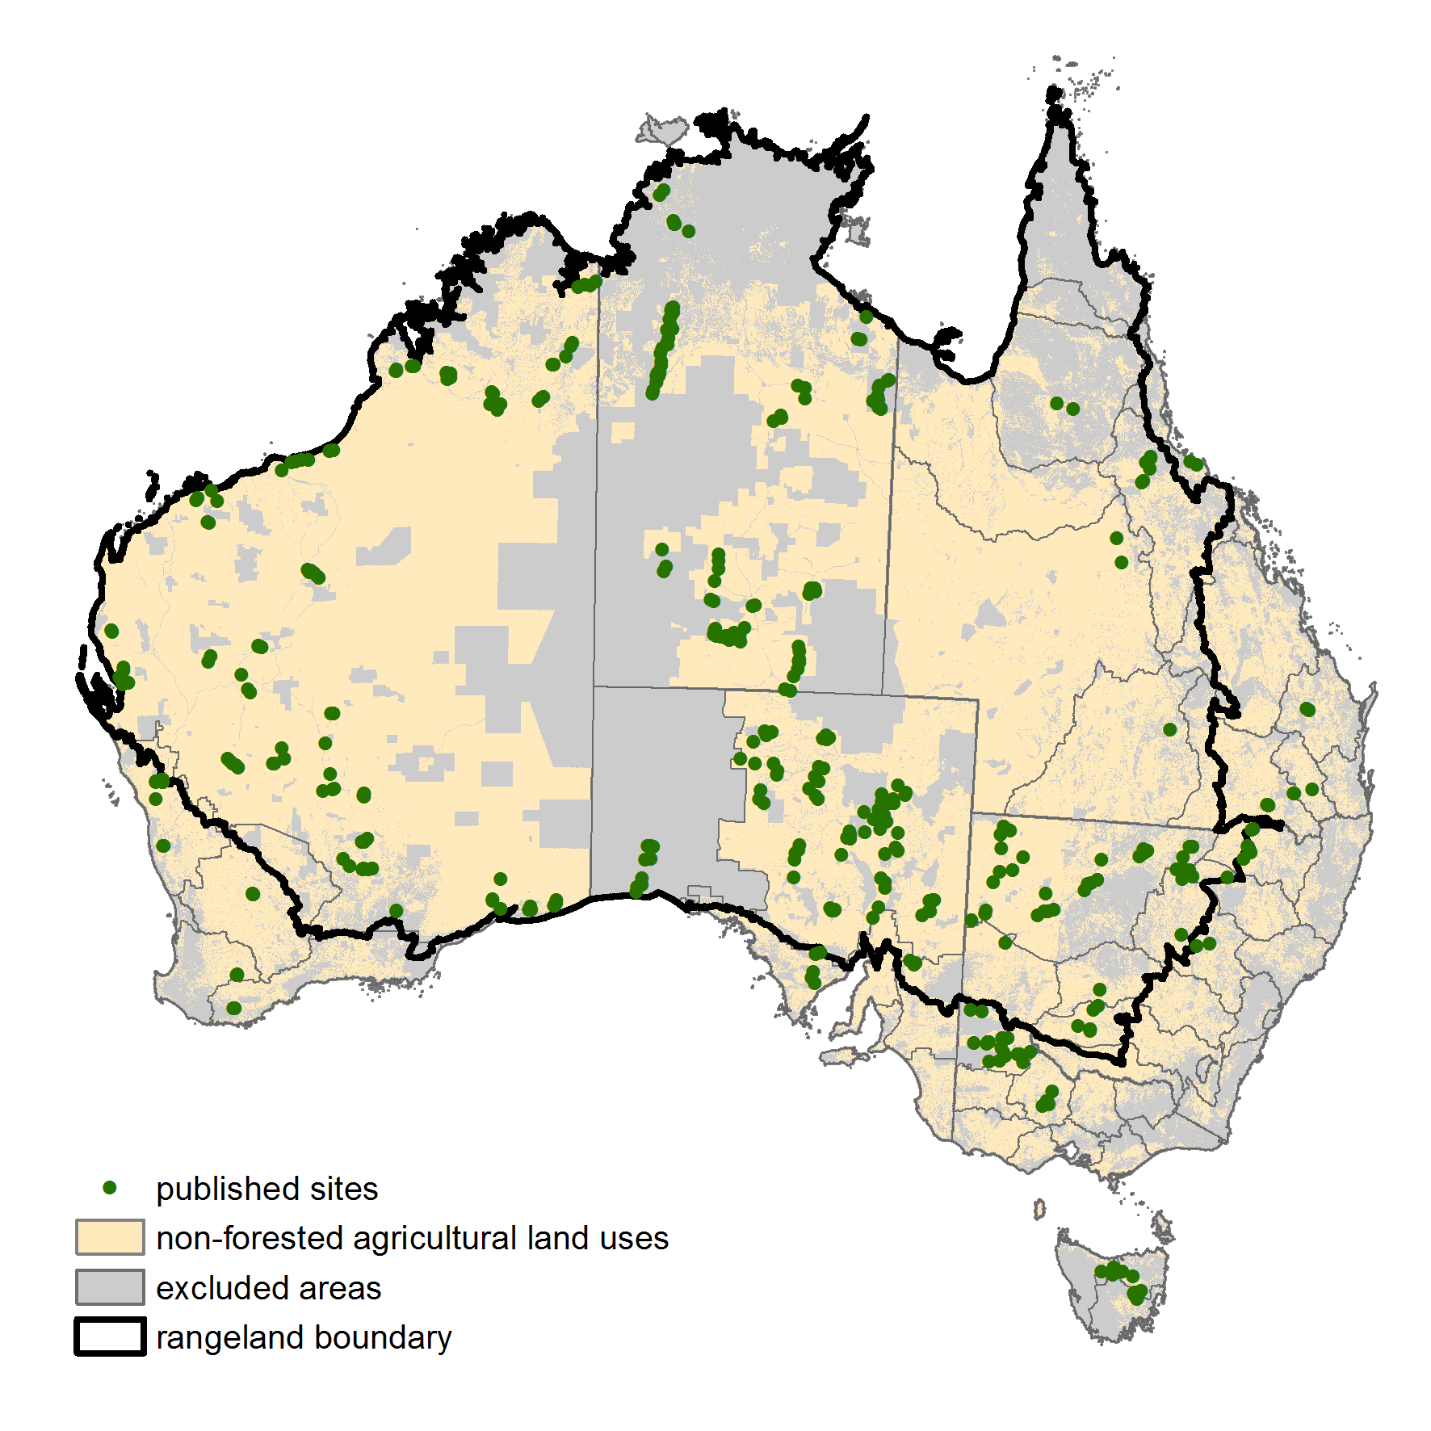
Source: ABARES 2013

Database design
The ground cover reference sites database has been created using the open source software PostGIS (http://postgis.refractions.net/) and is available as a pg-dump SQL file. It can be loaded into PostGIS by running the pg-dump file. Running this file will create and populate five ‘tables’ and three ‘views’ (schema shown in Figure 1). Tables contain static data. Views calculate values from the tables and automatically update when new data is entered into the tables.
A description of each table and view are given in Table 2. The attributes contained in each table are provided in Tables 3 to 12. Each site visit is assigned a 'unique_obs' code of 'longitude_latitude_date' to join or relate all tables. Each table also contains a ‘primary key’ which is unique for each data entry at a site. For attributes with a single data entry, such as in the site description table (Table 5), the ‘primary key’ is the ‘unique_obs’ code. For attributes with multiple data entries, such as in the raw transect data table (Table 3) with 200-300 points per site, the ‘primary key’ is either a new field or a combination of existing fields.
Figure 1 Schema of PostGIS database
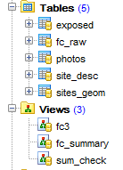

Table 2 Tables and views in the ground cover reference site database
Name | Content for each site | Type | Attributes
exposed | Exposed ground cover fractions (bare, brown and green) of sites | Table | Table 11
fc_raw | Raw data for each point along the transect layout (300 or 200 observations) | Table | Table 3
photos | An index of 7 or 5 photographs taken along the transect layout | Table | Table 4
site_desc | Other information describing the site such as land use, vegetation species, soil surface condition, soil colour etc | Table | Table 5-7
sites_geom | Location in latitude and longitude | Table(geom) | Table 8
fc3 | Totals for the ground layer fractions PV (green), NPV (dry) and BS (bare) fractions and ground cover (PV + NPV) (%) | View | Table 10
fc_summary | Totals for each cover category (%) | View | Table 9
sum_check | Total cover to identify errors (%) | View | Table 12
Note: PV—photosynthetic vegetation; NPV—non-photosynthetic vegetation; BS—bare soil

Field collection protocols
The field collection protocol code from the site_desc table in the PostGIS database (Table 5) identifies the layout of the field transects and the attributes collected at the site. The data collected through the ‘Ground cover monitoring for Australia’ project uses two transect layouts developed by Queensland Department of Science, Information Technology, Innovation and the Arts (Muir et al. 2011). Fractional ground cover data collected prior to this project used the same transect layouts but slightly different attributes. TERN AusPlots sites will use a more intensive transect layout to collect fractional ground cover data. The different transect layouts described by the protocols below are all suitable for improving MODIS and Landsat fractional cover algorithms. The protocols have been assigned a code beginning with P1 for Protocol 1. Each protocol is described below.
P1: The star-shaped transect method developed for the Queensland Statewide Land And Trees Survey (SLATS) has been used to measure vegetation in natural or pastoral environments (Figure 2). Three hundred points are measured using the star-shaped transect method as described in Muir et al. (2011).
Figure 2 P1 transect layout for natural or pastoral environments
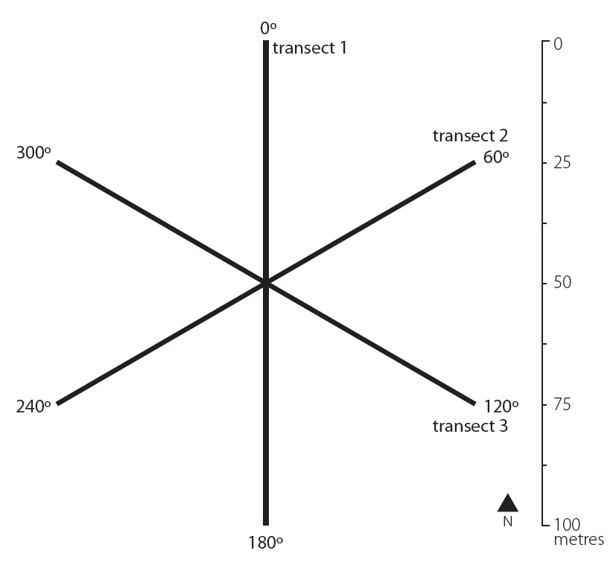
Source: Muir et al. (2011)

P2: The cross transect method has been adapted from the SLATS star-transect method as a simplified method for vegetation in rows, such as crops (Figure 3). Two hundred points are measured using the cross-shaped transect method as described in Muir et al. (2011).
Figure 3 P2 transect layout for vegetation in rows, such as agricultural crops
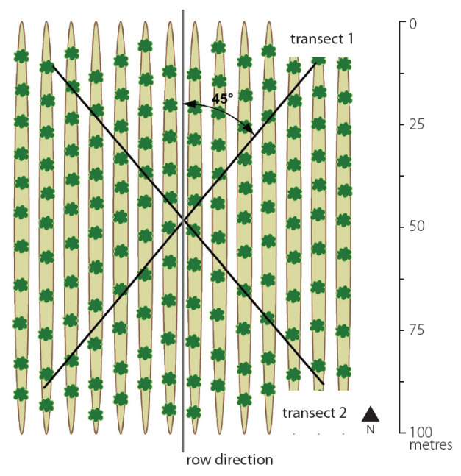
Source: Muir et al. (2011)

Raw transect data
The fc_raw table (Table 3) contains multiple measurements taken at each site of the presence or absence of ground cover, woody vegetation less than two metres (midstorey) and woody vegetation greater than 2 metres (overstorey). For most sites a total of 300 observations of the vegetation community are measured, with one measurement taken every metre along three 100 metre transects arranged in a star-shape called protocol 1 (P1) (Figure 2). Where vegetation is in rows, as for cropping, the pattern of cover is more uniform and the method has been simplified to a total of 200 observations recorded along two 100 metre transects oriented 45 degrees off-row called protocol 2 (P2) (Figure 3) as described in the section above.
Measurements are recorded as a ‘1’. Only one feature type (i.e. green leaf, dry leaf etc) is recorded for each observation category (stratum), except where the measurement for woody vegetation greater than two metres is within a live tree crown, in this case two measurements are recorded, 'in crown' (field name: ‘oic’) as well as the canopy element intercepted.
Table 3 Attributes of fc_raw table
Field name | Description | Data type | Values allowed | Strata
point | Transect measurement | Integer | 1–300 | All
cr | Soil crust | Integer | 0, 1 | Ground
ds | Disturbed soil | Integer | 0, 1 | Ground
rk | Rock | Integer | 0, 1 | Ground
gr | Green leaf non-woody vegetation | Integer | 0, 1 | Ground
dr | Dry leaf non-woody vegetation | Integer | 0, 1 | Ground
li | Litter | Integer | 0, 1 | Ground
cy | Cryptogam | Integer | 0, 1 | Ground
mg | Green leaf woody vegetation <2m | Integer | 0, 1 | Mid
md | Dry leaf woody vegetation <2m | Integer | 0, 1 | Mid
mb | Branch <2m | Integer | 0, 1 | Mid
oic | In crown for live woody vegetation >2m | Integer | 0, 1 | Over
og | Green leaf woody vegetation >2m | Integer | 0, 1 | Over
od | Dry leaf woody vegetation >2m | Integer | 0, 1 | Over
ob | Branch >2m | Integer | 0, 1 | Over
unique_obs | Site identifier  (longitude_latitude_date) | Text | 00000000_0000000_yyyymmdd  32 characters | All
g_total | Only one observation for ground cover (cr+ds+rk+gr+dr+li+cy) is permitted at each point | Integer | 1 | Ground
m_total | Zero or one observations of woody vegetation <2m (mg+md+mb) are permitted at each point | Integer | 0, 1 | Mid
o_total | Zero, one or two observations of woody vegetation >2m (oic+og+od+ob) are permitted at each point. | Integer | 0, 1, 2 | Over
all_total | Number of strata for each transect point (g_total+m_total+o_total) | Integer | 1, 2, 3, 4 | All
Note: Primary key = unique_obs, point. Non-woody vegetative cover, such as grasses, has no height restriction; dry leaf is senescent or dead vegetation attached to a plant or the ground; litter is unattached dead vegetation; cryptogam is a biological crust on the soil surface; in crown is the vertically projected perimeter of all foliage and branches of the plant and is recorded for live trees only. Latitude and longitude are given in decimal degrees.

Photographs
Digital photographs are taken at each site. All images are taken from the transect centre, with the first pointing directly down (G) and the others along each transect line (L) starting at north and working around in a clockwise direction. Five photos are taken when the site has vegetation in rows (cropping) and seven photos at each site in natural or pastoral environments. The number of photos taken reflects the field collection protocol adopted—protocol 2 (P2) or two transects for vegetation in rows (Figure 3) and protocol 1 (P1) or three transects for natural or pastoral environments (Figure 2). The photos table (Table 4) stores the details of these digital photographs.
Table 4 Attributes of photos table
Field name | Description | Data type | Values allowed
code | Primary key (unique_obs, name) | Text | 35 characters
unique_obs | Site identifier  (longitude_latitude_date) | Text | 00000000_0000000_yyyymmdd  32 characters
site_name | Name of the site e.g. Vic1001 | Text | 20 characters
state | State abbreviation e.g. NSW | Text | 3 characters
crop | Site cropped or not | Text | Yes, No
name | G1=centre down, L1=1st , L2=2nd , L3=3rd, L4=4th, L5=5th, L6=6th | Text | G1, L1, L2, L3, L4, L5 , L6
transect | Which transect the image shows | Integer | 1, 2, 3
direction | Site orientation in degrees | Integer | 0-360
cardinal_direction | Direction text | Text | 10 characters
weblink | Link to online photo library | Text | 255 characters
Note: At sites with vegetation in rows (cropping) only 5 photos were taken (G1, …, L4). Some site photographs were uploaded to the Earth Observation and Modelling Global Geo-Referenced Field Photo Library (www.eomf.ou.edu/photos). Site photos can now be viewed on the TERN AEKOS data portal (http://portal.aekos.org.au).

Site description
The site description details are saved in the table site_desc. In this user guide the site_desc attributes are presented in three tables corresponding to the three sections of the site description form used by the field operator to enter the data. Table 5 contains the basic site description attributes, Table 6 contains the vegetation description attributes and Table 7 contains the land surface attributes. Some site_desc table attributes—basic soil colours and soil moisture (Table 7)—have been calculated from the collected data.
Table 5 Attributes of site_desc table: basic site description
Field name | Description | Data type | Values allowed
publish | Consent for public release of data (if ‘No’: not published) | Text | Yes, No
unique_obs | Site identifier  (longitude_latitude_date) | Text | 00000000_0000000_yyyymmdd  32 characters
site_name | Name of the site e.g. Vic1001 | Text | 20 characters
state | State abbreviation e.g. NSW | Text | 3 characters
loc_desc | Landform or nearby landmarks e.g. towns or roads – UNPUBLISHED | Text | 255 characters
site_desc | Details of land use, management or recent natural events | Text | 255 characters
date_collect | Date site completed as year, month, day | Integer | yyyymmdd
time | Time site started in 24 hour time | Time 5 | hh:mm
purpose | Purpose of data collection | Text | Ground cover monitoring
protocol | Code describing the transect layout and attributes collected | Text | P1, P2, P3, P4, P5
revisit | If site has been observed previously using the same protocol | Text | Yes, No
zone | Zone as per MGA94 or UTM | Integer | 49–56
datum | Coordinate system, WGS94 or GDA94 | Text | 6 characters
obs_collect | Person who made the transect readings – UNPUBLISHED | Text | 20 characters
obs_log | Person who recorded the transect readings  UNPUBLISHED | Text | 20 characters
east_c | Transect centre easting | Real
north_c | Transect centre northing | Real
diff_gps | Whether a differential GPS was used for a more accurate location | Text | Yes, No
bear_t1,2,3 | Bearing of transect 1, 2 and 3 in degrees | Integer | 0–360
slope | Slope of site in per cent | Integer | 0–100
aspect | Horizontal direction in which the slope faces in degrees | Integer | 0–360
landuse | ALUM v7 tertiary class | Text | 50 characters
alumv7 | ALUM v7 tertiary code, no decimals e.g. 331 | Integer | 100–663
commod | Commodity name | Text | 20 characters
crop | Site cropped or not | Text | Yes, No
management | The current management phase for the vegetation present, including litter (interpreted with growth stage) | Text | Abandoned, Baled, Burnt, Cultivated, Grazed, Incorporated, Mulched, Sprayed, Standing/none, Other
growth | Growth phase for the majority of plants observed | Text | Establishment, Immature/growing, Mature, Senescence/residue, None
spectra | Whether field spectra collected | Text | Yes, No
Note: See field protocols section for descriptions of protocols. ALUM v7 is the Australian Land Use and Management Classification (www.daff.gov.au/abares/aclump). Unpublished data (see description: ‘UNPUBLISHED’) has been excluded from the dataset.

Table 6 Attributes of site_desc table: vegetation description
Field name | Description | Data type | Values allowed
biomass | Estimate of standing non-woody ground cover biomass (kg/ha) | Real
biomass_method | Method used to estimate biomass density | Text | Visual, Photo standards,  Visual and photo standards, Quantitative
grass_m | Average non-woody vegetation height (m) | Real
fire | Recent or severe fire | Text | 0 - No evidence,  1 - Minor burn (<5% site or >3 years),  2 - Recent/major burn (>5% site or <3 years)
perm_veg | Percentage of perennial grass cover | Text | 0-5%, 6-25%, 26-50%, 51-75%, 76-100%
overstorey | Average woody vegetation height (m) | Real
veg1st_o, 2nd, 3rd | Dominant 3 species by biomass for woody vegetation >2m | Text | 55 characters
veg1stpc_o, 2nd, 3rd | Occurrence by biomass of the 3 dominant woody vegetation >2m species (%) | Real | 0–100.00
veg1st_m, 2nd, 3rd | Dominant 3 species by biomass for woody vegetation <2m | Text | 55 characters
veg1stpc_m, 2nd, 3rd | Occurrence by biomass of the 3 dominant woody vegetation <2m species (%) | Real | 0–100.00
veg1st_g, 2nd, 3rd | Dominant 3 species by biomass for the non-woody ground layer | Text | 55 characters
veg1stpc_g | Occurrence by biomass of the 3 dominant non-woody species (%) | Real | 0–100.00
prism1, 2, 3, 4, 5, 6, 7 | Prism factor used for tree basal area at each of 7 points on the transects | Real
live1, 2 ,3 ,4 ,5 , 6, 7 | Number of live trees inside area at each of 7 points on the transect | Integer
dead1,2,3,4,5,6,7 | Number of dead trees inside area at each of 7 points on the transect | Integer
conv1, 2, 3, 4, 5, 6, 7 | Converted (prism x live) | Real
total_live | Average (live) tree basal area (total conv / 7) (m2/ha) | Real

Table 7 Attributes of site_desc table: land surface
Field name | Description | Data type | Values allowed
erosion | State of erosion | Text | N - None, A - Active, S - Stabilised, P – Partly stabilised
wind_erosion | Wind erosion severity | Text | 0 - None, 1 - Minor, 2 - Moderate, 3 - Severe, 4 - Very severe
scald_erosion | Scald erosion by water and/or wind severity | Text | 0 - None, 1 - Minor (<5% of site), 2 - Moderate (5-50% of site), 3 - Severe (>50% of site)
sheet_erosion | Sheet erosion by water severity | Text | 0 - None, 1 - Minor, 2 - Moderate, 3 - Severe
rill_erosion | Rill erosion by water severity | Text | 0 - None, 1 - Minor (occasional), 2 - Moderate (common), 3 - Severe (corrugated)
gully_erosion | Gully erosion by water severity | Text | 0 - None, 1 - Minor (isolated), 2 - Moderate (restricted to drainage lines), 3 - Severe (branch away from primary drainage lines)
deposits | Deposited materials | Text | Sand (<2mm), Gravel (2-60mm), Stones (>60mm)
amount | Abundance of deposited material | Text | 0 - None, 1 - Very few (<2%), 2 - Few (2-10%), 3 - Common (10-20%), 4 - Many (20-50%), 5 - Abundant (50-90%), 6 - Very abundant (>90%)
micro_relief | Surface smoothness, mounds, depressions, furrows | Text | 0 - Smooth (<3 mm variation), D - Depressions, M - Mounds, C - Cropping rows/furrows
vertical_m | Interval between base and crest (m) | Integer
horizontal_m | Horizontal distance between crests (m) | Integer
s_cond1, 2, 3 | Surface condition when dry | Text | G - Cracking, M - Self-mulching, L - Loose, S - Soft, F - Firm, H - Hard setting, C - Surface crust, X - Surface flake, Y - Cryptogam surface, T - Trampled, P - Poached, R - Recently cultivated, Z - Saline, O - Other
s_stngth | Surface soil strength | Text | 0 - Loose, 1 - Very weak, 2 - Weak, 3 - Firm, 4 - Very firm, 5 - Strong, 6 - Very strong, 7 - Rigid
s_cracks | Surface cracks | Text | 1 – Fine (<5 mm), 2 – Medium (5-10 mm), 3 – Coarse (10-20 mm), 4 - Very coarse (20-50 mm), 5 - Extremely coarse (>50 mm)
disturb1, 2, 3 | Biotic agents causing soil surface relief disturbance (up to 3 agents) | Text | NH - Horses, NS - Sheep, NC - Cows, NG - Goats, NP - Pigs, NM - Macropod, NL - Camel, NR - Rabbits, H - Human, B - Bird, T - Termite, A - Ant, V - Vegetation, O - Other
crust_d/w_h | Dry and wet soil crust colour (Munsell hue) | Text
crust_d/w_v | Dry and wet soil crust colour (Munsell value) | Integer
crust_d/w_c | Dry and wet soil crust colour (Munsell chroma) | Integer
dist_d/w_h | Dry and wet disturbed soil colour (Munsell hue) | Text
dist_d/w_v | Dry and wet disturbed soil colour (Munsell value) | Integer
dist_d/w_c | Dry and wet disturbed soil colour (Munsell chroma) | Integer
crypto | Cryptogam cover (%) | Text | None, <2%, 2-10%, 10-20%, 20-50%, 50-90%, >90%
crypto_mc | Cryptogam colour (Munsell hue, value, chroma) | Text | 50 characters e.g. 5YR 3/2
crypto_bc | Cryptogam colour (basic colour) | Text | 50 characters
crypto_w_d | Cryptogam wet or dry | Text | Wet, Dry
rock1st, 2nd, 3rd_h | First three dominant rock cover readings (Munsell hue) | Text
Table 7 (cont.) Attributes of site_desc table: land surface
Field name | Description | Data type | Values allowed
rock1st, 2nd, 3rd_v | Rock colour for dominant 3 (Munsell value) | Integer
rock1st, 2nd, 3rd_c | Rock colour for dominant 3 (Munsell chroma) | Integer
rock_lag | Abundance of rocks/lag (%) | Text | 0 - None, 1 - Very few (<2% of site), 2 - Few (2-10% of site), 3 - Common (10-20% of site), 4 - Many (20-50% of site), 5 - Abundant (50-90% of site), 6 - Very abundant (>90% of site)
rock_lag_s | Average fragment size | Text | Fine gravelly (2-6 mm), Medium gravelly (6-20 mm), Coarse gravelly (20-60 mm), Cobbly (60-200 mm), Stony (200-600 mm), Boulders (60-2000 mm), Large boulders (>2000 mm)
soilclr1_cd | Basic colour for dry soil crust | Text | Yellow, Red, Brown, Black, Grey
soilclr2_dd | Basic colour for dry disturbed soil | Text | Yellow, Red, Brown, Black, Grey
soilclr3_cw | Basic colour for wet soil crust | Text | Yellow, Red, Brown, Black, Grey
soilclr4_dw | Basic colour for wet disturbed soil | Text | Yellow, Red, Brown, Black, Grey
soil_col_max | Most represented soil colour | Text | Yellow, Red, Brown, Black, Grey, Null
wet_dry | Whether a dry soil colour was given | Text | Dry, Null, Wet
Note: Soil and rock/lag colour are recorded using the Munsell Soil Color Charts (1994). Basic soil colour is derived from the Munsell Soil Color Charts according to the colour classes of the Australian Soil Classification (Isbell 2002) (www.clw.csiro.au/aclep/asc_re_on_line/soilcocl.htm). Most represented soil colour is determined from the frequency of transect observations for soil crust and disturbed soil from fc_raw (Table 3). The soil surface is assumed to have been wet when visited if there is no dry soil colour recorded.

Site locations
The x, y coordinates of the field locations are saved in the sites_geom table (Table 8). This table contains geometries to enable the points to be shown and queried spatially in geographic information system programs such as QGIS.
Table 8 Attributes of sites_geom table
Field name | Description | Data type | Values allowed
site_name | Name of the site e.g. Vic1001 | Text | 20 characters
state | State abbreviations e.g. NSW | Text | 5 characters
latitude | Latitude | Real
longitude | Longitude | Real
unique_obs | Site identifier  (longitude_latitude_date) | Text | 00000000_0000000_yyyymmdd  32 characters
geom | Point geometry (latitude, longitude in WGS84) | Point location

Cover summaries
Views are automatically updated as data is added or changed in the other tables. The views fc_summary (Table 9) and fc3 (Table 10) calculate fractions for the ground layer from the raw transect values in fc_raw (Table 3). Other views could be produced to calculate total vegetation cover including the woody vegetation components (such as view sum_check; Table 12).
The view fc_summary (Table 9) calculates the percent cover for each cover type directly from the 200 or 300 transect observations (points) recorded in the table fc_raw.
Table 9 Attributes of fc_summary view
Field name | Description | Data type | Values allowed
crust | Soil crust (%) = (sum cr / no. points) x 100 | Real | 0–100.00
dist | Disturbed soil (%) = (sum ds / no. points) x 100 | Real | 0–100.00
rock | Rock (%) = (sum rk / no. points) x 100 | Real | 0–100.00
green | Green leaf non-woody vegetation (%) = (sum gr / no. points) x 100 | Real | 0–100.00
dry | Dry leaf non-woody vegetation (%) = (sum dr / no. points) x 100 | Real | 0–100.00
litter | Litter (%) = (sum li / no. points) x 100 | Real | 0–100.00
crypto | Cryptogam (%) = (sum cy / no. points) x 100 | Real | 0–100.00
mid_g | Green leaf woody vegetation <2m (%) = (sum mg / no. points) x 100 | Real | 0–100.00
mid_d | Dry leaf woody vegetation <2m (%) = (sum md / no. points) x 100 | Real | 0–100.00
mid_b | Branch <2m (%) = (sum mb/ no. points) x 100 | Real | 0–100.00
in_crown | In live tree crown (%) = (sum oic/ no. points) x 100 | Real | 0–100.00
over_g | Green leaf woody vegetation >2m (%) = (sum og/ no. points) x 100 | Real | 0–100.00
over_d | Dry leaf woody vegetation >2m (%) = (sum od / no. points) x 100 | Real | 0–100.00
over_b | Branch >2m (%) = (sum ob / no. points) x 100 | Real | 0–100.00
unique_obs | Site identifier  (longitude_latitude_date) | Text | 00000000_0000000_yyyymmdd  32 characters

Cover fractions
The view fc3 (Table 10) calculates the three ground cover fractions by adding the field calculated in the view fc_summary (Table 9).
Table 10 Attributes of fc3 view
Field name | Description | Data type | Values allowed
bare | Bare soil (BS) (%)  = (crust + dist + rock + crypto) | Real | 0–100.00
green | Photosynthetic non-woody vegetation (PV) (%)  = green | Real | 0–100.00
brown | Non-photosynthetic non-woody vegetation (NPV)(%) = dry + litter | Real | 0–100.00
cover | Non-woody ground cover (PV + NPV) (%) = green + brown | Real | 0–100.00
unique_obs | Site identifier  (longitude_latitude_date) | Text | 00000000_0000000_yyyymmdd  32 characters

Exposed cover fractions
The table exposed (Table 11) presents the three cover fractions calculated from all vegetation strata – ground, mid, and overstorey. Exposed cover is the first cover seen when looking down on the transect point and estimates the view seen by the satellite. Exposed cover differs from the fc3 calculated cover as fc3 presents the ground cover by calculating the cover fractions only for non woody vegetation, bare soil and litter and excludes woody vegetation <2m and woody vegetation >2m (Table 10). The calculation of exposed cover is currently completed in Microsoft Excel however this table could be improved by calculating exposed cover as a view so it automatically updates as new observations are added.
Table 11 Attributes of exposed table
Field name | Description | Data type | Values allowed
ex_bare | Exposed bare soil (BS)(%) = (crust + dist + rock + crypto) where no mid or overstorey | Real | 0–100.00
ex_green | Exposed green or photosynthetic vegetation (PV) (%) = og, mg or green | Real | 0–100.00
ex_brown | Exposed non-green or non-photosynthetic vegetation (%) = ob, od, mb, md, dry or litter | Real | 0–100.00
unique_obs | Site identifier  (longitude_latitude_date) | Text | 00000000_0000000_yyyymmdd  32 characters

The exposed cover is calculated for each transect point. A pivot table is then used to calculate the percentage exposed cover for the site. For each transect point the exposed cover is the overstorey cover fraction, unless there is no overstorey fraction then it is the midstorey fraction, unless there is no midstorey, then it is the ground cover fraction. The overstorey and midstorey are calculated as green, brown, or absent using the following calculations: mid = IF(mid green mg=1,"green", IF(mid dry md=1, "brown", IF(mid branch mb=1, "brown", 0))) over =IF(over green og=1,"green", IF(over dry od=1, "brown", IF(over branch ob=1, "brown", 0)))
The ground cover is calculated as green, brown or bare using the following calculation:
ground=IF(crust =1,"bare", IF(disturbed=1,"bare", IF(rock=1,"bare", IF(green=1,"green",IF(dry=1,"brown",IF(litter=1,"brown",IF(crypto=1,"bare",0)))))))
The exposed cover for the point is calculated as exposed=IF(over="green", "green",IF(over="brown","brown",IF(mid="green", "green",IF(mid="brown","brown", ground))))

Checking the data
The view sum_check (Table 12) calculates the cover fraction percentages for each site at the ground layer, woody vegetation <2m layer (midstorey) and woody vegetation >2m layer (overstorey). The ground layer percentage should equal 100 percent as a fraction is recorded at each transect intercept (observation). The woody vegetation <2m (midstorey) and woody vegetation >2m (overstorey) layers do not have values collected at every transect intercept. When woody vegetation >2m is encountered in a live tree crown two values are recorded. ‘In crown’ indicates that the transect falls in an area of live tree canopy, and the second value recorded describes the cover fraction encountered. Overstorey transect intercepts in sites with live tree canopy present may add up to 200. Sites suitable for collecting ground cover information are however chosen based on less than 20 per cent foliage projective cover and therefore the overstorey intercepts should be less than 100.

Table 12 Attributes of sum_check view
Field name | Description | Data type | Values allowed
unique_obs | Site identifier  (longitude_latitude_date) | Text | 00000000_0000000_yyyymmdd  32 characters
ground | Intercepts with a value for ground layer (%) | Real | 100.00
mid | Intercepts with a value for woody vegetation <2m (%) | Real | 0–100.00
over | Intercepts with a value for woody vegetation >2m (%) | Real | 0–200.00
total | Sum of all observations (%)  (ground + mid + over) | Real | 100.00–400.00

SQL functions

Querying the database
Example SQL functions to query the PostGIS field database (table name, field name or threshold values can be changed as desired):
- Select all raw transect points for a particular site (change table name or field as desired)
SELECT *FROM fc_raw WHERE "unique_obs" = '14885344_3205411_20101125';

- Select only some columns from a table
SELECT photos.code,photos.crop FROM photos;

- Select sites with bare (crust, disturbed, rock, crypto) greater than 40 per cent
SELECT * FROM fc3 WHERE (cast(bare as double precision)>40);

- Select sites with bare excluding crypto (crust, disturbed, rock) greater than 40 per cent
SELECT * FROM fc_sum WHERE (cast (dist as double precision)+cast(cr as double precision)+cast(rock as double precision)>40);

- Select site name and collection date for sites with active erosion
SELECT erosion,site_name,date_collect,time FROM site_desc WHERE erosion LIKE ('A%');

- Join two tables on unique_obs and select all bare, brown and green fractions and site name and collection date and time for sites with active erosion
SELECT fc3.*, site_desc.erosion, site_desc.site_name, site_desc.date_collect, site_desc.time FROM fc3,site_desc WHERE erosion LIKE ('A%') AND fc3.unique_obs=site_desc.unique_obs;

- Summarise data by a column (number of sites per state)
SELECT state, COUNT(*) FROM site_desc GROUP BY state;

- Select metrics and summarise by a column (bare—maximum, minimum, average by state)
SELECT state, MAX(bare), MIN(bare), AVG(bare) FROM site_desc, fc3 WHERE site_desc.unique_obs=fc3.unique_obs GROUP BY state;

- Summarise data by 2 columns (states, cropping)
SELECT state, crop, COUNT(*) FROM site_desc GROUP BY state, crop ORDER BY 1, 2;

Manipulating the database
Example SQL functions to manipulate the PostGIS field database:
- Create a copy of an existing table
CREATE TABLE fc_raw_backup AS SELECT * FROM fc_raw;
INSERT into gcov_pub.fc_raw SELECT * from gcov.fc_raw;

- Change a column name
ALTER TABLE photos RENAME COLUMN direction TO dir;

- Insert a row of values into a table
- landsat table
INSERT INTO landsat VALUES ('13426837_2887273_20110416_1','13426837_2887273_20110416','1','LT51010802011085ASA00.tar.gz','0');

- photos table
INSERT INTO photos (code,unique_obs,site_name,state,crop,name,transect,direction) VALUES ('10000000_1000000_20110101_g1','10000000_1000000_20110101','sitename','NSW','n','g1','00','00');

- Delete a row from a table
DELETE FROM photos WHERE code='10000000_1000000_20110101_g1';ALTER TABLE photos DROP ROW yel

- Delete column (a whole table can also be dropped)
ALTER TABLE table_name DROP COLUMN column_name

- Delete from a table based on an attribute in another table
DELETE from gcov_pub.fc_raw WHERE unique_obs in (select unique_obs from gcov.site_desc where publish = ‘No’);

- Update data in a column based on an existing attribute
- Replace an existing value with a new one
UPDATE exposed set "unique_obs" = '12172062_3086876_20101013' where "unique_obs" = '12172062_3086876_20101213';
- Add a new geometry location
UPDATE sites_geom set geom = geomfromtext('Point (-36.836742 143.96555)' ,4326) where site_name = 'vic002';

Acronyms

AEKOS Australian Ecological Knowledge and Observation System

ALUM Australian Land Use and Management classification

CSIRO Commonwealth Scientific and Industrial Research Organisation

GDA94 Geocentric Datum of Australia 1994 grid coordinate system for Australia

GPS Global Positioning System

MGA94 Map Grid of Australia (standard revised 1994) projection

MODIS Moderate Resolution Imaging Spectroradiometer

SQL Structured Query Language

TERN Terrestrial Ecosystem Research Network

UTM Universal Transverse Mercator projection

WGS84 World Geodetic System (standard revised 1984) projection

References
ABARES 2011, Guidelines for land use mapping in Australia: principles, procedures and definitions, a technical handbook supporting the Australian Collaborative Land Use and Management Program, 4th edn, Australian Bureau of Agricultural and Resource Economics and Sciences, Canberra, available at adl.brs.gov.au/data/warehouse/pe_abares99001806/GuidelinesLandUseMappingLowRes2011.pdf (PDF, 3.81MB).
Guerschman, JP, Hill, MJ, Renzullo, LJ, Barrett, DJ, Marks, AS and Botha, EJ 2009, ‘Estimating fractional cover of photosynthetic vegetation, non-photosynthetic vegetation and bare soil in the Australian tropical savanna region upscaling the EO-1 Hyperion and MODIS sensors’, Remote Sensing of Environment, vol. 113, no. 5, pp. 928–45, available at http://dx.doi.org/10.1016/j.rse.2009.01.006
Isbell, RF 2002. The Australian Soil Classification, revised edition, Australian Soil and Land Survey Handbooks series 4. CSIRO publishing.
Malthus, TJ, Randall LA, Barry, S, McVicar, TM, Bordas, VM, Stewart, JB and Guerschman, JP 2013, Ground cover monitoring for Australia: Sampling strategy and selection of ground cover control sites, CSIRO Land and Water Science Report, Canberra, available at adl.brs.gov.au/data/warehouse/9ic/9icl/2013/gcmssd9ica_00120130308/grndCovMonAustSampStratAndSelGrndCovCont_v1.0.0.pdf (PDF, 2.2MB).
Montreal Process Implementation Group for Australia 2008. Australia's State of the Forests Report 2008. Bureau of Rural Sciences, Canberra.
Muir, J, Schmidt, M, Tindall, D, Trevithick, R, Scarth, P and Stewart, JB 2011, Field measurement of fractional ground cover: A technical handbook supporting ground cover monitoring in Australia, prepared by the Queensland Department of Science, Information Technology, Innovation and the Arts for the Australian Bureau of Agricultural and Resource Economics and Sciences, Canberra, available at www.adl.brs.gov.au/data/warehouse/pe_hbgcm9abll07701/HndbkGrndCovMontring2011_1.0.0_HR.pdf (PDF, 81.20MB).
Rickards, JE, Stewart, JB, Randall, LA and Bordas, VM 2012, Ground cover reference sites database: User guide for PostGIS, Australian Bureau of Agricultural and Resource Economics and Sciences, Canberra, available at remote-sensing.nci.org.au/u39/public/html/modis/fractionalcover-sitedata-abares/doc/GcovPostGIS_report12.pdf (PDF, 501kb).
Stewart, JB, Rickards, JE, Bordas, VM, Randall LA and Thackway, RM 2011, Ground cover monitoring for Australia–Establishing a coordinated approach to ground cover mapping: Workshop proceedings Canberra 23–24 November 2009, Australian Bureau of Agricultural and Resource Economics and Sciences, Canberra, March, available at www.adl.brs.gov.au/data/warehouse/pe_abares99001799/Groundcover_mapping-workshop_proc_11.pdf (PDF, 1.50MB).

Stewart, JB, Randall, LA, Rickards, JE and Bordas, VM 2012, Ground cover monitoring for Australia: Progress report to June 2011, ABARES Technical report 12.1, Australian Bureau of Agricultural and Resource Economics and Sciences, Canberra, May, available at adl.brs.gov.au/data/warehouse/gcmfap9abll080/GroundCoverMonitoringAust_v.1.0.0.pdf (PDF, 2.13MB).
Stewart, JB, Rickards, JE and Randall, LA (in prep.), Ground cover monitoring for Australia: Progress report to June 2012, ABARES Technical Report, Australian Bureau of Agricultural and Resource Economics and Sciences, Canberra.
White, A, Sparrow, B, Leitch, E, Foulkes, J, Flitton, R, Lowe, AJ and Caddy-Retalic, S 2012, AusPlots Rangelands Survey Protocols Manual, Version 1.2.9 2012, University of Adelaide Press, South Australia, www.tern.org.au/rs/7/sites/998/user_uploads/File/AusPlots%20Rangelands%20manual%20versions/AusPlots%20Rangelands%20Survey%20Protocols%20Manual%20v1.2.9%20HiRes.pdf (PDF, 25.58MB).

