**Meta data**

**Cropping calendars for natural resource management regions of Australia 2010**

**– August 2012**

**Citation**

**Title**

Cropping calendars for natural resource management regions of Australia 2010 – August 2012

**ANZLIC Identifier**

**Custodian**

The Australian Bureau of Agricultural and Resource Economics and Sciences (ABARES) for the Australian Collaborative Land Use and Management Program (ACLUMP)

**Jurisdiction**

Australia

**Description**

**Abstract**

This document describes the data contained in the *Cropping calendars for natural resource management regions of Australia 2010* and is to be read with the User Guide Cropping calendars for natural resource management regions of Australia 2010 - August 2012

The cropping calendars have been collected to identify times when farming practices might lead to low ground cover. The calendars describe the timing of operations which may cause significant fluctuations in vegetative ground cover over large areas of agricultural land in each Natural Resource Management (NRM) region of Australia.

The cropping calendars present the timing of land management practices for broadacre crops which cover at least 1000 hectares within a Natural Resource Management (NRM) region of Australia. The calendars show the operations, their purpose, the methods used, any decision triggers and the month they occur in with an estimated vegetative ground cover for each operation. Operations considered include planting, harvesting, cultivation, irrigation, burning, mulching and grazing. Cereals, pulses, pastures, oilseeds, sugar cane, cotton, and selected vegetables and fruits are considered. Details on fallow lengths, cropping sequences, livestock types and stocking rates, for example, are also provided. The calendars were completed by state and territory agencies based on expert opinion and compiled into a nationally consistent Microsoft Excel workbook. These calendars are a generic representation of the sequence of crop production operations across a NRM region. In some cases multiple calendars are provided for a crop within a NRM region to indicate the variation in operations and their timing that may be influenced, for example, by climatic conditions, soil types, cropping or grazing systems.

**Search word(s)**

AGRICULTURE

AGRICULTURE Crops

AGRICULTURE Crops Management

AGRICULTURE Irrigation

AGRICULTURE Irrigation Management

LAND

LAND Cover

LAND Cover Management

LAND Cover Monitoring  
LAND Use

LAND Use Management

SOIL

SOIL Erosion

SOIL Erosion Management

SOIL Erosion Monitoring

**Spatial Domain**

**Geographic Extent Name (GEN)**

GEN Category: Australia

GEN Custodial Jurisdiction: Australia

GEN Name: AUSTRALIA EXCLUDING EXTERNAL TERRITORIES

**Data Currency**

**Beginning Date** 2009

**Ending Date** 2010

Calendars were collected between 2009 and 2010 however data is based on expert opinion representative of their experience of the general conditions until 2010 when the calendars were compiled and may take into account previous seasons.

**Data Status**

**Progress** Complete

**Maintenance and Update Frequency** Not planned

**Access**

**Stored Data Format:** DIGITAL data stored in related tables with a graph calendar interface in Microsoft Excel 2007 (2.5 MB),

**Available Format:** DIGITAL – Tables suitable forMicrosoft Excel .xlsm

**Access Constraints:** Users of this data set are asked to acknowledge, in any visual or published material, that is was compiled by DAFF ABARES on behalf of the Australian Collaborative Land Use and Management Program (ACLUMP).

**Data Quality**

**Lineage**

The cropping calendars have been completed using local or state expert knowledge. Calendars were provided for broadacre crops which cover large areas in each NRM region (at least 1000 hectares). This was based on area statistics from the ABS Agricultural Census 2005-06 and modified using recent local knowledge. The data was collected in a Microsoft excel format to ensure consist terminology across regions and subsequently checked and combined into national tables.

**Positional Accuracy**

The cropping calendars provide the most common order of operations within NRM regions as supplied by state government agriculture departments. The calendars represent those areas within the NRM region (or sub-region) where the crop is currently grown. More than one calendar per crop per region indicates significant management variation.

In Tasmania the NRM regions were subdivided to indicate more accurately the likely location of the crop and the associated management practices. In Western Australia the calendars are based on verified locations, such as state department agricultural research farms. In general the cropping calendars have a low positional accuracy and should not be assumed to be correct for any specific part of the region.

**Attribute Accuracy**

The cropping calendars have been compiled using expert knowledge by state agricultural departments and agronomists guided by area statistics from the Australian Bureau of Statistics’ (ABS) Agricultural Census 2005-06. Cropping calendars were not prepared for crops with less than 1000 hectares reported in a NRM region. The order and/or number of operations may vary from year to year depending on local climatic conditions and land management decisions.

**Logical Consistency**

The calendars have been collected using a standard data entry form (which can be provided upon request). Terminology and units have been standardised across regions as much as possible.

**Completeness**

Calendars are provided for 47 of the 56 NRM regions of Australia which have significant areas of cropping or improved pastures. Calendars were not provided for the Western Australian Rangelands, South Australian Arid lands and Alinytjara Wilurara, Queensland’s Cape York, Southern Gulf, and Torres Strait, and New South Wales Sydney Metro, Southern Rivers, and the ACT NRM regions.

**Contact Information**

**Contact Organisation** Australian Bureau of Agricultural and Resource Economics and Sciences

(ABARES)

**Contact Position** Data Manager

**Mail Address** GPO Box 1563

**Locality** Canberra

**State** ACT

**Country** Australia

**Postcode** 2601

**Email Address** land_management@daff.gov.au

**Telephone** +61 2 6272 4808

**Facsimile** +61 2 6272 2104

**Metadata Information**

**Metadata Date: August** 2012

**Additional Metadata**

A total of 495 calendars have been collected for Australia. The package includes the following files:

* **CropCalendars2010.xlsm** : The data in Microsoft Excel 2007 format. The sheets are:
  + Graphs (the user can select two commodities and see a visual calendar of events)
  + Crops (describing the commodity, location etc)
  + Operations (the sequence of events including planting, harvesting etc)

The worksheet contains a VBA macro to zoom in to make text displayed in the dropdown lists easier to view.

The number of calendars for different commodity groups are shown in Table 1. The number of calendars per NRM region is shown in Figure 1 and Table 2. Generally one calendar for each commodity was provided, however where the growing conditions or management within a region are variable multiple calendars were provided. The subregions in Tasmania and sample locations for Western Australia are shown in Figure 2. Figure 3 illustrates how the cropping calendars can be used to compare management practices and their timing across Australia for selected regions growing dryland wheat.

Table : The number of calendars per commodity group

|  |  |  |
| --- | --- | --- |
| **Commodity group** | **Commodities** | **Number of calendars** |
| Cereals | Barley, Maize, Oats, Rice, Sorghum, Triticale, Wheat, Other cereals (not used for hay or silage) | 218 |
| Plantation fruit | Pineapples, Bananas | 2 |
| Pulses | Chickpeas, Faba beans, Field peas, Lentils, Lupins, Peas, Vetches | 86 |
| Oilseeds | Canola, Peanuts, Soybeans, Sunflower | 47 |
| Pasture | Modified or improved pasture (grazed) | 44 |
| Poppies | Alkaloid poppies | 18 |
| Sugar cane | Sugar cane | 7 |
| Vegetables | French beans, Mung beans, Potatoes, Pumpkin, Sweet corn | 12 |
| Cotton | Cotton seed or lint | 6 |
| Hay or silage | Crops or pasture cut for hay or silage | 55 |

Figure 1: The number of cropping calendars within each NRM region. NRM regions shown in grey have no calendars.

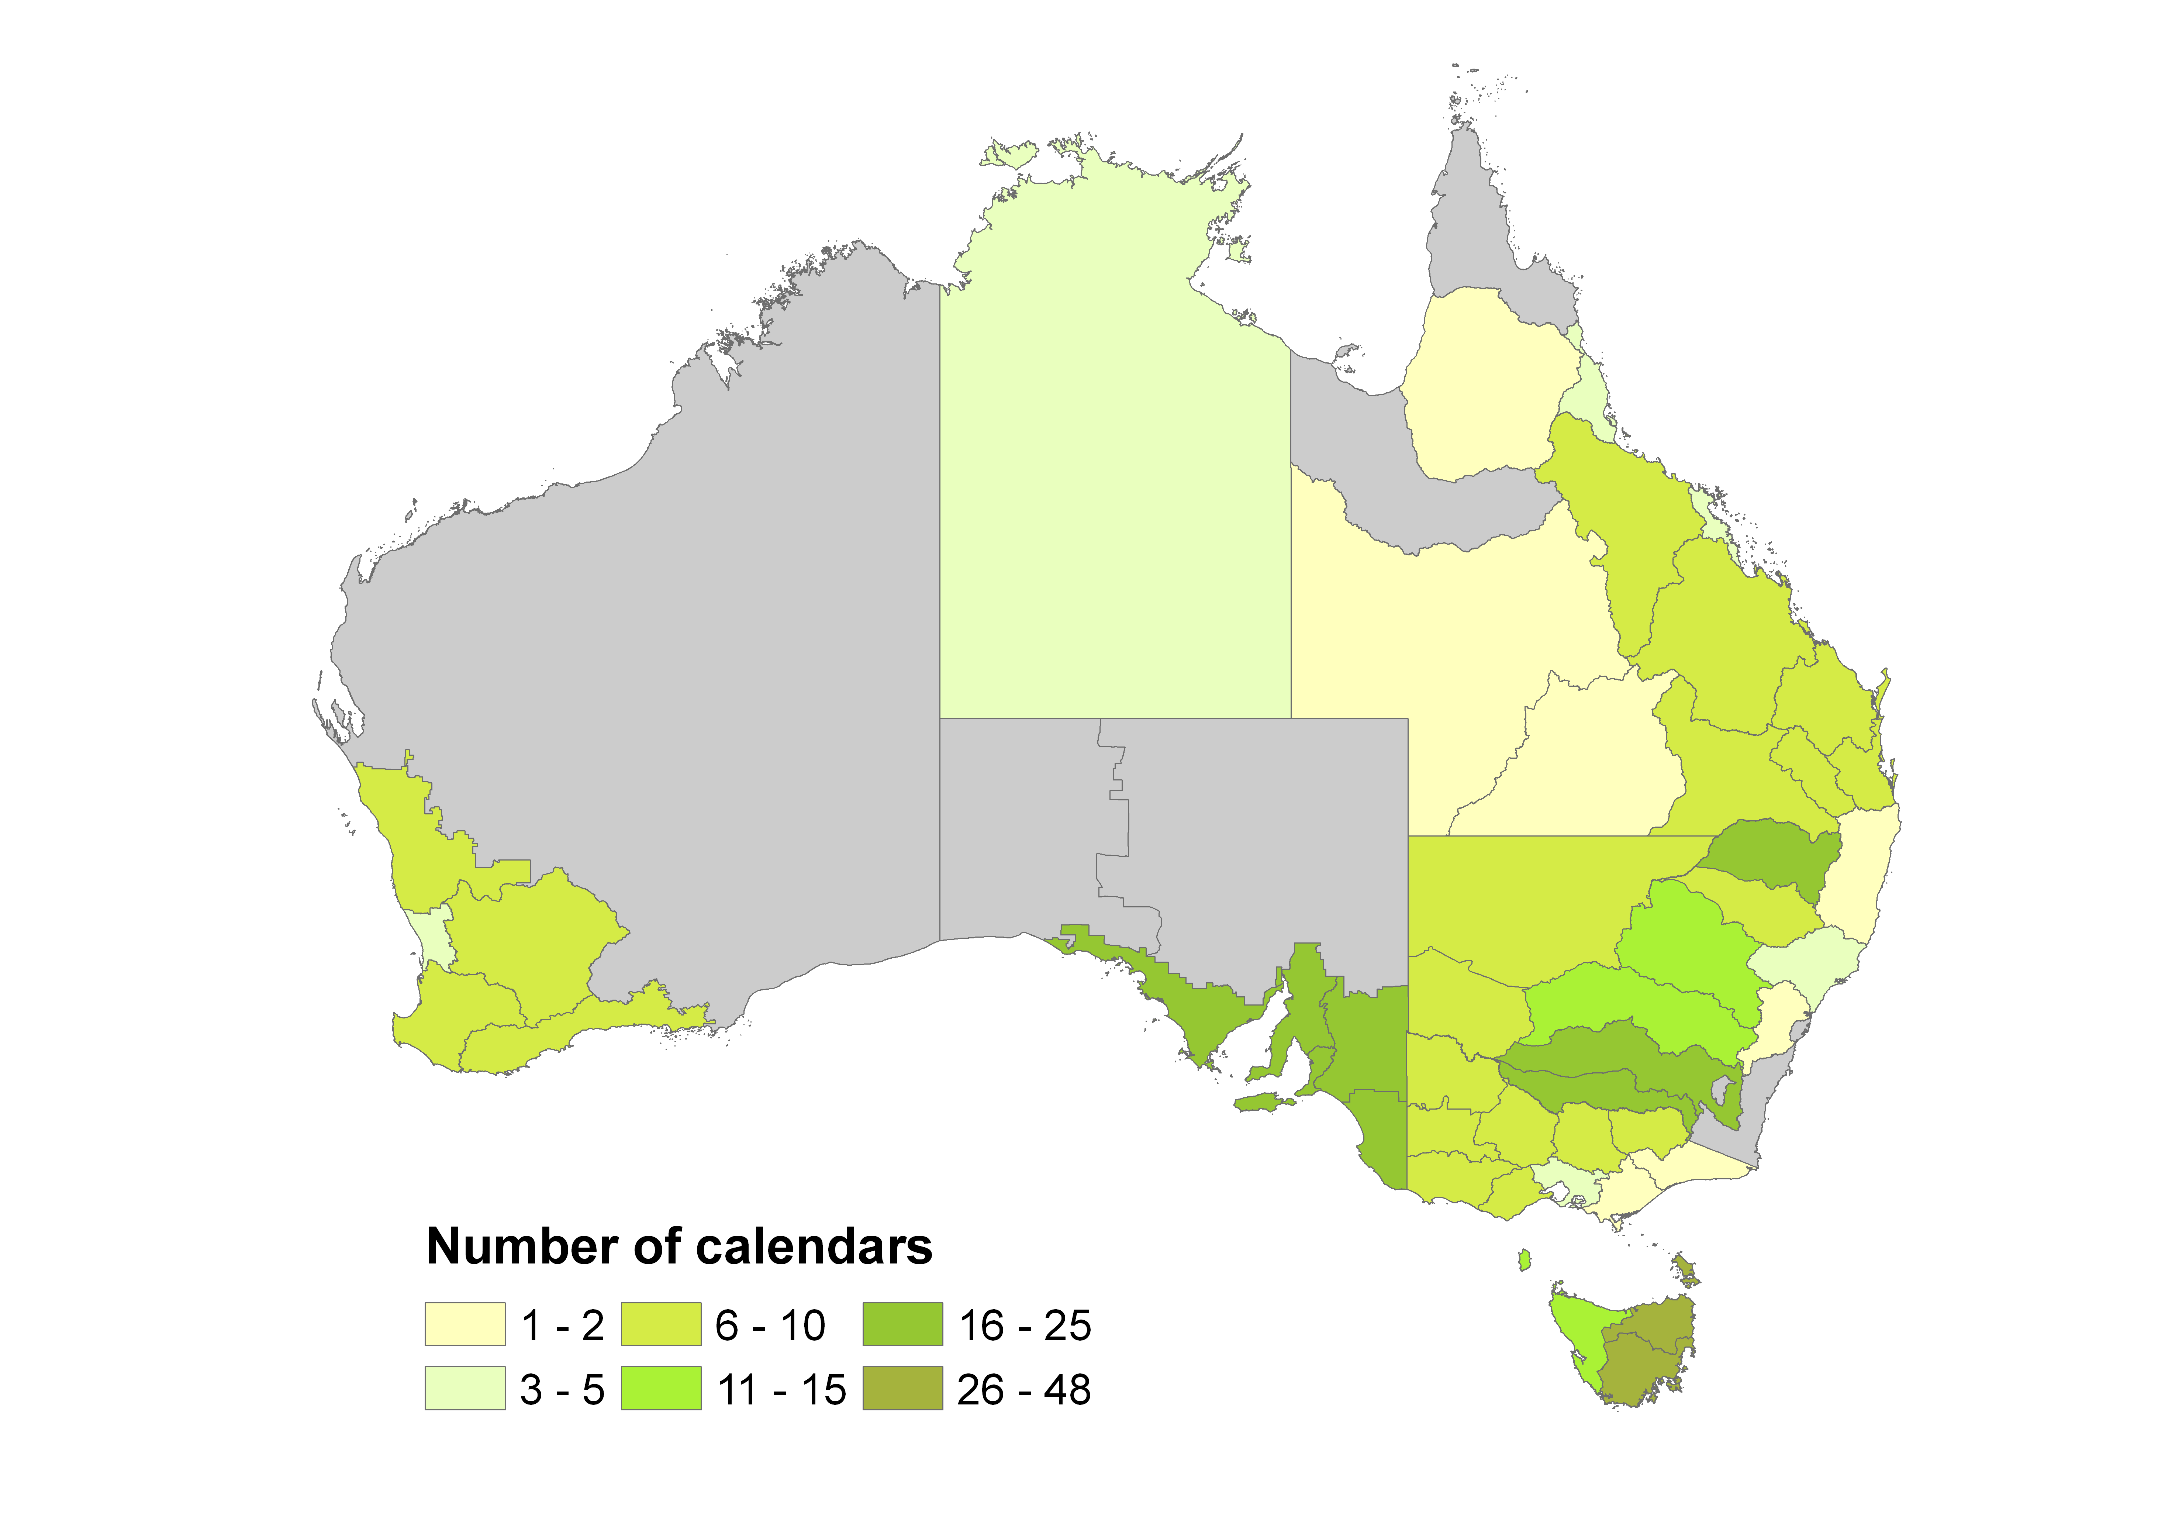

Table 2: The number of calendars within each NRM region. NRM regions shown in grey have no calendars.

| **NRM region** | **State** | **Number of Calendars** |
| --- | --- | --- |
| Border Rivers-Gwydir | NSW | 18 |
| Central West | NSW | 12 |
| Hawkesbury Nepean | NSW | 2 |
| Hunter-Central Rivers | NSW | 4 |
| Lachlan | NSW | 14 |
| Lower Murray Darling | NSW | 7 |
| Murray | NSW | 21 |
| Murrumbidgee | NSW | 23 |
| Namoi | NSW | 7 |
| Northern Rivers | NSW | 2 |
| Southern Rivers | NSW | 0 |
| Sydney Metro | NSW | 0 |
| Western | NSW | 6 |
| Corangamite | Vic. | 7 |
| East Gippsland | Vic. | 1 |
| Glenelg Hopkins | Vic. | 7 |
| Goulburn Broken | Vic. | 8 |
| Mallee | Vic. | 8 |
| North Central | Vic. | 10 |
| North East (VIC) | Vic. | 6 |
| Port Phillip and Westernport | Vic. | 4 |
| West Gippsland | Vic. | 2 |
| Wimmera | Vic. | 10 |
| Border Rivers | Qld. | 8 |
| Burdekin | Qld. | 6 |
| Burnett Mary | Qld. | 7 |
| Cape York | Qld. | 0 |
| Condamine | Qld. | 8 |
| Desert Channels | Qld. | 1 |
| Fitzroy | Qld. | 8 |
| Mackay Whitsunday | Qld. | 3 |
| Maranoa Balonne | Qld. | 8 |
| Northern Gulf | Qld. | 1 |
| South East (QLD) | Qld. | 6 |
| South West (QLD) | Qld. | 2 |
| Southern Gulf | Qld. | 0 |
| Torres Strait | Qld. | 0 |
| Wet Tropics | Qld. | 5 |
| Alinytjara Wilurara | SA | 0 |
| Eyre Peninsula | SA | 20 |
| Kangaroo Island | SA | 17 |
| Adelaide and Mount Lofty Ranges | SA | 18 |
| Northern and Yorke | SA | 20 |
| South Australian Arid Lands | SA | 0 |
| SA Murray Darling Basin | SA | 20 |
| South East (SA) | SA | 19 |
| Avon | WA | 8 |
| Northern Ag | WA | 7 |
| Rangelands | WA | 0 |
| South Coast | WA | 7 |
| South West | WA | 7 |
| Swan | WA | 5 |
| North (TAS) | Tas. | 48 |
| North West (TAS) | Tas. | 11 |
| South (TAS) | Tas. | 41 |
| Northern Territory | NT | 5 |
| Australian Capital Territory | ACT | 0 |

Figure : Calendar locations; NRM regions, Tasmanian subregions and Western Australia sample locations shown over the major land uses from the catchment scale land use map as at March 2010

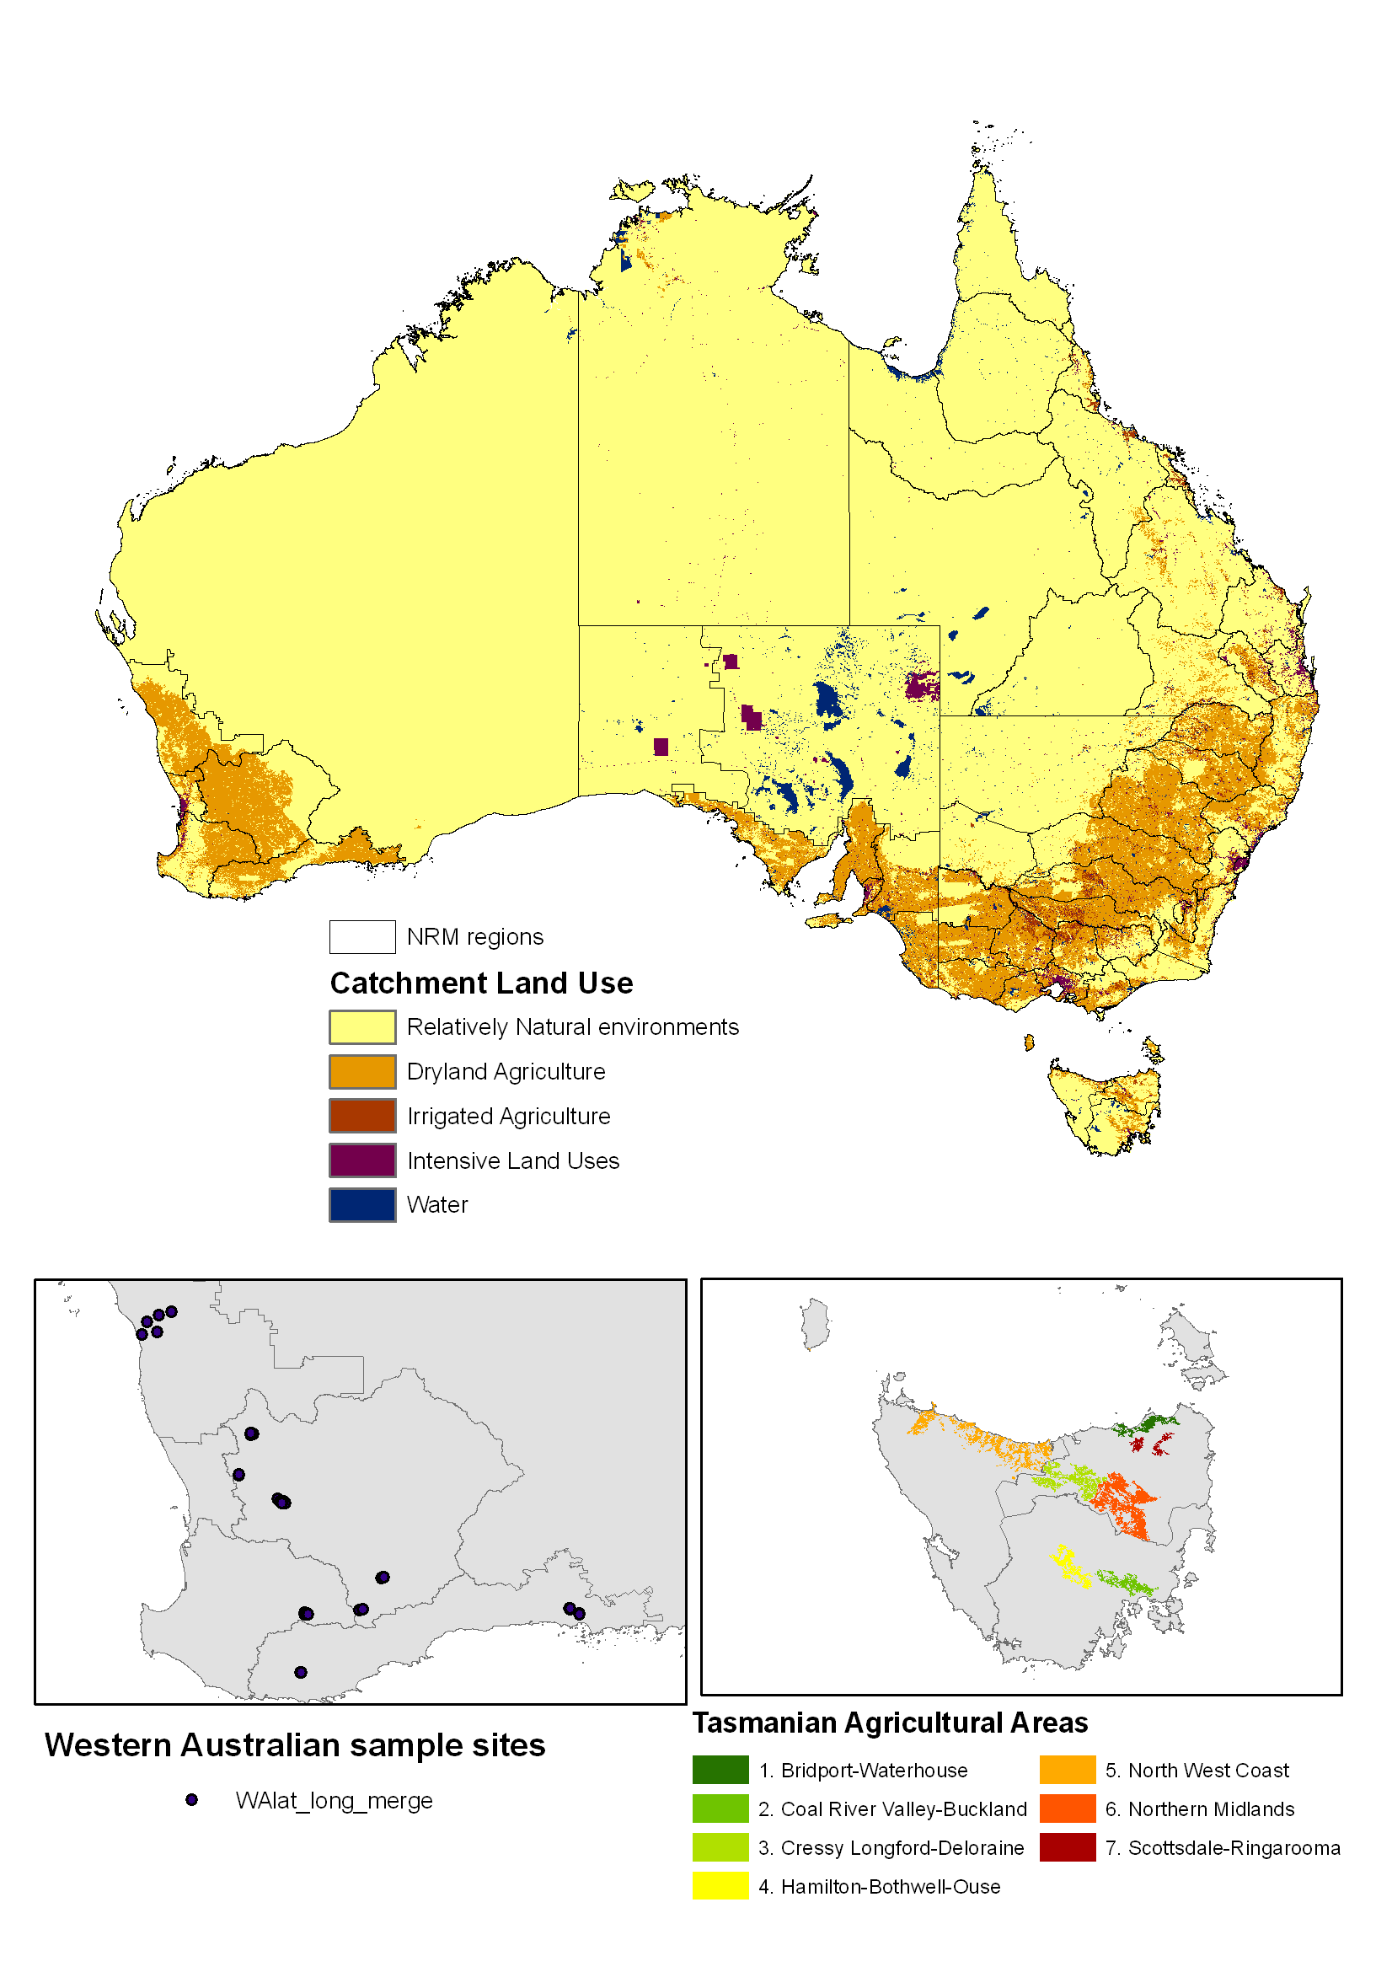

Figure 3: Dryland wheat calendars and NRM region locations



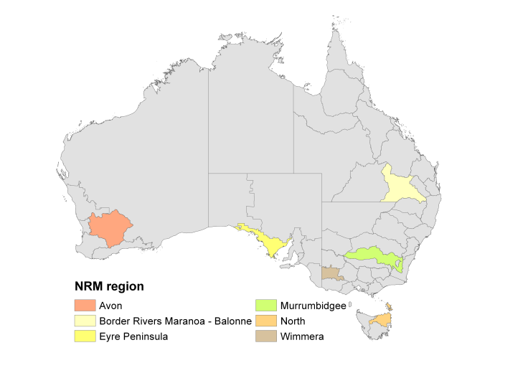

**Acknowledgements**:

The crop calendars were prepared by the following ACLUMP partners:

* NSW Office of Environment and Heritage
* Victoria Department of Primary Industries
* Queensland Department of Environment and Resource Management
* Western Australia Department of Agriculture and Food
* South Australia Department of Environment, Water and Natural Resources
* Tasmania Department of Primary Industries Parks Water and Environment
* Northern Territory Department of Natural Resources, Environment, the Arts and Sport.

**References**

ABARES 2012, *Cropping calendars for natural resource management regions of Australia 2010 – August 2012 – User Guide*, Australian Bureau of Agricultural and Resource Economics and Sciences, Canberra

SEWPaC 2009, *Natural Resource Management (NRM) Regions*, Australian Government Department of Sustainability, Environment, Water, Population and Communities (SEWPaC), Canberra <http://www.environment.gov.au/metadataexplorer/explorer.jsp> (search NRM)

ABS 2006, *Agricultural Census 2005-06 – selected Tasmanian Agricultural Areas*, Australian Bureau of Statistics, <http://www.abs.gov.au/ausstats/abs@.nsf/Previousproducts/1300.1.55.001Main%20Features8Jun%202007?opendocument&tabname=Summary&prodno=1300.1.55.001&issue=Jun%202007&num=&view>=