Land Cover Monitoring in New South Wales
Comparison of methodologies to collate information on ground cover and land management practices and an assessment of monitoring sites with regards to suitability for satellite imagery calibration.
Mr Nik Henry – Department of Environment, Climate Change and Water
Project Officer, Hunter Region, Newcastle
Tel: (02) 4904 2608 Fax: (02) 4904 2501
Email: Nik.Henry@environment.nsw.gov.au
Acknowledgments
The author would like to thank Stuart Lucas, John Leys, Andrew Murrell and Tim Danaher for their input and support.
A big thanks to Stuart Lucas for his work with collecting cropping calendar data for the Murray, Murrumbidgee and Lower Murray Darling catchments.
Published by:
NSW Department of Environment, Climate Change and Water
Newcastle NSW 2300
© NSW Government – February 2010
OEH 2011/0678
ISBN: 978 1 74293 325 2
Table of Contents
1 Background 1
2 Project Objectives 2
3 Current Situation 3
3.1 Current Land Use in New South Wales 3
3.2 Existing Monitoring Programs 3
4 Assessment 5
4.3 SLATS for Proposed National Land Cover Monitoring Program 5
4.3.1 Transect Sampling 5
4.3.2 General Site Description 6
4.4 Soil and Land Capability Monitoring 6
4.4.1 General Site Description 7
4.4.2 Monitoring Site Data 8
4.5 Monitoring Groundcover for Wind Erosion 8
4.5.1 Roadside Survey Location 9
4.5.2 Roadside Survey Data 9
4.6 Vegetation Floristic Surveys (VIS Plot) 9
4.7 Rangelands Assessment Program 10
4.8 Monitoring of Groundcover References for Remote Monitoring of Groundcover – Lower Murray Darling Catchment Management Authority 11
4.8.1 Transect Sampling 12
5 Conclusion 13
6 References 14
7 Abbreviations Used 15
8 Appendices 16
8.1 Example SLATS Data Collection Field Sheet 17
8.2 Example DECCW Vegetation Field Survey Form 24
8.3 Roadside Survey Form in LandMAPT database 30

Figure 1 – Map showing locations of the Soil and Land Capability Monitoring Project sampling sites (source DECCW) 7
Figure 2 – Map showing LandMAPT Roadside survey sites for the Lower Murray-Darling CMA (source DECCW). 9
Figure 3 – Map showing locations of the Rangelands Assessment Program sample sites (source DECCW). 10
Figure 4 – Map showing locations for the Monitoring of Groundcover References for Remote Monitoring of Groundcover Program within the Lower Murray-Darling CMA (source DECCW) 11

Background
The Bureau of Rural Sciences (BRS) has been provided with funds under the Caring for our Country Program to assess monitoring of ground cover for management practices in cropping and improved pasture systems in recognition of the key role that ground cover plays in sustainable farming practices. Coordinated through the Australian Collaborative Land Use and Management Program (ACLUMP), support is sought from the State Agency members of National Committee for Land Use and Management (NCLUM) to establish ground cover reference sites. These sites would be used to calibrate and test satellite derived land cover data in cropping and modified pasture land uses. Data collection would be standardised using recommendations of a technical working group (TWG). These reference sites would objectively measure land use, land management practice and ground cover. It has been outlined that existing monitoring sites, where practical, should be used in order to prevent duplication and reduce costs.
Land cover is the observed biophysical cover on the earth’s surface (FAO 2005 through National Land and Water Resources Audit (NLWRA) 2007). This includes various combinations of vegetation types, soil, rock and water bodies as well as anthropogenic elements such as agriculture and built environments. Land cover classes can usually be discriminated by characteristic patterns using remote sensing (Bureau of Rural Sciences, 2006; NLWRA, 2007). A wide variety of land cover data is collected by many levels of government for various purposes, such as monitoring, evaluation and reporting on the condition of land, soil and vegetation, greenhouse gas emissions and water resource modelling (NLWRA 2007). The NLWRA (2007) report includes a description of the specific “product” requirements for each identified “need” and indicates that the capacity to monitor the impact of land management practices is important at all levels from national to regional. Measurement of ground cover is generally a good indicator of land management and becomes increasingly useful when a time series is available (Leys et al. 2009) (NLWRA 2007).
The NLWRA (2007) report recognised that ideally a land cover data set should be generated once and be available to all. The dataset should also work for a range of scales, especially for the finer scales so data can be rolled up for coarser scale reporting. The Australian Collaborative Land Use and Management Program (ACLUMP) utilises land cover data to map land use and is developing the capacity to spatially locate and map land management practices. There is thus a requirement for consistent land cover data across Australia.

Project Objectives
This is a report of existing monitoring sites within New South Wales, detailing the methods used to measure ground cover and land management practices where applicable. The purpose of this report is to;
- Evaluate these current sites for suitability as validation and calibration sites for remotely sensed imagery
- Review the different methods used to collate ground cover and land management datasets to assist in developing nationally agreed standards. The proposed national standard data collection methodology is based on the Queensland SLATS methods (Statewide Landcover and Trees Study; Danaher et al. 1996 and 1998; Scarth et al. 2006) with changes incorporated as necessary.

Current Situation

Current Land Use in New South Wales
1997 land use figures for NSW (Australian Natural Resource Atlas (ANRA), 2002) indicated that agricultural activities occupied 81 percent of New South Wales (or 15.6 million hectares) during 1996/97. Grazing of native and mixed pastures accounts for 84 percent of this area with the rest largely dryland agriculture. In 1996/97, irrigated agriculture covered over 955000 hectares making New South Wales the most irrigated State.
The 5.3 million hectares of nature conservation is dominated by the IUCN (International Union for Conservation of Nature) categories national park (51 percent) and wilderness area (29 percent). Forestry covering 4 percent of the State tends to abut nature conservation and/or minimal use. Eighty-five percent of minimal use is remnant native cover on private land.
Since 1997 significant changes have been seen across the agricultural sector (DECC, 2006) including changes caused by drought and the spread of cropping into the western region of NSW. For example some former State-owned forests have transferred into the conservation estate, continuing urban growth within Sydney's west and along the coast, dairying has declined along the coastal strip and in inland irrigation areas. Cost pressures and the demand for rural residential and urban development have contributed to a general decline in area used for agriculture.
Table 1: Recorded Land Use for NSW – from ANRA and SOE reporting for 2006.
Major Land Use Category | 2006 | 1997 | 1997 Area
Nature conservation | 7.8% | 6.6% | 5,262,000.1 Ha
Livestock grazing | 69.8% | 68.3% | 54,656,000 Ha
Forestry | 3.6% | 4% | 3,207,200 Ha
Dryland agriculture | 7.9% | 11.5% | 9,190,300 Ha
Irrigated agriculture | 1% | 1.2% | 955,300 Ha

Existing Monitoring Programs
This section summarises monitoring programs in NSW that capture or have captured a range of land cover data or land management practices information. Some programs have regular time intervals for capture using a consistent methodology, yet others are part of data collection that may have only happened once. Some of these programs have been applied over a large geographic area. Programs of potential relevance to the proposed national ground cover monitoring program are described in greater detail in the following sections.
The monitoring programs listed below are state programs that are currently being used to collect ground cover data.
- Soil and Land Capability Monitoring - Monitoring of land cover on 800+ sites covering a range of land use categories commenced in 2009 within New South Wales as a Monitoring, Evaluation and Reporting project on a state wide basis. This ongoing program is focused on monitoring soil characteristics and comparing these against detailed land management practice information together with land capability limitations of each site.
- Monitoring groundcover for wind Erosion (LandMaPT) – Ongoing monitoring and evaluation soil and land resource conditions in NSW by State Government organisations (Department of Environment Climate Change and Water (DECCW), Catchment Management Authorities (CMA) and Industry and Investment NSW (I&I)). The program began in 1990 and includes over 900 sites. Data from the Roadside Surveys is directly entered into the Land Management Assessment for Priority Targets (LandMAPT) database managed by the NSW Department of Primary Industries (DPI). The survey data is collected by DECCW researchers for analyses and evaluation for reporting. The data are also used for ongoing predictive modelling. Modelling can estimate erosion rate (t/ha) and dust concentration (two indicators for wind erosion). These indicators can be used as an integrative measure of land and soil conditions from the scale of broad landscapes and sub-catchment to the catchment scale.
- Vegetation Floristic Surveys - The vegetation survey module (i.e. VIS Plot) of the NSW Government Vegetation Information System (VIS) is the central database for the management of systematic vegetation survey data used by MER Vegetation Condition and Vegetation Type Mapping programs (http://www.environment.nsw.gov.au/research/VISplot.htm). This database is underpinned by published standards, including field survey protocols (http://www.environment.nsw.gov.au/resources/nativeveg/10060nvinttypestand.pdf). VIS Plot is known colloquial as YETI. YETI 3.2 is currently available as a MS Access/SQL data base. By July 2010 YETI 3.2 will be migrated into a .net/SQL extranet application to support broader access. The current VIS Plot (YETI 3.2) holds more than 50,000 vegetation plot records from across the state.
- Rangelands Assessment Program – There are 338 Rangeland Assessment Program (RAP) sites located across the rangelands of Western NSW. These RAP sites allow statements to be made of the change in rangelands (of both short term and long term attributes) at a regional or landscape scale. As of 2010, there was some 3500 site by time records in the RAP site database. All 338 sites have more than four years of annual data, with the majority having 11 years of annual data.
- Monitoring of Reference sites for Remote Monitoring of Groundcover – 30 calibration sites were established during March, April and May of 2009 by the Lower Murray Darling Catchment Management Authority. These were used as groundcover reference points for satellite imagery for the purposes of assessing biodiversity and ecosystem health. The ability of the satellite imagery to detect changes in groundcover was done using the SLATS method (Milne et al 2007).

Assessment
In order to make an analysis of suitability for use as a calibration site, criteria need to be defined that reflect both the technical requirements and the capacity of State Agencies to undertake the work. This review examines the differences between programs for field data acquisition focusing on;
- Detailed Sampling – types of data collected could include; length of time it takes to complete the individual site assessments, specific data types for groundcover, soil characteristics etc;
- General Site Description – types of data collected ranged from location information to detailed land management practice data.
The intention is to assess the suitability of the datasets and any possible problems of integrating or cleaning data for multiple uses.
The ACLUMP Land Management Practices (LMP) TWG decided that data collection for the proposed national monitoring program should facilitate quantitative estimation of fractional cover of photosynthetic vegetation, or non-photosynthetic vegetation and bare soil as proposed by Guerschman et al. (2009). The collected data should also enable quantitative estimation of foliage projective cover (FPC), ground cover (GCI) and bare ground (BGI) indices, some or all of which are used by current land cover monitoring programs to assess landscape condition (e.g. Scarth et al. 2006; Karfs et al. 2001).

SLATS for Proposed National Land Cover Monitoring Program
The TWG determined that the field method used for the Queensland State-wide Land cover and Trees Study (SLATS) program (Danaher et al. 1996 and 1998; Scarth et al. 2006) provided the necessary data. Data collected by the various NSW monitoring programs are compared and contrasted with the SLATS method.
At each SLATS site a range of field data measurements are taken, these include:
- Collection of discrete point transect sampling data to determine ground cover and the Foliage Projective over (FPC) of the overstorey and midstorey woody vegetation;
- Description of general site details, including characteristics such as soil and rock hue value and chroma, tree basal area, dominant species, and soil surface characteristics according to the method described by Tongway and Hindley (1995).

Transect Sampling
The current SLATS methodology uses 3x100 metre transects, the midpoint of each (i.e. 50 m mark) centred on a common point. A modified discrete point sampling method is used such that at every metre interval a recording is made of the ground cover, midstorey and overstorey (Brady et al., 1995). The discrete point sampling technique was employed because it provided the best compromise between repeatability between different operators without requiring estimation training and regular calibration, and the time taken to measure each site in the field (Scarth et al. 2006).
The data collected along each transect includes;
- Soil surface characteristics (erosion features, soil microtopography, surface nature, faunal activity, evidence of recent site disturbance, e.g. fire, clearing, etc. And cover recordings:
- Bare soil
- Rock
- Green attached leaf
- Dead attached leaf
- Litter (including all organic litter, tree, grass, dung etc)
- Cryptogam (photosynthetic soil crust)
According to field trials, this process needs two to three staff to collect the data which takes up to 4 hours to complete. With the sites spread over a large distance, the time needed to travel could make the process quite time consuming.

General Site Description
General site data collected includes;
- Soil hue, value and chroma measurements. These data are collected for both wet and dry soil and for different soil surface conditions, e.g. soil crust, disturbed soil, windblown surface deposits (sand);
- Rock hue, value and chroma;
- Tree basal area at 7 points (original method proposed in Scarth et al. (2006) used 5 points) using calibrated optical wedges;
- Dominant species by biomass within ground/ midstorey / overstorey layers;
- Midstorey (woody material 0-2m) recordings of green leaf, dead leaf or branch; and
- Overstorey (woody material > 2m) recordings of green leaf, dead leaf or branch.

An example SLATS field data sheet is included at appendix 8.1.

Soil and Land Capability Monitoring
The monitoring program was primarily carried out by DECC during 2008. Detailed results will be presented in State of Catchment Reports (e.g. DECC 2009), NSW 2009 State of Environment (NSW Government in prep) and in proposed publications.
The primary aims of the current program were to:
- Design a monitoring procedure to allow assessment of progress towards meeting the MER target, that is, assess whether there is an increase in the area of land managed within its capability by 2015
- Develop a system to equate land management activities with Land and Soil Capability (LSC)
- Develop a baseline of permanent monitoring stations across NSW, distributed equally across representative Soil Monitoring Units for the 13 Catchment Management Authority regions, with data on soil condition, LSC and land management practices
- Provide results on the current degree of land management within capability at each of the monitoring sites, their respective Soil Monitoring Units, catchment regions and the entire State
- Highlight particular land degradation hazards and geographic areas of concern for each catchment region and the State as a whole
- Identify ongoing requirements for the MER program for this theme.
Assessment involved the establishment of up to 10 priority soil monitoring units (SMUs) within each of NSW’s 13 Catchment Management Authorities (CMA) regions. A SMU is a large tract of land with a relatively homogenous or repeating pattern of soils (and parent material, geomorphology, and climate). It is suitable for the periodic observation of changes in soil condition and land management. The identification of the priority SMUs involved a detailed stratification process in collaboration with CMA staff (Gray, 2008).
Within each SMU, up to 10 representative sites were set up as monitoring sites. Usually five typical paddocks were selected for the most extensive land use. Where possible neighbouring typical paddocks were selected and paired for the second most extensive land use. As of May 2009, a total of 850 sites have been sampled.

Figure 1 – Map showing locations of the Soil and Land Capability Monitoring Project sampling sites (source DECCW)
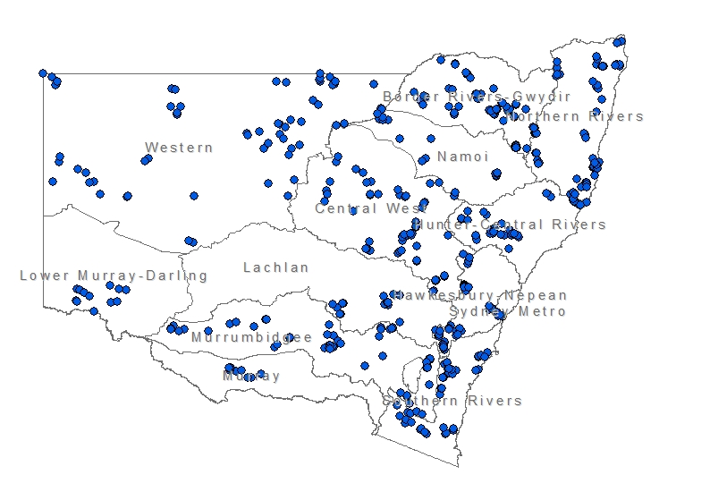
At each site a range of field data measurements are taken, these include:
- General site information - soil and land data collected from the monitoring sites, include extensive land management data was collected from the associated land holders. This information was supplemented by observations of local extension officers and soil scientists.
- Monitoring site data - extensive soil data was collected (Step 1). This involved collection of 10 random sub-samples over a 25 m x 25 m grid.

General Site Description
The primary source of land management data was derived from landholder surveys, using a standard questionnaire (Appendix 8.2d). The survey sought information from the landholder on:
- Overview of land management history and future plans (Section A, Gray2008).
- Broad land management practices, for example;
  - fertiliser use,
  - vehicle use
  - erosion control (Section B, Gray2008).
- Land management practices in relation to specific land uses, that is:
  - cropping (Section C, Gray 2008),
  - grazing (Section D, Gray2008),
  - horticulture and viticulture (Section E, Gray2008),
  - commercial forestry (Section F, Gray, 2008),
  - wooded / other vegetated areas (Section G, Gray 2008).
Other general comments regarding land management issues were also collected for the MER program.

Monitoring Site Data
Site data for soil and land information included;
- General soil type and detailed soil characteristics, including land use
- Percentage groundcover and surface condition of the soil
- Colour of surface soil sample (wet) using Munsell colour chart

Monitoring Groundcover for Wind Erosion
The Land Management Actions for Priority Targets (LandMAPT) database is a relational database programmed in Microsoft ® Office Access 2003. LandMAPT was initially created by collaboration between NSW DPI, NSW DNR and University of New England to service the needs of the Lower Murray Darling CMA project “Cropping, soil and recharge – monitoring” (Murphy et al. 2006).
The database consists of two core components; a ‘back end’ where data tables reside, and a ‘front end’ or interface where data entry and graphing takes place. The structure of the front end is such that it is technically feasible to graph any data set against any other via queries that are embedded in the database.
The roadside survey application consists of a live data entry form (Roadside survey data entry form) that communicates with a GPS and allows delivery of observation data directly to fields in data tables. The functionality that this system provides means that it has potential to collect, store and analyse data for a variety of land management activities and natural resource outcomes. These include, but are not limited to wind erosion, water erosion, and producer implementation of practices.
The database is used as a tool to further the understanding of progress made by the CMA towards priority catchment targets for erosion and salinity. Specifically, the database is used to collect, store and analyse datasets specific to district or catchment areas.

Currently survey sites exist across three NRM regions of NSW, the Lower Murray Darling, Murray and Lachlan CMA. The survey was conducted along a 2680 kilometre road-transect with approximately 910 GPS observation points. At each roadside survey site, a range of field data measurements are taken, these include:
- Roadside survey location – general site information, paddock management activities and wind erosion outcomes, including desktop assessments
- Survey site data - soil characteristics data and specific site information are collected through the Roadside Survey Data form (see appendix 8.3)

Roadside Survey Location
Figure 2 – Map showing LandMAPT Roadside survey sites for the Lower Murray-Darling CMA (source DECCW).
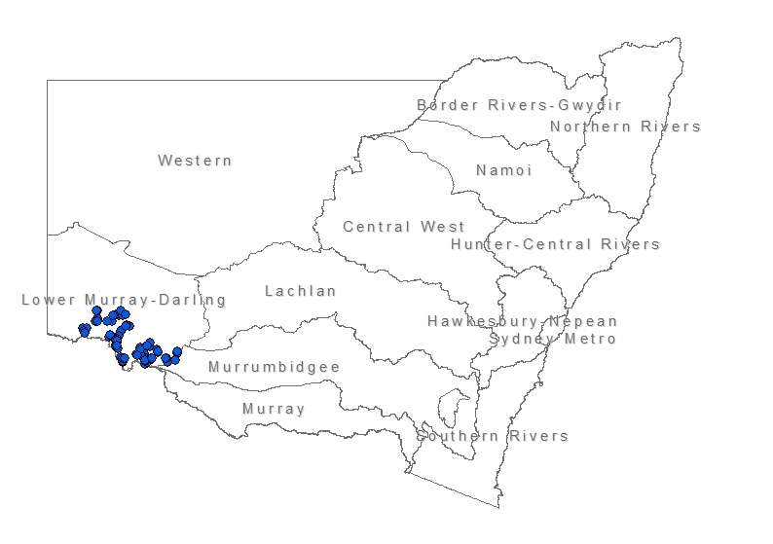
At each roadside survey general information is collected, including;
- Site location and characterisation information,
- Daily weather data for specific locations in the catchment

Roadside Survey Data
At each field site a range of measurements are taken:
- Soil profile physical (e.g. PSA) and chemical description (e.g. pH, EC),
- Paddock histories for each site,
- Wind erosion data such as visually estimated ground cover (as operators become more experienced accuracy also increases) and soil aggregation,
- Deep drainage data such as stored soil water, chloride concentration, deep drainage rate

Vegetation Floristic Surveys (VIS Plot)
Systematic field information about vegetation is used widely within government for a range of activities. For example, by the Rural Fire Service for fire management, by Catchment Management Authorities (CMAs) for monitoring the effectiveness of their land use planning, and by local government for natural resource management and planning. More specifically this data underpins native vegetation mapping program (particularly the classification of vegetation communities), and MER vegetation condition monitoring.

Each Vegetation field site is spatially represented by a single point, currently there are over 40,000 sites. The dataset is primarily a private dataset, which restricts access to location data for sites. For each site a range of field data measurements are taken, these include:
- Collection of discrete point sampling data to determine vegetation condition, floristic, and dominant species condition. Usually consists of 20X20m, 25X25m or 50X50m plots;
- Description of general site details, including characteristics such as land use, plot disturbance, land use history, and some soil surface characteristics.
An example of the field data sheet is included as appendix 8.2.

Rangelands Assessment Program
DECCW manages the Rangeland Assessment Program (RAP) in NSW rangelands. There are almost 340 ground-based sites, within seven landscape types, which have been recorded annually since the early 1990s. The emphasis within the RAP is on reporting changes in both trend and condition of vegetation and soil attributes at a regional or range type scale.
Figure 3 – Map showing locations of the Rangelands Assessment Program sample sites (source DECCW).
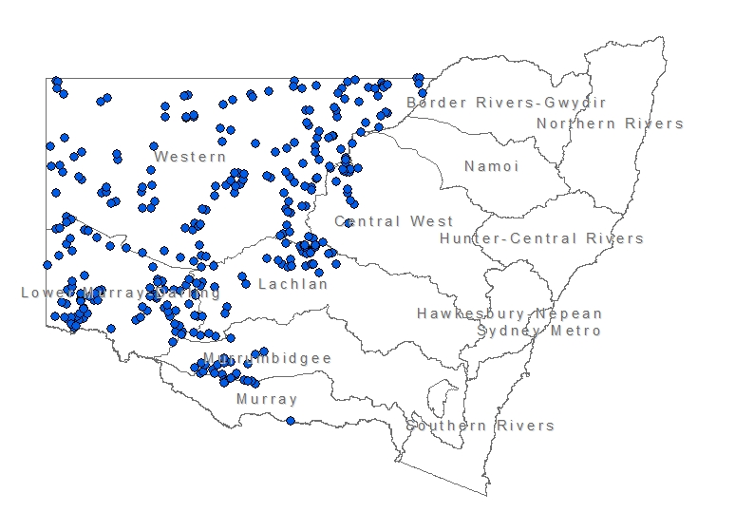
The RAP system evolved from a history of rangeland resource inventory and mapping, vegetation research and monitoring and extension by the former Soil Conservation Service of NSW. The attributes assessed at each site include species lists of all vascular plants, biomass, frequency and botanical composition of pasture species, and soil surface characteristics. The density of perennial chenopods and percent canopy cover of trees and shrubs is measured in selected range types.
There is currently no operational remote sensing program to monitor changes in NSW rangelands, although there is intermittent use of the RAP program to collect data. Site data has been consolidated and stored corporately on a regional server in the DECCW Wollongong office, with all paper files held securely in the DECCW Orange regional office.

Monitoring of Groundcover References for Remote Monitoring of Groundcover – Lower Murray Darling Catchment Management Authority
The Lower Murray Darling CMA of NSW has needed to understand the effectiveness of investment funded management actions in order to meet their Catchment Action Plan environmental targets. The same field method is also used for the Queensland State-wide Land cover and Trees Study (SLATS) program which was developed by Milne et al. 2007. The method was reported to be simple to use and successfully collected the required information after users where provided detailed training (Holmes et al 2009).
Figure 4 – Map showing locations for the Monitoring of Groundcover References for Remote Monitoring of Groundcover Program within the Lower Murray-Darling CMA (source DECCW)
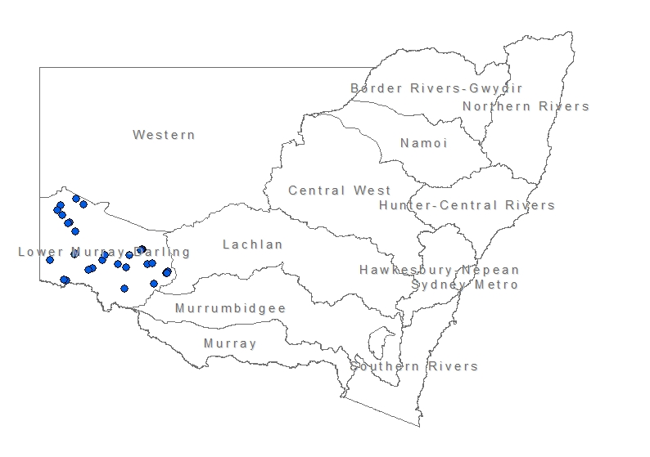

Each field site could be assessed within 1-2 hours, with non-treed sites taking less time (Holmes et al 2009). A range of field data measurements where taken, include:
- Collection of discrete point transect sampling data to determine ground cover and the Foliage Projective over (FPC) of the over-storey and mid-storey woody vegetation;
- Description of general site details, including characteristics such as soil and rock hue value and chroma, tree basal area, dominant species, and soil surface characteristics according to the method described by Tongway and Hindley (1995).

Transect Sampling
Because of similarities between this program and SLATS, only the feedback from users needs to be mentioned. Observers using the current SLATS methodology for this particular program reported that the laser pointer was effective in removing user bias, although users thought that with the addition of a magnified viewer an enhancement to user accuracy could be achieved (Holmes et al 2009). Other outcomes from the report highlighted:
- Transect data could use more refinement, mainly with definitions for the ‘disturbed’ classification to include a category ‘bare ground’ to allow for eroded or loose soil surfaces (Holmes et al 2009).

Conclusion
All NSW groundcover assessment programs collected data that were comparable with the modified SLATS methodology requirements for “General Site Information”. The only existing land cover monitoring program in New South Wales that collected data that was compatible with the modified SLATS methodology requirements for both “General Site Information” and “Transect Sampling” was the Lower Murray Darling CMA - Monitoring of Reference sites for Remote Monitoring of Groundcover (LMDCMA-MRSRMG). The only issue with the LMDCMA-MRSRMG program is it’s focus within the Lower Murray Darling CMA area, which limits the current program to deliver the requirements sought by ACLUMP.
The other existing land cover monitoring program sites that have groundcover data could only complement the SLATS data collection methodology. These complementary programs with sites in the cropping and grazing areas include;
- the MER Soil and Land Capability monitoring program – these sites spread across NSW, could be considered as possible modified SLATS collection sites, because of the recent interaction with the landholders by DECCW,
- the Rangelands Assessment Program has been used intermittently since 2004 within the Western NRM region of NSW.
Subject to the development of appropriate site selection criteria for proposed national land cover monitoring program, it is recommended that:
  - Additional compatible data be collected at selected MER Soil and Land Capability sites using the LMDCMA-MRSRMG program modified SLATS methodology; however, with the consideration that new sites may also be required.
  - Clarify the relationships between the modified SLATS mythologies and programs such as VIS Plot vegetation condition protocols and LandMaPT groundcover survey protocols.

References
ANRA (2002) Land Use – Land Use in New South Wales. Viewed at http://www.anra.gov.au/topics/land/landuse/nsw/index.html on (Insert date viewed)
Bureau of Rural Sciences (2002) Land Use Mapping at the Catchment Scale, Principles, Procedures and Definitions, 13-25. February 2002, Bureau of Rural Sciences, Canberra.
Bureau of Rural Sciences, 2006. Guidelines for Land Use Mapping in Australia: Principles, Procedures and Definitions, Edition 3. Bureau of Rural Sciences, Canberra.
Danaher T, Carter J, Brook K, Kelly G, Goulevitch B. 1996. Monitoring Vegetation Cover Change And Its Impact On Queensland’s Greenhouse Gas Emissions, In: 8th Australasian Remote Sensing Conference, Canberra 25-29 March, 1996, 2:128-134.
Danaher T, Wedderburn-Bisshop G, Kastanis L, Carter J. 1998. The State-wide Landcover and Trees Study (SLATS) - Monitoring Land Cover Change and Greenhouse Gas Emissions in Queensland in Proceedings of the 9th Australasian Remote Sensing Photogrammetry Conference, 24th July 1998, Sydney
DECC (2009) Vegetation Information System, viewed at http://www.environment.nsw.gov.au/research/VISplot.htm on 18 Feb 2009
DECC (2006) New South Wales State of the Environment 2006 Viewed at http://www.environment.nsw.gov.au/soe/soe2006/ on 14 Feb 2009
DEWHA and DAFF. 2009. NRM MERI Framework - Australian Government Natural Resource Management Monitoring, Evaluation, Reporting And Improvement Framework. Department of the Environment, Water, Heritage and the Arts and Department of Agriculture, Fisheries and Forestry, Canberra
Gray, J (2008) Chapman, G., Murphy, B. & Jenkins, B. (eds),. Land management survey 2008 (version 4.2). NSW monitoring, evaluation and reporting project, Scientific Services Division Department of Environment and Climate Change NSW, Sydney, NSW.
Green D., Richards R., Hart D. & Watson I. 2001, Rangeland monitoring, condition assessment and resource inventory activities in New South Wales conducted by the Department of Land and Water Conservation, report prepared for the National Land and Water Resources Audit, Canberra.
Holmes, A., Deans, F. 2009. Lower Murray Darling CMA – Report for Monitoring of Groundcover Reference Site for Remote (Satellite) Monitoring of Groundcover, GHD, Mildura VIC. 2 and 17pp
Guerschman JP, Hill M, Renzullo L, Barrett D, Marks A, Botha E. 2009. Estimating fractional cover of photosynthetic vegetation, non-photosynthetic vegetation and bare soil in the Australian tropical savanna region upscaling the EO-1 Hyperion and MODIS sensors in Remote Sensing of Environment Vol 113, Iss 5, pp 928-945.

Abbreviations Used
ACLUMP Australian Collaborative Land Use Mapping Programme
BGI Bare Ground Index
BRS Bureau of Rural Science (within the Australian Government
CMA catchment management authority
CSIRO Commonwealth Scientific Information and Research
Organisation
DAFF Department of Agriculture, Fisheries and Forestry
DBH Diameter Breast Height
DECCW Department of Environment Climate Change and Water
DEWHA Department of the Environment, Water, Heritage and the Arts
DPI Department of Primary Industries
FPC Foliage Projective Cover
GCI Ground Cover Index
I&I Industry and Investment NSW
IUCN International Union for Conservation of Nature
LAI Leaf Area Index
LUMIS Land Use Management Information System
LUMP Land Use Mapping Project
MER Monitoring Evaluation and Reporting
MODIS Moderate Resolution Imaging Spectroradiometer
NCLUM National Committee for Land Use and Management
NLWRA National Land and Water Resources Audit (now disbanded)
SLATS Statewide Landcover and Trees Study (Queensland)
SMU Soil Monitoring Unit
TWG Technical Working Group
VIS Vegetation Information System

Appendices

8.1 Example SLATS Data Collection Field Sheet

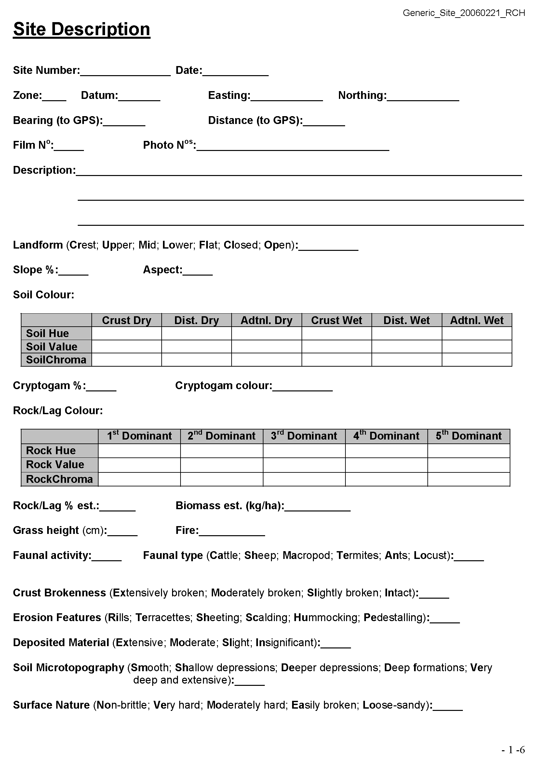
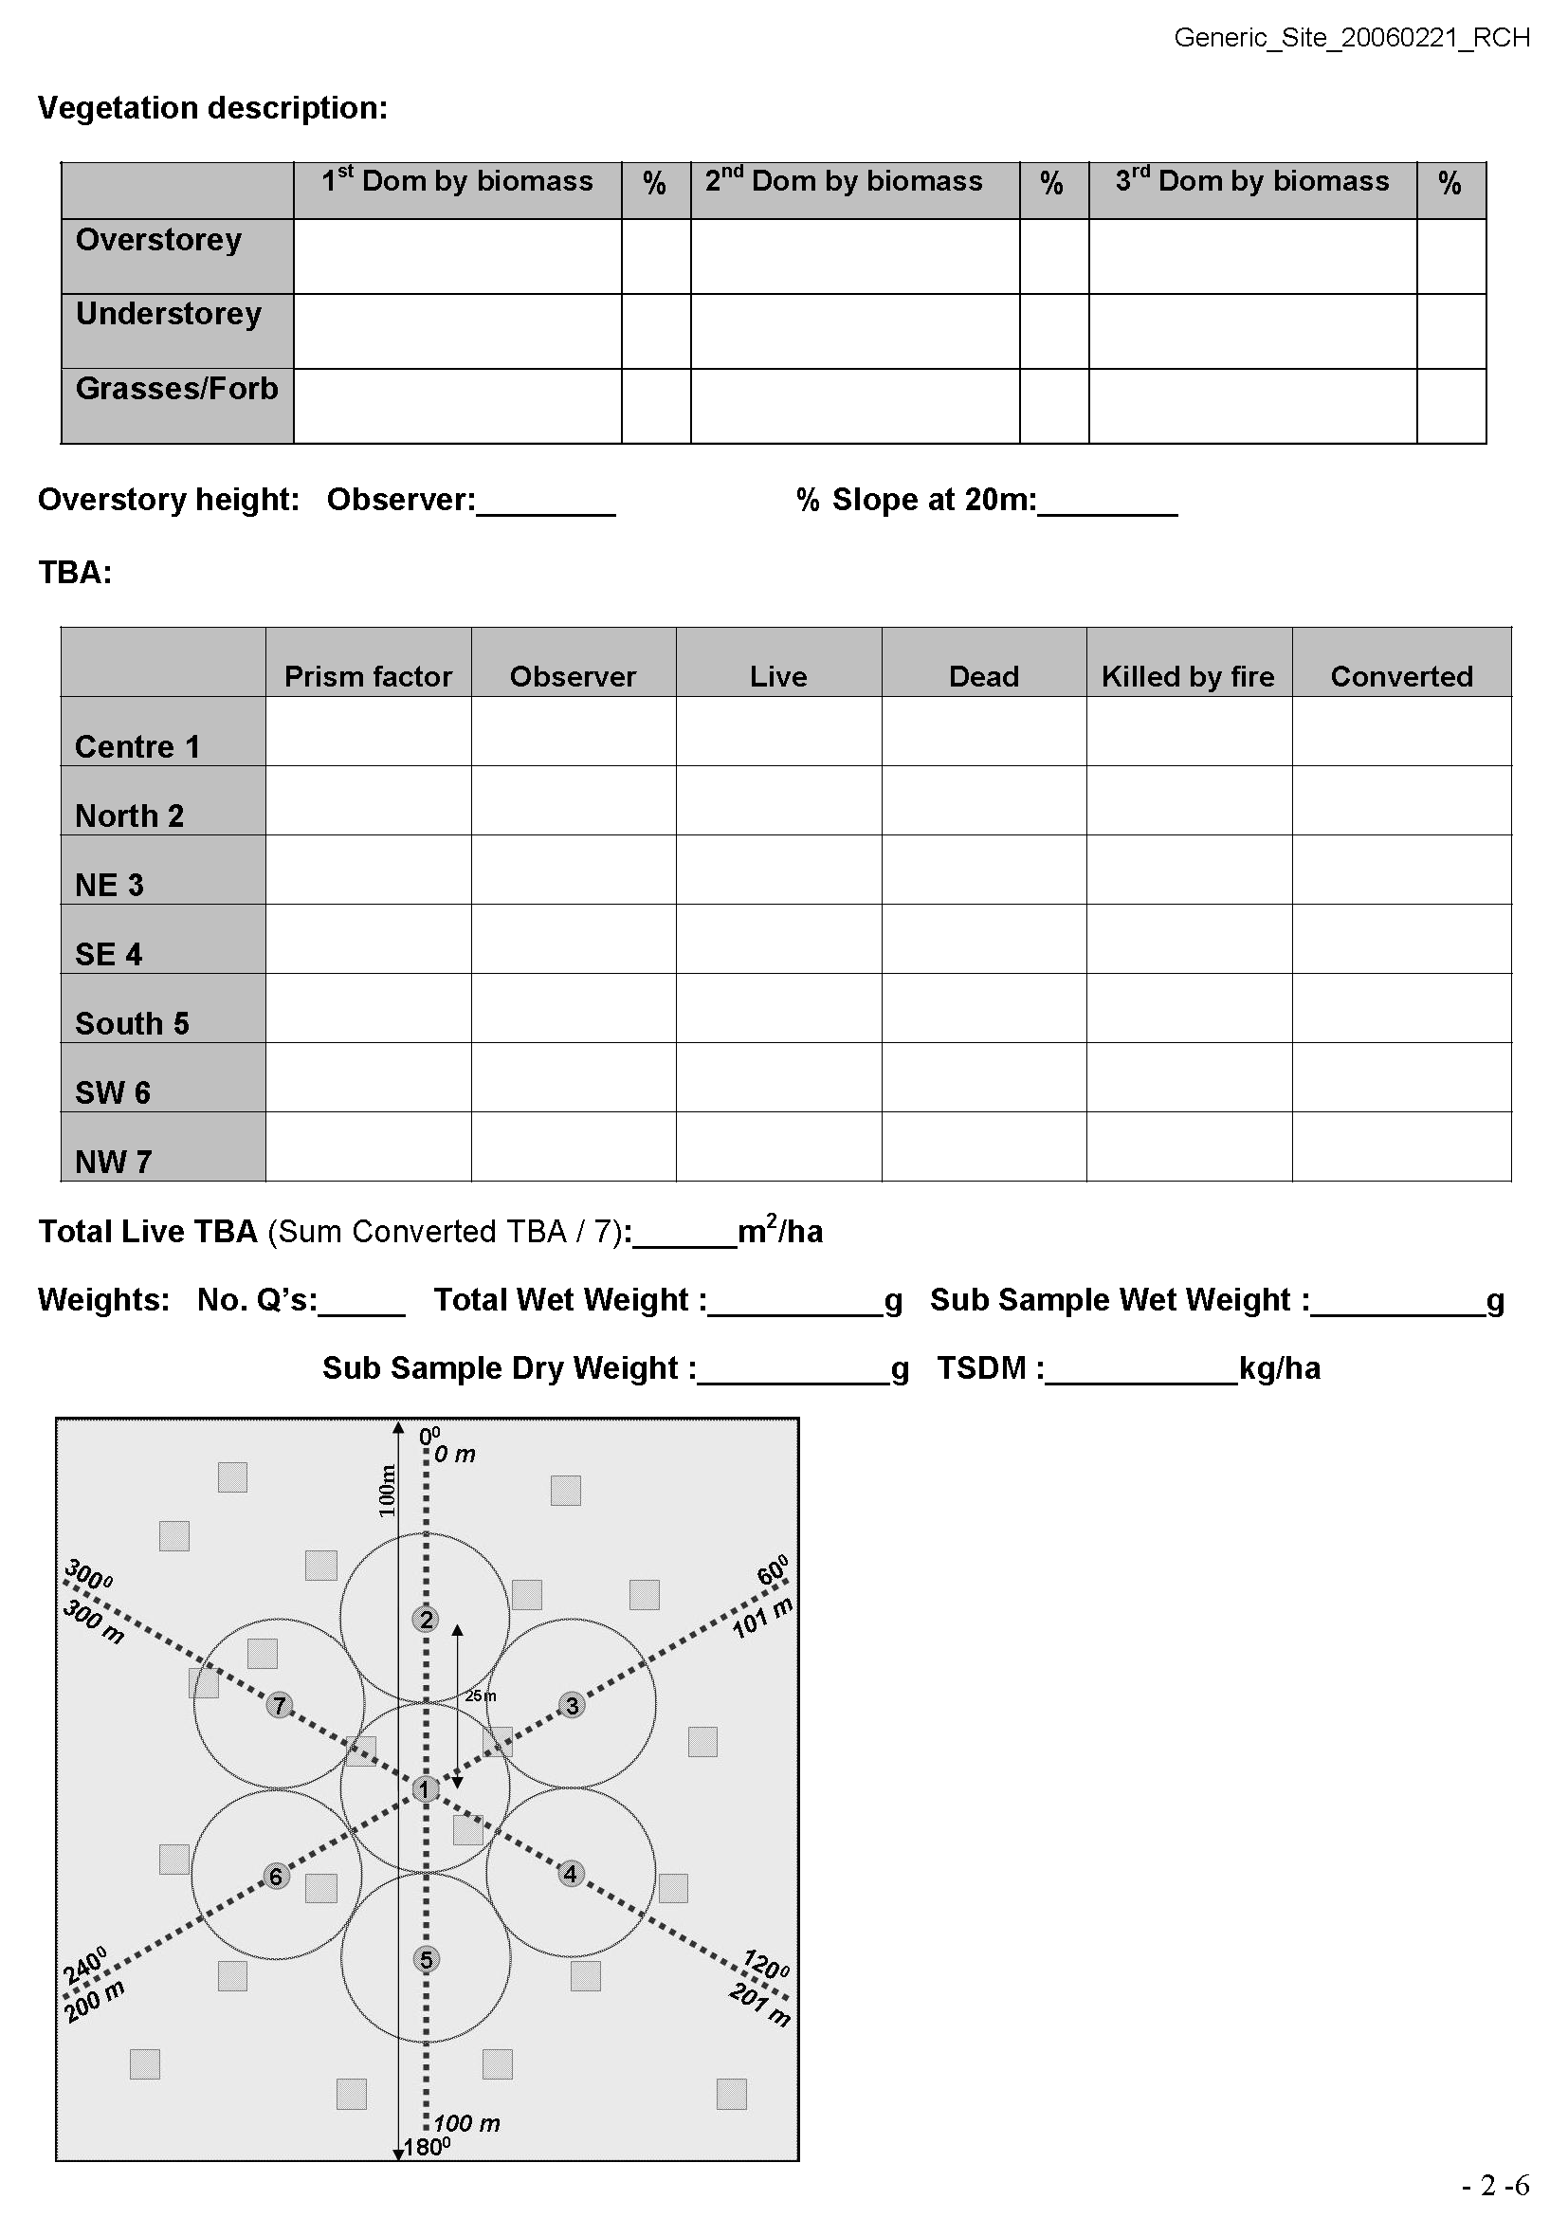
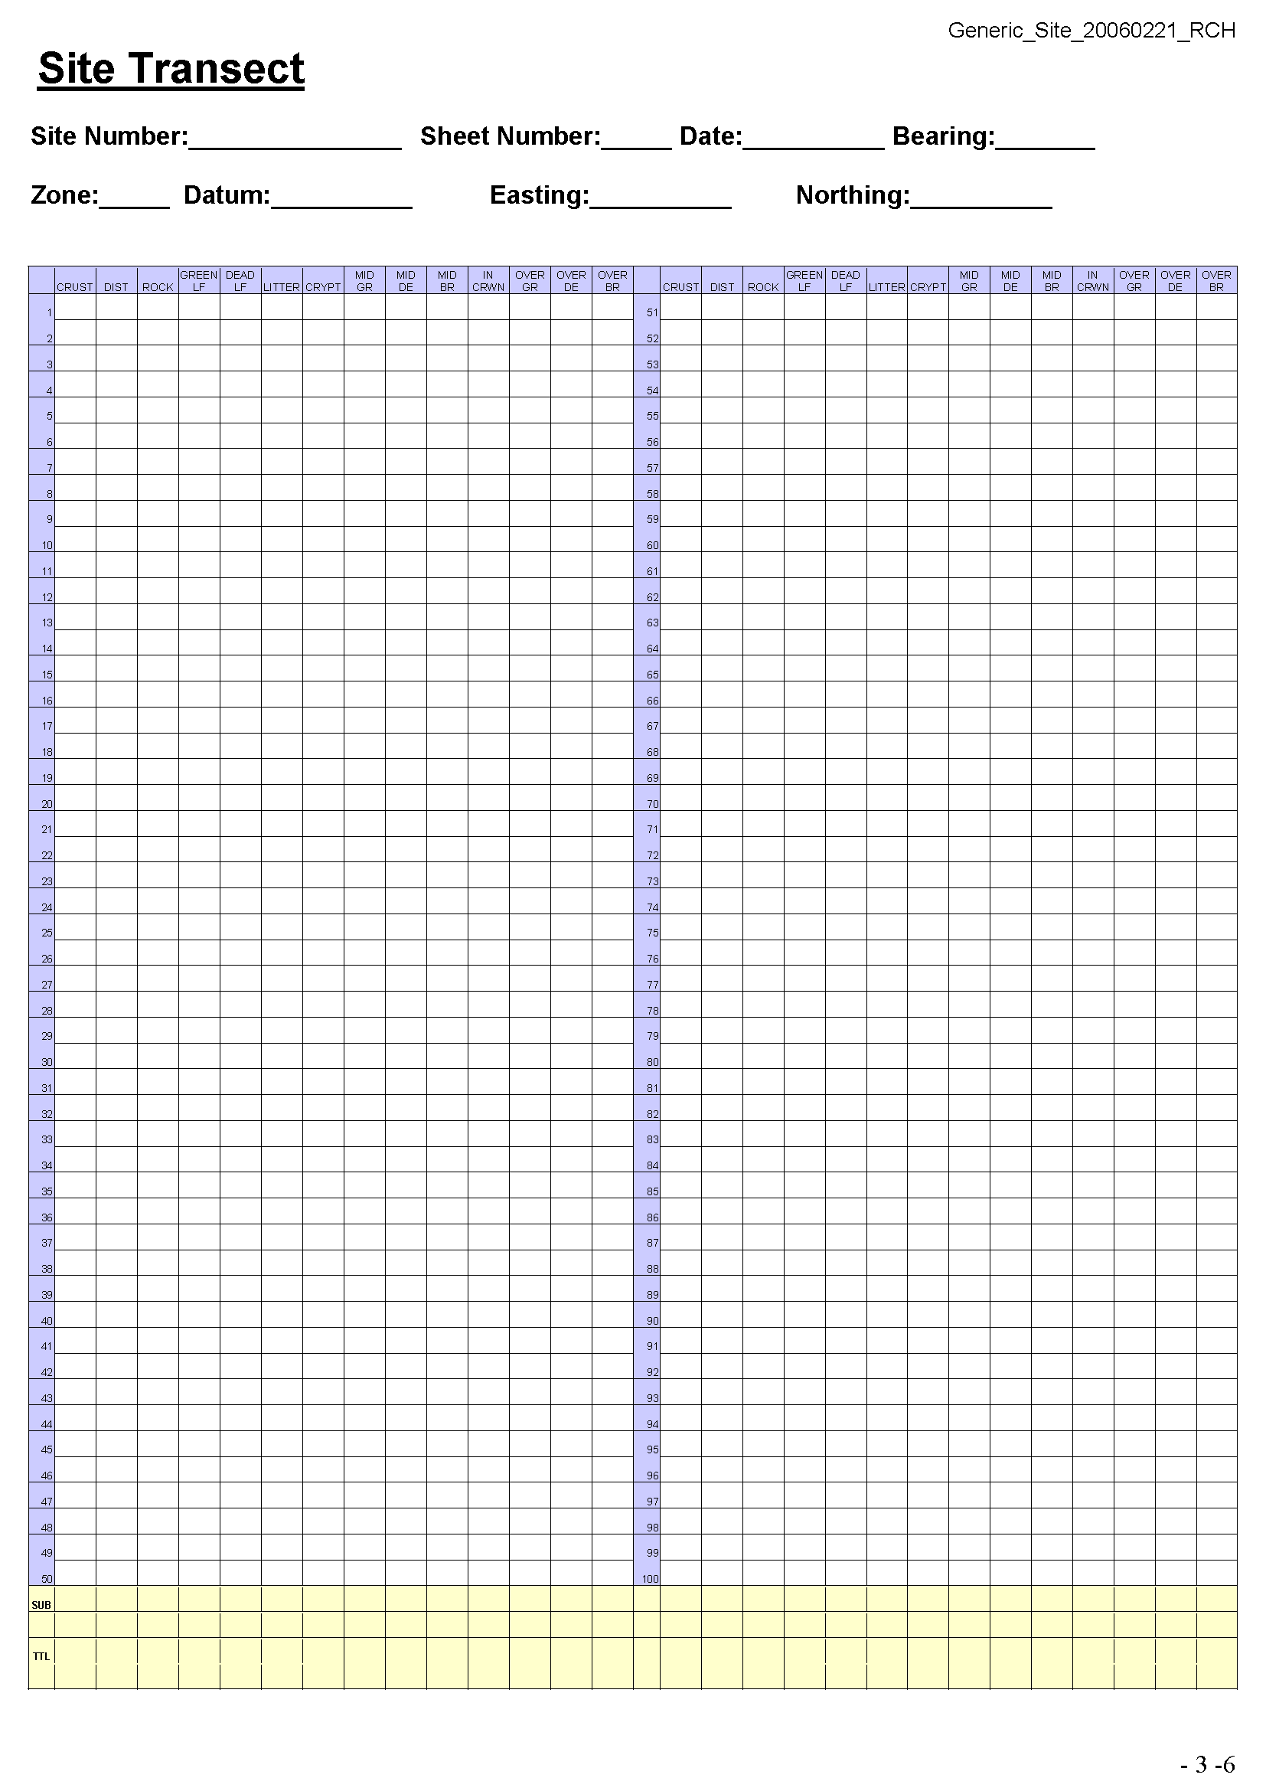
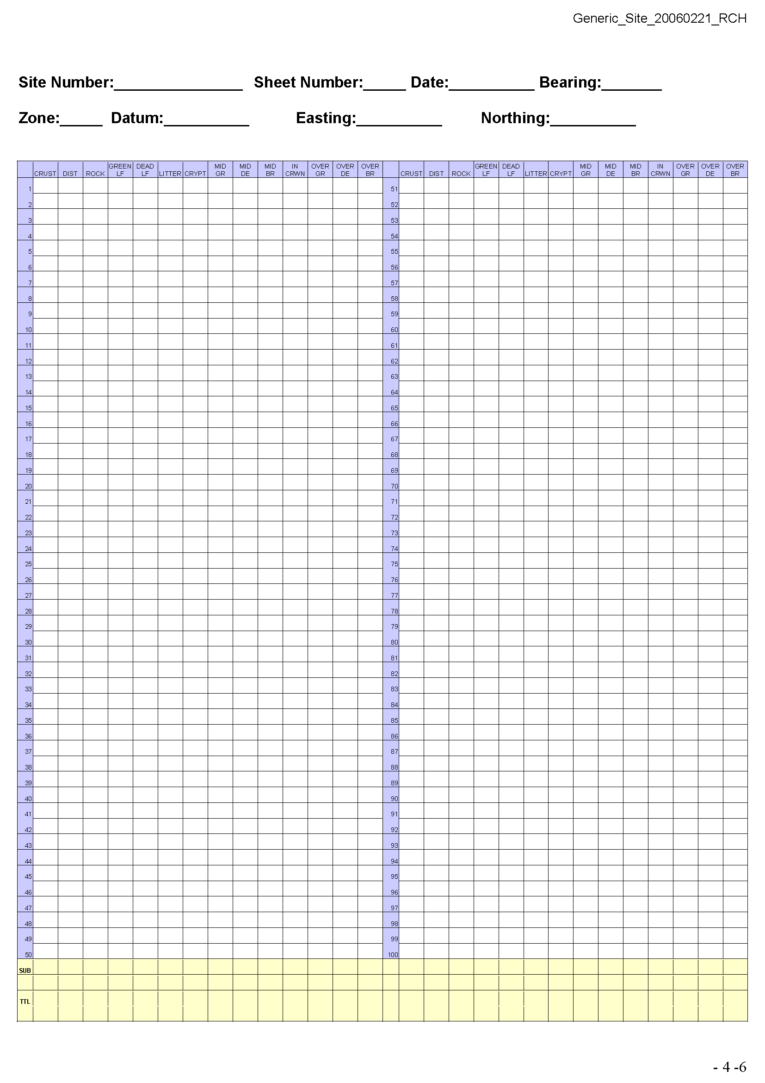

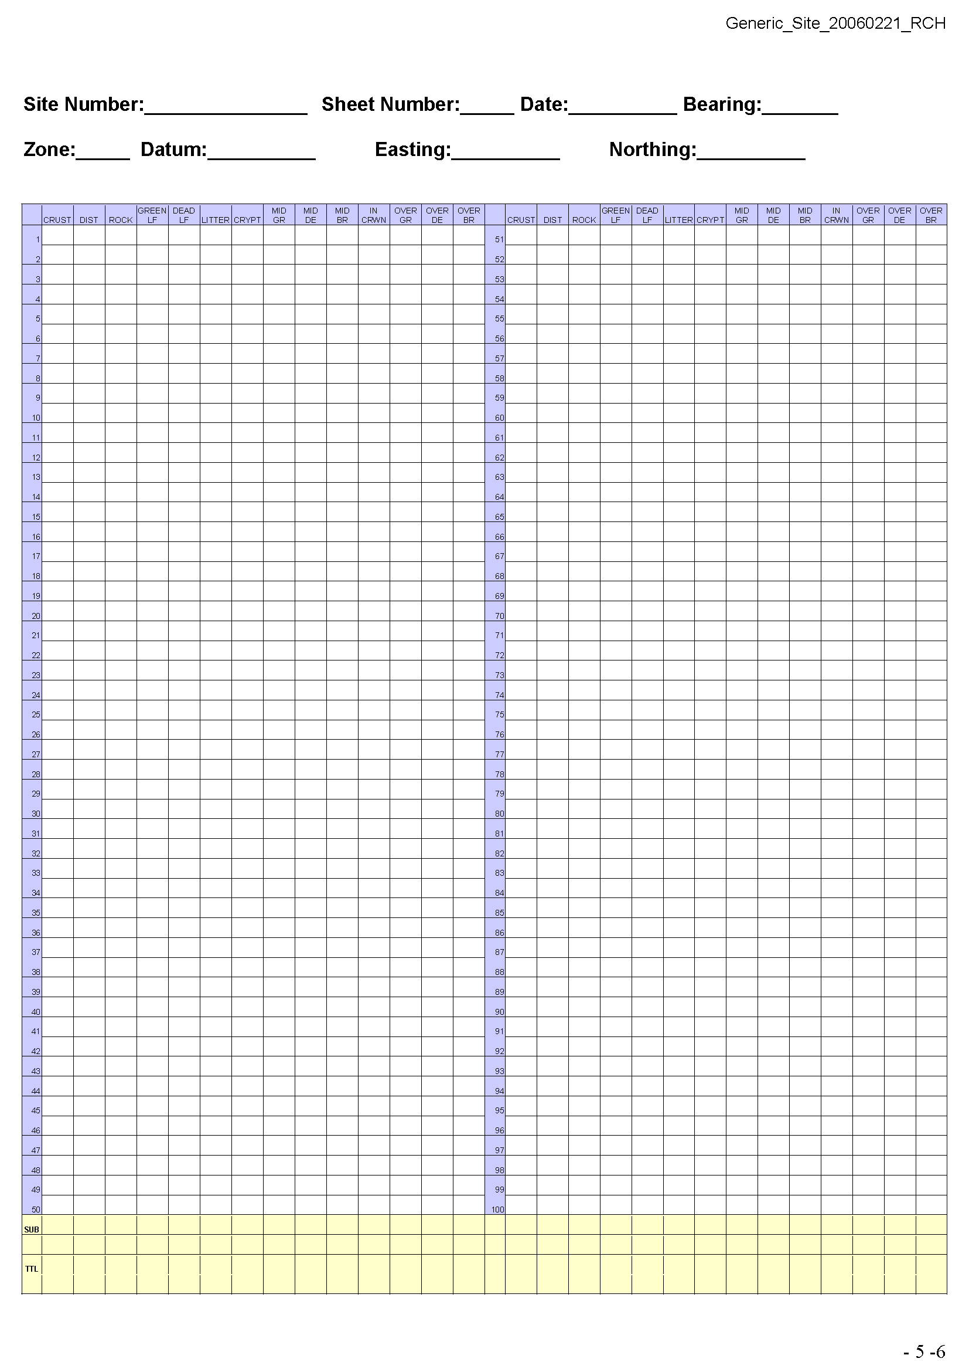

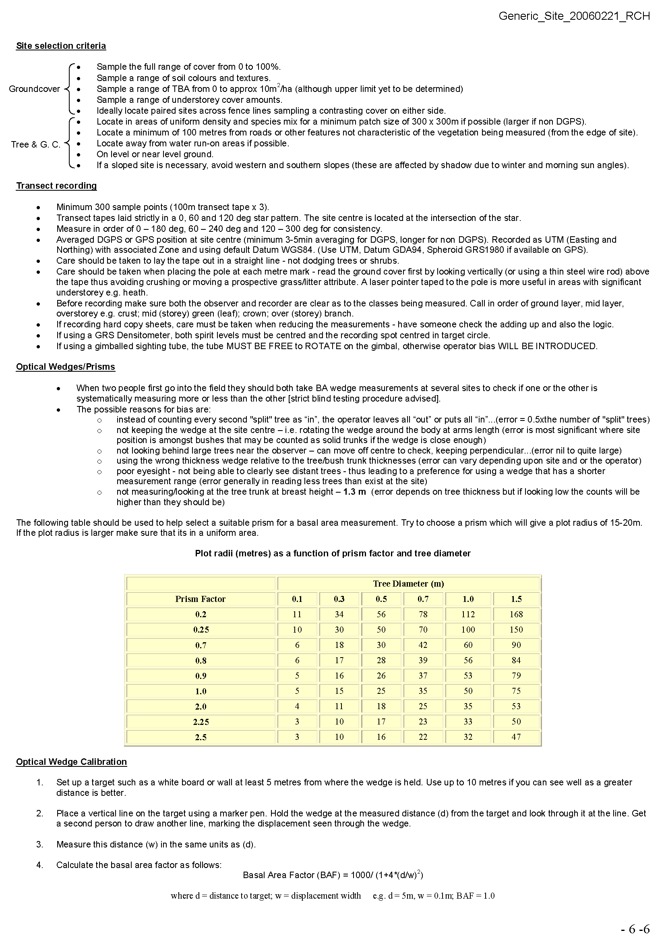

8.2 Example DECCW Vegetation Field Survey Form

Location |  |  | Survey Name | Plot No. | Recorders
Date |  | Site No.
AMG grid reference | zone datum  54 55 56 |  | Easting |  | Northing |  | Position in quadrat
Base Plot size |  | Orientation of 0.1ha plot |  | marked | yes no | photo # / orientation

Structure & Composition (within 0.04 ha quadrat)
Keith Class |  | Confidence: high mod low N.A
Regional Veg Class (BVT) |  | Confidence: high mod low N.A
BioMetric Type (or NVCA) |  | Confidence: high mod low N.A.
Other: |  | Confidence: high mod low N.A.

NVIS Level V (within 0.04 ha quadrat)
Stratum | Growth form | Species name | Cover | Abund | For The Entire |  |  | Field  No.
Upper |  |  |  |  | Upper Stratum  Height to crown (m)  min mode max
Upper
Upper
Mid |  |  |  |  | Mid Stratum  Height to crown (m)  min mode max
Mid
Mid
Ground |  |  |  |  | Ground Stratum  Height to crown (m)  min mode max
Ground
Ground
Growth form: T=tree, M=mallee tree, S=shrub, Y=mallee shrub, Z=heath shrub, C=chenopod shrub, Cover: <1,1,2,3,4,5, Abund: 1,2,3,4,5,6,7,8,9,10
G=tussock grass, H=hummock grass, D=sod grass, V=sedge, R=rush, E=fern, 10,15,20,25,30,35, 20,50,100,500,1000,>1000

Condition  (within 0.04 ha) | Upper stratum | Mid stratum | Ground stratum Grasses | Ground stratum  Shrubs | Ground stratum  Other | Cover % |  | Condition  (within 0.1ha quadrat)
Native richness |  |  |  |  |  | Litter |  | No. trees with hollows
Native cover |  |  |  |  |  | Bare ground |  | Woody debris  lineal metres
Exotic cover |  |  |  |  |  | Crypt-ogam |  | Woody regeneration  No. upper stratum sp. & abund.
(within 0.1ha quadrat)
Woody stem-sizes  (tally within category) | ≥ 5-  <10 |  |  | ≥10-  <20 |  |  | ≥20-  <30 |  |  | ≥30 cm DBH  measure all
(or, measure all ≥5cm DBH)
Tree health | no  evidence |  | branchlets  dead |  |  | small branches  dead |  | main branches  dead |  |  | trees  dead
Land Use  (dominant) | nature travelling forestry grazing grazing / cropping other:  conservation stock route cropping
Land Cover  (upper stratum) | none native environmental native exotic exotic  planting plantation plantation other:
Land Cover  (ground stratum) | none native environmental native exotic exotic  planting plantation crop other:
Age structure | early advanced uneven mature senescent  regeneration regeneration age

Site History | Freq. code | Age code | Land Manager Survey: categories, quantities, comments
Grazing management |  |  | not set rotational / cell  grazed stocked grazing
Farming |  |  | none direct disc plough mouldboard  drill tyned implement rotary hoe
Erosion control |  |  | none contour contour mulching other  cultivation banks
Pasture improvement rates (fertiliser) kg/ha |  |  | none <125 126-250 >250
Pasture improvement rates (lime/dolomite) t/ha |  |  | none <2 2-4 4-7 >7
Timber extraction
(incl. firewood)
Regrowth management
Weed control
Pest animal control
Burning
Other
Frequency: 0=no record, 1=rare (>5yrs), 2=occasional (2-5yrs), 3=frequent (<2yrs). Age: R=recent (<3yrs), NR=not recent (3-10yrs), O=old (>10yrs)

Plot Disturbance | Severity code | Age code | Observational evidence:
Clearing (inc. logging)
Cultivation (inc. pasture)
Soil erosion
Firewood collection
Grazing
Fire damage
Storm damage
Other
Severity: 0=no evidence, 1=light, 2=moderate, 3=severe Age: R=recent (<3yrs), NR=not recent (3-10yrs), O=old (>10yrs)

Increaser / Decreaser Species (disturbance sensitive spp. within 0.04 ha quadrat)
Stratum | Growth form | Field name | Species name | Cover | Abund | Field  No. | RBG No.

Physiography
Morphological  Type | Landform  Element | Landform  Pattern | Microrelief
Lithology | Soil Surface  Texture | Soil  Colour | Soil  Depth
Slope | Aspect | Site Drainage | Distance to nearest  water and type

Floristics
(within 0.04 ha quadrat)
Sub-Stratum | Growth form | Field name | Species name | Cover | Abund | Field  No. | RBG No.
Growth form: T=tree, M=mallee tree, S=shrub, Y=mallee shrub, Z=heath shrub, C=chenopod shrub, Cover: <1,1,2,3,4,5, Abund: 1,2,3,4,5,6,7,8,9,10
G=tussock grass, H=hummock grass, D=sod grass, V=sedge, R=rush, E=fern, 10,15,20,25,30,35, 20,50,100,500,1000,>1000
F=forb, L=vine, A=cycad, P=palm, X=xanthorrhoea, U=samphire shrub. etc crown cover %
Floristics (cont.)
(within 0.04 ha quadrat)
Sub-stratum | Growth form | Field name | Species name | cover | abund | Field  No. | RBG No.

Additional Overstorey species (within ESU to a maximum of 1ha area)
Stratum | Growth form | Field name | Species name | Cover | Abund | Field  No. | RBG No.
AdU
AdU
AdU
AdU
AdU
Growth form: T=tree, M=mallee tree, S=shrub, Y=mallee shrub, Z=heath shrub, C=chenopod shrub, Cover: <1,1,2,3,4,5, Abund: 1,2,3,4,5,6,7,8,9,10
G=tussock grass, H=hummock grass, D=sod grass, V=sedge, R=rush, E=fern, 10,15,20,25,30,35, 20,50,100,500,1000,>1000
F=forb, L=vine, A=cycad, P=palm, X=xanthorrhoea, U=samphire shrub. etc crown cover %
Location |  |  |  | Survey Name | Plot No. | Recorders
Date |  | Site No.
AMG grid reference | zone datum  54 55 56 |  |  | Transect Start (0m) |  | Transect End (50m)
AMG grid reference |  |  |  | E |  | E
AMG grid reference |  |  |  | N |  | N
Transect length |  |  | orientation |  | marked | yes no | photo # / orientation

Ground Cover | Tally first point of contact (<1m), every 50cm along 50m transect (0.5m to 50m = 100 points) | TOTAL
Litter
Bare Ground
Cryptogam
Woody debris
Rock
Exotic – Annual
Exotic – Perennial
Shrub
(crown height <1m)
Grass – Hummock *
Grass – Other *
Forb *
Sedge / Rush *
Fern *
Other *
* native species

Other | Tally presence within 25cm radius, every 50cm along 50m transect (0.5m to 50m = 100 points) | TOTAL
Dung – stock
Dung – exotic pests
Dung – native
Woody seedlings

8.3 Roadside Survey Form in LandMAPT database

Current land use mapping in NSW hasn’t concluded for the 2005 dataset (editing of this data is still continuing), so no figures from that data could be included in time for this report.

