Publication details
Title:

Catchment Scale Land Use of Australia – Commodities – Update December 2018
Alternate title:
CLUMC 12/2018 dataset

Date published:
2019-02-19 T10:00:00

Abstract:
This dataset is the second national compilation of catchment scale commodity data for Australia (CLUMC), current as at December 2018. It replaces the Catchment Scale Land Use of Australia – Commodities – September 2017. It has been compiled from vector land use datasets collected as part of state and territory mapping programs through the Australian Collaborative Land Use and Management Program (ACLUMP). It complements the Catchment Scale Land Use of Australia – Update December 2018 dataset (ABARES 2019). Agricultural commodities are assigned to the Australian Land Use and Management (ALUM) Classification version 8 (ABARES 2016) classes based on; perceived intervention to the landscape, growing conditions and management, the intended use of the commodity, consistency with national and international reporting frameworks and standards, such as National Plantation Inventory, industry guidelines, Australian Bureau of Statistics, harmonised trade codes and ABARES commodity reports, where possible.

Commodities data were produced as part of catchment scale land use mapping and primarily uses fine-scale satellite data and information collected in the field (ABARES 2011, 2015). Field validation was critical for mapping commodities. The date of mapping (2003 to 2018) and scale of mapping (1:5 000 to 1:250 000) vary, reflecting the source data, capture date and scale. It is important to note that the location of a commodity may change on an annual basis, depending on factors such as climate, markets or farming systems.

The following areas have been updated since the September 2017 version: Burdekin natural resource management (NRM) region in Queensland; the state of New South Wales; the state of Victoria; and the state of Western Australia.

Jurisdictions captured commodity data (where possible) for those areas most recently mapped in the Catchment scale land use of Australia – Update December 2018 (ABARES 2019) with a focus on horticultural and intensive animal industries. Other commodities which are tertiary classes of the ALUM classification (such as sugar cane, cotton, rice, olives and grapes) have been mapped by jurisdictions for some time and are included in this dataset.

Agricultural commodity level mapping is available for all of the Northern Territory, and is likely to be complete for the following commodities nationally (taking into consideration the date of mapping):
Crops - rice, sugar cane, cotton
Fruit – bananas (except Southern Queensland), avocados, mangoes, olives, grapes
Nuts – macadamias
Livestock – dairy cattle, pigs, poultry, horse studs, aquaculture.

Commodity information is selected from an agreed list of commodity names developed by ACLUMP partners. A commodity may be applied to one or many land use codes. For example the commodity ‘wheat’ is applied to class 3.3.1, ‘Cropping’ or 4.4.1, ‘Irrigated cropping’, while ‘cattle’ may be applied to any land use where cattle are observed including 2.1.0 ‘Grazing native vegetation’, 3.2.0 ‘Grazing modified pastures’, 4.2.0 ‘Grazing irrigated modified pastures’, 5.2.2 ‘Feedlots’ etc.

The commodity description is intended to add information to the catchment scale land use map which is not otherwise recorded in the ALUM Classification. Where there are several suitable commodity descriptions mappers are encouraged to record the most detailed description. For example when cattle breeds are known to be for milk production mappers would apply the commodity description ‘cattle dairy’ rather than just ‘cattle’.

This publication (and any material sourced from it) should be attributed as: ABARES 2019, Catchment Scale Land Use of Australia – Commodities – Update December 2018, ABARES, Canberra, March CC BY 4.0. https://doi.org/10.25814/5c887edfb0bbb

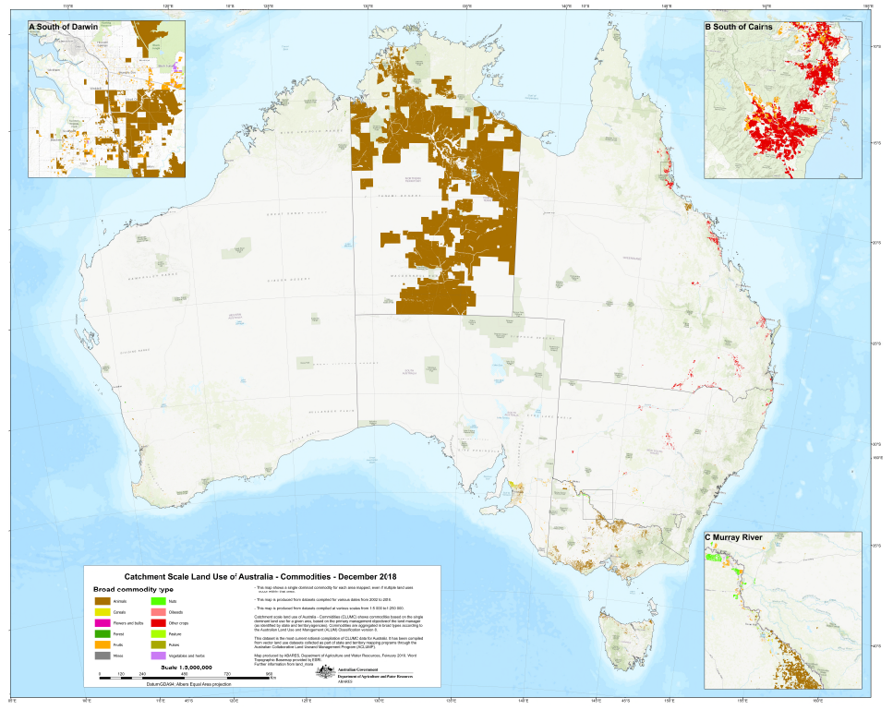

Descriptive information
Author(s)
and/or Stakeholder(s):
Acknowledgements: This dataset was produced by Australian Bureau of Agricultural and Resource Economics and Sciences (ABARES) within the Australian Government Department of Agriculture and Water Resources as part of the Australian Collaborative Land Use and Management Program (ACLUMP). ACLUMP, of which ABARES is a partner, is a consortium of Australian Government, and state and territory government partners that promotes the development of nationally consistent land use, land cover and land management practice information for Australia. Datasets were provided by: the New South Wales Office of Environment and Heritage; the Northern Territory Department of Environment and Natural Resources; the Queensland Department of Environment and Science; the South Australian Department of Environment and Water; the Tasmanian Department of Primary Industries, Parks, Water and Environment; the Victorian Department of Jobs, Precincts and Regions; and the Department of Primary Industries and Regional Development, Western Australia.

Constraints

LEGAL CONSTRAINTS ASSOCIATED WITH THE MATERIAL
Limitation on the use of the material:
The Australian Government acting through ABARES has exercised due care and skill in the preparation and compilation of the information and data set out in this publication. Notwithstanding, ABARES, its employees and advisers disclaim all liability, including liability for negligence, for any loss, damage, injury, expense or cost incurred by any person as a result of accessing, using or relying upon any of the information or data set out in this publication to the maximum extent permitted by law.
Constraints on using the material:
copyright
Other constraints:
Licence type:Copyright
(c) Commonwealth of Australia 2019
All material in this publication is licensed under a Creative Commons Attribution 4.0 Australia Licence, save for content supplied by third parties, logos and the Commonwealth Coat of Arms.

This publication (and any material sourced from it) should be attributed as: ABARES 2019, Catchment Scale Land Use of Australia – Commodities – Update December 2018, ABARES, Canberra, March CC BY 4.0. https://doi.org/10.25814/5c887edfb0bbb

Additional information about this material
Purpose for which the material was obtained:
This dataset provides the best available commodity level mapping information for Australia’s regions as at December 2018. It is used by the Department of Agriculture and Water Resources, state agencies and regional natural resource management groups to address issues such as agricultural productivity and sustainability, biosecurity, land use planning, natural disaster management and natural resource monitoring and investment. The data vary in currency (2003 to 2018) and scale (1:5 000 to 1:250 000).

Progress status of this material:
Completed
Maintenance and Update Frequency:
As needed

KEYWORD(S)
ANZLIC Search Words:
AGRICULTURE
AGRICULTURE mapping
LAND
LAND survey
LAND Use
LAND Use maps
LAND Use classification
General Keywords:
Australian Collaborative Land Use and Management Program (ACLUMP)

TOPICS
ABARES Topic categories:
Agriculture
Land Use
Environment and Natural Resource Management
Models, Risk, Spatial Data and Datasets
ISO topic categories:
farming
environment
biota

SPATIAL EXTENT(S)

Extent
Description of spatial extent:
Australian Land
Spatial bounding box included in:
North: -8.20 degrees; South: -44.37 degrees; East: 157.23 degrees; West: 109.49 degrees.

Extent
Description of spatial extent:
Australian Land
Spatial area included in:
Australian Mainland
Australia excluding external territories

Projection:
EPSG::3577
Coordinate reference details: Well-Known Text:
PROJCS["GDA94 / Australian Albers",GEOGCS["GDA94",DATUM["D_GDA_1994",SPHEROID["GRS_1980",6378137,298.257222101]],PRIMEM["Greenwich",0],UNIT["Degree",0.017453292519943295]],PROJECTION["Albers"],PARAMETER["standard_parallel_1",-18],PARAMETER["standard_parallel_2",-36],PARAMETER["latitude_of_origin",0],PARAMETER["central_meridian",132],PARAMETER["false_easting",0],PARAMETER["false_northing",0],UNIT["Meter",1]]

RESPONSIBILITY FOR THIS MATERIAL
custodian
Department of Agriculture and Water Resources: Australian Bureau of Agricultural and Resource Economics and Sciences
Data Manager
GPO Box 858
CANBERRA CITY
Australian Capital Territory 2601 AUSTRALIA
Voice: +61 2 6272 3933
dataman@agriculture.gov.au
publisher
Department of Agriculture and Water Resources: Australian Bureau of Agricultural and Resource Economics and Sciences
GPO Box 858
CANBERRA CITY
Australian Capital Territory 2601 AUSTRALIA
Voice: +61 2 6272 3933
dataman@agriculture.gov.au

go up to acknowledgements

CONTACT(S) WHEN INQUIRING ABOUT THIS MATERIAL
pointOfContact
Department of Agriculture and Water Resources: Australian Bureau of Agricultural and Resource Economics and Sciences
Data Manager
GPO Box 858
CANBERRA CITY
Australian Capital Territory 2601 AUSTRALIA
Voice: +61 2 6272 3933
dataman@agriculture.gov.au

PROCESS USED TO GENERATE THIS MATERIAL

Lineage Statement
Lineage:
ABARES has produced this vector dataset from vector catchment scale land use data provided by state and territory agencies, as follows:
- Catchment Scale Land Use Mapping for the Australian Capital Territory 2012
- 2017 NSW Land Use v1.0
- Northern Territory Land Use Mapping 2016-17
- Land use mapping - Queensland current (March 2018)
- South Australia Land Use (ACLUMP) 2017
- Tasmanian Land Use 2015
- Victorian Land Use Information System (VLUIS) 2016-17
- Victorian Northern Irrigation Region 2016
- Catchment Scale Land Use Mapping for Western Australia 2018

Links to land use mapping datasets and metadata are available at the ACLUMP data download page at http://www.agriculture.gov.au/abares/aclump/pages/land-use/data-download.aspx.
Commodities data were extracted using the tertiary land use code or the commodity description where appropriate. The State and source year were added to the attribute table and the area of the polygon calculated in hectares. Finally the commodities was joined to a lookup table to include a broad classification of commodities.
Positional Accuracy:
The scale of the source data varies from 1:5 000 to 1:250 000. See individual land use mapping dataset metadata for specific measures of accuracy.
Attribute Accuracy:
The methods for mapping and classifying commodities adhere to the standards outlined in ‘The Australian Land Use and Management Classification Version 8’ (ABARES 2016). Datasets mapped to version 7 of the ALUM Classification were converted to version 8 using a look-up table based on Appendix 1 (ABARES 2016).
Logical Consistency:
All input polygon datasets were checked for topological consistency.
Completeness:
Complete for Northern Territory. Complete for all relevant data provided.

Information about the product description

Parties responsible for description
Description custodian
Department of Agriculture and Water Resources: Australian Bureau of Agricultural and Resource Economics and Sciences
Data Manager
GPO Box 858
CANBERRA CITY
Australian Capital Territory 2601 AUSTRALIA
Voice: +61 2 6272 3933
dataman@agriculture.gov.au
Description publisher
Department of Agriculture and Water Resources: Australian Bureau of Agricultural and Resource Economics and Sciences
GPO Box 858
CANBERRA CITY
Australian Capital Territory 2601 AUSTRALIA
Voice: +61 2 6272 3933
dataman@agriculture.gov.au
Description originator
Department of Agriculture and Water Resources: Australian Bureau of Agricultural and Resource Economics and Sciences : Land and Spatial Analytics
GPO Box 858
CANBERRA CITY
Australian Capital Territory 2601 AUSTRALIA
Voice: +61 2 6272 3933
dataman@agriculture.gov.au

Additional Metadata
References
ABARES 2011, Guidelines for land use mapping in Australia: principles, procedures and definitions, A technical handbook supporting the Australian Collaborative Land Use and Management Program, 4th edition, Australian Bureau of Agricultural and Resource Economics and Sciences, Canberra, available at data.daff.gov.au/data/warehouse/pe_abares99001806/GuidelinesLandUseMappingLowRes2011.pdf.

ABARES 2015, Addendum to the Guidelines for land use mapping in Australia: principles, procedures and definitions, 4th edition, Australian Bureau of Agricultural and Resource Economics and Sciences, Canberra, available at data.daff.gov.au/data/warehouse/pe_abares99001806/AddendumGuidelinesLandUseMapping2015_v1.0.0.pdf.
ABARES 2016, The Australian Land Use and Management Classification Version 8, Detailed, Australian Bureau of Agricultural and Resource Economics and Sciences, Canberra, available at agriculture.gov.au/abares/aclump/Documents/ALUMCv8_Handbook4ednPart2_UpdateOctober2016.pdf.
ABARES 2019, Catchment Scale Land Use of Australia – Update December 2018, Australian Bureau of Agricultural and Resource Economics and Sciences, Canberra, available at agriculture.gov.au/abares/aclump/pages/land-use/data-download.aspx,

