**TUTORIAL**

**Multi-criteria analysis:**

**A framework for spatial decision making**

**MCAS-S Development Partnership**

[](http://www.agriculture.gov.au/abares)[](http://ecoed.org.au/)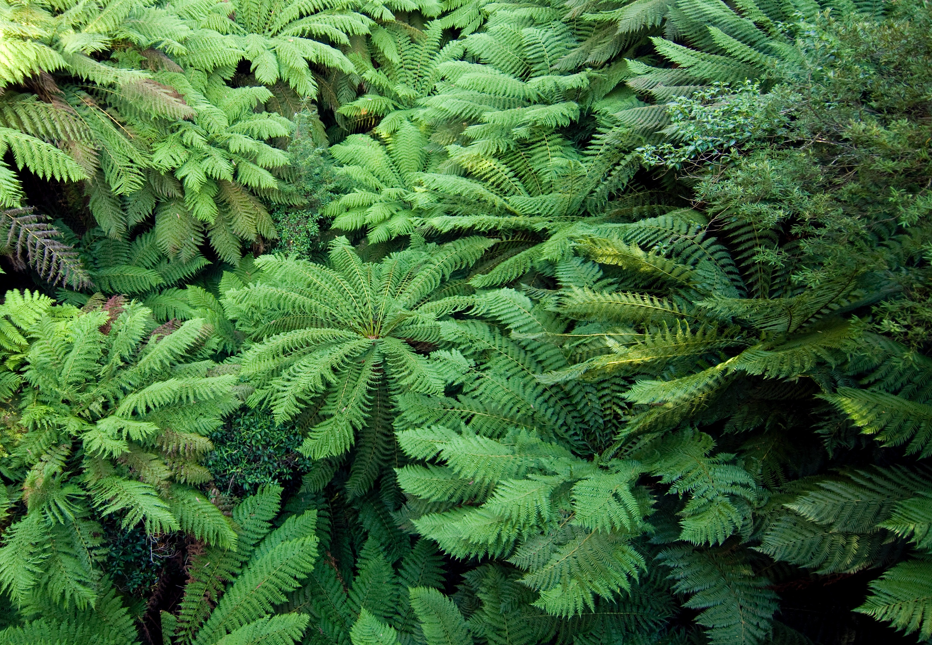

Introduction

In this tutorial exercise you will assemble a multi-criteria analysis, to help answer a “where” question, based on what you have learned in the spatial decision support lecture.

We will use the Multi-Criteria Analysis Shell for Spatial Decision Support (MCAS-S) to view, combine, and communicate mapped information. This tool and the exercise data pack will need to be on your desktop computer. The data pack includes data developed using the [Biodiversity and Climate Change Virtual Laboratory (BCCVL)](http://www.bccvl.org.au) in a previous exercise.

Key messages

* Spatial multi-criteria analysis is a framework for answering ‘where’ questions using input data with different units.
* Defining your objective is critical to success
* A means-to-an-end diagram can help define your objective and identify inputs.
* MCAS-S uses mapped information to inform decisions, based on your:
  + Objective
  + Criteria
  + Input layers.
* MCAS-S supports multi-criteria analysis as well as other spatial analysis.

Learning outcomes/activities

* Apply the 5 steps in a multi-criteria analysis
* Construct a spatial multi-criteria analysis
* Evaluate options
* Report outcomes

What will you need to complete this exercise?

* Assumes knowledge from the spatial decision support lecture.
* PC with MCAS-S software installed (If using a Mac you will need a virtual PC with windows)
* Exercise data pack

Extension exercises

* Learn more about creating the input data for this exercise in the Species Distribution Modelling and Climate Change Projection Exercise.
* Learn how to create your own spatial MCAS-S ready data using Geographic Information Systems (GIS) software.

This material is licensed with a CC-BY licence, meaning that you can use, repurpose, adapt, or change it to suit your needs.

Table of Contents

Contents

Introduction 2

Key messages 2

Learning outcomes/activities 2

What will you need to complete this exercise? 2

Extension exercises 2

Table of Contents 3

About ecoEd 3

MCAS-S Tutorial Exercise – where to focus Lantana prevention efforts 4

Aim 4

Background 4

Step 1: Define and identify components for evaluation 5

Step 2: Assemble data inputs 5

Step 3: Explore and combine data 8

Step 4: Calculate final score and develop options 12

Step 5: Review and report 13

Step 6: Repeat and improve 15

References 18

Suggested Answers 19

About ecoEd

ecoEd is a new innovative training and skills development program for university lecturers, researchers and industry professionals. The program is developed to enhance the translation of Australia’s eResearch infrastructure to the Eco science community by educating and upskilling the next generation of environmental scientists.

ecoEd provides access to information resources that can be used in courses that focus on topics such as ecology, biogeography, environmental management and spatial analysis. These resources explain the theoretical underpinnings of ecological models, and provide real-world examples to show how these concepts can be analysed in online tools.

More info: www.ecoed.org.au



MCAS-S Tutorial Exercise – where to focus Lantana prevention efforts

Aim

To determine where to focus efforts to prevent spread of *Lantana camara* in Australia for wetland conservation or forestry.

Background

*Lantana camara* is a significant Australian weed because it is invasive,

spreads easily, and has economic and environmental impacts.

(Image CRC for Australian weed management 2003)

Lantana is known to impact negatively on biodiversity, particularly

riparian zones and wet sclerophyll forests (Biodiversity Queensland 2010).

Lantana is extremely widespread and abundant being particularly well established on Australia’s east coast. The highest priority for lantana management is to prevent its spread into un-infested areas. Spread prevention is the most cost-effective weed management tool for lantana (CRC for Australian weed management 2003),

Spatial multi-criteria analysis will support your decision making by:

* providing a structured, transparent framework
* allowing you to include mapped information from different sources and units
* locating and counting pixels that meet your requirements, and
* helping to communicate your findings with stakeholders.

You will apply the 5 steps in the multi-criteria analysis framework and explore how you might repeat the 5 steps to improve your outcome.

Step 1: Define and identify components for evaluation

Defining your objective and decision criteria is critical to the success of your multi-criteria analysis. In this tutorial exercise our objective is to advise:

**“Where should we focus our efforts to prevent the spread of *Lantana camara* to priority wetlands in Australia?”**

Our decision criteria are: land suitable for Lantana, places where Lantana is not already established, important wetlands, and places where resources might be available. These criteria are used to assemble data inputs at Step 2.

Questions to ask:

* Is my objective clear? Will it give me a useful answer? Could it result in any unintended consequences?
* Are my criteria sensible? What assumptions am I making? What have I missed?
* Who are the stakeholders and what are their motivations? For example who will be doing the work? Who would be impacted by the spread of Lantana? Who is paying for the analysis?
* What kind of data will best meet this objective and where could I get it?

Note: Many other criteria could be important for this analysis. You should consider consultation with relevant experts and stakeholders and use of scientific literature in setting up a project.

Step 2: Assemble data inputs

**Suitable land**

Lantana is known to invade disturbed areas where soil is exposed and competition from other plants is reduced. Its seeds are often dispersed by birds. The seeds need warm temperatures and sufficient soil moisture to germinate. Shoots are frost sensitive and growth is reduced below 5°C. Lantana can survive drought once established but does not grow well in saline or waterlogged soils.

Options to determine suitable land for Lantana include:

1. Combine data on disturbance, temperature, soil moisture and saline or waterlogged soils (consider as an extension exercise)
2. Identify locations where *Lantana camara* is already established and extrapolate these conditions (using a prepared species distribution model)

Are there other approaches that could be effective?

In this exercise we will use approach 2. A species distribution model was run in the BCCVL to predict areas with a suitable climate for *Lantana camara*. This model produced a potential distribution map based on the climate at the locations of point observations of *Lantana camara* from the [Atlas of Living Australia](https://www.ala.org.au/). As an extension exercise you could complete approach 1 and compare the results.

**Places where Lantana is not already established**

Information about the distributions of weeds can be collected by:

1. National and state surveys which may include anecdotal information from land holders, natural resource management or Landcare groups, and field surveys.
2. Academic research and citizen science such as the collection of point observations contained in the Atlas of Living Australia.
3. Aerial photography or remote sensing may be useful if the weed has a distinctive visual or spectral signature and imagery is available at the appropriate time, resolutions and for the area of interest.

In this exercise we will use the point locations from Atlas of Living Australia and data from the Invasive species – weeds – National Survey 2006 – ABARES.

**Priority areas – important wetlands**

In this exercise we will use the Directory of Important Wetlands in Australia – Department of the Environment and Energy 2008,.

**Resources available**

In reality, the availability of resources, or other political, economic or social factors may mean that success is more achievable in some areas than others.

In this exercise we will explore tourism spend as an example of places where more money might be available to complete weed surveillance and or management.

**Means-to-an-end-diagrams**

Means-to-an-end diagrams can help to structure the multi-criteria analysis and identify data gaps.

Figure 1 Lantana spread prevention to wetlands means-to-an-end diagram

Questions to ask:

* Are my criteria and input data appropriate for my objective?
* Does it matter how recent the data is, or how reliable?
* Are my input data duplicated? Is any layer redundant or dependent on another input?

Step 3: Explore and combine data

We will now use the Multi-Criteria for Spatial Decision Support (MCAS-S) software tool to classify and combine our input data.

**Get started**

* + 1. Download and install MCAS-S software. MCAS-S is freely available software that works on Windows computers. Download from <http://www.agriculture.gov.au/abares/aclump/multi-criteria-analysis/mcas-s-tool> and follow prompts to install.
    2. Download the zipped data folder for this exercise. The data for this exercise is available from the MCAS-S and EcoEd websites. Download the Lantana exercise folder, save the folder to your working directory and unzip. The MCAS-S project needs to remain alongside the project data using the defined folder structure.

* + 1. Open the MCAS-S project ‘LantanaBlank.mcas’ to see an empty MCAS-S workspace. Either;
* Click the MCAS-S desktop shortcut and use *File* menu *Open*, or
* Navigate directly to the project using File explorer.

**Part 1: Create a spatial multi-criteria analysis ‘Priority wetlands for Lantana prevention’**

To create an MCAS-S project based on the means-to-an-end diagram at Figure 1:

* + Save a copy of the MCAS-S project (and save regularly)
  + Drag primary input data into the workspace
  + Explore and classify all layers from blue ‘low priority’ to red ‘ high priority’
  + Combine input layers into criteria by applying ranking and thresholds
  + Combine the criteria to meet the objective.
    1. Save a copy of the project:
       - From the *File* menu choose *Save as*
       - Choose *store alongside open project re-using project data*
       - Name your working project e.g. ‘Lantana Wetlands’
       - Save your project periodically. From the *File* menu choose *Save.* Note: the *Save* button on the left hand interface panel only saves classification settings for an individual data layer it does not save the project.
    2. Drag in primary input data
  + Click the primary input data icon and expand the folders ‘Conservation’ and ‘Lantana’ to view the available data relevant for this analysis.
  + Select data by clicking (shift or control allows you to select more than one layer) and drag into the workspace.
  + Click *Info* in the left hand panel to find out more about each layer.
    1. Explore and classify data layers

From ‘Lantana’ folder:

* Drag in ‘lancam06’ (categorical data) - State occurrence of Lantana (2006).
  + Rename to ‘Lantana present (survey)’
  + Select 4 classes
  + Classify by clicking the colour and assigning to a class as at Table 1.

Table 1 Classification of State occurrence of Lantana

|  |  |  |
| --- | --- | --- |
| Layer name | Class Colour | Class name |
| Lancam06 | Red | Present |
| Green | Eradicated under monitoring |
| Cyan | Unknown |
| Blue | Absent |

* Drag in ‘lantanaDis’ (continuous data) – Distance from observations of *Lantana camara*. Distance layers can be used to include line or point data in an MCAS-S analysis.
  + Rename to ‘Lantana observed’
  + Allocate in reverse order (to highlight places that are closer to Lantana)
  + Use a log distribution with three classes.
* Drag in ‘lantana_probability’ (continuous data) – Suitable climate
  + Rename ‘Lantana suitable climate’
  + Set the maximum value above the histogram from 0.9996 to 1
  + Use equal area distribution
  + Consider renaming the classes by typing ‘Low probability’ in Class 1 (dark blue) and ‘High probability’ in Class 5 (red).

Save the project.

From ‘Conservation’ folder:

* Drag in ‘diwa’ (categorical data) – Directory of Important Wetlands in Australia (2008)
  + Rename ‘Important wetlands’
  + Choose two classes ‘Important wetlands’ Red, ‘other’ Blue
* Drag in ‘TourismSpend’ (continuous data) – Tourist expenditure by region (2018)
  + Rename ‘Tourism spend’
  + Discard values <=1 (this removes areas where no data has been collected) *Tip: Use dropdown under histogram: Truncate values...*
  + Choose a custom distribution with 5 classes
  + Class 2 light blue From 50,000, Class 3 From 150,000, Class 4 from 600,000, Class 5 From 2,200,000
    1. Combine input data layers into criteria

To identify locations where the climate is suitable for Lantana but Lantana is not yet established: a) identify where Lantana is established b) combine suitable climate with areas where lantana is NOT established.

Construct the sub-criteria: ‘Lantana established’. We will use two inputs to determine where Lantana is established.

* Drag a Two-way into the workspace
* Set x axis to ‘Lantana present (survey)’ and y axis to ‘Lantana observed’
* Set as 3 classes and rename ‘Lantana established’.
* Explore the relationship between the two inputs by right clicking on different cells in the matrix
* Use the left click to assign areas of interest. You may assign any number of input combinations to each class colour. Consider the reliability of the input layers and what the input classes mean so that you can justify your decision.
  + Class 3 Red ‘Likely’
  + Class 2 Green ‘Possible’
  + Class 1 Blue ‘Unlikely’

Your two way matrix may display as at Figure 2

Figure 2 Two way matrix for location where Lantana is established

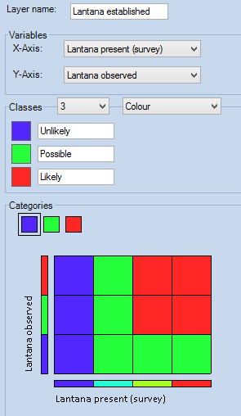

* + 1. Construct the criteria: ‘Suitable not established’

We are now constructing a matrix between where Lantana could be (‘Lantana suitable climate’) and where Lantana is already known to exist (‘Lantana established’). A matrix of possible management outcomes is shown at Figure 3:

Figure 3 Matrix of Management outcomes based on climate suitability and establishment

Lantana established

Lantana not yet established

Suitable

climate

Unsuitable

climate

* Drag a Two-way into the workspace
* Set x axis to ‘Lantana suitable climate’ and y axis to ‘Lantana established’
* Retain 5 classes
* Rename ‘Suitable not established’.
* Use the left click to assign areas of interest, for example:
  + Class 5 Red ‘Very highly suitable not established’
  + Class 4 Yellow ‘ Highly suitable not established’
  + Class 3 Green ‘Suitable or highly suitable possibly established’
  + Class 2 Cyan ‘Less suitable possibly established’
  + Class 1 Blue ‘Unsuitable or established’

Figure 4 Two way matrix for suitable locations where Lantana is not established

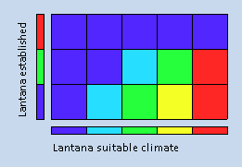

Step 4: Calculate final score and develop options

Remember our objective **“Where should we focus our efforts to prevent the spread of *Lantana camara* to priority wetlands in Australia?”**

Construct the objective: ‘Important wetlands at risk (with money)’:

* Drag a Multi-way into the workspace
* Check the boxes next to the three inputs: ‘Important wetlands’ (source ‘diwa’), Two-way ‘Suitable not established’, and ‘Tourism spend’
* Type the Layer name as ‘Important wetlands at risk (with money)’
* From the Function dropdown list select *Mask* (default)
* From the Intersect or Aggregate buttons choose *Intersect* (default)

Aggregate



Intersect

* Adjust the sliders on the radar plot to choose the red (and possibly yellow) classes from each input and observe the effect on the dark grey areas in the map.
* Turn on the overlays for states and Natural Resource Management regions (nrm2017)
* Align and resize all input layers

We have now located areas to focus our Lantana spread prevention program. These are important wetlands with a suitable climate where Lantana is not established and which receive income from tourism.

Your workspace may look similar to

Figure 5 below:

Figure 5 Important Wetlands at risk (with money) MCAS-S workspace

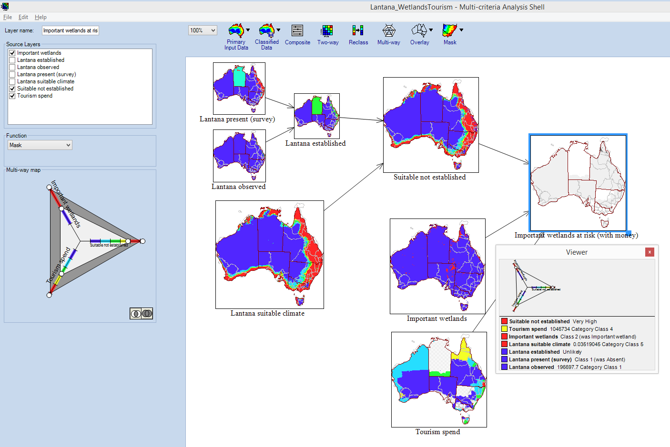

Which inputs might be restricting the target area? Is this contributing to your objective?

Develop options: Compare with and without Tourism spend.

Since Tourism spend is not a complete dataset for Australia you may be asked what the analysis would look like without this input.

* Drag in a Two-way with the inputs of ‘Suitable not established’, and ‘Important wetlands’
* Name this layer ‘Important Wetlands at risk 2-way’
* Consider methods to compare these options
  1. Visually
  2. Using a new two way with both layers as inputs
  3. Using a function composite to calculate the difference between layers

Step 5: Review and report

Right click to remove ‘Important wetlands at risk 2-way’ and the comparison layers.

‘Important wetlands at risk (with money)’ is a map showing in dark grey “Where we should we focus our efforts to prevent spread of *Lantana camara* to wetlands in Australia?” on a pixel by pixel basis. Does this look right?

Management of weeds may be the responsibility of the state government or the Natural Resources Management Region (NRM) organisation. To translate your map result into action you may be asked: Which region should get the most money? Or, where should our prevention efforts start?

Report on your final output by NRM region.

* Right-click on ‘Important wetlands at risk (with money)’
* Choose *Reporting*. Select *Reporting Regions*: ‘nrm2017’ and *Report As*: ‘Cell Counts’ and Resolution (output): ‘Lantana suitable climate’ as shown in Figure 6.

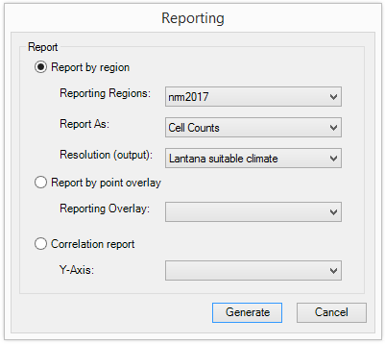Figure 6 Reporting window showing Report by region

* Press *Generate* and inspect the table. Classes are listed across the top with regions down the side. For this mask multiway there are three classes: ‘In’ – darker grey areas where inputs are met, ‘Out’ lighter grey areas where inputs are not met, and ‘?’ areas of no data. If you report on the ‘Suitable not established’ Two-way these columns would be the names you have assigned to the red, yellow, green, cyan and blue classes.
* Click at the top of a class ‘In’ to order results from largest to smallest for that field.
* The region with the most cells ‘In’ now appears at the top of the list. Click the number or count of cells that are ‘In’ for that region. This will highlight ‘In’ cells from this region in all the data layers in the MCAS-S workspace. (You can double click any layer to see this more clearly – escape to close).
* Change the *Graph by* dropdown list to ‘In’
* Save the report as a CSV file.

Questions:

* Which NRM regions contain areas of interest? Which NRM regions have the largest and second largest areas ‘In’?

*Click on the rows to see where the NRM regions are.*

* Focus on these NRM regions

*To mask the view to the NRM region with the largest area of interest: expand the nrm2017 mask from the mask dropdown list and check the box next to the name of the region.*

* Determine the major land uses in the identified areas.

*Drag in the ‘landuse’ layer from Primary Input Data and explore this layer. Right click on the objective layer ‘Important wetlands at risk (with money)’ and Report by region Choosing Reporting Regions ‘landuse’, Report As ‘proportion’ and Resolution (output): ‘Lantana suitable climate’. The largest land use area would be expected to be Water and or Nature conservation. Is this true? Are there any surprising land uses?*

* Check the output in Google earth.

*If you have an internet connection and Google Earth installed right click on your masked objective layer ‘Important wetlands at risk (with money)’ and select ‘Show in Google Earth’. When the layer opens zoom to the area of interest and adjust the transparency of the dark grey areas to view the background imagery. Can you see riparian features or other points of interest?*

Step 6: Repeat and improve

You have been asked whether it is possible to run a pilot program in an NRM region with wetland areas at risk close to a capital city as this will reduce transport and operating costs for field teams.

* Turn on capitals by clicking in the check box from the overlay menu
* Drag in a distance to capitals layer by clicking and dragging capitals from the overlay menu into the workspace
* Specify ‘Important wetlands at risk (with money)’ to use as your mask layer

Figure Dragging in a new distance layer

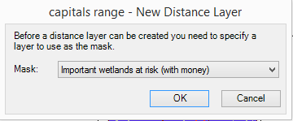

* Complete the fields in the Save layer box for example Filename ‘capitals_dist’ Description ‘Distance from capital cities masked to Important wetlands at risk (with money)’ Lineage (describe what you have done to make the layer ‘Capital cities overlay dragged into workspace and masked to Important wetlands at risk (with money)’ Group (create a new folder or add to an existing folder in the classified data folder

Figure Saving the new distance layer with metadata

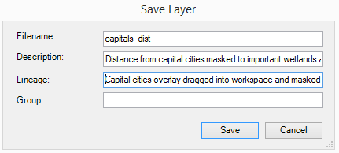

* Allocate classes in reverse order, choose two classes Red = ‘Close’ Blue = ‘Far’ , set distribution to custom with ‘Far’ from 100,000

Figure Classifying the new distance layer

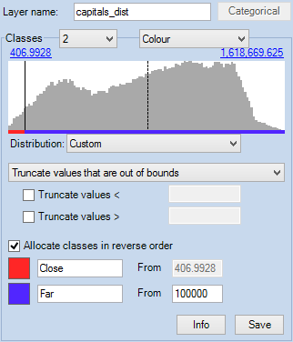

* Drag in a new composite and name it ‘Priority areas close to capital city’
* From the weighting option choose Function and press the Edit button to open the Function Editor
* In the Function Editor enter a function to choose areas which are close to capitals AND at risk of Lantana for example:

iif([capitals_dist]>0.5 AND [Important wetlands at risk (with money)]>0.5,1,0)

Figure Entering a composite function using the Function editor

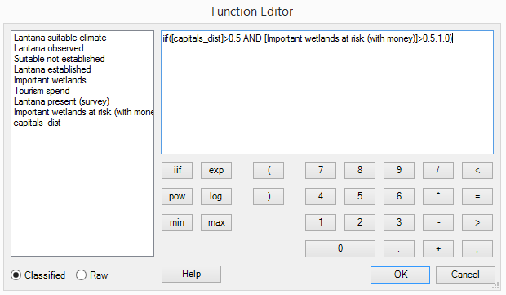

* Click Ok
* Choose two classes
* Consider naming the classes e.g Blue class 1 = ‘Not priority’ Red class 2 = ‘Priority’
* Right click to run a regional report by nrm2017 on cell counts (using resolution (output): Lantana suitable climate).
* When the report opens click the ‘Priority’ column and Graph by ‘Priority’
* Which regions have the most Priority area close to a capital city?

In order to help get funding to reduce spread of Lantana it has been suggested that you should also prioritise areas with threatened species.

* Expand the conservation folder from the Primary Input Data icon and drag ‘threatened_species’ layer into the workspace
* Keep the default settings of 5 classes Equal interval. Consider renaming the classes.
* Drag in a new Two-way
* Select X-Axis ‘Priority areas close to capital cities’ Y-Axis threatented_species
* Assign two classes and assign Red – ‘class 2’ to Priority areas with threatented species and Blue – ‘ class 1’ to other areas

Figure Two-way matrix for Priority areas close to cities and threatened species

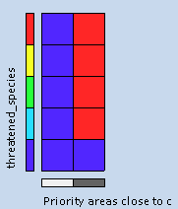

* Consider naming the layer e.g. ‘Priority capitals and species’ classes e.g class 1 = ‘Not priority’ class 2 = ‘Priority’
* Right click to run a regional report by nrm2017 on cell counts (Note: proportions will be too small to display in the report). Choose (Lantana suitable climate as the Report (output)).
* When the report opens click the ‘Priority’ column and Graph by ‘Priority’

*Which regions have priority areas and threatened species?*

* Mask View and Data to the region with the largest number of cells
* You now have a map of priority areas that has been improved based on feedback from your client.
* Enlarge the final map of priority areas
* You may wish to update the means to end diagram to reflect the new project

In order to write your proposal you want the names of the priority wetlands in this region

* From the Overlay menu check the box next to ‘WetlandSlctd’
* Hover over priority pixels to view the inputs from each layer in the viewer window
* Run a report by point to find the inputs for each wetland at a single point
* Right click on the layer and choose Reporting, Select ‘Report by point overlay’ from the dropdown list choose ‘WetlandSlctd’
* Choose a location to save the output .csv file

This file shows names for all wetlands in the point file but only data alongside those within the masked area. Save this as an Excel file in order to do further analysis

From the data menu in Excel apply a filter, select all points with a priority 2.

This should provide the names of the priority wetlands that meet all of the input criteria within the selected region.

**Extension**

Are you confident that you met your objective? What could you change?

Consider how the quality of your input data might have influenced your outcome. How reliable and current are all your data inputs?

How would you use this information to design a prevention program? How might this program be scaled up or back depending on available funds?

For example: could early detection for Lantana in these areas require; remote sensing, field sampling, targeted surveillance, or community education?

What would success look like? If success is NOT finding Lantana might you be rewarding less effort rather than more? How sure will you be that Lantana has been eradicated in these areas?

Who would have been affected by the results of your analysis and how?

Draw a means-to-an-end diagram to show how you might find areas suitable for Lantana based on disturbance, temperature, soil moisture and saline or waterlogged soils. Find this data and create this as an MCAS-S project. You can download data from the [MCAS-S data portal](http://mcas.auscover.net.au/mcas-s/).

References

Atlas of Living Australia (ALA) <https://www.ala.org.au>

Biodiversity and climate change virtual laboratory (BCCCL) [www.bccvl.org.au](http://www.bccvl.org.au)

Biosecurity Queensland on behalf of the National Lantana Management Group (2010). *Plan to Protect Environmental Assets from Lantana*. Department of Employment, Economic Development and Innovation, Yeerongpilly, Queensland. <http://weeds.ala.org.au/WoNS/lantana/docs/Lantana_Plan_Final_low_res.pdf>

CRC for Australian Weed Management 2003, *Weeds of National Significance, Weed Management Guide – Lantana camara*, <https://www.environment.gov.au/biodiversity/invasive/weeds/publications/guidelines/wons/pubs/l-camara.pdf>

MCAS-S development Partnership, Multi-Criteria Analysis Shell for Spatial Decision Support MCAS-S <http://www.agriculture.gov.au/abares/aclump/multi-criteria-analysis/mcas-s-tool>

[MCAS-S data portal](http://mcas.auscover.net.au/mcas-s/) <http://mcas.auscover.net.au/mcas-s/>

For details of data used in the exercise see the excel spreadsheet contained in the Lantana datapack and the .tip files for each layer.

Suggested Answers

**Step 4 Develop options**

b) Using a Two-way to compare results between including and excluding ‘Tourism spend’. Red areas represent areas that differ between the two analyses. More colours could be used to distinguish types of differences. In this case including ‘Tourism spend’ is expected to reduce the identified priority area so all differences are shown as red.

Figure Using a tw0-way to find difference between two layers

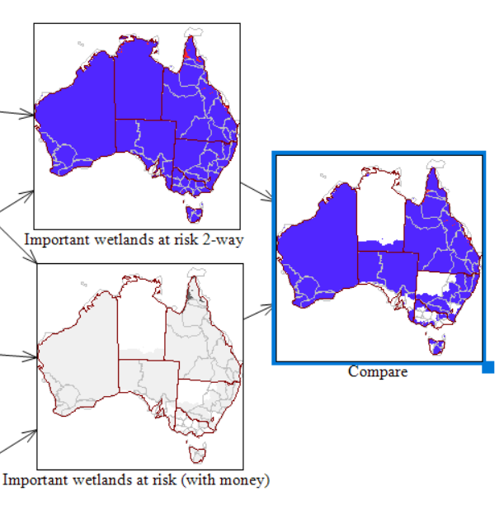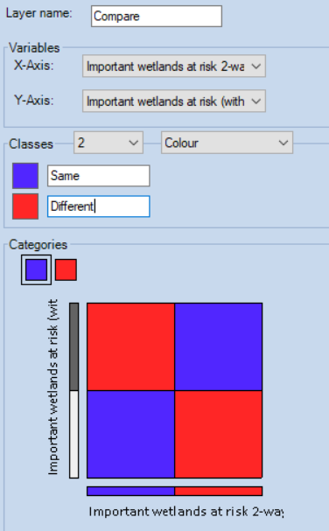

**Step 5 Review and report**

* Which NRM regions contain areas of interest? Which NRM regions have the largest and second largest areas ‘In’?

*Cape York = 23162 and Northern Gulf 3555. Queensland. Since the data is at 1000m x 1000m resolution these pixel counts should be equavalent to square kilometers.*

* Determine the major land uses in the identified areas.

*Water 0.03, Other protected areas including indigenous uses 0.02, Irrigated horticulture 0.01, Nature conservation 0.01.*

*Irrigated horticulture is an unexpected result. Report as proportion empasises very small regions. Since irrigated horticulture occupies a very small area of Australia the proportion of irrigated horticulture in the priority area is over represented. Running a report as cell count shows irrigated horticulture as only 33 pixels compared to Other protected areas: 10130, Grazing natural vegetation: 7247, Nature conservation: 6004 and Water 5777.*

**Step 6 Repeat and improve**

* Which regions have the most Priority area close to a capital city?

*South-East Queensland 83, Swan region (WA) 67, Adelaide and Mount Lofty (SA) 56, Peel-Harvey (WA) 56 etc.*

* Which regions have the Priority area and Threatened species?

*South-East Queensland 76, Peel-Harvey (WA) 41, Swan Region (WA) 24, Port Phillip and Western Port (Vic) 11.*

* Mask view and data to:

*South-East Queensland*

* What are the names of the Priority wetlands in the masked area?

*Moreton Bay, Bribie Island, Lake Coombabah*