Progress in national ground cover monitoring for Australian agriculture
Jane Stewart¹, Jasmine Rickards¹, Lucy Randall¹ and Juan Guerschman²

¹ Australian Bureau of Agricultural and Resource Economics and Sciences, Department of Agriculture, Fisheries and Forestry, GPO Box 1563, Canberra, ACT 2601, Australia, Email Jane.Stewart@daff.gov.au
² CSIRO Land and Water, GPO Box 1666, Canberra, ACT 2601, Australia.

Abstract
A nationally agreed basis for monitoring ground cover using satellite imagery is being implemented for Australia. This will assist with the assessment of Australia’s soil resources and agricultural productivity at national, state and regional scales. A MODIS-based vegetation fractional cover product has been selected for this purpose. It is being validated and improved using a national network of field sites. The results of the initial validation and improvement in fractional cover estimates are presented. Fractional cover is separated into photosynthetic and non-photosynthetic vegetation and bare soil components. The current focus is on establishing the accuracy of the product for agricultural land uses, in particular grazing in the rangelands, and for use in erosion models. Summary statistics are produced from the fractional cover product to report ground cover levels and trends over time. A national example is given using the seasonal mean ground cover levels for the 12 month period from autumn 2011. Further developments of the fractional cover product and associated metrics are outlined.

Key words
ground cover, remote sensing, erosion, agriculture

Introduction
Ground cover data has been identified as critical for assessment of environmental targets related to soil erosion and land management by natural resource management agencies (McKenzie and Dixon 2006). For Australia to manage its current soil resources, develop policies to help land managers adjust to a changing climate and demonstrate the effectiveness of current land management policies and investments, a clearly defined process is required for monitoring and reporting on ground cover at regional, state and national scales (Leys et al. 2009).

Ground cover can be monitored consistently over months, seasons and years for large spatial extents, such as Australia’s rangelands and broadacre cropping areas, using remote sensing. From a remote sensing perspective, ground cover is the fractional cover of the non-woody vegetation and litter near the soil surface. Fractional cover comprises living (photosynthetic) vegetation, senescent or dead (non-photosynthetic) vegetation and bare soil or rock.

A collaborative partnership (DAFF 2010) is implementing a nationally agreed, reliable and cost-effective project for mapping ground cover using satellite imagery to provide regular updates of ground cover conditions across Australia. This will assist the monitoring and reporting of ground cover at national, state and regional scales to assess soil resources and agricultural productivity.

This paper describes the progress in delivering a nationally validated ground cover product for Australia.

Methods
The Moderate Resolution Imaging Spectroradiometer (MODIS)-based vegetation fractional cover product of Guerschman et al. (2009) was selected for monitoring ground cover across Australia (Stewart et al. 2011). The product is available nationally every 8 days as 16-day composites from March 2000 onwards at 500 m resolution. It separates the photosynthetic and non-photosynthetic vegetation components from the bare soil —important for improving erosion model outputs. More extensive validation of the product is required.

A stratified sampling approach has been adopted to prioritise site selection (Malthus et al. in prep) to validate the fractional cover product. Grazing (predominately in the rangelands) and broadacre cropping areas were selected considering factors such as different ground cover levels and soil colours. The sites selected will contribute to a network of sites that are sensor independent (that is suitable for use for fractional cover products derived from satellites in addition to MODIS). Each site has been described and fractional cover measured on the ground according to national standards (Muir et al. 2011). These standards have been adapted from the Queensland Statewide Landcover and Tree Study with site description attributes conforming to the Australian soil and land survey field handbook (NCST 2009). Site description and transect measurements were recorded on paper and/or electronic forms and compiled into a national database (Rickards et al. 2012).

Summary statistics (metrics) that describe the maximum, minimum, mean and variation for each of the three fractional components (photosynthetic, non-photosynthetic and bare soil) are produced for each month, season, year and the whole archive.

Data products are available at the National Computational Infrastructure (NCI 2012).

Results
The algorithm for the MODIS-based vegetation fractional cover product (Guerschman et al. 2009; version 2.1) was originally developed for the northern savannas of Australia and then applied nationally. Using data available for 359 sites (567 observations) from Queensland, New South Wales and South Australia, version 2.1 was validated and the algorithm recalibrated to produce version 2.2 (Guerschman et al. 2012). The recalibration eliminated the bias in underestimation of non-photosynthetic vegetation and overestimation of bare soil of version 2.1. It also reduced the root mean square error (RMSE) in the estimates of the three fractions. The RMSE of version 2.2 is 14.7 % for photosynthetic vegetation, 20.6 % for non-photosynthetic vegetation and 17 % for bare soil. A lower RMSE indicates less difference between the modelled fractional cover data and the data collected at field sites.

ABARES (2012a) have produced metrics for version 2.2 to summarise the MODIS-based vegetation fractional cover product. These are used for monitoring and reporting on ground cover levels and trends.
Figure 1 shows seasonal change in mean ground cover levels, for each 500 m pixel across Australia, under non-forested agricultural land uses from autumn 2011 to summer 2012. Conservation and indigenous protected areas and other non agricultural land uses were excluded using the Catchment scale land use of Australia–Update March 2010 (ABARES 2010). Areas with more than 20 % tree cover were excluded based on Forests of Australia 2008 (ABARES 2008). Ground cover is the sum of the photosynthetic and non-photosynthetic vegetation fractions covering the soil. The mean ground cover for each season was then classified into four classes based on soil erosion control targets. These are: 0 to 30% ground cover, as areas where ground cover levels are 30 % or less are at high risk of soil loss; 30 to 50 %; 50 to 70 %, as targets of 50 % are promoted to prevent wind erosion and 70 % (50% for Western Australia) to prevent water erosion; and 70 to 100 %, as these areas are at very low risk (Leys et al. 2009). The high ground cover shown across most of Australia in 2011 is due to very high rainfall during 2010 and 2011 (BOM 2012).

Discussion
Further improvement of the algorithm is recommended by Guerschman et al. (2012) to achieve a RMSE of lower than 10-15 %. For erosion modelling, a precision of +/- 15 % for the bare soil component of the fractional cover product is required (Malthus et al. in prep.). Possible approaches to further improve the algorithm include:
- having variable endmembers, as defined in Guerschman et al. (2009), depending on environmental conditions
- incorporating more bands or indices to increase the ability of the model to estimate fractional cover
- increasing the number of field visits where spectral measurements are taken.

Comprehensive collection of field data representing vegetation conditions, preferably at internally homogeneous sites and with coincident Landsat imagery, will help validate the extent that these approaches improve the model. Also to be resolved are the effect of soil colour and soil moisture on model performance.

A minimum of 495 additional sites will be used in the validation and improvement of the algorithm in 2013. Data collection from these sites is funded under the current project and collected by collaborating state and territory partners. Extra site data for the rangelands should also be available for this exercise through the Terrestrial Ecosystem Research Network’s AusPlots. Methods of data collection have been aligned to ensure suitability for use with remote sensing. Other state-based activities in Queensland and New South Wales use the same transect sampling methods as described in Muir et al. (2011) and will also be sourced. These additional sites will improve the spatial accuracy of the MODIS-based vegetation fractional cover. Selected sites will need to be revisited to assess the temporal accuracy of the product.

ABARES is producing a report providing products for monitoring and reporting of ground cover levels and trends. It is anticipated that these products will be available via the Monitor, an on-line reporting tool (ABARES 2012b). Future developments will seek to automate the production and delivery of the MODIS-based vegetation fractional cover product and its associated metrics to enable real-time decision making.
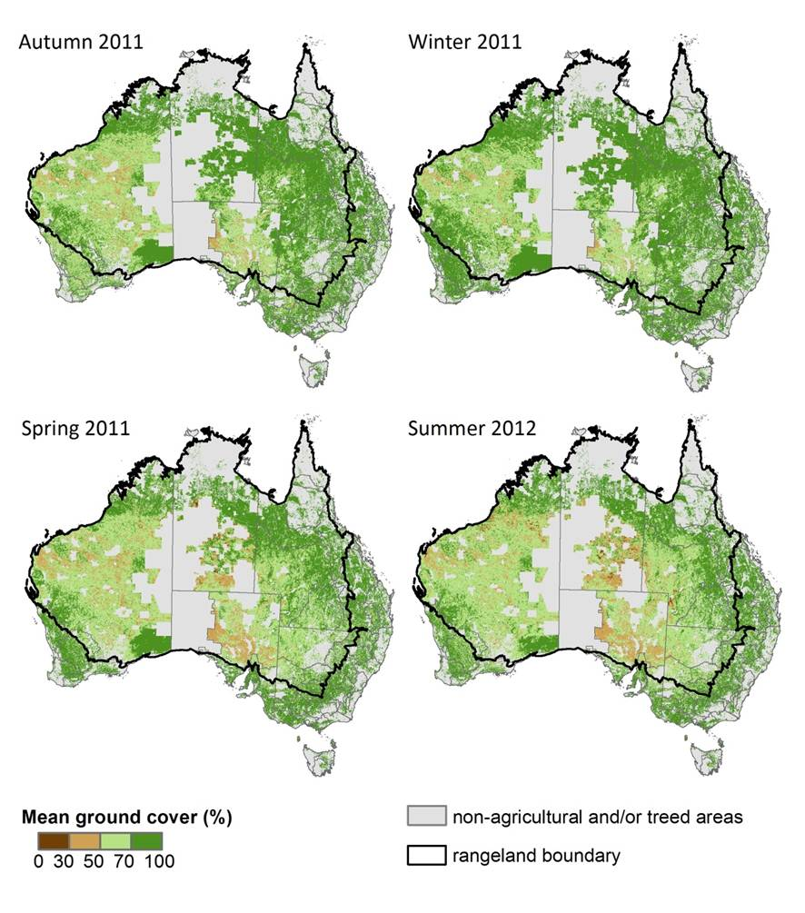
Figure 1. Seasonal ground cover levels for agricultural areas derived from the MODIS-based vegetation fractional cover metrics (version 2.2).

Acknowledgements
The Department of Agriculture, Fisheries and Forestry is supporting this activity. Collaborating organisations are: Commonwealth Scientific and Industrial Research Organisation (CSIRO) through the Sustainable Agriculture Flagship, the Terrestrial Ecosystem Research Network, the New South Wales Office of Environment and Heritage, the Northern Territory Department of Natural Resources, Environment, the Arts and Sport, the Queensland Department of Science, Information Technology, Innovation and the Arts, the South Australian Department of Environment, Water and Natural Resources, the Tasmanian Department of Primary Industries, Parks, Water and Environment, the Victorian Department of Primary Industries, and the Western Australian Department of Agriculture and Food.

References
ABARES 2008, Forests of Australia 2008, Australian Bureau of Agricultural and Resource Economics and Sciences, Canberra http://adl.brs.gov.au/anrdl/metadata_files/pa_foraug9abll0062008_11a.xml
ABARES 2010, Catchment scale land use of Australia–Update March 2010, Australian Bureau of Agricultural and Resource Economics and Sciences, Canberra http://adl.brs.gov.au/anrdl/metadata_files/pa_luausr9abll07611a00.xml
ABARES (2012a) User guide for MODIS-derived vegetation fractional cover version 2.2 metrics. Australian Bureau of Agricultural and Resource Economics and Sciences, Canberra
https://remote-sensing.nci.org.au/u39/public/html/modis/fractionalcover-metrics-abares/doc/Userguide‌_MODIS_FC_V2.2_Metrics.pdf
ABARES (2012b) The Monitor. Department of Agriculture, Fisheries and Forestry, Australian Bureau of Agricultural and Resource Economics and Sciences, Commonwealth of Australia http://www.daff.gov.au/abares/monitor
BOM (2012) Annual Australian climate statement 2011. Bureau of Meteorology, Commonwealth of Australia http://www.bom.gov.au/announcements/media_releases/climate/change/20120104.shtml
DAFF (2010) Ground cover monitoring for Australia: Factsheet. Department of Agriculture, Fisheries and Forestry, Canberra http://adl.brs.gov.au/landuse/docs/groundcover-factsheet.pdf
Guerschman JP, Hill MJ, Renzullo LJ, Barrett DJ, Marks AS, Botha EJ (2009) Estimating fractional cover of photosynthetic vegetation, non-photosynthetic vegetation and bare soil
in the Australian tropical savanna region upscaling the EO-1 Hyperion and MODIS sensors,
Remote Sensing of Environment, 113, 928–45 http://dx.doi.org/10.1016/j.rse.2009.01.006
Guerschman JP, Oyarzabal M, Malthus TJ, McVicar TM, Byrne G, Randall LA, Stewart JB (2012) Validation of the MODIS-based vegetation fractional cover product. CSIRO Land and Water Science Report, Canberra
http://www.clw.csiro.au/publications/science/2012/SAF-MODIS-fractional-cover.pdf
Leys J , Smith J, MacRae C, Rickards J, Yang X, Randall L, Hairsine P, Dixon J, McTainsh G (2009) Improving the capacity to monitor wind and water erosion: A review. Department of Agriculture, Fisheries and Forestry, Canberra http://nrmonline.nrm.gov.au/catalog/mql:2243
Malthus TJ, Randall LA, Barry S, McVicar TM, Bordas VM, Stewart JB, Guerschman JP (in prep.) Ground cover monitoring for Australia: Sampling strategy and selection of ground cover control sites. CSIRO Land and Water Science Report, Canberra.
McKenzie N, Dixon J (2006) Monitoring soil condition across Australia: Recommendations from the Expert Panels. National Land and Water Audit, Canberra
http://lwa.gov.au/files/products/national-land-and-water-resources-audit/pn21340/pn21340.pdf
Muir J, Schmidt M, Tindall D, Trevithick R, Scarth P, Stewart JB (2011) Field measurement of fractional ground cover: A technical handbook supporting ground cover monitoring in Australia. ABARES, Canberra http://adl.brs.gov.au/data/warehouse/pe_hbgcm9abll07701/HndbkGrndCovMontring2011_1.0.0_HR.pdf
NCI (2012) Remote sensing data sets at the NCI. National Computational Infrastructure, Canberra https://remote-sensing.nci.org.au/u39/public/html/
NCST (The National Committee on Soil and Terrain) (2009) ‘Australian Soil and Land Survey Field
Handbook.’ 3rd edn (CSIRO Publishing: Collingwood)
Rickards JE, Stewart JB, Randall LA, Bordas VM (2012) Ground cover reference sites database: User guide for PostGIS. ABARES, Canberra
https://remote-sensing.nci.org.au/u39/public/html/modis/fractionalcover-sitedata-abares/doc/‌GcovPostGIS_report12.pdf
Stewart JB, Rickards JE, Bordas VM, Randall LA and Thackway RM (2011) Ground cover monitoring for Australia–Establishing a coordinated approach to ground cover mapping: Workshop proceedings Canberra 23–24 November 2009. ABARES, Canberra http://adl.brs.gov.au/data/warehouse/pe_abares99001799/Groundcover_mapping-workshop_proc_11‌.pdf

