

Who talks to whom about marine pest biosecurity?
An analysis of the Australian marine pest network
Nyree Stenekes 1, Heleen Kruger 1, Ryan R. J. McAllister2 and
Rob Garrard2

Research by the 1Australian Bureau of Agricultural
and Resource Economics and Sciences and 2Commonwealth Scientific and Industrial Research Organisation
Technical report 19.5
August 2019
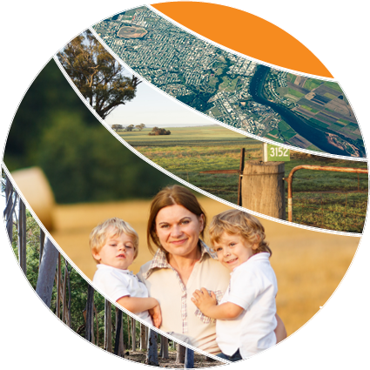
© Commonwealth of Australia 2019
Ownership of intellectual property rights
Unless otherwise noted, copyright (and any other intellectual property rights, if any) in this publication is owned by the Commonwealth of Australia (referred to as the Commonwealth).
Creative Commons licence
All material in this publication is licensed under a Creative Commons Attribution 4.0 International Licence except content supplied by third parties, logos and the Commonwealth Coat of Arms.
Inquiries about the licence and any use of this document should be emailed to copyright@agriculture.gov.au.

Cataloguing data
This publication (and any material sourced from it) should be attributed as: Stenekes, N, Kruger, H, McAllister, R.R.J & Garrard, R, 2019, Who talks to whom about marine pest biosecurity? An analysis of the Australian marine pest network, ABARES technical report 19.5 prepared for the Department of Agriculture, Canberra, August. CC BY 4.0. https://doi.org/10.25814/5d5370192d17e
ISBN: 978-1-74323-443-3
ISSN: 189-3128

This publication is available at agriculture.gov.au/publications.
Department of Agriculture
GPO Box 858 Canberra ACT 2601
Telephone 1800 900 090
Web agriculture.gov.au
The Australian Government acting through the Department of Agriculture, represented by the Australian Bureau of Agricultural and Resource Economics and Sciences, has exercised due care and skill in preparing and compiling the information and data in this publication. Notwithstanding, the Department of Agriculture, ABARES, its employees and advisers disclaim all liability, including liability for negligence and for any loss, damage, injury, expense or cost incurred by any person as a result of accessing, using or relying on any of the information or data in this publication to the maximum extent permitted by law.
Acknowledgements
The authors thank the Department of Agriculture and the Marine Pest Sectorial Committee for their guidance and support for this project. Thanks also to interview and survey respondents for their valuable input and willingness to share their insights about the marine pest network.

Abbreviations and acronyms

ABARES | Australian Bureau of Agricultural and Resource Economics and Sciences
CSIRO | Commonwealth Scientific and Industrial Research Organisation
DAWR | Australian Government Department of Agriculture (the acronym used in this report refers to the former name, Department of Agriculture and Water Resources)
ERGM | Exponential Random Graph Theory
MPSC | Marine Pest Sectoral Committee
NGO | Non-government organisation
NRM | Natural resource management
R&D | Research and development
RDCs | Research and development corporations
SNA | Social network analysis
SWASP | State Wide Array Surveillance Program

Contents
Executive summary 8
Background 9
1 Introduction 10
2 Approach and methods 13
3 Characteristics of an ‘ideal’ marine pest network 19
4 Results 23
Organisations and forums represented in the network studied 23
Policy forums for marine pest biosecurity 24
Entire marine pest network 27
Topics of information sharing 40
Resource sharing network 76
5 What survey respondents value in a marine pest network 81
6 Discussion 85
Entire marine pest network 85
Topics of information sharing in the network 96
Resource sharing network 100
Glossary 101
References 106
Appendix 1. Marine pest stakeholder network survey questionnaire 109
Appendix 2 Review of policy documents 116
Appendix 3 Detailed methods 118
Appendix 4 Interpreting the SNA and network graphs 130
Appendix 5 Characteristics of survey respondents 132
Appendix 6 Relationship counts across sector types 135
Appendix 7 ERGM full results 136
Appendix 8 Actor attributes 137

Tables
Table 1 Methods—measuring the extent to which the network has the characteristics of interest 18
Table 2 Structural characteristics of the ‘ideal’ marine pest network 20
Table 3 Organisations (or their branches) engaged in marine pest biosecurity networking 23
Table 4 Sectors represented in the marine pest biosecurity social network 24
Table 5 Policy forum participation 25
Table 6 Empirical examples of small-world networks compared to marine pest network 29
Table 7 Selection of network configurations of theoretical interest 71
Table 8 Over and under-representation of configurations. With +/++/+++ and -/--/---representing 90/95/99% significance for over-representation and under-representation, respectively 74
Table 9 Desired processes of the marine pest network—ratings of how well-supported by current network structures 86
Table 10 Exponential Random Graph Models; fixed-density for actor-actor level network; fixed meso-level (actor-forums) network. Count [], model parameter, t-score for parameter, and */**/*** signifying 90/95/99% significance. 136
Table 11 Goodness-of-fit. Selected parameters in addition to fitted configurations from Table 8: Count, average from simulated graphs, t-score for difference, */**/*** signifying 90/95/99% significance. Note all fitted parameters reports <0.3 t-scores 136
Table 12 Actor attributes list 137

Figures
Figure 1 Examples of ‘high’ network features. Each circle represents a unique actor in the network and lines between circles are connections 17
Figure 2 Formal network—attendance of policy forums between October 2016 and November 2017 26
Figure 3 Policy forum network—influential committees 27
Figure 4 Degree distribution of marine pest network 28
Figure 5 Core of well-connected actors in the marine pest network 29
Figure 6 Who is the most connected in the network (total degree)—information/advice flows and attendance of forums 30
Figure 7 Social network diagram of the entire network—information and/or advice flows and attendance of forums 32
Figure 8 Who have you asked for marine pest information/advice over the last 12 months? 33
Figure 9 Information and advice (all ties)—organisational influence based on eigenvector centrality score 34
Figure 10 Information and advice network (all ties)—showing organisational influence based on eigenvector centrality 35
Figure 11 Sub-groups in information network 37
Figure 12 Key potential knowledge-brokers 38
Figure 13 Passive surveillance network 41
Figure 14 Active surveillance network 42
Figure 15 Who is the most connected in the passive and active surveillance networks—information/advice flows 43
Figure 16 ‘Who have you asked for marine pest information/advice over the last 12 months?’ relating to passive and active surveillance 44
Figure 17 Organisational influence based on eigenvector score for passive and active surveillance 45
Figure 18 Key potential knowledge-brokers for surveillance 46
Figure 19 Sub-groups in passive surveillance network 48
Figure 20 Sub-groups in active surveillance network 49
Figure 21 Who is the most connected in the research and development network—information/advice flows 50
Figure 22 Research and development network 52
Figure 23 Who have you asked for marine pest related to R&D information/advice over the last 12 months? 53
Figure 24 Organisational influence based on eigenvector score for research and development 54
Figure 25 The eight key sub-groups in the research and development network based on provide and ask for information 55
Figure 26 Key potential knowledge-brokers for research and development 56
Figure 27 Who are potential knowledge-brokers in the research and development network? (Betweenness measure) 58
Figure 28 Who is most connected in the education and awareness-raising network—information/advice flows 59
Figure 29 Education and awareness-raising network 60
Figure 30 Who have you asked for marine pest related to education/awareness-raising information/advice over the last 12 months? 61
Figure 31 Education and awareness-raising network—organisational influence based on eigenvector centrality 62
Figure 32 Sub-groups in the education/awareness-raising network 64
Figure 33 Key potential knowledge-brokers for education and awareness-raising 65
Figure 34 Emergency response information/advice network 67
Figure 35 Networks explored (a) to (f) using Exponential Random Graph Models 73
Figure 36 Resource (a) providers and (b) receivers 76
Figure 37 Resource flows network—resource providers 78
Figure 38 Resource flows network—resource receivers 79
Figure 39 Sub-groups in resource flows network 80
Figure 40 Marine pest social network analysis project flow chart 120
Figure 41 An overview of parts of the marine pest network and participants of the study 121
Figure 42 The formal and informal network 124
Figure 43 (a) Centralised, (b) decentralised and (c) distributed networks 126
Figure 44 Configurations in UCINET’s triad census 128
Figure 45 Examples of configurations that were observed in network data, indicating network function along a continuum between bridging and bonding ‘capital’ 129
Figure 46 States and territories that respondents' marine pest activities related to 132
Figure 47 Types of marine pest activities that respondents are involved in 133
Figure 48 Category of marine pests that respondents focus on 134
Figure 49 Contingency table showing counts of relationships across sector types 135

Boxes
Box 1 Key network features considered in the marine pest social network analysis 16
Box 2 Case study - Innovation partnerships 89
Box 3 Case study - Consultants as bridges and knowledge-brokers 91
Box 4 Case study - Connectivity with the formal network 92
Box 5 Case study - Connecting marine care groups 93
Box 6 Case study - Surveillance partnerships 94
Box 7 Case study - Investment builds network connectivity 100

Executive summary

Background
Marine pests can cause significant negative social, ecological and economic impacts to infrastructure, marine habitats, water quality, marine industries and coastal amenity values. Maintaining an effective marine pest biosecurity system that minimises the risk of marine pests to Australia is a priority for the Australian Government.
The Department of Agriculture commissioned ABARES to investigate the current state of Australia’s marine pest biosecurity stakeholder network by means of a social network analysis. The analytical approach applied sought to understand whether certain network structures are in place to support key marine pest biosecurity functions. In order to determine the degree to which supporting network structures existed, network analysis techniques were applied that measure:
- Coordination
- Innovation
- Collaboration

Key findings
In essence, the findings identified that the marine pest stakeholder network supports coordination reasonably well. Some characteristics of the network support innovation well, while some areas of the network may benefit from interventions that encourage better innovation. A small amount of evidence was found showing that the network supports collaboration in some instances, and this could be expanded to other parts of the network.
More specifically, the findings of the study provide a broad understanding of the current marine pest stakeholder network by identifying key players in the network and relationships, and patterns of interaction, between them. The study showed that involvement and interest in marine pest biosecurity is extensive and complex. A wide range of government and non-government organisations and groups participate in the network. The analysis identified opportunities to tap into existing stakeholder networks and build on current structures to further improve network function. For example, central actors were identified as key points in the network from which to disseminate information about a detection of an invasive marine pest, new marine pest research or to develop surveillance activities and to attain maximum dispersion across the network. State and territory government agencies were positioned well to disseminate information and broker knowledge, many of these with extensive networks. Some non-government actors, such as marine consultants and businesses also had well developed networks, which appear to be underutilised.
The key gaps in knowledge and information flows across organisations or geographies were identified and offer guidance as to where efforts could be focussed to further build relationships. The analysis revealed various areas of the network were under-developed. This was particularly the case in the engagement of non-government stakeholders active in the marine environment, such as vessel owners, marine facility operators, natural resource management (NRM) groups, non-government organisations (NGOs), local governments and community groups, who can play a role in preventing, detecting, reporting and managing the impacts of marine pest risks.

Background
Marine pests threaten Australia’s unique marine environment and the industries and communities that depend on it, and can potentially result in significant ecological, economic and societal impacts. Maintaining an effective marine pest biosecurity system that minimises the risk of marine pests to Australia is a priority for the Australian Government. The 2015 Review of National Marine Pest Biosecurity (the Review) emphasised the importance of shared responsibility among diverse government and non-government stakeholders to support the task of managing and preserving Australia’s marine pest biosecurity (Australian Government 2015).
A key recommendation of the Review was for the Australian Government to establish a national marine pest network (Australian Government 2015, p5):
Recommendation 12: The Australian Government should establish a national marine pest network to develop strong partnerships that enable Australia to better identify, assess, communicate and manage the risks of marine pests. Membership should include industry, research and community members as well as representatives from all levels of government (Department Agriculture and Water Resources 2015, p.5).
In particular, the Review expressed the following goals for a national marine pest network:
- coordinate national communications activities, including education and raising awareness of marine pests
- facilitate passive surveillance activities from a wider range of sources such as community groups and industry, and facilitate coordinated reporting and data sharing of marine pest detections
- facilitate analysis of monitoring and active surveillance programs
- facilitate national research and development activities, including functional support for the Marine Pest Research Network as a component of the network (Australian Government 2015, p5).
MarinePestPlan 2018-2023: the National Strategic Plan for Marine Pest Biosecurity (Department Agriculture and Water Resources 2018), identified an independent National Marine Pest Network as an important step in supporting Australia’s capabilities to manage marine pest threats as it would facilitate greater coordination and collaboration among marine pest stakeholders (Activity 5.5). MarinePestPlan also identifies the need for information on the current structure and function of the marine pest network in Australia as a national priority for marine pest biosecurity (Activity 5.1).
The Department of Agriculture commissioned ABARES to analyse the current state of Australia’s marine pest biosecurity stakeholder network, including identifying the stakeholder groups involved, and their information and resource sharing relationships (both financial and in-kind). The information from this analysis will be used to improve communication and engagement with stakeholders across all aspects of marine pest biosecurity. This project represents the first comprehensive analysis of marine pest biosecurity stakeholder networking in Australia.

Introduction
A diversity of people and organisations, both government and non-government, are involved in managing marine pest biosecurity risks in Australia. The Australian Government has formal responsibility for marine pest biosecurity at a national level by providing national policy leadership and direction, and coordinates with state and territory governments through the Marine Pest Sectoral Committee, the body responsible for coordinating marine pest risk management arrangements, and its task groups. State and territory governments have primary responsibility for managing marine pest biosecurity within their jurisdictions (up to three nautical miles seaward from territorial sea baseline) together with other stakeholders (e.g. port authorities, marina and slipway operators, shipping companies, aquaculture operators, recreational boaters, and fishers), and for implementing emergency responses to marine pest incursions. They coordinate with their state and territory counterparts, provide leadership on research and development (R&D) and fulfil operational requirements for marine pest surveillance, response and management.
Effective marine pest biosecurity is a shared responsibility, dependent on everyone playing their part, and no single entity has the capacity to undertake all functions by itself. The Review recommended a more equitable sharing of responsibility for national marine pest biosecurity among the Australian, state and territory governments, the private sector, interested organisations and the Australian people. The community was considered an underutilised resource, particularly those who work in the marine environment and use it for recreation, and who have a high level of interest in the marine environment. A range of private sector and non-government stakeholders were identified as having the potential to help more with marine pest biosecurity on a voluntary basis, but with varying capacities, levels of knowledge and interest in being involved. After this project was initiated, defined roles and responsibilities were identified for different stakeholder groups in the MarinePestPlan 2018-2023 (Department of Agriculture and Water Resources, 2018). They were not considered as part of this research.
There are significant challenges in partnering with a diverse range of stakeholders in the collective task of marine pest biosecurity. At the heart of successful partnerships lies effective social relationships between people and organisations that are contained in social networks. Such relationships are important for facilitating learning and building capacity for better decision-making across a range of diverse interests and values and in supporting greater coordination, innovation and collaboration.
The purpose of this project was to establish an understanding of the current marine pest network’s characteristics, including the people and organisations involved in marine pest biosecurity, the relationships between them and whether there are any gaps, barriers or ways that the network could be strengthened.
This project provides a better understanding of:
- the people, groups and organisations who are part of the formal and informal networks that share information, knowledge and resources (financial and in-kind) about marine pests
- pathways and hubs through which information, knowledge and resources (financial and in-kind) about marine pests are shared
- information needs of the people, groups and organisations
- trusted communication channels used by people, groups and organisations, such as knowledge-brokers
- gaps, barriers or enablers within the pathways.
A social network approach was adopted, which involved identifying stakeholders who are engaged in networking about marine pest biosecurity and describing the relationships between them. The focus was on relationships that involved information seeking/providing behaviour or an exchange of resources (as funding or in-kind support).
Networks are often discussed as if they are static entities. However, networks are evolving entities in terms of actors, resources and power distribution (Carlsson and Sandström 2008). With this in mind, it should be noted that this report provides a snapshot of a dynamic network. It provides limited insight into whether interactions form part of long-term collaborations or short-term engagements, whether they are the result of informal connections or formal agreements.

Scope of project
The ABARES project team consulted with Department of Agriculture staff to define the scope of the project.
These considerations provided the following guidance on the scope of the project:
- boundary of the social network:
- participation in key policy forums (the formal network)
- informal relationships in the marine pest network (the informal network)
- policy forums were meetings that provided opportunities for two-way discussion or debate about marine pests, including:
- technical reference groups
- working and steering committees
- advisory groups

- stakeholder groups identified were (a further breakdown of the organisational types represented in the network data is contained in Table 4):
- government stakeholders (Commonwealth, States/territories)
- industry bodies/private businesses, such as fisheries associations and peak industry bodies, coastal and marine businesses/consultancies, port managers, maritime transport, off-shore oil and gas industry
- researchers, such as RDCs, CSIRO, universities (Australian and international links), museums, zoos
- non-government organisations, such as environmental advocacy groups, monitoring groups (e.g. PestWatch), Coastcare groups, NRM regional bodies, marine conservation groups
- community groups or associations, e.g. scuba diving clubs, boating clubs, education and training programs.
- topics of information sharing were:
- preparedness
- emergency response
- on-going management
- research and development
- active surveillance
- passive surveillance¹
- education and awareness-raising¹
- policy/regulation
- consultancies/services
- resource flows were:
- in-kind support (goods or services, other than direct financial support)
- funding (e.g. grants, scholarships, sponsorships, or a fee-for-service)
- analysis of the marine pest network was aggregated to organisations (rather than individuals) to maintain confidentiality.

Approach and methods
The steps required to meet the objectives of the project are summarised here and described in more detail in Appendix 3.

Stakeholder analysis (desktop review and client consultations)
The ABARES project team engaged with state and territory representatives and non-government stakeholders to gather information on people, service providers, industry bodies, organisations and institutions involved in marine pest biosecurity. The stakeholder analysis was used to develop a database of people likely to be active in the marine pest network, who could be invited to participate in the survey, which was the primary data collection tool.
Stakeholders identified for the database included participants in policy forums, for example, members of the Marine Pest Sectoral Committee (MPSC) and its task groups, and other national, state and industry forums (the formal network). There was a lack of information about informal networking activity, particularly about those stakeholders who are engaged in on-ground marine pest information and resource sharing beyond government and industry. Therefore, lists of these stakeholders were generated in each State and Territory from discussions with MPSC members, and from Internet searches. The search focussed on anyone with a link to or interest in marine pest biosecurity, or the coastal marine environment (including recreational activities or sports).
The scoping and stakeholder analysis identified 747 individuals potentially in the network across the identified stakeholder groups.

Identify characteristics of an ‘ideal’ marine pest network
Value judgements were made about how an ‘ideal’ marine pest network is supposed to behave and what it is supposed to achieve. This was needed in order to assess the network and provide comment on the extent to which is meets expectations, and what can be done to improve its function.
A number of specific recommendations for the network were set out in the Review, which identified what functions the network should support. Due to the large amount of network data collected, we consulted with the client about the functions that were of particular interest—these included: passive surveillance; research and development; education and awareness-raising. Therefore, these functions received more detailed consideration in the analysis and reporting.
Additional analyses were presented on active surveillance networking to enable comparison with passive surveillance and because active surveillance is a goal of the national marine pest network. Some analyses were carried out on emergency response networking as this is a key function of the network and provides useful comparisons with other functions. Finally, an analysis was conducted on resource sharing relationships (financial and in-kind).
The ABARES project team then considered what processes the network needs to support to deliver these functions. Based on consultations with clients, a review of social network theory and key policy documents, three major desired processes were identified (Table 2):
- Coordination—enough centrality (i.e. central actors) to enable rapid communication, decision-making and response
- Innovation—some communities of practice (or sub-groups) engaged in learning and information sharing; with knowledge-brokering roles between groups to foster knowledge transfer
- Collaboration—distributed networks to enable engagement and partnerships.
The assessment of the network largely focussed on determining if the network exhibits structures to support these processes.

Data collection
An online survey and supplementary interviews with key informants were the methods used to collect data on the flow of resources and information between stakeholders about marine pest biosecurity. Data was captured in a way that the nominated relationships between stakeholders could be mapped to reveal an entire, or particular parts of, a network. See Appendix 3 for further details on the data collection methods.

Survey
The survey questions focussed on:
- the respondent’s current role
- who they shared marine pest biosecurity advice and information with, or requested it from during the last 12 months
- what topics of marine pest information they spoke to their contacts about in the last 12 months
- who they shared resources with, or provided them to during the last 12 months; and
- what they would value from a national marine pest network.
Note: A relationship with a person was defined as someone with whom the respondent had 'an ongoing working relationship, including [their] work colleagues; and any other people with whom [they had] personal interactions that [they] consider meaningful' about marine pest biosecurity.
Appendix 1 contains a full copy of the survey questionnaire.

Survey delivery methods
The survey was delivered on an online survey platform, using functionality that enables individualised reminders and follow-up with people who have not started their response or whose responses are incomplete, both before the and after the survey due date. The survey was open from 6 December 2017 until 21 January 2018. Email invitations to complete the survey were sent to all people in the stakeholder database with an email address, i.e. 709 individuals; 38 email addresses were found to be no longer active or were associated with more than one person in the database. Inactive email addresses were excluded from further attempts to encourage responses. No email addresses could be found for 28 individuals on the stakeholder database. Strategies were applied to maximise the response rate, including sending reminders. MPSC members also assisted by encouraging those in their state and territory networks to complete the survey.

Survey response
Of the 681 individuals invited to complete the survey, 237 responded (35 per cent response rate). As the actual size of the marine pest network was unknown, the database contained only a sample of the total network. However, as respondents were asked to nominate others in their networks, insights were gained into the network beyond the people in our database. An overview of the respondents’ characteristics is provided in Appendix 5. This includes an overview of the marine pest activities that the respondents participated in and the aspects of marine pests they focused on at the time of completing the survey.

Semi-structured interviews
Semi-structured interviews with key informants in the network were used to provide a more nuanced understanding of the network function and structure (Alexander et al. 2017). Interviewees were selected based on their position in the network, with the aim of achieving a spread across the states/territories. Eight people were interviewed representing Australian Government (n=1) and state government (n=2), a community group (n=2), training organisation (n=1), seafood industry body (n=1), consultancy business (n=2) and a port corporation (n=1). Note that some interviewees represented more than one role and some interviews involved two interviewees. Interviews were focussed on finding out what networks are used for, by who and specifically how. A number of case studies were drawn from the interviews to illustrate the implications and importance of certain network configurations.

Analytical approaches
A number of analytical approaches were used to investigate the structure and function of the network. The key question of interest was whether the network has structures that support coordination, innovation and collaboration to deliver the desired functions of the network. To address these questions, descriptive and statistical network methods were applied that related to specific network structures and functions to understand ‘how is the network currently functioning’. An overview of the key network features considered in the analysis is provided in Box 1 and Figure 1

Box 1 Key network features considered in the marine pest social network analysis
Below are key network features that are referred to in Table 1 and throughout the report. Many are also graphically represented in Figure 1.
Actor level
Actors – Social entities represented as points on a social network graph. In this study, the actors were either organisations, or branches within organisations (informal network), or key policy forums (formal network).
Ties - Relationships between social entities represented by lines in a social network graph. In this study, ties represented either i) advice/information flows between actors in the network (informal network), or ii) an affiliation defined as membership of a key policy forum (formal network). The direction of the arrows on the ties always represents the direction in which advice/information flowed.
Centrality – is a measure of how connected an actor is in a network, based on the number of ties it has to other actors in the network. It is an indicator of the size of each actor’s network (Alexander 2015), their popularity (Hawe et al. 2004) or their 'immediate influence' (Borgetti 2005). Actors with high centrality have a greater ability to influence others, and are better positioned to access and distribute information.
The main ways that this report explores individual actors’ centrality are:
- Total degree centrality – considers all ties in and out of an actor
- In-degree centrality – ties directed towards an actor. Actors with more in- than out-degree ties are regarded as information ‘sinks’
- Out-degree centrality – ties directed out of an actor. Actors with more out- than in-degree ties are regarded as information ‘sources’
- Eigenvector centrality – considers an actor’s own connectedness together with the connectedness of the actors it is connected to. The score is positively related to an actor’s ability to rapidly spread information to other parts of the network.
Network level
Degree distribution - is the distribution of ties across the entire network. Colchester (2016; 2015) identifies three main configurations that lie on a spectrum of network configurations:
- Centralised networks (also called scale-free or power law networks) – a few actors have many connections with most having limited connections. Such networks are resilient to random elimination of actors, but removal of centralised actors can have a large impact on network function.
- Decentralised networks – a number of actors form a hub with ties (spokes) to other actors and the network has limited evidence of an overall centre. The hub actors link the spoke actors to other hubs. Such networks assist actors to combine resources and help achieve economies of scale.
- Distributed networks – a low level of sub-grouping with all actors having a similar degree centrality and little evidence of dominant actors. The removal of any node has limited impact on the network. Actors tend to have a high level of autonomy and are largely self-sufficient. However, such networks may lack coordination and it can be hard for information or resources to diffuse throughout the network.
Social capital
Social capital is the relationships that connect actors and facilitate information and resource flow. Connections with others may open opportunities that would otherwise not have been possible (Carlsson and Sandström 2008). There are two forms:
- Bonding capital involves strong connections between individuals within a group (Barnes et al. 2017a; Berardo 2014). It facilitates trust, shared norms, reciprocity, learning, cohesion, consensus building and conflict resolution within groups. Bonding capital can facilitate collective action and collaboration. However, an over-abundance of bonding capital can lead to homogenisation of knowledge and perceptions. This can stifle innovation, risk-taking and hinder new ideas and knowledge from entering a group, which can lessen resilience to deal with disturbances and shocks (Bodin and Crona 2009; Bodin et al. 2006). An example of social capital is communities of practice, such as formal forums as well as less formal groups who connect around a certain topic or issue.
- Bridging capital results when actors in a group create ties beyond their close acquaintances (Berardo 2014). Such actors can control information, knowledge or resources flow between otherwise relatively disconnected sub-groups (Bodin and Crona 2009). Bridging capital can also support rapid coordination where propensity for collaboration and adherence to authority exists (McAllister et al. 2017). Two concepts related to bridging capital are referred to in this report:
- Knowledge-brokers – such actors tend to have expanded networks, through which they can access a wider pool of knowledge and resources that they can use to initiate innovations or solve current problems. By connecting two relatively separate groups, the broker can foster learning by combining different knowledge types and translating information between the groups.
- Scale – in this report refers to (i) administrative levels, ranging from the local, regional, state and/territory, and national levels of administration; and (ii) connections between different sectors, such as between a government organisation, NGO and a community group.

Figure 1 Examples of ‘high’ network features. Each circle represents a unique actor in the network and lines between circles are connections
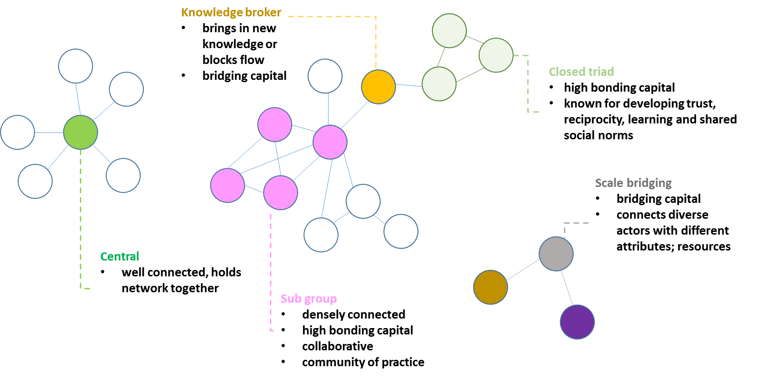
Table 1 summarises the social network measures and methods that were applied and reported in the results section of the report. Network features (see Box 1 and Table 1 (column 2)) are components of a social network that are related to particular desired processes (Table 1 (column 1)). A number of important structures of networks were identified as indicators of whether marine pest social network had these desired features, and hence can deliver the desired outcomes. Furthermore, qualitative analysis was applied to the open-ended survey questions and interviews.

Descriptive network analysis
Descriptive network analysis was used to describe how the network is currently functioning in terms of advice/information and resource flows (Table 1). These methods are discussed in more detail in Appendix 3 (‘Descriptive network analysis’) and are listed in the Glossary. All descriptive network analyses were done using UCINET version 6.654 (Analytic Technologies). Most of the analysis focused on R&D, passive surveillance and education and awareness-raising as prioritised by the client. However, some information about the emergency response and the active surveillance networks have been added for comparative purposes and to illustrate key points.

Table 1 Methods—measuring the extent to which the network has the characteristics of interest
Desired processes | Key network feature | Network structure | Network measures/methods used
1. Coordination | Centralised core with high bonding capital | Well connected actors are more likely to be influential | Degree centrality (total degree); Degree distribution (entire network); Statistical network analysis
 |  | Actors who were asked for information are likely to be trusted information sources | Degree centrality (in/out-degree)
 |  | Well connected core to enable quick information flow | Eigenvector centrality;  Qualitative
2. Innovation | Bonding capital | Loosely connected communities of practice | Girvan-Newman;  Statistical network analysis; qualitative
 | Bridging capital | Knowledge-brokers | Betweenness centrality;  Statistical network analysis (see Table 7)
3. Collaboration | Bonding capital | Strong connections between actors within a group, e.g. within policy forums or a community of practice | Reciprocal relationships/triad census;  Statistical network analysis (Table 7);  Qualitative
 | Bridging capital | i) Links across levels of administration and/or different sectors (Table 4), e.g. government-industry-NGO | Contingency table (Appendix 6, Figure 49);  Statistical network analysis (Table 7);  Qualitative
 |  | ii) Policy forum attendees linking to broader stakeholder network

Statistical network analysis
Statistical network analysis was undertaken using Exponential Random Graph Modelling (ERGM). ERGM identifies over or under representation of configurations in a network (Frank and Strauss, 1986, Wasserman and Pattison, 1996). This analysis assists in delivering an assessment of the effectiveness of the structure of information flows, including the network’s propensities for coordination, innovation and collaboration. More detail on the statistical network methods used to explore the network are specified in Appendix 3.

Qualitative analysis
Qualitative textual analysis was done on the open-ended questions in the marine pest network survey to summarise the main themes.

Characteristics of an ‘ideal’ marine pest network
In order to explore to what extent the current marine pest network structures support the desired processes of coordination, innovation and collaboration, clear definitions of these terms are needed. This section provides a short literature review of what these processes involve and how they may be present in a social network. Several of the terms are explained in Box 1 and in the Glossary. Table 2 provides an overview of the ‘ideal’ marine pest network and is an expanded version of Table 1 based on the network functions. Ratings (‘high’, ‘moderate’, or ‘some’) were used to assess how much of the processes could be expected to be seen in the ‘ideal’ marine pest network that would indicate that network structures are present to support the functions (Table 2). These ratings are based on subjective judgements of the project team drawn from discussions with the client and social network theory.
To effectively respond to natural resource management issues the network processes of coordination, innovation and collaboration need to reach across administrative levels, such as on-ground, state/territories, and the national levels. This relates to both ties between actors or groups located on one level, as well as ties to enable information and resource flow in multiple directions across levels (Alexander et al. 2017). This enables different stakeholder groups to learn from each other and to integrate different knowledge types to find workable ways forward to address marine pest issues (Armitage 2008).

Coordination
What does it mean?
Effective coordination in a network is important for a range of reasons, including facilitating quick information flow and task delegation (McAllister et al. 2015). Coordination is needed to enable rapid responses and decision-making by a small number of actors, but this needs to be balanced with access to multiple sources of information that can assist with learning (Bodin et al. 2006).
Coordination across multiple organisations can help bring together semi-autonomous groups to assist each other in accomplishing goals (McNamara 2012). Coordination interactions are where the behaviour of actors is fairly certain as it is generally stipulated by organisational policies, laws or strong pre-existing social norms (McAllister et al. 2017). Centralised networks are therefore typically characterised by low transaction costs for coordinating agreed-upon actions (Barnes et al. 2017b) as there is no need to invest in negotiating the terms according to which the interactions will occur.
Link to network structures
To support effective coordination, the marine pest network would need to have a high level of centralisation (Table 2 (1a)). Centralised organisational networks, that have a small number of actors occupying highly central positions, would facilitate coordination because the central actors are in a position to distribute information quickly and effectively to the rest of the network (Berardo and Scholz 2010). A highly centralised network could include interactions resembling a 'star'—with peripheral actors connected to the central actor (Figure 1). In reality, the central actor could be a number of actors making up the core group.
Table 2 Structural characteristics of the ‘ideal’ marine pest network
Desired processes | Network feature | Functions of network²
 |  | a) Entire network¹ | c) Passive surveillance | d) R&D | e) Education/ awareness-raising
Coordination | 1. Centralised core with high bonding capital | High, particularly in formal network | Some, but need diverse actors and distributed on-ground network | Some, but need balance between ability to coordinate and pockets of innovation | Some, but need diverse actors and distributed on-ground network
Innovation | 2. Communities of practice | Moderate | Moderate pockets of activity that are location or pest specific | Moderate pockets of research information sharing | Moderate pockets of activity that are location or pest specific
 | 3. Knowledge-brokering | Moderate | High, e.g. links with on-ground groups for trust building and two-way information flow | High between researchers and policy-makers; and with resource managers (for on-ground uptake); as well as allowing for inter-disciplinary research | High, e.g. links with on-ground groups for trust building and two-way information flow
Collaboration | 4. Bonding capital | High for example, bonding within forums or within sub-groups | High between state/territory agencies and other actors involved in passive surveillance programs | High between research and other groups | High between state/territory agencies and other actors
 | 5. Bridging capital | High with links between different sector groups and policy forum attendees linking to broader stakeholder network | High with two-way links from higher levels to on-ground actors, e.g. port managers, marinas, community groups active in the area | High, e.g. links across research-government-industry-on-ground groups to promote knowledge sharing | High to ensure information flow and trust between on-ground and higher levels. Links between on-ground groups are also valuable to share lessons learned and support one another
1 Entire network should be multi-functional; and offer structures and processes that support all the network functions.
²The Department of Agriculture identified passive surveillance; R&D; education and awareness-raising as key functions of interest for the analysis.

The entire network should be multi-functional; and offer structures and processes that support all the network functions. Therefore, the centralised structures need to be balanced by more distributed network structures to enable engagement of a diversity of stakeholders in shared tasks such as active and passive surveillance, R&D, and education and awareness-raising functions (Table 2 (1b-d)). In the case of the R&D information network, pockets of denser connections in that subset of the network, i.e. various communities of practice, would indicate information exchange related to R&D on a specific issue or location (Table 2 (1c)).

Innovation
What does it mean?
Innovation refers to activities and interactions that initiate, modify and diffuse new ideas, institutions or technologies (drawing on Freeman 1995). It is increasingly recognised that innovation that leads to societal progress typically involves co-evolving technological, social, economic and institutional change (Klerkx et al. 2012). This means that while R&D forms an important part, it is not the sole component of innovation. Knowledge-brokers (Figure 1) play a key role in innovation by connecting and translating information and knowledge between different groups.
Change can come about either incrementally through adaptation or through transformation. Adaptation typically involves relatively simple tasks that can be managed within the existing network. Transformation may involve complex tasks that call for a substantial reorganisation or the establishment of a fundamentally new network system. In both cases there is a need for changed norms, rules and human behaviour.
Link to network structures
Certain configurations in a social network might support innovation. Fostering innovation requires multiple interactions between various actors in the network (Klerkx et al. 2012).
Bonding capital is particularly valuable for incremental change of the network (Barnes et al. 2017b). Incremental changes are likely to be supported by closed configurations in the network, such as closed triads—where all actors of a three-actor cluster are connected to each other— that have been shown to facilitate learning (Prell and Lo 2015 Barnes et al. 2017b). They are important for ‘combining and reinforcing existing knowledge to make incremental updates and respond to change’ (Barnes et al. 2017b). The presence of sub-groups (for example, indicated by closed triads or areas of greater cohesion; Figure 1) would demonstrate that diverse knowledge bases could contribute to feedback opportunities and innovation in the overall network (Bodin et al. 2006). Moderate levels of sub-grouping could be expected in the entire marine pest network, and the passive surveillance and R&D functions if innovation was being well-supported (Table 2, (2b-c)).
More substantial transformational change is likely to be supported by bridging capital in the form of connections between actors with different attributes, such as different knowledge types or resources, across levels, or scales (Figure 1). Knowledge-brokering linkages between particular actors or in the marine pest network are expected to be high for the passive surveillance, R&D and education and awareness-raising functions, and moderate for the entire network and active surveillance function (Table 2, (3a-d)). However, actors who are well positioned to be knowledge-brokers need to be willing to actively take on the role as knowledge-broker.

Collaboration
What does it mean?
Collaboration is an interaction between actors who work together to pursue complex goals based on shared interests and a collective responsibility. Goals involve tasks that are interconnected and cannot be accomplished individually (McNamara 2012). In collaborative interactions, in contrast to coordinated interaction, the norms and shared rules used to govern the key behaviours of the actors are not stipulated in organisational policies or laws and need to be developed as part of the partnership (McNamara 2012). Decisions are made through negotiation, and the tendency is for open and frequent communications to establish common knowledge and understandings. This generates significant transaction costs, and frequent and many links between players.
The requirement for negotiation points to the need for bonding capital, whereas the need to link diverse actors indicate the need for bridging capital. Collaboration is required for functions such as active surveillance, passive surveillance, R&D and education and awareness-raising.
Link to network structures
The simplest form of bonding capital is reciprocal dyads (two actors with a two-way connection between them), followed by the closed triad (three actors connected). A fully completed triad, where all ties are reciprocated, is the strongest indicator of bonding capital in a social network (see Appendix 3 ‘Bonding and bridging’). Closure indicates bonding because the configurations are inward looking (Berardo 2014). Such structures in the entire marine pest network would include collaborative linkages between a number of actors and bonding within policy forums among affiliated organisations (Table 2 (4a)). Reciprocal connections within state and territory governments (between different departments) involved in active or passive surveillance programs would indicate bonding capital (Table 2 (4b)). Reciprocal connections between research groups and research groups with other actors would indicate collaborative relationships were supporting R&D functions (Table 2 (4c)), as well as a high number of such connections between state and territory government agencies and state and territory government agencies with other actors implementing education and awareness-raising activities (Table 2 (4d)).
In terms of bridging capital, the marine pest network would include a moderate to high amount of collaborative linkages between different sectors, such as between governments and on-ground groups such as port managers, community groups, marinas in marine pest 'hot-spots' (Table 2 (5a, 5b, 5d)) and links between research, industry and on-ground groups (Table 2 (5c)). Linkages between administrative levels such as between Commonwealth and their counterparts in state and territory governments would also be indicative of collaboration.

Results
This section describes the results of the network analyses, as it relates to the project aims. The results focus on the organisations that participated in the network, how information and resources flowed and what may hinder or enable such flows. Background information useful for interpreting the SNA and the network graphs is contained in Appendix 4.

Organisations and forums represented in the network studied
There were 316 organisations (or their branches) and policy forums identified in the overall marine pest network. Organisations, or their branches, were identified if representatives of that organisation filled out the survey, or were nominated as a contact by a survey respondent (Table 3). Policy forums were identified during the discussions between the project team and MPSC members and a scan of marine pest biosecurity policy documentation.
Table 3 Organisations (or their branches) engaged in marine pest biosecurity networking
Type | counts | % represented in network
Policy forums (e.g. committee) | 12 | 4
Organisations (or branches) with survey respondents1 | 118 | 37
Organisations nominated by survey respondents2 | 186 | 59
Total organisations/branches | 316 | 100
1Respondents may also have been nominated by other respondents
2Nominated only, people in these organisations did not submit a survey (or did not complete a survey to the necessary standard).
Most legislated responsibility and rule-making power remains largely within government organisations and responsibility for different marine pest issues are located at different levels of government. For example, most responsibility for dealing with on-ground management of marine pests is with state and territory jurisdictions. Discussions with MPSC members suggested that MPSC has considerable influence on jurisdictional dialogues and engagement; however, it should be noted that the committee has no powers to enforce decisions. It assists with facilitating collaboration or cooperation on certain issues. Likewise, the Department of Agriculture' powers relate to Commonwealth waters, including preventing and responding to exotic marine pest introductions. For ballast water, the Department of Agriculture has authority over all jurisdictions.
Organisational types represented in the network ranged from private companies/businesses (36 per cent), Australian Government organisations including their branches (11 per cent), state and territory governments (11 per cent), research/training organisations (8 per cent), port managers (8 per cent), to industry associations (8 per cent) (Table 4). On-ground organisations, such as regional NRM groups, NGOs, education/extension organisations and vessel service providers (marinas, slipways), collectively represented 13 per cent of the entities identified in the marine pest network. The remainder was made up of international governments, local governments and state owned corporations.
186 organisations were nominated, by at least one individual, for which no usable survey responses were provided. The assumption is that critical actors in the network were identified this way and that it is sufficient for their network position to be adequately represented in the data. There was no way of measuring potential ties between nominated pairs within the set of 186 organisations using the current methods. By using ERGM it was determined that treating potential ties as ‘missing’ did not significantly influence the results, suggesting our assumption holds that the survey provides a good sample of the network.
Table 4 Sectors represented in the marine pest biosecurity social network
Sector | Organisation/ branch / forum  (organisation/ branch counts) | Sector represented in network  (%) | (1) Provided information to community  (tie counts) | (2) Asked community for information  (tie counts) | Both (1) and 2)  (tie counts)
Private company/business | 114 | 36 | 5 | 0 | 0
Australian Government1 | 36 | 11 | 2 | 0 | 0
State/territory government | 35 | 11 | 12 | 3 | 2
Research/training organisation | 27 | 8 | 0 | 0 | 0
Industry association/body | 25 | 8 | 1 | 0 | 0
Port manager | 25 | 8 | 1 | 0 | 0
NRM/Regional government | 13 | 4 | 1 | 0 | 0
International Government | 10 | 3 | 2 | 0 | 0
Education/extension organisation | 9 | 3 | 2 | 0 | 1
Non-government organisation | 9 | 3 | 0 | 0 | 0
Vessel services (e.g. marina, slipway) | 9 | 3 | 1 | 0 | 0
Local government | 2 | 1 | 1 | 0 | 0
State Owned Corporation | 2 | 1 | 0 | 0 | 0
Total | 316 | 100 | 28 | 3 | 3
1Includes Commonwealth government departments; Department of Agriculture branches; and policy forums. In total, 12 different Australian Government organisations were identified (inclusive of the Department of Agriculture). Within Department of Agriculture, there were 17 separate branches. Of the 12 policy forums, eight were national policy forums and four were state convened forums.

Policy forums for marine pest biosecurity
Policy forums were groups or committee meetings where stakeholders had the opportunity to interact and participate in two-way discussions on marine pest biosecurity. Table 5 lists the key forums identified as part of this study. The discussions with MPSC members revealed that there were state and territory-based formal forums in some jurisdictions that dealt with marine pests, but not in all. A few members mentioned that it was an area that is under development in their jurisdiction, while others had a reference group that they consulted on an as-needs basis.
The formal network was predominantly comprised of government actors (Figure 2). National forums were located at the centre with dense connections to state and territory agency members. The MPSC - Partner Workshop was one of the only ways that key non-government and industry organisations were linked to the national forums.
During the key stakeholder discussions, some people expressed their support for the move towards seeing all stakeholders as potentially equal collaborators depending on their level of interest, as expressed in the MarinePestPlan 2018–2023. There was concern that the marine pest approach is too ‘Canberra-centric’ with a key focus on pushing information out to other stakeholders.
Table 5 Policy forum participation
Title | Forum details | Participating organisations or their branches  (actor counts) | Individual attendances at the forum  (tie counts)
CCIMPE | Consultative Committee for Introduced Marine Pest Emergencies | 16 | 87
MPSC | Marine Pest Sectoral Committee | 13 | 64
MPSC - M&S_TG | MPSC - Marina and Slipways Task Group | 9 | 11
MPSC - NMPS&DS_SG | MPSC - National Marine Pest Surveillance and Diagnostics Strategy Scoping Group | 10 | 16
MPSC - PTNR | MPSC - Partner Workshop | 39 | 96
MPSC - NMPBS_TG | MPSC - National Marine Pest Biosecurity Strategy Task Group | 7 | 8
MPSC - SS_TG | MPSC - Surveillance Strategy Task Group | 23 | 33
NBC | National Biosecurity Committee | 15 | 61
NSW MPWG | NSW Marine Pest Working Group | 7 | 32
QLD IAMPRG | Queensland Inter-Agency Marine Pest Reference Group | 8 | 17
WA BSOG | West Australian Biosecurity Senior Officer Group | 3 | 9
SA MBF | South Australian Marine Biosecurity Forum | 10 | 16

Figure 3 represents the relative ability to influence the policy forums based on the number of organisations connected to them (degree centrality; direction of ties non-applicable) and their betweenness centrality. These configurations are particularly helpful for coordination.

Figure 2 Formal network—attendance of policy forums between October 2016 and November 2017

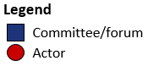
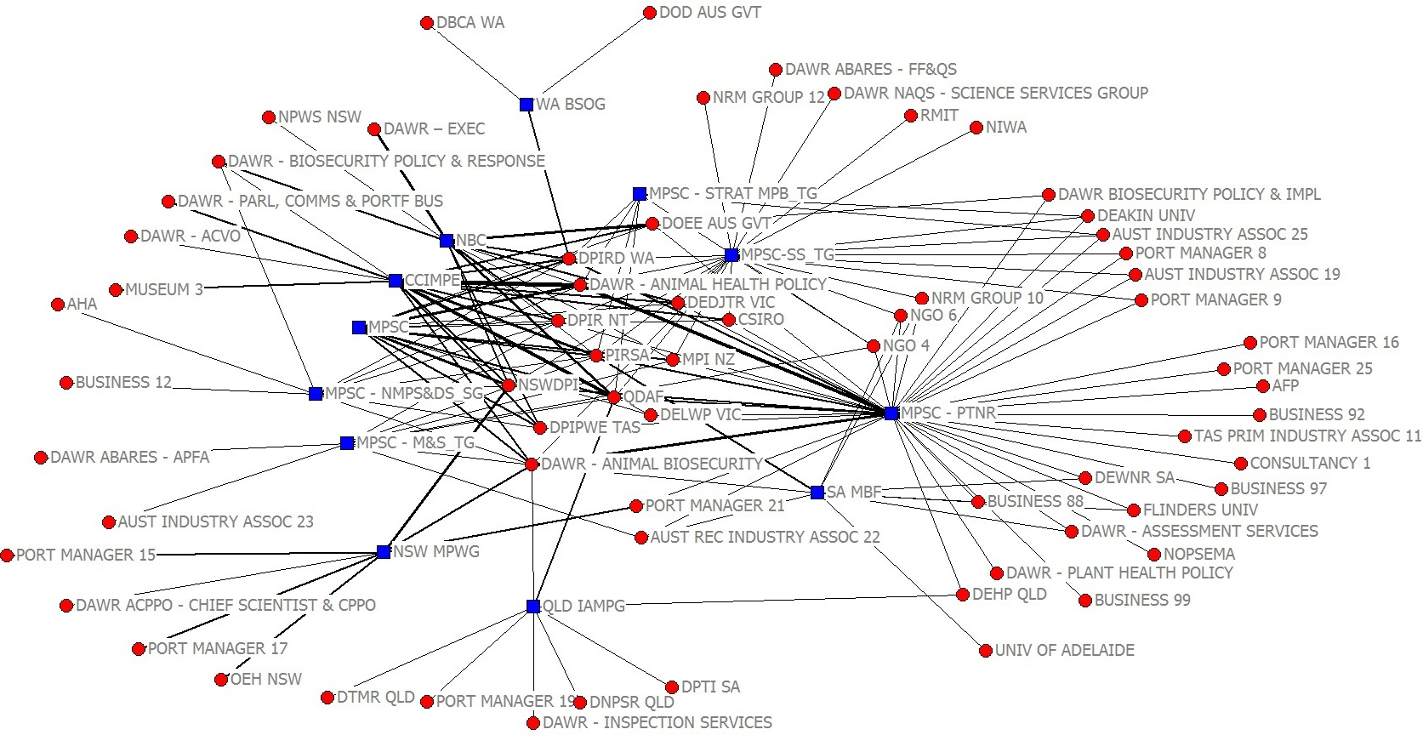

Source: ABARES marine pest network survey 2018. Note: Blue squares are policy forums and red circles are organisations with individuals attending specific forum events. Tie thickness indicates number of people in an organisation who attended a forum, i.e. the more attendees, the thicker the connecting line.
Forums with higher influence, as measured by their degree, were the MPSC - Partner Workshop, MPSC-SS Task Group, CCIMPE, NBC and MPSC; these had more ties linking other organisations to them. The highest betweenness—a measure of how well a forum connects disparate sub-groups—was held by the MPSC – Partner Workshop because it connected an otherwise disconnected set of stakeholders into the formal network.
Policy forums functioning at the state level, including NSW MPWG and QLD IAMPG, also played important linking roles, indicated by their higher betweenness scores. These forums were enabling other state government departments, port managers, museums, NRM groups, research organisations and private businesses, in their respective states to connect into the national forums.
Figure 3 Policy forum network—influential committees

Source: ABARES marine pest network survey 2018. Note: analysis of the 2-mode policy forum network produced normalised scores (i.e. rescaling of scores between 0 and 1 to improve presentation) for degree and betweenness against the maximum possible scores in an equivalently sized connected 2-mode network.

Entire marine pest network
This section presents results of the analysis of the entire network, which includes both the formal and informal network. Guidance on interpreting the network analysis, particularly the network diagrams, is contained in Appendix 4.

Coordination (Centrality)
The network analysis provided the opportunity to understand which actors (i.e. organisations) were positioned to play relatively important roles structurally, and by proxy, those who may have more influence in the network. The potential for influence was measured based on degree distribution and total degree centrality, based on sharing of information/advice. An additional analysis identified who the core of interconnected actors were at the centre of the network using k-core analysis.

Degree distribution
The overall network is centralised around a small number of core actors. When plotted on a logarithmic scale, the degree distribution of the network appeared approximately linear but fans out in the high degree tail (Figure 4). This is indicative of a centralised network; or power-law distribution associated with scale-free networks² (Albert and Barabási 2002; Barabási and Albert 1999). Rather than each actor having degree close to the average, these centralised networks have a few `hub-and-spoke' structures in which most actors are sparsely connected with the exception of a few high degree hubs. These high degree hubs are also likely to have highest centrality.
Apart from some of the Department of Agriculture’s branches, it was mostly state and territory government organisations that formed such hubs with various spokes to organisations in their jurisdictions (Figure 7). The discussions with MPSC members suggested that there were differences between states and territories in terms of their established networks. Some had highly developed networks, while others were in the process of strengthening their networks, or parts thereof, within their jurisdictions. Several mentioned that they have limited time and resources to build and maintain important connections.
Figure 4 Degree distribution of marine pest network
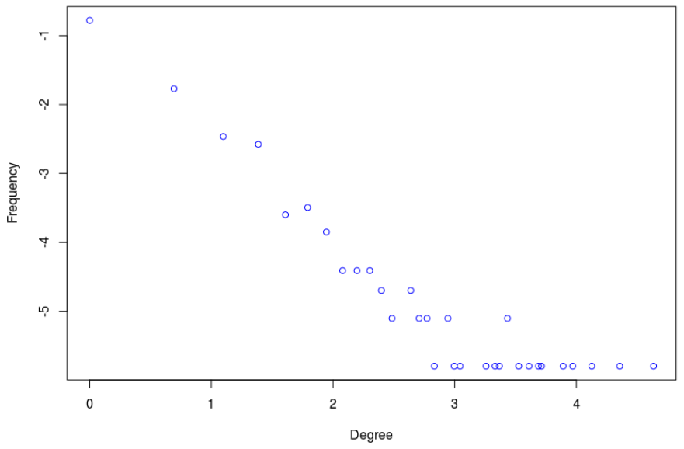
Degree
Frequency
The marine pest network exhibited small-world network characteristics. The average path length for the marine pest network was only 3.5 steps, which is considered short, meaning that across the whole network, any actor was on average only a few steps away from any other. The small-world index (σ) for the marine pest network was calculated and compared with clustering and path length properties of other empirical social and biological networks (Table 6) (Watts and Strogatz 1998). The marine pest network has an σ of 60.785, which means it met the small-worldness criteria.
Table 6 Empirical examples of small-world networks compared to marine pest network
 | L_{a} | L_{r} | C_{a} | C_{r} | n | Small world index σ
Film actors | 3.65 | 2.99 | 0.79 | 0.00027 | 225226 | 2484.277
Power grid | 18.7 | 12.4 | 0.08 | 0.005 | 4941 | 10.610
Caenorhabditis elegans (worm) | 2.65 | 2.25 | 0.28 | 0.05 | 282 | 4.755
Marine pest social network | 3.46 | 3.86 | 0.87 | 0.016 | 316 | 60.785
Characteristic path length L and clustering coefficient C for three real networks, compared to random graphs with the same number of actors (n) and average number of edges per actor (in Watts and Strogatz 1998). The small-world index, σ = (C /Cr) / (L/ Lr) is estimated; where, C is the clustering coefficient of the network, L is the average path length of actor pairs in the network, Cr is the clustering coefficient of the equivalent random network with same number of actors, and Lr is the average path length for actor pairs in a random network with same number of actors. If the small-world index, σ > 1 (i.e. C >> Cr and L ≈ Lr), then the network can be said to be small-world. Calculations for these metrics are described in Appendix 3 Detailed methods (‘Descriptive network analysis; small-world properties’).

The core of the network
A k-core analysis was performed to identify the organisations that form the core of the highly centralised network (Figure 5). Coreness is a measure that can help identify interlinked groups of actors in a social network. This shows that a ‘core’ of well-connected actors in the marine pest stakeholder network consists of Australian and state/territory government agencies, mainly those represented on the MPSC, and a government research provider. For a centralised network, the k-core analysis suggests the network is dominated by this core of actors.
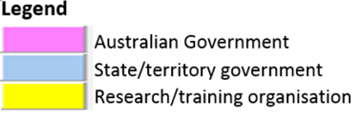
Figure 5 Core of well-connected actors in the marine pest network
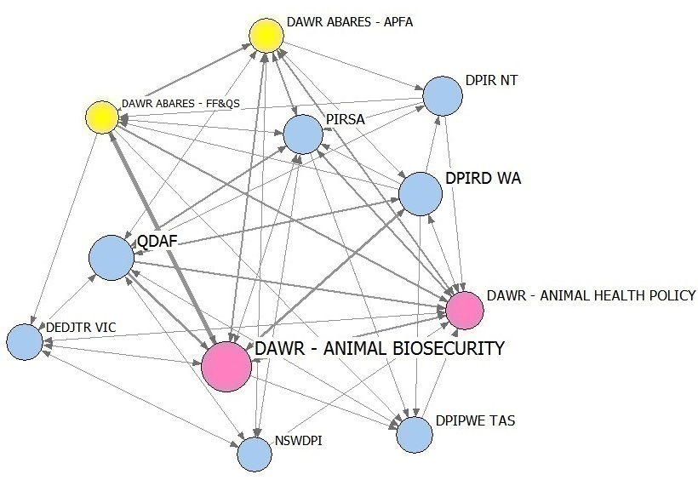
Source: ABARES marine pest network survey 2018. Note: K-core shown for group of actors who share 5 ties or more with all others in the group. Thickness of ties indicates number of connections for both asking for and providing information/advice. Colour indicates the organisational sector type (see legend).
Influential actors (total degree)
The most connected organisations (total degree) in the marine pest network were: DAWR Animal Biosecurity Branch, Queensland Department of Agriculture and Fisheries (QDAF), Department of Primary Industries and Regional Development, Western Australia (DPIRD WA), DAWR Animal Health Policy Branch, and Primary Industries and Regions South Australia (PIRSA), with more than 100 connections each (Figure 6; see Appendix 8 Actor attributes for full list of abbreviations used in the network diagrams).
Figure 6 Who is the most connected in the network (total degree)—information/advice flows and attendance of forums
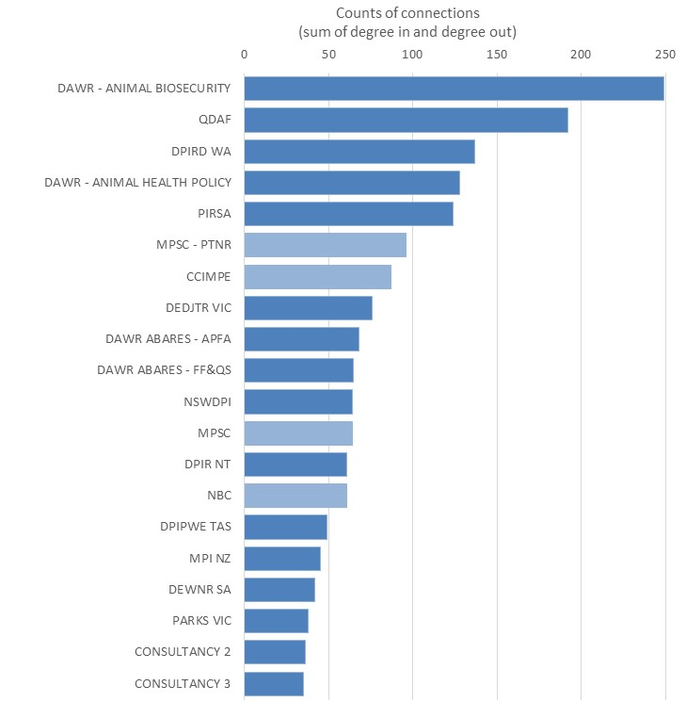
Source: ABARES marine pest network survey 2018
Note: Using the entire network (all ties); lighter shaded bars are counts of forum attendance (formal network); darker shaded bars are counts of information/advice exchange via working relationships between organisations (informal network). Darker shaded bars show any information/advice flow based on the survey questions: 1) Who did you provide marine pest related information or advice to over the last 12 months, and 2) Who have you asked for marine pest related information and/or advice over the last 12 months. Figure shows the top 20 organisations.
The actors with a high total degree in the marine pest network were all Australian Government and state/territory government organisations, which indicates a government-centric network. The only non-government stakeholders represented in the top 20 for total degree were consultancies. A large number of other marine consultants and private businesses were in the network, but had lower connectivity. 18 Australian and international universities were represented, with just under half of these nominated by other survey respondents, and therefore had low connectivity. Twenty-five port authorities were in the network, with more than half of them survey respondents and most had low connectivity (except a port manager in WA, which was connected with seven other WA port managers). Six museums (representing five different states/territories and Australia) were in the network but had relatively low connectivity despite most participating in the survey.
There were a number of sectors that were under-represented in the network and where they were represented their overall connectivity was low. There were three NRM regional groups, nine NGOs and a near absence of local government organisations (only two). Partly this is a function of the marine pest network survey only reaching a small number of these groups as the invitation list was developed based on the formal network players. However, any groups who are prominent in the network would have been nominated by others. For example, there were 11 fishing and aquaculture industry representative bodies present in the network, involving three who completed the survey and eight who were nominated by others. There were three recreational fishing representative bodies represented, one of whom completed the survey and two others nominated.

Figure 7 Social network diagram of the entire network—information and/or advice flows and attendance of forums
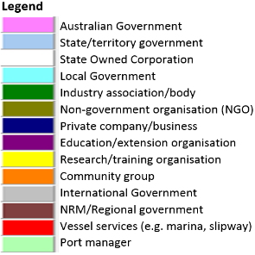
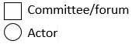
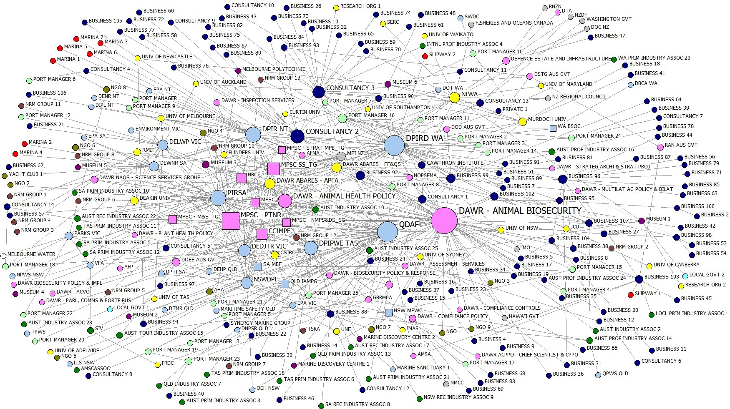
Source: ABARES marine pest network survey 2018. Note: Size of the shape is the degree centrality (total degree) of the actor in the network. Ties indicate connections for both asking and providing information/advice. Colour indicates the organisational sector type (see legend).

Trusted information sources
Figure 8 shows the direction of information/advice seeking behaviour across the whole network for any type of information.

Out-degree
Organisations that functioned as substantial information sources (high out-degree) in the marine pest network included DIPRD WA, a consultant, and state/territory government agencies, including PIRSA, DIPR NT and NSWDPI. The Ministry for Primary Industries NZ was also a popular information source.

In-degree
The greatest seekers of information and advice (high in-degree) in the network were QDAF, DAWR Animal Biosecurity Branch, DAWR Animal Health Policy Branch, DAWR ABARES-APFA, PIRSA, DEDJTR, a consultancy and DAWR ABARES – Fisheries, Forestry and Quantitative Sciences.
Figure 8 Who have you asked for marine pest information/advice over the last 12 months?
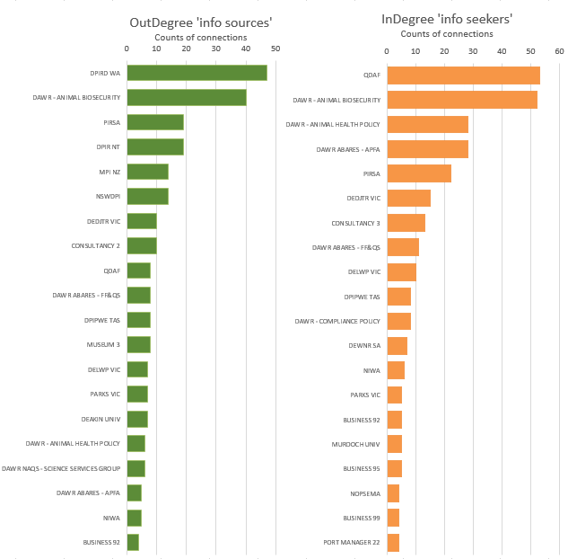

Source: ABARES marine pest network survey 2018. Note: Graph made using the survey question ‘Who have you asked for marine pest related information and/or advice over the last 12 months’ where respondents indicated any marine pest related information. Figure shows top 20 organisations for ‘Info sources’ and ‘Info seekers’.

Much of the data is likely to be contextual. If there was focus on a specific topic, such as dealing with biofouling and ballast water, then it can be expected that experts in these areas will be asked more than usual for information. For example, in Queensland the emergency responses to Asian green mussel (Perna viridis) resulted in instigating or strengthening various connections between QDAF staff and those affected by the outbreaks as confirmed in the emergency response network (see Emergency response, p65).

Speed of information flow
Degree centrality is a limited interpretation of social importance. Organisations can also have potential social influence or power if they are closely linked to other organisations that have high degree centrality. A method of identifying such organisations is Eigenvector Centrality. Five out of the top 20 actors with higher eigenvector centrality were national forums (Figure 9).
Figure 9 Information and advice (all ties)—organisational influence based on eigenvector centrality score
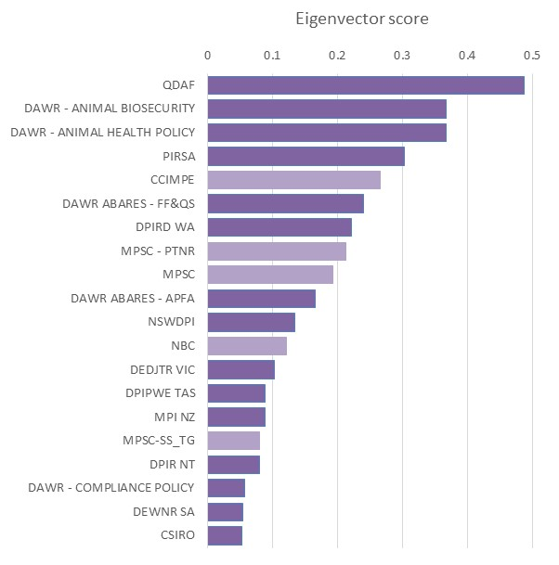
Source: ABARES marine pest network survey 2018
Note: Bars show eigenvector scores for the top 20 actors in the networks. Lighter shaded bars indicate a forum (formal network).

Figure 10 Information and advice network (all ties)—showing organisational influence based on eigenvector centrality
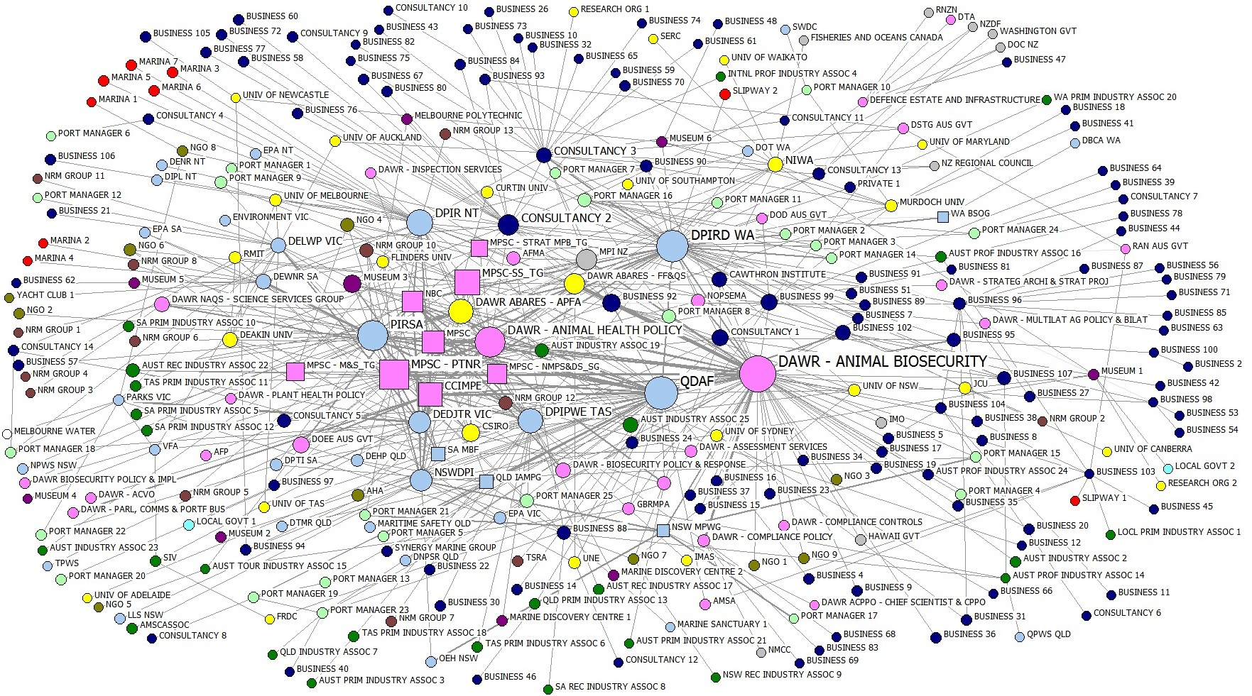

Source: ABARES marine pest network survey 2018. Note: Size of the shape is the eigenvector centrality of the actor in the network (larger means more ties). Thickness of ties indicates number of connections for both asking and providing information. Colour indicates the respondent type (see legend).

Innovation

Communities of practice
Different communities of practices are beneficial for innovation as their presence signals there are opportunities for combining different knowledge systems and enabling experimentation and some level of risk taking. Communities (or sub-groups) tend to emerge when a set of actors connect with each other at higher rates than how they connect with actors elsewhere in the network.
Eleven sub-groups were identified in the network using the Girvan Newman (2002) algorithm, which detects internally dense groups (Figure 11). The analysis was based on data provided by survey respondents to the questions: 1) Who did you provide marine pest related information or advice to over the last 12 months, and 2) Who have you asked for marine pest related information and/or advice over the last 12 months. Just over half of the network were assigned to the largest community. This sub-group contained all of the national policy forums, Australian Government departments, including Department of Agriculture branches, and a range of other organisations (red). The next largest community was a West Australian based sub-network connecting DIPRD WA with a number of port managers and universities (pink), and several stakeholders formed their own communities, such as some consultancy businesses. In effect, this model suggests the network is comprised of a small number of large communities, as would be expected given that scale-free networks tend to lack community structure.

Knowledge-brokers
While actors with high degree are not necessarily the most central, if the observed network is centralised then we would expect considerable overlap between the high degree actors and the other measures of centrality, i.e. high betweenness and high eigenvector centrality. Based on the betweenness centrality measures, major bridges to different parts of the network were DAWR - Animal Biosecurity, DPIRD WA and QDAF (Figure 12). Two consultancies and three businesses also form part of the twenty actors that rated the highest for betweenness.

Figure 11 Sub-groups in information network
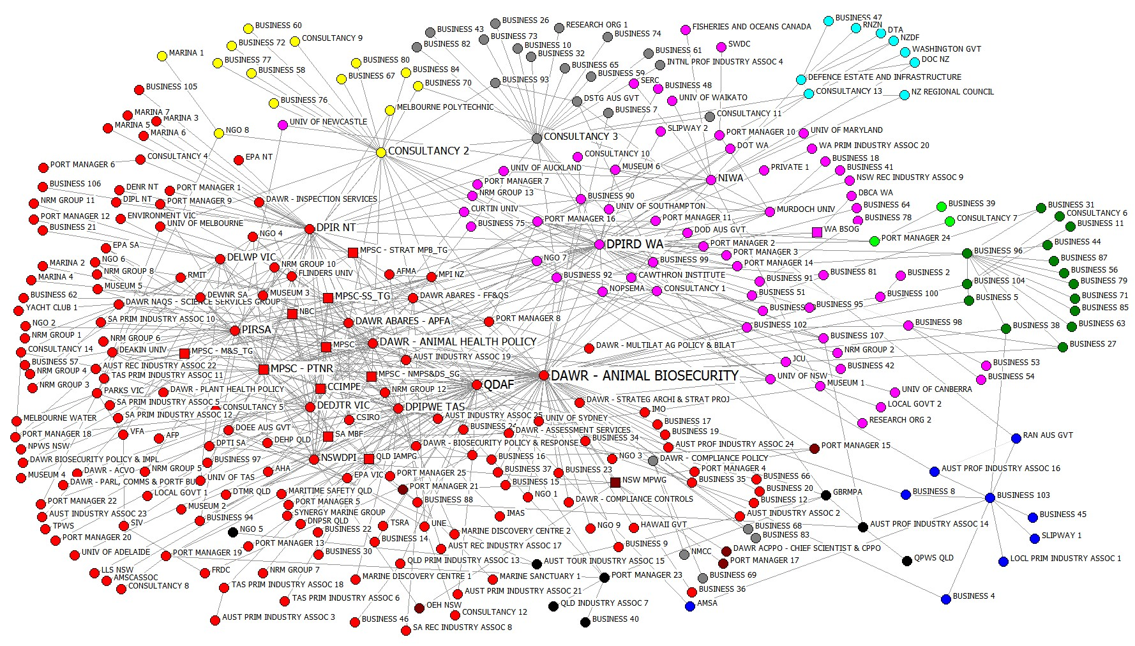

Source: ABARES marine pest network survey 2018. Note: The different colours represent membership of one of 11 sub-groups detected for all information flows (all ties) in the network. Sub-groups identified using the Girvan-Newman (2002) algorithm where 11 clusters were identified as the appropriate number of clusters based on the ‘Elbow method’ (Ketchen Jr and Shook 1996).
Figure 12 Key potential knowledge-brokers
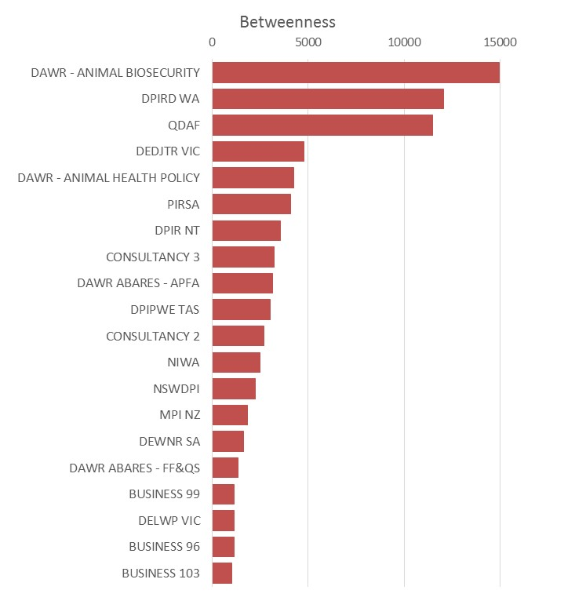
Source: ABARES marine pest network survey 2018. Note: Betweenness scores are based on Freeman betweenness (Freeman, 1977), a measure of centrality based on number of geodesic paths between two actors that pass through an actor. Based on survey data for all information flows (all-ties). Figure shows the top 20 organisations.

Collaboration

Bonding capital
Key configurations supporting collaboration in a social network are reciprocal relationships between two actors, and relationships between three actors (closed triads). These combinations are strong indicators of bonding capital that supports collaboration. The reciprocity exists at the organisational level in this analysis because working relationships between individuals were aggregated to the organisational (or branch) level.
A descriptive analysis of reciprocal relationships in the marine pest network using UCINET software revealed that 24 per cent of relationships in the network, are reciprocated at the organisational level. These two-way relationships radiate outwards in ‘hub and spoke’ formations mostly from QDAF, DAWR - Animal Biosecurity and DIPRD WA. Other state and territory agencies including PIRSA, DEDJTR VIC, DPIR NT, NSWDPI have some radiating reciprocal relationships with other government agencies, universities, museums and on-ground groups. A number of consultancies, universities, businesses, museums and industry associations have a small number of reciprocal relationships but these are mainly between them and the core actors rather than with each other.
A census of triads using UCINET software, revealed more than 500 closed triads in the entire marine pest network, which indicates considerable bonding capital. The closed triads were not evenly spread across the marine pest network. It is a highly centralised network, so the majority of these configurations were located at the core, between members of 'the core' of Commonwealth agencies and state/territory governments. Of these 500 triads, there were 38 fully reciprocated closed triads; meaning each actor in the triad had two-way relationships with each other, which is the strongest indicator of bonding capital. These completely reciprocated triads are present mainly at the core, and involve DAWR - Animal Biosecurity and QDAF. Only a few of the complete reciprocated triads extended outside of the core, and these involved a museum, a few businesses/consultancies, several universities (including RMIT, Deakin University, University of Sydney, JCU) and an international agency (MPI NZ).
This suggests that bonding configurations are supporting collaboration particularly in the core of the network, among key government actors, but much less so at the periphery of the network.

Bridging capital
Bridging relationships between actors of different levels of administration, or across different industry sectors, such as between governments and on-ground actors, are configurations that could indicate collaboration. The descriptive analysis of bridging relationships (Figure 49) indicates that the most common bridging relationships supporting collaborative across administrative levels are between Australian Government agencies and their counterparts in state/territory governments (43 ties). There are a small number of ties between Australian Government and international governments (9 ties) and only a few between local governments to any other government agencies (2 ties).
Of the bridging relationships supporting collaboration across sectors in the marine pest network (Figure 49), most of these occur between government actors and private companies/businesses (92 ties), and between governments and on-ground groups, which include port managers, NRM Groups, vessel service providers and education/extension organisations (56 ties). Also quite common are bridging links between governments of all types and research/training organisations (39 ties), and between state and territory governments and port managers (23 ties).
This suggests that some bridging configurations are supporting collaboration across scales between the core of network, i.e. government agencies, and private companies/businesses, and to a lesser extent with on-ground organisations at the periphery of the network.

Topics of information sharing

Passive and active surveillance
In the survey, passive surveillance was defined as ‘reporting a chance observation of a potential marine pest, not targeted as part of a survey’. Active surveillance was defined as 'the collection of data to determine the population status (e.g. presence or absence) of one or more marine pests'.
Surveillance tends to mean different things to different people as was evident from some of the interviews. Hester & Cacho (2017) recognise this confusion in terminology, pointing out that passive surveillance, general surveillance and citizen science are often used interchangeably. They posit that surveillance activities are located along a continuum of activities. Passive surveillance is at one end and consists of fortuitous finds by members of the public. On the other end of the continuum lies active surveillance, which is defined as targeted surveillance done by pest and disease management agencies comprising coordinated and planned searches for specific pests and diseases. In between the two ends of the spectrum lies citizen science, involving organised pest reporting by community members, usually of pests that are already present. General surveillance is another category that involves stakeholders who identify and report new or existing incursions as part of their regular interaction with potential hosts, vectors and/or their existing or potential habitat.
As this confusion of terminology may have affected the way respondents filled out their surveys, information about the active surveillance network is also included despite not being a prioritised sub-network. As it is mainly people well versed in biosecurity terminology that carry out active surveillance, it was foreseen that it is less likely that a respondent would have called an active surveillance interaction a passive surveillance interaction than the other way round. Ties that respondents indicated as passive surveillance are therefore likely to be all correct, whereas some ties captured in the active surveillance data may be in fact be passive surveillance ties. Some of the early discussions with key stakeholders suggested that considerable amounts of interaction about passive and active surveillance happens informally rather than through formal channels of communication and some of this activity is captured in the following analyses.

Coordination (Centrality)

Influential actors (total degree)
The passive surveillance network (Figure 13) had less ties and was therefore sparser than the active surveillance network (Figure 14). This suggests there was a lot more interaction occurring in the marine pest network in the active surveillance space than passive surveillance. State and territory government organisations were dominant actors across both passive and active networks (Figure 15). QDAF was by far the most active actor in both passive and active networks.

Figure 13 Passive surveillance network
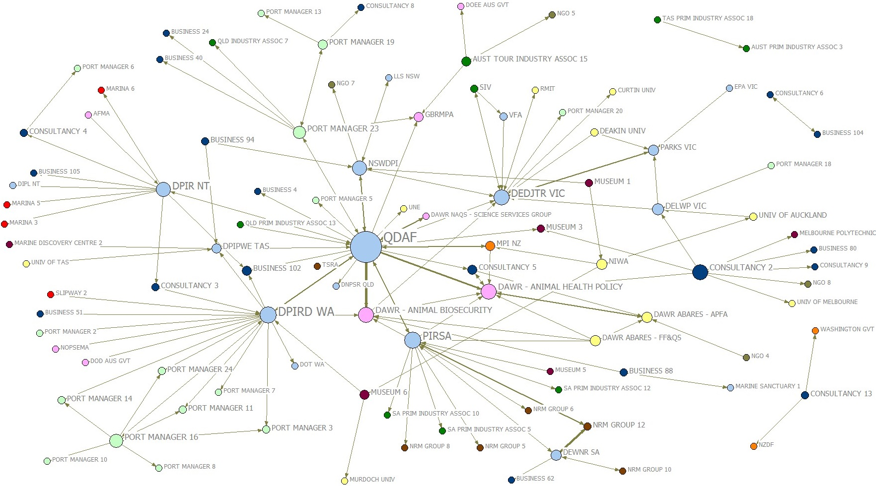

Source: ABARES marine pest network survey 2018. Note: Circles represent organisations exchanging information/advice relating to passive surveillance activities. Size of circles indicates degree centrality (larger means more ties). Thickness of ties indicates number of connections for both asking and providing information. Colours indicate organisational type (see legend).
Figure 14 Active surveillance network
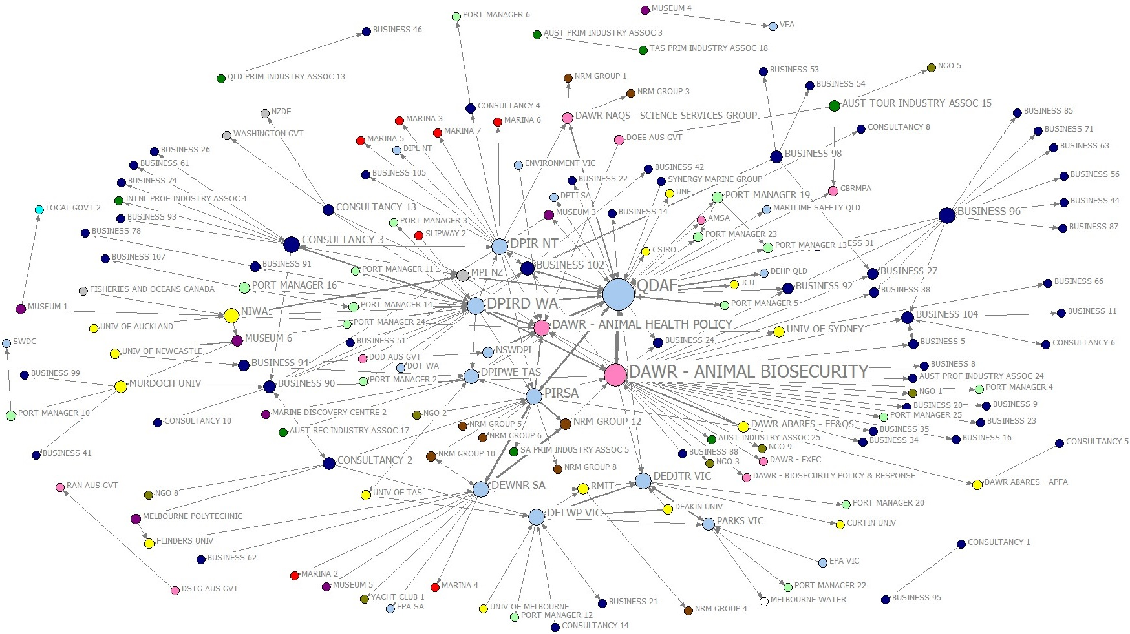
Source: ABARES marine pest network survey 2018. Note: Circles represent organisations exchanging information/advice relating to active surveillance activities. Size of circles indicates degree centrality (larger means more ties). Thickness of ties indicates number of connections for both asking and providing information. Colours indicate organisational type (see legend).
In the passive surveillance network, the next most involved actors after QDAF, were PIRSA and DPIRD WA. Two Commonwealth Department of Agriculture branches were present in the top 10. Key non-government stakeholders included an NRM group and a consultancy. Two port managers were listed eleventh and thirteenth.
During the discussions with MPSC members, several mentioned that passive surveillance, including citizen science was an area that is underdeveloped in their jurisdiction. A few mentioned that plans were in place to develop networks to further capitalise on this opportunity.
In contrast to the passive surveillance network, the active surveillance network showed evidence of far more interaction. After QDAF, the Australian Government (the Department of Agriculture) had a higher centrality in the active surveillance network (Figure 15), as would be expected given their role as a central point for information about national marine pest monitoring arrangements, including collating, coordinating and reporting on monitoring outcomes (Australian Government 2015). Besides QDAF, the more active states/territories who form the core of the active surveillance network were DPIRD WA, PIRSA, DEWNR SA, DPIR NT and three Victorian government departments. NSW DPI appears to have had a low level of interaction about active surveillance matters (ranking 22nd in the list).
Figure 15 Who is the most connected in the passive and active surveillance networks—information/advice flows
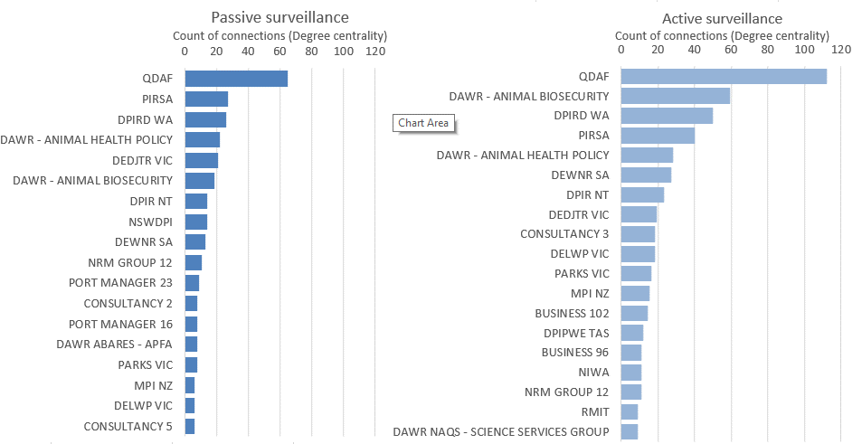
Source: ABARES marine pest network survey 2018
Note: Using the network where respondents indicated passive or active surveillance as the topic of conversation. Based on the survey questions: 1) Who did you provide marine pest related information or advice to over the last 12 months, and 2) Who have you asked for marine pest related information and/or advice over the last 12 months. Figure shows the top 20 organisations.

Trusted information sources
An overview of information/advice seeking behaviour about passive and active surveillance is represented in Figure 16. In the passive surveillance network, the most trusted sources were DIRPD WA, NSW DPI and PIRSA. Actors who were seeking information relating to passive surveillance more often were QDAF, DEDTJR VIC and DAWR Animal Health Policy.
Figure 16 ‘Who have you asked for marine pest information/advice over the last 12 months?’ relating to passive and active surveillance
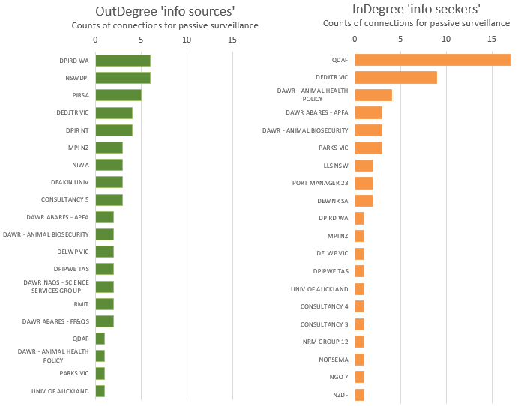
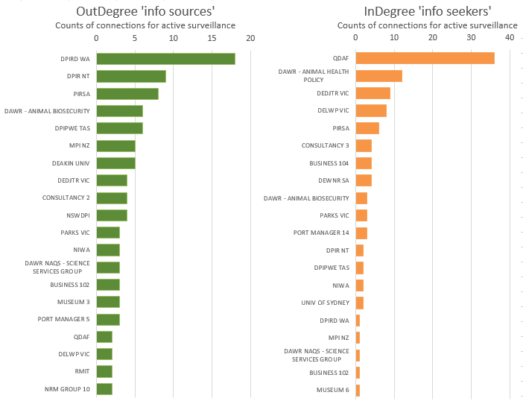
Source: ABARES marine pest network survey 2018. Note: Using the survey question ‘Who have you asked for marine pest related information and/or advice over the last 12 months’ where respondents indicated passive or active surveillance information. Out-degree refers to ‘Information sources’ and In-degree refers to ‘Information seekers’. Figures show the top 20 organisations.
In the active surveillance network, DPIRD WA was the most trusted source of information, followed by DPIR NT and PIRSA. In terms of seeking information/advice about active surveillance, the most frequent seekers were QDAF, DAWR Animal Health Policy and DEDJTR VIC.

Speed of information flow
The eigenvector scores for passive and active surveillance are contained in Figure 17. The actors best positioned for fast information dissemination in relation to passive surveillance were QDAF, PIRSA and two Department of Agriculture branches, that is, Animal Biosecurity Branch and Animal Health Policy Branch. The two highest rating non-government actors were a NRM group and a business.
QDAF scored the highest eigenvector score for active surveillance, followed by DAWR Animal Biosecurity and PIRSA. A business, James Cook University and a port manager were the highest scoring organisations that were not government agencies.
Figure 17 Organisational influence based on eigenvector score for passive and active surveillance
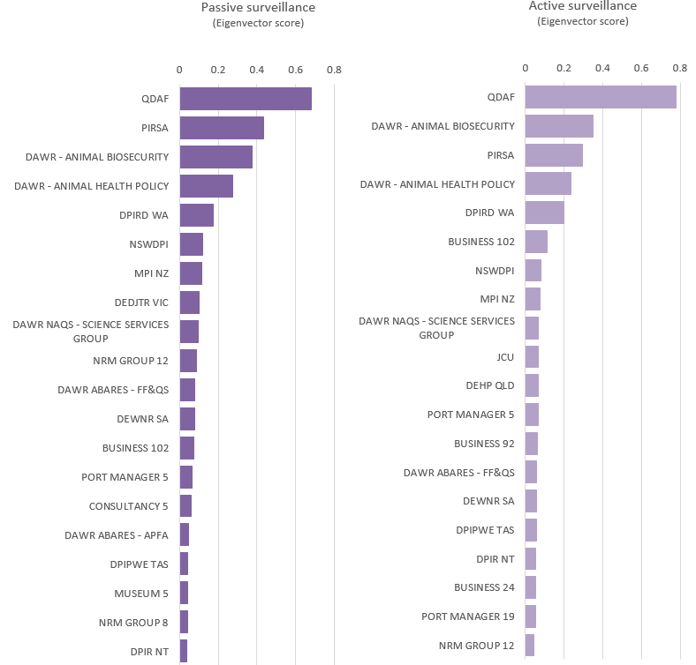
Source: ABARES marine pest network survey 2018
Note: Bars show eigenvector scores for top 20 actors in the networks.

Innovation

Communities of practice
Eight sub-groups were identified in the passive surveillance network using all ties (Figure 19). The largest sub-group revolved around DPIRD WA and DPIR NT. Several state and territory governments formed hub and spoke structures, including DPIRD WA, DPIR NT, QDAF, DEDTJR VIC/NSWDPI and PIRSA. A consultancy business and a port manager also formed hubs and spokes. Interestingly, a port manager (located in Queensland) and GBRMPA formed a sub-group with others, rather than being part of the QDAF-centred sub-group.

Knowledge-brokers
Actors with the highest betweenness scores in the passive and active surveillance networks are listed in Figure 18. In both networks, QDAF was the highest scoring actor. In the passive surveillance network, DEDJTR VIC, DPRID WA and PIRSA are bridges in the network. In the active surveillance network, major bridges are DAWR – Animal Biosecurity and DPRID WA.
Figure 18 Key potential knowledge-brokers for surveillance
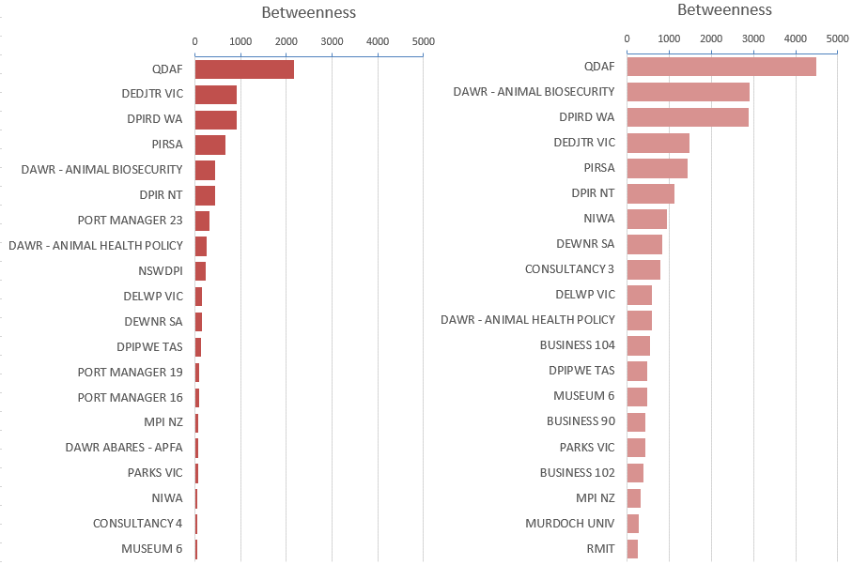
Source: ABARES marine pest network survey 2018. Note: Betweenness scores are based on Freeman betweenness (Freeman, 1977), a measure of centrality based on number of geodesic paths between two actors that pass through an actor. Based on information flows in all directions. Figures shows the top 20 organisations in the networks.

Collaboration
Passive surveillance is a sparser network, so there were fewer reciprocal relationships and closed triads that would indicate bonding capital is present. This means that there were fewer examples of configurations supporting collaboration across this network than in the other sub-networks.
There were 153 reciprocated relationships found between any two actors in the passive surveillance network. Most of these reciprocal relationships were radiating out from QDAF to and from other states/territories, e.g. DPIR NT, DIPRD WA, PIRSA, DEDJTR VIC, NSWDPI. Only PIRSA, DEDJTR VIC and DPRID WA have further reciprocal relationships radiating out to actors in their regions such as a university, industry association and port manager. However, the other state and territory agencies in the network did not have any other reciprocal relationships.
There were fewer closed triads than the other sub-networks, which indicates there were not many instances of strong collaboration in the passive surveillance network. The triads that were present all seem to radiate out from QDAF as the key ‘hub’. Only a few of the triads in the network were closed, while there were no completely reciprocated triads at all (i.e. where all three actors in the triad have reciprocal relationships).

Figure 19 Sub-groups in passive surveillance network
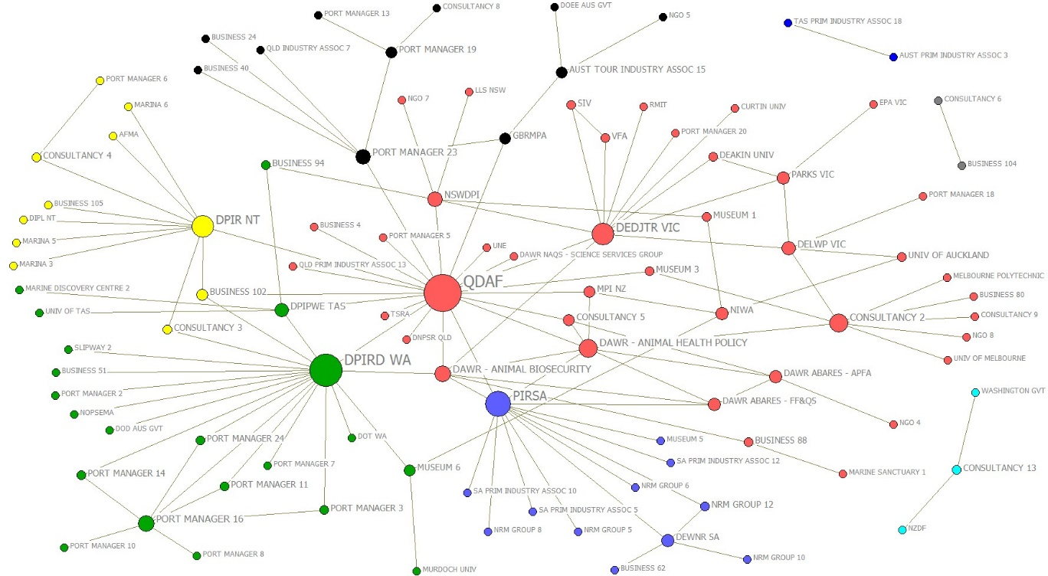

Source: ABARES marine pest network survey 2018 Note: The different colours represent the different sub-groups. Sub-groups were identified based the Girvan-Newman (2002) algorithm where eight clusters were identified as the appropriate number of clusters for the passive surveillance network, based on the ‘Elbow method’ (Ketchen Jr and Shook 1996).
Figure 20 Sub-groups in active surveillance network
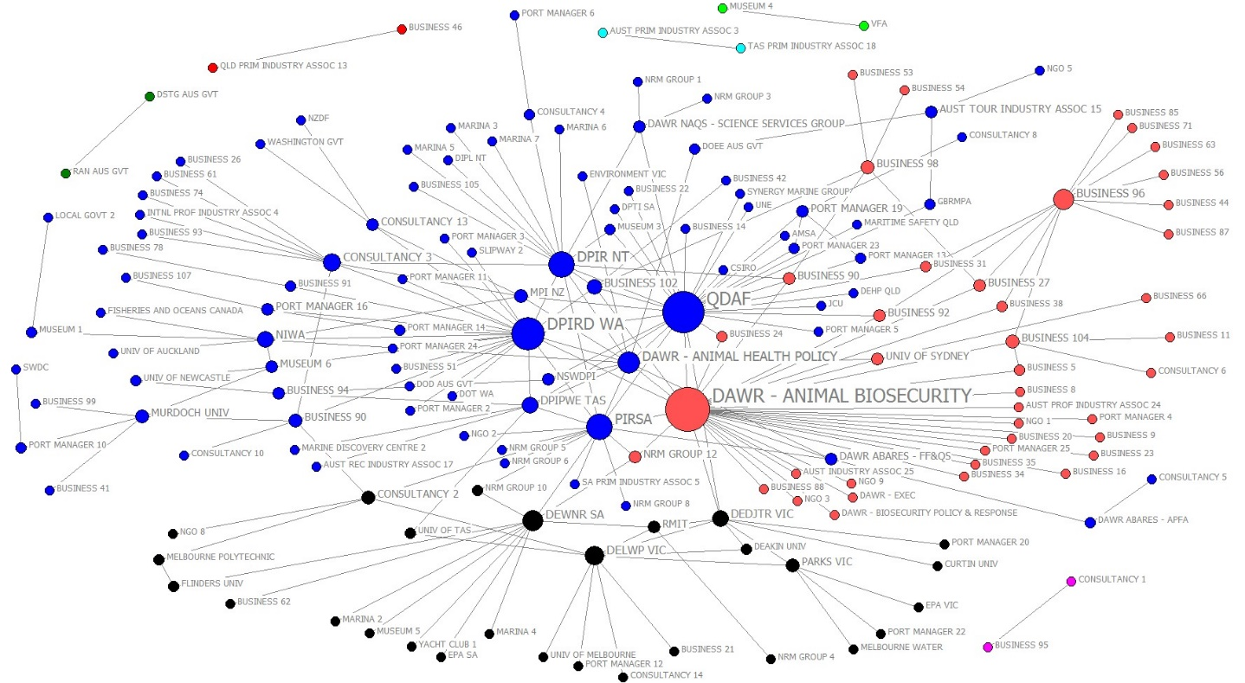

Source: ABARES marine pest network survey 2018 Note: The different colours represent the different sub-groups. Sub-groups were identified based the Girvan-Newman (2002) algorithm where nine clusters were identified as the appropriate number of clusters for the active surveillance network, based on the ‘Elbow method’ (Ketchen Jr and Shook 1996).

Research and development

Coordination (Centrality)

Influential actors (total degree)
Information exchange about R&D revolved much around government agencies (Figure 21 and Figure 22). DAWR – Animal Biosecurity was by far the most connected followed by DAWR ABARES - FF&QS, PIRSA, QDAF, DAWR ABARES - APFA and DPIRD. The most connected privately-owned actors were two consultancies and a business. Note that this particular business also provide consultancy as part of a wider range of services. The two highest scoring universities were Deakin University and RMIT.
Figure 21 Who is the most connected in the research and development network—information/advice flows
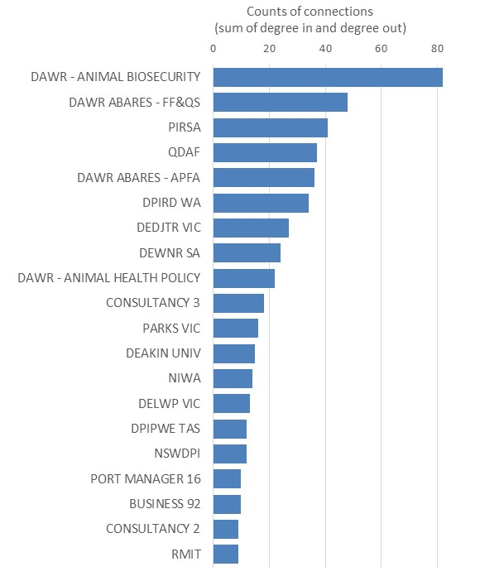
Source: ABARES marine pest network survey 2018
Note: Using survey data where respondents indicated information/advice flow related to R&D, based on the survey questions: 1) Who did you provide marine pest R&D related information and/or advice over the last 12 months, and 2) Who have you asked for marine pest R&D related information and/or advice over the last 12 months. Figure shows the top 20 organisations.

During some discussions with key stakeholders and some interviews the need for R&D coordination and networking was commonly highlighted. The champions of R&D, especially relating to some molecular diagnosis and genetic assays work, were identified as DPIRD WA and PIRSA. Some key stakeholders mentioned that while there is a formal international group that meets regularly to coordinate research on marine pests, there is no similar group within Australia. The countries represented on the international groups are Canada, USA, Australia and New Zealand. There were some initiatives happening to strengthen networking around marine pests R&D in Australia. For example, a researcher within DIRPD WA initiated the Australian Marine Pest Research Network in 2014-15 with the aim to unite scientists involved in marine pest science throughout Australia. However, activity within this network had been limited. At the time of the research, Western Australian Marine Science Institute (WAMSI) presented a platform where industry set research priorities and for which they contributed funding to carry out related projects. DPIRD WA was the major driving organisation in this initiative. Much networking in relation to R&D happened informally. Some pointed out that there is a lack of extension to ensure R&D outcomes are adopted, with some describing it as some of the ‘biggest holes’ in the system.
Several people spoke highly of certain events in facilitating networking between actors. A key event mentioned was an ANZPAC (Australia New Zealand and the Pacific) Workshop on Biofouling Management for Sustainable Shipping that occurred in September 2017. While the program was much like a conference with sessions comprising presentations by experts, the event reportedly instigated much discussion and interaction between attendees who represented a wide range of organisational types. Similar comments were made about a Global Strategic Partnerships Project (QUADS) program workshop held in New Zealand that focused on molecular science for marine pests. Some mentioned that there are strong informal networks in relation to marine biosecurity research.

Figure 22 Research and development network
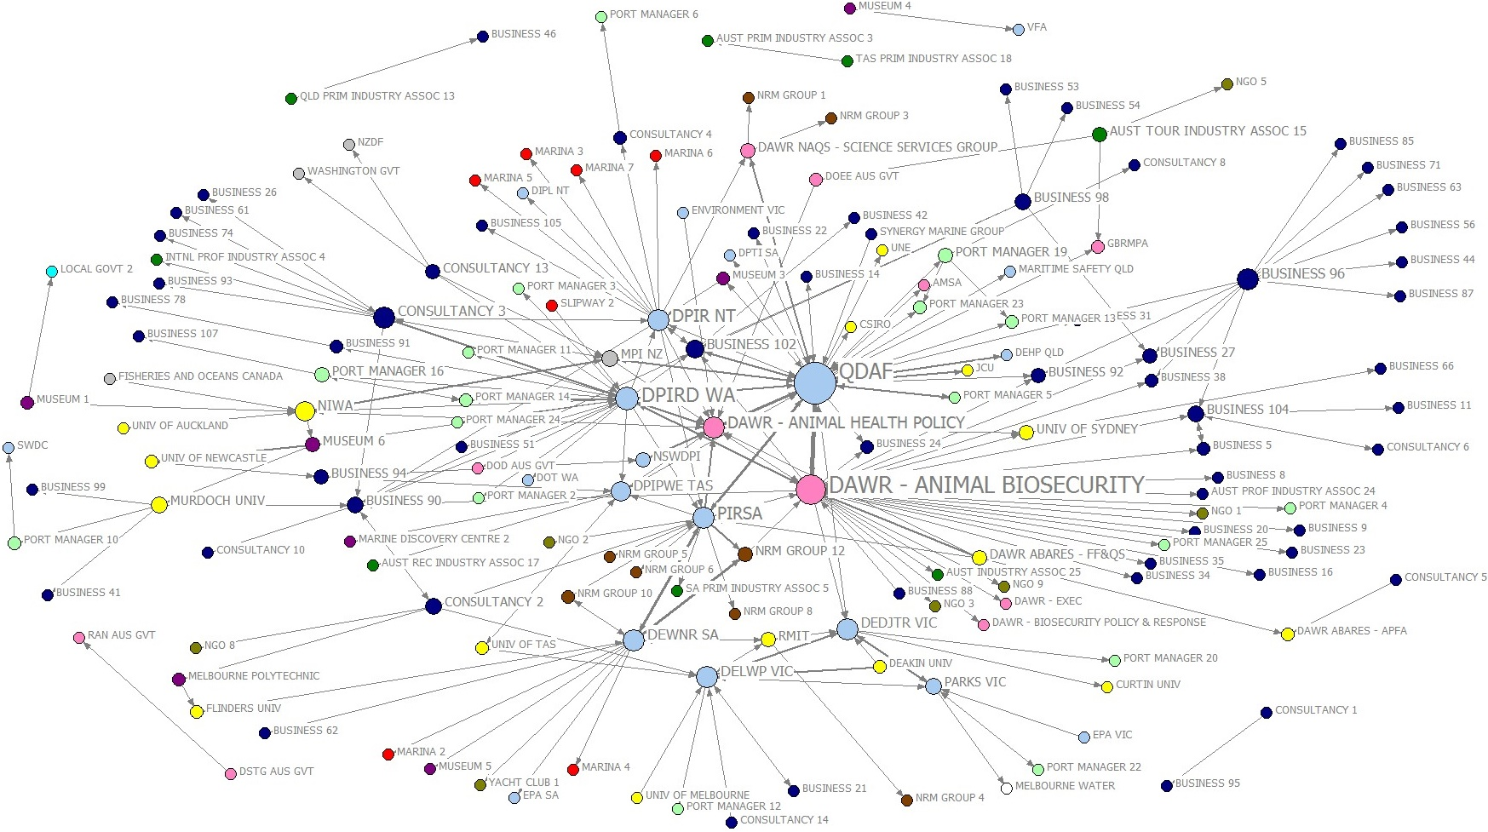
Source: ABARES marine pest network survey 2018. Note: Circles represent organisations exchanging information and advice relating to R&D activities. Size of circles indicates degree centrality (larger means more ties). Thickness of ties indicates number of connections for both asking and providing information. Colours indicate organisational type (see legend).

Trusted information sources
Figure 23 lists the actors that were the key information/advice sources and information/advice seekers relating to R&D. The most prominent information source about R&D was DPIRD WA. The next three were DAWR - Animal Biosecurity, PIRSA and Deakin University. The actors most involved in seeking information about R&D were DAWR ABARES - APFA and DAWR ABARES - FF&QS. Overall, universities appeared to be greater information sources than information seekers. Actors on the periphery of the network were mainly information receivers.
Figure 23 Who have you asked for marine pest related to R&D information/advice over the last 12 months?
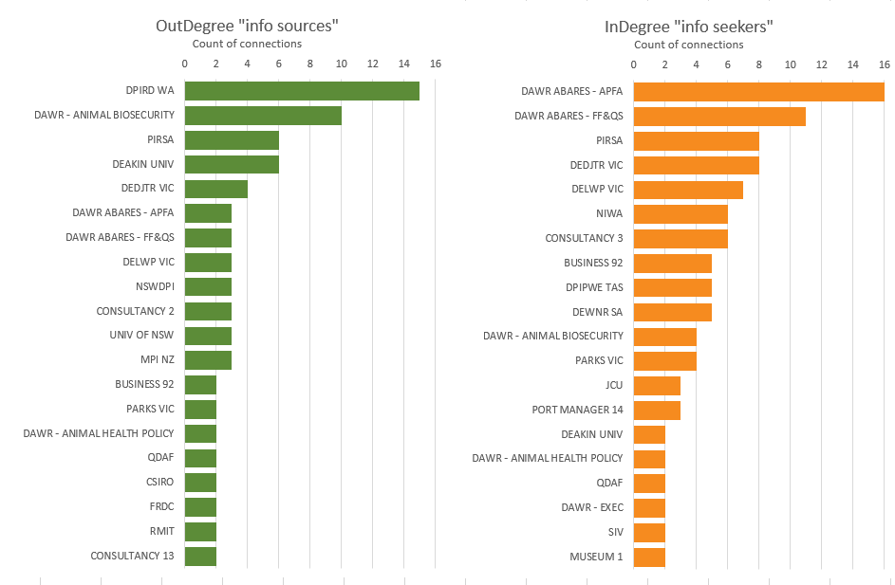
Source: ABARES marine pest network survey 2018
Note: Graph made using data from the survey question ‘Who have you asked for marine pest related information and/or advice over the last 12 months’ where respondents indicated R&D related information. OutDegree refers to ‘Information sources’ and InDegree refers to ‘Information seekers’. Figure shows the top 20 organisations.

Speed of information flow
The eigenvector scores for the research and development network are contained in Figure 24. The actors best positioned for fast information dissemination in relation to research and development were DAWR ABARES – FF&QS, DAWR – Animal Biosecurity, DAWR ABARES – APFA followed by QDAF, PIRSA and DPIRD WA. The two DAWR ABARES branches work on marine pest research topics and are part of the same research provider situated within the Department of Agriculture. The highest rating non-government actors included several businesses, an NGO and a consultancy.

Figure 24 Organisational influence based on eigenvector score for research and development

Source: ABARES marine pest network survey 2018
Note: Figure shows the top 20 organisations.

Innovation

Communities of practice
According to Figure 25, the R&D network can be best structured around eight sub-groups. However, the blue sub-group is the largest and contains most of the state and territory agencies, including DPIRD WA, PIRSA, QDAF, DPIPWE TAS, DEWNR SA, NSWDPI and DIPR NT. An exception is Victoria, which is mostly covered by the actors in the green group and which include DEDTJR VIC and DELWP VIC. DAWR - Animal Biosecurity formed its own hub and spoke sub-group represented by the actors in the pink group. A consultancy business seemed to be an important hub linking with actors in the purple group who would otherwise have been disconnected from the R&D network.
Figure 25 The eight key sub-groups in the research and development network based on provide and ask for information
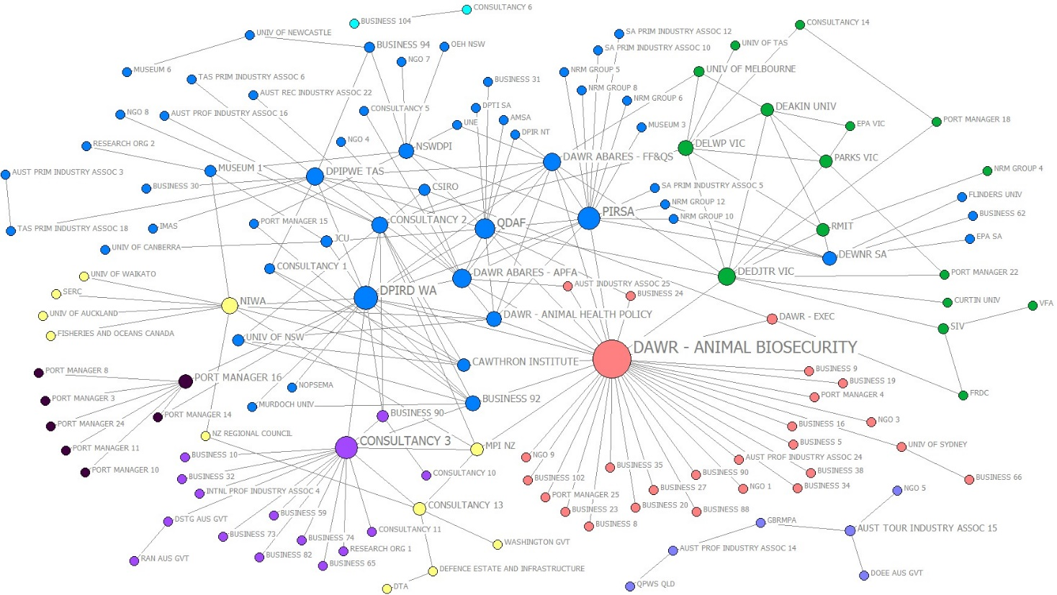
Source: ABARES marine pest network survey 2018 Note: The different colours represent the different partitions. Partitions were identified based the Girvan-Newman (2002) algorithm where eight clusters were identified as the appropriate number of clusters based on the ‘Elbow method’ (Ketchen Jr and Shook 1996).

Knowledge-brokers
Actors with the highest betweenness scores in the R&D network are listed in Figure 26 and represented in Figure 27. DAWR - Animal Biosecurity was the highest scoring actor, followed by PIRSA, DIRPD WA and a consultancy. Four consultancies formed part of the top thirty highest scoring actors. Figure 27 shows how several of these consultancies formed hub and spoke formations with other actors, many of whom were not connected to anyone else.
Figure 26 Key potential knowledge-brokers for research and development
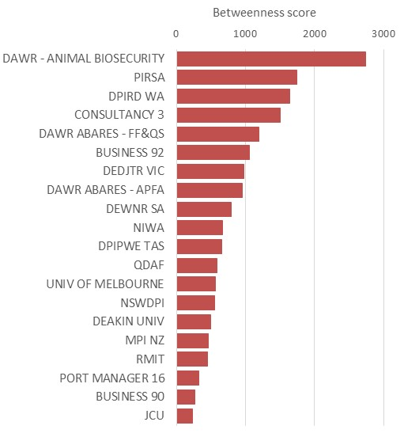
Source: ABARES marine pest network survey 2018
Note: Betweenness scores are based on Freeman betweenness (Freeman, 1977), a measure of centrality based on number of geodesic paths between two actors that pass through an actor. Based on R&D information flows in all directions. Figure shows the top 20 organisations.

Collaboration
Research and development networking was more extensive than networking about passive surveillance or education and awareness-raising, so there were more reciprocal relationships and closed triads that would indicate bonding capital. This means that there were more examples of configurations supporting collaboration in the R&D network than in the other sub-networks.
There were 36 reciprocated relationships between dyads at the organisational level. These reciprocol relationships mainly existed between three groups of government agencies. Firstly, a group made up of DAWR branches (Animal Biosecurity and Animal Health Policy), state agencies (QDAF, PIRSA, NSWDPI) and research providers (DAWR ABARES - FF&QS, DAWR ABARES - APFA). A second smaller group with reciprocated relationships included Victoria and South Australian state agencies (DEDJTR VIC, DEWNR SA, PARKS VIC, EPA VIC, DELWP VIC) and research service providers (DEAKIN University, RMIT, Flinders University). A third group with reciprocated relationships was in West Australia held by DPIRD WA, research providers (NIWA, JCU) and port managers in WA.
There is stronger evidence of bonding capital supporting collaboration in the R&D network due to its more numerous closed triads than the passive surveillance or education/awareness-raising networks. There were two main triadic groups involving: 1) DPIRD WA and two port managers in WA, and 2) DEDJTR VIC, PARKS VIC, DEWNR SA and Deakin University, RMIT and University of Melbourne.
Unlike in the other sub-networks, there were some (seven) completely reciprocated triads—the strongest form of bonding capital where there are two-way links on all three edges of the triad—in the R&D network. These were present only between DAWR ABARES - FF&QS, DAWR ABARES – APFA, which are research providers, and DAWR - Animal Biosecurity. This is the main collaborative group in the R&D network. There were only two other examples of completely reciprocated triads in the R&D network, involving DEDJTR VIC and DPIRD WA.

Figure 27 Who are potential knowledge-brokers in the research and development network? (Betweenness measure)
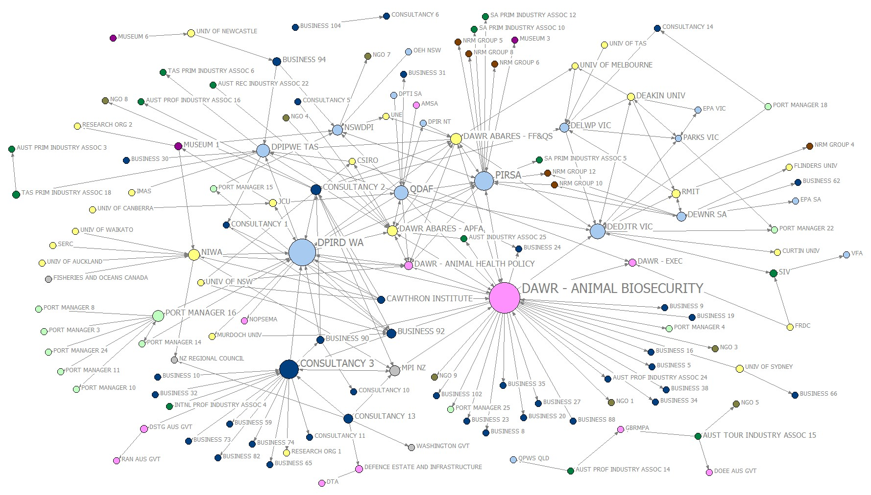
Source: ABARES marine pest network survey 2018. Note: Size of circles represent betweenness scores, which are based on number of times an actor connects pairs of other actors, who otherwise would not be able to reach one another. Colors indicate organisation type (see legend).

Education and awareness-raising

Coordination (Centrality)

Influential actors (total degree)
Entities who were most involved in sharing education and awareness-raising information/advice in the last 12 months are listed in Figure 28. The education and awareness-raising network is shown in Figure 29. Figure 28 shows that after QDAF, the Department of Agriculture was central, with two of its branches making up the second and third most connected entities, that is, the Animal Biosecurity Branch and Animal Health Policy Branch, respectively. Ten of the top 20 entities sharing information/advice about marine pest education and awareness-raising were state and territory government organisations. There was some cross-jurisdiction information sharing between state and territory actors, but it was not densely connected, such as between DPIPWE TAS and DPIRDWA (Figure 29). There were few private industries represented in the top 20 actors.
Figure 28 Who is most connected in the education and awareness-raising network—information/advice flows

Source: ABARES marine pest network survey 2018
Note: Blue bars are the counts of information/advice exchange about education and awareness-raising activities via working relationships between organisations (informal ties). Includes both asking and providing of information. Figure shows top 20 organisations.
A number of on-ground groups were involved the education and awareness-raising network, including community groups and regional groups on the periphery of the network. The states/territory governments were hubs for the flow of information to and from groups in their states, principally to and from port authorities, shipping companies and marinas.

Figure 29 Education and awareness-raising network
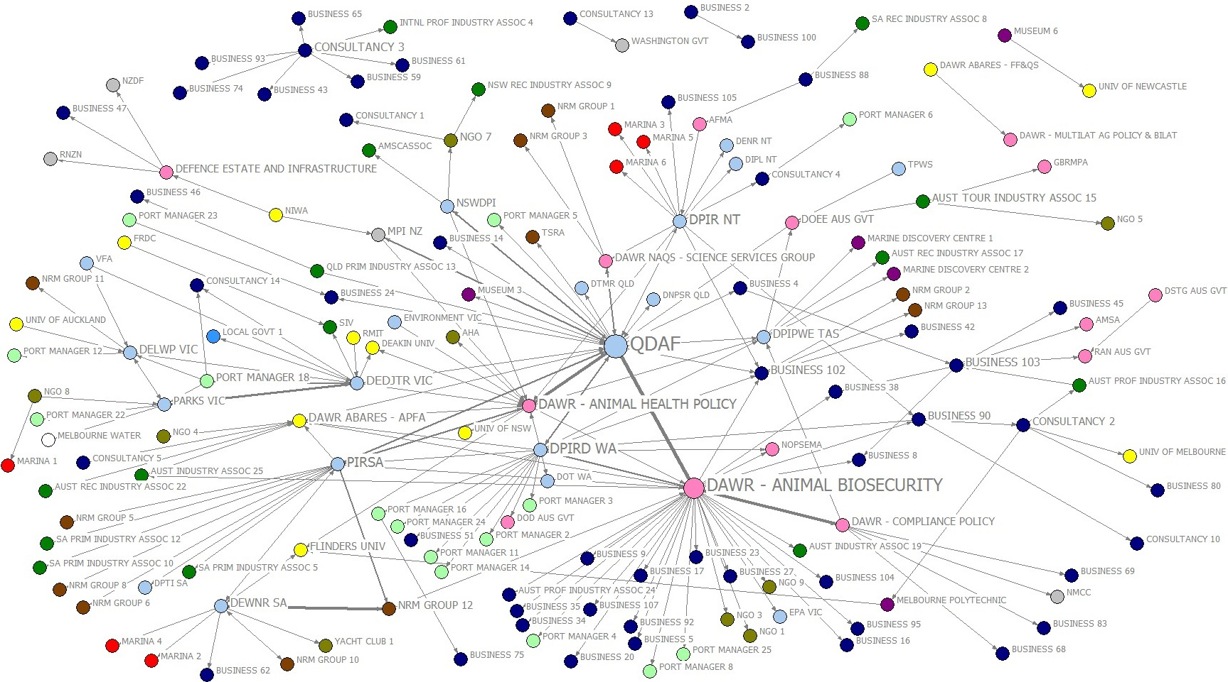
Source: ABARES marine pest network survey 2018. Note: Circles represent organisations exchanging information and advice relating to education and awareness-raising activities. Thickness of lines indicate number of connections between entities (larger means more ties). Colours indicate organisational type (see legend).

The discussions with MPSC members revealed that some state and territory governments had elaborate community engagement strategies in place for marine pests, whereas several others were still looking at strengthening their engagement with on-ground players. For several states/territories much education and awareness-raising was issue based, such as when there was a marine pest outbreak. There is no aquarium industry present, though they were flagged as an important sector for education and awareness-raising in the Review.

Trusted information sources
Figure 30 shows the direction of advice/information seeking behaviour about marine pest education and awareness-raising. Organisations which functioned as significant information sources (high out-degree) about education and awareness-raising included DAWR Animal Biosecurity Branch, and state and territory governments (PIRSA, DPIRD WA, DIPR NT, DPIPWE TAS, NSWDPI, DELWP VIC and DEDJTR VIC).
The significant seekers of information and advice (high in-degree) in the network were QDAF, DAWR Animal Health Policy, DAWR ABARES APFA and DAWR Compliance Policy.
Figure 30 Who have you asked for marine pest related to education/awareness-raising information/advice over the last 12 months?
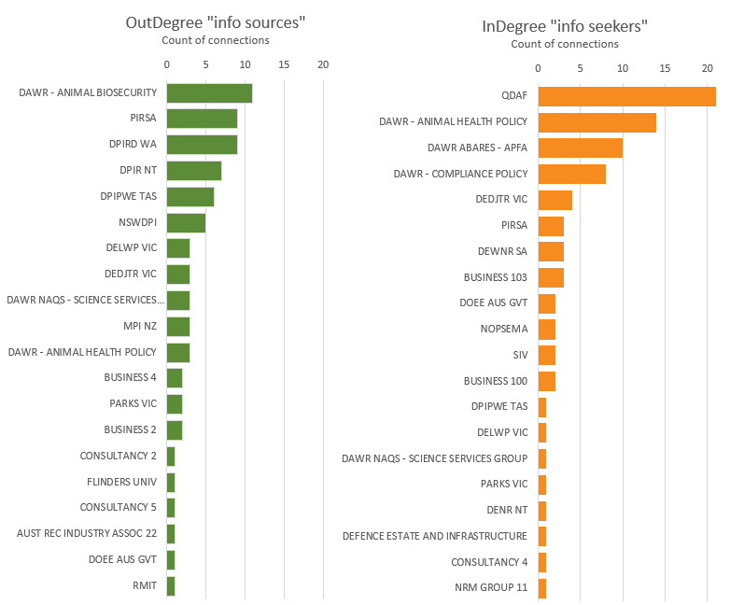
Source: ABARES marine pest network survey 2018
Note: Using the survey question ‘Who have you asked for marine pest related information and/or advice over the last 12 months’ where respondents indicated education and awareness-raising information. Out-degree refers to ‘Information sources’ and In-degree refers to ‘Information seekers’. Figure shows the top 20 organisations.

Speed of information flow
Five out of the top 20 actors with higher eigenvector centrality were the Department of Agriculture branches, while the others in the top 20 are mainly States/Territories, including QDAF, PIRSA, DPIRD WA and NSWDPI (Figure 31). This indicates national and state/territory jurisdictions were well positioned to facilitate efficient information dissemination about education and awareness-raising, and potentially have longer-term influence in the network.
Figure 31 Education and awareness-raising network—organisational influence based on eigenvector centrality
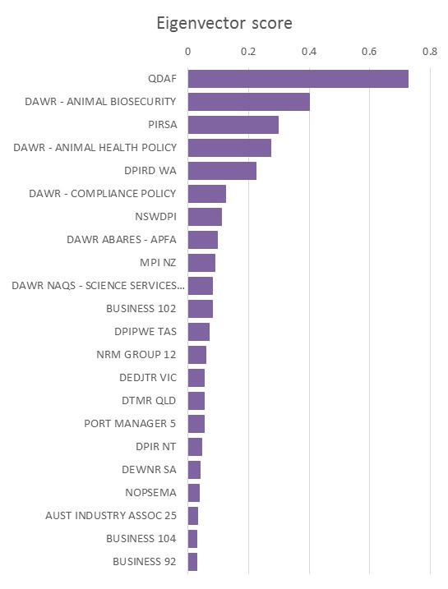
Source: ABARES marine pest network survey 2018
Note: Figure shows the top 20 organisations.

Innovation

Communities of practice
The Girvan-Newman analysis detected nine sub-communities in the network (Figure 32). A large sub-network in the centre connecting DAWR - Animal Health Policy Branch with most of the state and territory organisations, including QDAF, DPIRD WA, DEWNR SA, PIRSA, DPIPWE Tasmania and MPI NZ and their networks. In the next largest group, DAWR - Animal Biosecurity Branch was connected with a number of industry groups, port managers, and private businesses.
Another important feature was a Victorian sub-network, sharing information/advice around education and awareness-raising between DEDJTR VIC, DEWLP VIC, Parks VIC and on-ground groups such as port managers and marinas, coastal community groups and a shire council. There was also a distinct group sharing information/advice between DPIR NT and a range of marinas, port managers and ranger groups in the NT as well as to other NT government departments (DENR NT, DIPL NT).
A number of the consultancies had distributed networks relating to education and awareness-raising. Entities connected with these actors were private businesses, yacht clubs, universities and commercial diving companies. Note that some of these consultancies seemed totally disconnected from the rest of the network.
Figure 32 Sub-groups in the education/awareness-raising network
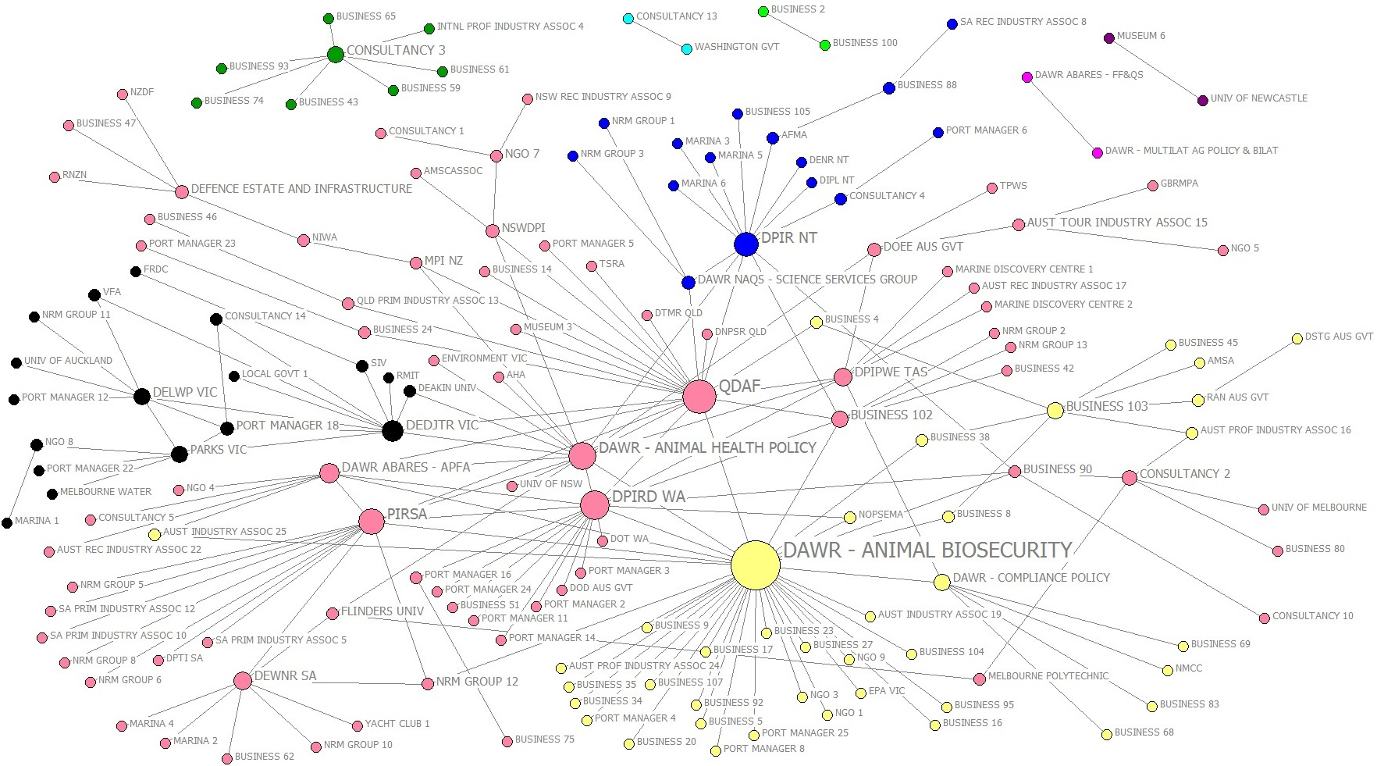
Source: ABARES marine pest network survey 2018. Note: Sub-groups identified using Girvan-Newman analysis for all information flows relating to education and awareness-raising in network. Colour of actors indicates membership to one of 9 sub-groups detected.

Knowledge-brokers
Figure 33 lists the top 20 organisations that scored the highest for betweenness. QDAF scored the highest, followed by the detection of a single Asian Green Mussel (Perna viridis) detected near Weipa. This was followed by DAWR Animal Biosecurity Branch, DAWR Animal Health Policy Branch, DEDTJR VIC and PIRSA. While the top nine organisations were governments, a university and several businesses were included as well. These businesses included a global maritime industry group, a large mining company and an education/extension organisation.

Figure 33 Key potential knowledge-brokers for education and awareness-raising
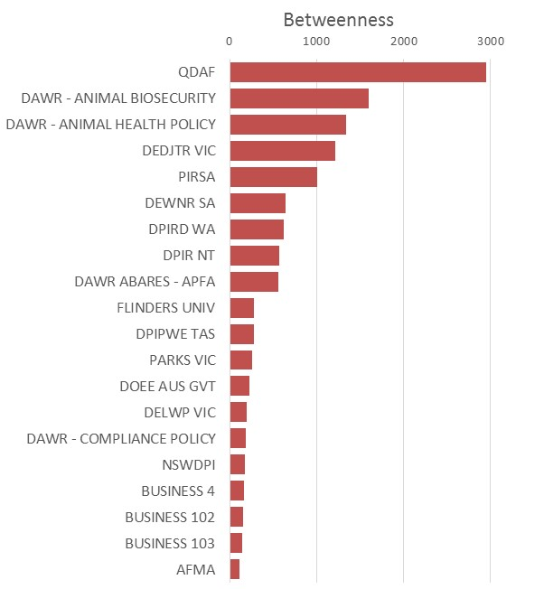
Source: ABARES marine pest network survey 2018
Note: Betweenness scores are based on Freeman betweenness (Freeman, 1977), a measure of centrality based on number of geodesic paths between two actors that pass through an actor. Based on information flows in all directions. Figure shows the top 20 organisations.

Collaboration
There are reciprocal relationships and closed triads that would indicate bonding capital is present in the education/awareness-raising network at the organisational level.
There were 21 dyads that were reciprocated in this network, with reciprocal ties mostly radiating out from QDAF to and from other state and territory agencies. There were two groups of others with reciprocal ties, as follows: 1) PIRSA had reciprocal ties with DEWRNR SA, which had reciprocal ties with Flinders University and an NRM Group in South Australia, and 2) in Victoria, DEDJTR VIC had radiating reciprocal relationships with PARKS VIC and then DELWP VIC. But the other state agencies had no reciprocal ties apart from these.
There were quite a few closed triads in the education and awareness-raising network, but less so than in R&D network. Mostly the triads (all of which are partially complete) involved the core group, which made up of DAWR - Animal Biosecurity, QDAF, DPIRD WA, DAWR - Animal Health Policy, PIRSA and DAWR ABARES - APFA. But there was also a small Victorian triadic group involving DELWP VIC, PARKS VIC, DEDJTR VIC and a port manager in Victoria. Despite this evidence of some configurations supporting collaboration, there were no completely reciprocated triads at all (where all three actors in the triad have reciprocal relationships).
This combination of findings suggests there was limited evidence of configurations supporting collaboration in the education and awareness-raising network.

Emergency response

Influential actors (total degree)
The emergency response network has been included as a comparative network to the other topic-related networks. Unlike the other networks, emergency responses often involve developing and refining proactive response plans that various stakeholders mutually agreed upon. In addition, during an emergency response relationships typically need to be established between a wide range of government and non-government stakeholders within a short time frame.
Hence, given the need for quick action during an emergency pest outbreak, the emergency response network is expected to have centralised structures in order to facilitate coordination. The network diagram in Figure 34 confirmed that government agencies were the most central actors. Entities who were most involved in sharing emergency response information/advice sharing in the last 12 months were QDAF and DPRID WA (Figure 34).
The high involvement of QDAF in the network is likely due to the focus on Asian Green Mussel (Perna viridis) detection near Weipa over the 6 months prior to the survey. The response to Asian Green Mussel involved on-ground operational staff actively engaging the community in the response effort, including working with Rio Tinto (which detected the species), North Queensland Ports Corporation, DAWR-NAQS, local recreational fishers and the community in Weipa. This highlights the temporal nature of the social networks, with relationships developed for specific emergency responses.
Figure 34 Emergency response information/advice network
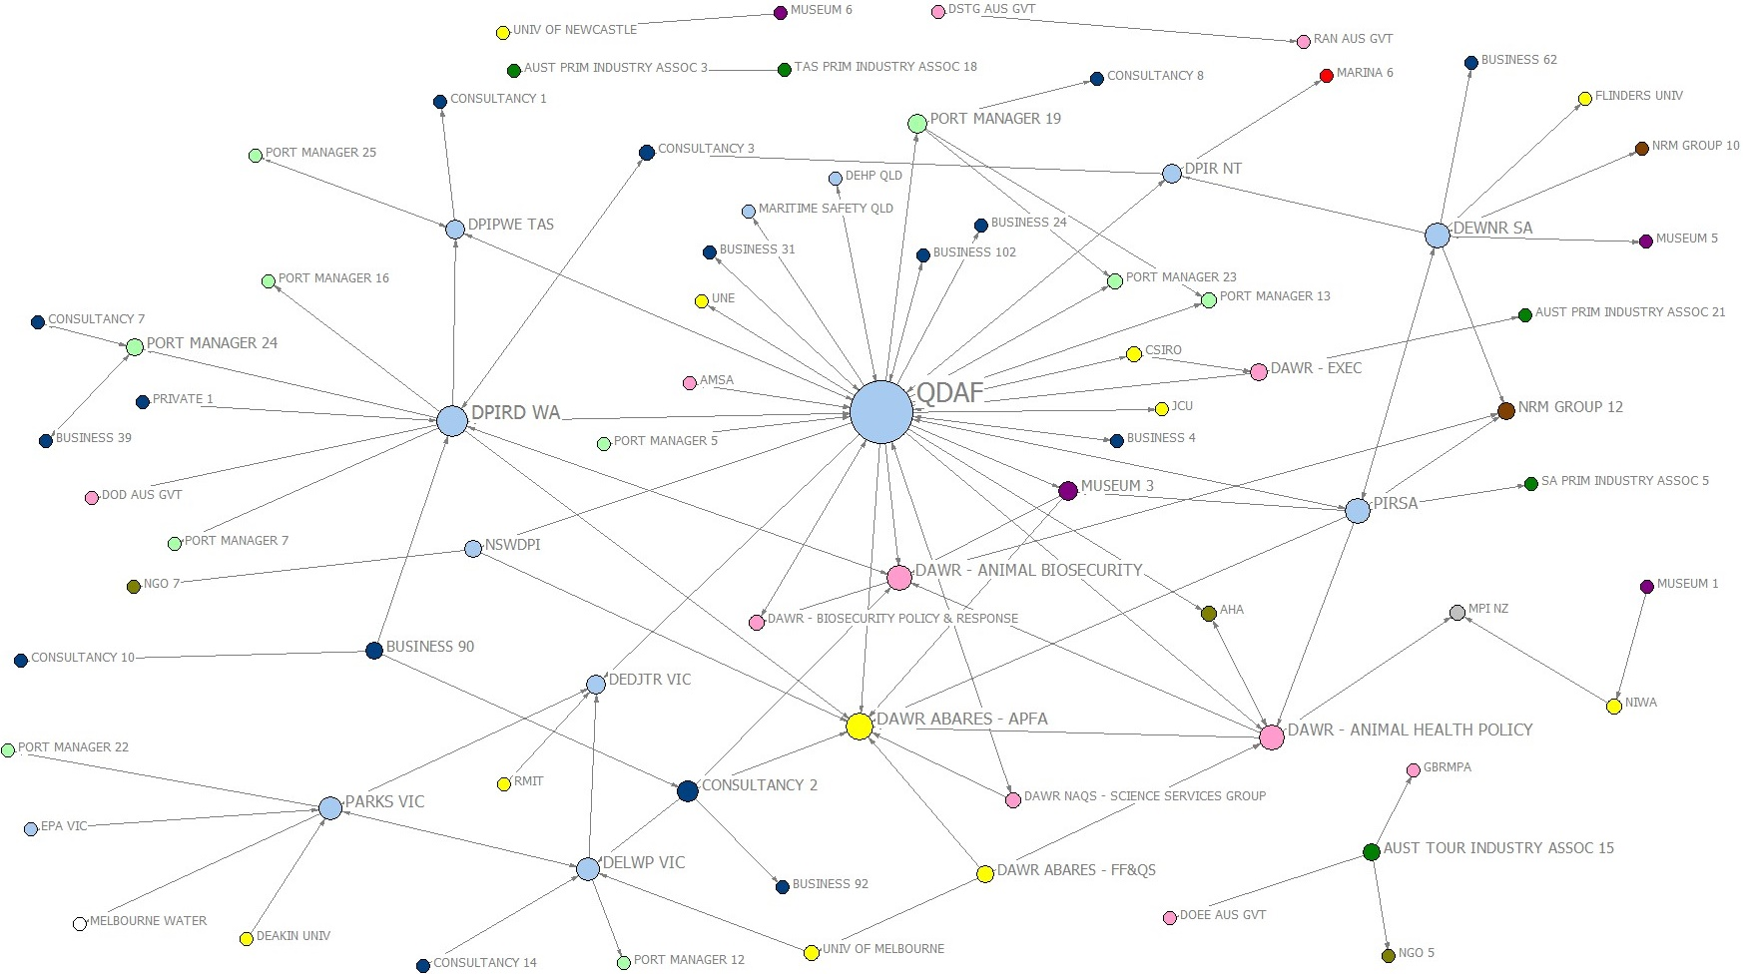
Source: ABARES marine pest network survey 2018. Note: Circles represent organisations exchanging information/advice relating to emergency responses. Size indicates degree centrality (larger means more ties). Colours indicate organisational type (see legend).
Statistical network analysis
Exponential Random Graph Models (ERGMs) were used to identify over or under representation of configurations (Frank and Strauss 1986; Wasserman and Pattison 1996). The configurations of interest represented important aspects of the marine pest network (Table 7). These refine the key processes of interest that were identified in Table 2, which contribute to the important functions of coordination, innovation and collaboration in the network.
The specific configurations of interest for the network can be summarised as:
- General structures - representing bonding capital (or multi-actor reciprocal relationships), which can promote shared values and learning in a network, and also bridging capital, which can contribute to disseminating information between different groups in the network
- Policy forum structures - representing the ability to share information into and out of key forums (a form of bridging capital)
- Community links - representing bridging relationships to community linked actors.
Five Exponential Random Graph Models (ERGMs) were run, each directed at finding the same set of configurations. The first model used the entire network where an actor-actor tie was based on any reported interaction (with no reference to the purpose of that interaction) for both the formal and informal network (Figure 42). The informal network interactions are derived from two survey questions: 1) Who have you provided information or advice to ('providers'), and 2) Who have you asked for information or advice ('receivers'). Therefore, the informal network ties are directed..
a) Entire network - all information sharing, and affiliations from forum attendance
Four subsequent ERGMs that restricted the ties to the informal network topics as follows:
b) Passive surveillance
c) Research and development
d) Education and awareness-raising.
A fifth ERGM was run on the actor-forum network only (i.e. the formal network based on affiliations between organisations and forums, Figure 42):
e) Forums only - affiliations from forum attendance (formal network).
The modelled network graphs (observed networks) are presented in Figure 35.

Exponential Random Graph Modelling (ERGM)
The ERGM models strongly indicate the entire network is heavily centralised around policy forums. This is illustrated in Figure 32 (a). There are significantly greater than expected provider and receiver interactions with actors who participate in policy forums, indicating that centralisation occurs around policy forums (Table 8 [16a, 17a]). However, actors connected to forums seem no more or less likely to form information sink or source hubs than can be expected by chance alone (Table 8 [18a, 19a]). Interestingly, there is no evidence that actors who participate in policy forums will have any more interactions with other policy forum participants than could be expected by chance (Table 8 [20a]). In fact, where two actors both participate in different forums, there is evidence that they themselves are unlikely to interact (Table 8 [21a]).
The centralisation of the network is a form of bonding, and this expressed in a number of ways. Given the observed counts of provider and receiver interactions, there are more reciprocal relationships than may be expected by chance alone (Table 8 [5a]). There is also statistical evidence of homophily—the tendency of actors to interact most with similar types of actors. The type of homophily tested in the ERGM analysis was the likelihood of connections between organisations of the same sector type (of the 13 sector types listed in Table 4). However, given the centralisation noted above, there is no additional evidence of closed triad structures that would indicate strong bonding capital (Table 8 [9a, 10a]), while there is evidence of bridging (Table 8 [8a]).
Additionally, there is a significantly greater relative abundance of key hubs for both receiving and providing information in the informal component of the entire network than would be expected by chance (Table 8 [6a, 7a]).
Actors with links to the community showed a strong tendency to provide rather than receive information (Table 8 [11a, 12a]). In total, community linked actors reported 40 per cent more providing information ties compared to receiving ties. Given the number of out/in ties, however, there is evidence of more bridging structures than could be expected by chance alone (Table 8 [13-15a]). It is worth noting that most community linkages are via state governments (35 organisations, 3 with community links, Table 4), and perhaps surprisingly, local government are not well represented (2 organisations, 1 with a community link Table 4).
All networks are a sub-set of (a) entire network, with (b) passive surveillance containing 24 per cent of the entire network ties, (c) R&D 37 per cent, and (d) education and awareness-raising 34 per cent (Table 8). This illustrated in Figure 35 that allows for comparing the sub-networks with node locations fixed. It is not surprising that all five models give comparable findings. However, there are a few notable differences:
- While the networks all show clustering around policy forums, education and awareness shows additional evidence of this (Table 8 [20d], in addition to [16-17]).
- R&D has the highest proportion of receiving ties compared to providing ties, and is also the only network with significant bonding configurations of triads (Table 8 [9c and 10c]).

Passive surveillance
In terms of the passive surveillance network, there was a high level of homophily (Table 8 [4b]). In other words, it indicates interactions between actors representing different sectors were less than expected by chance.
There was a higher occurrence of information sinks and sources than would be expected by chance alone (Table 8 [6b and 7b]), which can be helpful for coordination.
Community-linked actors providing information to other actors showed a higher level of representation in the passive surveillance network than can be expected by chance (Table 8 [11b]), whereas community-linked actors receiving information from others were the same as can be expected by chance (Table 8 [12b]).
Forum attendees had a higher level of ties that related to passive surveillance than would be expected by chance alone (Table 8 [16b and 17b]), but not as information sinks or hubs (Table 8 [18b and 19b]).
There was considerable evidence of bonding capital in terms of reciprocal relationships (Table 8 [5b]) in the passive surveillance network. However, the presence of triads—which is known to support learning—were the same as can be expected by chance only (Table 8 [9b and 10b]). Evidence of bridging was limited with the number of bridging ties the same as what can be expected by chance alone (Table 8 [8b, 18b and 19b]).
The research and development network
The R&D network was also characterised by a higher than expected level of homophily (Table 8 [4c]). There seemed to be good two-way information flow between actors as is evident in the higher than expected level of reciprocal ties (Table 8 [5c]). There were also clear sink and source hubs respectively (Table 8 [6c and 7c]), which can be helpful for coordinating R&D.
There was clear evidence of strong bonding capital in the R&D network, as shown by Table 8 [9c and 10c], more so than for any of the other networks. However, there seemed not to be significantly more bridging happening across three different actors as can be expected by chance alone as is evident from Table 8 [8c], and no significant bridging between forum members and other actors (Table 8 [18c and 19c]).
Community-linked actors appeared to have had a significantly higher number of links with one other actor for providing information, but significant fewer ties for receiving information from one other actor (Table 8 [11c versus 12c) than would be expected by chance alone. However, where a community-linked actor was connected with two or more other actors, there was not significantly more or fewer such configurations than can be expected by chance alone, based on Table 8 [13c, 14c and 15c].
Education and awareness-raising
With regards to education and awareness-raising, there was also a high level of homophily (Table 8 [4d]) and a limited level of bridging, than can be expected by chance alone (Table 8 [8e, 18e and 19e]).
One would expect higher levels of links with the community than by chance alone, but there was no evidence of this as all the community-linked actors had ties with others as expected (Table 8 [12d, 13d, 14d and 15d]). An exception was community-linked actors giving information to other actors, which were significantly higher than would be expected by chance alone (Table 8 [11d]).
The number of forum members speaking to their fellow forum members about awareness-raising and education was also higher than expected by chance (Table 8 [20d]). They rate significantly high for receiving and providing information with other actors about awareness-raising and education (Table 8 [16d and 17d]). However, forum members did not seem to form information sinks and sources in the education and awareness-raising network (Table 8 [18d and 19d]).

Table 7 Selection of network configurations of theoretical interest
Labels taken from MPNet manual for reference (see Wang et al, 2014). Arrows on the ties show the direction of flow of the information for informal interactions.
 | Network configuration | Process of interest | Description
 | Basic activity
1. |   Source A |  | Source: no in-ties
2. |   SinkA |  | Sink: no out-ties
3. |   IsolateA |  | Isolates: no ties
 | General structure
4. |   Type_MatchA | Within-scale preferences | Interactions that preference links to similar types of actors have similar implications to bonding (trust building and conflict resolution). Scale-bridging is the counterpart of this (Angst et al. 2018).
5. |   ReciprocityA | Bonding capital | Reciprocal relationships, signifying close bonds – this can re-enforce learning (Fischer and Jasny 2017). However, such cliques can prohibit sharing of information.
6. | 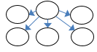  AoutSA | Coordination | Suggests network houses critical actors that act as sources/hubs for disseminating information. Such hubs help incremental adaptation (Barnes et al. 2017b).
7. | 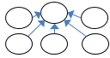  AinSA | Coordination | Suggests network houses critical sinks/repositories for receiving information.
8. | TwoPathA | Bridging capital | Good for information flows (Granovetter 1983)
9.  10. | 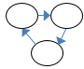  Cyclic-TriadA  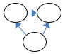  Transitive-TriadA | Bonding capital (between organisational actors) | Closed social structures where sets of actors form cliques are likely to either shared operational norms, or be able to efficiently development them. Good for re-enforcing learning - could hinder innovation.
 | Community links (Shaded circles show an actor who stated they provide information to ‘community’)
11. |   CommunityLink_ SenderA | Community linkages | Actors who acts as sources of dissemination to both the community and other actors.
12. |   CommunityLink_ ReceiverA | Community linkages | Actors with community links associated with bridging relationships, provide a structural ability to disseminate information.
13.  14.  15. | 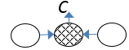  In2Star010A  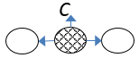  Out2Star010A  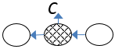 | Community linkages | Community linked actors as receivers of information; as key sources of information; or conduits of information flow (bridges).
 | Policy forum participation
16. | 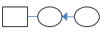  In2StarAX | Bridging capital around forums | Actors that facilitate the delivery of information from at least one other actor in the broader stakeholder network into a forum.
17. | 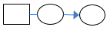  Out2starAX | Bridging capital around forums | Actors that facilitate information dissemination to at least one other actor in the broader stakeholder network from a forum.
18. | 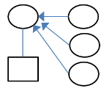  AAinS1X | Coordination / bridging capital around forums / forum attendees as information sink hubs | Key actors that facilitate the delivery of information from the broader stakeholder network into forums.
19. | 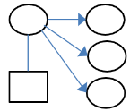  AAoutS1X | Coordination / bridging capital around forums / forum attendees as information source hubs | Key actors that facilitate information dissemination from forums into the broader stakeholder network.
20.  21. | 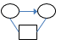  TXAXarc  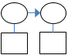  L3XAX | Collaboration /bonding capital around forums | Suggests participants who mutually attend forums (or both attend forums) likely to also share information through ties outside of forums. This suggests bonding around forum participation and re-enforces the collaboration potential set by the forums themselves.

Figure 35 Networks explored (a) to (f) using Exponential Random Graph Models
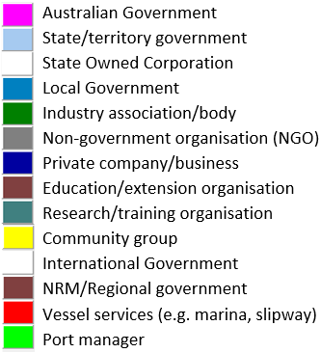
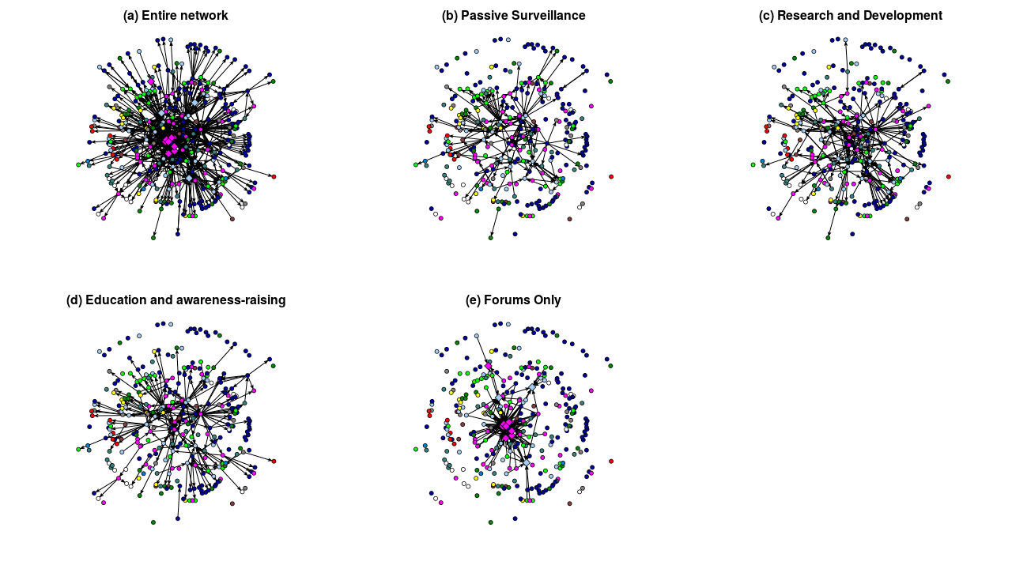

Note: Squares represent policy forums, circles represent organisations in marine pest network. Ties represent information sharing activity (one-mode) or affiliations through forums (two-mode).
Table 8 Over and under-representation of configurations. With +/++/+++ and -/--/---representing 90/95/99% significance for over-representation and under-representation, respectively
For full results, see Appendix 7, noting these results come from either Exponential Random Graph Modelling (Table 10) or Goodness-of-fit (Table 11). Arrows on the ties show the direction of flow of the information for informal interactions.
Ties shared with entire network: |  | a. Entire network |  | b. Passive surveillance |  | c. Research and Development |  | d. Education and awareness-raising
 |  | 643 (100%) |  | 156 (24.3%) |  | 238 (37.0%) |  | 220 (34.3%)
 |  | Count | Signif. | Count | Signif. | Count | Signif. | Count | Signif.
Basic activity
1. | Source A | 125 | --- | 55 |  | 65 |  | 106
2. | SinkA | 26 | --- | 17 | -- | 23 | --- | 22 | ---
3. | IsolateA | 18 | --- | 201 |  | 168 | --- | 140 | ---
General structures
4. | Type_MatchA | 186 | +++ | 49 | +++ | 71 | +++ | 56 | +++
5. |   ReciprocityA | 153 | +++ | 24 | +++ | 36 | +++ | 21 | +++
6. | AoutSA | 6234 | +++ | 101 | +++ | 194 | +++ | 112 | +++
7. | AinSA | 832 | +++ | 171 | +++ | 271 | +++ | 271 | +++
8. | TwoPathA | 6895 | +++ | 512 |  | 1071 |  | 766
9. | Cyclic-TriadA | 655 |  | 53 |  | 137 | +++ | 74
10. | Transitive-TriadA | 189 |  | 7 |  | 38 | +++ | 19

Ties shared with entire network: |  | a. Entire network |  | b. Passive surveillance |  | c. Research and Development |  | d. Education and awareness-raising
 |  | 643(100%) |  | 156(24.3%) |  | 238(37.0%) |  | 220(34.3%)
 |  | Count | Signif. | Count | Signif. | Count | Signif. | Count | Signif.
Community links (note that 'C' indicates an individual reported that they interacted with 'the community', including 'vessel owners', 'the public', 'fishers', 'marinas' and other generic categories of the community, see section on 'Survey data cleaning', page 123)
11. | Community Link_SenderA | 241 | +++ | 76 | +++ | 105 | +++ | 113 | +++
12. | Community Link_ReceiverA | 172 |  | 44 |  | 55 | -- | 43
13. | In2Star010A | 1923 | +++ | 86 |  | 138 |  | 105
14. | Out2Star010A | 3249 | +++ | 352 |  | 691 |  | 858
15. | Mix2Star010A | 4784 | +++ | 308 |  | 613 |  | 495
Policy forum participation
16. | 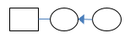  In2StarAX | 1616 | +++ | 439 | +++ | 588 | +++ | 441 | +++
17. | Out2starAX | 1992 | +++ | 627 | +++ | 791 | +++ | 991 | +++
18. | AAinS1X | 2768 |  | 554 |  | 805 |  | 558
19. | AAoutS1X | 3519 |  | 926 |  | 1217 |  | 1618
20. | 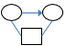  TXAXarc | 422 |  | 173 |  | 188 |  | 232 | ++
21. | L3XAX | 3888 | -- | 1664 |  | 1799 |  | 2083 | --

Resource sharing network
The survey asked respondents to indicate if and to whom they had provided or received resources (including funding and/or in-kind support) to address any aspects of marine pests in the last 12 months. 196 resource flows were reported by 73 organisations, giving an indication of considerable resource inter-dependency in the marine pest network. These relationships should be interpreted with caution due to the sparse nature of the survey responses on these questions.

Key players in resource sharing—providers and receivers
Figure 36 indicates the most frequent providers and receivers of resources. Note that this represents the percentage of total ties and does not reflect the value of the resources being provided or received. State and territory departments and the Australian Government were the most frequent funding and/or in-kind support providers in the marine pest network (64 per cent of resource ties flowed from government agencies). Research/training organisations also played a key role providing resources for marine pest activities and these included NIWA, DAWR ABARES, FRDC and universities.
The most frequent receivers of the resources were state and territory governments (33 per cent of ties) and research/training organisations (27 per cent of ties). Interestingly, private companies/businesses also played a role in resource sharing in the network.
Figure 36 Resource (a) providers and (b) receivers

Note: Charts show counts of ties as a percentage of (a) total 'Funding provider' ties (out-degree) and (b) total 'Funding receiver' ties (in-degree), by organisational type.
Figure 37 and 36 show the linkages and direction of the resource relationships in the network. DAWR Animal Biosecurity Branch was the single most frequent provider of resources (Figure 37). The state and territory governments were also substantial providers, this includes QDAF, PIRSA, DELWP VIC, DEWNR SA and DPIRD WA. The single major receiver of resources was DPIRD WA (Figure 38), followed by PIRSA, QDAF, DAWR ABARES, DAWR Animal Biosecurity Branch and NIWA.
Notable gaps in the resources network were local governments, NRM organisations and NGOs, which appeared to be under-represented (noting that the data represent a defined period of time).

Communities of practice
Figure 39 shows partitions or sub-groups in the resource flow network based on the Girvan-Newman (2002) algorithm. The algorithm splits the network into a few communities made up of organisations who work together, and these divisions appear to run along the lines of groups of states/territories. The largest community of resource sharers is represented by blue circles and indicates that marine pest resource flowed more frequently between Western Australia, Northern Territory, Queensland, South Australia and Tasmania.
Another large community centred around national and international agencies, principally Department of Agriculture, who shared resources with other Australian Government agencies and with New Zealand government (MPI NZ) and New Zealand research organisations (NIWA, the Cawthron Institute and several universities). NSW DPI was also in this community.
The state of Victoria had a community of its own represented by black circles centring mainly around DELWP Vic, Parks Vic and their connections with other Victorian government departments, a shire council, universities and port managers in Victoria.
There was a small community connecting WA universities (Murdoch and Curtin) with on-ground organisations, which include a port authority, a port construction company and several other private companies who specialise in commercial hull cleaning technology, and marine/environmental services.

Figure 37 Resource flows network—resource providers
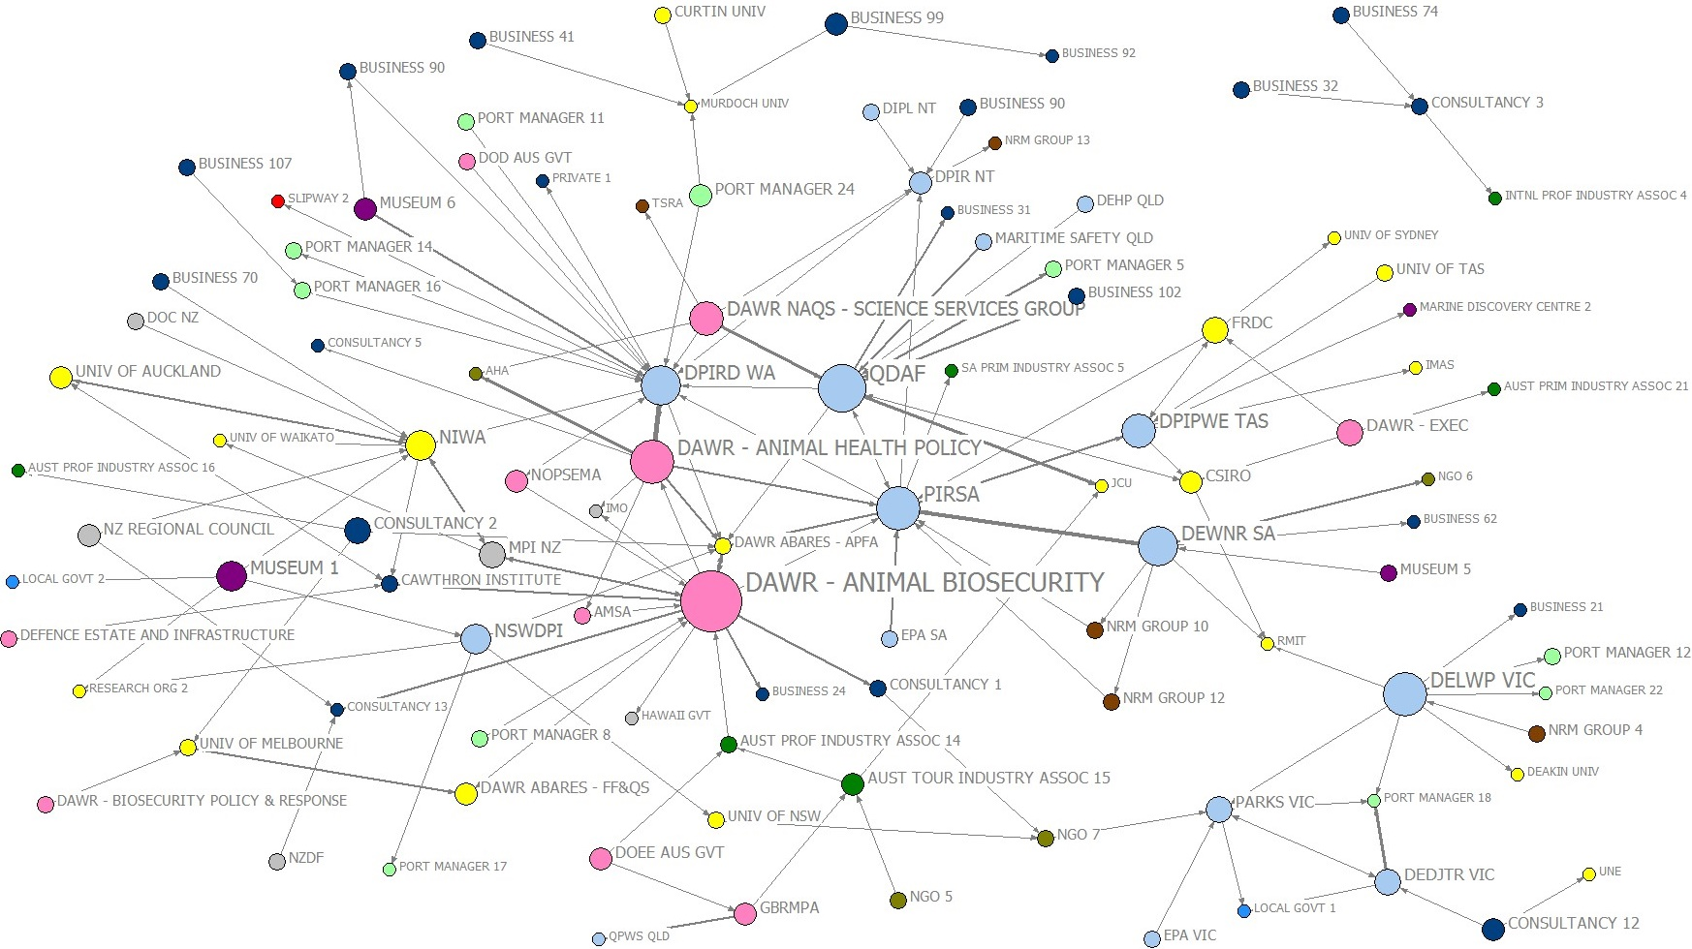
Source: ABARES marine pest network survey 2018. Note: Circles represent organisations exchanging resources (funding and/or in-kind) relating to marine pests. Size of circles indicates out-degree centrality (larger means more counts of resources provided). Direction of arrows indicate flow direction of resources. Thickness of lines represents number of resource exchanges. Colours indicate organisational type (see legend).
Figure 38 Resource flows network—resource receivers
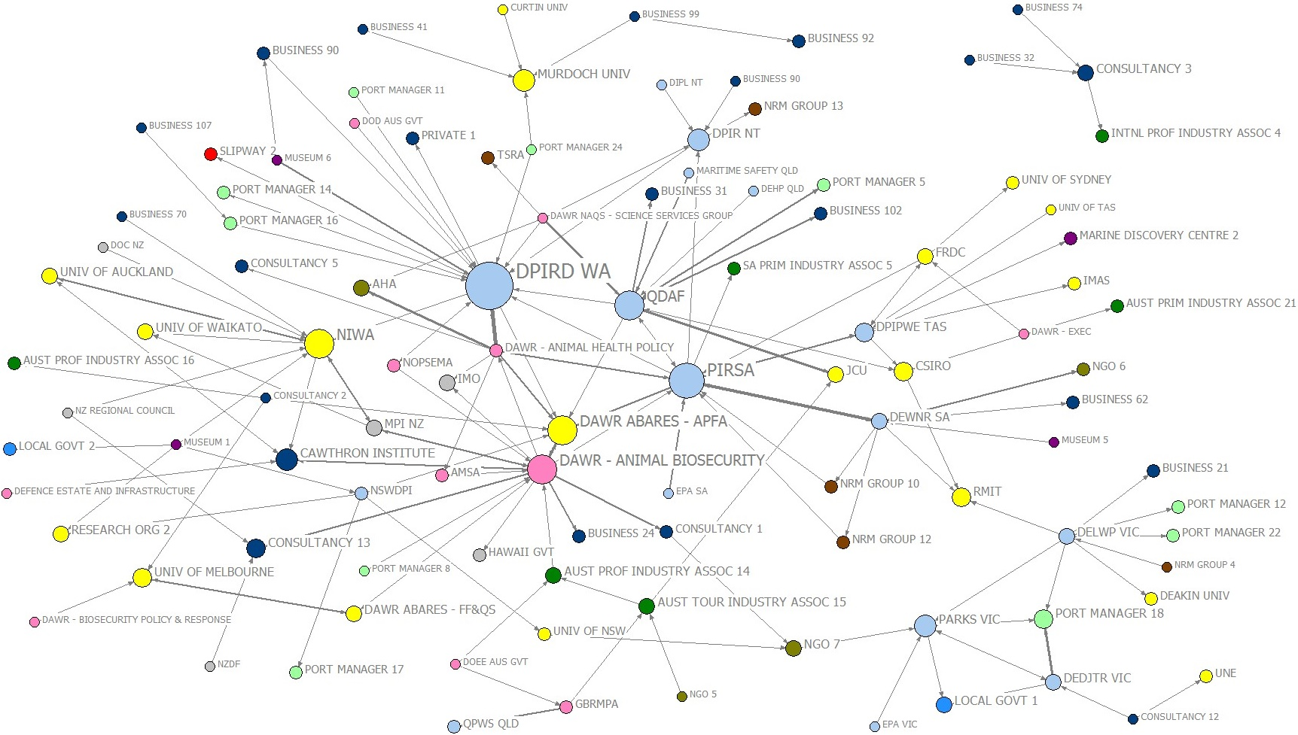
Source: ABARES marine pest network survey 2018. Note: Circles represent organisations exchanging resources (funding and/or in-kind) relating to marine pests. Size of circles indicates in-degree centrality (larger means more counts of resources received). Direction of arrows indicate flow direction of resources. Thickness of lines represents number of resource exchanges. Colours indicate organisational type (see legend).
Figure 39 Sub-groups in resource flows network
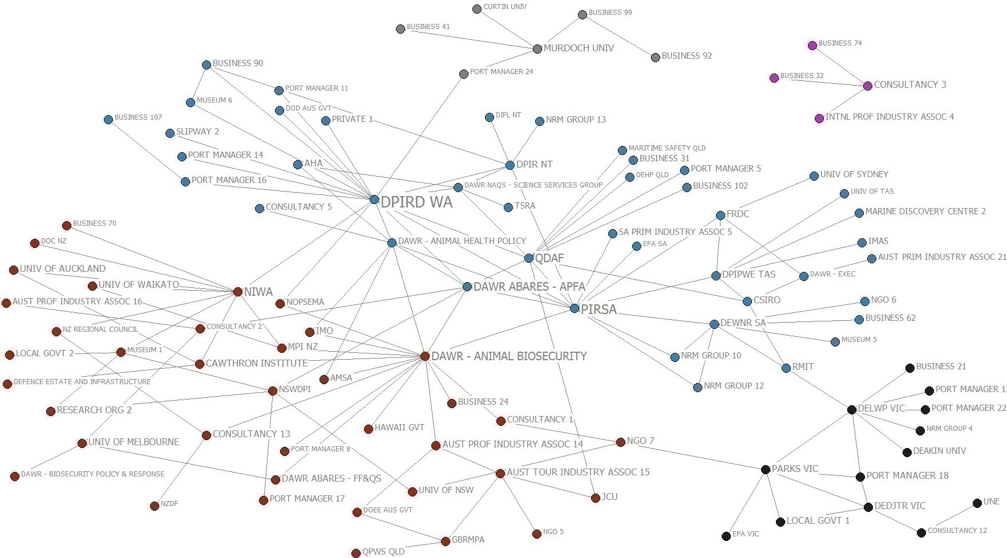
Source: ABARES marine pest network survey 2018. Note: The different colours represent membership of one of five sub-groups detected for resource flows in the network. Sub-groups identified using the Girvan-Newman (2002) algorithm where 5 clusters were identified as the appropriate number of clusters based on the ‘Elbow method’ (Ketchen Jr and Shook 1996).

What survey respondents value in a marine pest network
Survey respondents were asked what they would value from a national marine pest network. This provides insights into the project objective of understanding the 'information needs of the people, groups and organisations' in the network.
The strongest theme across all responses related to an improvement of information flow, although the aspects of that varied considerably. Several mentioned in a general sense that they would welcome better information sharing and having access to up-to-date information. Many respondents highlighted specific areas in relation to improved information flow.

Information sharing improvements
While there is some overlap, the key areas that a marine pest network could improve information sharing are summarised as follows:
- Information about marine pest species, including existing and exotic ones; this includes identification support—such as high quality images and pest distribution—and best practical treatment options. Other themes in relation to improved information flow that were mentioned less often than those above, included better communication about emerging issues, upcoming events, available funding or resources, future threats, and knowing what other stakeholder groups do in relation to marine pests. A few respondents also highlighted industry activities, for example, the need for better information flow about the contribution that aquaculture, fishers, and others might be making to marine pest issues as well as ways of addressing them. A few other respondents mentioned the need for more clarity around roles and responsibilities.

Community engagement advice sharing
Several respondents commented that the network could help to progress general surveillance by encouraging and supporting community groups, fishers and others involvement through enabling:
- awareness of pests to be on the lookout for
- advice on what community groups can best do to gather data and manage known marine pests
- building capacity of recreational fishers and divers to assist and support in identification, early detection and monitoring of marine pests
- community education kits, training packages
- education and advisory extension capability nationally, and assist the jurisdictions being able to find appropriate conduits to groups that can assist in passive surveillance

Incursions and emergency response facilitation
The marine pest network could facilitate responses through raising awareness of and providing updates about emerging and current incursions, and helping people to deal with emergencies. This could involve sharing:
- updates on current threats and incursions
- alerts on new invasive marine species and their extent
- notification of infestations that could adversely affect marine aquaculture farms – such as abalone, mussel and oyster farms
- information on exotic marine pest incursions nationally and how they were handled by relevant agencies and industry.

Regulation and policy feedback
Respondents saw a role for the marine pest network improving regulation and policy development, through both obtaining information needed to inform sound policy-making and communicating policy and regulation changes.
Areas the network could facilitate regulation and policy feedback included:
- be a contact point of the Marine Pest Sectoral Committee and regulators for consultation on policy and compliance issues to enable workable and effective policies and regulations
- up-to-date alerts and interpretation on new regulations and legislative changes
- identifying stakeholders who will be impacted in an area from a policy change
- awareness of inspection requirements for different areas of Australia
- clarity around local port and waterway managers responsibilities.
Some respondents indicated they would like to see part of the network focus on ballast water, mostly in relation to more effective information flow about related regulations, R&D, guidance for treatments, and surveillance and detection. Similarly, some respondents wanted to see a specific focus on biofouling with similar expectations as those expressed for ballast water.

Source of networking, advice and learning
Respondents commented that the marine pest network could be a source of advice and learning, including assisting in the ability to tap into expertise and have easy access to relevant information. Some people expressed this in a general sense whereas others pointed to specific topic areas, such as in surveillance, diagnostics, pest management and mitigation, in-water cleaning regulations and technologies, and vessel movements. Some requested forms of online training.
According to respondents, the specific areas the network could facilitate were:
- connecting with technical expertise that could be drawn upon during a response (e.g. diagnostic support), for surveillance (both during a response and ongoing), and on-ground resources during a response
- information for port manager and educational bodies about how to carry out surveillance in the port and educate and organise volunteers
- opportunity to gain feedback on proposed management options; assistance with taxonomic classification; advice on threat sources
- concise information on how ships with marine pests are to be handled
- a network to exchange ideas on a range of topics.

Research and development sharing
Respondents saw a role for the network in sharing current R&D knowledge, including regular updates in general, with some respondents mentioning specific areas, such as marine pest impacts, information about established marine pests, high risk species, and understanding actual versus perceived risk. Specific comments were:
A dedicated National Marine Pest Network would improve sharing of current research and innovation, outside the Ports networks
It would be great to have a dedicated and well managed online hub for all things marine pest related, including current research.

Links to tools and technologies
Respondents saw the network as potentially linking members to tools and technologies, including updated information on those relating to early detection, surveillance, control, management, eradication and response.

Improved policy coordination
Many respondents voiced the hope that the network would contribute to improved consistency in how marine pests are dealt with, especially between jurisdictions. These respondents expressed it as:
‘a united approach’; ‘provide uniform requirements across the country’; ‘consistency and certainty from government departments… State and Federal laws to be aligned and clear division of jurisdiction’; ‘Consistency in policy/regulation across all states’; ‘all the states will be on the same page’; ‘To be standard in every state, instead of different regulations in WA vs NT etc which is confusing for vessel operators and biofouling inspectors’
Improved coordination was nominated by many respondents as a valuable outcome that could come from a strengthened national marine pest network, including preventing doubling up of efforts to address certain issues. Some highlighted certain areas that could benefit from improved coordination, such as:
‘research and development…awareness-raising campaigns…and containment efforts’; ‘surveillance, monitoring, diagnostic testing and response’; and ‘marine pest surveillance, response, containment and treatment’.
One respondent commented:
I find that there are a lot of government agencies working towards the same goal, but not talking to each other directly, therefore doubling up on work that could be simplified. A National Marine Pest Network would hopefully help identify this and help in communication.
Others suggested more general potential coordination benefits from a marine pest network:
- more open relationships, co-operation, and coordination between government (regulatory and R&D) and stakeholders (industry, private, academia)
- less competition between agencies and institutions Australia wide
- coordination of non-government involvement in marine pest issues.

Access to network contact lists
Various respondents would value better access to contact lists and/or details of others working on marine pests. The scope of contact lists mentioned often depended on the respondent’s own interests, and included:
- domestic vessel operators, fishing industry and aquaculture participants, marine facility operators, marine maintenance and organisations that have an interest in marine pests control and management
- domestic vessels and facilities that require a ballast water management plan and/or marine pest management plan
- contact details for the various national stakeholders involved in marine pest biosecurity, including researchers and the relevant experts for each group of marine pests
- knowing who is involved and where so that stakeholders who will be impacted in an area as a result of a policy change can be found
- an identifiable contact number for prompt response to questions.

Strengthened collaboration to address marine pests
Some respondents hoped that an improved national marine pest network would result in strengthened collaboration on marine pest issues. Key areas mentioned included stronger lobbying through a more ‘coordinated push’ for certain policies or increased funding to address marine pests. Others wanted to see better collaboration in R&D to leverage combined resources, for example, with a focus on existing knowledge gaps.

Improved on-ground collaboration
A number of these respondents pointed to improved on-ground collaboration to address certain marine pest issues, such as better connections between port managers and industry groups; and the need to engage not only ‘big business’ but also the smaller operators to address marine pests. Others believed that the network could provide an avenue to extend successful collaborative programs such as the State Wide Array Surveillance Program (SWASP) in WA where a network of major ports undertake surveillance, R&D activities in collaboration with WA Department of Fisheries.
Several respondents would value a network that delivers greater transparency, including from government departments and that contributes to a greater shared understanding on national issues as well as the network’s functions and outputs.

Improved reporting mechanisms
Several other respondents hope that the network could contribute to improved reporting of pests, for example, by promoting a marine pest hotline to industry or by providing more support, rather than penalties, to encourage reporting where a pest is present on a vessel or cargo.

Discussion
The Australian Government highly values maintaining an effective marine pest biosecurity system that minimises the risk of marine pests to Australia. Given the substantive size of the task, success is dependent on effective networks that can facilitate equitable sharing of roles and responsibilities to deliver a range of functions, including passive surveillance, research and development and education and awareness-raising. Processes identified as likely to support the marine pest network’s functions are summarised as:
- Coordination—enough centrality (i.e. influential and trusted actors) to enable rapid communication, decision-making and response
- Innovation—some communities of practice (or sub-groups) engaged in learning and information sharing; with knowledge-brokering roles between groups to foster knowledge transfer
- Collaboration—distributed networks with bonding and bridging capital to enable engagement and partnerships.
These processes and the structural components underpinning them are used to frame the discussion about how networking about marine pests occurred during the period studied and opportunities for strengthening the network. Information from interviews with key stakeholders were used in case studies that illustrate the processes discussed.
Table 9 presents the summary of the structural characteristics that would be likely to support the 'ideal' marine pest network functions (across the first row) by type of social network processes in the first column (same as in Table 2). The traffic light ratings in the table were added to indicate the evidence of support compared to the ideal, based on the interpretation of the network analyses in this report. The traffic light ratings provide guidance as to where the best opportunities for improvement of the marine pest network are most likely.

Entire marine pest network

Coordination
Legislated responsibilities for marine pest management is spread across a federated system comprising all coast-bordering states and territories and the Commonwealth. In addition, as biosecurity is seen as a partnership and shared responsibility, there is a strong need for coordination and collaboration across a diverse set of actors. In the marine pest network, coordination is achieved through a number of core actors clustered at the centre of the network (Figure 5), particularly where government actors play a leadership role.

Table 9 Desired processes of the marine pest network—ratings of how well-supported by current network structures
The table below is a repeat of Table 2 (text in italics) with an added summary of the evidence that outlines how well the network structures support the functions of the ‘ideal’ marine pest network by type of desired process. Traffic light colours have been added to provide a quick, but approximate indication of the evidence of support, including well-supported (green); partly supported (yellow); or weakly supported (red). The phrase ‘as expected’ refers to ‘as expected by chance alone’, based on the statistical network analysis.
Pro- cess | Network feature |  | Functions of network
 |  |  | a) Entire network¹ |  | b) Passive surveillance | c) Research & development | d) Education/awareness-raising
COORDINATION | 1. Centrality |  | Ideally high, particularly in formal network  Good evidence  - Core of well-connected actors are dominant (Figure 5)  - Degree distribution – relatively small number of nodes have a high tie count (Figure 4).  - Forums with all state/territories represented have high scores for centrality (Figure 3) and eigenvector (Figure 9).  - Animal Biosecurity and Animal Health Policy Branches in DAWR scored high for centrality measures (Figure 6).  - State/territory government organisations tend to form hubs and spokes in their jurisdictions (Figure 7).  - Centralisation around forums (Figure 2 & Figure 7). |  | Ideally some, but need diverse actors and distributed on-ground network  Moderate evidence  - More actors forming information source and sink hubs than expected (Table 8 [6b and 7b])  - A few decentralised hubs mainly around state/territory governments, two Department of Agriculture branches and two consultancies (Figure 13). | Ideally some, but need balance between ability to coordinate and pockets of innovation  Moderate evidence  - Government agencies dominate highest centrality measures (Figure 21).  - More information source and sink hubs than expected (Table 8 [6c and 7c]). | Ideally some, but need diverse actors and distributed on-ground network  Good evidence  - More than expected information sink and source hubs (Table 8 [6d and 7d]).  - More forum members speaking to fellow forum members than expected (Table 8 [20d]).
INNOVATION | 2. Communities of practice |  | Ideally moderate  Moderate evidence  - Sub-grouping present, but most members in one large, yet diverse sub-group (Figure 11).  - Sub-grouping also around DPIRD WA and several marine consultancy businesses. |  | Ideally moderate pockets of activity that are location or pest specific  Moderate evidence  - Sub-grouping present, mainly revolving around state/territory organisations (Figure 19).  - Some distributed on-ground networks around non-government actors, but more would be ideal (Figure 19).  - Not possible to tell from current network structure data if there is pest specific activity, but an example of connected marine care groups (e.g. case study, Box 5). | Ideally moderate pockets of research information sharing  Moderate evidence  - Sub-grouping present, but all state government agencies, except VIC located in largest sub-group (Figure 25).  - More reciprocal ties and triads than expected (Table 8 [5c, 9c and 10c]).  - Example of innovation partnerships in network (e.g. case study, Box 2). | Ideally moderate pockets of activity that are location or pest specific  Moderate evidence  - Sub-grouping present, mainly revolving around state/territory organisations (Figure 32).  - Not possible to tell from current data if there is pest specific activity.
 | 3. Knowledge-brokering |  | Ideally moderate  Moderate evidence  - Significant bridging configurations (Table 8 [8a]).  Major bridges across the network were DAWR - Animal Biosecurity, DPIRD WA and QDAF.  - Average network path length 3.5 steps.  - Higher than expected bridging capital where forum members link to another actor (Table 8 [16a and 17a]), but not as information sink and source hubs (Table 8 [18a and 19a]). |  | Ideally high, e.g. links with on-ground groups for trust building and two-way information flow  Limited evidence  - Bridging configurations as expected (Table 8 [8b]).  - Major bridges in the network were QDAF, DEDJTR VIC, DPRID WA and PIRSA. Not possible to tell from current data if structures support knowledge-brokering between identified communities of practice and on-ground groups. | Ideally high between researchers, policy-makers and resource managers and interdisciplinary research  Limited evidence  - Bridging configurations as expected (Table 8 [8c]).  - Major bridges in the network were DAWR - Animal Biosecurity, PIRSA and DIRPD WA.  - Examples of knowledge brokering by consultants (e.g. case study, Box 3). | Ideally high, e.g. links with on-ground groups for trust building and two-way information flow  Limited evidence  - Bridging configurations as expected (Table 8 [8d]).  - Major bridges were QDAF, DAWR - Animal Biosecurity and Animal Health Policy Branches, DEDTJR VIC and PIRSA. Not possible to tell if structures support knowledge-brokering between identified communities of practice and on-ground groups.
COLLABORATION | 4. Bonding capital |  |  | Ideally high for example, bonding within forums or within communities of practice  Limited evidence  - Qualitative evidence of forums supporting bonding capital in the network’s core.  - High level of reciprocal ties at significant levels (Table 8 [5a]); many triads throughout informal network but not at significant levels (Table 8 [9a and 10a]). Some examples of very strong collaborations (i.e. completely reciprocated triads).  - Links between members of the same forum similar to expected (Table 8 [20a]). | Ideally high between state/territory agencies and other actors involved in passive surveillance programs  Limited evidence  - Reciprocal ties more than expected (Table 8 [5b]).  - Triads the same as expected (Table 8 [9b and 10b]). No examples of strong collaborations (i.e. completely reciprocated triads).  - Sparsest network (Table 8). | Ideally high between research and other groups  Good evidence  - More reciprocal ties and triads than expected (Table 8 [5c, 9c and 10c]).  - Some examples of strong collaboration found (i.e. completely reciprocated triads). | Ideally high between state/territory agencies and other actors  Limited evidence  - More reciprocal ties than expected (Table 8 [5d]).  - Triads the same as expected (Table 8 [9d and 10d]). No examples of strong collaborations (i.e. completely reciprocated triads).
 | 5. Bridging capital |  |  | Ideally high with links between different sector groups and policy forum attendees linking to broader stakeholder network  Mixed evidence  - Limited connections with on-ground groups.  - Out-ties outweigh in-ties to community groups (Table 4).  - Community-linked actors more likely to provide rather than receive information from another actor than expected (Table 8 [11a versus 12a]).  - Higher than expected bridging capital where forum members link to another actor (Table 8 [16a and 17a]), but not as information sink and source hubs (Table 8 [18a and 19a]).  - More ties between governments and private companies/businesses than between any other sectors (Appendix 6)  - Commercial aquaculture industries and local governments under-represented in the network.  - Some ties linking governments and on-ground groups (e.g. ports, NRM groups, vessel services) (Appendix 6). | Ideally high with two-way links from higher levels to on-ground actors  Mixed evidence  - Community-linked actors more likely to provide rather than receive information from other actors (Table 8 [11b versus 12b]).  - More bridging capital where forum members link to another actor than expected (Table 8 [16b and 17b]).  - No more than expected three linked actors (Table 8 [8b]) and forum members as information sink and source hubs (Table 8 [18b and 19b). | Ideally high, e.g. links across research-government-industry-on-ground groups to promote knowledge sharing  Limited evidence  - Some ties linking governments and the research sector (Appendix 6).  - Bridging configurations as expected (Table 8 [8c]).  - Higher than expected bridging capital where forum members link to another actor (Table 8 [16a and 17a]), but not as information sink and source hubs (Table 8 [18c and 19c]). | Ideally high to ensure information flow and trust between on-ground and higher levels.  Limited evidence  - Some ties linking governments and on-ground groups (e.g. ports, NRM groups, vessel services) (Appendix 6).  - Mostly no more configurations with community-linked actors than expected (Table 8 [12d, 13d, 14d and 15d], except [11d]).
¹Entire network should be multi-functional; and offer structures and processes that support all the network functions.

Overall, the evidence of a dominant core is strong (Figure 5), based on the degree distribution and the statistical network analysis (Figure 4). In terms of the formal network, there is a high degree of cohesion around policy forums. Forums that involve representation from all relevant states and territories rated high for centrality (total number of connections) and eigenvector scores, including CCIMPE, MPSC, MPSC - Partner Workshop, MPSCSS_TG and NBC all within the top twenty actors for one or both of these measures. This confirms effective coverage of the network's core across all state and territories through national forums.
While the network revealed limited evidence of bonding capital, the trust-building, problem-defining and risk-management that might otherwise be associated with bonding capital in networks (Berardo 2014) may well be provided for within the policy forums (Fischer and Leifeld 2015). Some interviewees confirmed that bonding capital in bodies like the MPSC can be regarded as strong. In addition, the statistical network analysis found considerable bridging activity (beyond actual forum participation) linking the policy fora with other actors in the wider network (Table 8 [16a and 17a]). However, forum members do not link with other actors in the network to the extent that they can be regarded as significant sink and source hubs of information (Table 8 [18a and 19a]). This suggest the forums provide some positive contribution to the network’s structural ability to share information.
The informal network is largely government-centric. In the Department of Agriculture, the Animal Biosecurity Branch and Animal Health Policy Branch both scored highly across the centrality measures. The Animal Biosecurity Branch is the most connected actor in the network (total degree) (Figure 6). It is also ranked second in eigenvector centrality (just ahead of Animal Health Policy Branch) (Figure 9) and is the second most popular ‘information source’ (out-degree) (Figure 8). This suggests that the Animal Biosecurity Branch and to some extent Animal Health Policy Branch, are well positioned to facilitate the functioning of the network, both for promoting coordination and for disseminating information. However, given the Department’s roles and responsibilities relate mainly to higher level issues, the agency's ability to reach a wide range of on-ground actors may be limited.
The main state and territory government organisations tend to form hubs and spokes in their jurisdictions (Figure 7). However, discussions with MPSC members suggested the level to which state and territory governments were able to establish their networks varied considerably. QDAF is most well connected of the states, based on degree centrality (total degree) (Figure 6) and eigenvector centrality (Figure 9), however, DPIRD WA is by far the most prominent information source (out-degree) (Figure 8).
Hence, state and territory government-centred hubs, together with the Department of Agriculture branches, key policy forums and some other non-government actors, form the dominant core of the network (Figure 5).
The statistical network analysis found more information source and sink hubs, which are indicative of coordinated activity, than would be expected by chance for the entire network (Table 8 [6a and 7a]).
In addition, the small world properties of the network mean that it is well-placed to enable efficient and quick communication. This suggests that the network is well structured for coordination and high-level inter-government collaboration through quick information diffusion to well-connected actors. A dominant core can aid quick decision-making and action to solve relatively simple challenges. It can also assist in capitalising on economies of scale, such as through coordinated and collaborative activities focused on issues that affect all stakeholders. It allows for quick coordination during times of emergency pest outbreaks as institutional structures that respond to biosecurity incursions need to foster rapid response, while being adaptable to local conditions (Cook et al. 2014).
However, when the centralised actors have limited access to multiple sources of information centralised decision-making can be problematic as it may inhibit learning (Bodin et al. 2006). The risk is that if the core becomes too dense, i.e. very high bonding capital, it may result in a homogenised core that lacks connectivity with the rest of the network. Such homogenisation can limit innovative thinking if all actors involved begin to think similarly and share similar norms and values. Hence, the network structures will not be in place to address complex tasks and challenges for which longer-term transformation is needed as this requires innovative thinking. The risk of a homogenised core can be overcome by centralised actors being well connected with a wide range of other actors throughout the network to facilitate information flow to and from them.

Innovation
In this study innovation is defined not just as technological advancements but rather as a broader process that includes co-evolving technological, social, economic and institutional change (Klerkx et al. 2012). Innovation is likely to come about only if there is considerable connectivity between R&D, policy-making, on-ground groups and others to allow for the integration of knowledge types to deliver workable solutions for all involved (see Box 2).
Box 2 Case study - Innovation partnerships
A collaborative state-wide marine pest surveillance program is in place between port authorities and a state government. The port authorities provide samples of organisms collected from settlement plate arrays situated in the port to the state government twice a year. State government scientists provide the technical capability behind the program, but the surveillance program has been developed in collaboration with the ports to ensure it is practical and cost-effective to implement. The program was set up so that port authorities can undertake the monitoring themselves rather than employing a specialised service provider. Different ports in the state have regular meetings related to environmental management, which include discussions about the surveillance program, including identifying ways to make the use of arrays more practical. The state government agency provides guidance material on how to identify marine pest species, send reminders, and sends staff out to ensure the port authority personnel use the correct sampling techniques. An interviewee representing a port authority spoke about the importance of these visits as they enable port authority staff to gain a deeper understanding of what is required and it is reassuring to know that what they do is correct. A survey respondent who also represented a port authority participating in this program remarked that the program has the potential to facilitate more R&D, reduce costs, and allow interstate/port sharing of information about the distribution of marine pests. The collaborative approach to surveillance somewhat overcomes the limitations of the current approach where some ports undertake the national system and others do not.
Source: Marine Pest project 2018 - Interview

Moderate levels of sub-grouping—or communities of practice—would be expected in the marine pest network as a whole if innovation was being well-supported. The presence of sub-groups, indicated by areas of greater cohesion in the network, with scale bridging and knowledge-brokering across sub-groups would demonstrate that diverse knowledge types have potential to contribute to feedback opportunities and innovation in the overall network (Bodin et al. 2006).

Bonding capital supporting communities of practice
The descriptive network analysis of the entire network revealed some sub-grouping in the network, but this was predominantly around the dominant actors at the centre (Figure 11). Almost half the network were members of one large sub-group, containing all of the national policy forums, most Commonwealth government organisations, and a range of other diverse organisation types (for example, port managers, industry bodies, businesses, NRM groups and NGOs). Relatively large sub-groups were detected: a distinct West Australian network (government agencies connected with port authorities and universities) and several stakeholders formed their own communities, such as marine consultancy businesses.
The statistical network analysis suggests there is good two-way information flow between organisations in the entire network as is evident in the higher than expected level of reciprocal ties (Table 8 [5a]). However, the presence of triads were no more than can be expected by chance only (Table 8 [9a and 10a]).

Bridging capital supporting knowledge-brokering
The evidence for bridging capital that supports knowledge-brokering was moderate in the entire network. The descriptive network analysis found that three government agencies stand out as good potential knowledge-brokers based on their relatively high betweenness scores, i.e. the Animal Biosecurity Branch in the Department of Agriculture, DPIRD WA and QDAF (Figure 12). Betweenness measures give an indication of actors in a network that are well positioned to take on bridging and knowledge-brokering roles. Although all three of these actors belong to the same large sub-group, they all have ties to several of the other sub-groups as well.
In the statistical network analysis, evidence of bridging configurations in the entire network involving three linked actors was strong in comparison to what could be expected by chance (Table 8 [8a]).
An interesting observation is that most actors are potentially connected within a few steps of each other via the dominant core of high degree actors at the network’s centre, as the average path length in the marine pest network was only 3.5 steps. This indicates the network has some ‘small world’ properties and might mean that any barriers to information sharing due to sub-grouping could be overcome by bridging offered by central hubs in the network.
The data suggest that the innovation capacity in the marine pest network may benefit from building stronger bridging capital, especially between actors representing different sectors in order to integrate different knowledge types (an example of a successful innovation partnership for integrating knowledge is in Box 2). This could take the form of the core establishing strong linkages with actors, such as marine consultants, who are already fulfilling knowledge-brokering roles (Box 3). In addition, organisations in the core can invest in the capabilities of well-located staff to reach out and maintain their connectivity with others in the network (Box 7).
Box 3 Case study - Consultants as bridges and knowledge-brokers
A consultancy representative interviewed with extensive experience in his subject field mentioned that he still continually learns in part because of his interactions with a wide network. This network includes experts on marine pests in overseas countries, as well as local scientists, engineers, dockyard workers, students and others. The information received from the different sources continually shapes his own knowledge and insights. In addition, he also adjusts and tailors his messages to a wide range of people he interacts with based on their existing knowledge.

Collaboration
Collaboration is happening at the core of the network among the central stakeholders, but there is less evidence of this happening in the periphery of the network. Efforts to address marine pests in part depends on initiatives and investments translating into improved on-ground activity, which would include many more two-way partnerships with on-ground groups and communities at the periphery of the network, in places where marine pests are present or likely to invade. Given Australia's extensive coastline, the scale of the marine pest biosecurity challenge is considerable, and this suggests that there is a need for a widely distributed on-ground network beyond the networks’ core. The Review advocated for more collaboration across a wide range of non-government actors involved in complementary initiatives to address marine pest issues.
Collaboration requires negotiation between the participating parties to establish the norms and shared rules that govern their behaviours (McNamara 2012). Two-way information flow and personal interactions are fundamental in building the trust-based relationships required for collaboration (Kruger et al. 2010).
Across all survey respondents, they claimed to provide information 747 times to 235 organisations, and asked others for information only 477 times from 127 organisations. Respondents are most likely to come from the most central organisations—partly because the survey targeted those with clear roles—and partly because central actors were more familiar with the content matter (for example, government department with responsibility for marine pests compared to a yacht owner). In the empirical data, a respondent stating they sought information is equivalent to the receiver stating they provided information. Yet it does suggest something about the perspective of organisations in the network that they are more likely to perceive that they ‘tell’ rather than ‘listen’; or that they disseminate rather than learn.

Bonding capital
Bonding capital is important for collaboration as it facilitates trust, shared norms, reciprocity, learning, cohesion, consensus building and conflict resolution within groups, and these are needed to allow people to work together effectively. The centralised network suggests that there is bonding capital at the core of the network. There was lots of evidence of two-way reciprocal ties, particularly between government agencies, both state/territory and Commonwealth. The statistical network analysis revealed strong evidence of these reciprocal relationships (Table 8 [5a]), the simplest form of bonding capital in the network. There was descriptive evidence of more than 500 closed triad configurations (three linked actors) in the network. Triads are a strong form of bonding known to facilitate learning since three way relationships combine and reinforce knowledge (Barnes et al. 2017b) and assist trust-building between stakeholders. The statistical analysis, however, revealed that closed triad configurations were not present at significant levels (Table 8 [9a and 10a]). Furthermore, in relation to the formal network, there were some ties between actors attending the same forum outside of the forum, but no more of these than would be expected by chance alone (Table 8 [20a]).
This suggests that while there are very good examples of bonding capital supporting collaboration in the network, it is mainly occurring among government agencies in the network’s core, and very little with actors outside of this core. There is a need for the networks’ core stakeholders to tap more effectively into existing sub-groups, such as quite extensive networks that revolve around particular marine consultants and businesses (Figure 11). Funding rounds, support services and organising events for on-ground groups could assist in fostering more bonding within and between on-ground groups. These actions can enhance their ability to carry out on-ground activities and build their connectivity with governments, researchers and other peer groups, as seen in the marine care group case study in Box 5. Such investments may also help them strengthen and retain their membership base.
Box 4 Case study - Connectivity with the formal network
An interviewed consultant reported he was previously well connected to the formal network when the multi-stakeholder National Introduced Marine Pests Coordination Group (NIMPCG) operated prior to 2011, including contributing to producing a range of marine pest related outputs. As a result of this involvement he also participated in various discussions outside those formal meetings. After the government-based MPSC replaced NIMCG, he reported that he only hears 'second or third hand' information about what is happening on marine pest biosecurity, despite some informal connections with key government organisations. He appreciated the opportunity offered by the Review to provide input into how the marine pest biosecurity system operates.

Bridging capital
Bridging capital is important for collaboration as it establishes linkages between otherwise disparate groups and facilitates knowledge-brokering, i.e. translating information between groups and integrating knowledge. Evidence of collaboration with a wide range of diverse actors outside the network core would be demonstrated by a high level of scale-bridging, that is, linkages between actors from different sectors or administrative levels. While there were many instances of bridging within and between different levels of government administration (104 ties), mainly between Commonwealth and state/territory agencies, there was less evidence of this bridging across actors from different sectors. The descriptive analysis showed that of the bridging relationships supporting collaboration across different sectors, most of these occur between core government actors and private companies/businesses (92 ties) and to a lesser extent with on-ground groups (port managers, NRM groups, vessel service providers and education/extension organisations) (56 ties) (Appendix 6). This suggests that some bridging configurations are supporting collaboration across scales but to a lesser extent with on-ground organisations at the periphery of the network.
Effective collaboration requires the core actors at the centre of the network to be well-connected with the rest of the network. Policy forums play an important role in connecting government actors with each other, and with non-government actors as is clear from the formal network (Figure 2) (see also Box 4). In terms of the formal network, there was higher than expected bridging capital in the form of forum members linked to another actor (Table 8 [16a and 17a]).
Most remarkable is the role of MPSC - Partner Workshop in scale-bridging that suggests engagement is happening with a wide group of non-government actors. It shows the important role of the MPSC - Partner Workshop in providing a forum for receiving and providing information to non-government partners. From the discussions and interviews, it was clear that MPSC and the Department of Agriculture staff value the MPSC - Partner Workshop meeting a great deal, and include an agenda item in every MPSC meeting to reflect on the preceding day’s MPSC - Partner Workshop and how it could be improved. The MPSC - Partner Workshop invitees are also asked if they would like to invite anyone else or whether they would like to add something to the agenda. In principle, anyone is able to present at these meetings. However, some of the non-government interviewees expressed a view that the MPSC - Partner Workshop predominantly involved the Department of Agriculture staff providing updates to attendees. The MPSC - Partner Workshop agendas showed that more than half of the meeting is allocated to the Department of Agriculture staff providing updates (although some of this time might also involve discussions with attendees). Typically, around an hour and a half is allocated for open discussion. One of the non-government interviewees was concerned about the cost involved in attending for those who are not funded by their organisations to do so, in terms of travel expenditure and time.
Box 5 Case study - Connecting marine care groups
This case study provides an illustration of a well-connected partnership between a state government, community groups and a research and education provider. It is based on interviews with a state government representative and a representative of the education/ research provider and community group.
Each year, the state government agency makes available a limited amount of funding to marine care groups to assist in marine pest removal from the marine sanctuary and monitoring efforts. Marine Care Group A, involving around 40 members, submits a volunteer action plan to the state government agency that includes the activities that the group have identified as priorities.
Marine Care Group A is well connected to a TAFE and higher education institute as one of the institute’s aquaculture experts is a key member of the care group. The group benefits from his expertise, while students have conducted research into invasive marine pests at the marine sanctuary where most of the group’s activities occur.
There is significant amount of ‘cross-pollination’ between the marine care groups across certain parts of the state, with some volunteers holding memberships to two or more groups. This is particularly useful when it comes to discussing issues such as introduced marine pests.
To encourage information sharing, the state government agency invests in community and stakeholder engagement. This includes bringing together in regular fora marine care groups from across the state since 2012. The state government agency funds the costs of travel for two representatives from each marine care group. These forums include sessions on marine pests, current reporting arrangements and how priorities are set. Importantly, opportunity is provided for marine care group representatives to air issues, which has led to streamlining reporting and monitoring procedures.
Source: Marine Pest project 2018 - Interview
All state and territory government agencies rated relatively high for betweenness and speed of information flow. These results confirm that state and territory government organisations are locations where different kinds of knowledge are being integrated. Keep in mind that such organisations are large entities with various divisions, sections and teams. This emphasises the importance of good networking within large government organisations in order for these important functions to occur.
Several consultancies and businesses had high betweenness scores (Figure 12), as well as forming their own sub-groups within the network (see Box 4 and Figure 11). While some traditional R&D providers such as universities featured high for centrality, some consultancies and businesses also scored relatively high (Figure 21). This suggests that several consultants and businesses play an active role in identifying and disseminating marine pest knowledge and research across the network. It is therefore important that organisations in the core of the network, such as those with high eigenvector scores, maintain relationships with active consultancies and businesses to support quick information dissemination throughout the broader network and to connect them with the core.
Box 6 Case study - Surveillance partnerships
A mining company have contracted a private service provider to facilitate a marine health project. The service provider carries out monitoring, photographing, collection and transport of sentinel settlement plate arrays and rope mops for monitoring biofouling in locations that have been identified as high risk of marine pest incursion. Photographs of plates are taken monthly and three monthly plates are collected and transported to the state/territory government department for species identification. This process serves to facilitate two outcomes: (i) an early detection system for exotic and invasive marine pests and (ii) establishment of a baseline database of marine biodiversity present in the area.
The interviewee reflected on this long-standing relationship between his business and the relevant team in the state/territory government department. He describes the ‘amazing links’ they have developed with the agency and the responsiveness and amicable relationships they have with the government staff. ‘If we find something strange, they will organise for the species identifications. They are very good to communicate with’. The relevant staff have well-established links with subject matter experts in a university and a museum, who assist with species identification and advice when needed. These relationships form an important network between subject matter experts, on-ground surveillance activities, and a state/territory government actively coordinating and facilitating these linkages. The interviewee emphasised over-reliance on distributing laminated species identification cards is insufficient to support such activities. Such resources need to be complemented with access to experts who are able to provide swift and accurate feedback.

Bridging links with on-ground actors
Some elements of on-ground networking were evident. For example, there was some connectivity across sectors, such as between state government actors and on-ground groups, e.g. port managers, marinas, NRM groups and museums, which facilitate active and passive surveillance, and education and awareness-raising activities. Similar links were evident between governments, research organisations and consultancies that were facilitating R&D discussions. There is also evidence of port authorities, and resource and energy companies being connected to the network. The case studies showed there were very successful examples of two-way partnerships supporting surveillance functions (Box 2 and Box 6), which could be adopted more widely throughout the network.
While there was some evidence of bridging links from core actors to on-ground actors, there were not enough to be able to say that an extensive network with on-ground groups was present. This suggests that more opportunities for collaborative linkages and two-way partnerships with on-ground and community groups could be developed and strengthened. One of the case studies showed how resource cuts can unwittingly undermine the connectivity of staff and their organisations (Box 7).
The statistical network analysis showed mixed results for actors with links to the broader community (such as vessel owners, fishers and the general public) in terms of fulfilling bridging roles. Where such community-linked actors received information from only one other actor, there was no more of these configurations than would be expected by chance alone (Table 8 [12a]). However, if such community-linked actors received information from two other actors, a higher number of these configurations were present than were expected (Table 8 [13a]).
State and territory governments dominate community links in the network. Of the 35 state and territory government organisations identified, 12 had ‘out-ties’ to community, as opposed to only three with ‘in-ties’ from the community (Table 4). This imbalance in the network’s structure with considerably more ties for providing information to the community compared to a near absence of ties for asking the community for information (Table 4) is potentially concerning. It may reflect a lack of community engagement to ensure community groups’ perspectives are incorporated into decision-making processes. As this study did not target those with links to the community, this assertion requires further evidence. A recent study about the knowledge, reporting behaviour and required education and awareness resources of marine pest passive surveillance observer groups also noted the need to tap into the knowledge of local groups (Mercer et al. 2017).
The case studies on the marine care group (Box 5) and the collaborative state-wide surveillance program involving port authorities and the state government (Box 2), illustrate the importance of bridging across levels—connections between state government organisations and community groups, as well as bonding links—connections within and between similar organisations. The latter assisted groups to learn from each other and to pool resources where possible. Bridging links from state governments facilitates connections between these on-ground groups and other important actors, such as research providers and scientific experts. It also illustrates the importance of investing in establishing and maintaining these linkages as they seldom form spontaneously from passive forms of information provision, such as print materials or websites.
Given their centrality in the network, state and territory government agencies are well placed to translate information between different groups, such as research findings to different on-ground users. This is not to suggest that the state and territory governments should be the sole actors active at the periphery. Given the limited on-ground extension roles in Australian marine pest biosecurity, it is likely that more active local actors could boost links to the community and particularly be more adapted to have in- and out-ties (and ability for the network to listen as well as tell).
Several consultancies and businesses play a key role in integrating and disseminating information (see Box 3) and are likely to have insights into the barriers and opportunities that their clients face, including innovative practices and ideas that may be of relevance for other actors in the network. However, there is a need to understand the drivers and barriers that consultancy businesses and private service providers may face in taking on a greater bridging and knowledge-brokering role. For example, Botha et al. (2008) investigated the involvement of private agricultural consultants in environmental extension, given that New Zealand has no public extension system. The study found that while the consultants played an important role in progressing on-farm agricultural production, their role in proactive environmental extension was limited resulting from a lack of market forces to do so.
A group that appears under-represented in the on-ground network is commercial aquaculture industries. This is confirmed by the survey data with several industry representative bodies present in the network, but their connectivity in the entire network was low (Figure 6), as well as low in the passive surveillance network (Figure 15) and education and awareness-raising networks (Figure 28). Some MPSC members mentioned that they have limited connection with commercial aquaculture industries. An interviewee explained that this is likely to be because biosecurity concerns for commercial aquaculture industries relate more to marine diseases that may affect fish stock, and less about marine pests.
Another potential bridging organisation that could fill the gap between state and territory governments and some on-ground actors is local government. Yet only two such local government actors are in the network (2 organisations, with one link to a community).
Information dissemination from the core needs to be prompt, easily accessible and accurate to enable actors in the distributed on-ground network to play their part. The strongest theme emerging from survey respondents to the question about what they would value from an improved network, was improved information sharing. The most commonly reported information sharing need identified was information about marine pest species that will support species identification and advice on the best treatment options. Some interviewees said they would like to see more transparent and timely communication from some national forums. A consultant operating at the ‘coal face’ of where marine pests have been detected was disappointed that up to date information about marine pest detections made in recent times was not publically available, as this information would assist in surveillance for particular species, for example, as part of marine pest boat hull surveys.
It is important to remember that knowledge-brokering does not happen spontaneously, even if there are bridging network structures in place. Leadership is required by organisations that act as boundary or bridging organisations (including as knowledge-brokers) to mediate different and often conflicting perceptions of actors across administrative levels. For example, a state level plan may be important to state actors, however, local actors may believe it does not address their concerns, or even worse, causes them more issues. In this situation, the plan will enjoy little legitimacy with local actors unless there is a process of mediation (Cash et al. 2006).

Topics of information sharing in the network

Passive surveillance
The passive surveillance network is dominated by state and territory government organisations, including hub and spoke formations and communities of practice revolving around state and territory governments. This is to be expected given that each state and territory has responsibility for passive surveillance in their jurisdiction. This was consistent with the high level of occurrence of information sink and source hubs than would be expected by chance alone (Table 8 [6b and 7b]), which can be helpful for coordination. State governments play a key role not only in information provision, but also in maintaining positive relationships with surveillance providers, and in capacity building and linking on-ground players with others, such as scientific experts.
Forum attendees had a higher level of bridging ties that related to passive surveillance than would be expected by chance alone (Table 8 [16b and 17b]), but they cannot be regarded as information sinks or hubs (Table 8 [18b and 19b]). This may suggest that there was considerable talk about passive surveillance by forum attendees, but not enough to show that these actors were playing a significant role in coordinating passive surveillance discussions. Confirming this inference requires further investigation.
As community-linked actors are likely to hold valuable insights about what works and does not work to facilitate passive surveillance for the communities they interact with, one would hope to see them as significant information sources for others in the network. This is supported by the statistical network analysis, which found that community-linked actors in the passive surveillance network show a higher likelihood of providing, rather than receiving information from another actor in the network (Table 8 [12b versus 11b]) than could be expected by chance alone. However, community-linked actors were acting as sinks and sources to other actors in the network at the same level that would be expected by chance alone (Table 8 [13b and 14b]).
A favourable configuration for innovation in the passive surveillance network would be moderate evidence of communities of practice supporting innovative thinking, and knowledge-brokers linking these communities with on-ground groups. Integration of different knowledge types would be required to make initiatives around passive surveillance workable for the stakeholders involved. While there was evidence of sub-grouping, mainly around state/territory organisations (Figure 19), and a major bridge in this network was QDAF (Figure 18), there is not enough evidence from the descriptive analyses to conclude if current network structures support knowledge-brokering between identified communities. Ideally, there would have been more evidence of extended networks involving core actors and on-ground actors, such as port managers and consultancies, rather than single ties between state/territory government organisations and on-ground players within the sub-groups (Figure 19).
As for collaboration, there was limited evidence of bonding capital supporting collaboration. Some evidence was found of the weaker form of bonding capital, i.e. reciprocal relationships between two actors (Table 8 [5b]). However, the descriptive analysis showed there were fewer closed triads—a stronger form of bonding capital known to support learning—than the other sub-networks. Indeed, the presence of the desired triads were the same as can be expected by chance alone (Table 8 [9b and 10b]) as confirmed by the statistical analysis. There was mixed evidence of bridging capital supporting collaboration. Forum members were more likely to link to another actor about passive surveillance (Table 8 [16b and 17b]), but they were no more or less likely to act as information sink and source hubs about the topic than expected by chance (Table 8 [18b and 19b]). Despite the examples of collaboration we came across in this study, the evidence indicates a low level of collaboration is occurring across the passive surveillance network and this suggests that organisations tend to be working in isolation on this issue.
In comparison, the active surveillance network is much more densely connected than that for passive surveillance, which suggests there is a lot more interaction occurring in the active surveillance space than for passive surveillance. The important role of state and territory governments in this space was highlighted during two interviews, where there were evidence of innovative on-ground partnerships underpinning surveillance activities (Box 2 and Box 6). The Department of Agriculture had a higher centrality in the active surveillance network than the passive surveillance network (Figure 15). There was a number of collaborative partnerships between state government departments and port authorities (Box 2) that indicated network structures were in place that were facilitating innovative approaches to active surveillance programs.

Research and development
The results suggest that the R&D network is well-structured for coordination. Centrality measures for the R&D networks (Figure 21 and Figure 24) show that government agencies are the dominant players, including research providers situated within government agencies (ABARES). The statistical network analysis found more information source and sink hubs than would be expected by chance for the R&D network (Table 8 [6c and 7c]), indicating network structures that are suited for coordinated activity.
The descriptive network analysis (Figure 25) suggests that there are at least eight sub-groups in the R&D network, which could potentially contain hubs for experimentation and risk-taking that could spark innovation. However, all state and territory government agencies, except Victoria are located in the largest sub-group. This group involved a diverse range of organisations, including universities and other research organisations, businesses, consultancies, museums, NRM groups and NGOs. This suggests that there is a considerable level of scale bridging that allows for the sharing and exchange of different perspectives—and probably learning—about R&D activities within the network.
The statistical network analysis suggests there is good two-way information flow between organisations in the R&D network as is evident in the higher than expected level of reciprocal ties (Table 8 [5c]). There were network structures present for combining and reinforcing knowledge in the R&D network, including more closed triads than expected by chance alone (Table 8 [9c and 10c]). Unlike in the other sub-networks, there were some (seven) completely reciprocated triads (i.e. where there are two-way ties between all three actors) in the R&D network. These were present only between two branches in DAWR ABARES, a government research provider, and DAWR - Animal Biosecurity. This is the main community of practice in the R&D network. There were only two other examples of completely reciprocated triads involving DEDJTR VIC and DPIRD WA in the R&D network. Neither the entire network, nor any other topic-related sub-network showed more triads than would be expected by chance alone (Table 8 [9a-d and 10a-d]). These results suggest there is stronger evidence of communities of practice supporting innovation in the R&D network than in the other sub-networks.
There was some evidence of bridging capital in the R&D network with about the same amount of three-linked-actor bridging configurations than can be expected by chance alone (Table 8 [8c]). However, some consultancies and businesses were connected with a range of actors (Figure 22) and relatively well-trusted as information and advice sources by others in the R&D network (Figure 23). This suggest that they may be playing a knowledge brokering role between different actors.
Feedback from discussions with MPSC members and others (before the survey) and interviews (after the survey) suggest that multi-stakeholder gatherings, such as workshops and conferences, contribute significantly to connections between stakeholders that have an interest in R&D. In addition, R&D investment can also be targeted at multi-disciplinary research to encourage greater integration of different knowledge types.

Education and awareness-raising
As can be expected from governments' roles and responsibilities, much of the education and awareness-raising networking activity was dominated by government organisations (Figure 28). Most state and territory governments formed hubs for education and awareness-raising information flows to and from groups in their states (Figure 29). This suggests that network structures were in place for coordination. QDAF was the most central actor in the education and awareness-raising network, followed by the Animal Biosecurity and Animal Health Policy branches in the Department of Agriculture. Evidence from the statistical network analysis confirms that the education and awareness-raising network is well-positioned for coordination as is evident from the higher than expected levels of information sink and source hubs (Table 8 [6d and 7d]). This is also supported by the number of forum members speaking to their fellow forum members about awareness-raising and education, which was higher than expected by chance (Table 8 [20d]).
Another favourable configuration in the education and awareness-raising network would be moderate evidence of communities of practice supporting innovative thinking, and knowledge-brokers linking these communities with on-ground groups. The evidence about sub-grouping showed the Department’s Animal Health Policy Branch at the centre of the largest sub-group containing most of the state and territory organisations in the network, including QDAF, DPIRD WA, DEWNR SA, PIRSA, DPIPWE Tasmania and MPI NZ and their distributed networks (Figure 32). Note that Animal Health Policy Branch provides the Commonwealth member for MPSC and CCIMPE and performs Secretariat duties for these committees, which may explain its high connectivity. The next largest sub-group connected Animal Biosecurity Branch in the Department of Agriculture with a number of industry groups, port managers, and private businesses. The discussions with MPSC members revealed that some state and territory governments had comprehensive community engagement strategies about marine pests, while others were more informal or being developed in response to specific marine pest outbreaks. QDAF was currently the best-positioned organisation to take up a major knowledge broker role in the education and awareness-raising network. Underutilised parts of the network included several marine consultancies and businesses with distributed networks relating to education and awareness-raising, which seemed totally disconnected from the rest of the network. From this evidence, it is difficult to conclude if current network structures support innovation in this network and this may benefit from further investigation.
The findings suggest that there was limited evidence of structures for collaboration in the education and awareness-raising network. There were some reciprocal relationships and closed triads that would indicate bonding capital is supporting collaboration in the education and awareness-raising network at the organisational level. But while there was a higher than expected level of reciprocal relationships (Table 8 [5d]), the number of triads were similar to what can be expected by chance alone (Table 8 [9d and 10d]) and there were no examples of really strong collaboration at the organisational level.
In general, the level of bridging configurations between organisations in the network were the same as could be expected by chance alone (Table 8 [8d]). One would expect higher levels of links with the community than by chance alone, but there was no evidence of this as community linked actors had ties with others mostly as expected (Table 8 [12d, 13d, 14d and 15d]). This may suggest that education and awareness-raising activities rely mainly on methods, such as pamphlets, posters and websites, to communicate messages as compared with on-going working relationships. Such methods are necessary but insufficient to build the trust-based relationships that are needed to establish and sustain collaboration. There is a need for greater relationship building to develop and sustain bonding capital. As several of the case studies above illustrate, it is the repeated personal interactions that build trust and a common understanding of the issues and opportunities at hand that is needed to maintain collaboration. It facilitates the integration of different knowledge types to identify workable ways forward for all involved.

Resource sharing network
The resource sharing network indicated considerable resource inter-dependency in the marine pest network, which suggests that there is some collaboration occurring. Australian Government and state and territory governments are strongly identified as frequent resource providers (Figure 36). Note this reflects number of ties, and does not reflect the value of the resources being provided or received. The number of ties originating from governments reflects the role in the network of Australian Government as providing leadership and advice on national and international marine pest biosecurity issues and coordination across jurisdictions to minimise and manage marine pest risk pathways. The role of state and territory governments in managing marine pest issues and the associated on-ground activities is also reflected. Box 7 illustrates the importance of core agency funding to the ability to participate in the network. Governments are also frequent receivers of in-kind support and/or funding.
Box 7 Case study - Investment builds network connectivity
A state/territory government employee listed 17 organisations in his survey response that he connects with based on resource flow (either receiving or providing funding and/or in-kind resources). However, in the interview he mentioned recent cuts to core agency funding have made networking with others more difficult. Before the cuts, they were in a much better position to provide in-kind and some financial support to a range of marine pest related projects, which contributed to his connectivity with a wide variety of recipients.

Glossary
Terminology | Description
Actors | Social entities represented as points on a social network graph, also known as 'vertices' or ‘nodes’. In this study, the actors represent either organisations, or branches within organisations (informal network), or key policy forums (formal network).
Betweenness—'package delivery' | The number of times an actor connects pairs of other actors, who otherwise would not be able to reach one another (Hawe, 2004). Means that an actor is more important because it has a lot of paths going through it. It is a measure of the potential for control as an actor who is high in ‘betweenness’ is able to act as bridge (Bodin and Crona 2009) or a gatekeeper controlling the flow of resources and information between the actors that he or she connects (Hawe, 2004). Actors with high betweenness ratings therefore tend to have increased influence over the actors it connects.  Betweenness assumes there is one path, where the traffic is indivisible such as with a ‘package’ being transferred through a network. A suitable measure if the shortest path is assumed and if there is a target destination and it is known how to get there (Borgetti 2005).
Closeness centrality—'shortest distance' | Closeness is the shortest path distance from an actor to another in terms of number of links; and gives an index of expected time until arrival of something flowing through a network (Borgetti 2005). If an actor is close to all others in the network, a distance of no more than one, then she or he is not dependent on any other to reach everyone in the network. Closeness measures independence or efficiency (Hawe, 2004).
Configurations (in social networks) | Configurations are small network substructures that are the ‘building blocks’ of social networks, that represent key relationships between social actors that can be important for achieving desirable outcomes (Barnes et al. 2017b).
Connectivity (density)—within and across boundaries | How connected groups are within themselves and with other pre-defined groups. Can use different boundaries such as geographic location or hierarchical level, or organisational function (attribute data) (Parker and Singer c.2015).
Degree | The number of connections an actor has to other actors in a network. Out-degree is the number of ties leaving an actor, while in-degree is the number of ties entering an actor.
Degree centrality— 'immediate influence' | Number of paths of length one emanating from an actor (Borgetti 2005). Based on the amount of in and out ties – the more ties the higher the centrality. It signifies activity or popularity and is an indicator of the size of each entity’s network. Identify the most prominent actors, the key players (Hawe, 2004).  Actors with high centrality have a greater ability to influence others in the network, and are better positioned to access valuable external information. A disadvantage of too many ties include that such actors may feel pressure to please its various neighbours in the network, which can constrain the options for action (Bodin and Crona 2009).  Borgetti (2005) suggests that degree centrality is a suitable measure for studying the transfer of funding in a network.
Degree distribution | Measures the frequency with which each possible degree occurs in the network; that is the proportion of actors with zero connections, with one connection, etc. Degree distribution can indicate the extent to which the network is resilient to malfunction in its components. It can hint at the process by which the network may have formed, and has implications for the rate at which information may spread through the network (Rob Garrard (CSIRO) Marine pest network: Descriptive statistics paper, March 19 2018).
Eigenvector centrality—'long term direct and indirect influence' | A measure of the influence of an actor in a network by taking into consideration the number of ties an actor has and the centrality of the actors it is connected to. A high eigenvector value suggests an actor will be a good facilitator of fast information distribution (Borgetti 2005). Borgetti (2005) also notes that the eigenvector measure assumes multiple pathways are used simultaneously.
Formal network | Formal network ties are the attendances of individuals at key policy forums. This network was built up from lists of attendees of key policy forums, at specific meetings. One tie represents attendance of one individual at a specific meeting during October 2016 and November 2017. It should be noted that the whole network is somewhat driven by the formal network actors, because the survey invitees were initially people in the formal network and also, those nominated by MPSC committee members during the discussions.
Girvan-Newman algorithm | See sub-group analysis.
Homophily | The tendency of individuals to associate disproportionately with others who are similar to themselves, which has important implications for how information flows along the social network (Globus and Jackson 2011).
Informal network | The informal network ties were defined as ‘on-going working relationships’ between people working on marine pests. All ties that are not covered by the formal network are regarded as part of the informal network. Informal relations do not cover all information flows, such as they do not cover bulk emails, conferences attendances nor other forms of impersonal information flow.
Information providers | The respondents who gave information to others within the context of on-going working relationships. This is not an indication of the organisations that are pushing out information as it does not take into account the transmission of bulk mail-outs, emails, or newsletters.
Information receivers | The respondents who were given the information. It does not tell us if the receiver read or responded to the information.
Information seekers | The respondents who are seeking information. This can be an indicator of which organisations are actively seeking information from others. However, as the survey enquired about ‘on-going working relationships’ it cannot be used as an indicator of how consultative an organisation is as it is unlikely that respondents would have nominated consultative processes such as open request for submissions.
Information sources | The respondents who were asked for information. This can be an indicator of who the trusted information sources are that people turn to in a social network.
K-core | Coreness is a measure that can help identify small interlinked core groups of actors in a social network. A k-core is a group of actors, all of which are connected to other entities in the group by least k ties.
MPSC or the Marine Pest Sectoral Committee | Initiated in 2011, MPSC’s objectives are to:  - develop, coordinate, implement and monitor national activities to address marine pest related issues  - provide scientific, technical and policy advice on marine pest related issues to the National Biosecurity Committee  - provide leadership in the implementation of a number of cross-jurisdictional activities  - develop and implement arrangements to support and enhance the national capacity to respond to outbreaks of introduced marine pests  - engage stakeholders in the development and implementation of national activities  MPSC comprises two representatives from the Australian Government and one government representative from each state and the Northern Territory. It involves three observers based on technical/scientific expertise and New Zealand is a standing observer. the Department of Agriculture provides secretariat support. Face-to-face meetings are convened bi-annually, with additional teleconferences as required. Industry is not formally represented, but they are engaged through the MPSC partner’s workshop. In developing policies and approaches, MPSC members are expected to engage their jurisdictional stakeholders before MPSC meetings.
MPSC - Partner Workshop | Held in conjunction with each MPSC bi-annual meeting to provide an opportunity for stakeholders to engage with MPSC members on national marine pest policy and programs. A core group of industry partners are invited to these meetings as well as targeted industry stakeholders on an ad hoc basis based on the issues at hand.
Network density | The number of existing ties divided by the number of possible ties. It is generally assumed that the more social ties, the greater the possibilities for different kinds of joint action. Increased joint actions are likely to contribute to increased communication, which may lead to strengthened trust, reciprocity, learning and distribution of information and knowledge. However, overly high network density can cause homogenization of information and knowledge. This can reduce the capacity to use resources efficiently and/or to deal with change (Bodin and Crona 2009).
Reciprocol relationships | A tie is reciprocated if whenever a tie is connected from actor A to actor B then there is a tie from actor B to actor A. This is also called ‘reciprocal dyads’. We can either count the number of dyads connected by a tie (which may or may not be reciprocated) and calculate the proportion of dyads that have reciprocated ties (the dyad based method). In this analysis, we used these counts as an indicator of bonding capital in a social network.
Scale bridging | In this report refers to (i) administrative levels, ranging from the local, regional, state and/territory, and national levels; and (ii) connections between different sectors, such as between a government organisation, NGO and a community group, or a government and other on-ground groups.
Scale-free network | A network whose degree distribution follows a power law, where the number of connections that some actors have greatly exceeds the average degree (Barabási and Albert 1999). The highest degree actors are often called the 'hubs' and serve specific functions in the network.
Sub-group analysis—'sub-communities' | Network structure can be analysed in terms of actors that are more closely related to each other than other actors, i.e. as clusters or communities. A popular algorithm for the demarcation of community structures is the Girvan-Newman (2002) algorithm, which detects network actors that are joined together in tightly knit groups, between which there are only looser connections.  The Girvan–Newman algorithm detects communities by progressively removing ties from the original network. The connected components of the remaining network are the communities (Girvan and Newman 2002).
Ties | Relationships between social entities represented by lines in a social network graph, also known as 'edges'. In this study, the terms 'connections', 'relationships' and 'links' were also used. Ties represented either i) the flow of advice/information between the actors in the network (informal network), or ii) an affiliation defined as membership of a key policy forum (formal network).
Triad Census | Triad census is an analysis performed on a directed social network. In a directed network, there are sixteen possible triads. The routine counts the number of each type of triad present in a directed network, including closed triads, a configuration indicating strong bonding capital.
Transaction cost | The costs of negotiating, establishing, changing and enforcing rules, including formal rules (e.g. legislation and regulations) and informal rules (e.g. shared norms and values).

References
Albert R & Barabási A-L 2002, 'Statistical mechanics of complex networks', Rev. Mod. Phys., vol. 74, no. 47-97.
Alexander M 2015, Introduction to social network research and network analysis, University of Melbourne, Melbourne.
Alexander SM, Armitage D, Carrington PJ & Bodin Ö 2017, 'Examining horizontal and vertical social ties to achieve social–ecological fit in an emerging marine reserve network', Aquatic Conservation: Marine and Freshwater Ecosystems, vol. 27, no. 6, pp. 1209-23.
Angst M, Widmer A, Fischer M & Ingold K 2018, 'Connectors and coordinators in natural resource governance: insights from Swiss water supply', Ecology and Society, vol. 20, available at https://doi.org/10.5751/ES-10030-230201.
Armitage D 2008, 'Governance and the commons in a multi-level world', International Journal of the Commons, vol. 2, no. 1, pp. 7-32.
Australian Government 2015, Review of national marine pest biosecurity, Department of Agriculture and Water Resources, Canberra.
Barabási A-L & Albert R 1999, 'Emergence of Scaling in Random Networks', Science, vol. 286, no. 5439, pp. 509-12, available at http://science.sciencemag.org/content/sci/286/5439/509.full.pdf (10.1126/science.286.5439.509).
Barnes M, Bodin Ö, Guerrero A, McAllister R, Alexander S & Robins G 2017a, 'The social structural foundations of adaptation and transformation in social–ecological systems', Ecology and Society, vol. 22, no. 4.
Barnes ML, Bodin Ö, Guerrero AM, McAllister RRJ, Alexander SM & Robins G 2017b, 'The social structural foundations of adaptation and transformation in social-ecological systems', Ecology and Society, vol. 22, available at https://www.ecologyandsociety.org/vol22/iss4/art16/ (10.5751/ES-09769-220416).
Berardo R 2014, 'Bridging and Bonding Capital in Two‐Mode Collaboration Networks', Policy Studies Journal, vol. 42, no. 2, pp. 197-225, available at https://onlinelibrary.wiley.com/doi/abs/10.1111/psj.12056 (doi:10.1111/psj.12056).
Berardo R & Scholz JT 2010, 'Self‐Organizing Policy Networks: Risk, Partner Selection, and Cooperation in Estuaries', American Journal of Political Science, vol. 54, no. 3, pp. 632-49, available at https://onlinelibrary.wiley.com/doi/abs/10.1111/j.1540-5907.2010.00451.x.
Bodin Ö 2017, 'Collaborative environmental governance: Achieving collective action in social-ecological systems', Science, vol. 357, no. 6352, pp. 659-+, available at <Go to ISI>://WOS:000407793600027 (10.1126/science.aan1114).
Bodin Ö, Crona B & Ernstson H 2006, 'Social networks in natural resource management: what is there to learn from a structural perspective?', Ecology and Society, vol. 11, no. 2.
Bodin Ö & Crona BI 2009, 'The role of social networks in natural resource governance: What relational patterns make a difference?', Global environmental change, vol. 19, no. 3, pp. 366-74.
Borgetti SP 2005, 'Centrality and network flow', Social Networks, vol. 27, pp. 55-71.
Botha N, Coutts J & Roth H 2008, 'The role of agricultural consultants in New Zealand in environmental extension', Journal of Agricultural Education and Extension, vol. 14, no. 2, pp. 125-38.
Carlsson LG & Sandström AC 2008, 'Network governance of the commons', International Journal of the Commons, vol. 2, no. 1, pp. 33-54.
Cohen R & Havlin S 2003, 'Scale-free networks are ultrasmall', Physical Review Letters, vol. 90, no. 5 (058701-4), available at https://arxiv.org/pdf/cond-mat/0205476.pdf.
Colchester J 2015, Random & Distributed Networks, available at http://complexitylabs.io/random-distributed-networks/?print-posts=pdf [Accessed 9/7/2018].
Colchester J 2016, Network theory - An overview, Complexity Labs, available at http://complexitylabs.io/nonlinear-systems-overview-book/.
Cook DC, Kristensen NP, Liu S, Paini DR, Kerr PJ, Sheppard AW, Lonsdale WM, McAllister RRJ & De Barro PJ 2014, 'Plant biosecurity policy-making modelled on the human immune system: What would it look like?', Environmental Science & Policy, vol. 41, pp. 1-10 (j.envsci.2014.04.007).
Cronin B 2015, 'Getting started in social network analysis with NETDRAW'.
Department Agriculture and Water Resources 2015, Review of national marine pest biosecurity, Canberra, available at agriculture.gov.au/publications.
Department Agriculture and Water Resources 2018, MarinePestPlan 2018-2023: The National Strategic Plan for Marine Pest Biosecurity, Canberra, available at http://www.marinepests.gov.au/marine_pests/publications/Pages/mmp-2018-23.aspx.
Doyle JC, Alderson DL, Li L, Low S, Roughan M, Shalunov S, Tanaka R & Willinger W 2005, 'The “robust yet fragile” nature of the Internet', Proceedings of the National Academy of Sciences of the United States of America, vol. 102, no. 41, pp. 14497-502, available at http://www.pnas.org/content/pnas/102/41/14497.full.pdf (10.1073/pnas.0501426102).
Fischer A & Jasny L 2017, 'Capacity to adapt to environmental change: evidence from a network of organizations concerned with increasing wildfire risk', Ecology and Society, vol. 22, no. 1, available at http://dx.doi.org/10.5751/ES-08867-220123.
Fischer M & Leifeld P 2015, 'Policy forums: why do they exist and what are they used for?', Policy Sciences, vol. 48, no. 3, pp. 363-82 (10.1007/s11077-015-9224-y).
Frank O & Strauss D 1986, 'Markov graphs', Journal of the American Statistical Association, vol. 81, no. 395, pp. 832-42 (10.2307/2289017).
Freeman C 1995, 'The 'National System of Innovation' in historical perspective', Cambridge Journal of Economics, no. 19, pp. 5-24.
Girvan M & Newman MEJ 2002, 'Community structure in social and biological networks', Proceedings of the National Academy of Sciences, vol. 99, no. 12, pp. 7821-26, available at http://www.pnas.org/content/pnas/99/12/7821.full.pdf (10.1073/pnas.122653799).
Globus B & Jackson MO 2011, 'How homophily affects the speed of learning and best-response dynamics', Quarterly Journal of Economics, vol. 127, no. 3, pp. 1287-338.
Granovetter M 1983, 'The strength of weak ties: A network theory revisited', Sociological Theory, vol. 1, pp. 201-33.
Guerrero AM, Mcallister RR & Wilson KA 2015, 'Achieving cross‐scale collaboration for large scale conservation initiatives', Conservation Letters, vol. 8, no. 2, pp. 107-17.
Hawe P, Webster C & Shiell A 2004, 'A glossary of terms for navigating the field of social network analysis', Journal of Epidemiology and Community Health, vol. 58, no. 12, pp. 971-75, available at http://jech.bmj.com/content/jech/58/12/971.full.pdf (10.1136/jech.2003.014530).
Hester SM & Cacho OJ 2017, 'The contribution of passive surveillance to invasive species management', Biological invasions, vol. 19, no. 3, pp. 737-48.
Ketchen Jr DJ & Shook CL 1996, 'The application of cluster analysis in strategic management research: an analysis and critique', Strategic management journal, pp. 441-58.
Klerkx L, Van Mierlo B & Leeuwis C 2012, Evolution of systems approaches to agricultural innovation: concepts, analysis and interventions, Farming Systems Research into the 21st century: The new dynamic: Springer.
Kouznetsov A & Tsvetovat M 2012, Chapter 4. Cliques, Clusters and Components, Social Network Analysis for Startups, 1st edn, Sebastopol, California, USA. O'Reilly Media.
Kruger H, Stenekes N, Clarke R & Carr A 2010, 'Biosecurity engagement guidelines: practical advice for involving communities', science for decision makers. Barton, ACT: Australian Government Bureau of Rural Sciences.
Lubell M, Robins G & Wang P 2014, 'Network structure and institutional complexity in an ecology of water management games', Ecology and Society, vol. 19, no. 4, available at https://www.ecologyandsociety.org/vol19/iss4/art23/ (10.5751/ES-06880-190423).
McAllister R, Robinson C, Brown A, Maclean K, Perry S & Liu S 2017, 'Balancing collaboration with coordination: Contesting eradication in the Australian plant pest and disease biosecurity system', International Journal of the Commons, vol. 11, no. 1.
McAllister RR, Robinson CJ, Maclean K, Guerrero AM, Collins K, Taylor BM & De Barro PJ 2015, 'From local to central: a network analysis of who manages plant pest and disease outbreaks across scales', Ecology and Society, vol. 20, no. 1.
McNamara M 2012, 'Starting to Untangle the Web of Cooperation, Coordination, and Collaboration: A Framework for Public Managers', International Journal of Public Administration, vol. 35, no. 6, pp. 389-401, available at https://doi.org/10.1080/01900692.2012.655527 (10.1080/01900692.2012.655527).
Mercer R, McLean F, Dickson J & Mitchell A 2017, Marine pest passive surveillance observer groups - Knowledge, reporting behaviour and required education and awareness resources, Department of Agriculture and Water Resources, Canberra, October.
Parker A & Singer J c.2015, Network analysis with Ucinet and NetDraw, Connected Commons, presentation slides, available at http://docplayer.net/49664399-Network-analysis-with-ucinet-and-netdraw-andrew-parker-jean-singer.html.
Porter MA 2012, Small-world network, available at http://www.scholarpedia.org/article/Small-world_network [Accessed 9/7/2018].
Robins G & Morris M 2007, 'Advances in exponential random graph (p*) models', Social Networks, vol. 29, no. 2, pp. 169-72 (10.1016/j.socnet.2006.08.004).
Robins G, Pattison P, Kalish Y & Lusher D 2007, 'An introduction to exponential random graph (p*) models for social networks', Social Networks, vol. 29, no. 2, pp. 173-91 (10.1016/j.socnet.2006.08.002).
Wang P, Pattison P & Robins G 2013a, 'Exponential random graph model specifications for bipartite networks A dependence hierarchy', Social Networks, vol. 35, no. 2, pp. 211-22 (10.1016/j.socnet.2011.12.004).
Wang P, Robins G, Pattison P & Koskinen JH 2014, edn, MNNet: Program for the Simulation and Estimation of (p*) Exponential Random Graph Models for Multilevel networks, Melbourne: Melbourne Universtity School of Psychological Sciences.
Wang P, Robins G, Pattison P & Lazega E 2013b, 'Exponential random graph models for multilevel networks', Social Networks, vol. 35, no. 1, pp. 96-115, available at http://www.sciencedirect.com/science/article/pii/S0378873313000051 (https://doi.org/10.1016/j.socnet.2013.01.004).
Wasserman S & Pattison P 1996, 'Logit models and logistic regressions for social networks .1. An introduction to Markov graphs and p', Psychometrika, vol. 61, no. 3, pp. 401-25 (10.1007/bf02294547).
Watts DJ & Strogatz SH 1998, 'Collective dynamics of ‘small-world’ networks', Nature, vol. 393, pp. 440, available at http://www.nature.com/articles/30918.pdf (10.1038/30918).
Wikipedia contributors 2018, Small-world network, available at https://en.wikipedia.org/wiki/Small-world_network [Accessed 9/7/2018].

Appendix 1. Marine pest stakeholder network survey questionnaire

Thank you for participating in the Marine Pest Stakeholder Network Survey. The purpose of the survey is to gain an understanding of the established interaction of people and organisations about marine pests. This information will be used to underpin the development of a National Marine Pest Network.
The survey is being conducted by the Australian Bureau of Agricultural and Resource Economics and Sciences (ABARES) with support from CSIRO, on behalf of the Department of Agriculture and Water Resources (DAWR).
Here are some important things to know:
- the survey will be open until 22 December 2017
- your answers will be confidential and will be used only for the purposes of this study by both ABARES and CSIRO. The results will be reported in aggregate form only, and you and any people you name will not be identified individually
- if you need to leave the survey and return later, there is a ‘Save’ function at the very top of each page
- if you are interested in receiving the findings of this research (due mid 2018), please provide your email address at the end of the survey.
If you have any questions about the survey, please contact Heleen Kruger (heleen.kruger@agriculture.gov.au) or Nyree Stenekes (nyree.stenekes@agriculture.gov.au) from the ABARES Research Team.
This research has also been approved by CSIRO’s Social Science Human Research Ethics Committee. Any concerns or complaints about the conduct of this survey can be raised with the Manager of Social Responsibility and Ethics on (07) 3833 5693 or by email at csshrec@csiro.au
I understand that no name or signature is required of me, and by undertaking the survey I give my consent to use my responses as described above
[ ] I agree

1) What is the name of the main group / organisation that you work for (or are affiliated with) that has an interest in marine pests?
If you work for a large organisation, such as a government department, please indicate Branch / Section as relevant.
Organisation: _____________________________________________________________________________________________
If your part of a larger organisation:
Branch: __________________________________________________________________________________________________
Section / Team: ___________________________________________________________________________________________

2) Are you associated with another organisation that has an interest in marine pests?
( ) Yes
( ) No

3) What is the name of the other organisation that you work for (or are affiliated with) that have an interest in marine pest?
Organisation / Group name: _________________________________________________
Branch: ________________________________________________________________________
Section / Team: _______________________________________________________________

4) Which of the following categories best describes your main group/organisation?
[ ] Local government
[ ] State/territory government agency
[ ] Australian Government agency
[ ] State Owned Corporation
[ ] Non-government organisation (NGO)
[ ] Industry association / body
[ ] Private company / business
[ ] Education / extension organisation
[ ] Research organisation
[ ] Community group
[ ] Other - Please write in: _________________________________________________

5) What is your role or job title within your main group/organisation?
_________________________________________________

6) In this role or job, please specify the regions that your activities regarding marine pests applied to, over the last 12 months.
[ ] Australia - all states/territories
[ ] Australian Capital Territory
[ ] New South Wales
[ ] Northern Territory
[ ] Queensland
[ ] South Australia
[ ] Tasmania
[ ] Victoria
[ ] Western Australia
[ ] Australia's external territories

7) What aspects of addressing marine pests are you mostly involved in?
[ ] Preparedness
[ ] Emergency response (potential or real)
[ ] On-going management (containment and on-going marine pest management)
[ ] Research and development
[ ] Passive surveillance (i.e. reporting a chance observation of a potential marine pest, not targeted as part of a survey)
[ ] Active surveillance (i.e. collection of data to determine the population status (e.g. presence or absence) of one or more marine pests)
[ ] Education and/or awareness-raising
[ ] Policy-making and/or regulation
[ ] Consultancies / services
[ ] All of the above
[ ] Other - Please write in: _________________________________________________

8) What category of marine pests do you focus on?
[ ] Exotic marine pests (not known to exist in Australia)
[ ] Established marine pests - in Australia but outside your area of operation
[ ] Established marine pests - present in your area of operation
[ ] All of the above
[ ] Other - Please write in: _________________________________________________

We would like to understand your interactions relating to sharing information about marine pests.
9) Have you provided any marine pest related information or advice to any other people over the last 12 months?
( ) Yes
( ) No
10) Who did you provide marine pest related information or advice to over the last 12 months?
The focus is on personal interactions. This includes people with whom you have an ongoing working relationship, including your work colleagues; and any other people with whom you have had personal interactions that you consider meaningful
The interaction could be via emails, phone conversations, face-to-face discussions, or any other forms of personal interaction
Exclude those people to whom you sent only regular bulk emails or newsletters.
Please be specific by including individuals' names where possible. Your responses are confidential and no individuals' names will be disclosed.

For each person, please indicate the type of information or advice you provided.
 | Name of individual | Organisa-tion / group name | Type of information you provided:
 |  |  | Prepared-ness | Emergency response | On-going management | R&D | Active surveillance | Passive surveillance | Education/ awareness-raising | Policy / regulation | Consult-ancies / services
1 |  |  | [ ] | [ ] | [ ] | [ ] | [ ] | [ ] | [ ] | [ ] | [ ]
2 |  |  | [ ] | [ ] | [ ] | [ ] | [ ] | [ ] | [ ] | [ ] | [ ]
… |  |  | [ ] | [ ] | [ ] | [ ] | [ ] | [ ] | [ ] | [ ] | [ ]
29 |  |  | [ ] | [ ] | [ ] | [ ] | [ ] | [ ] | [ ] | [ ] | [ ]
30 |  |  | [ ] | [ ] | [ ] | [ ] | [ ] | [ ] | [ ] | [ ] | [ ]

11) Have you asked for marine pest related information or advice from any other people over the last 12 months?
( ) Yes
( ) No
12) Who have you asked for marine pest related information or advice over the last 12 months?
The focus is on personal interactions. This includes people with whom you have an ongoing working relationship, including your work colleagues; and any other people with whom you have had personal interactions that you consider meaningful
The interaction could be via emails, phone conversations, face-to-face discussions, or any other forms of personal interaction
Please be specific by including individuals' names where possible. Your responses are confidential and no individuals' names will be disclosed.
For each person, please indicate the type of information or advice you received.
 | Name of individual | Organisation / group name | Type of information you provided:
 |  |  | Prepared-ness | Emergency response | On-going manage-ment | R&D | Active surveillance | Passive surveillance | Education/ awareness-raising | Policy / regulation | Consult-ancies / services
1 |  |  | [ ] | [ ] | [ ] | [ ] | [ ] | [ ] | [ ] | [ ] | [ ]
2 |  |  | [ ] | [ ] | [ ] | [ ] | [ ] | [ ] | [ ] | [ ] | [ ]
… |  |  | [ ] | [ ] | [ ] | [ ] | [ ] | [ ] | [ ] | [ ] | [ ]
29 |  |  | [ ] | [ ] | [ ] | [ ] | [ ] | [ ] | [ ] | [ ] | [ ]
30 |  |  | [ ] | [ ] | [ ] | [ ] | [ ] | [ ] | [ ] | [ ] | [ ]

In this section, we would like to understand your interactions relating to sharing funding or in-kind support to address marine pests.
13) In the last 12 months, did you (or your team/branch) provide any funding or in-kind support to other people (or organisations) to address any aspects of marine pests?
( ) Yes
( ) No
( ) Don't know
14) In the last 12 months, what were the main organisations that your team/branch provided funding or in-kind support to in order to address any aspects of marine pests?
Please indicate the type of resources that were provided.
Funding could include grants, scholarships, sponsorships, or a fee-for-service. In-kind resources could include goods or services, other than direct financial support.
If there was more than one type of group you provided funding to, such as various NRM groups, combine them as 'NRM groups' rather than listing them as individual groups.
 | Organisation / group name | Resources you provided:
 |  | Funding | In-kind support
1 |  | [ ] | [ ]
2 |  | [ ] | [ ]
… |  | [ ] | [ ]
19 |  | [ ] | [ ]
20 |  | [ ] | [ ]

15) In the last 12 months, did you (or your team/branch) receive any funding or in-kind support from other people (or organisations) to address any aspects of marine pests?
( ) Yes
( ) No
( ) Don't know

16) In the last 12 months, what were the main organisations that your team/branch received funding or in-kind support from in order to address any aspect of marine pests?
Please indicate the type of resources that were received.
Funding could include grants, scholarships, sponsorships, or a fee-for-service. In-kind resources could include goods or services, other than direct financial support
 | Organisation / group name | Resources you received:
 |  | Funding | In-kind support
1 |  | [ ] | [ ]
2 |  | [ ] | [ ]
… |  | [ ] | [ ]
19 |  | [ ] | [ ]
20 |  | [ ] | [ ]

17) Please tell us about what you would value from a National Marine Pest Network, or any other related feedback that you might have.
______________________________________________________________________________________________________________
______________________________________________________________________________________________________________
______________________________________________________________________________________________________________
18) If you are interested in receiving the findings of this research, please provide your email address below.
______________________________________________________________________________________________________________

Thank You!

Appendix 2 Review of policy documents
This appendix summarises the aspirations for the marine pest network based on a review of policy documents, primarily the Review of National Marine Pest Biosecurity (Department Agriculture and Water Resources 2015), but also MarinePestPlan 2018-2023 (Department Agriculture and Water Resources 2018) and consultations with the client.
Entire marine pest network
The Review recommended that the Australian Government establish a marine pest network to address many of the concerns about consultation and engagement that stakeholders identified (MarinePestPlan 2018–2023 Activity 5.5). It should facilitate research, surveillance, communication (education and awareness) and recording of marine pest detections (Department Agriculture and Water Resources 2015).
The main purpose of the network is to bring a collaborative approach to the supporting arrangements for the current system. The Review emphasised the importance of involving a larger groups of stakeholders with wider interests than those currently participating in the national system (Department Agriculture and Water Resources 2015). Collaboration is needed among all three levels of government (Australian, state and local) and non-government stakeholders. Such collaboration needs to contribute to complementary initiatives rather than competition.
The proposed network needs to offer flexibility that allows stakeholders to be involved in network-related activities to an appropriate extent.
Surveillance
The Review recommends the development of a new national monitoring and surveillance plan with agreed objectives of national surveillance and monitoring activities (MarinePestPlan 2018–2023 Activity 2.1). It highlights the need to engage taxonomists in the development of active and passive surveillance programs.
In relation to active surveillance, the Review recommends that the improved national marine pest network should facilitate the analysis of monitoring and active surveillance programs.
A strengthened marine pest network needs to facilitate passive surveillance activities among a wider range of sources, for example, community groups and industry, as well as enable coordinated reporting and data sharing of marine pest detections. The Review points to the need for developing a national citizen science network that can combine and improve surveillance activities.
Research and development
Australia’s national marine pest biosecurity arrangements need the support of a two-way connection between science and policy.
The Review recommended more strategic collaborative R&D. Coordination of marine pest biosecurity R&D is needed to ensure it remains a priority; including facilitating increased investment. Funding needs to be targeted to avoid duplication and ensure that the different research outputs produced are complementary to each other and to existing research.
Respected scientists outside government agencies require a more formal avenue for input into national marine pest biosecurity. The Review is also supportive of a champion for research and development opportunities. A strengthened marine pest network should facilitate research and development activities, including functional support for the Marine Pest Research Network as a component of the network (MarinePestPlan 2018–2023 Activity 4.2).
Education and awareness-raising
An improved marine pest network should coordinate national communications activities, including education and raising awareness about marine pests.
Specific topics were highlighted in the Review, including biofouling and minimising the domestic spread of marine pests. The aquarium industry was highlighted as a group that could be targeted for strengthened education and awareness-raising. This relates mainly to the risks associated with imports for the aquarium trade and to educate consumers about the risks of releasing aquarium stock into the wild. Education and raising awareness were regarded as important for supporting citizen science programs.

Appendix 3 Detailed methods
This project involved multiple, sometimes overlapping phases that were implemented between August 2017 and June 2018 (Figure 40). ABARES regularly liaised with the client about the project's progress and kept the Marine Pest Sectorial Committee (MPSC) informed or asked for their support on certain matters.
Ethical clearance for the project was given by CSIRO's Human Research Ethics Coordinator. A key ethical challenge for Social Network Analysis (SNA) is maintaining respondent anonymity (Cronin 2015). This challenge was overcome in this study by aggregating responses to organisational level (or branch level for Australian Government departments). All people invited to complete the survey were reassured of the confidentiality of their responses and advised that no individuals would be identified in reported study findings.

Phase 1. Scoping and stakeholder analysis
In order to define the project scope, a scoping workshop was held on 5 September 2017 involving representatives from the Animal Biosecurity Branch (the client) and Animal Health Policy Branch in the Department of Agriculture, ABARES Social Sciences team, CSIRO, and other experts. The workshop assisted in refining the project scope, research questions and methods. The workshop also contributed to developing an initial ‘map’ of the marine pest network and what the information and resource flows about marine pests might look like. Further refinements were made over time in consultation with the client.
Key decisions included:
- The 'formal marine pest biosecurity network' was defined as all policy forums that involved repeated meetings including two-way discussion or debate about marine pests. Meetings that involved predominantly one-way information provision, such as conferences, were excluded. The focus of the forum could have been on marine pests or marine pests was an agenda item, either a standing item or as part of the agenda for an extended period, e.g. following a pest outbreak. Hence policy forums included:
    - technical reference groups
    - working and steering committees
    - advisory groups.
- The 'informal marine pest network' was defined as all marine pest networking activities beyond the formal network, including the interactions and working relationships that people in the formal network had, beyond the forum and meeting attendance.
- The analysis focussed on organisations, but for complex government departments the branch level was identified, where possible. As such, actors in the network can be branches, organisations or forums.
- The scope included both exotic and established marine pests. The scope excluded diseases in the marine environment.
- Topics of information sharing that were in scope were:
  - preparedness
  - emergency response
  - on-going management
  - research and development
  - active surveillance
  - passive surveillance
  - education and awareness-raising
  - policy/regulation
  - consultancies/services.
- Resource flows that were in scope were:
  - in-kind support (goods or services, other than direct financial support)
  - funding (e.g. grants, scholarships, sponsorships, or a fee-for-service).
- The study focused on the interactions that occurred over more or less 12 month period prior to the survey launch date.
During the project proposal development period, the intention was to also investigate electronic interactions. However, data is only freely available for Twitter. Facebook is a closed service and its data is not available for analysis. During the phone discussions with MPSC members and others in the scoping phase (Figure 40) it became clear that very little communication happens through social media channels. It was not part of the scope of this study to harvest email communications. Electronic communication was therefore excluded from the study.
Therefore, the main method for data collection about the 'informal marine pest network' would be an online survey sent to organisational participants of the formal network asking about their informal interactions.
Another meeting was held with the client on 21 March 2018 after the survey data was collected and cleaned. Due to the large amount of data collected the client was asked to identify key areas for the analysis to focus on. The key areas were:
  - research and development
  - passive surveillance
  - education and awareness-raising.
As a result, these topics receive more detailed consideration in this report.

Figure 40 Marine pest social network analysis project flow chart
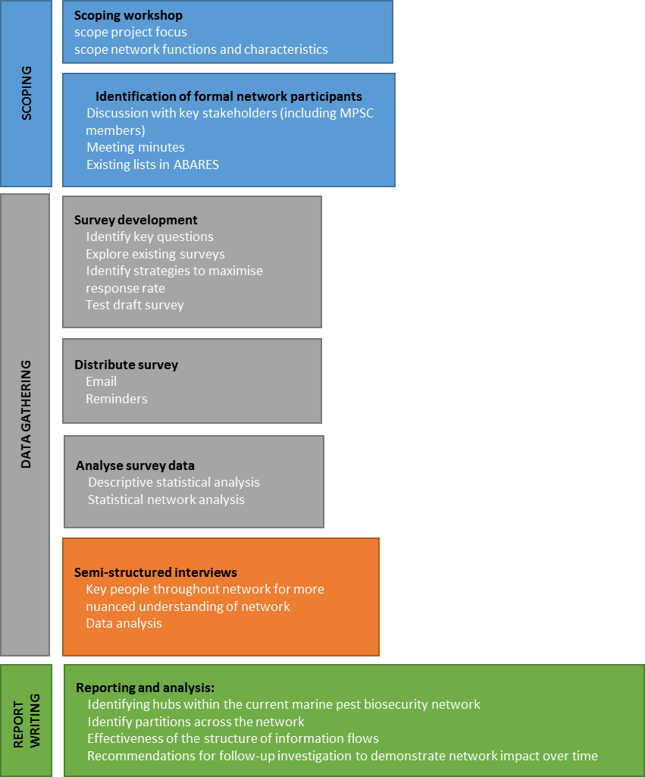

Phone discussions
MPSC members were the starting point for ABARES researchers to map the formal marine pest biosecurity network. Phone discussions were held with seven MPSC members representing each state and territory (except the A.C.T.) as well as two people who were able to provide insights from the perspective of R&D stakeholders and the environmental NGOs.
The discussions with MPSC members focused on:
- the key forums and meetings that dealt with marine pests and that occurred regularly in their jurisdiction; and the associated representative organisations and groups
- key people in the marine pest network in their state and territory or networks
- key channels through which marine pest biosecurity information, including awareness-raising and education activities, flowed to and from their departments
- online networking activity about marine pests.

Stakeholder analysis
A stakeholder database was developed with details of 748 people who were likely to be involved in the marine pest biosecurity network. The contacts were provided by MPSC members and others who participated in discussions. These contacts were supplemented with stakeholders who were identified through Internet searches (such as industry associations). Details in the stakeholder database included name, organisation, email address and where possible, phone numbers, and role/position.
As the actual size of the marine pest network was unknown, the database contained only a sample of the total network. However, as respondents were asked to nominate others in their networks insights were gained into the networks beyond the people in our database. Our data therefore comprised of survey invitees (35 per cent of whom responded) as well as actors unknown to us during the early stages of the research who were nominated by respondents. An overview of parts of the marine pest network covered by this study is provided in Figure 41.
Figure 41 An overview of parts of the marine pest network and participants of the study

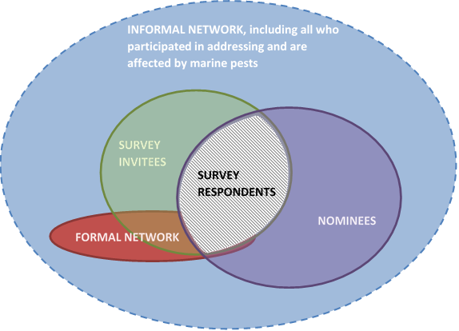

Phase 2. Data collection—survey and interviews

Survey development
As is often used in Social Network Analyses (Cronin 2015), a survey was developed to collect the primary data. A survey instrument was developed to enable stakeholders to nominate their contacts in the marine pest network. The survey targeted individuals, but data were aggregated to explore interactions between the organisations the individuals represented. A contact was defined as a person with whom the respondent has:
'an ongoing working relationship, including your work colleagues; and any other people with whom you have had personal interactions that you consider meaningful' in relation to marine pest biosecurity.
Survey questions were designed as clear and concise as possible to minimise the required completion time. Seven people in the Department of Agriculture assisted with testing the survey. Their feedback led to refinements of the survey.
The survey questions were (in summary):
- the respondent’s current role – including employer, location and nature of involvement in marine pest biosecurity
- sharing of marine pest biosecurity information – key people whom they provided information to or requested information from, and what the general topic of the information was (over the last 12 months)
- sharing of marine pest biosecurity resources – key organisations which they provided resources to or received resources from, and the nature of those resources, whether funding or in-kind support (over the last 12 months)
- what they would value from a national marine pest network.
Appendix 1 contains a copy of the full survey questionnaire.
As the content of the relational ties between actors is specific to the network under investigation (Bodin and Crona 2009), respondents were asked to indicate the topic of the information sharing between them and the people they nominated. The options given were based on the topics of information sharing identified in the Scoping meeting.

Survey delivery
The survey was hosted on SurveyGizmo, using the campaign functionality that enables individualised reminders and follow-up with people. The survey was launched on 6 December 2017 and email invites to complete the survey were sent to all people in the stakeholder database. Several strategies were applied to maximise the response rate, including sending several reminders to those who have not responded yet but who had received the invite. MPSC members also assisted by encouraging those in their state to complete the survey. In early January 2018, the due date for the survey was extended from 22 December 2017 until 21 January 2018.

Missing data
A key limitation of the response data was that it did not contain the level of detail requested. Many respondents were reluctant to share the names of the contacts despite the assurances of confidentiality. Several provided very broad information, such as nominating ‘state governments’ as the entity with whom they shared information. Some mentioned that they were not comfortable with providing individuals' details. This challenge is not uncommon in SNA because despite reassurances, respondents may find it difficult to foresee the implications of the information they enter (Cronin 2015).
In order to fill these information gaps, the research team followed up with respondents whose responses were unclear. As time constraints did not allow follow up with all respondents, highest priority was given to MPSC members and key people in each jurisdiction (as identified in the stakeholder discussions with MPSC members and others) as the core of the formal network. Initially, it was hoped that the study could report on branch level for all large organisations, but due to too many data gaps, the study reported on organisational level, except for Department of Agriculture, which is reported at branch level.

Survey data cleaning
During the data cleaning process, decisions had to be made in order to deliver a consistent dataset. These were:
- all organisation names were standardised (Table 12).
- where respondents nominated a committee or working group as a contact, it was allocated to the secretariat or chair of the particular group.
- when individuals responded that they interacted with vessel owners, the general public or fishers, their responses indicated general rather than specific interactions (for example, they wrote 'general public' rather than 'Joe Blogs'; 'visiting yachts' rather than 'The little mermaid'). Capturing such community interactions was critical, yet actors in networks need to be able to be uniquely defined. For each respondent who reported very general community interactions, this actor was flagged/coded as having a connection with the community, but did not include any generic groups themselves as actors in the network.

Semi-structured interviews
Following quantitative analysis, semi-structured interviews were used to provide a more nuanced understanding of the network function and structure (Alexander et al. 2017), including what networks are used for, by who and specifically how. A number of case studies were drawn from the interviews to illustrate the implications and importance of certain network configurations.
Interviewees were selected based on their position in the network. The research attempted to achieve a good spread across various states and territories. A total of eight people were interviewed, mostly over the phone. They represented the following:
  - Australian Government
  - state government agencies
  - community group
  - training organisation
  - seafood industry body
  - consultancy business
  - port corporation
Some interviewees represented more than one organisation, whereas other interviews involved more than one person each of whom represented a different kind of organisation. Interview length varied between 30 minutes to an hour.

Phase 3. Survey data analysis
This study investigated both a one-mode (involving only one type of actor, i.e. organisations) and a two-mode social network (involving organisations and policy forums) (Figure 42). The one-mode social network involved the relationships between survey respondents aggregated to the organisational level (the informal network). The two-mode social network investigated the affiliations certain organisations have by means of their membership and/or attendance of a policy forum (the formal marine pest biosecurity network).
The formal marine pest biosecurity network is multi-level and made up of the policy forums and organisations (actors) and the relationships between them (ties) on the basis of whether representatives from those organisations attended any forums. One tie represents attendance of one individual at a specific meeting during the period of October 2016 to November 2017.
Figure 42 The formal and informal network
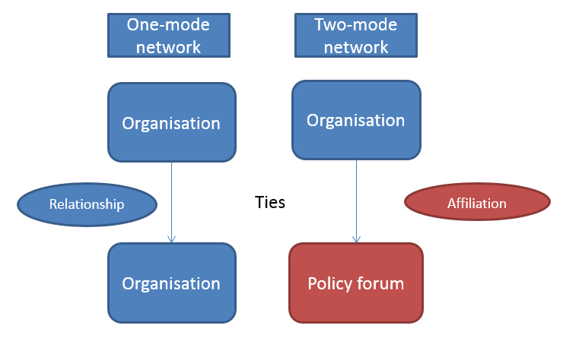
The data analysis involved both a descriptive network analysis as well as a statistical network analysis.

Descriptive network analysis
Descriptive network analysis was used to summarise the data by exploring the network structures and configurations in order to describe how the network is currently organised and how it functions in terms of information and resource flows. Our analysis included the identification of features across actors, sub-groups and the entire network (see 'Entire marine pest network').
Network structures and configurations can be observed at three levels: a) the level of individual actors; b) the level of sub-groups; and c) the whole network.

Centrality measures
Centrality is a measure of how 'important' an actor is in the network. Depending on the network’s function, different notions of centrality may be relevant. The following measures of centrality were considered to identify key actors in the marine pest network for the different topics of information sharing and resource flow:
- Degree centrality (actor level) - The degree of an actor is the number of direct ties it has to other actors in the network (Borgetti 2005). It is an indicator of the size of each actor’s network (Alexander 2015); their popularity (Hawe et al. 2004) or their 'immediate influence' (Borgetti 2005). Actors with high centrality have a greater ability to influence others in the network, and are better positioned to access and distribute information. A disadvantage of having too many ties can include the pressure those actors feel to please their various neighbours in the network, which can constrain their options for action (Bodin and Crona 2009).
There are three ways to define ‘degree’ in networks with information about the direction of ties:
  - Total-degree centrality – considers all ties in and out of an actor, i.e. in any direction, and can be a general indication of direct potential influence
  - In-degree centrality – ties directed into an actor (in-degree).
  - Out-degree centrality – ties directed out of an actor. Can be an indicator of popular or trusted sources of information in a social network depending on the data collected.
- Eigenvector centrality (actor level) (Bonacich, 1972) considers an actor to be important if it is tied to other actors with high centrality. This notion of centrality is linked to the ability of an actor to rapidly spread something through the network, such as information or a contagion.
- Degree distribution (network level) is the distribution of ties across the entire network, which determines the configuration of the network as a whole. The degree distribution measures the frequency with which each possible total degree per actor occurs in the network; that is, what proportion of actors have zero ties, what proportion have one ties, etc. Social networks are usually not random but emerge out of historical events and are shaped by local rules. Degree distribution has implications of the overall network's functioning. The degree distribution can tell us about how resilient the network is to the malfunction of some of its components; it can hint at the process by which the network may have formed such as ties forming randomly between actors or through a preferential attachment mechanism; and has implications for the rate at which information may spread through the network.
The degree distribution of networks can be said to lie on a spectrum, lying in between the two extremes of an Erdos-Renyi random graph at one end and a scale-free network (highly centralised) at the other (Erdos and Renyi, 1960, Barabasi and Albert, 1999). Colchester (2016; 2015) identifies three main configurations along the spectrum (Figure 43):
  - Centralised networks (also called scale-free networks or power law networks) have actors have limited connections, but only a few have many connections. Centralised networks are very resilient to random elimination of actors, because so many actors are on the periphery. However, they are very vulnerable to removal of centralised actors. Centralised networks are often said to be 'robust-yet-fragile' (Doyle et al. 2005). This network structure is thought to form through a preferential attachment mechanism (Barabási and Albert 1999). In this mechanism, actors entering the network are more likely to establish connections with actors that are already well connected. If the marine pest network is centralised, its high-degree actors (hubs) will be identified.
  - Decentralised networks comprised of a number of actors who each form a hub with ties (spokes) to other actors. The hub actors also link the spoke actors to other hubs. There is still a limited overall centre. Such a configuration assists actors to combine their resources and helps achieve economies of scale.
  - Distributed networks, which involve a low level of sub-grouping and all the actors have a similar degree of connectivity, with little evidence of dominant actors. Distributed networks can be quite similar to a random model. Such networks tend to be very robust because any actor can replace another as no one is more significant than another. Actors tend to have a high level of autonomy as they are largely self-sufficient and independent from other actors near them. However, this type of network tends to have a lack of coordination, everyone has responsibility, and it can be hard for information or resources to diffuse throughout the network without a centralised body.
If the degree distribution does not conform to one of these standard models, this would suggest that the network is likely to have community structures.
Figure 43 (a) Centralised, (b) decentralised and (c) distributed networks
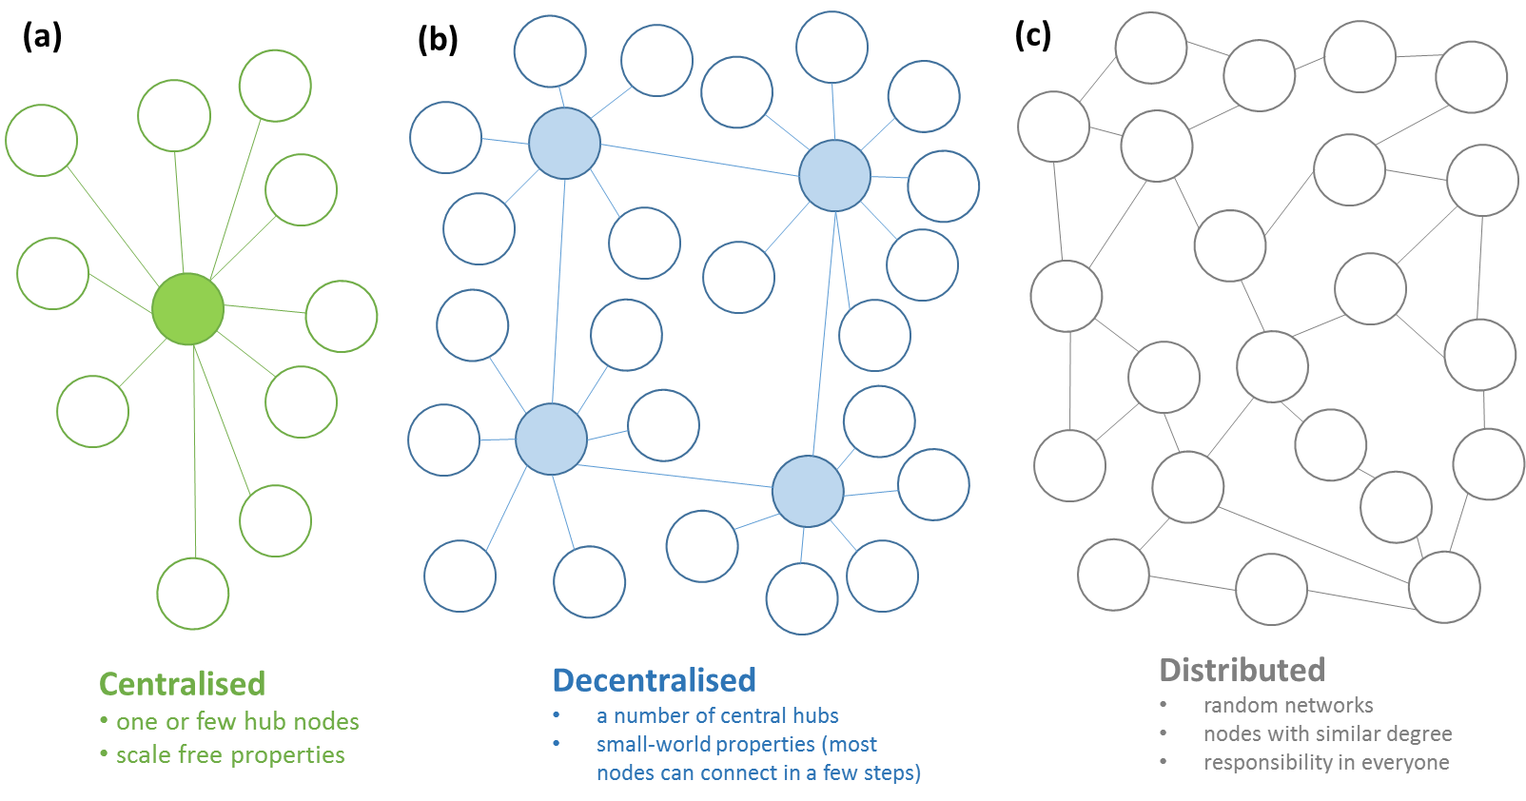
- ‘Small world’ properties (network level) - In reality, many networks lie somewhere in between the highly deterministic and completely random networks. Watts and Strogatz (1998) identified a certain category of networks that lie on a continuum between deterministic and completely stochastic, which they call ‘small world’ networks (the popular analogy of this phenomenon is known as ‘six degrees of separation’). Typically, these networks can be highly clustered, yet they have small path lengths. Typically, there are hubs in small-world networks with a high number of ties between them. The hubs serve to connect other less connected actors by routing ties through them. Examples of networks described as ‘small-world’ including social networks, website links on the Internet, DNA gene networks and neural networks in the human body.
Watts and Strogatz (1998) classified the properties of small world networks according to two independent structural features; the clustering coefficient and shortest average actor-to-actor distance. Others have proposed a small-world index, σ, which is calculated by comparing clustering and tie length of a given network to an equivalent random network with same number of actors and average degree.
The relationship is given by:
Small world index, σ = (C /C r) / (L/ L r)
Where,
C is the clustering coefficient of the network
L is the average shortest path length of actor pairs in the network
Cr is the clustering coefficient of a random network with same number of actors, and
Lr is the average shortest path length for actor pairs in a random network with same number of actors
If σ > 1 (i.e. C >> Cr and L ≈ Lr), meaning the network has a significantly higher clustering compared to a random network and the average shortest path distance is similar or greater than that found in a random network, then the network has small-world properties (Porter 2012; Wikipedia contributors 2018). Centralised networks have been shown to be ‘ultra-small’ worlds (Cohen and Havlin 2003), because of their hubs that make the shortest paths in a network become significantly smaller. There are many advantages of small-world networks, such as potentially very efficient speed of communication, or faster and more efficient response to emergencies.

Communities of practice
- Girvan-Newman algorithm (sub-group level) – sub-groups (sometimes called communities of practice) are internally dense groups in a network (Bodin et al. 2006). Various algorithms exist that can detect sub-groups in a network. The Girvan-Newman algorithm (Girvan and Newman 2002) was used, which detects sub-groups by progressively removing ties that are most likely 'between' sub-groups from the original network until the sub-groups are revealed. Such sub-groups may facilitate (i) the generation of knowledge within groups by offering opportunities for similar others to interact in each group, and (ii) contribute to generating a variety of knowledge types spread across the various sub-groups (Bodin and Crona 2009). Many sub-groups therefore facilitate diversity in knowledge development and contribute to feedback opportunities and innovation in the overall network (Bodin et al. 2006). Network heterogeneity is therefore associated with stronger innovation capacity (Carlsson and Sandström 2008). However, if modularity becomes too strong it can contribute to a 'them and us' mentality where actors become entrenched in certain views that may hinder them from acting towards consensus and joint action (Bodin et al. 2006).

Knowledge-brokering
- Betweenness centrality (actor and sub-group levels) - betweenness centrality is a measure of how often an actor is on the shortest path between other actors in the network (Freeman, 1977). This indicates the ability of an actor to function as a middleman or bridge between actors or sub-groups (Bodin and Crona 2009). Such actors are the bridging links in a diverse network between otherwise disparate weakly-connected or disconnected groups (Barnes et al. 2017b; Bodin et al. 2006). Actors with high betweenness rating therefore tend to have increased influence over the actors it connects. Such actors are often well positioned to act as knowledge-brokers as they may have access to information that resides within the groups and tend to have some understanding of the 'inner life' of the different groups they are connected to. Brokers are therefore well-positioned to combine different bits of information to develop more nuanced understanding of issues and potential solutions. As well, they are well positioned to understand who to involve in addressing certain matters and who not to involve (Bodin et al. 2006). It also allows these actors to reach out to various groups to spread ideas, knowledge and resources (Barnes et al. 2017b).

Bonding and bridging
- Reciprocol relationships – can be an indicator of bonding capital. The number of ties that are reciprocated in a network can be counted. A tie is reciprocated if whenever a tie is connected from actor A to actor B then there is a tie from actor B to actor A. We can count the number of dyads connected by a tie (which may or may not be reciprocated) and calculate the proportion of dyads that have reciprocated ties (the dyad based method).
- Triad census – triads can be a strong indicator of bonding capital in a social network. UCINET performs a triad census of a directed network. In a directed network there are sixteen possible triads (Figure 44). This routine counts the number of each type of triad present in a directed network. Closed triads include 030C, 030T, 120C, 120D, 120U, 210, 300. Configuration 300 is a fully completed triad, where all ties are reciprocated. It should be noted that the way UCINET counts is by unique examples of triads that correspond to any of the 16 configurations in its triad census (Figure 44); it does not count nested configurations. MPNet software counts all the nested configurations in the triad. Therefore, the triad counts by UCINET are generally lower than that given by MPNet in Table 8 (specifically for 9. Cyclic-TriadA and 10. Transitive-TriadA (which correspond to UCINET’s configurations 030C and 030T respectively).
Figure 44 Configurations in UCINET’s triad census
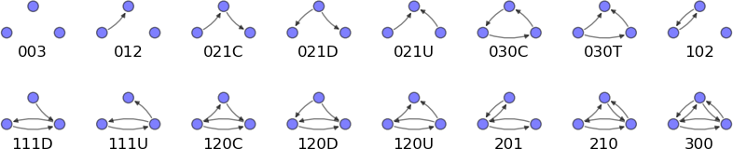
Source: Kouznetsov A & Tsvetovat M (2012), Social Network Analysis for Startups, 1st edn, California, USA. O'Reilly Media.
- Contingency analysis – an analysis of relationships that exist between actors in different sectors. These bridging ties can be an indicator of bridging capital. As defined in this study, bridging configurations supporting collaboration can refer to (i) connections across administrative levels, ranging from the local, regional, state and/territory, and national levels; and (ii) connections between different sectors, such as between a government organisation, NGO and a community group. The first of these was qualitatively assessed using network graphs visualised by UCINET. The second of these, i.e. sector bridging was analysed using a contingency analysis presented in Appendix 6.

Exponential Random Graph Modelling (ERGM)
An important approach used in our analysis was to examine configurations within the network. As different configurations are linked to a network’s ability to fulfil certain functions (Barnes et al. 2017b), using new statistical approaches can assist in determining which configurations are observed in the marine pest network more or less than could be expected by chance alone. This means inferences can be made about how well the network is positioned to achieve certain outcomes (Berardo 2014; Guerrero et al. 2015; Lubell et al. 2014).
Exponential Random Graph Modelling (ERGM) is a statistical network methodology used to identify over or under representation of configurations (or sub-networks) (Frank and Strauss, 1986, Wasserman and Pattison, 1996). ERGM analysis provides an assessment of the effectiveness of the structure of information flows, including the network’s propensities for collaboration and/or innovation. This was particularly suited to identifying finer detail in the structures of the network supporting collaboration, such as evidence of bonding and bridging capital. Such assessments can guide efforts to ‘nudge’ the network to achieve different objectives.
ERGM analysis was implemented in the package MPNET (Wang et al. 2014). ERGM treats an observed network as a single observation which can be compared to a distribution of all possible networks with a shared core set of characteristics (e.g. number of actors and ties) (Robins et al. 2007; Frank and Strauss 1986; Wang et al. 2013a; Wasserman and Pattison 1996; Robins and Morris 2007). By mapping selected configurations to important network processes (Table 7), ERGM can be used to test for the presence of important social and political processes (Bodin 2017).
ERGM allows for statistical inferences to be made without the need for multiple networks for comparison (Guerrero et al. 2015). Part of the explanatory power of ERGM comes from its handling of nested configurations. For example, in Figure 45 within each ‘bonding' (collaboration) configuration there are potentially three other configurations nested within. ERGM assess the relative frequency of configurations in a network given the observed frequency of other configurations, included those that are nested.
Figure 45 Examples of configurations that were observed in network data, indicating network function along a continuum between bridging and bonding ‘capital’
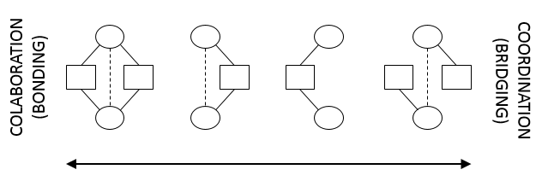
One of the limitations of ERGM is that the maximum likelihood approach used to find solutions offers no guarantee of an adequate estimate. This is increasingly problematic when an increasing number of configurations are included in the model. To overcome this, one can use 'goodness-of-fit' (see e.g. Lubell et al. 2014). The fitted model is used to simulate graphs, whereby the counts from the simulations are compared statistically to the observed count.
Through ERGM, a coefficient for each configuration included in a model was estimated. The signs of the coefficients quantify if configurations are observed more (positive coefficient) or less (negative coefficient) than can be expected by chance alone, and the t-scores of the coefficients quantify if this discrepancy between observation and expectation is statistically significant (Wang et al. 2013b).
Capturing community interactions was critical. Various survey respondents nominated broad categories such as vessel owners, the general public or fishers, rather than specific groups or entities. However, networks can only contain clearly defined nodes. To capture this information each actor that reported community interactions was coded with a community attribute and no generic nodes were included in the network.

Qualitative analysis
Semi-structured interviews with selected key informants were used to provide a more nuanced understanding of the network function and structure (Alexander et al. 2017), including what networks are used for, by who and specifically how. A number of case studies were drawn from the interviews to illustrate the implications and importance of certain network configurations.
Qualitative textual analysis was done on open-ended questions in the marine pest network survey, particularly the final survey question: ‘Please tell us what you would value from a National Marine Pest Network’. A summary of the responses is reported in section 6 ‘What survey respondents value in a marine pest network’.

Appendix 4 Interpreting the SNA and network graphs
When interpreting social network analysis diagrams presented in this report, it is important to understand four principals (Cronin 2015):
- organisations are represented as points called actors. While the data were collected from individuals, the information was aggregated to the organisational level (and branch level for the Department of Agriculture). The visualisation software typically places the most connected actors—that is, those with the highest centrality—towards the centre of the diagram and the least connected actors to the periphery.
- relationships are represented by lines, called ties, based on information provided by survey respondents. Ties between actors involve either: (i) forum attendance; (ii) advice/information sharing; or (iii) resource flow.
- actor attributes can be represented by the size of an actor (for example, the more connected an actor is the bigger it may be represented) as well as colour (different entities, e.g. formal committees, government agencies, industry bodies, etc. might each be represented by different colours) (actor attributes are listed in Appendix 8)
- the strength of the relationships in this report, based on the number of interactions between actors, is sometimes represented by line width (noting each organisational actor in our data is the aggregate of individuals who represented each organisation).
In addition, an important component of relationships—including information and resource flows as considered in this study—is directionality (Cronin 2015). For some topics, it is sufficient to know whether there is a tie, regardless of the direction, such as understanding the structure of the network as a whole. However, for some topic areas, it is important to understand the direction of information flow.
As the analysis generally focuses on the global network between organisations, the ties under consideration only involve the connection between different organisations. For example, if someone nominated a colleague within their branch, this tie has been excluded and does not contribute to measures such as centrality and eigenvector.
Certain configurations (or structures or building blocks) are seen as 'preconditions' to support adaptive capacity by facilitating information flow, including potentially different kinds of information (Bodin and Crona 2009). Whether such progressive change occurs will depend on whether the organisations involved implement the needed changes, which usually depends on social, institutional, political, and economic factors (Barnes et al. 2017b). Likewise, this SNA does not take into consideration the formal level of authority bestowed on certain actors, by which they may impose influence on decision-making, regardless of their position in the network (Carlsson and Sandström 2008). Many individuals have autonomy to make choices about if, how and when they participate in a network (Lubell, 2010). Hence, even if favourable structures are present, it provides no guarantee for success. Yet, poor or a lack of favourable network configurations can mean a network is ineffective and unable to respond to change (Barnes et al. 2017b).
This study has not investigated the quality of the ties between people, only whether there is a tie that constitutes an 'on-going working relationship' or 'any other relationship you [survey respondent] regard as significant'.
Despite initial attempts, this study was not able to represent the detail within large government organisations (i.e. they are represented as single homogenous entities). The exception is Department of Agriculture, which has been represented at its branch levels. It is important to be mindful that organisations, especially large government organisations, have internal network structures, including multi-level structures, that have a considerable impact on their influence and external networks (Wang et al. 2013b). Except for Department of Agriculture, this is not represented in this study.
During the semi-structured interviews, it became apparent that some respondents may have incorrectly interpreted the difference between 'passive' and 'active' surveillance, despite the fact that a definition was provided. 'Active surveillance' was sometimes indicated where in reality it was 'passive surveillance', implying there could be an overestimation of 'active surveillance' ties and an underestimation of 'passive surveillance' ties.

Appendix 5 Characteristics of survey respondents

Location of marine pest activities
Respondents were asked which regions their activities, regarding marine pests, applied to over the last 12 months. The largest proportion of respondents focused on all states and territories (32 percent). The next most likely region where activities were applied was Western Australia (24 percent) followed by Victoria (22 per cent) and the Northern Territory (15 per cent). Note that respondents could select more than one location, hence the percentages do not add up to 100 per cent in Figure 42.
Figure 46 States and territories that respondents' marine pest activities related to

Marine pest activities
The survey asked respondents which aspects of addressing marine pests they are involved in (Figure 47). Respondents were able to select more than one category. The top aspects in which respondents were involved were preparedness (43 per cent) and passive surveillance (43 per cent), followed by education and/or awareness-raising (39 per cent), and emergency response (38 per cent) aspects.
Four per cent of respondents indicated they were involved in all the aspects of marine pests, indicating a wide set of responsibilities. These responses were also allocated to the proportions shown for each marine pest activity.
A number of respondents filled in the 'Other–Please write in' option and indicated they were involved in marine pest prevention-related activities. These responses were allocated to the 'preparedness' category as this was the most closely related activity. This graph shows that the research team were able to capture the responses of people representing a good spread of activities and interests.
Figure 47 Types of marine pest activities that respondents are involved in

Respondents who indicated they were involved in 'all of the above' aspects of marine pests were also included in proportions shown for each marine pest activity.

Exotic and/or established marine pests
Respondents were asked what category of marine pests they focus on (Figure 48). They could select from:
  - Exotic marine pests, that is, pests not known to exist in Australia (or New Zealand for New Zealand respondents)
  - Established marine pests that are present in Australia, but are located outside the respondent's area of operation
  - Established marine pests that present in the area of operation of the respondent
  - All of the above
  - Other - Please write in
Exotic pests are an important focus for 82 per cent of respondents.
This is not surprising given the high percentage of respondents representing the Australian Government, which has responsibility for preventing exotic pests from entering Australia’s territory. Almost two-thirds of respondents (66 per cent) were involved in dealing with pests that are already established in their area of operation, with 63 per cent contributing to addressing pests that are established elsewhere in Australia, but not established in their area of operation. Almost half of respondents (45 per cent) indicated that they were involved in all of the above.
The diversity of actors is a positive observation as it provides an indication of range of backgrounds, values and resources that actors in the network have that could contribute to maintaining a resource (Carlsson and Sandström 2008).
Figure 48 Category of marine pests that respondents focus on

Appendix 6 Relationship counts across sector types
The contingency table (Figure 49) shows the total number of relationships between actors grouped into different sectors represented in the marine pest stakeholder network (listed in Table 4). In this table;
- Each tie count in a cell represents a single reported relationship (‘provided to’ or ‘asked for’ advice/information); ties were reported by respondents of the network survey; the ties (i.e. advice/information) flowed from sectors listed across the bottom, to the sectors listed in rows
- So for example, out of all the ties in the network, 30 of them go to a Private company/business actor from a State/territory government agency actor. Whereas in the State/territory government row, Private company/business column, there are 13 edges in the network which go to State/territory governments from Private companies/businesses. So the total number of ties between Private companies/businesses and State/territory governments, in any direction, is 30 + 13 = 43. Along the diagonal is ties within sectors, e.g. Private business/company to Private business/company.
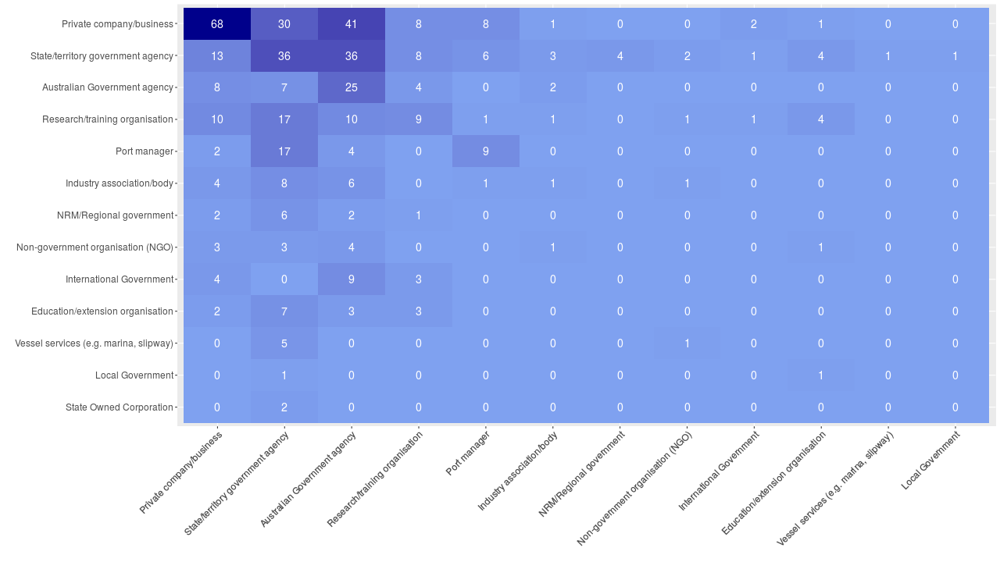
Figure 49 Contingency table showing counts of relationships across sector types

Appendix 7 ERGM full results
Table 10 Exponential Random Graph Models; fixed-density for actor-actor level network; fixed meso-level (actor-forums) network. Count [], model parameter, t-score for parameter, and */**/*** signifying 90/95/99% significance.
 | All-Ties | Passive Surveillance | Education and Awareness | Research and Development
1. SourceA | [26] -3.1158 (-7.097)*** | [17] -1.8678 (-2.142)** | [22] -4.0778 (-5.817)*** | [23] -3.4205 (-5.144)***
2. SinkA | [125] -2.3008 (-5.147)*** | [55] 0.3727 (0.404) | [106] 0.3887 (0.512) | [65] -0.4851 (-0.723)
3. IsolateA | [18] -6.7848 (-12.051)*** | [201] -0.5869 (-0.514) | [140] -3.4804 (-3.683)*** | [168] -3.0262 (-3.455)***
4. Type_MatchA | [186] 0.5894 (8.074)*** | [49] 0.6006 (3.977)*** | [56] 0.4675 (3.096)*** | [71] 0.513 (4.385)***
5. ReciprocityA | [153] 4.4004 (23.658)*** | [24] 3.3519 (8.464)*** | [21] 2.8541 (7.491)*** | [36] 3.3069 (11.286)***
6. AoutSA | [832.11] 2.3556 (10.659)*** | [171.4279] 1.2056 (2.445)*** | [270.8922] 1.2674 (3.047)*** | [271.3] 1.553 (4.581)***
7. AinSA | [623.9138] 1.7083 (7.800)*** | [100.7773] 1.423 (2.592)*** | [111.7983] 2.7747 (6.606)*** | [194.4004] 2.5211 (7.308)***
11. CommunityLink_SenderA | [247] 0.5569 (5.862)*** | [76] 0.5828 (3.293)*** | [113] 0.6624 (4.537)*** | [105] 0.6565 (5.210)***
12. CommunityLink_ReceiverA | [172] -0.1008 (-0.764) | [44] -0.13 (-0.544) | [42] -0.1351 (-0.734) | [55] -0.3862 (-2.207)**
16. In2StarAX | [1616] 0.1902 (7.315)*** | [439] 0.1597 (2.753)*** | [441] 0.0401 (0.771) | [588] 0.0883 (2.676)***
17. Out2StarAX | [1992] 0.1377 (8.100)*** | [627] 0.121 (3.270)*** | [991] 0.1737 (5.428)*** | [791] 0.0994 (3.976)***
20. TXAXarc | [422] 0.0563 (0.640) | [173] 0.0301 (0.166) | [232] 0.3276 (2.374)** | [188] 0.0053 (0.037)
21. L3XAX | [3888] -0.0226 (-2.260)** | [1674] -0.0128 (-0.674) | [2083] -0.0332 (-2.075)** | [1799] -0.0102 (-0.638)
Table 11 Goodness-of-fit. Selected parameters in addition to fitted configurations from Table 8: Count, average from simulated graphs, t-score for difference, */**/*** signifying 90/95/99% significance. Note all fitted parameters reports <0.3 t-scores
 | All-Ties | Passive Surveillance | Education and Awareness | Research and Development
8. TwoPathA | [6895] 5716.7 (3.525)*** | [512] 549.7 (-0.512) | [766] 781.3 (-0.139) | [1071] 923.6 (1.369)
9. Cyclic-TriadA | [189] 186.7 (0.071) | [7] 15.2 (-1.247) | [19] 23.2 (-0.489) | [38] 20.2 (2.75)***
10. Transitive-TriadA | [665] 575.9 (0.932) | [53] 50.9 (0.106) | [72] 82.9 (-0.438) | [137] 74.2 (3.182)***
13. In2Star010A | [1923] 1368.2 (3.105)*** | [86] 120.0 (-1.064) | [105] 116.4 (-0.351) | [138] 185.8 (-0.872)
14. Out2Star010A | [3249] 2568.5 (2.428)*** | [352] 353.3 (-0.02) | [858] 780.0 (0.625) | [691] 546.3 (1.222)
15. Mix2Star010A | [4784] 3728.5 (2.698)*** | [308] 401.9 (-1.265) | [495] 552.1 (-0.52) | [613] 604.4 (0.06)
18. AAinS1X | [2768.2889] 2678.4 (0.705) | [554.1172] 552.1 (0.025) | [537.9326] 542.0 (-0.048) | [804.584] 716.0 (0.893)
19. AAoutS1X | [3519.3063] 3488.6 (0.2) | [925.8897] 961.2 (-0.366) | [1617.543] 1633.9 (-0.131) | [1217.1272] 1146.6 (0.61)

Appendix 8 Actor attributes
Table 12 contains a list of actor attributes used in network graphs, including the organisational abbreviations, organisational names, number of people who responded to the network survey per actor (i.e. organisation/branch), and other attributes used in the network analyses. Some organisations’ names have been masked in order to maintain confidentiality.
Table 12 Actor attributes list
n.a. = not applicable because a person in the organisation was nominated but did not participate in survey
Actor abbreviation | Full name | Respondent type | Organisation type | Survey respondents (per actor)
AFP | AUSTRALIAN FEDERAL POLICE | Nominated | Australian Government | n.a.
AHA | ANIMAL HEALTH AUSTRALIA | Nominated | Non-government organisation (NGO) | n.a.
AMSA | AUSTRALIAN MARITIME SAFETY AUTHORITY | Nominated | Australian Government | n.a.
AMSCASSOC | AUSTRALIAN MARITIME SCIENCES ASSOCIATION | Survey | Industry association/body | 1
AUST INDUSTRY ASSOC 2 | AUSTRALIAN INDUSTRY ASSOCIATION 2 | Nominated | Industry association/body | n.a.
AUST INDUSTRY ASSOC 19 | AUSTRALIAN INDUSTRY ASSOCIATION 19 | Nominated | Industry association/body | n.a.
AUST INDUSTRY ASSOC 23 | AUSTRALIAN INDUSTRY ASSOCIATION 23 | Nominated | Industry association/body | n.a.
AUST INDUSTRY ASSOC 25 | AUSTRALIAN INDUSTRY ASSOCIATION 25 | Survey | Industry association/body | 1
AUST PRIM INDUSTRY ASSOC 3 | AUSTRALIAN PRIMARY INDUSTRY ASSOCIATION 3 | Nominated | Industry association/body | n.a.
AUST PRIM INDUSTRY ASSOC 21 | AUSTRALIAN PRIMARY INDUSTRY ASSOCIATION 21 | Nominated | Industry association/body | n.a.
AUST PROF INDUSTRY ASSOC 14 | AUSTRALIAN PROFESSIONAL INDUSTRY ASSOCIATION 14 | Survey | Industry association/body | 1
AUST PROF INDUSTRY ASSOC 16 | AUSTRALIAN PROFESSIONAL INDUSTRY ASSOCIATION 16 | Survey | Industry association/body | 1
AUST PROF INDUSTRY ASSOC 24 | AUSTRALIAN PROFESSIONAL INDUSTRY ASSOCIATION 24 | Nominated | Private company/business | n.a.
AUST REC INDUSTRY ASSOC 17 | AUSTRALIAN RECREATIONAL INDUSTRY ASSOCIATION 17 | Survey | Industry association/body | 1
AUST REC INDUSTRY ASSOC 22 | AUSTRALIAN RECREATIONAL INDUSTRY ASSOCIATION 22 | Nominated | Industry association/body | n.a.
AUST TOUR INDUSTRY ASSOC 15 | AUSTRALIAN TOURISM INDUSTRY ASSOCIATION 15 | Survey | Industry association/body | 1
BUSINESS 2 | BUSINESS 2 | Nominated | Private company/business | n.a.
BUSINESS 4 | BUSINESS 4 | Nominated | Private company/business | n.a.
BUSINESS 5 | BUSINESS 5 | Nominated | Private company/business | n.a.
BUSINESS 7 | BUSINESS 7 | Nominated | Private company/business | n.a.
BUSINESS 8 | BUSINESS 8 | Nominated | Private company/business | n.a.
BUSINESS 9 | BUSINESS 9 | Nominated | Private company/business | n.a.
BUSINESS 10 | BUSINESS 10 | Nominated | Private company/business | n.a.
BUSINESS 11 | BUSINESS 11 | Nominated | Private company/business | n.a.
BUSINESS 12 | BUSINESS 12 | Nominated | Private company/business | n.a.
BUSINESS 14 | BUSINESS 14 | Nominated | Private company/business | n.a.
BUSINESS 15 | BUSINESS 15 | Nominated | Private company/business | n.a.
BUSINESS 16 | BUSINESS 16 | Nominated | Private company/business | n.a.
BUSINESS 17 | BUSINESS 17 | Nominated | Private company/business | n.a.
BUSINESS 18 | BUSINESS 18 | Nominated | Private company/business | n.a.
BUSINESS 19 | BUSINESS 19 | Nominated | Private company/business | n.a.
BUSINESS 20 | BUSINESS 20 | Nominated | Private company/business | n.a.
BUSINESS 21 | BUSINESS 21 | Nominated | Private company/business | n.a.
BUSINESS 22 | BUSINESS 22 | Nominated | Private company/business | n.a.
BUSINESS 23 | BUSINESS 23 | Nominated | Private company/business | n.a.
BUSINESS 24 | BUSINESS 24 | Nominated | Private company/business | n.a.
BUSINESS 26 | BUSINESS 26 | Nominated | Private company/business | n.a.
BUSINESS 27 | BUSINESS 27 | Nominated | Private company/business | n.a.
BUSINESS 30 | BUSINESS 30 | Nominated | Private company/business | n.a.
BUSINESS 31 | BUSINESS 31 | Nominated | Private company/business | n.a.
BUSINESS 32 | BUSINESS 32 | Nominated | Private company/business | n.a.
BUSINESS 34 | BUSINESS 34 | Nominated | Private company/business | n.a.
BUSINESS 35 | BUSINESS 35 | Nominated | Private company/business | n.a.
BUSINESS 36 | BUSINESS 36 | Nominated | Private company/business | n.a.
BUSINESS 37 | BUSINESS 37 | Nominated | Private company/business | n.a.
BUSINESS 38 | BUSINESS 38 | Nominated | Private company/business | n.a.
BUSINESS 39 | BUSINESS 39 | Nominated | Private company/business | n.a.
BUSINESS 40 | BUSINESS 40 | Nominated | Private company/business | n.a.
BUSINESS 41 | BUSINESS 41 | Nominated | Private company/business | n.a.
BUSINESS 42 | BUSINESS 42 | Nominated | Private company/business | n.a.
BUSINESS 43 | BUSINESS 43 | Nominated | Private company/business | n.a.
BUSINESS 44 | BUSINESS 44 | Nominated | Private company/business | n.a.
BUSINESS 45 | BUSINESS 45 | Nominated | Private company/business | n.a.
BUSINESS 46 | BUSINESS 46 | Nominated | Private company/business | n.a.
BUSINESS 47 | BUSINESS 47 | Nominated | Private company/business | n.a.
BUSINESS 48 | BUSINESS 48 | Nominated | Private company/business | n.a.
BUSINESS 51 | BUSINESS 51 | Nominated | Private company/business | n.a.
BUSINESS 53 | BUSINESS 53 | Nominated | Private company/business | n.a.
BUSINESS 54 | BUSINESS 54 | Nominated | Private company/business | n.a.
BUSINESS 56 | BUSINESS 56 | Nominated | Private company/business | n.a.
BUSINESS 57 | BUSINESS 57 | Nominated | Private company/business | n.a.
BUSINESS 58 | BUSINESS 58 | Nominated | Private company/business | n.a.
BUSINESS 59 | BUSINESS 59 | Nominated | Private company/business | n.a.
BUSINESS 60 | BUSINESS 60 | Nominated | Private company/business | n.a.
BUSINESS 61 | BUSINESS 61 | Nominated | Private company/business | n.a.
BUSINESS 62 | BUSINESS 62 | Nominated | Private company/business | n.a.
BUSINESS 63 | BUSINESS 63 | Nominated | Private company/business | n.a.
BUSINESS 64 | BUSINESS 64 | Nominated | Private company/business | n.a.
BUSINESS 65 | BUSINESS 65 | Nominated | Private company/business | n.a.
BUSINESS 66 | BUSINESS 66 | Nominated | Private company/business | n.a.
BUSINESS 67 | BUSINESS 67 | Nominated | Private company/business | n.a.
BUSINESS 68 | BUSINESS 68 | Nominated | Private company/business | n.a.
BUSINESS 69 | BUSINESS 69 | Nominated | Private company/business | n.a.
BUSINESS 70 | BUSINESS 70 | Nominated | Private company/business | n.a.
BUSINESS 71 | BUSINESS 71 | Nominated | Private company/business | n.a.
BUSINESS 72 | BUSINESS 72 | Nominated | Private company/business | n.a.
BUSINESS 73 | BUSINESS 73 | Nominated | Private company/business | n.a.
BUSINESS 74 | BUSINESS 74 | Nominated | Private company/business | n.a.
BUSINESS 75 | BUSINESS 75 | Nominated | Private company/business | n.a.
BUSINESS 76 | BUSINESS 76 | Nominated | Private company/business | n.a.
BUSINESS 77 | BUSINESS 77 | Nominated | Private company/business | n.a.
BUSINESS 78 | BUSINESS 78 | Nominated | Private company/business | n.a.
BUSINESS 79 | BUSINESS 79 | Nominated | Private company/business | n.a.
BUSINESS 80 | BUSINESS 80 | Nominated | Private company/business | n.a.
BUSINESS 81 | BUSINESS 81 | Nominated | Private company/business | n.a.
BUSINESS 82 | BUSINESS 82 | Nominated | Private company/business | n.a.
BUSINESS 83 | BUSINESS 83 | Nominated | Private company/business | n.a.
BUSINESS 84 | BUSINESS 84 | Nominated | Private company/business | n.a.
BUSINESS 85 | BUSINESS 85 | Nominated | Private company/business | n.a.
BUSINESS 87 | BUSINESS 87 | Survey | Private company/business | 1
BUSINESS 88 | BUSINESS 88 | Survey | Private company/business | 1
BUSINESS 89 | BUSINESS 89 | Survey | Private company/business | 2
BUSINESS 90 | BUSINESS 90 | Survey | Private company/business | 2
BUSINESS 90 | BUSINESS 90 | Survey | Private company/business | 1
BUSINESS 91 | BUSINESS 91 | Survey | Private company/business | 1
BUSINESS 92 | BUSINESS 92 | Survey | Private company/business | 1
BUSINESS 93 | BUSINESS 93 | Survey | Private company/business | 2
BUSINESS 94 | BUSINESS 94 | Survey | Private company/business | 1
BUSINESS 95 | BUSINESS 95 | Survey | Private company/business | 2
BUSINESS 96 | BUSINESS 96 | Survey | Private company/business | 1
BUSINESS 97 | BUSINESS 97 | Survey | Private company/business | 1
BUSINESS 98 | BUSINESS 98 | Survey | Private company/business | 1
BUSINESS 99 | BUSINESS 99 | Survey | Private company/business | 1
BUSINESS 100 | BUSINESS 100 | Survey | Private company/business | 3
BUSINESS 102 | BUSINESS 102 | Survey | Private company/business | 1
BUSINESS 103 | BUSINESS 103 | Survey | Private company/business | 1
BUSINESS 104 | BUSINESS 104 | Survey | Private company/business | 1
BUSINESS 105 | BUSINESS 105 | Survey | Private company/business | 1
BUSINESS 106 | BUSINESS 106 | Survey | Private company/business | 1
BUSINESS 107 | BUSINESS107 | Survey | Private company/business | 1
CAWTHRON INSTITUTE | CAWTHRON INSTITUTE | Survey | Private company/business | 1
CCIMPE | CONSULTATIVE COMMITTEE FOR INTRODUCED MARINE PEST EMERGENCIES (CCIMPE) | Forum | Australian Government | n.a.
CONSULTANCY 1 | CONSULTANCY 1 | Survey | Private company/business | 1
CONSULTANCY 2 | CONSULTANCY 2 | Survey | Private company/business | 1
CONSULTANCY 3 | CONSULTANCY 3 | Survey | Private company/business | 1
CONSULTANCY 4 | CONSULTANCY 4 | Survey | Private company/business | 1
CONSULTANCY 5 | CONSULTANCY 5 | Nominated | Private company/business | n.a.
CONSULTANCY 6 | CONSULTANCY 6 | Nominated | Private company/business | n.a.
CONSULTANCY 7 | CONSULTANCY 7 | Nominated | Private company/business | n.a.
CONSULTANCY 8 | CONSULTANCY 8 | Nominated | Private company/business | n.a.
CONSULTANCY 9 | CONSULTANCY 9 | Nominated | Private company/business | n.a.
CONSULTANCY 10 | CONSULTANCY 10 | Nominated | Private company/business | n.a.
CONSULTANCY 11 | CONSULTANCY 11 | Nominated | Private company/business | n.a.
CONSULTANCY 12 | CONSULTANCY 12 | Survey | Private company/business | 1
CONSULTANCY 13 | CONSULTANCY 13 | Survey | Private company/business | 1
CONSULTANCY 14 | CONSULTANCY 14 | Nominated | Private company/business | n.a.
CSIRO | COMMONWEALTH SCIENTIFIC AND INDUSTRIAL RESEARCH ORGANISATION | Survey | Research/training organisation | 3
CURTIN UNIV | CURTIN UNIVERSITY | Nominated | Research/training organisation | n.a.
DAWR - ACVO | DAWR - AUSTRALIAN CHIEF VETERINARY OFFICER | Nominated | Australian Government | n.a.
DAWR - ANIMAL BIOSECURITY | DAWR - ANIMAL BIOSECURITY | Survey | Australian Government | 8
DAWR - ANIMAL HEALTH POLICY | DAWR - ANIMAL HEALTH POLICY | Survey | Australian Government | 5
DAWR - ASSESSMENT SERVICES | DAWR - ASSESSMENT SERVICES | Survey | Australian Government | 1
DAWR - BIOSECURITY POLICY & RESPONSE | DAWR - BIOSECURITY POLICY & RESPONSE | Survey | Australian Government | 3
DAWR - COMPLIANCE CONTROLS | DAWR - COMPLIANCE CONTROLS | Nominated | Australian Government | n.a.
DAWR - COMPLIANCE POLICY | DAWR - COMPLIANCE POLICY | Survey | Australian Government | 2
DAWR – EXEC | DAWR - EXECUTIVE | Survey | Australian Government | 2
DAWR - INSPECTION SERVICES | DAWR - INSPECTION SERVICES | Survey | Australian Government | 2
DAWR - MULTILAT AG POLICY & BILAT | DAWR - MULTILATERAL AGRICULTURE POLICY & BILATERAL | Nominated | Australian Government | n.a.
DAWR - PARL, COMMS & PORTF BUS | DAWR - PARLIAMENTARY, COMMUNICATIONS & PORTFOLIO BUSINESS | Survey | Australian Government | 2
DAWR - PLANT HEALTH POLICY | DAWR - PLANT HEALTH POLICY | Nominated | Australian Government | n.a.
DAWR - STRATEG ARCHI & STRAT PROJ | DAWR - STRATEGY ARCHITECHTURE & STRATEGIC PROJECTS | Nominated | Australian Government | n.a.
DAWR ABARES - APFA | DAWR ABARES - AGRICULTURAL PRODUCTIVITY AND FARM ANALYSIS | Survey | Research/training organisation | 3
DAWR ABARES - FF&QS | DAWR ABARES - FISHERIES, FORESTRY & QUANTITATIVE SCIENCES | Survey | Research/training organisation | 2
DAWR ACPPO - CHIEF SCIENTIST & CPPO | DAWR ACCPO - CHIEF SCIENTIST & CHIEF PLANT PROTECTION OFFICE | Nominated | Australian Government | n.a.
DAWR BIOSECURITY POLICY & IMPL | DAWR BIOSECURITY POLICY & IMPLEMENTATION | Nominated | Australian Government | n.a.
DAWR NAQS - SCIENCE SERVICES GROUP | DAWR NAQS - SCIENCE SERVICES GROUP (AQUATIC BIOSECURITY SURVEILLANCE) | Survey | Australian Government | 2
DBCA WA | DEPARTMENT OF BIODIVERSITY, CONSERVATION AND ATTRACTIONS, WESTERN AUSTRALIA | Nominated | State/territory government | n.a.
DEAKIN UNIV | DEAKIN UNIVERSITY | Survey | Research/training organisation | 2
DEDJTR VIC | DEPARTMENT OF ECONOMIC DEVELOPMENT, JOBS, TRANSPORT AND RESOURCES, VICTORIA | Survey | State/territory government | 7
DEFENCE ESTATE AND INFRASTRUCTURE | DEFENCE ESTATE AND INFRASTRUCTURE | Survey | Australian Government | 1
DEHP QLD | DEPARTMENT OF ENVIRONMENT AND HERITAGE PROTECTION, QUEENSLAND | Nominated | State/territory government | n.a.
DELWP VIC | DEPARTMENT OF ENVIRONMENT, LAND, WATER AND PLANNING, VICTORIA | Survey | State/territory government | 2
DENR NT | DEPARTMENT OF ENVIRONMENT AND NATURAL RESOURCES, NORTHERN TERRITORY | Survey | State/territory government | 3
DEWNR SA | DEPARTMENT OF ENVIRONMENT, WATER AND NATURAL RESOURCES, SOUTH AUSTRALIA | Survey | State/territory government | 4
DIPL NT | DEPARTMENT OF INFRASTRUCTURE, PLANNING AND LOGISTICS, NORTHERN TERRITORY | Survey | State/territory government | 1
DNPSR QLD | DEPARTMENT OF NATIONAL PARKS, SPORT AND RACING, QUEENSLAND | Nominated | State/territory government | n.a.
DOC NZ | DEPARTMENT OF CONSERVATION NEW ZEALAND | Nominated | International Government | n.a.
DOD AUS GVT | DEPARTMENT OF DEFENCE, AUSTRALIAN GOVERNMENT | Nominated | Australian Government | n.a.
DOEE AUS GVT | DEPARTMENT OF ENVIRONMENT AND ENERGY, AUSTRALIAN GOVERNMENT | Survey | Australian Government | 3
DOT WA | DEPARTMENT OF TRANSPORT, WESTERN AUSTRALIA | Nominated | State/territory government | n.a.
DPIPWE TAS | DEPARTMENT OF PRIMARY INDUSTRIES, PARKS, WATER AND ENVIRONMENT, TASMANIA | Survey | State/territory government | 5
DPIR NT | DEPARTMENT OF PRIMARY INDUSTRY AND RESOURCES, NORTHERN TERRITORY | Survey | State/territory government | 3
DPIRD WA | DEPARTMENT OF PRIMARY INDUSTRIES AND REGIONAL DEVELOPMENT, WESTERN AUSTRALIA | Survey | State/territory government | 10
DPTI SA | DEPARTMENT OF PLANNING, TRANSPORT AND INFRASTRUCTURE, SOUTH AUSTRALIA | Nominated | State/territory government | n.a.
DSTG AUS GVT | DEFENCE SCIENCE AND TECHNOLOGY GROUP, AUSTRALIAN GOVERNMENT | Survey | Australian Government | 3
DTA | DIGITAL TRANSFORMATION AGENCY, AUSTRALIAN GOVERNMENT | Nominated | Australian Government | n.a.
DTMR QLD | DEPARTMENT OF TRANSPORT AND MAIN ROADS, QUEENSLAND | Nominated | State/territory government | n.a.
ENVIRONMENT VIC | ENVIRONMENT VICTORIA | Nominated | State/territory government | n.a.
EPA NT | ENVIRONMENTAL PROTECTION AUTHORITY, NORTHERN TERRITORY | Nominated | State/territory government | n.a.
EPA SA | ENVIRONMENTAL PROTECTION AUTHORITY, SOUTH AUSTRALIA | Nominated | State/territory government | n.a.
EPA VIC | ENVIRONMENTAL PROTECTION AUTHORITY, VICTORIA | Survey | State/territory government | 1
FISHERIES AND OCEANS CANADA | FISHERIES AND OCEANS CANADA | Nominated | International Government | n.a.
FLINDERS UNIV | FLINDERS UNIVERSITY | Survey | Research/training organisation | 1
FRDC | FISHERIES RESEARCH & DEVELOPMENT CORPORATION | Nominated | Research/training organisation | n.a.
GBRMPA | GREAT BARRIER REEF MARINE PARK AUTHORITY | Survey | Australian Government | 2
HAWAII GVT | HAWAII STATE GOVERNMENT | Nominated | International Government | n.a.
IMAS | INSTITUTE FOR MARINE AND ANTARCTIC STUDIES | Nominated | Research/training organisation | n.a.
IMO | INTERNATIONAL MARITIME ORGANIZATION | Nominated | International Government | n.a.
INTNL PROF INDUSTRY ASSOC 4 | INTERNATIONAL PROFESSIONAL INDUSTRY ASSOCIATION 4 | Nominated | Industry association/body | n.a.
JCU | JAMES COOK UNIVERSITY | Survey | Research/training organisation | 1
LLS NSW | LOCAL LAND SERVICES NSW | Survey | State/territory government | 1
LOCAL GOVT 1 | LOCAL GOVERNMENT 1 | Nominated | Local Government | n.a.
LOCAL GOVT 2 | LOCAL GOVERNMENT 2 | Nominated | Local Government | n.a.
LOCL PRIM INDUSTRY ASSOC 1 | LOCAL PRIMARY INDUSTRY ASSOCIATION 1 | Nominated | Industry association/body | n.a.
MARINA 1 | MARINA 1 | Nominated | Vessel services (e.g. marina, slipway) | n.a.
MARINA 2 | MARINA 2 | Nominated | Vessel services (e.g. marina, slipway) | n.a.
MARINA 3 | MARINA 3 | Nominated | Vessel services (e.g. marina, slipway) | n.a.
MARINA 4 | MARINA 4 | Nominated | Vessel services (e.g. marina, slipway) | n.a.
MARINA 5 | MARINA 5 | Survey | Vessel services (e.g. marina, slipway) | 1
MARINA 6 | MARINA 6 | Survey | Vessel services (e.g. marina, slipway) | 1
MARINA 7 | MARINA 7 | Survey | Vessel services (e.g. marina, slipway) | 1
MARINE DISCOVERY CENTRE 1 | MARINE DISCOVERY CENTRE 1 | Nominated | Education/extension organisation | n.a.
MARINE DISCOVERY CENTRE 2 | MARINE DISCOVERY CENTRE 2 | Survey | Education/extension organisation | 2
MARINE SANCTUARY 1 | MARINE SANCTUARY 1 | Nominated | State/territory government | n.a.
MARITIME SAFETY QLD | MARITIME SAFETY QUEENSLAND | Nominated | State/territory government | n.a.
MELBOURNE POLYTECHNIC | MELBOURNE POLYTECHNIC | Survey | Education/extension organisation | 1
MELBOURNE WATER | MELBOURNE WATER | Nominated | State Owned Corporation | n.a.
MPI NZ | MINISTRY FOR PRIMARY INDUSTRIES, NEW ZEALAND | Survey | International Government | 2
MPSC | MARINE PEST SECTORAL COMMITTEE | Forum | Australian Government | n.a.
MPSC - M&S_TG | MPSC - MARINA AND SLIPWAY TASK GROUP | Forum | Australian Government | n.a.
MPSC - NMPS&DS_SG | MPSC- NATIONAL MARINE PEST SURVEILLANCE AND DIAGNOSTICS STRATEGY SCOPING GROUP | Forum | Australian Government | n.a.
MPSC - PTNR | MPSC - NATIONAL MARINE PEST STRATEGY DEVELOPMENT TASK GROUP (PARTNER WORKSHOP) | Forum | Australian Government | n.a.
MPSC - STRAT MPB_TG | MPSC - NATIONAL MARINE PEST STRATEGY DEVELOPMENT TASK GROUP | Forum | Australian Government | n.a.
MPSC-SS_TG | MPSC - SURVEILLANCE STRATEGY TASK GROUP | Forum | Australian Government | n.a.
MURDOCH UNIV | MURDOCH UNIVERSITY | Survey | Research/training organisation | 2
MUSEUM 1 | MUSEUM 1 | Survey | Education/extension organisation | 3
MUSEUM 2 | MUSEUM 2 | Nominated | Education/extension organisation | n.a.
MUSEUM 3 | MUSEUM 3 | Survey | Education/extension organisation | 1
MUSEUM 4 | MUSEUM 4 | Survey | Education/extension organisation | 1
MUSEUM 5 | MUSEUM 5 | Survey | Education/extension organisation | 1
MUSEUM 6 | MUSEUM 6 | Survey | Education/extension organisation | 3
NBC | NATIONAL BIOSECURITY COMMITTEE | Forum | Australian Government | n.a.
NGO 1 | NON-GOVERNMENT ORGANISATION 1 | Nominated | Non-government organisation (NGO) | n.a.
NGO 2 | NON-GOVERNMENT ORGANISATION 2 | Nominated | Non-government organisation (NGO) | n.a.
NGO 3 | NON-GOVERNMENT ORGANISATION 3 | Nominated | Non-government organisation (NGO) | n.a.
NGO 4 | NON-GOVERNMENT ORGANISATION 4 | Nominated | Non-government organisation (NGO) | n.a.
NGO 5 | NON-GOVERNMENT ORGANISATION 5 | Nominated | Non-government organisation (NGO) | n.a.
NGO 6 | NON-GOVERNMENT ORGANISATION 6 | Survey | Non-government organisation (NGO) | 1
NGO 7 | NON-GOVERNMENT ORGANISATION 7 | Survey | Non-government organisation (NGO) | 1
NGO 8 | NON-GOVERNMENT ORGANISATION 8 | Survey | Non-government organisation (NGO) | 1
NGO 9 | NON-GOVERNMENT ORGANISATION 9 | Nominated | Non-government organisation (NGO) | n.a.
NIWA | NATIONAL INSTITUTE OF WATER AND ATMOSPHERIC RESEARCH, NEW ZEALAND | Survey | Research/training organisation | 1
NMCC | NATIONAL MARITIME COORDINATION CENTRE | Nominated | International Government | n.a.
NOPSEMA | NATIONAL OFFSHORE PETROLEUM SAFETY AND ENVIRONMENTAL MANAGEMENT AUTHORITY | Survey | Australian Government | 1
NPWS NSW | NATIONAL PARKS AND WILDLIFE SERVICE, NEW SOUTH WALES | Nominated | State/territory government | n.a.
NRM GROUP 1 | NATURAL RESOURCE MANAGEMENT GROUP 1 | Nominated | NRM/Regional government | n.a.
NRM GROUP 2 | NATURAL RESOURCE MANAGEMENT GROUP 2 | Nominated | NRM/Regional government | n.a.
NRM GROUP 3 | NATURAL RESOURCE MANAGEMENT GROUP 3 | Nominated | NRM/Regional government | n.a.
NRM GROUP 4 | NATURAL RESOURCE MANAGEMENT GROUP 4 | Nominated | NRM/Regional government | n.a.
NRM GROUP 5 | NATURAL RESOURCE MANAGEMENT GROUP 5 | Nominated | NRM/Regional government | n.a.
NRM GROUP 6 | NATURAL RESOURCE MANAGEMENT GROUP 6 | Nominated | NRM/Regional government | n.a.
NRM GROUP 7 | NATURAL RESOURCE MANAGEMENT GROUP 7 | Nominated | NRM/Regional government | n.a.
NRM GROUP 8 | NATURAL RESOURCE MANAGEMENT GROUP 8 | Nominated | NRM/Regional government | n.a.
NRM GROUP 10 | NATURAL RESOURCE MANAGEMENT GROUP 10 | Survey | NRM/Regional government | 1
NRM GROUP 11 | NATURAL RESOURCE MANAGEMENT GROUP 11 | Survey | NRM/Regional government | 1
NRM GROUP 12 | NATURAL RESOURCE MANAGEMENT GROUP 12 | Survey | NRM/Regional government | 1
NRM GROUP 13 | NATURAL RESOURCE MANAGEMENT GROUP 13 | Survey | NRM/Regional government | 1
NSW REC INDUSTRY ASSOC 9 | NSW RECREATIONAL INDUSTRY ASSOCIATION 9 | Nominated | Industry association/body | n.a.
NSW_MPWG | NSW MARINE PEST WORKING GROUP | Forum | State/territory government | n.a.
NSWDPI | NEW SOUTH WALES DEPARTMENT OF PRIMARY INDUSTRIES | Survey | State/territory government | 8
NZ REGIONAL COUNCIL | NEW ZEALAND REGIONAL COUNCIL | Nominated | International Government | n.a.
NZDF | NEW ZEALAND DEFENSE FORCE | Survey | International Government | 1
OEH NSW | OFFICE OF ENVIRONMENT AND HERITAGE, NSW | Survey | State/territory government | 1
PARKS VIC | PARKS VICTORIA | Survey | State/territory government | 2
PIRSA | PRIMARY INDUSTRIES & REGIONS SOUTH AUSTRALIA | Survey | State/territory government | 6
PORT MANAGER 1 | PORT MANAGER 1 | Nominated | Port manager | n.a.
PORT MANAGER 2 | PORT MANAGER 2 | Nominated | Port manager | n.a.
PORT MANAGER 3 | PORT MANAGER 3 | Nominated | Port manager | n.a.
PORT MANAGER 4 | PORT MANAGER 4 | Nominated | Port manager | n.a.
PORT MANAGER 5 | PORT MANAGER 5 | Nominated | Port manager | n.a.
PORT MANAGER 6 | PORT MANAGER 6 | Nominated | Port manager | n.a.
PORT MANAGER 7 | PORT MANAGER 7 | Nominated | Port manager | n.a.
PORT MANAGER 8 | PORT MANAGER 8 | Nominated | Port manager | n.a.
PORT MANAGER 9 | PORT MANAGER 9 | Nominated | Port manager | n.a.
PORT MANAGER 10 | PORT MANAGER 10 | Survey | Port manager | 1
PORT MANAGER 11 | PORT MANAGER 11 | Survey | Port manager | 1
PORT MANAGER 12 | PORT MANAGER 12 | Survey | Port manager | 2
PORT MANAGER 13 | PORT MANAGER 13 | Survey | Port manager | 1
PORT MANAGER 14 | PORT MANAGER 14 | Survey | Port manager | 1
PORT MANAGER 15 | PORT MANAGER 15 | Survey | Port manager | 1
PORT MANAGER 16 | PORT MANAGER 16 | Survey | Port manager | 2
PORT MANAGER 17 | PORT MANAGER 17 | Survey | Port manager | 1
PORT MANAGER 18 | PORT MANAGER 18 | Survey | Port manager | 1
PORT MANAGER 19 | PORT MANAGER 19 | Survey | Port manager | 1
PORT MANAGER 20 | PORT MANAGER 20 | Survey | Port manager | 1
PORT MANAGER 21 | PORT MANAGER 21 | Survey | Port manager | 1
PORT MANAGER 22 | PORT MANAGER 22 | Survey | Port manager | 3
PORT MANAGER 23 | PORT MANAGER 23 | Survey | Port manager | 1
PORT MANAGER 24 | PORT MANAGER 24 | Survey | Port manager | 1
PORT MANAGER 25 | PORT MANAGER 25 | Survey | Port manager | 1
PRIVATE 1 | PRIVATE 1 | Survey | Private company/business | 1
QDAF | DEPARTMENT OF AGRICULTURE AND FISHERIES, QUEENSLAND | Survey | State/territory government | 5
QLD IAMPG | QLD INTER-AGENCY MARINE PEST REFERENCE GROUP | Forum | State/territory government | n.a.
QLD INDUSTRY ASSOC 7 | QLD INDUSTRY ASSOCIATION 7 | Nominated | Industry association/body | n.a.
QLD PRIM INDUSTRY ASSOC 13 | QLD PRIMARY INDUSTRY ASSOCIATION 13 | Survey | Industry association/body | 1
QPWS QLD | QUEENSLAND PARKS AND WILDLIFE SERVICE | Nominated | State/territory government | n.a.
RAN AUS GVT | ROYAL AUSTRALIAN NAVY, AUSTRALIAN GOVERNMENT | Nominated | Australian Government | n.a.
RESEARCH ORG 1 | RESEARCH ORGANISATION 1 | Nominated | Research/training organisation | n.a.
RESEARCH ORG 2 | RESEARCH ORGANISATION 2 | Nominated | Research/training organisation | n.a.
RMIT | RMIT UNIVERSITY | Survey | Research/training organisation | 1
RNZN | ROYAL NEW ZEALAND NAVY | Nominated | International Government | n.a.
SA MBF | SOUTH AUSTRALIAN MARINE BIOSECURITY FORUM | Forum | State/territory government | n.a.
SA PRIM INDUSTRY ASSOC 5 | SA PRIMARY INDUSTRY ASSOCIATION 5 | Nominated | Industry association/body | n.a.
SA REC INDUSTRY ASSOC 8 | SA RECREATIONAL INDUSTRY ASSOCIATION 8 | Nominated | Industry association/body | n.a.
SA PRIM INDUSTRY ASSOC 10 | SA PRIMARY INDUSTRY ASSOCIATION 10 | Nominated | Industry association/body | n.a.
SA PRIM INDUSTRY ASSOC 12 | SA PRIMARY INDUSTRY ASSOCIATION 12 | Nominated | Industry association/body | n.a.
SERC | SERC | Nominated | Research/training organisation | n.a.
SIV | SEAFOOD INDUSTRY VICTORIA | Survey | Industry association/body | 1
SLIPWAY 1 | SLIPWAY 1 | Nominated | Vessel services (e.g. marina, slipway) | n.a.
SLIPWAY 2 | SLIPWAY 2 | Survey | Vessel services (e.g. marina, slipway) | 1
SWDC | SOUTH WEST DEVELOPMENT COMMISSION | Nominated | State/territory government | n.a.
SYNERGY MARINE GROUP | SYNERGY MARINE GROUP | Nominated | Private company/business | n.a.
TAS PRIM INDUSTRY ASSOC 6 | TAS PRIMARY INDUSTRY ASSOCIATION 6 | Nominated | Industry association/body | n.a.
TAS PRIM INDUSTRY ASSOC 11 | TAS PRIMARY INDUSTRY ASSOCIATION 11 | Nominated | Industry association/body | n.a.
TAS PRIM INDUSTRY ASSOC 18 | TAS PRIMARY INDUSTRY ASSOCIATION 18 | Survey | Industry association/body | 1
TPWS | TASMANIA PARKS AND WILDLIFE SERVICE | Nominated | State/territory government | n.a.
TSRA | TORRES STRAIT REGIONAL AUTHORITY | Nominated | NRM/Regional government | n.a.
UNE | UNIVERSITY OF NEW ENGLAND | Nominated | Research/training organisation | n.a.
UNIV OF ADELAIDE | UNIVERSITY OF ADELAIDE | Nominated | Research/training organisation | n.a.
UNIV OF AUCKLAND | UNIVERSITY OF AUCKLAND | Survey | Research/training organisation | 1
UNIV OF CANBERRA | UNIVERSITY OF CANBERRA | Nominated | Research/training organisation | n.a.
UNIV OF MARYLAND | UNIVERSITY OF MARYLAND | Nominated | Research/training organisation | n.a.
UNIV OF MELBOURNE | UNIVERSITY OF MELBOURNE | Nominated | Research/training organisation | n.a.
UNIV OF NEWCASTLE | UNIVERSITY OF NEWCASTLE | Nominated | Research/training organisation | n.a.
UNIV OF NSW | UNIVERSITY OF NSW | Survey | Research/training organisation | 1
UNIV OF SOUTHAMPTON | UNIVERSITY OF SOUTHAMPTON | Nominated | Research/training organisation | n.a.
UNIV OF SYDNEY | UNIVERSITY OF SYDNEY | Survey | Research/training organisation | 1
UNIV OF TAS | UNIVERSITY OF TASMANIA | Survey | Research/training organisation | 1
UNIV OF WAIKATO | UNIVERSITY OF WAIKATO | Nominated | Research/training organisation | n.a.
VFA | VICTORIAN FISHERIES AUTHORITY | Survey | State/territory government | 5
WA BSOG | WEST AUSTRALIAN BIOSECURITY SENIOR OFFICER GROUP | Forum | State/territory government | n.a.
WA PRIM INDUSTRY ASSOC 20 | WA PRIMARY INDUSTRY ASSOCIATION 20 | Nominated | Industry association/body | n.a.
WASHINGTON GVT | WASHINGTON DEPARTMENT OF FISH AND WILDLIFE | Nominated | International Government | n.a.
YACHT CLUB 1 | YACHT CLUB 1 | Nominated | Non-government organisation (NGO) | n.a.

The client identified R&D, passive surveillance and education/awareness-raising as key areas of interest for the network analysis and therefore, they form the key focus of this report
Key policy documents were the Review of national marine pest biosecurity (Department Agriculture and Water Resources 2015) (the Review) and the MarinePestPlan 2018-2023: the National Strategic Plan for Marine Pest Biosecurity (Department Agriculture and Water Resources 2018).
Note that UCINET counts unique examples of triads that correspond to any of the 16 configurations in its triad census (Figure 44); it does not count nested configurations. MPNet software counts all the nested configurations in the triad. Therefore, the triad counts by UCINET are generally lower than that given by MPNet in Table 8.
The group / organisation you spend most time working for.
Aquatic plants or animals, usually introduced from overseas but can be established in Australia, that have a significant impact on our marine industries and environment. They can include mussels, crabs, seaweeds, sea stars and other marine pests.

