Criterion 2 Maintenance of productive capacity of forest ecosystems
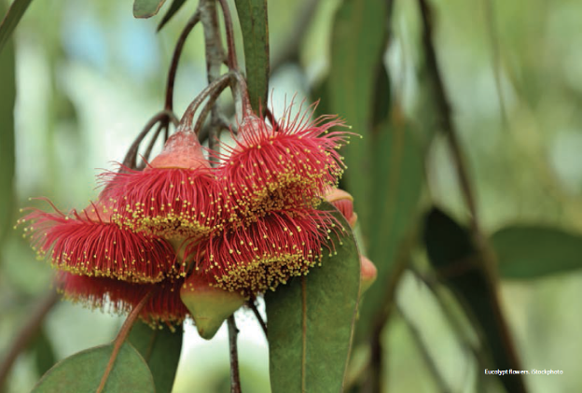
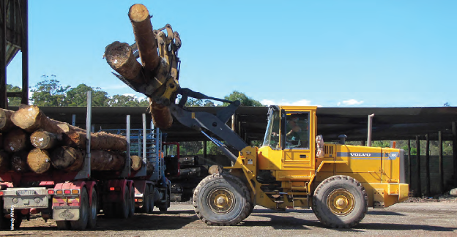
Unloading hardwood sawlogs from a truck at a sawmill, southern New South Wales.
A key goal of sustainable forest management is to maintain the productive capacity of native and plantation forests. This allows provision of the forest goods and services required by society without compromising the ability of future generations to meet their own needs. Maintaining the output of both wood and non-wood forest products through harvesting therefore requires, among other things, forest regeneration and the maintenance of ecosystem health.
The five indicators in this criterion set out information on the area of native forest available for wood production and the size of the plantation resource, the volumes of wood harvested against the calculated sustainable yield, the regeneration and re-establishment of harvested native forest and plantations, and the volumes and types of non-wood forest products extracted.
Native forest
The area of native forest available for commercial wood production is a key determinant of the capacity of forest-based industries to meet domestic and export demands for native timbers and wood products. Harvest volumes can also vary markedly among forest types and localities, depending on forest productivity, the merchantability of a forest's standing wood for timber or other products, and other factors. Information on both the area harvested and the volume extracted is therefore required to gauge trends over time.
The main wood products harvested from Australia's native forests are high-quality sawlogs for solid wood products, and pulplogs for paper, cardboard, fibreboard and related products. Increasingly, logs are also used to produce veneer for wood-based panel products. Other products include logs for speciality timbers, low-quality sawlogs, round and split posts, poles, piles and girders, timber sawn and hewn in the forest, sleepers, firewood for residential use, and fuelwood for industrial use. Some of these are obtained as ancillary products during a sawlog harvest.
States and territories apply regulatory frameworks designed to ensure that environmental attributes and the productive capacity of the forest are maintained. Sawlog volumes permitted for harvest are set according to a calculated annual sustainable yield (also called sustained yield or allowable cut), which requires data on the net area of forest available for harvest, forest type and age class, standing wood volume, terrain, accessibility, and growth and yield. Estimates of sustainable yield also take into account restrictions on harvesting within the area available for harvest that may be imposed by codes of forest practice, and by other rules and regulatory frameworks established to ensure the protection and maintenance of biodiversity and soil and water resources. Harvesting levels can fluctuate over time for operational reasons, with occasional overcuts in some years balanced by prescribed undercuts in others, in compliance with state regulations.
Native forest harvest for wood production is permitted only if systems are in place for forest regeneration—regeneration of a new forest stand is critical to maintaining the productive capacity of the forest. Data are collected routinely on the area of harvested forest that is regenerated successfully in an allocated time period. Remedial treatments are applied, if required, to ensure adequate regeneration.
Firewood and fuelwood are major energy sources for many Australian households and industries, respectively. States and territories have established permit systems to regulate collection of firewood and fuelwood, including permission to collect firewood and fuelwood as a by-product of sawlog harvesting operations, voluntary codes of practice for commercial operators, and restrictions on the clearing of native vegetation, including forests. The unregulated collection of firewood poses a significant risk to forest health and biodiversity.
Plantation forests
The primary purpose of industrial plantation forestry in Australia is wood production. Plantation forests also make a contribution to a range of environmental services, including production of drinking-quality water, mitigation of dryland salinity, sequestration of carbon, and, especially where native species such as eucalypts are planted, provision of habitat for native plants and animals.
The area of Australia's plantation estate increases when new plantations are established. Recently, new plantations have mostly been established on cleared agricultural land. Simultaneously, existing plantations can be harvested and re-established. The decision to re-establish plantations after harvest depends on factors such as site suitability (including with regard to projected climate change), grower intent, market availability, projected economic returns, and rationalisation of the plantation estate. The prospects for alternative land uses and the availability of other investment opportunities are also important considerations, especially for privately managed plantations.
State and territory agencies and most private growers have management systems in place to assess plantation regeneration or re-establishment against stocking standards, and to prescribe remedial treatments. Silvicultural and tree improvement programs play large roles in maintaining and increasing plantation productivity.
Non-wood forest products
Non-wood forest products (NWFPs) are products other than wood derived from forest, including products generated directly or indirectly from organisms living in forest ecosystems, as well as some minerals. Industries such as honey production rely heavily on the flowering of native forest. Other categories of non-wood products are plant foods; animal products; landscape and garden products; health and personal care products; decorative and aesthetic products; and minerals, stone and gravel. Many Aboriginal and Torres Strait Islander peoples (referred to as Indigenous peoples in SOFR 2013) rely to varying degrees on the use of non-wood forest products for customary purposes (e.g. food, medicine and livelihood) and commercial purposes (e.g. art and craft).
The sustainable management of non-wood forest products is essential for the conservation of harvested species and for maintaining the livelihoods of people who depend on them. Knowledge of the ecological sustainability of harvesting non-wood forest products has grown rapidly, but is mostly in the form of studies on individual species or specific regions.
In all states and territories, the removal of native animals from forests is prohibited or subject to regulation. Permits to harvest native forest plants and animals are part of the system of ensuring the sustainability of production and harvesting. Issuance of permits takes into consideration factors such as population levels and reproduction rates of the species concerned, and environmental pressures such as disease and habitat loss. Harvesting under permit for meat and skins is restricted to common and widespread species, or to exotic species, many of which (such as pigs and water buffalo) are officially declared as pests.
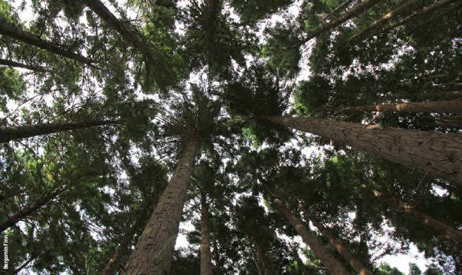
Mature pine plantation canopy, Victoria.

Key findings
Key findings are a condensed version of the Key points presented at the start of individual indicators in this criterion.
Native forest
- The total area of Australia's native forest both available and suitable for commercial wood production was 36.6 million hectares in 2010—11, a decrease from 37.6 million hectares in 2005—06. This includes 7.5 million hectares of public native forests (19% of Australia's public native forest area). A further 29.1 million hectares of leasehold and private tenure forests are also potentially both available and suitable for commercial wood production, subject to landholder intent, markets and environmental constraints.
- Harvesting in multiple-use public native forest is subject to substantial requirements for maintaining and managing non-wood values. When these additional local restrictions are taken into account, the net area available and suitable for harvest in multiple-use public native forest (the net harvestable area) is 5.5 million hectares.
- The area of multiple-use public native forest harvested annually in Australia decreased from 117 thousand hectares in 2006—07 to 79 thousand hectares in 2010—11, a decrease of 32%. Of the area of multiple-use public native forest harvested over the 10-year period 2001—02 to 2010—11, 85% was harvested by selection logging silviculture systems (selection logging, native cypress pine logging and commercial thinning), 12% by clearfell silviculture systems (clearfelling, fire salvage clearfelling and intensive silviculculture), and 3% by shelterwood systems.
- The average sustainable yield declined nationally by 47%, and in all states except Tasmania, between 1992—96 and 2006—11. This decline was a consequence of increased reservation of public multiple-use native forests; increased restrictions on harvesting through prescriptions in codes of forest practice; revised estimates of forest growth and yield; and impacts of occasional, intense, broadscale wildfires.
- The volume of sawlogs harvested from multiple-use public native forest in the period 1992—93 to 2010—11 was at or below the calculated sustainable yield in New South Wales, Tasmania, Victoria and Western Australia, and at or below the calculated sustainable yield or allowable cut in Queensland. Nationally, sawlog harvest levels were 17% below the calculated sustainable yield for the period 2006—11, and were 6—18% below the calculated sustainable yield in each of the four SOFR five-yearly reporting periods. In the period 2006—07 to 2010—11, the average annual sawlog volume harvested from multiple-use public native forest was 1.40 million cubic metres, a decline from 1.96 million cubic metres in the period 2001—02 to 2005—06.
- As the supply of high-quality logs from public multiple-use native forests declines as a consequence of reservation of forest and other factors, the importance of private native forests for the supply of hardwood logs will increase, and management of private native forests will increasingly determine the long-term national supply of high-quality native hardwood logs. However, a national assessment found that there is insufficient information to determine whether the rate of wood harvest from private native forests is sustainable.
- The use of firewood for residential heating and energy decreased slightly between 2006 and 2010, while use of industrial fuelwood increased.
- State jurisdictions require the regeneration and/or restocking of harvested multiple-use public native forest to specified standards; some states have similar codes of practice and regulations for private forests. Five-year average reported regeneration success rates in multiple-use public native forest in the reporting period 2005—06 to 2010—11 varied from 85% in New South Wales, to 100% in Queensland; over the four SOFR reporting periods, five-year average reported regeneration rates varied from 72% in Victoria, to 100% in Queensland and Western Australia. Remedial action was carried out where specified regeneration and restocking standards in harvested areas were not achieved. Drought, fire, poor seed reserves, and difficulties in carrying out regeneration burns contributed to low regeneration success rates in some states.
Plantation forests
- The area of Industrial plantations managed for wood production in Australia increased from 1.818 million hectares in 2005—06 to 2.017 million hectares in 2010—11, with almost all the increase achieved by planting on cleared agricultural land. Of the total area of Industrial plantations as at 2010—11, 51% is planted with softwood species, and 49% with hardwood species. The area of Industrial softwood plantations was relatively stable over the reporting period, but the area of Industrial hardwood plantations increased from 0.807 million hectares in 2005—06 to 0.980 million hectares in 2010—11.
- The area proportion of the Industrial plantation estate where the trees are government-owned decreased from 35% in 2006 to 24% in 2011, while the area proportion where the trees are privately owned increased from 65% to 76%. Private ownership identified as ownership by institutional investors increased from 12% in 2006 to 31% in 2011.
- In the period 2006-07 to 2010-11, plantations produced 71% of the volume of logs harvested in Australia. Hardwood plantations provided 35% of Australia's pulplog supply and 1% of Australia's sawlog supply, while softwood plantations provided 39% of Australia's pulplog supply and 79% of Australia's sawlog supply. The harvest of sawlog and pulplog from softwood plantations has increased since 2000, as has the pulplog harvest from hardwood plantations, while sawlog harvest from hardwood plantations has been relatively stable. In 2010—11, the final year of the SOFR 2013 reporting period, plantations produced 76% of the volume of logs harvested in Australia.
- If the current plantation area is maintained, total wood production from softwood plantations is expected to plateau by 2035 at 18 million cubic metres per year. Total production from hardwood plantations will increase to around 15 million cubic metres per year by 2030.
- Rates of successful establishment of new plantations, and re-establishment of plantations after plantation harvest, are generally ab ove 90%.
Non-wood forest products
- Australia produces a wide range of non-wood forest products derived from forest fauna, flora and fungi, and in general from forest biological resources. High-value non-wood forest products include wildflowers, seed, honey, and aromatic products derived from sandalwood.
- Data on annual removals and sustainable yields are limited for many non-wood forest products. The State of the Environment 2011 Committee assessed the extraction of non-wood forest products from native and plantation forests as generally having a low impact on the environment.
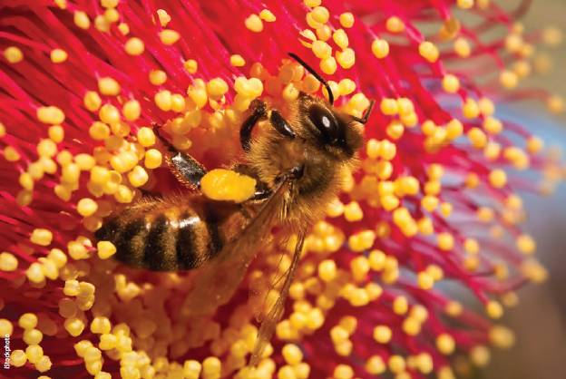
A honeybee collecting pollen from a eucalypt flower.

Indicator 2.1a Native forest available for wood production, area harvested, and growing stock of merchantable and non merchantable tree species
Rationale
This indicator reports the capacity of forests to sustainably produce wood to meet society's needs into the future. The area of native forest available for wood production, the nature of the growing stock, and the area harvested over time provide means to demonstrate the sustainability of forest management.

Key points
- In 2010—11, 82.6 million hectares of native forest in Australia were in tenures (leasehold, private, and multiple-use public lands) in which wood production is not legally restricted.
- The extent of native forest that is both available and suitable for commercial wood production declined from 37.6 million hectares in 2005—06 to 36.6 million hectares in 2010—11. This decline is a consequence of increases in reservation, and changes in the reported total area of Australia's forests.
- Only 7.5 million hectares (19%) of public native forests were both available and suitable for commercial wood production in 2010—11. A further 29.1 million hectares of leasehold and private tenure forests were also potentially available and suitable for commercial wood production, subject to landholder intent, markets and environmental constraints.
- Harvesting in multiple-use public native forests is subject to substantial requirements to maintain and manage non-wood values. The net area available and suitable for harvest in multiple-use public native forests when these additional local restrictions are taken into account (the net harvestable area) is 5.5 million hectares (14% of public native forests).
- The annual area of multiple-use public native forests harvested in Australia decreased from 117 thousand hectares in 2006—07 to 79 thousand hectares in 2010—11, a 32% decrease. Of the area of multiple-use public native forest harvested over the 10-year period 2001—02 to 2010—11, 85% was harvested by selection logging silvicultural systems (selection logging, native cypress pine logging and commercial thinning), 12% by clearfelling silvicultural systems (clearfelling, fire-salvage clearfelling, and intensive silviculture), and 3% by shelterwood systems.
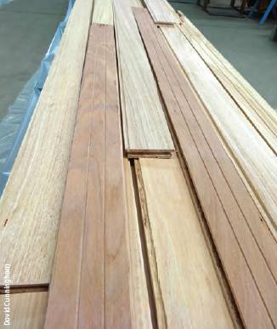
High-quality flooring made from timber sourced from multiple-use public native forests in south-east New South Wales.
The emphasis of this indicator is the area of native forests available for wood production—that is, the area in which harvesting is not legally restricted. For Australia's purposes, the term "not legally restricted" in this indicator is confined to the tenures leasehold forest, multiple-use public forest and private land. The tenures nature conservation reserve, other Crown land and unresolved tenure are considered for the purposes of this indicator to be legally restricted from harvesting. Harvesting is also subject to various forms of regulation on tenures where it is "not legally restricted", as well as economic constraints.
In Australia, the area of native forest available for wood production is a function of tenure, state and territory regulatory frameworks, codes of practice, and—on public lands—requirements to manage the forest for multiple values. In turn, the area of native forests available for wood production is one determinant of the forest sector's capacity to meet domestic and export demand for native timbers and wood-based products, and is also an important input for calculating the level of sustainable yield from native forests (see Indicator 2.1c). This indicator concentrates on the area of forest that is available and suitable for commercial wood production.

Native forest area available for wood production
The major source of Australia's native timber and wood-based products is multiple-use public forests in New South Wales, Queensland, Tasmania, Victoria and Western Australia; forests on land with leasehold and private tenure also contribute to supply in these states. Limited and periodic supplies are provided from leasehold and private tenures in the Northern Territory. By regulation, no commercial harvesting is carried out in native forests in the Australian Capital Territory or South Australia. Wood harvesting of native forests is not permitted in nature conservation reserves in any jurisdiction in Australia.
Within the various tenure categories in which wood harvest is permitted, harvesting can be restricted by legislation, codes of practice and management plans. Reasons for these restrictions include conservation and management of biodiversity and heritage, and protection of the water supply (see Indicator 7.1a).

Native forest not legally restricted from harvesting
In 2000-01, the area of native forest not legally restricted from wood harvesting was 119.8 million hectares—74% of Australia's native forests at that time (SOFR 2003). This area decreased in absolute terms to 112.6 million hectares in 2005—06, representing an increase to 76% of Australia's native forests at that time (SOFR 2008). In 2010—11, 82.6 million hectares are not legally restricted from wood harvesting (Table 2.1), which is 67% of Australia's total 122.6 million hectares of native forest (reported in Indicator 1.1a).

Forest available and suitable for harvesting
The area of native forest not legally restricted from wood harvesting is a poor representation of, and substantially overstates, the area actually available to the timber and wood-processing industries, because it includes forests that are unsuitable for wood harvesting or in which wood harvesting is not economically (commercially) viable.
Between 1960 and 1990, data were provided by state and territory agencies to Australian Government agencies on the area of native forest available and commercially suitable for wood production from multiple-use public forests, leasehold and private forests. Such reporting was not continued after 1992. Davey and Dunn (in preparation) therefore undertook a recent national assessment of commerciality, merchantability and productivity of native forests across all tenures, based on historical and recent data, and spatially identified native forests available and suitable for wood production.
Table 2.2 shows the estimated area of native forest both available and suitable for wood harvesting in 2006 and 2011, categorised by its commercial suitability for wood harvesting based on forest productivity and merchantability (Davey and Dunn, in preparation). Forest 'available and suitable' for harvesting is forest with a commerciality rating of very low, low, moderate, high or very high. A total of 37.6 million hectares of native forest was available and suitable for wood harvesting in 2006, which was 33% of the 112.6 million hectares of forest in the tenures leasehold, private and multiple-use native forest. In 2011, the estimate had decreased to 36.6 million hectares of native forest, which is 40% of the 92.1 million hectares of forest in the tenures leasehold, private and multiple-use native forest (Table 2.2).
Figure 2.1 shows the national distribution of native forest areas by their assessed level of commerciality in 2011. Only 7.5 million hectares (19%) of the 39.8 million hectares of public native forest (that is, native forest on the tenures multiple-use public forest, nature conservation reserve and other Crown land) are available and suitable for commercial wood production. A further 29.1 million hectares of leasehold and private tenure forests are also potentially available and suitable for commercial wood production, subject to landholder intent, markets and environmental constraints (Table 2.2). This is 1.0 million hectares less than in 2006—07, as a consequence of increases in reservation, and changes in the reported total area of Australia's forests. The increase in area of commercial multiple-use public forests resulted from changes in tenure classification in Queensland (see Indicator 1.1a).
Table 2.1: Area of leasehold native forest, multiple-use public native forest and native forest on private land legally restricted and not legally restricted from wood harvesting, by jurisdiction, 2010-11
Tenure | Legally restricted ª - Area ('000 hectares) | Not legally restricted - ACT ^{c} - Area ('000 hectares) | Not legally restricted - NSW - Area ('000 hectares) | Not legally restricted - NT - Area ('000 hectares) | Not legally restricted - Qld - Area ('000 hectares) | Not legally restricted - SA ^{c} - Area ('000 hectares) | Not legally restricted - Tas. - Area ('000 hectares) | Not legally restricted - Vic. - Area ('000 hectares) | Not legally restricted - WA - Area ('000 hectares) | Not legally restricted - Australia - Area ('000 hectares) | Total forest in tenure ^{b} - Area ('000 hectares)
Leasehold forest | 3,267 | 0 | 5,472 | 4,578 | 29,672 | 0 | 16 | 2 | 5,527 | 45,266 | 48,533
Multiple-use public forest | 550 | 0 | 1,830 | 0 | 2,774 | 0 | 789 | 2,926 | 1,290 | 9,609 | 10,159
Private land (including Indigenous) | 5,647 | 0 | 8,777 | 6,344 | 9,496 | 0 | 776 | 1,120 | 1,234 | 27,747 | 33,394
Total | 9,464 | 0 | 16,079 | 10,922 | 41,941 | 0 | 1,581 | 4,048 | 8,052 | 82,622 | 92,086
ª Within these tenures, wood harvesting is legally restricted on reserves on multiple-use public forest, private and leasehold land, and on covenanted private and leasehold land.
^{b} Figures for total forest in each tenure category are from Indicator 1.1a.
^{c} Commercial wood harvesting is not permitted in native forests in the ACT and SA.
Note: Totals may not tally due to rounding.
Source: Australian Bureau of Agricultural and Resource Economics and Sciences.
Table 2.2: Area of leasehold, private and multiple-use native forest, by level of wood commerciality, 2006 and 2011
Year | Tenure | Non-commercial forest and forest legally restricted from harvesting ª - Area ('000 hectares) | Commercial forest - (forest available and suitable for harvesting) - Level of wood commerciality - Very low - Area - ('000 hectares) | Commercial forest - (forest available and suitable for harvesting) - Level of wood commerciality - Low - Area - ('000 hectares) | Commercial forest - (forest available and suitable for harvesting) - Level of wood commerciality - Moderate - Area - ('000 hectares) | Commercial forest - (forest available and suitable for harvesting) - Level of wood commerciality - High - Area - ('000 hectares) | Commercial forest - (forest available and suitable for harvesting) - Level of wood commerciality - Very high - Area - ('000 hectares) | Commercial forest - (forest available and suitable for harvesting) - Level of wood commerciality - Total ^{b} - Area - ('000 hectares) | Total forest in tenure ^{c} - Area ('000 hectares) | Comm-erciality ^{d -} %
2006 | Leasehold forest | 51,155 | 4 | 12,790 | 845 | 308 | 30 | 13,977 | 65,132 | 21
2006 | Multiple-use public forest | 2,194 | 84 | 2,203 | 2,496 | 1,784 | 649 | 7,216 | 9,410 | 77
2006 | Private land | 21,652 | 42 | 12,567 | 2,428 | 1,013 | 396 | 16,447 | 38,099 | 43
2006 | Total | 75,001 | 130 | 27,561 | 5,769 | 3,105 | 1,075 | 37,640 | 112,641 | 33
2011 | Leasehold forest | 35,737 | 0 | 11,753 | 702 | 317 | 24 | 12,796 | 48,533 | 26
2011 | Multiple-use public forest | 2,637 | 86 | 2,732 | 2,486 | 1,615 | 603 | 7,522 | 10,159 | 74
2011 | Private land | 17,099 | 54 | 12,156 | 2,551 | 1,119 | 415 | 16,295 | 33,394 | 49
2011 | Total | 55,473 | 140 | 26,641 | 5,739 | 3,051 | 1,042 | 36,613 | 92,086 | 40
ª 'Non-commercial forest and forest legally restricted from harvesting' includes forest of limited, possible or no commerciality; sandalwood; forest of unknown floristics and structure; and conservation reserves where harvesting is excluded by covenant or regulation. Forests on formal nature conservation reserves, other Crown land and land of unresolved tenure are not included on this Table.
^{b} 'Total' column is the sum of the areas of forest of very low, low, moderate, high and very high commerciality.
^{c} Figures for total forest in each tenure category are from Indicator 1.1a for 2011, and SOFR 2008 for 2006; these area coverages were used to overlay the relevant commercial forest layer.
^{d} 'Commerciality' is the proportion of the total area of forest in a tenure category that is classified as very low, low, moderate, high or very high commerciality.
Notes:
'Total forest' uses area statements of forest reported in SOFR 2008 and this SOFR (Table 1.5, Indicator 1.1a); these area coverages were used to overlay the relevant commercial forest layer.
Totals may not tally due to rounding.
Source: Davey and Dunn (in preparation), Australian Bureau of Agricultural and Resource Economics and Sciences.
Figure 2.2: Australia's native forests available and suitable for wood production across the leasehold, private and multiple-use public forest estate
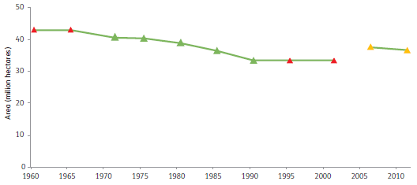
Note: Green data points are derived from tabular data provided by state and territory agencies to Australian Government agencies. Red data points are estimates based on the tabular data (green data points) and ancillary historical data. Yellow data points are based on recent spatial assessment (Davey and Dunn in preparation).
Source: Resource Assessment Commission (1992), Davey and Dunn (in preparation), and Australian Bureau of Agricultural and Resource Economics and Sciences (including historical forest resource datasets and publications from the Bureau of Agricultural Economics and the Commonwealth Forestry and Timber Bureau).
A large part of the native forest estate on leasehold and private land contributes minimally to wood supply. This includes forests used predominantly for grazing, forests containing few marketable species in commercial quantities, forests isolated from markets, or forests where harvesting is not operationally feasible. There is relatively little commercial native forest harvesting in the Northern Territory for a combination of these reasons.
Figure 2.2 shows the trend in the gross area of native forest available and suitable for wood production in the period 1960—2011, using these various data sources. Forests on leasehold, private and particularly multiple-use public forest tenures are increasingly managed for a range of values, such as water protection, flora and fauna protection, and conservation, as well as (or instead of) wood production. This trend of changing use has contributed to continuing reductions in the availability of multiple-use public forests for wood harvesting.

Net harvestable area of forest
The net harvestable area is the basis of sustainable yield calculations for multiple-use public native forests. Net harvestable area is estimated by subtracting from the gross available multiple-use public native forest area:
- areas within multiple-use forests that are reserved for nature conservation, water and heritage, and/or are zoned for management purposes that do not permit wood harvesting
- forest exclusions resulting from the application of codes of forest practice
- forests determined to have operational constraints (e.g. access) or to be non-merchantable—that is, they are not suitable for wood production because of the age, size and type of trees, or because they have been damaged by fire or disease.
The net harvestable area therefore represents the net area of available and suitable forest on multiple-use public native forest land after allowing for local and/or operational constraints on harvesting.
The net harvestable area of public native forest (that is, native forest on the tenures multiple-use public forest, nature conservation reserve and other Crown land) declined by 46% from 1995—96 to 2010—11, from 10.1 million hectares to 5.5 million hectares, including from decisions made by governments as a result of Regional Forest Agreements (Table 2.3). This is a direct result of significant amounts of multiple-use public native forest being transferred to nature conservation reserves (Davidson et al. 2008). The net harvestable area of public native forest in 2010—11 (5.5 million hectares) is 14% of the area of public native forest.
In New South Wales, the net harvestable area of public native forest declined from 2.35 million hectares in 1995—96 to 1.23 million hectares in 2010—11 (Table 2.3), a reduction of 48 %.
In Tasmania, the net harvestable area of public native forest decreased from 0.811 million hectares in 1995—96 to 0.563 million hectares in 2010—11 (Table 2.3). The proportion of Tasmania's public native forest estate available for harvesting decreased from 36% in 1995—96 to 23% in 2010—11. This was due to the reallocation of areas of multiple-use public native forest as nature conservation reserves as a result of the 1997 Regional Forest Agreement and 2005 Tasmanian Community Forest Agreement, and to changes to prescriptions in the Tasmanian code of forest practice (FPA 2012).
The net harvestable area of public native forest in Victoria decreased by 67% between 1995—96 and 2010—11, from 2.55 million hectares to 0.835 million hectares (Table 2.3). There were several reasons for this decrease: some multiple-use public native forest was transferred to nature conservation reserves; some forest became unavailable as a result of exclusions associated with changes to the Victorian Code of Practice for Timber Production and to special protection zones; and some forest was reassessed as unsuitable for wood production because of operational constraints and a lack of merchantable (i.e. saleable) timber.
Figure 2.1: Commerciality of Australia's native forest, assessed across the leasehold, private and multiple-use public forest estate, 2011
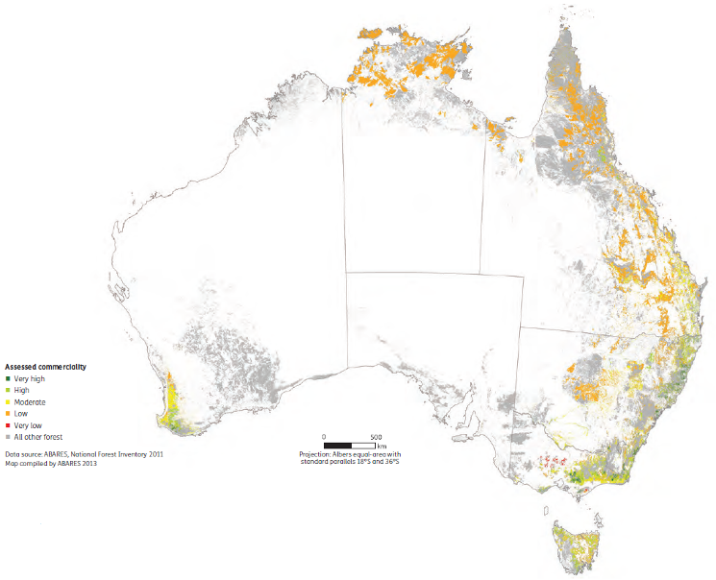
Notes:
Forest 'available and suitable' for harvesting is forest with a commerciality rating of very low, low, moderate, high or very high. 'All other forest' includes forest of limited, possible or no commerciality; sandalwood; forest of unknown floristics and structure; conservation reserves where harvesting is excluded by covenant or regulation; plus forests on formal nature conservation reserves, other Crown land and land of unresolved tenure.
Commerciality is limited in the Northern Territory and northern Queensland because of accessibility and remoteness. As a consequence, only a limited amount of harvesting occurs in these areas.
Source: Davey and Dunn (in preparation), Australian Bureau of Agricultural and Resource Economics and Sciences.
Table 2.3: Net harvestable area of public native forest ª, and proportion of total public native forest, by jurisdiction, 1995-96 to 2010-11
Jurisdiction | Public native forest | 1995–96 | 2000–01 | 2005–06 | 2010–11
NSW | Net harvestable area (‘000 hectares) | 2,352 | 1,516 | 966 ^{b} | 1,229 ^{b}
NSW | Proportion (%) ^{c} | 35 | 20 | 12 | 16
Qld | Net harvestable area (‘000 hectares) | 3,186 | 2,340 | 2,178 | 2,030
Qld | Proportion (%) ^{c} | 40 | 26 | 27 | 22
Tas. | Net harvestable area (‘000 hectares) | 811 | 787 | 607 | 563
Tas. | Proportion (%) ^{c} | 36 | 35 | 27 | 23
Vic. | Net harvestable area (‘000 hectares) | 2,555 | 1,010 | 930 | 835
Vic. | Proportion (%) ^{c} | 41 | 15 | 14 | 13
WA | Net harvestable area (‘000 hectares) | 1,157 | 904 | 848 | 848
WA | Proportion (%) ^{c} | 6 | 6 | 7 | 7
Total | Net harvestable area (‘000 hectares) | 10,061 | 6,557 | 5,528 | 5 505
Total | Proportion (%) ^{c} | 22 | 14 | 13 | 14
ª Public native forest comprises the tenures multiple-use public native forest, nature conservation reserve and other Crown land
^{b} The increase in the estimated net harvestable area between 2005-06 and 2010-11 for NSW public native forests resulted from use of a new standardised methodology involving a corporate geo-database.
^{c} Proportion of public native forest area in that jurisdiction.
Note: Area statements of public forest reported in SOFR 1998, 2003, 2008 and Table 1.5 (Indicator 1.1a) are used to calculate proportion of total public native forest.
Source: State and territory government agencies, including FPA (2002, 2007, 2012) and DSE (2003, 2008); Australian Bureau of Agricultural and Resource Economics and Sciences.
An estimated 0.364 million hectares (27%) of Victoria's private and leasehold forests were available and suitable for timber production in 2000—01 (DSE 2003). No estimates of the area of net harvestable private and leasehold forests in other jurisdictions were available for this report.
In Western Australia, the net harvestable area of public native forest declined from 1.157 million hectares in 1995—96 to 0.848 million hectares in 2005—06 (Table 2.3), a decrease of 27% . This was a result of the transfer of parts of the multiple-use public native forest area to nature conservation reserves and the introduction by the Western Australian Government of policies for the protection of old-growth forests. The net harvestable area has remained steady from 2005—06 to 2010—11.
In 1999, the Queensland Government signalled a phase-out of harvesting in public native forest in south-east Queensland in favour of wood production from hardwood plantations (SOFR 2008). This phase-out, which subsequently applied statewide, resulted in a steady decrease in the proportion of the net harvestable area of public native forest, from 40% of public forest in 1995—96 to 22% of public forest in 2010—11. Net harvestable area decreased from 3.2 million hectares in 1995—96 to 2.0 million hectares in 2010—11, a decline of 36%. The phase-out of harvesting was terminated in 2012, with no further transfers of multiple-use public native forest to nature conservation reserves. Some areas of multiple-use public native forests (principally state forests), where harvesting was excluded, will return to ongoing native timber production.

Area of native forest harvested for wood
Limited data are available on the area harvested annually in Australia, although state forest agencies report annually or five-yearly the area of forests that they manage that is harvested and regenerated. Some data are also available for the area harvested in private forests in Tasmania.
Western Australia has a long history of reporting the annual area of forest harvested for wood. Table 2.4 shows the areas of jarrah (Eucalyptus marginata), karri (E. diversicolor) and wandoo (E. wandoo) forest types harvested since 1975. The average annual harvested area decreased from 30,180 hectares in 1976—80 to 8,956 hectares in 2006—10, a 70% reduction. The majority of harvesting occurred using selection and shelterwood systems.
A range of silvicultural systems are used in Australia (Figure 2.3). The area of multiple-use public native forest harvested in Australia is summarised by silvicultural system in Table 2.5, and by jurisdiction in Table 2.6. Nationally, the total area harvested annually declined steadily from 140,700 hectares in 2001—02 to 79,400 hectares in 2010—11 (Tables 2.5 and 2.6), a 44% decrease. Over the period 2006—07 to 2010—11, the total area harvested declined from 117,400 hectares to 79,400 hectares, a 32% decrease.
Table 2.4: Average area of multiple-use public native forest harvested in Western Australia
Period | Selection, shelterwood and other harvest ª  (jarrah and wandoo) - Area (hectares) | Clearfelled or partially cut  (karri) - Area (hectares) | Thinned ^{b}  (karri) - Area (hectares) | Total - Area (hectares)
1976-80 | 27,340 | 2,792 | 48 | 30,180
1981-85 | 23,244 | 1,722 | 322 | 25,288
1986-90 | 18,266 | 1,330 | 656 | 20,252
1991-95 | 14,236 | 1,788 | 124 | 16,148
1996-2000 | 19,436 | 1,668 | 180 | 21,284
2001-05 | 11,032 | 724 | 608 | 12,364
2006-10 | 7,486 | 508 | 962 | 8,956
ª Includes harvesting for a range of silvicultural objectives, including by thinning, selection and shelterwood silviculture systems used in jarrah and wandoo forest and in jarrah forest harvested before being cleared for bauxite mining.
^{b} 'Thinning' of regrowth karri forests.
Source: CCWA (2012a), Western Australian Department of Environment and Conservation, Western Australian Forest Products Commission.
Table 2.5: Silvicultural systems used in multiple-use public native forest in Australia
Reporting year | Silvicultural system ª  Clear-felling ^{b} - Area (hectares) | Silvicultural system ª  Fire salvage (clear-felling) ^{b} - Area (hectares) | Silvicultural system ª  Intensive silviculture with retention ^{b} - Area (hectares) | Silvicultural system ª  Shelter-wood - Area (hectares) | Silvicultural system ª  Selection ^{c} - Area (hectares) | Silvicultural system ª  Native cypress pine silviculture ^{c} - Area (hectares) | Silvicultural system ª  Commercial thinning ^{c} - Area (hectares) | All systems - Area ('000 hectares) | Cleared for mining^{d} - Area (hectares) | Total area harvested - Area (hectares)
2001-02 | 10,607 | 100 | 7,958 | 7,920 | 68,968 | 29,576 | 14,952 | 140,081 | 630 | 140,711
2002-03 | 11,184 | 400 | 6,546 | 6,500 | 67,631 | 29,767 | 14,684 | 136,712 | 390 | 137,102
2003-04 | 10,440 | 1,800 | 5,862 | 4,330 | 60,150 | 33,075 | 12,995 | 128,652 | — | 128,652
2004-05 | 9,680 | 600 | 5,118 | 4,310 | 56,185 | 29,693 | 12,747 | 118,333 | 500 | 118,833
2005-06 | 7,580 | 900 | 5,719 | 2,870 | 60,755 | 30,954 | 9,895 | 118,673 | 340 | 119,013
2006-07 | 8,310 | 500 | 4,855 | 2,780 | 64,753 | 25,120 | 10,478 | 116,796 | 600 | 117,396
2007-08 | 6,710 | 1,500 | 3,566 | 3,040 | 61,715 | 38,200 | 12,039 | 126,770 | 920 | 127,690
2008-09 | 5,410 | 1,000 | 3,662 | 2,700 | 40,529 | 21,300 | 12,261 | 86,862 | 690 | 87,552
2009-10 | 4,910 | 1,600 | 3,018 | 3,710 | 47,299 | 27,450 | 8,032 | 96,019 | 990 | 97,009
2010-11 | 4,640 | 1,200 | 4,647 | 1,250 | 37,012 | 22,512 | 6,853 | 78,114 | 1,250 | 79,364
5-year mean, 2001-02 to 2005-06 | 9,898 | 760 | 6,241 | 5,186 | 62,738 | 30,613 | 13,055 | 128,490 | 372 | 128,862
5-year mean, 2006-07 to 2010-11 | 5,996 | 1,160 | 3,950 | 2,696 | 50,262 | 26,916 | 9,933 | 100,912 | 890 | 101,802
10-year mean, 2001-02 to 2010-11 | 7,947 | 960 | 5,095 | 3,941 | 56,500 | 28,765 | 11,494 | 114,701 | 631 | 115,332
10-year total as proportion of 10-year total for all silvicultural systems (%) | 7 | 1 | 4 | 3 | 49 | 25 | 10 | 100 | — | —
— = not separately reported
ª Some silvicultural systems are illustrated in Figure 2.3.
^{b} Clearfelling, fire-salvage clearfelling and intensive silviculture with retention are all clearfelling silvicultural systems. Intensive silviculture with retention includes areas harvested with seed-tree and/or habitat-tree retention, and alternate coupe harvesting.
^{C} Selection, native cypress pine silviculture and commercial thinning are all selection silvicultural systems.
^{d} Jarrah forests in WA that are cleared for bauxite mining are shown as 'cleared for mining'.
Notes:
No harvesting of native forest is permitted from public forests in the ACT, NT or SA.
Other than commercial thinning, Tasmania reports all non-clearfell silviculture (including variable retention) under selection logging.
Source: Data provided by NSW, Qld, Tas., Vic. and WA.
Figure 2.3: Silvicultural systems used in Australia's native forests
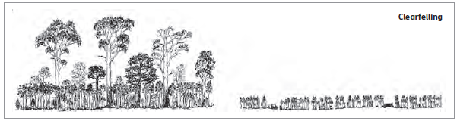
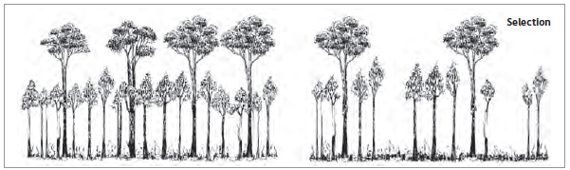
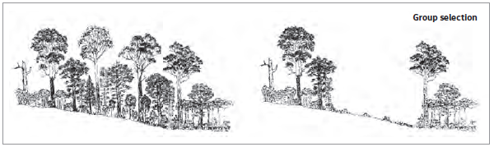
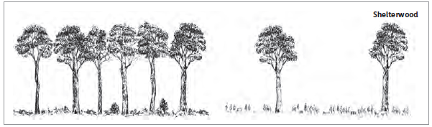
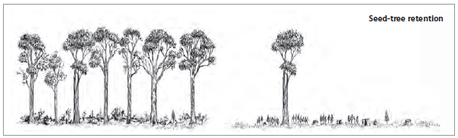
Source: Adapted from original artwork by Fred Duncan.
Tasmania, Victoria and Western Australia use clearfelling as a silvicultural system to promote native forest regeneration in certain forest types. Clearfelling data in Table 2.5 include native forest regenerated to native forest and, in Tasmania, native forest converted to plantation (Table 2.5). Fire salvage of damaged native forest stands using clearfelling systems in Victoria, and areas clearfelled for bauxite mining in Western Australia, are reported separately (Table 2.5). Intensive silviculture with retention includes areas harvested with seed-tree and/or habitat-tree retention, practised in Victoria, and alternate coupe harvesting in Eden, New South Wales; variable retention in Tasmania is reported under selection logging. A shelterwood silvicultural system used for nurturing and promoting regeneration in specific forest types is primarily practised in Western Australia.
Clearfelling, fire-salvage clearfelling and intensive silviculture account for 12% of the area harvested in multiple-use public native forest in Australia over the 10-year period 2001—02 to 2010—11. The average area harvested by these systems decreased from the 5-year period 2001—02 to 2005—06 to the 5-year period 2006—07 to 2010—11. Shelterwood silviculture represents 3% of the area harvested nationally from 2001—02 to 2010—11.
New South Wales, Queensland, Tasmania, Victoria and Western Australia apply selection harvesting silvicultural systems, including group or gap selection, Australian group selection, variable retention systems, single-tree selection (including light, moderate and heavy selection systems and diameter-limit cutting), and mixtures of group selection and single-tree selection. Native cypress pine silviculture (applied in New South Wales and Queensland) and commercial thinning (applied in New South Wales, Tasmania, Victoria and Western Australia) both use selection harvesting techniques but are reported separately (Table 2.5).
The various selection silviculture systems (selection logging, native cypress pine logging and commercial thinning) accounted for 85% of the area harvested in multiple-use public native forest over the 10-year period 2001—02 to 2010—11 (Table 2.5).
Table 2.6 reports the area harvested from multiple-use public native forest annually and the 5-year and 10-year mean, from 2001—02 to 2010—11, by jurisdiction. More than one-third of the area of multiple-use public native forest harvested in Australia is in New South Wales and Queensland; 12% is in Tasmania, 9% in Western Australia and 7% in Victoria.

Available growing stock
'Growing stock' is the total volume of wood in all living trees in a forest at a given time. Increases or decreases in growing stock can indicate (among other things) the sustainability of resource use. Previously, the Resource Assessment Commission (1992) compiled estimates of standing commercial wood growing stock, but no national estimates have been made since. Little information is available on the growing stock of non-merchantable tree species.
In New South Wales, Tasmania, Victoria and Western Australia, assessments of the growing stock of merchantable wood and tree growth rates are used to estimate sustainable harvesting levels in multiple-use public native forests (see Indicator 2.1c). In Tasmania, estimates of growing stock of merchantable wood are used to estimate wood supplies in private native forests. Few or no data are available on current growing stock in native forests outside the production areas of multiple-use public forests and those assessed in Tasmanian private forests.
Table 2.6: Forest area harvested annually from multiple-use public native forest in Australia
Reporting year | NSW - Area (hectares) | Qld - Area (hectares) | Tas. - Area (hectares) | Vic. - Area (hectares) | WA - Area (hectares) | Total - Area (hectares)
2001-02 | 50,351 | 47,700 | 14,900 | 10,500 | 17,260 | 140,711
2002-03 | 49,062 | 48,300 | 16,900 | 8,500 | 14,340 | 137,102
2003-04 | 45,337 | 48,400 | 17,090 | 8,100 | 9,725 | 128,652
2004-05 | 42,523 | 41,100 | 17,500 | 7,600 | 10,110 | 118,833
2005-06 | 43,233 | 47,700 | 12,500 | 7,800 | 7,780 | 119,013
2006-07 | 44,806 | 43,900 | 11,520 | 6,900 | 10,270 | 117,396
2007-08 | 52,960 | 44,200 | 12,990 | 7,800 | 9,740 | 127,690
2008-09 | 27,952 | 32,500 | 12,370 | 6,400 | 8,330 | 87,552
2009-10 | 38,499 | 32,300 | 8,660 | 5,900 | 11,650 | 97,009
2010-11 | 27,484 | 28,200 | 10,490 | 5,800 | 7,390 | 79,364
5-year mean, 2001-02 to 2005-06 | 46,101 | 46,640 | 15,778 | 8,500 | 11,843 | 128,862
5-year mean,2006-07 to 2010-11 | 38,340 | 36,220 | 11,206 | 6,560 | 9,476 | 101,802
10-year mean, 2001-02 to 2010-11 | 42,221 | 41,430 | 13,492 | 7,530 | 10,660 | 115,332
10-year total as proportion of 10-year total for all systems (%) | 37 | 36 | 12 | 7 | 9 | 100
Notes:
No harvesting of native forest is permitted from public forests in the ACT, NT or SA.
Harvest areas include areas harvested before plantation establishment (Tas.) and bauxite mining (WA).
Source: Data provided by NSW, Qld, Tas., Vic. and WA.

Indicator 2.1b Age class and growing stock of plantations
Rationale
This indicator uses the area, age class and growing stock of native and exotic species plantations to assess the volume of timber that Australia's plantation forests can supply now and into the future.

Key points
- The area of Industrial plantations managed for wood production in Australia increased from 1.818 million hectares in 2005—06 to 2.017 million hectares in 2010—11, with almost all the increase achieved by planting on cleared agricultural land.
- Of the total Industrial plantation estate, 51% by area is planted with softwood species and 49% with hardwood species. There are approximately 0.4 million hectares of Industrial plantations that are in their second, third or fourth rotation.
- The area of Industrial softwood plantations has been fairly stable over the reporting period, but the area of Industrial hardwood plantations increased from 0.807 million hectares in 2005—06 to 0.980 million hectares in 2010—11.
- The area proportion of the Industrial plantation estate where the trees are government-owned decreased from 35% in 2006 to 24% in 2011, while the proportion where the trees are privately owned increased from 65% to 76%. Private ownership identified as ownership by institutional investors increased from 12% in 2006 to 31% in 2011.
Industrial plantations provide two-thirds of Australia's log supply (see Indicator 2.1c). Growing trees in Industrial plantations, harvesting logs and processing them into sawn timber, paper, panels and other products generates substantial regional employment (see Indicator 6.5a). Industrial plantations therefore provide the raw material for major rural industries, even though they occupy only a small part of the rural land estate (see Indicator 1.1a).
The rationale for Indicator 2.1b identifies 'growing stock'—the total volume of wood in all living trees in a forest at a given time—as an indicator of potential wood supply from plantations. Growing stock is not usually measured in Australia, but the Australian Bureau of Agricultural and Resource Economics and Sciences, under the National Plantation Inventory (NPI), develops forecasts of plantation log supply every five years (see Indicator 2.1c).
Until the 1990s, most plantations established in Australia were pines and other softwood species grown to produce sawn timber. Many were planted on land where there had previously been native eucalypt forests. However, the clearing of native vegetation (including native forests) for new plantation development is now prohibited or restricted by state and territory policies and legislation, and new plantations are now mostly established on cleared agricultural land. Most plantations established over the past 15 years have been hardwood plantations grown to produce pulplogs.

Plantation areas and values
The area of Australia’s Industrial plantation estate from 1940, including data from before the establishment of the NPI in 1995, is shown in Figure 2.4. Australia’s plantations have expanded considerably since the NPI began collecting data in 1995, doubling in area from 1990 to 2010 (Figures 2.4 and 2.5), with almost all of the increase being in hardwood plantations. The first comprehensive map-based report from the NPI, published in 1997, showed that Australia had just over 1.0 million hectares of plantations. The plantation estate has since grown to 1.8 million hectares in 2005–06 (SOFR 2008) and to 2.0 million hectares in 2010–11 (Figures 2.4 and 2.5). Government policies and programs and joint government/industry initiatives such as Plantations for Australia: the 2020 Vision (Private Forestry Consultative Committee 2002) were important in removing impediments to plantation development over this period. Non-industrial plantations are reported separately, under the ‘Other forest’ category, in Indicator 1.1a.
Australia's Industrial plantation estate in 2010—11 was 2.017 million hectares, comprising 1.025 million hectares of softwood plantations, 0.980 million hectares of hardwood plantations, and about 12 thousand hectares classified as 'other' plantations (plantations of mixed hardwood and softwood species, and plantations where species type was not reported) (Gavran 2012). About 51% of the total Industrial plantation forest area is softwood plantations (mainly exotic pines), and 49% is hardwood plantations (mainly eucalypts).
The distribution of plantation establishment and re-establishment by five-year period is shown in Figure 2.6. After 1990, there was a shift from re-establishment of exotic softwood plantations (funded mainly by government investment) towards establishment of new hardwood plantations of a range of eucalypt species (funded mainly by private-sector investment).
The area proportions of hardwood and softwood plantations in Australia, by state and territory jurisdiction, are shown in Figures 2.7 and 2.8. In 2010—11, Victoria had the largest plantation area (Gavran 2012), with 21% of the national area of hardwood plantations and 22% of the national area of softwood plantations. This was followed by Western Australia (31% of all hardwood plantations and 10% of all softwood plantations) and New South Wales (9% of all hardwood plantations and 29% of all softwood plantations).
There are 1.1 million hectares of plantations known to be in their first rotation, and approximately 400,000 hectares of plantations known to be in their second, third or fourth rotation (Table 2.7). Rotation information is not available for a substantial part (approximately one-quarter) of the national plantation estate.
In 2011, there were 1.97 million hectares of Industrial plantations with plantation trees of known age. Younger age-classes dominate this growing stock (Figure 2.9): 10% of the growing stock was older than 30 years, while 69% was aged 15 years or less.

Plantation ownership
A significant change in Industrial plantation ownership (specifically, ownership of plantation trees) from public to private owners occurred over the period 2005—11 (Table 2.8). Government-owned plantations decreased from 37% of Australia's total plantation area to 24% over this period. Ownership by institutional investors (including international superannuation funding systems) increased from 12% in 2005 to 31% in 2011, as a result of transfer in 2010 and 2011 of tree ownership from managed investment schemes, and from state government plantations in Tasmania and Queensland. Plantation ownership by managed investment schemes rose from 23% in 2005 to a high of 36% in 2009, then fell to 24% in 2011. Ownership by farm foresters and other private owners (including small-scale plantation woodlots) declined from 13% to 8%. Timber industry company ownership fell from 15% in 2005 to 7% in 2009, and then rose to 13% in 2011.
Figure 2.10 describes the Industrial plantation stock at 2011 by tree and land ownership categories for each age class. Plantations established pre-1981 and still standing at 2011 are mostly (83%) on public land (pink and pale blue segments, Figure 2.10), although the trees are now in a mixture of public and private ownership. On the other hand, most (83%) of the plantations established since 1996 and still standing at 2011 are on private land (primarily purple and light green segments, Figure 2.10). Managed investment schemes on private land (purple segments, Figure 2.10) own 36% of the area of the 2011 growing stock established since 1996.
Table 2.7: Area of components of Industrial plantation estate, by type and rotation, 2010-11
Rotation | Hardwood - Area ('000 hectares) | Softwood - Area ('000 hectares) | Mixed and other - Area ('000 hectares) | Total - Area ('000 hectares)
1 | 672 | 435 | 9 | 1,117
2 | 92 | 272 | 2 | 366
3 | 1 | 28 | 0 | 29
4 | 0 | 1 | 0 | 1
Unknown | 214 | 289 | 1 | 504
Total | 980 | 1,025 | 12 | 2,017
Note:
'Other' includes unspecified or unknown species, plantation area in fallow between rotations, and trial plantations; 'mixed' plantations (700 hectares in total) are plantations containing both hardwood and softwood. 'Unknown' is where information is unavailable about the rotation.
Totals may not tally due to rounding.
Source: National Plantation Inventory.
Figure 2.4: Australia's Industrial plantation area, 1940-2010
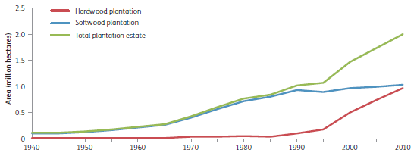
Source: Australian Bureau of Agricultural and Resource Economics, Bureau of Agricultural Economics, Commonwealth Forestry and Timber Bureau, National Plantation Inventory.
Figure 2.5: Australia's Industrial plantation area, 1995-2011
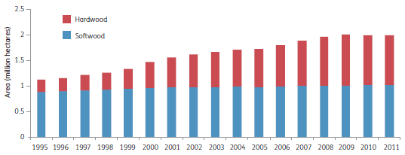
Note: 1995 to 2005 are calendar years, and 2006 to 2011 are financial years (i.e. 2005-06 to 2010-11).
Source: Gavran (2012), National Plantation Inventory.
Figure 2.6: Area of Industrial plantation establishment and re-establishment by five-year period, to 2006-10
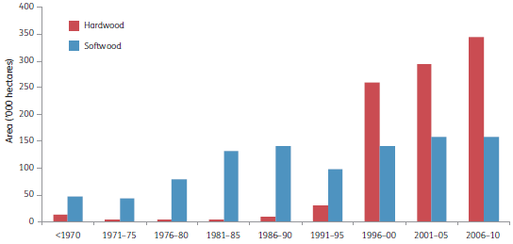
Source: Gavran and Parsons (2011), National Plantation Inventory.
Figure 2.7: Area proportions of Industrial hardwood plantation estate in 2010-11, by jurisdiction
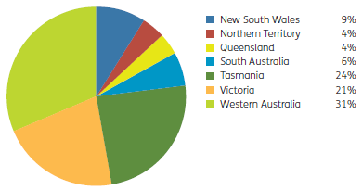
Notes:
The total Industrial hardwood plantation estate comprises 980,000 hectares.
There are no Industrial hardwood plantations in the Australian Capital Territory.
Source: Gavran (2012), National Plantation Inventory.
Figure 2.8: Area proportions of Industrial softwood plantation estate in 2010-11, by jurisdiction
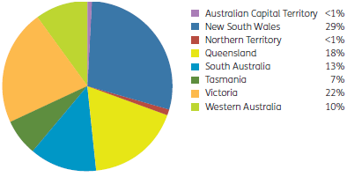
Note: The total Industrial softwood plantation estate comprises 1,025,000 hectares.
Source: Gavran (2012), National Plantation Inventory.
Table 2.8: Area proportion of Industrial plantations by ownership category
Category | 2005 - Area (%) | 2006 - Area (%) | 2007 - Area (%) | 2008 - Area (%) | 2009 - Area (%) | 2010 - Area (%) | 2011 - Area (%)
Institutional investors | 12 | 12 | 12 | 11 | 13 | 28 | 31
Timber industry companies | 15 | 15 | 9 | 9 | 7 | 13 | 13
Farm foresters and other private owners | 13 | 12 | 10 | 9 | 10 | 9 | 8
Managed investment schemes (MIS) | 23 | 26 | 33 | 34 | 36 | 25 | 24
Governments | 37 | 35 | 36 | 37 | 35 | 25 | 24
Total area of Industrial plantations (million hectares) | 1.74 | 1.82 | 1.90 | 1.97 | 2.02 | 2.01 | 2.02
Notes:
Ownership data refer to ownership of trees. Joint venture arrangements between government agencies and private owners are included under 'Governments' where government is the manager of the plantation resource.
Totals may not tally due to rounding.
Source: National Plantation Inventory, Gavran (2012).
Table 2.9: Main plantation species by region, and main uses
Hardwoods
Region | Main species | Main uses
Tropical—high rainfall | Mangium (Acacia mangium) | Paper products, veneer and sawn timber
Tropical—high rainfall | African mahogany (Khaya senegalensis), teak (Tectona grandis), some native eucalypt species | Sawn timber for building and furniture and other high-value uses
Subtropical—medium rainfall | Flooded gum (Eucalyptus grandis), Dunn's white gum (E. dunnii) | Paper products, veneer and sawn timber
Temperate—medium to high rainfall | Southern blue gum (E. globulus), shining gum (E. nitens) | Paper products, veneer and sawn timber
Several regions | Various eucalypts | Sawn timber for building and furniture and other high-value uses
Softwoods
Region | Main species | Main uses
Tropical, subtropical—high rainfall | Hoop pine (Araucaria cunninghamii) | Sawn timber for building, joinery, furniture, plywood, other high-value uses, posts and poles; residues used for paper, particleboard and other panels
Tropical, subtropical—medium rainfall | Caribbean pine (Pinus caribaea), slash pine (P. elliottii), hybrid pines | Sawn timber for building, joinery, furniture, plywood, other high-value uses, posts and poles; residues used for paper, particleboard and other panels
Temperate—medium rainfall | Radiata pine (P. radiata) | Sawn timber for building, joinery, furniture, plywood, other high-value uses, posts and poles; residues used for paper, particleboard and other panels
Temperate—low to medium rainfall | Maritime pine (P. pinaster) | Sawn timber for building, joinery, furniture, plywood, other high-value uses, posts and poles; residues used for paper, particleboard and other panels
Source: SOFR 2008.
Figure 2.9: Area proportion of 2011 Industrial plantation growing stock by age-class
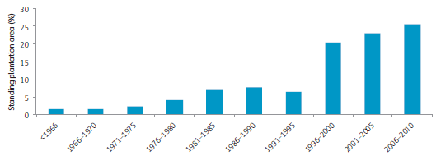
Note: Plantations of unknown age, harvested plantations awaiting re-establishment, and new plantations awaiting establishment are not included.
Source: National Plantation Inventory.
Figure 2.10: Area proportion of Industrial plantation land and trees in ownership categories in 2011, by establishment age-class
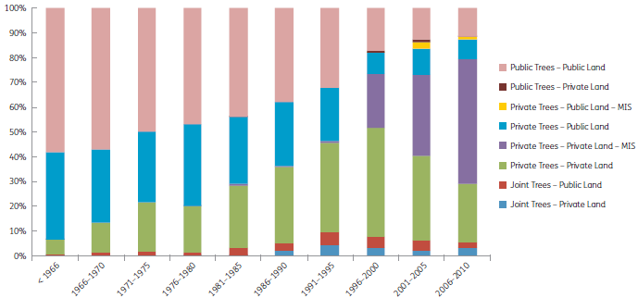
Notes:
Data are area proportions in 2011 for each age-class category.
Plantations of unknown age, harvested plantations awaiting re-establishment, and new plantations awaiting establishment are not included. Joint ownership includes government and private ownership arrangements.
Source: National Plantation Inventory.

Plantation species
The main Australian plantation species by climate and rainfall region, and the main uses for the wood they produce, are shown in Table 2.9.
In 2010—11, the hardwood plantation estate was dominated by southern blue gum (Eucalyptusglobulus; 55.1% by area) and shining gum (E. nitens; 24.1% by area), both of which are managed primarily for pulpwood production (Gavran 2012). These proportions are similar to those reported previously. Blackbutt (E. pilularis) and flooded gum (E. grandis) together comprise 2.6% of the total hardwood plantation estate area, and spotted gum (Corymbia maculata) comprises 2.2% by area. A further 5.6% by area is other eucalypts such as mountain ash (E. regnans) and Sydney blue gum (E. saligna), and 5.5% by area is other hardwood species, such as African mahogany (Khaya senegalensis) and teak (Tectona grandis); these species are all managed primarily for sawlog production.
In 2010—11, the softwood plantation estate was dominated by radiata pine (Pinus radiata; 75.5% by area) and southern pine (14.7% by area) (Gavran 2012). 'Southern pine' comprises Caribbean pine (P. caribaea), slash pine (P. elliottii) and several varieties of these; a hybrid between southern pine varieties is now the preferred plantation softwood in subtropical and tropical regions of Australia. Both radiata pine and southern pine are managed primarily for sawlog production. These proportions for the softwood plantation estate are similar to those reported previously. Other regionally important softwood species are maritime pine (P. pinaster) in Western Australia, and hoop pine ( Araucaria cunninghamii) in south-east Queensland.

Indicator 2.1c Annual removal of wood products compared to the volume determined to be sustainable for native forests, and future yields for plantations
Rationale
This indicator measures the harvest levels of wood products in relation to future yields. The capacity to implement strategies to deal with changing demand for forest products based on future yields from both native and plantation forests is an integral part of sustainable forest management.

Key points
- In the period 2006-07 to 2010-11, the average annual sawlog volume harvested from multiple-use public native forest was 1.40 million cubic metres, a decline from 1.96 million cubic metres in the period 2001—02 to 2005—06.
- The volume of sawlogs harvested from multiple-use public native forests in the period 1992—93 to 2010—11 was within sustainable levels in New South Wales, Tasmania, Victoria and Western Australia, and within sustainable yield or allowable cut in Queensland. Nationally, the actual sawlog harvest level was below sustainable yield levels by 17% for the period 2006-11, and the actual harvest volume was below sustainable yield levels by 6—18% for each of the four SOFR five-yearly reporting periods.
- Average sustainable yield declined nationally by 47%, and in all states except Tasmania, between the period covered by SOFR 1998 (1992—93 to 1995—96, sustained yield) and the period covered by SOFR 2013 (2006—07 to 2010—11). This decline was a consequence of increased reservation of multiple-use public native forests, which reduced the area of native forest available for harvesting; increased restrictions on harvesting in codes of forest practice; revised estimates of forest growth and yield due to improved information; and impacts of occasional, intense broadscale wildfires.
- Residential use of firewood for heating and energy decreased slightly in the 2006—10 reporting period, while industrial fuelwood use increased in this period.
- For the various wood product categories, sawlog and pulplog harvest from native forest has declined since 2000, sawlog and pulplog harvest from softwood plantations has increased, and sawlog harvest from hardwood plantations has been relatively stable, while pulplog harvest from hardwood plantations has increased significantly.
- In the period 2006-07 to 2010-11, plantations produced 71% of the volume of logs harvested in Australia. Hardwood plantations provided 35% of Australia's pulplog supply and 1% of Australia's sawlog supply—this was 5% of Australia's hardwood sawlog supply. Softwood plantations provided 39% of Australia's pulplog supply and 79% of Australia's sawlog supply. In 2010-11, the final year of the SOFR 2013 reporting period, plantations produced 76% of the volume of logs harvested in Australia.
- If the current plantation area is maintained, total wood production from softwood plantations is nearing its maximum potential and is expected to plateau by 2035 at 18 million cubic metres per year, while total production from hardwood plantations will increase to more than 14 million cubic metres per year by 2030.
- As the supply of high-quality logs from public multiple-use native forests declines as a consequence of reservation of forest, the importance of private native forests for the supply of hardwood logs will increase, and management of private native forests will determine the long-term national supply of high-quality native hardwood logs. However, a national assessment found that there is insufficient information to assess whether the rate of wood harvest from private native forests is sustainable.
This indicator examines the extent to which a sustainable harvest of wood products is being achieved in native forests, and the availability of future yields of wood products from native forests and plantations. The indicator reports the average annual sustainable yield in multiple-use public native forests, actual annual harvests in multiple-use public and private native forests, projections of sustainable yields from public native forests to 2055, forecast availability of wood products from public and private forests, and plantation harvesting rates and projected future yields to 2055. Indicator 2.1a describes the impact of changes in tenure and forest practices on the area available for the harvesting of wood products.
Plantation projections covering all plantation regions in Australia are reported in Gavran et al. (2012). This indicator presents plantation projections only for the regions contributing substantially to the plantation supply.
This indicator also reports only on those states where there is significant ongoing native forest harvesting: New South Wales, Queensland, Tasmania, Victoria and Western Australia. Native forest harvesting does not occur in the Australian Capital Territory or South Australia, and is small and limited in the Northern Territory.
The main wood products harvested in native forests are sawlogs, veneer logs (used for wood-based panel products) and pulplogs (used for paper products). Other wood products harvested in native forests include posts, poles, piles, girders, bush sawn/hewn timber, firewood, specialty timber and sleepers. The data presented in this indicator pertain mainly to sawlogs (generally including veneer logs in that category) and pulplogs.
Sandalwood is considered in this indicator and also in Indicator 2.1d, since sandalwood products are sometimes considered non-wood forest products (NWFPs). Sandalwood plantations are not considered Industrial plantations and so are included in the area statistics for 'Other forest' in Indicator 1.1a.
Most of Australia's native forest wood products are provided by multiple-use public native forests. Harvesting in public native forests is subject to regulatory frameworks designed to balance environmental, social and economic values, while maintaining environmental values and the productive capacity of forests. Harvest volumes in public native forests are set according to a calculated sustainable yield in all states other than Queensland, where an allowable cut is applied under long-term agreements issued as a result of the policy to phase out harvesting of multiple-use public native forest. Calculated sustainable yield is the estimated volume of wood that can be removed each year while ensuring maintenance of the functioning of the native forest system as a whole.

Sustainable yield from native forests
States in which native forest harvesting occurs have formal processes, backed by a regulatory framework (including codes of forest practice), to calculate sustainable sawlog yields for publicly managed native forests, primarily multiple-use forests. The volume of wood available for harvesting is calculated based on the net harvestable area (see Indicator 2.1a)—that is, the net area of forest available for high-quality sawlog and veneer production, after areas unavailable for economic, environmental and other reasons have been excluded.
Low-quality sawlogs, pulplogs and other wood products are also harvested from native forests, usually as a residual product of sawlog and veneer log harvesting; consequently, sustainable yields are not determined for these other wood products. An exception relates to Tasmanian special-species timbers (myrtle, blackwood, sassafras and various native pines), for which a strategy to sustain long-term production is in place (Forestry Tasmania 2010a). Similarly, sandalwood harvesting from Crown and leasehold forests in Western Australia is managed on an allowable harvest basis (DEC 2012a, FPC 2011) as specified in the Sandalwood (Limitation of Removal of Sandalwood) Order 1996 under the Sandalwood Act 1929.
Sustainable harvest volumes vary over time according to changing management strategies and utilisation standards, improved resource data, and changes in the net area of public native forest available for harvesting. To take account of these changes, estimates are reviewed periodically, usually every 5 to 10 years. For a range of reasons, annual harvesting levels are likely to fluctuate around the sustainable volume, but overcuts in some years must be at least balanced by undercuts in other years over a defined period.
Table 2.10 reports the proportional change in state and national sustainable yields across the four SOFR reporting periods, compared with the baseline of the first period (1992—93 to 1995—96). Average sustainable yield declined nationally, and in all states except Tasmania, between the periods covered by SOFR 1998 (1992—93 to 1995—96) and SOFR 2013 (2006—07 to 2010—11). This decline was a consequence of increased reservation of public native forests, which reduced the area of native forest available for harvesting (Davidson et al. 2008); increased restrictions on harvesting in codes of forest practice; revised estimates of forest growth and yield due to improved information; and, especially in Victoria (see Indicator 3.1b), impacts of occasional, intense broadscale wildfires (Forests NSW 2010a, VicForests 2011a). Sustainable yields from public multiple-use forests have decreased nationally by 47% from those reported in SOFR 1998 for the period 1992—93 to 1995—96 (Table 2.10).
Figures 2.11—2.16 show the reported harvested volume from multiple-use public native forests, by jurisdiction and aggregated nationally, averaged across the periods covered by the four SOFR reports: 1992—93 to 1995—96 (SOFR 1998), 1996—97 to 2000—01 (SOFR 2003), 2001—02 to 2005—06 (SOFR 2008) and 2006—07 to 2010—11 (SOFR 2013, this report). For all states except New South Wales, average harvested volumes were lower than the sustainable yields for each of the reporting periods.
Table 2.10: Change in sustainable yield from public multiple-use forests across SOFR reporting periods, from those reported in SOFR 1998, by jurisdiction
Jurisdiction | SOFR 2003 - Change from SOFR 1998 (%) | SOFR 2008 - Change from SOFR 1998 (%) | SOFR 2013 - Change from SOFR 1998 (%)
NSW | -16 | -37 | -42
Qld | -11 | -14 | -37
Tas. | 20 | 17 | 7
Vic. | -3 | -32 | -47
WA | -17 | -60 | -76
Australia | -8 | -34 | -47
Notes:
Product groups and standards used in determining sustainable yield are consistent across reporting periods in all jurisdictions other than Victoria; for Victoria, the sustainable yield for the first reporting period has been adjusted from C+ sawlog to a D+ equivalent (see Figure 2.13).
Reporting periods are 1992-93 to 1995-96 (SOFR 1998), 1996-97 to 2000-01 (SOFR 2003), 2001-02 to 2005-06 (SOFR 2008) and 2006-07 to 2010-11 (this report, SOFR 2013).
Figure 2.11: Average annual harvest and sustainable yield for multiple-use public native forests in New South Wales, by SOFR reporting period
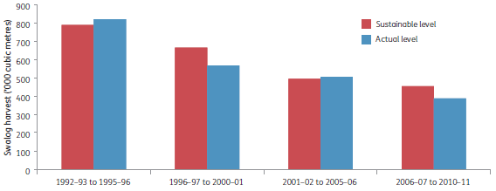
Notes:
Sustainable levels apply to multiple-use public native forests (with supplementation from hardwood plantations on multiple-use public forest). However, volumes of high-quality logs harvested from hardwood plantations (hardwood high-quality large and small sawlog, veneer log, poles, piles and girders: see Figure 2.19) are not included in the actual levels reported.
Figures for hardwood, brushwood (rainforest species), cypress pine and veneer logs are in 'quota sawlog equivalents' up to 1998-99, and figures for hardwood high-quality large and small sawlog, veneer sawlog and cypress pine are in 'high-quality equivalents' from 1999-2000. Poles, piles and girders are included in high-quality equivalents for calculating sustainable yield and reporting actual harvested level from 2006-07.
Source: Forestry Commission and State Forests of NSW annual reports from 1987 to 2000, SOFR 2003, SOFR 2008, Forests NSW (2007, 2008, 2009, 2010b, 2011) and additional data from Forests NSW.
In New South Wales, the actual harvest was slightly higher than the sustainable yield in two of the four reporting periods (Figure 2.11) but within allowable limits. Under state agreements applicable to multiple-use public native forests, the wood-processing industry in New South Wales is permitted to vary its actual cut by ±5% of the allowable cut determined by sustainable yield calculations, allowing industry to access previous undercuts to its allocations when required. The variances indicated in Figure 2.11 are within these limits.
Sustainable yield from New South Wales public forests for the period 1992—98 was 791,000 cubic metres of hardwood quota and cypress pine sawlog. However, the figures previously reported in SOFR 2003 and SOFR 2008 from New South Wales for actual logs harvested for the periods up to 1997—98 included 'non-quota' sawlogs. These figures have now been adjusted to represent only the 'high-quality sawlogs' and cypress pine logs reported after this period, so that log quality is comparable across the four SOFR periods (Figure 2.11).
In Tasmania, the sustainable sawlog yield from multiple-use public native forest increased in line with short-term forest management strategies (Figure 2.12; Table 2.10) (Forestry Tasmania 2007). The increase in sustainable yield in Victoria between the first (SOFR 1998) and second (SOFR 2003) reporting periods (Figure 2.13) is a result of changing log quality categories. Overall, however, the general decline in sustainable yield and harvesting in Victoria (Figure 2.13) and Western Australia (Figure 2.14) has continued since SOFR 2008. The impacts of three intense broadscale wildfires (2003, 2006—07 and 2009; see Indicator 3.1b) contributed to the decline in sustainable yield and harvest level in Victorian multiple-use public native forests, and will also affect long-term sawlog supplies over a 100-year period (VicForests 2011a).
Figure 2.12: Average annual harvest and sustainable yield for multiple-use public native forests in Tasmania, by SOFR reporting period
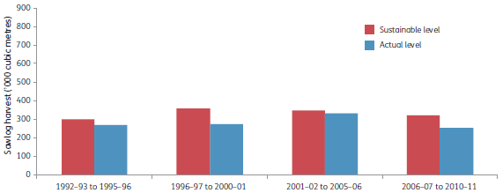
Note: Sustainable yield and actual harvested level are of category 1 and category 3 sawlogs and veneer logs.
Source: FPA (2012), SOFR 2003, SOFR 2008, Forestry Tasmania.
Figure 2.13: Average annual harvest and sustainable yield for multiple-use public native forests in Victoria, by SOFR reporting period
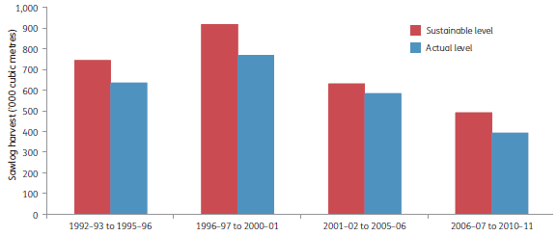
Note: Category C+ sawlogs are used to determine sustainable level and actual harvested level for the first reporting period; category D+ sawlogs apply in other periods. A D+ equivalent for the first reporting period equates to a sustainable level of 945,000 cubic metres and an actual harvested level of 809,000 cubic metres, and is used in calculations in Figure 2.16 and Table 2.10.
Source: SOFR 2003, SOFR 2008, Victorian Department of Sustainability and Environment.
In Queensland, the state government agreed in 1999 to a 25-year transition in which public native forests in the state's south-east—its major wood-producing area—would be withdrawn from wood harvesting after a harvesting event has occurred, and subsequently gazetted as nature conservation reserves. With regard to other areas of the state, decisions have been progressively made on future harvesting levels and nature conservation areas, underpinned by a policy of not allowing harvesting of multiple-use public native forests after 2025. As a consequence, Figure 2.15 shows a sustainable yield volume to 1999 and an allowable cut level after this. Wood harvest volumes have declined over the SOFR reporting periods, and have remained close to the sustainable yield and allowable cut levels. Public hardwood plantations have been established in Queensland to provide an alternative wood resource after 2025³.
In the period 2006—07 to 2010—11, the average annual sawlog volume harvested from multiple-use public native forest nationally was 1.40 million cubic metres, a decline from 1.96 million cubic metres in the period 2001—02 to 2005—06 (Figure 2.16). The actual harvest volume from multiple-use public native forests nationally for this period was 17% below the estimated sustainable sawlog yield. Furthermore, for all SOFR reporting periods the national actual harvest volume from multiple-use public native forests was below the estimated sustainable sawlog yield by 6—18%, and the actual harvest volume has decreased over the past 20 years in line with the decrease in sustainable yields (Figure 2.16).
Figure 2.14: Average annual harvest and sustainable yield for multiple-use public native forests in south-west Western Australia, by SOFR reporting period
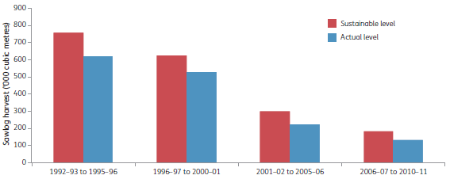
Note: Sustainable yield and actual harvested level are of first and second grade karri and jarrah sawlogs.
Source: DEC 2012a, SOFR 2003, SOFR 2008, Western Australian Department of Environment and Conservation.
Figure 2.15: Average annual harvest and sustainable yield for multiple-use public native forests in Queensland, by SOFR reporting period
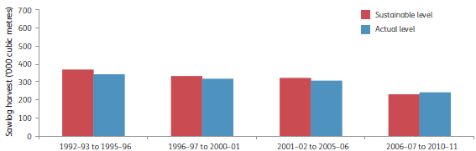
Notes:
For the last three periods, sustainable level refers to sustainable yield or allowable cut.
Data are for hardwood and cypress pine sawlogs; other log categories (e.g. poles, fencing, sleeper and mining timber) are excluded.
Sources: Queensland Department of Agriculture, Fisheries and Forestry, SOFR 2003, SOFR 2008.
Figure 2.16: Average annual harvest and sustainable yield for multiple-use public native forests in Australia, by SOFR reporting period
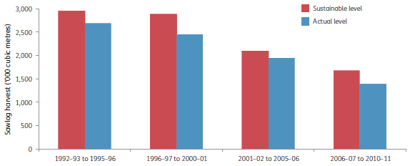
Note: Sawlog includes only high-quality and veneer logs. The first reporting period includes an adjustment applied to Victorian C+ sawlogs and expressed as a D+ equivalent (see Figure 2.13, Table 2.10).
Source: Australian Bureau of Agricultural and Resource Economics and Sciences database, state agencies, SOFR 2003, SOFR 2008.
Tasmanian special-species timbers are harvested from public forests on a sustainable yield basis. Annual supply targets for special timbers logs ('category 4' sawlogs and 'utility' logs) for the 10-year period to 2019, based on sustainable yield estimates of Tasmanian special-species timbers, are blackwood (Acacia melanoxylon)—10,000 cubic metres; silver wattle (A. dealbata), myrtle (Nothofagus cunninghamii), sassafras (Atherosperma moschatum), celery-top pine (Phyllocladus aspleniifolius) and huon pine (Lagarostrobos franklinii)—500 cubic metres each; and King Billy pine (Athrotaxis selaginoides) and other species, including figured eucalypt (Eucalyptus spp.)—arisings only with no volume target (Forestry Tasmania 2010a). Western Australian sandalwood is managed on an allowable harvest target of 1,500 tonnes per year of high-grade 'greenwood'. Low-grade greenwood sandalwood, root, bark and dead sandalwood are harvested with the high-grade greenwood.
Figure 2.17 reports the average annual volumes of special-species timbers (including sandalwood) harvested from public native forests, by jurisdiction, for the four SOFR reporting periods. Removals of logs designated as cabinet rainforest timbers in New South Wales ceased after 1992—93. The volume of Western Australian sandalwood harvested is also separately reported in Figure 2.18.
Sustainable yield estimates of high-quality sawlogs from multiple-use public native forests in New South Wales and Tasmania include supplementation with estimates of sawlogs of similar quality and specification from public hardwood plantations, with this component of the estimates based on projected yields of high-quality sawlogs from these plantations (the extent of supplementation is very small for Tasmania). High-quality hardwood sawlogs have been harvested from public plantations in New South Wales since 1997—98, and New South Wales contains a resource of older plantations available for harvest; high-quality sawlogs from plantations are becoming available in Tasmania and Western Australia (Figure 2.19). To date, the yield of high-quality plantation sawlogs in any state is small compared with the yield of high-quality sawlogs from multiple-use public native forest in the same jurisdiction.
Figure 2.17: Average annual production of special-species timbers from multiple-use public native forests, by SOFR reporting period
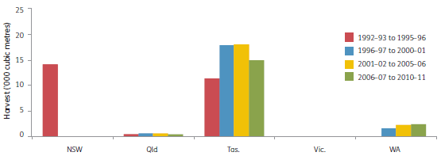
Note: Special-species timbers include cabinet rainforest timbers (NSW), Tasmanian special-species timbers, and sandalwood (Qld and WA: cubic metre equivalent converted from tonnes).
Source: Australian Bureau of Agricultural and Resource Economics and Sciences databases, state agencies.
Figure 2.18: Average annual production of Western Australian sandalwood from public native forests, by SOFR reporting period
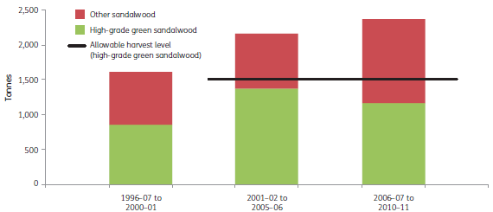
Notes:
No data are available for 1992-93 to 1995-96.
The allowable harvest level applies to 'High-grade green sandalwood' only, and not to the lower grade sandalwood, root, bark and dead material, which is included in the 'Other sandalwood' figures. Green (live) sandalwood trees produce more oil than dead trees and consequently have a higher commercial value.
Source: Western Australian Forest Products Commission annual reports.
Figure 2.19: Average annual production of high-quality hardwood sawlogs from public plantations, by SOFR reporting period
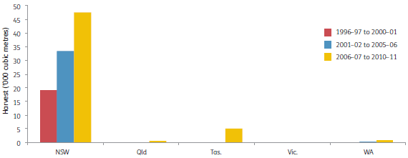
Note: Plantation high-quality sawlogs are assessed against jurisdictional quality and size specifications for similar products from native forest. These specifications are similar between states.
Source: Australian Bureau of Agricultural and Resource Economics and Sciences, state agencies.
Figure 2.20: Average annual sawlog production from private native forests, by SOFR reporting period
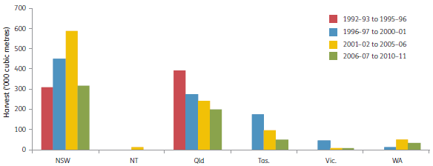
Notes:
Sawlogs harvested from private forests include high-quality and low-quality hardwood sawlog, hardwood 'veneer sawlog' and cypress sawlog.
Data are unavailable for the 1992-93 to 1995-96 reporting period for NT, Tas., Vic. and WA.
No sawlogs are harvested from private native forests in the ACT or SA.
Source: Australian Bureau of Agricultural and Resource Economics and Sciences databases, state agencies.

Yields from private native forests
Although there is no calculated sustainable yield for wood production from native forests on private land across Australia, harvesting operations on such land face increasing restrictions, which reduce yield. In practice, most private forest managers make limited use of their native forests for wood production, only responding to immediate needs and opportunities in the market. The supply of sawlogs from private native forests is significant in New South Wales, Queensland and Tasmania (Figure 2.20), but has decreased markedly in Queensland and Tasmania since 1992—96. Private Forests Tasmania (2005) provides an estimate of wood resource supply from private native forest in Tasmania.
A Queensland code of native forest practice on freehold land was introduced in December 2005, to allow commercial wood harvesting from private native forests while satisfying the requirements of the Vegetation Management Act 1999 (Qld). The application of the code, compared with previous practice, contributed to the reduced supply of sawlogs from 2006—07 to 2010—11. In the longer term, implementation of silvicultural regimes is planned to improve the productivity of private native forests (DERM 2011).
A national assessment of the role, values and potential of private native forests completed in 2009 (Parsons and Pritchard 2009) provided estimates of the contribution of private native forests to regional wood supply. The assessment found that, despite adequate information on the area of private native forests, little information is available on their quality, condition, value, current management regime and future management intent. The assessment also found that, although a proportion of landowners (varying by region) want to manage their forests to provide wood and other products and services in the long term, there is insufficient information nationally and regionally to assess whether the rate of wood harvest from private native forests is sustainable.

Pulplogs and pulpwood
Sustainable wood yields on public land are calculated based on high-quality sawlog and veneer production. Pulplogs, together with low-quality sawlogs and other wood products, are usually a residual product of sawlog and veneer log harvesting, and sustainable yields are not determined specifically for pulplogs or other wood products.
The volume of pulplogs harvested from multiple-use public native forests decreased substantially in Tasmania and slightly in Victoria, but remained essentially the same in New South Wales and Western Australia, between the SOFR 2008 and SOFR 2013 reporting periods (Figure 2.21). No pulplogs have been harvested from public native forests in Queensland since the 1996—97 to 2000—01 (SOFR 2003) reporting period.
Tasmania is Australia's major provider of pulpwood from both public and private forests (Figures 2.21 and 2.22); at the national level, only 13% of the pulplog harvest from private native forests was from mainland states between 2006—07 and 2010—11 (Figure 2.22). One reason for the decline in Tasmanian pulplog harvest was rotary-peeled veneer plants coming into full production during the reporting period (FPA 2012), and logs previously treated as pulplogs being used as feedstock for higher value rotary-peeled timber product.
Figure 2.21: Average annual pulplog harvest from multiple-use public native forests, by SOFR reporting period
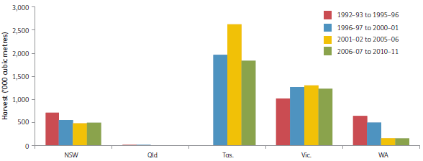
Notes:
Data are unavailable for the 1992-93 to 1995-96 reporting period for Tasmania.
Pulplog includes logs sold for pulp or equivalent, and for woodchip.
Data have been converted from tonnes to cubic metres.
Source: Australian Bureau of Agricultural and Resource Economics and Sciences databases, state agencies.
Figure 2.22: Average annual pulplog harvest from private native forests, by SOFR reporting period
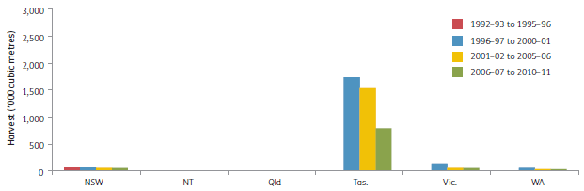
Notes:
Data are unavailable for the 1992-93 to 1995-96 reporting period for all states and territories other than New South Wales.
Pulplog includes logs sold for pulp or equivalent, and for woodchip. No pulpwood has been harvested from private native forests from 1996-97 onwards in Queensland or the Northern Territory.
Data have been converted from tonnes to cubic metres.
Source: Australian Bureau of Agricultural and Resource Economics and Sciences databases, state agencies.

Other wood products
The supply of other wood products, such as low-quality sawlogs, girders, poles, piles, non-pulpwood logs (logs that are not sawlogs or pulplogs), timber for mining, split and round posts, bush sawn/hewn timber and sleepers, varies by jurisdiction and is often opportunistic. These products are generally harvested in association with high-quality sawlogs and pulplogs, and are a major resource in New South Wales, Tasmania and Victoria. Figure 2.23 shows average annual harvest volumes for these products from multiple-use public native forests, by jurisdiction. Limited data are available on harvest rates for these products from private forests. Fuelwood and firewood are treated separately from these products, and are discussed separately.

Firewood and fuelwood
Firewood is wood used for residential heating, whereas fuelwood is wood or wood products used as industrial fuel or for bioenergy production. Australian consumption of firewood and fuelwood increased from 5.6 million cubic metres per year in 1973—75 to 6.1 million cubic metres per year in 2006—10, with a peak of 6.8 million cubic metres per year in 1996—2000 (Table 2.11).
Firewood is one of the most commonly used wood products. Its use is an important segment of the forest sector and is important to regional communities. Residential firewood use declined across the 15-year period to 2009—10, and averaged 3.7 million cubic metres per year nationally for the five-year period 2006—10 (Table 2.11). Reporting of the quantities of firewood removed from multiple-use public native forests and plantations is variable across states and territories. Australian households used an estimated 4.0—5.0 million cubic metres of firewood per year from 1973—75 to 2001—05, with New South Wales and Victoria accounting for more than half of this volume (Figure 2.24).
Driscoll et al. (2000) reported that the five most common tree species used as firewood are river red gum (Eucalyptus camaldulensis—1.10 million tonnes), jarrah (E. marginata—up to 0.61 million tonnes), red box and yellow box (E. polyanthemos and E. melliodora—0.54 million tonnes combined) and red ironbark (E. sideroxylon—0.47 million tonnes). Approximately half of the wood burned in households is collected by the residents. Sixty per cent of firewood was purchased through small suppliers. Of the firewood for private use or sale, 84% was collected from private property, 9% was collected from state forests, 3% was collected from roadsides and the remainder was from other sources (Driscoll et al. 2000).
Figure 2.23: Average annual harvest of 'other wood products' from native multiple-use public forests, by SOFR reporting period
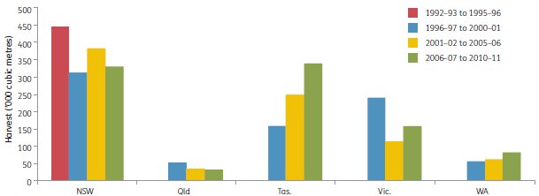
Notes:
Data are unavailable for the 1992-93 to 1995-96 reporting period for all states other than New South Wales.
'Other wood products' are products that are not included in data for high-quality sawlogs and veneer logs, special-species timbers or pulpwood; they do not include firewood and fuelwood.
Source: Australian Bureau of Agricultural and Resource Economics and Sciences databases, state agencies.
Table 2.11: Firewood and fuelwood use in Australia, 1973-75 to 2006-10
Firewood and fuelwood | 1973-75 | 1976-80 | 1981-85 | 1986-90 | 1991-95 | 1996-2000 | 2001-05 | 2006-10
Industrial fuelwood  ('000 cubic metres per year) | 1,121 | 1,026 | 990 | 1,249 | 1,542 | 1,714 | 1,869 | 2,482
Residential firewood  ('000 cubic metres per year) | 4,510 | 4,108 | 4,254 | 4,412 | 4,921 | 5,049 | 4,284 | 3,659
Total ('000 cubic metres per year) | 5,631 | 5,134 | 5,244 | 5,661 | 6,463 | 6,763 | 6,153 | 6,141
Firewood as proportion of total residential energy use (%) | 31 | 26 | 25 | 24 | 23 | 21 | 18 | 14
Source: Bureau of Resources and Energy Economics.
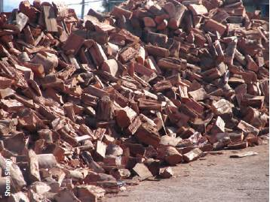
Eucalypt firewood for domestic use.
Firewood is collected from plantations and agricultural lands as well as native forests. As a proportion of total residential energy use, firewood use decreased from 31% in 1973—75 to 14% in 2006—10 (Table 2.11), and is predicted to decrease to 8 % by 2020 (DEWHA 2008). This predicted decrease may change as a result of consumer considerations (including price) relating to carbon emissions associated with the use of other energy types (DEWHA 2008).
Regulations and controls are in place across Australia to protect threatened species and ecological communities from the impacts of firewood collection. Collection is regulated in many states and territories through permit systems, controls on the clearing of native vegetation, and voluntary codes of practice applying to commercial firewood operators. A national approach was developed and endorsed by governments to increase the effectiveness of these regulations and controls, and place collection on a more sustainable basis (ANZECC 2001). In August 2005 the Natural Resource Management Ministerial Council endorsed a revised voluntary code of practice for firewood merchants.
Industrial fuelwood is used by a range of industry sectors, and usage has doubled since 1973—75 (Figure 2.25; Table 2.11). Fuelwood consumption in the wood, paper and printing manufacturing sector averaged around 75% of total industrial fuelwood use up to 1996—2000, mainly using the sector's waste product from the manufacturing process. Production of electricity from fuelwood and wood waste has grown significantly since 2001—05. The food, beverage and tobacco manufacturing sector has increased its use of fuelwood since the 1980s. Niche markets have also developed; for example, non-sawlog jarrah wood is used to make charcoal for silicon smelting in Western Australia.

Wood products harvested from plantations and native forests
Table 2.12 and Figure 2.26 report the amount of wood harvested annually, for the period 2000—01 to 2010—11, by sector (native forest, softwood plantation and hardwood plantation; sawlog and pulplog). Figures 2.27 and 2.28 show the separate contributions of public and private land to the amount of sawlogs and pulplogs harvested from Australian native forests over the period 1996—97 to 2010—11.
Overall over the period 2000—01 to 2010—11, the sawlog and pulplog harvest from native forest has declined, the sawlog and pulplog harvest from softwood plantations has increased, and the sawlog harvest from hardwood plantations has been relatively stable while the pulplog harvest from hardwood plantations has increased significantly. A total of 6.5 million cubic metres of native forest logs, 5.1 million cubic metres of hardwood plantation logs and 14.9 million cubic metres of softwood plantation logs were harvested in 2010—11.
Sawlog production from native forests declined from 4.3 million cubic metres annually in 1996—97 to 2.4 million cubic metres in 2010—11 (Table 2.12; Figures 2.26 and 2.27). The decline has occurred in production from both public and private multiple-use native forests, although the reduction in production from multiple-use public forests has been proportionally greater (Figure 2.27). Pulplog production from native forests increased from 5.1 million cubic metres annually in 1996—97 to 7.0 million cubic metres annually in 2000—01, then declined to 3.9 million cubic metres annually in 2010—11 (Table 2.12; Figures 2.26 and 2.28).
Figure 2.24: Average annual residential use of firewood, 1973-75 to 2006-10, by jurisdiction
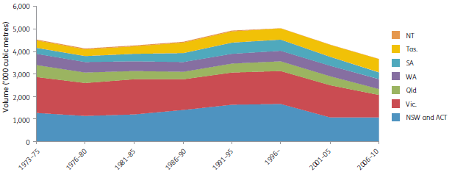
Note: Data have been converted to cubic metres.
Source: Bureau of Resources and Energy Economics.
Figure 2.25: Average annual Australian consumption of fuelwood, 1973-75 to 2006-10, by industry type
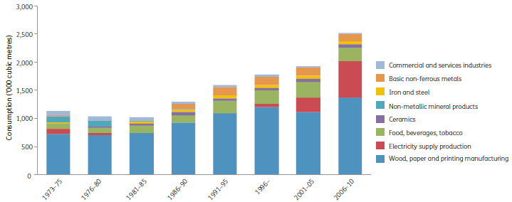
Note: Data have been converted to cubic metres.
Source: Bureau of Resources and Energy Economics.
Table 2.12: Logs harvested by native forest and plantation sector, 2000-01 to 2010-11
Native
Sector | 2000-01 - Volume ('000 cubic metres) | 2001-02 - Volume ('000 cubic metres) | 2002-03 - Volume ('000 cubic metres) | 2003-04 - Volume ('000 cubic metres) | 2004-05 - Volume ('000 cubic metres) | 2005-06 - Volume ('000 cubic metres) | 2006-07 - Volume ('000 cubic metres) | 2007-08 - Volume ('000 cubic metres) | 2008-09 - Volume ('000 cubic metres) | 2009-10 - Volume ('000 cubic metres) | 2010-11 - Volume ('000 cubic metres)
Hardwood sawlog | 3,583 | 3,639 | 3,543 | 3,444 | 3,320 | 3,204 | 2,939 | 2,966 | 2,640 | 2,495 | 2,251
Other hardwood product | 221 | 167 | 167 | 184 | 192 | 191 | 252 | 201 | 155 | 150 | 179
Native pine sawlog (cypress) | 296 | 293 | 297 | 316 | 291 | 279 | 224 | 210 | 211 | 198 | 182
Hardwood pulplog | 6,998 | 6,022 | 6,605 | 6,462 | 6,354 | 5,180 | 5,360 | 5,773 | 4,944 | 3,944 | 3,898
Native forest total | 11,098 | 10,121 | 10,611 | 10,406 | 10,158 | 8,855 | 8,774 | 9,150 | 7,950 | 6,787 | 6,509
Plantation
Sector | 2000-01 - Volume ('000 cubic metres) | 2001-02 - Volume ('000 cubic metres) | 2002-03 - Volume ('000 cubic metres) | 2003-04 - Volume ('000 cubic metres) | 2004-05 - Volume ('000 cubic metres) | 2005-06 - Volume ('000 cubic metres) | 2006-07 - Volume ('000 cubic metres) | 2007-08 - Volume ('000 cubic metres) | 2008-09 - Volume ('000 cubic metres) | 2009-10 - Volume ('000 cubic metres) | 2010-11 - Volume ('000 cubic metres)
Hardwood sawlog | 82 | 67 | 153 | 177 | 273 | 208 | 159 | 186 | 168 | 136 | 114
Other hardwood product | 5 | 4 | 6 | 9 | 14 | 17 | 15 | 19 | 10 | 7 | 12
Hardwood pulplog | 888 | 1,041 | 1,435 | 1,633 | 2,649 | 3,554 | 3,878 | 4,065 | 4,569 | 4,412 | 5,134
Hardwood total | 975 | 1,112 | 1,594 | 1,819 | 2,936 | 3,779 | 4,052 | 4,270 | 4,747 | 4,555 | 5,259
Softwood sawlog | 7,163 | 7,952 | 8,260 | 8,827 | 8,829 | 9,105 | 9,253 | 9,422 | 8,341 | 9,331 | 8,806
Other softwood product | 528 | 415 | 377 | 343 | 347 | 415 | 486 | 400 | 392 | 394 | 361
Softwood pulplog | 4,711 | 4,696 | 4,977 | 5,102 | 4,728 | 4,580 | 4,626 | 5,126 | 4,370 | 4,509 | 5,632
Softwood total | 12,402 | 13,063 | 13,614 | 14,272 | 13,904 | 14,100 | 14,365 | 14,948 | 13,103 | 14,234 | 14,799
Plantations total | 13,376 | 14,175 | 15,208 | 16,092 | 16,841 | 17,879 | 18,418 | 19,218 | 17,849 | 18,790 | 20,058
Grand total | 24,474 | 24,296 | 25,819 | 26,498 | 26,998 | 26,734 | 27,192 | 28,368 | 25,799 | 25,577 | 26,567
Notes:
Native hardwood sawlog includes logs for railway sleeper production, but excludes logs collected for firewood.
Sawlogs include logs for plywood and veneer.
'Other product' categories include poles, piles, fencing and other logs not included elsewhere.
Totals may not tally due to rounding.
Source: Australian Bureau of Agricultural and Resource Economics and Sciences (figures are supplied by growers and producers), Australian Forest and Wood Products Statistics database, ABARES (2013c).
Figure 2.26: Harvest of sawlogs and pulplogs from Australia's native forests and plantations, 2000-01 to 2010-11
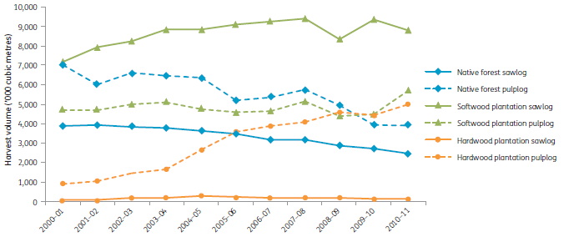
Note: Native forest sawlogs include hardwoods and native cypress pine.
Source: Australian Bureau of Agricultural and Resource Economics and Sciences, Australian Forest and Wood Products Statistics database.
Figure 2.27: Production of sawlogs from Australia's native forests, 1996-97 to 2010-11
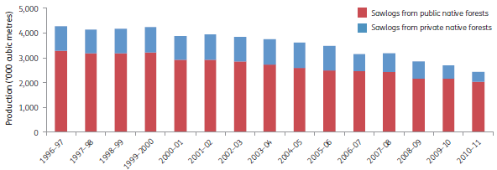
Note: Sawlogs include native hardwood and cypress pine species.
Source: Australian Bureau of Agricultural and Resource Economics and Sciences, Australian Forest and Wood Products Statistics database.
Figure 2.28: Production of pulplogs from Australia's native forests, 1996-97 to 2010-11
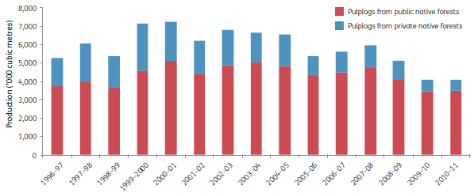
Note: Pulplogs are sourced from native hardwoods.
Source: Australian Bureau of Agricultural and Resource Economics and Sciences, Australian Forest and Wood Products Statistics database.
Supply of both sawlogs and pulplogs from both hardwood and softwood plantations has increased since 1996 (Table 2.12; Figure 2.26), and nationally plantation logs accounted for 71% of all logs harvested, by volume, in the period 2006—07 to 2010—11, compared with 57% in the period 2000—01 to 2002—03 (Table 2.13). In 2010—11, the final year of the SOFR 2013 reporting period, 76% of the volume of logs harvested in Australia in 2010-11 was from plantations.
The sawlog supply from hardwood plantations increased from a very low base of 7 thousand cubic metres in 1996—97 to a peak of 273 thousand cubic metres in 2004—05, and declined to 114 thousand cubic metres in 2010—11 (Table 2.12; Figure 2.26). This increase has not matched the significant decrease in harvest of native hardwood sawlogs. Sawlog supply from softwood plantations increased from 7.2 million cubic metres in 2000—01 to 8.8 million cubic metres in 2010—11; pulplogs from softwood plantations increased from 4.7 million cubic metres to 5.7 million cubic metres over the same period. The supply of hardwood plantation pulplog increased from about 1,500 cubic metres in 1996—97 to about 5 million cubic metres in 2010—11.
Harvested sawlog volumes declined progressively from 1996—97 to 2010—11 on both public and private forests (Figure 2.27). Pulplog production from native forests varied over this period but declined after 2007—08 with an accompanying decline in the proportion produced from private forests (Figure 2.28).
During the past decade, the proportion of total wood supply and pulplog derived from native forest has decreased, although native forests have remained the main source of hardwood sawlogs (Table 2.13). Industrial plantations produced 71% of Australia's total log supply in the period 2007—08 to 2010—11. Approximately half of Australia's plantation log supply was used for pulp, and half for sawn timber. In the period 2007—08 to 2010—11, plantation hardwoods made up 35% of the total pulplog supply and 5% of Australia's hardwood sawlog supply (ABARES 2012g), which is 1% of Australia's sawlog supply (Table 2.13), while plantation softwood provided 39% of Australia's pulplog supply and 79% of Australia's sawlog supply.

Forecast plantation log availability
Industrial plantations are mainly located in 15 regions in Australia (Figure 2.29). Plantations are established mainly for the production of timber and other wood-based products. Plantation estates are managed as businesses, so the timing and volume of log harvests are determined primarily by market forces, rotation length and thinning regimes, rather than considerations of long-term regional yields.
Table 2.13: Proportions of wood harvest volumes derived from native forests and plantations, 2000-01 to 2010-11
Product | Source | 2000-01 to 2002-03 - Proportions (%) | 2003-04 to 2006-07 - Proportions (%) | 2007-08 to 2010-11 - Proportions (%)
Sawlogs | Native forest | 33 | 28 | 23
Sawlogs | Plantation | 67 | 72 | 77
Sawlogs | Hardwood | 1 | 2 | 1
Sawlogs | Softwood | 66 | 71 | 75
Sawlogs | Total | 100 | 100 | 100
Hardwood sawlogs | Native forest | 97 | 94 | 95
Hardwood sawlogs | Plantation | 3 | 6 | 5
Hardwood sawlogs | Total | 100 | 100 | 100
Softwood sawlogs | Native forest | 4 | 3 | 2
Softwood sawlogs | Plantation | 96 | 97 | 98
Softwood sawlogs | Total | 100 | 100 | 100
Pulplogs | Native forest | 53 | 43 | 33
Pulplogs | Plantation | 47 | 57 | 67
Pulplogs | Total | 100 | 100 | 100
Hardwood pulplogs | Native forest | 85 | 67 | 50
Hardwood pulplogs | Plantation | 15 | 33 | 50
Hardwood pulplogs | Total | 100 | 100 | 100
Total wood products | Native forest | 43 | 36 | 29
Total wood products | Plantation | 57 | 64 | 71
Total wood products | Total | 100 | 100 | 100
Source: Australian Bureau of Agricultural and Resource Economics and Sciences, Australian Forest and Wood Products Statistics database.
Figure 2.29: Distribution of Industrial plantations and National Plantation Inventory regions
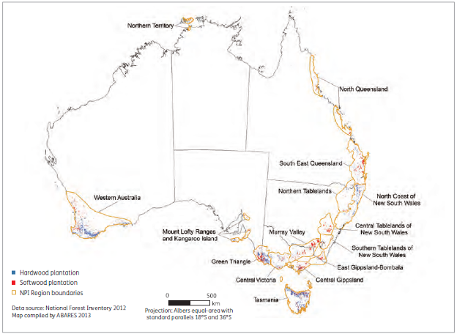
Source: Australian Bureau of Agricultural and Resource Economics and Sciences, National Plantation Inventory.
Table 2.14: Forecast plantation log supply, Australia, 2010-14 to 2050-54
Hardwood
Log type | 2010-14 - Volume ('000 cubic metres) | 2015-19 - Volume ('000 cubic metres) | 2020-24 - Volume ('000 cubic metres) | 2025-29 - Volume ('000 cubic metres) | 2030-34 - Volume ('000 cubic metres) | 2035-39 - Volume ('000 cubic metres) | 2040-44 - Volume ('000 cubic metres) | 2045-49 - Volume ('000 cubic metres) | 2050-54 - Volume ('000 cubic metres)
Pulplog | 9,763 | 12,571 | 13,499 | 10,145 | 13,776 | 12,448 | 12,236 | 13,099 | 11,495
Sawlog | 290 | 530 | 1,079 | 1,271 | 1,159 | 1,244 | 1,417 | 1,178 | 1,091
Total | 10,053 | 13,101 | 14,578 | 11,416 | 14,935 | 13,692 | 13,654 | 14,277 | 12,586
Softwood
Log type | 2010-14 - Volume ('000 cubic metres) | 2015-19 - Volume ('000 cubic metres) | 2020-24 - Volume ('000 cubic metres) | 2025-29 - Volume ('000 cubic metres) | 2030-34 - Volume ('000 cubic metres) | 2035-39 - Volume ('000 cubic metres) | 2040-44 - Volume ('000 cubic metres) | 2045-49 - Volume ('000 cubic metres) | 2050-54 - Volume ('000 cubic metres)
Pulplog | 5,309 | 5,593 | 5,797 | 5,474 | 5,734 | 5,381 | 5,540 | 5,743 | 5,720
Sawlog | 10,205 | 10,686 | 10,054 | 10,592 | 12,114 | 12,863 | 12,537 | 12,200 | 11,759
Total | 15,514 | 16,279 | 15,851 | 16,066 | 17,848 | 18,244 | 18,076 | 17,943 | 17,479
Total | 25,566 | 29,380 | 30,429 | 27,482 | 32,783 | 31,936 | 31,730 | 32,220 | 30,065
Notes:
Sawlogs include all quality classes of plantation sawlogs.
Totals may not tally due to rounding.
Source: Australian Bureau of Agricultural and Resource Economics and Sciences, National Plantation Inventory.
The National Plantation Inventory has developed a forecast of potential future log availability from existing plantations to 2050—54 (Table 2.14; Figure 2.30), based on data collected from the 15 plantation regions (see SOFR 2013 Introduction). The forecast is based mainly on the plantation areas in 2011, combined with assumptions about the yield of log products per unit area of land, and assuming that all harvested plantation sites are replanted. For softwood plantations, more than 100 years of growth and yield data are available to underpin the assumptions used to develop the forecast; fewer data are available for hardwood plantations, so the forecasts for hardwood log availability are less reliable. The proportion of the total volume produced that is suitable for hardwood sawlogs is particularly difficult to estimate accurately.
The potential annual average supply of logs from Australian plantations is forecast to be 26 million cubic metres in 2010—14, then to increase to more than 29 million cubic metres in 2015—19 (Table 2.14). Plantation log availability is forecast to reach an annual average peak of 33 million cubic metres in 2030—34 (Table 2.14). Based on current plantings, log production from softwood plantations is nearing its maximum potential and is expected to plateau by 2035 at around 18 million cubic metres per year, while production from hardwood plantations is forecast to peak at around 15 million cubic metres per year by 2030 (Table 2.14; Figure 2.30).
Total plantation hardwood supply in 2015—19 is forecast to be 13 million cubic metres per year on average (Table 2.14), more than three times the actual volume harvested in 2009—10 (Gavran et al. 2012) and reported in Table 2.12. Australia's hardwood plantation area has increased by 31.4% since 2004—05 (Gavran and Parsons 2011). However, the 2012 forecasts indicate a 2.3% decrease in national hardwood plantation log supply in 2015—19 compared with the 2007 report estimates, and the annual average hardwood sawlog supply forecast from 2012 for the 2010—45 period is around 17% lower than the 2007 forecast reported in SOFR 2008. These decreases in forecast volumes are a result of revised growth and yield forecasts by growers (Gavran et al. 2012). Increases in hardwood plantation area have not led to significant increases in sawlog volume because hardwood plantations are managed primarily for pulplog production, with only a small proportion managed for sawlog and veneer log production.
Hardwood plantation pulplog production was 4.4 million cubic metres in 2009—10. It is forecast to increase to about 13.5 million cubic metres per year in 2020—24, peaking at around 13.8 million cubic metres per year in 2030—34 (Table 2.14). By 2015—19, the major hardwood pulplog-producing regions will be Western Australia and Tasmania (Figure 2.31), each accounting for 27% of the national total pulplog volume, and the Green Triangle (South Australia—Victoria), accounting for another 22%. The North Coast New South Wales and Central Victoria regions are forecast to produce 6% each.
Figure 2.30: Forecast supply of plantation hardwood pulplog, by National Plantation Inventory region
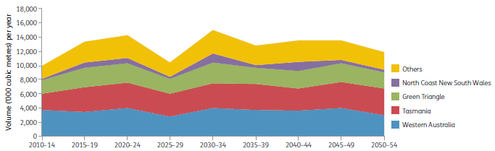
Source: Gavran et al. (2012).
Figure 2.31: Forecast supply of plantation hardwood sawlog, by National Plantation Inventory region
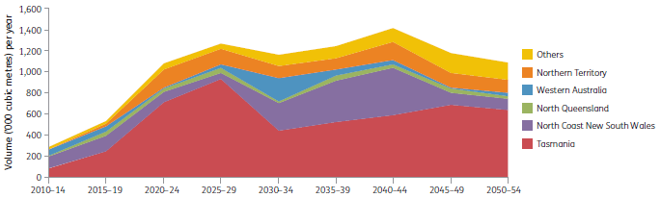
Source: Gavran et al. (2012).
Figure 2.32: Forecast supply of plantation softwood sawlog, by National Plantation Inventory region
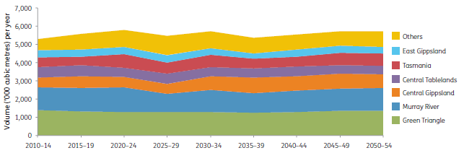
Source: Gavran et al. (2012).
Figure 2.33: Forecast supply of plantation softwood pulplog, by National Plantation Inventory region
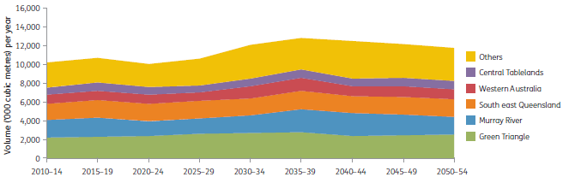
Source: Gavran et al. (2012).
Hardwood sawlog production was 136,000 cubic metres in 2009—10. It is forecast to increase to almost 1.3 million cubic metres per year in 2025—29, peaking at around 1.4 million cubic metres per year in 2040—44 (Table 2.14). By 2015—19, Tasmania and the North Coast New South Wales will be the main regions for production of hardwood plantation sawlogs (Figure 2.31), with an annual average of about 251,000 and 145,000 cubic metres available, respectively. These figures include all sawlog grades; only a small component of the projected hardwood plantation sawlogs will be of similar quality to high-quality sawlogs from native forest.
The forecast 2010—45 annual average supply of softwood logs (Table 2.14) is 1.3% higher in this report than in the forecast of Parsons et al. (2007). The increase is a result of the total softwood area increasing by 34,000 hectares (Gavran and Parsons 2011).
The major softwood sawlog—producing regions are currently, and will remain, the Green Triangle, the Murray Valley and South East Queensland (Figure 2.32). In 2015—19, the Green Triangle will produce an estimated 21% of the national softwood sawlog volume, the Murray Valley 20% and South East Queensland 17%. The supply of softwood sawlogs—more than 9.5 million cubic metres per year in 2009—10—is forecast to be steady at around 10.5 million cubic metres per year for the next 15—20 years, and increase to about 12.1 million cubic metres per year in 2030—34 (Table 2.14). Most of the sawn timber used for housing and general construction in Australia is derived from softwood plantation sawlogs.
Most plantation softwood pulplog is forecast to be produced in the Green Triangle, Murray Valley and Central Gippsland (Figure 2.33). In 2015—19, the Green Triangle and the Murray Valley will contribute 22% each of the total national softwood pulplog supply, and Central Gippsland will contribute 12% . The supply of softwood pulplog was 4.6 million cubic metres per year in 2009—10. It is forecast to increase to 5.6 million cubic metres per year in 2015—19 and remain around that level until the end of the 2050—54 period, with a slight decline in 2035—39 (Table 2.14).
Figure 2.34: Forecast availability of wood from native production forest in Australia (public plus private), 2010-14 to 2045-49
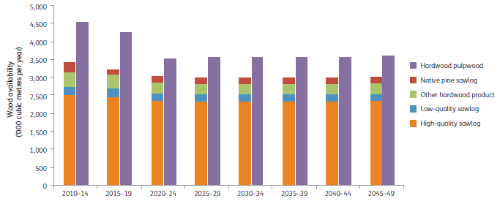
Note: Projections are based on SOFR 2008 area statement and data used in ABARES (2012a-f). This projection does not include changes reported in Forests NSW (2010a) or VicForests (2011a), nor changes resulting from the Tasmanian Forests Intergovernmental Agreement 2013.
Source: ABARES (2012a-f), Australian Bureau of Agricultural and Resource Economics and Sciences database.

Forecast native forest log supply
Native forests produced 29% of Australia's total log supply over the SOFR 2013 reporting period; historically it was much higher (Table 2.13). A forecast of potential future wood supply from multiple-use public, leasehold and private native forest to 2050 is presented in Figure 2.34, derived from ABARES (2012a—f). The forecast is a compilation of projected wood supply from native forests in six forest regions covering the majority of Australia's production forests; impacts of climate change, market forces or changing markets are not considered. The majority of native forest log supplies are from forests within Regional Forest Agreement areas (see SOFR 2013 Introduction). High-quality sawlogs are logs graded to standards used by state agencies; native pine sawlog is cypress pine; low-quality sawlog is sawlog not included in the high-quality category; and other hardwood product includes poles, piles, girders and other solid logs. Miscellaneous wood products such as firewood, industrial fuelwood, sleeper logs and fencing material are not included in the forecast projections.
Currently the supply of high-quality native forest sawlogs is primarily from multiple-use public native forests, with a smaller amount from private forests. A small amount of high-quality sawlogs is harvested from public hardwood plantations (Figure 2.19). The overall pulpwood supply from native forests is predicted to decrease from approximately 4.5 million cubic metres annually in 2010—14 to approximately 3.5 million cubic metres annually from 2020—24 onwards (Figure 2.34). This is a consequence of the predicted decrease in sustainable yield from public forests (Figure 2.35). As the supply of high-quality native sawlogs decreases from multiple-use public forests, the demand for supply of high-quality native sawlogs from private and leasehold forests will increase. Supplies from private and leasehold forests will depend on markets, and the objectives and goals of private and public owners.

Potential effects of climate change on forests
Forest growth and wood production are highly sensitive to changes in climate. The Australian Bureau of Agricultural and Resource Economics and Sciences (ABARES 2011a, 2012a—f) showed that most of Australia's production forest areas are likely to experience lower rainfall and higher temperatures by 2050 relative to 2005 as a result of predicted impacts of climate change. Two greenhouse gas emission scenarios (A1B and A2) developed by the Intergovernmental Panel on Climate Change were used to estimate climate change in 2030 and 2050. The A1B scenario assumes a moderate increase in atmospheric greenhouse gas levels, whereas the A2 scenario assumes a greater increase in greenhouse gas levels by the end of the century. The global mean annual temperature is expected to increase by 2030 and 2050 under both scenarios (0.8—0.9 °C increase in 2030 and 1.4—1.5 °C increase in 2050; see ABARES 2011a) when compared with the 1990 baseline.
Log availability from Australia's forests is projected to decline by 2050 under these climate predictions, relative to baseline projections in the absence of climate change. Both scenarios predict larger declines in log availability from softwood plantations than from hardwood plantations, and little change in log availability from native forests (Figure 2.36). The projected decline in log availability resulting from climate change varies by region. Jurisdictions are progressively factoring predicted changes into projected log supply from plantations and native forest.
Figure 2.35: Forecast sustainable yield of high-quality native forest sawlogs from public production forest in Australia, 2010-14 to 2045-49
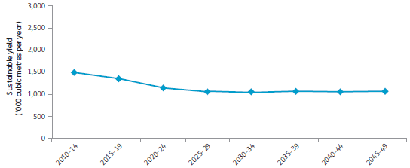
Notes:
Figures exclude changes resulting from the Tasmanian Forest Intergovernmental Agreement 2013 and supplementation with high-quality sawlogs from public hardwood plantations.
Figures include Queensland allowable cut estimates to 2025.
Source: ABARES (2012a-f), updates from Forests NSW (2010a) and VicForests (2011a), Australian Bureau of Agricultural and Resource Economics and Sciences database.
Figure 2.36: Projected changes in log availability due to effects of predicted climate change
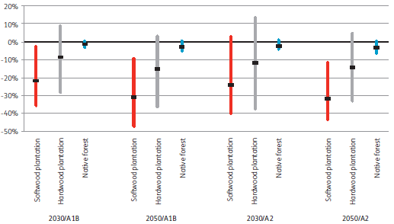
Notes:
Horizontal black bars show the predicted change in log availability due to the median model effect of climate change. Vertical coloured bars are the range of predicted change.
The estimated national baseline log supply from softwood and hardwood plantations for 2030 and 2050 was about 16 million cubic metres (each); from native forests, it was about 8 million cubic metres.
Source: ABARES (2011a), based on aggregated data from the six regional assessments (ABARES 2012a-f).

Indicator 2.1d Annual removal of non-wood forest products compared to the level determined to be sustainable
Rationale
This indicator is used to assess the sustainability of the harvest of non-wood forest products. These products can represent a significant asset base supporting the livelihoods of remote communities.

Key points
- Australia produces a wide range of non-wood forest products (NWFPs) derived from forest fauna, flora and fungi. High-value NWFPs include wildflowers, seed, honey, and aromatic products derived from sandalwood.
- State and territory governments regulate the removal of NWFPs in their respective jurisdictions, including through the issue of permits and licences. Commonwealth legislation, such as the Environment Protection and Biodiversity Conservation Act 1999, also regulates the removal of certain NWFPs.
- Indigenous Australians rely to varying degrees on the use of NWFPs for customary purposes (e.g. food and medicine) and commercial purposes (e.g. art and craft).
- Data on annual removals and sustainable yields are limited for many NWFPs, but are available for the more significant NWFPs.
- The extraction of NWFPs from native and plantation forests was assessed by the State of the Environment 2011 Committee as generally having a low impact on the environment. Climate variability and restrictions on resource access are among potential risks to the sustainability of NWFP-based industries.
Non-wood forest products (NWFPs) are products of biological origin, other than wood, derived from forests. For convenience, certain wood products, such as wood carvings and aromatic items produced from sandalwood (Santalum spp.), are included in this indicator. Sandalwood is also discussed in Indicator 2.1c. Water and carbon values derived from forests are discussed under Criteria 4 and 5, respectively, and the economic value and use of NWFPs are reported in Indicator 6.1b. Table 2.15 presents a non-exhaustive list of examples of Australian NWFPs.
The Australian, state and territory governments have regulations to limit and control the removal of plant and animal products from forests. Most commonly, this involves the issue of permits or licences for harvesting and hunting activities (Box 2.1). The allowable rates of extraction vary by jurisdiction.
The Australian Government has legislated measures to protect threatened species nationally through the Environment Protection and Biodiversity Conservation Act 1999 (EPBC Act), which also regulates, among other things, the ecologically sustainable use of wild native plants and animals that are exported.
The Australia State of the Environment 2011 report (State of the Environment 2011 Committee 2011) provides an assessment of land-use pressures on forests (Table 2.16). Land use involving native production forest is assessed in the report as having 'very low impact' on the land environment. This assessment is attributed to diminished intensity of native forest harvesting, the small scale of harvesting practices, and strong regulation of these practices. Plantation forests are also assessed as having 'very low impact'; this is attributed to the small area of plantation forest in proportion to land area, and strong regulations on forest management and use. The assessment pertains to the extraction of both wood and NFWP.
Table 2.15: Examples of NWFPs produced and used in Australia
Category | Examples
Terrestrial plants | Plants (trees, shrubs, wildflowers, grasses, tree ferns), seeds, essential oils, herbal health products, fragrances, bark, pigments, dyes, tannins, native plant food
Animals | Meat, skins, eggs, bee products
Fungi | Mushrooms, other fungi
Other products | Biochemicals, soil ameliorants, mulches, Indigenous artefacts
Source: Adapted from SOFR 2008.
Box 2.1: State and territory legislation relevant to the harvesting of non-wood forest products
Australian Capital Territory
The Nature Conservation Act 1980 protects all native fauna and flora. A licence is required to take protected fauna or flora.
New South Wales
The National Parks and Wildlife Act 1974 protects all native fauna (mammals, birds, reptiles and amphibians) and flora. A licence is required to take protected fauna or flora. Regulation of non-native fauna is under the control of the Non-Indigenous Animals Act 1987. The Threatened Species Conservation Act 1995 and the Environmental Planning and Assessment Act 1979 also have provisions relevant to the harvesting of non-wood forest products.
Northern Territory
The Territory Parks and Wildlife Conservation Regulations manage the use of native flora and fauna. A permit is issued to people wishing to take native flora or fauna from the wild. The Department of Natural Resources, Environment, the Arts and Sport regulates this permit system. If the integrity of a species is starting to be compromised by commercial use, a management plan is required. Such management plans are in place for cycads, crocodiles, the magpie goose and the red-tailed black-cockatoo. The 1997 A Strategy for Conservation through the Sustainable Use of Wildlife in the Northern Territory of Australia encourages sustainable use of wildlife for commercial purposes that are ecologically sustainable and where landholders are the beneficiaries, and encourages the development of management plans.
Queensland
The Nature Conservation Act 1992 specifically allows the ecologically sustainable use, including commercial use, of protected wildlife (animals or plants). Commercial activities operate through a licensing system that controls the taking and use of protected wildlife.
South Australia
The National Parks and Wildlife Act 1972 provides the state's legislative framework for the conservation of wildlife and flora in their natural environment. Protected animals include only indigenous and migratory birds, mammals and reptiles. A permit is needed to take any protected species, except where the relevant Minister declares otherwise based on a threat to crops or property, or declares an open hunting season for protected animals of specified species. A permit is needed to take native plants on any public land, as well as certain native plants on private land.
Tasmania
Wildlife (defined as all living creatures except stock, dogs, cats, farmed animals and fish) in Tasmania is protected by the Wildlife Regulations Act 1999. Open season may be declared by the Minister for Environment, Parks and Heritage for particular species of wildlife, such as wallabies, possums, deer, wild ducks and mutton-birds. A tree fern management plan was formulated, and additions were made to Tasmania's Forest Practices Act 1985, to improve the sustainability of the tree fern harvesting industry.
Victoria
In Victoria, wildlife (defined as vertebrate species indigenous to Australia, some non-native game species, and terrestrial invertebrate animals that are listed under the Flora and Fauna Guarantee Act 1988) is protected under the Wildlife Act 1975. A licence or authorisation is needed to take, destroy or disturb wildlife or protected fauna. Flora is protected under the Flora and Fauna Guarantee Act 1988; it may include both indigenous and non-indigenous species.
Western Australia
The Conservation and Land Management Act 1984 and the Wildlife Conservation Act 1950 provide for the conservation and protection of all native flora and fauna in Western Australia through a system of licensing, area-specific and species-specific management, and monitoring. A management plan (DEC 2008) governs the commercial harvesting of protected flora in Western Australia to June 2013 and satisfies the requirements of the Commonwealth Environment Protection and Biodiversity Conservation Act 1999. Under the Wildlife Conservation Act, flora is defined as 'any plant, including any wildflower, palm, shrub, tree, fern, creeper or vine which is either native to Western Australia or declared to be flora under the Act and includes any part of flora and the seeds and spores thereof'. A licence is required for the commercial use of protected species on Crown or private land. For Crown land, the licensee must demonstrate that they have both an area in which to harvest the species and written permission from the government agency that is managing that land.
Table 2.16: Contemporary land-use pressures on the land environment: forest
Component | Summary | Assessment grade | Confidence in grade and in trend
Native production forests | The intensity and scale of commercial wood harvesting in public native forests have diminished substantially; harvesting and other activities are strongly regulated. | Very low impact | Adequate high-quality evidence and high level of consensus
Plantation forests | The expansion of plantation forests is significant in some regions, but impacts on environmental values are generally limited, unless the site is converted directly from native vegetation. The area of plantation forests remains small as a proportion of land area, and plantation forestry has become very strongly regulated. | Very low impact | Adequate high-quality evidence and high level of consensus
Source: Adapted from State of the Environment 2011 Committee (2011).
Limited quantitative data are generally available for this indicator for reporting the harvest of NWFPs and the sustainability of harvest. Foster (2009) and Foster (in press) report that emerging rural industries based partly on forest plant and animal resources include buffalo, wild pig, crocodile, kangaroo and wallaby, possum, Australian native foods, essential oils from sandalwood, and wildflowers and native plants (including seed). The following is an overview, with examples of some high-value products for which data exist.

Terrestrial plant products
In general, factors that influence the sustainability of the harvest of native plant products in Australian forests include the plant part that is harvested; the plant's reproductive strategy, habitat specificity and growth rates; other uses for the land on which the plant grows (such as wood production or grazing); harvest methods; remoteness from human settlement; and land-use context or environmental factors (such as climate change). A number of forest-based non-wood plant product industries are subject to sustainability assessments.
In Tasmania, harvesting of tree ferns (only Dicksonia antarctica may be harvested) is strictly regulated under the provisions of the Forest Practices Act 1985, and a tree fern management plan (FPA 2005) endorsed by the Australian and Tasmanian governments governs the harvesting, transportation and trade of Tasmanian tree ferns. Estimated stocks of tree ferns in Tasmania total more than 63 million tree ferns across tenure categories (Table 2.17). Tags are placed on harvested stems and must remain on the stems at all times to ensure that the origin of the tree fern can be tracked to approved harvesting areas. The annual average number of tags issued, representing tree ferns harvested, has decreased over the reporting period (Table 2.18). Harvesting of tree ferns may only occur under a forest practices plan for areas subject to clearfell, burn and sow silviculture in native forest, or (rarely) a forest practices plan that authorises permanent clearing and conversion of native forest. Tree ferns are supplied to domestic and export markets.
Seed and wildflowers are other important NWFPs, particularly in Western Australia. Wildflower and seed industries in Western Australia are based on a combination of horticulture and native resources from forest and non-forest vegetation on public and private lands. Whereas the wildflower sector of the industry has a large export component, seed is used mainly for revegetation projects within Western Australia (DEC 2008). The Department of Environment and Conservation manages wildflower and seed harvesting in accordance with a management plan for commercial harvesting of protected flora in Western Australia on public and private land (DEC 2008). The Australian Government has approved the management plan for the purpose of the EPBC Act. The Western Australian Forest Management Plan 2004—2013 contains Key Performance Indicator 15 (wildflower and seed picking), which is monitored, audited and reported by the Conservation Commission of Western Australia (CCWA 2012b) to ensure that wildflower and seed industries are based on conservation and sustainable use of native resources in accordance with the principles of ecological sustainability.
Table 2.19 reports the harvest of wildflowers and seed for the region covered by the Forest Management Plan 2004—2013 in south-west Western Australia from 2004 to 2010. The harvest of wildflowers from native environments decreased by 60% over the period, from 10.3 million stems in 2004 to 4.2 million stems in 2010. This coincides with wildflower harvesting moving to private property not covered by the forest management plan (CCWA 2012b). Harvest of seed varied from 5,400 to 20,400 kilograms over the reporting period. The variation is attributed to changing demand for seed for rehabilitation and revegetation, together with the variability in the availability of seed between dry and wet periods.
Seed collection of forest species is also important in other states and territories, for use in native forest regeneration, plantation establishment, propagating nursery stock and land-care plantings. Collection is regulated and reported by relevant public authorities. Forestry Tasmania reported collection of native tree seed for the period 1996—97 to 2010-11 in the State of the forests Tasmania 2012 report (FPA 2012); the amount varied from a low of 564 kilograms during 1998—99 to a high of7,897 kilograms in 2009—10.
Table 2.17: Estimated tree fern numbers, by land tenure, in Tasmania
Tenure | Wet forest | Other forest | Total
Formal reserves | 13,574,200 | 3,579,000 | 17,153,200
Informal reserves | 3,849,700 | 378,100 | 4,227,800
Public land—state forest wood production areas | 24,875,900 | 1,386,700 | 26,262,600
Other public land | 4,789,200 | 1,223,400 | 6,012,600
Private land reserves | 11,900 | 2,600 | 14,500
Other private land | 8,985,200 | 803,000 | 9,788,200
Total | 56,086,000 | 7,372,800 | 63,458,900
Source: FPA (2012).
Table 2.18: Tree fern harvesting in Tasmania
Financial year | Number of tree fern tags issued
2002-03 | 64,182
2003-04 | 54,886
2004-05 | 61,368
2005-06 | 45,131
2006-07 | 43,843
2007-08 | 35,361
2008-09 | 17,529
2009-10 | 19,905
2010-11 | 11,229
Source: FPA (2012).
Table 2.19: Wildflower and seed harvest from south-west Western Australian native environments covered by the Forest Management Plan 2004-2013
Year | Number of wildflower stems harvested | Seed collected (kg)
2004 | 10,328,670 | 15,744
2005 | 9,502,362 | 5,597
2006 | 8,667,680 | 5,407
2007 | 6,493,230 | 10,333
2008 | 4,768,136 | 20,363
2009 | 4,700,672 | 9,649
2010 | 4,237,221 | 12,653
Source: CCWA (2012b).
Sandalwood is a parasitic plant that requires a host tree, such as raspberry jam wattle (Acacia acuminata), for its survival. Sandalwood is used in a range of products: the wood is used as incense and for carving, and sandalwood oil is distilled from the plant's heartwood. Almost all sandalwood products produced in Australia are derived from the Australian sandalwood (Santalum spicatum) in Western Australia (the largest producer), or northern sandalwood (S. lanceolatum) in northern Queensland. However, Indian sandalwood (S. album), the predominant sandalwood species in Asia, the Middle East and north Africa, has been planted in Australia since 2006. In 2012, there were more than 15 thousand hectares of S. spicatum plantations in Western Australia; there were also more than 8 thousand hectares of S. album plantations, mostly in Western Australia (Foster in press).
During the period 2005—06 to 2011—12, Australia produced 2,459—3,073 tonnes of sandalwood and 11—20 tonnes of sandalwood oil (Table 2.20). Virtually all parts of the tree—roots, bark and both live (green) and dead wood—are harvested for use. Western Australia is the major source of sandalwood, with small amounts harvested in Queensland. Much of the product is exported. Indicator 6.1b reports value, export amounts and consumption of sandalwood.
In Western Australia, the allowable harvest level is governed by the Sandalwood (Limitation of Removal of Sandalwood) Order 1996which provides for the removal of up to 1,500 tonnes per year of non-third-grade green sandalwood (excluding the harvest of dead wood, roots and third-grade green wood; see Indicator 2.1c). In 2010—11, the amount of green wood harvested from FPC-administered operations was 1,139 tonnes, compared with 1,239 tonnes in 2009—10.
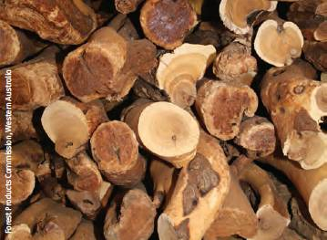
Harvested sandalwood logs, Western Australia.
In Queensland, sandalwood is a protected plant under the Nature Conservation Act 1992. Sandalwood harvesting must comply with the Nature Conservation (Protected Plants) Conservation Plan 2000, and the maximum allowable harvest for green sandalwood logs is set through a Nature Conservation (Protected Plants Harvest Period) Notice that is updated annually. The maximum allowable harvest of green sandalwood logs from 2008 to 2011 was 500 tonnes per year from state land and 50 tonnes per year from private land (excluding the harvest of dead wood, roots and stumps).
Table 2.20: Australian sandalwood production, 2005-06 to 2011-12
Product | 2005-06 - Production (tonnes) | 2006-07 - Production (tonnes) | 2007-08 - Production (tonnes) | 2008-09 - Production (tonnes) | 2009-10 - Production (tonnes) | 2010-11 - Production (tonnes) | 2011-12 - Production (tonnes)
Wood, Western Australia | 2,512 | 2,369 | 2,269 | 2,601 | 2,857 | 2,864 | 2,814
Green | 1,521 | 1,419 | 1,326 | 1,678 | 1,714 | 1,621 | 1,433
Dead | 726 | 758 | 729 | 666 | 873 | 963 | 1,179
Roots | 228 | 192 | 214 | 258 | 269 | 230 | 202
Bark | 38 | 0 | 0 | 0 | 0 | 50 | 0
Wood, Queensland | 132 | 118 | 190 | 274 | 167 | 209 | 130
Wood, total | 2,644 | 2,486 | 2,459 | 2,875 | 3,024 | 3,073 | 2,944
Sandalwood oil | 14.0 | 14.0 | 12.0 | 10.6 | 19.2 | 19.6 | 15.7
Source: Foster (in press).

Animal products
Mammals, reptiles, amphibians, birds, and insects and other invertebrates provide a range of NWFPs, such as meat, eggs, skins, fibres, honey and other bee products. In addition, many animal species provide important ecosystem services; for example, bees and other insects pollinate flowering plants.
The removal of native animals from Australian forests is prohibited or subject to regulations enforced by government agencies in all jurisdictions. Harvesting for meat and skin products is largely restricted to species that are considered to be common, and in most cases requires a permit. Permits are usually only issued after a detailed sustainability analysis based on monitoring of populations of the species. This analysis takes into account factors such as local population levels (including trends in population numbers), reproduction rates, and pressures such as disease or habitat loss that are likely to negatively affect the species. Harvesting of feral pest species does not require such sustainability analyses, since their populations have management targets for controlling populations.
Kangaroos (common wallaroo or euro, Macropus robustus; eastern grey kangaroo, M. giganteus; red kangaroo, M. rufus; and western grey kangaroo, M. fuliginosus) are harvested commercially for meat and skins in New South Wales, Queensland, South Australia and Western Australia. Bennett's wallaby (M. rufogriseus) and Tasmanian pademelon (Thylogale billardierii) were commercially harvested in Tasmania on Bass Strait Islands (Flinders and King) until 2010, when harvest ceased as it was commercially unviable. Currently a small amount of wallaby skins and fur is traded on mainland Tasmania. All of these species dwell in both forests and non-forests, and are common and not endangered. Other kangaroo and wallaby species are protected from commercial harvesting.
The commercial kangaroo harvest industry has management goals based on principles of sustainability (DSEWPaC 2012a). Annual quotas are set for each species by the relevant state agencies, and endorsed by the Australian Government under delegated authority provided by approved species management plans. The annual harvest quotas are published (DSEWPaC 2012b) and vary from year to year, based on the population estimates of the previous year. Quotas represent 10-20% of the populations estimated from direct population monitoring. In some states, subquotas are set regionally and allocated to individual property holders on a permit basis. In all states, commercial harvesting is done under a strict code of practice (NRMMC 2008) and a tag must be attached to each carcass before it can be processed. The proportion of harvest of wild kangaroos that is from forest lands is unknown; the harvest of Bennett's wallaby and Tasmanian pademelon is primarily from forested land.
Bennett's wallaby and Tasmanian pademelon are annually monitored by spotlight survey (Figure 2.37), and harvest rates in Tasmania are adjusted based on these statewide estimates. A sustainable yield formula under a commercial harvest plan covering forests and non-forests calculates the annual harvest based on the spotlight survey results (FPA 2012). Populations have remained relatively stable over the period 2001-10 (Figure 2.37); commercial harvesting levels have decreased substantially since 1996, while the number of non-commercial licences has increased (Table 2.21). Wallaby wildlife trade management plans were in place from November 2005 for harvesting wallabies on Flinders and King islands. They expired in 2010 and have not been renewed (FPA 2012).
Common brushtail possums (Trichosurus vulpecula) are harvested in Tasmania for skin and meat. Harvest is managed through a management plan approved under the EPBC Act and based on maintaining sustainable populations (DPIPWE 2010). The species is monitored annually (Figure 2.38), and harvest levels are based on monitored population levels. Table 2.22 reports the annual number of common brushtail possums harvested in Tasmania, which has varied substantially from 1996 to 2010-11; current harvesting rates are relatively low.
Figure 2.37: Density of macropods in Tasmania from annual spotlight surveys, 2002-10. A, Tasmanian pademelon. B, Bennett's wallaby.
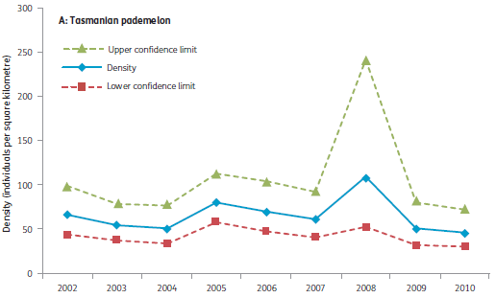
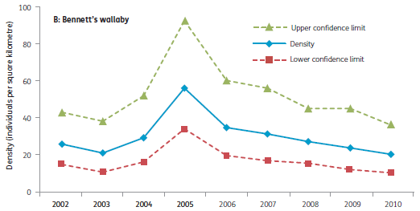
Note: Dashed lines show 95% confidence limits around density estimates.
Source: FPA (2012).
Table 2.21: Annual harvest of wallaby ª meat in Tasmania
Year | Commercial licences sold | Game meat produced  (kg) | Non-commercial shooting game licences sold
1996 | 113 | 69,617 | 4,956
1997 | 80 | 58,055 | 5,926
1998 | 61 | 50,974 | 4,989
1999 | 50 | 67,999 | 4,646
2000 | 44 | 61,642 | 4,392
2001 | 45 | — | 4,492
2002 | 49 | — | 4,769
2003 | 46 | 8,784 | 4,391
2004 | 60 | 2,630 | 4,518
2005 | 52 | 19,045 | 4,531
2006 | 27 | 20,920 | 5,840
2007 | 33 | 23,696 | 6,499
2008 | 28 | 20,746 | 6,534
2009 | 29 | 22,148 | 6,705
2010 | 32 | 27,670 | 6,835
2011 | 31 | 19,452 | 6,685
— = not available
ª Includes pademelon.
Source: FPA (2012).
Figure 2.38: Density of common brushtail possums in Tasmania from annual spotlight surveys, 2002-10
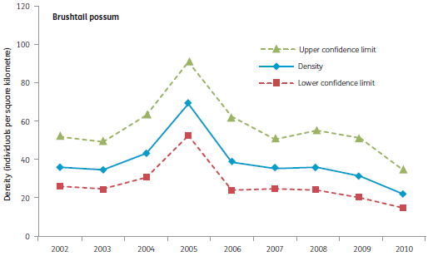
Note: Dashed lines show 95% confidence limits around density estimates.
Source: FPA (2012).
Table 2.22: Annual harvest of common brushtail possums in Tasmania
Year | Commercial permits | Estimated commercial harvest
1996 | 59 | 13,917
1997 | 35 | 12,364
1998 | 176 | 10,596
1999 | 38 | 11,635
2000 | 42 | 55,200
2001 | 22 | 4,900
2002 | 40 | 1,100
2003 | 17 | 1,700
2004 | 47 | 120
2005 | 45 | 5,672
2005-06 | 13 | 14,497
2006-07 | 14 | 4,832
2007-08 | 4 | 1,558
2008-09 | 7 | 4,680
2009-10 | 6 | 1,375
2010-11 | 12 | 4,379
Source: FPA (2012).
Forest-dwelling exotic fauna species are also harvested in Australia for meat and skins, and form the resource base of rural industries (Foster 2009, Foster in press). Many of these, such as pigs, goats and water buffalo, are officially declared pests that negatively affect forest health. In these cases, the harvesting rate is usually determined by forest management considerations rather than ecological sustainability criteria. Deer are harvested for venison and antlers from forests in New South Wales, Tasmania and Victoria. In Tasmania, annual harvest of male deer during 1996—2011 varied from a low of 544 animals in 1999 to a peak of 1,631 animals in 2006 (FPA 2012).
Apiary products are another important animal NWFP. Most states and territories of Australia have a significant beekeeping industry, and hives are placed in forest ecosystems based on the annual availability of flowering tree and understorey resources. The dependency of the beekeeping industry on forest resources varies across states and territories; it is estimated as 70—90% in south-eastern Australia (including southern Queensland) and south-western Australia (Benecke 2007, CALM 2006, DSE 2008). States and territories regulate apiarists through issuing permits and licences for apiary sites and hives.
Table 2.23 reports the number of beekeepers and hives by jurisdiction. Table 2.24 reports the average number of apiary sites and hives on state forest land in Tasmania from 1996—97. In Tasmania in 2010—11, there were 10,662 hives reported from 422 sites in state forest; in addition, 5,006 hives were reported from 87 sites in national parks and reserves (FPA 2012).
Although Australia is a net exporter of honey, there are several potential threats to the sustainability of the industry. These include restrictions on access to native flora due to land clearing for agriculture, rural dieback, limited clearfelling of native forest for wood products, bushfires, and the conversion of Crown land to reserves or national parks where apiaries may be excluded (RIRDC 2007a). Changing climate conditions also affect flowering patterns of forest species.
Tree plantations, including of eucalypt species, are unlikely to increase substantially the floral resources available to the beekeeping industry (Somerville 2010).
Other important animal NWFPs are wild crocodile eggs and juveniles that are used by the farmed crocodile industry in northern Australia (see Indicator 6.1b).

Indigenous harvest, including traditional use
Indigenous people harvest wildlife for both traditional and commercial purposes. Non-wood Indigenous products include bark paintings, weavings, pigments and dyes, and subsistence products, such as those used for food and ceremonial purposes. For convenience of classification, Indigenous NWFPs also include carvings and wooden sculpture. The sustainable use of NWFPs is extremely important to Indigenous communities in remote regions of Australia; such products often constitute a significant proportion of local customary and non-welfare cash economies (SOFR 2008). Despite the importance of the Indigenous NWFP harvest to the conservation of particular species and the livelihoods of many Indigenous communities, little data and few studies are available to assess its size and impact nationally.
Table 2.23: Number of beekeepers and hives by jurisdiction
Jurisdiction | Beekeepers  Number | Beekeepers  Proportion of national total  (%) | Hives  Number | Hives  Proportion of national total  (%)
NSW | 3,195 | 31.9 | 265,474 | 43.8
NT | 4 | 0.0 | 1,500 | 0.2
Qld | 3,084 | 30.8 | 119,418 | 19.7
SA | 740 | 7.4 | 66,013 | 10.9
Tas. | 179 | 1.8 | 17,904 | 3.0
Vic. | 1,927 | 19.2 | 96,455 | 16.0
WA | 880 | 8.8 | 39,000 | 6.4
Total | 10,009 | 100.0 | 605,764 | 100.0
Notes:
No data are available from ACT.
Totals may not tally due to rounding.
Source: Benecke (2007).
Table 2.24: Average number of apiary sites and hives on state forest land in Tasmania
Period | Number of sites | Number of hives
1996-97 to 2000-01 | 334 | 12,156
2001-02 to 2005-06 | 319 | 12,179
2006-07 to 2010-11 | 334 | 11,199
Note: Numbers are averages of the annual figures across each reporting period.
Source: FPA (2012).
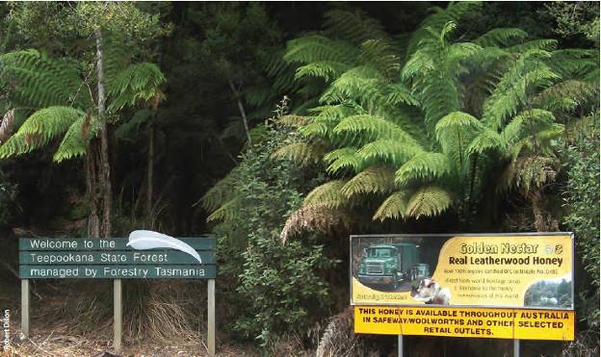
Tasmanian state forest containing leatherwood (Eucryphia iucida). Leatherwood honey produced in Tasmania is exported around the world.

Indicator 2.1e The area of native forest harvested and the proportion of that effectively regenerated, and the area of plantation harvested and the proportion of that effectively re established
Rationale
This indicator is used to assess the success of the re establishment of forests after harvesting. Re-establishment is critical to the maintenance of the productive capacity of the forest.

Key points
- State jurisdictions have codes of forest practice and other regulatory instruments requiring the regeneration and/or restocking of harvested multiple-use public native forests to specified standards; some states have similar codes of practice and regulations for private forests.
- Five-year average reported regeneration success rates in multiple-use public native forest in the reporting period 2005-06 to 2010-11 varied from 85% in New South Wales, to 100% in Queensland; over the four SOFR reporting periods, the five-year average reported regeneration rates varied from 72% in Victoria, to 100% in Queensland and Western Australia. Impacts of drought, bushfire, poor seed reserves and difficulties in carrying out regeneration burns contributed to low regeneration success rates in some states.
- In plantations, rates of successful establishment and re-establishment are generally above 90%.
- Remedial action is carried out by the grower or manager in native forest and plantations where specified regeneration and restocking standards are not achieved.
The term 'forest regeneration' usually refers to new trees that establish in a forest after harvesting, fire or other agents (e.g. wind or flood damage) have removed some or all trees from the forest overstorey. For native forests, this indicator provides annual information on the area regenerated after harvesting, the proportion of the total area of harvesting that this represents and the success of the regeneration effort. The indicator applies mostly to multiple-use public native forests in New South Wales, Queensland, Tasmania, Victoria and Western Australia, where significant volumes of wood are harvested, as well as private native forests in Tasmania, the only jurisdiction for which reliable data are available for that tenure. No native forest harvesting is permitted in multiple-use public native forests in the Australian Capital Territory or South Australia, and there is no multiple-use public native forest in the Northern Territory
For public plantations, this indicator reports on the area planted, or replanted after harvesting, and the success of the planting or replanting effort. Private plantations comprise 75% of Australia's plantation estate, but there is no available information about replanting success other than for private plantations in Tasmania. Regeneration audits are carried out in Tasmania on public and private native forest, and restocking or replanting audits apply to plantations.

Native forest regeneration
Effective regeneration of native forest after wood harvesting is a fundamental process in sustainable forest management, since regeneration determines the long-term productivity, growth, dynamics and composition of forest stands. Managers of multiple-use public forests are required by codes of forest practice, silvicultural manuals or guidelines, and other regulatory instruments to measure the effective regeneration (e.g. by stocking, density and species composition) of areas harvested for wood production, and to report the results publicly. Depending on the state, effective regeneration is judged by a combination of meeting a regeneration standard that prescribes the required stocking, and meeting specified silvicultural regeneration goals and objectives based on sustainable forest management objectives. For example, some of the silvicultural treatments applied to certain forest types promote the establishment of a cohort of trees for the next harvest. The guidelines, goals and objectives also consider both sustainable use and conservation requirements.
The states have established standards for the effective regeneration of multiple-use public native forests; some also have standards for private forests. Regeneration is usually assessed 1—3 years after harvesting, although the period is longer in some jurisdictions. Further follow-up treatments to promote regeneration, or supplementary planting with local tree species, are carried out if regeneration standards are not met at the first assessment. The definitions of, and standards for, effective regeneration vary between jurisdictions, but all aspire to stocking of the site that meets silvicultural manuals or guidelines, goals and objectives. Figure 2.39 illustrates effective regeneration four and six years after fire-salvage (clearfell) harvesting in Victoria.
Regional differences in forest type, climatic and biophysical conditions, and management objectives mean that each state has its own method for assessing the success or effectiveness of regeneration, and its own range of silvicultural techniques (see Indicator 2.1a). Whereas assessment techniques are well developed in even-aged native forests, they are more variable in multi-aged stands, where a single stand may contain trees of markedly varying growth stage (see Indicator 1.1b), age and height.
Retention of seed trees, prescribed fire and mechanical site disturbance are employed to encourage regeneration in many multiple-use public native forests. These methods are sometimes combined with aerial sowing of seed collected from the site (or a similar, local area) before harvesting of trees. Some silvicultural systems require adequate on-site regeneration to be present in the harvesting area before harvesting takes place; shelterwood and native cypress pine silvicultural systems are examples. Promotion of a subsequent regeneration event is not a priority where various thinning regimes are applied to young regrowth stands.
In New South Wales, effective regeneration in multiple-use public native forests for the period 2001—02 to 2010—11 was generally above 80% (see Table 2.25). In the three years when regeneration rates were below 80%, the impact of drought was a significant factor in the regeneration of some of these forests (successful regeneration requires adequate soil moisture for seedling establishment). Wildfires also affected regeneration on harvested areas in some of these forests.
Figure 2.39: Regeneration after harvesting using a fire-salvage (clearfell) silviculture system in Victorian native forests. A, Site immediately after harvesting; B, site four years after harvesting; C, site six years after harvesting. Granite Spur, Mitta Mitta, Victoria. Alpine Ash (Eucalyptus delegatensis) killed by wildfire in 2003 then salvage-logged and regenerated.
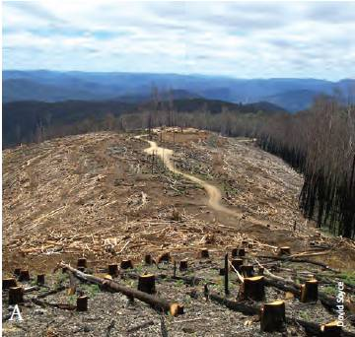
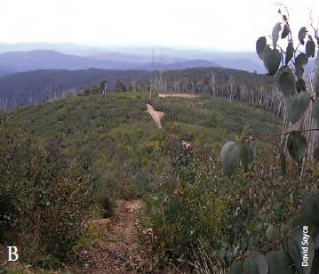
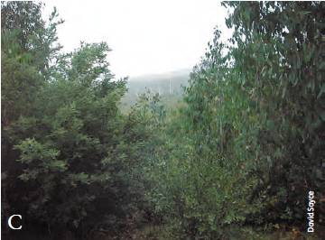
Table 2.25: Area proportion of harvested multiple-use public native forest effectively regenerated, New South Wales, 2001-02 to 2010-11
Year | Total area harvested  (hectares) | Proportion of harvested area effectively regenerated  (%) ª
2001-02 | 50,351 | 68
2002-03 | 49,062 | 87
2003-04 | 45,746 | 86
2004-05 | 42,923 | 83
2005-06 | 43,709 | 74
2006-07 | 44,806 | 63
2007-08 | 52,960 | 94
2008-09 | 27,952 | 81
2009-10 | 38,499 | 95
2010-11 | 27,484 | 92
ª Proportion of harvested area effectively regenerated with commercial species, based on sampled areas of forests of types that require post-harvest regeneration assessments and of forests harvested with silvicultural systems that require post-harvest regeneration assessments.
Notes:
Figures presented in Table 37 of SOFR 2008 were incorrect and have been updated with new figures.
Additional silvicultural treatment is undertaken when regeneration standards are not met, and the outcome of such treatment is not included in these data.
Source: Forests NSW.
In Victoria, the area of multiple-use public native forest treated and regenerated after harvesting has been reported since 1993—94 (Table 2.26). Prior to 2001, there was a 4—5-year lag between reporting regeneration treatment and assessment of effectiveness. Since 2004, results have been reported annually, with effectiveness assessed sooner (between 2 and 5 years after treatment and, from 2007, up to 3 years after treatment). A harvested coupe that does not meet the minimum standard is further treated with a follow-up resurvey for the effectiveness of regeneration 18—30 months after the additional treatment, with the goal that over time all the harvested area is effectively restocked (DSE 2007a; VicForests 2011b). Harvested coupes are transferred from the commercial harvesting agency (VicForests) back to the custodial managing agency (Department of Sustainability and Environment) once the coupe has been adequately regenerated and meets coupe regeneration handover guidelines (VicForests 2011b).
Table 2.26 shows for reporting years 1993—94 to 2010—11 the area of harvested multiple-use public native forest in Victoria that received an initial regeneration treatment; the area measured as meeting the standard and so effectively regenerated, including previously treated areas that were supplementary seeded or further treated; and the ratio between these two areas, which is the proportion effectively regenerated. Effective annual regeneration varies from 44% to 125% (inclusion of retreatment explains why this value can exceed 100%: see notes below Table 2.26), with a long-term area-weighted average success rate of 83%. Low regeneration percentages occur in years affected by drought, bushfire, poor seed reserves, or an inability to carry out adequate regeneration burns or mechanical disturbance. Harvest coupes that have not reached the regeneration standards at the first attempt have proven increasingly difficult to regenerate. Higher regeneration percentages occur in years with favourable conditions for regeneration establishment, or where areas from previous years have been effectively regenerated.
In Western Australia, the Forest Management Plan 20042013 (CCWA 2004), which covers all the main wood production areas in the state's south-west, and supporting guidance documents such as the silvicultural guidelines (DEC 2004a, 2004b, 2005), require that regeneration success and effective stocking rates be monitored in publicly owned native forests and pine plantations. In the mixed-age jarrah (Eucalyptus marginata) forest, the regeneration stocking rates in areas cut over to establish regeneration are sampled; a target has been set that no more than 5% of the area regenerated annually will require remedial action because it is understocked. Similarly, in karri (Eucalyptus diversicolor) forest, the regeneration stocking rates within even-aged forest are assessed after the first winter, and infill planting is undertaken if the stocking of patches falls below agreed standards. Key performance indicators have been developed for public reporting of the timeliness and effectiveness of regeneration, and are audited and reported by the Conservation Commission of Western Australia (CCWA 2012b—see Key Performance Indicator 10, Effectiveness of regeneration of native forest and plantation). Effectiveness of karri and jarrah regeneration is reported, as well as re-establishment of Pinus plantations. Silvicultural guidelines are reviewed and updated in response to outcomes of monitoring regeneration success (Burrows et al. 2011).
Table 2.27 summarises the results of the effectiveness of regeneration after harvesting in multiple-use public native forests in Western Australia. Jarrah regeneration was 100% for all the years reported, and karri regeneration varied from 97% to 100% (CCWA 2012b).
Under the Tasmanian code of forest practice, which applies to public and private native forests and plantations, sowing and planting mixtures applied to native forests must approximate the natural composition of the canopy trees of the forest before harvesting. The code also requires that regeneration surveys be conducted one year after clearfelling or two years after partial harvesting in eucalypt forest. Where surveys show that survival is less than the required stocking, measures to increase stocking to the required stocking standard are applied.
Tasmania reports annually on the level of regeneration achieved in all harvested native forest areas in multiple-use public forests. It requires that at least 85% of harvested forest meets the required stocking rate standard, which is based on the number and spatial distribution of acceptable seedlings, saplings or trees that occur within the area being assessed, and varies depending on forest type and silvicultural system.
Table 2.26: Area of multiple-use public native forest treated for regeneration and area effectively regenerated, Victoria, 1993-94 to 2010-11
Year ª | Total area treated for regeneration  (hectares) | Total area effectively regenerated  (hectares) | Proportion of total harvested area effectively regenerated  (%)
1993-94 | 9,328 | 6,987 | 75
1994-95 | 6,742 | 5,902 | 88
1995-96 | 8,961 | 8,046 | 90
1996-97 | 6,650 | 5,050 | 76
1997-98 | 5,590 | 5,140 | 92
1998-99 | 6,730 | 5,820 | 86
1999-2000 | 7,714 | 6,939 | 90
2000-01 | 8,119 | 6,988 | 86
2001-02 | 6,964 | 6,129 | 88
2002-03 | 5,810 | 4,984 | 86
2003-04 | 5,817 | 4,968 | 85
2004-05 | 4,556 | 2,655 | 58
2005-06 | 4,749 | 2,112 | 44
2006-07 | 4,545 | 4,062 | 89
2007-08 | 4,997 | 3,367 | 67
2008-09 | 4,466 | 3,050 | 68
2009-10 | 4,263 | 5,311 | 125
2010-11 | 4,804 | 4,137 | 86
ª Reporting year.
Notes:
The total area treated for regeneration in a reporting year is not equal to the total area harvested in the reporting year.
Areas not effectively regenerated are subject to subsequent remedial action: the total area treated for regeneration in a reporting year does not include areas of follow-up treatment.
There is a time lag of 2-5 years between regeneration treatment and assessment of the success of the regeneration. Consequently, the total area treated for regeneration, and the total area measured as effectively treated, in each reporting year are not measurements for the same area. Figures for total area effectively regenerated can include previously treated areas that were supplementary seeded or further treated and effectively regenerated from previous years. For this reason, the total area effectively regenerated can be higher than the total area treated for regeneration in any period.
Figures for the period 1999-2000 and 2000-01 are corrected from those reported in SOFR 2008.
Source: SOFR 2003, SOFR 2008, Victorian Department of Sustainability and Environment, VicForests.
Table 2.27: Area of multiple-use public native forest effectively regenerated, Western Australia, 2001-02 to 2010-11
Reporting year | Total area harvested and regenerated  (hectares) | Proportion of harvested area effectively regenerated  (%) ª
2001-02 | 16,630 | 100.00
2002-03 | 13,950 | 100.00
2003-04 | 9,725 | 100.00
2004-05 | 9,610 | 99.94
2005-06 | 7,440 | 99.94
2006-07 | 9,670 | 99.98
2007-08 | 8,820 | 99.90
2008-09 | 7,640 | 100.00
2009-10 | 10,660 | 99.65
2010-11 | 6,140 | —
— = not available
ª Proportion of harvested area effectively regenerated, based on harvested areas where the silvicultural objectives of the silvicultural systems require regeneration establishment in the harvested area and follow-up assessment for effectiveness.
Notes:
Reported forest area harvested and regenerated is the gross harvested area and does not include jarrah forest cleared for mining.
Proportion of area effectively regenerated is the weighted average of regeneration success reported for karri and jarrah regeneration for that year; regeneration success can relate to areas harvested 18-30 months previously.
Source: CCWA (2012b), Western Australian Department of Environment and Conservation.
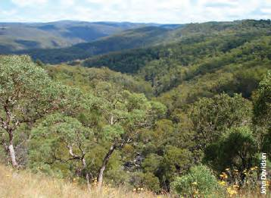
Native forest, Guy Fawkes River National Park, east of Armidale, New South Wales.
The standard was achieved from 1998-99 to 2010-11, with the majority of years having a proportion higher than 90% (Table 2.28).
The proportion of harvested private native forest area in Tasmania meeting required stocking rate standards during the period 2000-01 to 2002-03 averaged 89% and 95% for private independent and private industrial managers, respectively (FPA 2012).
Reporting of regeneration performance in private forests changed in 2003-04: after this, the Tasmanian Forest Practices Authority (FPA) applied a performance rating system to measure compliance with regeneration standards for public and private native forests and plantations. A compliance rating of 3.0 is considered the minimum acceptable level, and the maximum rating is 4.0. Table 2.29 presents the results on all management tenures from 2003-04 to 2010-11 for regeneration of native forest (results for plantations are presented later in this indicator). During this period, state forests averaged a rating of 3.6, with a minimum of 3.4, well above the acceptable minimum compliance level. Private industrial managers averaged 3.3, with one year at 2.6 being below the minimum acceptable compliance level. Private independent managers recorded two years that were below minimum acceptable compliance levels, and averaged a rating of 3.2. Tasmania is the only state or territory to report compliance with regeneration standards for harvesting of private native forests.
Single-tree selection silvicultural systems have been applied since 2000 to the harvest of wood products from multiple-use public native forests in Queensland. Because of the ecology of the relevant eucalypt and cypress forest types, regeneration is generally established continually and naturally from seed or lignotubers in the gaps produced by harvesting and associated soil disturbance, and/or post-harvest burning. Effective regeneration is monitored on harvested areas through the post-harvest audit process conducted by the Queensland Parks and Wildlife Service, and has been reported as being 100% since 2000-01.
Table 2.28: Area of regenerated multiple-use public native forest meeting stocking standards, Tasmania, 1998-99 to 2010-11
Reporting year | Regeneration year  Eucalypt clearfelling and partial logging | Regeneration year  Rainforest/ blackwood swamp | Total area harvested and regenerated  (hectares) | Total area that achieved standard  (hectares) | Proportion of total area that achieved standard  (%)
1998-99 | 1995-96 | 1993-94 | 4,006 | 3,815 | 95
1999-2000 | 1996-97 | 1994-95 | 5,466 | 5,184 | 95
2000-01 | 1997-98 | 1995-96 | 4,145 | 4,011 | 97
2001-02 | 1998-99 | 1996-97 | 4,808 | 4,568 | ⁹⁵
2002-03 | 1999-2000 | 1997-98 | 4,148 | 3,837 | 93
2003-04 | 2000-01 | 1998-99 | 5,526 | 5,141 | 93
2004-05 | 2001-02 | 1999-2000 | 6,569 | 6,526 | 99
2005-06 | 2002-03 | 2000-01 | 7,226 | 6,942 | 96
2006-07 | 2003-04 | 2001-02 | 9,445 | 9,244 | 98
2007-08 | 2004-05 | 2002-03 | 10,207 | 10,010 | 98
2008-09 | 2005-06 | 2003-04 | 7,522 | 7,002 | 93
2009-10 | 2006-07 | 2004-05 | 6,882 | 6,220 | 90
2010-11 | 2007-08 | 2005-06 | 7,820 | 6,888 | 88
Source: FPA (2012).
Table 2.29: Annual assessment performance rating for regeneration in native forestry operations, Tasmania, 2003-04 to 2010-11
Reporting year | Private industrial | Private independent | State forest | All tenures
2003-04 | 3.3 | 4.0 | 3.5 | 3.4
2004-05 | 2.6 | 2.9 | 3.4 | 3.0
2005-06 | 3.3 | 3.5 | 3.8 | 3.6
2006-07 | 3.4 | 2.4 | 3.7 | 3.4
2007-08 | 3.4 | 3.0 | 3.8 | 3.5
2008-09 | 3.5 | 3.1 | 3.7 | 3.5
2009-10 | 3.4 | 3.0 | 3.5 | 3.3
2010-11 | 3.6 | 3.5 | 3.6 | 3.6
Average | 3.3 | 3.2 | 3.6 | 3.4
Note: A rating of 3.0 is considered acceptable, and 4.0 is the maximum rating.
Source: FPA (2012).
Table 2.30: Percentage of regenerated multiple-use public native forest meeting the regeneration stocking standard or effectively regenerated
Reporting year | NSW | Qld | Tas. | Vic. | WA
1993-94 | — | — | — | 75 | —
1994-95 | — | — | 95 | 88 | —
1995-96 | — | — | 95 | 90 | —
1996-97 | — | — | 95 | 76 | —
1997-98 | — | — | 97 | 92 | —
1998-99 | — | — | 95 | 86 | —
1999-2000 | 98 | — | 95 | 90 | —
2000-01 | 95 | 100 | 97 | 86 | 100
2001-02 | 68 | 100 | 95 | 88 | 100
2002-03 | 87 | 100 | 93 | 86 | 100
2003-04 | 86 | 100 | 93 | 85 | 100
2004-05 | 83 | 100 | 99 | 58 | 100
2005-06 | 74 | 100 | 96 | 44 | 100
2006-07 | 63 | 100 | 98 | 89 | 100
2007-08 | 94 | 100 | 98 | 67 | 100
2008-09 | 81 | 100 | 93 | 68 | 100
2009-10 | 95 | 100 | 90 | 125 | 100
2010-11 | 92 | 100 | 88 | 86 | —
Average
Reporting year | NSW | Qld | Tas. | Vic. | WA
Before 1995-96 | — | — | 95.0 | 84.0 | —
1996-97 to 2000-01 | 96.5 | 100.0 | 95.8 | 86.0 | 100.0
2001-02 to 2005-06 | 79.6 | 100.0 | 95.2 | 72.4 | 100.0
2006-07 to 2010-11 | 85.0 | 100.0 | 93.4 | 86.9 | 99.9
— = not available
Notes:
Averages are based on available records in the period, and do not include records marked '–'.
For Victoria, percentages can be greater than 100 (see notes for Table 2.26).
Source: SOFR 2003, SOFR 2008, data sources for Tables 2.25-2.28, Queensland state agencies.
Table 2.30 compiles state data on effective regeneration where wood harvesting occurs in multiple-use public native forest. Western Australia and Queensland have experienced 100% effective regeneration since 2000, and Tasmania has averaged 93—96% effective regeneration for the four SOFR reporting periods. Victoria and New South Wales report much lower effective regeneration rates than the other three states. Factors contributing to low regeneration rates included drought, fire, poor seed reserves, and difficulties in carrying out regeneration burns or mechanical disturbance. Five-year averages of available data for the four reporting periods vary from 72% to 87% for multiple-use public native forest in Victoria, and 80% to 97% for multiple-use public native forest in New South Wales. In both states, in the years with low effective regeneration percentages, further treatment was applied to increase effective regeneration on harvested areas that did not meet required stocking standards.

Plantation establishment and re-establishment
The size of Australia's plantation estate continued to increase over the period 2006—11 as new plantations were established, almost all on already cleared agricultural land. However, the annual increase has declined since 2008 (Figure 2.40) due to a reduction in new plantation establishment (Gavran 2012). The size of Australia's plantation estate also depends on the extent to which existing plantations are re-established after clearfell harvesting at the end of a rotation. The decision to re-establish plantations, especially short-rotation hardwood plantations, depends on factors such as site suitability, previous yield, grower intent, market availability and alternative land uses.
Table 2.31 provides information on the planned subsequent land use of Tasmanian public and private plantations harvested since 1999—2000—either plantation re-establishment, re-establishment of native forest or conversion to non-forest land use. During the current SOFR reporting period, an annual average of 8,176 hectares of plantation was clearfelled and re-established to plantation, and 378 hectares was clearfelled and converted to non-forest use; these average rates are higher than in the previous reporting periods (Table 2.31). Streamside reserves that had been established with plantation species before the introduction of the Tasmanian code of forest practice in 1987 have been progressively reforested with native species.
Figure 2.40: New plantation establishment, Australia
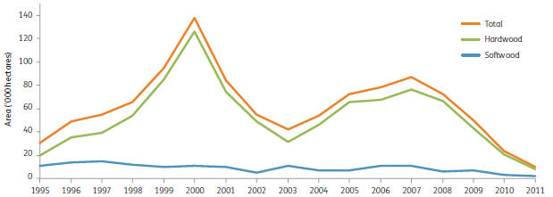
Source: Gavran (2012).
Conditions in Tasmania for plantation establishment were generally favourable over the SOFR reporting period. Forestry Tasmania reports annually on the level of restocking achieved for all plantation establishment operations on state forest. Stocking standards specify the minimum levels of growing stock to maintain a forest, and stocking success of plantations is reported two years after planting operations. The proportion of plantation establishment area meeting prescribed stocking standards varied between 97% and 100% (Table 2.32).
Table 2.33 reports the performance assessment for re-establishment of public and private plantations in Tasmania, based on the Tasmanian Forest Practices Authority's performance rating system. Private industrial and state forests rated highly, with all years being above the minimum standard of 3.0, and averaging 3.6 or 3.8 for private industrial and state forests, respectively. Private independent plantations rated lower, with an average of 3.3 and a range of 2.3—4.0.
Other state agencies and most private growers have internal management systems to assess plantation restocking or re-establishment levels and prescribe remedial treatment. Where plantations are re-established, the level of stocking is usually high, between 95% and 100%. Table 2.34 reports the re-establishment success of public softwood plantations in Western Australia from 2004 to 2010.
Tables 2.35 and 2.36 report the success of plantation establishment and re-establishment in South Australia and New South Wales. The rate of effective establishment or re-establishment of public softwood plantations in South Australia (Table 2.35) decreased from an average of 98% in the period 2001—02 to 2001—06 to 86% in the period 2006—07 to 2010—11. Results for establishing and re-establishing public plantations in New South Wales varied widely for both softwood and hardwood plantations (Table 2.36). Supplementary planting was used to reach adequate stocking levels in years when establishment rates were below prescribed levels.
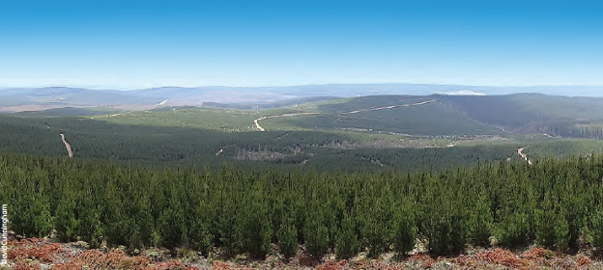
Second-rotation radiata pine (Pinus radiata) plantation, southern New South Wales.
Table 2.31: Planned subsequent land use of harvested plantation forest (public and private), Tasmania, 1999-2000 to 2010-11
Reporting year | Plantation clearfelling followed by  Plantation re-establishment - Area (hectares) | Plantation clearfelling followed by  Conversion to non-forest use ª - Area (hectares) | Plantation clearfelling followed by  Native forest re-establishment ^{b} - Area (hectares) | Total - Area (hectares)
1999-2000 | 3,600 | 50 | 0 | 3,650
2000-01 | 5,230 | 90 | 0 | 5,320
2001-02 | 5,350 | 360 | 0 | 5,710
2002-03 | 7,740 | 130 | 0 | 7,870
2003-04 | 8,250 | 420 | 0 | 8,670
2004-05 | 6,550 | 220 | 0 | 6,770
2005-06 | 7,590 | 510 | 0 | 8,100
2006-07 | 9,450 | 260 | 0 | 9,710
2007-08 | 9,760 | 610 | 0 | 10,370
2008-09 | 7,360 | 400 | 110 | 7,870
2009-10 | 7,940 | 280 | 240 | 8,460
2010-11 | 6,370 | 340 | 120 | 6,830
Average
Reporting year | Plantation clearfelling followed by  Plantation re-establishment - Area (hectares) | Plantation clearfelling followed by  Conversion to non-forest use ª - Area (hectares) | Plantation clearfelling followed by  Native forest re-establishment ^{b} - Area (hectares) | Total - Area (hectares)
1999-2000 to 2000-01 | 4,415 | 70 | 0 | 4,485
2001-02 to 2005-06 | 7,096 | 328 | 0 | 7,424
2006-07 to 2010-11 | 8,176 | 378 | 94 | 8,648
ª Conversion of harvested plantation forest to non-forest land use primarily applies to private plantations. It is minor in state forest and restricted to infrastructure requirements (roads, powerlines and dams)—these areas are not reported.
^{b} Largely native streamside reserves re-established in pine plantations established before the Forest Practices Code 2000.
Source: FPA (2012).
Table 2.32: Proportion of plantation establishment meeting stocking standards on state forest lands, Tasmania, 2006-10
Reporting year | Plantation establishment year | Total area treated  (hectares) | Area achieving standard  (hectares) | Proportion of total area achieving standard  (%) ª
2006 | 2004 | 1,890 | 1,835 | 97
2007 | 2005 | 1,677 | 1,659 | 100
2008 | 2006 | 1,769 | 1,760 | 100
2009 | 2007 | 3,610 | 3,599 | 98
2010 | 2008 | 2,901 | 2,884 | 99
ª Published figures taken directly from the State of the forest Tasmania 2012 (FPA 2012).
Source: FPA (2012).
Table 2.33: Annual assessment performance rating for re-establishment in plantation operations, Tasmania, 2003-04 to 2010-11
Reporting year | Private industrial | Private independent | State forest | Total of all tenures
2003-04 | 4.0 | 4.0 | 3.9 | 4.0
2004-05 | 3.3 | 3.6 | 3.1 | 3.3
2005-06 | 3.9 | 4.0 | 3.6 | 3.8
2006-07 | 3.8 | 2.5 | 3.8 | 3.7
2007-08 | 3.6 | 4.0 | 3.8 | 3.7
2008-09 | 3.3 | 3.3 | 4.0 | 3.4
2009-10 | 3.4 | 3.0 | 3.9 | 3.4
2010-11 | 3.5 | 2.3 | 4.0 | 3.4
Average | 3.6 | 3.3 | 3.8 | 3.6
Note: A rating of 3.0 is considered acceptable, and 4.0 is the maximum rating.
Source: FPA (2012).
Table 2.34: Annual area of public softwood plantation re-established, and area achieving stocking density standards specified in the silviculture guidelines, Western Australia
Year | Area regenerated in previous year (hectares) | Area surveyed  (hectares) | Area understocked (hectares) | Proportion of area requiring remedial treatment  (%) | Proportion of area that met standard  (%)
2004 | 1,418 | 1,418 | 105 | 7.4 | 93
2005 | 1,456 | 1,456 | 143 | 9.8 | 90
2006 | 1,433 | 1,433 | 45 | 3.1 | 97
2007 | 1,512 | 1,512 | 52 | 3.4 | 97
2008 | 1,627 | 1,627 | 24 | 1.5 | 99
2009 | 2,106 | 2,106 | 95 | 4.5 | 95
2010 | 570 | 570 | 28 | 5.0 | 95
Source: CCWA (2012b).
Table 2.35: Public softwood plantation establishment and re-establishment, South Australia, 2001-02 to 2010-11
Year | Total area treated  (hectares) | Total area effectively planted or replanted  (hectares) | Proportion effectively planted or replanted  (%)
2001-02 | 2,603 | 2,603 | 100
2002-03 | 2,267 | 2,225 | 98
2003-04 | 2,470 | 2,468 | 100
2004-05 | 2,521 | 2,517 | 100
2005-06 | 2,600 | 2,367 | 91
2006-07 | 3,033 | 2,440 | 80
2007-08 | 4,159 | 3,535 | 85
2008-09 | 3,307 | 2,910 | 88
2009-10 | 3,287 | 2,827 | 86
2010-11 | 2,762 | 2,541 | 92
Average
Year | Total area treated  (hectares) | Total area effectively planted or replanted  (hectares) | Proportion effectively planted or replanted  (%)
2001-02 to 2005-06 | 2,492 | 2,436 | 98
2006-07 to 2010-11 | 3,310 | 2,851 | 86
Note: Figures include new and re-established softwood plantations, and include plantations located in Victoria managed by ForestrySA.
Source: SAFC (2007, 2009, 2011), SOFR 2008.
Table 2.36: Public softwood and hardwood plantation planting, New South Wales, 1998 to 2011
Year | Softwood plantation - Planted area (hectares) | Hardwood plantation - Planted area (hectares) | Softwood plantation - Proportion successfully established (%) | Hardwood plantation - Proportion successfully established (%)
1998 | 5,750 | 7,800 | 97 | 94
1999 | 4,950 | 5,500 | 98 | 100
2000 | 3,867 | 3,392 | 96 | 95
2001 | 5,951 | 2,005 | 95 | 97
2002 | 5,500 | 1,680 | 81 | 97
2003 | 6,506 | 1,529 | 80 | 78
2004 | 6,764 | 1,164 | 93 | 100
2005 | 6,547 | 267 | 94 | 100
2006 | 7,260 | 889 | 37 | n.r.
2007 | 6,037 | 462 | 74 | n.r.
2008 | 9,874 | 945 | 74 | n.r.
2009 | 10,581 | 1,979 | 71 | 13
2010 | 9,942 | 1,104 | 78 | 91
2011 | 8,969 | 592 | 88 | 70
n.r. = not reported
Note: Planted area includes both new plantation establishment and plantation re-establishment. Establishment is measured one year after planting; the rate applies to the planted area in the previous year. Successful establishment is attained where 80% of softwood seedlings and 90% of hardwood seedlings survive. Follow-up replanting occurs as required to fully stock the planted site. In the case of the low 2009 hardwood establishment rate, much of the plantation estate was just below the 90% guideline threshold and only required a low level of supplementary planting to adequately stock the planted area. Data to 2006 are regional compilations; data after 2006 are revised corporate data.
Source: Forests NSW (2004, 2005, 2006, 2012a), State Forests of New South Wales (2001, 2002, 2003).

References—Criterion 2
ABARES (Australian Bureau of Agricultural and Resource Economics and Sciences) (2011a). Potential effects of climate change on forests and forestry in Australia, ABARES, Canberra.
——(2012a). Potential effects of climate change on forests and forestry: Technical Report for Green Triangle, ABARES, Canberra.
——(2012b). Potential effects of climate change on forests and forestry: Technical Report for North-eastern New South Wales – South-eastern Queensland, ABARES, Canberra.
——(2012c). Potential effects of climate change on forests and forestry: Technical Report for Northern Australia, ABARES, Canberra.
——(2012d). Potential effects of climate change on forests and forestry: Technical Report for South-eastern New South Wales – Eastern Victoria, ABARES, Canberra.
——(2012e). Potential effects of climate change on forests and forestry: Technical Report for South-western Western Australia, ABARES, Canberra.
——(2012f). Potential Potential effects of climate change on forests and forestry: Technical Report for Tasmania, ABARES, Canberra.
——(2012g). Australian Forest and Wood Products Statistics, March and June Quarters 2012, ABARES, Canberra.
——(2013c). Australian Forest and Wood Products Statistics: March and June Quarters 2013, ABARES, Canberra.
ANZECC (Australian and New Zealand Environment and Conservation Council) (2001). A National Approach to Firewood Collection and Use in Australia, ANZECC, Canberra.
Benecke FS (2007). Commercial Bee-keeping in Australia, 2nd edition, Rural Industries Research and Development Corporation, Canberra.
Burrows N, Dell B, Neyland M and Ruprecht J (2011). Review of Silviculture in Forests of South-west Western Australia, report to Department of Environment and Conservation, Conservation Commission of Western Australia, Perth.
CALM (Western Australian Department of Conservation and Land Management) (2006). Draft Policy Statement No. 41: Beekeeping on Public Land, CALM, Perth.
CCWA (Conservation Commission of Western Australia) (2004). Forest Management Plan 2004–2013, CCWA, Perth.
——(2012a) Draft Forest Management Plan 2014–2023, Conservation Commission of Western Australia, Perth.
——(2012b). Forest Management Plan 2004–2013: End-of-term Audit of Performance Report, Conservation Commission of Western Australia, Perth.
Davey S and Dunn G (in preparation). Australian Native Forest Commerciality, Australian Bureau of Agricultural and Resource Economics and Sciences, Canberra.
Davidson J, Davey S, Singh S, Parsons M, Stokes B and Gerrand A (2008). The Changing Face of Australia’s Forests, Bureau of Rural Sciences, Canberra.
DEC (Western Australian Department of Environment and Conservation) (2004a). Silvicultural Practice in the Jarrah Forest, Sustainable Forest Management Guideline no. 1, Sustainable Forest Management Series, DEC, Perth.
——(2004b). Silvicultural Practice in Wandoo Forest and Woodland, Sustainable Forest Management Guideline no. 2, Sustainable Forest Management Series, DEC, Perth.
——(2005). Silvicultural Practice in the Karri Forest, Sustainable Forest Management Guideline no. 3, Sustainable Forest Management Series, DEC, Perth.
——(2008). Management of Commercial Harvesting of Protected Flora in Western Australia, 1 July 2008 – 30 June 2013, DEC, Perth.
——(2012a). Sustained yield information sheet series, DEC, Perth.
DERM (Queensland Department of Environment and Resource Management) (2011). Native Forest Practice Survey, DERM, Brisbane.
DEWHA (Australian Government Department of the Environment, Water, Heritage and the Arts) (2008). Energy Use in the Australian Residential Sector 1986–2020, DEWHA, Canberra.
DPIPWE (Tasmanian Department of Primary Industries, Parks, Water and Environment) (2010). Management Plan for the Commercial Harvest and Export of Brushtail Possums 2010–2015, DPIPWE, Hobart.
Driscoll DA, Milkovits G and Freudenberger D (2000). Impact and Use of Firewood in Australia, CSIRO Sustainable Ecosystems report to Environment Australia, Canberra.
DSE (Victorian Department of Sustainability and Environment) (2003). Victoria’s State of the Forests Report 2003, DSE, Melbourne.
——(2007a). Code of Practice for Timber Production 2007, DSE, Melbourne.
——(2008). Victoria’s State of the Forests Report 2008, DSE, Melbourne.
DSEWPaC (Australian Government Department of Sustainability, Environment, Water, Population and Communities) (2012a). Commercial Kangaroo Harvesting, fact sheet, DSEWPaC, Canberra.
——(2012b). Kangaroo Population, Quota and Harvest Statistics, DSEWPaC, Canberra.
Forestry Tasmania (2007). Sustainable High Quality Eucalypt Sawlog Supply from Tasmanian State Forest, Review no. 3, Forestry Tasmania, Hobart.
——(2010a). Special Timbers Strategy, Forestry Tasmania, Hobart. Forests NSW (2004). Sustaining the Forest: Social, Environmental and Economic (Seeing) Report 2003/04, Forests NSW, Pennant Hills.
——(2005). Seeing: Social, Environmental and Economic (Seeing) Report 2004–05, Forests NSW, Pennant Hills.
——(2006). Seeing: Social, Environmental and Economic (Seeing) Report 2005–06, Forests NSW, Pennant Hills.
——(2007). Seeing Report. Social, Environmental and Economic (Seeing) Report 2006–07, Forests NSW, Pennant Hills.
——(2008). Seeing Report 2007–08, Forests NSW, Pennant Hills.
——(2009). Forests NSW Annual Report 2008–09: Social, Environmental and Economic Performance, Forests NSW, Pennant Hills.
——(2010a). Forests NSW yield estimates for native forest regions, Forests NSW, Pennant Hills.
——(2010b). Forests NSW Annual Report 2009–10: Social, Environmental and Economic Performance, Forests NSW, Pennant Hills
——(2011). Forests NSW Annual Report 2010–11: Social, Environmental and Economic Performance, Forests NSW, Pennant Hills.
——(2012a). Forests NSW Supplementary Sustainability Indicator Data 2011–12, Forests NSW, Pennant Hills.
Foster M (2009). Emerging Animal and Plant Industries—Their Value to Australia, 2nd edition, RIRDC publication no. 09/004, Rural Industries Research and Development Corporation, Canberra.
——(in press). Emerging Industries: Their Value to Australia, Rural Industries Research and Development Corporation, Canberra.
FPA (Forest Practices Authority) (2002). State of the Forests 2002, FPA, Hobart.
——(2005). Treefern Management Plan for Harvesting, Transporting or Trading of Dicksonia antarctica in Tasmania, FPA, Hobart.
——(2007). State of the Forests Tasmania 2006, FPA, Hobart.
——(2012). State of the forests Tasmania 2012, FPA, Hobart.
FPC (Forest Products Commission) (2011). Forest Products Commission Annual Report 2010–11, FPC, Perth.
Gavran M (2012). Australian Plantation Statistics 2012 Update, Australian Bureau of Agricultural and Resource Economics and Sciences, Canberra.
——and Parsons M (2011). Australian Plantation Statistics 2011, Australian Bureau of Agricultural and Resource Economics and Sciences, Canberra.
——, Frakes I, Davey S and Mahendrarajah S (2012). Australia’s Plantation Log Supply 2010–2054, Australian Bureau of Agricultural and Resource Economics and Sciences, Canberra.
Montreal Process Working Group (2001) Montréal Process Capacity Building Workshop Summary, August 26-31, 2001, Portland, Oregon. Available at http://www.montrealprocess.org/documents/meetings/adhoc/2001portland_e.pdf (Accessed 01 Nov 2013)
Montreal Process Implementation Group for Australia (2008). Australia’s State of the Forests Report 2008, Bureau of Rural Sciences, Canberra.
National Forestry Inventory (1998). Australia’s State of the Forests Report 1998, Bureau of Rural Sciences, Canberra.
——(2003). Australia’s State of the Forests Report 2003, Bureau of Rural Sciences, Canberra.
NRMMC (Natural Resource Management Ministerial Council) (2008). National Code of Practice for the Humane Shooting of Kangaroos and Wallabies for Commercial Purposes, Commonwealth of Australia, Canberra.
NSW Government Office of Environment and Heritage (2011). NSW Forest Agreements Implementation Report 2009–2010: Upper North East, Lower North East, Eden and Southern Regions. A report prepared by the Minister for the Environment as part of the implementation of the NSW forest agreements and integrated forestry operations approvals, Crown Forestry Section, Office of Environment and Heritage, Sydney.
Parsons M and Pritchard P (2009). The Role, Values and Potential of Australia’s Private Native Forests, RIRDC publication 09/049, Rural Industries Research and Development Corporation, Canberra.
——, Frakes I and Gavran M (2007). Australia’s Plantation Log Supply 2005–2049, Bureau of Rural Sciences, Australian Government Department of Agriculture, Fisheries and Forestry, Canberra.
Private Forestry Consultative Committee (2002). Plantations for Australia: The 2020 Vision. (Accessed 12 August 2013)
Private Forests Tasmania (2005). Tasmanian Private Property Wood Flow Estimates, Private Forests Tasmania, Hobart.
Resource Assessment Commission (1992). A Survey of Australia’s Forest Resource, Australian Government Publishing Service, Canberra.
RIRDC (Rural Industries Research and Development Corporation) (2007a). Honeybee R&D Plan 2007–2012, RIRDC Publication No 07/056, RIRDC Project No AGL-4A. RIRDC, Canberra.
SAFC (South Australian Forestry Corporation) (2007). ForestrySA Annual Report 2006–07, SAFC, Mount Gambier.
——(2009). ForestrySA Annual Report 2008–09, SAFC, Mount Gambier.
——(2011). ForestrySA Annual Report 2010–11, SAFC, Mount Gambier.
SOFR 1998—see National Forestry Inventory (1998).
SOFR 2003—see National Forestry Inventory (2003).
SOFR 2008—see Montreal Process Implementation Group for Australia (2008).
Somerville D (2010). Forestry Plantations and Honeybees, Rural Industries Research and Development Corporation, Canberra.
State Forests of New South Wales (2001). Seeing: Social, Environmental and Economic Report 2000/01, State Forests of New South Wales, Pennant Hills.
——(2002). Seeing: Social, Environmental and Economic Report 2001/02, State Forests of New South Wales, Pennant Hills.
——(2003). Seeing: Social, Environmental and Economic Report 2002/03, State Forests of New South Wales, Pennant Hills.
State of the Environment 2011 Committee (2011). Australia State of the Environment 2011, independent report to the Australian Government Minister for Sustainability, Environment, Water, Population and Communities, DSEWPaC, Canberra.
VicForests (2011a). VicForests 2011 Resource Outlook, VicForests, Melbourne.
——(2011b). Sustainability Report 2010–11, VicForests, Melbourne.

The Montreal Process guideline for this indicator (Montreal Process Working Group 2001) defines forest available for wood production as "forest land where wood product extraction is not legally restricted. For example, parks and other areas removed from harvest for protective purposes (i.e. soil protection) is legally restricted. Where harvesting is not legally restricted on private or public land and owners do or do not have a management intent to harvest, all this land would still be considered available for harvest".
See discussion of reported changes in Australia's total native forest area in Indicator 1.1a.
The Queensland policy to phase out harvesting of multiple-use public native forests ceased in 2012. Multiple-use public native forests in Queensland are returning to long-term wood production.
Sustainable sawlog harvest volumes are calculated using data on forest type and age class, standing timber volumes, terrain, accessibility, timber growth and yield, recreational use, water supply and conservation requirements. Estimates also take into account restrictions on harvesting imposed by codes of practice and other regulations. Once calculated, the sustainable volumes are used to produce harvesting schedules and forecasts of the future spatial and temporal characteristics of the forest.
Quota sawlogs are sawlogs of a specified quality and dimension that contribute to the committed volumes outlined in New South Wales Forest Agreements and Integrated Forest Operation Approvals (IFOAs) applying to multiple-use public native forests. Non-quota sawlogs are sawlogs that do not contribute to the committed volumes outlined in Forest Agreements and IFOAs. Further explanation of the grade categories used in New South Wales and reported in Figure 2.9 can be found in the NSW Government and Office of Environment and Heritage (2011).
'Arisings' refer to timber produced as a result of planned harvest of other species or timber grades.
Greenwood is wood from live sandalwood that meets a specified quality standard and size.
The conversion between tonnes and cubic metres for firewood and fuelwood is roughly 1:1.
http://www.environment.gov.au/land/publications/firewood-code.html.
http://www.environment.gov.au/topics/land/forests/intergovernmental-agreement.
Six technical reports (ABARES 2012a—f) give assumptions, caveats and cautions regarding the underpinning data applying to these forecasts. Because of the variability in grower management intent, and less reliable data on growth, yield, commerciality and forest condition, on private land, the confidence and accuracy of estimates from private and leasehold forests are less than those from public forests.
From October 2012, the Department of Land Resource Management.
The 2012 version of this management plan is available at http://www.fpa.tas.gov.au/__data/assets/pdf_file/0005/58037/Revised_Tasmanian_treefern_management_plan_2012.pdf and http://www.environment.gov.au/system/files/resources/605a78d8-a9a1-4a72-81af-046442573488/files/tas-treefern-2012.pdf.
A new management plan for protected flora covering July 2013 to June 2018 has been approved and was gazetted on 3 July 2013: http://www.environment.gov.au/resource/management-commercial-harvesting-protected-flora-western-australia-1-july-2013-30-june-2018.
The 2012 version of this management plan is available at http://www.environment.gov.au/system/files/resources/605a78d8-a9a1-4a72-81af-046442573488/files/tas-treefern-2012.pdf.
From July 2013, the Department of Parks and Wildlife.
A new management plan for protected flora covering July 2013 to June 2018 has been approved and was gazetted on 3 July 2013: http://www.environment.gov.au/resource/management-commercial-harvesting-protected-flora-western-australia-1-july-2013-30-june-2018.
Rural dieback is a collective term used to describe the degradation and loss of vigour of trees and native forest ecosystems as a result of changes in hydrology, salinity and nutrient balances; deterioration in soil attributes; increased pest and pathogen impacts; and changed fire regimes.
From April 2013, the Department of Environment and Primary Industries.

