Criterion 3 Maintenance of ecosystem health and vitality
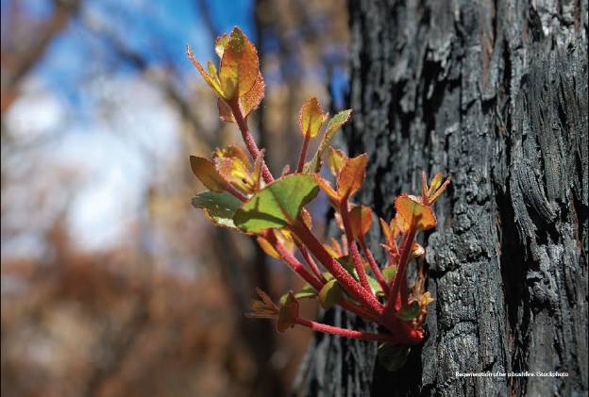
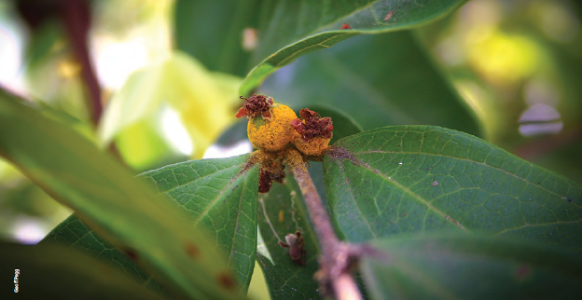
Myrtle rust (Puccinia psidii s.l.) on fruit of Rhodamnia sessiliflora, Queensland.
Sustainable forest management aims to maintain the productive capacity of native forests and plantations to provide the goods and services required by society while maintaining ecosystem health and vitality.
This criterion contains two indicators. The first considers the scale and impact of agents and processes affecting forest health and vitality, mainly pests and diseases, but also other environmental factors such as drought and extreme weather events. The second indicator considers the impacts of forest fire, and presents data on the area of forest burnt by planned and unplanned fires.
Forest health
Forest health and vitality are affected by vertebrate browsers, invertebrates (mainly insects), pathogens and weeds, but also by other potentially damaging processes such as drought, river regulation, soil changes, extreme climatic events, and climate change. Australia's forests are adapted to many of these disturbances, and impacts are generally followed by periods of recovery.
Many pests and diseases, particularly native ones, exhibit cyclical patterns of impact on native forests, and are generally of minor overall concern. Active management of agents affecting forest health is directed mainly at the protection of commercial values in multiple-use public and private native forests and plantations, and the protection of biodiversity and other forest values in all forests. In most states and territories, forest health surveillance is carried out regularly, to detect and identify the extent and severity of problems. Forest health surveillance is mainly undertaken in plantations, with the aim of detecting disease, insect and vertebrate pests, weeds, and nutrient deficiencies, and monitoring the impacts of these on tree survival and growth.
Vertebrate animals, both native and exotic, can damage forests by browsing and ring-barking vegetation, contributing to soil erosion, competing for food and habitat, and killing native fauna. Insect pests in Australian forests include defoliating leaf beetle and moth larvae, psyllids, aphids, sawflies, weevils, bark beetles, wood wasps and wood borers. The exotic root-rotting pathogen Phytophthora cinnamomi and related species, which occur in all states and territories, kill a wide range of plant species, and a range of fungal leaf pathogens can have significant impacts on hardwood and softwood plantations. Weeds compete with native forest flora and can become locally dominant, reducing biodiversity and other values. Weeds can also affect tree establishment, growth and product yield in commercial forest plantations, and reduce the ease of human access.
A wide range of persistent or intermittent crown dieback syndromes occurs to some degree in native forests in all states and territories, often resulting in significant tree mortality and associated ecosystem impacts. These syndromes are usually caused by combinations of factors such as climatic stresses, poor land management practices, severe insect attacks, and an imbalance in insect predator levels; ameliorating their impacts through forest management can be difficult.
Other factors that can affect forest health include river regulation, dryland salinity, soil acidification and drought. Drought, in particular, can cause production losses in plantations, including by increasing the susceptibility of trees to disease and pests.
Fire
Fire is a major component of the ecology of most Australian forests. Eucalypt forests, in particular, accumulate large amounts of flammable fuel, and the various types of eucalypt forest burn naturally with a characteristic seasonality, frequency and intensity (known collectively as the 'fire regime'), followed by regeneration and regrowth. Flora and fauna species have a range of adaptations for surviving fire, and the absence of fire or changed fire regimes are threats to many ecosystems and specifically to forest health. However, wildfire can be very dangerous to life and property, especially in south-west and eastern Australia, where the combination of climate and vegetation is particularly conducive to producing catastrophic fire conditions.
Fire is also an important forest management tool in Australia. Planned fire of the appropriate intensity is used in fire-adapted forest types to reduce fuel loads and increase the ability to manage subsequent unplanned wildfire, to promote forest regeneration after wood harvesting, to promote the health of forest stands, and for biodiversity management. Forest fires, both planned and unplanned, burn annually across large areas of the woodland forests of northern Australia.
Understanding the role of climate change and climate variability is important for management of planned and unplanned fires. Projected climate change may exacerbate the risk of unplanned fire, and reduce the opportunity for safe use of planned fire.
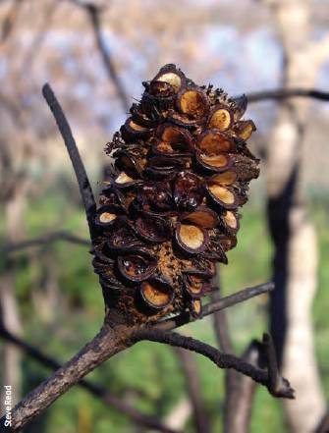
Banksia seed pod open after a fire event, Scamander, Tasmania.

Key findings
Key findings are a condensed version of the Key points presented at the start of individual indicators in this criterion.
Forest health
- In general, native insect pests and pathogens caused only low-severity damage to forest ecosystems over the reporting period. Most of the observed damage to forests was caused by exotic pests and pathogens that have become established in Australia. Occasional outbreaks caused damage that adversely affected commercial values, particularly in plantations.
- Quambalaria shoot blight caused damage in spotted gum plantations in Queensland, and fungal leaf pathogens caused occasional significant defoliation in plantations in Tasmania, Victoria, Queensland and Western Australia. Teratosphaeria (Kirramyces) leaf spot emerged as a major problem for eucalypt plantation establishment in the central-coast region of Queensland. Spotted gum canker became a health issue for Corymbia species in New South Wales. Spring needle cast remained one of the major problems affecting the radiata pine plantation estate, and Dothistroma needle blight had an impact on radiata pine plantations in Victoria and New South Wales.
- Phytophthora cinnamomi and a number of other Phytophthora species remained a threat to a wide range of plant species, predominantly in regions with an average annual rainfall of more than 600 millimetres. Spread of this pathogen is controlled with soil and water hygiene protocols, monitoring of quarries used in road-building, intensive monitoring to designate disease risk areas, and the use of management zones to protect threatened flora.
- Myrtle rust (Puccinia psidii), a strain of guava or eucalypt rust, established and spread in New South Wales, Queensland and Victoria. Rust spores can be spread by the wind, and myrtle rust has a wide host range within the Myrtaceae family, but the likely impact of myrtle rust on Australia's forests is still unclear.
- A number of tropical cyclones caused significant damage to native forests and plantations in Queensland during the reporting period, including cyclone Larry in March 2006, cyclone Ului in March 2010, and cyclone Yasi in February 2011. Cyclone Yasi was the largest and most powerful on the eastern coast of Australia since 1918, and the extensive cyclone damage impacted industry confidence in the viability of future forest plantations in coastal regions of Queensland.
- Native and plantation forests affected by drought, fire and cyclones were colonised by pests such as bark beetles and ambrosia beetles during the reporting period. The pine-killing Sirex wood wasp remained a significant issue, although it had only localised adverse impacts. Sirex was detected for the first time in Queensland in this reporting period.
- Drought affected large areas of the south-eastern states of Australia during much of the early part of the reporting period, and large areas of Western Australia for most of the reporting period, with significant impacts on forest health. Projected drier and warmer conditions in the rest of this century and beyond could make forests more susceptible to some pests and diseases.
- The Australian plantation industry is a significant user of biological control agents. Chemical pest and disease control methods used in plantations are highly regulated, and the Australian plantation forestry sector has been estimated to spend less than 1% of the total Australian spending on pesticides.
Fire
- An estimated 39.0 million hectares of forest was burnt by fire in Australia in the period 2006-07 to 2010-11. This estimate combines data derived from MODIS satellite imagery for northern Australia, with data provided by states and territories for southern Australia, and includes some areas of northern Australia that were burnt more than once during this period. A total of 77% of the forest area burnt was in the Northern Territory and Queensland. The reported forest area burnt increased by 14.3 million hectares compared with 2001-02 to 2005-06, with the increase mostly in the Northern Territory and Queensland.
- From 2006-07 to 2010-11, unplanned fires (wildfire) burnt an estimated 31.6 million hectares (81% of total forest burnt), and planned fires burnt an estimated 7.4 million hectares of forest (19% of total forest burnt).
- In southern Australia, all states and the ACT experienced serious bushfires over the reporting period. The most extensive bushfire activity was in Victoria, especially areas near Melbourne, with the Black Saturday bushfire of 2009 being exceptionally serious.
- Projected climate change could exacerbate the risk and impact of unplanned fire, and reduce the seasonal time 'window' in which planned fires can be used for management, especially in southern Australia. National fire research priorities are identified in the National Bushfire Management Policy Statement for Forests and Rangelands.
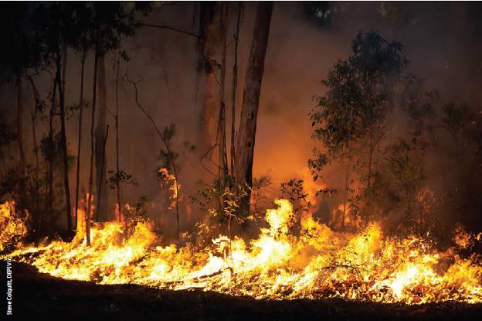
A planned fuel reduction burn in native production forest in Victoria.

Indicator 3.1a Scale and impact of agents and processes affecting forest health and vitality
Rationale
This indicator identifies the scale and impact on forest health of a variety of processes and agents, both natural and human-induced. Through the regular collection of this information, significant changes to the health and vitality of forest ecosystems can be monitored and measured.

Key points
- Damage to forest ecosystems from most native insect pests and pathogens over the reporting period has usually been of low severity but sometimes widespread in extent. Most of the observed damage to forests was caused by exotic pests and pathogens that have become established in Australia. Occasional outbreaks and epidemics occurred over the reporting period, with the resultant damage adversely affecting commercial values, particularly in plantations.
- Quambalaria shoot blight caused damage in spotted gum plantations in Queensland, while fungal leaf pathogens caused occasional significant defoliation in hardwood plantations in Tasmania, Victoria, Queensland and Western Australia. Teratosphaeria (Kirramyces) leaf spot emerged as a major problem for eucalypt plantation establishment in the central coast region of Queensland. Spotted gum canker became a health issue for Corymbia species in New South Wales. Spring needle cast remained one of the major problems affecting the radiata pine plantation estate, while Dothistroma needle blight affected radiata pine plantations in Victoria and New South Wales.
- Phytophthora cinnamomi and a number of other Phytophthora species remained a threat to a wide range of plant species, predominantly in regions with an annual rainfall of more than 600 millimetres. Spread of the pathogen is controlled with soil and water hygiene protocols, monitoring of quarries for Phytophthora, intensive monitoring to designate disease-risk areas, and the use of management zones to protect threatened flora.
- Myrtle rust (Puccinia psidii), a strain of guava rust or eucalypt rust, has entered, established and spread in New South Wales, Queensland and Victoria. Myrtle rust, which was initially detected in nurseries, is spreading rapidly to new areas, including bushland. The rust spores are predominantly disseminated by wind, and the pathogen has a wide host range within the Myrtaceae.
- Drought affected large areas of the south-eastern states of Australia during much of the early part of the reporting period, and large areas of Western Australia for most of the reporting period, with significant impacts on forest health. Drought also contributed to a series of intense wildfires that affected large areas of forest in south-eastern and western parts of Australia.
- A number of tropical cyclones caused significant damage to native forests and plantations in Queensland during the reporting period, including cyclone Larry in March 2006, cyclone Ului in March 2010, and cyclone Yasi in February 2011. Cyclone Yasi was the largest and most powerful on the eastern coast of Australia since 1918, and the extensive cyclone damage impacted industry confidence in the viability of future forest plantations in coastal regions of Queensland.
- Native and plantation trees that were stressed, dead or dying as a result of drought, fire and cyclones were colonised in increasing numbers by pests such as bark beetle (yps grandicollis) and a range of ambrosia beetles. The pine-killing Sirex wood wasp (Sirex noctilio) remained a significant issue in Pinus radiata plantations, although it had only localised adverse impacts. Sirex was detected for the first time in Queensland in this reporting period. The death of bait trees caused by the combination of drought and bark beetle attacks caused concerns about the effectiveness of biological control agents in controlling Sirex wood wasp.
- The Australian plantation industry is a significant user of biological control agents, such as several species of parasitoid wasps, for control of insect pests. Chemical pest and disease control methods used in plantations are highly regulated, and the Australian plantation forestry sector has been estimated to spend less than 1% of the total Australian spending on pesticides.
This indicator addresses the factors affecting the health and vitality of Australia's native forests and plantations. It focuses on the impacts of vertebrates, invertebrates, pathogens and weeds on forest health, but also covers other potentially damaging processes, such as drought, river regulation, soil changes, extreme climatic events and climate change. The active management of these agents in forests is directed mainly towards protecting commercial values in multiple-use public and private native and planted forests, and biodiversity and other forest values in all forests. It is important to note that many pests and diseases, particularly native ones, show cyclical patterns of impact and are generally of minor concern.
Some key quarantine pests and pathogens of concern for Australian forests are not currently present in Australia (Plant Health Australia 2007), and so are not covered in this indicator. These include burning moth (Hylesia nigricans), gypsy moth complex (Lymantria dispar), mountain pine beetle (Dendroctonusponderosae), nun moth (Lymantria monacha), pine sawyer beetles (Monochamus spp.), pine shoot beetle (Tomicuspiniperda), red turpentine beetle (Dendroctonus valens), subterranean termite (Coptotermes spp.), white-spotted tussock moth (Orgyia thyellina), pinewood nematode (Bursaphelenchus xylophilus), dano foliar del pino (Phytophthora pinifolia), eucalyptus cankers (Chrysoporthe austroafricana, Teratosphaeria zululensis and T. gauchensis), other strains of guava rust or eucalypt rust (Puccinia psidii), sudden oak death (Phytophthora ramorum), pine pitch canker (Fusarium circinatum), and western gall rust (Endocronartium harknessii). Australia's biosecurity measures aim to minimise the risk of introduction, establishment and spread of new exotic pests and pathogens, and to eradicate or manage incursions of introduced organisms.
The wide range of pests already present in Australia, including vertebrates, invertebrates (mainly insects), pathogens and weeds, that may affect forest health and vitality were described in SOFR 2008 in some detail, as were many other threatening processes. SOFR 2013 provides an update on the status of threats to forest health and vitality, and key events and trends over the period 2006—11.
Like most agricultural enterprises, plantation forestry uses pesticides for forest protection and to improve production. The Australian Pesticides and Veterinary Medicines Authority controls pesticide registration in a consistent manner across forestry and agriculture. Forestry relies mainly on pesticides developed for agricultural crops because the plantation forestry industry is too small to warrant the cost of specialised pesticide development and registration. The Australian plantation forestry sector was estimated to spend less than 1% of the total Australian spending on pesticides (Jenkins and Tomkins 2006).
Forest health surveillance systems in Australia were described in SOFR 2008. Further information on forest health surveillance in the states and territories was published in a series of papers in special issues of Australian Forestry (Carnegie 2008) and for Western Australia's Forestcheck program (McCaw et al. 2011). Most states and territories conduct annual surveys of forest plantations, but only limited surveys, or none, are conducted in native forests. In Victoria, ground-based plots for monitoring plantation forest health were established in 2001, and formalised aerial health surveillance of plantations was carried out for the first time in 2010—11. The Australian Capital Territory continued to monitor plantation forest health through aerial and on-ground observations; no significant health impacts were recorded over the monitoring period.

Vertebrate pests
Native and introduced vertebrate animals can damage native forests and plantations—for example, by browsing vegetation, by ring-barking saplings and trees, and by undermining, excavating and chewing root systems. These activities can contribute to soil erosion, increase competition for food and habitat. Introduced animals can also kill native fauna, and can act as vectors for pathogens.
Threat abatement plans have been developed for some vertebrate pest animals, such as rabbits, foxes, cats, pigs and goats. The plans address these species, which are listed as key threatening processes to nationally threatened species and endangered ecological communities.

Native vertebrate species
Kangaroos, wallabies and possums continued to have an adverse impact in multiple-use public forests in most states and territories, particularly by grazing on seedlings in the early stages of forest regeneration and planting. In Tasmania, bark stripping by wallabies in 3 to 6-year-old pine plantations increased in this reporting period and remains a widespread problem. Possums continued to cause localised top death in mid- to late-rotation pine plantations (especially near Bombala in southern New South Wales), affecting tree form. Localised bark stripping and branch breakage caused by possums were also seen in a limited number of young shining gum (Eucalyptus nitens) plantations. Local populations of E. gunnii and E. gunnii subsp. divaricata in Tasmania experienced severe dieback and mortality following heavy possum browsing and drought episodes during the early 2000s. Remedial treatment involving caging and fencing of sites that have sufficient regeneration has generally given good results. In Victoria, significant damage by koalas was recorded in restricted areas of nature conservation reserves. In Queensland, the pale field rat (Rattus tunneyi var. culmorum) caused damage to young Araucaria cunninghamii (hoop pine) plantations, through excavating around root systems, and girdling of roots and stems.
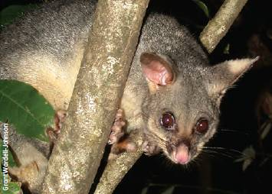
Common brushtail possum (Trichosurus vulpecula).
In Western Australia, Australian Ringnecks (Barnardius zonarius semitorquatus, locally known as Port Lincoln parrots or Twenty-eights) continued to cause localised damage to seedlings and blue-gum (Eucalyptus globulus) plantations. Bark was peeled off young trees, and tops were snapped, leading to poor form or death. As a result of drought and lack of feed, the parrots were found in large numbers in blue-gum plantations in areas north of Mount Barker and west to Busselton, with 3200 hectares of plantations showing sign of moderate to severe damage in 2010-11. Bell miner-associated dieback continued to be observed in some plantations and native forests in New South Wales, especially on E. grandis, E. dunnii and E. saligna.

Exotic vertebrate species
Some introduced species, such as rabbits, foxes, pigs, deer and cats, continued to cause major damage in forests and to the environment generally (Hart and Bomford 2006). Examples are given below.
Rabbit numbers increased in Australia over the reporting period as resistance to rabbit haemorrhagic disease (rabbit calicivirus, introduced in 1995) developed, and as successive wet seasons increased feed. Rabbits caused significant issues in South Australia and Victoria.
Foxes had a high adverse impact in forests in all mainland states and territories except the Northern Territory, and cats were also a significant problem in many jurisdictions. Deer populations continued to increase in South Australia and Victoria. Pigs continued to have an adverse impact in some forest areas in south-west Western Australia.
Cane toads continued to be a problem in Queensland, and moved westwards across the Northern Territory and entered north-eastern Western Australia during 2008-09. Cane toads also moved southwards into northern New South Wales.

Invertebrate pests
A range of invertebrate (mainly insect) pests were recorded in Australian plantations and native forests.

Insect pests affecting hardwood plantations
Species of the chrysomelid leaf beetles Paropsis and Paropsisterna (formerly Chrysophtharta) continued to cause damage in eucalypt forests and plantations Australia-wide. The most destructive chrysomelid species was Paropsisterna cloelia on E. dunnii plantations in south-east Queensland. In subtropical areas of Queensland, Paropsis atomaria remained a major insect pest risk, while in Tasmania Paropsisterna spp. continued to cause significant damage to eucalypt plantations and required an ongoing, extensive integrated pest management program. In Western Australia, the distribution of Paropsisterna m-fuscum expanded westward.
Autumn gum moths (Mnesampela privata) were present in most states and territories and caused widespread damage to juvenile or young adult eucalypt foliage: young larvae skeletonised the leaf, and older larvae ate the whole leaf, rapidly defoliating trees. Populations of autumn gum moths, although widespread throughout Tasmania, were rarely high enough to cause significant defoliation. Damage by the gumleaf skeletoniser (Uraba lugens) in eucalypt plantations in Tasmania was usually restricted to edge trees.
Shothole miner (Perthida spp.) caused increasing damage in blue-gum plantations across the whole of the Green Triangle region in South Australia, and was identified in Victoria as far east as Ballarat. The psyllid Creiis lituratus was a threat to young E. dunnii plantations in northern New South Wales, causing significant damage in both young (1 to 2-year-old) and older (5 to 8-year-old) stands in 2007. Tent leafhopper (Kahaono spp.) was an emerging problem for Corymbia hybrids in the South Burnett region of Queensland, although it is not expected to have a significant effect on tree growth rates. Sawflies and weevils continued to cause damage in some areas in South Australia, with the eucalypt weevil (Gonipterus scutellatus) causing significant localised damage in 2010-11 in some young eucalypt plantations. Steel-blue sawfly (Perga spp.) caused some damage to plantation and native forest in the western and Gippsland regions of Victoria, and the psyllid Cardiaspina squamula caused moderate defoliation of roadside E. dalrympleana in the upper Derwent Valley in Tasmania during the summer of 2010.

Insect pests affecting softwood plantations
The pine-killing Sirex wood wasp (Sirex noctilio) remained a significant issue in Pinus radiata plantations. Although Sirex was widespread in distribution across most planted areas, it had only localised adverse impacts, with its impact being minimised through biological control agents. Sirex usually attacked stressed trees, and numbers high enough to cause significant tree mortality generally did not occur in vigorous, healthy stands. In the past, however, serious Sirex outbreaks have killed several million trees in P. radiata plantations in several states (SOFR 2008). The National Sirex Control Strategy encourages an integrated pest management approach that aims to keep Sirex populations low by the release of virulent strains of the nematode Beddingia siricidicola, as well as a range of parasitoid wasps, as biological controls, and by encouraging optimal plantation thinning practices and site selection to minimise the occurrence of stressed trees in areas at risk.
In New South Wales, several plantations in the Murray Valley region suffered sustained Sirex attacks from 2006 onwards, with up to 500 hectares affected, mainly in unthinned stands. In Victoria, small areas in the north-east of the state had higher than acceptable levels of Sirex damage in 2010. These areas were scheduled for early thinning, and inoculation with nematode (Kamona strain) in areas not yet thinned. In this reporting period, Sirex was found for the first time in Queensland in 2009, and the increasing number of Sirex detections in Pinus radiata and P. taeda plantations in the southern border region of Queensland is a major health concern for pine plantations in that state. Western Australia remains free from Sirex, and annual surveillance trapping occurs in the flight season across the pine estate. The Australian Capital Territory continued to monitor Sirex levels, and to introduce biological control nematodes into bait or trap trees.
Monterey pine aphid (Essigella californica) was widespread and caused significant damage in most P. radiata plantation areas in New South Wales. Mid-rotation to preharvest plantations were the most severely affected, and plantations in the Murray Valley and Central Tablelands were the most severely impacted. The area affected by the aphids decreased over the reporting period, with 47%, 32%, 21% and 9 % of the New South Wales estate affected in 2007, 2008, 2009 and 2010, respectively. New South Wales, like all other eastern states, now uses a biological control program to manage Monterey pine aphid, with the parasitoid wasp Diaeretus essigellae being released into plantations over the past couple of years.
In South Australia, Monterey pine aphid remained a particular focus for control as higher numbers caused increased defoliation, including widespread significant damage in the Green Triangle region. Older plantations were most affected. In Victoria, Monterey pine aphid remained a concern for radiata pine plantations. In Tasmania, significant defoliation caused by Monterey pine aphid was restricted to localised areas in the Plenty Valley between 2006 and 2008. Monterey pine aphid was widespread in Western Australia, but numbers were consistently low and no damage to plantations was attributed to this pest.
The five-spined bark beetle (Ips grandicollis) has been present in Australia for at least 60 years. It occurs in all mainland states and the Australian Capital Territory, and is able to infest all plantation pine species grown in Australia (SOFR 2008). Population levels build primarily on fresh logging debris or in standing trees that are damaged (e.g. after fire) or severely stressed (e.g. after drought). High beetle numbers, particularly in trees in overstocked stands during periods of drought, can result in tree death. The beetle also acts as a vector for blue-stain fungi such as Ophiostoma ips. The parasitoids Roptrocerus xylophagorum and Dendrosoter sulcatus were introduced into Australia in the 1980s to limit numbers of the five-spined bark beetle.
In New South Wales, a significant and sustained outbreak of bark beetles in 2007 was associated with widespread tree mortality linked to drought; more than 17 thousand hectares were affected. Management included developing drought-risk maps (using historical forest health data and environmental and silvicultural data to develop drought-risk models) and site-specific silviculture (e.g. thinning regimes). In South Australia, I. grandicollis caused damage in mid-north pine plantations, as drought and high slash residue levels after clear-felling near young plantations led to build-up of the pest. In 2007, bark beetles caused death of trees (including healthy trees) in several plantations in the south-east of South Australia and significant deaths in some older plantations near Mount Gambier. I. grandicollis was not observed as a significant pest in Victoria—only two small localised areas in north-east and south-west Victoria were affected.
In south-east Queensland, I. grandicollis infected drought-affected and fire-scorched trees in coastal southern pine plantations, although rapid subsequent harvesting circumvented most production losses. Ambrosia beetles were commonly associated with delayed harvesting of felled and damaged timber, and at times defoliated adjacent Araucaria plantations and Araucaria in retained native vegetation, although the majority of defoliated trees recovered. In north Queensland, populations of the pin-hole borer (Truncaudum agnatum) expanded following damage to Caribbean pine (Pinus caribaea var. hondurensis) plantations by tropical cyclone Yasi in February 2011. Visual pin-hole damage and associated fungal staining caused by these and other beetles reduced recovered log values. Cacao armyworm (Tiracola plagiata) caterpillar defoliated large areas of young plantation Araucaria in south-east Queensland in 2010. Control was possible with aerial application of insecticide, as well as natural control through the parasitoid wasp Lissopimpla excelsa.
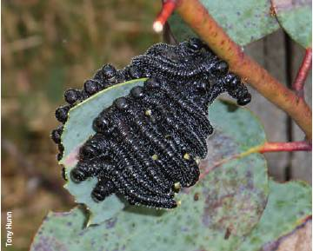
Larvae of Australian sawfly (Perga sp.).
The European house borer (Hylotrupes bajulus) was first detected in Western Australia in 2004 (SOFR 2008). This insect is a destructive pest of seasoned coniferous timber, including pine and oregon, and can cause major structural damage to buildings. Measures being taken to contain European house borer included regulations to control movement of seasoned pine, surveys to detect new infestations, better detection methods, removal and destruction of infested materials, and a communication program for the public and the building industry. Eradication activities for European house borer transitioned to ongoing management in 2011.
An outbreak of the native geometrid moth (Chlenias sp., 'pine looper') in 2009-10 completely defoliated more than 100 hectares of mature pine plantations in Tasmania at Pittwater, north-east of Hobart.

Insect pests affecting native forests
The gumleaf skeletoniser (Uraba lugens) causes widespread and severe defoliation of natural eucalypt stands across a range of climatic and vegetation types, but generally few trees die. Regional outbreaks tend to occur on a 5—10-year cycle (SOFR 2008). An outbreak of gumleaf skeletoniser occurred in southern Western Australia in 2009-11, causing moderate to severe temporary defoliation on extensive areas of forest. Outbreaks also occurred in Tasmania, Queensland and Victoria.
In Tasmania, several hundred hectares of peppermint forest (Eucalyptus amygdalina, E. tenuiramis and E. pulchella) near Hobart suffered near-complete defoliation by the cup moth (Doratifera oxleyi) in autumn 2010. The psyllid Cardiaspina squamula caused moderate defoliation of roadside E. dalrympleana in the upper Derwent Valley during the summer of 2010. In Victoria, significant cup moth defoliation was observed across the southern areas of the state, primarily in east Gippsland and the Otway Ranges. Damage (including dieback and tree mortality in severe cases) from Cardiaspina psyllids was widespread in remnant bushland areas and native forests in northern New South Wales and western Sydney. In Western Australia, bark and wood-boring beetles colonised more than 80% of jarrah and marri trees within selected sample plots of drought-affected forests in the Northern Jarrah Forest in the reporting period. Other important insect pests of native eucalypts included shothole miner (Pertha spp.) and spurlegged phasmatid or stick insect (Didymuria violescens). In the Australian Capital Territory, European wasp (Vespula germanica) was widespread and sometimes locally abundant in the forests of Namadgi National Park and Tidbinbilla Nature Reserve.

Pathogens
With the exception of the exotic soilborne and waterborne root-rotting pathogen Phytophthora cinnamomi, the pathogens significantly affecting native forests and plantations of native tree species continued to be indigenous plant pathogens.

Pathogens affecting hardwood plantations
Quambalaria shoot blight (Quambalaria pitereka) continued to cause major damage in spotted gum (Corymbia citriodora subsp. variegata) plantations in Queensland, and limits expansion of Corymbia plantations. Selection for resistance, supported by industry funding, has begun in Queensland.
The fungal leaf pathogens Teratosphaeria spp. (formerly Mycosphaerella spp.) can occasionally cause severe defoliation and shoot death in eucalypt plantations when moist, humid conditions coincide with periods of active growth. E. globulus plantations in the juvenile foliage phase are particularly susceptible to Teratosphaeria nubilosa, and planting of this species in high-risk areas, such as northern Tasmania, was discontinued in the early 2000s. Research has since shown that young E. globulus plantations can quickly recover growth after severe epidemics; in addition, resistance in E. globulus is under moderate genetic control, and heritability is stable across sites.
Conditions for epidemic leaf disease (unusually high regional summer and autumn rainfall) were widespread across northern and eastern Tasmania during the 2009—10 and 2010—11 seasons, and 2000 hectares of predominantly E. nitens plantations in these regions suffered defoliation at levels likely to cause significant growth reductions. Mycosphaerella leaf spot and target leaf spot (Aulographina eucalypti) also caused localised damage across Victoria. In Western Australia, E. globulus plantations in the Denbarker and Mount Barker areas were most affected by Teratosphaeria spp. Most damaging of the Mycosphaerella species was M. heimii (previously unknown in Australia) on E. dunnii plantations in south-east Queensland.
Teratosphaeria or Kirramyces leaf spot (Teratosphaeria pseudoeucalypti) emerged as a major problem for eucalypt plantation establishment (especially of E. grandis x E. camaldulensis hybrids, and E. grandis) in the central coast region of Queensland, resulting in plantations in this region being written off. In Victoria, Teratosphaeria eucalypti (Septoria leaf blight) caused significant defoliation of shining gum (E. nitens) in the Otway Ranges and Gippsland regions in 2010—11 as a result ofwet and warm conditions.
Spotted gum canker (Caliciopsis pleomorpha and other Caliciopsis spp.) emerged as a health issue for Corymbia species in New South Wales and Queensland and caused significant losses in some plantations. Stem canker (Caliciopsis spp.) was found in Queensland on E. grandis hybrids, E. dunnii plantation species and non-plantation eucalypts. Canker pathogens, including Holocryphia eucalypti, Neofusicoccum ribis and Cytospora eucalypticola, were common in young (1 to 2-year-old) E. dunnii plantations in southern Queensland, with H. eucalypti identified as the causal pathogen of 'sudden death syndrome' and the only pathogen observed to be capable of rapid killing of its host (Whyte 2012). Stem canker (possibly Fusarium solani) causing dieback was an issue for teak plantations in Tully and Babinda in north Queensland.
The soilborne root-rot pathogen Phytophthora cinnamomi remained a threat to young E. nitens plantations on infertile sites across lowland northern Tasmania, although mortality rarely reached levels that necessitated replanting. An elevated incidence of windthrow in plantations that had suffered mortality from P. cinnamomi when younger suggests the possibility of ongoing root damage in surviving trees.

Pathogens affecting softwood plantations
Spring needle cast caused by the fungus Cyclaneusma minus remained one of the major problems affecting the pine plantation estate in New South Wales, Victoria and Tasmania. The impact is managed using alternative silvicultural regimes and more resistant genetic material.
In 2007, Diplodia canker (Diplodiapint) affected many Pinus radiata plantations in the south-east of South Australia. Top death due to D. pini infection of drought-affected plantations was widespread in north-eastern Tasmania, peaking in 2006-07, and then contracting over the following four seasons. In Victoria, observed Diplodia damage was generally confined to two areas in central and north-east Victoria; the damage recorded was minor and generally confined to either individual trees or small groups of trees.
An outbreak of Dothistroma needle blight (Dothistroma septosporum) in radiata pine occurred in Victoria and in Murray Valley plantations in New South Wales following above-average rainfall in 2010—11 and warm conditions. Dothistroma needle blight remains a significant issue on the Northern Tablelands in New South Wales, with up to 2000 hectares severely affected annually, and had an impact on a small, high-altitude radiata pine plantation in south-east Queensland. The pathogen remained restricted to localised hotspots in north-eastern Tasmania; damage intensified in these hotspots in 2010—12 following above-average summer rainfall, but control remains unnecessary. Low levels of suspected Dothistroma infection were reported in the Australian Capital Territory.

Pathogens affecting native forests
Phytophthora cinnamomi and a number of other Phytophthora species affect and kill a wide range of plant species in all states and territories, predominantly in regions with an annual rainfall of more than 600 millimetres (SOFR 2008). The most significant impacts are on biodiversity. P. cinnamomi is listed as a 'key threatening process' under the Environment Protection and Biodiversity Conservation Act 1999, and a national threat abatement plan was released in 2001. Spread of the pathogen is controlled with soil and water hygiene protocols, and use of management zones to protect threatened flora.
P. cinnamomi remains the most significant biotic threat to the health of native forests in Tasmania, with three significant new extensions to its known distribution. The movement of contaminated gravel for road and other construction is a major mechanism of spread of P. cinnamomi. Road-construction quarries on state forests and, increasingly, other land are monitored to determine if Phytophthora spp. are present, and materials are sourced from quarries determined to be free from Phytophthora. In Victoria, P. cinnamomi activity has increased as the state recovered from significant drought conditions. In the Australian Capital Territory, P. cinnamomi was recorded adjacent to Namadgi National Park in an old pine forest, with the main species affected being grass trees (Xanthorrhoea species). As many as 2300 of the estimated 5710 native plant species in south-west Western Australia are susceptible to P. cinnamomi. Intensive monitoring is undertaken to identify its distribution in commercial forests and conservation areas, and to designate 'disease risk areas' in which special measures apply to minimise the risk of infection.
Root and butt rots caused by Armillaria species, most significantly A. luteobubalina in eucalypt forest in southern Australia and south-west Western Australia, cause small patch deaths of a range of species. Armillaria root rot was the most notable native disease affecting native forest in Tasmania. Particularly active disease foci developed in the forest surrounding the Tahune Airwalk in southern Tasmania, and many mature celery-top pine (Phyllocladus aspleniifolius) died in the reporting period. Armillaria root rot also caused scattered mortality of blackwood (Acacia melanoxylon) regeneration in a research trial in the Circular Head area in Tasmania.
In Tasmania, myrtle wilt caused by the native pathogen Chalara australis was the most significant factor affecting the health and vitality of rainforest dominated by Nothofagus cunninghamii. Myrtle wilt continued to cause some deaths of mature N. cunninghamii in rainforests across Victoria, although at low levels.
The most significant new incursion of a fungal pathogen into Australia during the reporting period was myrtle rust (Puccinia psidii s.l.), a strain of guava or eucalypt rust. Myrtle rust is now widespread in New South Wales and Queensland and spreading in Victoria, in bushland areas as well as in nurseries and on cultivated trees, and is a potential threat to forests, forestry and forest based industries. Management measures are still being developed to contain the spread of the disease. More details are given in Case study 3.1.
In Western Australia, Quambalaria coyrecup caused the decline and death of marri (Corymbia calophylla) trees in some areas, and has the potential to emerge as a significant threat in some parts of the state. Rigidoporus vinctus and Phellinus noxius killed a low, but increasing, number of trees in Queensland, including young hoop pine (Araucaria cunninghamii), rainforest species, eucalypts and Acacia species, especially in regrowth forests or second-rotation plantations. Various species of native gall or phyllode rust fungi (Racospermyces and Uromycladium) affected Acacia species, sometimes with severe defoliation and effects on form. Impacts on natural stands are usually ephemeral, but impacts on Acacia mangium plantations in northern Australia have led to investigations into disease-resistant varieties.

Dieback and other syndromes in native forests
A wide range of chronic or episodic crown dieback syndromes occur to some degree in native forests in all states and territories, often causing significant tree mortality and associated ecosystem impacts. They are usually caused by combinations of factors such as climatic stresses, poor land-management practices, severe insect attacks and an imbalance in insect predator levels. Pathogenic fungi are not usually the primary causal agents, but canker-causing fungi, including Holochryphia eucalypti (formerly Endothia gyrosa) in Western Australia and New South Wales, and Botryosphaeria species in New South Wales, often have a secondary role.
The identification of syndromes and their causal agents is often difficult and, because a wide range of land tenures is also involved, there are impediments to the effective delineation of the areas affected. For example, 'Mundulla yellows' is a progressive and complex dieback condition that is often fatal in eucalypts and also affects a range of other tree species. It is characterised by distinctive intervein yellowing of foliage, and occurs most commonly along road verges and in paddock environments, as well as in some urban plantings. It is especially common in the south-east of South Australia, but similar symptoms are recognised to varying extents in most states and territories. Attempts to find a causal biotic agent have failed; it has been suggested that the symptoms of Mundulla yellows are actually the symptoms of a lime-induced chlorosis (Parsons and Uren 2007).

Weeds
More than 2700 exotic plant species have become established as pests in Australia. Species such as blackberry (Rubus fruticosus and other Rubus spp.) and lantana (Lantana camara) compete with native flora and can become locally dominant, reducing biodiversity and other values; they can also affect tree establishment, growth and product yield in commercial forest plantations and native forests, and reduce the ease of human access. Several exotic plants common in Australian forests are listed as Weeds of National Significance under the Australian Weeds Strategy.
In the Australian Capital Territory, blackberry spread from a major infestation in a pine plantation destroyed by the 2003 fires into montane eucalypt forests in the northern Namadgi National Park, Brindabella National Park and Bimberi Nature Reserve. Blackberry remained one of the main environmental weeds in wetter forest types in Tidbinbilla Nature Reserve. African love grass (Eragrostis curvula) and serrated tussock (Nassella trichotoma) were among the main environmental weeds in drier forest types in the Naas Valley and northern Clear Range, within and adjacent to Namadgi National Park. A number of new weed incursions in mountain forests in Namadgi National Park were contained, including Mexican grass (N tenuissima), ox-eye daisy (Leucanthemum vulgare) and Shasta daisy (L. maximum).
Blackberry, lantana, boneseed (Chrysanthemoides monilifera subsp. monilifera), gorse (Ulex europaeus) and water hyacinth (Eichhornia crassipes) are significant issues in New South Wales, while gamba grass (Andropogongayanus), giant mimosa (Mimosa pigra) and bellyache bush ( Jatropha gossypiifolia) are significant issues in the Northern Territory.
Lantana (Lantana camara), a shrub native to Central and South America that is a noxious weed in Australia with impacts on both native and plantation forests.
In Queensland cat-claw creeper (Macfadyena unguis-cati) was an increasing threat to plant biodiversity within a wide range of forest habitats from plantations to native forests, in particular riparian zones within Araucaria plantations. The leaf-tying moth (Hypocosmia pyrochroma) and the leaf mining jewel beetle (Hylaeogena jureceki), biological control agents specific for cat's claw creeper, have been released in south-east Queensland.
In South Australia, sallow wattle (Acacia longifolia) decreases biodiversity and habitat opportunities, and obstructs access for management in plantation forests. Asparagus weeds, including bridal creeper (Asparagus asparagoides) and bridal veil (A. declinatus), smother native vegetation and plantation species and obstruct access for management. Reproduction through seed, spread by birds, and large, long-lived tuber masses make control difficult and expensive. Blackberry (Rubus fruticosus) is also a problem, producing thorny thickets that are difficult to penetrate for control activities and obstruct access for management in plantation forests. Olive (Olea europaea) is the worst weed in native forest in South Australia, because it replaces native trees and allows little understorey. Birds and mammals spread olive seeds widely from existing feral olive infestations and commercial olive groves.
Pine wildings, blackberry and bridal creeper are a problem in Victoria; management of pine wildlings is an ongoing challenge during return of the Delatite pine plantation to native vegetation. These weeds are addressed in parts of Victoria by the Australian Government's Caring for our Country program. In Tasmania, pine wildlings are a significant invasive threat in dry forests adjoining pine plantations, and rehabilitation of non-commercial pine plantations back to native forest has been undertaken in two plantation areas on state forest. Macquarie vine (Muehlenbeckia gunnii) has also emerged as a problem across Tasmania, having smothered a proportion of young trees across at least 129 hectares of plantation.
Widespread forest weeds requiring management in Western Australia included arum lily (Zantedeschia aethiopica), blackberry, bridal creeper, tea tree (Leptospermum spp.) and watsonia (Watsonia spp.), as well as gorse (Ulex europaeus), lantana and willow (Salix spp.) in more restricted areas.

Climatic events and climate change

Drought
The south-eastern states of Victoria and New South Wales experienced three years of drought from 2007 to 2010, which contributed to the severity of several major fires (see Indicator 3.1b). The drought broke when La Nina weather systems brought drenching rains to the region in late 2010. High levels of rain in the second half of 2009 reduced the impacts of drought experienced in previous years. Drought up to 2009 continued to affect forest health in South Australia, especially in the mid-north forests.
In Tasmania, Eucalyptus coccifera forests along the western edge of the Central Plateau have suffered severe dieback—a continuation of the syndrome that began in the late 1990s during a previous period of sustained drought. Drought also caused locally severe dieback of trees and understorey species in eastern, north-eastern and midlands Tasmanian forests; in some areas (e.g. the Waterhouse Conservation Area), forests have almost been eliminated. Forest trees affected include E. obliqua and E. amygdalina on ridges, E. risdonii and E. pauciflora on sands, and E. viminalis on dry sites, as well as Allocasuarina verticillata and some understorey species, such as the Tasmanian threatened species Mirbelia oxylobioides. In some eastern montane locations, pencil pine (Athrotaxis cupressoides) and King Billy pine (A. selaginoides) appear to be suffering dieback through gradual canopy thinning. However, the health of vegetation has improved, but not fully recovered, in many areas with the return to wet conditions in 2010. Drought conditions in Tasmania in 2006—08 also contributed to an increase in borer attack and subsequent mortality in mid-rotation plantations in drier areas of the state. Borer species involved included the wood moth (Culama australis) and longicorn beetles such as Epithora dorsalis and Phoracantha mastersi.
Very low rainfall, lowered groundwater levels and prolonged high temperatures led to widespread tree mortality on susceptible sites in south-west Western Australia over the reporting period. Extensive losses of pine plantations and impacts across vulnerable patches of forest in the Northern Jarrah Forest were observed during 2007—11, and had a major impact on forest productivity, biodiversity and visual amenity value. In coastal areas north of Perth, compartments of maritime pine (Pinus pinaster) plantations suffered losses up to 70%. Mortality was also observed in overstorey jarrah/marri (Eucalyptus marginata/Corymbia calophylla) and midstorey (Banksia grandis/Allocasuarina sp.) trees in native forest.
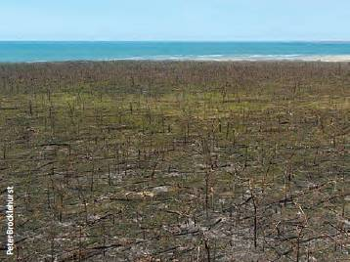
Cyclone damage to native forest in the Northern Territory.

Wind and storm damage
In Queensland, cyclone Larry in March 2006 affected Caribbean pine plantations on the coast from Ingham to Cardwell, and on the Atherton Tablelands west of Cairns. In March 2010, cyclone Ului damaged half the mature Caribbean pine plantations in Cathu State Forest near Proserpine. Immediate salvage of affected stems helped reduce the severity of the loss that could have occurred due to ambrosia beetles infesting cyclone-damaged trees.
In February 2011, cyclone Yasi destroyed thousands of hectares of forest trees along the north Queensland coast near Mission Beach. The cyclone, which was the largest and most powerful on the eastern coast of Australia since 1918, produced winds exceeding 163 kilometres per hour in coastal areas between Innisfail and Ingham. The extensive cyclone damage to forest trees has led to a decline in industry confidence in future forest plantations in the region. The extent of damage varied with species, genetics, species mixtures and planting pattern, tree age, stand management and site characteristics. Species considered to have superior resistance to cyclonic winds include silver quandong (Elaeocarpus grandis), Queensland maple (Flindersia brayleana), Gympie messmate (Eucalyptus cloeziana), flooded gum (E. grandis) and red mahogany (E. pellita) (Lindsay and Dickinson 2012).
In north-eastern Tasmania, strong wind was one of the most damaging factors for radiata pine in 2009—11, causing windthrow and stem breakage. Nearly 100 hectares suffered moderate to severe damage. In New South Wales and Victoria, wind damage occurred on 2294 hectares of softwood plantations in areas in the Murray Valley and east Gippsland—Bombala regions in 2010—11.
A severe wind event on 4 September 2010 and prevailing wet conditions resulted in windthrow damaging more than 130 hectares of softwood in ForestrySA's Bundaleer plantation in South Australia's mid-north; more than 20 thousand tonnes of timber were damaged.

Cold temperatures
Extreme low temperatures (—4 to —6 °C) led to rapid foliage and shoot mortality in marri and jarrah in the Northern Jarrah Forest in Western Australia in 2010—11. The damage was around drainage lines, which possibly acted as cold-air sinks.

Hail damage
In New South Wales, hail caused extensive damage in softwood plantations that led to 'dead topping' in 2010—11. In stands that were grown on, dead topping caused production of multi-leaders in recovering trees, and the trees were later downgraded because of development of blue stain in damaged wood.

Climate change
The nature of predicted climate change in Australia is complex when spatial and interannual variability is taken into account (CSIRO, Australian Bureau of Meteorology 2007). As described in SOFR 2008 (SOFR 2008), climate change of the magnitude predicted by some scenarios could have a profound effect on forests and forest production in Australia.
Climate modelling predicts that the productive capacity of forests will be affected by climate change in regions and subregions across Australia that are projected to receive lower rainfall and increased temperature. Potential increases in damage to forests by pests, diseases, weeds, fire, drought and severe cyclonic winds may also negatively affect forest health (ABARES 2011a, Select Carbon 2012). Projected increases in atmospheric levels of carbon dioxide may increase forest productivity or offset potential declines in forest productivity (ABARES 2011a).

River regulation
River regulation, overallocation of water resources and persistent drought have caused decline in river red gum (Eucalyptus camaldulensis) forest in the Murray—Darling Basin, with impacts on dependent industries and communities (Natural Resources Commission 2009). Large stands of river red gum in New South Wales and Victoria remain under ongoing long-term threat from water deficits.

Soil salinisation
Dryland salinity continues to be a widespread and growing problem in Australia. Although occurring predominantly on cleared agricultural land, it also affects adjacent forests. A contributing factor is historical widespread clearing of deep-rooted native tree species, causing watertables to rise and thereby mobilising salt in the soil (SOFR 2008). Catchments that are still largely forested are at less risk. Rehabilitation and salinity management may involve tree planting, and the regeneration and maintenance of native vegetation.

Soil acidification
Accelerated soil acidification involves formation of sulphuric acid when soils and sediments containing iron sulphides are drained or disturbed. It is a serious soil degradation problem across Australia (NLWRA 2001). The impact of forest plantations on soil acidity has yet to be examined in detail, and there are insufficient monitoring sites or measurements in soil profiles within forested lands to obtain baselines or trends for soil acidity in forests.
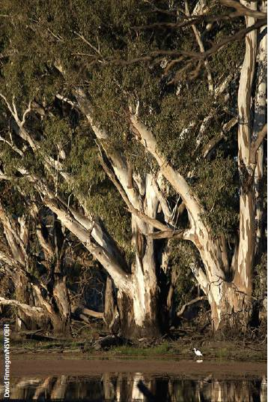
Mature river red gum (Eucalyptus camaldulensis) trees on the Murrumbidgee river, New South Wales.
Case study 3.1: Myrtle rust
Myrtle rust (Puccinia psidii s.l.), a strain of guava or eucalypt rust, was detected for the first time in Australia in April 2010 by a cut-flower grower on the central coast of New South Wales (Carnegie et al. 2010).
An emergency response was established to determine whether it was technically feasible to eradicate the rust. The response included surveys of a large number of nurseries, residential gardens and bushland sites; tracing plant movements to and from nurseries; destroying diseased material; establishing quarantine zones; and restricting interstate plant movements. However, rust spores are predominantly disseminated by air, and by December 2010 the rust had been detected on a large number of properties (nurseries and private gardens), spread to native bushland, and been identified on a large number of hosts in the Myrtaceae. Government agencies determined that eradication of the pathogen was not technically feasible, and the Australian Government invested $1.5 million for research to assist in the transition from the eradication program to ongoing management of the disease. This investment included developing information and tools to enable industries and communities to mitigate the impacts of the disease in urban, primary production and natural environments. Figure 3.1 shows the distribution of myrtle rust in New South Wales by Local Government Area.
Myrtle rust was detected in south-east Queensland in late 2010, and has since progressively spread north. It was first detected in and around Cairns in June 2012 (Pegg et al. 2012), and has been detected as far west as Toowoomba on the Great Dividing Range. The first detection of myrtle rust in Victoria was reported in December 2011, in a retail nursery on the Mornington Peninsula. The rust has spread progressively throughout Melbourne and to locations in regional Victoria, but is still restricted to nurseries, amenity plantings and urban backyards in that state. It was also recently found in a nursery in the Australian Capital Territory.
Figure 3.1: Distribution of myrtle rust in New South Wales by management zone (February 2012)
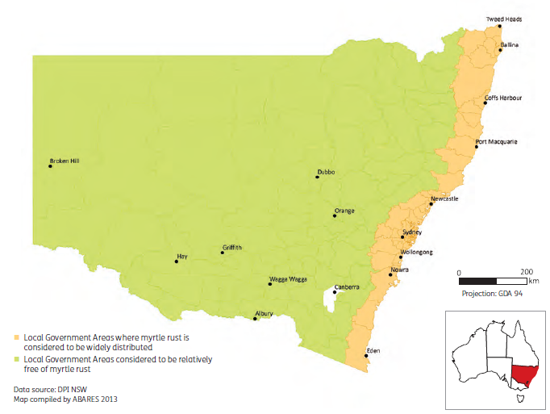
Myrtle rust is now established in native forests along the east coast of Australia, from Batemans Bay in southern New South Wales to the Daintree in far north Queensland. It occurs in a range of forest ecosystems, including coastal heath (Austromyrtus dulcis, Homoranthus spp.); coastal and river wetlands (Melaleuca quinquenervia); sand island ecosystems of Moreton, Stradbroke and Fraser islands; littoral, mountain temperate, subtropical and tropical rainforests (Rhodamnia spp., Rhodomyrtus spp.); and dry tropics around Mareeba in north Queensland. The disease has been detected in nurseries, urban and peri-urban environments, state forests and national parks, including World Heritage—or National Heritage—listed national parks (Royal, Gondwana, Fraser Island and Wet Tropics). Figure 3.2 shows the change in the distribution of myrtle rust in Queensland from 2011 to 2012.
Surveys since initial detection have shown a host range of more than 200 plant species in 41 genera of the Myrtaceae in New South Wales, Queensland and Victoria. Symptoms detected range from restricted leaf spots (Figure 3.3) to severe shoot and stem infection—with repeat infection resulting in tree dieback and plant death (Figures 3.4 and 3.5)—and infection also on flowers and fruit (Figure 3.6) (Coutinho et al. 1998). In Queensland, 9 species are considered extremely susceptible and 28 highly susceptible. Severe impact has been observed in several rainforest species, such as brush turpentine (Rhodamnia rubescens) and native guava (Rhodomyrtuspsidioides), stands of broad-leafed paperbark (Melaleuca quinquenervia), and some amenity species, including rose apple (Syzygium jambos).
Figure 3.2: Distribution of myrtle rust detections in Queensland in January 2011 and August 2012
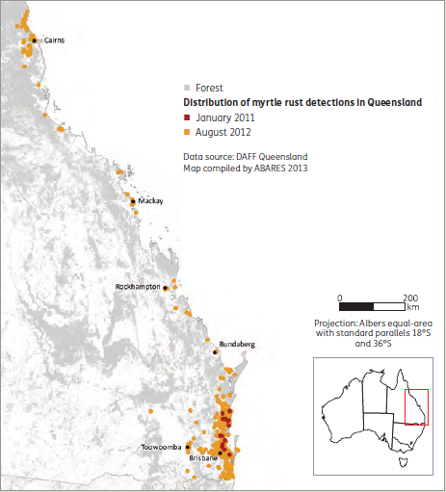
Note: Grey shading indicates forest.
Myrtle rust is a significant threat to Australia's native Myrtaceae. The overall impact on plant species or plant communities is not yet clear, and may not become evident for a number of years, and the level of natural resistance within populations of species in Australia is currently unknown. Observations since the first detection of myrtle rust suggest a number of species at risk of extinction, including Rhodamnia maideniana and the already rare and endangered R. angustifolia, Gossia gonoclada and Backhousia oligantha, all of which are highly or extremely susceptible to rust infection.
Preliminary studies have identified significant impacts of myrtle rust on regeneration ofMelaleuca quinquenervia, with repeat infection resulting in tree dieback, but more importantly a reduction in flower production and seed set. M. quinquenervia flowers during autumn and winter, providing shelter, breeding sites, food sources and nectar for mammals, birds, amphibians and insects—for example, the grey-headed flying fox (Pteropuspoliocephalus) and little red flying fox (P. scapulatus), which consume the flowers. Infection of flower buds, flowers and fruits has been observed in a further 17 species in Queensland, including Eugenia reinwardtiana and Rhodamnia sessiliflora, both of which are known food sources for the cassowary (Casuarius casuarius) (Coutinho et al. 1998).
Myrtle rust is likely to affect a range of industries that rely on the Myrtaceae, such as commercial nurseries and gardens, including the native cut-flower and native oil (lemon myrtle, Backhousia citriodora) industries; forestry and forest based industries, including beekeeping; and tea-tree oil production. Myrtle rust has been listed as a key biosecurity threat in several industry and national biosecurity plans.
A number of eucalypt species, including some of significance to the timber industry, have been identified as being susceptible, with infection found on seedlings in native forests and plantations. Susceptible species include Eucalyptus grandis, E. cloeziana, E. pilularis, E. agglomerata and Corymbia citriodora subsp. variegata. Surveys have revealed numerous young eucalypt plantations in New South Wales with myrtle rust, but the impact at this stage is minimal. However, many plantations are of an age at which infection is reported to be less frequent or in areas where reports of the disease have been restricted to nurseries (e.g. South Burnett in Queensland). Glasshouse studies suggest that species used in plantations are susceptible, with varying degrees of resistance within populations (Carnegie and Cooper 2011, Morin et al. 2012).
Current research is investigating the epidemiology and impact of myrtle rust in the native environment, identifying resistance in a range of Myrtaceae, and developing control options.
Figure 3.3: Restricted lesions caused by myrtle rust (Puccinia psidii s.l.) on older leaves of Eugenia reinwardtiana, Noosaville, Queensland
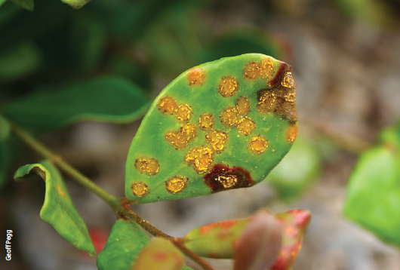
Figure 3.4: Shoot and stem of Melaleuca quinquenervia infected by myrtle rust (Puccinia psidii s.l.)
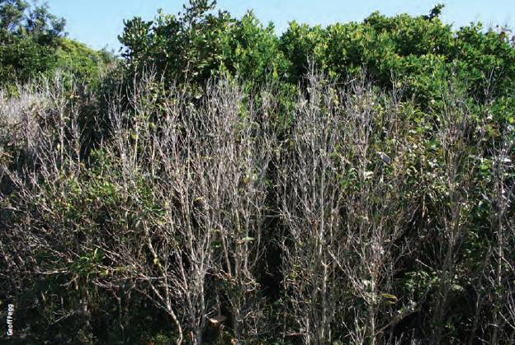
Figure 3.5: Dieback of Rhodomyrtus psidioides as a result of repeat infection by myrtle rust (Puccinia psidii s.l.), Byron Bay Lighthouse, Byron Bay, New South Wales
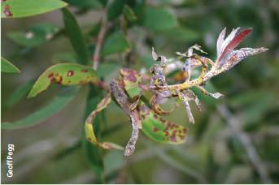
Figure 3.6: Fruit of Rhodamnia sessiliflora, a species native to far north Queensland, infected with myrtle rust
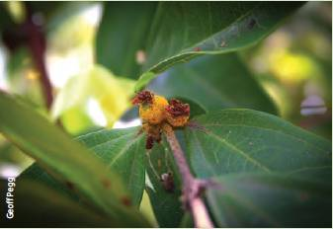

Indicator 3.1b Area of forest burnt by planned and unplanned fire
Rationale
This indicator is used to provide an understanding of the impact of fire on forests through the reporting of planned and unplanned fire. Fire is an important part of many forest ecosystems in Australia and may have either positive or negative impacts on forest health and vitality.

Key points
- In the period from 2006-07 to 2010-11, the estimated total area of forest burnt was 39.0 million hectares. This estimate was determined using a combination of data on fire extent derived from MODIS satellite imagery for northern Australia and data provided by states and territories for southern Australia. This represents an increase in reported fire area of 14.3 million hectares compared with the period 2001—02 to 2005—06, with the increase being mostly in the Northern Territory and Queensland. The area figure includes some areas of northern Australia that were burnt more than once from 2006—07 to 2010—11.
- Of the total, unplanned fires burnt an estimated 31.6 million hectares, and planned fires burnt an estimated 7.4 million hectares of forest.
- The largest areas of forest fire occurred in the Northern Territory and Queensland, which had a combined total of 77% of the area of Australia's forest that was burnt over the period 2006—07 to 2010—11. More than half the forest area burnt in Victoria over this period was burnt in the single year 2006—07.
- Data from the MODIS satellite (MODIS Burned Area product) suggested a total area of forest burnt of 33.7 million hectares over the period 2006—07 to 2010—11. Of this, an estimated 32.4 million hectares was in northern Australia and 1.3 million hectares was in southern Australia, as defined by rainfall seasonality zones. However, the MODIS platform substantially underestimates the extent of fire in closed-canopy forests.
- In southern Australia, the states and the ACT experienced serious bushfires over the reporting period. The most extensive bushfire activity was in Victoria, especially areas near Melbourne, with the Black Saturday bushfires of2009 being exceptionally serious. However, overall most bushfires, in number and area, occur in northern Australia.
- Fire is an important forest management tool in Australia. Planned fire is used in fire-adapted forest types for forest regeneration, to promote growth after harvest, to maintain forest health and ecological processes, and to reduce fuel loads and thereby increase the ability to manage subsequent unplanned bushfire and protect vulnerable communities.
- The incidence and severity of certain pests can increase in forests affected by fire when these pests colonise dead or dying trees. Pests, diseases, weeds and drought can make forests more vulnerable to fire, with stressed or dead stands being more flammable because of changes in the structure, amount and dryness of fuels. Absence of fire of appropriate intensity can also reduce the health of forest stands.
- Understanding the role of climate change and weather pattern variability is important for management of planned and unplanned fires. There is evidence that projected climate change may exacerbate the risk and impact of unplanned fire and reduce the window of opportunity for planned fires in southern Australia. Continued research on interactions between fire, biodiversity, people, fuel management and land-use change is required. National priorities are identified in the National Bushfire Management Policy Statement for Forest and Rangelands.
This indicator reports on the area of planned and unplanned fires in forested landscapes. Unplanned fire is used here to mean fire started naturally (such as by lightning), accidentally or deliberately (such as by arson), but not in accordance with planned fire management prescriptions. The terms 'unplanned fire', 'bushfire' and 'wildfire' are used interchangeably in this indicator—that is, 'bushfire' and 'wildfire' are restricted to unplanned fires. Planned fire, also called 'prescribed burning', is fire started in accordance with a fire management plan or planned burning program, such as fuel reduction burning. Bushfire response procedures such as back-burning are planned burns, but these are generally reported in the area of unplanned fire. Planned fires can, of course, become unplanned fires if they escape containment lines.
SOFR 2008 described in some detail the role of fire in Australian forests, impacts of fires on ecological values, fire management, the connection between fire and urban populations, and programs for reporting impacts of fires. Box 3.1 summarises the different types of fires, causes of fire and fire seasons across Australian landscapes. The drivers of fire are substantially different across the continent: the incidence of fire in northern Australia is essentially limited by fuel loads, and the incidence of fire in southern Australia is essentially limited by fuel dryness.
The National Bushfire Management Policy Statement for Forests and Rangelands (FFMG 2012) outlines Australian, state and territory government objectives and policies for the management of landscape-level fire in Australia's forests and rangelands. The statement was developed by the Forest Fire Management Group, a national body within the ministerial council structure, with the role of providing information to governments on major forest fire-related issues, policies and practices affecting land management. The Australasian Fire and Emergencies Authorities Council is the national peak organisation that provides advice on a range of polices and standards. Research on bushfires is performed by a number of organisations, including the Bushfire Cooperative Research Centre, which brings together experts from universities, the Commonwealth Scientific and Industrial Research Organisation (CSIRO), other Australian, state and territory government organisations, and the private sector for long-term programs of collaborative research.
Box 3.1: Where and when do bushfires occur?
The Australian climate is generally hot, dry and prone to drought. At any time of the year, some parts of Australia are prone to bushfires with the widely varied fire seasons reflected in the continent's different weather patterns (Figure 3.7). For most of southern Australia, the danger period is summer and autumn. For New South Wales and southern Queensland, the peak risk usually occurs in spring and early summer. The Northern Territory experiences most of its fires in winter and spring.
Grassland fires frequently occur after good periods of rainfall which results in abundant growth that dries out in hot weather. Bushfires tend to occur when light and heavy fuel loads in eucalypt forests have dried out, usually following periods of low rainfall.
The potential for extreme fire weather varies greatly throughout Australia, both in frequency and severity. When potential extreme fire weather is experienced close to populated areas, significant loss is possible. In terms of the total area burnt, the largest fires are in the Northern Territory and northern areas of Western Australia and Queensland. Most loss of life and economic damage occurs around the fringes of cities where homes are commonly in close proximity to flammable vegetation.
Figure 3.7: Distribution of fire seasonality across Australia
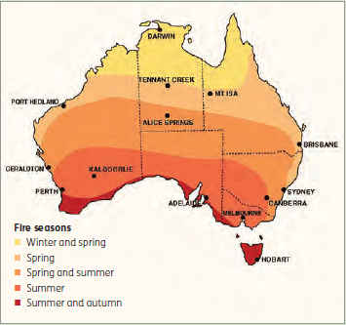
Source: Text from Geosciences Australia (www.ga.gov.au/hazards/bushfire/bushfire-basics/where.html); map courtesy of Bureau of Meteorology.

Origin and spread of fire
Fire is an intrinsic part of Australia's landscape, and has been an important factor in Australian ecosystems for millions of years. Much of Australia's native vegetation has evolved to be tolerant of fire, and many species require fire to regenerate, with adaptations that promote the spread of fire. Indigenous Australians have long used fire as a land-management tool. Fire is still used by land managers to manage vegetation, for both agricultural and ecological purposes, and to protect properties from uncontrolled fires.
The main factors required for propagation of fire are the presence of fuel, oxygen and an ignition source. Fires can originate from both human activity and natural causes. Lightning is the predominant natural source. Fire intensity and the speed at which a bushfire spreads depend on fuel load, fuel moisture, prevailing temperature, wind speed and slope angle. The worst bushfires therefore occur when temperatures are high, humidity is low and winds are strong. Crown fires in Australia's forests largely involve eucalypts, and are very difficult to control and extinguish, in part because of the highly flammable oil released from eucalypt leaves, and the substantial amount of other flammable material (bark, dead twigs and branches) in the forest.
The extent and intensity of forest fires vary with latitude and seasonal rainfall. In northern Australia, low-intensity fires burn over large areas in the dry season. South-eastern and south-western Australia include areas that are prone to the most severe and frequent wildfires in the world, with hot, dry and windy summer conditions, especially following periods of drought, leading to fires that are often intense and difficult to control. Such fires can result in the loss of human life and destroy community assets such as buildings, fences, bridges and powerlines, as well as standing stocks of wood (both native forest and plantations). They can also have a significant impact on ecological values and affect water supplies. Unusually large and uncontrolled landscape-level fires have been called 'mega-fires' (Bartlett et al. 2007).
Fire is very rare in the tropical rainforests of northern Australia, and is occasional in the subtropical, temperate and cool-temperate rainforests of southern Australia, but during prolonged droughts even some of these forests can be damaged by fire entering from adjacent grasslands or sclerophyll forests.
Box 3.2: Potential effects of projected climate change on fires
- Climate change will affect fire regimes in Australia through changes to temperature, rainfall, humidity and wind—the fire weather components—and through the effects of increases in levels of atmospheric carbon dioxide (CO₂) and changes in atmospheric moisture on vegetation and therefore fuels. Climate change projections are for warming and drying over much of Australia, and hence an increased risk of severe fire weather, especially in south-eastern Australia.
- Modelling suggests an increase of 5—65% in the incidence of extreme fire danger days by 2020 in southeastern Australia, compared with 2009. Modelling of fire regimes in the Australian Capital Territory predicts that a 2°C increase in mean annual temperature would increase landscape fire intensity by 25%, increase the area burnt and reduce intervals between fires.
- Fire danger at many sites in south-eastern Australia, as measured by the average annual sum of the Forest Fire Danger Index, rose by 10—40% between 1980—2000 and 2001—07. Increases in fire danger have also been detected in some other parts of Australia.
- Climate change will have complex effects on fuels. Elevated atmospheric CO₂ and temperatures may enhance vegetation production and thereby increase fuel loads. Drought may decrease long-term vegetation production and thereby decrease fuel loads; however, it might also reduce fuel moisture, thereby increasing potential rates of fire spread, especially in forested landscapes.
- Fire regimes within Australia differ because of variation in key drivers such as fuel accumulation and drying, fire weather and ignitions. Climate change may have a greater effect on fire regimes in regions where constraining factor(s) are related to fire weather and fuel dryness (e.g. temperate forests of the south-east) than in places where fuel load and ignition are more important (e.g. tropical woodland forests of the north).
- Climate change and changed fire regimes will have complex (positive and negative) feedback interactions with forest biodiversity, with different outcomes in different Australian biomes. There may be increased risks to species that are sensitive to either fire intensity or the interval between fires. Eucalypts and other species that are killed by fire and regenerate from seed may be at risk if fire frequency exceeds the time required for the plants to reach reproductive maturity.
- Managing fire regimes to reduce risk to property, people, biodiversity and ecosystem services will be increasingly challenging under climate change. In Australia, management of fire regimes for biodiversity conservation has variously emphasised fuel management, fire detection and fire suppression. Continued research on the complex interactions between fire, biodiversity, people, fuel management and land-use change is needed.
Source: Adapted from Williams et al. (2009)

Climate change and fire
Climate change and weather pattern variability are among the key factors that affect the occurrence and severity of fires. Projected increases in summer temperatures and declines in rainfall will exacerbate the risk of fire and increase the challenges associated with fire management (Box 3.2).
Forest fires are projected to have an increasing impact on the incidence and severity of certain pests, diseases and weeds (see Indicator 3.1a). Increases in populations of pests such as bark beetles (Ips sp.) may occur in response to higher availability of fire-damaged (dead, dying or stressed) trees that can be colonised by these pests. Furthermore, forests affected by pests, diseases and weeds may become more vulnerable to fire damage as a result of factors such as increases in fuel loads due to tree mortality (Singh et al. 2010).

Determination of the extent of fire in Australia's forests
Tools for capturing information on fire management and reporting are increasingly available to states and territories to assist fire management. However, there is currently no nationally coordinated approach to the systematic mapping and reporting of the extent, seasonality and intensity of fires, and whether they are planned or unplanned. A number of methods are used to estimate the total burnt area in each jurisdiction and nationally, including remote sensing (satellite data), operational knowledge and aerial reconnaissance.
Several satellite-based platforms, including the Advanced Very High Resolution Radiometer (AVHRR), Moderate-resolution Imaging Spectroradiometer (MODIS) and Landsat ETM (Russell-Smith et al. 2007), can be used to derive meaningful wildfire datasets. Such datasets are useful for detecting fires in woodland forests, such as the savannas of Australia's tropical north, but are much less effective in open forests or closed forests, as in the southern mesic rainfall zones. In Australia's southern forests, particularly those managed for wood production, state agencies rely on a combination of ground-based approaches and high-resolution aerial photography to estimate the extent and distribution of wildfire. Williamson et al. (2013) report that MODIS detected only 15—19% of the fires (whether prescribed fires or wildfires) recorded in state agency databases for regions of Victoria and New South Wales.
This indicator assembles a nationwide analysis of fire, using MODIS satellite imagery to estimate fire occurrence across Australia's northern forests, and information provided by the states and territories for Australia's southern forests. Methodology changes over time mean that direct comparison of fire area figures with those reported in SOFR 2008 requires caution.

Planned and unplanned fire
Planned and unplanned fires tend to occur in different seasons, but this dependence varies with the rainfall zone in which the fire occurs. The occurrence and seasonality of fire from 2000 to 2006, as identified in MODIS satellite imagery, were used to identify 10 rainfall seasonality zones that affect fire (Figure 3.8; Russell-Smith et al. 2007). For this purpose, northern Australia was taken to comprise zones 4 and 6—10, and southern Australia was taken to comprise zones 1—3 and 5. The rainfall seasonality zones shown in Figure 3.8 determine in part the seasonality of fire occurrence shown in Box 3.1.
For each of these 10 zones, fires are classified as planned or unplanned according to the season of their occurrence (Table 3.1); for this purpose, winter is defined as July-September, spring as October-December, summer as January-March and autumn as April-June. Across northern Australia (zones 4 and 6—10), fires that occur during autumn (the early dry season) are considered planned, while fires that occur during spring (the late dry season) are considered unplanned because fires in that season would be most intense and least amenable to control, and so are less likely to be lit by land managers. For similar reasons, in the mesic regions of southern Australia (included in zones 1—3 and 5), fires that occur in autumn and winter are considered planned, whereas fires that occur in spring and summer are considered unplanned (Thackway et al. 2008). To different extents between jurisdictions, some unplanned fires will occur in seasons designated as 'planned', and some planned fires will occur in seasons designated as 'unplanned'. This system therefore produces only an approximate allocation of fires to the planned and unplanned categories.

Remote sensing of fire in Australia's forests
In SOFR 2008, the areas burnt by fires in Australian northern forests were estimated using the MODIS Thermal Anomalies/ Fire product, which provided data at a resolution of 1 kilometre. The fires were allocated as planned or unplanned according to the rainfall region and season in which the fire occurred (Table 3.1). Since SOFR 2008, the National Aeronautics and Space Administration (NASA) has developed, tested and validated a methodology to map the approximate day and extent of burning at a finer resolution, based on spectral, temporal and structural changes in burnt areas (Chang and Song 2009, Giglio et al. 2009, Roy et al. 2008). This new MODIS Burned Area product is available as monthly imagery at 500 metre resolution. The extent of burnt areas derived from the MODIS Burned Area imagery and the current Australian forest cover (Indicator 1.1a) were combined to estimate the extent of forest burnt by fires from July 2006 to the end of June 2011 across the various rainfall zones (Table 3.2).
The total area of forest burnt from 2006—07 to 2010—11, as estimated using MODIS Burned Area data, was 33.7 million hectares (Table 3.2). Over this period, a total of 32.4 million hectares of burnt forest was detected by MODIS in northern Australia (rainfall zones 4 and 6—10; Figure 3.8), of which 26.7 million hectares were in zones 6—8. Large areas of forest in zones 7 and 8 were burnt repeatedly in the reporting period, so that the sum of areas burnt over the five years exceeded the total forest area in these zones (Table 3.2).
Figure 3.8: Classification of geographical zones according to seasonal rainfall distribution
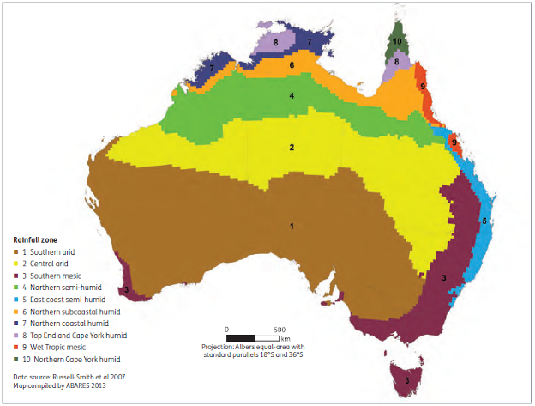
Table 3.1: Rainfall zones and seasons used to classify fires as planned or unplanned ª
Rainfall zone ^{b} | Winter  (Jul-Sep) | Spring  (Oct-Dec) | Summer  (Jan-Mar) | Autumn  (Apr-Jun)
1 Southern arid | Unplanned | Unplanned | Unplanned | Planned
2 Central arid | Unplanned | Unplanned | Planned | Planned
3 Southern mesic | Planned | Unplanned ^{c} | Unplanned | Planned
4 Northern semi-humid | Planned | Unplanned | Planned | Planned
5 East coast semi-humid | Planned | Unplanned | Unplanned | Planned
6 Northern subcoastal humid | Unplanned | Unplanned | Planned | Planned
7 Northern coastal humid | Unplanned | Unplanned | Planned | Planned
8 Top End and Cape York humid | Unplanned | Unplanned | Planned | Planned
9 Wet Tropic mesic | Unplanned | Unplanned | Planned | Planned
10 Northern Cape York humid | Unplanned | Unplanned | Planned | Planned
ª Occurrences of fire in shaded cells represent fires considered to be unplanned for analysis of MODIS Burned Area data.
^{b} Zone numeric code precedes zone name. Zones 1-3 and 5 constitute the forests of southern Australia. Zones 4 and 6-10 constitute the forests of northern Australia.
^{c} In south-west Western Australia, a proportion of planned burning takes place in spring.
Source: Thackway et al. (2008).
Table 3.2: Total forest area burnt, by rainfall zone, 2006-07 to 2010-11 (MODIS data)
Rainfall zone ª | 2006-07 - Area ('000 hectares) | 2007-08 - Area ('000 hectares) | 2008-09 - Area ('000 hectares) | 2009-10 - Area ('000 hectares) | 2010-11 - Area ('000 hectares) | Total 2006-11 - Area ('000 hectares) | Burnt forest area as proportion of total forest area in zone, 2006-11 (%)
1 Southern arid | 19 | 48 | 8 | 28 | 13 | 117 | 0.5
2 Central arid | 9 | 17 | 55 | 225 | 9 | 315 | 2.9
3 Southern mesic | 161 | 37 | 38 | 202 | 21 | 459 | 1.5
4 Northern semi-humid | 421 | 380 | 264 | 607 | 113 | 1,784 | 22.5
5 East coast semi-humid | 60 | 19 | 74 | 232 | 12 | 397 | 3.7
6 Northern subcoastal humid | 2,773 | 2,376 | 1,743 | 2,622 | 727 | 10,241 | 60.1
7 Northern coastal humid | 2,172 | 2,386 | 1,736 | 1,831 | 851 | 8,975 | 115.9
8 Top End and Cape York humid | 2,104 | 1,319 | 1,499 | 1,832 | 705 | 7,459 | 113.8
9 Wet Tropic mesic | 138 | 136 | 243 | 646 | 18 | 1,181 | 21.5
10 Northern Cape York humid | 726 | 360 | 589 | 1,076 | 38 | 2,790 | 65.4
4, 6-10 Northern Australia | 8,333 | 6,957 | 6,073 | 8,615 | 2,452 | 32,429 | 66.2
1-3, 5 Southern Australia | 249 | 121 | 175 | 687 | 55 | 1,288 | 1.7
1-10 Total | 8,582 | 7,078 | 6,248 | 9,302 | 2,507 | 33,717 | 27.2
ª Zone numeric code precedes zone name. Zones 1-3 and 5 constitute the forests of southern Australia. Zones 4 and 6-10 constitute the forests of northern Australia.
Note: Totals may not tally due to rounding.
Source: MODIS Burned Area data (500-metre resolution), resampled to 100-metre resolution, and cut by rainfall zone and forest cover (from Indicator 1.1a).
A total of only 1.3 million hectares of burnt forest was detected by MODIS in southern Australia (rainfall zones 1—3 and 5; Figure 3.8). The resolution of the new MODIS product (500 metres) is still relatively low, and small, low-intensity fires are not easily detected, particularly when obscured by cloud cover or a forest canopy. This may result in significant underestimation of the extent of both planned and unplanned fires in the closed-canopy forests of southern Australia (as also found by Williamson et al. 2013). Therefore, although MODIS detects the majority of Australia's burnt forest area, remote sensing is currently an accurate measure of fire extent only for high-intensity fire in the open and woodland forests of northern Australia.
The areas of planned and unplanned fires for the Northern Territory, Queensland and Western Australia (excluding south-west Western Australia) were determined from MODIS data (Table 3.3). In this analysis, fires are allocated as planned or unplanned according to the rainfall region and season in which the fire occurred (Table 3.1). The total area of forest fire detected by MODIS across these three jurisdictions in the period 2006—07 to 2010—11 was 33.1 million hectares, comprising 5.2 million hectares of planned fires and 28.0 million hectares of unplanned fires. A total of 14.3 million hectares of forest was burnt in Queensland, 15.4 million hectares in the Northern Territory, and 3.3 million hectares in Western Australia (excluding south-west Western Australia). These figures include the areas of forest burnt, as detected by MODIS, in all rainfall seasonality zones in these jurisdictions.

State and territory data on fire
Table 3.4 shows the extent of fire for 2006—07 to 2010—11 derived from aerial reconnaissance, and on-ground and operational data collated and supplied by state and territory agencies in the Australian Capital Territory, New South Wales, Victoria, South Australia, Tasmania and Western Australia (south-west of the state). Fires were allocated as planned and unplanned using information provided by the state and territory agencies, rather than according to the rainfall region and season in which the fire occurred. Over the period 2006—07 to 2010—11, approximately 1 million hectares of forest was burnt in each of New South Wales, South Australia and south-west Western Australia. Approximately 2.5 million hectares of forest were burnt in Victoria, and a comparatively small area (179,000 hectares) was burnt in Tasmania.
These areas of burnt forest in the southern states and territories are several-fold higher than those detected by MODIS for these states and territories, consistent with MODIS detecting fire areas in closed forest and some open forest at low efficiency.
Table 3.3: Forest areas burnt by planned and unplanned fire, 2006-07 to 2010-11, by jurisdiction (MODIS data)
NT
Jurisdiction | 2006-07 - Area ('000 hectares) | 2007-08 - Area ('000 hectares) | 2008-09 - Area ('000 hectares) | 2009-10 - Area ('000 hectares) | 2010-11 - Area ('000 hectares) | Total  2006-11 - Area ('000 hectares)
Planned | 465 | 897 | 991 | 293 | 330 | 2,977
Unplanned | 3,899 | 2,583 | 2,031 | 2,712 | 1,245 | 12,471
Total | 4,365 | 3,480 | 3,022 | 3,006 | 1,575 | 15,448
Qld
Jurisdiction | 2006-07 - Area ('000 hectares) | 2007-08 - Area ('000 hectares) | 2008-09 - Area ('000 hectares) | 2009-10 - Area ('000 hectares) | 2010-11 - Area ('000 hectares) | Total  2006-11 - Area ('000 hectares)
Planned | 112 | 157 | 413 | 299 | 128 | 1,108
Unplanned | 3,480 | 2,125 | 2,013 | 5,149 | 450 | 13,217
Total | 3,592 | 2,281 | 2,426 | 5,449 | 577 | 14,325
WA (excluding south-west WA)
Jurisdiction | 2006-07 - Area ('000 hectares) | 2007-08 - Area ('000 hectares) | 2008-09 - Area ('000 hectares) | 2009-10 - Area ('000 hectares) | 2010-11 - Area ('000 hectares) | Total  2006-11 - Area ('000 hectares)
Planned | 187 | 271 | 189 | 218 | 206 | 1,070
Unplanned | 228 | 951 | 501 | 476 | 123 | 2,278
Total | 415 | 1,221 | 689 | 693 | 329 | 3,348
Notes:
Data cover the whole of each state or territory (but not south-west WA), including areas in rainfall zones 1 and 3-5 (allocated to southern Australia).
Totals may not tally due to rounding.
Source: MODIS Burned Area data (500-metre resolution), resampled to 100-metre resolution, and cut by jurisdiction and National Forest Inventory forest cover (from Indicator 1.1a).
Table 3.4: Total forest area burnt by planned and unplanned fire, 2006-07 to 2010-11, by jurisdiction (data from states and territories)
ACT ª
Jurisdiction | 2006-07 - Area ('000 hectares) | 2007-08 - Area ('000 hectares) | 2008-09 - Area ('000 hectares) | 2009-10 - Area ('000 hectares) | 2010-11 - Area ('000 hectares) | Total  2006-11 - Area ('000 hectares)
Planned | 0.7 | 0.5 | 0.5 | 3.2 | 0.8 | 5.6
Unplanned | 0 | 0 | 0 | 0 | 0 | 0
Total | 0.7 | 0.5 | 0.5 | 3.2 | 0.8 | 5.6
NSW ^{b}
Jurisdiction | 2006-07 - Area ('000 hectares) | 2007-08 - Area ('000 hectares) | 2008-09 - Area ('000 hectares) | 2009-10 - Area ('000 hectares) | 2010-11 - Area ('000 hectares) | Total  2006-11 - Area ('000 hectares)
Planned | 61 | 81 | 84 | 128 | 93 | 447
Unplanned | 352 | 51 | 23 | 160 | 2 | 588
Total | 413 | 132 | 107 | 288 | 95 | 1,035
SA ^{c}
Jurisdiction | 2006-07 - Area ('000 hectares) | 2007-08 - Area ('000 hectares) | 2008-09 - Area ('000 hectares) | 2009-10 - Area ('000 hectares) | 2010-11 - Area ('000 hectares) | Total  2006-11 - Area ('000 hectares)
Planned | 157 | 7 | 2 | 3 | 4 | 174
Unplanned | 353 | 500 | 33 | 15 | 137 | 1,037
Total | 510 | 507 | 35 | 18 | 141 | 1,211
Tas. ^{d}
Jurisdiction | 2006-07 - Area ('000 hectares) | 2007-08 - Area ('000 hectares) | 2008-09 - Area ('000 hectares) | 2009-10 - Area ('000 hectares) | 2010-11 - Area ('000 hectares) | Total  2006-11 - Area ('000 hectares)
Planned | 11 | 21 | 17 | 12 | 15 | 76
Unplanned | 63 | 17 | 7 | 15 | 0.5 | 103
Total | 74 | 38 | 24 | 27 | 16 | 179
Vic. ^{e}
Jurisdiction | 2006-07 - Area ('000 hectares) | 2007-08 - Area ('000 hectares) | 2008-09 - Area ('000 hectares) | 2009-10 - Area ('000 hectares) | 2010-11 - Area ('000 hectares) | Total  2006-11 - Area ('000 hectares)
Planned | 138 | 156 | 154 | 146 | 189 | 784
Unplanned | 1,205 | 32 | 437 | 37 | 14 | 1,727
Total | 1,344 | 189 | 592 | 183 | 203 | 2,511
South-west WA ^{f}
Jurisdiction | 2006-07 - Area ('000 hectares) | 2007-08 - Area ('000 hectares) | 2008-09 - Area ('000 hectares) | 2009-10 - Area ('000 hectares) | 2010-11 - Area ('000 hectares) | Total  2006-11 - Area ('000 hectares)
Planned | 139 | 144 | 152 | 212 | 137 | 783
Unplanned | 32 | 10 | 24 | 47 | 28 | 141
Total | 170 | 154 | 176 | 259 | 165 | 924
ª Spatial data for fires in all vegetation types from ACT Parks and Conservation Service, supplied by ACT Environment and Sustainable Development Directorate; area of forest fires was then estimated using forest cover data from the Australian Bureau of Agricultural and Resource Economics and Sciences (Indicator 1.1a).
^{b} Sum of data supplied by Forests NSW for multiple-use forests, and Parks and Wildlife Division, NSW Office of Environment and Heritage, for native forest areas in nature conservation reserves only.
^{c} Spatial data for fires in National Parks and Wildlife Act 1972 reserves and the majority of state forests supplied by the Department of Environment, Water and Natural Resources, SA; planned and unplanned fires were determined using rainfall zone data. Planned fires in South Australia also occur in March and October.
^{d} Data from Forest Practices Authority, Tasmania (FPA 2012).
^{e} Data supplied by the Victorian Department of Sustainability and Environment for burns on public lands only.
^{f} Data from the WA Department of Environment and Conservation (DEC) for DEC-managed lands for south-west WA only.
Note: Totals may not tally due to rounding.
Table 3.5: Total forest area burnt by planned and unplanned fire, by jurisdiction, 2006-07 to 2010-11 (combination of MODIS data and state and territory data)
Jurisdiction | 2006-07  Area burnt  ('000 hectares) | 2007-08  Area burnt  ('000 hectares) | 2008-09  Area burnt  ('000 hectares) | 2009-10  Area burnt  ('000 hectares) | 2010-11  Area burnt  ('000 hectares) | Total 2006-11  Area burnt  ('000 hectares) | Proportion of total, 2006-11  (%)
ACT | 0.7 | 0.5 | 0.5 | 3.2 | 0.8 | 5.6 | 0.01
NSW | 413 | 132 | 107 | 288 | 95 | 1,035 | 2.7
NT | 4,365 | 3,480 | 3,022 | 3,006 | 1,575 | 15,448 | 40
Qld | 3,592 | 2,281 | 2,426 | 5,449 | 577 | 14,325 | 37
SA | 510 | 507 | 35 | 18 | 141 | 1,211 | 3
Tas. | 74 | 38 | 24 | 27 | 16 | 179 | 0.5
Vic. | 1,344 | 189 | 592 | 183 | 203 | 2,511 | 6.4
WA | 585 | 1,375 | 865 | 953 | 494 | 4,272 | 11
Australia | 10,883 | 8,002 | 7,072 | 9,926 | 3,102 | 38,985 | 100
Notes:
Totals may not tally due to rounding.
Data are combination of MODIS data (Table 3.3) and state and territory data (Table 3.4).

Synthesis of methods
Data on the extent of fire derived from MODIS for states and territories containing Australia's northern forests (Northern Territory, Queensland, and Western Australia outside the south-west; Table 3.3) were combined with data on the extent of fire reported by the states and territory containing Australia's southern forests (Australian Capital Territory, New South Wales, South Australia, Tasmania, Victoria and southwest Western Australia; Table 3.4) to generate the total area of Australian forests burnt between 2006—07 and 2010—11. This total area is 39.0 million hectares (Table 3.5).
The largest areas of forest fire occurred in the Northern Territory and Queensland, with a combined total of 29.8 million hectares burnt, which is 77% of the area of Australia's forest that was burnt over the period 2006—07 to 2010—11. More than half the forest area burnt in Victoria over this period was burnt in the single year 2006—07. Of the total, planned burns contributed approximately 7.4 million hectares (19% of the total) from 2006—07 to 2010—11, and unplanned burns contributed 31.6 million hectares (81% of the total).
The differences between the two methodologies in detecting and reporting the extent of forest fire highlight the need for a nationally coordinated fire reporting program that extends across all land tenures, and takes into account the difficulty in using remote sensing to detect planned fires in the southern mesic rainfall zone. In the absence of such a program, the level of accuracy of the figures presented is unknown.

Wildfire data from the National Inventory Report
The National Inventory Report produced annually by the Australian Government Department of Climate Change and Energy Efficiency reports on Australia's greenhouse gas emissions, including from wildfire. It also presents data on the annual area of forest burnt, compiled by CSIRO from data supplied by state and territory fire management organisations (similar to the approach underpinning Table 3.4). This totalled approximately 4.4 million hectares over the period 2006—2010 (Figure 5.3 in Indicator 5.1a). A number of reasons account for the difference between that figure and the figure reported in this indicator, including differences in data suppliers, methodological differences, and accounting for fires in a smaller area of forest cover than used in SOFR 2013 (see Box 1.2 in Indicator 1.1a, and Indicator 5.1a).

Prescribed burning
Prescribed burning is the deliberate use of fire to achieve particular management objectives, and is an important management tool on both public and private land. Management objectives can include reducing the levels of flammable fuels (fuel reduction burning), protection and enhancement of biodiversity in fire-adapted ecosystems, and promoting regeneration after forest harvesting. There is often a narrow window of time when fuel and weather conditions are suitable for achieving the objectives of the burn with appropriately managed risk, and target levels of prescribed burning are therefore often not met by state and territory agencies.
Prescribed burning will not prevent bushfires, but—depending on forest type—it can reduce future fire severity for a period. Prescribed burning can thus widen the range of weather and other conditions under which a bushfire may be controlled, and potentially allows firefighters to break the run of large fires, especially crown fires. A strategic approach to prescribed burning to protect assets is recommended or carried out by a number of public agencies. The final report from the 2009 Victorian Bushfires Royal Commission (2010) states that:
Properly carried out, prescribed burning reduces the spread and severity ofbushfire. It makes a valuable contribution to reducing the risks to communities and firefighters by complementing effective suppression and is one of the essential protective strategies associated with making it safer for people to live and work in bushfire-prone areas in the state.
One comprehensive Australian study on prescribed burning is from Western Australia (Boer et al. 2009). It showed that extensive prescribed burning of open forest of jarrah, marri and karri changed fuel distribution, and reduced the incidence and extent of unplanned fires for up to six years after the most recent burn, including reducing the incidence of large fires.
In the tropical savannas of northern Australia, woodland forests with a grassy understorey are part of a patchy landscape mosaic that may include other vegetation types, such as rainforest. Fuel loads from the grassy understorey build up during the dry season, increasing the risk of high-intensity fires late in the season. Up to 50% of some northern Australian landscapes may be burnt in a single year, and most areas burn at least once every three years. Suppression of fire and a consequent reduced fire frequency can lead to increased tree and shrub invasion, which may adversely affect biodiversity and habitat values and reduce pastoral productivity. The management of fire in tropical savannas is a trade-off between the tree—grass balance and grazing values. Land managers are being encouraged to employ traditional early dry-season burning techniques that result in reduced fire intensity and also reduce carbon dioxide emissions.
Table 3.6: Mega-fires in southern Australia, 1993-94 to 2010-11
Fire season | Location | Area burnt  (hectares) ª
1993-94 | Sydney, Blue Mountains, north coast, NSW | 800,000+
1994 | South-east Qld | 333,000
1997-98 | Hunter, Blue Mountains, Shoalhaven, NSW | 500,000+
2001-02 | Greater Sydney, NSW | 744,000
2002-03 | Eastern Highlands, Vic. | 1.1 million
2002-03 | Brindabella Ranges, Canberra, ACT and NSW | 157,000+
2002-03 | NSW east coast, including Greater Sydney | 1.46 million
2002-03 | Arthur Pieman, Tas. | 100,000
2005 | Eyre Peninsula, SA | 145,000
2006-07 | Eastern Highlands, Vic. | 1.05 million
2007 | Kangaroo Island, SA | 95,000
2009 | Eastern Highlands, Vic. | 430,000
ª Total area burnt, including vegetation types other than forests.
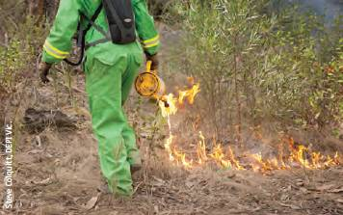
A Parks Victoria ranger igniting a planned fuel reduction burn.

Mega-fires
Mega-fires are especially large and severe fire events that cause catastrophic damage, including human casualties or economic loss, and that have long-lasting social, economic and environmental consequences (Bartlett et al. 2007). The frequency of mega-fires has been increasing in a changing climate, due in part to warmer and drier conditions and increasing fuel loads (Attiwill and Binkley 2013).
Table 3.6 lists the main mega-fire events in southern Australia from 1993—94 to 2010—11. Fewer very large fire events (mega-fires) occurred during this SOFR reporting period (2006—11) than the previous reporting periods, but nevertheless individual events in Victoria were among the worst bushfires experienced in Australia in the past century.
The three recent intense broadscale wildfires in Victoria (2002—03, 2006—07 and 2009; Figure 3.9) had significant impacts across the alpine and other national parks and on multiple-use forests used for wood production. The total area of multiple-use forests burnt in these fires was 1.2 million hectares, and the total area of nature conservation reserves burnt was 0.94 million hectares.
Figure 3.9: Distribution of wildfires affecting Victorian forests, by forest management area, through the last decade. A, 2002-03; B, 2006-07; C, 2009
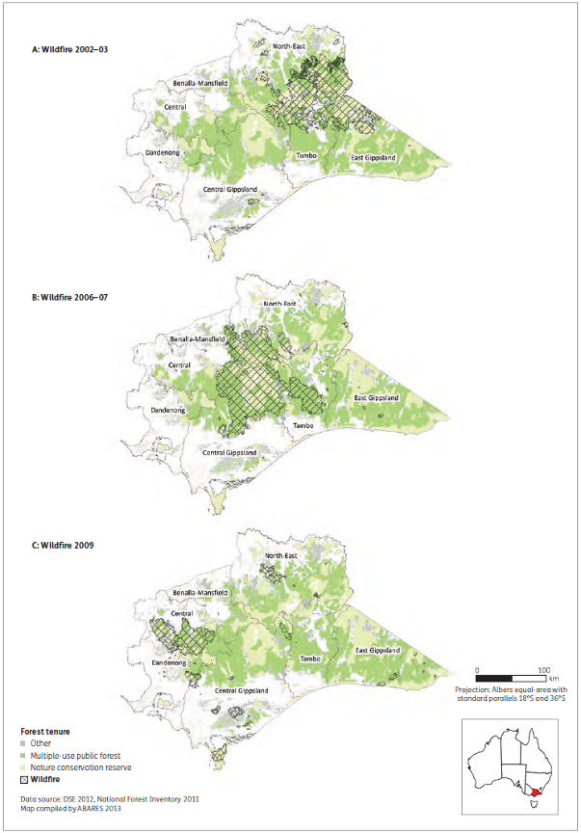
Case study 3.2: Black Saturday bushfires in Victoria
Victoria has experienced some of the worst bushfires in the nation's history, including 'Black Friday' in 1939, 'Ash Wednesday' in 1983 and 'Black Saturday' in 2009. The Black Saturday bushfires on 7 February 2009 were considered the worst in the history of Australia, causing the deaths of 173 people and serious injury to many others. The fires had impacts on 78 communities, and entire towns were left unrecognisable (Figure 3.10). The total direct and indirect cost of the fires has been estimated to be more than $4 billion.
The Black Saturday fires occurred after a long period of drought and significantly below-average rainfall. A wet November and December in 2008 permitted the growth of more fire fuels, but Victoria experienced some of the hottest conditions on record in January 2009, with temperatures in Melbourne reaching 43 °C for three consecutive days. The forests and grasslands were the driest since the Ash Wednesday fires in 1983. On 7 February 2009, record-breaking temperatures were recorded in many parts of Victoria, including a temperature of 46.4 °C in Melbourne, and relative humidity was as low as 6% at 3 pm. Strong winds grew to storm force as the day progressed, intensifying the fires.
In total, the Black Saturday fires burnt 406,337 hectares of land, comprising 118,958 hectares of private land, 101,740 hectares of nature conservation reserves, 170,169 hectares of multiple-use forest and 15,470 hectares of other Crown land.
The fires affected more than 200 historic places on public and private land and more than 200 places of recorded Indigenous heritage. Around 70 national parks and reserves, 61 businesses and 3,550 agricultural facilities were affected. Community assets on Crown land were damaged or destroyed; and a number of police stations, schools and kindergartens, fire and emergency services facilities, churches, community halls and sporting clubs were lost. Many landowners lost fences.
The fires severely affected forests of mountain ash (Eucalyptus regnans) and alpine ash (E. delegatensis), which are killed by even moderately intense fires and regenerate by seed. Famous old-growth ash forests (e.g. Wallaby Creek) and large areas of commercial forests in the Central Highlands were severely burnt. Some commercial wood assets were salvaged by VicForests in burnt forests, where time and wood quality permitted.
The habitats of more than 40 species of endangered animals were impacted by the bushfires. Two threatened species—Leadbeater's possum and barred galaxias (a native fish)—were affected. In addition, native flora and fauna were exposed to indirect effects such as ash deposition and sedimentation in streams, increased exposure to predators and increased weed invasion.
Victoria coordinated a massive whole-of-government rebuilding and recovery task, including funding for firefighting services and infrastructure, and targeted recovery and support packages, financed by the Victorian and Australian governments, the Victorian Bushfire Appeal Fund and other donor contributions. In the autumn following the fires, about 4,600 hectares of burnt mountain ash and alpine ash forests were aerially sowed with 3,500 kilograms of seed, in the largest aerial sowing program ever undertaken in Victoria. Further seed-bed treatment and resowing were undertaken in the autumn of 2011. As well, 100,000 seedlings were nursery raised and replanted across 100 hectares in Bunyip and Tarago State Forests and Murrindindi Scenic Reserve.
Figure 3.10: Bald Spur Road and Grandview Crescent junction, Kinglake, Victoria, after the 2009 fires
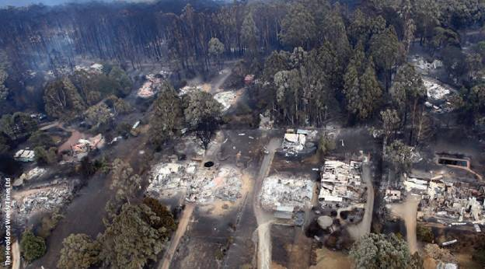
Long-term monitoring was put in place for measurement of populations of Leadbeater's possum. Parks Victoria and Zoos Victoria worked closely with volunteers at Lake Mountain to replace nest boxes and provide winter feeding stations for the only two family groups of Leadbeater's possum known to have survived at Lake Mountain. Native fish species faced degraded water quality and habitats smothered by ash, flooding and sedimentation after the fires. The state undertook rescue programs to relocate threatened native fish populations, and maintain them in aquariums, until they were returned to their natural habitats in 2011. Rains since the 2009 fires have helped some of Melbourne's waterways and catchments start their gradual recovery, and new vegetation growth has helped reduce the amount of ash and sediment entering rivers and creeks.
Case study 3.3: Monitoring fire regimes in the Greater Blue Mountains World Heritage Area
The Greater Blue Mountains World Heritage Area (GBMWHA; Figure 3.11) in New South Wales covers over 1 million hectares and comprises eight conservation reserves. It protects 70 different vegetation communities and more than 1,500 species of higher plants, representing 10% of Australia's total. It includes at least 150 plant species that are found only in the GBMWHA. It also protects examples of at least 100 species of eucalypts. The GBMWHA has extensive adjoining urban areas and is an important catchment area for Sydney's drinking-water supply. Protecting these features presents significant management challenges, including the need for good science to underpin decision making.
The GBMWHA is an extremely fire-prone region. Although fire is an important ecological process in the GBMWHA, inappropriate fire regimes can have significant adverse impacts. High-intensity and repeated fires at short intervals are of increasing concern. Such fires can lead to many adverse effects, including changes in ecosystem composition, increased risk of soil erosion, negative impacts on water quality and increased risk to property. Climate change is predicted to lead to an increase in fire frequency and intensity in the GBMWHA (Clarke et al. 2011); once started, a fire is more likely to spread rapidly, become difficult to control and ultimately affect larger areas. Consequently, the GBMWHA has become a focus for fire research (Tasker and Hammill 2011).
Research in New South Wales on monitoring fire regimes in the GBMWHA is investigating and documenting the pattern of fires, to help assess the risk to ecosystems in the face of climate change. The project aims to increase understanding of the effects of high fire frequency and intensity on vegetation communities in the GBMWHA, and to improve the information available for fire management. The project is producing:
- maps of the severity of all major fires in the GBMWHA since 1980, using remote-sensing methods and field validation
- analysis of the patterns of fire frequency across the entire GBMWHA
- a targeted field survey to assess the ecological condition of wet sclerophyll forests and rainforests in areas of repeated high fire intensities
- assessment of the status of the GBMWHA in relation to the fire ecological 'thresholds' recommended for maintaining biodiversity
- identification of the areas of 'sensitive' vegetation in the GBMWHA that are at risk from high fire frequency and intensity.
Other related national research is being undertaken by the Bushfire Cooperative Research Centre. The outcomes of these projects will be used to inform future fire management and as a baseline against which to assess climate change impacts.
Figure 3.11: Blue Mountains, New South Wales
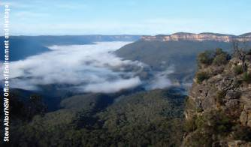

References—Criterion 3
ABARES (Australian Bureau of Agricultural and Resource Economics and Sciences) (2011a). Potential Effects of Climate Change on Forests and Forestry in Australia, ABARES, Canberra.
Attiwill P and Binkley D (2013). Exploring the mega-fire reality: a ‘forest ecology and management conference’. Forest Ecology Management 294:1–3.
Bartlett T, Leonard M and Morgan G (2007). The mega-fire phenomenon: some Australian perspectives. In: The 2007 Institute of Foresters of Australia and New Zealand Institute of Forestry Conference: Programme, Abstracts and Papers, Coffs Harbour, 3–7 June 2007, Institute of Foresters of Australia, Canberra.
Boer MM, Sadler RJ, Wittkuhn RS, McCaw L and Grierson PF (2009). Long-term impacts of prescribed burning on regional extent and incidence of wildfires—evidence from 50 years of active fire management in SW Australian forests. Forest Ecology and Management 259:132–142.
Carnegie AJ (2008). Guest editorial and introduction to this special issue. A decade of forest health surveillance in Australia: an overview. Australian Forestry 71:161–163.
——and Cooper K (2011). Emergency response to the incursion of an exotic myrtaceous rust. Australasian Plant Pathology 40:346–359.
——, Lidbetter JR, Walker J, Horwood MA, Tesoriero L, Glen M and Priest MJ (2010). Uredo rangelii, a taxon in the guava rust complex, newly recorded on Myrtaceae in Australia. Australasian Plant Pathology 39:463–466.
Chang D and Song Y (2009). Comparison of L3JRc and MODIS global burned area products from 2000 to 2007. Journal of Geophysical Research: Atmospheres 114(D16):1984–2012.
Clarke HG, Smith PL and Pitman AJ (2011). Regional signatures of future fire weather over eastern Australia from global climate models. International Journal of Wildland Fire 20:550–562.
Coutinho TA, Wingfield MJ, Alfenas AC and Crous PW (1998). Eucalyptus rust: a disease with the potential for serious international implications. Plant Disease 82:819–825.
CSIRO, Australian Bureau of Meteorology (2007). Climate Change in Australia, CSIRO, Melbourne.
FFMG (Forest Fire Management Group) (2012). National Bushfire Management Policy Statement for Forests and Rangelands, prepared by the Forest Fire Management Group for the Council of Australian Governments, Canberra.
FPA (Forest Practices Authority) (2012). State of the forests Tasmania 2012, FPA, Hobart.
Giglio L, Loboda T, Roy DP, Quayle B and Justice CO (2009). An active-fire based burned area mapping for MODIS sensor. Remote Sensing of Environment 113:408–420.
Hart Q and Bomford M (2006). Australia’s Pest Animals, Bureau of Rural Sciences, Canberra.
Jenkins BM and Tomkins B (2006). The Use of Chemical Pesticides by the Australian Plantation Forest Industry, Forest and Wood Products Research and Development Corporation, Melbourne.
Lindsay A and Dickinson G (2012). Influence of Cyclonic Winds on the Performance of Hardwood Plantations in Tropical North Queensland, report prepared for the Timber Queensland project: Best Practice Guide for Timber Plantations in Cyclonic Areas, Queensland Department of Agriculture, Fisheries and Forestry, Mareeba.
McCaw WL, Robinson RM and Williams MR (2011) Integrated biodiversity monitoring for the jarrah (Eucalyptus marginata) forest in south-west Western Australia: the Forestcheck project. Australian Forestry 74:240–254.
Montreal Process Implementation Group for Australia (2008). Australia’s State of the Forests Report 2008, Bureau of Rural Sciences, Canberra.
Morin L, Aveyard R, Lidbetter JR and Wilson PG (2012). Investigating the host-range of the rust fungus Puccinia psidii sensu lato across tribes of the family Myrtaceae present in Australia. PLoS ONE 7(4):e35434, doi:10.1371/journal.pone.0035434.
Natural Resources Commission (2009). Final Assessment Report: Riverina Bioregion Regional Forest Assessment—River Red Gum and Woodland Forests, Natural Resources Commission, Sydney.
NLWRA (National Land & Water Resources Audit) (2001). Australian Dryland Salinity Assessment 2000, NLWRA, Canberra.
Parsons R and Uren N (2007). The relationship between lime chlorosis, trace elements and Mundulla yellows. Australasian Plant Pathology 36:415-418.
Pegg G, Perry S, Carnegie A, Ireland K and Giblin F (2012). Understanding Myrtle Rust Epidemiology and Host Specificity to Determine Disease Impact in Australia, Cooperative Research Centre for National Plant Biosecurity, Canberra.
Plant Health Australia (2007). Plantation Forest Biosecurity Plan (Version 2.0 – Jan 2013), Plant Health Australia Ltd, Canberra.
Roy DP, Boschetti L, Justice CO and Ju J (2008). The collection 5 MODIS burnt area product—global evaluation by comparison with the MODIS active fire product. Remote Sensing of Environment 112: 3690–3707.
Russell-Smith J, Yates C, Whitehead P, Smith R, Craig R, Allan G, Thackway R, Frakes I, Cridland S, Meyer M and Gill A (2007). Bushfires ‘down under’: patterns and implications of contemporary Australian landscape burning. International Journal of Wildland Fire 16: 361–377.
Select Carbon (2012). Best Practice Guide for Timber Plantations in Tropical Cyclonic Areas of Queensland, report prepared for Timber Queensland, Select Carbon, Cairns.
Singh S, Davey S and Cole M (2010). Implications of climate change for forests, vegetation and carbon in Australia. New Zealand Journal of Forestry Science 40:141–152.
SOFR 2008—see Montreal Process Implementation Group for Australia (2008).
Tasker EM and Hammill KA (2012). Fire regimes and vegetation in the Greater Blue Mountains World Heritage Area. In: Proceedings of Bushfire CRC & AFAC 2011 Conference Science Day, Thornton RP (ed.), Sydney, 1 September 2011, Bushfire CRC, 182–195.
Thackway R, Mutendeudzi M and Kelley G (2008). Assessing the Extent of Australia’s Forest Burnt by Planned and Unplanned Fire, Bureau of Rural Sciences, Canberra.
Victorian Bushfire Royal Commission (2010). 2009 Victorian Bushfire Royal Commission Final Report, Parliament of Victoria. www.royalcommission.vic.gov.au/commission-reports/final-report (Accessed 6 February 2013)
Whyte G (2012). The ecology of insect pests and fungal pathogens of drought stressed eucalypt plantations in southern Queensland. PhD thesis, Murdoch University.
Williams RJ, Bradstock RA, Cary GJ, Enright NJ, Gill AM, Liedloff AC, Lucas C, Whelan RJ, Andersen AN, Bowman DJMS, Clarke PJ, Cook GD, Hennessy KJ and York A (2009). Interactions Between Climate Change, Fire Regimes and Biodiversity in Australia: A Preliminary Assessment, report to the Australian Government Department of Climate Change and Department of the Environment, Water, Heritage and the Arts, Canberra. http://climatechange.gov.au/climate-change/publications/interactions-between-climate-change-fire-regimes-and-biodiversity-australia-preliminary-assessment (Accessed 6 February 2013)
Williamson GJ, Price OF, Henderson SB and Bowman DMJS (2013). Satellite-based comparison of fire intensity and smoke plumes from prescribed fires and wildfires in south-eastern Australia. International Journal of Wildland Fire 22:121–129.

Puccinia psidii s.l., previously referred to by the name Uredo rangelii.
Puccinia psidii sensu lato, previously referred to by the name Uredo rangelii.
A quarantine pest, as defined by the International Plant Protection Convention of the Food and Agriculture Organization of the United Nations, is a pest of potential economic importance to the area it endangers and not yet present there, or present but not widely distributed and being officially controlled. A pest is any species, strain or biotype of plant, animal or pathogenic agent that is injurious to plants or plant products.
www.environment.gov.au/biodiversity/threatened/tap-approved.html and www.nrm.gov.au/funding/previous/business-plan/12-13/priorities/_biodiversity/vertebrate-pest.html.
www.nrm.gov.au/funding/previous/business-plan/12-13/priorities/biodiversity/vertebrate-pest.html.
www.weeds.org.au/aws.htm.
http://earthobservatory.nasa.gov/Features/WorldOfChange/australia_ndvi.php.
Source: Geoff Pegg, Queensland Department of Agriculture, Fisheries and Forestry; Angus Carnegie, New South Wales Department of Primary Industries; David Smith, Victorian Department of Primary Industries; and Fiona Giblin, New South Wales Department of Primary Industries
Qld: www.daff.qld.gov.au/4790_19788.htm; NSW: www.dpi.nsw.gov.au/biosecurity/plant/myrtle-rust; Victoria: www.dpi.vic.gov.au/forestry/pests-diseases-weeds/diseases/myrtle-rust.
www.daff.qld.gov.au/4790_19788.htm.
www.bushfirecrc.com.
Including in woodland forests with a grassy understorey.
http://noaasis.noaa.gov/NOAASIS/ml/avhrr.html.
http://modis.gsfc.nasa.gov/.
http://landsat.gsfc.nasa.gov/.
For this indicator in SOFR 2008, financial years were incorrectly defined as June—May, and fire seasons as June—August, September-November, December—February and March—May. This caused a 10% average area overestimation for unplanned fires in Queensland, the Northern Territory and Western Australia, and a 20% average area underestimation for planned fires in these jurisdictions, but negligible error in total fire area for any jurisdiction over the reporting period.
MODIS data will underestimate the area of fire in the mesic forests of Queensland, but fire is relatively rare in these forest types.
MODIS data for lands managed by the Department of Environment and Conservation in south-west Western Australia are omitted because MODIS will underestimate fire areas in these forest types; data provided by Western Australia for that region were used instead (see Table 3.5).
As in other tables, includes areas burnt more than once.
www.climatechange.gov.au/national-inventory-report-2010; the Department of the Environment from September 2013.

