Australia’s State of the Forests Report 2013
Executive summary

Five-yearly report
Prepared by the Montreal Process Implementation Group for Australia and the National Forest Inventory Steering Committee on behalf of the Australian, state and territory governments
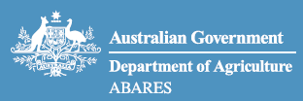
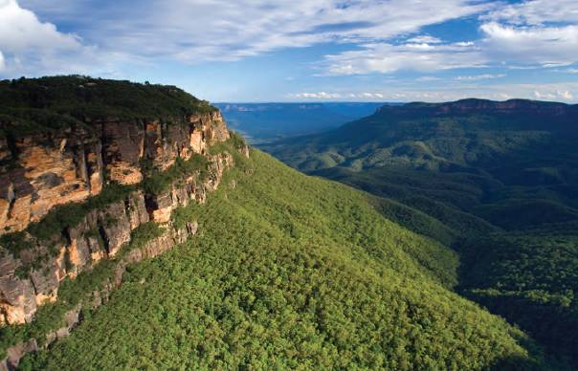
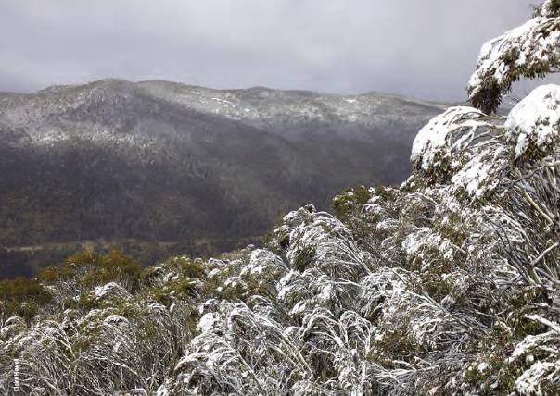
Snowgums (Eucalyptus pauciflora) in Kosciuszko National Park, New South Wales.
© Commonwealth of Australia
Ownership of intellectual property rights
Unless otherwise noted, copyright (and other intellectual property rights, if any) in this publication is owned by the Commonwealth of Australia (referred to as the Commonwealth).
Creative Commons licence
All material in this publication is licensed under a Creative Commons Attribution 3.0 Australia Licence, save for content supplied by third parties, logos and the Commonwealth Coat of Arms.

Creative Commons Attribution 3.0 Australia Licence is a standard form licence agreement that allows you to copy, distribute, transmit and adapt this publication provided you attribute the work. A summary of the licence terms is available from creativecommons.org/licenses/by/3.0/au/deed.en. The full licence terms are available from creativecommons.org/licenses/by/3.0/au/legalcode.
This publication (and any material sourced from it) should be attributed as:
Montreal Process Implementation Group for Australia and National Forest Inventory Steering Committee, 2013, Australia's State of the Forests Report 2013, ABARES, Canberra, December. CC BY 3.0.
Cataloguing data
Montreal Process Implementation Group for Australia and National Forest Inventory Steering Committee, 2013, Australia's State of the Forests Report 2013, ABARES, Canberra, December.
ISBN: 978-1-74323-170-8 (printed)
ISBN: 978-1-74323-169-2 (online)
Internet
Australia's State of the Forests Report 2013 is available at: daff.gov.au/abares/publications and daff.gov.au/forestsaustralia.
Australian Government Department of Agriculture Australian Bureau of Agricultural and Resource Economics and Sciences (ABARES)
Postal address GPO Box 858 Canberra ACT 2601
Switchboard +61 2 6272 2010
Facsimile +61 2 6272 2001
Email info.abares@daff.gov.au
Web daff.gov.au/abares
Inquiries regarding the licence and any use of this document should be sent to: copyright@daff.gov.au.
The Australian Government acting through the Department of Agriculture has exercised due care and skill in the preparation and compilation of the information and data in this publication. Notwithstanding, to the maximum extent permitted by law, the Department of Agriculture, its employees and advisers disclaim all liability, including liability for negligence, for any loss, damage, injury, expense or cost incurred by any person as a result of accessing, using or relying upon any of the information or data in this publication.
Edited by Biotext, Canberra
Design by Fusebox Design, Melbourne
Printed by Paragon Printers Australasia, Canberra
Cover and title page include the logo of the Montreal Process Working Group on Criteria and Indicators for the Conservation and Sustainable Management of Temperate and Boreal Forests.
Cover image: Blue Mountains National Park, New South Wales. Photo: iStockphoto. Back cover images: Getty Images and iStockphoto.

Executive summary
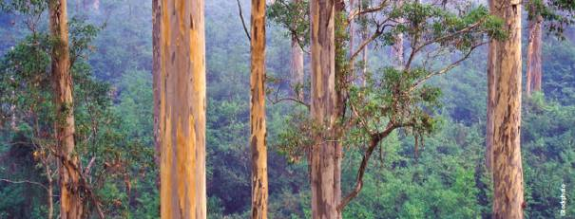
Warren National Park, Western Australia
Australia's State of the Forests Report 2013 (SOFR 2013) is the fourth in a series of national five-yearly reports on Australia's forests, and presents data from a wide range of sources. Previous national reports were published in 1998, 2003 and 2008.
Australia's forests are recognised and valued for their diverse ecosystems and unique biodiversity, for their cultural heritage, and for the provision of goods and services such as wood, carbon sequestration, soil and water protection, and aesthetic values and recreational opportunities. Australia's forests are subject to a range of pressures, including extreme weather, drought, climate change, invasive weeds, pests and diseases, changed fire regimes, urban development, mining, agricultural management practices such as grazing, and the legacy of previous land-management practices. The sustainable management and conservation of Australia's forests, whether on public or on private land, requires a sound understanding of their condition, use and management.
The seven criteria for sustainable forest management used in SOFR 2013 are those developed by the international-level Montreal Process Working Group on Criteria and Indicators for the Conservation and Sustainable Management of Temperate and Boreal Forests. The criteria address the following aspects of forest conservation and management:
- biological diversity
- the productive capacity of forest ecosystems
- ecosystem health and vitality
- soil and water resources
- forest contribution to global carbon cycles
- long-term multiple socioeconomic benefits
- legal, institutional and economic framework.
Indicators grouped under these criteria allow the presentation of a substantial body of data, in a consistent and repeatable format, on Australia's forests, their condition, their management, and their importance for people. Reporting on the state of Australia's forests through SOFR 2013 will support progress towards the sustainable management of Australia's forests.
The material under each of the 44 indicators in SOFR 2013 includes a brief description of the context for the indicator, presents nationally compiled data for the reporting period July 2006—June 2011 (or as close to this period as the data allow), gives caveats on data quality, and in many instances includes one or more regional case-studies. Trends over time are presented for indicators for which suitable data are available over a sufficient period.
This Executive summary draws together into key themes the information presented in SOFR 2013.

Australia's forests
Australia's forests are dominated by eucalypt and acacia forests, and the majority are woodland forests.
Australia has 125 million hectares of forest, equivalent to 16% of Australia's land area, as determined at 2011. Australia's forest cover is shown on the map below. Australia has about 3% of the world's forest area, and the seventh largest reported forest area of any country worldwide. Data on Australia's forest estate are compiled in the National Forest Inventory. A new approach has improved the resolution of mapping and given a more accurate measure of Australia's forest area.
Australia's forests comprise 123 million hectares of native forests (98% of the total forest area), 2.02 million hectares of industrial plantations, and 0.15 million hectares of other forests. Australia's native forests are dominated by eucalypt forests (92 million hectares; 75% of the native forest area) and acacia forests (9.8 million hectares; 8%). The area of rainforest is 3.6 million hectares (3%).
About two-thirds of Australia's native forest (81.7 million hectares; 66.6%) is woodland forest with 20—50% crown cover.
An estimated 81.9 million hectares (66.8%) of Australia's native forest is privately managed on private and leasehold lands, including Indigenous owned and managed lands, or Indigenous managed lands (the term Indigenous is used in SOFR 2013 to refer to Aboriginal and Torres Strait Islander people).
Australia's Industrial plantations, for which data are compiled in the National Plantation Inventory, consist of similar areas of softwood species (1.03 million hectares, mostly pines) and hardwood species (0.98 million hectares, mostly eucalypts).
Australia's native forests are dominated by eucalypt forests and acacia forests.
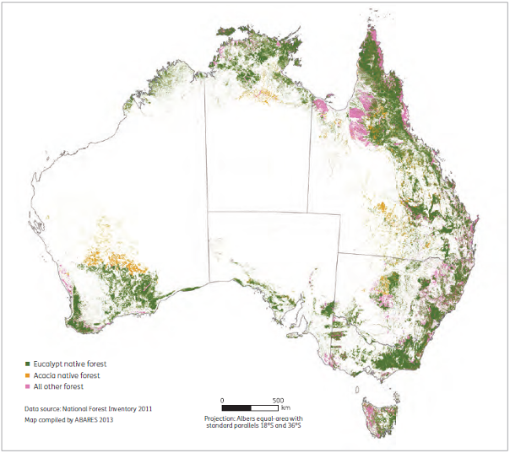
SOFR 2013 reports Australia's total forest area as 125 million hectares, as shown in this map. Australia's 123 million hectares of native forests are dominated by eucalypt forests and acacia forests.
A new approach has improved the resolution of mapping and given a more accurate measure of Australia's forest area.
The forest area data for Australia presented in SOFR 2013 were derived using a 'Multiple Lines of Evidence' approach, which integrates forest cover data provided by state and territory land management agencies with data sourced from a variety of remote-sensing methods.
- This approach gives a higher level of certainty of reporting for areas of forest and areas of non-forest.
- The resultant National Forest Inventory forest cover dataset contains an updated and more rigorous and robust understanding of Australia's total forest area, the geographic distribution of national forest types, and the geographic distribution of forests of different tenure.
Australia's forest area reported in SOFR 2013, following application of the 'Multiple Lines of Evidence' approach, is 125 million hectares; Australia's forest area was reported in SOFR 2008 as 149 million hectares.
- Reporting a smaller forest area in SOFR 2013 does not mean that there has been a reduction in actual forest area, but rather results from improvements in technology that have enabled the use of better quality data on Australia's forests. The main reason is an improved resolution of forest mapping, resulting from the use of finer scale vegetation data, and often complemented by interpreted satellite imagery.
- Most of this improvement in resolution has occurred in Australia's less dense woodland forests, and has resulted from more careful delineation of the boundaries between woodland forest (with a crown cover of20—50%) and other woody non-forest vegetation (with a crown cover of less than 20%). Much of the area previously reported as woodland forest in SOFR 2008 is now classified in SOFR 2013 as other woody non-forest vegetation.
- Another reason for reporting a smaller forest area is the incorporation of data on historical and recent land-use change for agriculture, mining or urban development.
- Most (83%) of the reduction in reported forest area between SOFR 2008 and SOFR 2013 is in the Northern Territory and South Australia, in forests generally managed under leasehold tenure.
SOFR 2013 reports no reduction in the areas of rainforest, multiple-use public forest, or forest in any of the Regional Forest Agreement regions compared with SOFR 2008.
- These areas have all been the subject of previous detailed forest mapping, and the Multiple Lines of Evidence approach led to only small amendments in their forest areas.
Continual improvements in understanding the extent of Australia's forests, and the reporting of forest area, have occurred since national figures were first reported in 1974.
- Australia's reported forest area has fluctuated between 105 million hectares and 164 million hectares since 1974, including across the three previous national State of the Forests reports in 1998, 2003 and 2008.
- These historical fluctuations in reported areas did not reflect actual changes in on-ground forest cover, but instead were mainly the result of changes in the basis of reporting (from only commercial forests to all forests), variability in state and territory data, mapping errors, and, before 1998, changes in the definition of forest.
The Multiple Lines of Evidence approach now adopted for the National Forest Inventory provides a forest area value, 125 million hectares, that is more accurate than previously reported values, and that is expected to be more suitable for the determination of changes in forest area over future reporting periods.

Change in forest area over time
Australia's forest cover changed over the period 2005-10, with a net loss estimated at 1.4 million hectares.
National figures for changes in on-ground forest cover are best determined using a single methodology applied consistently over time. The best available source of such data is currently satellite imagery interpreted for Australia's National Greenhouse Gas Inventory (previously known as the National Carbon Accounting System—NCAS). There are differences between the NCAS dataset used for carbon accounting, and the National Forest Inventory dataset used for the detailed recording and reporting of forest areas classified by forest structure, type and tenure. Overall, however, the NCAS dataset currently gives the most accurate measure of on-ground change in Australia's forest area.
Over the period 2005—10, the net loss of forest area calculated using the NCAS dataset is 1.4 million hectares (just over 1% of Australia's forest area). This was the result of land-use change for urban development and agriculture, plus short-term factors such as drought and fire. During this period, forest area decreased by 1.8 million hectares in 2005—08, then increased by 0.4 million hectares in 2009—10 as a result of recovery of forest from drought and fire.

Tenure and forest growth stage
The majority of Australia's native forests are in private and leasehold tenures. Smaller areas are held in formal nature conservation reserves and multiple-use public forests.
An estimated 81.9 million hectares (66.8%) of Australia's native forest is privately managed on private and leasehold tenures, while 21.5 million hectares of native forest (17.5%) is in formal nature conservation reserves. A further 10.2 million hectares of native forest (8.3%) is in multiple-use public forests. The remaining native forest (9.0 million hectares, 7.4%) occurs on other Crown land, or on land of unresolved tenure.
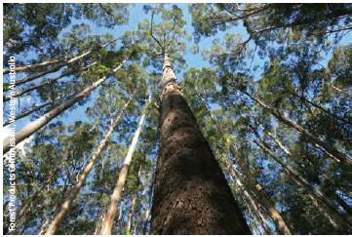
Regrowth karri (Eucalyptus diversicolor) forest in south-west Western Australia.
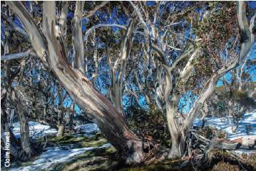
Woodland forest of snowgum (Eucalyptus pauciflora) in Kosciuszko National Park, New South Wales.
Nature conservation reserve and multiple-use public forest now both comprise a greater proportion of the native forest area than in SOFR 2008 (although for multiple-use public forest this is driven largely by forest tenure reclassification in Queensland), and there is a trend of progressive transfer of forest into reserves since the first SOFR in 1998. The distribution of native forest tenure types varies significantly across the different states and territories.
National data on native forest growth stage are available only for 15.4 million hectares of native forest, most of which is in Regional Forest Agreement regions in south-east and south-west Australia, where detailed measurements have been carried out. In this area of forest where growth stage is known, all four forest growth stages (regeneration, regrowth, mature and senescent) are present on all tenure types. More than 73% of Australia's identified old-growth forests are in formal or informal nature conservation reserves.

Protected forest areas on public and private land
A total of 39 million hectares (32% by area) of Australia's native forest is in areas protected for biodiversity conservation.
A total of 39 million hectares of Australia's native forest (32% of the native forest area) is designated as protected for biodiversity conservation. This comprises areas protected by prescription in multiple-use public forests, legally covenanted private land, formal and informal nature conservation reserves, and other protected areas on Crown-managed land.
Of this total protected area, the National Reserve System records 26 million hectares of forest (21% of Australia's forests) where nature conservation is the primary management intent (some types of protected area are not compiled into the description of the National Reserve System in the Collaborative Australian Protected Areas Database). All of the national native forest types in Australia, with the exception of Acacia forest, are represented at levels above the 10% area proportion target recommended by the International Union for Conservation of Nature.

Improved information on forest biodiversity and threats to forest species
Increases in the recorded national numbers of forest-dwelling species, and threatened forest-dwelling species, have resulted from improved information.
SOFR 2013 presents data from new national compilations of forest-dwelling vertebrate animals (2,212 species) and forest-dwelling vascular plants (at least 16,836 species), prepared from lists held by states and territories. The number of forest-dwelling species has generally increased in each jurisdiction since data were first reported in SOFR 1998, reflecting improved information from surveys. SOFR 2013 also presents data from a new national list of forest-dependent vertebrate animals (1,101 species) compiled from habitat data.
The national list of threatened species includes 1,431 forest-dwelling species (283 vertebrates, 32 invertebrates and 1,116 vascular plants). During 2006—11, a total of 89 forest-dwelling species were added to the national list of threatened species, and 21 forest-dwelling species were removed. Most removals (76%) were made because of better information about species populations, distributions or ecology that indicated that the species was not threatened, and the remaining removals (24%) resulted from taxonomic revisions. Among newly listed forest-dwelling species, the primary threats that led to their listing were historical land clearing for agriculture, grazing, and urban and industrial development, and associated habitat loss; predation by or competition from introduced fauna; small or localised populations; unsuitable fire regimes; and various mortality agents. Forestry operations pose a minor threat to nationally listed threatened forest-dwelling fauna and flora species compared with other identified threats.
No forest-dwelling species is known to have become extinct since the release of the first SOFR in 1998. Seven forest-dwelling plant species previously categorised as extinct were rediscovered during the SOFR 2013 reporting period.
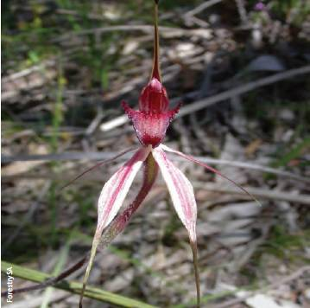
Spider orchid (Caladenia behrii), an endangered forest-dwelling vascular plant found in South Australia.

Conservation and use of forest genetic diversity
Australia's forest genetic resources are conserved by a variety of means, are widely distributed internationally, and constitute the basis of tree improvement programs.
Australia's native forest genetic resources are primarily conserved in Australia's native forest, and to a lesser degree in arboreta, seed banks, seed orchards and plantations. Significant amounts of Australia's forest genetic material have been exported for use internationally in industry development and environmental protection. Tree-breeding, improvement and genetic conservation programs exist for more than 30 native Australian wood-producing and oil-producing species and varieties.
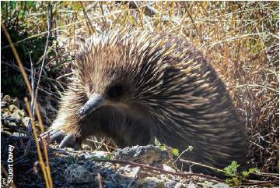
Echidna (Tachyglossus aculeatus), a forest-dwelling animal found in many of Australia's forests.
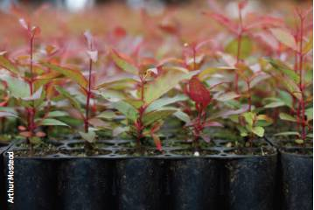
Eucalypt seedlings in tubestock.

Health and dynamics of Australia's forests
Many of Australia's forests were affected by drought and wildfire during the reporting period, and are currently recovering from these events. In both number and area, most wildfires occur in northern Australia. The Black Saturday bushfires in Victoria in 2009 had exceptionally serious impacts. There was an incursion of myrtle rust into Australia, with the potential to damage plantations and native forests.
Generally, Australia's forests are well adapted to disturbances such as fire, drought, cyclones and outbreaks of native pests and diseases, and impacts are followed by periods of recovery.
Damage caused to forests from native pests (mostly insects) and pathogens (mostly fungi) over the period 2005—10 was generally of low severity, and only occasionally widespread in extent. Most of the observed damage to forests was caused by exotic pests and pathogens that have become established in Australia. Occasionally, damage from outbreaks adversely affected commercial values in plantations.
Phytophthora cinnamomi and a number of other Phytophthora species remained a threat to a wide range of plant species, predominantly in regions with an average annual rainfall of more than 600 millimetres. Quambalaria shoot blight caused damage in spotted gum plantations in Queensland, while fungal leaf pathogens caused occasional significant defoliation in plantations in Tasmania, Victoria, Queensland and Western Australia. Teratosphaeria (Kirramyces) leaf spot became a major problem for eucalypt plantation establishment in the central-coast region of Queensland. Spotted gum canker emerged as a health issue for Corymbia species in New South Wales. Spring needle cast remained one of the major problems affecting the radiata pine plantation estate, while Dothistroma needle blight affected radiata pine plantations in Victoria and New South Wales.
The major new disease incursion in the reporting period was the establishment and spread of myrtle rust (Puccinia psidii) in New South Wales, Queensland and Victoria. The myrtle rust pathogen has a wide range of hosts within the Myrtaceae, the plant family that includes eucalypts and many other Australian tree species. Rust spores are predominantly disseminated by wind, and the rust has spread rapidly to new areas (including native forest) after it was detected initially in nurseries, but its likely impact on Australia's plantations and native forests remains unclear.
A number of tropical cyclones caused significant damage to native forests and plantations in Queensland during the reporting period, including Cyclone Yasi, the largest and most powerful on the eastern coast of Australia since 1918. Drought affected large areas of western and south-eastern Australia for much of the reporting period, with significant impacts on forest health.
A series of intense wildfires affected large areas of forest in western and south-eastern Australia during the reporting period. The previous drought contributed to the intensity and extent of these fires. The fires are expected to have a range of impacts on wood flows and environmental values, including by affecting seed supply and forest regeneration, and water yield and quality. In Victoria, the Black Saturday bushfires of 07 February 2009 were exceptionally serious, burning more than 400,000 hectares, and resulting in the deaths of 173 people.
Overall, however, most bushfires, in terms of number and area, continue to occur in northern Australia: 77% of the forest area burnt over the period 2006—07 to 2010—11 was in the Northern Territory and Queensland, with some areas burning more than once during the reporting period. The estimated total area of forest burnt in the period 2006—07 to 2010—11 was 39.0 million hectares, an increase of 14.3 million hectares over that burnt in the period 2001—02 to 2005—06, with the increase also being mostly in the Northern Territory and Queensland. Of this total, unplanned fires burnt an estimated 31.6 million hectares of forest (81% of the total forest area burnt), and planned fires burnt an estimated 7.4 million hectares of forest (19%).
However, the long-term impacts of projected climate change on the broader native forest estate are unclear; it is possible that the greatest impacts will be through altered fire regimes, and changes in the incidence of pests and diseases. The performance of individual plantation species is predicted to change, which could lead to regional changes in plantation productivity.
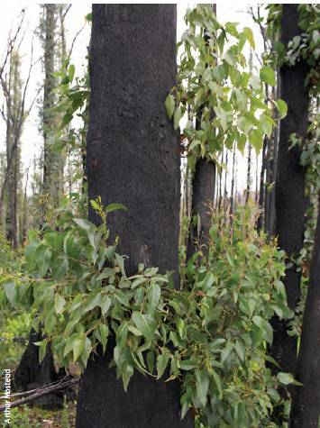
Epicormic growth in a eucalypt forest following fire.

Soil and water management
The forest practices systems in Australia's states and territories contain guidelines designed to protect forest soil and water resources.
Codes of forest practice, guidelines and other instruments in place for Australia's forests aim to protect soil values and maintain water supply and quality, including by preventing or mitigating soil erosion. A total of 29.8 million hectares of public forest (24% of Australia's total forest area) is managed primarily for protection, including of soil and water values, an increase of about 2% over the 2006—11 reporting period. A variety of national-level programs have encouraged re-establishment, restoration and maintenance of native vegetation, including forests, for protective functions.
Major wildfires in native forest during the reporting period caused temporary declines in water quality. Increased water use by the resultant natural regrowth is expected to reduce water yields in some affected catchments in coming years.

Role of forests and forest management in sequestering carbon
Carbon stocks in Australia's forests increased slightly over the period 2005-10, as did transfers of carbon from forests to forest products in service and in landfill.
Forests are an important component of the global carbon cycle, because they store substantial amounts of carbon, sequester carbon during growth, and release carbon during fire and decay. Forest carbon stocks vary over time according to natural processes of growth, disturbance and regeneration, and are also affected by forest management activities. There was a small increase in carbon stocks in Australia's forests (from 12,831 to 12,841 million tonnes) over the period 2005—10, driven by the recovery of forest from wildfires in the previous five years. Plantations accounted for 171 million tonnes of the forest carbon stock in 2010.
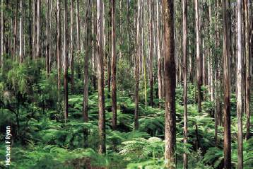
Tall open eucalypt forest, Victoria.
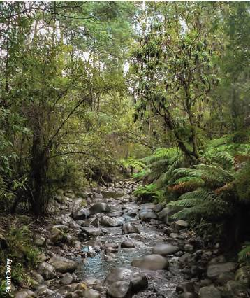
Forest streams provide clean water and contain aquatic biodiversity. This stream flows through mountain ash (Eucalyptus regnans) forest in a Victorian water-supply catchment.
In addition, in 2010 a total of 103 million tonnes of carbon derived from forests was present in wood and wood products, including paper, in service (7 million tonnes more than in 2005 and 14 million tonnes more than in 2000); a further 123 million tonnes was present in wood and wood products, including paper, in landfill (6 million tonnes more than in 2005 and 13 million tonnes more than in 2000). The transfer of carbon from forests to wood products thus increased during the reporting period. The total amount of greenhouse gases emitted by forestry operations in producing logs represents only 3—7% of the equivalent amount of carbon dioxide sequestered in those logs.

Industry resource base
A total of 36.6 million hectares of native forest was both available and suitable for commercial wood production in 2010-11, comprising 7.5 million hectares of multiple-use public forests and 29.1 million hectares of leasehold and private forests. Australia-wide, 2.0 million hectares of industrial plantations were available for commercial wood production in 2010-11, an increase from 1.8 million hectares in 2005-06.
The major source of native forest wood and wood-based products is multiple-use public forests in New South Wales, Queensland, Tasmania, Victoria and Western Australia. The majority of the native forest estate on leasehold and private land, including forests used predominantly for extensive grazing, does not contribute significantly to national wood supply.
The area of native forest both available and suitable for commercial wood production determines the forest sector's capacity to meet demand for native forest wood and wood-based products. The availability of an area for wood production is determined by its tenure; state and territory regulatory frameworks, including codes of forest practice; and other requirements, such as the protection of soil, water values and biodiversity. The area of native forest not legally restricted from wood harvesting decreased steadily over the period 2000—01 to 2010—11 as a result of the transfer of significant areas of multiple-use public forests to nature conservation reserves. The suitability of an area of native forest for wood harvesting is also limited by commercial reasons, including the absence of tree species marketable in commercial quantities, low site productivity, isolation from markets or processing facilities, operational harvesting difficulties, and other infrastructure constraints.
A new, national, forest commerciality database was used in SOFR 2013 to identify spatially the area of forest both available and suitable for harvesting. A total of 36.6 million hectares of native forest was both available and suitable for commercial wood production in 2010—11. Of this, 7.5 million hectares of public native forests is both available and suitable for commercial wood production; however, when additional local restrictions to maintain and manage non-wood values are taken into account, the net harvestable area in multiple-use public native forest is 5.5 million hectares. A substantially larger area (29.1 million hectares) of leasehold and private tenure forest is potentially available and suitable for commercial wood production, but this is subject to landholder intent, markets, regulatory frameworks, and environmental constraints.
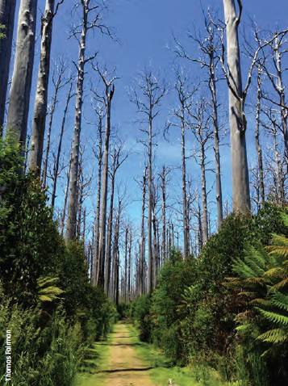
Regeneration of mountain ash (Eucalyptus regnans) forest, Victoria.
Australia also had 2.0 million hectares of Industrial plantations available for commercial wood production in 2010—11, an increase from 1.8 million hectares in 2005—06. Australia's softwood plantation estate has been approximately 1.0 million hectares in size since 1990 (and was 1.03 million hectares in 2011). The increase in Australia's hardwood plantation estate started in around 1990, with the area reaching 1.0 million hectares in 2009 and then remaining approximately constant (and was 0.98 million hectares in 2011).
Ownership of trees in the Industrial plantation estate changed significantly between 2005 and 2011. Of the total Industrial plantation estate, the area proportion where the trees are government-owned decreased from 35% in 2006 to 24% in 2011, while the proportion where the trees are privately owned increased from 65% to 76%. Private ownership identified as ownership by institutional investors increased to 31% in 2011; ownership by managed investment schemes rose to a high of 36% in 2009, then fell to 24% in 2011; other private ownership types, including farm foresters, timber industry companies and other private entities, totalled 21% by area in 2011.

Harvesting of wood and non-wood forest products
Over the period 2006-07 to 2010-11, the annual area of multiple-use public native forest harvested for wood decreased by 32%, with associated decreases in the volumes of sawlogs and pulplogs produced from native forests. Nationally, actual sawlog harvest levels were below sustainable yield levels by 17% for the period 2006-11, and below sustainable yield levels by 6-18% for each of the four SOFR five-yearly reporting periods. Average annual sawlog harvests from multiple-use public native forests declined from 1.96 million cubic metres in the period 2001-06, to 1.4 million cubic metres in the period 2006-11.
In the period 2006-11, there was an increase in the volumes of sawlogs and pulplogs harvested from plantations. In 2010-11, plantations produced 76% of Australia's total log supply.
The area of multiple-use public native forest harvested annually for wood declined from 117 thousand hectares in 2006—07 to 79 thousand hectares in 2010—11, a decrease of 32%. Of the area harvested over the 10-year period 2001—02 to 2010—11, 85% was harvested using a variety of selection logging systems, 12% by clearfelling silviculture systems (clearfelling, fire-salvage harvesting and intensive silviculture), and 3% by shelterwood systems.
Average sustainable sawlog harvest yields from multiple-use public native forests declined by 47% nationally between 1992—96 and 2006—11. This was a consequence of increased forest reservation, increased restrictions on harvesting in codes of forest practice, revised estimates of forest growth and yield, and the impacts of broadscale wildfires. In parallel with this trend, actual sawlog and pulplog harvests from native forest both declined: for example, average annual sawlog harvests from multiple-use public native forests declined from 1.96 million cubic metres in the period 2001—06, to 1.4 million cubic metres in the period 2006—11. Nationally, the actual sawlog harvest levels were below sustainable yield levels by 17% for the period 2006—11, and below sustainable yield levels by 6—18% for each of the four SOFR five-yearly reporting periods.
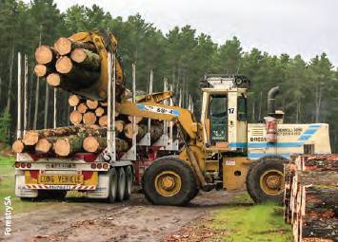
Loading harvested radiata pine (Pinus radiata) logs in the Green Triangle region, South Australia.
In comparison, over the period 1992—96 to 2006—11, the sawlog and pulplog harvest from softwood plantations increased, as did the pulplog harvest from hardwood plantations. The sawlog harvest from hardwood plantations has been low but relatively stable over time, but the availability for harvest of plantation hardwood sawlogs is projected to increase over the next decade. In the period 2006—07 to 2010—11, plantations produced 71% of the total volume of logs harvested in Australia: hardwood plantations provided 35% of the pulplog supply and 1% of the sawlog supply, while softwood plantations provided 39% of the pulplog supply and 79% of the sawlog supply. In 2010—11, the final year of the SOFR 2013 reporting period, 76% of the volume of logs harvested in Australia was from plantations.
The residential use of firewood for heating and energy decreased slightly between 2006 and 2010, while industrial fuelwood use increased over this period.
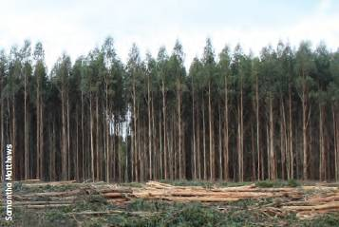
Blue gum (Eucalyptus globulus) plantation being harvested in the Eden region, New South Wales.
Australia also produces a wide range of non-wood forest products. High-value non-wood forest products include wildflowers, seeds, honey, and aromatic products derived from sandalwood. Generally, the extraction of non-wood forest products has a low environmental impact in Australia.

Trends in forest production
A total of 26.6 million cubic metres of logs was harvested in Australia in 2010-11, a decrease from 27.2 million cubic metres in 2006-07. This overall decrease was made up of a decrease in the harvest of native forest hardwood logs but an increase in the harvest of softwood and hardwood plantation logs.
The total value of logs harvested from native forests and plantations in 2010-11 was $1.85 billion. The wood and wood products industries contributed $8.3 billion or 0.59% of Australia's gross domestic product in 2010-11. Turnover of the Australian wood and wood products industries in 2010-11 was $24.0 billion. The trade deficit in wood products was $1.93 billion in 2010-11. The gross annual value of production of non-wood forest products in 2011-12 was estimated at $198 million.
A total of 26.6 million cubic metres of logs was harvested in Australia in 2010—11, a decrease from 27.2 million cubic metres in 2006—07. The volume of hardwood logs harvested from native forests declined by 26% over this period, from 8.55 million cubic metres to 6.3 million cubic metres. The volume of logs harvested in softwood and hardwood plantations (plus a small volume of softwoods harvested from native forests) increased by 8.1% over this period, from 18.4 million cubic metres to 20.2 million cubic metres; 76% of the volume of logs harvested in Australia in 2010—11 was from plantations.
Indexed to 2010—11 prices, the value of logs harvested from native forests and plantations decreased from $1.93 billion in 2006—07 to $1.85 billion in 2010—11, a decrease of 3.9%. Indexed to 2010—11 prices, the turnover (sales and service income) of the wood and wood products industries increased from $23.8 billion to $24.0 billion between 2006—07 and 2010—11, an increase of 0.9%. The value added by the wood and wood products industries was $7.4 billion in 2006—07, giving a contribution to Australia's gross domestic product of 0.68%. The value added was $8.3 billion in 2010—11, and the contribution to gross domestic product was 0.59%.
Australia is a net importer of wood and wood products. The trade deficit in wood products increased slightly over the reporting period, to $1.93 billion in 2010—11, due to an increase in imports linked to the strong Australian dollar, and an oversupply of wood products in international markets.
Recovery and recycling rates for paper and paperboard products increased over the reporting period, continuing a long-term trend.
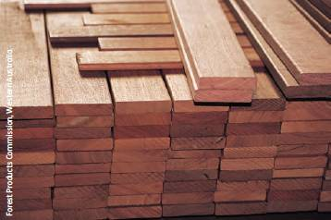
Premium grade jarrah (Eucalyptus marginata) timber from Western Australia.
The gross annual value of production of non-wood forest products regarded as having high forest dependence was $198 million in 2011—12.
The value of benefits from forests other than provision of wood, such as biodiversity, carbon storage and sequestration, production of water and soil protection, is generally not integrated into an economic framework for forest conservation or management.

Investment in forests and forest research
The annual rate of establishment of new hardwood and softwood plantations declined from 87 thousand hectares in 2006-07 to 10 thousand hectares in 2010-11. Annual investment in new plantations thus decreased substantially over this period. Expenditure on research and development in forestry and forest products and associated capacity also declined.
Investment in new hardwood and softwood plantation establishment can be measured by the area of new plantations established. A total of 10 thousand hectares of new plantations was established in 2010—11, compared with 87 thousand hectares in 2006—07.
The forestry sector accumulated $6.0 billion of fixed capital between 2006—07 and 2010—11, including new plantations, equipment and buildings; over this period, fixed capital formation net of depreciation and amortisation was estimated at $1.08 billion.
Research, inventory and the development of assessment methodologies provide the basis for sustainable forest management by allowing an understanding of the characteristics and functions of Australia's forests, while forest products research and development aims to identify new forest-based products and processing methods. Between 2005—06 and 2008—09, total expenditure on research and development (R&D) reported by businesses in the forestry sector declined from $ 164 million to $137 million. Adjusted for inflation, and using a consistent methodology over time, there has been an overall decline in forestry and forest product R&D expenditure since 1982.
Changes in funding and delivery models by the Australian Government and by state and territory governments reduced forest R&D capacity across a number of national organisations and state and territory forest management agencies. The numbers of staff engaged in R&D activities fell, especially between 2008 and 2011; the reduction occurred in both the public and the private sectors, including CSIRO, state and territory governments, and academic institutions. An estimated 396 researchers and technicians were involved in forestry and forest products R&D in 2011, a reduction from 635 in 2008.

Indigenous forests
Approximately one-third of Australia's forests are Indigenous owned and managed, Indigenous managed, Indigenous co-managed or subject to Other special rights.
Access, management and ownership are key parts of the relationship of Indigenous people with land. Just over one-third of Australia's forests (41.9 million hectares, 34% by area) were identified as part of the Indigenous estate—that is, in one of four broad Indigenous land tenure and management categories: Indigenous owned and managed, Indigenous managed, Indigenous co-managed and Other special rights. About three-quarters of this forest area is in Queensland and the Northern Territory.
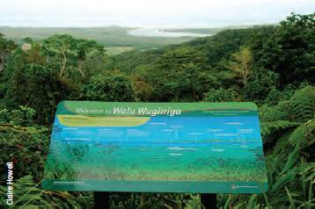
Interpretive sign, Walu Wugirriga, Daintree National Park, Queensland.

Non-Indigenous heritage
A total of 7.3 million hectares of forest is listed in the Non-Indigenous Heritage Sites of Australia dataset.
Australia's forests include many sites that provide evidence of the complex interactions between non-Indigenous people and forest landscapes. A total of 7.3 million hectares of forest is listed in the Non-Indigenous Heritage Sites of Australia dataset. Registered heritage sites occur in all tenure types, although many are not registered with the specific objective of protecting and conserving forests. Examples of larger sites with substantial protected forest components are Kakadu National Park, the Tasmanian Wilderness, the Gondwana Rainforests of Australia, and the Grampians National Park.

Forest-related employment
Total direct employment in the forest and wood products sector fell between 2006 and 2011, including in those Statistical Local Areas most dependent on these industries.
There was a fall in total direct employment in the forest and wood products sector over the reporting period, from 85 thousand people in 2006 to 73 thousand people in 2011, as reported in Australian census data. These figures comprise people employed full-time or part-time in forestry and logging; wood product manufacturing; pulp, paper and converted paper product manufacturing; forestry support services; and timber wholesaling. Direct employment in the forest and wood products sector also declined as a proportion of total national employment during this period. In Tasmania, forest-related employment fell by almost half between 2006 and 2011. The number of students commencing and graduating with forestry-specific university degrees also declined, and there were ongoing shortages of skilled workers across Australia's forest industry.
Total national employment in the forest and wood products sector, 2006 and 2011.
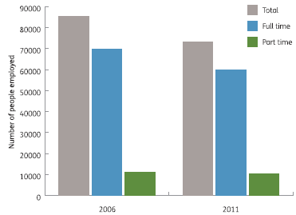
Note: Total employment may be higher than the sum of full-time and part-time employment because total employment includes people who were 'employed, but away from work' but for whom hours worked were not given.
Source: Australian Bureau of Statistics.
In 2011, there were 28 Statistical Local Areas (SLAs) in which 4% or more of the working population (the level used to show medium-to-high relative community dependence on direct employment in the sector) was employed in forest and wood products industries. Of these 28 SLAs, 24 showed a decline in employment in the sector over the period 2006—11. Community adaptive capacity to change (resilience) can be affected by available human capital, social capital and economic diversity; of the SLAs with relatively high employment dependence on forest and wood products industries, several had relatively low rankings in an adaptive capacity index.
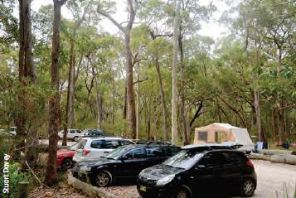
Visiting forests is a popular activity. Meroo National Park, New South Wales.

Public perceptions of forests
There is a range of public perceptions of forest management and of the acceptability of plantations.
Public perceptions are divided over whether Australia's native forests are sustainably managed. Wood is generally viewed as an environmentally friendly material. Harvesting trees is viewed favourably only if the trees are replaced with new ones. Understanding of the role of forests in carbon storage is high, and understanding of the role of wood in carbon storage increased appreciably over the reporting period. Public perceptions of the acceptability of plantations as a rural land-use are also divided, although with regional variations.

Policy and regulation
Australia has a well-established framework for forest management, including policy and legislative instruments, and codes of forest practice. The area of forest in which forest management is certified has continued to increase over the reporting period.
Australia's National Forest Policy Statement (1992) underpins a well-established policy and legislative framework for the conservation and sustainable management of Australia's forests, both nationally and at state and territory levels. Public native forest is governed and managed under state or territory regulatory frameworks and management plans. The management of forests on private land is also regulated under various native vegetation Acts. Twenty-six million hectares (21%) of Australia's forests are covered by management plans relating to their conservation and sustainable management. Fifteen million hectares of forest in the National Reserve System (56% of the area of forest in the National Reserve System) have management plans in place.
Codes of forest practice vary in their legal status and coverage, but generally they provide specific operational guidance for sustainable forest management practices in public and private forests available for wood production, including plantations.
The area of forest in which forest management is certified under either the Australian Forest Certification Scheme or the Forest Stewardship Council has continued to increase. In 2011, about 10.7 million hectares of native forests and plantations were certified, with some areas certified under both schemes.

New national data compilations, and remaining knowledge gaps
The analysis in SOFR 2013 of a number of new, national, forest-related datasets with improved coverage and quality has allowed improvements in reporting across a range of indicators, and has enabled a more complete description of trends over time. Data gaps remain in some indicators, especially for private and leasehold forests.
A number of new social, economic and environmental datasets have been compiled, analysed and presented in SOFR 2013. Compared with SOFR 2008, the coverage and quality of data presented in SOFR 2013 has improved for almost half (21) of the 44 national reporting indicators. These changes have increased the quality of the information, and confidence in its accuracy. For 16 indicators, data were sufficient to allow comparisons of metrics over longer periods of time, enabling analysis and presentation of trends.
However, quantitative information is not available equally across social, economic and environmental indicators, and a number of gaps remain in the data compiled for SOFR 2013. Some data are collected nationally, and other data are provided by states and territories. In addition, the ability to measure, monitor and report on forests varies considerably by tenure. Reliable and comprehensive information across a range of parameters is available for industrial plantations, and for native forests on multiple-use public tenure; data are more limited in other native forest tenure categories, including some nature conservation reserves and, especially, leasehold and private forests.
Overall, SOFR 2013 addresses its purpose of being a 'comprehensive national report', and provides the reader with information to assess progress towards sustainable forest management in Australia.
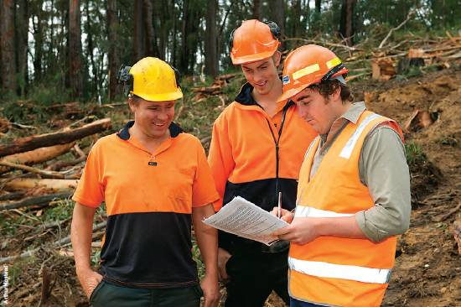
Forest officers inspecting a timber harvest operation, Victoria.
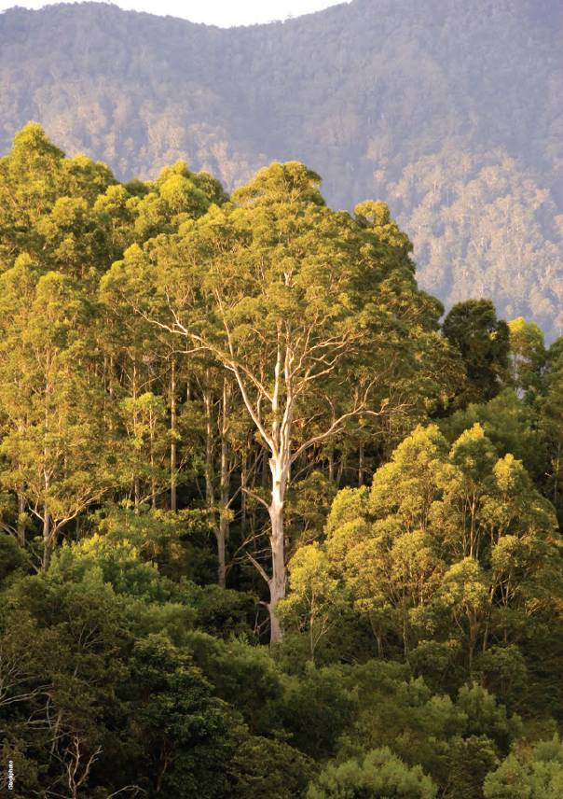
Forest near Bellingen, New South Wales

Pucciniapsidii sensu lato, previously referred to by the name Uredo rangelii.
Dollar amounts are only adjusted for inflation where specified.

