Jocks Lagoon
Ramsar Site
Ecological Character Description

This report should be cited as follows:
Newall, P.R., Lloyd, L.N. and Atchison, E.E. 2011. Ecological Character Description for the Jocks Lagoon Ramsar Site. Lloyd Environmental Pty Ltd Report (Project No: LE0930) for SEWPaC, Canberra, ACT. Final Report, August 2011.
Enquiries on this report can be made to:
Lance Lloyd, Director,
Lloyd Environmental Pty Ltd,
ph: 03 9884 5559, Mob: 0412 007 997,
Fax: 03 9884 7405,
lance@lloydenviro.com.au,
PO Box 3014, SYNDAL, Victoria 3149

The views and opinions expressed in this publication are those of the authors and do not necessarily reflect those of the Australian Government or the Minister for Sustainability, Environment, Water, Population and Communities or the Administrative Authority for Ramsar in Australia. While reasonable efforts have been made to ensure the contents of this publication are factually correct, the Australian Government does not accept responsibility for the accuracy or completeness of the contents, and shall not be liable for any loss or damage that may be occasioned directly or indirectly through the use of, or reliance on, the contents of this publication. Guidance on the development of Ecological Character Descriptions, including Limits of Acceptable Change, are areas of active policy development. Accordingly there may be differences in the type of information contained in this Ecological Character Description, to those of other Ramsar wetlands.
This information does not create a policy position to be applied in statutory decision making. Further, it does not provide assessment of any particular action within the meaning of the Environment Protection and Biodiversity Conservation Act 1999 (EPBC Act), nor replace the role of the Minister or his delegate in making an informed decision on any action.
This report is not a substitute for professional advice; rather, it is intended to inform professional opinion by providing the authors' assessment of available evidence on change in ecological character. This information is provided without prejudice to any final decision by the Administrative Authority for Ramsar in Australia on change in ecological character in accordance with the requirements of Article 3.2 of the Ramsar Convention. Users should obtain any appropriate professional advice relevant to their particular circumstances.

Acknowledgements
The authors of this document thank several people who provided valuable information in an expert workshop, advice on technical matters and/or comments on drafts of the document. In particular, we thank the following contributors:
- Emma Williams, Healthy Coasts and Seas Coordinator, NRM North
- Jo Voller, NRM North
- Nicole Walsh, PMP/Coastal Project Officer, NRM North
- Scott Schilg, Program Manager, Healthy Coasts and Seas, NRM North
- Polly Buchhorn, Break O’Day NRM Facilitator – NRM North / Break O’Day Council
- Andrew Baldwin, NRM North
- Stewart Blackhall, Wildlife Biologist, Wildlife and Marine Conservation Section, Biodiversity Conservation Branch, Department of Primary Industries, Parks, Water and Environment
- Micah Visoiu, Project Officer, Seed Safe Biodiversity, Monitoring Section Resource Management and Conservation Division, Department of Primary Industries, Parks, Water and Environment
- Adrian James, NRM North
- Kathy Noble, Coastal Planning Officer, DPIPWE
- Regan Parkinson, Technical Officer, Department of Primary Industries, Parks, Water and Environment
- Ken Morgan, Wetlands Section, SEWPaC

This project was commissioned and funded by the Australian Government (Department of Sustainability, Environment, Water, Population and Communities).
Micah Visoiu conducted a vegetation survey in November 2009 as part of the authors’ work in developing this ECD. This greatly increased our knowledge of the site and Micah is thanked for this contribution.
Ben Gawne, MDFRC, is thanked for sharing the Adobe Illustrator conceptual model base used for this project which arose out of the paper Price and Gawne (2009).
Symbols for conceptual model diagrams courtesy of the Integration and Application Network (ian.umces.edu/symbols), University of Maryland Center for Environmental Science.
Contents
List of Abbreviations 4
Executive Summary 5
1. Introduction 19
1.1. Purpose 19
1.2. Site Details 20
1.3. Date of Description 22
1.4. Relevant Treaties, Legislation or Regulations 22
1.4.1. International treaties and strategies 22
1.4.2. Commonwealth Legislation and Policy 23
1.4.3. State Legislation 24
2. general Description of the Site 25
2.1 Setting 25
2.2 Wetland Types 25
2.3 Land Use and Tenure 33
2.4 Ramsar Listing Criteria 36
2.4.1 Criteria under which the site is designated 36
2.4.2 Assessment against the remaining designation criteria 38
3. components and processes of Jocks Lagoon Ramsar Site 40
3.1 Critical Components and Processes and Essential Elements 40
3.2 Essential elements of the site 42
3.2.1 Climate 42
3.2.2 Geomorphology 43
3.2.3 Wetland fauna 44
3.2.4 Terrestrial vegetation 44
3.3 Critical Components and Processes 45
3.3.1 Hydrology 45
3.3.2 Water Quality 51
3.3.3 Wetland vegetation habitat types 51
3.3.4 Rare plant species of the site 53
4. Benefits and Services of the Site 54
4.1 Identifying benefits and services 54
4.2 Critical Benefits and Services 55
4.3 Linking services to processes and components of the site 55
5. key actual or potential threats to the site 60
6. Limits of acceptable change 65
7. Changes in Ecological Character since listing 69
8. Knowledge Gaps 70
9. Key Site Monitoring Needs 72
10. Communication, Education & Public Awareness (CEPA) Messages 73
10.1 Current CEPA Activities 73
10.2 Proposed CEPA Messages 74
11. Glossary 75
12. References 78
13. Appendices 81
13.1 Appendix 1: Flora of the site 81
13.2 Appendix 2: The Consultants 83
13.3 Appendix 3: Methodology to Develop the ECD 85
13.4 Appendix 4: LiDAR projection across the St Helens Peninsula showing flow paths of water from Jocks Lagoon. 90

List of Abbreviations
ANZECC | Australia and New Zealand Environment and Conservation Council
CAMBA | China-Australia Migratory Birds Agreement
CEPA | Community Education and Public Awareness
CMS | Bonn Convention on Migratory Species
DEWHA | Department of the Environment, Water, Heritage and the Arts (Commonwealth)
DPIPWE | Department of Primary Industries, Parks, Water and Environment
ECD | Ecological Character Description
EPBC | Environment Protection and Biodiversity Conservation Act 1999 (a Commonwealth Act)
JAMBA | Japan-Australia Migratory Birds Agreement
RIS | Ramsar Information Sheet
ROKAMBA | Republic of Korea-Australia Migratory Birds Agreement
SEWPaC Department of Sustainability, Environment, Water, Population and Communities (formerly DEWHA)
TSPA Threatened Species Protection Act 1995 (a Tasmanian Act)

Executive Summary
This Ecological Character Description (ECD) has been developed following the National Framework and Guidance for Describing the Ecological Character of Australia’s Ramsar Wetlands (DEWHA 2008) and contains information on the Jocks Lagoon Ramsar Site (referred to as ‘the site’). This information includes: geographic and administrative details; the site’s ecological character (including components, processes, benefits and services) at the time of Ramsar listing (1982) and currently; gaps in knowledge of the site and issues for management; actual or potential threats; changes that have occurred since listing; site monitoring needs; and communication, education and public awareness messages to facilitate management and planning.
The Site
Jocks Lagoon is a small, coastal freshwater lagoon, lying mostly on privately owned land and partly in the southern tip of the St Helens Point Conservation Area. It is one of a chain of lagoons, swamps and wetlands occurring along St Helens Point providing a freshwater resource in an otherwise dry coastal area. The site lies near a dune field and is 200 to 300 metres inland (westward) of the east coast of Tasmania (Figure E1).
Jocks Lagoon is approximately 150 metres wide and 650 metres long, with a north-south orientation. It receives water from a small drainage line with a catchment approximately three kilometres wide and one kilometre long and also from local groundwater. Although dark from tannins the waters of the lagoon are clear, low nutrient and acidic. This combination of clear, tannin stained waters with low nutrients and low pH (acidic) is referred to as ‘dystrophic’ and reflects substantial inputs of dissolved organic matter.
The northern half of Jocks Lagoon is mostly a large area of open water with isolated patches of emergent rush and sedge. In contrast, much of the southern half of the lagoon is covered with rush and sedge emerging from the water surface (Figure E2). The water level of the lagoon fluctuates with rainfall and reaches depths of two to three metres.
During a recent survey of the site, 51 species of vascular plant were identified. Approximately half of these were indicative of aquatic or damp habitat, with many of the remainder associated with the terrestrial vegetation communities, coastal woodland and Melaleuca forest. The aquatic flora of the lagoon is diverse and includes several rare species.
Ramsar Listing Criteria
At the time of preparing this ECD, Jocks Lagoon is listed under criteria one, three and four. During the preparation of the ECD, it was recognised that the site does not meet criterion four.
Criterion one (representative/rare/unique wetland type in appropriate biogeographic region)
Jocks Lagoon is a high quality representative of a wetland with Ramsar wetland types K, E, Ts and U within the Tasmania Drainage Division. The site is in near natural condition, with minimal disturbance. There is dense vegetation cover within the site and its surrounds, minimising erosion of the site, which is considered to be in good geomorphic condition (Dunn 2005).
The site met this criterion at time of designation and continues to meet it.

Criterion three (supports populations of plant and/or animals important for regional biodiversity)
This criterion includes species and communities listed at the State level. Jocks Lagoon supports rare, poorly reserved and scientifically valuable species. It provides wetland habitat for five threatened flora species considered to be at risk in Tasmania. These are:
- jointed twigsedge (Baumea articulata, rare, TSPA). Jocks Lagoon is one of the few wetlands in Tasmania containing the jointed twigsedge and is considered a key site for the species (DPIW 2009a). In Tasmania, jointed twigsedge is associated with rivers on the north-east coast (DPIW 2009a);
- slender twigsedge (Baumea gunnii, rare, TSPA). In Tasmania, slender twigsedge inhabits wet moors, creeks and riverbanks (DPIW 2009a) but was not previously known at the site until it was found in a botanical survey undertaken by Micah Visoiu (DPIPWE botanist) concurrently with a site visit for this ECD;
- zigzag bogsedge (Schoenus brevifolius, rare, TSPA). This species is only shown as occurring in six localities on the Tasmanian rare species database (DPIW 2009a) The species was not previously known at the site but was found as part of the botanical survey undertaken by Micah Visoiu (DPIPWE botanist) concurrently with a site visit for this ECD. In Tasmania, zigzag bogsedge grows in shallow water around the fringes of lagoons in the north-east (DPIW 2009a);
- yellow onion orchid (Microtidium atratum, rare, TSPA). The yellow onion orchid occurs in habitats subject to periodic inundation such as swamps, depressions and soaks (DPIW 2009a). Similar to the zigzag bogsedge, this species was not recorded at the site until it was found as part of the botanical survey undertaken by Micah Visoiu (DPIPWE botanist) concurrently with a site visit for the this ECD; and
- erect marshflower (Villarsia exaltata, rare, TSPA). This species occurs in the north east of Tasmania and Jocks Lagoon is one of the key sites for the species. It grows in stationary or slow flowing water to a depth of 50cm (DPIW 2009a).
At the time of designation, only the jointed twigsedge and the erect marshflower were recorded at the site. However, it is highly likely that the yellow onion orchid, slender twigsedge and the zigzag bogsedge were also present.
In addition, the site has several threatened native vegetation communities listed on Schedule 3 of the Tasmanian Nature Conservation Act 2002. These are Freshwater aquatic herbland – AHF, Freshwater aquatic sedgeland and rushland – ASF and Melaleuca ericifolia swamp forest – NME (following classifications in the Tasmanian Vegetation Map TASVEG (Harris and Kitchener 2005).
Based on the six rare, wetland-dependent plant species and the threatened native vegetation communities recorded at the site, it met criterion three at the time of designation and continues to do so.
Criterion four (supports species at critical stages or provides refuge in adverse conditions)
This criterion was applied to the site in the 2005 RIS (DEWHA 2010) based on the presence of the dinoflagellate Prorocentrum playfairi at the site (Croome and Tyler 1987). The genus Prorocentrum was previously thought to be entirely marine and is therefore of scientific interest. Jocks Lagoon is one of only seven known sites where this species exists. However, the presence of this species at the site is not evidence of providing support for the species at a critical stage, or for providing refuge in adverse conditions. Rather, it provides further justification for the site meeting criterion three – supporting populations important for regional biodiversity.
During site inspections, large numbers of young birds were observed at the site, including swans with cygnets, indicating that the site may be used for breeding or as a nursery. However, until further information is collected, this cannot be included in the site listing.
Based on the presence of the dinoflagellate population being more applicable to criterion three and the absence of other support for the site meeting criterion four, the site is not considered to meet this criterion currently or at the time of listing.
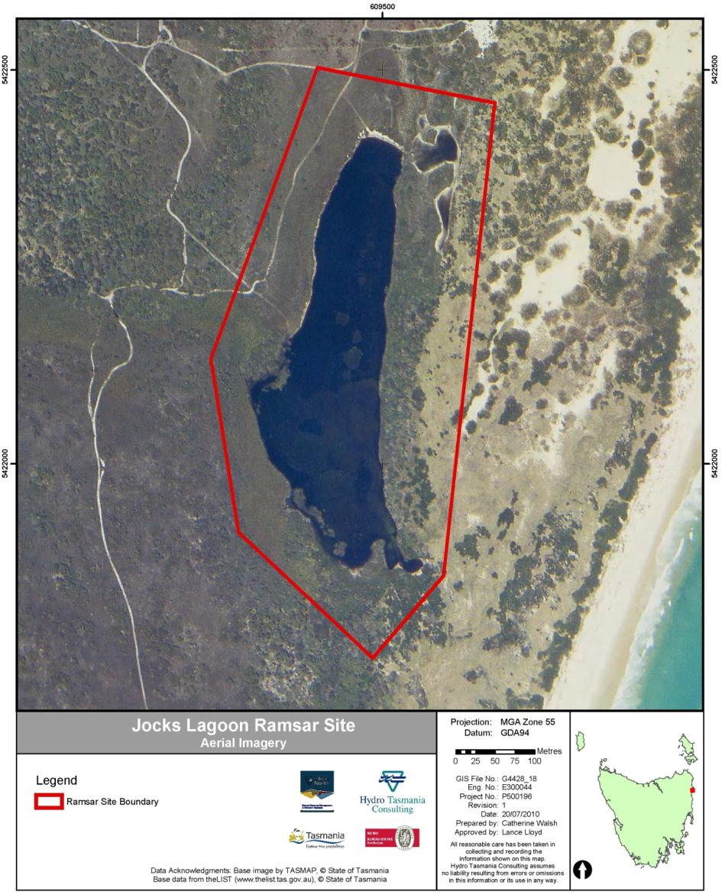
Figure E1: Map of location and boundary of Jocks Lagoon Ramsar Site (Source: NRM North; Base Photo is dated 29 Nov 2003).
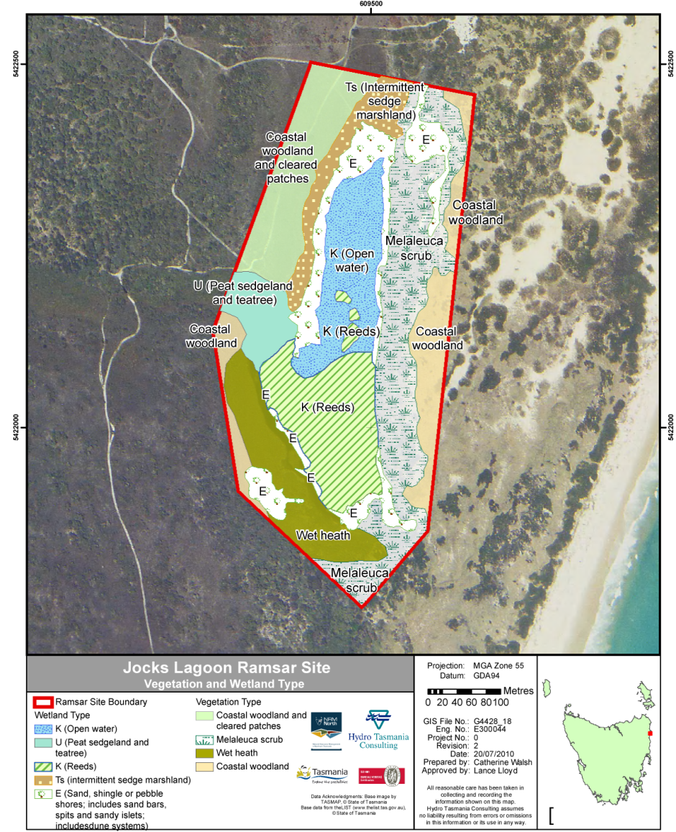
Figure E2: Vegetation and wetland types occurring at Jocks Lagoon Ramsar Site with TASVEG equivalent communities provided in the table below. (Source: NRM North and DPIPWE; Base Photo is dated 29 Nov 2003).
Ramsar Wetland Type | TASVEG equivalent
K (open water) & E | Freshwater aquatic herbland (AHF)
U | Wet heathland (SHW)
K (reeds) & Ts | Freshwater aquatic sedgeland and rushland (ASF)
Vegetation Type
Coastal woodland and cleared patches | Coastal heathland (SCH)
Melaleuca scrub | Melaleuca ericifolia swamp forest (NME)
Wet heath | Melaleuca squarrosa scrub (SMR)
Coastal woodland | Acacia longifolia coastal scrub (SAC)
Wetland Types
The wetland types of the site were recognised as a critical component of the site’s ecological character, contributing substantially to its ecological character and providing the habitat and species that form the basis of the site’s ecological services.
Wetland habitat type K: Coastal freshwater lagoon The wetland habitat type with the largest area at the site is coastal freshwater lagoon, with 4.4 hectares. This habitat type occurs in two distinct forms at the site: open water; and reed. The open water area occupies the northern half of the lagoon and is equivalent to the TASVEG community AHF – Freshwater aquatic herbland. During a site inspection following heavy rains, the authors canoed into part of this habitat type and observed patches of submerged macrophytes. Unfortunately, these were not able to be sampled and were difficult to distinguish as the water was uncharacteristically turbid due to the recent rainstorms. However, the floating leaved macrophyte water ribbons (Triglochin procerum) was observed in shallower parts of the site and has been recorded as constituting 40 percent of the vegetation cover in a marshy area of the site (Register of the National Estate 1999).
Within the open water, numerous Galaxias sp. fish were observed around the edges of the lagoon during a site inspection after heavy rains in late November 2009 and in February 2010, whereas no fish were observed during the prior inspection in May 2009, following a decade of drought conditions.
The reed section occupying the southern half of the lagoon is equivalent to the TASVEG community ASF – Freshwater aquatic sedgeland and rushland. It consists predominantly of giant spike rush (Eleocharis sphacelata) emerging from water approximately one half to one metre deep. Within the western area of the reed habitat there are also stands of slender twigsedge (Baumea gunnii) and, although not seen by the authors, this is where the jointed twigsedge (Baumea articulata) is reported to occur (Register of the National Estate 1999). Although there have been no systematic surveys of the site’s vegetation, a survey of Shaft Lagoon (approximately three kilometres to the north of the site) in 1999 described an Eleocharis sphacelata sedgeland dominating the lagoon, changing to a pithy swordsedge (Lepidosperma longitudinale) sedgeland in better drained areas (Glazik 1999). Pithy swordsedge was recorded as present at the site during the site inspections (Appendix 1). Reed habitat is known to provide shelter for a number of waterbirds and several were seen or heard during the site visits.
Wetland habitat type U: Non-forested peatland The peatland habitat type contained areas with shrubs and ferns and areas with mats of Sphagnum moss and sundews (Drosera spp.) interspersed with sedges. During the dry period this area remained a soak and was waterlogged underfoot, whereas after the heavy rainfall much of the area was between 20 and 50 centimetres underwater. Wetland field survey records (undated) note the presence of Leptospermum species at the site (L. scoparium var. scoparium and L. lanigerum), as well as the scented paperbark (Melaleuca squarrosa). A recent inspection suggests that the dominant shrub species in the peatland is L. scoparium var. scoparium with lesser amounts of Melaleuca present. This wetland type is equivalent to the TASVEG community SHW – Wet heathland.
Wetland habitat type Ts: Seasonal/intermittent freshwater marshes/pools The sedgeland of the site contained large areas of pithy swordsedge, with other sedge/rush species present. Species identified during the site inspections included common swordsedge (Lepidosperma filiforme), little clubrush (Isolepis marginate), slender twigsedge (Baumea gunnii) and the regionally rare zigzag bogsedge (Schoenus brevifolius). Species of rope rush (family Restionacea) were also common, including the slender twine rush (Leptocarpus tenax) and common scale-rush (Lepyrodia muelleri). This wetland type is equivalent to the TASVEG community ASF – Freshwater aquatic sedgeland and rushland. This is the area that became inundated following the large rainfall event just prior to the site inspection in November 2009.
During the dry period, most of the vegetation was sparse (estimated 15 to 30 percent cover), tussocked, and up to approximately 30 to 40 centimetres tall.
Wetland habitat type E: Sand shores At the site these were primarily the exposed areas of sand around the lagoon (which were far greater in area during the first site inspection), as well as areas that contained the overflow from the flooding. There was little in the way of vegetation in this habitat type, apart from the occasional tussock of sedge, rush or grass, and also very isolated individuals of water ribbons. This wetland type is equivalent to the TASVEG community AHF – Freshwater aquatic herbland.
During the high water site inspections, these areas were shallow (typically 5 to 20 centimetres deep) and contained large amounts of floating organic debris, such as leaves, twigs, bark and florets, which were providing cover for the juvenile fish and macroinvertebrates of the lagoon.
Conceptual Model
A landscape conceptual model is presented in Figure E3. Each critical ecosystem service supports one or more criteria for which the site is designated, and links in with specific components of the site through ecological processes. The linkages between the components, process and services are provided in Figure E3.
Climate is an essential element of the site that influences all aspects of the ecology. In particular, the provision of rainfall for the site’s hydrology is a vital element for the site. Reasonably uniform rainfall throughout the year typically provides a moist environment for the site, with all months receiving an average of at least 50 millilitres. The recent decade-long drought highlighted the importance of rainfall to the ecosystem, with the upsurge in biotic activity following the heavy rains in November 2009.
Clearly the site’s hydrology is also essential for each of the ecosystem services. As well as the delivery of surface water through overland flow, it appears likely that Jocks Lagoon receives groundwater, at least on a local scale. The extent of groundwater input from beyond the local area is unknown. However, the maintenance of a permanent freshwater lagoon during the extended drought indicates significant groundwater inputs. Similarly, the tannin stained, dystrophic nature of the water indicates a significant influence of ground water seepage through the peat layer underlying the site. The wetland habitat types and the rare species depend on the hydrology of the site providing occasional input of water through rainfall as well as the groundwater maintenance of the lagoon.
The hydrology and geomorphology of the site combine to provide the inputs of elemental nutrients as well as organic carbon from the intermittent sedgeland marsh to the lagoon. Without the occasional flooding of the sedgeland, it is likely that the already dystrophic lagoon would have substantially lower nutrient concentrations than it currently has. Abundant macroinvertebrates, fish and frogs following large rainfall events is at least partially dependent on this process.
The good vegetation cover of the catchment and, in particular, of the dunes nearby to the site provide important stability to Jocks Lagoon as a landform itself and also to the connected landforms. The connected landforms include the floodplain adjacent to the lagoon basin and the surrounding dune field. Without this good vegetation cover, the transgressive dune field could migrate through the site, covering the lagoon and surrounding areas. Similarly, the presence of quality, natural vegetation provides stability of drainage lines, reducing potential erosion into the lagoon.
The vegetation cover similarly contributes to the water quality of the site, with well-vegetated slopes slowing down overland flow thereby increasing infiltration of rainfall. Infiltration of rainfall decreases the overland transport of particulates and nutrients to receiving waters while increasing the filtering of the rainfall through the catchment soils generally leading to clearer and lower nutrient waters. The water quality of the site is important to many aspect of the biota, particularly the flora, including algae. The rare dinoflagellate Prorocentrum playfairi found at this site is noted to occur in freshwater coastal lagoon sites with low salinity (28-500 milligrams per litre), moderate to high colour and low pH (4.2-5.6) characteristic of dystrophic waters (Croome and Tyler 1987).
Although not critical to the ecological character of the site, other components add to it. These include the fish, frog and macroinvertebrates (including freshwater burrowing crayfish) of the site. As well as contributing to the general ecological character of the site, these biotic groups help sustain each other through the food chain (fish and frogs preying on macroinvertebrates, fish preying on tadpoles) as well as all providing prey for various waterbirds.

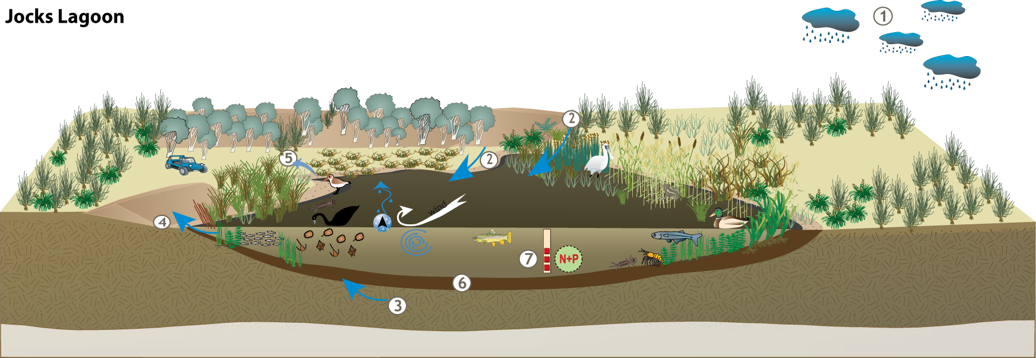

Figure E3: Conceptual model of Jocks Lagoon Ramsar site (explanations of symbols on the next page); The conceptual model base is from Price and Gawne 2009).
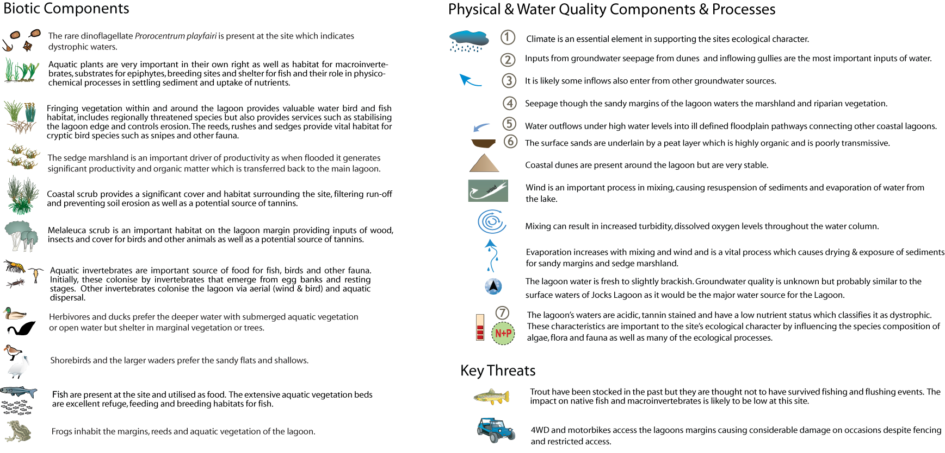

Key Actual or Potential Threats to the Site
The key threats identified for Jocks Lagoon Ramsar Site are long standing and most of these threats would have been occurring prior to the time of listing. These threats include:
- off-road vehicles
- climate change
- alien species introductions
- fire
- chytrid fungus
- Phytophthora cinnamomi
- sand mining
- weeds
- acid sulphate soils
- neighbouring developments
- slashing
Limits of Acceptable Change
Limits of acceptable change were derived for the following critical components, processes, benefits and services:
- wetland vegetation habitat types
- rare plant species
- hydrology
- supporting biodiversity
- water quality
Baseline information, justification and comments for these limits are provided in Table E1.

Table E1: Limits of Acceptable Change for the Jocks Lagoon Ramsar Site.
Critical component, process or service | Baseline information | Limit of acceptable change (LAC)* | Justification and Comments | Confidence
Wetland vegetation habitat types | The baseline information used in this assessment is the vegetation map produced as part of this ECD (Figure 2) | The limits of acceptable change for the wetland are that over a ten year period:  - no more than ten percent reduction in wetland types Ts (sedgeland marsh) and U (peat sedgeland and teatree). Areas for Ts and U are 1.0 and 0.8 hectares, respectively.  - no more than ten percent loss in the combined area of wetland types K (coastal freshwater lagoon) and E (sandy shores and dune slacks). Areas for K and E are 4.4 and 2.2 hectares, respectively. | There are no data on the variability of the wetland habitat types and, until this ECD, there was no mapping of the wetland types. These limits have been set as a common sense approach to defining a significant loss in wetland types. The second limit combines the standing water habitat with the sandy shores, as when the standing water (type K) reduces during drought, it exposes the sandy shores of the site (type E). As the map was made without proper field surveying, it will need verification. | Low-medium
Rare plant species | The only baseline information available is that two rare species were recorded as being at the site at the time of designation and a further three species were identified during site inspections for this ECD | Presence in two out of three surveys over a ten year period of:  - jointed twigsedge (Baumea articulata)  - slender twigsedge (Baumea gunnii)  - zigzag bogsedge (Schoenus brevifolius)  - yellow onion orchid (Microtidium atratum)  - erect marshflower (Villarsia exaltata). | There is no quantitative information on any of these species within the site. Therefore quantitative limits of acceptable change cannot be set and a qualitative LAC based on presence / absence of these five species is provided. | Low

Hydrology | There is no information on the hydrology of the site, other than the range in surface area of water observed during site visits. This was not quantified. | There is insufficient data to propose a quantitative limit of acceptable change for the hydrology of the site. | The relative input of surface water, local groundwater and (if applicable) regional groundwater is potentially of major importance to the functioning of the site, as is the establishment of its hydrological variability. | Low
Supporting biodiversity | The baseline information for the site as a support for regional biodiversity consists of a restricted plant species list and field observations for this project | There is insufficient data to propose a limit of acceptable change for the support of the range of biodiversity at the site. However, since the rare plant species of the site are the major indicators of the site’s biodiversity, the LAC for biodiversity is the same as the LAC for the rare plant species. | The presence of a diverse and abundant macroinvertebrate fauna, two frog species, at least one fish species and several rare wetland plant species suggests that this site supports biodiversity. However, without quantitative assessment, no limits of acceptable change san be derived | Low
Water Quality | The minimal data available shows Jocks Lagoon is consistently acidic, with a pH of 4.6 to 5.6 (Croome and Tyler 1987; Bowling et al 1993; Walsh et al 2002; Blackhall et al. 2003), although Horwitz (1992) recorded it with pH of 6.3. Very limited nutrient and colour data show low nutrients and generally highly coloured water. | There is insufficient data to set a limit of acceptable change for nutrients and tannin-staining. pH should have a 90th percentile of 6.5 over one year of sampling. | The lagoon’s waters are acidic, tannin stained and have a low nutrient status which classifies it as dystrophic. These characteristics are important to the site’s ecological character by influencing the species composition of algae, other flora, and fauna as well as many of the ecological processes. The LAC for pH is based on less than 10 samples and therefore is likely to benefit substantially from further sampling. | Low
*Exceeding or not meeting a LAC does not automatically indicate that there has been a change in ecological character.

Changes in Ecological Character Since Listing
The lack of baseline data on the critical components, processes and services of the site precludes assessment of ecological change since time of listing. However, it is unlikely that there has been any change in ecological character, as the site has remained largely with one owner who has done little to impact that site and has in fact recently erected fences to restrict access to off-road vehicles.
Although there is unlikely to have been a change to the ecological character of the site since listing, there are additions to be made to the justification of listing criteria:
- two Ramsar habitat types that had not previously been recorded at the site [Ts (intermittent sedgeland marsh) and U (peat sedgeland and teatree)]; and
- three more rare wetland dependent plant species: slender twigsedge (Baumea gunnii); zigzag bogsedge (Schoenus brevifolius); and yellow onion orchid (Microtidium atratum).
Knowledge Gaps
Highest priority for filling of knowledge gaps is given to the components most critical to the site’s listing and ecological character and to informing limits of acceptable change to the site’s ecological character. Despite the almost complete lack of quantitative data for the site, the key knowledge gaps are relatively few.
Baseline data should be gathered using standard methods that allow a derivation of a ‘point in time’ baseline that can be compared to future monitoring programs. Therefore, an initial sampling strategy should be designed in a way that is cognisant of repeatability. This is particularly the case for the biota (e.g. vegetation, fish) and water quality. The data should also be gathered using methods that allow comparison with other Tasmanian data sets.
The following knowledge gaps were assessed as high or medium priority:
- Vegetation: quantitative data on wetland plant species of the site (including comprehensive list of rare species).
- Significant species: quantitative information on presence and variability of Prorocentrum playfairi and other algae of the site.
- Hydrology: natural variability of site water depth and areal extent.
- Biodiversity: Quantitative data on wetland vertebrate and macroinvertebrate species of the site (including comprehensive list of rare species).
- Soils: confident assessment of potential presence and impacts of acid sulphate soils.
- Introduced species: abundance and diversity of introduced species at the site (particular focus on macrocrustacea and fish).
Site Monitoring Needs
The monitoring needs of the site focus upon the:
- identified knowledge gaps
- limits of acceptable change for the maintenance of the site’s ecological character, and
- major threats to the site.
The high priority monitoring needs mirror the knowledge gaps very closely with ongoing information gathering required for hydrology; vegetation extent, plant species distribution and diversity; vertebrate and invertebrate populations; and water quality of the site. Presence of tyre tracks and the impacts of recreational vehicles at the site were also identified as monitoring needs.

Communication, Education and Public Awareness (CEPA) Messages
The aim of CEPA messages is to highlight any important messages which may need to be addressed in a management or Wetland Communication, Education and Public Awareness (CEPA) action plan. This includes the identification of important communication, education and public awareness messages that may have been identified during the preparation of the description (DEWHA 2008).
CEPA activities currently occurring onsite include:
- Interpretive information is provided in the form of a sign. The sign contains information on the Ramsar Convention, ecological importance of the site and the names and locations of other Tasmanian Ramsar sites.
- SEWPaC officials have met with the landholder on several occasions to discuss issues relating to management and protection of the site, particularly in relation to Australia's obligations under the Ramsar Convention.
Potential CEPA messages include:
- The site is important as a representative example of a near natural freshwater coastal lagoon in Tasmania.
- The site has at least five species of wetland plant that are rare in Tasmania and could have more, as there is yet to be a comprehensive survey. The wetland plant species that have been identified at the site are:
- jointed twigsedge (Baumea articulata)
- slender twigsedge (Baumea gunnii)
- zigzag bogsedge (Schoenus brevifolius)
- yellow onion orchid (Microtidium atratum)
- erect marshflower (Villarsia exaltata)
- There are many threats to the site, most of which can be countered with appropriate management and appropriate use of the site and its surrounds. One threat that the public can assist with is to not drive vehicles to the site, as driving in the site can:
- physically destroy rare species and the soil that they grow in
- transport the disease ‘root rot’ (also known as die-back) to the site on the tyres of vehicles. This disease is prevalent in the area and threatens our native vegetation communities
- transport the disease ‘chytrid fungal disease’ to the site. This disease is spreading in Tasmania and threatens our native frog species
- Inappropriate development in the areas surrounding the site have the potential to impact on the site’s condition, through changes to the groundwater (quality and quantity).

Introduction
This document is an Ecological Character Description (ECD) for the Jocks Lagoon Ramsar Site (hereinafter referred to as ‘the site’). It contains information about:
- geographic and administrative details
- the site’s ecological character (including components, processes, benefits and services) at the time of Ramsar listing (1982) and currently
- gaps in knowledge of the site and issues for management
- actual or potential threats
- changes that have occurred since 1982 or are currently occurring
- site monitoring needs
- communication, education and public awareness messages to facilitate management and planning.

Purpose
Ecological Character Descriptions are critical in understanding the ecological character of a Ramsar site through the description of ecosystem components, processes, benefits and services. They form the benchmark for management action, including site monitoring to detect negative impacts, thus ensuring the site maintains its ecological character. It is imperative that the limits of acceptable change are documented as managers need to know how extensively ecosystem components, processes, benefits and services can vary without the ecological character changing. Information on the benchmarks or limits of acceptable change indicates when the ecological character has changed or is likely to change. The Environment Protection and Biodiversity Conservation Act, 1999 (the EPBC Act) provides the legal framework for ensuring the ecological character of all Australian Ramsar sites is preserved (DEWHA 2008).
The objectives of this ECD are (McGrath, 2006):
- To assist in implementing Australia’s obligations under the Ramsar Convention, as stated in Schedule 6 (Managing wetlands of international importance) of the Environment Protection and Biodiversity Conservation Regulations 2000 (Commonwealth of Australia):
  - to describe and maintain the ecological character of declared Ramsar wetlands in Australia; and
  - to formulate and implement planning that promotes:
    - conservation of the wetland; and
    - wise and sustainable use of the wetland for the benefit of humanity in a way that is compatible with maintenance of the natural properties of the ecosystem.
- To assist in fulfilling Australia’s obligation under the Ramsar Convention to arrange to be informed at the earliest possible time if the ecological character of any wetland in its territory and included in the Ramsar List has changed, is changing or is likely to change as the result of technological developments, pollution or other human interference.
- To supplement the description of the ecological character contained in the Ramsar Information Sheet submitted under the Ramsar Convention for each listed wetland and, collectively, form an official record of the ecological character of the site.
- To assist the administration of the EPBC Act, particularly:
  - to determine whether an action has, will have or is likely to have a significant impact on a declared Ramsar wetland in contravention of sections 16 and 17B of the EPBC Act; or
  - to assess the impacts that actions referred to the Minister under Part 7 of the EPBC Act have had, will have or are likely to have on a declared Ramsar wetland.
- To assist any person considering taking an action that may impact on a declared Ramsar wetland whether to refer the action to the Minister under Part 7 of the EPBC Act for assessment and approval.
- To inform members of the public who are interested generally in declared Ramsar wetlands to understand and value the wetlands.
The preparation of an ECD also forms the basis of understanding and management of the listed wetland site, including the information required for:
- providing a baseline description of the site as a benchmark for assessing any changes in ecological character
- identifying potential threats and impacts, and evaluating risks to the site
- identifying critical gaps in knowledge and approaches/methods for addressing these gaps
- determining methods and approaches for assessing changes to its condition
- designing programs for monitoring its condition
- devising efficient and appropriate management plans for the ongoing protection of the wetland
The process for preparing an ECD should also engage the relevant stakeholders, thereby laying the foundations for alignment of goals and agreed management outcomes.

Site Details
Introductory details are presented in Table 1.
The Ramsar site was designated in November 1982, under the (then) criterion 2b.
A wetland should be considered internationally important if:
2b - A wetland should be considered internationally important if it is of special value for maintaining the genetic and ecological diversity of a region because of the quality and peculiarities of its flora and fauna.
The site boundary was adjusted in 1998, using grid references rather than contours for boundary definition.

It is currently listed under the following criteria:
- Criterion 1 - A wetland should be considered internationally important if it contains a representative, rare, or unique example of a natural or near-natural wetland type found within the appropriate bioregion.
- Criterion 3 - it supports populations of plant and/or animal species important for maintaining the biological diversity of a particular biogeographic region.
- Criterion 4 - it supports plant and/or animal species at a critical stage in their life cycles, or provides refuge during adverse conditions.
Table 1: Introduction to the Jocks Lagoon Ramsar Site
Ramsar Site | Jocks Lagoon
General Location | Jocks Lagoon Ramsar Site is situated on the north-east coast of Tasmania, approximately five kilometres south-east of the township of St Helens. It lies on the eastern side of a narrow strip of land that extends out to St Helens Point.
Area | 18.58 hectares
Geographical Coordinates | 41°21'S 148°18'E
Date of Listing | 1982
Date Used for Description | 1982
Original Description Date | May 2010
Status of Description | First description, following site visit and consultation with stakeholders
Compiler’s Name | Lance Lloyd (Lloyd Environmental Pty Ltd) and Peter Newall  lance@lloydenviro.com.au
Ramsar Information Sheet | Ramsar Information Sheet: Jocks Lagoon (last updated June 2005)  Compiled by Department of Primary Industries, Water and Environment (DPIWE), Hobart, Tasmania.  Ramsar sites information service, Ramsar sites database: http://ramsar.wetlands.org/Database/Searchforsites/tabid/765/language/en-US/Default.aspx  Ramsar Site No.: 258
Management Plan | N/A
Responsible Management Authority | Private Landholders  Director, Parks and Wildlife Service  GPO Box 1751, Hobart, Tasmania 7001

Date of Description
This ecological character description has been undertaken in March 2010, approximately 28 years after the site was designated as Jocks Lagoon Ramsar Site. It is a Ramsar Convention requirement that the ecological character description reflects the conditions at the time of listing. Consequently, this document is focused on the 1982 condition of the site.
Due to a paucity of pre-listing information, this ECD utilises various studies and reports on the wetland system undertaken since listing, interpreted to infer the conditions at the time of listing as accurately as possible. There have been no identifiable changes to the site’s ecological character between listing and present day.

Relevant Treaties, Legislation or Regulations
This section describes treaties, legislation and regulations relevant to the protection of the Site, although most were enacted subsequent to 1982.

International treaties and strategies
Ramsar Convention
The Convention on Wetlands of International Importance especially as Waterfowl Habitat (Ramsar, Iran, 1971), known as the Ramsar Convention, is an inter-governmental treaty dedicated to the conservation and sustainable use of wetlands (Environment Australia 2001). Australia was one of the first 18 countries to sign the Convention in 1971, and its obligations to protect and maintain the ecological character of its Ramsar sites are recognised in the Commonwealth EPBC Act, described in Section 1.4.2.
The Ramsar Secretariat maintains a List of Wetlands of International Importance that includes 65 Australian sites as at September 2007 (c. 7.5 million hectares). Criteria to determine international importance are set out by the Ramsar Secretariat at http://www.ramsar.org/cda/en/ramsar-about-sites-criteria-for/main/ramsar/1-36-55%5E20740_4000_0 . They include considerations of representative, rare or unique wetland type, the presence of vulnerable, rare or threatened species or ecological communities, diversity of particular biogeographic regions, supporting critical life stages of plant or animal species, the support of large waterbird populations, significance to native fish populations and support for one percent or more of wetland dependent organisms.
International conventions on migratory species
Australia is a signatory to the international conventions on migratory species listed below:
- Japan-Australia Migratory Birds Agreement (JAMBA)
- China-Australia Migratory Birds Agreement (CAMBA)
- Republic of Korea-Australia Migratory Birds Agreement (ROKAMBA)
- Bonn Convention on Migratory Species (CMS)
- Convention on Biological Diversity (CBD)
JAMBA and CAMBA are bilateral agreements between the governments of Japan and Australia and China and Australia, seeking to protect migratory birds in the East Asian – Australasian Flyway. The two agreements list terrestrial, water and shorebird species (most are shorebirds) that migrate between Australia and the respective countries. They require parties to protect migratory birds from ‘take or trade’, except under limited circumstances, to protect and conserve habitats, exchange information and build cooperative relationships. The JAMBA agreement also includes specific provisions for conservation of threatened birds (DEWHA 2009a).
ROKAMBA, signed in Feb 2006, is a bilateral agreement similar to JAMBA and CAMBA. The agreement obliges its Parties to protect bird species which regularly migrate between Australia and the Republic of Korea, and their environment. An annex to ROKAMBA contains a list of species or subspecies of birds for which there is reliable evidence of migration between the two countries.
The Bonn CMS adopts a framework in which countries with jurisdiction over any part of the range of a particular species co-operate to prevent migratory species becoming endangered. For Australian purposes, many of the migratory species are birds.
In 1993, Australia ratified its support of the CBD, whose objectives include the conservation of biological diversity, sustainable use of its components and fair and equitable sharing of the benefits arising from commercial and other utilization of genetic resources. Appropriate management of Ramsar wetlands results in the conservation of biodiversity and wise use of its components.

Commonwealth Legislation and Policy
The principal Commonwealth environmental legislation that relates to wetland conservation is the EPBC Act. Under the Act, any actions that have, or are likely to have, a significant impact on a matter of National Environmental Significance requires approval from the Commonwealth Environment Minister.
Seven matters of national environmental significance are identified in the EPBC Act:
- world heritage properties
- national heritage places
- wetlands of international importance (Ramsar wetlands;
- threatened species and ecological communities
- migratory species
- commonwealth marine areas
- nuclear actions (including uranium mining)
The matters relevant to the Jocks Lagoon Ramsar Site are Ramsar listing, nationally-threatened species and ecological communities and migratory species.
Ramsar wetlands and the EPBC Act
Under the EPBC Act, a person is required to obtain an approval for any action that has, is likely to, or will have a significant impact on a matter of National Environmental Significance, which includes the ecological character of a wetland. Actions that would affect the ecological character of wetlands include:
- areas of wetland being destroyed or substantially modified
- a substantial and measurable change in the hydrological regime (for example, a change to ground-water, or to the volume, timing, duration and frequency of surface-water flows)
- any change that might affect the habitat or life cycle of native species dependent on the wetland
- a substantial and measurable change in the physico-chemical status of the wetland (for example, a change in salinity, pollutants, nutrients or water temperature which may affect biodiversity, ecological integrity, social amenity or human health)
- an invasive species potentially harmful to the wetland community
The EPBC Act also sets standards for managing Ramsar wetlands through the Australian Ramsar Management Principles, established as regulations under the Act (Environment Australia 2001).

State Legislation
Tasmanian legislation of most relevance to the site includes the:
- Threatened Species Protection Act 1995 (TSP Act)
- Nature Conservation Act 2002 (NC Act)
- Forest Practices Act 1985 (FP Act)
- Land Use Planning and Approvals Act 1993 (LUPA Act)
- Inland Fisheries Act 1995 (IF Act)
- Crown Lands Act 1976 (CL Act)
- National Parks and Reserve Management Act 2002(NPRM Act).
The Threatened Species Protection Act establishes a Scientific Advisory Committee and enables the development of threatened species lists, strategies, threat abatement and recovery plans. The Threatened Species Protection Act also enables the imposition of interim protection orders and facilitates the development of land-management plans.
Threatened vegetation communities at the Site and elsewhere in Tasmania are protected through recent amendments to the Nature Conservation Act and the Forest Practices Act:
- Nature Conservation Amendment (Threatened Native Vegetation Communities) Act 2006 (NCA Act)
- Forest Practices Amendment (Threatened Native Vegetation Communities) Act 2006 (FPA Act).
The new legislation establishes a list of threatened communities under the Nature Conservation Act, and provides measures to protect these communities from clearance and conversion under the Forest Practices Act.
The Inland Fisheries Act details fishing regulations and licence requirements, as well as prohibited actions in relation to impacts on fish in waterways, which are relevant to the site. As a portion of the site is Crown Land, the Crown Lands Act controls land use within the site. The National Parks and Reserves Management Act is similarly relevant to the site, as part of the lagoon lies in St Helens Point Conservation Area and it therefore determines permitted and prohibited activities that may impact the site.

general Description of the Site
As described in Section 1.3 of this report, this description of the site is relevant to its condition at the time of listing (approximately 28 years ago). Changes to the ecological character of the site since listing are presented in Section 4 of this report.

Setting
Jocks Lagoon is a small, coastal freshwater lagoon, lying mostly on privately owned land and partly in the southern tip of the St Helens Point Conservation Area. It is one of a chain of lagoons, swamps and wetlands occurring along St Helens Point providing a freshwater resource in an otherwise dry coastal area. The site lies between parallel dunes and is 200 to 300 metres inland (westward) of the east coast of Tasmania (Figure 1).
Jocks Lagoon is approximately 150 metres wide and 650 metres long, with in a north-south orientation. It receives water from a small inlet stream with a catchment approximately three kilometres wide and one kilometre long and also from local groundwater. Although dark from tannins the waters of the lagoon are clear, low nutrient and acidic. The northern half of Jocks Lagoon is mostly a large area of open water with isolated patches of emergent rush and sedge. In contrast, much of the southern half of the lagoon is covered with rush and sedge emerging from the water surface (Figure 2). The water level of the lagoon fluctuates with rainfall and reaches a depth of two to three metres.
During a recent survey of the site, 51 species of vascular plant were identified. Approximately half of these were indicative of aquatic or damp habitat (Appendix 1), with many of the remainder associated with the terrestrial vegetation communities, coastal woodland and Melaleuca forest. The aquatic flora of the lagoon is diverse and includes several rare species (Section 2.4).

Wetland Types
The 1998 RIS listed the Ramsar wetland types at the site as:
- K -- Coastal freshwater lagoons (TASVEG equivalent is AHF – Freshwater aquatic herbland); and
- E -- Sand, shingle or pebble shores; includes dune systems and humid dune slacks (TASVEG equivalent is AHF – Freshwater aquatic herbland).
During site visits undertaken as part of this ECD, other wetland types were identified at the site. These were:
- Ts -- Seasonal/intermittent freshwater marshes/pools on inorganic soils; includes sedge marshes (shown as sedge marshland in Figure 2. TASVEG equivalent is ASF – Freshwater aquatic sedgeland and herbland)).
- U -- Non-forested peatlands; includes shrub or open bogs, swamps, fens (shown as peat sedgeland and teatree in Figure 2. TASVEG equivalent is SHW – Wet heathland)).
Vegetation types of the site were mapped using aerial imagery and ground-truthing during the site visits and are presented in Figure 2. Figure 2 also identifies the location of the above mentioned Ramsar wetland types within the site. The area of each Ramsar wetland type is presented in Table 2, along with examples and landforms associated with the wetland types in the site. Photographs of each wetland type are displayed in Figures 3 – 6. TASVEG communities are according to the Tasmanian Vegetation Map (Harris and Kitchener 2005).

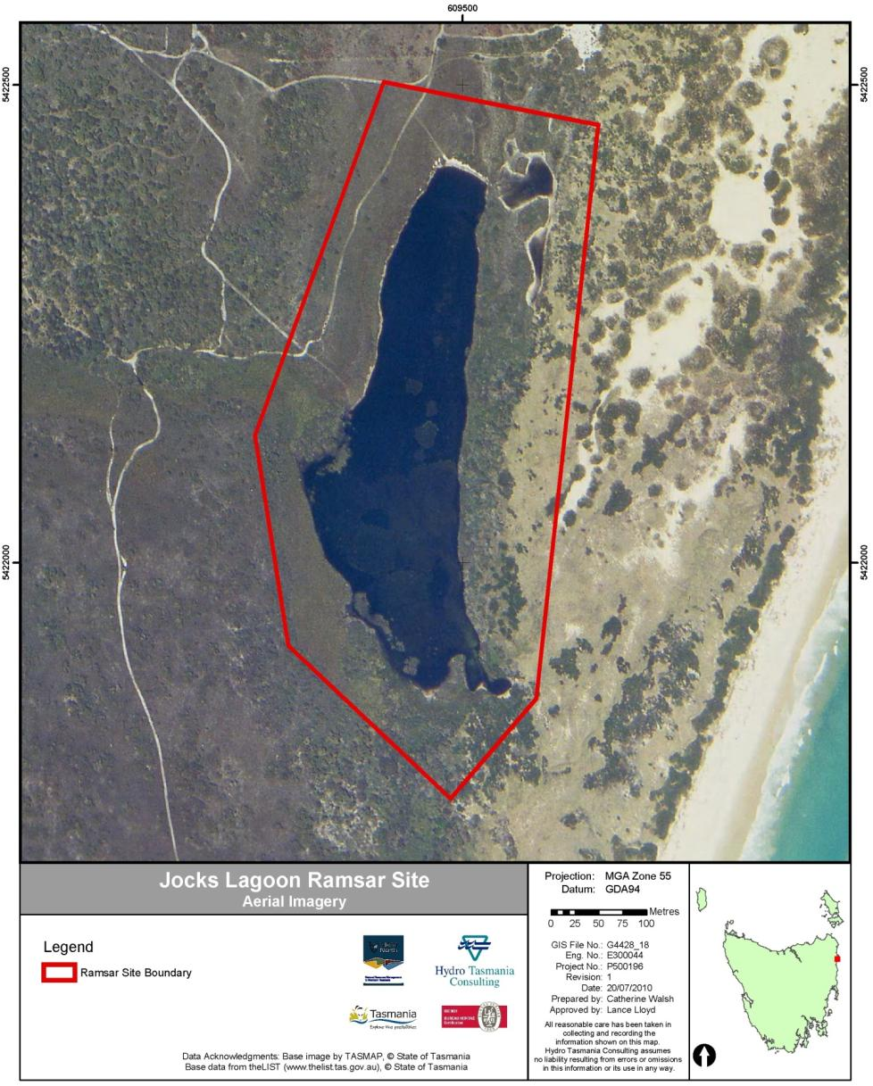

Figure 1: Map of location and boundary of Jocks Lagoon Ramsar Site (Source: NRM North; Base Photo is dated 29 Nov 2003).

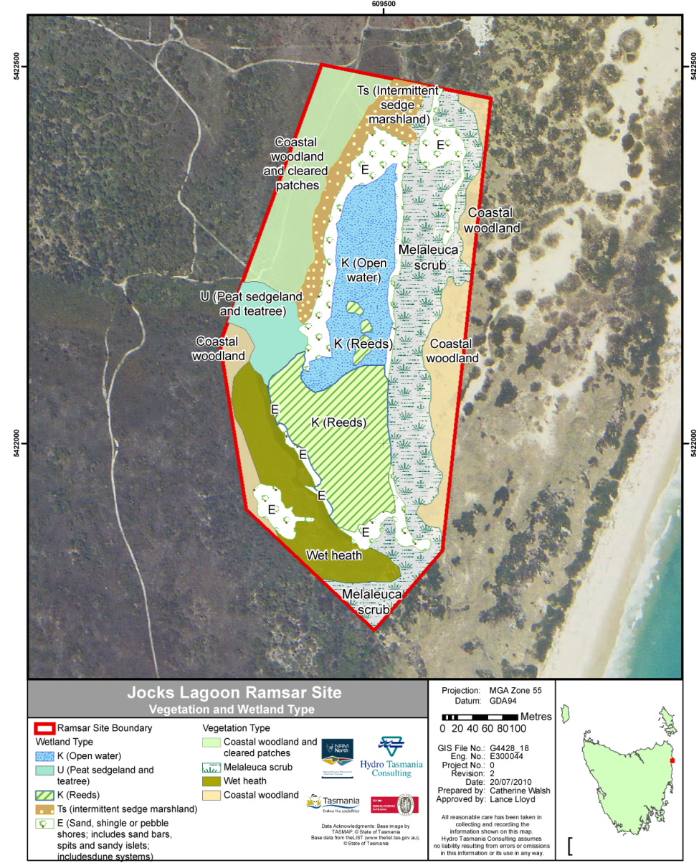
Figure 2: Vegetation and wetland types occurring at Jocks Lagoon Ramsar Site with TASVEG equivalent communities provided in the table below. (Source: NRM North, DPIPWE and the authors; Base Photo is dated 29 Nov 2003).
Ramsar Wetland Type | TASVEG equivalent
K (open water) & E | Freshwater aquatic herbland (AHF)
U | Wet heathland (SHW)
K (reeds) & Ts | Freshwater aquatic sedgeland and rushland (ASF)
Vegetation Type
Coastal woodland and cleared patches | Coastal heathland (SCH)
Melaleuca scrub | Melaleuca ericifolia swamp forest (NME)
Wet heath | Melaleuca squarrosa scrub (SMR)
Coastal woodland | Acacia longifolia coastal scrub (SAC)

Table 2: Wetland types, areas, associated landforms and examples within the site.
Code | Wetland Types | AREA (Square metres) | AREA (Hectares) | Associated Landforms and examples within site
K | Coastal freshwater lagoon | 44 072 | 4.4 | Interdunal depression; Open water, water with emergent reeds
E | Sandy shores and dune slacks | 22 121 | 2.2 | Lagoon shoreline & overflow areas
Ts | Seasonal/intermittent freshwater marshes/pools | 9 793 | 1.0 | Lagoon floodplain – intermittent sedge marsh
U | Non-forested peatlands | 8 315 | 0.8 | Soak where feeder drainage line meets lagoon

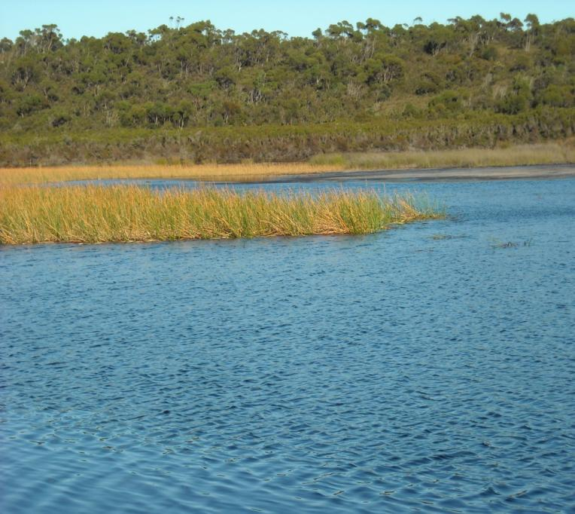 | 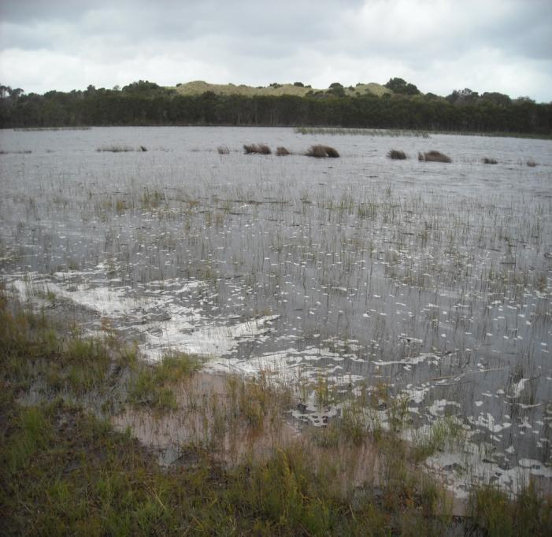
Figure 3: Wetland habitat type K (coastal lagoon; open water) at Jocks Lagoon in May 2009 (left) and November 2009 (right)
(photos: P. Newall, 2009)
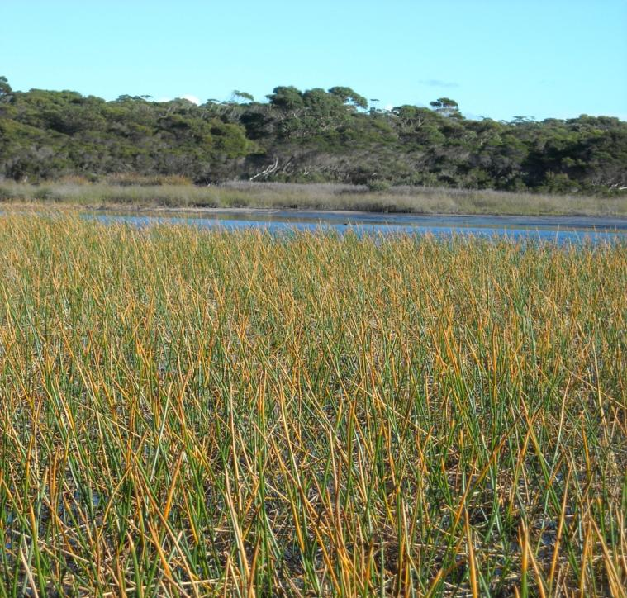 | 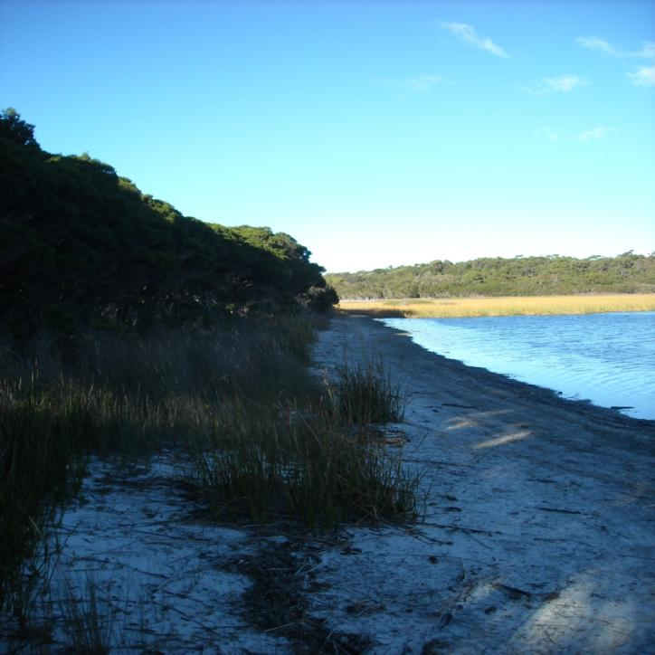
Figure 4: Wetland habitat type K (coastal lagoon; reed) and type E (sand shore) at Jocks Lagoon, May 2009 (photos: P. Newall, 2009)

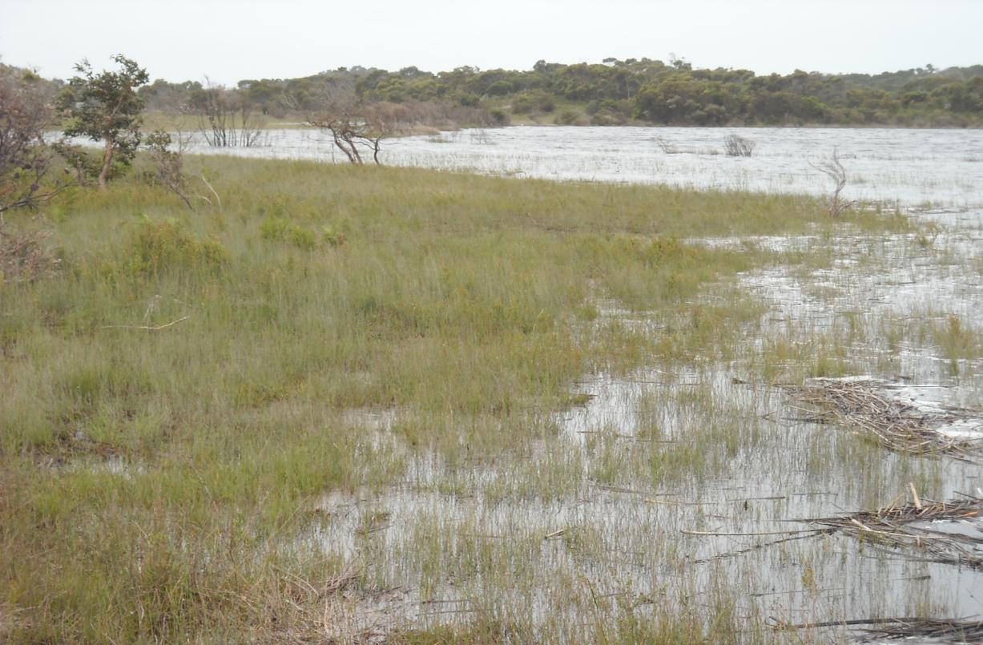
Figure 5: Wetland type Ts (sedgeland) at Jocks Lagoon, November 2009 (photo: P. Newall, 2009).

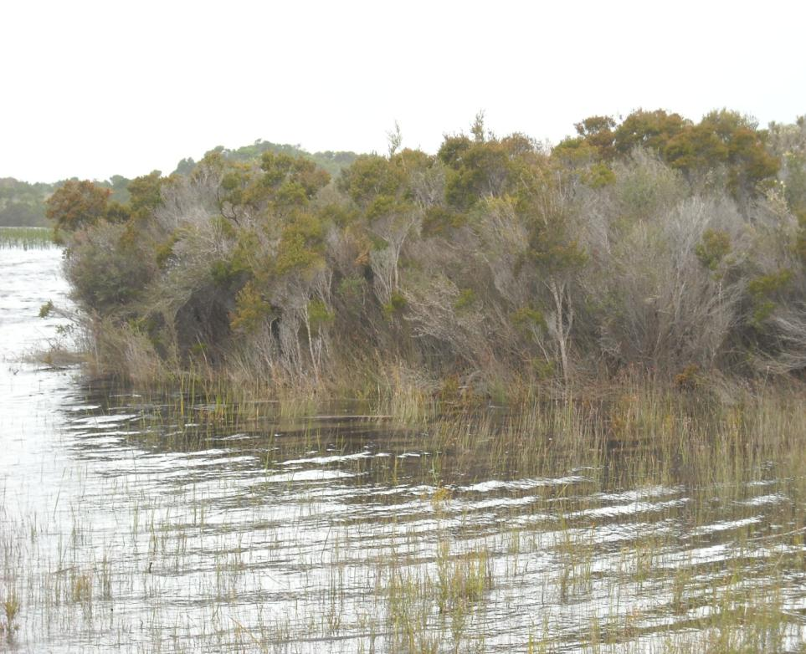 | 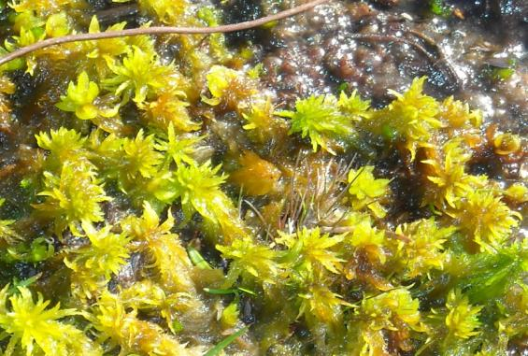
 | 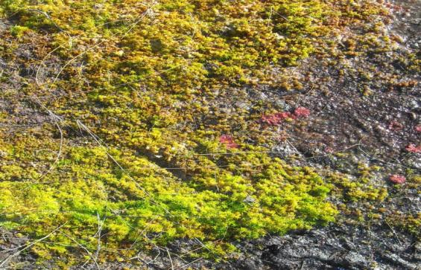
Figure 6: Wetland type U (peatland) showing teatree shrub (left) and Sphagnum moss (right) on peat at Jocks Lagoon (photos: P. Newall, 2009).

Land Use and Tenure
The majority of the Jocks Lagoon Ramsar Site is privately owned (Table 3). The crown land within the site is adjacent to the eastern boundary (Figure 7) and is situated within the St Helens Point Conservation Area, and therefore under the management of the Parks and Wildlife Service, Tasmania. The management objectives of conservation areas are to:
- conserve natural biological diversity
- conserve geological diversity
- preserve the quality of water and protect catchments
- conserve sites or areas of cultural significance
- provide for the controlled use of natural resources
- provide for exploration activities and utilisation of mineral resources subject to appropriate controls
- provide for the taking, on an ecologically sustainable basis, of designated game species for commercial or private purposes, or both
- provide, in special circumstances, for other small-scale commercial or industrial uses
- encourage education based on the purposes of reservation and the natural or cultural values of the conservation area, or both
- encourage research, particularly that which furthers the purposes of reservation
- protect the conservation area against, and rehabilitate the conservation area following, adverse impacts such as those of fire, introduced species, diseases and soil erosion on the conservation area's natural and cultural values and on assets within and adjacent to the conservation area
- encourage appropriate tourism, recreational use and enjoyment consistent with the conservation of the conservation area's natural and cultural values
- encourage cooperative management programs with Aboriginal people in areas of significance to them in a manner consistent with the purposes of reservation and the other management objectives.
Table 3: Land tenure and area of parcel within Jocks Lagoon Ramsar Site.
Tenure | Area (Square Metres) | Area (Hectares)
Crown land | 21 652 | 2.2
Freehold title | 164 206 | 16.4

There are two separate freehold titles within the site (Figure 7). In general, the site is only occasionally used by the major landholder for passive recreation. However, this use has included occasional clearing of a small part of the ‘coastal woodland and cleared patches’ (Figure 2). Use of recreational vehicles was also evident at the site, with tyre tracks observed in the sand and shoreline vegetation of the lagoon (Figure 8).

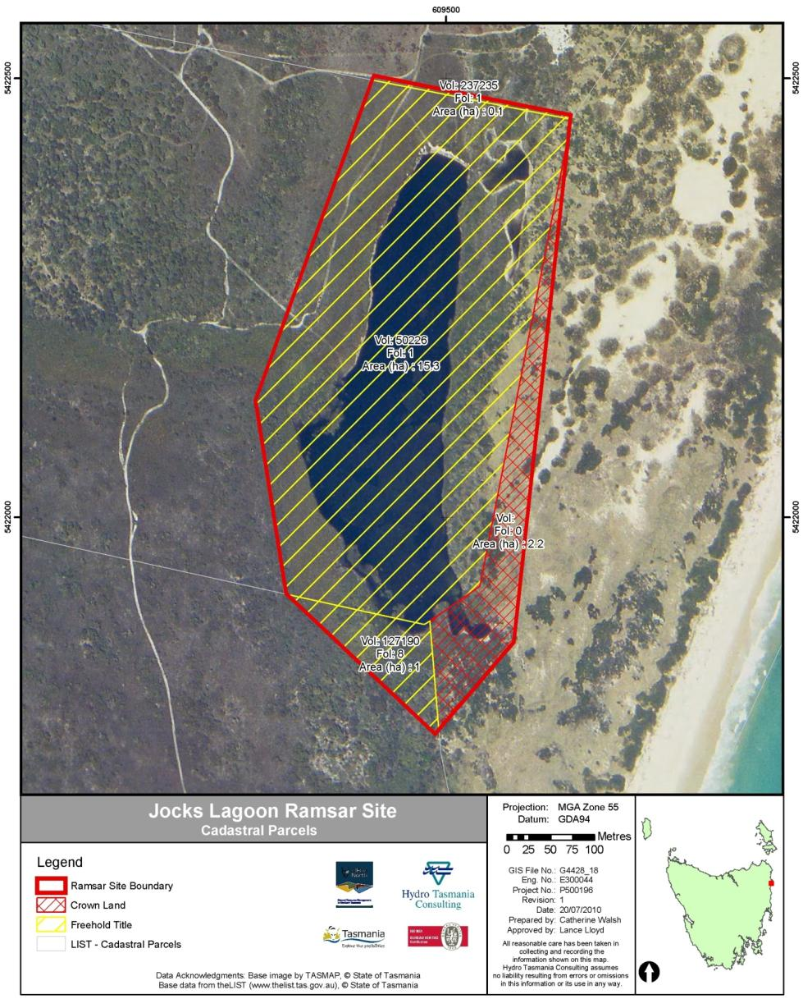

Figure 7: Land tenure of Jacks Lagoon Ramsar Site (Source: NRM North; Base Photo is dated 29 Nov 2003).

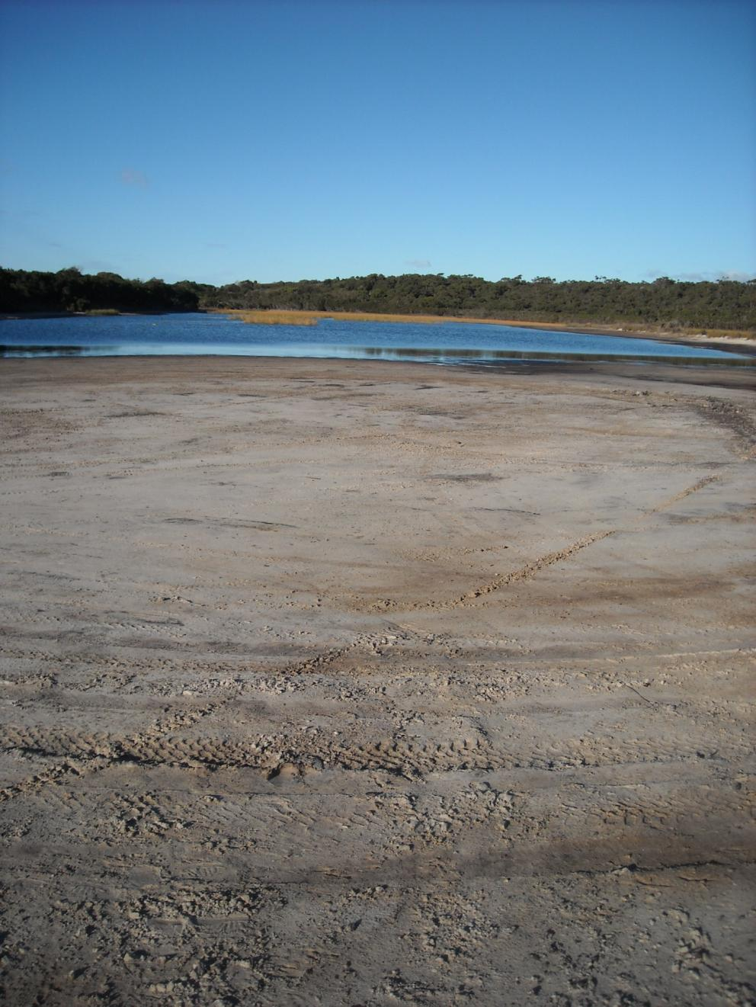
Figure 8: Tyre tracks at the shore of Jocks Lagoon (photo: P. Newall).

Ramsar Listing Criteria

Criteria under which the site is designated
The Ramsar site was designated in November 1982, under the (then) criterion 2b.
A wetland should be considered internationally important if:
2b - A wetland should be considered internationally important if it is of special value for maintaining the genetic and ecological diversity of a region because of the quality and peculiarities of its flora and fauna.
The site boundary was adjusted in 1998, using grid references rather than contours for boundary definition.
The site is currently listed as meeting three criteria (Table 4):
Table 4: Ramsar criteria that Jocks Lagoon Ramsar Site is currently assessed as meeting (Source: RIS 2005).
Group A: Sites containing representative, rare or unique wetland types
Criterion one: | A wetland should be considered internationally important if it contains a representative, rare, or unique example of a natural or near-natural wetland type found within the appropriate bioregion.
Group B: Sites of international importance for conserving biological diversity
Criteria based on species and ecological communities
Criterion three: | A wetland should be considered internationally important if it supports populations of plant and/or animal species important for maintaining the biological diversity of a particular biogeographic region.
Criterion four: | A wetland should be considered internationally important if it supports plant and/or animal species at a critical stage in their life cycles, or provides refuge during adverse conditions.
The application of criteria one and three must be considered within a bioregional context. Within Australia, Ramsar biogeographic regions are delineated on the basis of major drainage divisions. Jocks Lagoon is located in the Tasmanian Drainage Division (Commonwealth of Australia 2010), which consists of the whole of Tasmania.
Criterion one (representative/rare/unique wetland type in appropriate biogeographic region)
Jocks Lagoon is a high quality representative of a wetland with Ramsar wetland types K, E, Ts and U within the Tasmanian Drainage Division. The site is in near natural condition, with minimal disturbance. There is dense vegetation cover within the site and its surrounds, minimising erosion of the site, which is considered to be in good geomorphic condition (Dunn 2005).
The site met this criterion at time of designation and continues to meet it.

Criterion three (supports populations of plant and/or animals important for regional biodiversity)
This criterion includes species and communities listed at the State level. Jocks Lagoon supports rare, poorly reserved and scientifically valuable species. It provides wetland habitat for five threatened flora species considered to be at risk in Tasmania. These are:
- Jointed twigsedge (Baumea articulata, rare, TSPA). Jocks Lagoon is one of the few wetlands in Tasmania containing the jointed twigsedge and is considered a key site for the species (DPIW 2009a). In Tasmania, jointed twigsedge is associated with rivers on the north-east coast (DPIW 2009a).
- Slender twigsedge (Baumea gunnii, rare, TSPA). In Tasmania, slender twigsedge inhabits wet moors, creeks and riverbanks (DPIW 2009a) but was not previously known at the site until it was found in a botanical survey undertaken by Micah Visoiu (DPIPWE botanist) concurrently with a site visit for this ECD.
- Zigzag bogsedge (Schoenus brevifolius, rare, TSPA). This species is only shown as occurring in six localities on the Tasmanian rare species database (DPIW 2009a). The species was not previously known at the site but was found as part of the botanical survey undertaken by Micah Visoiu (DPIPWE botanist) noted above. In Tasmania, zigzag bogsedge grows in shallow water around the fringes of lagoons in the north-east (DPIW 2009a).
- Yellow onion orchid (Microtidium atratum, rare, TSPA). The yellow onion orchid occurs in habitats subject to periodic inundation such as swamps, depressions and soaks (DPIW 2009a). Similar to the zigzag bogsedge, this species was not recorded at the site until the botanical survey undertaken by Micah Visoiu (DPIPWE botanist) noted above.
- Erect marshflower (Villarsia exaltata, rare, TSPA). This species occurs in the north east of Tasmania and Jocks Lagoon is one of the key sites for the species. It grows in stationary or slow flowing water to a depth of 50 centimetres (DPIW 2009a).
During a workshop of scientific experts, held as part of the process for this ECD, there were some comments that there are likely to be other species within the site that are listed at State or National level. These included the following wetland dependent species:
- Yellow bladderwort (Utricularia australis) which may be found around the damp edges of the lagoon.
- Green and gold frog (Litoria raniformis) may be on the site, as it is found in nearby waterbodies (for example Windmill Lagoon).
However, these species cannot be included in the site listing, as they have not been confirmed at the site.
At the time of designation, only the jointed twigsedge and the erect marshflower were recorded at the site. However, it is highly likely that the yellow onion orchid, slender twigsedge and the zigzag bogsedge were also present.
In addition, the site has Melaleuca ericifolia present which is listed as a threatened native vegetation community on Schedule 3 of the Tasmanian Nature Conservation Act 2002. This is cited as Melaleuca scrub in this ECD as it occurs above the waterline and is not a “swamp forest” formation as in the TASVEG community, but the community is sustained by water flowing out of the dunes.
Based on the six rare, wetland-dependent plant species recorded at the site, it met criterion three at the time of designation and continues to do so.
Criterion four (supports species at critical stages or provides refuge in adverse conditions)
This criterion was applied to the site in the 2005 RIS (DEWHA 2010) based on the presence of the dinoflagellate Prorocentrum playfairi at the site (Croome and Tyler 1987). The genus Prorocentrum was previously thought to be entirely marine and is therefore of scientific interest. Jocks Lagoon is one of only seven known sites where this species exists. However, the presence of this species at the site is not evidence of providing support for the species at a critical stage, or for providing refuge in adverse conditions. Rather, it provides further justification for the site meeting criterion three – supporting populations important for regional biodiversity.
During site inspections, large numbers of young birds were observed at the site, including swans with cygnets, indicating that the site may be used for breeding or as a nursery. However, until further information is collected, this cannot be included in the site listing.
Based on the presence of the dinoflagellate population being more applicable to criterion three and the absence of other support for the site meeting criterion four, the site is not considered to meet this criterion currently or at the time of listing.

Assessment against the remaining designation criteria
Criterion two: A wetland should be considered internationally important if it supports vulnerable, endangered, or critically endangered species or threatened ecological communities.
There are no data to demonstrate that the site supports species or communities that are nationally threatened and listed under the EPBC Act or the International Union for Conservation of Nature (IUCN) red list.
The site is not considered to have met this criterion at time of designation or currently.
Criterion five: A wetland should be considered internationally important if it regularly supports 20 000 or more waterbirds.
There are no data on waterbird numbers at the site. However given the size of the lagoon it is reasonable to assume that the site could not support 20,000 waterbirds (currently or at time of listing).
Criterion six: A wetland should be considered internationally important if it regularly supports one percent of the individuals in a population of one species or subspecies of waterbird.
There are no data on waterbird numbers at the site and therefore no data to support the site meeting this criterion currently or at time of listing.
Criterion seven: A wetland should be considered internationally important if it supports a significant proportion of indigenous fish subspecies, species or families, life-history stages, species interactions and/or populations that are representative of wetland benefits and/or values and thereby contributes to global biological diversity.
There are no data on the fish fauna of the site. It is unlikely that the site would have a high degree of endemism or biodisparity in its fish communities, but this cannot be assessed.
Accordingly, there is no data to support the site meeting this criterion at time of listing or currently.
Criterion eight: A wetland should be considered internationally important if it is an important source of food for fishes, spawning ground, nursery and/or migration path on which fish stocks, either within the wetland or elsewhere, depend.
There are no data on the fish fauna of the site. However, given the small size of the lagoon and its landlocked setting, it is reasonable to assume that the site could not meet this criterion, currently or at time of listing.
Criterion nine: A wetland should be considered internationally important if it regularly supports one percent of the individuals in a population of one species or subspecies of wetland-dependent non-avian animal species.
There are no estimates of the total population of non-avian wetland dependent animal species or sub-species at the site. Accordingly, there is no data to support the site meeting this criterion at time of listing or currently.

components and processes of Jocks Lagoon Ramsar Site
Ecosystem components include the physical, chemical and biological parts of a wetland (Millennium Ecosystem Assessment 2005). Ecosystem processes are dynamic forces and include all those processes that occur between organisms and within and between populations and communities. This includes interactions with the non-living environment that result in existing ecosystems and bring about changes in ecosystems over time (Australian Heritage Commission 2002). They may be physical, chemical or biological.
In practice, many components can also be processes. For example, climate, hydrology and geomorphology can each be viewed as static parts (components) of the site as well as dynamic forces (processes) that bring about change to the wetland. In this ECD they are considered together.

Critical Components and Processes and Essential Elements
The production of an ECD requires the identification, description and where possible, quantification of the critical components, processes, benefits and services that characterise the site. As a minimum, DEWHA (2008) recommends the selection of critical components, processes, benefits and services as those:
- that are important determinants of the site’s unique character
- that are important for supporting the Ramsar criteria under which the site was listed
- for which change is reasonably likely to occur over short to medium time scales (<100 years) and
- that will cause significant negative consequences if change occurs.
Identification of the critical components and processes also lead to identification of components and processes that may not be critical to the site, but are important in supporting the critical components, processes, benefits and services. These have been termed ‘essential elements’ and may act as early warning indicators of a potential change in character and therefore should be considered in management planning for the site (Hale 2010). Using the approach of Hale (2010), a simple conceptual model has been developed that displays the essential elements for the site, the critical components and processes, the benefits and services and the listing criteria (Figure 9). The model also shows the links between these features.
The four critical components and processes identified for Jocks Lagoon Ramsar Site are:
- wetland vegetation habitat types
- rare plant species
- water quality
- hydrology.
All four of these critical components and processes meet the four criteria provided by DEWHA (2008): they are central to the character of the site; they are directly linked to the Ramsar criteria for which the site was listed; they could potentially change in the next 100 years; and their change would result in a negative change in the ecological character of the site.
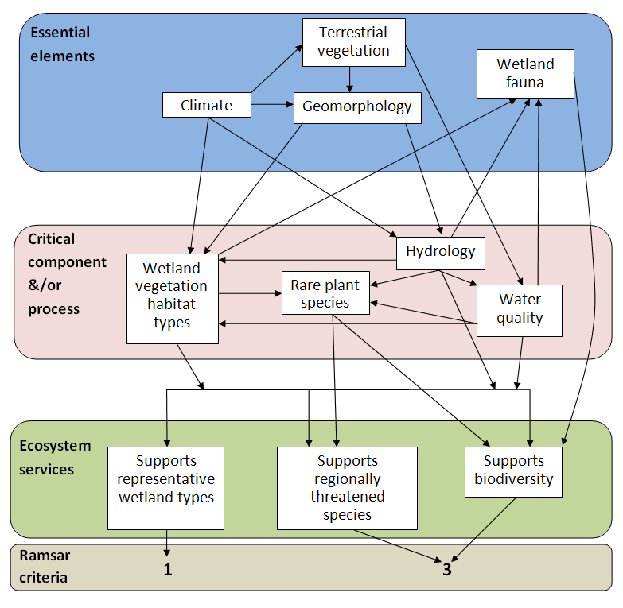
Figure 9: Conceptual model of the components, processes and services of the site, and their links to the Ramsar criteria.

The identified essential elements for the site are:
- climate
- geomorphology
- wetland fauna
- terrestrial vegetation.

Essential elements of the site

Climate
The climate at Jocks Lagoon is generally cool to mild with temperatures having a smaller annual range compared to other parts of Tasmania. St Helens, located 5 kilometres north west of Jocks Lagoon, experiences average summer temperature minima and maxima of 11.5 and 22.6 degrees Celsius and average winter temperature minima and maxima of 3.3 and 14.3 degrees Celsius (Figure 10) (Bureau of Meteorology 2009).
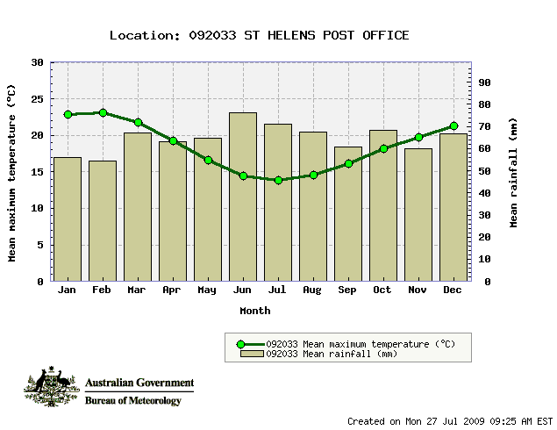
Figure 10: Climograph for St Helens; temperature (1957-2001) and rainfall
(1890-2006) (Source: Bureau of Meteorology 2009).
The area receives an average annual rainfall of 775.1 millimetres with major rain bearing winds arising from the south-east and north-east quarters (Dudley, undated). Rainfall is variable, with recorded annual extremes of 374.3 and 1258.3 millimetres (Bureau of Meteorology 2009). The 10th and 90th percentiles for rainfall for each month are displayed in Figure 11. Prevailing winds, which are generally dry, arise from the north-west and south-west and are at their greatest strength and persistence from September to November (Dudley, undated). Easterly formed weather systems bring strong winds and large swells to the east coast and are influential in shaping and controlling geomorphic features and processes along the east coast of Tasmania (Watt 2001).
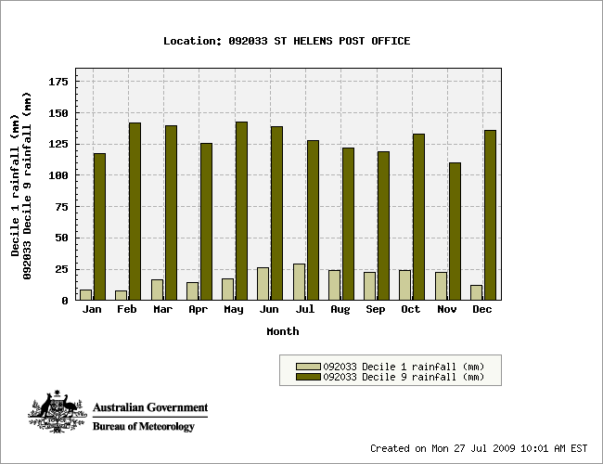
Figure 11: The 10th percentile (Decile 1) and 90th percentile (Decile 9) of St Helens rainfall, 1890-2006 (Source: Bureau of Meteorology 2009).

Geomorphology
Jocks Lagoon is part of a chain of mostly terrestrialised and ephemeral dune-barred lagoons, situated near the Peron Dunes, which contain a large mobile (transgressive) dune field, and a series of older parallel dunes inland (Watt 2001). The overall dune field contains several wetlands and dunes.
The site is located within Quaternary alluvium swamp and marsh deposits and partially consolidated Tertiary deposits, comprised of conglomerates and sand (Glazik 1999). The Quaternary sands and clays are highly erodible and longshore drift has created an extensive beach and sand dune system, which separates Jocks Lagoon from the sea (Blackhall et al. 2003). The dunes are of two ages, the younger series (Holocene and recent) flanks the ocean beach, while the older dunes (Pleistocene) lie inland and parallel (Harris, 1999). The backbone of the peninsula is an outcrop of Devonian granite, which forms the headland of St Helens Point to the north of Jocks Lagoon (Watt 2001). Watt (2001) notes that wetlands in the area are not considered to be in any danger of becoming inundated by the transgressive dune field, due to extensive, established vegetation cover of the dunes. However, there is a small area of vegetation-free sand north of the site, which extends southward to the immediate east of the lagoon, and may indicate the potential for some sand migration.
During a site inspection, several holes were dug in the sandy deposits around the lagoon. At depths of approximately 10 to 20 centimetres, the sand was underlain by a peat layer, suggesting mobile sands in the past, covering former areas of marshland/swamp and causing marginal infilling of the lagoon.

Wetland fauna
During site inspections for the ECD, several species of wetland-dependent fauna were observed. The species were not critical in defining the site’s ecological character, yet still contribute to that character. Taxa identified at the site include:
- a species of freshwater burrowing crayfish (genus unknown)
- a species of galaxiid (genus unknown)
- the brown froglet (Crinia signifera)
- the banjo frog (Limnodynastes dumerilli), (up to 100 individuals)
- the chestnut teal (Anas castanea)
- black duck (Anas superciliosa)
- white-bellied sea eagle (Haliaeetus leucogaster) (flying overhead)
- black swans (Cygnus atratus) with young, indicating that the site may be used for breeding
- white faced heron (Egretta novaehollandiae).
The lagoons support Macrocrustaceans; burrowing freshwater crayfish (Engaeus laevis), freshwater crabs, Amarinus lacustris, and Austrochiltonia sp. (an amphipod) as well as Microcrustaceans, calanoid copepods and cladocerans (Horwitz 1992). Two species of native frogs are also known to occur within the Site; Brown Froglet (Crinia signifera) and Eastern Banjo Frog (Lymnodynastes dumerili insularis).
Apart from these observations, there are no other data for these fauna at the site. Most of the fauna listed above were observed either immediately after heavy rains (in November 2009) or a few months after the rains (March 2010). The presence of the galaxiid is interesting, as it suggests that either there is a population of galaxiids in the lagoon or that the lagoon may connect with the sea or with other wetlands, as the site was previously listed as fishless. It appears that Jocks Lagoon may have connected, at high water levels, with the wetlands to the north and also runs to the sea to the south during the large flooding peaks (see section 3.3.1 – Hydrology).

Terrestrial vegetation
The major support for the wetland system provided by the terrestrial vegetation of the site is through its extensive, thick cover stabilising the otherwise transgressive dune field. Without this stability, the Peron Dunes could become mobile, covering large parts of the site and beyond.
The terrestrial vegetation of the site includes coastal woodland, coastal woodland and cleared patches, Melaleuca scrub and wet heath (Figure 2). The TASVEG equivalent communities are Acacia longifolia coastal scrub (SAC), Coastal heathland (SCH), Melaleuca ericifolia swamp forest (NME) and Melaleuca squarrosa scrub (SMR) respectively. There has not been any detailed vegetation survey of the site, however black peppermint (Eucalyptus amygdalina) has been recorded on the site and is likely to be prominent in the coastal woodland component. Black peppermint coastal woodlands occur in northern and eastern Tasmania and are dry sclerophyll communities, which vary from open forest to low open woodland dominated by black peppermint (DPIW 2009b). Trees in this community rarely exceed 25-30 metres in height and on many sites are less than 25 metres tall.
Scrub and heathland complexes in Tasmania have variable composition and structure, depending on soil, local climate and disturbance history. At the site the area of Melaleuca scrub was very dense with minimal understorey. Wet heath in Tasmania is typically dominated by species of Melaleuca, Leptospermum and/or Callistemon and are often associated with sedge and fern cover (DPIW 2009b), which appeared to be the case at the site.
Another potential advantage of the vegetation is through its contribution to water quality, slowing runoff, reducing erosion and contributing some filtering of rainwater once it infiltrates. The importance of vegetation in the hydrological cycle is well known and long established (for example Dunne and Leopold 1978). However, the sandy soils of the site and its catchment may enable rapid infiltration of rain water even without the assistance of vegetation, possibly reducing its importance. No hydrological modelling of the site has been undertaken (see Section 3.3.1).

Critical Components and Processes

Hydrology
There are no known studies on any aspect of the hydrology of Jocks Lagoon. However, the lagoon regularly fills to at least the top of the berm separating the open water from the sedgeland marsh, occurring approximately every two to three years (landholder, personal communication). At the time of the first site visit, the lagoon level was as low as the landholder had ever seen it, and had not refilled to the top of the berm for five to ten years. Therefore, the photographs of the site taken in May 2009 display the lagoon after a period in which eight of the ten years prior were below average rainfall (BOM 2009), and possibly at its lowest level in the memory of the landholder (landholder, personal communication).
The source of water appears to be local groundwater and surface flow, derived from a local catchment which enters the lagoon via a small drainage line (Lloyd, pers.obs. 2009). The lagoon has a maximum water depth of between two and three metres (from LiDAR mapping), though after the drought it may have only been one and half metres deep (Blackhall et al 2003; authors’ observations). Walsh et al. (2002) suggest it is too shallow to stratify. The tannin staining of the lagoon suggests significant groundwater input (Polly Buchhorn, NRM Facilitator, Break O’Day Council, personal communication), through the peat layer noted to be underlying the lagoon bed sands. The source of the tannin colour is the polyhumic acids (Croome and Tyler 1987) from the peat and organic soils of the slopes (particularly the peat sedgeland and tea tree vegetation types) and under the lagoon bed. There are also significant surface inflows which are also tannin-stained from the inflow creek (and the upstream dams; author’s observation and Polly Buchhorn, NRM Facilitator, Break O’Day Council, personal communication).
There is some suggestion that the lagoon may seep through the younger (seaward) dunes, ultimately discharging into the sea (as displayed in Figure 12). However, there are no data or studies to verify this.
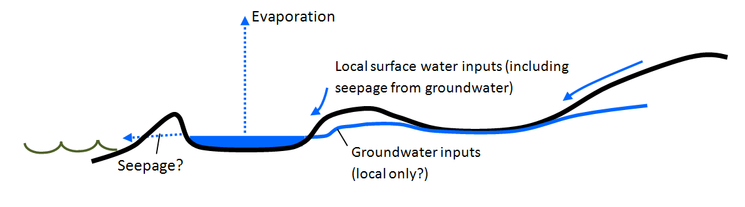
Figure 12: Hypothetical cross-section of the Jocks Lagoon Ramsar Site, showing water inputs and outputs.
The water level of the lagoon varies considerably and three site inspections that were undertaken showed the site during very different conditions in relation to water level. The first site inspection was in May 2009, following a long drought (drought conditions for approximately ten years) and the water was as low as could be remembered by local people. Photographs from May 2009 displaying the low water levels are shown in Figure 13 and Figure 14. During this site inspection, there appeared to be little faunal life in the lagoon.
In contrast, a second site visit in late November 2009 took place following very heavy and persistent rainfalls across much of the region. During this time, the water level was substantially higher, having risen over the lagoon banks and covering the seasonal sedgeland marsh. Water extended into nearby temporary wetlands and floodways to the north of the site. During the peak of the flooding, the water is likely to have connected the lagoon with Windmill and Moriarty Lagoons to the north.
Aerial photos indicate an outflow from the lagoon during high water levels through the southern end of the site (Figure 15). A LiDAR projection supports this, with Figure 16 showing a path of discharge from Jocks Lagoon to the sea when the water level reaches six and a half metres. This discharge path (shown with arrows in Figure 16), commences with an exit to the east at the southern end of the lagoon, after which water can flow in a north-easterly direction and a south-easterly direction, to the Tasman Sea. The LiDAR projection also shows that at levels of just five metres, the water from Jock Lagoon can also discharge through the northern end of the lagoon (Appendix 4), through to Windmill Lagoon and beyond to Moriarty Lagoon. At a level between six and a half and seven metres, the water can discharge into Shaft Lagoon and from there into Georges Bay (shown with arrows in Appendix 4).
In summary therefore, Figure 16 and Appendix 4 show that:
- at five metres and slightly higher, water from Jocks Lagoon can inundate large areas of wetland to the north of the lagoon
- once the water level reaches six and a half metres it can discharge into the Tasman Sea through the drainage lines to the south
- once the water level reaches seven metres the water can discharge through Shaft Lagoon, westwards into Georges Bay.
Numerous fish were observed in the lagoon in the November 2009 post-flooding period, as were microinvertebrates and macroinvertebrates. The water was slightly turbid, with low visibility of the lagoon bed. The water also appeared less tannin coloured, reflecting some dilution from surface water inputs.
During a third site inspection (in February 2010) the water level had subsided to bankfull level, no longer inundating the intermittent sedgeland marsh. There were still numerous fish observed, along with a diverse and abundant macroinvertebrate fauna that contained large predatory taxa including damselflies and dragonflies (order Odonata). There was also a macrocrustacean – a species of freshwater burrowing crayfish. The brown froglet (Crinia signifera) was also identified at the site as was the banjo frog (Limnodynastes dumerilli), which was observed in reasonably large numbers (up to 100 individuals). Water-dependent birds seen at the site included the chestnut teal (Anas castanea), black duck (Anas superciliosa), white-bellied sea eagle (Haliaeetus leucogaster) and black swans (Cygnus atratus). The black swans and other water birds had young with them, indicating that the site may be used for breeding.
The marked increase in aquatic life following the rise in water levels and the connection of the lagoon with its intermittent sedgeland marsh highlights the importance of this variation in the hydrologic regime. Connection of waterbodies to their catchments via floodwaters is recognised as an important process that contributes nutrients – including dissolved organic carbon – along with plant matter to the waterbodies (Croome and Tyler 1987; Qiu and McComb 1994). The plant matter and dissolved carbon provide the nutrient requirements for the base of the food chain. The paucity of aquatic life observed in the lagoon waters at the end of a very prolonged drought, juxtaposed against the abundant aquatic life observed following the lagoon’s reconnection with the adjacent Sedgeland, support the importance of the hydrological regime as a critical component of the site.

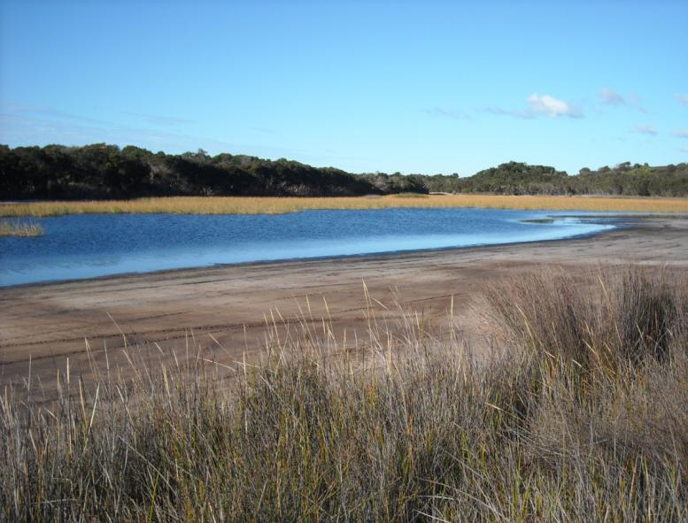
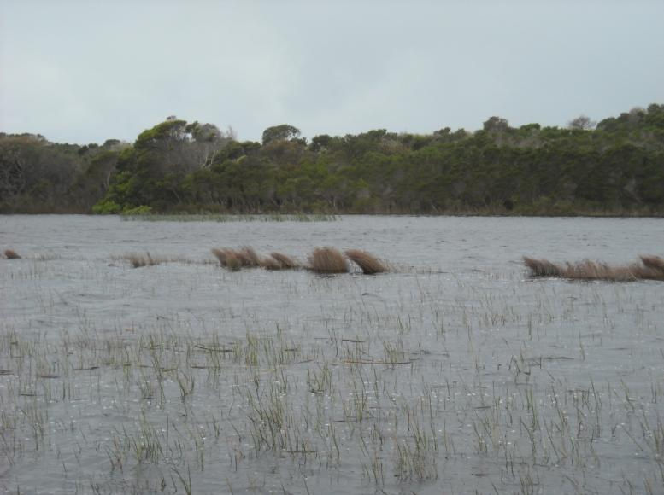
Figure 13: Jocks Lagoon after prolonged drought (top) and following heavy rainfall (bottom). The sedges in the foreground of the upper photograph are on a berm between the lake and intermittent sedgeland marsh and are the emergent plants in the middle distance of the bottom photograph (photos: P. Newall).

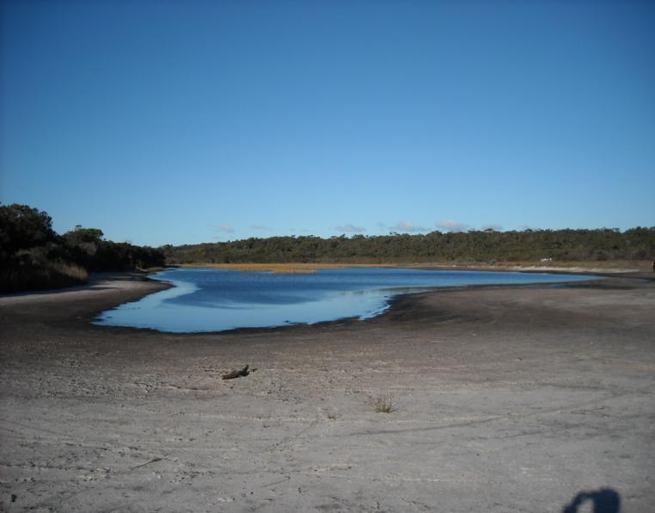
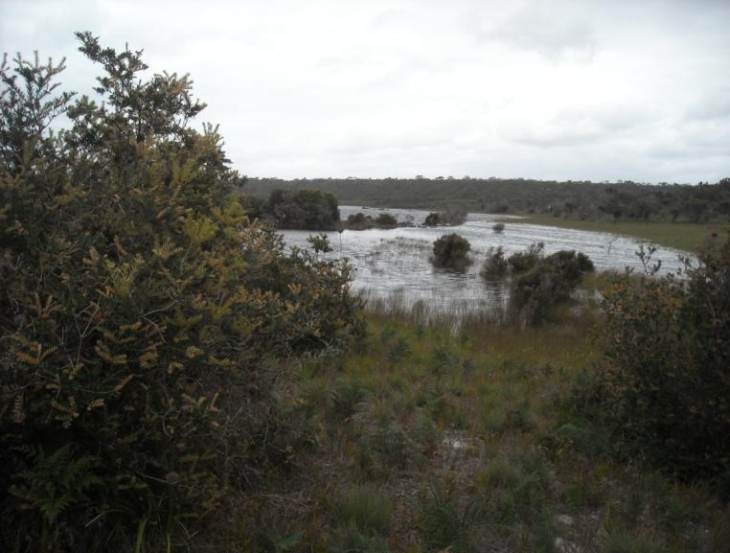
Figure 14: Jocks Lagoon viewed from the north after prolonged drought (top) and following heavy rainfall (bottom). The bottom photograph was taken substantially further back than the top, due to water covering the site (photos: P. Newall).

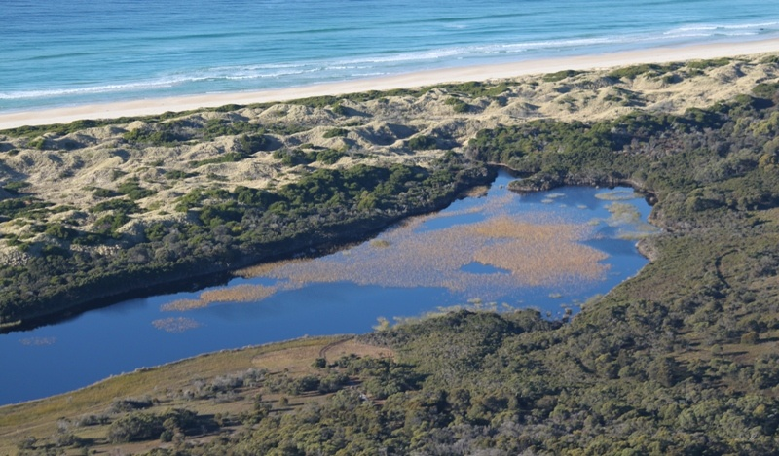
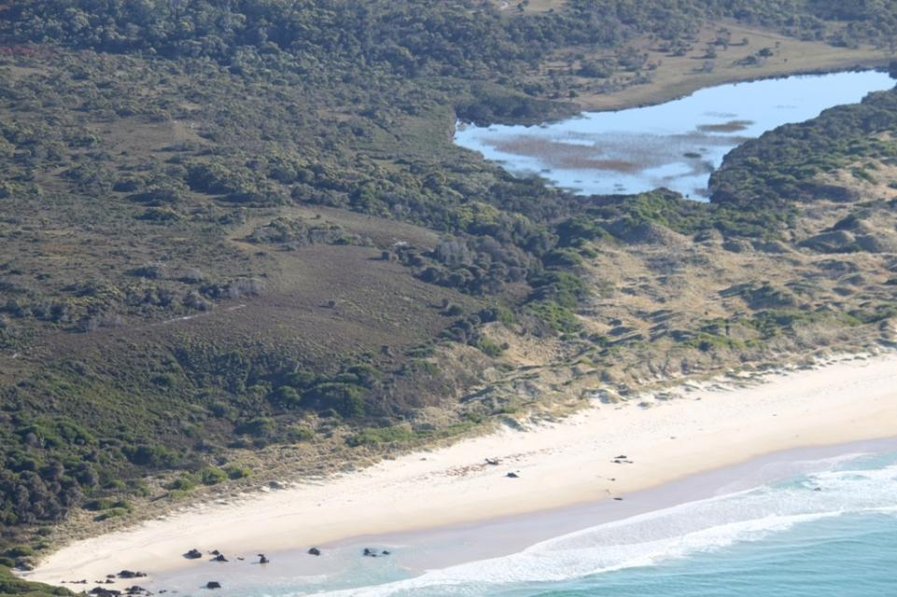
Figure 15: Likely Outflow from Jocks Lagoon (photo: Ken Morgan, 2010) (top image looking to the southeast and bottom image is looking towards northwest)

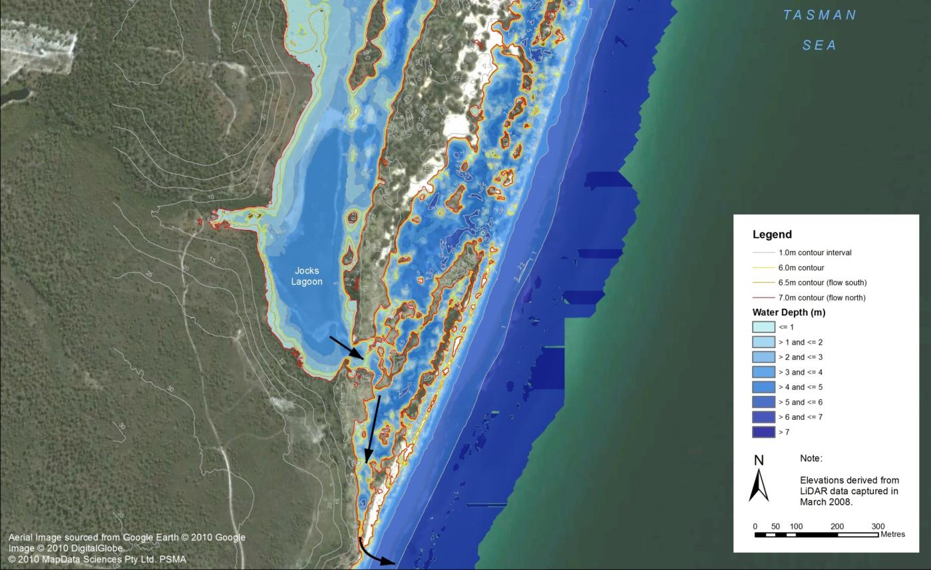
Figure 16: Water depths and topographic information at Jocks Lagoon (based on LiDAR projections). Note the areas to the east of Jocks Lagoon showing a water depth within the sand dunes are only indicative as these areas only hold water for short periods after flooding.

Water Quality
Very few water quality assessments have been conducted at Jocks Lagoon and those that have focus on pH, turbidity, conductivity and selected nutrients. Jocks Lagoon is described as a dystrophic coastal lagoon, which is consistently acidic; with a pH of between 4.6-6.28 (Blackhall et al. 2003, Bowling et al. 1993, Croome and Tyler 1987, Horwitz 1992 and Walsh et al. 2002). The lagoon is typically clear, with a very low turbidity of 0.6 nephelometric turbidity units measured by Horwitz (1992). The site can be slightly brackish, as it ranges between 310 and 580 microSiemens per centimetre (at 25 degrees Celsius) (Bowling et al. 1993, Croome and Tyler 1987 and Horwitz, 1992) and is identified by Walsh et al. (2002) as having higher salinity levels than most west coast lagoons. Nutrient levels were sampled by Horwitz in 1992, with oxidised nitrogen being below the detectable limit (<0.01milligrams per litre). Total phosphorous was measured as 0.03 milligrams per litre and Chlorophyll a was recorded as 2.26 micrograms per litre.
The waters of Jocks Lagoon are characteristically tannin-stained. This is due to polyhumic acids (Croome and Tyler 1987) that leach from the peat and organic soils of the surrounding slopes and also from surface inflows from the inflow creek which are also tannin-stained (author’s observation and Polly Buchhorn, NRM Facilitator, Break O’Day Council, personal communication).
These tannin-stained waters are typical of water bodies and creeks on the coarse humic/granitic soils on the east coast of Tasmania (including around St Helens). Jocks Lagoon has low turbidity and although large rain events do tend to dilute the tannin waters with some suspended material, which increases turbidity, it is a short lived effect (Polly Buchhorn, NRM Facilitator, Break O’Day Council, personal communication).
Croome and Tyler (1987) have described the site as low salinity, high colour and low pH, ‘characteristic of dystrophic waters’ which are characteristic of many water bodies in the area (Croome and Tyler 1987; Bowling et al. 1986). These waters are known to support a rich collection of phytoflagellates (planktonic algae) including rare species with the richest diversity in lagoons that are close to the sea but not connected to the sea (Croome and Tyler 1987).
Deeply coloured water modifies the light environment very quickly by attenuating short wavelengths of light creating a shallow, predominantly red euphotic zone (Bowling et al. 1986). This creates a unique light environment and unique habitat conditions for plants and animals because the coloured water absorbs the blue wavelengths. This contrasts with turbid waters where suspended particles cause a general scattering of light across the light spectrum, but often less light attenuation. These changes in the light environment are important biologically as they affect production and the species composition of algae and aquatic plants.

Wetland vegetation habitat types
Wetland vegetation is a critical component of the site, contributing substantially to its ecological character and providing the habitat and species that form the basis of the site’s ecological services. Unfortunately, there has been no systematic sampling of the site and therefore little information can be provided. However, some information is available from site inspections, plant species lists for the site and also from general descriptions of the regional wetland vegetation. The plant species lists for the site are not exhaustive and represent brief reconnaissance surveys only.
Wetland habitat type K: Coastal freshwater lagoon The wetland habitat type with the largest area at the site is coastal freshwater lagoon, with 4.4 hectares (Table 2). This habitat type occurs in two distinct forms at the site: open water; and reed. The open water area occupies the northern half of the lagoon. During a site inspection following heavy rains, the authors canoed into part of this habitat type and observed patches of submerged macrophytes. Unfortunately, these were not able to be sampled and were difficult to distinguish as the water was darkly tannin-stained and weather conditions meant the water was very choppy, together making poor visibility into the water. However, the floating leaved macrophyte water ribbon (Triglochin procerum) was observed in shallower parts of the site and has been recorded as constituting 40 percent of the vegetation cover in a marshy area of the site (Register of the National Estate, 1999).
Within the open water, numerous Galaxias sp. fish were observed around the edges of the lagoon during the site inspection in late November 2009 and in February 2010, whereas no fish were observed during the prior inspection in May 2009.
The reed section occupying the southern half of the lagoon is predominantly giant spike rush (Eleocharis sphacelata) emerging from water approximately one half to one metre deep. Within the western area of the reed habitat there are also stands of slender twig sedge (Baumea gunnii) and, although not seen by the authors, this is where the jointed twigsedge (Baumea articulata) is reported to occur (Register of the National Estate 1999). Although there have been no systematic surveys of the site’s vegetation, a survey of Shaft Lagoon (approximately three kilometres to the north of the site) in 1999 described an Eleocharis sphacelata sedgeland dominating the lagoon, changing to a pithy swordsedge (Lepidosperma longitudinale) sedgeland in better drained areas (Glazik 1999). Pithy swordsedge was recorded as present at the site during the site inspections (Appendix 1). Reed habitat is known to provide shelter for a number of waterbirds and several were seen or heard during the site visits.
Wetland habitat type U: Non-forested peatland The peatland habitat type contained areas with shrubs and ferns and areas with mats of Sphagnum moss and sundews (Drosera spp.) interspersed with sedges. During the dry period this area remained a soak and was waterlogged underfoot, whereas after the heavy rainfall much of the area was between 20 and 50 centimetres underwater. Wetland field survey records (undated) note the presence of Leptospermum species at the site (L. scoparium var. scoparium and L. lanigerum), as well as the scented paperbark (Melaleuca squarrosa). A recent inspection suggests that the dominant shrub species in the peatland is L. scoparium var. scoparium with lesser amounts of Melaleuca present.
Wetland habitat type Ts: Seasonal/intermittent freshwater marshes/pools The sedgeland of the site contained large areas of pithy swordsedge, with other sedge/rush species present. Species identified during the site inspections included common swordsedge (Lepidosperma filiforme), little clubrush (Isolepis marginate), slender twigsedge (Baumea gunnii) and the regionally rare zigzag bogsedge (Schoenus brevifolius). Species of rope rush (family Restionacea) were also common, including the slender twine rush (Leptocarpus tenax) and common scale-rush (Lepyrodia muelleri). This is the area that became inundated following the large rainfall event just prior to the site inspection in November 2009.
During the dry period, most of the vegetation was sparse (estimated 15 to 30 percent cover), tussocked, and up to approximately 30 to 40 centimetres tall.
Wetland habitat type E: Sand shores At the site these were primarily the exposed areas of sand around the lagoon (which were far greater in area during the first site inspection), as well as areas that contained the overflow from the flooding. There was little in the way of vegetation in this habitat type, apart from the occasional tussock of sedge, rush or grass, and also very isolated individuals of water ribbons.
During the high water site inspections, these areas were shallow (typically 5 to 20 centimetres deep) and contained large amounts of floating organic debris, such as leaves, twigs, bark and florets, which were providing cover for the juvenile fish and macroinvertebrates of the lagoon.

Rare plant species of the site
The five rare, wetland-dependent plant species that occur in the Jocks Lagoon Ramsar Site have specific habitat requirements, including hydrologic regime and substrate characteristics. During a technical experts workshop examining the ecological character of the site, the giant spike rush (Eleocharis sphacelata) was noted as being able to tolerate deeper waters than the rare jointed twigsedge (Baumea articulata) and the jointed twigsedge was able to tolerate more saline substrate (though still only slightly saline) than the giant spike rush (Eleocharis sphacelata). This results in the giant spike rush occupying the areas of the reed habitat (Ramsar wetland type K) up to one metre in depth, with the jointed twigsedge around the margin. Although the giant spike rush may also be able to tolerate more shallow waters, it is possible that the substrate is slightly saline in the shallows (Figure 17). The jointed twigsedge therefore occupies the periphery of the reed habitat, bordering the peat habitat (Ramsar wetland type U).
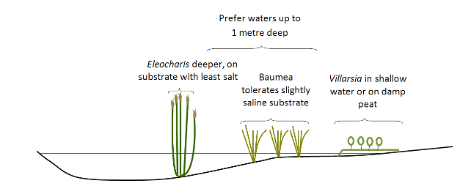
Figure 17: Plant-environment relationships in areas of Jocks Lagoon
The substrate of the giant spike rush and jointed twigsedge is typically sandy, grading into peat below the erect marshflower (Villarsia exaltata). The rare erect marshflower also thrives around the transition of the reed and peat habitat, but more so into the peat.
At the time of the technical experts workshop, zigzag bogsedge (Schoenus brevifolius) and yellow onion orchid (Microtidium atratum) had not been recorded at the site. The zigzag bogsedge is described as growing in shallow water around the fringes of lagoons in north-east Tasmania (DPIW 2009a) although it is noted in New South Wales as ranging from swamps through to damp heath (National Herbarium of NSW 2010) and in wet heathland in Victoria (State of Victoria 2010). This species was noted as occurring in the sedgeland (Ramsar wetland type Ts – seasonal/intermittent marshes/pools).
In Tasmania, the yellow onion orchid (Microtidium atratum) is uncommon and localised in coastal and near-coastal lowland areas, almost exclusively in the northeast and the Furneaux islands (DPIW 2009a). It occurs in habitats that are poorly drained, such as swamps, depressions and soaks. It has been recorded from herbfield, sedgeland, grassland, and heathland on peats, as well as roadside drains and winter-wet pastures (DPIW 2009a). The base of the plant is usually in water and can be wholly submerged in wet years. It is therefore possible that this species occurs in the sedgeland (wetland type Ts), peat (wetland type U) and/or the wet heath habitat of the site.

Benefits and Services of the Site

Identifying benefits and services
DEWHA (2008), states that benefits and services should be described in accordance with the Millennium Ecosystem Assessment definition of ecosystem services. This definition is: ‘the benefits that people receive from ecosystems’ (Ramsar Convention 2005, Resolution IX.1 Annex A). This definition focuses on the benefits that people receive from ecosystems (economic, social and cultural) although they may not benefit humans directly.
The Millennium Ecosystem Assessment (2005) identifies four main categories of ecosystem benefits and services:
- Provisioning services — the products obtained from the ecosystem such as food, fuel and fresh water.
- Regulating services — the benefits obtained from the regulation of ecosystem processes such as climate regulation, water regulation and natural hazard regulation.
- Cultural services — the benefits people obtain through spiritual enrichment, recreation, education and aesthetics.
- Supporting services — the services necessary for the production of all other ecosystem services such as water cycling, nutrient cycling and habitat for biota. These services will generally have an indirect benefit to humans or a direct benefit over a long period of time.
The Jocks Lagoon Ramsar Site is located almost entirely on private land, mostly owned by one landholder. The site is not operated for any extraction of products such as food, fuel or water, nor is it used for any regulatory services. The site’s small area means that any climatic regulation or hazard reduction would only occur at a very local scale. Similarly, the site’s private ownership results in limited cultural services although several scientific studies have been undertaken in Jocks Lagoon, often as part of larger studies examining several wetlands in the region. There is some possibility that the site is of importance to Indigenous cultural heritage as the Register of the National Estate indicated that significant Indigenous values are known to exist in the St Helens Point area. However no other documentation was found to support this.
The site contributes to supporting services in several ways. These include the site’s support of: wetland types; rare/threatened species; biodiversity; and a significant proportion of a species (Table 5).
Table 5: Ecosystem benefits and services provided by the Jocks Lagoon Ramsar Site.
Category of Ecosystem Benefit/service | Ecosystem Benefit/service | Description
Cultural services | Scientific/educational | The site has been the subject of several limnological studies, particularly in relation to algal endemism.
 | Cultural | The site could potentially be of Indigenous cultural significance.
Supporting services | Supports representative wetland types | The near-natural condition, minimal disturbance, geomorphic stability and water quality of the site contribute to its support of representative Ramsar wetland types.
 | Supports regionally rare/threatened species | The site supports five plant species, all listed as rare within the bioregion.
 | Supports biodiversity | As part of a chain of lagoons, the site supports species dependent upon coastal freshwater lagoon habitat. The site’s near-natural condition adds to its importance in supporting biodiversity of the region.

Critical Benefits and Services
The critical services supporting the ecosystem(s) of the site can be identified using the same determinants as those used for selecting the critical components and processes (DEWHA 2008). These are the services:
- that are important determinants of the site’s unique character
- that are important for supporting the Ramsar criteria under which the site was listed
- for which change is reasonably likely to occur over short to medium time scales (<100 years)
- that will cause significant negative consequences if change occurs.
Each of the three supporting services listed in Table 5 meets all of the four selection determinants above.
Supporting representative wetland types The site supports four Ramsar wetland types: K (coastal freshwater lagoon), E (sandy shores and dune slacks), Ts (intermittent sedge marsh) and U (non-forested peatlands).These wetland types are supported through the interactions of components and processes described below in Section 4.3.
Supporting regionally rare/threatened species The site supports five regionally threatened species of wetland dependent plants. The range of wetland habitats, from open water through sand to peatland and marsh, provide the variation in environments required for these species.
Supporting biodiversity Similarly, the provision of the range of habitats supports a range of biota. Perhaps more importantly the presence of freshwater habitat in near natural condition, situated within a dune system, provides this habitat in an otherwise dry and saline environment.
In the following section (section 4.3) the three critical services noted above are presented and discussed in relation to the processes that link them with the critical components of the site.

Linking services to processes and components of the site
The critical ecosystem services identified in section 4.2 provide support for numerous other services and benefits of the site. Each critical ecosystem service supports one or more criteria for which the site is designated, and links in with specific components of the site through ecological processes. These are presented in Table 6. The linkages between the components, process and services are provided in Figure 18.
Table 6: Ecosystem services (based on criteria) provided by the Jocks Lagoon Ramsar Site with relevant processes and components.
Ecosystem Services | Ecological processes creating / supporting the service | Specific components & essential elements
Supports representative wetland types (Criterion one) | Maintenance of landforms that provide the base for the wetland ecosystem. | Geomorphology; terrestrial vegetation, climate.
 | Provision of fresh water volumes and quality for ecosystem requirements. | Hydrology; water quality, climate.
Supports regionally rare/threatened species and regional biodiversity (Criterion three) | Provision of wetland habitat for five State-listed, wetland-dependent plant species. | Geomorphology, hydrology, water quality.
 | Provision of habitat for a range of other (non-critical) species, including waterbirds, fish, invertebrates (for their intrinsic value and as food for fish and waterbirds), aquatic macrophytes and an algal species currently found at only six other sites. | Geomorphology hydrology, water quality, fish and invertebrates (as food), climate.
Climate is an essential element of the site that influences all aspects of the ecology. In particular, the provision of rainfall for the site’s hydrology is a vital element for the site. The reasonably uniform rainfall throughout the year (Figure 10) typically provides a moist environment for the site, with all months receiving an average of at least 50 millimetres. The recent decade-long drought highlighted the importance of rainfall to the ecosystem, demonstrated by an upsurge in biotic activity following the heavy rains in November 2009.
Clearly the site’s hydrology is also essential for each of the ecosystem services. As well as the delivery of surface water through overland flow, it appears likely that Jocks Lagoon receives groundwater, at least from a local scale. The extent of groundwater input from beyond the local area is unknown. However, the maintenance of a permanent freshwater lagoon during the extended recent drought indicates significant groundwater inputs. The wetland habitat types and the rare species depend on the hydrology of the site providing occasional input of water through rainfall as well as the groundwater maintenance of the lagoon.
The hydrology and geomorphology of the site combine to provide the inputs of elemental nutrients as well as organic carbon from the intermittent sedgeland marsh to the lagoon. Without the occasional flooding of the sedgeland, it is likely that the already dystrophic lagoon would have substantially lower nutrient concentrations than it currently has. Abundant macroinvertebrates, fish and frogs following large rainfall events are at least partially dependent on this process.
The good vegetation cover of the catchment and, in particular, of the dunes nearby to the site, provide important stability to Jocks Lagoon as a landform itself and also to the connected landforms. The connected landforms include the floodplain adjacent to the lagoon basin and the surrounding dune field. Without this good vegetation cover, the transgressive dune field could migrate through the site, covering the lagoon and surrounding areas. Similarly, the presence of quality natural vegetation provides stability of drainage lines, reducing potential erosion into the lagoon.
The vegetation cover similarly contributes to the water quality of the site, with well-vegetated slopes slowing down overland flow thereby increasing infiltration of rainfall. Infiltration of rainfall decreases the overland transport of particulates and nutrients to receiving waters while increasing the filtering of rainfall through the catchment soils, generally leading to clearer and lower nutrient waters. The water quality of the site is important to many aspect of the biota, particularly the flora, including algae. The rare dinoflagellate Prorocentrum playfairi found at this site is noted to occur in freshwater coastal lagoon sites with low salinity (28-500 milligrams per litre), moderate to high colour and low pH (4.2-5.6) characteristic of dystrophic waters (Croome and Tyler 1987).
The site’s vegetation cover also contributes to the high level of tannin staining of the water, from ground and surface waters, which is central to the ecology of the site and supports the unique flora present (see also section 3.3.2).
Although not critical to the ecological character of the site, other components add to the ecological character. These include the fish, frogs and macroinvertebrates (including freshwater burrowing crayfish) of the site. As well as contributing to the general ecological character of the site, these biotic groups help sustain each other through the food chain (fish and frogs preying on macroinvertebrates, fish preying on tadpoles) as well as all providing prey for various waterbirds.

Figure 18: Conceptual model of Jocks Lagoon Ramsar Site. This model needs to be read in conjunction with the explanations of symbols shown on the next page (with thanks to Ben Gawne for use of his conceptual model base from Price and Gawne 2009).

key actual or potential threats to the site
The key actual or potential threats to the Jocks Lagoon Ramsar Site were identified through discussions with local landholders, the technical expert group and the project Steering Committee, and through review of relevant documents. These are presented in Table 7. Not all the threats identified in Table 7 necessarily impact on critical components, processes or services of the site; those that do have been identified, along with the relevant component, process or service.
Off road vehicles are clearly an issue at the site, with numerous tyre tracks observed at many locations, particularly close to the lagoon shore. The use of these vehicles at the site has the potential to destroy wetland vegetation, including individuals of rare species, as well as impact on the water quality through increasing water turbidity. Long-term impacts to the vegetation could be caused through erosion and compaction of the soil around the lagoon. There were some places where tracks were underwater, even prior to the substantial rainfall and subsequent rise in water levels. The landholder has fenced off most of the lagoon from this threat. However, the south-east end of the site opens to St Helens Point Conservation Area, and does remain at risk. A further complication is that some of the fencing put up by the landholder has been cut away by trespassers to enable vehicle access to the lagoon.
There are no neighbouring developments near the site, although it has been suggested that the owners of the property that covers one hectare of the south-western corner of the site may be planning to subdivide the land or build a resort. This could impact on the ecological character of the site through water extractions, escaped weeds, water discharges (including nutrients), use of fertilisers which make their way to the groundwater, or any potential toxicants used in building/garden construction and maintenance. Neighbouring development proposals would need to demonstrate that they do not threaten the ecological character of the site prior to approval.
Another existing development in the vicinity of the site is sand mining of secondary dunes, approximately one kilometre north of the site (Richard Buchhorn, NRM Facilitator - NRM North / Break O'Day Council, personal communication). Potential impacts of mining near the site include spread of weeds, spread of root rot (Phytophthora cinnamomi), water extractions from the groundwater, and release/spills of toxicants used during the mining process.
Phytophthora cinnamomi (root rot) is a water mould that attacks the roots of susceptible plants, in many cases killing large numbers of plants. It spreads with the movement of infected soil (including dirt adhering to vehicles, or footwear) or plant material and may be transported by water percolating through the soil or in creeks. It is present in many areas around the site and is clearly a threat to the site’s vegetation. The extent to which root rot would impact the wetland vegetation is uncertain. However some information can be obtained from Schahinger et al. (2003) which lists plant species in Tasmania that are susceptible to root rot. The wetland species at the site that are listed as susceptible include woolly heath (Epacris lanuginosa), swamp melaleuca (Melaleuca squamea) and short purpleflag (Patersonia fragilis).
Phytophthora may also impact the wetland indirectly (to an unknown degree) through the loss of susceptible species in the adjacent dry heath & heathy woodland communities affecting the area’s hydrology (highly susceptible species include Xanthorrhoea australis, Banksia marginata, Hibbertia spp. and Dillwynia glaberrima).
Therefore, root rot has the potential to impact on the wetland habitat of the site as well as the site’s biodiversity.

Table 7: Summary of actual or potential threats to the Jocks Lagoon Ramsar Site
Threat | Potential impacts to wetland component or service | Critical CPS Impacted | Likelihood | Time frame
Off-road vehicles | - loss of wetland habitat  - loss of individuals of rare species  - soil erosion and/or compaction | - wetland habitat;  - rare species | High | Current
Neighbouring developments | - lowering of groundwater through water extraction*  - eutrophication of surface or groundwater*  - weed infestation reducing near-natural status of vegetation (primarily terrestrial)  - discharge of toxicants to surface or groundwater* | - hydrology  - wetland habitat  - rare species  - biodiversity | Moderate | >10 years
Sand Mining | - lowering of groundwater through water extraction*  - spread of root rot, impacting native vegetation of site  - weed infestation reducing near-natural status of vegetation (primarily terrestrial)  - discharge of toxicants to surface or groundwater | - hydrology  - wetland habitat | Low-moderate | Near Future (1-10 years)
Phytophthora | - loss/change of native vegetation structure | - wetland habitat  - biodiversity | Moderate | Current
Chytrid fungus | - loss of brown froglet and eastern banjo frog from the site | - biodiversity | High | <10 years
Slashing | - changes the vegetation community by eliminating some species (terrestrial) |  | Moderate | Current
Weeds | - changes to vegetation communities and habitats (primarily terrestrial) |  | High | Near Future (1-10 years)
Fire | - changes to vegetation communities  - changes to geomorphology via erosion  - changes to hydrology via infiltration and landform | - hydrology  - wetland habitat  - biodiversity | High | Current
Alien species introduction | - reduction in diversity and abundance of fish and macroinvertebrate communities | - biodiversity | Certain | Current
Acid Sulphate Soils | - reduction in diversity and abundance of all aquatic flora and fauna groups | - biodiversity | Moderate | >10 years
Climate change | - reduced inflows and rainfall and evaporation rates mean changes to all water dependent ecosystems  - coastal recession  - dune reactivation | - all | High | 20-50 years
* Due to Jocks Lagoon appearing to have a local, perched water table, impacts to regional groundwater are unlikely to impact the site. However, this has not been proven.

Chytrid fungus (Batrachochytrium dendrobatidis) currently threatens Tasmania’s native amphibians. It is primarily spread through the movement of infected frogs, tadpoles and water although it can also be spread by people with mud on their boots, camping equipment and vehicle tyres. It can also be carried in water. There are no known ways to effectively treat wild infected frog populations. The main aim of management is to prevent further spread of chytrid fungus to uninfected sites. It has been identified in north east Tasmania and therefore poses a clear threat to the brown froglets and eastern banjo frogs found at the site (DPIW 2009c), potentially impacting the site’s biodiversity.
Slashing occurs in part of the site, with the landholder seeking to maintain a comparatively clear area for passive recreation. Regular slashing has the potential to eliminate some species while promoting opportunist species such as bracken (Pteridium esculentum). During discussions, the landholder stated that the area is not slashed often (however, this was not quantified). The slashing takes place outside the wetland itself and, being limited in extent, is unlikely to impact on any of the critical components, processes or services of the site. Weeds have also been identified as a threat to the site, having been recorded at the site and also as a potential threat from surrounding land uses. The only weeds identified at the site have been terrestrial. Although aquatic weeds may impact the site at some stage, they do not yet pose a significant threat to the wetland.
Fire is potentially a very high risk to all components of the site. Potential loss of the site’s vegetation cover through either very hot or frequent burning would impact landform stability, and therefore ultimately the site’s hydrology.
Introduction of alien species to the site has the potential to degrade the site’s fauna. The major landholder introduced brown trout (Salmo trutta) to the lagoon approximately 30 years ago. Brown trout are voracious feeders and have the potential to severely impact on the fish and invertebrate fauna of a waterbody. However, the fish were apparently ‘fished out’ by locals within a few years (landholder, personal communication). The landholder also introduced 300 brown trout approximately three years ago but he expects these to have been washed out with the heavy rains and floods of November 2009. There is also a distinct possibility that the dystrophic nature of the lagoon is not conducive to maintaining a trout population for a long period, given the high energy needs of the species and the typically low nutrient status of dystrophic waters. Trout typically need large invertebrate species and small fish for food, and these may not be sustained in sufficient numbers between replenishing floods. Another alien species, the yabby (Cherax destructor) also has the potential to impact on the macroinvertebrate fauna of the site. During one site inspection a yabby claw was seen, indicating that this species is present at the site.
Acid sulphate soils have the potential to have a major impact on wetlands. However, preliminary data for the site suggest that the lagoon itself has a low probability of containing acid sulphate soils, although there is a potential acid sulphate soil in the area occupied by the Melaleuca scrub (TASSI Project unpublished data, Regan Parkinson, personal communication). The data set for this issue is small but the potential impacts from acid sulphate soils could be very large.
Climate change could also change the ecological character of the site through changes to rainfall and temperatures, potentially altering the hydrology and the nature of the vegetation cover of the site. Although climate change projections contain a high level of uncertainty in terms of magnitude, climate modelling predicts higher temperatures and increased evaporation across south-eastern Australia (Timbal and Jones 2008). This could lead to reduced water availability for the site’s wetland communities.
The key threats identified have been presented in a driver-stressor model (Figure 19).

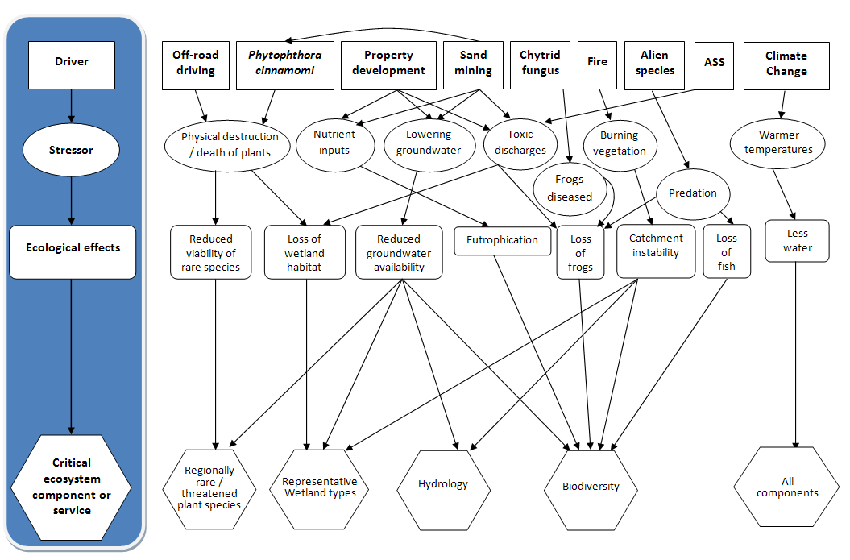
Figure 19: Driver-stressor model for Jocks Lagoon Ramsar Site.

Driver-stressor models of the type presented in Figure 19 can help with the determination of limits of acceptable change (Davis and Brock 2008). Figure 19 displays the major threats and their pathways of impact upon the critical components, processes and services. However, due to the large number of potential effects from each threat, not all pathways can be displayed.

Limits of acceptable change
The aim of deriving limits of acceptable change is to make it easier to determine when the ecological character of a wetland is likely to change or when it has changed due to pollution or other human interference (DEWHA 2008).
Limits of acceptable change are defined by Phillips (2006) as:
“…the variation that is considered acceptable in a particular measure or feature of the ecological character of the wetland. This may include population measures, hectares covered by a particular wetland type, the range of certain water quality parameter etc. The inference is that if the particular measure or parameter moves outside the ‘limits of acceptable change’ this may indicate a change in ecological character that could lead to a reduction or loss of the values for which the site was Ramsar listed (Figure 9). In most cases, change is considered in a negative context, leading to a reduction in the values for which a site was listed.”
Hale and Butcher (2008) noted problems associated with using extreme measures of a selected parameter and then setting the limits outside those extremes. These include the possibility of missing shifts in character that stay within the extremes, including more frequent events, changes in seasonal patterns, and changes in central tendency (mean/median). In Jocks Lagoon Ramsar Site there were no quantitative data available for any of the critical components prior to this ECD, creating difficulty in defining medians, natural variability and extreme conditions. However, the vegetation map produced as part of this ECD has been used in setting limits of acceptable change, allowing some quantification.
It is important to recognise the difference between limits of acceptable change and management triggers. Limits of acceptable change incorporate natural variability (where appropriate) into a quantitative assessment (where possible) of the components that define the Ramsar site’s unique character. Using data, expert judgment and the precautionary principle, limits of acceptable change set a quantitative limit which, if breached, will lead to a genuine change in the site’s unique ecological character.
In contrast, management triggers represent smaller changes towards exceeding limits of acceptable change (or other resource management goals of the site). This is an important distinction, as management triggers should be set at a level that allows appropriate management responses well in advance of the limits of acceptable change being breached. It is not appropriate to provide management triggers in an ECD, as these must be derived as part of a detailed management plan. However, the information provided in an ECD should be used as part of the management planning process for a Ramsar site.
The following components and processes were identified (Section 3.1) as critical to the ecological character of the Jocks Lagoon Ramsar Site ecosystem:
- wetland vegetation habitat types
- rare plant species
- water quality
- hydrology.
The following services were identified (Section 4) as critical to the ecological character of the Jocks Lagoon Ramsar Site ecosystem:
- supporting representative wetland types
- supporting regionally rare/threatened species
- supporting biodiversity.
The first two components and the first two services largely overlap, leaving the list of components, processes and services that require limits of acceptable change as:
- wetland vegetation habitat types
- rare plant species
- water quality
- hydrology
- supporting biodiversity.
Limits of Acceptable Change have been derived for these five components (Table 8). Baseline information, justification and comments are also provided in Table 8.
The confidence levels for the limits of acceptable change represent the degree to which the authors are confident that the LAC represents the point at which a change in character has occurred and follow the approach of Hale (2010):
High – Quantitative site specific data; good understanding linking the indicator to the ecological character of the site; LAC is objectively measureable.
Medium – Some site specific data or strong evidence for similar systems elsewhere derived from the scientific literature; or informed expert opinion; LAC is objectively measureable.
Low – no site specific data or reliable evidence from the scientific literature or expert opinion, LAC may not be objectively measurable and / or the importance of the indicator to the ecological character of the site is unknown.

Table 8: Limits of Acceptable Change for the Jocks Lagoon Ramsar Site.
Critical component, process or service | Baseline information | Limit of acceptable change (LAC)* | Justification and Comments | Confidence
Wetland vegetation habitat types | The baseline information used in this assessment is the vegetation map produced as part of this ECD (Figure 2) | The limits of acceptable change for the wetland are that over a ten year period:  - no more than ten percent reduction in wetland types Ts (sedgeland marsh) and U (peat sedgeland and teatree). Areas for Ts and U are 1.0and 0.8 hectares, respectively.  - no more than ten percent loss in the combined area of wetland types K (coastal freshwater lagoon) and E (sandy shores and dune slacks). Areas for K and E are 4.4 and 2.2 hectares, respectively. | There are no data on the variability of the wetland habitat types and, until this ECD, there was no mapping of the wetland types. These limits have been set as a common sense approach to defining a significant loss in wetland types. The second limit combines the standing water habitat with the sandy shores, as when the standing water (type K) reduces during drought, it exposes the sandy shores of the site (type E). As the map was made without proper field surveying, it will need verification. | Low-medium
Rare plant species | The only baseline information available is that two rare species were recorded as being at the site at the time of designation and a further three species were identified during site inspections for this ECD | Presence in two out of three surveys over a ten year period of:  - jointed twigsedge (Baumea articulata)  - slender twigsedge (Baumea gunnii)  - zigzag bogsedge (Schoenus brevifolius)  - yellow onion orchid (Microtidium atratum)  - erect marshflower (Villarsia exaltata). | There is no quantitative information on any of these species within the site. Therefore quantitative limits of acceptable change cannot be set and a qualitative LAC based on presence / absence of these five species is provided. | Low
Hydrology | There is no information on the hydrology of the site, other than the range in surface area of water observed during site visits. This was not quantified. | There is insufficient data to propose a quantitative limit of acceptable change for the hydrology of the site. | The relative input of surface water, local groundwater and (if applicable) regional groundwater is potentially of major importance to the functioning of the site, as is the establishment of its hydrological variability. | Low
Water Quality | The minimal data available shows Jocks Lagoon is consistently acidic, with a pH of 4.6 to 5.6 (Croome and Tyler 1987; Bowling et al 1993; Walsh et al 2002; Blackhall et al 2003), although Horwitz (1992) recorded it with pH of 6.3; Very limited nutrient and colour data show low nutrients and generally highly coloured water. | There is insufficient data to set a limit of acceptable change for nutrients and tannin-staining. pH should have a 90th percentile of 6.5 over one year of sampling. | The lagoon’s waters are acidic, tannin stained and have a low nutrient status which classifies it as dystrophic. These characteristics are important to the site’s ecological character by influencing the species composition of algae, other flora, and fauna as well as many of the ecological processes. The LAC for pH is based on less than 10 samples and therefore is likely to benefit substantially from further sampling. | Low
Supporting biodiversity | The baseline information for the site as a support for regional biodiversity consists of a restricted plant species list and field observations for this project | There is insufficient data to propose a limit of acceptable change for the support of the range of biodiversity at the site. However, since the rare plant species of the site are the major indicators of the site’s biodiversity, the LAC for biodiversity is the same as the LAC for the rare plant species. | The presence of a diverse and abundant macroinvertebrate fauna, two frog species, at least one fish species and several rare wetland plant species suggests that this site supports biodiversity. However, without quantitative assessment, no limits of acceptable change san be derived | Low
- Exceeding or not meeting a LAC does not automatically indicate that there has been a change in ecological character.

Changes in Ecological Character since listing
The lack of baseline data on the critical components, processes and services of the site precludes a detailed assessment of ecological change since time of listing. Kirkpatrick & Harwood (1981) undertook a coarse scale study of the vegetation in Tasmania, including Jocks Lagoon. This study indicated that Jocks Lagoon had a high value wetland vegetation community (including some endemic species and few weeds) but included very few details of the site (Michah Visoiu, DPIPWE, personal communication).
However, it is unlikely that there has been any change in ecological character, as the site has remained largely with one owner who has done little to impact that site and has, in fact, recently erected fences to restrict access to off-road vehicles.
While it is unlikely that the ecological character of the site has changed since listing, there are additions to be made to the justification of listing criteria:
- two Ramsar habitat types that had not previously been recorded at the site [Ts (intermittent sedgeland marsh) and U (peat sedgeland and teatree)]
- three more rare wetland dependent plant species: slender twigsedge (Baumea gunnii); zigzag bogsedge (Schoenus brevifolius); and yellow onion orchid (Microtidium atratum).
The apparent ‘absence’ of Baumea articulata from the site in 2009/2010 is likely to be a symptom of the long dry period prior to survey and the species may be obvious after several months of wetter conditions. Its absence, based on this survey alone (given its limited scope and effort), is not considered a change in character. However, this ECD recommends that surveys be conducted which specifically target rare plant species to identify this and other significant plant species on a regular basis.

Knowledge Gaps
Highest priority for filling of knowledge gaps is given to the components most critical to the site’s listing and ecological character and to informing limits of acceptable change to the site’s ecological character. These are presented in Table 9. Despite the almost complete lack of quantitative data for the site, the key knowledge gaps are relatively few.
Baseline data should be gathered using standard methods that allow a derivation of a ‘point in time’ baseline that can be compared to future monitoring programs. Therefore, an initial sampling strategy should be designed in a way that is cognisant of repeatability (see section 8, below). This is particularly the case for the biota (for example vegetation, fish) and water quality. The data should also be gathered using methods that allow comparison with other Tasmanian data sets.
Knowledge of the potential for acid sulphate soils to be present and also their potential to impact on the site is also included as a high priority, given the large impacts that acid sulphate soils can have in waterbodies, particularly small enclosed areas.
Table 9: Knowledge gaps for the site
Component / service | Identified Knowledge Gaps | Recommended Data collection or other action to address the gap. | Priority
Vegetation | Verification of the vegetation map produced for this ECD. | Comprehensive botanical survey of the site, focusing on the wetland area. | High
 | Quantitative data on wetland plant species of the site (including comprehensive list of rare species).
Rare plant species | Life history and functional attributes of the threatened species including responses to water regime will allow definition of the hydrology LAC and quantification of the rare plant species LAC. For example Villarsia exaltata will survive as a rosette on mudflats for long periods of time and then elongate and float on the surface of the water when inundated, however the water regime under which they will survive is unknown. | Population dynamics of threatened species as they relate to water level change. | High
Significant algal species | Quantitative information on presence and variability of Prorocentrum playfairi and other algae of the site. | Algal survey of water body and, if appropriate, analysis of sediments. Sediment analysis would be appropriate if sediments were sufficiently stable to allow coring and dating. | Medium
Significant fauna species | Information on presence and population dynamics of fish, Green and Gold Frog and the Ancient Greenling (Hemiphlebia mirabilis – damselfly). | Comprehensive aquatic fauna survey of the site, focusing on the wetland area. | High
Hydrology | Natural variability of site water depth and areal extent. | Hydrologic/geomorphic modelling. | High
 | Groundwater interactions with surface waters of lagoon. | Use of bores, hydrogeological techniques to determine proportion of ground water input and how it varies under different rainfall scenarios. | Medium
Water Quality | Baseline and natural variability of the standard measures of water quality, particularly those in relation to the site’s dystrophic nature. | Initial monthly (or more frequently if possible) in-situ measures of lagoon for pH and dissolved oxygen; monthly samples for colour, total phosphorus and dissolved nitrogen. | Medium
Biodiversity | Quantitative data on wetland macroinvertebrate species of the site (including comprehensive list of rare species). | Macroinvertebrate sampling of site. | Medium
 | Quantitative data on wetland vertebrate species of the site (including comprehensive list of rare species). | Vertebrate sampling of site, focusing on frogs and fish. | High
Soils | Confident assessment of potential presence and impacts of acid sulphate soils. | Sampling of the lagoon sediments, particularly focusing on areas subject to wetting and drying. | High
Introduced species | Abundance and diversity of introduced species at the site (particular focus on macrocrustacea and fish). | Obtain results from vertebrate and macroinvertebrate sampling noted above. | Medium

Key Site Monitoring Needs
The monitoring needs of the site should focus on the knowledge gaps, the limits of acceptable change for the maintenance of the site’s ecological character and also the major threats to the site. The major threats have been discussed in Section 5 and the limits of acceptable change in Section 6. Monitoring needs and prioritisations are presented in Table 10. Priorities for monitoring were established by considering the highest value components which face the highest threat.

Table 10: Key monitoring needs for the site
Component, process, or threat | Key Indicator(s) | Monitoring needs  (type & frequency) | Priority
Hydrology – surface water | Water depths at the site; surface water extent at the site  seasonal and annual variability | Depth measurements (at permanent points) and areal assessment of surface water extent at the site (possibly quarterly but may vary with water extent). | High
Vegetation | Vegetation extent and condition (health)  Structural and floristic diversity and flux | Vegetation surveying (species abundance/mapping and condition). Two to five yearly, relating results to hydrological data. | High
Hydrology - groundwater | Depth to water table  Correlations between regional rainfall and groundwater recharge | Measurements from bores within and near the site, analysis and modelling of bore data (quarterly)  Modelling of any proposed extractions and impact on groundwater and surface water at the site. | Medium
Fauna (macroinvertebrates and small vertebrates) | Population numbers  Natural variability | Annual counts, particularly of population changes in relation to water depths and depth fluxes  Include assessment of introduced species (for example yabby– Cherax destructor). | High
Water Quality | Salinity, nutrients, biocides, water clarity, dissolved oxygen | Water quality monitoring (both physical and chemical properties) at the site (preferably monthly, otherwise seasonally). | Medium
Use of site by recreational vehicles | Tyre tracks; fence condition | Monitor presence of tyre tracks within site, particularly around wetland. Assess landholder’s fencing, particularly for signs of vandalism. On-going. | Medium

Communication, Education & Public Awareness (CEPA) Messages
The aim of CEPA messages is to highlight any important messages which may need to be addressed in a management or Wetland Communication, Education and Public Awareness (CEPA) action plan. This includes the identification of important communication, education and public awareness messages that may have been identified during the preparation of the description (DEWHA 2008).

Current CEPA Activities
CEPA activities currently occurring onsite include;
- Interpretive information is provided in the form of a sign (Figure 20). The sign contains information on the Ramsar Convention, ecological importance of the site and the names and locations of other Tasmanian Ramsar sites.
- Departmental officials have met with the landholders on several occasions to discuss issues relating to management and protection of the site, particularly in relation to Australia's obligations under the Ramsar Convention.
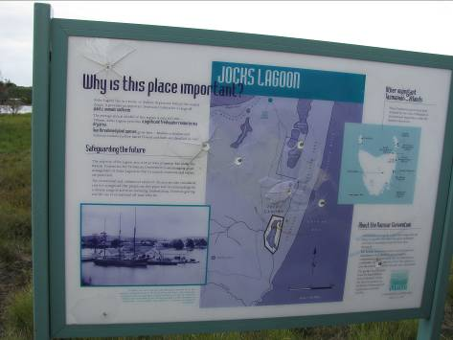
Figure 20: Interpretative sign at Jocks Lagoon Ramsar Site (photo: L.N. Lloyd)

Proposed CEPA Messages
Potential CEPA messages include:
- The site is important as a representative example of near natural freshwater coastal lagoon in Tasmania.
- The site has at least five species of wetland plant that are rare in Tasmania and could have more, as there is yet to be a comprehensive survey. The wetland plant species that have been identified at the site are:
- jointed twigsedge (Baumea articulata)
- slender twigsedge (Baumea gunnii)
- zigzag bogsedge (Schoenus brevifolius)
- yellow onion orchid (Microtidium atratum)
- erect marshflower (Villarsia exaltata).
- There are many threats to the site, most of which can be countered with appropriate management and appropriate use of the site and its surrounds. One threat that the public can assist with is to not drive vehicles to the site, as driving in the site can:
- physically destroy rare species and the soil that they grow in
- transport the disease ‘root rot’ (also known as die-back) to the site on the tyres of vehicles. This disease is prevalent in the area and threatens our native vegetation communities
- transport the disease ‘chytrid fungal disease’ to the site. This disease is spreading in Tasmania and threatens our native frog species
- Inappropriate development in the areas surrounding the site have the potential to impact on the site’s condition, through changes to the groundwater (quality and quantity).

Glossary
Definitions of words associated with ecological character descriptions. These are taken from DEWHA 2008 unless otherwise indicated.

Adverse conditions | ecological conditions unusually hostile to the survival of plant or animal species, such as occur during severe weather like prolonged drought, flooding, cold, etc.
Assessment | the identification of the status of, and threats to, wetlands as a basis for the collection of more specific information through monitoring activities
Baseline | condition at a starting point. For Ramsar wetlands it will usually be the time of listing of a Ramsar site
Benchmark | a standard or point of reference  a pre-determined state (based on the values which are sought to be protected) to be achieved or maintained
Benefits | benefits/services are defined in accordance with the Millennium Ecosystem Assessment definition of ecosystem services as "the benefits that people receive from ecosystems. See also “Ecosystem Services”.
Biogeographic region (also ‘bioregion’) | a scientifically rigorous determination of regions as established using biological and physical parameters such as climate, soil type, vegetation cover, etc.
Biological diversity | the variability among living organisms from all sources including, inter alia, terrestrial, marine and other aquatic ecosystems and the ecological complexes of which they are part; this includes diversity within species (genetic diversity), between species (species diversity), of ecosystems (ecosystem diversity), and of ecological processes. This definition is largely based on the one contained in Article 2 of the Convention on Biological Diversity.
Catchment | the total area draining into a river, reservoir, or other body of water.
Change in ecological character | is defined as the human-induced adverse alteration of any ecosystem component, process, and/or ecosystem benefit/service.
Community | an assemblage of organisms characterised by a distinctive combination of species occupying a common environment and interacting with one another.
Community Composition | all the types of taxa present in a community.
Conceptual model | wetland conceptual models express ideas about components and processes deemed important for wetland ecosystems.
Contracting Parties | are countries that are Member States to the Ramsar Convention on Wetlands; 154 as at March 2007. Membership in the Convention is open to all states that are members of the United Nations, one of the UN specialized agencies, or the International Atomic Energy Agency, or is a Party to the Statute of the International Court of Justice.
Critical stage | meaning stage of the life cycle of wetland-dependent species. Critical stages being those activities (breeding, migration stopovers, moulting etc.) which if interrupted or prevented from occurring may threaten long-term conservation of the species.

Dystrophic | A state of waterbodies, with very low nutrients, medium to high tannin colouration and medium to low pH (OECD 2001, Croome and Tyler 1987)
Ecological character | is the combination of the ecosystem components, processes and benefits/services that characterise the wetland at a given point in time. Within this context, ecosystem benefits are defined in accordance with the variety of benefits to people (Ecosystem Services). (Millennium definition of ecosystem services as "the benefits that people receive from ecosystems".  The phrase "at a given point in time" refers to Resolution VI.1 paragraph 2.1, which states that "It is essential that the ecological character of a site be described by the Contracting Party concerned at the time of designation for the Ramsar List, by completion of the Information Sheet on Ramsar Wetlands.
Ecological communities | any naturally occurring group of species inhabiting a common environment, interacting with each other especially through food relationships and relatively independent of other groups. Ecological communities may be of varying sizes, and larger ones may contain smaller ones.
Ecosystems | the complex of living communities (including human communities) and non-living environment (Ecosystem Components) interacting (through Ecological Processes) as a functional unit which provides inter alia a variety of benefits to people (Ecosystem Services).
Ecosystem components | include the physical, chemical and biological parts of a wetland (from large scale to very small scale, e.g. habitat, species and genes).
Ecosystem processes | are the dynamic forces within an ecosystem. They include all those processes that occur between organisms and within and between populations and communities, including interactions with the non-living environment that result in existing ecosystems and bring about changes in ecosystems over time. They may be physical, chemical or biological.
Ecosystem services | are the benefits that people receive or obtain from an ecosystem. The components of ecosystem services are provisioning (e.g. food & water), regulating (e.g. flood control), cultural (e.g. spiritual, recreational), and supporting (e.g nutrient cycling, ecological value). See also “Benefits”.
Geomorphology | the study of landforms
Indicator species | species whose status provides information on the overall condition of the ecosystem and of other species in that ecosystem; taxa that are sensitive to environmental conditions and which can therefore be used to assess environmental quality
Indigenous species | a species that originates and occurs naturally in a particular country.
Introduced (non-native) species | a species that does not originate or occur naturally in a particular country.
Limits of Acceptable Change | the variation that is considered acceptable in a particular component or process of the ecological character of the wetland without indicating change in ecological character which may lead to a reduction or loss of the criteria for which the site was Ramsar listed’.
List of Wetlands of International Importance ("the Ramsar List") | the list of wetlands which have been designated by the Ramsar Contracting Party in which they reside as internationally important, according to one or more of the criteria that have been adopted by the Conference of the Parties [http://www.ramsar.org/about/about_glossary.htm].
Monitoring | the collection of specific information for management purposes in response to hypotheses derived from assessment activities, and the use of these monitoring results for implementing.
Ramsar | city in Iran, on the shores of the Caspian Sea, where the Convention on Wetlands was signed on 2 February 1971; thus the Convention's short title, "Ramsar Convention on Wetlands" [http://www.ramsar.org/about/about_glossary.htm].
Ramsar Criteria | Criteria for Identifying Wetlands of International Importance, used by Contracting Parties and advisory bodies to identify wetlands as qualifying for the Ramsar List on the basis of representativeness or uniqueness or of biodiversity values. http://www.ramsar.org/about/about_glossary.htm
Ramsar Convention | Convention on Wetlands of International Importance especially as Waterfowl Habitat. Ramsar (Iran), 2 February 1971. UN Treaty Series No. 14583. As amended by the Paris Protocol, 3 December 1982, and Regina Amendments, 28 May 1987. The abbreviated names "Convention on Wetlands (Ramsar, Iran, 1971)" or "Ramsar Convention" are more commonly used [http://www.ramsar.org/index_very_key_docs.htm].
Ramsar Information Sheet (RIS) | the form upon which Contracting Parties record relevant data on proposed Wetlands of International Importance for inclusion in the Ramsar Database; covers identifying details like geographical coordinates and surface area, criteria for inclusion in the Ramsar List and wetland types present, hydrological, ecological, and socioeconomic issues among others, ownership and jurisdictions, and conservation measures taken and needed (http://www.ramsar.org/about/about_glossary.htm).
Ramsar List | the List of Wetlands of International Importance [http://www.ramsar.org/about/about_glossary.htm].
Ramsar Sites | wetlands designated by the Contracting Parties for inclusion in the List of Wetlands of International Importance because they meet one or more of the Ramsar Criteria [http://www.ramsar.org/about/about_glossary.htm].
Ramsar Sites Database | repository of ecological, biological, socio-economic, and political data and maps with boundaries on all Ramsar sites, maintained by Wetlands International in Wageningen, the Netherlands, under contract to the Convention [http://www.ramsar.org/about/about_glossary.htm].
Taxa, Taxon | A general name for a taxonomic group whatever level e.g. species or genus of any biota.
Wetlands | are areas of marsh, fen, peatland or water, whether natural or artificial, permanent or temporary with water that is static or flowing, fresh, brackish or salt, including areas of marine water the depth of which at low tide does not exceed six metres.
Wetland Assessment | the identification of the status of, and threats to, wetlands as a basis for the collection of more specific information through monitoring activities.
Wetland Ecological Risk Assessment | a quantitative or qualitative evaluation of the actual or potential adverse effects of stressors on a wetland ecosystem.
Wetland types | as defined by the Ramsar Convention’s wetland classification system [http://www.ramsar.org/ris/key_ris.htm#type].
Wise use of wetlands | is the maintenance of their ecological character, achieved through the implementation of ecosystem approaches[1], within the context of sustainable development[2]".  1. Including inter alia the Convention on Biological Diversity's "Ecosystem Approach" (CBD COP5 Decision V/6) and that applied by HELCOM and OSPAR (Declaration of the First Joint Ministerial Meeting of the Helsinki and OSPAR Commissions, Bremen, 25-26 June 2003).  2. The phrase "in the context of sustainable development" is intended to recognize that whilst some wetland development is inevitable and that many developments have important benefits to society, developments can be facilitated in sustainable ways by approaches elaborated under the Convention, and it is not appropriate to imply that 'development' is an objective for every wetland.

References
Australian Heritage Commission 2002. Australian Natural Heritage Charter for conservation of places of natural heritage significance. Second Edition. Australian Heritage Commission. Canberra.
Blackhall, S. McEntee, A. and Rollins, E. 2003. Information Sheet on Ramsar Wetlands (RIS): Jocks Lagoon. Department of Primary Industries, Water and Environment, Hobart.
Bowling, L.C. Banks, M.R. Croome, R.L. and Tyler, P.A. 1993. Reconnaissance Limnology of Tasmania II. Limnological features of Tasmanian freshwater coastal lagoons. Arch. Hydrobiol. 126(4): 385-403.
Bureau of Meteorology 2009. http://www.bom.gov.au/climate/averages/tables/cw_092033_All.shtml Date accessed: 23 July 2009.
Commonwealth of Australia 2010. http://www.bom.gov.au/hydro/wr/basins/index.shtml
Croome, R.L. and Tyler, P.A. 1987. Prorocentrum playfairi and Prorocentrum foveolata, two new dinoflagellates from Australian freshwaters. European Journal of Phycology 22: 67-75.
Davis, J. and Brock, M. 2008. Detecting unacceptable change in the ecological character of Ramsar wetlands. Ecological Management & Restoration 9(1): 26-32.
DEWHA 2008. (Department of Environment, Water, Heritage and the Arts), 2008, National Framework and Guidance for Describing the Ecological Character of Australia’s Ramsar Wetlands. Module 2 of Australian National Guidelines for Ramsar Wetlands – Implementing the Ramsar Convention in Australia.
DEWHA 2010. Australian Wetland Database. http://www.environment.gov.au/cgi-bin/wetlands/search.pl?smode=DOIW
DPIW 2009a.(Department of Primary Industries and Water) On-line list of threatened species (last updated April 2009) http://www.dpiw.tas.gov.au/inter.nsf/WebPages/SJON-58E2VD?open
DPIW 2009b On-line information on TASVEG Vegetation Community Benchmarks (last updated September 2009) http://www.dpiw.tas.gov.au/inter-nsf/ThemeNodes/LJEM-6RF4Q8?open
DPIW 2009c. Weeds Pests and Diseases: Frog Disease - Chytrid Fungus http://www.dpiw.tas.gov.au/inter.nsf/webpages/ljem-673v89?open#WhereischytridinTasm
Dudley, T.W.,undated. Protection of Natural Values in the Coastal Zone between Scamander and St. Helens Point.
Dunn, H. 2005. Assessing the Condition and Status of Tasmania’s Wetlands and Riparian Vegetation. Nature Conservation Branch, Department of Primary Industries, Water and Environment, Hobart.
Dunne, T. and Leopold, L. 1978. Water in Environmental Planning. W.H. Freeman and Company.
Environment Australia 2001. A Directory of Important Wetlands in Australia. Third Edition, Environment Australia, Canberra
Glazik, R. 1999. Botanical survey for crown land parcel UPI 0581376, St Helens, Tasmania. Report prepared for St Helens Landcare Group, Tasmania.
Hale, J., 2010, Ecological Character Description for the Pulu Keeling National Park Ramsar Site. Report to the Department of Environment, Water, Heritage and the Arts, Canberra.
Hale, J. and Butcher, R., 2008, Ecological Character Description of the Peel-Yalgorup Ramsar Site, Report to DEC and PHCC.
Harris, T. 1999. Register of National Estate Database Place Report- St Helens Point Lagoons Area.

Harris, S and Kitchener, A (2005). From Forest to Fjaeldmark: Descriptions of Tasmania's Vegetation. Department of Primary Industries, Parks, Water and Environment, Printing Authority of Tasmania. Hobart.
Horwitz, P. 1992. Macrocrustaceans, physicochemical properties and estimated trophic status of some coastal wetlands in northeastern Tasmania. Report to the Plomley Foundation and the Queen Victoria Museum and Art Gallery, Hobart.
Kirkpatrick, J. B. & Harwood, C. E. 1981. The conservation of Tasmanian wetland macrophytic species and communities. A report to the Australian Heritage Commission from the Tasmanian Conservation Trust Inc.
McGrath, C. 2006. unpublished Legal review of the framework for describing the ecological character of Ramsar wetlands to support implementation of the EPBC Act. Report to the Department of the Environment and Heritage, Unpublished.
Millennium Ecosystem Assessment 2005. Ecosystem Services and Human Well-Being: Wetlands & Water: Synthesis. 2005. Millennium Ecosystem Assessment report to the Ramsar Convention: World Resources Institute, Washington D.C.
National Herbarium of NSW 2010. PlantNET: Flora online http://plantnet.rbgsyd.nsw.gov.au/floraonline.htm
OECD 2001. Glossary. http://stats.oecd.org/glossary/detail.asp?ID=699
Phillips, B. 2006. Critique of the Framework for describing the ecological character of Ramsar Wetlands (Department of Sustainability and Environment, Victoria, 2005) based on its application at three Ramsar sites: Ashmore Reed National Nature Reserve, the Coral Sea Reserves (Coringa-Herald and Lihou Reeds and Cays), and Elizabeth and Middleton Reeds Marine National Nature Reserve. Mainstream Environmental Consulting Pty Ltd, Waramanga ACT.
Price, A. and Gawne, B. 2009. The Development of Wetland Conceptual Models for the Semi-Arid Zone - Final Report. A report prepared for the Murray-Darling Basin Authority by the Murray-Darling Freshwater Research Centre.
Qiu, S. and McComb, A.J. 1994. Effects of oxygen concentration on phosphorus release from reflooded air-dried wetland sediments. Australian Journal of Marine and Freshwater Research 45(7) 1319 – 1328.
Ramsar Convention 2005. Resolution IX.1 Annex A. A Conceptual Framework for the wise use of wetlands and the maintenance of their ecological character. http://www.ramsar.org/res/key_res_ix_01_annexa_e.htm
Register of the National Estate 1999. Database Place Report: St Helens Point Lagoons Area. Printed in September 1999.
Schahinger, R., Rudman T., and Wardlaw, T. J., 2003. Conservation of Tasmanian Plant Species & Communities threatened by Phytophthora cinnamomi. Strategic Regional Plan for Tasmania. Technical Report 03/03, Nature Conservation Branch, Department of Primary Industries, Water and Environment, Hobart.
State of Victoria 2010. Victorian Resources online: West Gippsland http://www.dpi.vic.gov.au/dpi/vro/wgregn.nsf/pages/wg_homepage
TASSI, unpublished. Tasmanian Acid Sulfate Soils Information. Unpublished site data.
Timbal, R. and Jones, D.A. 2008. Future projections of winter rainfall in southeast Australia using a statistical downscaling technique. Climate Change 86:165-187.
Walsh, R.G.J. Shiel, R.J. and Tyler, P.A. 2002. Reconnaissance Limnology of Tasmania VIII. Tasmanian coastal lagoons- epicentres of endemism in the Australian aquatic microbiota. Epicentres Final.
Watt, E. 2001. Peron dunes recreational use and geomorphological assessment project. Report for Tasmanian Recreational Vehicle Association Inc. Coastcare, Tasmania.

Appendices

Appendix 1: Flora of the site
List of plant species found at the Jocks Lagoon Ramsar Site during a vegetation survey, November 2009 (Source: Michah Visoiu, DPIPWE).

Family | Species name | Common name | TSP Act
Apiaceae | Centella cordifolia | swamp pennywort
 | Xanthosia dissecta | cut-leaf xanthosia
Asteraceae | Helichrysum scorpioides | button everlasting
 | Hypochoeris radicata* | cats ear
Dilleniaceae | Hibbertia acicularis | twiggy guinea-flower | Rare
 | Drosera peltata subsp. peltata | shield sundew
Droseraceae | Drosera pygmaea | pygmy sundew
Epacridaceae | Epacris lanuginosa | woolly heath
Fabaceae | Dillwynia glaberrima | smooth parrot-pea
 | Platylobium triangulare | ivy flat-pea
Goodeniaceae | Dampiera stricta | blue damperiera
Haloragaceae | Gonocarpus micranthus subsp. micranthus | creeping raspwort
Lamiaceae | Ajuga australis | Australian bugle
Menyanthaceae | Villarsia exaltata | erect marshflower | Rare
Mimosaceae | Acacia longifolia subsp. sophorae | coastal wattle
Myrtaceae | Eucalyptus amygdalina^{e} | black peppermint
 | Leptospermum scoparium var. scoparium | manuka
 | Melaleuca ericifolia | swamp paperbark⁽⁾
 | Melaleuca squamea | swamp melaleuca
Oxalidaceae | Oxalis perennans | grassland woodsorrel
Proteaceae | Banksia marginata | silver banksia
Rutaceae | Boronia nana var. nana | dwarf boronia
Stackhousiaceae | Stackhousia monogyna | creamy candles
Thymelaeaceae | Pimelea humilis | common riceflower
Centrolepidaceae | Centrolepis strigosa subsp. strigosa | hairy centrolepis
Cyperaceae | Baumea gunnii | slender twigsedge | Rare
 | Eleocharis sphacelata | giant spike-rush
 | Isolepis marginata | little clubrush
 | Lepidosperma filiforme | common swordsedge
 | Lepidosperma longitudinale | pithy swordsedge
 | Schoenus brevifolius | zig-zag bogsedge | Rare
 | Schoenus lepidosperma subsp. lepidosperma | common bogrush
Iridaceae | Patersonia fragilis | short purpleflag
Juncaginaceae | Triglochin procerum | water ribbons
Liliaceae | Burchardia umbellata | milkmaids
 | Hypoxis hygrometrica var. hygrometrica | golden weathergrass
Orchidaceae | Microtidium atratum | yellow onion orchid | Rare
 | Thelymitra cyanea | veined sun orchid
Poaceae | Austrostipa flavescens | coast speargrass
 | Ehrharta distichophylla | hairy rice-grass
 | Ehrharta stipoides | weeping grass
 | Notodanthonia semiannularis | Tasmanian wallaby grass
Restionaceae | Eurychorda complanata | flat cord rush
 | Hypolaena fastigiata | tassel rope rush
 | Leptocarpus tenax | slender twine rush
 | Lepyrodia muelleri | common scale rush
Xanthorrhoeaceae | Lomandra longifolia | mat rush
Xyridaceae | Xyris marginata^{e} | emarginate yellow-eye
 | Xyris operculata | tall yellow-eye
Dennstaedtiaceae | Pteridium esculentum | bracken
Lindsaeaceae | Lindsaea linearis | screw fern
Selaginellaceae | Selaginella uliginosa | swamp selaginella
^{e} endemic
*introduced
Indicative of damp/wet habitat

Appendix 2: The Consultants
Peter Newall, Independent Consulting Aquatic Ecologist
Peter Newall has over 25 years experience in studying, monitoring and assessing the physical, chemical and biological condition of water bodies and their catchments. He holds a B.Sc. Honours in Botany/Physical Geography (wetland ecology), a M.Env.Sci. in stream ecology and a PhD. on fish distributions across aquatic ecoregions. His work has included: examining the ecological condition of a broad range of aquatic ecosystems; developing systems for the use of biological indicators in ecosystem assessment and management; derivation of condition targets/objectives for natural resources; and developing river management policies for the care and protection of rivers.
Peter has been involved in developing water quality guidelines and objectives for aquatic ecosystem health, deriving biological regions for the assessment of stream condition across Victoria, developing the EPA (Victoria) protocol for the monitoring of licensed discharges to streams across Victoria, and furthering the development of biological indicators of stream condition. His work in these areas has been incorporated into the Victorian State Environment Protection Policy (Waters of Victoria) and its supporting documents.
Other studies he has undertaken include assessing catchment and land use management impacts upon receiving waterways; ecological risk assessments of streams; environmental assessment of streams and catchments; and character descriptions of wetlands.
Peter was a member of the CRC for Freshwater Ecology for five years, and has also worked in Environmental Auditing with EPA and as a consultant, particularly in natural resource auditing, focusing on waterway and catchment auditing.
Lance Lloyd, Principal Ecologist, Lloyd Environmental Pty Ltd
Principal Ecologist, Lance Lloyd, BSc, MSc. MAIBiol., provides high level strategic advice and services to industry and Government across Australia. He has 27 years experience in environmental consulting, research and management. Key expertise developed over this time is in relating the ecology of aquatic systems to the needs of management issues. The majority of work during his professional life, since 1979, has been in the ecology of aquatic and floodplain ecosystems and water regimes in flowing & lentic waters and their management. His M.Sc. studies and some of his major research projects and several published papers focused upon the central role of environmental water management to the ecology and biological requirements of fish, invertebrates and plants.
Lance also led a project to develop a wetlands inventory on Commonwealth Land as a contribution to the “Directory of Important Wetlands in Australia (3rd Edition)”. In 2003, Lance led an expert team to review the Environmental Water Requirements for Internationally significant Wetlands Framework where he undertook detailed studies on the Wyndgate Wetlands which are part of Coorong and Lakes Alexandrina and Albert Ramsar Site. He has contributed significantly to the MDBC Floodplain Wetlands Management Strategy. Lance was the lead author of the paper entitled “Natural Processes in Floodplain Ecosystems” which synthesised the current knowledge of floodplain wetland ecosystems and was produced as part of the MDBC Floodplain Wetlands Management Strategy.
Lance was a co-author of the FLOWs methodology for Victorian Streams and Rivers and lead a project to develop, pilot and refine a draft FLOWs methodology for the estuary ecosystems of Victoria. He was a key member of the team which developed the wetlands R&D requirements for Land & Water Australia in 1998, which included a specific review of water regime management and its research requirements.
Further, he was a board member of the Fisheries Co-management Council of Victoria (an advisory group to the Victorian Minister of Agriculture) in 2002 -2005. On the FCC he was responsible for the Estuaries, Bays and Inlets Fisheries. He led a process to develop a 10 year Vision for the Fisheries Industry in the region. He also served on the Victorian Fisheries Research Advisory Board for the Fisheries R&D Corporation. He currently chairs the Translocation Evaluation Panel for the Victorian Government which evaluates risks from fish translocations in Victoria.
In addition to the Jocks Lagoon Ramsar Site ECD, Lance also led the Ecological Character Description Project for the Tasmanian Government on the Floodplain Lower Ringarooma Ramsar Site and Little Waterhouse Lake.

Elisha Atchison, Environmental Consultant
Elisha Atchison recently completed a Bachelor of Environmental Science (Environmental Management) with Distinction at Deakin University. Whilst at university, Elisha undertook a broad range of subjects that provided her with background in various areas of environmental management such as policy instruments, catchment and coastal management, managing environmental projects, vegetation management and GIS. She developed an interest in water and vegetation management and chose to specialise in these areas in her final years of study. Elisha worked for Maroondah City Council as a Student Environmental Planner, which evolved her passion for environmental education. Elisha has since been working with Lloyd Environmental in a number of projects including Ecological Character Descriptions and the SA Murray Weir Operating Strategy.

Appendix 3: Methodology to Develop the ECD
This ecological character description was prepared following the general approach presented in National Framework and Guidance for Describing the Ecological Character of Australia’s Ramsar Wetlands (DEWHA 2008). This approach is presented in Figure A1.
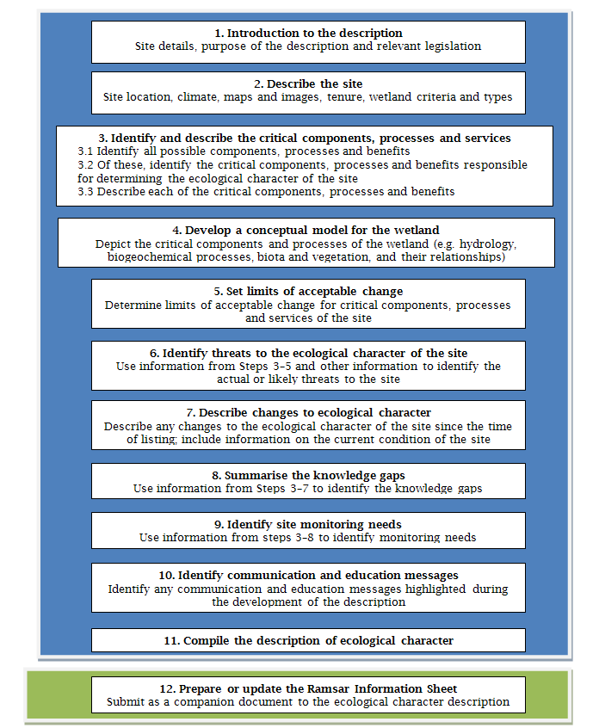
Figure A1: Summary of steps for the production of an ECD (Source: DEWHA 2008)
Eight major tasks were undertaken in the pursuit of this approach:
- Project inception and site visits
- Literature and information review
- Content of the ECD
- Preparation of first draft ECD for review by DEWHA
- Preparation of revised RIS, using the ECD
- Revision of first draft ECD (with DEWHA comments)
- Presentation of second draft ECD to stakeholders in a workshop format, seeking comments/feedback
- Finalisation of ECD, incorporating stakeholder comments
Although the ECD was mostly prepared as a desktop study, based on available data and information, the team also conducted interviews and informal discussions with relevant stakeholders and resource managers, to further develop our understanding of the site. Three site visits were also undertaken as part of the project and a structured workshop with scientific experts (Task 7) assisted with crystallising our understanding of the site and developing the conceptual model for the wetland. In addition, DPIPWE botanist, Michah Visoiu, assisted the authors by undertaking a vegetation survey to allow a full description of the site, as data on vegetation and wetlands types was not available.
The tasks outlined above are described in the following sections.
Task 1: Project inception and site inspections
The project commenced with an inception meeting with the Client Project Manager the Consultants and the Steering Committee. This meeting was to:
- Confirm project objectives, and outputs sought
- Discuss and finalise timeframes for delivery of project outputs
- Confirm existing information sources and obtain relevant reports, information, and data from the client.
This component was vital for ensuring alignment of objectives and discussion of approaches. The inception meeting was also used as a springboard for making contacts, obtaining details of key stakeholders and pursuing reference documents.
Site Inspection: Following the inception meeting a site inspection was undertaken to view the key areas and habitats of the Jocks Lagoon Ramsar Site. Two subsequent site inspections were held to augment the data and to view the site following heavy rains, as the initial site inspection was undertaken near the end of a 10 year drought.
Task 2: Literature and information review
The literature review initially focussed on the condition of the Ramsar site at the time of Ramsar listing. Information on potential changes to condition since listing was subsequently reviewed and documented. Information reviewed included documents prepared prior to and during the listing process, although most available information was in subsequent reports and studies on the condition of the wetland. In general, information was very limited
Collate/summarise information from inception meeting and Stakeholders: At the inception meeting relevant available documents held by the client were requested, as well as contact details of stakeholders and their relevant roles in relation to the Ramsar site. Subsequent to the inception meeting contact was made with relevant stakeholders as part of document searching/gathering. The collated and summarised information enabled an assessment of information gaps and needs.
Information and data search and review: Using the approaches and structures identified at the inception meeting and the collated information, information needs were prioritised and the most likely sources (people and documents) were identified. The data search and summary was a key component of the project. An “information log” was developed to document the reports and information resources available to the project. The “information log” was used during the course of the project to inform stakeholders which documents the project team possessed and which ones were missing for the project. A significant component of this included interviews and discussions with key stakeholders and technical experts.
Literature Summary: The information and data obtained was summarised to facilitate review of knowledge status and gaps, and was used as an important basis for the production of the ECD. The literature summary was structured to enable ready assessment against ECD requirements.
Discussions with NRM North and Government Agencies: Discussion with the client and key Government stakeholders was part of the project, both in the collection of information and also in the compilation of the literature summary. Feedback maximised the opportunity to uncover all relevant information.
Task 3: Content of the ECD
A scientific panel was convened and focussed on identifying the major content of the ECD, including:
- key ecological components and processes in the site
- the benefits and services that characterise the site
- key actual or potential threats to the site
- knowledge gaps
- monitoring needs
- an appropriate preliminary conceptual model of the system.
The Panel workshop consisted of the consultant team, representative of NRM North, and DPIPWE personnel who have substantial knowledge of the ecology of the site and/or and its region, covering a broad range of environmental/ecological disciplines.
Task 4: Preparation of a draft ECD for review by DEWHA and Steering Committee
A Draft of the ECD was prepared from the information gathered through the literature review, Scientific Panel, Steering Committee and through liaison with the client. The draft was provided to the client manager, for distribution to relevant staff within DEWHA.
The draft ECD generally followed the structure and content provided in the national framework (DEWHA 2008), which includes:
- Executive Summary
- Acknowledgements
- Table of Contents
- List of Abbreviations
- Introduction, including site details, purpose of the ECD, legislative context
- Detailed description of the site, including overview of the site; ECD context; Ramsar/DIWA criteria; geographic and ecosystem description
- Description of ecological character of the site, focusing on components, processes & benefits/services; conceptual model of site & system, quantified limits of change. Consideration will need to include biological, physical and chemical aspects of wetland condition and processes
- Key actual or potential threats or risks to the site, to aid identification of potential changes and their importance
- Knowledge gaps (and suggested approaches for addressing them)
- Changes in ecological character (if appropriate), including whether changes have occurred since listing
- Key site monitoring needs, identified from conceptual model, and covering knowledge gaps, assessing trends/changes and relevant triggers, monitoring management outcomes
- Triggers for management action, to be quantitative and place high importance on identified risks/threats
- Communication, Education and Public Awareness (CEPA) messages, summarising key ecological messages that will facilitate management planning and action
- Glossary
- References
- Appendices.
The ‘Executive Summary’, ‘List of Abbreviations’, ‘Glossary’ and ‘Appendices’ were not completed at this draft stage.
Describing the components, processes and benefits/services: The development of ecological character required a description of the ecosystem components, processes and benefits/services that characterise the Ramsar site. An important requirement within this task was the need to document the condition of the site at the time of its designation for the Ramsar list as well as current condition. This included assessments of trends in the condition of relevant components, processes and services and past and current changes in its character.
Development of conceptual models: Conceptual models were developed to represent the ecological processes and components of the Ramsar site in a simplified way, to will assist in describing the ecological character of the site.
Prepare draft ECD: The ecological character was described in accordance with the Draft National Framework. This required a description of the ecosystem components, processes and benefits/services that characterise the wetland as well as the conceptual model of the ecological functioning of the wetland system (described above).
Beyond the description of the wetland site, knowledge gaps were identified and recommendations made accordingly, including the development of monitoring recommendations. As well as filling of knowledge gaps, monitoring recommendations considered information required for assessment of trends, triggers for management action (including assessments of threats/risks), and feedback on management actions.
Task 5: Preparation of revised RIS, using the ECD
The preparation of the revised RIS used the existing RIS as a basis and incorporated changes to the site boundaries as well as any relevant changes to the ecology of the site since the preparation of the previous RIS. Much of the work undertaken as part of the literature review and also stakeholder discussion and team-member knowledge of the site fed into this task. The RIS was not prepared until after the first review of the ECD.
Task 6: Revision of first draft ECD (DEWHA comments)
The project team collated the comments provided by DEWHA, it’s reviewers, and the Steering Committee and incorporated those comments into a revision of the draft ECD, producing a second draft ECD for subsequent review.
Task 7: Presentation of second draft ECD to stakeholders in a workshop format, seeking comments/feedback
The 2nd draft ECD was circulated to DEWHA, it’s reviewers, and the Steering Committee Feedback received from the presentation/workshop was used in the preparation of the final draft of the ECD.
Task 8: Finalisation of ECD.
The ECD was finalised, incorporating the comments received and subsequent feedback.

Appendix 4: LiDAR projection across the St Helens Peninsula showing flow paths of water from Jocks Lagoon.

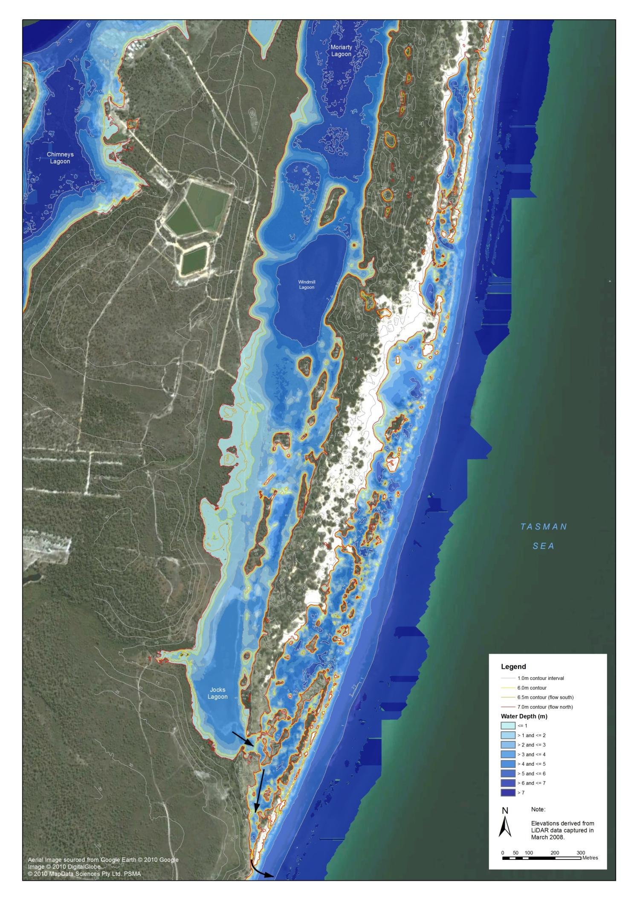
- Southern Map
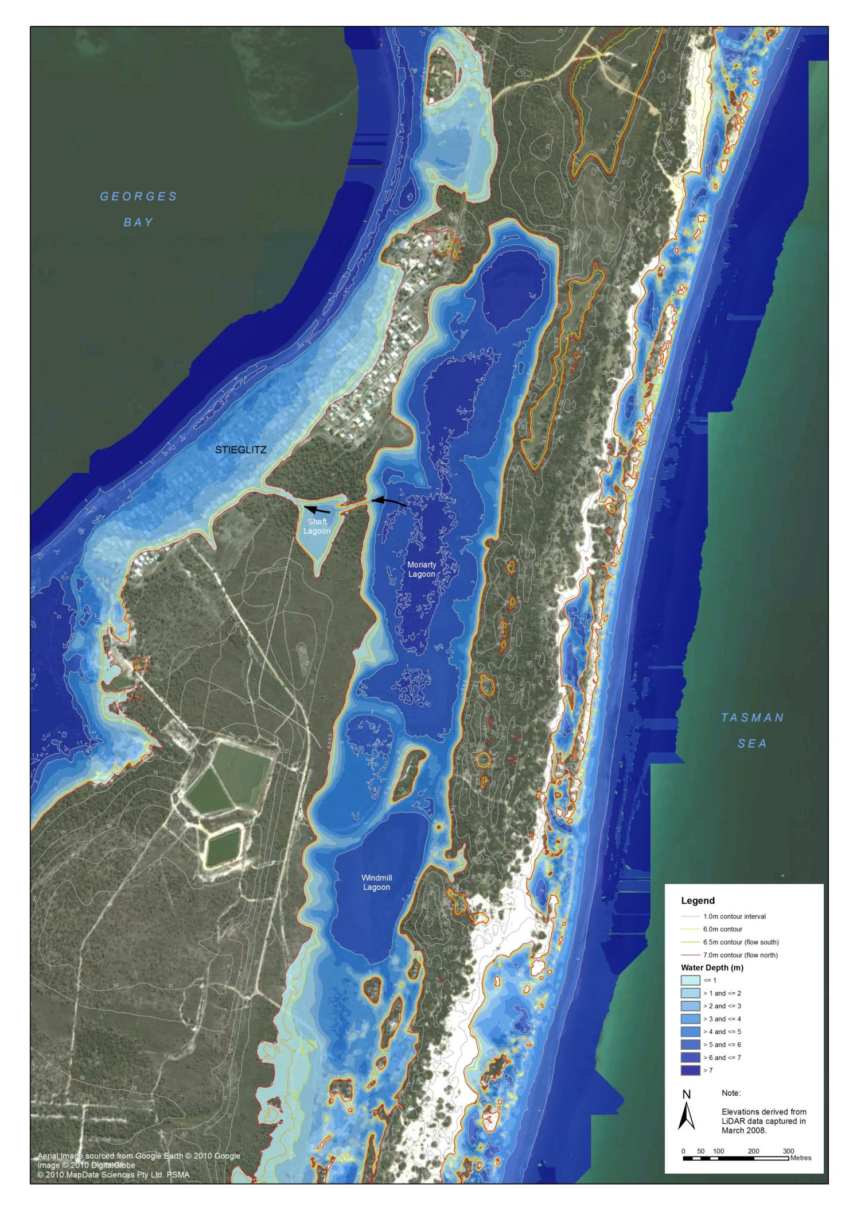
- Northern Map

Note that Horwitz (1992) recorded burrowing freshwater crayfish (Engaeus laevis) as present on site.

