2014–15 Basin-scale evaluation of Commonwealth environmental water
Hydrology: Annex Report Cards A1 - A13

Prepared by: Michael Stewardson and Fiorenzo Guarino

Final Report

MDFRC Publication 104/2016

2014–15 Basin-scale evaluation of Commonwealth environmental water — Hydrology: Annex Cards A1 - A13
Final Report prepared for the Commonwealth Environmental Water Office (CEWO) by The Murray–Darling Freshwater Research Centre

This report was prepared by The Murray–Darling Freshwater Research Centre (MDFRC). The aim of the MDFRC is to provide the scientific knowledge necessary for the management and sustained utilisation of the Murray–Darling Basin water resources. The MDFRC is a joint venture between La Trobe University and CSIRO.

For further information contact:
Ben Gawne
The Murray–Darling Freshwater Research Centre
PO Box 991
Wodonga VIC 3689
Ph: (02) 6024 9650

Email: Ben.Gawne@canberra.edu.au
Web: www.mdfrc.org.au
Enquiries: mdfrc@latrobe.edu.au

Report Citation: Stewardson MJ, Guarino F (2016) 2014–15 Basin-scale evaluation of Commonwealth environmental water — Hydrology Annexes. Final Report prepared for the Commonwealth Environmental Water Office by The Murray–Darling Freshwater Research Centre, MDFRC Publication 104/2016, November, 172pp.

This monitoring project was commissioned and funded by Commonwealth Environmental Water Office.
Copyright
© Copyright Commonwealth of Australia, 2016


2014-15 Basin-scale evaluation of Commonwealth environmental water: Hydrology Annex (2016) is licensed by the Commonwealth of Australia for use under a Creative Commons By Attribution 3.0 Australia licence with the exception of the Coat of Arms of the Commonwealth of Australia, the logo of the agency responsible for publishing the report, content supplied by third parties, and any images depicting people. For licence conditions see: http://creativecommons.org/licenses/by/3.0/au/
This report should be attributed as Stewardson MJ, Guarino F (2016) 2014–15 Basin-scale evaluation of Commonwealth environmental water — Hydrology Annex. Report prepared for the Commonwealth Environmental Water Office by The Murray–Darling Freshwater Research Centre, MDFRC Publication 104/2016, November, 172pp.
Disclaimer
The views and opinions expressed in this publication are those of the authors and do not necessarily reflect those of the Australian Government or the Minister for the Environment.
While reasonable efforts have been made to ensure that the contents of this publication are factually correct, the Commonwealth does not accept responsibility for the accuracy or completeness of the contents, and shall not be liable for any loss or damage that may be occasioned directly or indirectly through the use of, or reliance on, the contents of this publication.
The material contained in this publication represents the opinion of the author(s) only. While every effort has been made to ensure that the information in this publication is accurate, the author(s) and MDFRC do not accept any liability for any loss or damage howsoever arising whether in contract, tort or otherwise which may be incurred by any person as a result of any reliance or use of any statement in this publication. The author(s) and MDFRC do not give any warranties in relation to the accuracy, completeness and up-to-date status of the information in this publication.
Where legislation implies any condition or warranty which cannot be excluded restricted or modified, such condition or warranty shall be deemed to be included provided that the author’s and MDFRC’s liability for a breach of such condition or warranty is, at the option of MDFRC, limited to the supply of the services again or the cost of supplying the services again.

Document history and status
Version | Date Issued | Reviewed by | Approved by | Revision type
Draft | 19 October 2016 | Mike Stewardson & Fiorenzo Guarino | Penny Everingham | Internal
Draft | 2 November 2016 | Fiorenzo Guarino | Penny Everingham | Internal
Draft | 4 November 2016 | CEWO | Penny Everingham and Fiorenzo Guarino | External
Final | 17 November 2016 | CEWO | Penny Everingham | External

Distribution of copies
Version | Quantity | Issued to
Draft | 1 x Word | CEWO
Final | 1 x PDF 1 x Word | Paul Marsh, Sam Roseby and Andrew Lowes

Filename and path: Projects\CEWO\CEWH Long Term Monitoring Project\499 LTIM Stage 2 2014-19 Basin evaluation\Final Reports
Author(s): Michael Stewardson and Fiorenzo Guarino
Author affiliation(s): The University of Melbourne and The University of Canberra.
Project Manager: Ben Gawne
Client: Commonwealth Environmental Water Office
Project Title: Basin evaluation of the contribution of Commonwealth environmental water to the environmental objectives of the Murray‒Darling Basin Plan
Document Version: Final
Project Number: M/BUS/499
Contract Number: PRN 1213-0427

Acknowledgements:
We would like to acknowledge the many individuals and agencies assisted by providing data to support this evaluation. This included officers within the CEWO, Victorian Environmental Water Holder (VEWH), WaterNSW, Goulburn-Murray Water (GMW), Department of Environment, Water and Natural Resources (DEWNR) South Australia, Office of Environment & Heritage (OEH) New South Wales, Nature Foundation South Australia (NFSA), Mallee Catchment Management Authority (CMA), North-Central CMA, Goulburn Broken and North East CMA and the Murray–Darling Basin Authority (MDBA). In particular, we would like to thank Jim Foreman and Aftab Ahmad for conducting the Murray and Darling River modelling and for the drafting the modelling methodology for this report. Rachael Thomas and Jessica Heath provided invaluable data on inundation extents in the Murrumbidgee, Gwydir and Macquarie. Paul Packard provided extents for the Lachlan. Irene Wegener, Callie Nickolai, Jane White and Andrew Keogh provided inundation extents for various parts of the Murray. Jo Wood provided extents for the Broken. Ken Gee, Vincent Kelly and Sri Sritharan (WaterNSW) and Andrew Shields (GMW), Jarod Eaton, Matt Gibbs (DEWNR) and Gareth Carpenter (SA Water) provided hydrology data, foundational to this evaluation. Abbas Mohammadi provided GIS support. We thank the LTIM Project members who reviewed aspects of this report.
This project was undertaken using data collected for the Commonwealth Environmental Water Office Long Term Intervention Monitoring project. The assistance provided by the Monitoring and Evaluation Providers into interpretation of data and report review is greatly appreciated. The authors would also like to thank all Monitoring and Evaluation Provider staff involved in the collection and management of data.
The Murray–Darling Freshwater Research Centre offices are located on the land of the Latje Latje and Wiradjuri peoples. We undertake work throughout the Murray–Darling Basin and acknowledge the traditional owners of this land and water. We pay respect to Elders past, present and future.

Contents
A.1 Gwydir 1
1.1.1 Summary Statement 2
1.1.2 Description of Environmental Water System 2
1.1.3 Data Availability 3
1.1.4 Environmental Conditions 3
1.1.5 Environmental Water Actions in 2014-15 3
1.1.6 Contribution of Commonwealth Environmental Water to Flow Regimes 4
A.2 Murrumbidgee 29
2.1.1 Summary Statement 30
2.1.2 Description of Environmental Water System 30
2.1.3 Data Availability 31
2.1.4 Environmental Conditions 31
2.1.5 Environmental Water Actions in 2014-15 31
2.1.6 Contribution of Commonwealth Environmental Water to Flow Regimes 32
A.3 Lower Murray 47
3.1.1 Summary Statement 48
3.1.2 Description of Environmental Water System 48
3.1.3 Data Availability 49
3.1.4 Environmental Conditions 49
3.1.5 Environmental Water Actions in 2014-15 49
3.1.6 Contribution of Commonwealth Environmental Water to Flow Regimes 50
A.4 Central Murray 63
4.1.1 Summary Statement 64
4.1.2 Description of Environmental Water System 64
4.1.3 Data Availability 65
4.1.4 Environmental Conditions 65
4.1.5 Environmental Water Actions in 2014-15 65
4.1.6 Contribution of Commonwealth Environmental Water to Flow Regimes 66
A.5 Northern Unregulated 79
5.1.1 Summary Statement 80
5.1.2 Description of Environmental Water System 82
5.1.3 Data Availability 82
5.1.4 Environmental Conditions 83
5.1.5 Environmental Water Actions in 2014-15 83
5.1.6 Contribution of Commonwealth Environmental Water to Flow Regimes 85
A.6 Lachlan 95
6.1.1 Summary Statement 96
6.1.2 Description of Environmental Water System 96
6.1.3 Data Availability 97
6.1.4 Environmental Conditions 97
6.1.5 Environmental Water Actions in 2014-15 97
6.1.6 Contribution of Commonwealth Environmental Water to Flow Regimes 99
A.7 Macquarie 108
7.1.1 Summary Statement 109
7.1.2 Description of Environmental Water System 109
7.1.3 Data Availability 110
7.1.4 Environmental Conditions 110
7.1.5 Environmental Water Actions in 2014-15 110
7.1.6 Contribution of Commonwealth Environmental Water to Flow Regimes 111
A.8 Loddon 119
8.1.1 Summary Statement 120
8.1.2 Description of Environmental Water System 120
8.1.3 Data Availability 121
8.1.4 Environmental Conditions 121
8.1.5 Environmental Water Actions in 2014-15 121
8.1.6 Contribution of Commonwealth Environmental Water to Flow Regimes 122
A.9 Broken 130
9.1.1 Summary Statement 131
9.1.2 Description of Environmental Water System 131
9.1.3 Data Availability 132
9.1.4 Environmental Conditions 132
9.1.5 Environmental Water Actions in 2014-15 132
9.1.6 Contribution of Commonwealth Environmental Water to Flow Regimes 134
A.10 Goulburn 138
10.1.1 Summary Statement 139
10.1.2 Description of Environmental Water System 139
10.1.3 Data Availability 140
10.1.4 Environmental Conditions 140
10.1.5 Environmental Water Actions in 2014-15 140
10.1.6 Contribution of Commonwealth Environmental Water to Flow Regimes 142
A.11 Edward Wakool 147
11.1.1 Summary Statement 148
11.1.2 Description of Environmental Water System 148
11.1.3 Data Availability 149
11.1.4 Environmental Conditions 149
11.1.5 Environmental Water Actions in 2014-15 149
11.1.6 Contribution of Commonwealth Environmental Water to Flow Regimes 150
A.12 Ovens 156
12.1.1 Summary Statement 157
12.1.2 Description of Environmental Water System 157
12.1.3 Data Availability 158
12.1.4 Environmental Conditions 158
12.1.5 Environmental Water Actions in 2014-15 158
12.1.6 Contribution of Commonwealth Environmental Water to Flow Regimes 159
A.13 Campaspe 164
13.1.1 Summary Statement 165
13.1.2 Description of Environmental Water System 165
13.1.3 Data Availability 166
13.1.4 Environmental Conditions 166
13.1.5 Environmental Water Actions in 2014-15 166
13.1.6 Contribution of Commonwealth Environmental Water to Flow Regimes 168

A.1 Gwydir
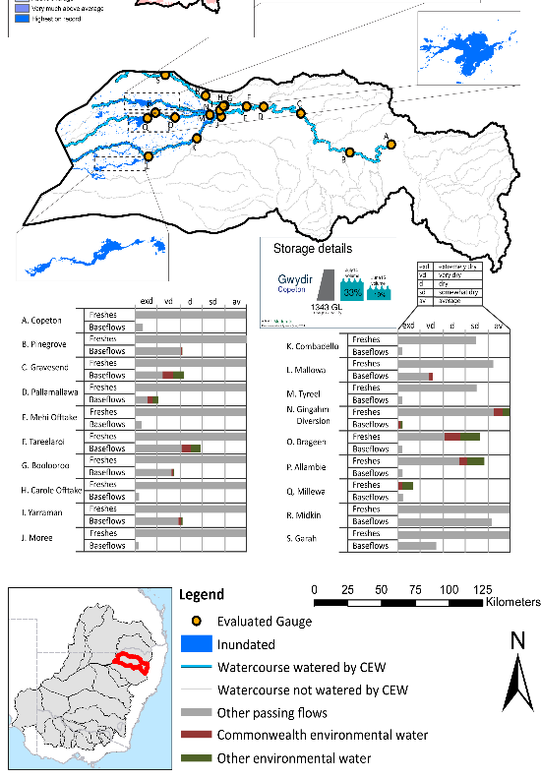
Figure GWY1: Location of evaluated gauges and the watercourses influenced by environmental water in the Gwydir valley during the 2014-15 water year. Inset bar graphs report the condition of annual flow regimes: for the hypothetical scenario if no environmental flow had been delivered (grey) and the improvements with the addition of environmental water. Rainfall conditions and trend in Storage levels for the water year are reported

Summary Statement
Environmental water delivery for the 2014-15 year in the Gwydir Valley is evaluated using data for 19 sites. This evaluation only considers the contribution of held environmental water, which is a primary focus for the Commonwealth. The contributions of planned environmental water (e.g. passing flows), unregulated tributary inflows and clever use of irrigation flows for environmental benefits can all be very important but these are outside the scope of this report. Environmental watering actions lasted on average 126 days over the course of the year. The volume of environmental water at these 19 sites was between 7% and 86% of the total streamflow. Commonwealth Environmental Water contributed on average 72% of this environmental water. Ideally, baseflows should be maintained and long periods of excessively low flows avoided. In this valley, the baseflow regime was generally considered to be extremely dry relative to the pre-development flow regime. In our analysis, a low fresh refers to a period of increased flow, when the water level rises at least one eighth of the way up the river bank (above the low flow level). These low freshes are a regular part of the natural flow regime and support a range of natural processes. In the Gwydir valley, in terms of the the occurrence and duration of low freshes, the year was assessed as being average. In our analysis, a medium fresh refers to a period of increased flow, when the water level rises at least one quater of the way up the river bank. These medium freshes are not as frequent as low freshes but are also a regular and important part of the natural flow regime. In the Gwydir valley, in terms of the occurrence of medium freshes, the year was assessed as being average. In our analysis, a high fresh refers to a period of increased flow, when the water level rises more than half way up the river. A high fresh may not occur every year but they are still important and long periods without major freshes can have serious consequences for floodplains and their contribution to river ecosystem health. Delivering environmental high in channel flows normally requires that all risks to riparian landholders and infrastructure have been resolved. In the Gwydir valley, in terms of the occurrence of high freshes, the year was assessed as being somewhat dry. Commonwealth environmental water actions altered flow regimes along an estimated 758 km of river and creek systems in the Gwydir Valley. These actions contributed partially to the 12659.1 ha of floodplain which was wet during the 2014-15 year.

Description of Environmental Water System
The Gwydir valley covers an area of 26,496 km2, which represents 2.50% of the total basin area. Dominant land use in the valley is livestock grazing and dryland agriculture which together cover approximately 90% of land management in the valley. Rainfall in the Gwydir varies from around 900 mm at the top of the catchment to around 450 mm in the west, with the dominant rainfall occurring between October and March.
Copeton dam is the largest dam in the valley (1343 GL) and it regulates around 55% of the Gwydir system inflows. Downstream structures at Tareelaroi, Boolooroo and Tyreel divert flows from the Gwydir River into the Mehi River, Carole Creek and Lower Gwydir river/Gingham watercourse. The Horton River is the largest tributary and is a major source of unregulated flows.
Strategically, environmental watering in the Gwydir valley is designed to contribute to wetland watering following natural cycles of drying and wetting. Typically water is delivered as discrete blocks of water fed from Copeton dam and regulated using instream infrastructure to target accounting points, augmented events (ie. enhance or extend a natural event), or finally piggy back events where it is delivered together with other water (e.g. 3T water or stock and domestic replenishment flows). The Lower Gwydir and Gingham are typical assets that are targeted for environmental water. These systems are low gradient with numerous anabranches and distributary creeks that terminate in wetlands. Baseflow and cease to flow periods commonly occur, whilst the overbank flooding is rare.
Environmental water delivery is heavily constrained in the Gwydir (Table GWY1). The constraints are typically operational and occur during the winter cereal cropping and harvesting season which can extend into the early summer. Similarly, small channel capacity in some areas means that overbank flows have the potential to destroy crops and restrict movements of heavy machinery by impacting low level crossings. In the lower Gwydir the flow constraint can sometimes be as low as no flow at all.
Table GWY1: List of key constraints limiting environmental flow delivery in the Gwydir River.
Location | Description | Flow Limit (ML/d)
The Raft ¹ | Channel Capacity | 5,000 – 10,000
Copeton Dam ¹ | Storage release capacity | 10,850
Moree (Mehi River) ¹ | Flood Levels | 10,500 (Minor)  21,000 (Moderate)  33,000 (Major)
Yarraman Bridge ¹ (Gwydir River) | Flood Levels | 9,700 (Minor)  35,700 (Moderate)  51,000 (Major)
Teralba | Inundation of winter crops and low level crossings | 480
Millewa | Inundation of winter crops and low level crossings | 300
Mallowa | Inundation of winter crops and low level crossings | 70
Gwydir | Inundation of winter crops and low level crossings | Can be as low as 0 during winter cropping period
¹ Mdba (2013)

Data Availability
The contribution (where applicable) of the CEW and NSW environmental water and other passing flows were derived from the CAIRO river operations spreadsheet held by Water NSW. The accounted waterholding, and its source was tracked longitudinally using known travel times, contributions from tributaries and differences between allocated and unallocated flow. The method assumed no longitudinal delivery loss, so in other words, the CEW component is likely to be underestimated at reaches upstream of the accounting point.

Environmental Conditions
The resource availability score for the Gwydir valley was estimated (July 2014) as Moderate (GWY 1). Whereas, the rainfall conditions (based on gridded rainfall percentiles which compare the rainfall experienced for the water year to the total record) experienced were categorised as average (Figure 1 – Main report). The storage levels of Lake Copeton declined from a high of 33% at the beginning of the water year to 19% by the end of the water year.

Environmental Water Actions in 2014-15
In 2014-15 CEW watering actions were designed to:
- Inundate core wetlands in the Gwydir wetlands for a period of 5-6 months
- Support native fish habitat by increasing availability of and access to suitable fish habitat, promoting fish movement and providing cues and appropriate habitats for spawning, recruitment and migration of native fish.
75,000 ML of CEW was approved for delivery in the Gwydir valley. The CEW portfolio yielded 56,639 ML (60.2%) of registered entitlement (excludes 20,450ML of supplementary flow entitlement).
56,639 ML of CEW was delivered in the Gwydir valley, contributing to four watering actions which spread over 308 days (84% of the water year) and occurred between September 2014 and March 2015 (Figure GWY2). The actions represented 65 % of the total environmental water delivered in the valley for 2014-15, but only accounted for 5.7% of total expected flows under a predevelopment condition (Table GWY2).
Two watering actions were designed to inundate wetlands, one in each of the lower Gwydir and Mallowa, whilst two watering actions were designed as freshes one in the Carole creek and the other in the Mehi river.
There were some minor deviations between the designed and observed hydrologic/hydraulic outputs of the four watering actions and these include:
- Harvesting operations meant that the Gwydir wetland inundation action was paused between late September and late November, whilst the Mallowa wetland action flow rates were reduced from 250 ML/day to 75 ML/day. Similarly, the flow rates designed in Carole creek were reduced from 500 ML/day to 400 ML/day.
- The construction of a stock and domestic pipeline in the Mallowa meant that a watering window of only 26 days was available until late December.
- Hot dry conditions meant that water NSW implemented a block release strategy to limit system losses on small volumes of water.
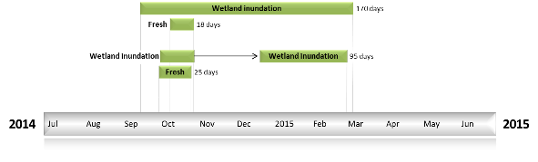
Figure GWY2: Timing and duration of Gwydir Commonwealth Environmental Water actions in 2014-15.
Table GWY2: Environmental water approved and delivered in the Gwydir over 2014-15.
Source | Total approved volume (ML) | Total volume delivered (ML) | % delivered of total EWater delivered | % contribution to predevelopment flows 1
CEW | 75000 | 56639 | 65.4 | 5.7
NSW |  | 29985 | 34.6 | 3.0
¹predevelopment average annual inflows of 996 GL

Contribution of Commonwealth Environmental Water to Flow Regimes
Copeton
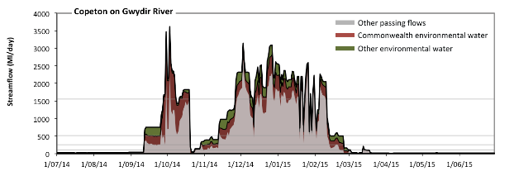
Figure GWY3: Contribution of environmental water delivery at Copeton. Horizontal lines indicate thresholds for very low flows, low flows, low freshes, medium freshes and high freshes (from lowest to highest).
At Copeton on Gwydir River environmental water contributed 34% of the total streamflow volume (much of which was Commonwealth Environmental Water) (Figure GWY3 and GWY4). Environmental watering actions affected streamflows for 47% of days between 1 June 2014 and 31 July 2015. Without environmental water, the durations of very low flows (i.e. < 21 Ml/day) in the periods January to March and April to June would have substantially exceeded durations expected in an average year in the natural flow regime. Environmental water mitigated these impacts by reducing the cumulative duration of very low flow spells from 21% to 19% of the year, with greatest influence in the periods October to December and January to March. Similarly, without environmental water, the durations of medium low flows (i.e. < 110 Ml/day) in the periods July to September, January to March and April to June would have substantially exceeded durations expected in an average year in the natural flow regime. Environmental water mitigated these impacts by reducing the cumulative duration of medium low flow spells from 56% to 53% of the year, with greatest influence in the period January to March. CEW equally shared responsibility with other environmental water holders for these enhancements of environmental baseflows at this site. In the absence of environmental water there would have been at least one low fresh (i.e. > 260 Ml/day) in the periods July to September, October to December and January to March. Environmental water increased the duration of the longest low fresh during the periods July to September (from 8 days to 19 days), October to December (from 49 days to 64 days) and January to March (from 43 days to 55 days). CEW equally shared responsibility with other environmental water holders for these increased durations of low freshes. In the absence of environmental water there would have been at least one medium fresh (i.e. > 520 Ml/day) in the periods July to September, October to December and January to March. Environmental water increased the duration of the longest medium fresh during the periods July to September (from 1 days to 19 days), October to December (from 20 days to 49 days) and January to March (from 18 days to 44 days). CEW made the dominant contribution to these increased durations of medium freshes. In the absence of environmental water there would have been at least one high fresh in the periods July to September, October to December and January to March. Environmental water increased the duration of the longest medium fresh during the periods July to September (from 1 days to 3 days), October to December (from 11 days to 19 days) and January to March (from 5 days to 18 days). CEW made the dominant contribution to these increased durations of high freshes.
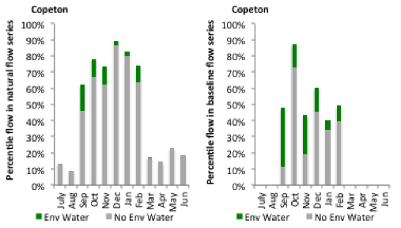
Figure GWY4: Contribution of environmental water delivery at Copeton as percentiles in the natural and baseline flow series.

Pinegrove
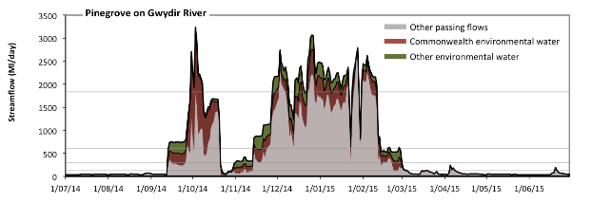
Figure GWY5: Contribution of environmental water delivery at Pinegrove. Horizontal lines indicate thresholds for very low flows, low flows, low freshes, medium freshes and high freshes (from lowest to highest).
At Pinegrove on Gwydir River environmental water contributed 33% of the total streamflow volume (much of which was Commonwealth Environmental Water) (Figure GWY5 and GWY6). Environmental watering actions affected streamflows for 47% of days between 1 June 2014 and 31 July 2015. Flow regulation does not substantially increase the duration of very low flows (i.e. < 25 Ml/day) compared to an average year in the natural flow regime. However, without environmental water, the durations of medium low flows (i.e. < 120 Ml/day) in the periods July to September, January to March and April to June would have substantially exceeded durations expected in an average year in the natural flow regime. Environmental water reduced the cumulative duration of medium low flow spells from 58% to 53% of the year, with greatest influence in the period October to December. CEW equally shared responsibility with other environmental water holders for these enhancements of environmental baseflows at this site. In the absence of environmental water there would have been at least one low fresh (i.e. > 300 Ml/day) in the periods July to September, October to December and January to March. Environmental water increased the duration of the longest low fresh during the periods July to September (from 5 days to 18 days) and January to March (from 44 days to 59 days). CEW equally shared responsibility with other environmental water holders for these increased durations of low freshes. In the absence of environmental water there would have been at least one medium fresh (i.e. > 610 Ml/day) in the periods July to September, October to December and January to March. Environmental water increased the duration of the longest medium fresh during the periods July to September (from 1 days to 17 days), October to December (from 38 days to 48 days) and January to March (from 22 days to 44 days). CEW made the dominant contribution to these increased durations of medium freshes. In the absence of environmental water there would have been at least one high fresh in the periods October to December and January to March. Environmental water increased the duration of the longest medium fresh during the periods July to September (from 0 days to 1 days), October to December (from 5 days to 12 days) and January to March (from 7 days to 21 days). CEW made the dominant contribution to these increased durations of high freshes.
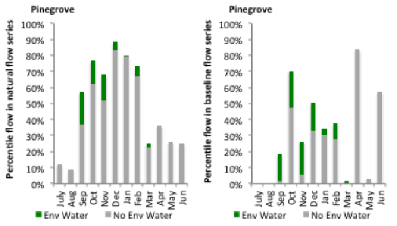
Figure GWY6: Contribution of environmental water delivery at Pinegrove as percentiles in the natural and baseline flow series.
Gravesend
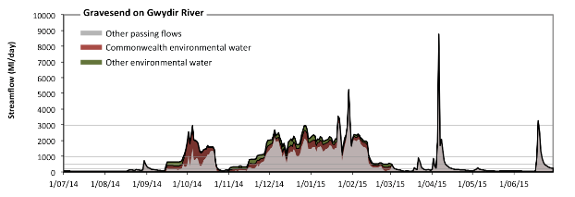
Figure GWY7: Contribution of environmental water delivery at Gravesend. Horizontal lines indicate thresholds for very low flows, low flows, low freshes, medium freshes and high freshes (from lowest to highest).
At Gravesend on Gwydir River environmental water contributed 29% of the total streamflow volume (much of which was Commonwealth Environmental Water) (Figure GWY7 and GWY8). Environmental watering actions affected streamflows for 48% of days between 1 June 2014 and 31 July 2015. Without environmental water, the duration of very low flows (i.e. < 40 Ml/day) in the period July to September would have substantially exceeded durations expected in an average year in the natural flow regime. Environmental water mitigated these impacts by reducing the cumulative duration of very low flow spells from 7% to 4% of the year, with greatest influence in the periods July to September and October to December. Similarly, without environmental water, the durations of medium low flows (i.e. < 200 Ml/day) in the periods July to September, January to March and April to June would have substantially exceeded durations expected in an average year in the natural flow regime. Environmental water mitigated these impacts by reducing the cumulative duration of medium low flow spells from 53% to 45% of the year, with greatest influence in the periods July to September and October to December. CEW equally shared responsibility with other environmental water holders for these enhancements of environmental baseflows at this site. In the absence of environmental water there would have been at least one low fresh (i.e. > 490 Ml/day) in the periods July to September, October to December, January to March and April to June. Environmental water increased the duration of the longest low fresh during the periods July to September (from 1 days to 15 days) and January to March (from 44 days to 60 days). CEW made the dominant contribution to these increased durations of low freshes. In the absence of environmental water there would have been at least one medium fresh (i.e. > 990 Ml/day) in the periods October to December, January to March and April to June. Environmental water increased the duration of the longest medium fresh during the periods July to September (from 0 days to 2 days), October to December (from 17 days to 40 days) and January to March (from 23 days to 44 days). CEW was entirely responsible for these increased durations of medium freshes. In the absence of environmental water there would have been at least one high fresh in the periods January to March and April to June. Environmental water made no change to the duration of these high freshes.
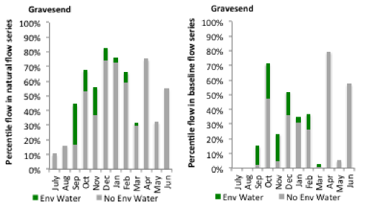
Figure GWY8: Contribution of environmental water delivery at Gravesend as percentiles in the natural and baseline flow series.
Pallamallawa
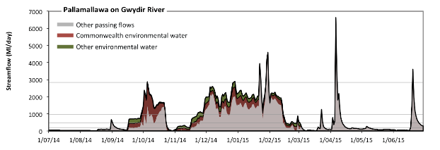
Figure GWY9: Contribution of environmental water delivery at Pallamallawa. Horizontal lines indicate thresholds for very low flows, low flows, low freshes, medium freshes and high freshes (from lowest to highest).
At Pallamallawa on Gwydir River environmental water contributed 29% of the total streamflow volume (much of which was Commonwealth Environmental Water) (Figure GWY9 and GWY10). Environmental watering actions affected streamflows for 48% of days between 1 June 2014 and 31 July 2015. Without environmental water, the durations of very low flows (i.e. < 39 Ml/day) in the periods July to September, October to December and January to March would have substantially exceeded durations expected in an average year in the natural flow regime. Environmental water mitigated these impacts by reducing the cumulative duration of very low flow spells from 17% to 11% of the year, with greatest influence in the period October to December. Similarly, without environmental water, the durations of medium low flows (i.e. < 200 Ml/day) in the periods July to September, January to March and April to June would have substantially exceeded durations expected in an average year in the natural flow regime. Environmental water mitigated these impacts by reducing the cumulative duration of medium low flow spells from 54% to 46% of the year, with greatest influence in the periods October to December and January to March. CEW equally shared responsibility with other environmental water holders for these enhancements of environmental baseflows at this site. In the absence of environmental water there would have been at least one low fresh (i.e. > 470 Ml/day) in the periods July to September, October to December, January to March and April to June. Environmental water increased the duration of the longest low fresh during the period July to September (from 2 days to 14 days). CEW equally shared responsibility with other environmental water holders for these increased durations of low freshes. In the absence of environmental water there would have been at least one medium fresh (i.e. > 950 Ml/day) in the periods October to December, January to March and April to June. Environmental water increased the duration of the longest medium fresh during the periods July to September (from 0 days to 2 days), October to December (from 15 days to 39 days) and January to March (from 24 days to 45 days). CEW was almost entirely responsible for these increased durations of medium freshes. In the absence of environmental water there would have been at least one high fresh in the periods January to March and April to June. Environmental water increased the duration of the longest medium fresh during the period October to December (from 0 days to 2 days). CEW equally shared responsibility with other environmental water holders for these increased durations of high freshes.
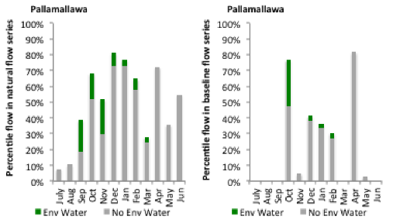
Figure GWY10: Contribution of environmental water delivery at Pallamallawa as percentiles in the natural and baseline flow series.

Mehi Offtake
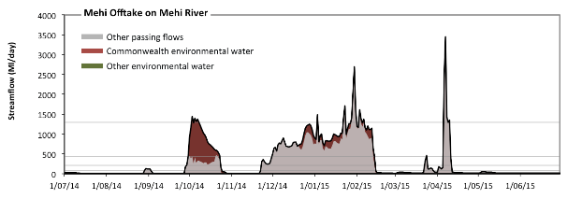
Figure GWY11: Contribution of environmental water delivery at Mehi Offtake. Horizontal lines indicate thresholds for very low flows, low flows, low freshes, medium freshes and high freshes (from lowest to highest).
At Mehi Offtake on Mehi River environmental water contributed 19% of the total streamflow volume (all of which was Commonwealth Environmental Water) (Figure GWY11 and GWY12). Environmental watering actions affected streamflows for 26% of days between 1 June 2014 and 31 July 2015. Without environmental water, the durations of very low flows (i.e. < 18 Ml/day) in the periods July to September, October to December, January to March and April to June would have all substantially exceeded durations expected in an average year in the natural flow regime. Environmental water mitigated these impacts by reducing the cumulative duration of very low flow spells from 36% to 33% of the year, with greatest influence in the period January to March. Similarly, without environmental water, the durations of medium low flows (i.e. < 90 Ml/day) in the periods July to September, October to December, January to March and April to June would have all substantially exceeded durations expected in an average year in the natural flow regime. However, environmental water had little effect on the duration of these medium low flows, which occurred for 64% of the year. CEW was entirely responsible for these enhancements of environmental baseflows at this site. There was at least one low fresh (i.e. > 220 Ml/day) in the periods July to September, October to December, January to March and April to June. Environmental water made little change to the duration of these low freshes. There was at least one medium fresh (i.e. > 440 Ml/day) in the periods July to September, October to December, January to March and April to June. Environmental water made little change to the duration of these medium freshes. In the absence of environmental water there would have been at least one high fresh in the periods January to March and April to June. Environmental water increased the duration of the longest medium fresh during the period October to December (from 0 days to 4 days). CEW was entirely responsible for these increased durations of high freshes.
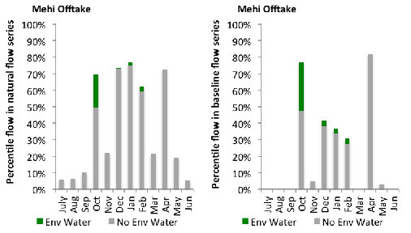
Figure GWY12: Contribution of environmental water delivery at Mehi Offtake as percentiles in the natural and baseline flow series.
Tareelaroi
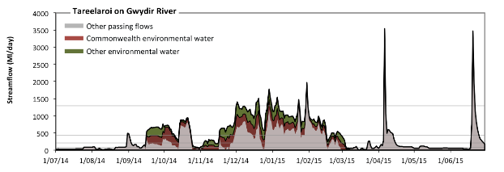Figure GWY13: Contribution of environmental water delivery at Tareelaroi. Horizontal lines indicate thresholds for very low flows, low flows, low freshes, medium freshes and high freshes (from lowest to highest).
At Tareelaroi on Gwydir River environmental water contributed 39% of the total streamflow volume (with approximately half contributed by Commonwealth Environmental Water) (Figure GWY13 and GWY14). Environmental watering actions affected streamflows for 48% of days between 1 June 2014 and 31 July 2015. Without environmental water, the durations of very low flows (i.e. < 18 Ml/day) in the periods October to December and January to March would have substantially exceeded durations expected in an average year in the natural flow regime. Environmental water mitigated these impacts by reducing the cumulative duration of very low flow spells from 8% to 1% of the year, with greatest influence in the period October to December. Similarly, without environmental water, the durations of medium low flows (i.e. < 90 Ml/day) in the periods July to September, October to December, January to March and April to June would have all substantially exceeded durations expected in an average year in the natural flow regime. Environmental water mitigated these impacts by reducing the cumulative duration of medium low flow spells from 44% to 34% of the year, with greatest influence in the period October to December. CEW equally shared responsibility with other environmental water holders for these enhancements of environmental baseflows at this site. In the absence of environmental water there would have been at least one low fresh (i.e. > 220 Ml/day) in the periods July to September, October to December, January to March and April to June. Environmental water increased the duration of the longest low fresh during the periods July to September (from 4 days to 15 days), October to December (from 24 days to 46 days) and January to March (from 46 days to 62 days). CEW equally shared responsibility with other environmental water holders for these increased durations of low freshes. In the absence of environmental water there would have been at least one medium fresh (i.e. > 440 Ml/day) in the periods July to September, October to December, January to March and April to June. Environmental water increased the duration of the longest medium fresh during the periods July to September (from 2 days to 15 days), October to December (from 16 days to 45 days) and January to March (from 24 days to 46 days). CEW equally shared responsibility with other environmental water holders for these increased durations of medium freshes. In the absence of environmental water there would have been at least one high fresh in the periods January to March and April to June. Environmental water increased the duration of the longest medium fresh during the periods October to December (from 0 days to 4 days) and January to March (from 1 days to 3 days). CEW equally shared responsibility with other environmental water holders for these increased durations of high freshes.
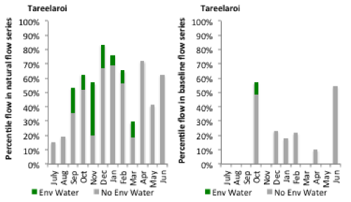
Figure GWY14: Contribution of environmental water delivery at Tareelaroi as percentiles in the natural and baseline flow series.
Carole Offtake
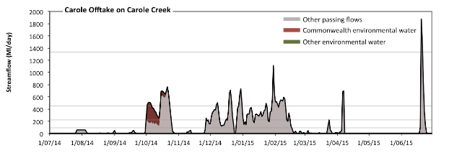 Figure GWY15: Contribution of environmental water delivery at Carole Offtake. Horizontal lines indicate thresholds for very low flows, low flows, low freshes, medium freshes and high freshes (from lowest to highest).
At Carole Offtake on Carole Creek environmental water contributed 7% of the total streamflow volume (all of which was Commonwealth Environmental Water) (Figure GWY15 and GWY16). Environmental watering actions affected streamflows for 7% of days between 1 June 2014 and 31 July 2015. Without environmental water, the durations of very low flows (i.e. < 19 Ml/day) in the periods July to September, October to December, January to March and April to June would have all substantially exceeded durations expected in an average year in the natural flow regime. However, environmental water had little effect on the duration of these very low flows, which occurred for 59% of the year. Similarly, without environmental water, the durations of medium low flows (i.e. < 94 Ml/day) in the periods July to September, October to December, January to March and April to June would have all substantially exceeded durations expected in an average year in the natural flow regime. However, environmental water had little effect on the duration of these medium low flows, which occurred for 68% of the year. In the absence of environmental water there would have been at least one low fresh (i.e. > 220 Ml/day) in the periods October to December, January to March and April to June. Environmental water increased the duration of the longest low fresh during the period October to December (from 11 days to 24 days). CEW was entirely responsible for these increased durations of low freshes. There was at least one medium fresh (i.e. > 450 Ml/day) in the periods October to December, January to March and April to June. Environmental water made no change to the duration of these medium freshes. In the absence of environmental water there would have been at least one high fresh in the period April to June. Environmental water made no change to the duration of these high freshes.
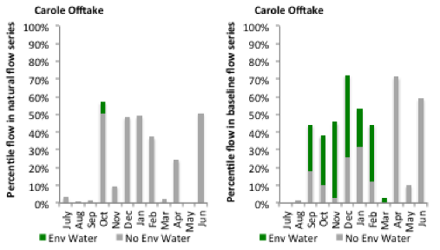
Figure GWY16: Contribution of environmental water delivery at Carole Offtake as percentiles in the natural and baseline flow series.

Boolooroo
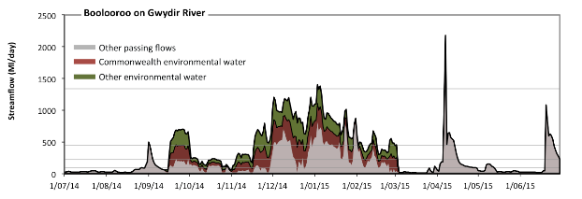 Figure GWY17: Contribution of environmental water delivery at Boolooroo. Horizontal lines indicate thresholds for very low flows, low flows, low freshes, medium freshes and high freshes (from lowest to highest).
At Boolooroo on Gwydir River environmental water contributed 49% of the total streamflow volume (with approximately half contributed by Commonwealth Environmental Water) (Figure GWY17 and GWY18). Environmental watering actions affected streamflows for 48% of days between 1 June 2014 and 31 July 2015. Without environmental water, the durations of very low flows (i.e. < 19 Ml/day) in the periods October to December and January to March would have substantially exceeded durations expected in an average year in the natural flow regime. Environmental water mitigated these impacts by reducing the cumulative duration of very low flow spells from 9% to 5% of the year, with greatest influence in the period October to December. Similarly, without environmental water, the durations of medium low flows (i.e. < 94 Ml/day) in the periods July to September, October to December, January to March and April to June would have all substantially exceeded durations expected in an average year in the natural flow regime. Environmental water mitigated these impacts by reducing the cumulative duration of medium low flow spells from 52% to 39% of the year, with greatest influence in the period October to December. CEW equally shared responsibility with other environmental water holders for these enhancements of environmental baseflows at this site. In the absence of environmental water there would have been at least one low fresh (i.e. > 220 Ml/day) in the periods July to September, October to December, January to March and April to June. Environmental water increased the duration of the longest low fresh during the periods July to September (from 4 days to 15 days), October to December (from 18 days to 45 days) and January to March (from 25 days to 61 days). CEW equally shared responsibility with other environmental water holders for these increased durations of low freshes. In the absence of environmental water there would have been at least one medium fresh (i.e. > 450 Ml/day) in the periods July to September, October to December, January to March and April to June. Environmental water increased the duration of the longest medium fresh during the periods July to September (from 1 days to 14 days), October to December (from 13 days to 44 days) and January to March (from 14 days to 32 days). CEW equally shared responsibility with other environmental water holders for these increased durations of medium freshes. In the absence of environmental water there would have been at least one high fresh in the period April to June. Environmental water increased the duration of the longest medium fresh during the period January to March (from 0 days to 1 days). CEW equally shared responsibility with other environmental water holders for these increased durations of high freshes.
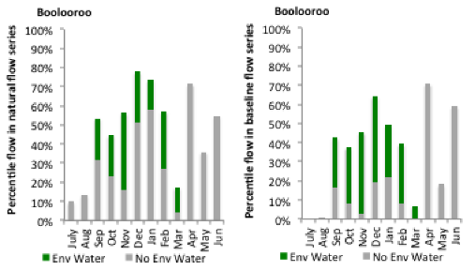
Figure GWY18: Contribution of environmental water delivery at Boolooroo as percentiles in the natural and baseline flow series.

Yarraman
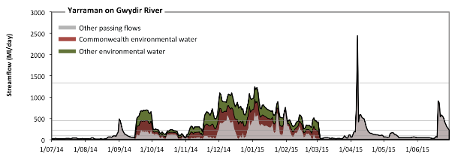 Figure GWY19: Contribution of environmental water delivery at Yarraman. Horizontal lines indicate thresholds for very low flows, low flows, low freshes, medium freshes and high freshes (from lowest to highest).
At Yarraman on Gwydir River environmental water contributed 52% of the total streamflow volume (with approximately half contributed by Commonwealth Environmental Water) (Figure GWY19 and GWY20). Environmental watering actions affected streamflows for 48% of days between 1 June 2014 and 31 July 2015. Without environmental water, the durations of very low flows (i.e. < 19 Ml/day) in the periods July to September, October to December and January to March would have substantially exceeded durations expected in an average year in the natural flow regime. Environmental water mitigated these impacts by reducing the cumulative duration of very low flow spells from 9% to 3% of the year, with greatest influence in the periods October to December and January to March. Similarly, without environmental water, the durations of medium low flows (i.e. < 94 Ml/day) in the periods July to September, October to December, January to March and April to June would have all substantially exceeded durations expected in an average year in the natural flow regime. Environmental water mitigated these impacts by reducing the cumulative duration of medium low flow spells from 55% to 38% of the year, with greatest influence in the period October to December. CEW equally shared responsibility with other environmental water holders for these enhancements of environmental baseflows at this site. In the absence of environmental water there would have been at least one low fresh (i.e. > 220 Ml/day) in the periods July to September, October to December, January to March and April to June. Environmental water increased the duration of the longest low fresh during the periods July to September (from 3 days to 15 days), October to December (from 14 days to 45 days) and January to March (from 19 days to 61 days). CEW equally shared responsibility with other environmental water holders for these increased durations of low freshes. In the absence of environmental water there would have been at least one medium fresh (i.e. > 450 Ml/day) in the periods July to September, October to December, January to March and April to June. Environmental water increased the duration of the longest medium fresh during the periods July to September (from 1 days to 14 days), October to December (from 3 days to 44 days) and January to March (from 4 days to 32 days). CEW equally shared responsibility with other environmental water holders for these increased durations of medium freshes. In the absence of environmental water there would have been at least one high fresh in the period April to June. Environmental water made no change to the duration of these high freshes.
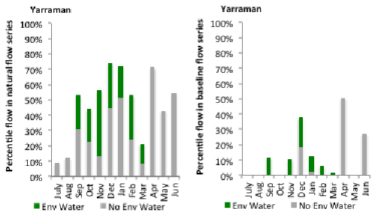
Figure GWY20: Contribution of environmental water delivery at Yarraman as percentiles in the natural and baseline flow series.
Gingham Diversion
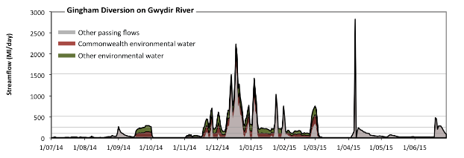 Figure GWY21: Contribution of environmental water delivery at Gingham Diversion. Horizontal lines indicate thresholds for very low flows, low flows, low freshes, medium freshes and high freshes (from lowest to highest).
At Gingham Diversion on Gwydir River environmental water contributed 48% of the total streamflow volume (with approximately half contributed by Commonwealth Environmental Water) (Figure GWY21 and GWY22). Environmental watering actions affected streamflows for 39% of days between 1 June 2014 and 31 July 2015. Without environmental water, the durations of very low flows (i.e. < 21 Ml/day) in the periods July to September, October to December and January to March would have substantially exceeded durations expected in an average year in the natural flow regime. Environmental water mitigated these impacts by reducing the cumulative duration of very low flow spells from 50% to 29% of the year, with greatest influence in the periods October to December and January to March. Similarly, without environmental water, the durations of medium low flows (i.e. < 100 Ml/day) in the periods July to September, October to December, January to March and April to June would have all substantially exceeded durations expected in an average year in the natural flow regime. Environmental water mitigated these impacts by reducing the cumulative duration of medium low flow spells from 81% to 59% of the year, with greatest influence in the periods October to December and January to March. CEW equally shared responsibility with other environmental water holders for these enhancements of environmental baseflows at this site. In the absence of environmental water there would have been at least one low fresh (i.e. > 250 Ml/day) in the periods July to September, October to December, January to March and April to June. Environmental water increased the duration of the longest low fresh during the periods July to September (from 1 days to 5 days), October to December (from 14 days to 22 days) and January to March (from 4 days to 7 days). CEW equally shared responsibility with other environmental water holders for these increased durations of low freshes. In the absence of environmental water there would have been at least one medium fresh (i.e. > 510 Ml/day) in the periods October to December, January to March and April to June. Environmental water increased the duration of the longest medium fresh during the periods October to December (from 8 days to 14 days) and January to March (from 3 days to 5 days). CEW equally shared responsibility with other environmental water holders for these increased durations of medium freshes. In the absence of environmental water there would have been at least one high fresh in the periods October to December and April to June. Environmental water increased the duration of the longest medium fresh during the period October to December (from 1 days to 2 days). CEW equally shared responsibility with other environmental water holders for these increased durations of high freshes.
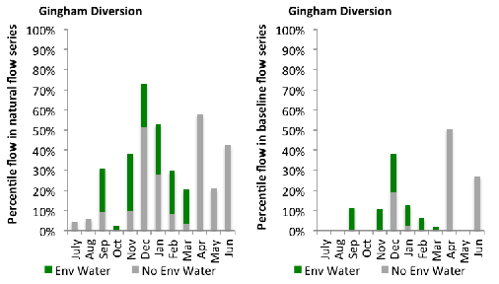
Figure GWY22: Contribution of environmental water delivery at Gingham Diversion as percentiles in the natural and baseline flow series.
Tyreel
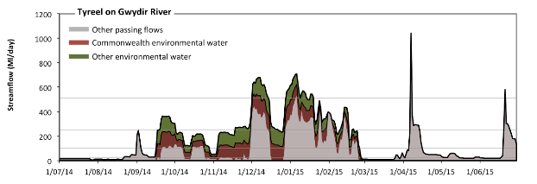 Figure GWY23: Contribution of environmental water delivery at Tyreel. Horizontal lines indicate thresholds for very low flows, low flows, low freshes and medium freshes (from lowest to highest).
At Tyreel on Gwydir River environmental water contributed 44% of the total streamflow volume (with approximately half contributed by Commonwealth Environmental Water) (Figure GWY23 and GWY24). Environmental watering actions affected streamflows for 44% of days between 1 June 2014 and 31 July 2015. Without environmental water, the durations of very low flows (i.e. < 21 Ml/day) in the periods July to September, October to December, January to March and April to June would have all substantially exceeded durations expected in an average year in the natural flow regime. Environmental water mitigated these impacts by reducing the cumulative duration of very low flow spells from 41% to 28% of the year, with greatest influence in the period October to December. Similarly, without environmental water, the durations of medium low flows (i.e. < 100 Ml/day) in the periods July to September, October to December, January to March and April to June would have all substantially exceeded durations expected in an average year in the natural flow regime. Environmental water mitigated these impacts by reducing the cumulative duration of medium low flow spells from 68% to 50% of the year, with greatest influence in the period October to December. CEW equally shared responsibility with other environmental water holders for these enhancements of environmental baseflows at this site. In the absence of environmental water there would have been at least one low fresh (i.e. > 250 Ml/day) in the periods October to December, January to March and April to June. Environmental water increased the duration of the longest low fresh during the periods July to September (from 0 days to 12 days), October to December (from 14 days to 35 days) and January to March (from 19 days to 37 days). CEW equally shared responsibility with other environmental water holders for these increased durations of low freshes. In the absence of environmental water there would have been at least one medium fresh (i.e. > 510 Ml/day) in the periods January to March and April to June. Environmental water increased the duration of the longest medium fresh during the periods October to December (from 0 days to 13 days) and January to March (from 1 days to 13 days). CEW equally shared responsibility with other environmental water holders for these increased durations of medium freshes. There was no high freshes (i.e. > 1500 Ml/day) this year.
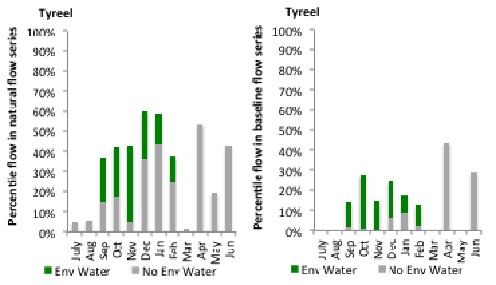
Figure GWY24: Contribution of environmental water delivery at Tyreel as percentiles in the natural and baseline flow series.

Brageen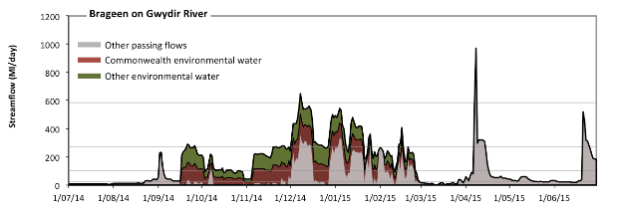 Figure GWY25: Contribution of environmental water delivery at Brageen. Horizontal lines indicate thresholds for very low flows, low flows, low freshes and medium freshes (from lowest to highest).
At Brageen on Gwydir River environmental water contributed 52% of the total streamflow volume (with approximately half contributed by Commonwealth Environmental Water) (Figure GWY25 and GWY26). Environmental watering actions affected streamflows for 44% of days between 1 June 2014 and 31 July 2015. Without environmental water, the durations of very low flows (i.e. < 21 Ml/day) in the periods July to September, October to December and January to March would have substantially exceeded durations expected in an average year in the natural flow regime. Environmental water mitigated these impacts by reducing the cumulative duration of very low flow spells from 45% to 23% of the year, with greatest influence in the period October to December. Similarly, without environmental water, the durations of medium low flows (i.e. < 100 Ml/day) in the periods July to September, October to December, January to March and April to June would have all substantially exceeded durations expected in an average year in the natural flow regime. Environmental water mitigated these impacts by reducing the cumulative duration of medium low flow spells from 79% to 55% of the year, with greatest influence in the period October to December. CEW equally shared responsibility with other environmental water holders for these enhancements of environmental baseflows at this site. In the absence of environmental water there would have been at least one low fresh (i.e. > 270 Ml/day) in the periods October to December, January to March and April to June. Environmental water increased the duration of the longest low fresh during the periods July to September (from 0 days to 2 days), October to December (from 8 days to 22 days) and January to March (from 3 days to 10 days). CEW equally shared responsibility with other environmental water holders for these increased durations of low freshes. In the absence of environmental water there would have been at least one medium fresh (i.e. > 580 Ml/day) in the period April to June. Environmental water increased the duration of the longest medium fresh during the period October to December (from 0 days to 2 days). CEW equally shared responsibility with other environmental water holders for these increased durations of medium freshes. There was no high freshes (i.e. > 1900 Ml/day) this year.
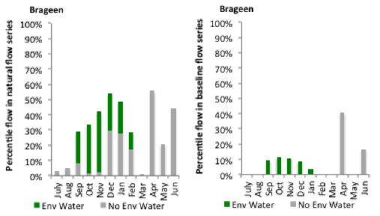
Figure GWY26: Contribution of environmental water delivery at Brageen as percentiles in the natural and baseline flow series.
Allambie
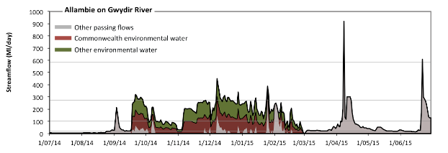 Figure GWY27: Contribution of environmental water delivery at Allambie. Horizontal lines indicate thresholds for very low flows, low flows, low freshes and medium freshes (from lowest to highest).
At Allambie on Gwydir River environmental water contributed 66% of the total streamflow volume (with approximately half contributed by Commonwealth Environmental Water) (Figure GWY27 and GWY28). Environmental watering actions affected streamflows for 44% of days between 1 June 2014 and 31 July 2015. Without environmental water, the durations of very low flows (i.e. < 21 Ml/day) in the periods July to September, October to December, January to March and April to June would have all substantially exceeded durations expected in an average year in the natural flow regime. Environmental water mitigated these impacts by reducing the cumulative duration of very low flow spells from 54% to 23% of the year, with greatest influence in the periods October to December and January to March. Similarly, without environmental water, the durations of medium low flows (i.e. < 100 Ml/day) in the periods July to September, October to December, January to March and April to June would have all substantially exceeded durations expected in an average year in the natural flow regime. Environmental water mitigated these impacts by reducing the cumulative duration of medium low flow spells from 92% to 59% of the year, with greatest influence in the periods October to December and January to March. CEW equally shared responsibility with other environmental water holders for these enhancements of environmental baseflows at this site. In the absence of environmental water there would have been at least one low fresh (i.e. > 270 Ml/day) in the periods January to March and April to June. Environmental water increased the duration of the longest low fresh during the periods July to September (from 0 days to 8 days), October to December (from 0 days to 5 days) and January to March (from 1 days to 2 days). CEW equally shared responsibility with other environmental water holders for these increased durations of low freshes. There was at least one medium fresh (i.e. > 580 Ml/day) in the period April to June. Environmental water made no change to the duration of these medium freshes. There was no high freshes (i.e. > 1900 Ml/day) this year.
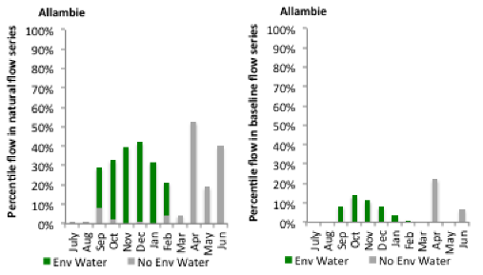
Figure GWY28: Contribution of environmental water delivery at Allambie as percentiles in the natural and baseline flow series.
Millewa
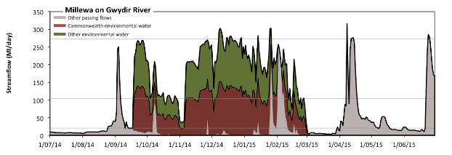 Figure GWY29: Contribution of environmental water delivery at Millewa. Horizontal lines indicate thresholds for very low flows, low flows and low freshes (from lowest to highest).
At Millewa on Gwydir River environmental water contributed 72% of the total streamflow volume (with approximately half contributed by Commonwealth Environmental Water) (Figure GWY29 and GWY30). Environmental watering actions affected streamflows for 44% of days between 1 June 2014 and 31 July 2015. Without environmental water, the durations of very low flows (i.e. < 21 Ml/day) in the periods July to September, October to December, January to March and April to June would have all substantially exceeded durations expected in an average year in the natural flow regime. Environmental water mitigated these impacts by reducing the cumulative duration of very low flow spells from 72% to 33% of the year, with greatest influence in the periods October to December and January to March. Similarly, without environmental water, the durations of medium low flows (i.e. < 100 Ml/day) in the periods July to September, October to December, January to March and April to June would have all substantially exceeded durations expected in an average year in the natural flow regime. Environmental water mitigated these impacts by reducing the cumulative duration of medium low flow spells from 92% to 56% of the year, with greatest influence in the periods October to December and January to March. CEW equally shared responsibility with other environmental water holders for these enhancements of environmental baseflows at this site. In the absence of environmental water there would have been at least one low fresh (i.e. > 270 Ml/day) in the period April to June. Environmental water increased the duration of the longest low fresh during the periods October to December (from 0 days to 4 days) and January to March (from 0 days to 2 days). CEW equally shared responsibility with other environmental water holders for these increased durations of low freshes. There was no medium or high freshes this year.
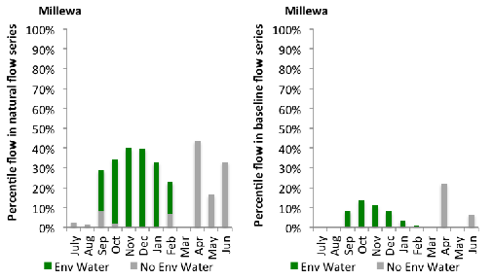
Figure GWY30: Contribution of environmental water delivery at Millewa as percentiles in the natural and baseline flow series.
Moree
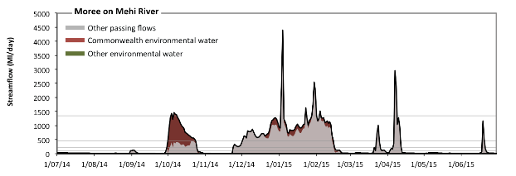 Figure GWY31: Contribution of environmental water delivery at Moree. Horizontal lines indicate thresholds for very low flows, low flows, low freshes, medium freshes and high freshes (from lowest to highest).
At Moree on Mehi River environmental water contributed 18% of the total streamflow volume (all of which was Commonwealth Environmental Water) (Figure GWY31 and GWY32). Environmental watering actions affected streamflows for 26% of days between 1 June 2014 and 31 July 2015. Without environmental water, the durations of very low flows (i.e. < 19 Ml/day) in the periods July to September, October to December, January to March and April to June would have all substantially exceeded durations expected in an average year in the natural flow regime. Environmental water mitigated these impacts by reducing the cumulative duration of very low flow spells from 42% to 41% of the year, with greatest influence in the period January to March. Similarly, without environmental water, the durations of medium low flows (i.e. < 95 Ml/day) in the periods July to September, October to December, January to March and April to June would have all substantially exceeded durations expected in an average year in the natural flow regime. Environmental water mitigated these impacts by reducing the cumulative duration of medium low flow spells from 63% to 61% of the year, with greatest influence in the periods October to December and January to March. There was at least one low fresh (i.e. > 230 Ml/day) in the periods October to December, January to March and April to June. Environmental water made little change to the duration of these low freshes. There was at least one medium fresh (i.e. > 460 Ml/day) in the periods October to December, January to March and April to June. Environmental water made little change to the duration of these medium freshes. In the absence of environmental water there would have been at least one high fresh in the periods January to March and April to June. Environmental water increased the duration of the longest medium fresh during the period October to December (from 0 days to 3 days). CEW was entirely responsible for these increased durations of high freshes.
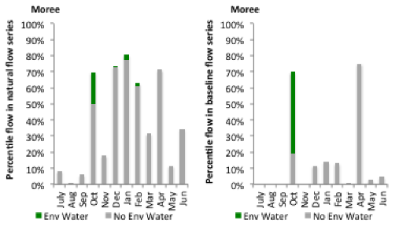
Figure GWY32: Contribution of environmental water delivery at Moree as percentiles in the natural and baseline flow series.
Combadello
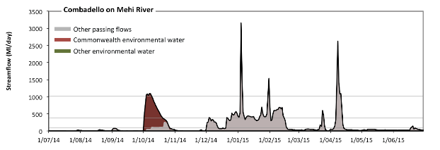 Figure GWY33: Contribution of environmental water delivery at Combadello. Horizontal lines indicate thresholds for very low flows, low flows, low freshes and medium freshes (from lowest to highest).
At Combadello on Mehi River environmental water contributed 19% of the total streamflow volume (all of which was Commonwealth Environmental Water) (Figure GWY33 and GWY34). Environmental watering actions affected streamflows for 7% of days between 1 June 2014 and 31 July 2015. Without environmental water, the durations of very low flows (i.e. < 20 Ml/day) in the periods July to September and October to December would have substantially exceeded durations expected in an average year in the natural flow regime. Environmental water mitigated these impacts by reducing the cumulative duration of very low flow spells from 32% to 32% of the year, with greatest influence in the period October to December. Similarly, without environmental water, the durations of medium low flows (i.e. < 99 Ml/day) in the periods July to September, October to December, January to March and April to June would have all substantially exceeded durations expected in an average year in the natural flow regime. Environmental water mitigated these impacts by reducing the cumulative duration of medium low flow spells from 72% to 70% of the year, with greatest influence in the period October to December. CEW was entirely responsible for these enhancements of environmental baseflows at this site. In the absence of environmental water there would have been at least one low fresh (i.e. > 380 Ml/day) in the periods October to December, January to March and April to June. Environmental water increased the duration of the longest low fresh during the period October to December (from 6 days to 18 days). CEW was entirely responsible for these increased durations of low freshes. In the absence of environmental water there would have been at least one medium fresh (i.e. > 1000 Ml/day) in the periods January to March and April to June. Environmental water increased the duration of the longest medium fresh during the period October to December (from 0 days to 6 days). CEW was entirely responsible for these increased durations of medium freshes. There was no high freshes (i.e. > 4100 Ml/day) this year.
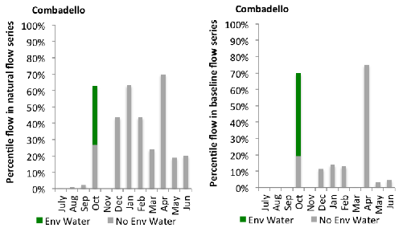
Figure GWY34: Contribution of environmental water delivery at Combadello as percentiles in the natural and baseline flow series.
Mallowa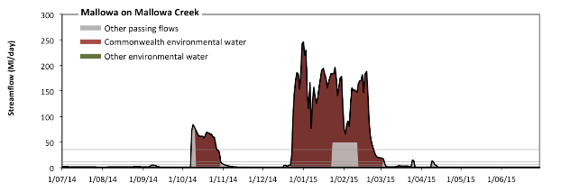 Figure GWY35: Contribution of environmental water delivery at Mallowa. Horizontal lines indicate thresholds for very low flows, low flows, low freshes, medium freshes and high freshes (from lowest to highest).
At Mallowa on Mallowa Creek environmental water contributed 86% of the total streamflow volume (all of which was Commonwealth Environmental Water) (Figure GWY35 and GWY36). Environmental watering actions affected streamflows for 24% of days between 1 June 2014 and 31 July 2015. Without environmental water, the durations of very low flows (i.e. < 0.43 Ml/day) in the periods October to December, January to March and April to June would have substantially exceeded durations expected in an average year in the natural flow regime. Environmental water mitigated these impacts by reducing the cumulative duration of very low flow spells from 52% to 33% of the year, with greatest influence in the periods October to December and January to March. Similarly, without environmental water, the durations of medium low flows (i.e. < 2.1 Ml/day) in the periods July to September, October to December, January to March and April to June would have all substantially exceeded durations expected in an average year in the natural flow regime. Environmental water mitigated these impacts by reducing the cumulative duration of medium low flow spells from 81% to 62% of the year, with greatest influence in the periods October to December and January to March. CEW was entirely responsible for these enhancements of environmental baseflows at this site. In the absence of environmental water there would have been at least one low fresh (i.e. > 5.5 Ml/day) in the periods October to December, January to March and April to June. Environmental water increased the duration of the longest low fresh during the periods October to December (from 4 days to 26 days) and January to March (from 20 days to 63 days). CEW was entirely responsible for these increased durations of low freshes. In the absence of environmental water there would have been at least one medium fresh (i.e. > 11 Ml/day) in the periods October to December, January to March and April to June. Environmental water increased the duration of the longest medium fresh during the periods October to December (from 3 days to 22 days) and January to March (from 20 days to 62 days). CEW was entirely responsible for these increased durations of medium freshes. In the absence of environmental water there would have been at least one high fresh in the periods October to December and January to March. Environmental water increased the duration of the longest medium fresh during the periods October to December (from 3 days to 19 days) and January to March (from 20 days to 54 days). CEW was entirely responsible for these increased durations of high freshes.
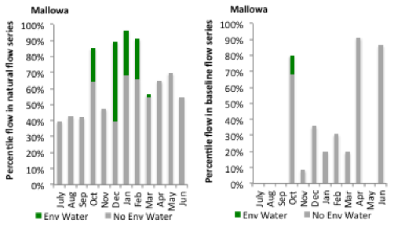
Figure GWY36: Contribution of environmental water delivery at Mallowa as percentiles in the natural and baseline flow series.

Midkin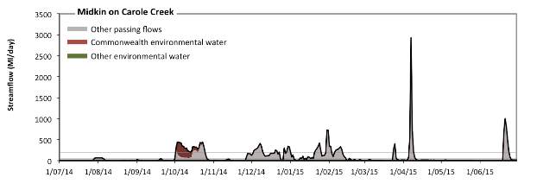 Figure GWY37: Contribution of environmental water delivery at Midkin. Horizontal lines indicate thresholds for very low flows, low flows, low freshes, medium freshes and high freshes (from lowest to highest).
At Midkin on Carole Creek environmental water contributed 11% of the total streamflow volume (all of which was Commonwealth Environmental Water) (Figure GWY37 and GWY38). Environmental watering actions affected streamflows for 7% of days between 1 June 2014 and 31 July 2015. Flow regulation does not substantially increase the duration of very low flows (i.e. < 2.1 Ml/day) compared to an average year in the natural flow regime. However, without environmental water, the duration of medium low flows (i.e. < 10 Ml/day) in the period July to September would have substantially exceeded durations expected in an average year in the natural flow regime. However, environmental water had little effect on the duration of these medium low flows, which occurred for 51% of the year. There was at least one low fresh (i.e. > 28 Ml/day) in the periods July to September, October to December, January to March and April to June. Environmental water made no change to the duration of these low freshes. There was at least one medium fresh (i.e. > 59 Ml/day) in the periods July to September, October to December, January to March and April to June. Environmental water made no change to the duration of these medium freshes. In the absence of environmental water there would have been at least one high fresh in the periods October to December, January to March and April to June. Environmental water increased the duration of the longest medium fresh during the period October to December (from 10 days to 24 days). CEW was entirely responsible for these increased durations of high freshes.
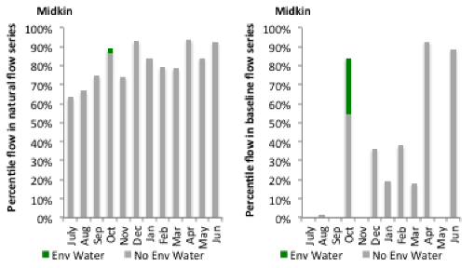
Figure GWY38: Contribution of environmental water delivery at Midkin as percentiles in the natural and baseline flow series.

Garah
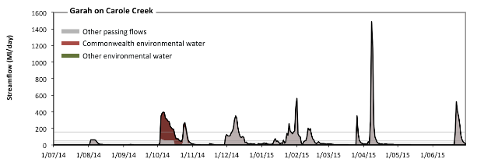 Figure GWY39: Contribution of environmental water delivery at Garah. Horizontal lines indicate thresholds for very low flows, low flows, low freshes, medium freshes and high freshes (from lowest to highest).
At Garah on Carole Creek environmental water contributed 19% of the total streamflow volume (all of which was Commonwealth Environmental Water) (Figure GWY39 and GWY40). Environmental watering actions affected streamflows for 7% of days between 1 June 2014 and 31 July 2015. Without environmental water, the duration of very low flows (i.e. < 1.7 Ml/day) in the period July to September would have substantially exceeded durations expected in an average year in the natural flow regime. Environmental water reduced the cumulative duration of very low flow spells from 43% to 41% of the year, with greatest influence in the period October to December. Similarly, without environmental water, the duration of medium low flows (i.e. < 8.3 Ml/day) in the period July to September would have substantially exceeded durations expected in an average year in the natural flow regime. Environmental water reduced the cumulative duration of medium low flow spells from 56% to 54% of the year, with greatest influence in the period October to December. CEW was entirely responsible for these enhancements of environmental baseflows at this site. In the absence of environmental water there would have been at least one low fresh (i.e. > 22 Ml/day) in the periods July to September, October to December, January to March and April to June. Environmental water increased the duration of the longest low fresh during the period October to December (from 19 days to 28 days). CEW was entirely responsible for these increased durations of low freshes. There was at least one medium fresh (i.e. > 48 Ml/day) in the periods July to September, October to December, January to March and April to June. Environmental water made little change to the duration of these medium freshes. In the absence of environmental water there would have been at least one high fresh in the periods October to December, January to March and April to June. Environmental water increased the duration of the longest medium fresh during the period October to December (from 6 days to 12 days). CEW was entirely responsible for these increased durations of high freshes.
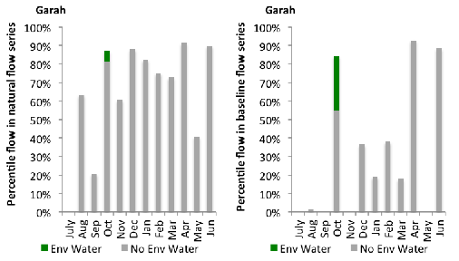
Figure GWY40: Contribution of environmental water delivery at Garah as percentiles in the natural and baseline flow series.

A.2 Murrumbidgee
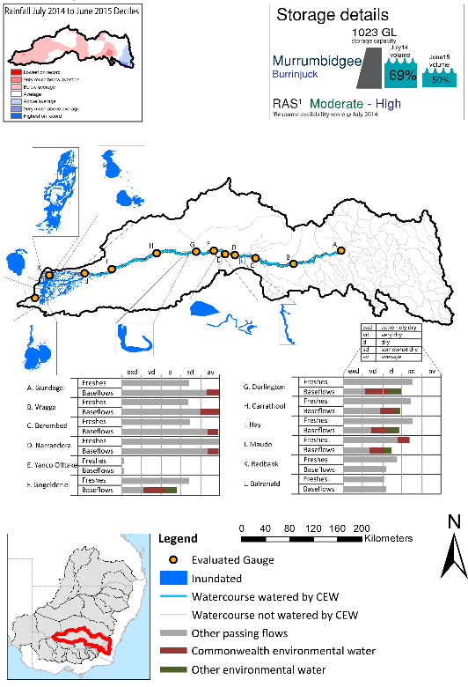
Figure MBG1: Location of evaluated gauges and the watercourses influenced by environmental water in the Murrumbidgee valley during the 2014-15 water year. Inset bar graphs report the condition of annual flow regimes: for the hypothetical scenario if no environmental flow had been delivered (grey) and the improvements with the addition of environmental water. Rainfall conditions and trend in Storage levels for the water year are reported.

Summary Statement
Environmental water delivery for the 2014-15 year in the Murrumbidgee Valley is evaluated using data for 12 sites. This evaluation only considers the contribution of held environmental water, which is a primary focus for the Commonwealth. The contributions of planned environmental water (e.g. passing flows), unregulated tributary inflows and clever use of irrigation flows for environmental benefits can all be very important but these are outside the scope of this report. Environmental watering actions lasted on average 245 days over the course of the year. The volume of environmental water at these 12 sites was between 0% and 30% of the total streamflow. Commonwealth Environmental Water contributed on average 48% of this environmental water. Ideally, baseflows should be maintained and long periods of excessively low flows avoided. In this valley, the baseflow regime was generally considered to be dry relative to the pre-development flow regime. In our analysis, a low fresh refers to a period of increased flow, when the water level rises at least one eighth of the way up the river bank (above the low flow level). These low freshes are a regular part of the natural flow regime and support a range of natural processes. In the Murrumbidgee valley, in terms of the the occurrence and duration of low freshes, the year was assessed as being average. In our analysis, a medium fresh refers to a period of increased flow, when the water level rises at least one quater of the way up the river bank. These medium freshes are not as frequent as low freshes but are also a regular and important part of the natural flow regime. In the Murrumbidgee valley, in terms of the occurrence of medium freshes, the year was assessed as being average. In our analysis, a high fresh refers to a period of increased flow, when the water level rises more than half way up the river. A high fresh may not occur every year but they are still important and long periods without major freshes can have serious consequences for floodplains and their contribution to river ecosystem health. Delivering environmental high in channel flows normally requires that all risks to riparian landholders and infrastructure have been resolved. In the Murrumbidgee valley, in terms of the occurrence of high freshes, the year was assessed as being extremely dry. Commonwealth environmental water actions altered flow regimes along an estimated 708 km of mainstem river out of a maximum of 895 km (79.1%). These actions contributed partially to the 41938ha of floodplain estimated to be wet the 2014-15 water year. .

Description of Environmental Water System
The Murrumbidgee valley covers 73406 km2, and represents 6.9% of the Basin area. It is bordered by the Great Dividing Range to the east, the Lachlan to the north and the Murray to the south. The river originates in the alpine area of Kosciuszko National Park and flows through the Monaro High Plains and the low-lying plains of the western Riverina, joining the Murray River south of Balranald. Water is primarily used for irrigation in this valley. Regulated water is provided by two major headwater storages, Burrinjuck and Blowering Dams. Collectively these storages have a capacity of 2,654 GL.
Environmental watering in the Murrumbidgee focuses on areas downstream of Burrinjuck and Blowering dams. The major environmental assets that are targeted for watering include the Lower Murrumbidgee River Floodplain and the Mid-Murrumbidgee River Wetlands, the Junction Wetlands, Western Lakes and the Murrumbidgee River channel. The Lower Murrumbidgee River Floodplain, which is listed under the Directory of Important Wetlands in Australia, is a wetland of national significance, covering 200,000 hectares. The Mid-Murrumbidgee-River wetlands consist of several nationally significant wetlands.
A number of flow constraints exist in the Murrumbidgee valley (Table MBG1). The constraints are largely focused on balancing demands on channel capacity, minimising erosion and avoiding the inundation of key assets.

Table MBG1: List of key constraints limiting environmental flow delivery in the Murrumbidgee River (Mdba 2013)
Location | Description | Flow Limit (ML/d)
Gundagai | Private land access and inundation (Mundarlo Bridge) | 32,000
Tumut River at Tumut | Channel constraint and erosion control | 9,000
Tumut River at Oddy’s ^{Bridge} | Channel constraint and erosion control | 9,300
Yanco Creek | Private land access and inundation | 1,400 at offtake  (~20,000 at Narrandera)
Darlington Point | Channel capacity  (minor flood level) | 27,700
Balranald | Channel capacity and delivery of flows to downstream locations on River Murray | ~9,000

Data Availability
The contribution (where applicable) of the CEW and NSW environmental water, IVT and other passing flows were derived from the CAIRO river operations spreadsheet held Water NSW. The waterholding, and its source was checked against use charged on the held environmental water entitlements. Known travel times, accounting data, contributions from tributaries and differences between allocated and unallocated flows were used to quantify the movement of water from the source point to its accounting point. The approach assumed no longitudinal delivery loss.

Environmental Conditions
The resource availability score for the Murrumbidgee valley was estimated (July 2014) as Moderate to High (MBG 1). Whereas, the rainfall conditions (based on gridded rainfall percentiles which compare the rainfall experienced for the water year to the total record) experienced were categorised as average (Figure 1 – Main report). The storage levels of Lake Burrinjuck declined from a high of 69% at the beginning of the water year to 50% by the end of the water year.

Environmental Water Actions in 2014-15
In 2014-15 CEW was designed to deliver high in-stream flows which were expected to:
Protect, maintain and where possible improve the condition and extent of floodplain, native riparian and wetland vegetation:
- Maintain and improve the diversity and condition of native aquatic fauna
- Support habitat requirements of waterbirds, native fish and other vertebrates
- Support ecosystem function and improve ecosystem and population resilience through supporting ecological recovery
571,820 ML of CEW was approved for delivery in the Murrumbidgee valley. The CEW portfolio yielded 154,214 ML (49%) of registered entitlement (excluding supplementary flows). The Long term average annual yield (Ltaay) of all the CEW entitlements in the Murrumbidgee was 351847 ML.
154,214 ML of CEW was delivered in the Murrumbidgee valley, contributing to eight water actions which spread over 330 days (90% of the water year), occurring between August 2014 and June 2015. The actions represented 52% of total environmental water delivered in the valley over 2014-15, but only accounted for 3.64% of total flows under a predevelopment condition (Table MBG2).
Seven actions were predominantly designed towards inundating wetlands, floodplains, and billabongs, one action was directed towards Yanco creek system, which included the inundation of a lagoon. All actions were delivered as intended, except for the mid Murrumbidgee watering action at Yarradda lagoon, this action was supposed to be watered as part of a designed piggy back event which did not proceed, therefore the action was delayed to coincide with lowbidgee watering actions. Furthermore, a pump breakage meant that only 80% of the water allocated to this event was used.
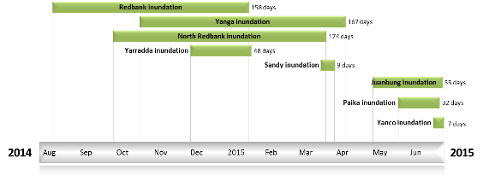
Figure MBG2: Timing and duration of Commonwealth Environmental Water actions in 2014-15.
Table MBG2: Environmental water approved and delivered in the Murrumbidgee over 2014-15.
Source | Total approved volume (ML) | Total volume delivered (ML) | % delivered of total EWater delivered | % contribution to predevelopment flows¹
CEW | 571820 | 154214 | 52 | 3.64
NSW | NA | 141325 | 48 | 3.34
¹ predevelopment average annual inflows of 4236.3 GL

Contribution of Commonwealth Environmental Water to Flow Regimes
Gundagai
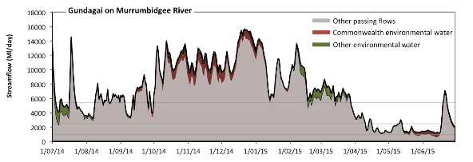
Figure MBG3: Contribution of environmental water delivery at Gundagai. Horizontal lines indicate thresholds for very low flows, low flows, low freshes and medium freshes (from lowest to highest).
At Gundagai on Murrumbidgee River environmental water contributed 10% of the total streamflow volume (with approximately half contributed by Commonwealth Environmental Water) (Figure MBG3 and MBG4). Environmental watering actions affected streamflows for 91% of days between 1 June 2014 and 31 July 2015. Flow regulation does not substantially increase the duration of very low flows (i.e. < 190 Ml/day) compared to an average year in the natural flow regime. However, without environmental water, the duration of medium low flows (i.e. < 930 Ml/day) in the period April to June would have substantially exceeded durations expected in an average year in the natural flow regime. Environmental water mitigated these impacts by reducing the cumulative duration of medium low flow spells from 5% to 0% of the year, with greatest influence in the period April to June. CEW was entirely responsible for these enhancements of environmental baseflows at this site. There was at least one low fresh (i.e. > 2500 Ml/day) in the periods July to September, October to December, January to March and April to June. Environmental water made little change to the duration of these low freshes. In the absence of environmental water there would have been at least one medium fresh (i.e. > 5400 Ml/day) in the periods July to September, October to December, January to March and April to June. Environmental water increased the duration of the longest medium fresh during the period January to March (from 33 days to 86 days). CEW made a modest contribution to these increased durations of medium freshes. There was no high freshes (i.e. > 18000 Ml/day) this year.
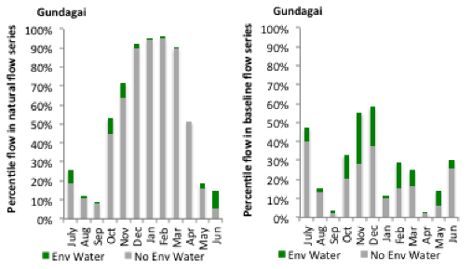
Figure MBG4: Contribution of environmental water delivery at Gundagai as percentiles in the natural and baseline flow series.
Wagga
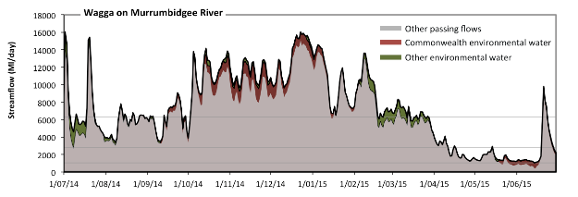
Figure MBG5: Contribution of environmental water delivery at Wagga. Horizontal lines indicate thresholds for very low flows, low flows, low freshes and medium freshes (from lowest to highest).
At Wagga on Murrumbidgee River environmental water contributed 10% of the total streamflow volume (with approximately half contributed by Commonwealth Environmental Water) (Figure MBG5 and MBG6). Environmental watering actions affected streamflows for 92% of days between 1 June 2014 and 31 July 2015. Flow regulation does not substantially increase the duration of very low flows (i.e. < 210 Ml/day) compared to an average year in the natural flow regime. However, without environmental water, the duration of medium low flows (i.e. < 1000 Ml/day) in the period April to June would have substantially exceeded durations expected in an average year in the natural flow regime. Environmental water mitigated these impacts by reducing the cumulative duration of medium low flow spells from 7% to 0% of the year, with greatest influence in the period April to June. CEW was entirely responsible for these enhancements of environmental baseflows at this site. There was at least one low fresh (i.e. > 2900 Ml/day) in the periods July to September, October to December, January to March and April to June. Environmental water made little change to the duration of these low freshes. In the absence of environmental water there would have been at least one medium fresh (i.e. > 6300 Ml/day) in the periods July to September, October to December, January to March and April to June. Environmental water increased the duration of the longest medium fresh during the period January to March (from 32 days to 49 days). CEW was almost entirely responsible for these increased durations of medium freshes. There was no high freshes (i.e. > 21000 Ml/day) this year.
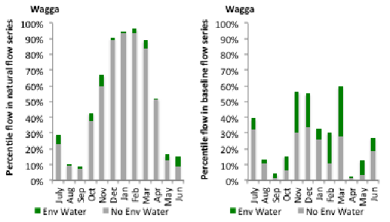
Figure MBG6: Contribution of environmental water delivery at Wagga as percentiles in the natural and baseline flow series.
Berembed
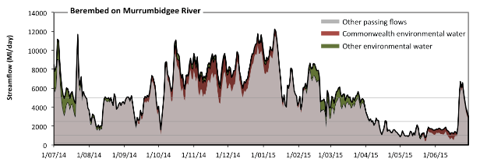
Figure MBG7: Contribution of environmental water delivery at Berembed. Horizontal lines indicate thresholds for very low flows, low flows, low freshes and medium freshes (from lowest to highest).
At Berembed on Murrumbidgee River environmental water contributed 14% of the total streamflow volume (with approximately half contributed by Commonwealth Environmental Water) (Figure MBG7 and MBG8). Environmental watering actions affected streamflows for 92% of days between 1 June 2014 and 31 July 2015. Flow regulation does not substantially increase the duration of very low flows (i.e. < 210 Ml/day) compared to an average year in the natural flow regime. However, without environmental water, the duration of medium low flows (i.e. < 1000 Ml/day) in the period April to June would have substantially exceeded durations expected in an average year in the natural flow regime. Environmental water mitigated these impacts by reducing the cumulative duration of medium low flow spells from 6% to 3% of the year, with greatest influence in the period April to June. CEW was almost entirely responsible for these enhancements of environmental baseflows at this site. In the absence of environmental water there would have been at least one low fresh (i.e. > 2500 Ml/day) in the periods July to September, October to December, January to March and April to June. Environmental water increased the duration of the longest low fresh during the period January to March (from 55 days to 90 days). CEW made little or no contribution to these increased durations of low freshes. In the absence of environmental water there would have been at least one medium fresh (i.e. > 5000 Ml/day) in the periods July to September, October to December, January to March and April to June. Environmental water increased the duration of the longest medium fresh during the periods July to September (from 7 days to 9 days), October to December (from 29 days to 87 days) and April to June (from 3 days to 4 days). CEW made the dominant contribution to these increased durations of medium freshes. There was no high freshes (i.e. > 15000 Ml/day) this year.
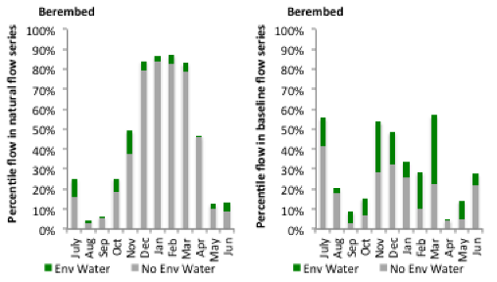
Figure MBG8: Contribution of environmental water delivery at Berembed as percentiles in the natural and baseline flow series.

Narrandera
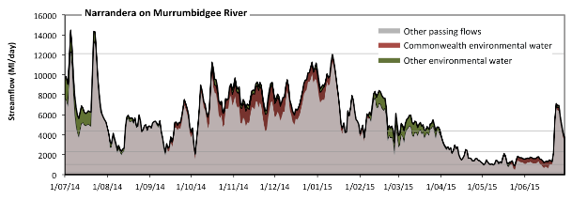
Figure MBG9: Contribution of environmental water delivery at Narrandera. Horizontal lines indicate thresholds for very low flows, low flows, low freshes, medium freshes and high freshes (from lowest to highest).
At Narrandera on Murrumbidgee River environmental water contributed 14% of the total streamflow volume (with approximately half contributed by Commonwealth Environmental Water) (Figure MBG9 and MBG10). Environmental watering actions affected streamflows for 92% of days between 1 June 2014 and 31 July 2015. Flow regulation does not substantially increase the duration of very low flows (i.e. < 210 Ml/day) compared to an average year in the natural flow regime. However, without environmental water, the duration of medium low flows (i.e. < 1000 Ml/day) in the period April to June would have substantially exceeded durations expected in an average year in the natural flow regime. Environmental water mitigated these impacts by reducing the cumulative duration of medium low flow spells from 5% to 1% of the year, with greatest influence in the period April to June. CEW was almost entirely responsible for these enhancements of environmental baseflows at this site. In the absence of environmental water there would have been at least one low fresh (i.e. > 2300 Ml/day) in the periods July to September, October to December, January to March and April to June. Environmental water increased the duration of the longest low fresh during the periods July to September (from 38 days to 73 days) and January to March (from 56 days to 90 days). CEW made little or no contribution to these increased durations of low freshes. In the absence of environmental water there would have been at least one medium fresh (i.e. > 4300 Ml/day) in the periods July to September, October to December, January to March and April to June. Environmental water increased the duration of the longest medium fresh during the periods July to September (from 21 days to 32 days), October to December (from 48 days to 87 days) and January to March (from 18 days to 25 days). CEW made a modest contribution to these increased durations of medium freshes. In the absence of environmental water there would have been at least one high fresh in the period July to September. Environmental water made no change to the duration of these high freshes.
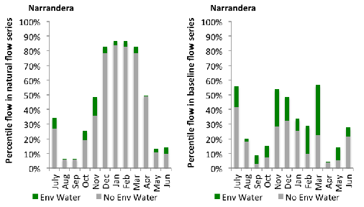
Figure MBG10: Contribution of environmental water delivery at Narrandera as percentiles in the natural and baseline flow series.
Yanco Offtake
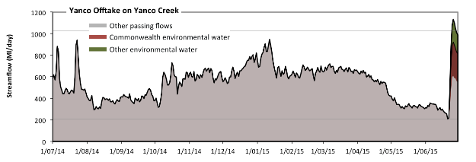
Figure MBG11: Contribution of environmental water delivery at Yanco Offtake. Horizontal lines indicate thresholds for very low flows and low flows (from lowest to highest).
At Yanco Offtake on Yanco Creek environmental water contributed 2% of the total streamflow volume (much of which was Commonwealth Environmental Water) (Figure MBG11 and MBG12). Environmental watering actions affected streamflows for 2% of days between 1 June 2014 and 31 July 2015. Flow regulation does not substantially increase the duration of very low flows (i.e. < 210 Ml/day) compared to an average year in the natural flow regime. However, without environmental water, the durations of medium low flows (i.e. < 1000 Ml/day) in the periods July to September, October to December, January to March and April to June would have all substantially exceeded durations expected in an average year in the natural flow regime. Environmental water mitigated these impacts by reducing the cumulative duration of medium low flow spells from 100% to 99% of the year, with greatest influence in the period April to June.
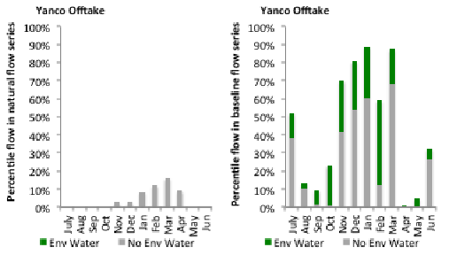
Figure MBG12: Contribution of environmental water delivery at Yanco Offtake as percentiles in the natural and baseline flow series.
Gogelderie
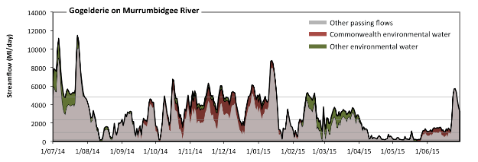Figure MBG13: Contribution of environmental water delivery at Gogelderie. Horizontal lines indicate thresholds for very low flows, low flows, low freshes and medium freshes (from lowest to highest).
At Gogelderie on Murrumbidgee River environmental water contributed 25% of the total streamflow volume (with approximately half contributed by Commonwealth Environmental Water) (Figure MBG13 and MBG14). Environmental watering actions affected streamflows for 88% of days between 1 June 2014 and 31 July 2015. Without environmental water, the durations of very low flows (i.e. < 190 Ml/day) in the periods July to September and April to June would have substantially exceeded durations expected in an average year in the natural flow regime. Environmental water mitigated these impacts by reducing the cumulative duration of very low flow spells from 5% to 1% of the year, with greatest influence in the period April to June. Similarly, without environmental water, the durations of medium low flows (i.e. < 960 Ml/day) in the periods July to September and April to June would have substantially exceeded durations expected in an average year in the natural flow regime. Environmental water mitigated these impacts by reducing the cumulative duration of medium low flow spells from 29% to 18% of the year, with greatest influence in the period April to June. CEW made the dominant contribution to these enhancements of environmental baseflows at this site. In the absence of environmental water there would have been at least one low fresh (i.e. > 2300 Ml/day) in the periods July to September, October to December, January to March and April to June. Environmental water increased the duration of the longest low fresh during the periods October to December (from 18 days to 49 days) and January to March (from 18 days to 25 days). CEW made a modest contribution to these increased durations of low freshes. In the absence of environmental water there would have been at least one medium fresh (i.e. > 4800 Ml/day) in the periods July to September, October to December, January to March and April to June. Environmental water increased the duration of the longest medium fresh during the periods July to September (from 8 days to 17 days) and October to December (from 2 days to 7 days). CEW equally shared responsibility with other environmental water holders for these increased durations of medium freshes. There was no high freshes (i.e. > 14000 Ml/day) this year.
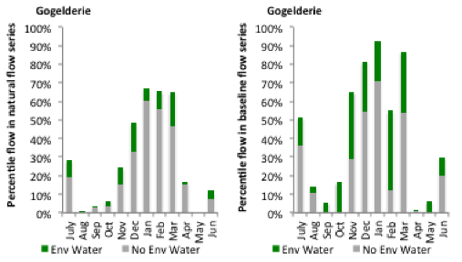
Figure MBG14: Contribution of environmental water delivery at Gogelderie as percentiles in the natural and baseline flow series.
Darlington
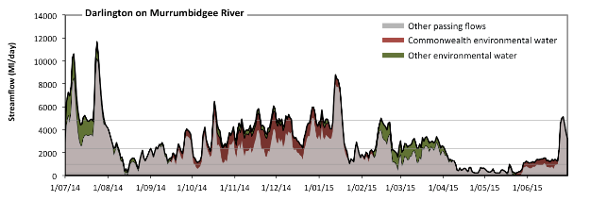 Figure MBG15: Contribution of environmental water delivery at Darlington. Horizontal lines indicate thresholds for very low flows, low flows, low freshes and medium freshes (from lowest to highest).
At Darlington on Murrumbidgee River environmental water contributed 25% of the total streamflow volume (with approximately half contributed by Commonwealth Environmental Water) (Figure MBG15 and MBG16). Environmental watering actions affected streamflows for 92% of days between 1 June 2014 and 31 July 2015. Without environmental water, the duration of very low flows (i.e. < 190 Ml/day) in the period April to June would have substantially exceeded durations expected in an average year in the natural flow regime. Environmental water mitigated these impacts by reducing the cumulative duration of very low flow spells from 3% to 0% of the year, with greatest influence in the period April to June. Similarly, without environmental water, the durations of medium low flows (i.e. < 960 Ml/day) in the periods July to September and April to June would have substantially exceeded durations expected in an average year in the natural flow regime. Environmental water mitigated these impacts by reducing the cumulative duration of medium low flow spells from 24% to 15% of the year, with greatest influence in the period April to June. CEW made the dominant contribution to these enhancements of environmental baseflows at this site. In the absence of environmental water there would have been at least one low fresh (i.e. > 2300 Ml/day) in the periods July to September, October to December, January to March and April to June. Environmental water increased the duration of the longest low fresh during the periods October to December (from 17 days to 78 days) and January to March (from 18 days to 28 days). CEW equally shared responsibility with other environmental water holders for these increased durations of low freshes. In the absence of environmental water there would have been at least one medium fresh (i.e. > 4800 Ml/day) in the periods July to September, October to December, January to March and April to June. Environmental water increased the duration of the longest medium fresh during the periods July to September (from 6 days to 10 days) and October to December (from 2 days to 5 days). CEW equally shared responsibility with other environmental water holders for these increased durations of medium freshes. There was no high freshes (i.e. > 14000 Ml/day) this year.
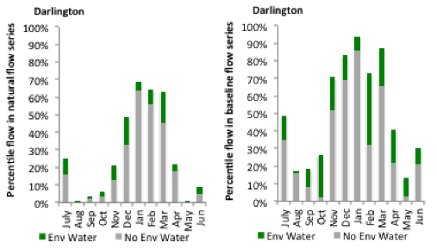
Figure MBG16: Contribution of environmental water delivery at Darlington as percentiles in the natural and baseline flow series.

Carrathool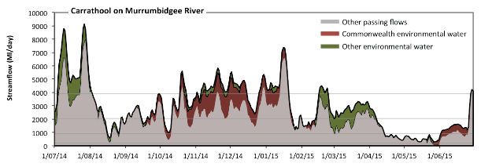 Figure MBG17: Contribution of environmental water delivery at Carrathool. Horizontal lines indicate thresholds for very low flows, low flows, low freshes and medium freshes (from lowest to highest).
At Carrathool on Murrumbidgee River environmental water contributed 26% of the total streamflow volume (with approximately half contributed by Commonwealth Environmental Water) (Figure MBG17 and MBG18). Environmental watering actions affected streamflows for 91% of days between 1 June 2014 and 31 July 2015. Without environmental water, the duration of very low flows (i.e. < 190 Ml/day) in the period April to June would have substantially exceeded durations expected in an average year in the natural flow regime. Environmental water mitigated these impacts by reducing the cumulative duration of very low flow spells from 2% to 0% of the year, with greatest influence in the period April to June. Similarly, without environmental water, the durations of medium low flows (i.e. < 930 Ml/day) in the periods July to September and April to June would have substantially exceeded durations expected in an average year in the natural flow regime. Environmental water mitigated these impacts by reducing the cumulative duration of medium low flow spells from 21% to 15% of the year, with greatest influence in the period April to June. CEW was almost entirely responsible for these enhancements of environmental baseflows at this site. In the absence of environmental water there would have been at least one low fresh (i.e. > 2000 Ml/day) in the periods July to September, October to December, January to March and April to June. Environmental water increased the duration of the longest low fresh during the periods October to December (from 27 days to 82 days), January to March (from 22 days to 30 days) and April to June (from 4 days to 6 days). CEW made a modest contribution to these increased durations of low freshes. In the absence of environmental water there would have been at least one medium fresh (i.e. > 3900 Ml/day) in the periods July to September, October to December, January to March and April to June. Environmental water increased the duration of the longest medium fresh during the periods July to September (from 11 days to 31 days), October to December (from 3 days to 40 days) and January to March (from 7 days to 20 days). CEW made the dominant contribution to these increased durations of medium freshes. There was no high freshes (i.e. > 11000 Ml/day) this year.
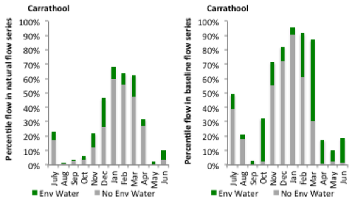
Figure MBG18: Contribution of environmental water delivery at Carrathool as percentiles in the natural and baseline flow series.
Hay
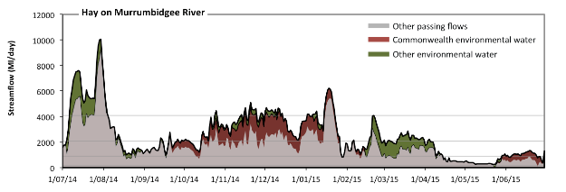 Figure MBG19: Contribution of environmental water delivery at Hay. Horizontal lines indicate thresholds for very low flows, low flows, low freshes and medium freshes (from lowest to highest).
At Hay on Murrumbidgee River environmental water contributed 30% of the total streamflow volume (with approximately half contributed by Commonwealth Environmental Water) (Figure MBG19 and MBG20). Environmental watering actions affected streamflows for 89% of days between 1 June 2014 and 31 July 2015. Flow regulation does not substantially increase the duration of very low flows (i.e. < 180 Ml/day) compared to an average year in the natural flow regime. However, without environmental water, the durations of medium low flows (i.e. < 900 Ml/day) in the periods July to September and April to June would have substantially exceeded durations expected in an average year in the natural flow regime. Environmental water mitigated these impacts by reducing the cumulative duration of medium low flow spells from 28% to 15% of the year, with greatest influence in the period April to June. CEW equally shared responsibility with other environmental water holders for these enhancements of environmental baseflows at this site. In the absence of environmental water there would have been at least one low fresh (i.e. > 2100 Ml/day) in the periods July to September, October to December and January to March. Environmental water increased the duration of the longest low fresh during the periods October to December (from 17 days to 79 days), January to March (from 10 days to 26 days) and April to June (from 0 days to 2 days). CEW equally shared responsibility with other environmental water holders for these increased durations of low freshes. In the absence of environmental water there would have been at least one medium fresh (i.e. > 4100 Ml/day) in the periods July to September and January to March. Environmental water increased the duration of the longest medium fresh during the periods July to September (from 10 days to 30 days), October to December (from 0 days to 9 days) and January to March (from 6 days to 8 days). CEW made the dominant contribution to these increased durations of medium freshes. There was no high freshes (i.e. > 12000 Ml/day) this year.
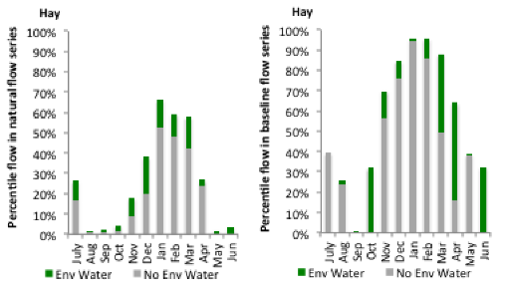
Figure MBG20: Contribution of environmental water delivery at Hay as percentiles in the natural and baseline flow series.
Maude
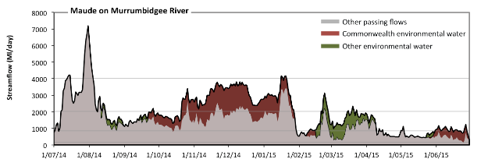 Figure MBG21: Contribution of environmental water delivery at Maude. Horizontal lines indicate thresholds for very low flows, low flows, low freshes and medium freshes (from lowest to highest).
At Maude on Murrumbidgee River environmental water contributed 27% of the total streamflow volume (much of which was Commonwealth Environmental Water) (Figure MBG21 and MBG22). Environmental watering actions affected streamflows for 79% of days between 1 June 2014 and 31 July 2015. Flow regulation does not substantially increase the duration of very low flows (i.e. < 170 Ml/day) compared to an average year in the natural flow regime. However, without environmental water, the durations of medium low flows (i.e. < 860 Ml/day) in the periods January to March and April to June would have substantially exceeded durations expected in an average year in the natural flow regime. Environmental water mitigated these impacts by reducing the cumulative duration of medium low flow spells from 33% to 20% of the year, with greatest influence in the periods January to March and April to June. CEW equally shared responsibility with other environmental water holders for these enhancements of environmental baseflows at this site. In the absence of environmental water there would have been at least one low fresh (i.e. > 2000 Ml/day) in the periods July to September, October to December and January to March. Environmental water increased the duration of the longest low fresh during the periods October to December (from 11 days to 72 days) and January to March (from 10 days to 27 days). CEW was entirely responsible for these increased durations of low freshes. In the absence of environmental water there would have been at least one medium fresh (i.e. > 4000 Ml/day) in the period July to September. Environmental water increased the duration of the longest medium fresh during the period January to March (from 0 days to 2 days). CEW was entirely responsible for these increased durations of medium freshes. There was no high freshes (i.e. > 12000 Ml/day) this year.
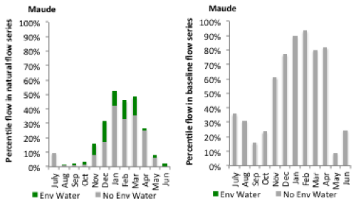
Figure MBG22: Contribution of environmental water delivery at Maude as percentiles in the natural and baseline flow series.
Redbank
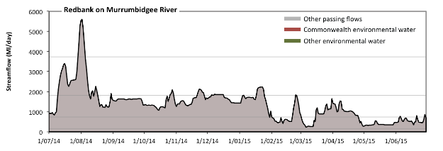 Figure MBG23: Contribution of environmental water delivery at Redbank. Horizontal lines indicate thresholds for very low flows, low flows, low freshes and medium freshes (from lowest to highest).
There was no environmental water delivered at Redbank on Murrumbidgee River (Figure MBG23 and MBG24). Flow regulation does not substantially increase the duration of very low flows (i.e. < 150 Ml/day) compared to an average year in the natural flow regime. However, without environmental water, the durations of medium low flows (i.e. < 740 Ml/day) in the periods January to March and April to June was substantially in excess of durations expected in an average year in the natural flow regime. There was at least one low fresh (i.e. > 1800 Ml/day) in the periods July to September, October to December and January to March. There was at least one medium fresh (i.e. > 3700 Ml/day) in the period July to September. There was no high freshes (i.e. > 11000 Ml/day) this year.
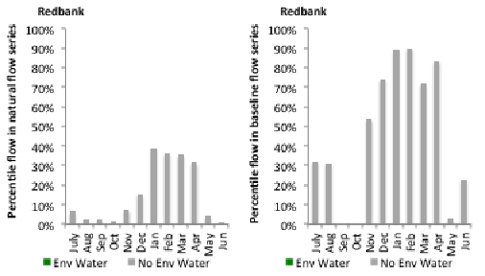
Figure MBG24: Contribution of environmental water delivery at Redbank as percentiles in the natural and baseline flow series.
Balranald
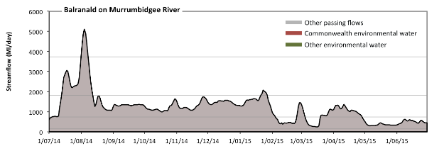 Figure MBG25: Contribution of environmental water delivery at Balranald. Horizontal lines indicate thresholds for very low flows, low flows, low freshes and medium freshes (from lowest to highest).
There was no environmental water delivered at Balranald on Murrumbidgee River (Figure MBG25 and MBG26). Flow regulation does not substantially increase the duration of very low flows (i.e. < 150 Ml/day) compared to an average year in the natural flow regime. However, without environmental water, the durations of medium low flows (i.e. < 740 Ml/day) in the periods January to March and April to June was substantially in excess of durations expected in an average year in the natural flow regime. There was at least one low fresh (i.e. > 1800 Ml/day) in the periods July to September and January to March. There was at least one medium fresh (i.e. > 3700 Ml/day) in the period July to September. There was no high freshes (i.e. > 11000 Ml/day) this year.
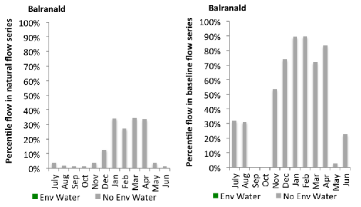
Figure MBG26: Contribution of environmental water delivery at Balranald as percentiles in the natural and baseline flow series.

A.3 Lower Murray
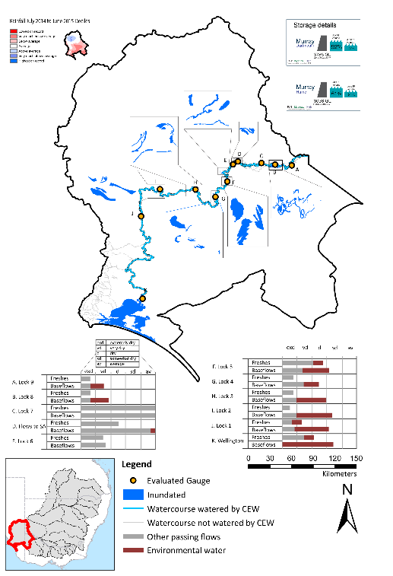
Figure LWM1: Location of evaluated gauges and the watercourses influenced by environmental water in the Lower Murray valley during the 2014-15 water year. Inset bar graphs report the condition of annual flow regimes: for the hypothetical scenario if no environmental flow had been delivered (grey) and the improvements with the addition of environmental water. Rainfall conditions and trend in Storage levels for the water year are reported.

Summary Statement
Environmental water delivery for the 2014-15 year in the Lower Murray Valley is evaluated using data for 11 sites. This evaluation only considers the contribution of held environmental water, which is a primary focus for the Commonwealth. The contributions of planned environmental water (e.g. passing flows), unregulated tributary inflows and clever use of irrigation flows for environmental benefits can all be very important but these are outside the scope of this report. Environmental watering actions lasted on average 274 days over the course of the year. The volume of environmental water at these 11 sites was between 0% and 31% of the total streamflow. Commonwealth Environmental Water contributed on average 91% of this environmental water. Ideally, baseflows should be maintained and long periods of excessively low flows avoided. In this valley, the baseflow regime was generally considered to be very dry relative to the pre-development flow regime. In our analysis, a low fresh refers to a period of increased flow, when the water level rises at least one eighth of the way up the river bank (above the low flow level). These low freshes are a regular part of the natural flow regime and support a range of natural processes. In the Lower Murray valley, in terms of the the occurrence and duration of low freshes, the year was assessed as being dry. In our analysis, a medium fresh refers to a period of increased flow, when the water level rises at least one quater of the way up the river bank. These medium freshes are not as frequent as low freshes but are also a regular and important part of the natural flow regime. In the Lower Murray valley, in terms of the occurrence of medium freshes, the year was assessed as being very dry. In our analysis, a high fresh refers to a period of increased flow, when the water level rises more than half way up the river. A high fresh may not occur every year but they are still important and long periods without major freshes can have serious consequences for floodplains and their contribution to river ecosystem health. Delivering environmental high in channel flows normally requires that all risks to riparian landholders and infrastructure have been resolved. In the Lower Murray valley, in terms of the occurrence of high freshes, the year was assessed as being extremely dry.

Description of Environmental Water System
The Lower Murray valley covers an area of 99525 km2, which represents 9.4% of the total basin area. The valley includes the South Australian part of the Murray River / Floodplain, the Murray River Estuary (the Lower Lakes Alexandrina and Albert and the Coorong) and the Murray Mouth (Figure LWM1). The confluence of the River Murray and Darling River is 500 m upstream of the Wentworth Weir (Weir and Lock 10) just over 832 river kilometres from the Murray mouth.
The lower Murray is extensively regulated in NSW and Victoria upstream of the SA Murray. Within the valley the river is regulated by 6 Locks and Weirs (Storage name and volume size: Lock 1 84GL; Lock 2 43 GL; Lock 3 52GL;Lock 4 31GL; Lock 5 39GL; and Lock 6 35GL) and finally a terminal set of barrages. The 11 weirs each raise the water level behind it by an average of 3.06 m, with the river dropping from 34.40 m AHD at Full Supply Level (FSL) in the weir pool at Mildura to 0.75 m AHD at FSL in Lake Alexandrina and the River Murray below Weir 1 at Blanchetown. The storage capacities upstream of all of the weirs are less than 2% of the largest storage on the River Murray system, Dartmouth Reservoir. The distance between the weirs varies from 29 to 88 km. The River Murray enters Lake Alexandrina 75 river kilometres from the Murray mouth.
Delivery constraints relevant to the Lower Murray include: out of zone releases from Yarrawonga Weir and Lake Victoria, 15,000 ML/day and 10,000 ML/day respectively. Similarly, Lake Menindee has an outlet capacity of 7,096 ML/day. Within the Lower Murray zone inundation of private property and caravan parks occurs at around 60,000 ML/day (Mdba 2013).

Data Availability
River Flows
The Msm-BigMod model was to calculate the impact of CEW in the Murray River. An extensive modelling exercise which modelled two conditions flows in a pre-buy back scenario and the other being the observed condition. For more details on the methodology, and assumptions please see Modelling Flows in the Murray and Darling River (this report).
Inundation extents
Inundation extents for wetlands, billabongs and other regions which received CEW outside of the main channel were supplied by various sources, utilising various methods. Table LWM1 lists the data owner and method used to derive inundation extent.

Environmental Conditions
The resource availability score for the Lower Murray valley was estimated (July 2014) as Moderate to High. Whereas, the rainfall conditions (based on gridded rainfall percentiles which compare the rainfall experienced for the water year to the total record) experienced were categorised as average (Figure 1 – Main report).
Table LWM1: Source of inundation data and method used to derive inundation extent
Data Owner | Wetland complex | Method | Result certainty
NRM Board | Various Murray wetlands | Field survey and aerial imagery | High
NFSA | Various wetlands, lagoons and floodplains | Visual estimation from aerial imagery | Medium-High
DEWNR | Coorong, Lower lakes | 2m Dem together with water surface levels. No field validation/verification. DEM missing Coorong north lagoon | Low
MDBA | Mulcra Island | Mike Flood model and Landsat imagery | High

Environmental Water Actions in 2014-15
801,367 ML of CEW was approved for delivery in the Lower Murray. The longterm average annual yield (Ltaay) of CEW entitlements in the Lower Murray during 2014-15 was 120,699 ML.
592,724ML of CEW was delivered in the Lower Murray. The actions covered most of the water year (Figure LWM2) and included:
(a) Weir pool manipulation between Lock 8 and Lock 9 (this action took place over the entire water year). This action involved raising and lowering weir pool levels. This action was delivered as intended and resulted in no net use of CEW.
(b) Infrastructure supported inundation known as the NFSA inundation series (watered 10 wetland/floodplain complexes over 286 days). These actions were largely delivered as intended.
(c) Infrastructure supported inundation known as the NRM board inundation series (watered 11 wetland/floodplain complexes over 299 days). These actions were largely delivered as intended with the exception of an intended delivery at Disher Ck which excluded because it received water via an unregulated event.
(d) Infrastructure supported inundation known as the Mulcra island. Mulcra island watering was delivered as intended, but significant underuse occurred, which was due to a change in the methodology used by the Authority to calculate water usage.
(e) Base flows and freshes as augmented flows through the Murray main channel. This water also supported water levels in the Lower Lakes / Coorong and contributed to 100% of flows over the barrages (between October 2014 and June 2015)
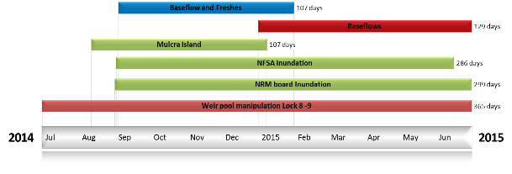
Figure LWM2: Timing and duration of Lower Murray CEW actions in 2014-15.
Table LWM2: Environmental water approved and delivered in the Lower Murray over 2014-15
Source | LTAAY (ML) | Total approved volume (ML) | Total volume delivered (ML) | % delivered of total E Water delivered | % contribution to predevelopment flows 1
CEW | 120699 | 801,367 | 592723.9 | 81.7 | 4.4
VEWH | NA | NA | 26,400 | 3.6 | 0.2
TLM | NA | NA | 106,800 | 14.7 | 0.8
1 predevelopment average annual inflows of 13,460 at SA Border

Contribution of Commonwealth Environmental Water to Flow Regimes
Lock 9
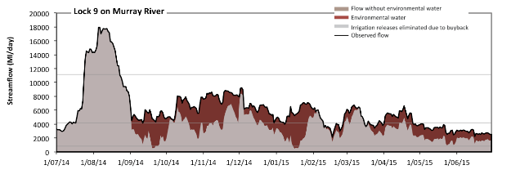
Figure LWM3: Contribution of environmental water delivery at Lock 9. Horizontal lines indicate thresholds for very low flows, low flows and low freshes (from lowest to highest).
At Lock 9 on Murray River environmental water contributed 27% of the total streamflow volume (Figure LWM3 and LWM4). Environmental watering actions affected streamflows for 83% of days between 1 June 2014 and 31 July 2015. Without environmental water, the duration of very low flows (i.e. < 800 Ml/day) in the period January to March would have substantially exceeded durations expected in an average year in the natural flow regime. Environmental water mitigated these impacts by reducing the cumulative duration of very low flow spells from 2% to 0% of the year, with greatest influence in the periods July to September and January to March. Similarly, without environmental water, the durations of medium low flows (i.e. < 4200 Ml/day) in the periods July to September, October to December, January to March and April to June would have all substantially exceeded durations expected in an average year in the natural flow regime. Environmental water mitigated these impacts by reducing the cumulative duration of medium low flow spells from 63% to 30% of the year, with greatest influence in the periods October to December and January to March. There was at least one low fresh (i.e. > 11000 Ml/day) in the period July to September. Environmental water made no change to the duration of these low freshes. There was no medium or high freshes this year.
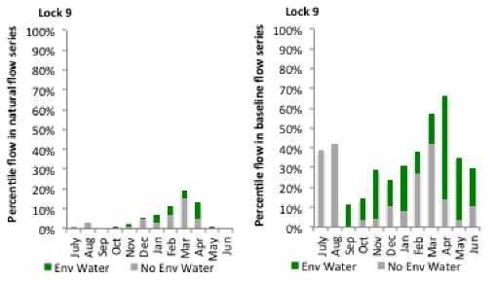
Figure LWM4: Contribution of environmental water delivery at Lock 9 as percentiles in the natural and baseline flow series.
Lock 8
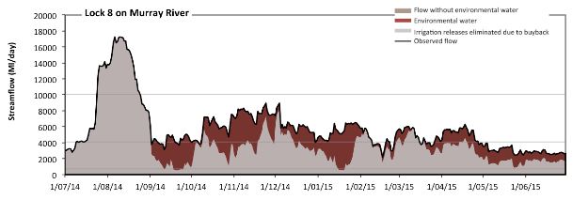
Figure LWM5: Contribution of environmental water delivery at Lock 8. Horizontal lines indicate thresholds for very low flows, low flows and low freshes (from lowest to highest).
At Lock 8 on Murray River environmental water contributed 28% of the total streamflow volume (Figure LWM5 and LWM6). Environmental watering actions affected streamflows for 83% of days between 1 June 2014 and 31 July 2015. Without environmental water, the durations of very low flows (i.e. < 720 Ml/day) in the periods July to September and January to March would have substantially exceeded durations expected in an average year in the natural flow regime. Environmental water mitigated these impacts by reducing the cumulative duration of very low flow spells from 4% to 0% of the year, with greatest influence in the periods July to September and January to March. Similarly, without environmental water, the durations of medium low flows (i.e. < 4100 Ml/day) in the periods July to September, October to December, January to March and April to June would have all substantially exceeded durations expected in an average year in the natural flow regime. Environmental water mitigated these impacts by reducing the cumulative duration of medium low flow spells from 67% to 31% of the year, with greatest influence in the periods October to December and January to March. There was at least one low fresh (i.e. > 10000 Ml/day) in the period July to September. Environmental water made no change to the duration of these low freshes. There was no medium or high freshes this year.
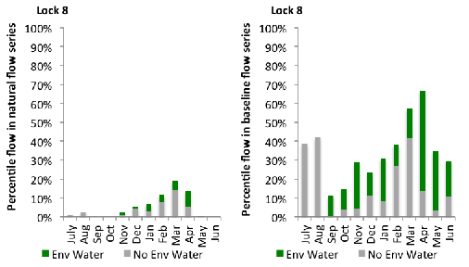
Figure LWM6: Contribution of environmental water delivery at Lock 8 as percentiles in the natural and baseline flow series.

Lock 7
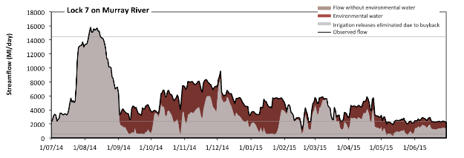
Figure LWM7: Contribution of environmental water delivery at Lock 7. Horizontal lines indicate thresholds for very low flows, low flows, low freshes, medium freshes and high freshes (from lowest to highest).
At Lock 7 on Murray River environmental water contributed 30% of the total streamflow volume (Figure LWM6 and LWM8). Environmental watering actions affected streamflows for 83% of days between 1 June 2014 and 31 July 2015. Flow regulation does not substantially increase the duration of very low flows (i.e. < 11 Ml/day) compared to an average year in the natural flow regime. Flow regulation does not substantially increase the duration of medium low flows (i.e. < 53 Ml/day) compared to an average year in the natural flow regime. In the absence of environmental water there would have been at least one low fresh (i.e. > 580 Ml/day) in the periods July to September, October to December, January to March and April to June. Environmental water increased the duration of the longest low fresh during the periods October to December (from 64 days to 92 days), January to March (from 67 days to 90 days) and April to June (from 35 days to 91 days). In the absence of environmental water there would have been at least one medium fresh (i.e. > 2400 Ml/day) in the periods July to September, October to December, January to March and April to June. Environmental water increased the duration of the longest medium fresh during the periods July to September (from 63 days to 92 days), October to December (from 52 days to 92 days), January to March (from 23 days to 46 days) and April to June (from 19 days to 35 days). In the absence of environmental water there would have been at least one high fresh in the period July to September. Environmental water made no change to the duration of these high freshes.

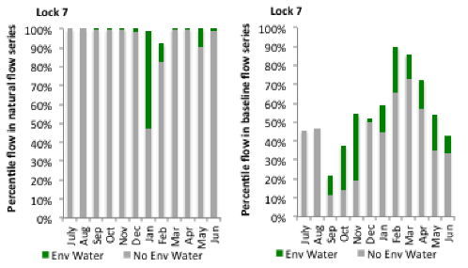
Figure LWM8: Contribution of environmental water delivery at Lock 7 as percentiles in the natural and baseline flow series.
SA Border
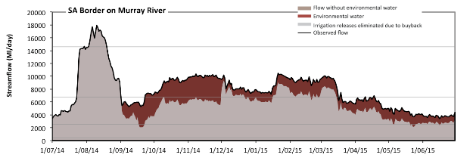
Figure LWM9: Contribution of environmental water delivery at SA Border. Horizontal lines indicate thresholds for very low flows, low flows, low freshes and medium freshes (from lowest to highest).
At SA Border on Murray River environmental water contributed 21% of the total streamflow volume (Figure LWM9 and LWM10). Environmental watering actions affected streamflows for 83% of days between 1 June 2014 and 31 July 2015. Flow regulation does not substantially increase the duration of very low flows (i.e. < 430 Ml/day) compared to an average year in the natural flow regime. However, without environmental water, the duration of medium low flows (i.e. < 2500 Ml/day) in the period July to September would have substantially exceeded durations expected in an average year in the natural flow regime. Environmental water mitigated these impacts by reducing the cumulative duration of medium low flow spells from 3% to 0% of the year, with greatest influence in the periods July to September and April to June. In the absence of environmental water there would have been at least one low fresh (i.e. > 6700 Ml/day) in the periods July to September, October to December and January to March. Environmental water increased the duration of the longest low fresh during the periods October to December (from 21 days to 92 days), January to March (from 35 days to 75 days) and April to June (from 0 days to 1 days). There was at least one medium fresh (i.e. > 15000 Ml/day) in the period July to September. Environmental water made no change to the duration of these medium freshes. There was no high freshes (i.e. > 47000 Ml/day) this year.
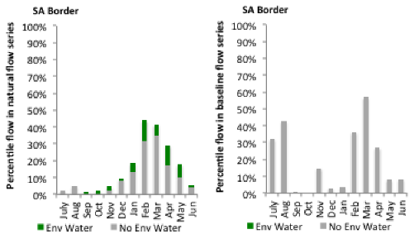
Figure LWM10: Contribution of environmental water delivery at SA Border as percentiles in the natural and baseline flow series.

Lock 6
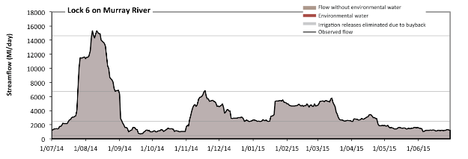
Figure LWM11: Contribution of environmental water delivery at Lock 6. Horizontal lines indicate thresholds for very low flows, low flows, low freshes and medium freshes (from lowest to highest).
There was no environmental water delivered at Lock 6 on Murray River (Figure LWM11 and LWM12). Flow regulation does not substantially increase the duration of very low flows (i.e. < 430 Ml/day) compared to an average year in the natural flow regime. However, without environmental water, the durations of medium low flows (i.e. < 2500 Ml/day) in the periods July to September, October to December and April to June was substantially in excess of durations expected in an average year in the natural flow regime. There was at least one low fresh (i.e. > 6700 Ml/day) in the periods July to September and October to December. There was at least one medium fresh (i.e. > 15000 Ml/day) in the period July to September. There was no high freshes (i.e. > 47000 Ml/day) this year.
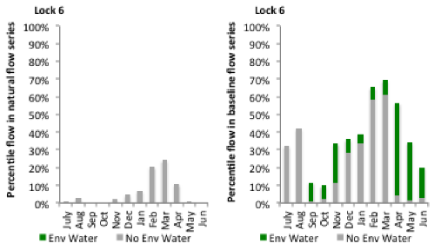
Figure LWM12: Contribution of environmental water delivery at Lock 6 as percentiles in the natural and baseline flow series.

Lock 5
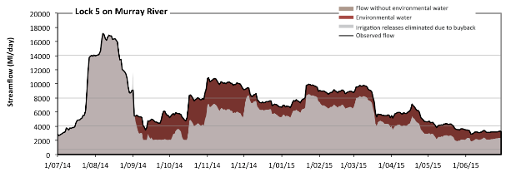Figure LWM13: Contribution of environmental water delivery at Lock 5. Horizontal lines indicate thresholds for very low flows, low flows, low freshes and medium freshes (from lowest to highest).
At Lock 5 on Murray River environmental water contributed 22% of the total streamflow volume (Figure LWM13 and LWM14). Environmental watering actions affected streamflows for 83% of days between 1 June 2014 and 31 July 2015. Flow regulation does not substantially increase the duration of very low flows (i.e. < 700 Ml/day) compared to an average year in the natural flow regime. However, without environmental water, the durations of medium low flows (i.e. < 4100 Ml/day) in the periods July to September, October to December and April to June would have substantially exceeded durations expected in an average year in the natural flow regime. Environmental water mitigated these impacts by reducing the cumulative duration of medium low flow spells from 37% to 16% of the year, with greatest influence in the periods July to September and April to June. In the absence of environmental water there would have been at least one low fresh (i.e. > 8000 Ml/day) in the periods July to September, October to December and January to March. Environmental water increased the duration of the longest low fresh during the periods October to December (from 3 days to 43 days) and January to March (from 10 days to 57 days). There was at least one medium fresh (i.e. > 14000 Ml/day) in the period July to September. Environmental water made no change to the duration of these medium freshes. There was no high freshes (i.e. > 36000 Ml/day) this year.
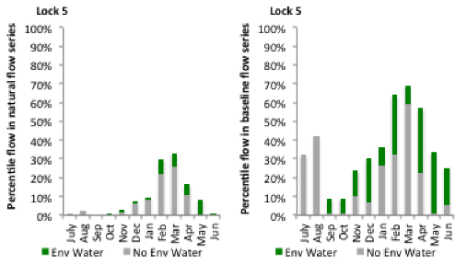
Figure LWM14: Contribution of environmental water delivery at Lock 5 as percentiles in the natural and baseline flow series.
Lock 4
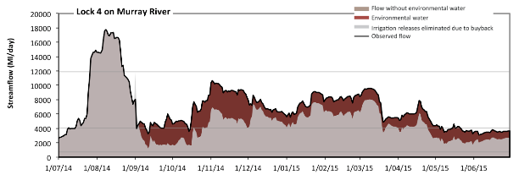 Figure LWM15: Contribution of environmental water delivery at Lock 4. Horizontal lines indicate thresholds for very low flows, low flows and low freshes (from lowest to highest).
At Lock 4 on Murray River environmental water contributed 23% of the total streamflow volume (Figure LWM15 and LWM16). Environmental watering actions affected streamflows for 83% of days between 1 June 2014 and 31 July 2015. Flow regulation does not substantially increase the duration of very low flows (i.e. < 700 Ml/day) compared to an average year in the natural flow regime. However, without environmental water, the durations of medium low flows (i.e. < 4100 Ml/day) in the periods July to September, October to December and April to June would have substantially exceeded durations expected in an average year in the natural flow regime. Environmental water mitigated these impacts by reducing the cumulative duration of medium low flow spells from 37% to 20% of the year, with greatest influence in the periods July to September, October to December and April to June. There was at least one low fresh (i.e. > 12000 Ml/day) in the period July to September. Environmental water made no change to the duration of these low freshes. There was no medium or high freshes this year.
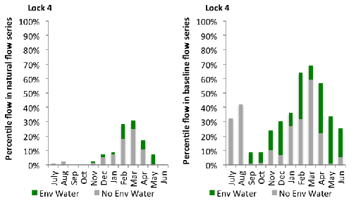
Figure LWM16: Contribution of environmental water delivery at Lock 4 as percentiles in the natural and baseline flow series.
Lock 3
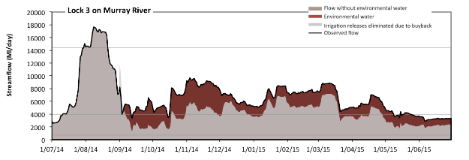 Figure LWM17: Contribution of environmental water delivery at Lock 3. Horizontal lines indicate thresholds for very low flows, low flows and low freshes (from lowest to highest).
At Lock 3 on Murray River environmental water contributed 25% of the total streamflow volume (Figure LWM17 and LWM18). Environmental watering actions affected streamflows for 83% of days between 1 June 2014 and 31 July 2015. Flow regulation does not substantially increase the duration of very low flows (i.e. < 690 Ml/day) compared to an average year in the natural flow regime. However, without environmental water, the durations of medium low flows (i.e. < 3900 Ml/day) in the periods July to September, October to December, January to March and April to June would have all substantially exceeded durations expected in an average year in the natural flow regime. Environmental water mitigated these impacts by reducing the cumulative duration of medium low flow spells from 46% to 16% of the year, with greatest influence in the periods October to December and April to June. There was at least one low fresh (i.e. > 14000 Ml/day) in the period July to September. Environmental water made no change to the duration of these low freshes. There was no medium or high freshes this year.
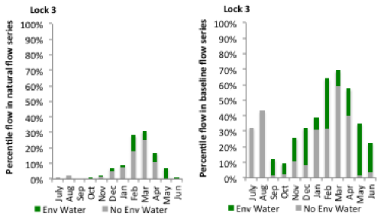
Figure LWM18: Contribution of environmental water delivery at Lock 3 as percentiles in the natural and baseline flow series.
Lock 2
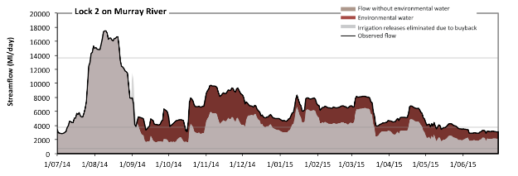 Figure LWM19: Contribution of environmental water delivery at Lock 2. Horizontal lines indicate thresholds for very low flows, low flows and low freshes (from lowest to highest).
At Lock 2 on Murray River environmental water contributed 26% of the total streamflow volume (Figure LWM19 and LWM20). Environmental watering actions affected streamflows for 83% of days between 1 June 2014 and 31 July 2015. Flow regulation does not substantially increase the duration of very low flows (i.e. < 690 Ml/day) compared to an average year in the natural flow regime. However, without environmental water, the durations of medium low flows (i.e. < 3800 Ml/day) in the periods July to September, October to December, January to March and April to June would have all substantially exceeded durations expected in an average year in the natural flow regime. Environmental water mitigated these impacts by reducing the cumulative duration of medium low flow spells from 46% to 15% of the year, with greatest influence in the periods October to December and April to June. There was at least one low fresh (i.e. > 14000 Ml/day) in the period July to September. Environmental water made no change to the duration of these low freshes. There was no medium or high freshes this year.
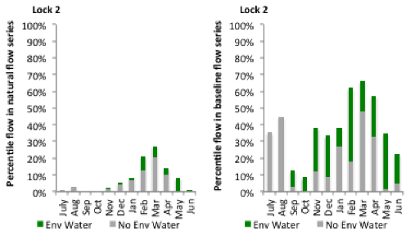
Figure LWM20: Contribution of environmental water delivery at Lock 2 as percentiles in the natural and baseline flow series.
Lock 1
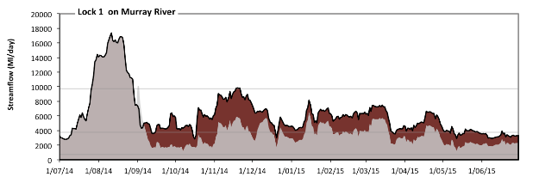 Figure LWM21: Contribution of environmental water delivery at Lock 1. Horizontal lines indicate thresholds for very low flows, low flows and low freshes (from lowest to highest).
At Lock 1 on Murray River environmental water contributed 28% of the total streamflow volume (Figure LWM21 and LWM22). Environmental watering actions affected streamflows for 83% of days between 1 June 2014 and 31 July 2015. Flow regulation does not substantially increase the duration of very low flows (i.e. < 690 Ml/day) compared to an average year in the natural flow regime. However, without environmental water, the durations of medium low flows (i.e. < 3700 Ml/day) in the periods July to September, October to December, January to March and April to June would have all substantially exceeded durations expected in an average year in the natural flow regime. Environmental water mitigated these impacts by reducing the cumulative duration of medium low flow spells from 56% to 16% of the year, with greatest influence in the periods October to December, January to March and April to June. In the absence of environmental water there would have been at least one low fresh (i.e. > 9700 Ml/day) in the period July to September. Environmental water increased the duration of the longest low fresh during the period October to December (from 0 days to 4 days). There was no medium or high freshes this year.
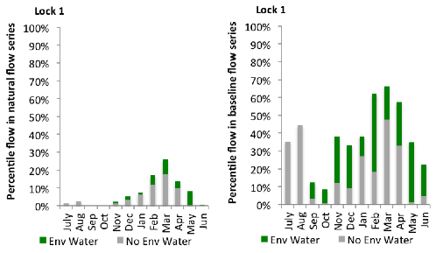
Figure LWM22: Contribution of environmental water delivery at Lock 1 as percentiles in the natural and baseline flow series.
Wellington
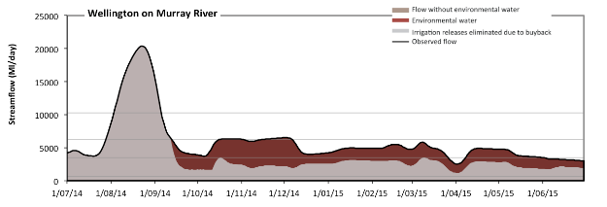 Figure LWM23: Contribution of environmental water delivery at Wellington. Horizontal lines indicate thresholds for very low flows, low flows, low freshes and medium freshes (from lowest to highest).
At Wellington on Murray River environmental water contributed 31% of the total streamflow volume (Figure LWM23 and LWM24). Environmental watering actions affected streamflows for 80% of days between 1 June 2014 and 31 July 2015. Flow regulation does not substantially increase the duration of very low flows (i.e. < 690 Ml/day) compared to an average year in the natural flow regime. However, without environmental water, the durations of medium low flows (i.e. < 3500 Ml/day) in the periods July to September, October to December, January to March and April to June would have all substantially exceeded durations expected in an average year in the natural flow regime. Environmental water mitigated these impacts by reducing the cumulative duration of medium low flow spells from 79% to 12% of the year, with greatest influence in the periods October to December and January to March. In the absence of environmental water there would have been at least one low fresh (i.e. > 6300 Ml/day) in the period July to September. Environmental water increased the duration of the longest low fresh during the period October to December (from 0 days to 21 days). There was at least one medium fresh (i.e. > 10000 Ml/day) in the period July to September. Environmental water made no change to the duration of these medium freshes. There was no high freshes (i.e. > 23000 Ml/day) this year.
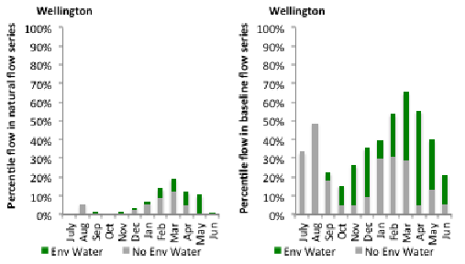
Figure LWM24: Contribution of environmental water delivery at Wellington as percentiles in the natural and baseline flow series.

A.4 Central Murray
`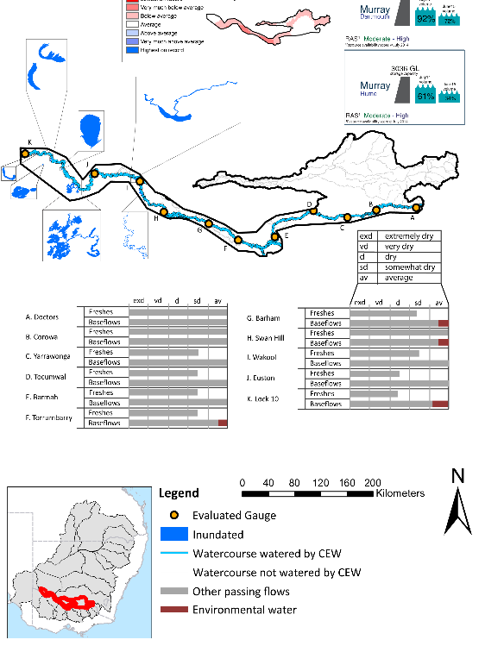
Figure CNM1: Location of evaluated gauges and the watercourses influenced by environmental water in the Central Murray valley during the 2014-15 water year. Inset bar graphs report the condition of annual flow regimes: for the hypothetical scenario if no environmental flow had been delivered (grey) and the improvements with the addition of environmental water. Rainfall conditions and trend in Storage levels for the water year are reported.

Summary Statement
Environmental water delivery for the 2014-15 year in the Central Murray Valley is evaluated using data for 11 sites. This evaluation only considers the contribution of held environmental water, which is a primary focus for the Commonwealth. The contributions of planned environmental water (e.g. passing flows), unregulated tributary inflows and clever use of irrigation flows for environmental benefits can all be very important but these are outside the scope of this report. Environmental watering actions lasted on average 362 days over the course of the year. The volume of environmental water at these 11 sites was between -13% and 20% of the total streamflow. Commonwealth Environmental Water contributed on average 100% of this environmental water. Ideally, baseflows should be maintained and long periods of excessively low flows avoided. In this valley, the baseflow regime was generally considered to be average relative to the pre-development flow regime. In our analysis, a low fresh refers to a period of increased flow, when the water level rises at least one eighth of the way up the river bank (above the low flow level). These low freshes are a regular part of the natural flow regime and support a range of natural processes. In the Central Murray Valley, in terms of the the occurrence and duration of low freshes, the year was assessed as being average. In our analysis, a medium fresh refers to a period of increased flow, when the water level rises at least one quater of the way up the river bank. These medium freshes are not as frequent as low freshes but are also a regular and important part of the natural flow regime. In the Central Murray Valley, in terms of the occurrence of medium freshes, the year was assessed as being average. In our analysis, a high fresh refers to a period of increased flow, when the water level rises more than half way up the river. A high fresh may not occur every year but they are still important and long periods without major freshes can have serious consequences for floodplains and their contribution to river ecosystem health. Delivering environmental high in channel flows normally requires that all risks to riparian landholders and infrastructure have been resolved. In the Central Murray Valley, in terms of the occurrence of high freshes, the year was assessed as being very dry.

Description of Environmental Water System
The Central Murray valley covers an area of approximately 19886 km2, representing approximately 1.9% of the Mdb. This part of the Murray consists of the Murray River, its billabongs, flood runners and floodplains between Hume Dam and the South Australian border. It excludes the region known as the Edward-Wakool. The region contains important irrigation areas, and receives tributary inputs from the Goulburn, Broken, Campaspe, Loddon, Ovens and the Edward-Wakool system.
Environmental water can be supplied from a range of sources to meet demands in the Central Murray valley. This includes entitlements held by the CEWH, NSW OEH, VEWH, and TLM Living Murray, as well as the reuse of return flows (in Victoria), and in some instances input into the design of IVT flows intended for use downstream. The source of the water and ability to deliver approved watering actions depends on water availability, water commitments by other environmental water holders, and operational conditions.
In NSW, environmental water is acquired and managed by the NSW OEH, whom have established the Murray Lower Darling Environmental Water Advisory Group (Murray Lower Darling EWAG) to provide advice on the management of environmental water in the Murray and Lower Darling Water Source. The Murray Lower Darling EWAG provides specific advice on draft Annual Watering Plans which specify where water will be delivered under a range of possible water availability scenarios. In Victoria, the Victorian Environmental Water Holder (VEWH) coordinates with other environmental water holders in northern Victoria, New South Wales and South Australia to deliver environmental outcomes.
Water infrastructure development and regulation of the Murray River has altered the hydrology of the Murray River and its wetlands. In particular, the frequency and duration of high river flows which activate anabranches, fill billabongs and inundate floodplains have been reduced. Environmental water can be delivered to the Murray wetlands through a combination of direct pumping from the River Murray and through use of irrigation infrastructure.
Environmental water in the Central Murray is constrained by flooding impacts and impacts to irrigation delivery. The identified impact occurs below Yarrawonga weir and Barmah choke where a flow constraint of between 10,000 and 18,000 Ml/d has been identified (Mdba 2013).

Data Availability

River Flows
The Msm-BigMod model was to calculate the impact of CEW in the Murray River. An extensive modelling exercise which modelled two flow scenarios: (1) pre-buy back – this scenario modelled flows under a scenario where water purchased by the CEWH was returned back to irrigators and use was modelled with respect to allocations in 2014-15. Flow scenario (2) Observed flow – this scenario modelled flow under the observed condition 2014-15 condition. For more details on the methodology, and assumptions please see Modelling Flows in the Murray and Darling River (this report).
Inundation extents
Inundation extents for wetlands, billabongs and other regions which received CEW outside of the main channel were supplied by various sources, utilising various methods. Table CNM1 lists the data owner and method used to derive inundation extent.

Environmental Conditions
The resource availability score for the Central Murray valley was estimated (July 2014) as Moderate to High (CNM 1). Whereas, the rainfall conditions (based on gridded rainfall percentiles which compare the rainfall experienced for the water year to the total record) experienced were categorised as average (Figure 1 – Main report). The storage levels of Dartmouth and Hume dam declined from a high of 92 % and 61% at the beginning of the water year respectively to 72% and 34% respectively, by the end of the water year.
Table CNM1: Source of inundation data and method used to derive inundation extent
Data Owner | Wetland complex | Method | Result certainty
Mallee CMA | Wimmera wetlands | Field survey and aerial photographs | High
MDBA | Hattah lakes | Mike Flood model and Landsat imagery | High

Environmental Water Actions in 2014-15
The LTAAY of the CEW entitlements in the Central Murray was 57,9426 ML. 104,366.9 ML of CEW was approved for delivery in the Central Murray. 59,726 ML of CEW was delivered (57.2% of approved volume) in three broad watering actions.
The shortfall between approved volumes and delivered volumes has multiple explanations. Firstly, in the Mallee wetland action the total CEW delivered was less because the original volume estimates were approved before the VEWH advised that they would share delivery on a 50:50 basis with the CEWO. In the Hattah lakes system the contribution of CEW was less than planned because of operational issues which meant a late start to the watering action. Similarly, poor water quality also impacted the commencement of this action. All other actions were delivered as intended.
In 2014-15, CEW represented 57.6 % of total delivered environmental water (based on actions where the CEW contributed in collaboration or isolation). The CEW volume only represented 5.4% of total predevelopment flows (Table CNM2). The three encompassing watering actions spread over 568days, as many actions were being delivered simultaneously (Figure CNM2). The actions were delivered as a combination of instream flows, and wetland inundation assisted by infrastructure assisted.
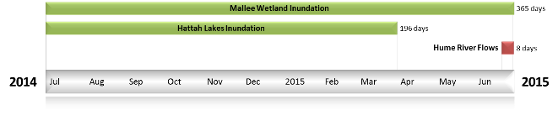
Figure CNM2: Timing and duration of CEW actions in the Central Murray during 2014-15.
Table CNM2: Environmental water approved and delivered in the Central Murray during 2014-15.
Source | LTAAY (ML) | Total approved volume (ML) | Total volume delivered (ML) | % delivered of total E Water delivered | % contribution to predevelopment flows ¹
CEW | 57,9426 | 104,366.9 | 59,726 | 57.6 | 5.4
VEWH | NA | NA | 16,638.8 | 16.1 | 1.5
TLM | NA | NA | 27,306.2 | 26.3 | 2.4
¹ predevelopment average annual flows at Wentworth of 11,162 GL

Contribution of Commonwealth Environmental Water to Flow Regimes
Doctors
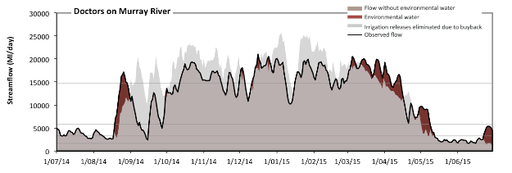
Figure CNM3: Contribution of environmental water delivery at Doctors. Horizontal lines indicate thresholds for very low flows, low flows, low freshes, medium freshes and high freshes (from lowest to highest).
At Doctors on Murray River environmental water recovery and delivery resulted in a net 13% reduction in streamflow at this site (Figure CNM3 and CNM4). Environmental water purchases and watering actions affected streamflows for 100% of days between 1 June 2014 and 31 July 2015. Flow regulation does not substantially increase the duration of very low flows (i.e. < 410 Ml/day) compared to an average year in the natural flow regime. Flow regulation does not substantially increase the duration of medium low flows (i.e. < 1700 Ml/day) compared to an average year in the natural flow regime. There was at least one low fresh (i.e. > 3300 Ml/day) in the periods July to September, October to December, January to March and April to June. Environmental water made little change to the duration of these low freshes. There was at least one medium fresh (i.e. > 5800 Ml/day) in the periods July to September, October to December, January to March and April to June. Environmental water made little change to the duration of these medium freshes. In the absence of environmental water there would have been at least one high fresh in the periods July to September, October to December, January to March and April to June. Environmental water increased the duration of the longest medium fresh during the period April to June (from 1 days to 6 days).
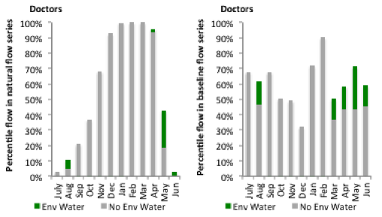
Figure CNM4: Contribution of environmental water delivery at Doctors as percentiles in the natural and baseline flow series.

Corowa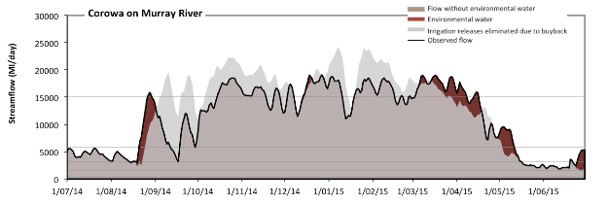
Figure CNM5: Contribution of environmental water delivery at Corowa. Horizontal lines indicate thresholds for very low flows, low flows, low freshes, medium freshes and high freshes (from lowest to highest).
At Corowa on Murray River environmental water recovery and delivery resulted in a net 13% reduction in streamflow at this site (Figure CNM5 and CNM6). Environmental water purchases and watering actions affected streamflows for 98% of days between 1 June 2014 and 31 July 2015. Flow regulation does not substantially increase the duration of very low flows (i.e. < 380 Ml/day) compared to an average year in the natural flow regime. Flow regulation does not substantially increase the duration of medium low flows (i.e. < 1600 Ml/day) compared to an average year in the natural flow regime. There was at least one low fresh (i.e. > 3200 Ml/day) in the periods July to September, October to December, January to March and April to June. Environmental water made little change to the duration of these low freshes. In the absence of environmental water there would have been at least one medium fresh (i.e. > 5800 Ml/day) in the periods July to September, October to December, January to March and April to June. Environmental water increased the duration of the longest medium fresh during the period April to June (from 32 days to 41 days). In the absence of environmental water there would have been at least one high fresh in the periods July to September, October to December and January to March. Environmental water increased the duration of the longest medium fresh during the period April to June (from 0 days to 7 days).

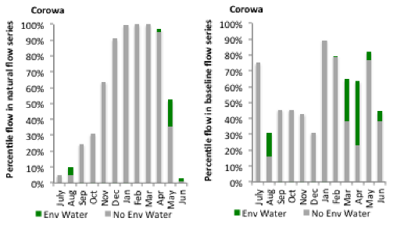
Figure CNM6: Contribution of environmental water delivery at Corowa as percentiles in the natural and baseline flow series.
Yarrawonga
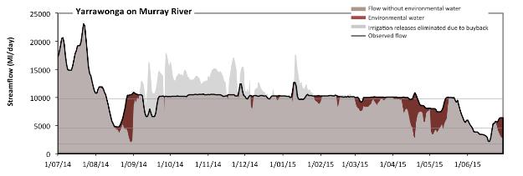
Figure CNM7: Contribution of environmental water delivery at Yarrawonga. Horizontal lines indicate thresholds for very low flows, low flows, low freshes and medium freshes (from lowest to highest).
At Yarrawonga on Murray River environmental water recovery and delivery resulted in a net 4% reduction in streamflow at this site (Figure CNM7 and CNM8). Environmental water purchases and watering actions affected streamflows for 93% of days between 1 June 2014 and 31 July 2015. Flow regulation does not substantially increase the duration of very low flows (i.e. < 340 Ml/day) compared to an average year in the natural flow regime. Flow regulation does not substantially increase the duration of medium low flows (i.e. < 1700 Ml/day) compared to an average year in the natural flow regime. In the absence of environmental water there would have been at least one low fresh (i.e. > 4600 Ml/day) in the periods July to September, October to December, January to March and April to June. Environmental water increased the duration of the longest low fresh during the periods July to September (from 47 days to 92 days) and April to June (from 24 days to 65 days). In the absence of environmental water there would have been at least one medium fresh (i.e. > 9800 Ml/day) in the periods July to September, October to December, January to March and April to June. Environmental water increased the duration of the longest medium fresh during the periods October to December (from 47 days to 63 days), January to March (from 17 days to 45 days) and April to June (from 5 days to 14 days). There was no high freshes (i.e. > 31000 Ml/day) this year.
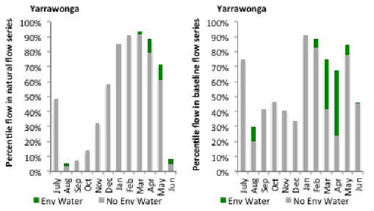
Figure CNM8: Contribution of environmental water delivery at Yarrawonga as percentiles in the natural and baseline flow series.
Tocumwal
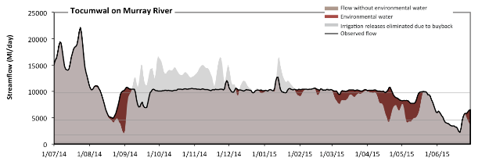
Figure CNM9: Contribution of environmental water delivery at Tocumwal. Horizontal lines indicate thresholds for very low flows, low flows, low freshes and medium freshes (from lowest to highest).
At Tocumwal on Murray River environmental water recovery and delivery resulted in a net 4% reduction in streamflow at this site (Figure CNM9 and CNM10). Environmental water purchases and watering actions affected streamflows for 100% of days between 1 June 2014 and 31 July 2015. Flow regulation does not substantially increase the duration of very low flows (i.e. < 340 Ml/day) compared to an average year in the natural flow regime. Flow regulation does not substantially increase the duration of medium low flows (i.e. < 1700 Ml/day) compared to an average year in the natural flow regime. In the absence of environmental water there would have been at least one low fresh (i.e. > 4600 Ml/day) in the periods July to September, October to December, January to March and April to June. Environmental water increased the duration of the longest low fresh during the periods July to September (from 50 days to 92 days) and April to June (from 29 days to 67 days). In the absence of environmental water there would have been at least one medium fresh (i.e. > 9700 Ml/day) in the periods July to September, October to December, January to March and April to June. Environmental water increased the duration of the longest medium fresh during the periods October to December (from 68 days to 92 days), January to March (from 28 days to 46 days) and April to June (from 8 days to 23 days). There was no high freshes (i.e. > 31000 Ml/day) this year.
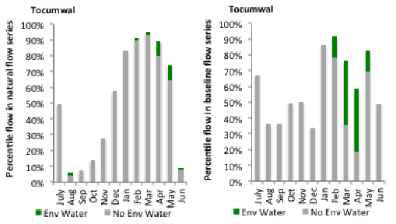
Figure CNM10: Contribution of environmental water delivery at Tocumwal as percentiles in the natural and baseline flow series.
Torrumbarry
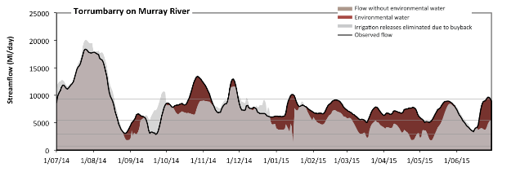
Figure CNM11: Contribution of environmental water delivery at Torrumbarry. Horizontal lines indicate thresholds for very low flows, low flows, low freshes and medium freshes (from lowest to highest).
At Torrumbarry on Murray River environmental water contributed 12% of the total streamflow volume (Figure CNM11 and CNM12). Environmental watering actions affected streamflows for 100% of days between 1 June 2014 and 31 July 2015. Flow regulation does not substantially increase the duration of very low flows (i.e. < 760 Ml/day) compared to an average year in the natural flow regime. However, without environmental water, the durations of medium low flows (i.e. < 3000 Ml/day) in the periods July to September and April to June would have substantially exceeded durations expected in an average year in the natural flow regime. Environmental water mitigated these impacts by reducing the cumulative duration of medium low flow spells from 8% to 0% of the year, with greatest influence in the periods July to September and April to June. In the absence of environmental water there would have been at least one low fresh (i.e. > 5500 Ml/day) in the periods July to September, October to December, January to March and April to June. Environmental water increased the duration of the longest low fresh during the periods January to March (from 22 days to 74 days) and April to June (from 19 days to 33 days). In the absence of environmental water there would have been at least one medium fresh (i.e. > 9300 Ml/day) in the periods July to September and October to December. Environmental water increased the duration of the longest medium fresh during the periods October to December (from 11 days to 19 days), January to March (from 0 days to 5 days) and April to June (from 0 days to 4 days). There was no high freshes (i.e. > 22000 Ml/day) this year.
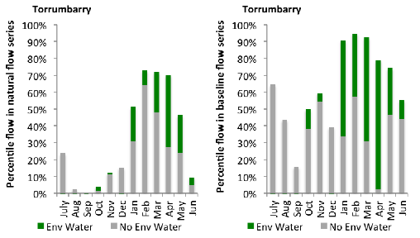
Figure CNM12: Contribution of environmental water delivery at Torrumbarry as percentiles in the natural and baseline flow series.
Barham
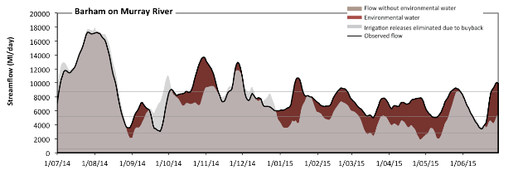Figure CNM13: Contribution of environmental water delivery at Barham. Horizontal lines indicate thresholds for very low flows, low flows, low freshes and medium freshes (from lowest to highest).
At Barham on Murray River environmental water contributed 13% of the total streamflow volume (Figure CNM13 and CNM14). Environmental watering actions affected streamflows for 100% of days between 1 June 2014 and 31 July 2015. Flow regulation does not substantially increase the duration of very low flows (i.e. < 550 Ml/day) compared to an average year in the natural flow regime. However, without environmental water, the duration of medium low flows (i.e. < 2800 Ml/day) in the period April to June would have substantially exceeded durations expected in an average year in the natural flow regime. Environmental water mitigated these impacts by reducing the cumulative duration of medium low flow spells from 7% to 0% of the year, with greatest influence in the period April to June. In the absence of environmental water there would have been at least one low fresh (i.e. > 5200 Ml/day) in the periods July to September, October to December, January to March and April to June. Environmental water increased the duration of the longest low fresh during the periods January to March (from 23 days to 76 days) and April to June (from 21 days to 36 days). In the absence of environmental water there would have been at least one medium fresh (i.e. > 8700 Ml/day) in the periods July to September, October to December and April to June. Environmental water increased the duration of the longest medium fresh during the periods October to December (from 18 days to 24 days), January to March (from 0 days to 8 days) and April to June (from 3 days to 8 days). There was no high freshes (i.e. > 20000 Ml/day) this year.
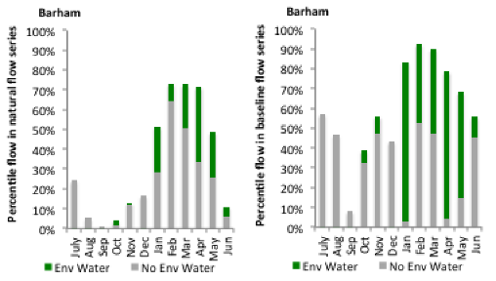
Figure CNM14: Contribution of environmental water delivery at Barham as percentiles in the natural and baseline flow series.

Swan Hill
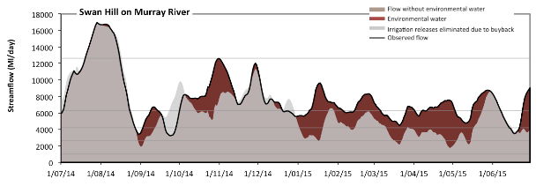 Figure CNM15: Contribution of environmental water delivery at Swan Hill. Horizontal lines indicate thresholds for very low flows, low flows, low freshes, medium freshes and high freshes (from lowest to highest).
At Swan Hill on Murray River environmental water contributed 16% of the total streamflow volume (Figure CNM15 and CNM6). Environmental watering actions affected streamflows for 100% of days between 1 June 2014 and 31 July 2015. Flow regulation does not substantially increase the duration of very low flows (i.e. < 980 Ml/day) compared to an average year in the natural flow regime. However, without environmental water, the durations of medium low flows (i.e. < 2600 Ml/day) in the periods July to September and April to June would have substantially exceeded durations expected in an average year in the natural flow regime. Environmental water mitigated these impacts by reducing the cumulative duration of medium low flow spells from 7% to 0% of the year, with greatest influence in the periods January to March and April to June. In the absence of environmental water there would have been at least one low fresh (i.e. > 4200 Ml/day) in the periods July to September, October to December, January to March and April to June. Environmental water increased the duration of the longest low fresh during the periods January to March (from 24 days to 90 days) and April to June (from 29 days to 75 days). In the absence of environmental water there would have been at least one medium fresh (i.e. > 6300 Ml/day) in the periods July to September, October to December, January to March and April to June. Environmental water increased the duration of the longest medium fresh during the periods October to December (from 63 days to 79 days), January to March (from 4 days to 26 days) and April to June (from 16 days to 23 days). In the absence of environmental water there would have been at least one high fresh in the period July to September. Environmental water made no change to the duration of these high freshes.
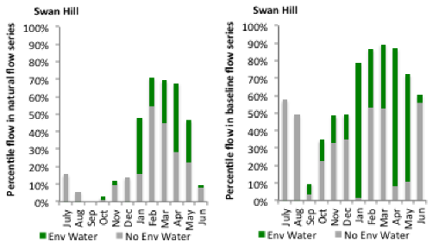
Figure CNM16: Contribution of environmental water delivery at Swan Hill as percentiles in the natural and baseline flow series.
Wakool
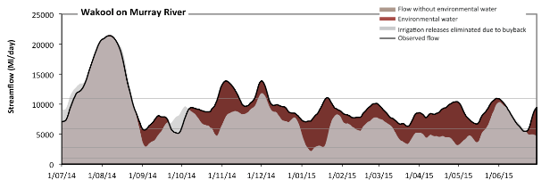 Figure CNM17: Contribution of environmental water delivery at Wakool. Horizontal lines indicate thresholds for very low flows, low flows, low freshes and medium freshes (from lowest to highest).
At Wakool on Murray River environmental water contributed 19% of the total streamflow volume (Figure CNM17 and CNM18). Environmental watering actions affected streamflows for 100% of days between 1 June 2014 and 31 July 2015. Flow regulation does not substantially increase the duration of very low flows (i.e. < 1000 Ml/day) compared to an average year in the natural flow regime. Flow regulation does not substantially increase the duration of medium low flows (i.e. < 2800 Ml/day) compared to an average year in the natural flow regime. In the absence of environmental water there would have been at least one low fresh (i.e. > 5900 Ml/day) in the periods July to September, October to December, January to March and April to June. Environmental water increased the duration of the longest low fresh during the periods October to December (from 61 days to 92 days), January to March (from 24 days to 90 days) and April to June (from 29 days to 79 days). In the absence of environmental water there would have been at least one medium fresh (i.e. > 11000 Ml/day) in the periods July to September and October to December. Environmental water increased the duration of the longest medium fresh during the periods October to December (from 6 days to 16 days), January to March (from 0 days to 2 days) and April to June (from 0 days to 1 days). There was no high freshes (i.e. > 29000 Ml/day) this year.
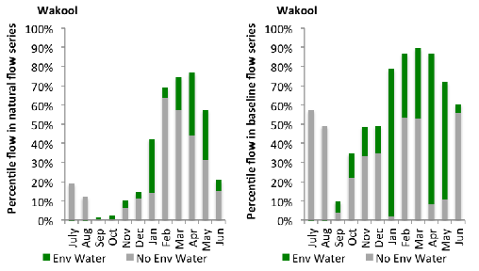
Figure CNM18: Contribution of environmental water delivery at Wakool as percentiles in the natural and baseline flow series.
Euston
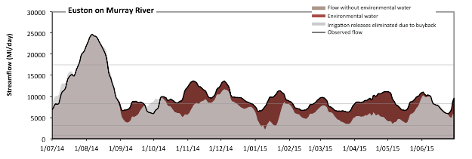 Figure CNM19: Contribution of environmental water delivery at Euston. Horizontal lines indicate thresholds for very low flows, low flows, low freshes and medium freshes (from lowest to highest).
At Euston on Murray River environmental water contributed 18% of the total streamflow volume (Figure CNM19 and CNM20). Environmental watering actions affected streamflows for 100% of days between 1 June 2014 and 31 July 2015. Flow regulation does not substantially increase the duration of very low flows (i.e. < 910 Ml/day) compared to an average year in the natural flow regime. Flow regulation does not substantially increase the duration of medium low flows (i.e. < 3200 Ml/day) compared to an average year in the natural flow regime. In the absence of environmental water there would have been at least one low fresh (i.e. > 8300 Ml/day) in the periods July to September, October to December, January to March and April to June. Environmental water increased the duration of the longest low fresh during the periods October to December (from 38 days to 83 days), January to March (from 2 days to 24 days) and April to June (from 15 days to 37 days). There was at least one medium fresh (i.e. > 18000 Ml/day) in the period July to September. Environmental water made no change to the duration of these medium freshes. There was no high freshes (i.e. > 55000 Ml/day) this year.
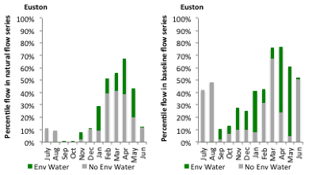
Figure CNM20: Contribution of environmental water delivery at Euston as percentiles in the natural and baseline flow series.
Lock 10
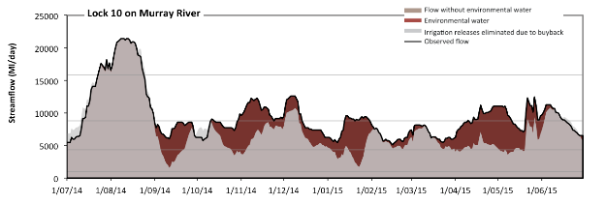 Figure CNM21: Contribution of environmental water delivery at Lock 10. Horizontal lines indicate thresholds for very low flows, low flows, low freshes and medium freshes (from lowest to highest).
At Lock 10 on Murray River environmental water contributed 20% of the total streamflow volume (Figure CNM21 and CNM22). Environmental watering actions affected streamflows for 100% of days between 1 June 2014 and 31 July 2015. Flow regulation does not substantially increase the duration of very low flows (i.e. < 940 Ml/day) compared to an average year in the natural flow regime. However, without environmental water, the durations of medium low flows (i.e. < 4300 Ml/day) in the periods July to September, October to December, January to March and April to June would have all substantially exceeded durations expected in an average year in the natural flow regime. Environmental water mitigated these impacts by reducing the cumulative duration of medium low flow spells from 17% to 0% of the year, with greatest influence in the period January to March. In the absence of environmental water there would have been at least one low fresh (i.e. > 8800 Ml/day) in the periods July to September, October to December and April to June. Environmental water increased the duration of the longest low fresh during the periods October to December (from 10 days to 46 days), January to March (from 0 days to 18 days) and April to June (from 19 days to 28 days). There was at least one medium fresh (i.e. > 16000 Ml/day) in the period July to September. Environmental water made no change to the duration of these medium freshes. There was no high freshes (i.e. > 41000 Ml/day) this year.
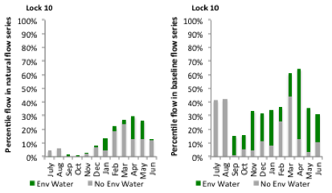
Figure CNM22: Contribution of environmental water delivery at Lock 10 as percentiles in the natural and baseline flow series.

A.5 Northern Unregulated
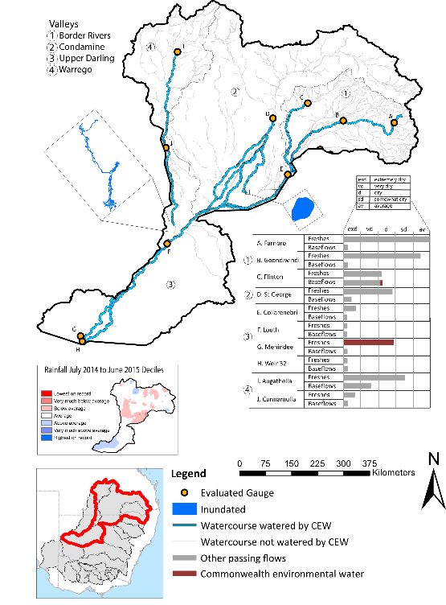
Figure NUT1: Location of evaluated gauges and the watercourses influenced by environmental water in the Northern Unregulated valley during the 2014-15 water year. Inset bar graphs report the condition of annual flow regimes: for the hypothetical scenario if no environmental flow had been delivered (grey) and the improvements with the addition of environmental water. Rainfall conditions and trend in Storage levels for the water year are reported.

Summary Statement
Border Rivers
Environmental water delivery for the 2014-15 year in the Border Rivers Valley is evaluated using data for 3 sites. This evaluation only considers the contribution of held environmental water, which is a primary focus for the Commonwealth. The contributions of planned environmental water (e.g. passing flows), unregulated tributary inflows and clever use of irrigation flows for environmental benefits can all be very important but these are outside the scope of this report. Environmental watering actions lasted on average 18 days over the course of the year. The volume of environmental water at these 3 sites was between 0% and 18% of the total streamflow. Commonwealth Environmental Water contributed on average 100% of this environmental water. Ideally, baseflows should be maintained and long periods of excessively low flows avoided. In this valley, the baseflow regime was generally considered to be extremely dry relative to the pre-development flow regime. In our analysis, a low fresh refers to a period of increased flow, when the water level rises at least one eighth of the way up the river bank (above the low flow level). These low freshes are a regular part of the natural flow regime and support a range of natural processes. In the Border Rivers valley, in terms of the the occurrence and duration of low freshes, the year was assessed as being dry. In our analysis, a medium fresh refers to a period of increased flow, when the water level rises at least one quater of the way up the river bank. These medium freshes are not as frequent as low freshes but are also a regular and important part of the natural flow regime. In the Border Rivers valley, in terms of the occurrence of medium freshes, the year was assessed as being average. In our analysis, a high fresh refers to a period of increased flow, when the water level rises more than half way up the river. A high fresh may not occur every year but they are still important and long periods without major freshes can have serious consequences for floodplains and their contribution to river ecosystem health. Delivering environmental high in channel flows normally requires that all risks to riparian landholders and infrastructure have been resolved. In the Border Rivers valley, in terms of the occurrence of high freshes, the year was assessed as being average. Commonwealth environmental water water altered flow regimes along an estimated 1001 km of river out of a maximum of 1447 km (i.e. 69%).
Condamine
Environmental water delivery for the 2014-15 year in the Condamine Valley is evaluated using data for 1 sites. This evaluation only considers the contribution of held environmental water, which is a primary focus for the Commonwealth. The contributions of planned environmental water (e.g. passing flows), unregulated tributary inflows and clever use of irrigation flows for environmental benefits can all be very important but these are outside the scope of this report. Environmental watering actions lasted on average 22 days over the course of the year. The volume of environmental water at this site was 8% of the total streamflow. Commonwealth Environmental Water contributed on average 100% of this environmental water. Ideally, baseflows should be maintained and long periods of excessively low flows avoided. In this valley, the baseflow regime was generally considered to be extremely dry relative to the pre-development flow regime. In our analysis, a low fresh refers to a period of increased flow, when the water level rises at least one eighth of the way up the river bank (above the low flow level). These low freshes are a regular part of the natural flow regime and support a range of natural processes. In the Condamine valley, in terms of the the occurrence and duration of low freshes, the year was assessed as being very dry. In our analysis, a medium fresh refers to a period of increased flow, when the water level rises at least one quater of the way up the river bank. These medium freshes are not as frequent as low freshes but are also a regular and important part of the natural flow regime. In the Condamine valley, in terms of the occurrence of medium freshes, the year was assessed as being dry. In our analysis, a high fresh refers to a period of increased flow, when the water level rises more than half way up the river. A high fresh may not occur every year but they are still important and long periods without major freshes can have serious consequences for floodplains and their contribution to river ecosystem health. Delivering environmental high in channel flows normally requires that all risks to riparian landholders and infrastructure have been resolved. In the Condamine valley, in terms of the occurrence of high freshes, the year was assessed as being average. Commonwealth environmental water altered flow regimes along an estimated 1509 km of river out of a maximum estimated of 2323 km (i.e. 65%). These actions contributed partially to the 343 ha of floodplain which was wet during the 2014-15 year.
Upper Darling
Environmental water delivery for the 2014-15 year in the Upper Darling Valley is evaluated using data for 2 sites. This evaluation only considers the contribution of held environmental water, which is a primary focus for the Commonwealth. The contributions of planned environmental water (e.g. passing flows), unregulated tributary inflows and clever use of irrigation flows for environmental benefits can all be very important but these are outside the scope of this report. Environmental watering actions lasted on average 17 days over the course of the year. The volume of environmental water at these 2 sites was between 1% and 3% of the total streamflow. Commonwealth Environmental Water contributed on average 100% of this environmental water. Ideally, baseflows should be maintained and long periods of excessively low flows avoided. In this valley, the baseflow regime was generally considered to be extremely dry relative to the pre-development flow regime. In our analysis, a low fresh refers to a period of increased flow, when the water level rises at least one eighth of the way up the river bank (above the low flow level). These low freshes are a regular part of the natural flow regime and support a range of natural processes. In the Upper Darling valley, in terms of the the occurrence and duration of low freshes, the year was assessed as being extremely dry. In our analysis, a medium fresh refers to a period of increased flow, when the water level rises at least one quater of the way up the river bank. These medium freshes are not as frequent as low freshes but are also a regular and important part of the natural flow regime. In the Upper Darling valley, in terms of the occurrence of medium freshes, the year was assessed as being extremely dry. In our analysis, a high fresh refers to a period of increased flow, when the water level rises more than half way up the river. A high fresh may not occur every year but they are still important and long periods without major freshes can have serious consequences for floodplains and their contribution to river ecosystem health. Delivering environmental high in channel flows normally requires that all risks to riparian landholders and infrastructure have been resolved. In the Upper Darling valley, in terms of the occurrence of high freshes, the year was assessed as being extremely dry. Commonwealth environmental water altered flow regimes along an estmiated 2022 km of upper Darling and Barwon rivers for which data were available.
Warrego
Environmental water delivery for the 2014-15 year in the Warrego Valley is evaluated using data for 2 sites. This evaluation only considers the contribution of held environmental water, which is a primary focus for the Commonwealth. The contributions of planned environmental water (e.g. passing flows), unregulated tributary inflows and clever use of irrigation flows for environmental benefits can all be very important but these are outside the scope of this report. Environmental watering actions lasted on average 7 days over the course of the year. The volume of environmental water at these 2 sites was between 2% and 5% of the total streamflow. Commonwealth Environmental Water contributed on average 100% of this environmental water. Ideally, baseflows should be maintained and long periods of excessively low flows avoided. In this valley, the baseflow regime was generally considered to be very dry relative to the pre-development flow regime. In our analysis, a low fresh refers to a period of increased flow, when the water level rises at least one eighth of the way up the river bank (above the low flow level). These low freshes are a regular part of the natural flow regime and support a range of natural processes. In the Warrego valley, in terms of the the occurrence and duration of low freshes, the year was assessed as being very dry. In our analysis, a medium fresh refers to a period of increased flow, when the water level rises at least one quater of the way up the river bank. These medium freshes are not as frequent as low freshes but are also a regular and important part of the natural flow regime. In the Warrego valley, in terms of the occurrence of medium freshes, the year was assessed as being dry. In our analysis, a high fresh refers to a period of increased flow, when the water level rises more than half way up the river. A high fresh may not occur every year but they are still important and long periods without major freshes can have serious consequences for floodplains and their contribution to river ecosystem health. Delivering environmental high in channel flows normally requires that all risks to riparian landholders and infrastructure have been resolved. In the Warrego valley, in terms of the occurrence of high freshes, the year was assessed as being dry. Commonwealth environmental water altered flow regimes along an estimated 623 km of 1271km of mainstem Warrego river for which data were available. These actions contributed partially to the 28.9 ha of floodplain which was wet during the 2014-15 year.

Description of Environmental Water System
This section describes the northern unregulated valleys of the MDB where the CEWO maintains a portfolio of water entitlements. The northern unregulated rivers are the vast network of rivers and channels spread across south-west Queensland and north-west NSW, occurring in mostly semi-arid, largely flat region of the northern basin. The flows are highly variable and the ecology tends to follow boom and bust cycles. For the purposes of this report the northern unregulated valleys include the Border Rivers, Condamine, Upper Darling and Warrego valleys. Collectively these valleys represent a total area of 372088 km2, representing 35% of the Basin.
The Commonwealth’s environmental water entitlements in the Queensland and northern NSW unregulated valleys are mostly used “passively”, which is the practice of leaving water in-stream to supplement rainfall-runoff events. The intent of this watering strategy is to lengthen natural flow periods thereby reducing the number of dry spells that do not exceed the critical conditions that can be tolerated by aquatic and floodplain species.
In 2014-15, the valleys in scope included the Warrego, Border Rivers, Upper Darling and the Condamine. Commonwealth environmental water holdings in these northern unregulated valleys totalled 175,863 GL. In a typical year, the Border Rivers flow most of the time, as do the Barwon and Darling. However, under natural conditions rivers, such as the Condamine and Warrego experience periods of no flow, which can last up to several years, especially when there is no significant rainfall or nothing is done to supplement the flow.

Data Availability
River Flows
The Commonwealth Environmental Water Office closely monitors stream flows in the northern Basin using real-time data from river gauges, to detect when access to Commonwealth unregulated entitlements is triggered. River flow data in conjunction with official announcements of water harvesting access in unregulated systems (Lower Balonne, Border Rivers & Warrego) is used to estimate in-stream use. Volumes are accounted for in accordance with the licence (access) conditions of each entitlement in the same way that other water users manage their take, and we assume that water is used at all available opportunities (when flow conditions are triggered) up to allowed limits. This reflects the use pattern of use of the majority of irrigators in unregulated systems and hence the volumes and pattern of flows that have been reinstated to the systems.
Inundation extents
The data owner and method used to estimate inundation extents for wetlands, billabongs and other regions where CEW contributed to overbank watering are outlined in Table NUT 1.

Environmental Conditions
The resource availability score for the Border Rivers valley was estimated (July 2014) as Low to Moderate, no estimates were made for the other northern valleys. Rainfall conditions experienced (based on gridded rainfall percentiles which compare the rainfall experienced for the water year to the total record) in the northern unregulated valleys were categorised as average (Figure 1 – Main report).
Table NUT1: Source of inundation data and method used to derive inundation extent
Data Owner | Wetland complex | Method | Result certainty
Ecological | Western floodplain | DEM fitted to a height datum at Boera | High
LTIM | Narran | Estimation based on Wofs frequency of inundation and qualitative comments provided by the NSW NPWS | Medium-Low

Environmental Water Actions in 2014-15
The long term average annual yield in the Northern unregulated valleys was 10659 ML in the Border Rivers, 53754 ML in the Condamine, 24279 ML in the Upper Darling and 25826 ML in the Warrego. In 2014-15, a total of 247,121 ML of environmental water was approved for delivery, but only 10.7% (24,878.5 ML) was delivered (Table NUT2). The valleys watered included actions in the Border rivers (including the Moonie), Condamine, Warrego and Barwon-Darling. However, two actions approved for delivery in the Condamine – Nebine (approved 5920 ML) and NSW Warrego (approved 25,932) did not proceed because inflows did not trigger the license conditions to ‘take’ water.
CEW contributed to instream flows in sixteen watering actions in the northern unregulated valleys during 2014-15. Nine watering actions took place in the Border Rivers (3229.5 ML), including four in the Moonie (1415 ML), two actions in the Condamine-Balonne (17,392 ML), four actions in the Warrego (2541.7 ML) and three actions in the Barwon-Darling (1715.8 ML). Of the 18-watering actions 89% were considered freshes (16 watering actions), whilst 11% (two actions – both in the Border Rivers) were considered overbank or full bank. The watering actions spanned approximately 146 days, with the average duration of flows in the entitlement zone spanning 8 days.
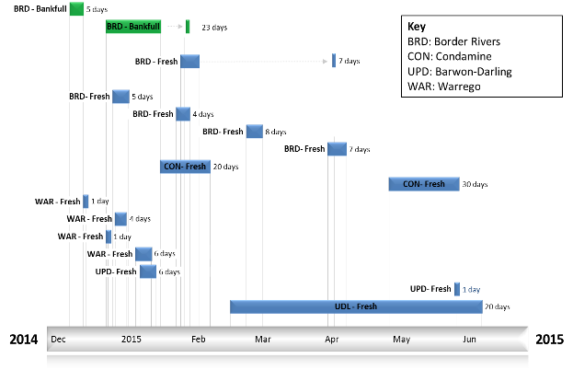
Figure NUT2: Timing and duration of Northern unregulated CEW actions in 2014-15.
Table NUT2: Environmental water approved and delivered in the Northern unregulated over 2014-15
Source | LTAAY (ML) | Total approved volume (ML) | Total volume delivered (ML) | % total Ewater delivered | % contribution to predevelopment flows¹
CEW | 10659 BRD  53754 CON  24279 UPD  25826 WAR | 247,121 | 24878.5 | 20.4 | 5.6
QLD | NA |  | 96,521 | 79.5 | 2.2
¹ predevelopment average annual inflows for combined valleys in the Northern unregulated of 4476.8 GL

Contribution of Commonwealth Environmental Water to Flow Regimes

Flinton
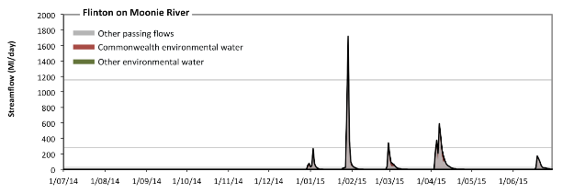
Figure NUT3: Contribution of environmental water delivery at Flinton. Horizontal lines indicate thresholds for very low flows, low flows, low freshes, medium freshes and high freshes (from lowest to highest).
At Flinton on Moonie River environmental water contributed 18% of the total streamflow volume (all of which was Commonwealth Environmental Water) (Figure NUT3 and NUT4). Environmental watering actions affected streamflows for 7% of days between 1 June 2014 and 31 July 2015. Without environmental water, the durations of very low flows (i.e. < 5.1 Ml/day) in the periods July to September, October to December, January to March and April to June would have all substantially exceeded durations expected in an average year in the natural flow regime. However, environmental water had little effect on the duration of these very low flows, which occurred for 83% of the year. Similarly, without environmental water, the durations of medium low flows (i.e. < 25 Ml/day) in the periods July to September, October to December, January to March and April to June would have all substantially exceeded durations expected in an average year in the natural flow regime. Environmental water mitigated these impacts by reducing the cumulative duration of medium low flow spells from 90% to 89% of the year, with greatest influence in the periods October to December and January to March. There was at least one low fresh (i.e. > 280 Ml/day) in the periods January to March and April to June. Environmental water made no change to the duration of these low freshes. There was at least one medium fresh (i.e. > 1200 Ml/day) in the period January to March. Environmental water made no change to the duration of these medium freshes. In the absence of environmental water there would have been at least one high fresh in the period January to March. Environmental water made no change to the duration of these high freshes.
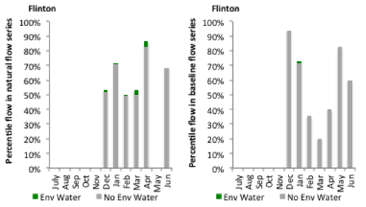
Figure NUT4: Contribution of environmental water delivery at Flinton as percentiles in the natural and baseline flow series.
Farnbro
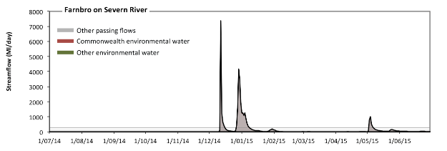
Figure NUT5: Contribution of environmental water delivery at Farnbro. Horizontal lines indicate thresholds for very low flows, low flows, low freshes, medium freshes and high freshes (from lowest to highest).
At Farnbro on Severn River environmental water contributed 3% of the total streamflow volume (all of which was Commonwealth Environmental Water) (Figure NUT5 and NUT6). Environmental watering actions affected streamflows for 6% of days between 1 June 2014 and 31 July 2015. Without environmental water, the durations of very low flows (i.e. < 3.9 Ml/day) in the periods July to September, October to December and January to March would have substantially exceeded durations expected in an average year in the natural flow regime. However, environmental water had little effect on the duration of these very low flows, which occurred for 63% of the year. Similarly, without environmental water, the durations of medium low flows (i.e. < 19 Ml/day) in the periods July to September, October to December and January to March would have substantially exceeded durations expected in an average year in the natural flow regime. However, environmental water had little effect on the duration of these medium low flows, which occurred for 70% of the year. There was at least one low fresh (i.e. > 97 Ml/day) in the periods October to December, January to March and April to June. Environmental water made little change to the duration of these low freshes. There was at least one medium fresh (i.e. > 290 Ml/day) in the periods October to December, January to March and April to June. Environmental water made little change to the duration of these medium freshes. In the absence of environmental water there would have been at least one high fresh in the periods October to December, January to March and April to June. Environmental water made little change to the duration of these high freshes.
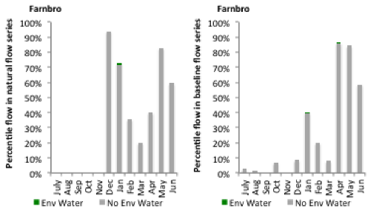
Figure NUT6: Contribution of environmental water delivery at Farnbro as percentiles in the natural and baseline flow series.
Goondiwindi
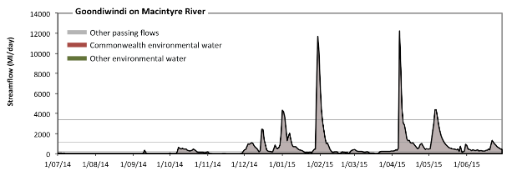
Figure NUT7: Contribution of environmental water delivery at Goondiwindi. Horizontal lines indicate thresholds for very low flows, low flows, low freshes, medium freshes and high freshes (from lowest to highest).
At Goondiwindi on Macintyre River environmental water contributed 0% of the total streamflow volume (all of which was Commonwealth Environmental Water) (Figure NUT7 and NUT8). Environmental watering actions affected streamflows for 1% of days between 1 June 2014 and 31 July 2015. Without environmental water, the durations of very low flows (i.e. < 48 Ml/day) in the periods July to September and October to December would have substantially exceeded durations expected in an average year in the natural flow regime. However, environmental water had little effect on the duration of these very low flows, which occurred for 33% of the year. Similarly, without environmental water, the durations of medium low flows (i.e. < 240 Ml/day) in the periods July to September, October to December and January to March would have substantially exceeded durations expected in an average year in the natural flow regime. However, environmental water had little effect on the duration of these medium low flows, which occurred for 53% of the year. There was at least one low fresh (i.e. > 1100 Ml/day) in the periods October to December, January to March and April to June. Environmental water made no change to the duration of these low freshes. There was at least one medium fresh (i.e. > 3400 Ml/day) in the periods January to March and April to June. Environmental water made no change to the duration of these medium freshes. In the absence of environmental water there would have been at least one high fresh in the periods January to March and April to June. Environmental water made no change to the duration of these high freshes.
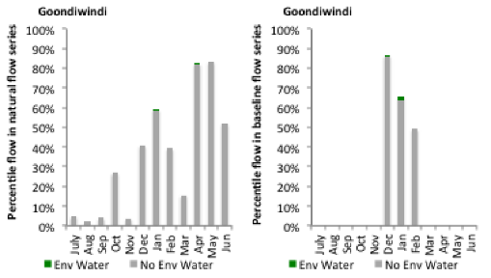
Figure NUT8: Contribution of environmental water delivery at Goondiwindi as percentiles in the natural and baseline flow series.
St George
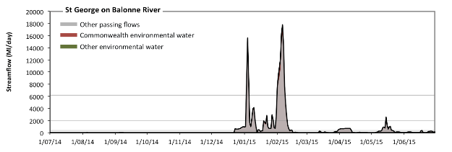
Figure NUT9: Contribution of environmental water delivery at St George. Horizontal lines indicate thresholds for very low flows, low flows, low freshes, medium freshes and high freshes (from lowest to highest).
At St George on Balonne River environmental water contributed 8% of the total streamflow volume (all of which was Commonwealth Environmental Water) (Figure NUT9 and NUT10). Environmental watering actions affected streamflows for 6% of days between 1 June 2014 and 31 July 2015. Without environmental water, the durations of very low flows (i.e. < 71 Ml/day) in the periods July to September, October to December, January to March and April to June would have all substantially exceeded durations expected in an average year in the natural flow regime. However, environmental water had little effect on the duration of these very low flows, which occurred for 69% of the year. Similarly, without environmental water, the durations of medium low flows (i.e. < 350 Ml/day) in the periods July to September, October to December, January to March and April to June would have all substantially exceeded durations expected in an average year in the natural flow regime. However, environmental water had little effect on the duration of these medium low flows, which occurred for 79% of the year. There was at least one low fresh (i.e. > 2000 Ml/day) in the periods January to March and April to June. Environmental water made no change to the duration of these low freshes. There was at least one medium fresh (i.e. > 6200 Ml/day) in the period January to March. Environmental water made no change to the duration of these medium freshes. In the absence of environmental water there would have been at least one high fresh in the period January to March. Environmental water made no change to the duration of these high freshes.
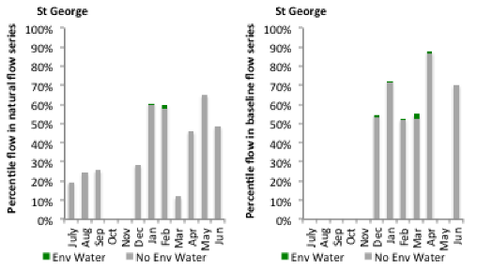
Figure NUT10: Contribution of environmental water delivery at St George as percentiles in the natural and baseline flow series.

Louth
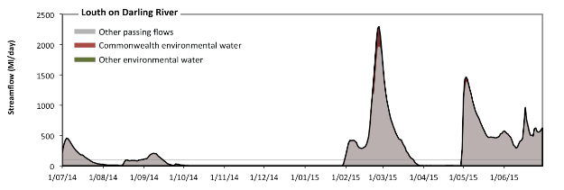
Figure NUT11: Contribution of environmental water delivery at Louth. Horizontal lines indicate thresholds for very low flows and low flows (from lowest to highest).
At Louth on Darling River environmental water contributed 3% of the total streamflow volume (all of which was Commonwealth Environmental Water) (Figure NUT11 and NUT12). Environmental watering actions affected streamflows for 6% of days between 1 June 2014 and 31 July 2015. Without environmental water, the durations of very low flows (i.e. < 20 Ml/day) in the periods July to September, October to December, January to March and April to June would have all substantially exceeded durations expected in an average year in the natural flow regime. However, environmental water had little effect on the duration of these very low flows, which occurred for 48% of the year. Similarly, without environmental water, the durations of medium low flows (i.e. < 99 Ml/day) in the periods July to September, October to December, January to March and April to June would have all substantially exceeded durations expected in an average year in the natural flow regime. However, environmental water had little effect on the duration of these medium low flows, which occurred for 58% of the year.
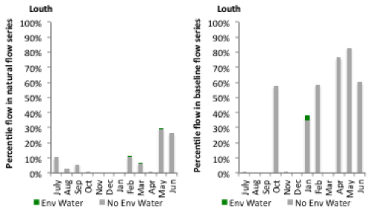
Figure NUT12: Contribution of environmental water delivery at Louth as percentiles in the natural and baseline flow series.

Collarenebri
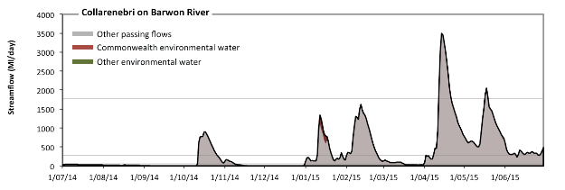Figure NUT13: Contribution of environmental water delivery at Collarenebri. Horizontal lines indicate thresholds for very low flows, low flows and low freshes (from lowest to highest).
At Collarenebri on Barwon River environmental water contributed 1% of the total streamflow volume (all of which was Commonwealth Environmental Water) (Figure NUT13 and NUT14). Environmental watering actions affected streamflows for 3% of days between 1 June 2014 and 31 July 2015. Without environmental water, the durations of very low flows (i.e. < 55 Ml/day) in the periods July to September, October to December and January to March would have substantially exceeded durations expected in an average year in the natural flow regime. However, environmental water had little effect on the duration of these very low flows, which occurred for 47% of the year. Similarly, without environmental water, the durations of medium low flows (i.e. < 270 Ml/day) in the periods July to September, October to December and January to March would have substantially exceeded durations expected in an average year in the natural flow regime. However, environmental water had little effect on the duration of these medium low flows, which occurred for 63% of the year. There was at least one low fresh (i.e. > 1800 Ml/day) in the period April to June. Environmental water made no change to the duration of these low freshes. There was no medium or high freshes this year.
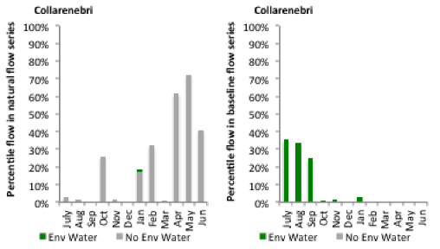
Figure NUT14: Contribution of environmental water delivery at Collarenebri as percentiles in the natural and baseline flow series.
Augathella
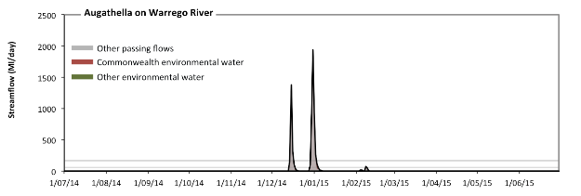 Figure NUT15: Contribution of environmental water delivery at Augathella. Horizontal lines indicate thresholds for very low flows, low flows, low freshes, medium freshes and high freshes (from lowest to highest).
At Augathella on Warrego River environmental water contributed 5% of the total streamflow volume (all of which was Commonwealth Environmental Water) (Figure NUT15 and NUT16). Environmental watering actions affected streamflows for 2% of days between 1 June 2014 and 31 July 2015. Without environmental water, the durations of very low flows (i.e. < 2.7 Ml/day) in the periods July to September, October to December, January to March and April to June would have all substantially exceeded durations expected in an average year in the natural flow regime. However, environmental water had little effect on the duration of these very low flows, which occurred for 95% of the year. Similarly, without environmental water, the durations of medium low flows (i.e. < 14 Ml/day) in the periods July to September, October to December, January to March and April to June would have all substantially exceeded durations expected in an average year in the natural flow regime. However, environmental water had little effect on the duration of these medium low flows, which occurred for 96% of the year. In the absence of environmental water there would have been at least one low fresh (i.e. > 59 Ml/day) in the periods October to December and January to March. Environmental water increased the duration of the longest low fresh during the period January to March (from 2 days to 3 days). CEW was entirely responsible for these increased durations of low freshes. There was at least one medium fresh (i.e. > 170 Ml/day) in the periods October to December and January to March. Environmental water made no change to the duration of these medium freshes. In the absence of environmental water there would have been at least one high fresh in the periods October to December and January to March. Environmental water made no change to the duration of these high freshes.
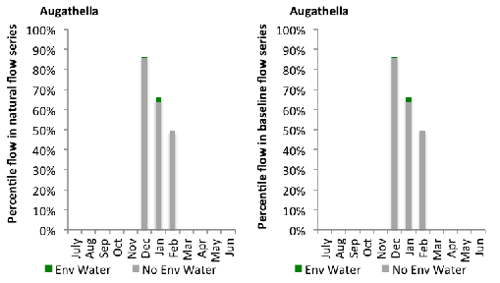
Figure NUT16: Contribution of environmental water delivery at Augathella as percentiles in the natural and baseline flow series.
Cunamulla
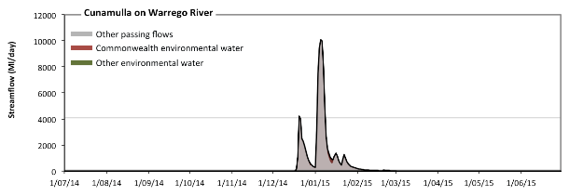 Figure NUT17: Contribution of environmental water delivery at Cunamulla. Horizontal lines indicate thresholds for very low flows, low flows and low freshes (from lowest to highest).
At Cunamulla on Warrego River environmental water contributed 2% of the total streamflow volume (all of which was Commonwealth Environmental Water) (Figure NUT17 and NUT18). Environmental watering actions affected streamflows for 2% of days between 1 June 2014 and 31 July 2015. Without environmental water, the durations of very low flows (i.e. < 20 Ml/day) in the periods July to September, October to December, January to March and April to June would have all substantially exceeded durations expected in an average year in the natural flow regime. However, environmental water had little effect on the duration of these very low flows, which occurred for 80% of the year. Similarly, without environmental water, the durations of medium low flows (i.e. < 99 Ml/day) in the periods July to September, October to December, January to March and April to June would have all substantially exceeded durations expected in an average year in the natural flow regime. However, environmental water had little effect on the duration of these medium low flows, which occurred for 86% of the year. There was at least one low fresh (i.e. > 4100 Ml/day) in the periods October to December and January to March. Environmental water made no change to the duration of these low freshes. There was no medium or high freshes this year.
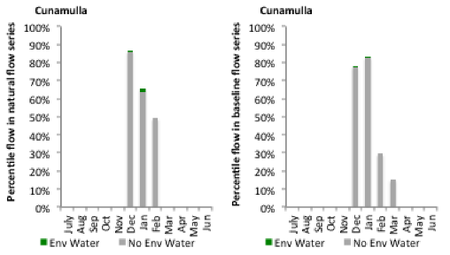
Figure NUT18: Contribution of environmental water delivery at Cunamulla as percentiles in the natural and baseline flow series.

A.6 Lachlan
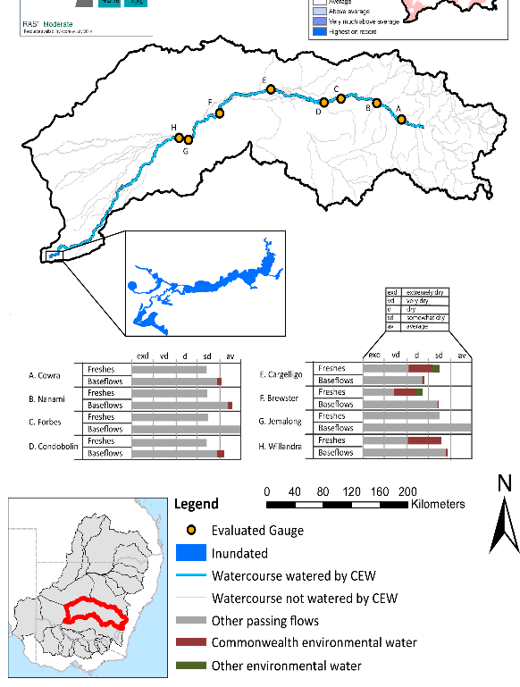
Figure LCH1: Location of evaluated gauges and the watercourses influenced by environmental water in the Lachlan valley during the 2014-15 water year. Inset bar graphs report the condition of annual flow regimes: for the hypothetical scenario if no environmental flow had been delivered (grey) and the improvements with the addition of environmental water. Rainfall conditions and trend in Storage levels for the water year are reported.

Summary Statement
Environmental water delivery for the 2014-15 year in the Lachlan Valley is evaluated using data for 8 sites. This evaluation only considers the contribution of held environmental water, which is a primary focus for the Commonwealth. The contributions of planned environmental water (e.g. passing flows), unregulated tributary inflows and clever use of irrigation flows for environmental benefits can all be very important but these are outside the scope of this report. Environmental watering actions lasted on average 11 days over the course of the year. The volume of environmental water at these 8 sites was between 1% and 5% of the total streamflow. Commonwealth Environmental Water contributed on average 86% of this environmental water. Ideally, baseflows should be maintained and long periods of excessively low flows avoided. In this valley, the baseflow regime was generally considered to be somewhat dry relative to the pre-development flow regime. In our analysis, a low fresh refers to a period of increased flow, when the water level rises at least one eighth of the way up the river bank (above the low flow level). These low freshes are a regular part of the natural flow regime and support a range of natural processes. In the Lachlan valley, in terms of the the occurrence and duration of low freshes, the year was assessed as being average. In our analysis, a medium fresh refers to a period of increased flow, when the water level rises at least one quater of the way up the river bank. These medium freshes are not as frequent as low freshes but are also a regular and important part of the natural flow regime. In the Lachlan valley, in terms of the occurrence of medium freshes, the year was assessed as being average. In our analysis, a high fresh refers to a period of increased flow, when the water level rises more than half way up the river. A high fresh may not occur every year but they are still important and long periods without major freshes can have serious consequences for floodplains and their contribution to river ecosystem health. Delivering environmental high in channel flows normally requires that all risks to riparian landholders and infrastructure have been resolved. In the Lachlan valley, in terms of the occurrence of high freshes, the year was assessed as being extremely dry. Commonwealth environmental water actions altered flow regimes along an estimated 838 km of 947 km of mainstem river (88.5%) from the Wyangla Dam outlet to the wetlands of the Cumbungi swamp. These actions contributed partially to the 995.4 ha of floodplain which was wet during the 2014-15 year.

Description of Environmental Water System
The Lachlan valley covers an area of 2193 km 2 representing 8.1% percent of the Murray Darling Basin. It is a virtual-terminal system with the river ending in the wetlands of the Great Cumbung Swamp. The Valley’s major water storage is Wyangala Dam (1217 GL). There are a series of minor in-stream storages, including Brewster Weir (5.5 GL). The Lachlan is a very long river with many anabranches and creeks both in the section near Condobolin, but primarily on the lower river downstream of Lake Brewster. Consequently the River’s channel capacity varies significantly with it becoming a smaller channel, particularly around the Condobolin anabranch area, and progressively downstream of Lake Brewster mainly due the distributary nature of the channels.
Floodplain wetlands in the Lachlan valley cover some 400,000 ha. They include the Lake Cowal system (near Forbes), to the billabong habitats in the Condobolin anabranch district and to the large wetland systems downstream of Lake Brewster both along the River and its other connected watercourses. There are nine-Nationally important wetlands in the Lachlan catchment.
Environmental water is typically released from Wyangala Dam, Lake Cargelligo and Lake Brewster. However, since the year 2000, Wyangala Dam has been the main source of regulated water. The main constraint impeding environmental flow delivery in the Lachlan is associated with Wyangala’s release capacity of 6,600 ML/day which reduces as the volume of stored water reduces (Mdba 2013). Wyangala Dam is also the source of secure water supply for downstream irrigators and towns in the Lachlan, so any environmental releases are made in addition to the consumptive needs. Other constraints occur at Lake Brewster which has a maximum release capacity of 3000 ML/day. Flows greater than 2400 ML/d upstream of Willandra weir cause inflows to begin in Willandra Creek. Finally, irrigation infrastructure maybe inundated in the Hillston area at flows above 2800 ML/day.
The Lachlan is a highly variable system with many distributary creeks with varying channel capacities. Delivery efficiency is a very important consideration for use of CEW in the Lachlan, as assets are located a long distance from the major storage, and the secondary storages have limited capacity. Many potential watering actions incorporate an element of piggybacking in order to maximise efficiency and outcomes for assets. This has the potential to constrain use e.g. replenishment flows can occur within a large operating window, and the timing can affect efficient delivery of CEW.
The CEW portfolio consists of 86 GL of General Security entitlements which have a Long Term Average Annual Yield of 36 GL. Under continuous accounting and the provisions for carryover, the risk of forfeiture for CEW in the Lachlan is low (considering the previous use pattern). In order to have a reasonable ability to maintain key environmental assets, CEW is managed by effectively carrying over volumes of water for use in future years, with the pattern of use changing and adapting depending on what additional water is available in the system and the condition of assets. In the event that the volume in CEW accounts reaches a low threshold (e.g. 10 GL), water use would potentially be limited in order to maintain a contingency volume to avoid damage to environmental assets. Overall, environmental water delivery in this valley aims to maintain and contribute to restoration to key environmental features by delivering river flow regimes, which, mimic as much as possible, the natural conditions.

Data Availability
The contribution (where applicable) of the CEW and NSW environmental water and other passing flows were derived from the CAIRO river operations spreadsheet held by Water NSW. The waterholding, and its source was checked against use charged on the held environmental water entitlements. Known travel times, accounting data, contributions from tributaries and differences between allocated and unallocated flows were used to quantify the movement of water from the source point to its accounting point. The approach assumed no longitudinal delivery loss.

Environmental Conditions
The resource availability score for the Lachlan valley was estimated (July 2014) as Moderate (LCH 1). Whereas, the rainfall conditions (based on gridded rainfall percentiles which compare the rainfall experienced for the water year to the total record) experienced were categorised as average (Figure 1 – Main report). The storage levels of Lake Wyangala declined from a high of 49% at the beginning of the water year to 40% by the end of the water year.

Environmental Water Actions in 2014-15
In 2014-15 CEW was designed to:
- Support native fish by preserving natural cues for migration, spawning and recruitment of native fish; and
- Support ecosystem function and improve ecosystem and population resilience through supporting ecological recovery.

15000 ML of CEW was approved for delivery in the Lachlan valley. The CEW portfolio yielded 5000ML (5.7%) of its registered entitlement.
5000ML of CEW was delivered in the Lachlan valley, which contributed to one watering action which spread over 69 days, covering 19% of the water year and occurred between August and November 2014 (Figure LCH2). The action represented 86% of total environmental water delivered in the catchment, but only accounted for 0.35% of total flows expected under predevelopment conditions (Table LCH1).
The watering action was designed to protect the integrity of small to medium unregulated flows through the Lachlan valley which would contribute to the maintenance of hydrological connectivity and end of system flows. This action was largely delivered and protected as intended. However, the fresh flow of approximately 10GL targeting the Booligal wetlands did not proceed because the trigger associated with replenishment flows was not met. Approximately 39 GL of CEW was carried over for use.
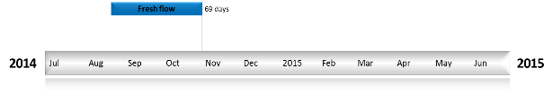
Figure LCH2: Timing and duration of Commonwealth Environmental Water actions in 2014-15.
Table LCH1: Environmental water approved and delivered in the Lachlan over 2014-15
Source | Total approved volume (ML) | Total volume delivered (ML) | % delivered of total EWater delivered | % contribution to predevelopment flows ¹
CEW | 15,000 | 5000 | 85.9 | 0.35
NSW | NA | 821 | 14.1 | 0.06
¹ predevelopment average annual inflows of 1424.3 GL

Contribution of Commonwealth Environmental Water to Flow Regimes
Cowra
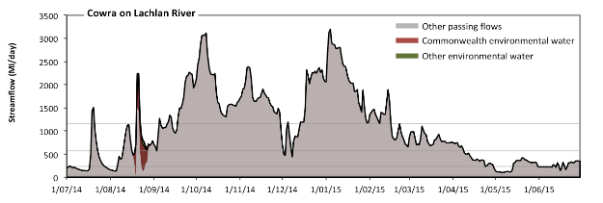
Figure LCH3: Contribution of environmental water delivery at Cowra. Horizontal lines indicate thresholds for very low flows, low flows, low freshes and medium freshes (from lowest to highest).
At Cowra on Lachlan River environmental water contributed 1% of the total streamflow volume (most of which was Commonwealth Environmental Water) (Figure LCH3 and LCH4). Environmental watering actions affected streamflows for 3% of days between 1 June 2014 and 31 July 2015. Flow regulation does not substantially increase the duration of very low flows (i.e. < 47 Ml/day) compared to an average year in the natural flow regime. However, without environmental water, the duration of medium low flows (i.e. < 240 Ml/day) in the period July to September would have substantially exceeded durations expected in an average year in the natural flow regime. Environmental water mitigated these impacts by reducing the cumulative duration of medium low flow spells from 16% to 15% of the year, with greatest influence in the period July to September. In the absence of environmental water there would have been at least one low fresh (i.e. > 570 Ml/day) in the periods July to September, October to December, January to March and April to June. Environmental water increased the duration of the longest low fresh during the period July to September (from 34 days to 43 days). CEW equally shared responsibility with other environmental water holders for these increased durations of low freshes. There was at least one medium fresh (i.e. > 1200 Ml/day) in the periods July to September, October to December and January to March. Environmental water made no change to the duration of these medium freshes. There was no high freshes (i.e. > 3500 Ml/day) this year.
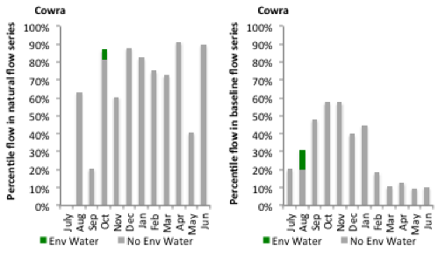
Figure LCH4: Contribution of environmental water delivery at Cowra as percentiles in the natural and baseline flow series.
Forbes
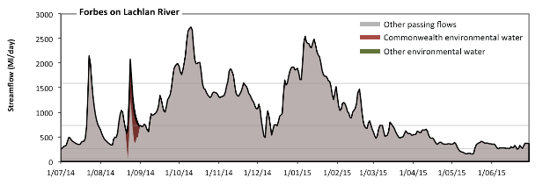
Figure LCH5: Contribution of environmental water delivery at Forbes. Horizontal lines indicate thresholds for very low flows, low flows, low freshes and medium freshes (from lowest to highest).
At Forbes on Lachlan River environmental water contributed 2% of the total streamflow volume (most of which was Commonwealth Environmental Water) (Figure LCH5 and LCH6). Environmental watering actions affected streamflows for 3% of days between 1 June 2014 and 31 July 2015. Flow regulation does not substantially increase the duration of very low flows (i.e. < 54 Ml/day) compared to an average year in the natural flow regime. Flow regulation does not substantially increase the duration of medium low flows (i.e. < 270 Ml/day) compared to an average year in the natural flow regime. There was at least one low fresh (i.e. > 730 Ml/day) in the periods July to September, October to December and January to March. Environmental water made no change to the duration of these low freshes. There was at least one medium fresh (i.e. > 1600 Ml/day) in the periods July to September, October to December and January to March. Environmental water made no change to the duration of these medium freshes. There was no high freshes (i.e. > 5200 Ml/day) this year.
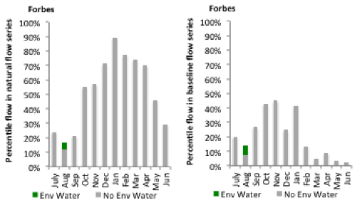
Figure LCH6: Contribution of environmental water delivery at Forbes as percentiles in the natural and baseline flow series.
Nanami
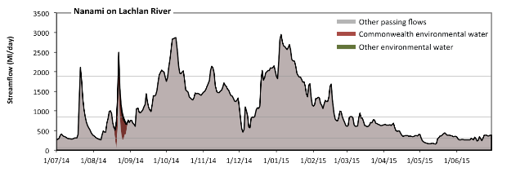
Figure LCH7: Contribution of environmental water delivery at Nanami. Horizontal lines indicate thresholds for very low flows, low flows, low freshes and medium freshes (from lowest to highest).
At Nanami on Lachlan River environmental water contributed 2% of the total streamflow volume (most of which was Commonwealth Environmental Water) (Figure LCH7 and LCH8). Environmental watering actions affected streamflows for 3% of days between 1 June 2014 and 31 July 2015. Flow regulation does not substantially increase the duration of very low flows (i.e. < 61 Ml/day) compared to an average year in the natural flow regime. However, without environmental water, the duration of medium low flows (i.e. < 300 Ml/day) in the period July to September would have substantially exceeded durations expected in an average year in the natural flow regime. Environmental water mitigated these impacts by reducing the cumulative duration of medium low flow spells from 13% to 12% of the year, with greatest influence in the period July to September. There was at least one low fresh (i.e. > 850 Ml/day) in the periods July to September, October to December and January to March. Environmental water made no change to the duration of these low freshes. There was at least one medium fresh (i.e. > 1900 Ml/day) in the periods July to September, October to December and January to March. Environmental water made no change to the duration of these medium freshes. There was no high freshes (i.e. > 6300 Ml/day) this year.
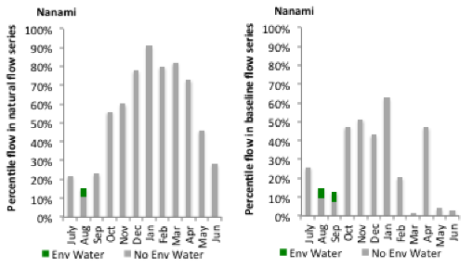
Figure LCH8: Contribution of environmental water delivery at Nanami as percentiles in the natural and baseline flow series.
Condobolin
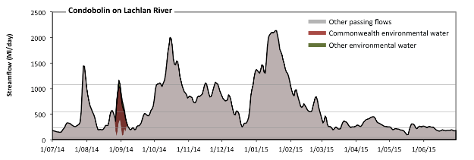
Figure LCH9: Contribution of environmental water delivery at Condobolin. Horizontal lines indicate thresholds for very low flows, low flows, low freshes and medium freshes (from lowest to highest).
At Condobolin on Lachlan River environmental water contributed 3% of the total streamflow volume (most of which was Commonwealth Environmental Water) (Figure LCH9 and LCH10). Environmental watering actions affected streamflows for 3% of days between 1 June 2014 and 31 July 2015. Flow regulation does not substantially increase the duration of very low flows (i.e. < 46 Ml/day) compared to an average year in the natural flow regime. However, without environmental water, the duration of medium low flows (i.e. < 230 Ml/day) in the period July to September would have substantially exceeded durations expected in an average year in the natural flow regime. Environmental water mitigated these impacts by reducing the cumulative duration of medium low flow spells from 20% to 18% of the year, with greatest influence in the period July to September. There was at least one low fresh (i.e. > 540 Ml/day) in the periods July to September, October to December and January to March. Environmental water made no change to the duration of these low freshes. There was at least one medium fresh (i.e. > 1100 Ml/day) in the periods July to September, October to December and January to March. Environmental water made no change to the duration of these medium freshes. There was no high freshes (i.e. > 3200 Ml/day) this year.
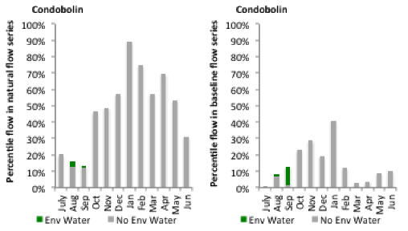
Figure LCH10: Contribution of environmental water delivery at Condobolin as percentiles in the natural and baseline flow series.
Cargelligo
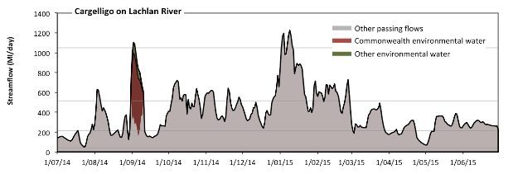
Figure LCH11: Contribution of environmental water delivery at Cargelligo. Horizontal lines indicate thresholds for very low flows, low flows, low freshes and medium freshes (from lowest to highest).
At Cargelligo on Lachlan River environmental water contributed 4% of the total streamflow volume (most of which was Commonwealth Environmental Water) (Figure LCH11 and LCH12). Environmental watering actions affected streamflows for 3% of days between 1 June 2014 and 31 July 2015. Flow regulation does not substantially increase the duration of very low flows (i.e. < 42 Ml/day) compared to an average year in the natural flow regime. However, without environmental water, the duration of medium low flows (i.e. < 210 Ml/day) in the period July to September would have substantially exceeded durations expected in an average year in the natural flow regime. However, environmental water had little effect on the duration of these medium low flows, which occurred for 22% of the year. In the absence of environmental water there would have been at least one low fresh (i.e. > 520 Ml/day) in the periods July to September, October to December and January to March. Environmental water increased the duration of the longest low fresh during the period July to September (from 3 days to 11 days). CEW was entirely responsible for these increased durations of low freshes. In the absence of environmental water there would have been at least one medium fresh (i.e. > 1000 Ml/day) in the period January to March. Environmental water increased the duration of the longest medium fresh during the period July to September (from 0 days to 2 days). CEW equally shared responsibility with other environmental water holders for these increased durations of medium freshes. There was no high freshes (i.e. > 3200 Ml/day) this year.
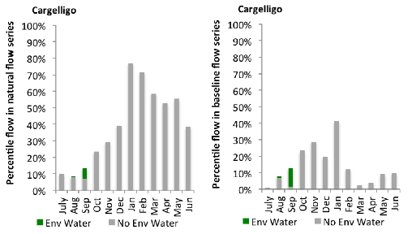
Figure LCH12: Contribution of environmental water delivery at Cargelligo as percentiles in the natural and baseline flow series.
Jemalong
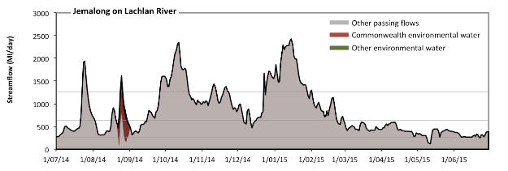Figure LCH13: Contribution of environmental water delivery at Jemalong. Horizontal lines indicate thresholds for very low flows, low flows, low freshes and medium freshes (from lowest to highest).
At Jemalong on Lachlan River environmental water contributed 2% of the total streamflow volume (most of which was Commonwealth Environmental Water) (Figure LCH13 and LCH14). Environmental watering actions affected streamflows for 3% of days between 1 June 2014 and 31 July 2015. Flow regulation does not substantially increase the duration of very low flows (i.e. < 54 Ml/day) compared to an average year in the natural flow regime. Flow regulation does not substantially increase the duration of medium low flows (i.e. < 270 Ml/day) compared to an average year in the natural flow regime. There was at least one low fresh (i.e. > 640 Ml/day) in the periods July to September, October to December and January to March. Environmental water made no change to the duration of these low freshes. There was at least one medium fresh (i.e. > 1300 Ml/day) in the periods July to September, October to December and January to March. Environmental water made no change to the duration of these medium freshes. There was no high freshes (i.e. > 3700 Ml/day) this year.
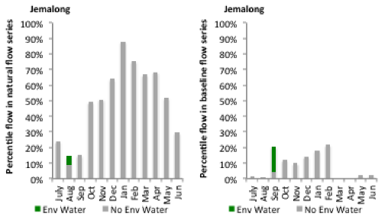
Figure LCH14: Contribution of environmental water delivery at Jemalong as percentiles in the natural and baseline flow series.
Brewster
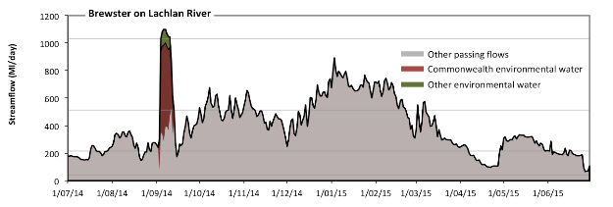 Figure LCH15: Contribution of environmental water delivery at Brewster. Horizontal lines indicate thresholds for very low flows, low flows, low freshes and medium freshes (from lowest to highest).
At Brewster on Lachlan River environmental water contributed 4% of the total streamflow volume (most of which was Commonwealth Environmental Water) (Figure LCH15 and LCH16). Environmental watering actions affected streamflows for 3% of days between 1 June 2014 and 31 July 2015. Flow regulation does not substantially increase the duration of very low flows (i.e. < 43 Ml/day) compared to an average year in the natural flow regime. However, without environmental water, the durations of medium low flows (i.e. < 220 Ml/day) in the periods July to September and April to June would have substantially exceeded durations expected in an average year in the natural flow regime. However, environmental water had little effect on the duration of these medium low flows, which occurred for 22% of the year. In the absence of environmental water there would have been at least one low fresh (i.e. > 510 Ml/day) in the periods July to September, October to December and January to March. Environmental water increased the duration of the longest low fresh during the period July to September (from 1 days to 10 days). CEW was almost entirely responsible for these increased durations of low freshes. In the absence of environmental water there would have been no medium or high freshes this year. Environmental water increased the duration of the longest medium fresh during the period July to September (from 0 days to 7 days). CEW equally shared responsibility with other environmental water holders for these increased durations of medium freshes.
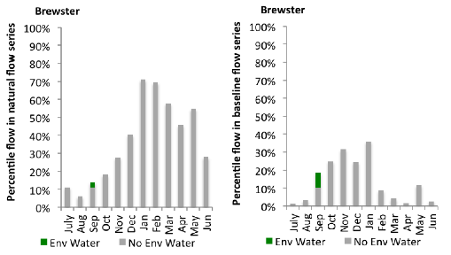
Figure LCH16: Contribution of environmental water delivery at Brewster as percentiles in the natural and baseline flow series.
Willandra
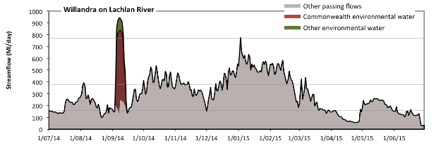 Figure LCH17: Contribution of environmental water delivery at Willandra. Horizontal lines indicate thresholds for very low flows, low flows, low freshes and medium freshes (from lowest to highest).
At Willandra on Lachlan River environmental water contributed 5% of the total streamflow volume (most of which was Commonwealth Environmental Water) (Figure LCH17 and LCH18). Environmental watering actions affected streamflows for 3% of days between 1 June 2014 and 31 July 2015. Flow regulation does not substantially increase the duration of very low flows (i.e. < 31 Ml/day) compared to an average year in the natural flow regime. However, without environmental water, the durations of medium low flows (i.e. < 160 Ml/day) in the periods July to September and April to June would have substantially exceeded durations expected in an average year in the natural flow regime. Environmental water mitigated these impacts by reducing the cumulative duration of medium low flow spells from 25% to 25% of the year, with greatest influence in the period July to September. In the absence of environmental water there would have been at least one low fresh (i.e. > 380 Ml/day) in the periods July to September, October to December and January to March. Environmental water increased the duration of the longest low fresh during the period July to September (from 1 days to 10 days). CEW was entirely responsible for these increased durations of low freshes. In the absence of environmental water there would have been at least one medium fresh (i.e. > 770 Ml/day) in the period January to March. Environmental water increased the duration of the longest medium fresh during the period July to September (from 0 days to 7 days). CEW was entirely responsible for these increased durations of medium freshes. There was no high freshes (i.e. > 2300 Ml/day) this year.
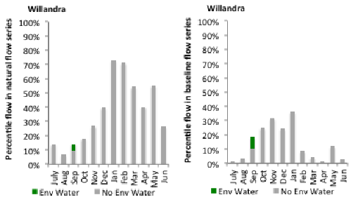
Figure LCH18: Contribution of environmental water delivery at Willandra as percentiles in the natural and baseline flow series.

A.7 Macquarie
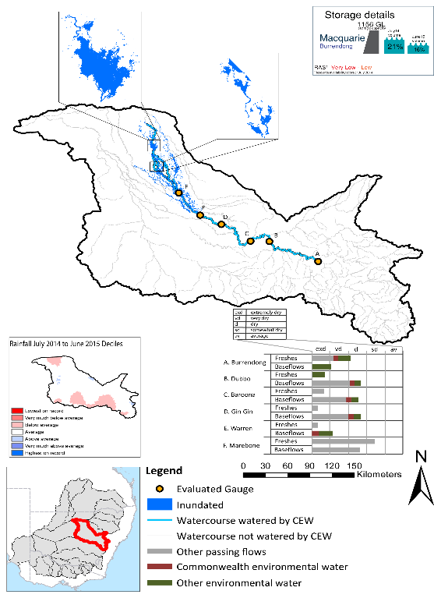
Figure MCQ1: Location of evaluated gauges and the watercourses influenced by environmental water in the Macquarie valley during the 2014-15 water year. Inset bar graphs report the condition of annual flow regimes: for the hypothetical scenario if no environmental flow had been delivered (grey) and the improvements with the addition of environmental water. Rainfall conditions and trend in Storage levels for the water year are reported.

Summary Statement
Environmental water delivery for the 2014-15 year in the Macquarie Valley is evaluated using data for 6 sites. This evaluation only considers the contribution of held environmental water, which is a primary focus for the Commonwealth. The contributions of planned environmental water (e.g. passing flows), unregulated tributary inflows and clever use of irrigation flows for environmental benefits can all be very important but these are outside the scope of this report. Environmental watering actions lasted on average 74 days over the course of the year. The volume of environmental water at these 6 sites was between 17% and 37% of the total streamflow. Commonwealth Environmental Water contributed on average 30% of this environmental water. Ideally, baseflows should be maintained and long periods of excessively low flows avoided. In this valley, the baseflow regime was generally considered to be extremely dry relative to the pre-development flow regime. In our analysis, a low fresh refers to a period of increased flow, when the water level rises at least one eighth of the way up the river bank (above the low flow level). These low freshes are a regular part of the natural flow regime and support a range of natural processes. In the Macquarie valley, in terms of the the occurrence and duration of low freshes, the year was assessed as being very dry. In our analysis, a medium fresh refers to a period of increased flow, when the water level rises at least one quater of the way up the river bank. These medium freshes are not as frequent as low freshes but are also a regular and important part of the natural flow regime. In the Macquarie valley, in terms of the occurrence of medium freshes, the year was assessed as being very dry. In our analysis, a high fresh refers to a period of increased flow, when the water level rises more than half way up the river. A high fresh may not occur every year but they are still important and long periods without major freshes can have serious consequences for floodplains and their contribution to river ecosystem health. Delivering environmental high in channel flows normally requires that all risks to riparian landholders and infrastructure have been resolved. In the Macquarie valley, in terms of the occurrence of high freshes, the year was assessed as being extremely dry. Commonwealth environmental water actions altered an estimated 602 km of river out of a maximum of 1246 km (48%). These actions contributed partially to the 16,592 ha of floodplain which was wet during the 2014-15 year.

Description of Environmental Water System
The Macquarie valley covers an area of 74582 km2, which represents 7.0% of the total Mdb area. The valley is bordered by the Barwon-Darling catchment to the north and west, the Lachlan to the south and the Namoi to the north. Burrendong Dam (capacity 1,188 GL) is the major storage in the valley. There are several distributary rivers and creeks that enter the Macquarie river, including Bell, Little and Talbragar Rivers. The Macquarie Marshes Ramsar site is located within the Macquarie Marshes wetland system in the northern part of the water resource plan area.
Flows to the Lower Macquarie River (80km river section downstream of the Macquarie Marshes, to the Barwon River confluence) occur either from surplus and environmental flows from the Northern Macquarie Marshes. The WSP states that replenishment flows are required of up to 50ML/day at Miltara, at least twice a year. Delivery of dedicated replenishment flows is usually via the North Marsh Bypass channel. It is not possible to deliver water to the Lower Macquarie River without beneficial losses along the way that contribute to watering the Macquarie Marshes and mid-Macquarie River. A consequence of the integrated nature of the Lower Macquarie and northern Macquarie Marshes means that targeting the lower Macquarie will transfer or transport important ecological outputs to the Barwon/Darling River.
Delivery of environmental water in the Macquarie valley is constrained by storage release capacities, channel capacity, infrastructure and unintended third party impacts. As such, watering options are developed with consideration to the following constraints (CEWO 2014):
1. South Dubbo weir drown out at >14385 Ml/day
2. Marebone Choke – third party impact at prolonged flows > 4000 ML / day
3. Marebone weir: 3200ml/day in areas downstream which can result in overbank flows upstream of the delivery point, impacts to crops and channel congestion at Marebone break
4. Infrastructure constraints such as Crooked Creek off take capacity of 100 ML/day
5. Banks, weirs, regulators and diversion channels in the Marshes

Data Availability
The contribution (where applicable) of the CEW and NSW environmental water and other passing flows were derived from the CAIRO river operations spreadsheet held by Water NSW. The accounted waterholding, and its source was tracked longitudinally using known travel times, contributions from tributaries and differences between allocated and unallocated flow. The method assumed no longitudinal delivery loss, so in other words, the CEW component is likely to be underestimated at reaches upstream of the accounting point.

Environmental Conditions
The resource availability score for the Macquarie valley was estimated (July 2014) as Very Low to Low (BRK 1). Whereas, the rainfall conditions (based on gridded rainfall percentiles which compare the rainfall experienced for the water year to the total record) experienced were categorised as average (Figure 1 – Main report). The storage levels of Lake Burrendong declined from a high of 21% at the beginning of the water year to 16% by the end of the water year.

Environmental Water Actions in 2014-15
In 2014-15 CEW watering actions were designed to:
- Inundate core wetlands in the Macquarie Marshes and contribute to annual water requirements of the native marsh vegetation
- Support native fish habitat by increasing availability of and access to suitable fish habitat, promoting fish movement and providing cues and appropriate habitats for spawning, recruitment and migration of native fish
- Restore a more natural flow regime and address cold water pollution.
19,337 ML of CEW was approved for delivery in the Macquarie valley. The CEW portfolio yielded 10,000 ML (7.4%) of its registered entitlement. The longterm average annual yield (Ltaay) of the CEW entitlement during 2014-15 was 54755 ML.
10,000 of CEW was delivered in the Macquarie valley, contributing to one watering action which spread over 60 days (16% of the water year) and occurred between October and December 2014 (Figure MCQ2). The watering action represented 35 % of total environmental water delivered in the valley for 2014-15, but only accounted for 0.3% of the total expected flows under a predevelopment condition. This was improved to 0.9% by contributions from the NSW Office of Environment and Heritage (Table MCQ2).
The action was delivered largely as intended with flow rates at Marebone Weir (accounting point) peaking at around 880ML/day, with flows of around 500ML/day being experienced at the accounting point for most of the 60 day period which was followed by slow recession.
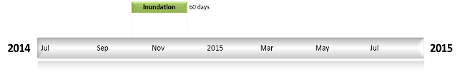
Figure MCQ2: Timing and duration of Macquarie Commonwealth environmental water actions in 2014-15.

Table MCQ2: Environmental water approved and delivered in the Macquarie over 2014-15
Source | LTAAY (ML) | Total approved volume (ML) | Total volume delivered (ML) | % delivered of total EWater delivered | % contribution to predevelopment flows ¹
CEW | 54755 | 19337 | 10000 | 35.1 | 0.3
NSW | NA |  | 18494 | 64.9 | 0.6
¹ predevelopment average annual inflows for Macquarie-Castlereagh of 2859.1 GL

Contribution of Commonwealth Environmental Water to Flow Regimes
Burrendong
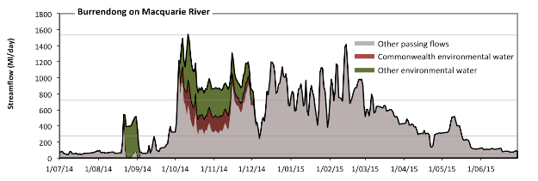
Figure MCQ3: Contribution of environmental water delivery at Burrendong. Horizontal lines indicate thresholds for very low flows, low flows, low freshes and medium freshes (from lowest to highest).
At Burrendong on Macquarie River environmental water contributed 18% of the total streamflow volume (with a medium contribution of Commonwealth Environmental Water) (Figure MCQ3 and MCQ4). Environmental watering actions affected streamflows for 20% of days between 1 June 2014 and 31 July 2015. Without environmental water, the duration of very low flows (i.e. < 55 Ml/day) in the period July to September would have substantially exceeded durations expected in an average year in the natural flow regime. Environmental water mitigated these impacts by reducing the cumulative duration of very low flow spells from 5% to 3% of the year, with greatest influence in the period July to September. Similarly, without environmental water, the durations of medium low flows (i.e. < 270 Ml/day) in the periods July to September and April to June would have substantially exceeded durations expected in an average year in the natural flow regime. Environmental water mitigated these impacts by reducing the cumulative duration of medium low flow spells from 37% to 34% of the year, with greatest influence in the period July to September. CEW made little or no contribution to these enhancements of environmental baseflows at this site. In the absence of environmental water there would have been at least one low fresh (i.e. > 720 Ml/day) in the periods October to December and January to March. Environmental water increased the duration of the longest low fresh during the period October to December (from 17 days to 61 days). CEW made little or no contribution to these increased durations of low freshes. In the absence of environmental water there would have been no medium or high freshes this year. Environmental water increased the duration of the longest medium fresh during the period October to December (from 0 days to 1 days). CEW equally shared responsibility with other environmental water holders for these increased durations of medium freshes.
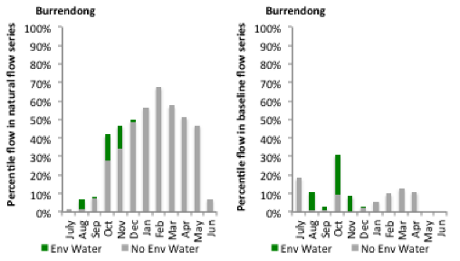
Figure MCQ4: Contribution of environmental water delivery at Burrendong as percentiles in the natural and baseline flow series.
Dubbo
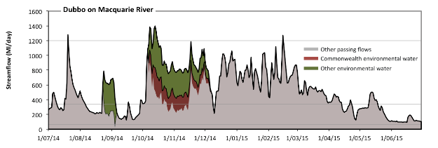
Figure MCQ5: Contribution of environmental water delivery at Dubbo. Horizontal lines indicate thresholds for very low flows, low flows and low freshes (from lowest to highest).
At Dubbo on Macquarie River environmental water contributed 17% of the total streamflow volume (with a medium contribution of Commonwealth Environmental Water) (Figure MCQ5 and MCQ6). Environmental watering actions affected streamflows for 20% of days between 1 June 2014 and 31 July 2015. Flow regulation does not substantially increase the duration of very low flows (i.e. < 68 Ml/day) compared to an average year in the natural flow regime. However, without environmental water, the durations of medium low flows (i.e. < 340 Ml/day) in the periods July to September and April to June would have substantially exceeded durations expected in an average year in the natural flow regime. Environmental water mitigated these impacts by reducing the cumulative duration of medium low flow spells from 41% to 33% of the year, with greatest influence in the periods July to September and October to December. CEW made a modest contribution to these enhancements of environmental baseflows at this site. In the absence of environmental water there would have been at least one low fresh (i.e. > 1200 Ml/day) in the periods July to September and January to March. Environmental water increased the duration of the longest low fresh during the period October to December (from 0 days to 4 days). CEW made little or no contribution to these increased durations of low freshes. There was no medium or high freshes this year.
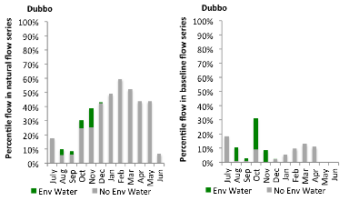
Figure MCQ6: Contribution of environmental water delivery at Dubbo as percentiles in the natural and baseline flow series.
Baroona
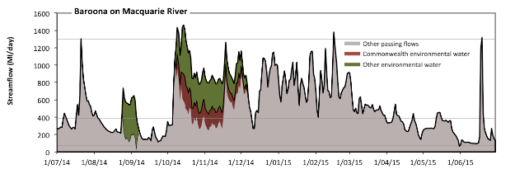
Figure MCQ7: Contribution of environmental water delivery at Baroona. Horizontal lines indicate thresholds for very low flows, low flows and low freshes (from lowest to highest).
At Baroona on Macquarie River environmental water contributed 17% of the total streamflow volume (with a medium contribution of Commonwealth Environmental Water) (Figure MCQ7 and MCQ8). Environmental watering actions affected streamflows for 20% of days between 1 June 2014 and 31 July 2015. Flow regulation does not substantially increase the duration of very low flows (i.e. < 77 Ml/day) compared to an average year in the natural flow regime. However, without environmental water, the durations of medium low flows (i.e. < 390 Ml/day) in the periods July to September, October to December and April to June would have substantially exceeded durations expected in an average year in the natural flow regime. Environmental water mitigated these impacts by reducing the cumulative duration of medium low flow spells from 49% to 39% of the year, with greatest influence in the periods July to September and October to December. CEW made a modest contribution to these enhancements of environmental baseflows at this site. In the absence of environmental water there would have been at least one low fresh (i.e. > 1300 Ml/day) in the periods July to September, January to March and April to June. Environmental water increased the duration of the longest low fresh during the period October to December (from 0 days to 3 days). CEW equally shared responsibility with other environmental water holders for these increased durations of low freshes. There was no medium or high freshes this year.
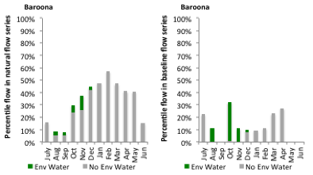
Figure MCQ8: Contribution of environmental water delivery at Baroona as percentiles in the natural and baseline flow series.
Gin Gin
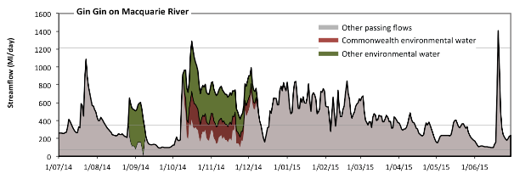
Figure MCQ9: Contribution of environmental water delivery at Gin Gin. Horizontal lines indicate thresholds for very low flows, low flows and low freshes (from lowest to highest).
At Gin Gin on Macquarie River environmental water contributed 20% of the total streamflow volume (with a medium contribution of Commonwealth Environmental Water) (Figure MCQ9 and MCQ10). Environmental watering actions affected streamflows for 20% of days between 1 June 2014 and 31 July 2015. Flow regulation does not substantially increase the duration of very low flows (i.e. < 69 Ml/day) compared to an average year in the natural flow regime. However, without environmental water, the durations of medium low flows (i.e. < 350 Ml/day) in the periods July to September, October to December and April to June would have substantially exceeded durations expected in an average year in the natural flow regime. Environmental water mitigated these impacts by reducing the cumulative duration of medium low flow spells from 55% to 39% of the year, with greatest influence in the period October to December. CEW made a modest contribution to these enhancements of environmental baseflows at this site. In the absence of environmental water there would have been at least one low fresh (i.e. > 1200 Ml/day) in the period April to June. Environmental water increased the duration of the longest low fresh during the period October to December (from 0 days to 1 days). CEW equally shared responsibility with other environmental water holders for these increased durations of low freshes. There was no medium or high freshes this year.
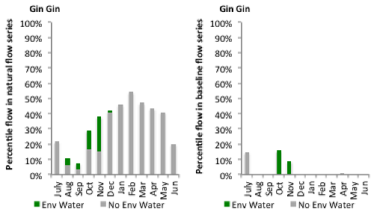
Figure MCQ10: Contribution of environmental water delivery at Gin Gin as percentiles in the natural and baseline flow series.

Warren
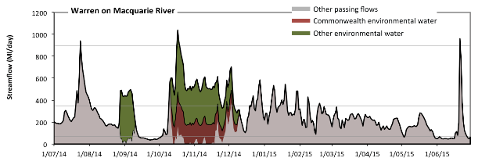
Figure MCQ11: Contribution of environmental water delivery at Warren. Horizontal lines indicate thresholds for very low flows, low flows and low freshes (from lowest to highest).
At Warren on Macquarie River environmental water contributed 32% of the total streamflow volume (with a medium contribution of Commonwealth Environmental Water) (Figure MCQ11 and MCQ12). Environmental watering actions affected streamflows for 20% of days between 1 June 2014 and 31 July 2015. Without environmental water, the durations of very low flows (i.e. < 69 Ml/day) in the periods July to September, October to December and April to June would have substantially exceeded durations expected in an average year in the natural flow regime. Environmental water mitigated these impacts by reducing the cumulative duration of very low flow spells from 25% to 12% of the year, with greatest influence in the period October to December. Similarly, without environmental water, the durations of medium low flows (i.e. < 350 Ml/day) in the periods July to September, October to December, January to March and April to June would have all substantially exceeded durations expected in an average year in the natural flow regime. Environmental water mitigated these impacts by reducing the cumulative duration of medium low flow spells from 88% to 71% of the year, with greatest influence in the period October to December. CEW made a modest contribution to these enhancements of environmental baseflows at this site. In the absence of environmental water there would have been at least one low fresh (i.e. > 900 Ml/day) in the periods July to September and April to June. Environmental water increased the duration of the longest low fresh during the period October to December (from 0 days to 2 days). CEW equally shared responsibility with other environmental water holders for these increased durations of low freshes. There was no medium or high freshes this year.
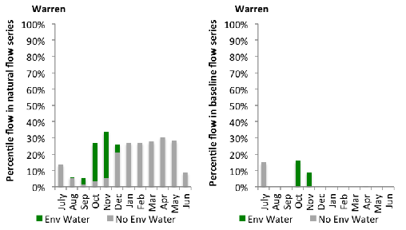
Figure MCQ12: Contribution of environmental water delivery at Warren as percentiles in the natural and baseline flow series.

Marebone
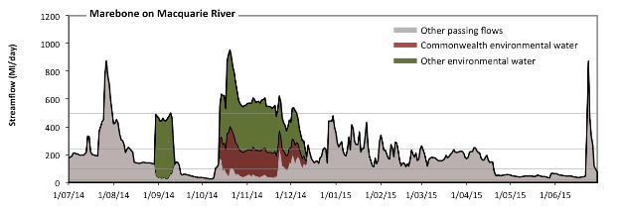Figure MCQ13: Contribution of environmental water delivery at Marebone. Horizontal lines indicate thresholds for very low flows, low flows, low freshes and medium freshes (from lowest to highest).
At Marebone on Macquarie River environmental water contributed 37% of the total streamflow volume (with a medium contribution of Commonwealth Environmental Water) (Figure MCQ13 and MCQ14). Environmental watering actions affected streamflows for 20% of days between 1 June 2014 and 31 July 2015. Flow regulation does not substantially increase the duration of very low flows (i.e. < 20 Ml/day) compared to an average year in the natural flow regime. However, without environmental water, the durations of medium low flows (i.e. < 98 Ml/day) in the periods July to September, October to December and April to June would have substantially exceeded durations expected in an average year in the natural flow regime. Environmental water mitigated these impacts by reducing the cumulative duration of medium low flow spells from 39% to 25% of the year, with greatest influence in the period October to December. CEW equally shared responsibility with other environmental water holders for these enhancements of environmental baseflows at this site. In the absence of environmental water there would have been at least one low fresh (i.e. > 240 Ml/day) in the periods July to September, October to December, January to March and April to June. Environmental water increased the duration of the longest low fresh during the period October to December (from 5 days to 59 days). CEW made a small contribution to these increased durations of low freshes. In the absence of environmental water there would have been at least one medium fresh (i.e. > 500 Ml/day) in the periods July to September and April to June. Environmental water increased the duration of the longest medium fresh during the period October to December (from 0 days to 39 days). CEW made little or no contribution to these increased durations of medium freshes. There was no high freshes (i.e. > 1500 Ml/day) this year.
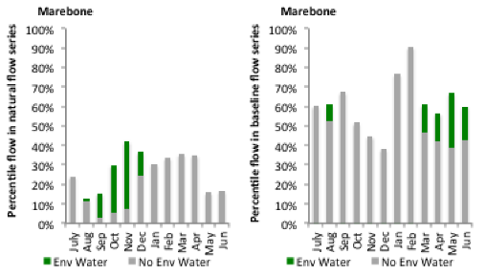
Figure MCQ14: Contribution of environmental water delivery at Marebone as percentiles in the natural and baseline flow series.

A.8 Loddon
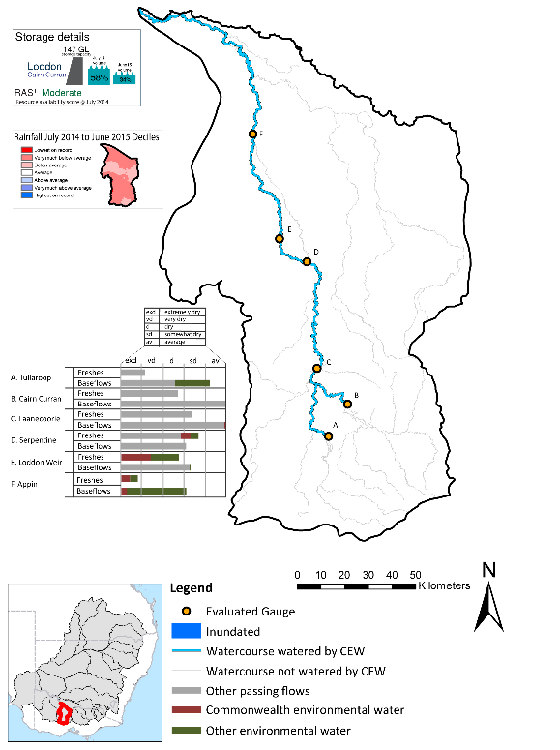
Figure LOD1: Location of evaluated gauges and the watercourses influenced by environmental water in the Loddon valley during the 2014-15 water year. Inset bar graphs report the condition of annual flow regimes: for the hypothetical scenario if no environmental flow had been delivered (grey) and the improvements with the addition of environmental water. Rainfall conditions and trend in Storage levels for the water year are reported.

Summary Statement
Environmental water delivery for the 2014-15 year in the Loddon Valley is evaluated using data for 6 sites. This evaluation only considers the contribution of held environmental water, which is a primary focus for the Commonwealth. The contributions of planned environmental water (e.g. passing flows), unregulated tributary inflows and clever use of irrigation flows for environmental benefits can all be very important but these are outside the scope of this report. Environmental watering actions lasted on average 175 days over the course of the year. The volume of environmental water at these 6 sites was between 7% and 39% of the total streamflow. Commonwealth Environmental Water contributed on average 37% of this environmental water. Ideally, baseflows should be maintained and long periods of excessively low flows avoided. In this valley, the baseflow regime was generally considered to be somewhat dry relative to the pre-development flow regime. In our analysis, a low fresh refers to a period of increased flow, when the water level rises at least one eighth of the way up the river bank (above the low flow level). These low freshes are a regular part of the natural flow regime and support a range of natural processes. In the Loddon valley, in terms of the the occurrence and duration of low freshes, the year was assessed as being somewhat dry. In our analysis, a medium fresh refers to a period of increased flow, when the water level rises at least one quater of the way up the river bank. These medium freshes are not as frequent as low freshes but are also a regular and important part of the natural flow regime. In the Loddon valley, in terms of the occurrence of medium freshes, the year was assessed as being dry. In our analysis, a high fresh refers to a period of increased flow, when the water level rises more than half way up the river. A high fresh may not occur every year but they are still important and long periods without major freshes can have serious consequences for floodplains and their contribution to river ecosystem health. Delivering environmental high in channel flows normally requires that all risks to riparian landholders and infrastructure have been resolved. In the Loddon valley, in terms of the occurrence of high freshes, the year was assessed as being extremely dry. Commonwealth environmental water actions altered flow regimes along an estimated 358 km of river out of a maximum of 358 km.

Description of Environmental Water System
The Loddon valley covers an area of 716km2, which represents 1.4% of the total Mdb area. The river rises on the northern slopes of the Great Dividing Range, south of Daylesford, before flowing northward to join the Murray River (NCCMA 2010) downstream of the Gunbower and Koondrook Pericoota Forests.
Three main streams of the upper catchment (Loddon River, Tullaroop Creek and Bet Bet Creek) all meet at Laanecoorie Reservoir, where the Loddon River then flows into a single channel toward Serpentine Weir. In addition to numerous small water storages, there are three main storages in the upper catchment: Cairn Curran Reservoir (147 GL capacity), Tullaroop Reservoir (73 GL capacity), and Laanecoorie Reservoir (8 GL capacity).
At high flows the Loddon River breaks out at several locations into the Wandella Creek to the west and Tragowel Plains to the east. The Waranga Western Channel crosses the Loddon River catchment south of Boort and at the Loddon Weir, and carries water from the Goulburn system that can be released to the lower reaches of the Loddon River. Macorna Channel crosses underneath the Loddon River upstream of Kerang to supply River Murray water to irrigators in the Torrumbarry system. This report does not explicitly consider the Loddon River from Kerang Weir to the River Murray, as managed flows in this reach are predominantly supplied from diversions from the River Murray at Torrumbarry Weir.
The CEW portfolio maintains water entitlements in the Loddon which can be delivered from head water storages (Cairn Curran or Tullaroop Reservoirs). Similarly, held CEW entitlements in the Goulburn and Campaspe systems can be used to deliver water in the lower Loddon system (downstream of Loddon Weir) via the Waranga Western Channel.
Environmental flow preferences in the Loddon recommend a regime which consists of periods of low or no flow, interspersed by occasional higher fresh flows. Although summer irrigation flows only occur in reaches upstream of Loddon weir they are much larger than the preferred (e.g 10 – 20 ml/d), because of the need to supply consumptive water during the peak irrigation period. Moreover, the delivery of the recommended high flows of 3,000 ML/d every year to the Loddon from Cairn Curran is constrained by its outlet capacity (1,600 ML/d) (SKM 2006).

Data Availability
Daily discharge data was provided by GMW at six gauge stations within the Loddon valley (Figure LOD1). GMW derived the contribution of the CEW, VEWH, IVT and other passing flows using operational models in their ‘in house’ accounting spreadsheet. The contribution made by each component was derived by delivering agreed volumes with each water holder. Delivery volumes for the environmental water holders were deemed at Loddon Weir. Flows passing Loddon Weir were not made available for use further downstream in the Murray system. Losses between upstream reservoirs and accounting points were not taken into account when assessing the flows available due to the low rates of delivery. The component of environmental flows to the flow in the Loddon at the sites upstream of Serpentine Weir was estimated based on the volumes delivered at Loddon Weir.

Environmental Conditions
The resource availability score for the Loddon valley was estimated (July 2014) as Moderate (LOD 1). Whereas, the rainfall conditions (based on gridded rainfall percentiles which compare the rainfall experienced for the water year to the total record) experienced were categorised as very much below average (Figure 1 – Main report). Lake Cairn Curran storage levels declined from a high of 58% at the beginning of the water year to 34% by the end of the water year.

Environmental Water Actions in 2014-15
In 2014-15 CEW was designed to deliver high in-stream flows which were expected to:
- Contribute to riparian vegetation and fish condition
- Macroinvertebrates
- Fish reproduction
- Hydrological connectivity and water quality
The Ltaay of the CEW entitlements in the Loddon was 3330 ML. 3396 ML of CEW was approved for delivery in the Loddon valley. The CEW portfolio yielded 2,869 ML (86%) of it ltaay entitlement. The allocations received were all derived from high security entitlements.
2,869 ML of CEW was delivered in the Loddon valley, contributing to one watering action which was spread over 17 days (4.7% of the year), this action was delivered as a spring fresh (Figure LOD2). This action was implemented as intended with some minor deviations around the target flow of 450 ML. The actions represented 24% of total environmental water delivered in the valley for 2014-15, but only accounted for 1.1% of flows under a predevelopment condition (Table LOD1).

Table LOD1: Environmental water approved and delivered in the Loddon over 2014-15
Source | LTAAY (ML) | Total approved volume (ML) | Total volume delivered (ML) | % approved of total EWater delivered | % contribution to predevelopment flows ¹
CEW | 3330.6 | 3396.5 | 2869.5 | 24.8 | 1.1
VEWH | NA | NA | 8680.4 | 75.2 | 3.4
¹ predevelopment average annual inflows of 255.4 GL
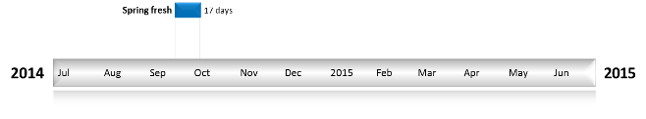

Figure LOD2: Timing and duration of Commonwealth Environmental Water actions in 2014-15.

Contribution of Commonwealth Environmental Water to Flow Regimes
Cairn Curran
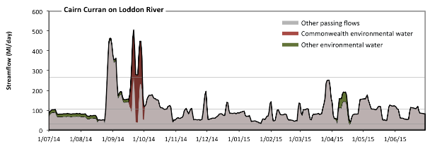
Figure LOD3: Contribution of environmental water delivery at Cairn Curran. Horizontal lines indicate thresholds for very low flows, low flows, low freshes and medium freshes (from lowest to highest).
At Cairn Curran on Loddon River environmental water contributed 11% of the total streamflow volume (much of which was Commonwealth Environmental Water) (Figure LOD3 and LOD4). Environmental watering actions affected streamflows for 29% of days between 1 June 2014 and 31 July 2015. Flow regulation does not substantially increase the duration of very low flows (i.e. < 6.2 Ml/day) compared to an average year in the natural flow regime. Flow regulation does not substantially increase the duration of medium low flows (i.e. < 31 Ml/day) compared to an average year in the natural flow regime. In the absence of environmental water there would have been at least one low fresh (i.e. > 110 Ml/day) in the periods July to September, October to December, January to March and April to June. Environmental water increased the duration of the longest low fresh during the period July to September (from 24 days to 36 days). CEW was entirely responsible for these increased durations of low freshes. There was at least one medium fresh (i.e. > 270 Ml/day) in the period July to September. Environmental water made little change to the duration of these medium freshes. There was no high freshes (i.e. > 1000 Ml/day) this year.
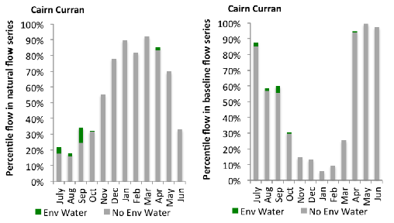
Figure LOD4: Contribution of environmental water delivery at Cairn Curran as percentiles in the natural and baseline flow series.
Tullaroop
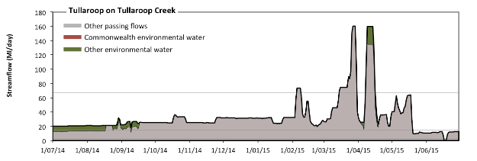
Figure LOD5: Contribution of environmental water delivery at Tullaroop. Horizontal lines indicate thresholds for very low flows, low flows and low freshes (from lowest to highest).
At Tullaroop on Tullaroop Creek environmental water contributed 7% of the total streamflow volume (none of which was Commonwealth Environmental Water) (Figure LOD5 and LOD6). Environmental watering actions affected streamflows for 25% of days between 1 June 2014 and 31 July 2015. Flow regulation does not substantially increase the duration of very low flows (i.e. < 2.9 Ml/day) compared to an average year in the natural flow regime. However, without environmental water, the durations of medium low flows (i.e. < 14 Ml/day) in the periods July to September and April to June would have substantially exceeded durations expected in an average year in the natural flow regime. Environmental water mitigated these impacts by reducing the cumulative duration of medium low flow spells from 25% to 12% of the year, with greatest influence in the period July to September. CEW made little or no contribution to these enhancements of environmental baseflows at this site. There was at least one low fresh (i.e. > 67 Ml/day) in the periods January to March and April to June. Environmental water made no change to the duration of these low freshes. There was no medium or high freshes this year.
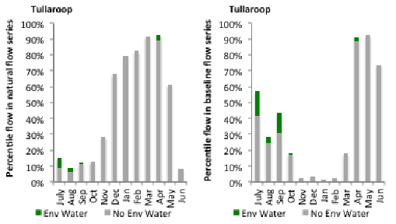
Figure LOD6: Contribution of environmental water delivery at Tullaroop as percentiles in the natural and baseline flow series.
Laanecoorie
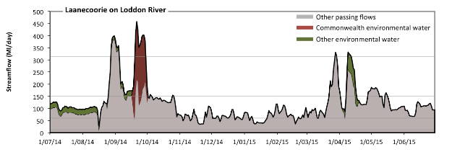
Figure LOD7: Contribution of environmental water delivery at Laanecoorie. Horizontal lines indicate thresholds for very low flows, low flows, low freshes and medium freshes (from lowest to highest).
At Laanecoorie on Loddon River environmental water contributed 12% of the total streamflow volume (with approximately half contributed by Commonwealth Environmental Water) (Figure LOD7 and LOD8). Environmental watering actions affected streamflows for 29% of days between 1 June 2014 and 31 July 2015. Flow regulation does not substantially increase the duration of very low flows (i.e. < 12 Ml/day) compared to an average year in the natural flow regime. Flow regulation does not substantially increase the duration of medium low flows (i.e. < 60 Ml/day) compared to an average year in the natural flow regime. In the absence of environmental water there would have been at least one low fresh (i.e. > 150 Ml/day) in the periods July to September, October to December, January to March and April to June. Environmental water increased the duration of the longest low fresh during the period July to September (from 14 days to 36 days). CEW made a small contribution to these increased durations of low freshes. In the absence of environmental water there would have been at least one medium fresh (i.e. > 310 Ml/day) in the periods July to September and January to March. Environmental water increased the duration of the longest medium fresh during the period April to June (from 0 days to 4 days). CEW made little or no contribution to these increased durations of medium freshes. There was no high freshes (i.e. > 970 Ml/day) this year.
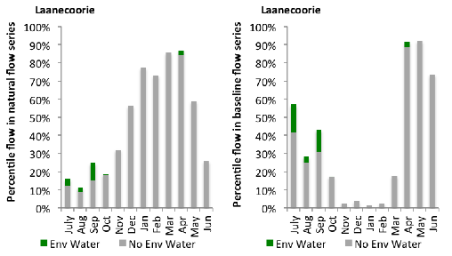
Figure LOD8: Contribution of environmental water delivery at Laanecoorie as percentiles in the natural and baseline flow series.
Serpentine
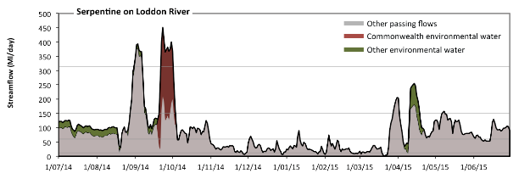
Figure LOD9: Contribution of environmental water delivery at Serpentine. Horizontal lines indicate thresholds for very low flows, low flows, low freshes and medium freshes (from lowest to highest).
At Serpentine on Loddon River environmental water contributed 16% of the total streamflow volume (with approximately half contributed by Commonwealth Environmental Water) (Figure LOD9 and LOD10). Environmental watering actions affected streamflows for 29% of days between 1 June 2014 and 31 July 2015. Flow regulation does not substantially increase the duration of very low flows (i.e. < 12 Ml/day) compared to an average year in the natural flow regime. However, without environmental water, the durations of medium low flows (i.e. < 60 Ml/day) in the periods October to December and January to March would have substantially exceeded durations expected in an average year in the natural flow regime. Environmental water reduced the cumulative duration of medium low flow spells from 44% to 43% of the year, with greatest influence in the period July to September. In the absence of environmental water there would have been at least one low fresh (i.e. > 150 Ml/day) in the periods July to September, October to December, January to March and April to June. Environmental water increased the duration of the longest low fresh during the periods October to December (from 1 days to 3 days) and April to June (from 5 days to 8 days). CEW equally shared responsibility with other environmental water holders for these increased durations of low freshes. In the absence of environmental water there would have been at least one medium fresh (i.e. > 310 Ml/day) in the period July to September. Environmental water increased the duration of the longest medium fresh during the periods July to September (from 6 days to 9 days) and October to December (from 0 days to 1 days). CEW was almost entirely responsible for these increased durations of medium freshes. There was no high freshes (i.e. > 970 Ml/day) this year.
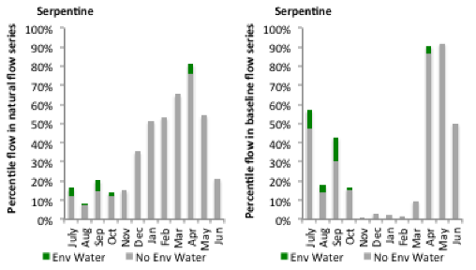
Figure LOD10: Contribution of environmental water delivery at Serpentine as percentiles in the natural and baseline flow series.

Loddon
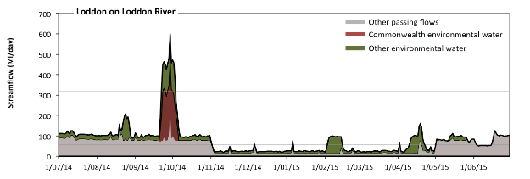
Figure LOD11: Contribution of environmental water delivery at Loddon. Horizontal lines indicate thresholds for very low flows, low flows, low freshes and medium freshes (from lowest to highest).
At Loddon on Loddon River environmental water contributed 39% of the total streamflow volume (with a medium contribution of Commonwealth Environmental Water) (Figure LOD11 and LOD12). Environmental watering actions affected streamflows for 87% of days between 1 June 2014 and 31 July 2015. Flow regulation does not substantially increase the duration of very low flows (i.e. < 11 Ml/day) compared to an average year in the natural flow regime. However, without environmental water, the durations of medium low flows (i.e. < 56 Ml/day) in the periods October to December, January to March and April to June would have substantially exceeded durations expected in an average year in the natural flow regime. Environmental water mitigated these impacts by reducing the cumulative duration of medium low flow spells from 52% to 45% of the year, with greatest influence in the periods January to March and April to June. CEW made little or no contribution to these enhancements of environmental baseflows at this site. In the absence of environmental water there would have been at least one low fresh (i.e. > 150 Ml/day) in the period July to September. Environmental water increased the duration of the longest low fresh during the periods July to September (from 1 days to 10 days), October to December (from 0 days to 5 days) and April to June (from 0 days to 1 days). CEW made a modest contribution to these increased durations of low freshes. In the absence of environmental water there would have been no medium or high freshes this year. Environmental water increased the duration of the longest medium fresh during the periods July to September (from 0 days to 9 days) and October to December (from 0 days to 3 days). CEW was almost entirely responsible for these increased durations of medium freshes.
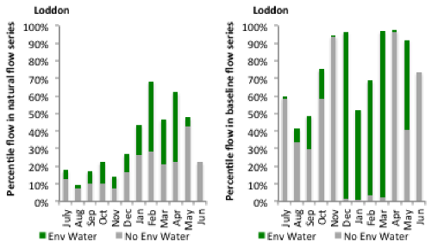
Figure LOD12: Contribution of environmental water delivery at Loddon as percentiles in the natural and baseline flow series.
Appin
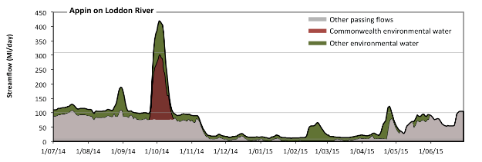Figure LOD13: Contribution of environmental water delivery at Appin. Horizontal lines indicate thresholds for very low flows, low flows and low freshes (from lowest to highest).
At Appin on Loddon River environmental water contributed 39% of the total streamflow volume (with a medium contribution of Commonwealth Environmental Water) (Figure LOD13 and LOD14). Environmental watering actions affected streamflows for 88% of days between 1 June 2014 and 31 July 2015. Without environmental water, the durations of very low flows (i.e. < 7.9 Ml/day) in the periods October to December and January to March would have substantially exceeded durations expected in an average year in the natural flow regime. Environmental water mitigated these impacts by reducing the cumulative duration of very low flow spells from 32% to 0% of the year, with greatest influence in the periods October to December and January to March. Similarly, without environmental water, the durations of medium low flows (i.e. < 100 Ml/day) in the periods July to September, October to December, January to March and April to June would have all substantially exceeded durations expected in an average year in the natural flow regime. Environmental water mitigated these impacts by reducing the cumulative duration of medium low flow spells from 96% to 71% of the year, with greatest influence in the period July to September. CEW made a small contribution to these enhancements of environmental baseflows at this site. Environmental water increased the duration of the longest low fresh during the periods July to September (from 0 days to 3 days) and October to December (from 0 days to 8 days). CEW equally shared responsibility with other environmental water holders for these increased durations of low freshes.
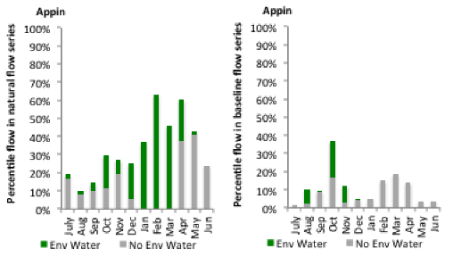
Figure LOD14: Contribution of environmental water delivery at Appin as percentiles in the natural and baseline flow series.

A.9 Broken
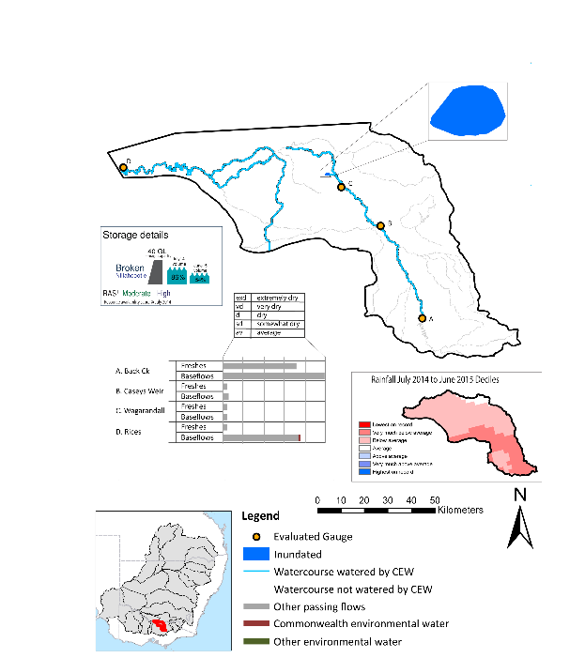
Figure BRK1: Location of evaluated gauges and the watercourses influenced by environmental water in the Broken valley during the 2014-15 water year. Inset bar graphs report the condition of annual flow regimes: for the hypothetical scenario if no environmental flow had been delivered (grey) and the improvements with the addition of environmental water. Rainfall conditions and trend in Storage levels for the water year are reported.

Summary Statement
Environmental water delivery for the 2014-15 year in the Broken Valley is evaluated using data for 4 sites. This evaluation only considers the contribution of held environmental water, which is a primary focus for the Commonwealth. The contributions of planned environmental water (e.g. passing flows), unregulated tributary inflows and clever use of irrigation flows for environmental benefits can all be very important but these are outside the scope of this report. Environmental watering actions lasted on average 117 days over the course of the year. The volume of environmental water at these 4 sites was between 3% and 37% of the total streamflow. Commonwealth Environmental Water contributed on average 49% of this environmental water. Ideally, baseflows should be maintained and long periods of excessively low flows avoided. In this valley, the baseflow regime was generally considered to be dry relative to the pre-development flow regime. In our analysis, a low fresh refers to a period of increased flow, when the water level rises at least one eighth of the way up the river bank (above the low flow level). These low freshes are a regular part of the natural flow regime and support a range of natural processes. In the Broken valley, in terms of the the occurrence and duration of low freshes, the year was assessed as being extremely dry. In our analysis, a medium fresh refers to a period of increased flow, when the water level rises at least one quater of the way up the river bank. These medium freshes are not as frequent as low freshes but are also a regular and important part of the natural flow regime. In the Broken valley, in terms of the occurrence of medium freshes, the year was assessed as being extremely dry. In our analysis, a high fresh refers to a period of increased flow, when the water level rises more than half way up the river. A high fresh may not occur every year but they are still important and long periods without major freshes can have serious consequences for floodplains and their contribution to river ecosystem health. Delivering environmental high in channel flows normally requires that all risks to riparian landholders and infrastructure have been resolved. In the Broken valley, in terms of the occurrence of high freshes, the year was assessed as being very dry. Commonwealth environmental water actions altered flow regimes along an estimated 314 km of river out of a maximum of 314 km of mainstem river. These actions contributed partially to the 150.9 ha of floodplain which was wet during the 2014-15 year.

Description of Environmental Water System
The Broken valley covers approximately 6784 km2 which represents 0.6% of Basin area. Much of the valley has been cleared for dryland and irrigated agriculture.
The valley includes Broken creek, a distributary stream of the Broken River. Broken creek has served as a conduit for irrigation-related water supply flows for over 100 years, with water primarily sourced from the Broken River. Based on records obtained at Casey's Weir gauging station, flows of 5- 10 ML per day in winter and 50-120 ML per day were consistently directed down Broken Creek from 1972 to 2008. In practice, this resulted in a reliable year-round flow regime being experienced by fauna occupying the upper reaches of Broken Creek (downstream to Waggarandall Weir and for some distance beyond) for nearly the last four decades (CEWO 2011). Upper Broken Creek maintains relatively low flows all year round from Casey's Weir to Waggarandal Weir (supplying irrigation entitlements), and is ephemeral between Waggarandal Weir and Katamatite with short duration fresh/high flow events occurring in response to catchment rainfall.
The major sources of regulated inflows into the Broken are discharges from the Shepparton and Murray Valley Irrigation Area. The major sources of regulated inflows are the upstream catchments (ie. The upper broken creek), Shepparton unregulated flows and other irrigation drains. About 40,000ML of regulated water is needed in a normal year to supply the consumptive demands along the lower broken creek system, and to cover transmission and operational losses. Environmental water delivery to lower Broken Creek normally comes from both the Goulburn and Murray.
Channel capacity constraints can occur seasonally within both the Shepparton and Murray Valley irrigation area channel systems. Competition with consumptive (irrigation) demands can at times pose a constraint on environmental water delivery. Additionally, the channel systems typically don’t run from mid-May to mid-August.
Analysis of modelled data found that in a very dry year there is likely to be ample capacity in these main channels to deliver environmental water to the Lower Broken Creek. In dry, median and wet years, the Yarrawonga main channel is often at capacity. Along the east Goulburn main channel (which has historically delivered the bulk of water to the Lower Broken Creek), there is likely to be limited spare capacity during the irrigation season in median and wet years.

Data Availability
Daily discharge data was provided by GMW at four gauge stations within the Broken valley (Figure BRK1). GMW derived the contribution of the CEW, VEWH, IVT and other passing flows using operational models in their ‘in house’ accounting spreadsheet. The contribution made by each component was derived by delivering agreed volumes with each water holder (i.e. delivery for TLM was required at specific times). Delivery volumes for the environmental water holders in the Lower Broken Creek were deemed at the outfalls into the Creek with the volume arriving at Rices Weir being made available for use further downstream in the Murray system. Losses within the Broken valley were taken into account when assessing the flows available. The component of environmental flows to the flow in the Broken River was estimated based on the volumes delivered downstream of Lake Nillahcootie.

Environmental Conditions
The resource availability score for the Broken valley was estimated (July 2014) as Moderate to High (BRK 1). Whereas, the rainfall conditions (based on gridded rainfall percentiles which compare the rainfall experienced for the water year to the total record) experienced were categorised as below average (Figure 1 – Main report). The storage levels of Lake Nillahcootie declined from a high of 86% at the beginning of the water year to 54% by the end of the water year.

Environmental Water Actions in 2014-15
The Longterm average annual yield of CEW entitlements in the Broken valley during the 14-15 water year was 243.57 ML. 50,500 ML of CEW was approved for delivery in the Broken valley. The CEW portfolio yielded approximately 121 ML (47%) of Broken valley registered entitlement (257 ML). The shortfall in approved volume was sourced from the Goulburn Valley. In 2014-15 environmental flows in the Broken intended to achieve the following:
Inundation of Moodies swamp (including baseflows en-route) which:
(a) Maintained or improved condition and diversity of riverine and wetland native vegetation
(b) Maintained or improved diversity and condition of native fish and waterbird populations through the maintenance of suitable aquatic habitat and provision of breeding and recruitment opportunities; and
(c) Maintained or improved ecosystem and population resilience through support of ecological recovery and maintenance of aquatic habitat.
Maintenance of appropriate water quality for native fish species, including the management of excessive azolla growth and dissolved oxygen levels above 5 mg/L.
Improved hydrological connectivity within lower Broken Creek to support: native fish passage through fishways on weirs and increased availability of habitat during migration and breeding seasons for native fish
CEW represented the largest volume of environmental water delivered in the valley (93.5% of total environmental water), but it only represented 1.1% of total average annual flows (Table BRK1). Of the total CEW flow approved for delivery, 34% was not used (17372ML). The shortfall was due to approximately 20,468 ML of Murray consumptive water being passed through the system which met the specifications of the environmental water demands.
Table BRK1: Environmental water approved and delivered in the Broken over 2014-15
Waterholder | LTAAY | Total approved volume (ML) | Total volume delivered (ML) | % holding of total EWater delivered | % contribution to predevelopment flows ¹
CEW | 243.57 | 50,500 | 33,129 | 93.5 | 1.090
VEWH | NA | NA | 2315.1 | 6.5 | 0.076
Murray by-pass flows | NA | NA | 20468 | NA | 0.673
¹ predevelopment average annual flows of 3040 GL
In 2014-15, 33,129ML of CEW was delivered in the Broken as instream flows sourced from managed storage releases. CEW contributed to four watering actions which spread over 275 days (75% of the year). Three actions were delivered as baseflows over 219 days (60 %). These actions were distributed in the spring / early summer (86 days), summer / autumn (109 days) and Autumn (24 days) (Figure BRK2). The baseflow actions were delivered as intended, but discharge rates in some instances were above the target rate and this was mainly due to fluctuations in irrigation demand.
A combination event (baseflow/wetland inundation) was delivered in spring (one action over 56 days). It was delivered as a baseflow with the intention of filling of Moodies swamp. Approximately, 150.9 ha (84 %) of the 180 ha wetland was inundated.
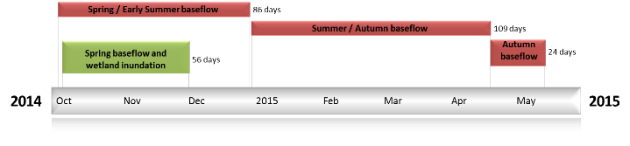

Figure BRK2: Timing and duration of Commonwealth Environmental Water actions in 2014-15.

Contribution of Commonwealth Environmental Water to Flow Regimes

Rices
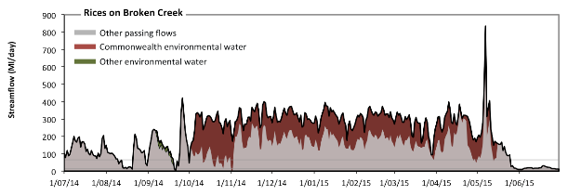
Figure BRK3: Contribution of environmental water delivery at Rices. Horizontal lines indicate thresholds for very low flows and low flows (from lowest to highest).
At Rices on Broken Creek environmental water contributed 37% of the total streamflow volume (most of which was Commonwealth Environmental Water) (Figure BRK3 and BRK4). Environmental watering actions affected streamflows for 65% of days between 1 June 2014 and 31 July 2015. Without environmental water, the duration of very low flows (i.e. < 13 Ml/day) in the period April to June would have substantially exceeded durations expected in an average year in the natural flow regime. Environmental water reduced the cumulative duration of very low flow spells from 4% to 3% of the year, with greatest influence in the period October to December. Similarly, without environmental water, the durations of medium low flows (i.e. < 65 Ml/day) in the periods July to September and April to June would have substantially exceeded durations expected in an average year in the natural flow regime. Environmental water reduced the cumulative duration of medium low flow spells from 20% to 15% of the year, with greatest influence in the period October to December. CEW was almost entirely responsible for these enhancements of environmental baseflows at this site.
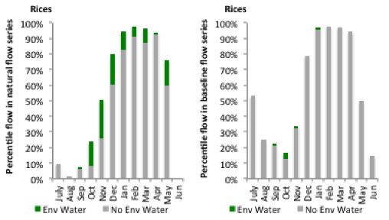
Figure BRK4: Contribution of environmental water delivery at Rices as percentiles in the natural and baseline flow series.
Back Ck
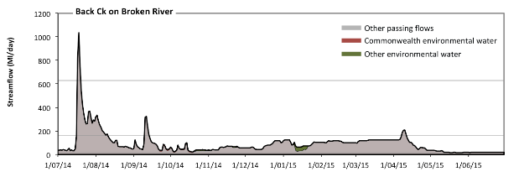
Figure BRK5: Contribution of environmental water delivery at Back Ck. Horizontal lines indicate thresholds for very low flows, low flows, low freshes, medium freshes and high freshes (from lowest to highest).
At Back Ck on Broken River environmental water contributed 3% of the total streamflow volume (with a medium contribution of Commonwealth Environmental Water) (Figure BRK5 and BRK6). Environmental watering actions affected streamflows for 21% of days between 1 June 2014 and 31 July 2015. Flow regulation does not substantially increase the duration of very low flows (i.e. < 3.4 Ml/day) compared to an average year in the natural flow regime. Flow regulation does not substantially increase the duration of medium low flows (i.e. < 17 Ml/day) compared to an average year in the natural flow regime. There was at least one low fresh (i.e. > 160 Ml/day) in the periods July to September and April to June. Environmental water made no change to the duration of these low freshes. There was at least one medium fresh (i.e. > 630 Ml/day) in the period July to September. Environmental water made no change to the duration of these medium freshes. In the absence of environmental water there would have been at least one high fresh in the period July to September. Environmental water made no change to the duration of these high freshes.
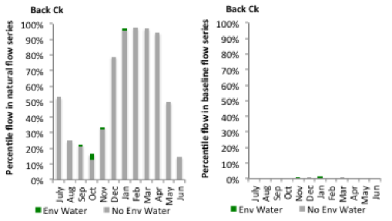
Figure BRK6: Contribution of environmental water delivery at Back Ck as percentiles in the natural and baseline flow series.
Caseys Weir
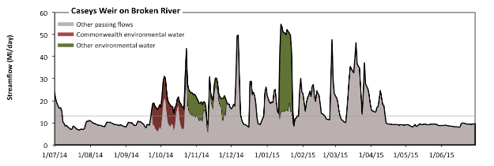
Figure BRK7: Contribution of environmental water delivery at Caseys Weir. Horizontal lines indicate thresholds for very low flows and low flows (from lowest to highest).
At Caseys Weir on Broken River environmental water contributed 15% of the total streamflow volume (with a medium contribution of Commonwealth Environmental Water) (Figure BRK7 and BRK8). Environmental watering actions affected streamflows for 21% of days between 1 June 2014 and 31 July 2015. Without environmental water, the durations of very low flows (i.e. < 13 Ml/day) in the periods July to September, October to December, January to March and April to June would have all substantially exceeded durations expected in an average year in the natural flow regime. Environmental water mitigated these impacts by reducing the cumulative duration of very low flow spells from 60% to 50% of the year, with greatest influence in the period October to December. Similarly, without environmental water, the durations of medium low flows (i.e. < 65 Ml/day) in the periods July to September, October to December, January to March and April to June would have all substantially exceeded durations expected in an average year in the natural flow regime. However, environmental water had little effect on the duration of these medium low flows, which occurred for 100% of the year. CEW made the dominant contribution to these enhancements of environmental baseflows at this site.
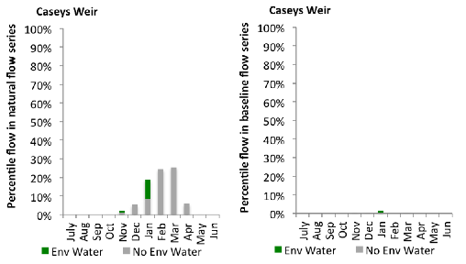
Figure BRK8: Contribution of environmental water delivery at Caseys Weir as percentiles in the natural and baseline flow series.
Wagarandall
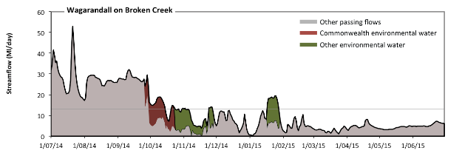
Figure BRK9: Contribution of environmental water delivery at Wagarandall. Horizontal lines indicate thresholds for very low flows and low flows (from lowest to highest).
At Wagarandall on Broken Creek environmental water contributed 14% of the total streamflow volume (with a medium contribution of Commonwealth Environmental Water) (Figure BRK9 and BRK10). Environmental watering actions affected streamflows for 21% of days between 1 June 2014 and 31 July 2015. Without environmental water, the durations of very low flows (i.e. < 13 Ml/day) in the periods October to December, January to March and April to June would have substantially exceeded durations expected in an average year in the natural flow regime. Environmental water mitigated these impacts by reducing the cumulative duration of very low flow spells from 75% to 65% of the year, with greatest influence in the periods October to December and January to March. Similarly, without environmental water, the durations of medium low flows (i.e. < 65 Ml/day) in the periods July to September, October to December, January to March and April to June would have all substantially exceeded durations expected in an average year in the natural flow regime. However, environmental water had little effect on the duration of these medium low flows, which occurred for 100% of the year. CEW equally shared responsibility with other environmental water holders for these enhancements of environmental baseflows at this site.
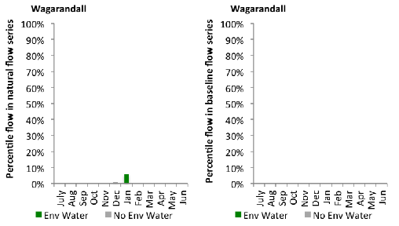
Figure BRK10: Contribution of environmental water delivery at Wagarandall as percentiles in the natural and baseline flow series.

A.10 Goulburn
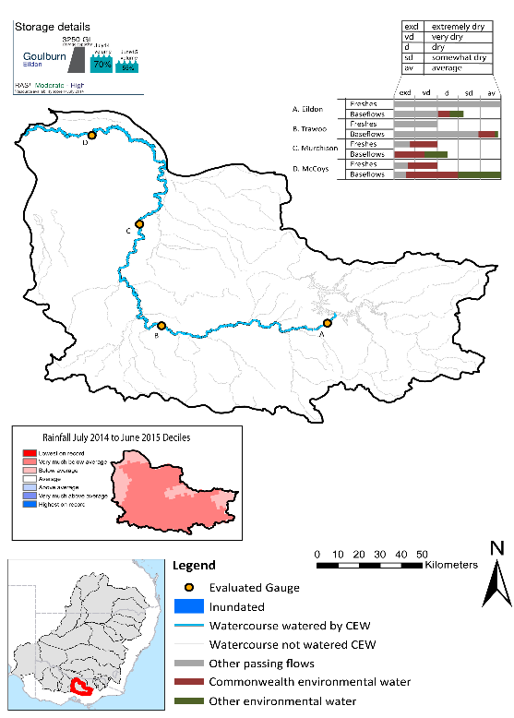
Figure GLB1: Location of evaluated gauges and the watercourses influenced by environmental water in the Goulburn valley during the 2014-15 water year. Inset bar graphs report the condition of annual flow regimes: for the hypothetical scenario if no environmental flow had been delivered (grey) and the improvements with the addition of environmental water. Rainfall conditions and trend in Storage levels for the water year are reported.

Summary Statement
Environmental water delivery for the 2014-15 year in the Goulburn Valley is evaluated using data for 4 sites. This evaluation only considers the contribution of held environmental water, which is a primary focus for the Commonwealth. The contributions of planned environmental water (e.g. passing flows), unregulated tributary inflows and clever use of irrigation flows for environmental benefits can all be very important but these are outside the scope of this report. Environmental watering actions lasted on average 253 days over the course of the year. The volume of environmental water at these 4 sites was between 14% and 41% of the total streamflow. Commonwealth Environmental Water contributed on average 76% of this environmental water. Ideally, baseflows should be maintained and long periods of excessively low flows avoided. In this valley, the baseflow regime was generally considered to be somewhat dry relative to the pre-development flow regime. In our analysis, a low fresh refers to a period of increased flow, when the water level rises at least one eighth of the way up the river bank (above the low flow level). These low freshes are a regular part of the natural flow regime and support a range of natural processes. In the Goulburn valley, in terms of the the occurrence and duration of low freshes, the year was assessed as being average. In our analysis, a medium fresh refers to a period of increased flow, when the water level rises at least one quater of the way up the river bank. These medium freshes are not as frequent as low freshes but are also a regular and important part of the natural flow regime. In the Goulburn valley, in terms of the occurrence of medium freshes, the year was assessed as being very dry. In our analysis, a high fresh refers to a period of increased flow, when the water level rises more than half way up the river. A high fresh may not occur every year but they are still important and long periods without major freshes can have serious consequences for floodplains and their contribution to river ecosystem health. Delivering environmental high in channel flows normally requires that all risks to riparian landholders and infrastructure have been resolved. In the Goulburn valley, in terms of the occurrence of high freshes, the year was assessed as being very dry. Commonwealth environmental water actions altered flow regimes along an estimated 340 km of river out of a maximum of 340 km of main stem river.

Description of Environmental Water System
The Goulburn valley covers 16829 km2, which represents 1.6% of the Basin. The valley has a mean annual discharge of approximately 3200 GL of which, 50% is diverted for consumptive use (CSIRO 2008). The Goulburn River is valued for its high overall economic significance. It is also valued for its many significant social, heritage and environmental values. The lower Goulburn floodplain covers an area of 13,000 ha and is highly valued for its wetland system and associated ecological features.
Although numerous water regulators exist in the Goulburn valley, Lake Eildon and Goulburn weir are the two most influential. Lake Eildon, which has a useable capacity of 3250GL provides water to Shepparton, Central Goulburn, Rochester and Pyramid/Boort irrigation districts. Flows reaching Goulburn weir are diverted to the east of Goulburn main channel and Waranga basin to meet consumptive demands. Water is also released from Goulburn weir to the lower Goulburn. Downstream of Goulburn weir, the river collects tributary inflows and irrigation drain inflows prior to discharging to the Murray River near Echuca.
Releases from Lake Eildon are constrained by downstream flooding constraints (particularly around Thornton and Moleswoth) (SKM, 2006). Flow peaks downstream of Lake Eildon in excess of 14,500 ML/day will cause minor flooding, 26,000 ML/day will cause moderate flooding and 40,000 ML/day will cause major flooding (SKM, 2006). Irrigation releases are in the order of 10,000 ML/day in summer. Goulburn Weir is operated close to its FSL to allow maximum diversion into the irrigation offtake channels. Releases from Goulburn Weir are capable of releasing low flows in the range of 100 ML/day to over 1,000 ML/day as well as higher flows when Goulburn Weir is spilling (SKM, 2006). The Goulburn River downstream of Shepparton is confined within a leveed floodway but its capacity is inadequate to convey moderate flood events
Downstream of Eildon, flow conditions in the Goulburn River are less than natural during the non-irrigation season. Conversely, during the summer irrigation season, flow conditions are higher than natural (particularly between Eildon and Goulburn weir). Environmental flow recommendations in the literature, together with consultations among the VEWH, GBCMA and LTIM providers, guide the planning and use of CEW in protecting and restoring functions and assets of the Goulburn River.

Data Availability
Daily discharge data was provided by GMW for four gauge stations within the Goulburn valley (Figure GLB1). GMW derived the contribution of the CEW, VEWH, IVT and other passing flows using operational models in their ‘in house’ accounting spreadsheet. The contribution made by each component was derived by delivering agreed volumes with each water holder (i.e. delivery for TLM was required at specific times). Delivery volumes for the environmental water holders were deemed at Goulburn Weir with the flows that arrive at McCoy Bridge being made available for use further downstream in the Murray system. Losses between Goulburn Weir and McCoy Bridge were taken into account when assessing the flows available. The component of environmental flows to the flow in the Goulburn River at the sites upstream of Goulburn Weir was estimated based on the volumes delivered at Goulburn Weir as well as the inflows from tributaries downstream of Lake Eildon.

Environmental Conditions
The resource availability score for the Goulburn valley was estimated (July 2014) as Moderate to High (GLB 1). Whereas, the rainfall conditions (based on gridded rainfall percentiles which compare the rainfall experienced for the water year to the total record) experienced were categorised as very much below average (Figure 1 – Main report). The storage levels of Lake Eildon declined from a high of 70% at the beginning of the water year to 55% by the end of the water year.

Environmental Water Actions in 2014-15
The longterm average annual yield (Ltaay) for the CEW Goulburn entitlements during the 2014-15 water year was 251.5 GL. 275000 ML of CEW was approved for delivery in the Goulburn valley. The CEW portfolio yielded 241.7 GL of water, representing approximately 96% (251.5 GL) of Ltaay.
During 2014-15 environmental flows in the Goulburn River intended to achieve the following:
- Design and implement Base flows to: (1) improve fish habitat and facilitate fish movement, (2) improve macroinvertebrate habitat (including instream vegetation) and (3) macroinvertebrate abundance.
- Design and implement Fresh flows to: (1) stimulate spawning of golden perch, (2) encourage fish migration/movement, (3) encourage the recovery of bank vegetation and (3) increase macroinvertebrate habitat and therefore abundance.
- Contribute to winter flows and ecosystem connectivity which will contribute to native fish populations, riparian, littoral and aquatic vegetation needs in the Murray River.
In 2014-15, CEW was delivered in the Goulburn River as instream flows sourced from managed storage releases. The watering actions were targeted at the following reaches: Goulburn Weir to Shepparton and Shepparton to Murray River.
In 2014-15, CEW was directly involved in nine watering actions which occurred on 277 days, representing a contribution to river hydrology of 76% of the year. This included the use of 53,695 ML of water towards five base flow actions on 197 days (54% of the year) and four fresh flow actions on 80 days (22% of the year). The baseflow actions occurred in Spring (2 actions over 37 days), Summer (1 action over 14 days), autumn (1 action over 87 days) and winter (1 action over 59 days). These actions were implemented as intended, but discharge rates in some actions were above the target rate due to a combination of unregulated flows and IVT requirements.
Four watering actions were designed as freshes (160697ML) and these occurred in spring (2 actions over 37 days), autumn (1 action over 26 days) and winter (1 action over 17 days). The fresh actions were largely delivered as planned with the exception of the winter action where some deviation was experienced in flow magnitude and duration, mainly due to external factors.
Although, the CEW component represented the largest volume of ewater delivered in the Goulburn valley (73% of total ewater), during 2014-15 it only represented 7.4% of estimated predevelopment flows (Table GLB1). Of the total CEW flow allocated for delivery, 6.5% was not used (15,816.2 ML). The water was not used because the designed environmental flows were (1) met by natural unregulated stream flow events (which occurred July - August) and (2) river operators (acting on advice from the CEWO and VEWH) designed IVT flows in a form that met the environmental demand for those periods.
Table GLB1: Environmental water approved and delivered in the Goulburn over 2014-15.
Waterholder | LTAAY (ML) | Approved Volume (ML) | Total volume delivered (ML) | % holding of total EWater delivered | % contribution to predevelopment flows ¹
CEW | 251506 | 275000 | 225,883.8 | 73 | 7.4
TLM | NA | NA | 54,348.7 | 18 | 1.8
VEWH | NA | NA | 29,138.6 | 9 | 1.0

¹ predevelopment average annual inflows of 3040 GL
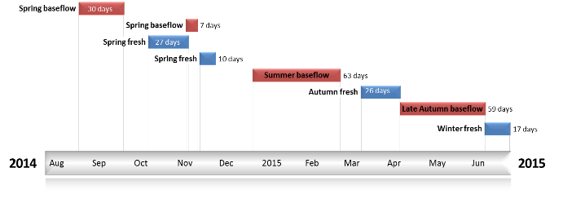
Figure GLB2: Timing and duration of Commonwealth Environmental Water actions in 2014-15.

Contribution of Commonwealth Environmental Water to Flow Regimes

Eildon
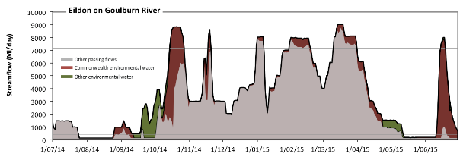
Figure GLB3: Contribution of environmental water delivery at Eildon. Horizontal lines indicate thresholds for very low flows, low flows, low freshes, medium freshes and high freshes (from lowest to highest).
At Eildon on Goulburn River environmental water contributed 21% of the total streamflow volume (much of which was Commonwealth Environmental Water) (Figure GLB3 and GLB4). Environmental watering actions affected streamflows for 67% of days between 1 June 2014 and 31 July 2015. Flow regulation does not substantially increase the duration of very low flows (i.e. < 79 Ml/day) compared to an average year in the natural flow regime. However, without environmental water, the durations of medium low flows (i.e. < 400 Ml/day) in the periods July to September and April to June would have substantially exceeded durations expected in an average year in the natural flow regime. Environmental water mitigated these impacts by reducing the cumulative duration of medium low flow spells from 28% to 17% of the year, with greatest influence in the periods July to September and April to June. CEW equally shared responsibility with other environmental water holders for these enhancements of environmental baseflows at this site. In the absence of environmental water there would have been at least one low fresh (i.e. > 2200 Ml/day) in the periods October to December, January to March and April to June. Environmental water increased the duration of the longest low fresh during the periods July to September (from 0 days to 5 days) and October to December (from 47 days to 64 days). CEW equally shared responsibility with other environmental water holders for these increased durations of low freshes. In the absence of environmental water there would have been at least one medium fresh (i.e. > 7200 Ml/day) in the periods October to December and January to March. Environmental water increased the duration of the longest medium fresh during the periods October to December (from 1 days to 14 days) and April to June (from 0 days to 5 days). CEW was entirely responsible for these increased durations of medium freshes. In the absence of environmental water there would have been at least one high fresh in the periods October to December and January to March. Environmental water increased the duration of the longest medium fresh during the periods October to December (from 1 days to 14 days) and April to June (from 0 days to 5 days). CEW was entirely responsible for these increased durations of high freshes.
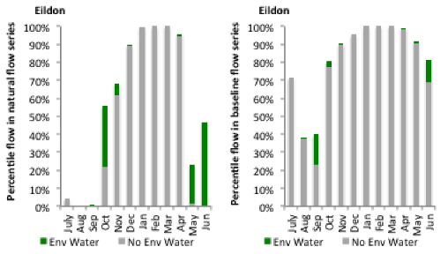
Figure GLB4: Contribution of environmental water delivery at Eildon as percentiles in the natural and baseline flow series.
Trawool
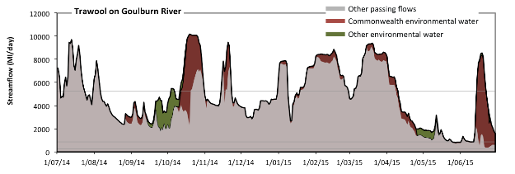
Figure GLB5: Contribution of environmental water delivery at Trawool. Horizontal lines indicate thresholds for very low flows, low flows and low freshes (from lowest to highest).
At Trawool on Goulburn River environmental water contributed 14% of the total streamflow volume (much of which was Commonwealth Environmental Water) (Figure GLB5 and GLB6). Environmental watering actions affected streamflows for 67% of days between 1 June 2014 and 31 July 2015. Flow regulation does not substantially increase the duration of very low flows (i.e. < 250 Ml/day) compared to an average year in the natural flow regime. However, without environmental water, the duration of medium low flows (i.e. < 870 Ml/day) in the period April to June would have substantially exceeded durations expected in an average year in the natural flow regime. Environmental water mitigated these impacts by reducing the cumulative duration of medium low flow spells from 7% to 2% of the year, with greatest influence in the period April to June. CEW was almost entirely responsible for these enhancements of environmental baseflows at this site. In the absence of environmental water there would have been at least one low fresh (i.e. > 5300 Ml/day) in the periods July to September, October to December, January to March and April to June. Environmental water increased the duration of the longest low fresh during the period October to December (from 12 days to 21 days). CEW was entirely responsible for these increased durations of low freshes. There was no medium or high freshes this year.
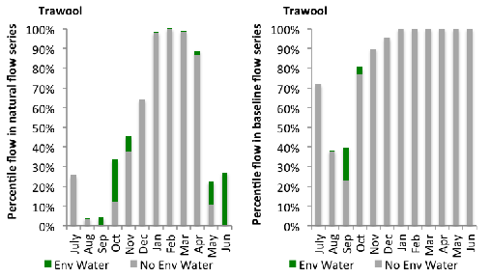
Figure GLB6: Contribution of environmental water delivery at Trawool as percentiles in the natural and baseline flow series.
Murchison
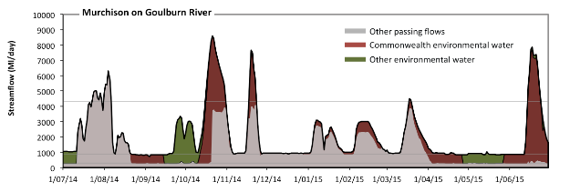
Figure GLB7: Contribution of environmental water delivery at Murchison. Horizontal lines indicate thresholds for very low flows, low flows and low freshes (from lowest to highest).
At Murchison on Goulburn River environmental water contributed 41% of the total streamflow volume (much of which was Commonwealth Environmental Water) (Figure GLB7 and GLB8). Environmental watering actions affected streamflows for 72% of days between 1 June 2014 and 31 July 2015. Without environmental water, the durations of very low flows (i.e. < 310 Ml/day) in the periods July to September, October to December and April to June would have substantially exceeded durations expected in an average year in the natural flow regime. Environmental water mitigated these impacts by reducing the cumulative duration of very low flow spells from 39% to 0% of the year, with greatest influence in the periods July to September and April to June. Similarly, without environmental water, the durations of medium low flows (i.e. < 900 Ml/day) in the periods July to September, October to December and April to June would have substantially exceeded durations expected in an average year in the natural flow regime. Environmental water mitigated these impacts by reducing the cumulative duration of medium low flow spells from 50% to 21% of the year, with greatest influence in the period April to June. Environmental water increased the magnitude of flows below this medium low flow threshold with the result that low flows were generally far below the medium low flow threshold. CEW equally shared responsibility with other environmental water holders for these enhancements of environmental baseflows at this site. In the absence of environmental water there would have been at least one low fresh (i.e. > 4300 Ml/day) in the period July to September. Environmental water increased the duration of the longest low fresh during the periods October to December (from 0 days to 16 days), January to March (from 0 days to 2 days) and April to June (from 0 days to 10 days). CEW was entirely responsible for these increased durations of low freshes. There was no medium or high freshes this year.
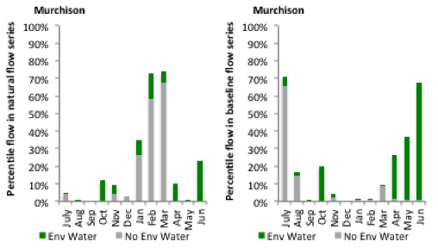
Figure GLB8: Contribution of environmental water delivery at Murchison as percentiles in the natural and baseline flow series.
McCoys
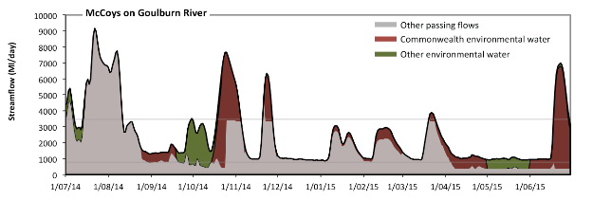
Figure GLB9: Contribution of environmental water delivery at McCoys. Horizontal lines indicate thresholds for very low flows, low flows and low freshes (from lowest to highest).
At McCoys on Goulburn River environmental water contributed 32% of the total streamflow volume (much of which was Commonwealth Environmental Water) (Figure GLB9 and GLB10). Environmental watering actions affected streamflows for 72% of days between 1 June 2014 and 31 July 2015. Flow regulation does not substantially increase the duration of very low flows (i.e. < 130 Ml/day) compared to an average year in the natural flow regime. However, without environmental water, the durations of medium low flows (i.e. < 770 Ml/day) in the periods July to September, October to December and April to June would have substantially exceeded durations expected in an average year in the natural flow regime. Environmental water mitigated these impacts by reducing the cumulative duration of medium low flow spells from 32% to 0% of the year, with greatest influence in the period April to June. CEW equally shared responsibility with other environmental water holders for these enhancements of environmental baseflows at this site. In the absence of environmental water there would have been at least one low fresh (i.e. > 3500 Ml/day) in the periods July to September, October to December and January to March. Environmental water increased the duration of the longest low fresh during the periods October to December (from 1 days to 18 days), January to March (from 1 days to 5 days) and April to June (from 0 days to 12 days). CEW was entirely responsible for these increased durations of low freshes. There was no medium or high freshes this year.
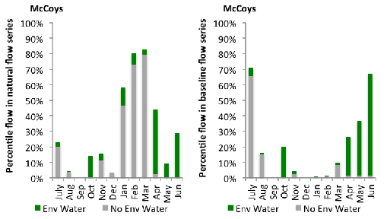
Figure GLB10: Contribution of environmental water delivery at McCoys as percentiles in the natural and baseline flow series.

A.11 Edward Wakool
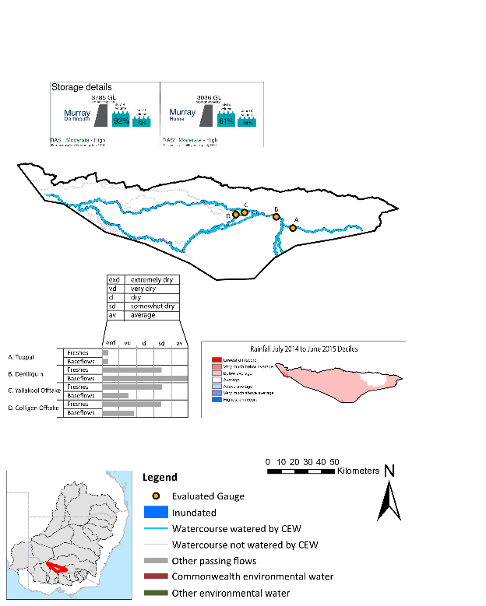
Figure EWK1: Location of evaluated gauges and the watercourses influenced by environmental water in the Edward Wakool valley during the 2014-15 water year. Inset bar graphs report the condition of annual flow regimes: for the hypothetical scenario if no environmental flow had been delivered (grey) and the improvements with the addition of environmental water. Rainfall conditions and trend in Storage levels for the water year are reported.

Summary Statement
Environmental water delivery for the 2014-15 year in the Edward Wakool Valley is evaluated using data for 4 sites. This evaluation only considers the contribution of held environmental water, which is a primary focus for the Commonwealth. The contributions of planned environmental water (e.g. passing flows), unregulated tributary inflows and clever use of irrigation flows for environmental benefits can all be very important but these are outside the scope of this report. Environmental watering actions lasted on average 131 days over the course of the year. The volume of environmental water at these 4 sites was between 3% and 100% of the total streamflow. Commonwealth Environmental Water contributed on average 80% of this environmental water. Ideally, baseflows should be maintained and long periods of excessively low flows avoided. In this valley, the baseflow regime was generally considered to be dry relative to the pre-development flow regime. In our analysis, a low fresh refers to a period of increased flow, when the water level rises at least one eighth of the way up the river bank (above the low flow level). These low freshes are a regular part of the natural flow regime and support a range of natural processes. In the Edward Wakool valley, in terms of the the occurrence and duration of low freshes, the year was assessed as being somewhat dry. In our analysis, a medium fresh refers to a period of increased flow, when the water level rises at least one quater of the way up the river bank. These medium freshes are not as frequent as low freshes but are also a regular and important part of the natural flow regime. In the Edward Wakool valley, in terms of the occurrence of medium freshes, the year was assessed as being somewhat dry. In our analysis, a high fresh refers to a period of increased flow, when the water level rises more than half way up the river. A high fresh may not occur every year but they are still important and long periods without major freshes can have serious consequences for floodplains and their contribution to river ecosystem health. Delivering environmental high in channel flows normally requires that all risks to riparian landholders and infrastructure have been resolved. In the Edward Wakool valley, in terms of the occurrence of high freshes, the year was assessed as being extremely dry. Commonwealth environmental water actions altered flow regimes along an estimated 617 km of river out of a maximum of 773 km.

Description of Environmental Water System
The Edward–Wakool River system covers approximately 10,786 km2, representing approximately 1% of Basin. This Edward-Wakool is a major anabranch and floodplain of the River Murray. It consists of a network of inter-connecting rivers, creeks, flood runners and wetlands covering more than 1,000 square kilometres between the Murray and Edward Rivers. The hydrology of the system is complex. Flows can originate from a variety of sources. These include the upper Murray, and Murrumbidgee, and Victorian tributaries such as the Kiewa, Ovens, Goulburn, Campaspe, Loddon and Avoca Rivers. The main water sources are from the Murray River via the Edward River and Gulpa Creek, which originate in the Barmah-Millewa Forest. During high flows the Edward-Wakool is supplemented with water from the Murray River via a number of creeks. The intermittent stream network also connects to a number of large wetland depressions.
Stevens Weir limits the regulated flow into the Edward-Wakool, with unregulated events entering the Edward shared alternately between the Edward and the Wakool Rivers. The Edward River provides an important conveyance function for River Murray needs as well as the supply of consumptive water within the Edward Wakool.
The delivery of environmental water in the Edward-Wakool is constrained by flooding impacts as well as numerous third party impacts on private infrastructure. Environmental water delivery in the Edward-Wakool minimises the impact to neighbouring operations by aligning the delivery of environmental water within the constraints listed in Table (EWK1).
Table EWK1: List of key constraints limiting environmental flow delivery in the Edward-Wakool River.
Location | Description | Flow or Level limit
Edward R @ Deniliquin1 | Flood levels | 17,100 ML/day
Tuppal Creek2 | Various impacts third party impacts | >5.9m at Tocumwal
Wakool River2 | Various impacts third party impacts | 200 ML/D
Yallakool CK2 | Various impacts third party impacts | 450-600 ML/D
Colligen CK2 | Various impacts third party impacts | 800 ML/D
Niemur R2 | Various impacts third party impacts | 500 ML/D
¹Mdba (2013), 2NSWCMA (2012)

Data Availability
The contribution (where applicable) of the CEW and NSW environmental water and other passing flows were derived from the CAIRO river operations spreadsheet held by Water NSW. The accounted waterholding was tracked longitudinally from the release point to the accounting point using known travel times, which are programmed into the operational model. The method assumed no longitudinal transmission loss of water, so the outputs likely underestimate the impact of CEW.

Environmental Conditions
The resource availability score for the Edward-Wakool valley was estimated (July 2014) as Moderate to High. Whereas, the rainfall conditions (based on gridded rainfall percentiles which compare the rainfall experienced for the water year to the total record) experienced were categorised as below average (Figure 1 – Main report). The storage levels of Dartmouth and Hume dam declined from a high of 92 % and 61% at the beginning of the water year respectively to 72% and 34% respectively, by the end of the water year.

Environmental Water Actions in 2014-15
70,000 ML of CEW was approved for delivery in the Edward-Wakool. 39,562 ML of CEW was delivered in 2014-15 (56.5% of approved volume) as four instream watering actions. The actions were delivered as baseflows, freshes and recession actions with the aim of supporting instream biodiversity and river function. The four watering actions were delivered between August 2014 and April 2015, and spread over 269 days (74 % of days in the water year) (Figure EWK2). The actions were delivered as intended, with the exception of the 147 day baseflow action which ceased earlier than requested.
The CEW component (39,562 ML) represented 90.5 % of the total ewater delivered in 2014-15 (based on actions where the CEWO contributed in collaboration with a partner agency or alone). The volume of CEW only represented 1.8% of total predevelopment flows (Table EWK2).

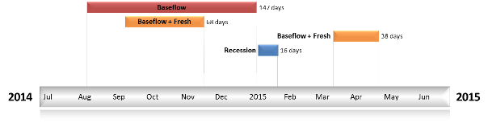
Figure EWK2: Timing and duration of Commonwealth environmental watering actions in the Edward-Wakool during the 2014-15 water year.
Table EWK2: Environmental water approved and delivered in the Edward-Wakool over 2014-15
Source | LTAAY (ML) | Total approved volume (ML) | Total volume delivered (ML) | % delivered of total E Water delivered | % contribution to predevelopment flows ¹
CEW | 579426 | 70,000 | 39,562.00 | 90.5 | 1.6
NSW OEH | NA | NA | 4,170.00 | 9.5 | 0.2
¹ predevelopment average annual inflows of 2420 GL at Deniliquin

Contribution of Commonwealth Environmental Water to Flow Regimes

Deniliquin
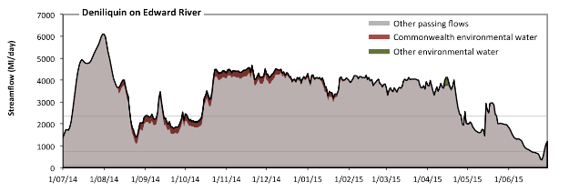
Figure EWK3: Contribution of environmental water delivery at Deniliquin. Horizontal lines indicate thresholds for very low flows, low flows, low freshes and medium freshes (from lowest to highest).
At Deniliquin on Edward River environmental water contributed 4% of the total streamflow volume (most of which was Commonwealth Environmental Water) (Figure EWK3 and EWK4). Environmental watering actions affected streamflows for 61% of days between 1 June 2014 and 31 July 2015. Flow regulation does not substantially increase the duration of very low flows (i.e. < 24 Ml/day) compared to an average year in the natural flow regime. Flow regulation does not substantially increase the duration of medium low flows (i.e. < 120 Ml/day) compared to an average year in the natural flow regime. There was at least one low fresh (i.e. > 710 Ml/day) in the periods July to September, October to December, January to March and April to June. Environmental water made little change to the duration of these low freshes. There was at least one medium fresh (i.e. > 2300 Ml/day) in the periods July to September, October to December, January to March and April to June. Environmental water made little change to the duration of these medium freshes. There was no high freshes (i.e. > 12000 Ml/day) this year.
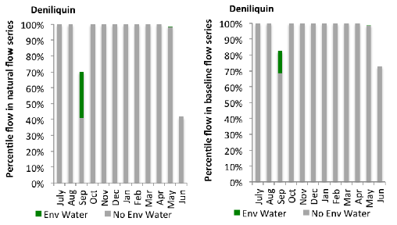
Figure EWK4: Contribution of environmental water delivery at Deniliquin as percentiles in the natural and baseline flow series.
Tuppal
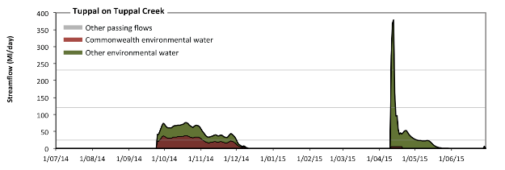
Figure EWK5: Contribution of environmental water delivery at Tuppal. Horizontal lines indicate thresholds for very low flows, low flows and low freshes (from lowest to highest).
At Tuppal on Tuppal Creek environmental water contributed 100% of the total streamflow volume (with a medium contribution of Commonwealth Environmental Water) (Figure EWK5 and EWK6). Environmental watering actions affected streamflows for 36% of days between 1 June 2014 and 31 July 2015. Without environmental water, the durations of very low flows (i.e. < 24 Ml/day) in the periods July to September, October to December, January to March and April to June would have all substantially exceeded durations expected in an average year in the natural flow regime. Environmental water mitigated these impacts by reducing the cumulative duration of very low flow spells from 100% to 75% of the year, with greatest influence in the periods October to December and April to June. Similarly, without environmental water, the durations of medium low flows (i.e. < 120 Ml/day) in the periods July to September, October to December, January to March and April to June would have all substantially exceeded durations expected in an average year in the natural flow regime. Environmental water mitigated these impacts by reducing the cumulative duration of medium low flow spells from 100% to 99% of the year, with greatest influence in the period April to June. CEW made a modest contribution to these enhancements of environmental baseflows at this site. Environmental water increased the duration of the longest low fresh during the period April to June (from 0 days to 3 days). CEW made little or no contribution to these increased durations of low freshes. However, environmental water increased peak flows substantially below the medium fresh threshold.
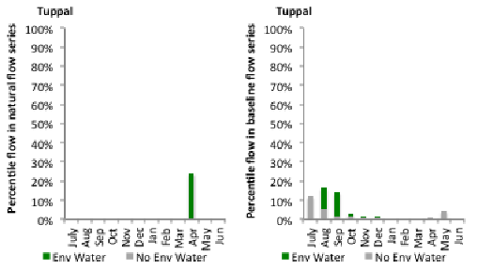
Figure EWK6: Contribution of environmental water delivery at Tuppal as percentiles in the natural and baseline flow series.

Yallakool Offtake
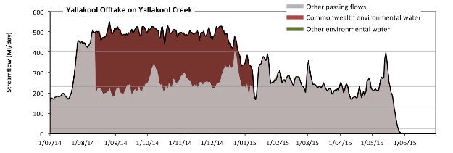
Figure EWK7: Contribution of environmental water delivery at Yallakool Offtake. Horizontal lines indicate thresholds for very low flows, low flows, low freshes and medium freshes (from lowest to highest).
At Yallakool Offtake on Yallakool Creek environmental water contributed 29% of the total streamflow volume (all of which was Commonwealth Environmental Water) (Figure EWK7 and EWK8). Environmental watering actions affected streamflows for 41% of days between 1 June 2014 and 31 July 2015. Without environmental water, the duration of very low flows (i.e. < 24 Ml/day) in the period April to June would have substantially exceeded durations expected in an average year in the natural flow regime. However, environmental water had little effect on the duration of these very low flows, which occurred for 10% of the year. Similarly, without environmental water, the duration of medium low flows (i.e. < 120 Ml/day) in the period April to June would have substantially exceeded durations expected in an average year in the natural flow regime. However, environmental water had little effect on the duration of these medium low flows, which occurred for 11% of the year. In the absence of environmental water there would have been at least one low fresh (i.e. > 230 Ml/day) in the periods July to September, October to December, January to March and April to June. Environmental water increased the duration of the longest low fresh during the periods July to September (from 21 days to 70 days) and October to December (from 24 days to 92 days). CEW was entirely responsible for these increased durations of low freshes. In the absence of environmental water there would have been at least one medium fresh (i.e. > 400 Ml/day) in the periods July to September and October to December. Environmental water increased the duration of the longest medium fresh during the periods July to September (from 17 days to 66 days) and October to December (from 1 days to 86 days). CEW was entirely responsible for these increased durations of medium freshes. There was no high freshes (i.e. > 990 Ml/day) this year.
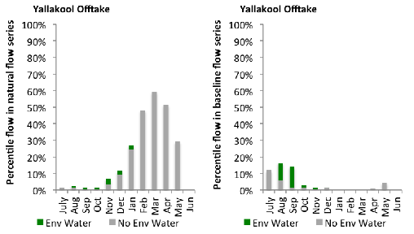
Figure EWK8: Contribution of environmental water delivery at Yallakool Offtake as percentiles in the natural and baseline flow series.

Colligen Offtake
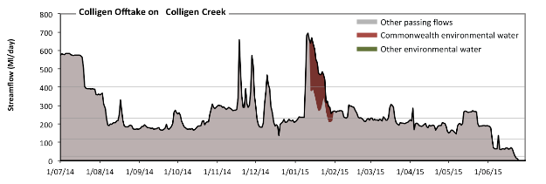
Figure EWK9: Contribution of environmental water delivery at Colligen Offtake. Horizontal lines indicate thresholds for very low flows, low flows, low freshes and medium freshes (from lowest to highest).
At Colligen Offtake on Yallakool Creek environmental water contributed 3% of the total streamflow volume (all of which was Commonwealth Environmental Water) (Figure EWK9 and EWK10). Environmental watering actions affected streamflows for 5% of days between 1 June 2014 and 31 July 2015. Without environmental water, the duration of very low flows (i.e. < 24 Ml/day) in the period April to June would have substantially exceeded durations expected in an average year in the natural flow regime. However, environmental water had little effect on the duration of these very low flows, which occurred for 2% of the year. Similarly, without environmental water, the duration of medium low flows (i.e. < 120 Ml/day) in the period April to June would have substantially exceeded durations expected in an average year in the natural flow regime. However, environmental water had little effect on the duration of these medium low flows, which occurred for 7% of the year. In the absence of environmental water there would have been at least one low fresh (i.e. > 230 Ml/day) in the periods July to September, October to December, January to March and April to June. Environmental water increased the duration of the longest low fresh during the period January to March (from 23 days to 49 days). CEW was entirely responsible for these increased durations of low freshes. In the absence of environmental water there would have been at least one medium fresh (i.e. > 400 Ml/day) in the periods July to September, October to December and January to March. Environmental water increased the duration of the longest medium fresh during the period January to March (from 4 days to 16 days). CEW was entirely responsible for these increased durations of medium freshes. There was no high freshes (i.e. > 990 Ml/day) this year.
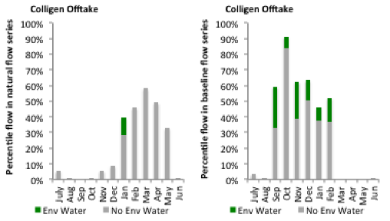
Figure EWK10: Contribution of environmental water delivery at Colligen Offtake as percentiles in the natural and baseline flow series.

A.12 Ovens
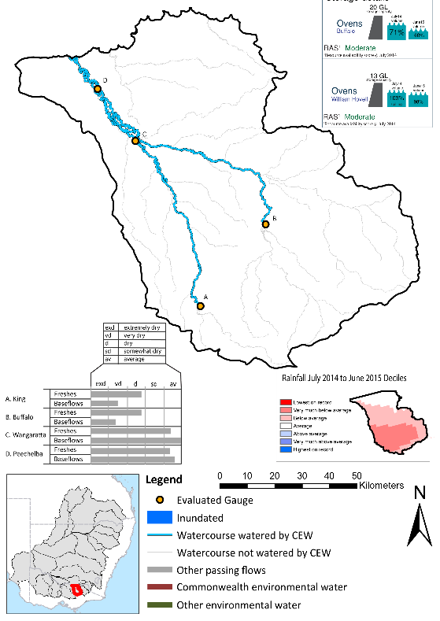
Figure OVN1: Location of evaluated gauges and the watercourses influenced by environmental water in the Ovens valley during the 2014-15 water year. Inset bar graphs report the condition of annual flow regimes: for the hypothetical scenario if no environmental flow had been delivered (grey) and the improvements with the addition of environmental water. Rainfall conditions and trend in Storage levels for the water year are reported.

Summary Statement
Environmental water delivery for the 2014-15 year in the Ovens Valley is evaluated using data for 4 sites. This evaluation only considers the contribution of held environmental water, which is a primary focus for the Commonwealth. The contributions of planned environmental water (e.g. passing flows), unregulated tributary inflows and clever use of irrigation flows for environmental benefits can all be very important but these are outside the scope of this report. Environmental watering actions lasted on average 2 days over the course of the year. The volume of environmental water at these 4 sites was between 0% and 0% of the total streamflow. Commonwealth Environmental Water contributed on average 100% of this environmental water. Ideally, baseflows should be maintained and long periods of excessively low flows avoided. In this valley, the baseflow regime was generally considered to be dry relative to the pre-development flow regime. In our analysis, a low fresh refers to a period of increased flow, when the water level rises at least one eighth of the way up the river bank (above the low flow level). These low freshes are a regular part of the natural flow regime and support a range of natural processes. In the Ovens valley, in terms of the the occurrence and duration of low freshes, the year was assessed as being somewhat dry. In our analysis, a medium fresh refers to a period of increased flow, when the water level rises at least one quater of the way up the river bank. These medium freshes are not as frequent as low freshes but are also a regular and important part of the natural flow regime. In the Ovens valley, in terms of the occurrence of medium freshes, the year was assessed as being dry. In our analysis, a high fresh refers to a period of increased flow, when the water level rises more than half way up the river. A high fresh may not occur every year but they are still important and long periods without major freshes can have serious consequences for floodplains and their contribution to river ecosystem health. Delivering environmental high in channel flows normally requires that all risks to riparian landholders and infrastructure have been resolved. In the Ovens valley, in terms of the occurrence of high freshes, the year was assessed as being average. Commonwealth environmental water actions altered flow regimes along an estimated 335 km of river out of a maximum of 335 km (100%) of mainstem river.

Description of Environmental Water System
The Ovens valley covers an area of 7882 km2, which represents 0.7% of the total Basin area. The valley is located in north-east Victoria. The Ovens River flows in a northerly direction from its headwaters in the Great Dividing Range. Its main tributary, the King River, joins the Ovens River near Wangaratta. The major water storages in the region include Lake Buffalo on the Buffalo River, with a capacity 20 GL, and Lake William Hovell on the King River, with a capacity of 13 GL. Over half of the region is covered with native vegetation primarily in the highlands. The major land use is dryland pasture used for beef and sheep grazing. In 2000, approximately 7700 ha were irrigated, including 2700 ha for vines and 3500 ha for pasture production. The Ovens River has a high environmental significance due to a combination of the high level of naturalness to its flow regime, relative intactness of the river system and the presence of a wide range of listed species. The Ovens River channel from downstream of Wangaratta to Lake Mulwala (the impoundment behind Yarrawonga Weir on the Murray River) is an environmental asset of national importance, containing an extensive network of billabongs, anabranches and islands (CSIRO 2008). The lower Ovens from Killawarra to Lake Mulwala is listed within the Directory of Important Wetlands Australia (DIWA - Ovens River - VIC144) (DSEWPaC 2010). The Ovens River is also nominated under the Victorian Heritage Rivers Act 1992 in recognition of its high ecological significance.
In the Ovens valley, environmental water is delivered as managed in-stream flows sourced from Lake William Hovell and Lake Buffalo. The main purpose of environmental flow delivery in the Ovens is to maintain or improve the ecological condition and functioning of the system. Typically water is only available from the holdings, so outcomes in the reaches immediately downstream of the holding areas are targeted. At times, these actions are delivered together with consumptive water. The Ovens valley is not considered to contain significant constraints to the delivery of environmental water (Mdba 2013). Under high and very high inflow conditions, environmental water deliveries are not feasible due to channel capacity constraints arising from river operating practices and agreed rules within the catchment (Mdba 2013).

Data Availability
Daily discharge data was provided by GMW at four gauge stations within the Ovens valley (Figure OVN1). GMW derived the contribution of the CEW and other passing flows based on the water released from storages and recorded flows at the downstream flow gauges. The contribution made by each component was derived by delivering agreed volumes with each water holder. Delivery volumes for the CEW were deemed at Lake Buffalo and Lake William Hovell. Flows that were estimated to arrive at Wangaratta were not available for use further downstream in the Murray system. Losses between upstream reservoirs and accounting points were not taken into account when assessing the flows available due to the low rates of delivery.

Environmental Conditions
The resource availability score for the Ovens valley was estimated (July 2014) as Moderate (OVN 1). Whereas, the rainfall conditions (based on gridded rainfall percentiles which compare the rainfall experienced for the water year to the total record) experienced were categorised as below average (Figure 1 – Main report). The storage levels of Lake Buffalo and William Hovell declined from a high of 71 and 103% respectively, at the beginning of the water year to 60 and 98% respectively, by the end of the water year.

Environmental Water Actions in 2014-15
In 2014-15 CEW was designed to deliver high in-stream flows which were expected to:
- Improve primary production through the disruption of biofilms;
- contribute toward macroinvertebrate diversity through the provision of shallow water habitat; and
- support native fish through provision of flows sufficient to stimulate fish movement and allow passage between habitats.
The long term average annual yield of the CEW entitlements in the Ovens were 66.5 ML. 70 ML of CEW was approved for delivery in the Ovens valley. The CEW portfolio yielded 100% of its registered high security entitlement. 70 ML of CEW was delivered in the Ovens valley, contributing to one watering action which spread over 3 days (0.8% of the water year) and occurred in April 2014. The watering action represented 100% of total environmental water delivered in the valley over 2014-15, but only accounted for 0.004% of the total expected flows under a predevelopment condition (Table OVN1).
The watering action provided variability in the low flows released downstream of Lake William Hovel and Lake Buffalo. The 50 ML holding from Lake William Hovel (King River) was delivered on the 4th and 5th of April. The 20 ML holding from Lake Buffalo (Buffalo River) was delivered on the 30th of April. This action was delayed in an attempt to deliver CEW in conjunction with a larger GMW bulk release drawdown (as was the case in 2013-14 where CEW was delivered with 4.8 GL of GMW bulk drawdown water) which was cancelled due to low inflows.

Table OVN1: Environmental water approved and delivered in the Ovens over 2014-15
Source | Total approved volume (ML) | Total volume delivered (ML) | % approved of total EWater delivered | % contribution to predevelopment flows ¹
CEW | 70 | 70 | 100 | 0.004%
¹ predevelopment average annual inflows of 1,753 GL

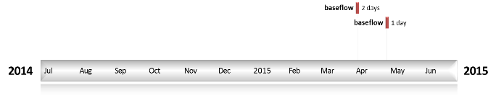

Figure OVN2: Timing and duration of Commonwealth Environmental Water actions in 2014-15.

Contribution of Commonwealth Environmental Water to Flow Regimes

King
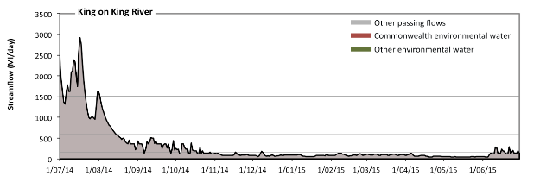
Figure OVN3: Contribution of environmental water delivery at King. Horizontal lines indicate thresholds for very low flows, low flows, low freshes, medium freshes and high freshes (from lowest to highest).
At King on King River environmental water contributed 0% of the total streamflow volume (all of which was Commonwealth Environmental Water) (Figure OVN3 and OVN4). Environmental watering actions affected streamflows for 1% of days between 1 June 2014 and 31 July 2015. Flow regulation does not substantially increase the duration of very low flows (i.e. < 10 Ml/day) compared to an average year in the natural flow regime. However, without environmental water, the durations of medium low flows (i.e. < 170 Ml/day) in the periods October to December, January to March and April to June would have substantially exceeded durations expected in an average year in the natural flow regime. However, environmental water had little effect on the duration of these medium low flows, which occurred for 69% of the year. There was at least one low fresh (i.e. > 590 Ml/day) in the period July to September. Environmental water made no change to the duration of these low freshes. There was at least one medium fresh (i.e. > 1500 Ml/day) in the period July to September. Environmental water made no change to the duration of these medium freshes. In the absence of environmental water there would have been at least one high fresh in the period July to September. Environmental water made no change to the duration of these high freshes.
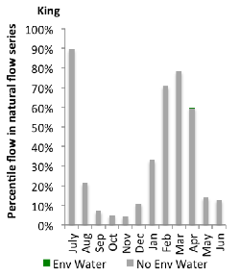
Figure OVN4: Contribution of environmental water delivery at King as percentiles in the natural flow series.
Wangaratta
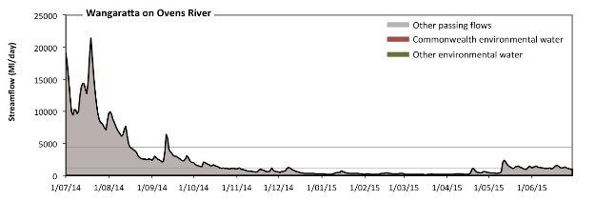
Figure OVN5: Contribution of environmental water delivery at Wangaratta. Horizontal lines indicate thresholds for very low flows, low flows, low freshes, medium freshes and high freshes (from lowest to highest).
At Wangaratta on Ovens River environmental water contributed 0% of the total streamflow volume (all of which was Commonwealth Environmental Water) (Figure OVN5 and OVN6). Environmental watering actions affected streamflows for 1% of days between 1 June 2014 and 31 July 2015. Flow regulation does not substantially increase the duration of very low flows (i.e. < 86 Ml/day) compared to an average year in the natural flow regime. Flow regulation does not substantially increase the duration of medium low flows (i.e. < 140 Ml/day) compared to an average year in the natural flow regime. There was at least one low fresh (i.e. > 1200 Ml/day) in the periods July to September, October to December and April to June. Environmental water made no change to the duration of these low freshes. There was at least one medium fresh (i.e. > 4400 Ml/day) in the period July to September. Environmental water made no change to the duration of these medium freshes. In the absence of environmental water there would have been at least one high fresh in the period July to September. Environmental water made no change to the duration of these high freshes.
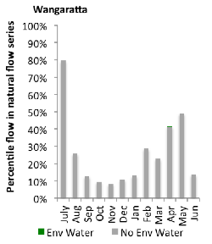
Figure OVN6: Contribution of environmental water delivery at Wangaratta as percentiles in the natural flow series.

Buffalo
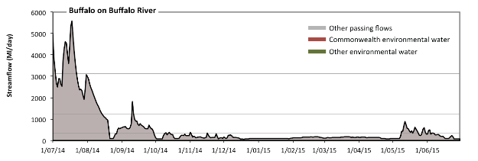
Figure OVN7: Contribution of environmental water delivery at Buffalo. Horizontal lines indicate thresholds for very low flows, low flows, low freshes, medium freshes and high freshes (from lowest to highest).
At Buffalo on Buffalo River environmental water contributed 0% of the total streamflow volume (all of which was Commonwealth Environmental Water) (Figure OVN7 and OVN8). Environmental watering actions affected streamflows for 0% of days between 1 June 2014 and 31 July 2015. Flow regulation does not substantially increase the duration of very low flows (i.e. < 22 Ml/day) compared to an average year in the natural flow regime. However, without environmental water, the durations of medium low flows (i.e. < 350 Ml/day) in the periods July to September, October to December, January to March and April to June would have all substantially exceeded durations expected in an average year in the natural flow regime. However, environmental water had little effect on the duration of these medium low flows, which occurred for 70% of the year. There was at least one low fresh (i.e. > 1200 Ml/day) in the period July to September. Environmental water made no change to the duration of these low freshes. There was at least one medium fresh (i.e. > 3100 Ml/day) in the period July to September. Environmental water made no change to the duration of these medium freshes. In the absence of environmental water there would have been at least one high fresh in the period July to September. Environmental water made no change to the duration of these high freshes.
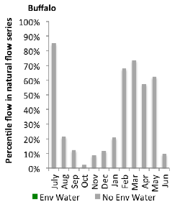
Figure OVN8: Contribution of environmental water delivery at Buffalo as percentiles in the natural flow series.
Peechelba
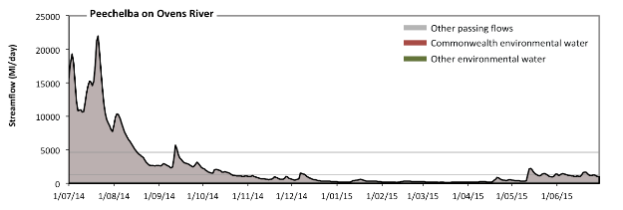
Figure OVN9: Contribution of environmental water delivery at Peechelba. Horizontal lines indicate thresholds for very low flows, low flows, low freshes, medium freshes and high freshes (from lowest to highest).
At Peechelba on Ovens River environmental water contributed 0% of the total streamflow volume (all of which was Commonwealth Environmental Water) (Figure OVN9 and OVN10). Environmental watering actions affected streamflows for 1% of days between 1 June 2014 and 31 July 2015. Flow regulation does not substantially increase the duration of very low flows (i.e. < 94 Ml/day) compared to an average year in the natural flow regime. Flow regulation does not substantially increase the duration of medium low flows (i.e. < 170 Ml/day) compared to an average year in the natural flow regime. There was at least one low fresh (i.e. > 1300 Ml/day) in the periods July to September, October to December and April to June. Environmental water made no change to the duration of these low freshes. There was at least one medium fresh (i.e. > 4600 Ml/day) in the period July to September. Environmental water made no change to the duration of these medium freshes. In the absence of environmental water there would have been at least one high fresh in the period July to September. Environmental water made no change to the duration of these high freshes.
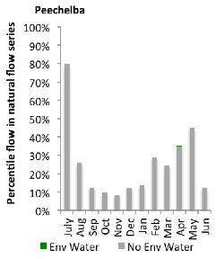
Figure OVN10: Contribution of environmental water delivery at Peechelba as percentiles in the natural flow series.

A.13 Campaspe
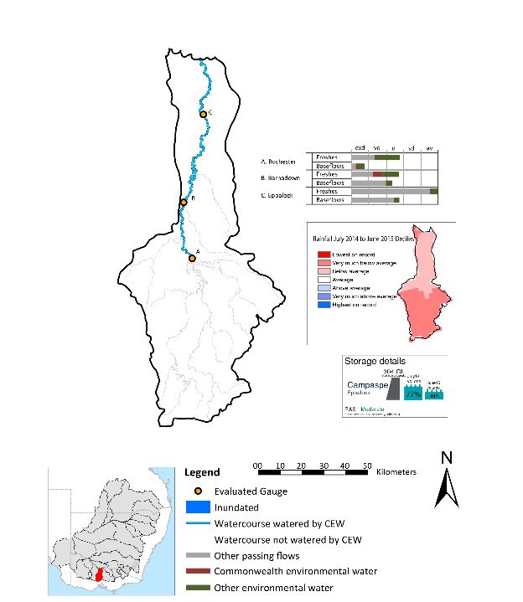
Figure CMP1: Location of evaluated gauges and the watercourses influenced by environmental water in the Campaspe valley during the 2014-15 water year. Inset bar graphs report the condition of annual flow regimes: for the hypothetical scenario if no environmental flow had been delivered (grey) and the improvements with the addition of environmental water. Rainfall conditions and trend in Storage levels for the water year are reported.

Summary Statement
Environmental water delivery for the 2014-15 year in the Campaspe Valley is evaluated using data for 3 sites. This evaluation only considers the contribution of held environmental water, which is a primary focus for the Commonwealth. The contributions of planned environmental water (e.g. passing flows), unregulated tributary inflows and clever use of irrigation flows for environmental benefits can all be very important but these are outside the scope of this report. Environmental watering actions lasted on average 145 days over the course of the year. The volume of environmental water at these 3 sites was between 36% and 41% of the total streamflow. Commonwealth Environmental Water contributed on average 19% of this environmental water. Ideally, baseflows should be maintained and long periods of excessively low flows avoided. In this valley, the baseflow regime was generally considered to be extremely dry relative to the pre-development flow regime. In our analysis, a low fresh refers to a period of increased flow, when the water level rises at least one eighth of the way up the river bank (above the low flow level). These low freshes are a regular part of the natural flow regime and support a range of natural processes. In the Campaspe valley, in terms of the the occurrence and duration of low freshes, the year was assessed as being somewhat dry. In our analysis, a medium fresh refers to a period of increased flow, when the water level rises at least one quater of the way up the river bank. These medium freshes are not as frequent as low freshes but are also a regular and important part of the natural flow regime. In the Campaspe valley, in terms of the occurrence of medium freshes, the year was assessed as being average. In our analysis, a high fresh refers to a period of increased flow, when the water level rises more than half way up the river. A high fresh may not occur every year but they are still important and long periods without major freshes can have serious consequences for floodplains and their contribution to river ecosystem health. Delivering environmental high in channel flows normally requires that all risks to riparian landholders and infrastructure have been resolved. In the Campaspe valley, in terms of the occurrence of high freshes, the year was assessed as being very dry. Commonwealth environmental water actions altered flow regimes along an estimated 160 km of river out of a maximum of 160 km of mainstem river.

Description of Environmental Water System
The Campaspe valley covers approximately 4020 km2 representing 0.4% of the Mdb. The Campaspe river extends for approximately 160 km from the northern slopes of the Great Dividing Range near Trentham to the River Murray at Echuca. The Campaspe River and Coliban River are the largest rivers in the catchment, but other significant tributaries include Axe, McIvor, Mt Pleasant, Forest, Wild Duck and Pipers Creeks (SKM 2006).
Prior to European settlement, streams in the middle and lower Campaspe River catchment would have had low energy, contained fine grained sediments and had occasional rocky outcrops. Most of the streams would have had incised channels, with deep pools, infrequent riffles over gravel, boulders or logs and an abundance of large woody debris (NCCMA 2005). Flows would have been seasonally variable, with high flows in winter and spring and low or no flow in summer and autumn. However, the construction of reservoirs and weirs for potable supply and irrigation has substantially reduced flows throughout the catchment and reversed the seasonal flow patterns in the lower reaches.
The Campaspe River is heavily regulated and supplies water for irrigation and urban demands. Significant features include: Malmsbury Reservoir, Lake Eppalock, Campaspe Weir and Campaspe Siphon, as well as the Waranga Channel. The regulated sections of the Campaspe River include four main reaches:
- Coliban River: Malmsbury Reservoir to Lake Eppalock
- Campaspe River: Lake Eppalock to Campaspe Weir
- Campaspe River: Campaspe Weir to Campaspe Siphon
- Campaspe River: Campaspe Siphon to River Murray
The environmental flow needs of the Campaspe valley are broadly summarised as meeting baseflow targets in the Campaspe River and providing contributions towards flows in the Murray River. The key constraints believed to limit environmental flow delivery in this valley occur in the Coliban and Campaspe Rivers.
In the Campaspe River, the main constraint on delivery is on bankfull winter flows (estimated at approximately 8000 to 12000 Ml/d). This is because Lake Eppalock has an outlet capacity of 1000Ml/d to 1850Ml/d (SKM 2006). The Waranga Western Channel could partially contribute to the recommended winter bankfull and overbank flow, but it is also constrained by outfall capacity (1,470 to 2,300 ML/d) (SKM 2006). Moreover, infrastructure capacity and the flooding of Rochester Caravan Park (which occurs at 19,000Ml/d) are additional important constraints (SKM 2006).
In the Coliban River, the main delivery constraint is on low baseflows. This is because Malmsbury Reservoir is partially constrained by the existing outlet, which for low flows, is between 10 ML/d and 45 Ml/d (SKM 2006). SKM (2006) also report that a flow of 8,700 ML/d may overtop the Calder Highway at Malmsbury, constraining delivery of winter bankfull flows.

Data Availability
Daily discharge data was provided by GMW at three gauge stations within the Campaspe valley (Figure CMP1). GMW derived the contribution of the CEW, VEWH, TLM, IVT and other passing flows using operational models in their ‘in house’ accounting spreadsheet. The contribution made by each component was derived by delivering agreed volumes with each water holder (i.e. delivery for TLM was required at specific times). Delivery volumes for the environmental water holders were deemed at Eppalock with the flows that arrive at Rochester being made available for use further downstream in the Murray system. Losses between upstream reservoirs and accounting points were taken into account when assessing the flows available. The component of environmental flows to the flow in the Rochester at the sites upstream of Barnadown was estimated based on the volumes downstream of Eppalock.

Environmental Conditions
The resource availability score for the Campaspe valley was estimated (July 2014) as Moderate (CMP 1). Whereas, the rainfall conditions (based on gridded rainfall percentiles which compare the rainfall experienced for the water year to the total record) experienced were categorised as very much below average (Figure 1 – Main report). The storage levels of Lake Eppalcok declined from a high of 77% at the beginning of the water year to 44% by the end of the water year.

Environmental Water Actions in 2014-15
The LTAAY of CEW entitlements in the Campaspe during 14-15 was 6412 ML. 7,086 ML of CEW was approved for delivery in the Campaspe valley. The CEW portfolio yielded approximately 6,547 ML (94%) of high security entitlement, whilst the registered CEW entitlement in the Campaspe (in 2014-15) was 6437 ML.
In 2014-15 environmental flows in the Broken intended to achieve the following outcomes:
- Reduce encroachment of exotic and terrestrial vegetation
- Enhance river red gum recruitment
- Stimulate fish movement and facilitate movement downstream
- Improve water quality and conditions for macroinvertebrates via flushing and mixing pool habitat
- Flushing orgaincs on bank and bench habitats to reduce likelihood of blackwater events in summer
- Inundate snags and flush sediment off biofilms for macroinvertebrates
- Contribute to River Murray outcomes
CEW (5791.4ML) represented approximately 19% of the total volume of environmental water delivered, this amounted to approximately 2.7% of predevelopment total inflows (Table CMP1). CEW and VEW shared delivery of environmental water equally during 2014-15, roughly based on pro-rata entitlement. This strategy is to ensure no water holder is left with too much or too little carryover relative to holdings and is why 18% of approved CEW was not used (1294.6 ML). The unused CEW was carried over in the Goulburn account as part of the broader Commonwealth portfolio management.
Table CMP1: Environmental water approved and delivered in the Campaspe over 2014-15
Source | LTAAY (ML) | Total approved volume (ML) | Total volume delivered (ML) | % holding of total Ewater delivered | % contribution to predevelopment flows¹
CEW | 6412 | 7086 | 5791.4 | 18.8 | 2.7
VEWH | NA | NA | 22363.8 | 72.8 | 7.7
TLM | NA | NA | 2574.1 | 8.4 | 0.9
¹ predevelopment average annual inflows of 289.7 GL
5,791 ML of CEW was delivered in the Campaspe as instream flows sourced from managed storage releases. CEW was used in one watering actions which spread over 14 days (4% of the year). The action was delivered as a spring fresh. In collaboration with VEW and TLM water, flows of approximately 1500 ML/d were achieved at the target reach - Lake Eppalock and Campaspe Siphon (Figure CMP1.2). This action was delivered as intended, but discharge rates were slightly below the target rate. This was mainly due to concerns expressed by landowners with respect to third party impacts, including inundation and restricting access to key assets.
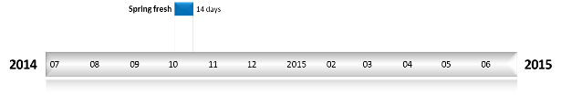
Figure CMP2: Timing and duration of Commonwealth Environmental Water actions in 2014-15.

Contribution of Commonwealth Environmental Water to Flow Regimes

Eppalock
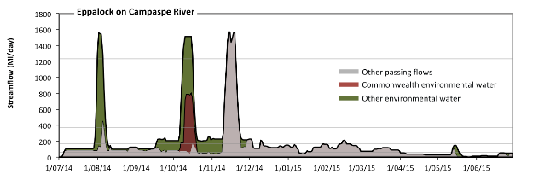
Figure CMP3: Contribution of environmental water delivery at Eppalock. Horizontal lines indicate thresholds for very low flows, low flows, low freshes, medium freshes and high freshes (from lowest to highest).
At Eppalock on Campaspe River environmental water contributed 40% of the total streamflow volume (with a relatively small contribution of Commonwealth Environmental Water) (Figure CMP3 and CMP4). Environmental watering actions affected streamflows for 40% of days between 1 June 2014 and 31 July 2015. Flow regulation does not substantially increase the duration of very low flows (i.e. < 12 Ml/day) compared to an average year in the natural flow regime. However, without environmental water, the duration of medium low flows (i.e. < 61 Ml/day) in the period April to June would have substantially exceeded durations expected in an average year in the natural flow regime. Environmental water reduced the cumulative duration of medium low flow spells from 33% to 26% of the year, with greatest influence in the period October to December. CEW made a small contribution to these enhancements of environmental baseflows at this site. In the absence of environmental water there would have been at least one low fresh (i.e. > 170 Ml/day) in the periods July to September, October to December and January to March. Environmental water increased the duration of the longest low fresh during the periods July to September (from 3 days to 14 days) and October to December (from 14 days to 64 days). CEW made little or no contribution to these increased durations of low freshes. In the absence of environmental water there would have been at least one medium fresh (i.e. > 370 Ml/day) in the periods July to September and October to December. Environmental water increased the duration of the longest medium fresh during the period July to September (from 1 days to 8 days). CEW made little or no contribution to these increased durations of medium freshes. In the absence of environmental water there would have been at least one high fresh in the period October to December. Environmental water increased the duration of the longest medium fresh during the period July to September (from 0 days to 5 days). CEW made little or no contribution to these increased durations of high freshes.
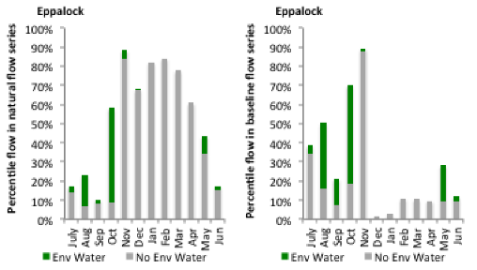
Figure CMP4: Contribution of environmental water delivery at Eppalock as percentiles in the natural and baseline flow series.
Barnadown
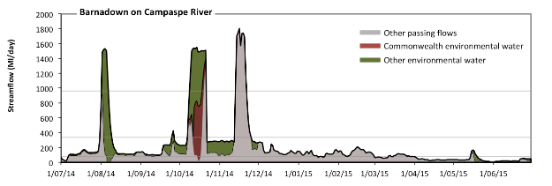
Figure CMP5: Contribution of environmental water delivery at Barnadown. Horizontal lines indicate thresholds for very low flows, low flows, low freshes and medium freshes (from lowest to highest).
At Barnadown on Campaspe River environmental water contributed 36% of the total streamflow volume (with a relatively small contribution of Commonwealth Environmental Water) (Figure CMP5 and CMP6). Environmental watering actions affected streamflows for 40% of days between 1 June 2014 and 31 July 2015. Flow regulation does not substantially increase the duration of very low flows (i.e. < 15 Ml/day) compared to an average year in the natural flow regime. However, without environmental water, the durations of medium low flows (i.e. < 77 Ml/day) in the periods July to September and April to June would have substantially exceeded durations expected in an average year in the natural flow regime. Environmental water mitigated these impacts by reducing the cumulative duration of medium low flow spells from 32% to 29% of the year, with greatest influence in the periods July to September and April to June. CEW made a small contribution to these enhancements of environmental baseflows at this site. In the absence of environmental water there would have been at least one low fresh (i.e. > 340 Ml/day) in the periods July to September and October to December. Environmental water increased the duration of the longest low fresh during the period July to September (from 2 days to 9 days). CEW made little or no contribution to these increased durations of low freshes. In the absence of environmental water there would have been at least one medium fresh (i.e. > 970 Ml/day) in the period October to December. Environmental water increased the duration of the longest medium fresh during the periods July to September (from 0 days to 5 days) and October to December (from 9 days to 13 days). CEW equally shared responsibility with other environmental water holders for these increased durations of medium freshes. There was no high freshes (i.e. > 4200 Ml/day) this year.
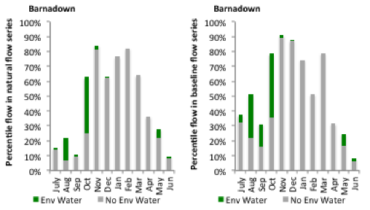
Figure CMP6: Contribution of environmental water delivery at Barnadown as percentiles in the natural and baseline flow series.
Rochester
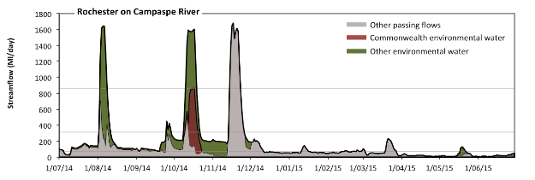
Figure CMP7: Contribution of environmental water delivery at Rochester. Horizontal lines indicate thresholds for very low flows, low flows, low freshes and medium freshes (from lowest to highest).
At Rochester on Campaspe River environmental water contributed 41% of the total streamflow volume (with a relatively small contribution of Commonwealth Environmental Water) (Figure CMP7 and CMP8). Environmental watering actions affected streamflows for 39% of days between 1 June 2014 and 31 July 2015. Without environmental water, the durations of very low flows (i.e. < 15 Ml/day) in the periods October to December and April to June would have substantially exceeded durations expected in an average year in the natural flow regime. Environmental water mitigated these impacts by reducing the cumulative duration of very low flow spells from 16% to 11% of the year, with greatest influence in the periods October to December and April to June. Similarly, without environmental water, the durations of medium low flows (i.e. < 77 Ml/day) in the periods July to September, October to December, January to March and April to June would have all substantially exceeded durations expected in an average year in the natural flow regime. Environmental water mitigated these impacts by reducing the cumulative duration of medium low flow spells from 62% to 51% of the year, with greatest influence in the periods July to September and October to December. CEW made a small contribution to these enhancements of environmental baseflows at this site. In the absence of environmental water there would have been at least one low fresh (i.e. > 310 Ml/day) in the periods July to September and October to December. Environmental water increased the duration of the longest low fresh during the period July to September (from 2 days to 9 days). CEW made little or no contribution to these increased durations of low freshes. In the absence of environmental water there would have been at least one medium fresh (i.e. > 860 Ml/day) in the period October to December. Environmental water increased the duration of the longest medium fresh during the period July to September (from 0 days to 6 days). CEW made little or no contribution to these increased durations of medium freshes. There was no high freshes (i.e. > 3600 Ml/day) this year.
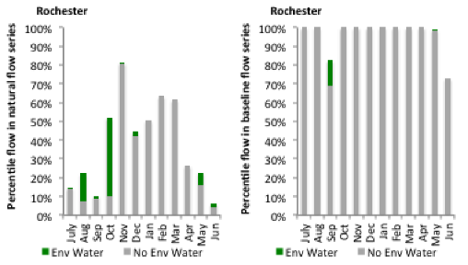
Figure CMP8: Contribution of environmental water delivery at Rochester as percentiles in the natural and baseline flow series.

