**2014–15 Basin-scale evaluation of Commonwealth environmental water — Hydrology**

**Prepared by:** Michael Stewardson and Fiorenzo Guarino

Final Report

**MDFRC Publication 104/2016**

2014–15 Basin-scale evaluation of Commonwealth environmental water — Hydrology

Final Report prepared for the Commonwealth Environmental Water Office (CEWO) by The Murray–Darling Freshwater Research Centre

This report was prepared by The Murray–Darling Freshwater Research Centre (MDFRC). The aim of the MDFRC is to provide the scientific knowledge necessary for the management and sustained utilisation of the Murray–Darling Basin water resources. The MDFRC is a joint venture between La Trobe University and CSIRO.

C:\Users\hmissen\AppData\Local\Microsoft\Windows\Temporary Internet Files\Content.Outlook\EZ3BCCAB\CSIRO_Grad_RGB_lr.jpg

For further information contact:

**Ben Gawne**

The Murray–Darling Freshwater Research Centre  
PO Box 991   
Wodonga VIC 3689

Ph: (02) 6024 9650

Email: [Ben.Gawne@](mailto:Ben.Gawne@)canberra.edu.au  
Web: [www.mdfrc.org.au](http://www.mdfrc.org.au)  
Enquiries: [mdfrc@latrobe.edu.au](mailto:mdfrc@latrobe.edu.au)

**Report Citation:** Stewardson MJ, Guarino F (2016) 2014–15 Basin-scale evaluation of Commonwealth environmental water — Hydrology. Final Report prepared for the Commonwealth Environmental Water Office by The Murray–Darling Freshwater Research Centre, MDFRC Publication 104/2016, November, 50pp.

This monitoring project was commissioned and funded by Commonwealth Environmental Water Office.

**Copyright**

© Copyright Commonwealth of Australia, 2016



2014-15 Basin-scale evaluation of Commonwealth environmental water: Hydrology (2016) is licensed by the Commonwealth of Australia for use under a Creative Commons By Attribution 3.0 Australia licence with the exception of the Coat of Arms of the Commonwealth of Australia, the logo of the agency responsible for publishing the report, content supplied by third parties, and any images depicting people. For licence conditions see: <http://creativecommons.org/licenses/by/3.0/au/>

This report should be attributed as Stewardson MJ, Guarino F (2016) 2014–15 Basin-scale evaluation of Commonwealth environmental water — Hydrology. Report prepared for the Commonwealth Environmental Water Office by The Murray–Darling Freshwater Research Centre, MDFRC Publication 104/2016, November, 50pp.

**Disclaimer**

The views and opinions expressed in this publication are those of the authors and do not necessarily reflect those of the Australian Government or the Minister for the Environment.

While reasonable efforts have been made to ensure that the contents of this publication are factually correct, the Commonwealth does not accept responsibility for the accuracy or completeness of the contents, and shall not be liable for any loss or damage that may be occasioned directly or indirectly through the use of, or reliance on, the contents of this publication.

The material contained in this publication represents the opinion of the author(s) only. While every effort has been made to ensure that the information in this publication is accurate, the author(s) and MDFRC do not accept any liability for any loss or damage howsoever arising whether in contract, tort or otherwise which may be incurred by any person as a result of any reliance or use of any statement in this publication. The author(s) and MDFRC do not give any warranties in relation to the accuracy, completeness and up-to-date status of the information in this publication.

Where legislation implies any condition or warranty which cannot be excluded restricted or modified, such condition or warranty shall be deemed to be included provided that the author’s and MDFRC’s liability for a breach of such condition or warranty is, at the option of MDFRC, limited to the supply of the services again or the cost of supplying the services again.

Document history and status

|  |  |  |  |  |
| --- | --- | --- | --- | --- |
| Version | Date Issued | Reviewed by | Approved by | Revision type |
| Draft | 20 June 2016 | Penny Everingham & Ben Gawne | Ben Gawne | Internal |
| Draft | 23 June 2016 | Mary Webb | Penny Everingham | External copy edit |
| Draft | 7 September 2016 | Jenny Hale & Penny Everingham | Ben Gawne | Internal |
| Draft | 13 September 2016 | CEWO | Penny Everingham | External |
| Draft | 19 October 2016 | Mike Stewardson & Fiorenzo Guarino | Penny Everingham | Internal |
| Draft | 2 November 2016 | Jenny Hale | Penny Everingham | Internal |
| Draft | 4 November 2016 | Mary Webb | Penny Everingham and Mike Stewardson | External copy edit |
| Final | 16 November 2016 | CEWO | Ben Gawne | External |

Distribution of copies

|  |  |  |
| --- | --- | --- |
| Version | Quantity | Issued to |
| Draft | 1 x PDF | CEWO and M&E Providers |
| Draft | 1 x PDF 1 x Word | CEWO |
| Final | 1 x PDF 1 x Word | Paul Marsh, Sam Roseby and Andrew Lowes |

**Filename and path:** Projects\CEWO\CEWH Long Term Monitoring Project\499 LTIM Stage 2 2014-19 Basin evaluation\Final Reports

**Author(s):** Michael Stewardson and Fiorenzo Guarino

**Author affiliation(s):** The University of Melbourne and The University of Canberra.

**Project Manager:** Ben Gawne

**Client:** Commonwealth Environmental Water Office

**Project Title:** Basin evaluation of the contribution of Commonwealth environmental water to the environmental objectives of the Murray‒Darling Basin Plan

**Document Version:** Final

**Project Number:** M/BUS/499

**Contract Number:** PRN 1213-0427

**Acknowledgements:**

We would like to acknowledge the many individuals and agencies assisted by providing data to support this evaluation. This included officers within the CEWO, Victorian Environmental Water Holder (VEWH), WaterNSW, Goulburn-Murray Water (GMW), Department of Environment, Water and Natural Resources (DEWNR) South Australia, Office of Environment & Heritage (OEH) New South Wales, Nature Foundation South Australia (NFSA), Mallee Catchment Management Authority (CMA), North-Central CMA, Goulburn Broken and North East CMA and the Murray–Darling Basin Authority (MDBA). In particular, we would like to thank Jim Foreman and Aftab Ahmad for conducting the Murray and Darling River modelling and for the drafting the modelling methodology for this report. Rachael Thomas and Jessica Heath provided invaluable data on inundation extents in the Murrumbidgee, Gwydir and Macquarie. Paul Packard provided extents for the Lachlan. Irene Wegener, Callie Nickolai, Jane White and Andrew Keogh provided inundation extents for various parts of the Murray. Jo Wood provided extents for the Broken. Ken Gee, Vincent Kelly and Sri Sritharan (WaterNSW) and Andrew Shields (GMW), Jarod Eaton, Matt Gibbs (DEWNR) and Gareth Carpenter (SA Water) provided hydrology data, foundational to this evaluation. Abbas Mohammadi provided GIS support. We thank the LTIM Project members who reviewed aspects of this report.

This project was undertaken using data collected for the Commonwealth Environmental Water Office Long Term Intervention Monitoring project. The assistance provided by the Monitoring and Evaluation Providers into interpretation of data and report review is greatly appreciated. The authors would also like to thank all Monitoring and Evaluation Provider staff involved in the collection and management of data.

The Murray–Darling Freshwater Research Centre offices are located on the land of the Latje Latje and Wiradjuri peoples. We undertake work throughout the Murray–Darling Basin and acknowledge the traditional owners of this land and water. We pay respect to Elders past, present and future.

Contents

[1 Introduction 1](#_Toc467072989)

[1.1 Background 1](#_Toc467072990)

[1.2 Context in 2014–15 2](#_Toc467072991)

[1.3 Summary of watering actions for 2014–15 5](#_Toc467072992)

[1.4 Hydrological contribution of Commonwealth environmental water to flow regimes in 2014–15 6](#_Toc467072993)

[2 Methods 9](#_Toc467072994)

[2.1 Observations of streamflows 9](#_Toc467072995)

[2.2 Baseline hydrology scenarios 9](#_Toc467072996)

[2.3 Floodplain inundation and connectivity 12](#_Toc467072997)

[2.4 Watercourses watered 13](#_Toc467072998)

[2.5 Assessment of Basin-wide hydrological impacts 13](#_Toc467072999)

[2.5.1 Flow thresholds 14](#_Toc467073000)

[2.5.2 Flow regime score 15](#_Toc467073001)

[2.5.3 Attribution of Commonwealth environmental water 16](#_Toc467073002)

[3 Summary of outcomes 16](#_Toc467073003)

[3.1 Base flows (low–medium flows) 16](#_Toc467073004)

[3.2 Freshes 17](#_Toc467073005)

[3.3 Floodplain connectivity 19](#_Toc467073006)

[4 Contribution to achievement of Basin Annual Environmental Watering Priorities 19](#_Toc467073007)

[4.1 Connect rivers and floodplains: Gwydir Wetlands 20](#_Toc467073008)

[4.1.1 Environmental watering actions 20](#_Toc467073009)

[4.1.2 Gwydir Wetland inundation event 21](#_Toc467073010)

[4.1.3 Mallowa wetland inundation event 21](#_Toc467073011)

[4.1.4 Carole Creek fresh 22](#_Toc467073012)

[4.1.5 Mehi River fresh 22](#_Toc467073013)

[4.2 Connect rivers and floodplains: mid-Murrumbidgee wetlands 23](#_Toc467073014)

[4.2.1 Environmental watering actions 23](#_Toc467073015)

[4.2.2 Inundation of mid-Murrumbidgee wetlands 24](#_Toc467073016)

[4.2.3 Inundation of lower Murrumbidgee wetlands 25](#_Toc467073017)

[4.3 Support instream functions: Macquarie River 26](#_Toc467073018)

[4.3.1 Environmental watering actions 26](#_Toc467073019)

[4.3.2 In-channel flow regime 26](#_Toc467073020)

[4.3.3 Wetland inundation 28](#_Toc467073021)

[4.4 Support instream functions: connectivity in the Murray river system and winter flows for fish in the southern Basin 28](#_Toc467073022)

[4.4.1 Goulburn River 29](#_Toc467073023)

[4.4.2 Loddon River 30](#_Toc467073024)

[4.4.3 Campaspe River 31](#_Toc467073025)

[4.4.4 Broken Creek 32](#_Toc467073026)

[4.4.5 Yanco billabong system 32](#_Toc467073027)

[4.4.6 Edward–Wakool river system 33](#_Toc467073028)

[4.4.7 Central Murray River 35](#_Toc467073029)

[4.4.8 Lower Murray River (downstream of Lock 10) 38](#_Toc467073030)

[4.5 Maintain the Coorong, Lower Lakes and Murray Mouth 40](#_Toc467073031)

[4.5.1 Water levels in the Lower Lakes 40](#_Toc467073032)

[4.5.2 The contribution of Commonwealth environmental water to barrage flows of the Murray Mouth 42](#_Toc467073033)

[4.5.3 Murray Mouth opening 42](#_Toc467073034)

[4.5.4 Commonwealth environmental water contribution to salinity and sediment transport 45](#_Toc467073035)

[4.6 Enhance and protect refuge habitat: native fish in the northern Basin 46](#_Toc467073036)

[4.7 Enhance and protect refuge habitat: waterbird refuge 48](#_Toc467073037)

[References 49](#_Toc467073038)

[Annex A. Valley report cards 1 to 13 50](#_Toc467073039)

List of tables

[Table 1. Summary of CEWO watering actions by valley. 5](#_Toc466036373)

[Table 2. Contribution of Commonwealth environmental water to Murray–Darling Basin Authority (MDBA) Annual Environmental Watering Priorities. 7](#_Toc466036374)

[Table 3. Websites used to source discharge data for 109 gauge stations in the Murray–Darling Basin. 9](#_Toc466036375)

[Table 4. The 109 sites used to evaluate Commonwealth environmental water in the 2014–15 watering year, including an outline of the method used to account environmental water. 11](#_Toc466036376)

List of figures

[Figure 1. Valleys used for 2014-15 hydrological assessment. 3](#_Toc467072823)

[Figure 2. Gauges evaluated, areas inundated, streams watered by Commonwealth environmental water, and rainfall conditions during the 2014–15 watering year. 4](#_Toc467072824)

[Figure 3. Average contributions of Commonwealth environmental water and other environmental water entitlements to base flow durations and occurrence of freshes across each valley in 2014–15. 18](#_Toc467072825)

[Figure 4. Streamflows at Yarraman on the Gwydir River in 2014–15. Contributions of Commonwealth environmental water and other environmental water are shown.. 21](#_Toc467072826)

[Figure 5. Streamflows at Mallowa on Mallowa Creek in 2014–15. Contributions of Commonwealth environmental water are shown. 22](#_Toc467072827)

[Figure 6. Streamflow at Garah on Carole Creek in 2014–15. Contribution of Commonwealth environmental water is shown in red. 22](#_Toc467072828)

[Figure 7. Streamflow at Combadello on the Mehi River in 2014–15. Contribution of Commonwealth environmental water is shown in red. 23](#_Toc467072829)

[Figure 8. Inundation in the mid-Murrumbidgee wetlands. Inundation extents provided by the NSW Office of Environment and Heritage and map base layer derived from Google (2016), which used CNES/Astrium and Landsat imagery. 24](#_Toc467072830)

[Figure 9. Inundation extent in the lower Murrumbidgee River. Inundation extents provided by the NSW Office of Environment and Heritage and map base layer derived from Google (2016), which used Landsat imagery. 25](#_Toc467072831)

[Figure 10. Streamflows at Burrendong (upland) and Marebone (lowland) on the Macquarie River in 2014–15. Contributions of Commonwealth environmental water and other environmental water 27](#_Toc467072832)

[Figure 11. Inundation extent in the Macquarie Marshes. Inundation extents provided by NSW Office of Environment and Heritage and map base layer derived from Google (2016), which used Landsat imagery. 28](#_Toc467072833)

[Figure 12. Streamflows at Trawool (upstream) and Murchison (downstream) on the Goulburn River in2014–15. Contributions of Commonwealth environmental water and other environmental water .. 30](#_Toc467072834)

[Figure 13. Streamflows at Laanacoorie Reservoir (upstream) and Appin South (downstream) on the Loddon River in 2014–15. Contributions of Commonwealth environmental water and non–Commonwealth environmental water . 31](#_Toc467072835)

[Figure 14. Streamflows at Rochester on Campaspe River in 2014–15. Contributions of Commonwealth environmental water and non–Commonwealth environmental water shown. Horizontal lines indicate thresholds for very low flows, low flows, low freshes and medium freshes (from lowest to highest). 32](#_Toc467072836)

[Figure 15. Streamflows at Rices Weir on Broken Creek in 2014–15. Contributions of Commonwealth environmental water 32](#_Toc467072837)

[Figure 16. Streamflows in the Yanco Creek at the offtake from the Murrumbidgee River in 2014–15. Contributions of Commonwealth environmental water and NSW environmental water . 33](#_Toc467072838)

[Figure 17. Streamflows at sites in the Edward–Wakool river system in 2014–15. Contributions of Commonwealth environmental water and other environmental water . 34](#_Toc467072839)

[Figure 18. Streamflows at Corowa, Barmah and Lock 10 on the Central Murray River in 2014–15. 36](#_Toc467072840)

[Figure 19. Wetlands inundated using Commonwealth environmental water during 2014–15 along the Central Murray River downstream of Piangil (base layer derived from Google (2016) which used 2016 CNES/Astrium and Digital Globe). 37](#_Toc467072841)

[Figure 20. Streamflows at Lock 9 and Lock 1 in the Lower Murray River in 2014–15. 38](#_Toc467072842)

[Figure 21. Wetlands inundated during the 2014–15 year along the Lower and Central Murray River (base layer derived from Google (2016) which used Landsat imagery). 39](#_Toc467072843)

[Figure 22. Contribution of Commonwealth environmental water (CEW) to flows into the Murray Estuary and the Coorong in 2014–15 (TLM = The Living Murray; VEWH = Victorian Environmental Water Holder; Lake Alex = Lake Alexandrina). 41](#_Toc467072844)

[Figure 23. Streamflows over barrages of the Murray Mouth in 2014–15. Contribution of environmental water 42](#_Toc467072845)

[Figure 24. Box and whisker plot of the Goolwa Barrage diurnal tide ratio for days where no Commonwealth environmental water was delivered (No CEW) and days where Commonwealth environmental water was delivered via the barrages (With CEW). 43](#_Toc467072846)

[Figure 25. Box and whisker plot showing the modelled streambed height for the 2014–15 watering year. The reference line of 1 m indicates a modelled Murray Mouth depth. 44](#_Toc467072847)

[Figure 26. Modelled change in the Murray Mouth bed depth for the counterfactual scenario (modelled pre-buyback) and an actual scenario (modelled actual). Lake level and diurnal tide ratio index at Goolwa Barrage 45](#_Toc467072848)

[Figure 27. Streamflows at sites in the Darling, Warrego, Condamine–Balonne, Barwon and Border Rivers valleys. Contributions of Commonwealth environmental water . 48](#_Toc467072849)

# Introduction

## Background

The management of Commonwealth environmental water holdings is one of the principal means by which the Australian Government seeks to achieve the Basin Plan environmental objectives. The Commonwealth Environmental Water Office (CEWO) holds entitlements for around 2400 gigalitres (GL) of water, providing a long-term average annual yield of over 1600 GL. The holdings are managed to achieve specified environmental outcomes through a series of watering actions every year.

This report seeks to evaluate the hydrological outcomes of the CEWO’s water management decisions on two Basin Plan objectives. Specifically, it aims to check that there is no loss of, or degradation in, the following:

1. flow regimes, which include relevant flow components set out in the Basin Plan (Section 8.51(1)(b))
2. hydrological connectivity between the river and floodplain and between hydrologically connected valleys.

Over the course of the Long Term Intervention Monitoring (LTIM) Project, it is envisaged that the capacity to evaluate hydrological outcomes will increase to enable inclusion of all the Murray–Darling Basin’s (MDB’s) major river valleys and to consider the effects of both individual watering actions and the transfer of water from consumptive use to environmental use on flow regimes.

The Hydrology evaluation underpins the evaluation of ecological outcomes by the other ecological indicators that are evaluated at the Basin scale (called ‘Basin Matters’: Fish, Vegetation Diversity, Ecosystem Diversity, Stream Metabolism and Water Quality, and Generic Diversity). This is a three-step process:

1. Identify flow outcomes to support evaluation of Commonwealth environmental water effects on flow regime.
2. Identify resultant hydraulic outcomes to enable evaluation of whether environmental flow management achieved the expected hydraulic and connectivity outcomes. This takes the form of inundation mapping across the Basin.
3. The hydraulic outcomes are then used to evaluate the environmental outcomes and, over time, improve our understanding of environmental water requirements.

In this first report, Basin-wide evaluation of hydraulic outcomes has been limited to inundation mapping. Other outcomes may be assessed in future years.

This evaluation of the effect of Commonwealth environmental water delivery on flow regime is a collaborative undertaking by the CEWO, the Murray–Darling Basin Authority (MDBA) and the Murray–Darling Freshwater Research Centre (MDFRC). The MDBA is responsible for coordinating hydrological modelling, including contributions from state modellers. The CEWO coordinates compilation of operational data to characterise Commonwealth environmental water delivery. The MDFRC and its collaborators undertake the analysis and interpretation of these data to evaluate Basin-scale hydrological outcomes.

## Context in 2014–15

This report provides an evaluation of the contribution of Commonwealth environmental water to flow regimes and hydrological connectivity across the Murray–Darling Basin. The evaluation is limited temporally to the 2014–15 watering year, which extended from 1 July 2014 to 30 June 2015 and focuses on the valleys of the MDB where Commonwealth environmental water was delivered.

This evaluation is one component of the broader LTIM Project for the CEWO, which seeks to evaluate the ecological outcomes of the management of Commonwealth environmental water and its contribution to the environmental objectives of the Basin Plan. These hydrological outcomes are specifically targeted in the Basin-wide Environmental Watering Strategy and Annual Environmental Watering Priorities. Hydrological outcomes also inform the broader evaluation for biodiversity, ecosystem function and resilience at the Basin scale.

The valleys used for the LTIM Project Basin-scale hydrological assessment are adapted from the Murray–Darling Basin Sustainable Rivers Audit valley boundaries (Figure 1). These valley boundaries are the most closely aligned with the hydrological assessment sites to enable meaningful assessments of Commonwealth environmental water.

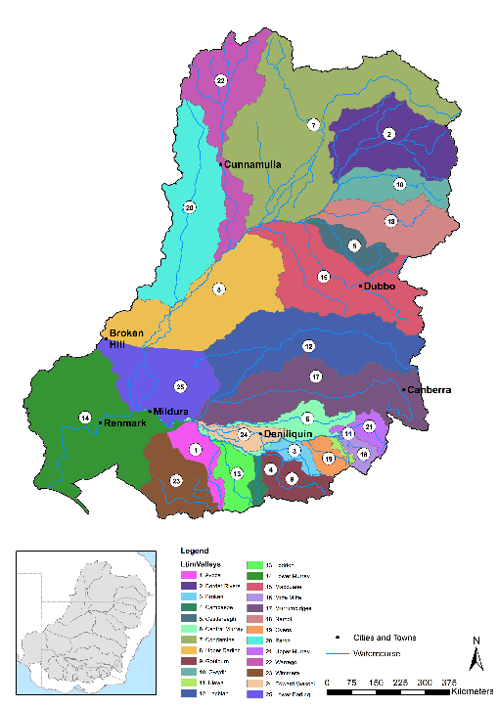

Figure 1. Valleys used for 2014-15 hydrological assessment.

In 2014–15, valleys where Commonwealth environmental watering occurred experienced average to very much below average rainfall conditions (Figure 2). Ten valleys experienced average rainfall conditions (Central Murray, Condamine, Upper Darling, Gwydir, Lachlan, Lower Murray, Macquarie, Murrumbidgee and Warrego rivers and Border Rivers), while three valleys experienced below average rainfall conditions (Broken, Ovens and Edward–Wakool) and three valleys (Campaspe, Loddong and Goulburn — all in Victoria) experienced very much below average rainfall conditions. In the southern Basin, Victoria experienced the lowest rainfall on record. Similarly, the storages from which the majority of regulated Commonwealth environmental water is ordered declined. Storages across the Basin declined, between 5% (Burrendong in the Macquarie) and 33% (Eppalock in the Campaspe), with the average storage declining 19% over the course of the watering year. Menindee Lakes reached very low storage levels and releases into Lower Darling ceased during the 2014–15 year.

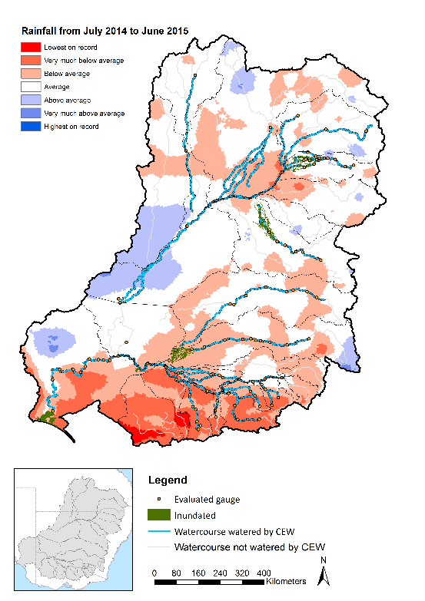

Figure 2. Gauges evaluated, areas inundated, streams watered by Commonwealth environmental water, and rainfall conditions during the 2014–15 watering year.

## Summary of watering actions for 2014–15

The CEWO had 1021 GL of water allocated and brought forward 450 GL from the previous year, giving it up to 1471 GL of water to be allocated in the 2014–15 watering year of which 1014 GL was delivered and the remainder was carried over. The CEWO undertook watering actions across 16 river valleys3 refer to the Report Card Annex for further detail (Annex 1-13 Report Card). The actions included 12 base flow watering actions, 25 freshes and infrastructure-facilitated wetland inundations (Table 1). Further information on the associated expected outcomes for these watering actions is included in Appendix A of the Basin synthesis report and the relevant companion Basin Matter evaluation reports.

Table 1. Summary of Commonwealth Environmental Water Office (CEWO) watering actions by valley. Note that there were two additional watering actions; one in the Broken that was both a base flow; and an inundation and one in the Edward–Wakool that managed a flow recession.

|  |  |  |  |  |  |  |  |  |  |
| --- | --- | --- | --- | --- | --- | --- | --- | --- | --- |
| **Valley** | **Volume of water approved (ML)** | **Volume of water delivered (ML)** | **Base** | **Fresh** | **Bankfull** | **Overbank** | **Inundate** | **In-channel** | **Base & fresh** |
| Gwydir | 75 000 | 56 639 |  | 2 |  |  | 2 |  |  |
| Murrumbidgee | 571 820 | 152 560 |  |  |  |  | 8 |  |  |
| Lower Murray1 | 801 367 | 592 723.4 | 2 | 1 |  |  | 21 |  |  |
| Central Murray2 | 104 366.9 | 59 726 |  |  |  |  | 9 | 1 |  |
| Border Rivers3,4 | Up to 11 970 | 3229 |  | 6 | 2 |  |  |  |  |
| Condamine3,5 | Up to 168 890 | 17 392 |  | 2 |  |  |  |  |  |
| Upper Darling3,6 | Up to 24 279 | 1760.76 |  | 3 |  |  |  |  |  |
| Warrego3 | Up to 41 982 | 2541.7 |  | 3 |  |  |  |  |  |
| Lachlan | 15 000 | 5000 |  | 1 |  |  |  |  |  |
| Macquarie | 19 337 | 10 000 |  |  |  |  | 1 |  |  |
| Loddon | 3396.5 | 2869.5 |  | 1 |  |  |  |  |  |
| Broken7,8 | 50 500 | 32 878.5 | 3 |  |  |  |  |  |  |
| Goulburn9 | 275 000 | 225 883.8 | 4 | 4 |  |  | 1 |  |  |
| Edward–Wakool10 | 70 000 | 39 562 | 2 |  |  |  |  |  | 2 |
| Ovens | 70 | 70 | 2 |  |  |  |  |  |  |
| Campaspe | 7086 | 5791.4 |  | 1 |  |  |  |  |  |

1Broad actions lumped as per unpublished acquittal reports supplied by the CEWO. The Central Murray includes the reaches downstream of Hume Dam to approximately 8km upstream of the Darling and Murray confluence. For the purposes of this report the Hattah Lakes have been reported in the Central Murray valley. The Lower Murray valley includes the reaches downstream of the Darling and Murray confluence to the Murray Mouth.

2Broad actions lumped as per unpublished acquittal reports supplied by the CEWO.

3 The Border Rivers, Condamine, Upper Darling and Warrego comprise the northern unregulated valleys. The approved volume for unregulated entitlements is the maximum volume that can be taken based on access conditions and annual or multi-year limits for entitlements. Ability to access water is subject to unregulated trigger flows.

4Includes the Moonie valley.

5Includes the Balonne valley.

6Includes the Barwon and Darling valleys above Menindee.

7Event-based volumes are re-credited flow from Lower Broken Creek (LBC) to the River Murray at Rices Weir (i.e. losses in LBC have been removed) and will differ from official accounted volumes (volumes delivered at Rices Weir (pre losses).

8There was one additional water action in the Broken that was both a base-flow and an inundation flow.

9Event-based volumes are delivered volumes at McCoys Bridge and may differ from official accounted volumes, which are based on releases from Goulburn Weir (near Murchison) - i.e. losses are incurred *en route* from the accounting point (GW), to the environmental water delivery reach (McCoy’s).

10 There was one additional water action in the Edward-Wakool that was to manage a flow recession. The Edward-Wakool is reported separately from the Central Murray valley, so as to align with LTIM selected area inputs.

The largest volumes of Commonwealth environmental water were allocated to eight watering actions in the Goulburn–Broken system (226 GL) and six watering actions in the Murray River (581 GL) which, when combined, accounted for 79% of the Commonwealth’s total allocation for the 2014–15 year. Other large deliveries were made in the Murrumbidgee River (eight watering actions) and Gwydir river system (four watering actions).

Many of these watering actions were undertaken collaboratively or sought to piggyback on unregulated flow events.

## Hydrological contribution of Commonwealth environmental water to flow regimes in 2014–15

Commonwealth environmental water made an important contribution to improved flow regimes across the MDB (Figure 2), including a contribution to: base flows in the Goulburn, Murrumbidgee and Lower Murray rivers; the low flow fresh regime in the Lower Murray, Darling, Loddon, Goulburn, Lachlan, Macquarie and Gwydir rivers; and medium freshes in the Loddon, Campaspe, Murrumbidgee, Lachlan and Macquarie valleys. Commonwealth environmental water was also delivered to wetlands in the Border Rivers, Condamine, Warrego, Gwydir, Macquarie, Murrumbidgee, Lachlan, Broken and Lower Murray valleys.

It was possible to assess the contribution of Commonwealth environmental water to seven MDBA Annual Environmental Water Priorities for 2014–15 (Table 2). Commonwealth environmental water contributed to these priorities by:

* achieving significant wetland inundation and delivering a medium and high fresh in the Gwydir Valley with the objective of improving wetland condition and meeting instream ecological needs
* filling wetlands along the mid-Murrumbidgee river system and in the lower Murrumbidgee to improve the condition of wetland vegetation communities in the mid-Murrumbidgee wetlands
* delivering two fresh events in the Macquarie River to support native fish populations and wetland inundation in the Macquarie Marshes
* providing winter flows to tributaries of the Murray River to improve survival, recruitment and condition of native fish
* achieving the hydrological targets set for the Lower Lakes in the Basin-wide Environmental Watering Strategy, but discharge through the barrages and the mouth were low relative to the target flows and will need to be increased in future years.

Table 2. Contribution of Commonwealth environmental water to Murray–Darling Basin Authority (MDBA) Annual Environmental Watering Priorities.

| MDBA 2014–15 Annual Environmental Watering Priority | Summary of outcomes and Commonwealth environmental water contribution |
| --- | --- |
| Improve the condition and maintain the extent of wetland vegetation communities in the Gwydir Wetlands (including Ramsar sites) by restoring hydrological connectivity and a flow regime that meet ecological requirements. | The available environmental water was well targeted to achieve this priority. The Commonwealth environmental water contributed to significant wetland inundation along Mallowa Creek and provided some limited inundation along the lower Gwydir River and Gingham Watercourse. These inundations took place over spring–summer. In October 2014, the Commonwealth environmental water delivered a high fresh in Carole Creek and a medium fresh in Mehi River. In total, Commonwealth environmental water contributed to 12,660 hectares (ha) of floodplain inundation in the Gwydir Valley. |
| Improve the condition of wetland vegetation communities in the mid-Murrumbidgee wetlands through a winter or spring fresh. | Commonwealth environmental water allocation was used to fill wetlands along the mid-Murrumbidgee and in the lower Murrumbidgee (Lowbidgee). The extensive inundation achieved in the Lowbidgee contributed to the long-term ecological objectives of the Basin Plan and were the result of successful collaboration between New South Wales and the Commonwealth. |
| Improve native fish habitat within the Macquarie River below Burrendong Dam by restoring a more natural flow regime and addressing cold water pollution. | Commonwealth environmental water contributed to one of the two low fresh events in spring, with the second one exceeding the moderate fresh threshold as the channel size declines within the Macquarie Marshes. Irrigation releases (possibly combined with unregulated tributary inflows) provided additional flow variability during periods of low flow between December 2014 and May 2015. These outcomes go some way towards achieving the Basin Annual Environmental Watering Priority for the Macquarie River. Environmental watering actions were also provided for wetland inundation in the Macquarie Marshes, which is an important contribution to the overall environmental objectives in the Basin Plan (Section 8, Part 2), including objectives related to protection of Ramsar wetlands and connectivity within and between water-dependent ecosystems. |
| Priorities include two that relate to the Murray river system and its tributaries: (1) improve riparian, littoral and aquatic vegetation (e.g. *Ruppia tuberosa*) and native fish populations by increasing ecosystem connectivity through coordinating water delivery in the Murray river system; and (2) improve survival, recruitment and condition of native fish populations by providing winter flows to tributaries and creeks of the Murray River and through the barrages to the Coorong. | Moderate low flows were largely maintained throughout the Murray river system although there were periods of very low flow in the Campaspe and Loddon rivers. Environmental watering actions produced multiple low freshes in most of these valleys (Goulburn, Loddon, Campaspe, Edward–Wakool and Central Murray) and most sites experienced some flow variability during the irrigation season. Winter flows were maintained at or above the medium low-flow threshold in the Goulburn River, and both Central and Lower Murray river reaches. Winter flow freshes were delivered in the Goulburn River, Yallakool Creek, Campaspe River and Central Murray River. A number of wetlands were inundated using environmental water along the Central and Lower Murray in addition to Moodies Swamp along the Broken Creek and several wetlands on Yanco Creek. Given 2014–15 was considered a dry year in terms of water resource availability in the southern Basin, environmental water was effectively used to meet the MDBA annual watering targets across the Murray River and entire southern-connected river system. Commonwealth environmental water made a significant contribution to this outcome and worked together with water provided by other environmental water holders. However, there was limited success in achieving significant flow freshes in the Lower Murray River. Stable flows were maintained throughout the irrigation season upstream of Barmah Choke, with periods of exceptionally low flow in the Campsape and Loddon rivers and limited success in delivering winter flow freshes in many sites. Note that we consider outcomes in the Coorong, Lower Lakes and Murray Mouth system separately, in the following entry. |
| The MDBA Basin-wide Environmental Watering Strategy sets targets to maintain the level of the Lower Lakes, minimum annual flows through the barrages, and Murray Mouth openness. | Commonwealth environmental water contributed to the targets set for the Lower Lakes in the Basin-wide Environmental Watering Strategy. However, discharge through the barrages and the mouth were low relative to the target flows and will need to be increased in future years if the rolling 3-year average is to meet the discharge target. |
| Improve survival of native fish populations by enhancing and protecting dry-period refuge habitat in the northern Basin. | The significant volumes of water delivered in the Gwydir and Macquarie rivers, including wetland watering, is likely to have made an important contribution towards these protecting dry-period refuges. For other northern Basin rivers, streamflow data indicate that the contribution of Commonwealth environmental water to sustaining dry-period refuges (e.g. in-channel pools) is limited (Annex A). Data that have been provided by agencies indicate that there was very little success in contributing to this objective in the Border Rivers and the Warrego, Condamine and Upper Darling rivers. |
| Maintain waterbird habitat, including refuge sites and food sources, to support waterbird populations across the Murray–Darling Basin. Support waterbird breeding where feasible. | We have not been able to assess the contribution of Commonwealth environmental watering actions to hydrological outcomes against this objective as only limited and inconsistent information is available on floodplain inundation at the Basin scale. |

# Methods

## Observations of streamflows

The Basin-scale hydrology evaluation uses streamflow series for the 2014–15 watering year, derived for 109 sites across the MDB. This includes observations of streamflow data available online at the respective jurisdictional websites (Table 3). Discharge, i.e. megalitres per day (ML/day), and height (metres) were the primary variables used for assessing river and lake habitat, respectively. Data suitable for quantitative evaluation were available at 109 sites across 18 valleys (Table 4). It was assumed that the minimum requirements set by the International Organization for Standardization (ISO) standard (ICS.17.120:20) for flow in open channels have been met by the custodians of the gauge stations, so we provided no further assessment of data quality other than checking for complete records.

Table 3. Websites used to source discharge data for 109 gauge stations in the Murray–Darling Basin.

|  |  |
| --- | --- |
| Jurisdiction | Water monitoring website |
| New South Wales | http://waterinfo.nsw.gov.au |
| South Australia | https://www.waterconnect.sa.gov.au |
| Queensland | https://water-monitoring.information.qld.gov.au |
| Victoria | http://data.water.vic.gov.au/monitoring.htm |

## Baseline hydrology scenarios

The evaluation is based on a comparison of observed hydrology (i.e. daily streamflow time-series for the 2014–15 watering year) with baseline hydrology represented by daily streamflows for the 2014–15 year in the absence of Commonwealth environmental water. In most cases, the baseline hydrology was estimated as actual flows less those flows delivered from an environmental water entitlement. However, in cases where the baseline was calculated using the water planning model method (described below), a further adjustment was made so that the baseline hydrology represented streamflows that would have occurred in the 2014–15 year if the Commonwealth water portfolio had never been procured (i.e. agricultural water entitlements resemble those before establishment of the Commonwealth environmental water program). This latter case allows evaluation of the combined consequences of the Commonwealth environmental water recovery and delivery program. In the future, we hope to work with data providers to extend the water planning model approach (see below) to more sites.

Baseline hydrology for the 2014–15 year was derived by several agencies (Table 4) using one of the following three approaches: water accounting model; water planning model; and point derivation.

1. *Water accounting model:* This approach is based on a mass balance of water in river reaches between gauging stations with a fixed lag time to allow for travel times as well as estimates of losses and gains. Operators enter known factors, such as water orders and water taken, and use empirical data, such as actual unaccounted differences and meteorological data, to calculate available flows at nominated gauge stations. Based on these data, the data provider estimates the Commonwealth environmental water and non–Commonwealth environmental water components of the observed time-series. The baseline scenario is derived by subtracting the environmental water component from the observed hydrograph at the streamflow gauge. This approach is used by river operators (Goulburn–Murray Water (GMW) and WaterNSW) to provide baseline streamflow series in the Victorian tributaries (Goulburn, Broken, Campaspe, Loddon, Ovens) and regulated valleys of New South Wales (NSW) (Murrumbidgee, Lachlan, Macquarie, Gwydir, Edward–Wakool).

This approach is used to provide the time-series of environmental water provided by Commonwealth Environmental Water Holders and non–Commonwealth environmental water holders separately.

1. *Water planning model:* The method was developed by MDBA and applied in the Murray River. In this method, two scenarios were modelled, ‘modelled pre-buyback’ and ‘modelled actual’, for the period from July 2014 to June 2015, using the MSM-BigMod modelling suite. The difference between the two model runs gave the impact of environmental water recovery (and use) during 2014–15. The ‘modelled actual’ flow differs from the actual observed flow at streamflow gauges because of model error. In order to avoid artefacts associated with this error, we recalculated the ‘pre-buyback’ case by subtracting the difference (i.e. the modelled actual minus the modelled pre-buyback flows) from the actual observed flows. The resulting flow series is used as the baseline. In this model, the total environmental water entitlement is treated as a single component and there is no separate treatment of Commonwealth environmental water and non–Commonwealth environmental water.

1. *Point derivation:* This method was developed in-house by the CEWO and was applied to the unregulated valleys of NSW and Queensland (Border Rivers, and Condamine, Warrego and Upper Darling rivers). The CEWO monitors real-time river data, to detect when access to Commonwealth unregulated entitlements is triggered. Gauge data in conjunction with official announcements of water-harvesting access in unregulated systems (Border Rivers and Lower Balonne and Warrego rivers) are then used to estimate instream use. Volumes are accounted for in accordance with the licence (access) conditions of each entitlement in the same way that other water users manage their take, where water is assumed to be used at all available opportunities (when flow conditions are triggered) up to the allowed limits. This approach reflects the use pattern of the majority of irrigators in unregulated systems and hence the volumes and pattern of flows that have been reinstated. The baseline scenario was derived by subtracting the Commonwealth environmental water component from the hydrograph.

In many cases, Commonwealth environmental water delivery is coordinated with delivery of water by other environmental water holders. In such cases, the evaluation considers the combined hydrological effect of all environmental water delivery. Where possible, we also indicate the contribution of the Commonwealth environmental water component to the total hydrological effect of all environmental water.

Importantly, none of these methods account for planned environmental water. The focus of this evaluation is on the contribution of Commonwealth environmental water–held environmental water allocations or other environmental water allocations delivered in coordination with this Commonwealth environmental water.

Table 4. The 109 sites used to evaluate Commonwealth environmental water in the 2014–15 watering year, including an outline of the method used to account environmental water.

| Valley name | Site count | Site names | Baseline modelling approach | Data owner or provider |
| --- | --- | --- | --- | --- |
| Border Rivers | 3 | Goondiwindi, Farnbro, Flinton | Point derived | CEWO |
| Broken | 4 | Rices Weir, Caseys Weir, Wagarandall, BackCk | Water accounting | GMW |
| Campaspe | 3 | Barnadown, Rochester, Eppalock | Water accounting | GMW |
| Central Murray | 11 | Doctors, Corowa, Barmah, Yarrawonga, Tocumwal, Torrumbarry, Barham, Swan Hill, Wakool, Euston, Lock 10 | Water planning | MDBA |
| Condamine-Balonne | 1 | St George | Point derived | CEWO |
| Coorong, Lower Lakes and Murray Mouth | 4 | 1Barrages, 2Flows to sea, Milang3, Meningie3 | 1Water accounting, 2Water planning  3Raw data | MDBA  SA DEWNR |
| Edward Wakool | 4 | Deniliquin, YallakoolOfftake, ColligenOfftake, Tuppal | Water accounting | WaterNSW |
| Goulburn | 4 | Murchison, Trawool, Eildon, McCoys | Water accounting | GMW |
| Gwydir | 19 | Pallamallawa, Moree, Yarraman, CaroleOfftake, Pinegrove, Gravesend, Copeton, Boolooroo, Combadello, Tareelaroi, Mehi Offtake, Mallowa, Garah, Tyreel, GinghamDiversion, Brageen, Millewa, Allambie, Midkin | Water accounting | WaterNSW |
| Lachlan | 8 | Cowra, Forbes, Condobolin, Cargelligo, Jemalong, Willandra, Brewster, Nanami | Water accounting | WaterNSW |
| Loddon | 6 | Laanecoorie, CairnCurran, Loddon, Serpentine, Tullaroop, Appin South | Water accounting | GMW |
| Lower Darling | 3 | Burtundy, Weir 32, Menindee | Water planning | MDBA |
| Lower Murray | 11 | Lock 9, Lock 8, Lock 7, SA Border, Lock 6, Lock 5, Lock 4, Lock 3, Lock 2, Lock 1, Wellington | Water planning | MDBA |
| Macquarie | 6 | Dubbo, Warren, GinGin, Burrendong, Marebone, Baroona | Water accounting | WaterNSW |
| Murrumbidgee | 12 | Wagga, Gundagai, Narrandera, Yanco Offtake, Darlington, Berembed, Maude, Redbank, Carrathool, Gogelderie, Balranald, Hay | Water accounting | WaterNSW |
| Ovens | 4 | Buffalo, King, Peechelba, Wangaratta | Water accounting | GMW |
| Upper Darling | 4 | Louth, Collarenebri, Weir32, Menindee | Point derived | CEWO |
| Warrego | 2 | Cunnamulla, Augathella | Point derived | CEWO |
| **Total** | **109** |  |  |  |

Note: CEWO = Commonwealth Environmental Water Office; GMW = Goulburn–Murray Water;   
MDBA = Murray–Darling Basin Authority; SA DEWNR = South Australian Department of Environment Water and Natural Resources.

## Floodplain inundation and connectivity

Inundation extents are reported as mapped area (hectares; ha) for a single date. These data were provided by multiple providers and each used their own methods to map wetted area (Table 5). Consistent data on hydro-period were not available for the first year of this evaluation.

Table 5. Description of the method used to derive inundation across valleys where inundation was reported in the Murray–Darling Basin. Boundary definition and data confidence are reported.

| Valley name | Method | Data owner | Confidence | Boundary definition |
| --- | --- | --- | --- | --- |
| Broken | Landsat and visual survey | GBCMA | High | Wet-area boundaries only denote Commonwealth environmental water–assisted contributions |
| Central Murray | Landsat and visual survey; MIKE hydro-dynamic model | Mallee CMA;  MDBA | High | Wet-area boundaries only denote Commonwealth environmental water–assisted contributions |
| Conda-mine | Water observations from space | Geoscience Australia | Low | Wet-area boundaries only denote Commonwealth environmental water–assisted contributions |
| Gwydir | Landsat and visual survey | NSW OEH | High | Wet-area boundaries denote contributions from both Commonwealth environmental water and natural rainfall/runoff processes |
| Lachlan | Visual survey; NDVI; Landsat | NSW OEH | High | Wet-area boundaries only denote Commonwealth environmental water–assisted contributions |
| Lower Murray | Landsat and visual survey; MIKE hydro-dynamic model; DEM + water level | NSFA; SA DEWNR; MDBA | High | Wet-area boundaries only denote Commonwealth environmental water–assisted contributions |
| Macquarie | Landsat and visual survey | NSW OEH | High | Wet-area boundaries denote contributions from both Commonwealth environmental water and natural rainfall/runoff processes |
| Murrum-bidgee | Landsat and visual survey | NSW OEH | High | Wet-area boundaries denote contributions from both Commonwealth environmental water and natural rainfall/runoff processes |
| Border Rivers | Not calculated | – | – | – |
| Warrego | DEM + water level | Eco Logical Australia | High | Wet-area boundaries only denote Commonwealth environmental water–assisted contributions |

Note: DEM = digital elevation model; GBCMA = Goulburn Broken Catchment Management Authority (CMA);   
MDBA = Murray–Darling Basin Authority; NDVI = Normalised Difference Vegetation Index; NFSA = Nature Foundation South Australia; NSW OEH = NSW Office of Environment and Heritage; SA DEWNR = South Australian Department of Environment, Water and Natural Resources.

## Watercourses watered

The watercourses watered using Commonwealth environmental water were mapped using information provided via CEWO water use acquittal reports and the Environmental Assets Database that is operated within the CEWO. In the regulated rivers where environmental water was ordered from a dam, the reaches downstream to the accounting point (in NSW) were marked as watered (i.e. reaches downstream of water-accounting points were not included), whereas, in Victoria, the reaches watered were extended to the confluence with the Murray River. This is because return flows were protected as environmental water in Victoria but not NSW. In the unregulated rivers of the northern Basin, the relevant environmental water delivery teams within the CEWO provided advice on the estimated extent of Commonwealth environmental watering.

## Assessment of Basin-wide hydrological impacts

The hydrological evaluation is in two parts. The first part summarises the Basin-scale contribution of environmental water to general enhancements in flow regimes without reference to local watering targets. This is provided to fulfil two purposes:

1. To support an evaluation against the Basin Plan objectives as described in the Basin Plan Part 5. 851. The Basin Plan identifies seven flow components that must be considered in the determination of watering requirements of environmental assets and ecosystem functions. Given the dry year across much of the Basin, only some of these flow components are included in this evaluation (Table 6).
2. As a basis for evaluating ecological consequences of environmental watering at the Basin scale. In this part, we use hydrological measures related to standardised flow thresholds to indicate effects on base flows and freshes. It is important to note that this section is not for assessing the performance of environmental water delivery with respect to local hydrological targets (which is instead dealt with in the Section 4 of this report).

Table 6. Flow components included in the Basin Plan and those that are included in the first year of the Basin-scale evaluation.

|  |  |
| --- | --- |
| Basin Plan flow components | Included in evaluation? |
| Cease-to-flow | No |
| Low flow season base flows | Yes |
| High flow season base flows | Yes |
| Low flow season freshes | Yes |
| High flow season freshes | Yes |
| Bankfull flows | No |
| Overbank flows | No |

We provide a summary of the hydrological outcomes across the MDB using data for 109 sites. Given these sites were selected based on data availability, the data are not random, so it is not possible to make statistically based inferences concerning the mean and variance of outcomes across the Basin. Also, these data include many sites that were not specifically targeted to receive environmental water. This means any outcomes at these sites are an inadvertent result of actions designed to meet environmental targets elsewhere in the Basin. This is important as the Basin Plan sets principles on maximising environmental benefits which are intended to ensure that the water achieves the best environmental outcomes (i.e. through considerations on multi-site watering en routeto an intended priority asset or enhancing existing flow events).

### Flow thresholds

The summary is based on the occurrence of low flows and freshes. We consider two low flow thresholds: very low and medium low. We also consider three freshes of varying magnitudes: low, medium and high. These flow components are defined by five threshold discharges as follows:

* **Very low flows** are defined as flows that fall below the lowest flow in the unimpacted (defined below) monthly flow series or 2% of mean unimpacted flow, whichever is greater. This threshold corresponds to exceptionally low flows at the lower end of range that would normally occur in an unimpacted perennial river.
* Medium low flows are defined as flows that fall below the 95th percentile exceedance flow in the unimpacted monthly flow series or 10% of the mean unimpacted flow, whichever is greater. This flow threshold corresponds to a value that might typically be used as a minimum flow to maintain low flow habitats.
* Low freshes are defined as flow spells that raise water levels at least one-eighth of the height of the bank above the medium low flow level. This threshold corresponds to a slight increase in stage above base flow levels and would be a frequent occurrence in both the dry and wet seasons under unimpacted flow conditions.
* Medium freshes are defined as flow spells that raise water levels at least one-quarter of the height of the bank above the medium low flow level. This threshold corresponds to an increase in stage that wets the lower part of the bank and would be a frequent occurrence in an unimpacted regime maintaining moist soils and is an important component of a variable watering regime for this portion of the channel throughout the year.
* High freshes are defined as flow spells that raise water levels at least half of the height of the bank above the medium low flow level. Freshes of this magnitude would have occurred in most years in the unimpacted flow regime, and it would be common for freshes to exceed this threshold several times per year.

The unimpacted flow is the expected flow series without development conditions under an historical climate. Unimpacted monthly flow series were provided by the MDBA for sites across the Basin. These were not always the same sites as used this evaluation of Commonwealth environmental water delivery. In these cases, the nearest appropriate unimpacted flow data site was chosen. These unimpacted flow series were modelled using the various water planning models across the Basin during the development of the basin plan. The bankfull discharge was estimated either as the 5th percentile exceedance in the monthly unimpacted flow (×1.5 as a rough estimate of peak daily flow based on the mean monthly value) or from channel dimensions available for sites across the Basin (these were data collected for the Sustainable Rivers Audit II — Physical Form Theme). Dimensions were taken from the site closest to each of our hydrological evaluation sites, and on the same river channel. Bankfull discharge was estimated from these dimensions using equation M15 in Stewardsonet al.(2005). We generally used the larger of these two bankfull estimates but some exceptions were made based on individual site considerations. The estimates of discharge corresponding to the low, median and high fresh water levels (defined above) were based on widely accepted at-a-station hydraulic geometry equations (Stewardson 2005).

### Flow regime score

We calculated a flow regime ‘score’ corresponding to each of the five flow thresholds. The purpose of this score is to provide a summary of the flow regime and identify contributions of environmental water to protection and restoration of flow regimes across the Basin. In the case of the two low flow thresholds, the score relates to the maintenance of flows above the very low and medium low flow thresholds in each calendar season. Under unimpacted conditions, there would have been a broad range of base flow regimes across the Basin, including some intermittent rivers. To allow for this, the score was calculated based on a comparison of 2014–15 low flows with unimpacted low flows. The score measures the duration of flows exceeding our two low flow thresholds in each calendar season relative to the normal duration in the unimpacted state. If the average unimpacted base flow durations were maintained in 2014–15, then the site received the maximum score of ‘1‘. A reduction in the duration compared with unimpacted duration, in any of the four seasons, reduced the score. If we applied this score to an unimpacted regime, we could expect that in dry years we would get a lower score than in average and wet years. The score should not be interpreted as an environmental flow objective. The purpose of the score is to indicate the ‘dryness’ of the low flow regime in 2014–15 and the components of the flow regime that are significantly affected by environmental watering actions.

Similarly, a score was calculated for each of the three thresholds corresponding to low, medium and high freshes. However, we did not attempt to adjust these scores based on a comparison with the unimpacted flow regime. Instead, the score relates to the occurrence (or not) of flow freshes exceeding these fresh thresholds. For the low fresh threshold, the duration of flows above this threshold within a calendar season must have exceeded 3 days for a ‘fresh’ to be considered to have occurred. The maximum score (of ‘1’) was achieved for the low fresh if a fresh occurred in three of the calendar seasons. For the medium fresh, the maximum score was achieved if a fresh occurred in at least two calendar seasons. For the high fresh, the maximum score was achieved if a fresh exceeded this threshold at some time over the year.

In Annex A, we report scores for each site but simplify the results by combining the two low flow scores into a single base flow score and the three scores for the flow fresh thresholds into a single freshes score. The freshes score (reported in the Annex A) weights the low, medium and high fresh scores according to the percentage weights 50:30:20, respectively.

We emphasise that these scores are not an evaluation of individual watering actions and their associated objectives. The scores are used to summarise the flow regime at sites across the Basin and support an evaluation of the overall effect of the management of Commonwealth environmental water on flow regimes at the Basin scale. For this reason, a number of the sites included in the analysis were not actually targeted with environmental watering actions.

### Attribution of Commonwealth environmental water

Commonwealth environmental water delivery is often coordinated with delivery of other environmental water to achieve a combined outcome. In such cases, it makes little sense to consider the contribution of the Commonwealth environmental water in isolation. For consistency, we have evaluated the aggregate hydrological outcome of all held environmental water.

However, the total contributions of all environmental water cannot be fully attributable to the Commonwealth environmental water in situations where there is coordinated delivery with other environmental water holders. To address this issue, we have developed a simple procedure for sharing score increases between Commonwealth environmental water and non–Commonwealth environmental water:

1. Calculate the total improvement in score with all environmental water entitlements (i.e. compare the score for the observed and baseline flow regimes).
2. Calculate the improvement that would have been achieved if Commonwealth environmental water was delivered on its own.
3. Calculate the improvement if the non–Commonwealth environmental water had been delivered on its own.
4. Apportion the total improvement (from 1 above) to Commonwealth environmental water and non–Commonwealth environmental water based on the ratio of improvements achieved in 2 and 3 above.

# Summary of outcomes

## Base flows (low–medium flows)

Across the southern Murray–Darling Basin, the durations of flows were mostly maintained above the very low flow threshold for at least as long as in the average unimpacted flow regime (Figure 3a). Exceptions were in Broken Creek and Edward–Wakool and where very low flows persisted for much longer than the average unimpacted case, indicating a dry low flow regime in 2014–15. Medium low flows were reduced relative to the average unimpacted state across all valleys in the southern MDB (Figure 3b).

Periods of extended low and very low flows were common across the northern Basin, indicating very dry base flow conditions in 2014–15. The only exception was in the Macquarie River where minimum flows (at the very low flow threshold) were consistent with those expected in the unimpacted regime, although reduced at the medium low flow level.

In 2014–15, environmental water contributed to maintaining minimum flows in the Loddon, Campaspe and Goulburn rivers in northern Victoria and the Murrumbidgee and Macquarie river valleys in NSW. Commonwealth environmental water significantly contributed to these minimum flows in the Goulburn and Murrumbidgee. Commonwealth environmental water also contributed to enhanced minimum flows in the Lower Murray River, including flows delivered into the Lower Lakes and Coorong.

## Freshes

There was a frequent occurrence of low freshes throughout much of the southern MDB with the exception of Broken Creek (Figure 3c). In contrast, low freshes were rare in the northern Basin (largely a reflection of the passive rather than active water delivery pattern) with the exception of the Gwydir River valley. The low flow fresh regime was enhanced by environmental watering actions in the Lower Murray, Loddon, Campaspe, Goulburn, Lachlan, Macquarie and Gwydir valleys. Commonwealth environmental water made a significant contribution in all cases except in the Campaspe River valley. Medium and high freshes were generally rare across the Basin (Figure 3d,e), with environmental watering actions contributing in the Loddon, Campaspe, Murrumbidgee, Lachlan and Macquarie valleys (Figures 3d). The Commonwealth environmental water was an important contributor in all these valleys.

Figure 3. Average contributions of Commonwealth environmental water and other environmental water entitlements to base flow durations and occurrence of freshes across each valley in 2014–15. (Average score for the valley (horizontal axis) is taken across all sites for which data were available and note that valleys using the water planning model approach do not differentiate between Commonwealth and other environmental water).

## Floodplain connectivity

In the 2014–15 watering year, out-of-channel watering (known here to include wetland or floodplain watering) occurred in the Border Rivers (no data available), Condamine–Balonne, Warrego, Gwydir, Macquarie, Murrumbidgee, Lachlan, Broken and Lower Murray valleys. The method of delivering water out-of-channel differed between sites. In the Condamine–Balonne, Macquarie, Gwydir and Lachlan, this involved watering terminal/distributary system wetlands via the main channel. In the Murrumbidgee, Warrego at Toorale (no accounted Commonwealth environmental water use), Broken and Lower Murray, out-of-channel watering was infrastructure assisted; that is, using pipes, pumps, regulators and weirs.

# Contribution to achievement of Basin Annual Environmental Watering Priorities

In contrast to the previous section, this section specifically evaluates the hydrological outcomes across the Basin, in relation to the Basin Annual Environmental Watering Priorities established by the MDBA for 2014–15.[[1]](#footnote-2) Where possible, it also provides a discussion of the contribution made by environmental water, and specifically Commonwealth environmental water, to achieving these outcomes. We use the Basin Annual Environmental Watering Priorities because:

1. they are relevant to the Basin scale
2. they are well defined and include hydrological targets
3. they are one of several inputs considered by the CEWO in making decisions concerning management of its water portfolio in line with requirements of the *Water Act 2007*.

However, it is important to note that the CEWO is only obliged to ‘have regard’ for these priorities when planning and allocating environmental water. The CEWO develops its annual priorities based on a set of established criteria and is informed by these priorities.

## Connect rivers and floodplains: Gwydir Wetlands

MDBA 2014–15 Basin Annual Environmental Watering Priority: Improve the condition and maintain the extent of wetland vegetation communities in the Gwydir Wetlands (including Ramsar sites) by restoring hydrological connectivity and a flow regime that meets ecological requirements.

CEWO 2014–15 Environmental Water Objectives: Consistent with the Basin Annual Environmental Watering Priority, the Commonwealth environmental water’s watering actions in 2014–15 in the Gwydir Valley were designed to: (1) inundate core wetlands in the Gwydir Wetlands for a period of 5–6 months; and (2) support native fish habitat by increasing availability of, and access to, suitable fish habitat, promoting fish movement and providing cues and appropriate habitats for spawning, recruitment and migration of native fish.

Summary of outcomes and Commonwealth environmental water contribution: Delivery of environmental water in 2014–15 was constrained by available water volume but the available environmental water was well targeted to achieve this Basin Annual Environmental Watering Priority. The Commonwealth environmental water contributed to significant wetland inundation along Mallowa Creek and some limited inundation along the lower Gwydir River and Gingham Watercourse. These inundations took place over spring–summer. In October 2014, Commonwealth environmental water delivered a high fresh in Carole Creek and a medium fresh in Mehi River. In both waterways, the initial environmental flow event was followed later in the year by several other freshes of similar magnitude but these did not receive any environmental water contribution. In total, Commonwealth environmental water contributed to 12 660 hectares (ha) of floodplain inundation in the Gwydir Valley.

### Environmental watering actions

Although the 2014–15 watering year was considered a ‘moderate’ year with respect to water availability in the Gwydir Valley, this was largely a reflection of carryover, as the portfolio only yielded 375 ML of high-security entitlements in 2014–15. The Commonwealth delivered 56 639 ML (60.2%) of registered entitlement (excludes 20 450 ML of supplementary flow entitlement) and this water was all delivered in the Gwydir Valley, contributing to four watering actions. Two watering actions were designed to inundate wetlands, one in each of the lower Gwydir River and Mallowa Creek; while two watering actions were designed as freshes, one in Carole Creek and the other in the Mehi River. Base flows were not targeted by environmental water. These actions were spread over 308 days (84% of the watering year) and occurred between September 2014 and March 2015. The actions represented 65% of the total environmental water delivered in the valley for 2014–15, which was approximately 6% of mean annual flows under predevelopment conditions.

There were some minor deviations between the designed and observed hydrological/hydraulic outputs of the four watering actions. Harvesting operations in the lower Gwydir meant that wetland inundation action was paused between late September and late November 2014, while the Mallowa wetland action flow rates were reduced from 250 ML/day to 75 ML/day. Similarly, the flow rates designed in Carole Creek were reduced from 500 ML/day to 400 ML/day. Other issues that impacted environmental flow delivery included the construction of a stock and domestic pipeline along Mallowa Creek which reduced the watering window, and hot dry conditions which meant that WaterNSW implemented a block release strategy to limit system losses on small volumes of water.

### Gwydir Wetland inundation event

The Gwydir Wetland inundation targeted wetlands along the lower Gwydir River and Gingham Watercourse — the region commonly referred to as the Gwydir Wetlands. The Yarraman streamflow gauge is upstream of the Gingham Watercourse anabranch and records total flow delivered to both channels (Figure 4). Environmental water substantially increased flows from mid-September 2014 to the end of March 2015. Little over half of the total flow volume at this site was contributed by environmental water, with Commonwealth environmental water contributing half of this (i.e. 25% of the total flow volume). Discharges thought to be required for maintaining the Gwydir Wetlands exceed 3000 ML/day at this site (MDBA 2010). Streamflows did not reach this level. Nevertheless, some limited inundation of wetlands was achieved, as evidenced from mapping of inundation extent.

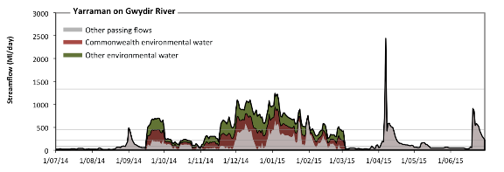

Figure 4. Streamflows at Yarraman on the Gwydir River in 2014–15. Contributions of Commonwealth environmental water and other environmental water are shown. Horizontal lines indicate thresholds for very low flows, low flows, low freshes, medium freshes and high freshes(from lowest to highest).

### Mallowa wetland inundation event

Environmental water contributed most of the streamflow for two flow events in Mallowa Creek (Figure 5). A shorter event was delivered in October 2014 with a peak of less than 100 ML/day. A second event commenced in mid-December 2014 and persisted until the end of February 2015, with peak flows greater than 200 ML/day. Mallowa Creek is thought to require a flow event lasting 90 days with a magnitude exceeding 120 ML/day, delivered every second year on average, to maintain the extent of floodplain wetlands in good condition (MDBA 2010). The December–February event did not meet this target but came close to it and can be expected to have made a significant contribution towards this ecological objective.

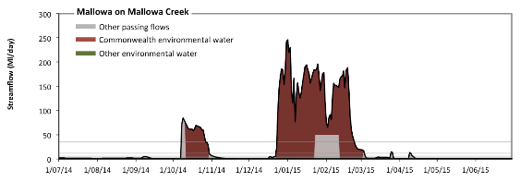

Figure 5. Streamflows at Mallowa on Mallowa Creek in 2014–15. Contributions of Commonwealth environmental water are shown. Horizontal lines indicate thresholds for very low flows, low flows, low freshes, medium freshes and high freshes (from lowest to highest).

### Carole Creek fresh

A flow pulse was delivered to Carole Creek using Commonwealth environmental water in October 2014. The flow pulse lasted for close to 4 weeks with a peak discharge of 770 ML/day at the upstream site (data not shown) and 390 ML/day at the downstream site (Figure 6). Freshes of this magnitude are likely to raise water levels to a high level within the river channel. There was is no evidence of wetland or floodplain inundation. This was the first of several flow events that reached these magnitudes or greater during the year. The later events did not receive any contribution from held environmental water.

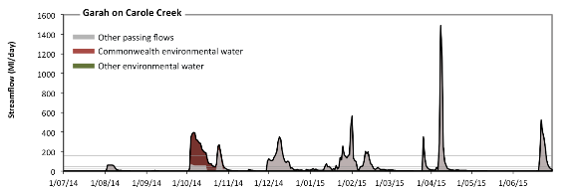

Figure 6. Streamflow at Garah on Carole Creek in 2014–15. Contribution of Commonwealth environmental water is shown in red. Horizontal lines indicate thresholds for very low flows, low flows, low freshes, medium freshes and high freshes (from lowest to highest).

### Mehi River fresh

A flow pulse was delivered to Mehi River using Commonwealth environmental water in October 2014. The flow pulse lasted for close to 4 weeks with a peak discharge of 1040 ML/day (Figure 7). Freshes of this magnitude are likely to produce a medium rise in water. The overall resulting flow volume for October was close to the median October flow in the unimpacted flow regime. There was no evidence of wetland or floodplain inundation. This was the first of several flow events that reached these magnitudes or greater during the year. The later events did not receive any contribution from held environmental water.

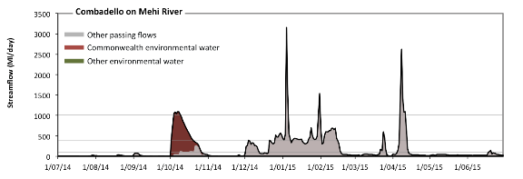

Figure 7. Streamflow at Combadello on the Mehi River in 2014–15. Contribution of Commonwealth environmental water is shown in red. Horizontal lines indicate thresholds for very low flows, low flows, low freshes and medium freshes (from lowest to highest).

## Connect rivers and floodplains: mid-Murrumbidgee wetlands

MDBA 2014–15 Basin Annual Environmental Watering Priority: Improve the condition of wetland vegetation communities in the mid-Murrumbidgee wetlands through a winter or spring fresh.

CEWO 2014–15 Environmental Water Objectives: The CEWO prioritised watering actions in the Murrumbidgee valley to: (1) protect, maintain and, where possible, improve the condition and extent of floodplain, native riparian and wetland vegetation (consistent with the MDBA annual environmental watering priority); (2) maintain and improve the diversity and condition of native aquatic fauna; (3) support habitat requirements of waterbirds, native fish and other vertebrates; and (4) support ecosystem function and improve ecosystem and population resilience through supporting ecological recover.

Summary of outcomes and Commonwealth environmental water contribution: The entire Commonwealth environmental water allocation for the 2014–15 year was used to fill wetlands along the mid-Murrumbidgee and in the lower Murrumbidgee (Lowbidgee). The extensive inundation achieved in the Lowbidgee contributed to the long-term ecological objectives of the Basin Plan and was the result of successful collaborative delivery of NSW environmental water and Commonwealth environmental water. The watering actions along the mid-Murrumbidgee were restricted to a few sites and many wetlands did not receive environmental water in the 2014–15 year.

### Environmental watering actions

The 2014–15 watering year was considered a ‘dry’ year with respect to water availability in the Murrumbidgee valley. In all, 571 820 ML of Commonwealth environmental water was approved for delivery and the Commonwealth environmental water portfolio yielded (including carryover) 178 373 ML (27%) of registered entitlement. A total of 152 560 ML of Commonwealth environmental water was delivered in the Murrumbidgee valley, contributing to eight watering actions, which spread over 330 days (90% of the watering year), occurring between August 2014 and June 2015. The actions represented 52% of total environmental water delivered in the valley over the year, but only accounted for less than 4% of total flows under a predevelopment condition.

Seven actions were predominantly sought to inundate wetlands, floodplains and billabongs, while one action was directed towards the Yanco Creek system, which included the inundation of a lagoon. All actions were delivered as intended, except for the mid-Murrumbidgee watering action at Yarradda lagoon. This action was supposed to occur as part of a designed piggyback event which did not proceed; therefore, the action was delayed to coincide with Lowbidgee watering actions. Furthermore, a pump breakage meant that only 80% of the water allocated to this event was used.

### Inundation of mid-Murrumbidgee wetlands

Streamflows did not exceed the threshold of 26 850 ML/day at Narrandera (MDBA 2012) required for natural connections to be made with low-lying wetlands. However, infrastructure-assisted inundation occurred at three sites (Figure 8): Yarradda Lagoon between 4 December 2014 and 22 January 2015 (delivered mostly with Commonwealth environmental water); Spring Creek between 22 March and 1 April 2015 (delivered mostly with non–Commonwealth environmental water); and along Yanco Creek, including Molleys Lagoon and Dry Lake between 23 and 30 June 2015 (with Commonwealth environmental water contributing much of the water).

These three inundation events contributed to the MDBA’s 2014–15 Basin Annual Environmental Water Priority of inundating the mid-Murrumbidgee wetlands. These sites were chosen because of their high ecological value, close proximity to river channel and suitability for pumped delivery of water. However, there are many wetlands along the mid-Murrumbidgee River that did not receive environmental water.

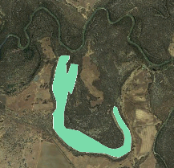**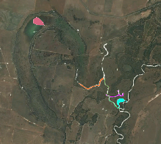******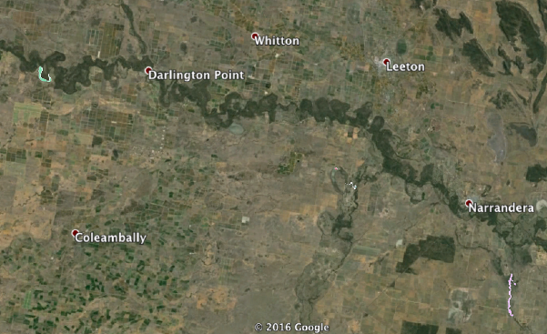

*Spring Creek (Sandy)*

*Inundation*

*Yarradda Lagoon Inundation*

*Yanco Creek Inundation*

*Yanco Creek Inundation*

Figure 8. Inundation in the mid-Murrumbidgee wetlands. Inundation extents provided by the NSW Office of Environment and Heritage and map base layer derived from Google (2016), which used CNES/Astrium and Landsat imagery.

### Inundation of lower Murrumbidgee wetlands

Several watering actions contributed to significant wetland inundation in the lower Murrumbidgee River with all environmental water diverted out of the channel before passing over Redbank Weir (Figure 9). Both the Commonwealth and NSW contributed to these actions. These actions make an important contribution to the long-term ecological targets in the Basin Plan, although not specifically included in the Basin Annual Environmental Watering Priorities for 2014–15.

**Redbank Weir**

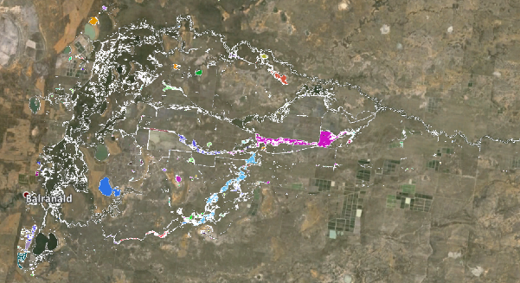

**Redbank Weir**

Figure 9. Inundation extent in the lower Murrumbidgee River. Inundation extents provided by the NSW Office of Environment and Heritage and map base layer derived from Google (2016), which used Landsat imagery.

## Support instream functions: Macquarie River

MDBA 2014–15 Basin Annual Environmental Watering Priority: Improve native fish habitat within the Macquarie River below Burrendong Dam by restoring a more natural flow regime and addressing cold water pollution.

CEWO 2014–15 Environmental Water Objectives: The CEWO prioritised: (1) inundation of core wetlands in the Macquarie Marshes and contributing to annual water requirements of the native marsh vegetation; (2) supporting native fish habitat by increasing availability of, and access to, suitable fish habitat, promoting fish movement and providing cues and appropriate habitats for spawning, recruitment and migration of native fish; and (3) restoring a more natural flow regime and addressing cold water pollution (consistent with the MDBA Basin Annual Environmental Watering Priorities).

Summary of outcomes and Commonwealth environmental water contribution: Commonwealth environmental water contributed to two low fresh events in spring with the second one exceeding the moderate fresh threshold as the channel size reduced in capacity within the Macquarie Marshes. Irrigation releases, possibly combined with unregulated tributary inflows, provided additional flow variability at the low fresh magnitudes between December 2014 and May 2015. These outcomes go some way towards achieving the Basin Annual Environmental Watering Priority for the Macquarie River. In future years, the specific components of the flow regime required by native fish and other ecosystem components should be articulated in the priorities for this site. Environmental watering actions were also provided for wetland inundation in the Macquarie Marshes. This makes an important contribution to the overall environmental objectives in the Basin Plan (Section 8, Part 2), including objectives related to protection of Ramsar wetlands and connectivity within and between water-dependent ecosystems.

### Environmental watering actions

The 2014–15 watering year was considered as a dry year with respect to water availability and, as such, 19 337 ML of Commonwealth environmental water was approved for delivery in the Macquarie valley. The Commonwealth environmental water portfolio yielded 21 732 ML (16.1%) of its registered entitlement (including carryover). In all, 10 000 ML was delivered in the Macquarie valley, contributing to one watering action which spread over 60 days (16% of the watering year) and occurred between October and December 2014. The Commonwealth environmental watering action represented 35% of total environmental water delivered in the valley for 2014–15, but only accounted for 0.3% of the total expected flows under a predevelopment condition. This was improved to 0.9% by contributions from the NSW Office of Environment and Heritage (OEH). The action was delivered largely as intended, with streamflow peaking at around 880 ML/day, and flows of around 500 ML/day experienced at the accounting point for most of the 60-day period which was followed by a slow recession.

### In-channel flow regime

The environmental water component of the hydrograph shows little attenuation between Burrendong Dam (uplands) and the Macquarie Marshes at Marebone (lowlands) (Figure 10). The combined outcome of all environmental water is the addition of two flow freshes — one exceeding the low fresh threshold and the other exceeding the medium fresh threshold. The first fresh in September 2014 did not exceed the low fresh threshold at Burrendong. At Marebone, this fresh was more significant, just reaching the medium fresh threshold as a result of reduced channel capacity within the Macquarie Marshes. The second flow pulse lasted from mid-October to mid-December 2014. This second stage of watering was larger and just reached the medium fresh threshold at Burrendong, augmenting irrigation releases being made over this period. At Marebone, irrigation diversions reduced the magnitude of flows, leaving the environmental water component alone, but which still exceeded the medium flow fresh thresholds in this smaller channel. Between December 2014 and April 2015, irrigation releases, possibly combined with unregulated tributary inflows, provide a series of low flow freshes.

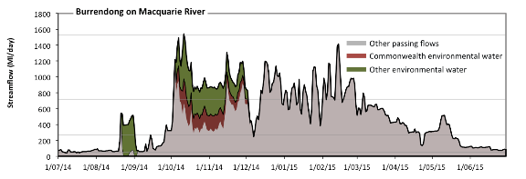

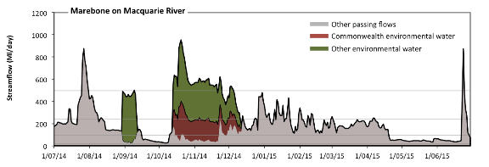

Figure 10. Streamflows at Burrendong (upland) and Marebone (lowland) on the Macquarie River in 2014–15. Contributions of Commonwealth environmental water and other environmental water are shown. Horizontal lines indicate thresholds for very low flows, low flows, low freshes and medium freshes (from lowest to highest).

The MDBA Annual Environmental Watering Priorities for 2014–15 targeted a more natural flow regime downstream of Burrendong Dam; noting that flow regulation for irrigation water delivery has historically reduced moderate to high flows, reduced end-of-system flows, increased the period between large flows, reduced the number of small flows and introduced permanent low flows in previously intermittent streams. In 2014–15, environmental water mitigated these impacts by increasing the number of small flows and potentially increasing end-of-system flows, although data are not available to indicate the proportion of environmental flows that reached the Darling River. These improvements, combined with the flow variability achieved with irrigation releases, provided a significant improvement in the flow regime in 2014–15 and were consistent with the MDBA Annual Environmental Watering Priority. In order to achieve the MDBA priorities in full, increased flow magnitudes would ideally be achieved. Flows in the Macquarie upstream of Warren are constrained to less than 4000 ML/day because of the risk of third-party impacts. However, this level exceeds the medium fresh threshold for the river at most sites.

### Wetland inundation

Environmental watering actions were also provided for wetland inundation in the Macquarie Marshes, which made an important contribution to the overall environmental objectives in the Basin Plan (Section 8, Part 2), including objectives related to protection of Ramsar wetlands and connectivity within and between water-dependent ecosystems(Figure 11).

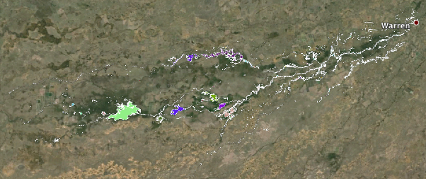

**North**

**North**

Figure 11. Inundation extent in the Macquarie Marshes. Inundation extents provided by NSW Office of Environment and Heritage and map base layer derived from Google (2016), which used Landsat imagery.

## Support instream functions: connectivity in the Murray river system and winter flows for fish in the southern Basin

MDBA 2014–15 Annual Environmental Watering Priority: In relation to the Murray river system and its tributaries: (1) improve riparian, littoral and aquatic vegetation (e.g. Ruppia tuberosa) and native fish populations by increasing ecosystem connectivity through coordinating water delivery in the Murray river system; and (2) improve survival, recruitment and condition of native fish populations by providing winter flows to tributaries and creeks of the Murray River and through the barrages to the Coorong.

CEWO 2014–15 Environmental Water Objectives: There was a broad range of priorities established by the CEWO for the rivers in the southern Murray–Darling system, which includes the Goulburn River, Loddon River, Campaspe River, Broken Creek, Yanco river system, Edward–Wakool river system, Central Murray River and Lower Murray River.

Summary of outcomes and Commonwealth environmental water contribution: Moderate low flows were largely maintained throughout the Murray River systems, although there were periods of very low flow in the Campaspe and Loddon rivers. Environmental watering actions produced multiple low flow freshes in most of these valleys (Goulburn, Loddon, Campaspe, Edward–Wakool, Central and Lower Murray) and most sites include some flow variability during the irrigation season. Winter flows were maintained at or above the medium low flow threshold in Goulburn River, and both Central and Lower Murray River reaches. A winter flow fresh was achieved in the Goulburn River, Yallakool Creek, Campaspe River and Central Murray River. A number of wetlands were filled using environmental water along the Central and Lower Murray in addition to Moodies Swamp along the Broken Creek and several wetlands on Yanco Creek. Given 2014–15 was considered a dry year in terms of water resource availability in the southern Basin, environmental water was effectively used to meet the MDBA Annual Environmental Watering Priorities across the Murray River and entire southern-connected river system. Commonwealth environmental water, in collaboration with other environmental water holders, made a significant contribution to achieving this Basin Annual Environmental Watering Priority. However, there was limited success in achieving significant flow freshes in the Lower Murray River due to the dry conditions, with stable flows maintained throughout the irrigation season upstream of Barmah Choke, periods of exceptionally low flow occurred in the Campaspe and Loddon rivers and there was capacity to deliver winter flow freshes in many sites. Further, environmental water could not be used in the Lower Darling (below Menindee) due to drought management circumstances, which further limited opportunities to provide flow variability. Note that we consider outcomes in the Coorong, Lower Lakes and Murray Mouth system separately, in the following section.

### Goulburn River

During 2014–15, Commonwealth environmental water portfolio was allocated 241 700 ML (excluding carryover) and had a total of 256 739 ML of water available for delivery. The Commonwealth delivered 225 883 ML of water (including losses) over 251 days, representing a contribution to river hydrology of 69% of the year. This included the delivery of 53 695 ML of Commonwealth environmental water towards four base-flow actions. The four actions occurred in spring (2 actions over 37 days), summer (1 action over 14 days) and autumn–winter (1 action over 71 days). These actions were typically implemented as intended, but discharge rates in some actions were above the target rate due to a combination of unregulated flows and inter-valley transfer requirements. In addition, four watering actions were designed as freshes (160 697ML) and these occurred in spring (2 actions over 37 days), autumn (1 action over 26 days) and winter (1 action over 17 days). The fresh actions were largely delivered as planned, with the exception of the winter action where some deviation was experienced in flow magnitude and duration, mainly due to external factors. Also, the autumn fresh was achieved with minimal environmental water.

Although the Commonwealth environmental water component represented the largest volume of environmental water delivered in the Goulburn valley (73% of the total), it only represents 7.4% of total average annual flows. Of the total Commonwealth environmental water flow allocated for delivery, 6.5% was not used (15 816.2 ML). The water was not used because the designed environmental flows were: (1) met by natural unregulated streamflow events (which occurred July–August 2014); and (2) river operators (acting on advice from the CEWO and the Victorian Environmental Water Holder; VEWH) designed inter-valley transfer flows in a form that met the environmental demand for those periods.

Throughout the year, minimum flows were maintained at or above the medium low flow level (Figure 12). The flow regime included two low flow freshes in winter, one at the start of the watering year (produced by unregulated tributary inflows) and one at the end of the year delivered entirely as a Commonwealth environmental watering action. Two low freshes were also delivered in October–November 2014 with significant contribution from Commonwealth environmental water. These were preceded by an action delivered using non–Commonwealth environmental water that produced a slight rise in stage above base flows in September–October. Three freshes approaching the low fresh level were also delivered between January and April 2015, in coordination with the delivery of consumptive water use.

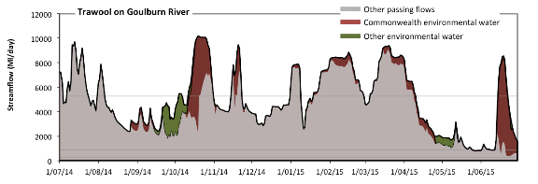

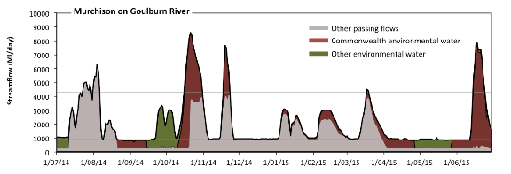

Figure 12. Streamflows at Trawool (upstream) and Murchison (downstream) on the Goulburn River in2014–15. Contributions of Commonwealth environmental water and other environmental water are shown. Horizontal lines indicate thresholds for very low flows, low flows and low freshes (from lowest to highest).

### Loddon River

In the Loddon River, 3396 ML of Commonwealth environmental water was approved for delivery. The Commonwealth environmental water portfolio yielded 2869 ML and this was delivered in full, contributing towards a single spring fresh, which lasted over 17 days. This action was implemented as intended with some minor deviations around the target flow of 750 ML/day. The actions represented 24% of total environmental water delivered in the valley for 2014–15, but only accounted for 1% of total expected flows under a predevelopment condition.

At Laanecoorie, there were two medium freshes in spring of 2014, one of which was entirely the result of the Commonwealth environmental watering action (Figure 13). At Appin, the first of these two freshes had been attenuated and the second fresh occurred in October 2014 and corresponded with the low fresh threshold. Summer–autumn flows at Appin, downstream of the major irrigation diversions, corresponded with the very low flow threshold but over the winter–spring months was maintained at the medium low flow level.

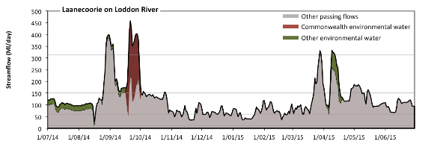

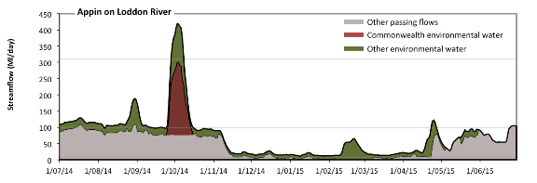

Figure 13. Streamflows at Laanacoorie Reservoir (upstream) and Appin South (downstream) on the Loddon River in 2014–15. Contributions of Commonwealth environmental water and non–Commonwealth environmental water shown. Horizontal lines indicate thresholds for very low flows, low flows, low freshes and medium freshes (from lowest to highest).

### Campaspe River

In all, 7086 ML of Commonwealth environmental water was approved for delivery in the Campaspe valley. The Commonwealth environmental water portfolio yielded approximately 6547 ML, and 5791 ML was delivered. Commonwealth environmental water was used in one watering action, which spread over 14 days. The action was delivered as a spring fresh. In conjunction with the VEWH and The Living Murray, flows of approximately 1500 ML/day were achieved at the target reaches between Lake Eppalock and Campaspe Siphon. This action was delivered as intended, but discharge rates were slightly below the target rate, mainly due to concerns expressed by landowners with respect to third-party impacts, including inundation and restricting access to key assets.

Streamflows remained close to, or above, the medium low flow threshold for between July 2014 and March 2015. After this, they dropped to the very low flow threshold (Figure 14). Three medium flow freshes were achieved in August, October and December 2014.

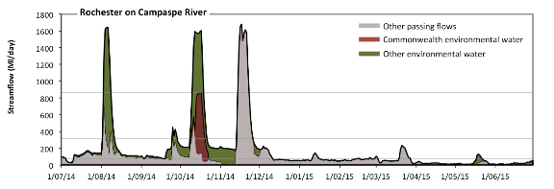

Figure 14. Streamflows at Rochester on Campaspe River in 2014–15. Contributions of Commonwealth environmental water and non–Commonwealth environmental water shown. Horizontal lines indicate thresholds for very low flows, low flows, low freshes and medium freshes (from lowest to highest).

### Broken Creek

In all, 50 500 ML of Commonwealth environmental water was approved for delivery in the Broken valley. The Commonwealth environmental water portfolio yielded approximately 121 ML but this was augmented with environmental water substituted from the Goulburn valley to allow delivery of 33 129 ML. Commonwealth environmental water contributed to four watering actions which were spread over 275 days (75% of the year). Three base flow actions were delivered over 219 days, with one in each of spring – early summer, summer–autumn and autumn. All actions were delivered as intended, but discharge rates in some actions were above the target rate mainly due to fluctuations in irrigation demand. A combination event (base flow/wetland inundation) was delivered in spring (1 action over 56 days), as a base flow and also to inundate Moodies Swamp. The action successfully inundated approximately 150.9 ha (84%) of the 180 ha wetland. Streamflows at Rices Weir, just upstream of the Murray River Confluence, were augmented with environmental water between October 2014 and May 2015, although remaining below the low fresh threshold throughout the year (Figure 15).

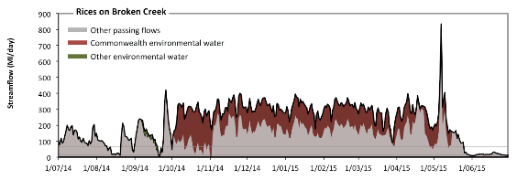

Figure 15. Streamflows at Rices Weir on Broken Creek in 2014–15. Contributions of Commonwealth environmental water is shown. Horizontal lines indicate thresholds for very low flows and low flows (from lowest to highest).

### Yanco billabong system

The Yanco system is a distributary of the mid-Murrumbidgee River and joins the Central Murray system via Edward River and includes multiple channels and billabongs. Yanco Creek supplies water to a significant area of irrigation, several rural towns and environmental assets (Alluvium 2013). In 2014–15, streamflows provided from the Murrumbidgee River were maintained at between 400 ML/day and 1150 ML/day at the upstream end of Yanco Creek, including a brief environmental watering action late in June 2015 that produced the maximum flow of approximately 1130 ML/day (Figure 16). No streamflow data were available along the creek to assess how far downstream these flows penetrated through Yanco Creek and so it is not possible to assess whether there was any connectivity with the Murray river system.

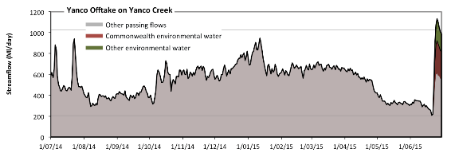

Figure 16. Streamflows in the Yanco Creek at the offtake from the Murrumbidgee River in 2014–15. Contributions of Commonwealth environmental water and NSW environmental water shown. Horizontal lines indicate thresholds for very low flows and low flows (from lowest to highest).

### Edward–Wakool river system

In 2014–15, a total of 70 000 ML of Commonwealth environmental water was approved for delivery in the Edward–Wakool and 39 562 ML of Commonwealth environmental water was delivered (57% of approved volume) across four instream watering actions (Figure 17). The actions were delivered as a combination of base flows, freshes and recession actions with the aim of supporting instream biodiversity and river function. The four watering actions were spread over 269 days between August 2014 and April 2015, covering 74% of the year. The actions were delivered as intended, with the exception of the latter part of the 147-day base flow action which ceased earlier than requested. The Commonwealth environmental water component (39 562 ML) represented 91% of the total amount of environmental water delivered in the Edward–Wakool river system in 2014–15 (based on actions where the Commonwealth environmental water contributed with a partner agency or alone).

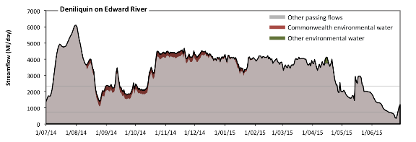

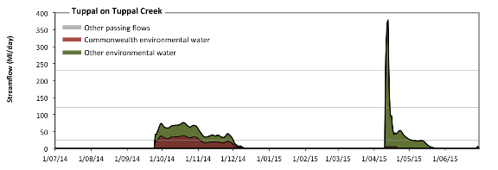

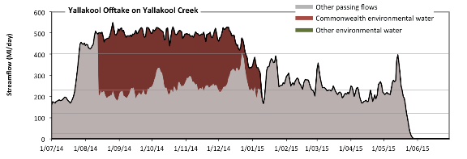

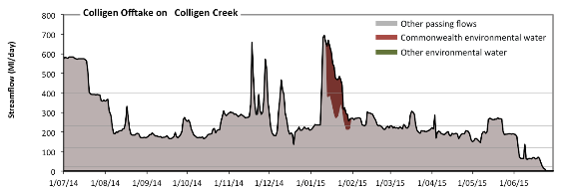

Figure 17. Streamflows at sites in the Edward–Wakool river system in 2014–15. Contributions of Commonwealth environmental water and other environmental water shown. Horizontal lines indicate thresholds for very low flows, low flows, low freshes, and medium freshes (from lowest to highest).

### Central Murray River

The 2014–15 watering year was known as a dry year in this reach compared with the historical record. In all, 104 366 ML of Commonwealth environmental water was approved for delivery in the Central Murray and 59 726 ML of Commonwealth environmental water was delivered (57% of the approved volume) across three watering actions, in a combination of instream flows, weir pool manipulations and flows to support wetland inundation (infrastructure-assisted). There were several reasons for the shortfall between the approved and delivered volumes. Coordination of water delivery with the VEWH reduced the volume required in one action. Other reasons included operational constraints and adaptive management decisions, which reduced the total number of wetlands watered. In the Hattah lakes system, the total Commonwealth environmental water volume used was less than planned due to operational issues. All other actions were delivered as intended.

In 2014–15, Commonwealth environmental water represented close to 60% of total environmental water volumes delivered in this reach (based on actions where the CEWO contributed with a partner agency or alone), but the Commonwealth environmental water volume only represented 5.4% of total predevelopment flows.

Downstream, along the Central Murray River, streamflows vary with irrigation offtakes and tributary inflows. There are three distinct river reaches, based on longitudinal changes in streamflows and these sections can be represented by flows (from upstream to downstream) at Corowa, Barmah and Lock 10 (Figure 18). Streamflows at Corowa are representative of flows from Hume Weir to the Ovens River Confluence. In this reach, irrigation releases during winter have been reduced as a result of the Commonwealth environmental water recovery program and environmental water delivery augmented streamflows outside the irrigation season (August 2014 and March to June 2015).

Additional flows from the Ovens River are offset by irrigation water diversions at Yarrawonga Weir. Streamflows between Yarrawonga to Barmah can be represented by streamflows at Barmah. A large winter flow pulse occurred in July–August 2014, which appears to have been the result of unregulated tributary inflows from the Ovens River. Flows during the irrigation season are maintained at the capacity of the Barmah Choke, a constriction of the river channel at the exit from the Barmah floodplain.

Streamflows at Lock 10 are representative of flows from Torrumbarry to Lock 10, which includes irrigation diversions and tributary inputs from the Goulburn, Campaspe, Loddon, Murrumbidgee and Darling rivers. Along this reach, the large unregulated winter pulse increased as a result of tributary inputs (but not the result of environmental water delivery). With the addition of significant environmental water between September 2014 and June 2015, streamflows fluctuated between 5000 ML/day and 12 000 ML/day, approximately corresponding to the medium low flow and low flow fresh thresholds.

Targeted watering of key wetlands was also achieved along the Central Murray River (Figure 19).

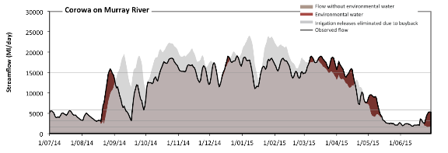

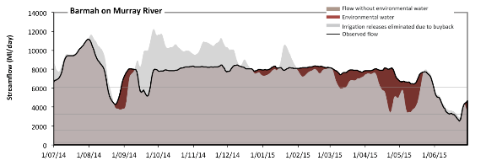

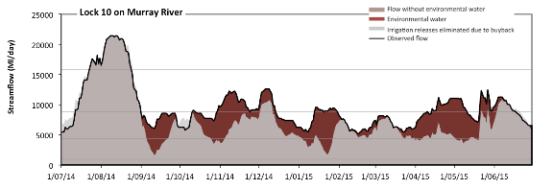

Figure 18. Streamflows at Corowa, Barmah and Lock 10 on the Central Murray River in 2014–15. Red shading indicates contribution of environmental water delivery by Commonwealth environmental water and other environmental water entitlement holders; grey shading indicates flow reduction as a result of the Commonwealth environmental water recovery program. Horizontal lines indicate thresholds for very low flows, low flows, low freshes, and medium freshes (from lowest to highest).

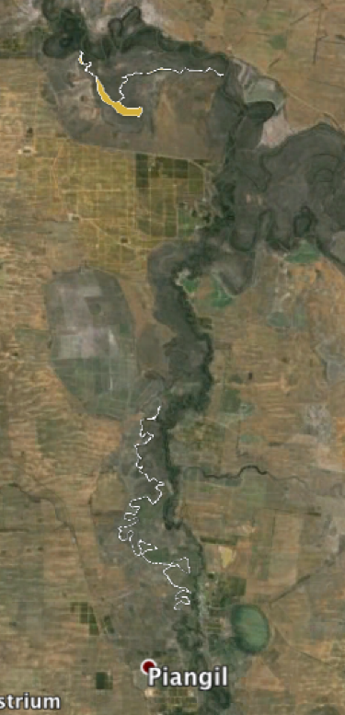

Burra Cr

Bridge Cr

Burra Cr

Bridge Cr

Figure 19. Wetlands inundated using Commonwealth environmental water during 2014–15 along the Central Murray River downstream of Piangil (base layer derived from Google (2016) which used 2016 CNES/Astrium and Digital Globe).

### Lower Murray River (downstream of Lock 10)

Murray River storages were at 64% in July 2014 and resource availability scenario at the beginning of the watering year was deemed moderate–high. As such, 801 367 ML of Commonwealth environmental water was approved for delivery in the Lower Murray. The Commonwealth environmental water portfolio delivered 592 724 ML, contributing to six watering actions which spread over the entire watering year. The actions were delivered as a combination of instream flows, weir pool manipulations and flows to support wetland inundation (infrastructure-assisted).

The large 2014 unregulated winter flow pulse from the Central Murray River continued along the Lower Murray River with the peak arriving at Lock 1 in mid-August and the recession extending into mid-September 2014 (Figure 20). Between October 2014 and May 2015, flows at Lock 9 were maintained between 7500 ML/day and 10 000 ML/day. Between April and June 2015, flows were reduced from 6500 ML/day to 4000 ML/day.

Targeted watering of key wetlands was also achieved along the Lower Murray River (Figure 21).

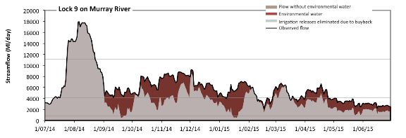

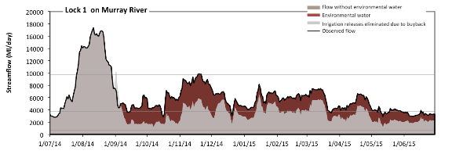

Figure 20. Streamflows at Lock 9 and Lock 1 in the Lower Murray River in 2014–15. Red shading indicates contribution of environmental water delivery by Commonwealth environmental water and other environmental water entitlement holders; grey shading indicates flow reduction as a result of the Commonwealth environmental water recovery program. Horizontal lines indicate thresholds for very low flows, low flows and low freshes (from lowest to highest).

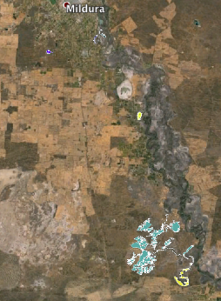

Hattah Lakes

Bullock

Cardross

Basin

Woorlong Wetland

& Psyche Lagoon

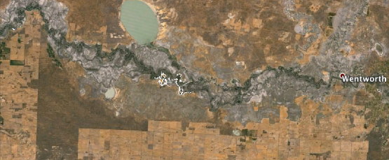

Viela

Murray Island

Brickworks

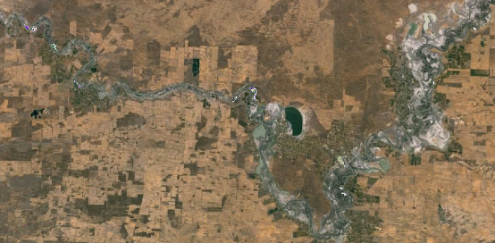

Whirlpool

Corner

& Duck

Hole

Johnson’s

Waterhole

Several Wetlands

at Overland Corner

Several Wetlands

Upstream of Morgan

Several Wetlands

Upstream of

Loxton

Calperum

Figure 21. Wetlands inundated during the 2014–15 year along the Lower and Central Murray River (base layer derived from Google (2016) which used Landsat imagery).

## Maintain the Coorong, Lower Lakes and Murray Mouth

MDBA Basin Annual Environmental Watering Priority: The MDBA Basin-wide Environmental Watering Strategy sets targets to maintain the level of the Lower Lakes, minimum annual flows through the barrages and Murray Mouth openness.

Summary of outcomes and Commonwealth environmental water contribution: The Commonwealth environmental water contributed to the targets set for the Lower Lakes in the Basin-wide Environmental Watering Strategy. However, discharge through the barrages and the mouth was low relative to the target flows and will need to be increased in future years if the 3-year average is to meet the discharge target.

The Coorong, Lower Lakes and Murray Mouth (CLLMM) region is approximately 142 500 ha in size and contains a diverse range of freshwater, estuarine and marine habitats. The region is a Ramsar site and is currently used for several purposes, including conservation, recreation, water storage and extraction, grazing and cropping, and urban and residential development.

This region includes Lake Albert, Lake Alexandrina, the Murray estuary, the Coorong and the Murray Mouth. Lake Albert is a terminal lake connected to Lake Alexandrina by a narrow channel. They are collectively referred to as the Lower Lakes, and comprise fresh to brackish waters. The waters are separated by a series of barrages, constructed between 1935 and 1940, which are intended to maintain a water level in the lakes and to protect agricultural areas from exposure to saltwater. The five barrages span the Goolwa, Mundoo, Boundary Creek, Ewe Island and Tauwitchere channels. The Coorong comprises two lagoons (known as the North and South). Together, they form a long, shallow lagoon comprising brackish to hypersaline water, which is more than 100 kilometres long. The Coorong is separated from the Southern Ocean by a narrow sand-dune peninsula.

We evaluate hydrological and salinity outcomes in the Coorong, Lower Lakes and Murray Mouth based on the contribution of Commonwealth environmental water to: water levels in the Lower Lakes; Murray Mouth openness, including barrage releases; and indirect hydrological impact on salinity. These criteria reflect Basin Plan objectives and the Basin Annual Environmental Watering Priorities.

### Water levels in the Lower Lakes

The Basin Plan lists specific end-of-Basin guidance for the Lower Lakes, while the Basin-wide Environmental Watering Strategy (BWS) (MDBA 2014) lists quantifiable objectives for end-of-Basin flows. The BWS target for the Lower Lakes is to maintain the level of the lakes at above sea level and 0.4 m Australian height datum (AHD), for 95% of the time, as far as practicable to allow for barrage releases.

Approximately 464.702 GL of Commonwealth environmental water travelled to Wellington directly upstream of the Lower Lakes during the 2014–15 watering year, with a contribution of Commonwealth environmental water from early September 2014 through to the end of the watering year (based on modelling results provided by MDBA as explained in Section 2.2, method 3). The minimum daily water level at Milang (Lake Alexandrina) was 0.399 m and at Meningie (Lake Albert) was 0.365 m and both of these minimum levels occurred during the period where Commonwealth environmental water was being delivered to the Lower Lakes. The daily water level was less than 0.4 m for just 1 day in Lake Alexandrina and 11 days in Lake Albert. The use of Commonwealth environmental water to support levels of the Lower Lakes appears to have been appropriate through the lens of mitigating the impact of low water levels in the Lower Lakes.

The South Australian long-term Environmental Watering Plan recommends that water levels in Lake Alexandrina and Lake Albert are managed for variability. The management recommends a regime where water levels fluctuate between 0.40 m and 0.75 m every year; 0.40 m to 0.83 m once every 2 years and 0.40 m to 0.90 m once every 7 years. During the 2014–15 watering year, water levels at Lake Alexandrina and Lake Albert were managed higher than the 1-in-2-year range prescribed in the Environmental Watering Plan (Figure 22) and have been so consecutively since the 2012–13 watering year. The maximum daily water levels in Lake Alexandrina and Lake Albert were 0.844 m (0.856 m average daily water level) and 0.878 m (0.867 average daily), respectively. The duration of days in the year where the daily water level was greater than 0.750 m was 18 (5%) and 56 (15%) in Lake Alexandrina and Lake Albert, respectively.

The number of days above 0.75 m is of interest because over the previous three watering years, water levels have been greater than the stipulated full supply level of 0.75 m. Managing the Lower Lakes within this higher range alters the timing, magnitude and volume of barrage flow, thereby limiting the hydrological benefit of system flows into the Coorong and Murray Mouth. Murray River flows that enter the Coorong can lower salinity levels and improve estuarine productivity and connectivity (Webster *et al.* 2009; Webster 2010). Similarly, Murray River flows have a hydraulic benefit through the Murray Mouth. Given the limited environmental water available, maintaining these high water levels in the Lower Lakes needs to be balanced with other end-of-Basin priorities such as the Coorong and Murray Estuary. The current management regime appears to prioritise high lake water levels over maintenance of flows to the Coorong and Murray Mouth.

Figure 22. Contribution of Commonwealth environmental water (CEW) to flows into the Murray Estuary and the Coorong in 2014–15 (TLM = The Living Murray; VEWH = Victorian Environmental Water Holder; Lake Alex = Lake Alexandrina).

### The contribution of Commonwealth environmental water to barrage flows of the Murray Mouth

Five barrages in the CLLMM are operated to assist water managers in providing water to the Coorong and Murray Mouth as well as for managing the water levels of the Lower Lakes. At the barrages, environmental water contributed 46% of the total streamflow volume (most of which was Commonwealth environmental water). Environmental watering actions affected streamflows for 80% of days between 1 July 2014 and 30 June 2015 (Figure 23). With historic operating practice and observed lake water levels, it is reasonable to assume that barrage flows would have ceased from November 2014, if not earlier (as indicated by Figure 24). The Basin Plan lists specific end-of-Basin guidance for barrage flows, while the BWS lists quantifiable objectives for end-of-Basin flows. The BWS target is for flows at the barrages to be greater than 2000 GL/year on a 3-year rolling average basis for 95% of the time, with a 2-year minimum of 600 GL/year. The total barrage flows for 2014–15 were 987 GL, of which Commonwealth environmental water contributed 453 GL (46%) — less than the BWS target. However, the target allows for a 3-year rolling average, and the average for 2012–15 was 2680 GL, which met the guidance as set in the BWS. It is also noted that the barrage fishways were maintained throughout the year, enabling the increased movement of migratory fish species between the Murray Estuary, Lower Lakes and Murray River, consistent with the ecological objectives of the BWS.

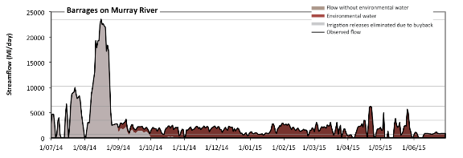

Figure 23. Streamflows over barrages of the Murray Mouth in 2014–15. Contribution of environmental water is shown. Horizontal lines indicate thresholds for very low flows, low flows, low freshes, medium freshes and high freshes (from lowest to highest).

During August 2014, an experimental action was conducted by the South Australian Department of Environment, Water and Natural Resources, which aimed to cycle water levels in Lake Albert with the goal of increasing net salinity export. The success of this action is uncertain. The unfortunate outcome was that barrage flows were maintained at minimum levels to rebuild lake water levels following the cycling event, targeting a water level of 0.80 m in December 2014, which led to a reduction in barrage flows during early- to mid-summer. As a result, barrage flows dropped from 1000 ML/day to 170 ML/day with the objective of ensuring sufficient filling of lake water levels.

### Murray Mouth opening

The Murray Mouth depth is highly variable. It increases in depth during high river flows and decreases in depth under low flows. The system has traditionally been reliant on flood-dominated processes rather than tidal-dominated processes to flush sediment. It is to no surprise then, that a trend of decreasing flows in this region has contributed to the Murray Mouth filling with ocean-derived sediment for over 150 years (Colby *et al.* 2010).

Several indicators of Murray Mouth openness are available, each with advantages and disadvantages (see Walker & Jessup 1992; Webster 2010; Bark et al. 2013). In this evaluation, we assessed the contribution that Commonwealth environmental water has had towards keeping the Murray Mouth open using the Murray Mouth openness index and the depth of the Murray Mouth as surrogates to evaluating the contribution of Commonwealth environmental water.

The Murray Mouth openness index (calculated as the diurnal tide ratio; DTR) measures the energy of water level fluctuations in the Coorong lagoon relative to that in the ocean. It has values ranging from ‘0’ for a closed mouth to ‘1’ for Coorong tides that equal ocean tides. A high value of the DTR indicates an open mouth while a trend towards 0 may be a warning of mouth closure. High DTR values act as an indicator for good tidal flushing, ecosystem health and mudflat habitat exposure.

During the 2014–15 watering year, the mean DTR at Goolwa Barrage during the period when Commonwealth environmental water was contributing environmental water was 0.28 ± 0.076, whereas for the period when Commonwealth environmental water did not make a contribution, the DTR was lower at 0.24 ± 0.090 (Figure 24). Although a minor difference, the result indicates that Commonwealth environmental water had a positive influence on Murray Mouth openness; the extent of benefit for the volume of environmental water available is subject to the lake water level management and barrage operating strategy implemented (discussed above).

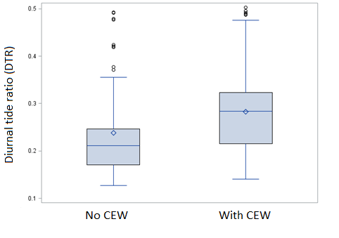

Figure 24. Box and whisker plot of the Goolwa Barrage diurnal tide ratio for days where no Commonwealth environmental water was delivered (No CEW) and days where Commonwealth environmental water was delivered via the barrages (With CEW). The box height is the interquartile range, while the diamond and line within the box are the mean and median, respectively. The whiskers represent 1.5 times the interquartile. The circles show outlying observations.

We also utilised the model developed by Webster (2010) to estimate the effective bed elevation of the Murray Mouth channel. The input data used for this analysis were two scenarios: (a) ‘modelled pre-buyback’ (i.e. without held Commonwealth environmental water); and (b) ‘modelled actual’ (i.e. held Commonwealth environmental water). As the input data are theoretical and not verified against actual barrage releases, we report this information with low certainty. More details on the channel dynamics model can be found in Webster (2010); for details on how modelled flow inputs were derived, refer to Section 2.2 of this report.

For the 2014–15 watering year, the modelled actual stream bed height was estimated to be   
–1.38 ± 0.31 m, while the modelled pre-buyback scenario (or counterfactual) result was significantly lower at –0.33 ± 0.29 m (Figures 25 and 26). This result indicates that under a modelled condition, Commonwealth environmental water has contributed to the Murray Mouth openness indicator via the increase in depth of the channel through its deliveries of environmental water over the barrages. Moreover, the pattern observed in the depth of the Murray Mouth is similar to the impact of Commonwealth environmental water on the DTR index, whereby the contribution of Commonwealth environmental water is having a positive contribution to the end-of-Basin outcome.

BSW targets state that the Murray Mouth is to remain open 90% of the time to an average annual depth of 1 m. Modelling has shown that, under a modelled condition, Commonwealth environmental water has contributed to maintaining a depth of greater than 1 m. However, it is important to note that, in reality, dredges were commissioned in December 2014 and continued through to 30 June 2015 to maintain Murray Mouth openness. Dredging has been identified as sensible management option to manipulate tidal asymmetry towards a natural flushing system (Colby et al.2010). While the modelling shows an improvement, no field data were available to validate the level of improvement with a high degree of certainty. As more data become available, as well as improvements with the modelling procedure, the level of certainty is likely to increase.

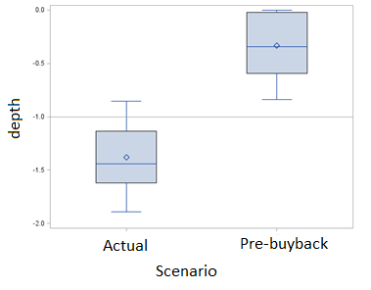

Figure 25. Box and whisker plot showing the modelled streambed height for the 2014–15 watering year. The reference line of 1 m indicates a modelled Murray Mouth depth. The box height is the interquartile range, while the diamond and line within the box are the mean and median, respectively. The whiskers represent 1.5 times the interquartile range.

Figure 26. Modelled change in the Murray Mouth bed depth for the counterfactual scenario (modelled pre-buyback) and an actual scenario (modelled actual). Lake level and diurnal tide ratio index at Goolwa Barrage are provided.

### Commonwealth environmental water contribution to salinity and sediment transport

Environmental water releases over the barrages contribute to river outflows which, aside from contributions to Lower Lake levels and Murray Mouth outcomes, also provide benefits to the Ramsar-listed Coorong, where the Australian Government holds an international obligation to protect under the Ramsar Convention. It is well established that delivering environmental water to the Coorong reduces salinity via the export and dilution of salt, but it also provides other benefits, such as connectivity between fresh, estuarine and marine waters, facilitating movement of aquatic plants/animals and phytoplankton and zooplankton (including increasing the diversity and abundance of zooplankton) (e.g. Geddes et al.2016).

Modelling conducted by Ye et al.(2016) found that environmental water increased salt exports from the Murray River Channel and Lower Lakes. It estimated that environmental water contributed to 96 284 tonnes (t) (27%) and 294 449 t (66%) to the total modelled export from the Murray River Channel and Lower Lakes, respectively, with an attribution to Commonwealth environmental water of between 21% and 64% of the total modelled export from the Murray River Channel and Lower Lakes, respectively. This result clearly highlights the effectiveness of environmental water in supporting functions that maintain water quality within tolerable limits and which will facilitate the connectivity of biota between the freshwater, estuarine and marine environments.

## Enhance and protect refuge habitat: native fish in the northern Basin

MDBA 2014–15 Basin Annual Environmental Watering Priority: Improve survival of native fish populations by enhancing and protecting dry-period refuge habitat in the northern Basin.

CEWO 2014–15 Environmental Water Objectives: Various priorities were set for native fish in the northern Basin.

Summary of outcomes and Commonwealth environmental water contribution: Streamflow data indicating contribution of Commonwealth environmental water are limited in the northern Basin (Annex A). Data that have been provided by agencies indicate that there was very little success in contributing to this objective in the Border Rivers and the Warrego, Condamine and Upper Darling rivers. The significant volumes of water delivered in the Gwydir and Macquarie rivers, including wetland watering, is likely to have made an important contribution towards this priority.

Earlier sections of this report have already dealt with hydrological outcomes in the Gwydir river system and Macquarie River. Here, we focus on the Border Rivers and Warrego, Condamine and Upper Darling rivers where there are some limited data available on environmental watering.

The 2014–15 watering year was a dry one in the northern unregulated valleys and this is reflected in the volume of in-stream contributions by unregulated entitlements (Annex A, Report card 5), and the environmental outcomes that were achieved. In 2014–15, a total of 247 121 ML of environmental water was potentially available for access, but only 10% (24 924 ML) was activated. The valleys watered included actions in the Border Rivers (including the Moonie River) and Lower Balonne (in the Condamine), Warrego and Barwon–Darling rivers. However, due to the dry conditions, entitlements in Nebine Creek (approved 5920 ML) and NSW Warrego at Toorale (approved 25 932 ML) were not activated. Commonwealth environmental water contributed to instream flows in 17 watering actions in the northern unregulated valleys during 2014–15. There were eight access periods in the Border Rivers – (3229.5 ML), which included four in the Moonie River (1415 ML). There were two access periods in the Condamine–Balonne (17 392 ML), four in the Warrego (2541.7 ML) and three in the Barwon–Darling above Menindee (1760.6 ML). Of the 17 watering actions, 15 were considered freshes and 2 (both in the Border Rivers) were considered overbank or bankfull. The watering actions spanned approximately 146 days, with the average duration of individual flows in the entitlement zone spanning 8 days. In all cases, where data are available (Figure 27), the contribution of environmental water to each action is very small relative to non-environmental water. Activation of entitlements in the Barwon–Darling was limited by an embargo on B- and C-class pumping that was in place for most of the first 6 months of 2015.

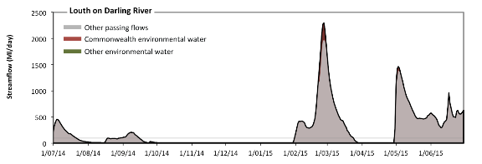

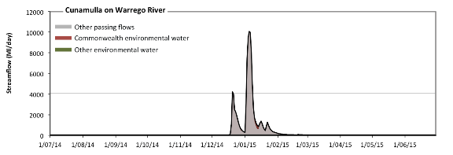

**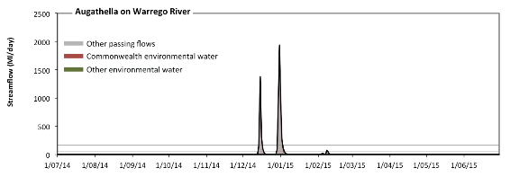**

**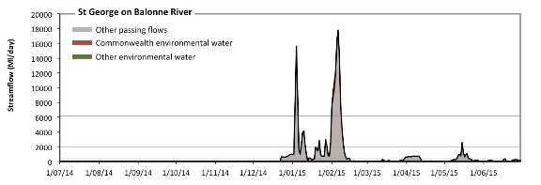**

**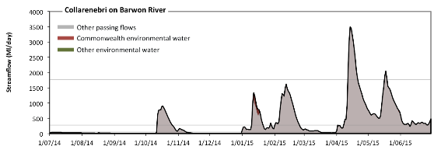**

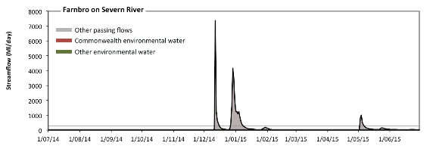

Figure 27. Streamflows at sites in the Darling, Warrego, Condamine–Balonne, Barwon and Border Rivers valleys. Contributions of Commonwealth environmental water is shown. Horizontal lines indicate thresholds for very low flows, low flows and low freshes (from lowest to highest).

## Enhance and protect refuge habitat: waterbird refuge

MDBA 2014–15 Basin Annual Environmental Watering Priority: Maintain waterbird habitat, including refuge sites and food sources, to support waterbird populations across the Murray–Darling Basin. Support waterbird breeding where feasible.

CEWO 2014–15 Environmental Water Objectives: The CEWO did not provide any Basin-wide objectives.

Summary of outcomes and Commonwealth environmental water contribution: We have not been able to assess the contribution of Commonwealth environmental water watering actions to hydrological outcomes against this objective as information available on floodplain inundation at the Basin scale was limited and inconsistent.

References

Alluvium (2013) *Yanco Creek system environmental flow study (final report).* Report prepared by Alluvium Consulting Australia for State Water, Leeton NSW.

Bark RH, Peeters LJM, Lester RE, Pollino CA, Crossman ND, Kandulu JM (2013) Understanding the sources of uncertainty to reduce the risks of undesirable outcomes in large-scale freshwater ecosystem restoration projects: an example from the Murray–Darling Basin, Australia. Environmental Science & Policy **33**, 97–108.

Colby LH, Maycock SD, Nelligan FA, Pocock HJ, Walker DJ (2010) An investigation into the effect of dredging on tidal asymmetry at the River Murray Mouth. Journal of Coastal Research **26(5)**, 843–850.

Geddes MC, Shiel RJ, Francis J (2016) Zooplankton in the Murray estuary and Coorong during flow and no-flow periods. Transactions of the Royal Society of South Australia **140(1)**, 74–89.

MDBA (Murray–Darling Basin Authority) (2010) Guide to the proposed Basin Plan MDBA, Canberra.

MDBA (Murray–Darling Basin Authority) (2012) Assessment of environmental watering requirements for the Proposed Basin Plan: mid-Murrumbidgee River wetlands MDBA, Canberra.

MDBA 2014 (Murray–Darling Basin Authority) (2014) Basin-wide Environmental Watering Strategy MDBA, Canberra.Stewardson M, DeRose R, Harman C (2005) Regional models of stream channel metrics*.* Report 05/16. Cooperative Research Centre for Catchment Hydrology, Monash University, Melbourne.

Stewardson MJ (2005) Hydraulic geometry of stream reaches. Journal of Hydrology **306(1)**, 97–111.

Walker DJ, Jessup A (1992) Analysis of the dynamic aspects of the River Murray Mouth. Journal of Coastal Research **8(1),** 71–76.

Webster, IT, Lester RE and Fairweather, PG (2009) Preliminary determination of environmental water requirements for the Coorong. CSIRO: Water for a Healthy Country National Research Flagship.

Webster IT (2010) The hydrodynamics and salinity regime of a coastal lagoon — the Coorong, Australia — seasonal to multi-decadal timescales. Estuarine, Coastal and Shelf Science**90(4)**, 264–274.

Ye Q, Giatas G, Aldridge K, Busch B, Gibbs M, Hipsey M, Lorenz Z, Oliver R, Shiel R, Zampatti B (2016) Long Term Intervention Monitoring for the ecological responses to Commonwealth environmental water delivered to the Lower Murray River Selected Area in 2014/15.A report prepared for the Commonwealth Environmental Water Office. South Australian Research and Development Institute, Aquatic Sciences, Adelaide.

Annex A. Valley report cards 1 to 13

1. http://www.mdba.gov.au/publications/report/basin-annual-environmental-watering-priorities-2014-15 [↑](#footnote-ref-2)