2014–15 Basin-scale evaluation of Commonwealth environmental water — Synthesis Report

**Prepared by:** Ben Gawne, Jennifer Hale, Shane Brooks, Cherie Campbell, Samantha Capon, Penny Everingham, Mike Grace, Fiorenzo Guarino, Rick Stoffels and Michael Stewardson

Final Report

**MDFRC Publication 103/2016**

2014–15 Basin-scale evaluation of Commonwealth environmental water — Synthesis Report

Report prepared for the Commonwealth Environmental Water Office by The Murray–Darling Freshwater Research Centre.

Commonwealth Environmental Water Office

GPO Box 787

Canberra ACT 2601

John Gorton Building

King Edward Terrace

Parkes ACT 2600

Ph: (02) 6274 1111

This report was prepared by The Murray–Darling Freshwater Research Centre (MDFRC). The aim of the MDFRC is to provide the scientific knowledge necessary for the management and sustained utilisation of the Murray–Darling Basin water resources. The MDFRC is a joint venture between La Trobe University and CSIRO. Additional investment is provided through the University of Canberra.



For further information contact:

**Ben Gawne**

The Murray–Darling Freshwater Research Centre  
PO Box 991   
Wodonga VIC 3689

Ph: (02) 6024 9650

Email: Ben.Gawne@Canberra.edu.au  
Web: [www.mdfrc.org.au](http://www.mdfrc.org.au)  
Enquiries: [mdfrc@latrobe.edu.au](mailto:mdfrc@latrobe.edu.au)

**Report Citation:** Gawne B, Hale J, Brooks S, Campbell C, Capon S, Everingham P, Grace M, Guarino F, Stoffels R, Stewardson M (2016) 2014–15 Basin-scale evaluation of Commonwealth environmental water — Synthesis Report. Final report prepared for the Commonwealth Environmental Water Office by The Murray–Darling Freshwater Research Centre, MDFRC Publication 103/2016, November, 40pp.

This monitoring project was commissioned and funded by Commonwealth Environmental Water Office.

**Copyright**

© Copyright Commonwealth of Australia, 2016



2014-15 Basin-scale evaluation of Commonwealth environmental water – Synthesis Report (2016) is licensed by the Commonwealth of Australia for use under a Creative Commons By Attribution 3.0 Australia licence with the exception of the Coat of Arms of the Commonwealth of Australia, the logo of the agency responsible for publishing the report, content supplied by third parties, and any images depicting people. For licence conditions see: <http://creativecommons.org/licenses/by/3.0/au/>

This report should be attributed as Gawne B, Hale J, Brooks S, Campbell C, Capon S, Everingham P, Grace M, Guarino F, Stoffels R, Stewardson M (2016) 2014–15 Basin-scale evaluation of Commonwealth environmental water — Synthesis Report. Final report prepared for the Commonwealth Environmental Water Office by The Murray-Darling Freshwater Research Centre, MDFRC Publication 103/2016, November, 40pp.

**Disclaimer**

The views and opinions expressed in this publication are those of the authors and do not necessarily reflect those of the Australian Government or the Minister for the Environment and Energy.

While reasonable efforts have been made to ensure that the contents of this publication are factually correct, the Commonwealth does not accept responsibility for the accuracy or completeness of the contents, and shall not be liable for any loss or damage that may be occasioned directly or indirectly through the use of, or reliance on, the contents of this publication.

The material contained in this publication represents the opinion of the author only. Whilst every effort has been made to ensure that the information in this publication is accurate, the author and MDFRC do not accept any liability for any loss or damage howsoever arising whether in contract, tort or otherwise which may be incurred by any person as a result of any reliance or use of any statement in this publication. The author and MDFRC do not give any warranties in relation to the accuracy, completeness and up to date status of the information in this publication.

Where legislation implies any condition or warranty which cannot be excluded restricted or modified such condition or warranty shall be deemed to be included provided that the author’s and MDFRC’s liability for a breach of such term condition or warranty is, at the option of MDFRC, limited to the supply of the services again or the cost of supplying the services again.

Document history and status

|  |  |  |  |  |
| --- | --- | --- | --- | --- |
| **Version** | **Date Issued** | **Reviewed by** | **Approved by** | **Revision type** |
| Draft | 22 August 2016 | M&E Advisers | Ben Gawne | Internal |
| Draft | 20 September 2016 | Ben Gawne and Jenny Hale | Penny Everingham | Internal |
| Draft | 20 September 2016 | CEWO | Ben Gawne | External |
| Drat | 7 October 2016 | Ben Gawne and Jenny Hale | Ben Gawne | Internal |
| Draft | 17 October 2016 | Mary Webb | Penny Everingham and Jenny Hale | External copy edit |
| Final | 16 November 2016 | CEWO | Penny Everingham | External |

Distribution of copies

|  |  |  |
| --- | --- | --- |
| **Version** | **Quantity** | **Issued to** |
| Draft | 1 x PDF 1 x Word | Paul Marsh, Sam Roseby and Andrew Lowes |
| Final | 1 x PDF 1 x Word | Paul Marsh, Sam Roseby and Andrew Lowes |

**Filename and path:** \Projects\CEWO\CEWH Long Term Monitoring Project\499 LTIM Stage 2 - 2014–2019 Basin Evaluation\Final Reports

**Author(s):** Ben Gawne, Jennifer Hale, Shane Brooks, Cherie Campbell, Samantha Capon, Penny Everingham, Mike Grace, Fiorenzo Guarino, Rick Stoffels and Michael Stewardson

**Author affiliation(s):** University of Canberra, Consultant, LitePC Technology Pty Ltd, MDFRC, Griffith University, MDFRC, Monash University, University of Canberra, CSIRO and University of Melbourne

**Project Leader: Ben Gawne**

**Client:** Commonwealth Environmental Water Office

**Project Title:** Basin evaluation of the contribution of Commonwealth environmental water to the environmental objectives of the Murray‒Darling Basin Plan

**Document Version:** Final

**Project Number:** M/BUS/499

**Contract Number:** PRN 1213-0427

**Acknowledgements:**

This project was undertaken using data collected for the Commonwealth Environmental Water Office Long Term Intervention Monitoring project. The assistance provided by the Monitoring and Evaluation Providers into interpretation of data and report review is greatly appreciated. The authors would also like to thank all Monitoring and Evaluation Provider staff involved in the collection and management of data.

The Murray–Darling Freshwater Research Centre offices are located on the land of the Latje Latje and Wiradjuri peoples. We undertake work throughout the Murray–Darling Basin and acknowledge the traditional owners of this land and water. We pay respect to Elders past, present and future.

Contents

[1 Background 1](#_Toc465858045)

[1.1 The Commonwealth *Water Act 2007* 1](#_Toc465858046)

[1.2 Roles and responsibilities under the Basin Plan 1](#_Toc465858047)

[1.3 Monitoring aquatic ecosystem responses to environmental flows 2](#_Toc465858048)

[2 Introduction 3](#_Toc465858049)

[2.1 What is the Long Term Intervention Monitoring Project? 3](#_Toc465858050)

[2.2 How are we evaluating outcomes at the Basin scale? 5](#_Toc465858051)

[2.3 Context: the 2014–15 watering year 7](#_Toc465858052)

[2.3.1 Climate and water availability 7](#_Toc465858053)

[2.3.2 Commonwealth environmental water delivery in 2014–15 7](#_Toc465858054)

[3 Basin-scale evaluation 11](#_Toc465858055)

[3.1 Biodiversity 12](#_Toc465858056)

[3.1.1 Basin Matter evaluations related to biodiversity 12](#_Toc465858057)

[3.1.2 Basin-scale biodiversity outcomes 13](#_Toc465858058)

[3.2 Ecosystem function 16](#_Toc465858059)

[3.2.1 Basin Matter evaluations related to ecosystem function 16](#_Toc465858060)

[3.2.2 Basin-scale ecosystem function outcomes 17](#_Toc465858061)

[3.3 Resilience 22](#_Toc465858062)

[3.3.1 Protecting refuge habitat 22](#_Toc465858063)

[3.3.2 Contributing to resilience through improved condition 23](#_Toc465858064)

[4 Adaptive management 26](#_Toc465858065)

[4.1 What we have learned about the effects of environmental water? 26](#_Toc465858066)

[4.1.1 Timing of water delivery affects outcomes for fish and vegetation 26](#_Toc465858067)

[4.1.2 Small in-channel water regimes do not promote productivity 26](#_Toc465858068)

[4.2 What we have learned about managing environmental water? 27](#_Toc465858069)

[4.2.1 Past and current conditions are important determinants of the effects of environmental water 27](#_Toc465858070)

[4.2.2 Objectives of water actions need to be SMART 27](#_Toc465858071)

[4.2.3 Objectives of watering actions need to be placed in context 28](#_Toc465858072)

[4.3 How can we improve the LTIM Project? 28](#_Toc465858073)

[4.3.1 Long-term monitoring is essential 28](#_Toc465858074)

[4.3.2 Improving monitoring methods 28](#_Toc465858075)

[4.3.3 Inundation mapping with and without Commonwealth environmental water is crucial 28](#_Toc465858076)

[5 Contribution to Basin Plan objectives 29](#_Toc465858077)

[References 32](#_Toc465858078)

[Appendix A. 2014–15 Commonwealth environmental watering actions 34](#_Toc465858079)

[Appendices B–G. Basin Matter Reports 40](#_Toc465858080)

List of tables

Table 1. Resource availability scenarios, management outcomes and strategies to achieve them (MDBA 2014b). 9

Table 2. Summary of CEWO watering actions by valley (see Appendix B for further explanation). 10

Table 3. Summary of ‘expected outcomes’ for Commonwealth environmental watering actions 2014–15 (see Appendix A). 11

Table 4. Listed species that were recorded at sites that received Commonwealth environmental water in 2014–15. 15

Table 5. ANAE floodplain types inundated from environmental watering in 2014–15 at the Gingham and Lower Gwydir Ramsar site. 16

Table 6. Contribution of CEWO watering in 2014–15 to Basin Plan objectives. 30

List of figures

[Figure 1. Monitoring and evaluation reporting obligations (Source: Commonwealth Environmental Water Office). 2](#_Toc465858087)

[Figure 2. General location of the seven Selected Areas where the LTIM Project is measuring the effects of Commonwealth environmental water. 4](#_Toc465858088)

[Figure 3. Rainfall, areas inundated and streams watered by Commonwealth environmental water during the 2014–15 water year. 8](#_Toc465858089)

[Figure 4. Five flow types and their influence on different parts of the river channel, wetlands and floodplains (MDBA 2011). 17](#_Toc465858090)

[Figure 5. Average contribution of Commonwealth environmental water and other environmental water entitlements to low flow durations and occurrence of freshes across each valley (see Appendix B for explanation on scoring and further details). 18](#_Toc465858091)

[Figure 6. Box and whisker plot showing the modelled streambed height for the 2014–15 watering year. The reference line of 1 metre indicates the target Murray Mouth depth. The diamond and line within the box are the mean and median, respectively. 20](#_Toc465858092)

[Figure 7. Box plots representing seasonal gross primary productivity (left) and ecosystem respiration (right) in the five Selected Areas for which data were available in 2014–15 (Edward–Wakool, Goulburn, Murrumbidgee, Lachlan and Lower Murray). 21](#_Toc465858093)

[Figure 8. An illustration of the way a hypothetical model could be applied iteratively to generate a series of outcomes from different flow regimes over a 5-year period (Gawne *et al.* 2014). 25](#_Toc465858094)

[Figure 9. An illustration of a hypothetical model of a long-term response to environmental watering where the greatest influence is from watering in the most recent year, with progressively weaker influence from watering in previous years (Gawne *et al.* 2014). 25](#_Toc465858095)

# Background

## The Commonwealth Water Act 2007

The Water Act 2007 (Cwlth) provides the legal basis for the determination of sustainable water extraction limits within the Murray–Darling Basin. The Act establishes the Murray–Darling Basin Authority (MDBA) to develop a Basin Plan, which defines these limits, and the Commonwealth Environmental Water Holder (CEWH) to manage the environmental flows that result, and gives greater powers to the Bureau of Meteorology to obtain and disseminate water information across the country.

To support the implementation of these arrangements and rebalance the system between the environment and consumptive use, the Australian Government is investing in recovering water through investment in irrigation efficiency and the buyback of entitlements from irrigators.

The CEWH is a statutory position responsible for managing the water that the Australian Government acquires for the purpose of protecting or restoring environmental assets so as to give effect to international agreements. In undertaking this role, there are three options available to the CEWH at any given time:

* use the environmental water which accrues to the entitlement, with the release of water from storage or the manipulation of other in-stream or floodplain infrastructure (with the timing, flow rate and volume released designed to have maximum environmental benefit)
* carryover the water in storage for use in a future year (under the same rules that apply to irrigators)
* trade (buy or sell water) with irrigators in order to improve environmental outcomes at a future time or in a different valley (e.g. sell water when it is not needed and buy when it is).

The MDBA is an independent, expertise-based agency responsible for leading the planning and management of Basin water resources. It has key roles in:

* developing and overseeing the implementation of all aspects of the Basin Plan 2012
* coordinating state and federal agencies in the management of the water resources
* evaluating and auditing the implementation of the Basin Plan.

## Roles and responsibilities under the Basin Plan

The Basin Plan,a legislative instrument*,* sets out the roles and responsibilities for reporting on environmental outcomes of the MDBA, state governments and the CEWH:

* the MDBA is responsible for reporting on achievements against the environmental objectives of the Basin Plan at the Basin scale (i.e. whole of drainage basin)
* state governments are responsible for reporting on achievements against the environmental objectives of the Basin Plan at an asset scale (i.e. rivers, wetlands, floodplains)
* the CEWH is responsible for reporting on the contribution of Commonwealth environmental water to the environmental objectives of the Basin Plan (at multiple scales).

These reporting obligations set up the architecture for the monitoring and evaluation that is required to enable a determination by the MDBA of overall Basin Plan outcomes, as indicated in Figure 1.

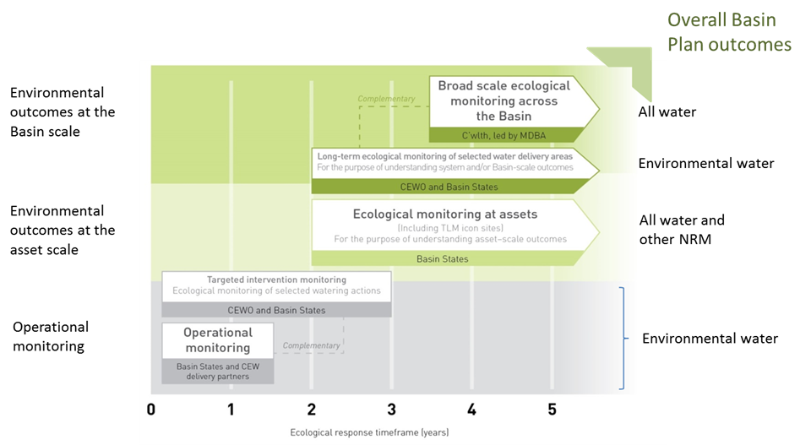

Figure 1. Monitoring and evaluation reporting obligations (Source: Commonwealth Environmental Water Office).

## Monitoring aquatic ecosystem responses to environmental flows

Within this framework, the CEWH needs to ensure that its monitoring and evaluation activities will enable it to meet is reporting obligations and demonstrate both value for money from the Australian Government’s investment and support adaptive environmental flow management over time.

The common elements of all reporting requirements are the Basin Plan environmental objectives, or more specifically, the environmental objectives contained within the Environmental Watering Plan (Chapter 8 of the Basin Plan). The overall environmental objectives for water dependent ecosystems of the Murray Darling Basin (Section 8.04) include:

1. *to protect and restore water-dependent ecosystems of the Murray-Darling Basin; and*
2. *to protect and restore the ecosystem function of water-dependent ecosystems; and*
3. *to ensure that water dependent ecosystems are resilient to climate change and other risks and threats.*

These objectives are Basin scale and long term. For example (Section 8.05(3)):

An objective is to protect and restore biodiversity that is dependent on Basin water resources by ensuring that:

1. water-dependent ecosystems that support the life cycles of a listed threatened species or listed threatened ecological community, or species treated as threatened or endangered (however described) in State law, are protected and, if necessary, restored so that they continue to support those life cycles; and
2. representative populations and communities of native biota are protected and, if necessary, restored.

However, environmental flows are delivered at an asset scale in the short term. To bridge this gap, the Commonwealth Environmental Water Office’s (CEWO’s) Long Term Intervention Monitoring (LTIM) Project is based around an Outcomes Framework[[1]](#footnote-1) (CEWO 2013b) which describes the outcomes expected from environmental flows at 1- and 5-year time scales that will contribute to the longer term objectives of the Environmental Watering Plan.

These outcomes help guide the monitoring that needs to take place to support an evaluation of the impact of environmental flows and are based on cause-and-effect diagrams that describe the relationships between different parameters in response to environmental flows, reflecting current scientific knowledge.

This Outcomes Framework also ensures that the monitoring undertaken by the CEWO is aligned with the broader scale monitoring undertaken by the MDBA for vegetation, fish, waterbirds and hydrological connectivity and for which there are quantified environmental targets described in a Basin-wide environmental watering strategy — one of the key planning documents that guides all environmental water use within the Basin.

The Basin-wide environmental watering strategy provides the next level of detail on the environmental objectives and targets, with ‘quantified expected outcomes’ identified for four components: river flows and connectivity; native vegetation; waterbirds; and native fish. Examples of the expected outcomes include:

* a 20–25% increase in waterbirds by 2024
* a 10–15% increase in mature Murray cod and golden perch at key sites
* maintenance of the current area and condition (and in some regions, improved condition) of river red gum, black box, coolabah and lignum communities
* improved overall flow, such as 10% more flow in the Barwon–Darling, 30% more flow in the Murray River and 30–40% more flow to the Murray Mouth.

These outcomes are the MDBA’s best assessment of how the Basin’s environment will respond over the next decade as a result of implementing the Basin Plan and associated water reforms. It is the responsibility of the MBDA to evaluate the contribution of Basin Plan reforms to achieving these targets using its own monitoring information and that obtained from Basin states and the CEWO.

# Introduction

## What is the Long Term Intervention Monitoring Project?

The Commonwealth Environmental Water Office (CEWO) Long Term Intervention Monitoring (LTIM) Project is assessing the ecological effects of Commonwealth environmental water and its contribution to Basin Plan[[2]](#footnote-2) environmental objectives. The LTIM Project aligns with the CEWO Monitoring, Evaluation, Reporting and Improvement (MERI) Framework (CEWO 2013a) and will provide information that will help improve the management of environmental water, through adaptive management. Monitoring is being conducted at seven areas (called Selected Areas) across the Basin from 2014 to 2019 (Figure 2) and the evaluation is undertaken across the entire Basin and includes all watering actions.

LTIM Project Selected Areas were chosen to be representative of areas where environmental flows will occur; to complement but not duplicate areas where other monitoring activities are undertaken; to be in catchments where 90% of Commonwealth environmental water entitlements are held; and which enable results to be used to infer outcomes at areas not monitored with:

* the support of dose–response models that will be progressively improved over time
* an understanding of the existing science and knowledge of how ecosystems respond to changes in hydrological parameters
* modelling of with and without environmental water hydrological scenarios.

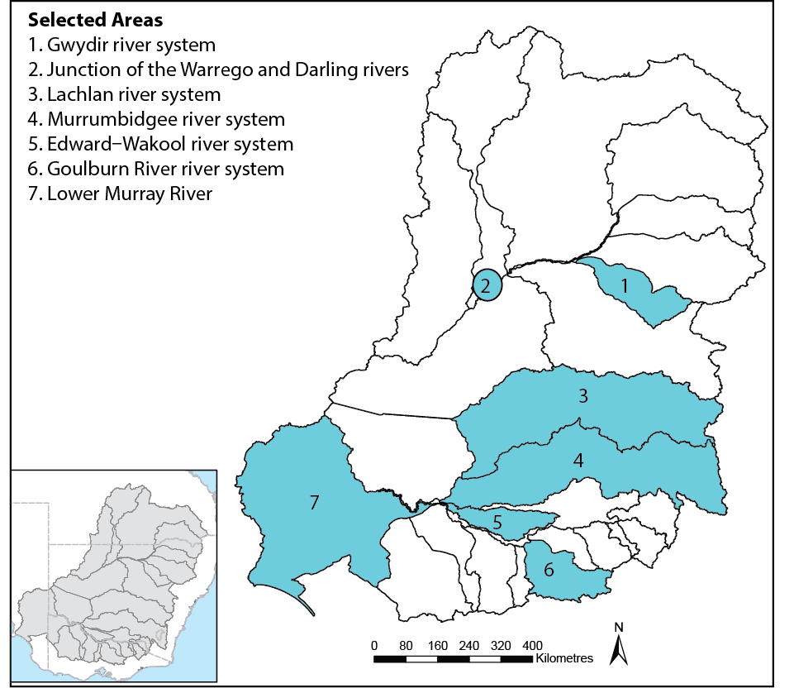

Figure 2. General location of the seven Selected Areas where the LTIM Project is measuring the effects of Commonwealth environmental water.

The five high-level objectives of the LTIM Project are to:

1. evaluate the contribution of Commonwealth environmental watering to the objectives of the MDBA’s Environmental Watering Plan
2. evaluate the ecological outcomes of Commonwealth environmental watering at each of the seven Selected Areas
3. infer ecological outcomes of Commonwealth environmental watering in areas of the Murray–Darling Basin (the Basin) not monitored
4. support the adaptive management of Commonwealth environmental water
5. monitor the ecological response to Commonwealth environmental watering at each of the seven Selected Areas.

The LTIM Project is evaluating the effect of Commonwealth environmental water at several spatial scales. Evaluation at the site and regional (Selected Area) scales is being completed by monitoring teams at each of the Selected Areas and is documented in individual reports that are published on the CEWO website annually.[[3]](#footnote-3) Evaluation is also being conducted at the Basin scale, which seeks to integrate information from monitoring at Selected Areas and other information sources to determine outcomes from the portfolio of Commonwealth environmental water across the Basin. This report documents the Basin-scale evaluation for the first year of the LTIM Project (2014–15).

## How are we evaluating outcomes at the Basin scale?

The development of the Basin-scale evaluation is described in the LTIM Project Logic and Rationale document (Gawne et al. 2013)[[4]](#footnote-4) and the Basin Evaluation Plan (Gawne et al. 2014).[[5]](#footnote-5) These documents provide an overview of the LTIM Project and the selection process for six ecological indicators or ‘matters’ for Basin evaluation:

* **ecosystem diversity** — the aquatic ecosystem types (e.g. wetlands, rivers, streams) that benefitted from Commonwealth environmental water
* **hydrology** — river flow and wetland water regimes modelled with and without Commonwealth environmental water
* **stream metabolism and water quality** — rates of instream primary productivity and decomposition, salinity and pH
* **vegetation diversity** — plant species’ responses with respect to extent, diversity and condition
* **fish** — short- and long-term responses of fish with respect to movement, condition abundance and diversity
* **generic diversity** — effects on diversity of all biota from monitoring and observations.

Standard methods have been adopted for these Basin Matters to allow for integration and analysis of data across Selected Areas. Over the course of the 5 years of the LTIM Project, this will provide a unique opportunity for evaluation of environmental watering at a large spatial scale and, in many respects, represents a world first in intervention monitoring (see Box 1 for an example from the Fish Basin Matter).

The general approach is based on a conceptual understanding of how water regimes affect aquatic ecosystems and the communities and species that depend on them. This conceptual understanding represents the current state of knowledge, but the evaluation process is designed to both generate and incorporate new knowledge about the influence of water regimes on aquatic ecosystems.

The monitoring data from the six Basin Matters are used to evaluate outcomes of the management of Commonwealth environmental water at the Basin scale, building upon the area-scale evaluations provided in the individual Selected Area reports. For monitored watering actions, this requires a comparison between the observed outcome and a prediction of what would have happened in the absence of the environmental flow.

Predictions of what would have happened in the absence of the environmental flow can be derived from a number of sources, including reference sites, conceptual models or quantitative models. Due to limitations associated with identifying suitable reference sites, the Basin evaluation will, over the next 5 years, develop quantitative models that predict the outcomes of Commonwealth environmental water based on the characteristics of the event and the condition prior to watering. The next step is to make a judgement about whether the observed outcome matches the expected outcome. The evaluation then considers the factors that contributed to success, and which could be modified to lead to improved outcomes or to ensure success next time. This process, once again relies on our conceptual understanding of how water regimes affect aquatic ecosystems.

For unmonitored watering actions, any available evidence is used to inform an evaluation of the likelihood that the watering action achieved its objectives. The next step is to consider the factors that may have contributed to action’s outcomes. This process is reliant on both the available evidence and our capacity to predict responses to flow. The development of quantitative models by the LTIM Project will significantly increase the capacity to evaluate unmonitored watering actions.

Evaluation at the Basin scale requires both an estimation of the overall outcomes across the Basin and then a judgement of their significance and contribution to Basin Plan objectives. This process synthesises the evaluations from the Selected Areas and then uses the CEWO Outcomes Framework to link these to Basin Plan objectives, by translating local or site-scale outcomes into the four high-level environmental objectives under the Basin Plan generically described as Biodiversity, Ecosystem Function, Resilience and Water Quality (see Table 6).

#### Monitoring fish populations — a step forward in intervention monitoring

Monitoring of fish to inform Basin-scale evaluation has adopted a long-term census approach, with a high intensity of sampling at the same time of year at each of six Selected Areas (noting that fish monitoring for Basin-scale evaluation is not a target in the Junction of the Warrego and Darling rivers Selected Area). Fish can be classified into three guilds based on life-history strategies (see figure below) and it is thought that fish in different guilds may respond to flows in different ways (Winemiller & Rose 1992). For this reason, LTIM fish monitoring captures all species, but population data (length, weight, age) are focused on four target species that represent each of the three guilds:

1. equilibrium: Murray cod (large adult size; long-lived; non-flow spawner; greater investment in offspring)
2. periodic: golden perch (large adult size; long-lived; flow-spawner; little investment in offspring) and bony herring (medium adult size, medium longevity, spawning not tightly linked to flows)
3. opportunistic: carp gudgeon (small adult size; short life span; spawning not tightly linked to flows).

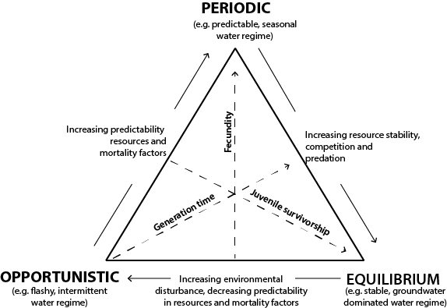

**Model of the three fish guilds, with example water regimes (Olden & Kennard 2010).**

Results of analysis in the first LTIM year indicate that the data being collected across the six Selected Areas are of high quality and will provide the level of precision needed to build predictive models of fish responses to flows. In time, this will enable quantitative prediction of flow responses of native fish in areas and times where monitoring data are not collected.

Box 1. Monitoring for the fish Basin Matter.

The LTIM Project is a 5-year project and evaluation of the effects of Commonwealth environmental water at the Basin scale will be progressively developed over this time, with each year’s data adding to the analysis and contributing to both improvements in our conceptual understanding and development of models to support improved predictions of the outcomes of environmental flows. It is anticipated that this process will see significant improvements in the scope and rigour of the evaluation process over the life of the LTIM Project.

This Basin-scale evaluation report draws together the results of each Basin Matter to provide an integrated assessment of the outcomes of Commonwealth environmental water in the first LTIM year, 2014–15. This is the start of the project and predictive, quantitative models are still in the early stages of development. Basin evaluation for 2014–15 is based on a single year’s data and is provided in three parts:

1. **integrated Basin-scale evaluation** — a summary of the achievements of Commonwealth environmental water under three broad themes of the Basin Plan (biodiversity, ecological function and resilience)
2. **contributions to Basin Plan environmental objectives** — a tabulation of progress toward these long-term goals in the first year
3. **adaptive management** — a summary of key ‘lessons learned’ for both improved environmental water outcomes and the LTIM Project.

## Context: the 2014–15 watering year

### Climate and water availability

Rainfall conditions were variable across the Basin in 2014–15 (Figure 3). While small areas experienced above-average rainfall, such as parts of the Paroo and Lower Darling catchments, the majority of the northern Basin had average rainfall. In contrast, the southern Basin experienced mostly below-average rainfall conditions and parts of Victoria had the lowest rainfall on record.

Annual planning of environmental watering actions throughout the Basin considers climatic forecasts and likely water availability. To aid in this planning, the Environmental Watering Strategy (MDBA 2014b) provides high-level objectives, management outcomes and strategies under four resource availability scenarios: very dry, dry, moderate, and wet to very wet.

The Hydrology Basin Matter assessment (Appendix B) identified the resource availability scenarios across each of the catchments that received Commonwealth environmental water in 2014–15. They considered that all the catchments experienced ‘dry’ scenarios with the exception of the Gwydir and Lachlan valleys, which were assessed as ‘moderate’. Under a ‘dry’ resource availability scenario, water is delivered to support threatened species and maintain refuges, communities and functions. Under the moderate scenario, there is an increasing emphasis on connectivity and biological processes such as growth and recruitment (Table 1).

### Commonwealth environmental water delivery in 2014–15

Commonwealth environmental water contributed to 83 watering actions across 16 catchments in the 2014–15 watering year (Appendix A). A net total of 1014 gigalitres of Commonwealth environmental water was delivered, with the largest volumes allocated to the Murray River (581 gigalitres) and the Goulburn–Broken system (226 gigalitres). The majority of water was delivered as base flow or freshes in rivers and streams, with smaller volumes allocated to inundate wetlands and floodplains (Table 2). Many of these watering actions were undertaken collaboratively with state jurisdiction partners and/or sought to piggyback on unregulated flow events to maximise ecological benefits from available water reserves.

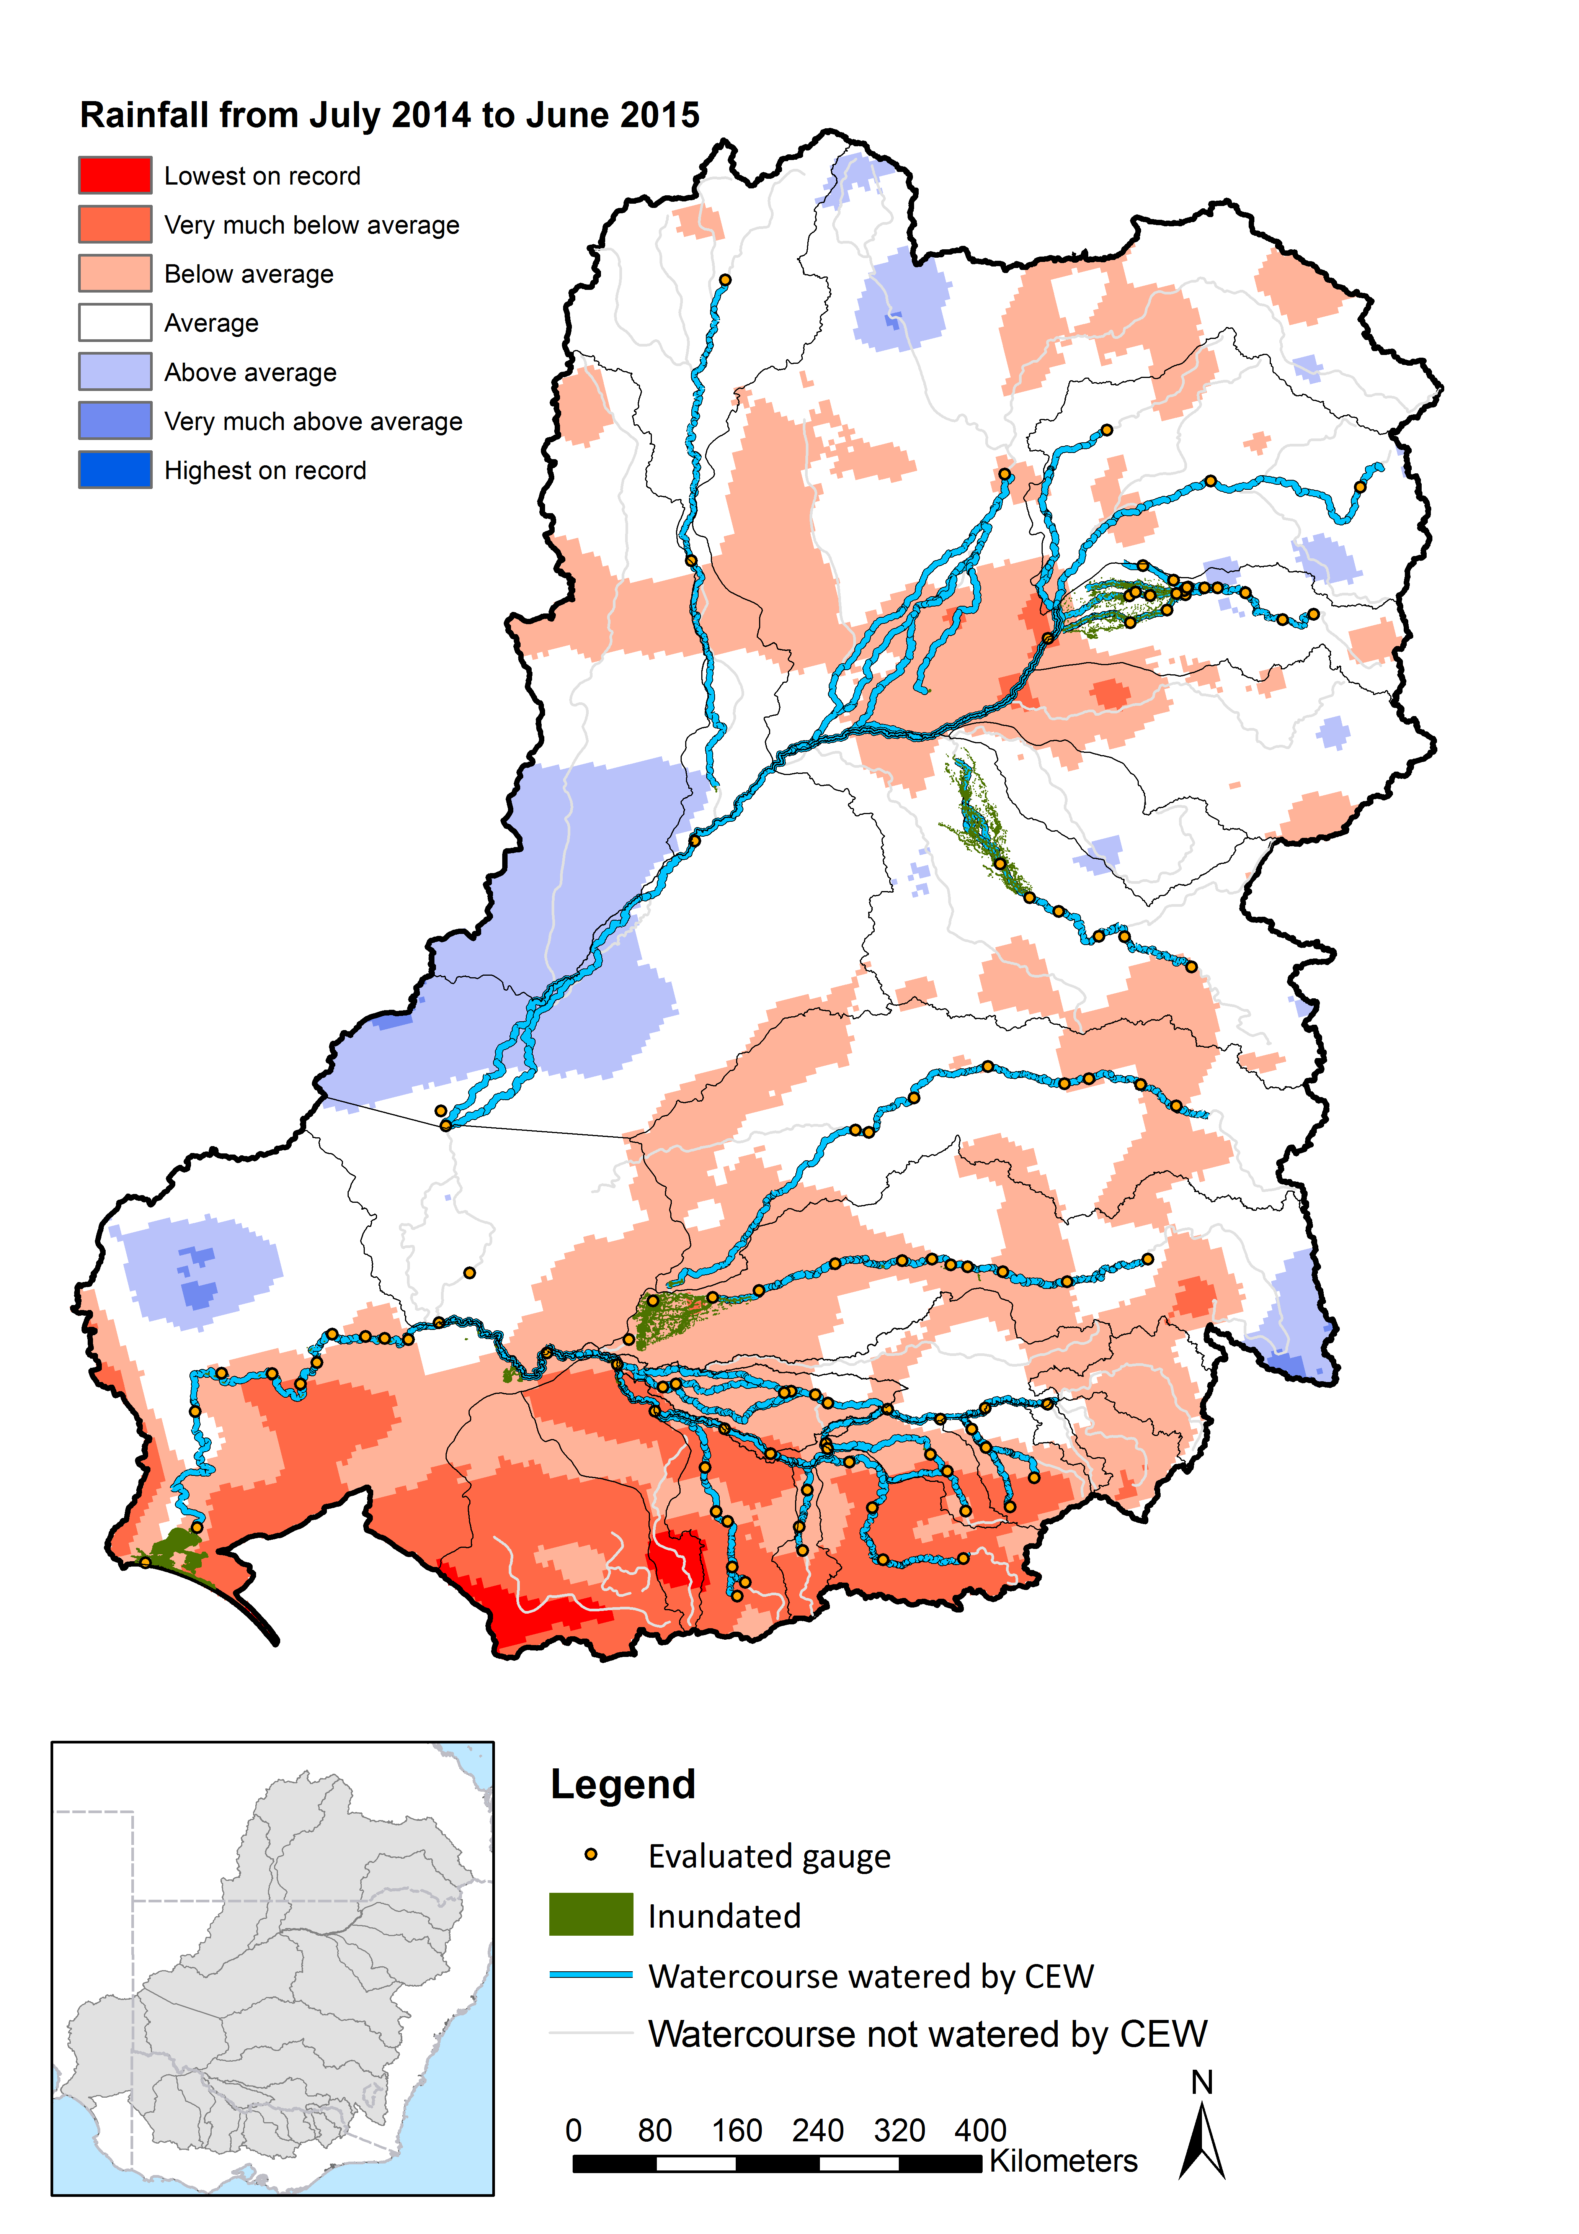

Figure 3. Rainfall, areas inundated and streams watered by Commonwealth environmental water during the 2014–15 water year.

The objectives of watering actions are described in terms of ‘expected outcomes’, which describe the desired ecological effects of environmental watering for any given watering action. These are developed through a process that accounts for both broad conditions across the Basin in the months leading up to environmental water delivery (Table 1) and localised site-based conditions at target aquatic ecosystems. The majority of watering actions have multiple expected outcomes, with water delivered to benefit a range of species, ecological functions and processes. In 2014–15, the most prevalent expected outcomes of Commonwealth environmental water were to support vegetation and fish, and to improve biological and hydrological connectivity (Table 3).

Table 1. Resource availability scenarios, management outcomes and strategies to achieve them (MDBA 2014b).

|  |  |  |
| --- | --- | --- |
|  | Scenario: dry | Scenario: moderate |
| Management objectives | Ensure environmental assets maintain their basic functions and resilience | Maintain ecological health and resilience |
| Management outcomes | Support the survival and viability of threatened species and communities  Maintain environmental assets and ecosystem functions, including by allowing drying to occur consistent with natural wetting–drying cycles  Maintain refuges | Enable growth, reproduction and small-scale recruitment for a diverse range of flora and fauna  Promote low-lying floodplain–river connectivity  Support medium-flow river and floodplain functions |
| Annual strategies to achieve outcomes | Allow drying to occur consistent with natural wetting–drying cycles to support maintenance of vegetation condition where possible  Prioritise discharges through barrages, where possible  Prioritise watering where possible for:   * water-dependent vegetation sites identified as critical as refuges for other species * waterbird drought refuges, identified dry-period native fish refuges, particularly for threatened species, and including opportunities to maintain refuge habitat (e.g. scouring flows) | Undertake follow-up watering events to promote longitudinal and lateral connectivity (where possible) to:   * support successful recruitment or to assist in restoring and maintaining vegetation condition in floodplain communities near river wetlands and anabranches * support growth, reproduction and recruitment for waterbirds, including low-lying floodplain–river connectivity for foraging opportunities * promote instream flows and low-lying floodplain–river connectivity for fish breeding, foraging, growth and movement, including for estuarine species |

Table 2. Summary of CEWO watering actions by valley (see Appendix B for further explanation).

|  |  |  |  |  |  |  |  |  |
| --- | --- | --- | --- | --- | --- | --- | --- | --- |
| **Valley** | **Volume of water approved (megalitres)** | **Volume of water delivered (megalitres)a** | **Flow type (no. of actions)b** | | | | | |
| **Base** | **Fresh** | **Bankfull** | **Overbank** | **Wetland** | **Base & fresh** |
| Murrumbidgee | 571,820 | 152,560 |  |  |  |  | 8 |  |
| Gwydir | 75,000 | 56,639 |  | 2 |  |  | 2 |  |
| Lower Murray | 801,367 | 592,723.4 | 2 | 1 |  |  | 21 |  |
| Central Murray | 104,366.9 | 59,726 |  | 1 |  |  | 9 |  |
| Border Rivers | Up to 11,970 | 3229 |  | 6 | 2 |  |  |  |
| Condamine | Up to 168,890 | 17392 |  | 2 |  |  |  |  |
| Upper Darling | Up to 24,279 | 1760.76 |  | 3 |  |  |  |  |
| Warrego | Up to 41,982 | 2541.7 |  | 3 |  |  |  |  |
| Lachlan | 15,000 | 5000 |  | 1 |  |  |  |  |
| Macquarie | 19,337 | 10,000 |  |  |  |  | 1 |  |
| Loddon | 3396.5 | 2869.5 |  | 1 |  |  |  |  |
| Broken | 50,500 | 32,878.5 | 3 |  |  |  |  |  |
| Goulburn | 275,000 | 225,883.8 | 4 | 4 |  |  | 1 |  |
| Edward–Wakool | 70,000 | 39,562 | 2 |  |  |  |  | 2 |
| Ovens | 70 | 70 | 2 |  |  |  |  |  |
| Campaspe | 7086 | 5791.4 |  | 1 |  |  |  |  |

a The volumes in this table are slightly more (1,209 GL) than the official 1014 GL delivered by the Commonwealth in 2014-15. This is because environmental water used in Victorian tributaries of the Murray River is passed into the Murray River (known as a return flow) where it is reused to maximise environmental benefit. It is important to note that a portion of the total water volume delivered in the Victorian tributaries is debited prior to passing the return flow into the Murray River. The volume of water debited covers associated conveyancing costs (e.g. Losses) of transporting that water through the system, which means the environmental water can be reused by environmental water managers to provide Murray River outcomes

b The total number of watering actions in the table (84) appears higher than the actual number of actions (83) as one watering action spanned both the Central and Lower Murray Valleys.

Table 3. Summary of watering objectives (or ‘expected outcomes’) for Commonwealth environmental watering actions 2014–15 (see Appendix A).

| **Valley** | **Number of ecological objectives (or expected outcomes) by watering action** | | | | | | | | |
| --- | --- | --- | --- | --- | --- | --- | --- | --- | --- |
| **Fish** | **Vegetation** | **Birds** | **Frogs** | **Other biota** | **Connectivity** | **Processes** | **Resilience** | **Water quality** |
| Murrumbidgee | 5 | 8 | 8 | 8 | 4 | 3 | 3 |  |  |
| Gwydir | 2 | 2 | 2 |  | 2 | 2 | 3 | 1 | 3 |
| Lower Murray | 3 | 21 | 12 | 8 | 2 | 2 |  | 1 | 2 |
| Central Murray | 7 | 6 | 2 |  |  | 2 | 1 |  | 5 |
| Border Rivers | 8 | 2 |  |  |  | 6 | 2 | 6 |  |
| Condamine | 2 |  |  |  |  | 2 |  | 2 |  |
| Upper Darling |  |  |  |  |  |  | 3 | 3 | 3 |
| Warrego | 3 |  |  |  |  | 3 |  | 1 |  |
| Lachlan | 1 | 1 |  |  |  | 1 |  |  |  |
| Macquarie | 1 | 1 | 1 |  | 1 | 1 | 1 | 1 |  |
| Loddon | 1 | 1 |  |  | 1 | 1 |  |  | 1 |
| Broken | 3 | 3 |  |  |  | 1 |  |  | 3 |
| Goulburn | 6 | 5 | 1 |  | 4 | 4 | 8 | 1 | 5 |
| Edward–Wakool | 4 | 1 |  |  |  | 3 |  | 2 | 2 |
| Ovens | 2 |  |  |  | 2 | 2 | 2 |  |  |
| Campaspe | 1 | 1 |  |  | 1 |  | 1 |  | 1 |
| **Total (% of all water actions)** | **60** | **63** | **31** | **20** | **20** | **40** | **29** | **22** | **30** |

# Basin-scale evaluation

There are six Basin Matters (ecological indicators monitored using standard methods across Selected Areas and evaluated at the Basin scale) and the full details on the methods and the results of evaluations at site, Selected Area and Basin scales for each of these can be found in Appendices:

B: Hydrology

C: Stream Metabolism and Water Quality

D: Ecosystem Diversity

E: Vegetation Diversity

F: Fish

G: Generic Diversity

Provided here is an integrated assessment of the outcomes of Commonwealth environmental water in 2014–15, across the three broad themes of the Basin Plan as defined by the CEWO Outcomes Framework: biodiversity, ecosystem function and resilience. This section draws together the main findings of each of the Basin Matter evaluations in the context of prevailing climate in the Basin during the period of water delivery.

## Biodiversity

**Basin-scale biodiversity outcomes**

* There is strong evidence to suggest that Commonwealth environmental water contributed significantly to maintaining the ecological character of the Hattah–Kulkyne Lakes Ramsar site and some evidence suggesting that Commonwealth environmental water contributed to maintaining the ecological character of the Macquarie Marshes Ramsar site, especially in the context of a regionally dry period.
* Eighteen species of conservation significance were recorded at sites that received Commonwealth environmental water.
* Large-scale environmental watering occurred in the Gwydir catchment, resulting in benefits to a range of species and communities.

### Basin Matter evaluations related to biodiversity

In terms of biodiversity, Basin-scale evaluation seeks to address the questions:

* What did Commonwealth environmental water contribute to ecosystem diversity?
* What did Commonwealth environmental water contribute to species diversity?
* What did Commonwealth environmental water contribute to vegetation community diversity?

Four Basin Matters assess the effects of Commonwealth environmental water on aspects of biodiversity. Ecosystem Diversity (Appendix D), Vegetation Diversity (Appendix E) and Fish (Appendix F) all report the outcomes of LTIM Project monitoring at the Selected Area and Basin scales. Generic Diversity (Appendix G) integrates the biodiversity outcomes of these three Basin Matters together with information from other sources to provide an aggregated list of species and communities that potentially benefited from Commonwealth environmental water each year.

In the 2014–15 water year, Commonwealth environmental water was delivered to 11 of 22 catchments across the Basin. Commonwealth environmental water, in conjunction with natural flows and other sources of environmental water, contributed to approximately 79,000 hectares of wetland and floodplain inundation (not including the Coorong/Lower Lakes) across these catchments. These figures include only the maximum extent of inundation for the first year of the LTIM Project and exclude flows within river channels, the Coorong, Lakes Alexandrina and Albert and the Murray Mouth as water inundation models are still being developed for these areas (Appendix D). This has contributed to maintaining (or restoring) ecosystem diversity and the species and communities upon which those ecosystems depend.

In terms of vegetation communities, results of analysis of data collected at the Selected Areas indicated that those communities that received Commonwealth environmental water were more diverse at the landscape scale than those that remained dry. In addition, inundation mapping showed that large areas and significant proportions of the mapped extent of some vegetation communities were influenced by Commonwealth environmental water in 2014–15, including over 30% of the mapped extent of four wetland types:

* Temporary sedge/grass/forb floodplain marsh
* Permanent floodplain tall emergent marshes
* Permanent floodplain grass marshes
* Intermittent river cooba swamp.

Aggregation of data from Basin Matters, Selected Areas and other observations and monitoring programs indicates that a variety of species were recorded at sites that received Commonwealth environmental water. Species that potentially benefited from Commonwealth environmental water in 2014–15 comprise (see Appendix G):

* 47 species of plants
* 11 species of fish
* 48 species of bush birds
* 59 species of waterbird
* 10 species of frog
* 2 species of turtle.

### Basin-scale biodiversity outcomes

In this first year of data collection and evaluation, assessing the significance of Commonwealth environmental water at the Basin scale has a high degree of uncertainty. As the portfolio of watering actions increases over time and we have results from multiple years at a larger number of locations, confidence will increase in our evaluation of Basin-scale outcomes. Therefore, this first assessment of Basin-scale outcomes is focused on three more certain pathways:

1. contributions to maintaining the ecological character of Ramsar sites, which are of international significance and, as such, can be considered significant at the Basin scale
2. benefits to threatened species and communities that, by definition, are also considered significant at the Basin scale
3. the effects of large-scale environmental watering actions that inundated a significant proportion of a catchment that would otherwise have remained dry and therefore could be considered significant at the Basin scale.

#### Maintaining the ecological character of Ramsar sites

Three Ramsar sites were the target of Commonwealth environmental water in 2014–15 and had expected outcomes related to diversity (see Appendix G for more detail):

* Hattah–Kulkyne Lakes — good evidence that environmental watering in 2014–15 benefited a large number of species and communities within the Hattah–Kulkyne Lakes Ramsar site and contributed to maintaining ecological character (Box 2)
* Macquarie Marshes — some evidence from local monitoring and observations indicating that Commonwealth environmental water contributed to maintaining the ecological character of the Macquarie Marshes Ramsar site, especially in the context of a regionally dry period
* Gingham and Lower Gwydir Ramsar site — good evidence to suggest that Commonwealth environmental water contributed to maintaining the ecological character of the Gingham and Lower Gwydir Ramsar site, which would have remained largely dry in the absence of environmental water (see below).

#### Maintaining the ecological character of Ramsar sites: Hattah–Kulkyne Lakes

Hattah–Kulkyne Lakes was listed as a Ramsar site in 1982 for a high diversity of wetland-dependent plant species, breeding of waterbirds and fish, and supporting threatened species. During and following the ‘Millennium Drought’, inundation extent and frequency of the Ramsar site had declined. To address this, The Living Murray (TLM) program commissioned significant environmental works to facilitate environmental water delivery and maintenance of the ecological character of the site. CEWO, together with the Victorian Environmental Water Holder (VEWH) and TLM delivered 106 gigalitres of environmental water to Hattah–Kulkyne Lakes in 2014–15, using the new works. All 12 lakes that comprise the Hattah–Kulkyne Ramsar site were inundated.

The ecological character of the Hattah–Kulkyne Lakes Ramsar site is described in the Ecological Character Description, which identifies a number of components, processes and services that are ‘critical’ to ecological character and sets Limits of Acceptable Change that define thresholds for potential change in character (Butcher & Hale 2011). Commonwealth environmental water contributed to maintaining ecological character by:

* restoring the water regime so that the hydrology component of ecological character is now within the defined Limits of Acceptable Change for all 12 lakes within the Ramsar site (Victorian Department of Environment, Land, Water and Planning (DELWP) in prep.)
* maintaining the critical service of ecological connectivity by contributing to return flows back to the Murray River
* supporting the threatened regent parrot, which occurred in large numbers following the 2014–15 inundation (Loyn & Dutson 2016)
* promoting the condition and diversity of the lakebed herbland vegetation community
* providing nursery habitat for native fish species, including the threatened silver perch and spawning of at least three species within the lakes (golden perch, bony herring and Australian smelt)

|  |  |
| --- | --- |
| * providing feeding habitat for waterbirds, particularly fish-eating species, with high abundances of Australian darter and over 1% of the population of great cormorant recorded at the site following environmental water delivery (Mallee CMA 2014) * providing breeding habitat for Australasian darter and great cormorant at Lakes Arawak, Yelwell, Hattah and Mournpall, with Lake Yelwell also supporting the breeding of pied cormorant (Mallee CMA 2014). | E:\Ben Files\Pictures\Hobby\sites\hattah\IMG_3728.JPG |

Box 2. Case study example of effects of Commonwealth environmental water on Ramsar sites in 2014–15 (photo of regent parrot by Ben Gawne, MDFRC).

#### Threatened species

Under the ‘dry’ water availability scenario (see Table 1), protecting threatened species through environmental water management is a priority. In 2014–15, 18 species of conservation significance were recorded at sites that received Commonwealth environmental water; 10 bird, 5 fish, 1 frog and 2 plant species (Table 4). While presence of a species is not necessarily evidence of that species having benefited, there is clear evidence of the effect of Commonwealth environmental water on several threatened species. For example:

* Regent parrot (*Polytelis anthopeplus*) at Hattah–Kulkyne Lakes — monitoring after inundation in black box forests indicated increases in productivity and food resources benefited several species of insectivores, nectivores and seed-eating species, including the vulnerable regent parrot (Loyn & Dutson 2016), which is listed under the Environment Protection and Biodiversity Conservation Act 1999 (Cwlth) (EPBC Act).
* Monitoring of the EPBC-listed endangered fish species Murray hardyhead (*Craterocephalus fluviatilis*) indicates a strong positive response to Commonwealth environmental water in South Australia. High abundances of the species were recorded at the Berri Saline Water Disposal Basin in February 2015 (MDBA 2015) after the Commonwealth watering action. Murray hardyhead is largely an annual species (populations dominated by individuals aged less than 1 year) and therefore heavily reliant on yearly recruitment (Ellis & Kavanagh 2014). It appears likely that the watering action in South Australia provided ideal spawning and recruitment conditions.

It is also likely that a number of water-dependent threatened species that were not observed or recorded in monitoring programs also benefited from Commonwealth environmental water in 2014–15. Threatened species are by definition rare and unless the target of dedicated monitoring programs are less likely to be observed or recorded than more common species.

Table 4. Listed species that were recorded at sites that received Commonwealth environmental water in 2014–15.

| Group | Common name | Species name | Significancea |
| --- | --- | --- | --- |
| Birds | Common greenshank | *Tringa nebularia* | JAMBA, CAMBA, ROKAMBA |
| Latham’s snipe | *Gallinago hardwickii* | JAMBA, CAMBA, ROKAMBA |
| Sharp-tailed sandpiper | *Calidris acuminata* | JAMBA, CAMBA, ROKAMBA |
| Magpie goose | *Anseranas semipalmata* | Vulnerable (NSW) |
| Brolga | *Grus rubicunda* | Vulnerable (NSW, VIC) |
| Australasian bittern | *Botaurus poiciloptilus* | Endangered (EPBC) |
| Regent parrot | *Polytelis anthopeplus* | Vulnerable (EPBC) |
| White-bellied sea eagle | *Haliaeetus leucogaster* | Vulnerable (VIC) |
| Eastern great egret | *Ardea modesta* | Vulnerable (VIC) |
| Musk duck | *Biziura lobata* | Vulnerable (VIC) |
| Fish | Eel-tailed catfish | *Tandanus tandanus* | Endangered (NSW, VIC) |
| Murray hardyhead | *Craterocephalus fluviatilis* | Endangered (EPBC) |
| Silver perch | *Bidyanus bidyanus* | Critically Endangered (EPBC) |
| Trout cod | *Maccullochella macquariensis* | Endangered (EPBC) |
| Murray cod | *Maccullochella peelii* | Vulnerable (EPBC) |
| Frogs | Southern bell frog | *Litoria raniformis* | Vulnerable (EPBC) |
| Plants | Basalt peppercress | *Lepidium hyssopifolium* | Endangered (EPBC) |
| Ridged water milfoil | *Myriophyllum porcatum* | Vulnerable (EPBC) |

a CAMBA = China–Australia Migratory Bird Agreement; JAMBA = Japan–Australia Migratory Bird Agreement;   
ROKAMBA = Republic of Korea – Australia Migratory Bird Agreement;  
EPBC = Environment Protection and Biodiversity Conservation (Act)

#### Large-scale inundation

Environmental water delivery to the Gwydir wetlands followed a prolonged dry period. Environmental water inundated approximately 6700 hectares of wetlands across the Gingham and Lower Gwydir wetlands (Ramsar-listed site) with peak inundation in late summer (see Box 3). Habitats inundated included large areas of sedge/forb/grassland as well as woodland floodplain (Table 5).

Table 5. ANAE floodplain types inundated from environmental watering in 2014–15 at the Gingham and Lower Gwydir Ramsar site.

| Australian National Aquatic Ecosystem (ANAE) floodplain type | Area inundated (hectares) |
| --- | --- |
| Coolibah woodland and forest floodplain | 44 |
| River cooba woodland floodplain | 470 |
| River red gum woodland floodplain | 1660 |
| Sedge/forb/grassland floodplain | 4556 |
| Floodplain with unspecified vegetation | 10 |
| **Total** | **6740** |

Commonwealth environmental water contributed approximately 50% of the total water volume in the wetlands of the Gwydir river system (the remainder being provided from state environmental water reserves). In the absence of environmental water, the wetlands would have been largely dry. This large-scale water event that persisted over many months would have benefited a large number of aquatic ecosystem–dependent species and communities. The size of the watering actions, and the high biodiversity values of the Gingham and Lower Gwydir Ramsar site support the premise that these outcomes were of Basin-scale significance.

## Ecosystem function

**Basin-scale ecosystem function outcomes**

* The effects of Commonwealth environmental water on ecosystem function were limited by the dry conditions that occurred across most of the Basin in 2014–15, which limited environmental flows mostly to base flows and freshes as is expected under a ‘dry’ resource availability scenario.
* Commonwealth environmental water contributed to maintaining base flows and freshes in the drier southern Basin, and to floodplain inundation, particularly in the Gwydir, where water availability was moderate.
* Commonwealth environmental water contributed to connectivity between the Murray River and the Southern Ocean through the opening of the Murray Mouth.
* Monitoring did not detect any effect of Commonwealth environmental water on stream metabolism in the southern Selected Areas, which can, in part, be attributed to water being delivered as in-channel flows (base flows and freshes) in the dry 2014–15 year.

### Basin Matter evaluations related to ecosystem function

Ecosystem function can be defined in many ways, but in the context of Basin evaluation relates to the processes that occur within ecosystems and between species and communities (Jax 2005). Common functions in aquatic ecosystems include water movement along rivers and between rivers and wetlands (hydrological connectivity), nutrient cycling, primary production, decomposition, predation, competition and movement (migration and dispersal of plants and animals between rivers, estuaries and wetlands).

In this first LTIM year, two Basin Matters specifically considered the effects of Commonwealth environmental water on ecosystem function; Hydrology (Appendix B) and Stream Metabolism and Water Quality (Appendix C).[[6]](#footnote-6) In terms of ecosystem function, Basin-scale evaluation seeks to address the following questions:

* Hydrology
  + What did Commonwealth environmental water contribute to restoration of the hydrological regime?
  + What did Commonwealth environmental water contribute to hydrological connectivity?
* Stream metabolism
  + What did Commonwealth environmental water contribute to patterns and rates of decomposition?
  + What did Commonwealth environmental water contribute to patterns and rates of primary productivity?

### Basin-scale ecosystem function outcomes

#### Restoration of the hydrological regime

The Basin Plan seeks to ensure there is no loss of, or degradation in, flow regimes that include relevant flow components. The flow components are classified into five discrete types (Figure 4). Dry conditions prevailed over much of the Basin in 2014–15 and, as a result, the majority of Commonwealth environmental water was delivered as base flows or freshes (see Table 2). The contribution of Commonwealth environmental water to restoration of the flow regime has been evaluated by comparing the base flow and fresh components of the water regime in 2014–15 to what would have occurred in the absence of water resource development and extraction (Figure 5). Commonwealth environmental water contributed significantly to maintaining base flows, particularly in the Lower Murray, Goulburn and Murrumbidgee catchments and to maintaining freshes in the Loddon, Goulburn, Lachlan and Lower Darling catchments.

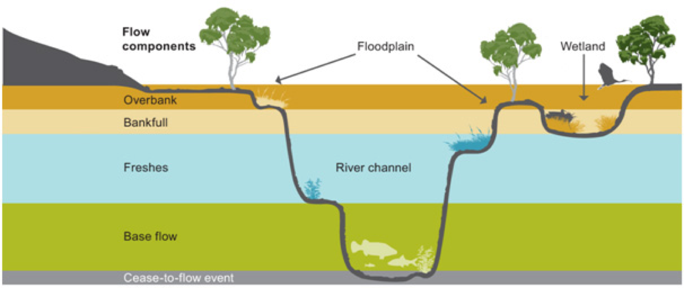

Figure 4. Five flow types and their influence on different parts of the river channel, wetlands and floodplains (MDBA 2011).

Figure 5. Average contribution of Commonwealth environmental water (by percentage) and other environmental water entitlements to low flow durations and occurrence of freshes across each valley (see Appendix B for explanation on scoring and further details).

#### Hydrological connectivity

Commonwealth environmental water delivered as in-channel flows contributed to longitudinal connectivity across 16 river valleys in the Basin (see Box 3 for case study example). In addition, Commonwealth environmental water contributed to floodplain and wetland connectivity through the delivery of water to terminal wetland systems and infrastructure-assisted wetland inundation.

#### Connecting rivers and floodplains: the Gwydir wetlands

Restoring hydrological connectivity and a flow regime that meets ecological requirements for the Gwydir Wetlands was one of the Annual Environmental Water Priorities for the Murray–Darling Basin in 2014–15 (MDBA 2014a). Commonwealth environmental water contributed to both longitudinal and floodplain connectivity in this system and in the Ramsar-listed Gingham and Lower Gwydir wetlands.

Environmental water substantially increased flows in the Gwydir River from mid-September to the end of March, with Commonwealth environmental water contributing 25% of the total flow volume (as pictured in the hydrograph below, with brown = Commonwealth environmental water and green = other environmental water).

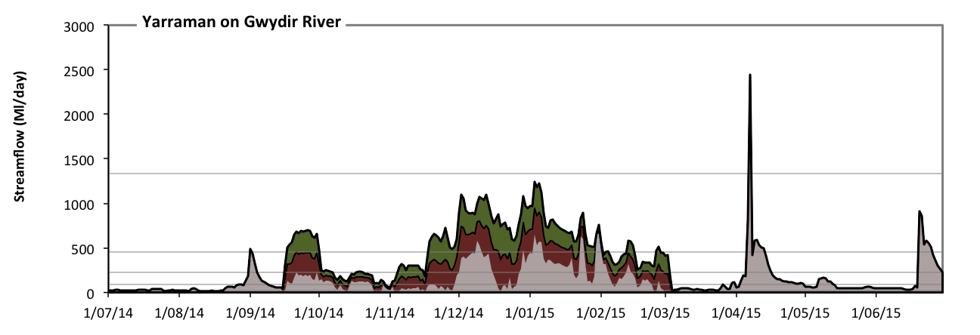

Environmental water also inundated approximately 6700 hectares of wetlands across the Gingham and Lower Gwydir wetlands (Ramsar-listed site), with peak inundation in late summer (see image below). Habitats inundated included large areas of sedge/forb/grassland (4556 hectares) as well as woodland floodplain (over 2000 hectares).

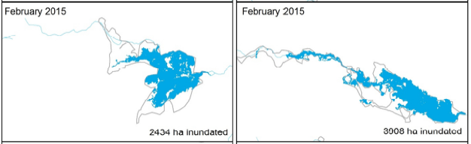

**Maximum extent of inundation in the Lower Gwydir (left) and Gingham (right) wetlands (CEWO 2015).**

This large-scale water event that persisted over many months would have benefited a large number of aquatic ecosystem–dependent species and communities.

Box 3. Case study of restoring hydrological connectivity in the Gwydir wetlands.

Commonwealth environmental water also contributed to connectivity through its effect on the Murray Mouth opening. Connectivity between the Southern Ocean and the Murray River is important for a number of reasons, including for fish species that migrate between inland and ocean environments as well as for maintaining water quality in the Coorong and Lower Lakes, by allowing nutrients and salts to flush out to sea. During periods of low flow, sands are deposited and there is increased risk of the mouth of the Murray closing (Colby et al.2010). To this end, there is a target in the Environmental Watering Strategy (MDBA 2014b) for the Murray Mouth to remain open 90% of the time to an average depth of 1 metre.

Modelling has shown that Commonwealth environmental water, together with other management options such as dredging, has contributed to maintaining a depth of greater than 1 metre compared with conditions that would have occurred in the absence of the buyback of water (Figure 6). However, discharges through the barrages to the Southern Ocean were relatively low in 2014–15, perhaps reflecting the dry conditions, and an increase in flow will be required in future years to meet longer term targets.

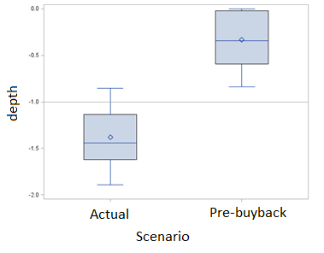

Figure 6. Box and whisker plot showing the modelled streambed height for the 2014–15 watering year. The reference line of 1 metre indicates the target Murray Mouth depth. The diamond and line within the box are the mean and median, respectively.

#### Stream metabolism

Stream metabolism comprises two ecological processes: primary production (use of light and carbon dioxide to produce organic material through photosynthesis) and decomposition (recycling of organic matter). Stream metabolism is measured through changes in dissolved oxygen, as the process of primary production produces oxygen and decomposition uses it. Healthy aquatic ecosystems require both processes, with primary production providing the basis of food for organisms higher up the food chain, and decomposition providing essential nutrients to maintain plant growth.

There are three ways that water regimes can influence rates of primary production and decomposition in aquatic systems, through the movement of organic material:

1. Entrainment, in which flow introduces nutrients and organic carbon from external sources to the river or stream, increasing stream metabolism — nutrients and carbon in backwaters, in-channel benches, wetlands and floodplains move into stream channels with inundation.
2. Mixing or resuspending material within the river or stream — organic material may be stored in parts of the stream where they are not readily available (e.g. in the sediment, in a backwater or low flow area, in the bottom water of stratified pools). Increasing flows may mobilise these organic material stores and increase rates of stream metabolism.
3. Disturbance or scour of biofilms — biofilms comprise algae, fungi and bacteria on sediments and plants in the river and can contribute significantly to stream metabolism. Very high flows can scour these biofilms, reducing stream metabolism rates temporarily until the biofilms re-establish (Ryder et al. 2006).

Monitoring at Selected Areas in 2014–15 provided the data to inform the evaluation of the effects of Commonwealth environmental water on stream metabolism. Data presented seasonally illustrate the effects of day length and temperature, in the five Selected Areas for which there were sufficient data, with increased metabolic rates in summer compared to spring (Figure 7).

|  |  |
| --- | --- |
|  |  |

Figure 7. Box plots representing seasonal gross primary productivity (left) and ecosystem respiration (right) in the five Selected Areas for which data were available in 2014–15 (Edward–Wakool, Goulburn, Murrumbidgee, Lachlan and Lower Murray).

Against this backdrop of seasonal variation in stream metabolism, monitoring did not detect any significant change in primary productivity and decomposition as a result of Commonwealth environmental watering actions for which data were available. The reasons for this are complex, as described above; stream metabolism is driven not only by temperature and light but also by available resources (nutrients and carbon). Environmental water delivered in the 2014–15 water year was largely in-channel and consisted of base flows and freshes (Table 2).

With water remaining in-stream, nutrients and organic carbon in backwaters, flood runners and the floodplains are not being delivered into the stream channel and rates of stream metabolism remain low. It is likely that this pattern would have been repeated at sites that received Commonwealth environmental water in 2014–15, but were not monitored. There were several watering actions in which environmental flows inundated wetlands (Murrumbidgee) or floodplains (Gwydir, Condamine–Balonne and Barwon–Darling), but these were not monitored.

It appears likely from our conceptual understanding that these watering actions and associated return flows would have increased in-channel metabolism. Data collected from northern Basin sites in future years will improve evaluation of these types of Commonwealth environmental watering actions on stream metabolism.

## Resilience

**Basin-scale resilience outcomes**

* Contributions to resilience were made through both ecosystem diversity and hydrological connectivity.
* Commonwealth environmental water contributed to resilience through maintaining refuges in a dry landscape in wetlands and, to a lesser extent, by maintaining in-channel waterholes.
* Inundation has contributed to improving the condition of vegetation, fish, waterbirds and other biota, making them more resilient to adverse events in the future. The role of Commonwealth environmental water in promoting resilience through improved condition will be explored over the following years.

Resilience can be defined as a system’s capacity to respond to disturbance (resist, recover and adapt) so as to still retain essentially the same function, structure and therefore identity (Colloff & Baldwin 2010; Gawne et al. 2013). In Australian aquatic ecosystems that are adapted to periods of both wet and dry conditions, resilience can be related to the ability to recover function, species and communities in the wet phase, following a dry period (Brock et al. 2003). The science of understanding resilience is in its infancy and indicators of resilience are still being explored. At the Basin scale, resilience can be considered as a factor of (McCluney et al. 2014):

* Diversity of habitats and ecosystems — the different habitats and ecosystems support species and biota under different conditions and a mosaic of habitats increases resilience at a landscape scale. For example, temporary wetland and floodplain systems may provide greater food resources during wet periods, but under dry conditions biota may need to move to permanent water, which acts as refuges.
* Connectivity of those habitats and ecosystems — so that species and propagules (seeds, plants material, invertebrate eggs) can move between systems to both temporally escape adverse conditions and to aid in recovery following disturbance.
* Condition of biota — plants and animals that are healthy are better able to withstand adverse environmental conditions.

Considering these factors, environmental water can influence resilience of aquatic ecosystems and the species that depend on them in a number of ways including:

* maintaining the diversity of ecosystems across the Basin
* ensuring that refuges are of sufficient quality and quantity to support biota during adverse conditions
* maintaining connectivity along rivers and between rivers and wetland habitats
* improving or maintaining the condition of individuals, populations and communities of plants and animals.

Contributions of Commonwealth environmental water to maintaining ecosystem diversity and hydrological connectivity have been considered under sections 3.1.2 and 3.2.2, respectively. Contributions of Commonwealth environmental water to protecting refuge habitat and maintaining condition of biota in 2014–15 are summarised below.

### Protecting refuge habitat

In-channel waterholes are recognised as important refuge habitat, particularly for native fish, and their persistence is strongly linked to their depth (MDBA 2014b). As a consequence, environmental flows that replenish waterholes by increasing their depth and improving water quality would be expected to contribute to the system’s resilience. In the dry conditions that prevailed over much of the Basin in 2014–15, maintaining refuges was considered a priority for environmental water (Table 1) and was the target of a number of watering actions, particularly in the northern Basin, including the Severn River, Lower Moonie River, Lower Balonne Floodplain, Upper Warrego River and Barwon–Darling River. The effectiveness of environmental water in achieving objectives related to providing waterhole refuge habitat was varied (see Box 4).

Wetlands and floodplains may also represent important refuges for some biota, with permanent wetlands acting as refuges when temporary wetland systems are dry. The ecosystem diversity analysis revealed that Commonwealth environmental water contributed to the inundation of 11% of permanent floodplain wetlands (41,000 hectares), 6% of permanent floodplain tall emergent marshes (7000 hectares) and 0.5% of permanent floodplain lakes (627 hectares). Given the dry conditions that persisted across most of the Basin in 2014–15, it is assumed that these permanent wetland areas provided refuge habitat for aquatic biota. Included within these figures were sites that were identified by the Environmental Watering Strategy (MDBA 2014b) as key refuge sites for waterbirds: specifically:

* Lowbidgee wetlands
* Mid-Murrumbidgee wetlands
* Macquarie Marshes
* Lower Murray and Coorong.

### Contributing to resilience through improved condition

Improving or maintaining condition, specifically pertaining to increased resilience, was the target of environmental water in a number of catchments, including Moonie, Macquarie and Gwydir Rivers and the South Australian River Murray (CEWO, unpublished water use acquittal reports). There were a large number of observations of improved condition of vegetation, fish, waterbirds and other biota at sites that received Commonwealth environmental water in 2014–15. Specific examples include (CEWO, unpublished water use acquittal reports):

* improved condition of aquatic vegetation communities in Moodies Swamp in the Goulburn–Broken system
* promotion of growth and condition of native wetland vegetation communities in the Gingham and Gwydir wetlands
* recruitment and survival of native fish in the Carole and Mehi rivers
* feeding and foraging of waterbirds in the Murrumbidgee and Gwydir systems
* improved condition of river red gum and black box communities at Hattah Lakes.

The Fish Basin Matter evaluation indicated that fish populations in the Basin were in good condition, with native species comprising over 70% of the abundance in four of the six Selected Areas that were monitored for fish (see Appendix F). The Vegetation Diversity Basin Matter evaluation suggested that inundation may have improved resilience of native vegetation communities and species by effects on condition, thus increasing their resilience in the coming seasons (see Appendix E). The role of Commonwealth environmental water on resilience through improved condition will become more apparent over the 5 years of the LTIM Project as we can follow a trajectory of change over time.

There are a number of ways in which environmental water could affect condition, and therefore resilience, over time. There may be iterative effects of inundation that result in changes in condition (Figure 8) or time-lagged effects where the current condition of an ecosystem, species or community is determined by the most recent water regime and incrementally less by previous water regimes (Figure 9). Over the next 4 years, models will be developed to aid in the evaluation of multi-year effects of Commonwealth environmental water at the Basin-scale.

#### Enhancing and protecting refuge habitat: native fish in the northern Basin

During dry conditions (as occurred in 2014–15), the low levels of flow in river channels result in aquatic habitat being reduced to disconnected waterholes scattered along channels (Arthington & Balcombe 2011). Under these conditions, larger and more permanent waterholes act as refuges for aquatic biota that cannot survive without water (e.g. fish, aquatic invertebrates). If the condition of those refuges can be maintained in terms of water quality and productivity, biota within these refuges have a greater chance of survival and the survivors can recolonise other areas when wetter conditions return (Arthington et al. 2010), contributing to resilience in these systems. Therefore, contributing to refuge persistence and quality was a target of Commonwealth environmental watering actions across a number of river systems in the northern Basin in 2014–15.

Observations from individual river systems indicated that there were examples of refilling, connectivity and prolonged persistence of waterholes along rivers such as the Moonie, Warrego and Severn rivers (CEWO, unpublished water use acquittal reports).

Commonwealth environmental water contributed to instream flows in 17 watering actions in the northern unregulated valleys during 2014–15. There were several access periods in the Border Rivers–Moonie valley (3229.5 megalitres), including 4 in the Moonie River (1415 megalitres), 2 in the Condamine–Balonne (17,392 megalitres), 4 in the Warrego (2541.7 megalitres) and 3 in the Barwon–Darling above Menindee (1760.6 megalitres). However, in all instances, the contribution of Commonwealth environmental water was very small compared with other water sources (such as natural flows) in northern unregulated systems. Until more information is available on the effects of these small volumes of water on refuge characteristics, it is difficult to evaluate these outcomes in the context of fulfilling the Environmental Watering Strategy management objectives for dry conditions or long-term resilience of the system.

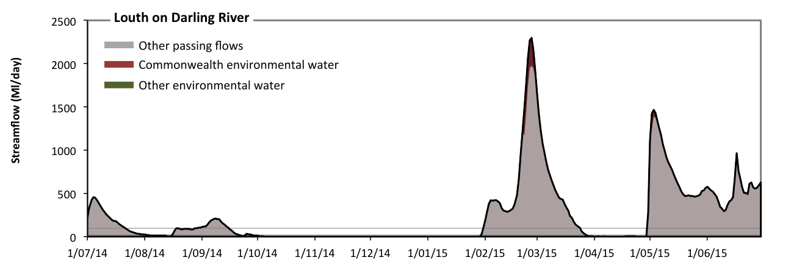

**Contributions of Commonwealth environmental water (red) in the Darling River at Louth in 2014-15.**

Box 4: Commonwealth environmental water contributions to refuge habitat in the northern Basin 2014–15.

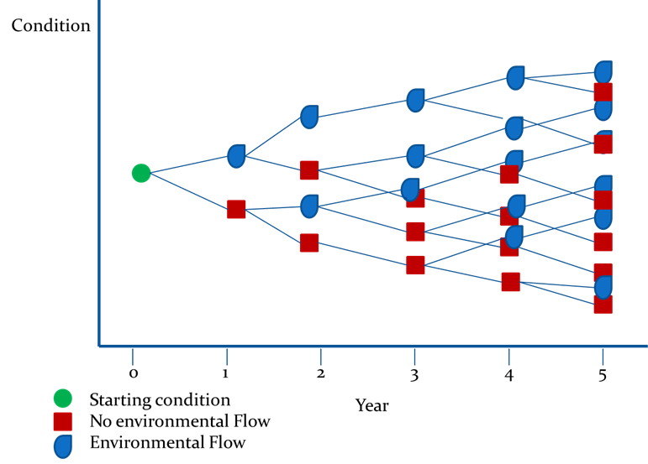

Figure 8. An illustration of the way a hypothetical model could be applied iteratively to generate a series of outcomes from different flow regimes over a 5-year period (Gawne *et al.* 2014).

**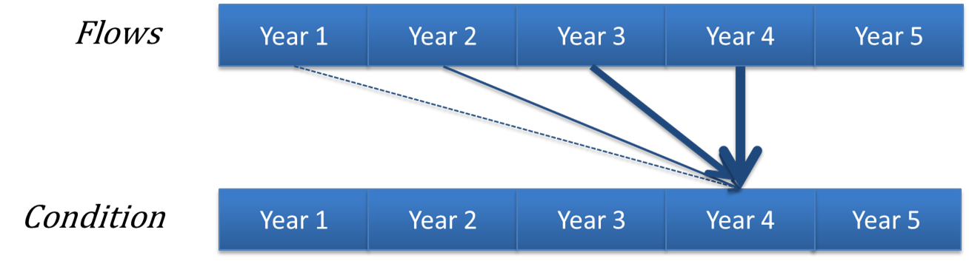**

Figure 9. An illustration of a hypothetical model of a long-term response to environmental watering where the greatest influence is from watering in the most recent year, with progressively weaker influence from watering in previous years (Gawne *et al.* 2014).

# Adaptive management

**Key adaptive management messages**

1. *What we have learned about the effects of environmental water?*

* Timing of water delivery affects outcomes for fish and vegetation and should continue to be a key consideration in planning environmental watering actions.
* Environmental water needs to inundate areas outside the main channel to affect metabolism.

1. *What we have learned about managing environmental water?*

* Past and current conditions at the site and catchment scale are important to the success of environmental watering actions.
* Objectives of environmental watering actions need to be specific, measurable, achievable, relevant and time bound (SMART).

1. *How can we improve the LTIM Project?*

* Long-term monitoring is essential.
* Methods must be reviewed and improved through the life of the project.
* Inundation mapping of environmental watering is crucial.

In this first year of the LTIM Project there are a small number of lessons learned related to three aspects of environmental watering:

1. improvements in our understanding of flow–ecology relationships that could inform future environmental water actions
2. lessons from evaluation related to management decisions for environmental water
3. identification of information needs that are required for monitoring and evaluation of the outcomes of environmental water.

## What we have learned about the effects of environmental water?

### Timing of water delivery affects outcomes for fish and vegetation

The evaluation of vegetation at the Basin scale considered that there was evidence across several Selected Areas that benefits to vegetation diversity may be enhanced by changes to the timing, depth and duration of inundation. In particular, slower recession of water levels would likely enhance germination and growth of inundation-dependent vegetation by prolonging the time that soil moisture conditions are optimal.

The evaluation of fish at the Basin scale reported that evidence from the Goulburn River indicated that flows delivered in November–December that coincided with warmer water had a greater impact on spawning in golden perch and silver perch than flows delivered during the cooler period of October–November. This finding is consistent with previous studies on spawning and movement of these two species (O’Connor et al*.* 2005; Roberts et al. 2008; King et al. 2009, 2010; Zampatti & Leigh 2013), strengthening the argument for consideration of temperature and timing on environmental water targeting these species.

### Small in-channel water regimes do not promote productivity

The evaluation of stream metabolism at the Basin scale concluded that rates of primary production and ecosystem respiration are unlikely to respond to base flows or freshes. Under these lower flow conditions, potential sources of nutrients and organic carbon in backwaters, flood runners, in-channel benches, wetlands and floodplains are not delivered to the river channel and ecosystem functions of production and decomposition are not stimulated. It may be expected that the lack of any significant increases in primary productivity might result in impacts on biota further up the food chain (e.g. invertebrates, fish, waterbirds).

It must be recognised that there are constraints to environmental water delivery related to volumes available, overbank flows and third-party impacts and that widescale inundation of floodplains with environmental water is unlikely to be possible in some catchments. Despite this, if metabolism is a priority outcome or believed to be an important causal pathway by which flow influences the desired outcome (e.g. fish condition) then connecting backwaters, flood runners, in-channel benches and areas of wetland and floodplain is critical. If these connections are not feasible, environmental flows may need to focus on the provision of habitat or longitudinal connections rather than improvements to stream metabolism (primary productivity and decomposition).

## What we have learned about managing environmental water?

### Past and current conditions are important determinants of the effects of environmental water

Evaluations of several Basin Matters have indicated that the outcomes of environmental watering actions are highly dependent not only on the characteristics of a particular action, but also on the condition of the ecosystem prior to water delivery and the history of water regimes at the site (see Figure 9). For example, the evaluation of vegetation diversity at the Basin-scale indicated that vegetation diversity responses to Commonwealth environmental water are highly dependent on local and Selected Area–scale factors, such as the existing vegetation community and landscape configuration, as well as hydrological characteristics of water delivery (e.g. timing, duration) and the history of inundation at the site.

This suggests that setting realistic objectives (expected outcomes) of watering actions and planning the type of water regime that would maximise ecological benefits will require careful consideration of the current and historical conditions at the site. These need to be documented or articulated in a way that enables others to understand the reasons why the objectives may or may not have been achieved so continued improvements in environmental water management can be made.

### Objectives of water actions need to be SMART

When planning Basin-scale evaluation, a sequence of events was proposed (Gawne et al. 2014):

1. Identify the expected outcome(s) of the watering action.
2. Determine the actual outcome of the watering action.
3. Predict the condition of the system in the absence of the watering action.
4. Compare and contrast the expected, observed and no flow predicted outcomes to inform an evaluation of the overall outcome of the watering action.
5. Integrate the outcomes to develop expected, observed and predicted without Commonwealth environmental water outcomes at the Basin scale.

This process starts with, and is highly dependent upon, clearly articulated objectives (expected outcomes) of watering actions that are measurable and can be evaluated quantitatively. In 2014–15, however, many of the expected outcomes did not include this level of detail, as shown these examples related to resilience (CEWO, unpublished water use acquittal reports):

* ‘Improve ecosystem and population resilience through supporting ecological recovery and maintaining aquatic habitat’ — Lower Murray
* ‘Resilience. Ecosystem Resilience’ — Mulcra Island
* ‘Provide refuge habitat for waterbirds, fish and other aquatic species’ — Gwydir.

These do not provide the level of detail that is required to inform evaluation or make ecological predictions of outcomes in the absence of environmental water. Evaluation at the site, Selected Area and Basin scales would all be improved if expected outcomes were articulated following the SMART principles:

* **S**pecific — clear and unambiguous
* **M**easurable — quantified, contain a measurable element that can be readily monitored to determine success or failure
* **A**chievable — realistic and attainable
* **R**elevant — considerate of temporal scale of response, resources available
* **T**ime bound — specify a time scale in which the outcome is met/assessed.

### Objectives of watering actions need to be placed in context

Environmental watering decisions are made within a specific management context; that is, decisions about an individual watering action are made within the context of the Basin Plan (including its objectives, targets and priorities) and the long-term objectives for the asset. The evaluation process and subsequent adaptive management would be facilitated if this contextual information was documented. This issue will become increasingly important as the LTIM Project matures and the focus progressively shifts to long-term changes in condition resulting from cumulative responses to sequences of environmental flows. Without context, decisions and the evaluation process will remain focused on individual watering actions and their short-term outcomes.

## How can we improve the LTIM Project?

### Long-term monitoring is essential

All Basin Matter evaluations have recognised that this is the first year of a 5-year project and that the outcomes, particularly at the Basin scale, will require multiple years of data to determine the effects of Commonwealth environmental water with any degree of certainty. Monitoring methods for several Basin Matters (especially fish) are designed specifically for longer term data and preliminary analysis has indicated that they are fit for this purpose. So while outcomes in the first year are limited and come with a high degree of uncertainty, there is confidence that the processes are in place for improved evaluation over the life of the LTIM Project.

### Improving monitoring methods

Every year, the LTIM Project holds an annual forum to connect all aspects of the project and to discuss potential improvements that could be made. At the 2016 forum, the fish experts discussed outcomes of monitoring from the Goulburn River and used this to redesign and implement improved larval monitoring methods. We anticipate improved capacity to link fish spawning to flows from 2016 onwards.

In addition, the LTIM Project is contributing to improved mapping and classification of wetlands in the Basin through the validation of ecosystem types within each Selected Area. This information can be used to update the current Basin wetland map to better plan environmental watering and evaluate the types and areas of wetlands inundated by Commonwealth environmental water each year.

### Inundation mapping with and without Commonwealth environmental water is crucial

Our ability to evaluate the contribution of Commonwealth environmental water to achieving objectives of the Basin Plan is currently limited by high uncertainty in the fate of water in the landscape after it is released. The volumes in storage and the rates and timing of delivery are well known, but the physical extent of water covering the land and the duration it persists in wetlands and on floodplains is much more poorly understood. In addition, much of the inundation information used in this first year was provided by individuals who were willing to share data. This is a significant risk for the program if the activities generating these data are discontinued.

Initial planning for Basin evaluation was contingent on good inundation data both with and without Commonwealth environmental water. The Basin Evaluation Plan considered that for much analysis there would be an assessment of the types and extent of wetlands inundated by Commonwealth environmental water and the use of conceptual modelling to infer ecological responses based on the timing, duration and wetland type inundated (Gawne et al. 2014).

In the absence of this information, Basin-scale evaluations for several Basin Matters (Ecosystem Diversity, Vegetation Diversity, Generic Diversity) in this first year of the LTIM Project are limited. It is expected that ongoing development of the hydrological and ecological information base by Basin jurisdictions will increase the accuracy of Basin-scale evaluations in subsequent years of the LTIM Project.

# Contribution to Basin Plan objectives

The relevant objectives of the Basin Plan were used as the basis for developing a framework that could be used to assess the contribution of Commonwealth environmental water to achieving those objectives (CEWH 2013b). The Outcomes Framework is a nested hierarchy that links the overarching Basin Plan objectives of biodiversity, ecosystem function, resilience and water quality to indicators and outcomes that could be expected from environmental water at two time steps:

* within a 1-year time frame (1-year expected outcomes)
* within a 1–5-year time frame (5-year expected outcomes).

The Outcomes Framework is the distillation of the combined ecological knowledge of flow–ecology relationships and was underpinned by the development of conceptual models (cause–effect diagrams) and literature reviews (CEWH 2013b; Gawne et al. 2013).

Despite the limitation of the data available in this first year, the Outcomes Framework provides a template for synthesising the effects of environmental water and progress towards meeting Basin Plan objectives. There is evidence across the Basin that Commonwealth environmental water is contributing to each of the broad Basin Plan objectives in a number of ways (Table 6).

It should be noted that while this framework is presented hierarchically, there is a degree of overlap and synergy between outcomes. For example, resilience outcomes both influence other areas of the framework through ensuring survival of biota via the provision of refuges, for example; and are in turn influenced by other factors such as ecosystem diversity and connectivity between those ecosystems. This summary should be considered a snapshot of the contributions of Commonwealth environmental water to Basin Plan objectives, but be read in the context of the evaluations described in summary in the previous sections and in detail in Appendices B to G.

Table 6. Contribution of CEWO watering in 2014–15 to Basin Plan objectives.

| **Basin Plan objectives** | **Basin outcomes** | | **5-year expected outcomes** | **1-year expected outcomes** | **Measured and predicted 1-year outcomes 2014–15** |
| --- | --- | --- | --- | --- | --- |
| Biodiversity (Basin Plan S. 8.05) | Ecosystem diversity | | None identified | None identified | Total of 79,000 hectares of mapped wetland inundated; 48% of the different wetland types and 79% of the different floodplain types |
| Species diversity | Vegetation | Vegetation diversity |  | Mostly, but not consistently increased diversity and cover of vegetation communities |
| Reproduction |
| Condition |
| Growth and survival | Germination and dispersal |  |
| Macro-invertebrates | Macroinvertebrate diversity |  |  |
| Fish | Fish diversity | Condition | Comparatively high level of nativeness in fish assemblages |
| Larval abundance Reproduction | Spawning by golden perch, bony bream |
| Larval and juvenile recruitment |  | Evidence of Murray hardyhead recruitment |
| Waterbirds | Waterbird diversity |  | Foraging habitat provided at a number of locations, most notably the Gwydir and Hattah–Kulkyne Lakes |
| Waterbird diversity and population condition (abundance and population structure) | Survival and condition |  |
| Chicks | Some evidence of breeding of waterbird species |
| Fledglings |  |
| Other vertebrate diversity |  | Young | Evidence of breeding of frogs |
| Adult abundance |  |  |
| Ecosystem Function (Basin Plan S. 8.06) | Connectivity |  |  | Hydrological connectivity including end of system flows | Evidence of lateral, longitudinal connectivity in a number of river systems  Some contribution to maintaining an open Murray Mouth |
|  | Biotic dispersal and movement |  |
|  | Sediment transport |  |
| Process |  |  | Primary productivity (of aquatic ecosystems) | Little evidence in year 1, under dry conditions, of effects on these processes |
|  | Decomposition |
|  | Nutrient and carbon cycling |
| Resilience (Basin Plan S. 8.07) | Ecosystem resilience |  | Population condition (individual refuges) | Individual survival and condition (individual refuges) | Evidence from permanent wetlands 11 % inundated. Very minor contributions to in-channel waterholes |
| Population condition (landscape refuges) |  |
|  | Individual condition (ecosystem resistance) | Some evidence of improved condition of vegetation communities and fish populations with a high degree of nativeness. |
| Population condition (ecosystem recovery) |  |  |
| Water quality (Basin Plan S. 9.04) | Chemical |  |  | Salinity |  |
| Dissolved oxygen | Evidence from a single location in the Edward–Wakool of maintaining dissolved oxygen concentrations |
| pH |  |
| Dissolved organic carbon |  |
| Biological |  |  | Algal blooms |  |

References

Arthington AH, Balcombe SR (2011) Extreme flow variability and the ‘boom and bust’ ecology of fish in arid-zone floodplain rivers: a case history with implications for environmental flows, conservation and management. Ecohydrology **4(5)**, 708–720.

Arthington AH, Olden JD, Balcombe SR, Thoms MC (2010) Multi-scale environmental factors explain fish losses and refuge quality in drying waterholes of Cooper Creek, an Australian arid-zone river. Marine and Freshwater Research **61(8)**, 842–856.

Brock MA, Nielsen DL, Shiel RJ, Green JD, Langley JD (2003) Drought and aquatic community resilience: the role of eggs and seeds in sediments of temporary wetlands. Freshwater Biology **48(7)**, 1207–1218.

Butcher R, Hale J (2011) Ecological Character Description for the Hattah–Kulkyne Lakes Ramsar site Department of Sustainability, Environment, Water, Population and Communities, Canberra.

CEWO (Commonwealth Environmental Water Office) (2013a) *Commonwealth environmental   
water — Monitoring, Evaluation, Reporting and Improvement (MERI) Framework*, June 2013, V1.0. Commonwealth Environmental Water Holder, Canberra.

CEWO (Commonwealth Environmental Water Office) (2013b) *Commonwealth environmental   
water — the Environmental Water Outcomes Framework*, December 2013 V2.0. Commonwealth Environmental Water Holder, Canberra.

CEWO (Commonwealth Environmental Water Office) (2015) Long Term Intervention Monitoring Project Gwydir River System Selected Area — 2014–15 Evaluation Report, Commonwealth of Australia, Canberra.

Colby LH, Maycock SD, Nelligan FA, Pocock HJ, Walker DJ (2010) An investigation into the effect of dredging on tidal asymmetry at the River Murray Mouth. *Journal of Coastal Research* **26(5)**, 843–850.

Colloff MJ, Baldwin DS (2010) Resilience of floodplain ecosystems in a semi-arid environment. The Rangeland Journal **32(3)**, 305–314.

Ellis I, Kavanagh M (2014) A review of the biology and status of the endangered Murray hardyhead: streamlining recovery processes. MDFRC Publication 42/2014. Murray–Darling Freshwater Research Centre, Wodonga.

Gawne B, Brooks S, Butcher R, Cottingham P, Everingham P, Hale J, Nielsen DL, Stewardson M, Stoffels R (2013) Long Term Intervention Monitoring Logic and Rationale Document. Final report prepared for the Commonwealth Environmental Water Office by The Murray–Darling Freshwater Research Centre. MDFRC Publication 01/2013. MDFRC, Wodonga.

Gawne B, Roots J, Hale J, Stewardson M (2014) Commonwealth Environmental Water Office Long–Term Intervention Monitoring Project: Basin Evaluation Plan. Report prepared for the Commonwealth Environmental Water Office by The Murray–Darling Freshwater Research Centre. MDFRC Publication 42/2014. MDFRC, Wodonga.

Jax K (2005) Function and ‘functioning’ in ecology: what does it mean? Oikos **111(3)**, 641–648.

King AJ, Tonkin Z, Mahoney J (2009) Environmental flow enhances native fish spawning and recruitment in the Murray River, Australia. *River Research and Applications* **25(10)**, 1205–1218.

King AJ, Ward KA, O’Connor P, Green D, Tonkin Z, Mahoney J (2010) Adaptive management of an environmental watering event to enhance native fish spawning and recruitment. *Freshwater Biology* **55(1)**, 17–31.

Loyn R, Dutson G (2016) Birds in black box woodlands in Hattah–Kulkyne NP 2015, one year after environmental watering in 2014, with comparative data from Nangiloc and Kings Billabong Eco Insights, Viewbank, Victoria.

McCluney KE, Poff NL, Palmer AP, Thorp JH, Poole GC, Williams BS, Williams MR, Baron JS (2014) Riverine macrosystems ecology: sensitivity, resistance, and resilience of whole river basins with human alterations. *Frontiers of Ecology and the Environment* **12(1)**, 48–58.

Mallee CMA (Catchment Management Authority) (2014) Waterbird response to environmental water at Hattah Lakes Mallee CMA, Irymple, Victoria.

MDBA (Murray–Darling Basin Authority) (2011) The proposed ‘environmentally sustainable level of take’ for surface water of the Murray–Darling Basin: methods and outcomes. MDBA Publication No. 226/11. MDBA, Canberra.

MDBA (Murray–Darling Basin Authority) (2014a) 2014–15 Basin Annual Environmental Watering Priorities MDBA, Canberra.

MDBA (Murray–Darling Basin Authority) (2014b) *Environmental* Watering Strategy MDBA, Canberra.

MDBA (Murray–Darling Basin Authority) (2015) Towards a healthy, working Murray–Darling Basin: Basin Plan annual report 2014–15 MDBA, Canberra.

O’Connor JP, O’Mahony DJ, O’Mahony JM (2005) Movements of *Macquaria ambigua* in the Murray River, south-eastern Australia. *Journal of Fish Biology* **66(2)**, 392–403.

Olden JD, Kennard MJ (2010) Intercontinental comparison of fish life history strategies along a gradient of hydrologic variability. American Fisheries Society Symposium **73**, 83–107.

Roberts DT, Duivenvoorden LJ, Stuart IG (2008) Factors influencing recruitment patterns of golden perch (*Macquaria ambigua oriens*) within a hydrologically variable and regulated Australian tropical river system. *Ecology of Freshwater Fish* **17(4)**, 577–589.

Ryder DS, Watts RJ, Nye E, Burns A (2006) Can flow velocity regulate epixylic biofilm structure in a regulated floodplain river? *Marine and Freshwater Research* **57(1)**, 29–36.

Winemiller KO, Rose KA (1992) Patterns of life-history diversification in North American fishes: implications for population regulation. Canadian Journal of Fisheries and Aquatic Sciences **49(10)**, 2196–2218

Zampatti BP, Leigh SJ (2013) Within-channel flows promote spawning and recruitment of golden perch, *Macquaria ambigua ambigua* — implications for environmental flow management in the River Murray, Australia. *Marine and Freshwater Research* **64(7)**, 618–630.

Appendix A. 2014–15 Commonwealth environmental watering actions

Table A1. Watering actions that included Commonwealth environmental water in 2014–15. Note that many of these actions were implemented in conjunction with other environmental water (The Living Murray, state environmental water) but only the Commonwealth environmental water component is shown here. Expected outcomes have been translated into the categories of the Outcomes Framework for simplicity (Con. = connectivity; Proc. = processes (primary production/decomposition); Res. = resilience; WQ = water quality).

| **Surface water region/asset** | **Watering Action Reference (WAR)** | **Commonwealth environmental water volume (gigalitres)** | **Dates** | **Flow component** | **Expected Outcomes (P = primary; S = secondary;**  **X = unassigned)** | | | | | | | | |
| --- | --- | --- | --- | --- | --- | --- | --- | --- | --- | --- | --- | --- | --- |
| **Fish** | **Veg** | **Birds** | **Frogs** | **Other**  **biota** | **Con.** | **Proc.** | **Res.** | **WQ** |
| Campaspe – Reaches 2 and 4 | 10003-01 | 5.7914 | 09/10/14 – 22/10/14 | Fresh | X | X |  |  | X |  | X |  | X |
| Goulburn – Reaches 4 and 5 | 10002-01 | 12.986 | 25/08/14 – 25/09/14 | Base | P |  |  |  | P | P | S |  | P |
| Goulburn – Reaches 4 and 5 | 10002-01 | 1.315 | 10/11/14 – 17/11/14 | Base | P |  |  |  | P | P | S |  | P |
| Goulburn – Reaches 4 and 5 | 10002-01 | 67.46 | 14/10/14 – 11/11/14 | Fresh | S | P |  |  |  |  | S |  |  |
| Goulburn – Reaches 4 and 5 | 10002-01 | 14.472 | 20/11/14 – 30/11/14 | Fresh | P | S |  |  |  |  | S |  |  |
| Goulburn – Reaches 4 and 5 | 10002-01 | 18.291 | 01/12/14 – 28/02/15 | Base | P |  |  |  | P | P | S |  | P |
| Goulburn – Reaches 4 and 5 | 10002-01 | 21.103 | 01/03/15 – 15/03/15 13/04/15 – 12/06/15 | Base | P |  |  |  | P | P | S |  | P |
| Goulburn – Reaches 4 and 5 | 10002-01 | 13.321 | 16/03/15 – 12/04/15 | Fresh |  | P |  |  |  |  | S |  |  |
| Goulburn – Reaches 4 and 5 | 10002-01 | 65.444 | 13/06/15 – 30/06/15 | Fresh |  | P |  |  |  |  | S |  |  |
| Goulburn – Lower Broken Creek | 10020-01 | 13.592 | 03/10/14 – 30/12/14 | Base | P | S |  |  |  |  |  |  | P |
| Goulburn – Lower Broken Creek | 10020-01 | 13.13 | 01/01/15 – 20/04/15 | Base | S | P |  |  |  | P |  |  | P |
| Goulburn – Lower Broken Creek | 10020-01 | 2.644 | 21/04/15 – 15/05/15 | Base | P | S |  |  |  |  |  |  | P |
| Goulburn – Moodies Swamp | 10014-01 | 0.25 | 06/10/14 – 02/12/14 | Wetland |  | P | P |  |  |  |  | S | S |
| Gwydir – Gwydir wetlands | 00016-01 | 30 | 17/09/14 – 07/03/15 | Wetland | X | X | X |  | X | X | X | X | X |
| Gwydir – Mallowa wetlands | 00016-02 | 9.667 | 17/09/14 – 07/03/15 | Wetland | X | X | X |  | X | X |  |  |  |
| Gwydir – Carole Creek | 00016-03 | 3.656 | 03/10/14 – 29/10/15 | Fresh |  |  |  |  |  |  | X |  | X |
| Gwydir – Mehi River | 00016-04 | 13.316 | 02/10/14 – 27/10/14 | Fresh |  |  |  |  |  |  | X |  | X |
| Lachlan – Lower Lachlan | 10013-01 | 5 | 03/10/14 – 29/10/14 | Fresh | X | X |  |  |  | X |  |  |  |
| Loddon – Reaches 3 and 4 and fringing wetlands | 10001-01 | 2.8695 | 21/09/14 – 07/10/15 | Fresh | X | X |  |  | X | X |  |  | X |
| Macquarie–Castlereagh – Macquarie Marshes | 10015-01 | 10 | 13/10/14 – 12/12/14 | Base Fresh Wetland | P | P | S |  | S | S | S | S |  |
| Murrumbidgee – Mid North Redbank | 10023-01 | 40 | 12/08/14 – 20/01/15 | Wetland | P | P | P | P | P | P | P |  |  |
| Murrumbidgee – Yanga National Park | 10023-02 | 74.512 | 23/10/14 – 10/04/15 | Wetland | P | P | P | P | P | S | S |  |  |
| Murrumbidgee – Upper North Redbank | 10023-03 | 20 | 01/10/14 – 25/03/15 | Wetland | P | P | P | P | P |  | S |  |  |
| Murrumbidgee – Yarradda Lagoon | 10023-04 | 1.15 | 04/12/14 – 22/01/15 | Wetland |  | P | S | S |  |  |  |  |  |
| Murrumbidgee – Sandy Creek | 10023-05 | 0.25 | 22/03/15 – 01/04/15 | Wetland |  | P | S | S |  |  |  |  |  |
| Murrumbidgee – Juanbung | 10023-06 | 5.688 | 04/05/15 – 29/06/15 | Wetland |  | P | S | S |  |  |  |  |  |
| Murrumbidgee – Paika Lake | 10023-06 | 8.498 | 25/05/15 – 27/06/15 | Wetland | S | S | P | S |  |  |  |  |  |
| Murrumbidgee – Yanco Creek | 10005-02 | 2.46 | 23/06/15 – 30/06/15 | Wetland | P | P | P | P | P | S |  |  |  |
| NSW Murray – Edward–Wakool: Yallakool Creek and Wakool River | 10008-01 | 34.563 | 12/08/14 – 09/01/15 | Base | P | S |  |  |  | S |  |  |  |
| NSW Murray – Edward–Wakool: Tuppal Creek | 10008-03 | 2 | 15/09/14 – 23/11/14 | Base / Fresh | P |  |  |  |  | P |  | P | P |
| NSW Murray – Edward–Wakool: Tuppal Creek | 10008-05 | 0.05 | 15/09/14 – 23/11/14 | Base / Fresh | P |  |  |  |  | P |  | P | P |
| NSW Murray – Edward–Wakool: Colligen–Niemur System | 10008-04 | 2.949 | 12/01/15 – 28/01/15 | Base | P |  |  |  |  |  |  |  |  |
| NSW / Vic Murray – River Murray Hume Dam to Coroong | 10031-01 | 23.5 | 22/06/15 – 30/06/15 | Fresh | P | P | S |  |  | S |  |  | P |
| Vic Murray – Mulcra Island | 10009-02 | 3.7609 | 12/08/14 – 22/12/14 | Wetland | S | P | S |  |  | P |  |  |  |
| Vic Murray – Hattah Lakes | NA | 34.2389 | 26/05/14 – 17/01/15 | Wetland | X | X | X |  |  | X | X |  |  |
| Ovens – Ovens River | 10004-01 | 0.05  0.02 | 04/04/15 – 05/04/15  30/04/15 – 30/04/15 | Base | X |  |  |  | X | X | X |  |  |
| SA Murray – Murray River from Wentworth to Lower Lakes | 10009-01 | 191.833 | 04/09/14 – 31/12/14 | Base | X | X |  |  |  | X |  | X | X |
| SA Murray – Murray River from Wentworth to Lower Lakes | 10026-01 | 389.205 | 01/01/15 – 30/06/15 | Base | X |  |  |  |  | X |  |  | X |
| SA Murray – Berri Creek | 10009-03 | 1.241 | 01/09/14 – 30/06/15 | Wetland | P |  | S |  |  |  |  |  |  |
| SA Murray – Overland Corner | 10009-05 | 0.842 | 17/12/14 – 15/05/15 | Wetland |  | P |  | P |  |  |  |  |  |
| SA Murray – Piggy Creek | 10009-05 | 0.201 | 11/11/14 – 21/11/14 | Wetland |  | P | P |  |  |  |  |  |  |
| SA Murray – Wella | 10009-05 | 0.255 | 12/11/14 – 21/02/15 | Wetland |  | P |  | P |  |  |  |  |  |
| SA Murray – Whirlpool | 10009-05 | 0.09 | 02/12/14 – 24/03/15 | Wetland |  | P |  | P |  |  |  |  |  |
| SA Murray – Markaranka South | 10009-06 | 1.652 | 01/12/14 – 07/06/15 | Wetland |  | P | P |  |  |  |  |  |  |
| SA Murray – Markaranka East | 10009-06 | 0.6 | 06/01/15 – 24/02/15 | Wetland |  | P |  | P |  |  |  |  |  |
| SA Murray – Nikalapko | 10009-06 | 0.8 | 10/11/14 – 28/11/14 | Wetland |  | P | P | P |  |  |  |  |  |
| SA Murray – Molo Flats | 10009-06 | 0.703 | 03/12/14 – 02/04/15 | Wetland |  | P |  | P |  |  |  |  |  |
| SA Murray – Wigley | 10009-06 | 0.31 | 13/11/14 – 23/01/15 | Wetland |  | P |  | P |  |  |  |  |  |
| SA Murray – Akuna | 10009-06 | 0.125 | 26/11/14 – 04/12/15 | Wetland |  | P |  | P |  |  |  |  |  |
| SA Murray – Johnson’s Waterhole | 00137-01 | 0.162 | 02/09/14 – 15/06/15 | Wetland |  | P | P |  | S |  |  |  |  |
| SA Murray – Clark’s Floodplain | 00148-04 | 0.201 | 27/10/14 – 15/06/15 | Wetland |  | P | P |  |  |  |  |  |  |
| SA Murray – Loxton Riverfront Reserve | 00148-05 | 0.039 | 25/09/14 – 15/06/15 | Wetland |  | P | P |  |  |  |  |  |  |
| SA Murray – Thiele’s Flat | 00148-06 | 0.033 | 02/09/14 – 30/04/15 | Wetland |  | P | P |  |  |  |  |  |  |
| SA Murray – Ramco River Terrace | 00150-03 | 0.008 | 06/11/14 – 30/04/15 | Wetland |  | P | P |  |  |  |  |  |  |
| SA Murray – Rilli Reach | 00150-04 | 0.025 | 19/11/14 – 30/04/15 | Wetland |  | P | P |  |  |  |  |  |  |
| SA Murray – Cobdogla | 00150-04 | 0.002 | 04/03/15 – 10/03/15 | Wetland |  | P |  |  |  |  |  |  |  |
| SA Murray – Calperum Station | 10024-01 | 0.276 | 05/11/14 – 15/06/15 | Wetland |  | P | P |  |  |  |  |  | P |
| SA Murray – Duck Hole | 10024-03 | 0.220 | 13/11/14 – 07/12/14 | Wetland |  | P |  |  |  |  |  |  |  |
| SA Murray – South Teringie | 10024-03 | 0.136 | 25/11/14 – 30/05/14 | Wetland |  | P | S |  | S |  |  |  |  |
| Wimmera–Mallee – Brickworks Billabong | 10011-02 | 0.0999 | x | Wetland | P | P |  |  |  |  |  |  | P |
| Wimmera–Mallee – Bridge Creek | 10011-02 | 0.233 | x | Wetland |  | P |  |  |  |  |  |  |  |
| Wimmera–Mallee – Bullock Swamp | 10011-02 | 0.2995 | x | Wetland | P | P |  |  |  |  |  |  | P |
| Wimmera–Mallee – Burra Creek South | 10011-02 | 0.3151 | x | Wetland |  | P |  |  |  |  |  |  |  |
| Wimmera–Mallee – Cardross Lakes | 10011-02 | 0.2883 | x | Wetland | P |  |  |  |  |  |  |  | P |
| Wimmera–Mallee – Psyche Bend | 10011-02 | 0.4176 | x | Wetland | P | P |  |  |  |  |  |  | P |
| Wimmera–Mallee – Woorlong Wetlands | 10011-02 | 0.3341 | x | Wetland | P | P |  |  |  |  |  |  | P |
| QLD Border Rivers – Severn River | 00111-17 | 0.3179 | 11/12/14 – 16/12/14 | Bankfull | P | S |  |  |  | P |  | S |  |
| QLD Border Rivers – Severn River | 00111-17 | 0.931 | 27/12/14 – 30/01/15 | Bankfull | P | S |  |  |  | P |  | S |  |
| QLD Border Rivers – Dumaresq–Macintyre River and fringing wetlands | 00111-18 | 0.332  0.231 | 29/01/15 – 05/02/15  06/04/2015 | Fresh | P |  |  |  |  |  | S |  |  |
| QLD Moonie – Lower Moonie River and fringing wetlands | 00111-19 | 0.1968  0.324  0.2856  0.6086 | 30/12/14 – 05/01/15  27/01/15 – 01/02/15  27/02/15 – 05/03/15  04/04/15 – 11/04/15 | Fresh | P |  |  |  |  | P |  | S |  |
| QLD Condamine-Balonne | 0011-21 | 17.244  0. 145 | Late Jan – Early Feb  May 2015 | Fresh | S |  |  |  |  | P |  | S |  |
| QLD Warrego – Upper Warrego and fringing wetlands | 00111-22 | 0.3728 | 17/12/14 – 04/01/15 | Fresh | P |  |  |  |  | P |  | S |  |
| QLD Warrego – Upper Warrego and fringing wetlands | 00111-23 | 0.2816  1.8873 | 27/12/14 – 28/12/14  09/01/15 – 15/01/15 | Fresh | P |  |  |  |  | P |  |  |  |
| NSW Barwon-Darling | 00111-24 | 1.2564  0.108  0.39636 | 11-17 Jan 2015  30-31 May 2015  Late Feb & May 2015 | Fresh |  |  |  |  |  |  | S | P | S |

Appendices B–G. Basin Matter Reports

1. Hydrology
2. Stream Metabolism and Water Quality
3. Ecosystem Diversity
4. Vegetation Diversity
5. Fish
6. Generic Diversity

1. http://www.environment.gov.au/water/cewo/publications/environmental-water-outcomes-framework [↑](#footnote-ref-1)
2. The Basin Plan has been prepared by the Murray–Darling Basin Authority for subparagraph 44 (2)(c)(ii) of the *Water Act 2007* (Cwlth): http://www.mdba.gov.au/basin-plan [↑](#footnote-ref-2)
3. https://www.environment.gov.au/water/cewo/monitoring/ltim-project [↑](#footnote-ref-3)
4. http://www.environment.gov.au/water/cewo/publications/long-term-intervention-monitoring-project-logic-and-rationale-document [↑](#footnote-ref-4)
5. http://www.environment.gov.au/water/cewo/publications/cewo-ltim-basin-evaluation-plan [↑](#footnote-ref-5)
6. Note that in future years the Fish Basin Matter will consider aspects of biological connectivity through fish movement monitoring and evaluation. [↑](#footnote-ref-6)