2014–15 Basin-scale evaluation of Commonwealth environmental water — Vegetation Diversity

**Prepared by:** Samantha Capon and Cherie Campbell

Final Report

**MDFRC Publication 107/2016**

2014-15 Basin-scale evaluation of Commonwealth environmental water — Vegetation Diversity

Final Report prepared for the Commonwealth Environmental Water Office by The Murray–Darling Freshwater Research Centre

Commonwealth Environmental Water Office  
PO Box 787

Canberra ACT 2901

Ph: (02) 6274 1088

This report was prepared by The Murray–Darling Freshwater Research Centre (MDFRC). The aim of the MDFRC is to provide the scientific knowledge necessary for the management and sustained utilisation of the Murray–Darling Basin water resources. The MDFRC is a joint venture between La Trobe University and CSIRO. Additional investment is provided through the University of Canberra.

 

For further information contact:

**Ben Gawne**

The Murray–Darling Freshwater Research Centre  
PO Box 991   
Wodonga VIC 3689

Ph: (02) 6024 9650

Email: [Ben.Gawne@](mailto:Ben.Gawne@)canberra.edu.au  
Web: [www.mdfrc.org.au](http://www.mdfrc.org.au)  
Enquiries: [mdfrc@latrobe.edu.au](mailto:mdfrc@latrobe.edu.au)

**Report Citation:** Capon S, Campbell C (2016) 2014–15 Basin-scale evaluation of Commonwealth environmental water - Vegetation Diversity. Final Report prepared for the Commonwealth Environmental Water Office by The Murray–Darling Freshwater Research Centre, MDFRC Publication 107/2016, September, 85pp.

This monitoring project was commissioned and funded by Commonwealth Environmental Water Office.

**Copyright**

© Copyright Commonwealth of Australia, 2016



2014-15 Basin-scale evaluation of Commonwealth environmental water – Vegetation Diversity (2016) is licensed by the Commonwealth of Australia for use under a Creative Commons By Attribution 3.0 Australia licence with the exception of the Coat of Arms of the Commonwealth of Australia, the logo of the agency responsible for publishing the report, content supplied by third parties, and any images depicting people. For licence conditions see: <http://creativecommons.org/licenses/by/3.0/au/>

This report should be attributed as Capon S, Campbell C (2016) 2014-15 Basin-scale evaluation of Commonwealth environmental water- Vegetation Diversity. Final Report prepared for the Commonwealth Environmental Water Office by The Murray–Darling Freshwater Research Centre, MDFRC Publication 107/2016, September, 85 pp.

**Disclaimer**

The views and opinions expressed in this publication are those of the authors and do not necessarily reflect those of the Australian Government or the Minister for the Environment.

While reasonable efforts have been made to ensure that the contents of this publication are factually correct, the Commonwealth does not accept responsibility for the accuracy or completeness of the contents, and shall not be liable for any loss or damage that may be occasioned directly or indirectly through the use of, or reliance on, the contents of this publication.

The material contained in this publication represents the opinion of the author only. Whilst every effort has been made to ensure that the information in this publication is accurate, the author and MDFRC do not accept any liability for any loss or damage howsoever arising whether in contract, tort or otherwise which may be incurred by any person as a result of any reliance or use of any statement in this publication. The author and MDFRC do not give any warranties in relation to the accuracy, completeness and up to date status of the information in this publication.

Where legislation implies any condition or warranty which cannot be excluded restricted or modified such condition or warranty shall be deemed to be included provided that the author’s and MDFRC’s liability for a breach of such term condition or warranty is, at the option of MDFRC, limited to the supply of the services again or the cost of supplying the services again.

Document history and status

|  |  |  |  |  |
| --- | --- | --- | --- | --- |
| **Version** | **Date Issued** | **Reviewed by** | **Approved by** | **Revision type** |
| Draft | 22 March 2016 | Jenny Hale & Ben Gawne | Penny Everingham | Internal review |
| Draft | 8 April 2016 | Mary Webb | Penny Everingham | External scientific editing |
| Draft | 4 May 2016 | Andrew Lowes | Penny Everingham | External |
| Draft | 24 September 2016 | Jenny Hale | Penny Everingham | Internal review |
| Final | 28 September 2016 | Penny Everingham | Ben Gawne | Internal |

Distribution of copies

|  |  |  |
| --- | --- | --- |
| **Version** | **Quantity** | **Issued to** |
| Draft | 1 x PDF | CEWO and M&E Providers |
| Final | 1 x PDF 1 x Word | Paul Marsh, Sam Roseby and Andrew Lowes |

**Filename and path:** Projects\CEWO\CEWH Long Term Monitoring Project\499 LTIM Stage 2 2014-19 Basin evaluation\Final Reports

**Author(s):** Samantha Capon and Cherie Campbell

**Author affiliation(s): Griffith University and** The Murray‒Darling Freshwater Research Centre

**Project Manager:** Ben Gawne

**Client:** Commonwealth Environmental Water Office

**Project Title:** Basin evaluation of the contribution of Commonwealth environmental water to the environmental objectives of the Murray‒Darling Basin Plan

**Document Version:** Final

**Project Number:** M/BUS/499

**Contract Number:** PRN 1213-0427

**Acknowledgements:**

The authors would like to acknowledge and appreciate the assistance provided by Fiorenzo Guarino and Mike Stewardson in providing hydrology data, and by Shane Brooks in relation to the MDMS database and ecosystem diversity. The authors also thank Jenny Hale for internal review, and Ben Gawne and Penny Everingham for assistance with project management.

This project was undertaken using data collected for the Commonwealth Environmental Water Office Long Term Intervention Monitoring project. The assistance provided by the Monitoring and Evaluation Providers into interpretation of data and report review is greatly appreciated. The authors would also like to thank all Monitoring and Evaluation Provider staff involved in the collection and management of data.

The Murray–Darling Freshwater Research Centre offices are located on the land of the Latje Latje and Wiradjuri peoples. We undertake work throughout the Murray–Darling Basin and acknowledge the traditional owners of this land and water. We pay respect to Elders past, present and future.

Contents

1 Introduction 1

1.1 Summary of watering actions with expected outcomes for the year relevant to the Basin Matter 2

2 Methods 9

2.1 Approach 9

2.1.1 Aggregated Area scale, annual evaluation 9

2.1.2 Basin scale, annual evaluation 11

2.1.3 1–5 year evaluation 11

3 Synthesis of area outcomes 16

3.1 Selected Area outcomes 16

3.1.1 Highlights 16

3.1.2 Effects of Commonwealth environmental water on plant species diversity at Selected Areas 16

3.1.3 Effects of Commonwealth environmental water on vegetation community diversity at Selected Areas 22

3.1.4 Synthesis 39

3.1.5 Adaptive management 40

3.2 Unmonitored area outcomes 42

3.2.1 Highlights 42

3.2.2 Synthesis 42

3.2.3 Adaptive management 42

4 Basin scale outcomes 47

4.1 Highlights 47

4.2 Synthesis 47

4.2.1 Effects of Commonwealth environmental water on plant species diversity at the Basin scale 47

4.2.2 Effects of Commonwealth environmental water on vegetation community diversity at the Basin scale 49

4.2.3 Effects of Commonwealth environmental water on vegscape diversity at the Basin scale 51

5 Expected 1–5-year outcomes 53

5.1 Highlights 53

5.2 Synthesis 53

5.2.1 Plant species diversity 53

5.2.2 Vegetation diversity 53

6 Contribution to achievement of Basin Plan objectives 55

References 57

Appendix A. Watering actions contributed to by Commonwealth environmental water in 2014–15 with Expected Outcomes related to vegetation 58

Appendix B. Plant taxa recorded from Selected Areas under different water regime categories in 2014–15. Note: Edward-Wakool data is not included as data was not available to M&E Adviser. 62

List of tables

Table 1. Summary of watering actions and expected outcomes related to vegetation at Selected Areas in 2014–15. 3

Table 2. Vegetation diversity monitoring data collected from Selected Areas in 2014–15. 13

Table 3. Water regime categories assigned to vegetation diversity field survey plots/transects at wetland/floodplain Selected Areas in 2014–15. 14

Table 4. Water regime categories assigned to vegetation diversity field survey transects at the Murrumbidgee Selected Area for the third and fourth surveys 2014–2015. 15

Table 5. Plant species with distributions affected by wetting in the Gwydir Selected Area in 2014–15. 19

Table 6. Plant species with distributions affected by wetting in the Murrumbidgee Selected Area in 2014–15. 20

Table 7. Plant species with distributions affected by wetting in the Warrego–Darling Selected Area in 2014–15. 21

Table 8. Differences between pair-wise groups of water regime categories at each survey time and between survey times in the Gwydir Selected Area 2014–15. 23

Table 9. Differences between pair-wise groups of water regime categories at each survey time and between survey times in the Murrumbidgee Selected Area 2014–15. 35

Table 10. Differences between pair-wise groups of water regime categories at each survey time and between survey times in the Warrego–Darling Selected Area 2014–15 36

Table 11. Key recommendations concerning adaptive management of Commonwealth environmental water delivery and assessment at each Selected Area made by M&E Providers in Selected Area reports in 2014–15. 41

Table 12. Estimated areas (hectares) of floodplain inundated and wetlands influenced1 by Commonwealth environmental water within each Basin valley in 2014–15, and proportions of the total area of floodplain or wetland ecosystems inundated/influenced in each valley. 43

Table 13. ANAE types likely to have been influenced by Commonwealth environmental water in specific valleys of the Basin in 2014–15. 44

Table 14. Plant species only occurring in Selected Area plots/transects under wet conditions in 2014–15. 48

Table 15. Top-five plant species significantly contributing to similarity of vegetation assemblages within each Selected Area. 49

Table 16. Differences between pair-wise groups of Selected Areas in 2014–15. 49

Table 17. Estimated areas (hectares) inundated and influenced1 by Commonwealth environmental water of wetland and floodplain ANAE type across the entire Basin in 2014–15. 51

Table 18. Contribution of CEWO watering in 2014–15 to Basin Plan objectives associated with vegetation diversity. 56

List of figures

Figure 1. Vegetation diversity monitoring sites at Selected Areas in 2014–2015. 12

Figure 2. Differences in vegetation structure between water regime categories (see Table 3) for the Gwydir Selected Area in 2014–15. Error bars indicate +/– standard error. Left column represents November 2014 survey and right column March 2015: a–b) total vegetation cover, c–d) total species richness, e–f) proportion of total cover comprising exotic taxa and g–h) proportion of total taxa that was exotic. 24

Figure 3. Ordination of vegetation assemblages at the Gwydir Selected Area in 2014–15 based on water regime categories (based on nMDS calculated from species cover values, excluding rare species). Note: the Wet–Wet category is omitted here as there was only one sample point. 25

Figure 4. Ordination of vegetation assemblages at the Gwydir Selected Area in 2014–15 showing average values and dispersion within each water regime category (based on Bootstrapping procedure in PRIMER 7). 25

Figure 5. Differences in vegetation structure between water regime categories (see Table 3) for the Lachlan Selected Area in 2014–15. Error bars indicate +/– standard error: a) total vegetation cover, b) total species richness, c) proportion of total cover comprising exotic taxa and d) proportion of total taxa that was exotic. 26

Figure 6. Ordination of vegetation assemblages at the Lachlan Selected Area in 2014–15 based on water regime categories (based on nMDS calculated from species cover values, excluding rare species). 27

Figure 7. Ordination of vegetation assemblages at the Lachlan Selected Area in 2014–15 showing average values and dispersion within each water regime category (based on Bootstrapping procedure in PRIMER 7). 27

Figure 8. Differences in total vegetation cover between water regime categories (see Table 3) for the Murrumbidgee Selected Area in 2014–15. Error bars indicate +/– standard error; a) September 2014, b) November 2014, c) January 2015 and d) March–May 2015. 29

Figure 9. Differences in total species richness between water regime categories (see Table 3) for the Murrumbidgee Selected Area in 2014–15. Error bars indicate +/– standard error; a) September 2014, b) November 2014, c) January 2015 and d) March–May 2015. 30

Figure 10. Differences in the proportion of total vegetation cover comprising exotic taxa between water regime categories (see Table 3) for the Murrumbidgee Selected Area in 2014–15. Error bars indicate +/– standard error; a) September 2014, b) November 2014, c) January 2015 and d) March–May 2015. 31

Figure 11. Differences in the proportion of total taxa that was exotic between water regime categories (see Table 3) for the Murrumbidgee Selected Area in 2014–15. Error bars indicate +/– standard error; a) September 2014, b) November 2014, c) January 2015 and d) March–May 2015. 32

Figure 12. Ordination of vegetation assemblages at the Murrumbidgee Selected Area in 2014–15 based on water regime categories (based on nMDS calculated from species cover values, excluding rare species). 34

Figure 13. Ordination of vegetation assemblages at the Murrumbidgee Selected Area in 2014–15 showing average values and dispersion within each water regime category (based on Bootstrapping procedure in PRIMER 7). 34

Figure 14. Differences in vegetation structure between water regime categories (see Table 3) for the Warrego–Darling Selected Area in 2014–15. Error bars indicate +/– standard error. Left column represents February 2015 survey and right column May 2015: a–b) total vegetation cover, c–d) total species richness, e–f) proportion of total cover comprising exotic taxa and g–h) proportion of total taxa that was exotic. 37

Figure 15. Ordination of vegetation assemblages at the Warrego–Darling Selected Area in 2014–15 based on water regime categories (based on nMDS calculated from species cover values, excluding rare species). 38

Figure 16. Ordination of vegetation assemblages at the Warrego–Darling Selected Area in 2014–15 showing average values and dispersion within each water regime category (based on Bootstrapping procedure in PRIMER 7). 38

Figure 17. Ordination of vegetation assemblages across the four floodplain / wetland Selected Areas. Sample points represent assemblages at a plot/transect at a particular survey date. (Based on nMDS calculated from species presence/absence, excluding rare species.) 48

Figure 18. Ordination of vegetation assemblages across the four floodplain/wetland Selected Areas. Sample points represent assemblages at a plot/transect at a particular survey date. (Based on nMDS calculated from species cover values, excluding rare species.) 50

Figure 19. Ordination of vegetation assemblages at the four floodplain/wetland Selected Areas in 2014–15 showing average values and dispersion within each water regime category (based on Bootstrapping procedure. in PRIMER 7). Note: water regime categories for Murrumbidgee condensed to current and preceding states only, i.e. Wet–Wet–Dry–Wet = Dry–Wet. 50

# Introduction

Vegetation in riparian, floodplain and wetland habitats is strongly influenced by surface water hydrology (Brock *et al.* 2006; Capon *et al.* 2016). Plant species inhabiting these environments exhibit a wide range of tolerances and responses to varying hydrological conditions at different life history stages. Consequently, patterns of wetting and drying tend to have an overriding influence on the germination, establishment, growth, reproduction and dispersal of individual plants as well as their intra- and inter-specific interactions (e.g. competition and facilitation) and sensitivity to other stressors and disturbances (e.g. fire; Capon 2016). Responses to hydrological conditions therefore shape the distribution and abundance of different plant species in space and time which, in turn, determine the composition and structure of vegetation communities and their distribution over larger spatial and temporal scales, referred to here as ‘vegscapes’ (Capon 2003, 2005). The timing, duration, depth and rates of change of wetting can all have a significant influence on plant and vegetation responses in the short term (Nilsson & Svedmark 2002). Over longer time periods, inundation history, including flood frequency, is also important, particularly with respect to responses at the level of plant popuations, vegetation communities and vegscapes (Stromberg 2001).

Vegetation diversity in riparian, floodplain and wetland habitats, at all of these scales and levels of organisation, is highly significant with respect to ecological function (Capon *et al.* 2013). Vegetation diversity influences many other components and proceses targeted by the Basin Plan and Long Term Intervention Monitoring (LTIM) Basin Matters (e.g. ecosystem diversity). Consequently, vegetation diversity is included in the suite of matters for evaluation at the Basin scale because it:

* aligns well with Basin Plan objectives
* is known to be flow-sensitive
* provides a good short-term response to environmental watering
* is easily communicated to and valued by the broader community.

The Vegetation Diversity component of the Basin evaluation will address the following short-term (1-year) and long-term (1–5-year) Basin scale evaluation questions:

1. What did Commonwealth environmental water contribute to plant species diversity?

* i.e. How did Commonwealth environmental water affect the presence, distribution and abundance of individual plant species?

2. What did Commonwealth environmental water contribute to vegetation community diversity?

* i.e. How did Commonwealth environmental water affect the composition and structure of particular vegetation communities?
* How did Commonwealth environmental water affect the composition and structure of particular vegscapes?

## Summary of watering actions with expected outcomes for the year relevant to the Basin Matter

In 2014–15, the Commonwealth Environmental Water Office (CEWO) contributed to 83 watering actions, with a total of 1041 GL delivered across the Basin. A total of 65 watering actions specifically targeted riverine and wetland vegetation (Appendix A). Of these, 15 watering actions had expected outcomes associated with vegetation within and/or immediately fringing river channels, including its maintenance and/or improvement as well as, in several cases, to prevent encroachment by terrestrial plants. A further 20 watering actions focused mainly on improving the condition or recruitment of particular species, mostly riparian trees (e.g. River Red Gum, Black Box) and Lignum. The remaining watering actions had expected outcomes relating to vegetation diversity in floodplain and wetland ecosystems.

Seventeen of the watering actions conducted by CEWO in 2014–15 for which expected outcomes were identified for vegetation, occurred in the Selected Areas being considered by the Basin Matter evaluation for vegetation (i.e. Edward–Wakool, Goulburn, Gwydir, Lachlan, Murrumbidgee and Warrego–Darling; Table 1). Monitoring of vegetation diversity responses occurred with respect to eight of these watering actions (Table 1). Expected outcomes for these watering actions were mostly to maintain or promote the extent and diversity of wetland plant communities (Table 1).

Table 1. Summary of watering actions and expected outcomes related to vegetation at Selected Areas in 2014–15.

| Selected Area (Watering Action Reference)1 | Water delivery dates (start– end)1 | Flow component type1 | Commonwealth environmental water volume delivered (GL)1 | Expected ecological outcome 1 | Monitored site(s)2 | Expected outcome2 | Observed ecological outcomes2 | Influences 2 |
| --- | --- | --- | --- | --- | --- | --- | --- | --- |
| Edward–Wakool (10008-01) | 12/08/14–09/01/15 | Base flow | 34.563 | In-stream aquatic vegetation condition, germination, recruitment and dispersal | Sites in Yalkool River and Wakool River, zones 3 and 4 | Maintain health of riparian, floodplain and wetland native vegetation communities | Higher % cover of aquatic and riverbank vegetation on inundated edge in 2 out of 3 zones receiving Commonwealth environmental water  More aquatic and riverbank taxa in all 3 zones receiving Commonwealth environmental water than in 1 zone that did not | % cover of aquatic and riverbank vegetation correlated with wetted benthic area |
| Goulburn (10002-01) | 14/10/14–11/11/14 | Fresh | 67.460 | Improve condition and cover of native in-channel vegetation; discourage terrestrial vegetation encroachment | Riverbank transects at Loch Garry, McCoys Bridge | Provide opportunities for germination and growth of inundation-adapted native species | Several hydrophytic native species only appeared on banks subject to spring freshes  Distribution of some native species, e.g. *Poa labillardierei*, confined to areas not subject to inundation | Hotter and drier conditions than average may have limited observed responses  Vegetation cover on banks subject to freshes declined in relation to duration and frequency of inundation, i.e. lower elevations |
| 20/11/14–30/11/14 | Fresh | 14.472 | Improve condition and cover of native in-channel vegetation | Not stated |
| 16/03/15–12/04/15 | Fresh | 13.321 | Improve condition and cover of native in-channel vegetation | Not monitored |  |  |  |
| 13/06/15–30/06/15 | Fresh | 65.444 | Improve condition and cover of native in-channel vegetation; discourage terrestrial vegetation encroachment | Not monitored |  |  |  |
| Gwydir (10016-01) | 17/09/14–07/03/15 | Base flow; fresh; wetland Inundation | 30.000 | Maintain vegetation condition and reproduction | Sites along Gwydir and Gingham watercourses | Maintain extent and improve condition of wetland vegetation communities | Decline in % bare ground in sites receiving Commonwealth environmental water  Greater cover of hydrophytic natives (e.g. water couch, flat spike rush) in inundated plots  Reduced cover of the exotic lippia in inundated plots  Lower overall species richness in inundated plots except for single inundated plot in coolibah woodland | Antecedent vegetation influenced by wildfires in March 2014  Seasonal conditions also found to influence vegetation diversity |
| Gwydir (10016-02) | 11/10/14–29/10/14; 23/12/14–02/03/15 | Wetland inundation | 9.667 | Support further recovery of vegetation extent and condition | Not monitored |  |  |  |
| Lachlan (10013-01) | 22/08/14–31/10/14 | Fresh | 5.000 | Support vegetation condition and reproduction | Not monitored |  |  |  |
| Murrumbidgee (10023-01) | 12/08/14–20/01/15 | Wetland inundation; floodplain inundation | 40.000 | Protect, maintain and improve condition and extent of floodplain, riparian and wetland native vegetation | Not monitored |  |  |  |
| Murrumbidgee (10023-02) | 23/10/14–10/04/15 | Wetland inundation; floodplain inundation | 74.512 | Protect, maintain and improve condition and extent of floodplain, riparian and wetland native vegetation | Yanga National Park — Mercedes Swamp, Two Bridges Swamp, Waugorah Lagoon and Piggery Lake – Avalon Swamp, Nap Nap Swamp, Eulimbah Swamp, Telephone Creek | Promote germination, growth and flowering of aquatic and semi-aquatic vegetation  Contribute to the re-establishment and maintenance of diverse native aquatic and semi-aquatic vegetation communities  Provide habitat to support breeding and recruitment of wetland species, including frogs, small-bodied fish, waterbirds | Promoted germination, growth and flowering of aquatic and semi-aquatic vegetation  Promoted growth in spike rush  Promoted establishment of aquatic and semi-flood-dependent species  Maintained the presence of the culturally significant *Centipeda cunninghamii* | Rapid response in spike rush from perennial rhizomes in good condition  The rate of change in vegetation responses between surveys was influenced by water depth (increases in the cover of aquatic vegetation was slower at larger, deeper sites) |
| Murrumbidgee (10023-03) | 01/10/14–23/03/15 | Wetland inundation; floodplain inundation | 20.000 | Protect, maintain and improve condition and extent of floodplain, riparian and wetland native vegetation | Not monitored |  |  |  |
| Murrumbidgee (10023-04) | 04/12/14–22/01/15 | Wetland inundation | 1.150 | Protect and maintain wetland and riparian native vegetation | Yarradda Lagoon | Promote germination, growth and flowering of aquatic and semi-aquatic vegetation  Contribute to the reestablishment and maintenance of diverse native aquatic and semi-aquatic vegetation communities | Promoted germination, growth and flowering of aquatic and semi-aquatic vegetation  Promoted emergence and growth of *Persicaria decipiens, Pseudoraphis spinescens, Eleocharis acuta* | Seeds or fragments of *Pseudoraphis spinescens* may have originated in irrigation canals |
| Murrumbidgee (10023-05) | 23/03/15–01/04/15 | Wetland inundation | 0.250 | Protect and maintain wetland and riparian native vegetation | Not monitored |  |  |  |
| Murrumbidgee (10023-06a) | 04/05/15–29/05/15 | Wetland inundation | 5.688 | Inundate water-stressed river red gum floodplain and riparian native vegetation | Not monitored |  |  |  |
| Murrumbidgee (10005-02) | 23/06/15–30/06/15 | Base flow; fresh; wetland inundation | 2.462 | Protect, maintain and improve condition and extent of floodplain, riparian and wetland native vegetation | Not monitored |  |  |  |
| Murrumbidgee (10023-06b) | 25/05/15–27/06/15 | Wetland inundation | 8.498 | Inundate fringing aquatic vegetation communities | Not monitored |  |  |  |
| Warrego– Darling  (WUM00152-03) | 02/15– 03/15 | Floodplain inundation* |  | None stated | Sites on western floodplain | Maintain wetland vegetation and waterbird habitat (Warrego Western Floodplain) | Increases in species richness, particularly terrestrial damp type species, over time in sites inundated by Commonwealth environmental water prior to first survey but not in those that were not  Greater increases in proportion of terrestrial plants with drying in sites not inundated by Commonwealth environmental water |  |

1 As reported by CEWO.

2 As reported by the Monitoring and Evaluation (M&E) team for each Selected Area in Selected Area reports for 2014–15.

*\** management decisions by the CEWO resulted in inundation of 36.9ha of the Western Floodplain.

# Methods

## Approach

The Vegetation Diversity component of the Basin evaluation aims to use data collected by Monitoring and Evaluation (M&E) Providers at Selected Areas, in combination with data and analyses made available by other Basin Matter components, particularly Hydrology (Stewardson 2016) and Ecosystem Diversity (Brooks 2016), to evaluate the effects of Commonwealth environmental water on the diversity of plants and vegetation communities with respect to:

1. *Plant species-level responses*: responses to Commonwealth environmental water of individual plant species across Selected Areas, including changes to species presence, distribution and abundance
2. *Vegetation community-level responses*: responses to Commonwealth environmental water of particular vegetation communities across Selected Areas, including changes in vegetation structure and composition
3. *Vegscape-level responses*: responses to Commonwealth environmental water of vegetation communities across the Selected Area landscapes, including changes in the presence, distribution and diversity of vegetation communities.

The Basin scale evaluation will build on the following assessments:

1. *Aggregated Area scale, annual evaluation*. Across the Selected Areas, this will identify vegetation outcomes to water actions by comparing observed outcomes to the outcomes predicted to occur in the absence of the environmental flow. In particular, this evaluation will be used to assess the consistency of responses to watering at the level of species, communities and vegscapes.
2. *Basin scale, annual evaluation*. For unmonitored sites, a multiple-lines-of-evidence approach will be used to describe the likely outcomes of annual water actions. Responses of plant species, vegetation communities and vegscapes will also be assessed at a Basin scale using the aggregated data set from Selected Areas.
3. *Area scale, 1–5-year evaluation*. For Selected Areas, this will assess the cumulative outcomes from water actions over the relevant time frame. It is possible that the models may be able to identify the influence of antecedent conditions, in which case the counterfactual scenario(s) will include consideration of the annual outcome without antecedent water actions.
4. *Basin scale, 1–5-year evaluation*. This assessment will build on the annual Basin scale evaluation and area scale 1–5-year evaluation to describe the likely cumulative outcomes of water actions over the relevant time frame compared with the counterfactual scenarios(s).

### Aggregated Area scale, annual evaluation

In this first year of the Basin evaluation, the emphasis for the Vegetation Diversity component has been on evaluating the variation and consistency of responses to wetting and drying across the Selected Areas using data provided by M&E Providers (Table 2). Analyses for the first year have focused on the four wetland/floodplain Selected Areas (i.e. Gwydir, Lachlan, Murrumbidgee and Warrego–Darling; Figure 1) due to constraints relating to data availability. Selected Area outcomes for the two river channel areas (i.e. Edward–Wakool and Goulburn) are considered mainly with respect to those reported by M&E Providers in relevant Selected Area reports for 2014–15.

To assess vegetation diversity responses in relation to watering actions, water regime categories were assigned to field survey plots and transects from each Selected Area for each survey date (Tables 3 and 4). Water regime categories were determined by collating evidence from Selected Area reports, data provided by M&E Providers and maps of Commonwealth environmental water inundation provided as part of the Hydrology Basin Matter evaluation and were checked for accuracy by consulting with M&E Providers (Tables 3 and 4). Where sampling units comprised transects rather than plots, a ‘Wet’ category was designated where the majority of the transect was inundated at the time of survey. Because of variation in survey dates between Selected Areas, as well as differences in the watering actions delivered, water regime categories cannot be considered equivalent between Selected Areas or even within Selected Areas. In the absence of more detailed hydrological information, however, these water regime categories do provide an indication of the hydrological condition at the time of survey and of recent antecedent patterns of wetting and drying influencing vegetation diversity at each survey point, i.e. whether or not a plot was wet or dry at the time of sampling and during any preceding sampling times. Hydrological conditions prior to the first survey in 2014–15 are also not accounted for, however, nor are more specific differences between watering regimes experienced during the year, e.g. inundation duration, depth etc.

Plant species-level responses across Selected Areas were assessed in this first year of the Basin evaluation by inspecting the presence and absence of recorded species across water regime categories within each Selected Area. In particular, this assessment aimed to identify the consistency of species-level responses to patterns of wetting and drying and to determine which species, if any, were likely to have been affected by the delivery of Commonwealth environmental water in 2014–15 with respect to their presence and distribution within Selected Areas.

Vegetation community-level responses across Selected Areas were assessed with respect to a suite of structural community metrics and the composition of assemblages. The structural community metrics considered were total vegetation cover, total species richness, the proportion of total vegetation cover comprising exotic species and the proportion of total species richness comprising exotic species. To assess differences in these structural metrics in relation to water regime, univariate analysis of variance (ANOVA) was conducted on untransformed data for each survey date within each Selected Area using SPSS (version 22.0). Tukey’s post-hoc tests were conducted to determine which groups differed significantly from each other, where relevant. To investigate patterns in the composition of vegetation assemblages in relation to water regime, PRIMER 7 was used to conduct non-metric multi-dimensional scaling (nMDS) based on Bray–Curtis similarity measures computed from a matrix of species abundance (i.e. % cover) at a plot/transect level, excluding rare species (i.e. species that occurred with a total cover lower than 5% and/or were only recorded in a single plot or transect at a single survey date). To determine if vegetation assemblage composition differed significantly between water regime categories, permutational multivariate ANOVA (PERMANOVA) was used. Similarity percentages breakdown (SIMPER) analyses were also conducted to identify which species contributed most to the similarity of assemblages within water regime categories and the dissimilarity of assemblages between water regime categories. Multivariate dispersion (MVDSIP) and permutational analysis of multivariate dispersion (PERMDISP) routines in PRIMER 7 were also conducted to explore differences in the dispersion of sampling units (i.e. plots/transects) within water regime categories and survey times at each Selected Area. Finally, the PRIMER 7 Bootstrapping procedure was conducted to examine trends in relation to the spread in multidimensional space of potential samples within and between each water regime category at each Selected Area. These analyses were interpreted with respect to the spatial and temporal diversity of vegetation assemblages at a landscape scale.

Unmonitored CEWO watering actions were assessed in this first year of the Basin evaluation by considering inundation maps provided by the Hydrology Basin Matter team in relation to maps of Australian National Aquatic Ecosystem (ANAE) types provided by the Ecosystem Diversity Basin Matter team. The intersection of these two spatial layers provided information concerning the area of each ANAE type which was inundated, or influenced, by Commonwealth environmental water in 2014–15 within each river valley in the Basin. The area influenced by Commonwealth environmental water was calculated as the total area of polygons within a wetland type that were intersected by polygons representing inundation. In this first year of the Basin evaluation, this information has been used to assess the area and potential diversity of vegetation likely to have exhibited responses to Commonwealth environmental water comparable to those observed in Selected Areas.

### Basin scale, annual evaluation

Watering actions for vegetation diversity outcomes in 2014–15 were assessed at the Basin scale in relation to plant species diversity and vegetation community diversity. Basin scale plant species diversity outcomes were considered by assessing the distribution of all species observed across the four wetland/floodplain Selected Areas in relation to water regime categories. Particular attention was given to species of known Basin scale significance, i.e. those of conservation concern listed in state and/or national legislation. Basin scale vegetation community diversity was assessed by conducting nMDS based on Bray–Curtis similarity measures calculated from matrices of species presence/absence and species cover combined across the all four wetland/floodplain Selected Areas. PERMANOVA was used to identify significant differences between groups and MVDSIP, PERMDISP and Bootstrapping procedures in PRIMER 7 were used to explore heterogeneity of sampling points with respect to Selected Area, survey date and water regime category.

Information from the Hydrology and Ecosystem Diversity Basin Matters, as described with respect to the Aggregated Area scale, annual evaluation above, were used to determine the proportion of different ANAE types likely to have been influenced by Commonwealth environmental water in 2014–15 at the Basin scale. This has implications for the spatial diversity and heterogeneity of vegetation across the Basin.

### 1–5 year evaluation

In this first year of the Basin evaluation, the 1–5 year evaluations have focused on developing hypotheses regarding the potential outcomes of Commonwealth environmental watering actions in 2014–15 over the next 4 years at both the Selected Area and Basin scales. These hypotheses will be investigated in relation to data supplied by M&E Providers each year and revised accordingly.

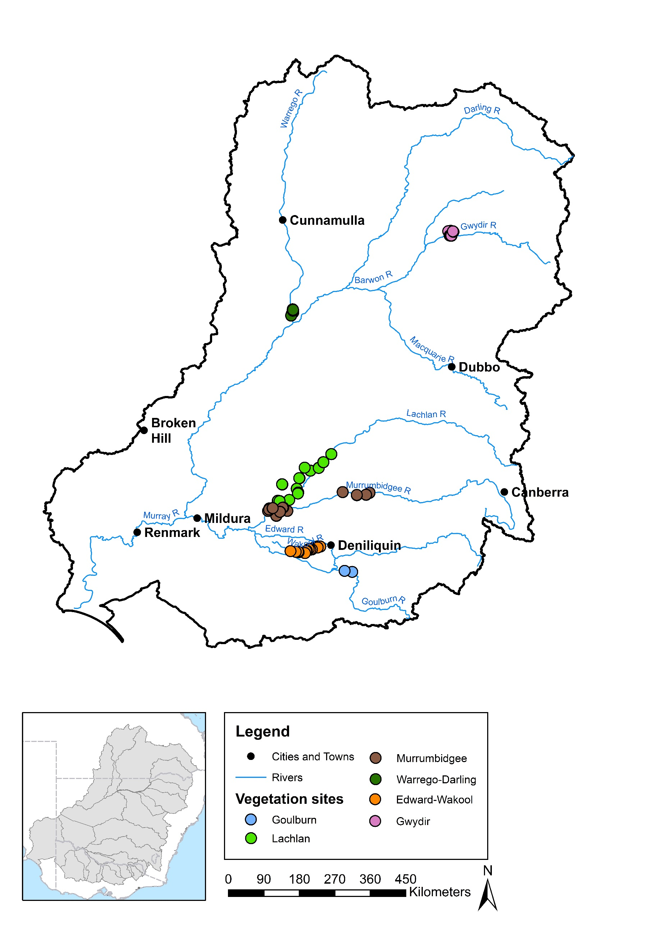

Figure 1. Vegetation diversity monitoring sites at Selected Areas in 2014–2015.

Table 2. Vegetation diversity monitoring data collected from Selected Areas in 2014–15.

| **Selected Area** | **Sampling design** | | | | | **Vegetation diversity metrics** | | | | | | |
| --- | --- | --- | --- | --- | --- | --- | --- | --- | --- | --- | --- | --- |
| **Survey times** | **No. of sites** | **No. of quadrats/ transects per site** | **Quadrat/transect description** | **Sampling unit description** | **% Cover by species** | **% Canopy cover**  **(>5 m tall)** | **% Understorey cover**  **(1–5 m tall)** | **% Groundcover**  **(<1 m tall)** | **% Litter cover** | **% Wood cover** | **% Bare ground** |
| Edward–Wakool | Monthly between Oct 2014 and Jun 2015 | 16 (across 4 zones) | 1 | Transects perpendicular to channel, sampling from 5 permanent markers along 25 m transects parallel to water, points every 50 cm along | % cover values calculated for each elevation on each transect (point-intercept method) | ✓ (Note: taxa only) | | | |  |  |  |
| Goulburn | Sep–Oct 2014, Dec 2014 | 2 | 10 | Transects perpendicular to channel, sampling every 1 m along 2 m lengths, points every 10 cm | % cover values calculated for each elevation on each transect (point-intercept method) | ✓ | ✓ | ✓ | ✓ | ✓ | ✓ | ✓ |
| Gwydir | Nov 2014,  Mar 2015 | 12 (across 2 zones) | 1–4 | 0.04 ha plots | Entire 0.04 ha plot | ✓ | ✓ | ✓ | ✓ | ✓ |  | ✓ |
| Lachlan | Nov/Dec 2014, May 2015 | 10 | 2–4 | 100 m transects | 1 m2 quadrats every 10 m along transect | ✓ | ✓ | ✓ | ✓ | ✓ |  | ✓ |
|  | 12 | 2–4 | 0.1 ha plots (trees) with nested 0.04 ha plots (understorey) | % cover values for 0.04 ha plot (Note: canopy cover recorded for 0.1 ha plot) | ✓ | ✓ | ✓ | ✓ | ✓ |  | ✓ |
| Murrum-bidgee | Sept 2014, Nov 2014, Jan 2015, Mar–May 2015 | 12 | 3–5 | Transects, 90 – 250 m long depending on wetland bathymetry and area | 3 – 5 1 × 10 m2 quadrats along transect | ✓ | ✓ | ✓ | ✓ | ✓ |  | ✓ |
| Warrego | Feb 2015, May 2015 | 8 | 3 | 0.04 ha plots | Entire 0.04 ha plot | ✓ | ✓ | ✓ | ✓ | ✓ |  | ✓ |

Table 3. Water regime categories assigned to vegetation diversity field survey plots/transects at wetland/floodplain Selected Areas in 2014–15.

| Selected Area | Survey 1 | | Survey 2 | | | | |
| --- | --- | --- | --- | --- | --- | --- | --- |
| **Dry** | **Wet** | **Dry–Dry** | **Dry–Wet** | **Wet–Dry** | **Wet–Wet** | **Wet** |
| Gwydir  (Survey 1: 32 plots across 12 sample points)  (Survey 2: 33 plots across 13 sample points) | 25 plots  (across 9 sample points) | 7 plots  (across 3 sample points) | 7 plots  (across 4 sample points) | 18 plots  (across 6 sample points) | 6 plots  (across 3 sample points) | 1 plot  (across 1 sample point) | 1 plot  (across 1 sample point) |
| Lachlan  (Survey 1: 34 plots across 14 sample points + 22 transects across 10 sample points)  (Survey 2: 30 plots across 12 sample points + 22 transects across 10 sample points) | 34 plots  (across 14 sample points) + 22 transects (across 10 sample points) | 0 | 30 plots (across 12 sample points) + 22 transects (across 10 sample points) | 0 | 0 | 0 | N.A. |
| Murrumbidgee  (Surveys 1–4: 33 transects across 12 sample points) | 23 transects (across 9 sample points) | 10 transects (across 5 sample points) | 13 transects (across 5 sample points) | 10 transects (across 5 sample points) | 4 transects (across 2 sample points) | 6 transects (across 4 sample points) | N.A. |
| Warrego  (Surveys 1 + 2: 24 plots across 8 sample points) | 20 plots (across 7 sample points) | 4 plots (across 2 sample points) | 20 plots (across 7 sample points) | 0 | 4 plots (across 2 sample points) | 0 | N.A. |

Note: N.A. = not applicable.

Table 4. Water regime categories assigned to vegetation diversity field survey transects at the Murrumbidgee Selected Area for the third and fourth surveys 2014–2015.

| Selected Area | Survey 3 | | | | | | Survey 4 | | | | | | | |
| --- | --- | --- | --- | --- | --- | --- | --- | --- | --- | --- | --- | --- | --- | --- |
| **Dry–Dry– Dry** | **Dry–Dry– Wet** | **Dry–Wet– Dry** | **Dry–Wet–Wet** | **Wet–Dry– Dry** | **Wet–Wet–Wet** | **Dry–Dry–Dry– Dry** | **Dry–Dry–Wet– Dry** | **Dry–Wet–Dry– Dry** | **Dry–Wet–Wet– Dry** | **Dry–Wet–Wet–Wet** | **Wet–Dry–Dry– Dry** | **Wet–Wet–Wet– Dry** | **Wet–Wet–Wet–Wet** |
| Murrumbidgee  (Surveys 1–4: 33 transects across 12 sample points) | 6 transects (across 2 sample points) | 7 transects (across 3 sample points) | 1 transect (across 1 sample point) | 9 transects (across 5 sample points) | 4 transects (across 2 sample points) | 6 transects (across 4 sample points) | 6 transects (across 2 sample points) | 7 transects (across 3 sample points) | 1 transect (across 1 sample point) | 3 transects (across 2 sample points) | 6 transects (across 3 sample points) | 4 transects (across 2 sample points) | 3 transects (across 2 sample points) | 3 transects (across 3 sample points) |

# Synthesis of area outcomes

## Selected Area outcomes

### Highlights

* At each Selected Area, inundation by Commonwealth environmental water promoted the presence and/or increased extent and abundance of some species, including both natives and exotics, although mainly emergent taxa associated with wetting.
* In several Selected Areas (i.e. Goulburn, Gwydir and Murrumbidgee), inundation by Commonwealth environmental water constrained the presence and/or extent and abundance of some species, especially exotic forbs. (Note: this effect was difficult to assess at the Warrego–Darling due to the low number of plots that experienced inundation.)
* At most Selected Areas, inundation by Commonwealth environmental water promoted the development of vegetation cover over time, especially in wetland/floodplain locations subject to longer durations of wetting.
* At a local scale, inundation by Commonwealth environmental water promoted the species richness of local vegetation assemblages, with the highest number of species tending to occur in response to drying following wetting.
* The relative cover and diversity of exotic taxa were mostly reduced by the delivery of Commonwealth environmental water. In a few cases, however, there is some evidence to suggest that establishment of exotic taxa may have been promoted by short periods of inundation at particular times (e.g. in some transects of the Murrumbidgee and in the Warrego–Darling).
* In most cases, Commonwealth environmental water promoted shifts in the composition of vegetation towards assemblages characterised by high abundance of emergent aquatic and semi-aquatic species, especially *Eleocharis* spp., and low cover of exotic forbs.
* At all Selected Areas, Commonwealth environmental water promoted spatial and temporal heterogeneity of vegetation assemblages at a landscape scale. In contrast, vegetation assemblages homogenised over time in the Lachlan where no environmental watering occurred.

### Effects of Commonwealth environmental water on plant species diversity at Selected Areas

#### Edward–Wakool

Three of four monitored zones of Yallakool Creek and Wakool River channels were influenced by Commonwealth environmental water during 2014–15. Several species — *Potamogeton* spp., *Myriophyllum* spp. and *Azolla* spp. — were absent from the zone that did not receive Commonwealth environmental water. A few taxa also exhibited lower abundances in this zone, e.g. *Chara* spp., *Eleocharis acuta*. Riverbank vegetation in zones receiving Commonwealth environmental water were characterised by *Centipeda cunninghamii* (p. 17, Edward–Wakool Synthesis and Technical Report, 2014–15).

#### Goulburn

A total of 73 species were recorded across two zones of the Goulburn River in two field surveys, i.e. September/October and December 2014, conducted before and after the delivery of spring freshes. Several species were found to be restricted to bank elevations inundated by spring freshes: *Alternanthera denticulata*, *Persicaria prostrata* and *Cyperus eragrostis* (an exotic species). In contrast, the native perennial grass *Poa labillardierei* appeared to be constrained by inundation, exhibiting greater abundances at higher bank elevations. (p. 85, Goulburn Synthesis and Technical Report, 2014–15).

#### Gwydir

A total of 152 taxa were recorded from the Gwydir Selected Area across the two field surveys conducted in 2014–15 (Appendix B). These comprised at least 88 native species and 39 exotic species with the remainder of uncertain status. Most species (84) were forbs with a significant number of sub-shrubs (21), grasses (19) and sedges/rushes (15) also present. A further 4 shrub species, 3 tree species and 3 mistletoe species were recorded.

In November 2014, 7 out of a total of 32 plots were wet at the time of the field survey (Survey 1 in Table 3). At this time, 25 species, mainly comprising perennial forbs, were only present in these wet plots (Table 5). In March 2015 (Survey 2 in Table 3), only one of these plots remained wet (i.e. Wet–Wet) and six plots dried out (Wet–Dry). A further 18 plots were inundated by Commonwealth environmental water between the two surveys (Dry–Wet). Only a single species (*Polygonum arenastrum*) was limited to sites that remained wet (i.e. Wet–Wet) in March 2015. This species was also present in some dry plots during the first survey, however, so is not limited to flooded habitats.

Ten species were only present in March 2015 in plots that were affected by Commonwealth environmental water between surveys (i.e. Dry–Wet; Table 5). Of these, five species were also absent during November 2014, suggesting the presence of these species at the Selected Area in March 2015 was attributable to Commonwealth environmental water. All of these species are considered to be amphibious except for the exotic *Rumex crispus\**, which is a terrestrial species with a preference for damp conditions. In contrast, only two species were present in March 2015 (and absent in November 2014) that were limited to dry plots: *Boerhavia dominii* and *Trianthema triquetra*, both terrestrial forbs.

A further suite of species were present during March 2015 only in sites that had experienced some wetting during 2014–15 (i.e. Wet–Dry, Dry–Wet or Wet–Wet; Table 5). All of these species were also present under either condition during November 2014. Their persistence in March 2015, however, may be due to the application of Commonwealth environmental water in Dry–Wet plots. There were no species that appeared in March 2015 only in plots that had been wet in November 2014 and then dried out (i.e. Wet–Dry).

A large number of species that were present under wet conditions in November 2014 were not observed during March 2015, probably reflecting seasonal preferences. Some species that were present during November 2014 with moderate to high frequency (i.e. present in >3 plots), under both wet and dry conditions, were limited to dry plots in March 2015 (i.e. Dry–Dry and Wet–Dry; Table 5). Most of these species were exotics. The emergence and/or persistence of these species between surveys may therefore have been constrained by the application of Commonwealth environmental water.

#### Lachlan

A total of 152 taxa were recorded from the Lachlan Selected Area during the two field surveys conducted in November/December 2014 and May 2015 (Appendix B). These comprised at least 94 native species and 37 exotics with the remainder of uncertain status. Forbs were the most common group (76 species) followed by sub-shrubs (45), grasses (9), sedges/rushes (4) and shrubs (4). Thirty-four species were only present during the first survey and 45 species only observed in the second survey (Appendix B). As no wetting occurred in monitored sites in the Lachlan Selected Area during 2014–15, plant species responses to environmental watering could not be assessed for this first year. Knowledge of species’ distributions and abundances under dry conditions, however, will be used to evaluate species-level responses to watering in future years.

#### Murrumbidgee

A total of 138 plant taxa were recorded from the Murrumbidgee Selected Area during the four field surveys conducted in 2014–15 (Appendix B). These included at least 94 native species and 34 exotic species with the remainder being of uncertain status. Most species were forbs (87) with 27 sub-shrubs, 11 sedges/rushes, 7 grasses, 3 shrubs and 1 tree species also being recorded. Bryophytes and charophytes were also observed.

In the first survey, conducted in September 2014, 10 out of 33 survey transects were mostly wet (Table 3). Of the 93 species observed at this time, 37 species were only present in dry transects while 15 taxa were limited to wet transects (Table 6).

In November 2014, 6 transects remained wet (Wet–Wet) while 4 dried out (Wet–Dry; Survey 2 in Table 3). A further 13 transects remained dry (Dry–Dry) while 10 were inundated by Commonwealth environmental water actions between surveys (Dry–Wet; Table 3). Of the 73 species present at this time, 18 species were limited to transects that were wet at the time (Wet–Wet and Dry–Wet) of which 10 species were only present in transects that had also been wet in the preceding survey. Additionally, four species appeared in the vegetation in November 2014 only in transects that had dried out between September and November 2014 (Wet–Dry): *Carthamus lanatus* (exotic), *Einadia nutans*, *Haloragis heterophylla* and *Verbena officinalis* (exotic).

In the third survey, during January 2015, 15 transects remained wet (Wet–Wet–Wet, Dry–Wet–Wet), with 6 of these having been continuously wet (i.e. Wet–Wet–Wet; Table 4). A further seven transects were only wet for the first time between the second and third surveys. Seventy-five species were present in January 2015 with 37 of these only present in transects that were wet at the time (Table 6). Four of these species were only present in transects that had been continuously wet since the first survey (Table 6).

In the final survey (March–May 2015), nine transects were wet, with three of these having been continuously wet (Wet–Wet–Wet–Wet; Survey 4 in Table 3). Eighty-three taxa were recorded during this survey with 11 restricted to transects that were wet at the time (Table 6). Of these, only two species were restricted to transects that had been wet during all four surveys (Wet–Wet–Wet–Wet; Table 6). Only two species were recorded solely from the six transects that remained dry throughout all four surveys: *Cynodon dactylon* and *Rhagodia spinescens*. Other species were present under a range of conditions (Appendix B).

Table 5. Plant species with distributions affected by wetting in the Gwydir Selected Area in 2014–15.

|  |  |  |  |
| --- | --- | --- | --- |
| **Species restricted to Wet plots in November 2014** | **Species restricted to Dry–Wet plots in March 2015*1*** | **Species present in March 2015 only in plots with some wetting (i.e. Wet–Wet, Dry–Wet)** | **Species limited to Dry plots in March 2015 (i.e. Wet–Dry, Dry–Dry)** |
| *Ludwigia octovalvis*  *Ammannia multiflora*  *Cycnogeton dubium*  *Cyperus bifax*  *Glyceria* spp.  *Soliva anthemifolia\**  *Lemna disperma*  *Myriophyllum crispatum*  *Nymphoides crenata*  *Persicaria lapathifolia*  Chenopodiaceae  *Crinum flaccidum*  *Cyperus concinnus*  *Dysphania ambrosioides\**  *Echinochloa inundata*  *Eriochloa pseudoacrotricha*  *Helichrysum luteoalbum*  *Landoltia punctata*  *Oxalis* spp.  *Physalis minima\**  *Senecio* spp.  *Carex appressa*  *Paspalum dilatatum\**  *Azolla filiculoides*  *Marsilea drummondii* | *Duma florulenta*  *Acacia stenophylla*  *Amyema quandang* var. *quandang*  *Ottelia ovalifolia* subsp. *ovalifolia1*  *Persicaria hydropiper1*  *Spirodela polyrhiza1*  *Panicum decompositum*  *Juncus* spp.  *Eichhornia crassipes1\**  *Rumex crispus1\** | *Marsilea* spp.  *Azolla filiculoides*  *Myriophyllum crispatum*  *Typha domingensis*  *Juncus usitatus*  *Lemna disperma*  *Persicaria orientalis*  *Nymphoides crenata*  *Sesbania cannabina* var. *cannabina*  *Carex appressa*  *Cycnogeton dubium*  *Lachnagrostis filiformis*  *Rorippa palustris\**  *Lobelia concolor*  *Oxalis thompsoniae*  *Paspalum dilatatum\** | *Conyza bonariensis\**  *Solanum nigrum\**  *Malva parviflora\**  *Cullen tenax*  *Xanthium spinosum\**  *Sonchus oleraceus\**  *Medicago polymorpha\**  *Portulaca oleracea*  *Cynodon dactylon* |

*1*Indicates species not present in November 2014

Note: asterisks (*\**) indicate exotic species.

Table 6. Plant species with distributions affected by wetting in the Murrumbidgee Selected Area in 2014–15.

|  |  |  |  |
| --- | --- | --- | --- |
| **Species restricted to Wet transects in September 2014** | **Species restricted to Wet transects in November 2014*1*** | **Species restricted to Wet transects in January 2015*2*** | **Species restricted to Wet transects in March – May 2015*3*** |
| *Eleocharis pallens*  *Ricciocarpos* spp.  *Cotula australis*  *Limosella australis*  Characeae  *Helminthotheca echioides\**  *Damasonium minus*  *Osteocarpum acropterum*  *Potamogeton tricarinatus*  *Vallisneria australis*  *Phyla nodiflora*  *Pseudoraphis spinescens*  *Chenopodium nitrariaceum*  *Atriplex* spp.  *Sclerolaena muricata* | *Paspalidium jubiflorum*  *Eleocharis pusilla*  *Eleocharis sphacealata*  *Eleocharis pallens1*  *Vittadinia hispidula1*  Characeae*1*  *Goodenia heteromera1*  *Oxalis corniculata1\**  *Crassula helmsii1*  *Senecio magnificus*  *Euchiton sphaericus*  *Typha* spp.  *Ranunculus undosus*  *Mimulus gracilis*  *Brachyscome basaltica* var. *gracilis*  *Persicaria orientalis*  *Paspalum distichum*  *Lobelia concolor* | *Senecio* spp.*, Centipeda cunninghamii, Pseudoraphis spinescens, Panicum effusum, Alternanthera nodiflora, Persicaria prostrata, Juncus usitatus, Trapopogon porrifolius, Alternanthera denticulata, Persicaria decipens, Duma florulenta, Senecio runcinifolius, Cyperus eragrostis*, Polygonum aviculare*, Mimulus gracilis2, Einadia nutans, Lemna* spp.*, Chenopodium nitrariaceum, Solanum nigrum*, Sclerolaena muricata2, Enchylaena tomentosa2, Marsilea hirsuta, Eleocharis sphacelata, Rumex brownii, Ludwigia peploides* subsp. *montevidensis, Goodenia heteromera2, Cyperus difformis,* Poaceae*, Potamogeton tricarinatus, Brachyscome basaltica* var. *gracilis, Lycium australe, Nymphoides crenata, Salsola australis, Sida fibulifera, Xanthium spinosum*, Typha* spp.*, Ranunculus undosus* | Characeae  *Eleocharis sphacelata*  *Persicaria orientalis*  *Callitriche umbonata*  *Myriophyllum crispatum*  *Cycnogeton procerum*  *Typha* spp.  *Ranunculus undosus*  *Ottelia ovalifolia* subsp. *ovalifolia*  *Vittadinia hispidula3*  *Maireana* spp.*3* |

*1* Occurred only in Wet–Wet transects.

*2* Occurred only in Wet–Wet–Wet transects.

*3* Occurred only in Wet–Wet–Wet–Wet transects.

Note: asterisks (*\**) indicate exotic species

#### Warrego–Darling

In the Warrego–Darling Selected Area, 4 out of 24 plots were inundated at the time of the first survey in February 2015 due to watering resulting from decisions made by the CEWO. These plots all dried out by the second survey in May 2015 and no further inundation was received in any other plot (Table 3). A total of 132 taxa, comprising at least 81 natives and 25 exotics, were recorded across the two surveys (Appendix B). Most taxa were forbs (47) with a significant diversity of sub-shrubs (30) and grasses (23) also present as well as several shrub (6), tree (6), sedge/rush (5) and mistletoe (2) taxa.

In February 2015, only two species were limited to wet plots (Table 7). Neither of these species persisted in May. Thirteen species were only present in Wet–Dry plots during the second survey (Table 7). Of these, most were also absent during the first survey suggesting that their presence in the vegetation at this time may be attributable to the water which inundated the Western Floodplain as a result of management decisions.

Table 7. Plant species with distributions affected by wetting in the Warrego–Darling Selected Area in 2014–15.

|  |  |
| --- | --- |
| **Species restricted to Wet plots in February 2015** | **Species present in May 2015 only in Wet–Dry plots1** |
| *Hibiscus trionum*  *Echinochloa inundata* | *Alternanthera nodiflora*  *Goodenia* spp.  *Panicum decompositum*  *Boerhavia dominii1*  *Eragrostis leptostachya1*  *Cyperus* spp. *1*  *Trifolium* spp.*1\**  *Heliotropium supinum1\**  *Myoporum acuminatum1*  *Xanthium strumarium1\**  *Gnaphalium* spp. *1*  *Persicaria* spp. *1*  *Wahlenbergia communis1* |

*1* Occurred only in May.

Note: asterisks (*\**) indicate exotic species.

### Effects of Commonwealth environmental water on vegetation community diversity at Selected Areas

#### Edward–Wakool

Aquatic and riverbank vegetation cover in the Edward–Wakool Selected Area was found to be significantly correlated with wetted benthic area at a reach scale. Consequently, greater vegetation cover was observed in zones that received Commonwealth environmental water compared with those that did not (p. 16, Edward–Wakool Synthesis and Technical Report, 2014–15).

#### Goulburn

Riverbank vegetation cover in the Goulburn Selected Area was found to be greatest at higher elevations that were subject to short durations of shallow inundation and lowest at elevations that experienced longer periods of deeper inundation. Vegetation assemblages responded to spring freshes with changes in composition at one site (Loch Garry) but not the other (McCoys Bridge). Changes that were observed at Loch Garry included an increase in the cover of *Alternanthera denticulata* and a decline in the cover of the exotic *Cyperus eragrostis*. Responses may have been constrained by limited rainfall and higher than average temperatures during the survey period (p. 85, Goulburn Synthesis and Technical Report, 2014–15).

#### Gwydir

##### Vegetation structure

Neither total vegetation cover nor total species richness differed significantly between dry and wet plots in November 2014 (Figure 2). In March 2015, however, water regime did have a significant effect on total cover with Wet–Dry sites having significantly greater vegetation cover (F2, 28 = 4.034, p < 0.05) than those that remained dry. Plots that received Commonwealth environmental water between survey dates had intermediate levels of vegetation cover. Total species richness tended to decline between the survey times, probably reflecting seasonal responses, and was also significantly higher (F2, 28 = 4.968, p < 0.05) in Wet–Dry plots than those that were wet in March 2015 (Figure 2).

The proportion of total vegetation cover comprising exotic taxa did not differ significantly between wet and dry plots in November 2014, though tended to be higher in dry sites. In March 2015, however, the proportion of exotic cover was significantly higher (F2, 28 = 12.547, p < 0.0001) in plots that remained dry (Dry–Dry). A similar pattern was detected for the proportion of total species that was exotic (F2, 28 = 6.854, p < 0.01; Figure 2).

##### Vegetation composition

Distinctive vegetation assemblages were present in November 2014 between Dry and Wet plots and in March 2015 between all water regime categories, indicating the significance of antecedent conditions on vegetation composition (Figure 3, Table 8). Wetting was also related to a significant shift in vegetation composition over time (e.g. Dry to Dry–Wet). Composition did not shift significantly, however, in plots that remained dry across the two surveys (Dry–Dry). Similarly, plots that were wet initially and then dried (Wet–Dry) did not exhibit a significant shift in composition (Figure 3, Table 8).

Species characterising the shift in assemblage composition over time in relation to wetting (i.e. Dry to Dry–Wet), as detected by SIMPER analysis, included *Paspalum distichum*, *Eleocharis plana* and *Echinchloa conlona*, all of which increased in cover, as well as *Phyla canescens* (exotic) and *Ludwigia peploides*, which declined in cover in response to wetting — very significantly in the case of *P. canescens*. An increase in cover of this species was also strongly associated with compositional changes that occurred in plots that remained dry between the two surveys.

##### Vegscape dynamics

Analysis of dispersion of assemblages between survey periods and water regime categories revealed a slight increase in heterogeneity at the Selected Area scale between surveys but this was not significant (0.969 to 1.031). Results of Bootstrapping, however, suggest a considerable increase in the diversity of vegetation assemblages across the Selected Area between the two survey dates as a result of the variation in watering regimes experienced by different locations (Figure 4).

Table 8. Differences between pair-wise groups of water regime categories at each survey time and between survey times in the Gwydir Selected Area 2014–15.

|  |  |  |
| --- | --- | --- |
| **Pair-wise group** | **t-value** | **p-value** |
| *December 2014* | | |
| Dry, Wet | 1.9009 | **0.004** |
| *March 2015* | | |
| Dry–Wet, Dry–Dry | 2.5302 | **0.002** |
| Dry–Wet, Wet–Dry | 2.4281 | **0.002** |
| Dry–Dry, Wet–Dry | 1.9166 | **0.012** |
| *Between surveys* | | |
| Dry, Dry–Dry | 1.5355 | 0.054 |
| Dry, Dry–Wet | 2.2561 | **0.003** |
| Wet, Wet–Dry | 1.0386 | 0.382 |
| Dry, Wet–Dry | 2.308 | **0.001** |
| Wet, Dry–Wet | 2.2831 | **0.002** |
| Wet, Dry–Dry | 1.9693 | **0.008** |

Note: based on PERMANOVA results;   
p-values < 0.05 shown in bold.

**a**

**b**

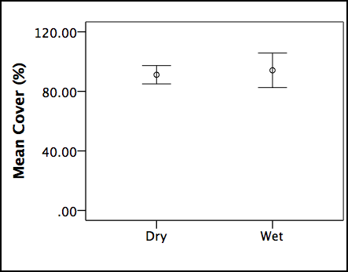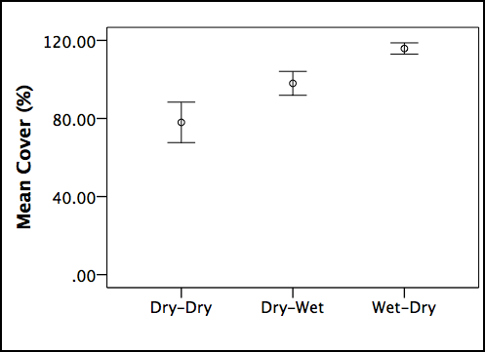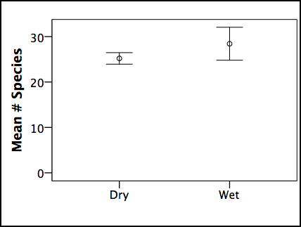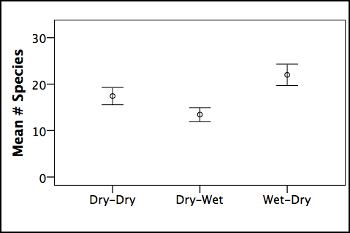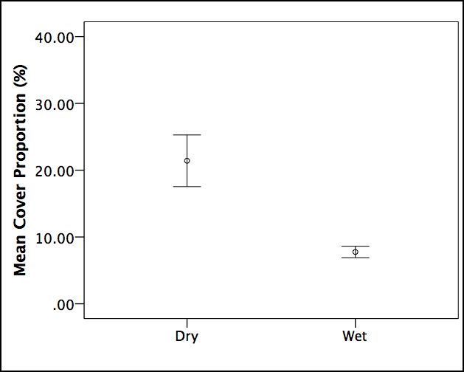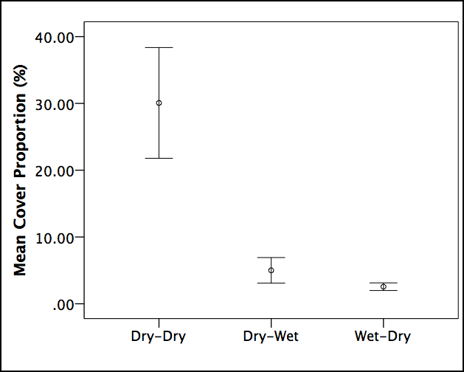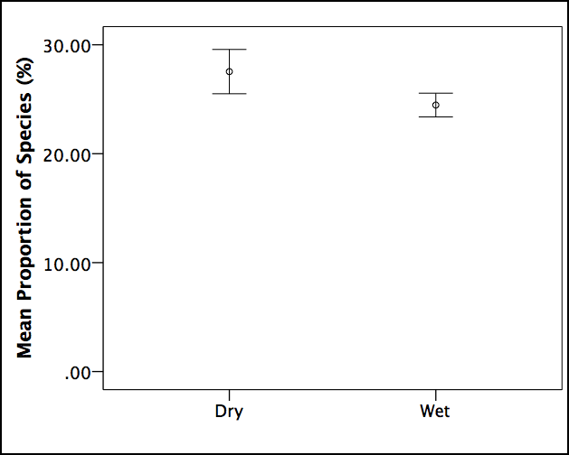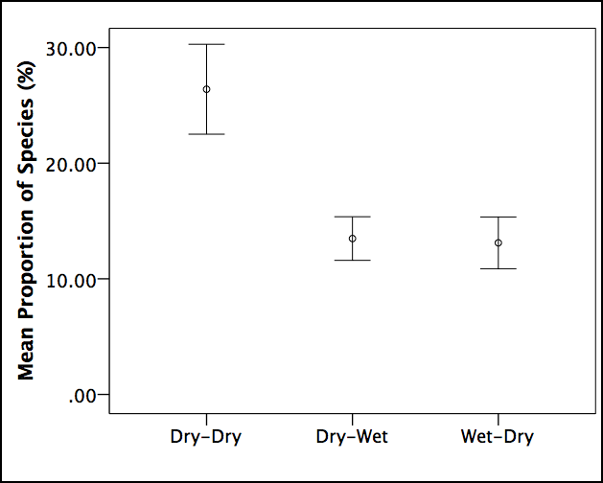

**v**

**d**

**c**

**f**

**e**

**h**

**g**

Figure 2. Differences in vegetation structure between water regime categories (see Table 3) for the Gwydir Selected Area in 2014–15. Error bars indicate +/– standard error. Left column represents November 2014 survey and right column March 2015: a–b) total vegetation cover, c–d) total species richness, e–f) proportion of total cover comprising exotic taxa and g–h) proportion of total taxa that was exotic.

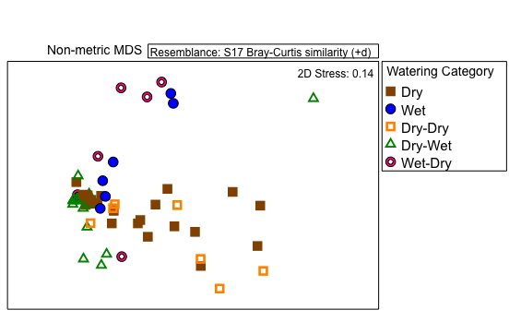

Figure 3. Ordination of vegetation assemblages at the Gwydir Selected Area in 2014–15 based on water regime categories (based on nMDS calculated from species cover values, excluding rare species). Note: the Wet–Wet category is omitted here as there was only one sample point.

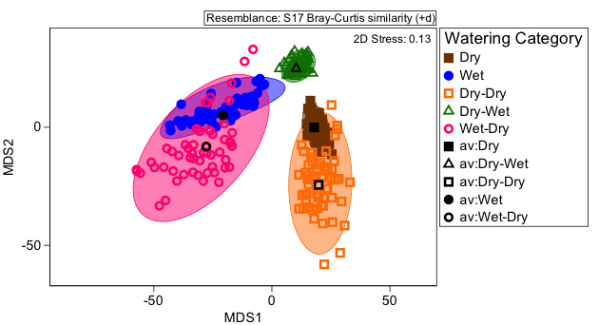

Figure 4. Ordination of vegetation assemblages at the Gwydir Selected Area in 2014–15 showing average values and dispersion within each water regime category (based on Bootstrapping procedure in PRIMER 7).

#### Lachlan

##### Vegetation structure

Total vegetation cover tended to be higher in the Lachlan Selected Area during the second survey, following prolonged drying, but this was not significant (Figure 5). Total species richness, however, was significantly higher (F1, 106 = 18.299, p < 0.0001) in May 2015 than in November/December 2014. The proportion of total vegetation cover comprising exotic taxa was also significantly higher following extended drying (F1, 106 = 38.552, p < 0.0001), as was the proportion of species that was exotic (F1, 106 = 15.046, p < 0.0001; Figure 5).

**a**

**b**

**c**

**d**

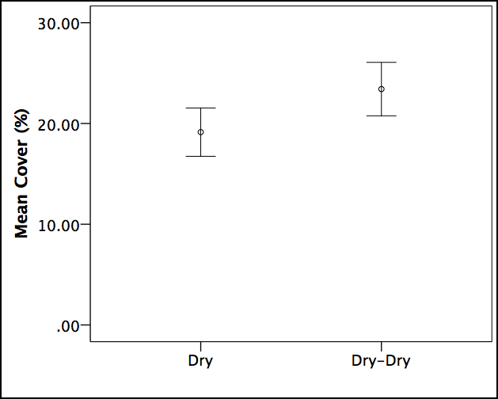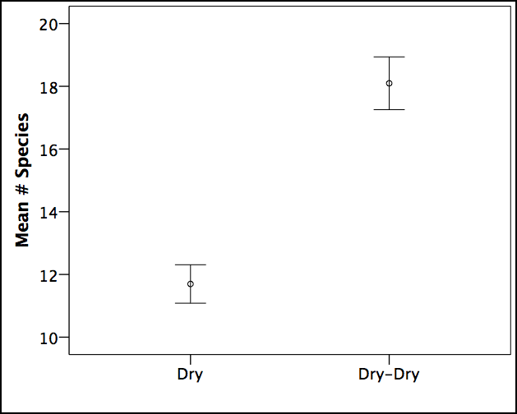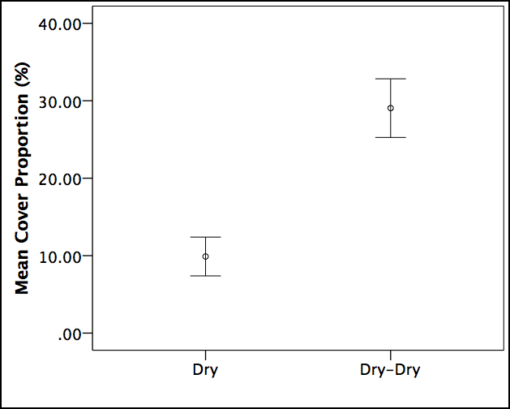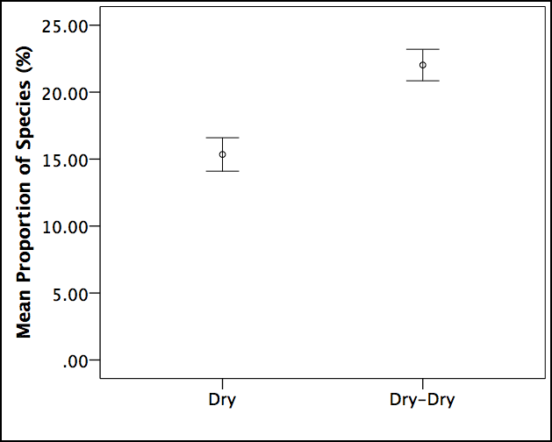

Figure 5. Differences in vegetation structure between water regime categories (see Table 3) for the Lachlan Selected Area in 2014–15. Error bars indicate +/– standard error: a) total vegetation cover, b) total species richness, c) proportion of total cover comprising exotic taxa and d) proportion of total taxa that was exotic.

##### Vegetation composition

Vegetation assemblages at the Lachlan differed significantly between survey times (Pseudo-F1, 102 = 3.2834, p = 0.01; Figure 6), indicating a shift in composition in relation to prolonged drying and/or seasonal changes. Species contributing most to the dissimilarity between survey times included *Duma florulenta*, *Paspalidium jubiflorum* and *Eucalyptus camaldulensis*, which all declined in cover, and *Medicago polymorpha* (exotic) which increased in cover.

##### Vegscape dynamics

A significant reduction in the dispersion of vegetation assemblages was detected between survey times (1.136 to 0.864; t = 2.7609, p < 0.01) indicating homogenisation of vegetation communities across the Selected Area with prolonged drying and/or other seasonal changes (Figure 7).

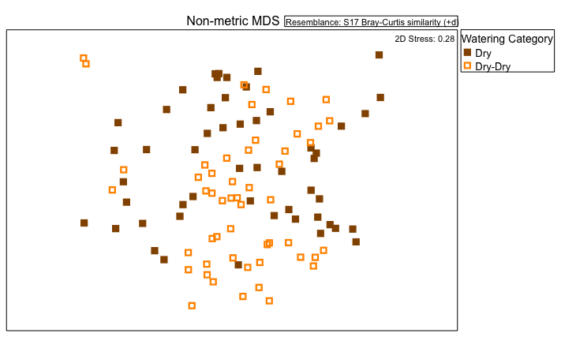

Figure 6. Ordination of vegetation assemblages at the Lachlan Selected Area in 2014–15 based on water regime categories (based on nMDS calculated from species cover values, excluding rare species).

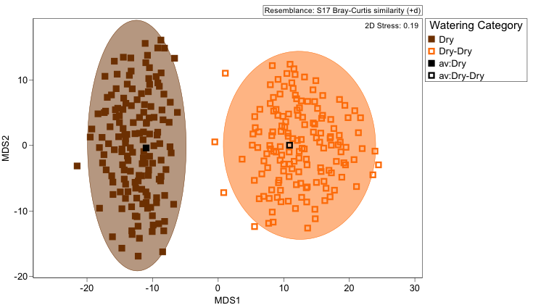

Figure 7. Ordination of vegetation assemblages at the Lachlan Selected Area in 2014–15 showing average values and dispersion within each water regime category (based on Bootstrapping procedure in PRIMER 7).

#### Murrumbidgee

##### Vegetation structure

Total vegetation cover was significantly higher in dry transects than wet transects during the first field survey in September 2014 (F1, 31 = 4.544, p < 0.05; Figure 8). No significant difference, however, in vegetation cover was detected between water regime categories in November 2014, although continuously wet (Wet–Wet) transects and those which had been wet but dried out (Wet-Dry) tended to have greater cover than other transects (Figure 8). In January 2015, a significant difference in vegetation cover was again detected (F4, 27 = 4.288, p < 0.02) but no homogeneous subsets were identified. Vegetation cover at this time tended to be highest in transects that were wet at this time and had been wet for at least the preceding survey as well (i.e. Wet–Wet–Wet and Dry–Wet–Wet; Figure 8). In the final survey in March–May 2015, there was again no significant difference in vegetation cover between water regime categories. However, transects that had been continuously dry (Dry–Dry–Dry–Dry) and those that had only been wet in the first survey (Wet–Dry–Dry–Dry) tended to have the lowest total vegetation cover (Figure 8).

Total species richness did not differ significantly between water regime categories in either September or November 2014 but in January 2015 was significantly lower in Dry–Dry–Wet transects and higher in Wet–Dry–Dry transects (F4, 27 = 2.841, p < 0.05; Figure 9). In March–May 2015, species richness differed significantly between water regime categories (F6, 25 = 3.229, p < 0.05) but no homogeneous subsets were detected. Greatest species richness tended to occur in transects that had been wet for the longest (Dry–Wet–Wet–Wet; Figure 9).

The proportion of total vegetation cover comprising exotic taxa differed significantly between water regime categories at each survey time (p < 0.05) although homogeneous subsets were not always detected. In general, however, the proportion of exotic plant cover was greater where the duration of drying was highest and lower in transects with longer durations of wetting (Figure 10). The proportion of taxa that was exotic also differed significantly between water regime categories in September 2014 (F1, 31 = 7.111, p < 0.05), January 2015 (F4, 27 = 6.162, p = 0.01) and March–May 2015 (F6, 25 = 7.202, p < 0.001; Figure 11). By the final survey time, there was a considerably higher proportion of exotic taxa present in transects that had been wet during the third survey, but dry for the remainder of the time and significantly lower proportions of exotic taxa in transects that had only been wet during the first survey and had subsequently dried out (Figure 11).

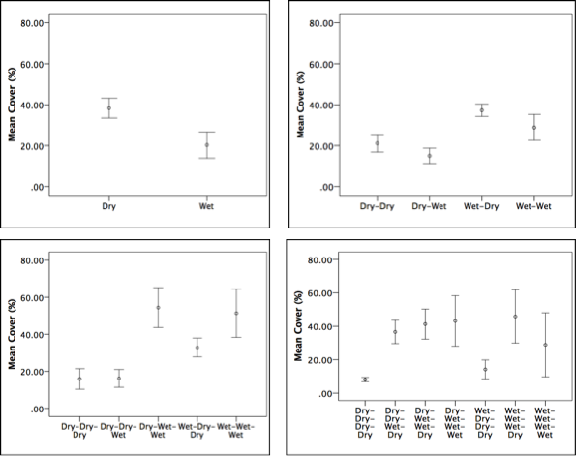

**d**

**c**

**b**

**a**

Figure 8. Differences in total vegetation cover between water regime categories (see Table 3) for the Murrumbidgee Selected Area in 2014–15. Error bars indicate +/– standard error; a) September 2014,  
b) November 2014, c) January 2015 and d) March–May 2015.

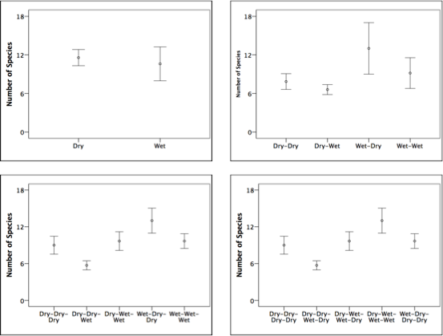

**a**

**b**

**d**

**c**

Figure 9. Differences in total species richness between water regime categories (see Table 3) for the Murrumbidgee Selected Area in 2014–15. Error bars indicate +/– standard error; a) September 2014, b) November 2014, c) January 2015 and d) March–May 2015.

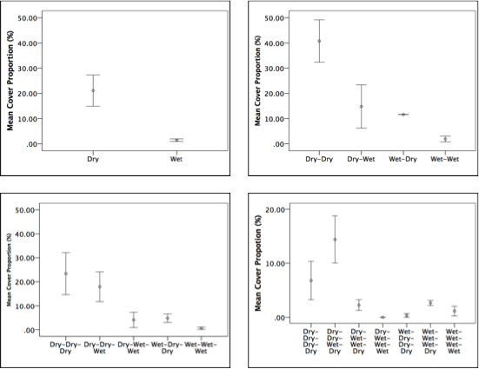

**d**

**c**

**b**

**a**

Figure 10. Differences in the proportion of total vegetation cover comprising exotic taxa between water regime categories (see Table 3) for the Murrumbidgee Selected Area in 2014–15. Error bars indicate +/– standard error; a) September 2014, b) November 2014, c) January 2015 and d) March–May 2015.

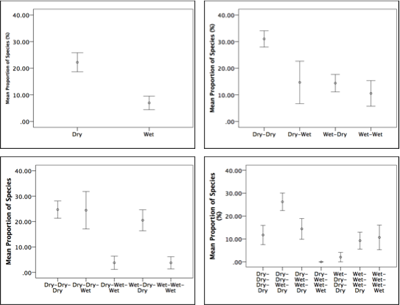

**c**

**d**

**b**

**a**

Figure 11. Differences in the proportion of total taxa that was exotic between water regime categories (see Table 3) for the Murrumbidgee Selected Area in 2014–15. Error bars indicate +/– standard error; a) September 2014, b) November 2014, c) January 2015 and d) March–May 2015.

##### Vegetation composition

Significant differences in the composition of vegetation assemblages were detected between transects under dry and wet conditions in September 2014 (Figure 12, Table 9). Species contributing most to the dissimilarity between these assemblages included *Eleocharis acuta*, *Medicago polymorpha* (exotic) and *Centipeda cunninghamii*, all of which were less abundant in wet transects, and *Eleocharis pusilla* which was more abundant in wet transects.

In November 2014, transects that remained wet (Wet–Wet) had different assemblages from those that had dried out (Wet–Dry) and from those that remained dry (Dry–Dry; Figure 12, Table 9). Other pair-wise combinations of water regime categories did not differ significantly at this time though (i.e. Dry–Wet and Wet–Wet). Species contributing mainly to the differences between Wet–Wet and Dry–Dry assemblages included *Eleocharis sphacelata*, *Duma florulenta*, *Azolla filiculoides* and *Ludwigia peploides*, all of which were more abundant in Wet–Wet transects, and *Cirsium vulgare* (exotic) which was more abundant in Dry–Dry transects.

In January 2015, transects that had been wet during the last two surveys only (Dry–Wet–Wet) had significantly different assemblages than sites that had been continuously dry (Dry–Dry–Dry) and from those that were only wet in the third survey (Dry–Dry–Wet; Figure 9, Table 9). Sites that had been continuously dry (Dry–Dry–Dry) also differed significantly form those that had only been wet in the first survey and then dried out (Wet–Dry–Dry) and those that had been continuously wet (Wet–Wet–Wet).

By the final survey, the only assemblages that differed significantly from each other included those that had been near continuously wet from those that had been near continuously dry (Table 9). Transects that were continuously wet were mainly distinguished from those that had been continuously dry by the presence and high abundance of *Eleocharis sphacelata*.

##### Vegscape dynamics

No significant change in dispersion of transects at the Selected Area scale was detected over time. Results of Bootstrapping, however, suggest that diversity of assemblages across the landscape was promoted by wetting, as assemblages that were dry initially and those that remained dry were more similar to each than assemblages that had mixed watering patterns (Figure 13). Both prolonged wetting and drying, however, appeared to homogenise the composition of assemblages.

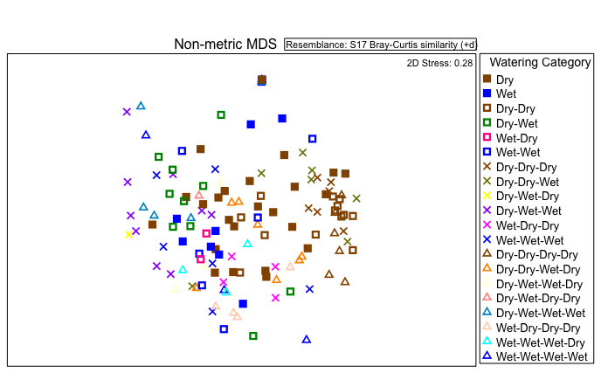

Figure 12. Ordination of vegetation assemblages at the Murrumbidgee Selected Area in 2014–15 based on water regime categories (based on nMDS calculated from species cover values, excluding rare species).

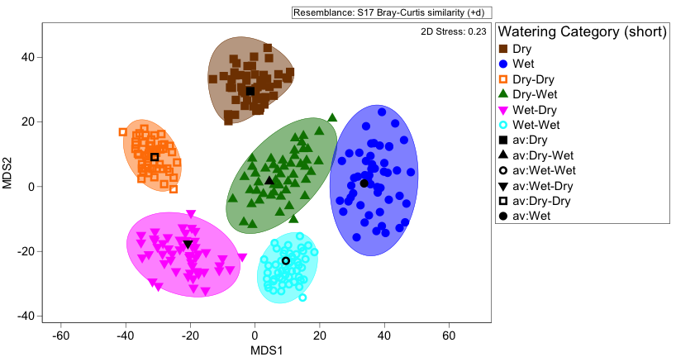

Figure 13. Ordination of vegetation assemblages at the Murrumbidgee Selected Area in 2014–15 showing average values and dispersion within each water regime category (based on Bootstrapping procedure in PRIMER 7).

Table 9. Differences between pair-wise groups of water regime categories at each survey time and between survey times in the Murrumbidgee Selected Area 2014–15.

|  |  |  |
| --- | --- | --- |
| **Pair-wise group** | **t- value** | **p-value** |
| *September 2014* | | |
| Dry, Wet | 1.4322 | 0.01 |
| *November 2014* | | |
| Dry–Dry, Dry–Wet | 1.9796 | 0.001 |
| Dry–Dry, Wet–Dry | 1.455 | 0.03 |
| Dry–Dry, Wet–Wet | 1.5918 | 0.007 |
| *January 2015* | | |
| Dry–Dry–Dry, Dry–Wet–Wet | 2.0375 | 0.001 |
| Dry–Dry–Dry, Wet–Dry–Dry | 2.3049 | 0.009 |
| Dry–Dry–Dry, Wet–Wet–Wet | 1.885 | 0.005 |
| Dry–Dry–Wet, Dry–Wet–Wet | 1.4732 | 0.001 |
| Dry–Dry–Wet, Wet–Dry–Dry | 1.6378 | 0.005 |
| Dry–Dry–Wet, Wet–Wet–Wet | 1.3336 | 0.011 |
| Dry–Wet–Wet, Wet–Dry–Dry | 1.7673 | 0.003 |
| *March–May 2015* | | |
| Dry–Dry–Dry–Dry, Dry–Dry–Wet–Dry | 1.814 | 0.001 |
| Dry–Dry–Dry–Dry, Dry–Wet–Wet–Dry | 1.7555 | 0.039 |
| Dry–Dry–Dry–Dry, Dry–Wet–Wet–Wet | 1.9757 | 0.005 |
| Dry–Dry–Dry–Dry, Wet–Dry–Dry–Dry | 1.9366 | 0.007 |
| Dry–Dry–Dry–Dry, Wet–Wet–Wet–Dry | 1.9084 | 0.009 |
| Dry–Dry–Dry–Dry, Wet–Wet–Wet–Wet | 1.5715 | 0.04 |
| Dry–Dry–Wet–Dry, Dry–Wet–Wet–Wet | 1.4865 | 0.007 |
| Dry–Dry–Wet–Dry, Wet–Dry–Dry–Dry | 1.5335 | 0.01 |
| Dry–Wet–Wet–Wet, Wet–Dry–Dry–Dry | 1.6787 | 0.009 |
| Wet–Wet–Wet–Dry, Dry–Wet–Wet–Wet | 1.4491 | 0.037 |
| Wet–Wet–Wet–Dry, Wet–Dry–Dry–Dry | 1.4077 | 0.033 |

Note: based on PERMANOVA results; only combinations with significant  
p values (i.e. <0.05) shown.

#### Warrego–Darling

##### Vegetation structure

Total vegetation cover in February 2015 was significantly higher in dry plots than in wet plots (F1, 22 = 4.386, p < 0.05; Figure 14). In May 2015, total vegetation cover was slightly lower in plots that had dried out since February than in those that had remained dry, but this was not significant (Figure 14). No significant differences in species richness were found between water regime categories at either survey time, although plots that were initially wet and then dried out tended to support more species in May 2015 (Figure 14). The proportion of total cover comprising exotic taxa, but not the proportion of exotic species, was significantly higher in Wet–Dry plots than in Dry–Dry plots in May 2015 (F1, 22= 8.375, p < 0.01; Figure 14).

##### Vegetation composition

No significant difference was detected between assemblages of Wet and Dry plots in February 2015 or between assemblages that remained dry and those that had been wet but dried out in May 2015 (Figure 15; Table 10). Results of the Bootstrapping analysis in PRIMER 7, however, indicated some distinction between assemblages that experienced wetting and those that did not (Figure 16).

##### Vegscape dynamics

Dispersion of assemblages across the Selected Area did not differ significantly between survey times. However, results of Bootstrapping indicate that there was a greater diversity of assemblages across the landscape at each survey time as a result of wetting (Figure 16). In particular, assemblages under wet conditions during the first survey and those that had been wet and then dried out during the second survey were considerably more heterogeneous than those which developed under dry conditions at either time (Figure 16).

Table 10. Differences between pair-wise groups of water regime categories at each survey time and between survey times in the Warrego–Darling Selected Area 2014–15

|  |  |  |
| --- | --- | --- |
| **Pair-wise group** | **t- value** | **p-value** |
| *February 2015* | | |
| Dry, Wet | 1.4259 | 0.068 |
| *May 2015* | | |
| Dry–Dry, Wet–Dry | 1.3658 | 0.09 |

Note: based on PERMANOVA results.

**h**

**g**

**f**

**e**

**d**

**c**

**b**

**a**

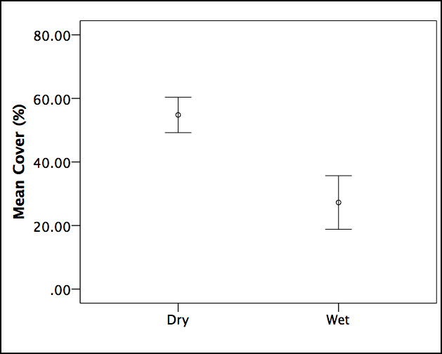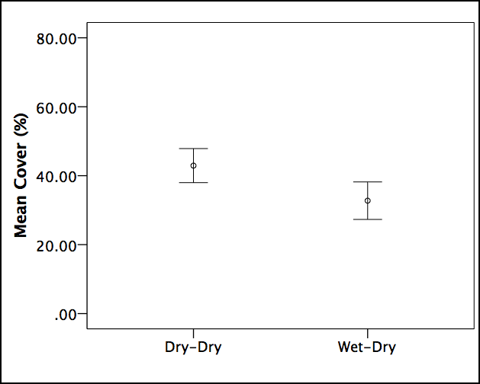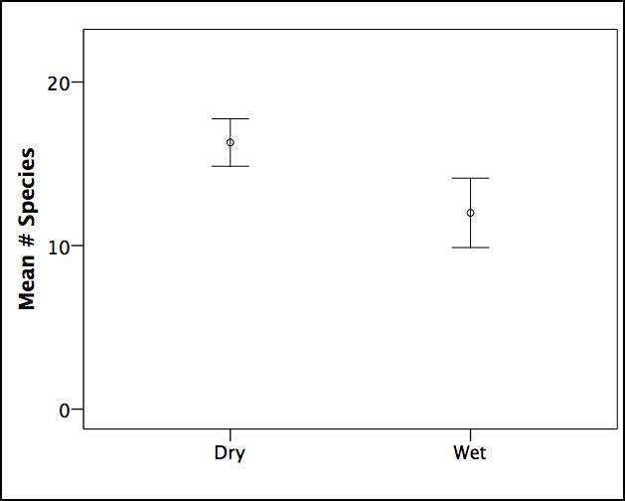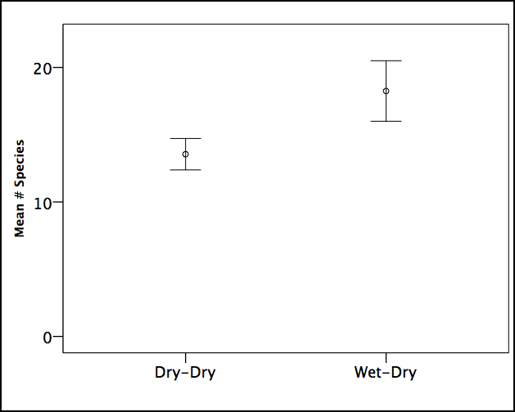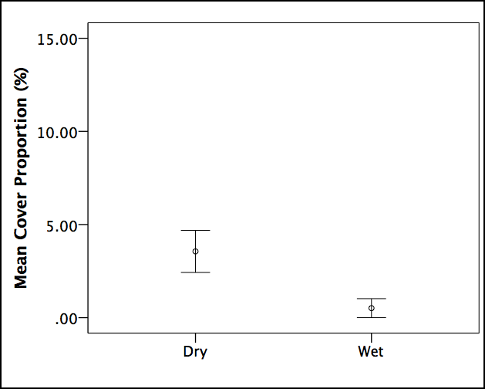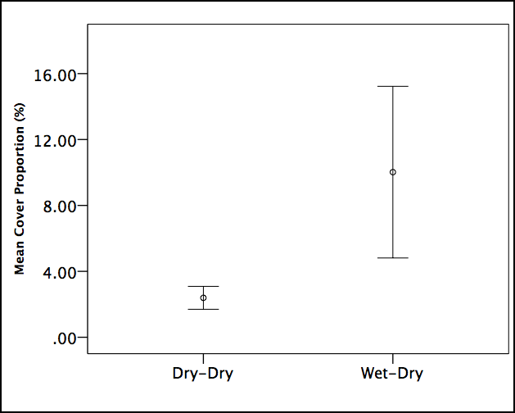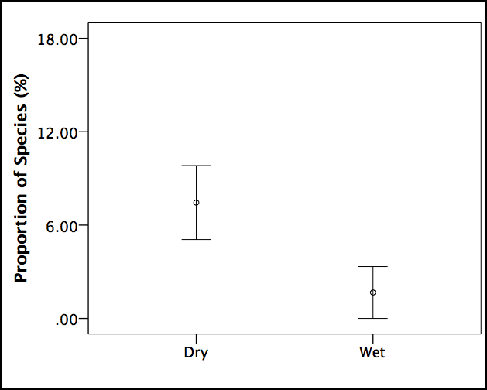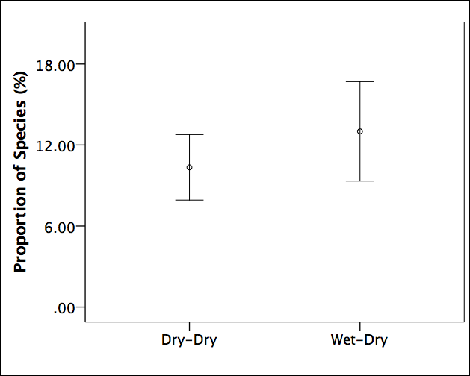

Figure 14. Differences in vegetation structure between water regime categories (see Table 3) for the Warrego–Darling Selected Area in 2014–15. Error bars indicate +/– standard error. Left column represents February 2015 survey and right column May 2015: a–b) total vegetation cover, c–d) total species richness, e–f) proportion of total cover comprising exotic taxa and g–h) proportion of total taxa that was exotic.

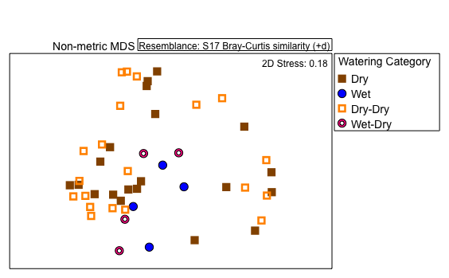

Figure 15. Ordination of vegetation assemblages at the Warrego–Darling Selected Area in 2014–15 based on water regime categories (based on nMDS calculated from species cover values, excluding rare species).

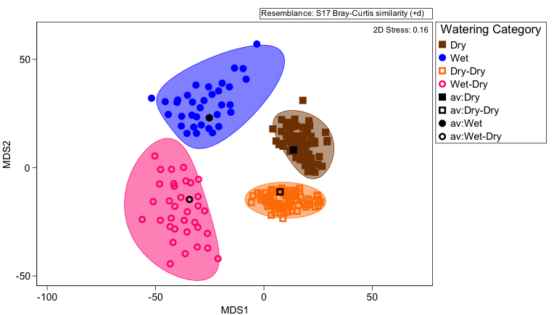

Figure 16. Ordination of vegetation assemblages at the Warrego–Darling Selected Area in 2014–15 showing average values and dispersion within each water regime category (based on Bootstrapping procedure in PRIMER 7).

### Synthesis

Inundation by Commonwealth environmental water resulted in changes in the presence, distribution and abundance of some plant species at both a plot/transect scale and a Selected Area scale. The species affected by wetting and drying, however, differed between survey times and Selected Area. At each Selected Area where inundation by Commonwealth environmental water occurred, some species were observed at each survey time that were limited to plots/transects that were currently inundated. These mostly comprised aquatic species and a range of grasses, sedges/rushes and hydrophilic forbs among which germination, growth and reproduction is likely to be tolerant of, or even favoured by, flooding (e.g. Casanova 2011). Conversely, some species appeared to be constrained by inundation and were only present in dry plots/transects or occurred at much reduced frequency and/or abundance in wet plots/transects. In numerous cases, especially in Gwydir, such species mainly comprised exotic taxa. Most terrestrial plants have limited tolerance of flooding and therefore are unlikely to persist or establish under such conditions (Brock *et al.* 2006). A further suite of species were either limited to or more frequent and/or abundant under the damp conditions following the recession of floodwaters and either emerged or persisted solely in plots/transects where drying had followed wetting. This likely reflects that germination and establishment of most wetland and floodplain plants are favoured by such conditions (Capon 2007). The majority of species recorded across the Selected Areas in 2014–15 were observed under a range of hydrological conditions, both within and between Selected Areas (Appendix B).

Vegetation cover at a plot/transect scale was mostly, but not always, promoted by wetting by Commonwealth environmental water. This was directly the case in the two river channel Selected Ares, i.e. Edward–Wakool and Goulburn, where greater aquatic and riverbank vegetation cover was observed in relation to wetting. In some cases, however, e.g. in Gwydir and some Murrumbidgee transects, higher vegetation cover was associated with vegetation assemblages that developed in response to drying following flooding, especially compared with plots/transects that remained dry. In Warrego–Darling, however, lower vegetation cover was observed in plots that were wet and then dried out than in those that remained dry. This may be due mainly to the timing of field surveys, however, with insufficient time for species establishing in damp conditions to have gained biomass. In other cases, e.g. other Murrumbidgee transects, higher vegetation cover developed in response to longer durations of wetting. This probably reflects the accumulation of biomass of dominant aquatic taxa that were able to flourish and spread vegetatively under longer durations of wetting (Reid & Capon 2011).

Species richness exhibited variable responses to wetting and drying and also varied considerably in relation to the timing of field surveys (i.e. seasonally). In many cases, plots/transects that were wet at the time of field surveys supported fewer species than those that were currently dry. For the most part, however, the greatest number of species within a Selected Area at a particular survey time occurred in plots/transects that were drying out following prior wetting. This was especially the case in Gwydir and Warrego–Darling. As highlighted previously, germination and establishment of most wetland and floodplain plants, particularly in dryland regions, is favoured by damp conditions following the recession of floodwaters (Capon 2007). In the Murrumbidgee, greater species richness tended to occur in transects that were subject to a mix of hydrological conditions. By the final survey, higher species richness was also observed in transects that had experienced some dry conditions but also longer durations of wetting. Higher numbers of species favoured by inundation could be expected at this Selected Area given the historically frequent (approximately annual) flood regimes of many of these wetlands. Interestingly, species richness increased in the Lachlan Selected Area with prolonged drying, possibly reflecting the presence of more species with a preference for cooler conditions.

In general, drying at the Selected Areas promoted both the proportion of total vegetation cover comprising exotic taxa and the relative proportion of exotic taxa present. Watering with Commonwealth environmental water therefore appears to have had a significant effect on the presence, extent and distribution of exotic taxa at both a plot/transect and Selected Area scale. In Murrumbidgee, the presence and extent of exotic taxa also tended to be greater in transects that experienced a short duration of wetting in early 2015 but were otherwise dry.

Wetting by Commonwealth environmental water tended to result in a shift in the composition of vegetation assemblages over time and, therefore, the presence of assemblages that differed significantly at any particular time from those that had not experienced any wetting. In most cases, wetting prior to the survey time (i.e. during the preceding survey) also resulted in significantly different assemblages. In general, wetting promoted the cover of emergent native taxa (i.e. grasses and sedges, e.g. *Eleocharis* spp.) and reduced the cover of exotic taxa. In contrast, detectable shifts in vegetation assemblage composition in response to drying tended to involve a decline in the cover of perennial wetland taxa and an increase in the cover of exotic forbs at a local scale.

At a landscape scale, wetting by Commonwealth environmental water consistently promoted heterogeneity of vegetation patches with respect to both their composition and structure in both time and space. In all Selected Areas, plots/transects that remained dry tended to support relatively similar assemblages while those that were wet, or drying out following wetting, were typically more heterogeneous across the landscape. In Murrumbidgee, however, persistent wetting also resulted in relatively similar assemblages. Nevertheless, wetting by Commonwealth environmental water during 2014–15 clearly promoted vegetation diversity within the vegscapes at each Selected Area by creating a dynamic mosaic of patches that differed in their hydrological conditions and, therefore, the vegetation assemblages that developed in response to these (Capon 2003, 2005). In contrast, homogenisation of vegetation at the vegscape scale occurred at the Lachlan Selected Area, where no wetting occurred within monitored sites.

### Adaptive management

A range of recommendations concerning the delivery and assessment of Commonwealth environmental water at each Selected Area has been made by M&E Providers in their 2014–15 reports (Table 11). As this is the first year of the LTIM Project, few adaptive strategies regarding the practical delivery of Commonwealth environmental water for vegetation diversity outcomes can be identified at this stage. In a few cases, however, evidence suggests benefits to vegetation diversity may be enhanced by changes to the timing, depth and duration of inundation (especially slower recession of water levels) and the spatial targets of watering actions within Selected Areas (Table 12).

Results of the Aggregated Area scale annual evaluation presented here indicate that vegetation diversity responses to Commonwealth environmental water are highly dependent on local and Selected Area scale factors, such as the existing vegetation community and vegscape configuration, as well as hydrological characteristics of water delivery (e.g. timing, duration). Consequently, different responses to watering actions can be expected both within and between Selected Areas in terms of both plant species diversity and vegetation diversity. In the Murrumbidgee Selected Area, for example, diverse and highly productive aquatic plant communities will develop in some wetlands in response to longer durations of inundation, while in other wetlands, greater vegetation diversity may occur during drying phases following periods of inundation. Different expected outcomes and water delivery may therefore be required for individual wetlands within a Selected Area, perhaps based on their wetland type (e.g. ANAE type) or prior watering history. Additionally, promoting a representative range of possible wetland vegetation assemblages across a Selected Area landscape is likely to be functionally significant, e.g. providing breeding and feeding habitat for waterbirds.

Results of the Basin scale evaluation further suggest that short durations of inundation in some locations, e.g. the Western Floodplain in the Warrego–Darling and some wetlands in the Murrumbidgee, may promote the establishment and/or growth of exotic taxa. Longer durations of inundation, however, such as those delivered in 2014–15 to the Gwydir and some parts of the Murrumbidgee, appear to be very effective at reducing or even prohibiting the local establishment and growth of most exotic taxa and therefore the extent of these species across the Selected Area.

Additional recommendations made by M&E Providers concern monitoring methodologies (Table 10). In particular, the timing of vegetation surveys in relation to watering actions is likely to be very important. Surveys conducted too soon after inundation, for example, may fail to detect vegetation responses. Furthermore, evaluation of monitoring data must take into account other factors including seasonal changes and disturbances such as fire and grazing. These complexities associated with collecting and evaluating vegetation monitoring data strengthen the need for the long-term monitoring across multiple locations being undertaken by the LTIM Project.

Table 11. Key recommendations concerning adaptive management of Commonwealth environmental water delivery and assessment at each Selected Area made by M&E Providers in Selected Area reports in 2014–15.

|  |  |
| --- | --- |
| **Selected Area** | **Recommendations** |
| Gwydir | * The current inter-annual drying and wetting strategy delivered to the wetlands is effective and should be continued. * Delivery constraints in the Gingham system need to be addressed to enable greater extent and duration of flooding in this system. |
| Warrego–Darling | * Flows to the Western Floodplain should be maximised through water management decisions at Boera Dam on the Warrego River. CEWO’s 5-year watering use strategy for Toorale includes potential watering of this floodplain. * Vegetation diversity responses to watering are dependent on season and vegetation community type. Consequently, vegetation changes are hard to attribute solely to watering. |
| Lachlan | * Grazing, by stock and feral animals, appears to be exerting considerable pressure on recruitment of floodplain trees which will constrain capacity of environmental watering to achieve vegetation regeneration outcomes. |
| Murrumbidgee | * Restoration of historical hydrological regimes in mid-Murrumbidgee floodplain wetlands is crucial for the restoration of aquatic vegetation communities. Annual or near-annual inundation with occasional brief drying periods is recommended. * To thin seedlings in wetlands encroached by river red gum seedlings, greater depth and duration of flooding (i.e. up to 3 years) is required. |
| Goulburn | * Earlier delivery of first extended spring fresh is recommended to enhance benefits to bankside vegetation as this would enable plants to establish/grow in response to wetting more before potentially stressful, hotter summer temperatures are experienced. * Stepping the recession of flows may promote propagule deposition at a range of bank elevations and thereby enhance vegetation responses at lower elevations. Propagule retention may be constrained, however, by low levels of woody litter or surface roughness in these elevations. * Delivery of spring freshes with lower depths could facilitate greater vegetation recovery at lower bank elevations. * Timing of vegetation surveys following inundation is likely to be important as insufficient time may limit the responses observed. Vegetation monitoring must also consider role of channel morphology as vegetation cover tended to be higher on banks located on inside bends, followed by straight sections and lowest on outside bends. |
| Edward–Wakool | * Slower recession of flows is recommended to enhance benefits to instream aquatic vegetation. * A greater focus for environmental water delivery to the Wakool River, rather than Yallakool Creek, may enhance outcomes for instream aquatic vegetation. * The temporal and spatial scale of expected outcomes should be set in relation to the magnitude of proposed watering actions. |

## Unmonitored area outcomes

### Highlights

* Over 118 000 hectares (ha) of floodplain and wetland ecosystems are likely to have been influenced by Commonwealth environmental water in 2014–15. This included 54 different ecosystem types, representing a wide range of vegetation communities across 12 valleys.
* Vegetation heterogeneity is likely to have been particularly enhanced by Commonwealth environmental water in the Lower Murray, Macquarie, Murrumbidgee and Gwydir as these valleys experienced inundation by Commonwealth environmental water in a wider range of ecosystem types.

### Synthesis

Approximately 70,000 ha of wetland ecosystems and over 48,000 ha of floodplain ecosystems are estimated to have been inundated by Commonwealth environmental water in the Basin during 2014–15, including those in the Selected Areas (Table 12). A total of 54 Australian National Aquatic Ecosystem (ANAE) types are likely to have been inundated by Commonwealth environmental water during 2014–15 across the Basin across 12 valleys (Table 13). The Lower Murray valley had the greatest diversity of ecosystem types inundated by Commonwealth environmental water followed by the Macquarie, Murrumbidgee and Gwydir valleys (Table 13).

At a local scale, unmonitored areas subject to inundation by Commonwealth environmental water during this period are highly likely to have exhibited some responses with respect to vegetation diversity, although these will have been strongly dependent on the vegetation present prior to inundation and the attributes of wetting experienced (e.g. duration, depth, timing etc.). Plant species responses almost certainly included the reduction in cover, extent or local extirpation of flood-intolerant species and the increased presence, extent and abundance of species favoured by inundation. The species involved, however, are likely to have differed between valleys and wetlands as per the monitored Selected Areas.

At a vegetation community scale, Commonwealth environmental water is highly likely to have resulted in shifts in composition and structure, which again are likely to be dependent on local context. Different responses are likely to occur in different vegetation communities. Consequently, greater regional heterogeneity in vegetation is probably proportional to the number and area of ecosystem types inundated by Commonwealth environmental water in each valley. Nevertheless, inundation by Commonwealth environmental water in valleys where only one or two ecosystem types were influenced (i.e. Lower and Upper Darling, Warrego, Broken and Border Rivers) is also likely to have produced a significant response as this would have increased vegetation diversity where landscapes were otherwise dry.

### Adaptive management

Because different vegetation communities respond to wetting and drying differently, targets for, and evaluation of, CEWO watering actions within particular valleys and across the Basin should consider the representativeness and diversity of floodplain and wetland ecosystem types inundated and influenced by Commonwealth environmental water each year and over time.

Table 12. Estimated areas (hectares) of floodplain inundated and wetlands influenced1 by Commonwealth environmental water within each Basin valley in 2014–15, and proportions of the total area of floodplain or wetland ecosystems inundated/influenced in each valley.

|  |  |  |  |
| --- | --- | --- | --- |
| **River valley** | **ANAE class type** | **Area inundated (ha)** | **% of total area of ANAE type in valley** |
| Avoca | Floodplain | 147.63 | 0.8152 |
| Border Rivers | Floodplain | 0.09 | 0.0001 |
| Central Murray | Wetland | 80.14 | 0.0921 |
|  | Floodplain | 70.73 | 0.0356 |
| Gwydir | Wetland | 1167.84 | 20.1922 |
|  | Floodplain | 8064.52 | 14.2743 |
| Lachlan | Wetland | 3794.37 | 2.6043 |
|  | Floodplain | 474.82 | 0.1204 |
| Lower Darling | Wetland | 19.62 | 0.0056 |
|  | Floodplain | 0.28 | 0.0002 |
| Lower Murray | Wetland | 4642.71 | 1.8496 |
|  | Floodplain | 3255.26 | 1.6563 |
| Macquarie | Wetland | 26 684.60 | 44.8852 |
|  | Floodplain | 8300.58 | 2.2003 |
| Murrumbidgee | Wetland | 15 064.05 | 11.4702 |
|  | Floodplain | 28 367.58 | 15.1280 |
| Upper Darling | Wetland | 286.40 | 0.2228 |
| Warrego | Wetland | 17 867.95 | 18.3249 |
|  | Floodplain | 6.27 | 0.0008 |
| **TOTAL** |  | 118 295.44 | 3.1711 |

1 Area ‘influenced’ comprises total area of all polygons intersected to some degree by Commonwealth environmental water inundation.

Note: floodplain and wetland areas determined according to ANAE ecosystem mapping; only valleys receiving some Commonwealth environmental water are shown.

Table 13. ANAE types likely to have been influenced by Commonwealth environmental water in specific valleys of the Basin in 2014–15.

| **Australian National Aquatic Ecosystem (ANAE) type** | **Avoca** | **Border Rivers** | **Broken** | **Central Murray** | **Gwydir** | **Lachlan** | **Lower Darling** | **Lower Murray** | **Macquarie** | **Murrumbidgee** | **Upper Darling** | **Warrego** | **Number of valleys containing the inundated ANAE type** |
| --- | --- | --- | --- | --- | --- | --- | --- | --- | --- | --- | --- | --- | --- |
| F.1.8: Black box woodland floodplain | ✓ |  |  | ✓ | ✓ | ✓ |  | ✓ | ✓ | ✓ |  |  | 7 |
| F1.1: Upland river red gum forest floodplain |  |  |  |  | ✓ |  |  |  | ✓ | ✓ |  |  | 3 |
| F1.10: Coolibah woodland and forest floodplain |  | ✓ |  |  | ✓ |  |  |  |  |  |  |  | 2 |
| F1.11: River cooba woodland floodplain |  |  |  |  | ✓ |  |  |  |  |  |  |  | 1 |
| F1.12: Woodland floodplain |  |  |  |  | ✓ |  |  |  | ✓ | ✓ |  | ✓ | 4 |
| F1.2: River red gum forest floodplain |  |  |  |  | ✓ | ✓ | ✓ | ✓ | ✓ | ✓ |  |  | 6 |
| F1.3: Upland river red gum woodland floodplain |  |  |  |  |  |  |  | ✓ |  |  |  |  | 1 |
| F1.4: River red gum woodland floodplain |  |  |  |  | ✓ |  |  | ✓ | ✓ | ✓ |  |  | 4 |
| F1.9: Upland coolibah woodland and forest floodplain |  |  |  |  | ✓ |  |  |  |  |  |  |  | 1 |
| F2.1: Upland lignum shrubland floodplain |  |  |  |  |  |  |  | ✓ |  |  |  |  | 1 |
| F2.2: Lignum shrubland floodplain |  |  |  | ✓ |  | ✓ |  | ✓ |  | ✓ |  |  | 4 |
| F2.4: Shrubland floodplain |  |  |  |  |  | ✓ |  | ✓ | ✓ | ✓ |  |  | 4 |
| F3.1: Upland sedge/forb/grassland floodplain |  |  |  |  |  |  |  | ✓ |  |  |  |  | 1 |
| F3.2: Sedge/forb/grassland floodplain |  |  |  |  | ✓ | ✓ |  | ✓ | ✓ | ✓ |  |  | 5 |
| F4: Floodplain with unspecified vegetation | ✓ |  |  |  | ✓ |  |  | ✓ | ✓ | ✓ |  |  | 5 |
| Lp1.1: Permanent lakes |  |  |  |  |  |  |  |  | ✓ | ✓ |  |  | 2 |
| Lp2.1: Permanent floodplain lakes |  |  |  |  |  |  |  |  |  | ✓ |  |  | 1 |
| Lst1.1: Temporary saline lakes |  |  |  |  |  |  |  | ✓ |  |  |  |  | 1 |
| Lst2.1: Temporary saline floodplain lakes |  |  |  |  |  |  |  | ✓ |  |  |  |  | 1 |
| Lt1.1: Temporary lakes |  |  |  |  | ✓ |  | ✓ | ✓ | ✓ | ✓ |  |  | 5 |
| Lt2.1: Temporary floodplain lakes |  |  |  |  | ✓ | ✓ |  |  | ✓ | ✓ |  |  | 4 |
| Pp2.1.1: Permanent floodplain tall emergent marshes |  |  |  |  |  | ✓ |  |  |  | ✓ |  |  | 2 |
| Pp2.1.2: Permanent tall emergent marshes |  |  |  |  |  | ✓ |  |  | ✓ |  |  |  | 2 |
| Pp2.2.2: Permanent sedge/grass/forb marshes |  |  |  |  | ✓ |  |  |  |  |  |  |  | 1 |
| Pp2.3.1: Permanent floodplain grass marshes |  |  |  |  |  |  |  | ✓ | ✓ |  |  |  | 2 |
| Pp2.3.2: Permanent grass marshes |  |  |  |  |  |  |  |  | ✓ |  |  |  | 1 |
| Pp4.1: Permanent floodplain wetland | ✓ |  |  | ✓ | ✓ |  |  | ✓ | ✓ | ✓ |  |  | 6 |
| Pp4.2: Permanent wetland |  |  |  |  | ✓ |  |  |  | ✓ |  |  |  | 2 |
| Psp4: Permanent saline wetland |  |  |  | ✓ |  |  |  | ✓ |  |  |  |  | 2 |
| Pst1.1: Temporary saline swamp |  |  |  |  |  |  |  | ✓ |  |  |  |  | 1 |
| Pst4: Temporary saline wetland |  |  |  |  |  |  |  | ✓ |  |  |  |  | 1 |
| Pt1.1.1: Intermittent river red gum floodplain swamp |  |  |  | ✓ | ✓ |  |  | ✓ | ✓ | ✓ |  |  | 5 |
| Pt1.1.2: Intermittent river red gum swamps |  |  |  |  |  |  |  | ✓ | ✓ | ✓ |  |  | 3 |
| Pt1.2.1: Intermittent black box floodplain swamp |  |  |  | ✓ |  |  |  | ✓ |  | ✓ |  |  | 3 |
| Pt1.2.2: Intermittent black box swamp |  |  |  |  |  |  |  | ✓ |  |  |  |  | 1 |
| Pt1.3.1: Intermittent coolibah floodplain swamp |  |  |  |  | ✓ |  |  |  |  |  |  |  | 1 |
| Pt1.3.2: Intermittent coolibah swamp |  |  |  |  | ✓ |  |  |  |  |  |  |  | 1 |
| Pt1.4.2: Intermittent river cooba swamp |  |  |  |  |  |  |  |  | ✓ |  |  |  | 1 |
| Pt1.6.1: Temporary woodland floodplain swamp |  |  |  |  |  |  |  | ✓ | ✓ |  |  |  | 2 |
| Pt1.6.2: Temporary woodland swamp |  |  |  |  | ✓ |  |  |  | ✓ |  |  |  | 2 |
| Pt1.7.1: Intermittent lignum floodplain swamp |  |  |  | ✓ |  |  |  | ✓ |  | ✓ |  |  | 3 |
| Pt1.7.2: Intermittent lignum swamps |  |  |  | ✓ |  |  |  | ✓ |  |  |  |  | 2 |
| Pt1: Temporary swamps |  |  |  |  |  |  |  | ✓ |  |  |  |  | 1 |
| Pt2.1.1: Temporary tall emergent floodplain marsh |  |  |  |  | ✓ |  |  |  |  |  |  |  | 1 |
| Pt2.2.1: Temporary sedge/grass/forb floodplain marsh |  |  |  |  |  |  |  | ✓ | ✓ |  | ✓ | ✓ | 4 |
| Pt2.2.2: Temporary sedge/grass/forb marsh |  |  |  |  |  |  |  |  | ✓ |  |  |  | 1 |
| Pt2.3.1: Floodplain freshwater meadow | ✓ |  | ✓ | ✓ |  |  |  | ✓ | ✓ |  |  |  | 5 |
| Pt3.1.1: Floodplain clay pans |  |  |  |  |  |  |  | ✓ | ✓ | ✓ |  |  | 3 |
| Pt3.1.2: Clay pans |  |  |  |  | ✓ |  |  |  | ✓ | ✓ |  |  | 3 |
| Pt4.1: Temporary floodplain wetland |  |  |  |  |  |  |  |  |  | ✓ |  |  | 1 |
| Rp1.3: Permanent low energy upland streams |  |  |  |  | ✓ |  |  |  |  | ✓ |  |  | 2 |
| Rp1.4: Permanent lowland streams | ✓ |  |  | ✓ | ✓ |  |  | ✓ | ✓ | ✓ | ✓ |  | 7 |
| Rt1.4: Temporary lowland streams | ✓ |  |  | ✓ | ✓ |  |  | ✓ | ✓ | ✓ |  |  | 6 |
| Rt1: Temporary streams |  |  |  |  |  |  |  | ✓ |  |  |  |  | 1 |
| Count of ANAE classes influenced by Commonwealth environmental water within valley | 6 | 1 | 1 | 11 | 24 | 8 | 2 | 32 | 28 | 25 | 2 | 2 | 142 |

# Basin scale outcomes

## Highlights

* All of the plant species recorded from Selected Areas in 2014–15 have widespread distributions across most Basin states as well as beyond the Basin. Only one species of concern was recorded: *Lepidium hyssopifolium* (basalt peppercress) in the Warrego-Darling(Endangered nationally and in New South Wales (NSW) and listed as threatened in Victoria).
* Vegetation assemblages, in terms of composition and structure, were highly distinctive between Selected Areas and also tended to be distinguished at a Basin scale by their water regime categories (i.e. current and antecedent hydrological conditions). Consequently, any watering actions by Commonwealth environmental water could be considered to have Basin scale significance as they will likely promote the development of unique vegetation assemblages and vegscapes.
* Spatial and temporal heterogeneity of vegetation assemblages at landscape and Basin scales is highly likely to have been enhanced by the delivery of Commonwealth environmental water in 2014–15 as vegetation assemblages subject solely to drying are relatively homogeneous at these larger scales.
* Several floodplain and wetland ecosystem types received inundation by Commonwealth environmental water or were likely to have been influenced by Commonwealth environmental water over a significant proportion of their area, including intermittent river cooba swamp, permanent floodplain grass marshes, permanent floodplain tall emergent marshes, other permanent floodplain wetlands, temporary sedge/grass/forb floodplain marsh and permanent tall emergent marsh.

## Synthesis

### Effects of Commonwealth environmental water on plant species diversity at the Basin scale

Across the four wetland/floodplain Selected Areas, a total of 406 taxa was recorded during the 2014–15 field surveys, comprising at least 255 native species and 102 exotic species. Almost all of the species recorded have distributions that extend across all of the Basin states, as well as beyond the Basin. One recorded species is listed as Endangered nationally: *Lepidium hyssopifolium* (basalt peppercress; Environment Protection and Biodiversity Conservation Act *1999*). This species is also listed as Endangered in NSW and listed as threatened in Victoria (Atlas of Living Australia 2015: ala.org.au). *Lepidium hyssopifolium* was recorded in a single dry plot in the Warrego–Darling Selected Area in May 2015.

In total, 47 plant taxa were recorded only from plots/transects that experienced wetting by Commonwealth environmental water at some time during the monitoring period. Twenty-eight of these were limited to plots/transects that were wet at the survey time they were observed (Table 14). A total of 205 taxa (around 50%) were recorded only from plots/transects that remained dry throughout the monitoring period (Appendix B). Remaining taxa were recorded under both wet and dry conditions.

Although the vast majority of plant species recorded are widely distributed across the Basin and beyond, analyses of species presence/absence data indicated that highly distinctive assemblages were present at each Selected Area (Pseudo-F3, 344 = 50.088, p = 0.01; Figure 17), with PERMANOVA detecting significant differences between all pair-wise combinations of Selected Areas. The main species distinguishing assemblages at each Selected Area comprised a range of life forms, including grasses, shrubs, sub-shrubs and forbs (Table 15).

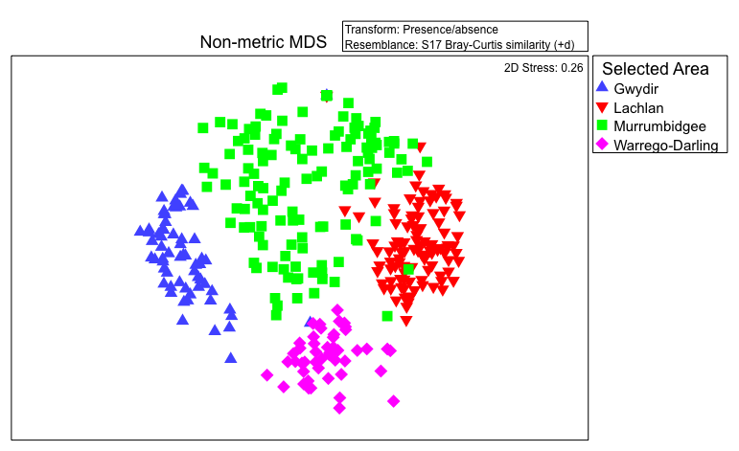

Figure 17. Ordination of vegetation assemblages across the four floodplain / wetland Selected Areas. Sample points represent assemblages at a plot/transect at a particular survey date. (Based on nMDS calculated from species presence/absence, excluding rare species.)

Table 14. Plant species only occurring in Selected Area plots/transects under wet conditions in 2014–15.

|  |  |
| --- | --- |
| **Species restricted to Wet plots/transects across all Selected Areas in 2014–15** | |
| *Atriplex* spp.  Charophytes  *Cotula australis*  *Cycnogeton procerum*  *Cyperus bifax*  *Cyperus concinnus*  *Dysphania ambrosioides\**  *Echinochloa inundata*  *Eichhornia crassipes\**  *Eriochloa pseudoacrotrichaGlyceria* spp.  *Hibiscus trionum*  *Landoltia punctata*  *Lemna* spp.  *Limosella australis*  *Lycium australe*  *Maireana* spp. | *Osteocarpum acropterum*  *Ottelia ovalifolia* subsp. *ovalifolia*  *Oxalis* spp.  *Persicaria hydropiper*  *Physalis minima\**  *Senecio* spp.  *Soliva anthemifolia\**  *Spirodela polyrhiza*  Unknown chenopod  *Vallisneria australis*  *Vittadinia hispidula* |

Note: asterisks (*\**) indicate exotic species.

Table 15. Top-five plant species significantly contributing to similarity of vegetation assemblages within each Selected Area.

|  |  |
| --- | --- |
| **Selected Area** | **Species** |
| Gwydir | *Paspalum distichum* |
| Lachlan | *Duma florulenta*  *Medicago polymorpha\**  *Atriplex semibaccata*  *Paspalidium jubiflorum* |
| Murrumbidgee | *Eleocharis acuta*  *Centipeda cunninghamii*  *Eucalyptus camaldulensis*  *Duma florulenta*  *Ludwigia peploides* subsp. *montevidensis* |
| Warrego-Darling | *Duma florulenta*  *Eucalyptus coolabah*  *Paspalidium jubiflorum*  *Persicaria prostrata* |

Note: as determined by Simper analysis in PRIMER 7;  
asterisk (*\**) indicates exotic species)

### Effects of Commonwealth environmental water on vegetation community diversity at the Basin scale

The composition of vegetation assemblages (i.e. based on species cover) was also highly distinct between Selected Areas (Pseudo-F3, 344 = 23.518, p = 0.01), with significant differences detected by PERMANOVA between all pair-wise combinations (Table 16; Figure 18). Some similarities were detected, however, among assemblages responding to particular water regime categories across Selected Areas (Figure 19). In particular, assemblages developing in response to dry conditions, in both the short-term and over two or more survey dates, tended to be very closely related to each other across all Selected Areas. A compositional shift was apparent, however, with longer durations of drying. In contrast, assemblages developing under wet conditions, as well as those subjected to a mixture of hydrological states, were considerably more heterogeneous (Figure 19). Shifts in composition with prolonged wetting occurred in the opposite direction to those occurring in response to extended drying (i.e. corresponding with the x axis of the ordination).

Table 16. Differences between pair-wise groups of Selected Areas in 2014–15.

|  |  |  |
| --- | --- | --- |
| **Pair-wise group** | **t-value** | **p-value** |
| Gwydir, Lachlan | 6.3466 | 0.001 |
| Gwydir, Murrumbidgee | 6.0627 | 0.001 |
| Gwydir, Warrego–Darling | 6.7418 | 0.001 |
| Lachlan, Murrumbidgee | 3.1894 | 0.001 |
| Lachlan, Warrego–Darling | 3.6875 | 0.001 |
| Murrumbidgee, Warrego–Darling | 3.9186 | 0.001 |

Note: based on PERMANOVA results examining vegetation assemblage composition.

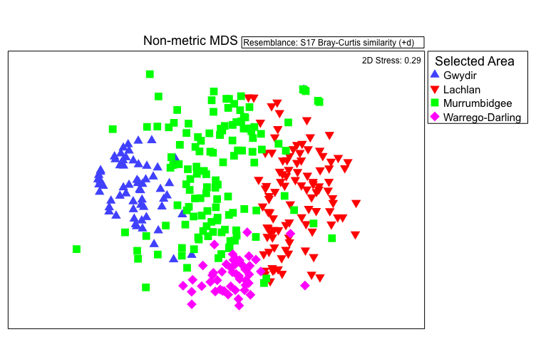

Figure 18. Ordination of vegetation assemblages across the four floodplain/wetland Selected Areas. Sample points represent assemblages at a plot/transect at a particular survey date. (Based on nMDS calculated from species cover values, excluding rare species.)

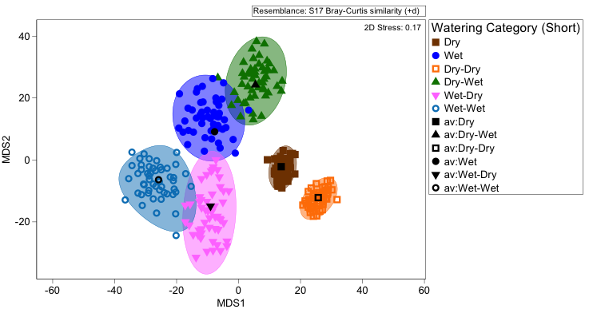

Figure 19. Ordination of vegetation assemblages at the four floodplain/wetland Selected Areas in 2014–15 showing average values and dispersion within each water regime category (based on Bootstrapping procedure. in PRIMER 7). Note: water regime categories for Murrumbidgee condensed to current and preceding states only, i.e. Wet–Wet–Dry–Wet = Dry–Wet.

### Effects of Commonwealth environmental water on vegscape diversity at the Basin scale

Inundation of wetland and floodplain ecosystems (i.e. ANAE types) during 2014–15 resulted in a high proportion of some ecosystem types receiving inundation at a Basin scale (Table 17). In particular, a very high proportion of intermittent river cooba swamp ecosystems was influenced by Commonwealth environmental water across the Basin in 2014–15. A moderate proportion of permanent floodplain grass marshes, permanent floodplain tall emergent marshes, other permanent floodplain wetlands, temporary sedge/grass/forb floodplain marsh and permanent tall emergent marsh were also influenced by Commonwealth environmental water during this period.

Table 17. Estimated areas (hectares) inundated and influenced1 by Commonwealth environmental water of wetland and floodplain ANAE type across the entire Basin in 2014–15.

| **Australian National Aquatic Ecosystem (ANAE) type** | **Area inundated (ha)** | **% of total area of ANAE** | **Area influenced1 (ha)** | **% of total area of ANAE** |
| --- | --- | --- | --- | --- |
| Pt1.4.2: Intermittent river cooba swamp | 17 | 16.6 | 101 | 96.4 |
| Pp2.3.1: Permanent floodplain grass marshes | 23 | 5.2 | 217 | 50.4 |
| Pp2.1.1: Permanent floodplain tall emergent marshes | 471 | 6.0 | 3557 | 45.6 |
| Pp4.1: Permanent floodplain wetland | 4685 | 11.2 | 18 645 | 44.4 |
| Pt2.2.1: Temporary sedge/grass/forb floodplain marsh | 70 | 0.1 | 18 200 | 35.6 |
| Pp2.1.2: Permanent tall emergent marshes | 25 | 18.9 | 31 | 23.0 |
| Pt1.1.1: Intermittent river red gum floodplain swamp | 4130 | 6.5 | 10 043 | 15.8 |
| Lst2.1: Temporary saline floodplain lakes | 1334 | 12.5 | 1383 | 13.0 |
| Rp1.3: Permanent low energy upland streams | 23 | 8.2 | 24 | 8.5 |
| Pt1: Temporary swamps | 264 | 7.0 | 280 | 7.4 |
| Rp1.4: Permanent lowland streams | 2135 | 2.9 | 3906 | 5.2 |
| Pt3.1.2: Clay pans | 1047 | 2.0 | 2098 | 4.1 |
| Psp4: Permanent saline wetland | 157 | 4.0 | 158 | 4.0 |
| Pp2.3.2: Permanent grass marshes | 7 | 3.6 | 7 | 3.6 |
| Pt1.2.1: Intermittent black box floodplain swamp | 322 | 0.9 | 1188 | 3.5 |
| Pst1.1: Temporary saline swamp | 411 | 2.4 | 551 | 3.2 |
| Pt3.1.1: Floodplain clay pans | 1354 | 2.7 | 1578 | 3.2 |
| Pt2.3.1: Floodplain freshwater meadow | 229 | 2.1 | 327 | 2.9 |
| Pt1.7.2: Intermittent lignum swamps | 141 | 0.8 | 321 | 1.8 |
| Rt1: Temporary streams | 3 | 1.0 | 5 | 1.7 |
| Pt4.1: Temporary floodplain wetland | 463 | 0.4 | 1557 | 1.3 |
| Pt1.1.2: Intermittent river red gum swamps | 28 | 0.3 | 91 | 1.1 |
| Rt1.4: Temporary lowland streams | 624 | 0.3 | 2100 | 0.9 |
| Pst4: Temporary saline wetland | 101 | 0.9 | 102 | 0.9 |
| Pt1.3.2: Intermittent coolibah swamp | 3 | 0.3 | 9 | 0.9 |
| Pt1.7.1: Intermittent lignum floodplain swamp | 120 | 0.5 | 205 | 0.8 |
| Lt1.1: Temporary lakes | 171 | 0.1 | 1593 | 0.5 |
| Lp2.1: Permanent floodplain lakes | 627 | 0.5 | 634 | 0.5 |
| Lp1.1: Permanent lakes | 9 | 0.0 | 150 | 0.3 |
| Pt2.2.2: Temporary sedge/grass/forb marsh | 2 | 0.0 | 92 | 0.3 |
| Lt2.1: Temporary floodplain lakes | 148 | 0.1 | 517 | 0.3 |
| Pp4.2: Permanent wetland | 16 | 0.1 | 51 | 0.2 |
| Pp2.2.2: Permanent sedge/grass/forb marshes | 0 | 0.0 | 4 | 0.2 |
| Pt2.1.1: Temporary tall emergent floodplain marsh | 42 | 0.1 | 42 | 0.1 |
| Pt1.3.1: Intermittent coolibah floodplain swamp | 0 | 0.0 | 3 | 0.1 |

1 Area ‘influenced’ comprises total area of all polygons intersected to some degree by Commonwealth environmental water inundation.

# Expected 1–5-year outcomes

## Highlights

* Plant species favoured by Commonwealth environmental water in 2014–15 are likely to have enhanced resilience to drought over the next 1–5 years and should exhibit greater responses (i.e. in terms of presence, extent and abundance) to further wetting over this period.
* The presence, extent and abundance of exotic taxa constrained by Commonwealth environmental water in 2014–15 are likely to be reduced over the next 1–5 years.
* Vegetation communities inundated by Commonwealth environmental water in 2014–15 are likely to have enhanced resilience to drought over the next 1–5 years and should exhibit stronger responses to further wetting over this period.
* Vegetation heterogeneity at landscape scales will by enhanced be CEWO watering in 2014–15.

## Synthesis

### Plant species diversity

Plant species whose presence, extent and/or abundance were favoured by inundation by Commonwealth environmental water in 2014–15 will likely have enhanced resilience to drought over the next 5 years as a result of watering in this year. Even small germination events may be sufficient to trigger reproduction among many floodplain and wetland plant species in these habitats, many of which will, in turn, add to soil seed banks that will enable responses to future wetting (Capon & Brock 2006; James *et al.* 2007). For those species that mainly reproduce vegetatively, e.g. *Eleocharis* spp., watering during 2014–15 will have enabled the development and sustenance of vegetative propagules (e.g. rhizomes) such that survival and capacity to respond to future inundation have been promoted (Reid & Capon 2011). Increased extents and abundances of species that positively responded to watering in 2014–15 may therefore be expected over the next 1–5 years in response to further watering.

Exotic taxa whose presence, extent and/or abundance was constrained by inundation by Commonwealth environmental water in 2014–15 are likely to exhibit reduced extents and abundances over the next 5 years as a result of watering in this year. Most exotic taxa observed appeared to be favoured by dry conditions. Establishment and spread of such exotic taxa, however, may be lower in response to dry conditions as a result of watering in this year because there will be fewer individual plants and propagules available to drive this.

### Vegetation diversity

Vegetation communities that experienced wetting by Commonwealth environmental water in 2014–15 are likely to have enhanced resilience to drought over the next 5 years as a result of plant responses to watering in this year, i.e. replenishment of propagule banks and maintenance of mature perennial plants. Assemblages that have responded to wetting in 2014–15 are also likely to exhibit stronger responses to further wetting in the next 1–5 years as they will have more species, represented by both extant individuals and viable propagules, present to respond. In particular, wetlands that receive frequent and prolonged inundation (e.g. in the Murrumbidgee) may develop greater biomass/cover and richness of aquatic plant communities over this period.

Vegetation heterogeneity at landscape scales is highly likely to be enhanced over the next 1–5 years as a result of watering by Commonwealth environmental water in this year. Even where no further watering occurs, the diversity of vegetation assemblages across landscapes will likely be greater as a result of responses to wetting in this first year of monitoring (or at least homogenisation will occur in response to drying at a slower rate).

# Contribution to achievement of Basin Plan objectives

Watering by Commonwealth environmental water in 2014–15 contributed to both Biodiversity and Ecosystem Resilience objectives associated with vegetation diversity (Table 18). With respect to species diversity, there is considerable evidence from the first year’s outcomes that Commonwealth environmental water increased plant species diversity at Selected Area and Basin scales. The diversity of vegetation communities within Selected Areas and across the Basin was also strongly promoted by the delivery of Commonwealth environmental water in 2014–15. Plant species and vegetation communities influenced by Commonwealth environmental water in 2014–15 are also highly likely to be more resilient to drought over the next 1–5 years as a result of watering in this first year. Greater responses to further watering during this period can also be expected to occur among these species and vegetation communities.

Table 18. Contribution of CEWO watering in 2014–15 to Basin Plan objectives associated with vegetation diversity.

| **Basin Plan objectives** | **Basin Outcomes** | | **Five-year Expected Outcomes** | **One-year Expected Outcomes** | **Measured and predicted one-year outcomes 2014-15** |
| --- | --- | --- | --- | --- | --- |
| Biodiversity  (Basin Plan S. 8.05) | Species diversity | Plants | Greater plant species diversity | Establishment, growth, spread and reproduction of hydrophilic taxa | Some species favoured by Commonwealth environmental water inundation but dependent on Selected Area. |
| Mortality, reduced establishment and spread of xeric taxa | Exotic taxa mostly constrained by Commonwealth environmental water inundation but a few cases where exotic cover promoted by short-duration inundation. |
| Ecosystem diversity | Vegetation | Greater vegetation diversity | Increased richness and productivity of wetland vegetation communities | Mostly, but not consistently, increased diversity and cover of vegetation communities. Highly dependent on timing of survey and community type (e.g. wetland versus floodplain). |
| Shifts in composition of floodplain and wetland vegetation communities | Consistently shifted vegetation composition towards dominance by range of hydrophilic species (often emergent grasses and sedges) and reduced cover of exotic forbs. |
| Increased heterogeneity of vegetation communities at landscape scales | Consistently increased heterogeneity of vegetation at landscape scales. |
| Resilience  (Basin Plan S. 8.07) | Ecosystem resilience | Vegetation | Greater plant species resilience to drought | Enhanced resilience to drought among plant taxa benefitting from Commonwealth environmental water | Species with presence/extent/abundance positively influenced by Commonwealth environmental water will have greater resilience to drought over next 1–5 years and should exhibit greater responses to further wetting. |
| Greater vegetation resilience to drought | Enhanced resilience to drought among vegetation assemblages from Commonwealth environmental water | Vegetation communities influenced by Commonwealth environmental water will have greater resilience to drought over next 1–5 years and should exhibit greater responses to further wetting. |

References

Brock MA, Capon SJ, Porter JL (2006) Disturbance of plant communities dependent on desert rivers. In: Kingsford RT (ed) *Ecology of* *desert rivers*. Cambridge University Press, Cambridge, pp 100–132.

Capon S (2016) Riparian herbs. In: Capon S, James C, Reid M (eds) *Vegetation of Australian riverine landscapes*. CSIRO Publishing, Melbourne, pp 103–118.

Capon S, James C, Reid M (2016) *Vegetation of Australian riverine landscapes* CSIRO Publishing, Melbourne.

Capon SJ (2003) Plant community responses to wetting and drying in a large arid floodplain. *River Research and Applications* **19(5–6)**, 509–520.

Capon SJ (2005) Flood variability and spatial variation in plant community composition and structure on a large arid floodplain. *Journal of Arid Environments* **60(2)**, 283–302.

Capon SJ (2007) Effects of flooding on seedling emergence from the soil seed bank of a large desert floodplain. *Wetlands* **27(4)**, 904–914.

Capon SJ, Brock MA (2006) Flooding, soil seed bank dynamics and vegetation resilience of a hydrologically variable desert floodplain. *Freshwater Biology* **51(2)**, 206–223.

Capon SJ, Chambers LE, Mac Nally R, Naiman RJ, Davies P, Marshall N, Pittock J, Reid M, Capon T, Douglas M, Catford J (2013) Riparian ecosystems in the 21st century: hotspots for climate change adaptation? *Ecosystems* **16(3)**, 359–381.

Casanova MT (2011) Using water plant functional groups to investigate environmental water requirements. *Freshwater Biology* **56(12)**, 2637–2652.

James CS, Capon SJ, White MG, Rayburg SC, Thoms MC (2007) Spatial variability of the soil seed bank in a heterogeneous ephemeral wetland system in semi-arid Australia. *Plant Ecology* **190(2)**, 205–217.

Nilsson C, Svedmark M (2002) Basic principles and ecological consequences of changing water regimes: riparian plant communities. *Environmental Management* **30(4)**, 468–480.

Reid M, Capon S (2011) Role of the soil seed bank in vegetation responses to environmental flows on a drought-affected floodplain. *River Systems* **19(3)**, 249–259.

Stromberg JC (2001) Restoration of riparian vegetation in the south-western United States: importance of flow regimes and fluvial dynamism. *Journal of Arid Environments* **49(1)**, 17–34.

Appendix A. Watering actions contributed to by Commonwealth environmental water in 2014–15 with Expected Outcomes related to vegetation

| **Surface water region/asset** | **Watering Action Reference (WAR)** | **Commonwealth environmental water volume (GL)** | **Dates** | **Flow component** | **Expected Outcomes** |
| --- | --- | --- | --- | --- | --- |
|  |
| Campaspe – Reaches 2 and 4 | 10003-01 | 5.7914 | 09/10/14 – 22/10/14 | Fresh | reduce encroachment of exotic and terrestrial vegetation; enhance river red gum recruitment |
| Goulburn – Reaches 4 and 5 | 10002-01 | 67.46 | 14/10/14 – 11/11/14 | Fresh | improved condition and cover of native in-channel vegetation (especially on banks); discourage terrestrial vegetation encroachment on lower bank |
| Goulburn – Reaches 4 and 5 | 10002-01 | 14.472 | 20/11/14 – 30/11/14 | Fresh | improved condition and cover of native in-channel vegetation |
| Goulburn – Reaches 4 and 5 | 10002-01 | 13.321 | 16/03/15 – 12/04/15 | Fresh | improved condition and cover of native in-channel vegetation |
| Goulburn – Reaches 4 and 5 | 10002-01 | 65.444 | 13/06/15 – 30/06/15 | Fresh | improved condition and cover of native in-channel vegetation (especially on banks); discourage terrestrial vegetation encroachment on lower bank |
| Goulburn – Lower Broken Creek | 10020-01 | 13.592 | 03/10/14 – 30/12/14 | Base | support aquatic and fringing vegetation |
| Goulburn – Lower Broken Creek | 10020-01 | 13.13 | 01/01/15 – 20/04/15 | Base | minimise Azolla build-up, support aquatic and fringing vegetation |
| Goulburn – Lower Broken Creek | 10020-01 | 2.644 | 21/04/15 – 15/05/15 | Base | minimise Azolla build-up, support aquatic and fringing vegetation |
| Goulburn – Moodies Swamp | 10014-01 | 0.25 | 06/10/14 – 02/12/14 | Wetland | Maintain wetland vegetation, especially southern cane grass and the EPBC (1999) listed rigid-water milfoil |
| Gwydir – Gwydir wetlands | 00016-01 | 30 | 17/09/14 – 07/03/15 |  | Maintain water dependent vegetation after a season of drying down, Maintain vegetation condition and reproduction |
| Gwydir – Mallowa wetlands | 00016-02 | 9.667 | 17/09/14 – 07/03/15 |  | Support further recovery of vegetation extent and condition |
| Lachlan – Lower Lachlan | 10013-01 | 5 | 03/10/14 – 29/10/14 | Fresh | Supporting vegetation condition and reproduction |
| Loddon – Reaches 3 and 4 and fringing wetlands | 10001-01 | 2.8695 | 21/09/14 – 07/10/15 | Fresh | native riparian vegetation condition |
| Macquarie–Castlereagh – Macquarie Marshes | 10015-01 | 10 | 13/10/14 – 12/12/14 | Base Fresh Wetland | Inundate core wetlands to contribute to annual water requirements of native marsh vegetation |
| Murrumbidgee – Mid North Redbank | 10023-01 | 40 | 12/08/14 – 20/01/15 | Wetland | protect, maintain, and in some cases improve the condition and extent of floodplain, riparian and wetland native vegetation |
| Murrumbidgee – Yanga National Park | 10023-02 | 74.512 | 23/10/14 – 10/04/15 | Wetland | protect, maintain, and in some cases improve the condition and extent of floodplain, riparian and wetland native vegetation |
| Murrumbidgee – Upper North Redbank | 10023-03 | 20 | 01/10/14 – 25/03/15 | Wetland | protect, maintain, and in some cases improve the condition and extent of floodplain, riparian and wetland native vegetation |
| Murrumbidgee – Yarradda Lagoon | 10023-04 | 1.15 | 04/12/14 – 22/01/15 | Wetland | protect and maintain wetland and riparian native vegetation |
| Murrumbidgee – Sandy Creek | 10023-05 | 0.25 | 22/03/15 – 01/04/15 | Wetland | protect and maintain wetland and riparian native vegetation |
| Murrumbidgee – Juanbung | 10023-06 | 5.688 | 04/05/15 – 29/06/15 | Wetland | water stressed river gum floodplain and riparian native vegetation |
| Murrumbidgee – Paika Lake | 10023-06 | 8.498 | 25/05/15 – 27/06/15 | Wetland | inundate fringing aquatic vegetation communities |
| Murrumbidgee – Yanco Creek | 10005-02 | 2.46 | 23/06/15 – 30/06/15 | Wetland | protect, maintain, and in some cases improve the condition and extent of floodplain, riparian and wetland native vegetation |
| NSW Murray – Edward–Wakool: Yallakool Creek and Wakool River | 10008-01 | 34.563 | 12/08/14 – 09/01/15 | Base | instream aquatic vegetation condition, germination, recruitment and dispersal |
| NSW / Vic Murray – River Murray Hume Dam to Coroong | 10031-01 | 23.5 | 22/06/15 – 30/06/15 | Fresh | Maintaining the extent and condition of riparian and in-channel vegetation; - Maintaining the current extent of Ruppia tuberosa, - Maintaining the diversity, condition and extent of aquatic and littoral vegetation in the Lower Lakes |
| Vic Murray – Mulcra Island | 10009-02 | 3.7609 | 12/08/14 – 22/12/14 | Wetland | Maintain and improve diversity and condition of native riverine, wetland and floodplain veg, particulary higher elevation lignum vegetation communities |
| Vic Murray – Hattah Lakes | NA | 34.2389 | 26/05/14 – 17/01/15 | Wetland | Increase the diversity, extent and abundance of wetland and floodplain vegetation communities, particularly river red gum and black box woodlands |
| SA Murray – Murray River from Wentworth to Lower Lakes | 10009-01 | 191.833 | 04/09/14 – 31/12/14 | Base | Maintain and improve the condition, diversity and extent of floodplain and wetland native vegetation |
| SA Murray – Overland Corner | 10009-05 | 0.842 | 17/12/14 – 15/05/15 | Wetland | Maintain condition of mature river red gum, Support establishment of juvenile river red gum, Stimulate germination and complete life cycle of aquatic vegetation |
| SA Murray – Piggy Creek | 10009-05 | 0.201 | 11/11/14 – 21/11/14 | Wetland | Maintain condition of mature river red gum, Support establishment of juvenile river red gum |
| SA Murray – Wella | 10009-05 | 0.255 | 12/11/14 – 21/02/15 | Wetland | Maintain condition of mature river red gum, Maintain understorey vegetation (e.g. lignum) condition |
| SA Murray – Whirlpool | 10009-05 | 0.09 | 02/12/14 – 24/03/15 | Wetland | Maintain condition of mature river red gum, Support establishment of juvenile river red gum, Stimulate germination and complete life cycle of aquatic vegetation |
| SA Murray – Markaranka South | 10009-06 | 1.652 | 01/12/14 – 07/06/15 | Wetland | Maintain condition of mature river red gum, Stimulate germination and complete life cycle of aquatic vegetation |
| SA Murray – Markaranka East | 10009-06 | 0.6 | 06/01/15 – 24/02/15 | Wetland | Maintain understorey vegetation (e.g. lignum) condition |
| SA Murray – Nikalapko | 10009-06 | 0.8 | 10/11/14 – 28/11/14 | Wetland | Maintain condition of mature river red gum |
| SA Murray – Molo Flats | 10009-06 | 0.703 | 03/12/14 – 02/04/15 | Wetland | Maintain condition of mature river red gum |
| SA Murray – Wigley | 10009-06 | 0.31 | 13/11/14 – 23/01/15 | Wetland | Maintain condition of mature river red gum |
| SA Murray – Akuna | 10009-06 | 0.125 | 26/11/14 – 04/12/15 | Wetland | Maintain condition of mature river red gum, Support establishment of juvenile river red gums, Maintain understorey vegetation (e.g. lignum) condition |
| SA Murray – Johnson’s Waterhole | 00137-01 | 0.162 | 02/09/14 – 15/06/15 | Wetland | Improve cover and condition of under-storey vegetation, including lignum |
| SA Murray – Clark’s Floodplain | 00148-04 | 0.201 | 27/10/14 – 15/06/15 | Wetland | Improve condition of mature trees including black box, river coobah and river red gum., Improve cover and condition of under-storey vegetation, including lignum |
| SA Murray – Loxton Riverfront Reserve | 00148-05 | 0.039 | 25/09/14 – 15/06/15 | Wetland | Improve soil moisture levels to enhance survival of seedlings arising from 2011 flood event Improve condition of mature trees including black box, river coobah and river red gum., Improve cover and condition of under-storey vegetation, including lignum |
| SA Murray – Thiele’s Flat | 00148-06 | 0.033 | 02/09/14 – 30/04/15 | Wetland | Improve condition of mature trees including black box, river coobah and river red gum., Improve cover and condition of under-storey vegetation, including lignum |
| SA Murray – Ramco River Terrace | 00150-03 | 0.008 | 06/11/14 – 30/04/15 | Wetland | Improve soil moisture levels to enhance survival of seedlings arising from 2011 flood event Improve condition of mature trees including black box, river coobah and river red gum., Improve cover and condition of under-storey vegetation, including lignum |
| SA Murray – Rilli Reach | 00150-04 | 0.025 | 19/11/14 – 30/04/15 | Wetland | Improve soil moisture levels to enhance survival of seedlings arising from 2011 flood event Improve condition of mature trees including black box, river coobah and river red gum., Improve cover and condition of under-storey vegetation, including lignum |
| SA Murray – Cobdogla | 00150-04 | 0.002 | 04/03/15 – 10/03/15 | Wetland | Improve condition of mature trees including black box, river coobah and river red gum |
| SA Murray – Calperum Station | 10024-01 | 0.276 | 05/11/14 – 15/06/15 | Wetland | Improve condition of mature trees including black box, river coobah and river red gum., Improve cover and condition of under-storey vegetation, including lignum |
| SA Murray – Duck Hole | 10024-03 | 0.220 | 13/11/14 – 07/12/14 | Wetland | Improve soil moisture levels to enhance survival of seedlings arising from 2011 flood event Improve condition of mature trees including black box, river coobah and river red gum., Improve cover and condition of under-storey vegetation, including lignum |
| SA Murray – South Teringie | 10024-03 | 0.136 | 25/11/14 – 30/05/14 | Wetland | Improve the condition of Ruppia polycarpa and Halosarcia spp. shrubland, and beds of submerged aquatic macrophytes |
| Wimmera–Mallee – Brickworks Billabong | 10011-02 | 0.0999 | x | Wetland | Maintain and improve the health of aquatic vegetation |
| Wimmera–Mallee – Bridge Creek | 10011-02 | 0.233 | x | Wetland | Promote ecological recovery of the site, particularly River Red Gum and Black Box communities |
| Wimmera–Mallee – Bullock Swamp | 10011-02 | 0.2995 | x | Wetland | Provide freshwater inflows to reduce salinity levels and improve the condition and diversity of wetland vegetation, improving ecological function |
| Wimmera–Mallee – Burra Creek South | 10011-02 | 0.3151 | x | Wetland | Promote ecological recovery of the site, particularly River Red Gum and Black Box communities |
| QLD Border Rivers – Severn River | 00111-17 | 0.3179 | 11/12/14 – 16/12/14 | Bankfull | Inundation, maintenance of riparian vegetation |
| QLD Border Rivers – Severn River | 00111-17 | 0.931 | 27/12/14 – 30/01/15 | Bankfull | Inundation, maintenance of riparian vegetation |

Appendix B. Plant taxa recorded from Selected Areas under different water regime categories in 2014–15. Note: Edward-Wakool data is not included as data was not available to M&E Adviser.

|  |  |  |  | **Gwydir** | | | | | | **Lachlan** | | **Warrego–Darling** | | | | **Murrumbidgee** | | | | | | | | | | | | | | | | | | | |  |
| --- | --- | --- | --- | --- | --- | --- | --- | --- | --- | --- | --- | --- | --- | --- | --- | --- | --- | --- | --- | --- | --- | --- | --- | --- | --- | --- | --- | --- | --- | --- | --- | --- | --- | --- | --- | --- |
| **Species name** | **Family** | **Authority** | **Goulburn** | **Dry** | **Wet** | **Dry–Dry** | **Dry–Wet** | **Wet–Dry** | **Wet–Wet** | **Dry** | **Dry–Dry** | **Dry** | **Wet** | **Dry–Dry** | **Wet–Dry** | **Dry** | **Dry–Dry** | **Dry–Dry–Dry** | **Dry–Dry–Dry–Dry** | **Dry–Dry–Wet** | **Dry–Dry–Wet–Dry** | **Dry–Wet** | **Dry–Wet–Dry** | **Dry–Wet–Dry–Dry** | **Dry–Wet–Wet** | **Dry–Wet–Wet–Dry** | **Dry–Wet–Wet–Wet** | **Wet** | **Wet–Dry** | **Wet–Dry–Dry** | **Wet–Dry–Dry–Dry** | **Wet–Wet** | **Wet–Wet–Wet** | **Wet–Wet–Wet–Dry** | **Wet–Wet–Wet–Wet** | **Total count** |
| *Abutilon malvifolium* | Malvaceae | (Benth.) J.M.Black |  |  |  |  |  |  |  |  |  | + |  |  |  |  |  |  |  |  |  |  |  |  |  |  |  |  |  |  |  |  |  |  |  | 3 |
| *Abutilon otocarpum* | Malvaceae | F.Muell. |  |  |  |  |  |  |  |  |  | + |  | + | + |  |  |  |  |  |  |  |  |  |  |  |  |  |  |  |  |  |  |  |  | 7 |
| *Abutilon oxycarpum* | Malvaceae | (F.Muell.) F.Muell. ex Benth. |  | + |  |  |  |  |  |  |  | + |  |  |  |  |  |  |  |  |  |  |  |  |  |  |  |  |  |  |  |  |  |  |  | 2 |
| *Abutilon* spp. | Malvaceae | Mill. |  |  |  |  |  |  |  |  |  | + | + |  |  |  |  |  |  |  |  |  |  |  |  |  |  |  |  |  |  |  |  |  |  | 7 |
| *Abutilon theophrasti\** | Malvaceae | Medik. |  |  |  |  |  |  |  | + | + |  |  |  |  |  |  |  |  |  |  |  |  |  |  |  |  |  |  | + |  |  |  |  |  | 5 |
| *Acacia dealbata* | Fabaceae | Link | + |  |  |  |  |  |  |  |  |  |  |  |  |  |  |  |  |  |  |  |  |  |  |  |  |  |  |  |  |  |  |  |  | 222 |
| *Acacia salicina* | Fabaceae | Lindl. |  |  |  |  |  |  |  | + | + |  |  |  |  |  |  |  |  |  |  |  |  |  |  |  |  |  |  |  |  |  |  |  |  | 3 |
| *Acacia* spp. | Fabaceae | Mill. |  |  |  |  |  |  |  |  | + |  |  |  |  |  |  |  |  |  |  |  |  |  |  |  |  |  |  |  |  |  |  |  |  | 2 |
| *Acacia stenophylla* | Fabaceae | A.Cunn. ex Benth. |  | + |  |  | + |  |  | + | + | + | + | + | + |  |  |  |  |  |  |  |  |  |  |  |  |  |  |  |  |  |  |  |  | 52 |
| *Acacia victoriae* | Fabaceae | Benth. |  |  |  |  |  |  |  |  |  | + |  | + |  |  |  |  |  |  |  |  |  |  |  |  |  |  |  |  |  |  |  |  |  | 4 |
| *Aeschynomene indica* | Fabaceae | L. |  | + | + | + | + | + | + |  |  |  |  |  |  |  |  |  |  |  |  |  |  |  |  |  |  |  |  |  |  |  |  |  |  | 41 |
| *Alternanthera denticulata* | Amaranthaceae | R.Br. | + | + | + | + | + | + |  | + | + | + | + | + | + | + | + |  |  | + | + |  |  | + | + | + | + | + | + | + | + |  | + | + | + | 237 |
| *Alternanthera nodiflora* | Amaranthaceae | R.Br. |  |  |  |  |  |  |  | + |  | + | + |  | + |  |  |  |  | + |  |  |  |  |  |  |  |  |  |  |  |  |  |  |  | 7 |
| *Alternanthera* spp. | Amaranthaceae | Forssk. |  |  |  |  |  |  |  |  | + |  |  |  |  |  |  |  |  |  |  |  |  |  |  |  |  |  |  |  |  |  |  |  |  | 2 |
| *Amaranthus macrocarpus* | Amaranthaceae | Benth. |  | + |  | + |  |  |  |  | + |  |  |  |  |  |  |  |  |  |  |  |  |  |  |  |  |  |  |  |  |  |  |  |  | 5 |
| *Ammannia multiflora* | Lythraceae | Roxb. |  |  | + | + | + | + |  |  |  |  |  |  |  |  |  |  |  |  | + |  | + |  | + | + |  |  |  |  |  |  | + | + | + | 22 |
| *Amphibromus nervosus* | Poaceae | (Hook.f.) Baill. |  | + | + |  |  |  |  |  |  |  |  |  |  |  |  |  |  |  |  |  |  |  |  |  |  |  |  |  |  |  |  |  |  | 7 |
| *Amyema miquelii* | Loranthaceae | (Lehm. ex Miq.) Tiegh. |  | + |  |  |  |  |  |  |  |  |  |  |  |  |  |  |  |  |  |  |  |  |  |  |  |  |  |  |  |  |  |  |  | 1 |
| *Amyema quandang* var. *quandang* | Loranthaceae | (Lindl.) Tiegh |  | + |  |  | + |  |  |  |  |  |  |  |  |  |  |  |  |  |  |  |  |  |  |  |  |  |  |  |  |  |  |  |  | 6 |
| *Amyema* spp. | Loranthaceae | Tiegh. |  | + |  |  |  |  |  |  |  | + |  |  |  |  |  |  |  |  |  |  |  |  |  |  |  |  |  |  |  |  |  |  |  | 2 |
| *Anthosachne multiflora* | Poaceae | (Banks&Sol. ex Hook.f.) C.Yen & J.L.Yang | + |  |  |  |  |  |  |  |  |  |  |  |  |  |  |  |  |  |  |  |  |  |  |  |  |  |  |  |  |  |  |  |  | 3 |
| *Arabidella nasturtium* | Brassicaceae | (F.Muell.) E.A.Shaw |  |  |  |  |  |  |  |  | + |  |  |  |  |  |  |  |  |  |  |  |  |  |  |  |  |  |  |  |  |  |  |  |  | 1 |
| *Argemone ochroleuca* subsp. *ochroleuca\** | Papaveraceae | Sweet |  | + |  | + |  |  |  |  |  | + |  | + |  |  |  |  |  |  |  |  |  |  |  |  |  |  |  |  |  |  |  |  |  | 11 |
| *Asperula conferta* | Rubiaceae | Hook.f. |  |  |  |  |  |  |  |  | + |  |  |  |  |  |  |  |  |  |  |  |  |  |  |  |  |  |  |  |  |  |  | + |  | 3 |
| *Asperula gemella* | Rubiaceae | Airy Shaw & Turrill |  |  |  |  |  |  |  | + | + |  |  |  |  |  |  |  |  |  |  |  |  |  |  |  |  |  |  |  |  |  |  |  |  | 6 |
| *Asperula geminifolia* | Rubiaceae | F.Muell. |  |  |  |  |  |  |  |  |  |  |  |  |  | + |  |  |  |  |  |  |  |  |  | + |  | + | + |  |  |  |  | + |  | 18 |
| *Aster subulatus\** | Asteraceae | Michx. | + | + | + | + | + | + | + |  |  |  |  |  |  |  |  |  |  |  |  |  |  |  |  |  |  |  |  |  |  |  |  |  |  | 63 |
| Asteraceae | Asteraceae |  |  |  |  |  |  |  |  | + | + | + |  | + |  |  |  |  |  |  |  |  |  |  |  |  |  |  |  |  |  |  |  |  |  | 61 |
| *Atriplex leptocarpa* | Chenopodiaceae | F.Muell. |  | + |  |  |  |  |  | + |  |  |  |  |  |  |  |  |  |  |  |  |  |  |  |  |  |  |  |  |  |  |  |  |  | 6 |
| *Atriplex lindleyi* | Chenopodiaceae | Moq. |  |  |  |  |  |  |  | + | + |  |  |  |  |  |  |  |  |  |  |  |  |  |  |  |  |  |  |  |  |  |  |  |  | 13 |
| *Atriplex muelleri* | Chenopodiaceae | Benth. |  |  |  |  |  |  |  |  |  | + |  | + |  |  |  |  |  |  |  |  |  |  |  |  |  |  |  |  |  |  |  |  |  | 3 |
| *Atriplex nummularia* | Chenopodiaceae | Lindl. |  |  |  |  |  |  |  | + | + |  |  |  |  |  |  |  |  |  |  |  |  |  |  |  |  |  |  |  |  |  |  |  |  | 5 |
| *Atriplex semibaccata* | Chenopodiaceae | R.Br. |  |  |  |  |  |  |  | + | + |  |  |  |  | + | + | + | + | + | + | + |  |  | + |  |  |  | + | + | + | + | + |  |  | 185 |
| *Atriplex spp.* | Chenopodiaceae | L. |  |  |  |  |  |  |  | + |  | + |  | + |  |  |  |  |  |  |  |  |  |  |  |  |  | + |  |  |  |  |  |  |  | 10 |
| *Atriplex vesicaria* | Chenopodiaceae | Heward ex Benth. |  |  |  |  |  |  |  | + | + |  |  |  |  |  |  |  |  |  |  |  |  |  |  |  |  |  |  |  |  |  |  |  |  | 15 |
| *Avena* spp.*\** | Poaceae | L. | + |  |  |  |  |  |  |  |  |  |  |  |  |  |  |  |  |  |  |  |  |  |  |  |  |  |  |  |  |  |  |  |  | 13 |
| *Azolla filiculoides* | Salviniaceae | Lam. |  |  | + |  | + | + |  |  |  |  |  |  |  | + |  |  |  |  |  | + |  |  | + | + | + | + | + | + |  |  | + |  | + | 62 |
| *Boerhavia dominii* | Nyctaginaceae | Meikle & Hewson |  |  |  | + |  |  |  | + | + | + |  |  | + |  |  |  |  |  |  |  |  |  |  |  |  |  |  |  |  |  |  |  |  | 13 |
| *Boerhavia* spp. | Nyctaginaceae | L. |  |  |  |  |  |  |  |  | + |  |  |  |  |  |  |  |  |  |  |  |  |  |  |  |  |  |  |  |  |  |  |  |  | 1 |
| *Bolboschoenus fluviatilis* | Cyperaceae | (Torr.) Sojak |  | + |  | + |  |  |  |  |  |  |  |  |  |  |  |  |  |  |  |  |  |  |  |  |  |  |  |  |  |  |  |  |  | 3 |
| *Brachyscome basaltica* var. *gracilis* | Asteraceae | Benth. |  |  |  |  |  |  |  | + | + |  |  |  |  | + |  |  |  |  |  | + |  | + | + |  | + | + |  |  |  | + |  |  |  | 29 |
| *Brachyscome goniocarpa* | Asteraceae | Sond. & F.Muell. |  |  |  |  |  |  |  |  | + |  |  |  |  |  |  |  |  |  |  |  |  |  |  |  |  |  |  |  |  |  |  |  |  | 2 |
| *Brachyscome* spp. | Asteraceae | Cass. |  | + |  |  |  |  |  |  | + |  |  |  |  |  |  |  |  |  |  |  |  |  |  |  |  |  |  |  |  |  |  |  |  | 3 |
| *Brassica tournefortii\** | Brassicaceae | Gouan |  |  |  |  |  |  |  |  |  | + |  |  |  |  |  |  |  |  |  |  |  |  |  |  |  |  |  |  |  |  |  |  |  | 1 |
| Brassicaceae | Brassicaceae |  |  |  |  |  |  |  |  |  | + | + |  |  |  |  |  |  |  |  |  |  |  |  |  |  |  |  |  |  |  |  |  |  |  | 2 |
| *Bromus diandrus\** | Poaceae | Roth | + |  |  |  |  |  |  |  |  |  |  |  |  |  |  |  |  |  |  |  |  |  |  |  |  |  |  |  |  |  |  |  |  | 12 |
| *Bulbine semibarbata* | Asphodelaceae | (R.Br.) Haw. |  | + |  |  |  |  |  |  |  |  |  |  |  | + |  |  |  |  |  |  |  |  |  |  |  |  |  |  |  |  |  |  |  | 3 |
| *Callitriche umbonata* | Plantaginaceae | Hegelm. |  |  |  |  |  |  |  |  |  |  |  |  |  | + |  |  |  |  |  |  |  |  |  |  | + | + |  |  |  |  |  |  |  | 9 |
| *Calotis erinacea* | Asteraceae | Steetz |  |  |  |  |  |  |  |  |  |  |  | + |  |  |  |  |  |  |  |  |  |  |  |  |  |  |  |  |  |  |  |  |  | 1 |
| *Calotis hispidula* | Asteraceae | (F.Muell.) F.Muell. |  | + |  |  |  |  |  |  |  |  |  |  |  |  |  |  |  |  |  |  |  |  |  |  |  |  |  |  |  |  |  |  |  | 1 |
| *Calotis scabiosifolia* | Asteraceae | Sond. & F.Muell. |  |  |  |  |  |  |  |  |  | + |  |  |  |  |  |  |  |  |  |  |  |  |  |  |  |  |  |  |  |  |  |  |  | 1 |
| *Calotis scapigera* | Asteraceae | Hook. | + | + |  |  |  |  |  |  |  |  |  |  |  | + | + | + | + |  | + | + |  |  |  |  |  | + | + | + |  |  |  |  |  | 34 |
| *Calotis* spp. | Asteraceae | R.Br. |  | + |  |  |  |  |  |  |  |  |  |  |  |  |  |  |  |  |  |  |  |  |  |  |  |  |  |  |  |  |  |  |  | 1 |
| *Capsella bursa-pastoris\** | Brassicaceae | (L.) Medik. |  |  |  |  |  |  |  |  | + |  |  |  |  |  |  |  |  |  |  |  |  |  |  |  |  |  |  |  |  |  |  |  |  | 5 |
| *Cardamine hirsuta\** | Brassicaceae | L. |  |  |  |  |  |  |  |  | + |  |  |  |  |  |  |  |  |  |  |  |  |  |  |  |  |  |  |  |  |  |  |  |  | 1 |
| *Carex appressa* | Cyperaceae | R.Br. | + |  | + |  |  | + |  |  |  |  |  |  |  |  |  |  |  |  | + |  |  |  |  |  |  |  |  |  |  |  |  |  |  | 7 |
| *Carex inversa* | Cyperaceae | R.Br. |  | + | + |  |  |  |  |  |  |  |  |  |  |  |  |  |  |  |  |  |  |  |  |  |  |  |  |  |  |  |  |  |  | 2 |
| *Carex* spp. | Cyperaceae | L. | + |  |  |  |  |  |  |  |  |  |  |  |  |  |  |  |  |  |  |  |  |  |  |  |  |  |  |  |  |  |  |  |  | 16 |
| *Carex tereticaulis* | Cyperaceae | F.Muell. | + |  |  |  |  |  |  |  |  |  |  |  |  |  |  |  |  |  |  |  |  |  |  |  |  |  |  |  |  |  |  |  |  | 5 |
| *Carrichtera annua\** | Brassicaceae | (L.) DC. |  |  |  |  |  |  |  | + | + |  |  |  |  |  |  |  |  |  |  |  |  |  |  |  |  |  |  |  |  |  |  |  |  | 16 |
| *Carthamus lanatus\** | Asteraceae | L. |  |  |  |  |  |  |  |  |  |  |  |  |  |  |  |  |  |  |  |  |  |  |  |  |  |  | + |  |  |  |  |  |  | 1 |
| *Caryophyllaceae* | Caryophyllaceae |  |  |  |  |  |  |  |  |  |  |  |  | + |  |  |  |  |  |  |  |  |  |  |  |  |  |  |  |  |  |  |  |  |  | 4 |
| *Casuarina cristata* | Casuarinaceae | Miq. |  | + |  | + |  |  |  |  |  |  |  |  |  |  |  |  |  |  |  |  |  |  |  |  |  |  |  |  |  |  |  |  |  | 2 |
| *Cenchrus ciliaris\** | Poaceae | L. |  |  |  |  |  |  |  |  |  | + |  |  |  |  |  |  |  |  |  |  |  |  |  |  |  |  |  |  |  |  |  |  |  | 1 |
| *Centaurea melitensis\** | Asteraceae | L. |  |  |  |  |  |  |  |  |  | + |  |  |  |  |  |  |  |  |  |  |  |  |  |  |  |  |  |  |  |  |  |  |  | 2 |
| *Centaurium tenuiflorum\** | Gentianaceae | (Hoffmanns. & Link) Fritsch |  |  |  |  |  |  |  |  |  |  |  |  |  | + |  |  |  |  |  |  |  |  |  |  |  | + | + |  |  |  |  |  |  | 3 |
| *Centipeda cunninghamii* | Asteraceae | (DC.) A.Braun & Asch. | + |  |  |  |  |  |  | + | + |  |  |  |  | + | + |  |  | + | + | + |  |  | + | + | + | + | + | + | + | + | + | + | + | 150 |
| *Centipeda minima* | Asteraceae | (L.) A.Braun & Asch. |  | + | + |  |  |  |  |  |  |  |  | + | + |  |  |  |  |  |  |  |  |  |  |  |  |  |  |  |  |  |  |  |  | 12 |
| *Centipeda pleiocephala* | Asteraceae | N.G.Walsh |  | + |  |  |  |  |  |  |  |  |  |  |  |  |  |  |  |  |  |  |  |  |  |  |  |  |  |  |  |  |  |  |  | 1 |
| *Characeae* | Characeae |  |  |  |  |  |  |  |  |  |  |  |  |  |  |  |  |  |  |  |  |  |  |  |  |  | + | + |  |  |  | + |  |  | + | 6 |
| *Chenopodiaceae* | Chenopodiaceae |  |  |  | + |  |  |  |  |  |  |  |  | + |  |  |  | + |  |  |  |  |  |  |  |  |  |  |  |  |  |  |  |  |  | 3 |
| *Chenopodium album\** | Chenopodiaceae | L. |  |  |  |  |  |  |  |  | + |  |  |  |  | + |  |  |  |  |  |  |  |  | + |  |  |  |  | + |  |  |  |  |  | 14 |
| *Chenopodium atriplicinum* | Chenopodiaceae | (F.Muell.) F.Muell. |  |  |  |  |  |  |  |  | + |  |  |  |  | + | + |  |  |  |  |  |  |  |  |  |  |  |  |  |  |  |  |  |  | 97 |
| *Chenopodium curvispicatum* | Chenopodiaceae | Paul G. Wilson |  |  |  |  |  |  |  |  |  |  |  |  |  |  |  | + |  |  | + |  |  |  |  |  |  |  |  |  |  |  |  |  |  | 11 |
| *Chenopodium desertorum subsp. andiophyllum* | Chenopodiaceae | (Aellen) Paul G. Wilson |  |  |  |  |  |  |  |  |  |  |  |  |  |  |  | + |  |  |  |  |  |  |  |  |  |  |  |  |  |  |  |  |  | 9 |
| *Chenopodium murale\** | Chenopodiaceae | L. |  | + |  |  |  |  |  | + | + |  |  |  |  |  |  |  |  |  |  |  |  |  |  |  |  |  |  |  |  |  |  |  |  | 8 |
| *Chenopodium nitrariaceum* | Chenopodiaceae | (F.Muell.) F.Muell. ex Benth. |  |  |  |  |  |  |  | + | + | + |  |  |  |  | + |  |  |  | + |  |  |  |  | + |  | + | + | + | + | + | + |  | + | 62 |
| *Chenopodium* spp. | Chenopodiaceae | L. |  | + |  |  |  |  |  | + | + | + |  |  |  |  |  |  |  |  |  |  |  |  |  |  |  |  |  |  |  |  |  |  |  | 4 |
| *Chloris* spp. | Poaceae | Sw. |  | + |  |  |  |  |  |  |  |  |  |  |  |  |  |  |  |  |  |  |  |  |  |  |  |  |  |  |  |  |  |  |  | 1 |
| *Chondrilla juncea\** | Asteraceae | L. |  |  |  |  |  |  |  |  |  |  |  | + |  |  |  |  |  |  |  |  |  |  |  |  |  |  |  |  |  |  |  |  |  | 1 |
| *Cichorium intybus\** | Asteraceae | L. |  |  |  |  |  |  |  |  |  | + |  |  |  |  |  |  |  |  |  |  |  |  |  |  |  |  |  |  |  |  |  |  |  | 1 |
| *Cirsium vulgare\** | Asteraceae | (Savi) Ten. | + | + | + | + | + | + |  | + | + | + |  | + |  | + | + | + | + | + | + |  |  |  |  | + |  | + | + | + |  |  |  |  |  | 194 |
| *Citrullus lanatus\** | Cucurbitaceae | (Thunb.) Matsum. & Nakai |  | + |  |  |  |  |  |  |  |  |  |  |  |  |  |  |  |  |  |  |  |  |  |  |  |  |  |  |  |  |  |  |  | 1 |
| *Convolvulus erubescens* | Convolvulaceae | Sims |  | + |  |  |  |  |  | + |  |  |  |  |  |  |  |  |  |  |  |  |  |  |  |  |  |  |  |  |  |  |  |  |  | 2 |
| *Convolvulus graminetinus* | Convolvulaceae | R.W.Johnson |  | + |  |  |  |  |  |  |  |  |  |  |  |  |  |  |  |  |  |  |  |  |  |  |  |  |  |  |  |  |  |  |  | 2 |
| *Convolvulus* spp. | Convolvulaceae | L. |  | + |  |  |  |  |  |  |  |  |  |  |  |  |  |  |  |  |  |  |  |  |  |  |  |  |  |  |  |  |  |  |  | 1 |
| *Conyza bonariensis\** | Asteraceae | (L.) Cronquist |  | + | + | + |  | + |  |  |  |  |  | + |  | + | + |  |  |  | + | + |  |  |  |  |  |  |  | + |  | + |  |  |  | 50 |
| *Conyza* spp.*\** | Asteraceae | Less. | + |  |  |  |  |  |  |  |  | + | + | + | + |  |  |  |  |  |  |  |  |  |  |  |  |  |  |  |  |  |  |  |  | 13 |
| *Conyza sumatrensis\** | Asteraceae | (Retz.) E.Walker | + |  |  |  |  |  |  |  |  |  |  |  |  |  |  |  |  |  |  |  |  |  |  |  |  |  |  |  |  |  |  |  |  | 1 |
| *Cotula australis* | Asteraceae | (Sieber ex Spreng.) Hook.f. |  |  |  |  |  |  |  |  |  |  |  |  |  |  |  |  |  |  |  |  |  |  |  |  |  | + |  |  |  |  |  |  |  | 3 |
| *Crassula helmsii* | Crassulaceae | (Kirk) Cockayne |  |  |  |  |  |  |  |  |  |  |  |  |  | + |  |  |  |  |  |  |  |  |  |  |  | + |  |  |  | + |  |  |  | 15 |
| *Crinum flaccidum* | Amaryllidaceae | Herb. |  |  | + |  |  |  |  |  |  |  |  | + |  |  |  |  |  |  |  |  |  |  |  |  |  |  |  |  |  |  |  |  |  | 2 |
| *Cucumis myriocarpus\** | Cucurbitaceae | Naudin |  |  |  |  |  |  |  |  | + | + |  | + | + |  |  |  |  |  |  |  |  |  |  |  |  |  |  |  |  |  |  |  |  | 11 |
| *Cullen cinereum* | Fabaceae | (Lindl.) J.W.Grimes |  |  |  |  |  |  |  | + | + |  |  |  |  |  |  |  |  |  |  |  |  |  |  |  |  |  |  |  |  |  |  |  |  | 3 |
| *Cullen tenax* | Fabaceae | (Lindl.) J.W.Grimes |  | + | + | + |  |  |  |  |  |  |  |  |  |  |  |  |  |  |  |  |  |  |  |  |  |  |  |  |  |  |  |  |  | 10 |
| *Cuscuta* spp. | Convolvulaceae | L. |  | + |  |  |  |  |  |  |  |  |  |  |  |  |  |  |  |  |  |  |  |  |  |  |  |  |  |  |  |  |  |  |  | 1 |
| *Cyclospermum leptophyllum\** | Apiaceae | (Pers.) Sprague |  | + | + |  |  |  |  |  |  |  |  |  |  |  |  |  |  |  |  |  |  |  |  |  |  |  |  |  |  |  |  |  |  | 5 |
| *Cycnogeton dubium* | Juncaginaceae | (R.Br.) Mering & Kadereit |  |  | + |  | + | + | + |  |  |  |  |  |  |  |  |  |  |  |  |  |  |  |  |  |  |  |  |  |  |  |  |  |  | 7 |
| *Cycnogeton procerum* | Juncaginaceae | (R.Br.) Buchenau |  |  |  |  |  |  |  |  |  |  |  |  |  |  |  |  |  |  |  |  |  |  |  |  | + |  |  |  |  |  |  |  |  | 2 |
| *Cynodon dactylon* | Poaceae | (L.) Pers. |  | + | + | + |  |  |  | + | + | + | + | + | + | + |  |  | + |  |  |  |  |  |  |  |  |  |  |  |  |  |  |  |  | 37 |
| *Cyperaceae* | Cyperaceae |  | + |  |  |  |  |  |  |  |  |  |  |  |  |  |  |  |  |  |  |  |  |  |  |  |  |  |  |  |  |  |  |  |  | 11 |
| *Cyperus bifax* | Cyperaceae | C.B.Clarke |  |  | + |  |  |  |  |  |  |  |  |  |  |  |  |  |  |  |  |  |  |  |  |  |  |  |  |  |  |  |  |  |  | 2 |
| *Cyperus concinnus* | Cyperaceae | R.Br. |  |  | + |  |  |  |  |  |  |  |  |  |  |  |  |  |  |  |  |  |  |  |  |  |  |  |  |  |  |  |  |  |  | 1 |
| *Cyperus difformis* | Cyperaceae | L. |  | + | + | + | + | + | + |  |  |  |  |  |  |  | + |  |  |  |  |  |  |  | + | + | + |  |  |  |  |  | + | + | + | 49 |
| *Cyperus eragrostis\** | Cyperaceae | Lam. | + |  |  |  |  |  |  |  |  |  |  |  |  | + | + |  |  | + | + |  |  |  |  |  |  |  |  |  |  |  |  |  |  | 41 |
| *Cyperus exaltatus* | Cyperaceae | Retz. | + |  |  |  |  |  |  |  |  |  |  |  |  |  |  |  |  |  |  |  |  |  |  |  |  |  |  | + |  |  |  |  |  | 2 |
| *Cyperus gymnocaulos* | Cyperaceae | Steud. |  |  |  |  |  |  |  |  | + |  |  |  |  |  |  |  |  |  |  |  |  |  |  |  |  |  |  |  |  |  |  |  |  | 3 |
| *Cyperus* spp. | Cyperaceae | L. | + | + |  |  |  |  |  |  |  |  |  |  | + |  |  |  |  |  |  |  |  |  |  |  |  |  |  |  |  |  |  |  |  | 11 |
| *Damasonium minus* | Alismataceae | (R.Br.) Buchenau |  | + | + | + | + | + | + |  |  |  |  |  |  |  |  |  |  |  | + |  | + |  | + |  | + | + |  | + |  |  |  |  |  | 32 |
| *Daucus glochidiatus* | Apiaceae | (Labill.) Fisch., C.A.Mey. & Ave-Lall. |  |  |  |  |  |  |  |  |  |  |  |  |  | + |  |  |  |  |  |  |  |  |  |  |  |  |  |  |  |  |  | + |  | 4 |
| *Daucus* spp. | Apiaceae | L. |  |  |  |  |  |  |  |  | + |  |  |  |  |  |  |  |  |  |  |  |  |  |  |  |  |  |  |  |  |  |  |  |  | 1 |
| *Dichanthium sericeum* | Poaceae | (R.Br.) A.Camus |  | + |  |  |  |  |  |  |  |  |  |  |  |  |  |  |  |  |  |  |  |  |  |  |  |  |  |  |  |  |  |  |  | 1 |
| *Digitaria ammophila* | Poaceae | (Benth.) Hughes |  |  |  |  |  |  |  |  |  |  |  | + |  |  |  |  |  |  |  |  |  |  |  |  |  |  |  |  |  |  |  |  |  | 1 |
| *Digitaria* spp. | Poaceae | Haller |  |  |  |  |  |  |  |  |  | + |  |  |  |  |  |  |  |  |  |  |  |  |  |  |  |  |  |  |  |  |  |  |  | 1 |
| *Dissocarpus paradoxus* | Chenopodiaceae | (R.Br.) Ulbr. |  |  |  |  |  |  |  | + |  |  |  |  |  |  |  |  |  |  |  |  |  |  |  |  |  |  |  |  |  |  |  |  |  | 1 |
| *Dodonaea visosa* subsp. *angustissima* | Sapindaceae | (DC.) J.G.West |  |  |  |  |  |  |  |  |  | + |  |  |  |  |  |  |  |  |  |  |  |  |  |  |  |  |  |  |  |  |  |  |  | 2 |
| *Duma florulenta* | Polygonaceae | (Meisn.) T.M.Schust. |  | + |  |  | + |  |  | + | + | + | + | + | + | + | + |  |  | + | + | + |  |  | + | + |  | + | + | + | + | + | + | + | + | 204 |
| *Dysphania ambrosioides\** | Chenopodiaceae | (L.) Mosyakin & Clemants | + |  | + |  |  |  |  |  |  |  |  |  |  |  |  |  |  |  |  |  |  |  |  |  |  |  |  |  |  |  |  |  |  | 2 |
| *Dysphania melanocarpa* | Chenopodiaceae | (J.M.Black) Mosyakin & Clemants |  |  |  |  |  |  |  | + | + |  |  |  |  |  |  |  |  |  |  |  |  |  |  |  |  |  |  |  |  |  |  |  |  | 21 |
| *Dysphania pumilio* | Chenopodiaceae | (R.Br.) Mosyakin & Clemants |  | + |  |  |  |  |  | + | + |  |  |  |  | + | + | + | + |  | + |  |  |  |  | + | + | + | + | + | + |  | + | + |  | 115 |
| *Echinochloa colona* | Poaceae | (L.) Link |  | + | + | + | + | + | + |  |  | + | + | + | + |  |  |  |  |  |  |  |  |  |  |  |  |  |  |  |  |  |  |  |  | 41 |
| *Echinochloa crus-galli\** | Poaceae | (L.) P.Beauv. |  | + | + | + | + |  |  |  |  |  |  |  |  |  |  |  |  |  |  |  |  |  |  |  |  |  |  |  |  |  |  |  |  | 13 |
| *Echinochloa inundata* | Poaceae | P.W.Michael & Vickery |  |  | + |  |  |  |  |  |  |  | + |  |  |  |  |  |  |  |  |  |  |  |  |  |  |  |  |  |  |  |  |  |  | 2 |
| *Echium plantagineum\** | Boraginaceae | L. |  |  |  |  |  |  |  |  | + |  |  | + |  | + |  |  |  |  |  |  |  |  |  |  |  |  |  |  |  |  |  |  |  | 14 |
| *Eclipta platyglossa* | Asteraceae | F.Muell. |  | + | + | + | + | + |  | + |  |  |  |  |  | + |  |  |  |  |  |  |  | + |  |  | + |  |  |  |  |  |  |  |  | 18 |
| *Eichhornia crassipes\** | Pontederiaceae | (Mart.) Solms |  |  |  |  | + |  |  |  |  |  |  |  |  |  |  |  |  |  |  |  |  |  |  |  |  |  |  |  |  |  |  |  |  | 1 |
| *Einadia hastata* | Chenopodiaceae | (R.Br.) A.J.Scott |  |  |  |  |  |  |  |  |  |  |  |  |  |  |  |  |  |  |  |  |  |  |  |  |  |  |  |  | + |  |  |  |  | 2 |
| *Einadia nutans* | Chenopodiaceae | (R.Br.) A.J.Scott |  | + |  | + |  |  |  | + | + | + |  | + |  |  |  |  | + |  |  |  |  |  | + | + |  |  | + | + |  |  | + |  |  | 144 |
| *Einadia polygonoides* | Chenopodiaceae | (Murr) Paul G. Wilson |  | + | + |  |  |  |  |  |  |  |  |  |  |  |  |  |  |  |  |  |  |  |  |  |  |  |  |  |  |  |  |  |  | 9 |
| *Einadia* spp. | Chenopodiaceae | Raf. |  |  |  |  |  |  |  |  | + |  |  |  |  |  |  |  |  |  |  |  |  |  |  |  |  |  |  |  |  |  |  |  |  | 6 |
| *Eleocharis acuta* | Cyperaceae | R.Br. |  |  |  |  |  |  |  |  |  |  |  |  |  | + | + | + |  | + | + | + | + | + | + | + | + | + | + |  |  | + | + |  | + | 95 |
| *Eleocharis pallens* | Cyperaceae | S.T.Blake |  |  |  |  |  |  |  |  |  | + | + | + |  |  |  |  |  |  |  |  |  |  |  |  |  | + |  |  |  | + |  |  |  | 20 |
| *Eleocharis plana* | Cyperaceae | S.T.Blake |  | + | + | + | + | + | + |  |  |  |  |  |  |  |  |  |  |  |  |  |  |  |  |  |  |  |  |  |  |  |  |  |  | 49 |
| *Eleocharis pusilla* | Cyperaceae | R.Br. |  |  |  |  |  |  |  | + |  |  |  |  |  | + |  |  |  |  |  | + | + |  | + | + | + | + |  |  | + | + | + | + | + | 55 |
| *Eleocharis sphacelata* | Cyperaceae | R.Br. |  | + | + | + | + | + |  |  |  |  |  |  |  | + |  |  |  |  |  | + |  |  | + |  | + | + |  |  |  | + | + |  | + | 52 |
| *Eleocharis* spp. | Cyperaceae | R.Br. |  |  |  |  |  |  |  |  |  | + | + |  |  |  |  |  |  |  |  |  |  |  |  |  |  |  |  |  |  |  |  |  |  | 5 |
| *Enchylaena tomentosa* | Chenopodiaceae | R.Br. |  |  |  |  |  |  |  | + | + | + | + | + |  |  |  |  |  |  | + |  |  |  |  | + |  |  |  |  |  |  | + |  |  | 71 |
| *Epaltes australis* | Asteraceae | Less. |  |  |  |  |  |  |  | + |  |  |  |  |  |  |  |  |  |  |  |  |  |  |  |  |  |  |  |  |  |  |  |  |  | 1 |
| *Eragrostis australasica* | Poaceae | (Steud.) C.E.Hubb. |  |  |  |  |  |  |  | + |  |  |  |  |  |  |  |  |  |  |  |  |  |  |  |  |  |  |  |  |  |  |  |  |  | 6 |
| *Eragrostis elongata* | Poaceae | (Willd.) J.Jacq. | + |  |  |  |  |  |  |  |  |  |  |  |  |  |  |  |  |  |  |  |  |  |  |  |  |  |  |  |  |  |  |  |  | 15 |
| *Eragrostis leptostachya* | Poaceae | (R.Br.) Steud. |  |  |  |  |  |  |  |  |  |  |  |  | + |  |  |  |  |  |  |  |  |  |  |  |  |  |  |  |  |  |  |  |  | 1 |
| *Eragrostis parviflora* | Poaceae | (R.Br.) Trin. | + | + |  |  |  |  |  |  |  |  |  |  |  |  |  |  |  |  |  |  |  |  |  |  |  |  |  |  |  |  |  |  |  | 6 |
| *Eragrostis* spp. | Poaceae | Wolf | + |  |  |  |  |  |  |  |  | + | + | + |  |  |  |  |  |  |  |  |  |  |  |  |  |  |  |  |  |  |  |  |  | 15 |
| *Eriochloa crebra* | Poaceae | S.T.Blake |  |  |  |  |  |  |  |  |  | + |  | + |  |  |  |  |  |  |  |  |  |  |  |  |  |  |  |  |  |  |  |  |  | 5 |
| *Eriochloa procera* | Poaceae | (Retz.) C.E.Hubb. |  |  |  |  |  |  |  |  |  |  |  | + |  |  |  |  |  |  |  |  |  |  |  |  |  |  |  |  |  |  |  |  |  | 1 |
| *Eriochloa pseudoacrotricha* | Poaceae | (Stapf ex Thell.) J.M.Black |  |  | + |  |  |  |  |  |  |  |  |  |  |  |  |  |  |  |  |  |  |  |  |  |  |  |  |  |  |  |  |  |  | 1 |
| *Erodium malacoides* | Geraniaceae | (L.) L'Her. ex Aiton |  |  |  |  |  |  |  |  | + |  |  |  |  |  |  |  |  |  |  |  |  |  |  |  |  |  |  |  |  |  |  |  |  | 15 |
| *Eucalyptus camaldulensis* | Myrtaceae | Dehnh. | + |  |  |  |  |  |  | + | + |  |  |  |  | + | + | + | + | + | + |  |  | + |  | + |  | + |  | + | + | + | + | + |  | 548 |
| *Eucalyptus coolabah* | Myrtaceae | Blakely & Jacobs |  | + | + | + |  | + |  |  |  | + | + | + | + |  |  |  |  |  |  |  |  |  |  |  |  |  |  |  |  |  |  |  |  | 46 |
| *Eucalyptus largiflorens* | Myrtaceae | F.Muell. |  |  |  |  |  |  |  | + | + | + | + | + | + |  |  |  |  |  |  |  |  |  |  |  |  |  |  |  |  |  |  |  |  | 18 |
| *Eucalyptus microcarpa* | Myrtaceae | (Maiden) Maiden | + |  |  |  |  |  |  |  |  |  |  |  |  |  |  |  |  |  |  |  |  |  |  |  |  |  |  |  |  |  |  |  |  | 169 |
| *Eucalyptus populnea* | Myrtaceae | F.Muell. |  |  |  |  |  |  |  |  |  | + |  |  |  |  |  |  |  |  |  |  |  |  |  |  |  |  |  |  |  |  |  |  |  | 1 |
| *Euchiton involucratus* | Asteraceae | (G.Forst.) Holub | + |  |  |  |  |  |  |  |  |  |  |  |  |  |  |  |  |  |  |  |  |  |  |  |  |  |  |  |  |  |  |  |  | 2 |
| *Euchiton sphaericus* | Asteraceae | (Willd.) Holub |  | + | + |  |  | + |  |  |  |  |  |  |  |  |  |  |  |  |  |  |  |  |  |  |  |  |  |  |  | + |  |  |  | 6 |
| *Euchiton* spp. | Asteraceae | Cass. | + |  |  |  |  |  |  |  |  |  |  |  |  |  |  |  |  |  |  |  |  |  |  |  |  |  |  |  |  |  |  |  |  | 5 |
| *Euphorbia australis* | Euphorbiaceae | Boiss. |  |  |  |  |  |  |  |  | + |  |  |  |  |  |  |  |  |  |  |  |  |  |  |  |  |  |  |  |  |  |  |  |  | 1 |
| *Euphorbia dallachyana* | Euphorbiaceae | Baill. |  | + |  | + |  |  |  |  |  |  |  |  |  |  |  |  |  |  |  |  |  |  |  |  |  |  |  |  |  |  |  |  |  | 12 |
| *Euphorbia drummondii* | Euphorbiaceae | Boiss. |  |  |  |  |  |  |  | + | + | + |  |  |  | + | + | + | + | + | + |  |  |  |  |  |  |  | + | + | + |  |  |  |  | 80 |
| Fabaceae | Fabaceae |  |  |  |  |  |  |  |  |  |  | + |  |  |  |  |  |  |  |  |  |  |  |  |  |  |  |  |  |  |  |  |  |  |  | 1 |
| Forb |  |  | + |  |  |  |  |  |  |  |  |  |  |  |  |  |  |  | + |  |  |  |  |  |  | + |  |  |  |  | + |  |  | + | + | 19 |
| *Fumaria* spp.*\** | Papaveraceae | L. |  |  |  |  |  |  |  |  | + |  |  |  |  |  |  |  |  |  |  |  |  |  |  |  |  |  |  |  |  |  |  |  |  | 8 |
| *Galium aparine\** | Rubiaceae | L. | + |  |  |  |  |  |  |  |  |  |  |  |  |  |  |  |  |  |  |  |  |  |  |  |  |  |  |  |  |  |  |  |  | 9 |
| *Galium gaudichaudii* | Rubiaceae | DC. |  |  |  |  |  |  |  |  | + |  |  |  |  |  |  |  |  |  |  |  |  |  |  |  |  |  |  |  |  |  |  |  |  | 13 |
| *Galium* spp. | Rubiaceae | L. |  |  |  |  |  |  |  |  | + |  |  |  |  |  |  |  |  |  |  |  |  |  |  |  |  |  |  |  |  |  |  |  |  | 2 |
| *Geococcus pusillus* | Brassicaceae | J.Drumm. ex Harv. |  |  |  |  |  |  |  |  | + |  |  |  |  |  |  |  |  |  |  |  |  |  |  |  |  |  |  |  |  |  |  |  |  | 9 |
| Geraniaceae | Geraniaceae |  |  |  |  |  |  |  |  |  | + |  |  |  |  |  |  |  |  |  |  |  |  |  |  |  |  |  |  |  |  |  |  |  |  | 1 |
| *Geranium solanderi* | Geraniaceae | Carolin |  |  |  |  |  |  |  |  | + |  |  |  |  |  |  |  |  |  |  |  |  |  |  |  |  |  |  |  |  |  |  |  |  | 4 |
| *Glinus lotoides* | Molluginaceae | L. |  | + |  | + |  |  |  | + | + |  |  |  |  |  |  |  |  |  | + |  |  |  |  |  |  |  |  | + |  |  |  | + |  | 20 |
| *Glyceria* spp. | Poaceae | R.Br. |  |  | + |  |  |  |  |  |  |  |  |  |  |  |  |  |  |  |  |  |  |  |  |  |  |  |  |  |  |  |  |  |  | 2 |
| *Gnaphalium* spp. | Asteraceae | L. |  |  |  |  |  |  |  |  |  |  |  |  | + |  |  |  |  |  |  |  |  |  |  |  |  |  |  |  |  |  |  |  |  | 1 |
| *Goodenia cycloptera* | Goodeniaceae | R.Br. |  |  |  |  |  |  |  | + | + |  |  |  |  |  |  |  |  |  |  |  |  |  |  |  |  |  |  |  |  |  |  |  |  | 4 |
| *Goodenia glauca* | Goodeniaceae | F.Muell. |  |  |  |  |  |  |  |  |  |  |  | + | + |  |  |  |  |  |  |  |  |  |  |  |  |  |  |  |  |  |  |  |  | 4 |
| *Goodenia heteromera* | Goodeniaceae | F.Muell. |  |  |  |  |  |  |  |  |  |  |  |  |  |  |  |  |  |  |  |  |  |  |  |  |  |  |  |  |  | + | + | + | + | 13 |
| *Goodenia* spp. | Goodeniaceae | Sm. |  |  |  |  |  |  |  |  |  | + |  |  | + |  |  |  |  |  |  |  |  |  |  |  |  |  |  |  |  |  |  |  |  | 3 |
| *Haloragis aspera* | Haloragaceae | Lindl. | + |  |  |  |  |  |  | + |  | + |  |  |  |  |  |  |  |  |  |  |  |  |  |  |  |  |  |  |  |  |  |  |  | 6 |
| *Haloragis heterophylla* | Haloragaceae | Brongn. |  |  |  |  |  |  |  |  |  | + | + |  |  |  |  |  |  |  |  |  |  |  |  |  |  |  | + |  |  |  |  |  |  | 6 |
| *Haloragis* spp. | Haloragaceae | J.R.Forst. & G.Forst. |  |  |  |  |  |  |  |  |  | + |  |  |  |  |  |  |  |  |  |  |  |  |  |  |  |  |  |  |  |  |  |  |  | 1 |
| *Helichrysum luteoalbum* | Asteraceae | (L.) Rchb. |  |  | + |  |  |  |  | + |  |  |  |  |  | + |  |  |  |  |  |  |  |  |  |  |  |  |  | + |  |  |  |  |  | 4 |
| *Heliotropium curassavicum* | Boraginaceae | L. |  |  |  |  |  |  |  |  | + |  |  |  |  |  |  |  |  |  |  |  |  |  |  |  |  |  |  |  |  |  |  |  |  | 1 |
| *Heliotropium europaeum* | Boraginaceae | L. |  |  |  |  |  |  |  | + | + |  |  |  |  | + | + |  |  |  | + |  |  |  |  | + |  |  | + | + | + | + |  | + |  | 68 |
| *Heliotropium supinum\** | Boraginaceae | L. |  | + |  |  |  |  |  | + |  |  |  |  | + |  |  |  |  |  |  |  |  |  |  |  |  |  |  |  |  |  |  |  |  | 5 |
| *Helminthotheca echioides\** | Asteraceae | (L.) Holub |  |  |  |  |  |  |  | + |  |  |  |  |  |  |  |  |  |  |  |  |  |  |  |  |  | + |  |  |  |  |  |  |  | 2 |
| *Hibiscus trionum* | Malvaceae | L. |  |  |  |  |  |  |  |  |  |  | + |  |  |  |  |  |  |  |  |  |  |  |  |  |  |  |  |  |  |  |  |  |  | 1 |
| *Hordeum leporinum\** | Poaceae | Link |  |  |  |  |  |  |  | + |  |  |  |  |  |  |  |  |  |  |  |  |  |  |  |  |  |  |  |  |  |  |  |  |  | 1 |
| *Hordeum* spp*.\** | Poaceae | L. | + |  |  |  |  |  |  |  |  |  |  |  |  |  |  |  |  |  |  |  |  |  |  |  |  |  |  |  |  |  |  |  |  | 1 |
| *Hydrocotyle trachycarpa* | Araliaceae | F.Muell. |  |  |  |  |  |  |  |  | + |  |  |  |  |  |  |  |  |  |  |  |  |  |  |  |  |  |  |  |  |  |  |  |  | 14 |
| *Hypochaeris albiflora\** | Asteraceae | (Kuntze) Azevedo-Gonc. & Matzenb. |  | + | + |  |  |  |  |  |  |  |  |  |  |  |  |  |  |  |  |  |  |  |  |  |  |  |  |  |  |  |  |  |  | 4 |
| *Juncus amabilis* | Juncaceae | Edgar | + |  |  |  |  |  |  |  |  |  |  |  |  |  |  |  |  |  |  |  |  |  |  |  |  |  |  |  |  |  |  |  |  | 14 |
| *Juncus aridicola* | Juncaceae | L.A.S.Johnson |  | + | + | + | + | + |  |  |  |  |  | + |  |  |  |  |  |  |  |  |  |  |  |  |  |  |  |  |  |  |  |  |  | 38 |
| *Juncus flavidus* | Juncaceae | L.A.S.Johnson |  | + | + |  |  |  |  | + | + |  |  |  |  |  |  |  |  |  | + |  |  |  |  | + |  |  |  | + | + |  |  | + |  | 32 |
| *Juncus* spp. | Juncaceae | L. | + | + |  |  | + |  |  | + | + | + | + | + | + |  |  |  |  |  |  |  |  |  |  |  |  |  |  |  |  |  |  |  |  | 78 |
| *Juncus usitatus* | Juncaceae | L.A.S.Johnson | + | + | + |  | + | + |  |  |  |  |  |  |  | + | + |  |  | + | + | + |  |  | + |  |  | + | + |  |  | + | + |  |  | 77 |
| *Lachnagrostis filiformis* | Poaceae | (G.Forst.) Trin. | + | + | + |  | + | + |  | + |  | + | + |  |  |  |  |  |  |  |  |  |  |  |  |  |  |  |  |  |  |  |  |  |  | 32 |
| *Lactuca serriola\** | Asteraceae | L. | + | + |  |  |  |  |  |  |  |  |  |  |  | + | + | + |  |  |  |  |  |  |  |  |  |  |  |  |  |  |  |  |  | 28 |
| *Lamium amplexicaule\** | Lamiaceae | L. |  |  |  |  |  |  |  |  |  |  |  |  |  | + |  |  |  |  |  |  |  |  |  |  |  |  |  |  |  |  |  |  |  | 1 |
| *Landoltia punctata* | Araceae | (G.Mey.) Les &D.J.Crawford |  |  | + |  |  |  |  |  |  |  |  |  |  |  |  |  |  |  |  |  |  |  |  |  |  |  |  |  |  |  |  |  |  | 1 |
| *Lemna disperma* | Araceae | Hegelm. |  |  | + |  | + | + |  |  |  |  |  |  |  |  |  |  |  |  |  |  |  |  |  |  |  |  |  |  |  |  |  |  |  | 9 |
| *Lemna* spp. | Araceae | L. |  |  |  |  |  |  |  |  |  |  |  |  |  |  |  |  |  |  |  |  |  |  | + |  |  |  |  |  |  |  | + |  |  | 9 |
| *Lepidium bonariense\** | Brassicaceae | L. |  | + | + |  |  |  |  |  |  |  |  |  |  |  |  |  |  |  |  |  |  |  |  |  |  |  |  |  |  |  |  |  |  | 2 |
| *Lepidium hyssopifolium* | Brassicaceae | Desv. |  |  |  |  |  |  |  |  |  |  |  | + |  |  |  |  |  |  |  |  |  |  |  |  |  |  |  |  |  |  |  |  |  | 1 |
| *Lepidium pseudohyssopifolium* | Brassicaceae | Hewson |  |  |  |  |  |  |  |  |  | + |  |  |  |  |  |  |  |  |  |  |  |  |  |  |  |  |  |  |  |  |  |  |  | 1 |
| *Lepidium* spp. | Brassicaceae | L. | + | + |  |  |  |  |  | + |  | + |  | + |  |  |  |  |  |  |  |  |  |  |  |  |  |  |  |  |  |  |  |  |  | 11 |
| *Leptochloa fusca* s.l. | Poaceae | (L.) Kunth |  | + |  | + | + |  |  |  |  |  |  |  |  |  |  |  |  |  |  |  |  |  |  |  |  |  |  |  |  |  |  |  |  | 11 |
| *Leptochloa fusca* subsp. *fusca* | Poaceae | (L.) Kunth |  |  |  |  |  |  |  |  |  | + | + | + | + |  |  |  |  |  |  |  |  |  |  |  |  |  |  |  |  |  |  |  |  | 10 |
| *Limosella australis* | Phrymaceae | R.Br. |  |  |  |  |  |  |  |  |  |  |  |  |  |  |  |  |  |  |  |  |  |  |  |  |  | + |  |  |  |  |  |  |  | 2 |
| *Lobelia concolor* | Campanulaceae | R.Br. |  | + | + |  |  | + |  | + | + | + |  |  |  | + |  |  |  |  | + | + | + | + | + | + | + | + |  |  |  |  | + | + |  | 47 |
| *Lobelia pedunculata* | Campanulaceae | R.Br. |  |  |  |  |  |  |  | + |  |  |  |  |  |  |  |  |  |  |  |  |  |  |  |  |  |  |  |  |  |  |  |  |  | 1 |
| *Lobelia* spp. | Campanulaceae | L. |  |  |  |  |  |  |  |  | + |  |  |  |  |  |  |  |  |  |  |  |  |  |  |  |  |  |  |  |  |  |  |  |  | 1 |
| *Lolium perenne\** | Poaceae | L. | + |  |  |  |  |  |  |  |  |  |  |  |  |  |  |  |  |  |  |  |  |  |  |  |  |  |  |  |  |  |  |  |  | 59 |
| *Lolium rigidum\** | Poaceae | Gaudin. | + |  |  |  |  |  |  |  |  |  |  |  |  |  |  |  |  |  |  |  |  |  |  |  |  |  |  |  |  |  |  |  |  | 15 |
| *Ludwigia octovalvis* | Onagraceae | (Jacq.) P.H.Raven |  |  | + | + | + | + | + |  |  |  |  |  |  |  |  |  |  |  |  |  |  |  |  |  |  |  |  |  |  |  |  |  |  | 27 |
| *Ludwigia peploides* subsp. *montevidensis* | Onagraceae | (Spreng.) P.H.Raven |  | + | + | + | + | + | + |  |  |  |  |  |  | + | + |  |  |  | + | + |  |  | + | + | + | + | + | + | + | + | + | + |  | 142 |
| *Lycium australe* | Solanaceae | F.Muell. |  |  |  |  |  |  |  |  |  |  |  |  |  |  |  |  |  |  |  |  |  |  | + |  |  |  |  |  |  |  |  |  |  | 1 |
| *Lycium ferocissimum\** | Solanaceae | Miers |  |  |  |  |  |  |  | + | + | + |  | + |  |  |  |  |  |  |  |  |  |  |  |  |  |  |  |  |  |  |  |  |  | 23 |
| *Lysiana* spp. | Loranthaceae | Tiegh. |  |  |  |  |  |  |  |  |  |  |  | + |  |  |  |  |  |  |  |  |  |  |  |  |  |  |  |  |  |  |  |  |  | 2 |
| *Lysimachia* spp.*\** | Primulaceae | L. | + |  |  |  |  |  |  |  |  |  |  |  |  |  |  |  |  |  |  |  |  |  |  |  |  |  |  |  |  |  |  |  |  | 1 |
| *Lythrum hyssopifolia* | Lythraceae | L. | + | + |  | + |  | + |  |  |  |  |  |  |  | + | + |  |  |  |  |  |  |  |  |  |  | + | + |  |  | + |  |  |  | 33 |
| *Maireana appressa* | Chenopodiaceae | (Benth.) Paul G. Wilson |  |  |  |  |  |  |  | + |  |  |  |  |  |  |  |  |  |  |  |  |  |  |  |  |  |  |  |  |  |  |  |  |  | 1 |
| *Maireana brevifolia* | Chenopodiaceae | (R.Br.) Paul G. Wilson |  |  |  |  |  |  |  | + | + |  |  |  |  |  |  |  |  |  |  |  |  |  |  |  |  |  |  |  |  |  |  |  |  | 4 |
| *Maireana decalvans* | Chenopodiaceae | (Gand.) Paul G. Wilson |  |  |  |  |  |  |  | + | + |  |  |  |  |  |  |  |  |  |  |  |  |  |  |  |  |  |  |  |  |  |  |  |  | 4 |
| *Maireana* spp. | Chenopodiaceae | Moq. |  |  |  |  |  |  |  | + | + |  |  |  |  |  |  |  |  |  |  |  |  |  |  |  |  |  |  |  |  |  |  |  | + | 39 |
| *Malva parviflora* | Malvaceae | L. |  | + | + | + |  |  |  | + | + |  |  | + |  |  |  |  |  |  |  |  |  |  |  | + |  |  |  |  |  |  |  |  | + | 28 |
| *Malva preissiana* | Malvaceae | Miq. |  |  |  |  |  |  |  | + |  |  |  |  |  |  |  |  |  |  |  |  |  |  |  |  |  |  |  |  |  |  |  |  |  | 17 |
| *Malva* spp. | Malvaceae | L. |  |  |  |  |  |  |  |  |  | + |  |  |  |  |  |  |  |  |  |  |  |  |  |  |  |  |  |  |  |  |  |  |  | 1 |
| *Malvastrum americanum\** | Malvaceae | (L.) Torr. |  | + |  |  |  |  |  |  |  | + |  | + |  |  |  |  |  |  |  |  |  |  |  |  |  |  |  |  |  |  |  |  |  | 12 |
| *Marrubium vulgare\** | Lamiaceae | L. |  |  |  |  |  |  |  | + | + |  |  | + |  | + |  | + |  |  | + | + |  |  | + | + |  | + |  | + |  |  | + |  | + | 35 |
| *Marsilea costulifera* | Marsileaceae | D.L.Jones |  |  |  |  |  |  |  |  |  |  |  |  |  |  |  |  |  |  | + |  |  |  |  | + |  |  |  |  |  |  |  | + | + | 9 |
| *Marsilea drummondii* | Marsileaceae | A.Braun |  |  | + | + | + | + |  | + | + | + | + | + | + | + | + |  |  | + | + | + | + | + | + | + | + | + | + | + | + | + | + | + | + | 144 |
| *Marsilea hirsuta* | Marsileaceae | R.Br. |  |  |  |  |  |  |  |  |  |  |  |  |  | + |  |  |  |  |  |  |  |  | + |  |  | + | + |  |  |  | + |  |  | 9 |
| *Marsilea* spp. | Marsileaceae | L. |  | + | + |  | + | + | + |  |  |  |  |  |  |  |  |  |  |  |  |  |  |  |  |  |  |  |  |  |  |  |  |  |  | 33 |
| *Medicago lupulina\** | Fabaceae | L. |  |  |  |  |  |  |  |  |  |  |  |  |  |  |  |  |  |  | + |  |  |  |  |  |  |  |  |  |  |  |  |  |  | 3 |
| *Medicago minima\** | Fabaceae | (L.) L. ex Bartal. |  | + |  |  |  |  |  |  |  |  |  |  |  |  |  |  |  |  |  |  |  |  |  |  |  |  |  |  |  |  |  |  |  | 3 |
| *Medicago polymorpha\** | Fabaceae | L. |  | + | + | + |  |  |  | + | + |  |  |  |  | + |  |  |  |  | + |  |  |  |  | + |  |  |  |  |  |  |  | + |  | 214 |
| *Medicago praecox\** | Fabaceae | DC. |  |  |  |  |  |  |  |  | + |  |  |  |  |  |  |  |  |  |  |  |  |  |  |  |  |  |  |  |  |  |  |  |  | 21 |
| *Medicago* spp.*\** | Fabaceae | L. |  | + |  |  |  |  |  |  | + |  |  |  |  |  |  |  |  |  |  |  |  |  |  |  |  |  |  |  |  |  |  |  |  | 4 |
| *Medicago truncatula\** | Fabaceae | Gaertn. |  | + |  |  |  |  |  |  |  |  |  |  |  |  |  |  |  |  |  |  |  |  |  |  |  |  |  |  |  |  |  |  |  | 1 |
| *Melilotus* spp.*\** | Fabaceae | Mill. |  | + |  |  |  |  |  |  |  |  |  |  |  |  |  |  |  |  |  |  |  |  |  |  |  |  |  |  |  |  |  |  |  | 1 |
| *Mentha australis* | Lamiaceae | R.Br. |  |  |  |  |  |  |  | + | + | + | + | + | + | + | + |  |  |  | + | + |  |  | + | + |  |  |  | + | + |  |  |  |  | 80 |
| *Mentha* spp. | Lamiaceae | L. |  |  |  |  |  |  |  |  |  | + |  |  |  |  |  |  |  |  |  |  |  |  |  |  |  |  |  |  |  |  |  |  |  | 1 |
| *Mimulus gracilis* | Phrymaceae | R.Br. |  |  |  |  |  |  |  |  |  |  |  |  |  | + |  |  |  |  |  |  |  |  |  |  | + | + |  |  |  | + | + | + |  | 9 |
| *Modiola caroliniana\** | Malvaceae | (L.) G.Don |  |  |  |  |  |  |  | + |  |  |  |  |  |  |  |  |  |  |  |  |  |  |  |  |  |  |  |  |  |  |  |  |  | 2 |
| *Myoporum acuminatum* | Scrophulariaceae | R.Br. |  |  |  |  |  |  |  |  |  |  |  |  | + |  |  |  |  |  |  |  |  |  |  |  |  |  |  |  |  |  |  |  |  | 2 |
| *Myoporum montanum* | Scrophulariaceae | R.Br. |  |  |  |  |  |  |  | + |  |  |  |  |  |  |  |  |  |  |  |  |  |  |  |  |  |  |  |  |  |  |  |  |  | 1 |
| *Myosurus australis* | Ranunculaceae | F.Muell. |  |  |  |  |  |  |  |  | + |  |  |  |  | + |  |  |  |  |  |  |  |  |  |  |  | + |  |  |  |  |  |  |  | 7 |
| *Myriophyllum crispatum* | Haloragaceae | Orchard |  |  | + |  | + | + |  |  |  |  |  |  |  | + |  |  |  |  |  |  |  |  |  |  | + | + |  |  |  |  |  |  |  | 22 |
| *Myriophyllum papillosum* | Haloragaceae | Orchard |  |  |  |  |  |  |  |  |  |  |  |  |  |  |  |  |  |  |  | + | + |  | + | + | + |  | + | + |  | + | + | + |  | 30 |
| *Myriophyllum* spp. | Haloragaceae | L. |  | + | + |  |  |  |  |  |  |  |  |  |  |  |  |  |  |  |  |  |  |  |  |  |  |  |  |  |  |  |  |  |  | 6 |
| *Myriophyllum verrucosum* | Haloragaceae | Lindl. |  |  |  |  |  |  |  |  |  |  |  |  |  | + |  |  |  |  |  |  |  |  | + | + |  | + | + | + |  | + |  |  |  | 17 |
| *Nymphoides crenata* | Menyanthaceae | (F.Muell.) Kuntze |  |  | + |  | + | + |  |  |  |  |  |  |  |  |  |  |  |  |  |  |  |  | + |  |  |  |  |  |  |  |  |  |  | 7 |
| *Oenothera* spp*.\** | Onagraceae | L. |  |  |  |  |  |  |  |  |  | + |  |  |  |  |  |  |  |  |  |  |  |  |  |  |  |  |  |  |  |  |  |  |  | 1 |
| *Osteocarpum acropterum* | Chenopodiaceae | (F.Muell. & Tate) Volkens |  |  |  |  |  |  |  |  |  |  |  |  |  |  |  |  |  |  |  |  |  |  |  |  |  | + |  |  |  |  |  |  |  | 1 |
| *Ottelia ovalifolia* subsp. *ovalifolia* | Hydrocharitaceae | (R.Br.) Rich. |  |  |  |  | + |  |  |  |  |  |  |  |  |  |  |  |  |  |  |  |  |  |  |  | + |  |  |  |  |  |  |  |  | 9 |
| *Oxalis corniculata\** | Oxalidaceae | L. |  |  |  |  |  |  |  | + | + |  |  | + |  | + |  | + |  |  |  |  |  |  |  |  |  |  |  |  |  | + |  |  |  | 30 |
| *Oxalis exilis* | Oxalidaceae | A.Cunn. | + |  |  |  |  |  |  |  |  |  |  |  |  |  |  |  |  |  |  |  |  |  |  |  |  |  |  |  |  |  |  |  |  | 5 |
| *Oxalis perennans* | Oxalidaceae | Haw. | + |  |  |  |  |  |  |  |  | + |  |  |  |  |  |  |  |  |  |  |  |  |  |  |  |  |  |  |  |  |  |  |  | 21 |
| *Oxalis pes-caprae\** | Oxalidaceae | L. | + |  |  |  |  |  |  |  |  |  |  |  |  |  |  |  |  |  |  |  |  |  |  |  |  |  |  |  |  |  |  |  |  | 1 |
| *Oxalis* spp. | Oxalidaceae | L. | + |  | + |  |  |  |  |  | + | + |  | + |  |  |  |  |  |  |  |  |  |  |  |  |  |  |  |  |  |  |  |  |  | 8 |
| *Oxalis thompsoniae* | Oxalidaceae | B.J.Conn & P.G.Richards |  | + | + |  |  | + |  |  |  |  |  |  |  |  |  |  |  |  |  |  |  |  |  |  |  |  |  |  |  |  |  |  |  | 4 |
| *Panicum coloratum\** | Poaceae | L. | + |  |  |  |  |  |  |  |  |  |  |  |  |  |  |  |  |  |  |  |  |  |  |  |  |  |  |  |  |  |  |  |  | 27 |
| *Panicum decompositum* | Poaceae | R.Br. |  | + | + |  | + |  |  |  |  | + |  |  | + |  |  |  |  |  |  |  |  |  |  |  |  |  |  |  |  |  |  |  |  | 11 |
| *Panicum effusum* | Poaceae | R.Br. |  |  |  |  |  |  |  | + |  |  |  |  |  |  | + |  |  | + | + | + |  |  |  |  |  |  |  |  |  | + |  |  |  | 15 |
| *Panicum* spp. | Poaceae | L. | + |  |  |  |  |  |  |  |  |  |  |  |  |  |  |  |  |  |  |  |  |  |  |  |  |  |  |  |  |  |  |  |  | 1 |
| *Paspalidium constrictum* | Poaceae | (Domin) C.E.Hubb. |  |  |  |  |  |  |  |  |  | + |  |  |  |  |  |  |  |  |  |  |  |  |  |  |  |  |  |  |  |  |  |  |  | 1 |
| *Paspalidium jubiflorum* | Poaceae | (Trin.) Hughes | + | + | + | + |  | + |  | + | + | + | + | + | + | + |  | + | + | + | + | + |  |  | + | + | + | + |  |  |  | + | + | + | + | 140 |
| *Paspalidium* spp. | Poaceae | Stapf |  |  |  |  |  |  |  |  |  | + |  |  |  |  |  |  |  |  |  |  |  |  |  |  |  |  |  |  |  |  |  |  |  | 1 |
| *Paspalum dilatatum\** | Poaceae | Poir. |  |  | + |  |  | + |  |  |  |  |  |  |  |  |  |  |  |  |  |  |  |  |  |  |  |  |  |  |  |  |  |  |  | 2 |
| *Paspalum distichum* | Poaceae | L. |  | + | + | + | + | + | + |  |  |  |  |  |  | + |  | + |  | + | + | + |  |  | + |  |  | + |  |  |  |  |  |  |  | 89 |
| *Persicaria decipiens* | Polygonaceae | (R.Br.) K.L.Wilson | + | + | + | + | + | + | + |  |  |  |  |  |  | + |  |  |  | + | + |  |  |  |  | + | + | + |  |  |  |  | + | + |  | 80 |
| *Persicaria hydropiper* | Polygonaceae | (L.) Delarbre |  |  |  |  | + |  |  |  |  |  |  |  |  |  |  |  |  |  |  |  |  |  |  |  |  |  |  |  |  |  |  |  |  | 2 |
| *Persicaria lapathifolia* | Polygonaceae | (L.) Gray |  | + | + | + | + | + |  |  |  |  |  |  |  |  | + |  |  |  | + | + |  |  |  |  |  |  |  |  |  | + |  |  |  | 38 |
| *Persicaria orientalis* | Polygonaceae | (L.) Spach |  | + | + |  | + | + |  |  |  |  |  |  |  |  |  |  |  |  |  | + |  |  |  |  | + |  |  |  |  |  |  |  |  | 14 |
| *Persicaria prostrata* | Polygonaceae | (R.Br.) Sojak | + |  |  |  |  |  |  |  |  | + | + | + | + | + | + |  |  | + |  |  |  |  | + | + |  |  |  |  |  |  | + |  |  | 126 |
| *Persicaria* spp. | Polygonaceae | Mill. |  |  |  |  |  |  |  |  |  |  |  |  | + |  |  |  |  |  |  |  |  |  |  |  |  |  |  |  |  |  |  |  |  | 1 |
| *Phyla canescens\** | Verbenaceae | (Kunth) Greene |  | + | + | + | + | + | + |  |  |  |  |  |  |  |  |  |  |  |  |  |  |  |  |  |  |  |  |  |  |  |  |  |  | 49 |
| *Phyla nodiflora* | Verbenaceae | (L.) Greene |  |  |  |  |  |  |  |  | + |  |  | + | + |  |  |  |  |  |  |  |  |  |  |  |  | + |  |  |  |  |  | + |  | 14 |
| *Phyllanthus lacunarius* | Phyllanthaceae | F.Muell. |  |  |  |  |  |  |  |  |  |  |  |  |  |  | + |  |  |  |  | + |  |  |  | + |  |  |  |  |  |  |  |  |  | 5 |
| *Physalis angulata\** | Solanaceae | L. |  | + | + |  |  |  |  |  |  |  |  |  |  |  |  |  |  |  |  |  |  |  |  |  |  |  |  |  |  |  |  |  |  | 8 |
| *Physalis minima\** | Solanaceae | L. |  |  | + |  |  |  |  |  |  |  |  |  |  |  |  |  |  |  |  |  |  |  |  |  |  |  |  |  |  |  |  |  |  | 1 |
| *Piptatherum miliaceum\** | Poaceae | (L.) Coss. | + |  |  |  |  |  |  |  |  |  |  |  |  |  |  |  |  |  |  |  |  |  |  |  |  |  |  |  |  |  |  |  |  | 5 |
| *Plantago cunninghamii* | Plantaginaceae | Decne. |  | + |  |  |  |  |  |  |  |  |  |  |  |  |  |  |  |  |  |  |  |  |  |  |  |  |  |  |  |  |  |  |  | 1 |
| *Plantago lanceolata\** | Plantaginaceae | L. | + |  |  |  |  |  |  |  |  |  |  |  |  |  |  |  |  |  |  |  |  |  |  |  |  |  |  |  |  |  |  |  |  | 1 |
| *Pluchea dentex* | Asteraceae | Benth. |  |  |  |  |  |  |  |  |  |  |  |  |  | + |  |  |  |  |  |  |  |  |  |  |  |  |  |  |  |  |  |  |  | 1 |
| *Poa infirma\** | Poaceae | Kunth | + |  |  |  |  |  |  |  |  |  |  |  |  |  |  |  |  |  |  |  |  |  |  |  |  |  |  |  |  |  |  |  |  | 2 |
| *Poa labillardierei* | Poaceae | Steud. | + |  |  |  |  |  |  |  |  |  |  |  |  |  |  |  |  |  |  |  |  |  |  |  |  |  |  |  |  |  |  |  |  | 50 |
| *Poaceae* | Poaceae |  | + | + |  |  |  |  |  | + | + |  |  | + |  | + | + |  | + |  |  |  |  |  | + | + |  | + | + |  |  |  |  | + |  | 182 |
| *Polycarpon tetraphyllum\** | Caryophyllaceae | (L.) L. |  |  |  |  |  |  |  |  | + |  |  |  |  |  |  |  |  |  |  |  |  |  |  |  |  |  |  |  |  |  |  |  |  | 1 |
| *Polygonum arenastrum\** | Polygonaceae | Jord. ex Boreau |  | + |  |  |  |  | + |  |  |  |  |  |  |  |  |  |  |  | + |  |  |  |  | + |  |  |  |  |  |  |  | + |  | 10 |
| *Polygonum aviculare\** | Polygonaceae | L. | + | + | + | + |  |  |  | + | + |  |  |  |  | + | + |  |  | + | + | + |  |  |  |  |  | + |  |  |  | + |  |  |  | 57 |
| *Polygonum plebeium* | Polygonaceae | R.Br. |  | + |  |  |  |  |  | + |  |  |  |  |  | + | + |  |  |  |  |  |  |  |  |  |  |  | + |  |  |  |  |  |  | 14 |
| *Polygonum* spp. | Polygonaceae | L. |  | + | + |  |  |  |  |  |  |  |  |  |  |  |  |  |  |  |  |  |  |  |  |  |  |  |  |  |  |  |  |  |  | 7 |
| *Polymeria pusilla* | Convolvulaceae | R.Br. |  | + |  |  |  |  |  |  |  |  |  |  |  |  |  |  |  |  |  |  |  |  |  |  |  |  |  |  |  |  |  |  |  | 1 |
| *Polypogon monspeliensis\** | Poaceae | (L.) Desf. |  | + |  |  |  |  |  |  |  |  |  |  |  |  |  |  |  |  |  |  |  |  |  |  |  |  |  |  |  |  |  |  |  | 1 |
| *Portulaca oleracea* | Portulacaceae | L. |  | + | + | + |  |  |  |  |  |  |  |  |  |  |  |  |  |  |  |  |  |  |  |  |  |  |  |  |  |  |  |  |  | 6 |
| *Potamogeton tricarinatus* | Potamogetonaceae | F.Muell. & A.Benn. |  |  |  |  |  |  |  |  |  |  |  |  |  |  |  |  |  |  |  | + |  |  | + |  |  | + | + |  |  |  |  |  |  | 10 |
| *Pseudoraphis spinescens* | Poaceae | (R.Br.) Vickery |  |  |  |  |  |  |  | + |  |  |  |  |  |  | + |  |  | + | + | + |  |  | + |  | + | + |  |  |  |  |  |  |  | 26 |
| *Psilocaulon granulicaule\** | Aizoaceae | (Haw.) Schwantes |  |  |  |  |  |  |  | + |  |  |  |  |  |  |  |  |  |  |  |  |  |  |  |  |  |  |  |  |  |  |  |  |  | 2 |
| *Pycnosorus chrysanthus* | Asteraceae | (Schltdl.) Sond. |  |  |  |  |  |  |  |  |  |  |  |  |  | + |  |  |  |  |  |  |  |  |  |  |  |  |  |  |  |  |  |  |  | 1 |
| *Radyera farragei* | Malvaceae | (F.Muell.) Fryxell & S.H.Hashmi |  |  |  |  |  |  |  | + | + |  |  |  |  |  |  |  |  |  |  |  |  |  |  |  |  |  |  |  |  |  |  |  |  | 46 |
| *Ranunculus pumilio* | Ranunculaceae | R.Br. ex DC | + |  |  |  |  |  |  |  |  |  |  |  |  | + |  |  |  |  |  |  |  |  |  |  |  | + |  |  |  |  |  |  |  | 13 |
| *Ranunculus sceleratus\** | Ranunculaceae | L. |  | + |  |  |  |  |  |  |  |  |  |  |  |  |  |  |  |  |  |  |  |  |  |  |  |  |  |  |  |  |  |  |  | 2 |
| *Ranunculus undosus* | Ranunculaceae | Melville |  | + | + | + | + | + | + |  |  |  |  |  |  | + |  |  |  |  |  | + |  |  | + |  | + |  |  |  |  | + |  |  |  | 57 |
| *Raphanus raphanistrum\** | Brassicaceae | L. |  |  |  |  |  |  |  |  |  |  |  |  |  | + |  |  |  |  | + |  |  |  |  |  |  |  |  |  |  |  |  |  |  | 2 |
| *Rapistrum rugosum\** | Brassicaceae | (L.) All. |  | + |  |  |  |  |  |  |  |  |  |  |  |  | + |  |  |  |  |  |  |  |  |  |  |  |  |  |  |  |  |  |  | 8 |
| *Rhagodia spinescens* | Chenopodiaceae | R.Br. |  |  |  |  |  |  |  | + | + | + |  | + |  |  |  |  | + |  |  |  |  |  |  |  |  |  |  |  |  |  |  |  |  | 52 |
| *Ricciocarpos* spp. | Ricciaceae | Corda |  |  |  |  |  |  |  |  |  |  |  |  |  |  |  |  |  |  |  |  |  |  |  |  |  | + | + |  |  |  |  |  |  | 4 |
| *Rorippa eustylis* | Brassicaceae | (F.Muell.) L.A.S.Johnson |  | + | + |  |  |  |  |  |  |  |  |  |  | + | + |  |  |  |  |  |  |  |  |  |  | + | + |  |  |  |  |  |  | 46 |
| *Rorippa palustris\** | Brassicaceae | (L.) Besser | + | + | + |  |  | + |  |  |  |  |  |  |  |  |  |  |  |  |  |  |  |  |  |  |  |  |  |  |  |  |  |  |  | 6 |
| *Rumex brownii* | Polygonaceae | Campd. | + |  |  |  |  |  |  | + | + |  |  |  |  | + | + |  |  |  | + |  |  |  | + |  | + | + |  |  |  |  | + |  |  | 18 |
| *Rumex crispus\** | Polygonaceae | L. |  |  |  |  | + |  |  |  |  |  |  |  |  | + |  |  |  |  |  |  |  |  |  |  |  |  |  |  |  |  |  |  |  | 2 |
| *Rumex crystallinus* | Polygonaceae | Lange |  |  |  |  |  |  |  |  | + |  |  |  |  |  |  |  |  |  |  |  |  |  |  |  |  |  |  |  |  |  |  |  |  | 10 |
| *Rumex* spp. | Polygonaceae | L. |  | + | + |  |  |  |  | + | + |  |  |  |  |  |  |  |  |  |  |  |  |  |  |  |  |  |  |  |  |  |  |  |  | 13 |
| *Rumex tenax* | Polygonaceae | Rech.f. |  | + | + | + | + | + |  | + | + |  |  |  |  |  |  |  |  |  |  |  |  |  |  |  |  |  |  |  |  |  |  |  |  | 38 |
| *Rytidosperma* spp. | Poaceae | Steud. | + |  |  |  |  |  |  |  |  |  |  |  |  | + | + |  |  |  |  | + |  |  |  |  |  |  |  |  |  |  |  |  |  | 5 |
| *Sagittaria calycina* var. *calycina\** | Alismataceae | Engelm. |  |  |  |  |  |  |  |  |  |  |  |  |  | + |  |  |  |  | + |  |  |  |  |  |  |  |  |  |  |  |  |  |  | 3 |
| *Salsola australis* | Chenopodiaceae | R.Br. |  | + |  | + |  |  |  | + | + | + |  | + |  |  |  |  | + |  |  |  |  |  | + |  |  |  |  |  |  |  |  |  |  | 20 |
| *Schenkia australis* | Gentianaceae | (R.Br.) G.Mans. |  | + |  |  |  |  |  |  |  |  |  |  |  |  |  |  |  |  |  |  |  |  |  |  |  |  |  |  |  |  |  |  |  | 1 |
| *Sclerolaena bicornis* | Chenopodiaceae | Lindl. |  |  |  |  |  |  |  |  |  | + |  |  |  |  |  |  |  |  |  |  |  |  |  |  |  |  |  |  |  |  |  |  |  | 1 |
| *Sclerolaena birchii* | Chenopodiaceae | (F.Muell.) Domin |  | + |  |  |  |  |  | + |  | + |  | + |  |  |  |  |  |  |  |  |  |  |  |  |  |  |  |  |  |  |  |  |  | 16 |
| *Sclerolaena brachyptera* | Chenopodiaceae | (F.Muell.) S.W.L.Jacobs |  |  |  |  |  |  |  | + | + |  |  |  |  |  |  |  |  |  |  |  |  |  |  |  |  |  |  |  |  |  |  |  |  | 4 |
| *Sclerolaena convexula* | Chenopodiaceae | (R.H.Anderson) A.J.Scott |  |  |  |  |  |  |  | + |  |  |  |  |  |  |  |  |  |  |  |  |  |  |  |  |  |  |  |  |  |  |  |  |  | 1 |
| *Sclerolaena cuneata* | Chenopodiaceae | Paul G. Wilson |  |  |  |  |  |  |  |  |  | + |  |  |  |  |  |  |  |  |  |  |  |  |  |  |  |  |  |  |  |  |  |  |  | 1 |
| *Sclerolaena decurrens* | Chenopodiaceae | (J.M.Black) A.J.Scott |  |  |  |  |  |  |  |  |  |  |  |  |  | + |  | + |  |  |  |  |  |  |  |  |  |  | + |  | + |  |  |  |  | 5 |
| *Sclerolaena divaricata* | Chenopodiaceae | (R.Br.) Sm. |  |  |  |  |  |  |  | + | + | + |  |  |  |  |  |  |  |  |  |  |  |  |  |  |  |  |  |  |  |  |  |  |  | 4 |
| *Sclerolaena glabra* | Chenopodiaceae | (F.Muell.) Domin |  |  |  |  |  |  |  |  |  | + |  |  |  |  |  |  |  |  |  |  |  |  |  |  |  |  |  |  |  |  |  |  |  | 3 |
| *Sclerolaena intricata* | Chenopodiaceae | (R.H.Anderson) A.J.Scott |  |  |  |  |  |  |  | + | + |  |  |  |  |  |  |  |  |  |  |  |  |  |  |  |  |  |  |  |  |  |  |  |  | 2 |
| *Sclerolaena muricata* | Chenopodiaceae | (Moq.) Domin |  | + |  | + |  |  |  | + | + | + |  | + |  |  |  |  |  |  | + | + |  |  |  |  | + | + | + | + | + | + | + |  | + | 134 |
| *Sclerolaena* spp. | Chenopodiaceae | R.Br. |  |  |  |  |  |  |  | + | + | + |  |  |  |  |  |  |  |  |  |  |  |  |  |  |  |  |  |  |  |  |  |  |  | 17 |
| *Sclerolaena stelligera* | Chenopodiaceae | (F.Muell.) S.W.L.Jacobs |  |  |  |  |  |  |  |  | + |  |  |  |  |  |  |  |  |  |  |  |  |  |  |  |  |  |  |  |  |  |  |  |  | 1 |
| *Sclerolaena tricuspis* | Chenopodiaceae | (F.Muell.) Ulbr. |  |  |  |  |  |  |  | + |  |  |  | + |  |  |  |  |  |  |  |  |  |  |  |  |  |  |  |  |  |  |  |  |  | 5 |
| *Senecio cunninghamii* var. *cunninghamii* | Asteraceae | DC. |  |  |  |  |  |  |  | + | + |  |  |  |  |  |  |  |  |  |  |  |  |  |  | + |  |  |  |  |  |  |  | + |  | 42 |
| *Senecio glossanthus* | Asteraceae | (Sond.) Belcher |  |  |  |  |  |  |  |  | + |  |  |  |  |  |  |  |  |  |  |  |  |  |  |  |  |  |  |  |  |  |  |  |  | 4 |
| *Senecio hispidulus* | Asteraceae | A.Rich. |  |  |  |  |  |  |  | + |  |  |  |  |  |  |  |  |  |  |  |  |  |  |  |  |  |  |  |  |  |  |  |  |  | 1 |
| *Senecio magnificus* | Asteraceae | F.Muell. |  |  |  |  |  |  |  |  |  |  |  |  |  | + |  |  |  |  |  |  |  |  |  |  |  | + |  |  |  | + |  |  |  | 5 |
| *Senecio quadridentatus* | Asteraceae | Labill. | + |  |  |  |  |  |  |  |  |  |  |  |  | + | + | + | + |  | + |  |  |  |  |  |  | + |  |  |  |  |  |  |  | 43 |
| *Senecio runcinifolius* | Asteraceae | J.H.Willis |  | + |  |  |  |  |  | + |  |  |  |  |  | + | + |  |  | + | + | + |  |  | + |  |  | + | + |  |  | + |  | + | + | 30 |
| *Senecio* spp. | Asteraceae | L. |  |  | + |  |  |  |  | + | + |  |  |  |  |  |  |  |  | + |  |  |  |  | + |  |  |  |  | + |  |  | + |  |  | 100 |
| *Sesbania cannabina* var. *cannabina* | Fabaceae | (Retz.) Poir. |  |  |  |  |  | + | + |  |  | + | + | + | + |  |  |  |  |  |  |  |  |  |  |  |  |  |  |  |  |  |  |  |  | 14 |
| *Sida cunninghamii* | Malvaceae | C.T.White |  |  |  |  |  |  |  |  |  | + |  |  |  |  |  |  |  |  |  |  |  |  |  |  |  |  |  |  |  |  |  |  |  | 1 |
| *Sida fibulifera* | Malvaceae | Lindl. |  |  |  |  |  |  |  |  | + | + |  | + |  |  |  |  |  |  |  |  |  |  | + |  |  |  |  |  |  |  |  |  |  | 14 |
| *Sida intricata* | Malvaceae | F.Muell. |  |  |  |  |  |  |  |  | + |  |  |  |  |  |  |  |  |  |  |  |  |  |  |  |  |  |  |  |  |  |  |  |  | 1 |
| *Sida rhombifolia\** | Malvaceae | L. |  |  |  |  |  |  |  |  |  | + |  |  |  |  |  |  |  |  |  |  |  |  |  |  |  |  |  |  |  |  |  |  |  | 1 |
| *Sida* spp. | Malvaceae | L. |  |  |  |  |  |  |  | + | + | + |  |  |  |  |  |  |  |  |  |  |  |  |  |  |  |  |  |  |  |  |  |  |  | 9 |
| *Sida trichopoda* | Malvaceae | F.Muell. |  | + |  |  |  |  |  |  |  |  |  |  |  |  |  |  |  |  |  |  |  |  |  |  |  |  |  |  |  |  |  |  |  | 4 |
| *Sinapis* spp.*\** | Brassicaceae | L. |  |  |  |  |  |  |  |  |  |  |  |  |  | + |  |  |  |  |  |  |  |  |  |  |  | + |  |  |  |  |  |  |  | 3 |
| *Sisymbrium erysimoides\** | Brassicaceae | Desf. |  |  |  |  |  |  |  | + | + |  |  |  |  |  |  |  |  |  |  |  |  |  |  |  |  |  |  |  |  |  |  |  |  | 85 |
| *Sisymbrium irio\** | Brassicaceae | L. |  | + |  | + |  |  |  | + |  |  |  |  |  |  |  |  |  |  |  |  |  |  |  |  |  |  |  |  |  |  |  |  |  | 7 |
| *Sisymbrium* spp.*\** | Brassicaceae | L. |  |  |  |  |  |  |  |  | + |  |  |  |  |  |  |  |  |  |  |  |  |  |  |  |  |  |  |  |  |  |  |  |  | 51 |
| *Solanum ellipticum* | Solanaceae | R.Br. |  |  |  |  |  |  |  |  |  |  |  | + |  |  |  |  |  |  |  |  |  |  |  |  |  |  |  |  |  |  |  |  |  | 1 |
| *Solanum esuriale* | Solanaceae | Lindl. |  |  |  |  |  |  |  |  | + | + |  | + |  |  |  |  |  |  |  |  |  |  |  |  |  |  |  | + |  |  |  |  |  | 11 |
| *Solanum nigrum\** | Solanaceae | L. |  | + | + | + |  |  |  | + | + |  |  |  |  |  |  |  |  |  |  |  |  |  |  |  |  |  |  | + |  |  | + |  |  | 36 |
| *Solanum* spp. | Solanaceae | L. |  |  |  |  |  |  |  | + |  |  |  |  |  |  |  |  |  |  |  |  |  |  |  |  |  |  |  |  |  |  |  |  |  | 1 |
| *Soliva anthemifolia\** | Asteraceae | (Juss.) Sweet |  |  | + |  |  |  |  |  |  |  |  |  |  |  |  |  |  |  |  |  |  |  |  |  |  |  |  |  |  |  |  |  |  | 2 |
| *Sonchus asper\** | Asteraceae | (L.) Hill | + |  |  |  |  |  |  |  |  |  |  |  |  |  |  |  |  |  |  |  |  |  |  |  |  |  |  |  |  |  |  |  |  | 1 |
| *Sonchus oleraceus\** | Asteraceae | L. | + | + | + | + |  | + |  | + | + |  |  |  |  | + |  |  |  |  |  |  |  |  |  |  |  |  |  |  |  |  |  |  |  | 58 |
| *Sonchus* spp. | Asteraceae | L. |  |  |  |  |  |  |  |  |  | + |  |  |  |  |  |  |  |  |  |  |  |  |  |  |  |  |  |  |  |  |  |  |  | 1 |
| *Spirodela polyrhiza* | Araceae | (L.) Schleid. |  |  |  |  | + |  |  |  |  |  |  |  |  |  |  |  |  |  |  |  |  |  |  |  |  |  |  |  |  |  |  |  |  | 2 |
| *Sporobolus caroli* | Poaceae | Mez |  |  |  |  |  |  |  |  |  | + | + | + |  |  |  |  |  |  |  |  |  |  |  |  |  |  |  |  |  |  |  |  |  | 6 |
| *Sporobolus creber* | Poaceae | De Nardi |  |  |  |  |  |  |  |  |  | + |  |  |  |  |  |  |  |  |  |  |  |  |  |  |  |  |  |  |  |  |  |  |  | 2 |
| *Sporobolus mitchellii* | Poaceae | (Trin.) C.E.Hubb. ex S.T.Blake |  |  |  |  |  |  |  |  |  | + | + | + | + |  |  |  |  |  |  |  |  |  |  |  |  |  |  |  |  |  |  |  |  | 12 |
| *Sporobolus* spp. | Poaceae | R.Br. |  |  |  |  |  |  |  |  |  |  |  | + |  |  |  |  |  |  |  |  |  |  |  |  |  |  |  |  |  |  |  |  |  | 1 |
| *Stellaria angustifolia* | Caryophyllaceae | Hook. |  | + | + | + | + | + |  |  |  |  |  | + | + |  |  |  |  |  |  |  |  |  |  |  |  |  |  |  |  |  |  |  |  | 34 |
| *Stellaria media\** | Caryophyllaceae | (L.) Vill. | + |  |  |  |  |  |  |  | + |  |  |  |  |  |  |  |  |  |  |  |  |  |  |  |  |  |  |  |  |  |  |  |  | 6 |
| *Stemodia florulenta* | Plantaginaceae | W.R.Barker |  |  |  |  |  |  |  | + | + |  |  |  |  |  |  |  |  |  |  |  |  |  |  |  |  |  |  |  |  |  |  |  |  | 31 |
| *Taraxacum* spp. | Asteraceae | F.H.Wigg. | + |  |  |  |  |  |  |  |  |  |  |  |  |  |  |  |  |  |  |  |  |  |  |  |  |  |  |  |  |  |  |  |  | 6 |
| *Tecticornia triandra* | Chenopodiaceae | (F.Muell.) K.A.Sheph. & Paul G. Wilson |  |  |  |  |  |  |  |  |  | + |  |  |  |  |  |  |  |  |  |  |  |  |  |  |  |  |  |  |  |  |  |  |  | 1 |
| *Tetragonia tetragonioides* | Aizoaceae | (Pall.)Kuntze |  | + |  |  |  |  |  |  |  |  |  |  |  | + |  |  |  |  |  |  |  |  |  |  |  |  |  |  |  |  |  |  |  | 2 |
| *Teucrium racemosum* | Lamiaceae | R.Br. |  |  |  |  |  |  |  | + | + |  |  |  |  |  |  |  |  |  |  |  |  |  |  |  |  |  |  |  |  |  |  |  |  | 4 |
| *Thellungia advena* | Poaceae | Stapf |  |  |  |  |  |  |  |  |  | + |  |  |  |  |  |  |  |  |  |  |  |  |  |  |  |  |  |  |  |  |  |  |  | 1 |
| *Themeda* spp. | Poaceae | Forssk. | + |  |  |  |  |  |  |  |  |  |  |  |  |  |  |  |  |  |  |  |  |  |  |  |  |  |  |  |  |  |  |  |  | 1 |
| *Themeda triandra* | Poaceae | Forssk. |  |  |  |  |  |  |  | + |  |  |  |  |  |  |  |  |  |  |  |  |  |  |  |  |  |  |  |  |  |  |  |  |  | 2 |
| *Tragopogon porrifolius\** | Asteraceae | L. |  |  |  |  |  |  |  |  |  |  |  |  |  | + | + |  |  | + | + | + |  |  |  |  |  | + |  |  |  | + |  |  |  | 16 |
| *Tragus australianus* | Poaceae | S.T.Blake |  |  |  |  |  |  |  |  |  | + |  |  |  |  |  |  |  |  |  |  |  |  |  |  |  |  |  |  |  |  |  |  |  | 2 |
| *Trianthema triquetrum* | Aizoaceae | Willd. |  |  |  | + |  |  |  |  |  |  |  |  |  |  |  |  |  |  |  |  |  |  |  |  |  |  |  |  |  |  |  |  |  | 1 |
| *Tribulus terrestris\** | Zygophyllaceae | L. |  |  |  |  |  |  |  |  |  | + |  |  |  |  |  |  |  |  |  |  |  |  |  |  |  |  |  |  |  |  |  |  |  | 1 |
| *Trifolium arvense\** | Fabaceae | L. |  |  |  |  |  |  |  |  |  |  |  |  |  | + |  |  |  |  |  |  |  |  |  |  |  |  |  |  |  |  |  |  |  | 14 |
| *Trifolium campestre\** | Fabaceae | Schreb. |  |  |  |  |  |  |  |  |  |  |  |  |  | + |  |  |  |  |  |  |  |  |  |  |  |  |  |  |  |  |  |  |  | 1 |
| *Trifolium* spp.*\** | Fabaceae | L. |  |  |  |  |  |  |  |  |  |  |  |  | + |  |  |  |  |  |  |  |  |  |  |  |  |  |  |  |  |  |  |  |  | 3 |
| *Trifolium subterraneum\** | Fabaceae | L. |  |  |  |  |  |  |  |  |  |  |  |  |  | + |  |  |  |  |  |  |  |  |  |  |  |  |  |  |  |  |  |  |  | 2 |
| *Trifolium tomentosum\** | Fabaceae | L. |  |  |  |  |  |  |  |  |  |  |  |  |  | + |  |  |  |  |  |  |  |  |  |  |  |  |  |  |  |  |  |  |  | 4 |
| *Typha domingensis* | Typhaceae | Pers. |  | + | + |  | + | + |  |  |  |  |  |  |  |  |  |  |  |  |  |  |  |  |  |  |  |  |  |  |  |  |  |  |  | 23 |
| *Typha* spp. | Typhaceae | L. |  |  |  |  | + | + | + |  |  |  |  |  |  | + |  |  |  |  |  | + |  |  | + |  | + |  |  |  |  | + |  |  |  | 18 |
| *Unknown* spp. |  |  | + |  |  |  |  |  |  | + | + |  |  | + |  |  |  |  |  |  |  |  |  |  |  |  |  |  |  |  |  |  |  |  |  | 182 |
| *Urochloa* spp. | Poaceae | P.Beauv. |  | + |  |  |  |  |  |  |  |  |  |  |  |  |  |  |  |  |  |  |  |  |  |  |  |  |  |  |  |  |  |  |  | 1 |
| *Urtica urens\** | Urticaceae | L. |  |  |  |  |  |  |  |  | + |  |  |  |  |  |  |  |  |  |  |  |  |  |  |  |  |  |  |  |  |  |  |  |  | 4 |
| *Vachellia farnesiana* | Fabaceae | (L.) Wight & Arn. |  | + |  | + |  |  |  |  |  |  |  |  |  |  |  |  |  |  |  |  |  |  |  |  |  |  |  |  |  |  |  |  |  | 6 |
| *Vallisneria australis* | Hydrocharitaceae | S.W.L.Jacobs & Les |  |  |  |  |  |  |  |  |  |  |  |  |  |  |  |  |  |  |  |  |  |  |  |  |  | + |  |  |  |  |  |  |  | 1 |
| *Velleia paradoxa* | Goodeniaceae | R.Br. |  |  |  |  |  |  |  |  |  | + |  |  |  |  |  |  |  |  |  |  |  |  |  |  |  |  |  |  |  |  |  |  |  | 7 |
| *Verbascum* spp.*\** | Scrophulariaceae | L. |  |  |  |  |  |  |  |  |  |  |  | + |  |  |  |  |  |  |  |  |  |  |  |  |  |  |  |  |  |  |  |  |  | 2 |
| *Verbascum virgatum\** | Scrophulariaceae | Stokes |  |  |  |  |  |  |  |  |  | + |  | + |  |  |  |  |  |  |  |  |  |  |  |  |  |  |  |  |  |  |  |  |  | 3 |
| *Verbena gaudichaudii* | Verbenaceae | (Briq.) P.W.Michael |  | + |  |  |  |  |  |  |  |  |  |  |  |  |  |  |  |  |  |  |  |  |  |  |  |  |  |  |  |  |  |  |  | 3 |
| *Verbena officinalis\** | Verbenaceae | L. | + |  |  |  |  |  |  | + | + |  |  | + | + |  |  |  |  |  |  |  |  |  |  |  |  |  | + |  |  |  |  |  |  | 24 |
| *Verbena supina\** | Verbenaceae | L. |  | + | + |  |  |  |  |  | + |  |  |  |  | + | + |  |  |  | + | + |  |  |  |  |  |  | + | + | + | + |  | + | + | 30 |
| *Veronica gracilis* | Plantaginaceae | R.Br. | + |  |  |  |  |  |  |  |  |  |  |  |  |  |  |  |  |  |  |  |  |  |  |  |  |  |  |  |  |  |  |  |  | 1 |
| *Vittadinia cuneata* | Asteraceae | DC. |  |  |  |  |  |  |  |  | + | + |  | + |  | + | + | + |  |  |  |  |  |  |  |  |  | + |  |  |  |  |  |  |  | 13 |
| *Vittadinia hispidula* | Asteraceae | F.Muell. ex A.Gray |  |  |  |  |  |  |  |  |  |  |  |  |  |  |  |  |  |  |  |  |  |  |  |  |  |  |  |  |  | + |  |  | + | 3 |
| *Vittadinia* spp. | Asteraceae | A.Rich. |  |  |  |  |  |  |  |  |  | + | + | + |  |  |  |  |  |  |  |  |  |  |  |  |  |  |  |  |  |  |  |  |  | 10 |
| *Vulpia bromoides\** | Poaceae | (L.) Gray | + |  |  |  |  |  |  | + |  |  |  |  |  |  |  |  |  |  |  |  |  |  |  |  |  |  |  |  |  |  |  |  |  | 6 |
| *Wahlenbergia communis* | Campanulaceae | Carolin |  |  |  |  |  |  |  |  |  |  |  |  | + |  |  |  |  |  |  |  |  |  |  |  |  |  |  |  |  |  |  |  |  | 1 |
| *Wahlenbergia fluminalis* | Campanulaceae | (J.M.Black) E.Wimm. ex H.Eichler |  |  |  |  |  |  |  |  |  |  |  |  |  | + |  | + |  |  |  |  |  |  |  |  |  |  |  |  |  |  |  |  |  | 5 |
| *Wahlenbergia gracilenta* | Campanulaceae | Lothian |  |  |  |  |  |  |  |  |  | + |  |  |  |  |  |  |  |  |  |  |  |  |  |  |  |  |  |  |  |  |  |  |  | 1 |
| *Wahlenbergia* spp. | Campanulaceae | Schrad. ex Roth |  |  |  |  |  |  |  |  |  | + | + | + |  |  |  |  |  |  |  |  |  |  |  |  |  |  |  |  |  |  |  |  |  | 12 |
| *Xanthium spinosum\** | Asteraceae | L. |  | + | + | + |  |  |  | + | + |  |  |  |  |  |  |  |  |  |  |  |  |  | + |  |  |  |  |  |  |  |  |  |  | 16 |
| *Xanthium strumarium\** | Asteraceae | L. |  | + |  |  |  |  |  | + |  |  |  |  | + |  |  |  |  |  |  | + |  |  |  | + |  |  |  |  |  | + |  |  |  | 6 |
| *Zygophyllum apiculatum* | Zygophyllaceae | F.Muell. |  |  |  |  |  |  |  | + | + |  |  |  |  |  |  |  |  |  |  |  |  |  |  |  |  |  |  |  |  |  |  |  |  | 52 |
| *Zygophyllum* spp. | Zygophyllaceae | L. |  |  |  |  |  |  |  | + | + |  |  |  |  |  |  |  |  |  |  |  |  |  |  |  |  |  |  |  |  |  |  |  |  | 4 |

Note: asterisks (*) indicate exotic species.