2015–16 Basin-scale evaluation of Commonwealth environmental water — Hydrology: Annex A – Valley Report Cards 1 - 16

Prepared by: Michael Stewardson and Fiorenzo Guarino

Final Report

MDFRC Publication 142/2017

2015–16 Basin-scale evaluation of Commonwealth environmental water — Hydrology: Annex A Valley Report Cards 1 - 16
Final Report prepared for the Commonwealth Environmental Water Office (CEWO) by The Murray–Darling Freshwater Research Centre

This report was prepared by The Murray–Darling Freshwater Research Centre (MDFRC). The aim of the MDFRC is to provide the scientific knowledge necessary for the management and sustained utilisation of the Murray–Darling Basin water resources. The MDFRC is a joint venture between La Trobe University and CSIRO.

For further information contact:
Ben Gawne
The Murray–Darling Freshwater Research Centre
PO Box 991
Wodonga VIC 3689
Ph: (02) 6024 9650

Email: Ben.Gawne@canberra.edu.au
Web: www.mdfrc.org.au
Enquiries: mdfrc@latrobe.edu.au

Report Citation: Stewardson MJ, Guarino F (2016) 2015–16 Basin-scale evaluation of Commonwealth environmental water — Hydrology: Annex A Valley Report Cards 1-16. Final Report prepared for the Commonwealth Environmental Water Office by The Murray–Darling Freshwater Research Centre, MDFRC Publication 142/2017, October, 184pp.

This monitoring project was commissioned and funded by Commonwealth Environmental Water Office.
Copyright
© Copyright Commonwealth of Australia, 2017


2015-16 Basin-scale evaluation of Commonwealth environmental water: Hydrology Annex (2017) is licensed by the Commonwealth of Australia for use under a Creative Commons By Attribution 3.0 Australia licence with the exception of the Coat of Arms of the Commonwealth of Australia, the logo of the agency responsible for publishing the report, content supplied by third parties, and any images depicting people. For licence conditions see: http://creativecommons.org/licenses/by/3.0/au/
This report should be attributed as Stewardson MJ, Guarino F (2017) 2015–16 Basin-scale evaluation of Commonwealth environmental water — Hydrology Annex A. Report prepared for the Commonwealth Environmental Water Office by The Murray–Darling Freshwater Research Centre, MDFRC Publication 142/2017, October, 184pp.
Disclaimer
The views and opinions expressed in this publication are those of the authors and do not necessarily reflect those of the Australian Government or the Minister for the Environment.
While reasonable efforts have been made to ensure that the contents of this publication are factually correct, the Commonwealth does not accept responsibility for the accuracy or completeness of the contents, and shall not be liable for any loss or damage that may be occasioned directly or indirectly through the use of, or reliance on, the contents of this publication.
The material contained in this publication represents the opinion of the author(s) only. While every effort has been made to ensure that the information in this publication is accurate, the author(s) and MDFRC do not accept any liability for any loss or damage howsoever arising whether in contract, tort or otherwise which may be incurred by any person as a result of any reliance or use of any statement in this publication. The author(s) and MDFRC do not give any warranties in relation to the accuracy, completeness and up-to-date status of the information in this publication.
Where legislation implies any condition or warranty which cannot be excluded restricted or modified, such condition or warranty shall be deemed to be included provided that the author’s and MDFRC’s liability for a breach of such condition or warranty is, at the option of MDFRC, limited to the supply of the services again or the cost of supplying the services again.

Document history and status
Version | Date Issued | Reviewed by | Approved by | Revision type
Draft | 21 July 2017 | Mike Stewardson & Fiorenzo Guarino | Penny Everingham | Internal
Draft | 29 May 2017 | CEWO | Fiorenzo Guarino | External
Draft | 11 September 2017 | Helen Missen | Penny Everingham | Internal
Final | 18 October 2017 | Fiorenzo Guarino | Penny Everingham | Internal

Distribution of copies
Version | Quantity | Issued to
Draft | 1 x Word | CEWO
Final | 1 x PDF 1 x Word | Paul Marsh, Sam Roseby and Andrew Lowes

Filename and path: Projects\CEWO\CEWH Long Term Monitoring Project\499 LTIM Stage 2 2014-19 Basin evaluation\Final Reports
Author(s): Michael Stewardson and Fiorenzo Guarino
Author affiliation(s): The University of Melbourne and The University of Canberra.
Project Manager: Ben Gawne
Client: Commonwealth Environmental Water Office
Project Title: Basin evaluation of the contribution of Commonwealth environmental water to the environmental objectives of the Murray‒Darling Basin Plan
Document Version: Final
Project Number: M/BUS/499
Contract Number: PRN 1213-0427

Acknowledgements:
We would like to acknowledge the many individuals and agencies assisted by providing data to support this evaluation. This included officers within the CEWO, Victorian Environmental Water Holder (VEWH), WaterNSW, Goulburn-Murray Water (GMW), Department of Environment, Water and Natural Resources (DEWNR) South Australia, Office of Environment & Heritage (OEH) New South Wales, Nature Foundation South Australia (NFSA), Mallee Catchment Management Authority (CMA), North-Central CMA, Goulburn Broken and North East CMA and the Murray–Darling Basin Authority (MDBA). In particular, we would like to thank Jim Foreman and Aftab Ahmad for conducting the Murray and Darling River modelling and for the drafting the modelling methodology for this report. Rachael Thomas and Jessica Heath provided invaluable data on inundation extents in the Murrumbidgee, Gwydir and Macquarie. Paul Packard provided extents for the Lachlan. Irene Wegener, Callie Nickolai, Jane White and Andrew Keogh provided inundation extents for various parts of the Murray. Jo Wood provided extents for the Broken. Ken Gee, Vincent Kelly and Sri Sritharan (WaterNSW) and Andrew Shields (GMW), Jarod Eaton, Matt Gibbs (DEWNR) and Gareth Carpenter (SA Water) provided hydrology data, foundational to this evaluation. Abbas Mohammadi provided GIS support. We thank the LTIM Project members who reviewed aspects of this report.
This project was undertaken using data collected for the Commonwealth Environmental Water Office Long Term Intervention Monitoring project. The assistance provided by the Monitoring and Evaluation Providers into interpretation of data and report review is greatly appreciated. The authors would also like to thank all Monitoring and Evaluation Provider staff involved in the collection and management of data.
The Murray–Darling Freshwater Research Centre offices are located on the land of the Latje Latje and Wiradjuri peoples. We undertake work throughout the Murray–Darling Basin and acknowledge the traditional owners of this land and water. We pay respect to Elders past, present and future.

Contents
1 Gwydir 9
1.1 Summary 10
1.2 Environmental water system 10
1.3 Data availability 10
1.4 Water delivery context 11
1.5 Environmental conditions and resource availability 11
1.6 Watering actions 11
1.7 Contribution of Commonwealth Environmental Water to Flow Regimes 13
2 Lachlan 40
2.1 Summary 41
2.2 Environmental water system 41
2.3 Data availability 42
2.4 Water delivery context 42
2.5 Environmental conditions and resource availability 42
2.6 Watering actions 43
2.7 Contribution of Commonwealth Environmental Water to Flow Regimes 43
3 Murrumbidgee 58
3.1 Summary 59
3.2 Environmental water system 59
3.3 Data availability 59
3.4 Water delivery context 60
3.5 Environmental conditions and resource availability 60
3.6 Watering actions 60
3.7 Contribution of Commonwealth Environmental Water to Flow Regimes 62
4 Central Murray 77
4.1 Summary 78
4.2 Environmental water system 78
4.3 Data availability 79
4.4 Water delivery context 79
4.5 Environmental conditions and resource availability 79
4.6 Watering actions 80
4.7 Contribution of Commonwealth Environmental Water to Flow Regimes 81
5 Edward-Wakool 94
5.1 Summary 94
5.2 Environmental water system 95
5.3 Data availability 95
5.4 Water delivery context 96
5.5 Environmental conditions and resource availability 96
5.6 Watering actions 96
5.7 Contribution of Commonwealth Environmental Water to Flow Regimes 98
6 Lower Murray 105
6.1 Summary 106
6.2 Environmental water system 106
6.3 Data availability 107
6.4 Water delivery context 107
6.5 Environmental conditions and resource availability 107
6.6 Watering actions 108
6.7 Contribution of Commonwealth Environmental Water to Flow Regimes 109
7 Macquarie 117
7.1 Summary 118
7.2 Environmental water system 118
7.3 Data availability 119
7.4 Water delivery context 119
7.5 Environmental conditions and resource availability 119
7.6 Watering actions 120
7.7 Contribution of Commonwealth Environmental Water to Flow Regimes 120
8 Loddon 129
8.1 Summary 130
8.2 Environmental water system 130
8.3 Data availability 131
8.4 Water delivery context 131
8.5 Environmental conditions and resource availability 131
8.6 Watering actions 132
8.7 Contribution of Commonwealth Environmental Water to Flow Regimes 133
9 Goulburn 140
9.1 Summary 141
9.2 Environmental water system 141
9.3 Data availability 142
9.4 Water delivery context 142
9.5 Environmental conditions and resource availability 142
9.6 Watering actions 143
9.7 Contribution of Commonwealth Environmental Water to Flow Regimes 144
10 Ovens 149
10.1 Summary 150
10.2 Environmental water system 150
10.3 Data availability 150
10.4 Water delivery context 151
10.5 Environmental conditions and resource availability 151
10.6 Watering actions 151
10.7 Contribution of Commonwealth Environmental Water to Flow Regimes 152
11 Broken 157
11.1 Summary 158
11.2 Environmental water system 158
11.3 Data availability 159
11.4 Water delivery context 159
11.5 Environmental conditions and resource availability 159
11.6 Watering actions 160
11.7 Contribution of Commonwealth Environmental Water to Flow Regimes 161
12 Campaspe 166
12.1 Campaspe 167
12.2 Environmental water system 167
12.3 Data availability 168
12.4 Water delivery context 168
12.5 Environmental conditions and resource availability 169
12.6 Watering actions 169
12.7 Contribution of Commonwealth Environmental Water to Flow Regimes 170
13 Border Rivers 175
13.1 Summary 176
13.2 Environmental water system 176
13.3 Data availability 176
13.4 Water delivery context 177
13.5 Environmental conditions and resource availability 177
13.6 Watering actions 177
13.7 Contribution of Commonwealth Environmental Water to Flow Regimes 179
14 Condamine Balonne 183
14.1 Summary 184
14.2 Environmental water system 184
14.3 Data availability 185
14.4 Water delivery context 185
14.5 Environmental conditions and resource availability 185
14.6 Watering actions 186
14.7 Contribution of Commonwealth Environmental Water to Flow Regimes 186
15 Barwon Darling 188
15.1 Summary 189
15.2 Environmental water system 189
15.3 Data availability 189
15.4 Water delivery context 190
15.5 Environmental conditions and resource availability 190
15.6 Watering actions 190
15.7 Contribution of Commonwealth Environmental Water to Flow Regimes 191
16 Warrego 194
16.1 Summary 195
16.2 Environmental water system 195
16.3 Data availability 195
16.4 Water delivery context 196
16.5 Environmental conditions and resource availability 196
16.6 Watering actions 196
16.7 Contribution of Commonwealth Environmental Water to Flow Regimes 197

Gwydir
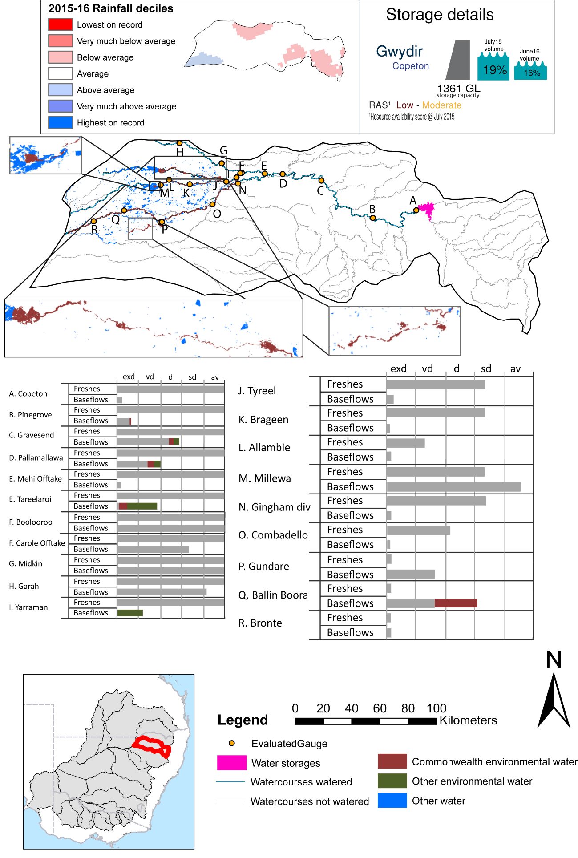

Figure GWY1: Watercourses influenced, areas inundated (where applicable) and gauge stations evaluated in the Gwydir valley during the 2015-16 water year. Inset bar graphs report the condition of annual flow regimes by showing the improvements in hydrological condition with the addition of environmental water as well as the hypothetical scenario in “grey” (if no environmental flow had been delivered). Rainfall conditions (rainfall deciles) and trend in storage levels for the water year are also shown.

Summary
Environmental water delivery for the 2015-16 year in the Gwydir valley is evaluated using data for 22 sites. This evaluation only considers the contribution of held environmental water, which is a primary focus for the Commonwealth. The contributions of planned environmental water (e.g. passing flows), unregulated tributary inflows and clever use of irrigation flows for environmental benefits can all be very important but these are outside the scope of this report. Environmental watering actions lasted on average 49 days over the course of the year. The volume of environmental water at these 22 sites was between 0% and 78% of the total streamflow. Commonwealth Environmental Water contributed on average 69% of this environmental water. Ideally, baseflows should be maintained and long periods of excessively low flows avoided. In this valley, the baseflow regime was generally considered to be very dry relative to the pre-development flow regime. In our analysis, a low fresh refers to a period of increased flow, when the water level rises at least one eighth of the way up the river bank (above the low flow level). These low freshes are a regular part of the natural flow regime and support a range of natural processes. In the Gwydir valley, in terms of the occurrence and duration of low freshes, the year was assessed as being somewhat dry. In our analysis, a medium fresh refers to a period of increased flow, when the water level rises at least one quarter of the way up the river bank. These medium freshes are not as frequent as low freshes but are also a regular and important part of the natural flow regime. In the Gwydir valley, in terms of the occurrence of medium freshes, the year was assessed as being average. In our analysis, a high fresh refers to a period of increased flow, when the water level rises more than half way up the river. A high fresh may not occur every year but they are still important and long periods without major freshes can have serious consequences for floodplains and their contribution to river ecosystem health. Delivering environmental water as high in channel flows normally requires that all risks to riparian landholders and infrastructure have been resolved. In the Gwydir valley, in terms of the occurrence of high freshes, the year was assessed as being somewhat dry.

Environmental water system
The Gwydir valley covers an area of 26,496 km2, which represents 2.50% of the total basin area. Rainfall in the Gwydir varies from around 900 mm at the top of the catchment to around 450 mm in the west, with the dominant rainfall occurring between October and March. Copeton dam is the largest dam in the valley (1343 GL) and it regulates around 55% of the Gwydir system inflows. Strategically, environmental watering in the Gwydir valley is designed to contribute to wetland watering following natural cycles of drying and wetting. Typically water is delivered as discrete blocks of water fed from Copeton dam and regulated using instream infrastructure to target accounting points, augmented events (to enhance or extend a natural event), or piggy back events where it is delivered together with other water (e.g. 3T water or stock and domestic replenishment flows). The Lower Gwydir and Gingham are typical assets that are targeted for environmental water. These systems are low gradient with numerous anabranches and distributary creeks that terminate in wetlands. Baseflow and cease to flow periods commonly occur.

Data availability
The contribution (where applicable) of the Commonwealth environmental water and NSW environmental water and other passing flows were derived from the CAIRO river operations spreadsheet held by Water NSW. The accounted waterholding, and its source was tracked longitudinally using known travel times, contributions from tributaries and differences between allocated and unallocated flow. The method assumed no longitudinal delivery loss, so in other words, the Commonwealth environmental water component is likely to be underestimated at reaches upstream of the accounting point.

Water delivery context
During the 2015-16 water year, the Commonwealth Environmental Water Holder (CEWH) held water entitlements of up to 114484ML for environmental use in the Gwydir valley. Each year, water utilities allocate the water entitlement holders a percentage of water based on their holding, license type and carryover (the exact rules vary among Jurisdictions). In the 2015-16 water year, the CEWH Gwydir entitlements were allocated 10535 ML of water, representing 25.93% of the Long term average annual yield for the Gwydir valley (40623 ML). The 2015-16 water allocation (10535 ML) together with the carryover volume of 23425 ML of water meant the CEWH had 33960 ML of water available for delivery.
A total of 8064 ML of Commonwealth environmental water was delivered in the Gwydir valley. A total of 0 ML of Commonwealth environmental water was traded to consumptive users and 25559ML (75.26% of available resource) of Commonwealth environmental water was carried over for environmental use into the 2016-17 water year.

Environmental conditions and resource availability
The water available for delivery combined with the present and antecedent environmental conditions are key inputs used by environmental water managers in planning and implementing watering actions. Post hoc, this information provides important context when evaluating the effectiveness and appropriateness of environmental water use with respect to hydrological outputs.
The rainfall conditions in the Gwydir valley were classified as Average, based on rainfall percentile data for the entire record held by the Bureau of Meteorology for this valley. The major storages in the Gwydir valley remained stable, being 19% full at the beginning of the water year and 16% full by the end of the year (Figure GWY1).
The Commonwealth Environmental Water Office (CEWO) calculates resource availability scenarios (RAS) progressively as part of its continual adaptive management planning processes. The RAS are based on the availability of held water (including progressive license acquisitions and allocations) as well as the potential for unregulated or planned environmental flows. The resource availability of held water was classified as Low in this valley, whilst the potential for unregulated or planned environmental flow was classified as Moderate. The physical conditions meant that the CEWO was managing to Protect wetland vegetation of the Gwydirdir wetlands ensuring their ecological capacity for recovery, while maintaining the ecological health and resilience of other important sites in the catchment, including in stream aquatic ecology. The overall demand for environmental water was deemed High (water predominantly needed this year).

Watering actions
A total of 4 watering actions were implemented, the duration of these actions varied (range of individual actions: 2 - 86 days). The total cumulative sum of watering actions days was 170). The number of actions commencing in each season varied: Spring (2), Summer (1) and Autumn (1). The flow component types delivered included (1 baseflow, 1 freshes, 0 bankfull, 2 overbank and 0 wetland).

Table GWY2. Commonwealth environmental water accounting information for the Gwydir valley over 2015-16 water year.
Total registered volume (ML) | Allocated volume (ML) | Carry over available (ML) | Delivered (ML) | LTAAY (ML) | Trade (ML) | Carried over to 2016-17 | Forfeited (ML)
114484 | 10535 | 33960 | 8064 | 40623 | 0 | 25559 | 0

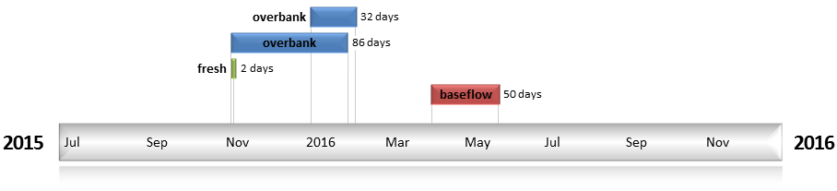
Figure GWY2. Timing and duration of water actions implemented by the CEWO during the 2015-16 water year in the Gwydir valley.

Contribution of Commonwealth Environmental Water to Flow Regimes
Copeton
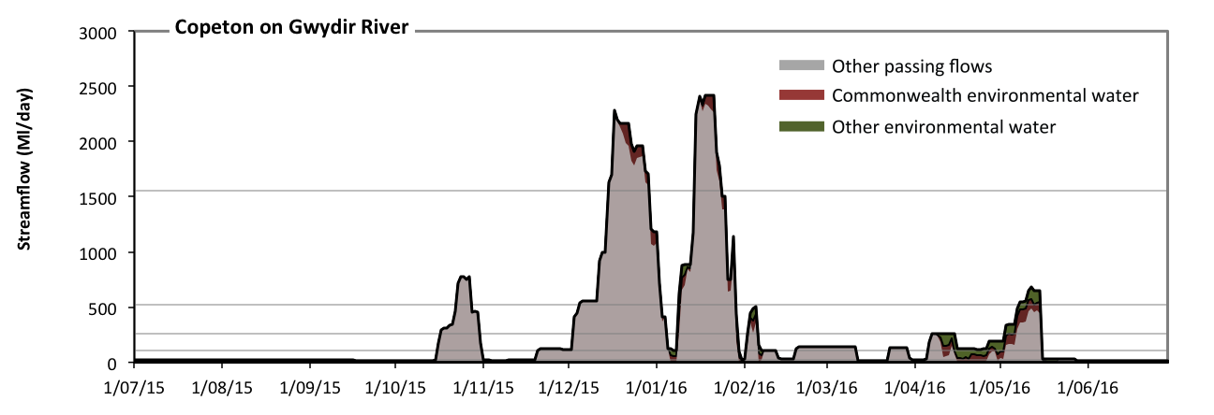
Figure GWY3: Contribution of environmental water delivery at Copeton. Horizontal lines indicate thresholds for very low flows, low flows, low freshes, medium freshes and high freshes (from lowest to highest).
At Copeton on Gwydir River environmental water contributed 11% of the total streamflow volume (much of which was Commonwealth environmental water) (Figure GWY3 and GWY4). Environmental watering actions affected streamflows for 26% of days between 1 July 2015 and 30 June 2016. Without environmental water, the durations of very low flows (i.e. < 21 Ml/day) in the periods July to September, October to December, January to March and April to June would have all substantially exceeded durations expected in an average year in the natural flow regime. Environmental water mitigated these impacts by reducing the cumulative duration of very low flow spells from 31% to 24% of the year, with greatest influence in the periods January to March and April to June. Similarly, without environmental water, the durations of medium low flows (i.e. < 110 Ml/day) in the periods July to September, October to December, January to March and April to June would have all substantially exceeded durations expected in an average year in the natural flow regime. Environmental water mitigated these impacts by reducing the cumulative duration of medium low flow spells from 62% to 55% of the year, with greatest influence in the period April to June. Commonwealth environmental water equally shared responsibility with other environmental water holders for these enhancements of environmental baseflows at this site. In the absence of environmental water there would have been at least one low fresh (i.e. > 260 Ml/day) in the periods October to December, January to March and April to June. Environmental water increased the duration of the longest low fresh during the period April to June (from 9 days to 13 days). Commonwealth environmental water was entirely responsible for these increased durations of low freshes. In the absence of environmental water there would have been at least one medium fresh (i.e. > 520 Ml/day) in the periods October to December and January to March. Environmental water increased the duration of the longest medium fresh during the period April to June (from 0 days to 8 days). Commonwealth environmental water equally shared responsibility with other environmental water holders for these increased durations of medium freshes. In the absence of environmental water there would have been at least one high fresh in the periods October to December and January to March. Environmental water made no change to the duration of these high freshes.
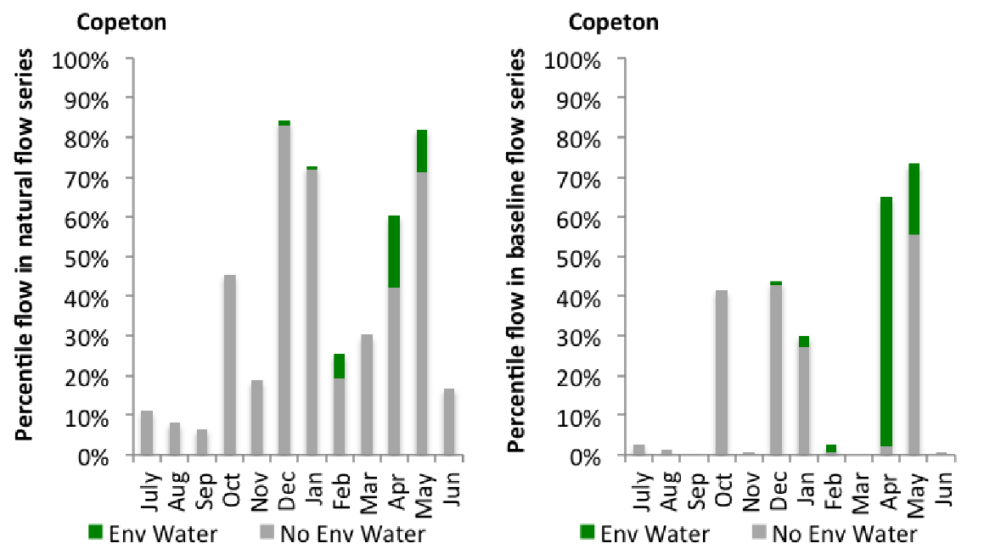
Figure GWY4: Contribution of environmental water delivery at Copeton as percentiles in the natural and baseline flow series.
Pinegrove
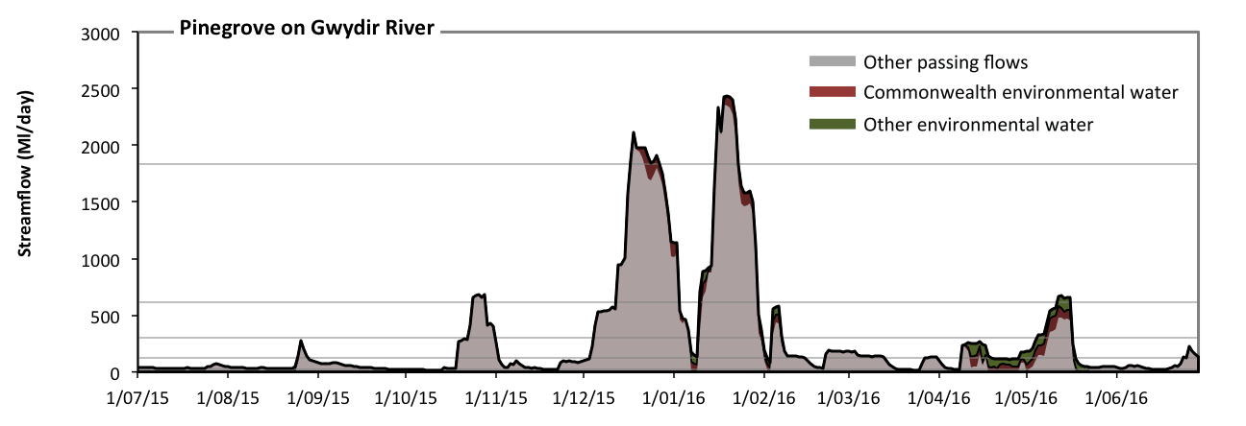
Figure GWY5: Contribution of environmental water delivery at Pinegrove. Horizontal lines indicate thresholds for very low flows, low flows, low freshes, medium freshes and high freshes (from lowest to highest).
At Pinegrove on Gwydir River environmental water contributed 11% of the total streamflow volume (with approximately half contributed by Commonwealth environmental water) (Figure GWY5 and GWY6). Environmental watering actions affected streamflows for 26% of days between 1 July 2015 and 30 June 2016. Without environmental water, the durations of very low flows (i.e. < 25 Ml/day) in the periods October to December, January to March and April to June would have substantially exceeded durations expected in an average year in the natural flow regime. Environmental water mitigated these impacts by reducing the cumulative duration of very low flow spells from 14% to 8% of the year, with greatest influence in the period April to June. Similarly, without environmental water, the durations of medium low flows (i.e. < 120 Ml/day) in the periods July to September, October to December, January to March and April to June would have all substantially exceeded durations expected in an average year in the natural flow regime. Environmental water mitigated these impacts by reducing the cumulative duration of medium low flow spells from 64% to 59% of the year, with greatest influence in the period April to June. Commonwealth environmental water made a modest contribution to these enhancements of environmental baseflows at this site. In the absence of environmental water there would have been at least one low fresh (i.e. > 300 Ml/day) in the periods October to December, January to March and April to June. Environmental water increased the duration of the longest low fresh during the period April to June (from 8 days to 12 days). Commonwealth environmental water equally shared responsibility with other environmental water holders for these increased durations of low freshes. In the absence of environmental water there would have been at least one medium fresh (i.e. > 610 Ml/day) in the periods October to December and January to March. Environmental water increased the duration of the longest medium fresh during the period April to June (from 0 days to 5 days). Commonwealth environmental water equally shared responsibility with other environmental water holders for these increased durations of medium freshes. In the absence of environmental water there would have been at least one high fresh in the periods October to December and January to March. Environmental water increased the duration of the longest medium fresh during the period October to December (from 5 days to 10 days). Commonwealth environmental water was entirely responsible for these increased durations of high freshes.
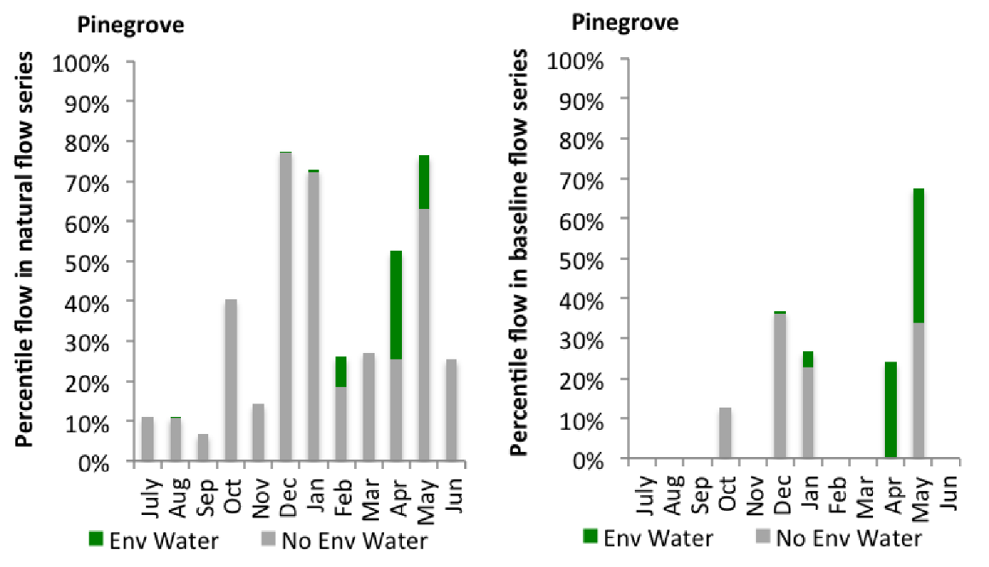
Figure GWY6: Contribution of environmental water delivery at Pinegrove as percentiles in the natural and baseline flow series.

Gravesend
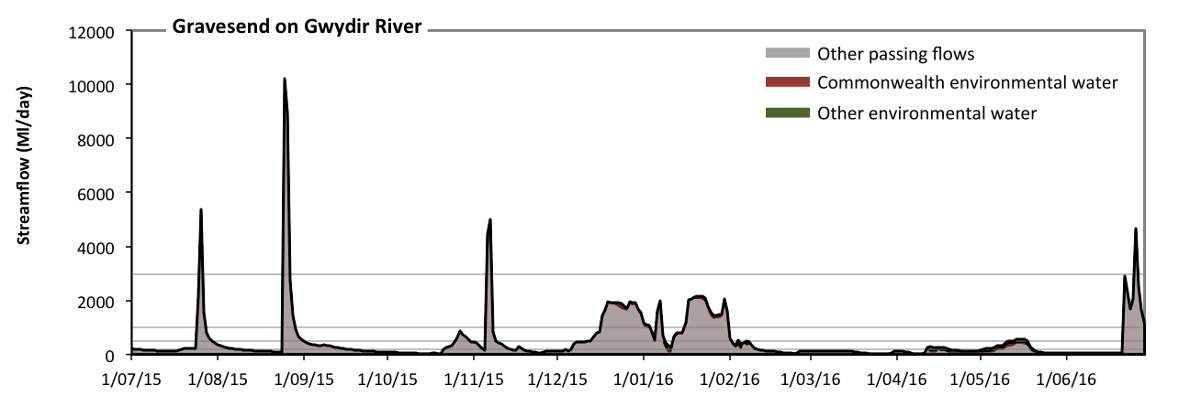
Figure GWY7: Contribution of environmental water delivery at Gravesend. Horizontal lines indicate thresholds for very low flows, low flows, low freshes, medium freshes and high freshes (from lowest to highest).
At Gravesend on Gwydir River environmental water contributed 7% of the total streamflow volume (much of which was Commonwealth environmental water) (Figure GWY7 and GWY8). Environmental watering actions affected streamflows for 28% of days between 1 July 2015 and 30 June 2016. Without environmental water, the durations of very low flows (i.e. < 40 Ml/day) in the periods January to March and April to June would have substantially exceeded durations expected in an average year in the natural flow regime. Environmental water mitigated these impacts by reducing the cumulative duration of very low flow spells from 11% to 6% of the year, with greatest influence in the period April to June. Similarly, without environmental water, the durations of medium low flows (i.e. < 200 Ml/day) in the periods July to September, October to December, January to March and April to June would have all substantially exceeded durations expected in an average year in the natural flow regime. Environmental water mitigated these impacts by reducing the cumulative duration of medium low flow spells from 60% to 55% of the year, with greatest influence in the period April to June. Commonwealth environmental water equally shared responsibility with other environmental water holders for these enhancements of environmental baseflows at this site. There was at least one low fresh (i.e. > 490 Ml/day) in the periods July to September, October to December, January to March and April to June. Environmental water made no change to the duration of these low freshes. There was at least one medium fresh (i.e. > 990 Ml/day) in the periods July to September, October to December, January to March and April to June. Environmental water made no change to the duration of these medium freshes. In the absence of environmental water there would have been at least one high fresh in the periods July to September, October to December and April to June. Environmental water made no change to the duration of these high freshes.
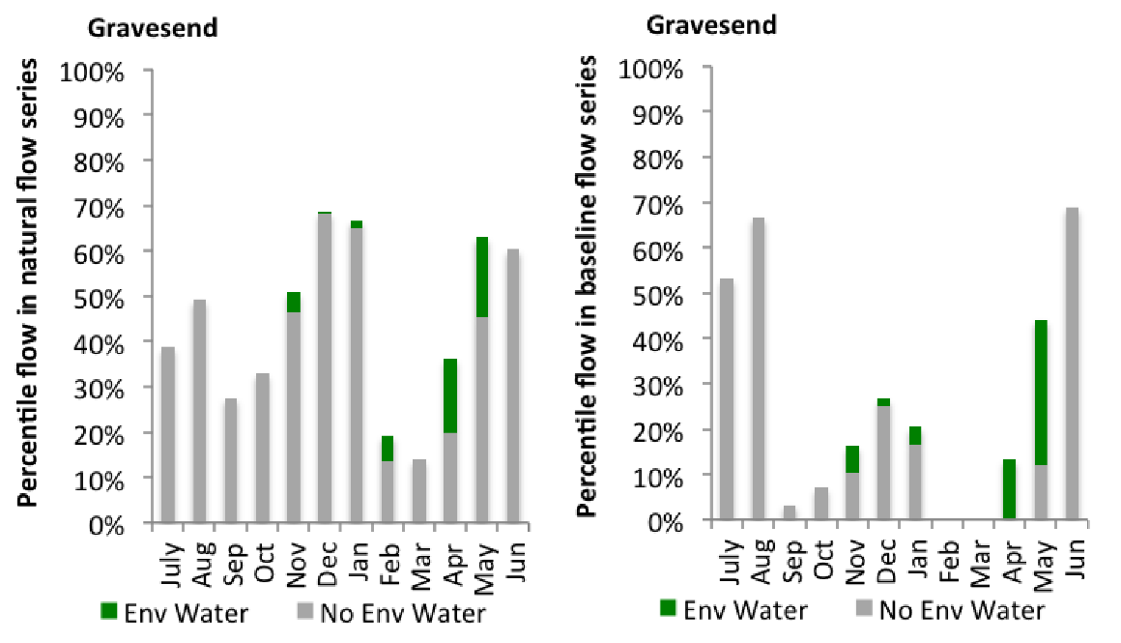
Figure GWY8: Contribution of environmental water delivery at Gravesend as percentiles in the natural and baseline flow series.
Pallamallawa
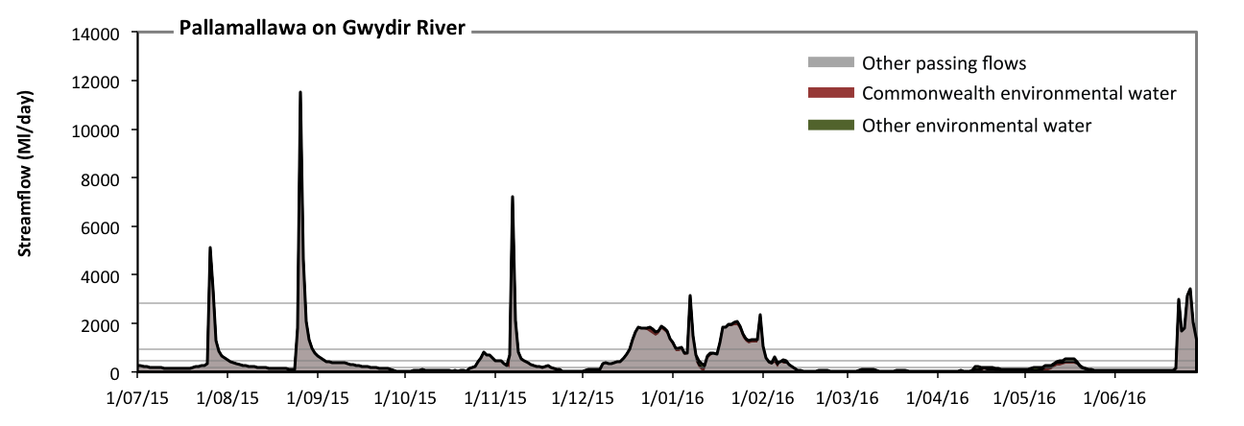
Figure GWY9: Contribution of environmental water delivery at Pallamallawa. Horizontal lines indicate thresholds for very low flows, low flows, low freshes, medium freshes and high freshes (from lowest to highest).
At Pallamallawa on Gwydir River environmental water contributed 7% of the total streamflow volume (much of which was Commonwealth environmental water) (Figure GWY9 and GWY10). Environmental watering actions affected streamflows for 28% of days between 1 July 2015 and 30 June 2016. Without environmental water, the durations of very low flows (i.e. < 39 Ml/day) in the periods October to December, January to March and April to June would have substantially exceeded durations expected in an average year in the natural flow regime. Environmental water mitigated these impacts by reducing the cumulative duration of very low flow spells from 20% to 14% of the year, with greatest influence in the period April to June. Similarly, without environmental water, the durations of medium low flows (i.e. < 200 Ml/day) in the periods July to September, October to December, January to March and April to June would have all substantially exceeded durations expected in an average year in the natural flow regime. Environmental water mitigated these impacts by reducing the cumulative duration of medium low flow spells from 58% to 54% of the year, with greatest influence in the period April to June. Commonwealth environmental water equally shared responsibility with other environmental water holders for these enhancements of environmental baseflows at this site. There was at least one low fresh (i.e. > 470 Ml/day) in the periods July to September, October to December, January to March and April to June. Environmental water made little change to the duration of these low freshes. There was at least one medium fresh (i.e. > 950 Ml/day) in the periods July to September, October to December, January to March and April to June. Environmental water made little change to the duration of these medium freshes. In the absence of environmental water there would have been at least one high fresh in the periods July to September, October to December, January to March and April to June. Environmental water made no change to the duration of these high freshes.
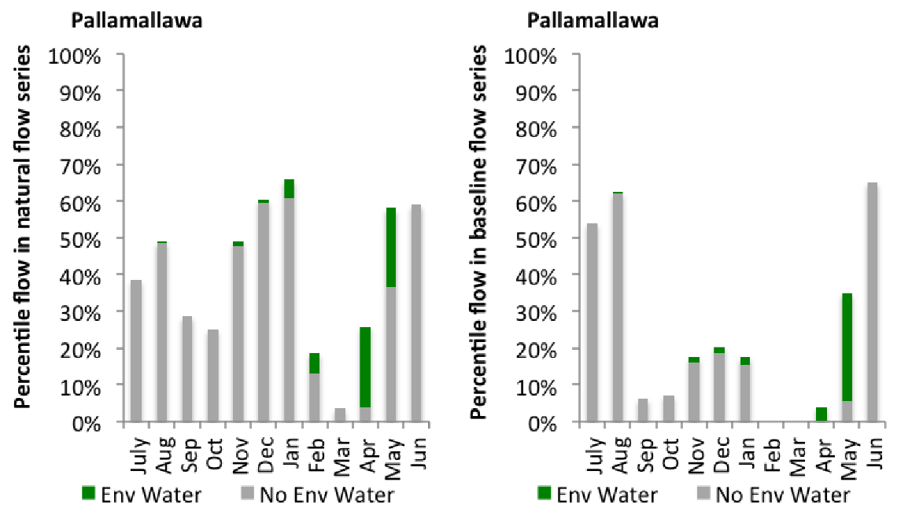
Figure GWY10: Contribution of environmental water delivery at Pallamallawa as percentiles in the natural and baseline flow series.

Mehi Offtake
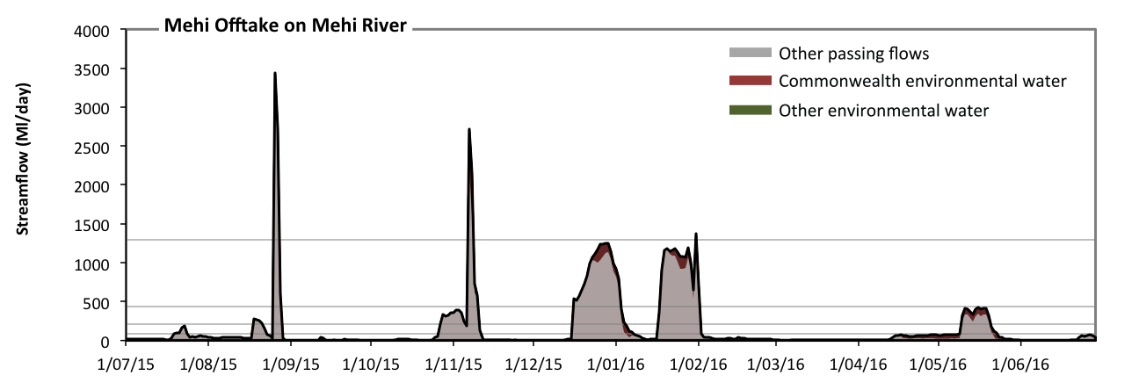
Figure GWY11: Contribution of environmental water delivery at Mehi Offtake. Horizontal lines indicate thresholds for very low flows, low flows, low freshes, medium freshes and high freshes (from lowest to highest).
At Mehi Offtake on Mehi River environmental water contributed 11% of the total streamflow volume (most of which was Commonwealth environmental water) (Figure GWY11 and GWY12). Environmental watering actions affected streamflows for 21% of days between 1 July 2015 and 30 June 2016. Without environmental water, the durations of very low flows (i.e. < 18 Ml/day) in the periods July to September, October to December, January to March and April to June would have all substantially exceeded durations expected in an average year in the natural flow regime. Environmental water mitigated these impacts by reducing the cumulative duration of very low flow spells from 52% to 50% of the year, with greatest influence in the period April to June. Similarly, without environmental water, the durations of medium low flows (i.e. < 90 Ml/day) in the periods July to September, October to December, January to March and April to June would have all substantially exceeded durations expected in an average year in the natural flow regime. Environmental water mitigated these impacts by reducing the cumulative duration of medium low flow spells from 79% to 78% of the year, with greatest influence in the periods January to March and April to June. There was at least one low fresh (i.e. > 220 Ml/day) in the periods July to September, October to December, January to March and April to June. Environmental water made no change to the duration of these low freshes. There was at least one medium fresh (i.e. > 440 Ml/day) in the periods July to September, October to December and January to March. Environmental water made no change to the duration of these medium freshes. In the absence of environmental water there would have been at least one high fresh in the periods July to September and October to December. Environmental water increased the duration of the longest medium fresh during the period January to March (from 0 days to 1 days). Commonwealth environmental water was entirely responsible for these increased durations of high freshes.
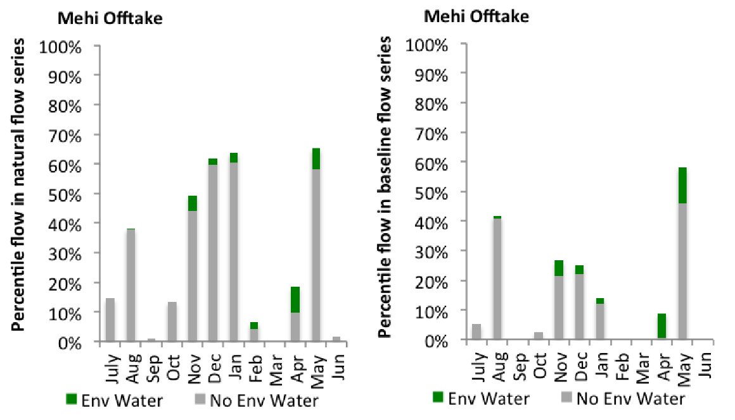
Figure GWY12: Contribution of environmental water delivery at Mehi Offtake as percentiles in the natural and baseline flow series.

Tareelaroi
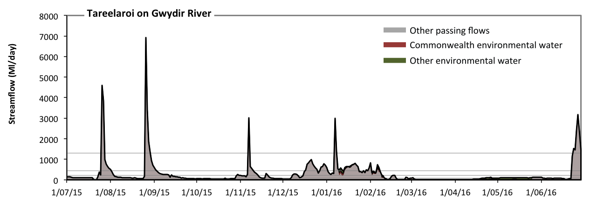
Figure GWY13: Contribution of environmental water delivery at Tareelaroi. Horizontal lines indicate thresholds for very low flows, low flows, low freshes, medium freshes and high freshes (from lowest to highest).
At Tareelaroi on Gwydir River environmental water contributed 6% of the total streamflow volume (with a medium contribution of Commonwealth environmental water) (Figure GWY13 and GWY14). Environmental watering actions affected streamflows for 19% of days between 1 July 2015 and 30 June 2016. Without environmental water, the durations of very low flows (i.e. < 18 Ml/day) in the periods January to March and April to June would have substantially exceeded durations expected in an average year in the natural flow regime. Environmental water mitigated these impacts by reducing the cumulative duration of very low flow spells from 25% to 14% of the year, with greatest influence in the period April to June. Similarly, without environmental water, the durations of medium low flows (i.e. < 90 Ml/day) in the periods October to December, January to March and April to June would have substantially exceeded durations expected in an average year in the natural flow regime. Environmental water mitigated these impacts by reducing the cumulative duration of medium low flow spells from 50% to 42% of the year, with greatest influence in the period April to June. Commonwealth environmental water made a small contribution to these enhancements of environmental baseflows at this site. In the absence of environmental water there would have been at least one low fresh (i.e. > 220 Ml/day) in the periods July to September, October to December, January to March and April to June. Environmental water increased the duration of the longest low fresh during the period January to March (from 27 days to 40 days). Commonwealth environmental water equally shared responsibility with other environmental water holders for these increased durations of low freshes. There was at least one medium fresh (i.e. > 440 Ml/day) in the periods July to September, October to December, January to March and April to June. Environmental water made no change to the duration of these medium freshes. In the absence of environmental water there would have been at least one high fresh in the periods July to September, October to December, January to March and April to June. Environmental water made no change to the duration of these high freshes.
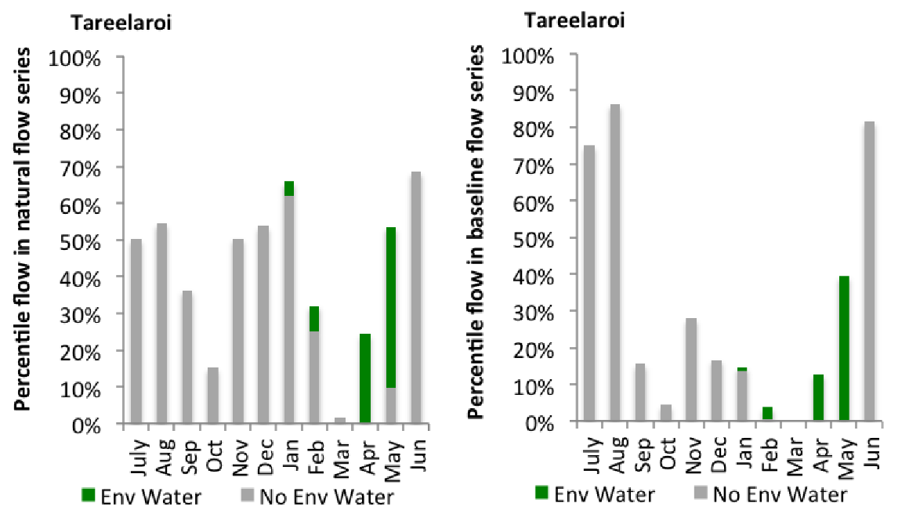
Figure GWY14: Contribution of environmental water delivery at Tareelaroi as percentiles in the natural and baseline flow series.
Carole Offtake
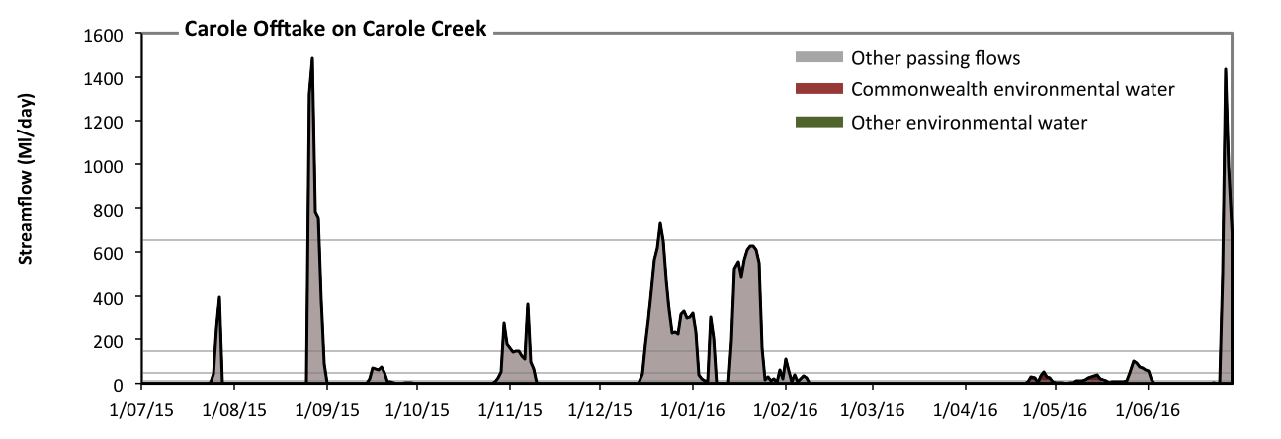 Figure GWY15: Contribution of environmental water delivery at Carole Offtake. Horizontal lines indicate thresholds for very low flows, low flows, low freshes, medium freshes and high freshes (from lowest to highest).
At Carole Offtake on Carole Creek environmental water contributed 2% of the total streamflow volume (all of which was Commonwealth environmental water) (Figure GWY15 and GWY16). Environmental watering actions affected streamflows for 5% of days between 1 July 2015 and 30 June 2016. Without environmental water, the duration of very low flows (i.e. < 2.1 Ml/day) in the period July to September would have substantially exceeded durations expected in an average year in the natural flow regime. Environmental water reduced the cumulative duration of very low flow spells from 69% to 65% of the year, with greatest influence in the period April to June. Similarly, without environmental water, the duration of medium low flows (i.e. < 10 Ml/day) in the period July to September would have substantially exceeded durations expected in an average year in the natural flow regime. Environmental water reduced the cumulative duration of medium low flow spells from 75% to 71% of the year, with greatest influence in the period April to June. Commonwealth environmental water was entirely responsible for these enhancements of environmental baseflows at this site. There was at least one low fresh (i.e. > 49 Ml/day) in the periods July to September, October to December, January to March and April to June. Environmental water made no change to the duration of these low freshes. There was at least one medium fresh (i.e. > 150 Ml/day) in the periods July to September, October to December, January to March and April to June. Environmental water made no change to the duration of these medium freshes. In the absence of environmental water there would have been at least one high fresh in the periods July to September, October to December and April to June. Environmental water made no change to the duration of these high freshes.
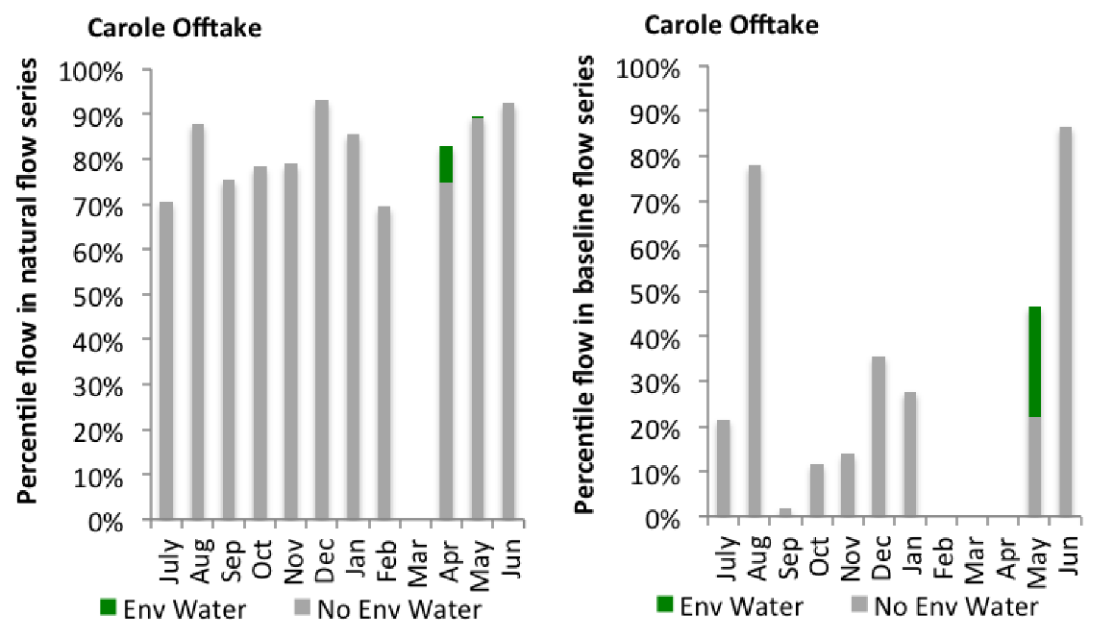
Figure GWY16: Contribution of environmental water delivery at Carole Offtake as percentiles in the natural and baseline flow series.
Midkin
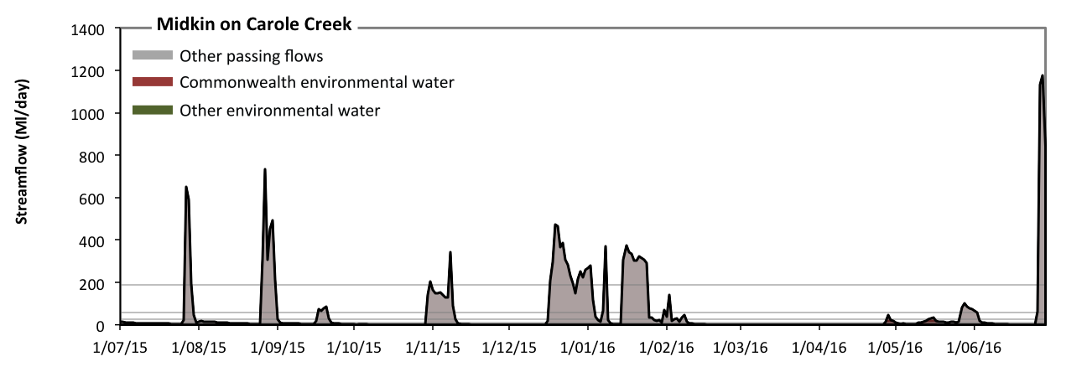 Figure GWY17: Contribution of environmental water delivery at Midkin. Horizontal lines indicate thresholds for very low flows, low flows, low freshes, medium freshes and high freshes (from lowest to highest).
At Midkin on Carole Creek environmental water contributed 1% of the total streamflow volume (all of which was Commonwealth environmental water) (Figure GWY17 and GWY18). Environmental watering actions affected streamflows for 6% of days between 1 July 2015 and 30 June 2016. Flow regulation does not substantially increase the duration of very low flows (i.e. < 2.1 Ml/day) compared to an average year in the natural flow regime. Flow regulation does not substantially increase the duration of medium low flows (i.e. < 10 Ml/day) compared to an average year in the natural flow regime. Commonwealth environmental water was entirely responsible for these enhancements of environmental baseflows at this site. There was at least one low fresh (i.e. > 28 Ml/day) in the periods July to September, October to December, January to March and April to June. Environmental water made no change to the duration of these low freshes. There was at least one medium fresh (i.e. > 59 Ml/day) in the periods July to September, October to December, January to March and April to June. Environmental water made no change to the duration of these medium freshes. In the absence of environmental water there would have been at least one high fresh in the periods July to September, October to December, January to March and April to June. Environmental water made no change to the duration of these high freshes.
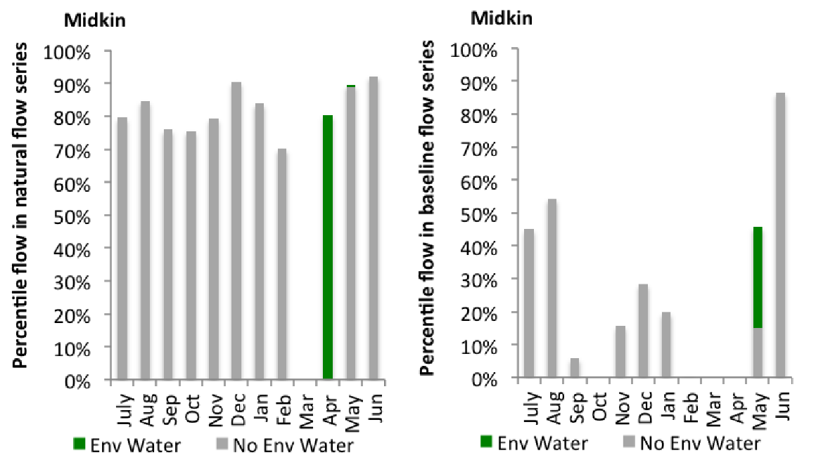
Figure GWY18: Contribution of environmental water delivery at Midkin as percentiles in the natural and baseline flow series.
Garah
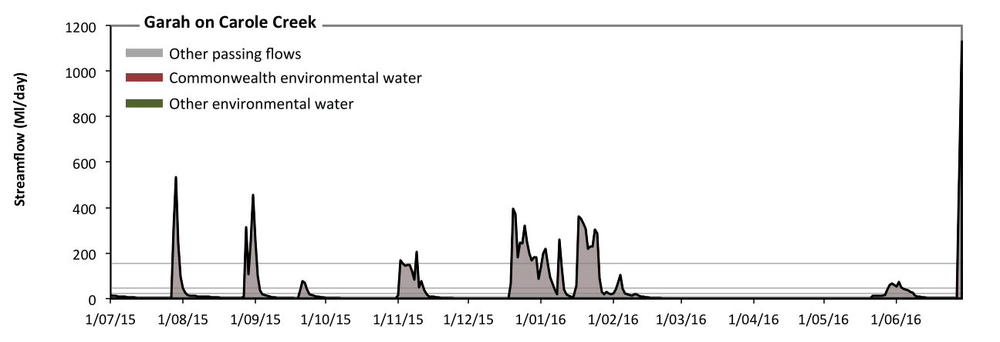 Figure GWY19: Contribution of environmental water delivery at Garah. Horizontal lines indicate thresholds for very low flows, low flows, low freshes, medium freshes and high freshes (from lowest to highest).
There was no environmental water delivered at Garah on Carole Creek (Figure GWY19 and GWY20). Without environmental water, the durations of very low flows (i.e. < 1.7 Ml/day) in the periods October to December, January to March and April to June was substantially in excess of durations expected in an average year in the natural flow regime. Similarly, without environmental water, the duration of medium low flows (i.e. < 8.3 Ml/day) in the period October to December was substantially in excess of durations expected in an average year in the natural flow regime. There was at least one low fresh (i.e. > 22 Ml/day) in the periods July to September, October to December, January to March and April to June. There was at least one medium fresh (i.e. > 48 Ml/day) in the periods July to September, October to December, January to March and April to June. In the absence of environmental water there was at least one high fresh in the periods July to September, October to December, January to March and April to June.
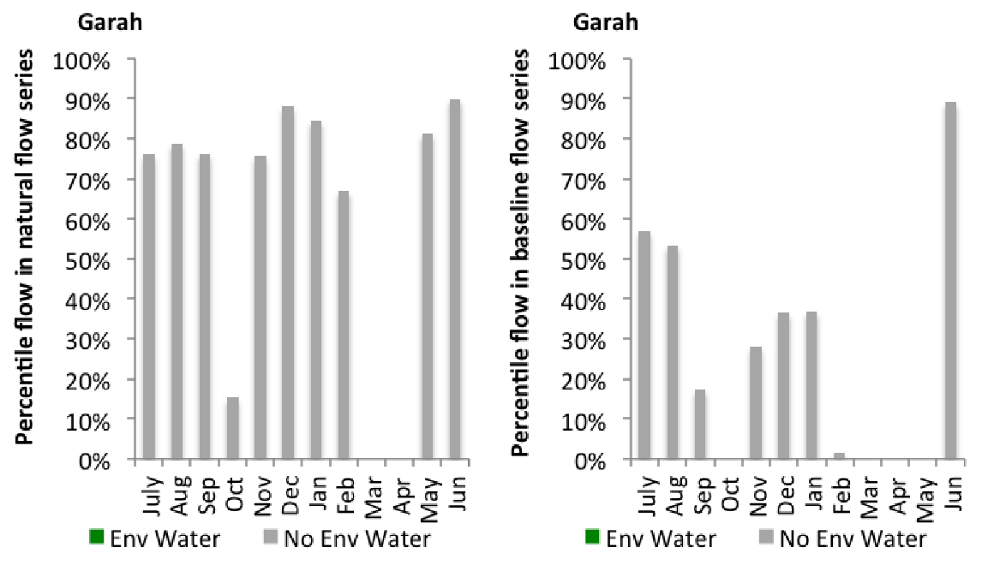
Figure GWY20: Contribution of environmental water delivery at Garah as percentiles in the natural and baseline flow series.
Boolooroo
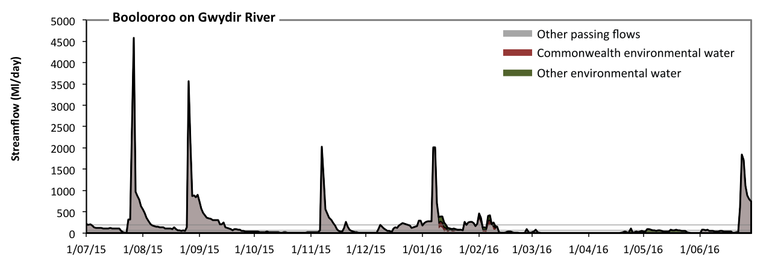 Figure GWY21: Contribution of environmental water delivery at Boolooroo. Horizontal lines indicate thresholds for very low flows, low flows, low freshes, medium freshes and high freshes (from lowest to highest).
At Boolooroo on Gwydir River environmental water contributed 7% of the total streamflow volume (with a medium contribution of Commonwealth environmental water) (Figure GWY21 and GWY22). Environmental watering actions affected streamflows for 17% of days between 1 July 2015 and 30 June 2016. Flow regulation does not substantially increase the duration of very low flows (i.e. < 2.1 Ml/day) compared to an average year in the natural flow regime. Flow regulation does not substantially increase the duration of medium low flows (i.e. < 10 Ml/day) compared to an average year in the natural flow regime. Commonwealth environmental water made little or no contribution to these enhancements of environmental baseflows at this site. In the absence of environmental water there would have been at least one low fresh (i.e. > 28 Ml/day) in the periods July to September, October to December, January to March and April to June. Environmental water increased the duration of the longest low fresh during the periods January to March (from 27 days to 42 days) and April to June (from 17 days to 26 days). Commonwealth environmental water made a modest contribution to these increased durations of low freshes. In the absence of environmental water there would have been at least one medium fresh (i.e. > 59 Ml/day) in the periods July to September, October to December, January to March and April to June. Environmental water increased the duration of the longest medium fresh during the period January to March (from 12 days to 42 days). Commonwealth environmental water equally shared responsibility with other environmental water holders for these increased durations of medium freshes. In the absence of environmental water there would have been at least one high fresh in the periods July to September, October to December, January to March and April to June. Environmental water increased the duration of the longest medium fresh during the period January to March (from 8 days to 13 days). Commonwealth environmental water equally shared responsibility with other environmental water holders for these increased durations of high freshes.
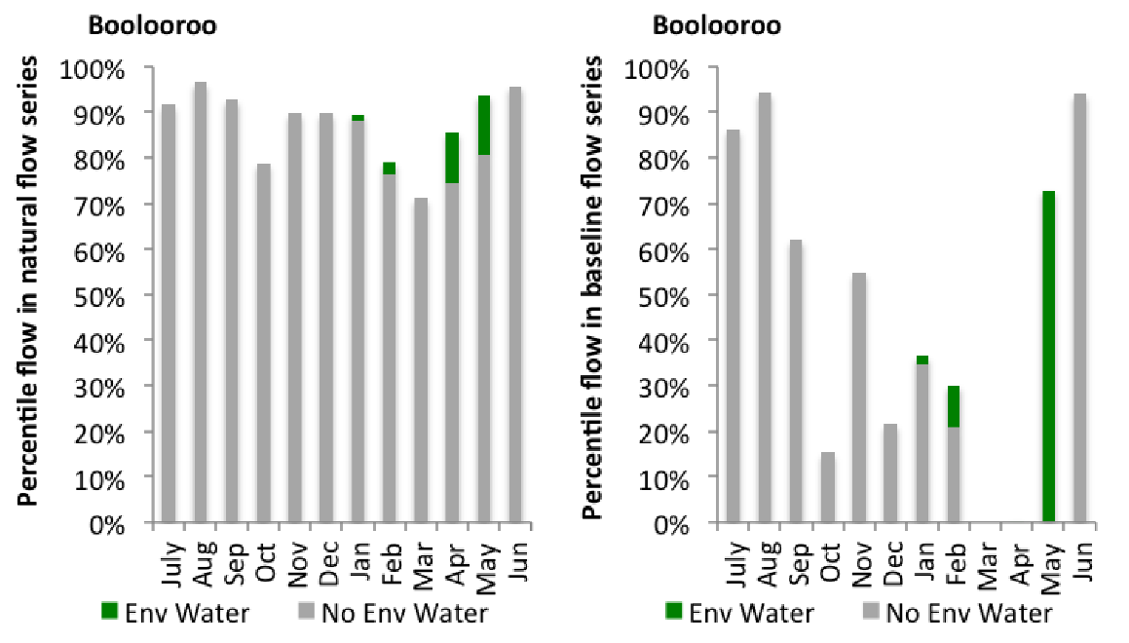
Figure GWY22: Contribution of environmental water delivery at Boolooroo as percentiles in the natural and baseline flow series.
Yarraman
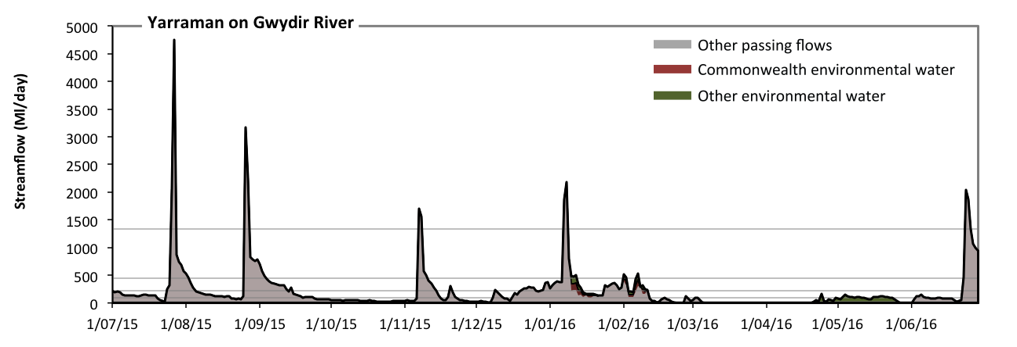 Figure GWY23: Contribution of environmental water delivery at Yarraman. Horizontal lines indicate thresholds for very low flows, low flows, low freshes, medium freshes and high freshes (from lowest to highest).
At Yarraman on Gwydir River environmental water contributed 8% of the total streamflow volume (with a medium contribution of Commonwealth environmental water) (Figure GWY23 and GWY24). Environmental watering actions affected streamflows for 16% of days between 1 July 2015 and 30 June 2016. Without environmental water, the durations of very low flows (i.e. < 19 Ml/day) in the periods January to March and April to June would have substantially exceeded durations expected in an average year in the natural flow regime. Environmental water mitigated these impacts by reducing the cumulative duration of very low flow spells from 27% to 17% of the year, with greatest influence in the period April to June. Similarly, without environmental water, the durations of medium low flows (i.e. < 94 Ml/day) in the periods October to December, January to March and April to June would have substantially exceeded durations expected in an average year in the natural flow regime. Environmental water mitigated these impacts by reducing the cumulative duration of medium low flow spells from 55% to 50% of the year, with greatest influence in the period April to June. Commonwealth environmental water made little or no contribution to these enhancements of environmental baseflows at this site. In the absence of environmental water there would have been at least one low fresh (i.e. > 220 Ml/day) in the periods July to September, October to December, January to March and April to June. Environmental water increased the duration of the longest low fresh during the period January to March (from 10 days to 14 days). Commonwealth environmental water equally shared responsibility with other environmental water holders for these increased durations of low freshes. In the absence of environmental water there would have been at least one medium fresh (i.e. > 450 Ml/day) in the periods July to September, October to December, January to March and April to June. Environmental water increased the duration of the longest medium fresh during the period January to March (from 3 days to 6 days). Commonwealth environmental water equally shared responsibility with other environmental water holders for these increased durations of medium freshes. In the absence of environmental water there would have been at least one high fresh in the periods July to September, October to December, January to March and April to June. Environmental water made no change to the duration of these high freshes.
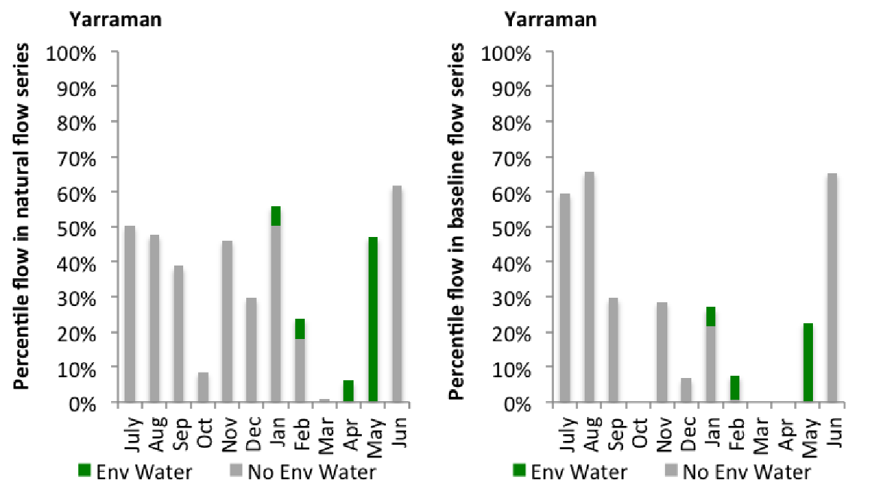
Figure GWY24: Contribution of environmental water delivery at Yarraman as percentiles in the natural and baseline flow series.

Gingham Diversion
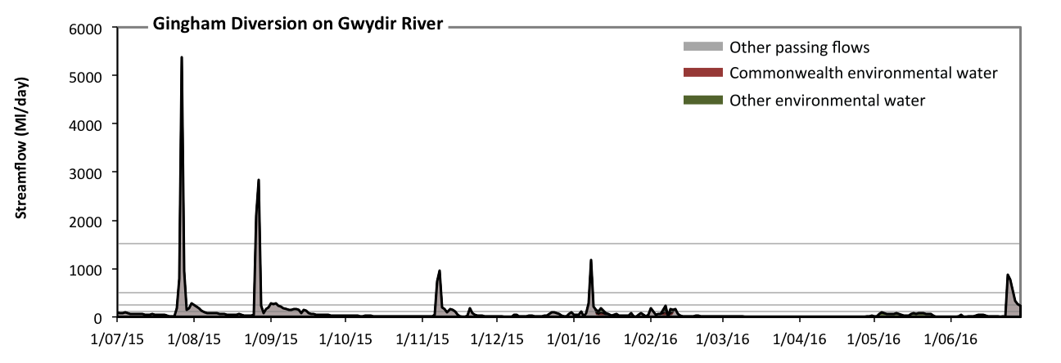 Figure GWY25: Contribution of environmental water delivery at Gingham Diversion. Horizontal lines indicate thresholds for very low flows, low flows, low freshes, medium freshes and high freshes (from lowest to highest).
At Gingham Diversion on Gwydir River environmental water contributed 8% of the total streamflow volume (with a medium contribution of Commonwealth environmental water) (Figure GWY25 and GWY26). Environmental watering actions affected streamflows for 13% of days between 1 July 2015 and 30 June 2016. Without environmental water, the durations of very low flows (i.e. < 21 Ml/day) in the periods October to December, January to March and April to June would have substantially exceeded durations expected in an average year in the natural flow regime. Environmental water mitigated these impacts by reducing the cumulative duration of very low flow spells from 55% to 45% of the year, with greatest influence in the periods January to March and April to June. Similarly, without environmental water, the durations of medium low flows (i.e. < 100 Ml/day) in the periods July to September, October to December, January to March and April to June would have all substantially exceeded durations expected in an average year in the natural flow regime. Environmental water mitigated these impacts by reducing the cumulative duration of medium low flow spells from 86% to 84% of the year, with greatest influence in the period January to March. Commonwealth environmental water made a modest contribution to these enhancements of environmental baseflows at this site. There was at least one low fresh (i.e. > 250 Ml/day) in the periods July to September, October to December, January to March and April to June. Environmental water made no change to the duration of these low freshes. There was at least one medium fresh (i.e. > 510 Ml/day) in the periods July to September, October to December, January to March and April to June. Environmental water made no change to the duration of these medium freshes. In the absence of environmental water there would have been at least one high fresh in the period July to September. Environmental water made no change to the duration of these high freshes.
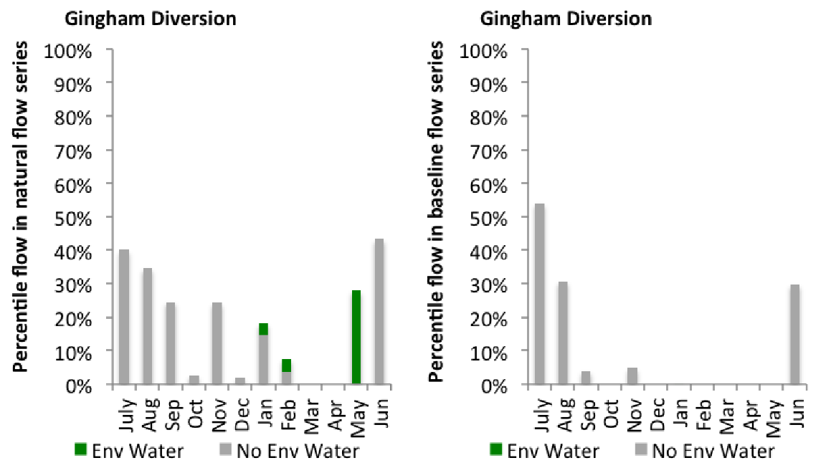
Figure GWY26: Contribution of environmental water delivery at Gingham Diversion as percentiles in the natural and baseline flow series.
Tyreel
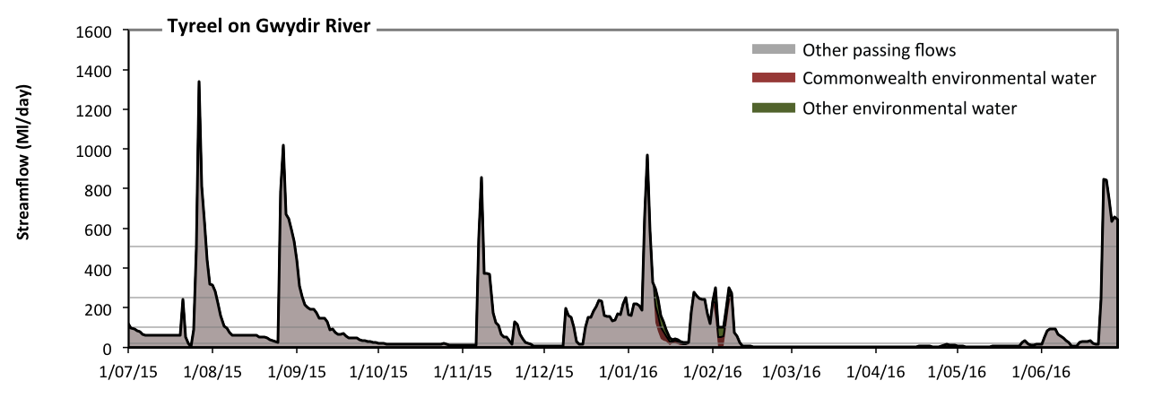 Figure GWY27: Contribution of environmental water delivery at Tyreel. Horizontal lines indicate thresholds for very low flows, low flows, low freshes and medium freshes (from lowest to highest).
At Tyreel on Gwydir River environmental water contributed 4% of the total streamflow volume (with approximately half contributed by Commonwealth environmental water) (Figure GWY27 and GWY28). Environmental watering actions affected streamflows for 8% of days between 1 July 2015 and 30 June 2016. Without environmental water, the durations of very low flows (i.e. < 21 Ml/day) in the periods October to December, January to March and April to June would have substantially exceeded durations expected in an average year in the natural flow regime. Environmental water mitigated these impacts by reducing the cumulative duration of very low flow spells from 49% to 46% of the year, with greatest influence in the period January to March. Similarly, without environmental water, the durations of medium low flows (i.e. < 100 Ml/day) in the periods July to September, October to December, January to March and April to June would have all substantially exceeded durations expected in an average year in the natural flow regime. Environmental water mitigated these impacts by reducing the cumulative duration of medium low flow spells from 75% to 74% of the year, with greatest influence in the period January to March. Commonwealth environmental water equally shared responsibility with other environmental water holders for these enhancements of environmental baseflows at this site. There was at least one low fresh (i.e. > 250 Ml/day) in the periods July to September, October to December, January to March and April to June. Environmental water made no change to the duration of these low freshes. Commonwealth environmental water made little or no contribution to these increased durations of low freshes. There was at least one medium fresh (i.e. > 510 Ml/day) in the periods July to September, October to December, January to March and April to June. Environmental water made no change to the duration of these medium freshes. There was no high freshes (i.e. > 1500 Ml/day) this year.
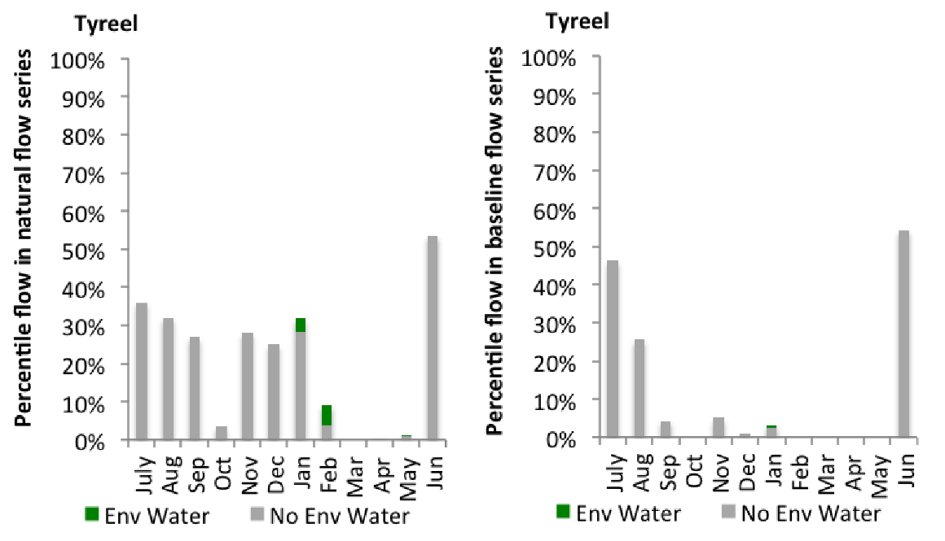
Figure GWY28: Contribution of environmental water delivery at Tyreel as percentiles in the natural and baseline flow series.
Brageen
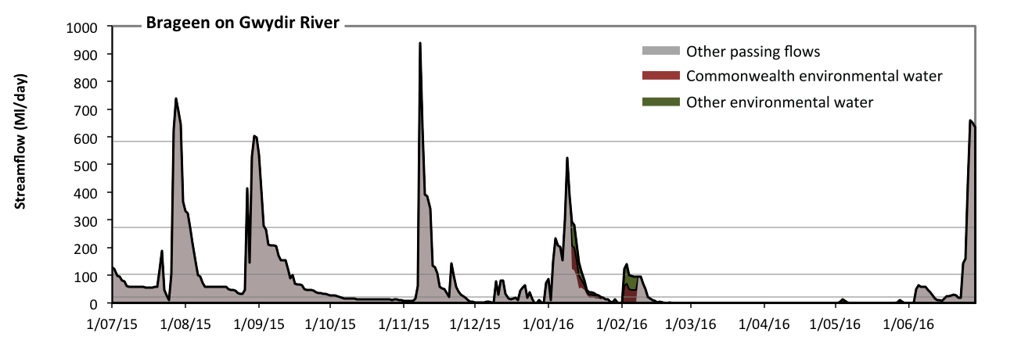 Figure GWY29: Contribution of environmental water delivery at Brageen. Horizontal lines indicate thresholds for very low flows, low flows, low freshes and medium freshes (from lowest to highest).
At Brageen on Gwydir River environmental water contributed 5% of the total streamflow volume (with approximately half contributed by Commonwealth environmental water) (Figure GWY29 and GWY30). Environmental watering actions affected streamflows for 7% of days between 1 July 2015 and 30 June 2016. Without environmental water, the durations of very low flows (i.e. < 21 Ml/day) in the periods October to December, January to March and April to June would have substantially exceeded durations expected in an average year in the natural flow regime. Environmental water mitigated these impacts by reducing the cumulative duration of very low flow spells from 55% to 51% of the year, with greatest influence in the period January to March. Similarly, without environmental water, the durations of medium low flows (i.e. < 100 Ml/day) in the periods July to September, October to December, January to March and April to June would have all substantially exceeded durations expected in an average year in the natural flow regime. Environmental water mitigated these impacts by reducing the cumulative duration of medium low flow spells from 84% to 83% of the year, with greatest influence in the period January to March. Commonwealth environmental water equally shared responsibility with other environmental water holders for these enhancements of environmental baseflows at this site. In the absence of environmental water there would have been at least one low fresh (i.e. > 270 Ml/day) in the periods July to September, October to December, January to March and April to June. Environmental water increased the duration of the longest low fresh during the period January to March (from 3 days to 5 days). Commonwealth environmental water equally shared responsibility with other environmental water holders for these increased durations of low freshes. There was at least one medium fresh (i.e. > 580 Ml/day) in the periods July to September, October to December and April to June. Environmental water made no change to the duration of these medium freshes. There was no high freshes (i.e. > 1900 Ml/day) this year.
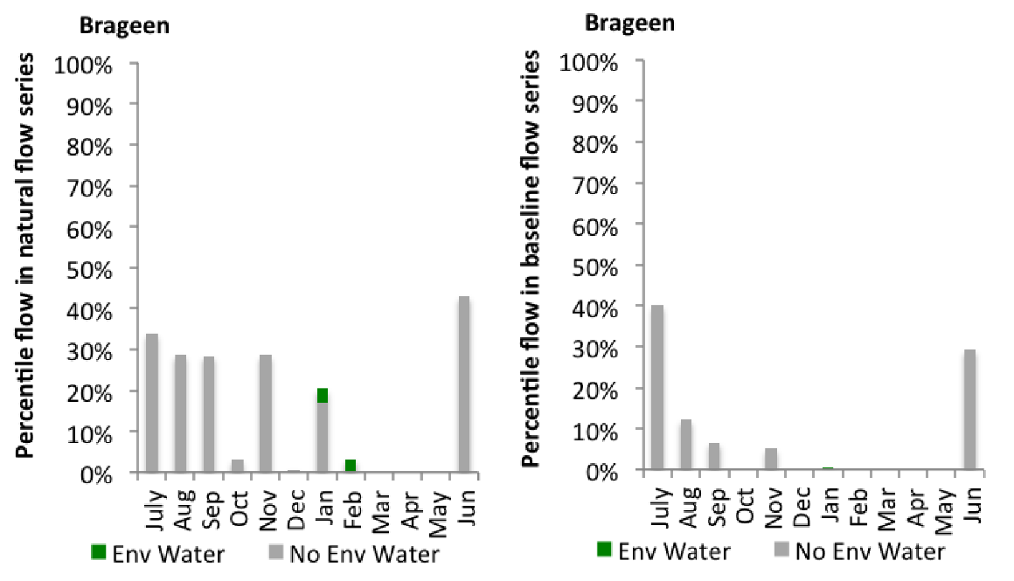
Figure GWY30: Contribution of environmental water delivery at Brageen as percentiles in the natural and baseline flow series.
Allambie
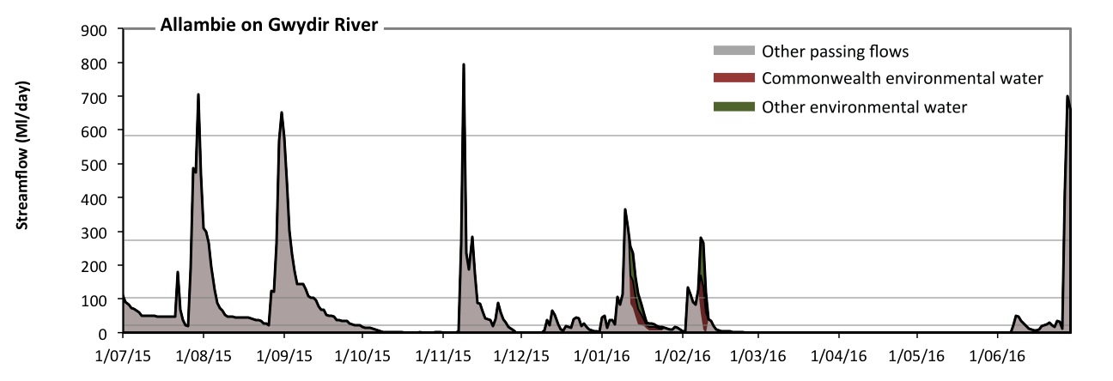 Figure GWY31: Contribution of environmental water delivery at Allambie. Horizontal lines indicate thresholds for very low flows, low flows, low freshes and medium freshes (from lowest to highest).
At Allambie on Gwydir River environmental water contributed 7% of the total streamflow volume (with approximately half contributed by Commonwealth environmental water) (Figure GWY31 and GWY32). Environmental watering actions affected streamflows for 5% of days between 1 July 2015 and 30 June 2016. Without environmental water, the durations of very low flows (i.e. < 21 Ml/day) in the periods October to December, January to March and April to June would have substantially exceeded durations expected in an average year in the natural flow regime. Environmental water mitigated these impacts by reducing the cumulative duration of very low flow spells from 58% to 56% of the year, with greatest influence in the period January to March. Similarly, without environmental water, the durations of medium low flows (i.e. < 100 Ml/day) in the periods July to September, October to December, January to March and April to June would have all substantially exceeded durations expected in an average year in the natural flow regime. Environmental water mitigated these impacts by reducing the cumulative duration of medium low flow spells from 88% to 86% of the year, with greatest influence in the period January to March. There was at least one low fresh (i.e. > 270 Ml/day) in the periods July to September, October to December, January to March and April to June. Environmental water made no change to the duration of these low freshes. There was at least one medium fresh (i.e. > 580 Ml/day) in the periods July to September, October to December and April to June. Environmental water made no change to the duration of these medium freshes. There was no high freshes (i.e. > 1900 Ml/day) this year.
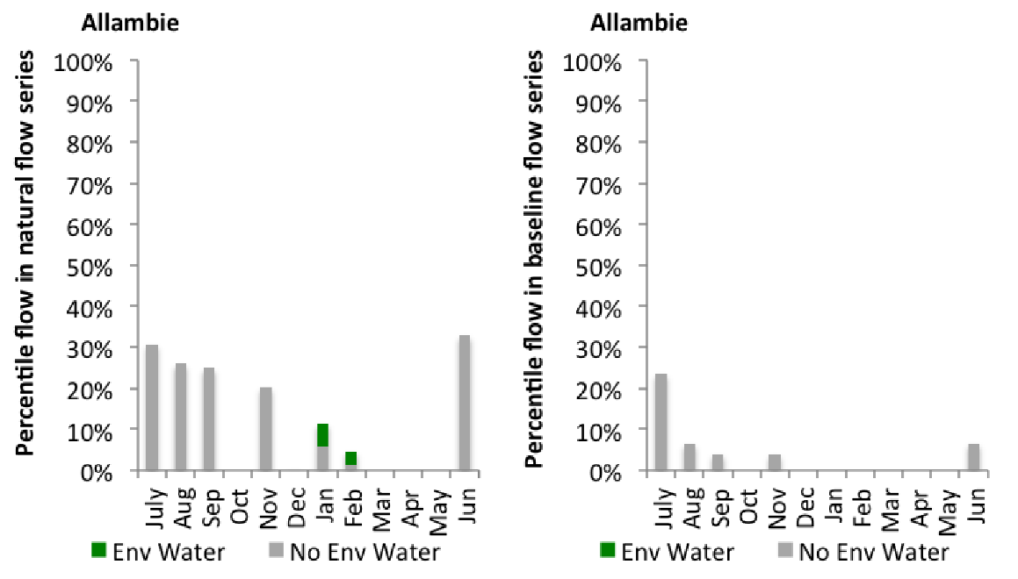
Figure GWY32: Contribution of environmental water delivery at Allambie as percentiles in the natural and baseline flow series.

Millewa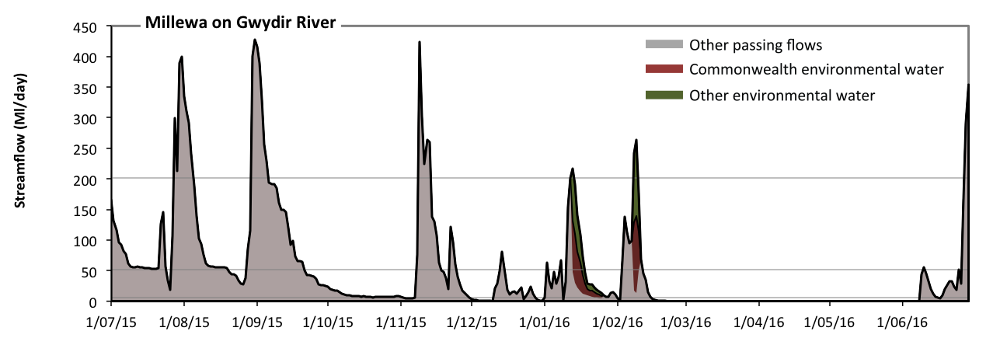 Figure GWY33: Contribution of environmental water delivery at Millewa. Horizontal lines indicate thresholds for very low flows, low flows, low freshes and medium freshes (from lowest to highest).
At Millewa on Gwydir River environmental water contributed 7% of the total streamflow volume (with approximately half contributed by Commonwealth environmental water) (Figure GWY33 and GWY34). Environmental watering actions affected streamflows for 5% of days between 1 July 2015 and 30 June 2016. Flow regulation does not substantially increase the duration of very low flows (i.e. < 1.1 Ml/day) compared to an average year in the natural flow regime. Flow regulation does not substantially increase the duration of medium low flows (i.e. < 5.7 Ml/day) compared to an average year in the natural flow regime. In the absence of environmental water there would have been at least one low fresh (i.e. > 52 Ml/day) in the periods July to September, October to December, January to March and April to June. Environmental water increased the duration of the longest low fresh during the period January to March (from 5 days to 9 days). Commonwealth environmental water equally shared responsibility with other environmental water holders for these increased durations of low freshes. In the absence of environmental water there would have been at least one medium fresh (i.e. > 200 Ml/day) in the periods July to September, October to December, January to March and April to June. Environmental water increased the duration of the longest medium fresh during the period January to March (from 1 days to 2 days). Commonwealth environmental water equally shared responsibility with other environmental water holders for these increased durations of medium freshes. There was no high freshes (i.e. > 1200 Ml/day) this year.

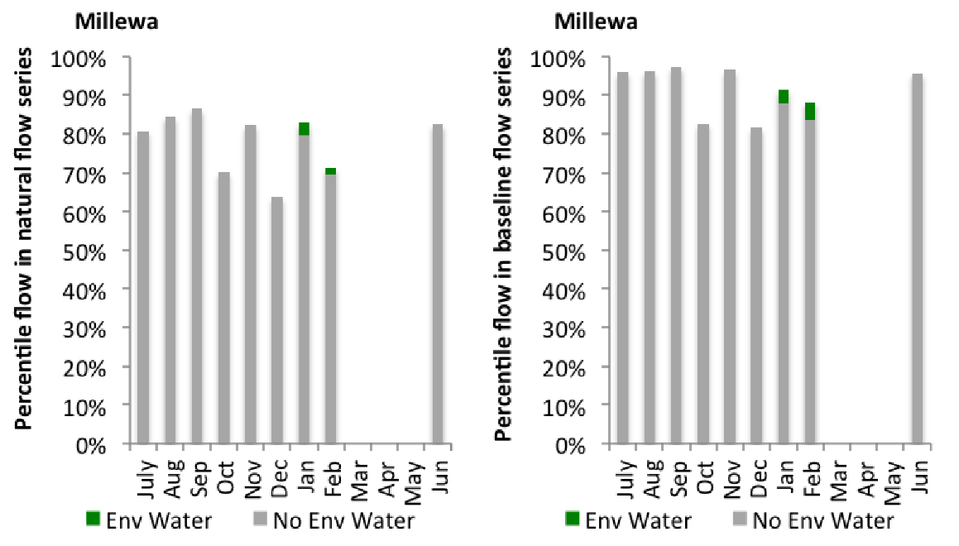
Figure GWY34: Contribution of environmental water delivery at Millewa as percentiles in the natural and baseline flow series.
Moree
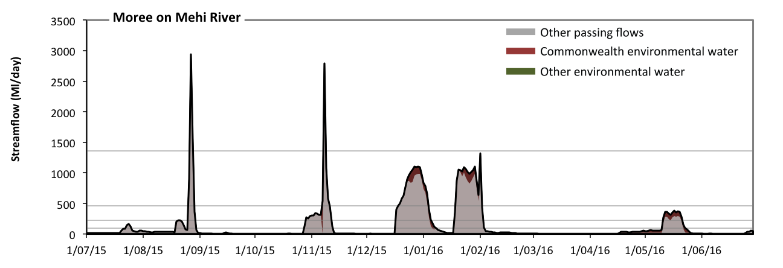 Figure GWY35: Contribution of environmental water delivery at Moree. Horizontal lines indicate thresholds for very low flows, low flows, low freshes, medium freshes and high freshes (from lowest to highest).
At Moree on Mehi River environmental water contributed 12% of the total streamflow volume (most of which was Commonwealth environmental water) (Figure GWY35 and GWY36). Environmental watering actions affected streamflows for 21% of days between 1 July 2015 and 30 June 2016. Without environmental water, the durations of very low flows (i.e. < 19 Ml/day) in the periods July to September, October to December, January to March and April to June would have all substantially exceeded durations expected in an average year in the natural flow regime. Environmental water mitigated these impacts by reducing the cumulative duration of very low flow spells from 63% to 56% of the year, with greatest influence in the period April to June. Similarly, without environmental water, the durations of medium low flows (i.e. < 95 Ml/day) in the periods July to September, October to December, January to March and April to June would have all substantially exceeded durations expected in an average year in the natural flow regime. Environmental water mitigated these impacts by reducing the cumulative duration of medium low flow spells from 79% to 78% of the year, with greatest influence in the periods October to December, January to March and April to June. Commonwealth environmental water was entirely responsible for these enhancements of environmental baseflows at this site. In the absence of environmental water there would have been at least one low fresh (i.e. > 230 Ml/day) in the periods July to September, October to December, January to March and April to June. Environmental water increased the duration of the longest low fresh during the period April to June (from 5 days to 11 days). Commonwealth environmental water was entirely responsible for these increased durations of low freshes. There was at least one medium fresh (i.e. > 460 Ml/day) in the periods July to September, October to December and January to March. Environmental water made no change to the duration of these medium freshes. In the absence of environmental water there would have been at least one high fresh in the periods July to September and October to December. Environmental water made no change to the duration of these high freshes.
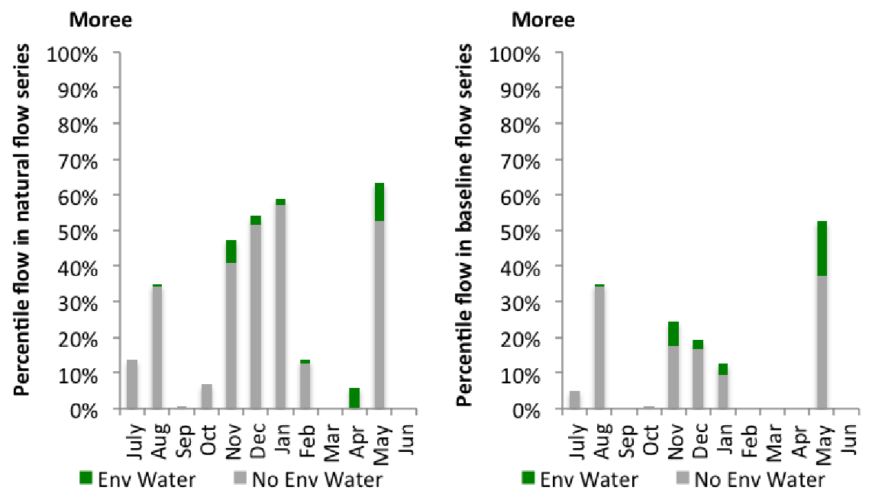
Figure GWY36: Contribution of environmental water delivery at Moree as percentiles in the natural and baseline flow series.
Combadello
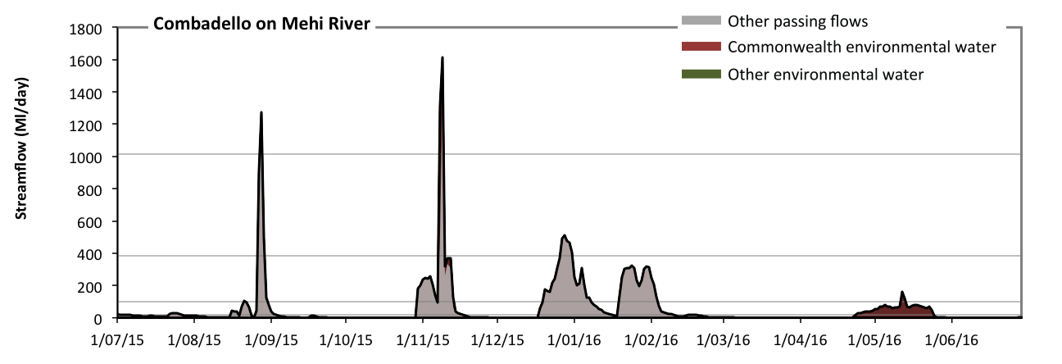
Figure GWY37: Contribution of environmental water delivery at Combadello. Horizontal lines indicate thresholds for very low flows, low flows, low freshes and medium freshes (from lowest to highest).
At Combadello on Mehi River environmental water contributed 15% of the total streamflow volume (all of which was Commonwealth environmental water) (Figure GWY37 and GWY38). Environmental watering actions affected streamflows for 11% of days between 1 July 2015 and 30 June 2016. Without environmental water, the durations of very low flows (i.e. < 20 Ml/day) in the periods July to September, October to December, January to March and April to June would have all substantially exceeded durations expected in an average year in the natural flow regime. Environmental water mitigated these impacts by reducing the cumulative duration of very low flow spells from 75% to 66% of the year, with greatest influence in the period April to June. Similarly, without environmental water, the durations of medium low flows (i.e. < 99 Ml/day) in the periods July to September, October to December, January to March and April to June would have all substantially exceeded durations expected in an average year in the natural flow regime. Environmental water mitigated these impacts by reducing the cumulative duration of medium low flow spells from 85% to 85% of the year, with greatest influence in the periods October to December and April to June. Commonwealth environmental water was entirely responsible for these enhancements of environmental baseflows at this site. There was at least one low fresh (i.e. > 380 Ml/day) in the periods July to September and October to December. Environmental water made little change to the duration of these low freshes. In the absence of environmental water there would have been at least one medium fresh (i.e. > 1000 Ml/day) in the periods July to September and October to December. Environmental water increased the duration of the longest medium fresh during the period October to December (from 1 days to 2 days). Commonwealth environmental water was entirely responsible for these increased durations of medium freshes. There was no high freshes (i.e. > 4100 Ml/day) this year.
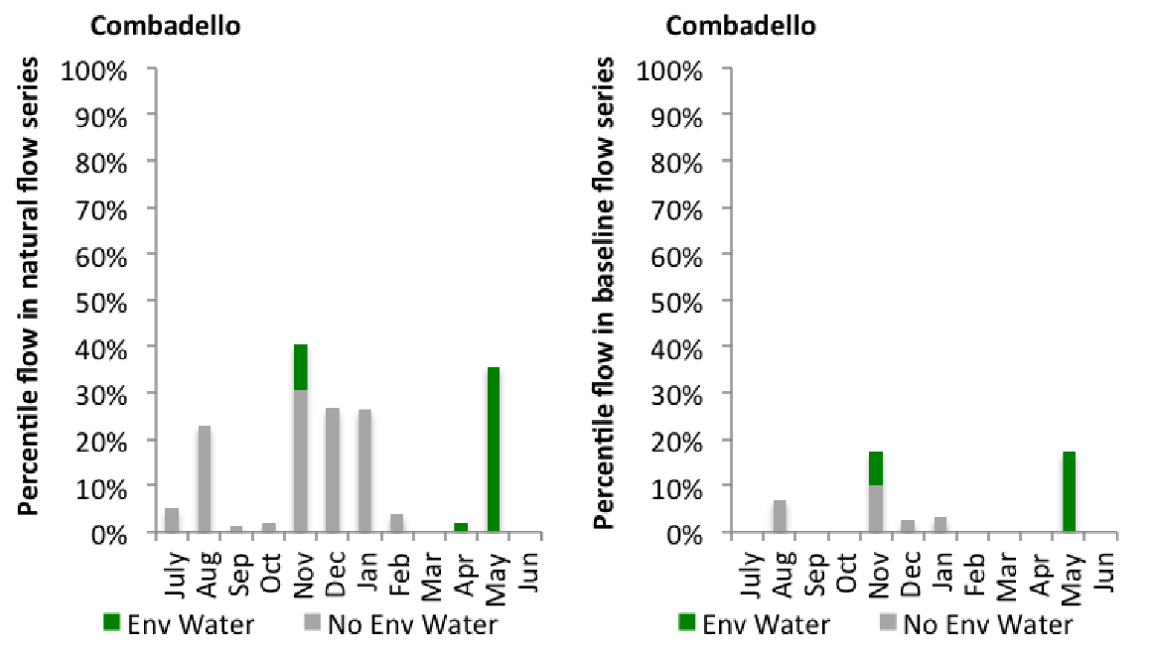
Figure GWY38: Contribution of environmental water delivery at Combadello as percentiles in the natural and baseline flow series.

Mallowa
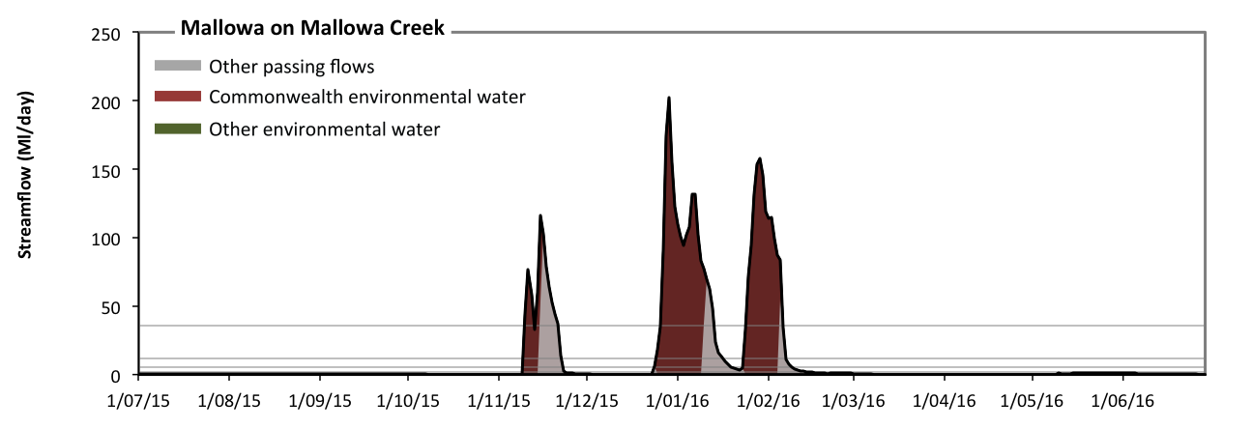
Figure GWY39: Contribution of environmental water delivery at Mallowa. Horizontal lines indicate thresholds for very low flows, low flows, low freshes, medium freshes and high freshes (from lowest to highest).
At Mallowa on Mallowa Creek environmental water contributed 78% of the total streamflow volume (all of which was Commonwealth environmental water) (Figure GWY39 and GWY40). Environmental watering actions affected streamflows for 10% of days between 1 July 2015 and 30 June 2016. Without environmental water, the durations of very low flows (i.e. < 0.43 Ml/day) in the periods July to September, October to December and January to March would have substantially exceeded durations expected in an average year in the natural flow regime. Environmental water mitigated these impacts by reducing the cumulative duration of very low flow spells from 74% to 66% of the year, with greatest influence in the periods October to December and January to March. Similarly, without environmental water, the durations of medium low flows (i.e. < 2.1 Ml/day) in the periods July to September, October to December, January to March and April to June would have all substantially exceeded durations expected in an average year in the natural flow regime. Environmental water mitigated these impacts by reducing the cumulative duration of medium low flow spells from 91% to 82% of the year, with greatest influence in the periods October to December and January to March. Commonwealth environmental water was entirely responsible for these enhancements of environmental baseflows at this site. In the absence of environmental water there would have been at least one low fresh (i.e. > 5.5 Ml/day) in the periods October to December and January to March. Environmental water increased the duration of the longest low fresh during the periods October to December (from 8 days to 13 days) and January to March (from 10 days to 19 days). Commonwealth environmental water was entirely responsible for these increased durations of low freshes. In the absence of environmental water there would have been at least one medium fresh (i.e. > 11 Ml/day) in the periods October to December and January to March. Environmental water increased the duration of the longest medium fresh during the periods October to December (from 8 days to 13 days) and January to March (from 7 days to 16 days). Commonwealth environmental water was entirely responsible for these increased durations of medium freshes. In the absence of environmental water there would have been at least one high fresh in the periods October to December and January to March. Environmental water increased the duration of the longest medium fresh during the period January to March (from 4 days to 13 days). Commonwealth environmental water was entirely responsible for these increased durations of high freshes.
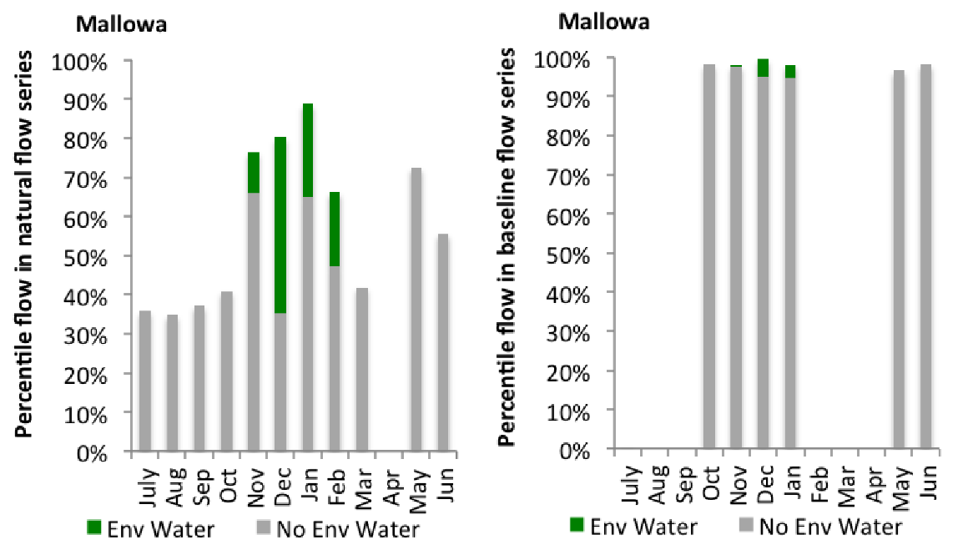
Figure GWY40: Contribution of environmental water delivery at Mallowa as percentiles in the natural and baseline flow series.
Gundare
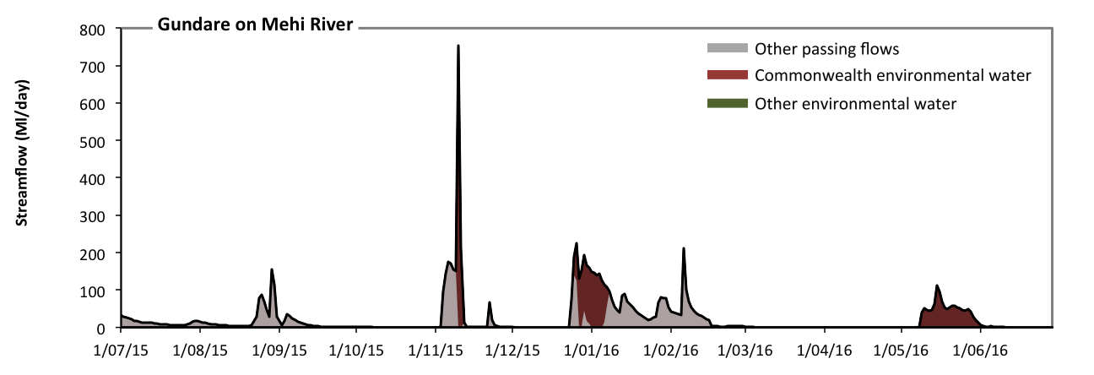
Figure GWY41: Contribution of environmental water delivery at Gundare. Horizontal lines indicate thresholds for (from lowest to highest).
At Gundare on Mehi River environmental water contributed 43% of the total streamflow volume (all of which was Commonwealth environmental water) (Figure GWY41 and GWY42). Environmental watering actions affected streamflows for 13% of days between 1 July 2015 and 30 June 2016. Without environmental water, the durations of very low flows (i.e. < 0.43 Ml/day) in the periods October to December and April to June would have substantially exceeded durations expected in an average year in the natural flow regime. Environmental water mitigated these impacts by reducing the cumulative duration of very low flow spells from 47% to 36% of the year, with greatest influence in the period April to June. Similarly, without environmental water, the durations of medium low flows (i.e. < 2.1 Ml/day) in the periods October to December and April to June would have substantially exceeded durations expected in an average year in the natural flow regime. Environmental water mitigated these impacts by reducing the cumulative duration of medium low flow spells from 58% to 48% of the year, with greatest influence in the period April to June. Commonwealth environmental water was entirely responsible for these enhancements of environmental baseflows at this site.
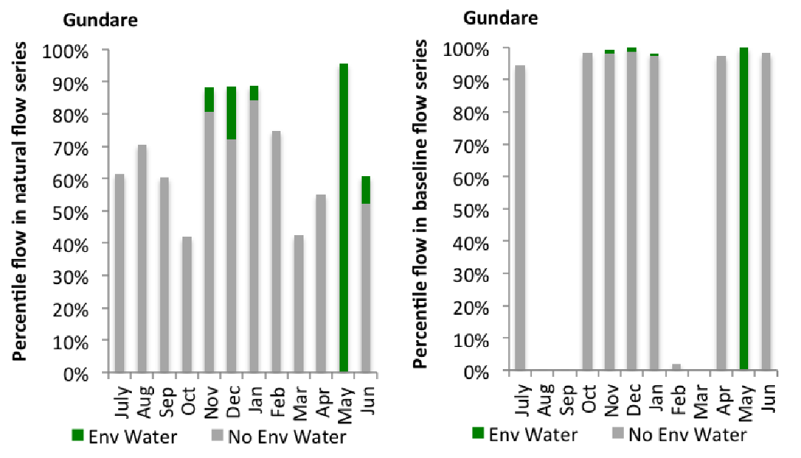
Figure GWY42: Contribution of environmental water delivery at Gundare as percentiles in the natural and baseline flow series.
BallinBoora
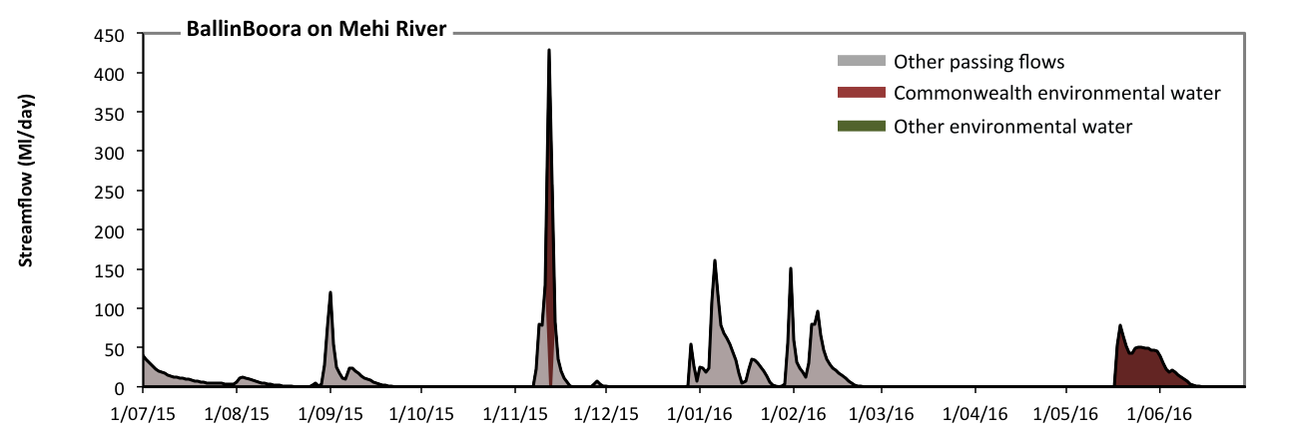
Figure GWY43: Contribution of environmental water delivery at BallinBoora. Horizontal lines indicate thresholds for (from lowest to highest).
At BallinBoora on Mehi River environmental water contributed 31% of the total streamflow volume (all of which was Commonwealth environmental water) (Figure GWY43). Environmental watering actions affected streamflows for 8% of days between 1 July 2015 and 30 June 2016. However, environmental water had little effect on the duration of these very low flows, which occurred for 100% of the year.

Bronte
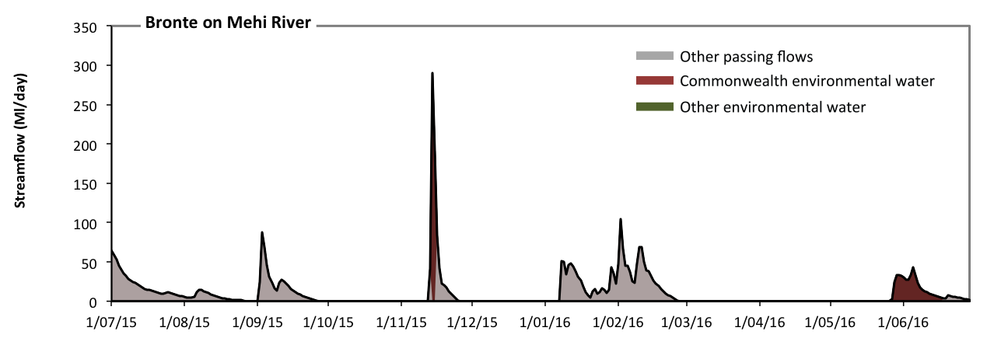
Figure GWY44: Contribution of environmental water delivery at Bronte. Horizontal lines indicate thresholds for (from lowest to highest).
At Bronte on Mehi River environmental water contributed 23% of the total streamflow volume (all of which was Commonwealth environmental water) (Figure GWY44). Environmental watering actions affected streamflows for 7% of days between 1 July 2015 and 30 June 2016. However, environmental water had little effect on the duration of these very low flows, which occurred for 100% of the year.

Lachlan
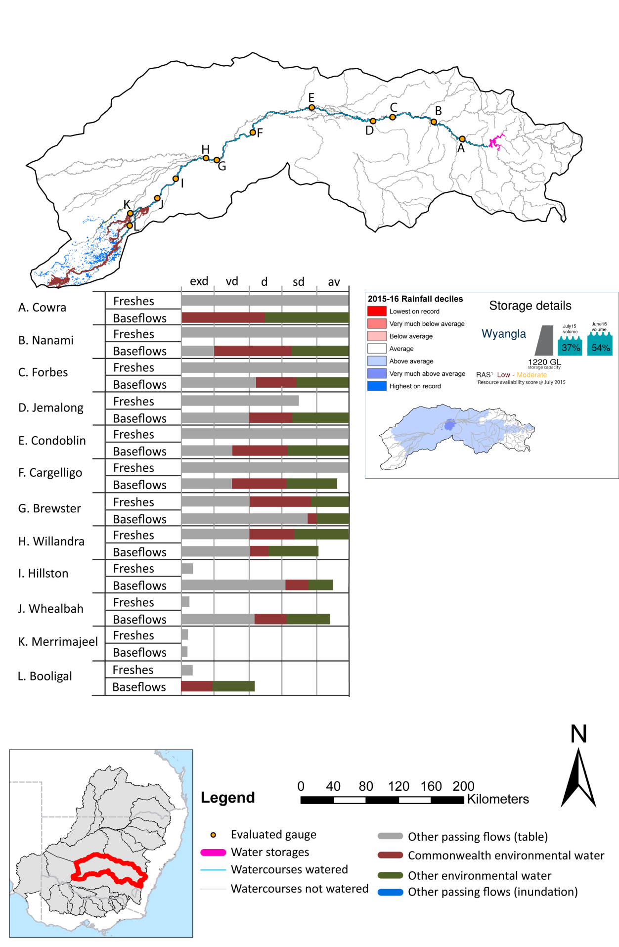
Figure LCH1: Watercourses influenced, areas inundated (where applicable) and gauge stations evaluated in the Lachlan valley during the 2015-16 water year. Inset bar graphs report the condition of annual flow regimes by showing the improvements in hydrological condition with the addition of environmental water as well as the hypothetical scenario in “grey” (if no environmental flow had been delivered). Rainfall conditions (rainfall deciles) and trend in storage levels for the water year are also shown.

Summary
Environmental water delivery for the 2015-16 year in the Lachlan Valley is evaluated using data for 13 sites. This evaluation only considers the contribution of held environmental water, which is a primary focus for the Commonwealth. The contributions of planned environmental water (e.g. passing flows), unregulated tributary inflows and clever use of irrigation flows for environmental benefits can all be very important but these are outside the scope of this report. Environmental watering actions lasted on average 115 days over the course of the year. The volume of environmental water at these 13 sites was between 15% and 63% of the total streamflow. Commonwealth Environmental Water contributed on average 37% of this environmental water. Ideally, baseflows should be maintained and long periods of excessively low flows avoided. In this valley, the baseflow regime was generally considered to be somewhat dry relative to the pre-development flow regime. In our analysis, a low fresh refers to a period of increased flow, when the water level rises at least one eighth of the way up the river bank (above the low flow level). These low freshes are a regular part of the natural flow regime and support a range of natural processes. In the Lachlan valley, in terms of the occurrence and duration of low freshes, the year was assessed as being somewhat dry. In our analysis, a medium fresh refers to a period of increased flow, when the water level rises at least one quarter of the way up the river bank. These medium freshes are not as frequent as low freshes but are also a regular and important part of the natural flow regime. In the Lachlan valley, in terms of the occurrence of medium freshes, the year was assessed as being somewhat dry. In our analysis, a high fresh refers to a period of increased flow, when the water level rises more than half way up the river. A high fresh may not occur every year but they are still important and long periods without major freshes can have serious consequences for floodplains and their contribution to river ecosystem health. Delivering environmental water as high in channel flows normally requires that all risks to riparian landholders and infrastructure have been resolved. In the Lachlan valley, in terms of the occurrence of high freshes, the year was assessed as being dry.

Environmental water system
The Lachlan valley covers an area of 2193 km 2 representing 8.1% percent of the Murray Darling Basin. It is a virtual-terminal system with the river ending in the wetlands of the Great Cumbung Swamp. The Valley’s major water storage is Wyangala Dam (1217 GL). The Lachlan is a very long river with many anabranches and creeks both in the section near Condobolin, but primarily on the lower river downstream of Lake Brewster. Consequently the River’s channel capacity varies significantly with it becoming a smaller channel, particularly around the Condobolin anabranch area, and progressively downstream of Lake Brewster inflows mainly due the distributary nature of the channels.
Floodplain wetlands in the Lachlan valley cover some 400,000 ha. They include the Lake Cowal system (near Forbes), to the billabong habitats in the Condobolin anabranch district and to the large wetland systems downstream of Lake Brewster both along the River and its other connected watercourses. There are nine-Nationally important wetlands in the Lachlan catchment.
Environmental water is typically released from Wyangala Dam, Lake Cargelligo and Lake Brewster. However, since the year 2000, Wyangala Dam has been the main source of regulated water. The main constraint impeding environmental flow delivery in the Lachlan is associated with Wyangala’s release capacity of 6,600 ML/day which reduces as the volume of stored water reduces (Mdba 2013). Wyangala Dam is also the source of secure water supply for downstream irrigators and towns in the Lachlan, so any environmental releases are made in addition to the consumptive needs. Other constraints occur at Lake Brewster which has a maximum release capacity of 3000 ML/day. Flows greater than 2400 ML/d upstream of Willandra weir initiate flows in Willandra Creek. Finally, irrigation infrastructure maybe inundated in the Hillston area at flows above 2800 ML/day.
The Lachlan is a highly variable system with many distributary creeks with varying channel capacities. Delivery efficiency is a very important consideration for use of Commonwealth environmental water in the Lachlan, as assets are located a long distance from the major storage, and the secondary storages have limited capacity. Many potential watering actions incorporate an element of piggybacking in order to maximise efficiency and outcomes for assets. This has the potential to constrain use e.g. replenishment flows can occur within a large operating window, and the timing can affect efficient delivery of Commonwealth environmental water.
The Commonwealth environmental water portfolio consists of 86 GL of General Security entitlements which have a Long Term Average Annual Yield of 36 GL. Under continuous accounting and the provisions for carryover, the risk of forfeiture for Commonwealth environmental water in the Lachlan is low (considering the previous use pattern). In order to have a reasonable ability to maintain key environmental assets, Commonwealth environmental water is managed by effectively carrying over volumes of water for use in future years, with the pattern of use changing and adapting depending on what additional water is available in the system and the condition of assets. In the event that the volume in Commonwealth environmental water accounts reaches a low threshold (e.g. 10 GL), water use would potentially be limited in order to maintain a contingency volume to avoid damage to environmental assets. Overall, environmental water delivery in this valley aims to maintain and contribute to restoration to key environmental features by delivering river flow regimes, which, mimic as much as possible, the natural conditions.

Data availability
The contribution (where applicable) of the Commonwealth environmental water and NSW environmental water and other passing flows were derived from the CAIRO river operations spreadsheet held by Water NSW. The waterholding, and its source was checked against use charged on the held environmental water entitlements. Known travel times, accounting data, contributions from tributaries and differences between allocated and unallocated flows were used to quantify the movement of water from the source point to its accounting point. The approach assumed no longitudinal delivery loss.

Water delivery context
During the 2015-16 water year, the Commonwealth Environmental Water Holder (CEWH) held water entitlements of up to 87856ML for environmental use in the Lachlan valley. Each year, water utilities allocate the water entitlement holders a percentage of water based on their holding, license type and carryover (the exact rules vary among Jurisdictions). In the 2015-16 water year, the CEWH Lachlan entitlements were allocated 22812 ML of water, representing 60.93% of the Long term average annual yield for the Lachlan valley (37441 ML). The 2015-16 water allocation (22812 ML) together with the carryover volume of 39462 ML of water meant the CEWH had 62274 ML of water available for delivery.
A total of 36021 ML of Commonwealth environmental water was delivered in the Lachlan valley. A total of 0 ML of Commonwealth environmental water was traded to consumptive users and 26253ML (42.16% of available resource) of Commonwealth environmental water was carried over for environmental use into the 2016-17 water year.

Environmental conditions and resource availability
The water available for delivery combined with the present and antecedent environmental conditions are key inputs used by environmental water managers in planning and implementing watering actions. Post hoc, this information provides important context when evaluating the effectiveness and appropriateness of environmental water use with respect to hydrological outputs.
The rainfall conditions in the Lachlan valley were classified as Above Average, based on rainfall percentile data for the entire record held by the Bureau of Meteorology for this valley. The major storages in the Lachlan valley remained increased, being 37% full at the beginning of the water year and 54% full by the end of the year (Figure LCH1).
The Commonwealth Environmental Water Office (CEWO) calculates resource availability scenarios (RAS) progressively as part of its continual adaptive management planning processes. The RAS are based on the availability of held water (including progressive license acquisitions and allocations) as well as the potential for unregulated or planned environmental flows. The resource availability of held water was classified as Low in this valley, whilst the potential for unregulated or planned environmental flow was classified as Moderate. The physical conditions meant that the CEWO was managing to Maintain the ecological health and resilience of wetland sites in the catchment, and support the recovery of native fish species. The overall demand for environmental water was deemed High (water predominantly needed this year).

Watering actions
A total of 4 watering actions were implemented, the duration of these actions varied (range of individual actions: 11 - 66 days). The total cumulative sum of watering actions days was 168). The number of actions commencing in each season varied: Winter (1) and Spring (3). The flow component types delivered included (0 baseflow, 4 freshes, 0 bankfull, 0 overbank and 0 wetland).

Table LCH2. Commonwealth environmental water accounting information for the Lachlan valley over 2015-16 water year.
Total registered volume (ML) | Allocated volume (ML) | Carry over available (ML) | Delivered (ML) | LTAAY (ML) | Trade (ML) | Carried over to 2016-17 | Forfeited (ML)
87856 | 22812 | 62274 | 36021 | 37441 | 0 | 26253 | 0

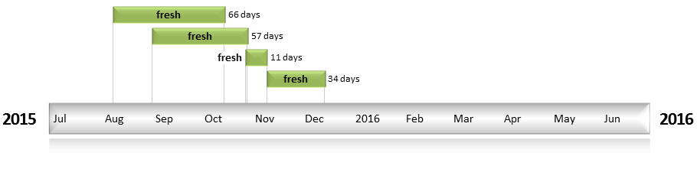
Figure LCH2. Timing and duration of water actions implemented by the CEWO during the 2015-16 water year in the Lachlan valley.

Contribution of Commonwealth Environmental Water to Flow Regimes
Cowra
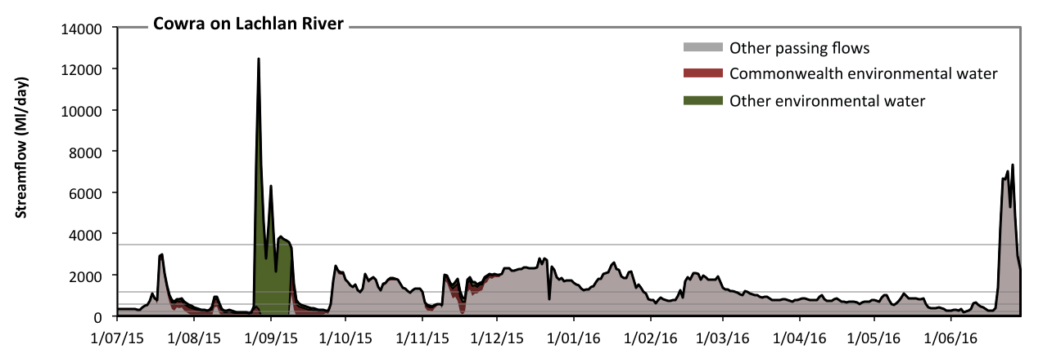
Figure LCH3: Contribution of environmental water delivery at Cowra. Horizontal lines indicate thresholds for very low flows, low flows, low freshes, medium freshes and high freshes (from lowest to highest).
At Cowra on Lachlan River environmental water contributed 21% of the total streamflow volume (with a medium contribution of Commonwealth environmental water) (Figure LCH3 and LCH4). Environmental watering actions affected streamflows for 35% of days between 1 July 2015 and 30 June 2016. Without environmental water, the duration of very low flows (i.e. < 47 Ml/day) in the period July to September would have substantially exceeded durations expected in an average year in the natural flow regime. Environmental water mitigated these impacts by reducing the cumulative duration of very low flow spells from 13% to 0% of the year, with greatest influence in the period July to September. Similarly, without environmental water, the duration of medium low flows (i.e. < 240 Ml/day) in the period July to September would have substantially exceeded durations expected in an average year in the natural flow regime. Environmental water mitigated these impacts by reducing the cumulative duration of medium low flow spells from 16% to 3% of the year, with greatest influence in the period July to September. Commonwealth environmental water equally shared responsibility with other environmental water holders for these enhancements of environmental baseflows at this site. In the absence of environmental water there would have been at least one low fresh (i.e. > 570 Ml/day) in the periods July to September, October to December, January to March and April to June. Environmental water increased the duration of the longest low fresh during the period July to September (from 9 days to 18 days). Commonwealth environmental water equally shared responsibility with other environmental water holders for these increased durations of low freshes. In the absence of environmental water there would have been at least one medium fresh (i.e. > 1200 Ml/day) in the periods July to September, October to December, January to March and April to June. Environmental water increased the duration of the longest medium fresh during the period July to September (from 5 days to 16 days). Commonwealth environmental water made little or no contribution to these increased durations of medium freshes. In the absence of environmental water there would have been at least one high fresh in the period April to June. Environmental water increased the duration of the longest medium fresh during the period July to September (from 0 days to 5 days). Commonwealth environmental water made little or no contribution to these increased durations of high freshes.
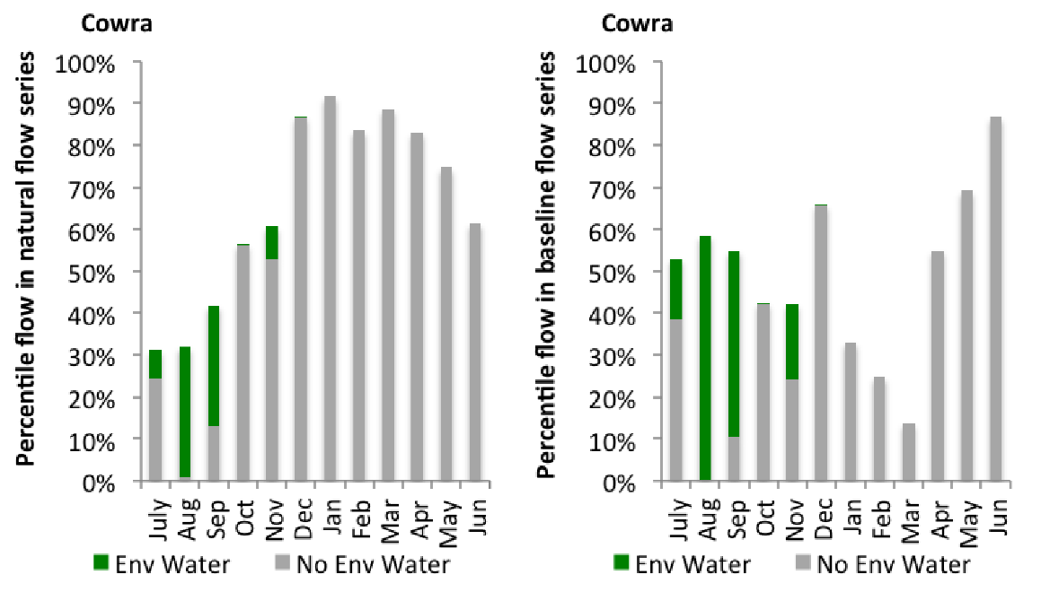
Figure LCH4: Contribution of environmental water delivery at Cowra as percentiles in the natural and baseline flow series.

Forbes
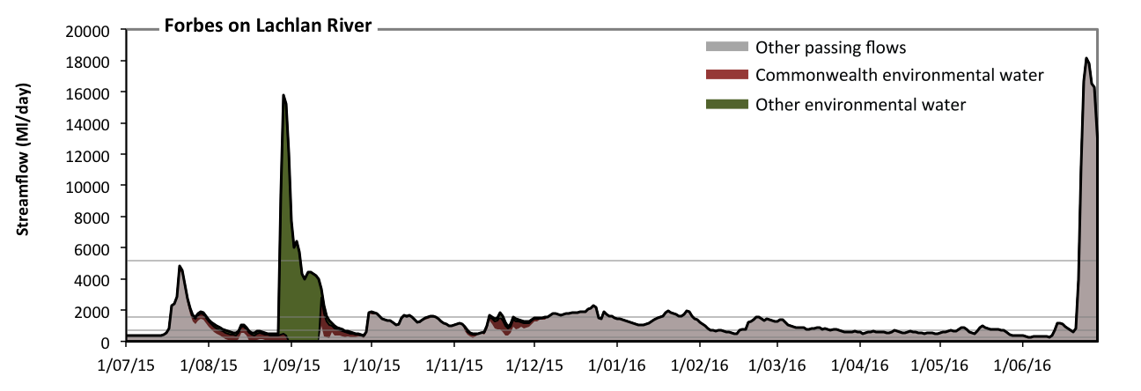
Figure LCH5: Contribution of environmental water delivery at Forbes. Horizontal lines indicate thresholds for very low flows, low flows, low freshes, medium freshes and high freshes (from lowest to highest).
At Forbes on Lachlan River environmental water contributed 26% of the total streamflow volume (with a medium contribution of Commonwealth environmental water) (Figure LCH5 and LCH6). Environmental watering actions affected streamflows for 35% of days between 1 July 2015 and 30 June 2016. Without environmental water, the duration of very low flows (i.e. < 54 Ml/day) in the period July to September would have substantially exceeded durations expected in an average year in the natural flow regime. Environmental water mitigated these impacts by reducing the cumulative duration of very low flow spells from 6% to 0% of the year, with greatest influence in the period July to September. Similarly, without environmental water, the duration of medium low flows (i.e. < 270 Ml/day) in the period July to September would have substantially exceeded durations expected in an average year in the natural flow regime. Environmental water mitigated these impacts by reducing the cumulative duration of medium low flow spells from 10% to 0% of the year, with greatest influence in the period July to September. Commonwealth environmental water equally shared responsibility with other environmental water holders for these enhancements of environmental baseflows at this site. In the absence of environmental water there would have been at least one low fresh (i.e. > 730 Ml/day) in the periods July to September, October to December, January to March and April to June. Environmental water increased the duration of the longest low fresh during the periods July to September (from 17 days to 24 days) and October to December (from 39 days to 49 days). Commonwealth environmental water was entirely responsible for these increased durations of low freshes. In the absence of environmental water there would have been at least one medium fresh (i.e. > 1600 Ml/day) in the periods July to September, October to December, January to March and April to June. Environmental water increased the duration of the longest medium fresh during the period July to September (from 8 days to 18 days). Commonwealth environmental water made a small contribution to these increased durations of medium freshes. In the absence of environmental water there would have been at least one high fresh in the period April to June. Environmental water increased the duration of the longest medium fresh during the period July to September (from 0 days to 8 days). Commonwealth environmental water made little or no contribution to these increased durations of high freshes.
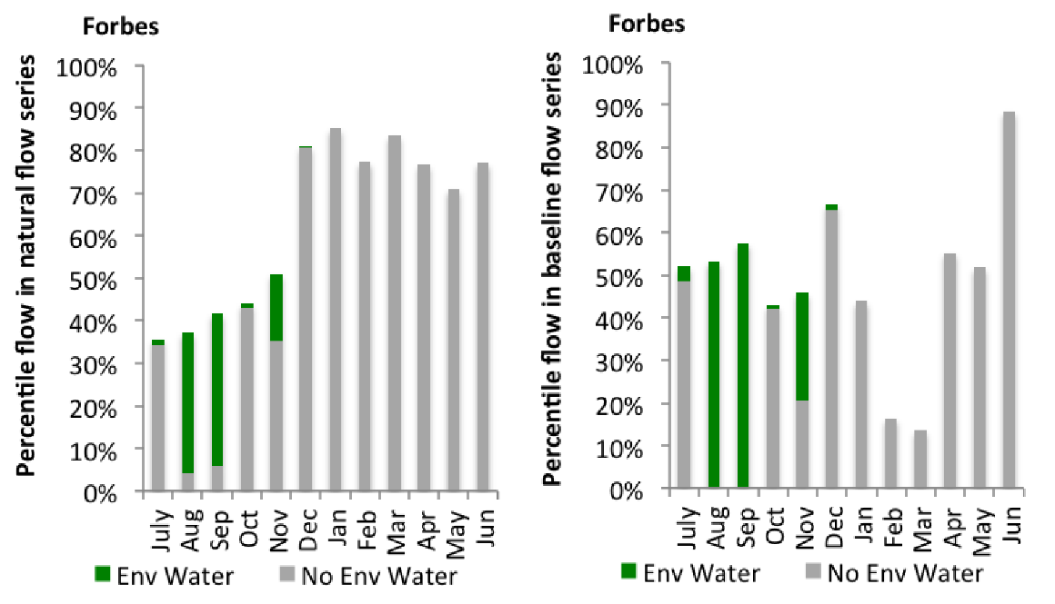
Figure LCH6: Contribution of environmental water delivery at Forbes as percentiles in the natural and baseline flow series.
Nanami
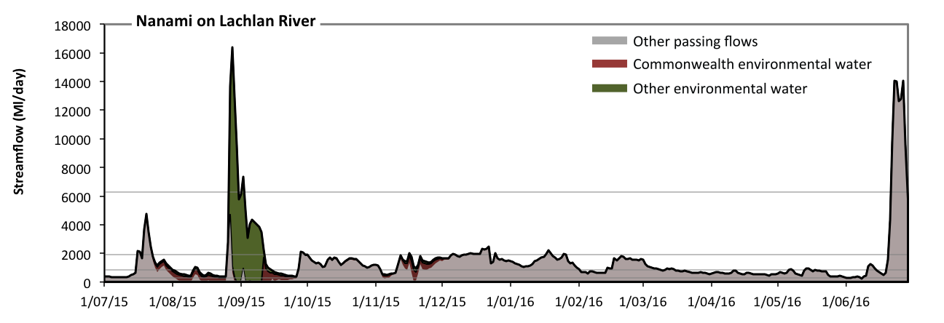
Figure LCH7: Contribution of environmental water delivery at Nanami. Horizontal lines indicate thresholds for very low flows, low flows, low freshes, medium freshes and high freshes (from lowest to highest).
At Nanami on Lachlan River environmental water contributed 25% of the total streamflow volume (with a medium contribution of Commonwealth environmental water) (Figure LCH7 and LCH8). Environmental watering actions affected streamflows for 35% of days between 1 July 2015 and 30 June 2016. Without environmental water, the duration of very low flows (i.e. < 61 Ml/day) in the period July to September would have substantially exceeded durations expected in an average year in the natural flow regime. Environmental water mitigated these impacts by reducing the cumulative duration of very low flow spells from 9% to 0% of the year, with greatest influence in the period July to September. Similarly, without environmental water, the duration of medium low flows (i.e. < 300 Ml/day) in the period July to September would have substantially exceeded durations expected in an average year in the natural flow regime. Environmental water mitigated these impacts by reducing the cumulative duration of medium low flow spells from 16% to 1% of the year, with greatest influence in the period July to September. Commonwealth environmental water equally shared responsibility with other environmental water holders for these enhancements of environmental baseflows at this site. In the absence of environmental water there would have been at least one low fresh (i.e. > 850 Ml/day) in the periods July to September, October to December, January to March and April to June. Environmental water increased the duration of the longest low fresh during the periods July to September (from 9 days to 20 days) and October to December (from 38 days to 51 days). Commonwealth environmental water equally shared responsibility with other environmental water holders for these increased durations of low freshes. In the absence of environmental water there would have been at least one medium fresh (i.e. > 1900 Ml/day) in the periods July to September, October to December, January to March and April to June. Environmental water increased the duration of the longest medium fresh during the period July to September (from 4 days to 17 days). Commonwealth environmental water made little or no contribution to these increased durations of medium freshes. In the absence of environmental water there would have been at least one high fresh in the period April to June. Environmental water increased the duration of the longest medium fresh during the period July to September (from 0 days to 4 days). Commonwealth environmental water made little or no contribution to these increased durations of high freshes.
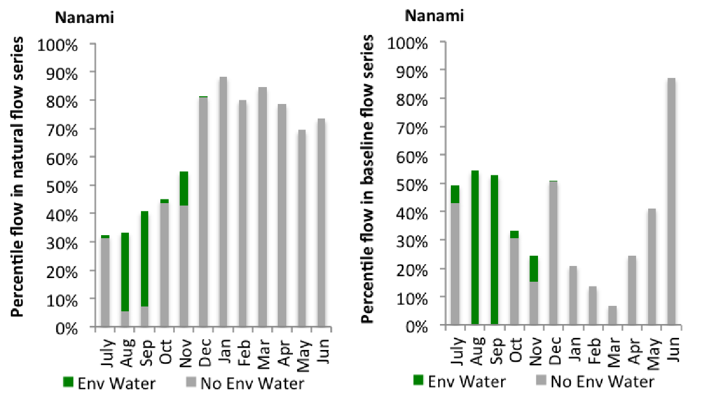
Figure LCH8: Contribution of environmental water delivery at Nanami as percentiles in the natural and baseline flow series.
Condobolin
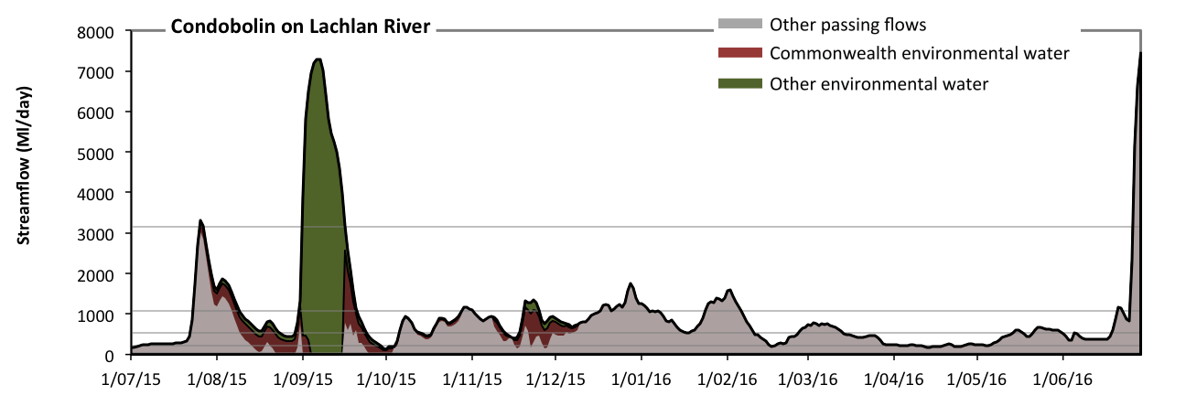
Figure LCH9: Contribution of environmental water delivery at Condobolin. Horizontal lines indicate thresholds for very low flows, low flows, low freshes, medium freshes and high freshes (from lowest to highest).
At Condobolin on Lachlan River environmental water contributed 37% of the total streamflow volume (with a medium contribution of Commonwealth environmental water) (Figure LCH9 and LCH10). Environmental watering actions affected streamflows for 35% of days between 1 July 2015 and 30 June 2016. Without environmental water, the duration of very low flows (i.e. < 46 Ml/day) in the period July to September would have substantially exceeded durations expected in an average year in the natural flow regime. Environmental water mitigated these impacts by reducing the cumulative duration of very low flow spells from 9% to 0% of the year, with greatest influence in the period July to September. Similarly, without environmental water, the duration of medium low flows (i.e. < 230 Ml/day) in the period July to September would have substantially exceeded durations expected in an average year in the natural flow regime. Environmental water mitigated these impacts by reducing the cumulative duration of medium low flow spells from 21% to 9% of the year, with greatest influence in the period July to September. Commonwealth environmental water equally shared responsibility with other environmental water holders for these enhancements of environmental baseflows at this site. In the absence of environmental water there would have been at least one low fresh (i.e. > 540 Ml/day) in the periods July to September, October to December, January to March and April to June. Environmental water increased the duration of the longest low fresh during the periods July to September (from 17 days to 32 days) and October to December (from 24 days to 44 days). Commonwealth environmental water made the dominant contribution to these increased durations of low freshes. In the absence of environmental water there would have been at least one medium fresh (i.e. > 1100 Ml/day) in the periods July to September, October to December, January to March and April to June. Environmental water increased the duration of the longest medium fresh during the period July to September (from 14 days to 21 days). Commonwealth environmental water made a modest contribution to these increased durations of medium freshes. In the absence of environmental water there would have been at least one high fresh in the period April to June. Environmental water increased the duration of the longest medium fresh during the period July to September (from 0 days to 16 days). Commonwealth environmental water made a small contribution to these increased durations of high freshes.
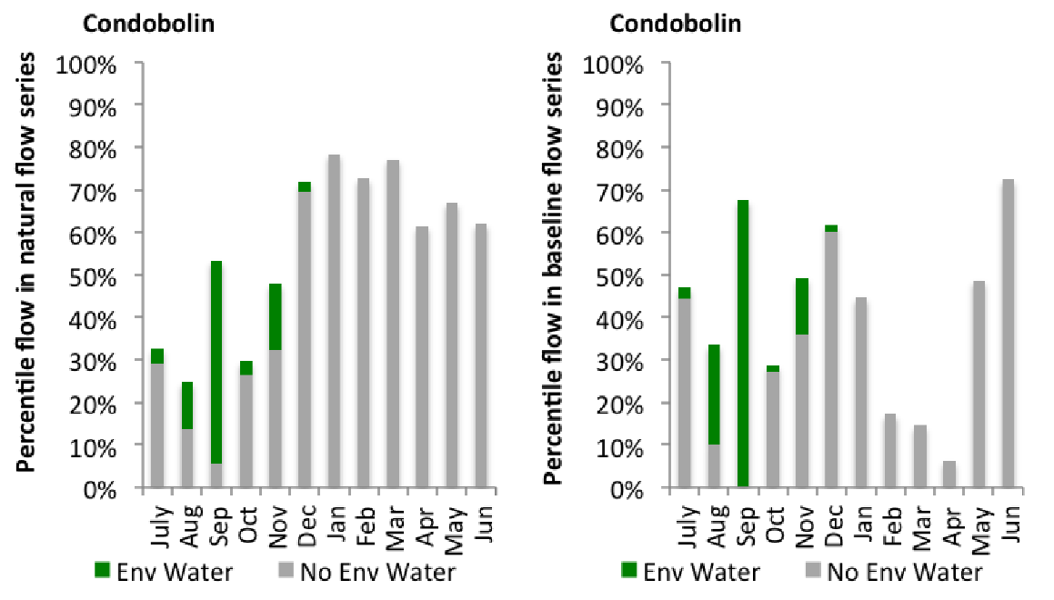
Figure LCH10: Contribution of environmental water delivery at Condobolin as percentiles in the natural and baseline flow series.

Cargelligo
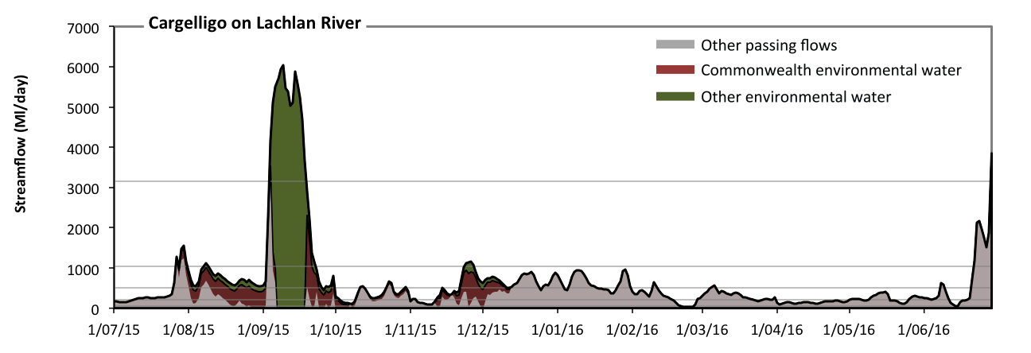
Figure LCH11: Contribution of environmental water delivery at Cargelligo. Horizontal lines indicate thresholds for very low flows, low flows, low freshes, medium freshes and high freshes (from lowest to highest).
At Cargelligo on Lachlan River environmental water contributed 50% of the total streamflow volume (with a medium contribution of Commonwealth environmental water) (Figure LCH11 and LCH12). Environmental watering actions affected streamflows for 35% of days between 1 July 2015 and 30 June 2016. Without environmental water, the duration of very low flows (i.e. < 42 Ml/day) in the period July to September would have substantially exceeded durations expected in an average year in the natural flow regime. Environmental water mitigated these impacts by reducing the cumulative duration of very low flow spells from 11% to 1% of the year, with greatest influence in the periods July to September and October to December. Similarly, without environmental water, the durations of medium low flows (i.e. < 210 Ml/day) in the periods July to September, October to December and April to June would have substantially exceeded durations expected in an average year in the natural flow regime. Environmental water mitigated these impacts by reducing the cumulative duration of medium low flow spells from 41% to 25% of the year, with greatest influence in the periods July to September and October to December. Commonwealth environmental water equally shared responsibility with other environmental water holders for these enhancements of environmental baseflows at this site. In the absence of environmental water there would have been at least one low fresh (i.e. > 520 Ml/day) in the periods July to September, October to December, January to March and April to June. Environmental water increased the duration of the longest low fresh during the periods July to September (from 7 days to 62 days) and October to December (from 12 days to 19 days). Commonwealth environmental water equally shared responsibility with other environmental water holders for these increased durations of low freshes. In the absence of environmental water there would have been at least one medium fresh (i.e. > 1000 Ml/day) in the periods July to September and April to June. Environmental water increased the duration of the longest medium fresh during the periods July to September (from 2 days to 20 days) and October to December (from 0 days to 4 days). Commonwealth environmental water equally shared responsibility with other environmental water holders for these increased durations of medium freshes. In the absence of environmental water there would have been at least one high fresh in the period April to June. Environmental water increased the duration of the longest medium fresh during the period July to September (from 0 days to 15 days). Commonwealth environmental water made a small contribution to these increased durations of high freshes.
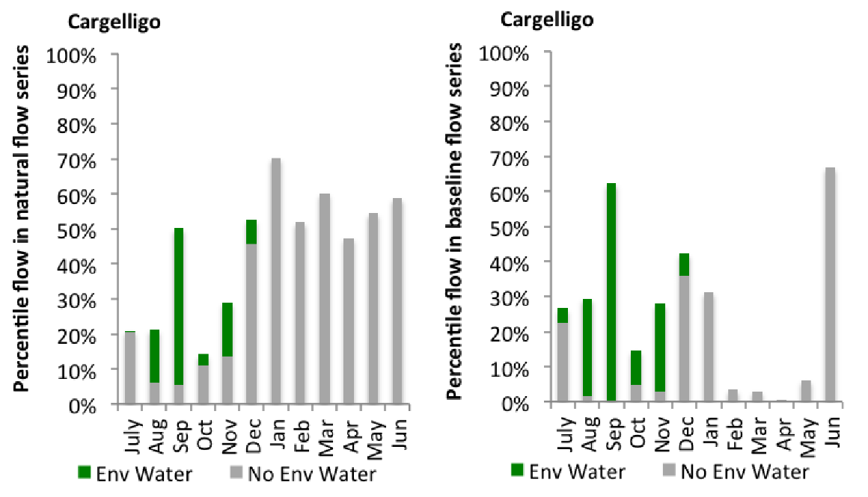
Figure LCH12: Contribution of environmental water delivery at Cargelligo as percentiles in the natural and baseline flow series.
Jemalong
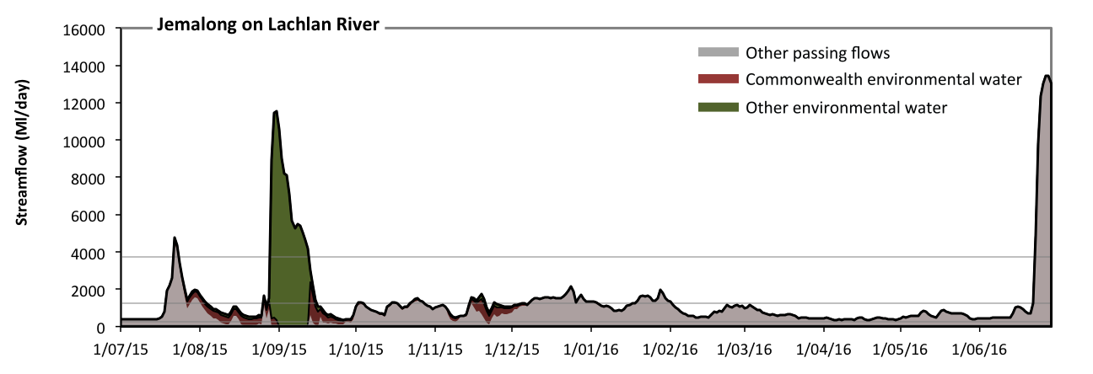Figure LCH13: Contribution of environmental water delivery at Jemalong. Horizontal lines indicate thresholds for very low flows, low flows, low freshes and medium freshes (from lowest to highest).
At Jemalong on Lachlan River environmental water contributed 30% of the total streamflow volume (with a medium contribution of Commonwealth environmental water) (Figure LCH13 and LCH14). Environmental watering actions affected streamflows for 35% of days between 1 July 2015 and 30 June 2016. Without environmental water, the duration of very low flows (i.e. < 54 Ml/day) in the period July to September would have substantially exceeded durations expected in an average year in the natural flow regime. Environmental water mitigated these impacts by reducing the cumulative duration of very low flow spells from 5% to 0% of the year, with greatest influence in the period July to September. Similarly, without environmental water, the duration of medium low flows (i.e. < 270 Ml/day) in the period July to September would have substantially exceeded durations expected in an average year in the natural flow regime. Environmental water mitigated these impacts by reducing the cumulative duration of medium low flow spells from 13% to 0% of the year, with greatest influence in the period July to September. Commonwealth environmental water equally shared responsibility with other environmental water holders for these enhancements of environmental baseflows at this site. In the absence of environmental water there would have been at least one low fresh (i.e. > 1300 Ml/day) in the periods July to September, October to December, January to March and April to June. Environmental water increased the duration of the longest low fresh during the period July to September (from 8 days to 19 days). Commonwealth environmental water equally shared responsibility with other environmental water holders for these increased durations of low freshes. In the absence of environmental water there would have been at least one medium fresh (i.e. > 3700 Ml/day) in the periods July to September and April to June. Environmental water increased the duration of the longest medium fresh during the period July to September (from 2 days to 15 days). Commonwealth environmental water made little or no contribution to these increased durations of medium freshes. There was no high freshes (i.e. > 17000 Ml/day) this year.
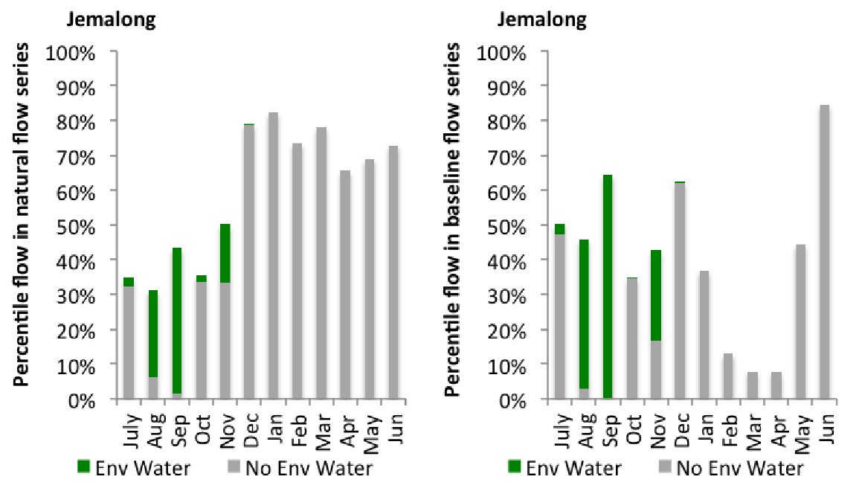
Figure LCH14: Contribution of environmental water delivery at Jemalong as percentiles in the natural and baseline flow series.
Willandra
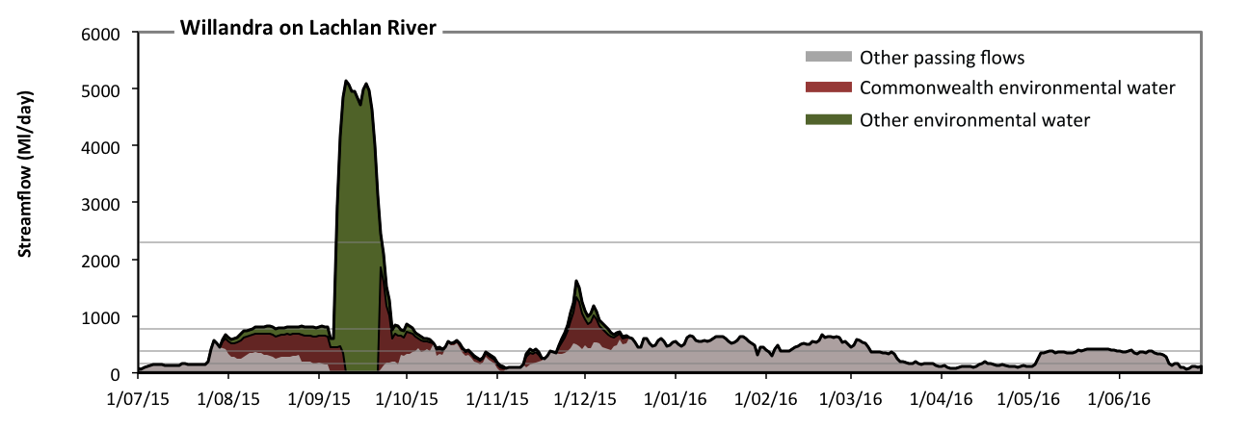 Figure LCH15: Contribution of environmental water delivery at Willandra. Horizontal lines indicate thresholds for very low flows, low flows, low freshes, medium freshes and high freshes (from lowest to highest).
At Willandra on Lachlan River environmental water contributed 50% of the total streamflow volume (with a medium contribution of Commonwealth environmental water) (Figure LCH15 and LCH16). Environmental watering actions affected streamflows for 35% of days between 1 July 2015 and 30 June 2016. Without environmental water, the duration of very low flows (i.e. < 31 Ml/day) in the period July to September would have substantially exceeded durations expected in an average year in the natural flow regime. Environmental water mitigated these impacts by reducing the cumulative duration of very low flow spells from 5% to 0% of the year, with greatest influence in the period July to September. Similarly, without environmental water, the duration of medium low flows (i.e. < 160 Ml/day) in the period July to September would have substantially exceeded durations expected in an average year in the natural flow regime. Environmental water mitigated these impacts by reducing the cumulative duration of medium low flow spells from 29% to 21% of the year, with greatest influence in the period July to September. Commonwealth environmental water made a modest contribution to these enhancements of environmental baseflows at this site. In the absence of environmental water there would have been at least one low fresh (i.e. > 380 Ml/day) in the periods July to September, October to December, January to March and April to June. Environmental water increased the duration of the longest low fresh during the period July to September (from 6 days to 67 days). Commonwealth environmental water made the dominant contribution to these increased durations of low freshes. In the absence of environmental water there would have been no medium or high freshes this year. Environmental water increased the duration of the longest medium fresh during the periods July to September (from 0 days to 27 days) and October to December (from 0 days to 14 days). Commonwealth environmental water equally shared responsibility with other environmental water holders for these increased durations of medium freshes. Environmental water increased the duration of the longest medium fresh during the period July to September (from 0 days to 16 days). Commonwealth environmental water made little or no contribution to these increased durations of high freshes.
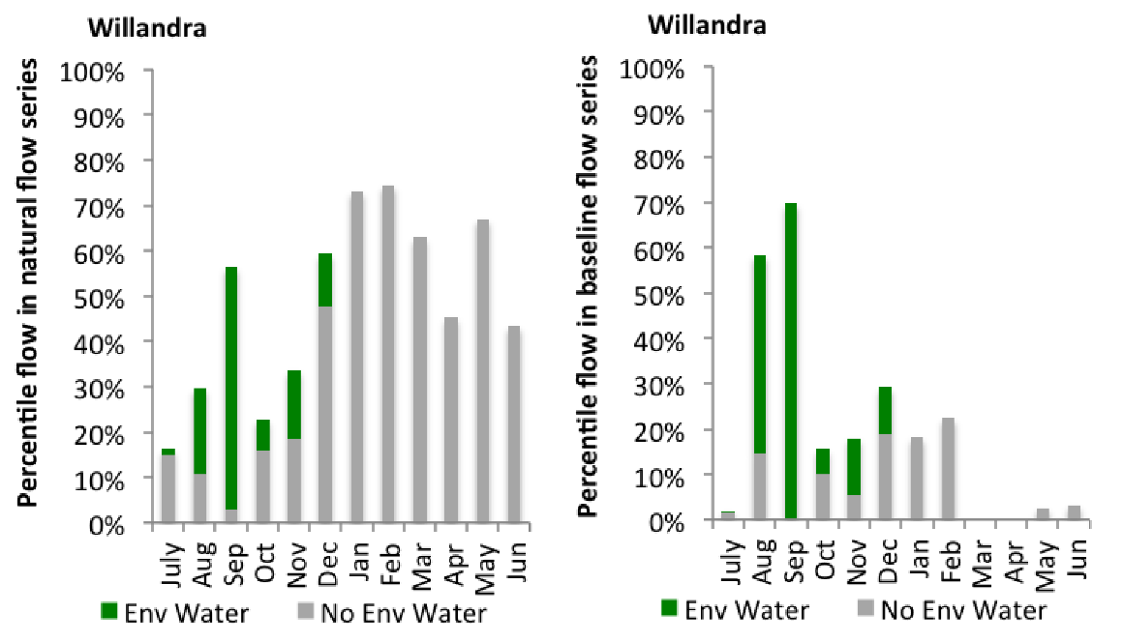
Figure LCH16: Contribution of environmental water delivery at Willandra as percentiles in the natural and baseline flow series.

Brewster
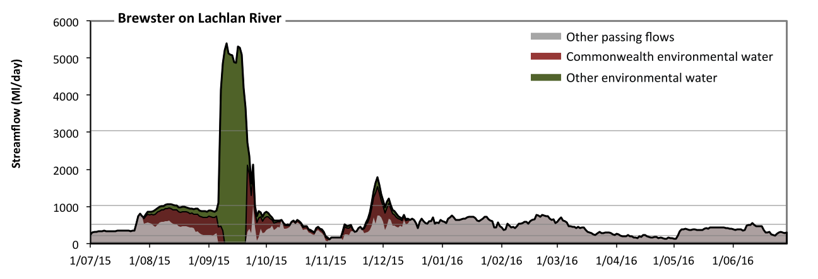 Figure LCH17: Contribution of environmental water delivery at Brewster. Horizontal lines indicate thresholds for very low flows, low flows, low freshes, medium freshes and high freshes (from lowest to highest).
At Brewster on Lachlan River environmental water contributed 44% of the total streamflow volume (with a medium contribution of Commonwealth environmental water) (Figure LCH17 and LCH18). Environmental watering actions affected streamflows for 35% of days between 1 July 2015 and 30 June 2016. Without environmental water, the duration of very low flows (i.e. < 43 Ml/day) in the period July to September would have substantially exceeded durations expected in an average year in the natural flow regime. Environmental water mitigated these impacts by reducing the cumulative duration of very low flow spells from 4% to 0% of the year, with greatest influence in the period July to September. Similarly, without environmental water, the duration of medium low flows (i.e. < 220 Ml/day) in the period July to September would have substantially exceeded durations expected in an average year in the natural flow regime. Environmental water mitigated these impacts by reducing the cumulative duration of medium low flow spells from 15% to 10% of the year, with greatest influence in the period July to September. Commonwealth environmental water made a modest contribution to these enhancements of environmental baseflows at this site. In the absence of environmental water there would have been at least one low fresh (i.e. > 510 Ml/day) in the periods July to September, October to December, January to March and April to June. Environmental water increased the duration of the longest low fresh during the periods July to September (from 9 days to 68 days) and October to December (from 12 days to 27 days). Commonwealth environmental water made the dominant contribution to these increased durations of low freshes. In the absence of environmental water there would have been no medium or high freshes this year. Environmental water increased the duration of the longest medium fresh during the periods July to September (from 0 days to 19 days) and October to December (from 0 days to 7 days). Commonwealth environmental water made the dominant contribution to these increased durations of medium freshes. Environmental water increased the duration of the longest medium fresh during the period July to September (from 0 days to 14 days). Commonwealth environmental water made little or no contribution to these increased durations of high freshes.
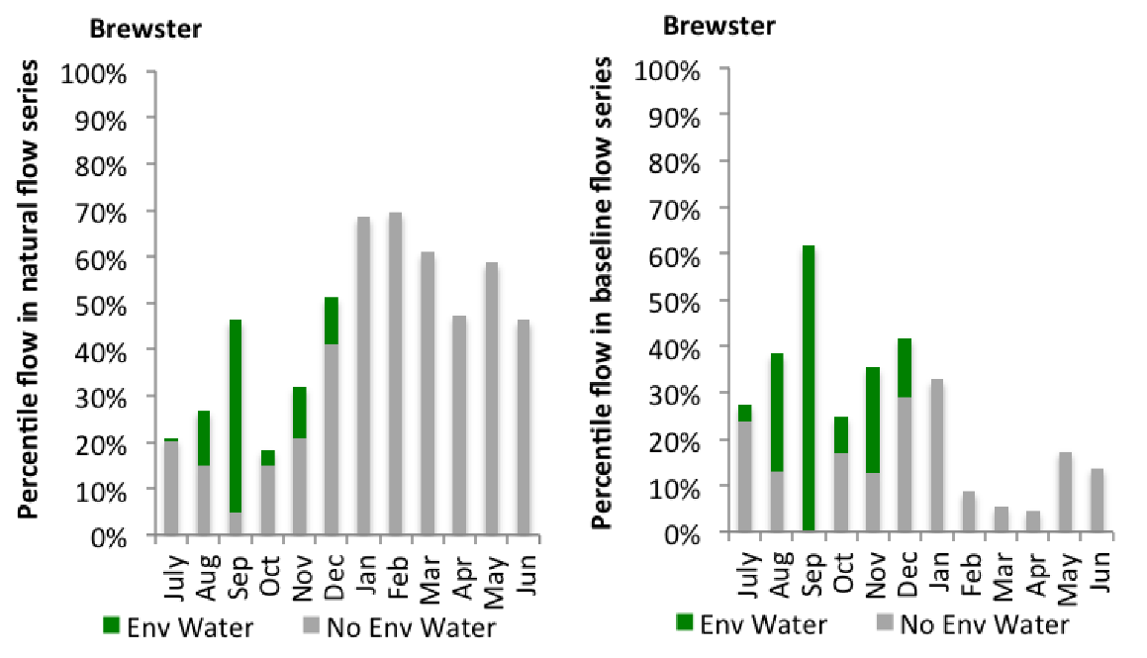
Figure LCH18: Contribution of environmental water delivery at Brewster as percentiles in the natural and baseline flow series.
Hillston
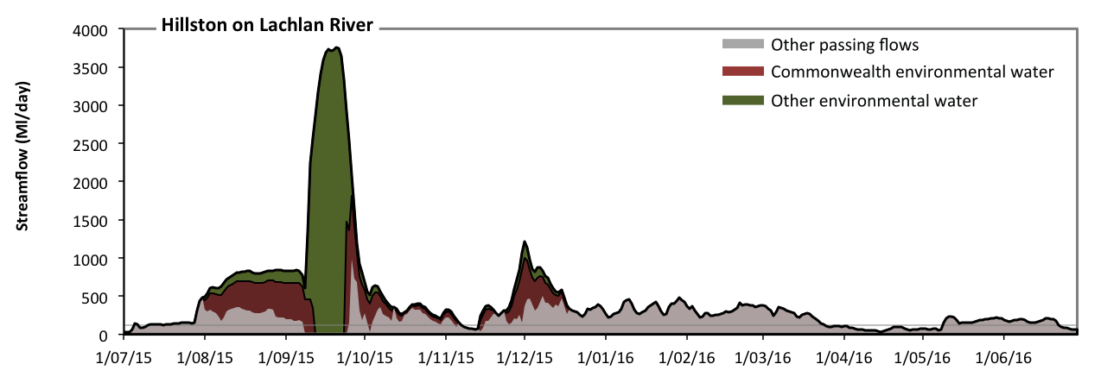 Figure LCH19: Contribution of environmental water delivery at Hillston. Horizontal lines indicate thresholds for (from lowest to highest).
At Hillston on Lachlan River environmental water contributed 54% of the total streamflow volume (with a medium contribution of Commonwealth environmental water) (Figure LCH19). Environmental watering actions affected streamflows for 35% of days between 1 July 2015 and 30 June 2016. Without environmental water, the duration of very low flows (i.e. < 23 Ml/day) in the period July to September would have substantially exceeded durations expected in an average year in the natural flow regime. Environmental water mitigated these impacts by reducing the cumulative duration of very low flow spells from 5% to 0% of the year, with greatest influence in the period July to September. Similarly, without environmental water, the durations of medium low flows (i.e. < 120 Ml/day) in the periods July to September and April to June would have substantially exceeded durations expected in an average year in the natural flow regime. Environmental water mitigated these impacts by reducing the cumulative duration of medium low flow spells from 24% to 18% of the year, with greatest influence in the period July to September. Commonwealth environmental water made a modest contribution to these enhancements of environmental baseflows at this site.

Whealbah
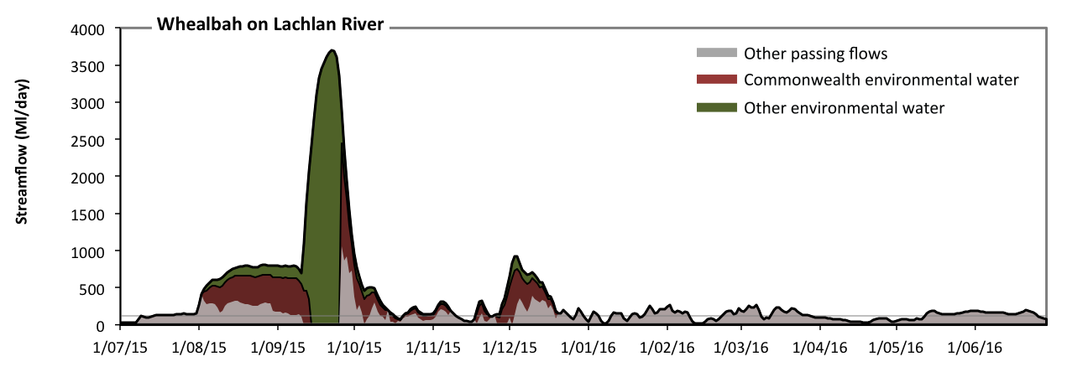 Figure LCH20: Contribution of environmental water delivery at Whealbah. Horizontal lines indicate thresholds for (from lowest to highest).
At Whealbah on Lachlan River environmental water contributed 62% of the total streamflow volume (with a medium contribution of Commonwealth environmental water) (Figure LCH20). Environmental watering actions affected streamflows for 35% of days between 1 July 2015 and 30 June 2016. Without environmental water, the durations of very low flows (i.e. < 23 Ml/day) in the periods July to September and October to December would have substantially exceeded durations expected in an average year in the natural flow regime. Environmental water mitigated these impacts by reducing the cumulative duration of very low flow spells from 8% to 1% of the year, with greatest influence in the periods July to September and October to December. Similarly, without environmental water, the durations of medium low flows (i.e. < 120 Ml/day) in the periods July to September, October to December, January to March and April to June would have all substantially exceeded durations expected in an average year in the natural flow regime. Environmental water mitigated these impacts by reducing the cumulative duration of medium low flow spells from 41% to 28% of the year, with greatest influence in the periods July to September and October to December. Commonwealth environmental water equally shared responsibility with other environmental water holders for these enhancements of environmental baseflows at this site.
Booligal
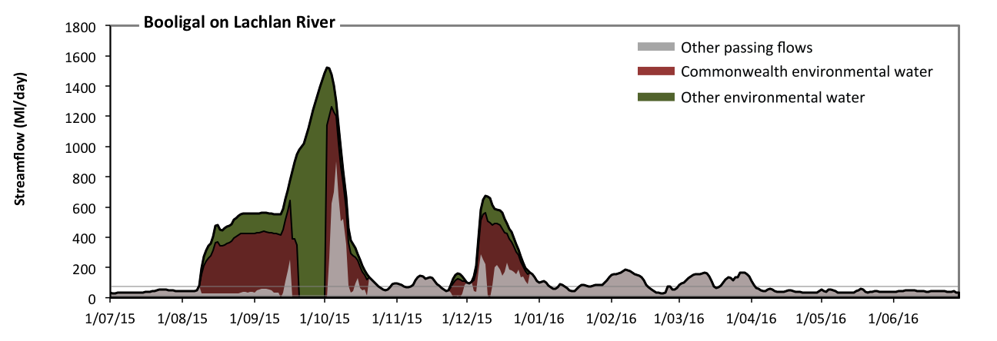 Figure LCH21: Contribution of environmental water delivery at Booligal. Horizontal lines indicate thresholds for (from lowest to highest).
At Booligal on Lachlan River environmental water contributed 63% of the total streamflow volume (with approximately half contributed by Commonwealth environmental water) (Figure LCH21). Environmental watering actions affected streamflows for 28% of days between 1 July 2015 and 30 June 2016. Without environmental water, the duration of very low flows (i.e. < 15 Ml/day) in the period July to September would have substantially exceeded durations expected in an average year in the natural flow regime. Environmental water mitigated these impacts by reducing the cumulative duration of very low flow spells from 6% to 0% of the year, with greatest influence in the periods July to September and October to December. Similarly, without environmental water, the durations of medium low flows (i.e. < 76 Ml/day) in the periods July to September, October to December and April to June would have substantially exceeded durations expected in an average year in the natural flow regime. Environmental water mitigated these impacts by reducing the cumulative duration of medium low flow spells from 65% to 46% of the year, with greatest influence in the periods July to September and October to December. Commonwealth environmental water equally shared responsibility with other environmental water holders for these enhancements of environmental baseflows at this site.
Merrimajeel
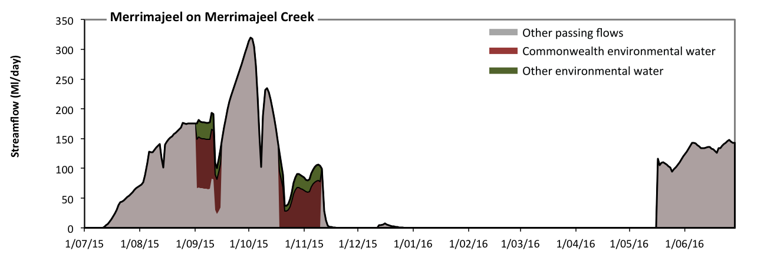 Figure LCH22: Contribution of environmental water delivery at Merrimajeel. Horizontal lines indicate thresholds for (from lowest to highest).
At Merrimajeel on Merrimajeel Creek environmental water contributed 15% of the total streamflow volume (much of which was Commonwealth environmental water) (Figure LCH22). Environmental watering actions affected streamflows for 10% of days between 1 July 2015 and 30 June 2016. However, environmental water had little effect on the duration of these very low flows, which occurred for 100% of the year.

Murrumbidgee
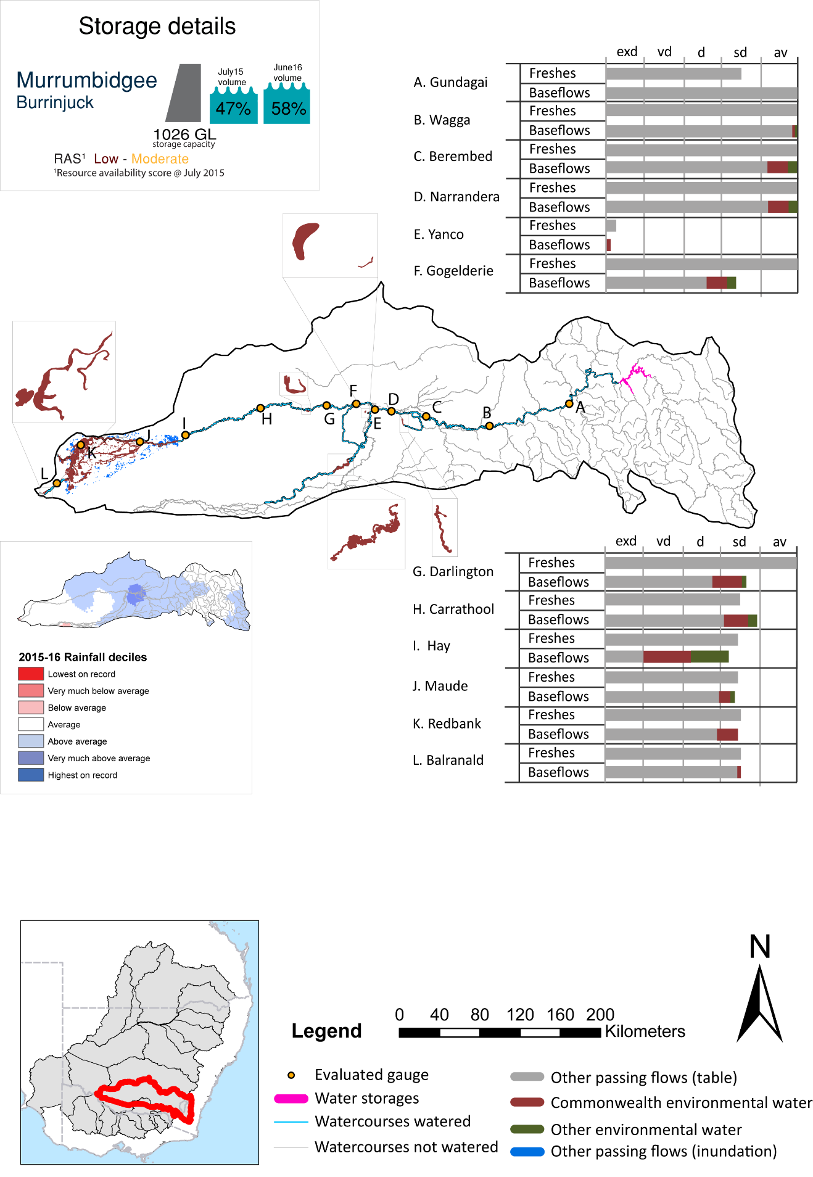

Figure MBG1: Watercourses influenced, areas inundated (where applicable) and gauge stations evaluated in the Murrumbidgee valley during the 2015-16 water year. Inset bar graphs report the condition of annual flow regimes by showing the improvements in hydrological condition with the addition of environmental water as well as the hypothetical scenario in “grey” (if no environmental flow had been delivered). Rainfall conditions (rainfall deciles) and trend in storage levels for the water year are also shown.

Summary
Environmental water delivery for the 2015-16 year in the Murrumbidgee Valley is evaluated using data for 12 sites. This evaluation only considers the contribution of held environmental water, which is a primary focus for the Commonwealth. The contributions of planned environmental water (e.g. passing flows), unregulated tributary inflows and clever use of irrigation flows for environmental benefits can all be very important but these are outside the scope of this report. Environmental watering actions lasted on average 238 days over the course of the year. The volume of environmental water at these 12 sites was between 0% and 21% of the total streamflow. Commonwealth Environmental Water contributed on average 58% of this environmental water. Ideally, baseflows should be maintained and long periods of excessively low flows avoided. In this valley, the baseflow regime was generally considered to be somewhat dry relative to the pre-development flow regime. In our analysis, a low fresh refers to a period of increased flow, when the water level rises at least one eighth of the way up the river bank (above the low flow level). These low freshes are a regular part of the natural flow regime and support a range of natural processes. In the Murrumbidgee valley, in terms of the occurrence and duration of low freshes, the year was assessed as being average. In our analysis, a medium fresh refers to a period of increased flow, when the water level rises at least one quarter of the way up the river bank. These medium freshes are not as frequent as low freshes but are also a regular and important part of the natural flow regime. In the Murrumbidgee valley, in terms of the occurrence of medium freshes, the year was assessed as being average. In our analysis, a high fresh refers to a period of increased flow, when the water level rises more than half way up the river. A high fresh may not occur every year but they are still important and long periods without major freshes can have serious consequences for floodplains and their contribution to river ecosystem health. Delivering environmental water as high in channel flows normally requires that all risks to riparian landholders and infrastructure have been resolved. In the Murrumbidgee valley, in terms of the occurrence of high freshes, the year was assessed as being dry.

Environmental water system
The Murrumbidgee valley covers 73406 km2, and represents 6.9% of the Basin area. Regulated water is provided by two major headwater storages, Burrinjuck and Blowering Dams. Collectively these storages have a capacity of 2,654 GL.Environmental watering in the Murrumbidgee focuses on areas downstream of Burrinjuck and Blowering dams. The major environmental assets that are targeted for watering include the Lower Murrumbidgee River Floodplain and the Mid-Murrumbidgee River Wetlands, the Junction Wetlands, Western Lakes and the Murrumbidgee River channel. The Lower Murrumbidgee River Floodplain, which is listed under the Directory of Important Wetlands in Australia, is a wetland of national significance, covering 200,000 hectares. The Mid-Murrumbidgee-River wetlands consist of several nationally significant wetlands.

Data availability
The contribution (where applicable) of the Commonwealth environmental water and NSW environmental water, IVT and other passing flows were derived from the CAIRO river operations spreadsheet held Water NSW. The waterholding, and its source was checked against use charged on the held environmental water entitlements. Known travel times, accounting data, contributions from tributaries and differences between allocated and unallocated flows were used to quantify the movement of water from the source point to its accounting point. The approach assumed no longitudinal delivery loss.

Water delivery context
During the 2015-16 water year, the Commonwealth Environmental Water Holder (CEWH) held water entitlements of up to 675945ML for environmental use in the Murrumbidgee valley. Each year, water utilities allocate the water entitlement holders a percentage of water based on their holding, license type and carryover (the exact rules vary among Jurisdictions). In the 2015-16 water year, the CEWH Murrumbidgee entitlements were allocated 133073 ML of water, representing 36.87% of the Long term average annual yield for the Murrumbidgee valley (360886 ML). The 2015-16 water allocation (133073 ML) together with the carryover volume of 54597 ML of water meant the CEWH had 187670 ML of water available for delivery.
A total of 108327 ML of Commonwealth environmental water was delivered in the Murrumbidgee valley. A total of 0 ML of Commonwealth environmental water was traded to consumptive users and 55275ML (29.45% of available resource) of Commonwealth environmental water was carried over for environmental use into the 2016-17 water year.

Environmental conditions and resource availability
The water available for delivery combined with the present and antecedent environmental conditions are key inputs used by environmental water managers in planning and implementing watering actions. Post hoc, this information provides important context when evaluating the effectiveness and appropriateness of environmental water use with respect to hydrological outputs.
The rainfall conditions in the Murrumbidgee valley were classified as Above Average, based on rainfall percentile data for the entire record held by the Bureau of Meteorology for this valley. The major storages in the Murrumbidgee valley remained increased, being 47% full at the beginning of the water year and 58% full by the end of the year (Figure MBG1).
The Commonwealth Environmental Water Office (CEWO) calculates resource availability scenarios (RAS) progressively as part of its continual adaptive management planning processes. The RAS are based on the availability of held water (including progressive license acquisitions and allocations) as well as the potential for unregulated or planned environmental flows. The resource availability of held water was classified as Low in this valley, whilst the potential for unregulated or planned environmental flow was classified as Moderate. The physical conditions meant that the CEWO was managing to Avoid further decline in the mid Murrumbidgee wetlands and to assist with their ecological capacity to recover, while proectecting and maintaining the cecological health and resilience of other important sites. The overall demand for environmental water was deemed Very High to Low (water predominantly needed urgently in some areas whilst in others none needed this year).

Watering actions
A total of 13 watering actions were implemented, the duration of these actions varied (range of individual actions: 21 - 141 days). The total cumulative sum of watering actions days was 939). The number of actions commencing in each season varied: Winter (1), Spring (6), Summer (1) and Autumn (5). The flow component types delivered included (0 baseflow, 2 freshes, 0 bankfull, 5 overbank and 6 wetland).

Table MBG2. Commonwealth environmental water accounting information for the Murrumbidgee valley over 2015-16 water year.
Total registered volume (ML) | Allocated volume (ML) | Carry over available (ML) | Delivered (ML) | LTAAY (ML) | Trade (ML) | Carried over to 2016-17 | Forfeited (ML)
675945 | 133073 | 187670 | 108327 | 360886 | 0 | 55275 | 0

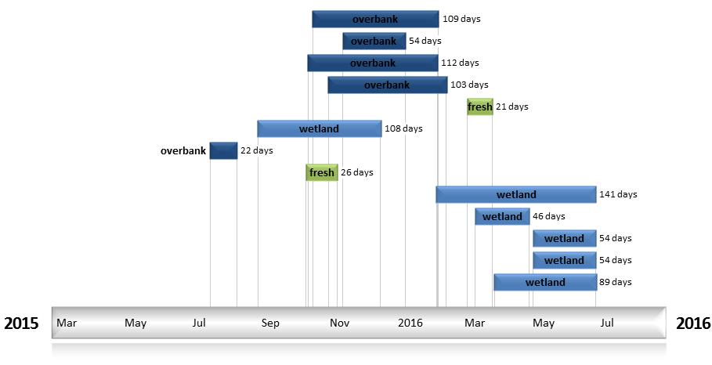
Figure MBG2. Timing and duration of water actions implemented by the CEWO during the 2015-16 water year in the Murrumbidgee valley.

Contribution of Commonwealth Environmental Water to Flow Regimes
Gundagai
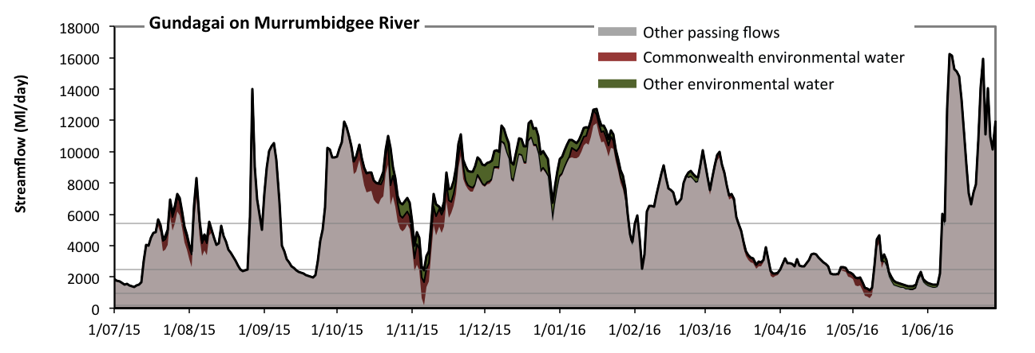
Figure MBG3: Contribution of environmental water delivery at Gundagai. Horizontal lines indicate thresholds for very low flows, low flows, low freshes and medium freshes (from lowest to highest).
At Gundagai on Murrumbidgee River environmental water contributed 9% of the total streamflow volume (with approximately half contributed by Commonwealth environmental water) (Figure MBG3 and MBG4). Environmental watering actions affected streamflows for 81% of days between 1 July 2015 and 30 June 2016. Flow regulation does not substantially increase the duration of very low flows (i.e. < 190 Ml/day) compared to an average year in the natural flow regime. Flow regulation does not substantially increase the duration of medium low flows (i.e. < 930 Ml/day) compared to an average year in the natural flow regime. There was at least one low fresh (i.e. > 2500 Ml/day) in the periods July to September, October to December, January to March and April to June. Environmental water made little change to the duration of these low freshes. There was at least one medium fresh (i.e. > 5400 Ml/day) in the periods July to September, October to December, January to March and April to June. Environmental water made little change to the duration of these medium freshes. There was no high freshes (i.e. > 18000 Ml/day) this year.

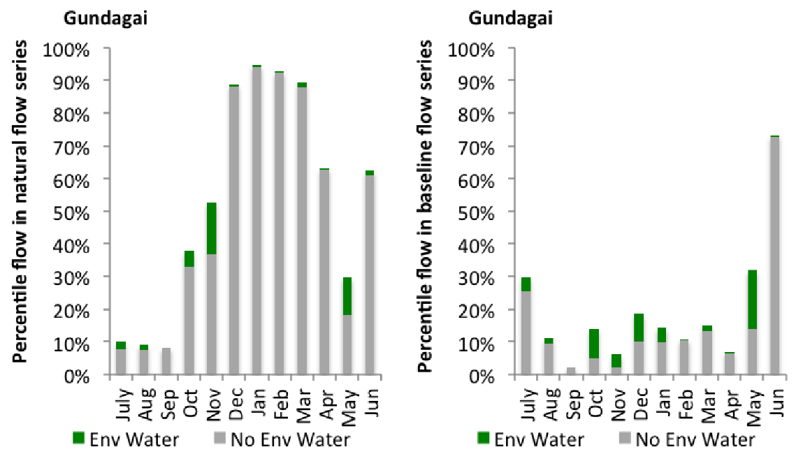
Figure MBG4: Contribution of environmental water delivery at Gundagai as percentiles in the natural and baseline flow series.
Wagga
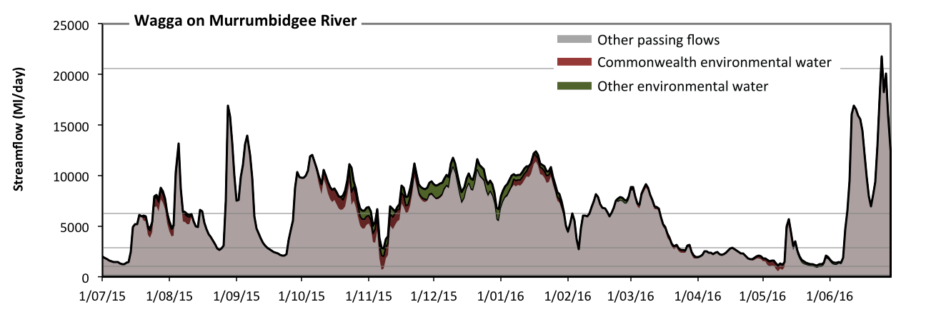
Figure MBG5: Contribution of environmental water delivery at Wagga. Horizontal lines indicate thresholds for very low flows, low flows, low freshes, medium freshes and high freshes (from lowest to highest).
At Wagga on Murrumbidgee River environmental water contributed 8% of the total streamflow volume (with approximately half contributed by Commonwealth environmental water) (Figure MBG5 and MBG6). Environmental watering actions affected streamflows for 81% of days between 1 July 2015 and 30 June 2016. Flow regulation does not substantially increase the duration of very low flows (i.e. < 210 Ml/day) compared to an average year in the natural flow regime. Flow regulation does not substantially increase the duration of medium low flows (i.e. < 1000 Ml/day) compared to an average year in the natural flow regime. Commonwealth environmental water equally shared responsibility with other environmental water holders for these enhancements of environmental baseflows at this site. There was at least one low fresh (i.e. > 2900 Ml/day) in the periods July to September, October to December, January to March and April to June. Environmental water made little change to the duration of these low freshes. There was at least one medium fresh (i.e. > 6300 Ml/day) in the periods July to September, October to December, January to March and April to June. Environmental water made little change to the duration of these medium freshes. In the absence of environmental water there would have been at least one high fresh in the period April to June. Environmental water made no change to the duration of these high freshes.
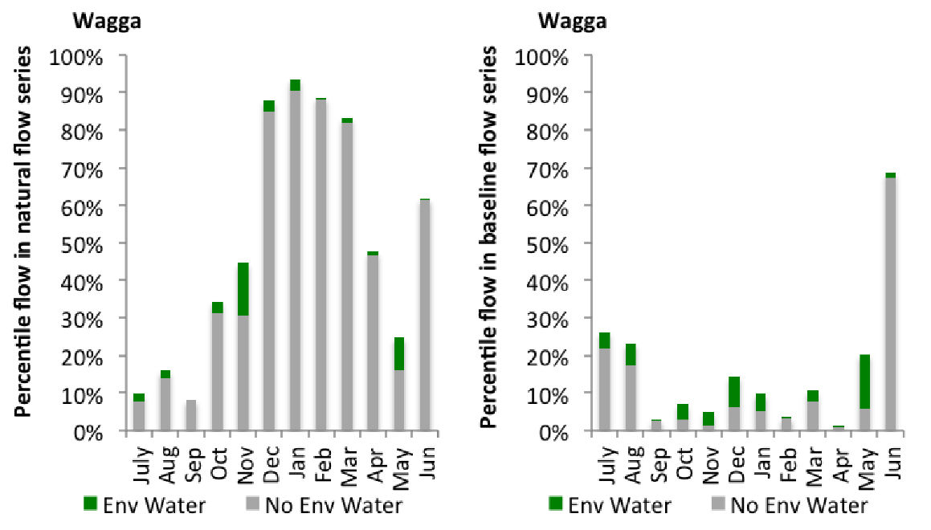
Figure MBG6: Contribution of environmental water delivery at Wagga as percentiles in the natural and baseline flow series.
Berembed
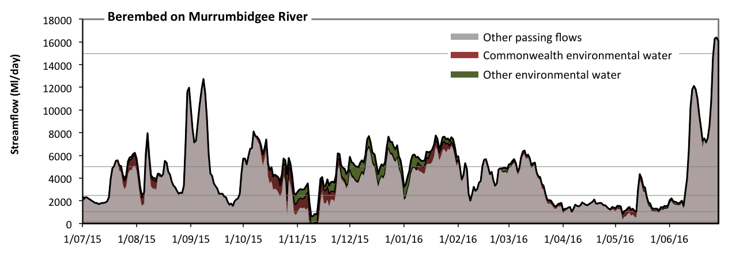
Figure MBG7: Contribution of environmental water delivery at Berembed. Horizontal lines indicate thresholds for very low flows, low flows, low freshes, medium freshes and high freshes (from lowest to highest).
At Berembed on Murrumbidgee River environmental water contributed 12% of the total streamflow volume (with approximately half contributed by Commonwealth environmental water) (Figure MBG7 and MBG8). Environmental watering actions affected streamflows for 82% of days between 1 July 2015 and 30 June 2016. Without environmental water, the duration of very low flows (i.e. < 210 Ml/day) in the period October to December would have substantially exceeded durations expected in an average year in the natural flow regime. Environmental water mitigated these impacts by reducing the cumulative duration of very low flow spells from 1% to 0% of the year, with greatest influence in the period October to December. Similarly, without environmental water, the duration of medium low flows (i.e. < 1000 Ml/day) in the period October to December would have substantially exceeded durations expected in an average year in the natural flow regime. Environmental water mitigated these impacts by reducing the cumulative duration of medium low flow spells from 6% to 1% of the year, with greatest influence in the periods October to December and April to June. Commonwealth environmental water made the dominant contribution to these enhancements of environmental baseflows at this site. There was at least one low fresh (i.e. > 2500 Ml/day) in the periods July to September, October to December, January to March and April to June. Environmental water made little change to the duration of these low freshes. In the absence of environmental water there would have been at least one medium fresh (i.e. > 5000 Ml/day) in the periods July to September, October to December, January to March and April to June. Environmental water increased the duration of the longest medium fresh during the period January to March (from 19 days to 28 days). Commonwealth environmental water was entirely responsible for these increased durations of medium freshes. In the absence of environmental water there would have been at least one high fresh in the period April to June. Environmental water made no change to the duration of these high freshes.
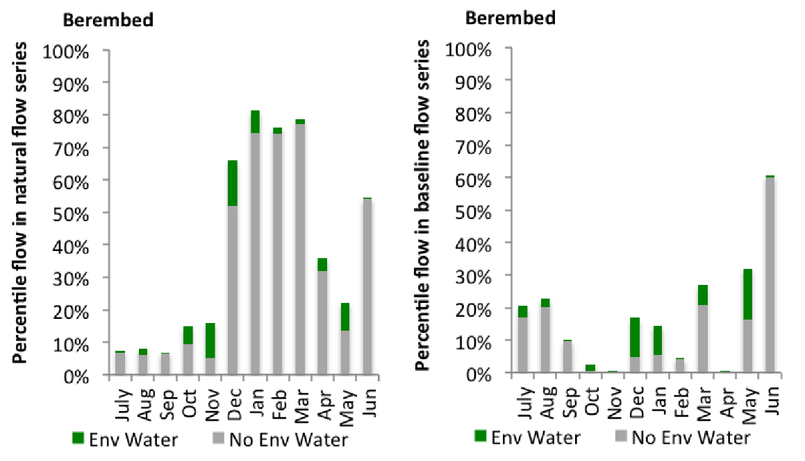
Figure MBG8: Contribution of environmental water delivery at Berembed as percentiles in the natural and baseline flow series.
Narrandera
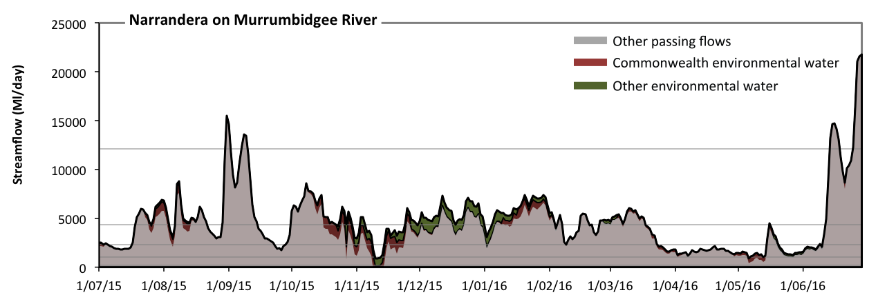
Figure MBG9: Contribution of environmental water delivery at Narrandera. Horizontal lines indicate thresholds for very low flows, low flows, low freshes, medium freshes and high freshes (from lowest to highest).
At Narrandera on Murrumbidgee River environmental water contributed 12% of the total streamflow volume (with approximately half contributed by Commonwealth environmental water) (Figure MBG9 and MBG10). Environmental watering actions affected streamflows for 82% of days between 1 July 2015 and 30 June 2016. Without environmental water, the duration of very low flows (i.e. < 210 Ml/day) in the period October to December would have substantially exceeded durations expected in an average year in the natural flow regime. Environmental water mitigated these impacts by reducing the cumulative duration of very low flow spells from 1% to 0% of the year, with greatest influence in the period October to December. Flow regulation does not substantially increase the duration of medium low flows (i.e. < 1000 Ml/day) compared to an average year in the natural flow regime. Commonwealth environmental water made the dominant contribution to these enhancements of environmental baseflows at this site. In the absence of environmental water there would have been at least one low fresh (i.e. > 2300 Ml/day) in the periods July to September, October to December, January to March and April to June. Environmental water increased the duration of the longest low fresh during the periods July to September (from 48 days to 68 days), October to December (from 38 days to 48 days) and January to March (from 42 days to 83 days). Commonwealth environmental water made the dominant contribution to these increased durations of low freshes. In the absence of environmental water there would have been at least one medium fresh (i.e. > 4300 Ml/day) in the periods July to September, October to December, January to March and April to June. Environmental water increased the duration of the longest medium fresh during the periods October to December (from 15 days to 22 days) and January to March (from 20 days to 30 days). Commonwealth environmental water made the dominant contribution to these increased durations of medium freshes. In the absence of environmental water there would have been at least one high fresh in the periods July to September and April to June. Environmental water made no change to the duration of these high freshes.
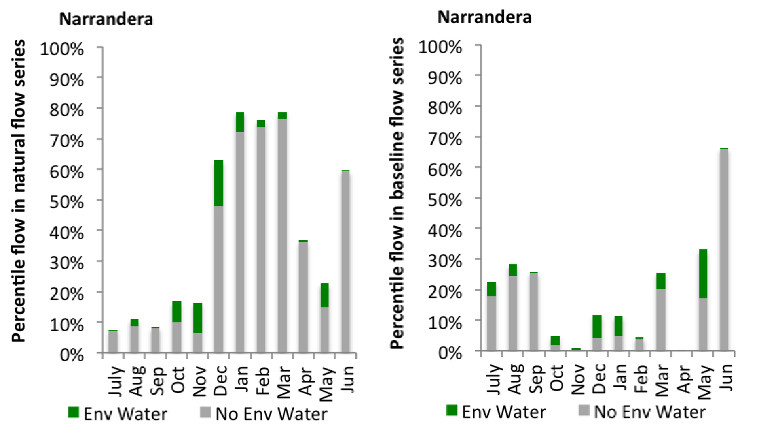
Figure MBG10: Contribution of environmental water delivery at Narrandera as percentiles in the natural and baseline flow series.

Yanco Offtake
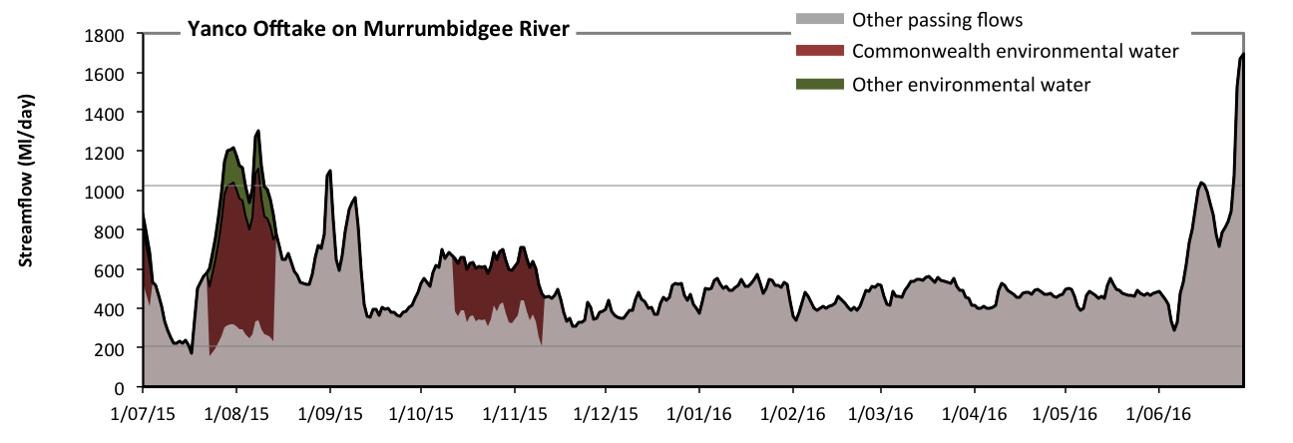
Figure MBG11: Contribution of environmental water delivery at Yanco Offtake. Horizontal lines indicate thresholds for very low flows and low flows (from lowest to highest).
At Yanco Offtake on Murrumbidgee River environmental water contributed 13% of the total streamflow volume (most of which was Commonwealth environmental water) (Figure MBG11 and MBG12). Environmental watering actions affected streamflows for 15% of days between 1 July 2015 and 30 June 2016. Flow regulation does not substantially increase the duration of very low flows (i.e. < 210 Ml/day) compared to an average year in the natural flow regime. However, without environmental water, the durations of medium low flows (i.e. < 1000 Ml/day) in the periods July to September, October to December, January to March and April to June would have all substantially exceeded durations expected in an average year in the natural flow regime. Environmental water mitigated these impacts by reducing the cumulative duration of medium low flow spells from 98% to 95% of the year, with greatest influence in the period July to September. Commonwealth environmental water was almost entirely responsible for these enhancements of environmental baseflows at this site.
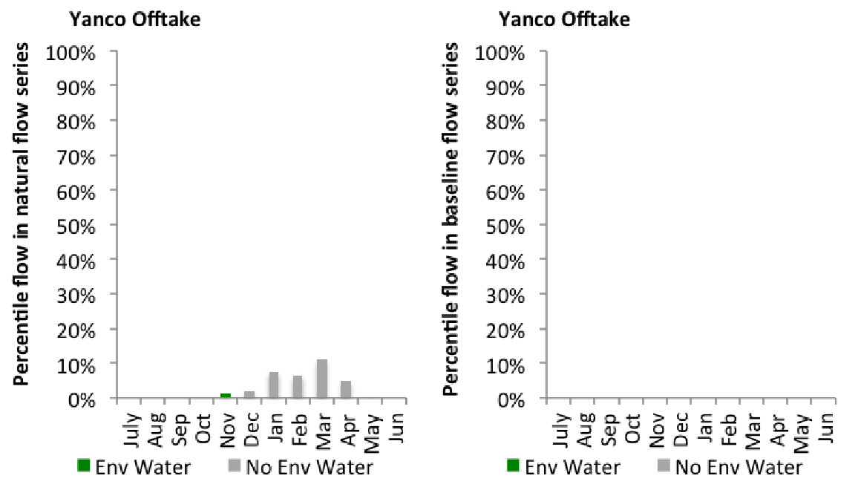
Figure MBG12: Contribution of environmental water delivery at Yanco Offtake as percentiles in the natural and baseline flow series.

Gogelderie
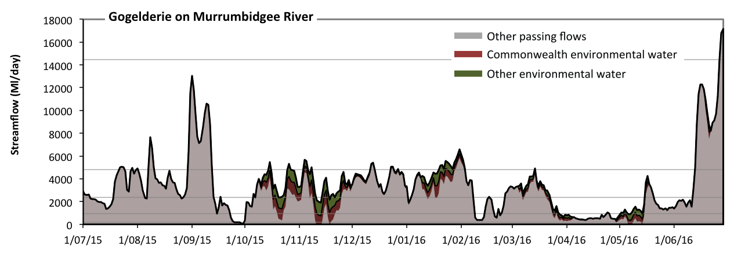Figure MBG13: Contribution of environmental water delivery at Gogelderie. Horizontal lines indicate thresholds for very low flows, low flows, low freshes, medium freshes and high freshes (from lowest to highest).
At Gogelderie on Murrumbidgee River environmental water contributed 13% of the total streamflow volume (with approximately half contributed by Commonwealth environmental water) (Figure MBG13 and MBG14). Environmental watering actions affected streamflows for 68% of days between 1 July 2015 and 30 June 2016. Without environmental water, the durations of very low flows (i.e. < 190 Ml/day) in the periods July to September and April to June would have substantially exceeded durations expected in an average year in the natural flow regime. Environmental water mitigated these impacts by reducing the cumulative duration of very low flow spells from 4% to 2% of the year, with greatest influence in the periods October to December and April to June. Similarly, without environmental water, the durations of medium low flows (i.e. < 960 Ml/day) in the periods July to September, October to December and April to June would have substantially exceeded durations expected in an average year in the natural flow regime. Environmental water mitigated these impacts by reducing the cumulative duration of medium low flow spells from 23% to 15% of the year, with greatest influence in the periods October to December and April to June. Commonwealth environmental water equally shared responsibility with other environmental water holders for these enhancements of environmental baseflows at this site. In the absence of environmental water there would have been at least one low fresh (i.e. > 2300 Ml/day) in the periods July to September, October to December, January to March and April to June. Environmental water increased the duration of the longest low fresh during the period January to March (from 20 days to 35 days). Commonwealth environmental water equally shared responsibility with other environmental water holders for these increased durations of low freshes. In the absence of environmental water there would have been at least one medium fresh (i.e. > 4800 Ml/day) in the periods July to September, October to December, January to March and April to June. Environmental water increased the duration of the longest medium fresh during the period January to March (from 5 days to 15 days). Commonwealth environmental water equally shared responsibility with other environmental water holders for these increased durations of medium freshes. In the absence of environmental water there would have been at least one high fresh in the period April to June. Environmental water made no change to the duration of these high freshes.
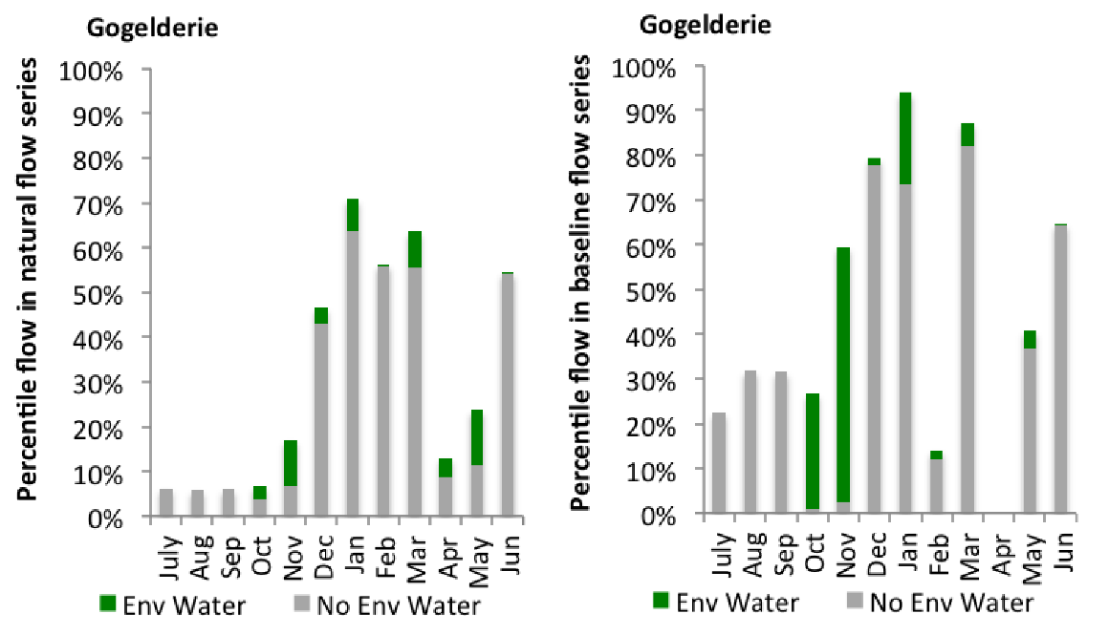
Figure MBG14: Contribution of environmental water delivery at Gogelderie as percentiles in the natural and baseline flow series.
Darlington
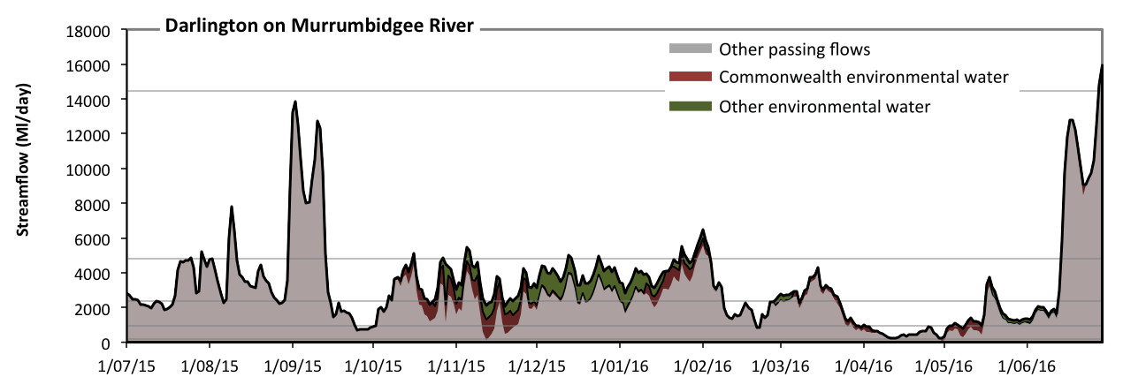 Figure MBG15: Contribution of environmental water delivery at Darlington. Horizontal lines indicate thresholds for very low flows, low flows, low freshes, medium freshes and high freshes (from lowest to highest).
At Darlington on Murrumbidgee River environmental water contributed 14% of the total streamflow volume (with approximately half contributed by Commonwealth environmental water) (Figure MBG15 and MBG16). Environmental watering actions affected streamflows for 75% of days between 1 July 2015 and 30 June 2016. Flow regulation does not substantially increase the duration of very low flows (i.e. < 190 Ml/day) compared to an average year in the natural flow regime. However, without environmental water, the durations of medium low flows (i.e. < 960 Ml/day) in the periods July to September, October to December and April to June would have substantially exceeded durations expected in an average year in the natural flow regime. Environmental water mitigated these impacts by reducing the cumulative duration of medium low flow spells from 19% to 13% of the year, with greatest influence in the periods October to December and April to June. Commonwealth environmental water made the dominant contribution to these enhancements of environmental baseflows at this site. In the absence of environmental water there would have been at least one low fresh (i.e. > 2300 Ml/day) in the periods July to September, October to December, January to March and April to June. Environmental water increased the duration of the longest low fresh during the periods October to December (from 11 days to 41 days) and January to March (from 24 days to 39 days). Commonwealth environmental water made a modest contribution to these increased durations of low freshes. In the absence of environmental water there would have been at least one medium fresh (i.e. > 4800 Ml/day) in the periods July to September, January to March and April to June. Environmental water increased the duration of the longest medium fresh during the period October to December (from 0 days to 2 days). Commonwealth environmental water made a modest contribution to these increased durations of medium freshes. In the absence of environmental water there would have been at least one high fresh in the period April to June. Environmental water made no change to the duration of these high freshes.
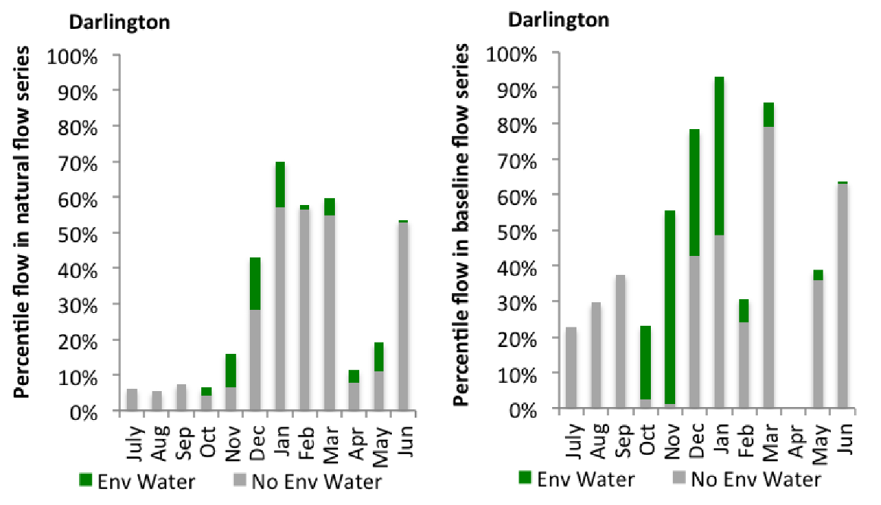
Figure MBG16: Contribution of environmental water delivery at Darlington as percentiles in the natural and baseline flow series.
Carrathool
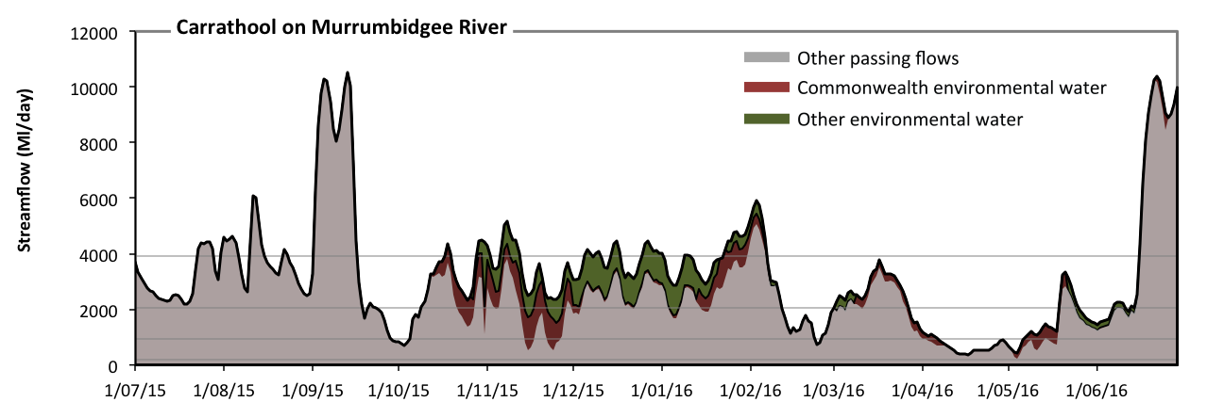 Figure MBG17: Contribution of environmental water delivery at Carrathool. Horizontal lines indicate thresholds for very low flows, low flows, low freshes and medium freshes (from lowest to highest).
At Carrathool on Murrumbidgee River environmental water contributed 15% of the total streamflow volume (with approximately half contributed by Commonwealth environmental water) (Figure MBG17 and MBG18). Environmental watering actions affected streamflows for 70% of days between 1 July 2015 and 30 June 2016. Flow regulation does not substantially increase the duration of very low flows (i.e. < 190 Ml/day) compared to an average year in the natural flow regime. However, without environmental water, the durations of medium low flows (i.e. < 930 Ml/day) in the periods October to December and April to June would have substantially exceeded durations expected in an average year in the natural flow regime. Environmental water mitigated these impacts by reducing the cumulative duration of medium low flow spells from 17% to 10% of the year, with greatest influence in the periods October to December and April to June. Commonwealth environmental water made the dominant contribution to these enhancements of environmental baseflows at this site. In the absence of environmental water there would have been at least one low fresh (i.e. > 2000 Ml/day) in the periods July to September, October to December, January to March and April to June. Environmental water increased the duration of the longest low fresh during the periods October to December (from 18 days to 84 days) and January to March (from 25 days to 42 days). Commonwealth environmental water equally shared responsibility with other environmental water holders for these increased durations of low freshes. In the absence of environmental water there would have been at least one medium fresh (i.e. > 3900 Ml/day) in the periods July to September, January to March and April to June. Environmental water increased the duration of the longest medium fresh during the periods October to December (from 0 days to 7 days) and January to March (from 7 days to 15 days). Commonwealth environmental water equally shared responsibility with other environmental water holders for these increased durations of medium freshes. There was no high freshes (i.e. > 11000 Ml/day) this year.
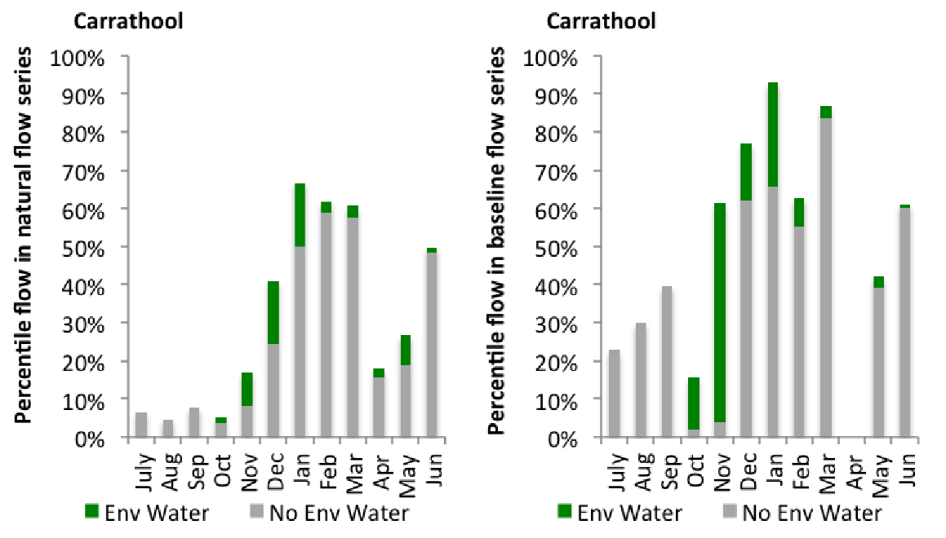
Figure MBG18: Contribution of environmental water delivery at Carrathool as percentiles in the natural and baseline flow series.

Hay
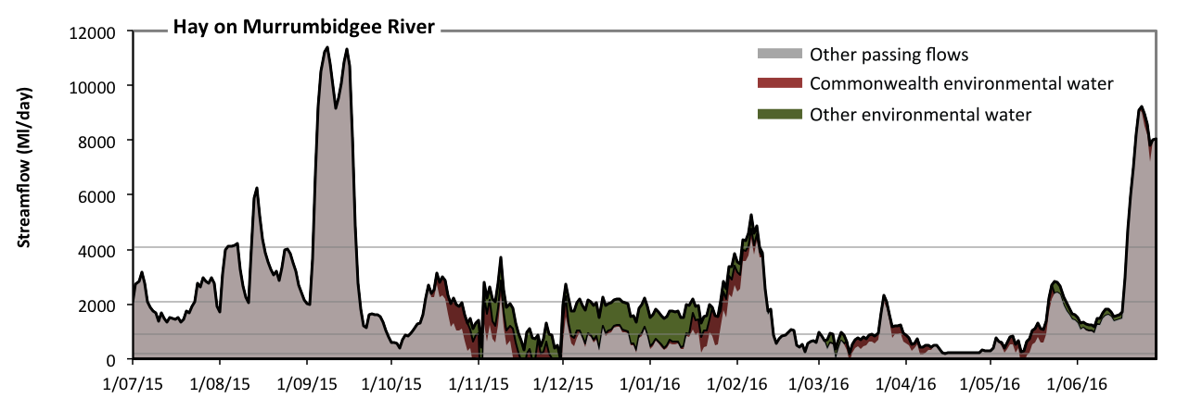 Figure MBG19: Contribution of environmental water delivery at Hay. Horizontal lines indicate thresholds for very low flows, low flows, low freshes and medium freshes (from lowest to highest).
At Hay on Murrumbidgee River environmental water contributed 21% of the total streamflow volume (with approximately half contributed by Commonwealth environmental water) (Figure MBG19 and MBG20). Environmental watering actions affected streamflows for 70% of days between 1 July 2015 and 30 June 2016. Without environmental water, the durations of very low flows (i.e. < 180 Ml/day) in the periods October to December and April to June would have substantially exceeded durations expected in an average year in the natural flow regime. Environmental water mitigated these impacts by reducing the cumulative duration of very low flow spells from 8% to 0% of the year, with greatest influence in the period October to December. Similarly, without environmental water, the durations of medium low flows (i.e. < 900 Ml/day) in the periods October to December, January to March and April to June would have substantially exceeded durations expected in an average year in the natural flow regime. Environmental water mitigated these impacts by reducing the cumulative duration of medium low flow spells from 45% to 26% of the year, with greatest influence in the periods October to December and January to March. Commonwealth environmental water equally shared responsibility with other environmental water holders for these enhancements of environmental baseflows at this site. There was at least one low fresh (i.e. > 2100 Ml/day) in the periods July to September, October to December, January to March and April to June. Environmental water made little change to the duration of these low freshes. In the absence of environmental water there would have been at least one medium fresh (i.e. > 4100 Ml/day) in the periods July to September, January to March and April to June. Environmental water increased the duration of the longest medium fresh during the period January to March (from 1 days to 6 days). Commonwealth environmental water equally shared responsibility with other environmental water holders for these increased durations of medium freshes. There was no high freshes (i.e. > 12000 Ml/day) this year.
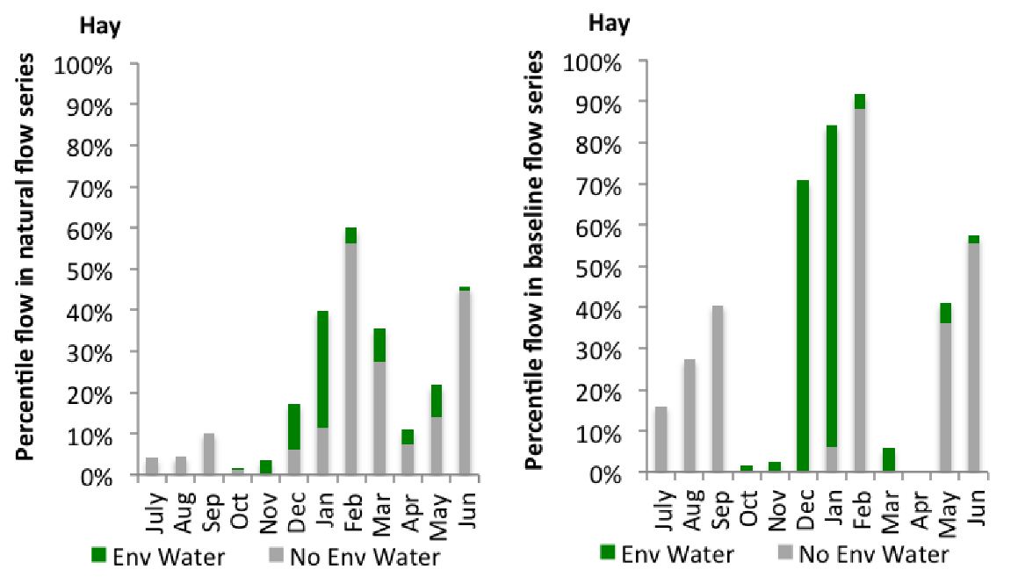
Figure MBG20: Contribution of environmental water delivery at Hay as percentiles in the natural and baseline flow series.
Maude
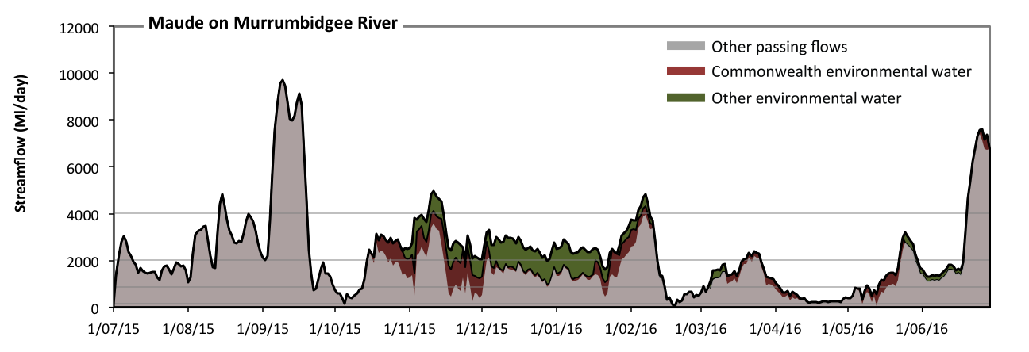 Figure MBG21: Contribution of environmental water delivery at Maude. Horizontal lines indicate thresholds for very low flows, low flows, low freshes and medium freshes (from lowest to highest).
At Maude on Murrumbidgee River environmental water contributed 19% of the total streamflow volume (with approximately half contributed by Commonwealth environmental water) (Figure MBG21 and MBG22). Environmental watering actions affected streamflows for 70% of days between 1 July 2015 and 30 June 2016. Flow regulation does not substantially increase the duration of very low flows (i.e. < 170 Ml/day) compared to an average year in the natural flow regime. However, without environmental water, the durations of medium low flows (i.e. < 860 Ml/day) in the periods October to December and April to June would have substantially exceeded durations expected in an average year in the natural flow regime. Environmental water mitigated these impacts by reducing the cumulative duration of medium low flow spells from 26% to 19% of the year, with greatest influence in the periods October to December and April to June. Commonwealth environmental water made the dominant contribution to these enhancements of environmental baseflows at this site. In the absence of environmental water there would have been at least one low fresh (i.e. > 2000 Ml/day) in the periods July to September, October to December, January to March and April to June. Environmental water increased the duration of the longest low fresh during the periods October to December (from 12 days to 40 days) and January to March (from 15 days to 20 days). Commonwealth environmental water equally shared responsibility with other environmental water holders for these increased durations of low freshes. In the absence of environmental water there would have been at least one medium fresh (i.e. > 4000 Ml/day) in the periods July to September and April to June. Environmental water increased the duration of the longest medium fresh during the periods October to December (from 0 days to 6 days) and January to March (from 0 days to 5 days). Commonwealth environmental water made a modest contribution to these increased durations of medium freshes. There was no high freshes (i.e. > 12000 Ml/day) this year.
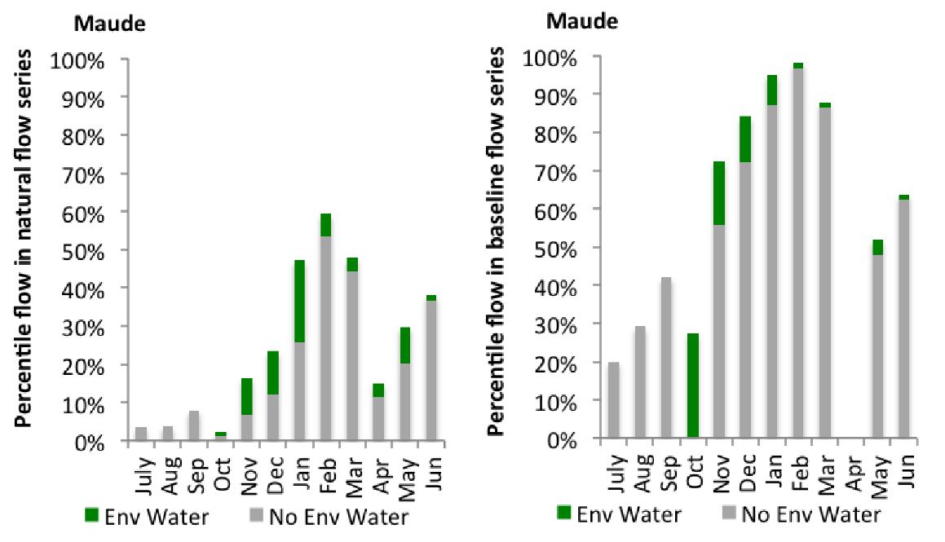
Figure MBG22: Contribution of environmental water delivery at Maude as percentiles in the natural and baseline flow series.
Redbank
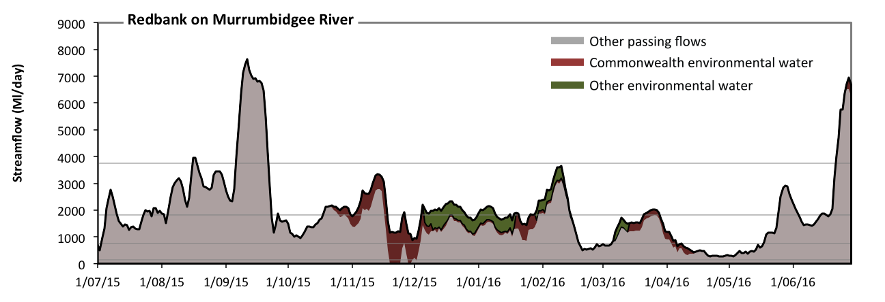 Figure MBG23: Contribution of environmental water delivery at Redbank. Horizontal lines indicate thresholds for very low flows, low flows, low freshes and medium freshes (from lowest to highest).
At Redbank on Murrumbidgee River environmental water contributed 12% of the total streamflow volume (much of which was Commonwealth environmental water) (Figure MBG23 and MBG24). Environmental watering actions affected streamflows for 59% of days between 1 July 2015 and 30 June 2016. Without environmental water, the duration of very low flows (i.e. < 150 Ml/day) in the period October to December would have substantially exceeded durations expected in an average year in the natural flow regime. Environmental water mitigated these impacts by reducing the cumulative duration of very low flow spells from 2% to 0% of the year, with greatest influence in the period October to December. Similarly, without environmental water, the durations of medium low flows (i.e. < 740 Ml/day) in the periods October to December and April to June would have substantially exceeded durations expected in an average year in the natural flow regime. Environmental water mitigated these impacts by reducing the cumulative duration of medium low flow spells from 21% to 16% of the year, with greatest influence in the period October to December. Commonwealth environmental water was entirely responsible for these enhancements of environmental baseflows at this site. In the absence of environmental water there would have been at least one low fresh (i.e. > 1800 Ml/day) in the periods July to September, October to December, January to March and April to June. Environmental water increased the duration of the longest low fresh during the periods October to December (from 11 days to 21 days) and January to March (from 15 days to 20 days). Commonwealth environmental water made a modest contribution to these increased durations of low freshes. There was at least one medium fresh (i.e. > 3700 Ml/day) in the periods July to September and April to June. Environmental water made no change to the duration of these medium freshes. There was no high freshes (i.e. > 11000 Ml/day) this year.
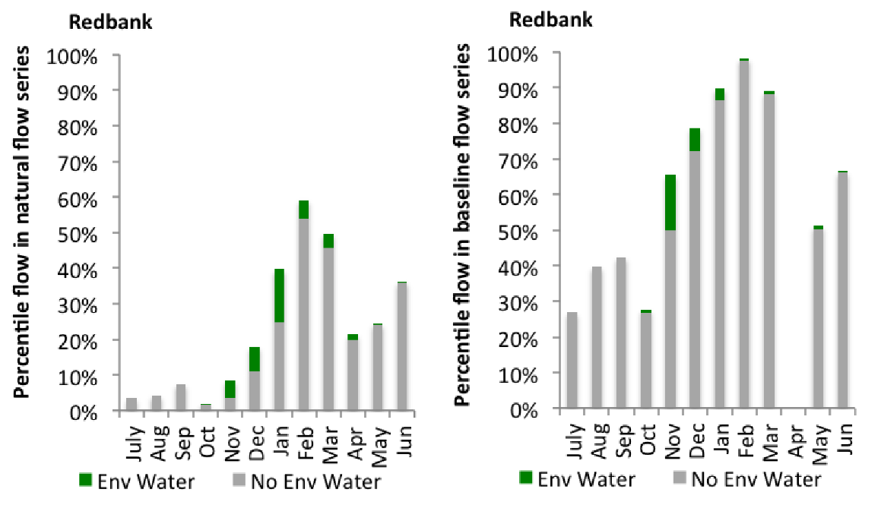
Figure MBG24: Contribution of environmental water delivery at Redbank as percentiles in the natural and baseline flow series.
Balranald
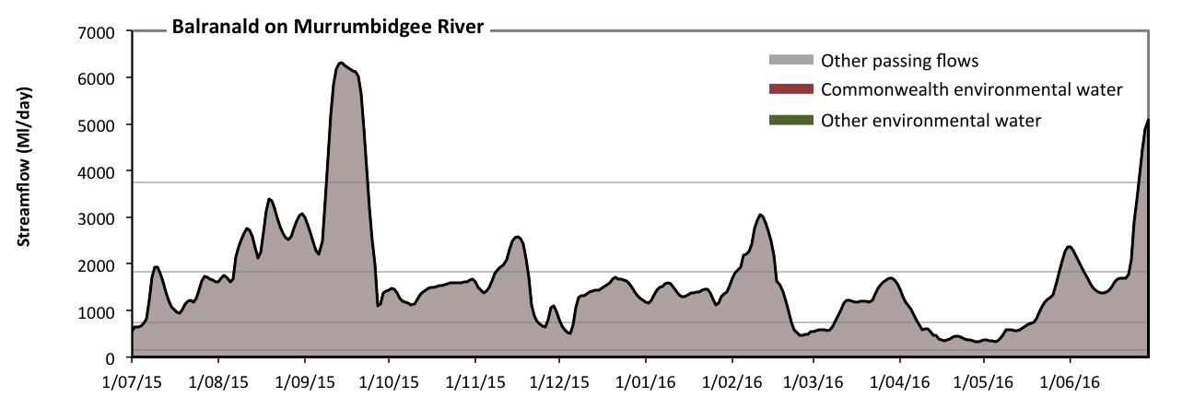 Figure MBG25: Contribution of environmental water delivery at Balranald. Horizontal lines indicate thresholds for very low flows, low flows, low freshes and medium freshes (from lowest to highest).
At Balranald on Murrumbidgee River environmental water contributed 0% of the total streamflow volume (all of which was Commonwealth environmental water) (Figure MBG25 and MBG26). Environmental watering actions affected streamflows for 29% of days between 1 July 2015 and 30 June 2016. Flow regulation does not substantially increase the duration of very low flows (i.e. < 150 Ml/day) compared to an average year in the natural flow regime. However, without environmental water, the durations of medium low flows (i.e. < 740 Ml/day) in the periods July to September and April to June would have substantially exceeded durations expected in an average year in the natural flow regime. However, environmental water had little effect on the duration of these medium low flows, which occurred for 19% of the year. There was at least one low fresh (i.e. > 1800 Ml/day) in the periods July to September, October to December, January to March and April to June. Environmental water made no change to the duration of these low freshes. There was at least one medium fresh (i.e. > 3700 Ml/day) in the periods July to September and April to June. Environmental water made no change to the duration of these medium freshes. There was no high freshes (i.e. > 11000 Ml/day) this year.
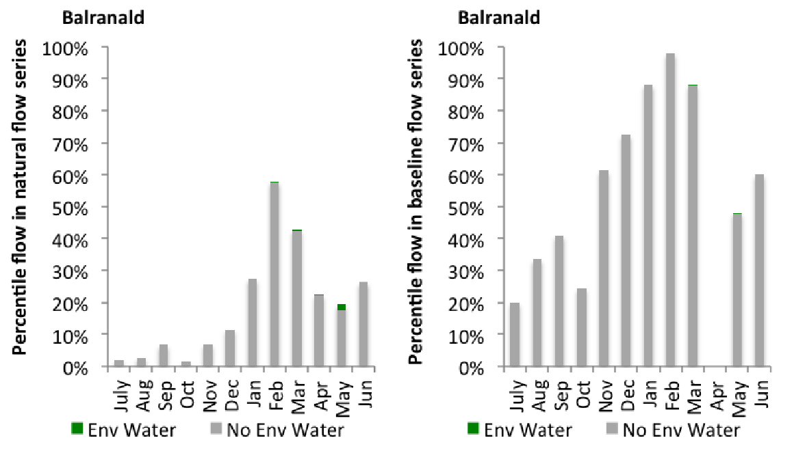
Figure MBG26: Contribution of environmental water delivery at Balranald as percentiles in the natural and baseline flow series.

Central Murray
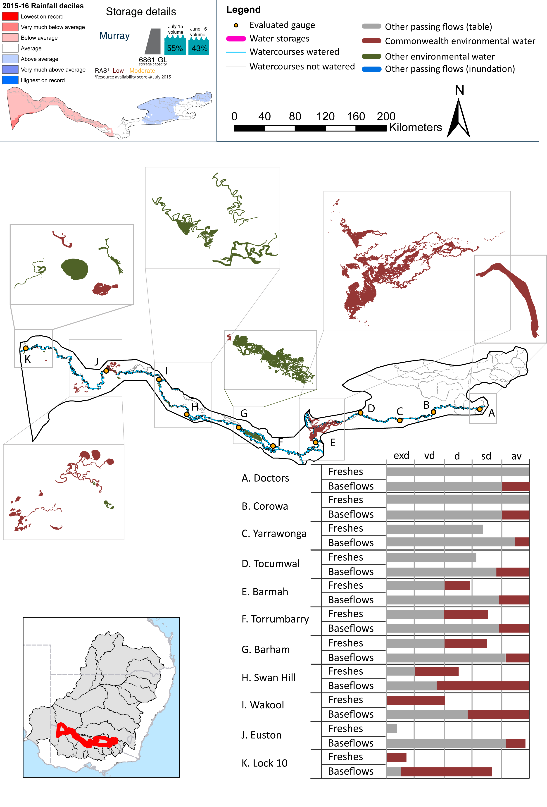
Figure CNM1: Watercourses influenced, areas inundated (where applicable) and gauge stations evaluated in the Central Murray valley during the 2015-16 water year. Inset bar graphs report the condition of annual flow regimes by showing the improvements in hydrological condition with the addition of environmental water as well as the hypothetical scenario in “grey” (if no environmental flow had been delivered). Rainfall conditions (rainfall deciles) and trend in storage levels for the water year are also shown.

Summary
Environmental water delivery for the 2015-16 year in the Central Murray valley is evaluated using data for 11 sites. This evaluation only considers the contribution of held environmental water, which is a primary focus for the Commonwealth. The contributions of planned environmental water (e.g. passing flows), unregulated tributary inflows and clever use of irrigation flows for environmental benefits can all be very important but these are outside the scope of this report. Environmental watering actions lasted on average 278 days over the course of the year. The volume of environmental water at these 11 sites was between 19% and 44% of the total streamflow. The contribution of environmental water delivery to improved flow regimes is evaluated using data for 11 sites. Ideally, baseflows should be maintained and long periods of excessively low flows avoided. In this valley, the baseflow regime was generally considered to be average relative to the pre-development flow regime. In our analysis, a low fresh refers to a period of increased flow, when the water level rises at least one eighth of the way up the river bank (above the low flow level). These low freshes are a regular part of the natural flow regime and support a range of natural processes. In the Central Murray valley, in terms of the occurrence and duration of low freshes, the year was assessed as being average. In our analysis, a medium fresh refers to a period of increased flow, when the water level rises at least one quarter of the way up the river bank. These medium freshes are not as frequent as low freshes but are also a regular and important part of the natural flow regime. In the Central Murray valley, in terms of the occurrence of medium freshes, the year was assessed as being dry. In our analysis, a high fresh refers to a period of increased flow, when the water level rises more than half way up the river. A high fresh may not occur every year but they are still important and long periods without major freshes can have serious consequences for floodplains and their contribution to river ecosystem health. Delivering environmental high in channel flows normally requires that all risks to riparian landholders and infrastructure have been resolved. In the Central Murray valley, in terms of the occurrence of high freshes, the year was assessed as being extremely dry.

Environmental water system
The Central Murray valley covers an area of approximately 19886 km2, representing approximately 1.9% of the Mdb. This part of the Murray consists of the Murray river, its billabongs, flood runners and floodplains between Hume Dam and the South Australian border. It excludes the region known as the Edward-Wakool. Environmental water can be supplied from a range of sources to meet demands in the Central Murray valley. This includes entitlements held by the Commonwealth environmental water, NSW OEH, VEWH, and TLM Living Murray, as well as the reuse of return flows (from Victorian tributaries), and in some instances input into the design of IVT flows intended for downstream users.
In NSW, environmental water is acquired and managed by the NSW OEH, whom have established the Murray Lower Darling Environmental Water Advisory Group (Murray Lower Darling EWAG) to provide advice on the management of environmental water in the Murray and Lower Darling Water Source. The Murray Lower Darling EWAG provides specific advice on draft Annual Watering Plans which specify where water will be delivered under a range of possible water availability scenarios. In Victoria, the Victorian Environmental Water Holder (VEWH) coordinates with other environmental water holders in northern Victoria, New South Wales and South Australia to deliver environmental outcomes.
Water infrastructure development and regulation of the Murray River has altered the hydrology of the Murray River and its wetlands. In particular, the frequency and duration of high river flows which activate anabranches, fill billabongs and inundate floodplains have been reduced. Environmental water can be delivered to the Murray wetlands through a combination of direct pumping from the River Murray and irrigation canals. Environmental water in the Central Murray is constrained by flooding impacts and impacts to irrigation delivery. The identified impact occurs below Yarrawonga weir and Barmah choke where a flow constraint of between 10,000 and 18,000 Ml/d has been identified (Mdba 2013).

Data availability
River Flows
The Msm-BigMod model was to calculate the impact of Commonwealth environmental water in the Murray River. An extensive modelling exercise which modelled two flow scenarios: (1) pre-buy back – this scenario modelled flows under a scenario where water purchased by the Commonwealth environmental water was returned back to irrigators and use was modelled with respect to allocations in 2014-15. Flow scenario (2) Observed flow – this scenario modelled flow under the observed condition 2014-15 condition. . For more details on the methodology, and assumptions please see Modelling Flows in the Murray and Darling River (this report).
Inundation extents
Inundation extents for wetlands, billabongs and other regions which received Commonwealth environmental water outside of the main chanel were supplied by various sources, utilising various methods. Table CNM1 lists the data owner and method used to derive inundation extent.

Water delivery context
During the 2015-16 water year, the Commonwealth Environmental Water Holder (CEWH) held water entitlements of up to 713259ML for environmental use in the Central Murray valley. Each year, water utilities allocate the water entitlement holders a percentage of water based on their holding, license type and carryover (the exact rules vary among Jurisdictions). In the 2015-16 water year, the CEWH Central Murray entitlements were allocated 413467 ML of water, representing 67.26% of the Long term average annual yield for the Central Murray valley (614738 ML). The 2015-16 water allocation (413467 ML) together with the carryover volume of 275836 ML of water meant the CEWH had 689303 ML of water available for delivery.
A total of 389663 ML of Commonwealth environmental water was delivered in the Central Murray valley. A total of 0 ML of Commonwealth environmental water was traded to consumptive users and 186162ML (27.01% of available resource) of Commonwealth environmental water was carried over for environmental use into the 2016-17 water year. Intervalley transfer of water in the southern connected Basin, means on occasion there may be a mismatch between Commonwealth environmental water available for delivery and the actual volume of Commonwealth environmental water delivered.

Environmental conditions and resource availability
The water available for delivery combined with the present and antecedent environmental conditions are key inputs used by environmental water managers in planning and implementing watering actions. Post hoc, this information provides important context when evaluating the effectiveness and appropriateness of environmental water use with respect to hydrological outputs.
The rainfall conditions in the Central Murray valley were classified as Average, based on rainfall percentile data for the entire record held by the Bureau of Meteorology for this valley. The major storages in the Central Murray valley remained decreased, being 55% full at the beginning of the water year and 38% full by the end of the year (Figure CNM1).
The Commonwealth Environmental Water Office (CEWO) calculates resource availability scenarios (RAS) progressively as part of its continual adaptive management planning processes. The RAS are based on the availability of held water (including progressive license acquisitions and allocations) as well as the potential for unregulated or planned environmental flows. The resource availability of held water was classified as Low in this valley, whilst the potential for unregulated or planned environmental flow was classified as Moderate. The physical conditions meant that the CEWO was managing to Protect the floodplain forest areas where demands are high, while maintaining ecological health and resilience of other key sites. The overall demand for environmental water was deemed Moderate (Water predominantly needed this year and or next).

Watering actions
A total of 12 watering actions were implemented, the duration of these actions varied (range of individual actions: 11 - 365 days). The total cumulative sum of watering actions days was 1151). The number of actions commencing in each season varied: Winter (5), Spring (6), Summer (1) and Autumn (0). The flow component types delivered included (1 baseflow, 1 fresh, 1 baseflow/fresh combo, 0 bankfull, 4 overbank and 5 wetland).
Table CNM2. Commonwealth environmental water accounting information for the Central Murray valley over 2015-16 water year.
Total registered volume (ML) | Allocated volume (ML) | Carry over available (ML) | Delivered (ML) | LTAAY (ML) | Trade (ML) | Carried over to 2016-17 | Forfeited (ML)
713259 | 413467 | 689303 | 389,663 | 614738 | 0 | 186162 | 0

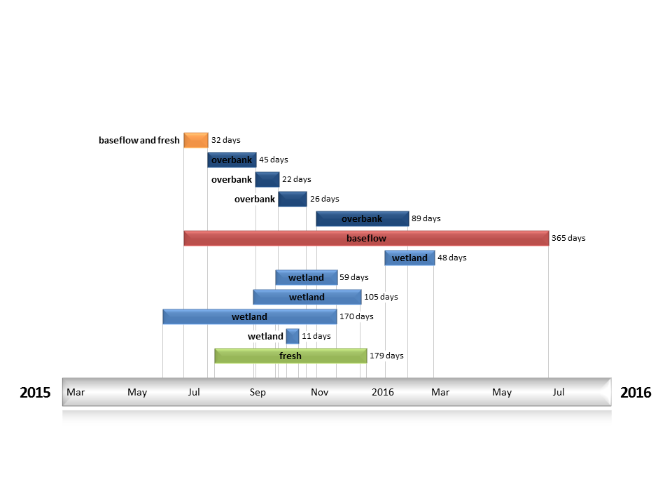
Figure CNM2. Timing and duration of water actions implemented by the CEWO during the 2015-16 water year in the Central Murray valley.

Contribution of Commonwealth Environmental Water to Flow Regimes
Doctors
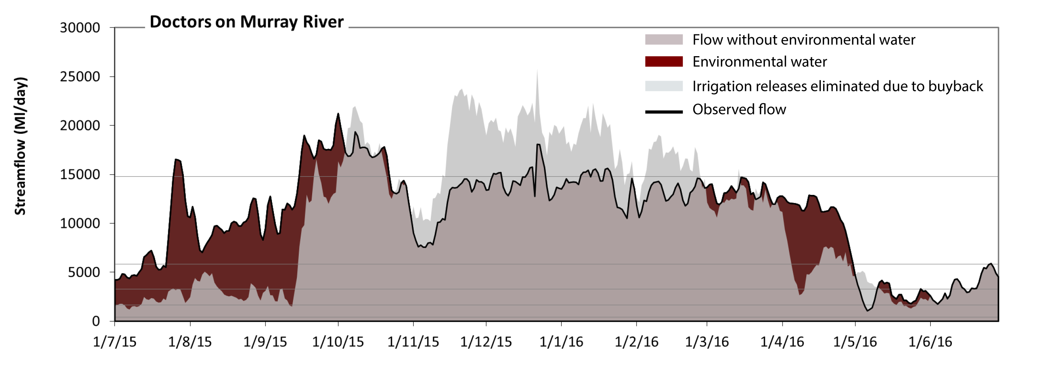
Figure CNM3: Contribution of environmental water delivery at Doctors. Horizontal lines indicate thresholds for very low flows, low flows, low freshes, medium freshes and high freshes (from lowest to highest).
At Doctors on Murray River environmental water contributed 20% of the total streamflow volume. Environmental watering actions affected streamflows for 50% of days between 1 July 2015 and 30 June 2016. Flow regulation does not substantially increase the duration of very low flows (i.e. < 410 Ml/day) compared to an average year in the natural flow regime. However, without environmental water, the duration of medium low flows (i.e. < 1700 Ml/day) in the period July to September would have substantially exceeded durations expected in an average year in the natural flow regime. Environmental water mitigated these impacts by reducing the cumulative duration of medium low flow spells from 5% to 1% of the year, with greatest influence in the period July to September. In the absence of environmental water there would have been at least one low fresh (i.e. > 3300 Ml/day) in the periods July to September, October to December, January to March and April to June. Environmental water increased the duration of the longest low fresh during the period July to September (from 17 days to 92 days). In the absence of environmental water there would have been at least one medium fresh (i.e. > 5800 Ml/day) in the periods July to September, October to December, January to March and April to June. Environmental water increased the duration of the longest medium fresh during the periods July to September (from 16 days to 70 days) and April to June (from 11 days to 31 days). In the absence of environmental water there would have been at least one high fresh in the periods July to September, October to December and January to March. Environmental water increased the duration of the longest medium fresh during the period July to September (from 3 days to 16 days). 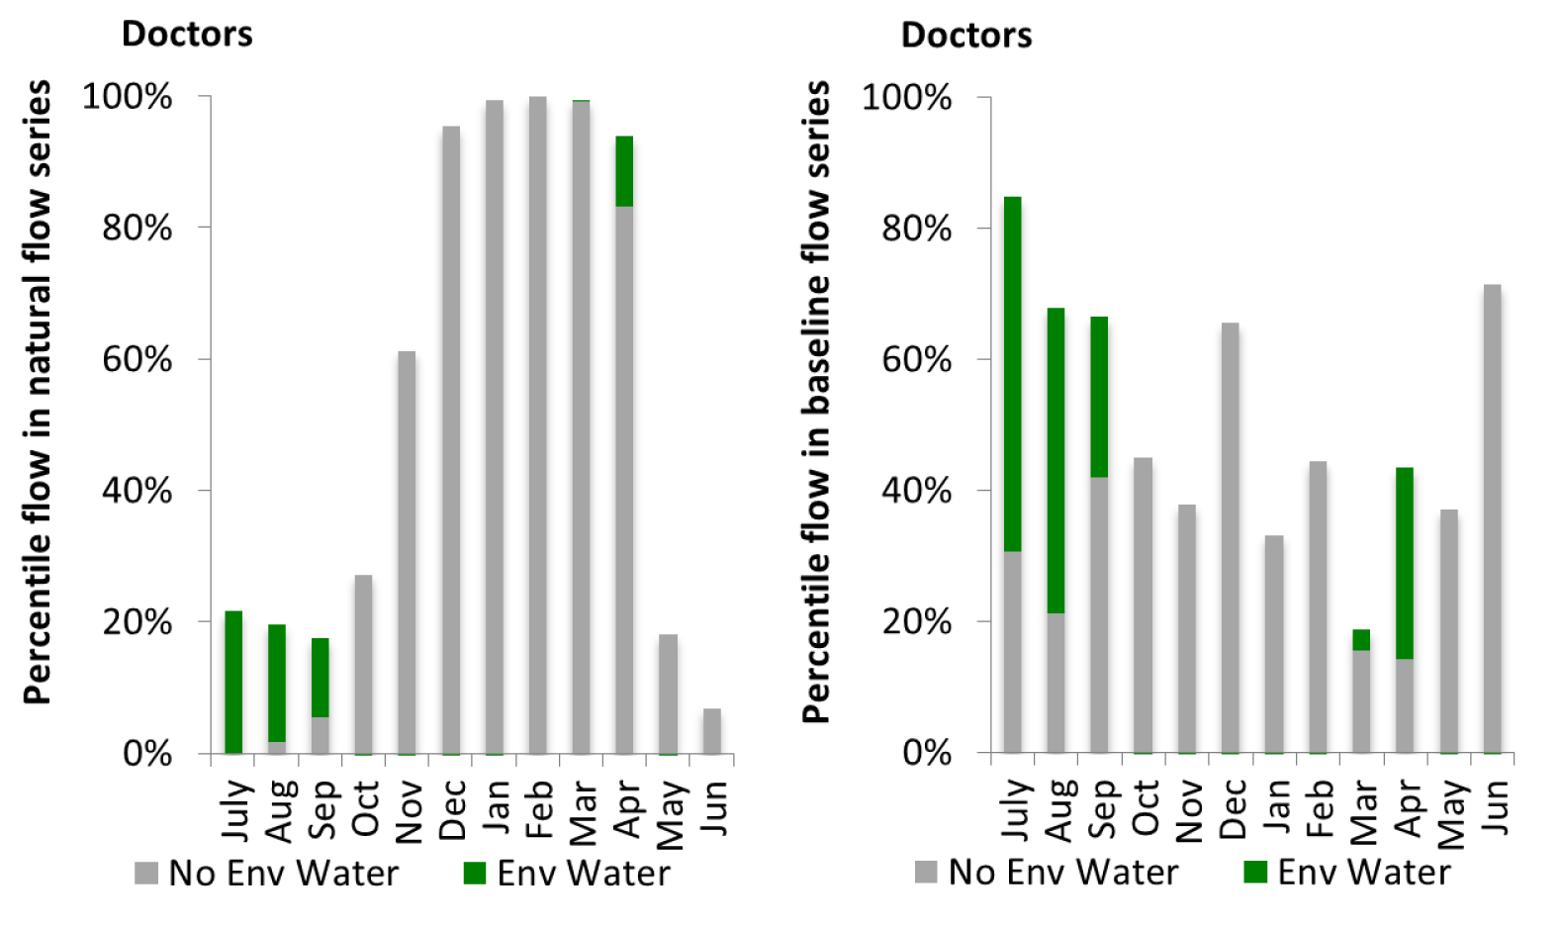
Figure CNM4: Contribution of environmental water delivery at Doctors as percentiles in the natural and baseline flow series.

Corowa
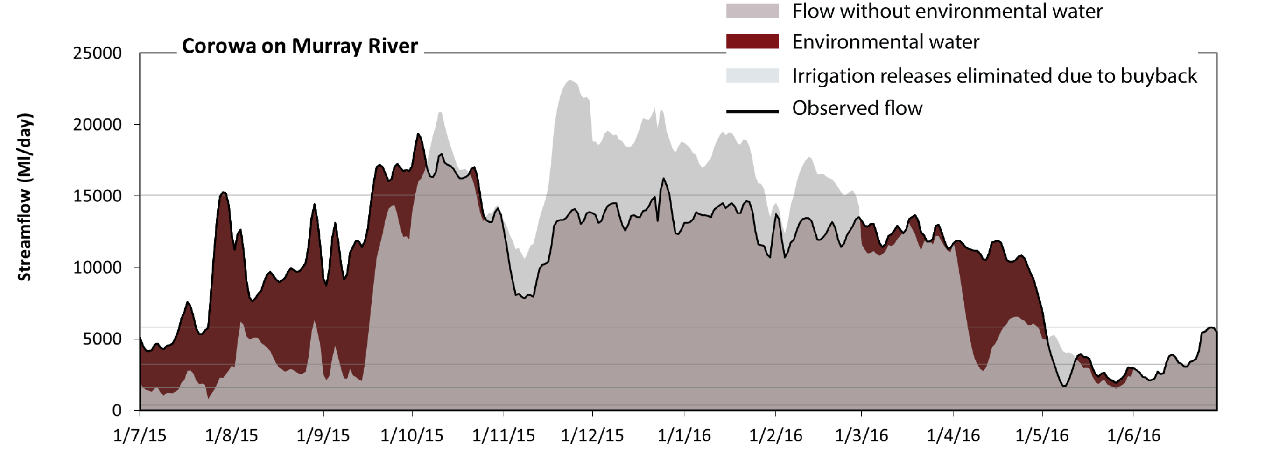
Figure CNM5: Contribution of environmental water delivery at Corowa. Horizontal lines indicate thresholds for very low flows, low flows, low freshes, medium freshes and high freshes (from lowest to highest).
At Corowa on Murray River environmental water contributed 19% of the total streamflow volume. Environmental watering actions affected streamflows for 49% of days between 1 July 2015 and 30 June 2016. Flow regulation does not substantially increase the duration of very low flows (i.e. < 380 Ml/day) compared to an average year in the natural flow regime. However, without environmental water, the duration of medium low flows (i.e. < 1600 Ml/day) in the period July to September would have substantially exceeded durations expected in an average year in the natural flow regime. Environmental water mitigated these impacts by reducing the cumulative duration of medium low flow spells from 4% to 0% of the year, with greatest influence in the period July to September. In the absence of environmental water there would have been at least one low fresh (i.e. > 3200 Ml/day) in the periods July to September, October to December, January to March and April to June. Environmental water increased the duration of the longest low fresh during the period July to September (from 15 days to 92 days). In the absence of environmental water there would have been at least one medium fresh (i.e. > 5800 Ml/day) in the periods July to September, October to December, January to March and April to June. Environmental water increased the duration of the longest medium fresh during the periods July to September (from 14 days to 68 days) and April to June (from 12 days to 32 days). In the absence of environmental water there would have been at least one high fresh in the periods October to December and January to March. Environmental water increased the duration of the longest medium fresh during the period July to September (from 0 days to 13 days).
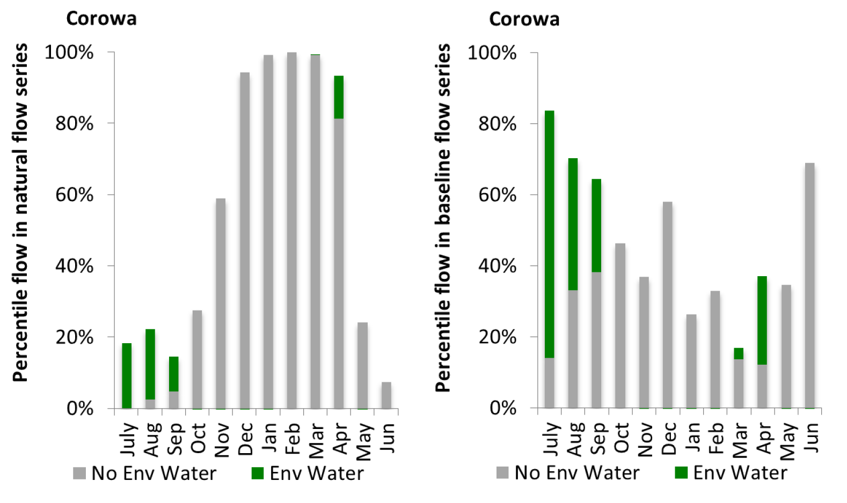
Figure CNM6: Contribution of environmental water delivery at Corowa as percentiles in the natural and baseline flow series.
Yarrawonga
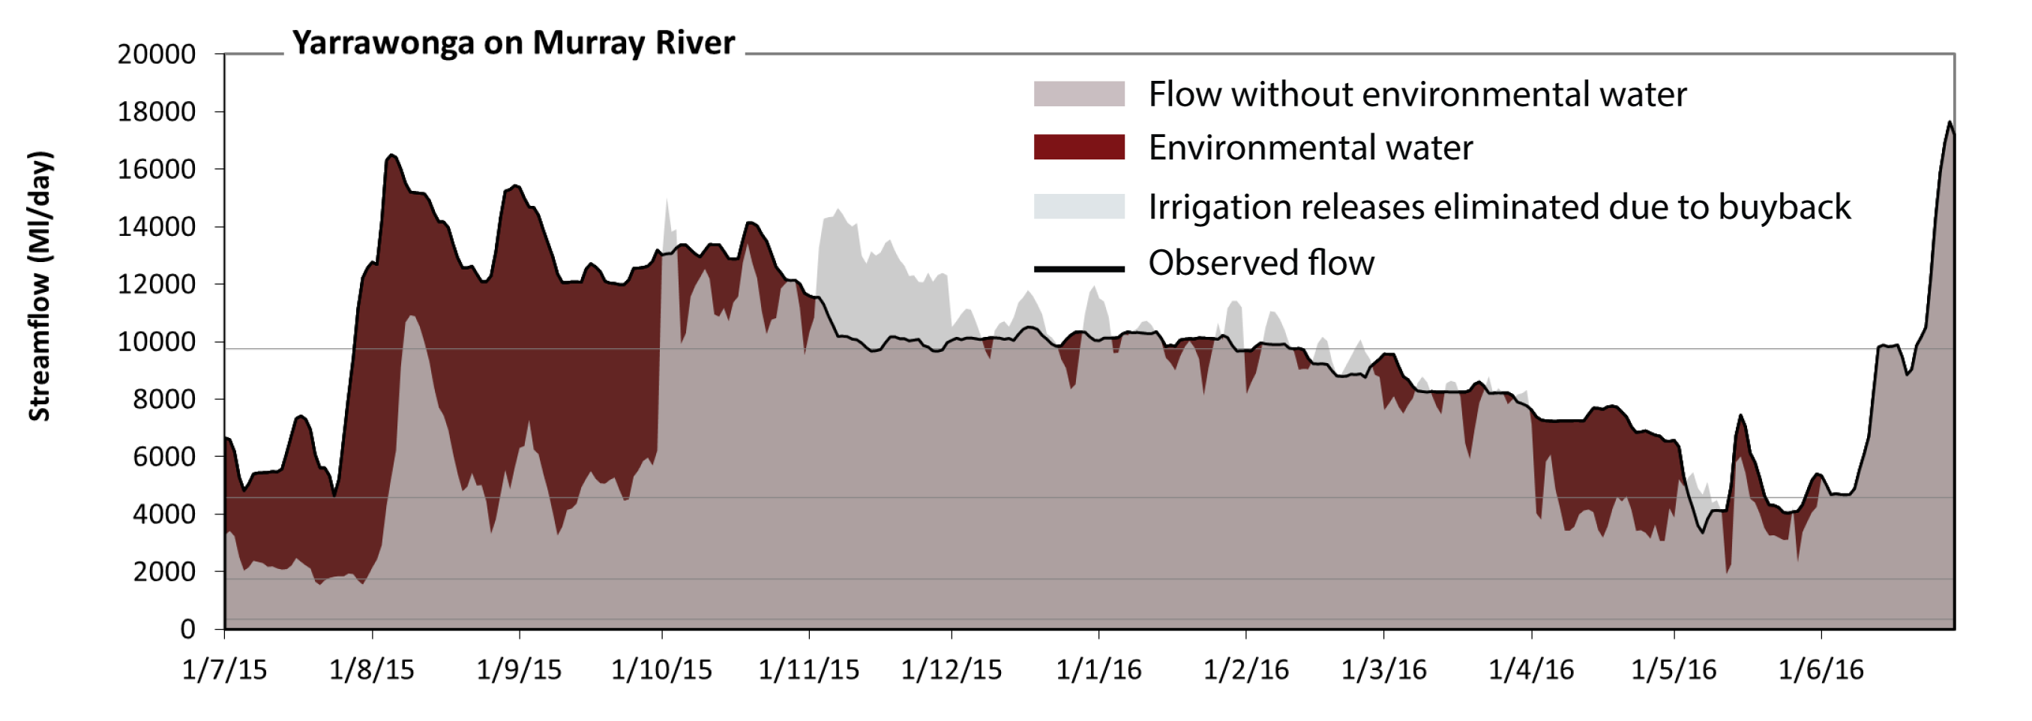
Figure CNM7: Contribution of environmental water delivery at Yarrawonga. Horizontal lines indicate thresholds for very low flows, low flows, low freshes and medium freshes (from lowest to highest).
At Yarrawonga on Murray River environmental water contributed 23% of the total streamflow volume. Environmental watering actions affected streamflows for 64% of days between 1 July 2015 and 30 June 2016. Flow regulation does not substantially increase the duration of very low flows (i.e. < 340 Ml/day) compared to an average year in the natural flow regime. However, without environmental water, the duration of medium low flows (i.e. < 1700 Ml/day) in the period July to September would have substantially exceeded durations expected in an average year in the natural flow regime. Environmental water mitigated these impacts by reducing the cumulative duration of medium low flow spells from 1% to 0% of the year, with greatest influence in the period July to September. In the absence of environmental water there would have been at least one low fresh (i.e. > 4600 Ml/day) in the periods July to September, October to December, January to March and April to June. Environmental water increased the duration of the longest low fresh during the period July to September (from 20 days to 92 days). In the absence of environmental water there would have been at least one medium fresh (i.e. > 9800 Ml/day) in the periods July to September, October to December, January to March and April to June. Environmental water increased the duration of the longest medium fresh during the periods July to September (from 5 days to 64 days) and January to March (from 9 days to 29 days). There was no high freshes (i.e. > 31000 Ml/day) this year.
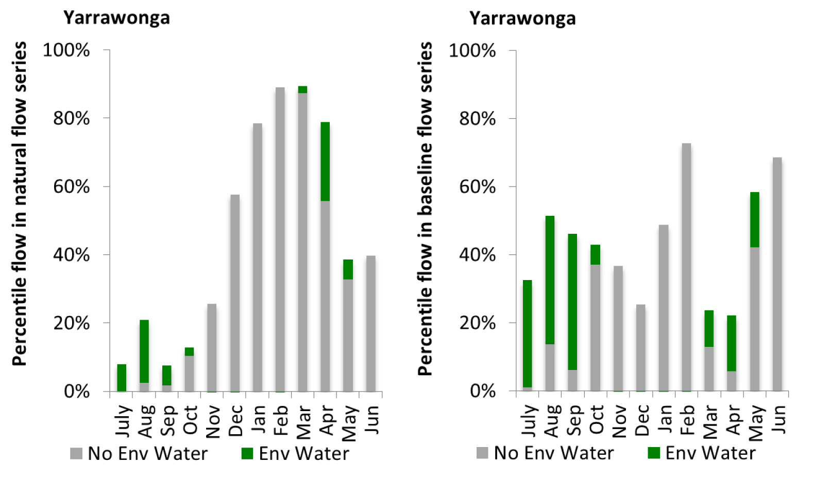
Figure CNM8: Contribution of environmental water delivery at Yarrawonga as percentiles in the natural and baseline flow series.
Tocumwal
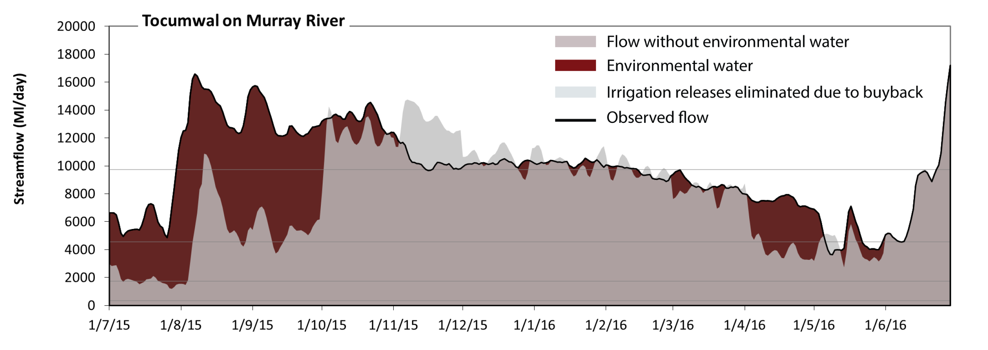
Figure CNM9: Contribution of environmental water delivery at Tocumwal. Horizontal lines indicate thresholds for very low flows, low flows, low freshes and medium freshes (from lowest to highest).
At Tocumwal on Murray River environmental water contributed 23% of the total streamflow volume. Environmental watering actions affected streamflows for 65% of days between 1 July 2015 and 30 June 2016. Flow regulation does not substantially increase the duration of very low flows (i.e. < 340 Ml/day) compared to an average year in the natural flow regime. However, without environmental water, the duration of medium low flows (i.e. < 1700 Ml/day) in the period July to September would have substantially exceeded durations expected in an average year in the natural flow regime. Environmental water mitigated these impacts by reducing the cumulative duration of medium low flow spells from 5% to 0% of the year, with greatest influence in the period July to September. In the absence of environmental water there would have been at least one low fresh (i.e. > 4600 Ml/day) in the periods July to September, October to December, January to March and April to June. Environmental water increased the duration of the longest low fresh during the period July to September (from 20 days to 92 days). In the absence of environmental water there would have been at least one medium fresh (i.e. > 9700 Ml/day) in the periods July to September, October to December, January to March and April to June. Environmental water increased the duration of the longest medium fresh during the periods July to September (from 4 days to 63 days) and January to March (from 16 days to 45 days). There was no high freshes (i.e. > 31000 Ml/day) this year.
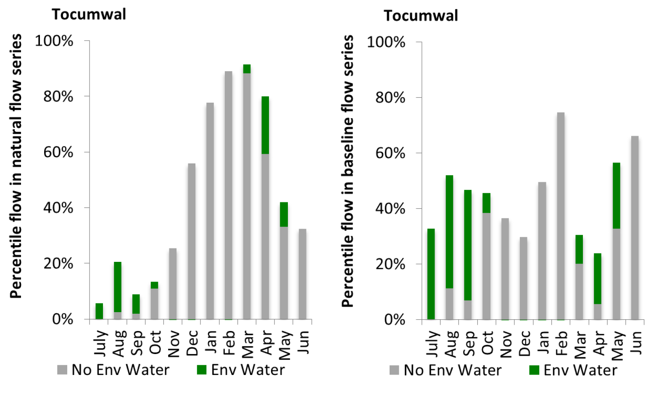
Figure CNM10: Contribution of environmental water delivery at Tocumwal as percentiles in the natural and baseline flow series.
Barmah
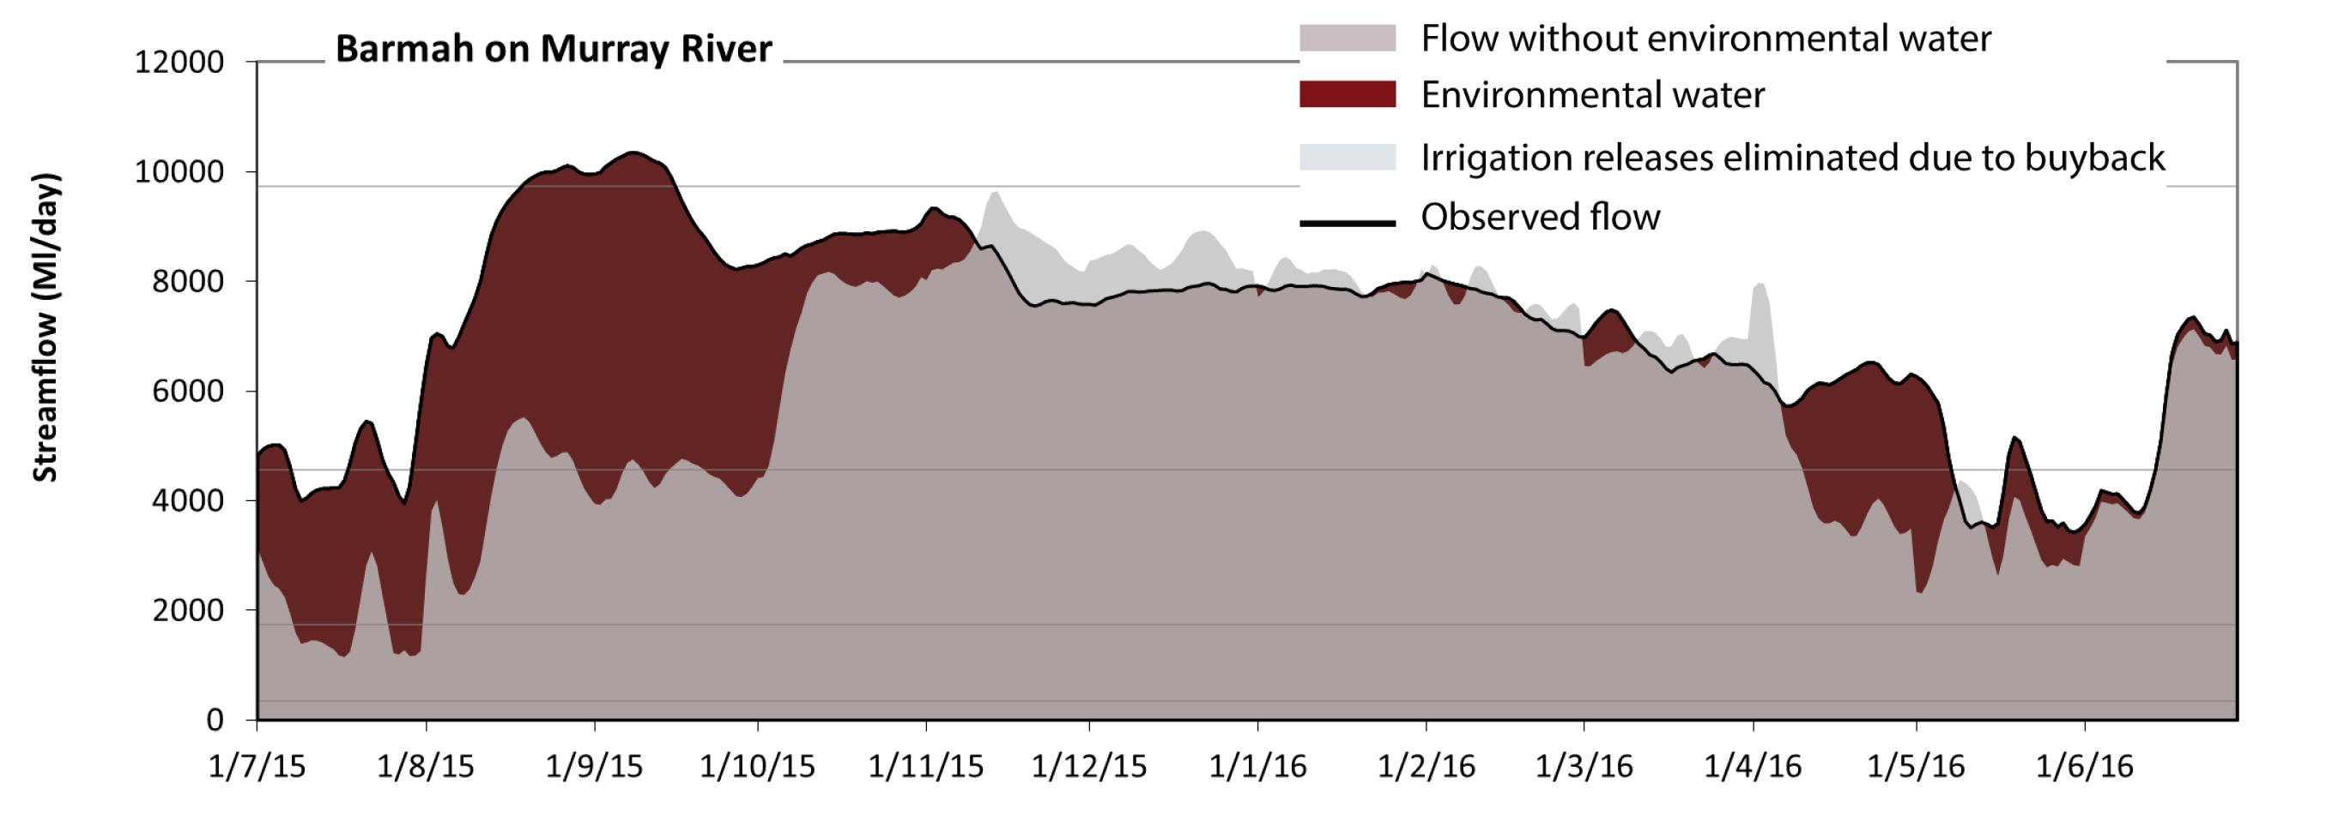
Figure CNM11: Contribution of environmental water delivery at Barmah. Horizontal lines indicate thresholds for very low flows, low flows, low freshes and medium freshes (from lowest to highest).
At Barmah on Murray River environmental water contributed 21% of the total streamflow volume. Environmental watering actions affected streamflows for 67% of days between 1 July 2015 and 30 June 2016. Flow regulation does not substantially increase the duration of very low flows (i.e. < 340 Ml/day) compared to an average year in the natural flow regime. However, without environmental water, the duration of medium low flows (i.e. < 1700 Ml/day) in the period July to September would have substantially exceeded durations expected in an average year in the natural flow regime. Environmental water mitigated these impacts by reducing the cumulative duration of medium low flow spells from 5% to 0% of the year, with greatest influence in the period July to September. In the absence of environmental water there would have been at least one low fresh (i.e. > 4600 Ml/day) in the periods July to September, October to December, January to March and April to June. Environmental water increased the duration of the longest low fresh during the periods July to September (from 15 days to 63 days) and April to June (from 15 days to 38 days). In the absence of environmental water there would have been no medium or high freshes this year. Environmental water increased the duration of the longest medium fresh during the period July to September (from 0 days to 28 days). 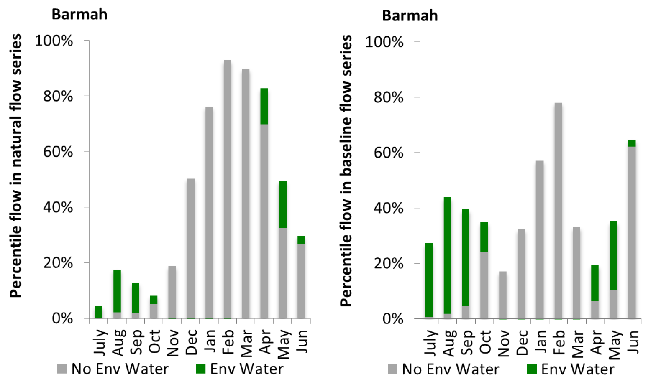
Figure CNM12: Contribution of environmental water delivery at Barmah as percentiles in the natural and baseline flow series.
Torrumbarry
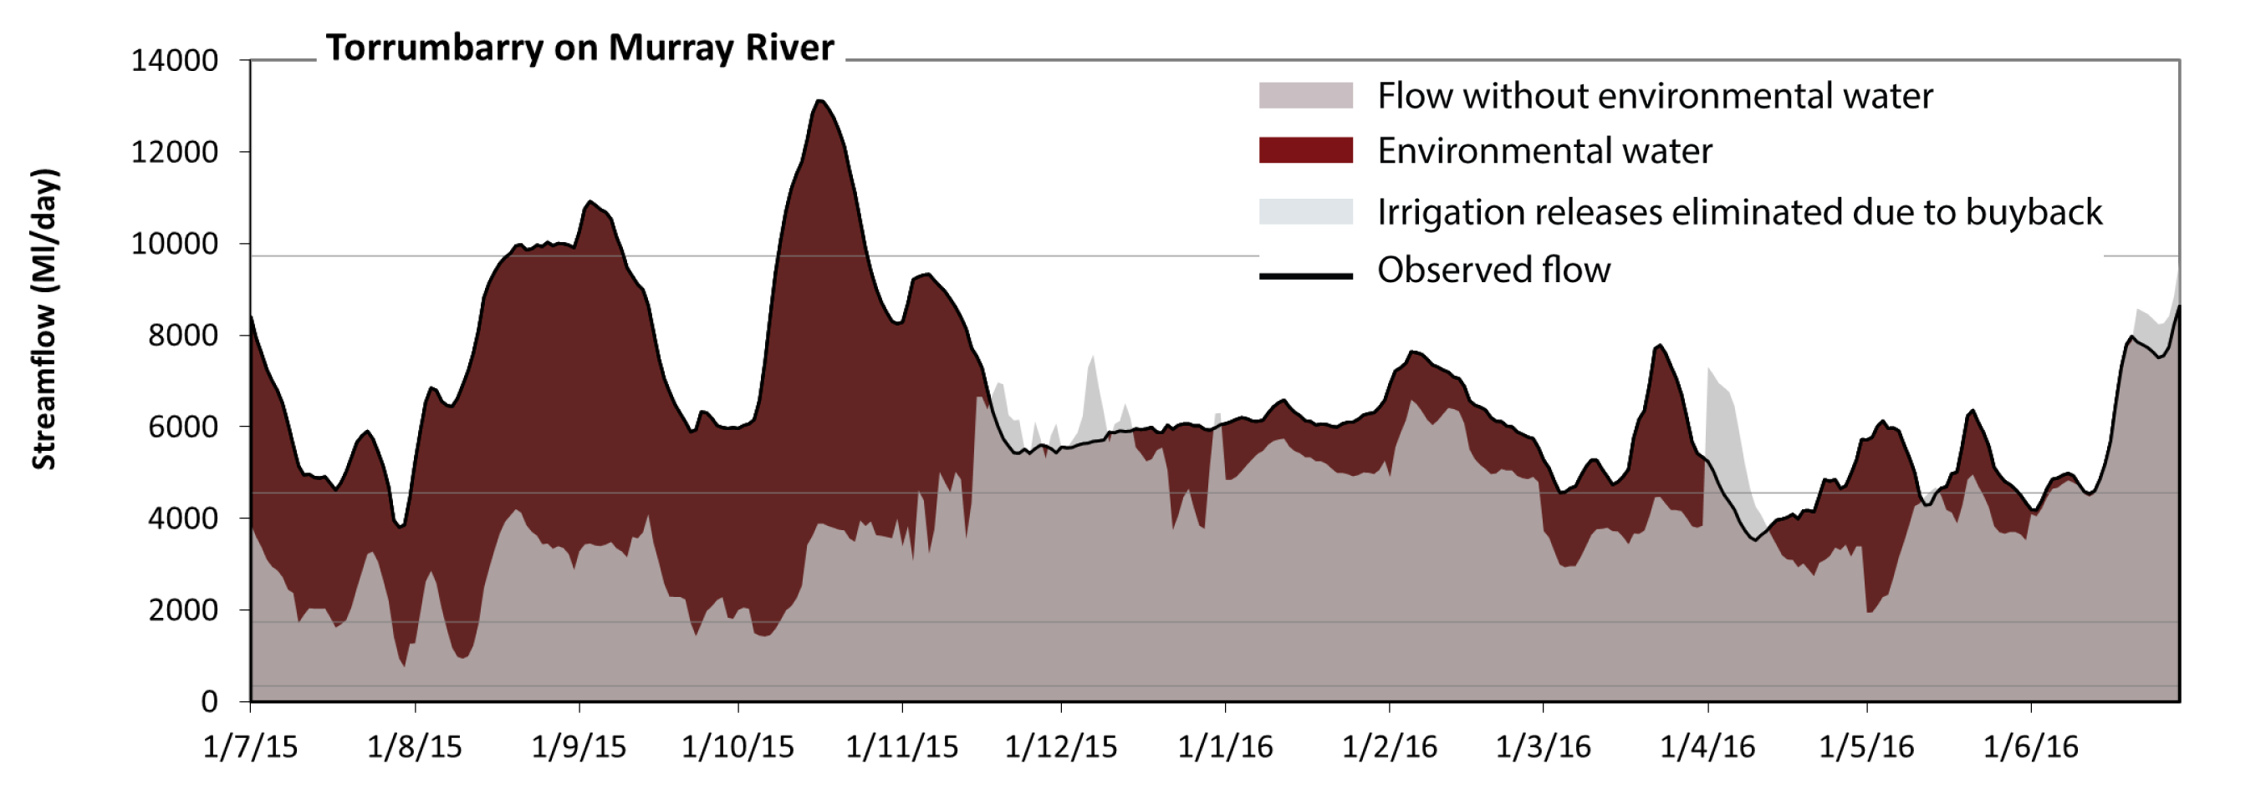Figure CNM13: Contribution of environmental water delivery at Torrumbarry. Horizontal lines indicate thresholds for very low flows, low flows, low freshes and medium freshes (from lowest to highest).
At Torrumbarry on Murray River environmental water contributed 39% of the total streamflow volume. Environmental watering actions affected streamflows for 86% of days between 1 July 2015 and 30 June 2016. Flow regulation does not substantially increase the duration of very low flows (i.e. < 340 Ml/day) compared to an average year in the natural flow regime. However, without environmental water, the durations of medium low flows (i.e. < 1700 Ml/day) in the periods July to September and October to December would have substantially exceeded durations expected in an average year in the natural flow regime. Environmental water mitigated these impacts by reducing the cumulative duration of medium low flow spells from 6% to 0% of the year, with greatest influence in the period July to September. In the absence of environmental water there would have been at least one low fresh (i.e. > 4600 Ml/day) in the periods October to December, January to March and April to June. Environmental water increased the duration of the longest low fresh during the periods July to September (from 0 days to 61 days), October to December (from 37 days to 92 days) and January to March (from 60 days to 90 days). In the absence of environmental water there would have been no medium or high freshes this year. Environmental water increased the duration of the longest medium fresh during the periods July to September (from 0 days to 22 days) and October to December (from 0 days to 17 days). 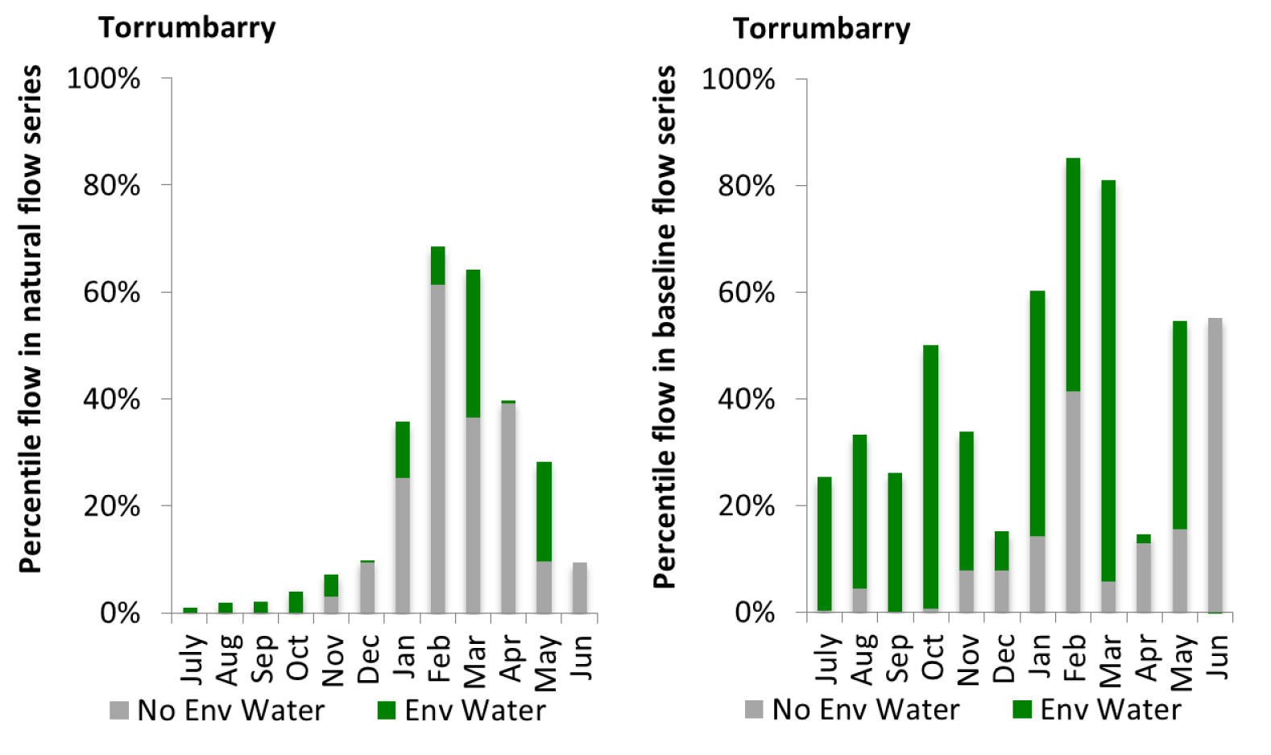
Figure CNM14: Contribution of environmental water delivery at Torrumbarry as percentiles in the natural and baseline flow series.
Barham
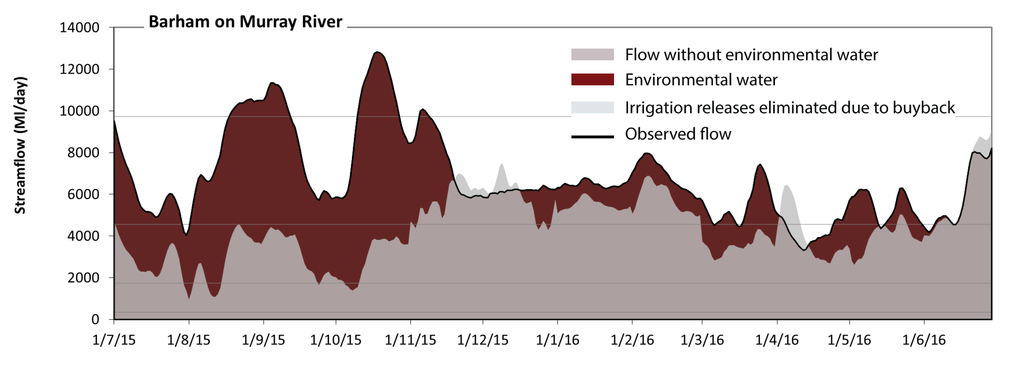 Figure CNM15: Contribution of environmental water delivery at Barham. Horizontal lines indicate thresholds for very low flows, low flows, low freshes and medium freshes (from lowest to highest).
At Barham on Murray River environmental water contributed 37% of the total streamflow volume. Environmental watering actions affected streamflows for 84% of days between 1 July 2015 and 30 June 2016. Flow regulation does not substantially increase the duration of very low flows (i.e. < 340 Ml/day) compared to an average year in the natural flow regime. However, without environmental water, the durations of medium low flows (i.e. < 1700 Ml/day) in the periods July to September and October to December would have substantially exceeded durations expected in an average year in the natural flow regime. Environmental water mitigated these impacts by reducing the cumulative duration of medium low flow spells from 5% to 0% of the year, with greatest influence in the periods July to September and October to December. In the absence of environmental water there would have been at least one low fresh (i.e. > 4600 Ml/day) in the periods July to September, October to December, January to March and April to June. Environmental water increased the duration of the longest low fresh during the periods July to September (from 1 days to 60 days) and October to December (from 50 days to 92 days). In the absence of environmental water there would have been no medium or high freshes this year. Environmental water increased the duration of the longest medium fresh during the periods July to September (from 0 days to 26 days) and October to December (from 0 days to 18 days).
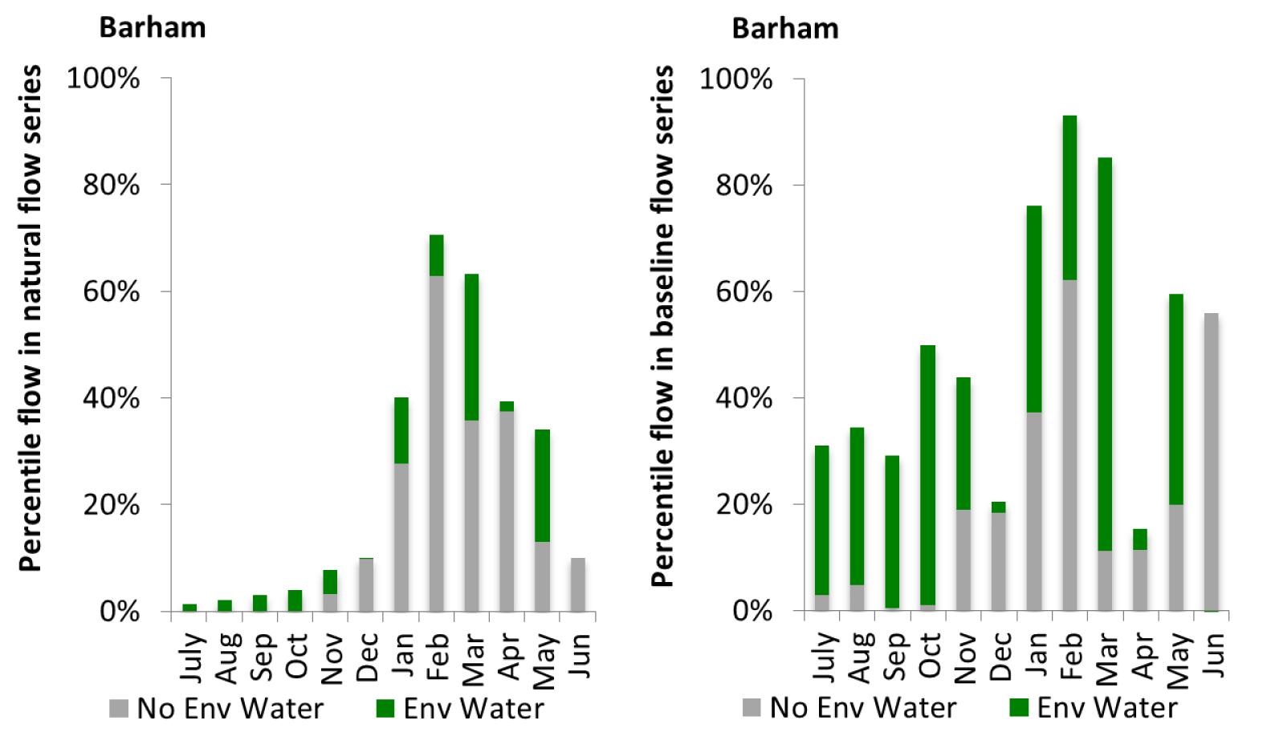
Figure CNM16: Contribution of environmental water delivery at Barham as percentiles in the natural and baseline flow series.
Swan Hill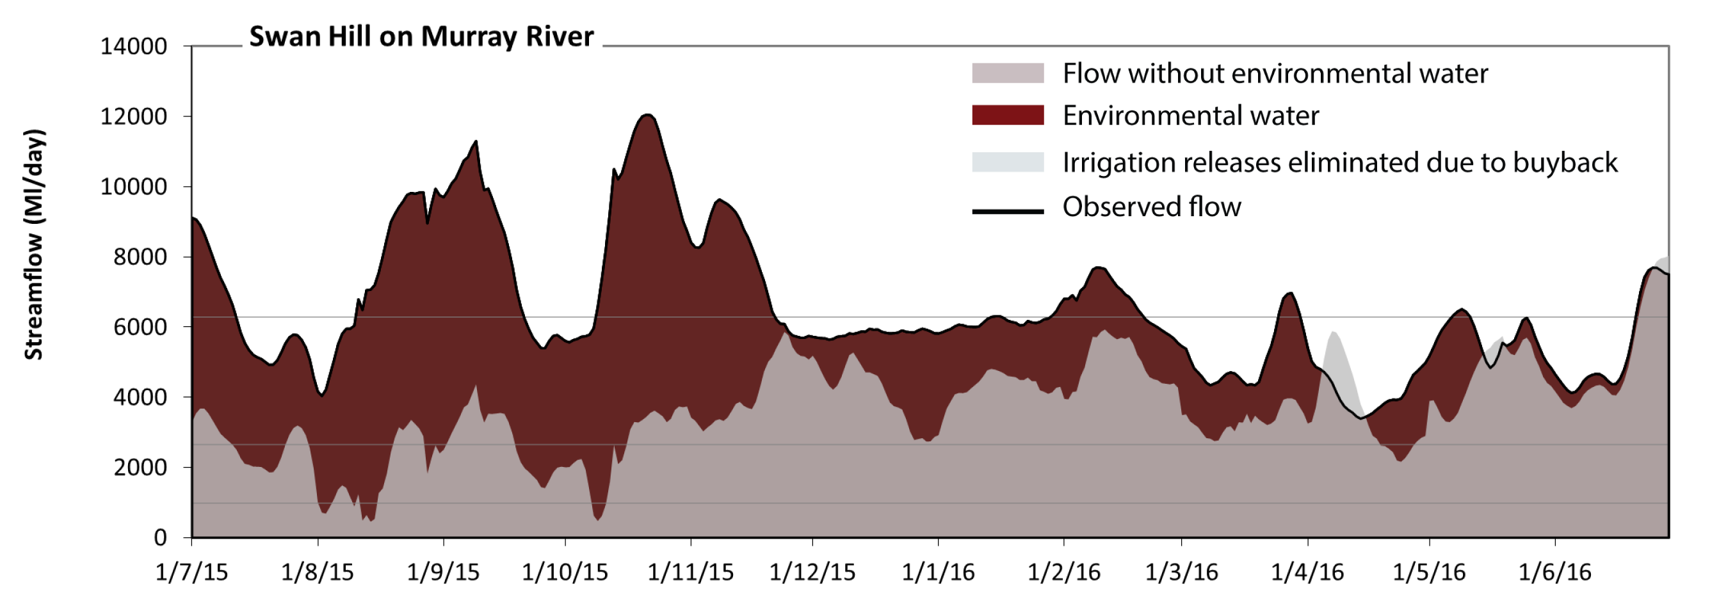 Figure CNM17: Contribution of environmental water delivery at Swan Hill. Horizontal lines indicate thresholds for very low flows, low flows, low freshes, medium freshes and high freshes (from lowest to highest).
At Swan Hill on Murray River environmental water contributed 44% of the total streamflow volume. Environmental watering actions affected streamflows for 95% of days between 1 July 2015 and 30 June 2016. Without environmental water, the duration of very low flows (i.e. < 980 Ml/day) in the period July to September would have substantially exceeded durations expected in an average year in the natural flow regime. Environmental water mitigated these impacts by reducing the cumulative duration of very low flow spells from 3% to 0% of the year, with greatest influence in the periods July to September and October to December. Similarly, without environmental water, the durations of medium low flows (i.e. < 2600 Ml/day) in the periods July to September and October to December would have substantially exceeded durations expected in an average year in the natural flow regime. Environmental water mitigated these impacts by reducing the cumulative duration of medium low flow spells from 21% to 0% of the year, with greatest influence in the period July to September. In the absence of environmental water there would have been at least one low fresh (i.e. > 6300 Ml/day) in the period April to June. Environmental water increased the duration of the longest low fresh during the periods July to September (from 0 days to 41 days), October to December (from 0 days to 44 days) and January to March (from 0 days to 23 days). There was no medium or high freshes this year.
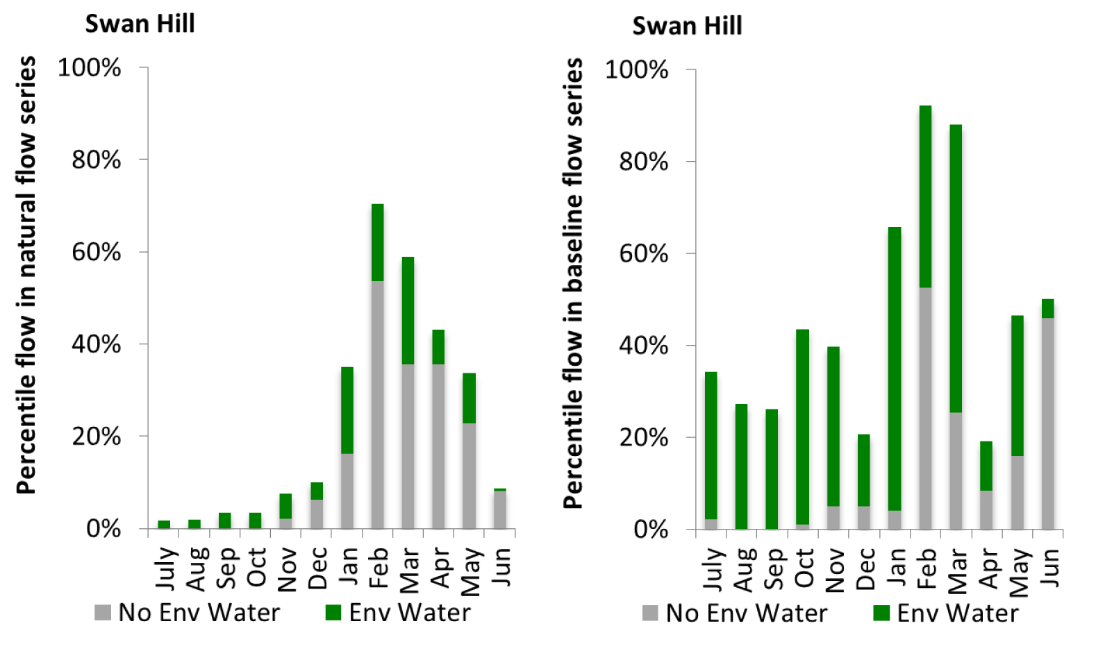
Figure CNM18: Contribution of environmental water delivery at Swan Hill as percentiles in the natural and baseline flow series.

Wakool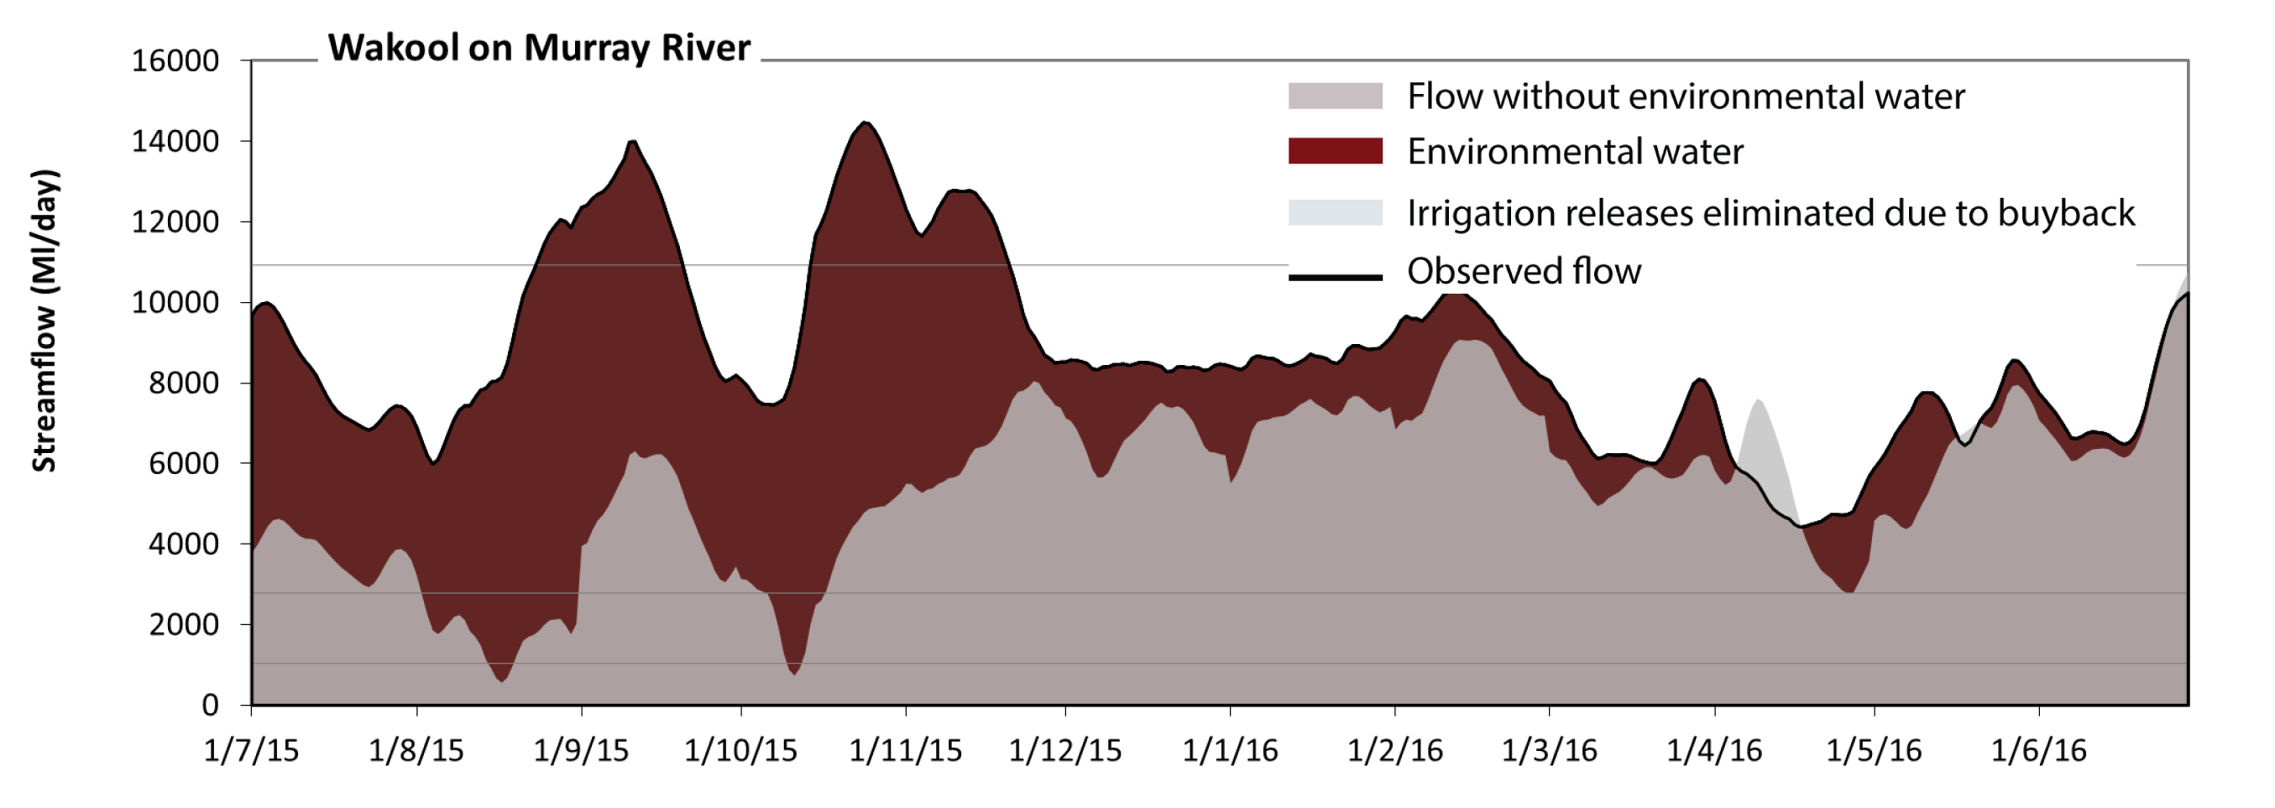 Figure CNM19: Contribution of environmental water delivery at Wakool. Horizontal lines indicate thresholds for very low flows, low flows and low freshes (from lowest to highest).
At Wakool on Murray River environmental water contributed 37% of the total streamflow volume. Environmental watering actions affected streamflows for 95% of days between 1 July 2015 and 30 June 2016. Without environmental water, the duration of very low flows (i.e. < 1000 Ml/day) in the period July to September would have substantially exceeded durations expected in an average year in the natural flow regime. Environmental water mitigated these impacts by reducing the cumulative duration of very low flow spells from 2% to 0% of the year, with greatest influence in the periods July to September and October to December. Similarly, without environmental water, the durations of medium low flows (i.e. < 2800 Ml/day) in the periods July to September and October to December would have substantially exceeded durations expected in an average year in the natural flow regime. Environmental water mitigated these impacts by reducing the cumulative duration of medium low flow spells from 12% to 0% of the year, with greatest influence in the periods July to September and October to December. Environmental water increased the duration of the longest low fresh during the periods July to September (from 0 days to 27 days) and October to December (from 0 days to 37 days).
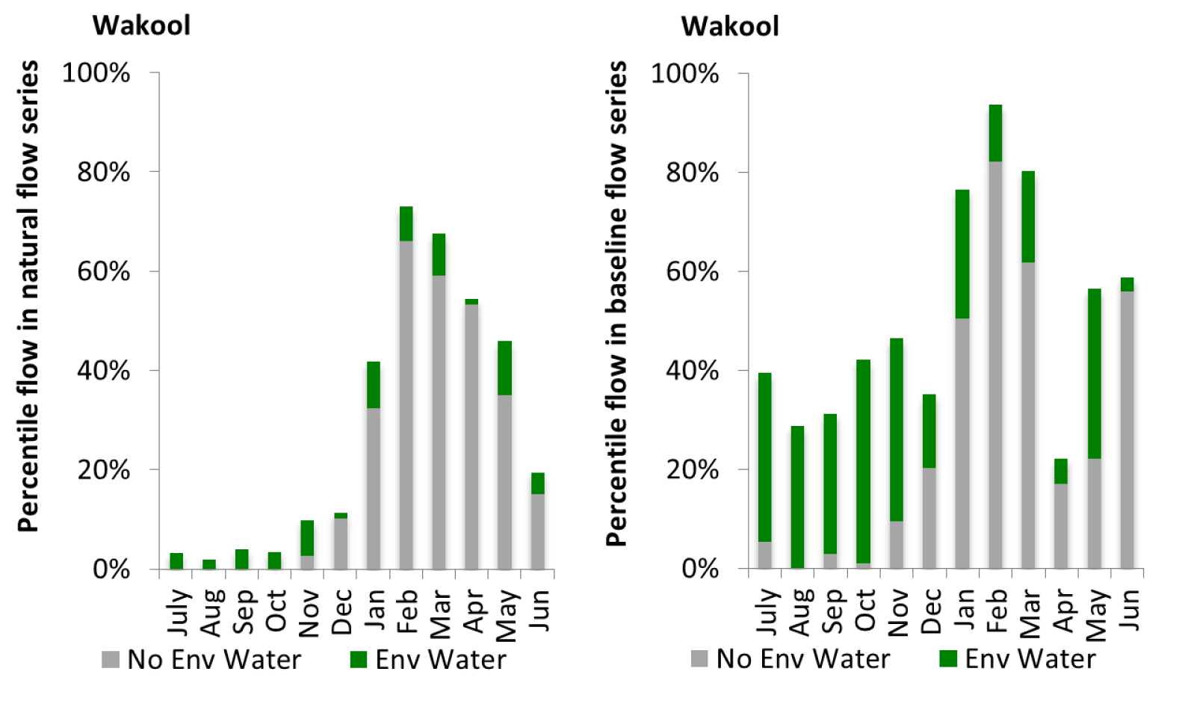
Figure CNM20: Contribution of environmental water delivery at Wakool as percentiles in the natural and baseline flow series.

Euston
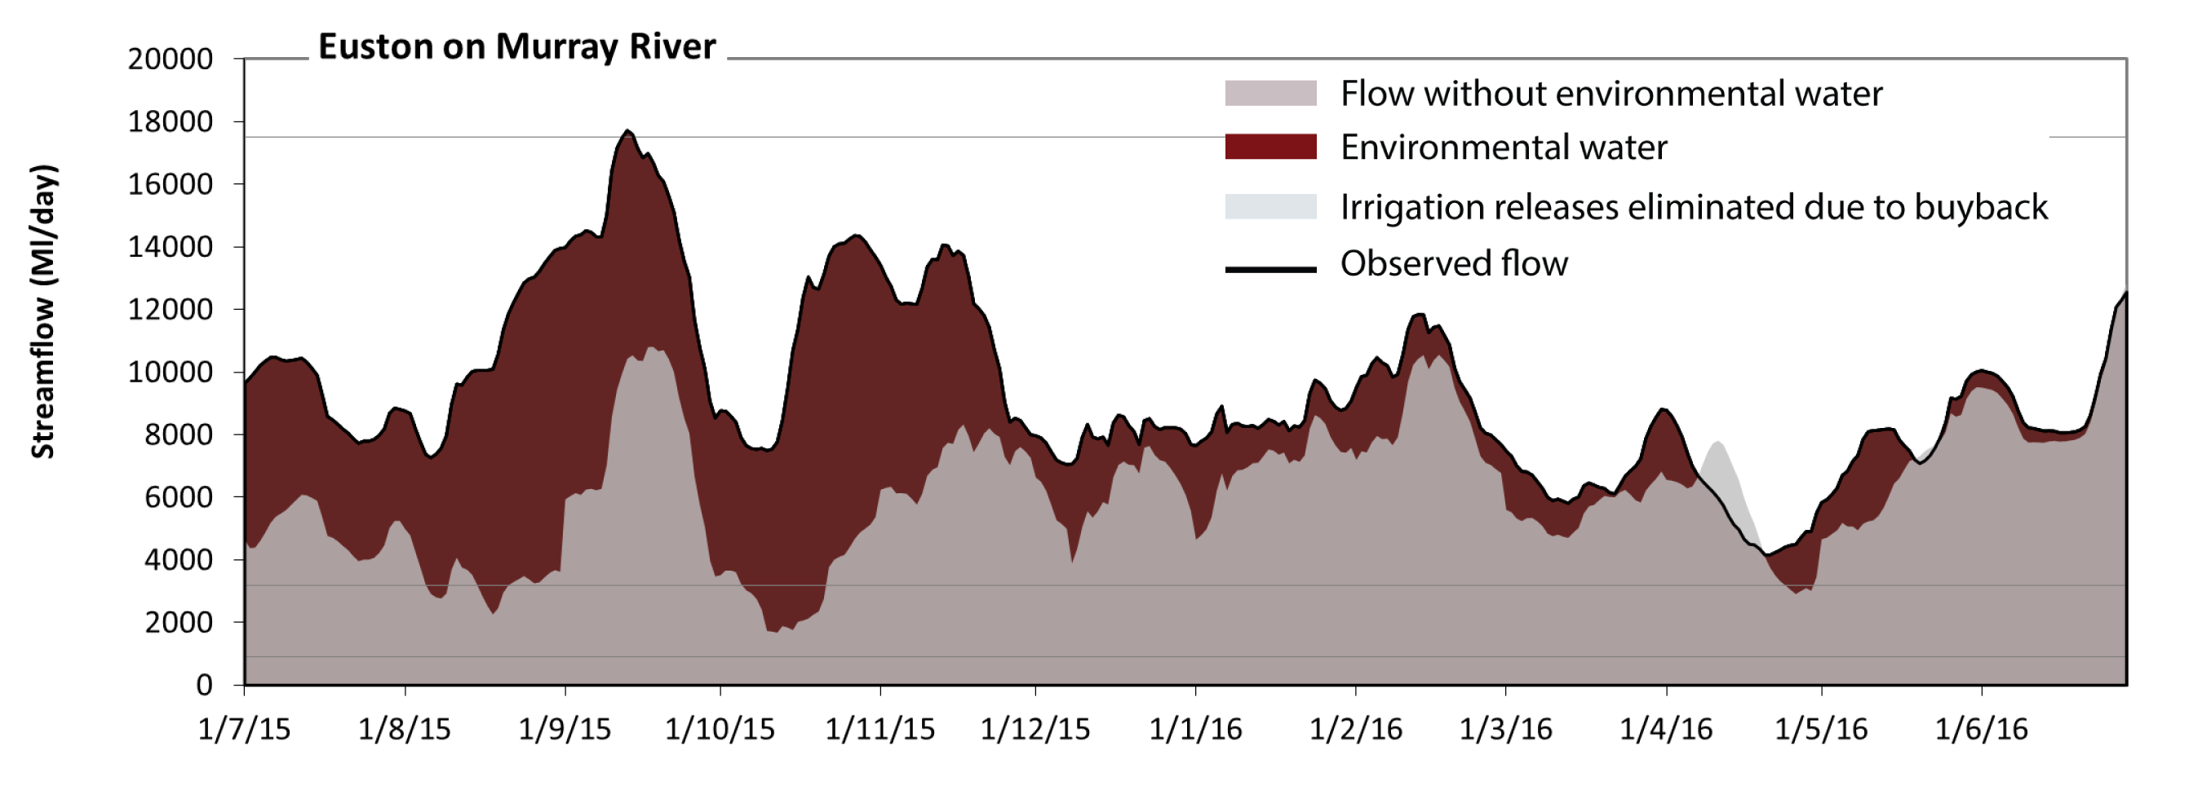 Figure CNM21: Contribution of environmental water delivery at Euston. Horizontal lines indicate thresholds for very low flows and low flows (from lowest to highest).
At Euston on Murray River environmental water contributed 34% of the total streamflow volume. Environmental watering actions affected streamflows for 95% of days between 1 July 2015 and 30 June 2016. Flow regulation does not substantially increase the duration of very low flows (i.e. < 910 Ml/day) compared to an average year in the natural flow regime. However, without environmental water, the durations of medium low flows (i.e. < 3200 Ml/day) in the periods July to September and October to December would have substantially exceeded durations expected in an average year in the natural flow regime. Environmental water mitigated these impacts by reducing the cumulative duration of medium low flow spells from 9% to 0% of the year, with greatest influence in the periods July to September and October to December. Environmental water increased the duration of the longest low fresh during the period July to September (from 0 days to 2 days). 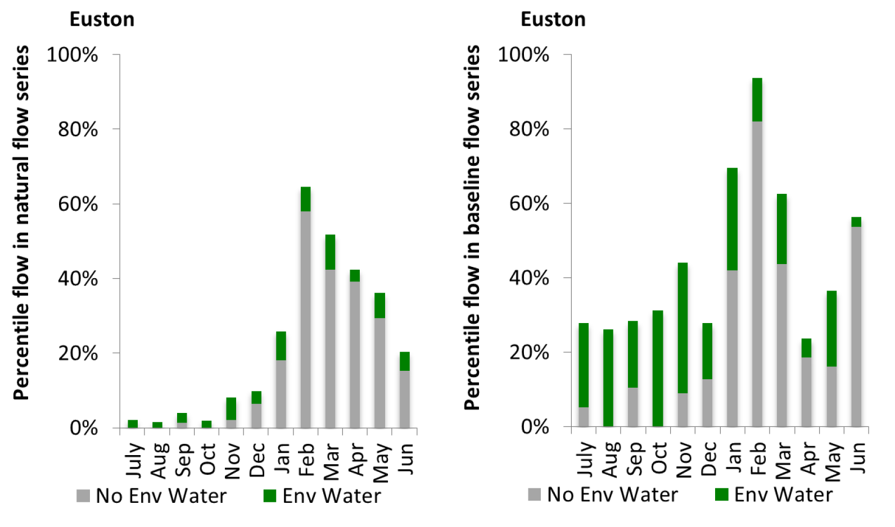
Figure CNM22: Contribution of environmental water delivery at Euston as percentiles in the natural and baseline flow series.

Lock 10
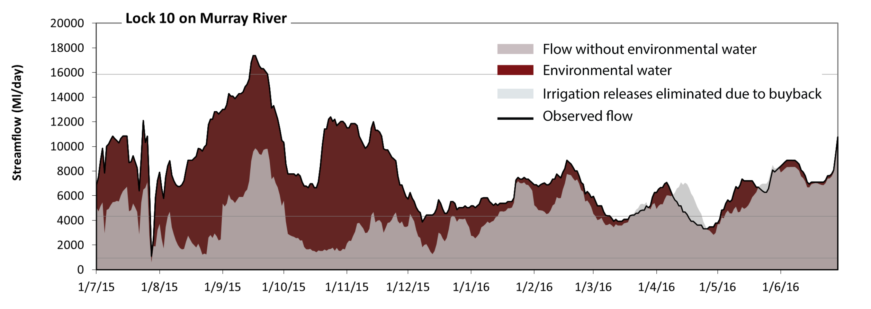 Figure CNM23: Contribution of environmental water delivery at Lock 10. Horizontal lines indicate thresholds for very low flows and low flows (from lowest to highest).
At Lock 10 on Murray River environmental water contributed 41% of the total streamflow volume. Environmental watering actions affected streamflows for 90% of days between 1 July 2015 and 30 June 2016. Flow regulation does not substantially increase the duration of very low flows (i.e. < 940 Ml/day) compared to an average year in the natural flow regime. However, without environmental water, the durations of medium low flows (i.e. < 4300 Ml/day) in the periods July to September, October to December, January to March and April to June would have all substantially exceeded durations expected in an average year in the natural flow regime. Environmental water mitigated these impacts by reducing the cumulative duration of medium low flow spells from 45% to 8% of the year, with greatest influence in the periods July to September and October to December. Environmental water increased the duration of the longest low fresh during the period July to September (from 0 days to 9 days).
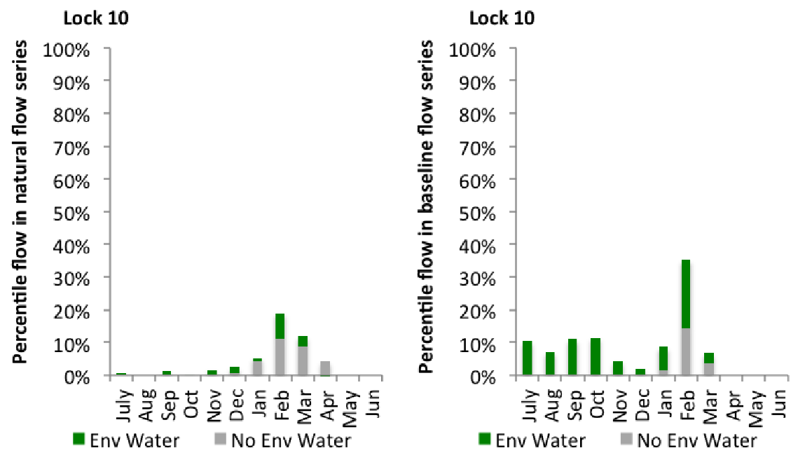
Figure CNM24: Contribution of environmental water delivery at Lock 10 as percentiles in the natural and baseline flow series

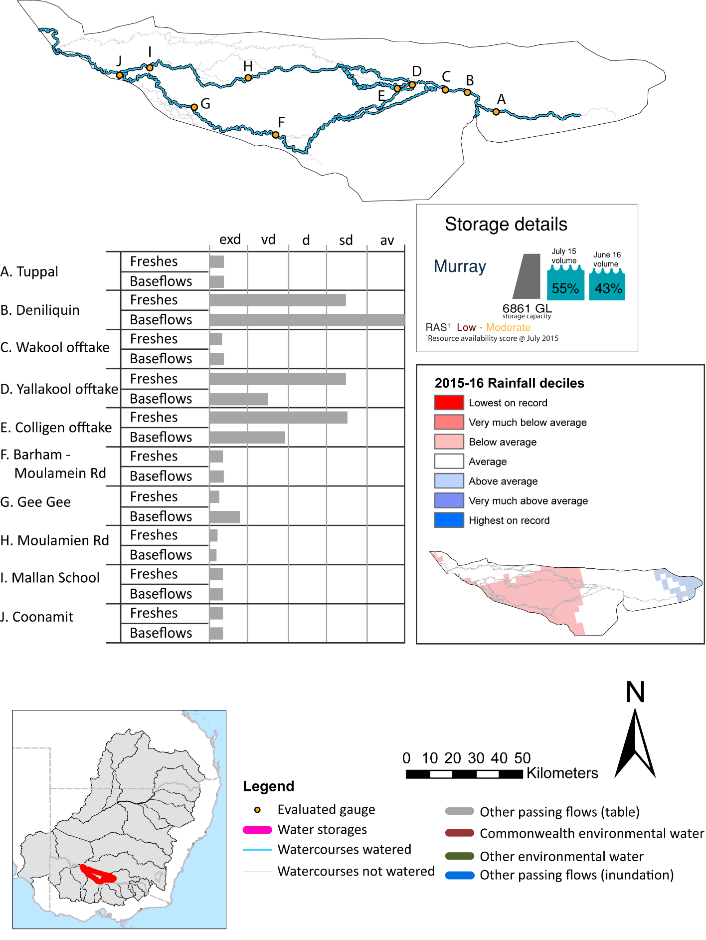
Edward-Wakool

Figure EWK1: Watercourses influenced, areas inundated (where applicable) and gauge stations evaluated in the Edward Wakool valley during the 2015-16 water year. Inset bar graphs report the condition of annual flow regimes by showing the improvements in hydrological condition with the addition of environmental water as well as the hypothetical scenario in “grey” (if no environmental flow had been delivered). Rainfall conditions (rainfall deciles) and trend in storage levels for the water year are also shown.

Summary
Environmental water delivery for the 2015-16 year in the Edward-Wakool Valley is evaluated using data for 10 sites. This evaluation only considers the contribution of held environmental water, which is a primary focus for the Commonwealth. The contributions of planned environmental water (e.g. passing flows), unregulated tributary inflows and clever use of irrigation flows for environmental benefits can all be very important but these are outside the scope of this report. Environmental watering actions lasted on average 83 days over the course of the year. The volume of environmental water at these 10 sites was between 3% and 100% of the total streamflow. Commonwealth Environmental Water contributed on average 95% of this environmental water. Ideally, baseflows should be maintained and long periods of excessively low flows avoided. In this valley, the baseflow regime was generally considered to be extremely dry relative to the pre-development flow regime. In our analysis, a low fresh refers to a period of increased flow, when the water level rises at least one eighth of the way up the river bank (above the low flow level). These low freshes are a regular part of the natural flow regime and support a range of natural processes. In the Edward-Wakool valley, in terms of the occurrence and duration of low freshes, the year was assessed as being very dry. In our analysis, a medium fresh refers to a period of increased flow, when the water level rises at least one quarter of the way up the river bank. These medium freshes are not as frequent as low freshes but are also a regular and important part of the natural flow regime. In the Edward-Wakool valley, in terms of the occurrence of medium freshes, the year was assessed as being very dry. In our analysis, a high fresh refers to a period of increased flow, when the water level rises more than half way up the river. A high fresh may not occur every year but they are still important and long periods without major freshes can have serious consequences for floodplains and their contribution to river ecosystem health. Delivering environmental water as high in channel flows normally requires that all risks to riparian landholders and infrastructure have been resolved. In the Edward-Wakool valley, in terms of the occurrence of high freshes, the year was assessed as being extremely dry.

Environmental water system
The Edward–Wakool River system covers approximately 10,786 km2, representing approximately 1% of Basin. This Edward-Wakool is a major anabranch and floodplain of the River Murray. It consists of a network of inter-connecting rivers, creeks, flood runners and wetlands covering more than 1,000 square kilometres between the Murray and Edward Rivers. The hydrology of the system is complex. Flows can originate from a variety of sources. These include the upper Murray, and Murrumbidgee, and Victorian tributaries such as the Kiewa, Ovens, Goulburn, Campaspe, Loddon and Avoca Rivers. The main water sources are from the Murray River via the Edward River and Gulpa Creek, which originate in the Barmah-Millewa Forest. During high flows the Edward-Wakool is supplemented with water from the Murray River via a number of creeks. The intermittent stream network also connects to a number of large wetland depressions.
Stevens Weir limits the regulated flow into the Edward-Wakool, with unregulated events entering the Edward shared alternately between the Edward and the Wakool Rivers. The Edward River provides an important conveyance function for River Murray needs as well as the supply of consumptive water within the Edward Wakool.

Data availability
The contribution (where applicable) of the Commonwealth environmental water and NSW environmental water and other passing flows were derived from the CAIRO river operations spreadsheet held by Water NSW. The accounted waterholding was tracked longitudinally from the release point to the accounting point using known travel times, which are programmed into the operational model. The method assumed no longitudinal transmission loss of water, so the outputs likely underestimate the impact of Commonwealth environmental water.

Water delivery context
During the 2015-16 water year, the Commonwealth Environmental Water Holder (CEWH) held water entitlements of up to 0ML for environmental use in the Edward Wakool valley. Each year, water utilities allocate the water entitlement holders a percentage of water based on their holding, license type and carryover (the exact rules vary among Jurisdictions). In the 2015-16 water year, the CEWH Edward Wakool entitlements were allocated 0 ML of water, representing % of the Long term average annual yield for the Edward Wakool valley (0 ML). The 2015-16 water allocation (0 ML) together with the carryover volume of 0 ML of water meant the CEWH had 0 ML of water available for delivery.
A total of 32189 ML of Commonwealth environmental water was delivered in the Edward Wakool valley. A total of 0 ML of Commonwealth environmental water was traded to consumptive users and 0ML (% of available resource) of Commonwealth environmental water was carried over for environmental use into the 2016-17 water year. Intervalley transfer of water in the southern connected Basin, means on occasion there may be a mismatch between Commonwealth environmental water available for delivery and the actual volume of Commonwealth environmental water delivered. Intervalley transfer of water in the southern connected Basin, means on occasion there may be a mismatch between Commonwealth environmental water available for delivery and the actual volume of Commonwealth environmental water delivered.

Environmental conditions and resource availability
The water available for delivery combined with the present and antecedent environmental conditions are key inputs used by environmental water managers in planning and implementing watering actions. Post hoc, this information provides important context when evaluating the effectiveness and appropriateness of environmental water use with respect to hydrological outputs.
The rainfall conditions in the Edward Wakool valley were classified as Average, based on rainfall percentile data for the entire record held by the Bureau of Meteorology for this valley. The major storages in the Edward Wakool valley remained decreased, being 55% full at the beginning of the water year and 38% full by the end of the year (Figure EWK1).
The Commonwealth Environmental Water Office (CEWO) calculates resource availability scenarios (RAS) progressively as part of its continual adaptive management planning processes. The RAS are based on the availability of held water (including progressive license acquisitions and allocations) as well as the potential for unregulated or planned environmental flows. The resource availability of held water was classified as refer to the Central Murray values in this valley, whilst the potential for unregulated or planned environmental flow was classified as . The physical conditions meant that the CEWO was managing to Protect the floodplain forest areas where demands are high, while maintaining ecological health and resiience of other key sites. The overall demand for environmental water was deemed .

Watering actions
A total of 4 watering actions were implemented, the duration of these actions varied (range of individual actions: 65 - 146 days). The total cumulative sum of watering actions days was 503). The number of actions commencing in each season did not vary: Spring (4). The flow component types delivered included (4 baseflow, 4 freshes, 0 bankfull, 0 overbank and 0 wetland).

Table EWK2. Commonwealth environmental water accounting information for the Edward Wakool valley over 2015-16 water year.
Total registered volume (ML) | Allocated volume (ML) | Carry over available (ML) | Delivered (ML) | LTAAY (ML) | Trade (ML) | Carried over to 2016-17 | Forfeited (ML)
0 | 0 | 0 | 32189 | 0 | 0 | 0 | 0

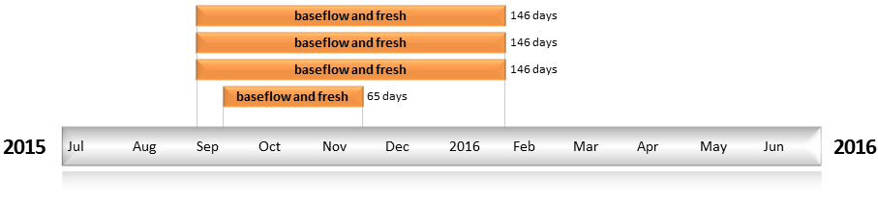
Figure EWK2. Timing and duration of water actions implemented by the CEWO during the 2015-16 water year in the Edward Wakool valley.

Contribution of Commonwealth Environmental Water to Flow Regimes
Tuppal
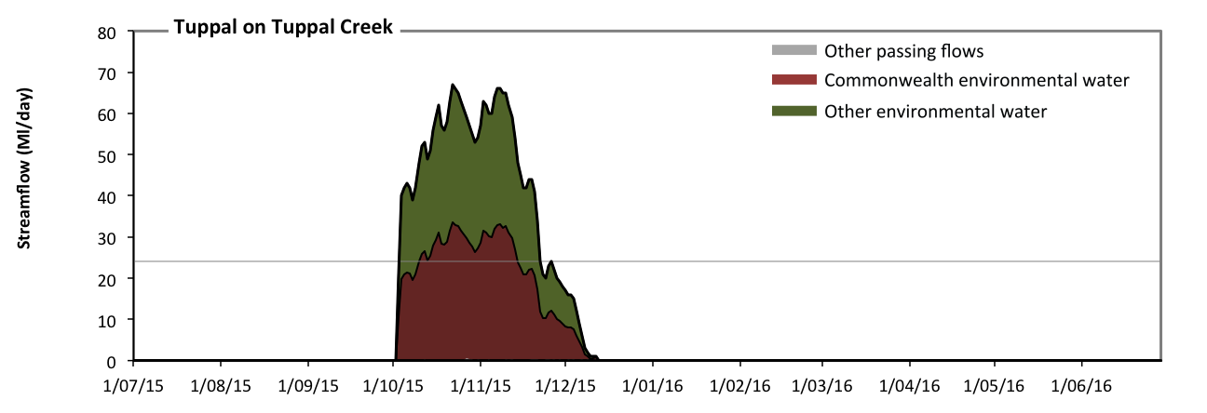
Figure EWK3: Contribution of environmental water delivery at Tuppal. Horizontal lines indicate thresholds for very low flows and low flows (from lowest to highest).
At Tuppal on Tuppal Creek environmental water contributed 100% of the total streamflow volume (with approximately half contributed by Commonwealth environmental water) (Figure EWK3). Environmental watering actions affected streamflows for 19% of days between 1 July 2015 and 30 June 2016. Without environmental water, the durations of very low flows (i.e. < 24 Ml/day) in the periods July to September, October to December, January to March and April to June would have all substantially exceeded durations expected in an average year in the natural flow regime. Environmental water mitigated these impacts by reducing the cumulative duration of very low flow spells from 100% to 86% of the year, with greatest influence in the period October to December. Similarly, without environmental water, the durations of medium low flows (i.e. < 120 Ml/day) in the periods July to September, October to December, January to March and April to June would have all substantially exceeded durations expected in an average year in the natural flow regime. However, environmental water had little effect on the duration of these medium low flows, which occurred for 100% of the year. Commonwealth environmental water equally shared responsibility with other environmental water holders for these enhancements of environmental baseflows at this site.
Deniliquin
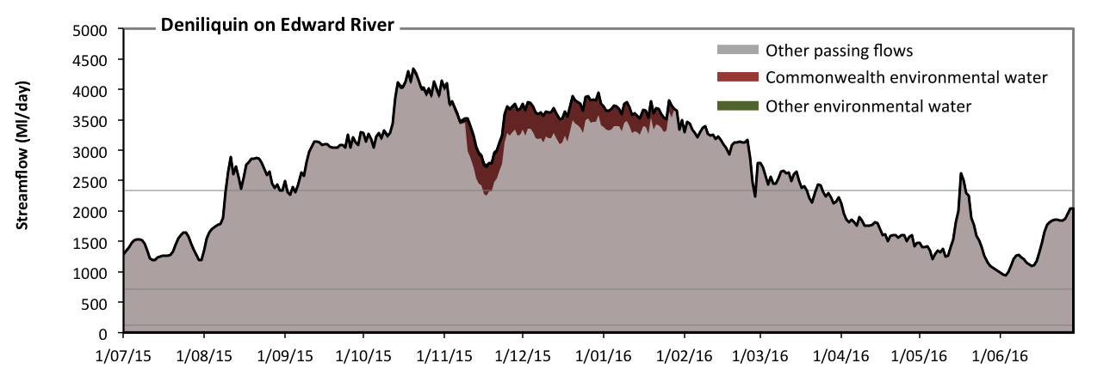
Figure EWK4: Contribution of environmental water delivery at Deniliquin. Horizontal lines indicate thresholds for very low flows, low flows, low freshes and medium freshes (from lowest to highest).
At Deniliquin on Edward River environmental water contributed 3% of the total streamflow volume (most of which was Commonwealth environmental water) (Figure EWK4 and EWK5). Environmental watering actions affected streamflows for 31% of days between 1 July 2015 and 30 June 2016. Flow regulation does not substantially increase the duration of very low flows (i.e. < 24 Ml/day) compared to an average year in the natural flow regime. Flow regulation does not substantially increase the duration of medium low flows (i.e. < 120 Ml/day) compared to an average year in the natural flow regime. There was at least one low fresh (i.e. > 710 Ml/day) in the periods July to September, October to December, January to March and April to June. Environmental water made little change to the duration of these low freshes. In the absence of environmental water there would have been at least one medium fresh (i.e. > 2300 Ml/day) in the periods July to September, October to December, January to March and April to June. Environmental water increased the duration of the longest medium fresh during the period October to December (from 46 days to 92 days). Commonwealth environmental water was entirely responsible for these increased durations of medium freshes. There was no high freshes (i.e. > 12000 Ml/day) this year.

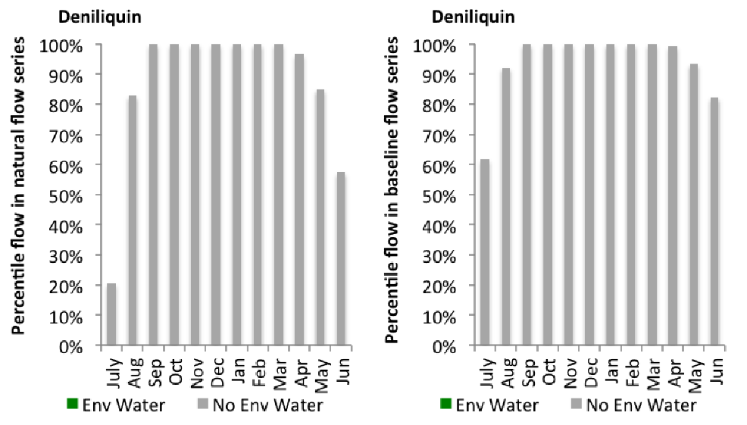
Figure EWK5: Contribution of environmental water delivery at Deniliquin as percentiles in the natural and baseline flow series.

Wakool Offtake
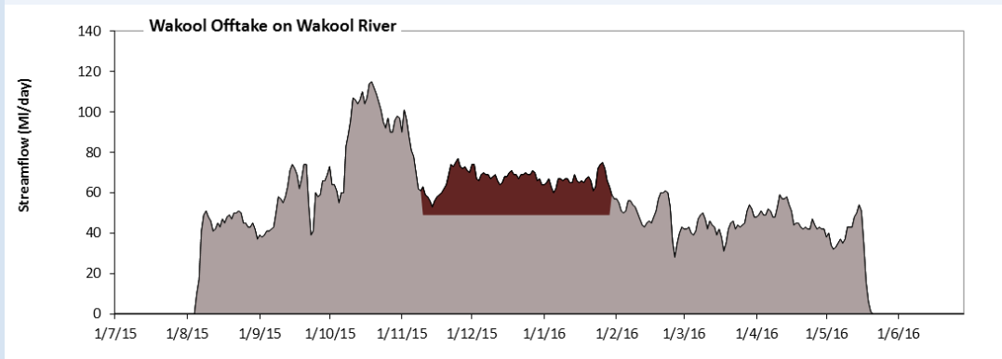
Figure EWK6: Contribution of environmental water delivery at Wakool Offtake. Horizontal lines indicate thresholds for (from lowest to highest).
At Wakool Offtake on Wakool River environmental water contributed 9% of the total streamflow volume (all of which was Commonwealth environmental water) (Figure EWK6). Environmental watering actions affected streamflows for 22% of days between 1 July 2015 and 30 June 2016. However, environmental water had little effect on the duration of these very low flows, which occurred for 100% of the year.
Yallakool Offtake
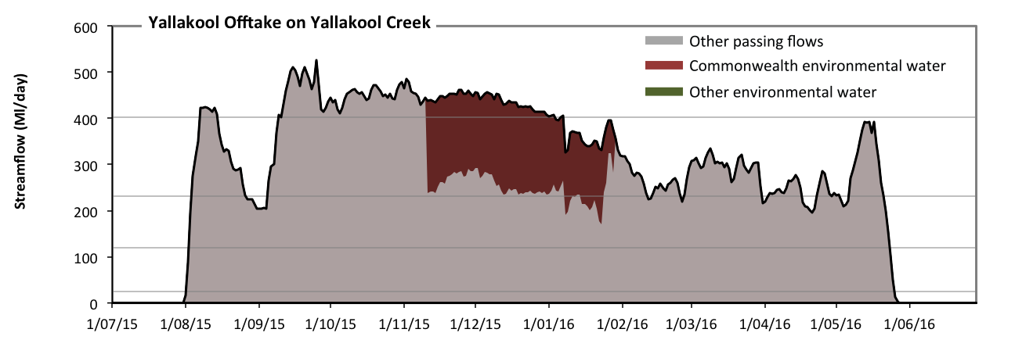
Figure EWK7: Contribution of environmental water delivery at Yallakool Offtake. Horizontal lines indicate thresholds for very low flows, low flows, low freshes and medium freshes (from lowest to highest).
At Yallakool Offtake on Yallakool Creek environmental water contributed 12% of the total streamflow volume (all of which was Commonwealth environmental water) (Figure EWK7 and EWK8). Environmental watering actions affected streamflows for 22% of days between 1 July 2015 and 30 June 2016. Without environmental water, the durations of very low flows (i.e. < 24 Ml/day) in the periods July to September and April to June would have substantially exceeded durations expected in an average year in the natural flow regime. However, environmental water had little effect on the duration of these very low flows, which occurred for 18% of the year. Similarly, without environmental water, the durations of medium low flows (i.e. < 120 Ml/day) in the periods July to September and April to June would have substantially exceeded durations expected in an average year in the natural flow regime. However, environmental water had little effect on the duration of these medium low flows, which occurred for 19% of the year. In the absence of environmental water there would have been at least one low fresh (i.e. > 230 Ml/day) in the periods July to September, October to December, January to March and April to June. Environmental water increased the duration of the longest low fresh during the period January to March (from 33 days to 42 days). Commonwealth environmental water was entirely responsible for these increased durations of low freshes. In the absence of environmental water there would have been at least one medium fresh (i.e. > 400 Ml/day) in the periods July to September and October to December. Environmental water increased the duration of the longest medium fresh during the periods October to December (from 41 days to 92 days) and January to March (from 0 days to 3 days). Commonwealth environmental water was entirely responsible for these increased durations of medium freshes. There was no high freshes (i.e. > 990 Ml/day) this year.
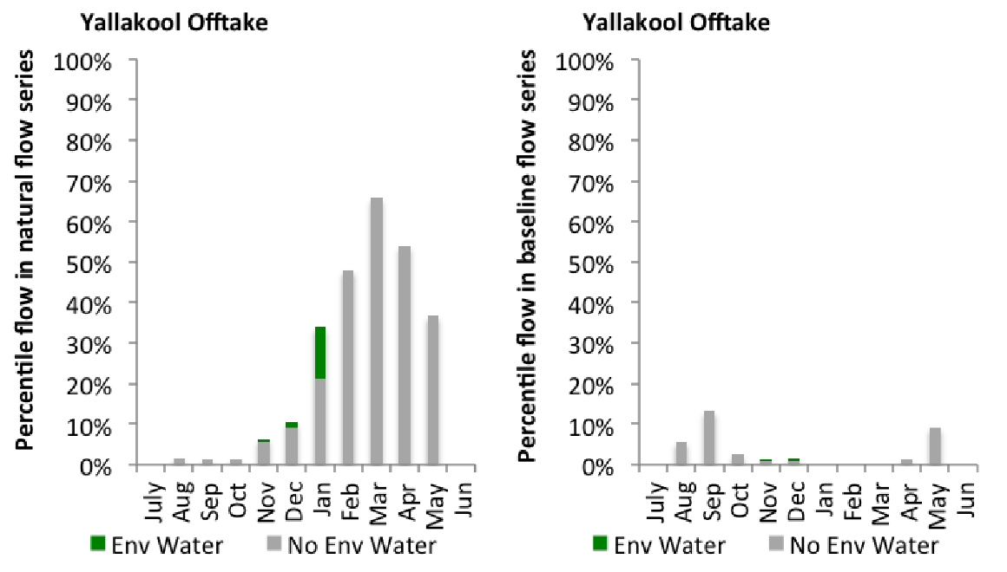
Figure EWK8: Contribution of environmental water delivery at Yallakool Offtake as percentiles in the natural and baseline flow series.
Colligen Offtake
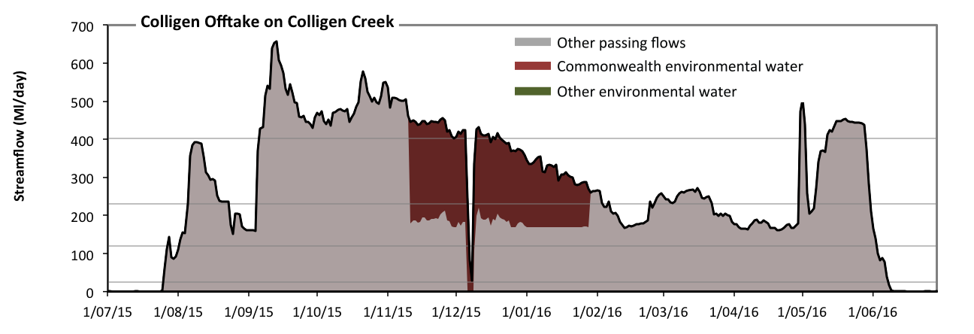
Figure EWK9: Contribution of environmental water delivery at Colligen Offtake. Horizontal lines indicate thresholds for very low flows, low flows, low freshes and medium freshes (from lowest to highest).
At Colligen Offtake on Colligen Creek environmental water contributed 15% of the total streamflow volume (all of which was Commonwealth environmental water) (Figure EWK9 and EWK10). Environmental watering actions affected streamflows for 22% of days between 1 July 2015 and 30 June 2016. Without environmental water, the durations of very low flows (i.e. < 24 Ml/day) in the periods July to September and April to June would have substantially exceeded durations expected in an average year in the natural flow regime. Environmental water reduced the cumulative duration of very low flow spells from 14% to 13% of the year, with greatest influence in the period October to December. Similarly, without environmental water, the durations of medium low flows (i.e. < 120 Ml/day) in the periods July to September and April to June would have substantially exceeded durations expected in an average year in the natural flow regime. Environmental water reduced the cumulative duration of medium low flow spells from 17% to 16% of the year, with greatest influence in the period October to December. In the absence of environmental water there would have been at least one low fresh (i.e. > 230 Ml/day) in the periods July to September, October to December, January to March and April to June. Environmental water increased the duration of the longest low fresh during the periods October to December (from 41 days to 67 days) and January to March (from 26 days to 34 days). Commonwealth environmental water was entirely responsible for these increased durations of low freshes. In the absence of environmental water there would have been at least one medium fresh (i.e. > 400 Ml/day) in the periods July to September, October to December and April to June. Environmental water increased the duration of the longest medium fresh during the period October to December (from 41 days to 60 days). Commonwealth environmental water was entirely responsible for these increased durations of medium freshes. There was no high freshes (i.e. > 990 Ml/day) this year.
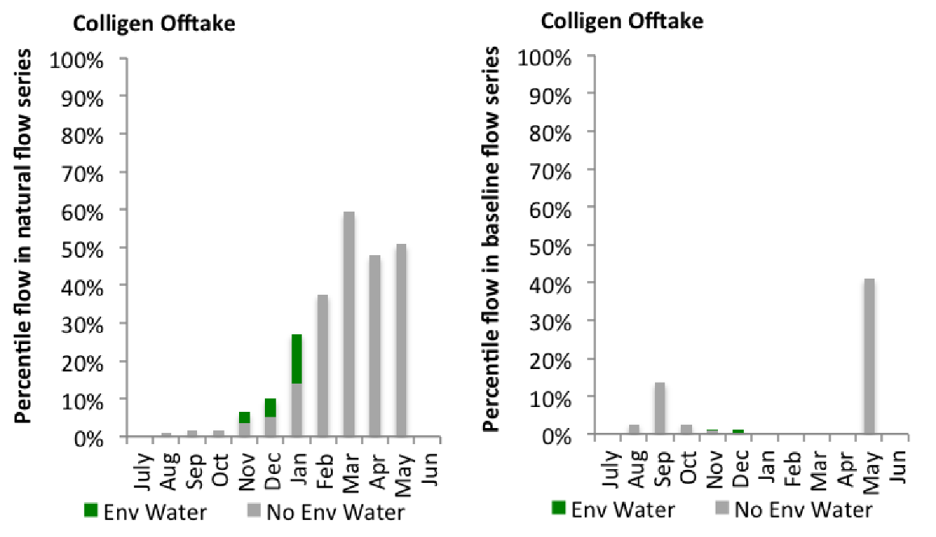
Figure EWK10: Contribution of environmental water delivery at Colligen Offtake as percentiles in the natural and baseline flow series.
Moulamien Rd
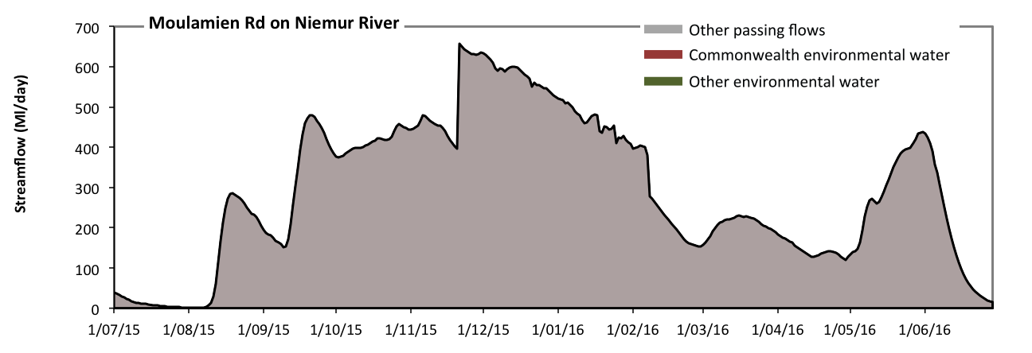Figure EWK11: Contribution of environmental water delivery at Moulamien Rd. Horizontal lines indicate thresholds for (from lowest to highest).
At Moulamien Rd on Niemur River environmental water contributed 17% of the total streamflow volume (all of which was Commonwealth environmental water) (Figure EWK11). Environmental watering actions affected streamflows for 22% of days between 1 July 2015 and 30 June 2016. However, environmental water had little effect on the duration of these very low flows, which occurred for 100% of the year.

Mallan School
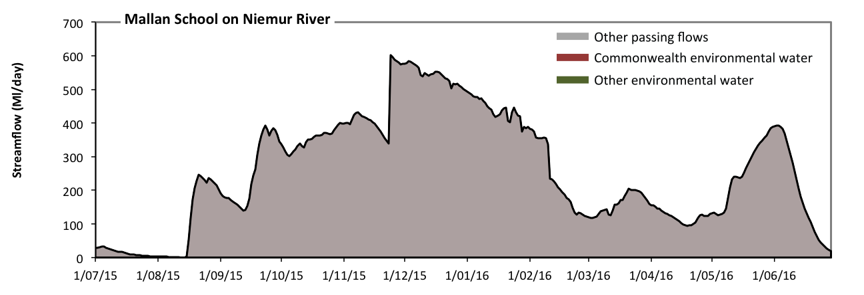 Figure EWK12: Contribution of environmental water delivery at Mallan School. Horizontal lines indicate thresholds for (from lowest to highest).
At Mallan School on Niemur River environmental water contributed 20% of the total streamflow volume (all of which was Commonwealth environmental water) (Figure EWK12). Environmental watering actions affected streamflows for 22% of days between 1 July 2015 and 30 June 2016. However, environmental water had little effect on the duration of these very low flows, which occurred for 100% of the year.
Barham Moulamien
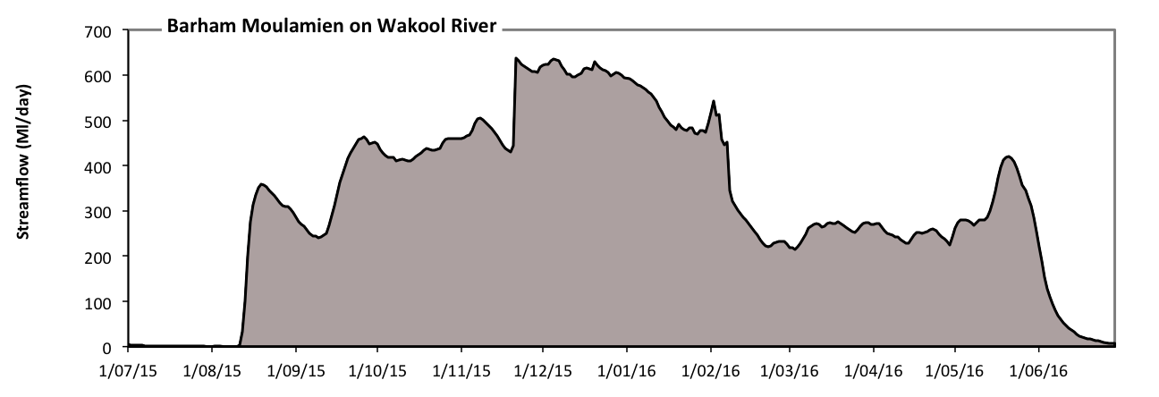 Figure EWK13: Contribution of environmental water delivery at Barham Moulamien. Horizontal lines indicate thresholds for (from lowest to highest).
At Barham Moulamien on Wakool River environmental water contributed 14% of the total streamflow volume (all of which was Commonwealth environmental water) (Figure EWK13). Environmental watering actions affected streamflows for 22% of days between 1 July 2015 and 30 June 2016. However, environmental water had little effect on the duration of these very low flows, which occurred for 100% of the year.

Gee Gee Bridge
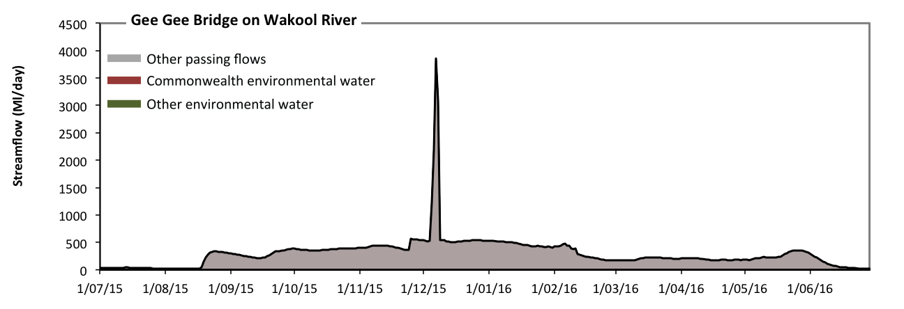 Figure EWK14: Contribution of environmental water delivery at Gee Gee Bridge. Horizontal lines indicate thresholds for (from lowest to highest).
At Gee Gee Bridge on Wakool River environmental water contributed 14% of the total streamflow volume (all of which was Commonwealth environmental water) (Figure EWK14). Environmental watering actions affected streamflows for 22% of days between 1 July 2015 and 30 June 2016. However, environmental water had little effect on the duration of these very low flows, which occurred for 100% of the year.

Coonamit
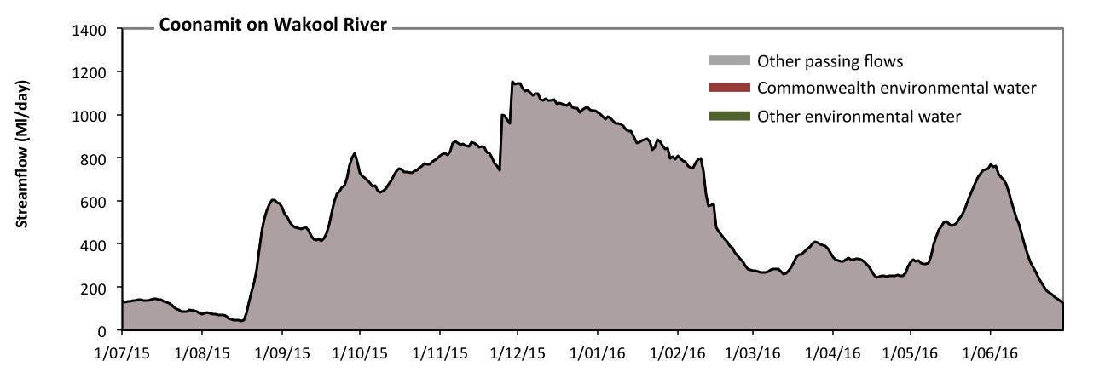 Figure EWK15: Contribution of environmental water delivery at Coonamit. Horizontal lines indicate thresholds for (from lowest to highest).
At Coonamit on Wakool River environmental water contributed 17% of the total streamflow volume (all of which was Commonwealth environmental water) (Figure EWK15). Environmental watering actions affected streamflows for 23% of days between 1 July 2015 and 30 June 2016. However, environmental water had little effect on the duration of these very low flows, which occurred for 100% of the year.

Lower Murray
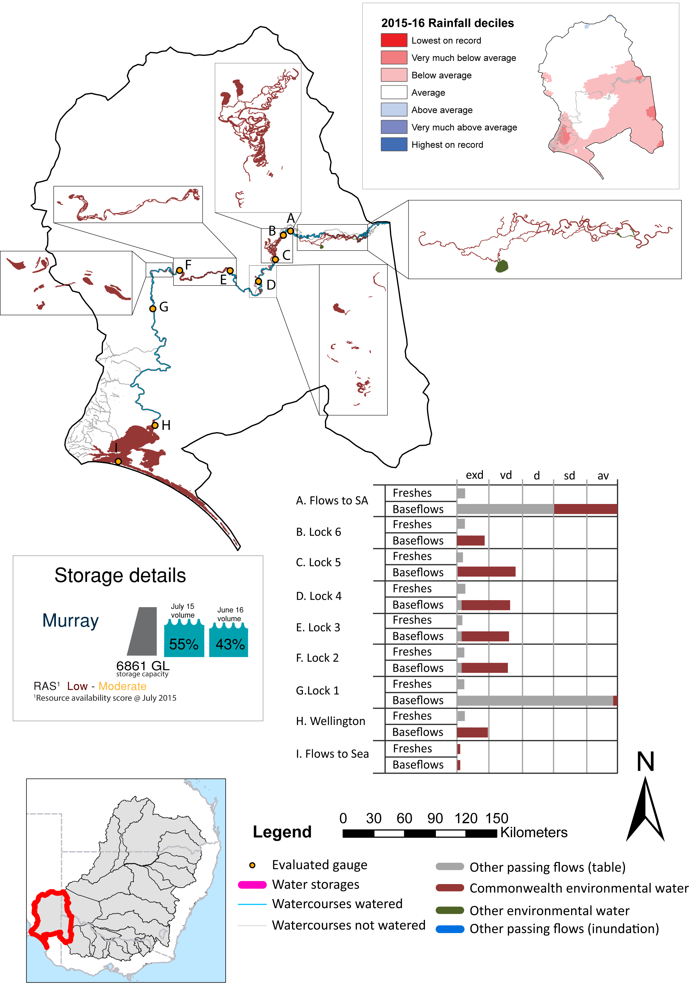
Figure LWM1: Watercourses influenced, areas inundated (where applicable) and gauge stations evaluated in the Lower Murray valley during the 2015-16 water year. Inset bar graphs report the condition of annual flow regimes by showing the improvements in hydrological condition with the addition of environmental water as well as the hypothetical scenario in “grey” (if no environmental flow had been delivered). Rainfall conditions (rainfall deciles) and trend in storage levels for the water year are also shown.

Summary
Environmental water delivery for the 2015-16 year in the Lower Murray valley is evaluated using data for 8 sites. This evaluation only considers the contribution of held environmental water, which is a primary focus for the Commonwealth. The contributions of planned environmental water (e.g. passing flows), unregulated tributary inflows and clever use of irrigation flows for environmental benefits can all be very important but these are outside the scope of this report. Environmental watering actions lasted on average 356 days over the course of the year. The volume of environmental water at these 8 sites was between 32% and 57% of the total streamflow. The contribution of environmental water delivery to improved flow regimes is evaluated using data for 8 sites. Ideally, baseflows should be maintained and long periods of excessively low flows avoided. In this valley, the baseflow regime was generally considered to be very dry relative to the pre-development flow regime. In our analysis, a low fresh refers to a period of increased flow, when the water level rises at least one eighth of the way up the river bank (above the low flow level). These low freshes are a regular part of the natural flow regime and support a range of natural processes. In the Lower Murray valley, in terms of the occurrence and duration of low freshes, the year was assessed as being extremely dry. In our analysis, a medium fresh refers to a period of increased flow, when the water level rises at least one quarter of the way up the river bank. These medium freshes are not as frequent as low freshes but are also a regular and important part of the natural flow regime. In the Lower Murray valley, in terms of the occurrence of medium freshes, the year was assessed as being extremely dry. In our analysis, a high fresh refers to a period of increased flow, when the water level rises more than half way up the river. A high fresh may not occur every year but they are still important and long periods without major freshes can have serious consequences for floodplains and their contribution to river ecosystem health. Delivering environmental high in channel flows normally requires that all risks to riparian landholders and infrastructure have been resolved. In the Lower Murray valley, in terms of the occurrence of high freshes, the year was assessed as being extremely dry.

Environmental water system
The Lower Murray valley covers an area of 99525 km2, which represents 9.4% of the total basin area. The valley includes the South Australian part of the Murray River / Floodplain, the Murray River Estuary (the Lower Lakes Alexandrina and Albert and the Coorong) and the Murray Mouth (Figure LWM1). The confluence of the River Murray and Darling River is 500 m upstream of the Wentworth Weir (Weir and Lock 10) just over 832 river kilometres from the Murray mouth.
The lower Murray is extensively regulated in NSW and Victoria upstream of the SA Murray. Within the valley the river is regulated by 6 Locks and Weirs ( Storage name and volume size: Lock 1 84GL; Lock 2 43 GL; Lock 3 52GL;Lock 4 31GL; Lock 5 39GL; and Lock 6 35GL) and finally a terminal set of barrages. The 11 weirs each raise the water level behind it by an average of 3.06 m, with the river dropping from 34.40 m AHD at Full Supply Level (FSL) in the weir pool at Mildura to 0.75 m AHD at FSL in Lake Alexandrina and the River Murray below Weir 1 at Blanchetown. The storage capacities upstream of all of the weirs are less than 2% of the largest storage on the River Murray system, Dartmouth Reservoir. The distance between the weirs varies from 29 to 88 km. The River Murray enters Lake Alexandrina 75 river kilometres from the Murray mouth.
Delivery constraints relevant to the Lower Murray include: out of zone releases from Yarrawonga Weir and Lake Victoria, 15,00 ML/day and 10,000 ML/day respectively. Similarly, Lake Menindee has an outlet capacity of 7,096 ML/day. Within the Lower Murray zone inundation of private property and caravan parks occurs at around 60,000 ML/day (Mdba 2013).

Data availability
River Flows
The Msm-BigMod model was to calculate the impact of Commonwealth environmental water in the Murray River. An extensive modelling exercise which modelled two conditions flows in a pre-buy back scenario and the other being the observed condition. For more details on the methodology, and assumptions please see Modelling Flows in the Murray and Darling River (this report).
Inundation extents
Inundation extents for wetlands, billabongs and other regions which received Commonwealth environmental water outside of the main channel were supplied by various sources, utilising various methods. Table LWM1 lists the data owner and method used to derive inundation extent.

Water delivery context
During the 2015-16 water year, the Commonwealth Environmental Water Holder (CEWH) held water entitlements of up to 151103ML for environmental use in the Lower Murray valley. Each year, water utilities allocate the water entitlement holders a percentage of water based on their holding, license type and carryover (the exact rules vary among Jurisdictions). In the 2015-16 water year, the CEWH Lower Murray entitlements were allocated 133110 ML of water, representing 97.88% of the Long term average annual yield for the Lower Murray valley (135994 ML). The 2015-16 water allocation (133110 ML) together with the carryover volume of 0 ML of water meant the CEWH had 133110 ML of water available for delivery.
A total of 827737 ML of Commonwealth environmental water was delivered in the Lower Murray valley. A total of 1000 ML of Commonwealth environmental water was traded to consumptive users and 0ML (0.0% of available resource) of Commonwealth environmental water was carried over for environmental use into the 2016-17 water year. Intervalley transfer of water in the southern connected Basin, means on occasion there may be a mismatch between Commonwealth environmental water available for delivery and the actual volume of Commonwealth environmental water delivered.

Environmental conditions and resource availability
The water available for delivery combined with the present and antecedent environmental conditions are key inputs used by environmental water managers in planning and implementing watering actions. Post hoc, this information provides important context when evaluating the effectiveness and appropriateness of environmental water use with respect to hydrological outputs.
The rainfall conditions in the Lower Murray valley were classified as Average, based on rainfall percentile data for the entire record held by the Bureau of Meteorology for this valley. The major storages in the Lower Murray valley remained stable, being 67% full at the beginning of the water year and 64% full by the end of the year (Figure LWM1).
The Commonwealth Environmental Water Office (CEWO) calculates resource availability scenarios (RAS) progressively as part of its continual adaptive management planning processes. The RAS are based on the availability of held water (including progressive license acquisitions and allocations) as well as the potential for unregulated or planned environmental flows. The resource availability of held water was classified as Low in this valley, whilst the potential for unregulated or planned environmental flow was classified as Moderate. The physical conditions meant that the CEWO was managing to Protect habitats within the Coorong and maintain the ecological health and resliience of other key sites in the system. The overall demand for environmental water was deemed Moderate (Water predominantly needed this year and or next).

Watering actions
A total of 48 watering actions were implemented, the duration of these actions varied (range of individual actions: 8 - 329 days). The total cumulative sum of watering actions days was 2197). The number of actions commencing in each season varied: Winter (11), Spring (21), Summer (14) and Autumn (2). The flow component types delivered included (2 baseflow, 5 freshes, 0 bankfull, 0 overbank, 40 wetland, 1 fresh/wetland combo).
Table LWM2: Commonwealth environmental water accounting information for the Lower Murray valley over 2015-16 water year.
Total registered volume (ML) | Allocated volume (ML) | Carry over available (ML) | Delivered¹ (ML) | LTAAY (ML) | Trade (ML) | Carried over to 2016-17 | Forfeited (ML)
151104 | 133110 | 133110 | 827737 | 135994 | 1000 | 0 | 0
¹Lower Murray water entitlements accounted for 133110 ML of Commonwealth environmental delivered in this valley.
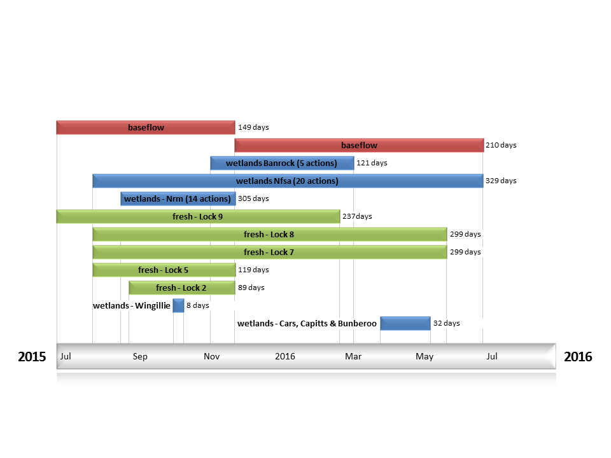
Figure LWM2: Timing and duration of water actions implemented by the CEWO during the 2015-16 water year in the Lower Murray valley.

Contribution of Commonwealth Environmental Water to Flow Regimes
SA Border
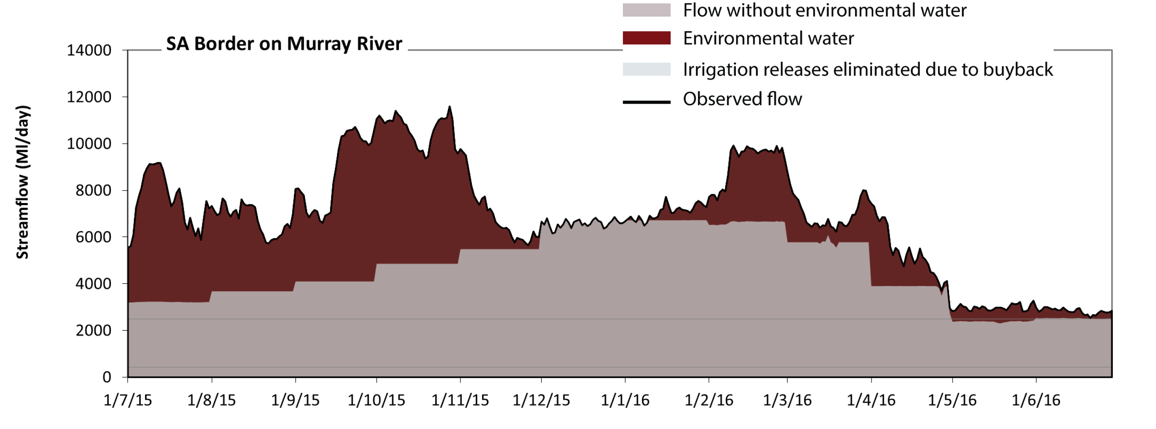
Figure LWM3: Contribution of environmental water delivery at SA Border. Horizontal lines indicate thresholds for very low flows and low flows (from lowest to highest).
At SA Border on Murray River environmental water contributed 32% of the total streamflow volume. Environmental watering actions affected streamflows for 90% of days between 1 July 2015 and 30 June 2016. Flow regulation does not substantially increase the duration of very low flows (i.e. < 430 Ml/day) compared to an average year in the natural flow regime. However, without environmental water, the duration of medium low flows (i.e. < 2500 Ml/day) in the period April to June would have substantially exceeded durations expected in an average year in the natural flow regime. Environmental water mitigated these impacts by reducing the cumulative duration of medium low flow spells from 9% to 0% of the year, with greatest influence in the period April to June. 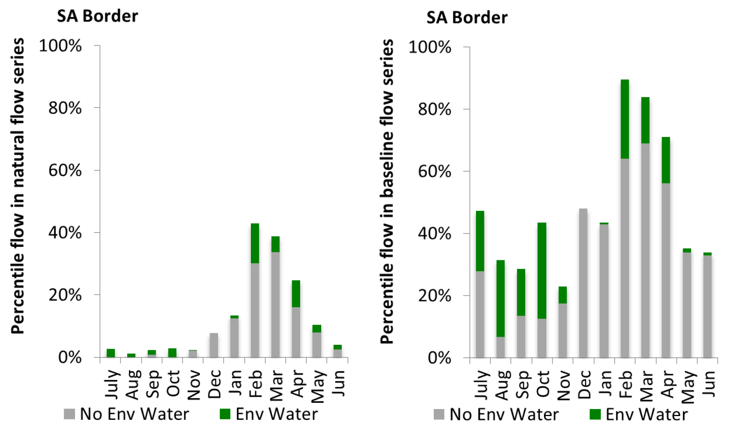
Figure LWM4: Contribution of environmental water delivery at SA Border as percentiles in the natural and baseline flow series.
Lock 6
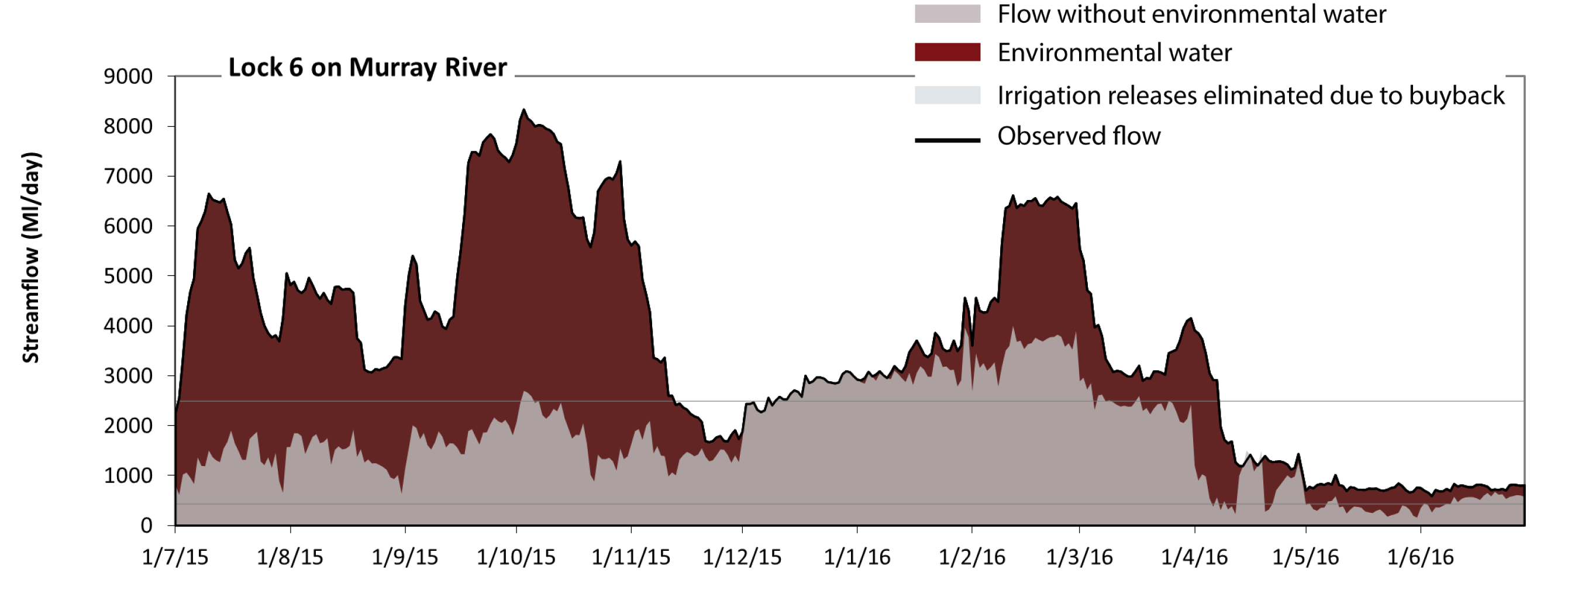
Figure LWM5: Contribution of environmental water delivery at Lock 6. Horizontal lines indicate thresholds for very low flows and low flows (from lowest to highest).
At Lock 6 on Murray River environmental water contributed 51% of the total streamflow volume. Environmental watering actions affected streamflows for 91% of days between 1 July 2015 and 30 June 2016. Without environmental water, the duration of very low flows (i.e. < 430 Ml/day) in the period April to June would have substantially exceeded durations expected in an average year in the natural flow regime. Environmental water mitigated these impacts by reducing the cumulative duration of very low flow spells from 11% to 0% of the year, with greatest influence in the period April to June. Similarly, without environmental water, the durations of medium low flows (i.e. < 2500 Ml/day) in the periods July to September, October to December, January to March and April to June would have all substantially exceeded durations expected in an average year in the natural flow regime. Environmental water mitigated these impacts by reducing the cumulative duration of medium low flow spells from 74% to 30% of the year, with greatest influence in the period July to September.
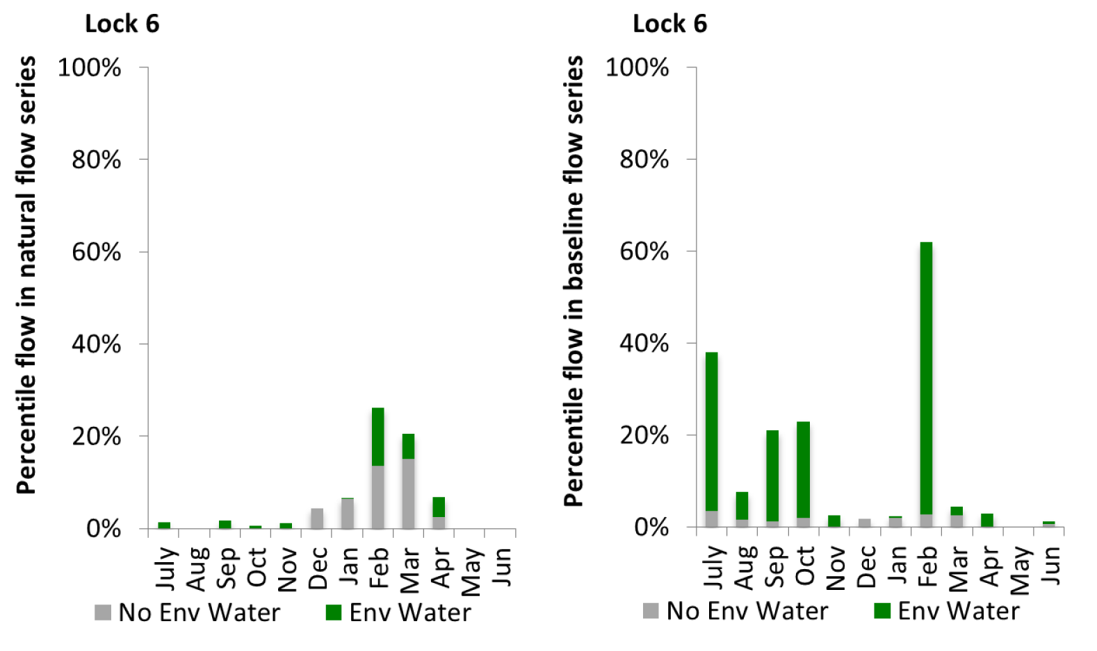
Figure LWM6: Contribution of environmental water delivery at Lock 6 as percentiles in the natural and baseline flow series.

Lock 5
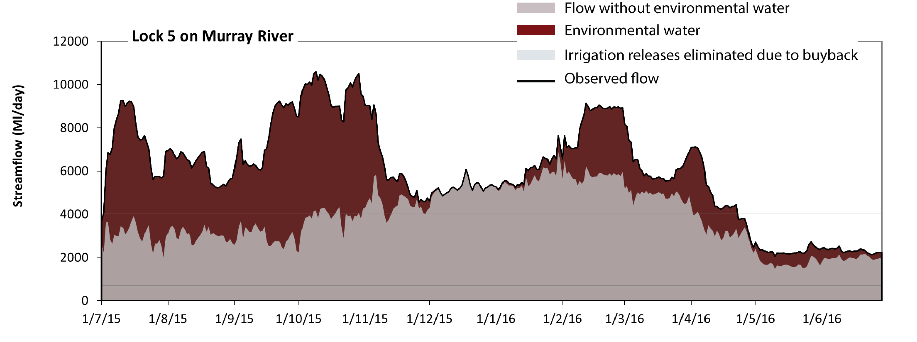
Figure LWM7: Contribution of environmental water delivery at Lock 5. Horizontal lines indicate thresholds for very low flows and low flows (from lowest to highest).
At Lock 5 on Murray River environmental water contributed 36% of the total streamflow volume. Environmental watering actions affected streamflows for 100% of days between 1 July 2015 and 30 June 2016. Flow regulation does not substantially increase the duration of very low flows (i.e. < 700 Ml/day) compared to an average year in the natural flow regime. However, without environmental water, the durations of medium low flows (i.e. < 4100 Ml/day) in the periods July to September, October to December and April to June would have substantially exceeded durations expected in an average year in the natural flow regime. Environmental water mitigated these impacts by reducing the cumulative duration of medium low flow spells from 56% to 19% of the year, with greatest influence in the period July to September.
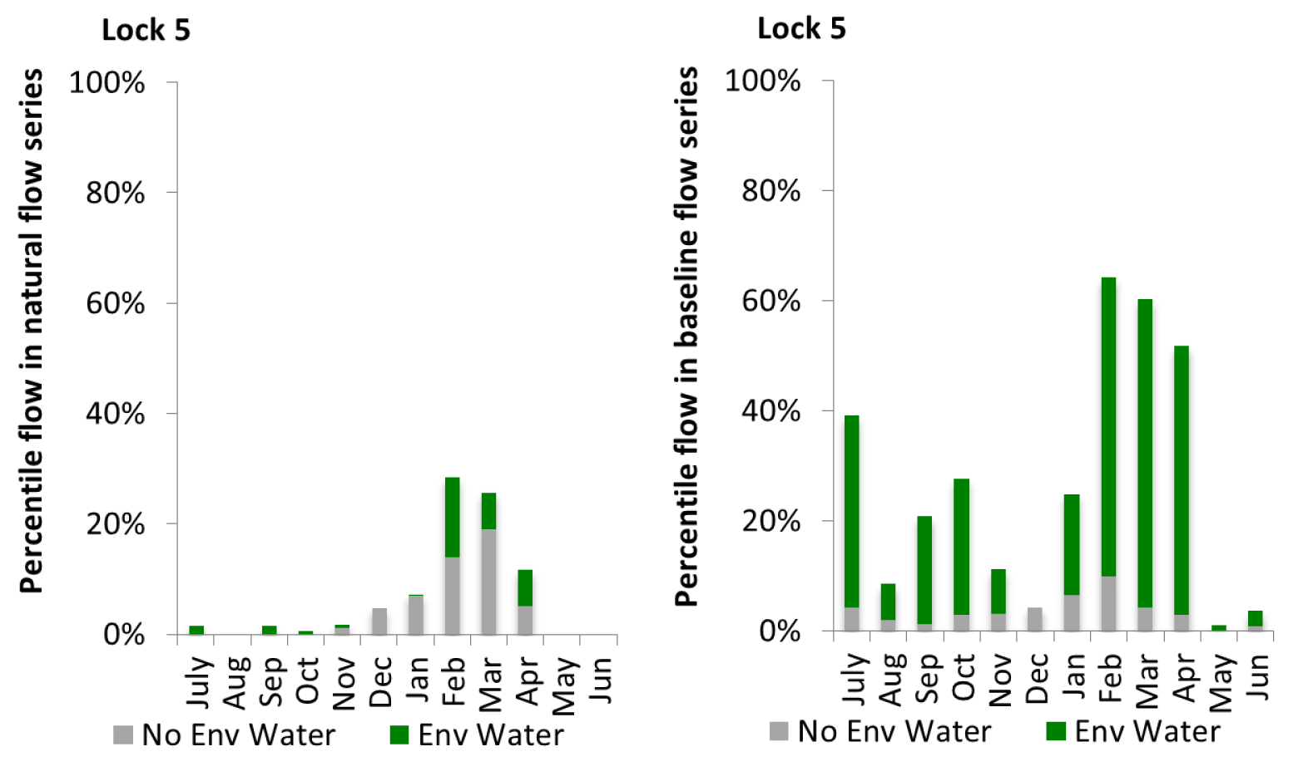
Figure LWM8: Contribution of environmental water delivery at Lock 5 as percentiles in the natural and baseline flow series.

Lock 4
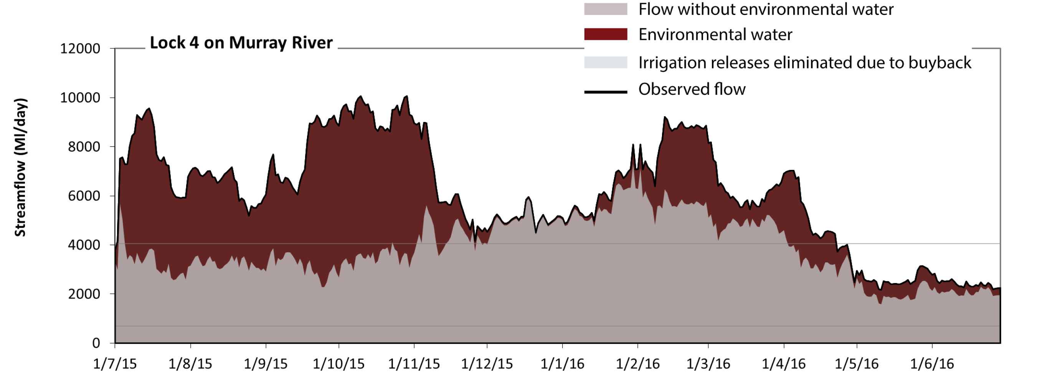
Figure LWM9: Contribution of environmental water delivery at Lock 4. Horizontal lines indicate thresholds for very low flows and low flows (from lowest to highest).
At Lock 4 on Murray River environmental water contributed 36% of the total streamflow volume. Environmental watering actions affected streamflows for 100% of days between 1 July 2015 and 30 June 2016. Flow regulation does not substantially increase the duration of very low flows (i.e. < 700 Ml/day) compared to an average year in the natural flow regime. However, without environmental water, the durations of medium low flows (i.e. < 4100 Ml/day) in the periods July to September, October to December and April to June would have substantially exceeded durations expected in an average year in the natural flow regime. Environmental water mitigated these impacts by reducing the cumulative duration of medium low flow spells from 59% to 19% of the year, with greatest influence in the periods July to September and October to December.
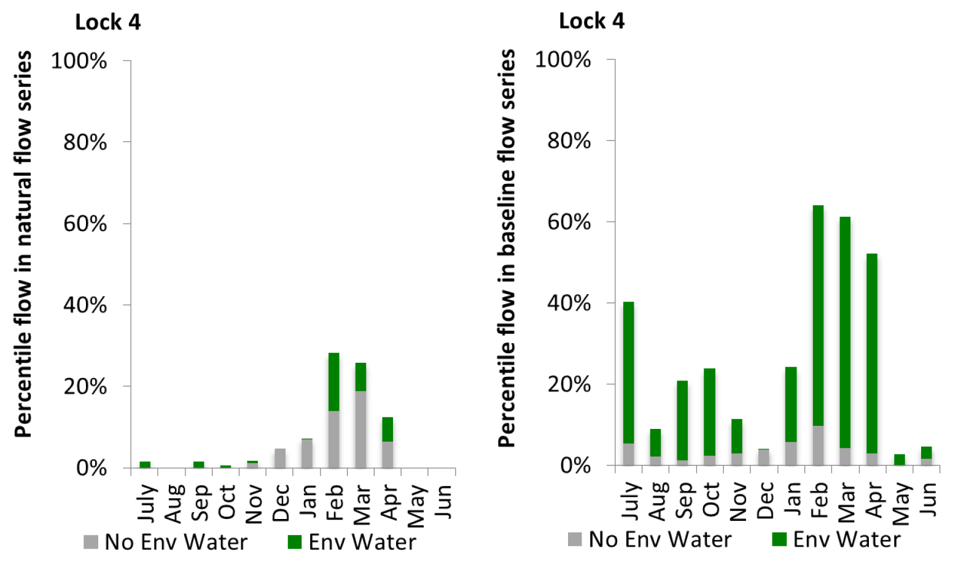
Figure LWM10: Contribution of environmental water delivery at Lock 4 as percentiles in the natural and baseline flow series.

Lock 3
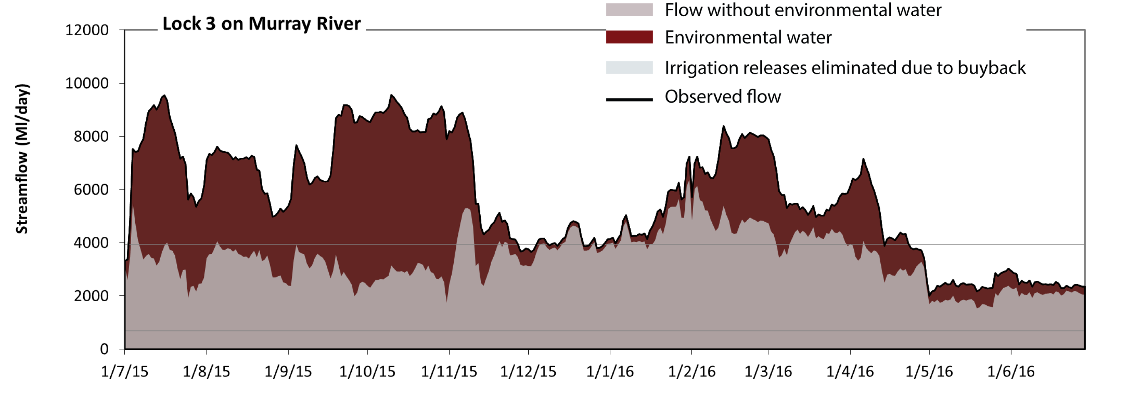
Figure LWM11: Contribution of environmental water delivery at Lock 3. Horizontal lines indicate thresholds for very low flows and low flows (from lowest to highest).
At Lock 3 on Murray River environmental water contributed 40% of the total streamflow volume. Environmental watering actions affected streamflows for 100% of days between 1 July 2015 and 30 June 2016. Flow regulation does not substantially increase the duration of very low flows (i.e. < 690 Ml/day) compared to an average year in the natural flow regime. However, without environmental water, the durations of medium low flows (i.e. < 3900 Ml/day) in the periods July to September, October to December and April to June would have substantially exceeded durations expected in an average year in the natural flow regime. Environmental water mitigated these impacts by reducing the cumulative duration of medium low flow spells from 70% to 23% of the year, with greatest influence in the periods July to September and October to December.
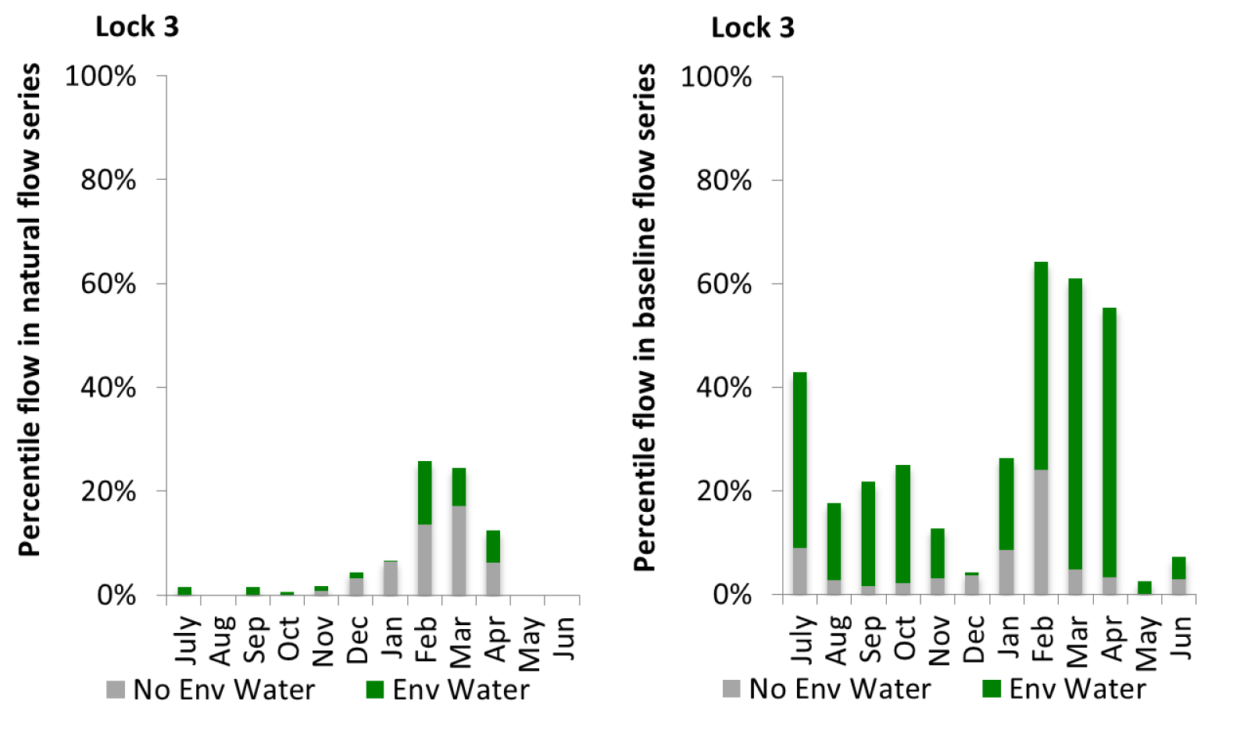
Figure LWM12: Contribution of environmental water delivery at Lock 3 as percentiles in the natural and baseline flow series.

Lock 2
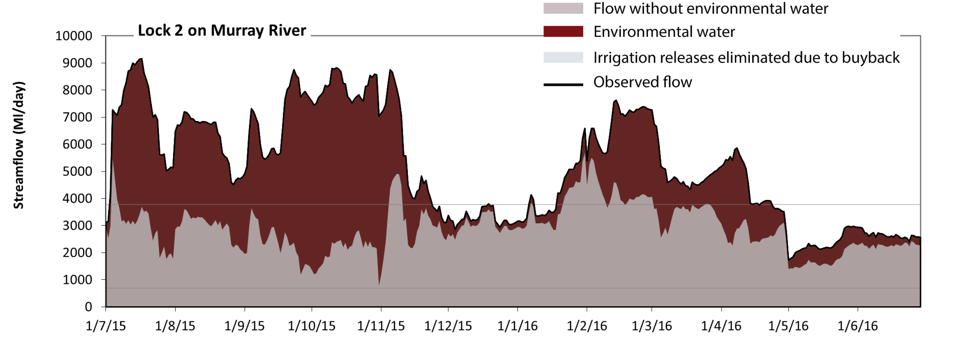
Figure LWM13: Contribution of environmental water delivery at Lock 2. Horizontal lines indicate thresholds for very low flows and low flows (from lowest to highest).
At Lock 2 on Murray River environmental water contributed 44% of the total streamflow volume. Environmental watering actions affected streamflows for 100% of days between 1 July 2015 and 30 June 2016. Flow regulation does not substantially increase the duration of very low flows (i.e. < 690 Ml/day) compared to an average year in the natural flow regime. However, without environmental water, the durations of medium low flows (i.e. < 3800 Ml/day) in the periods July to September, October to December, January to March and April to June would have all substantially exceeded durations expected in an average year in the natural flow regime. Environmental water mitigated these impacts by reducing the cumulative duration of medium low flow spells from 86% to 34% of the year, with greatest influence in the periods July to September and October to December. 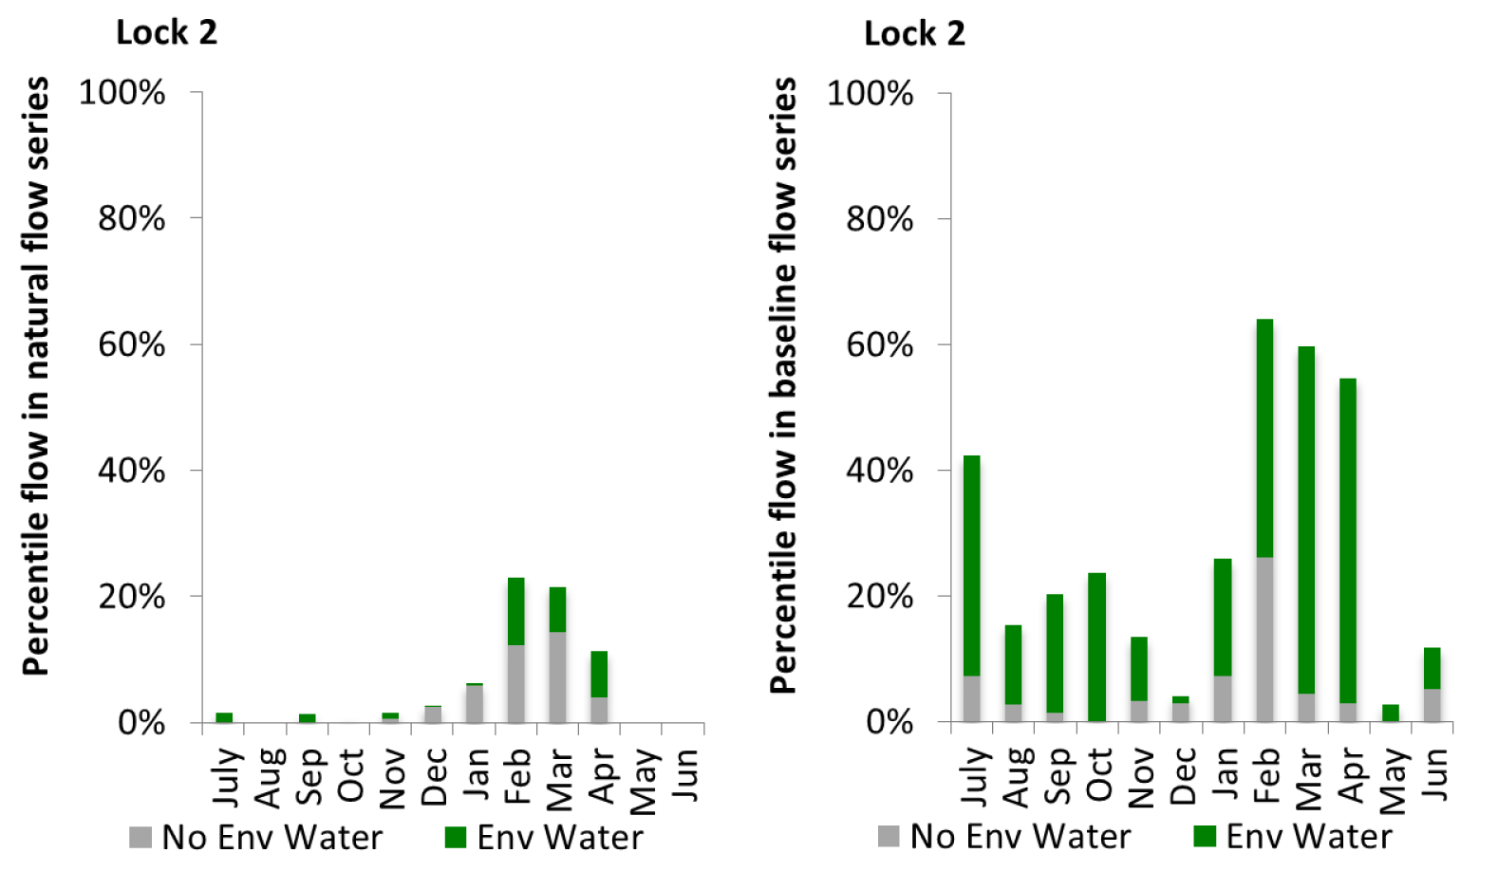
Figure LWM14: Contribution of environmental water delivery at Lock 2 as percentiles in the natural and baseline flow series.

Lock 1
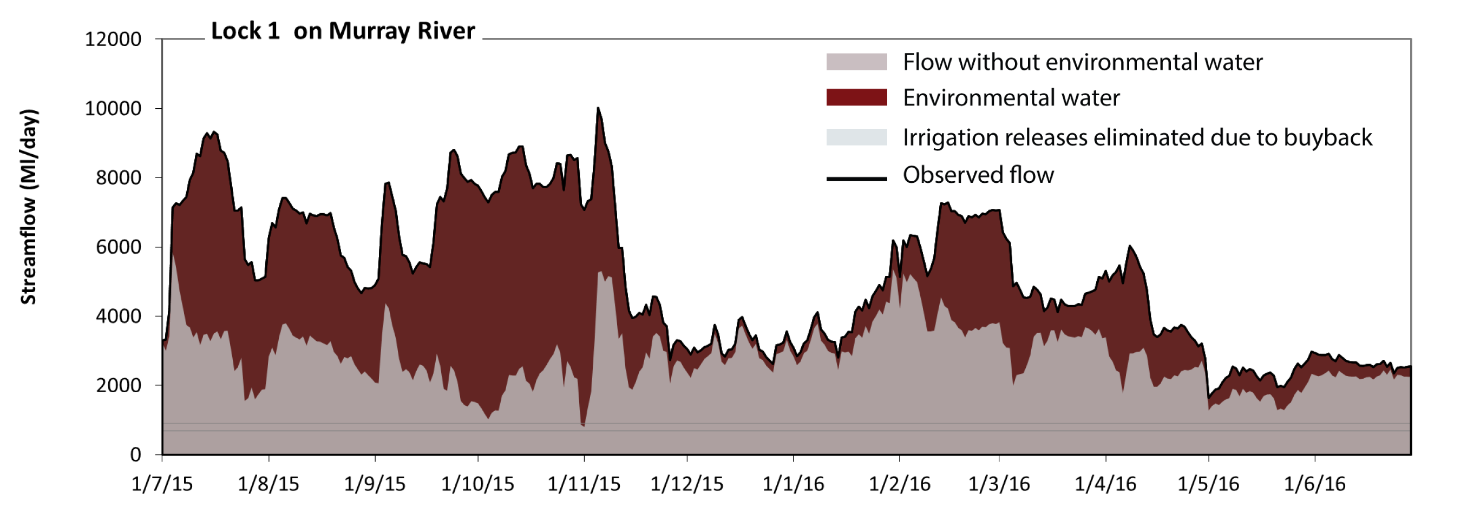
Figure LWM15: Contribution of environmental water delivery at Lock 1. Horizontal lines indicate thresholds for very low flows and low flows (from lowest to highest).
At Lock 1 on Murray River environmental water contributed 45% of the total streamflow volume. Environmental watering actions affected streamflows for 100% of days between 1 July 2015 and 30 June 2016. Flow regulation does not substantially increase the duration of very low flows (i.e. < 690 Ml/day) compared to an average year in the natural flow regime. Flow regulation does not substantially increase the duration of medium low flows (i.e. < 900 Ml/day) compared to an average year in the natural flow regime.
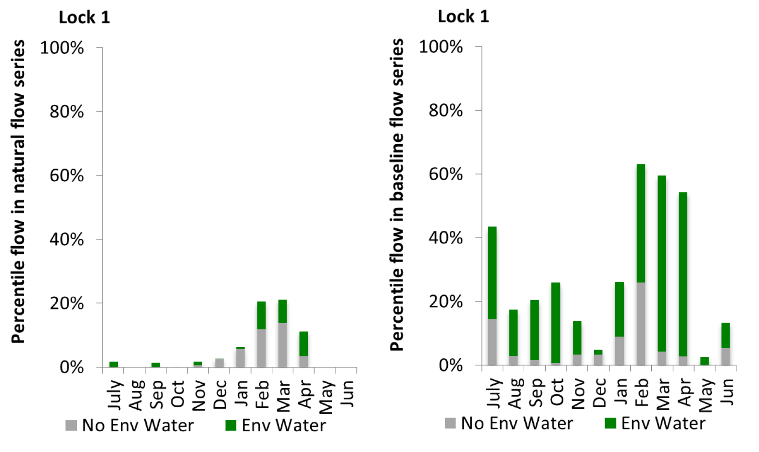
Figure LWM16: Contribution of environmental water delivery at Lock 1 as percentiles in the natural and baseline flow series.

Wellington
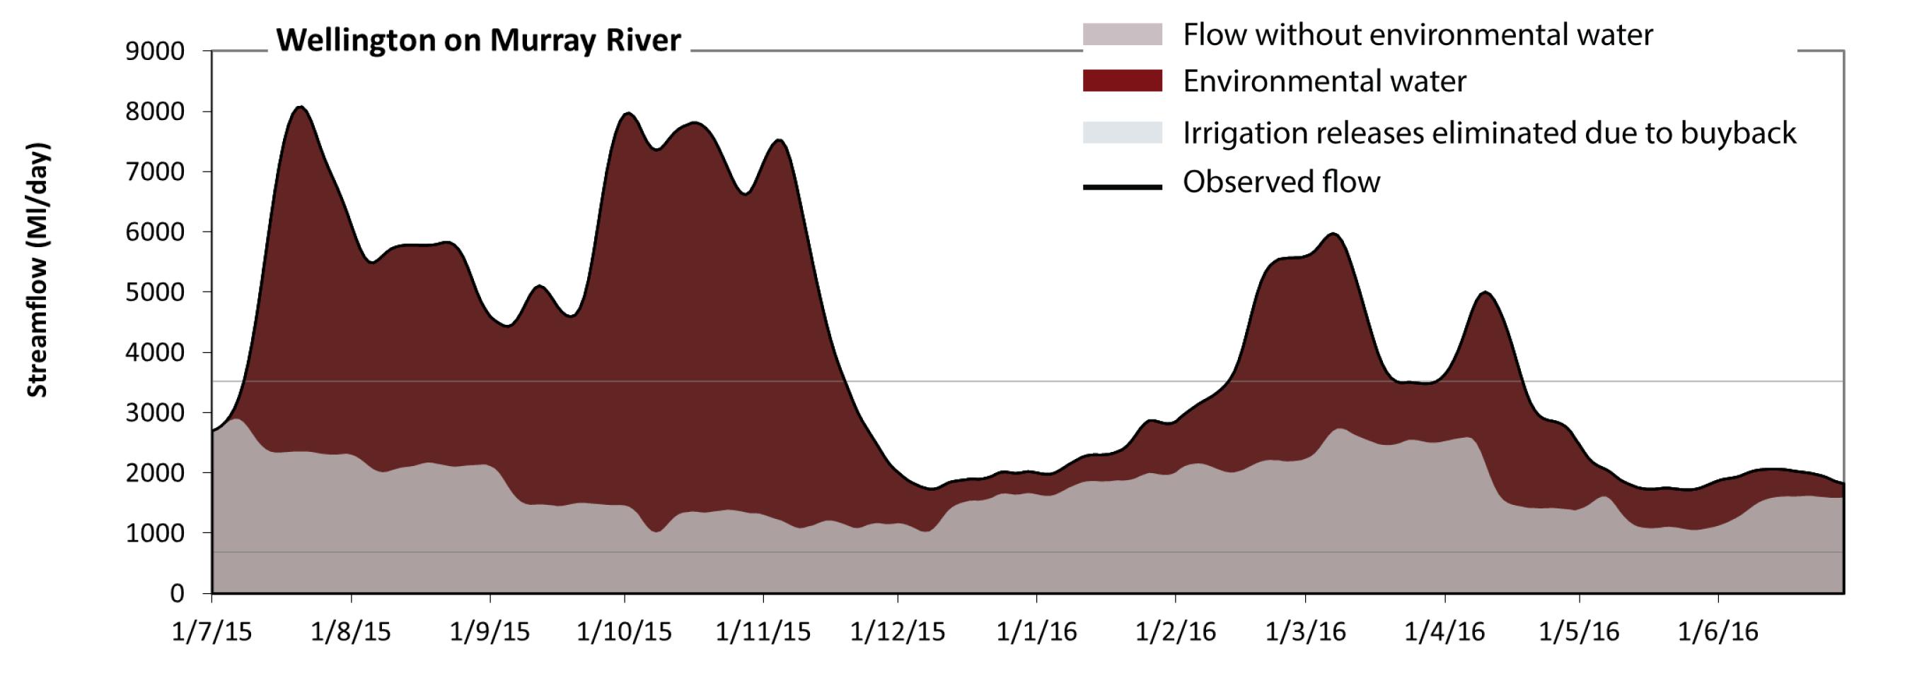 Figure LWM17: Contribution of environmental water delivery at Wellington. Horizontal lines indicate thresholds for very low flows, low flows and low freshes (from lowest to highest).
At Wellington on Murray River environmental water contributed 57% of the total streamflow volume. Environmental watering actions affected streamflows for 100% of days between 1 July 2015 and 30 June 2016. Flow regulation does not substantially increase the duration of very low flows (i.e. < 690 Ml/day) compared to an average year in the natural flow regime. However, without environmental water, the durations of medium low flows (i.e. < 3500 Ml/day) in the periods July to September, October to December, January to March and April to June would have all substantially exceeded durations expected in an average year in the natural flow regime. Environmental water mitigated these impacts by reducing the cumulative duration of medium low flow spells from 100% to 48% of the year, with greatest influence in the periods July to September and October to December.
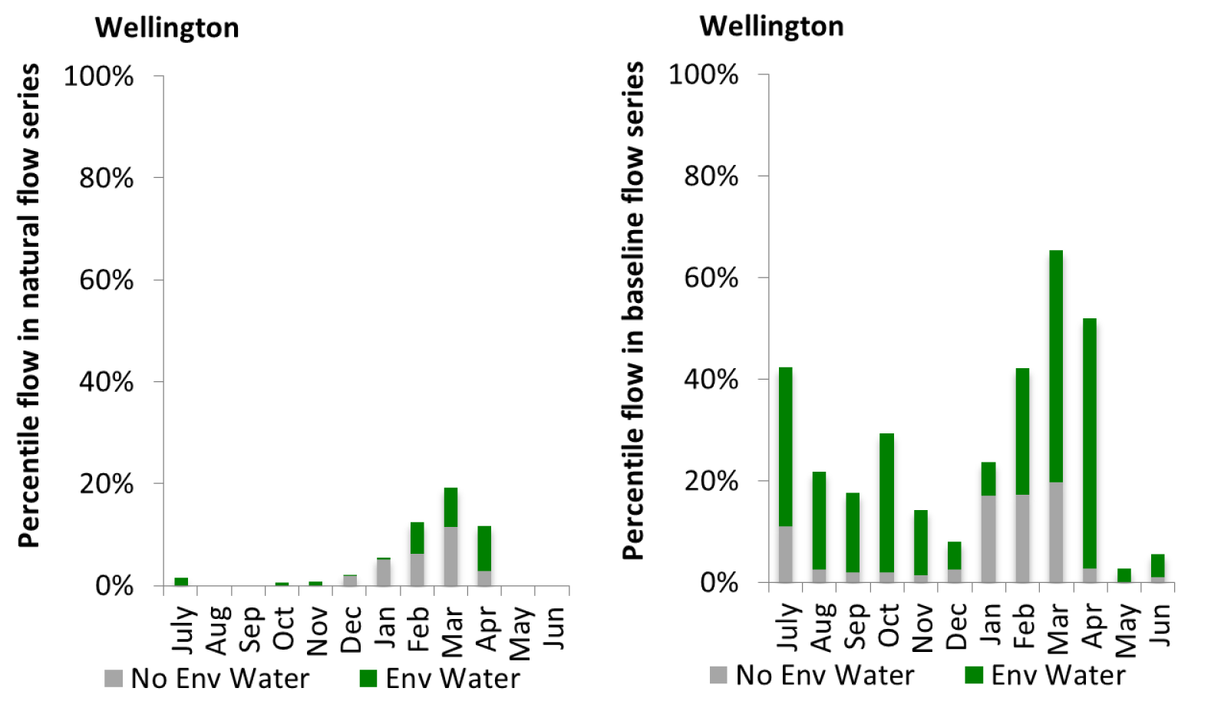
Figure LWM18: Contribution of environmental water delivery at Wellington as percentiles in the natural and baseline flow series.

Macquarie
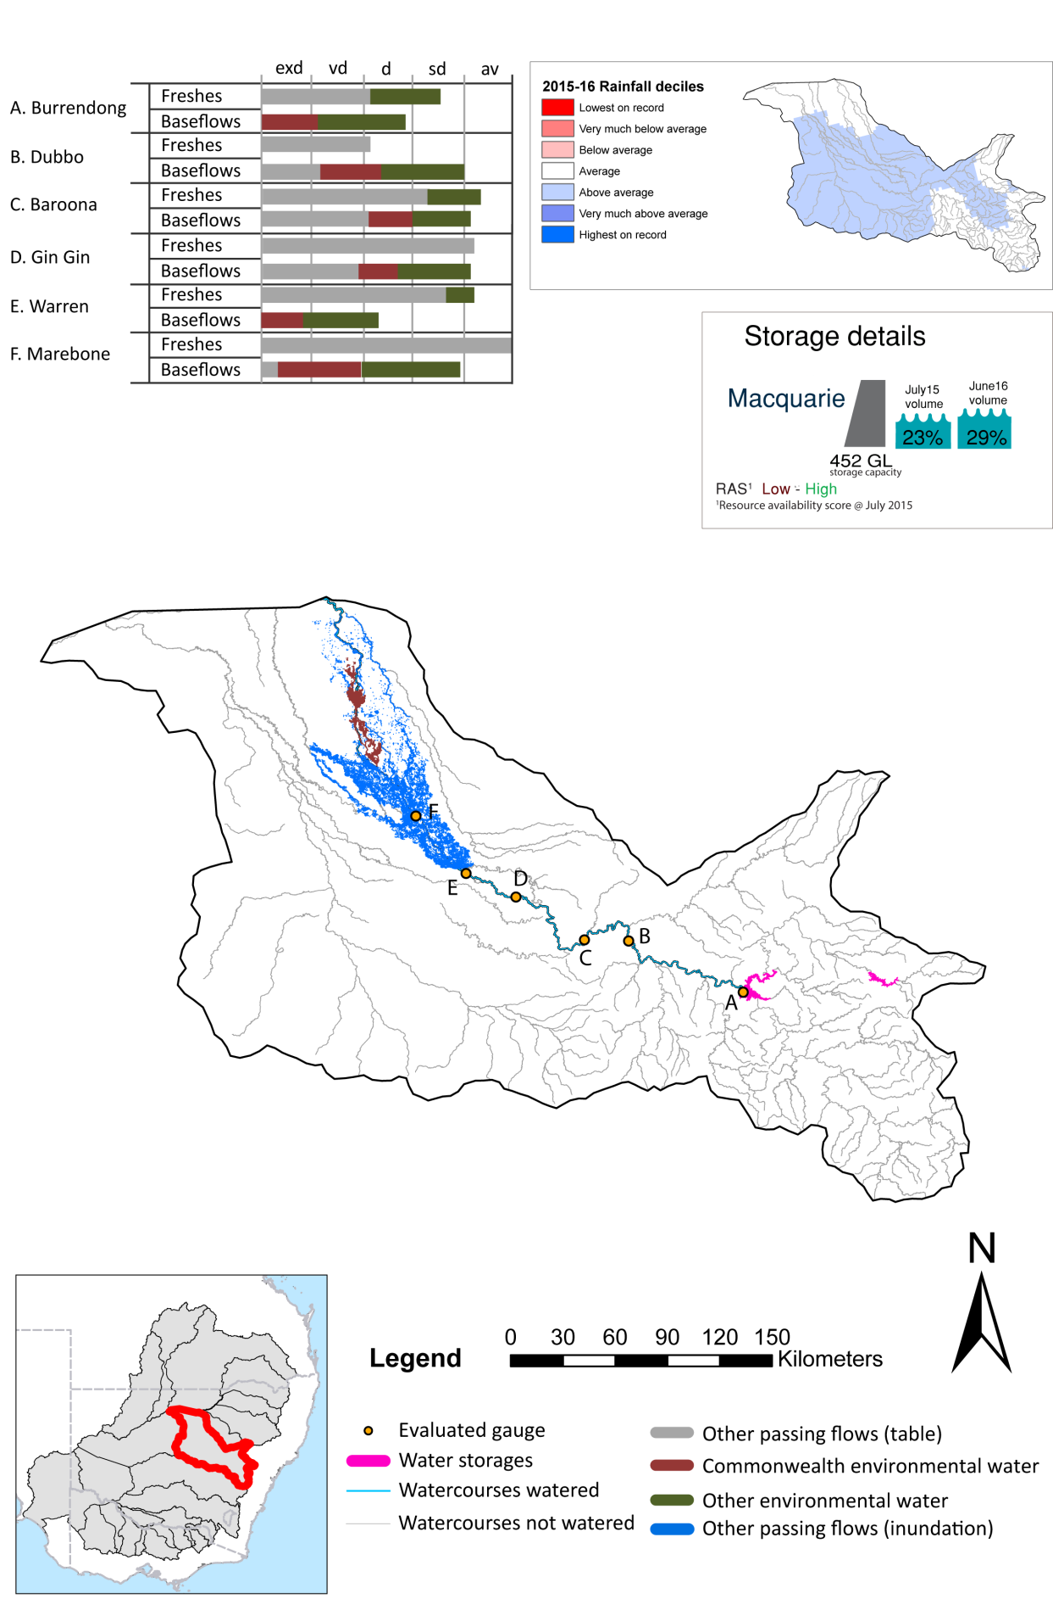

Figure MCQ1: Watercourses influenced, areas inundated (where applicable) and gauge stations evaluated in the Macquarie valley during the 2015-16 water year. Inset bar graphs report the condition of annual flow regimes by showing the improvements in hydrological condition with the addition of environmental water as well as the hypothetical scenario in “grey” (if no environmental flow had been delivered). Rainfall conditions (rainfall deciles) and trend in storage levels for the water year are also shown.

Summary
Environmental water delivery for the 2015-16 year in the Macquarie Valley is evaluated using data for 6 sites. This evaluation only considers the contribution of held environmental water, which is a primary focus for the Commonwealth. The contributions of planned environmental water (e.g. passing flows), unregulated tributary inflows and clever use of irrigation flows for environmental benefits can all be very important but these are outside the scope of this report. Environmental watering actions lasted on average 68 days over the course of the year. The volume of environmental water at these 6 sites was between 17% and 19% of the total streamflow. Commonwealth Environmental Water contributed on average 27% of this environmental water. The contribution of environmental water delivery to improved flow regimes is evaluated using data for 6 sites. Ideally, baseflows should be maintained and long periods of excessively low flows avoided. In this valley, the baseflow regime was generally considered to be somewhat dry relative to the pre-development flow regime. In our analysis, a low fresh refers to a period of increased flow, when the water level rises at least one eighth of the way up the river bank (above the low flow level). These low freshes are a regular part of the natural flow regime and support a range of natural processes. In the Macquarie valley, in terms of the occurrence and duration of low freshes, the year was assessed as being average. In our analysis, a medium fresh refers to a period of increased flow, when the water level rises at least one quarter of the way up the river bank. These medium freshes are not as frequent as low freshes but are also a regular and important part of the natural flow regime. In the Macquarie valley, in terms of the occurrence of medium freshes, the year was assessed as being dry. In our analysis, a high fresh refers to a period of increased flow, when the water level rises more than half way up the river. A high fresh may not occur every year but they are still important and long periods without major freshes can have serious consequences for floodplains and their contribution to river ecosystem health. Delivering environmental water as high in channel flows normally requires that all risks to riparian landholders and infrastructure have been resolved. In the Macquarie valley, in terms of the occurrence of high freshes, the year was assessed as being somewhat dry.

Environmental water system
The Macquarie valley covers an area of 74582 km2, which represents 7.0% of the total Mdb area. The valley is bordered by the Barwon-Darling catchment to the north and west, the Lachlan to the south and the Namoi to the north. Burrendong Dam (capacity 1,188 GL) is the major storage in the valley. There are several distributary rivers and creeks that enter the Macquarie river, including Bell, Little and Talbragar Rivers. The Macquarie Marshes Ramsar site is located within the Macquarie Marshes wetland system in the northern part of the water resource plan area.
Flows to the Lower Macquarie River (80km river section downstream of the Macquarie Marshes, to the Barwon River confluence) occur either from surplus and environmental flows from the Northern Macquarie Marshes. The WSP states that replenishment flows are required of up to 50ML/day at Miltara, at least twice a year. Delivery of dedicated replenishment flows is usually via the North Marsh Bypass channel. It is not possible to deliver water to the Lower Macquarie River without beneficial losses along the way that contribute to watering the Macquarie Marshes and mid-Macquarie River. A consequence of the integrated nature of the Lower Macquarie and northern Macquarie Marshes means that targeting the lower Macquarie will transfer or transport important ecological outputs to the Barwon/Darling River.
Delivery of environmental water in the Macquarie valley is constrained by storage release capacities, channel capacity, infrastructure and unintended third party impacts. As such, watering options are developed with consideration to the following constraints:
1. South Dubbo weir drown out at >14385 Ml/day
2. Marebone Choke – third party impact at prolonged flows > 4000 ML / day
3. Marebone weir: flows over 3200ML may result in breakouts between Warren and Marebone weir causing third party impacts
4. Infrastructure constraints such as Crooked Creek off take capacity of 100 ML/day
5. Banks, weirs, regulators and diversion channels in the Marshes

Data availability
The contribution (where applicable) of the Commonwealth environmental water and NSW environmental water and other passing flows were derived from the CAIRO river operations spreadsheet held by Water NSW. The accounted waterholding, and its source was tracked longitudinally using known travel times, contributions from tributaries and differences between allocated and unallocated flow. The method assumed no longitudinal delivery loss, so in other words, the Commonwealth environmental water component is likely to be underestimated at reaches upstream of the accounting point.

Water delivery context
During the 2015-16 water year, the Commonwealth Environmental Water Holder (CEWH) held water entitlements of up to 134516ML for environmental use in the Macquarie valley. Each year, water utilities allocate the water entitlement holders a percentage of water based on their holding, license type and carryover (the exact rules vary among Jurisdictions). In the 2015-16 water year, the CEWH Macquarie entitlements were allocated 10966 ML of water, representing 20.03% of the Long term average annual yield for the Macquarie valley (54755 ML). The 2015-16 water allocation (10966 ML) together with the carryover volume of 11164 ML of water meant the CEWH had 22130 ML of water available for delivery.
A total of 14239 ML of Commonwealth environmental water was delivered in the Macquarie valley. A total of 0 ML of Commonwealth environmental water was traded to consumptive users and 7886ML (58.82% of available resource) of Commonwealth environmental water was carried over for environmental use into the 2016-17 water year.

Environmental conditions and resource availability
The water available for delivery combined with the present and antecedent environmental conditions are key inputs used by environmental water managers in planning and implementing watering actions. Post hoc, this information provides important context when evaluating the effectiveness and appropriateness of environmental water use with respect to hydrological outputs.
The rainfall conditions in the Macquarie valley were classified as Above Average, based on rainfall percentile data for 2015-16 compared to the entire record held by the Bureau of Meteorology for this valley. The major storages in the Macquarie valley remained increased, being 14% full at the beginning of the water year and 24% full by the end of the year (Figure MCQ1).
The Commonwealth Environmental Water Office (CEWO) calculates resource availability scenarios (RAS) progressively as part of its continual adaptive management planning processes. The RAS are based on the availability of held water (including progressive license acquisitions and allocations) as well as the potential for unregulated or planned environmental flows. The resource availability of held water was classified as Low in this valley, whilst the potential for unregulated or planned environmental flow was classified as Low to High. The physical conditions meant that the CEWO was managing to Avoid damage and protect core areas of the Macquarie marshes and assets in the Macquarie river and effleunt creeks, to ensure ecological capacity for recovery. The overall demand for environmental water was deemed High (water predominantly needed this year).

Watering actions
A total of 2 watering actions were implemented, the duration of these actions varied (range of individual actions: 5 - 71 days). The total cumulative sum of watering actions days was 76). The number of actions commencing in each season did not vary: Winter (2). The flow component types delivered included (0 baseflow, 2 freshes, 0 bankfull, 0 overbank and 0 wetland).
Table MCQ2. Commonwealth environmental water accounting information (includes General and Supplementary entitlements) for the Macquarie valley over 2015-16 water year.
Total registered volume (ML) | Allocated volume (ML) | Carry over available (ML) | Delivered (ML) | LTAAY (ML) | Trade (ML) | Carried over to 2016-17 | Forfeited (ML)
134516 | 10966 | 11164 | 14239 | 54755 | 0 | 7886 | 0

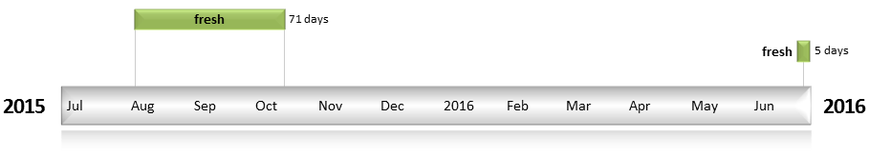
Figure MCQ2: Timing and duration of water actions implemented by the CEWO during the 2015-16 water year in the Macquarie valley.

Contribution of Commonwealth Environmental Water to Flow Regimes
Burrendong
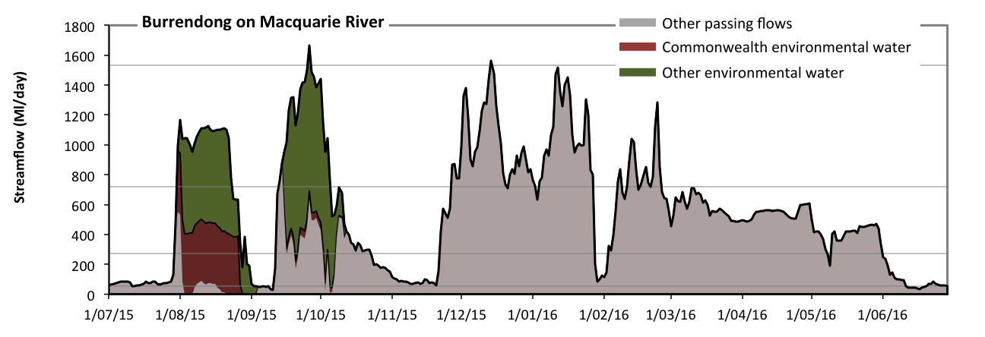
Figure MCQ3: Contribution of environmental water delivery at Burrendong. Horizontal lines indicate thresholds for very low flows, low flows, low freshes and medium freshes (from lowest to highest).
At Burrendong on Macquarie River environmental water contributed 23% of the total streamflow volume (with a medium contribution of Commonwealth environmental water) (Figure MCQ3 and MCQ4). Environmental watering actions affected streamflows for 17% of days between 1 July 2015 and 30 June 2016. Without environmental water, the duration of very low flows (i.e. < 55 Ml/day) in the period July to September would have substantially exceeded durations expected in an average year in the natural flow regime. Environmental water mitigated these impacts by reducing the cumulative duration of very low flow spells from 12% to 5% of the year, with greatest influence in the period July to September. Similarly, without environmental water, the durations of medium low flows (i.e. < 270 Ml/day) in the periods July to September and October to December would have substantially exceeded durations expected in an average year in the natural flow regime. Environmental water mitigated these impacts by reducing the cumulative duration of medium low flow spells from 40% to 30% of the year, with greatest influence in the period July to September. Commonwealth environmental water equally shared responsibility with other environmental water holders for these enhancements of environmental baseflows at this site. In the absence of environmental water there would have been at least one low fresh (i.e. > 720 Ml/day) in the periods July to September, October to December and January to March. Environmental water increased the duration of the longest low fresh during the period July to September (from 2 days to 24 days). Commonwealth environmental water made little or no contribution to these increased durations of low freshes. In the absence of environmental water there would have been at least one medium fresh (i.e. > 1500 Ml/day) in the period October to December. Environmental water increased the duration of the longest medium fresh during the period July to September (from 0 days to 1 days). Commonwealth environmental water made little or no contribution to these increased durations of medium freshes. There was no high freshes (i.e. > 4900 Ml/day) this year.
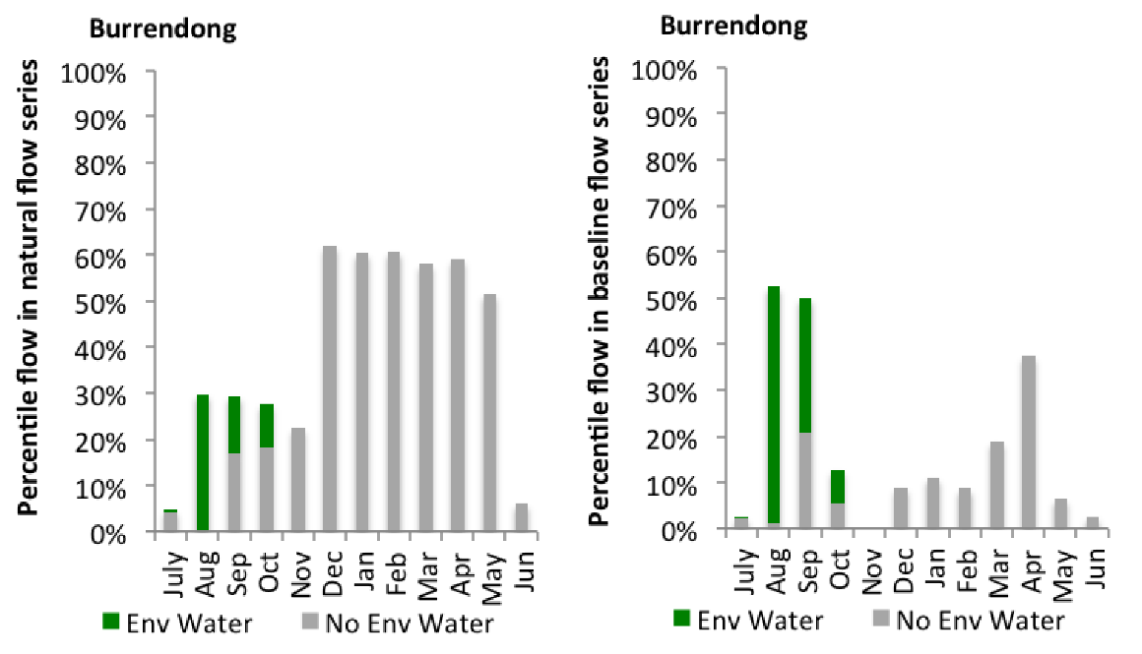
Figure MCQ4: Contribution of environmental water delivery at Burrendong as percentiles in the natural and baseline flow series.

Dubbo
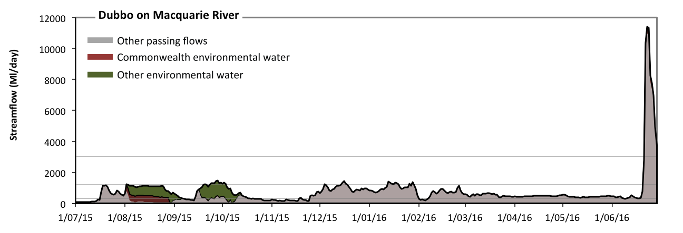
Figure MCQ5: Contribution of environmental water delivery at Dubbo. Horizontal lines indicate thresholds for very low flows, low flows, low freshes and medium freshes (from lowest to highest).
At Dubbo on Macquarie River environmental water contributed 18% of the total streamflow volume (with a medium contribution of Commonwealth environmental water) (Figure MCQ5 and MCQ6). Environmental watering actions affected streamflows for 19% of days between 1 July 2015 and 30 June 2016. Without environmental water, the duration of very low flows (i.e. < 68 Ml/day) in the period July to September would have substantially exceeded durations expected in an average year in the natural flow regime. Environmental water mitigated these impacts by reducing the cumulative duration of very low flow spells from 4% to 0% of the year, with greatest influence in the period July to September. Similarly, without environmental water, the durations of medium low flows (i.e. < 340 Ml/day) in the periods July to September and October to December would have substantially exceeded durations expected in an average year in the natural flow regime. Environmental water mitigated these impacts by reducing the cumulative duration of medium low flow spells from 34% to 20% of the year, with greatest influence in the period July to September. Commonwealth environmental water made a modest contribution to these enhancements of environmental baseflows at this site. In the absence of environmental water there would have been at least one low fresh (i.e. > 1200 Ml/day) in the periods October to December, January to March and April to June. Environmental water increased the duration of the longest low fresh during the period July to September (from 0 days to 8 days). Commonwealth environmental water made a small contribution to these increased durations of low freshes. There was at least one medium fresh (i.e. > 3000 Ml/day) in the period April to June. Environmental water made no change to the duration of these medium freshes. There was no high freshes (i.e. > 12000 Ml/day) this year.
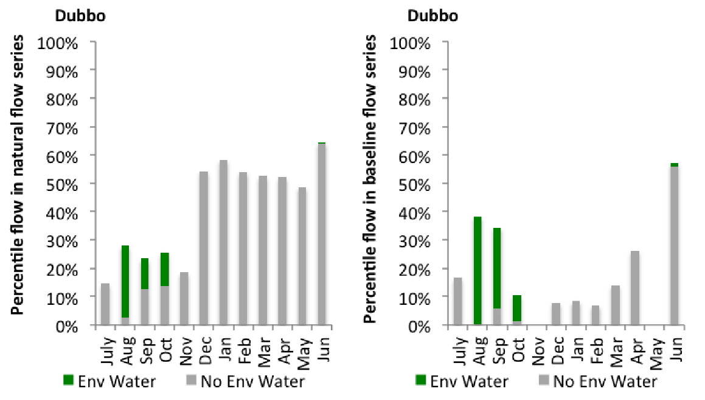
Figure MCQ6: Contribution of environmental water delivery at Dubbo as percentiles in the natural and baseline flow series.
Baroona
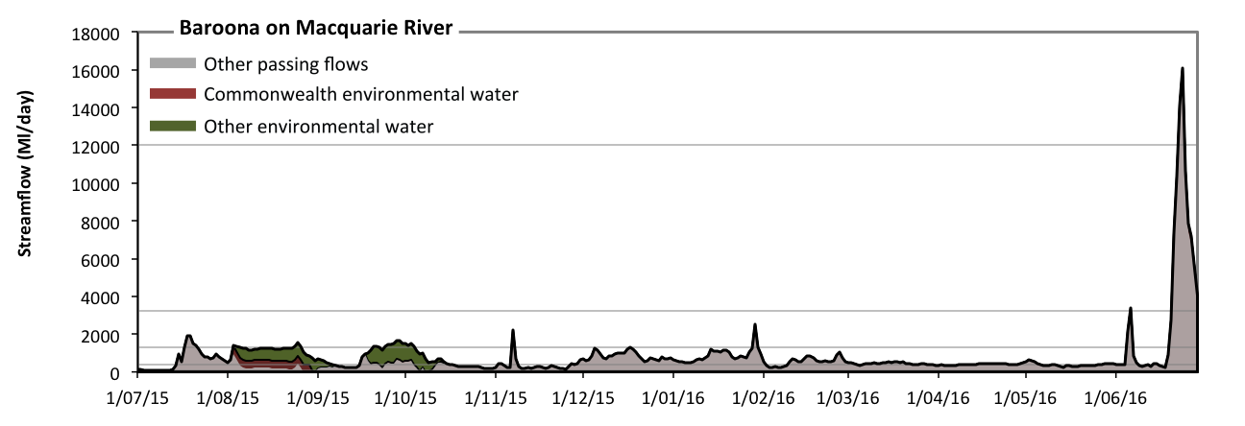
Figure MCQ7: Contribution of environmental water delivery at Baroona. Horizontal lines indicate thresholds for very low flows, low flows, low freshes, medium freshes and high freshes (from lowest to highest).
At Baroona on Macquarie River environmental water contributed 17% of the total streamflow volume (with a medium contribution of Commonwealth environmental water) (Figure MCQ7 and MCQ8). Environmental watering actions affected streamflows for 19% of days between 1 July 2015 and 30 June 2016. Flow regulation does not substantially increase the duration of very low flows (i.e. < 77 Ml/day) compared to an average year in the natural flow regime. However, without environmental water, the durations of medium low flows (i.e. < 390 Ml/day) in the periods July to September and October to December would have substantially exceeded durations expected in an average year in the natural flow regime. Environmental water mitigated these impacts by reducing the cumulative duration of medium low flow spells from 41% to 30% of the year, with greatest influence in the period July to September. Commonwealth environmental water made a modest contribution to these enhancements of environmental baseflows at this site. In the absence of environmental water there would have been at least one low fresh (i.e. > 1300 Ml/day) in the periods July to September, October to December, January to March and April to June. Environmental water increased the duration of the longest low fresh during the periods July to September (from 4 days to 7 days) and October to December (from 1 days to 4 days). Commonwealth environmental water made little or no contribution to these increased durations of low freshes. There was at least one medium fresh (i.e. > 3200 Ml/day) in the period April to June. Environmental water made no change to the duration of these medium freshes. In the absence of environmental water there would have been at least one high fresh in the period April to June. Environmental water made no change to the duration of these high freshes.
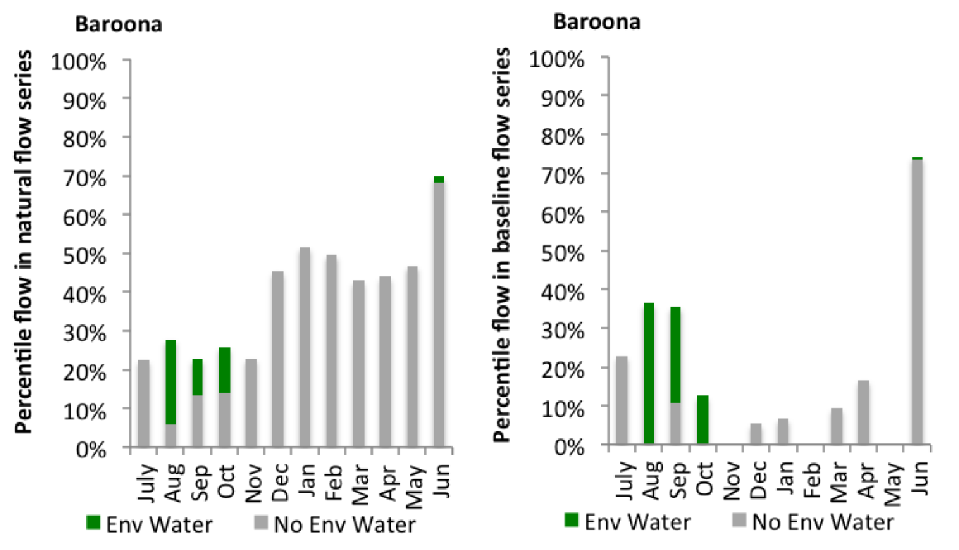
Figure MCQ8: Contribution of environmental water delivery at Baroona as percentiles in the natural and baseline flow series.

Gin Gin
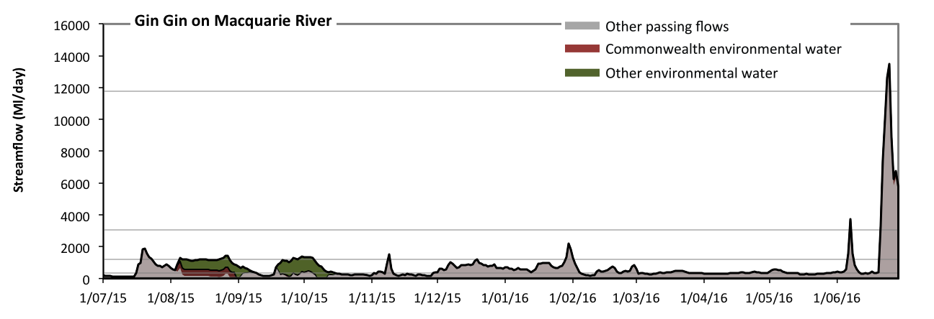
Figure MCQ9: Contribution of environmental water delivery at Gin Gin. Horizontal lines indicate thresholds for very low flows, low flows, low freshes, medium freshes and high freshes (from lowest to highest).
At Gin Gin on Macquarie River environmental water contributed 19% of the total streamflow volume (with a medium contribution of Commonwealth environmental water) (Figure MCQ9 and MCQ10). Environmental watering actions affected streamflows for 19% of days between 1 July 2015 and 30 June 2016. Flow regulation does not substantially increase the duration of very low flows (i.e. < 69 Ml/day) compared to an average year in the natural flow regime. However, without environmental water, the durations of medium low flows (i.e. < 350 Ml/day) in the periods July to September and October to December would have substantially exceeded durations expected in an average year in the natural flow regime. Environmental water mitigated these impacts by reducing the cumulative duration of medium low flow spells from 48% to 34% of the year, with greatest influence in the period July to September. Commonwealth environmental water made a modest contribution to these enhancements of environmental baseflows at this site. In the absence of environmental water there would have been at least one low fresh (i.e. > 1200 Ml/day) in the periods July to September, October to December, January to March and April to June. Environmental water increased the duration of the longest low fresh during the period October to December (from 1 days to 5 days). Commonwealth environmental water made little or no contribution to these increased durations of low freshes. There was at least one medium fresh (i.e. > 3100 Ml/day) in the period April to June. Environmental water made no change to the duration of these medium freshes. In the absence of environmental water there would have been at least one high fresh in the period April to June. Environmental water made no change to the duration of these high freshes.
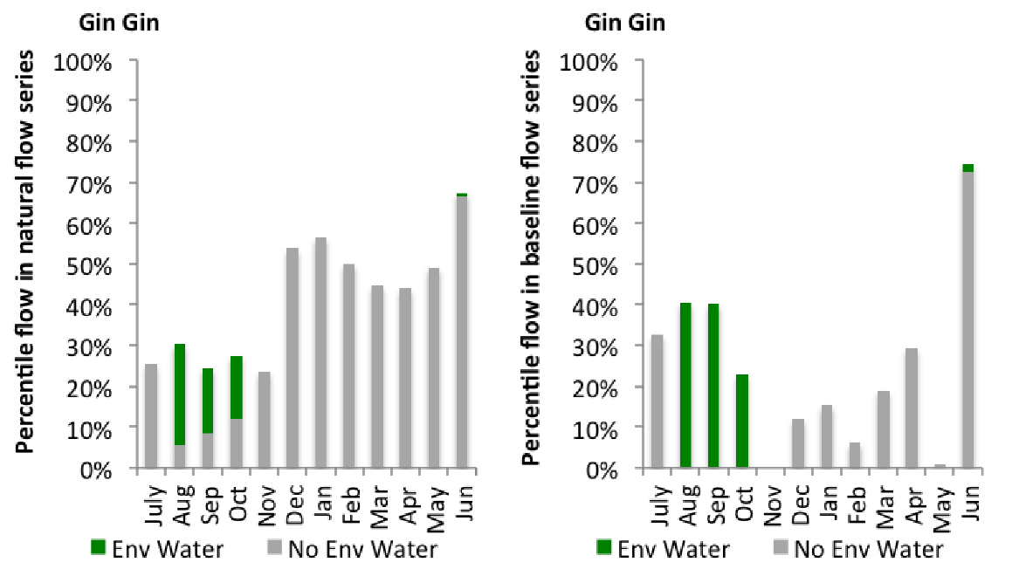
Figure MCQ10: Contribution of environmental water delivery at Gin Gin as percentiles in the natural and baseline flow series.
Warren
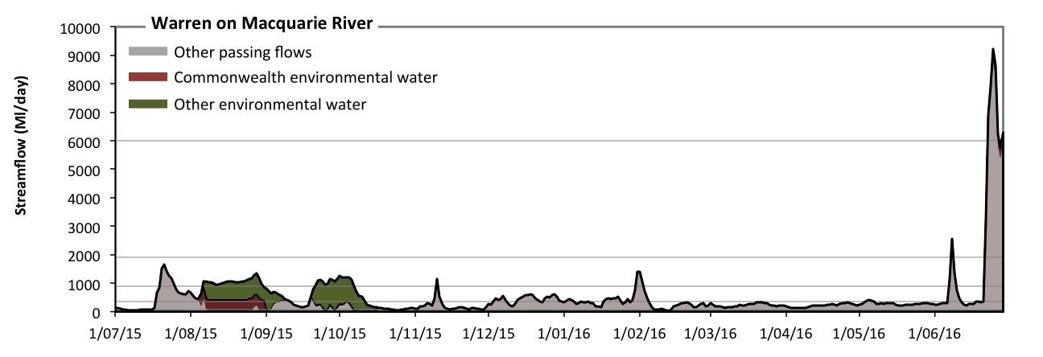
Figure MCQ11: Contribution of environmental water delivery at Warren. Horizontal lines indicate thresholds for very low flows, low flows, low freshes, medium freshes and high freshes (from lowest to highest).
At Warren on Macquarie River environmental water contributed 26% of the total streamflow volume (with a medium contribution of Commonwealth environmental water) (Figure MCQ11 and MCQ12). Environmental watering actions affected streamflows for 19% of days between 1 July 2015 and 30 June 2016. Without environmental water, the durations of very low flows (i.e. < 69 Ml/day) in the periods July to September and October to December would have substantially exceeded durations expected in an average year in the natural flow regime. Environmental water mitigated these impacts by reducing the cumulative duration of very low flow spells from 15% to 4% of the year, with greatest influence in the periods July to September and October to December. Similarly, without environmental water, the durations of medium low flows (i.e. < 350 Ml/day) in the periods July to September, October to December, January to March and April to June would have all substantially exceeded durations expected in an average year in the natural flow regime. Environmental water mitigated these impacts by reducing the cumulative duration of medium low flow spells from 75% to 61% of the year, with greatest influence in the period July to September. Commonwealth environmental water made a modest contribution to these enhancements of environmental baseflows at this site. In the absence of environmental water there would have been at least one low fresh (i.e. > 900 Ml/day) in the periods July to September, October to December, January to March and April to June. Environmental water increased the duration of the longest low fresh during the periods July to September (from 6 days to 25 days) and October to December (from 1 days to 6 days). Commonwealth environmental water made little or no contribution to these increased durations of low freshes. There was at least one medium fresh (i.e. > 1900 Ml/day) in the period April to June. Environmental water made no change to the duration of these medium freshes. In the absence of environmental water there would have been at least one high fresh in the period April to June. Environmental water made little change to the duration of these high freshes. Commonwealth environmental water made little or no contribution to these increased durations of high freshes.
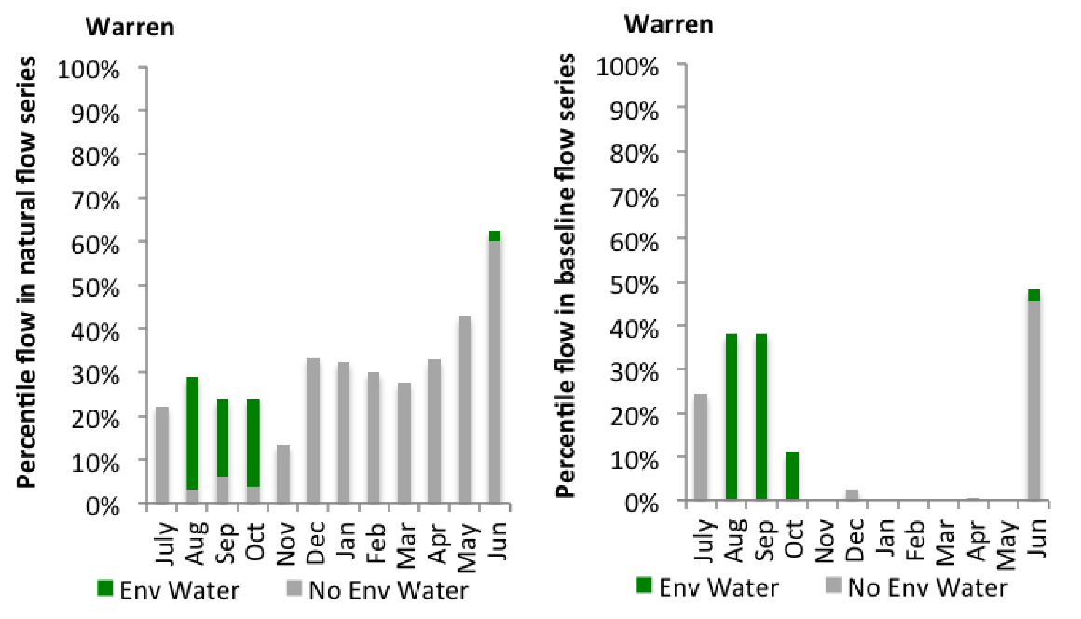
Figure MCQ12: Contribution of environmental water delivery at Warren as percentiles in the natural and baseline flow series.
Marebone
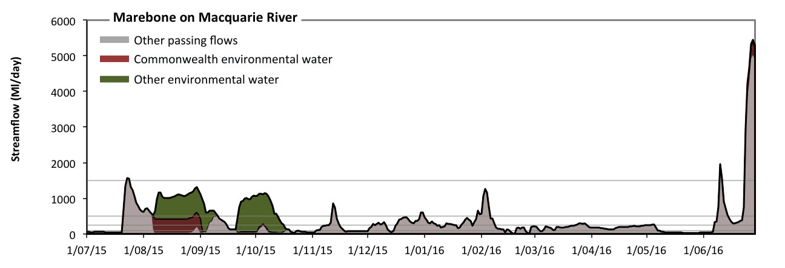
Figure MCQ13: Contribution of environmental water delivery at Marebone. Horizontal lines indicate thresholds for very low flows, low flows, low freshes, medium freshes and high freshes (from lowest to highest). Flows derived from Marebone weir and Marebone break.
At Marebone (which includes the flows at both Marebone weir and Marebone break) on Macquarie River environmental water contributed 33% of the total streamflow volume (with a medium contribution of Commonwealth environmental water) (Figure MCQ13 and MCQ14). Environmental watering actions affected streamflows for 18% of days between 1 July 2015 and 30 June 2016. Without environmental water, the duration of very low flows (i.e. < 20 Ml/day) in the period July to September would have substantially exceeded durations expected in an average year in the natural flow regime. Environmental water mitigated these impacts by reducing the cumulative duration of very low flow spells from 12% to 1% of the year, with greatest influence in the period July to September. Similarly, without environmental water, the durations of medium low flows (i.e. < 98 Ml/day) in the periods July to September, October to December and April to June would have substantially exceeded durations expected in an average year in the natural flow regime. Environmental water mitigated these impacts by reducing the cumulative duration of medium low flow spells from 38% to 24% of the year, with greatest influence in the period July to September. Commonwealth environmental water equally shared responsibility with other environmental water holders for these enhancements of environmental baseflows at this site. In the absence of environmental water there would have been at least one low fresh (i.e. > 240 Ml/day) in the periods July to September, October to December, January to March and April to June. Environmental water increased the duration of the longest low fresh during the period July to September (from 16 days to 57 days). Commonwealth environmental water equally shared responsibility with other environmental water holders for these increased durations of low freshes. In the absence of environmental water there would have been at least one medium fresh (i.e. > 500 Ml/day) in the periods July to September, October to December, January to March and April to June. Environmental water increased the duration of the longest medium fresh during the periods July to September (from 16 days to 52 days) and October to December (from 2 days to 12 days). Commonwealth environmental water made little or no contribution to these increased durations of medium freshes. In the absence of environmental water there would have been at least one high fresh in the periods July to September and April to June. Environmental water made no change to the duration of these high freshes.
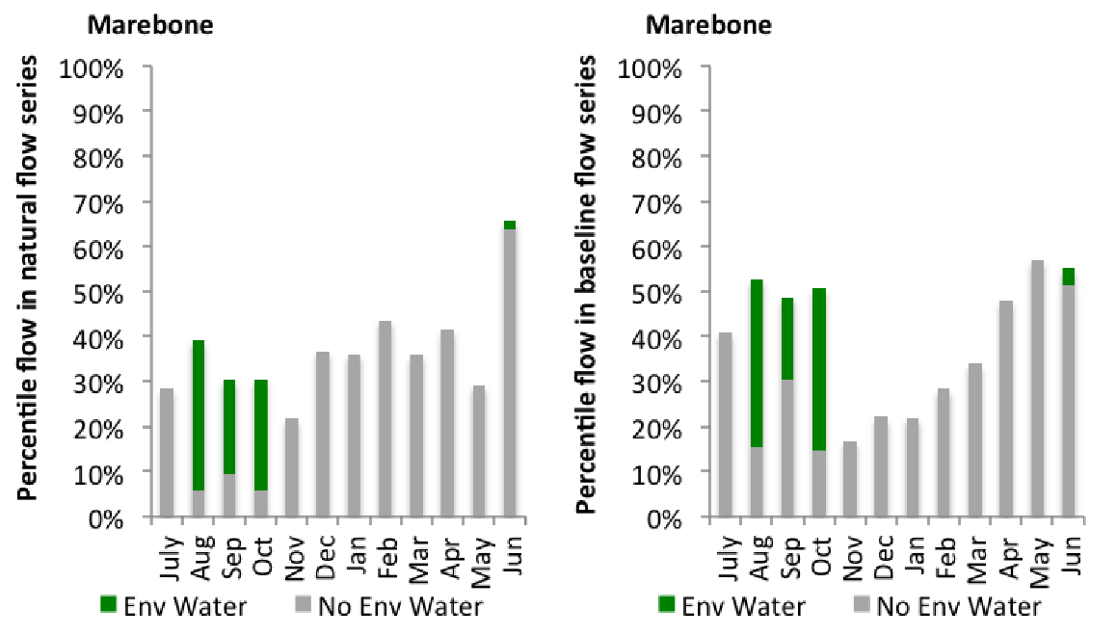
Figure MCQ14: Contribution of environmental water delivery at Marebone as percentiles in the natural and baseline flow series.

Loddon
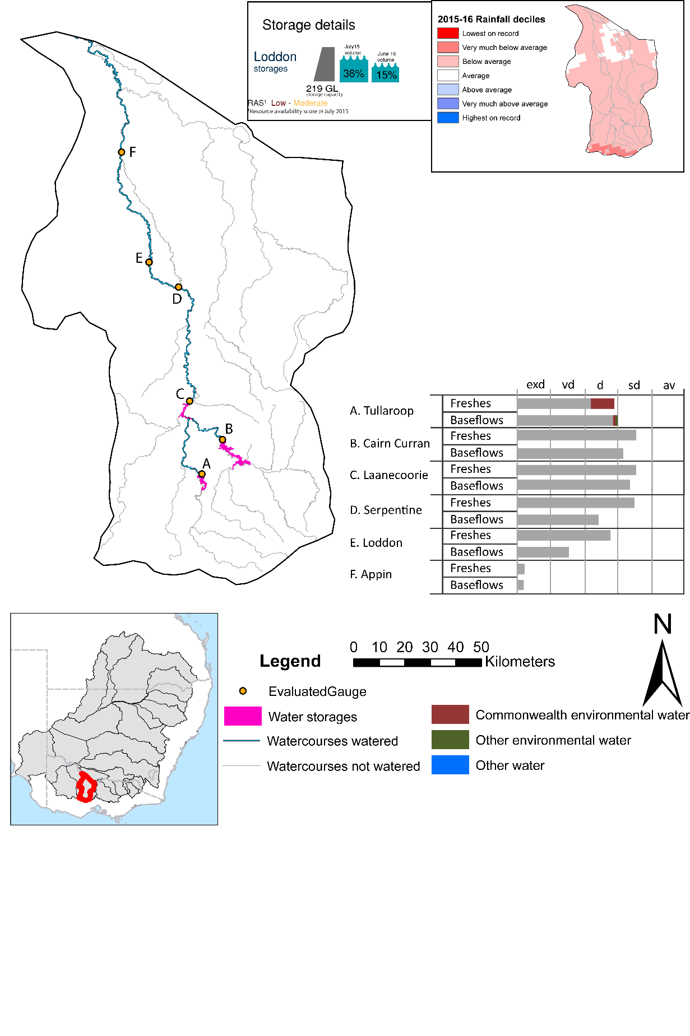

Figure LOD1: Watercourses influenced, areas inundated (where applicable) and gauge stations evaluated in the Loddon valley during the 2015-16 water year. Inset bar graphs report the condition of annual flow regimes by showing the improvements in hydrological condition with the addition of environmental water as well as the hypothetical scenario in “grey” (if no environmental flow had been delivered). Rainfall conditions (rainfall deciles) and trend in storage levels for the water year are also shown.

Summary
Environmental water delivery for the 2015-16 year in the Loddon Valley is evaluated using data for 13 sites. This evaluation only considers the contribution of held environmental water, which is a primary focus for the Commonwealth. The contributions of planned environmental water (e.g. passing flows), unregulated tributary inflows and clever use of irrigation flows for environmental benefits can all be very important but these are outside the scope of this report. Environmental watering actions lasted on average 46 days over the course of the year. The volume of environmental water at these 13 sites was between 5% and 48% of the total streamflow. Commonwealth Environmental Water contributed on average 48% of this environmental water. Ideally, baseflows should be maintained and long periods of excessively low flows avoided. In this valley, the baseflow regime was generally considered to be very dry relative to the pre-development flow regime. In our analysis, a low fresh refers to a period of increased flow, when the water level rises at least one eighth of the way up the river bank (above the low flow level). These low freshes are a regular part of the natural flow regime and support a range of natural processes. In the Loddon valley, in terms of the occurrence and duration of low freshes, the year was assessed as being somewhat dry. In our analysis, a medium fresh refers to a period of increased flow, when the water level rises at least one quarter of the way up the river bank. These medium freshes are not as frequent as low freshes but are also a regular and important part of the natural flow regime. In the Loddon valley, in terms of the occurrence of medium freshes, the year was assessed as being somewhat dry. In our analysis, a high fresh refers to a period of increased flow, when the water level rises more than half way up the river. A high fresh may not occur every year but they are still important and long periods without major freshes can have serious consequences for floodplains and their contribution to river ecosystem health. Delivering environmental water as high in channel flows normally requires that all risks to riparian landholders and infrastructure have been resolved. In the Loddon valley, in terms of the occurrence of high freshes, the year was assessed as being very dry.

Environmental water system
The Loddon valley covers an area of 716km2, which represents 1.4% of the total Mdb area. The river rises on the northern slopes of the Great Dividing Range, south of Daylesford, before flowing northward to join the Murray River (NCCMA 2010) downstream of the Gunbower and Koondrook Pericoota Forests.
Three main streams of the upper catchment (Loddon River, Tullaroop Creek and Bet Bet Creek) all meet at Laanecoorie Reservoir, where the Loddon River then flows into a single channel toward Serpentine Weir. In addition to numerous small water storages, there are three main storages in the upper catchment: Cairn Curran Reservoir (147 GL capacity), Tullaroop Reservoir (73 GL capacity), and Laanecoorie Reservoir (8 GL capacity).
At high flows the Loddon River breaks out at several locations into the Wandella Creek to the west and Tragowel Plains to the east. The Waranga Western Channel crosses the Loddon River catchment south of Boort and at the Loddon Weir, and carries water from the Goulburn system that can be released to the lower reaches of the Loddon River. Macorna Channel crosses underneath the Loddon River upstream of Kerang to supply River Murray water to irrigators in the Torrumbarry system. This report does not explicitly consider the Loddon River from Kerang Weir to the River Murray, as managed flows in this reach are predominantly supplied from diversions from the River Murray at Torrumbarry Weir.
The Commonwealth environmental water portfolio maintains water entitlements in the Loddon which can be delivered from head water storages (Cairn Curran or Tullaroop Reservoirs). Similarly, held Commonwealth environmental water entitlements in the Goulburn and Campaspe systems can be used to deliver water in the lower Loddon system (downstream of Loddon Weir) via the Waranga Western Channel.
Environmental flow preferences in the Loddon recommend a regime which consists of periods of low or no flow, interspersed by occasional higher fresh flows. Although summer irrigation flows only occur in reaches upstream of Loddon weir they are much larger than the preferred (e.g 10 – 20 ml/d), because of the need to supply consumptive water during the peak irrigation period. Moreover, the delivery of the recommended high flows of 3,000 ML/d every year to the Loddon from Cairn Curran is constrained by its outlet capacity (1,600 ML/d) (SKM 2006).

Data availability
Daily discharge data was provided by GMW at six gauge stations within the Loddon valley (Figure LOD1). GMW derived the contribution of the Commonwealth environmental water, VEWH, IVT and other passing flows using operational models in their ‘in house’ accounting spreadsheet. The contribution made by each component was derived by delivering agreed volumes with each water holder. Delivery volumes for the environmental water holders were deemed at Loddon Weir. Flows passing Loddon Weir were not made available for use further downstream in the Murray system. Losses between upstream reservoirs and accounting points were not taken into account when assessing the flows available due to the low rates of delivery. The component of environmental flows to the flow in the Loddon at the sites upstream of Serpentine Weir was estimated based on the volumes delivered at Loddon Weir.

Water delivery context
During the 2015-16 water year, the Commonwealth Environmental Water Holder (CEWH) held water entitlements of up to 3883ML for environmental use in the Loddon valley. Each year, water utilities allocate the water entitlement holders a percentage of water based on their holding, license type and carryover (the exact rules vary among Jurisdictions). In the 2015-16 water year, the CEWH Loddon entitlements were allocated 2819 ML of water, representing 84.65% of the Long term average annual yield for the Loddon valley (3330 ML). The 2015-16 water allocation (2819 ML) together with the carryover volume of 0 ML of water meant the CEWH had 2819 ML of water available for delivery.
A total of 1476 ML of Commonwealth environmental water was delivered in the Loddon valley. A total of 0 ML of Commonwealth environmental water was traded to consumptive users and 1342ML (47.64% of available resource) of Commonwealth environmental water was carried over for environmental use into the 2016-17 water year. Intervalley transfer of water in the southern connected Basin, means on occasion there may be a mismatch between Commonwealth environmental water available for delivery and the actual volume of Commonwealth environmental water delivered.

Environmental conditions and resource availability
The water available for delivery combined with the present and antecedent environmental conditions are key inputs used by environmental water managers in planning and implementing watering actions. Post hoc, this information provides important context when evaluating the effectiveness and appropriateness of environmental water use with respect to hydrological outputs.
The rainfall conditions in the Loddon valley were classified as Below Average, based on rainfall percentile data for the entire record held by the Bureau of Meteorology for this valley. The major storages in the Loddon valley remained decreased, being 36% full at the beginning of the water year and 15% full by the end of the year (Figure LOD1).
The Commonwealth Environmental Water Office (CEWO) calculates resource availability scenarios (RAS) progressively as part of its continual adaptive management planning processes. The RAS are based on the availability of held water (including progressive license acquisitions and allocations) as well as the potential for unregulated or planned environmental flows. The resource availability of held water was classified as Low in this valley, whilst the potential for unregulated or planned environmental flow was classified as Moderate. The physical conditions meant that the CEWO was managing to Protect in channel habitats and conditions/survival of native fish, vegetation and other biota, primarily through the provision of baseflows. The overal purpose also seeks to maintain the ecological health and resilience of the river systems by providing freshes that maintain appropriate habitat and provide opportunities for breeding and recruitment. The overall demand for environmental water was deemed High (water predominantly needed this year).

Watering actions
A total of 1 watering actions were implemented, the duration of these actions varied (range of individual actions: 13 days). The total cumulative sum of watering actions days was 13). The number of actions commencing in each season did not vary: Winter (1). The flow component types delivered included (0 baseflow, 1 freshes, 0 bankfull, 0 overbank and 0 wetland).

Table LOD2. Commonwealth environmental water accounting information for the Loddon valley over 2015-16 water year.
Total registered volume (ML) | Allocated volume (ML) | Carry over available (ML) | Delivered (ML) | LTAAY (ML) | Trade (ML) | Carried over to 2016-17 | Forfeited (ML)
3883 | 2819 | 2819 | 1476 | 3330 | 0 | 1342 | 0

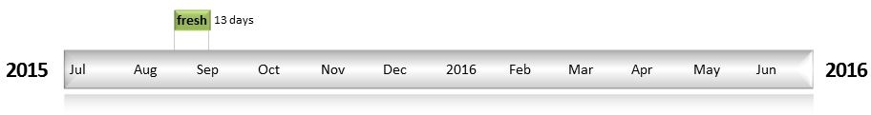
Figure LOD2: Timing and duration of water actions implemented by the CEWO during the 2015-16 water year in the Loddon valley.

Contribution of Commonwealth Environmental Water to Flow Regimes
Cairn Curran
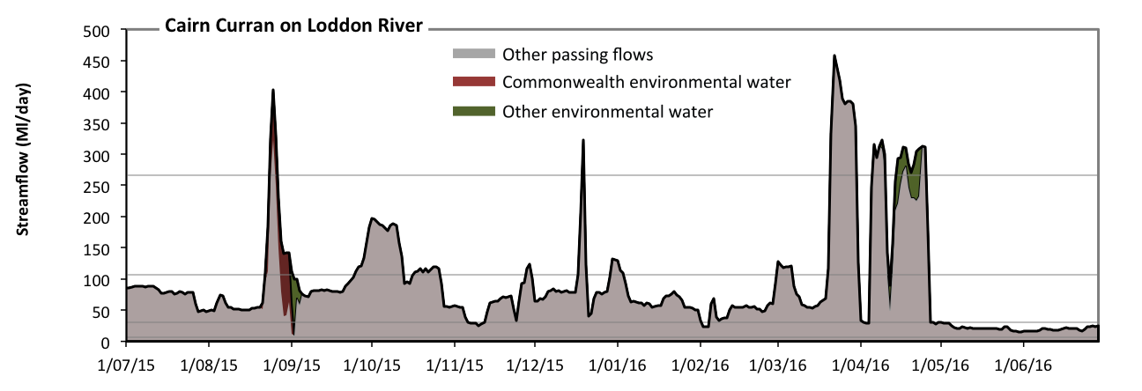
Figure LOD3: Contribution of environmental water delivery at Cairn Curran. Horizontal lines indicate thresholds for very low flows, low flows, low freshes and medium freshes (from lowest to highest).
At Cairn Curran on Loddon River environmental water contributed 5% of the total streamflow volume (with approximately half contributed by Commonwealth environmental water). Environmental watering actions affected streamflows for 8% of days between 1 July 2015 and 30 June 2016 (Figure LOD3 and LOD4). Flow regulation does not substantially increase the duration of very low flows (i.e. < 6.2 Ml/day) compared to an average year in the natural flow regime. However, without environmental water, the duration of medium low flows (i.e. < 31 Ml/day) in the period April to June would have substantially exceeded durations expected in an average year in the natural flow regime. Environmental water reduced the cumulative duration of medium low flow spells from 22% to 21% of the year, with greatest influence in the period July to September. In the absence of environmental water there would have been at least one low fresh (i.e. > 110 Ml/day) in the periods July to September, October to December, January to March and April to June. Environmental water increased the duration of the longest low fresh during the period July to September (from 6 days to 11 days). Commonwealth environmental water was entirely responsible for these increased durations of low freshes. In the absence of environmental water there would have been at least one medium fresh (i.e. > 270 Ml/day) in the periods July to September, October to December, January to March and April to June. Environmental water increased the duration of the longest medium fresh during the periods July to September (from 1 days to 3 days) and April to June (from 5 days to 11 days). Commonwealth environmental water equally shared responsibility with other environmental water holders for these increased durations of medium freshes. There was no high freshes (i.e. > 1000 Ml/day) this year.
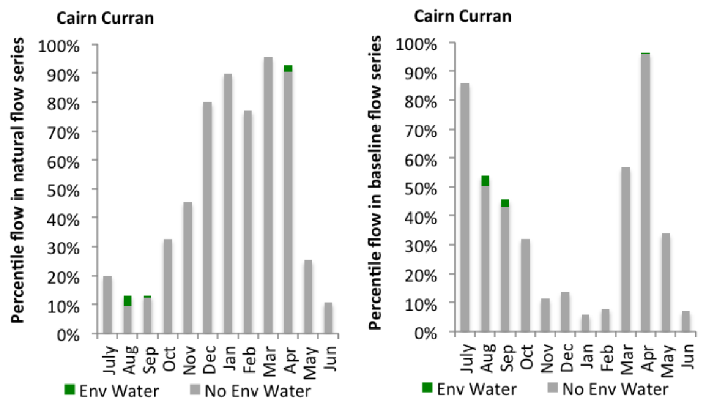
Figure LOD4: Contribution of environmental water delivery at Cairn Curran as percentiles in the natural and baseline flow series.
Tullaroop
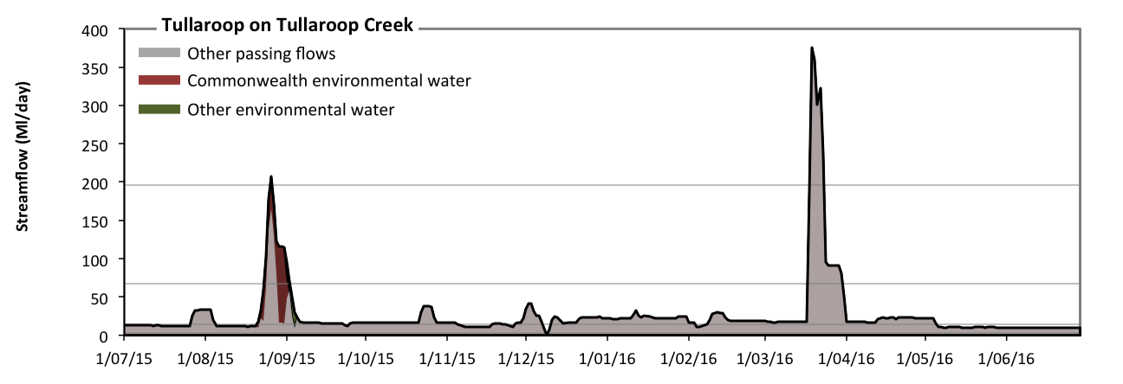
Figure LOD5: Contribution of environmental water delivery at Tullaroop. Horizontal lines indicate thresholds for very low flows, low flows, low freshes and medium freshes (from lowest to highest).
At Tullaroop on Tullaroop Creek environmental water contributed 7% of the total streamflow volume (most of which was Commonwealth environmental water). Environmental watering actions affected streamflows for 4% of days between 1 July 2015 and 30 June 2016 (Figure LOD5 and LOD6). Flow regulation does not substantially increase the duration of very low flows (i.e. < 2.9 Ml/day) compared to an average year in the natural flow regime. However, without environmental water, the durations of medium low flows (i.e. < 14 Ml/day) in the periods July to September and April to June would have substantially exceeded durations expected in an average year in the natural flow regime. Environmental water mitigated these impacts by reducing the cumulative duration of medium low flow spells from 35% to 35% of the year, with greatest influence in the period July to September. In the absence of environmental water there would have been at least one low fresh (i.e. > 67 Ml/day) in the periods July to September and January to March. Environmental water increased the duration of the longest low fresh during the period July to September (from 4 days to 10 days). Commonwealth environmental water was entirely responsible for these increased durations of low freshes. In the absence of environmental water there would have been at least one medium fresh (i.e. > 200 Ml/day) in the period January to March. Environmental water increased the duration of the longest medium fresh during the period July to September (from 0 days to 1 days). Commonwealth environmental water was entirely responsible for these increased durations of medium freshes. There was no high freshes (i.e. > 870 Ml/day) this year.
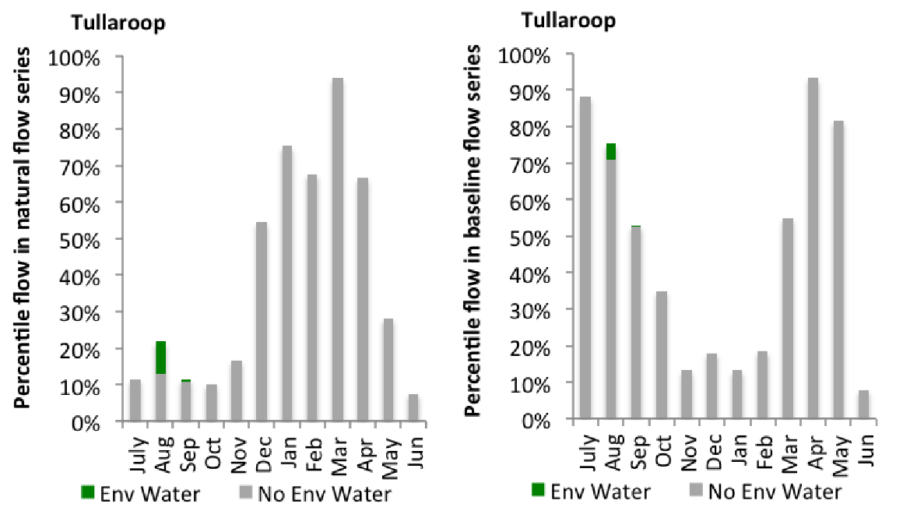
Figure LOD6: Contribution of environmental water delivery at Tullaroop as percentiles in the natural and baseline flow series.
Laanecoorie
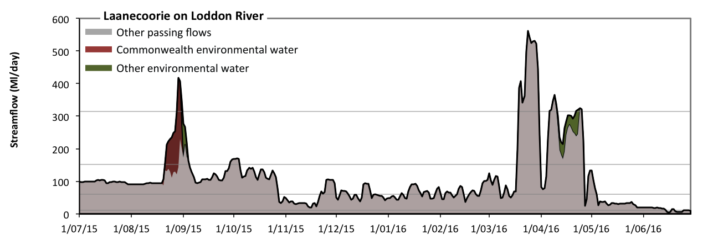
Figure LOD7: Contribution of environmental water delivery at Laanecoorie. Horizontal lines indicate thresholds for very low flows, low flows, low freshes and medium freshes (from lowest to highest).
At Laanecoorie on Loddon River environmental water contributed 6% of the total streamflow volume (with approximately half contributed by Commonwealth environmental water). Environmental watering actions affected streamflows for 8% of days between 1 July 2015 and 30 June 2016 (Figure LOD7 and LOD8). Flow regulation does not substantially increase the duration of very low flows (i.e. < 12 Ml/day) compared to an average year in the natural flow regime. However, without environmental water, the durations of medium low flows (i.e. < 60 Ml/day) in the periods October to December and April to June would have substantially exceeded durations expected in an average year in the natural flow regime. However, environmental water had little effect on the duration of these medium low flows, which occurred for 37% of the year. In the absence of environmental water there would have been at least one low fresh (i.e. > 150 Ml/day) in the periods July to September, October to December, January to March and April to June. Environmental water increased the duration of the longest low fresh during the period July to September (from 6 days to 15 days). Commonwealth environmental water was entirely responsible for these increased durations of low freshes. In the absence of environmental water there would have been at least one medium fresh (i.e. > 310 Ml/day) in the periods January to March and April to June. Environmental water increased the duration of the longest medium fresh during the period July to September (from 0 days to 3 days). Commonwealth environmental water was entirely responsible for these increased durations of medium freshes. There was no high freshes (i.e. > 970 Ml/day) this year.
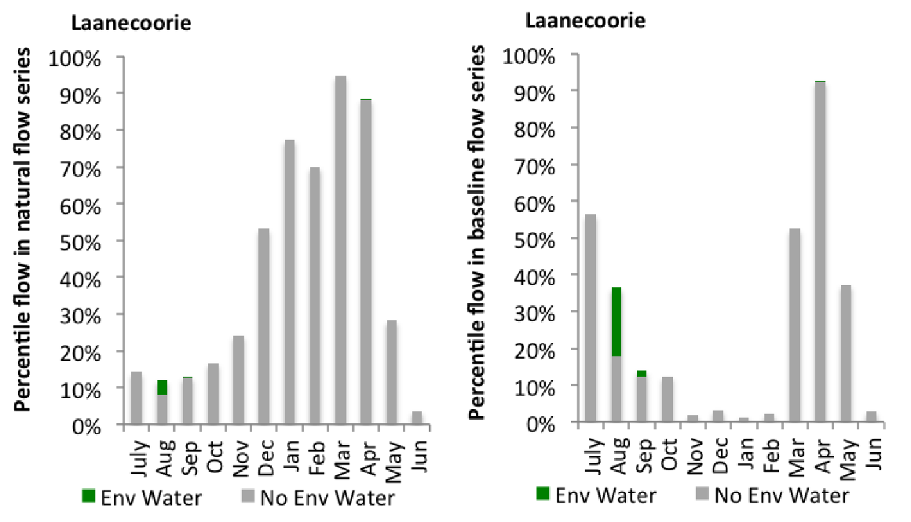
Figure LOD8: Contribution of environmental water delivery at Laanecoorie as percentiles in the natural and baseline flow series.
Serpentine
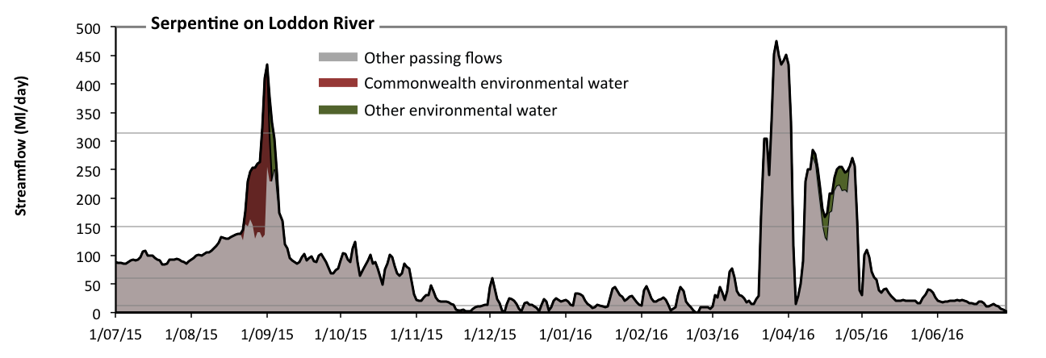
Figure LOD9: Contribution of environmental water delivery at Serpentine. Horizontal lines indicate thresholds for very low flows, low flows, low freshes and medium freshes (from lowest to highest).
At Serpentine on Loddon River environmental water contributed 7% of the total streamflow volume (much of which was Commonwealth environmental water). Environmental watering actions affected streamflows for 8% of days between 1 July 2015 and 30 June 2016 (Figure LOD9 and LOD10). Without environmental water, the duration of very low flows (i.e. < 12 Ml/day) in the period October to December would have substantially exceeded durations expected in an average year in the natural flow regime. However, environmental water had little effect on the duration of these very low flows, which occurred for 14% of the year. Similarly, without environmental water, the durations of medium low flows (i.e. < 60 Ml/day) in the periods October to December, January to March and April to June would have substantially exceeded durations expected in an average year in the natural flow regime. However, environmental water had little effect on the duration of these medium low flows, which occurred for 55% of the year. In the absence of environmental water there would have been at least one low fresh (i.e. > 150 Ml/day) in the periods July to September, January to March and April to June. Environmental water increased the duration of the longest low fresh during the periods July to September (from 7 days to 16 days) and April to June (from 12 days to 22 days). Commonwealth environmental water equally shared responsibility with other environmental water holders for these increased durations of low freshes. In the absence of environmental water there would have been at least one medium fresh (i.e. > 310 Ml/day) in the periods January to March and April to June. Environmental water increased the duration of the longest medium fresh during the period July to September (from 0 days to 5 days). Commonwealth environmental water made the dominant contribution to these increased durations of medium freshes. There was no high freshes (i.e. > 970 Ml/day) this year.
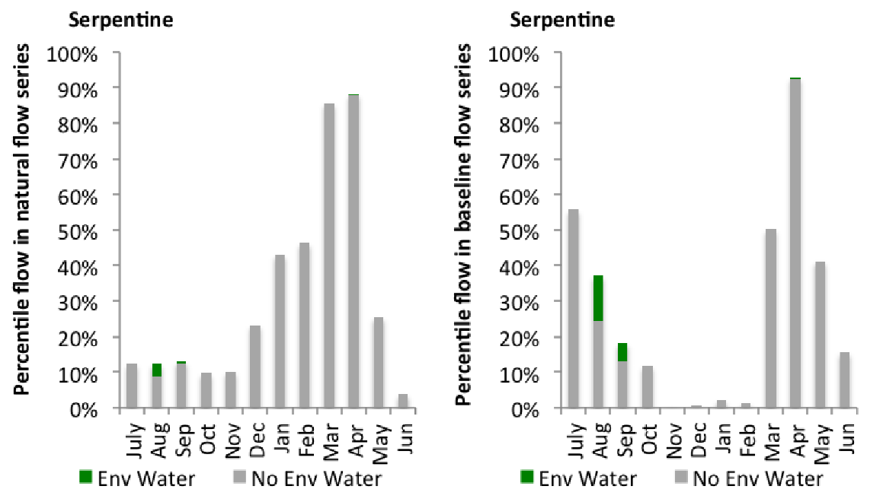
Figure LOD10: Contribution of environmental water delivery at Serpentine as percentiles in the natural and baseline flow series.

Loddon
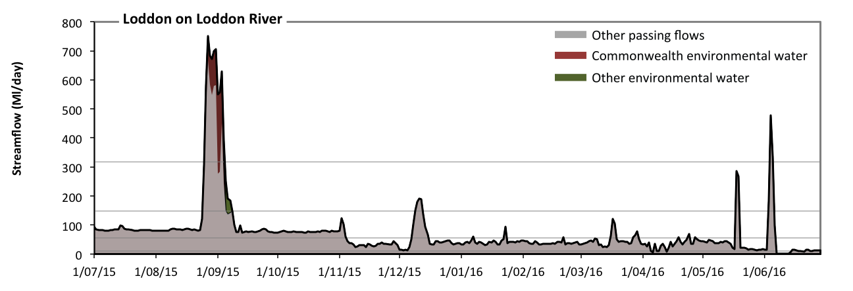
Figure LOD11: Contribution of environmental water delivery at Loddon. Horizontal lines indicate thresholds for very low flows, low flows, low freshes and medium freshes (from lowest to highest).
At Loddon on Loddon River environmental water contributed 6% of the total streamflow volume (most of which was Commonwealth environmental water). Environmental watering actions affected streamflows for 4% of days between 1 July 2015 and 30 June 2016 (Figure LOD11 and LOD12). Without environmental water, the duration of very low flows (i.e. < 11 Ml/day) in the period April to June would have substantially exceeded durations expected in an average year in the natural flow regime. However, environmental water had little effect on the duration of these very low flows, which occurred for 5% of the year. Similarly, without environmental water, the durations of medium low flows (i.e. < 56 Ml/day) in the periods October to December, January to March and April to June would have substantially exceeded durations expected in an average year in the natural flow regime. However, environmental water had little effect on the duration of these medium low flows, which occurred for 58% of the year. There was at least one low fresh (i.e. > 150 Ml/day) in the periods July to September, October to December and April to June. Environmental water made little change to the duration of these low freshes. Commonwealth environmental water made little or no contribution to these increased durations of low freshes. In the absence of environmental water there would have been at least one medium fresh (i.e. > 320 Ml/day) in the periods July to September and April to June. Environmental water increased the duration of the longest medium fresh during the period July to September (from 6 days to 10 days). Commonwealth environmental water was entirely responsible for these increased durations of medium freshes. There was no high freshes (i.e. > 1000 Ml/day) this year.
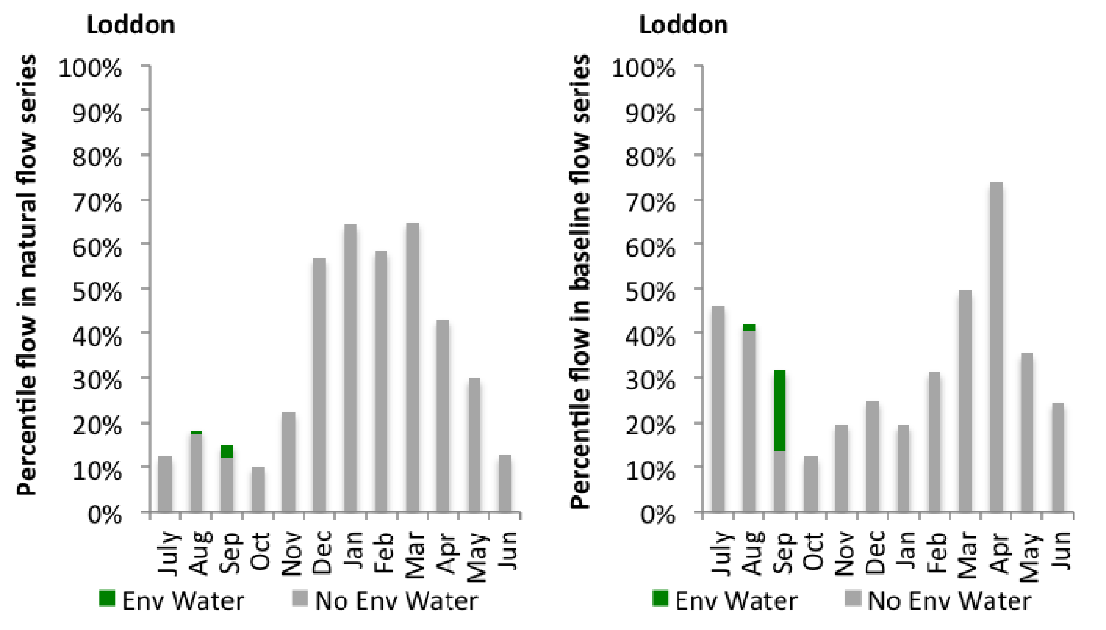
Figure LOD12: Contribution of environmental water delivery at Loddon as percentiles in the natural and baseline flow series.
Appin
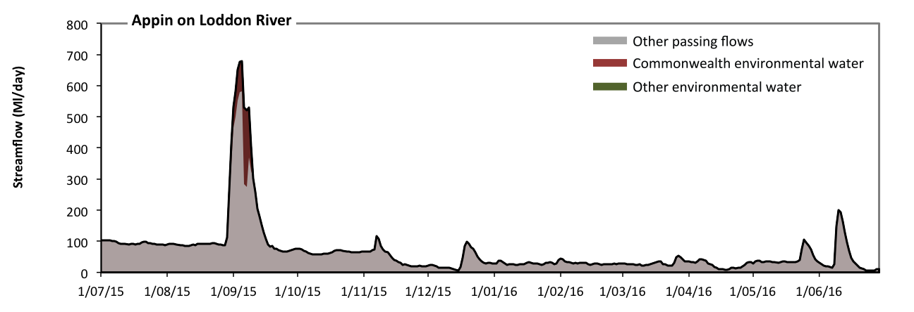Figure LOD13: Contribution of environmental water delivery at Appin. Horizontal lines indicate thresholds for (from lowest to highest).
At Appin on Loddon River environmental water contributed 6% of the total streamflow volume (all of which was Commonwealth environmental water) (Figure LOD13). Environmental watering actions affected streamflows for 3% of days between 1 July 2015 and 30 June 2016. However, environmental water had little effect on the duration of these very low flows, which occurred for 100% of the year.

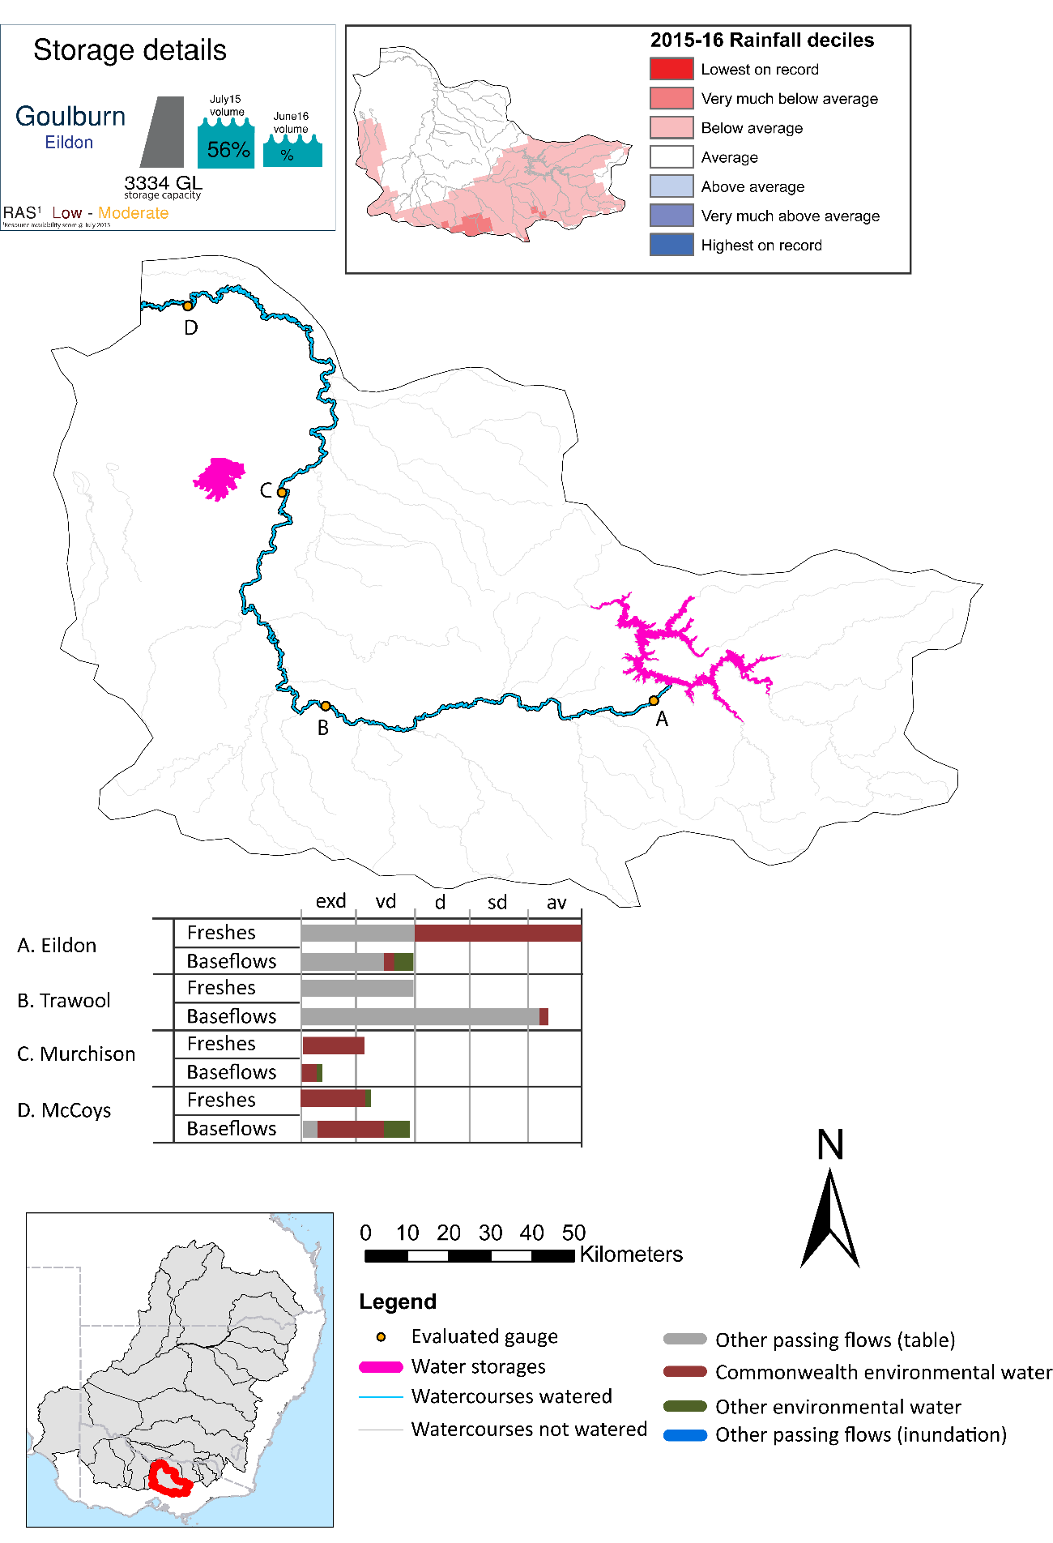
Goulburn

Figure GLB1: Watercourses influenced, areas inundated (where applicable) and gauge stations evaluated in the Goulburn valley during the 2015-16 water year. Inset bar graphs report the condition of annual flow regimes by showing the improvements in hydrological condition with the addition of environmental water as well as the hypothetical scenario in “grey” (if no environmental flow had been delivered). Rainfall conditions (rainfall deciles) and trend in storage levels for the water year are also shown.

Summary
Environmental water delivery for the 2015-16 year in the Goulburn Valley is evaluated using data for 4 sites. This evaluation only considers the contribution of held environmental water, which is a primary focus for the Commonwealth. The contributions of planned environmental water (e.g. passing flows), unregulated tributary inflows and clever use of irrigation flows for environmental benefits can all be very important but these are outside the scope of this report. Environmental watering actions lasted on average 179 days over the course of the year. The volume of environmental water at these 4 sites was between 12% and 55% of the total streamflow. Commonwealth Environmental Water contributed on average 84% of this environmental water. The contribution of environmental water delivery to improved flow regimes is evaluated using data for 4 sites. Ideally, baseflows should be maintained and long periods of excessively low flows avoided. In this valley, the baseflow regime was generally considered to be extremely dry relative to the pre-development flow regime. In our analysis, a low fresh refers to a period of increased flow, when the water level rises at least one eighth of the way up the river bank (above the low flow level). These low freshes are a regular part of the natural flow regime and support a range of natural processes. In the Goulburn valley, in terms of the occurrence and duration of low freshes, the year was assessed as being somewhat dry. In our analysis, a medium fresh refers to a period of increased flow, when the water level rises at least one quarter of the way up the river bank. These medium freshes are not as frequent as low freshes but are also a regular and important part of the natural flow regime. In the Goulburn valley, in terms of the occurrence of medium freshes, the year was assessed as being very dry. In our analysis, a high fresh refers to a period of increased flow, when the water level rises more than half way up the river. A high fresh may not occur every year but they are still important and long periods without major freshes can have serious consequences for floodplains and their contribution to river ecosystem health. Delivering environmental water as high in channel flows normally requires that all risks to riparian landholders and infrastructure have been resolved. In the Goulburn valley, in terms of the occurrence of high freshes, the year was assessed as being very dry.

Environmental water system
The Goulburn valley covers 16829 km2, which represents 1.6% of the Basin. The valley has a mean annual discharge of approximately 3200 GL of which, 50% is diverted for consumptive use (CSIRO 2008). The Goulburn River is valued for its high overall economic significance. It is also valued for its many significant social, heritage and environmental values. The lower Goulburn floodplain covers an area of 13,000 ha and is highly valued for its wetland system and associated ecological features.
Although numerous water regulators exist in the Goulburn valley, Lake Eildon and Goulburn weir are the two most influential. Lake Eildon, which has a useable capacity of 3250GL provides water to Shepparton, Central Goulburn, Rochester and Pyramid/Boort irrigation districts. Flows reaching Goulburn weir are diverted to the east of Goulburn main channel and Waranga basin to meet consumptive demands. Water is also released from Goulburn weir to the lower Goulburn. Downstream of Goulburn weir, the river collects tributary inflows and irrigation drain inflows prior to discharging to the Murray River near Echuca.
Releases from Lake Eildon are constrained by downstream flooding constraints (particularly around Thornton and Moleswoth) (SKM, 2006). Flow peaks downstream of Lake Eildon in excess of 14,500 ML/day will cause minor flooding, 26,000 ML/day will cause moderate flooding and 40,000 ML/day will cause major flooding (SKM, 2006). Irrigation releases are in the order of 10,000 ML/day in summer. Goulburn Weir is operated close to its FSL to allow maximum diversion into the irrigation offtake channels. Releases from Goulburn Weir are capable of releasing low flows in the range of 100 ML/day to over 1,000 ML/day as well as higher flows when Goulburn Weir is spilling (SKM, 2006). The Goulburn River downstream of Shepparton is confined within a leveed floodway but its capacity is inadequate to convey moderate flood events
Downstream of Eildon, flow conditions in the Goulburn River are less than natural during the non-irrigation season. Conversely, during the summer irrigation season, flow conditions are higher than natural (particularly between Eildon and Goulburn weir). Environmental flow recommendations in the literature, together with consultations among the VEWH, GBCMA and LTIM providers, guide the planning and use of Commonwealth environmental water in protecting and restoring functions and assets of the Goulburn River.

Data availability
Daily discharge data was provided by GMW for four gauge stations within the Goulburn valley (Figure GLB1). GMW derived the contribution of the Commonwealth environmental water, VEWH, IVT and other passing flows using operational models in their ‘in house’ accounting spreadsheet. The contribution made by each component was derived by delivering agreed volumes with each water holder (i.e. delivery for TLM was required at specific times). Delivery volumes for the environmental water holders were deemed at Goulburn Weir with the flows that arrive at McCoy Bridge being made available for use further downstream in the Murray system. Losses between Goulburn Weir and McCoy Bridge were taken into account when assessing the flows available. The component of environmental flows to the flow in the Goulburn River at the sites upstream of Goulburn Weir was estimated based on the volumes delivered at Goulburn Weir as well as the inflows from tributaries downstream of Lake Eildon.

Water delivery context
During the 2015-16 water year, the Commonwealth Environmental Water Holder (CEWH) held water entitlements of up to 305414ML for environmental use in the Goulburn valley. Each year, water utilities allocate the water entitlement holders a percentage of water based on their holding, license type and carryover (the exact rules vary among Jurisdictions). In the 2015-16 water year, the CEWH Goulburn entitlements were allocated 226250 ML of water, representing 82.44% of the Long term average annual yield for the Goulburn valley (274457 ML). The 2015-16 water allocation (226250 ML) together with the carryover volume of 24113 ML of water meant the CEWH had 250363 ML of water available for delivery.
A total of 190563 ML of Commonwealth environmental water was delivered in the Goulburn valley. A total of 21864 ML of Commonwealth environmental water was traded to consumptive users and 46191ML (18.45% of available resource) of Commonwealth environmental water was carried over for environmental use into the 2016-17 water year. Intervalley transfer of water in the southern connected Basin, means on occasion there may be a mismatch between Commonwealth environmental water available for delivery and the actual volume of Commonwealth environmental water delivered.

Environmental conditions and resource availability
The water available for delivery combined with the present and antecedent environmental conditions are key inputs used by environmental water managers in planning and implementing watering actions. Post hoc, this information provides important context when evaluating the effectiveness and appropriateness of environmental water use with respect to hydrological outputs.
The rainfall conditions in the Goulburn valley were classified as Below Average, based on rainfall percentile data for the entire record held by the Bureau of Meteorology for this valley. The major storages in the Goulburn valley remained decreased, being 56% full at the beginning of the water year and 36% full by the end of the year (Figure GLB1).
The Commonwealth Environmental Water Office (CEWO) calculates resource availability scenarios (RAS) progressively as part of its continual adaptive management planning processes. The RAS are based on the availability of held water (including progressive license acquisitions and allocations) as well as the potential for unregulated or planned environmental flows. The resource availability of held water was classified as Low in this valley, whilst the potential for unregulated or planned environmental flow was classified as Moderate. The physical conditions meant that the CEWO was managing to Protect in channel habitats and conditions/survival of native fish, vegetation and other biota, primarily through the provision of baseflows. The overal purpose also seeks to maintain the ecological health and resilience of the river systems by providing freshes that maintain appropriate habitat and provide opportunities for breeding and recruitment. The overall demand for environmental water was deemed Moderate to High (Water predominantly needed this year and or next).

Watering actions
A total of 6 watering actions were implemented, the duration of these actions varied (range of individual actions: 7 - 132 days). The total cumulative sum of watering actions days was 352). The number of actions commencing in each season varied: Winter (2), Spring (2) and Autumn (2). The flow component types delivered included (4 baseflow, 2 freshes, 0 bankfull, 0 overbank and 0 wetland).
Table GLB2. Commonwealth environmental water accounting information for the Goulburn valley over 2015-16 water year.
Total registered volume (ML) | Allocated volume (ML) | Carry over available (ML) | Delivered (ML) | LTAAY (ML) | Trade (ML) | Carried over to 2016-17 | Forfeited (ML)
305414 | 226250 | 250363 | 190563 | 274457 | 21864 | 46191 | 0

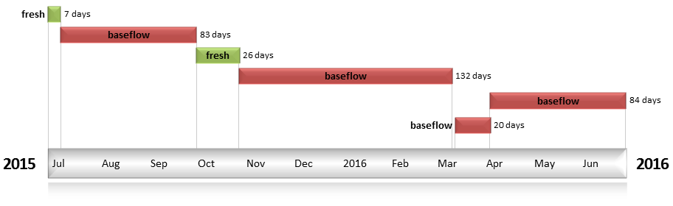
Figure GLB2: Timing and duration of water actions implemented by the CEWO during the 2015-16 water year in the Goulburn valley.

Contribution of Commonwealth Environmental Water to Flow Regimes
Eildon
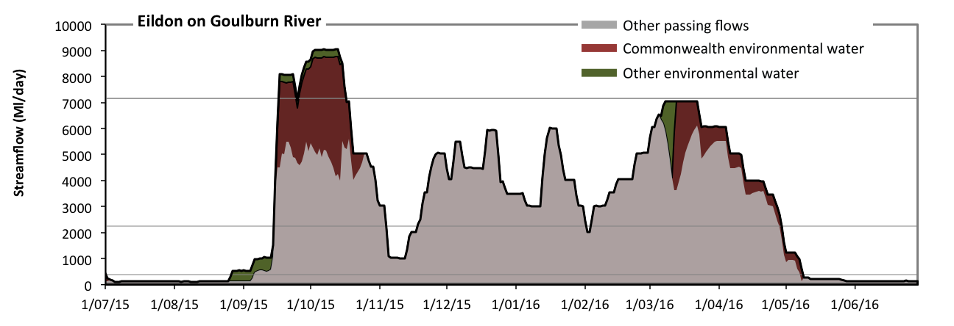
Figure GLB3: Contribution of environmental water delivery at Eildon. Horizontal lines indicate thresholds for very low flows, low flows, low freshes, medium freshes and high freshes (from lowest to highest).
At Eildon on Goulburn River environmental water contributed 16% of the total streamflow volume (most of which was Commonwealth environmental water). Environmental watering actions affected streamflows for 35% of days between 1 July 2015 and 30 June 2016 (Figure GLB3 and GLB4). Flow regulation does not substantially increase the duration of very low flows (i.e. < 79 Ml/day) compared to an average year in the natural flow regime. However, without environmental water, the durations of medium low flows (i.e. < 400 Ml/day) in the periods July to September and April to June would have substantially exceeded durations expected in an average year in the natural flow regime. Environmental water mitigated these impacts by reducing the cumulative duration of medium low flow spells from 33% to 30% of the year, with greatest influence in the period July to September. Commonwealth environmental water made a small contribution to these enhancements of environmental baseflows at this site. There was at least one low fresh (i.e. > 2200 Ml/day) in the periods July to September, October to December, January to March and April to June. Environmental water made little change to the duration of these low freshes. In the absence of environmental water there would have been no medium or high freshes this year. Environmental water increased the duration of the longest medium fresh during the periods July to September (from 0 days to 8 days) and October to December (from 0 days to 16 days). Commonwealth environmental water was entirely responsible for these increased durations of medium freshes. Environmental water increased the duration of the longest medium fresh during the periods July to September (from 0 days to 8 days) and October to December (from 0 days to 16 days). Commonwealth environmental water was entirely responsible for these increased durations of high freshes.
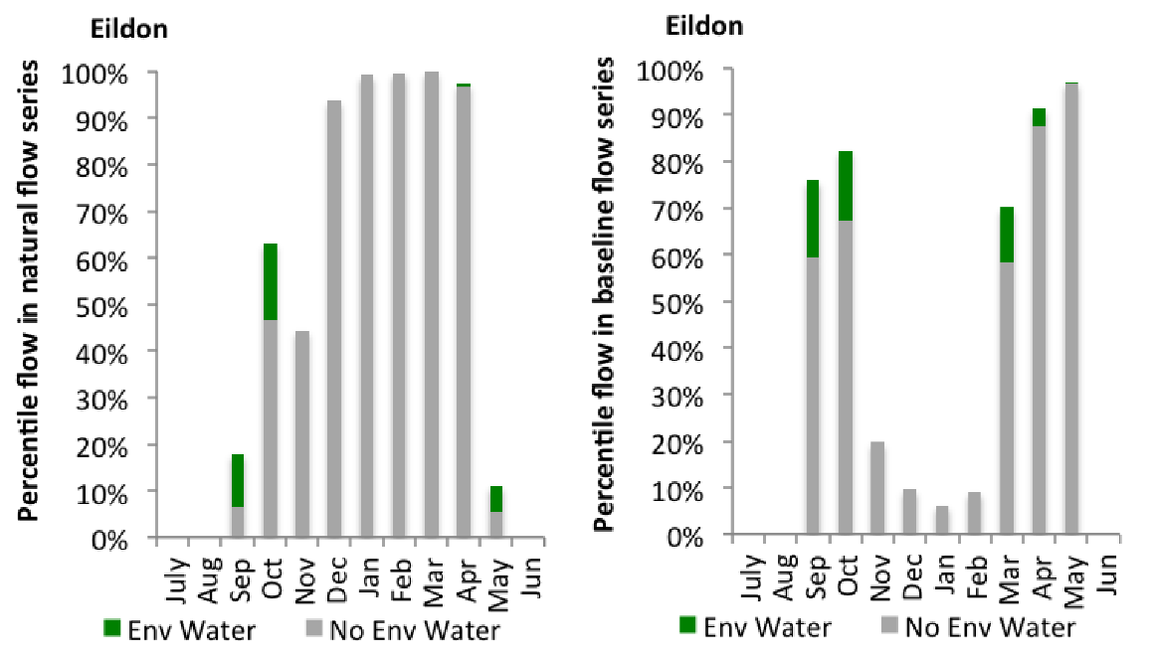
Figure GLB4: Contribution of environmental water delivery at Eildon as percentiles in the natural and baseline flow series.
Trawool
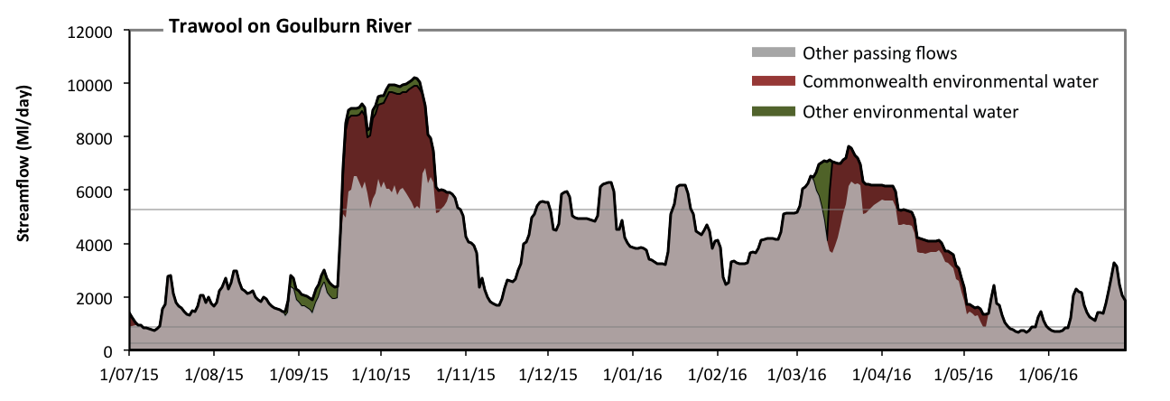
Figure GLB5: Contribution of environmental water delivery at Trawool. Horizontal lines indicate thresholds for very low flows, low flows and low freshes (from lowest to highest).
At Trawool on Goulburn River environmental water contributed 12% of the total streamflow volume (most of which was Commonwealth environmental water). Environmental watering actions affected streamflows for 35% of days between 1 July 2015 and 30 June 2016 (Figure GLB5 and GLB6). Flow regulation does not substantially increase the duration of very low flows (i.e. < 250 Ml/day) compared to an average year in the natural flow regime. However, without environmental water, the durations of medium low flows (i.e. < 870 Ml/day) in the periods July to September and April to June would have substantially exceeded durations expected in an average year in the natural flow regime. Environmental water mitigated these impacts by reducing the cumulative duration of medium low flow spells from 7% to 6% of the year, with greatest influence in the periods July to September and April to June. In the absence of environmental water there would have been at least one low fresh (i.e. > 5300 Ml/day) in the periods July to September, October to December, January to March and April to June. Environmental water increased the duration of the longest low fresh during the periods October to December (from 20 days to 30 days) and January to March (from 9 days to 29 days). Commonwealth environmental water was almost entirely responsible for these increased durations of low freshes. There was no medium or high freshes this year.
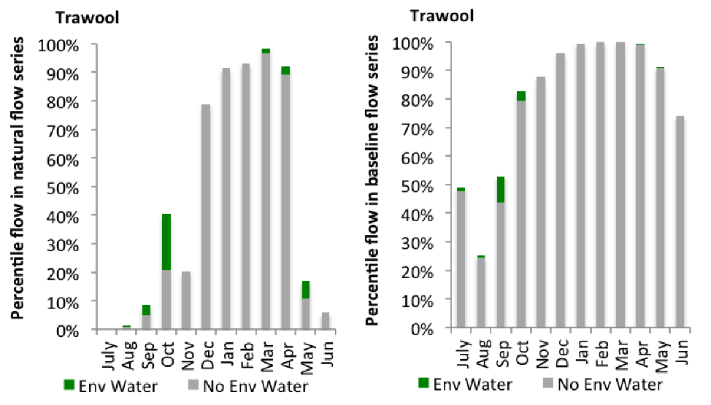
Figure GLB6: Contribution of environmental water delivery at Trawool as percentiles in the natural and baseline flow series.
Murchison
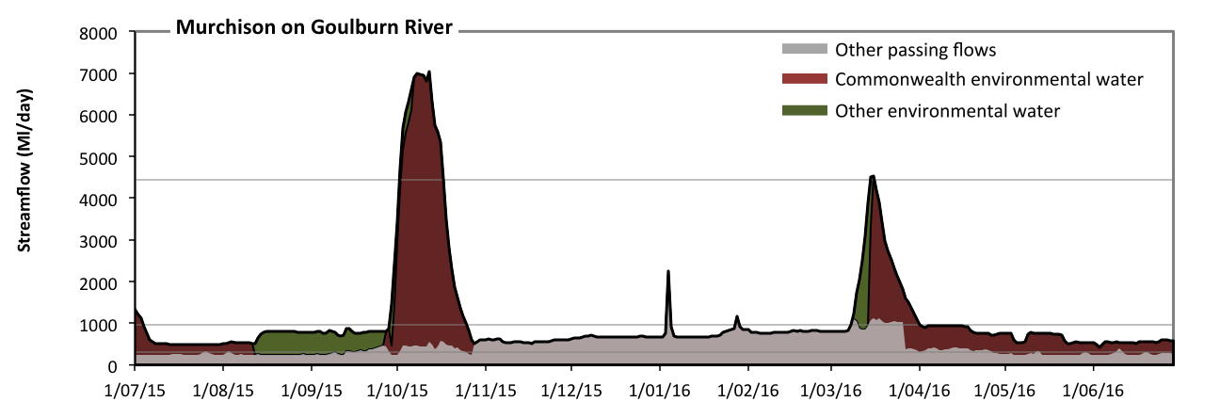
Figure GLB7: Contribution of environmental water delivery at Murchison. Horizontal lines indicate thresholds for very low flows, low flows and low freshes (from lowest to highest).
At Murchison on Goulburn River environmental water contributed 55% of the total streamflow volume (most of which was Commonwealth environmental water). Environmental watering actions affected streamflows for 64% of days between 1 July 2015 and 30 June 2016 (Figure GLB7 and GLB8). Without environmental water, the durations of very low flows (i.e. < 310 Ml/day) in the periods July to September and April to June would have substantially exceeded durations expected in an average year in the natural flow regime. Environmental water mitigated these impacts by reducing the cumulative duration of very low flow spells from 38% to 0% of the year, with greatest influence in the periods July to September and April to June. Similarly, without environmental water, the durations of medium low flows (i.e. < 960 Ml/day) in the periods July to September, October to December, January to March and April to June would have all substantially exceeded durations expected in an average year in the natural flow regime. Environmental water mitigated these impacts by reducing the cumulative duration of medium low flow spells from 96% to 85% of the year, with greatest influence in the period October to December. Commonwealth environmental water made the dominant contribution to these enhancements of environmental baseflows at this site. Environmental water increased the duration of the longest low fresh during the periods October to December (from 0 days to 16 days) and January to March (from 0 days to 2 days). Commonwealth environmental water was entirely responsible for these increased durations of low freshes.
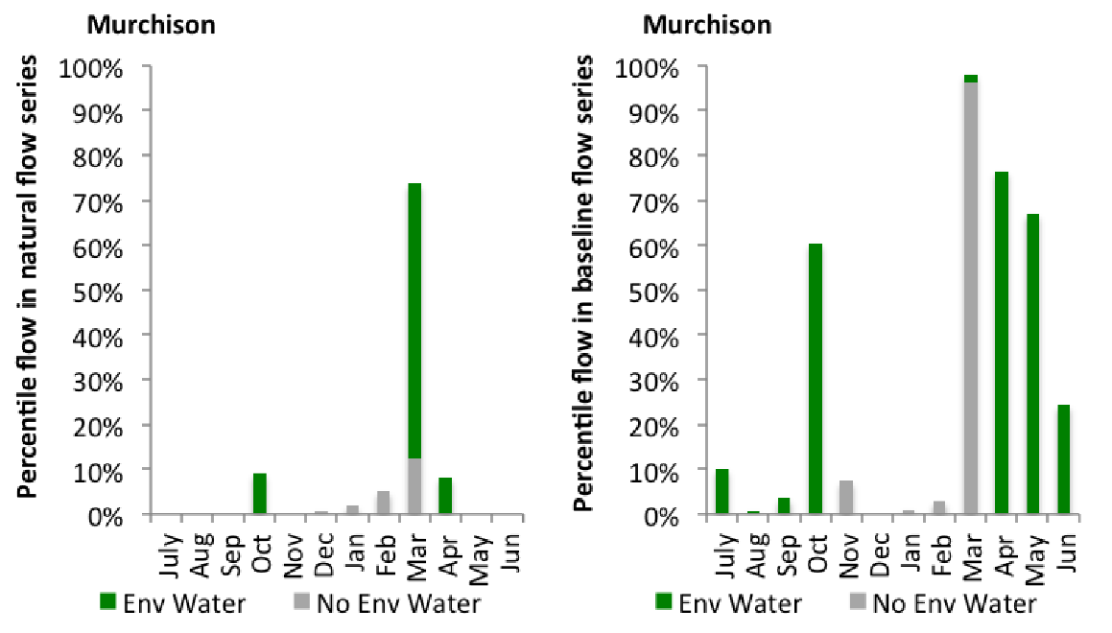
Figure GLB8: Contribution of environmental water delivery at Murchison as percentiles in the natural and baseline flow series.
McCoys
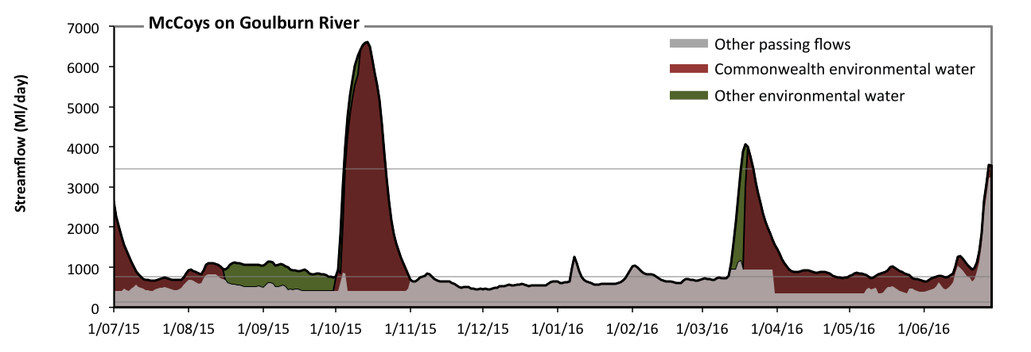
Figure GLB9: Contribution of environmental water delivery at McCoys. Horizontal lines indicate thresholds for very low flows, low flows and low freshes (from lowest to highest).
At McCoys on Goulburn River environmental water contributed 50% of the total streamflow volume (most of which was Commonwealth environmental water). Environmental watering actions affected streamflows for 64% of days between 1 July 2015 and 30 June 2016 (Figure GLB9 and GLB10). Flow regulation does not substantially increase the duration of very low flows (i.e. < 130 Ml/day) compared to an average year in the natural flow regime. However, without environmental water, the durations of medium low flows (i.e. < 770 Ml/day) in the periods July to September, October to December, January to March and April to June would have all substantially exceeded durations expected in an average year in the natural flow regime. Environmental water mitigated these impacts by reducing the cumulative duration of medium low flow spells from 84% to 43% of the year, with greatest influence in the periods July to September and April to June. Commonwealth environmental water made the dominant contribution to these enhancements of environmental baseflows at this site. Environmental water increased the duration of the longest low fresh during the periods October to December (from 0 days to 17 days), January to March (from 0 days to 4 days) and April to June (from 0 days to 2 days). Commonwealth environmental water was almost entirely responsible for these increased durations of low freshes.
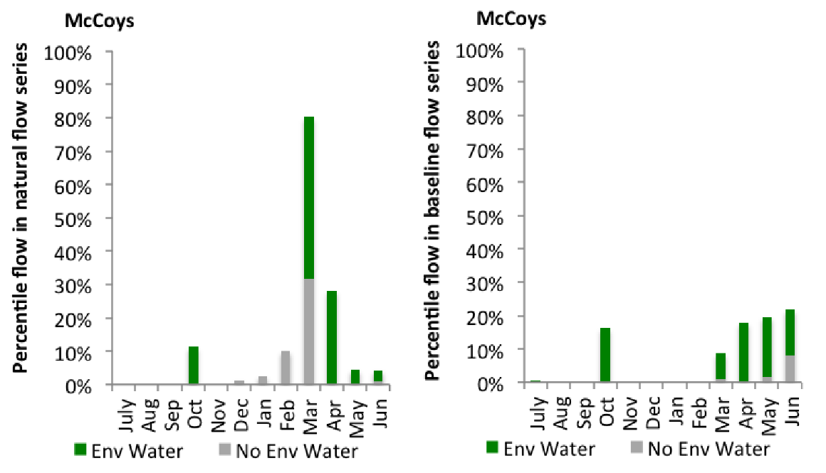
Figure GLB10: Contribution of environmental water delivery at McCoys as percentiles in the natural and baseline flow series.

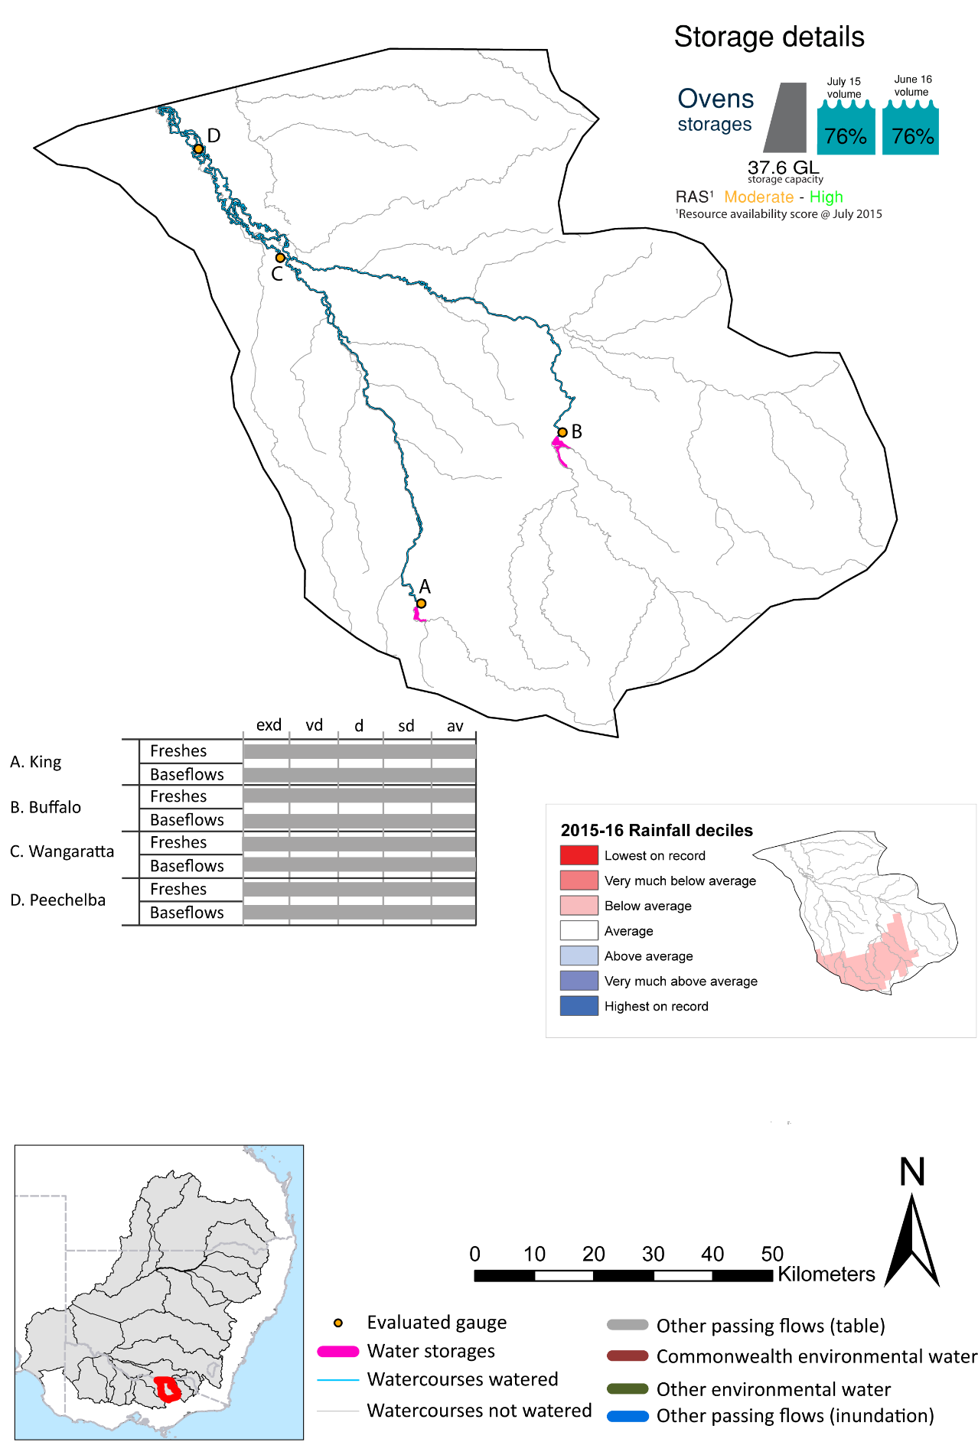
Ovens

Figure OVN1: Watercourses influenced, areas inundated (where applicable) and gauge stations evaluated in the Ovens valley during the 2015-16 water year. Inset bar graphs report the condition of annual flow regimes by showing the improvements in hydrological condition with the addition of environmental water as well as the hypothetical scenario in “grey” (if no environmental flow had been delivered). Rainfall conditions (rainfall deciles) and trend in storage levels for the water year are also shown.

Summary
Environmental water delivery for the 2015-16 year in the Ovens Valley is evaluated using data for 4 sites. This evaluation only considers the contribution of held environmental water, which is a primary focus for the Commonwealth. The contributions of planned environmental water (e.g. passing flows), unregulated tributary inflows and clever use of irrigation flows for environmental benefits can all be very important but these are outside the scope of this report. Environmental watering actions lasted on average 3 days over the course of the year. The volume of environmental water at these 4 sites was between 0% and 0% of the total streamflow. Commonwealth Environmental Water contributed on average 100% of this environmental water. The contribution of environmental water delivery to improved flow regimes is evaluated using data for 4 sites. Ideally, baseflows should be maintained and long periods of excessively low flows avoided. In this valley, the baseflow regime was generally considered to be average relative to the pre-development flow regime. In our analysis, a low fresh refers to a period of increased flow, when the water level rises at least one eighth of the way up the river bank (above the low flow level). These low freshes are a regular part of the natural flow regime and support a range of natural processes. In the Ovens valley, in terms of the occurrence and duration of low freshes, the year was assessed as being average. In our analysis, a medium fresh refers to a period of increased flow, when the water level rises at least one quarter of the way up the river bank. These medium freshes are not as frequent as low freshes but are also a regular and important part of the natural flow regime. In the Ovens valley, in terms of the occurrence of medium freshes, the year was assessed as being average. In our analysis, a high fresh refers to a period of increased flow, when the water level rises more than half way up the river. A high fresh may not occur every year but they are still important and long periods without major freshes can have serious consequences for floodplains and their contribution to river ecosystem health. Delivering environmental water as high in channel flows normally requires that all risks to riparian landholders and infrastructure have been resolved. In the Ovens valley, in terms of the occurrence of high freshes, the year was assessed as being average.

Environmental water system
The Ovens valley covers an area of 7882 km², which represents 0.7% of the total Basin area. The valley is located in north-east Victoria. The Ovens River flows in a northerly direction from its headwaters in the Great Dividing Range. Its main tributary, the King River, joins the Ovens River near Wangaratta. The major water storages in the region include Lake Buffalo on the Buffalo River, with a capacity 20 GL, and Lake William Hovell on the King River, with a capacity of 13 GL. Over half of the region is covered with native vegetation primarily in the highlands.
Environmental water is delivered in the Ovens River as managed in-stream flows sourced from Lake William Hovell and Lake Buffalo. The main purpose of environmental flow delivery in the Ovens are to maintain and or improve the ecological condition and functioning of the system. Typically water is only available from the holdings, so outcomes in the reaches immediately downstream of the holding areas are targeted. At times, these actions are delivered together with consumptive water. The Ovens valley is not considered to contain significant constraints to the delivery of environmental water (Mdba 2013). Under high and very high inflow conditions, environmental water deliveries are not feasible due to channel capacity constraints arising from river operating practices and agreed rules within the catchment (Mdba 2013).

Data availability
Daily discharge data was provided by GMW at four gauge stations within the Ovens valley (Figure OVN1). GMW derived the contribution of the Commonwealth environmental water and other passing flows based on the water released from storages and recorded flows at the downstream flow gauges. The contribution made by each component was derived by delivering agreed volumes with each water holder. Delivery volumes for the Commonwealth environmental water were deemed at Lake Buffalo and Lake William Hovell. Flows that were estimated to arrive at Wangaratta were not available for use further downstream in the Murray system. Losses between upstream reservoirs and accounting points were not taken into account when assessing the flows available due to the low rates of delivery.

Water delivery context
During the 2015-16 water year, the Commonwealth Environmental Water Holder (CEWH) held water entitlements of up to 70ML for environmental use in the Ovens valley. Each year, water utilities allocate the water entitlement holders a percentage of water based on their holding, license type and carryover (the exact rules vary among Jurisdictions). In the 2015-16 water year, the CEWH Ovens entitlements were allocated 70 ML of water, representing 104.48% of the Long term average annual yield for the Ovens valley (67 ML). The 2015-16 water allocation (70 ML) together with the carryover volume of 0 ML of water meant the CEWH had 70 ML of water available for delivery.
A total of 70 ML of Commonwealth environmental water was delivered in the Ovens valley. A total of 0 ML of Commonwealth environmental water was traded to consumptive users and 0ML (0.0% of available resource) of Commonwealth environmental water was carried over for environmental use into the 2016-17 water year.

Environmental conditions and resource availability
The water available for delivery combined with the present and antecedent environmental conditions are key inputs used by environmental water managers in planning and implementing watering actions. Post hoc, this information provides important context when evaluating the effectiveness and appropriateness of environmental water use with respect to hydrological outputs.
The rainfall conditions in the Ovens valley were classified as Average, based on rainfall percentile data for the entire record held by the Bureau of Meteorology for this valley. The major storages in the Ovens valley remained stable, being 76% full at the beginning of the water year and 76% full by the end of the year (Figure OVN1).
The Commonwealth Environmental Water Office (CEWO) calculates resource availability scenarios (RAS) progressively as part of its continual adaptive management planning processes. The RAS are based on the availability of held water (including progressive license acquisitions and allocations) as well as the potential for unregulated or planned environmental flows. The resource availability of held water was classified as Moderate in this valley, whilst the potential for unregulated or planned environmental flow was classified as Moderate to High. The physical conditions meant that the CEWO was managing to Protect in channel habitats and conditions/survival of native fish, vegetation and other biota, primarily through the provision of baseflows. The overal purpose also seeks to maintain the ecological health and resilience of the river systems by providing freshes that maintain appropriate habitat and provide opportunities for breeding and recruitment. The overall demand for environmental water was deemed High (water predominantly needed this year).

Watering actions
A total of 2 watering actions were implemented, the duration of these actions varied (range of individual actions: 1 - 33 days). The total cumulative sum of watering actions days was 34). The number of actions commencing in each season did not vary: Autumn (2). The flow component types delivered included (2 baseflow, 0 freshes, 0 bankfull, 0 overbank and 0 wetland).
Table OVN2. Commonwealth environmental water accounting information for the Ovens valley over 2015-16 water year.
Total registered volume (ML) | Allocated volume (ML) | Carry over available (ML) | Delivered (ML) | LTAAY (ML) | Trade (ML) | Carried over to 2016-17 | Forfeited (ML)
70 | 70 | 70 | 70 | 67 | 0 | 0 | 0

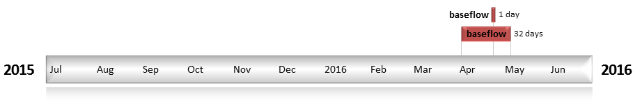
Figure OVN2: Timing and duration of water actions implemented by the CEWO during the 2015-16 water year in the Ovens valley.

Contribution of Commonwealth Environmental Water to Flow Regimes
King
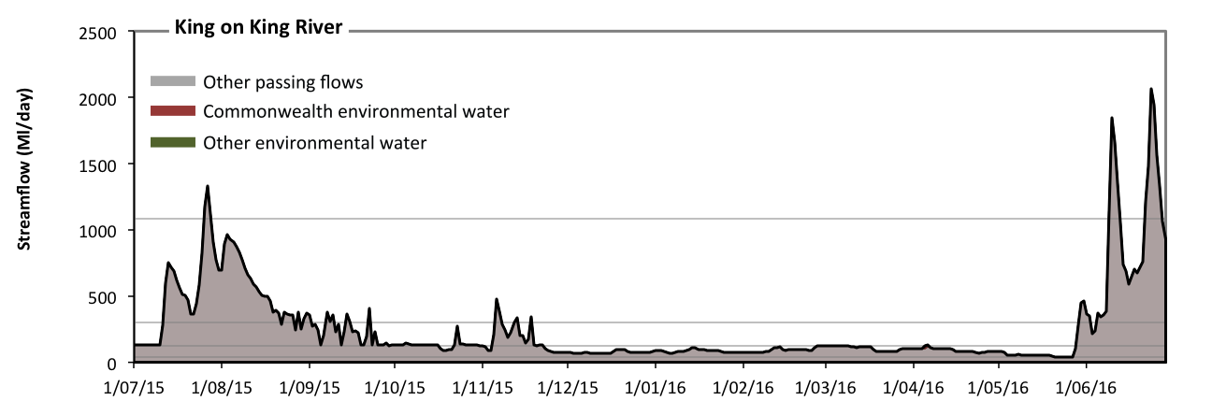
Figure OVN3: Contribution of environmental water delivery at King. Horizontal lines indicate thresholds for very low flows, low flows, low freshes, medium freshes and high freshes (from lowest to highest).
At King on King River environmental water contributed 0% of the total streamflow volume (all of which was Commonwealth environmental water). Environmental watering actions affected streamflows for 1% of days between 1 July 2015 and 30 June 2016 (Figure OVN3 and OVN4). Flow regulation does not substantially increase the duration of very low flows (i.e. < 7.9 Ml/day) compared to an average year in the natural flow regime. Flow regulation does not substantially increase the duration of medium low flows (i.e. < 39 Ml/day) compared to an average year in the natural flow regime. There was at least one low fresh (i.e. > 130 Ml/day) in the periods July to September, October to December and April to June. Environmental water made no change to the duration of these low freshes. There was at least one medium fresh (i.e. > 300 Ml/day) in the periods July to September, October to December and April to June. Environmental water made no change to the duration of these medium freshes. In the absence of environmental water there would have been at least one high fresh in the periods July to September and April to June. Environmental water made no change to the duration of these high freshes.
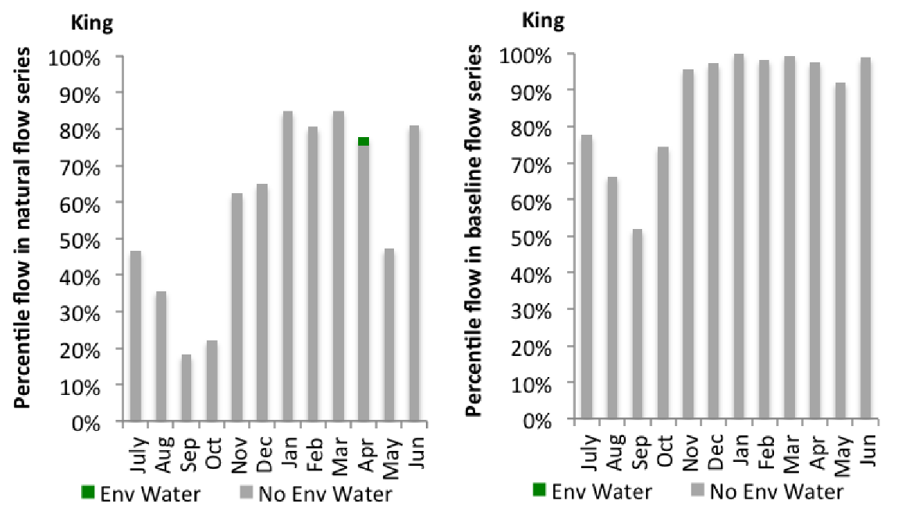
Figure OVN4: Contribution of environmental water delivery at King as percentiles in the natural and baseline flow series.
Wangaratta
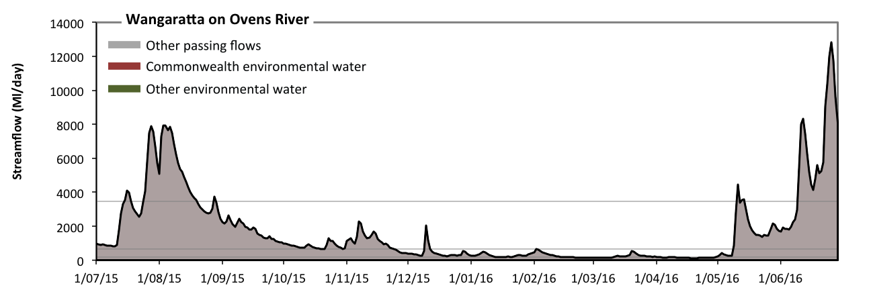
Figure OVN5: Contribution of environmental water delivery at Wangaratta. Horizontal lines indicate thresholds for very low flows, low flows, low freshes, medium freshes and high freshes (from lowest to highest).
At Wangaratta on Ovens River environmental water contributed 0% of the total streamflow volume (all of which was Commonwealth environmental water). Environmental watering actions affected streamflows for 1% of days between 1 July 2015 and 30 June 2016 (Figure OVN5 and OVN6). Flow regulation does not substantially increase the duration of very low flows (i.e. < 5.7 Ml/day) compared to an average year in the natural flow regime. Flow regulation does not substantially increase the duration of medium low flows (i.e. < 28 Ml/day) compared to an average year in the natural flow regime. There was at least one low fresh (i.e. > 190 Ml/day) in the periods July to September, October to December, January to March and April to June. Environmental water made no change to the duration of these low freshes. There was at least one medium fresh (i.e. > 670 Ml/day) in the periods July to September, October to December and April to June. Environmental water made no change to the duration of these medium freshes. In the absence of environmental water there would have been at least one high fresh in the periods July to September and April to June. Environmental water made no change to the duration of these high freshes.
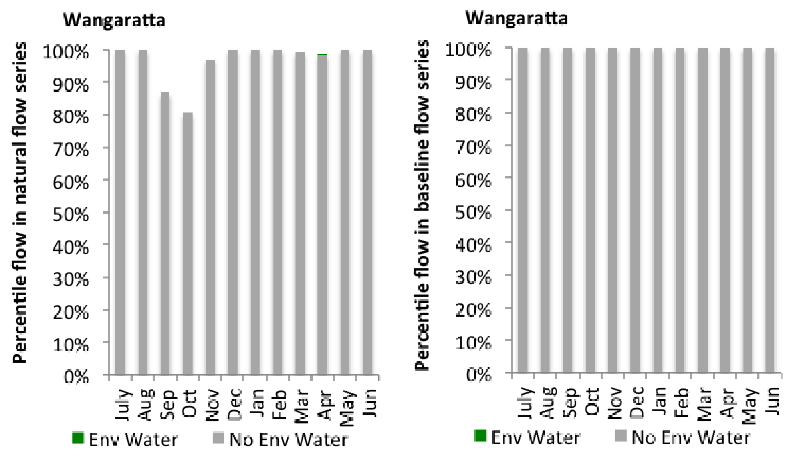
Figure OVN6: Contribution of environmental water delivery at Wangaratta as percentiles in the natural and baseline flow series.
Buffalo
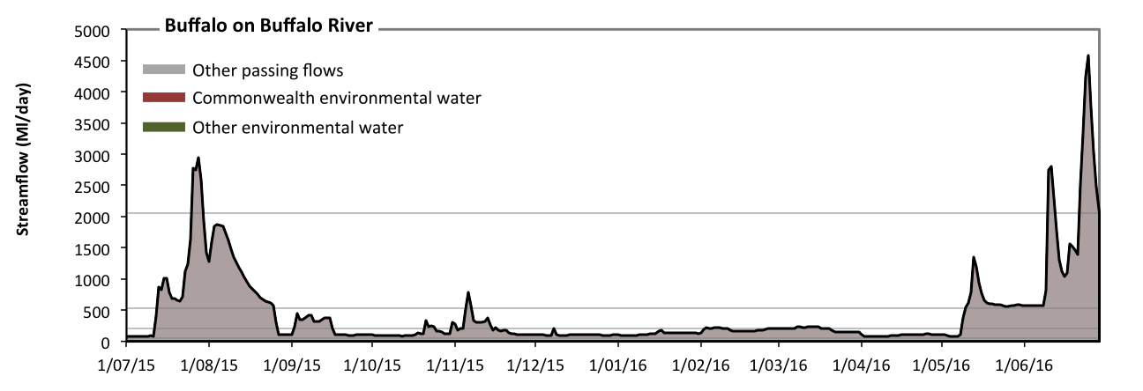
Figure OVN7: Contribution of environmental water delivery at Buffalo. Horizontal lines indicate thresholds for very low flows, low flows, low freshes, medium freshes and high freshes (from lowest to highest).
At Buffalo on Buffalo River environmental water contributed 0% of the total streamflow volume (all of which was Commonwealth environmental water). Environmental watering actions affected streamflows for 1% of days between 1 July 2015 and 30 June 2016 (Figure OVN7 and OVN8). Flow regulation does not substantially increase the duration of very low flows (i.e. < 11 Ml/day) compared to an average year in the natural flow regime. Flow regulation does not substantially increase the duration of medium low flows (i.e. < 56 Ml/day) compared to an average year in the natural flow regime. There was at least one low fresh (i.e. > 200 Ml/day) in the periods July to September, October to December, January to March and April to June. Environmental water made no change to the duration of these low freshes. There was at least one medium fresh (i.e. > 530 Ml/day) in the periods July to September, October to December and April to June. Environmental water made no change to the duration of these medium freshes. In the absence of environmental water there would have been at least one high fresh in the periods July to September and April to June. Environmental water made no change to the duration of these high freshes.
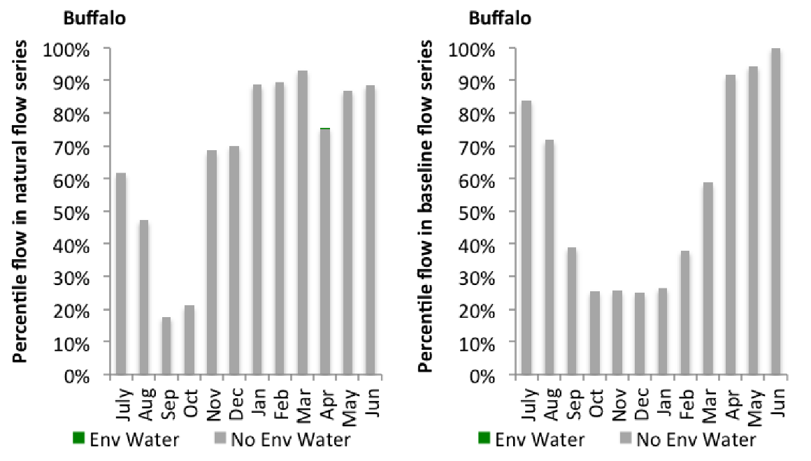
Figure OVN8: Contribution of environmental water delivery at Buffalo as percentiles in the natural and baseline flow series.
Peechelba
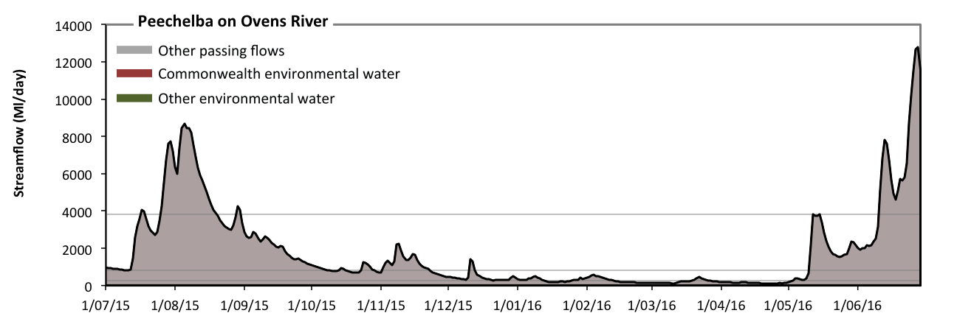
Figure OVN9: Contribution of environmental water delivery at Peechelba. Horizontal lines indicate thresholds for very low flows, low flows, low freshes, medium freshes and high freshes (from lowest to highest).
At Peechelba on Ovens River environmental water contributed 0% of the total streamflow volume (all of which was Commonwealth environmental water). Environmental watering actions affected streamflows for 1% of days between 1 July 2015 and 30 June 2016 (Figure OVN9 and OVN10). Flow regulation does not substantially increase the duration of very low flows (i.e. < 11 Ml/day) compared to an average year in the natural flow regime. Flow regulation does not substantially increase the duration of medium low flows (i.e. < 56 Ml/day) compared to an average year in the natural flow regime. There was at least one low fresh (i.e. > 280 Ml/day) in the periods July to September, October to December, January to March and April to June. Environmental water made no change to the duration of these low freshes. There was at least one medium fresh (i.e. > 830 Ml/day) in the periods July to September, October to December and April to June. Environmental water made no change to the duration of these medium freshes. In the absence of environmental water there would have been at least one high fresh in the periods July to September and April to June. Environmental water made no change to the duration of these high freshes.
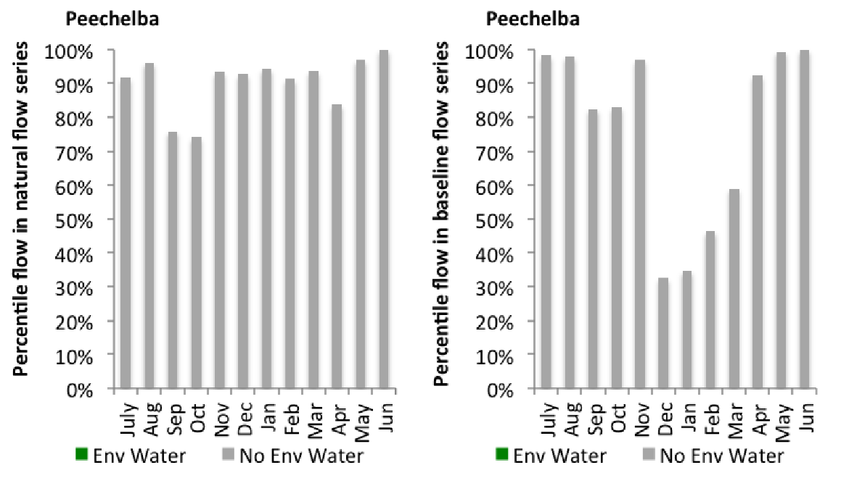
Figure OVN10: Contribution of environmental water delivery at Peechelba as percentiles in the natural and baseline flow series.

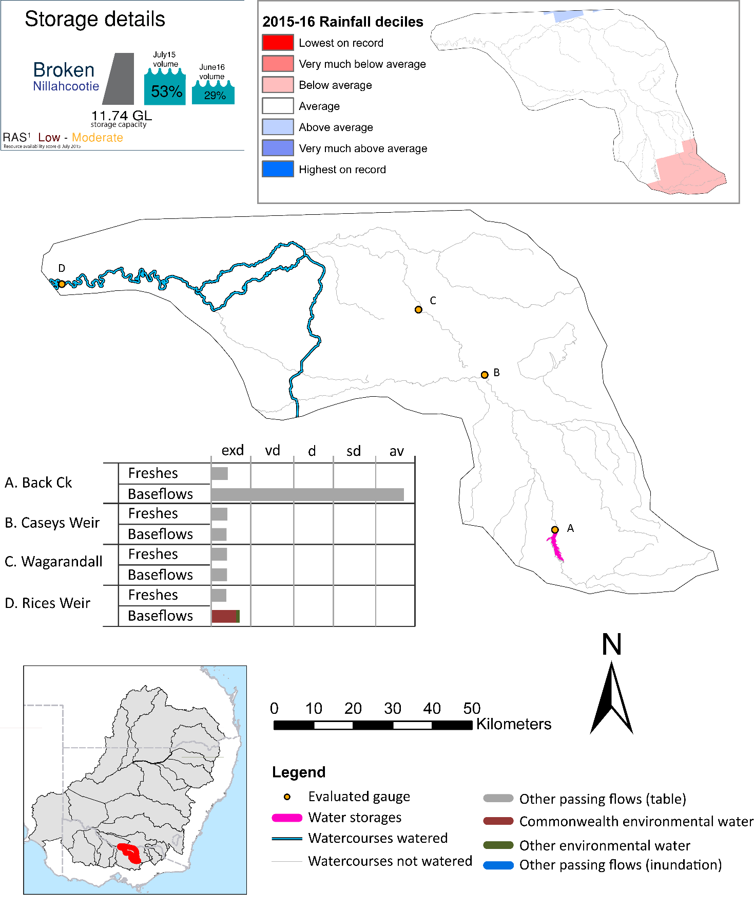
Broken

Figure BRK1: Watercourses influenced, areas inundated (where applicable) and gauge stations evaluated in the Broken valley during the 2015-16 water year. Inset bar graphs report the condition of annual flow regimes by showing the improvements in hydrological condition with the addition of environmental water as well as the hypothetical scenario in “grey” (if no environmental flow had been delivered). Rainfall conditions (rainfall deciles) and trend in storage levels for the water year are also shown.

Summary
Environmental water delivery for the 2015-16 year in the Broken Valley is evaluated using data for 4 sites. This evaluation only considers the contribution of held environmental water, which is a primary focus for the Commonwealth. The contributions of planned environmental water (e.g. passing flows), unregulated tributary inflows and clever use of irrigation flows for environmental benefits can all be very important but these are outside the scope of this report. Environmental watering actions lasted on average 93 days over the course of the year. The volume of environmental water at these 4 sites was between 3% and 33% of the total streamflow. Commonwealth Environmental Water contributed on average 24% of this environmental water. The contribution of environmental water delivery to improved flow regimes is evaluated using data for 4 sites. Ideally, baseflows should be maintained and long periods of excessively low flows avoided. In this valley, the baseflow regime was generally considered to be very dry relative to the pre-development flow regime. In our analysis, a low fresh refers to a period of increased flow, when the water level rises at least one eighth of the way up the river bank (above the low flow level). These low freshes are a regular part of the natural flow regime and support a range of natural processes. In the Broken valley, in terms of the occurrence and duration of low freshes, the year was assessed as being extremely dry. In our analysis, a medium fresh refers to a period of increased flow, when the water level rises at least one quarter of the way up the river bank. These medium freshes are not as frequent as low freshes but are also a regular and important part of the natural flow regime. In the Broken valley, in terms of the occurrence of medium freshes, the year was assessed as being extremely dry. In our analysis, a high fresh refers to a period of increased flow, when the water level rises more than half way up the river. A high fresh may not occur every year but they are still important and long periods without major freshes can have serious consequences for floodplains and their contribution to river ecosystem health. Delivering environmental water as high in channel flows normally requires that all risks to riparian landholders and infrastructure have been resolved. In the Broken valley, in terms of the occurrence of high freshes, the year was assessed as being extremely dry.

Environmental water system
The Broken valley covers approximately 6784 km2 which represents 0.6% of Basin area. Much of the valley has been cleared for dryland and irrigated agriculture.
The valley includes Broken creek, a distributary stream of the Broken River. Broken creek has served as a conduit for irrigation-related water supply flows for over 100 years, with water primarily sourced from the Broken River. Based on records obtained at Casey's Weir gauging station, flows of 5- 10 ML per day in winter and 50-120 ML per day were consistently directed down Broken Creek from 1972 to 2008. In practice, this resulted in a reliable year-round flow regime being experienced by fauna occupying the upper reaches of Broken Creek (downstream to Waggarandall Weir and for some distance beyond) for nearly the last four decades (Commonwealth environmental waterO 2011). Upper Broken Creek maintains relatively low flows all year round from Casey's Weir to Waggarandal Weir (supplying irrigation entitlements), and is ephemeral between Waggarandal Weir and Katamatite with short duration fresh/high flow events occurring in response to catchment rainfall.
The major sources of regulated inflows into the Broken are discharges from the Shepparton and Murray Valley Irrigation Area. The major sources of regulated inflows are the upstream catchments (ie. The upper broken creek), Shepparton unregulated flows and other irrigation drains. About 40,000ML of regulated water is needed in a normal year to supply the consumptive demands along the lower broken creek system, and to cover transmission and operational losses. Environmental water delivery to lower Broken Creek normally comes from both the Goulburn and Murray.
Channel capacity constraints can occur seasonally within both the Shepparton and Murray Valley irrigation area channel systems. Competition with consumptive (irrigation) demands can at times pose a constraint on environmental water delivery. Additionally, the channel systems typically don’t run from mid-May to mid-August.
Analysis of modelled data found that in a very dry year there is likely to be ample capacity in these main channels to deliver environmental water to the Lower Broken Creek. In dry, median and wet years, the Yarrawonga main channel is often at capacity. Along the east Goulburn main channel (which has historically delivered the bulk of water to the Lower Broken Creek), there is likely to be limited spare capacity during the irrigation season in median and wet years.

Data availability
Daily discharge data was provided by GMW at four gauge stations within the Broken valley (Figure BRK1). GMW derived the contribution of the Commonwealth environmental water, VEWH, IVT and other passing flows using operational models in their ‘in house’ accounting spreadsheet. The contribution made by each component was derived by delivering agreed volumes with each water holder (i.e. delivery for TLM was required at specific times). Delivery volumes for the environmental water holders in the Lower Broken Creek were deemed at the outfalls into the Creek with the volume arriving at Rices Weir being made available for use further downstream in the Murray system. Losses within the Broken valley were taken into account when assessing the flows available. The component of environmental flows to the flow in the Broken River was estimated based on the volumes delivered downstream of Lake Nillahcootie.

Water delivery context
During the 2015-16 water year, the Commonwealth Environmental Water Holder (CEWH) held water entitlements of up to 257ML for environmental use in the Broken valley. Each year, water utilities allocate the water entitlement holders a percentage of water based on their holding, license type and carryover (the exact rules vary among Jurisdictions). In the 2015-16 water year, the CEWH Broken entitlements were allocated 66 ML of water, representing 27.16% of the Long term average annual yield for the Broken valley (243 ML). The 2015-16 water allocation (66 ML) together with the carryover volume of 2 ML of water meant the CEWH had 68 ML of water available for delivery.
A total of 29520 ML of Commonwealth environmental water was delivered in the Broken valley. A total of 0 ML of Commonwealth environmental water was traded to consumptive users and 65ML (95.59% of available resource) of Commonwealth environmental water was carried over for environmental use into the 2016-17 water year. Intervalley transfer of water in the southern connected Basin, means on occasion there may be a mismatch between Commonwealth environmental water available for delivery and the actual volume of Commonwealth environmental water delivered.

Environmental conditions and resource availability
The water available for delivery combined with the present and antecedent environmental conditions are key inputs used by environmental water managers in planning and implementing watering actions. Post hoc, this information provides important context when evaluating the effectiveness and appropriateness of environmental water use with respect to hydrological outputs.
The rainfall conditions in the Broken valley were classified as Average, based on rainfall percentile data for the entire record held by the Bureau of Meteorology for this valley. The major storages in the Broken valley remained decreased, being 54% full at the beginning of the water year and 29% full by the end of the year (Figure BRK1).
The Commonwealth Environmental Water Office (CEWO) calculates resource availability scenarios (RAS) progressively as part of its continual adaptive management planning processes. The RAS are based on the availability of held water (including progressive license acquisitions and allocations) as well as the potential for unregulated or planned environmental flows. The resource availability of held water was classified as Low in this valley, whilst the potential for unregulated or planned environmental flow was classified as Moderate. The physical conditions meant that the CEWO was managing to Protect in channel habitats and conditions/survival of native fish, vegetation and other biota, primarily through the provision of baseflows. The overal purpose also seeks to maintain the ecological health and resilience of the river systems by providing freshes that maintain appropriate habitat and provide opportunities for breeding and recruitment. The overall demand for environmental water was deemed High (water predominantly needed this year).

Watering actions
A total of 5 watering actions were implemented, the duration of these actions varied (range of individual actions: 14 - 280 days). The total cumulative sum of watering actions days was 673). The number of actions commencing in each season varied: Winter (2) and Spring (3). The flow component types delivered included (4 baseflow, 1 freshes, 0 bankfull, 0 overbank and 0 wetland).

Table BRK2. Commonwealth environmental water accounting information for the Broken valley over 2015-16 water year.
Total registered volume (ML) | Allocated volume (ML) | Carry over available (ML) | Delivered (ML) | LTAAY (ML) | Trade (ML) | Carried over to 2016-17 | Forfeited (ML)
257 | 66 | 68 | 29520 | 243 | 0 | 65 | 0

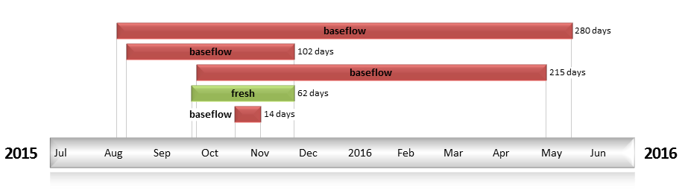
Figure BRK2: Timing and duration of water actions implemented by the CEWO during the 2015-16 water year in the Broken valley.

Contribution of Commonwealth Environmental Water to Flow Regimes
Rices
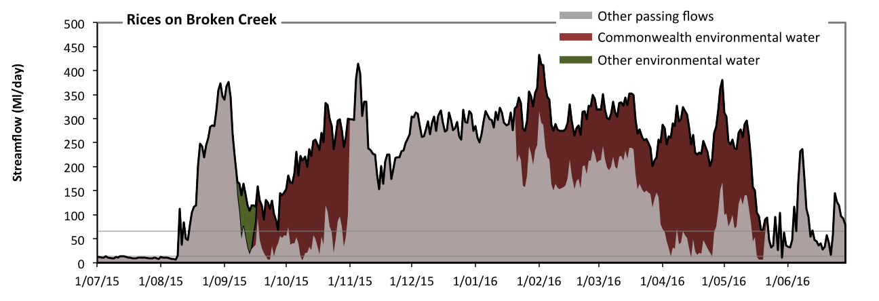
Figure BRK3: Contribution of environmental water delivery at Rices. Horizontal lines indicate thresholds for very low flows and low flows (from lowest to highest).
At Rices on Broken Creek environmental water contributed 33% of the total streamflow volume (most of which was Commonwealth environmental water). Environmental watering actions affected streamflows for 48% of days between 1 July 2015 and 30 June 2016 (Figure BRK3 and BRK4). Without environmental water, the durations of very low flows (i.e. < 13 Ml/day) in the periods July to September and April to June would have substantially exceeded durations expected in an average year in the natural flow regime. Environmental water mitigated these impacts by reducing the cumulative duration of very low flow spells from 14% to 11% of the year, with greatest influence in the periods July to September and April to June. Similarly, without environmental water, the durations of medium low flows (i.e. < 65 Ml/day) in the periods July to September, October to December and April to June would have substantially exceeded durations expected in an average year in the natural flow regime. Environmental water mitigated these impacts by reducing the cumulative duration of medium low flow spells from 38% to 18% of the year, with greatest influence in the periods July to September, October to December and April to June. Commonwealth environmental water was almost entirely responsible for these enhancements of environmental baseflows at this site.
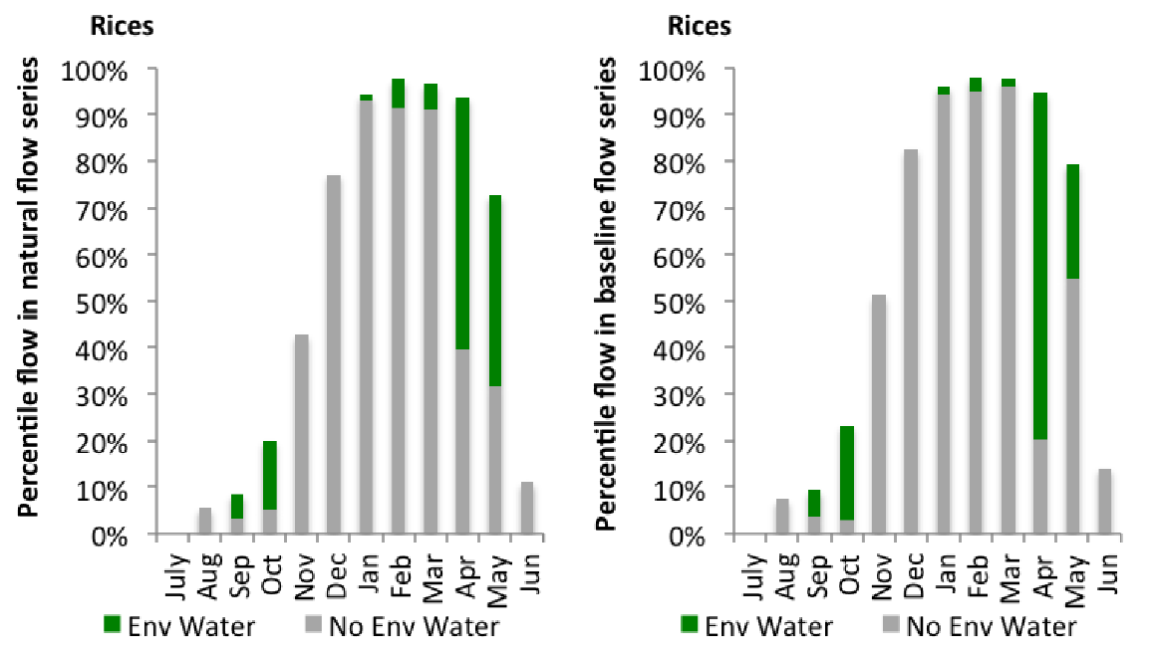
Figure BRK4: Contribution of environmental water delivery at Rices as percentiles in the natural and baseline flow series.
Back Ck
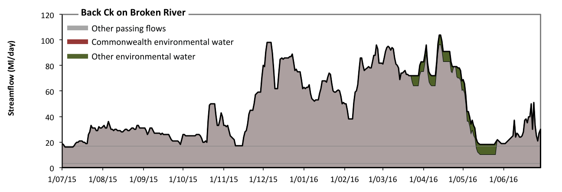
Figure BRK5: Contribution of environmental water delivery at Back Ck. Horizontal lines indicate thresholds for very low flows and low flows (from lowest to highest).
At Back Ck on Broken River environmental water contributed 3% of the total streamflow volume (none of which was Commonwealth environmental water). Environmental watering actions affected streamflows for 17% of days between 1 July 2015 and 30 June 2016 (Figure BRK5 and BRK6). Flow regulation does not substantially increase the duration of very low flows (i.e. < 3.4 Ml/day) compared to an average year in the natural flow regime. Flow regulation does not substantially increase the duration of medium low flows (i.e. < 17 Ml/day) compared to an average year in the natural flow regime. Commonwealth environmental water made little or no contribution to these enhancements of environmental baseflows at this site.
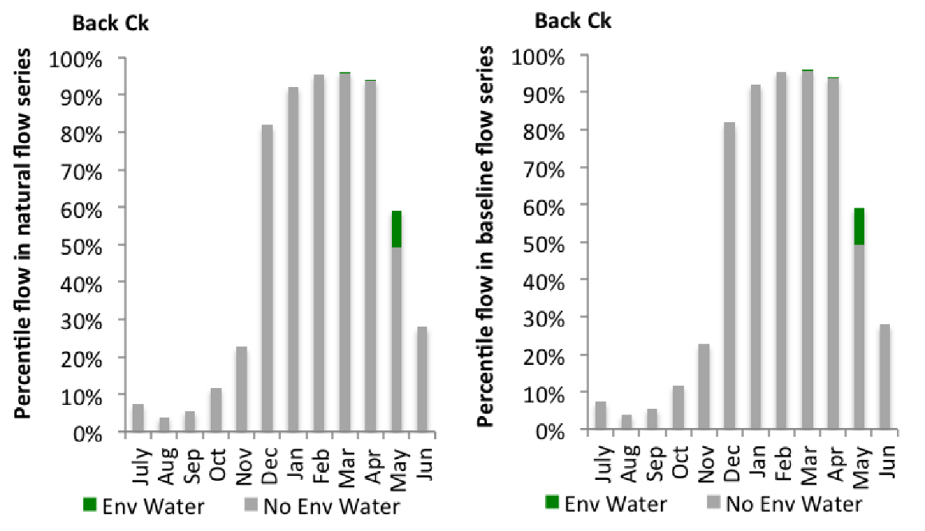
Figure BRK6: Contribution of environmental water delivery at Back Ck as percentiles in the natural and baseline flow series.
Caseys Weir
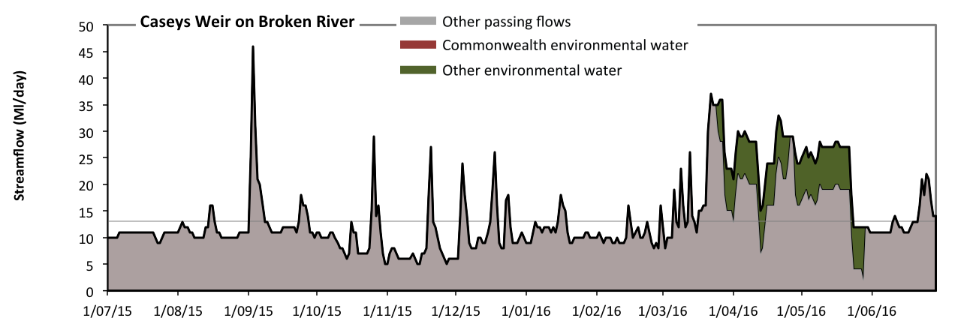
Figure BRK7: Contribution of environmental water delivery at Caseys Weir. Horizontal lines indicate thresholds for very low flows and low flows (from lowest to highest).
At Caseys Weir on Broken River environmental water contributed 10% of the total streamflow volume (none of which was Commonwealth environmental water). Environmental watering actions affected streamflows for 17% of days between 1 July 2015 and 30 June 2016 (Figure BRK7 and BRK8). Without environmental water, the durations of very low flows (i.e. < 13 Ml/day) in the periods July to September, October to December, January to March and April to June would have all substantially exceeded durations expected in an average year in the natural flow regime. Environmental water mitigated these impacts by reducing the cumulative duration of very low flow spells from 70% to 69% of the year, with greatest influence in the period April to June. Similarly, without environmental water, the durations of medium low flows (i.e. < 65 Ml/day) in the periods July to September, October to December, January to March and April to June would have all substantially exceeded durations expected in an average year in the natural flow regime. However, environmental water had little effect on the duration of these medium low flows, which occurred for 100% of the year.
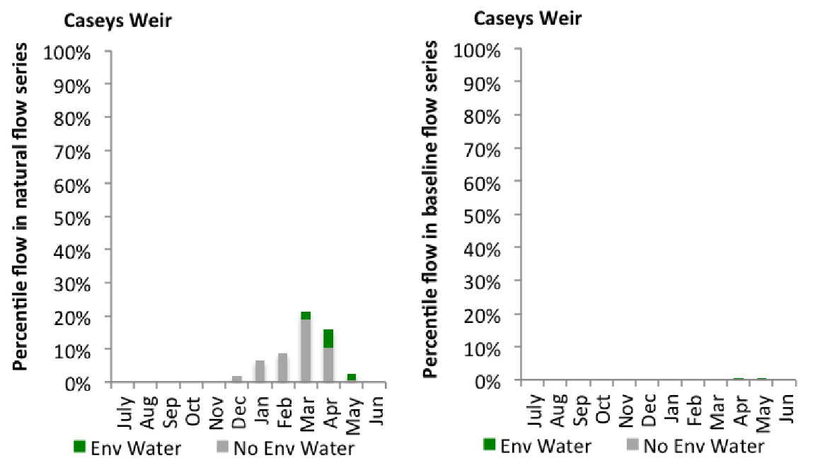
Figure BRK8: Contribution of environmental water delivery at Caseys Weir as percentiles in the natural and baseline flow series.
Wagarandall
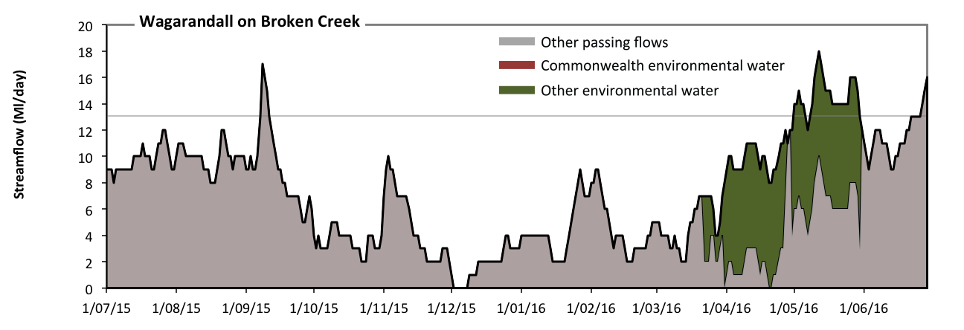
Figure BRK9: Contribution of environmental water delivery at Wagarandall. Horizontal lines indicate thresholds for very low flows and low flows (from lowest to highest).
At Wagarandall on Broken Creek environmental water contributed 19% of the total streamflow volume (none of which was Commonwealth environmental water). Environmental watering actions affected streamflows for 19% of days between 1 July 2015 and 30 June 2016 (Figure BRK9 and BRK10). Without environmental water, the durations of very low flows (i.e. < 13 Ml/day) in the periods July to September, October to December, January to March and April to June would have all substantially exceeded durations expected in an average year in the natural flow regime. Environmental water mitigated these impacts by reducing the cumulative duration of very low flow spells from 98% to 91% of the year, with greatest influence in the period April to June. Similarly, without environmental water, the durations of medium low flows (i.e. < 65 Ml/day) in the periods July to September, October to December, January to March and April to June would have all substantially exceeded durations expected in an average year in the natural flow regime. However, environmental water had little effect on the duration of these medium low flows, which occurred for 100% of the year. Commonwealth environmental water made little or no contribution to these enhancements of environmental baseflows at this site.
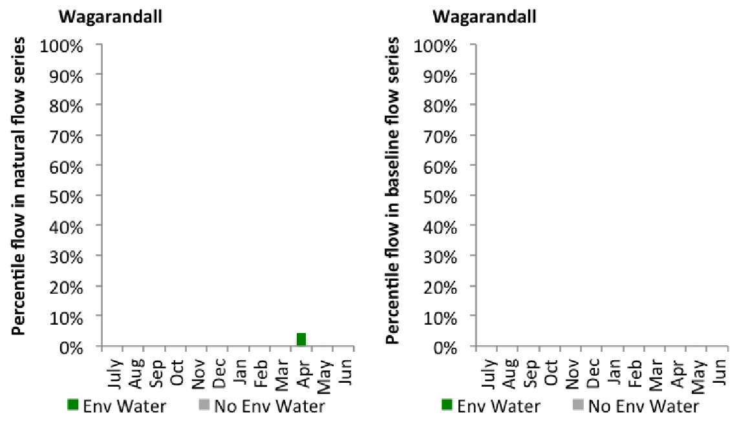
Figure BRK10: Contribution of environmental water delivery at Wagarandall as percentiles in the natural and baseline flow series.

Campaspe
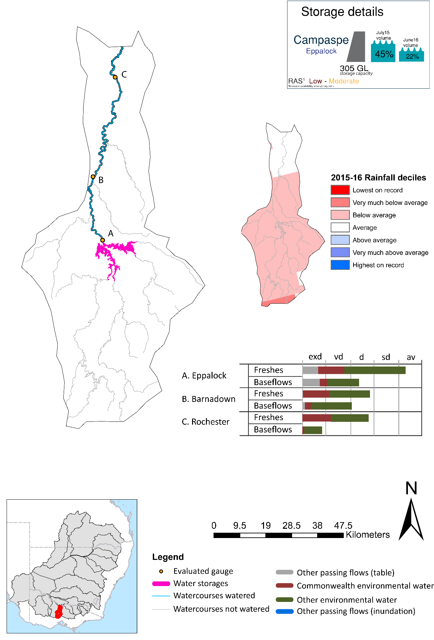

Figure CMP1: Watercourses influenced, areas inundated (where applicable) and gauge stations evaluated in the Campaspe valley during the 2015-16 water year. Inset bar graphs report the condition of annual flow regimes by showing the improvements in hydrological condition with the addition of environmental water as well as the hypothetical scenario in “grey” (if no environmental flow had been delivered). Rainfall conditions (rainfall deciles) and trend in storage levels for the water year are also shown.

Campaspe
Environmental water delivery for the 2015-16 year in the Campaspe Valley is evaluated using data for 3 sites. This evaluation only considers the contribution of held environmental water, which is a primary focus for the Commonwealth. The contributions of planned environmental water (e.g. passing flows), unregulated tributary inflows and clever use of irrigation flows for environmental benefits can all be very important but these are outside the scope of this report. Environmental watering actions lasted on average 204 days over the course of the year. The volume of environmental water at these 3 sites was between 35% and 49% of the total streamflow. Commonwealth Environmental Water contributed on average 23% of this environmental water. The contribution of environmental water delivery to improved flow regimes is evaluated using data for 3 sites. Ideally, baseflows should be maintained and long periods of excessively low flows avoided. In this valley, the baseflow regime was generally considered to be extremely dry relative to the pre-development flow regime. In our analysis, a low fresh refers to a period of increased flow, when the water level rises at least one eighth of the way up the river bank (above the low flow level). These low freshes are a regular part of the natural flow regime and support a range of natural processes. In the Campaspe valley, in terms of the occurrence and duration of low freshes, the year was assessed as being somewhat dry. In our analysis, a medium fresh refers to a period of increased flow, when the water level rises at least one quarter of the way up the river bank. These medium freshes are not as frequent as low freshes but are also a regular and important part of the natural flow regime. In the Campaspe valley, in terms of the occurrence of medium freshes, the year was assessed as being average. In our analysis, a high fresh refers to a period of increased flow, when the water level rises more than half way up the river. A high fresh may not occur every year but they are still important and long periods without major freshes can have serious consequences for floodplains and their contribution to river ecosystem health. Delivering environmental water as high in channel flows normally requires that all risks to riparian landholders and infrastructure have been resolved. In the Campaspe valley, in terms of the occurrence of high freshes, the year was assessed as being very dry.

Environmental water system
The Campaspe valley covers approximately 4020 km2 representing 0.4% of the Mdb. The Campaspe river extends for approximately 160 km from the northern slopes of the Great Dividing Range near Trentham to the River Murray at Echuca. The Campaspe River and Coliban River are the largest rivers in the catchment, but other significant tributaries include Axe, McIvor, Mt Pleasant, Forest, Wild Duck and Pipers Creeks (SKM 2006).
Prior to European settlement, streams in the middle and lower Campaspe River catchment would have had low energy, contained fine grained sediments and had occasional rocky outcrops. Most of the streams would have had incised channels, with deep pools, infrequent riffles over gravel, boulders or logs and an abundance of large woody debris (NCCMA 2005). Flows would have been seasonally variable, with high flows in winter and spring and low or no flow in summer and autumn. However, the construction of reservoirs and weirs for potable supply and irrigation has substantially reduced flows throughout the catchment and reversed the seasonal flow patterns in the lower reaches.
The Campaspe River is heavily regulated and supplies water for irrigation and urban demands. Significant features include: Malmsbury Reservoir, Lake Eppalock, Campaspe Weir and Campaspe Siphon, as well as the Waranga Channel. The regulated sections of the Campaspe River include four main reaches:
1. Coliban River: Malmsbury Reservoir to Lake Eppalock
2. Campaspe River: Lake Eppalock to Campaspe Weir
3. Campaspe River: Campaspe Weir to Campaspe Siphon
4. Campaspe River: Campaspe Siphon to River Murray
The environmental flow needs of the Campaspe valley are broadly summarised as meeting baseflow targets in the Campaspe River and providing contributions towards flows in the Murray River. The key constraints believed to limit environmental flow delivery in this valley occur in the Coliban and Campaspe Rivers.
In the Campaspe River, the main constraint on delivery is on bankfull winter flows (estimated at approximately 8000 to 12000 Ml/d). This is because Lake Eppalock has an outlet capacity of 1000Ml/d to 1850Ml/d (SKM 2006). The Waranga Western Channel could partially contribute to the recommended winter bankfull and overbank flow, but it is also constrained by outfall capacity (1,470 to 2,300 ML/d) (SKM 2006). Moreover, infrastructure capacity and the flooding of Rochester Caravan Park (which occurs at 19,000Ml/d) are additional important constraints (SKM 2006).
In the Coliban River, the main delivery constraint is on low baseflows. This is because Malmsbury Reservoir is partially constrained by the existing outlet, which for low flows, is between 10 ML/d and 45 Ml/d (SKM 2006). SKM (2006) also report that a flow of 8,700 ML/d may overtop the Calder Highway at Malmsbury, constraining delivery of winter bankfull flows.

Data availability
Daily discharge data was provided by GMW at three gauge stations within the Campaspe valley (Figure CMP1). GMW derived the contribution of the Commonwealth environmental water, VEWH, TLM, IVT and other passing flows using operational models in their ‘in house’ accounting spreadsheet. The contribution made by each component was derived by delivering agreed volumes with each water holder (i.e. delivery for TLM was required at specific times). Delivery volumes for the environmental water holders were deemed at Eppalock with the flows that arrive at Rochester being made available for use further downstream in the Murray system. Losses between upstream reservoirs and accounting points were taken into account when assessing the flows available. The component of environmental flows to the flow in the Rochester at the sites upstream of Barnadown was estimated based on the volumes downstream of Eppalock.

Water delivery context
During the 2015-16 water year, the Commonwealth Environmental Water Holder (CEWH) held water entitlements of up to 6942ML for environmental use in the Campaspe valley. Each year, water utilities allocate the water entitlement holders a percentage of water based on their holding, license type and carryover (the exact rules vary among Jurisdictions). In the 2015-16 water year, the CEWH Campaspe entitlements were allocated 4331 ML of water, representing 67.53% of the Long term average annual yield for the Campaspe valley (6413 ML). The 2015-16 water allocation (4331 ML) together with the carryover volume of 0 ML of water meant the CEWH had 4331 ML of water available for delivery.
A total of 3259 ML of Commonwealth environmental water was delivered in the Campaspe valley. A total of 0 ML of Commonwealth environmental water was traded to consumptive users and 991ML (22.86% of available resource) of Commonwealth environmental water was carried over for environmental use into the 2016-17 water year.

Environmental conditions and resource availability
The water available for delivery combined with the present and antecedent environmental conditions are key inputs used by environmental water managers in planning and implementing watering actions. Post hoc, this information provides important context when evaluating the effectiveness and appropriateness of environmental water use with respect to hydrological outputs.
The rainfall conditions in the Campaspe valley were classified as Below Average, based on rainfall percentile data for the entire record held by the Bureau of Meteorology for this valley. The major storages in the Campaspe valley remained decreased, being 45% full at the beginning of the water year and 22% full by the end of the year (Figure CMP1).
The Commonwealth Environmental Water Office (CEWO) calculates resource availability scenarios (RAS) progressively as part of its continual adaptive management planning processes. The RAS are based on the availability of held water (including progressive license acquisitions and allocations) as well as the potential for unregulated or planned environmental flows. The resource availability of held water was classified as Low in this valley, whilst the potential for unregulated or planned environmental flow was classified as Moderate. The physical conditions meant that the CEWO was managing to Protect in channel habitats and conditions/survival of native fish, vegetation and other biota, primarily through the provision of baseflows. The overal purpose also seeks to maintain the ecological health and resilience of the river systems by providing freshes that maintain appropriate habitat and provide opportunities for breeding and recruitment. The overall demand for environmental water was deemed High (water predominantly needed this year).

Watering actions
A total of 2 watering actions were implemented, the duration of these actions varied (range of individual actions: 7 - 10 days). The total cumulative sum of watering actions days was 17). The number of actions commencing in each season varied: Winter (1) and Spring (1). The flow component types delivered included (0 baseflow, 2 freshes, 0 bankfull, 0 overbank and 0 wetland).
Table CMP2. Commonwealth environmental water accounting information for the Campaspe valley over 2015-16 water year.
Total registered volume (ML) | Allocated volume (ML) | Carry over available (ML) | Delivered (ML) | LTAAY (ML) | Trade (ML) | Carried over to 2016-17 | Forfeited (ML)
6942 | 4331 | 4331 | 3259 | 6413 | 0 | 991 | 30

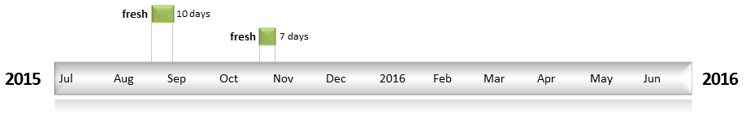
Figure CMP2: Timing and duration of water actions implemented by the CEWO during the 2015-16 water year in the Campaspe valley.

Contribution of Commonwealth Environmental Water to Flow Regimes
Eppalock
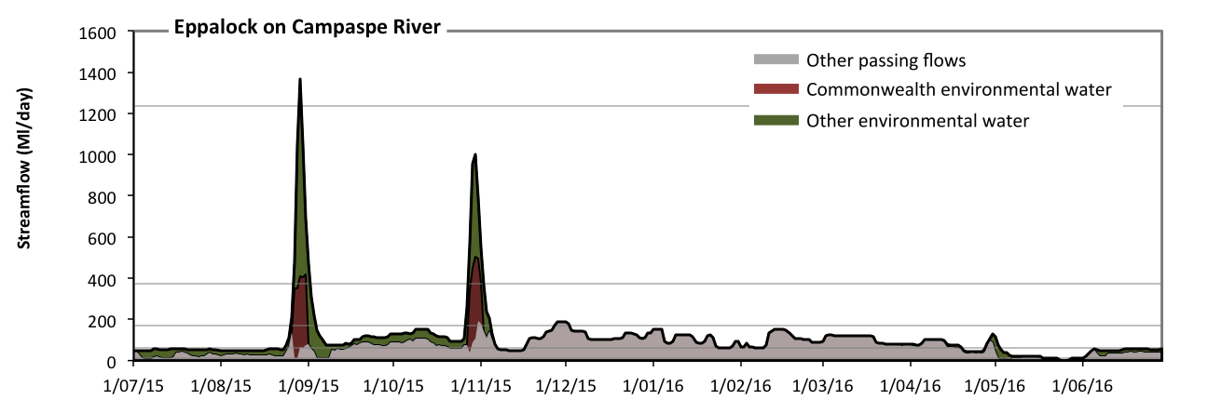
Figure CMP3: Contribution of environmental water delivery at Eppalock. Horizontal lines indicate thresholds for very low flows, low flows, low freshes, medium freshes and high freshes (from lowest to highest).
At Eppalock on Campaspe River environmental water contributed 35% of the total streamflow volume (with a medium contribution of Commonwealth environmental water). Environmental watering actions affected streamflows for 56% of days between 1 July 2015 and 30 June 2016 (Figure CMP3 and CMP4). Without environmental water, the duration of very low flows (i.e. < 12 Ml/day) in the period July to September would have substantially exceeded durations expected in an average year in the natural flow regime. Environmental water mitigated these impacts by reducing the cumulative duration of very low flow spells from 10% to 4% of the year, with greatest influence in the periods July to September and April to June. Similarly, without environmental water, the durations of medium low flows (i.e. < 61 Ml/day) in the periods July to September and April to June would have substantially exceeded durations expected in an average year in the natural flow regime. Environmental water mitigated these impacts by reducing the cumulative duration of medium low flow spells from 43% to 36% of the year, with greatest influence in the period July to September. Commonwealth environmental water made a small contribution to these enhancements of environmental baseflows at this site. In the absence of environmental water there would have been at least one low fresh (i.e. > 170 Ml/day) in the period October to December. Environmental water increased the duration of the longest low fresh during the periods July to September (from 0 days to 9 days) and October to December (from 5 days to 9 days). Commonwealth environmental water made a modest contribution to these increased durations of low freshes. In the absence of environmental water there would have been no medium or high freshes this year. Environmental water increased the duration of the longest medium fresh during the periods July to September (from 0 days to 6 days) and October to December (from 0 days to 5 days). Commonwealth environmental water equally shared responsibility with other environmental water holders for these increased durations of medium freshes. Environmental water increased the duration of the longest medium fresh during the period July to September (from 0 days to 1 days). Commonwealth environmental water equally shared responsibility with other environmental water holders for these increased durations of high freshes.
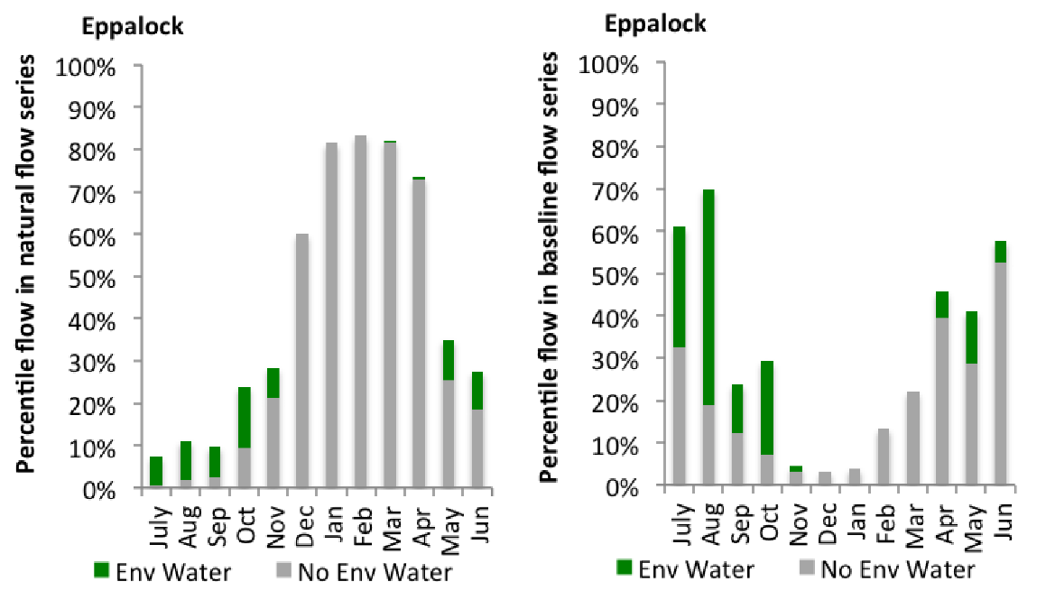
Figure CMP4: Contribution of environmental water delivery at Eppalock as percentiles in the natural and baseline flow series.
Barnadown
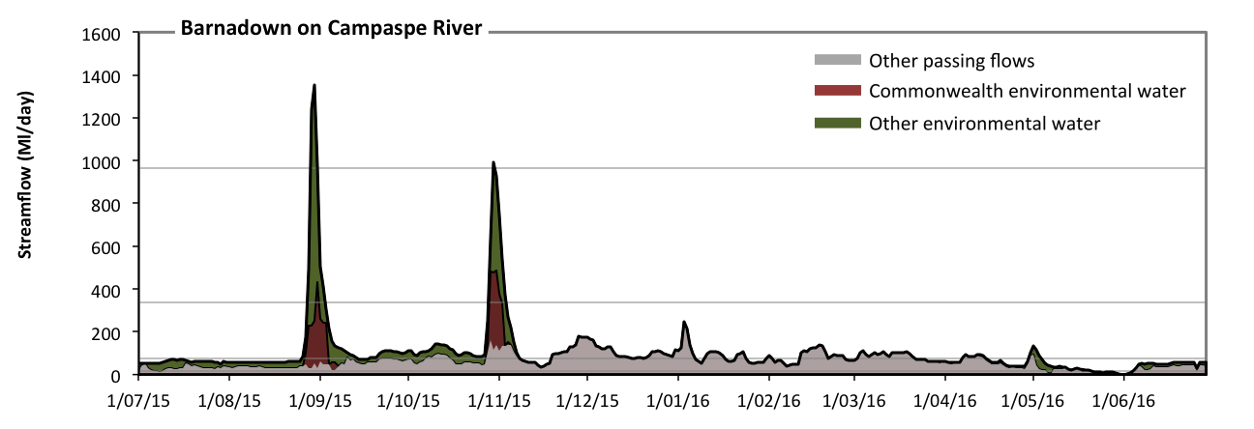Figure CMP5: Contribution of environmental water delivery at Barnadown. Horizontal lines indicate thresholds for very low flows, low flows, low freshes and medium freshes (from lowest to highest).
At Barnadown on Campaspe River environmental water contributed 37% of the total streamflow volume (with a medium contribution of Commonwealth environmental water). Environmental watering actions affected streamflows for 55% of days between 1 July 2015 and 30 June 2016 (Figure CMP5 and CMP6). Without environmental water, the duration of very low flows (i.e. < 15 Ml/day) in the period April to June would have substantially exceeded durations expected in an average year in the natural flow regime. Environmental water mitigated these impacts by reducing the cumulative duration of very low flow spells from 7% to 4% of the year, with greatest influence in the periods July to September and April to June. Similarly, without environmental water, the durations of medium low flows (i.e. < 77 Ml/day) in the periods July to September, October to December and April to June would have substantially exceeded durations expected in an average year in the natural flow regime. Environmental water mitigated these impacts by reducing the cumulative duration of medium low flow spells from 66% to 52% of the year, with greatest influence in the periods July to September and October to December. Commonwealth environmental water made a small contribution to these enhancements of environmental baseflows at this site. Environmental water increased the duration of the longest low fresh during the periods July to September (from 0 days to 6 days) and October to December (from 0 days to 6 days). Commonwealth environmental water made a modest contribution to these increased durations of low freshes. Environmental water increased the duration of the longest medium fresh during the periods July to September (from 0 days to 3 days) and October to December (from 0 days to 1 days). Commonwealth environmental water equally shared responsibility with other environmental water holders for these increased durations of medium freshes.
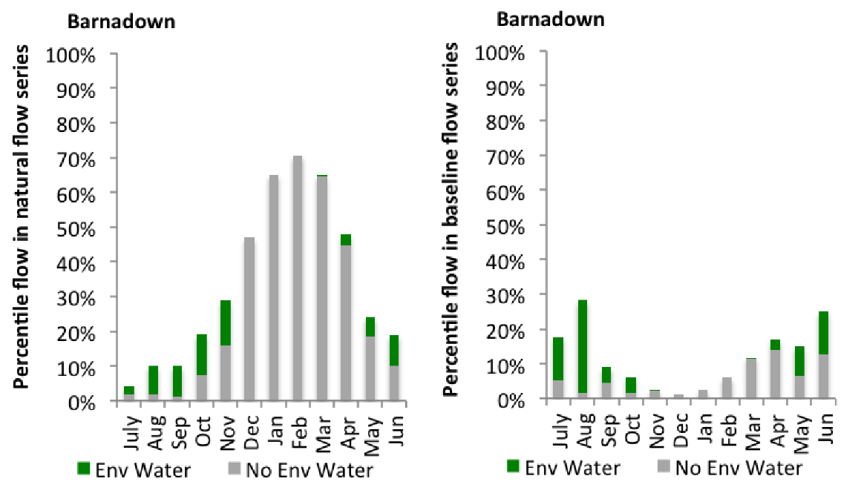
Figure CMP6: Contribution of environmental water delivery at Barnadown as percentiles in the natural and baseline flow series.

Rochester
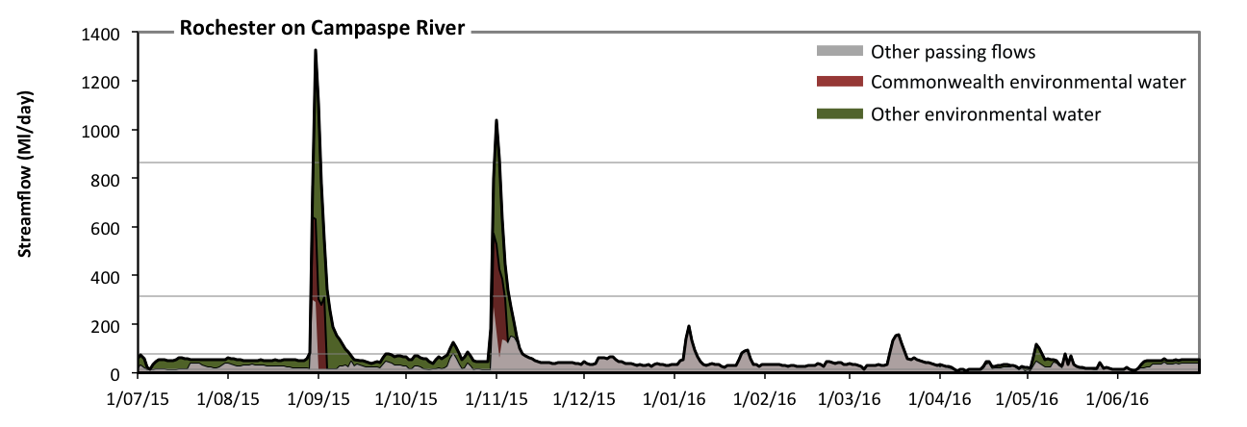
Figure CMP7: Contribution of environmental water delivery at Rochester. Horizontal lines indicate thresholds for very low flows, low flows, low freshes and medium freshes (from lowest to highest).
At Rochester on Campaspe River environmental water contributed 49% of the total streamflow volume (with a medium contribution of Commonwealth environmental water). Environmental watering actions affected streamflows for 56% of days between 1 July 2015 and 30 June 2016 (Figure CMP7 and CMP8). Without environmental water, the durations of very low flows (i.e. < 15 Ml/day) in the periods July to September, October to December and April to June would have substantially exceeded durations expected in an average year in the natural flow regime. Environmental water mitigated these impacts by reducing the cumulative duration of very low flow spells from 18% to 5% of the year, with greatest influence in the periods July to September, October to December and April to June. Similarly, without environmental water, the durations of medium low flows (i.e. < 77 Ml/day) in the periods July to September, October to December, January to March and April to June would have all substantially exceeded durations expected in an average year in the natural flow regime. Environmental water mitigated these impacts by reducing the cumulative duration of medium low flow spells from 93% to 87% of the year, with greatest influence in the periods July to September and October to December. Commonwealth environmental water made a small contribution to these enhancements of environmental baseflows at this site. Environmental water increased the duration of the longest low fresh during the periods July to September (from 0 days to 6 days) and October to December (from 0 days to 6 days). Commonwealth environmental water equally shared responsibility with other environmental water holders for these increased durations of low freshes. Environmental water increased the duration of the longest medium fresh during the periods July to September (from 0 days to 2 days) and October to December (from 0 days to 2 days). Commonwealth environmental water equally shared responsibility with other environmental water holders for these increased durations of medium freshes.
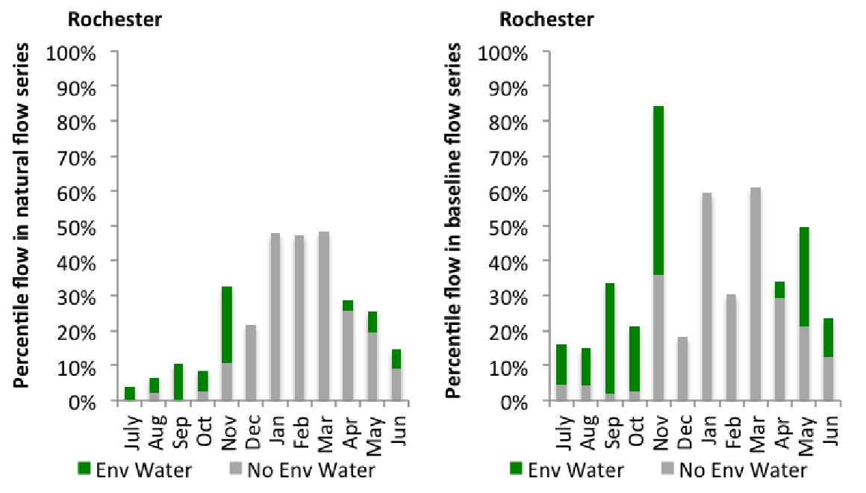
Figure CMP8: Contribution of environmental water delivery at Rochester as percentiles in the natural and baseline flow series.

Border Rivers
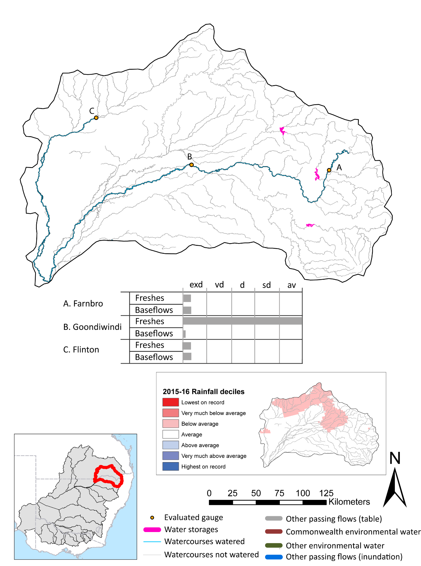

Figure BRD1: Watercourses influenced, areas inundated (where applicable) and gauge stations evaluated in the Border Rivers valley during the 2015-16 water year. Inset bar graphs report the condition of annual flow regimes by showing the improvements in hydrological condition with the addition of environmental water as well as the hypothetical scenario in “grey” (if no environmental flow had been delivered). Rainfall conditions (rainfall deciles) and trend in storage levels for the water year are also shown.

Summary
Environmental water delivery for the 2015-16 year in the Border Rivers Valley is evaluated using data for 3 sites. This evaluation only considers the contribution of held environmental water, which is a primary focus for the Commonwealth. The contributions of planned environmental water (e.g. passing flows), unregulated tributary inflows and clever use of irrigation flows for environmental benefits can all be very important but these are outside the scope of this report. Environmental watering actions lasted on average 4 days over the course of the year. The volume of environmental water at these 3 sites was between 0% and 33% of the total streamflow. Commonwealth Environmental Water contributed on average 100% of this environmental water. The contribution of environmental water delivery to improved flow regimes is evaluated using data for 3 sites. Ideally, baseflows should be maintained and long periods of excessively low flows avoided. In this valley, the baseflow regime was generally considered to be extremely dry relative to the pre-development flow regime. In our analysis, a low fresh refers to a period of increased flow, when the water level rises at least one eighth of the way up the river bank (above the low flow level). These low freshes are a regular part of the natural flow regime and support a range of natural processes. In the Border Rivers valley, in terms of the occurrence and duration of low freshes, the year was assessed as being very dry. In our analysis, a medium fresh refers to a period of increased flow, when the water level rises at least one quarter of the way up the river bank. These medium freshes are not as frequent as low freshes but are also a regular and important part of the natural flow regime. In the Border Rivers valley, in terms of the occurrence of medium freshes, the year was assessed as being very dry. In our analysis, a high fresh refers to a period of increased flow, when the water level rises more than half way up the river. A high fresh may not occur every year but they are still important and long periods without major freshes can have serious consequences for floodplains and their contribution to river ecosystem health. Delivering environmental water as high in channel flows normally requires that all risks to riparian landholders and infrastructure have been resolved. In the Border Rivers valley, in terms of the occurrence of high freshes, the year was assessed as being very dry.

Environmental water system
The Condamine valley is spread across south-west Queensland and north-west NSW, occurring in mostly semi-arid, largely flat region of the northern basin. Under natural conditions rivers, such as the Condamine experience periods of no flow, which can last up to several years, especially when there is no significant rainfall or nothing is done to supplement the flow. Commonwealth environmental water holdings in this valley comprise unsupplemented water allocations (on the Queensland side). Accessing these water entitlements is contingent upon river flow thresholds triggering periods of ‘take’. Volumetric limits and maximum daily take rates limit the volume of water available for use. The Commonwealth Environmental Water Office uses these entitlements “passively”, leaving the water in-stream for downstream benefit.

Data availability
The Commonwealth environmental water office closely monitors stream flows in the Border Rivers by monitoring in real-time the flow at selected river gauges to detect when access rights to Commonwealth unregulated entitlements will be triggered. River flow data in conjunction with official announcements of water harvesting access in unregulated entilements in the Border Rivers are used to estimate in-stream use. Volumes are accounted for in accordance with the licence (access) conditions of each entitlement in the same way that other water users manage their take, and assume that water is used at all available opportunities (when flow conditions are triggered) up to allowed limits. This reflects the use pattern of use of the majority of irrigators in unregulated systems and hence the volumes and pattern of flows that have been reinstated to the systems. The Border River valley includes watering actions delivered in the Moonie River.

Water delivery context
During the 2015-16 water year, the Commonwealth Environmental Water Holder (CEWH) held water entitlements of up to 34533ML for environmental use in the Border Rivers valley. Each year, water utilities allocate the water entitlement holders a percentage of water based on their holding, license type and carryover (the exact rules vary among Jurisdictions). In the 2015-16 water year, the CEWH Border Rivers entitlements were allocated 3524 ML of water, representing 26.58% of the Long term average annual yield for the Border Rivers valley (13260 ML). The 2015-16 water allocation (3524 ML) together with the carryover volume of 6594 ML of water meant the CEWH had 10118 ML of water available for delivery.
A total of 1248 ML of Commonwealth environmental water was delivered in the Border Rivers valley. A total of 0 ML of Commonwealth environmental water was traded to consumptive users and 8876ML (87.88% of available resource) of Commonwealth environmental water was carried over for environmental use into the 2016-17 water year.

Environmental conditions and resource availability
The water available for delivery combined with the present and antecedent environmental conditions are key inputs used by environmental water managers in planning and implementing watering actions. Post hoc, this information provides important context when evaluating the effectiveness and appropriateness of environmental water use with respect to hydrological outputs.
The rainfall conditions in the Border Rivers valley were classified as Average, based on rainfall percentile data for the entire record held by the Bureau of Meteorology for this valley. The major storages in the Border Rivers valley remained stable, being 32% full at the beginning of the water year and 32% full by the end of the year (Figure BRD1).
The Commonwealth Environmental Water Office (CEWO) calculates resource availability scenarios (RAS) progressively as part of its continual adaptive management planning processes. The RAS are based on the availability of held water (including progressive license acquisitions and allocations) as well as the potential for unregulated or planned environmental flows. The resource availability of held water was classified as Low in this valley, whilst the potential for unregulated or planned environmental flow was classified as Moderate. The physical conditions meant that the CEWO was managing to Protect in channel assets in the Macintyre, and where practical, contribute to wetlands and anabranches to ensure ecological capacity for recovery. The overall demand for environmental water was deemed High (water predominantly needed this year).

Watering actions
A total of 6 watering actions were implemented, the duration of these actions varied (range of individual actions: 1 -11 days). The total cumulative sum of watering actions days was 19). The number of actions commencing in each season varied: Winter (3), Spring (1) and Summer (2). The flow component types delivered included (1 baseflow, 5 freshes, 0 bankfull, 0 overbank and 0 wetland).

Table BRD2. Commonwealth environmental water accounting information for the Border Rivers valley over 2015-16 water year.
Total registered volume (ML) | Allocated volume (ML) | Carry over available (ML) | Delivered (ML) | LTAAY (ML) | Trade (ML) | Carried over to 2016-17 | Forfeited (ML)
34533 | 3524 | 10118 | 1248 | 13260 | 0 | 8876 | 0

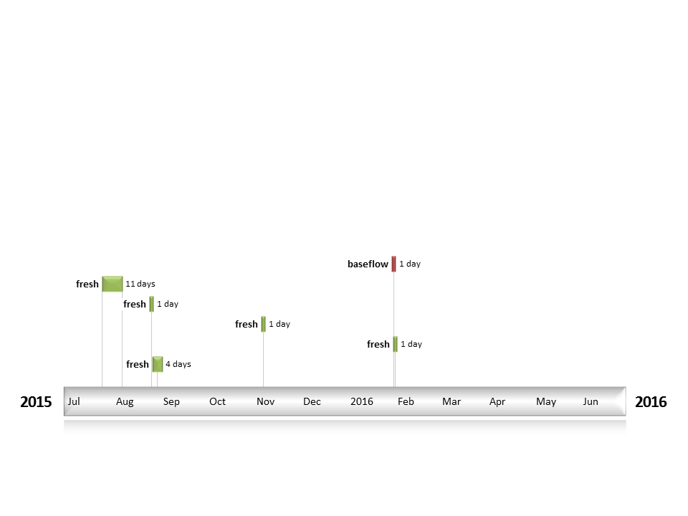
Figure BRD2: Timing and duration of water actions implemented by the CEWO during the 2015-16 water year in the Border Rivers valley.

Contribution of Commonwealth Environmental Water to Flow Regimes
Farnbro
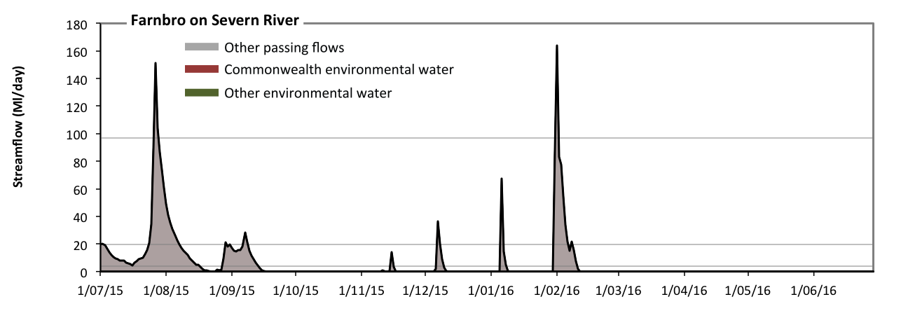
Figure BRD3: Contribution of environmental water delivery at Farnbro. Horizontal lines indicate thresholds for very low flows, low flows and low freshes (from lowest to highest).
At Farnbro on Severn River environmental water contributed 1% of the total streamflow volume (all of which was Commonwealth environmental water). Environmental watering actions affected streamflows for 1% of days between 1 July 2015 and 30 June 2016 (Figure BRD3 and BRD4). Without environmental water, the durations of very low flows (i.e. < 3.9 Ml/day) in the periods October to December, January to March and April to June would have substantially exceeded durations expected in an average year in the natural flow regime. However, environmental water had little effect on the duration of these very low flows, which occurred for 78% of the year. Similarly, without environmental water, the durations of medium low flows (i.e. < 19 Ml/day) in the periods July to September, October to December, January to March and April to June would have all substantially exceeded durations expected in an average year in the natural flow regime. However, environmental water had little effect on the duration of these medium low flows, which occurred for 91% of the year. There was at least one low fresh (i.e. > 97 Ml/day) in the periods July to September and January to March. Environmental water made no change to the duration of these low freshes. There was no medium or high freshes this year.

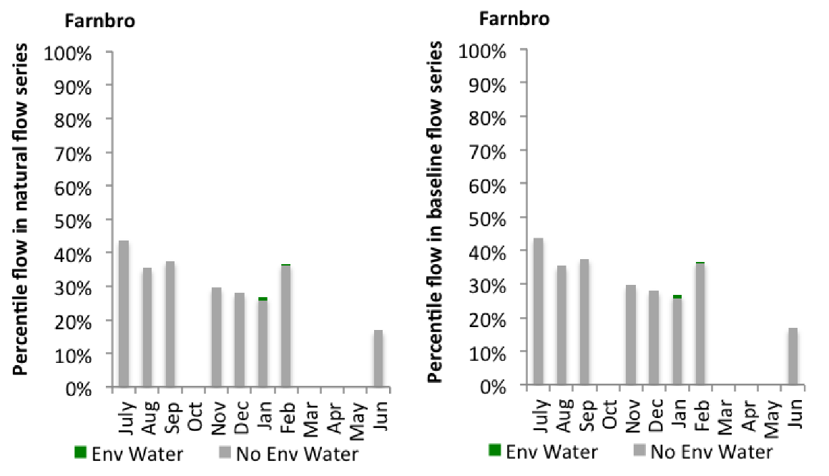
Figure BRD4: Contribution of environmental water delivery at Farnbro as percentiles in the natural and baseline flow series.
Goondiwindi
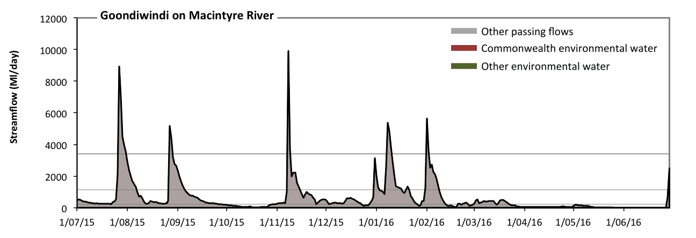
Figure BRD5: Contribution of environmental water delivery at Goondiwindi. Horizontal lines indicate thresholds for very low flows, low flows, low freshes, medium freshes and high freshes (from lowest to highest).
At Goondiwindi on Macintyre River environmental water contributed 0% of the total streamflow volume (all of which was Commonwealth environmental water). Environmental watering actions affected streamflows for 2% of days between 1 July 2015 and 30 June 2016 (Figure BRD5 and BRD6). Without environmental water, the durations of very low flows (i.e. < 48 Ml/day) in the periods October to December and April to June would have substantially exceeded durations expected in an average year in the natural flow regime. However, environmental water had little effect on the duration of these very low flows, which occurred for 17% of the year. Similarly, without environmental water, the durations of medium low flows (i.e. < 240 Ml/day) in the periods October to December, January to March and April to June would have substantially exceeded durations expected in an average year in the natural flow regime. However, environmental water had little effect on the duration of these medium low flows, which occurred for 43% of the year. There was at least one low fresh (i.e. > 1100 Ml/day) in the periods July to September, October to December, January to March and April to June. Environmental water made no change to the duration of these low freshes. There was at least one medium fresh (i.e. > 3400 Ml/day) in the periods July to September, October to December and January to March. Environmental water made no change to the duration of these medium freshes. In the absence of environmental water there would have been at least one high fresh in the periods July to September, October to December and January to March. Environmental water made no change to the duration of these high freshes.
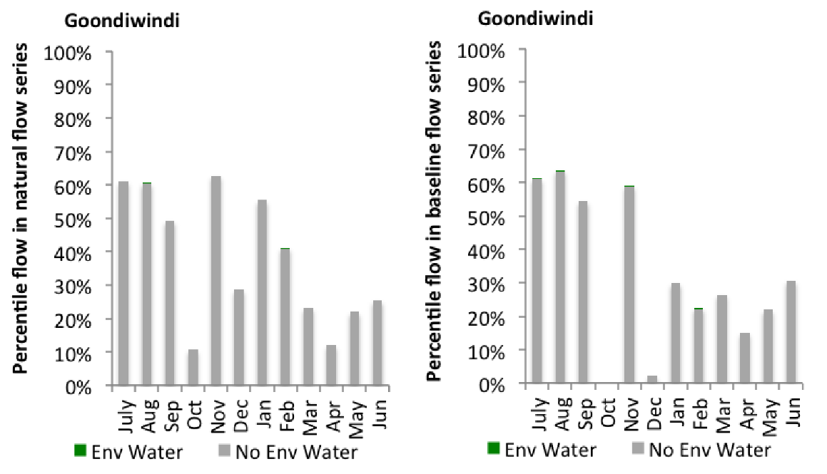
Figure BRD6: Contribution of environmental water delivery at Goondiwindi as percentiles in the natural and baseline flow series.
Flinton
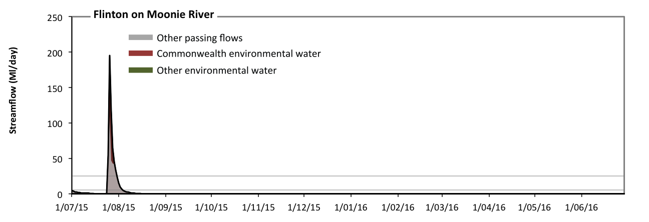
Figure BRD7: Contribution of environmental water delivery at Flinton. Horizontal lines indicate thresholds for very low flows and low flows (from lowest to highest).
At Flinton on Moonie River environmental water contributed 33% of the total streamflow volume (all of which was Commonwealth environmental water). Environmental watering actions affected streamflows for 1% of days between 1 July 2015 and 30 June 2016 (Figure BRD7 and BRD8). Without environmental water, the durations of very low flows (i.e. < 5.1 Ml/day) in the periods July to September, October to December, January to March and April to June would have all substantially exceeded durations expected in an average year in the natural flow regime. However, environmental water had little effect on the duration of these very low flows, which occurred for 97% of the year. Similarly, without environmental water, the durations of medium low flows (i.e. < 25 Ml/day) in the periods July to September, October to December, January to March and April to June would have all substantially exceeded durations expected in an average year in the natural flow regime. However, environmental water had little effect on the duration of these medium low flows, which occurred for 98% of the year.
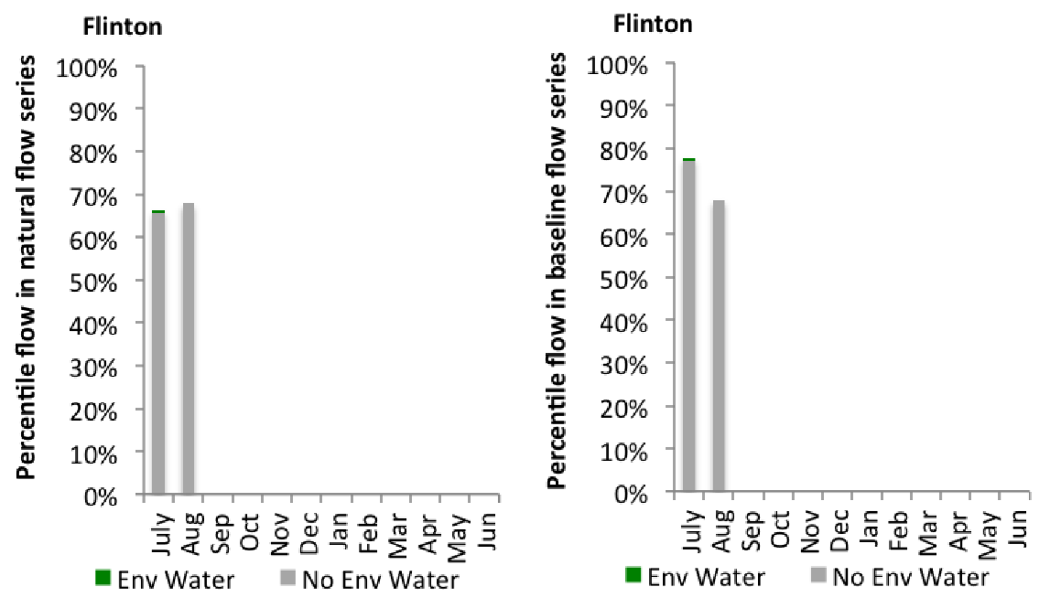
Figure BRD8: Contribution of environmental water delivery at Flinton as percentiles in the natural and baseline flow series.

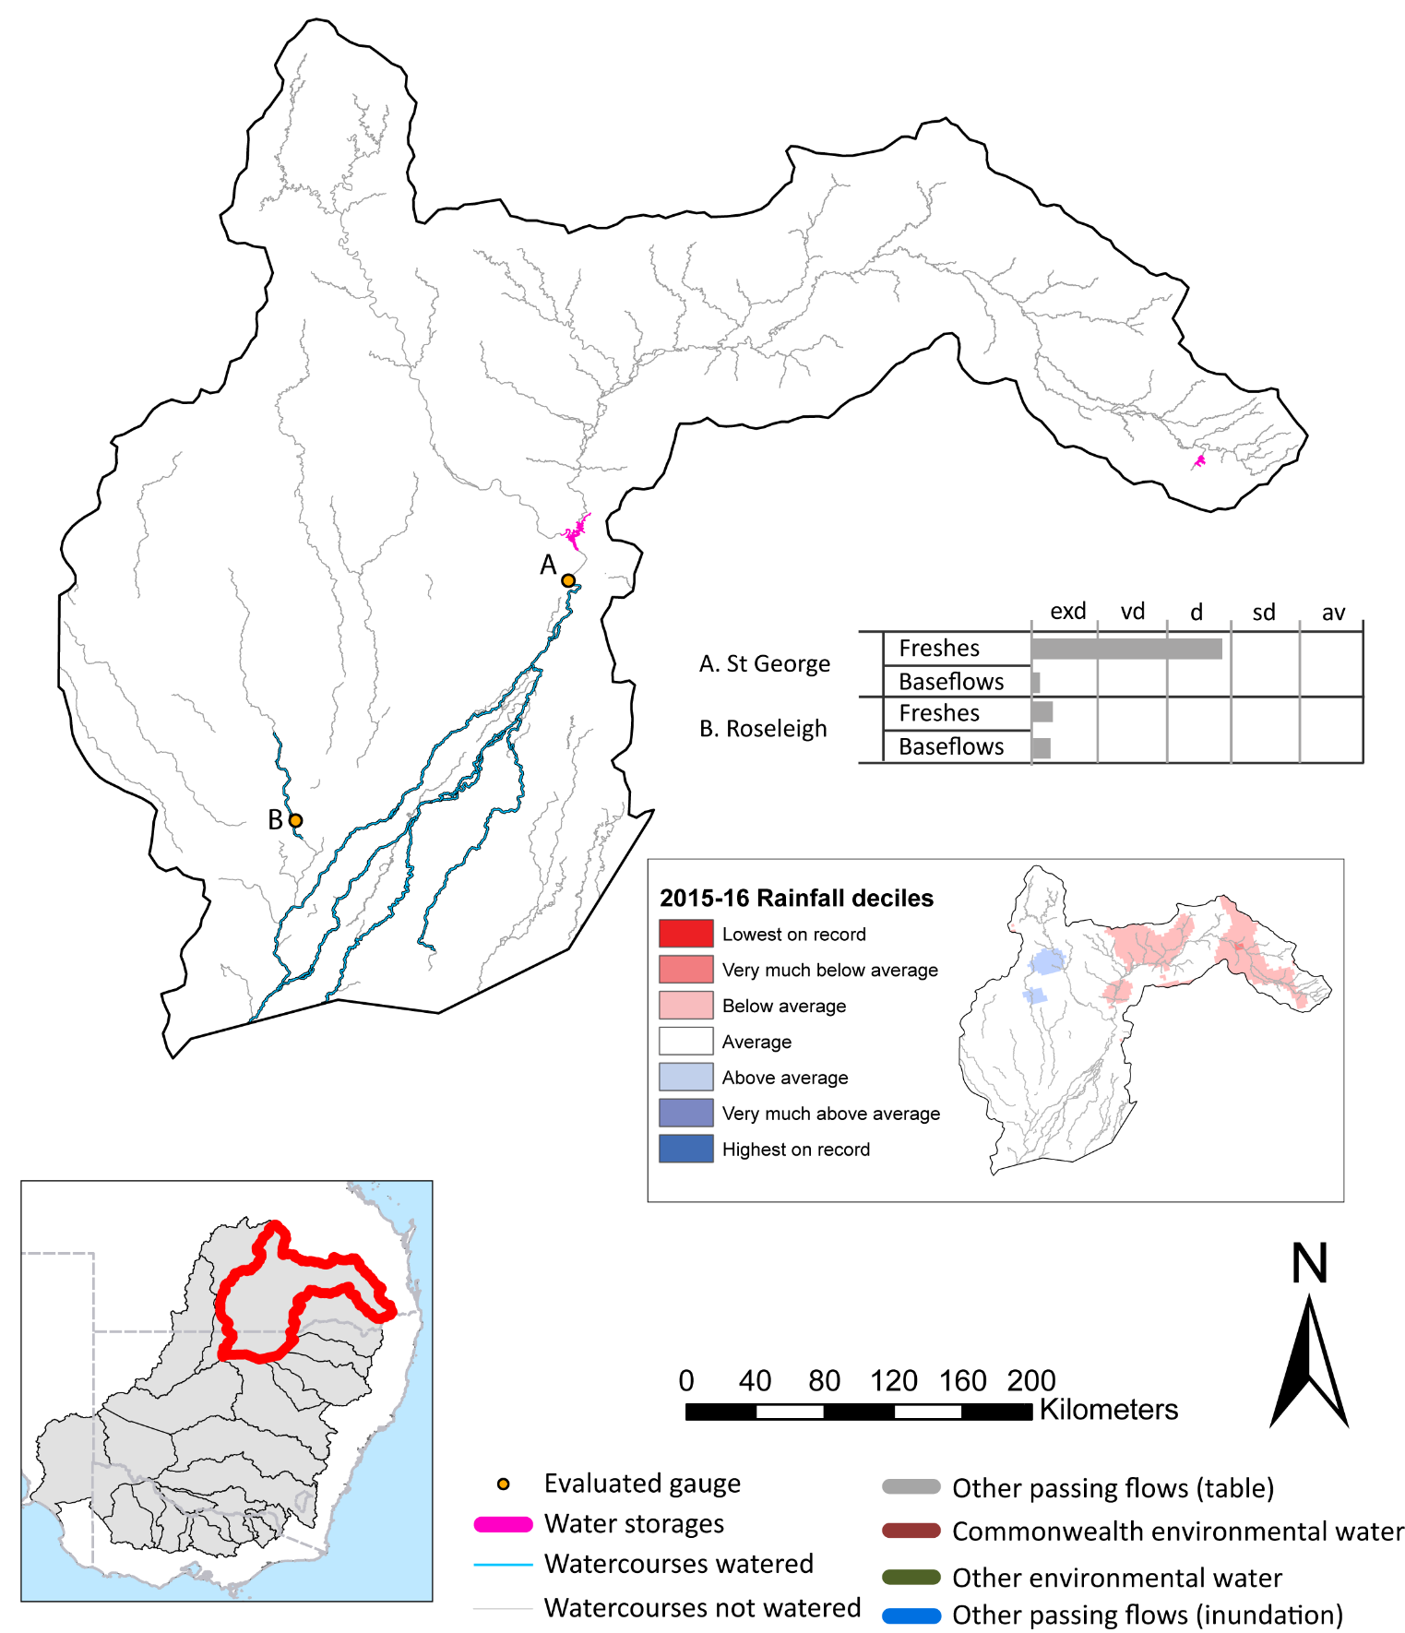
Condamine Balonne

Figure CNB1: Watercourses influenced, areas inundated (where applicable) and gauge stations evaluated in the Condamine-Balonne valley during the 2015-16 water year. Inset bar graphs report the condition of annual flow regimes by showing the improvements in hydrological condition with the addition of environmental water as well as the hypothetical scenario in “grey” (if no environmental flow had been delivered). Rainfall conditions (rainfall deciles) and trend in storage levels for the water year are also shown.

Summary
Environmental water delivery for the 2015-16 year in the Condamine-Balonne Valley is evaluated using data for 2 sites. This evaluation only considers the contribution of held environmental water, which is a primary focus for the Commonwealth. The contributions of planned environmental water (e.g. passing flows), unregulated tributary inflows and clever use of irrigation flows for environmental benefits can all be very important but these are outside the scope of this report. Environmental watering actions lasted on average 7 days over the course of the year. The volume of environmental water at these 2 sites was between 5% and 7% of the total streamflow. Commonwealth Environmental Water contributed on average 100% of this environmental water. The contribution of environmental water delivery to improved flow regimes is evaluated using data for 1 sites. Ideally, baseflows should be maintained and long periods of excessively low flows avoided. In this valley, the baseflow regime was generally considered to be extremely dry relative to the pre-development flow regime. In our analysis, a low fresh refers to a period of increased flow, when the water level rises at least one eighth of the way up the river bank (above the low flow level). These low freshes are a regular part of the natural flow regime and support a range of natural processes. In the Condamine-Balonne valley, in terms of the occurrence and duration of low freshes, the year was assessed as being very dry. In our analysis, a medium fresh refers to a period of increased flow, when the water level rises at least one quarter of the way up the river bank. These medium freshes are not as frequent as low freshes but are also a regular and important part of the natural flow regime. In the Condamine-Balonne valley, in terms of the occurrence of medium freshes, the year was assessed as being dry. In our analysis, a high fresh refers to a period of increased flow, when the water level rises more than half way up the river. A high fresh may not occur every year but they are still important and long periods without major freshes can have serious consequences for floodplains and their contribution to river ecosystem health. Delivering environmental water as high in channel flows normally requires that all risks to riparian landholders and infrastructure have been resolved. In the Condamine-Balonne valley, in terms of the occurrence of high freshes, the year was assessed as being average.

Environmental water system
This section describes the northern unregulated valleys of the MDB where the Commonwealth environmental water maintains a portfolio of water entitlements. The northern unregulated rivers are the vast network of rivers and channels spread across south-west Queensland and north-west NSW, occurring in mostly semi-arid, largely flat region of the northern basin. The flows are highly variable and the ecology tends to follow boom and bust cycles. For the purposes of this report the northern unregulated valleys include the Border Rivers, Condamine, Upper Darling and Warrego valleys. Collectively these valleys represent a total area of 372088 km2, representing 35% of the Basin.
The Commonwealth’s environmental water entitlements in the Queensland and northern NSW unregulated valleys are mostly used “passively”, which is the practice of leaving water in-stream to supplement rainfall-runoff events. The intent of this watering strategy is to lengthen natural flow periods thereby reducing the number of dry spells that do not exceed the critical conditions that can be tolerated by aquatic and floodplain species.
In 2015-16, the valleys in scope included the Warrego, Border Rivers, Barwon-Darling and the Condamine-Balonne. In a typical year, the Border Rivers flow most of the time, as do the Barwon and Darling. However, under natural conditions, the Condamine and Warrego experience periods of no flow, which can last up to several years, especially when there is no significant rainfall or nothing is done to supplement the flow.

Data availability
The Commonwealth environmental waterO closely monitors stream flows in the Condamine-Balonne by monitoring in real-time the flow at selected river gauges to detect when access rights to Commonwealth unregulated entitlements will be triggered. River flow data in conjunction with official announcements of water harvesting access in unregulated entilements in the Condamine-Balonne are used to estimate in-stream use. Volumes are accounted for in accordance with the licence (access) conditions of each entitlement in the same way that other water users manage their take, and assume that water is used at all available opportunities (when flow conditions are triggered) up to allowed limits. This reflects the use pattern of use of the majority of irrigators in unregulated systems and hence the volumes and pattern of flows that have been reinstated to the systems.

Water delivery context
During the 2015-16 water year, the Commonwealth Environmental Water Holder (CEWH) held water entitlements of up to 95693ML for environmental use in the Condamine-Balonne valley. Each year, water utilities allocate the water entitlement holders a percentage of water based on their holding, license type and carryover (the exact rules vary among Jurisdictions). In the 2015-16 water year, the CEWH Condamine-Balonne entitlements were allocated 10233 ML of water, representing 17.61% of the Long term average annual yield for the Condamine-Balonne valley (58099 ML). The 2015-16 water allocation (10233 ML) together with the carryover volume of 35 ML of water meant the CEWH had 10268 ML of water available for delivery.
A total of 10452 ML of Commonwealth environmental water was delivered in the Condamine-Balonne valley. A total of 0 ML of Commonwealth environmental water was traded to consumptive users and 35ML (0.34% of available resource) of Commonwealth environmental water was carried over for environmental use into the 2016-17 water year.

Environmental conditions and resource availability
The water available for delivery combined with the present and antecedent environmental conditions are key inputs used by environmental water managers in planning and implementing watering actions. Post hoc, this information provides important context when evaluating the effectiveness and appropriateness of environmental water use with respect to hydrological outputs.
The rainfall conditions in the Condamine-Balonne valley were classified as Average, based on rainfall percentile data for the entire record held by the Bureau of Meteorology for this valley. The major storages in the Condamine-Balonne valley remained decreased, being 59% full at the beginning of the water year and 40% full by the end of the year (Figure CNB1).
The Commonwealth Environmental Water Office (CEWO) calculates resource availability scenarios (RAS) progressively as part of its continual adaptive management planning processes. The RAS are based on the availability of held water (including progressive license acquisitions and allocations) as well as the potential for unregulated or planned environmental flows. The resource availability of held water was classified as not calculated in this valley, whilst the potential for unregulated or planned environmental flow was classified as not calculated. The physical conditions meant that the CEWO was managing to the strategy here relies on passive management as watering is dependant on the natural flows triggering the license condition to take water The overall demand for environmental water was deemed .

Watering actions
A total of 2 watering actions were implemented, the duration of these actions varied (range of individual actions: 4 - 7 days). The total cumulative sum of watering actions days was 11). The number of actions commencing in each season varied: Winter (1) and Summer (1). The flow component types delivered included (0 baseflow, 2 freshes, 0 bankfull, 0 overbank and 0 wetland).
Table CNB2. Commonwealth environmental water accounting information for the Condamine-Balonne valley over 2015-16 water year.
Total registered volume (ML) | Allocated volume (ML) | Carry over available (ML) | Delivered (ML) | LTAAY (ML) | Trade (ML) | Carried over to 2016-17 | Forfeited (ML)
95693 | 10233 | 10268 | 10452 | 58099 | 0 | 35 | 0
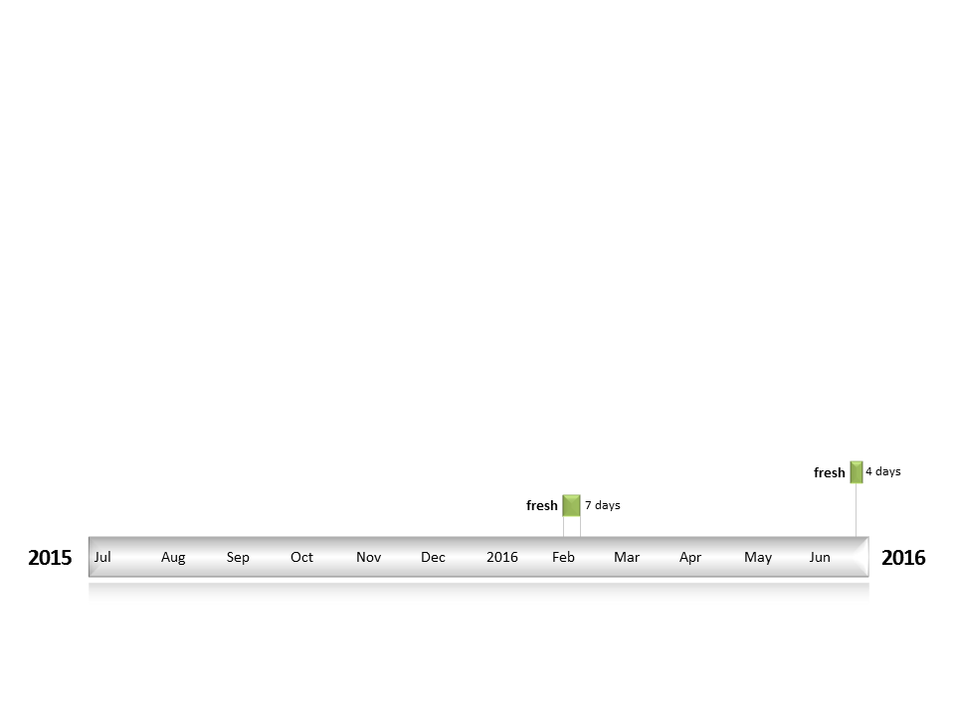
Figure CNB2: Timing and duration of water actions implemented by the CEWO during the 2015-16 water year in the Condamine-Balonne valley.

Contribution of Commonwealth Environmental Water to Flow Regimes
St George
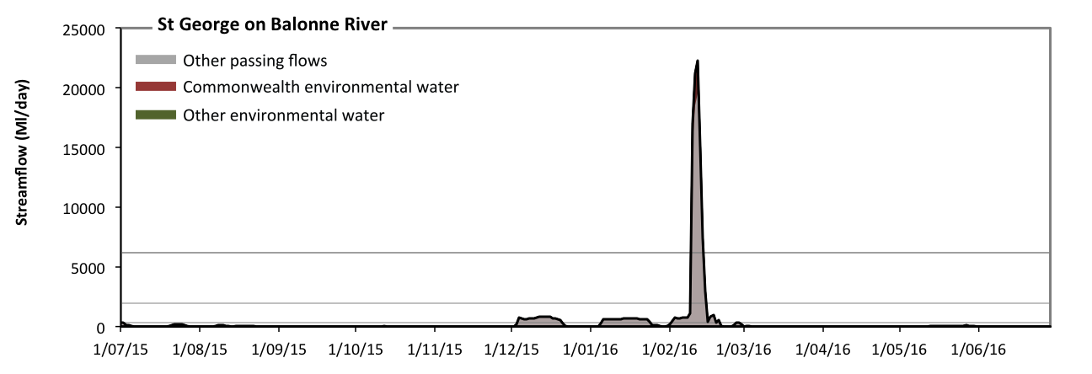
Figure CNB3: Contribution of environmental water delivery at St George. Horizontal lines indicate thresholds for very low flows, low flows, low freshes, medium freshes and high freshes (from lowest to highest).
At St George on Balonne River environmental water contributed 7% of the total streamflow volume (all of which was Commonwealth environmental water). Environmental watering actions affected streamflows for 2% of days between 1 July 2015 and 30 June 2016 (Figure CNB3 and CNB4). Without environmental water, the durations of very low flows (i.e. < 71 Ml/day) in the periods July to September, October to December, January to March and April to June would have all substantially exceeded durations expected in an average year in the natural flow regime. However, environmental water had little effect on the duration of these very low flows, which occurred for 78% of the year. Similarly, without environmental water, the durations of medium low flows (i.e. < 350 Ml/day) in the periods July to September, October to December, January to March and April to June would have all substantially exceeded durations expected in an average year in the natural flow regime. However, environmental water had little effect on the duration of these medium low flows, which occurred for 85% of the year. There was at least one low fresh (i.e. > 2000 Ml/day) in the period January to March. Environmental water made no change to the duration of these low freshes. There was at least one medium fresh (i.e. > 6200 Ml/day) in the period January to March. Environmental water made no change to the duration of these medium freshes. In the absence of environmental water there would have been at least one high fresh in the period January to March. Environmental water made no change to the duration of these high freshes.
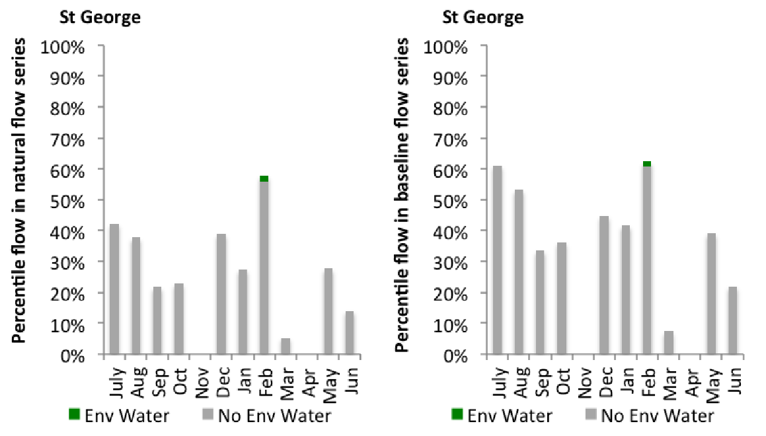
Figure CNB4: Contribution of environmental water delivery at St George as percentiles in the natural and baseline flow series.
Roseleigh
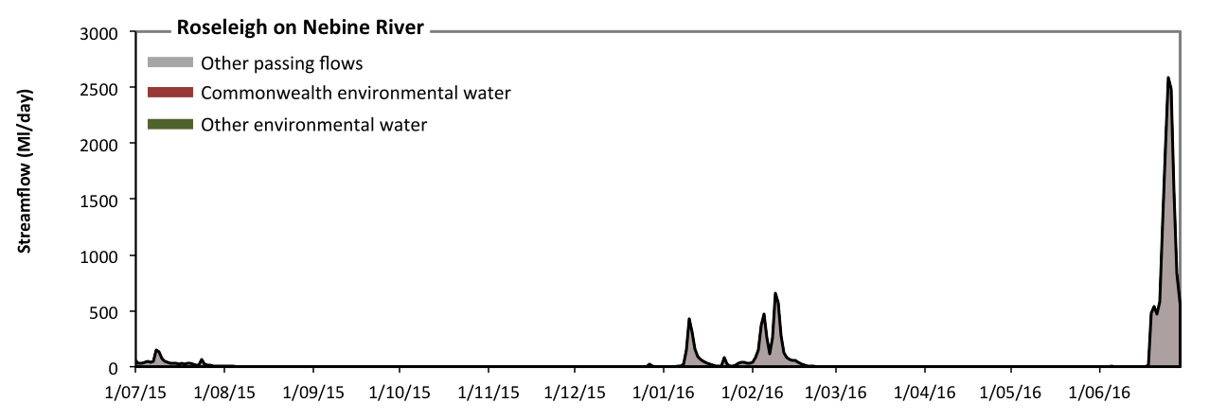
Figure CNB5: Contribution of environmental water delivery at Roseleigh. Horizontal lines indicate thresholds for (from lowest to highest).
At Roseleigh on Nebine River environmental water contributed 5% of the total streamflow volume (all of which was Commonwealth environmental water). Environmental watering actions affected streamflows for 1% of days between 1 July 2015 and 30 June 2016 (Figure CNB5). However, environmental water had little effect on the duration of these very low flows, which occurred for 100% of the year.

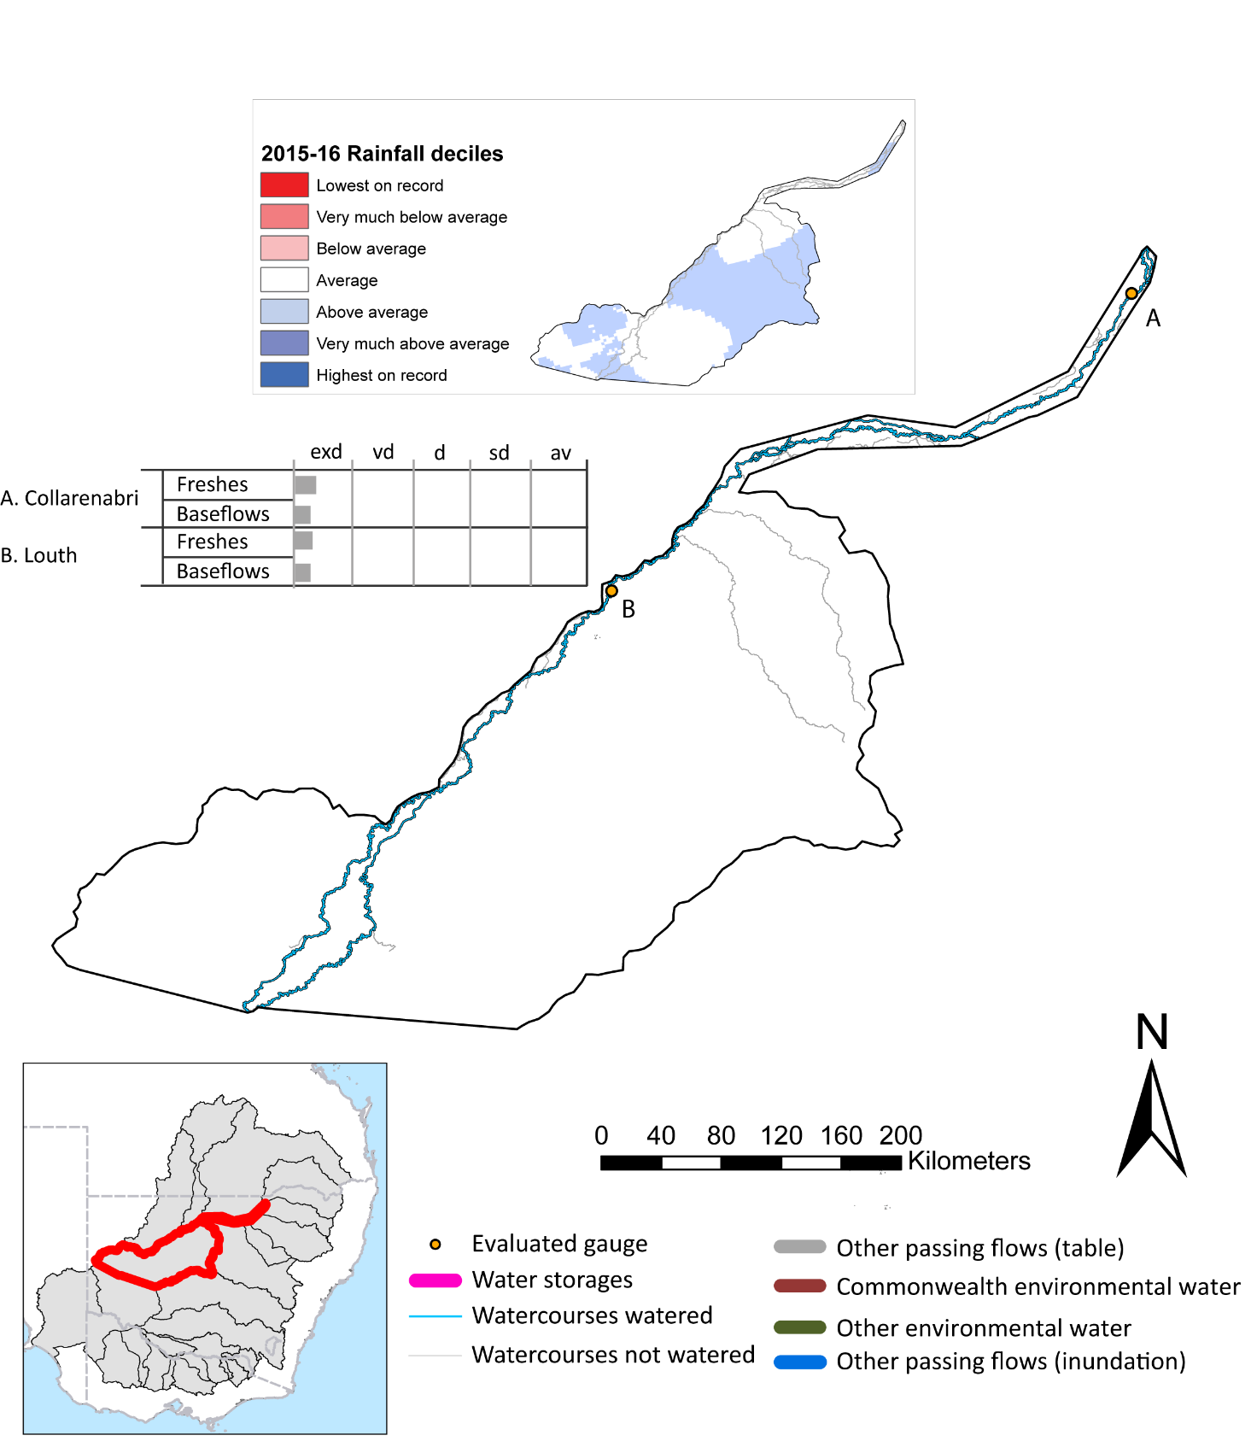
Barwon Darling

Figure UPD1: Watercourses influenced, areas inundated (where applicable) and gauge stations evaluated in the Barwon Darling valley during the 2015-16 water year. Inset bar graphs report the condition of annual flow regimes by showing the improvements in hydrological condition with the addition of environmental water as well as the hypothetical scenario in “grey” (if no environmental flow had been delivered). Rainfall conditions (rainfall deciles) and trend in storage levels for the water year are also shown.

Summary
The volume of environmental water delivery for the 2015-16 year in the Barwon-Darling Valley is quantified using data for 2 sites. This evaluation only considers the contribution of held environmental water, which is a primary focus for the Commonwealth. The contributions of planned environmental water (e.g. passing flows), unregulated tributary inflows and clever use of irrigation flows for environmental benefits can all be very important but these are outside the scope of this report. Environmental watering actions lasted on average 37 days over the course of the year. The volume of environmental water at these 2 sites was between 1% and 7% of the total streamflow. Commonwealth Environmental Water contributed on average 100% of this environmental water. The contribution of environmental water delivery to improved flow regimes is evaluated using data for 2 sites. Ideally, baseflows should be maintained and long periods of excessively low flows avoided. In this valley, the baseflow regime was generally considered to be extremely dry relative to the pre-development flow regime. In our analysis, a low fresh refers to a period of increased flow, when the water level rises at least one eighth of the way up the river bank (above the low flow level). These low freshes are a regular part of the natural flow regime and support a range of natural processes. In the Barwon-Darling valley, in terms of the occurrence and duration of low freshes, the year was assessed as being extremely dry. In our analysis, a medium fresh refers to a period of increased flow, when the water level rises at least one quarter of the way up the river bank. These medium freshes are not as frequent as low freshes but are also a regular and important part of the natural flow regime. In the Barwon-Darling valley, in terms of the occurrence of medium freshes, the year was assessed as being extremely dry. In our analysis, a high fresh refers to a period of increased flow, when the water level rises more than half way up the river. A high fresh may not occur every year but they are still important and long periods without major freshes can have serious consequences for floodplains and their contribution to river ecosystem health. Delivering environmental water as high in channel flows normally requires that all risks to riparian landholders and infrastructure have been resolved. In the Barwon-Darling valley, in terms of the occurrence of high freshes, the year was assessed as being extremely dry.

Environmental water system
The Barwon-Darling valley is spread across south-west Queensland and north-west NSW, occurring in mostly semi-arid, largely flat region of the northern basin. The flows are highly variable and the ecology tends to follow boom and bust cycles. Commonwealth environmental water holdings in this valley comprise unsupplemented water allocations (on the Queensland side) and unregulated river access licenses (on the NSW side). Accessing these water entitlements is contingent upon river flow thresholds triggering periods of ‘take’. Volumetric limits and maximum daily take rates limit the volume of water available for use. The Commonwealth Environmental Water Office uses these entitlements “passively”, leaving the water in-stream for downstream benefit.

Data availability
The Commonwealth environmental water office closely monitors stream flows in the Barwon-Darling by monitoring in real-time the flow at selected river gauges to detect when access rights to Commonwealth unregulated entitlements will be triggered. River flow data in conjunction with official announcements of water harvesting access in unregulated entilements in the Barwon-Darling are used to estimate in-stream use. Volumes are accounted for in accordance with the licence (access) conditions of each entitlement in the same way that other water users manage their take, and assume that water is used at all available opportunities (when flow conditions are triggered) up to allowed limits. This reflects the use pattern of use of the majority of irrigators in unregulated systems and hence the volumes and pattern of flows that have been reinstated to the systems.

Water delivery context
During the 2015-16 water year, the Commonwealth Environmental Water Holder (CEWH) held water entitlements of up to 24900ML for environmental use in the Barwon Darling valley. Each year, water utilities allocate the water entitlement holders a percentage of water based on their holding, license type and carryover (the exact rules vary among Jurisdictions). In the 2015-16 water year, the CEWH Barwon Darling entitlements were allocated 7640 ML of water, representing 30.68% of the Long term average annual yield for the Barwon Darling valley (24900 ML). The 2015-16 water allocation (7640 ML) together with the carryover volume of 0 ML of water meant the CEWH had 7640 ML of water available for delivery.
A total of 7640 ML of Commonwealth environmental water was delivered in the Barwon Darling valley. A total of 0 ML of Commonwealth environmental water was traded to consumptive users and 0ML (0.0% of available resource) of Commonwealth environmental water was carried over for environmental use into the 2016-17 water year.

Environmental conditions and resource availability
The water available for delivery combined with the present and antecedent environmental conditions are key inputs used by environmental water managers in planning and implementing watering actions. Post hoc, this information provides important context when evaluating the effectiveness and appropriateness of environmental water use with respect to hydrological outputs.
The rainfall conditions in the Barwon Darling valley were classified as Above Average, based on rainfall percentile data for the entire record held by the Bureau of Meteorology for this valley. The major storages in the Barwon Darling valley remained decreased, being 5% full at the beginning of the water year and 3% full by the end of the year (Figure UPD1).
The Commonwealth Environmental Water Office (CEWO) calculates resource availability scenarios (RAS) progressively as part of its continual adaptive management planning processes. The RAS are based on the availability of held water (including progressive license acquisitions and allocations) as well as the potential for unregulated or planned environmental flows. The resource availability of held water was classified as not calculated in this valley, whilst the potential for unregulated or planned environmental flow was classified as not calculated. The physical conditions meant that the CEWO was managing to the strategy here relies on passive management as watering is dependant on the natural flows triggering the license condition to take water The overall demand for environmental water was deemed .

Watering actions
A total of 3 watering actions were implemented, the duration of these actions varied (range of individual actions: 29 - 89 days). The total cumulative sum of watering actions days was 151). The number of actions commencing in each season varied: Winter (2) and Summer (1). The flow component types delivered included (0 baseflow, 3 freshes, 0 bankfull, 0 overbank and 0 wetland).

Table UPD2. Commonwealth environmental water accounting information for the Barwon Darling valley over 2015-16 water year.
Total registered volume (ML) | Allocated volume (ML) | Carry over available (ML) | Delivered (ML) | LTAAY (ML) | Trade (ML) | Carried over to 2016-17 | Forfeited (ML)
24900 | 7640 | 7640 | 7640 | 24900 | 0 | 0 | 0

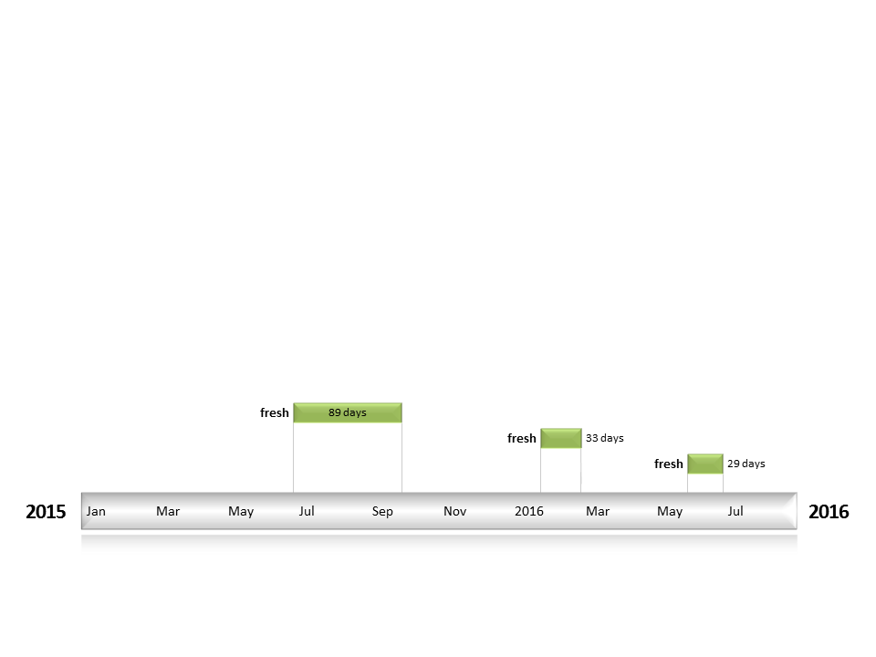
Figure UPD2: Timing and duration of water actions implemented by the CEWO during the 2015-16 water year in the Barwon Darling valley.

Contribution of Commonwealth Environmental Water to Flow Regimes
Collarenebri
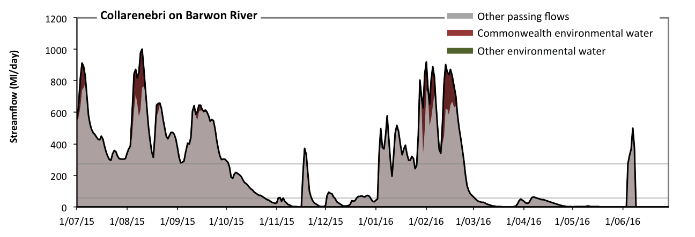
Figure UPD3: Contribution of environmental water delivery at Collarenebri. Horizontal lines indicate thresholds for very low flows and low flows (from lowest to highest).
At Collarenebri on Barwon River environmental water contributed 7% of the total streamflow volume (all of which was Commonwealth environmental water). Environmental watering actions affected streamflows for 14% of days between 1 July 2015 and 30 June 2016 (Figure UPD3 and UPD4). Without environmental water, the durations of very low flows (i.e. < 55 Ml/day) in the periods October to December, January to March and April to June would have substantially exceeded durations expected in an average year in the natural flow regime. However, environmental water had little effect on the duration of these very low flows, which occurred for 43% of the year. Similarly, without environmental water, the durations of medium low flows (i.e. < 270 Ml/day) in the periods October to December, January to March and April to June would have substantially exceeded durations expected in an average year in the natural flow regime. However, environmental water had little effect on the duration of these medium low flows, which occurred for 59% of the year.
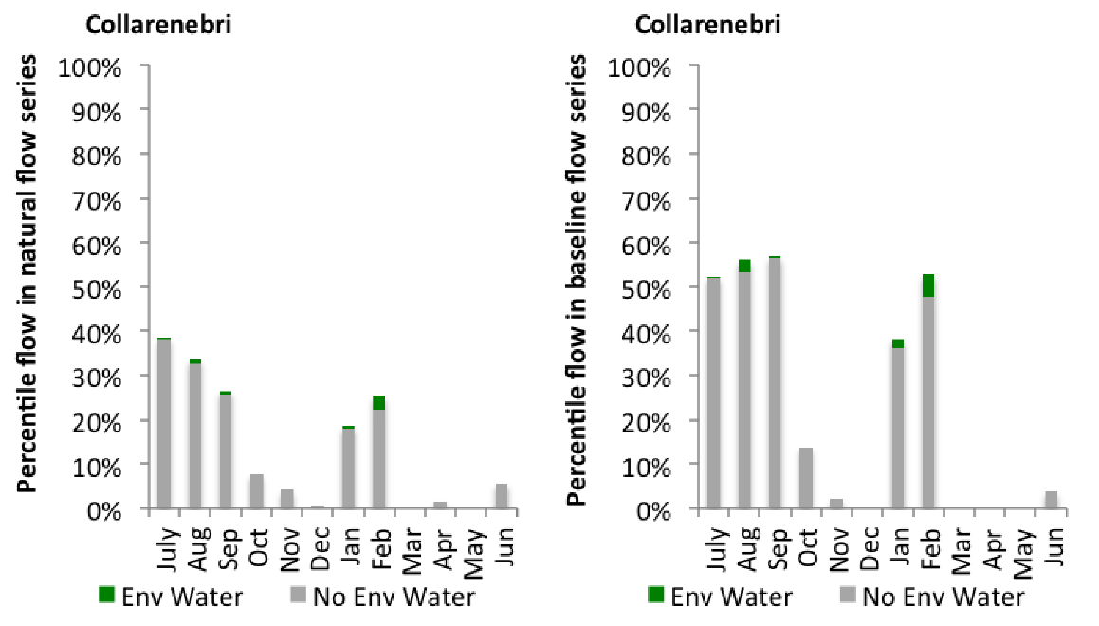
Figure UPD4: Contribution of environmental water delivery at Collarenebri as percentiles in the natural and baseline flow series.
Louth
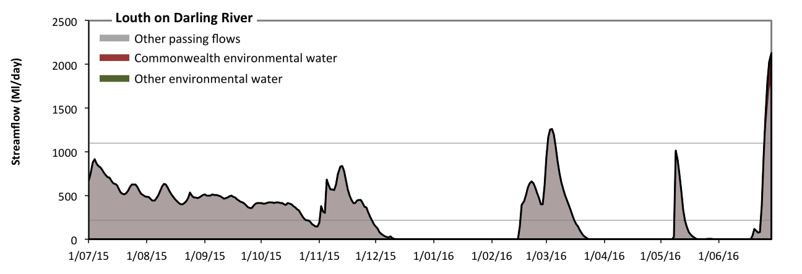
Figure UPD5: Contribution of environmental water delivery at Louth. Horizontal lines indicate thresholds for very low flows and low flows (from lowest to highest).
At Louth on Darling River environmental water contributed 1% of the total streamflow volume (all of which was Commonwealth environmental water). Environmental watering actions affected streamflows for 6% of days between 1 July 2015 and 30 June 2016 (Figure UPD5 and UPD6). Without environmental water, the durations of very low flows (i.e. < 220 Ml/day) in the periods October to December, January to March and April to June would have substantially exceeded durations expected in an average year in the natural flow regime. However, environmental water had little effect on the duration of these very low flows, which occurred for 50% of the year. Similarly, without environmental water, the durations of medium low flows (i.e. < 1100 Ml/day) in the periods July to September, October to December, January to March and April to June would have all substantially exceeded durations expected in an average year in the natural flow regime. However, environmental water had little effect on the duration of these medium low flows, which occurred for 98% of the year.
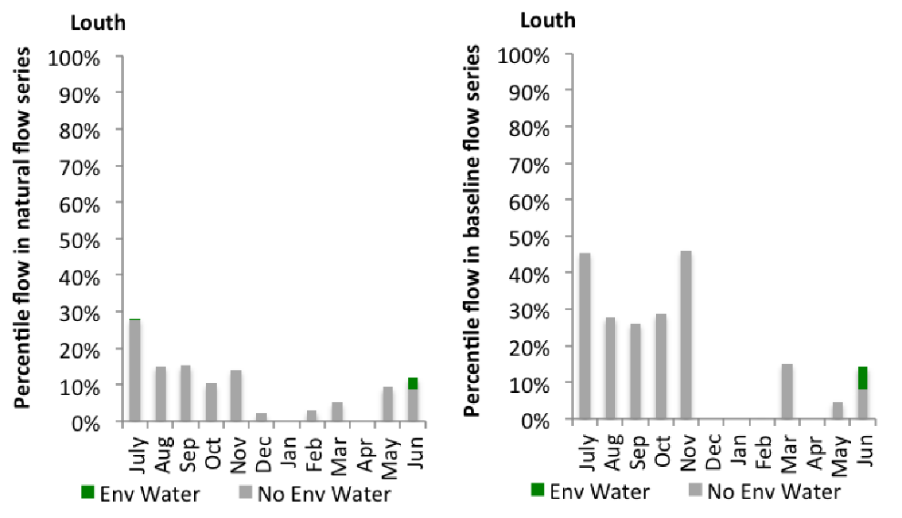
Figure UPD6: Contribution of environmental water delivery at Louth as percentiles in the natural and baseline flow series.

Warrego
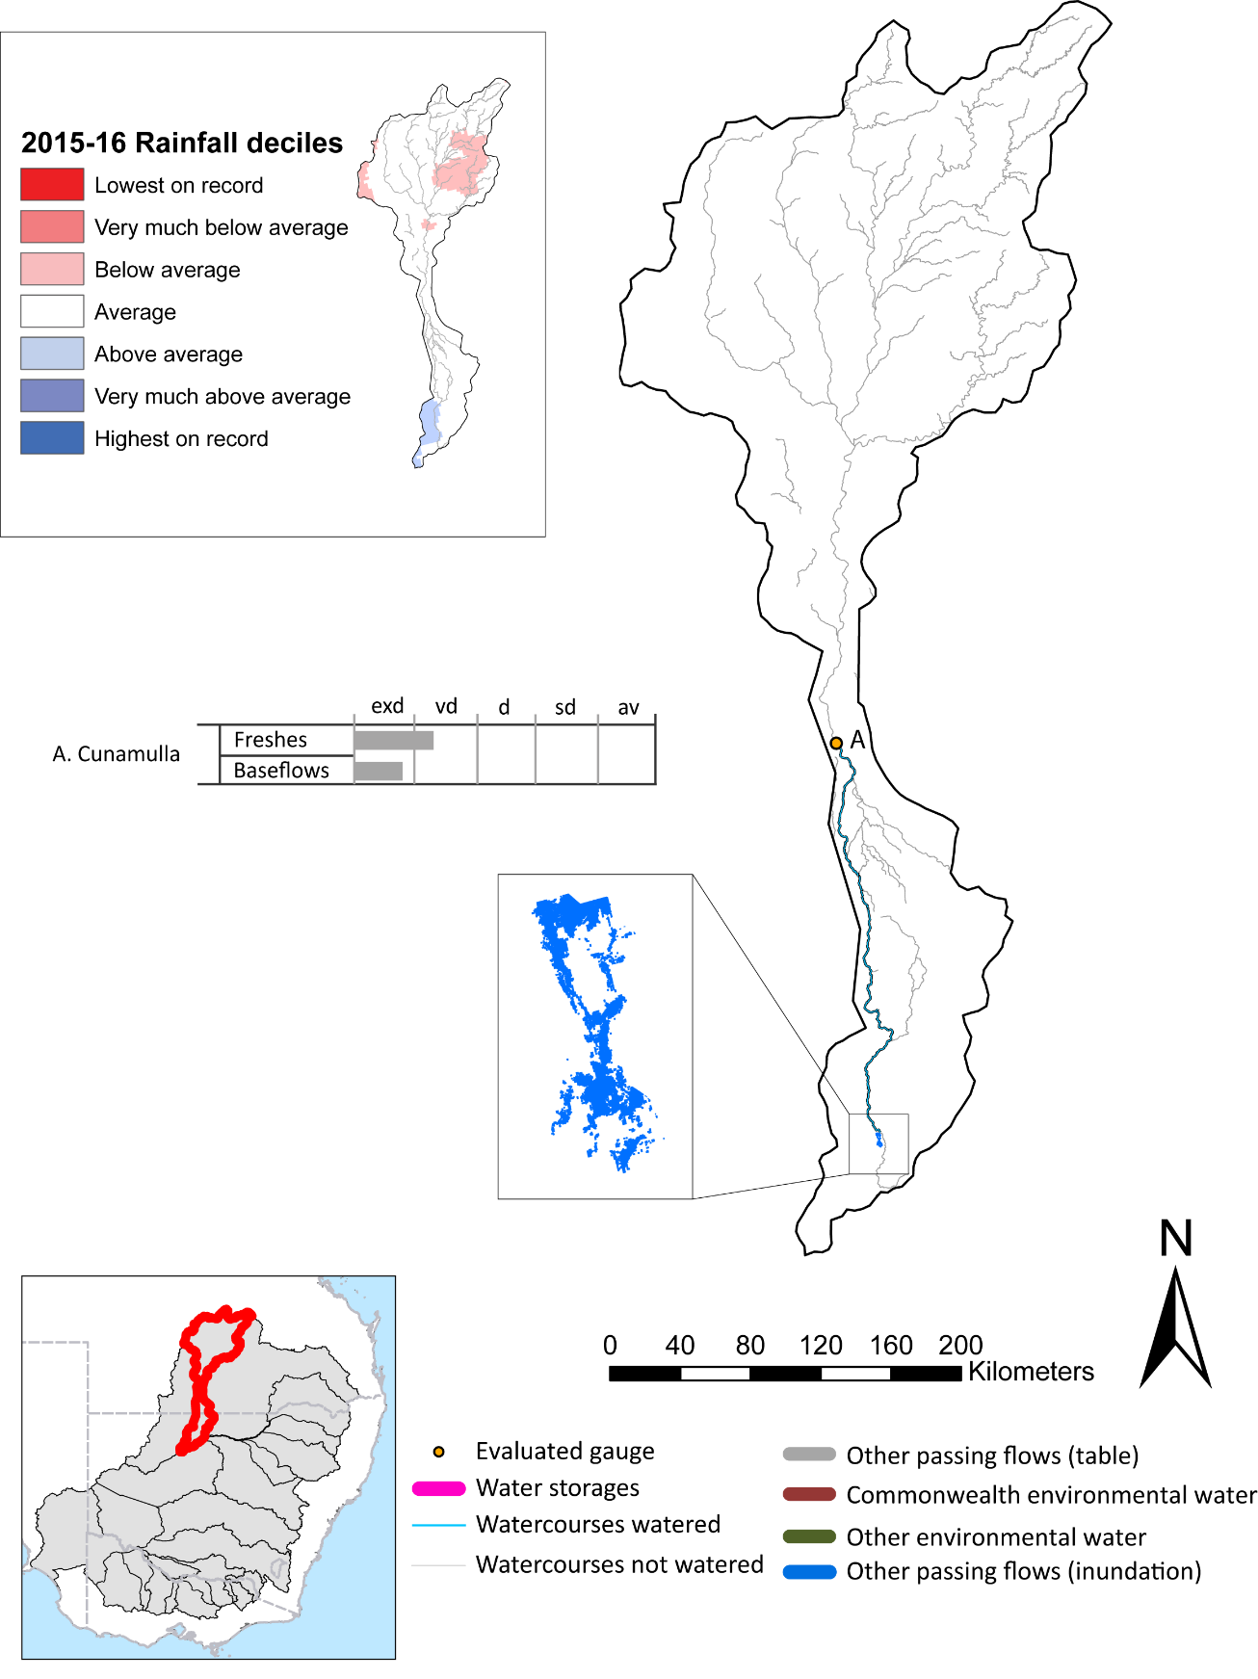

Figure WAR1: Watercourses influenced, areas inundated (where applicable) and gauge stations evaluated in the Warrego valley during the 2015-16 water year. Inset bar graphs report the condition of annual flow regimes by showing the improvements in hydrological condition with the addition of environmental water as well as the hypothetical scenario in “grey” (if no environmental flow had been delivered). Rainfall conditions (rainfall deciles) and trend in storage levels for the water year are also shown.

Summary
Environmental water delivery for the 2015-16 year in the Warrego Valley is evaluated using data for 1 sites. This evaluation only considers the contribution of held environmental water, which is a primary focus for the Commonwealth. The contributions of planned environmental water (e.g. passing flows), unregulated tributary inflows and clever use of irrigation flows for environmental benefits can all be very important but these are outside the scope of this report. Environmental watering actions lasted on average 3 days over the course of the year. The volume of environmental water at this site was 1% of the total streamflow. Commonwealth Environmental Water contributed on average 100% of this environmental water. The contribution of environmental water delivery to improved flow regimes is evaluated using data for 1 sites. Ideally, baseflows should be maintained and long periods of excessively low flows avoided. In this valley, the baseflow regime was generally considered to be extremely dry relative to the pre-development flow regime. In our analysis, a low fresh refers to a period of increased flow, when the water level rises at least one eighth of the way up the river bank (above the low flow level). These low freshes are a regular part of the natural flow regime and support a range of natural processes. In the Warrego valley, in terms of the occurrence and duration of low freshes, the year was assessed as being somewhat dry. In our analysis, a medium fresh refers to a period of increased flow, when the water level rises at least one quarter of the way up the river bank. These medium freshes are not as frequent as low freshes but are also a regular and important part of the natural flow regime. In the Warrego valley, in terms of the occurrence of medium freshes, the year was assessed as being extremely dry. In our analysis, a high fresh refers to a period of increased flow, when the water level rises more than half way up the river. A high fresh may not occur every year but they are still important and long periods without major freshes can have serious consequences for floodplains and their contribution to river ecosystem health. Delivering environmental water as high in channel flows normally requires that all risks to riparian landholders and infrastructure have been resolved. In the Warrego valley, in terms of the occurrence of high freshes, the year was assessed as being extremely dry.

Environmental water system
The Warrego valley is spread across south-west Queensland and north-west NSW, occurring in mostly semi-arid, largely flat region of the northern basin. The flows are highly variable and the ecology tends to follow boom and bust cycles. Under natural conditions the Warrego can experience periods of no flow which can last up to several years. Commonwealth environmental water holdings in this valley comprise unsupplemented water allocations (on the Queensland side) and unregulated river access licenses (on the NSW side). Accessing these water entitlements is contingent upon river flow thresholds triggering periods of ‘take’. Volumetric limits and maximum daily take rates limit the volume of water available for use. The Commonwealth Environmental Water Office uses these entitlements “passively”, leaving the water in-stream for downstream benefit.

Data availability
The Commonwealth environmental water office closely monitors stream flows in the Warrego by monitoring in real-time the flow at selected river gauges to detect when access rights to Commonwealth unregulated entitlements will be triggered. River flow data in conjunction with official announcements of borwater harvesting access in unregulated entilements in the Warrego are used to estimate in-stream use. Volumes are accounted for in accordance with the licence (access) conditions of each entitlement in the same way that other water users manage their take, and assume that water is used at all available opportunities (when flow conditions are triggered) up to allowed limits. This reflects the use pattern of use of the majority of irrigators in unregulated systems and hence the volumes and pattern of flows that have been reinstated to the systems.

Water delivery context
During the 2015-16 water year, the Commonwealth Environmental Water Holder (CEWH) held water entitlements of up to 882ML for environmental use in the Warrego valley. Each year, water utilities allocate the water entitlement holders a percentage of water based on their holding, license type and carryover (the exact rules vary among Jurisdictions). In the 2015-16 water year, the CEWH Warrego entitlements were allocated 0 ML of water, representing % of the Long term average annual yield for the Warrego valley (0 ML). The 2015-16 water allocation (0 ML) together with the carryover volume of 0 ML of water meant the CEWH had 0 ML of water available for delivery.
A total of 859 ML of Commonwealth environmental water was delivered in the Warrego valley. A total of 0 ML of Commonwealth environmental water was traded to consumptive users and 0ML (% of available resource) of Commonwealth environmental water was carried over for environmental use into the 2016-17 water year.

Environmental conditions and resource availability
The water available for delivery combined with the present and antecedent environmental conditions are key inputs used by environmental water managers in planning and implementing watering actions. Post hoc, this information provides important context when evaluating the effectiveness and appropriateness of environmental water use with respect to hydrological outputs.
The rainfall conditions in the Warrego valley were classified as Average, based on rainfall percentile data for the entire record held by the Bureau of Meteorology for this valley. The major storages in the Warrego valley remained , being % full at the beginning of the water year and % full by the end of the year (Figure WAR1).
The Commonwealth Environmental Water Office (CEWO) calculates resource availability scenarios (RAS) progressively as part of its continual adaptive management planning processes. The RAS are based on the availability of held water (including progressive license acquisitions and allocations) as well as the potential for unregulated or planned environmental flows. The resource availability of held water was classified as not calculated in this valley, whilst the potential for unregulated or planned environmental flow was classified as not calculated. The physical conditions meant that the CEWO was managing to the strategy here relies on passive management as watering is dependant on the natural flows triggering the license condition to take water The overall demand for environmental water was deemed .

Watering actions
A total of 1 watering actions were implemented, the duration of these actions varied (range of individual actions: 2 days). The total cumulative sum of watering actions days was 2). The number of actions commencing in each season did not vary: Summer (1). The flow component types delivered included (1 baseflow, 1 freshes, 0 bankfull, 0 overbank and 0 wetland).
Table WAR2: Commonwealth environmental water accounting information for the Warrego valley over 2015-16 water year.
Total registered volume (ML) | Allocated volume (ML) | Carry over available (ML) | Delivered (ML) | LTAAY (ML) | Trade (ML) | Carried over to 2016-17 | Forfeited (ML)
882 | 0 | 0 | 859 | 0 | 0 | 0 | 0
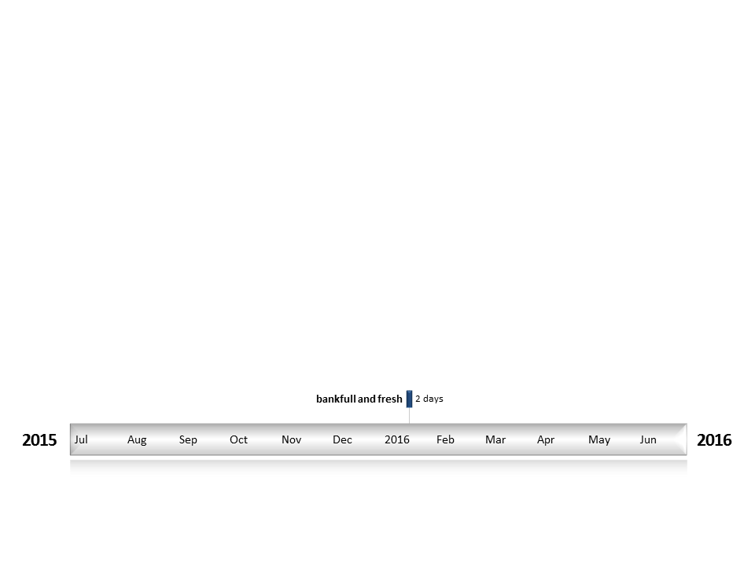
Figure WAR2. Timing and duration of water actions implemented by the CEWO during the 2015-16 water year in the Warrego valley.

Contribution of Commonwealth Environmental Water to Flow Regimes
Cunamulla
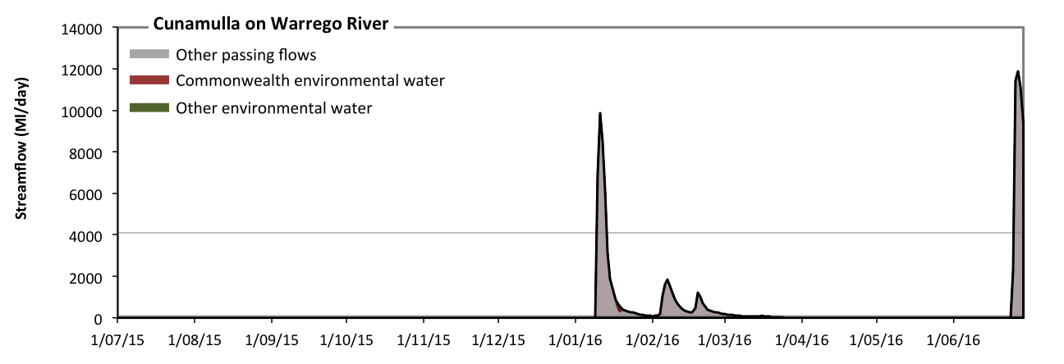
Figure WAR3: Contribution of environmental water delivery at Cunamulla. Horizontal lines indicate thresholds for very low flows, low flows and low freshes (from lowest to highest).
At Cunamulla on Warrego River environmental water contributed 1% of the total streamflow volume (all of which was Commonwealth environmental water). Environmental watering actions affected streamflows for 1% of days between 1 July 2015 and 30 June 2016 (Figure WAR3 and WAR4). Without environmental water, the durations of very low flows (i.e. < 20 Ml/day) in the periods July to September, October to December and April to June would have substantially exceeded durations expected in an average year in the natural flow regime. However, environmental water had little effect on the duration of these very low flows, which occurred for 79% of the year. Similarly, without environmental water, the durations of medium low flows (i.e. < 99 Ml/day) in the periods July to September, October to December and April to June would have substantially exceeded durations expected in an average year in the natural flow regime. However, environmental water had little effect on the duration of these medium low flows, which occurred for 84% of the year. There was at least one low fresh (i.e. > 4100 Ml/day) in the periods January to March and April to June. Environmental water made no change to the duration of these low freshes. There was no medium or high freshes this year.
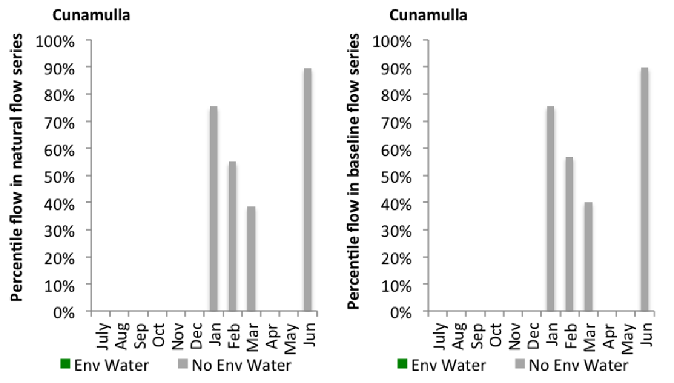
Figure WAR4: Contribution of environmental water delivery at Cunamulla as percentiles in the natural and baseline flow series.

