2015–16 Basin-scale evaluation of Commonwealth environmental water – Hydrology

Prepared by: Michael Stewardson and Fiorenzo Guarino

Final Report

MDFRC Publication 142/2017

2015–16 Basin scale evaluation of Commonwealth environmental water – Hydrology
Final Report prepared for the Commonwealth Environmental Water Office (CEWO) by The Murray–Darling Freshwater Research Centre


This report was prepared by The University of Melbourne and University of Canberra in collaboration with The Murray–Darling Freshwater Research Centre (MDFRC). The aim of the MDFRC is to provide the scientific knowledge necessary for the management and sustained utilisation of the Murray–Darling Basin water resources. The MDFRC is a joint venture between La Trobe University and CSIRO.

For further information contact:
Ben Gawne
The Murray–Darling Freshwater Research Centre
PO Box 991
Wodonga VIC 3689
Ph: (02) 6024 9650

Email: Ben.Gawne@canberra.edu.au
Web: www.mdfrc.org.au
Enquiries: mdfrc@latrobe.edu.au

Report Citation: Stewardson MJ, Guarino F (2017) 2015–16 Basin scale evaluation of Commonwealth environmental water — Hydrology. Final Report prepared for the Commonwealth Environmental Water Office by The Murray–Darling Freshwater Research Centre, MDFRC Publication 142/2017, October, 45pp plus annex.

This monitoring project was commissioned and funded by Commonwealth Environmental Water Office.
Copyright
© Copyright Commonwealth of Australia, 2016


2015–16 Basin scale evaluation of Commonwealth environmental water: Hydrology (2017) is licensed by the Commonwealth of Australia for use under a Creative Commons By Attribution 3.0 Australia licence with the exception of the Coat of Arms of the Commonwealth of Australia, the logo of the agency responsible for publishing the report, content supplied by third parties, and any images depicting people. For licence conditions see: http://creativecommons.org/licenses/by/3.0/au/
This report should be attributed as Stewardson MJ, Guarino F (2017) 2015–16 Basin scale evaluation of Commonwealth environmental water — Hydrology. Report prepared for the Commonwealth Environmental Water Office by The Murray–Darling Freshwater Research Centre, MDFRC Publication 142/2017, October, 45pp plus annex.
Disclaimer
The views and opinions expressed in this publication are those of the authors and do not necessarily reflect those of the Australian Government or the Minister for the Environment.
While reasonable efforts have been made to ensure that the contents of this publication are factually correct, the Commonwealth does not accept responsibility for the accuracy or completeness of the contents, and shall not be liable for any loss or damage that may be occasioned directly or indirectly through the use of, or reliance on, the contents of this publication.
The material contained in this publication represents the opinion of the author(s) only. While every effort has been made to ensure that the information in this publication is accurate, the author(s) and MDFRC do not accept any liability for any loss or damage howsoever arising whether in contract, tort or otherwise which may be incurred by any person as a result of any reliance or use of any statement in this publication. The author(s) and MDFRC do not give any warranties in relation to the accuracy, completeness and up-to-date status of the information in this publication.
Where legislation implies any condition or warranty which cannot be excluded restricted or modified, such condition or warranty shall be deemed to be included provided that the author’s and MDFRC’s liability for a breach of such condition or warranty is, at the option of MDFRC, limited to the supply of the services again or the cost of supplying the services again.

Document history and status
Version | Date Issued | Reviewed by | Approved by | Revision type
Draft | 15 April 2017 | Ben Gawne | Ben Gawne | Internal
Draft | 10 May 2017 | Mike Stewardson | Ben Gawne | Internal
Draft | 16 May 2017 | Penny Everingham | Ben Gawne | Internal
Draft | 22 May 2017 | CEWO | Penny Everingham | External
Final | 2 August 2017 | Mike Stewardson | Ben Gawne | Internal
Final | 15 August 2017 | Mary Webb | Penny Everingham | External
Final | 23 August 2017 | Mike Stewardson | Penny Everingham | Internal
Final | 16 October 2017 | Jenny Hale and Fiorenzo Guarino | Penny Everingham | Internal

Distribution of copies
Version | Quantity | Issued to
Draft | 1 x PDF | CEWO and M&E Providers
Final | 1 x PDF 1 x Word | CEWO

Filename and path: Projects\CEWO\CEWH Long Term Monitoring Project\499 LTIM Stage 2 2014-19 Basin evaluation\Final Reports
Author(s): Michael Stewardson and Fiorenzo Guarino
Author affiliation(s): The University of Melbourne and The University of Canberra.
Project Manager: Ben Gawne
Client: Commonwealth Environmental Water Office
Project Title: Basin evaluation of the contribution of Commonwealth environmental water to the environmental objectives of the Murray‒Darling Basin Plan
Document Version: Final
Project Number: M/BUS/499
Contract Number: PRN 1213-0427

Acknowledgements:
We would like to acknowledge the many individuals and agencies who assisted by providing data to support this evaluation. This included officers within the Commonwealth Environmental Water Office (CEWO), Victorian Environmental Water Holder (VEWH), WaterNSW, Goulburn–Murray Water (GMW), Department of Environment, Water and Natural Resources (DEWNR) South Australia, Office of Environment & Heritage (OEH) New South Wales, Mallee Catchment Management Authority (CMA), North-Central CMA, Goulburn Broken and North East CMA and the Murray–Darling Basin Authority (MDBA). The authors would also like to thank all Long Term Intervention Monitoring (LTIM) Monitoring and Evaluation Provider staff.
The Murray–Darling Freshwater Research Centre offices are located on the land of the Latje Latje and Wiradjuri peoples. We undertake work throughout the Murray–Darling Basin and acknowledge the traditional owners of this land and water. We pay respect to Elders past, present and future.

Contents
1 Introduction 1
1.1 Background 1
1.2 Context 1
2 Methods 3
2.1 Scale of evaluation 3
2.2 Data sources for evaluating contribution to flow regimes 4
2.2.1 Observations of streamflows 5
2.2.2 Baseline hydrology scenarios 6
2.3 Data sources for evaluating contribution to hydrological connectivity 7
2.3.1 Floodplain inundation extent 7
2.3.2 Watercourses watered 7
2.4 Evaluation of Basin-wide hydrological impacts 8
2.4.1 Flow thresholds 9
2.4.2 Flow regime score 10
2.4.3 Attribution of Commonwealth environmental water 11
3 2015–16 hydrological context 12
3.1 Climate and water availability 12
3.2 MDBA Basin watering priorities 12
3.3 Watering actions 17
4 Evaluation of flow regimes and hydrological connectivity in 2015–16 20
4.1 Highlights 20
4.2 Evaluation by flow components 22
4.2.1 Base flow (low–medium flows) 22
4.2.2 Freshes 22
4.2.3 Overbank and wetland inundation 23
4.3 Cumulative evaluation of flow components, 2014–16 23
5 Evaluation of watering actions against Basin priorities 28
5.1 Basin-wide flow variability and longitudinal connectivity 28
5.1.1 Base flow 28
5.1.2 Freshes 28
5.2 River Murray weir pool variation 29
5.3 Coorong, Lower Lakes and Murray Mouth 29
5.3.1 Water levels in the Lower Lakes 30
5.3.2 The contribution of Commonwealth environmental water to flows over the barrages 31
5.3.3 Murray Mouth opening 32
5.4 Basin-wide in-stream and riparian vegetation 34
5.5 Mid-Murrumbidgee wetlands 34
5.6 Macquarie Marshes 35
5.7 Basin-wide waterbird habitat and future population recovery 35
5.8 Basin-wide native fish habitat and movement 35
5.9 Northern Basin fish refuges 36
5.10 Silver perch 37
6 Adaptive management 38
7 Expected 1–5-year outcomes 39
8 Basin-scale outcomes 40
9 Contribution to 2015–16 Basin annual watering priorities 42
References 44
Annex A. Valley report cards 1 to 16 45

List of tables
Table 1. The contribution of Commonwealth environmental water was estimated at 111streamflow sites across 16 valleys in 2015–16. The names of streamflow sites, the baseline modelling approach and number of sites within each valley is also reported. 4
Table 2. Websites used to source discharge data for 111 streamflow sites in the Murray–Darling Basin. 5
Table 3. Description of the method used to derive inundation across valleys where inundation was reported in the Murray–Darling Basin. Boundary definition and data confidence are reported. 8
Table 4. Flow components included in the Basin Plan and those that are included in the first year of the Basin-scale evaluation. 9
Table 5. 2015–16 Basin Annual Environmental Watering Priorities as they relate to the four priority themes. Asterisks indicate relevant river valleys from the 16 river valleys in which Commonwealth environmental water was delivered. 14
Table 6. Summary of Commonwealth environmental watering actions by valley. 18
Table 7. Achievement of the annual Basin Annual Environmental Watering Priorities for the 2015–16 year. Assessment indicates compliance with priority flow strategies for each priority in each of the valleys were Commonwealth environmental water was delivered. 40
Table 8. Contribution of Commonwealth environmental water to Murray–Darling Basin Authority (MDBA) Annual Environmental Watering Priorities. 42

List of figures
Figure 1. Valleys assessed in the 2015–16 hydrological evaluation of Commonwealth environmental water. 3
Figure 2. Gauges evaluated, areas inundated, streams watered by Commonwealth environmental water, and rainfall conditions during the 2015–16 watering year. 13
Figure 3. Length of river where flow regimes are enhanced by the delivery of Commonwealth environmental water in the 2015–16 year. 19
Figure 4. Area of floodplain and wetland inundation in the 2015–16 year.¹ 19
Figure 5. Average contributions of Commonwealth environmental water and other environmental water entitlements to base flow durations and occurrence of freshes across each valley in 2015–16. 24
Figure 6. Average contributions of Commonwealth environmental water and other environmental water entitlements to base flow durations across each valley in the 2 years of Long Term Intervention Monitoring (LTIM). 25
Figure 7. Average contributions of Commonwealth environmental water and other environmental water entitlements to low and medium freshes across each valley in the 2 years of Long Term Intervention Monitoring (LTIM). 26
Figure 8. Average contributions of Commonwealth environmental water and other environmental water entitlements to low and medium freshes across each valley in the 2 years of Long Term Intervention Monitoring (LTIM). 27
Figure 9. Contribution of environmental water delivery over the barrages (flows contributed by environmental water shown in brown). 31
Figure 10. Box and whisker plot showing the modelled streambed height for the 2015–16 watering year. The box height is the interquartile range, the line within the box is the median and the diamond is the mean. The whiskers represent the minimum and maximum. 33
Figure 11. Modelled change in the Murray Mouth bed elevation for the counterfactual scenario (modelled pre-buyback) and an actual scenario (modelled actual). 33
Figure 12. The contribution of environmental water to monthly flow magnitudes for 2015–16 averaged over valleys in the southern Basin. The contribution is evaluated as the change in flow percentiles for each month in the unimpacted flow series. 36

Introduction

Background
The management of Commonwealth environmental water is one of the principal means by which the Australian Government seeks to achieve the Basin Plan environmental objectives. The Commonwealth Environmental Water Holder (CEWH) manages Commonwealth environmental water to achieve specified environmental outcomes through a series of watering actions every year.
This report seeks to evaluate the hydrological outcomes of the CEWH decisions on two Basin Plan objectives. Specifically, it aims to evaluate whether there is no loss of, or degradation in, the following:
- flow regimes, which include relevant flow components set out in the Basin Plan (Section 8.51(1)(b))

- hydrological connectivity between the river and floodplain and between hydrologically connected valleys.
Over the course of the Long Term Intervention Monitoring (LTIM) Project, it is envisaged that the capacity to evaluate hydrological outcomes will increase to enable inclusion of all the Murray–Darling Basin’s major river valleys and to consider the effects of both individual watering actions and the transfer of water from consumptive use to environmental use on flow regimes.
The Hydrology evaluation underpins the evaluation of ecological outcomes by the other ecological indicators that are evaluated at the Basin scale (called ‘Basin Matters’: Fish, Vegetation Diversity, Ecosystem Diversity, Stream Metabolism and Water Quality, and Generic Diversity). This is a three-step process:
- Identify flow outcomes to support evaluation of Commonwealth environmental water effects on flow regime.

- Identify resultant hydraulic outcomes to enable evaluation of whether environmental flow management achieved the expected hydraulic and connectivity outcomes. This takes the form of inundation mapping across the Basin.

- The hydraulic outcomes are then used to evaluate the environmental outcomes and, over time, improve our understanding of environmental water requirements.
This evaluation of the effect of Commonwealth environmental water delivery on flow regime is a collaborative undertaking by the Commonwealth Environmental Water Office (CEWO) and the Murray–Darling Freshwater Research Centre (MDFRC). The CEWO coordinates compilation of operational data to characterise Commonwealth environmental water delivery. The MDFRC and its collaborators undertake the analysis and interpretation of these data to evaluate Basin-scale hydrological outcomes.

Context
This report provides an evaluation of the contribution of Commonwealth environmental water to flow regimes and hydrological connectivity across the Basin. The evaluation focuses on the 2015–16 watering year, with a limited evaluation of the cumulative outcomes achieved over the period 1 July 2014 to 30 June 2016 in the valleys of the Basin where Commonwealth environmental water was delivered.
This evaluation is one component of the broader LTIM Project for the CEWH, which seeks to evaluate the ecological outcomes of the management of Commonwealth environmental water and its contribution to the environmental objectives of the Basin Plan. These hydrological outcomes are specifically targeted in the Basin-wide Environmental Watering Strategy and Annual Environmental Watering Priorities. Hydrological outcomes also inform the broader evaluation of biodiversity, ecosystem function and resilience at the Basin scale. The report does refer to specific outcomes within individual valleys but only where these contribute important information to the Basin-wide outcomes. The report does not attempt a systematic account of outcomes at the valley scale (this is the intent of the Valley Report Cards – Annex A), nor does it focus on specific Selected Areas (this is the purpose of the Selected Area reports).

Methods

Scale of evaluation
This evaluation assesses the hydrological outputs of Commonwealth environmental water use at the levels of sites, valleys and the Basin. The valleys used for the LTIM Project Basin-scale hydrological assessment are adapted from the Murray–Darling Basin Sustainable Rivers Audit valley boundaries (Figure 1). These valley boundaries were the most closely aligned with regions targeted for environmental flow delivery. Note that the regulated portion of the River Murray is divided at Lake Victoria into the Central Murray Valley, extending from Hume Dam to Lock 10 (upstream of Lake Victoria); and the Lower Murray Valley, extending from Lake Victoria to the upstream extent of the Lower Lakes.
Site-based reports are provided in the Valley Report Cards (Annex A). Although the Basin comprises a total of 25 valleys (Figure 1), valley-based reporting is only provided for 16 valleys (Table 1) where environmental water was delivered. Hydrological outputs are synthesised at the Basin scale in this report.
This evaluation has two parts: (1) the contribution of Commonwealth environmental water to flow regimes; and (2) the contribution of Commonwealth environmental water to connectivity.
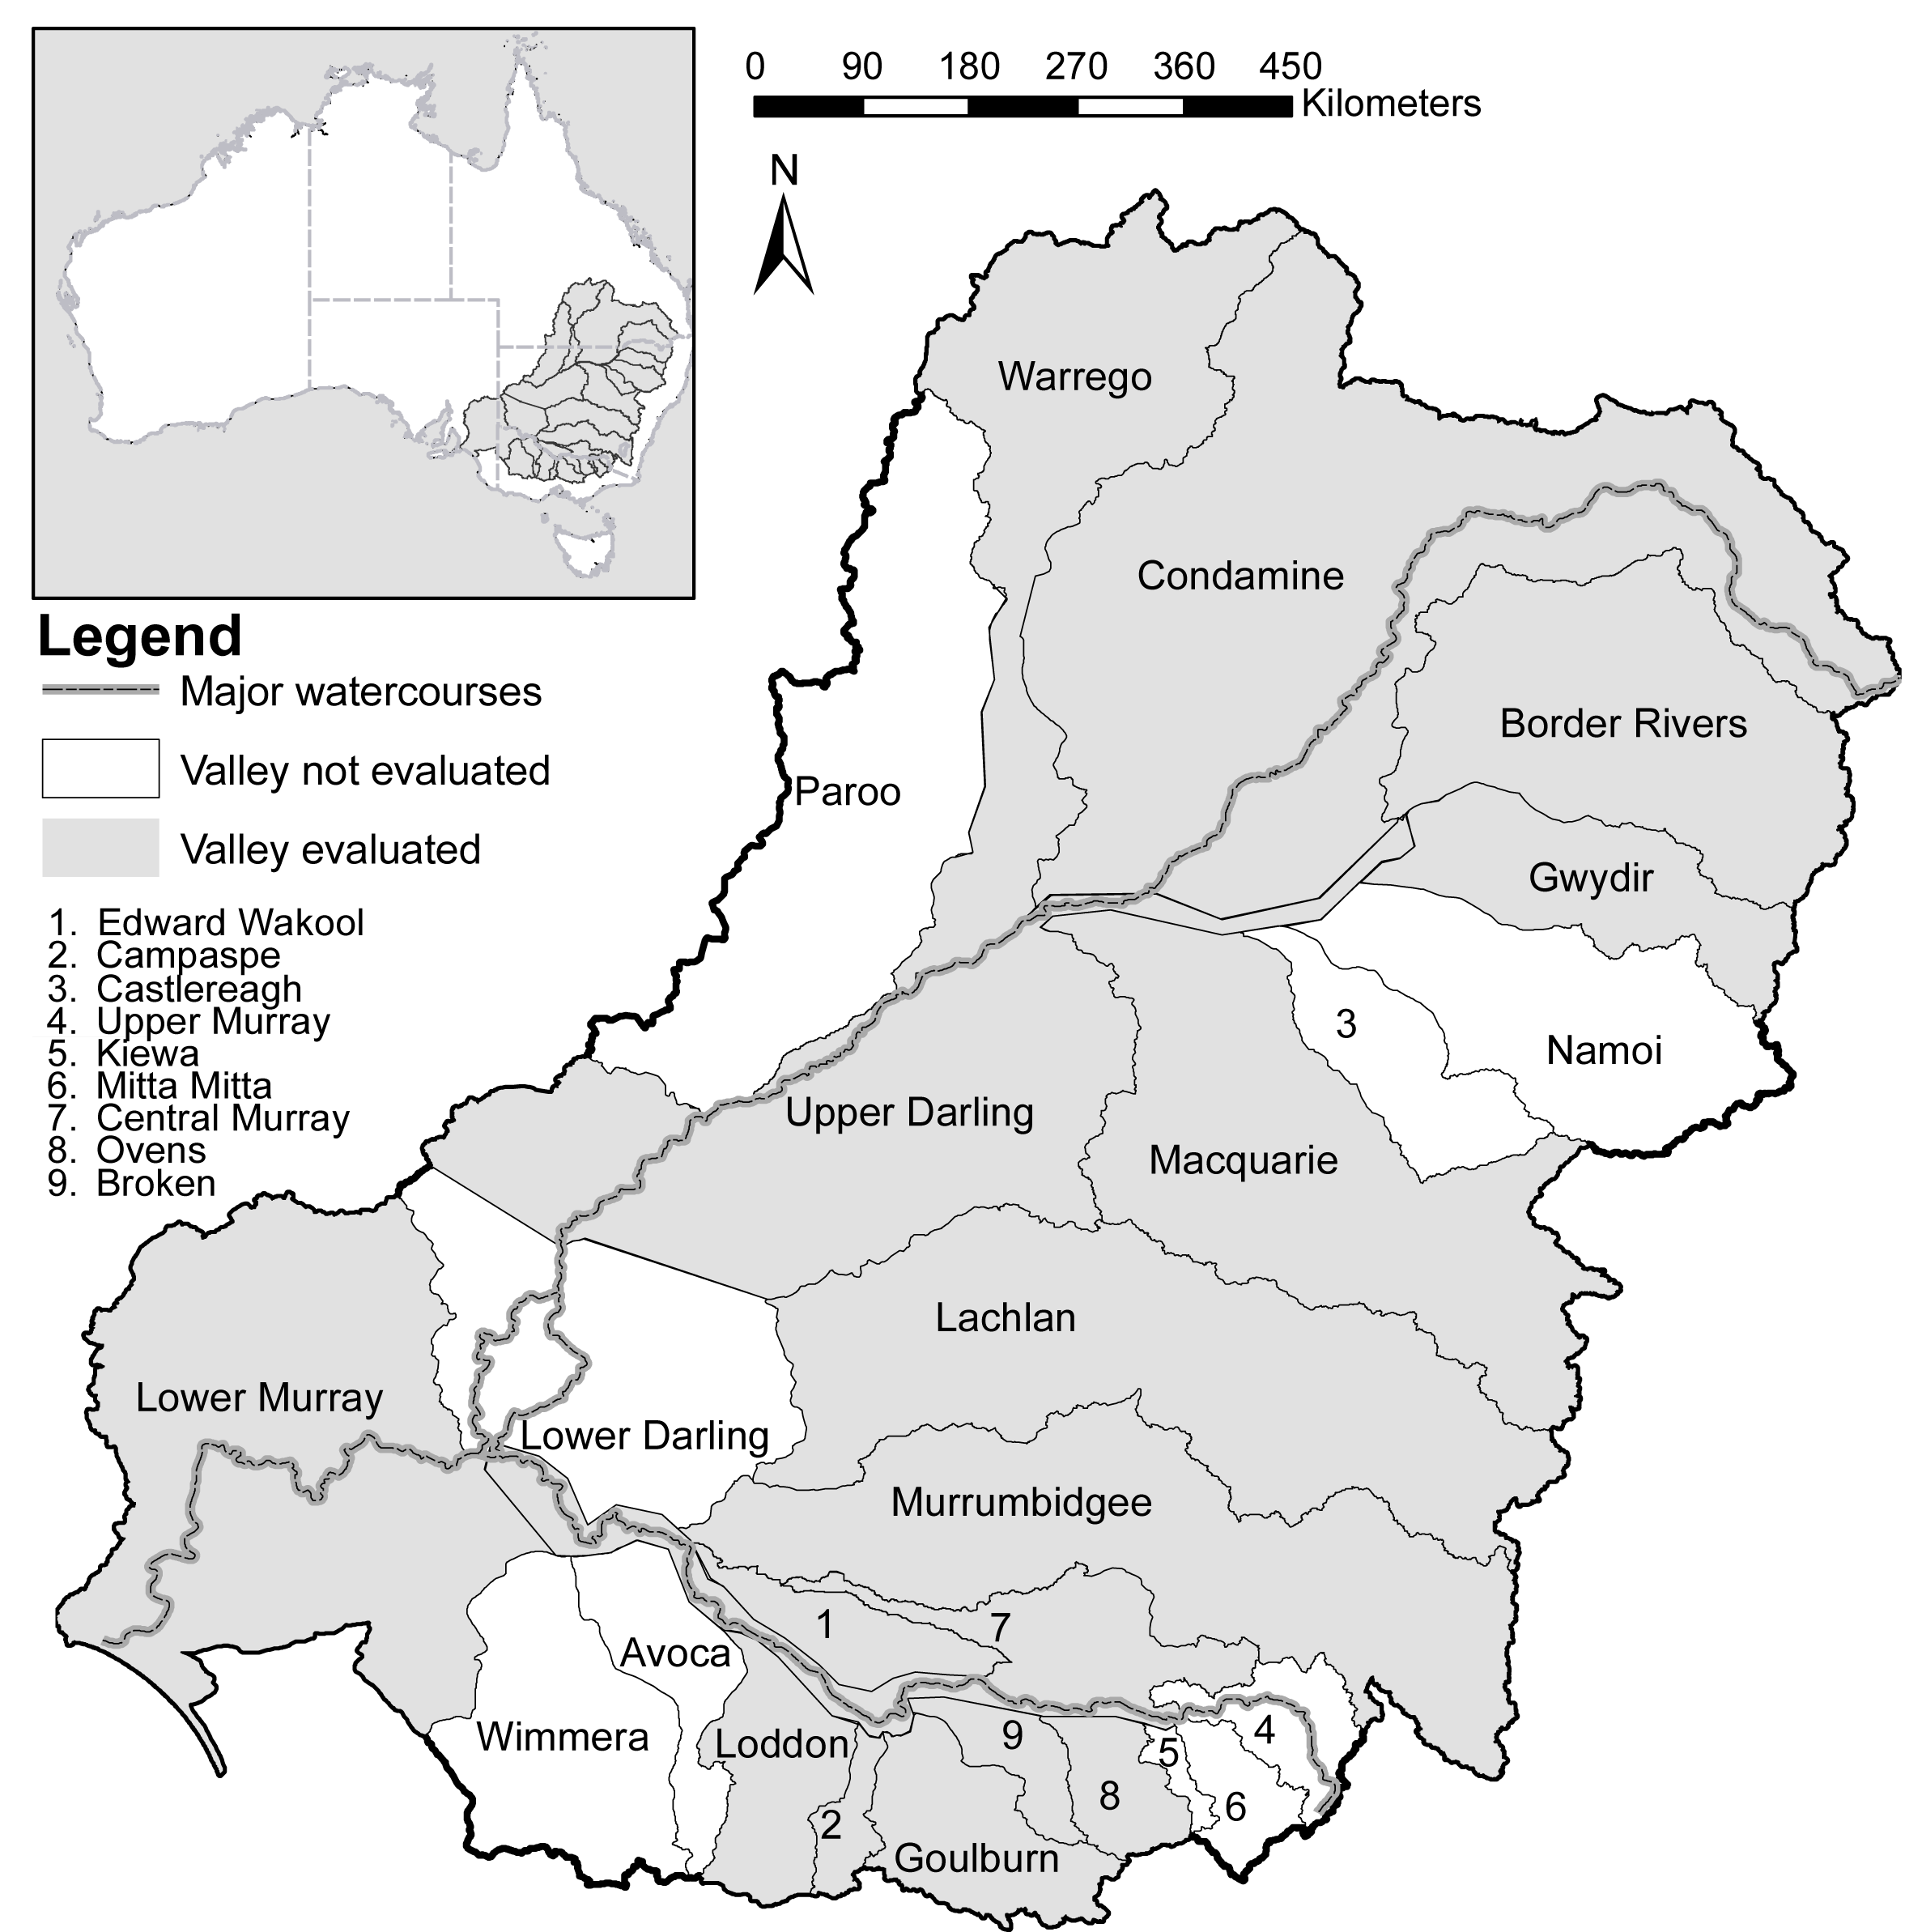
Figure 1. Valleys assessed in the 2015–16 hydrological evaluation of Commonwealth environmental water.

Data sources for evaluating contribution to flow regimes
The contribution of Commonwealth environmental water to flow regimes in the Basin is primarily evaluated using streamflow for the 2015–16 watering year. Estimates of the contribution of Commonwealth environmental water were calculated at 111 streamflow sites across 16 valleys within Basin (Table 1). The evaluation of flow regimes is based on a comparison of streamflows recorded at these sites during the 2015–16 year (actual case) with streamflows that would have occurred in the absence of the Commonwealth environmental water program (baseline case). Of the sites where Commonwealth environmental water was delivered, 97 were evaluated to produce flow regime scores.

Table 1. The contribution of Commonwealth environmental water was estimated at 111streamflow sites across 16 valleys in 2015–16. The names of streamflow sites, the baseline modelling approach and number of sites within each valley is also reported.
No. | Valley name | Site count | Site name | Baseline modelling approach | Data owner or provider
1 | Border Rivers | 3 | Goondiwindi, Farnbro, Flinton | Point derived | CEWO
2 | Broken | 4 | Rices Weir, Caseys Weir, Wagarandall, BackCk | Water accounting | GMW
3 | Campaspe | 3 | Barnadown, Rochester, Eppalock | Water accounting | GMW
4 | Central Murray | 11 | Doctors, Corowa, Barmah, Yarrawonga, Tocumwal, Torrumbarry, Barham, Swan Hill, Wakool, Euston, Lock 10 | Water planning | MDBA
5 | Condamine–Balonne | 2 | Roseleigh, St George | Point derived | CEWO
6 | Edward–Wakool | 10 | Gee Gee Bridge, Deniliquin, Yallakool Offtake, Colligen Offtake, Tuppal, Niemur R at Barham Rd, Wakool R at Barham Rd, Niemur R at Mallan School, Wakool at offtake regulator, Wakool at Coonamit | Water accounting | Water NSW
7 | Goulburn | 4 | Murchison, Trawool, Eildon, McCoys | Water accounting | GMW
8 | Gwydir | 22 | Pallamallawa, Moree, Yarraman, Carole Offtake, Pinegrove, Gravesend, Copeton, Boolooroo, Combadello, Tareelaroi, Mehi Offtake, Mallowa, Garah, Tyreel, Gingham Diversion, Brageen, Millewa, Allambie, Midkin, Ballin Boora, Gundare, Bronte | Water accounting | Water NSW
9 | Lachlan | 12 | Cowra, Forbes, Condobolin, Cargelligo, Jemalong, Willandra, Brewster, Nanami, Hillston, Whealbah, Booligal, Merrimajeel | Water accounting | Water NSW
10 | Loddon | 6 | Laanecoorie, Cairn Curran, Loddon, Serpentine, Tullaroop, Appin South | Water accounting | GMW or provider
11 | Lower Murray | 9 | SA Border¹, Lock 6¹, Lock 5¹, Lock 4¹, Lock 3¹, Lock 2¹, Lock 1¹, Wellington¹, Barrages² | ¹Water planning  ²Water accounting | MDBA¹  CEWO²
12 | Macquarie | 6 | Dubbo, Warren, GinGin, Burrendong, Marebone, Baroona | Water accounting | Water NSW
13 | Murrumbidgee | 12 | Wagga, Gundagai, Narrandera, Yanco Offtake, Darlington, Berembed, Maude, Redbank, Carrathool, Gogelderie, Balranald, Hay | Water accounting | Water NSW
14 | Ovens | 4 | Buffalo, King, Peechelba, Wangaratta | Water accounting | GMW
15 | Barwon–Darling | 2 | Louth, Collarenebri | Point derived | CEWO
16 | Warrego | 1 | Cunnamulla | Point derived | CEWO
 | Total | 111
Note: CEWO = Commonwealth Environmental Water Office; GMW = Goulburn–Murray Water;
MDBA = Murray–Darling Basin Authority; SA DEWNR = South Australian Department of Environment Water and Natural Resources.

Observations of streamflows
Recorded streamflows were available online at the respective jurisdictional websites (Table 2). It was assumed that the minimum requirements set by the International Organization for Standardization (ISO) standard (ICS.17.120:20) for flow measurement in open channels had been met by the custodians of the streamflow sites, so we provided no further assessment of data quality other than checking for complete records.

Table 2. Websites used to source discharge data for 111 streamflow sites in the Murray–Darling Basin.
Jurisdiction | Water monitoring website
New South Wales | http://waterinfo.nsw.gov.au
South Australia | https://www.waterconnect.sa.gov.au
Queensland | https://water-monitoring.information.qld.gov.au
Victoria | http://data.water.vic.gov.au/monitoring.htm

Baseline hydrology scenarios
The evaluation was based on a comparison of observed hydrology (i.e. daily streamflow time series for the 2015–16 watering year) with baseline hydrology represented by daily streamflows for the 2015–16 year in the absence of Commonwealth environmental water. In most cases, the baseline hydrology was estimated as actual flows minus flows delivered from an environmental water entitlement. However, in cases where the baseline was calculated using the water planning model method (described below), a further adjustment was made so that the baseline hydrology represented streamflows that would have occurred in the 2015–16 year if the Commonwealth water portfolio had never been procured (i.e. agricultural water entitlements resemble those before establishment of the Commonwealth environmental water program). This latter case allows evaluation of the combined consequences of the Commonwealth environmental water recovery and delivery program. In the future, we hope to work with data providers to extend the water planning model approach (see below) to more sites.
Baseline hydrology for the 2015–16 year was derived by several agencies (Table 1) using one of the following three approaches: water accounting model; water planning model; and point derivation.
- Water accounting model: This approach is based on a mass balance of water in river reaches between streamflow sites with a fixed lag time to allow for travel times as well as estimates of losses and gains. Operators enter known factors, such as water orders and water taken, and use empirical data, such as actual unaccounted differences and meteorological data, to calculate saleable components of flow at nominated streamflow sites. Based on these data, the data provider estimates the Commonwealth environmental water and non–Commonwealth environmental water components of the observed time series. The baseline scenario is derived by subtracting the environmental water component from the observed hydrograph at the streamflow gauge. This approach is used by river operators (Goulburn–Murray Water (GMW) and WaterNSW) to provide baseline streamflow series in the Victorian tributaries (Goulburn, Broken, Campaspe, Loddon, Ovens) and regulated valleys of New South Wales (NSW) (Murrumbidgee, Lachlan, Macquarie, Gwydir, Edward–Wakool).

This approach is used to provide the time series of environmental water provided by the CEWH and non–Commonwealth environmental water holders separately.

- Water planning model: The method was developed by the Murray–Darling Basin Authority (MDBA) and applied in the River Murray. In this method, two scenarios were modelled using the MSM-BigMod modelling suite; ‘modelled pre-buyback’ and ‘modelled actual’, for the period between July 2015 and June 2016. The initial conditions of the model were based on the 2014–15 model run. The difference between the two model runs measured the impact of environmental water recovery and use during 2015–16. The ‘modelled actual’ flow differs from the actual observed flow at streamflow gauges because of model error. To avoid artefacts associated with this error, we recalculated the ‘pre-buyback’ case by subtracting the difference (i.e. the modelled actual minus the modelled pre-buyback flows) from the actual observed flows. The resulting flow series is used as the baseline. In this model, the total environmental water entitlement is treated as a single component and there is no separate treatment of Commonwealth environmental water and non–Commonwealth environmental water.

- Point derivation: This method was developed in-house by the CEWO and applies to the unregulated valleys of NSW and Queensland (Border Rivers, and Condamine–Balonne, Warrego and Upper Darling rivers). The CEWO monitors real-time river data to detect when access to Commonwealth unregulated entitlements is triggered. Gauge data, in conjunction with official announcements of water-harvesting access in unregulated valleys (Border Rivers and Lower Balonne and Warrego rivers), are used to estimate in-stream contributions. Volumes are accounted for in accordance with the licence (access) conditions of each entitlement in the same way that other water users manage their take (i.e. water is assumed to be used at all available opportunities when access conditions are triggered). This approach reflects the use pattern of the majority of irrigators in unregulated systems and hence the volumes and pattern of flows that have been reinstated. The baseline scenario was derived by subtracting the Commonwealth environmental water component from the hydrograph.
Commonwealth environmental water delivery is often coordinated with delivery of water by other environmental water holders; hence, the evaluation considers the combined hydrological effect of all environmental water delivery. Where possible, we also indicate the contribution of the Commonwealth environmental water component to the total hydrological effect of all environmental water.
None of these methods comprehensively account for planned environmental water. The focus of this evaluation is on the contribution of Commonwealth environmental water–held environmental water allocations or other environmental water allocations delivered in coordination with this Commonwealth environmental water.

Data sources for evaluating contribution to hydrological connectivity

Floodplain inundation extent
Floodplain and wetland inundation extents in this evaluation are reported as mapped area hectares (ha) and represent monitoring outputs from multiple providers using differing methods (Table 3). The areas reported represent cumulative inundation over the course of the year. An attempt to attribute inundation as Commonwealth environmental water, other environmental water (where the watering actions were separate to Commonwealth actions) and other water (reflecting the inundation associated with natural events) was made. However, this attribution was not straightforward because the information required for attribution was not easily accessible and on-ground validation was not comprehensive. Inundation areas attributed as watered by Commonwealth environmental water may represent inundation areas that included contributions from other environmental water and other water. As such, inundation area linked to Commonwealth environmental water has been classed with low confidence Basin wide and will remain this way until accurate, reliable and accessible inundation mapping is made available to support defensible and robust monitoring and evaluation.

Watercourses watered
The watercourses watered using Commonwealth environmental water were mapped using information provided via CEWO environmental water delivery personnel and other operational reports. In the regulated rivers where environmental water was ordered from a dam, the reaches downstream to the accounting point (in NSW) were marked as watered (i.e. reaches beyond the end of system were not included) whereas, in Victoria, the reaches watered were extended to the confluence with the River Murray. In Victoria, returning environmental flows are protected whereas in NSW they are not protected. In the unregulated rivers of the northern Basin, CEWO provided advice on the estimated extents of watercourses influenced by Commonwealth environmental water.

Table 3. Description of the method used to derive inundation across valleys where inundation was reported in the Murray–Darling Basin. Boundary definition and data confidence are reported.
Valley name | Method | Data owner | Boundary definition
Central Murray | Landsat and visual survey; MIKE hydro-dynamic model; DEM + water level | Mallee CMA; MDBA | Wet area boundaries show Commonwealth environmental water–assisted contributions.
Gwydir | Landsat and visual survey | NSW OEH;  Eco Logical | Wet area boundaries denote contributions from both Commonwealth environmental water and natural rainfall/runoff processes.
Lachlan | Visual survey; NDVI; Landsat | NSW OEH | Wet area boundaries denote contributions from both Commonwealth environmental water, other environmental water, other water and natural rainfall/runoff contributions.
Lower Murray | Landsat and visual survey; MIKE hydrodynamic model; DEM + water level | NSFA; SA DEWNR; NRM Board; MDBA;  CEWO | Wet area boundaries only denote Commonwealth environmental water–assisted contributions.
Macquarie | Landsat and visual survey | NSW OEH | Wet area boundaries estimate contributions from both Commonwealth environmental water and natural rainfall/runoff processes.
Murrum-bidgee | Landsat and visual survey | NSW OEH | Wet area boundaries denote contributions from both Commonwealth environmental water and natural rainfall/runoff processes.
Warrego | Landsat and visual survey | NSW OEH;  Eco Logical | Wet area boundaries denote contributions natural rainfall/runoff processes.
Note: DEM = digital elevation model; GBCMA = Goulburn Broken Catchment Management Authority (CMA);
MDBA = Murray–Darling Basin Authority; NDVI = Normalised Difference Vegetation Index; NFSA = Nature Foundation South Australia; NRM = Natural Resource Management; NSW OEH = NSW Office of Environment and Heritage; SA DEWNR = South Australian Department of Environment, Water and Natural Resources.

Evaluation of Basin-wide hydrological impacts
The hydrological evaluation is in two parts. The first part summarises the Basin-scale contribution of environmental water to general enhancements in flow regimes without reference to local watering targets. This is provided to fulfil two purposes:
- To support an evaluation against the Basin Plan objectives as described in the Basin Plan Section 8.51(1)(b). The Basin Plan identifies seven flow components that must be considered in the determination of watering requirements of environmental assets and ecosystem functions. Given the dry year across much of the Basin, only some of these flow components are included in this evaluation (Table 4).

- To provide the basis for evaluating ecological consequences of environmental watering at the Basin scale. In this part, we use hydrological measures related to standardised flow thresholds to indicate effects on base flows and freshes. It is important to note that this section is not for assessing the performance of environmental water delivery with respect to local hydrological targets (which is instead dealt with in the Section 4 of this report).
Table 4. Flow components included in the Basin Plan and those that are included in the first year of the Basin-scale evaluation.
Basin Plan flow components | Included in evaluation?
Cease to flow | No
Low flow season base flows | Yes
High flow season base flows | Yes
Low flow season freshes | Yes
High flow season freshes | Yes
Bankfull flows | No
Overbank flows | No

We provide a summary of the hydrological outcomes across the Basin using data for 111 streamflow sites, selected based on data availability rather than randomly sampled. As such, it is not possible to make statistically based inferences concerning the mean and variance of outcomes across the Basin because statistical design does not support a random sample. Also, streamflow sites included in this evaluation were not specifically targeted to receive environmental water. This means any outcomes at these sites are an inadvertent result of actions designed to meet environmental targets elsewhere in the Basin. This is important as the Basin Plan sets principles on maximising environmental benefits, which are intended to ensure that the water achieves the best environmental outcomes (i.e. through considerations on multi-site watering en route to an intended priority asset or enhancing existing flow events).

Flow thresholds
The summary is based on the occurrence of low flows and freshes. We consider two components of low flows – very low and medium low; and three components for freshes – low, medium and high. These flow components are defined by five threshold discharges as follows:
- Very low flows are defined as flows that fall below the lowest flow in the unimpacted (defined below) monthly flow series or 2% of mean unimpacted flow, whichever is greater. This threshold corresponds to exceptionally low flows at the lower end of range that would normally occur in an unimpacted perennial river.
- Medium low flows are defined as flows that fall below the 95th percentile exceedance flow in the unimpacted monthly flow series or 10% of the mean unimpacted flow, whichever is greater. This flow threshold corresponds to a value that might typically be used as a minimum flow to maintain low flow habitats.
- Low freshes are defined as flow spells that raise water levels at least one-eighth of the height of the bank above the medium low flow level. This threshold corresponds to a slight increase in stage above base flow levels and would be a frequent occurrence in both the dry and wet seasons under unimpacted flow conditions.
- Medium freshes are defined as flow spells that raise water levels at least one-quarter of the height of the bank above the medium low flow level. This threshold corresponds to an increase in stage that wets the lower part of the bank and would be a frequent occurrence in an unimpacted regime maintaining moist soils and is an important component of a variable watering regime for this portion of the channel throughout the year.
- High freshes are defined as flow spells that raise water levels at least half of the height of the bank above the medium low flow level. Freshes of this magnitude would have occurred in most years in the unimpacted flow regime, and it would be common for freshes to exceed this threshold several times per year.
The unimpacted flow is the expected flow series without development conditions under an historical climate. Unimpacted monthly flow series were provided by the MDBA for sites across the Basin. These were not always the same sites as used in this evaluation of Commonwealth environmental water delivery. In most of these cases, the nearest appropriate unimpacted flow data site was chosen. There were a small number of sites where unimpacted flow series were modelled using the various water planning models across the Basin during the development of the Basin Plan. The bankfull discharge was estimated either as the 5th percentile exceedance in the monthly unimpacted flow (×1.5 as a rough estimate of peak daily flow based on the mean monthly value) or from channel dimensions available for sites across the Basin (these were data collected for the Sustainable Rivers Audit II – Physical Form Theme). Dimensions were taken from the site closest to each of our hydrological evaluation sites, and on the same river channel. Bankfull discharge was estimated from these dimensions using equation M15 in Stewardson et al. (2005). We generally used the larger of these two bankfull estimates but made some exceptions based on individual site considerations. The estimates of discharge corresponding to the low, median and high fresh water levels (defined above) were based on widely accepted at-a-station hydraulic geometry equations (Stewardson 2005).

Flow regime score
We calculated a flow regime ‘score’ corresponding to each of the five flow thresholds. The score is a number equal to or between zero and one. The purpose of this score is to provide a summary of the flow regime and identify contributions of environmental water to protection and restoration of flow regimes across the Basin. In the case of the two low flow thresholds, the score relates to the maintenance of flows above the very low and medium low flow thresholds in each calendar season. Under unimpacted conditions, there would have been a broad range of base flow regimes across the Basin, including some intermittent rivers. To allow for this, the score was calculated based on a comparison of 2015–16 low flows with unimpacted low flows. The score measures the duration of flows exceeding our two low flow thresholds in each calendar season relative to the normal duration in the unimpacted state. If the average unimpacted base flow durations were maintained in 2015–16, then the site received the maximum score of ‘1‘. A reduction in the duration compared with unimpacted duration, in any of the four seasons, reduced the score. If we applied this score to an unimpacted regime, we could expect that, in dry years, we would get a lower score than in average and wet years. The score is not an environmental flow objective, rather an indication of the dryness of the low flow regime in 2015–16 and the components of the flow regime that are significantly affected by environmental watering actions.
Similarly, a score was calculated for each of the three thresholds corresponding to low, medium and high freshes. However, we did not attempt to adjust these scores based on a comparison with the unimpacted flow regime. Instead, the score relates to the occurrence (or not) of flow freshes exceeding these fresh thresholds. For the low fresh threshold, the duration of flows above this threshold within a calendar season must have exceeded 3 days for a ‘fresh’ to be considered to have occurred. The maximum score (of ‘1’) was achieved for the low fresh if a fresh occurred in three of the calendar seasons. For the medium fresh, the maximum score was achieved if a fresh occurred in at least two calendar seasons. For the high fresh, the maximum score was achieved if a fresh exceeded this threshold at some time over the year.
In Annex A, we report scores for each site but simplify the results by combining the two low flow scores into a single base flow score and the three scores for the flow fresh thresholds into a single freshes score. The freshes score (reported in the Annex A) weights the low, medium and high fresh scores according to the percentage weights 50:30:20, respectively.
We emphasise that these scores are not an evaluation of individual watering actions and their associated objectives. The scores are used to summarise the flow regime at sites across the Basin and support an evaluation of the overall effect of the management of Commonwealth environmental water on flow regimes at the Basin scale. For this reason, a number of the sites included in the analysis were not actually targeted with environmental watering actions.

Attribution of Commonwealth environmental water
Commonwealth environmental water delivery is often coordinated with delivery of other environmental water to achieve a combined outcome. In such cases, it makes little sense to consider the contribution of the Commonwealth environmental water in isolation. For consistency, we have evaluated the aggregate hydrological outcome of all held environmental water.
The total contributions of all environmental water cannot be fully attributable to the Commonwealth environmental water in situations where there is coordinated delivery with other environmental water holders. To address this issue, we have developed a simple procedure for sharing score increases between Commonwealth environmental water and other environmental water:
- Calculate the total improvement in score with all environmental water entitlements (i.e. compare the score for the observed and baseline flow regimes).

- Calculate the improvement that would have been achieved if Commonwealth environmental water was delivered on its own.

- Calculate the improvement if the non–Commonwealth environmental water had been delivered on its own.

- Apportion the total improvement (from 1 above) to Commonwealth environmental water and non–Commonwealth environmental water based on the ratio of improvements achieved in 2 and 3 above.

2015–16 hydrological context

Climate and water availability
In 2015–16, valleys where Commonwealth environmental watering occurred experienced above-average to below-average rainfall conditions (Figure 2). Four valleys experienced above-average rainfall conditions (Barwon–Darling, Lachlan, Macquarie and Murrumbidgee), while nine valleys experienced average rainfall conditions (Central Murray, Border Rivers, Broken, Condamine–Balonne, Gwydir, Lower Murray, Ovens, Warrego and Edward–Wakool) and three valleys (Campaspe, Goulburn and Loddon – all in Victoria) experienced below-average rainfall conditions. In the southern Basin, Victoria experienced the lowest rainfall conditions compared with average rainfall. Similarly, the volume of water held in the majority of Victorian storages declined. Excluding the Murrumbidgee, Macquarie and Lachlan, the volume of water held in storages across the Basin declined between 2% and 25% (with the average storage declining 15% over the course of the watering year).

MDBA Basin watering priorities
The Basin Annual Environmental Watering Priorities are produced by the MDBA to guide annual planning and prioritisation of environmental watering across the Basin (MDBA 2015). These aim to achieve the most effective use of environmental water, promote better Basin-scale outcomes, coordinate environmental watering between environmental water holders and managers, in an effort to maintain ecological health and ecosystem resilience throughout the Basin. The priorities are guided by the Basin-wide Environmental Watering Strategy (MDBA 2014). All watering decisions in the Basin for environmental benefit must consider the priorities, including watering that uses both held and planned environmental water. However, the priorities do not preclude other watering priorities identified by environmental water holders.
Existing storage levels, rainfall projections and the outlook for water availability is considered when deciding on the priorities. At the time of planning the 2015–16 priorities, storage levels were generally below 50% full capacity and inflows were anticipated to be low due to low soil moisture levels. The 2015–16 priorities were planned to accommodate a range of conditions from dry to moderate water availability scenarios. Lower than average inflows over the year were consistent with this expectation.
The Basin priorities are organised in four themes: river flows and connectivity; native vegetation; waterbirds; and native fish. All four themes include hydrological targets for the valleys that received Commonwealth environmental water in 2015–16 (summarised in Table 5).
The MDBA also maintains a set of streamflow indicators (SFIs) that are specific for key ecological assets across the Basin. These are used to guide Annual Environmental Watering Priorities. SFIs were first developed as an input to the Basin Plan when the MDBA undertook an assessment of Basin-wide environmental water requirements to achieve the Basin Plan ecological objectives (MDBA 2011). They have subsequently been adapted to inform the Northern Basin Sustainable Diversion Limit (SDL) Review and assessment of SDL Adjustments in the southern Basin. There is currently a set of 53 SFIs across 10 sites in the southern Basin and 48 SFIs across 11 sites in the northern Basin. The sites are mostly in the lower reaches of the Basin’s key valleys where large floodplain ecosystems have the greatest environmental water demands. SFIs are generally characterised by threshold discharge that must be exceeded for a specific duration during a particular season. The SFIs are binary, i.e. the durations above threshold are either achieved or not achieved. The MDBA does not account for any benefits that might be delivered in years when there is partial achievement of SFIs but not full achievement of the required durations. Importantly, some SFIs have threshold discharges that are in excess of what is achievable with environmental water given the many constraints on delivery of high environmental flows in the Basin.
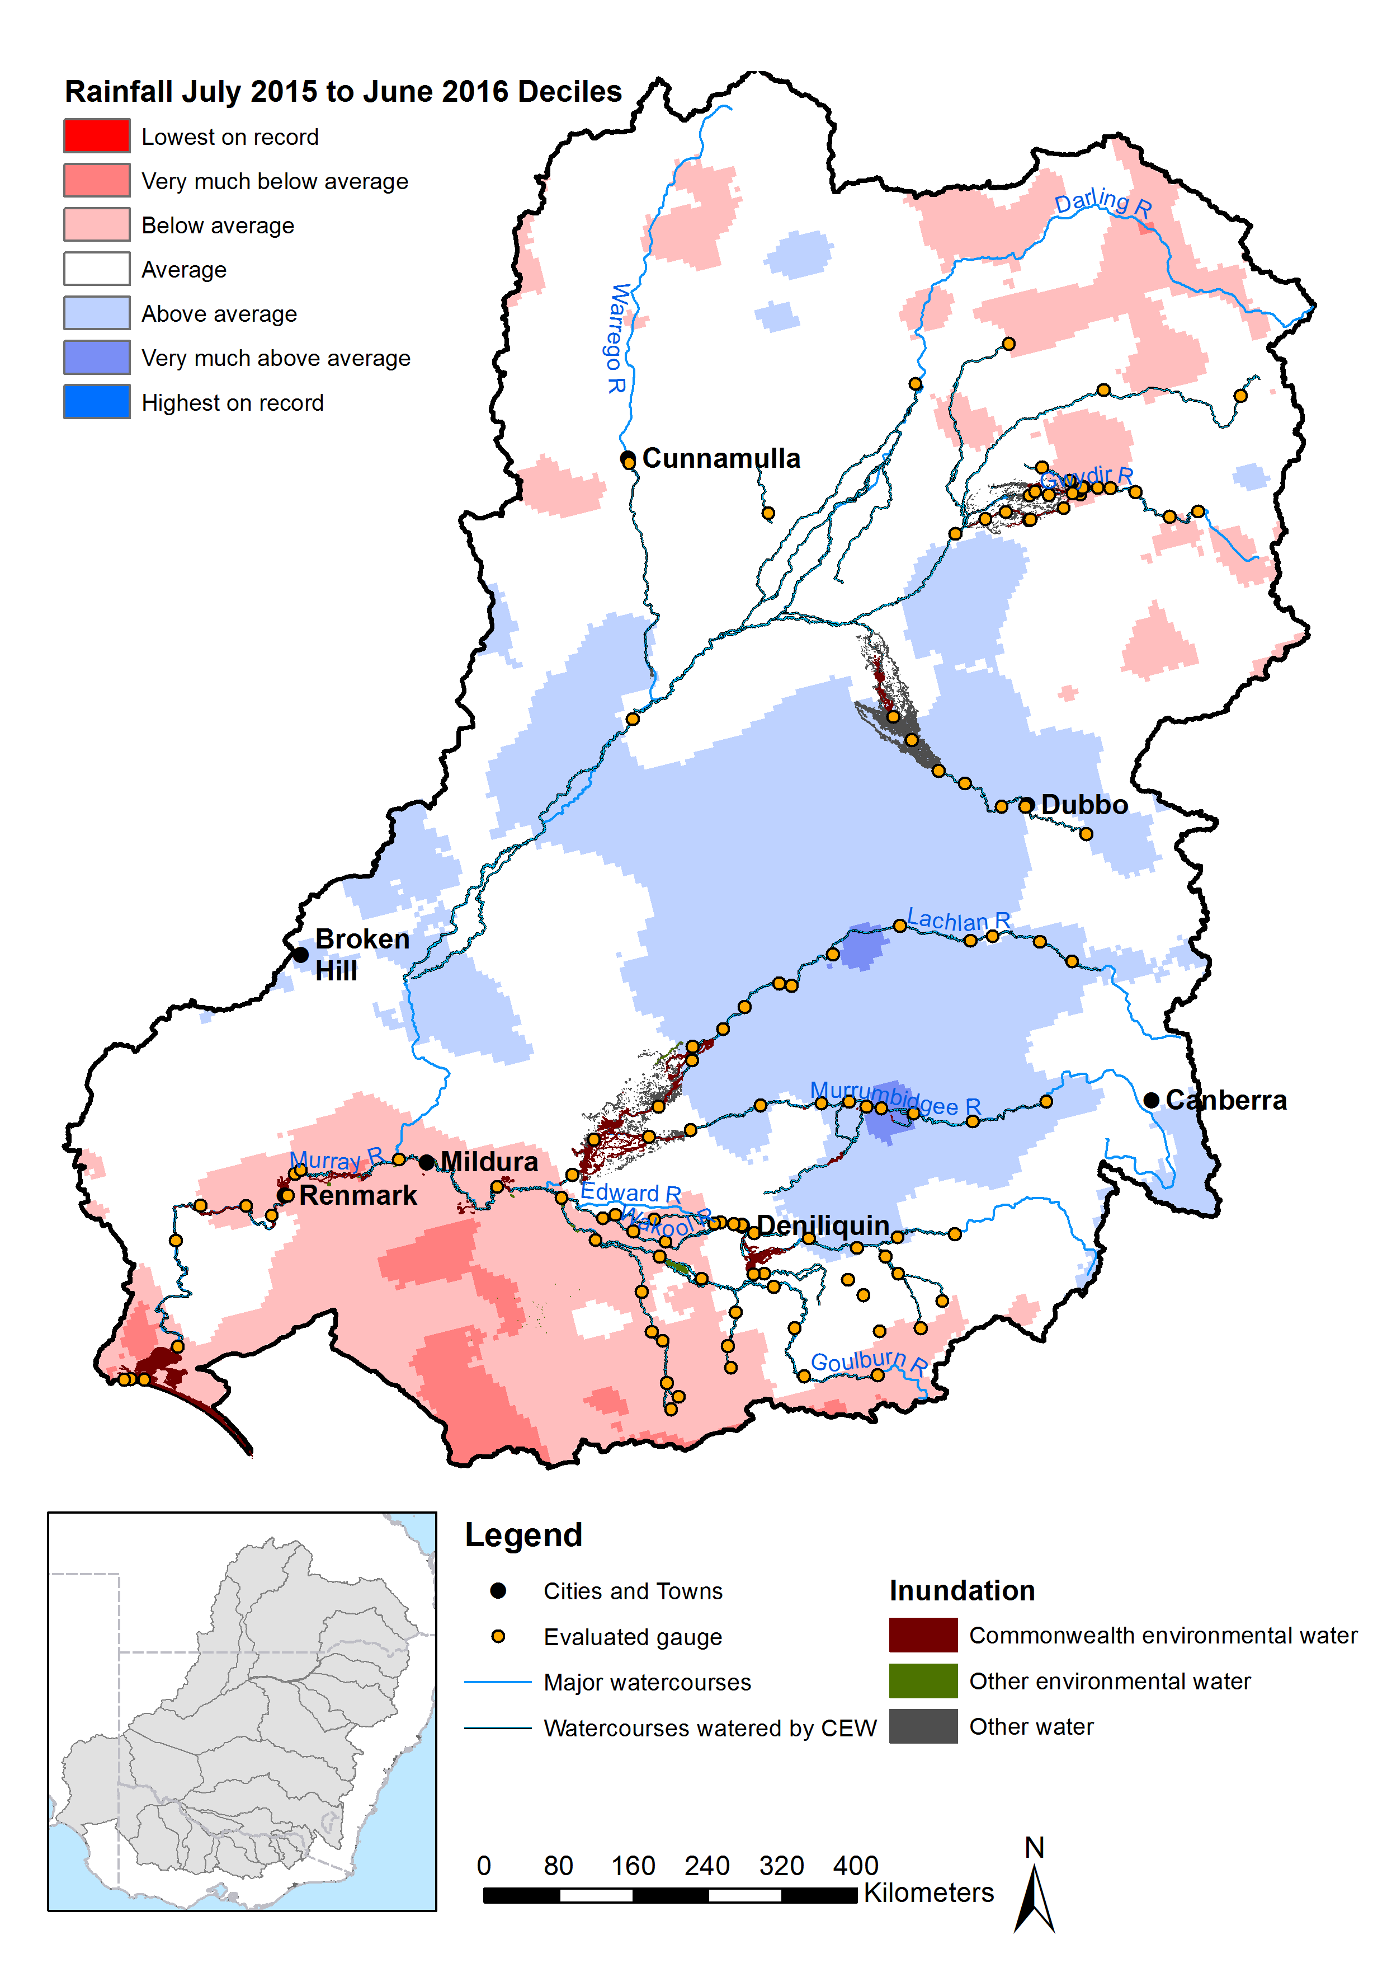
Figure 2. Gauges evaluated, areas inundated, streams watered by Commonwealth environmental water, and rainfall conditions during the 2015–16 watering year.

Table 5. 2015–16 Basin Annual Environmental Watering Priorities as they relate to the four priority themes. Asterisks indicate relevant river valleys from the 16 river valleys in which Commonwealth environmental water was delivered. ^note included in the table as a valley, but is part of the Lower Murray valley.
Priority | Flow component |  |  |  |  | River valley
Priority | Cease to flow | Baseflow | Freshes | Bankfull and overbank | Art. wetland inundation | Barwon–Darling | Border Rivers | Broken | Campaspe | Central Murray | Condamine–Balonne | Edward–Wakool | Goulburn | Gwydir | Lachlan | Loddon | Lower Murray | Macquarie | Moonie | Murrumbidgee | Ovens | Warrego | Coorong, LL and MM^
River flows and connectivity theme
Basin-wide flow variability and longitudinal connectivity: Provide flow variability and longitudinal connectivity within rivers to support refuge habitats. |  | X | X |  |  | X | X | X | X | X | X | X | X | X | X | X | X | X | X | X | X | X | X
River Murray weir pool variation: Ensure a variable flow pattern and lateral connectivity through coordinated weir pool management in the River Murray from Euston to Blanchetown. |  |  | X |  |  |  |  |  |  | X |  |  |  |  |  |  | X
Coorong, Lower Lakes (LL) and Murray Mouth (MM): Improve water quality, fringing vegetation and native fish movement by varying the water levels in Lakes Alexandrina and Albert to maintain flows into the Coorong and Murray Mouth. |  |  | X |  |  |  |  |  |  |  |  |  |  |  |  |  |  |  |  |  |  |  | X

Native vegetation theme
Basin-wide in-stream and riparian vegetation: Maintain and where possible improve the condition of in-stream riparian vegetation, through in-channel freshes. | X |  | X |  |  | X | X | X | X | X | X | X | X | X | X | X | X | X | X | X | X | X
Mid-Murrumbidgee etlands: Improve the condition of wetland vegetation communities in the mid-Murrumbidgee wetlands. |  |  |  | X | X |  |  |  |  |  |  |  |  |  |  |  |  |  |  | X
Macquarie Marshes: Maintain semi-permanent wetland vegetation in core refuge areas in the Macquarie Marshes. |  |  |  | X |  |  |  |  |  |  |  |  |  |  |  |  |  | X
Moira grass: Maintain the condition and range of Moira grass in Barmah–Millewa Forest by supplementing a natural event and extending the duration of inundation. |  |  |  | X | X |  |  |  |  | X
Waterbirds theme
Basin-wide waterbird habitat and future population recovery: Improve the complexity and health of priority waterbird habitat to maintain species richness and aid future population recovery. |  |  |  | X | X | X | X | X | X | X | X | X | X | X | X | X | X | X | X | X | X | X | X

Native fish theme
Basin-wide native fish habitat and movement: Maintain native fish populations by protecting and improving the condition of fish habitat and providing opportunities for movement. |  | X | X |  |  | X | X | X | X | X | X | X | X | X | X | X | X | X | X | X | X | X | X
Northern Basin fish refuges: Protect native fish populations and in-stream habitats, particularly drought refuges, in the northern Basin. |  | X | X |  |  |  | X |  |  |  | X |  |  | X | X |  |  | X
Silver perch: Contribute to the long-term recovery of silver perch by maintaining key populations, supporting recruitment and facilitating movement and dispersal. |  | X | X |  |  |  | X |  |  | X |  | X | X |  |  |  | X |  |  |  | X

Watering actions
In 2015–16, 1049 gigalitres (GL) of Commonwealth environmental water was debited from the CEWH accounts, realising 115 watering actions across 16 LTIM valleys (Table 6). Through the use of return flows, Commonwealth environmental water was used and reused, effectively contributing to 1662 GL. These actions improved flow regimes along approximately 20,200 km of waterway (Figure 2 and Figure 3). Almost two-thirds of the Commonwealth environmental water delivered in 2015–16 was used in 15 base flow watering actions across the River Murray, northern Victoria, Gwydir and Border Rivers. A smaller portion, only 16% of the Commonwealth environmental water, contributed to the 36 actions involving freshes or actions that combined both freshes and base flows across 16 LTIM valleys. In most valleys there were either one or two actions involving freshes, with three in the Barwon–Darling, five in the Border Rivers and four in the Lachlan. In the River Murray, 6 events were classified as freshes due to an increase in water level, which were artificially produced by weir pool manipulations as opposed to increases in flow.
Commonwealth environmental water substantially contributed to 273,000 ha of wetland/floodplain inundation over 2015–16 (Figure 2 and Figure 4). A total of 25% of Commonwealth environmental water was used in watering actions that delivered water out of the river channel in 64 watering actions. Approximately two-thirds of this environmental water was used in 7 watering actions where flows were increased to magnitudes equal to, or greater than bankfull channel capacity in the Central Murray, Warrego and Gwydir valleys. The remainder of this environmental water was used to fill wetlands with the assistance of regulating structures and pumps in 57 actions restricted to the Central and Lower Murray and Murrumbidgee valleys.
Watering actions involving freshes or infrastructure-assisted wetland inundation were often delivered in partnership with other environmental water holders, although Commonwealth environmental water contributed more than all other environmental water holders combined for these actions.

Table 6. Summary of Commonwealth environmental watering actions by valley.
Valley | Number of actions | Commonwealth environmental water volume (GL) | Total active environmental volume (GL) | CEW volume  as % of total | Flow components
 |  |  |  |  | Cease to flow | Baseflow | Fresh | Base flow and fresh | Bankfull | Overbank | Wetland inundation | Fresh and wetland
Barwon–Darling | 3 | 7.6 | 7.6 | 100 |  |  | 3
Border Rivers | 6 | 1.2 | 1.2 | 100 |  | 1 | 5
Broken | 5 | 29.5 | 30.3 | 97 |  | 4 | 1
Campaspe | 2 | 3.3 | 9.8 | 34 |  |  | 2
Central Murray | 12 | 399.9 | NA | NA |  | 1 | 1 | 1 |  | 4 | 5
Condamine–Balonne | 2 | 10.5 | 10.5 | 100 |  |  | 2
Edward–Wakool | 4 | 32.2 | 34.5 | 93 |  |  |  | 4
Goulburn | 6 | 190.6 | 228.2 | 84 |  | 4 | 2
Gwydir | 4 | 8.1 | 13.2 | 61 |  | 1 | 1 |  |  | 2
Lachlan | 4 | 36.0 | 48.0 | 75 |  |  | 4
Loddon | 1 | 1.5 | 3.9 | 38 |  |  | 1
Lower Murray | 48 | 817.7ª | NA | NA |  | 2 | 5 |  |  |  | 40 | 1
Macquarie | 2 | 14.2 | 55.1 | 26 |  |  | 2
Murrumbidgee | 13 | 108.3 | 200.8 | 54 |  |  | 2 |  |  |  | 11
Ovens | 2 | 0.1 | 0.1 | 100 |  | 2
Warrego | 1 | 0.9 | 0.9 | 100 |  |  |  |  | 1
Total count | 115 |  |  |  | 0 | 15 | 31 | 5 | 1 | 6 | 56 | 1
Component volume as % of total |  |  |  |  | 0.0 | 62.3 | 6.1 | 7.9 | 0.1 | 16.8 | 6.8 | 0.1
ª This volume includes water delivered in the Central Murray so total Commonwealth environmental water is less than sum of Central Murray and Lower Murray volumes.

Figure 3. Length of river where flow regimes are enhanced by the delivery of Commonwealth environmental water in the 2015–16 year.

Figure 4. Area of floodplain and wetland inundation in the 2015–16 year.¹
¹ Area of inundation shows the total cumulative inundation area of wetlands and floodplains where Commonwealth environmental water made a contribution. This means the inundation areas shown include contributions from other water sources (groundwater, rainfall, surface runoff and other inflows) from the current or previous watering years as well as Commonwealth environmental water. In other words, inundation area reflects the total inundation and not the net area contribution of Commonwealth environmental water. The extremely large inundation area recorded in the Lower Murray reflects the fact that Commonwealth environmental water made a contribution in the Coorong and Lower Lakes, but the net inundation area attributed to Commonwealth environmental water (which was not calculated) would be lower.

Evaluation of flow regimes and hydrological connectivity in 2015–16

Highlights
The Commonwealth watered 20,200 km of river channels and made a major contribution to the 273,000 ha of wetland and floodplain inundation over the 2015–16 watering year. Seven of the MDBA’s SFIs were achieved across five of the LTIM valleys (List below). Commonwealth environmental water contributed to successful delivery of an SFI in the Goulburn River and three SFIs targeted at floodplain ecosystems in the Lachlan River valley. Three others were achieved without the need for additional environmental water although environmental water may have enhanced these flow events beyond the minimum requirements. These seven SFIs are all relatively low magnitude events and are intended to occur in at least 60% of years (i.e. the SFI is achieved in at least 3 years out of 5). Generally, these SFIs targeting a high frequency of years have a lower threshold discharge and require less environmental water. SFIs with a target frequency of less than 60% (i.e. lower frequency and a higher flow magnitude) were not expected to be achieved in 2015–16 due to the dry conditions.
The seven SFIs were:
- A fresh of greater than 5000 megalitres (ML)/day in October–November in the Goulburn River at Shepparton in the Goulburn Valley (SFI2). This fresh is targeted for achievement on average every 2 years in 3.
- A sustained flow above 300 ML/day for 25 days between June and November at the Booligal Wetland in the Lachlan Valley (SFI1). This event is targeted for achievement on average every 3 years in 4.
- A sustained flow above 700 ML/day for 25 days between June and November at the Great Cumbung Swamp in the Lachlan Valley (SFI1). This event is targeted for achievement on average every 3 years in 5.
- A sustained flow above 850 ML/day for 20 days between June and November at the Lachlan Swamp in the Lachlan Valley (SFI1). This event is targeted for achievement on average every 3 years in 5.
- A cumulative duration of 180 days when flow is above 1500 ML/day between June and March in the Edwards River at Deniliquin in the Edward–Wakool Valley (SFI1). This SFI is targeted for achievement in every year.
- A fresh of greater than 1100 ML/day between October and January in the Murrumbidgee River at Balranald in the Murrumbidgee Valley (SFI1 in the freshes group). This fresh is targeted for achievement on average every 3 years in 4.
- A fresh of greater than 1000 ML/day for at least 2 days between October and January in the Gwydir Wetlands in the Gwydir Valley (SFI2). This fresh is targeted for achievement on average in 85% of years.
The MDBA set environmental watering priorities for the 2015–16 year relating to: river flow and connectivity; native vegetation; waterbirds and native fish. The waterbirds theme was not assessed based on hydrological outcomes because hydrological targets were not specified. Two of the priorities relate directly to hydrological outcomes and progress was made in at least 60% of the relevant valleys. These priorities were:
- Provide flow variability and longitudinal connectivity within rivers to support refuge habitats. This priority emphasises the importance of maintaining base flows to protect a diversity of hydraulic habitat conditions and in-channel flow freshes to support movement of fish along river channels. Given it was a dry year, there was good success in achieving this priority. Many of the 16 valleys where Commonwealth environmental water was delivered in 2015–16 maintained either a good base flow or fresh flow regime.
- Ensure a variable flow pattern and lateral connectivity through coordinated weir pool management in the River Murray from Euston to Blanchetown. There was continued improvement in achieving this priority during 2015–16 with weir level manipulations undertaken at 6 of the 12 weirs along the River Murray downstream of Euston.
Seven priorities focused on outcomes for native vegetation and native fish and, in each case, Commonwealth environmental water was used to produce flows that would be expected to contribute to achieving the priority outcomes. An evaluation of environmental outcomes is included in (2015–16 Basin evaluation reports). These priorities were:
- Improve water quality, fringing vegetation and native fish movement by varying the water levels in Lakes Alexandrina and Albert to maintain flows into the Coorong and Murray Mouth. The environmental watering strategy for this priority targeted extended base flows and coordinated operation of barrages. Commonwealth environmental water contributed to the hydraulic targets set for the Lower Lakes in the Basin-wide Environmental Watering Strategy. However, discharge through the barrages and the mouth was low relative to the target flows and will need to be increased in future years if the 3-year average is to meet the discharge target.
- Maintain and where possible improve the condition of in-stream riparian vegetation, through in-channel freshes. The environmental watering strategy for this priority targeted low to moderate freshes, high freshes, watering wetlands in the lower reaches, and cease to flows. Given this was a dry year, there was good progress towards this priority. Low to moderate freshes were widespread in nine valleys. High freshes were achieved in three valleys. Watering of end-of-systems wetlands was achieved in four valleys.
- Improve the condition of wetland vegetation communities in the mid-Murrumbidgee wetlands. The environmental watering strategy for this priority targeted wetland inundation through overbank flows or operation of infrastructure. Six wetlands or wetland systems received environmental water along the mid-Murrumbidgee Valley. This is a relatively small portion of the wetlands targeted in this priority.
- Maintain semi-permanent wetland vegetation in core refuge areas in the Macquarie Marshes. The environmental watering strategy for this priority targeted delivery of sustained flows into the lower Macquarie River to produce flooding. The delivery of Commonwealth environmental water achieved expected flooding extents across the Macquarie Marshes.
- Maintain native fish populations by protecting and improving the condition of fish habitat and providing opportunities for movement. The environmental watering strategy for this priority targeted base flows, low to moderate freshes, high freshes, slowing overbank recession and maintaining natural winter flows. Generally, native fish populations were expected to be supported through the maintenance of base flows and freshes in many of the Basins valleys. Base flows and freshes are believed to be important in sustaining water quality and hydraulic habitat diversity. Commonwealth environmental water was used to deliver base flows in seven river valleys and had significant effects on the low flow characteristics in the Central-Murray, Lachlan and Macquarie Rivers. Thirty-five freshes were delivered across 14 river valleys with significant influences on low or medium freshes in the Campaspe, Central Murray, Goulburn, Lachlan and Loddon Rivers. The lack of high in-channel flows in many valleys was expected given this was a dry year.
- Protect native fish populations and in-stream habitats, particularly drought refuges, in the northern Basin. The environmental watering strategy for this priority targeted base flows and low to moderate freshes. Commonwealth environmental water was allocated to base flows in the Border Rivers and Gwydir River, while freshes were delivered in six northern rivers (Barwon–Darling, Condamine, Gwydir, Moonie, Macquarie and Lachlan).
- Contribute to the long-term recovery of silver perch by maintaining key populations, supporting recruitment and facilitating movement and dispersal. The environmental watering strategy for this priority targeted base flows and low to moderate freshes. As noted above, base flows and freshes are believed to be important in sustaining water quality and hydraulic habitat for fish, with silver perch being sensitive to poor water quality and having a preference for flowing water (Rogers and Ralph 2001). The allocation of base flows and freshes is described under Point 5 (above) and Sections 4.2.1 and 4.2.2 (below).

Evaluation by flow components

Base flow (low–medium flows)
Across the southern Basin, the durations of flows were mostly maintained above the very low flow threshold for at least as long as achieved on average with the unimpacted flow regime (Figure 5a). Exceptions were in Broken Creek and Edward–Wakool river systems, where very low flows persisted for much longer than the average unimpacted case, indicating a dry low flow regime in 2015–16. These two valleys also experienced a very dry low flow regime in the previous year. Medium low flows were also maintained relative to the average unimpacted state in the Central Murray, Murrumbidgee and Ovens Valleys but were substantially reduced in the other valleys of the southern Basin (Figure 5b). In contrast, medium low flows were reduced across all valleys in the southern Basin in the previous year.
Flows less than medium and very low base flow levels persisted for significantly longer periods than under the unimpacted case across the northern Basin, indicating very dry base flow conditions in 2015–16. This is the same result as the previous year. The only exception was in the Macquarie and Lachlan rivers where base flows were consistent with those expected in the unimpacted regime at both the very low and medium low flow level.
In 2015–16, environmental water contributed to maintaining minimum flows in the Broken, Campaspe, Central Murray, Goulburn, Gwydir, Lachlan, Lower Murray, Murrumbidgee and Macquarie valleys. Commonwealth environmental water significantly contributed to these minimum flows in all cases except the Campaspe. Commonwealth environmental water also contributed to enhanced minimum flows in the Lower River Murray, including flows delivered into the Lower Lakes and Coorong.

Freshes
In the southern Basin, the occurrence of low and medium-size freshes was similar to that expected in unimpacted rivers with the exception of Broken Creek (where low and medium freshes were largely absent) and the Goulburn River (where significantly fewer medium freshes occurred) (Figure 5c, d). High flow freshes occurred in the Broken, Campaspe and Goulburn valleys and not in the other valleys (Figure 5e). Commonwealth environmental water made an important contribution to the frequency of freshes in all cases except the Murrumbidgee and Ovens where freshes were provided without the need for additional environmental water. Flow magnitudes corresponding to medium flow freshes were largely absent in the Lower Murray Valley downstream of the major irrigation offtakes. However, rise-and-fall sequences in water levels consistent with a fresh event were achieved along the Lower Murray through manipulation of selected weir levels at Lock 2 and Lock 5. The major change in the fresh regime for the southern Basin compared with the previous year was a severely reduced frequency of flow magnitudes corresponding to all freshes in the Lower Murray. However, high flow freshes were more frequent in the Goulburn and Murrumbidgee valleys.
In the northern Basin, low and medium freshes were largely absent in the Barwon–Darling; occurred to a limited extent in the Border Rivers, Condamine–Balonne and Warrego valleys; and were frequent in the Gwydir, Lachlan and Macquarie valleys (Figure 5c, d). Environmental water only contributed in the Macquarie Valley – Commonwealth environmental water had a relatively minor role. High freshes occurred in the Border Rivers, Gwydir, Lachlan and Macquarie and but without the need for additional environmental water (Figure 5e). In the 2015–16 year, the fresh regime of the northern Basin was similar to the previous year.

Overbank and wetland inundation
In the 2015–16 watering year, Commonwealth environmental water contributed to out-of-channel watering (including wetland or floodplain watering) in the Gwydir, Lachlan, Central Murray, Lower Murray and Murrumbidgee valleys (Table 6). Commonwealth environmental water contributed to wetland and floodplain inundation in Gwydir and Central Murray valleys by enhancing flows to magnitudes in excess of channel capacity. In the Murrumbidgee, Central Murray and Lower Murray valleys, Commonwealth environmental water achieved wetland inundation using weirs, pumps, floodplain regulators and other infrastructure.

Cumulative evaluation of flow components, 2014–16
The LTIM Project commenced in mid-2014. This section examines cumulative contribution of Commonwealth environmental water to flow regimes over the 2-year period of LTIM monitoring (mid-2014 to mid-2016). The general conclusion of this comparison is that environmental water delivered in the 2 years of monitoring within each valley achieved similar outcomes in terms of base flows and both low and medium freshes. The major exception is the delivery of high freshes which largely resulted from unregulated inflows and hence are subject to natural inter-annual variations, particularly during dry years when high flows may not be delivered in some rivers by natural inflows.
The duration of very low flows (Figure 5 Figure 6a) is very similar in 2014–15 and 2015–16. Periods when baseflows drop below the very low flow threshold are rare throughout the southern Basin in both years. In contrast, periods of exceptionally low flows exceed natural duration in many rivers of the northern Basin in both years (Figure 5 Figure 6a). Flows less than the medium low flow threshold are considerably increased compared with the reference (pre-development) state across the southern Basin with the exception of Central Murray where base flows were consistently maintained in both years (Figure 6b). Base flow conditions improved in the second year in the Ovens and Lachlan valleys. Baseflow conditions declined in the Lower Murray and Goulburn valleys. Low flows below natural levels persisted in the Campaspe for extended periods in both years. In the northern Basin, flows less than the medium low flow threshold were much more persistent than under pre-development conditions. The only exception was in the Macquarie River, where environmental flows maintained the pre-development base flow regime in 2015–16 only.

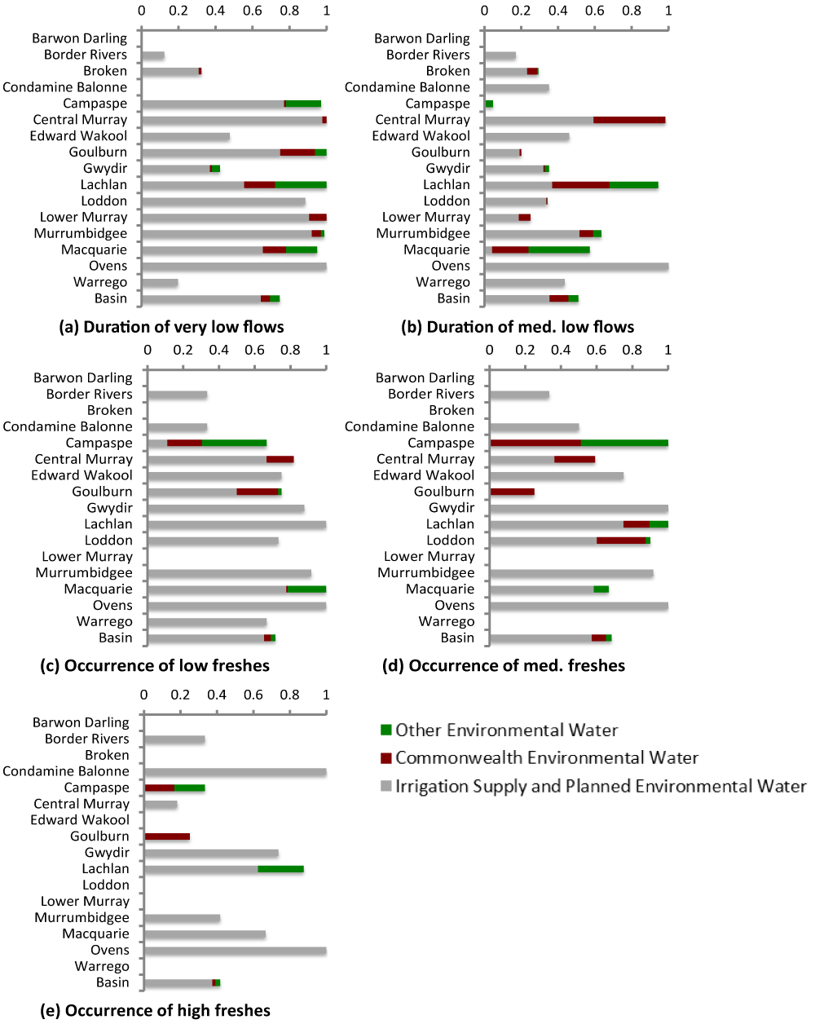
Figure 5. Average contributions of Commonwealth environmental water and other environmental water entitlements to base flow durations and occurrence of freshes across each valley in 2015–16. (Average score for the valley (horizontal axis – where 0 is severely altered from pre-development and 1 is indicative of an adequate frequency of the flow type in channel) is taken across all sites for which data were available and note that valleys using the water planning model approach do not differentiate between Commonwealth and other environmental water.)
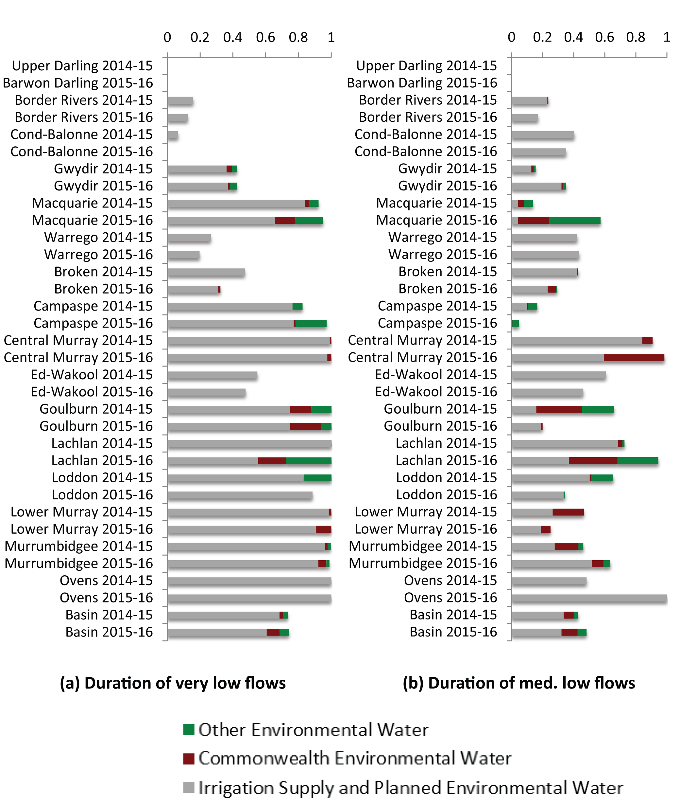
Figure 6. Average contributions of Commonwealth environmental water and other environmental water entitlements to base flow durations across each valley in the 2 years of Long Term Intervention Monitoring (LTIM). (Average score for the valley (horizontal axis – where 0 is severely altered from pre-development and 1 is indicative of an adequate frequency of the flow type in channel) is taken across all sites for which data were available and note that valleys using the water planning model approach do not differentiate between Commonwealth and other environmental water).
With the exception of the Lower Murray Valley in 2015–16, low freshes occurred across much of the southern Basin in both years (Figure 6Figure 7a) and medium freshes were common in some valleys (Figure 6Figure 7b). In the northern Basin, low and medium freshes were rare in 1 or both of the years with the exception the Gwydir Valley. There were some rivers where freshes were more common in 2015–16 than in 2014–15 (Macquarie and Warrego for low freshes) and vice versa (Border Rivers and Warrego for medium freshes). In the other valleys, freshes were rare in both years.
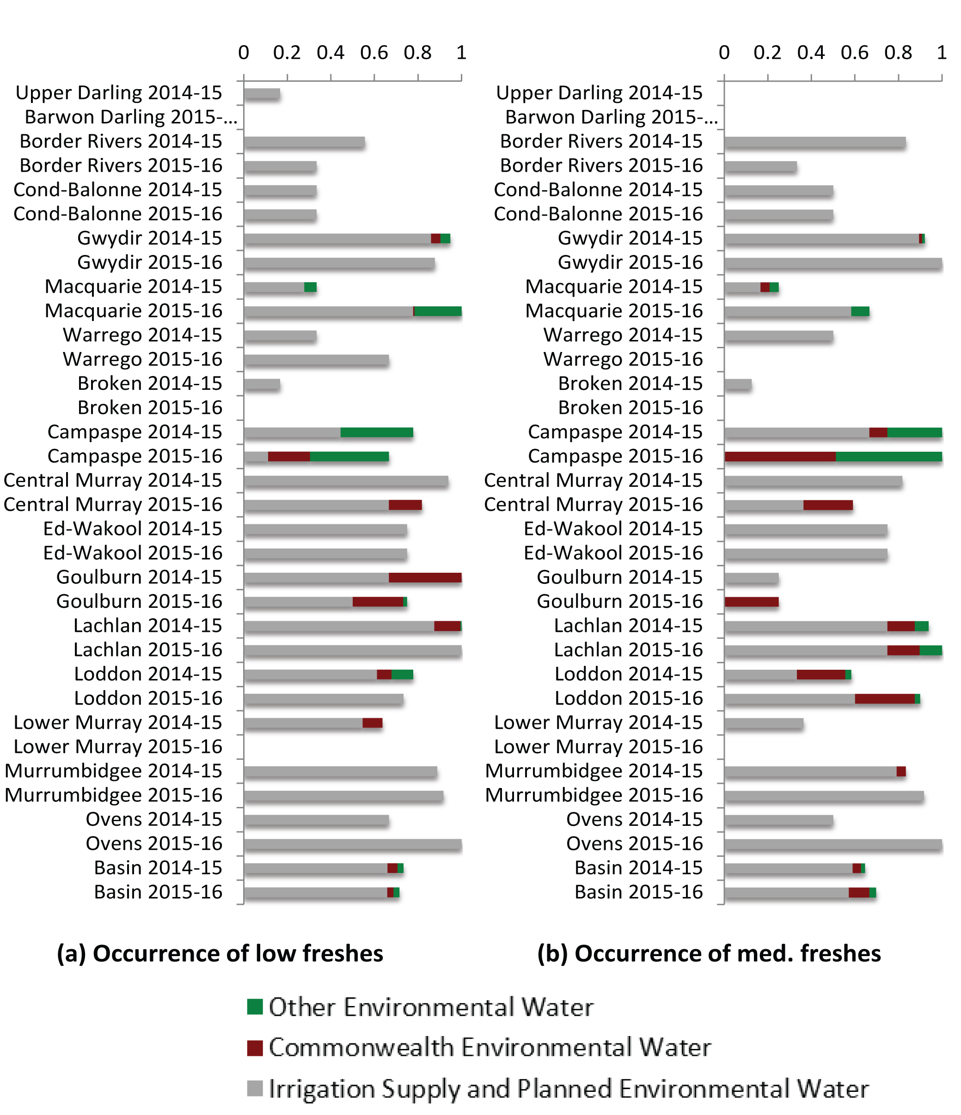 Figure 7. Average contributions of Commonwealth environmental water and other environmental water entitlements to low and medium freshes across each valley in the 2 years of Long Term Intervention Monitoring (LTIM). (Average score for the valley (horizontal axis – where 0 is severely altered from pre-development and 1 is indicative of an adequate frequency of the flow type in channel) is taken across all sites for which data were available and note that valleys using the water planning model approach do not differentiate between Commonwealth and other environmental water).

In all valleys, the occurrence of high freshes varied between years and were generally more prevalent in 2014–15 than in 2015–16 (Figure 8). This variation is largely due to inter-annual variations in unregulated flows, with the exception of the Campaspe Valley where environmental flows provided high freshes in 2015–16 (Figure 8).

Figure 8. Average contributions of Commonwealth environmental water and other environmental water entitlements to low and medium freshes across each valley in the 2 years of Long Term Intervention Monitoring (LTIM). (Average score for the valley (horizontal axis – where 0 is severely altered from pre-development and 1 is indicative of an adequate frequency of the flow type in channel) is taken across all sites for which data were available and note that valleys using the water planning model approach do not differentiate between Commonwealth and other environmental water).

Evaluation of watering actions against Basin priorities

Basin-wide flow variability and longitudinal connectivity
MDBA Environmental Watering Priority: Provide flow variability and longitudinal connectivity within rivers to support refuge habitats.
Summary of outcomes and Commonwealth environmental water contribution: Many of the 16 valleys where environmental water was delivered in 2015–16 maintained either a good base flow or fresh flow regime. A base flow regime was maintained close to natural in eight valleys, partially maintained in five valleys and was dramatically reduced from natural in three valleys. The low and medium regime of freshes was good in nine valleys, partially maintained in four valleys, and poor in three valleys. There are six valleys where both the base flow and freshes regime were maintained in good conditions: Central Murray, Lachlan, Loddon, Macquarie, Murrumbidgee and Ovens.
This Basin priority emphasises the importance of maintaining base flows to protect a diversity of hydraulic habitat conditions and in-channel flow freshes to support movement of fish along river channels. This priority does not target lateral or floodplain connectivity. While the priority also identifies lateral connectivity as important, it recognises that flow conditions in this dry year were not suited to deliver the high flow magnitudes required for overbank flows.

Base flow
Across the southern Basin, the durations of flows were mostly maintained above the very low flow threshold for at least as long as in the average unimpacted flow regime (Figure 5a). Exceptions were in Broken Creek and Edward–Wakool, where very low flows persisted for much longer than the average unimpacted case, indicating a dry low flow regime in 2015–16. Medium low flows were also maintained relative to the average unimpacted state in the Central Murray, Lachlan, Murrumbidgee and Ovens valleys but were substantially reduced in the other valleys of the southern Basin (Figure 5b). Flows less than medium and very low base flows levels persisted for significantly longer periods than under the unimpacted case across the northern Basin, indicating very dry base flow conditions in 2015–16. The only exception was in the Macquarie River where base flows were consistent with those expected in the unimpacted regime at both the very low and medium low flow levels. Commonwealth environmental water made an important contribution in most cases where base flows were maintained.

Freshes
There was a frequent occurrence of low and medium-size freshes throughout much of the southern Basin with the exception of Broken Creek (where low and medium freshes were largely absent) and the Goulburn River (where medium freshes were rare) (Figure 5c, d). High flow freshes occurred in the Broken, Campaspe and Goulburn valleys (Figure 5e). Flow freshes were achieved in the Central Murray Valley at both the low and medium fresh levels. Commonwealth environmental water made an important contribution to the frequency of freshes in all cases except the Murrumbidgee and Ovens where freshes were provided without the need for additional environmental water. In the northern Basin, low and medium freshes were: largely absent in the Barwon–Darling; occurred to a limited extent in the Border Rivers, Condamine–Balonne and Warrego valleys; and were frequent in the Gwydir and Macquarie valleys (Figure 5c, d). Environmental water only contributed in the Macquarie Valley where Commonwealth environmental water has a relatively minor role. High freshes occurred in the Barwon–Darling, Gwydir, Macquarie and Warrego but without the need for additional environmental water (Figure 5e).

River Murray weir pool variation
MDBA Environmental Watering Priority: Ensure a variable flow pattern and lateral connectivity through coordinated weir pool management in the River Murray from Euston to Blanchetown.
Summary of outcomes and Commonwealth environmental water contribution: Weir level manipulations occurred at 6 of the 12 weirs along the River Murray downstream of Euston.
This Basin priority applies to the 12 weir pools along the River Murray between Euston and Blanchetown. This includes the downstream portion of the Central Murray Valley but mostly applies to the Lower Murray Valley. The aim is for weir pool levels to be: raised in order to inundate low-lying wetlands and floodplains, flood runners and tributaries that are influenced by the locks and weirs; and lowered to create additional stream variability (Table 8)
The CEWO reported 10 manipulations of water levels at 6 weirs along this lower reach of River Murray. They are summarised here for each of the six weirs:
- Lock 15: The weir level was raised between July and December and lowered between April and June. This led to inundation of Euston Lakes, including inundation of Lake Caringay to its maximum extent.
- Lock 9: The weir level was raised between July and September and lowered between October and February.
- Lock 8: The weir level was raised between August and December and lowered between December and May. The raised weir levels produced a high-velocity spring fresh through Potterwalkagee Creek (Mulcra Island) and inundated Backwater Lagoon and other wetlands. It also allowed water to be delivered to Wingillie Wetland.
- Lock 7: The weir level was raised between August and January and lowered between January and May. The raised weir levels enabled flows to be delivered through the anabranch system and to Lake Wallawalla.
- Lock 5: The weir level was raised between August and November before returning to normal levels.
- Lock 2: The weir level was raised between September and November before returning to normal levels.

Coorong, Lower Lakes and Murray Mouth
MDBA Environmental Watering Priority: Improve water quality, fringing vegetation and native fish movement by varying the water levels in Lakes Alexandrina and Albert to maintain flows into the Coorong and Murray Mouth.
Summary of outcomes and Commonwealth environmental water contribution: The Commonwealth environmental water contributed to the targets set for the Lower Lakes in the Basin Environmental Watering Strategy. However, discharge through the barrages and the mouth was low relative to the target flows and will need to be increased in future years if the 3-year average is to meet the discharge target.
The Coorong, Lower Lakes and Murray Mouth (CLLMM) region is approximately 142 500 ha in size and contains a diverse range of freshwater, estuarine and marine habitats. The region is a Ramsar site and is currently used for several purposes, including conservation, recreation, water storage and extraction, grazing and cropping, and urban and residential development.
This region includes the lagoons of the Coorong, Lake Albert, Lake Alexandrina, the Murray estuary and the Murray Mouth. Lake Albert is a terminal lake connected to Lake Alexandrina by a narrow channel. They are collectively referred to as the Lower Lakes and comprise fresh to brackish and saline waters. The waters are separated by a series of barrages, constructed between 1935 and 1940, which are intended to maintain a consistent water level in the lakes and to protect agricultural areas from exposure to saltwater. The five barrages span the Goolwa, Mundoo, Boundary Creek, Ewe Island and Tauwitchere channels. The Coorong comprises two lagoons (known as the North and South). Together, they form a long, shallow, lagoon comprising brackish to hypersaline water, which is more than 100 km long. The Coorong is separated from the Southern Ocean by a narrow sand-dune peninsula.
We evaluate hydrological outcomes in the CLLMM region based on the contribution of Commonwealth environmental water to: water levels in the Lower Lakes; Murray Mouth openness, and barrage releases. These criteria reflect Basin Plan objectives and Annual Environmental Watering Priorities.

Water levels in the Lower Lakes
The Basin Plan lists specific end-of-Basin guidance for the Lower Lakes, while the Basin-wide Environmental Watering Strategy (BWS) (MDBA 2014) lists quantifiable objectives for end-of-Basin flows. The BWS target for the Lower Lakes is to maintain the level of the lakes at above sea level and 0.4 m Australian height datum (AHD) for 95% of the time to allow for barrage releases.
Approximately 798 GL of Commonwealth environmental water travelled through Wellington into the Lower Lakes during the 2015–16 watering year. Commonwealth environmental water contributed to water levels in the Lower Lakes, and flows through the Coorong and Murray Mouth from July 2015 through to the end of the watering year.
The minimum 7-day rolling average water level at Milang (Lake Alexandrina) was 0.50 m (AHD) and at Meningie (Lake Albert) was 0.47 m (AHD). Both of these minimum levels occurred during the period where Commonwealth environmental water was being delivered to the Lower Lakes. The daily water level was not less than 0.4 m in Lake Alexandrina. Lake Albert water levels were less than 0.4 m for 1 day. The use of Commonwealth environmental water appears to have been successful in supporting water levels above the BWS benchmark within the Lower Lakes.
The South Australian long-term Environmental Watering Plan (DEWNR 2015) recommends that water levels in Lake Alexandrina and Lake Albert are managed for variability. The management recommends a regime where water levels fluctuate between 0.40 m and 0.75 m every year; 0.40 m to 0.83 m once every 2 years; and 0.40 m to 0.90 m once every 7 years. During the 2015–16 watering year, water levels at Lake Alexandrina and Lake Albert were managed for the 1 in 2-year range prescribed in the Environmental Watering Plan. This management regime has been applied consecutively since the 2012–13 watering year. The maximum 7-day rolling average water levels for Lake Alexandrina and Lake Albert were 0.852 m and 0.840 m, respectively, thereby achieving the Watering Plan objectives.
Managing water levels in the Lower Lakes involves a trade-off between passing flows as they arrive through the Coorong and Murray Mouth, or using high lake levels to store flow in winter and spring to enable barrage flow in summer. The values and risks associated with decisions to retain or pass flows in the Lower Lakes need to be evaluated on a case-by-case basis. The duration of days in the year where the 7-day rolling average water level was greater than 0.750 m was 101 days (27%) and 124 days (34%) in Lake Alexandrina and Lake Albert, respectively. While this can be a result of deliberate storage in the lakes, high water levels can also occur during storm surge events, where it is not possible to make barrage releases (when Coorong water levels are higher than lake levels).
River Murray flows that enter the Coorong can lower salinity levels improve estuarine productivity and connectivity. Similarly, River Murray flows have a hydraulic benefit through the River Murray Mouth. Balancing the environmental demand of the Lower Lakes with both the timing and volume of other end-of-Basin demands (e.g. Coorong and Murray Mouth) is a difficult challenge in dry years such as 2015–16 when limited environmental water is available.

The contribution of Commonwealth environmental water to flows over the barrages
Five barrages exist in the CLLMM to assist water managers in providing water to the Coorong and Murray Mouth as well as for managing the water levels of the Lower Lakes. The barrages are typically operated under a ‘fill and spill’ philosophy, whereby barrages are opened to drop lake levels prior to forecasted flows into the lakes, which can then be used to refill the Lower Lakes to the full supply level (0.75 m) (Phillips & Muller 2006).
At the River Murray barrages, Commonwealth environmental water contributed 100% of the total streamflow volume. Environmental watering actions affected streamflows for 353 days between 1 July 2015 and 30 June 2016 (Figure 9Figure 9). The Basin Plan lists specific end-of-Basin guidance for barrage flows, while the BWS lists quantifiable objectives for end-of-Basin flows. The BWS flow targets at the barrages are for greater than 2000 GL/year on a 3-year rolling average basis for 95% of the time, with a 2-year minimum of 600 GL.
The delivery of Commonwealth environmental water secured the 2-year minimum target (600 GL) set in the BWS. In the absence of Commonwealth environmental water, flows over the barrages would have been negligible in 2015–16. This suggests that river operations may have adapted to the availability of Commonwealth environmental water. Possibly, water that would have previously passed through to the Coorong and Murray Mouth (i.e. prior to the Commonwealth environmental water program) is no longer being prioritised below the Lower Lakes, with the possibility that Commonwealth environmental water is substituting previously provided environmental water rather than augmenting it.

Figure 9. Contribution of environmental water delivery over the barrages (flows contributed by environmental water shown in brown).

Murray Mouth opening
The Murray Mouth bed elevation is highly variable, increasing in depth during high river flows and decreasing in depth under low flows. The system has traditionally been reliant on flood-dominated processes rather than tidal-dominated processes to flush sediment. So, it is no surprise that a trend of decreasing flows in this region has contributed to the Murray Mouth filling with ocean-derived sediment for over 150 years (Colby et al. 2010).
Several indicators of Murray Mouth openness are available, each with advantages and disadvantages (see Walker & Jessup 1992; Webster 2010; Bark et al. 2013). In this evaluation, we assessed the contribution that Commonwealth environmental water would have had towards keeping the Murray Mouth open had dredges not been in operation using the Murray Mouth openness index and the depth of the Murray Mouth as surrogates for evaluating the contribution of Commonwealth environmental water.
We applied the model developed by Webster (2010) to estimate the bed elevation of the Murray Mouth channel under two scenarios: (a) ‘modelled pre-buyback’ (i.e. without held Commonwealth environmental water); and (b) ‘modelled actual’ (i.e. held Commonwealth environmental water). We report this information with low confidence as the modelled actual result will report a more closed mouth than occurred in reality, as the model did not include the contribution made by the dredges. This is because, during the 2015–16 watering year, two dredges were in place to remove sediment contributing to minimum mouth openness targets. Dredging has been assessed as an effective management option for improving openness (Colby et al. 2010) and complements the delivery of Commonwealth environmental water.
For the 2015–16 watering year, the modelled actual stream bed elevation was estimated to be –0.94 ± 0.23 m, while the modelled pre-buyback scenario (or counterfactual) result was significantly less at –0.15 ± 0.22 m (Figures 10 and 11). The starting condition used for this analysis was derived from the end of modelled conditions from the 2014–15 watering year, representing contributions from environmental water in previous years. Figure 11 shows that the barrage flow that occurred due to Commonwealth environmental water was modelled to be sufficient to maintain mouth depth over spring, whereas without this flow, in the pre-buyback scenario (and ignoring the effect of dredging), the mouth openness reduced rapidly. This result indicates that under a modelled condition, Commonwealth environmental water has contributed to the Murray Mouth openness indicator via the increase in depth of the channel through its deliveries of environmental water over the barrages.
The BWS targets state that the Murray Mouth is to remain open 90% of the time to an average annual depth of 1 m. Our modelling has shown that Commonwealth environmental water contributed to maintaining an assumed Murray Mouth depth of approximately 1 m which without Commonwealth environmental water would have been significantly shallower at approximately 0.15 m.
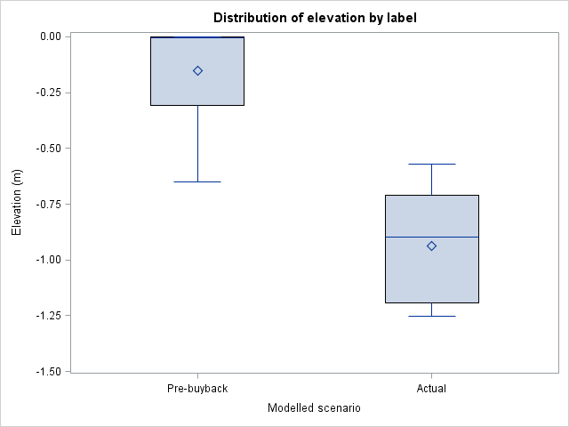

Figure 10. Box and whisker plot showing the modelled streambed height for the 2015–16 watering year. The box height is the interquartile range, the line within the box is the median and the diamond is the mean. The whiskers represent the minimum and maximum.

Figure 11. Modelled change in the Murray Mouth bed elevation for the counterfactual scenario (modelled pre-buyback) and an actual scenario (modelled actual).

Basin-wide in-stream and riparian vegetation
MDBA Environmental Watering Priority: Maintain and where possible improve the condition of in-stream riparian vegetation, through in-channel freshes.
Summary of outcomes and Commonwealth environmental water contribution: Given this was a dry year, there was good progress towards this priority. Low to moderate freshes were widespread in nine valleys. High freshes were achieved in three valleys. Watering of end-of-systems wetlands was achieved in four valleys.
MDBA (2015) identifies four strategies relevant for this priority:
- Providing in-channel low to moderate freshes: The occurrence of low and moderate freshes across the Basin is discussed in Sections 4.2.2 and 5.1.2 and is not repeated here.
- Providing in-channel high flows which fill closely fringing, low-lying wetlands: High freshes are achieved: throughout the Broken, Goulburn and Murrumbidgee; in some sites in the Barwon–Darling, Campaspe, Gwydir, Lachlan, Lower Murray, Macquarie and Warrego; and not achieved in the Border Rivers, Central Murray, Condamine–Balonne, Edward–Wakool, Loddon and Ovens valleys. The restricted distribution of high flows was expected given this was a dry year.
- Watering end-of-river low-lying wetlands: expected flooding was successfully achieved in valleys at the downstream end of the Gwydir, Macquarie, Lachlan and Murrumbidgee valleys by passing large volumes of water to these downstream reaches combined with the use of weirs and regulators in some cases.
- Maintaining a drying regime consistent with a natural wetting and drying cycle: There is no monitoring of cease-to-flow events or wetland hydroperiods and these were not considered in the assessment.

Mid-Murrumbidgee wetlands
MDBA Environmental Watering Priority: Improve the condition of wetland vegetation communities in the mid-Murrumbidgee wetlands.
Summary of outcomes and Commonwealth environmental water contribution: Six wetlands or wetland systems received environmental water along the mid-Murrumbidgee Valley. This is a relatively small proportion of the wetlands targeted in this priority.
Three wetlands or wetland systems were filled using Commonwealth environmental water along the mid-Murrumbidgee River:
- Yarrada Lagoon was filled in October 2015 and then dried down naturally through to mid-2016.
- Toogimbie Indigenous Protected Area Wetlands were targeted between March and May 2016 and 50% of total area was wetted.
- Sandy Creek was targeted between April and June 2016, watered over 42 days and 90% of the wetland area was wetted.

Macquarie Marshes
MDBA Environmental Watering Priority: Maintain semi-permanent wetland vegetation in core refuge areas in the Macquarie Marshes.
Summary of outcomes and Commonwealth environmental water contribution: Flooding across the Macquarie Marshes was achieved, with the extent of flooding enhanced through the contribution of Commonwealth environmental water.
Flows were passed downstream into the Macquarie Marshes between August and October 2015, achieving an estimated inundation extent of 41,400 ha of which 10,150 ha is attributed to Commonwealth environmental water. This priority is considered to have been achieved.

Basin-wide waterbird habitat and future population recovery
MDBA Environmental Watering Priority: Improve the complexity and health of priority waterbird habitat to maintain species richness and aid future population recovery.
Summary of outcomes and Commonwealth environmental water contribution: Although there are no specific hydrological targets associated with this priority, watering (or not watering) wetlands and floodplains will contribute to habitat complexity for waterbirds. Of the 115 watering actions delivered in 2015–16, 67 actions identified objectives related to waterbirds. Of these, 25% of Commonwealth environmental water was used in watering actions that delivered water out of the river channel in 59 watering actions. Approximately two-thirds of this environmental water was used in eight watering actions where flows were increased to magnitudes equal to, or greater than bankfull. The remainder of this environmental water was used to fill wetlands along the Central and Lower Murray and Murrumbidgee.

Basin-wide native fish habitat and movement
MDBA Environmental Watering Priority: Maintain native fish populations by protecting and improving the condition of fish habitat and providing opportunities for movement.
Summary of outcomes and Commonwealth environmental water contribution: Native fish populations generally were expected to be supported through the maintenance of base flows and freshes in many of the Basin’s valleys. The lack of high in-channel flows in many valleys was to be expected given this was a dry year.
The annual priorities identify the following flow manipulation strategies for achieving this priority:
- Maintaining base flows: Base flows across the Basin are assessed in Section 4.2.1.
- Low and moderate flow freshes for fish passage: Low to moderate flow freshes across the Basin are assessed in Section 4.2.2.
- High flow freshes to inundate benches to increase food resources and inundate key in-stream and off-stream habitats: High flow freshes across the Basin are assessed in Section 4.2.2.
- Slowing the recession tail of overbank flows to allow fish to exit off-stream habitats: With the exception of end-of-system flooding, the only overbank flow exceeding bankfull channel capacity that involved some environmental water was at the Barmah–Millawa forest.
- Reinstate winter flows in the southern Basin: This strategy is not relevant for such a dry year. Achieving natural winter flows is difficult in heavily regulated systems of the southern Basin, where higher winter lows are captured in storage for release in the drier summer season. It is even more difficult in dry winters like 2015. The contribution of environmental water to increased flow magnitudes in the winter months is minor (Figure 12). Contributions peak in the spring and autumn months. The only exception is the Ovens Valley, where unregulated tributary inflows maintain high winter flows. Although severely reduced compared with natural, winter flow reductions in the Lachlan and Loddon were not as severe as in the other valleys.

Figure 12. The contribution of environmental water to monthly flow magnitudes for 2015–16 averaged over valleys in the southern Basin. The contribution is evaluated as the change in flow percentiles for each month in the unimpacted flow series. For example, the October flow without environmental flow is equivalent to the 22nd cumulative percentile of October flows in the unimpacted series and environmental water increases this to the 26th percentile, so the figure shows 4% for this month.

Northern Basin fish refuges
MDBA Environmental Watering Priority: Protect native fish populations and in-stream habitats, particularly drought refuges, in the northern Basin.
Summary of outcomes and Commonwealth environmental water contribution: Generally good conditions were maintained for native fish in the Macquarie, Lachlan and Gwydir valleys but poor conditions were maintained in Condamine–Balonne and Border Rivers.
This priority is supported by maintaining natural base flow levels and low to moderate freshes in the northern Basin rivers identified as providing critical native fish habitats, including the Macquarie, Lachlan, Gwydir, Condamine-Balonne and Border Rivers valleys. Base flow levels persisted for significantly longer periods than under the unimpacted case, indicating very dry conditions. The only exception was in the Macquarie River where base flows were consistent with those expected in the unimpacted regime. Commonwealth environmental water only contributed to freshes in northern Basin in the Macquarie River. (See Sections 4.2.1 and 4.2.2 for more detail.)

Silver perch
MDBA Environmental Watering Priority: Contribute to the long-term recovery of silver perch by maintaining key populations, supporting recruitment and facilitating movement and dispersal.
Summary of outcomes and Commonwealth environmental water contribution: Generally good conditions were maintained for silver perch except in the Border Rivers.
This priority is supported by maintaining natural base flow levels and low to moderate freshes in the valleys that support silver perch, including Border Rivers, Central Murray, Edward–Wakool, Goulburn, Lower Murray, Murrumbidgee and Ovens. Base flows and freshes are believed to be important in sustaining water quality and hydraulic habitat for fish, with silver perch believed to be sensitive to poor water quality and having a preference for flowing water (Rogers & Ralph 1996). Base flow levels were influenced by Commonwealth environmental water in the southern Basin; however, in the northern Basin, low flow periods persisted for significantly longer periods than under the unimpacted case indicating very dry conditions. There was a frequent occurrence of low and medium freshes throughout much of the southern Basin. (see Sections 4.2.1 and 4.2.2).

Adaptive management
The following recommendations are made for consideration in future years:
- There is generally very low rate of success in achieving the SFIs targeted by the Basin Plan. There are likely three reasons for this: (1) constraints on high flows due to limited release capacity at dams or the risks of impacting on private or public assets make high flow releases unachievable at this time; (2) insufficient water entitlement has been recovered to achieve SFI with the desired frequency; and (3) the allocations of water have been too low to achieve these targets in the first 2 years of the LTIM Project but wetter conditions may allow these targets to be achieved in future years, which may lead to achieving the target frequency in the long term. A review of the SFIs is needed to identify which are reasonable with current water holdings and constraints. This can inform future prioritisation of environmental watering actions and LTIM.
- Documentation of weir pool manipulations in the River Murray is variable; in particular, the hydrological outcomes in terms of the extent and duration of flooding produced by weir pool raising. This should be reported along with an account of the extent to which this was consistent with targeted outcomes for particular habitat types.
- Managing water levels in the Lower Lakes involves a trade-off between maintaining high lake levels and when to pass flows through the Coorong and Murray Mouth. Evaluation of the outcomes of the decision to prioritise sustained water levels in the Lower Lakes over passing flows immediately into the Coorong and Murray Mouth, as opposed to later in the year, requires a clear statement of the expected outcomes of this decision within the context of the BWS and the long-term management plan.
- The delivery of Commonwealth environmental water secured the 2-year minimum target (600 GL) set in the BWS. In the absence of Commonwealth environmental water, flows over the barrages would have been negligible in 2015–16. This suggests that river operations may have adapted to the availability of Commonwealth environmental water. Possibly, water that would have previously passed through to the Coorong and Murray Mouth (i.e. prior to the Commonwealth environmental water program) is no longer being prioritised below the Lower Lakes, with the possibility that Commonwealth environmental water is substituting previously provided environmental water rather than augmenting it.
- Reporting on hydrological outcomes for wetland watering achieved through pumping or use of weirs and other infrastructure is quite limited. For example, the hydraulic outcomes for watering actions during 2015–16 that delivered water into Toogimbie Indigenous Protected Area Wetlands, Nap Nap Wetland and Sandy Creek are uncertain. Some thought is required to provide identify hydrological targets for these watering events and then reporting against these targets.

Expected 1–5-year outcomes
The results of the first 2 years of the LTIM evaluation enable predictions of the influence of Commonwealth environmental water on flow regimes over the period mid 2014 to 2019 if water availability conditions were to remain below average or dry. The major predictions are:
- Minimum flows will generally be maintained in the rivers of the southern Basin, although there will be exceptions such as the Lower Murray where variations in the base flow regime can be expected from year to year.
- In the northern Basin, base flows will continue to be reduced below pre-development magnitudes, with extended periods of artificially low flows as a result of irrigation water withdrawals. Environmental watering actions will not dramatically alter the persistence of low flows in most cases although experience in the Macquarie in 2015–16 demonstrates that there can be exceptions (when dams are full).
- In the River Murray, freshes will largely be dependent on unregulated tributary inflows.
- Medium freshes will continue to be rare in the Goulburn River but low and medium freshes will be delivered in most other valleys of the southern Basin.
- In the northern Basin, freshes will be produced by unregulated flows and environmental water will have very little influence on whether or not freshes occur.
- In most cases, high freshes will be dependent on unregulated tributary inflows and will not be the result of environmental watering actions. High freshes may not occur at all for many sites across both the southern and northern Basin.
If water availability increases in subsequent years it is likely that water regimes would be enhanced beyond the predictions listed in terms of the types of flows restored and the number of areas in which they are restored, particularly as storages fill and then spill.
From a risk management perspective, the predictions could be used to inform the development of contingency plans for the next major drought though consideration of whether the watering actions delivered over 2014–15 and 2015–16 could be modified in the future to ensure damage to the environment is minimised.

Basin-scale outcomes
A ‘score card’ showing how well the Annual Environmental Watering Priorities were met in the valleys receiving Commonwealth environmental water in 2015–16 is provided in Table 7.
Table 7. Achievement of the annual Basin Annual Environmental Watering Priorities for the 2015–16 year. Assessment indicates compliance with priority flow strategies for each priority in each of the valleys were Commonwealth environmental water was delivered. ^note included in the table as a valley, but is part of the Lower Murray valley.
Priority |  | Barwon–Darling | Border Rivers | Broken | Campaspe |  | Central Murray |  | Condamine–Balonne |  | Edward–Wakool |  | Goulburn |  | Gwydir |  | Lachlan | Loddon |  | Lower Murray |  | Macquarie |  | Murrumbidgee |  | Ovens |  | Warrego |  | Coorong, LL and MM^
River flows and connectivity theme
Basin-wide flow variability and longitudinal connectivity | baseflows | 0 | 0 | 1 | 1 |  | 2 |  | 0 |  | 1 |  | 2 |  | 1 |  | 2 | 2 |  | 2 |  | 2 |  | 2 |  | 2 |  | 1
Basin-wide flow variability and longitudinal connectivity | low and moderate freshes | 0 | 1 | 0 | 2 |  | 2 |  | 1 |  | 2 |  | 1 |  | 2 |  | 2 | 2 |  | 0 |  | 2 |  | 2 |  | 2 |  | 1
River Murray weir pool variation |  |  |  |  |  |  | 2 |  |  |  |  |  |  |  |  |  |  |  |  | 2
Coorong, Lower Lakes and Murray Mouth |  |  |  |  |  |  |  |  |  |  |  |  |  |  |  |  |  |  |  |  |  |  |  |  |  |  |  |  |  | 1
Native vegetation theme
Basin-wide in-stream and riparian vegetation | low to mod. freshes | 0 | 1 | 0 | 2 |  | 2 |  | 1 |  | 2 |  | 1 |  | 2 |  | 2 | 2 |  | 0 |  | 2 |  | 2 |  | 2 |  | 1
Basin-wide in-stream and riparian vegetation | high freshes | 1 | 0 | 2 | 1 |  | 0 |  | 0 |  | 0 |  | 2 |  | 1 |  | 1 | 0 |  | 1 |  | 1 |  | 2 |  | 0 |  | 1
Basin-wide in-stream and riparian vegetation | watering d/s wetlands |  |  |  |  |  |  |  |  |  |  |  |  |  | 2 |  | 2 |  |  |  |  | 2 |  | 2
Basin-wide in-stream and riparian vegetation | cease-to-flows
Mid-Murrumbidgee wetlands |  |  |  |  |  |  |  |  |  |  |  |  |  |  |  |  |  |  |  |  |  |  |  | 1
Macquarie Marshes |  |  |  |  |  |  |  |  |  |  |  |  |  |  |  |  |  |  |  |  |  | 2
Moira grass |  |  |  |  |  |  | 0
Waterbird theme
Basin-wide waterbird habitat
Native fish theme
Basin-wide native fish habitat and movement | baseflows | 0 | 0 | 1 | 1 | 2 |  | 0 |  | 1 |  | 2 |  | 1 |  | 2 |  |  | 2 |  | 2 |  | 2 |  | 2 |  | 2 |  | 1
Basin-wide native fish habitat and movement | low to mod. freshes | 0 | 1 | 0 | 2 | 2 |  | 1 |  | 2 |  | 1 |  | 2 |  | 2 |  |  | 2 |  | 0 |  | 2 |  | 2 |  | 2 |  | 1
Basin-wide native fish habitat and movement | high freshes | 1 | 0 | 2 | 1 | 0 |  | 0 |  | 0 |  | 2 |  | 1 |  | 1 |  |  | 0 |  | 1 |  | 1 |  | 2 |  | 0 |  | 1
Basin-wide native fish habitat and movement | slowing o/b recession
Basin-wide native fish habitat and movement | natural winter flows |  |  | 0 | 0 | 0 |  |  |  |  |  | 0 |  |  |  | 1 |  |  | 0 |  | 1 |  |  |  | 0 |  | 2
Northern Basin fish refuges | baseflows |  | 0 |  |  |  |  | 0 |  |  |  |  |  | 1 |  | 2 |  |  |  |  |  |  | 2
Northern Basin fish refuges | low to mod. freshes |  | 1 |  |  |  |  | 1 |  |  |  |  |  | 2 |  | 2 |  |  |  |  |  |  | 2
Silver perch | baseflows |  | 0 |  |  | 2 |  |  |  | 1 |  | 2 |  |  |  |  |  |  |  |  | 2 |  |  |  |  |  | 2
Silver perch | low to mod. freshes |  | 1 |  |  | 2 |  |  |  | 2 |  | 1 |  |  |  |  |  |  |  |  | 0 |  |  |  |  |  | 2
 |  | 0 | Very limited or no success in achieving priority outcome
 |  | 1 | Partial success in achieving priority outcome
 |  | 2 | Good success in achieving priority outcome

Contribution to 2015–16 Basin annual watering priorities
The contribution of Commonwealth environmental water to meeting the Annual Environmental Watering Priorities for the Basin are summarised in Table 8. Full details are provided in Section 5.
Table 8. Contribution of Commonwealth environmental water to Murray–Darling Basin Authority (MDBA) Annual Environmental Watering Priorities.
Annual priority | Purpose | Summary of outcomes and Commonwealth environmental water contribution
Basin-wide flow variability and longitudinal connectivity | Provide flow variability and longitudinal connectivity within rivers to support refuge habitats. | A portion of the valleys where environmental water is delivered, was maintained with either a good base flow or fresh flow regime. A natural baseflow regime was generally maintained close to natural in eight valleys, partially maintained in five valleys and was dramatically reduced from natural in three valleys. The low and medium regime of freshes was good in nine valleys, partially maintained in four valleys, and poor in three valleys. There are six valleys where both the base flow and freshes regime were maintained in good conditions: Central Murray, Lachlan, Loddon, Macquarie, Murrumbidgee and Ovens.
River Murray weir pool variation | Ensure a variable flow pattern and lateral connectivity through coordinated weir pool management in the River Murray from Euston to Blanchetown. | Weir level manipulations occurred at 6 of the 12 weirs along the River Murray downstream of Euston.
Coorong, Lower Lakes and Murray Mouth | Improve water quality, fringing vegetation and native fish movement by varying the water levels in Lakes Alexandrina and Albert to maintain flows into the Coorong and Murray Mouth. | Commonwealth environmental water contributed to the targets set for the Lower Lakes in the Basin-wide Environmental Watering Strategy. However, discharge through the barrages and the mouth was low relative to the target flows and will need to be increased in future years if the 3-year average is to meet the discharge target.
Basin-wide in-stream and riparian vegetation | Maintain and where possible improve the condition of in-stream riparian vegetation, through in-channel freshes. | Given this was a dry year, there was good progress towards this priority. Low to moderate freshes were widespread in nine valleys. High freshes were achieved in three valleys. Watering of end-of-systems wetlands was achieved in four valleys.
Mid-Murrumbidgee wetlands | Improve the condition of wetland vegetation communities in the mid-Murrumbidgee wetlands. | Two wetlands or wetland systems received environmental water along the mid-Murrumbidgee Valley. This is a relatively small portion of the wetlands targeted in this priority.
Macquarie Marshes | Maintain semi-permanent wetland vegetation in core refuge areas in the Macquarie Marshes. | This priority was achieved, with extensive flooding across the Macquarie Valley.
Basin-wide waterbird habitat and future population recovery | Improve the complexity and health of priority waterbird habitat to maintain species richness and aid future population recovery. | Although there are no specific hydrological targets associated with this priority, of the 11 watering actions delivered in 2015–16, 67 actions identified objectives related to waterbirds.
Basin-wide native fish habitat and movement | Maintain native fish populations by protecting and improving the condition of fish habitat and providing opportunities for movement. | Native fish populations were generally supported through the maintenance of base flows and freshes in many of the Basins valleys. The lack of high in-channel flows in many valleys was to be expected given this was a dry year.
Northern Basin fish refuges | Protect native fish populations and in-stream habitats, particularly drought refuges, in the northern Basin. | Generally good conditions were maintained for native fish in the Macquarie, Lachlan and Gwydir valleys but poor conditions were maintained in Condamine–Balonne and Border Rivers.
Silver perch | Contribute to the long-term recovery of silver perch by maintaining key populations, supporting recruitment and facilitating movement and dispersal. | Generally good conditions were maintained for silver perch except in the Border Rivers.

References
Bark RH, Peeters LJM, Lester RE, Pollino CA, Crossman ND, Kandulu JM (2013) Understanding the sources of uncertainty to reduce the risks of undesirable outcomes in large-scale freshwater ecosystem restoration projects: an example from the Murray–Darling Basin, Australia. Environmental Science & Policy 33, 97–108.
Colby LH, Maycock SD, Nelligan FA, Pocock HJ, Walker DJ (2010) An investigation into the effect of dredging on tidal asymmetry at the River Murray Mouth. Journal of Coastal Research 26(5), 843–850.
Department of Environment, Water and Natural Resources (DEWNR) 2015 Long term environmental watering plan for the South Australian River Murray water resource plan area. Government of South Australia, through Department of Environment, Water and Natural Resources, Adelaide.
MDBA (Murray–Darling Basin Authority) (2011) The proposed ‘environmentally sustainable level of take’ for surface water of the Murray–Darling Basin: methods and outcomes. MDBA Publication No. 226/11. MDBA, Canberra.
MDBA (Murray–Darling Basin Authority) (2014) Environmental Watering Strategy MDBA, Canberra.
MDBA (Murray–Darling Basin Authority) (2015) 2015–16 Basin Annual Environmental Watering Priorities MDBA, Canberra.
Phillips W, Muller K (2006) Ecological character of the Coorong, Lakes Alexandrina and Albert wetland of international importance South Australian Department for Environment and Heritage, Adelaide. 323pp.
Rogers K, Ralph T (2011) Floodplain wetland biota in the Murray-Darling basin: water and habitate requirements. CSIRO publishing, Australia.
Stewardson M, DeRose R, Harman C (2005) Regional models of stream channel metrics. Report 05/16. Cooperative Research Centre for Catchment Hydrology, Monash University, Melbourne.
Stewardson MJ (2005) Hydraulic geometry of stream reaches. Journal of Hydrology 306(1), 97–111.
Walker DJ, Jessup A (1992) Analysis of the dynamic aspects of the River Murray Mouth. Journal of Coastal Research 8(1) 71–76.
Webster IT (2010) The hydrodynamics and salinity regime of a coastal lagoon – The Coorong, Australia – seasonal to multi-decadal timescales. Estuarine, Coastal and Shelf Science 90(4), 264–274.

Annex A. Valley report cards 1 to 16

