2015–16 Basin-scale evaluation of Commonwealth environmental water – Vegetation Diversity

**Prepared by:** Samantha Capon and Cherie Campbell

Final Report

**MDFRC Publication 145/2017**

2015–16 Basin-scale evaluation of Commonwealth environmental water — Vegetation Diversity

Final Report prepared for the Commonwealth Environmental Water Office by The Murray–Darling Freshwater Research Centre

This report was prepared by The Murray–Darling Freshwater Research Centre (MDFRC). The aim of the MDFRC is to provide the scientific knowledge necessary for the management and sustained utilisation of the Murray–Darling Basin water resources. The MDFRC is a joint venture between La Trobe University and CSIRO. Additional investment is provided through the University of Canberra.

 

For further information contact:

**Ben Gawne**

The Murray–Darling Freshwater Research Centre  
PO Box 991   
Wodonga VIC 3689

Ph: (02) 6024 9650

Email: [Ben.Gawne@](mailto:Ben.Gawne@)canberra.edu.au  
Web: [www.mdfrc.org.au](http://www.mdfrc.org.au)  
Enquiries: [mdfrc@latrobe.edu.au](mailto:mdfrc@latrobe.edu.au)

**Report Citation:** Capon S, Campbell C (2017) 2015–16 Basin-scale evaluation of Commonwealth environmental water – Vegetation Diversity. Report prepared for the Commonwealth Environmental Water Office by The Murray–Darling Freshwater Research Centre, MDFRC Publication 145/2017, August, 87pp.

This monitoring project was commissioned and funded by Commonwealth Environmental Water Office.

**Copyright**

© Copyright Commonwealth of Australia, 2017



2015–16 Basin-scale evaluation of Commonwealth environmental water – Vegetation Diversity (2017) is licensed by the Commonwealth of Australia for use under a Creative Commons By Attribution 3.0 Australia licence with the exception of the Coat of Arms of the Commonwealth of Australia, the logo of the agency responsible for publishing the report, content supplied by third parties, and any images depicting people. For licence conditions see: <http://creativecommons.org/licenses/by/3.0/au/>

This report should be attributed as Capon S, Campbell C (2017) 2015–16 Basin-scale evaluation of Commonwealth environmental water – Vegetation Diversity. Final report prepared for the Commonwealth Environmental Water Office by The Murray–Darling Freshwater Research Centre, MDFRC Publication 145/2017, August, 87pp.

The views and opinions expressed in this publication are those of the authors and do not necessarily reflect those of the Australian Government or the Minister for the Environment.

While reasonable efforts have been made to ensure that the contents of this publication are factually correct, the Commonwealth does not accept responsibility for the accuracy or completeness of the contents, and shall not be liable for any loss or damage that may be occasioned directly or indirectly through the use of, or reliance on, the contents of this publication.

The material contained in this publication represents the opinion of the author only. While every effort has been made to ensure that the information in this publication is accurate, the author and MDFRC do not accept any liability for any loss or damage howsoever arising whether in contract, tort or otherwise which may be incurred by any person as a result of any reliance or use of any statement in this publication. The author and MDFRC do not give any warranties in relation to the accuracy, completeness and up to date status of the information in this publication.

Where legislation implies any condition or warranty which cannot be excluded restricted or modified such condition or warranty shall be deemed to be included provided that the author’s and MDFRC’s liability for a breach of such term condition or warranty is, at the option of MDFRC, limited to the supply of the services again or the cost of supplying the services again.

Document history and status

|  |  |  |  |  |
| --- | --- | --- | --- | --- |
| **Version** | **Date Issued** | **Reviewed by** | **Approved by** | **Revision type** |
| Draft | 21 April 2017 | Ben Gawne | Ben Gawne | Internal |
| Draft | 26 April 2017 | Cherie Campbell | Penny Everingham | Internal |
| Draft | 26 April 2017 | CEWO & M&E Providers | Sam Capon | External |
| Draft | 30 June 2017 | Cherie Campbell | Penny Everingham | Internal |
| Draft | 4 July 2017 | Mary Webb | Penny Everingham | External |
| Final | 11 August 2017 | Sam Capon and Cherie Campbel | Penny Everingham | Internal |

Distribution of copies

|  |  |  |
| --- | --- | --- |
| **Version** | **Quantity** | **Issued to** |
| Draft | 1 x PDF | CEWO and M&E Providers |
| Final | 1 x Word 1 x PDF | CEWO |

**Filename and path:** Projects\CEWO\CEWH Long Term Monitoring Project\499 LTIM Stage 2 2014-19 Basin evaluation\Final Reports

**Author(s):** Samantha Capon and Cherie Campbell

**Author affiliation(s): Griffith University and** The Murray‒Darling Freshwater Research Centre

**Project Manager:** Ben Gawne

**Client:** Commonwealth Environmental Water Office

**Project Title:** Basin evaluation of the contribution of Commonwealth environmental water to the environmental objectives of the Murray‒Darling Basin Plan

**Document Version:** Final

**Project Number:** M/BUS/499

**Contract Number:** PRN 1213-0427

**Acknowledgements:**

The authors wish to thank the Basin Matters project team for their continued support, including Ben Gawne and Penny Everingham for their diligent project management and Shane Brookes for his efficient data management and Ecosystem Diversity analyses which are drawn on here.

This project was undertaken using data collected for the Commonwealth Environmental Water Office Long Term Intervention Monitoring project. The assistance provided by the Monitoring and Evaluation Providers into interpretation of data and report review is greatly appreciated. The authors would also like to thank all Monitoring and Evaluation Provider staff involved in the collection and management of data.

The Murray–Darling Freshwater Research Centre offices are located on the land of the Latje Latje and Wiradjuri peoples. We undertake work throughout the Murray–Darling Basin and acknowledge the traditional owners of this land and water. We pay respect to Elders past, present and future.

Contents

1 Introduction 1

1.1 Context 1

1.2 Evaluation objectives 2

1.3 Summary of Basin Matter outcomes for 2014–15 2

1.4 Summary of watering actions with expected outcomes for the year relevant to the Basin Matter 2

2 Methods 6

2.1 Approach 6

2.1.1 Aggregated Area scale, annual evaluation 6

2.1.2 Aggregated Area scale, 1–2-year evaluation 11

2.1.3 Basin scale, annual evaluation 12

2.1.4 Basin scale, 1–2-year evaluation 12

2.2 Monitoring approaches in Selected Areas and Basin evaluation focus 13

3 Aggregated Area–scale annual evaluation 13

3.1 Highlights 13

3.2 Effects of Commonwealth environmental water on plant species diversity at Selected Areas 14

3.2.1 River channel systems 14

3.2.2 Wetland and floodplain systems 14

3.3 Effects of Commonwealth environmental water on vegetation community diversity at Selected Areas 15

3.3.1 Edward–Wakool river system 15

3.3.2 Goulburn River 16

3.3.3 Gwydir river system 16

3.3.4 Lachlan river system 20

3.3.5 Murrumbidgee river system 24

3.3.6 Junction of the Warrego and Darling rivers 29

3.4 Synthesis 29

4 Aggregated Area–scale longer term (1–2-year) evaluation 31

4.1 Highlights 31

4.2 Effects of Commonwealth environmental water on plant species diversity at Selected Areas over 1–2 years 31

4.3 Effects of Commonwealth environmental water on vegetation community diversity at Selected Areas over 1–2 years 33

4.3.1 Gwydir river system 33

4.3.2 Lachlan river system 34

4.3.3 Murrumbidgee river system 36

4.3.4 Junction of the Warrego and Darling rivers 40

4.4 Synthesis 42

5 Basin scale (<1-year) evaluation 43

5.1 Highlights 43

5.2 Effects of Commonwealth environmental water on plant species diversity at the Basin scale 43

5.3 Effects of Commonwealth environmental water on vegetation community diversity at the Basin scale 44

5.3.1 Aggregated Selected Area scale 44

5.3.2 Unmonitored areas 46

6 Basin scale (1–2-year) evaluation 50

6.1 Highlights 50

6.2 Effects of Commonwealth environmental water on plant species diversity at the Basin scale over 1–2 years 50

6.3 Effects of Commonwealth environmental water on vegetation community diversity at the Basin scale over 1–2 years 50

7 Adaptive management 53

8 Contribution to achievement of Basin Plan objectives 55

References 58

Annex A. Watering actions contributed to by Commonwealth environmental water in 2015–16 with expected outcomes related to vegetation 61

Annex B. Plant taxa recorded by LTIM from wetland/floodplain Selected Areas in 2014–15 and 2015–16. 68

List of tables

Table 1. Summary of watering actions and expected outcomes related to vegetation at Selected Areas in 2015–16. 3

Table 2. Vegetation diversity sampling design at Selected Areas in 2015–16. (Note refers to methods for collecting data regarding % cover of plant taxa.) 8

Table 3. Water regime categories assigned to vegetation diversity field survey plots/transects at wetland/floodplain Selected Areas in 2015–16. D indicates ‘Dry’ and W indicates ‘Wet’. Refer to Section 2.1.1 for further details on water regime categories. Numbers indicate the total number of plots/transects surveyed in each water regime category at each survey time. Numbers in brackets indicate the number of sample points (i.e. locations) across which these plots/transects were distributed. The number of plots/transects (and associated sample points) affected by Commonwealth environmental watering actions delivered during 2015–16 are shown in bold. 10

Table 4. Plant species only present in each wetland/floodplain Selected Area in 2015–16 in plots/transects following inundation by Commonwealth environmental water delivered during 2015–16. (Note: no samples were inundated by Commonwealth environmental water during 2015–16 at the Junction of the Warrego and Darling rivers Selected Area.) 14

Table 5. Plant species characterising vegetation communities in each water regime category in the Gwydir river system Selected Area in 2015–16 (according to SIMPER analysis). 17

Table 6. Plant species characterising vegetation communities in each water regime category in the Lachlan river system Selected Area in 2015–16 (according to SIMPER analysis). 21

Table 7. Plant species characterising vegetation communities in each water regime category in Murrumbidgee river system Selected Area in 2015–16 (according to SIMPER analysis). 25

Table 8. Plant species only present in each wetland/floodplain Selected Area in 2014–15 and 2015–16 in plots/transects following inundation by Commonwealth environmental water delivered during this period. 32

Table 9. Water regime (D: Dry; W: Wet; PW: Partially Wet, i.e. not all transects/plots inundated) and influence of Commonwealth environmental water (1: during 2014–15; 2: during 2015–16) at individual wetlands surveyed within the Murrumbidgee river system Selected Area in 2014–15 and 2015–16. 36

Table 10. Plant species only recorded from the Basin in plots/transects following inundation by Commonwealth environmental water delivered during 2015–16. 44

Table 11. Area of each LTIM catchment inundated by Commonwealth environmental water (excluding in-channel flows) in 2015–16, including both floodplain and wetland ecosystem types. (Source: Ecosystem Diversity Basin Matter Evaluation 2015–16). 47

Table 12. Areas of wetland and floodplain ANAE types inundated and influenced by Commonwealth environmental water in the Basin in 2015–16 (See Ecosystem Diversity Basin Matter Evaluation 2015–16 for definitions). 48

Table 13. Plant species only recorded from the Basin in plots/transects following inundation by Commonwealth environmental water delivered during 2014–15 and 2015–16. 51

Table 14. Key recommendations concerning adaptive management of Commonwealth environmental water delivery and assessment with respect to Vegetation Diversity at each Selected Area made by Monitoring and Evaluation Providers in Selected Area reports in 2015–16. 54

Table 15. Contribution of Commonwealth Environmental Water Office (CEWO) watering over 2014–15 and 2015–16 to Basin Plan objectives associated with vegetation diversity. 56

List of figures

Figure 1. Vegetation diversity monitoring sites at Selected Areas in 2015–16. 7

Figure 2. Differences in vegetation community metrics between water regime categories (see Table 3) for the Gwydir river system Selected Area in 2015–16. Error bars indicate ± standard error. Left column represents October 2015 survey and right column March 2016: (top) total vegetation cover (summed % cover); (centre) total species richness (number of taxa); and (bottom) dominance (%) . 18

Figure 3. Differences in exotic species cover and richness between water regime categories (see Table 3) for the Gwydir river system Selected Area in 2015–16. Error bars indicate ± standard error. Left column represents October 2015 survey and right column March 2016: (top) proportion of total cover comprising exotic taxa (%); and (bottom) proportion of total taxa that were exotic (%). 19

Figure 4. Ordination of vegetation assemblages at the Gwydir river system Selected Area in 2015–16 showing water regime categories (based on nMDS calculated from species cover values). Note: Dry and Wet categories represent sampling conducted in October 2015 while the other water regime categories represent samples from March 2016. 19

Figure 5. Ordination of vegetation assemblages at the Gwydir rivery system Selected Area in 2015–16 showing average values and dispersion within each water regime category (based on the bootstrapping procedure in PRIMER 7). 20

Figure 6. Differences in vegetation community metrics between water regime categories (see Table 3) for the Lachlan river system Selected Area in 2015–16. Error bars indicate ± standard error. Left column represents October 2015 survey and right column May 2016: (top) total vegetation cover (summed % cover); (centre) total species richness (number of taxa); and (bottom) dominance (%). 22

Figure 7. Differences in exotic species cover and richness between water regime categories (see Table 3) for the Lachlan river system Selected Area in 2015–16. Error bars indicate ± standard error. Left column represents October 2015 survey and right column May 2016: (top) proportion of total cover comprising exotic taxa (%); and (bottom) proportion of total taxa that were exotic (%). 23

Figure 8. Ordination of vegetation assemblages at the Lachlan river system Selected Area in 2015–16 based on water regime categories (based on nMDS calculated from species cover values). Note: Dry and Wet categories represent sampling conducted in October 2015 while the other water regime categories represent samples from May 2016. 23

Figure 9. Ordination of vegetation assemblages at the Lachlan river system Selected Area in 2015–16 showing average values and dispersion within each water regime category (based on the bootstrapping procedure in PRIMER 7). 24

Figure 10. Differences in vegetation community metrics between water regime categories (see Table 3) for the Murrumbidgee river system Selected Area in 2015–16. Error bars indicate ± standard error. Left column represents October 2015 survey, second column December 2015, third column January 2016 and fourth column March 2016: (top) total vegetation cover (summed % cover); (centre) total species richness (number of taxa); and (bottom) dominance (%). 26

Figure 11. Differences in exotic species cover and richness between water regime categories (see Table 3) for the Murrumbidgee river system Selected Area in 2015–16. Error bars indicate ± standard error. Left column represents October 2015 survey, second column December 2015, third column January 2016 and fourth column March 2016: (top) proportion of total cover comprising exotic taxa (%); and (bottom) proportion of total taxa that were exotic (%). 27

Figure 12. Ordination of vegetation assemblages at the Murrumbidgee river system Selected Area in 2015–16 based on water regime categories (based on nMDS calculated from species cover values). 28

Figure 13. Ordination of vegetation assemblages at the Murrumbidgee river system Selected Area in 2015–16 showing average values and dispersion within each short water regime category (based on the bootstrapping procedure in PRIMER 7). 28

Figure 14. Ordination of vegetation assemblages at the Junction of the Warrego and Darling rivers Selected Area in 2015–16 based on water regime categories (based on nMDS calculated from species cover values, excluding rare species). 29

Figure 15. Ordination of vegetation assemblages at the Gwydir river system Selected Area in 2014–15 and 2015–16 based on water regime categories, Long Term Intervention Monitoring year and the influence of Commonwealth environmental water (CEW) (based on nMDS calculated from species cover values). 33

Figure 16. Ordination of vegetation assemblages at the Gwydir river system Selected Area in 2014–15 and 2015–16 showing average values and dispersion within each water regime category, Long Term Intervention Monitoring year and the influence of Commonwealth environmental water (CEW) (based on the bootstrapping procedure in PRIMER 7). 34

Figure 17. Ordination of vegetation assemblages at the Lachlan river system Selected Area in 2014–15 and 2015–16 based on water regime categories, Long Term Intervention Monitoring year and the influence of Commonwealth environmental water (CEW) (based on nMDS calculated from species cover values). 35

Figure 18. Ordination of vegetation assemblages at the Lachlan river system Selected Area in 2014–15 and 2015–16 showing average values and dispersion within each water regime category, Long Term Intervention Monitoring year and the influence of Commonwealth environmental water (CEW) (based on Bootstrapping procedure in PRIMER 7). 35

Figure 19. Trajectories of change in mean total vegetation cover in each wetland surveyed in the Murrumbidgee river system Selected Area over eight surveys during 2014–15 and 2015–16. 37

Figure 20. Trajectories of change in mean species richness in each wetland surveyed in the Murrumbidgee river system Selected Area over eight surveys during 2014–15 and 2015–16. 37

Figure 21. Trajectories of change in mean proportion of total vegetation cover comprising exotic taxa in each wetland surveyed in the Murrumbidgee river system Selected Area over eight surveys during 2014–15 and 2015–16. 38

Figure 22. Ordination of vegetation assemblages at the Murrumbidgee river system Selected Area in 2014–15 and 2015–16. Colours indicate particular wetlands, with blue colours signifying mostly Wet conditions overall, green colours Partially Wet conditions and brown/orange colours mostly Dry conditions (Table 9). Purple represents Yarrada Lagoon, the only wetland to receive Commonwealth environmental water in 2015–16. Closed shapes indicate samples from 2014–15 and open shapes from 2015–16. 39

Figure 23. Ordination of vegetation assemblages at the Murrumbidgee river system Selected Area in 2014–15 and 2015–16 with sample points representing means for each wetland at each survey date. Colours signify particular wetlands, with blue signifying mostly Wet conditions overall, green Partially Wet conditions and brown mostly Dry conditions (Table 9). Closed symbols indicate samples not influenced by Commonwealth environmental water (CEW) in either year while open and crossed symbols signify inundation by Commonwealth environmental water in 2014–15 and 2015–16, respectively. 39

Figure 24. Ordination of vegetation assemblages at the Murrumbidgee river system Selected Area in 2014–15 and 2015–16 showing average values and dispersion within each water regime category (based on the bootstrapping procedure in PRIMER 7). 40

Figure 25. Ordination of vegetation assemblages at the Junction of the Warrego and Darling rivers Selected Area in 2015–16 based on water regime and the influence of Commonwealth environmental water (CEW) in 2015–16 (based on nMDS calculated from species cover values). 41

Figure 26. Ordination of vegetation assemblages at the Junction of the Warrego and Darling rivers Selected Area in 2014–15 and 2015–16 showing average values and dispersion within each water regime category, LTIM year and influence of Commonwealth environmental water (CEW) (based on Bootstrapping procedure in PRIMER 7). 41

Figure 27. Ordination of vegetation communities across all four wetland/floodplain Selected Areas in 2015–16. Points represent samples at a plot/transect at a particular survey date (based on Bray–Curtis resemblance matrix calculated from species presence/absence). 45

Figure 28. Ordination of vegetation assemblages at the four floodplain/wetland Selected Areas in 2015–16 showing average values and dispersion within each water regime category (based on the bootstrapping procedure in PRIMER 7 and species presence/absence). Note: water regime categories for Murrumbidgee condensed to current and preceding states only, i.e. Wet–Wet–Dry–Wet = Dry–Wet. 45

Figure 29. Ordination of vegetation assemblages at the four floodplain/wetland Selected Areas in 2015–16 showing average values and dispersion within each water regime category (based on the bootstrapping procedure in PRIMER 7 and species presence/absence). Note: water regime categories for Murrumbidgee condensed to current and preceding states only, i.e. Wet–Wet–Dry–Wet = Dry–Wet. 52

# Introduction

## Context

Vegetation diversity is a critical component of riverine environments of the Murray–Darling Basin. Referring to both plant species diversity as well as the diversity of vegetation communities at local and landscape scales, vegetation diversity supports a wide range of ecological processes and functions as well as ecosystem services of benefit to people (Capon *et al.* 2013). Vegetation diversity in riverine habitats is also known to be highly sensitive to watering in both the short term and over longer time scales (Capon *et al.* 2016). Because of its high value, flow sensitivity and alignment with the Basin Plan objectives, vegetation diversity is therefore included in the suite of matters for evaluation at the Basin scale in the Long Term Intervention Monitoring (LTIM) project.

Surface water hydrology usually has an overriding influence on the growth and reproduction of plants inhabiting riverine environments and these display a variety of responses to wetting in relation to their plant traits (e.g. flood tolerance), life history stage (e.g. seedling versus mature plants), hydrological characteristics (e.g. flood duration, timing etc.) and antecedent conditions (e.g. recent rainfall, fire, grazing etc.; Nilsson & Svedmark 2002; Capon 2003, 2016; Brock *et al.* 2006). Flooding and drying can also influence interactions between plant species (e.g. competition and facilitation; James *et al.* 2015). Consequently, the composition and structure of vegetation communities in riverine habitats, especially herbaceous communities, tend to strongly reflect patterns of recent wetting and drying (Capon 2016). Because vegetation responses to inundation in the short term depend on the composition and condition of the vegetation prior to wetting, vegetation diversity is also structured by flooding patterns over large spatial scales and longer periods of time (Stromberg 2001; Capon 2005). Similarly, short-term respones to wetting may differ between comparable wetlands with different flood histories, e.g. where one has been dry for several years prior to inundation while the other has received regular water.

Plants and vegetation of riverine landscapes in the Basin exhibit a high degree of resilience to hydrological variability, especially drought, although mechanisms and degrees of reslience vary in relation to flood history, vegetation type and other landscape characteristics (e.g. proximity to other land systems; Capon & Reid 2016). Large, persistent and widely dispersed soil seed banks represent a means for many herbaceous plant speces in these habitats to persist during periods of unfavourable conditions (e.g. drought) and re-establish when suitable conditions return which, for many species, tend to be during damp rather than flooded conditions (Brock *et al.* 2006). Some important aquatic species, however, including several dominant aquatic grasses and sedges, only produce very small soil seed banks, if any, and rely more on regeneration via vegetative mechanisms (e.g. resprouting from rhizomes; e.g. Reid & Capon 2011; Durant *et al.* 2016). Consequently, increased plant species richness, including greater presence of rare species (e.g. Kenny *et al.* 2017), might be expected following wetting that occurs after longer periods of drying or during phases following the recession of floodwaters as this is when more soil seed bank species are likely to establish and highly productive clonal aquatic plants may be less abundant (e.g. Reid & Capon 2011) and competition may be reduced. In contrast, vegetation responses to watering in habitats that have experienced more frequent recent wetting might instead involve greater increases in cover and biomass of a few dominant aquatic taxa rather than significant responses in terms of species diversity. However, some aquatic taxa that lack persistent soil seed banks may require a considerable period of time to disperse back into a wetland following an extended period of drought, so species richness may increase initially following re-wetting after extended durations of drying. In either case, contrasting trajectories of vegetation response to wetting can be expected over longer time periods in relation to different flood histories, historical vegetation community composition and landscape factors (e.g. proximity to other wetlands). Similarly, spatial variation in responses to wetting is also likely in relation to a suite of local factors, including fire, grazing and canopy conditions (e.g. shading, litter cover etc.; Capon *et al.* 2017). Monitoring and evaluation conducted under the LTIM Project provides a valuable opportunity to better understand and, in time, predict temporal and spatial variation in responses of vegetation diversity to wetting and drying.

## Evaluation objectives

This Basin Matter evaluation seeks to describe vegetation diversity responses to Commonwealth environmental water in both the short term (i.e. <1 year) and longer term (1–5 years) using the findings of monitoring conducted across six Selected Areas in the Basin. Two of these Selected Areas focus solely on within channel and riverbank habitats: the Edward–Wakool river system and the Goulburn River. The other four Selected Areas examine wetland and floodplain habitats: the Gwydir river system, the Lachlan river system, Murrumbidgee river system and the Junction of the Warrego and Darling rivers. The specific questions addressed by this monitoring and evalution are:

1. What did Commonwealth environmental water contribute to plant species diversity?

* How did Commonwealth environmental water affect the presence, distribution and abundance of individual plant species?

2. What did Commonwealth environmental water contribute to vegetation community diversity?

* How did Commonwealth environmental water affect the composition and structure of particular vegetation communities?
* How did Commonwealth environmental water affect the composition and structure of particular vegscapes?

## Summary of Basin Matter outcomes for 2014–15

In the first year of LTIM (i.e. 2014–15), the Basin-scale evaluation of vegetation diversity indicated that Commonwealth environmental water promoted the establishment and growth of numerous native plant species, although these varied considerably between the different Selected Areas. Responses of exotic species to watering were also mixed across Selected Areas, with some cases of exotic plant cover and distribution being constrained by watering while, in other instances, short-duration flooding appeared to promote exotic plant cover. Most, but not all, vegetation communities that were inundated by Commonwealth environmental water in 2014–15 exhibited increases in vegetation cover and plant species richness but, again, these responses were dependent on the timing of vegetation surveys and wetland (and vegetation) type. Across all Selected Areas, however, inundation by Commonwealth environmental water during this first year of LTIM was consistently associated with shifts in vegetation community composition towards a greater abundance of hydrophilic species (e.g. emergent grasses and sedges) along with a reduction in the cover of exotic forbs. Watering actions also consistently promoted the diversity and heterogeneity of vegetation communities at landscape scales at each Selected Area and across the Basin.

## Summary of watering actions with expected outcomes for the year relevant to the Basin Matter

In the second year of LTIM, i.e. 2015–16, the Commonwealth Environmental Water Office (CEWO) contributed to 115 watering actions, delivering a total of 1 662 GL across the Basin. Of these, 110 watering actions, comprising a total of 1 582 441.23 ML, were delivered to achieve primary or secondary expected outcomes associated with vegetation (Annex A). Twenty-three watering actions conducted by CEWO in 2015–16 for vegetation expected outcomes occurred in the Selected Areas relevant to the Vegetation Diversity Basin Matter, with vegetation responses to watering monitored under LTIM with respect to 10 of these (Table 1).

Table 1. Summary of watering actions and expected outcomes related to vegetation at Selected Areas in 2015–16.

| Water Action Number | Surface water region/asset | Commonwealth environmental water volume (ML) | Dates | Flow component | Expected ecological outcome1 | Monitored site(s)2 | Observed ecological outcome2 | **Reported influences2** |
| --- | --- | --- | --- | --- | --- | --- | --- | --- |
| 1516-Lch-01 | Lachlan – Great Cumbung Swamp | 24 058.5 | 09/08/2015 – 15/10/15 | Fresh | primary | Nooran Lake, Lake Marool, Tom’s Lake, Murrumbidgal Swamp, Booligal | Slight shift in community composition, especially in flood-dependent vegetation in 2015–16 | Last watered by 2012–13 watering action |
| 1516-Lch-02 | Lachlan – Booligal Wetlands – Merrimajeel and Muggabah Creek | 1087.5 | 02/09/15 – 29/10/15 | Fresh | primary |
| 1516-Lch-04 | Lower Lachlan River channel | 9378.5 | 11/11/15 – 15/12/15 | Fresh | primary | Not monitored |  |  |
| 1516-Mbg-06 | Murrumbidgee – North Redbank | 25 000.0 | 21/10/15 – 10/02/16 | Wetland inundation | primary | Not monitored |  |  |
| 1516-Mbg-07 | Murrumbidgee – Juanbung | 10 000.0 | 04/11/15 – 17/02/16 | Wetland inundation | primary | Not monitored |  |  |
| 1516-Mbg-01 | Murrumbidgee – Hobblers Lake – Penarie Creek | 5000.0 | 15/03/16 – 13/04/16 | Wetland inundation | secondary | Not monitored |  |  |
| 1516-Mbg-02 | Murrumbidgee – Yarrada Lagoon | 1394.3 | 01/09/15 – 07/12/15 | Wetland inundation | primary | Yarrada Lagoon (3 transects) | Major shift in plant community composition, especially in aquatic community in 2015–16 | Extended dry phase (2002 – 2010 and 2012–2013) |
| 1516-Mbg-13 | Murrumbidgee – Yanco Creek Wetland inundation | 18 263.0 | 01/07/15 – 13/08/15 | Wetland inundation | primary | Not monitored |  |  |
| 1516-Mbg-08 | Murrumbidgee – Waldaira Wetlands (Junction Wetlands) | 2000.0 | 09/02/16 – 15/06/16 | Wetland inundation | primary | Not monitored |  |  |
| 1516-Mbg-09 | Murrumbidgee – Toogimbie Indigenous Protected Area (IPA) | 933.0 | 15/03/16 – 15/06/16 | Wetland inundation | primary | Not monitored |  |  |
| 1516-Mbg-12 | Murrumbidgee – Nap Nap –Waugorah | 7000.0 | 06/05/16 – 30/06/16 | Wetland inundation | primary | Nap Nap, Wagauroh | Not monitored in 2015–16 surveys |  |
| 1516-Mbg-11 | Murrumbidgee – Nap Nap – Waugorah | 2557.0 | 06/05/16 – 30/06/16 | Wetland inundation | primary |
| 1516-Mbg-10 | Murrumbidgee – Sandy Creek | 105.7 | 01/04/16 – 12/05/16 | Wetland inundation | secondary | Not monitored |  |  |
| 1516-EdWak-03 | Edward–Wakool – Colligen–Niemur system | 15 740.0 | 04/09/15 – 30/01/16 | Base flow and Fresh | primary | Not monitored |  |  |
| 1516-EdWak-02 | Edward–Wakool – Upper Wakool River | 1444.9 | 04/09/15 – 30/01/16 | Base flow and Fresh | primary | Wakool River | Little observed effect | Variable wetting history |
| 1516-EdWak-01 | Edward–Wakool – Yallakool Creek | 13 004.1 | 04/09/15 – 30/01/16 | Base flow and Fresh | primary | Yallakool Creek | Further gradual increase in riverbank and aquatic plant cover and species richness |
| 1516-EdWak-04 | Edward–Wakool – Tuppal Creek | 2000.0 | 17/09/15 – 22/11/15 | Base flow and Fresh | primary | Not monitored |  |  |
| 1516-Gbn-01 | Goulburn – Lower River Channel | 190 563.0 | 01/07/15 – 08/07/15 | Fresh | primary | Not monitored |  |  |
| 1516-Gbn-03 | Goulburn – Lower River Channel | 03/10/15 – 29/10/15 | Fresh | primary | Loch Garry, McCoys Bridge | Little observed effect on plant cover, increased probability of aquatic taxa, reduced probability of grasses | Dry antecedent conditions |
| 1516-Gbn-05 | Goulburn – Lower River Channel | 15/03/16 – 05/04/16 | Baseflow | primary | Not monitored |  |  |
| 1516-Gwyd-01 | Gwydir – Gwydir Wetlands | 1350.0 | 09/01/16 – 11/02/16 | Overbank | primary | Gwydir and Gingham wetlands | Watering action did not inundate substantial wetland area |  |
| 1516-Gwyd-02 | Gwydir – Mallowa Wetlands  (Commonwealth environmental water – Regulated water) | 3150.0 | 09/11/15 – 05/02/16 | Overbank  (in conjunction with a fresh and irrigation deliveries in the Mehi River) | primary | Mallowa wetlands | Increased groundcover vegetation, especially native species. Reduced cover of exotic lippia. |  |
| (Commonwealth environmental water – Supplementary) | 336.0 | primary |
| 1516-Gwyd-04 | Gwydir – Gwydir River System | 2600.0 | 10/04/16 – 30/05/16 | Baseflow | secondary | Not monitored |  |  |
| **TOTAL** |  | **336 965.5** |  |  |  |  |  |  |

1 As reported by the Commonwealth Environmental Water Office (CEWO).

2 As reported by the Monitoring and Evaluation (M&E) Provider team for each Selected Area in Selected Area reports for 2015–16. ‘Not monitored’ indicates that an action was not directly monitored during this year. However, responses to these actions will be considered in relation to future long-term monitoring.

# Methods

## Approach

The Vegetation Diversity component of the Basin evaluation synthesises and evaluates data collected by Monitoring and Evaluation (M&E) Providers at six Selected Areas to evaluate the effects of Commonwealth environmental water on vegetation diversity at three levels:

1. *plant species*: responses to Commonwealth environmental water of individual plant species across Selected Areas, including changes to species presence, distribution and abundance
2. *vegetation communities*: responses to Commonwealth environmental water within particular vegetation communities across Selected Areas, including changes in vegetation structure and composition
3. *vegscapes*: responses to Commonwealth environmental water of vegetation communities across the Selected Area landscapes, including changes in the presence, distribution and diversity of vegetation communities.

To address the evaluation objectives (see Section 1.2), the following assessments are made:

1. *Aggregated Area scale, annual evaluation*. Vegetation diversity responses to Commonwealth environmental watering actions in the relevant water year are identified and compared across Selected Areas.
2. *Aggregated Area scale, 1–5-year evaluation*. Vegetation diversity responses to Commonwealth environmental watering actions are identified and compared across Selected Areas over the duration of the LTIM project to date, with particular attention to identifying: (i) effects of prior conditions on responses in the most recent watering year considered; and (ii) different long-term trajectories in vegetation response to cumulative watering actions.
3. *Basin scale, annual evaluation*. Vegetation diversity responses to Commonwealth environmental watering actions in the relevant water year are identified and compared in relation to all monitored sites and discussed in relation to unmonitored sites.
4. *Basin scale, 1–5-year evaluation*. Vegetation diversity responses to Commonwealth environmental watering actions are identified for an aggregated data set from the Selected Areas over the duration of the LTIM project to date.

### Aggregated Area scale, annual evaluation

As per the first year of the Basin evaluation, most of the Basin-scale evaluation for 2015–16 has focused on the four wetland/floodplain Selected Areas (i.e. Gwydir river system, Lachlan river system, Murrumbidgee river system and the Junction of the Warrego and Darling rivers; Figure 1). Consequently, Selected Area outcomes for the two monitored channel systems (i.e. Edward–Wakool river system and Goulburn River) are mainly considered here with respect to those reported by M&E Providers in relevant Selected Area reports for 2015–16. Details of vegetation diversity monitoring in each Selected Area in 2015–16 are summarised in Table 2.

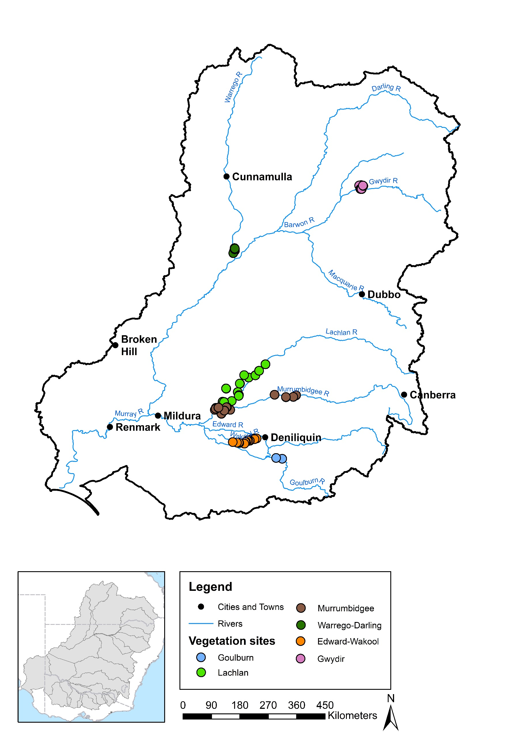

Figure . Vegetation diversity monitoring sites at Selected Areas in 2015–16.

Table 2. Vegetation diversity sampling design at Selected Areas in 2015–16. (Note refers to methods for collecting data regarding % cover of plant taxa.)

| Selected Area | Sampling design | | | | | |
| --- | --- | --- | --- | --- | --- | --- |
| Survey dates | No. of sites | No. of quadrats/ transects per site | Changes from 2014–15 | Quadrat/transect description | Sampling unit description |
| Edward–Wakool | Monthly between Aug 2015 and May 2016 | 16 (across 4 zones) | 1 | – | Transects perpendicular to channel, sampling from 5 permanent markers along 25 m transects parallel to water, points every  50 cm along | Subtransect at each elevation on each perpendicular transect (point-intercept method) |
| Goulburn | Sept 2015, Dec 2015 | 2 | 10 | – | Transects perpendicular to channel, sampling every 1 m along 2 m lengths, points every 10 cm | Subtransect at each elevation on each perpendicular transect (point-intercept method) |
| Gwydir | Oct–Dec 2015,  Mar 2016 | 18 (across  2 zones) | 1–4 | 5 sites added (1 site only surveyed  Mar 2016) | 0.04 ha plots | Entire 0.04 ha plot |
| Lachlan | Oct 2015, May 2016 | 10 | 2–4 | – | 100 m transects | 1 m2 quadrats every 10 m along transect |
| 14 | 2–4 |  | 0.1 ha plots (trees) with nested 0.04 ha plots (understorey) | Entire 0.04 ha plot (Note: canopy cover recorded for 0.1 ha plot) |
| Murrum-bidgee | Sept 2015, Nov 2015, Jan 2016, Mar 2016 | 12 | 3–5 | – | Transects, 90–250 m long depending on wetland bathymetry and area | 3 – 5 × 1 × 10 m2 quadrats along transect |
| Warrego–Darling | Aug 2015, Mar 2016 | 8 | 3 | – | 0.04 ha plots | Entire 0.04 ha plot |

Ten Commonwealth environmental watering actions with vegetation diversity expected outcomes were monitored across the six Selected Areas considered in this Basin Matter in 2015–16 (Table 1). These included the delivery of freshes in each of the two monitored channel systems (i.e. Edward–Wakool river system and Goulburn River). In the Gwydir river system, only the watering action targeting the Mallowa wetland resulted in wetland and floodplain inundation (Table 1). Five survey plots in this system were flooded by Commonwealth environmental water between the two survey dates while the remainder stayed dry. In contrast, almost half of the plots/transects in the Gingham and Gwydir zones were inundated during the first survey (October 2015), all of which had dried out by March 2016 (Commonwealth Environmental Water Office 2016a). In the Lachlan river system, between 50–75% of plots/transects at Nooran Lake and Tom’s Lake were inundated by Commonwealth environmental water prior to surveying in October/November 2015, but after the last 2014–15 survey, and all of these dried out by the second survey in May/June 2016. Some plots/transects in the Booligal wetlands were also inundated by Commonwealth environmental water at each survey date in 2015–16 (Dyer *et al.* 2016). In the Murrumbidgee river system, two of three transects in Yarrada Lagoon were wet in September 2015 and were all inundated by Commonwealth environmental water from December 2015 through to January 2016. Only a single transect in this wetland, however, remained wet by March 2016 (Wassens *et al.* 2016). No delivery of Commonwealth environmental water occurred in the Junction of the Warrego and Darling rivers during 2015–16.

The Aggregated Area–scale evaluation was conducted using water regime categories assigned to field survey plots/transects at each of the four wetland/floodplain Selected Areas on each survey date, i.e. ‘Wet’ or ‘Dry’ (Table 3). Water regime categories were determined by collating evidence from Selected Area reports, data provided by M&E Providers and through consultation with M&E Providers. Where sampling units comprised transects rather than plots, a ‘Wet’ category was designated if the majority of the transect was inundated at the time of surveying. For the Murrumbidgee river system Selected Area, multivariate analyses were conducted using ‘short’ water regime categories because of the additional survey dates included. Short water regime categories refer to the hydrological state at a particular survey time as well as the survey preceding this, regardless of survey time within the current year of LTIM.

Because of variation in survey dates between Selected Areas, as well as differences in the watering actions delivered, water regime categories cannot be considered as strictly equivalent between Selected Areas or even within Selected Areas. In the absence of more detailed inundation information, however, these water regime categories provide an indication of the hydrological condition at the time of survey and of broad recent antecedent patterns of wetting and drying influencing vegetation diversity at each survey point, i.e. whether or not a plot was wet or dry at the time of sampling and during any preceding sampling times. Therefore, neither hydrological conditions prior to the first LTIM survey in 2014–15 nor differences in annual watering patterns (e.g. inundation duration, depth etc.) are not considered in this assessment. Additionally, effects of any very short duration wetting occurring entirely between survey dates is not captured.

Because considerable inundation occurred at some Selected Areas during 2015–16 independent of Commonwealth environmental watering actions, we also determined which ‘Wet’ plots at each survey time were influenced by Commonwealth environmental water. As per water regime categories, this was achieved using information from Selected Area reports.

Table . Water regime categories assigned to vegetation diversity field survey plots/transects at wetland/floodplain Selected Areas in 2015–16. D indicates ‘Dry’ and W indicates ‘Wet’. Refer to Section 2.1.1 for further details on water regime categories. Numbers indicate the total number of plots/transects surveyed in each water regime category at each survey time. Numbers in brackets indicate the number of sample points (i.e. locations) across which these plots/transects were distributed. The number of plots/transects (and associated sample points) affected by Commonwealth environmental watering actions delivered during 2015–16 are shown in bold.

| Selected Area | Survey 1 | | Survey 2 | | | | | | | Survey 3 | | | | | | | Survey 4 | | | | | | | |
| --- | --- | --- | --- | --- | --- | --- | --- | --- | --- | --- | --- | --- | --- | --- | --- | --- | --- | --- | --- | --- | --- | --- | --- | --- |
| D | W | D–D | D–W | W–D | W–W | W* | D* | D–D–D | | D–W–D | D–W–W | W–D–D | W–W–D | W–W–W | D–D–D–D | | D–W–D–D | D–W–W–D | D–W–W–W | W–D–D–D | W–W–D–D | W–W–W–D | W–W–W–W |
| Gwydir river system | 21 (10) | 19 (6) | 16 (7) | **5 (3)** | 19 (6) | 0 | 0 | 1 (1) |  | |  |  |  |  |  |  | |  |  |  |  |  |  |  |
| Lachlan river system | 32 (15) | 18 (9)  **4 (2)** | 28 (12) | 0 | 13 (7) **4 (2)** | 18 (9)  **2 (1)** | 0 | 4 (2) |  | |  |  |  |  |  |  | |  |  |  |  |  |  |  |
| Murrumbidgee river system | 10 (10) | 13 (6)  **2 (1)** | 11 (6) | 9 (4)  **1 (1)** | 1 (1) | 12 (6)  **2 (1)** | 0 | 0 | 11 (6) | | 4 (2) | 5 (3)  **1 (1)** | 1 (1) | 3 (3) | 9 (4)  **2 (1)** | **1 (1)** | | 3 (2) | 1 (1) | 3 (3) | 5 (4) **1 (1)** | 4 (3)  **1 (1)** | 11 (6) | 4 (2) |
| Junction of the Warrego and Darling rivers | 21 (8) | 2 (1) | 18 (7) | 4 (3) | 0 | 2 (1) | 0 | 0 |  | |  |  |  |  |  |  | |  |  |  |  |  |  |  |

* Only sampled during second survey.

Plant species responses to Commonwealth environmental water across the four wetland/floodplain Selected Areas in 2015–16 were assessed by determining the presence or absence of recorded species in plots/transects of different water regime categories within each Selected Area. Species only appearing in plots/transects inundated by Commonwealth environmental watering actions in each of these Selected Areas during this year were thereby identified and compared between Selected Areas.

Vegetation community responses across the four wetland/floodplain Selected Areas were assessed in relation to total cover, species richness, dominance (i.e. proportion of total cover occupied by most abundant taxa), the proportion of total vegetation cover comprising exotic species, the proportion of total species richness comprising exotic species and community composition. With the exception of community composition, these variables were examined for differences in relation to water regime category at each survey time within each of these Selected Areas using univariate general linear models (GLMs) on untransformed data in SPSS (version 22.0). Where relevant, Tukey’s post-hoc tests were conducted to determine which groups differed significantly from each other. Trends in vegetation community responses to watering were then compared between Selected Areas.

Patterns in vegetation community composition in relation to water regime category and survey date were explored using non-metric multidimensional scaling (nMDS) based on Bray–Curtis similarity measures computed from a matrix of species abundance (i.e. % cover) at a plot/transect level in PRIMER 7. Permutational multivariate analysis of variance (ANOVA) (PERMANOVA) was used to determine if vegetation community composition differed significantly between water regime categories, and species contributing most to the similarity of assemblages within water regime categories (and the dissimilarity of assemblages between water regime categories) were identified using the similarity percentages breakdown (SIMPER) routine. Multivariate dispersion (MVDSIP) and permutational analysis of multivariate dispersion (PERMDISP) routines were also conducted in PRIMER 7 to explore differences in the dispersion of sampling units (i.e. plots/transects) within water regime categories and survey times at each Selected Area. Finally, the PRIMER 7 bootstrapping procedure was conducted to examine trends in relation to the spread of potential samples in multidimensional space within and between each water regime category at each wetland/floodplain Selected Area. The bootstrapping procedure is computed from a matrix of species abundance (i.e. % cover) at a plot/transect level in PRIMER 7. The bootstrapping procedure provides a region estimate (similar to a confidence interval) for each *a priori* group mean. This procedure calculates one observed mean (displayed as a black symbol) within pre-defined categories and displays the region estimate around this mean (e.g. the placement of other potential means). Sample size can greatly effect region estimates and groups with small sample sizes need to be interpreted with caution. For further details about the bootstrapping procedure, refer to Clarke & Gorley (2015).

These analyses were interpreted with respect to the spatial and temporal diversity of vegetation communities at both local and landscape scales.

### Aggregated Area scale, 1–2-year evaluation

To consider the effects of wetting, drying and Commonwealth environmental water delivery more specifically over the first 2 years of LTIM, plots/transects at each of the four wetland/floodplain Selected Areas for each survey time were further classified according to the influence of Commonwealth environmental water. Regardless of survey date, ‘Wet’ sites that had been inundated by Commonwealth environmental water during 2014–15 were assigned a ‘1’ while those inundated by Commonwealth environmental water during 2015–­16 were assigned a ‘2’ and those inundated in both years ‘1+2’.

Plant species responses to Commonwealth environmental water across wetland/floodplain Selected Areas over the first 2 years of LTIM were assessed by identifying those species that only appeared within each Selected Area in plots/transects following inundation by Commonwealth environmental watering actions during that period. Results were then compared across Selected Areas.

Vegetation community responses to inundation by Commonwealth environmental water delivered in 2015–16 were explored in relation to water regime categories assigned to plots/transects in the preceding year (i.e. 2014–15). A univariate GLM was used to test whether ‘Wet’ plots/transects during each survey date in 2015–16 differed in relation to conditions during the preceding year and the influence of Commonwealth environmental water delivered in 2014–15. Responses were then compared between these Selected Areas.

Patterns in vegetation community composition over the 2-year period were explored with nMDS based on Bray–Curtis similarity measures calculated from matrices of species cover for each of the four wetland/floodplain Selected Areas in relation to water regime category and the influence of Commonwealth environmental water. PERMANOVA was used to identify significant differences between groups and MVDSIP, PERMDISP and Bootstrapping procedures in PRIMER 7 were used to explore heterogeneity of sampling points with respect to Selected Area, survey date and water regime category.

### Basin scale, annual evaluation

Watering actions for vegetation diversity outcomes in 2015–16 were assessed at the Basin scale in relation to plant species diversity and vegetation community diversity. Basin-scale plant species diversity outcomes were considered by identifying those species that only appeared in the Basin (i.e. across the four wetland/floodplain Selected Areas) in plots/transects following inundation by Commonwealth environmental watering actions during 2015–16. Particular attention was given to species of known Basin-scale significance, i.e. those of conservation concern listed in state and/or national legislation.

Basin-scale vegetation community diversity was assessed by conducting nMDS based on Bray–Curtis similarity measures calculated from matrices of species presence/absence and species cover combined across all four wetland/floodplain Selected Areas in relation to water regime category and the influence of Commonwealth environmental water during 2015–16. PERMANOVA was used to identify significant differences between groups and MVDSIP, PERMDISP and bootstrapping procedures in PRIMER 7 were used to explore heterogeneity of sampling points with respect to Selected Area, survey date and water regime category.

Information provided by the Hydrology (Stewardson & Guarino 2017) and Ecosystem Diversity Basin Matter evaluations (Brooks 2017) were used to determine the proportion of different Australian National Aquatic Ecosystem (ANAE) types that were inundated or influenced by Commonwealth environmental water in 2015–16 across the entire Basin. Findings were assessed in relation to the diversity, proportion and distribution of vegetation communities that were affected by Commonwealth environmental water in 2015–16.

### Basin scale, 1–2-year evaluation

Basin-scale plant species diversity outcomes over the 2-year period comprising 2014–15 and 2015–16 were evaluated by determining which species were only present in the Basin (i.e. across the four wetland/floodplain Selected Areas) in plots/transects following inundation by Commonwealth environmental watering actions during this period. As per the annual Basin-scale evaluation, particular attention was given to species of known Basin-scale significance.

Basin-scale vegetation community diversity over the 2-year period was explored using nMDS based on Bray–Curtis similarity measures calculated from matrices of species presence/absence and species cover combined across the all four wetland/floodplain Selected Areas in relation to water regime category and the influence of Commonwealth environmental water during 2014–15 and 2015–16. PERMANOVA was used to identify significant differences between groups and MVDSIP, PERMDISP and bootstrapping procedures in PRIMER 7 were used to explore heterogeneity of sampling points with respect to Selected Area, survey date and water regime category.

## Monitoring approaches in Selected Areas and Basin evaluation focus

Data collected by M&E Providers at Selected Areas are collected using different methods as summarised in Capon et al. (2015) and detailed in monitoring plans for the individual Selected Areas (Dyer *et al.* 2014; Ecological Australia & UNE 2014; Wassens *et al.* 2014; Watts *et al.* 2014; Webb *et al.* 2014; Ecological Australia and UNE 2015). Wetland and floodplain vegetation communities in the Murrumbidgee river system, Lachlan river system, Gwydir river system and at the Junction of the Warrego and Darling rivers Selected Areas were monitored using modified Category 1 survey methods (Hale *et al.* 2014) and data from these Selected Areas will be the focus of this report. Wetland and floodplain vegetation was not monitored in the Goulburn River or the Edward–Wakool river system Selected Areas. Riverbank and river channel aquatic vegetation in these two Selected Areas were monitored using Category 3 survey methods, which are specific to the Selected Areas (Watts *et al.* 2014; Webb *et al.* 2014).

# Aggregated Area–scale annual evaluation

## Highlights

* Significant numbers of plant species (2–11%) recorded from wetland/floodplain Selected Areas in 2015–16 were only observed in plots/transects following inundation by sources including Commonwealth environmental water. These species were mostly native grasses and forbs but also included some sedges.
* Total vegetation cover exhibited a relatively positive and significant response to wetting across all Selected Areas. Continuous wetting, such as that produced by the delivery of Commonwealth environmental water in some parts of the Murrumbidgee river system, tended to produce the highest levels of vegetation cover but high cover was also observed in plots/transects that dried following wetting.
* Species richness of vegetation communities exhibited mixed responses to wetting both within and between Selected Areas, although drier plots/transects tended to have more species with a higher proportion of these comprising exotic species.
* Vegetation communities in wet plots/transects generally had greater dominance by the most abundant species present than dry plots/transects.
* Cover and richness of exotic plant species tended to be higher under dry conditions across all Selected Areas.
* Shifts in vegetation community composition in surveyed plots/transects at Selected Areas over 2015–16 were driven mainly by wetting, although some seasonal shifts in composition were apparent between survey dates in response to continued drying (except in the Gwydir river system).
* The diversity of vegetation communities responding to particular water regimes within each Selected Area was higher under wetter conditions than dry and greatest in response to variable water regimes (i.e. both wetting and drying during 2015–16). Differences in community composition relating to water regime were largely related to changes in the abundance of native species.
* Where it resulted in inundation during 2015–16, Commonwealth environmental water contributed substantially to landscape-scale vegetation diversity in all wetland/floodplain Selected Areas by promoting the range of water regimes present and therefore both the diversity of vegetation communities able to respond and the trajectories of response these exhibited.

## Effects of Commonwealth environmental water on plant species diversity at Selected Areas

### River channel systems

Commonwealth environmental water delivered during 2015–16 had no observable effects on plant species diversity in the Goulburn River (Webb *et al.* 2017). Species-level data were not available to evaluate plant species diversity responses in the Edward–Wakool river system.

### Wetland and floodplain systems

In the Gwydir river system Selected Area, 159 plant taxa were recorded during 2015–16 (Annex B). Of these, 17 taxa (i.e. around 11%), mostly comprising native grasses and forbs, were only present in plots following inundation during this period by Commonwealth environmental water (Table 4). Furthermore, at least one species prevalent in dry plots during the year’s second field survey, i.e. the exotic sub-shrub \**Aster subulatus*, was absent from areas subject to inundation during this year.

Table . Plant species only present in each wetland/floodplain Selected Area in 2015–16 in plots/transects following inundation by Commonwealth environmental water delivered during 2015–16. (Note: no samples were inundated by Commonwealth environmental water during 2015–16 at the Junction of the Warrego and Darling rivers Selected Area.)

|  |  |  |
| --- | --- | --- |
| Gwydir river system | Lachlan river system1 | *Murrumbidgee river system* |
| **Grasses** | | |
| *Aristida leptopoda*  *Diplachne fusca*  *Echinochloa inundata*  *Echinochloa* spp.  *Eriochloa crebra*  *Leptochloa* spp. | *Eragrostis australasica*  *Panicum decompositum*  *Paspalum distichum*  *Sporobolus caroli* |  |
| **Forbs** | | |
| *Amaranthus macrocarpus*  *Bidens pilosa*\*  *Centipeda minima*  *Rumex brownii*  *Tetragonia tetragonioides*  *Vittadinia cuneata* | *Azolla filiculoides*  *Dichondra* spp.  *Heliotropium curassavicum*  *Lythrum hyssopifolia*  *Myosurus australis*  *Myriophyllum crispatum*  *Myriophyllum* spp.  *Stellaria angustifolia*  *Veronica catenata*\* | *Senecio pinnatifolius* var. *pinnatifolius*  *Stellaria media*\*  *Verbena gaudichaudii* |
| **Sedges/rushes** | | |
| *Cyperus bifax* | *Eleocharis plana*  *Juncus flavidus*  *Juncus usitatus* |  |
| **Sub-shrubs/shrubs** | | |
| *Eremophila debilis* | *Persicaria lapathifolia* |  |
| **Trees** | | |
| *Acacia salicina*  *Eucalyptus camaldulensis* |  |  |
| **Mistletoes** | | |
| *Dendrophthoe* spp. |  |  |

1 Due to methodological differences in the Lachlan river system Selected Area, the list of grass species present may be incomplete.

Note: asterisks (*) indicate exotic species.

In the Lachlan river system Selected Area, 192 plant taxa were recorded during 2015–16 (Annex B), including 17 taxa (around 9%) only recorded in plots/transects following inundation during this year by Commonwealth environmental water (Table 4). As in the Gwydir river system, these mostly comprised native grasses and forbs but also several sedges/rushes. Several additional species were also identified that were only present on each survey occasion in plots inundated by Commonwealth environmental water, i.e. *Myriophyllum verrucosum* in October 2015 and *Lachnagrostis filiformis* and *Salsola australis* in May 2016.

In the Murrumbidgee river system Selected Area, 169 plant taxa were recorded during 2015–16 (Annex B). Three of these, all forbs including one exotic, were only present in plots/transects inundated by Commonweatlh environmental water during this year (Table 4). Several additional species were only present on each survey occasion in plots/transects inundated by Commowealth environmental water: the exotic annual forb \**Raphanus raphanistrum* in November 2015; the native annual forb *Rorippa eustylis* in both January and March 2016 and the native perennial grass *Rytidosperma caespitosum* in March 2016.

No inunundation due to Commonwealth environmental water occurred in the Junction of the Warrego and Darling rivers Selected Area during 2015–16. Vegetation surveys conducted during this year, however, recorded 128 plant taxa in this Selected Area (Annex B).

The presence of some typically terrestrial species only in plots inundated by Commonwealth environmental water may reflect shallow inundation of short duration, early colonisation of bare ground following recession of water or only partial inundation of a plot/transect.

## Effects of Commonwealth environmental water on vegetation community diversity at Selected Areas

### Edward–Wakool river system

Higher vegetation cover and species richness of aquatic and riverbank vegetation was observed in the Edward–Wakool river system Selected Area in 2015–16 in areas that received Commonwealth environmental water during this year compared with those that received very little or no environmental water in this period (Watts *et al.* 2016). Some species (i.e. *Chara* spp. and *Myriophyllum* spp.) had consistently higher cover in zones receiving environmental water while other species (e.g. *Potamogeton tricarinatus*, *Azolla* spp., *Ludwigia peoploides* subsp. *Montevidensis* and *Centipeda cunninghamii*) had higher cover at some sites receiving environmental water.

### Goulburn River

Considering the cumulative effects of multiple years, spring freshes along the Goulburn River Selected Area appear to contribute to maintaining water-dependent species on the bank face and limiting the occurrence and cover of grasses and woody species at lower elevations along the bank (Webb *et al.* 2017). Short-term responses of vegetation to freshes in 2015–16 were limited, with no discernible difference in species richness or cover. However, the cover of particular vegetation types along the elevation gradient reflects the longer term influence of spring freshes. The cover and probability of occurrence of aquatic vegetation as a group tended to be higher in regions of the bank inundated by spring freshes and declined at elevation above this. In contrast, the cover and probability of occurrence of grasses tended to be higher along parts of the bank not influenced by freshes (Webb *et al.* 2017).

Dry conditions prior to the spring fresh in 2015 are likely to have resulted in a shift of aquatic species to lower elevations. Below-average rainfall and lower inflows to the Goulburn prior to the 2015–16 spring fresh may have limited the vegetation response to the fresh (Webb *et al.* 2017). M&E Providers continue to work closely with water managers to develop flow regimes to benefit establishing vegetation and the replenishment of soil seed banks.

### Gwydir river system

In October 2015, around 48% of plots in the Gwydir river system Selected Area were Wet as a result of local rainfall and remnant water from 2014–15 (Table 3). Total vegetation cover (F1, 38 = 6.307, p < 0.05), species richness (F1, 38 = 8.517, p < 0.05) and dominance (F1, 38 = 6.693, p < 0.05) all differed between Wet and Dry plots at this time. Dry plots had lower total cover and dominance but more species present (Figure 2). The proportion of total cover comprising exotic species (F1, 38= 8.748, p < 0.05) was also significantly higher in Dry plots than in Wet plots at this time (Figure 3). A significant difference in the proportion of species that were exotic was not detected in relation to water regime at this time, although this also tended to be higher in Dry plots (Figure 3).

In March 2016, only five Wet plots surveyed in the Gwydir river system had all been inundated by Commonwealth environmental water between surveys while previously Wet plots had all dried out (Table 3). No differences in total cover, species richness, dominance or the proportion of cover or species that were exotic were apparent between plots of different water regimes at this time (Figures 2 and 3). There was a strong tendency, however, for sites that remained dry throughout 2015–16 to have a greater proportion of exotic species cover and a greater proportion of species that were exotic than sites that had been wet at some stage during 2015–16 (Figure 3).

Vegetation community composition differed significantly between water regime categories over 2015–16 (Figure 4). Significant differences were detected between most pair-wise comparisons with the exception of Dry communities (i.e. surveyed in October 2015) and Dry–Dry communities (i.e. surveyed in March 2016). Of note with regards to the species characterising each water regime (Table 5) is the presence of the exotic forb \**Phyla canescens* in Dry plots during October 2015 as well as Dry–Dry plots in March 2016 but not plots that experienced some wetting. Heterogeneity between vegetation communities at a landscape scale was increased substantially as a result of inundation by Commonwealth environmental water in the Gwydir river system with the composition of communities receiving water in this year (i.e. Dry–Wet) differing from that of plots that remained dry or dried out during this year (Figure 5).

Table . Plant species characterising vegetation communities in each water regime category in the Gwydir river system Selected Area in 2015–16 (according to SIMPER analysis).

|  |  |
| --- | --- |
| Water regime | Characteristic species |
| **October 2015** | |
| Dry | *Eleocharis plana* (sedge/rush)  *Paspalum distichum* (grass)  *Phyla canescens*\* (forb)  *Ranunculus undosus* (forb)  *Typha domingensis* (sedge/rush) |
| Wet | *Azolla filiculoides* (forb)  *Paspalum distichum* |
| **March 2016** | |
| Dry–Dry | *Eleocharis sphacelata* (sedge/rush)  *Eucalyptus coolabah* (tree)  *Paspalum distichum*  *Phyla canescens*\*  *Typha domingensis* |
| Dry–Wet | *Eleocharis plana* |
| Wet–Dry | *Paspalum distichum* |

Note: asterisks (*) indicate exotic species.

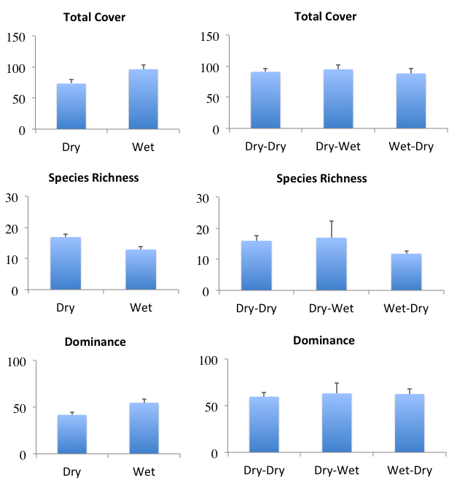

Figure 2. Differences in vegetation community metrics between water regime categories (see Table 3) for the Gwydir river system Selected Area in 2015–16. Error bars indicate ± standard error. Left column represents October 2015 survey and right column March 2016: (top) total vegetation cover (summed % cover); (centre) total species richness (number of taxa); and (bottom) dominance (%) .

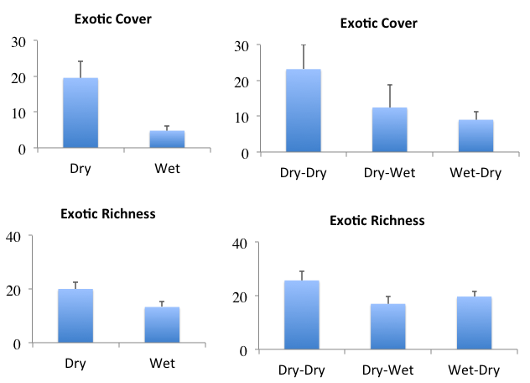

Figure . Differences in exotic species cover and richness between water regime categories (see Table 3) for the Gwydir river system Selected Area in 2015–16. Error bars indicate ± standard error. Left column represents October 2015 survey and right column March 2016: (top) proportion of total cover comprising exotic taxa (%); and (bottom) proportion of total taxa that were exotic (%).

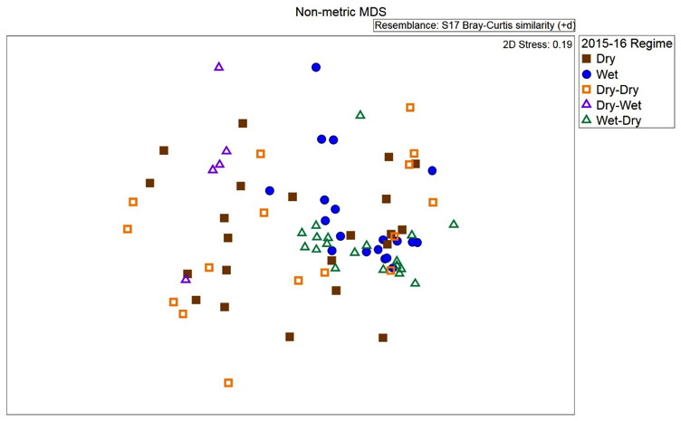

Figure . Ordination of vegetation assemblages at the Gwydir river system Selected Area in 2015–16 showing water regime categories (based on nMDS calculated from species cover values). Note: Dry and Wet categories represent sampling conducted in October 2015 while the other water regime categories represent samples from March 2016.

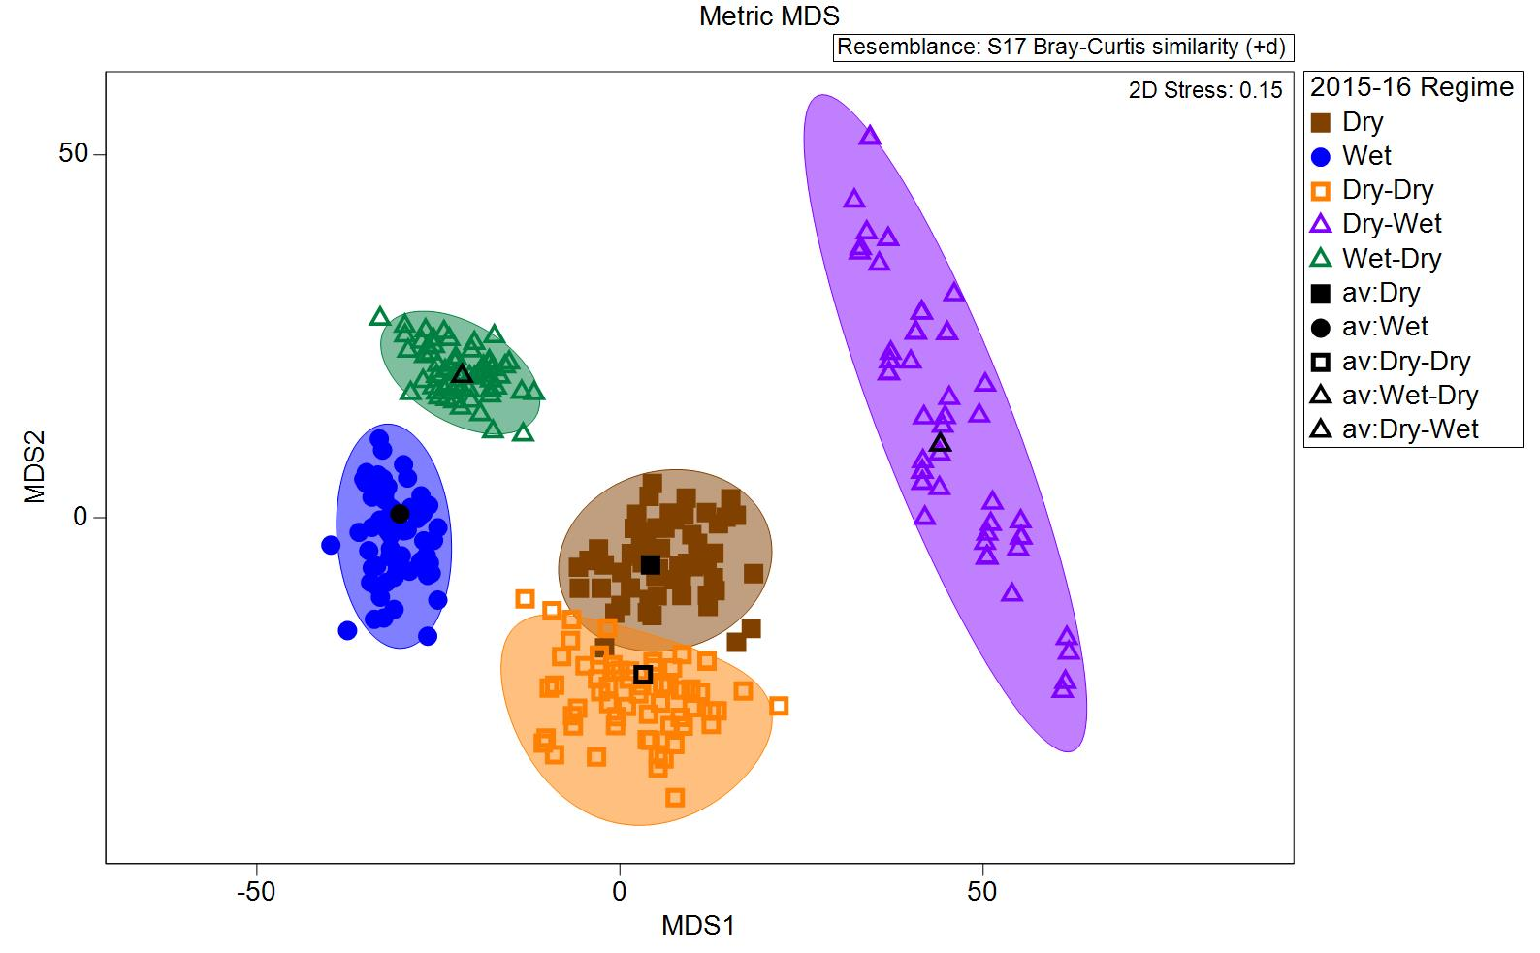

Figure . Ordination of vegetation assemblages at the Gwydir rivery system Selected Area in 2015–16 showing average values and dispersion within each water regime category (based on the bootstrapping procedure in PRIMER 7).

### Lachlan river system

In October 2015, Wet plots/transects in the Lachlan river system Selected Area included four across Tom’s Lake and Nooran Lake that had received Commonwealth environmental water prior to this survey date, as well as a further 18 plots/transects not inundated by Commonwealth environmental water in 2015–16 (Table 3). Significant differences were apparent at this time between Dry and Wet plots/transects for total cover (F1, 48 = 7.014, p < 0.05), species richness (F1, 48 = 7.766, p < 0.05), dominance (F1, 48 = 5.047, p < 0.05) and the proportion of species that were exotic (F1, 48 = 3.049, p < 0.05; Figures 6 and 7). Wet plots at this time had higher total cover, greater dominance and a lower proportion of species that were exotic. Wet plots in October 2015 also tended to have a lower proportion of exotic cover while Dry plots had more species overall (Figures 6 and 7).

In May 2016, total cover (F3, 44 = 7.129, p = 0.01) and the proportion of species that were exotic (F3, 44 = 3.049, p < 0.05) also varied significantly with respect to water regime but not species richness, dominance or the proportion of cover that was exotic (Figures 6 and 7). At this time, total cover was greater in all plots/transects that had been wet at some stage during 2015–16, particularly those that were wet on both occasions (Figure 6), i.e. Booligal plots/transects. The proportion of species that were exotic was also significantly lower in plots/transects that were wet on both occasions and in the new Dry sites (n = 4) added during the second 2015–16 survey (Figure 7). Plots/transects that had previously received Commonwealth environmental water during 2015–16 (Wet–Dry, i.e. in Tom’s Lake and Nooran Lake) had a higher proportion of species that were exotic in May 2016 although a similar trend was not evident for proportion of vegetation cover that was exotic (Figure 7).

Vegetation community composition differed significantly between water regime categories over 2015–16 (Figure 8). Significant differences were detected between most pair-wise comparisons except between Wet (i.e. surveyed in October 2015) and Wet–Wet and Wet–Dry (i.e. surveyed in May 2016) samples. Dry and Dry–Dry vegetation communities were characterised by high cover of several shrub and sub-shrub species (Table 6). Wet, Wet–Wet and Wet–Dry communities were also characterised by the shrub *Duma florulenta* as well as several sedge, grass and forb species (Table 6). Landscape-scale heterogeneity of vegetation communities across the Lachlan river system was likely enhanced by the delivery of Commonwealth environmental water during 2015–16 as the composition of vegetation communities that were wet during the first or both surveys differed considerably from plots that were dry at either survey time (Figure 9).

Table . Plant species characterising vegetation communities in each water regime category in the Lachlan river system Selected Area in 2015–16 (according to SIMPER analysis).

|  |  |
| --- | --- |
| Water regime | Characteristic species |
| **October 2015** | |
| Dry | *Atriplex semibaccata* (sub-shrub/shrub)  *Duma florulenta* (sub-shrub/shrub)  *Enchylaena tomentosa* (sub-shrub/shrub)  *Eucalyptus camaldulensis* (tree)  *Sisymbrium erysimoides*\* (forb) |
| Wet | *Duma florulenta*  *Eleocharis acuta* (sedge/rush)  *Paspalidium jubiflorum* (grass)  *Sisymbrium erysimoides*\* |
| **May 2016** | |
| Dry–Dry | *Atriplex semibaccata*  *Duma florulenta*  *Einadia nutans* subsp. *nutans* (sub-shrub/shrub)  *Enchylaena tomentosa*  *Sclerolaena muricata* (sub-shrub/shrub) |
| Wet–Dry | *Duma florulenta*  *Centipeda cunninghamii* (forb)  *Euphorbia drummondii* (forb)  *Paspalidium jubiflorum* |
| Wet–Wet | *Duma florulenta*  *Medicago polymorpha*\* (forb)  *Tetragonia tetragonioides* (forb) |

Note: asterisks (*) indicate exotic species.

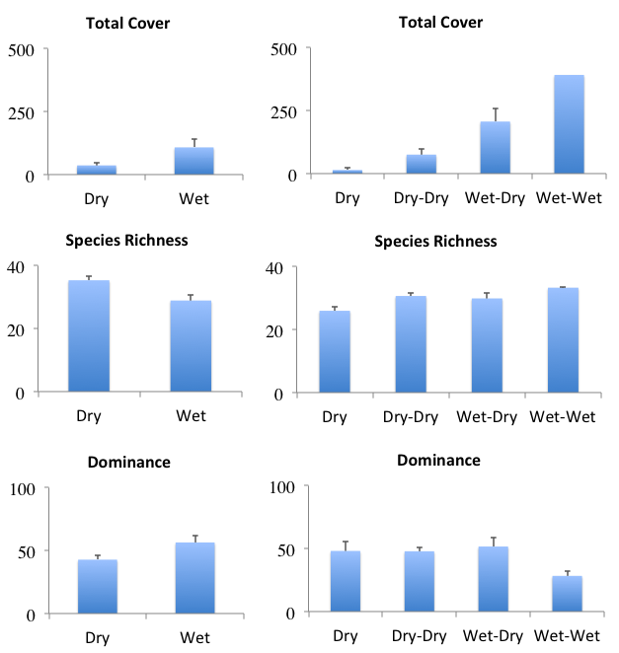

Figure . Differences in vegetation community metrics between water regime categories (see Table 3) for the Lachlan river system Selected Area in 2015–16. Error bars indicate ± standard error. Left column represents October 2015 survey and right column May 2016: (top) total vegetation cover (summed % cover); (centre) total species richness (number of taxa); and (bottom) dominance (%).

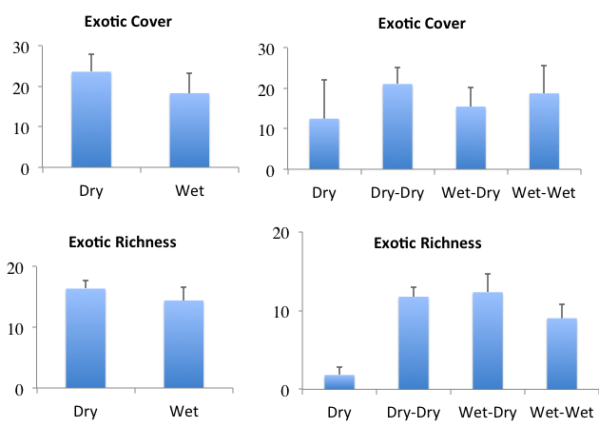

Figure . Differences in exotic species cover and richness between water regime categories (see Table 3) for the Lachlan river system Selected Area in 2015–16. Error bars indicate ± standard error. Left column represents October 2015 survey and right column May 2016: (top) proportion of total cover comprising exotic taxa (%); and (bottom) proportion of total taxa that were exotic (%).

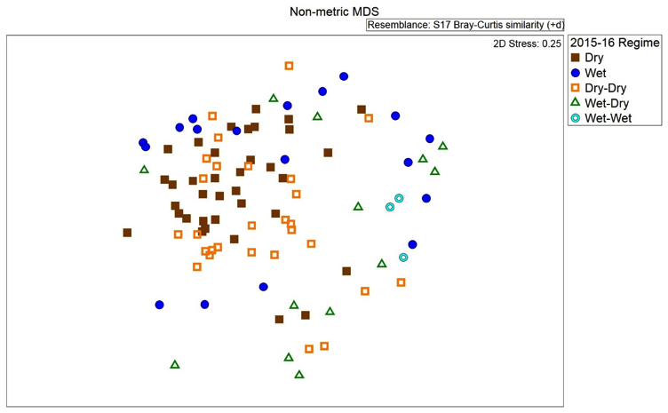

Figure . Ordination of vegetation assemblages at the Lachlan river system Selected Area in 2015–16 based on water regime categories (based on nMDS calculated from species cover values). Note: Dry and Wet categories represent sampling conducted in October 2015 while the other water regime categories represent samples from May 2016.

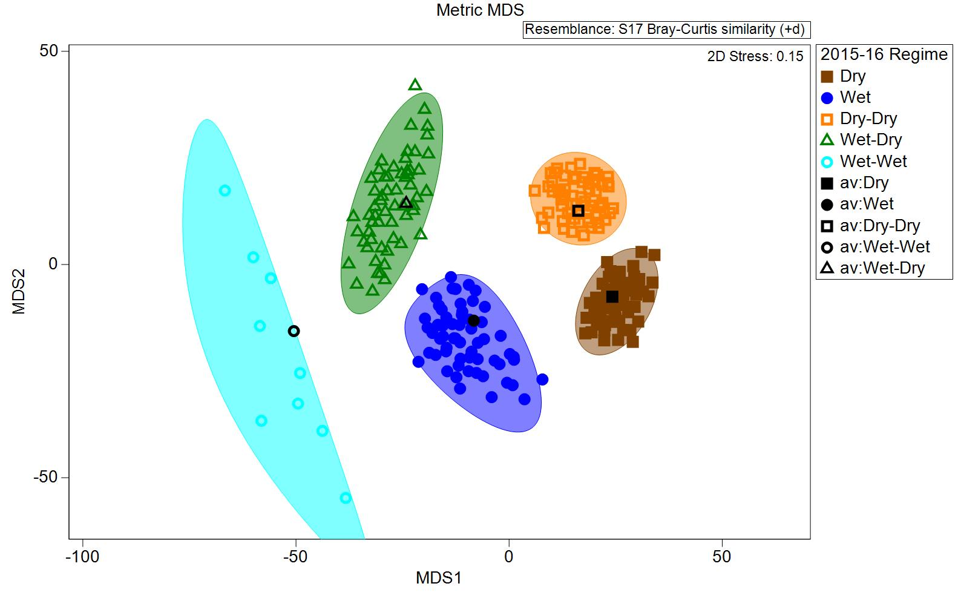

Figure . Ordination of vegetation assemblages at the Lachlan river system Selected Area in 2015–16 showing average values and dispersion within each water regime category (based on the bootstrapping procedure in PRIMER 7).

### Murrumbidgee river system

Only a small proportion of plots/transects that were Wet in the Murrumbidgee river system Selected Area at each survey time in 2015–16 were inundated by Commonwealth environmental water delivered during this year (i.e. those in Yarrada Lagoon) (Table 3). In September 2015, significant differences were apparent between Wet and Dry plots/transects in species richness (F1, 31 = 19.176, p < 0.001) and dominance (F1, 31 = 8.221, p < 0.01), with more species present in Dry plots/transects and greater dominance occurring in Wet plot/transects at this time (Figure 10).

By the second survey, in November 2015, significant differences in species richness (F3, 29 = 6.910, p = 0.001) and the proportion of species that were exotic (F3, 29 = 5.772, p < 0.05) were apparent, with both metrics higher in sites that remained dry in both surveys (i.e. Dry–Dry; Figures 10 and 11).

In January 2016, no significant differences in the vegetation metrics examined were apparent in relation to water regime. However, there was a strong trend for higher vegetation cover and lower exotic cover and richness in plots/transects that had been inundated in at least one prior survey during the 2015–16 year (i.e. Dry–Wet– and Wet–Wet– water regime categories (water regimes categories condensed to current and preceding states only); Figures 10 and 11).

In the final survey of this year (March 2016), total cover was significantly higher (F7, 25 = 3.427, p < 0.05) in plots/transects that had been inundated in at least one prior survey during the 2015–16 year (i.e. Dry–Wet– and Wet–Wet– water regime categories (water regimes categories condensed to current and preceding states only); Figure 10), including the transects at Yarrada Lagoon which were inundated by a Commonwealth environmental watering action in 2015–16.

Vegetation community composition differed significantly between most (short) water regime categories in the Murrumbidgee river system over 2015–16 (Figure 12). Non-significant pair-wise comparisons were between: Wet and Wet–Wet samples; Wet–Wet and Dry–Wet samples; Wet–Wet and Wet–Dry samples; and Wet–Dry and Dry–Wet samples. Vegetation communities in plots/transects subject to some wetting during 2015–16 tended to be characterised by the presence of aquatic sedges and forbs (Table 7). Landscape-scale heterogeneity of vegetation communities across the Murrumbidgee river system was enhanced by the diversity of water regimes that occurred during 2015–16, especially the presence of some plots/transects that experienced both wetting and drying (Figure 13).

Table . Plant species characterising vegetation communities in each water regime category in Murrumbidgee river system Selected Area in 2015–16 (according to SIMPER analysis).

|  |  |
| --- | --- |
| Water regime | Characteristic species |
| **September 2015** | |
| Dry | *Centipeda cunninghamii* (forb)  *Duma florulenta* (sub-shrub/shrub)  *Eucalyptus camaldulensis* (tree)  *Medicago polymorpha*\* (forb)  *Sinapis* spp.* (forb) |
| Wet | *Eleocharis acuta* (sedge/rush)  *Eucalyptus camaldulensis* |
| **All other survey times** | |
| Dry–Dry | *Centipeda cunninghamii*  *Duma florulenta*  *Eucalyptus camaldulensis*  *Marsilea drummondii* (forb)  *Polygonum aviculare*\* (forb) |
| Dry–Wet | *Azolla filiculoides* (forb)  *Duma florulenta*  *Ludwigia peploides* subsp. *montevidensis* (forb) |
| Wet–Dry | *Azolla filiculoides*  *Centipeda cunninghamii*  *Dysphania pumilio* (forb)  *Eleocharis acuta*  *Ludwigia peploides* subsp. *montevidensis* |
| Wet–Wet | *Azolla filiculoides*  *Eleocharis acuta*  *Eleocharis sphacelata*  *Eucalyptus camaldulensis*  *Myriophyllum verrucosum* (forb) |

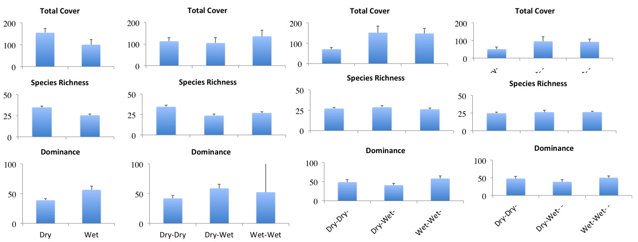

Figure . Differences in vegetation community metrics between water regime categories (see Table 3) for the Murrumbidgee river system Selected Area in 2015–16. Error bars indicate ± standard error. Left column represents October 2015 survey, second column December 2015, third column January 2016 and fourth column March 2016: (top) total vegetation cover (summed % cover); (centre) total species richness (number of taxa); and (bottom) dominance (%). Water regime categories have been condensed to current and preceding state only.

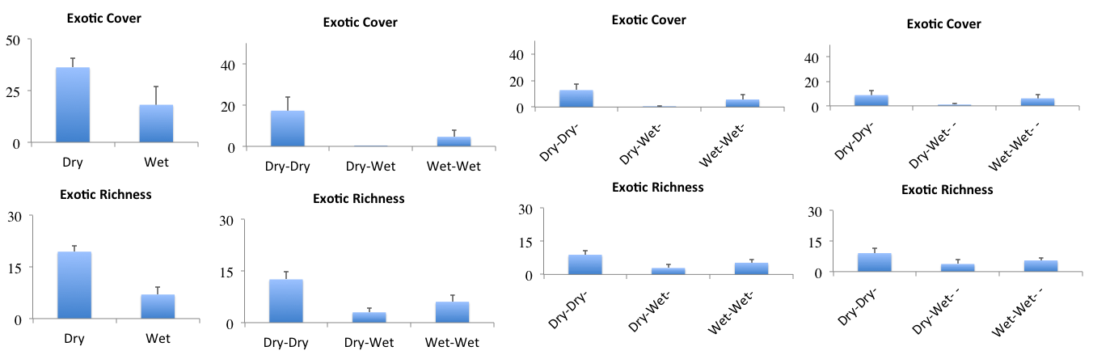

Figure . Differences in exotic species cover and richness between water regime categories (see Table 3) for the Murrumbidgee river system Selected Area in 2015–16. Error bars indicate ± standard error. Left column represents October 2015 survey, second column December 2015, third column January 2016 and fourth column March 2016: (top) proportion of total cover comprising exotic taxa (%); and (bottom) proportion of total taxa that were exotic (%). Water regime categories have been condensed to current and preceding state only.

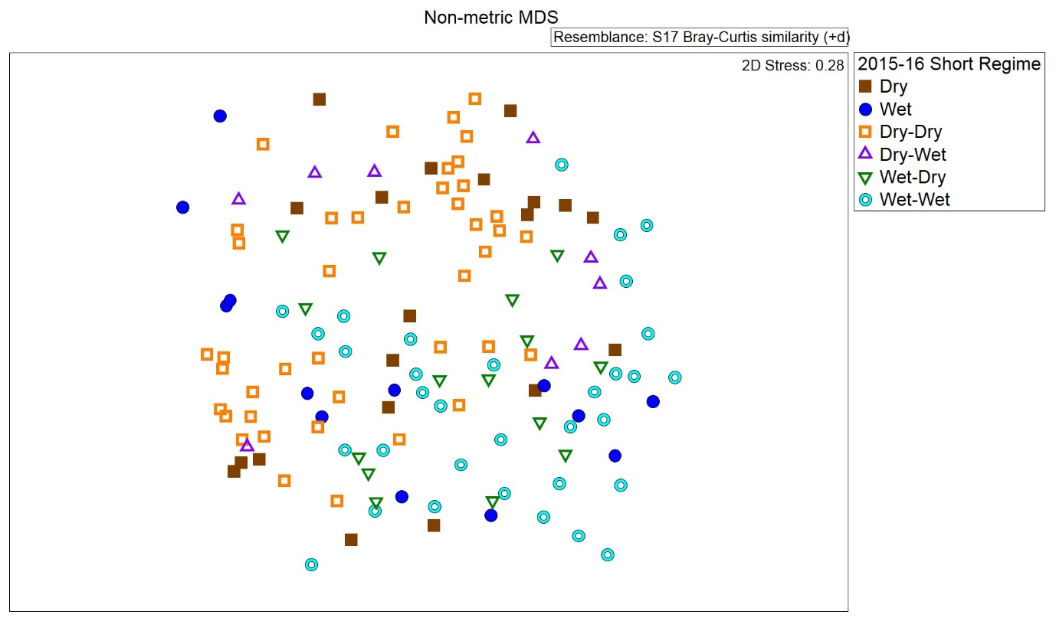

Figure 12. Ordination of vegetation assemblages at the Murrumbidgee river system Selected Area in 2015–16 based on water regime categories (based on nMDS calculated from species cover values).

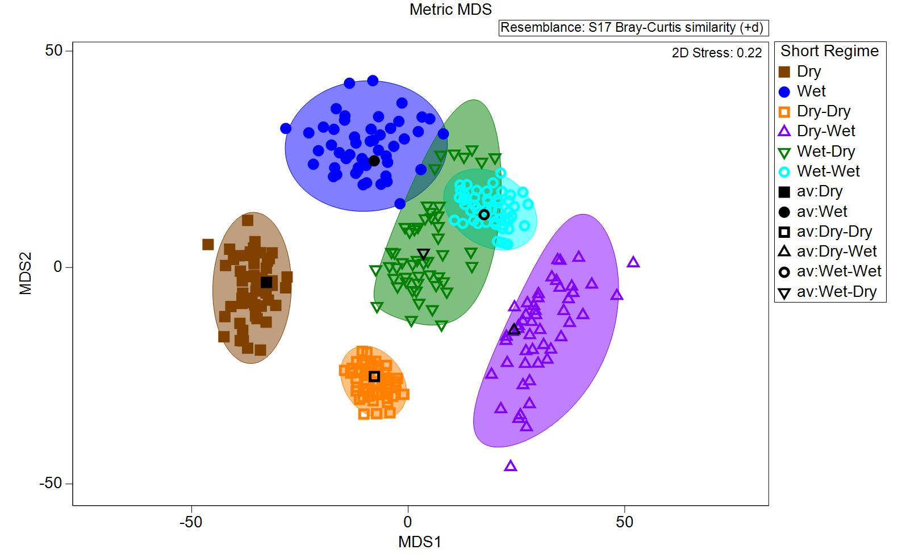

Figure . Ordination of vegetation assemblages at the Murrumbidgee river system Selected Area in 2015–16 showing average values and dispersion within each short water regime category (based on the bootstrapping procedure in PRIMER 7).

### Junction of the Warrego and Darling rivers

No Commonwealth environmental water was delivered to wetlands and floodplains of the Junction of the Warrego and Darling rivers Selected Area in 2015–16, although a small number of plots were inundated at each survey time due to water from other sources (Table 3). A significant influence of water regime on vegetation community composition was detected for 2015–16 but, likely due to the small sample sizes involved, a significant pair-wise difference was only detected between Dry plots (i.e. sampled in August 2015) and Dry–Dry plots (i.e. sampled in March 2016; Figure 14).

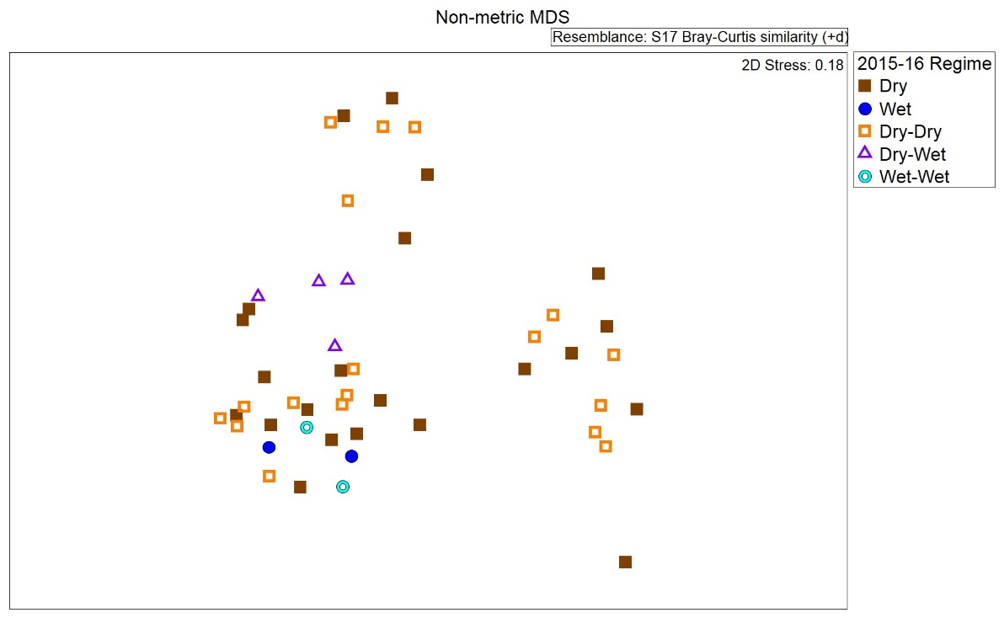

Figure . Ordination of vegetation assemblages at the Junction of the Warrego and Darling rivers Selected Area in 2015–16 based on water regime categories (based on nMDS calculated from species cover values).

## Synthesis

Significant numbers of taxa were only observed within each wetland/floodplain Selected Area in plots/transects following inundation by Commonwealth environmental water (Table 4), except in the Junction of the Warrego and Darling rivers which did not receive any Commonwealth environmental water during this year. The species were mostly native grasses and forbs but also included some sedges. Interestingly, the suite of species was distinctive between each Selected Area. It is probable that these species established within these plots/transects in response to wetting and/or drying following wetting and, given the heterogeneous nature of vegetation communities in these wetland systems, would not therefore have been present during 2015–16 in the absence of Commonwealth environmental water. The limited number of shrubs and trees only observed in these plots/transects, however, are unlikely to have been present in response to inundation by Commonwealth environmental water given the short time frame involved. Their presence is more likely a response to longer term water regimes.

Total cover of vegetation communities surveyed in Selected Areas exhibited relatively consistent positive and significant responses to wetting, with higher levels of cover promoted particularly by continuous wetting but also by drying following wetting across all Selected Areas. In contrast, the species richness of vegetation communities exhibited mixed responses to wetting both within and between Selected Areas, with drier plots/transects often having more species and, in particular, a higher proportion of exotic species. Dominance, like total cover, was mostly higher in wet plots. These observations support previous findings that vegetation communities of many wetland systems in the Basin comprise comparatively few truly aquatic species but that those which are present tend to be highly productive and abundant under suitable conditions (Reid & Capon 2011). Most species persisting in these systems in soil seed banks, however, establish in responses to drying following inundation (Brock *et al*. 2006) which is when greater species richness, but lower total cover, might be expected in these wetlands.

The proportion of species present that were exotic tended to be highest across all Selected Areas under dry conditions, especially during later survey rounds in plots/transects that had been dry throughout 2015–16. Wetting also appeared to reduce the proportion of vegetation cover comprising exotic species at all Selected Areas.

Shifts in vegetation community composition apparent at Selected Areas over 2015–16 were driven mainly by wetting, although some seasonal shifts in composition were apparent between survey dates in response to continued drying, except in the Gwydir river system. Where continued wetting occurred during the year (i.e. some plots/transects in the Lachlan river system and Murrumbidgee river system), however, vegetation community composition did not differ substantially in relation to season. At later survey dates, community composition also tended to exhibit more overlap within Selected Areas among communities that had experienced at least some wetting during the year, especially in the Murrumbidgee river system.

The diversity of vegetation within each Selected Area was clearly much greater under wet conditions than dry, but particularly so in relation to variable water regimes. This trend was evident for each survey time in all Selected Areas except the Junction of the Warrego and Darling rivers where very few sites were inundated in 2015–16. For the most part, differences in vegetation composition between water regimes and/or survey dates were characterised by changes in the abundances of native species. Commonwealth environmental water contributed to landscape-scale vegetation diversity in all Selected Areas where it resulted in inundation during 2015–16 by promoting the range of water regimes present.

# Aggregated Area–scale longer term (1–2-year) evaluation

## Highlights

* A significant proportion of plant species (5–9%) recorded from each Selected Area over both 2014–15 and 2015–16 – mostly native grasses and forbs, but including a few exotic forbs – have been observed only in plots/transects following inundation by sources including Commonwealth environmental water.
* Continuous drying over 2014–15 and 2015–16 was typically associated with lower vegetation cover and higher proportional cover and richness of exotic species at all wetland/floodplain Selected Areas.
* The diversity of vegetation communities present in each Selected Area at any particular time, as well as over the entire 2-year period, has been enhanced by the diversity of water regimes experienced which, in turn, have a strong influence on vegetation composition. Commonwealth environmental water has therefore contributed to the diversity of vegetation communities by promoting spatial and temporal variation in water regimes.
* Effects of prior watering in 2014–15 were apparent in several cases in the responses of vegetation communities to particular annual water regimes in 2015–16. For example, vegetation community composition in the second year tended to differ between those communities that had received wetting in 2014–15 and those that had been continuously dry.
* Commonwealth environmental water contributed significantly to the diversity of vegetation communities at a landscape scale at all four wetland/floodplain Selected Areas over the 2-year period by promoting the diversity of water regimes that occurred. In particular, vegetation communities subject to variable wetting regimes over this period (i.e. wetting and drying) exhibited the greatest range of responses.

## Effects of Commonwealth environmental water on plant species diversity at Selected Areas over 1–2 years

Over both 2014–15 and 2015–16, 200 plant taxa have been recorded from surveyed plots in the Gwydir river system Selected Area, comprising 50 exotic taxa and 150 natives (Annex B). Nineteen of these taxa (around 10%) – mainly native forbs and grasses but including two exotic forbs – have only been observed in plots following inundation by Commonwealth environmental water during this period (Table 8).

In the Lachlan river system Selected Area, 178 native and 62 exotic plant taxa have been recorded in the first two years of LTIM (Annex B). During this period, 11 taxa (around 5%) – again, mainly native forbs and grasses but including one exotic forb – have only been present in plots/transects following inundation by Commonwealth environmental water during this period (Table 8).

Fifty-five exotic and 144 native taxa have been recorded in the Murrumbidgee river system Selected Area over both 2014–15 and 2015–16 (Annex B). Of these, 17 species (~9%), including four exotic taxa, have only been present in plots/transects following inundation by Commonwealth environmental water during this period (Table 8). In contrast to the other Selected Areas, these taxa did not include any grasses and were mainly forbs and sub-shrubs/shrubs (Table 8).

In the Junction of Warrego and Darling rivers Selected Area, 162 native and 41 exotic plant taxa have been recorded over both years of LTIM. Eleven taxa (~5%), mostly forbs and grasses and including two exotics, have only been recorded in plots following inundation by Commonwealth environmental water during this period (Table 8).

Table . Plant species only present in each wetland/floodplain Selected Area in 2014–15 and 2015–16 in plots/transects following inundation by Commonwealth environmental water delivered during this period.

|  |  |  |  |
| --- | --- | --- | --- |
| Gwydir river system | Lachlan river system | Murrumbidgee river system | Junction of Warrego and Darling rivers |
| Grasses | | | |
| *Aristida leptopoda*  *Diplachne fusca*  *Echinochloa* spp.  *Eriochloa crebra*  *Leptochloa* spp. | *Panicum decompositum*  *Paspalum distichum*  *Sporobolus caroli* |  | *Echinochloa inundata*  *Eragrostis australasica*  *Eragrostis leptostachya* |
| Forbs | | | |
| *Bidens pilosa*\*  *Eichhornia crassipes*\*  *Gratiola pedunculata*  *Centipeda minima*  *Rumex brownii*  *Spirodela polyrhiza*  *Tetragonia tetragonioides*  *Vittadinia cuneata* | *Azolla filiculoides*  *Dichondra* spp.  *Lythrum hyssopifolia*  *Myriophyllum* spp.  *Stellaria angustifolia*  *Veronica catenata*\* | *Arctotheca calendula*\*  *Calotis erinacea*  *Nymphoides crenata*  *Rhaponticum repens*\*  *Senecio pinnatifolius* var. *pinnatifolius*  *Stellaria media*\*  *Verbena gaudichaudii* | *Heliotropium supinum*\*  *Chrysocephalum apiculatum*  *Goodenia pinnatifida*  *Gnaphalium spp.*  *Persicaria spp.* |
| Sedges/rushes | | | |
| *Cyperus bifax*  *Persicaria hydropiper* | *Eleocharis plana* | *Carex appressa*  *Carex bichenoviana* | *Cyperus spp.* |
| Sub-shrubs/shrubs | | | |
| *Eremophila debilis* | *Persicaria lapathifolia* | *Alternanthera nodiflora*  *Atriplex leptocarpa*  *Conyza sumatrensis*\*  *Lycium australe*  *Persicaria orientalis*  *Sclerolaena spp.*  *Sida fibulifera* | *Xanthium strumarium*\* |
| Trees | | | |
| *Acacia salicina*  *Eucalyptus camaldulensis* |  | *Eucalyptus largiflorens* | *Myoporum acuminatum* |
| Mistletoes | | | |
| *Dendrophthoe* spp. |  |  |  |

Note: asterisks (*) indicate exotic species.

## Effects of Commonwealth environmental water on vegetation community diversity at Selected Areas over 1–2 years

### Gwydir river system

All of the surveyed plots in the Gwydir river system Selected Area that were Wet in October 2015–16 had previously been inundated by Commonwealth environmental water in 2014–15, as well as receiving local rainfall (Commonwealth Environmental Water Office 2016a). Consequently, the significantly higher total cover and dominance and the lower species richness and proportion of cover comprising exotic species in Wet plots compared with Dry plots in October 2015–16 (Figures 6 and 7) could be at least partially attributed to the delivery of Commonwealth environmental water in the prior year. Effects of watering in 2014–15 on vegetation community metrics in March 2016 in either Dry or Wet plots, however, were not apparent.

With respect to vegetation community composition over both years, a significant (p = 0.001) combined effect of water regime, LTIM year and the influence of Commonwealth environmental water was detected (Figure 15). Significant differences were detected between most pair-wise comparisons with the exception of Dry and Dry–Dry plots both within and between years and between Wet and Wet–Dry plots in 2014–15. Wet–Wet plots in 2014–15 also did not differ significantly to those under other regimes but this is largely due to very small sample sizes. Dry and Dry–Dry samples were particularly characterised by *Paspalum distichum* and *Phyla canescens*\* while wet sites were characterised by *P. distichum*, *Eleocharis sphacelata* and a number of other species at smaller abundances in 2014–15 and by *P. distichum* and *Azolla filiculoides* in 2015–16. *Paspalum distichum* is characteristic of most water regimes within the Gwydir river system to date with differences relating to the average cover (i.e. abundance) of the species.

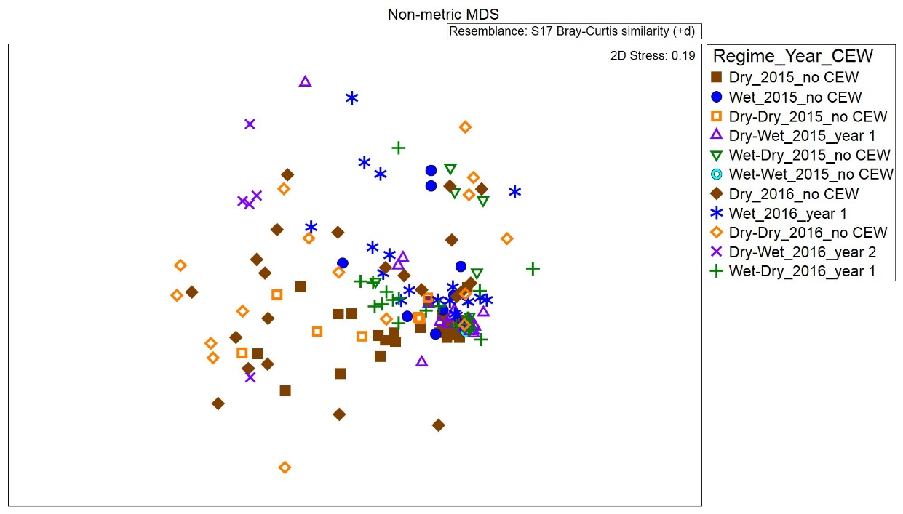

Figure . Ordination of vegetation assemblages at the Gwydir river system Selected Area in 2014–15 and 2015–16 based on water regime categories, Long Term Intervention Monitoring year and the influence of Commonwealth environmental water (CEW) (based on nMDS calculated from species cover values).

The diversity and heterogeneity of vegetation communities across the Gwydir river system was promoted by the diversity of water regimes that occurred over 2015–16, with inundation by Commonwealth environmental water playing a significant role in shaping this hydrological diversity (Figure 16). In particular, inundation by Commonwealth environmental water during the first year influenced vegetation community responses to drying in the second year (Figure 16).

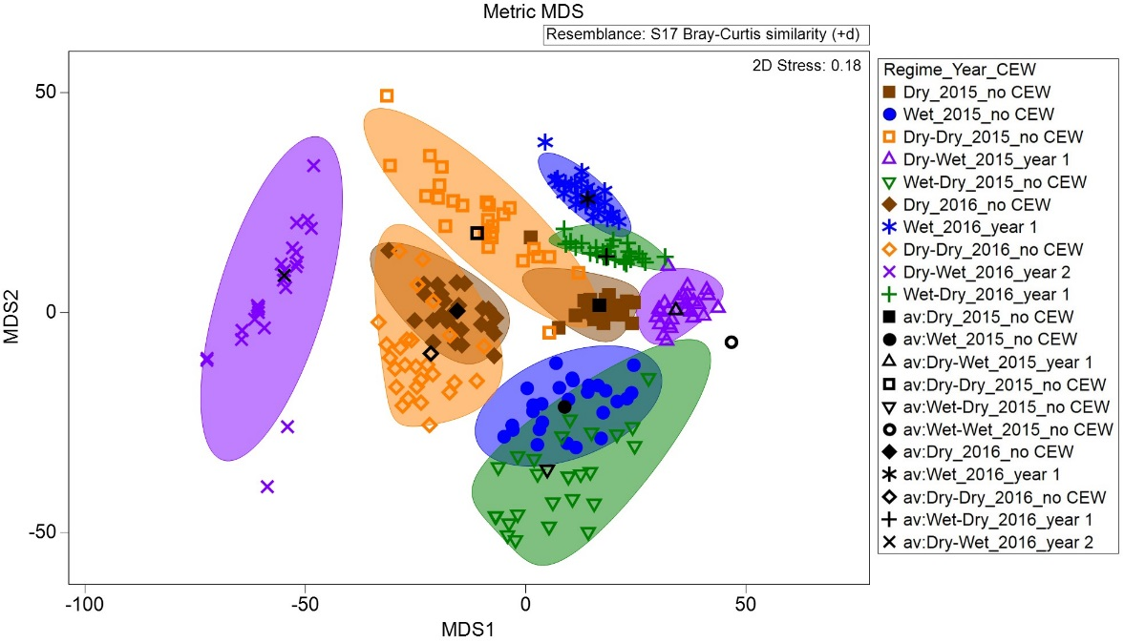

Figure . Ordination of vegetation assemblages at the Gwydir river system Selected Area in 2014–15 and 2015–16 showing average values and dispersion within each water regime category, Long Term Intervention Monitoring year and the influence of Commonwealth environmental water (CEW) (based on the bootstrapping procedure in PRIMER 7).

### Lachlan river system

No Commonwealth environmental water was delivered to the Lachlan river system Selected Area in 2014–15. Wetting in 2015–16 due to Commonwealth environmental water and other sources resulted in a significant shift in the diversity of vegetation communities at local and landscape scales between the 2 years (Figures 17 and 18). Inundation by Commonwealth environmental water appears to have greatly promoted vegetation heterogeneity at a landscape scale in 2015–16 by enabling a wider range of vegetation community responses to wetting and subsequent drying than would have occurred in its absence (Figure 18).

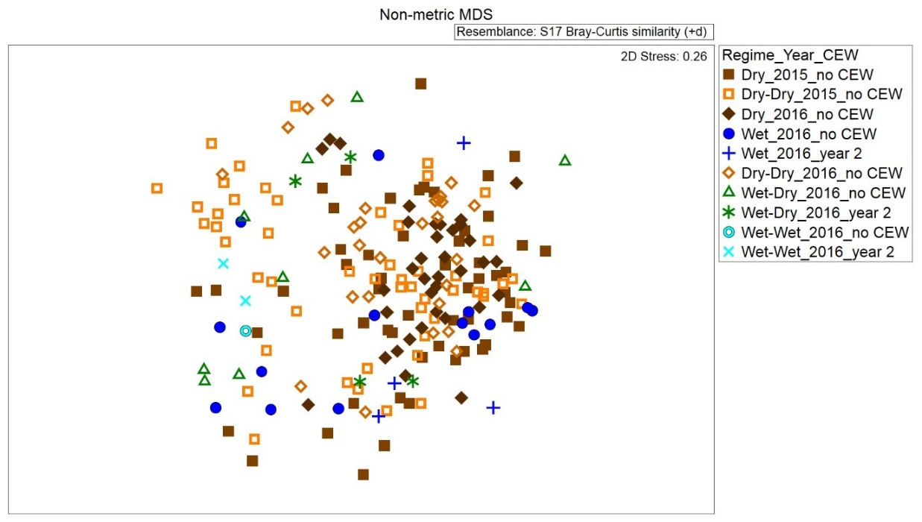

Figure . Ordination of vegetation assemblages at the Lachlan river system Selected Area in 2014–15 and 2015–16 based on water regime categories, Long Term Intervention Monitoring year and the influence of Commonwealth environmental water (CEW) (based on nMDS calculated from species cover values).

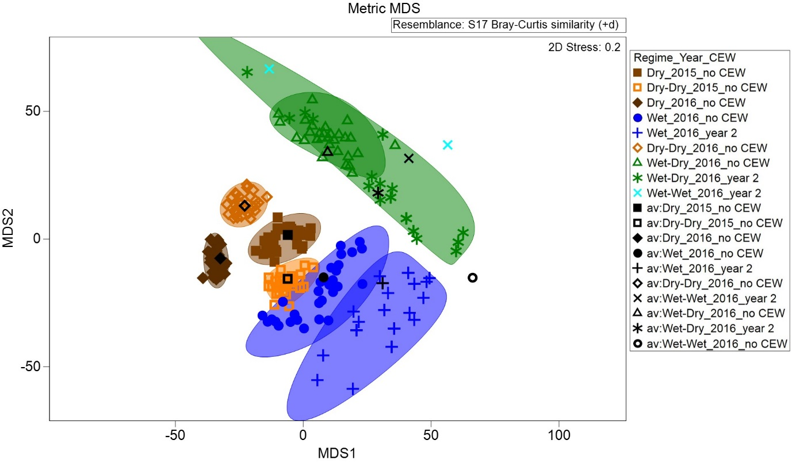

Figure . Ordination of vegetation assemblages at the Lachlan river system Selected Area in 2014–15 and 2015–16 showing average values and dispersion within each water regime category, Long Term Intervention Monitoring year and the influence of Commonwealth environmental water (CEW) (based on Bootstrapping procedure in PRIMER 7).

### Murrumbidgee river system

Twelve individual wetlands are monitored under LTIM in the Murrumbidgee river system Selected Area (Table 9). Of these, three wetlands (i.e. McKennas Lagoon, Nap Nap Swamp and Sunshower Lagoon) have been mostly dry over both 2014–15 and 2015–16 and have not been inundated by any Commonwealth environmental water. Of the wetlands receiving Commonwealth environmental water in 2014–15 (i.e. Avalon Swamp, Mercedes Swamp, Piggery Lake, Telephone Creek, Two Bridges Swamp and Yarrada Lagoon), most either dried out or were inundated by other water during 2015–16 (Table 9). Only Yarrada Lagoon received further Commonwealth environmental water during 2015–16 (Table 9).

The highest mean total vegetation cover and species richness in 2015–16 occurred in wetlands that had been influenced by Commonwealth environmental water in 2014–15, including Piggery Lake, Two Bridges Swamp and Telephone Creek (Figures 19 and 20). Declines in cover were apparent, however, as these wetlands began to dry out in the later survey dates in contrast to the persistently high vegetation cover in Eulimbah swamp (Figure 19) which remained wet throughout 2015–16, although not due to Commonwealth environmental water. Wetlands that had been relatively drier during 2014–15 (e.g. Gooragool Lagoon, McKennas Lagoon, Nap Nap Swamp and Sunshower Lagoon) tended to have lower vegetation cover and fewer species during 2015–16 (Figures 19 and 20) regardless of whether they remained dry or not.

The mean proportion of total vegetation cover comprising exotic species in 2015–16 tended to be considerably higher in two of the wetlands that were mostly dry in both years, i.e. Sunshower Lagoon and McKennas Lagoon (Figure 21). In contrast, substantial decline in the proportion of total vegetation cover comprising exotic species over this 2-year period were apparent at Yarrada Lagoon which received Commonwealth environmental water in both years (Figure 21).

Table . Water regime (D: Dry; W: Wet; PW: Partially Wet, i.e. not all transects/plots inundated) and influence of Commonwealth environmental water (1: during 2014–15; 2: during 2015–16) at individual wetlands surveyed within the Murrumbidgee river system Selected Area in 2014–15 and 2015–16.

|  |  |  |  |  |  |  |  |  |
| --- | --- | --- | --- | --- | --- | --- | --- | --- |
| Wetland | Water regime | | | | | | | |
| 2014–15 | | | | 2015–16 | | | |
| Sept | Nov | Jan | Mar | Sept | Nov | Jan | Mar |
| Avalon Swamp | D | PW1 | W1 | D | D | D | D | D |
| Eulimbah Swamp | W | W | W | PW | D | W | W | W |
| Gooragool Lagoon | D | D | W | D | W | W | W | PW |
| McKennas Lagoon | D | D | D | D | D | D | D | D |
| Mercedes Swamp | PW | W1 | PW1 | PW1 | PW1 | PW1 | PW1 | D |
| Nap Nap Swamp | W | D | D | D | D | D | D | D |
| Piggery Lake | D | W1 | W1 | W1 | PW1 | PW1 | D | D |
| Sunshower Lagoon | D | D | D | D | PW | PW | D | D |
| Telephone Creek | PW | W1 | W1 | D | D | W | PW | PW |
| Two Bridges Swamp | D | W1 | W1 | W1 | W1 | W1 | W1 | PW |
| Waugorah Lagoon | W | PW | PW | PW | D | W | D | D |
| Yarrada Lagoon | D | D | W1 | D | PW1,2 | W1,2 | W1,2 | PW1,2 |

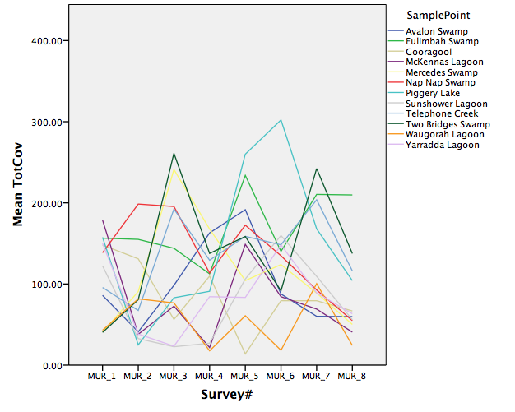

Figure . Trajectories of change in mean total vegetation cover in each wetland surveyed in the Murrumbidgee river system Selected Area over eight surveys during 2014–15 and 2015–16.

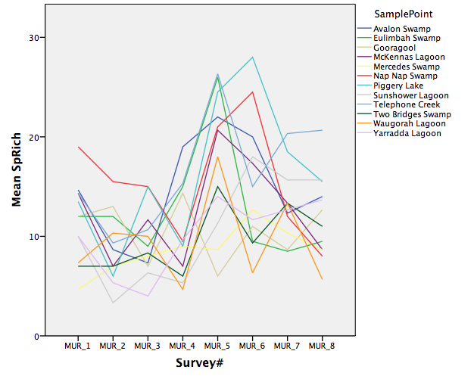

Figure . Trajectories of change in mean species richness in each wetland surveyed in the Murrumbidgee river system Selected Area over eight surveys during 2014–15 and 2015–16.

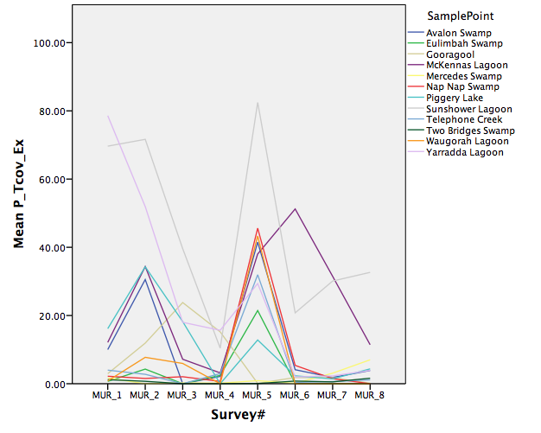

Figure . Trajectories of change in mean proportion of total vegetation cover comprising exotic taxa in each wetland surveyed in the Murrumbidgee river system Selected Area over eight surveys during 2014–15 and 2015–16.

The composition of vegetation communities in the Murrumbidgee river system to date is strongly influenced by the particular wetland (Figure 22). A broad gradient in composition is apparent from Dry to Partially Wet to Wet samples (Figure 23). Significant differences were detected between Dry and Wet samples (p = 0.001) and Dry and Partially Wet samples (p = 0.004) but not between Partially Wet and Wet samples (Figure 23). Inundation by Commonwealth environmental water enhanced the diversity of vegetation communities at a landscape scale in this Selected Area over the 2-year period by promoting the diversity of water regimes represented (Figures 23 and 24).

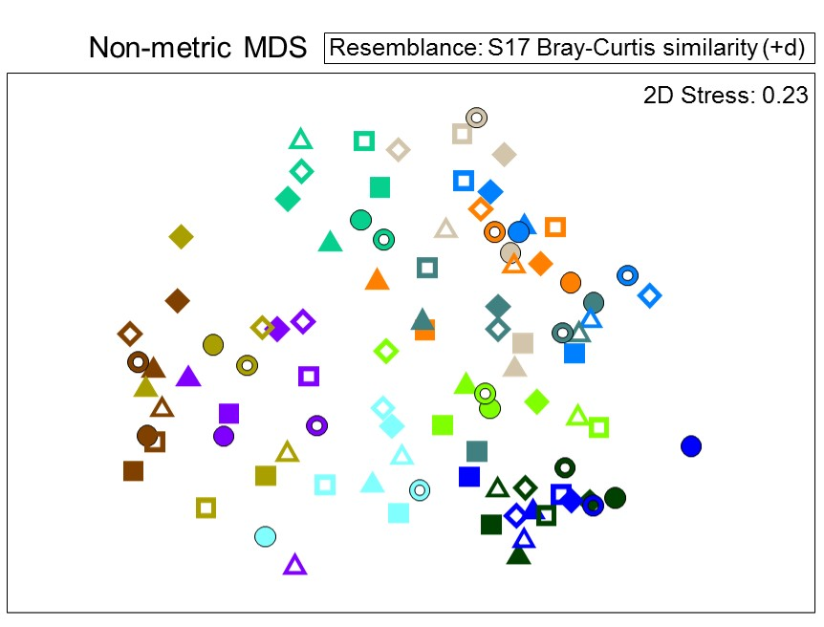

Figure . Ordination of vegetation assemblages at the Murrumbidgee river system Selected Area in 2014–15 and 2015–16. Colours indicate particular wetlands, with blue colours signifying mostly Wet conditions overall, green colours Partially Wet conditions and brown/orange colours mostly Dry conditions (Table 9). Purple represents Yarrada Lagoon, the only wetland to receive Commonwealth environmental water in 2015–16. Closed shapes indicate samples from 2014–15 and open shapes from 2015–16.

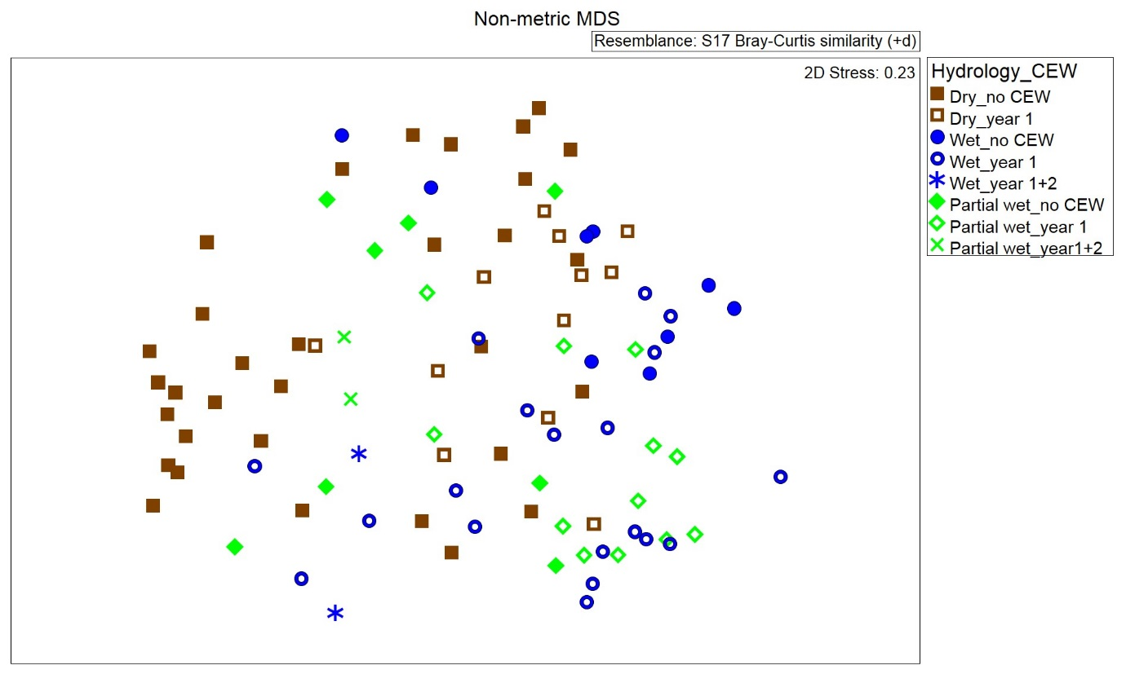

Figure . Ordination of vegetation assemblages at the Murrumbidgee river system Selected Area in 2014–15 and 2015–16 with sample points representing means for each wetland at each survey date. Colours signify particular wetlands, with blue signifying mostly Wet conditions overall, green Partially Wet conditions and brown mostly Dry conditions (Table 9). Closed symbols indicate samples not influenced by Commonwealth environmental water (CEW) in either year while open and crossed symbols signify inundation by Commonwealth environmental water in 2014–15 and 2015–16, respectively.

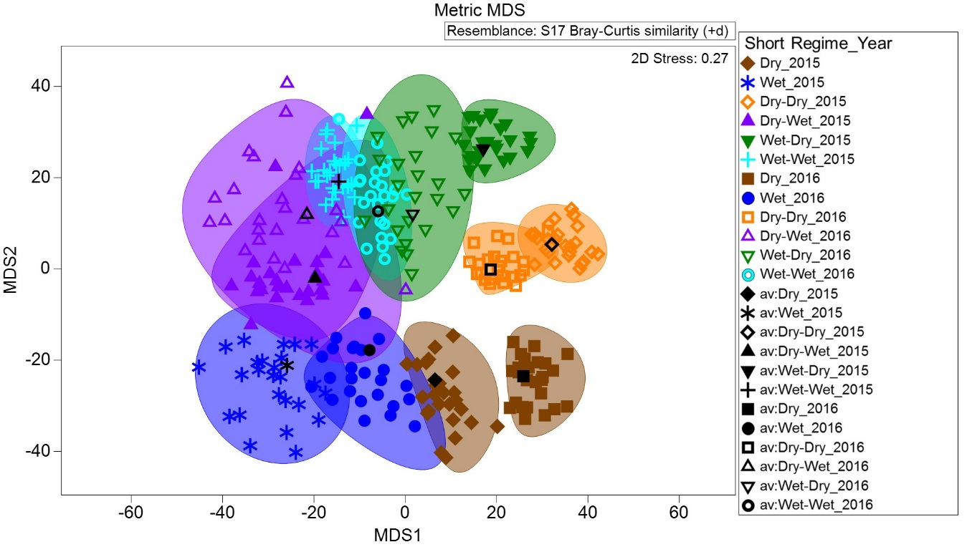

Figure . Ordination of vegetation assemblages at the Murrumbidgee river system Selected Area in 2014–15 and 2015–16 showing average values and dispersion within each water regime category (based on the bootstrapping procedure in PRIMER 7).

### Junction of the Warrego and Darling rivers

No significant influence of water regime in 2014–15 was detected at the Junction of the Warrego and Darling rivers Selected Area on the total cover or species richness of vegetation, or the cover and richness of exotic species, in either Wet or Dry plots at either survey time in 2015–16. Similarly, no significant effects of water regime in 2014–15 could be inferred from vegetation community responses to wetting or drying in 2015–16 (Figure 25) due to very small sample sizes. A shift in vegetation composition in dry plots was apparent between years (Figure 26).

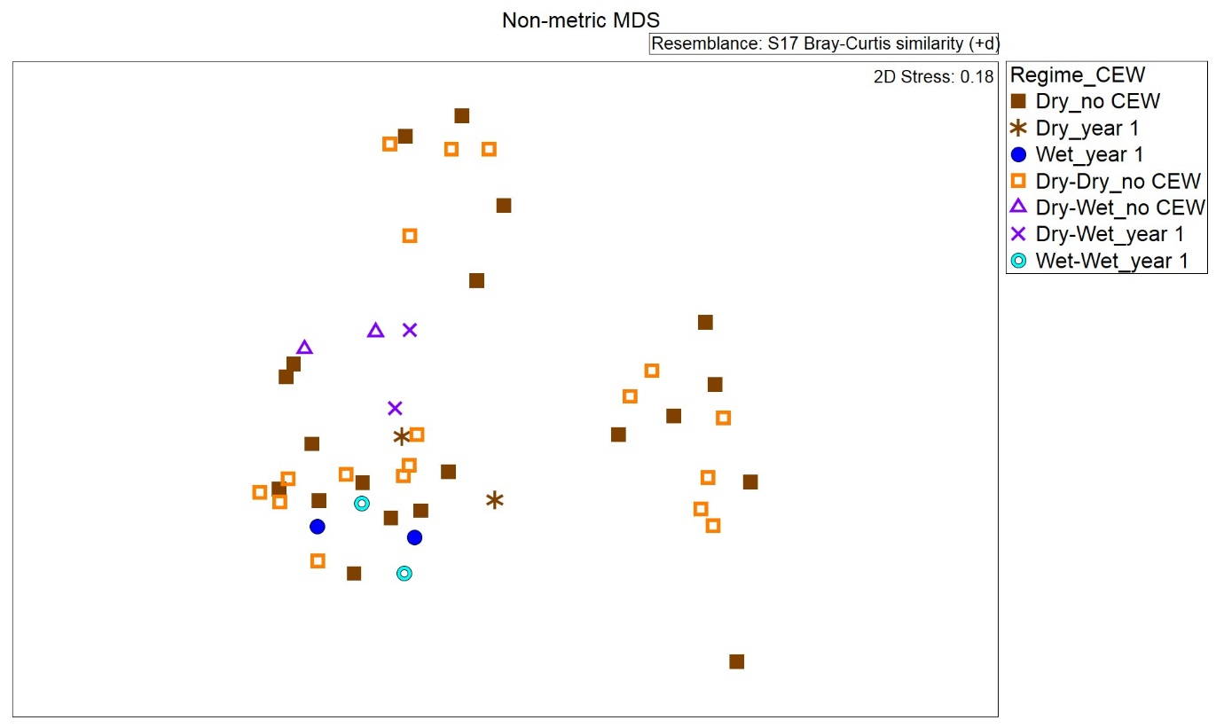

Figure . Ordination of vegetation assemblages at the Junction of the Warrego and Darling rivers Selected Area in 2015–16 based on water regime and the influence of Commonwealth environmental water (CEW) in 2015–16 (based on nMDS calculated from species cover values).

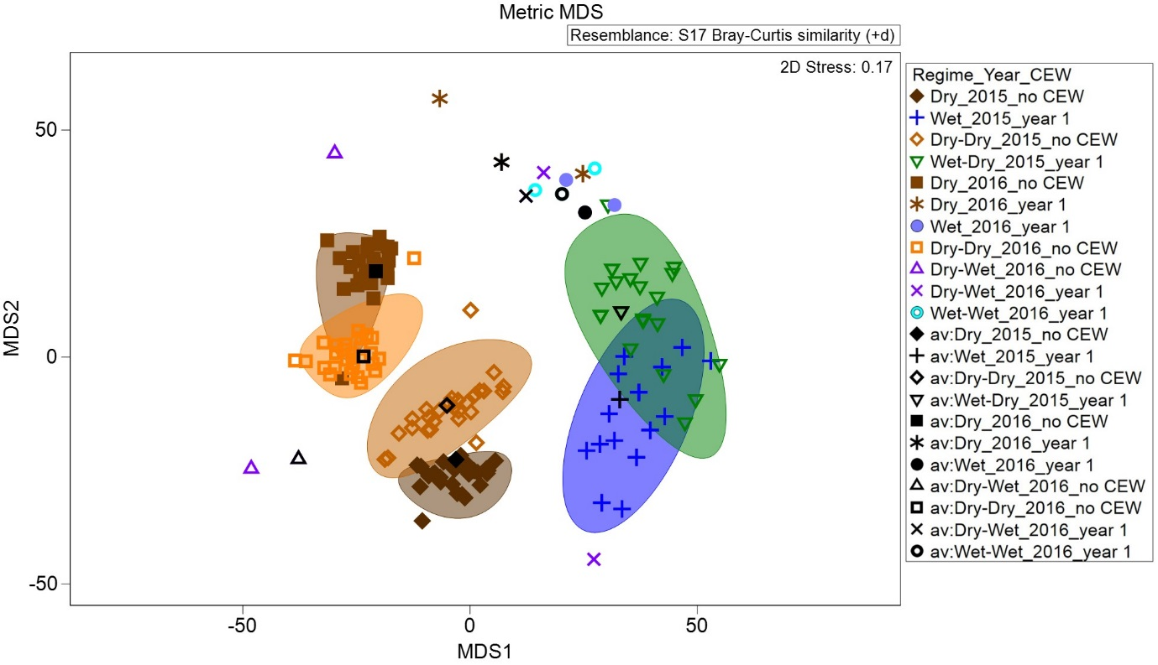

Figure . Ordination of vegetation assemblages at the Junction of the Warrego and Darling rivers Selected Area in 2014–15 and 2015–16 showing average values and dispersion within each water regime category, LTIM year and influence of Commonwealth environmental water (CEW) (based on Bootstrapping procedure in PRIMER 7).

## Synthesis

A significant proportion of plant species recorded from each Selected Area over the 2-year period comprising 2014–15 and 2015–16 have only been observed in plots/transects following inundation by Commonwealth environmental water. Different species are involved at each Selected Area but are mainly native forbs and grasses, with the exception of the Murrumbidgee which are largely forbs and sub-shrubs/shrubs, with at least one exotic forb in this category in each location.

Continued drying over both years of LTIM is broadly associated in all Selected Areas with lower vegetation cover but higher proportions of cover and richness of exotic species. In all Selected Areas, vegetation community diversity has also been greatly enhanced by a diversity of water regimes. In comparison to the strong influence of water regime on vegetation community composition, shifts due solely to survey time appeared relatively slight in each Selected Area. There is some evidence indicating that vegetation responses to water regimes in 2015–16, however, were shaped by conditions in 2014–15. For example, vegetation community composition under dry conditions in 2015–16 typically differed between plots/transects that had received wetting in 2014–15 and those that had been continuously dry. The greatest heterogeneity of vegetation communities at a landscape scale tended to occur in response to variable wetting regimes.

# Basin scale (<1-year) evaluation

## Highlights

* A significant proportion of taxa (around 4%) recorded from all wetland/floodplain Selected areas in 2015–16 – all native species and mostly grasses – were only recorded from plots/transects inundated by sources including Commonwealth environmental water delivered during this year.
* Vegetation community composition in 2015–16 was highly distinctive between the four wetland/floodplain Selected Areas with only limited overlap in terms of species presence. Annual water regime, however, exerted an overall influence on vegetation composition across all Selected Areas.
* Environmental water (Commonwealth and state), in combination with natural flows, contributed to the inundation of more than 200,000 ha of wetlands and floodplains during 2015–16 and was delivered across 20,000 km of river channel within the Basin.
* Variable wetting regimes in 2015–16 (i.e. both wetting and drying) resulted in the greatest range of vegetation community responses while dry conditions tended to produce the most homogeneous vegetation communities across the Basin. Because Commonwealth environmental water promoted the diversity of water regimes experienced across the Basin, it is highly likely, therefore, to have enhanced the diversity and heterogeneity of vegetation communities across the Basin during 2015–16 in both unmonitored areas and LTIM Selected Areas.

## Effects of Commonwealth environmental water on plant species diversity at the Basin scale

A total of 383 plant taxa were recorded in 2015–16 across the four wetland/floodplain Selected Areas. Of these, 15 taxa were only recorded in this year in plots/transects inundated by Commonwealth environmental water delivered during this year (Table 10). This is across the four wetland/floodplain Selected Areas so represents a smaller number of species than presented in Table 4 (i.e. the species must have only occurred in plots/transects inundated by Commonwealth environmental water across the four Selected Areas). All of these were native species, predominantly grasses.

Almost all of the taxa recorded by LTIM across these Selected Areas in 2015–16 have distributions that extend across most or all areas of the Basin as well as beyond the Basin. Only a single species of conservation concern was recorded – *Brachyscome papillosa* (Mossgiel daisy) – which is listed as Vulnerable in both the national *Environment Protection and Biodiveristy Conservation Act 1999* and in the New South Wales *Threatened Species Conservation Act 1995*. This species was recorded during 2015–16 from the Murrumbidgee river system but only under dry conditions and not at a plot/transect that had been previously inundated by Commonwealth environmental water since the commencement of LTIM.

Table . Plant species only recorded from the Basin in plots/transects following inundation by Commonwealth environmental water delivered during 2015–16.

|  |  |
| --- | --- |
| Grasses | Sub-shrubs / shrubs |
| *Aristida leptopoda*  *Echinochloa inundata*  *Echinochloa* spp.  *Eragrostis australasica*  *Eriochloa crebra*  *Leptochloa* spp.  *Sporobolus caroli* | *Eremophila debilis* |
| Forbs | Trees |
| *Amaranthus macrocarpus*  *Centipeda minima*  *Dichondra* spp.  *Heliotropium curassavicum* | *Acacia salicina* |
| Sedges / rushes | Mistletoes |
| *Cyperus bifax* | *Dendrophthoe* spp. |

Note: asterisks (*) indicate exotic species.

## Effects of Commonwealth environmental water on vegetation community diversity at the Basin scale

### Aggregated Selected Area scale

Vegetation community composition differed significantly (p = 0.001) between the four wetland/floodplain Selected Areas surveyed in 2015–16, with significant pair-wise differences detected for all combinations (Figure 27). Nevertheless, similarities were apparent across Selected Areas with respect to the composition of vegetation communities establishing in response to the broad water regime categories considered here. Vegetation communities present under dry conditions appear to be the most homogeneous while communities subject to varied watering regimes, including some drying and some wetting, were most diverse (Figure 28).

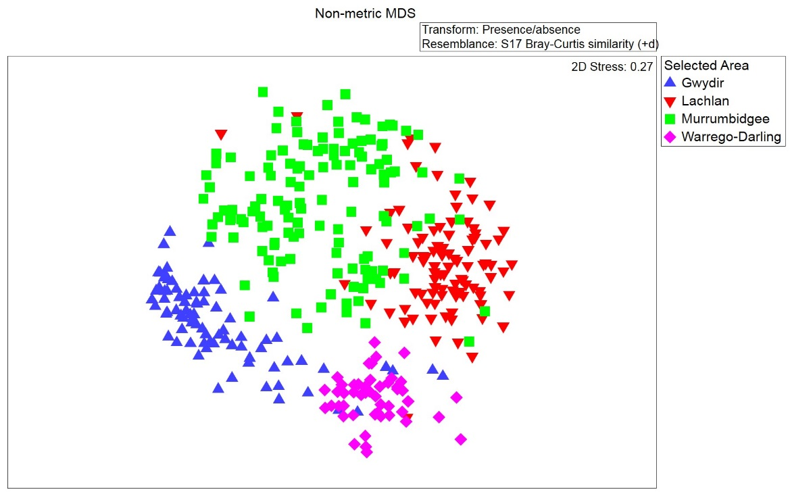

Figure . Ordination of vegetation communities across all four wetland/floodplain Selected Areas in 2015–16. Points represent samples at a plot/transect at a particular survey date (based on Bray–Curtis resemblance matrix calculated from species presence/absence).

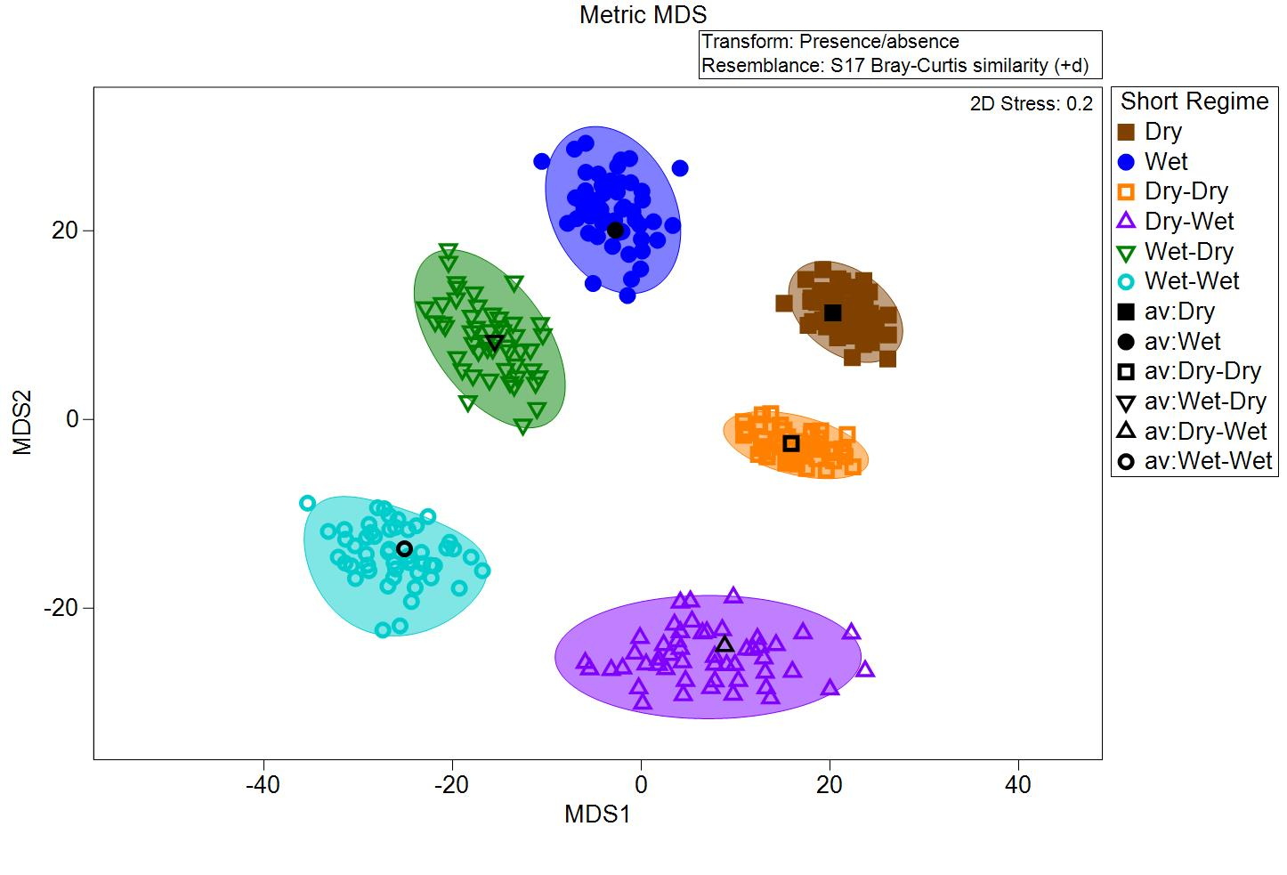

Figure . Ordination of vegetation assemblages at the four floodplain/wetland Selected Areas in 2015–16 showing average values and dispersion within each water regime category (based on the bootstrapping procedure in PRIMER 7 and species presence/absence). Note: water regime categories for Murrumbidgee condensed to current and preceding states only, i.e. Wet–Wet–Dry–Wet = Dry–Wet.

### Unmonitored areas

Environmental water (Commonwealth and state), in combination with natural flows, contributed to the inundation of more than 200,000 ha of wetlands and floodplains during 2015–16 and was delivered across 20,000 km of river channel within the Basin (Tables 11 and 12). A remaining 29 ANAE wetland types in the Basin did not receive Commonwealth environmental water during 2015–16 (Table 12).

Most unmonitored wetland and floodplain inundation resulting from Commonwealth environmental watering actions during this year occurred in the Central Murray and Lower Murray catchments (Table 11). Significant inundation also resulted from Commonwealth environmental watering actions in the Macquarie catchment (Table 11). The remaining inundation areas were all within the Selected Areas, although not all of these were covered by LTIM monitoring.

It is almost certain that vegetation diversity within inundated communities responded to the influence of Commonwealth environmental water at unmonitored sites during 2015–16. With respect to the diversity of plant species and the composition and structure of inundated vegetation communities, however, responses to watering are likely to have varied between ecosystem types and valleys in relation to antecedent conditions, hydrological attributes of the inundation that occurred (e.g. duration, depth, timing etc.) and vegetation type (i.e. both local and regional). It is highly likely that shifts in vegetation composition and structure would have occurred in most, if not all, of these inundated vegetation communities. Consequently, there can be very high confidence that the diversity and heterogeneity of wetland and floodplain vegetation communities at a vegscape scale would have increased during 2015–16 in these valleys as a result of Commonwealth environmental watering actions.

Table . Area of each LTIM catchment inundated by Commonwealth environmental water (excluding in-channel flows) in 2015–16, including both floodplain and wetland ecosystem types. (Source: Ecosystem Diversity Basin Matter Evaluation 2015–16).

|  |  |  |  |
| --- | --- | --- | --- |
| Catchment name | Selected Area | Wetland and floodplain area inundated (ha) | Length of waterways influenced (km) |
| Avoca |  | – | – |
| Barwon–Darling |  | – | 3458 |
| Border Rivers |  | – | 1836 |
| Broken |  | – | 276 |
| Campaspe |  | – | 175 |
| Castlereagh |  | – | – |
| Central Murray |  | 16 172 | 2508 |
| Condamine–Balonne |  | – | 2335 |
| Edward–Wakool | Edward–Wakool river system | – | 1049 |
| Goulburn | Goulburn River | – | 537 |
| Gwydir | Gwydir river system | 2322 | 1127 |
| Kiewa |  | – | – |
| Lachlan | Lachlan river system | 20 912 | 1597 |
| Loddon |  | – | 560 |
| Lower Darling |  | – | – |
| Lower Murray | Lower Murray River* | 130 791 | 991 |
| Macquarie |  | 9902 | 829 |
| Mitta Mitta |  | – | – |
| Murrumbidgee | Murrumbidgee river system | 22 316 | 1875 |
| Namoi |  | – | – |
| Ovens |  | – | 544 |
| Paroo |  | – | – |
| Upper Murray |  | – | – |
| Warrego | Junction of the Warrego and Darling rivers | – | 493 |
| Wimmera |  | – | – |
| **Total area inundated (excluding channels)** | | **202 415** | **20 190** | |

* Includes the Coorong, lakes Alexandrina and Albert and the Murray Mouth.

Table . Areas of wetland and floodplain ANAE types inundated and influenced by Commonwealth environmental water in the Basin in 2015–16 (See Ecosystem Diversity Basin Matter Evaluation 2015–16 for definitions).

| Australian National Aquatic Ecosystem (ANAE) wetland/ floodplain type | Total area (ha) | Inundated* | | Influenced* | |
| --- | --- | --- | --- | --- | --- |
| Area (ha) | % of total | Area (ha) | % of total |
| ***Wetland types*** | | | | | |
| Lp2.1: Permanent floodplain lakes | 137 406 | 84 637 | 61.6 | 84 964 | 61.8 |
| Pt1.1.1: Intermittent river red gum floodplain swamp | 63 396 | 8541 | 13.5 | 27 357 | 43.2 |
| Pp4.1: Permanent floodplain wetland | 42 004 | 6938 | 16.5 | 21 525 | 51.2 |
| Rp1.4: Permanent lowland rivers and streams | 74 534 | 5199 | 7.0 | 14 326 | 19.2 |
| Pt2.1.2: Temporary tall emergent marsh | 18 381 | 7368 | 40.1 | 7470 | 40.6 |
| Pt4.1: Temporary floodplain wetland | 122 885 | 855 | 0.7 | 7066 | 5.8 |
| Pt2.2.1: Temporary sedge/grass/forb floodplain marsh | 51 081 | 4645 | 9.1 | 6510 | 12.7 |
| Pp2.1.1: Permanent floodplain tall emergent marshes | 7809 | 2625 | 33.6 | 4276 | 54.8 |
| Pt3.1.2: Clay pans | 51 074 | 901 | 1.8 | 3265 | 6.4 |
| Lt2.1: Temporary floodplain lakes | 198 459 | 1128 | 0.6 | 2597 | 1.3 |
| Lst2.1: Temporary saline floodplain lakes | 10 636 | 1253 | 11.8 | 2338 | 22.0 |
| Pt3.1.1: Floodplain clay pans | 49 329 | 1831 | 3.7 | 2267 | 4.6 |
| Psp4: Permanent saline wetland | 3965 | 1862 | 47.0 | 2221 | 56.0 |
| Pst1.1: Temporary saline swamp | 17 020 | 1824 | 10.7 | 2119 | 12.5 |
| Lt1.1: Temporary lakes | 306 351 | 865 | 0.3 | 2082 | 0.7 |
| Lsp1.1: Permanent saline lakes | 8225 | 327 | 4.0 | 2079 | 25.3 |
| Rt1.4: Temporary lowland rivers and streams | 223 362 | 782 | 0.4 | 1925 | 0.9 |
| Pt1.2.1: Intermittent black box floodplain swamp | 33 916 | 498 | 1.5 | 1299 | 3.8 |
| Pst4: Temporary saline wetland | 11 912 | 303 | 2.5 | 973 | 8.2 |
| Pt1: Temporary swamps | 3766 | 608 | 16.1 | 706 | 18.7 |
| Pt2.2.2: Temporary sedge/grass/forb marsh | 30 527 | 563 | 1.8 | 655 | 2.1 |
| Pst2.2: Temporary salt marsh | 8575 | 76 | 0.9 | 412 | 4.8 |
| Rp1: Permanent streams | 1428 | 297 | 20.8 | 406 | 28.4 |
| Pt1.6.1: Temporary woodland floodplain swamp | 179 804 | 253 | 0.1 | 395 | 0.2 |
| Lp1.1: Permanent lakes | 47 669 | 130 | 0.3 | 334 | 0.7 |
| Pt2.1.1: Temporary tall emergent floodplain marsh | 50 687 | 121 | 0.2 | 180 | 0.4 |
| Pt2.3.1: Floodplain freshwater meadow | 11 138 | 126 | 1.1 | 166 | 1.5 |
| Pst3.2: Salt pans and salt flats | 13 186 | 39 | 0.3 | 163 | 1.2 |
| Rt1.3: Temporary low energy streams | 712 | 9 | 1.3 | 163 | 22.9 |
| Rt1: Temporary streams | 294 | 70 | 23.8 | 99 | 33.7 |
| Pt4.2: Temporary wetland | 130 760 | 52 | <0.1 | 92 | 0.1 |
| Pt1.2.2: Intermittent black box swamp | 16 470 | 54 | 0.3 | 88 | 0.5 |
| Rt1.2: Temporary transitional zone streams | 5957 | 10 | 0.2 | 33 | 0.6 |
| Pp2.1.2: Permanent tall emergent marshes | 134 | 31 | 23.1 | 31 | 23.1 |
| Rp1.3: Permanent low energy streams | 286 | 25 | 8.7 | 26 | 9.1 |
| Pp2.3.1: Permanent floodplain grass marshes | 431 | 10 | 2.3 | 25 | 5.8 |
| Pp4.2: Permanent wetland | 22 388 | 18 | 0.1 | 18 | 0.1 |
| Pt1.7.1: Intermittent lignum floodplain swamp | 27 356 | 4 | <0.1 | 11 | <0.1 |
| Pp2.3.2: Permanent grass marshes | 183 | 7 | 3.8 | 7 | 3.8 |
| Lst1.1: Temporary saline lakes | 12 759 | 2 | <0.1 | 4 | <0.1 |
| Pt1.3.1: Intermittent coolibah floodplain swamp | 5173 | <1 | <0.1 | 3 | 0.1 |
| Pt1.7.2: Intermittent lignum swamps | 17 967 | 1 | <0.1 | 3 | <0.1 |
| Psp2.1: Permanent salt marsh | 3 | <1 | <0.1 | 2 | 66.7 |
| Rp1.2: Permanent transitional zone streams | 3652 | <1 | <0.1 | <1 | <0.1 |
| Lp1.2: Permanent lakes with aquatic beds | 1197 | 0 | 0 | 0 | – |
| Lp2.2: Permanent floodplain lakes with aquatic beds | 1868 | 0 | 0 | 0 | – |
| Lsp1.2: Permanent saline lakes with aquatic beds | 18 | 0 | 0 | 0 | – |
| Lsp2.1: Permanent saline floodplain lakes | 13 178 | 0 | 0 | 0 | – |
| Lst1.2: Temporary saline lakes with aquatic beds | 1905 | 0 | 0 | 0 | – |
| Lst2.2: Temporary saline floodplain lakes with aquatic beds | 391 | 0 | 0 | 0 | – |
| Lt1.2: Temporary lakes with aquatic beds | 804 | 0 | 0 | 0 | – |
| Lt2.2: Temporary floodplain lakes with aquatic beds | 2520 | 0 | 0 | 0 | – |
| Pp1.1.2: Permanent paperbark swamps | 1 | 0 | 0 | 0 | – |
| Pp2.2.1: Permanent floodplain sedge/grass/forb marshes | 2275 | 0 | 0 | 0 | – |
| Pp2.2.2: Permanent sedge/grass/forb marshes | 2564 | 0 | 0 | 0 | – |
| Pp2.4.1: Permanent floodplain forb marshes | 157 | 0 | 0 | 0 | – |
| Pp2.4.2: Permanent forb marshes | 32 | 0 | 0 | 0 | – |
| Pp3: Peat bogs and fen marshes | 173 | 0 | 0 | 0 | – |
| Pps5: Permanent springs | 130 | 0 | 0 | 0 | – |
| Psp1.1: Saline paperbark swamp | 137 | 0 | 0 | 0 | – |
| Psp3.1: Permanent seagrass marshes | 16 328 | 0 | 0 | 0 | – |
| Pt1.1.2: Intermittent river red gum swamps | 8480 | 0 | 0 | 0 | – |
| Pt1.3.2: Intermittent coolibah swamp | 1019 | 0 | 0 | 0 | – |
| Pt1.4.1: Intermittent river cooba floodplain swamp | 3 | 0 | 0 | 0 | – |
| Pt1.4.2: Intermittent river cooba swamp | 104 | 0 | 0 | 0 | – |
| Pt1.5.1: Temporary paperbark floodplain swamp | 32 | 0 | 0 | 0 | – |
| Pt1.5.2: Temporary paperbark swamp | 89 | 0 | 0 | 0 | – |
| Pt1.6.2: Temporary woodland swamp | 44 406 | 0 | 0 | 0 | – |
| Pt2.3.2: Freshwater meadow | 14 780 | 0 | 0 | 0 | – |
| Pu1: Unspecified wetland | 1768 | 0 | 0 | 0 | – |
| Rp1.1: Permanent high energy streams | 9662 | 0 | 0 | 0 | – |
| Rt1.1: Temporary high energy streams | 13 853 | 0 | 0 | 0 | – |
| Ru1: Unspecified river (landform unknown) | 3 | 0 | 0 | 0 | – |
| ***Floodplain types*** | | | | | |
| F2.2: Lignum shrubland floodplain | 200 821 | 6155 | 3.1 | – | – |
| F1.2: River red gum forest floodplain | 268 820 | 5432 | 2.0 | – | – |
| F1.4: River red gum woodland floodplain | 225 106 | 4438 | 2.0 | – | – |
| F1.10: Coolibah woodland and forest floodplain | 1 762 948 | 559 | <0.1 | – | – |
| F2.4: Shrubland floodplain | 341 713 | 327 | 0.1 | – | – |
| F1.8: Black box woodland floodplain | 242 434 | 117 | <0.1 | – | – |
| F1.9: Upland coolibah woodland and forest floodplain | 2765 | 110 | 4.0 | – | – |
| F1.12: Woodland floodplain | 521 659 | 33 | <0.1 | – | – |
| F1.7: Upland black box woodland floodplain | 1375 | 33 | 2.4 | – | – |
| F2.1: Upland lignum shrubland floodplain | 482 | 9 | 1.9 | – | – |
| F2.3: Upland shrubland floodplain | 1500 | 9 | 0.6 | – | – |
| F1.1: Upland river red gum forest floodplain | 767 | 5 | 0.7 | – | – |
| F3.2: Sedge/forb/grassland floodplain | 1 140 832 | 5 | <0.1 | – | – |
| F1.3: Upland river red gum woodland floodplain | 2511 | 4 | 0.2 | – | – |
| F4: Floodplain with unspecified vegetation | 433 042 | 4 | <0.1 | – | – |
| F1.6: Black box forest floodplain | 192 212 | 3 | <0.1 | – | – |
| F3.1: Upland sedge/forb/grassland floodplain | 2412 | 2 | 0.1 | – | – |
| F1.11: River cooba woodland floodplain | 150 | 0 | – | – | – |
| F1.5: Upland black box forest floodplain | 112 | 0 | – | – | – |

* Area inundated/influenced by Commonwealth environmental water: see Section 2.1 for definitions.

# Basin scale (1–2-year) evaluation

## Highlights

* A significant proportion of taxa (around 5%) recorded from all wetland/floodplain Selected Areas over 2014–15 and 2015–16, mostly forbs and including six exotic species, have only been recorded from plots/transects inundated by sources including Commonwealth environmental water delivered during this 2-year period.
* Annual water regimes exerted a strong overall influence on vegetation composition across all Selected Areas with greater diversity of vegetation communities promoted by variable water regimes (i.e. wet and dry) compared with those under continuously wet or continuously dry conditions.
* Because Commonwealth environmental water contributed significantly to the diversity of water regimes present across the Basin over this period, it is almost certain that this promoted the diversity of vegetation communities present at both landscape and Basin scales.

## Effects of Commonwealth environmental water on plant species diversity at the Basin scale over 1–2 years

A total of 498 plant taxa have been recorded under LTIM at the four wetland/floodplain Selected Areas over 2014–15 and 2015–16 (Annex B). Of these, 376 taxa were recorded in 2014–15 and 383 in 2015–16. In all, 122 new taxa were recorded in 2015–16 while 115 taxa recorded in 2014–15 were not observed in 2015–16. This latter group included the Endangered native forb *Lepidium hyssopifolium* whichwas recorded in a single dry plot in the Junction of the Warrego and Darling rivers Selected Area in May 2015 but not since then.

Twenty-five plant taxa, mostly forbs, have only been recorded from these Selected Areas over this 2-year period in plots/transects following inundation by Commonwealth environmental water (Table 13). These include six exotic forb species (Table 13). This is across the four wetland/floodplain Selected Areas and across both sampling years so represents a different number of species than presented in Tables 4 and 10 (i.e. the species must have only occurred in plots/transects inundated by Commonwealth environmental water across the four Selected Areas in at least one of the two survey years). None of these species, however, are of conservation concern at either national or state levels.

## Effects of Commonwealth environmental water on vegetation community diversity at the Basin scale over 1–2 years

Vegetation community composition and heterogeneity across all of the four wetland/floodplain Selected Areas displayed considerable variation in relation to the broad water regime categories considered over 2014–15 and 2015–16, but less in relation to LTIM year (Figure 29). At this Basin scale, dry plots/transects had relatively similar vegetation composition although small shifts were apparent between years and within years. In general, the composition of communities shifting from dry to wet conditions tended to approach that of Wet or Wet–Wet communities in each year and communities that dried out following wetting were intermediate between Wet and Wet–Wet samples and Dry samples. The hetereogeneity (i.e. dispersion) of vegetation communities within particular water regime categories also tended to be greatest where at least some wetting was involved but especially under a mix of dry and wet conditions. Because Commonwealth environmental water contributed significantly to the diversity of water regimes present across the Basin over this period, it is almost certain that this promoted the diversity of vegetation communities present at both landscape and Basin scales.

Table . Plant species only recorded from the Basin in plots/transects following inundation by Commonwealth environmental water delivered during 2014–15 and 2015–16.

|  |  |
| --- | --- |
| Grasses | Sub-shrubs / shrubs |
| *Aristida leptopoda*  *Echinochloa* spp.  *Eragrostis leptostachya*  *Leptochloa* spp. | *Eremophila debilis*  *Lycium australe* |
| Forbs | Trees |
| *Arctotheca calendula\**  *Centipeda thespidioides*  *Chrysocephalum apiculatum*  *Dichondra* spp.  *Eichhornia crassipes\**  *Emex australis\**  *Gnaphalium* spp.  *Goodenia pinnatifida*  *Gratiola pedunculata*  *Hibiscus trionum*  *Medicago lupulina\**  *Persicaria hydropiper*  *Persicaria* spp.  *Rhaponticum repens\**  *Spirodela polyrhiza*  *Veronica catenata\** | *Myoporum acuminatum* |
| Sedges / rushes | Mistletoes |
| *Carex bichenoviana* | *Dendrophthoe* spp. |

Note: asterisks (*) indicate exotic species.



Figure . Ordination of vegetation assemblages at the four floodplain/wetland Selected Areas in 2015–16 showing average values and dispersion within each water regime category (based on the bootstrapping procedure in PRIMER 7 and species presence/absence). Note: water regime categories for Murrumbidgee condensed to current and preceding states only, i.e. Wet–Wet–Dry–Wet = Dry–Wet.

# Adaptive management

The Basin Matter evaluation presented here demonstrates a high degree of temporal and spatial variation in vegetation responses to environmental watering. Although some near consistent responses to wetting are apparent both within and between Selected Areas (e.g. increased vegetation cover), it is clear that shifts in species diversity and composition in relation to wetting and drying vary in relation to a wide range of factors, including vegetation type, regional location and antecedent conditions. Decision-making regarding the objectives, targets, delivery and evaluation of watering actions should account for, and indeed capitalise on, this high level of heterogeneity.

At a wetland scale, responses to watering depend in part on the prior watering history, with continuous inundation resulting in different responses to those triggered by variable wetting and drying regimes. In many wetlands, repeated or continuous watering over periods longer than 1 year appears likely to generate vegetation communities that are dominated by a few aquatic plant species with relatively high cover. However, the identity of these dominant species will probably vary between individual wetlands at both landscape (i.e. within Selected Areas) and regional scales. In contrast, prolonged drying throughout the Basin typically results in low cover, species-depauperate vegetation communities that have a higher proportion of both exotic cover and exotic species. The greatest range of vegetation community responses is consistently generated by variable water regimes in which both wetting and drying are experienced.

At a landscape scale, vegetation diversity is extremely likely to be enhanced by watering actions that promote spatial variation in water regimes over both the short term (i.e. <1 year) and longer time frames (i.e. variable flow histories). Therefore, to address Basin Plan objectives (see Table 15), annual watering decisions should prioritise actions that increase the diversity of annual and longer term water regimes experienced at both local and regional scales. This might firstly include actions which inundate wetlands and floodplains, where this is possible, that have not been watered for the longest periods. Secondly, maintaining regular watering in at least some wetland areas within each valley may also be important for promoting vegscape heterogeneity and vegetation resilience over the longer term as these wetlands may provide reservoirs of propagules (e.g. vegetative fragments, short-lived seed etc.) which can disperse into other wetland habitats when broader-scale wetting occurs, potentially enabling a faster response to re-wetting. Finally, ensuring that some variable wetting and drying regimes are also experienced in landscapes (e.g. allowing some wet areas to dry and vice versa) may generate the greatest vegetation diversity at a landscape (i.e. Selected Area) scale in terms of both species presence and community composition and structure.

A range of recommendations concerning the delivery and assessment of Commonwealth environmental water for each Selected Area has also been made by M&E Providers in their 2015–16 reports (Table 14).

Table . Key recommendations concerning adaptive management of Commonwealth environmental water delivery and assessment with respect to Vegetation Diversity at each Selected Area made by Monitoring and Evaluation Providers in Selected Area reports in 2015–16.

|  |  |  |
| --- | --- | --- |
| Selected Area | Recommendations | Source |
| River systems | | |
| Edward–Wakool river system | * Trial delivery of continuous base flow during late autumn and winter in tributaries to promote habitat availability for aquatic vegetation * Trial delivery of short-duration but higher discharge environmental flow in late winter or spring to test the hypothesis that this would promote higher river productivity * Introduce greater flow variability into watering actions to avoid long periods of constant flows | Watts *et al.* 2016 |
| Goulburn River | * Cancel planned spring fresh in 2016–17 to allow young plants on lower banks to better re-establish following early spring flooding in the Goulburn Catchment in September 2016 | Webb *et al.* 2017 |
| Wetland and floodplain systems | | |
| Gwydir river system | * Environmental watering actions should be dependent on natural flow cues | Commonwealth Environmental Water Office 2016a |
| Lachlan river system | * Need to monitor vegetation responses in channel sites, particularly ‘nuisance’ vegetation | Dyer *et al.* 2016 |
| Murrumbidgee river system | * Spring watering is ideal for vegetation outcomes * Repeat watering required in wetlands similar to Yarrada Lagoon (e.g. Gooragool, McKennas and Sunshower lagoons) to support the establishment and persistence of species that require frequent wetting and short durations of drying (i.e. <1 year), e.g. spiny mud grass and tall spike rush | Wassens *et al.* 2016 |
| Junction of the Warrego and Darling rivers | * Prioritise inundation of Western Floodplain which hasn’t been inundated since 2012 | Commonwealth Environmental Water Office 2016b |

# Contribution to achievement of Basin Plan objectives

Watering by Commonwealth environmental water in 2015–16 contributed significantly to the Biodiversity objectives of the Basin Plan associated with vegetation diversity (Table 15). Commonwealth environmental water is likely to have increased species diversity at both Selected Area and Basin scales in this year. Where Commonwealth environmental water generated wetland and floodplain inundation in 2015–16, it is also likely to have promoted greater total cover, dominance and species richness of inundated vegetation communities as well as shifts in composition, including a reduction in the proportional cover and richness of exotic taxa. The diversity and heterogeneity of vegetation communities present within Selected Areas and across the Basin in 2015–16 was almost certainly promoted by the delivery of Commonwealth environmental water through its contribution to spatial and temporal variability in water regimes. Outcomes of watering by Commonwealth environmental water over the 2-year period of 2014–15 to 2015–16 are similar to those detected within each year. In particular, these include positive effects on plant species diversity and an increased heterogeneity of vegetation communities at both Selected Area and Basin scales.

The resilience of plant species and vegetation communities to drought is also likely to have been enhanced by the delivery of Commonwealth environmental water during LTIM to date (Table 15). In particular, evidence suggests that inundation due to Commonwealth environmental water delivered in 2014–15 influenced the responses of vegetation communities to drying in 2015–16.

Table . Contribution of Commonwealth Environmental Water Office (CEWO) watering over 2014–15 and 2015–16 to Basin Plan objectives associated with vegetation diversity.

| **Basin Plan objectives** | **Basin outcomes** | | **5-year expected outcomes** | **1-year expected outcomes** | **Measured and predicted 1–2-year outcomes1** | **Measured**  **1-year outcomes 2015–16** | | **Measured**  **1–2-year outcomes 2014–16** | | **Predicted 1–5-year outcomes** |
| --- | --- | --- | --- | --- | --- | --- | --- | --- | --- | --- |
| Biodiversity  (Basin Plan S. 8.05) | Species diversity | Plants | Greater plant species diversity | Establishment, growth, spread and reproduction of hydrophilic taxa | Some species favoured by Commonwealth environmental water inundation but dependent on Selected Area. | Some species only apparent following inundation by Commonwealth environmental water inundation but dependent on Selected Area. | | Some species only apparent following inundation by Commonwealth environmental water inundation but dependent on Selected Area. | | Presence of some species in extant vegetation likely to be dependent on inundation by Commonwealth environmental water inundation but dependent on Selected Area. |
| Mortality, reduced establishment and spread of xeric taxa | Exotic taxa mostly constrained by Commonwealth environmental water inundation but a few cases where exotic cover promoted by short-duration inundation. | Lower proportional cover and richness of exotic taxa observed in response to inundation by Commonwealth environmental water and other sources. | | Lower proportional cover and richness of exotic taxa observed in response to inundation by Commonwealth environmental water and other sources. | | Mostly lower proportional cover and richness of exotic taxa in response to inundation although may be a risk of promoting exotic cover through short-duration inundation. |
| Ecosystem diversity | Vegetation | Greater vegetation diversity | Increased richness and productivity of wetland vegetation communities | Mostly, but not consistently, increased diversity and cover of vegetation communities. Highly dependent on timing of survey and community type (e.g. wetland versus floodplain). | Increased total cover and dominance of inundated vegetation communities and mostly higher species richness (though highly dependent on range of intrinsic and extrinsic factors). | | Greater vegetation cover in plots/transects subjected to at least some wetting during this period. | | Mostly, but not consistently, increased diversity and cover of vegetation communities. |
| Shifts in composition of floodplain and wetland vegetation communities | Consistently shifted vegetation composition towards dominance by a range of hydrophilic species (often emergent grasses and sedges) and reduced cover of exotic forbs. | Consistent and distinctive shifts in vegetation composition driven by wetting. | | Consistent and distinctive shifts in vegetation composition driven by wetting. | | Consistently shifted vegetation composition towards dominance by a range of hydrophilic species (often emergent grasses and sedges) and reduced cover of exotic forbs. |
| Increased heterogeneity of vegetation communities at landscape scales | Consistently increased heterogeneity of vegetation at landscape scales. | Consistently increased heterogeneity of vegetation at landscape scales. | | Consistently increased heterogeneity of vegetation at landscape scales. | | Consistently increased heterogeneity of vegetation at landscape scales. |
| Resilience  (Basin Plan S. 8.07) | Ecosystem resilience | Vegetation | Greater resilience of plant species to drought | Enhanced resilience to drought among plant taxa benefiting from Commonwealth environmental water | Species with presence/extent/abundance positively influenced by Commonwealth environmental water will have greater resilience to drought over next 1–5 years and should exhibit greater responses to further wetting. | | | | | |
| Greater vegetation resilience to drought | Enhanced resilience to drought among vegetation assemblages benefiting from Commonwealth environmental water | Vegetation communities influenced by Commonwealth environmental water will have greater resilience to drought over next 1–5 years and should exhibit greater responses to further wetting. | | Evidence that wetting during 2014–15 influenced vegetation response to drying in 2015–16. | | Vegetation communities influenced by Commonwealth environmental water will have greater resilience to drought over next 1–5 years and should exhibit greater responses to further wetting. | |

1 Predicted 1–2 year outcomes discussed in Vegetation Diversity Basin Matter Evaluation Report 2014–15 (Capon & Campbell 2016).

References

Brock MA, Capon SJ, Porter JL (2006) Disturbance of plant communities dependent on desert rivers. In: Kingsford RT (ed) *Ecology of* *desert rivers*. Cambridge University Press, Cambridge, pp 100–132.

Capon S (2016) Riparian herbs. In: Capon S, James C, Reid M (eds) *Vegetation of Australian riverine landscapes*. CSIRO Publishing, Melbourne, pp 103–118.

Capon S, Campbell C (2016) 2014–15 Basin-scale evaluation of Commonwealth environmental water – Vegetation Diversity. Final report prepared for the Commonwealth Environmental Water Office by The Murray–Darling Freshwater Research Centre, MDFRC Publication 107/2016, September, 85pp

Capon S, Campbell C, Steward-Koster B (2015) Long Term Intervention Monitoring Basin Matter – Vegetation Diversity foundation report. Final Report prepared for the Commonwealth Environmental Water Office by The Murray–Darling Freshwater Research Centre, MDFRC Publication 68/2015, May, 11pp.

Capon S, James C, Reid M (ed) (2016) *Vegetation of Australian riverine landscapes: biology, ecology and management* CSIRO Publishing, Melbourne.

Capon SJ (2003) Plant community responses to wetting and drying in a large arid floodplain. *River Research and Applications* **19(5–6)**, 509–520.

Capon SJ (2005) Flood variability and spatial variation in plant community composition and structure on a large arid floodplain. *Journal of Arid Environments* **60(2)**, 283–302.

Capon SJ, Balcombe SR, McBroom J (2017) Environmental watering for vegetation diversity outcomes must account for local canopy conditions. *Ecohydrology*, DOI:10.1002/eco.1859

Capon SJ, Chambers LE, Mac Nally R, Naiman RJ, Davies P, Marshall N, Pittock J, Reid M, Capon T, Douglas M, Catford J (2013) Riparian ecosystems in the 21st century: hotspots for climate change adaptation? *Ecosystems* **16(3)**, 359–381.

Capon SJ, Reid MA (2016) Vegetation resilience to mega‐drought along a typical floodplain gradient of the southern Murray–Darling Basin, Australia. *Journal of Vegetation Science* **27(5)**, 926–937.

Clarke KR and Gorley RN (2015) *PRIMER v7: User Manual/Tutorial*, PRIMER-E, Plymouth.

Commonwealth Environmental Water Office (2016a) Long Term Intervention Monitoring Project Gwydir River System Selected Area – 2015–16 Final Evaluation Report, Commonwealth of Australia 2016.

Commonwealth Environmental Water Office (2016b) Long Term Intervention Monitoring Project Junction of the Warrego and Darling rivers Selected Area – 2015–16 Final Evaluation Report, Commonwealth of Australia 2016.

Durant RA, Nielsen DL, Ward KA (2016) Evaluation of *Pseudoraphis spinescens* (Poaceae) seed bank from Barmah Forest floodplain. *Australian Journal of Botany* **64(8)**, 669–677.

Dyer F, Broadhurst B, Thompson R, Jenkins K, Driver P, Saintilin N, Bowen S, Packard P, Gilligan D, Brandis K, Amos C, Hall A, Martin F, Lenehan J (2014) Long Term Intervention Monitoring and Evaluation Plan Lachlan river system, Commonwealth of Australia.

Dyer F, Broadhurst B, Tschierschke A, Thiem J, Thompson R, Driver P, Bowen S, Asmus M, Wassens S, Walcott A, Lenehan J, van der Weyer N (2016) Commonwealth Environmental Water Office Long Term Intervention Monitoring Project: Lower Lachlan river system Selected Area 2015–16 Monitoring and Evaluation Synthesis Report. Commonwealth of Australia, 2016.

Ecological Australia and UNE (University of New England) (2014) Commonwealth Environmental Water Office Long Term Intervention Monitoring Project Gwydir River System Selected Area, Commonwealth of Australia.

Ecological Australia and UNE (University of New England) (2015) Commonwealth Environmental Water Office Long Term Intervention Monitoring Project Junction of the Warrego and Darling Rivers Selected Area – Monitoring and Evaluation Plan version 3, Commonwealth of Australia.

Hale J, Stoffels R, Butcher R, Shackleton M, Brooks S, Gawne B, Stewardson M (2014) Commonwealth Environmental Water Office Long Term Intervention Monitoring Project – Standard Methods. Final Report prepared for the Commonwealth Environmental Water Office by The Murray–Darling Freshwater Research Centre, MDFRC Publication 29.2/2014, January,   
175pp.

James CS, Capon SJ, Quinn GP (2015) Nurse plant effects of a dominant shrub (Duma florulenta) on understorey vegetation in a large, semi‐arid wetland in relation to flood frequency and drying. *Journal of Vegetation Science* **26(5)**, 985–994.

Kenny SA, Moxham C, Sutter G (2017) The response of rare floodplain plants to an environmental watering event at Hattah Lakes, Victoria. *The* *Victorian Naturalist* **134(1)**, 19–27.

Nilsson C, Svedmark M (2002) Basic principles and ecological consequences of changing water regimes: riparian plant communities. *Environmental Management* **30(4)**, 468–480.

Reid M, Capon S (2011) Role of the soil seed bank in vegetation responses to environmental flows on a drought-affected floodplain. *River Systems* **19(3)**, 249–259.

Stromberg JC (2001) Restoration of riparian vegetation in the south-western United States: importance of flow regimes and fluvial dynamism. *Journal of Arid Environments* **49(1)**, 17–34.

Wassens S, Jenkins K, Spencer J, Thiem J, Bino G, Lenon E, Thomas R, Kobyashi T, Baumgartner L, Brandis K, Wolfenden B, Hall A, Watson M, Scott N (2014) Murrumbidgee Monitoring and Evaluation Plan, Commonwealth of Australia.

Wassens S, Spencer J, Thiem J, Wolfenden B, Jenkins K, Hall A, Ocock J, Kobayashi T, Thomas R, Bino, G, Heath J, Lenon E (2016) Commonwealth Environmental Water Office long term intervention monitoring program Murrumbidgee River System Selected Area evaluation report, Commonwealth of Australia 2016.

Watts RJ, McCasker N, Baumgartner L, Bond N, Bowen P, Conallin A, Grace M, Healy S, Howitt JA, Kopf RK, Scott N, Thiem J, Wooden I (2014) Monitoring and Evaluation Plan for the Edward–Wakool Selected Area, Commonwealth of Australia.

Watts RJ, McCasker N, Howitt JA, Thiem J, Grace M, Kopf RK, Healy S, Bond N (2016) Commonwealth Environmental Water Office Long Term Intervention Monitoring Project: Edward–Wakool River System Selected Area Evaluation Report, 2015–16. Institute for Land, Water and Society, Charles Sturt University prepared for Commonwealth Environment al Water Office. Commonwealth of Australia.

Webb A, Baker B, Casanelia S, Grace M, King E, Koster W, Lansdown K, Lintern A, Lovell D, Morris K, Pettigrove V, Sharpe A, Townsend K, Vietz G (2017) Commonwealth Environmental Water Office Long Term Intervention Monitoring Project – Goulburn River Selected Area evaluation report 2015–16. Report prepared for the Commonwealth Environmental Water Office. Commonwealth of Australia, Melbourne.

Webb A, Sharpe A, Koster W, Morris K, Pettigrove V, Grace M, Vietz J, Woodman A, Earl G, Casanelia S (2014) Long Term Intervention Monitoring Project for the lower Goulburn River: Final Monitoring and Evaluation Plan prepared for the Commonwealth Environmental Water Office

Annex A. Watering actions contributed to by Commonwealth environmental water in 2015–16 with expected outcomes related to vegetation

| **Watering Action Number** | **Surface water region/asset** | **Commonwealth environmental water volume (ML)** | **Dates** | **Flow component** | **Expected ecological outcome1** |
| --- | --- | --- | --- | --- | --- |
| 1516-Lch-01 | Lachlan – Great Cumbung Swamp | 24 058.50 | 09/08/15 – 15/10/15 | Fresh | primary |
| 1516-Lch-02 | Lachlan – Booligal Wetlands – Merrimajeel and Muggabah Creek | 1087.50 | 02/09/15 – 29/10/15 | Fresh | primary |
| 1516-Lch-04 | Lower Lachlan River channel | 9378.50 | 11/11/15 – 15/12/15 | Fresh | primary |
| 1516-BrdR-01 | Qld Border Rivers – Severn River (Qld) | 22.22 | 31/01/16 – 01/02/16 | Base | secondary |
| 1516-CndBal-01 | QLD Condamine–Balonne – Nebine Creek | 997.78 | 23/06/15 – 27/06/15 | Fresh | secondary |
| 1516-Mbg-06 | Murrumbidgee – North Redbank | 25 000.00 | 21/10/15 – 10/02/16 | Wetland inundation | primary |
| 1516-Mbg-07 | Murrumbidgee – Juanbung | 10 000.00 | 04/11/15 – 17/02/16 | Wetland inundation | primary |
| 1516-Mbg-01 | Murrumbidgee – Hobblers Lake – Penarie Creek | 5000.00 | 15/03/16 – 13/04/16 | Wetland inundation | secondary |
| 1516-Mbg-02 | Murrumbidgee – Yarrada Lagoon | 1394.30 | 01/09/15 – 07/12/15 | Wetland inundation | primary |
| 1516-Mbg-13 | Murrumbidgee – Yanco Creek Wetland inundation | 18 263.00 | 01/07/15 – 13/08/15 | Wetland inundation | primary |
| 1516-Mbg-08 | Murrumbidgee – Waldaira Wetlands (Junction Wetlands) | 2000.00 | 09/02/16 – 15/06/16 | Wetland inundation | primary |
| 1516-Mbg-09 | Murrumbidgee – Toogimbie Indigenous Protected Area (IPA) | 933.00 | 15/03/16 – 15/06/16 | Wetland inundation | primary |
| 1516-Mbg-12 | Murrumbidgee – Nap Nap –Waugorah | 7000.00 | 06/05/16 – 30/06/16 | Wetland inundation | primary |
| 1516-Mbg-11 | Murrumbidgee – Nap Nap – Waugorah | 2557.00 | 06/05/16 – 30/06/16 | Wetland inundation | primary |
| 1516-Mbg-10 | Murrumbidgee – Sandy Creek | 105.70 | 01/04/16 – 12/05/16 | Wetland inundation | secondary |
| 1516-EdWak-03 | Edward–Wakool – Colligen–Niemur system | 15 740.00 | 04/09/15 – 30/01/16 | Base flow and Fresh | primary |
| 1516-EdWak-02 | Edward–Wakool – Upper Wakool River | 1444.90 | 04/09/15 – 30/01/16 | Base flow and Fresh | primary |
| 1516-EdWak-01 | Edward–Wakool – Yallakool Creek | 13 004.10 | 04/09/15 – 30/01/16 | Base flow and Fresh | primary |
| 1516-EdWak-04 | Edward–Wakool – Tuppal Creek | 2000.00 | 17/09/15 – 22/11/15 | Base flow and Fresh | primary |
| 1516-Gbn-01 | Goulburn – Lower River Channel | 190 563.00 | 01/07/15 – 08/07/15 | Fresh | primary |
| 1516-Gbn-03 | Goulburn – Lower River Channel | 03/10/15 – 29/10/15 | Fresh | primary |
| 1516-Gbn-05 | Goulburn – Lower River Channel | 15/03/16 – 05/04/16 | Baseflow | primary |
| 1516-SA-01 | South Australian River Murray and Coorong | 556 000.00 | 01/07/15 – 30/11/15 | Baseflow | primary |
| 1516-SA-02 | South Australian River Murray and Coorong | 242 000.00 | 01/12/15 – 01/07/16 | Baseflow | primary |
| 1516-Brock-01 | Banrock Station – Herons Bend | 20.41 | 10/11/15 – 27/11/15 | Wetland inundation | primary |
| 1516-Brock-04 | Banrock Station – Banrock Bend | 15.48 | 03/12/15 – 18/12/15 | Wetland inundation | primary |
| 1516-Brock-05 | Banrock Station – Wigley Reach Central | 52.49 | 20/01/16 – 01/02/16 | Wetland inundation | primary |
| 1516-Brock-02 | Banrock Station – Wigley Reach Depression | 571.91 | 10/11/15 – 18/01/16 | Wetland inundation | primary |
| 1516-Brock-03 | Banrock Station – Eastern Lagoon | 1340.43 | 17/11/15 – 11/03/16 | Wetland inundation | primary |
| 1516-NRMB-01 | Lower Murray wetlands (NRM Board) – Bookmark Creek | 424.00 | 25/08/15 – 30/06/16 | Wetland inundation | primary |
| 1516-NRMB-02 | Lower Murray wetlands (NRM Board) – Martin Bend | 56.00 | 31/08/15 – 03/09/15 | Wetland inundation | primary |
| 1516-NRMB-04 | Lower Murray wetlands (NRM Board) – Old Parcoola (West) | 353.00 | 30/09/15 – 28/11/15 | Wetland inundation | primary |
| 1516-NRMB-06 | Lower Murray wetlands (NRM Board) – Piggy Creek | 201.00 | 20/10/15 – 05/11/15 | Wetland inundation | primary |
| 1516-NRMB-07 | Lower Murray wetlands (NRM Board) – Carpark Lagoons | 229.00 | 21/10/15 – 31/01/16 | Wetland inundation | primary |
| 1516-NRMB-05 | Lower Murray wetlands (NRM Board) – Molo Flat (Western and Eastern channels) | 105.00 | 08/10/15 – 21/10/15 | Wetland inundation | primary |
| 1516-NRMB-08 | Lower Murray wetlands (NRM Board) – Wiela | 375.00 | 04/11/15 – 11/12/15 | Wetland inundation | primary |
| 1516-NRMB-10 | Lower Murray wetlands (NRM Board) – Hogwash Bend North | 28.00 | 14/01/16 – 06/04/16 | Wetland inundation | primary |
| 1516-NRMB-12 | Lower Murray wetlands (NRM Board) – Hogwash Bend South | 420.00 | 20/01/16 – 18/02/16 | Wetland inundation | primary |
| 1516-NRMB-09 | Lower Murray wetlands (NRM Board) – Morgan East | 200.00 | 12/11/15 – 30/01/16 | Wetland inundation | primary |
| 1516-NRMB-11 | Lower Murray wetlands (NRM Board) – Morgan Conservation Park Bird & Meeting Lagoons | 306.00 | 11 /01/16 – 29/04/16 | Wetland inundation | primary |
| 1516-NRMB-14 | Lower Murray wetlands (NRM Board) – Maize Island Conservation Park | 213.00 | 04/02/16 – 24/04/16 | Wetland inundation | primary |
| 1516-NRMB-13 | Lower Murray wetlands (NRM Board) – Yabby Creek | 1290.00 | 10/03/16 – 18/05/16 | Wetland inundation | primary |
| 1516-NFSA-01 | Lower Murray wetlands (NFSA) – Lyrup Lagoon | 284.00 | 01/09/15 – 30/01/16 | Wetland inundation | Primary |
| 1516-NFSA-02 | Lower Murray wetlands (NFSA) – Mundic Wetland | 104.00 | 01/10/15 – 30/11/15 | Wetland inundation | Primary |
| 1516-NFSA-03 | Lower Murray wetlands (NFSA) – Duck Hole | 271.00 | 01/10/15 – 30/11/16 | Wetland inundation | Primary |
| 1516-NFSA-04 | Lower Murray wetlands (NFSA) – Inner Mundic Creek | 42.00 | 01/11/15 – 30/11/15 | Wetland inundation | primary |
| 1516-NFSA-05 | Lower Murray wetlands (NFSA) – Johnson's Waterhole | 117.00 | 01/09/15 – 30/04/16 | Wetland inundation | primary |
| 1516-NFSA-06 | Lower Murray wetlands (NFSA) – South Teringie | 79.00 | 01/12/15 – 30/05/16 | Wetland inundation | primary |
| 1516-NFSA-07 | Lower Murray wetlands (NFSA) – Calperum Station | 837.00 | 01/11/15 – 30/06/16 | Wetland inundation | primary |
| 1516-NFSA-08 | Lower Murray wetlands (NFSA) – Lescheid Pikes | 19.00 | 01/12/15 – 30/12/15 | Wetland inundation | primary |
| 1516-NFSA-09 | Lower Murray wetlands (NFSA) – Loxton Riverfront Reserve | 19.00 | 01/08/15 – 30/05/16 | Wetland inundation | primary |
| 1516-NFSA-10 | Lower Murray wetlands (NFSA) – Clark's Floodplain | 105.00 | 01/08/15 – 30/03/16 | Wetland inundation | primary |
| 1516-NFSA-11 | Lower Murray wetlands (NFSA) – Waikerie Ferry | 6.00 | 01/12/15 – 30/01/16 | Wetland inundation | primary |
| 1516-NFSA-12 | Lower Murray wetlands (NFSA) – Yarra Creek | 593.00 | 01/10/15 – 30/01/16 | Wetland inundation | primary |
| 1516-NFSA-13 | Lower Murray wetlands (NFSA) – Thiele's Flat | 43.00 | 01/08/15 – 30/03/16 | Wetland inundation | primary |
| 1516-NFSA-14 | Lower Murray wetlands (NFSA) – Rilli Reach – Stanitzkis | 27.00 | 01/11/15 – 30/05/16 | Wetland inundation | primary |
| 1516-NFSA-15 | Lower Murray wetlands (NFSA) – Westbrooks | 14.00 | 01/10/15 –30/04/16 | Wetland inundation | primary |
| 1516-NFSA-16 | Lower Murray wetlands (NFSA) – Rilli Reserve | 2.00 | 01/08/15 – 30/09/15 | Wetland inundation | primary |
| 1516-NFSA-17 | Lower Murray wetlands (NFSA) – Riversleigh | 569.00 | 01/01/16 – 30/06/16 | Wetland inundation | primary |
| 1516-NFSA-18 | Lower Murray wetlands (NFSA) – Greigers @ Sugar Shack | 59.00 | 01/12/15 – 30/04/16 | Wetland inundation | primary |
| 1516-NFSA-19 | Lower Murray wetlands (NFSA) – Greenways | 39.00 | 01/02/16 – 30/03/16 | Wetland inundation | primary |
| 1516-NFSA-20 | Lower Murray wetlands (NFSA) – Warnoch Lescheid | 32.00 | 1/02/16 –30/02/16 | Wetland inundation | primary |
| 1516-Cmp-01 | Campaspe – downstream of Lake Eppalock (Reach 4 with benefit to Reaches 2 and 3 en route) | 1700.00 | 26/08/15 – 06/09/15 | Fresh | primary |
| 1516-Cmpe-02 | Campaspe – downstream of Lake Eppalock (Reach 4 with benefit to Reaches 2 and 3 en route) | 1558.70 | 27/10/15 – 04/11/15 | Fresh | primary |
| 1516-Brkn-01 | Lower Broken Creek – Reach 3 with benefit to Reaches 1 and 2 en route | 29 519.50 | 12/08/15 – 22/05/16 | Baseflow | secondary |
| 1516-Brkn-02 | Lower Broken Creek – Reach 3 with benefit to Reaches 1 and 2 en route | 18/08/15 –30/11/16 | Baseflow | secondary |
| 1516-Brkn-04 | Lower Broken Creek – Reach 3 with benefit to Reaches 1 and 2 en route | 01/10/15 –16/05/16 | Baseflow | secondary |
| 1516-Brkn-03 | Lower Broken Creek – Reach 3 with benefit to Reaches 1 and 2 en route | 18/08/15 – 12/09/15  28/09/15 – 30/11/15 | Freshes | secondary |
| 1516-Brkn-05 | Lower Broken Creek – Reach 3 with benefit to Reaches 1 and 2 en route | 25/10/15 – 9/11/15   29/11/15 – 31/12/15 | Baseflows | secondary |
| 1516-Mur-01 | NSW and Vic Murray – River Murray to SA and Floodplain – River Murray Channel | 99 400.00 | 22/06/15 – 24/07/15 | Baseflow and in-channel freshes | primary |
| 1516-Mur-03 | NSW and Vic Murray – River Murray to SA and Floodplain – River Murray Channel, Barmah and Millewa | 172 600.00 | 25/07/15 – 10/09/15 | Overbank | primary |
| 1516-Mur-04 | NSW and Vic Murray – River Murray to SA and Floodplain – River Murray Channel, Barmah and Millewa | 63 900.00 | 11/09/15 –03/10/15 | Overbank | primary |
| 1516-Mur-05 | NSW and Vic Murray – River Murray to SA and Floodplain – River Murray Channel, Barmah and Millewa | 30 900.00 | 04/10/15 – 31/10/15 | Overbank | primary |
| 1516-Mur-07 | NSW and Vic Murray – River Murray to SA and Floodplain – Gulpa Creek and Reed Beds Swamp (millewa Forest) | 8000.00 | 11 /11/15 – 10/02/16 | Overbank | primary |
| 1516-Mur-06 | River Murray Valley – Wingillie Station | 192.00 | 09/10/15 – 17/10/15 | Wetland inundation | primary |
| 1516-Mur-09 | River Murray Valley – Carrs, Capitts and Bunberoo Creek System | 950.00 | 04/04/16 – 16/05/16 | Fresh and Wetland Inundation | primary |
| 1516-Mur-08 | NSW Murray – Barham Lake | 115.00 | 19/01/16 – 07/03/16 | Wetland Inundation | primary |
| 1516-Weir-01 | NSW, Vic and SA Murray – Weir pool manipulation, Lock 15 raising | 5249.00 | 01/07/15 – 30/12/15 | Fresh  (raising weir) | primary |
| NSW, Vic and SA Murray – Weir pool manipulation, Lock 15 lowering | 01/04/16 – 30/06/16 | Fresh  (lowering weir) | primary |
| 1516-Weir-04 | NSW, Vic and SA Murray – Weir pool manipulation, Lock 7 raising | 2739.00 | 01/08/15 – 30/01/16 | Fresh | primary |
| NSW, Vic and SA Murray – Weir pool manipulation, Lock 7 lowering | 01/01/16 – 30/05/16 | Fresh | primary |
| 1516-Weir-05 | NSW, Vic and SA Murray – Weir pool manipulation, Lock 5 raising | 4346.00 | 01/08/15 – 30/11/15 | Fresh | primary |
| 1516-Weir-06 | NSW, Vic and SA Murray – Weir pool manipulation, Lock 2 raising | 738.00 | 01/09/15 – 30/11/15 | Fresh | primary |
| 1516-Macq-01 | Macquarie – Macquarie Marshes Nature Reserve and Core Wetlands | 12 114.00 | 06/08/15 – 17/10/15 | Fresh | primary |
| 1516-Macq-02 | Macquarie – Macquarie River System, including floodplain (Supplementary water) | 2125.00 | 25/06/16 – 30/06/16 | Fresh | primary |
| 1516-Gwyd-01 | Gwydir – Gwydir Wetlands | 1350.00 | 09/01/16 – 11/02/16 | Overbank | primary |
| 1516-Gwyd-02 | Gwydir – Mallowa Wetlands  (Commonwealth environmental water – Regulated water) | 3150.00 | 09/11/15 – 05/02/16 | Overbank  (in conjunction with a fresh and irrigation deliveries in the Mehi River) | primary |
| (Commonwealth environmental water – Supplementary) | 336.00 | primary |
| 1516-Gwyd-04 | Gwydir – Gwydir River System | 2600.00 | 10/04/16 – 30/05/16 | Baseflow | secondary |
| 1516-VicW-01 | Mallee wetland Sites – Brickworks Billabong | 200.00 | 01/10/15 – 30/11/15  09/03/16 – 03/06/16 | Wetland inundation | primary |
| 1516-VicW-02 | Mallee wetland Sites – Cardross Wetland inundations | 476.61 | 09/09/15 – 24/12/15 | Wetland inundation | primary |
| 1516-VicW-03 | Mallee wetland Sites – Cowanna Billabong | 125.00 | 10/06/15 – 30/11/15 | Wetland inundation | primary |
| 1516-HattL-01 | Hattah Lakes | 5347.50 | 12/10/15 – 23/10/15 | Wetland inundation | primary |
| **TOTAL** |  | **1 582 441.23** |  |  |  |

1 As reported by the Commonwealth Environmental Water Office (CEWO).

Annex B. Plant taxa recorded by LTIM from wetland/floodplain Selected Areas in 2014–15 and 2015–16.

Note: asterisks (*) indicate exotic species; circumflexes (^) indicate species of uncertain origin at a Basin scale.

|  |  | **Gwydir** | | **Lachlan** | | **Murrumbidgee** | | **Warrego–Darling** | |  |
| --- | --- | --- | --- | --- | --- | --- | --- | --- | --- | --- |
| **Species name** | **Family** | **2014–15** | **2015–16** | **2014–15** | **2015–16** | **2014–15** | **2015–16** | **2014–15** | **2015–16** | **Total Count** |
| *Abutilon malvifolium* | Malvaceae |  |  |  |  |  |  | + |  | 1 |
| *Abutilon otocarpum* | Malvaceae |  |  |  |  |  |  | + |  | 1 |
| *Abutilon oxycarpum* | Malvaceae | + |  |  |  |  |  | + |  | 2 |
| *Abutilon* spp. | Malvaceae |  |  |  | + |  |  | + | + | 3 |
| *Abutilon theophrasti*\* | Malvaceae |  |  | + | + | + | + |  |  | 4 |
| *Acacia salicina* | Fabaceae |  | + | + |  |  |  |  |  | 2 |
| *Acacia* spp. | Fabaceae |  |  | + | + |  |  |  |  | 2 |
| *Acacia stenophylla* | Fabaceae | + | + | + | + |  | + | + | + | 7 |
| *Acacia victoriae* | Fabaceae |  |  |  |  |  |  | + | + | 2 |
| *Aeschynomene indica* | Fabaceae | + | + |  |  |  |  |  | + | 3 |
| *Agrostis parviflora* | Poaceae |  |  |  | + |  |  |  |  | 1 |
| *Alectryon oleifolius* subsp. *canescens* | Sapindaceae |  | + |  |  |  |  |  |  | 1 |
| *Alopecurus geniculatus* | Poaceae |  |  |  |  |  | + |  |  | 1 |
| *Alternanthera denticulata* | Amaranthaceae | + | + | + | + | + | + | + | + | 8 |
| *Alternanthera nodiflora* | Amaranthaceae |  |  | + | + | + |  | + | + | 5 |
| *Alternanthera* spp. | Amaranthaceae |  |  | + | + |  |  |  |  | 2 |
| *Amaranthus macrocarpus* | Amaranthaceae | + | + | + |  |  |  |  |  | 3 |
| *Ammannia multiflora* | Lythraceae | + |  |  |  | + | + |  |  | 3 |
| *Amphibromus nervosus* | Poaceae | + | + |  |  |  |  |  |  | 2 |
| *Amyema cambagei* | Loranthaceae |  | + |  |  |  |  |  |  | 1 |
| *Amyema miquelii* | Loranthaceae | + |  |  |  |  |  |  |  | 1 |
| *Amyema quandang* var. *quandang* | Loranthaceae | + | + |  |  |  |  |  |  | 2 |
| *Amyema* spp. | Loranthaceae | + |  |  |  |  |  | + |  | 2 |
| *Arabidella nasturtium* | Brassicaceae |  |  | + |  |  |  |  |  | 1 |
| *Arctotheca calendula*\* | Asteraceae |  |  |  |  |  | + |  |  | 1 |
| *Argemone ochroleuca* subsp. *ochroleuca*\* | Papaveraceae | + | + |  |  |  |  | + | + | 4 |
| *Aristida leptopoda* | Poaceae |  | + |  |  |  |  |  |  | 1 |
| *Asperula conferta* | Rubiaceae |  |  | + |  | + | + |  |  | 3 |
| *Asperula gemella* | Rubiaceae |  |  | + | + |  |  |  |  | 2 |
| *Asperula geminifolia* | Rubiaceae |  |  |  |  | + | + |  | + | 3 |
| *Aster subulatus*\* | Asteraceae | + | + |  |  |  |  |  | + | 3 |
| Asteraceae | Asteraceae |  |  | + | + |  | + | + | + | 5 |
| *Atriplex angulata* | Chenopodiaceae |  |  |  |  |  |  |  | + | 1 |
| *Atriplex leptocarpa* | Chenopodiaceae | + |  | + | + |  | + |  | + | 5 |
| *Atriplex lindleyi* | Chenopodiaceae |  |  | + |  |  |  |  |  | 1 |
| *Atriplex muelleri* | Chenopodiaceae |  |  |  |  |  |  | + |  | 1 |
| *Atriplex nummularia* | Chenopodiaceae |  |  | + | + |  |  |  |  | 2 |
| *Atriplex pseudocampanulata* | Chenopodiaceae |  |  |  |  |  | + |  |  | 1 |
| *Atriplex semibaccata* | Chenopodiaceae |  |  | + | + | + | + |  |  | 4 |
| *Atriplex* spp. | Chenopodiaceae |  |  | + | + | + |  | + | + | 5 |
| *Atriplex suberecta* | Chenopodiaceae |  |  |  |  |  |  |  | + | 1 |
| *Atriplex vesicaria* | Chenopodiaceae |  |  | + | + |  |  |  |  | 2 |
| *Austrostipa* spp. | Poaceae |  |  |  | + |  |  |  |  | 1 |
| *Avena spp.*\* | Poaceae |  |  |  |  |  | + |  |  | 1 |
| *Azolla filiculoides* | Salviniaceae | + | + |  | + | + | + |  |  | 5 |
| *Bidens pilosa*\* | Asteraceae |  | + |  | + |  |  |  |  | 2 |
| *Boerhavia dominii* | Nyctaginaceae | + | + | + | + |  |  | + |  | 5 |
| *Boerhavia* spp. | Nyctaginaceae |  |  | + | + |  |  |  |  | 2 |
| *Bolboschoenus fluviatilis* | Cyperaceae | + | + |  |  |  |  |  |  | 2 |
| *Brachyscome basaltica* var. *gracilis* | Asteraceae |  |  | + | + | + | + |  |  | 4 |
| *Brachyscome ciliaris* | Asteraceae |  |  |  |  |  | + |  |  | 1 |
| *Brachyscome dentata* | Asteraceae |  |  |  |  |  |  |  | + | 1 |
| *Brachyscome goniocarpa* | Asteraceae |  |  | + |  |  |  |  |  | 1 |
| *Brachyscome melanocarpa* | Asteraceae |  |  |  |  |  |  |  | + | 1 |
| *Brachyscome papillosa* | Asteraceae |  |  |  |  |  | + |  |  | 1 |
| *Brachyscome* spp. | Asteraceae | + | + | + | + |  |  |  | + | 5 |
| *Brassica* spp.* | Brassicaceae |  |  |  |  |  |  |  | + | 1 |
| *Brassica tournefortii*\* | Brassicaceae |  |  |  | + |  |  | + | + | 3 |
| Brassicaceae | Brassicaceae |  |  | + | + |  |  | + |  | 3 |
| *Bromus* spp.* | Poaceae |  |  |  |  |  | + |  |  | 1 |
| *Bulbine bulbosa* | Asphodelaceae |  |  |  |  |  |  |  | + | 1 |
| *Bulbine semibarbata* | Asphodelaceae | + | + |  | + | + |  |  |  | 4 |
| *Callitriche umbonata* | Plantaginaceae |  |  |  |  | + | + |  |  | 2 |
| *Calotis cuneifolia* | Asteraceae |  |  |  |  |  | + |  | + | 2 |
| *Calotis erinacea* | Asteraceae |  |  |  |  |  | + | + |  | 2 |
| *Calotis hispidula* | Asteraceae | + |  |  |  |  |  |  | + | 2 |
| *Calotis lappulacea* | Asteraceae |  |  |  |  |  |  |  | + | 1 |
| *Calotis scabiosifolia* | Asteraceae |  |  |  | + |  |  | + |  | 2 |
| *Calotis scapigera* | Asteraceae | + | + |  | + | + | + |  |  | 5 |
| *Calotis* spp. | Asteraceae | + | + |  |  |  |  |  |  | 2 |
| *Capsella bursa-pastoris*\* | Brassicaceae |  |  | + |  |  | + |  |  | 2 |
| *Cardamine hirsuta*\* | Brassicaceae |  |  | + |  |  |  |  |  | 1 |
| *Cardamine* spp. | Brassicaceae |  | + |  |  |  |  |  |  | 1 |
| *Carex appressa* | Cyperaceae | + | + |  |  | + | + |  |  | 4 |
| *Carex bichenoviana* | Cyperaceae |  |  |  |  |  | + |  |  | 1 |
| *Carex inversa* | Cyperaceae | + | + |  |  |  |  |  |  | 2 |
| *Carex* spp. | Cyperaceae |  | + |  |  |  |  |  |  | 1 |
| *Carpobrotus spp.* | Aizoaceae |  |  |  | + |  |  |  |  | 1 |
| *Carrichtera annua*\* | Brassicaceae |  |  | + | + |  |  |  |  | 2 |
| *Carthamus lanatus*\* | Asteraceae |  |  |  |  | + |  |  |  | 1 |
| Caryophyllaceae | Caryophyllaceae |  |  |  |  |  |  | + |  | 1 |
| *Casuarina cristata* | Casuarinaceae | + | + |  |  |  |  |  |  | 2 |
| *Cenchrus ciliaris*\* | Poaceae |  |  |  |  |  |  | + |  | 1 |
| *Centaurea melitensis*\* | Asteraceae |  | + |  | + |  |  | + |  | 3 |
| *Centaurium tenuiflorum*\* | Gentianaceae |  |  |  |  | + |  |  |  | 1 |
| *Centipeda cunninghamii* | Asteraceae |  | + | + | + | + | + |  |  | 5 |
| *Centipeda minima* | Asteraceae | + | + |  |  |  |  | + | + | 4 |
| *Centipeda pleiocephala* | Asteraceae | + |  |  |  |  |  |  |  | 1 |
| *Centipeda thespidioides* | Asteraceae |  |  |  |  |  |  |  | + | 1 |
| Characeae | Characeae |  |  |  |  | + | + |  |  | 2 |
| Chenopodiaceae | Chenopodiaceae | + |  |  |  | + |  | + |  | 3 |
| *Chenopodium album*\* | Chenopodiaceae |  |  | + | + | + | + |  |  | 4 |
| *Chenopodium curvispicatum* | Chenopodiaceae |  |  |  |  | + |  |  |  | 1 |
| *Chenopodium desertorum* subsp. *andiophyllum* | Chenopodiaceae |  |  |  |  | + | + |  |  | 2 |
| *Chenopodium murale*\* | Chenopodiaceae | + | + | + | + |  |  |  |  | 4 |
| *Chenopodium nitrariaceum* | Chenopodiaceae |  |  | + | + | + | + | + |  | 5 |
| *Chenopodium* spp. | Chenopodiaceae | + |  | + |  |  | + |  |  | 3 |
| *Chloris* spp. | Poaceae | + |  |  |  |  |  |  |  | 1 |
| *Chloris truncata* | Poaceae |  | + |  |  |  |  |  |  | 1 |
| *Chondrilla juncacea*\* | Asteraceae |  |  |  |  |  |  | + |  | 1 |
| *Chrysocephalum apiculatum* | Asteraceae |  |  |  |  |  |  |  | + | 1 |
| *Cichorium intybus*\* | Asteraceae |  |  |  |  |  |  | + |  | 1 |
| *Cirsium vulgare*\* | Asteraceae | + | + | + | + | + | + | + | + | 8 |
| *Citrullus lanatus*\* | Cucurbitaceae | + |  |  |  |  |  |  |  | 1 |
| *Commelina cyanea* | Commelinaceae |  | + |  |  |  |  |  |  | 1 |
| *Convolvulus erubescens* | Convolvulaceae | + | + | + | + |  |  |  |  | 4 |
| *Convolvulus graminetinus* | Convolvulaceae | + |  |  |  |  |  |  |  | 1 |
| *Convolvulus* spp. | Convolvulaceae | + |  |  |  |  |  |  |  | 1 |
| *Conyza bonariensis*\* | Asteraceae | + | + |  |  | + | + | + |  | 5 |
| *Conyza* spp.* | Asteraceae |  |  |  | + |  |  | + |  | 2 |
| *Conyza sumatrensis*\* | Asteraceae |  | + |  | + |  | + |  |  | 3 |
| *Coronidium rutidolepis* | Asteraceae |  |  |  | + |  |  |  |  | 1 |
| *Cotula australis* | Asteraceae |  |  |  |  | + | + |  |  | 2 |
| *Craspedia* spp. | Asteraceae |  |  |  | + |  |  |  |  | 1 |
| *Crassula helmsii* | Crassulaceae |  |  |  |  | + |  |  |  | 1 |
| *Crinum flaccidum* | Amaryllidaceae | + | + |  |  |  |  | + | + | 4 |
| *Cucumis myriocarpus*\* | Cucurbitaceae |  |  | + | + |  |  | + | + | 4 |
| *Cullen cinereum* | Fabaceae |  |  | + |  |  |  |  |  | 1 |
| *Cullen tenax* | Fabaceae | + | + |  |  |  |  |  |  | 2 |
| *Cuscuta* spp. | Convolvulaceae | + |  |  |  |  |  |  |  | 1 |
| *Cyclospermum leptophyllum*\* | Apiaceae | + | + |  |  |  |  |  |  | 2 |
| *Cycnogeton dubium* | Juncaginaceae | + | + |  |  |  |  |  |  | 2 |
| *Cycnogeton procerum* | Juncaginaceae |  |  |  |  | + | + |  |  | 2 |
| *Cynodon dactylon* | Poaceae | + | + | + | + | + | + | + | + | 8 |
| *Cynoglossum australe* | Boraginaceae |  |  |  |  |  |  |  | + | 1 |
| *Cyperus bifax* | Cyperaceae | + | + |  |  |  |  |  |  | 2 |
| *Cyperus concinnus* | Cyperaceae | + | + |  |  |  |  |  |  | 2 |
| *Cyperus difformis* | Cyperaceae | + | + |  | + | + |  |  |  | 4 |
| *Cyperus eragrostis*\* | Cyperaceae |  |  |  |  | + | + |  |  | 2 |
| *Cyperus exaltatus* | Cyperaceae |  |  |  |  | + |  |  |  | 1 |
| *Cyperus gymnocaulos* | Cyperaceae |  |  | + | + |  |  |  |  | 2 |
| *Cyperus* spp. | Cyperaceae | + | + |  |  |  |  | + |  | 3 |
| *Damasonium minus* | Alismataceae | + | + |  |  | + | + |  |  | 4 |
| *Daucus glochidiatus* | Apiaceae |  | + |  | + | + |  |  | + | 4 |
| *Daucus* spp. | Apiaceae |  |  | + |  |  |  |  | + | 2 |
| *Dendrophthoe* spp. | Loranthaceae |  | + |  |  |  |  |  |  | 1 |
| *Dichanthium sericeum* | Poaceae | + |  |  |  |  |  |  |  | 1 |
| *Dichondra repens* | Convolvulaceae |  |  |  |  |  | + |  |  | 1 |
| *Dichondra* spp. | Convolvulaceae |  |  |  | + |  |  |  |  | 1 |
| *Digitaria* spp. | Poaceae |  |  |  |  |  |  | + |  | 1 |
| *Digitaria ammophila* | Poaceae |  |  |  |  |  |  | + |  | 1 |
| *Diplachne fusca* | Poaceae |  | + |  |  |  |  | + |  | 2 |
| *Dissocarpus paradoxus* | Chenopodiaceae |  |  | + |  |  |  |  |  | 1 |
| *Dodonaea viscosa* subsp. *angustissima* | Sapindaceae |  |  |  |  |  |  | + | + | 2 |
| *Duma florulenta* | Polygonaceae | + | + | + | + | + | + | + | + | 8 |
| *Dysphania ambrosioides*\* | Chenopodiaceae | + |  |  |  |  |  |  |  | 1 |
| *Dysphania melanocarpa* | Chenopodiaceae |  |  | + | + |  |  |  |  | 2 |
| *Dysphania plantaginella* | Chenopodiaceae |  |  |  | + |  |  |  |  | 1 |
| *Dysphania pumilio* | Chenopodiaceae | + | + | + | + | + | + |  |  | 6 |
| *Echinochloa colona* | Poaceae | + | + |  |  |  |  | + |  | 3 |
| *Echinochloa crus-galli*\* | Poaceae | + | + |  |  |  |  |  |  | 2 |
| *Echinochloa inundata* | Poaceae | + | + |  |  |  |  | + |  | 3 |
| *Echinochloa* spp. | Poaceae |  | + |  |  |  |  |  |  | 1 |
| *Echium plantagineum*\* | Boraginaceae |  |  | + | + | + | + | + | + | 6 |
| *Echium* spp.* | Boraginaceae |  |  |  |  |  |  |  | + | 1 |
| *Eclipta platyglossa* | Asteraceae | + | + | + | + | + | + |  |  | 6 |
| *Eichhornia crassipes*\* | Pontederiaceae | + | + |  |  |  |  |  |  | 2 |
| *Einadia hastata* | Chenopodiaceae |  |  |  |  | + | + |  | + | 3 |
| *Einadia nutans* | Chenopodiaceae | + | + | + | + | + | + | + | + | 8 |
| *Einadia nutans* subsp. *linifolia* | Chenopodiaceae |  |  |  | + |  |  |  |  | 1 |
| *Einadia nutans* subsp. *nutans* | Chenopodiaceae | + |  |  | + |  |  |  |  | 2 |
| *Einadia polygonoides* | Chenopodiaceae | + | + |  |  |  | + |  |  | 3 |
| *Einadia* spp. | Chenopodiaceae |  |  | + |  |  |  |  |  | 1 |
| *Elatine gratioloides* | Elatinaceae |  |  |  |  |  | + |  |  | 1 |
| *Eleocharis acuta* | Cyperaceae |  |  |  | + | + | + |  |  | 3 |
| *Eleocharis pallens* | Cyperaceae |  |  |  |  | + | + | + | + | 4 |
| *Eleocharis plana* | Cyperaceae | + | + |  | + |  |  |  |  | 3 |
| *Eleocharis pusilla* | Cyperaceae |  | + | + | + | + | + |  | + | 6 |
| *Eleocharis sphacelata* | Cyperaceae | + | + |  |  | + | + |  |  | 4 |
| *Eleocharis* spp. | Cyperaceae |  |  |  | + |  |  | + | + | 3 |
| *Emex australis*\* | Polygonaceae |  |  |  |  |  | + |  |  | 1 |
| *Enchylaena tomentosa* | Chenopodiaceae |  | + | + | + | + | + | + | + | 7 |
| *Epaltes australis* | Asteraceae |  |  | + | + |  |  |  |  | 2 |
| *Eragrostis australasica* | Poaceae |  |  | + | + |  |  |  | + | 3 |
| *Eragrostis leptostachya* | Poaceae |  |  |  |  |  |  | + |  | 1 |
| *Eragrostis parviflora* | Poaceae | + |  |  |  |  |  |  |  | 1 |
| *Eragrostis setifolia* | Poaceae |  |  |  | + |  |  |  |  | 1 |
| *Eragrostis* spp. | Poaceae |  |  |  | + |  |  | + | + | 3 |
| *Eremophila debilis* | Scrophulariaceae |  | + |  |  |  |  |  |  | 1 |
| *Eriochloa crebra* | Poaceae |  | + |  |  |  |  | + |  | 2 |
| *Eriochloa procera* | Poaceae |  |  |  |  |  |  | + |  | 1 |
| *Eriochloa pseudoacrotricha* | Poaceae | + | + |  |  |  |  |  |  | 2 |
| *Erodium botrys*\* | Geraniaceae |  |  |  | + |  | + |  |  | 2 |
| *Erodium malacoides*\* | Geraniaceae |  |  | + |  |  |  |  |  | 1 |
| *Eryngium ovinum* | Apiaceae |  |  |  |  |  |  |  | + | 1 |
| *Eucalyptus camaldulensis* | Myrtaceae |  | + | + | + | + | + |  |  | 5 |
| *Eucalyptus coolabah* | Myrtaceae | + | + |  |  |  |  | + | + | 4 |
| *Eucalyptus largiflorens* | Myrtaceae |  |  | + | + |  | + | + | + | 5 |
| *Eucalyptus populnea* subsp. *bimbil* | Myrtaceae |  | + |  |  |  |  | + | + | 3 |
| *Euchiton sphaericus* | Asteraceae | + | + |  | + | + | + |  |  | 5 |
| *Euphorbia australis* | Euphorbiaceae |  |  | + |  |  |  |  |  | 1 |
| *Euphorbia dallachyana* | Euphorbiaceae | + | + |  |  |  |  |  |  | 2 |
| *Euphorbia drummondii* | Euphorbiaceae |  | + | + | + | + | + | + |  | 6 |
| *Euphorbia* spp. | Euphorbiaceae |  |  |  |  |  |  |  | + | 1 |
| Fabaceae | Fabaceae |  |  |  |  |  |  | + |  | 1 |
| Forb |  |  |  |  |  | + | + | + |  | 3 |
| *Fumaria capreolata*\* | Fumariaceae |  |  |  | + |  | + |  |  | 2 |
| *Fumaria* spp.* | Papaveraceae |  |  | + | + |  |  |  |  | 2 |
| *Gahnia* spp. | Cyperaceae |  | + |  |  |  |  |  |  | 1 |
| *Galium aparine*\* | Rubiaceae |  | + |  | + |  | + |  |  | 3 |
| *Galium gaudichaudii* | Rubiaceae |  | + | + | + |  | + |  |  | 4 |
| *Galium murale*\* | Rubiaceae |  |  |  | + |  |  |  |  | 1 |
| *Galium* spp. | Rubiaceae |  |  | + |  |  |  |  |  | 1 |
| *Geijera parviflora* | Rutaceae |  | + |  |  |  |  |  |  | 1 |
| *Geococcus pusillus* | Brassicaceae |  |  | + |  |  |  |  |  | 1 |
| Geraniaceae | Geraniaceae |  |  | + |  |  |  |  |  | 1 |
| *Geranium solanderi* | Geraniaceae |  |  | + | + |  |  |  |  | 2 |
| *Glinus lotoides* | Molluginaceae | + | + | + | + | + | + |  | + | 7 |
| *Glyceria* spp. | Poaceae | + |  |  |  |  |  |  |  | 1 |
| *Glycyrrhiza acanthocarpa* | Fabaceae |  |  |  | + |  |  |  |  | 1 |
| *Gnaphalium* spp. | Asteraceae |  |  |  |  |  |  | + |  | 1 |
| *Goodenia cycloptera* | Goodeniaceae |  |  | + |  |  |  |  |  | 1 |
| *Goodenia fascicularis* | Goodeniaceae |  |  |  | + |  |  |  |  | 1 |
| *Goodenia glauca* | Goodeniaceae |  |  |  |  |  |  | + |  | 1 |
| *Goodenia heteromera* | Goodeniaceae |  |  |  | + | + | + |  | + | 4 |
| *Goodenia pinnatifida* | Goodeniaceae |  |  |  |  |  |  |  | + | 1 |
| *Goodenia* spp. | Goodeniaceae |  |  |  |  |  |  | + |  | 1 |
| *Gratiola pedunculata* | Plantaginaceae |  | + |  |  |  |  |  |  | 1 |
| *Haloragis aspera* | Haloragaceae |  |  | + |  |  |  | + |  | 2 |
| *Haloragis glauca* | Haloragaceae |  | + |  | + |  | + |  |  | 3 |
| *Haloragis heterophylla* | Haloragaceae |  |  |  | + | + | + | + |  | 4 |
| *Haloragis* spp. | Haloragaceae |  |  |  |  |  |  | + |  | 1 |
| *Heliotropium curassavicum*^ | Boraginaceae |  |  | + | + |  |  |  |  | 2 |
| *Heliotropium europaeum*^ | Boraginaceae |  |  | + | + | + | + |  | + | 5 |
| *Heliotropium supinum*\* | Boraginaceae | + |  | + |  |  |  | + |  | 3 |
| *Helminthotheca echioides*\* | Asteraceae |  |  | + | + | + |  |  |  | 3 |
| *Hibiscus sturtii* | Malvaceae |  |  |  | + |  |  |  |  | 1 |
| *Hibiscus trionum* | Malvaceae |  |  |  |  |  |  | + | + | 2 |
| *Hordeum leporinum*\* | Poaceae |  |  | + | + |  |  |  |  | 2 |
| *Hordeum* spp.* | Poaceae |  |  |  |  |  | + |  |  | 1 |
| *Hydrocotyle trachycarpa* | Araliaceae |  |  | + |  |  |  |  |  | 1 |
| *Hypochaeris microcephala* var. *albiflora*\* | Asteraceae | + | + |  |  |  |  |  |  | 2 |
| *Hypochoeris radicata*\* | Asteraceae |  |  |  |  |  | + |  |  | 1 |
| *Isolepis* spp. | Cyperaceae |  | + |  |  |  |  |  |  | 1 |
| Juncaceae | Juncaceae |  |  |  | + |  |  |  |  | 1 |
| *Juncus aridicola* | Juncaceae | + | + |  | + |  | + | + |  | 5 |
| *Juncus flavidus* | Juncaceae | + |  | + | + | + | + |  |  | 5 |
| *Juncus* spp. | Juncaceae | + | + | + | + |  |  | + | + | 6 |
| *Juncus usitatus* | Juncaceae | + | + |  | + | + | + |  | + | 6 |
| *Kickxia elatine* subsp. *crinita*\* | Plantaginaceae |  |  |  |  |  | + |  |  | 1 |
| *Lachnagrostis filiformis* | Poaceae | + | + | + | + |  |  | + | + | 6 |
| *Lactuca saligna*\* | Asteraceae |  |  |  | + |  |  |  |  | 1 |
| *Lactuca serriola*\* | Asteraceae | + |  |  | + | + | + |  |  | 4 |
| *Lactuca* spp.* | Asteraceae |  |  |  | + |  |  |  |  | 1 |
| *Lamium amplexicaule*\* | Lamiaceae |  |  |  |  | + |  |  |  | 1 |
| *Landoltia punctata* | Araceae | + |  |  |  |  |  |  |  | 1 |
| *Leiocarpa* spp. | Asteraceae |  |  |  |  |  |  |  | + | 1 |
| *Lemna disperma* | Araceae | + | + |  | + |  |  |  |  | 3 |
| *Lemna* spp. | Araceae |  |  |  | + | + | + |  |  | 3 |
| *Lepidium bonariense*\* | Brassicaceae | + | + |  |  |  |  |  |  | 2 |
| *Lepidium campestre*\* | Brassicaceae |  |  |  |  |  |  |  | + | 1 |
| *Lepidium fasciculatum* | Brassicaceae |  |  |  | + |  |  |  |  | 1 |
| *Lepidium hyssopifolium* | Brassicaceae |  |  |  |  |  |  | + |  | 1 |
| *Lepidium pseudohyssopifolium* | Brassicaceae |  |  |  |  |  |  | + |  | 1 |
| *Lepidium* spp. | Brassicaceae | + | + | + |  |  |  | + | + | 5 |
| *Leptochloa fusca* s.l. | Poaceae | + |  |  |  |  |  |  |  | 1 |
| *Leptochloa* spp. | Poaceae |  | + |  |  |  |  |  |  | 1 |
| *Leptorhynchos squamatus* | Asteraceae |  |  |  |  |  | + |  |  | 1 |
| *Limosella australis* | Phrymaceae |  |  |  |  | + |  |  |  | 1 |
| *Lobelia concolor* | Campanulaceae | + | + | + | + | + | + | + | + | 8 |
| *Lobelia pedunculata* | Campanulaceae |  |  | + |  |  |  |  |  | 1 |
| *Lobelia purpurascens* | Campanulaceae |  |  |  |  |  |  |  | + | 1 |
| *Lobelia* spp. | Campanulaceae |  |  | + |  |  |  |  |  | 1 |
| *Lolium rigidum*\* | Poaceae |  |  |  | + |  |  |  |  | 1 |
| *Lolium* spp.* | Poaceae |  |  |  |  |  | + |  |  | 1 |
| *Lotus cruentus* | Fabaceae |  |  |  |  |  | + |  |  | 1 |
| *Ludwigia octovalvis* | Onagraceae | + | + |  |  |  |  |  |  | 2 |
| *Ludwigia peploides* subsp. *montevidensis* | Onagraceae | + | + |  |  | + | + |  |  | 4 |
| *Lycium australe* | Solanaceae |  |  |  |  | + |  |  |  | 1 |
| *Lycium ferocissimum*\* | Solanaceae |  | + | + | + |  | + | + | + | 6 |
| *Lysiana exocarpi* | Loranthaceae |  |  |  |  |  |  |  | + | 1 |
| *Lysiana* spp. | Loranthaceae |  |  |  |  |  |  | + |  | 1 |
| *Lysimachia arvensis\** | Primulaceae |  |  |  |  |  |  |  | + | 1 |
| *Lythrum hyssopifolia* | Lythraceae | + | + |  | + | + | + |  |  | 5 |
| *Maireana aphylla* | Chenopodiaceae |  |  |  |  |  | + |  |  | 1 |
| *Maireana appressa* | Chenopodiaceae |  |  | + |  |  |  |  |  | 1 |
| *Maireana brevifolia* | Chenopodiaceae |  |  | + | + |  | + |  |  | 3 |
| *Maireana decalvans* | Chenopodiaceae |  |  | + | + |  | + |  |  | 3 |
| *Maireana* spp. | Chenopodiaceae |  |  | + | + | + | + |  |  | 4 |
| *Maireana trichoptera* | Chenopodiaceae |  |  |  | + |  |  |  |  | 1 |
| *Malva parviflora*\* | Malvaceae | + | + | + | + | + | + | + | + | 8 |
| *Malva preissiana* | Malvaceae |  |  | + | + |  |  |  |  | 2 |
| *Malva* spp. | Malvaceae |  |  |  | + |  |  | + |  | 2 |
| Malvaceae | Malvaceae |  |  |  | + |  |  |  |  | 1 |
| *Malvastrum americanum*\* | Malvaceae | + | + |  |  |  |  | + |  | 3 |
| *Marrubium vulgare*\* | Lamiaceae |  |  | + | + | + | + | + | + | 6 |
| *Marsilea costulifera* | Marsileaceae |  |  |  |  | + | + |  |  | 2 |
| *Marsilea drummondii* | Marsileaceae | + | + | + | + | + | + | + | + | 8 |
| *Marsilea hirsuta* | Marsileaceae |  |  |  |  | + | + |  |  | 2 |
| *Marsilea* spp. | Marsileaceae | + | + |  |  |  |  |  |  | 2 |
| *Medicago lupulina*\* | Fabaceae |  |  |  |  | + |  |  |  | 1 |
| *Medicago minima*\* | Fabaceae | + |  |  |  |  |  |  |  | 1 |
| *Medicago polymorpha*\* | Fabaceae | + | + | + | + | + | + |  | + | 7 |
| *Medicago praecox*\* | Fabaceae |  |  | + | + |  |  |  |  | 2 |
| *Medicago* spp.* | Fabaceae | + | + | + |  |  |  |  | + | 4 |
| *Medicago truncatula*\* | Fabaceae | + |  |  |  |  |  |  |  | 1 |
| *Melilotus indicus*\* | Fabaceae |  | + |  | + |  |  |  |  | 2 |
| *Melilotus* spp.* | Fabaceae | + |  |  |  |  |  |  |  | 1 |
| *Mentha australis* | Lamiaceae |  |  | + | + | + | + | + | + | 6 |
| *Mentha* spp. | Lamiaceae |  |  |  |  |  |  | + |  | 1 |
| *Mimulus gracilis* | Phrymaceae |  | + |  |  | + | + |  |  | 3 |
| *Minuria denticulata* | Asteraceae |  |  |  | + |  |  |  |  | 1 |
| *Modiola caroliniana*\* | Malvaceae |  |  | + |  |  |  |  |  | 1 |
| *Myoporum acuminatum* | Scrophulariaceae |  |  |  |  |  |  | + |  | 1 |
| *Myoporum montanum* | Scrophulariaceae |  | + | + | + |  |  |  | + | 4 |
| *Myosurus australis* | Ranunculaceae |  |  | + | + | + | + |  |  | 4 |
| *Myriophyllum crispatum* | Haloragaceae | + | + |  | + | + | + |  |  | 5 |
| *Myriophyllum papillosum* | Haloragaceae |  |  |  |  | + | + |  |  | 2 |
| *Myriophyllum* spp. | Haloragaceae | + | + |  | + |  |  |  |  | 3 |
| *Myriophyllum verrucosum* | Haloragaceae |  |  |  | + | + | + |  |  | 3 |
| *Nicotiana velutina* | Solanaceae |  |  |  |  |  |  |  | + | 1 |
| *Nymphoides crenata* | Menyanthaceae | + | + |  |  | + | + |  |  | 4 |
| *Oenothera* spp.* | Onagraceae |  |  |  |  |  |  | + |  | 1 |
| *Onopordum acanthium* subsp. *acanthium*\* | Asteraceae |  | + |  | + |  |  |  |  | 2 |
| *Osteocarpum acropterum* | Chenopodiaceae |  |  |  |  | + |  |  |  | 1 |
| *Ottelia ovalifolia* subsp. *ovalifolia* | Hydrocharitaceae | + | + |  |  | + | + |  |  | 4 |
| *Oxalis chnoodes* | Oxalidaceae |  |  |  | + |  |  |  |  | 1 |
| *Oxalis corniculata*\* | Oxalidaceae |  |  | + | + | + | + | + |  | 5 |
| *Oxalis perennans* | Oxalidaceae |  |  |  |  |  |  | + | + | 2 |
| *Oxalis* spp. | Oxalidaceae | + | + | + | + |  |  | + | + | 6 |
| *Oxalis thompsoniae* | Oxalidaceae | + | + |  |  |  |  |  |  | 2 |
| *Panicum decompositum* | Poaceae | + | + |  | + |  |  | + |  | 4 |
| *Panicum effusum* | Poaceae |  |  | + |  | + | + |  |  | 3 |
| *Paspalidium constrictum* | Poaceae |  |  |  |  |  |  | + |  | 1 |
| *Paspalidium jubiflorum* | Poaceae | + | + | + | + | + | + | + | + | 8 |
| *Paspalidium* spp. | Poaceae |  |  |  |  |  |  | + |  | 1 |
| *Paspalum dilatatum*\* | Poaceae | + | + |  |  |  |  |  |  | 2 |
| *Paspalum distichum*^ | Poaceae | + | + |  | + | + | + |  |  | 5 |
| *Persicaria decipiens* | Polygonaceae | + | + |  | + | + | + |  |  | 5 |
| *Persicaria hydropiper* | Polygonaceae | + |  |  |  |  |  |  |  | 1 |
| *Persicaria lapathifolia* | Polygonaceae | + | + |  | + | + | + |  |  | 5 |
| *Persicaria orientalis* | Polygonaceae | + | + |  | + | + | + |  |  | 5 |
| *Persicaria prostrata* | Polygonaceae |  |  |  |  | + | + | + | + | 4 |
| *Persicaria* spp. | Polygonaceae |  |  |  |  |  |  | + |  | 1 |
| *Phalaris minor*\* | Poaceae |  |  |  | + |  |  |  |  | 1 |
| *Phalaris paradoxa*\* | Poaceae |  |  |  | + |  |  |  |  | 1 |
| *Phyla canescens*\* | Verbenaceae | + | + |  |  |  | + |  | + | 4 |
| *Phyla nodiflora*^ | Verbenaceae |  |  | + | + | + |  | + | + | 5 |
| *Phyllanthus lacunarius* | Phyllanthaceae |  |  |  |  | + | + |  |  | 2 |
| *Phyllanthus* spp. | Phyllanthaceae |  |  |  |  |  |  |  | + | 1 |
| *Physalis angulata*\* | Solanaceae | + |  |  |  |  |  |  |  | 1 |
| *Physalis minima*\* | Solanaceae | + | + |  |  |  |  |  |  | 2 |
| *Physalis* spp.* | Solanaceae |  |  |  | + |  |  |  |  | 1 |
| *Picris angustifolia* subsp. *angustifolia* | Asteraceae |  |  |  | + |  |  |  |  | 1 |
| *Plantago cunninghamii* | Plantaginaceae | + |  |  |  |  |  |  |  | 1 |
| *Plantago debilis* | Plantaginaceae |  |  |  |  |  |  |  | + | 1 |
| *Plantago* spp. | Plantaginaceae |  |  |  |  |  |  |  | + | 1 |
| *Pluchea dentex* | Asteraceae |  |  |  |  | + |  |  |  | 1 |
| *Poa* spp. | Poaceae |  |  |  | + |  | + |  |  | 2 |
| Poaceae | Poaceae | + | + | + | + | + | + | + | + | 8 |
| *Polycarpon tetraphyllum*\* | Caryophyllaceae |  |  | + |  |  |  |  |  | 1 |
| *Polygonum arenastrum*\* | Polygonaceae | + |  |  |  | + | + |  |  | 3 |
| *Polygonum aviculare*\* | Polygonaceae | + | + | + | + | + | + |  |  | 6 |
| *Polygonum plebeium* | Polygonaceae | + |  | + | + | + | + |  |  | 5 |
| *Polygonum* spp. | Polygonaceae | + |  |  |  |  |  |  |  | 1 |
| *Polymeria pusilla* | Convolvulaceae | + | + |  |  |  |  |  |  | 2 |
| *Polypogon monspeliensis*\* | Poaceae | + |  |  | + |  |  |  |  | 2 |
| *Portulaca oleracea*^ | Portulacaceae | + | + |  |  |  | + |  |  | 3 |
| *Potamogeton tricarinatus* | Potamogetonaceae |  |  |  |  | + | + |  |  | 2 |
| *Pseudognaphalium luteoalbum* | Asteraceae | + | + | + |  | + | + |  | + | 6 |
| *Pseudoraphis spinescens* | Poaceae |  |  | + | + | + | + |  |  | 4 |
| *Psilocaulon granulicaule*\* | Aizoaceae |  |  | + | + |  |  |  |  | 2 |
| *Pycnosorus chrysanthus* | Asteraceae |  |  |  |  | + |  |  |  | 1 |
| *Radyera farragei* | Malvaceae |  |  | + |  |  |  |  |  | 1 |
| *Ranunculus pentandrus* | Ranunculaceae |  |  |  |  |  | + |  |  | 1 |
| *Ranunculus pumilio* | Ranunculaceae |  | + |  |  | + | + |  | + | 4 |
| *Ranunculus sceleratus*\* | Ranunculaceae | + | + |  |  |  |  |  |  | 2 |
| *Ranunculus* spp. | Ranunculaceae |  |  |  |  |  |  |  | + | 1 |
| *Ranunculus undosus* | Ranunculaceae | + | + |  |  | + | + |  |  | 4 |
| *Raphanus raphanistrum*\* | Brassicaceae |  |  |  | + | + | + |  |  | 3 |
| *Rapistrum rugosum*\* | Brassicaceae | + | + |  | + | + | + |  |  | 5 |
| *Rhagodia spinescens* | Chenopodiaceae |  | + | + | + | + | + | + | + | 7 |
| *Rhaponticum repens*\* | Asteraceae |  |  |  |  |  | + |  |  | 1 |
| *Rhodanthe corymbiflora* | Asteraceae |  |  |  | + |  | + |  |  | 2 |
| *Rhodanthe floribunda* | Asteraceae |  |  |  |  |  |  |  | + | 1 |
| *Rhodanthe stricta* | Asteraceae |  |  |  |  |  |  |  | + | 1 |
| *Ricciocarpos* spp. | Ricciaceae |  |  |  |  | + |  |  |  | 1 |
| *Rorippa eustylis* | Brassicaceae | + | + |  |  | + | + |  |  | 4 |
| *Rorippa palustris*\* | Brassicaceae | + | + |  |  |  |  |  |  | 2 |
| *Rorippa* spp. | Brassicaceae |  |  |  | + |  |  |  |  | 1 |
| *Rumex brownii* | Polygonaceae |  | + | + | + | + | + |  | + | 6 |
| *Rumex crispus*\* | Polygonaceae | + | + |  |  | + | + |  |  | 4 |
| *Rumex crystallinus* | Polygonaceae |  |  | + | + |  |  |  |  | 2 |
| *Rumex* spp. | Polygonaceae | + | + | + | + |  |  |  |  | 4 |
| *Rumex tenax* | Polygonaceae | + | + | + | + |  |  |  |  | 4 |
| *Rytidosperma caespitosum* | Poaceae |  |  |  |  |  | + |  |  | 1 |
| *Rytidosperma* spp. | Poaceae |  |  |  |  | + | + |  |  | 2 |
| *Sagittaria calycina* var. *calycina*\* | Alismataceae |  |  |  |  | + |  |  |  | 1 |
| *Salsola australis* | Chenopodiaceae | + | + | + | + | + | + | + |  | 7 |
| *Salvia verbenaca*\* | Lamiaceae |  |  |  |  |  |  |  | + | 1 |
| *Schenkia australis* | Gentianaceae | + | + |  |  |  |  |  |  | 2 |
| *Scleroblitum atriplicinum* | Chenopodiaceae |  |  | + |  | + | + |  | + | 4 |
| *Sclerolaena bicornis* | Chenopodiaceae |  |  |  |  |  |  | + |  | 1 |
| *Sclerolaena birchii* | Chenopodiaceae | + | + | + |  |  |  | + | + | 5 |
| *Sclerolaena brachyptera* | Chenopodiaceae |  |  | + | + |  | + |  |  | 3 |
| *Sclerolaena calcarata* | Chenopodiaceae |  |  |  |  |  |  |  | + | 1 |
| *Sclerolaena convexula* | Chenopodiaceae |  |  | + |  |  |  |  |  | 1 |
| *Sclerolaena cuneata* | Chenopodiaceae |  |  |  |  |  |  | + |  | 1 |
| *Sclerolaena decurrens* | Chenopodiaceae |  |  |  |  | + | + |  |  | 2 |
| *Sclerolaena diacantha* | Chenopodiaceae |  |  |  |  |  | + |  |  | 1 |
| *Sclerolaena divaricata* | Chenopodiaceae |  |  | + |  |  | + | + |  | 3 |
| *Sclerolaena glabra* | Chenopodiaceae |  |  |  |  |  |  | + |  | 1 |
| *Sclerolaena intricata* | Chenopodiaceae |  |  | + |  |  |  |  |  | 1 |
| *Sclerolaena muricata* | Chenopodiaceae | + | + | + | + | + | + | + | + | 8 |
| *Sclerolaena parviflora* | Chenopodiaceae |  |  |  | + |  |  |  |  | 1 |
| *Sclerolaena* spp. | Chenopodiaceae |  |  | + |  |  | + | + | + | 4 |
| *Sclerolaena stelligera* | Chenopodiaceae |  |  | + |  |  |  |  |  | 1 |
| *Sclerolaena tricuspis* | Chenopodiaceae |  |  | + | + |  |  | + | + | 4 |
| *Senecio cunninghamii* var. *cunninghamii* | Asteraceae |  |  | + | + | + | + |  |  | 4 |
| *Senecio glossanthus* | Asteraceae |  |  | + | + |  | + |  | + | 4 |
| *Senecio hispidulus* | Asteraceae |  |  | + |  |  |  |  |  | 1 |
| *Senecio magnificus* | Asteraceae |  |  |  |  | + | + |  |  | 2 |
| *Senecio pinnatifolius* var. *pinnatifolius* | Asteraceae |  |  |  | + |  | + |  |  | 2 |
| *Senecio quadridentatus* | Asteraceae |  |  |  | + | + | + |  | + | 4 |
| *Senecio runcinifolius* | Asteraceae | + | + | + | + | + | + |  | + | 7 |
| *Senecio* spp. | Asteraceae | + |  | + | + | + |  |  | + | 5 |
| *Sesbania cannabina* var. *cannabina* | Fabaceae | + | + |  |  |  |  | + |  | 3 |
| *Sida corrugata* | Malvaceae |  |  |  |  |  | + |  |  | 1 |
| *Sida cuninghammii* | Malvaceae |  |  |  |  |  |  | + |  | 1 |
| *Sida fibulifera* | Malvaceae |  |  | + |  | + |  | + |  | 3 |
| *Sida intricata* | Malvaceae |  |  | + |  |  |  |  |  | 1 |
| *Sida rhombifolia*\* | Malvaceae |  |  |  | + |  |  | + |  | 2 |
| *Sida* spp. | Malvaceae |  |  | + |  |  |  | + | + | 3 |
| *Sida trichopoda* | Malvaceae | + |  |  |  |  |  |  | + | 2 |
| *Sinapis* spp.* | Brassicaceae |  |  |  |  | + | + |  |  | 2 |
| *Sisymbrium erysimoides*\* | Brassicaceae |  |  | + | + |  | + |  |  | 3 |
| *Sisymbrium irio*\* | Brassicaceae | + | + | + | + |  |  |  | + | 5 |
| *Sisymbrium officinale*\* | Brassicaceae |  |  |  |  |  | + |  | + | 2 |
| *Sisymbrium* spp.* | Brassicaceae |  |  | + | + |  |  |  | + | 3 |
| Solanaceae | Solanaceae |  |  |  | + |  |  |  |  | 1 |
| *Solanum ellipticum* | Solanaceae |  |  |  |  |  |  | + |  | 1 |
| *Solanum esuriale* | Solanaceae |  | + | + | + | + |  | + |  | 5 |
| *Solanum nigrum*\* | Solanaceae | + | + | + | + | + | + |  |  | 6 |
| *Solanum simile* | Solanaceae |  |  |  | + |  |  |  |  | 1 |
| *Solanum* spp. | Solanaceae |  |  | + | + |  |  |  |  | 2 |
| *Soliva anthemifolia*\* | Asteraceae | + | + |  |  |  |  |  |  | 2 |
| *Sonchus oleraceus*\* | Asteraceae | + | + | + | + | + | + |  | + | 7 |
| *Sonchus* spp.* | Asteraceae |  |  |  |  |  |  | + |  | 1 |
| *Spergularia rubra*\* | Caryophyllaceae |  | + |  |  |  |  |  |  | 1 |
| *Spirodela polyrhiza* | Araceae | + |  |  |  |  |  |  |  | 1 |
| *Sporobolus caroli* | Poaceae |  |  |  | + |  |  | + |  | 2 |
| *Sporobolus creber* | Poaceae |  |  |  |  |  |  | + |  | 1 |
| *Sporobolus mitchellii* | Poaceae |  | + |  |  |  |  | + |  | 2 |
| *Sporobolus* spp. | Poaceae |  |  |  |  |  |  | + |  | 1 |
| *Stellaria angustifolia* | Caryophyllaceae | + | + |  | + |  |  | + | + | 5 |
| *Stellaria media*\* | Caryophyllaceae |  |  | + | + |  | + |  | + | 4 |
| *Stemodia florulenta* | Plantaginaceae |  |  | + | + |  |  |  | + | 3 |
| *Swainsona procumbens* | Fabaceae |  |  |  |  |  |  |  | + | 1 |
| *Swainsona* spp. | Fabaceae |  |  |  |  |  |  |  | + | 1 |
| *Tecticornia triandra* | Chenopodiaceae |  |  |  |  |  |  | + |  | 1 |
| *Tetragonia tetragonioides* | Aizoaceae | + | + |  | + | + | + |  | + | 6 |
| *Teucrium racemosum* | Lamiaceae |  |  | + | + |  | + |  |  | 3 |
| *Thellungia advena* | Poaceae |  |  |  |  |  |  | + |  | 1 |
| *Themeda triandra* | Poaceae |  |  | + |  |  |  |  |  | 1 |
| *Tragopogon porrifolius*\* | Asteraceae |  |  |  |  | + |  |  |  | 1 |
| *Tragus australianus* | Poaceae |  |  |  |  |  |  | + |  | 1 |
| *Trianthema triquetrum* | Aizoaceae | + |  |  |  |  |  |  |  | 1 |
| *Tribulus terrestris*\* | Zygophyllaceae |  | + |  |  |  |  | + |  | 2 |
| *Trifolium angustifolium*\* | Fabaceae |  |  |  |  |  | + |  |  | 1 |
| *Trifolium arvense*\* | Fabaceae |  |  |  |  | + | + |  |  | 2 |
| *Trifolium campestre*\* | Fabaceae |  |  |  |  | + | + |  |  | 2 |
| *Trifolium glomeratum*\* | Fabaceae |  |  |  |  |  |  |  | + | 1 |
| *Trifolium* spp.* | Fabaceae |  |  |  |  |  |  | + | + | 2 |
| *Trifolium subterraneum*\* | Fabaceae |  |  |  |  | + |  |  |  | 1 |
| *Trifolium tomentosum*\* | Fabaceae |  |  |  |  | + |  |  |  | 1 |
| *Trigonella suavissima* | Fabaceae |  |  |  |  |  |  |  | + | 1 |
| *Typha domingensis* | Typhaceae | + | + |  |  |  |  |  |  | 2 |
| *Typha* spp. | Typhaceae | + |  |  |  | + | + |  |  | 3 |
| Unknown spp. |  |  |  | + | + |  |  |  | + | 3 |
| *Urochloa* spp. | Poaceae | + |  |  |  |  |  |  |  | 1 |
| *Urtica urens*\* | Urticaceae |  |  | + |  |  |  |  |  | 1 |
| *Vachellia farnesiana*^ | Fabaceae | + | + |  |  |  |  |  |  | 2 |
| *Vallisneria australis* | Hydrocharitaceae |  |  |  |  | + | + |  |  | 2 |
| *Velleia paradoxa* | Goodeniaceae |  |  |  |  |  |  | + |  | 1 |
| *Verbascum* spp.* | Scrophulariaceae |  |  |  |  |  |  | + |  | 1 |
| *Verbascum virgatum*\* | Scrophulariaceae |  |  |  |  |  |  | + | + | 2 |
| *Verbena gaudichaudii* | Verbenaceae | + | + |  |  |  | + |  | + | 4 |
| *Verbena officinalis*\* | Verbenaceae |  | + | + | + | + |  | + | + | 6 |
| *Verbena* spp. | Verbenaceae |  |  |  | + |  |  |  | + | 2 |
| *Verbena supina*\* | Verbenaceae | + |  | + | + | + | + |  |  | 5 |
| *Veronica catenata*\* | Plantaginaceae |  |  |  | + |  |  |  |  | 1 |
| *Veronica peregrina*\* | Plantaginaceae |  | + |  | + |  | + |  |  | 3 |
| *Vicia* spp.* | Fabaceae |  |  |  | + |  |  |  |  | 1 |
| *Vittadinia cuneata* | Asteraceae |  | + | + |  | + | + | + | + | 6 |
| *Vittadinia gracilis* | Asteraceae |  |  |  |  |  | + |  |  | 1 |
| *Vittadinia hispidula* | Asteraceae |  |  |  |  | + |  |  |  | 1 |
| *Vittadinia* spp. | Asteraceae |  |  |  |  |  |  | + | + | 2 |
| *Vulpia bromoides*\* | Poaceae |  |  | + |  |  |  |  |  | 1 |
| *Wahlenbergia communis* | Campanulaceae |  |  |  |  |  |  | + | + | 2 |
| *Wahlenbergia fluminalis* | Campanulaceae |  |  |  | + | + | + |  |  | 3 |
| *Wahlenbergia gracilenta* | Campanulaceae |  |  |  |  |  |  | + |  | 1 |
| *Wahlenbergia* spp. | Campanulaceae |  |  |  | + |  |  | + | + | 3 |
| *Walwhalleya proluta* | Poaceae |  |  |  |  |  |  |  | + | 1 |
| *Xanthium spinosum\** | Asteraceae | + | + | + | + | + | + |  |  | 6 |
| *Xanthium strumarium \** | Asteraceae | + | + | + | + | + | + | + |  | 7 |
| *Zaleya galericulata* | Aizoaceae |  | + |  |  |  |  |  | + | 2 |
| *Zygophyllum apiculatum* | Zygophyllaceae |  |  | + | + |  |  |  |  | 2 |
| *Zygophyllum* spp. | Zygophyllaceae |  |  | + |  |  |  |  |  | 1 |