

**2016–17 Basin-scale evaluation of Commonwealth environmental water – Ecosystem Diversity**

**Prepared by:** Shane Brooks

Final Report

**La Trobe Publication 190/2018**

2016–17 Basin-scale evaluation of Commonwealth environmental water — Ecosystem Diversity

Report prepared for the Commonwealth Environmental Water Office by La Trobe University

For further information contact:

**Nick Bond**

La Trobe University  
PO Box 991   
Wodonga VIC 3689

Ph: (02) 6024 9650

Email: [N.Bond@latrobe.edu.au](mailto:N.Bond@latrobe.edu.au)   
Web: [www.la](http://www.la)trobe.edu.au  
Enquiries: [cfe@latrobe.edu.au](mailto:mdfrc@latrobe.edu.au)

**Report Citation:** Brooks S (2018) 2016–17 Basin-scale evaluation of Commonwealth environmental water – Ecosystem Diversity. Final Report prepared for the Commonwealth Environmental Water Office by La Trobe University, Publication 190/2018, September, 40pp.

This monitoring project was commissioned and funded by Commonwealth Environmental Water Office.

**Copyright**

© Copyright Commonwealth of Australia, 2018



2016–17 Basin-scale evaluation of Commonwealth environmental water – Ecosystem Diversity (2018) is licensed by the Commonwealth of Australia for use under a Creative Commons By Attribution 3.0 Australia licence with the exception of the Coat of Arms of the Commonwealth of Australia, the logo of the agency responsible for publishing the report, content supplied by third parties, and any images depicting people. For licence conditions see: <http://creativecommons.org/licenses/by/3.0/au/>

This report should be attributed as: Brooks S (2018) 2016–17 Basin-scale evaluation of Commonwealth environmental water – Ecosystem Diversity. Final Report prepared for the Commonwealth Environmental Water Office by La Trobe University, Publication 190/2018, September, 40pp.

**Disclaimer**

The views and opinions expressed in this publication are those of the authors and do not necessarily reflect those of the Australian Government or the Minister for the Environment.

**While reasonable efforts have been made to ensure that the contents of this publication are factually correct, the Commonwealth does not accept responsibility for the accuracy or completeness of the contents, and shall not be liable for any loss or damage that may be occasioned directly or indirectly through the use of, or reliance on, the contents of this publication.**

**The material contained in this publication represents the opinion of the author(s) only. While every effort has been made to ensure that the information in this publication is accurate, the author(s) and La Trobe University do not accept any liability for any loss or damage howsoever arising whether in contract, tort or otherwise which may be incurred by any person as a result of any reliance or use of any statement in this publication. The author(s) and La Trobe University do not give any warranties in relation to the accuracy, completeness and up-to-date status of the information in this publication.**

Where legislation implies any condition or warranty which cannot be excluded restricted or modified, such condition or warranty shall be deemed to be included provided that the author’s and La Trobe University’s liability for a breach of such condition or warranty is, at the option of La Trobe University, limited to the supply of the services again or the cost of supplying the services again.

Document history and status

|  |  |  |  |  |
| --- | --- | --- | --- | --- |
| **Version** | **Date Issued** | **Reviewed by** | **Approved by** | **Revision type** |
| Draft | 23/7/2018 | M&E Providers |  | External |
| Draft | 5/8/2018 | CEWO |  | External |
| Final | 22/8/2018 | Shane Brooks | Nicole Thurgate | Internal |
| Final | 25/9/2018 | CEWO | Sam Roseby | External |

Distribution of copies

|  |  |  |
| --- | --- | --- |
| **Version** | **Quantity** | **Issued to** |
| Draft | 1 x PDF 1 x Word | CEWO and M&E Providers |
| Final | 1 x PDF 1 x Word | Paul Marsh, Sam Roseby |

**Filename and path:** Projects\CEWO\CEWH Long Term Monitoring Project\499 LTIM Stage 2 2014-19 Basin evaluation\Final Reports

**Author(s):** Shane Brooks

**Author affiliation(s):** LitePC Technologies Pty Ltd

**Project Manager:** Nicole Thurgate

**Client:** Commonwealth Environmental Water Office

**Project Title:** Basin evaluation of the contribution of Commonwealth environmental water to the environmental objectives of the Murray‒Darling Basin Plan

**Document Version:** Final

**Project Number:** M/BUS/499

**Contract Number:** PRN 1213-0427

**Acknowledgements:**

This project was undertaken using data collected for the Commonwealth Environmental Water Office Long Term Intervention Monitoring Project. The assistance provided by the Monitoring and Evaluation Providers into interpretation of data and report review is greatly appreciated. The author would also like to thank Commonwealth Environmental Water Office staff, State water agency staff, and LTIM Monitoring and Evaluation Providers who contributed to detailed mapping of inundation from watering actions that is a core input to this report. Thank you to the LTIM Hydrology team for compiling the inundation maps.

The La Trobe University offices are located on the land of the Latje Latje and Wiradjuri peoples. We undertake work throughout the Murray–Darling Basin and acknowledge the traditional owners of this land and water. We pay respect to Elders past, present and future.

Contents

1 Preface 1

2 Introduction 1

3 Method 3

3.1 Data 4

3.2 GIS Workflows 8

4 Ecosystem Diversity Basin-scale evaluation 9

4.1 Highlights 9

4.2 Basin-scale evaluation 2016–17 10

4.3 Cumulative Basin-scale evaluation (2014–17) 15

4.4 Adaptive management 19

5 Contribution to achievement of Basin Plan objectives 21

References 22

Annex A. Ongoing evolution of the Basin ANAE classification 24

Annex B. ANAE wetland types influenced by Commonwealth environmental water by valley 26

Annex C. ANAE floodplain types inundated by Commonwealth environmental water by valley 34

Annex D. ANAE river channel types influenced by Commonwealth environmental water by valley 38

List of tables

**Table 1.** Area of each LTIM catchment inundated by Commonwealth environmental water in 2016–17, including both floodplain and wetland ecosystem types. 12

Table 2. Contribution of Commonwealth environmental water to ecosystem diversity of lakes and wetlands at the basin-scale. Ecosystem types are sorted by the area influenced by Commonwealth environmental water. 13

Table 3. Contribution of Commonwealth environmental water to ecosystem diversity of floodplains at the Basin-scale, sorted by the area inundated. 14

Table 4. Contribution of Commonwealth environmental water to ecosystem diversity within river channels of the Basin sorted by the area influenced by Commonwealth environmental water. 14

Table 5. Ecosystem types in the Coorong, Lower Lakes and Murray Mouth that are influenced by Commonwealth environmental water. Ecosystem types are sorted by the area inundated by Commonwealth environmental water. 15

Table 6. Comparison of the contribution of Commonwealth environmental water to ecosystem diversity of lakes and palustrine wetlands from 2014-17 (sorted by the magnitude of watering in the 2016-17 water year). Ecosystem types with more than 5% of their total Basin area inundated in any one year are shaded pale blue. Ecosystem types that have not received Commonwealth environmental water during the period of LTIM are shaded red. Large differences (>10%) among years are highlighted in dark blue. 17

Table 7. Comparison of the contribution of Commonwealth environmental water to ecosystem diversity of floodplains from 2014-17 (sorted by the magnitude of watering in the 2016-17 water year). Ecosystem types with more than 5% of their total Basin area inundated in any one year are shaded pale blue. Ecosystem types that have not received Commonwealth environmental water during the period of LTIM are shaded red. Large differences (>10%) among years are highlighted in dark blue. 19

Table 8. Commonwealth Environmental Outcomes framework for ecosystem diversity. 21

Table B1. Area of each lake and wetland ecosystem type and the contribution of Commonwealth environmental water to supporting wetland ecosystem diversity within each valley, sorted by the area influenced with inundation highlighted in blue (excludes in-channel flows presented in Annex D). 26

Table C1. Area of each floodplain ecosystem type and the contribution of Commonwealth environmental water to supporting floodplain ecosystem diversity within each valley, sorted by the area inundated with inundation highlighted in blue. 34

Table D1. Length of river and stream ecosystem types influenced by the delivery of Commonwealth environmental water (shaded blue) as represented by the Basin ANAE waterways data set in each valley 38

List of figures

Figure 1. Hierarchical levels of biodiversity in aquatic ecosystems (Geist 2011) 1

Figure 2. Cause-and-effect diagram depicting the influence of flow on landscape ecosystem diversity (MDFRC 2013). 2

Figure 3. Structure and levels of the Interim Australian National Aquatic Ecosystem Classification Framework (Aquatic Ecosystems Task Group 2012). 3

Figure 4. Aquatic ecosystems of the Murray-Darling basin (ANAE 2018 mapping). 4

Figure 5. Revision history for the ANAE mapping in the Basin. 5

Figure 6. Commonwealth environmental water 2016–17. 6

Figure 7. Valley boundaries within the Murray–Darling Basin used in this evaluation. 7

Abbreviations

ANAE Australian National Aquatic Ecosystem (classification)

CEWO Commonwealth Environmental Water Office

GIS geographical information system

ha hectare

LTIM Long Term Intervention Monitoring

MDBA Murray–Darling Basin Authority

# Preface

This evaluation of the contribution of Commonwealth environmental water to Ecosystem Diversity uses a revised ecosystem classification and new mapping and results herein should not be compared to those of previous LTIM Ecosystem Diversity reports (Brooks 2016, 2017b). The Australian National Aquatic Ecosystem (ANAE) classification of the Basin on which this report is based underwent a substantial revision in 2017 to improve the accuracy and comprehensiveness of ecosystem mapping in the Basin (Brooks 2017a). The update included new mapping that substantially changed the number and extent of mapped aquatic ecosystems in areas that receive Commonwealth environmental water. The most significant changes are to the extent of floodplain and riparian ecosystems; however, the use of new and improved data sources for the different ecosystem attributes (e.g. water regime, salinity and vegetation) also changed the ecosystem type classification of many lakes and wetlands.

A basin-scale comparison among years of the LTIM project was achieved by re-evaluating the contribution of Commonwealth environmental water delivered in each of the previous years against the revised ANAE classification. Therefore, the results presented below reflect the most current mapped aquatic ecosystems in the Basin and the results presented in previous reports (2014-2016) are not comparable. Further changes to the ANAE classification are expected in the near future as NSW updates mapping of vegetation over much of the western half of the state. The cumulative evaluation of Ecosystem Diversity outcomes across years will then be repeated in a future report.

# Introduction

Biological diversity describes the variety of living organisms and ecosystems on Earth. The concept of biodiversity is often understood in terms of numbers of species of microbes, plants and animals but increasingly the definition is expanded to include other forms of natural variation such as genetic diversity, ecosystem diversity and diversity of ecosystem function (Figure 1). A focus on protecting and restoring ecosystems also preserve the communities and species within them in addition to critical ecosystem functions and services that ecosystems may provide to us (Cadotte *et al.* 2011; Pollock *et al.* 2017)

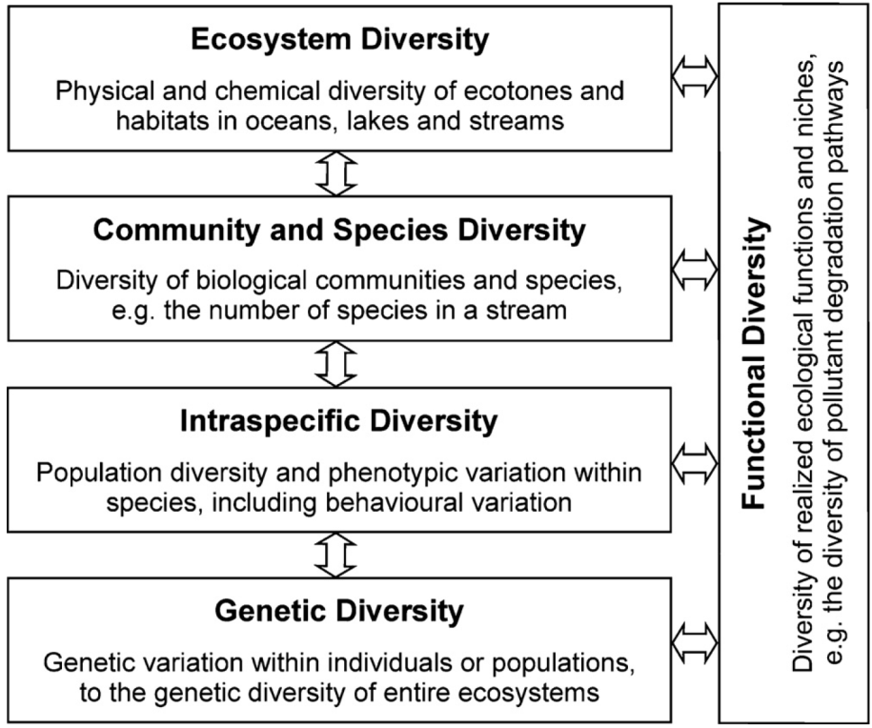

Figure 1. Hierarchical levels of biodiversity in aquatic ecosystems (Geist 2011)

There is increasing recognition globally that conserving biodiversity is critically important to maintain the functioning of natural ecosystems and for the sustainability of resources and ecosystem services on which human survival depends. Australia has joined 195 other countries as signatories to the United Nations Convention on Biological Diversity (1993, <https://www.cbd.int>) which provides guidance and impetus for conserving biodiversity and promoting sustainable development and sharing of genetic resources. The Basin Plan (Commonwealth of Australia 2012) is consistent with these objectives as it balances the need for sustainable water resource use with the environmental imperative to protect and restore biodiversity that is dependent on those same water resources.

Managed delivery of Commonwealth environmental water supports the maintenance of ecosystem diversity in the Basin via the provision of water to aquatic habitats which in turn supports a mosaic of water-dependent flora and fauna and provides the physical and chemical conditions that determine how ecosystems function (Junk *et al.* 1989; Poff 1997; Thorp *et al.* 2006). In theory, delivery of environmental water also has the potential to change physical landscape diversity through geomorphological processes (Figure 2). In practice, however, the frequency and volumes of Commonwealth environmental water that are delivered are constrained by storage volumes, infrastructure, and land use to volumes that complement natural hydrological regimes rather than creating wholesale hydrological regime change that has potential to restructure landscapes.

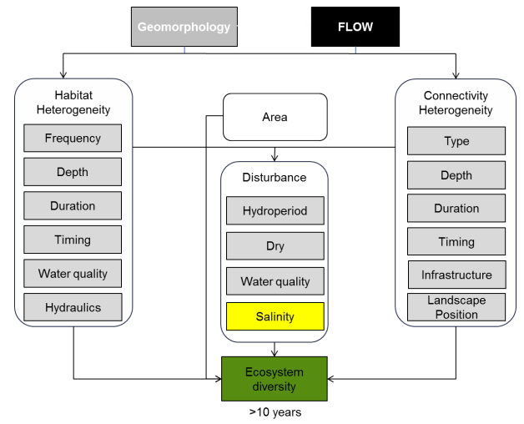

Figure 2. Cause-and-effect diagram depicting the influence of flow on landscape ecosystem diversity (MDFRC 2013).

This evaluation catalogues the different ecosystem types that received Commonwealth environmental water during the 2016–17 water year. Evaluating the extent to which water-dependent ecosystem types have been supported by Commonwealth environmental water therefore contributes to assessing the contribution of Commonwealth environmental water to biodiversity in the Basin as outlined in the Commonwealth Environmental Water Outcomes Framework (CEWH 2013).

The output of the Ecosystem Diversity evaluation also provides a template that can be used to extrapolate observed outcomes at monitoring sites within the Basin (e.g. in LTIM Selected Areas) to similar ecosystem types in areas that are not monitored, thereby facilitating a Basin-scale evaluation of the impact of Commonwealth environmental water. The specific hydrological and ecological outcomes are the subject of other LTIM Basin matter and Selected Area reports (Gawne *et al.* 2014).

# Method

Ecosystem diversity is quantified using the interim ANAE Classification Framework to define the distinct ecosystem types and their location in the Basin. The ANAE framework was prepared by the Australian Government Aquatic Ecosystems Task Group (AETG) to provide a consistent ecosystem type classification that can inform cross-jurisdictional adaptive management of aquatic ecosystems (Aquatic Ecosystems Task Group 2012). It uses three levels of attribute data to classify ecosystem types (

Figure 3).

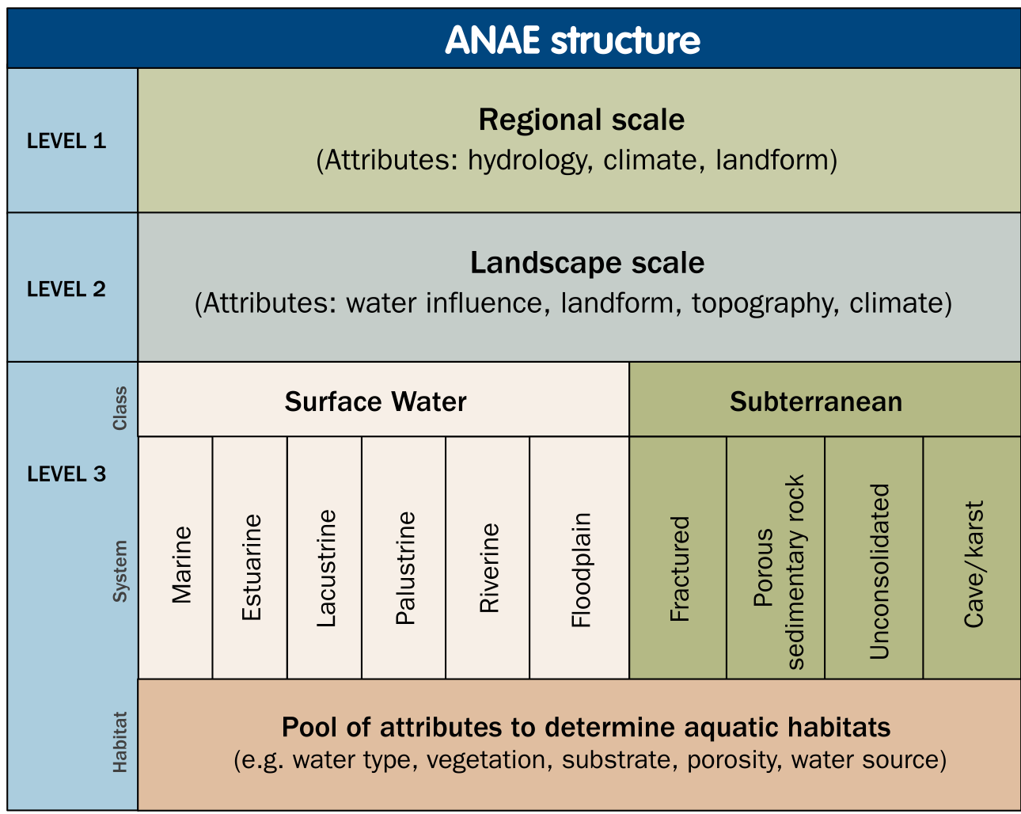

Figure 3. Structure and levels of the Interim Australian National Aquatic Ecosystem Classification Framework (Aquatic Ecosystems Task Group 2012).

Level 1 attributes include national and regional data related to national climate, landform and hydrological patterns. Level 2 attributes are similar to Level 1 attributes but applied at sub-catchment scales. Level 3 attributes are applied to individual aquatic ecosystems. The ANAE classification was applied to the best available jurisdictional mapping for Basin wetlands, floodplains and rivers by Brooks *et al.* (2014) to produce the interim Murray-Darling Basin Aquatic Ecosystem Classification data set. This data set provides the LTIM project with a relevant and contemporary means for defining ecosystem diversity in the Basin.

Overlaying the ANAE ecosystem map with the distribution of Commonwealth environmental water that was delivered in the Basin can then identify which ecosystem types received Commonwealth environmental water to answer the following short-term (1-year) and long-term (5-year) Basin-scale evaluation question:

1. What did Commonwealth environmental water contribute to ecosystem diversity?

## Data

Data inputs to the evaluation of ecosystem diversity include:

The Murray-Darling Basin ANAE data set (Brooks *et al.* 2014; Brooks 2017a) (Figure 4). In 2017 the ANAE classification of the Basin underwent a substantial revision designed to improve the accuracy and currency of aquatic ecosystem mapping and to integrate all ecosystem types into a single aquatic ecosystem map for the Basin (Brooks 2017a). Additional changes were made in 2018 to further refine the classification of floodplains and to add new mapping for floodplains in QLD to improve consistency of mapping across state borders (Figure 5).   
  
As a result of all the changes to the ecosystem mapping, the Ecosystem Diversity evaluation results presented in this report are not comparable to those presented in previous reports. To facilitate comparison among years, the inundation extents from previous years were re-evaluated against the revised ANAE and compared below.

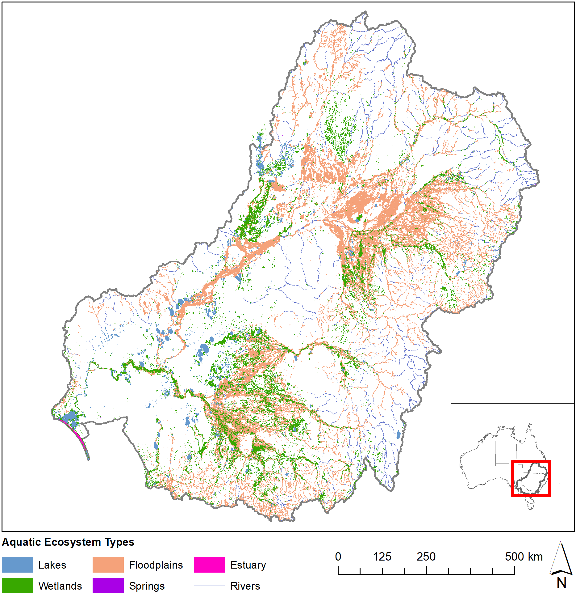

Figure 4. Aquatic ecosystems of the Murray-Darling basin (ANAE 2018 mapping).

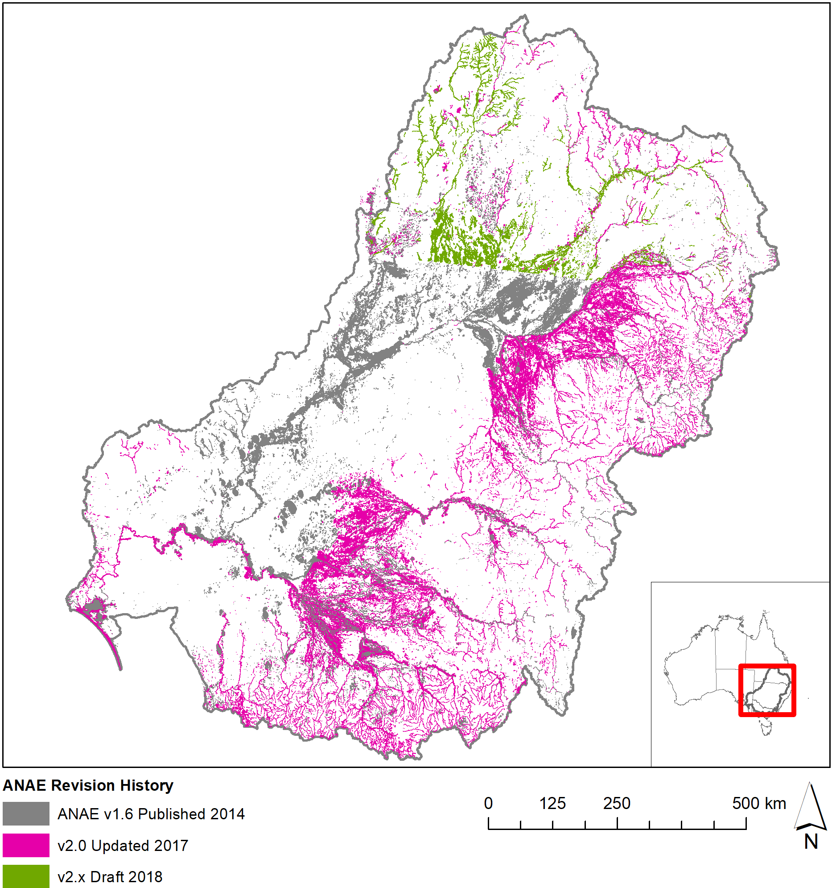

Figure 5. Revision history for the ANAE mapping in the Basin.

Commonwealth environmental water Inundation 2016–17 — a spatial representation of watering extent for Commonwealth environmental water delivered in the 2016–17 water year (Stewardson & Guarino 2018) (Figure 6). Improvements in the mapping of inundation extent this year led to the inclusion of the Coorong and Lakes Alexandria and Albert and the longitudinal extent of influence of Commonwealth environmental water in river channels. Commonwealth environmental water may include other environmental water (e.g. from State agencies) in a combined delivery and the extent mapped is the combined extent.

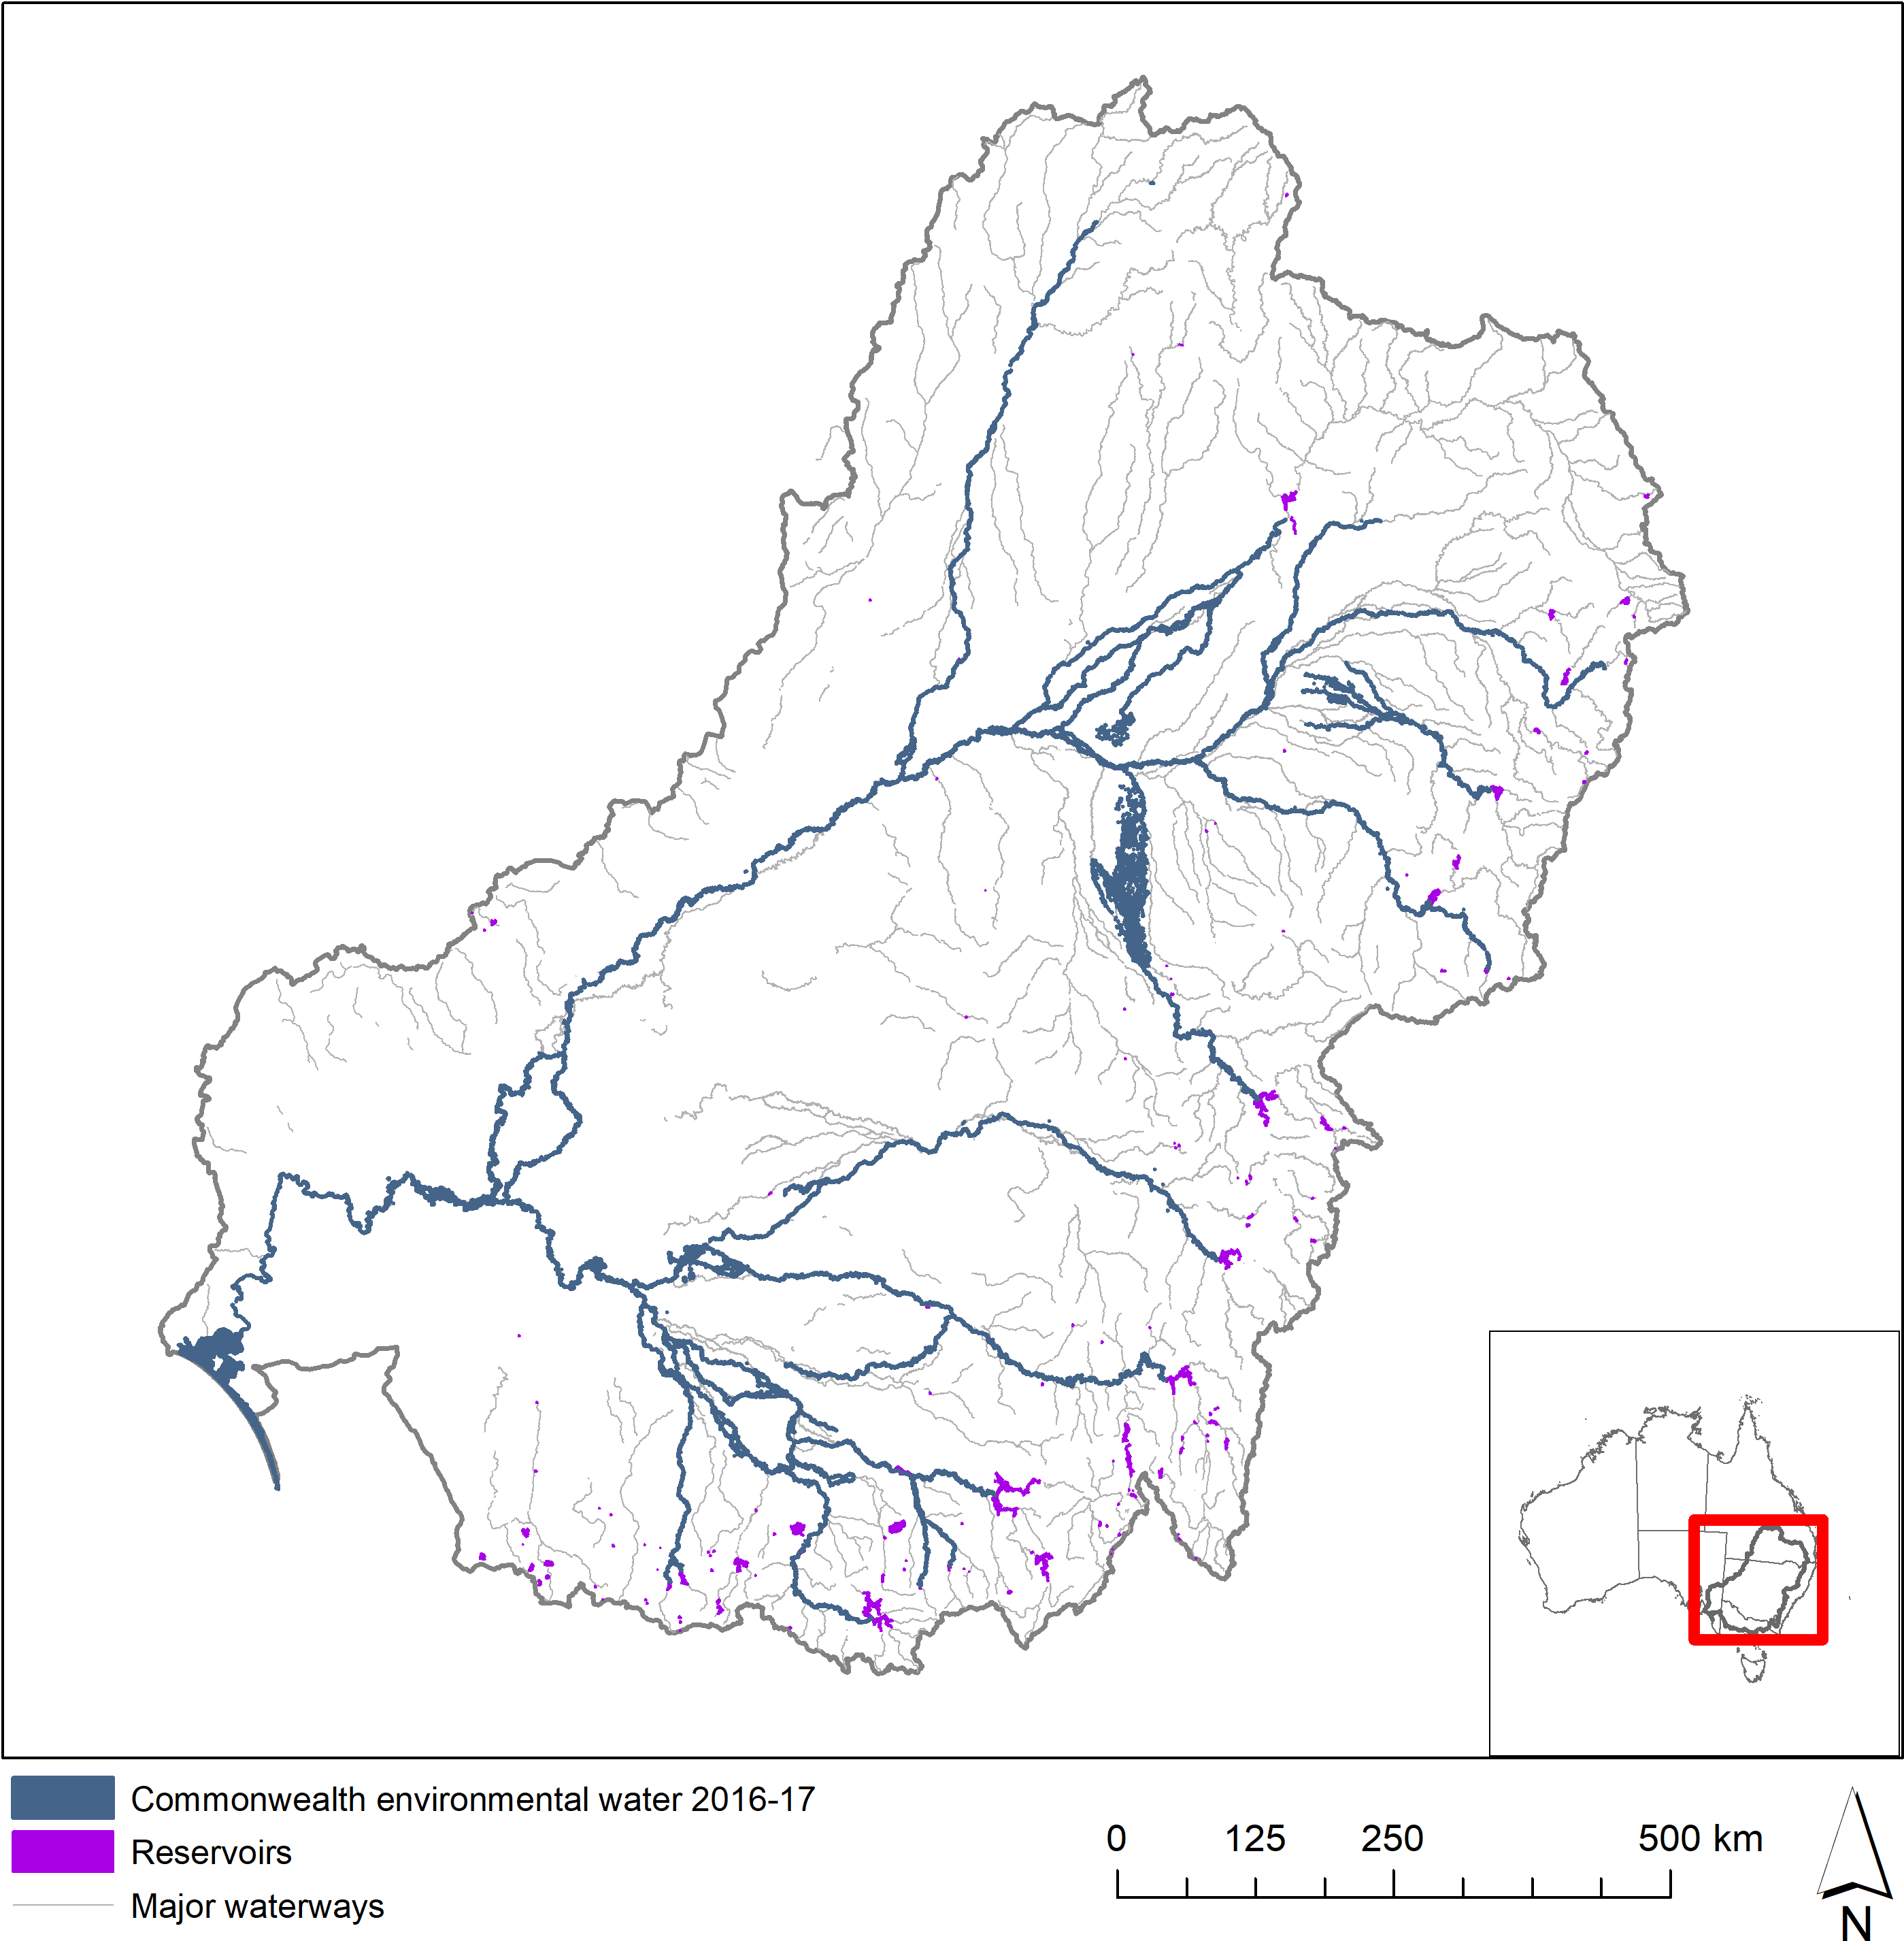

Figure 6. Commonwealth environmental water 2016–17.

LTIM valleys — a spatial layer developed for the LTIM project that subdivides the Basin into the major river valleys (Figure 7). These boundaries were derived from the Sustainable Rivers Audit (SRA) catchment boundaries with a modification to separate the Edward-Wakool Catchment from the Central Murray. The boundaries were adjusted slightly to improve the assignment of wetlands near valley boundaries to the watersheds in which managers and Commonwealth environmental water accounting allocate them. Mostly these changes affect the Central Murray area with a widening along the Murray River corridor to encompass fringing wetlands and the Gunbower and Barmah forests, and southern expansion of the Murrumbidgee valley to include Yanco Creek within the Murrumbidgee valley.

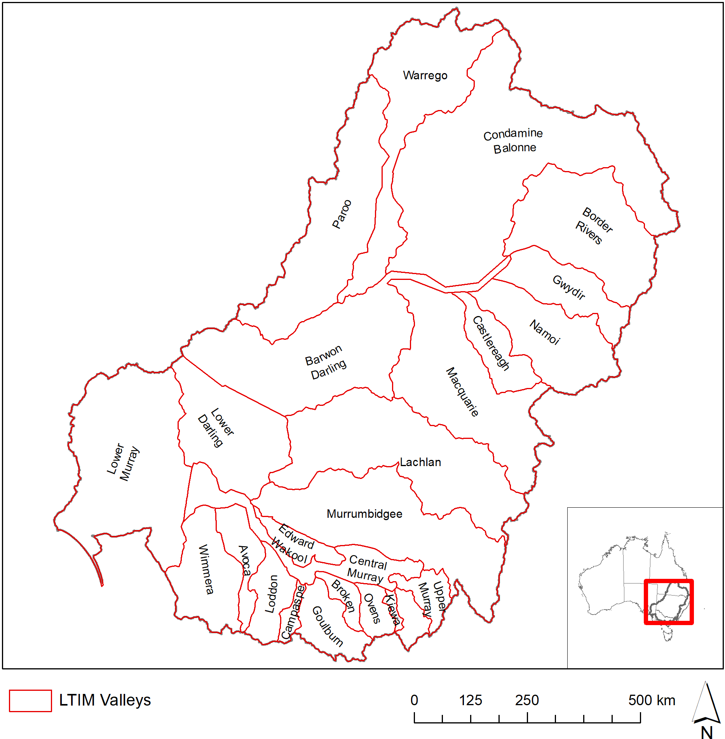

Figure 7. Valley boundaries within the Murray–Darling Basin used in this evaluation.

As in previous years, two different approaches were used to quantify the area of different ecosystem types that received Commonwealth environmental water:

1. Area inundated by Commonwealth environmental water = the sum of only the inundated areas of each wetland type, excluding the areas of wetlands that were not inundated.
2. Area influenced by Commonwealth environmental water = the sum of the all wetland areas that received water even if the inundation mapping showed that only a portion of the wetland was inundated.

The area *inundated* by Commonwealth environmental water is a ‘literal’ definition that represents the minimum contribution of Commonwealth environmental water in the landscape. The area *influenced* by Commonwealth environmental water acknowledges that aquatic ecosystems are complex interconnected systems and delivering water to part of a wetland contributes benefits to the entire wetland system. For example, filling a wetland depression may raise local water tables and benefit fringing vegetation, or provide feeding habitat for waterbirds that roost elsewhere in the wetland vegetation that was not inundated.

For lakes and palustrine wetlands, the total area *influenced* by Commonwealth environmental water is the appropriate measure of the contribution of Commonwealth environmental water to ecosystem diversity because water entering one part of a wetland depression is likely to raise water levels or the local water table across the extent.

For floodplains, the area *inundated* by Commonwealth environmental water is used to measure the contribution of Commonwealth environmental water to ecosystem diversity. This more conservative measure is used for floodplains because floodplains occur as broad continuous expanses and the ecosystem response is generally limited to the wetted area. Depressional wetlands and channels that hold or convey water through floodplains are considered as separate entities.

GIS methodologies for calculating these areas are provided in Section 3.2.

The spatial representation of watering extent for Commonwealth environmental water delivered in 2016–17 includes all watering actions that resulted in inundation beyond the river channel (Stewardson & Guarino 2018). River reaches that received in-channel pulses, freshes and passing flows are also identified (Figure 6); however, the river channel inundation mapping is not of sufficient resolution to identify inundation of river banks and fringing habitats along the channels.

Commonwealth environmental water reaching the end of the system contributes to the maintenance of the Coorong, Lake Alexandrina, Lake Albert and the Murray Mouth ecosystems. Reliable inundation models for this area do not exist at this time so the extent of inundation is estimated from the mapped extent of the Coorong, Lake Alexandrina, Lake Albert and the Murray Mouth. This estimate is considered reliable because the lakes are managed for a relatively constant water level of 0.5 to 0.8m AHD by regulating outflows through the barrages. Below the barrages, water levels in the Murray Mouth and Coorong are maintained near sea level.

## GIS Workflows

All spatial layers are based on the 1994 Geocentric Datum of Australia (GDA94). Areas in this report are in hectares and have been calculated in the Australia Albers Equal Area Conic projection to report accurate area measurements across the Basin.

*The area of ecosystems inundated by Commonwealth environmental water is the fraction of the wetland area that intersects the Commonwealth environmental water inundation extent.*

GIS Workflow:

1. Intersect:
   1. The Basin ANAE classification mapping;
   2. Commonwealth environmental water Inundation; and
   3. LTIM Valleys
2. Calculate polygon area in hectares using equal area GDA94 Australian Albers projection.
3. Sum the area of each ANAE wetland type per valley.

*The area of ecosystems influenced by Commonwealth environmental water is defined as the sum of the areas of mapped features that are partially or fully overlapped by Commonwealth environmental water inundation extent.*

GIS Workflow:

1. Select by location all ANAE wetland polygons that intersect the Commonwealth environmental water Inundation.
2. Intersect the selected wetlands with the catchment boundaries.
3. Calculate polygon area in hectares using equal area GDA94 Australian Albers projection.
4. Sum the area of each ANAE wetland type per valley.

*Length of waterways influenced by Commonwealth environmental water*

River length measurement is highly dependent on the resolution of the mapping with higher resolution mapping capturing more twists and turns in the river that increase the measured river length along the flow path between two points. The Basin ANAE waterway mapping compiles state data that varies in resolution from 1:25 000 to 1:100 000.

GIS Workflow:

1. Intersect:
   1. The Basin ANAE Waterways
   2. Commonwealth environmental water Inundation
   3. LTIM Valleys
2. Calculate the channel length inundated for each riverine ecosystem type in kilometres using equal area GDA94 Australian Albers projection.
3. Calculate summary statistics to sum the length of each river ecosystem type per valley.

# Ecosystem Diversity Basin-scale evaluation

## Highlights

**In the 2016–17 water year:**

* More than 77 500 ha of lakes and wetlands, 14 000 ha of floodplains and 21 000 km of rivers in the Basin upstream of the Lower Lakes were supported by Commonwealth environmental water.
* Commonwealth environmental water supported another 118 000 ha of Lake Alexandrina and Lake Albert and their fringing wetlands and 24 000 ha of estuarine habitat in the Coorong and Murray Mouth.
* Wetland and floodplains in five LTIM Selected Areas received Commonwealth environmental water with substantial areas also inundated in the Macquarie and Central Murray valleys.
* More than half (51%) of the different wetland ecosystem types and 83% of floodplain ecosystem types in the basin were represented in the area inundated by Commonwealth environmental water. Of the wetland areas receiving Commonwealth environmental water, 52% were meadows and marshes (41 000 ha) primarily in Gwydir and Macquarie valleys.
* Approximately 42% of the wetland areas that received Commonwealth environmental water were classed as temporary (intermittent) ecosystem types. These areas can be hot-spots for diversity if they support different suites of species in the dry and wet phases.
* As in previous years, Commonwealth environmental water contributed to all of the estuarine ecosystem types in the Basin during 2016–17 as environmental flows passed through to the Murray Mouth and Coorong.
* The rarest aquatic ecosystem types in the Basin, which include various types of paperback swamp and lakes with aquatic macrophyte beds, did not receive Commonwealth environmental water (and have not during the period of LTIM).

**Comparing the three watering years 2014–15 to 2016–17:**

* The broad pattern of watering across ecosystem types is similar across all the three years with 51% of wetland and lake ecosystem types receiving Commonwealth environmental water in all three years and 38% of ecosystem types not receiving any Commonwealth environmental water in any year over the same period.
* The mix of ecosystem types and the proportions of those types that received Commonwealth environmental water in 2016–17 was very similar to 2014–15 with the two exceptions; permanent tall emergent marshes of the Great Cumbung Swamp at the end of the Lachlan River were not watered in 2016–17 and 12 500 ha of temporary lignum swamp within the Narran Lakes Ramsar Site received water in 2016–17 for the first time since LTIM commenced in 2013.
* The distribution of Commonwealth environmental water in 2015–16 was different to the other two years in that larger areas of the Lowbidgee, Barmah Forest and Lachlan river system were inundated supporting a greater proportion of temporary river red gum swamps, floodplain and riparian wetlands, temporary swamps and permanent saline wetlands compared to the years either side.

## Basin-scale evaluation 2016–17

This evaluation does not consider the details of individual watering events and is ignorant of the specific timing and duration of Commonwealth environmental water in different areas of the landscape. The inundation map (Figure 6) collapses the maximum wetted extent of all watering actions during 2016–17 that included Commonwealth environmental water. The area inundated in each valley, and the length of river channels influenced by Commonwealth environmental water is presented in

Table **1**.

The contribution of Commonwealth environmental water to Ecosystem Diversity upstream of the Lower Lakes is presented under the broad system type categories: lakes and wetlands (Table 2), floodplains (Table 3), river channels (Table 4). The contribution of Commonwealth environmental water to Ecosystem Diversity in the Coorong and Lakes Alexandrina and Albert and the Murray Mouth are presented separately in (Table 5) for two main reasons. Firstly to prevent the large areas of Lakes Alexandrina and Albert from masking finer scale patterns of inundation of lakes in the rest of the Lower Murray valley. Secondly, the assumption of constant water levels inundating the same ecosystems each year may hinder evaluation of more variable inter-annual differences in the use of Commonwealth environmental water in other areas of the Basin.

Commonwealth environmental watering actions contributed to the inundation of a wide range of ecosystem types within the Basin that included approximately 51% of the different wetland types and 83% of the different floodplain types, and all (100%) of the river channel and estuarine ecosystem types.

A more detailed breakdown by valley is provided in Annex B (wetlands and estuarine ecosystems), Annex C (floodplains) and Annex D (river channels).

**Table 1.** Area of each LTIM catchment inundated by Commonwealth environmental water in 2016–17, including both floodplain and wetland ecosystem types.

|  |  |  |  |  |
| --- | --- | --- | --- | --- |
| Catchment name | LTIM Selected Area | Lakes and wetland area influenced (ha) | Floodplain area inundated (ha) | Length of waterways influenced (km) |
| Avoca |  | – | – | – |
| Barwon Darling |  | 412 | – | 2611 |
| Border Rivers |  | 74 | 48 | 1630 |
| Broken |  | – | – | 177 |
| Campaspe |  | – | – | – |
| Castlereagh |  | – | – | – |
| Central Murray |  | 3372 | 209 | 2538 |
| Condamine Balonne |  | 17 341 | 34 | 2141 |
| Edward–Wakool | Edward–Wakool river system | – | – | 1033 |
| Goulburn | Goulburn River | – | – | 523 |
| Gwydir | Gwydir river system | 6730 | 1251 | 846 |
| Kiewa |  | – | – |  |
| Lachlan | Lachlan river system | 144 | 2047 | 1506 |
| Loddon |  | – | – | 528 |
| Lower Darling |  | 32 | 11 | 1241 |
| Lower Murray* | Lower Murray River* | 6465* | 1158 | 960 |
| Lower Murray  (Coorong Lakes Alexandrina and Albert and Murray Mouth) |  | Fresh: 118 148 Estuary: 23 850 | 66 | – |
| Macquarie |  | 36 842 | 6250 | 807 |
| Mitta Mitta |  | – | – | – |
| Murrumbidgee | Murrumbidgee river system | 6448 | 3211 | 2222 |
| Namoi |  | – | – | 1027 |
| Ovens |  | – | – | 483 |
| Paroo |  | – | – | – |
| Upper Murray |  | – | – | – |
| Warrego | Junction of the Warrego and Darling rivers | 17 734 | 186 | 1367 |
| Wimmera |  | – | – | – |
| **Total** | | **237 592** | **14 471** | **21 640** |

* excludes the Coorong, Lakes Alexandrina and Albert and the Murray Mouth.

Table 2. Contribution of Commonwealth environmental water to ecosystem diversity of lakes and wetlands at the basin-scale. Ecosystem types are sorted by the area influenced by Commonwealth environmental water.

| Australian National Aquatic Ecosystem (ANAE) wetland type | Total ex Coorong and Lower Lakes | Inundated* | | Influenced* | |
| --- | --- | --- | --- | --- | --- |
| area (ha) | Area (ha) | % of total | Area (ha) | % of total |
| Pt2.3.2: Freshwater meadow | 125 128 | 3420 | 2.7 | 20 508 | 16.4 |
| Pp4.2: Permanent wetland | 77 300 | 11 132 | 14.4 | 20 095 | 26.0 |
| Pt2.2.2: Temporary sedge/grass/forb marsh | 135 475 | 3811 | 2.8 | 16 917 | 12.5 |
| Pt1.7.2: Temporary lignum swamp | 49 962 | 516 | 1.0 | 12 427 | 24.9 |
| Pt1.1.2: Temporary river red gum swamp | 74 721 | 1423 | 1.9 | 7517 | 10.1 |
| Lp1.1: Permanent lake | 127 660 | 1855 | 1.5 | 6840 | 5.4 |
| Pt2.1.2: Temporary tall emergent marsh | 68 622 | 2369 | 3.5 | 3116 | 4.5 |
| Lt1.1: Temporary lake | 459 347 | 808 | 0.2 | 2485 | 0.5 |
| Pt1.8.2: Temporary shrub swamp | 234 393 | 834 | 0.4 | 2122 | 0.9 |
| Pt3.1.2: Clay pan | 129 736 | 1299 | 1.0 | 1698 | 1.3 |
| Pt4.1: Floodplain or riparian wetland | 10 494 | 10 | 0.1 | 1008 | 9.6 |
| Pt1.2.2: Temporary black box swamp | 60 272 | 69 | 0.1 | 228 | 0.4 |
| Pt1.6.2: Temporary woodland swamp | 216 625 | 1 | <0.1 | 186 | 0.1 |
| Psp4: Permanent saline wetland | 2114 | 156 | 7.4 | 172 | 8.1 |
| Pt1: Temporary swamp | 3767 | 110 | 2.9 | 132 | 3.5 |
| Pp2.3.2: Permanent grass marsh | 1507 | 50 | 3.3 | 96 | 6.4 |
| Pp2.4.2: Permanent forb marsh | 738 | 15 | 2.0 | 30 | 4.1 |
| Pp2.2.2: Permanent sedge/grass/forb marsh | 3590 | 15 | 0.4 | 15 | 0.4 |
| Pst2.2: Temporary salt marsh | 40 294 | 1 | <0.1 | 1 | <0.1 |
| Lst1.1: Temporary saline lake | 27 897 | 0 | - | 0 | - |
| Pt4.2: Temporary wetland | 26 892 | 0 | - | 0 | - |
| Lsp1.1: Permanent saline lake | 9229 | 0 | - | 0 | - |
| Lt1.2: Temporary lake with aquatic bed | 9052 | 0 | - | 0 | - |
| Pp2.1.2: Permanent tall emergent marsh | 7995 | 0 | - | 0 | - |
| Pst4: Temporary saline wetland | 6118 | 0 | - | 0 | - |
| Pst1.1: Temporary saline swamp | 5728 | 0 | - | 0 | - |
| Pp3: Peat bog or fen marsh | 4425 | 0 | - | 0 | - |
| Pst3.2: Salt pan or salt flat | 3201 | 0 | - | 0 | - |
| Lst1.2: Temporary saline lake with aquatic bed | 2238 | 0 | - | 0 | - |
| Lp1.2: Permanent lake with aquatic bed | 2067 | 0 | - | 0 | - |
| Pu1: Unspecified wetland | 1763 | 0 | - | 0 | - |
| Pt1.5.2: Temporary paperbark swamp | 412 | 0 | - | 0 | - |
| Psp2.1: Permanent salt marsh | 248 | 0 | - | 0 | - |
| Lsp1.2: Permanent saline lake with aquatic bed | 181 | 0 | - | 0 | - |
| Psp1.1: Saline paperbark swamp | 163 | 0 | - | 0 | - |
| Pps5: Permanent spring | 130 | 0 | - | 0 | - |
| Pp1.1.2: Permanent paperbark swamp | 1 | 0 | - | 0 | - |

* Area inundated/influenced by Commonwealth environmental water: see Section 3.2 for definitions.

Table 3. Contribution of Commonwealth environmental water to ecosystem diversity of floodplains at the Basin-scale, sorted by the area inundated.

|  |  |  |  |
| --- | --- | --- | --- |
| Australian National Aquatic Ecosystem (ANAE) floodplain type | Total  area (ha) | Inundated*  area (ha) | % of total |
| F1.2: River red gum forest riparian zone or floodplain | 639 022 | 6525 | 1.0 |
| F2.4: Shrubland riparian zone or floodplain | 407 981 | 2554 | 0.6 |
| Lp1.1: Permanent lake | 127 660 | 1855 | 1.5 |
| F1.4: River red gum woodland riparian zone or floodplain | 325 221 | 1237 | 0.4 |
| F2.2: Lignum shrubland riparian zone or floodplain | 143 852 | 1164 | 0.8 |
| F1.10: Coolibah woodland and forest riparian zone or floodplain | 427 507 | 949 | 0.2 |
| F1.8: Black box woodland riparian zone or floodplain | 779 636 | 844 | 0.1 |
| F1.12: Woodland riparian zone or floodplain | 318 572 | 136 | <0.1 |
| F1.6: Black box forest riparian zone or floodplain | 131 442 | 118 | 0.1 |
| F4: Unspecified riparian zone or floodplain | 989 305 | 67 | <0.1 |
| F3.2: Sedge/forb/grassland riparian zone or floodplain | 833 102 | 32 | <0.1 |
| F1.13: Paperpark riparian zone or floodplain | 17 | 0 | - |

* Area inundated/influenced by Commonwealth environmental water: see Section 3.2 for definitions.

Table 4. Contribution of Commonwealth environmental water to ecosystem diversity within river channels of the Basin sorted by the area influenced by Commonwealth environmental water.

| Australian National Aquatic Ecosystem (ANAE) waterway type | Total | Inundated* | |
| --- | --- | --- | --- |
| Length (km) | Length (km) | % of total |
| Rp1.4: Permanent lowland stream | 40 783 | 15 558 | 38.1 |
| Rt1.4: Temporary lowland stream | 198 613 | 3894 | 2.0 |
| Rp1.1: Permanent high energy upland stream | 59 080 | 897 | 1.5 |
| Rp1.2: Permanent transitional zone stream | 17 920 | 766 | 4.3 |
| Rp1.3: Permanent low energy upland stream | 545 | 164 | 30.1 |
| Rt1: Temporary stream | 174 | 85 | 48.9 |
| Rp1: Permanent stream | 293 | 80 | 27.3 |
| Rt1.1: Temporary high energy upland stream | 167 220 | 69 | <0.1 |
| Rt1.2: Temporary transitional zone stream | 116 557 | 55 | <0.1 |
| Rt1.3: Temporary low energy upland stream | 2795 | 47 | 1.7 |
| Rw1: Permanent river (landform unknown) | 308 | 11 | 3.6 |
| Ru1: Unspecified river (landform unknown) | 256 | 8 | 3.1 |

* Area inundated/influenced by Commonwealth environmental water: see Section 3.2 for definitions.

Table 5. Ecosystem types in the Coorong, Lower Lakes and Murray Mouth that are influenced by Commonwealth environmental water. Ecosystem types are sorted by the area inundated by Commonwealth environmental water.

| Australian National Aquatic Ecosystem (ANAE) wetland type | Total | Inundated* | |
| --- | --- | --- | --- |
| area (ha) | Area (ha) | % of total |
| Lp1.1: Permanent lake | 82 533 | 82 098 | 99.5 |
| Ewd1.3.2: Coastal lagoon | 18 912 | 18 657 | 98.7 |
| Pt2.1.2: Temporary tall emergent marsh | 7717 | 4702 | 60.9 |
| Pt2.2.2: Temporary sedge/grass/forb marsh | 7042 | 2405 | 34.2 |
| Etd1.3.3: Tide dominated estuary | 2240 | 2212 | 98.8 |
| Pst1.1: Temporary saline swamp | 2215 | 1493 | 67.4 |
| Ewd1.2.4: Intertidal mudflat or sand bar | 960 | 928 | 96.7 |
| Pt3.1.2: Clay pan | 8990 | 653 | 7.3 |
| Lsp1.1: Permanent saline lake | 2432 | 591 | 24.3 |
| Etd1.2.2: Tide dominated mudflats and sandbar | 629 | 590 | 93.8 |
| Psp4: Permanent saline wetland | 595 | 568 | 95.5 |
| Ewd1.2.3: Intertidal saltmarsh | 478 | 358 | 74.9 |
| Pt4.2: Temporary wetland | 4295 | 350 | 8.1 |
| Pt4.1: Floodplain or riparian wetland | 994 | 304 | 30.6 |
| Ewd1.2.5: Intertidal rocky shoreline | 284 | 274 | 96.5 |
| Etd1.2.1: Tide dominated saltmarsh | 321 | 259 | 80.7 |
| Pst4: Temporary saline wetland | 513 | 118 | 23.0 |
| Pst2.2: Temporary salt marsh | 412 | 109 | 26.5 |
| Pst3.2: Salt pan or salt flat | 169 | 70 | 41.4 |
| F2.4: Shrubland riparian zone or floodplain | 632 | 56 | 8.9 |
| Pp4.2: Permanent wetland | 107 | 46 | 43.0 |
| Pt2.3.2: Freshwater meadow | 64 | 27 | 42.2 |
| Etd1.2.3: Tide dominated forest | 19 | 16 | 84.2 |
| Etd1.1.1: Tide dominated rocky shoreline | 7 | 7 | 100.0 |
| F2.2: Lignum shrubland riparian zone or floodplain | 33 | 6 | 18.2 |
| F1.12: Woodland riparian zone or floodplain | 57 | 4 | 7.0 |
| Pt1.8.2: Temporary shrub swamp | 26 | 4 | 15.4 |
| Lt1.1: Temporary lake | 28 | 1 | 3.6 |
| Pp2.1.2: Permanent tall emergent marsh | 9 | 1 | 11.1 |
| Pt1.7.2: Temporary lignum swamp | 3 | 1 | 33.3 |
| Pp2.4.2: Permanent forb marsh | 2 | 1 | 50.0 |
| Psp2.1: Permanent salt marsh | 2 | 1 | 50.0 |
| F1.8: Black box woodland riparian zone or floodplain | 3 | 0 | - |

* Area inundated/influenced by Commonwealth environmental water: see Section 3.2 for definitions.

## Cumulative Basin-scale evaluation (2014–17)

The cumulative evaluation compares the area of each floodplain ecosystem type that was inundated, and each wetland that was influenced by Commonwealth environmental water (i.e. the whole wetland area if part of the wetland was inundated) in each of the LTIM water years.

The inter-annual comparisons presented in Inundation of floodplain ecosystems has been similar across all years (Table 7) but the inundated extents are relatively small (often less than 1%). Inundation of floodplain ecosystems has been as high as 10% of total extent for “river cooba woodland riparian zone or floodplain” which is the second most restricted aquatic ecosystem type in the basin. The very restricted 17 ha of paperbark riparian zone or floodplain has not received Commonwealth environmental water during LTIM. Floodplain inundation is rarely an objective for Commonwealth environmental water because volumes are limited and delivery constraints imposed by infrastructure and built assets often restrict watering actions to volumes that are contained within river channels and wetlands. Extensive floodplain inundation is not expected unless Commonwealth environmental water is delivered to augment natural floods.

Table 6 and Table 7 should be viewed as indicative only as there are some differences in the way inundation extents were mapped in each year. The 2014–15 inundation likely over-estimates the extent of Commonwealth environmental water in the Macquarie Marshes, Gwydir wetlands and Lower Murrumbidgee (Lowbidgee) due to poor discrimination of Commonwealth environmental water from other water in satellite imagery. Improvements to the data assembly process increased the accuracy and confidence in the inundation mapping from 2015–16 onwards. The LTIM hydrology Basin Matter is investigating ways of correcting the earlier estimates.

Commonwealth environmental water contributed to inundation of the Gwydir wetlands, Macquarie Marshes and Lowbidgee in all three years of LTIM 2014–17. The broad pattern of ecosystem types supported by Commonwealth environmental water reflects this similarity in the distribution of watering actions with 51% of wetland and lake ecosystem types in the Basin receiving Commonwealth environmental water in all 3 years and conversely 38% of ecosystem types have not received any Commonwealth environmental water during the same period (Inundation of floodplain ecosystems has been similar across all years (Table 7) but the inundated extents are relatively small (often less than 1%). Inundation of floodplain ecosystems has been as high as 10% of total extent for “river cooba woodland riparian zone or floodplain” which is the second most restricted aquatic ecosystem type in the basin. The very restricted 17 ha of paperbark riparian zone or floodplain has not received Commonwealth environmental water during LTIM. Floodplain inundation is rarely an objective for Commonwealth environmental water because volumes are limited and delivery constraints imposed by infrastructure and built assets often restrict watering actions to volumes that are contained within river channels and wetlands. Extensive floodplain inundation is not expected unless Commonwealth environmental water is delivered to augment natural floods.

Table 6). Some of the ecosystem types that have not been supported by Commonwealth environmental water since 2014 may be included in areas targeted for watering by state-based delivery partners but it is currently beyond the scope of the of LTIM to evaluate all environmental water delivered by other jurisdictions.

Water delivery infrastructure (river networks, storages, canals and regulators) constrains the area to which environmental water can be delivered. Some of the aquatic ecosystem types that are yet to receive Commonwealth environmental water will exist in locations that are outside the scope of environmental water delivery. Preliminary investigation has shown that during the three years of LTIM all Commonwealth environmental water (outside of river channels) has supported 332 000 ha of lakes and wetlands in the Basin. This is small proportion (0.3%) of the total Basin area, but represents a larger proportion (5%) of the area MDBA has mapped as “managed floodplain”. Improving understanding of the ecosystems that are within scope for Commonwealth environmental water is an ongoing research activity for the LTIM project, and indeed for water managers in the Basin. Approximately 63 500 ha of the inundation by Commonwealth environmental water LTIM has measured over the first three years of LTIM lies outside of the area currently mapped as managed floodplain by MDBA. This may be further evidence that LTIM inundation extents for 2014–15 over-estimate the watering extent and that we still have a way to go before we can confidently delineate the population of ecosystem types that are within scope for Commonwealth environmental water.

The area and diversity of ecosystem types supported by Commonwealth environmental water in 2014–15 (year 1) and 2016–17 (year 3) were similar with the major differences being that 3 400 ha of permanent tall emergent marsh in the Great Cumbung Swamp was watered in year 1 and 2 but not in year 3 and 12 500 ha of temporary lignum swamp primarily around Narran Lakes received Commonwealth environmental water for the first time in year 3

The distribution of water delivery differed in 2015–16 (year 2), with Commonwealth environmental water reaching substantial areas of temporary river red gum swamps, floodplain and riparian wetlands, temporary black box swamp, temporary swamps with unknown vegetation and permanent saline wetlands in watering actions along the Murray River between Morgan and the S.A Border, Barmah Forest and the Lachlan River.

Over the duration of LTIM, Commonwealth environmental water has influenced more than 5% of the area of 13 different lake and wetland ecosystem types in at least one year (35% of the variety of these types present in the basin). Another 10 lake and wetland ecosystem types have had only small areas inundated by Commonwealth environmental water.

Inundation of floodplain ecosystems has been similar across all years (Table 7) but the inundated extents are relatively small (often less than 1%). Inundation of floodplain ecosystems has been as high as 10% of total extent for “river cooba woodland riparian zone or floodplain” which is the second most restricted aquatic ecosystem type in the basin. The very restricted 17 ha of paperbark riparian zone or floodplain has not received Commonwealth environmental water during LTIM. Floodplain inundation is rarely an objective for Commonwealth environmental water because volumes are limited and delivery constraints imposed by infrastructure and built assets often restrict watering actions to volumes that are contained within river channels and wetlands. Extensive floodplain inundation is not expected unless Commonwealth environmental water is delivered to augment natural floods.

Table 6. Comparison of the contribution of Commonwealth environmental water to ecosystem diversity of lakes and palustrine wetlands from 2014-17 (sorted by the magnitude of watering in the 2016-17 water year). Ecosystem types with more than 5% of their total Basin area inundated in any one year are shaded pale blue. Ecosystem types that have not received Commonwealth environmental water during the period of LTIM are shaded red. Large differences (>10%) among years are highlighted in dark blue.

| Australian National Aquatic Ecosystem (ANAE) wetland type | Total  area (ha) | % receiving Cew | | | Differences | | |
| --- | --- | --- | --- | --- | --- | --- | --- |
| Y1  14-15 | Y2  15–16 | Y3  16–17 | Y2-Y1 | Y3-Y2 | Y3-Y1 |
| Pp4.2: Permanent wetland | 77 300 | 26.2 | 28.2 | 26.0 | 2.0 | -2.2 | -0.2 |
| Pt1.7.2: Temporary lignum swamp | 49 962 | 1.1 | 7.0 | 24.9 | 5.9 | 17.9 | 23.8 |
| Pt2.3.2: Freshwater meadow | 125 128 | 15.1 | 16.8 | 16.4 | 1.8 | -0.4 | 1.3 |
| Pt2.2.2: Temporary sedge/grass/forb marsh | 135 475 | 12.1 | 15.1 | 12.5 | 3.0 | -2.6 | 0.4 |
| Pt1.1.2: Temporary river red gum swamp | 74 721 | 13.3 | 56.1 | 10.1 | 42.8 | -46.0 | -3.2 |
| Pt4.1: Floodplain or riparian wetland | 10 494 | 8.3 | 21.0 | 9.6 | 12.7 | -11.4 | 1.3 |
| Psp4: Permanent saline wetland | 2114 | 10.9 | 48.6 | 8.1 | 37.7 | -40.4 | -2.8 |
| Pp2.3.2: Permanent grass marsh | 1507 | 1.5 | 1.7 | 6.4 | 0.1 | 4.7 | 4.8 |
| Lp1.1: Permanent lake | 127 660 | 1.1 | 3.9 | 5.4 | 2.8 | 1.5 | 4.2 |
| Pt2.1.2: Temporary tall emergent marsh | 68 622 | 4.5 | 6.3 | 4.5 | 1.8 | -1.8 | 0.0 |
| Pp2.4.2: Permanent forb marsh | 738 | 1.4 | 0.7 | 4.1 | -0.7 | 3.4 | 2.7 |
| Pt1: Temporary swamp | 3767 | 7.4 | 18.5 | 3.5 | 11.1 | -15.0 | -3.9 |
| Pt3.1.2: Clay pan | 129 736 | 2.4 | 2.9 | 1.3 | 0.5 | -1.6 | -1.1 |
| Pt1.8.2: Temporary shrub swamp | 234 393 | 0.7 | 3.2 | 0.9 | 2.5 | -2.2 | 0.2 |
| Lt1.1: Temporary lake | 459 347 | 0.6 | 1.7 | 0.5 | 1.1 | -1.1 | 0.0 |
| Pp2.2.2: Permanent sedge/grass/forb marsh | 3590 | 0.4 | 0.5 | 0.4 | 0.1 | -0.1 | 0.0 |
| Pt1.2.2: Temporary black box swamp | 60 272 | 1.8 | 10.4 | 0.4 | 8.7 | -10.1 | -1.4 |
| Pst2.2: Temporary salt marsh | 40 294 | <0.1 | 1.6 | <0.1 | 1.6 | -1.6 | -0.1 |
| Pt1.6.2: Temporary woodland swamp | 216 625 | <0.1 | 0.3 | <0.1 | 0.2 | -0.2 | - |
| Pp2.1.2: Permanent tall emergent marsh | 7995 | 43.1 | 52.0 | - | 8.8 | -52.0 | -43.1 |
| Pt4.2: Temporary wetland | 26 892 | <0.1 | 2.2 | - | 2.1 | -2.2 | - |
| Lst1.1: Temporary saline lake | 27 897 | - | 0.5 | - | 0.5 | -0.5 | - |
| Pst1.1: Temporary saline swamp | 5728 | 1.6 | - | - | -1.6 | - | -1.6 |
| Lsp1.1: Permanent saline lake | 9229 | - | - | - | - | - | - |
| Lt1.2: Temporary lake with aquatic bed | 9052 | - | - | - | - | - | - |
| Pst4: Temporary saline wetland | 6118 | - | - | - | - | - | - |
| Pp3: Peat bog or fen marsh | 4425 | - | - | - | - | - | - |
| Pst3.2: Salt pan or salt flat | 3201 | - | - | - | - | - | - |
| Lst1.2: Temporary saline lake with aquatic bed | 2238 | - | - | - | - | - | - |
| Lp1.2: Permanent lake with aquatic bed | 2067 | - | - | - | - | - | - |
| Pu1: Unspecified wetland | 1763 | - | - | - | - | - | - |
| Pt1.5.2: Temporary paperbark swamp | 412 | - | - | - | - | - | - |
| Psp2.1: Permanent salt marsh | 248 | - | - | - | - | - | - |
| Lsp1.2: Permanent saline lake with aquatic bed | 181 | - | - | - | - | - | - |
| Psp1.1: Saline paperbark swamp | 163 | - | - | - | - | - | - |
| Pps5: Permanent spring | 130 | - | - | - | - | - | - |
| Pp1.1.2: Permanent paperbark swamp | 1 | - | - | - | - | - | - |

Table 7. Comparison of the contribution of Commonwealth environmental water to ecosystem diversity of floodplains from 2014-17 (sorted by the magnitude of watering in the 2016-17 water year). Ecosystem types with more than 5% of their total Basin area inundated in any one year are shaded pale blue. Ecosystem types that have not received Commonwealth environmental water during the period of LTIM are shaded red. Large differences (>10%) among years are highlighted in dark blue.

| Australian National Aquatic Ecosystem (ANAE) wetland type | Total  area (ha) | % receiving Cew | | | Differences | | |
| --- | --- | --- | --- | --- | --- | --- | --- |
| Y1 14-15 | Y2 15–16 | Y3  16–17 | Y1-Y2 | Y2-Y3 | Y1-Y3 |
| F1.11: River cooba woodland riparian zone or floodplain | 11 541 | 9.8 | 10.9 | 6.7 | 1.0 | -4.1 | -3.1 |
| F1.2: River red gum forest riparian zone or floodplain | 639 022 | 3.8 | 5.2 | 1.0 | 1.3 | -4.2 | -2.8 |
| F2.2: Lignum shrubland riparian zone or floodplain | 143 852 | 3.8 | 1.7 | 0.8 | -2.0 | -0.9 | -3.0 |
| F2.4: Shrubland riparian zone or floodplain | 407 981 | 0.3 | 1.8 | 0.6 | 1.5 | -1.1 | 0.4 |
| F1.4: River red gum woodland riparian zone or floodplain | 325 221 | 1.1 | 0.6 | 0.4 | -0.5 | -0.2 | -0.7 |
| F1.10: Coolibah woodland and forest riparian zone or floodplain | 427 507 | 0.8 | 0.4 | 0.2 | -0.4 | -0.2 | -0.6 |
| F1.8: Black box woodland riparian zone or floodplain | 779 636 | 0.3 | 0.9 | 0.1 | 0.6 | -0.8 | -0.2 |
| F4: Unspecified riparian zone or floodplain | 989 305 | <0.1 | <0.1 | <0.1 | - | - | - |
| F1.12: Woodland riparian zone or floodplain | 318 686 | <0.1 | <0.1 | <0.1 | - | - | - |
| F1.6: Black box forest riparian zone or floodplain | 131 442 | 0.4 | 1.3 | <0.1 | 0.9 | -1.2 | -0.3 |
| F3.2: Sedge/forb/grassland riparian zone or floodplain | 833 102 | - | - | <0.1 | - | - | - |
| F1.13: Paperpark riparian zone or floodplain | 17 | - | - | - | - | - | - |

## Adaptive management

There are a number of avenues by which the Ecosystem Diversity evaluation can foster improvements in Commonwealth environmental water management and evaluation. Namely:

1. Improving confidence in the evaluation of the contribution of Commonwealth environmental water to Ecosystem Diversity. This third year evaluation has benefited from improved knowledge and mapping of the spatial extent of Commonwealth environmental water in the Basin combined with the recent major update to parts of the Basin aquatic ecosystem mapping and ANAE classification. Completing the ANAE update for Western NSW will further improve the evaluation of the contribution of Commonwealth environmental water to Ecosystem Diversity in tributaries of the Darling river including the Junction of the Warrego and Darling rivers LTIM Selected Area.
2. Improving understanding of the landscape context at monitoring sites to inform extrapolation of observed outcomes to unmonitored sites. Understanding how biotic and functional responses vary among ecosystem types that are monitored within Selected Areas may permit extrapolation of Selected Area and Basin matter outcomes to watering events in the same ecosystem types located in other areas of the Basin.
3. Developing watering objectives and expected outcomes for different ecosystem types. Understanding how key ecosystem types influence Basin biodiversity, resilience, ecosystem function and ecosystem services paves the way towards delivering Commonwealth environmental water for ecosystem objectives that move beyond counting ecosystem watering targets. For example, shaping flow regimes to preserve patterns of spatio-temporal variability along a river, or delivering water at critical times to maintain life forms or processes *because* they characterise ecosystem types that are to be preserved or improved. Managing to prevent or promote ecosystem turnover to new types may require long-term management frameworks with institutional memory and conviction to stay the course over decadal time scales. The CEWO currently does not have 1-year or 5-year expected outcomes for ecosystem diversity but it is hoped that within the LTIM project we can develop thinking towards an appropriate approach to draft ecosystem objectives. Current planning that links ecosystem types to water availability scenarios, e.g. directing water to maintain permanent water systems in dry years, and augmenting over-bank flows to the floodplain in wet years may be a good starting point.
4. Reducing the risks of implementing inappropriate watering regimes. Too much water, too frequently or consistently missing particular ecosystems types are all scenarios that are potentially deleterious to biodiversity in the Basin. Improving understanding of watering requirements at the aquatic ecosystem level should complement and enhance existing approaches that focus on the requirements of key species or communities. Through LTIM, we are assembling a library of Basin wide watering frequencies from Commonwealth environmental water. Ecosystems types (and locations) that are consistently not watered, or watered with too much regularity, can then be identified and an informed assessment of risks can then take place to determine if there is a need and capability to adjust management planning to ensure Basin Plan objectives are met.

# Contribution to achievement of Basin Plan objectives

The Ecosystem Diversity component of the Basin evaluation contributes to the Basin Plan objective for Biodiversity under Section 8.05 of the Basin Plan and contributes indirectly to additional Basin Plan objectives by informing the evaluation of the Vegetation and Generic Diversity Basin Matters within the LTIM Project (Capon & Campbell 2016, 2017; Hale 2016, 2017).

The Commonwealth does not yet have 1-year or 5-year expected outcomes for ecosystem diversity (**Error! Reference source not found.**) and water is not currently delivered with direct understanding of the contribution of Commonwealth environmental watering to ecosystem diversity at the Basin-scale. However, this evaluation provides a foundation from which expected outcomes for ecosystem diversity may be developed in the future as the spatial and temporal patterns of watering to different ecosystem types under current management regimes is better understood.

Table 8. Commonwealth Environmental Outcomes framework for ecosystem diversity.

| **Basin Plan objectives** | **Basin outcomes** | **5–year expected outcomes** | **1–year expected outcomes** | **Measured and predicted 1-year outcomes 2016–17** | **Measured and predicted 1–3 year outcomes 2014–17** |
| --- | --- | --- | --- | --- | --- |
| Biodiversity  (Basin Plan S. 8.05) | Ecosystem diversity | None identified | None identified | Over 252 000 hectares of mapped wetland and floodplain inundated  52% of the different aquatic ecosystem types inundated with Commonwealth environmental water | 72% of the different aquatic ecosystem types inundated with Commonwealth environmental water. |

References

Aquatic Ecosystems Task Group (2012) *Aquatic Ecosystems Toolkit. Module 2 Interim Australian National Aquatic Ecosystems (ANAE) Classification Framework*. Department of Sustainability, Environment, Water Population and Communities, Canberra, Australia.

Brooks SS (2016) *Final Ecosystem Diversity Basin Matter Evaluation Report 2014-15* ( No. MDFRC Publication 144/2017, May). Final Report prepared for the Commonwealth Environmental Water Office. Murray–Darling Freshwater Research Centre.

Brooks SS (2017a) *Classification of aquatic ecosystems in the Murray-Darling Basin: 2017 update*. Report to the Murray-Darling Basin Authority and Commonwealth Environmental Water Office, Canberra, Australia.

Brooks SS (2017b) *Final Ecosystem Diversity Basin Matter Evaluation Report 2015-16* ( No. MDFRC Publication 144/2017, May). Final Report prepared for the Commonwealth Environmental Water Office. Murray–Darling Freshwater Research Centre.

Brooks SS, Cottingham P, Butcher R, Hale J (2014) *Murray-Darling Basin aquatic ecosystem classification: Stage 2 report*. Peter Cottingham & Associates report to the Commonwealth Environmental Water Office and Murray-Darling Basin Authority. Canberra, Australia.

Cadotte MW, Carscadden K, Mirotchnick N (2011) Beyond species: functional diversity and the maintenance of ecological processes and services: Functional diversity in ecology and conservation. *Journal of Applied Ecology* **48(5)**, 1079–1087.

Capon SJ, Campbell C (2016) *2014–15 Basin-scale evaluation of Commonwealth environmental water - Vegetation Diversity*. Final Report prepared for the Commonwealth Environmental Water Office by The Murray–Darling Freshwater Research Centre, MDFRC Publication 107/2016, September, 85pp.

Capon SJ, Campbell C (2017) *2015–16 Basin-scale evaluation of Commonwealth environmental water - Vegetation Diversity*. Final Report prepared for the Commonwealth Environmental Water Office by The Murray–Darling Freshwater Research Centre, MDFRC Publication 145/2017, May.

CBD (1993) The Convention on Biological Diversity.

CEWH (2013) Commonwealth Environmental Water – The Environmental Water Outcomes Framework v1.1.

Commonwealth of Australia (2012) Water Act 2007 Basin Plan.

Gawne B, Roots J, Hale J, Stewardson M (2014) *Commonwealth Environmental Water Office Long Term Intervention Monitoring Project: Basin Evaluation Plan* (Report prepared for the Commonwealth Environmental Water Office No. Murray–Darling Freshwater Research Centre). Murray–Darling Freshwater Research Centre, Wodonga.

Geist J (2011) Integrative freshwater ecology and biodiversity conservation. *Ecological Indicators* **11(6)**, 1507–1516.

Hale J (2016) *2014–15 Basin-scale evaluation of Commonwealth environmental water – Generic Diversity.* Final report prepared for the Commonwealth Environmental Water Office by The Murray–Darling Freshwater Research Centre, MDFRC Publication 109/2016, October, 48pp.

Hale J (2017) *2015–16 Basin-scale evaluation of Commonwealth environmental water – Generic Diversity.* Final report prepared for the Commonwealth Environmental Water Office by The Murray–Darling Freshwater Research Centre, MDFRC Publication 147/2017.

Junk J, Bayley P, Sparks R (1989) The flood pulse concept in river floodplain systems. *Canadian Special Publications of Fisheries and Aquatic Sciences* **106**, 110–127.

MDFRC (2013) *Long-term Intervention Monitoring - Generic Cause and Effect Diagrams* ( No. 01.5/2013). The Murray-Darling Freshwater Research Centre, Albury.

Miles M, Eckert G (2013) Murray‐Darling Basin ANAE dataset – Manual edits to SA component.

Poff NL (1997) Landscape filters and species traits: towards mechanistic understanding and prediction in stream ecology. *Journal of the north american Benthological society* **16(2)**, 391–409.

Pollock LJ, Thuiller W, Jetz W (2017) Large conservation gains possible for global biodiversity facets. *Nature* **546(7656)**, 141–144.

Stewardson MJ, Guarino F (2018) *2016–17 Basin-scale evaluation of Commonwealth environmental water — Hydrology* (Final Report prepared for the Commonwealth Environmental Water Office). MDFRC Publication 142/2017. The Murray–Darling Freshwater Research Centre, Albury.

Thorp JH, Thoms MC, Delong MD (2006) The riverine ecosystem synthesis: biocomplexity in river networks across space and time. *River Research and Applications* **22(2)**, 123–147.

# Annex A. Ongoing evolution of the Basin ANAE classification

Confidence in the accuracy of mapping and the Basin ANAE classification was examined in a previous LTIM ecosystem diversity evaluation (Brooks 2016a) and in the development of the ANAE classification (Brooks *et al.* 2014). In South Australia, ANAE types were manually ascribed to wetlands and riverine reaches along the full length of the Murray River to improve confidence and alignment of the classification to ecosystem types used by South Australian wetland managers. Some additional limitations of the ANAE classification in South Australia that influence the findings in this report are noted in Miles and Eckert (2013) and include: farm dams classified as natural wetland ecosystems, temporary wetlands to the south-east of the south lagoon of the Coorong being classified as permanent, and wetland boundaries adjacent to the Lake Alexandrina that encompass multiple ecosystem types. These errors are mainly associated with wetland types around Lake Alexandrina and the Coorong (M Miles, pers. comm., 2017) but similar examples can be found in all states in areas where fundamental hydrological data and vegetation mapping are limited. The recent update to the ANAE addressed some of these issues but a comprehensive evaluation against the issues raised by Miles and Eckert (2013) has not been conducted.

There was generally good agreement between the ecosystem types identified by the Basin ANAE classification when ground-truthed at Selected Area sampling sites (Brooks 2016). Most discrepancies were related to inaccuracies in the mapping of wetland boundaries rather than fundamental disagreement with the ANAE classification itself. The poorest representation of ecosystem types by the ANAE classification was in the Lachlan river system, Gwydir river system and Junction of the Warrego and Darling rivers Selected Areas (Brooks 2016). The Lachlan and Gwydir valleys were included in the 2017 major update to the ANAE classification which greatly improved the mapping for this and subsequent evaluations of the contribution of Commonwealth environmental water to Ecosystem Diversity in these Valleys (Brooks 2017a). Ecosystem mapping in the Central Murray Forests, the Macquarie Marshes, and Murrumbidgee were also improved in the revision.

A major component of the 2017 ANAE update relied on new NSW State vegetation mapping that is still incomplete for the NSW portion of the Basin (Figure 8). Further updates to the ANAE classification are being considered for when the draft NSW Western region vegetation mapping is finalised (expected July 2018). This is expected to greatly improve wetland and floodplain ecosystem mapping in the Junction of the Warrego and Darling rivers Selected Area and in southwestern NSW along the Darling and Murray River floodplains that have received Commonwealth environmental water already during the LTIM project. Updating the ANAE classification in these areas is therefore a high priority, with the understanding that there will be a need to re-evaluate the past contribution of Commonwealth environmental water to Ecosystem Diversity in the Lower Darling, Barwon Darling, Paroo, Warrego and Condamine Balonne valleys.

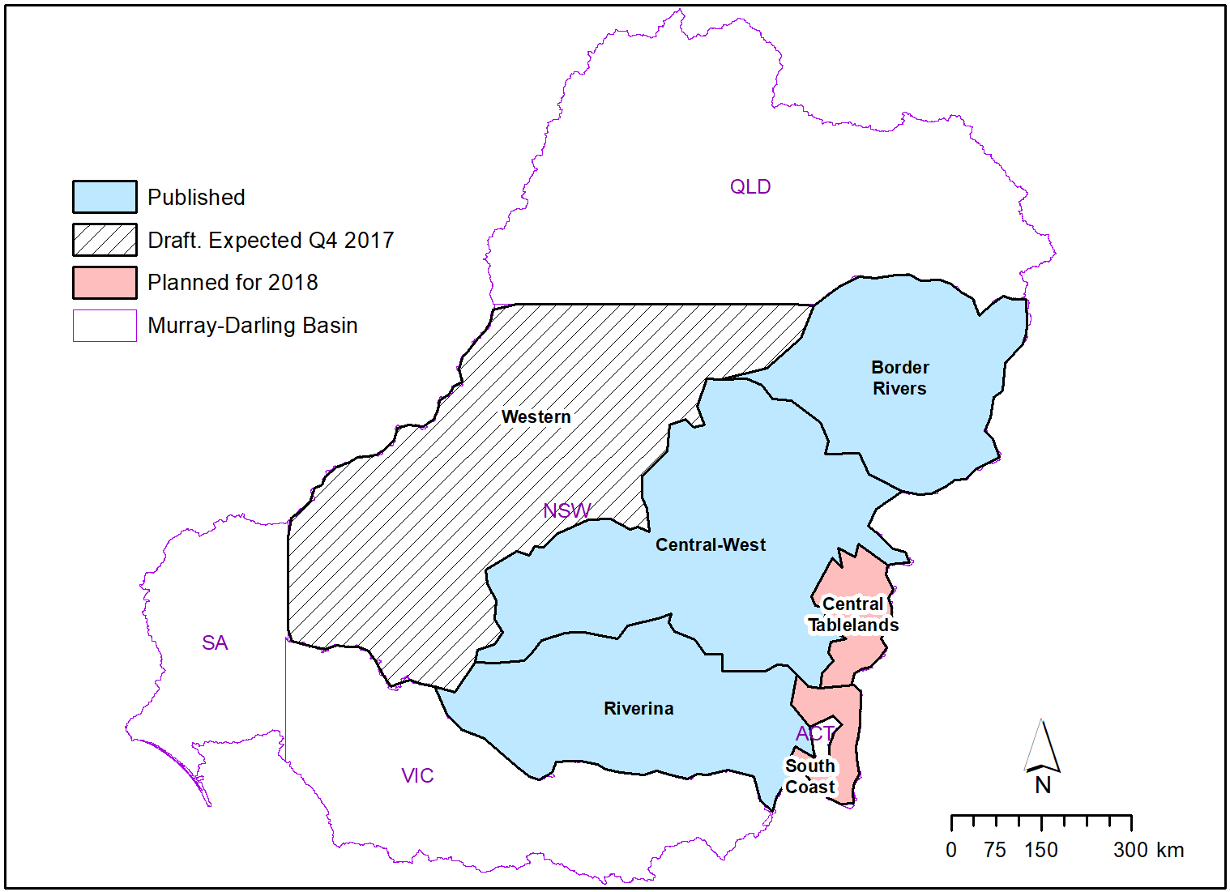

Figure 8: Extent and status of the new NSW state vegetation mapping. Published regions (blue) were used to update the ANAE classification in 2017. The Central Tablelands has recently been released as a draft and the Western region draft is expected to be finalised July 2018.

# Annex B. ANAE wetland types influenced by Commonwealth environmental water by valley

Lake and wetland types influenced by Commonwealth environmental water are represented by the entire wetland when any portion of the wetland was recorded as having been inundated. The contribution of Commonwealth environmental water to supporting wetland ecosystem diversity within each valley is presented below in Table B1.

Table B1. Area of each lake and wetland ecosystem type and the contribution of Commonwealth environmental water to supporting wetland ecosystem diversity within each valley, sorted by the area influenced with inundation highlighted in blue (excludes in-channel flows presented in Annex D).

| Valley name | Australian National Aquatic Ecosystem (ANAE) lake and wetland types | Total  area (ha) | Cew  Area (ha) | Percent |
| --- | --- | --- | --- | --- |
| Avoca | Lst1.1: Temporary saline lake | 19 829 | 0 | - |
| Avoca | Pt3.1.2: Clay pan | 18 587 | 0 | - |
| Avoca | Pt1.2.2: Temporary black box swamp | 4372 | 0 | - |
| Avoca | Lt1.1: Temporary lake | 4232 | 0 | - |
| Avoca | Lst1.2: Temporary saline lake with aquatic bed | 1820 | 0 | - |
| Avoca | Pst1.1: Temporary saline swamp | 1541 | 0 | - |
| Avoca | Pst2.2: Temporary salt marsh | 1174 | 0 | - |
| Avoca | Pt1.6.2: Temporary woodland swamp | 805 | 0 | - |
| Avoca | Pt2.3.2: Freshwater meadow | 723 | 0 | - |
| Avoca | Pt1.7.2: Temporary lignum swamp | 720 | 0 | - |
| Avoca | Pst3.2: Salt pan or salt flat | 309 | 0 | - |
| Avoca | Psp2.1: Permanent salt marsh | 209 | 0 | - |
| Avoca | Pt4.2: Temporary wetland | 208 | 0 | - |
| Avoca | Pt1.1.2: Temporary river red gum swamp | 145 | 0 | - |
| Avoca | Lsp1.1: Permanent saline lake | 137 | 0 | - |
| Avoca | Lp1.1: Permanent lake | 61 | 0 | - |
| Avoca | Pt1.8.2: Temporary shrub swamp | 51 | 0 | - |
| Avoca | Pp4.2: Permanent wetland | 50 | 0 | - |
| Avoca | Pst4: Temporary saline wetland | 50 | 0 | - |
| Avoca | Pt4.1: Floodplain or riparian wetland | 1 | 0 | - |
| Barwon Darling | Pt2.3.2: Freshwater meadow | 1225 | 412 | 33.6 |
| Barwon Darling | Lt1.1: Temporary lake | 56 914 | 0 | - |
| Barwon Darling | Lp1.1: Permanent lake | 31 477 | 0 | - |
| Barwon Darling | Pt1.6.2: Temporary woodland swamp | 16 269 | 0 | - |
| Barwon Darling | Pt1.8.2: Temporary shrub swamp | 10 914 | 0 | - |
| Barwon Darling | Pt1.2.2: Temporary black box swamp | 2956 | 0 | - |
| Barwon Darling | Pp4.2: Permanent wetland | 2566 | 0 | - |
| Barwon Darling | Pt2.2.2: Temporary sedge/grass/forb marsh | 1217 | 0 | - |
| Barwon Darling | Pt1.1.2: Temporary river red gum swamp | 378 | 0 | - |
| Barwon Darling | Pt3.1.2: Clay pan | 148 | 0 | - |
| Barwon Darling | Pt4.2: Temporary wetland | 63 | 0 | - |
| Border Rivers | Lt1.1: Temporary lake | 655 | 74 | 11.3 |
| Border Rivers | Pt2.2.2: Temporary sedge/grass/forb marsh | 8659 | 0 | - |
| Border Rivers | Pt4.2: Temporary wetland | 3495 | 0 | - |
| Border Rivers | Pt1.6.2: Temporary woodland swamp | 2486 | 0 | - |
| Border Rivers | Pp2.2.2: Permanent sedge/grass/forb marsh | 1405 | 0 | - |
| Border Rivers | Pp4.2: Permanent wetland | 1097 | 0 | - |
| Border Rivers | Lp1.1: Permanent lake | 938 | 0 | - |
| Border Rivers | Pt1.1.2: Temporary river red gum swamp | 718 | 0 | - |
| Border Rivers | Pp3: Peat bog or fen marsh | 633 | 0 | - |
| Border Rivers | Pt2.3.2: Freshwater meadow | 592 | 0 | - |
| Border Rivers | Lp1.2: Permanent lake with aquatic bed | 227 | 0 | - |
| Border Rivers | Pt3.1.2: Clay pan | 218 | 0 | - |
| Border Rivers | Pt2.1.2: Temporary tall emergent marsh | 96 | 0 | - |
| Border Rivers | Pp2.3.2: Permanent grass marsh | 26 | 0 | - |
| Border Rivers | Pt1.2.2: Temporary black box swamp | 13 | 0 | - |
| Border Rivers | Lt1.2: Temporary lake with aquatic bed | 12 | 0 | - |
| Border Rivers | Pt1.8.2: Temporary shrub swamp | 11 | 0 | - |
| Border Rivers | Pst1.1: Temporary saline swamp | 2 | 0 | - |
| Broken | Lp1.1: Permanent lake | 3305 | 0 | - |
| Broken | Pt3.1.2: Clay pan | 2998 | 0 | - |
| Broken | Pt1.1.2: Temporary river red gum swamp | 1911 | 0 | - |
| Broken | Pt1.6.2: Temporary woodland swamp | 427 | 0 | - |
| Broken | Pt2.3.2: Freshwater meadow | 268 | 0 | - |
| Broken | Pt1.7.2: Temporary lignum swamp | 192 | 0 | - |
| Broken | Lt1.1: Temporary lake | 104 | 0 | - |
| Broken | Pt2.1.2: Temporary tall emergent marsh | 98 | 0 | - |
| Broken | Pt1.2.2: Temporary black box swamp | 84 | 0 | - |
| Broken | Pt2.2.2: Temporary sedge/grass/forb marsh | 77 | 0 | - |
| Broken | Pt4.1: Floodplain or riparian wetland | 66 | 0 | - |
| Broken | Pp4.2: Permanent wetland | 43 | 0 | - |
| Campaspe | Pt3.1.2: Clay pan | 1887 | 0 | - |
| Campaspe | Pt1.1.2: Temporary river red gum swamp | 280 | 0 | - |
| Campaspe | Pt1.6.2: Temporary woodland swamp | 232 | 0 | - |
| Campaspe | Lt1.1: Temporary lake | 49 | 0 | - |
| Campaspe | Pt2.1.2: Temporary tall emergent marsh | 24 | 0 | - |
| Campaspe | Lp1.1: Permanent lake | 12 | 0 | - |
| Campaspe | Pt2.3.2: Freshwater meadow | 10 | 0 | - |
| Campaspe | Pp4.2: Permanent wetland | 4 | 0 | - |
| Campaspe | Pps5: Permanent spring | 1 | 0 | - |
| Castlereagh | Pt2.2.2: Temporary sedge/grass/forb marsh | 10 737 | 0 | - |
| Castlereagh | Lt1.1: Temporary lake | 456 | 0 | - |
| Castlereagh | Pt1.8.2: Temporary shrub swamp | 51 | 0 | - |
| Castlereagh | Pt1.6.2: Temporary woodland swamp | 35 | 0 | - |
| Castlereagh | Pt3.1.2: Clay pan | 30 | 0 | - |
| Castlereagh | Pt1.2.2: Temporary black box swamp | 26 | 0 | - |
| Castlereagh | Pp4.2: Permanent wetland | 18 | 0 | - |
| Castlereagh | Pt2.1.2: Temporary tall emergent marsh | 16 | 0 | - |
| Castlereagh | Pp2.2.2: Permanent sedge/grass/forb marsh | 8 | 0 | - |
| Castlereagh | Lp1.1: Permanent lake | 6 | 0 | - |
| Castlereagh | Pps5: Permanent spring | 1 | 0 | - |
| Castlereagh | Pt1.1.2: Temporary river red gum swamp | 1 | 0 | - |
| Castlereagh | Pt2.3.2: Freshwater meadow | 1 | 0 | - |
| Central Murray | Lp1.1: Permanent lake | 4518 | 1375 | 30.4 |
| Central Murray | Lt1.1: Temporary lake | 13 062 | 1243 | 9.5 |
| Central Murray | Pp4.2: Permanent wetland | 9222 | 496 | 5.4 |
| Central Murray | Pt2.3.2: Freshwater meadow | 5185 | 117 | 2.3 |
| Central Murray | Pt1.1.2: Temporary river red gum swamp | 38 447 | 76 | 0.2 |
| Central Murray | Pt3.1.2: Clay pan | 17 536 | 39 | 0.2 |
| Central Murray | Pt1.8.2: Temporary shrub swamp | 638 | 13 | 2.0 |
| Central Murray | Pp2.4.2: Permanent forb marsh | 133 | 7 | 5.3 |
| Central Murray | Pt1.2.2: Temporary black box swamp | 4137 | 6 | 0.1 |
| Central Murray | Pt2.2.2: Temporary sedge/grass/forb marsh | 2856 | 0 | - |
| Central Murray | Pst2.2: Temporary salt marsh | 2122 | 0 | - |
| Central Murray | Pst4: Temporary saline wetland | 2114 | 0 | - |
| Central Murray | Pt1.7.2: Temporary lignum swamp | 1602 | 0 | - |
| Central Murray | Pt1.6.2: Temporary woodland swamp | 1543 | 0 | - |
| Central Murray | Pt2.1.2: Temporary tall emergent marsh | 1475 | 0 | - |
| Central Murray | Lst1.1: Temporary saline lake | 1303 | 0 | - |
| Central Murray | Pp2.1.2: Permanent tall emergent marsh | 1169 | 0 | - |
| Central Murray | Pst3.2: Salt pan or salt flat | 732 | 0 | - |
| Central Murray | Pt4.2: Temporary wetland | 654 | 0 | - |
| Central Murray | Psp4: Permanent saline wetland | 642 | 0 | - |
| Central Murray | Pt4.1: Floodplain or riparian wetland | 462 | 0 | - |
| Central Murray | Lsp1.1: Permanent saline lake | 461 | 0 | - |
| Central Murray | Pp2.3.2: Permanent grass marsh | 80 | 0 | - |
| Central Murray | Pp2.2.2: Permanent sedge/grass/forb marsh | 45 | 0 | - |
| Central Murray | Pst1.1: Temporary saline swamp | 22 | 0 | - |
| Condamine Balonne | Pt1.7.2: Temporary lignum swamp | 11 804 | 11 695 | 99.1 |
| Condamine Balonne | Lp1.1: Permanent lake | 6454 | 5201 | 80.6 |
| Condamine Balonne | Pp4.2: Permanent wetland | 3754 | 445 | 11.9 |
| Condamine Balonne | Pt2.1.2: Temporary tall emergent marsh | 38 236 | 0 | - |
| Condamine Balonne | Pt1.8.2: Temporary shrub swamp | 29 303 | 0 | - |
| Condamine Balonne | Pt1.6.2: Temporary woodland swamp | 13 223 | 0 | - |
| Condamine Balonne | Lt1.1: Temporary lake | 11 526 | 0 | - |
| Condamine Balonne | Pt4.2: Temporary wetland | 8822 | 0 | - |
| Condamine Balonne | Pt1.2.2: Temporary black box swamp | 4684 | 0 | - |
| Condamine Balonne | Pt2.2.2: Temporary sedge/grass/forb marsh | 4248 | 0 | - |
| Condamine Balonne | Pt2.3.2: Freshwater meadow | 4102 | 0 | - |
| Condamine Balonne | Pp2.1.2: Permanent tall emergent marsh | 2522 | 0 | - |
| Condamine Balonne | Pt3.1.2: Clay pan | 1872 | 0 | - |
| Condamine Balonne | Lp1.2: Permanent lake with aquatic bed | 1648 | 0 | - |
| Condamine Balonne | Lst1.1: Temporary saline lake | 1624 | 0 | - |
| Condamine Balonne | Pt1.1.2: Temporary river red gum swamp | 1116 | 0 | - |
| Condamine Balonne | Lt1.2: Temporary lake with aquatic bed | 684 | 0 | - |
| Condamine Balonne | Pt1.5.2: Temporary paperbark swamp | 95 | 0 | - |
| Condamine Balonne | Pp2.3.2: Permanent grass marsh | 23 | 0 | - |
| Condamine Balonne | Pps5: Permanent spring | 6 | 0 | - |
| Condamine Balonne | Lsp1.1: Permanent saline lake | 3 | 0 | - |
| Condamine Balonne | Pst4: Temporary saline wetland | 1 | 0 | - |
| Edward Wakool | Pt3.1.2: Clay pan | 3581 | 0 | - |
| Edward Wakool | Pt1.2.2: Temporary black box swamp | 1663 | 0 | - |
| Edward Wakool | Pt1.1.2: Temporary river red gum swamp | 1318 | 0 | - |
| Edward Wakool | Lt1.1: Temporary lake | 886 | 0 | - |
| Edward Wakool | Pp4.2: Permanent wetland | 814 | 0 | - |
| Edward Wakool | Pt2.3.2: Freshwater meadow | 628 | 0 | - |
| Edward Wakool | Pt1.6.2: Temporary woodland swamp | 421 | 0 | - |
| Edward Wakool | Pt1.8.2: Temporary shrub swamp | 280 | 0 | - |
| Edward Wakool | Pt2.2.2: Temporary sedge/grass/forb marsh | 213 | 0 | - |
| Edward Wakool | Pt1.7.2: Temporary lignum swamp | 175 | 0 | - |
| Edward Wakool | Lp1.1: Permanent lake | 131 | 0 | - |
| Edward Wakool | Pt2.1.2: Temporary tall emergent marsh | 59 | 0 | - |
| Edward Wakool | Pp2.3.2: Permanent grass marsh | 19 | 0 | - |
| Edward Wakool | Pp2.1.2: Permanent tall emergent marsh | 7 | 0 | - |
| Edward Wakool | Psp4: Permanent saline wetland | 6 | 0 | - |
| Edward Wakool | Pst1.1: Temporary saline swamp | 5 | 0 | - |
| Edward Wakool | Pp2.2.2: Permanent sedge/grass/forb marsh | 1 | 0 | - |
| Goulburn | Pt3.1.2: Clay pan | 10 949 | 0 | - |
| Goulburn | Pt1.1.2: Temporary river red gum swamp | 5177 | 0 | - |
| Goulburn | Lt1.1: Temporary lake | 1598 | 0 | - |
| Goulburn | Lp1.1: Permanent lake | 1086 | 0 | - |
| Goulburn | Pp4.2: Permanent wetland | 1060 | 0 | - |
| Goulburn | Pt1.6.2: Temporary woodland swamp | 869 | 0 | - |
| Goulburn | Pt2.1.2: Temporary tall emergent marsh | 828 | 0 | - |
| Goulburn | Pt2.3.2: Freshwater meadow | 815 | 0 | - |
| Goulburn | Pt1.7.2: Temporary lignum swamp | 631 | 0 | - |
| Goulburn | Pp2.4.2: Permanent forb marsh | 571 | 0 | - |
| Goulburn | Lst1.2: Temporary saline lake with aquatic bed | 238 | 0 | - |
| Goulburn | Pt2.2.2: Temporary sedge/grass/forb marsh | 189 | 0 | - |
| Goulburn | Pt4.1: Floodplain or riparian wetland | 184 | 0 | - |
| Goulburn | Pt1.2.2: Temporary black box swamp | 118 | 0 | - |
| Goulburn | Lsp1.1: Permanent saline lake | 46 | 0 | - |
| Goulburn | Lst1.1: Temporary saline lake | 25 | 0 | - |
| Goulburn | Pt4.2: Temporary wetland | 19 | 0 | - |
| Goulburn | Pp2.1.2: Permanent tall emergent marsh | 4 | 0 | - |
| Goulburn | Pst4: Temporary saline wetland | 2 | 0 | - |
| Goulburn | Pt1.8.2: Temporary shrub swamp | 2 | 0 | - |
| Gwydir | Pt2.2.2: Temporary sedge/grass/forb marsh | 10 051 | 6218 | 61.9 |
| Gwydir | Pt2.1.2: Temporary tall emergent marsh | 373 | 373 | 10- |
| Gwydir | Lt1.1: Temporary lake | 1142 | 69 | 6.0 |
| Gwydir | Pt3.1.2: Clay pan | 236 | 42 | 17.8 |
| Gwydir | Lp1.1: Permanent lake | 77 | 26 | 33.8 |
| Gwydir | Pp4.2: Permanent wetland | 354 | 1 | 0.3 |
| Gwydir | Pp2.2.2: Permanent sedge/grass/forb marsh | 1579 | 0 | - |
| Gwydir | Pt4.2: Temporary wetland | 374 | 0 | - |
| Gwydir | Pp3: Peat bog or fen marsh | 185 | 0 | - |
| Gwydir | Pt1.6.2: Temporary woodland swamp | 183 | 0 | - |
| Gwydir | Pt1.8.2: Temporary shrub swamp | 92 | 0 | - |
| Gwydir | Pt1.1.2: Temporary river red gum swamp | 13 | 0 | - |
| Gwydir | Pt2.3.2: Freshwater meadow | 6 | 0 | - |
| Gwydir | Pt1.2.2: Temporary black box swamp | 4 | 0 | - |
| Gwydir | Pp1.1.2: Permanent paperbark swamp | 1 | 0 | - |
| Kiewa | Pp4.2: Permanent wetland | 749 | 0 | - |
| Kiewa | Pt3.1.2: Clay pan | 323 | 0 | - |
| Kiewa | Pt1.6.2: Temporary woodland swamp | 39 | 0 | - |
| Kiewa | Lp1.1: Permanent lake | 37 | 0 | - |
| Kiewa | Pt1.1.2: Temporary river red gum swamp | 25 | 0 | - |
| Kiewa | Pt2.2.2: Temporary sedge/grass/forb marsh | 12 | 0 | - |
| Kiewa | Pt2.1.2: Temporary tall emergent marsh | 3 | 0 | - |
| Lachlan | Pt1.8.2: Temporary shrub swamp | 21 194 | 121 | 0.6 |
| Lachlan | Pp4.2: Permanent wetland | 2915 | 23 | 0.8 |
| Lachlan | Lt1.1: Temporary lake | 32 280 | 0 | - |
| Lachlan | Pst2.2: Temporary salt marsh | 30 311 | 0 | - |
| Lachlan | Pt1.7.2: Temporary lignum swamp | 22 220 | 0 | - |
| Lachlan | Pt2.3.2: Freshwater meadow | 21 013 | 0 | - |
| Lachlan | Pt1.2.2: Temporary black box swamp | 15 294 | 0 | - |
| Lachlan | Pt3.1.2: Clay pan | 14 938 | 0 | - |
| Lachlan | Pt2.2.2: Temporary sedge/grass/forb marsh | 13 535 | 0 | - |
| Lachlan | Lp1.1: Permanent lake | 7907 | 0 | - |
| Lachlan | Pp2.1.2: Permanent tall emergent marsh | 3450 | 0 | - |
| Lachlan | Pt1.6.2: Temporary woodland swamp | 3305 | 0 | - |
| Lachlan | Pt1.1.2: Temporary river red gum swamp | 2206 | 0 | - |
| Lachlan | Pt2.1.2: Temporary tall emergent marsh | 588 | 0 | - |
| Lachlan | Pt4.2: Temporary wetland | 348 | 0 | - |
| Lachlan | Pp2.2.2: Permanent sedge/grass/forb marsh | 63 | 0 | - |
| Lachlan | Pp2.3.2: Permanent grass marsh | 44 | 0 | - |
| Lachlan | Pps5: Permanent spring | 7 | 0 | - |
| Loddon | Pt3.1.2: Clay pan | 12 139 | 0 | - |
| Loddon | Lp1.1: Permanent lake | 5976 | 0 | - |
| Loddon | Pt1.2.2: Temporary black box swamp | 5762 | 0 | - |
| Loddon | Pt1.7.2: Temporary lignum swamp | 3995 | 0 | - |
| Loddon | Pt2.3.2: Freshwater meadow | 3483 | 0 | - |
| Loddon | Lst1.1: Temporary saline lake | 1478 | 0 | - |
| Loddon | Pt1.6.2: Temporary woodland swamp | 1404 | 0 | - |
| Loddon | Pst1.1: Temporary saline swamp | 1379 | 0 | - |
| Loddon | Pt1.1.2: Temporary river red gum swamp | 1256 | 0 | - |
| Loddon | Lsp1.1: Permanent saline lake | 1252 | 0 | - |
| Loddon | Lt1.1: Temporary lake | 417 | 0 | - |
| Loddon | Pp4.2: Permanent wetland | 314 | 0 | - |
| Loddon | Lsp1.2: Permanent saline lake with aquatic bed | 181 | 0 | - |
| Loddon | Pst3.2: Salt pan or salt flat | 109 | 0 | - |
| Loddon | Pt1.8.2: Temporary shrub swamp | 109 | 0 | - |
| Loddon | Lt1.2: Temporary lake with aquatic bed | 55 | 0 | - |
| Loddon | Pst4: Temporary saline wetland | 55 | 0 | - |
| Loddon | Pt2.1.2: Temporary tall emergent marsh | 54 | 0 | - |
| Loddon | Psp2.1: Permanent salt marsh | 37 | 0 | - |
| Loddon | Pst2.2: Temporary salt marsh | 28 | 0 | - |
| Loddon | Pps5: Permanent spring | 4 | 0 | - |
| Lower Darling | Pp4.2: Permanent wetland | 1221 | 30 | 2.5 |
| Lower Darling | Pt1.1.2: Temporary river red gum swamp | 879 | 2 | 0.2 |
| Lower Darling | Lt1.1: Temporary lake | 187 338 | 0 | - |
| Lower Darling | Pt1.8.2: Temporary shrub swamp | 103 569 | 0 | - |
| Lower Darling | Lp1.1: Permanent lake | 9685 | 0 | - |
| Lower Darling | Pt2.3.2: Freshwater meadow | 8082 | 0 | - |
| Lower Darling | Pt1.6.2: Temporary woodland swamp | 4422 | 0 | - |
| Lower Darling | Pt1.2.2: Temporary black box swamp | 1921 | 0 | - |
| Lower Darling | Pt3.1.2: Clay pan | 1470 | 0 | - |
| Lower Darling | Lst1.1: Temporary saline lake | 509 | 0 | - |
| Lower Darling | Pt4.2: Temporary wetland | 53 | 0 | - |
| Lower Darling | Pp2.3.2: Permanent grass marsh | 26 | 0 | - |
| Lower Darling | Pst2.2: Temporary salt marsh | 4 | 0 | - |
| Lower Murray | Pt2.3.2: Freshwater meadow | 8938 | 2150 | 24.1 |
| Lower Murray | Pt4.1: Floodplain or riparian wetland | 9646 | 1008 | 10.4 |
| Lower Murray | Lt1.1: Temporary lake | 30 729 | 825 | 2.7 |
| Lower Murray | Pt1.7.2: Temporary lignum swamp | 2651 | 733 | 27.6 |
| Lower Murray | Pp4.2: Permanent wetland | 4362 | 651 | 14.9 |
| Lower Murray | Pt3.1.2: Clay pan | 8717 | 251 | 2.9 |
| Lower Murray | Psp4: Permanent saline wetland | 1450 | 172 | 11.9 |
| Lower Murray | Pt1.8.2: Temporary shrub swamp | 2987 | 154 | 5.2 |
| Lower Murray | Pt1: Temporary swamp | 3767 | 132 | 3.5 |
| Lower Murray | Pt1.1.2: Temporary river red gum swamp | 503 | 121 | 24.1 |
| Lower Murray | Pp2.3.2: Permanent grass marsh | 109 | 95 | 87.2 |
| Lower Murray | Lp1.1: Permanent lake | 21 652 | 64 | 0.3 |
| Lower Murray | Pt2.1.2: Temporary tall emergent marsh | 3787 | 51 | 1.3 |
| Lower Murray | Pt1.2.2: Temporary black box swamp | 412 | 33 | 8.0 |
| Lower Murray | Pp2.4.2: Permanent forb marsh | 34 | 24 | 70.6 |
| Lower Murray | Pu1: Unspecified wetland | 1763 | 0 | - |
| Lower Murray | Lst1.1: Temporary saline lake | 1529 | 0 | - |
| Lower Murray | Pt1.6.2: Temporary woodland swamp | 862 | 0 | - |
| Lower Murray | Pt4.2: Temporary wetland | 687 | 0 | - |
| Lower Murray | Pst1.1: Temporary saline swamp | 545 | 0 | - |
| Lower Murray | Pst3.2: Salt pan or salt flat | 417 | 0 | - |
| Lower Murray | Lsp1.1: Permanent saline lake | 242 | 0 | - |
| Lower Murray | Psp1.1: Saline paperbark swamp | 132 | 0 | - |
| Lower Murray | Pt1.5.2: Temporary paperbark swamp | 132 | 0 | - |
| Lower Murray | Pst4: Temporary saline wetland | 125 | 0 | - |
| Lower Murray | Pt2.2.2: Temporary sedge/grass/forb marsh | 41 | 0 | - |
| Lower Murray | Pst2.2: Temporary salt marsh | 26 | 0 | - |
| Lower Murray | Pp2.1.2: Permanent tall emergent marsh | 2 | 0 | - |
| Lower Murray | Pps5: Permanent spring | 2 | 0 | - |
| Lower Murray | Psp2.1: Permanent salt marsh | 1 | 0 | - |
| Macquarie | Pp4.2: Permanent wetland | 18 998 | 18 032 | 94.9 |
| Macquarie | Pt2.2.2: Temporary sedge/grass/forb marsh | 41 785 | 9 866 | 23.6 |
| Macquarie | Pt1.1.2: Temporary river red gum swamp | 5783 | 5 156 | 89.2 |
| Macquarie | Pt2.1.2: Temporary tall emergent marsh | 3014 | 2 454 | 81.4 |
| Macquarie | Pt1.8.2: Temporary shrub swamp | 1704 | 781 | 45.8 |
| Macquarie | Lt1.1: Temporary lake | 9214 | 249 | 2.7 |
| Macquarie | Pt1.6.2: Temporary woodland swamp | 2636 | 186 | 7.1 |
| Macquarie | Pt1.2.2: Temporary black box swamp | 1919 | 55 | 2.9 |
| Macquarie | Lp1.1: Permanent lake | 814 | 33 | 4.1 |
| Macquarie | Pt3.1.2: Clay pan | 1895 | 16 | 0.8 |
| Macquarie | Pp2.2.2: Permanent sedge/grass/forb marsh | 46 | 15 | 32.6 |
| Macquarie | Pt2.3.2: Freshwater meadow | 2348 | 0 | - |
| Macquarie | Pt4.2: Temporary wetland | 1442 | 0 | - |
| Macquarie | Pps5: Permanent spring | 15 | 0 | - |
| Macquarie | Pp3: Peat bog or fen marsh | 9 | 0 | - |
| Mitta Mitta | Pp4.2: Permanent wetland | 984 | 0 | - |
| Mitta Mitta | Pt2.3.2: Freshwater meadow | 626 | 0 | - |
| Mitta Mitta | Pt3.1.2: Clay pan | 594 | 0 | - |
| Mitta Mitta | Pt1.6.2: Temporary woodland swamp | 562 | 0 | - |
| Mitta Mitta | Pt1.8.2: Temporary shrub swamp | 449 | 0 | - |
| Mitta Mitta | Lp1.1: Permanent lake | 86 | 0 | - |
| Mitta Mitta | Pt4.2: Temporary wetland | 57 | 0 | - |
| Mitta Mitta | Pt1.1.2: Temporary river red gum swamp | 3 | 0 | - |
| Murrumbidgee | Pt1.1.2: Temporary river red gum swamp | 7371 | 2161 | 29.3 |
| Murrumbidgee | Pt3.1.2: Clay pan | 17 188 | 1350 | 7.9 |
| Murrumbidgee | Pt1.8.2: Temporary shrub swamp | 22 695 | 1054 | 4.6 |
| Murrumbidgee | Pt2.2.2: Temporary sedge/grass/forb marsh | 30 863 | 833 | 2.7 |
| Murrumbidgee | Pp4.2: Permanent wetland | 8910 | 417 | 4.7 |
| Murrumbidgee | Pt2.1.2: Temporary tall emergent marsh | 855 | 239 | 28.0 |
| Murrumbidgee | Lp1.1: Permanent lake | 1484 | 140 | 9.4 |
| Murrumbidgee | Pt1.2.2: Temporary black box swamp | 4795 | 134 | 2.8 |
| Murrumbidgee | Pt2.3.2: Freshwater meadow | 35 225 | 95 | 0.3 |
| Murrumbidgee | Lt1.1: Temporary lake | 30 616 | 24 | 0.1 |
| Murrumbidgee | Pst2.2: Temporary salt marsh | 1739 | 1 | 0.1 |
| Murrumbidgee | Pp3: Peat bog or fen marsh | 1784 | 0 | - |
| Murrumbidgee | Pt1.6.2: Temporary woodland swamp | 1611 | 0 | - |
| Murrumbidgee | Pt4.2: Temporary wetland | 1475 | 0 | - |
| Murrumbidgee | Pt1.7.2: Temporary lignum swamp | 1464 | 0 | - |
| Murrumbidgee | Pp2.1.2: Permanent tall emergent marsh | 186 | 0 | - |
| Murrumbidgee | Pp2.3.2: Permanent grass marsh | 36 | 0 | - |
| Murrumbidgee | Pp2.2.2: Permanent sedge/grass/forb marsh | 31 | 0 | - |
| Murrumbidgee | Pps5: Permanent spring | 19 | 0 | - |
| Namoi | Pp4.2: Permanent wetland | 11 298 | 0 | - |
| Namoi | Pt3.1.2: Clay pan | 5331 | 0 | - |
| Namoi | Pt2.2.2: Temporary sedge/grass/forb marsh | 5183 | 0 | - |
| Namoi | Lp1.1: Permanent lake | 5123 | 0 | - |
| Namoi | Pt4.2: Temporary wetland | 3510 | 0 | - |
| Namoi | Pt1.6.2: Temporary woodland swamp | 3427 | 0 | - |
| Namoi | Lt1.1: Temporary lake | 2604 | 0 | - |
| Namoi | Pt1.2.2: Temporary black box swamp | 1771 | 0 | - |
| Namoi | Pt1.1.2: Temporary river red gum swamp | 1618 | 0 | - |
| Namoi | Pt2.3.2: Freshwater meadow | 622 | 0 | - |
| Namoi | Pt1.8.2: Temporary shrub swamp | 567 | 0 | - |
| Namoi | Pp2.2.2: Permanent sedge/grass/forb marsh | 392 | 0 | - |
| Namoi | Pp3: Peat bog or fen marsh | 17 | 0 | - |
| Namoi | Pt1.7.2: Temporary lignum swamp | 16 | 0 | - |
| Namoi | Pps5: Permanent spring | 1 | 0 | - |
| Ovens | Pt3.1.2: Clay pan | 2015 | 0 | - |
| Ovens | Pt2.3.2: Freshwater meadow | 915 | 0 | - |
| Ovens | Pt1.6.2: Temporary woodland swamp | 818 | 0 | - |
| Ovens | Pt1.1.2: Temporary river red gum swamp | 441 | 0 | - |
| Ovens | Pp4.2: Permanent wetland | 213 | 0 | - |
| Ovens | Pt4.2: Temporary wetland | 106 | 0 | - |
| Ovens | Lp1.1: Permanent lake | 80 | 0 | - |
| Ovens | Pt2.1.2: Temporary tall emergent marsh | 47 | 0 | - |
| Ovens | Pt2.2.2: Temporary sedge/grass/forb marsh | 45 | 0 | - |
| Ovens | Pp2.1.2: Permanent tall emergent marsh | 30 | 0 | - |
| Ovens | Pt4.1: Floodplain or riparian wetland | 23 | 0 | - |
| Ovens | Lt1.1: Temporary lake | 4 | 0 | - |
| Paroo | Pt1.6.2: Temporary woodland swamp | 152 703 | 0 | - |
| Paroo | Lt1.1: Temporary lake | 44 652 | 0 | - |
| Paroo | Pt1.8.2: Temporary shrub swamp | 29 765 | 0 | - |
| Paroo | Lp1.1: Permanent lake | 18 283 | 0 | - |
| Paroo | Pt2.1.2: Temporary tall emergent marsh | 12 485 | 0 | - |
| Paroo | Pt1.2.2: Temporary black box swamp | 8427 | 0 | - |
| Paroo | Pt2.3.2: Freshwater meadow | 7398 | 0 | - |
| Paroo | Lsp1.1: Permanent saline lake | 5868 | 0 | - |
| Paroo | Pp4.2: Permanent wetland | 4470 | 0 | - |
| Paroo | Pt2.2.2: Temporary sedge/grass/forb marsh | 4165 | 0 | - |
| Paroo | Pt1.7.2: Temporary lignum swamp | 3471 | 0 | - |
| Paroo | Pt4.2: Temporary wetland | 1949 | 0 | - |
| Paroo | Pst2.2: Temporary salt marsh | 1449 | 0 | - |
| Paroo | Pp2.1.2: Permanent tall emergent marsh | 586 | 0 | - |
| Paroo | Lst1.1: Temporary saline lake | 371 | 0 | - |
| Paroo | Pt1.1.2: Temporary river red gum swamp | 111 | 0 | - |
| Paroo | Pst4: Temporary saline wetland | 77 | 0 | - |
| Paroo | Pt3.1.2: Clay pan | 31 | 0 | - |
| Paroo | Pps5: Permanent spring | 9 | 0 | - |
| Upper Murray | Pp3: Peat bog or fen marsh | 1611 | 0 | - |
| Upper Murray | Pt3.1.2: Clay pan | 1457 | 0 | - |
| Upper Murray | Pp2.3.2: Permanent grass marsh | 1144 | 0 | - |
| Upper Murray | Pt2.2.2: Temporary sedge/grass/forb marsh | 725 | 0 | - |
| Upper Murray | Pp4.2: Permanent wetland | 408 | 0 | - |
| Upper Murray | Pt1.1.2: Temporary river red gum swamp | 290 | 0 | - |
| Upper Murray | Pt1.6.2: Temporary woodland swamp | 137 | 0 | - |
| Upper Murray | Lp1.1: Permanent lake | 94 | 0 | - |
| Upper Murray | Pps5: Permanent spring | 63 | 0 | - |
| Upper Murray | Lt1.1: Temporary lake | 50 | 0 | - |
| Upper Murray | Pt4.2: Temporary wetland | 50 | 0 | - |
| Upper Murray | Pt2.3.2: Freshwater meadow | 24 | 0 | - |
| Upper Murray | Pp2.1.2: Permanent tall emergent marsh | 16 | 0 | - |
| Upper Murray | Pt2.1.2: Temporary tall emergent marsh | 3 | 0 | - |
| Upper Murray | Pp2.2.2: Permanent sedge/grass/forb marsh | 1 | 0 | - |
| Warrego | Pt2.3.2: Freshwater meadow | 19 130 | 17 734 | 92.7 |
| Warrego | Pt1.6.2: Temporary woodland swamp | 4611 | 0 | - |
| Warrego | Pt2.1.2: Temporary tall emergent marsh | 4389 | 0 | - |
| Warrego | Pt1.8.2: Temporary shrub swamp | 3691 | 0 | - |
| Warrego | Lp1.1: Permanent lake | 3277 | 0 | - |
| Warrego | Pp4.2: Permanent wetland | 3227 | 0 | - |
| Warrego | Lt1.1: Temporary lake | 2330 | 0 | - |
| Warrego | Pt4.2: Temporary wetland | 1573 | 0 | - |
| Warrego | Pt2.2.2: Temporary sedge/grass/forb marsh | 875 | 0 | - |
| Warrego | Pt3.1.2: Clay pan | 653 | 0 | - |
| Warrego | Pp2.1.2: Permanent tall emergent marsh | 23 | 0 | - |
| Warrego | Pt1.1.2: Temporary river red gum swamp | 12 | 0 | - |
| Warrego | Pps5: Permanent spring | 2 | 0 | - |
| Warrego | Pst1.1: Temporary saline swamp | 2 | 0 | - |
| Wimmera | Lt1.1: Temporary lake | 25 070 | 0 | - |
| Wimmera | Lt1.2: Temporary lake with aquatic bed | 8300 | 0 | - |
| Wimmera | Pt1.8.2: Temporary shrub swamp | 5885 | 0 | - |
| Wimmera | Pt3.1.2: Clay pan | 4918 | 0 | - |
| Wimmera | Pt1.1.2: Temporary river red gum swamp | 4712 | 0 | - |
| Wimmera | Pt2.3.2: Freshwater meadow | 3729 | 0 | - |
| Wimmera | Pst4: Temporary saline wetland | 3311 | 0 | - |
| Wimmera | Pt1.6.2: Temporary woodland swamp | 3222 | 0 | - |
| Wimmera | Pst1.1: Temporary saline swamp | 2232 | 0 | - |
| Wimmera | Pt1.2.2: Temporary black box swamp | 1912 | 0 | - |
| Wimmera | Pst3.2: Salt pan or salt flat | 1633 | 0 | - |
| Wimmera | Lp1.1: Permanent lake | 1541 | 0 | - |
| Wimmera | Lst1.1: Temporary saline lake | 1132 | 0 | - |
| Wimmera | Pt4.2: Temporary wetland | 559 | 0 | - |
| Wimmera | Pst2.2: Temporary salt marsh | 404 | 0 | - |
| Wimmera | Lp1.2: Permanent lake with aquatic bed | 192 | 0 | - |
| Wimmera | Pt1.5.2: Temporary paperbark swamp | 185 | 0 | - |
| Wimmera | Lst1.2: Temporary saline lake with aquatic bed | 180 | 0 | - |
| Wimmera | Pt1.7.2: Temporary lignum swamp | 174 | 0 | - |
| Wimmera | Pp4.2: Permanent wetland | 145 | 0 | - |
| Wimmera | Pt2.1.2: Temporary tall emergent marsh | 127 | 0 | - |
| Wimmera | Pt4.1: Floodplain or riparian wetland | 111 | 0 | - |
| Wimmera | Psp1.1: Saline paperbark swamp | 31 | 0 | - |
| Wimmera | Lsp1.1: Permanent saline lake | 24 | 0 | - |
| Wimmera | Psp4: Permanent saline wetland | 16 | 0 | - |

# Annex C. ANAE floodplain types inundated by Commonwealth environmental water by valley

For floodplains, the area inundated by out-of-channel delivery of Commonwealth environmental water is presented in Table C1.

Table C1. Area of each floodplain ecosystem type and the contribution of Commonwealth environmental water to supporting floodplain ecosystem diversity within each valley, sorted by the area inundated with inundation highlighted in blue.

| Valley name | Australian National Aquatic Ecosystem (ANAE) floodplain type | Total  Length (km) | Cew  Length (km) | Percent |
| --- | --- | --- | --- | --- |
| Avoca | F1.4: River red gum woodland riparian zone or floodplain | 3128 | 0 | - |
| Avoca | F1.8: Black box woodland riparian zone or floodplain | 2988 | 0 | - |
| Avoca | F1.6: Black box forest riparian zone or floodplain | 977 | 0 | - |
| Avoca | F1.12: Woodland riparian zone or floodplain | 891 | 0 | - |
| Avoca | F2.2: Lignum shrubland riparian zone or floodplain | 80 | 0 | - |
| Avoca | F2.4: Shrubland riparian zone or floodplain | 4 | 0 | - |
| Avoca | F1.2: River red gum forest riparian zone or floodplain | 1 | 0 | - |
| Barwon Darling | F3.2: Sedge/forb/grassland riparian zone or floodplain | 238 708 | 0 | - |
| Barwon Darling | F1.8: Black box woodland riparian zone or floodplain | 74 613 | 0 | - |
| Barwon Darling | F4: Unspecified riparian zone or floodplain | 69 185 | 0 | - |
| Barwon Darling | F2.4: Shrubland riparian zone or floodplain | 38 445 | 0 | - |
| Barwon Darling | F1.6: Black box forest riparian zone or floodplain | 26 262 | 0 | - |
| Barwon Darling | F1.10: Coolibah woodland and forest riparian zone or floodplain | 14 516 | 0 | - |
| Barwon Darling | F1.12: Woodland riparian zone or floodplain | 4544 | 0 | - |
| Barwon Darling | F1.2: River red gum forest riparian zone or floodplain | 3997 | 0 | - |
| Barwon Darling | F2.2: Lignum shrubland riparian zone or floodplain | 1049 | 0 | - |
| Barwon Darling | F1.4: River red gum woodland riparian zone or floodplain | 346 | 0 | - |
| Barwon Darling | F1.11: River cooba woodland riparian zone or floodplain | 17 | 0 | - |
| Border Rivers | F1.4: River red gum woodland riparian zone or floodplain | 666 | 30 | 4.5 |
| Border Rivers | F1.2: River red gum forest riparian zone or floodplain | 27 172 | 15 | 0.1 |
| Border Rivers | F1.12: Woodland riparian zone or floodplain | 24 909 | 3 | <0.1 |
| Border Rivers | F1.10: Coolibah woodland and forest riparian zone or floodplain | 71 383 | 0 | - |
| Border Rivers | F3.2: Sedge/forb/grassland riparian zone or floodplain | 14 098 | 0 | - |
| Border Rivers | F4: Unspecified riparian zone or floodplain | 5657 | 0 | - |
| Border Rivers | F1.8: Black box woodland riparian zone or floodplain | 3196 | 0 | - |
| Border Rivers | F2.2: Lignum shrubland riparian zone or floodplain | 2488 | 0 | - |
| Border Rivers | F1.11: River cooba woodland riparian zone or floodplain | 2322 | 0 | - |
| Border Rivers | F1.6: Black box forest riparian zone or floodplain | 1104 | 0 | - |
| Border Rivers | F2.4: Shrubland riparian zone or floodplain | 371 | 0 | - |
| Broken | F1.4: River red gum woodland riparian zone or floodplain | 4503 | 0 | - |
| Broken | F1.12: Woodland riparian zone or floodplain | 1355 | 0 | - |
| Broken | F1.8: Black box woodland riparian zone or floodplain | 61 | 0 | - |
| Broken | F1.2: River red gum forest riparian zone or floodplain | 20 | 0 | - |
| Broken | F2.2: Lignum shrubland riparian zone or floodplain | 6 | 0 | - |
| Campaspe | F1.4: River red gum woodland riparian zone or floodplain | 2961 | 0 | - |
| Campaspe | F1.12: Woodland riparian zone or floodplain | 1966 | 0 | - |
| Campaspe | F1.2: River red gum forest riparian zone or floodplain | 17 | 0 | - |
| Campaspe | F2.2: Lignum shrubland riparian zone or floodplain | 1 | 0 | - |
| Castlereagh | F1.10: Coolibah woodland and forest riparian zone or floodplain | 41 417 | 0 | - |
| Castlereagh | F1.8: Black box woodland riparian zone or floodplain | 31 874 | 0 | - |
| Castlereagh | F1.2: River red gum forest riparian zone or floodplain | 11 973 | 0 | - |
| Castlereagh | F1.6: Black box forest riparian zone or floodplain | 4553 | 0 | - |
| Castlereagh | F1.12: Woodland riparian zone or floodplain | 4156 | 0 | - |
| Castlereagh | F2.4: Shrubland riparian zone or floodplain | 1725 | 0 | - |
| Castlereagh | F1.4: River red gum woodland riparian zone or floodplain | 214 | 0 | - |
| Castlereagh | F2.2: Lignum shrubland riparian zone or floodplain | 102 | 0 | - |
| Castlereagh | F1.11: River cooba woodland riparian zone or floodplain | 61 | 0 | - |
| Central Murray | F1.2: River red gum forest riparian zone or floodplain | 161 186 | 125 | 0.1 |
| Central Murray | F1.8: Black box woodland riparian zone or floodplain | 48 212 | 42 | 0.1 |
| Central Murray | F1.4: River red gum woodland riparian zone or floodplain | 23 554 | 40 | 0.2 |
| Central Murray | F2.4: Shrubland riparian zone or floodplain | 1245 | 2 | 0.2 |
| Central Murray | F4: Unspecified riparian zone or floodplain | 671 | 1 | 0.1 |
| Central Murray | F2.2: Lignum shrubland riparian zone or floodplain | 7212 | 0 | - |
| Central Murray | F1.12: Woodland riparian zone or floodplain | 6760 | 0 | - |
| Central Murray | F1.6: Black box forest riparian zone or floodplain | 4414 | 0 | - |
| Condamine Balonne | F3.2: Sedge/forb/grassland riparian zone or floodplain | 290 499 | 32 | <0.1 |
| Condamine Balonne | F2.2: Lignum shrubland riparian zone or floodplain | 3474 | 2 | 0.1 |
| Condamine Balonne | F4: Unspecified riparian zone or floodplain | 501 081 | 0 | - |
| Condamine Balonne | F1.12: Woodland riparian zone or floodplain | 68 315 | 0 | - |
| Condamine Balonne | F1.8: Black box woodland riparian zone or floodplain | 30 578 | 0 | - |
| Condamine Balonne | F1.2: River red gum forest riparian zone or floodplain | 18 032 | 0 | - |
| Condamine Balonne | F1.4: River red gum woodland riparian zone or floodplain | 13 901 | 0 | - |
| Condamine Balonne | F2.4: Shrubland riparian zone or floodplain | 9419 | 0 | - |
| Edward Wakool | F1.8: Black box woodland riparian zone or floodplain | 77 935 | 0 | - |
| Edward Wakool | F1.2: River red gum forest riparian zone or floodplain | 58 568 | 0 | - |
| Edward Wakool | F1.4: River red gum woodland riparian zone or floodplain | 7710 | 0 | - |
| Edward Wakool | F1.6: Black box forest riparian zone or floodplain | 4196 | 0 | - |
| Edward Wakool | F2.4: Shrubland riparian zone or floodplain | 2484 | 0 | - |
| Edward Wakool | F2.2: Lignum shrubland riparian zone or floodplain | 1858 | 0 | - |
| Goulburn | F1.12: Woodland riparian zone or floodplain | 26 248 | 0 | - |
| Goulburn | F1.4: River red gum woodland riparian zone or floodplain | 18 088 | 0 | - |
| Goulburn | F1.2: River red gum forest riparian zone or floodplain | 5721 | 0 | - |
| Goulburn | F1.8: Black box woodland riparian zone or floodplain | 130 | 0 | - |
| Goulburn | F2.4: Shrubland riparian zone or floodplain | 35 | 0 | - |
| Goulburn | F2.2: Lignum shrubland riparian zone or floodplain | 27 | 0 | - |
| Gwydir | F1.10: Coolibah woodland and forest riparian zone or floodplain | 161 514 | 611 | 0.4 |
| Gwydir | F1.11: River cooba woodland riparian zone or floodplain | 4501 | 584 | 13.0 |
| Gwydir | F1.2: River red gum forest riparian zone or floodplain | 15 550 | 56 | 0.4 |
| Gwydir | F1.12: Woodland riparian zone or floodplain | 15 189 | 0 | - |
| Gwydir | F1.6: Black box forest riparian zone or floodplain | 12 186 | 0 | - |
| Gwydir | F1.8: Black box woodland riparian zone or floodplain | 5679 | 0 | - |
| Gwydir | F1.4: River red gum woodland riparian zone or floodplain | 859 | 0 | - |
| Gwydir | F2.2: Lignum shrubland riparian zone or floodplain | 656 | 0 | - |
| Gwydir | F2.4: Shrubland riparian zone or floodplain | 87 | 0 | - |
| Kiewa | F1.12: Woodland riparian zone or floodplain | 2713 | 0 | - |
| Kiewa | F1.4: River red gum woodland riparian zone or floodplain | 1436 | 0 | - |
| Lachlan | F2.4: Shrubland riparian zone or floodplain | 222 840 | 1784 | 0.8 |
| Lachlan | F1.8: Black box woodland riparian zone or floodplain | 100 711 | 260 | 0.3 |
| Lachlan | F1.2: River red gum forest riparian zone or floodplain | 96 919 | 2 | - |
| Lachlan | F1.6: Black box forest riparian zone or floodplain | 22 898 | 0 | - |
| Lachlan | F2.2: Lignum shrubland riparian zone or floodplain | 9694 | 0 | - |
| Lachlan | F1.4: River red gum woodland riparian zone or floodplain | 4123 | 0 | - |
| Lachlan | F1.12: Woodland riparian zone or floodplain | 2260 | 0 | - |
| Lachlan | F1.11: River cooba woodland riparian zone or floodplain | 3 | 0 | - |
| Lachlan | F3.2: Sedge/forb/grassland riparian zone or floodplain | 1 | 0 | - |
| Loddon | F1.4: River red gum woodland riparian zone or floodplain | 8031 | 0 | - |
| Loddon | F1.8: Black box woodland riparian zone or floodplain | 7835 | 0 | - |
| Loddon | F2.2: Lignum shrubland riparian zone or floodplain | 6600 | 0 | - |
| Loddon | F1.12: Woodland riparian zone or floodplain | 2524 | 0 | - |
| Loddon | F2.4: Shrubland riparian zone or floodplain | 104 | 0 | - |
| Loddon | F1.2: River red gum forest riparian zone or floodplain | 100 | 0 | - |
| Loddon | F1.6: Black box forest riparian zone or floodplain | 33 | 0 | - |
| Lower Darling | F1.2: River red gum forest riparian zone or floodplain | 13 158 | 11 | 0.1 |
| Lower Darling | F1.8: Black box woodland riparian zone or floodplain | 71 157 | 0 | - |
| Lower Darling | F1.6: Black box forest riparian zone or floodplain | 20 532 | 0 | - |
| Lower Darling | F2.4: Shrubland riparian zone or floodplain | 11 441 | 0 | - |
| Lower Darling | F1.12: Woodland riparian zone or floodplain | 1270 | 0 | - |
| Lower Darling | F4: Unspecified riparian zone or floodplain | 279 | 0 | - |
| Lower Darling | F3.2: Sedge/forb/grassland riparian zone or floodplain | 106 | 0 | - |
| Lower Darling | F2.2: Lignum shrubland riparian zone or floodplain | 8 | 0 | - |
| Lower Murray | F1.8: Black box woodland riparian zone or floodplain | 35 563 | 372 | 1.0 |
| Lower Murray | F1.2: River red gum forest riparian zone or floodplain | 11 190 | 278 | 2.5 |
| Lower Murray | F1.4: River red gum woodland riparian zone or floodplain | 35 798 | 190 | 0.5 |
| Lower Murray | F2.4: Shrubland riparian zone or floodplain | 27 184 | 176 | 0.6 |
| Lower Murray | F2.2: Lignum shrubland riparian zone or floodplain | 20 382 | 128 | 0.6 |
| Lower Murray | F4: Unspecified riparian zone or floodplain | 567 | 8 | 1.4 |
| Lower Murray | F1.12: Woodland riparian zone or floodplain | 1529 | 5 | 0.3 |
| Lower Murray | F1.6: Black box forest riparian zone or floodplain | 109 | 1 | 0.9 |
| Lower Murray | F1.11: River cooba woodland riparian zone or floodplain | 348 | 0 | - |
| Macquarie | F1.2: River red gum forest riparian zone or floodplain | 73 188 | 4167 | 5.7 |
| Macquarie | F1.4: River red gum woodland riparian zone or floodplain | 14 799 | 931 | 6.3 |
| Macquarie | F1.10: Coolibah woodland and forest riparian zone or floodplain | 50 855 | 338 | 0.7 |
| Macquarie | F2.4: Shrubland riparian zone or floodplain | 41 097 | 303 | 0.7 |
| Macquarie | F1.11: River cooba woodland riparian zone or floodplain | 2752 | 195 | 7.1 |
| Macquarie | F1.8: Black box woodland riparian zone or floodplain | 158 447 | 150 | 0.1 |
| Macquarie | F1.6: Black box forest riparian zone or floodplain | 20 284 | 117 | 0.6 |
| Macquarie | F2.2: Lignum shrubland riparian zone or floodplain | 6048 | 49 | 0.8 |
| Macquarie | F4: Unspecified riparian zone or floodplain | 104 669 | 0 | - |
| Macquarie | F1.12: Woodland riparian zone or floodplain | 6905 | 0 | - |
| Macquarie | F3.2: Sedge/forb/grassland riparian zone or floodplain | 142 | 0 | - |
| Mitta Mitta | F1.12: Woodland riparian zone or floodplain | 7466 | 0 | - |
| Mitta Mitta | F1.4: River red gum woodland riparian zone or floodplain | 320 | 0 | - |
| Mitta Mitta | F2.4: Shrubland riparian zone or floodplain | 37 | 0 | - |
| Murrumbidgee | F1.2: River red gum forest riparian zone or floodplain | 127 050 | 1870 | 1.5 |
| Murrumbidgee | F2.2: Lignum shrubland riparian zone or floodplain | 70 420 | 985 | 1.4 |
| Murrumbidgee | F2.4: Shrubland riparian zone or floodplain | 29 070 | 288 | 1.0 |
| Murrumbidgee | F1.4: River red gum woodland riparian zone or floodplain | 5154 | 47 | 0.9 |
| Murrumbidgee | F1.8: Black box woodland riparian zone or floodplain | 95 432 | 20 | - |
| Murrumbidgee | F1.6: Black box forest riparian zone or floodplain | 9120 | 0 | - |
| Murrumbidgee | F4: Unspecified riparian zone or floodplain | 80 | 0 | - |
| Murrumbidgee | F1.12: Woodland riparian zone or floodplain | 49 | 0 | - |
| Murrumbidgee | F1.11: River cooba woodland riparian zone or floodplain | 24 | 0 | - |
| Murrumbidgee | F1.10: Coolibah woodland and forest riparian zone or floodplain | 23 | 0 | - |
| Namoi | F1.10: Coolibah woodland and forest riparian zone or floodplain | 87 799 | 0 | - |
| Namoi | F1.12: Woodland riparian zone or floodplain | 26 612 | 0 | - |
| Namoi | F1.8: Black box woodland riparian zone or floodplain | 13 142 | 0 | - |
| Namoi | F1.2: River red gum forest riparian zone or floodplain | 10 920 | 0 | - |
| Namoi | F1.6: Black box forest riparian zone or floodplain | 3401 | 0 | - |
| Namoi | F2.2: Lignum shrubland riparian zone or floodplain | 2614 | 0 | - |
| Namoi | F1.11: River cooba woodland riparian zone or floodplain | 1513 | 0 | - |
| Namoi | F1.4: River red gum woodland riparian zone or floodplain | 599 | 0 | - |
| Namoi | F2.4: Shrubland riparian zone or floodplain | 153 | 0 | - |
| Namoi | F1.13: Paperpark riparian zone or floodplain | 17 | 0 | - |
| Ovens | F1.12: Woodland riparian zone or floodplain | 11 406 | 0 | - |
| Ovens | F1.4: River red gum woodland riparian zone or floodplain | 6845 | 0 | - |
| Ovens | F1.2: River red gum forest riparian zone or floodplain | 1903 | 0 | - |
| Paroo | F3.2: Sedge/forb/grassland riparian zone or floodplain | 258 815 | 0 | - |
| Paroo | F1.4: River red gum woodland riparian zone or floodplain | 98 116 | 0 | - |
| Paroo | F1.12: Woodland riparian zone or floodplain | 62 687 | 0 | - |
| Paroo | F4: Unspecified riparian zone or floodplain | 33 734 | 0 | - |
| Paroo | F2.4: Shrubland riparian zone or floodplain | 20 116 | 0 | - |
| Paroo | F1.8: Black box woodland riparian zone or floodplain | 17 227 | 0 | - |
| Upper Murray | F1.12: Woodland riparian zone or floodplain | 3845 | 0 | - |
| Upper Murray | F1.2: River red gum forest riparian zone or floodplain | 2261 | 0 | - |
| Upper Murray | F1.4: River red gum woodland riparian zone or floodplain | 1475 | 0 | - |
| Upper Murray | F2.4: Shrubland riparian zone or floodplain | 265 | 0 | - |
| Upper Murray | F2.2: Lignum shrubland riparian zone or floodplain | 10 | 0 | - |
| Warrego | F1.12: Woodland riparian zone or floodplain | 18 687 | 128 | 0.7 |
| Warrego | F4: Unspecified riparian zone or floodplain | 273 342 | 58 | - |
| Warrego | F1.4: River red gum woodland riparian zone or floodplain | 60 448 | 0 | - |
| Warrego | F3.2: Sedge/forb/grassland riparian zone or floodplain | 30 732 | 0 | - |
| Warrego | F2.2: Lignum shrubland riparian zone or floodplain | 10 980 | 0 | - |
| Warrego | F2.4: Shrubland riparian zone or floodplain | 1048 | 0 | - |
| Warrego | F1.8: Black box woodland riparian zone or floodplain | 441 | 0 | - |
| Warrego | F1.2: River red gum forest riparian zone or floodplain | 96 | 0 | - |
| Wimmera | F1.12: Woodland riparian zone or floodplain | 16 032 | 0 | - |
| Wimmera | F1.4: River red gum woodland riparian zone or floodplain | 12 038 | 0 | - |
| Wimmera | F1.8: Black box woodland riparian zone or floodplain | 4416 | 0 | - |
| Wimmera | F1.6: Black box forest riparian zone or floodplain | 1373 | 0 | - |
| Wimmera | F2.4: Shrubland riparian zone or floodplain | 809 | 0 | - |
| Wimmera | F2.2: Lignum shrubland riparian zone or floodplain | 146 | 0 | - |
| Wimmera | F1.13: Paperpark riparian zone or floodplain | 1 | 0 | - |

# Annex D. ANAE river channel types influenced by Commonwealth environmental water by valley

The length of river and stream channels of differing ANAE type influenced by the delivery of Commonwealth environmental water is presented in Table D1 as an in indicator of the contribution of Commonwealth environmental water towards ecosystem diversity within each valley. River length measurement is highly dependent on the resolution of the mapping with higher resolution mapping capturing more twists and turns in the river that increase the measured river length along the flow path between two points. The Basin ANAE waterway mapping compiles state data that varies in resolution from 1:70 000 to 1:100 000.

Commonwealth environmental water is typically delivered from storages into lowland rivers. In hilly landscapes and where rivers cut through gorges the ANAE classification often identifies individual river sections as high energy streams. These transition into low energy lowland rivers as the valleys widen and flatten further downstream. The different ANAE types recorded in Table D1 are mostly different ecosystem types identified on the same major river within each valley rather than separate watercourses.

Table D1. Length of river and stream ecosystem types influenced by the delivery of Commonwealth environmental water (shaded blue) as represented by the Basin ANAE waterways data set in each valley

| Valley name | Australian National Aquatic Ecosystem (ANAE) waterway type | Total  Length (km) | Cew  Length (km) | Percent |
| --- | --- | --- | --- | --- |
| Avoca | Rp1.1: Permanent high energy upland stream | 1 | 0 | - |
| Avoca | Rp1.2: Permanent transitional zone stream | 25 | 0 | - |
| Avoca | Rp1.4: Permanent lowland stream | 41 | 0 | - |
| Avoca | Rt1.1: Temporary high energy upland stream | 1031 | 0 | - |
| Avoca | Rt1.2: Temporary transitional zone stream | 1840 | 0 | - |
| Avoca | Rt1.3: Temporary low energy upland stream | 84 | 0 | - |
| Avoca | Rt1.4: Temporary lowland stream | 1976 | 0 | - |
| Barwon Darling | Rp1.4: Permanent lowland stream | 4777 | 2521 | 52.8 |
| Barwon Darling | Rt1.4: Temporary lowland stream | 21 363 | 83 | 0.4 |
| Barwon Darling | Ru1: Unspecified river (landform unknown) | 14 | 6 | 42.9 |
| Barwon Darling | Rp1.1: Permanent high energy upland stream | 4 | 1 | 25.0 |
| Barwon Darling | Rw1: Permanent river (landform unknown) | 1 | 1 | 100 |
| Barwon Darling | Rp1.2: Permanent transitional zone stream | 38 | 0 | - |
| Barwon Darling | Rt1.1: Temporary high energy upland stream | 1325 | 0 | - |
| Barwon Darling | Rt1.2: Temporary transitional zone stream | 7163 | 0 | - |
| Barwon Darling | Rt1.3: Temporary low energy upland stream | 185 | 0 | - |
| Border Rivers | Rp1.4: Permanent lowland stream | 2690 | 890 | 33.1 |
| Border Rivers | Rt1.4: Temporary lowland stream | 13 799 | 573 | 4.2 |
| Border Rivers | Rp1.2: Permanent transitional zone stream | 2580 | 74 | 2.9 |
| Border Rivers | Rt1.1: Temporary high energy upland stream | 10 282 | 68 | 0.7 |
| Border Rivers | Rt1.2: Temporary transitional zone stream | 10 572 | 15 | 0.1 |
| Border Rivers | Rp1.1: Permanent high energy upland stream | 3676 | 9 | 0.2 |
| Border Rivers | Rp1.3: Permanent low energy upland stream | 2 | 0 | - |
| Border Rivers | Rt1.3: Temporary low energy upland stream | 80 | 0 | - |
| Border Rivers | Ru1: Unspecified river (landform unknown) | 10 | 0 | - |
| Border Rivers | Rw1: Permanent river (landform unknown) | 6 | 0 | - |
| Broken | Rt1.4: Temporary lowland stream | 1614 | 177 | 11.0 |
| Broken | Rp1.1: Permanent high energy upland stream | 86 | 0 | - |
| Broken | Rp1.2: Permanent transitional zone stream | 47 | 0 | - |
| Broken | Rp1.3: Permanent low energy upland stream | 1 | 0 | - |
| Broken | Rp1.4: Permanent lowland stream | 75 | 0 | - |
| Broken | Rt1.1: Temporary high energy upland stream | 1575 | 0 | - |
| Broken | Rt1.2: Temporary transitional zone stream | 548 | 0 | - |
| Broken | Rt1.3: Temporary low energy upland stream | 61 | 0 | - |
| Broken | Ru1: Unspecified river (landform unknown) | 13 | 0 | - |
| Broken | Rw1: Permanent river (landform unknown) | 3 | 0 | - |
| Campaspe | Rp1.1: Permanent high energy upland stream | 128 | 0 | - |
| Campaspe | Rp1.2: Permanent transitional zone stream | 66 | 0 | - |
| Campaspe | Rp1.3: Permanent low energy upland stream | 20 | 0 | - |
| Campaspe | Rp1.4: Permanent lowland stream | 98 | 0 | - |
| Campaspe | Rt1.1: Temporary high energy upland stream | 1821 | 0 | - |
| Campaspe | Rt1.2: Temporary transitional zone stream | 2106 | 0 | - |
| Campaspe | Rt1.3: Temporary low energy upland stream | 42 | 0 | - |
| Campaspe | Rt1.4: Temporary lowland stream | 652 | 0 | - |
| Campaspe | Ru1: Unspecified river (landform unknown) | 2 | 0 | - |
| Campaspe | Rw1: Permanent river (landform unknown) | 9 | 0 | - |
| Castlereagh | Rp1.1: Permanent high energy upland stream | 194 | 0 | - |
| Castlereagh | Rp1.2: Permanent transitional zone stream | 458 | 0 | - |
| Castlereagh | Rp1.3: Permanent low energy upland stream | 43 | 0 | - |
| Castlereagh | Rp1.4: Permanent lowland stream | 483 | 0 | - |
| Castlereagh | Rt1.1: Temporary high energy upland stream | 2554 | 0 | - |
| Castlereagh | Rt1.2: Temporary transitional zone stream | 4168 | 0 | - |
| Castlereagh | Rt1.3: Temporary low energy upland stream | 187 | 0 | - |
| Castlereagh | Rt1.4: Temporary lowland stream | 4776 | 0 | - |
| Central Murray | Rp1.4: Permanent lowland stream | 3516 | 2243 | 63.8 |
| Central Murray | Rt1.4: Temporary lowland stream | 3991 | 198 | 5.0 |
| Central Murray | Rp1.3: Permanent low energy upland stream | 73 | 48 | 65.8 |
| Central Murray | Rp1.2: Permanent transitional zone stream | 153 | 33 | 21.6 |
| Central Murray | Rp1.1: Permanent high energy upland stream | 458 | 9 | 2.0 |
| Central Murray | Rw1: Permanent river (landform unknown) | 5 | 5 | 100 |
| Central Murray | Rt1.3: Temporary low energy upland stream | 122 | 1 | 0.8 |
| Central Murray | Rt1.1: Temporary high energy upland stream | 2594 | 0 | - |
| Central Murray | Rt1.2: Temporary transitional zone stream | 1131 | 0 | - |
| Central Murray | Ru1: Unspecified river (landform unknown) | 6 | 0 | - |
| Condamine Balonne | Rt1.4: Temporary lowland stream | 31 556 | 1227 | 3.9 |
| Condamine Balonne | Rp1.4: Permanent lowland stream | 1440 | 911 | 63.3 |
| Condamine Balonne | Ru1: Unspecified river (landform unknown) | 27 | 2 | 7.4 |
| Condamine Balonne | Rw1: Permanent river (landform unknown) | 1 | 1 | 100 |
| Condamine Balonne | Rp1.1: Permanent high energy upland stream | 29 | 0 | - |
| Condamine Balonne | Rp1.2: Permanent transitional zone stream | 28 | 0 | - |
| Condamine Balonne | Rp1.3: Permanent low energy upland stream | 1 | 0 | - |
| Condamine Balonne | Rt1.1: Temporary high energy upland stream | 4072 | 0 | - |
| Condamine Balonne | Rt1.2: Temporary transitional zone stream | 18 656 | 0 | - |
| Condamine Balonne | Rt1.3: Temporary low energy upland stream | 126 | 0 | - |
| Edward Wakool | Rp1.4: Permanent lowland stream | 2299 | 959 | 41.7 |
| Edward Wakool | Rt1.4: Temporary lowland stream | 1067 | 74 | 6.9 |
| Edward Wakool | Rp1.3: Permanent low energy upland stream | 1 | 0 | - |
| Goulburn | Rp1.4: Permanent lowland stream | 557 | 347 | 62.3 |
| Goulburn | Rp1.1: Permanent high energy upland stream | 1258 | 111 | 8.8 |
| Goulburn | Rp1.2: Permanent transitional zone stream | 356 | 48 | 13.5 |
| Goulburn | Rt1.4: Temporary lowland stream | 2513 | 10 | 0.4 |
| Goulburn | Rt1.2: Temporary transitional zone stream | 3570 | 5 | 0.1 |
| Goulburn | Rt1.3: Temporary low energy upland stream | 240 | 2 | 0.8 |
| Goulburn | Rp1.3: Permanent low energy upland stream | 65 | 1 | 1.5 |
| Goulburn | Rt1.1: Temporary high energy upland stream | 14 778 | 0 | - |
| Goulburn | Ru1: Unspecified river (landform unknown) | 20 | 0 | - |
| Goulburn | Rw1: Permanent river (landform unknown) | 39 | 0 | - |
| Gwydir | Rp1.4: Permanent lowland stream | 1652 | 346 | 20.9 |
| Gwydir | Rt1.4: Temporary lowland stream | 3429 | 159 | 4.6 |
| Gwydir | Rp1.2: Permanent transitional zone stream | 3577 | 153 | 4.3 |
| Gwydir | Rp1.1: Permanent high energy upland stream | 3985 | 116 | 2.9 |
| Gwydir | Rp1.3: Permanent low energy upland stream | 115 | 45 | 39.1 |
| Gwydir | Rt1.3: Temporary low energy upland stream | 145 | 27 | 18.6 |
| Gwydir | Rt1.1: Temporary high energy upland stream | 8314 | 0 | - |
| Gwydir | Rt1.2: Temporary transitional zone stream | 4323 | 0 | - |
| Gwydir | Ru1: Unspecified river (landform unknown) | 8 | 0 | - |
| Gwydir | Rw1: Permanent river (landform unknown) | 10 | 0 | - |
| Kiewa | Rp1.1: Permanent high energy upland stream | 136 | 0 | - |
| Kiewa | Rp1.2: Permanent transitional zone stream | 5 | 0 | - |
| Kiewa | Rp1.3: Permanent low energy upland stream | 2 | 0 | - |
| Kiewa | Rp1.4: Permanent lowland stream | 187 | 0 | - |
| Kiewa | Rt1.1: Temporary high energy upland stream | 2427 | 0 | - |
| Kiewa | Rt1.2: Temporary transitional zone stream | 171 | 0 | - |
| Kiewa | Rt1.3: Temporary low energy upland stream | 2 | 0 | - |
| Kiewa | Rt1.4: Temporary lowland stream | 102 | 0 | - |
| Kiewa | Ru1: Unspecified river (landform unknown) | 1 | 0 | - |
| Lachlan | Rp1.4: Permanent lowland stream | 4565 | 1311 | 28.7 |
| Lachlan | Rt1.4: Temporary lowland stream | 15 023 | 87 | 0.6 |
| Lachlan | Rp1.1: Permanent high energy upland stream | 8412 | 68 | 0.8 |
| Lachlan | Rp1.2: Permanent transitional zone stream | 2399 | 36 | 1.5 |
| Lachlan | Rp1.3: Permanent low energy upland stream | 38 | 4 | 10.5 |
| Lachlan | Rt1.1: Temporary high energy upland stream | 15 564 | 0 | - |
| Lachlan | Rt1.2: Temporary transitional zone stream | 9639 | 0 | - |
| Lachlan | Rt1.3: Temporary low energy upland stream | 219 | 0 | - |
| Lachlan | Ru1: Unspecified river (landform unknown) | 10 | 0 | - |
| Lachlan | Rw1: Permanent river (landform unknown) | 27 | 0 | - |
| Loddon | Rp1.4: Permanent lowland stream | 467 | 457 | 97.9 |
| Loddon | Rp1.2: Permanent transitional zone stream | 70 | 52 | 74.3 |
| Loddon | Rt1.4: Temporary lowland stream | 5410 | 15 | 0.3 |
| Loddon | Rp1.1: Permanent high energy upland stream | 96 | 4 | 4.2 |
| Loddon | Rt1.2: Temporary transitional zone stream | 4089 | 1 | <0.1 |
| Loddon | Rt1.1: Temporary high energy upland stream | 2132 | 0 | - |
| Loddon | Rt1.3: Temporary low energy upland stream | 95 | 0 | - |
| Loddon | Ru1: Unspecified river (landform unknown) | 8 | 0 | - |
| Lower Darling | Rp1.4: Permanent lowland stream | 1883 | 1198 | 63.6 |
| Lower Darling | Rt1.4: Temporary lowland stream | 3450 | 34 | 1.0 |
| Lower Darling | Rp1.2: Permanent transitional zone stream | 50 | 6 | 12.0 |
| Lower Darling | Rp1.1: Permanent high energy upland stream | 2 | 2 | 100 |
| Lower Darling | Rt1.2: Temporary transitional zone stream | 557 | 1 | 0.2 |
| Lower Darling | Rt1.1: Temporary high energy upland stream | 34 | 0 | - |
| Lower Darling | Rt1.3: Temporary low energy upland stream | 43 | 0 | - |
| Lower Murray | Rp1.4: Permanent lowland stream | 1495 | 713 | 47.7 |
| Lower Murray | Rt1: Temporary stream | 175 | 85 | 48.6 |
| Lower Murray | Rp1: Permanent stream | 294 | 80 | 27.2 |
| Lower Murray | Rt1.4: Temporary lowland stream | 7871 | 26 | 0.3 |
| Lower Murray | Rp1.1: Permanent high energy upland stream | 26 | 22 | 84.6 |
| Lower Murray | Rp1.3: Permanent low energy upland stream | 56 | 20 | 35.7 |
| Lower Murray | Rw1: Permanent river (landform unknown) | 58 | 4 | 6.9 |
| Lower Murray | Rp1.2: Permanent transitional zone stream | 44 | 1 | 2.3 |
| Lower Murray | Rt1.1: Temporary high energy upland stream | 4758 | 1 | <0.1 |
| Lower Murray | Rt1.2: Temporary transitional zone stream | 5455 | 1 | <0.1 |
| Lower Murray | Rt1.3: Temporary low energy upland stream | 209 | 0 | - |
| Lower Murray | Ru1: Unspecified river (landform unknown) | 64 | 0 | - |
| Macquarie | Rp1.4: Permanent lowland stream | 5236 | 590 | 11.3 |
| Macquarie | Rp1.2: Permanent transitional zone stream | 3030 | 143 | 4.7 |
| Macquarie | Rp1.1: Permanent high energy upland stream | 11 442 | 61 | 0.5 |
| Macquarie | Rt1.4: Temporary lowland stream | 12 967 | 14 | 0.1 |
| Macquarie | Rp1.3: Permanent low energy upland stream | 8 | 0 | - |
| Macquarie | Rt1.1: Temporary high energy upland stream | 22 520 | 0 | - |
| Macquarie | Rt1.2: Temporary transitional zone stream | 10 939 | 0 | - |
| Macquarie | Rt1.3: Temporary low energy upland stream | 113 | 0 | - |
| Macquarie | Ru1: Unspecified river (landform unknown) | 7 | 0 | - |
| Macquarie | Rw1: Permanent river (landform unknown) | 31 | 0 | - |
| Mitta Mitta | Rp1.1: Permanent high energy upland stream | 769 | 0 | - |
| Mitta Mitta | Rp1.2: Permanent transitional zone stream | 86 | 0 | - |
| Mitta Mitta | Rp1.4: Permanent lowland stream | 132 | 0 | - |
| Mitta Mitta | Rt1.1: Temporary high energy upland stream | 8472 | 0 | - |
| Mitta Mitta | Rt1.2: Temporary transitional zone stream | 149 | 0 | - |
| Mitta Mitta | Rt1.3: Temporary low energy upland stream | 3 | 0 | - |
| Mitta Mitta | Rt1.4: Temporary lowland stream | 46 | 0 | - |
| Mitta Mitta | Ru1: Unspecified river (landform unknown) | 14 | 0 | - |
| Mitta Mitta | Rw1: Permanent river (landform unknown) | 26 | 0 | - |
| Murrumbidgee | Rp1.4: Permanent lowland stream | 4104 | 1562 | 38.1 |
| Murrumbidgee | Rp1.1: Permanent high energy upland stream | 16 241 | 377 | 2.3 |
| Murrumbidgee | Rp1.2: Permanent transitional zone stream | 2672 | 154 | 5.8 |
| Murrumbidgee | Rt1.4: Temporary lowland stream | 9 311 | 96 | 1.0 |
| Murrumbidgee | Rp1.3: Permanent low energy upland stream | 87 | 31 | 35.6 |
| Murrumbidgee | Rt1.1: Temporary high energy upland stream | 23 149 | 1 | <0.1 |
| Murrumbidgee | Rt1.2: Temporary transitional zone stream | 7391 | 1 | <0.1 |
| Murrumbidgee | Rt1.3: Temporary low energy upland stream | 62 | 0 | - |
| Murrumbidgee | Ru1: Unspecified river (landform unknown) | 5 | 0 | - |
| Murrumbidgee | Rw1: Permanent river (landform unknown) | 44 | 0 | - |
| Namoi | Rp1.4: Permanent lowland stream | 2406 | 843 | 35.0 |
| Namoi | Rp1.1: Permanent high energy upland stream | 6437 | 71 | 1.1 |
| Namoi | Rp1.2: Permanent transitional zone stream | 1819 | 58 | 3.2 |
| Namoi | Rt1.4: Temporary lowland stream | 7700 | 37 | 0.5 |
| Namoi | Rp1.3: Permanent low energy upland stream | 20 | 12 | 60 |
| Namoi | Rt1.3: Temporary low energy upland stream | 266 | 5 | 1.9 |
| Namoi | Rt1.1: Temporary high energy upland stream | 19518 | 0 | - |
| Namoi | Rt1.2: Temporary transitional zone stream | 7758 | 0 | - |
| Namoi | Ru1: Unspecified river (landform unknown) | 3 | 0 | - |
| Namoi | Rw1: Permanent river (landform unknown) | 24 | 0 | - |
| Ovens | Rp1.4: Permanent lowland stream | 396 | 292 | 73.7 |
| Ovens | Rt1.4: Temporary lowland stream | 1182 | 136 | 11.5 |
| Ovens | Rp1.1: Permanent high energy upland stream | 481 | 46 | 9.6 |
| Ovens | Rp1.2: Permanent transitional zone stream | 54 | 8 | 14.8 |
| Ovens | Rp1.3: Permanent low energy upland stream | 2 | 2 | 100 |
| Ovens | Rt1.1: Temporary high energy upland stream | 8227 | 0 | - |
| Ovens | Rt1.2: Temporary transitional zone stream | 799 | 0 | - |
| Ovens | Rt1.3: Temporary low energy upland stream | 49 | 0 | - |
| Ovens | Rw1: Permanent river (landform unknown) | 1 | 0 | - |
| Paroo | Rp1.2: Permanent transitional zone stream | 40 | 0 | - |
| Paroo | Rp1.4: Permanent lowland stream | 1220 | 0 | - |
| Paroo | Rt1.1: Temporary high energy upland stream | 383 | 0 | - |
| Paroo | Rt1.2: Temporary transitional zone stream | 5688 | 0 | - |
| Paroo | Rt1.3: Temporary low energy upland stream | 140 | 0 | - |
| Paroo | Rt1.4: Temporary lowland stream | 25 114 | 0 | - |
| Paroo | Ru1: Unspecified river (landform unknown) | 27 | 0 | - |
| Upper Murray | Rp1.1: Permanent high energy upland stream | 5348 | 0 | - |
| Upper Murray | Rp1.2: Permanent transitional zone stream | 393 | 0 | - |
| Upper Murray | Rp1.3: Permanent low energy upland stream | 5 | 0 | - |
| Upper Murray | Rp1.4: Permanent lowland stream | 497 | 0 | - |
| Upper Murray | Rt1.1: Temporary high energy upland stream | 8889 | 0 | - |
| Upper Murray | Rt1.2: Temporary transitional zone stream | 567 | 0 | - |
| Upper Murray | Rt1.3: Temporary low energy upland stream | 7 | 0 | - |
| Upper Murray | Rt1.4: Temporary lowland stream | 277 | 0 | - |
| Upper Murray | Ru1: Unspecified river (landform unknown) | 1 | 0 | - |
| Upper Murray | Rw1: Permanent river (landform unknown) | 24 | 0 | - |
| Warrego | Rt1.4: Temporary lowland stream | 19 608 | 947 | 4.8 |
| Warrego | Rp1.4: Permanent lowland stream | 799 | 375 | 46.9 |
| Warrego | Rt1.2: Temporary transitional zone stream | 6695 | 33 | 0.5 |
| Warrego | Rt1.3: Temporary low energy upland stream | 247 | 12 | 4.9 |
| Warrego | Rp1.3: Permanent low energy upland stream | 9 | 0 | - |
| Warrego | Rt1.1: Temporary high energy upland stream | 639 | 0 | - |
| Warrego | Ru1: Unspecified river (landform unknown) | 2 | 0 | - |
| Warrego | Rw1: Permanent river (landform unknown) | 1 | 0 | - |
| Wimmera | Rp1.2: Permanent transitional zone stream | 46 | 0 | - |
| Wimmera | Rp1.4: Permanent lowland stream | 47 | 0 | - |
| Wimmera | Rt1.1: Temporary high energy upland stream | 2225 | 0 | - |
| Wimmera | Rt1.2: Temporary transitional zone stream | 2980 | 0 | - |
| Wimmera | Rt1.3: Temporary low energy upland stream | 84 | 0 | - |
| Wimmera | Rt1.4: Temporary lowland stream | 4215 | 0 | - |
| Wimmera | Ru1: Unspecified river (landform unknown) | 10 | 0 | - |