

2016–17 Basin-scale evaluation of Commonwealth environmental water — Hydrology: Annex A – Valley Report Cards

Prepared by: Michael Stewardson and Fiorenzo Guarino

Final Report

La Trobe Publication 203/2018

2016–17 Basin-scale evaluation of Commonwealth environmental water — Hydrology: Annex A Valley Report Cards
Report prepared for the Commonwealth Environmental Water Office by La Trobe University

For further information contact:
Nick Bond
La Trobe University
PO Box 991
Wodonga VIC 3689
Ph: (02) 6024 9650

Email: N.Bond@latrobe.edu.au
Web: www.latrobe.edu.au
Enquiries: cfe@latrobe.edu.au

Report Citation: Stewardson MJ, Guarino F (2018) 2016–17 Basin-scale evaluation of Commonwealth environmental water — Hydrology: Annex A Valley Report Cards. Final Report prepared for the Commonwealth Environmental Water Office by La Trobe University, Publication 203/2018, September, 262pp.

This monitoring project was commissioned and funded by Commonwealth Environmental Water Office.
Copyright
© Copyright Commonwealth of Australia, 2018


2016–17 Basin-scale evaluation of Commonwealth environmental water — Biodiversity (2018) is licensed by the Commonwealth of Australia for use under a Creative Commons By Attribution 3.0 Australia licence with the exception of the Coat of Arms of the Commonwealth of Australia, the logo of the agency responsible for publishing the report, content supplied by third parties, and any images depicting people. For licence conditions see: http://creativecommons.org/licenses/by/3.0/au/
This report should be attributed as Stewardson MJ, Guarino F (2017) 2016–17 Basin-scale evaluation of Commonwealth environmental water — Hydrology Annex A. Report prepared for the Commonwealth Environmental Water Office by La Trobe University, Publication 142/2017, September, 262pp.
Disclaimer
The views and opinions expressed in this publication are those of the authors and do not necessarily reflect those of the Australian Government or the Minister for the Environment.
While reasonable efforts have been made to ensure that the contents of this publication are factually correct, the Commonwealth does not accept responsibility for the accuracy or completeness of the contents, and shall not be liable for any loss or damage that may be occasioned directly or indirectly through the use of, or reliance on, the contents of this publication.
The material contained in this publication represents the opinion of the author(s) only. While every effort has been made to ensure that the information in this publication is accurate, the author(s) and La Trobe University do not accept any liability for any loss or damage howsoever arising whether in contract, tort or otherwise which may be incurred by any person as a result of any reliance or use of any statement in this publication. The author(s) and La Trobe University do not give any warranties in relation to the accuracy, completeness and up-to-date status of the information in this publication.
Where legislation implies any condition or warranty which cannot be excluded restricted or modified, such condition or warranty shall be deemed to be included provided that the author’s and La Trobe University’s liability for a breach of such condition or warranty is, at the option of La Trobe University, limited to the supply of the services again or the cost of supplying the services again.

Document history and status
Version | Date Issued | Reviewed by | Approved by | Revision type
Final | 6/7/2018 | Mike Stewardson & Fiorenzo Guarino | Nikki Thurgate | Internal
Final |  | CEWO |  | External

Distribution of copies
Version | Quantity | Issued to
Draft | 1 x PDF 1 x Word | CEWO
Final | 1 x PDF 1 x Word | Paul Marsh, Sam Roseby

Filename and path: Projects\CEWO\CEWH Long Term Monitoring Project\499 LTIM Stage 2 2014-19 Basin evaluation\Final Reports
Author(s): Michael Stewardson and Fiorenzo Guarino
Author affiliation(s): The University of Melbourne and The University of Canberra.
Project Manager: Nicole Thurgate
Client: Commonwealth Environmental Water Office
Project Title: Basin evaluation of the contribution of Commonwealth environmental water to the environmental objectives of the Murray‒Darling Basin Plan
Document Version: Final
Project Number: M/BUS/499
Contract Number: PRN 1213-0427

Contents
1 Gwydir 9
1.1 Summary 11
1.2 Water delivery context 11
1.3 Environmental conditions and resource availability 11
1.4 Watering actions 12
1.5 Contribution of Commonwealth Environmental Water to Flow Regimes 13
2 Namoi 0
2.1 Summary 2
2.2 Water delivery context 2
2.3 Environmental conditions and resource availability 2
2.4 Watering actions 3
2.5 Contribution of Commonwealth Environmental Water to Flow Regimes 4
3 Murrumbidgee 0
3.1 Summary 2
3.2 Water delivery context 2
3.3 Environmental conditions and resource availability 2
3.4 Watering actions 3
3.5 Contribution of Commonwealth Environmental Water to Flow Regimes 4
4 Lachlan 0
4.1 Summary 2
4.2 Water delivery context 2
4.3 Environmental conditions and resource availability 2
4.4 Watering actions 3
4.5 Contribution of Commonwealth Environmental Water to Flow Regimes 4
5 Central Murray 0
5.1 Summary 2
5.2 Water delivery context 2
5.3 Environmental conditions and resource availability 3
5.4 Watering actions 3
5.5 Contribution of Commonwealth Environmental Water to Flow Regimes 4
6 Edward Wakool 0
6.1 Summary 2
6.2 Water delivery context 2
6.3 Environmental conditions and resource availability 2
6.4 Watering actions 3
6.5 Contribution of Commonwealth Environmental Water to Flow Regimes 4
7 Lower Murray 0
7.1 Summary 2
7.2 Water delivery context 2
7.3 Environmental conditions and resource availability 3
7.4 Watering actions 3
7.5 Contribution of Commonwealth Environmental Water to Flow Regimes 4
8 Macquarie 0
8.1 Summary 2
8.2 Water delivery context 2
8.3 Environmental conditions and resource availability 3
8.4 Watering actions 3
8.5 Contribution of Commonwealth Environmental Water to Flow Regimes 4
9 Loddon 0
9.1 Summary 1
9.2 Water delivery context 1
9.3 Environmental conditions and resource availability 1
9.4 Watering actions 2
9.5 Contribution of Commonwealth Environmental Water to Flow Regimes 3
10 Darling 0
10.1 Summary 2
10.2 Water delivery context 2
10.3 Environmental conditions and resource availability 2
10.4 Watering actions 3
10.5 Contribution of Commonwealth Environmental Water to Flow Regimes 4
11 Ovens 0
11.1 Summary 2
11.2 Water delivery context 2
11.3 Environmental conditions and resource availability 2
11.4 Watering actions 3
11.5 Contribution of Commonwealth Environmental Water to Flow Regimes 4
12 Broken 0
12.1 Summary 2
12.2 Water delivery context 2
12.3 Environmental conditions and resource availability 2
12.4 Watering actions 3
12.5 Contribution of Commonwealth Environmental Water to Flow Regimes 4
13 Goulburn 0
13.1 Summary 2
13.2 Water delivery context 2
13.3 Environmental conditions and resource availability 2
13.4 Watering actions 3
13.5 Contribution of Commonwealth Environmental Water to Flow Regimes 4
14 Border Rivers 0
14.1 Summary 2
14.2 Water delivery context 2
14.3 Environmental conditions and resource availability 2
14.4 Watering actions 3
14.5 Contribution of Commonwealth Environmental Water to Flow Regimes 4
15 Campaspe 0
15.1 Summary 3
15.2 Water delivery context 3
15.3 Environmental conditions and resource availability 3
15.4 Watering actions 4
15.5 Contribution of Commonwealth Environmental Water to Flow Regimes 5
16 Warrego 0
16.1 Summary 1
16.2 Water delivery context 1
16.3 Environmental conditions and resource availability 1
16.4 Watering actions 2
16.5 Contribution of Commonwealth Environmental Water to Flow Regimes 3
17 Barwon Darling 0
17.1 Summary 3
17.2 Water delivery context 3
17.3 Environmental conditions and resource availability 3
17.4 Watering actions 4
17.5 Contribution of Commonwealth Environmental Water to Flow Regimes 5
18 Condamine Balonne 0
18.1 Summary 1
18.2 Water delivery context 1
18.3 Environmental conditions and resource availability 1
18.4 Watering actions 2
18.5 Contribution of Commonwealth Environmental Water to Flow Regimes 3
19 Coorong 0
19.1 Summary 1
19.2 Environmental conditions and resource availability 1
19.3 Watering actions 1
19.4 Contribution of Commonwealth Environmental Water to Flow Regimes 2

Gwydir
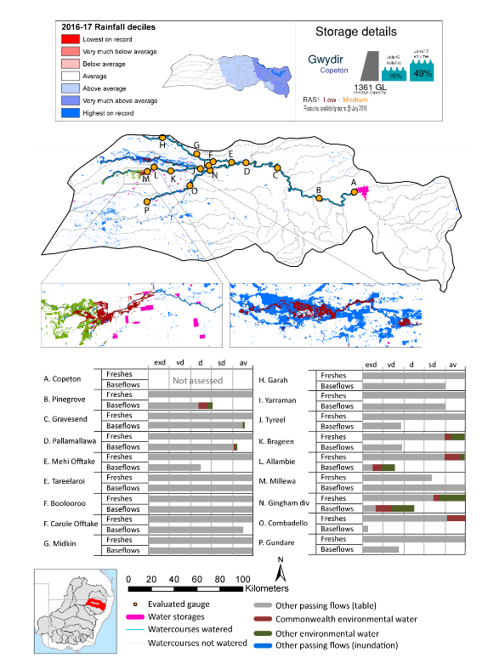

exd: extremely dry | vd: very dry | d: dry
sd: somewhat dry | av: average

Figure GWY1. Watercourses influenced, areas inundated (where applicable) and gauge stations evaluated in the Gwydir valley during the 2016-17 water year. Inset bar graphs report the condition of annual flow regimes by showing the improvements in hydrological condition with the addition of environmental water as well as the hypothetical scenario in “grey” (if no environmental flow had been delivered). Rainfall conditions (rainfall deciles) and trend in storage levels for the water year are also shown.

Summary
Environmental water delivery for the 2016-17 year in the Gwydir valley is evaluated using data for 19 sites. This evaluation only considers the contribution of held environmental water, which is a primary focus for the Australian Government. The contributions of planned environmental water (e.g. passing flows), unregulated tributary inflows and clever use of irrigation flows for environmental benefits can all be very important but these are outside the scope of this report, but where this data was made availalable (for planned ewater only) it has been included. Environmental watering actions lasted on average 60 days over the course of the year. The volume of environmental water at these 19 sites was between 0% and 84% of the total streamflow. Commonwealth environmental water contributed on average 54% of this environmental water. Ideally, baseflows should be maintained and long periods of excessively low flows avoided. In this valley, the baseflow regime was generally considered to be dry relative to the pre-development flow regime. In our analysis, a low fresh refers to a period of increased flow, when the water level rises at least one eighth of the way up the river bank (above the low flow level). These low freshes are a regular part of the natural flow regime and support a range of natural processes. In the Gwydir valley, in terms of the occurrence and duration of low freshes, the year was assessed as being average. In our analysis, a medium fresh refers to a period of increased flow, when the water level rises at least one quarter of the way up the river bank. These medium freshes are not as frequent as low freshes but are also a regular and important part of the natural flow regime. In the Gwydir valley, in terms of the occurrence of medium freshes, the year was assessed as being average. In our analysis, a high fresh refers to a period of increased flow, when the water level rises more than half way up the river. A high fresh may not occur every year but they are still important and long periods without major freshes can have serious consequences for floodplains and their contribution to river ecosystem health. Delivering high in channel flows normally requires that all risks to riparian landholders and infrastructure have been resolved. In the Gwydir valley, in terms of the occurrence of high freshes, the year was assessed as being average.

Water delivery context
During 2016-17, the Commonwealth Environmental Water Holder (CEWH) held water entitlements of up to 114 484 ML for environmental use in the Gwydir valley. Each year, water utilities allocate water entitlement holders a percentage of water based on their holding, license type and carryover (the exact rules vary among jurisdictions). In 2016-17, the Gwydir entitlements held by the CEWH were allocated 81 253 ML of water, representing 200% of the long-term average annual yield for the Gwydir valley (40 623 ML). Information and data relating to the portfolio of held Commonwealth environmental water is shown in Table GWY1.
The 2016-17 water allocation (81 253 ML) together with the carryover volume of 25 559 ML of water meant the CEWH had 106 812 ML of water available for delivery. A total of 22 847 ML of Commonwealth environmental water was delivered in the Gwydir valley. A total of 0 ML of Commonwealth environmental water was traded to consumptive users and 83 965 ML (79%) of available Commonwealth environmental water was carried over for environmental use into the 2017-18 water year.

Environmental conditions and resource availability
The water available for environmental delivery combined with the present and antecedent environmental conditions are key inputs used by environmental water managers in planning and implementing watering actions. Post hoc, this information provides important context when evaluating the effectiveness and appropriateness of environmental water use with respect to hydrological outputs.
The rainfall conditions in the Gwydir valley were classified as above average, based on rainfall percentile data for the entire record held by the Bureau of Meteorology for this valley. The water held in major storages in the Gwydir valley increased over the water year, for example Copeton dam was 16% full at the beginning of the water year and 49% full by the end of the year (Figure GWY1).
The Commonwealth Environmental Water Office (CEWO) calculates resource availability scenarios (RAS) to guide the use and prioritisation of held environmental water. The RAS are progressively calculated over the year as part of the continual adaptive management planning processes. The RAS are based on the availability of held environmental water (including progressive license acquisitions and allocations) as well as the potential for unregulated or planned environmental flows. The outcome is then used to determine the demand for environmental water across The Basin.
In 2016-17, the resource availability of held Commonwealth environmental water was classified as low in this valley, whilst the potential for unregulated or planned environmental flow was classified as medium to low. The antecedent and forecasted physical conditions meant that Commonwealth environmental water was being planned to protect wetland vegetation of the Gwydir wetlands and ensuring their ecological capacity for recovery, while maintaining the ecological health and resilience of other important sites in the catchment, including in stream aquatic ecology. The overall demand for environmental water was deemed high (water predominantly needed this year).

Watering actions
A total of four watering actions were delivered over the 2016-17 water year, the duration of these actions varied (range of individual actions: 4 - 78 days) and Commonwealth environmental water was delivered for a total of 90 days. The count of actions commencing in each season was; spring (2) and summer (2). The flow component types delivered were; (1) baseflow, (1) freshes, (0) bankfull, (0) overbank and (2) wetland inundation.
There were 18 expected outcomes across four watering actions in the Gwydir valley. The percentage of expected outcomes across the nine main themes were: fish (5.56%), vegetation (11.11%), waterbirds (11.11%), frogs (5.56%), other biota (11.11%), connectivity (22.22%), process (16.67%), resilience (5.56%) and water quality (11.11%).
Table GWY1. Commonwealth environmental water accounting information for the Gwydir valley over 2016-17 water year (LTAAY = long-term average annual yield).
Total registered volume (ML) | Allocated volume (ML) | Carry over + allocated volume (ML) | Delivered (ML) | LTAAY (ML) | Trade (ML) | Carried over to 2016-17 | Forfeited (ML)
114 484 | 81 253 | 106 812 | 22 847 | 40 623 | 0 | 83 965 | 0

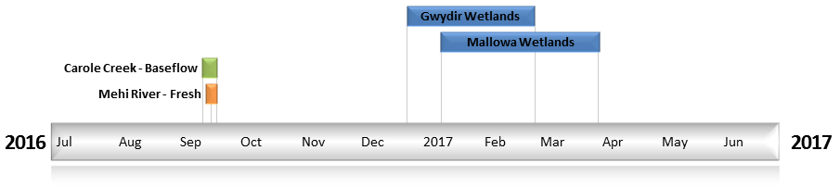
Figure GWY2. Timing and duration of Commonwealth environmental water actions delivered in the Gwydir valley.

Contribution of Commonwealth Environmental Water to Flow Regimes
Pinegrove
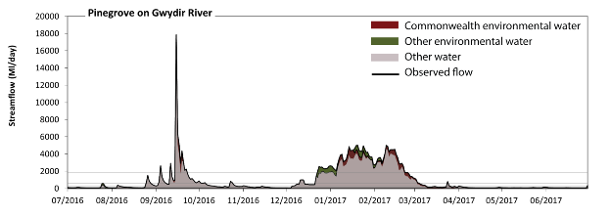
Figure GWY3. Contribution of environmental water delivery at Pinegrove. Horizontal lines indicate thresholds for very low flows, low flows, low freshes, medium freshes and high freshes (from lowest to highest).
At Pinegrove on the Gwydir River environmental water contributed 15% of the total streamflow volume (much of which was Commonwealth environmental water). Environmental watering actions affected streamflows for 32% of days between 1 July 2016 and 30 June 2017. Without environmental water, the durations of very low flows (i.e. < 25 ML/day) in the periods July to September and January to March would have substantially exceeded durations expected in an average year in the natural flow regime. Environmental water mitigated these impacts by reducing the cumulative duration of very low flow spells from 6% to 0% of the year, with greatest influence in the periods July to September and January to March. Similarly, without environmental water, the durations of medium low flows (i.e. < 120 ML/day) in the periods July to September and April to June would have substantially exceeded durations expected in an average year in the natural flow regime. Environmental water reduced the cumulative duration of medium low flow spells from 45% to 40% of the year, with greatest influence in the period January to March. Commonwealth environmental water made the dominant contribution to these enhancements of environmental base flows at this site. There was at least one low fresh (i.e. > 300 ML/day) in the periods July to September, October to December, January to March and April to June. Environmental water made little change to the duration of these low freshes. There was at least one medium fresh (i.e. > 610 ML/day) in the periods July to September, October to December and January to March. In the absence of environmental water there would have been at least one high fresh in the periods July to September, October to December and January to March. Environmental water increased the duration of the longest high fresh during the periods July to September (from 4 days to 8 days) and October to December (from 2 days to 9 days). Commonwealth environmental water equally shared responsibility with other environmental water holders for these increased durations of high freshes.
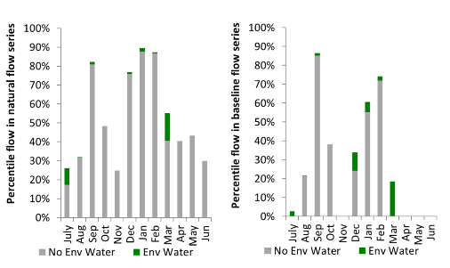
Figure GWY4. Contribution of environmental water delivery at Pinegrove as percentiles in the natural and baseline flow series.
Gravesend
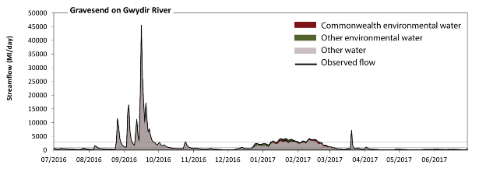
Figure GWY5. Contribution of environmental water delivery at Gravesend. Horizontal lines indicate thresholds for very low flows, low flows, low freshes, medium freshes and high freshes (from lowest to highest).
At Gravesend on the Gwydir River environmental water contributed 9% of the total streamflow volume (much of which was Commonwealth environmental water). Environmental watering actions affected streamflows for 32% of days between 1 July 2016 and 30 June 2017. Flow regulation does not substantially increase the duration of very low flows (i.e. < 40 ML/day) compared to an average year in the natural flow regime. However, without environmental water, the duration of medium low flows (i.e. < 200 ML/day) in the period April to June would have substantially exceeded durations expected in an average year in the natural flow regime. Environmental water reduced the cumulative duration of medium low flow spells from 21% to 18% of the year, with greatest influence in the periods July to September and January to March. Commonwealth environmental water made a modest contribution to these enhancements of environmental baseflows at this site. There was at least one low fresh (i.e. > 490 ML/day) in each of the periods July to September, October to December, January to March and April to June. Environmental water made little change to the duration of these low freshes. There was at least one medium fresh (i.e. > 990 ML/day) in the periods July to September, October to December, January to March and April to June. Environmental water made little change to the duration of these medium freshes. In the absence of environmental water there would have been at least one high fresh in the periods July to September, October to December and January to March. Environmental water increased the duration of the longest high fresh during the period January to March (from 9 days to 19 days). Commonwealth environmental water made a small contribution to these increased durations of high freshes.
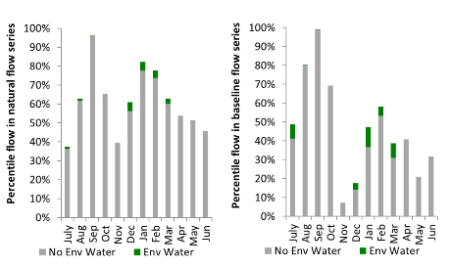
Figure GWY6. Contribution of environmental water delivery at Gravesend as percentiles in the natural and baseline flow series.
Pallamallawa
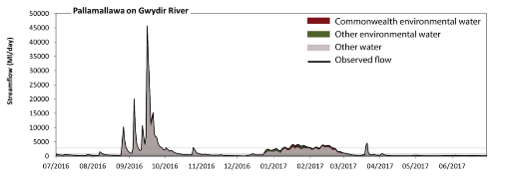
Figure GWY7. Contribution of environmental water delivery at Pallamallawa. Horizontal lines indicate thresholds for very low flows, low flows, low freshes, medium freshes and high freshes (from lowest to highest).
At Pallamallawa on the Gwydir River environmental water contributed 9% of the total streamflow volume (much of which was Commonwealth environmental water). Environmental watering actions affected streamflows for 32% of days between 1 July 2016 and 30 June 2017. Flow regulation does not substantially increase the duration of very low flows (i.e. < 39 ML/day) compared to an average year in the natural flow regime. However, without environmental water, the duration of medium low flows (i.e. < 200 ML/day) in the period April to June would have substantially exceeded durations expected in an average year in the natural flow regime. Environmental water reduced the cumulative duration of medium low flow spells from 25% to 22% of the year, with greatest influence in the periods July to September and January to March. Commonwealth environmental water made a modest contribution to these enhancements of environmental baseflows at this site. There was at least one low fresh (i.e. > 470 ML/day) in each of the periods July to September, October to December, January to March and April to June. Environmental water made little change to the duration of these low freshes. There was at least one medium fresh (i.e. > 950 ML/day) in the periods July to September, October to December and January to March. Environmental water made little change to the duration of these medium freshes. In the absence of environmental water there would have been at least one high fresh in the periods July to September, October to December and January to March. Environmental water increased the duration of the longest high fresh during the period January to March (from 8 days to 18 days). Commonwealth environmental water made a modest contribution to these increased durations of high freshes.
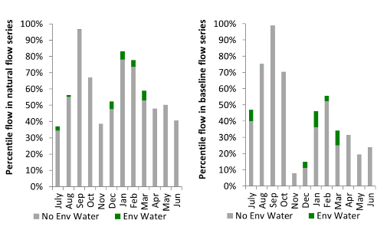
Figure GWY8. Contribution of environmental water delivery at Pallamallawa as percentiles in the natural and baseline flow series.

Mehi Offtake
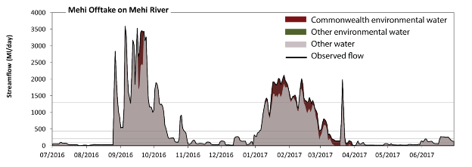
Figure GWY9. Contribution of environmental water delivery at the Mehi Offtake. Horizontal lines indicate thresholds for very low flows, low flows, low freshes, medium freshes and high freshes (from lowest to highest).
At the Mehi Offtake on the Mehi River environmental water contributed 10% of the total streamflow volume (all of which was Commonwealth environmental water). Environmental watering actions affected streamflows for 24% of days between 1 July 2016 and 30 June 2017. Without environmental water, the durations of very low flows (i.e. < 18 ML/day) in the periods July to September, January to March and April to June would have substantially exceeded durations expected in an average year in the natural flow regime. Environmental water mitigated these impacts by reducing the cumulative duration of very low flow spells from 13% to 10% of the year, with greatest influence in the period January to March. Similarly, without environmental water, the durations of medium low flows (i.e. < 90 ML/day) in the periods July to September, October to December and April to June would have substantially exceeded durations expected in an average year in the natural flow regime. Environmental water reduced the cumulative duration of medium low flow spells from 46% to 43% of the year, with greatest influence in the period January to March. Commonwealth environmental water was entirely responsible for these enhancements of environmental baseflows at this site. There was at least one low fresh (i.e. > 220 ML/day) in each of the periods July to September, October to December, January to March and April to June. Environmental water made little change to the duration of these low freshes. There was at least one medium fresh (i.e. > 440 ML/day) in each of the periods July to September, October to December and January to March. Environmental water made little change to the duration of these medium freshes. In the absence of environmental water there would have been at least one high fresh in each of the periods July to September, October to December and January to March. Environmental water made little change to the duration of these high freshes.
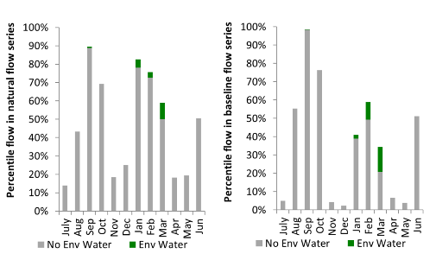
Figure GWY10. Contribution of environmental water delivery at the Mehi Offtake as percentiles in the natural and baseline flow series.
Tareelaroi
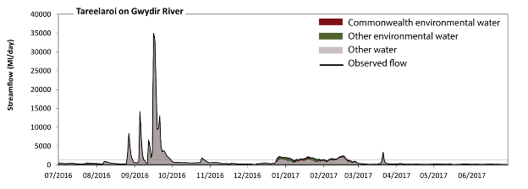
Figure GWY11. Contribution of environmental water delivery at Tareelaroi. Horizontal lines indicate thresholds for very low flows, low flows, low freshes, medium freshes and high freshes (from lowest to highest).
At Tareelaroi on the Gwydir River environmental water contributed 9% of the total streamflow volume (with a medium contribution of Commonwealth environmental water). Environmental watering actions affected streamflows for 24% of days between 1 July 2016 and 30 June 2017. Flow regulation does not substantially increase the duration of very low flows (i.e. < 18 ML/day) compared to an average year in the natural flow regime. Flow regulation does not substantially increase the duration of medium low flows (i.e. < 90 ML/day) compared to an average year in the natural flow regime. There was at least one low fresh (i.e. > 220 ML/day) in each of the periods July to September, October to December, January to March and April to June. Environmental water made no change to the duration of these low freshes. There was at least one medium fresh (i.e. > 440 ML/day) in each of the periods July to September, October to December and January to March. Environmental water made no change to the duration of these medium freshes. In the absence of environmental water there would have been at least one high fresh in the periods July to September, October to December and January to March. Environmental water increased the duration of the longest high fresh during the periods October to December (from 5 days to 7 days) and January to March (from 7 days to 20 days). Commonwealth environmental water made a modest contribution to these increased durations of high freshes.
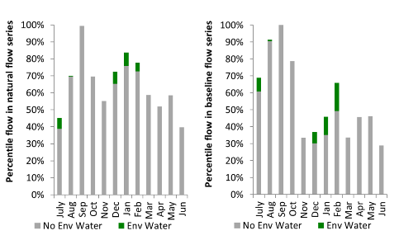
Figure GWY12. Contribution of environmental water delivery at Tareelaroi as percentiles in the natural and baseline flow series.
Carole Offtake
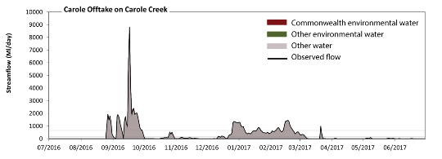
Figure GWY13. Contribution of environmental water delivery at Carole Offtake. Horizontal lines indicate thresholds for very low flows, low flows, low freshes, medium freshes and high freshes (from lowest to highest).
At the Carole Offtake on Carole Creek environmental water contributed 1% of the total streamflow volume (all of which was Commonwealth environmental water). Environmental watering actions affected streamflows for 2% of days between 1 July 2016 and 30 June 2017. Flow regulation does not substantially increase the duration of very low flows (i.e. < 2.1 ML/day) compared to an average year in the natural flow regime. Flow regulation does not substantially increase the duration of medium low flows (i.e. < 10 ML/day) compared to an average year in the natural flow regime. There was at least one low fresh (i.e. > 49 ML/day) in each of the periods July to September, October to December, January to March and April to June. Environmental water made no change to the duration of these low freshes. There was at least one medium fresh (i.e. > 150 ML/day) in each of the periods July to September, October to December and January to March. Environmental water made no change to the duration of these medium freshes. In the absence of environmental water there would have been at least one high fresh in each of the periods July to September, October to December and January to March. Environmental water made no change to the duration of these high freshes.
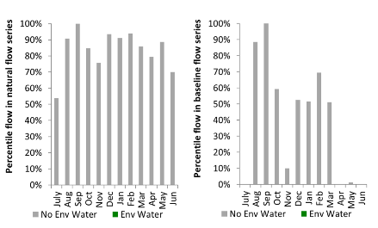
Figure GWY14. Contribution of environmental water delivery at Carole Offtake as percentiles in the natural and baseline flow series.
Boolooroo
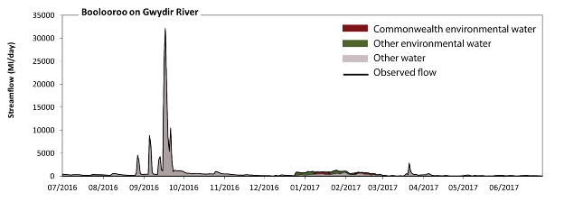 Figure GWY15. Contribution of environmental water delivery at Boolooroo. Horizontal lines indicate thresholds for very low flows, low flows, low freshes, medium freshes and high freshes (from lowest to highest).
At Boolooroo on the Gwydir River environmental water contributed 12% of the total streamflow volume (with a medium contribution of Commonwealth environmental water). Environmental watering actions affected streamflows for 22% of days between 1 July 2016 and 30 June 2017. Flow regulation does not substantially increase the duration of very low flows (i.e. < 2.1 ML/day) compared to an average year in the natural flow regime. Flow regulation does not substantially increase the duration of medium low flows (i.e. < 10 ML/day) compared to an average year in the natural flow regime. In the absence of environmental water there would have been at least one low fresh (i.e. > 28 ML/day) in each of the periods July to September, October to December, January to March and April to June. Environmental water increased the duration of the longest low fresh during the period July to September (from 67 days to 92 days). Commonwealth environmental water made little or no contribution to these increased durations of low freshes. In the absence of environmental water there would have been at least one medium fresh (i.e. > 59 ML/day) in each of the periods July to September, October to December, January to March and April to June. Environmental water increased the duration of the longest medium fresh during the period July to September (from 59 days to 92 days). Commonwealth environmental water made little or no contribution to these increased durations of medium freshes. In the absence of environmental water there would have been at least one high fresh in each of the periods July to September, October to December, January to March and April to June. Environmental water made little change to the duration of these high freshes.
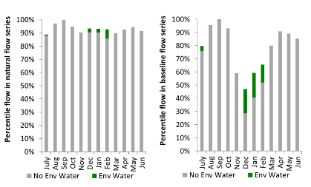
Figure GWY16. Contribution of environmental water delivery at Boolooroo as percentiles in the natural and baseline flow series.
Yarraman
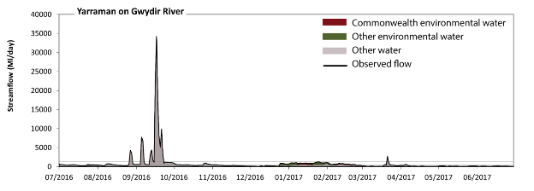 Figure GWY17. Contribution of environmental water delivery at Yarraman. Horizontal lines indicate thresholds for very low flows, low flows, low freshes, medium freshes and high freshes (from lowest to highest).
At Yarraman on the Gwydir River environmental water contributed 12% of the total streamflow volume (with a medium contribution of Commonwealth environmental water). Environmental watering actions affected streamflows for 22% of days between 1 July 2016 and 30 June 2017. Flow regulation does not substantially increase the duration of very low flows (i.e. < 19 ML/day) compared to an average year in the natural flow regime. However, without environmental water, the duration of medium low flows (i.e. < 94 ML/day) in the period April to June would have substantially exceeded durations expected in an average year in the natural flow regime. Environmental water reduced the cumulative duration of medium low flow spells from 21% to 20% of the year, with greatest influence in the periods October to December and January to March. There was at least one low fresh (i.e. > 220 ML/day) in each of the periods July to September, October to December, January to March and April to June. Environmental water made little change to the duration of these low freshes. In the absence of environmental water there would have been at least one medium fresh (i.e. > 450 ML/day) in each of the periods July to September, October to December, January to March and April to June. Environmental water increased the duration of the longest medium fresh during the period January to March (from 11 days to 54 days). Commonwealth environmental water made a modest contribution to these increased durations of medium freshes. In the absence of environmental water there would have been at least one high fresh in the two periods July to September and January to March. Environmental water made no change to the duration of these high freshes.
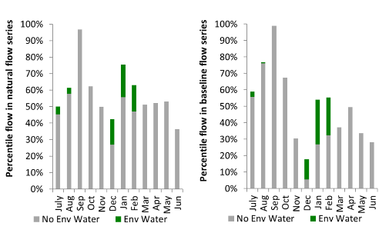
Figure GWY18. Contribution of environmental water delivery at Yarraman as percentiles in the natural and baseline flow series.

Gingham Diversion
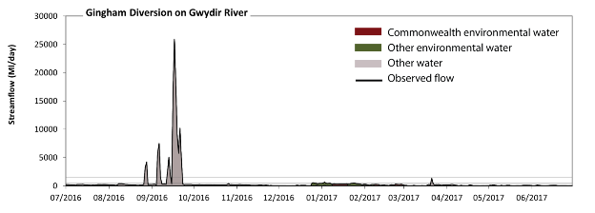 Figure GWY19. Contribution of environmental water delivery at Gingham Diversion. Horizontal lines indicate thresholds for very low flows, low flows, low freshes, medium freshes and high freshes (from lowest to highest).
At the Gingham Diversion on the Gwydir River environmental water contributed 11% of the total streamflow volume (with a medium contribution of Commonwealth environmental water). Environmental watering actions affected streamflows for 22% of days between 1 July 2016 and 30 June 2017. Without environmental water, the durations of very low flows (i.e. < 21 ML/day) in the periods October to December, January to March and April to June would have substantially exceeded durations expected in an average year in the natural flow regime. Environmental water mitigated these impacts by reducing the cumulative duration of very low flow spells from 19% to 14% of the year, with greatest influence in the period January to March. Similarly, without environmental water, the durations of medium low flows (i.e. < 100 ML/day) in the periods October to December, January to March and April to June would have substantially exceeded durations expected in an average year in the natural flow regime. Environmental water mitigated these impacts by reducing the cumulative duration of medium low flow spells from 59% to 41% of the year, with greatest influence in the period January to March. Commonwealth environmental water equally shared responsibility with other environmental water holders for these enhancements of environmental baseflows at this site. In the absence of environmental water there would have been at least one low fresh (i.e. > 250 ML/day) in each of the periods July to September, October to December and January to March. Environmental water increased the duration of the longest low fresh during the periods October to December (from 1 days to 7 days) and January to March (from 2 days to 29 days). Commonwealth environmental water made a modest contribution to these increased durations of low freshes. In the absence of environmental water there would have been at least one medium fresh (i.e. > 510 ML/day) in the two periods July to September and January to March. Environmental water increased the duration of the longest medium fresh during the period October to December (from 0 days to 2 days). Commonwealth environmental water made little or no contribution to these increased durations of medium freshes. In the absence of environmental water there would have been at least one high fresh in the period July to September. Environmental water made no change to the duration of these high freshes.
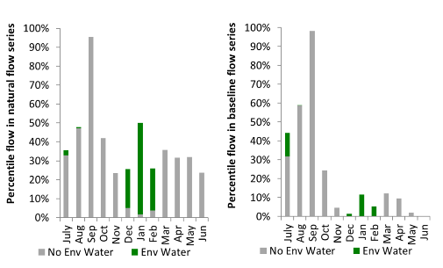
Figure GWY20. Contribution of environmental water delivery at Gingham Diversion as percentiles in the natural and baseline flow series.
Tyreel
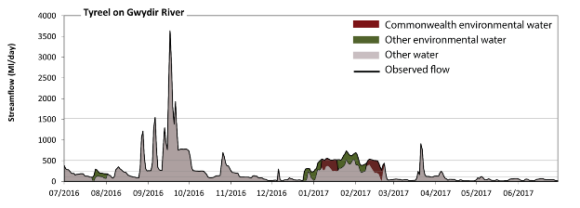 Figure GWY21. Contribution of environmental water delivery at Tyreel. Horizontal lines indicate thresholds for very low flows, low flows, low freshes, medium freshes and high freshes (from lowest to highest).
At Tyreel on the Gwydir River environmental water contributed 14% of the total streamflow volume (with approximately half contributed by Commonwealth environmental water). Environmental watering actions affected streamflows for 20% of days between 1 July 2016 and 30 June 2017. Without environmental water, the duration of very low flows (i.e. < 21 ML/day) in the period April to June would have substantially exceeded durations expected in an average year in the natural flow regime. Environmental water reduced the cumulative duration of very low flow spells from 10% to 8% of the year, with greatest influence in the periods July to September, October to December and January to March. Similarly, without environmental water, the durations of medium low flows (i.e. < 100 ML/day) in the periods October to December, January to March and April to June would have substantially exceeded durations expected in an average year in the natural flow regime. Environmental water mitigated these impacts by reducing the cumulative duration of medium low flow spells from 47% to 43% of the year, with greatest influence in the periods July to September, October to December and January to March. Commonwealth environmental water made a small contribution to these enhancements of environmental baseflows at this site. In the absence of environmental water there would have been at least one low fresh (i.e. > 250 ML/day) in the periods July to September, October to December and January to March. Environmental water increased the duration of the longest low fresh during the period January to March (from 17 days to 52 days). Commonwealth environmental water made the dominant contribution to these increased durations of low freshes. In the absence of environmental water there would have been at least one medium fresh (i.e. > 510 ML/day) in the periods July to September, October to December and January to March. Environmental water increased the duration of the longest medium fresh during the period January to March (from 2 days to 25 days). Commonwealth environmental water made a modest contribution to these increased durations of medium freshes. In the absence of environmental water there would have been at least one high fresh in the period July to September. Environmental water made no change to the duration of these high freshes.
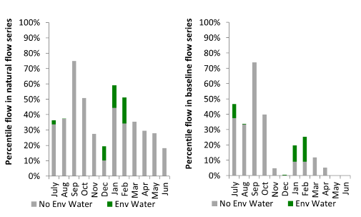
Figure GWY22. Contribution of environmental water delivery at Tyreel as percentiles in the natural and baseline flow series.

Brageen
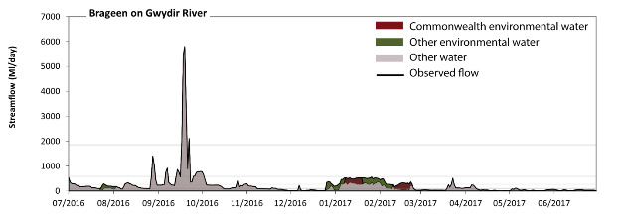 Figure GWY23. Contribution of environmental water delivery at Brageen. Horizontal lines indicate thresholds for very low flows, low flows, low freshes, medium freshes and high freshes (from lowest to highest).
At Brageen on the Gwydir River environmental water contributed 16% of the total streamflow volume (with approximately half contributed by Commonwealth environmental water). Environmental watering actions affected streamflows for 20% of days between 1 July 2016 and 30 June 2017. Without environmental water, the durations of very low flows (i.e. < 21 ML/day) in the periods October to December and April to June would have substantially exceeded durations expected in an average year in the natural flow regime. Environmental water reduced the cumulative duration of very low flow spells from 14% to 12% of the year, with greatest influence in the period January to March. Similarly, without environmental water, the durations of medium low flows (i.e. < 100 ML/day) in the periods October to December, January to March and April to June would have substantially exceeded durations expected in an average year in the natural flow regime. Environmental water mitigated these impacts by reducing the cumulative duration of medium low flow spells from 52% to 45% of the year, with greatest influence in the periods July to September and January to March. Commonwealth environmental water equally shared responsibility with other environmental water holders for these enhancements of environmental baseflows at this site. In the absence of environmental water there would have been at least one low fresh (i.e. > 270 ML/day) in the periods July to September, October to December and January to March. Environmental water increased the duration of the longest low fresh during the periods October to December (from 3 days to 4 days) and January to March (from 6 days to 33 days). Commonwealth environmental water made a small contribution to these increased durations of low freshes. There was at least one medium fresh (i.e. > 580 ML/day) in the periods July to September and October to December. Environmental water made no change to the duration of these medium freshes. In the absence of environmental water there would have been at least one high fresh in the period July to September. Environmental water made no change to the duration of these high freshes.
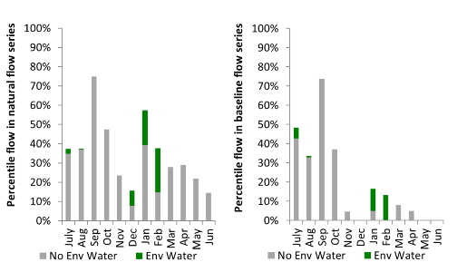
Figure GWY24. Contribution of environmental water delivery at Brageen as percentiles in the natural and baseline flow series.
Allambie
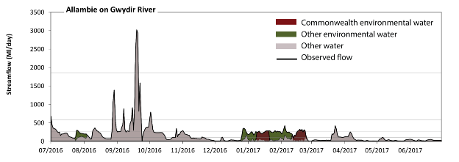 Figure GWY25. Contribution of environmental water delivery at Allambie. Horizontal lines indicate thresholds for very low flows, low flows, low freshes, medium freshes and high freshes (from lowest to highest).
At Allambie on the Gwydir River environmental water contributed 21% of the total streamflow volume (with a medium contribution of Commonwealth environmental water). Environmental watering actions affected streamflows for 20% of days between 1 July 2016 and 30 June 2017. Without environmental water, the durations of very low flows (i.e. < 21 ML/day) in the periods October to December, January to March and April to June would have substantially exceeded durations expected in an average year in the natural flow regime. Environmental water mitigated these impacts by reducing the cumulative duration of very low flow spells from 21% to 15% of the year, with greatest influence in the period January to March. Similarly, without environmental water, the durations of medium low flows (i.e. < 100 ML/day) in the periods October to December, January to March and April to June would have substantially exceeded durations expected in an average year in the natural flow regime. Environmental water mitigated these impacts by reducing the cumulative duration of medium low flow spells from 65% to 48% of the year, with greatest influence in the period January to March. Commonwealth environmental water equally shared responsibility with other environmental water holders for these enhancements of environmental baseflows at this site. In the absence of environmental water there would have been at least one low fresh (i.e. > 270 ML/day) in the periods July to September, October to December and January to March. Environmental water increased the duration of the longest low fresh during the period January to March (from 2 days to 5 days). Commonwealth environmental water made the dominant contribution to these increased durations of low freshes. There was at least one medium fresh (i.e. > 580 ML/day) in the periods July to September and October to December. Environmental water made no change to the duration of these medium freshes. In the absence of environmental water there would have been at least one high fresh in the period July to September. Environmental water made no change to the duration of these high freshes.
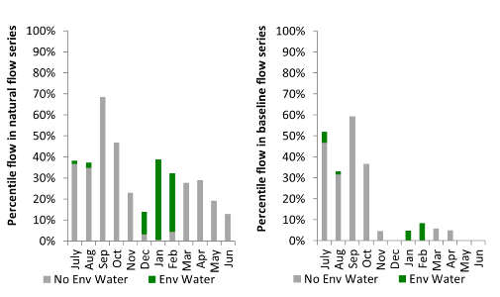
Figure GWY26. Contribution of environmental water delivery at Allambie as percentiles in the natural and baseline flow series.
Millewa
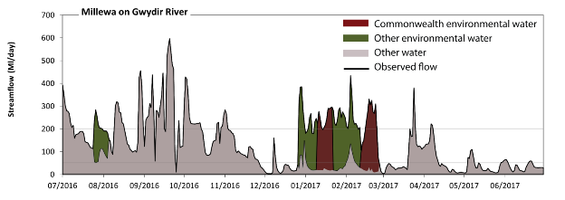 Figure GWY27. Contribution of environmental water delivery at Millewa. Horizontal lines indicate thresholds for very low flows, low flows, low freshes and medium freshes (from lowest to highest).
At Millewa on the Gwydir River environmental water contributed 27% of the total streamflow volume (with a medium contribution of Commonwealth environmental water). Environmental watering actions affected streamflows for 20% of days between 1 July 2016 and 30 June 2017. Flow regulation does not substantially increase the duration of very low flows (i.e. < 1.1 ML/day) compared to an average year in the natural flow regime. Flow regulation does not substantially increase the duration of medium low flows (i.e. < 5.7 ML/day) compared to an average year in the natural flow regime. In the absence of environmental water there would have been at least one low fresh (i.e. > 52 ML/day) in the periods July to September, October to December, January to March and April to June. Environmental water increased the duration of the longest low fresh during the periods July to September (from 60 days to 86 days) and January to March (from 12 days to 56 days). Commonwealth environmental water made a small contribution to these increased durations of low freshes. In the absence of environmental water there would have been at least one medium fresh (i.e. > 200 ML/day) in the periods July to September, October to December, January to March and April to June. Environmental water increased the duration of the longest medium fresh during the period January to March (from 2 days to 26 days). Commonwealth environmental water made a modest contribution to these increased durations of medium freshes. There was no high freshes (i.e. > 1200 ML/day) this year.
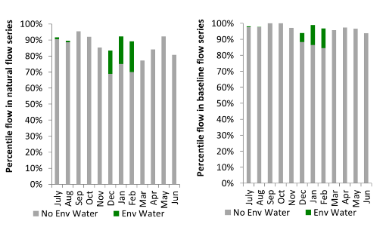
Figure GWY28. Contribution of environmental water delivery at Millewa as percentiles in the natural and baseline flow series.

Moree
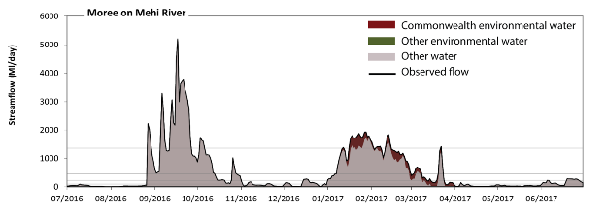 Figure GWY29. Contribution of environmental water delivery at Moree. Horizontal lines indicate thresholds for very low flows, low flows, low freshes, medium freshes and high freshes (from lowest to highest).
At Moree on the Mehi River environmental water contributed 8% of the total streamflow volume (all of which was Commonwealth environmental water). Environmental watering actions affected streamflows for 22% of days between 1 July 2016 and 30 June 2017. Without environmental water, the durations of very low flows (i.e. < 19 ML/day) in the periods July to September, October to December, January to March and April to June would have all substantially exceeded durations expected in an average year in the natural flow regime. Environmental water mitigated these impacts by reducing the cumulative duration of very low flow spells from 16% to 13% of the year, with greatest influence in the period January to March. Similarly, without environmental water, the durations of medium low flows (i.e. < 95 ML/day) in the periods July to September, October to December and April to June would have substantially exceeded durations expected in an average year in the natural flow regime. Environmental water reduced the cumulative duration of medium low flow spells from 48% to 45% of the year, with greatest influence in the period January to March. Commonwealth environmental water was entirely responsible for these enhancements of environmental baseflows at this site. There was at least one low fresh (i.e. > 230 ML/day) in the periods July to September, October to December, January to March and April to June. Environmental water made little change to the duration of these low freshes. There was at least one medium fresh (i.e. > 460 ML/day) in the periods July to September, October to December and January to March. Environmental water made little change to the duration of these medium freshes. In the absence of environmental water there would have been at least one high fresh in the periods July to September, October to December and January to March. Environmental water increased the duration of the longest high fresh during the period January to March (from 7 days to 18 days). Commonwealth environmental water was entirely responsible for these increased durations of high freshes.
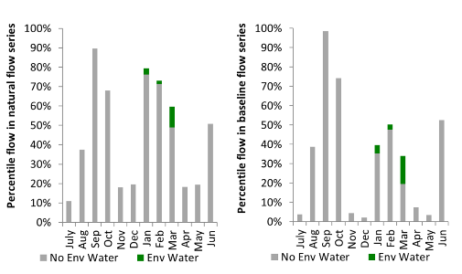
Figure GWY30. Contribution of environmental water delivery at Moree as percentiles in the natural and baseline flow series.
Combadello
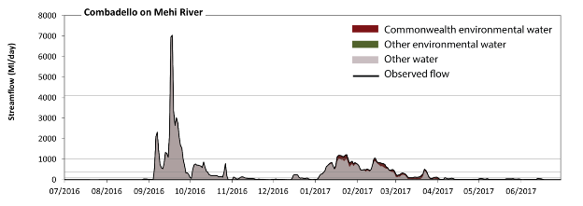 Figure GWY31. Contribution of environmental water delivery at Combadello. Horizontal lines indicate thresholds for very low flows, low flows, low freshes, medium freshes and high freshes (from lowest to highest).
At Combadello on the Mehi River environmental water contributed 7% of the total streamflow volume (all of which was Commonwealth environmental water). Environmental watering actions affected streamflows for 22% of days between 1 July 2016 and 30 June 2017. Without environmental water, the durations of very low flows (i.e. < 20 ML/day) in the periods July to September, October to December and April to June would have substantially exceeded durations expected in an average year in the natural flow regime. Environmental water mitigated these impacts by reducing the cumulative duration of very low flow spells from 39% to 38% of the year, with greatest influence in the periods January to March and April to June. Similarly, without environmental water, the durations of medium low flows (i.e. < 99 ML/day) in the periods July to September, October to December and April to June would have substantially exceeded durations expected in an average year in the natural flow regime. Environmental water reduced the cumulative duration of medium low flow spells from 64% to 60% of the year, with greatest influence in the period January to March. Commonwealth environmental water was entirely responsible for these enhancements of environmental baseflows at this site. There was at least one low fresh (i.e. > 380 ML/day) in the periods July to September, October to December and January to March. Environmental water made little change to the duration of these low freshes. In the absence of environmental water there would have been at least one medium fresh (i.e. > 1000 ML/day) in the period July to September. Environmental water increased the duration of the longest medium fresh during the period January to March (from 0 days to 8 days). Commonwealth environmental water was entirely responsible for these increased durations of medium freshes. In the absence of environmental water there would have been at least one high fresh in the period July to September. Environmental water made no change to the duration of these high freshes.
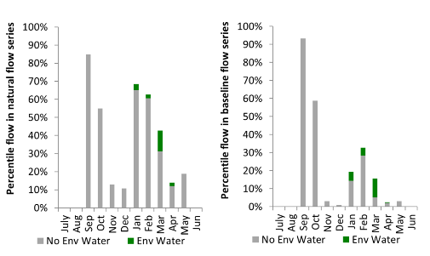
Figure GWY32. Contribution of environmental water delivery at Combadello as percentiles in the natural and baseline flow series.
Gundare
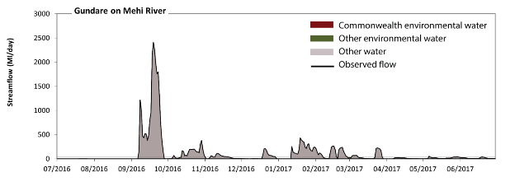 Figure GWY33. Contribution of environmental water delivery at Gundare. Horizontal lines indicate thresholds for very low flows, low flows, low freshes, medium freshes and high freshes (from lowest to highest).
There was no environmental water delivered at Gundare on the Mehi River. Without environmental water, the duration of very low flows (i.e. < 0.43 ML/day) in the period July to September was substantially in excess of durations expected in an average year in the natural flow regime. Similarly, without environmental water, the duration of medium low flows (i.e. < 2.1 ML/day) in the period July to September was substantially in excess of durations expected in an average year in the natural flow regime. There was at least one low fresh (i.e. > 5.5 ML/day) in the periods July to September, October to December, January to March and April to June. There was at least one medium fresh (i.e. > 11 ML/day) in the periods July to September, October to December, January to March and April to June. In the absence of environmental water there was at least one high fresh in the periods July to September, October to December, January to March and April to June.
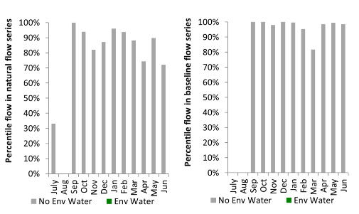
Figure GWY34. Contribution of environmental water delivery at Gundare as percentiles in the natural and baseline flow series.
Mallowa
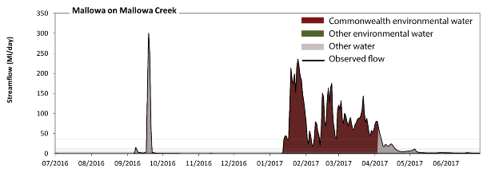 Figure GWY35. Contribution of environmental water delivery at Mallowa. Horizontal lines indicate thresholds for very low flows, low flows, low freshes, medium freshes and high freshes (from lowest to highest).
At Mallowa on Mallowa Creek environmental water contributed 84% of the total streamflow volume (all of which was Commonwealth environmental water). Environmental watering actions affected streamflows for 22% of days between 1 July 2016 and 30 June 2017. Without environmental water, the durations of very low flows (i.e. < 0.43 ML/day) in the periods July to September, October to December and January to March would have substantially exceeded durations expected in an average year in the natural flow regime. Environmental water mitigated these impacts by reducing the cumulative duration of very low flow spells from 71% to 49% of the year, with greatest influence in the period January to March. Similarly, without environmental water, the durations of medium low flows (i.e. < 2.1 ML/day) in the periods July to September, October to December and January to March would have substantially exceeded durations expected in an average year in the natural flow regime. Environmental water mitigated these impacts by reducing the cumulative duration of medium low flow spells from 87% to 64% of the year, with greatest influence in the period January to March. Commonwealth environmental water was entirely responsible for these enhancements of environmental baseflows at this site. In the absence of environmental water there would have been at least one low fresh (i.e. > 5.5 ML/day) in the periods July to September and April to June. Environmental water increased the duration of the longest low fresh during the period January to March (from 0 days to 78 days). Commonwealth environmental water was entirely responsible for these increased durations of low freshes. In the absence of environmental water there would have been at least one medium fresh (i.e. > 11 ML/day) in the periods July to September and April to June. Environmental water increased the duration of the longest medium fresh during the period January to March (from 0 days to 78 days). Commonwealth environmental water was entirely responsible for these increased durations of medium freshes. In the absence of environmental water there would have been at least one high fresh in the periods July to September and April to June. Environmental water increased the duration of the longest high fresh during the periods January to March (from 0 days to 46 days) and April to June (from 3 days to 6 days). Commonwealth environmental water was entirely responsible for these increased durations of high freshes.
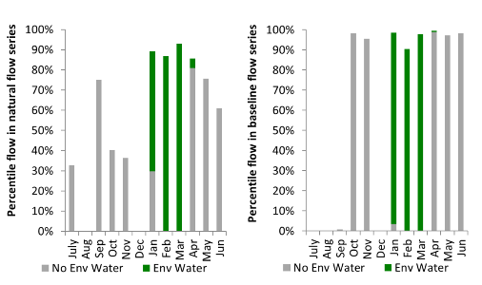
Figure GWY36. Contribution of environmental water delivery at Mallowa as percentiles in the natural and baseline flow series.

Midkin
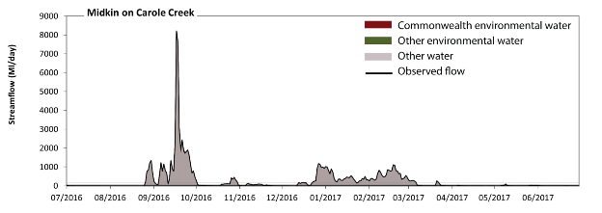 Figure GWY37. Contribution of environmental water delivery at Midkin. Horizontal lines indicate thresholds for very low flows, low flows, low freshes, medium freshes and high freshes (from lowest to highest).
At Midkin on Carole Creek environmental water contributed 1% of the total streamflow volume (all of which was Commonwealth environmental water). Environmental watering actions affected streamflows for 2% of days between 1 July 2016 and 30 June 2017. Flow regulation does not substantially increase the duration of very low flows (i.e. < 2.1 ML/day) compared to an average year in the natural flow regime. Flow regulation does not substantially increase the duration of medium low flows (i.e. < 10 ML/day) compared to an average year in the natural flow regime. There was at least one low fresh (i.e. > 28 ML/day) in the periods July to September, October to December, January to March and April to June. Environmental water made no change to the duration of these low freshes. There was at least one medium fresh (i.e. > 59 ML/day) in the periods July to September, October to December, January to March and April to June. Environmental water made no change to the duration of these medium freshes. In the absence of environmental water there would have been at least one high fresh in the periods July to September, October to December and January to March. Environmental water made no change to the duration of these high freshes.
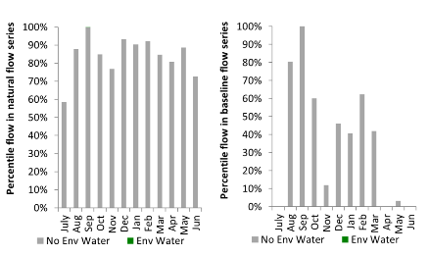
Figure GWY38. Contribution of environmental water delivery at Midkin as percentiles in the natural and baseline flow series.
Garah
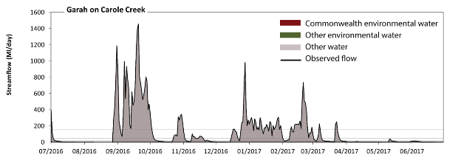 Figure GWY39. Contribution of environmental water delivery at Garah. Horizontal lines indicate thresholds for very low flows, low flows, low freshes, medium freshes and high freshes (from lowest to highest).
At Garah on Carole Creek environmental water contributed 0% of the total streamflow volume (all of which was Commonwealth environmental water). Environmental watering actions affected streamflows for 2% of days between 1 July 2016 and 30 June 2017. Flow regulation does not substantially increase the duration of very low flows (i.e. < 1.7 ML/day) compared to an average year in the natural flow regime. However, without environmental water, the duration of medium low flows (i.e. < 8.3 ML/day) in the period April to June would have substantially exceeded durations expected in an average year in the natural flow regime. However, environmental water had little effect on the duration of these medium low flows, which occurred for 44% of the year. There was at least one low fresh (i.e. > 22 ML/day) in the periods July to September, October to December, January to March and April to June. Environmental water made no change to the duration of these low freshes. There was at least one medium fresh (i.e. > 48 ML/day) in the periods July to September, October to December and January to March. Environmental water made no change to the duration of these medium freshes. In the absence of environmental water there would have been at least one high fresh in the periods July to September, October to December and January to March. Environmental water made no change to the duration of these high freshes.
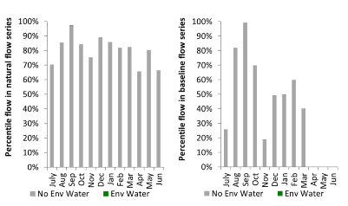
Figure GWY40. Contribution of environmental water delivery at Garah as percentiles in the natural and baseline flow series.

Namoi
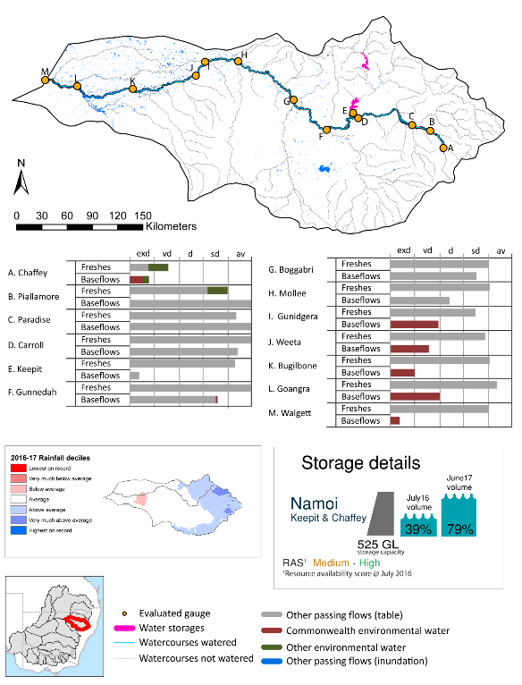

exd: extremely dry | vd: very dry | d: dry | sd: somewhat dry | av: average

Figure NAM1. Watercourses influenced, areas inundated (where applicable) and gauge stations evaluated in the Namoi valley during the 2016-17 water year. Inset bar graphs report the condition of annual flow regimes by showing the improvements in hydrological condition with the addition of environmental water as well as the hypothetical scenario in “grey” (if no environmental flow had been delivered). Rainfall conditions (rainfall deciles) and trend in storage levels for the water year are also shown.

Summary
Environmental water delivery for the 2016-17 year in the Namoi valley is evaluated using data for 13 sites. This evaluation only considers the contribution of held environmental water, which is a primary focus for the Commonwealth. The contributions of planned environmental water (e.g. passing flows), unregulated tributary inflows and clever use of irrigation flows for environmental benefits can all be very important but these are outside the scope of this report, but where this data was made availalable (for planned ewater only) it has been included.. Environmental watering actions lasted on average 49 days over the course of the year. The volume of environmental water at these 13 sites was between 0% and 30% of the total streamflow. Commonwealth environmental water contributed on average 75% of this environmental water. Ideally, baseflows should be maintained and long periods of excessively low flows avoided. In this valley, the baseflow regime was generally considered to be very dry relative to the pre-development flow regime. In our analysis, a low fresh refers to a period of increased flow, when the water level rises at least one eighth of the way up the river bank (above the low flow level). These low freshes are a regular part of the natural flow regime and support a range of natural processes. In the Namoi valley, in terms of the occurrence and duration of low freshes, the year was assessed as being somewhat dry. In our analysis, a medium fresh refers to a period of increased flow, when the water level rises at least one quarter of the way up the river bank. These medium freshes are not as frequent as low freshes but are also a regular and important part of the natural flow regime. In the Namoi valley, in terms of the occurrence of medium freshes, the year was assessed as being somewhat dry. In our analysis, a high fresh refers to a period of increased flow, when the water level rises more than half way up the river. A high fresh may not occur every year but they are still important and long periods without major freshes can have serious consequences for floodplains and their contribution to river ecosystem health. Delivering high in channel flows normally requires that all risks to riparian landholders and infrastructure have been resolved. In the Namoi valley, in terms of the occurrence of high freshes, the year was assessed as being average.

Water delivery context
During 2016-17, the Commonwealth Environmental Water Holder (CEWH) held water entitlements of up to 12 404 ML for environmental use in the Namoi valley. Each year, water utilities allocate water entitlement holders a percentage of water based on their holding, license type and carryover (the exact rules vary among Jurisdictions). In 2016-17, the Namoi entitlements held by the CEWH were allocated 12 042 ML of water, representing 135% of the Long term average annual yield for the Namoi valley (8 909 ML). Information and data relating to the portfolio of held Commonwealth environmental water is shown in Table NAM1.
The 2016-17 water allocation (12 042 ML) together with the carryover volume of 6 227 ML of water meant the CEWH had 18 269 ML of water available for delivery. A total of 9 109 ML of Commonwealth environmental water was delivered in the Namoi valley. A total of 0 ML of Commonwealth environmental water was traded to consumptive users and 9 160 ML (50%) of available Commonwealth environmental water was carried over for environmental use into the 2017-18 water year.

Environmental conditions and resource availability
The water available for environmental delivery combined with the present and antecedent environmental conditions are key inputs used by environmental water managers in planning and implementing watering actions. Post hoc, this information provides important context when evaluating the effectiveness and appropriateness of environmental water use with respect to hydrological outputs.
The rainfall conditions in the Namoi valley were classified as average, based on rainfall percentile data for the entire record held by the Bureau of Meteorology for this valley. The water held in major storages in the Namoi valley increased over the water year, for example Keepit and Chaffey dam were 39% full at the beginning of the water year and 79% full by the end of the year (Figure NAM1).
The Commonwealth Environmental Water Office (CEWO) calculates resource availability scenarios (RAS) to guide the use and prioritisation of held environmental water. The RAS are progressively calculated over the year as part of the continual adaptive management planning processes. The RAS are based on the availability of held environmental water (including progressive license acquisitions and allocations) as well as the potential for unregulated or planned environmental flows. The outcome is then used to determine the demand for environmental water across The Basin.
In 2016-17, the resource availability of held Commonwealth environmental water was classified as medium in this valley, whilst the potential for unregulated or planned environmental flow was classified as high. The antecedent and forecasted physical conditions meant that Commonwealth environmental water was being planned to avoid damage and protect assets in the Lower Namoi River channel, wetlands and anabranches, and the Peel River to ensure ecological capacity for recovery. The overall demand for environmental water was deemed high (water predominantly needed this year).

Watering actions
A total of 2 watering actions were delivered over the 2016-17 water year, the duration of these actions varied (range of individual actions: 26 - 81 days) and Commonwealth environmental water was delivered for a total of 107 days. The count of actions commencing in each season was; autumn (1) and winter (1). The flow component types delivered were; (1) baseflow, (1) freshes, (0) bankfull, (0) overbank and (0) wetland.
There were six expected outcomes across the two watering actions in the Namoi valley. The percentage of expected outcomes across the nine main themes were: fish (33.33%), vegetation (16.67%), waterbirds (0.0%), frogs (0.0%), other biota (16.67%), connectivity (16.67%), process (16.67%), resilience (0.0%) and water quality (0.0%).
Table NAM1. Commonwealth environmental water accounting information for the Namoi valley over 2016-17 water year (LTAAY = long-term average annual yield).
Total registered volume (ML) | Allocated volume (ML) | Carry over + allocated volume (ML) | Delivered (ML) | LTAAY (ML) | Trade (ML) | Carried over to 2016-17 | Forfeited (ML)
12 404 | 12 042 | 18 269 | 9 109 | 8 909 | 0 | 9 160 | 0

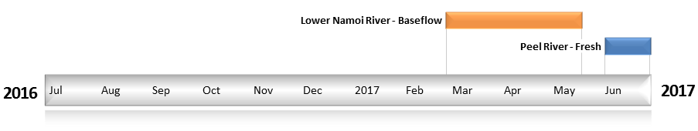
Figure NAM2. Timing and duration of Commonwealth environmental water actions delivered in the Namoi valley.

Contribution of Commonwealth Environmental Water to Flow Regimes
Walgett
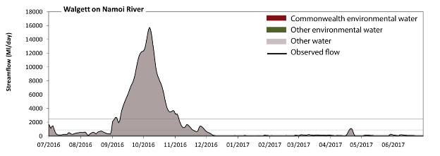
Figure NAM3. Contribution of environmental water delivery at Walgett. Horizontal lines indicate thresholds for very low flows, low flows, low freshes, medium freshes and high freshes (from lowest to highest).
At Walgett on the Namoi River environmental water contributed less than 1% of the total streamflow volume. Environmental watering actions affected streamflows for 24% of days between 1 July 2016 and 30 June 2017. Without environmental water, the durations of very low flows (i.e. < 41 ML/day) in the periods October to December, January to March and April to June would have exceeded durations expected in an average year in the natural flow regime. Environmental water mitigated these impacts by reducing the cumulative duration of very low flow spells from 26% to 17% of the year, with greatest influence in the period April to June. Similarly, without environmental water, the durations of medium low flows (i.e. < 200 ML/day) in the periods January to March and April to June would have substantially exceeded durations expected in an average year in the natural flow regime. Environmental water mitigated these impacts by reducing the cumulative duration of medium low flow spells from 55% to 55% of the year, with greatest influence in the period April to June. Commonwealth environmental water was entirely responsible for these enhancements of environmental baseflows at this site. There was at least one low fresh (i.e. > 890 ML/day) in the periods July to September, October to December and April to June. Environmental water made no change to the duration of these low freshes. There was at least one medium fresh (i.e. > 2500 ML/day) in the periods July to September and October to December. Environmental water made no change to the duration of these medium freshes. Environmental water made no change to the duration of these high freshes.
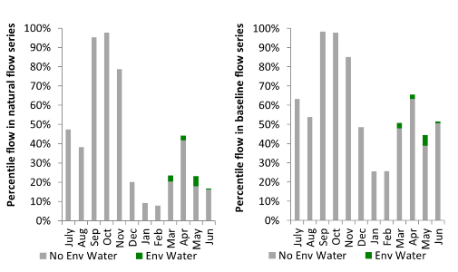
Figure NAM4. Contribution of environmental water delivery at Walgett as percentiles in the natural and baseline flow series.
Goangra
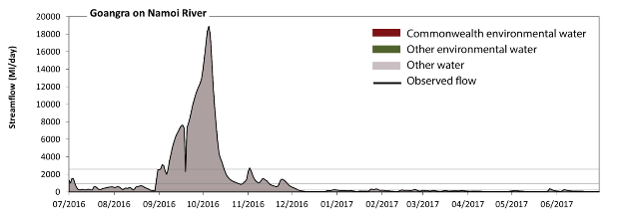
Figure NAM5. Contribution of environmental water delivery at Goangra. Horizontal lines indicate thresholds for very low flows, low flows, low freshes, medium freshes and high freshes (from lowest to highest).
At Goangra on the Namoi River environmental water contributed 1% of the total streamflow volume (all of which was Commonwealth environmental water). Environmental watering actions affected streamflows for 24% of days between 1 July 2016 and 30 June 2017. Without environmental water, the durations of very low flows (i.e. < 45 ML/day) in the periods October to December and April to June would have substantially exceeded durations expected in an average year in the natural flow regime. Environmental water mitigated these impacts by reducing the cumulative duration of very low flow spells from 21% to 8% of the year, with greatest influence in the period April to June. Similarly, without environmental water, the durations of medium low flows (i.e. < 220 ML/day) in the periods January to March and April to June would have substantially exceeded durations expected in an average year in the natural flow regime. However, environmental water had little effect on the duration of these medium low flows, which occurred for 55% of the year. Commonwealth environmental water was entirely responsible for these enhancements of environmental baseflows at this site. There was at least one low fresh (i.e. > 940 ML/day) in the periods July to September and October to December. Environmental water made no change to the duration of these low freshes. There was at least one medium fresh (i.e. > 2600 ML/day) in the periods July to September and October to December. Environmental water made no change to the duration of these medium freshes. In the absence of environmental water there would have been at least one high fresh in the periods July to September and October to December. Environmental water made no change to the duration of these high freshes.
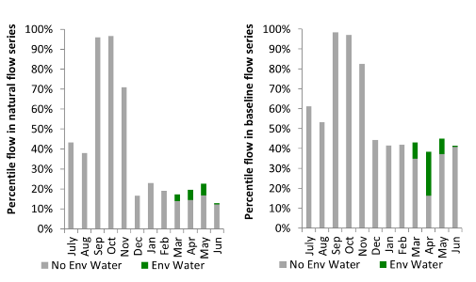
Figure NAM6. Contribution of environmental water delivery at Goangra as percentiles in the natural and baseline flow series.
Bugilbone
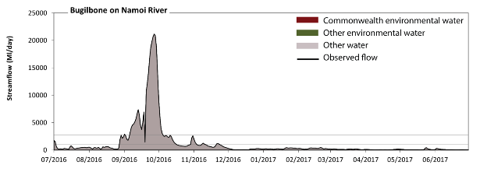
Figure NAM7. Contribution of environmental water delivery at Bugilbone. Horizontal lines indicate thresholds for very low flows, low flows, low freshes, medium freshes and high freshes (from lowest to highest).
At Bugilbone on the Namoi River environmental water contributed 1% of the total streamflow volume (all of which was Commonwealth environmental water). Environmental watering actions affected streamflows for 24% of days between 1 July 2016 and 30 June 2017. Without environmental water, the durations of very low flows (i.e. < 47 ML/day) in the periods January to March and April to June would have substantially exceeded durations expected in an average year in the natural flow regime. Environmental water mitigated these impacts by reducing the cumulative duration of very low flow spells from 24% to 12% of the year, with greatest influence in the periods January to March and April to June. Similarly, without environmental water, the durations of medium low flows (i.e. < 240 ML/day) in the periods October to December, January to March and April to June would have substantially exceeded durations expected in an average year in the natural flow regime. However, environmental water had little effect on the duration of these medium low flows, which occurred for 51% of the year. Commonwealth environmental water was entirely responsible for these enhancements of environmental baseflows at this site. There was at least one low fresh (i.e. > 1000 ML/day) in the periods July to September and October to December. Environmental water made no change to the duration of these low freshes. There was at least one medium fresh (i.e. > 2800 ML/day) in the periods July to September and October to December. Environmental water made no change to the duration of these medium freshes. In the absence of environmental water there would have been at least one high fresh in the periods July to September and October to December. Environmental water made no change to the duration of these high freshes.
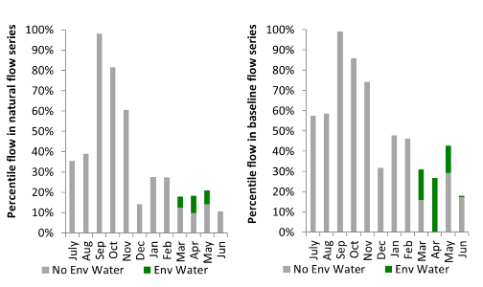
Figure NAM8. Contribution of environmental water delivery at Bugilbone as percentiles in the natural and baseline flow series.

Gunidgera
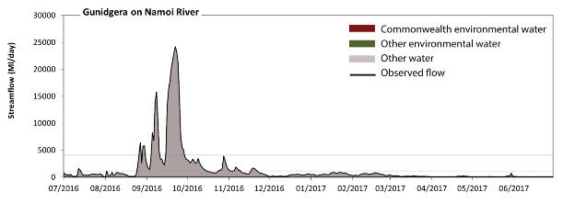
Figure NAM9. Contribution of environmental water delivery at Gunidgera. Horizontal lines indicate thresholds for very low flows, low flows, low freshes, medium freshes and high freshes (from lowest to highest).
At Gunidgera on the Namoi River environmental water contributed 1% of the total streamflow volume (all of which was Commonwealth environmental water). Environmental watering actions affected streamflows for 24% of days between 1 July 2016 and 30 June 2017. Without environmental water, the durations of very low flows (i.e. < 32 ML/day) in the periods January to March and April to June would have substantially exceeded durations expected in an average year in the natural flow regime. Environmental water mitigated these impacts by reducing the cumulative duration of very low flow spells from 18% to 0% of the year, with greatest influence in the period April to June. Similarly, without environmental water, the durations of medium low flows (i.e. < 160 ML/day) in the periods January to March and April to June would have substantially exceeded durations expected in an average year in the natural flow regime. Environmental water mitigated these impacts by reducing the cumulative duration of medium low flow spells from 38% to 35% of the year, with greatest influence in the periods January to March and April to June. Commonwealth environmental water was entirely responsible for these enhancements of environmental baseflows at this site. There was at least one low fresh (i.e. > 1100 ML/day) in the periods July to September and October to December. Environmental water made no change to the duration of these low freshes. There was at least one medium fresh (i.e. > 4100 ML/day) in the period July to September. Environmental water made no change to the duration of these medium freshes. In the absence of environmental water there would have been at least one high fresh in the period July to September. Environmental water made no change to the duration of these high freshes.
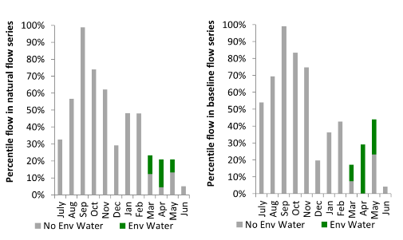
Figure NAM10. Contribution of environmental water delivery at Gunidgera as percentiles in the natural and baseline flow series.
Weeta
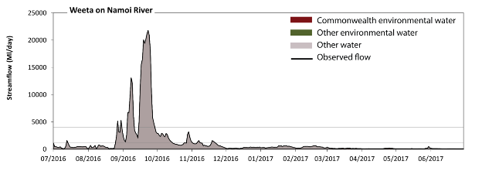
Figure NAM11. Contribution of environmental water delivery at Weeta. Horizontal lines indicate thresholds for very low flows, low flows, low freshes, medium freshes and high freshes (from lowest to highest).
At Weeta on the Namoi River environmental water contributed 1% of the total streamflow volume (all of which was Commonwealth environmental water). Environmental watering actions affected streamflows for 24% of days between 1 July 2016 and 30 June 2017. Without environmental water, the durations of very low flows (i.e. < 31 ML/day) in the periods January to March and April to June would have substantially exceeded durations expected in an average year in the natural flow regime. Environmental water mitigated these impacts by reducing the cumulative duration of very low flow spells from 19% to 0% of the year, with greatest influence in the period April to June. Similarly, without environmental water, the durations of medium low flows (i.e. < 150 ML/day) in the periods January to March and April to June would have substantially exceeded durations expected in an average year in the natural flow regime. Environmental water mitigated these impacts by reducing the cumulative duration of medium low flow spells from 38% to 36% of the year, with greatest influence in the periods January to March and April to June. Commonwealth environmental water was entirely responsible for these enhancements of environmental baseflows at this site. There was at least one low fresh (i.e. > 1100 ML/day) in the periods July to September and October to December. Environmental water made no change to the duration of these low freshes. There was at least one medium fresh (i.e. > 4000 ML/day) in the period July to September. Environmental water made no change to the duration of these medium freshes. In the absence of environmental water there would have been at least one high fresh in the period July to September. Environmental water made no change to the duration of these high freshes.
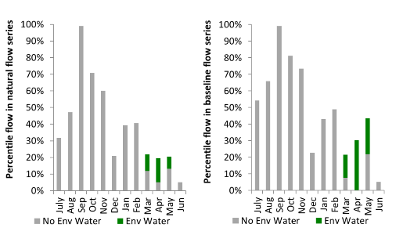
Figure NAM12. Contribution of environmental water delivery at Weeta as percentiles in the natural and baseline flow series.

Mollee
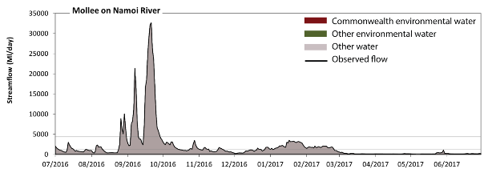Figure NAM13. Contribution of environmental water delivery at Mollee. Horizontal lines indicate thresholds for very low flows, low flows, low freshes, medium freshes and high freshes (from lowest to highest).
At Mollee on the Namoi River environmental water contributed less than 1% of the total streamflow volume (all of which was Commonwealth environmental water). Environmental watering actions affected streamflows for 8% of days between 1 July 2016 and 30 June 2017. Flow regulation does not substantially increase the duration of very low flows (i.e. < 44 ML/day) compared to an average year in the natural flow regime. However, without environmental water, the duration of medium low flows (i.e. < 220 ML/day) in the period April to June would have exceeded durations expected in an average year in the natural flow regime. Environmental water reduced the cumulative duration of medium low flow spells from 29% to 28% of the year, with greatest influence in the period January to March. There was at least one low fresh (i.e. > 1300 ML/day) in the periods July to September, October to December and January to March. Environmental water made no change to the duration of these low freshes. There was at least one medium fresh (i.e. > 4400 ML/day) in the period July to September. Environmental water made no change to the duration of these medium freshes. In the absence of environmental water there would have been at least one high fresh in the period July to September. Environmental water made no change to the duration of these high freshes.
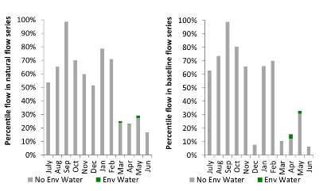
Figure NAM14. Contribution of environmental water delivery at Mollee as percentiles in the natural and baseline flow series.
Boggabri
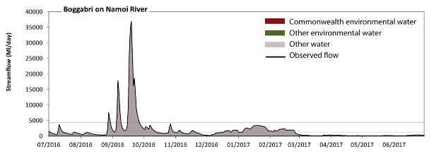 Figure NAM15. Contribution of environmental water delivery at Boggabri. Horizontal lines indicate thresholds for very low flows, low flows, low freshes, medium freshes and high freshes (from lowest to highest).
At Boggabri on the Namoi River environmental water contributed less than 1% of the total streamflow volume (all of which was Commonwealth environmental water). Environmental watering actions affected streamflows for 8% of days between 1 July 2016 and 30 June 2017. Flow regulation does not substantially increase the duration of very low flows (i.e. < 42 ML/day) compared to an average year in the natural flow regime. However, without environmental water, the duration of medium low flows (i.e. < 210 ML/day) in the period April to June would have exceeded durations expected in an average year in the natural flow regime. Environmental water reduced the cumulative duration of medium low flow spells from 25% to 24% of the year, with greatest influence in the period January to March. There was at least one low fresh (i.e. > 1300 ML/day) in the periods July to September, October to December and January to March. Environmental water made no change to the duration of these low freshes. There was at least one medium fresh (i.e. > 4300 ML/day) in the period July to September. Environmental water made no change to the duration of these medium freshes. In the absence of environmental water there would have been at least one high fresh in the period July to September. Environmental water made no change to the duration of these high freshes.
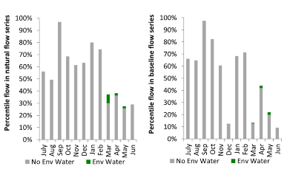
Figure NAM16. Contribution of environmental water delivery at Boggabri as percentiles in the natural and baseline flow series.
Keepit
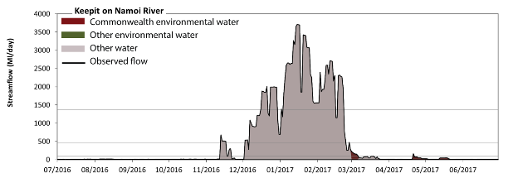 Figure NAM17. Contribution of environmental water delivery at Keepit. Horizontal lines indicate thresholds for very low flows, low flows, low freshes, medium freshes and high freshes (from lowest to highest).
At Keepit on the Namoi River environmental water contributed 1% of the total streamflow volume (all of which was Commonwealth environmental water). Environmental watering actions affected streamflows for 8% of days between 1 July 2016 and 30 June 2017. Without environmental water, the durations of very low flows (i.e. < 20 ML/day) in the periods July to September, October to December, January to March and April to June would have all substantially exceeded durations expected in an average year in the natural flow regime. Environmental water mitigated these impacts by reducing the cumulative duration of very low flow spells from 68% to 61% of the year, with greatest influence in the period April to June. Similarly, without environmental water, the durations of medium low flows (i.e. < 99 ML/day) in the periods July to September, October to December, January to March and April to June would have all substantially exceeded durations expected in an average year in the natural flow regime. Environmental water mitigated these impacts by reducing the cumulative duration of medium low flow spells from 73% to 72% of the year, with greatest influence in the period January to March. Commonwealth environmental water was entirely responsible for these enhancements of environmental baseflows at this site. There was at least one low fresh (i.e. > 470 ML/day) in the periods October to December and January to March. Environmental water made no change to the duration of these low freshes. There was at least one medium fresh (i.e. > 1400 ML/day) in the periods October to December and January to March. Environmental water made no change to the duration of these medium freshes. In the absence of environmental water there would have been at least one high fresh in the periods October to December and January to March. Environmental water made no change to the duration of these high freshes.
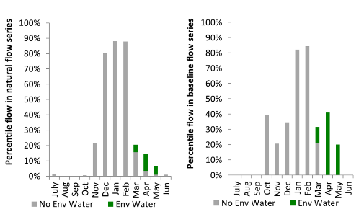
Figure NAM18. Contribution of environmental water delivery at Keepit as percentiles in the natural and baseline flow series.
Gunnedah
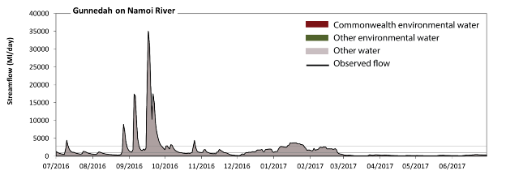 Figure NAM19. Contribution of environmental water delivery at Gunnedah. Horizontal lines indicate thresholds for very low flows, low flows, low freshes, medium freshes and high freshes (from lowest to highest).
At Gunnedah on the Namoi River environmental water contributed less than 1% of the total streamflow volume (all of which was Commonwealth environmental water). Environmental watering actions affected streamflows for 8% of days between 1 July 2016 and 30 June 2017. Flow regulation does not substantially increase the duration of very low flows (i.e. < 41 ML/day) compared to an average year in the natural flow regime. However, without environmental water, the duration of medium low flows (i.e. < 210 ML/day) in the period April to June would have substantially exceeded durations expected in an average year in the natural flow regime. Environmental water reduced the cumulative duration of medium low flow spells from 24% to 22% of the year, with greatest influence in the period January to March. There was at least one low fresh (i.e. > 970 ML/day) in the periods July to September, October to December and January to March. Environmental water made no change to the duration of these low freshes. There was at least one medium fresh (i.e. > 2900 ML/day) in the periods July to September, October to December and January to March. Environmental water made no change to the duration of these medium freshes. In the absence of environmental water there would have been at least one high fresh in the periods July to September, October to December and January to March. Environmental water made no change to the duration of these high freshes.
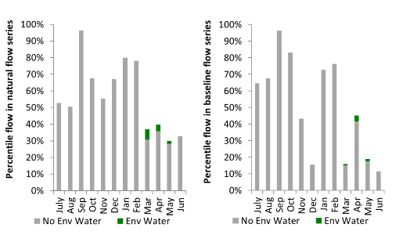
Figure NAM20. Contribution of environmental water delivery at Gunnedah as percentiles in the natural and baseline flow series.
Chaffey
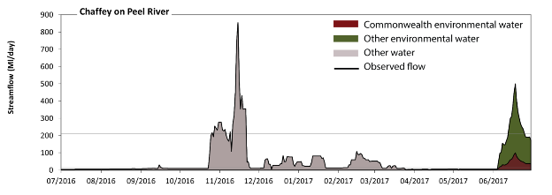 Figure NAM21. Contribution of environmental water delivery at Chaffey. Horizontal lines indicate thresholds for very low flows, low flows and low freshes (from lowest to highest).
At Chaffey on the Peel River environmental water contributed 30% of the total streamflow volume (with a medium contribution of Commonwealth environmental water). Environmental watering actions affected streamflows for 7% of days between 1 July 2016 and 30 June 2017. Without environmental water, the duration of very low flows (i.e. < 2.9 ML/day) in the period April to June would have substantially exceeded durations expected in an average year in the natural flow regime. Environmental water mitigated these impacts by reducing the cumulative duration of very low flow spells from 7% to 0% of the year, with greatest influence in the period April to June. Similarly, without environmental water, the durations of medium low flows (i.e. < 14 ML/day) in the periods July to September, October to December, January to March and April to June would have all substantially exceeded durations expected in an average year in the natural flow regime. Environmental water mitigated these impacts by reducing the cumulative duration of medium low flow spells from 69% to 62% of the year, with greatest influence in the period April to June. Commonwealth environmental water equally shared responsibility with other environmental water holders for these enhancements of environmental baseflows at this site. In the absence of environmental water there would have been at least one low fresh (i.e. > 210 ML/day) in the period October to December. Environmental water increased the duration of the longest low fresh during the period April to June (from 0 days to 13 days). Commonwealth environmental water made little or no contribution to these increased durations of low freshes. There was no medium or high freshes this year.
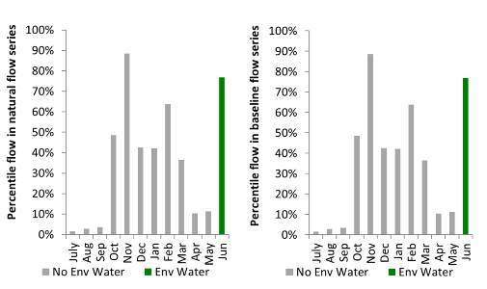
Figure NAM22. Contribution of environmental water delivery at Chaffey as percentiles in the natural and baseline flow series.
Piallamore
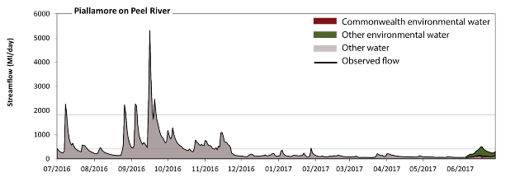 Figure NAM23. Contribution of environmental water delivery at Piallamore. Horizontal lines indicate thresholds for very low flows, low flows, low freshes, medium freshes and high freshes (from lowest to highest).
At Piallamore on the Peel River environmental water contributed 4% of the total streamflow volume (with a medium contribution of Commonwealth environmental water). Environmental watering actions affected streamflows for 7% of days between 1 July 2016 and 30 June 2017. Flow regulation does not substantially increase the duration of very low flows (i.e. < 5.7 ML/day) compared to an average year in the natural flow regime. Flow regulation does not substantially increase the duration of medium low flows (i.e. < 29 ML/day) compared to an average year in the natural flow regime. In the absence of environmental water there would have been at least one low fresh (i.e. > 410 ML/day) in the periods July to September, October to December and January to March. Environmental water increased the duration of the longest low fresh during the period April to June (from 0 days to 4 days). Commonwealth environmental water made little or no contribution to these increased durations of low freshes. There was at least one medium fresh (i.e. > 1800 ML/day) in the period July to September. Environmental water made no change to the duration of these medium freshes. In the absence of environmental water there would have been at least one high fresh in the period July to September. Environmental water made no change to the duration of these high freshes.
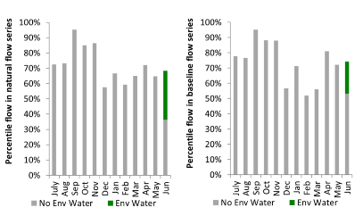
Figure NAM24. Contribution of environmental water delivery at Piallamore as percentiles in the natural and baseline flow series.
Paradise
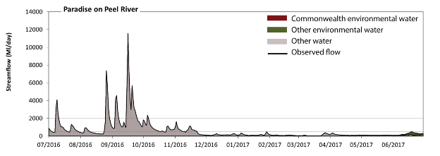 Figure NAM25. Contribution of environmental water delivery at Paradise. Horizontal lines indicate thresholds for very low flows, low flows, low freshes, medium freshes and high freshes (from lowest to highest).
At Paradise on the Peel River environmental water contributed 2% of the total streamflow volume (with a medium contribution of Commonwealth environmental water). Environmental watering actions affected streamflows for 7% of days between 1 July 2016 and 30 June 2017. Flow regulation does not substantially increase the duration of very low flows (i.e. < 11 ML/day) compared to an average year in the natural flow regime. Flow regulation does not substantially increase the duration of medium low flows (i.e. < 53 ML/day) compared to an average year in the natural flow regime. There was at least one low fresh (i.e. > 510 ML/day) in the periods July to September and October to December. Environmental water made no change to the duration of these low freshes. There was at least one medium fresh (i.e. > 2000 ML/day) in the periods July to September and October to December. Environmental water made no change to the duration of these medium freshes. In the absence of environmental water there would have been at least one high fresh in the periods July to September and October to December. Environmental water made no change to the duration of these high freshes.
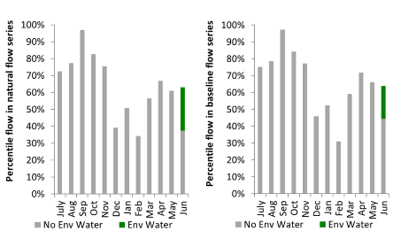
Figure NAM26. Contribution of environmental water delivery at Paradise as percentiles in the natural and baseline flow series.
Carroll
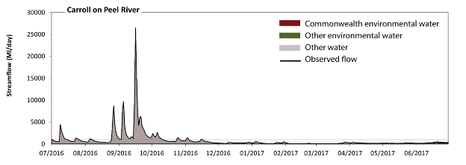 Figure NAM27. Contribution of environmental water delivery at Carroll. Horizontal lines indicate thresholds for very low flows, low flows, low freshes, medium freshes and high freshes (from lowest to highest).
At Carroll on the Peel River environmental water contributed 1% of the total streamflow volume (with a medium contribution of Commonwealth environmental water). Environmental watering actions affected streamflows for 6% of days between 1 July 2016 and 30 June 2017. Flow regulation does not substantially increase the duration of very low flows (i.e. < 14 ML/day) compared to an average year in the natural flow regime. However, without environmental water, the duration of medium low flows (i.e. < 70 ML/day) in the period January to March would have substantially exceeded durations expected in an average year in the natural flow regime. However, environmental water had little effect on the duration of these medium low flows, which occurred for 9% of the year. In the absence of environmental water there would have been at least one low fresh (i.e. > 330 ML/day) in the periods July to September, October to December, January to March and April to June. Environmental water increased the duration of the longest low fresh during the period April to June (from 1 days to 12 days). Commonwealth environmental water made little or no contribution to these increased durations of low freshes. There was at least one medium fresh (i.e. > 980 ML/day) in the periods July to September and October to December. Environmental water made no change to the duration of these medium freshes. In the absence of environmental water there would have been at least one high fresh in the periods July to September and October to December. Environmental water made no change to the duration of these high freshes.
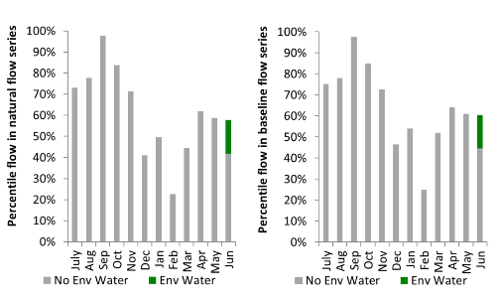
Figure NAM28. Contribution of environmental water delivery at Carroll as percentiles in the natural and baseline flow series.

Murrumbidgee
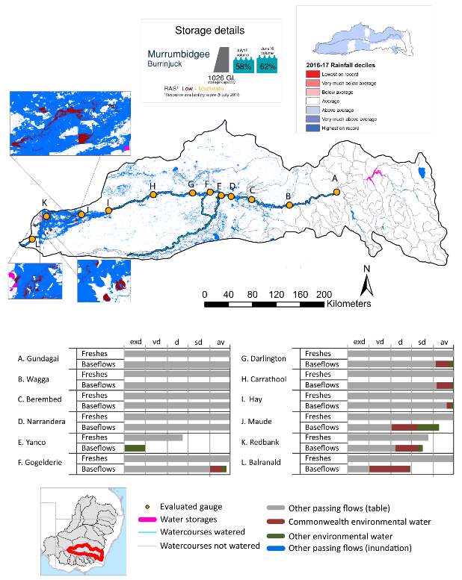

exd: extremely dry | vd: very dry | d: dry | sd: somewhat dry | av: average

Figure MBG1. Watercourses influenced, areas inundated (where applicable) and gauge stations evaluated in the Murrumbidgee valley during the 2016-17 water year. Inset bar graphs report the condition of annual flow regimes by showing the improvements in hydrological condition with the addition of environmental water as well as the hypothetical scenario in “grey” (if no environmental flow had been delivered). Rainfall conditions (rainfall deciles) and trend in storage levels for the water year are also shown.

Summary
Environmental water delivery for the 2016-17 year in the Murrumbidgee valley is evaluated using data for 12 sites. This evaluation only considers the contribution of held environmental water, which is a primary focus for the Australian Government. The contributions of planned environmental water (e.g. passing flows), unregulated tributary inflows and clever use of irrigation flows for environmental benefits can all be very important but these are outside the scope of this report, but where this data was made availalable (for planned ewater only) it has been included.. Environmental watering actions lasted on average 149 days over the course of the year. The volume of environmental water at these 12 sites was between 2% and 18% of the total streamflow. Commonwealth environmental water contributed on average 49% of this environmental water. Ideally, baseflows should be maintained and long periods of excessively low flows avoided. In this valley, the baseflow regime was generally considered to be somewhat dry relative to the pre-development flow regime. In our analysis, a low fresh refers to a period of increased flow, when the water level rises at least one eighth of the way up the river bank (above the low flow level). These low freshes are a regular part of the natural flow regime and support a range of natural processes. In the Murrumbidgee valley, in terms of the occurrence and duration of low freshes, the year was assessed as being average. In our analysis, a medium fresh refers to a period of increased flow, when the water level rises at least one quarter of the way up the river bank. These medium freshes are not as frequent as low freshes but are also a regular and important part of the natural flow regime. In the Murrumbidgee valley, in terms of the occurrence of medium freshes, the year was assessed as being average. In our analysis, a high fresh refers to a period of increased flow, when the water level rises more than half way up the river. A high fresh may not occur every year but they are still important and long periods without major freshes can have serious consequences for floodplains and their contribution to river ecosystem health. Delivering high in channel flows normally requires that all risks to riparian landholders and infrastructure have been resolved. In the Murrumbidgee valley, in terms of the occurrence of high freshes, the year was assessed as being average.

Water delivery context
During the 2016-17, the Commonwealth Environmental Water Holder (CEWH) held water entitlements of up to 728 809 ML for environmental use in the Murrumbidgee valley. Each year, water utilities allocate water entitlement holders a percentage of water based on their holding, license type and carryover (the exact rules vary among Jurisdictions). In 2016-17, the Murrumbidgee entitlements held by the CEWH were allocated 251 201 ML of water, representing 64% of the Long term average annual yield for the Murrumbidgee valley (393 779 ML). Information and data relating to the portfolio of held Commonwealth environmental water is shown in Table MBG1.
The 2016-17 water allocation (251 201 ML) together with the carryover volume of 55 276 ML of water meant the CEWH had 306 476 ML of water available for delivery. A total of 241 465 ML of Commonwealth environmental water was delivered in the Murrumbidgee valley. A total of 0 ML of Commonwealth environmental water was traded to consumptive users and 78 509 ML (26%) of available Commonwealth environmental water was carried over for environmental use into the 2017-18 water year.

Environmental conditions and resource availability
The water available for environmental delivery combined with the present and antecedent environmental conditions are key inputs used by environmental water managers in planning and implementing watering actions. Post hoc, this information provides important context when evaluating the effectiveness and appropriateness of environmental water use with respect to hydrological outputs.
The rainfall conditions in the Murrumbidgee valley were classified as above average, based on rainfall percentile data for the entire record held by the Bureau of Meteorology for this valley. The water held in major storages in the Murrumbidgee valley increased over the water year, for example Burrinjuck dam was 58% full at the beginning of the water year and 62% full by the end of the year (Figure MBG1).
The Commonwealth Environmental Water Office (CEWO) calculates resource availability scenarios (RAS) to guide the use and prioritisation of held environmental water. The RAS are progressively calculated over the year as part of the continual adaptive management planning processes. The RAS are based on the availability of held environmental water (including progressive license acquisitions and allocations) as well as the potential for unregulated or planned environmental flows. The outcome is then used to determine the demand for environmental water across The Basin.
In 2016-17, the resource availability of held Commonwealth environmental water was classified as low in this valley, whilst the potential for unregulated or planned environmental flow was classified as high. The antecedent and forecasted physical conditions meant that Commonwealth environmental water was being planned to protect the mid-Murrumbidgee wetlands and ensure their ecological capacity for recovery, while maintaining and where possible improving the ecological health and resilience of other important sites in the catchment. The overall demand for environmental water was deemed moderate (water predominantly needed this year and or next).

Watering actions
A total of 12 watering actions were delivered over the 2016-17 water year, the duration of these actions varied (range of individual actions: 4 - 116 days) and Commonwealth environmental water was delivered for a total of 149 days. The count of actions commencing in each season was; winter (1), spring (3), summer(5) and autumn (3). The flow component types delivered were; (0) baseflow, (2) freshes, (1) bankfull, (0) overbank and (10) wetland.
There were 49 expected outcomes across the 12 watering actions in the Murrumbidgee. The percentage of expected outcomes across the nine main themes were: fish (22.45%), vegetation (22.45%), waterbirds (20.41%), frogs (4.08%), other biota (4.08%), connectivity (2.04%), process (4.08%), resilience (2.04%) and water quality (18.37%).
Table MBG1. Commonwealth environmental water accounting information for the Murrumbidgee valley over 2016-17 water year (LTAAY = long-term average annual yield).
Total registered volume (ML) | Allocated volume (ML) | Carry over + allocated volume (ML) | Delivered (ML) | LTAAY (ML) | Trade (ML) | Carried over to 2016-17 | Forfeited (ML)
728 809 | 251 201 | 306 476 | 241 465 | 393 779 | 0 | 78 509 | 0

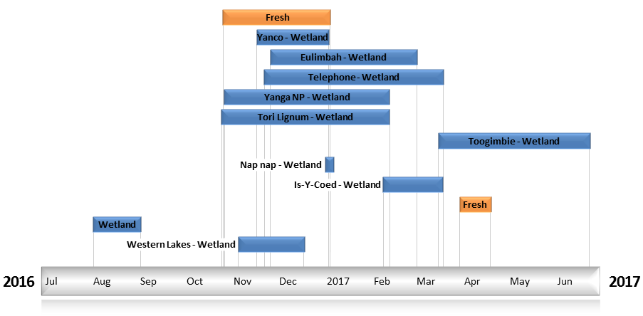
Figure MBG2. Timing and duration of Commonwealth environmental water actions delivered in the Murrumbidgee valley.

Contribution of Commonwealth Environmental Water to Flow Regimes
Gundagai
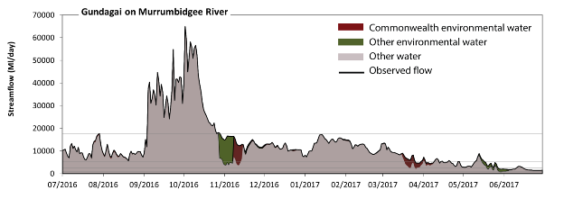
Figure MBG3. Contribution of environmental water delivery at Gundagai. Horizontal lines indicate thresholds for very low flows, low flows, low freshes, medium freshes and high freshes (from lowest to highest).
At Gundagai on the Murrumbidgee River environmental water contributed 6% of the total streamflow volume (with approximately half contributed by Commonwealth environmental water). Environmental watering actions affected streamflows for 49% of days between 1 July 2016 and 30 June 2017. Flow regulation does not substantially increase the duration of very low flows (i.e. < 190 ML/day) compared to an average year in the natural flow regime. Flow regulation does not substantially increase the duration of medium low flows (i.e. < 930 ML/day) compared to an average year in the natural flow regime. There was at least one low fresh (i.e. > 2500 ML/day) in the periods July to September, October to December, January to March and April to June. Environmental water made little change to the duration of these low freshes. In the absence of environmental water there would have been at least one medium fresh (i.e. > 5400 ML/day) in the periods July to September, October to December, January to March and April to June. Environmental water increased the duration of the longest medium fresh during the periods July to September (from 50 days to 92 days), October to December (from 48 days to 92 days) and April to June (from 4 days to 6 days). Commonwealth environmental water made the dominant contribution to these increased durations of medium freshes. In the absence of environmental water there would have been at least one high fresh in the periods July to September and October to December. Environmental water made little change to the duration of these high freshes.
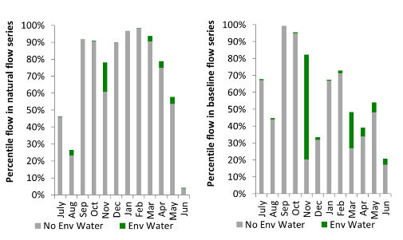
Figure MBG4. Contribution of environmental water delivery at Gundagai as percentiles in the natural and baseline flow series.
Wagga
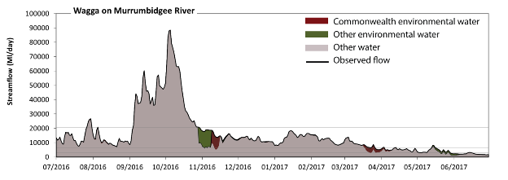
Figure MBG5. Contribution of environmental water delivery at Wagga. Horizontal lines indicate thresholds for very low flows, low flows, low freshes, medium freshes and high freshes (from lowest to highest).
At Wagga on the Murrumbidgee River environmental water contributed 5% of the total streamflow volume (with approximately half contributed by Commonwealth environmental water). Environmental watering actions affected streamflows for 49% of days between 1 July 2016 and 30 June 2017. Flow regulation does not substantially increase the duration of very low flows (i.e. < 210 ML/day) compared to an average year in the natural flow regime. Flow regulation does not substantially increase the duration of medium low flows (i.e. < 1000 ML/day) compared to an average year in the natural flow regime. There was at least one low fresh (i.e. > 2900 ML/day) in the periods July to September, October to December, January to March and April to June. Environmental water made little change to the duration of these low freshes. In the absence of environmental water there would have been at least one medium fresh (i.e. > 6300 ML/day) in the periods July to September, October to December, January to March and April to June. Environmental water increased the duration of the longest medium fresh during the periods October to December (from 48 days to 92 days) and April to June (from 3 days to 5 days). Commonwealth environmental water equally shared responsibility with other environmental water holders for these increased durations of medium freshes. In the absence of environmental water there would have been at least one high fresh in the periods July to September and October to December. Environmental water made little change to the duration of these high freshes.
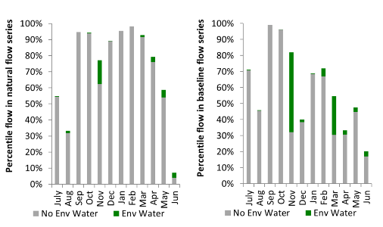
Figure MBG6. Contribution of environmental water delivery at Wagga as percentiles in the natural and baseline flow series.

Berembed
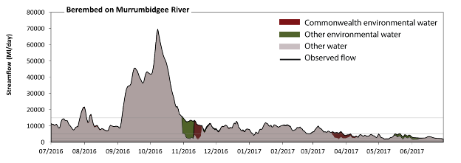
Figure MBG7. Contribution of environmental water delivery at Berembed. Horizontal lines indicate thresholds for very low flows, low flows, low freshes, medium freshes and high freshes (from lowest to highest).
At Berembed on the Murrumbidgee River environmental water contributed 6% of the total streamflow volume (with approximately half contributed by Commonwealth environmental water). Environmental watering actions affected streamflows for 49% of days between 1 July 2016 and 30 June 2017. Flow regulation does not substantially increase the duration of very low flows (i.e. < 210 ML/day) compared to an average year in the natural flow regime. Flow regulation does not substantially increase the duration of medium low flows (i.e. < 1000 ML/day) compared to an average year in the natural flow regime. In the absence of environmental water there would have been at least one low fresh (i.e. > 2500 ML/day) in the periods July to September, October to December, January to March and April to June. Environmental water increased the duration of the longest low fresh during the periods October to December (from 46 days to 92 days) and April to June (from 26 days to 42 days). Commonwealth environmental water made the dominant contribution to these increased durations of low freshes. In the absence of environmental water there would have been at least one medium fresh (i.e. > 5000 ML/day) in the periods July to September, October to December, January to March and April to June. Environmental water increased the duration of the longest medium fresh during the periods October to December (from 44 days to 92 days), January to March (from 49 days to 82 days) and April to June (from 1 days to 2 days). Commonwealth environmental water equally shared responsibility with other environmental water holders for these increased durations of medium freshes. In the absence of environmental water there would have been at least one high fresh in the periods July to September and October to December. Environmental water made little change to the duration of these high freshes.
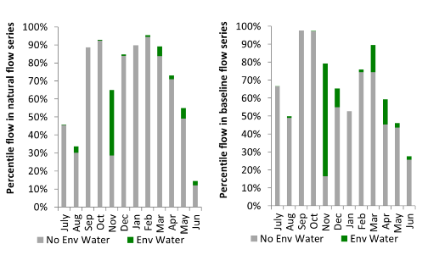
Figure MBG8. Contribution of environmental water delivery at Berembed as percentiles in the natural and baseline flow series.
Narrandera
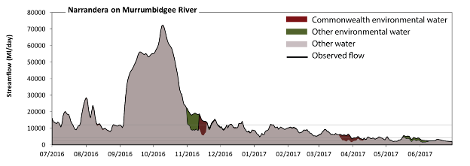
Figure MBG9. Contribution of environmental water delivery at Narrandera. Horizontal lines indicate thresholds for very low flows, low flows, low freshes, medium freshes and high freshes (from lowest to highest).
At Narrandera on the Murrumbidgee River environmental water contributed 5% of the total streamflow volume (with approximately half contributed by Commonwealth environmental water). Environmental watering actions affected streamflows for 50% of days between 1 July 2016 and 30 June 2017. Flow regulation does not substantially increase the duration of very low flows (i.e. < 210 ML/day) compared to an average year in the natural flow regime. Flow regulation does not substantially increase the duration of medium low flows (i.e. < 1000 ML/day) compared to an average year in the natural flow regime. There was at least one low fresh (i.e. > 2300 ML/day) in the periods July to September, October to December, January to March and April to June. Environmental water made little change to the duration of these low freshes. In the absence of environmental water there would have been at least one medium fresh (i.e. > 4300 ML/day) in the periods July to September, October to December, January to March and April to June. Environmental water increased the duration of the longest medium fresh during the period April to June (from 3 days to 7 days). Commonwealth environmental water made little or no contribution to these increased durations of medium freshes. In the absence of environmental water there would have been at least one high fresh in the periods July to September, October to December and January to March. Environmental water increased the duration of the longest medium fresh during the period October to December (from 32 days to 50 days). Commonwealth environmental water made little or no contribution to these increased durations of high freshes.
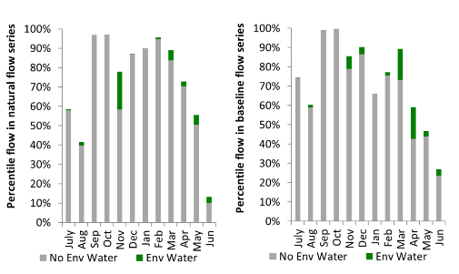
Figure MBG10. Contribution of environmental water delivery at Narrandera as percentiles in the natural and baseline flow series.
Yanco Offtake
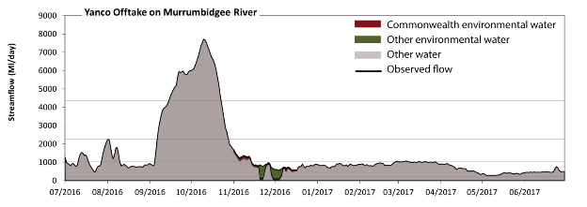
Figure MBG11. Contribution of environmental water delivery at Yanco Offtake. Horizontal lines indicate thresholds for very low flows, low flows, low freshes and medium freshes (from lowest to highest).
At Yanco Offtake on the Murrumbidgee River environmental water contributed 2% of the total streamflow volume (with a medium contribution of Commonwealth environmental water). Environmental watering actions affected streamflows for 14% of days between 1 July 2016 and 30 June 2017. Without environmental water, the duration of very low flows (i.e. < 210 ML/day) in the period October to December would have substantially exceeded durations expected in an average year in the natural flow regime. Environmental water mitigated these impacts by reducing the cumulative duration of very low flow spells from 3% to 0% of the year, with greatest influence in the period October to December. Similarly, without environmental water, the durations of medium low flows (i.e. < 1000 ML/day) in the periods July to September, October to December, January to March and April to June would have all substantially exceeded durations expected in an average year in the natural flow regime. However, environmental water had little effect on the duration of these medium low flows, which occurred for 72% of the year. Commonwealth environmental water made little or no contribution to these enhancements of environmental baseflows at this site. There was at least one low fresh (i.e. > 2300 ML/day) in the periods July to September and October to December. Environmental water made no change to the duration of these low freshes. There was at least one medium fresh (i.e. > 4400 ML/day) in the periods July to September and October to December. Environmental water made no change to the duration of these medium freshes. There was no high freshes (i.e. > 12000 ML/day) this year.
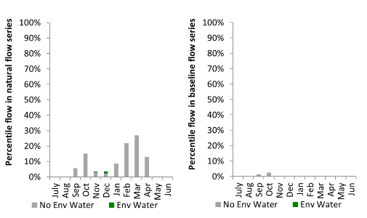
Figure MBG12. Contribution of environmental water delivery at Yanco Offtake as percentiles in the natural and baseline flow series.

Gogelderie
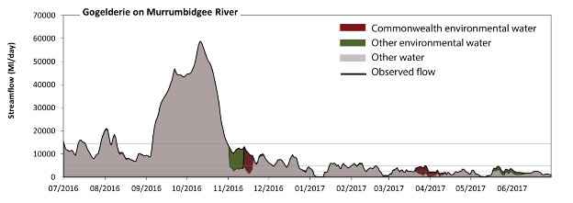Figure MBG13. Contribution of environmental water delivery at Gogelderie. Horizontal lines indicate thresholds for very low flows, low flows, low freshes, medium freshes and high freshes (from lowest to highest).
At Gogelderie on the Murrumbidgee River environmental water contributed 7% of the total streamflow volume (with approximately half contributed by Commonwealth environmental water). Environmental watering actions affected streamflows for 48% of days between 1 July 2016 and 30 June 2017. Without environmental water, the duration of very low flows (i.e. < 190 ML/day) in the period January to March would have substantially exceeded durations expected in an average year in the natural flow regime. Environmental water mitigated these impacts by reducing the cumulative duration of very low flow spells from 2% to 1% of the year, with greatest influence in the periods January to March and April to June. Similarly, without environmental water, the duration of medium low flows (i.e. < 960 ML/day) in the period April to June would have substantially exceeded durations expected in an average year in the natural flow regime. Environmental water mitigated these impacts by reducing the cumulative duration of medium low flow spells from 12% to 6% of the year, with greatest influence in the period April to June. Commonwealth environmental water made the dominant contribution to these enhancements of environmental baseflows at this site. In the absence of environmental water there would have been at least one low fresh (i.e. > 2300 ML/day) in the periods July to September, October to December, January to March and April to June. Environmental water increased the duration of the longest low fresh during the periods October to December (from 45 days to 92 days), January to March (from 28 days to 39 days) and April to June (from 6 days to 8 days). Commonwealth environmental water equally shared responsibility with other environmental water holders for these increased durations of low freshes. In the absence of environmental water there would have been at least one medium fresh (i.e. > 4800 ML/day) in the periods July to September, October to December and January to March. Environmental water increased the duration of the longest medium fresh during the periods October to December (from 32 days to 65 days) and January to March (from 7 days to 9 days). Commonwealth environmental water equally shared responsibility with other environmental water holders for these increased durations of medium freshes. In the absence of environmental water there would have been at least one high fresh in the periods July to September and October to December. Environmental water made no change to the duration of these high freshes.
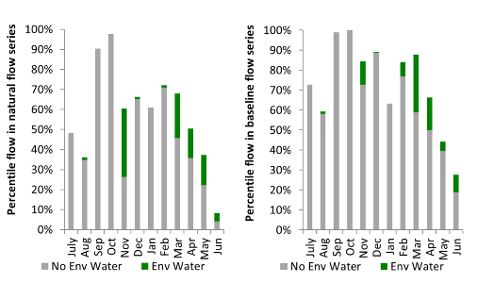
Figure MBG14. Contribution of environmental water delivery at Gogelderie as percentiles in the natural and baseline flow series.
Darlington
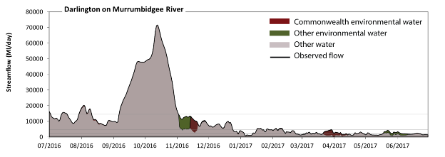 Figure MBG15. Contribution of environmental water delivery at Darlington. Horizontal lines indicate thresholds for very low flows, low flows, low freshes, medium freshes and high freshes (from lowest to highest).
At Darlington on the Murrumbidgee River environmental water contributed 6% of the total streamflow volume (with approximately half contributed by Commonwealth environmental water). Environmental watering actions affected streamflows for 48% of days between 1 July 2016 and 30 June 2017. Flow regulation does not substantially increase the duration of very low flows (i.e. < 190 ML/day) compared to an average year in the natural flow regime. However, without environmental water, the duration of medium low flows (i.e. < 960 ML/day) in the period April to June would have substantially exceeded durations expected in an average year in the natural flow regime. Environmental water mitigated these impacts by reducing the cumulative duration of medium low flow spells from 6% to 0% of the year, with greatest influence in the periods January to March and April to June. Commonwealth environmental water made the dominant contribution to these enhancements of environmental baseflows at this site. In the absence of environmental water there would have been at least one low fresh (i.e. > 2300 ML/day) in the periods July to September, October to December, January to March and April to June. Environmental water increased the duration of the longest low fresh during the period April to June (from 4 days to 8 days). Commonwealth environmental water made a modest contribution to these increased durations of low freshes. In the absence of environmental water there would have been at least one medium fresh (i.e. > 4800 ML/day) in the periods July to September, October to December and January to March. Environmental water increased the duration of the longest medium fresh during the period October to December (from 36 days to 85 days). Commonwealth environmental water equally shared responsibility with other environmental water holders for these increased durations of medium freshes. In the absence of environmental water there would have been at least one high fresh in the periods July to September and October to December. Environmental water made no change to the duration of these high freshes.
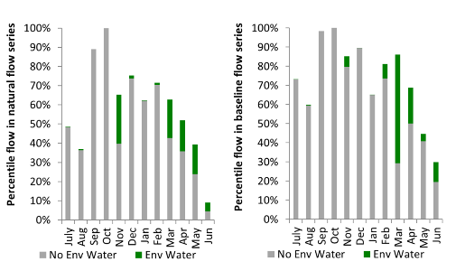
Figure MBG16. Contribution of environmental water delivery at Darlington as percentiles in the natural and baseline flow series.

Carrathool
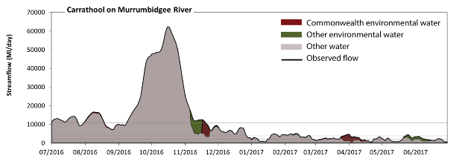 Figure MBG17. Contribution of environmental water delivery at Carrathool. Horizontal lines indicate thresholds for very low flows, low flows, low freshes, medium freshes and high freshes (from lowest to highest).
At Carrathool on the Murrumbidgee River environmental water contributed 6% of the total streamflow volume (with approximately half contributed by Commonwealth environmental water). Environmental watering actions affected streamflows for 48% of days between 1 July 2016 and 30 June 2017. Flow regulation does not substantially increase the duration of very low flows (i.e. < 190 ML/day) compared to an average year in the natural flow regime. However, without environmental water, the duration of medium low flows (i.e. < 930 ML/day) in the period April to June would have substantially exceeded durations expected in an average year in the natural flow regime. Environmental water mitigated these impacts by reducing the cumulative duration of medium low flow spells from 7% to 4% of the year, with greatest influence in the period April to June. Commonwealth environmental water was almost entirely responsible for these enhancements of environmental baseflows at this site. In the absence of environmental water there would have been at least one low fresh (i.e. > 2000 ML/day) in the periods July to September, October to December, January to March and April to June. Environmental water increased the duration of the longest low fresh during the period April to June (from 9 days to 22 days). Commonwealth environmental water made a small contribution to these increased durations of low freshes. In the absence of environmental water there would have been at least one medium fresh (i.e. > 3900 ML/day) in the periods July to September, October to December and January to March. Environmental water increased the duration of the longest medium fresh during the periods October to December (from 50 days to 88 days) and April to June (from 0 days to 4 days). Commonwealth environmental water made the dominant contribution to these increased durations of medium freshes. In the absence of environmental water there would have been at least one high fresh in the periods July to September and October to December. Environmental water increased the duration of the longest medium fresh during the period October to December (from 36 days to 50 days). Commonwealth environmental water made little or no contribution to these increased durations of high freshes.
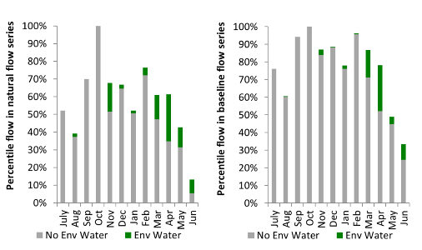
Figure MBG18. Contribution of environmental water delivery at Carrathool as percentiles in the natural and baseline flow series.
Hay
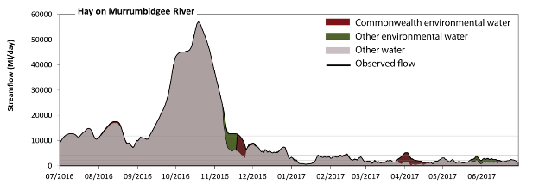 Figure MBG19. Contribution of environmental water delivery at Hay. Horizontal lines indicate thresholds for very low flows, low flows, low freshes, medium freshes and high freshes (from lowest to highest).
At Hay on the Murrumbidgee River environmental water contributed 6% of the total streamflow volume (with approximately half contributed by Commonwealth environmental water). Environmental watering actions affected streamflows for 48% of days between 1 July 2016 and 30 June 2017. Flow regulation does not substantially increase the duration of very low flows (i.e. < 180 ML/day) compared to an average year in the natural flow regime. Flow regulation does not substantially increase the duration of medium low flows (i.e. < 900 ML/day) compared to an average year in the natural flow regime. Commonwealth environmental water was almost entirely responsible for these enhancements of environmental baseflows at this site. In the absence of environmental water there would have been at least one low fresh (i.e. > 2100 ML/day) in the periods July to September, October to December, January to March and April to June. Environmental water increased the duration of the longest low fresh during the period April to June (from 7 days to 24 days). Commonwealth environmental water made a small contribution to these increased durations of low freshes. In the absence of environmental water there would have been at least one medium fresh (i.e. > 4100 ML/day) in the periods July to September, October to December and January to March. Environmental water increased the duration of the longest medium fresh during the periods October to December (from 53 days to 90 days), January to March (from 1 days to 3 days) and April to June (from 0 days to 4 days). Commonwealth environmental water was almost entirely responsible for these increased durations of medium freshes. In the absence of environmental water there would have been at least one high fresh in the periods July to September and October to December. Environmental water increased the duration of the longest medium fresh during the period October to December (from 40 days to 51 days). Commonwealth environmental water made little or no contribution to these increased durations of high freshes.
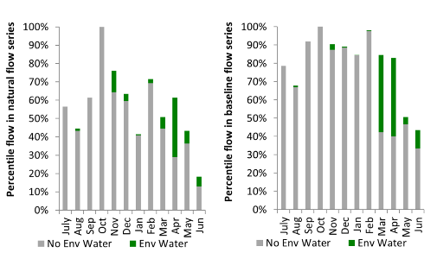
Figure MBG20. Contribution of environmental water delivery at Hay as percentiles in the natural and baseline flow series.
Maude
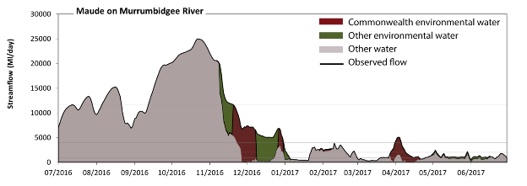 Figure MBG21. Contribution of environmental water delivery at Maude. Horizontal lines indicate thresholds for very low flows, low flows, low freshes, medium freshes and high freshes (from lowest to highest).
At Maude on the Murrumbidgee River environmental water contributed 13% of the total streamflow volume (with approximately half contributed by Commonwealth environmental water). Environmental watering actions affected streamflows for 43% of days between 1 July 2016 and 30 June 2017. Without environmental water, the durations of very low flows (i.e. < 170 ML/day) in the periods October to December and April to June would have substantially exceeded durations expected in an average year in the natural flow regime. Environmental water mitigated these impacts by reducing the cumulative duration of very low flow spells from 6% to 0% of the year, with greatest influence in the periods October to December and April to June. Similarly, without environmental water, the durations of medium low flows (i.e. < 860 ML/day) in the periods October to December, January to March and April to June would have substantially exceeded durations expected in an average year in the natural flow regime. Environmental water mitigated these impacts by reducing the cumulative duration of medium low flow spells from 34% to 12% of the year, with greatest influence in the periods October to December and April to June. Commonwealth environmental water equally shared responsibility with other environmental water holders for these enhancements of environmental baseflows at this site. In the absence of environmental water there would have been at least one low fresh (i.e. > 2000 ML/day) in the periods July to September, October to December, January to March and April to June. Environmental water increased the duration of the longest low fresh during the periods October to December (from 57 days to 92 days) and April to June (from 1 days to 8 days). Commonwealth environmental water was entirely responsible for these increased durations of low freshes. In the absence of environmental water there would have been at least one medium fresh (i.e. > 4000 ML/day) in the periods July to September and October to December. Environmental water increased the duration of the longest medium fresh during the periods October to December (from 53 days to 91 days) and April to June (from 0 days to 5 days). Commonwealth environmental water was entirely responsible for these increased durations of medium freshes. In the absence of environmental water there would have been at least one high fresh in the periods July to September and October to December. Environmental water made little change to the duration of these high freshes.
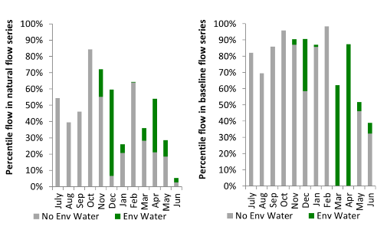
Figure MBG22. Contribution of environmental water delivery at Maude as percentiles in the natural and baseline flow series.

Redbank
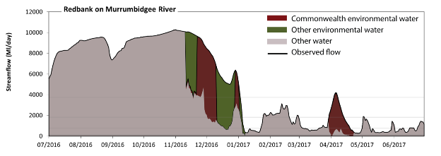 Figure MBG23. Contribution of environmental water delivery at Redbank. Horizontal lines indicate thresholds for very low flows, low flows, low freshes and medium freshes (from lowest to highest).
At Redbank on the Murrumbidgee River environmental water contributed 18% of the total streamflow volume (with approximately half contributed by Commonwealth environmental water). Environmental watering actions affected streamflows for 22% of days between 1 July 2016 and 30 June 2017. Without environmental water, the duration of very low flows (i.e. < 150 ML/day) in the period April to June would have substantially exceeded durations expected in an average year in the natural flow regime. Environmental water mitigated these impacts by reducing the cumulative duration of very low flow spells from 3% to 0% of the year, with greatest influence in the period April to June. Similarly, without environmental water, the durations of medium low flows (i.e. < 740 ML/day) in the periods January to March and April to June would have substantially exceeded durations expected in an average year in the natural flow regime. Environmental water mitigated these impacts by reducing the cumulative duration of medium low flow spells from 29% to 21% of the year, with greatest influence in the period April to June. Commonwealth environmental water made the dominant contribution to these enhancements of environmental baseflows at this site. In the absence of environmental water there would have been at least one low fresh (i.e. > 1800 ML/day) in the periods July to September, October to December, January to March and April to June. Environmental water increased the duration of the longest low fresh during the periods October to December (from 62 days to 92 days) and April to June (from 2 days to 13 days). Commonwealth environmental water was entirely responsible for these increased durations of low freshes. In the absence of environmental water there would have been at least one medium fresh (i.e. > 3700 ML/day) in the periods July to September and October to December. Environmental water increased the duration of the longest medium fresh during the periods October to December (from 48 days to 92 days), January to March (from 0 days to 2 days) and April to June (from 0 days to 4 days). Commonwealth environmental water made the dominant contribution to these increased durations of medium freshes. There was no high freshes (i.e. > 11000 ML/day) this year.
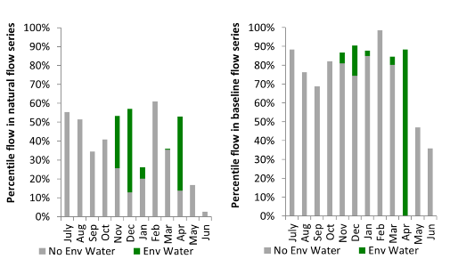
Figure MBG24. Contribution of environmental water delivery at Redbank as percentiles in the natural and baseline flow series.
Balranald
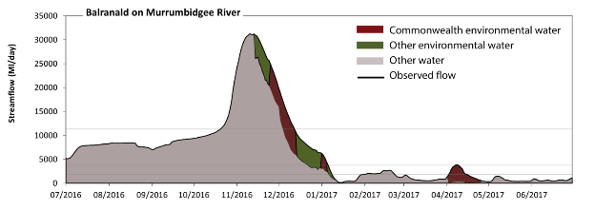 Figure MBG25. Contribution of environmental water delivery at Balranald. Horizontal lines indicate thresholds for very low flows, low flows, low freshes, medium freshes and high freshes (from lowest to highest).
At Balranald on the Murrumbidgee River environmental water contributed 12% of the total streamflow volume (with approximately half contributed by Commonwealth environmental water). Environmental watering actions affected streamflows for 22% of days between 1 July 2016 and 30 June 2017. Flow regulation does not substantially increase the duration of very low flows (i.e. < 150 ML/day) compared to an average year in the natural flow regime. However, without environmental water, the duration of medium low flows (i.e. < 740 ML/day) in the period April to June would have substantially exceeded durations expected in an average year in the natural flow regime. Environmental water mitigated these impacts by reducing the cumulative duration of medium low flow spells from 28% to 22% of the year, with greatest influence in the period April to June. Commonwealth environmental water was almost entirely responsible for these enhancements of environmental baseflows at this site. In the absence of environmental water there would have been at least one low fresh (i.e. > 1800 ML/day) in the periods July to September, October to December and January to March. Environmental water increased the duration of the longest low fresh during the period April to June (from 0 days to 15 days). Commonwealth environmental water was entirely responsible for these increased durations of low freshes. In the absence of environmental water there would have been at least one medium fresh (i.e. > 3700 ML/day) in the periods July to September and October to December. Environmental water increased the duration of the longest medium fresh during the periods January to March (from 0 days to 5 days) and April to June (from 0 days to 1 days). Commonwealth environmental water equally shared responsibility with other environmental water holders for these increased durations of medium freshes. In the absence of environmental water there would have been at least one high fresh in the period October to December. Environmental water made little change to the duration of these high freshes.
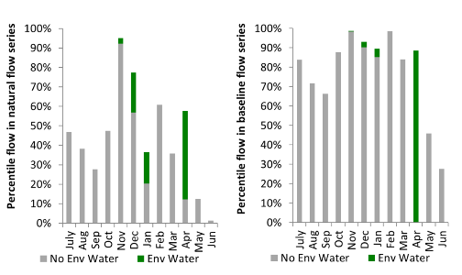
Figure MBG26. Contribution of environmental water delivery at Balranald as percentiles in the natural and baseline flow series.

Lachlan
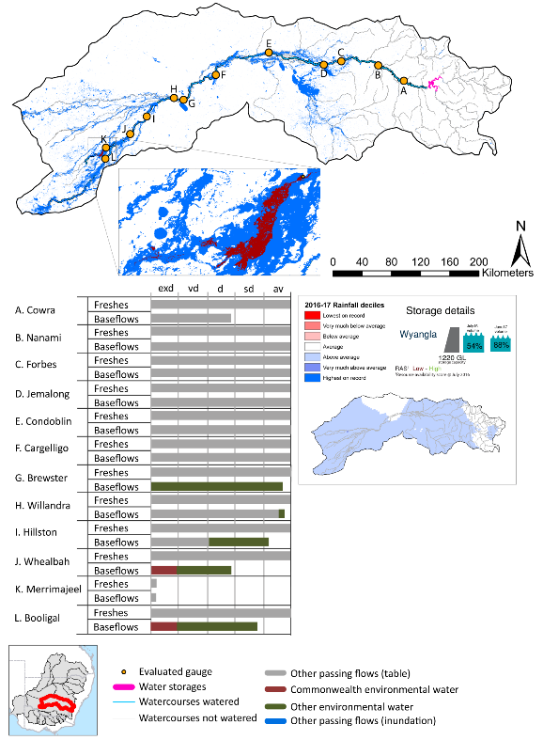

exd: extremely dry | vd: very dry | d: dry
sd: somewhat dry | av: average

Figure LCH1. Watercourses influenced, areas inundated (where applicable) and gauge stations evaluated in the Lachlan valley during the 2016-17 water year. Inset bar graphs report the condition of annual flow regimes by showing the improvements in hydrological condition with the addition of environmental water as well as the hypothetical scenario in “grey” (if no environmental flow had been delivered). Rainfall conditions (rainfall deciles) and trend in storage levels for the water year are also shown.

Summary
Environmental water delivery for the 2016-17 year in the Lachlan valley is evaluated using data for 13 sites. This evaluation only considers the contribution of held environmental water, which is a primary focus for the Australian Government. The contributions of planned environmental water (e.g. passing flows), unregulated tributary inflows and clever use of irrigation flows for environmental benefits can all be very important but these are outside the scope of this report, but where this data was made availalable (for planned ewater only) we have included it. Environmental watering actions lasted on average 115 days over the course of the year. The volume of environmental water at these 13 sites was between 0% and 36% of the total streamflow. Commonwealth environmental water contributed on average 36% of this environmental water. Ideally, baseflows should be maintained and long periods of excessively low flows avoided. In this valley, the baseflow regime was generally considered to be somewhat dry relative to the pre-development flow regime. In our analysis, a low fresh refers to a period of increased flow, when the water level rises at least one eighth of the way up the river bank (above the low flow level). These low freshes are a regular part of the natural flow regime and support a range of natural processes. In the Lachlan valley, in terms of the occurrence and duration of low freshes, the year was assessed as being average. In our analysis, a medium fresh refers to a period of increased flow, when the water level rises at least one quarter of the way up the river bank. These medium freshes are not as frequent as low freshes but are also a regular and important part of the natural flow regime. In the Lachlan valley, in terms of the occurrence of medium freshes, the year was assessed as being average. In our analysis, a high fresh refers to a period of increased flow, when the water level rises more than half way up the river. A high fresh may not occur every year but they are still important and long periods without major freshes can have serious consequences for floodplains and their contribution to river ecosystem health. Delivering high in channel flows normally requires that all risks to riparian landholders and infrastructure have been resolved. In the Lachlan valley, in terms of the occurrence of high freshes, the year was assessed as being average.

Water delivery context
During the 2016-17, the Commonwealth Environmental Water Holder (CEWH) held water entitlements of up to 87 856 ML for environmental use in the Lachlan valley. Each year, water utilities allocate water entitlement holders a percentage of water based on their holding, license type and carryover (the exact rules vary among Jurisdictions). In 2016-17, the Lachlan entitlements held by the CEWH were allocated 88 550 ML of water, representing 237% of the Long term average annual yield for the Lachlan valley (37,441 ML). Information and data relating to the portfolio of held Commonwealth environmental water is shown in Table LCH1.
The 2016-17 water allocation (88 550 ML) together with the carryover volume of 26 253 ML of water meant the CEWH had 114 802 ML of water available for delivery. A total of 29 492 ML of Commonwealth environmental water was delivered in the Lachlan valley. A total of 0 ML of Commonwealth environmental water was traded to consumptive users and 85 310 ML (74%) of available Commonwealth environmental water was carried over for environmental use into the 2017-18 water year.

Environmental conditions and resource availability
The water available for environmental delivery combined with the present and antecedent environmental conditions are key inputs used by environmental water managers in planning and implementing watering actions. Post hoc, this information provides important context when evaluating the effectiveness and appropriateness of environmental water use with respect to hydrological outputs.
The rainfall conditions in the Lachlan valley were classified as above average, based on rainfall percentile data for the entire record held by the Bureau of Meteorology for this valley. The water held in major storages in the Lachlan valley increased over the water year, for example Wyangla dam was 54% full at the beginning of the water year and 88% full by the end of the year (Figure LCH1).
The Commonwealth Environmental Water Office (CEWO) calculates resource availability scenarios (RAS) to guide the use and prioritisation of held environmental water. The RAS are progressively calculated over the year as part of the continual adaptive management planning processes. The RAS are based on the availability of held environmental water (including progressive license acquisitions and allocations) as well as the potential for unregulated or planned environmental flows. The outcome is then used to determine the demand for environmental water across The Basin.
In 2016-17, the resource availability of held Commonwealth environmental water was classified as low in this valley, whilst the potential for unregulated or planned environmental flow was classified as high. The antecedent and forecasted physical conditions meant that Commonwealth environmental water was being planned to protect and ensure the ecological capacity for recovery for key waterbird habitat such as the Booligal wetlands, providing opportunities for native fish migration, spawning and recruitment and maintaining the ecological health and resilience of other important sites in the catchment, through capitalising on natural events or planned environmental water. The overall demand for environmental water was deemed very high to moderate.

Watering actions
A total of 2 watering actions were delivered over the 2016-17 water year, the duration of these actions varied (range of individual actions: 59 - 67 days) and Commonwealth environmental water was delivered for a total of 90 days. The count of actions commencing in each season was; summer (2). The flow component types delivered were; (0) baseflow, (1) freshes, (0) bankfull, (0) overbank and (1) wetland.
There were two expected outcomes across the two watering actions in the Lachlan valley. The percentage of expected outcomes across the nine main themes were as follows: fish (0.0%), vegetation (0.0%), waterbirds (50%), frogs (0.0%), other biota (0.0%), connectivity (0.0%), process (0.0%), resilience (0.0%) and water quality (50%).
Table LCH1. Commonwealth environmental water accounting information for the Lachlan valley over 2016-17 water year (LTAAY = long-term average annual yield).
Total registered volume (ML) | Allocated volume (ML) | Carry over + allocated volume (ML) | Delivered (ML) | LTAAY (ML) | Trade (ML) | Carried over to 2016-17 | Forfeited (ML)
87 856 | 88 550 | 114 802 | 29 492 | 37 441 | 0 | 85 310 | 0
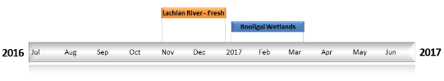
Figure LCH2. Timing and duration of Commonwealth environmental water actions delivered in the Lachlan valley.

Contribution of Commonwealth Environmental Water to Flow Regimes
Cowra
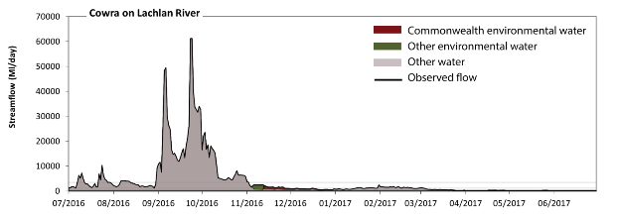
Figure LCH3. Contribution of environmental water delivery at Cowra. Horizontal lines indicate thresholds for very low flows, low flows, low freshes, medium freshes and high freshes (from lowest to highest).
At Cowra on the Lachlan River environmental water contributed 4% of the total streamflow volume (much of which was Commonwealth environmental water). Environmental watering actions affected streamflows for 30% of days between 1 July 2016 and 30 June 2017. Flow regulation does not substantially increase the duration of very low flows (i.e. < 47 ML/day) compared to an average year in the natural flow regime. However, without environmental water, the duration of medium low flows (i.e. < 240 ML/day) in the period April to June would have substantially exceeded durations expected in an average year in the natural flow regime. Environmental water reduced the cumulative duration of medium low flow spells from 25% to 23% of the year, with greatest influence in the period October to December. In the absence of environmental water there would have been at least one low fresh (i.e. > 570 ML/day) in the periods July to September, October to December and January to March. Environmental water increased the duration of the longest low fresh during the period October to December (from 37 days to 82 days). Commonwealth environmental water made a modest contribution to these increased durations of low freshes. In the absence of environmental water there would have been at least one medium fresh (i.e. > 1200 ML/day) in the periods July to September, October to December and January to March. Environmental water increased the duration of the longest medium fresh during the periods October to December (from 35 days to 57 days) and January to March (from 16 days to 25 days). Commonwealth environmental water made little or no contribution to these increased durations of medium freshes. In the absence of environmental water there would have been at least one high fresh in the periods July to September and October to December. Environmental water made no change to the duration of these high freshes.
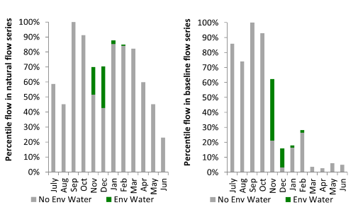
Figure LCH4. Contribution of environmental water delivery at Cowra as percentiles in the natural and baseline flow series.
Forbes
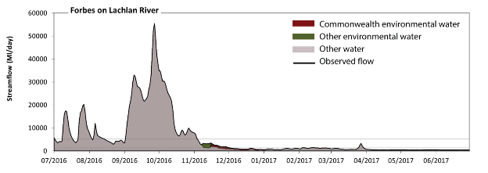
Figure LCH5. Contribution of environmental water delivery at Forbes. Horizontal lines indicate thresholds for very low flows, low flows, low freshes, medium freshes and high freshes (from lowest to highest).
At Forbes on the Lachlan River environmental water contributed 2% of the total streamflow volume (much of which was Commonwealth environmental water). Environmental watering actions affected streamflows for 30% of days between 1 July 2016 and 30 June 2017. Flow regulation does not substantially increase the duration of very low flows (i.e. < 54 ML/day) compared to an average year in the natural flow regime. Flow regulation does not substantially increase the duration of medium low flows (i.e. < 270 ML/day) compared to an average year in the natural flow regime. In the absence of environmental water there would have been at least one low fresh (i.e. > 730 ML/day) in the periods July to September, October to December, January to March and April to June. Environmental water increased the duration of the longest low fresh during the period October to December (from 59 days to 85 days). Commonwealth environmental water was entirely responsible for these increased durations of low freshes. In the absence of environmental water there would have been at least one medium fresh (i.e. > 1600 ML/day) in the periods July to September, October to December and January to March. Environmental water increased the duration of the longest medium fresh during the period October to December (from 39 days to 60 days). Commonwealth environmental water made little or no contribution to these increased durations of medium freshes. In the absence of environmental water there would have been at least one high fresh in the periods July to September and October to December. Environmental water made no change to the duration of these high freshes.
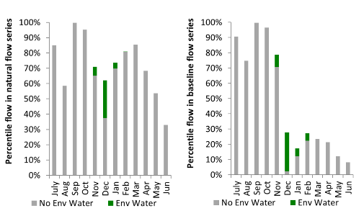
Figure LCH6. Contribution of environmental water delivery at Forbes as percentiles in the natural and baseline flow series.
Nanami
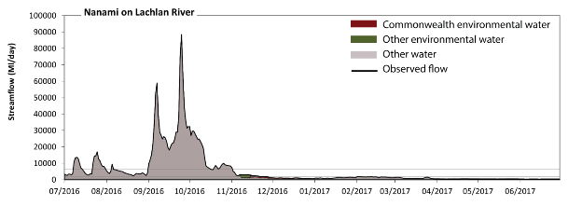
Figure LCH7. Contribution of environmental water delivery at Nanami. Horizontal lines indicate thresholds for very low flows, low flows, low freshes, medium freshes and high freshes (from lowest to highest).
At Nanami the on Lachlan River environmental water contributed 2% of the total streamflow volume (much of which was Commonwealth environmental water). Environmental watering actions affected streamflows for 30% of days between 1 July 2016 and 30 June 2017. Flow regulation does not substantially increase the duration of very low flows (i.e. < 61 ML/day) compared to an average year in the natural flow regime. Flow regulation does not substantially increase the duration of medium low flows (i.e. < 300 ML/day) compared to an average year in the natural flow regime. In the absence of environmental water there would have been at least one low fresh (i.e. > 850 ML/day) in the periods July to September, October to December and January to March. Environmental water increased the duration of the longest low fresh during the period October to December (from 44 days to 69 days). Commonwealth environmental water made little or no contribution to these increased durations of low freshes. In the absence of environmental water there would have been at least one medium fresh (i.e. > 1900 ML/day) in the periods July to September, October to December and January to March. Environmental water increased the duration of the longest medium fresh during the period October to December (from 38 days to 52 days). Commonwealth environmental water made little or no contribution to these increased durations of medium freshes. In the absence of environmental water there would have been at least one high fresh in the periods July to September and October to December. Environmental water made no change to the duration of these high freshes.
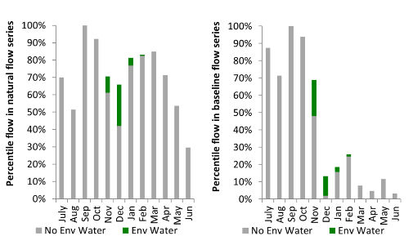
Figure LCH8. Contribution of environmental water delivery at Nanami as percentiles in the natural and baseline flow series

Condobolin
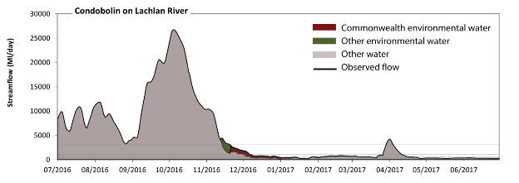
Figure LCH9. Contribution of environmental water delivery at Condobolin. Horizontal lines indicate thresholds for very low flows, low flows, low freshes, medium freshes and high freshes (from lowest to highest).
At Condobolin on the Lachlan River environmental water contributed 3% of the total streamflow volume (much of which was Commonwealth environmental water). Environmental watering actions affected streamflows for 30% of days between 1 July 2016 and 30 June 2017. Flow regulation does not substantially increase the duration of very low flows (i.e. < 46 ML/day) compared to an average year in the natural flow regime. Flow regulation does not substantially increase the duration of medium low flows (i.e. < 230 ML/day) compared to an average year in the natural flow regime. Commonwealth environmental water made the dominant contribution to these enhancements of environmental baseflows at this site. In the absence of environmental water there would have been at least one low fresh (i.e. > 540 ML/day) in the periods July to September, October to December, January to March and April to June. Environmental water increased the duration of the longest low fresh during the period October to December (from 64 days to 90 days). Commonwealth environmental water was entirely responsible for these increased durations of low freshes. There was at least one medium fresh (i.e. > 1100 ML/day) in the periods July to September, October to December, January to March and April to June. Environmental water made little change to the duration of these medium freshes. In the absence of environmental water there would have been at least one high fresh in the periods July to September, October to December, January to March and April to June. Environmental water made little change to the duration of these high freshes.
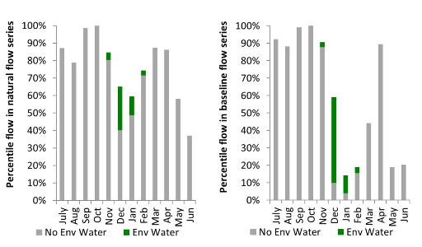
Figure LCH10. Contribution of environmental water delivery at Condobolin as percentiles in the natural and baseline flow series.

Cargelligo
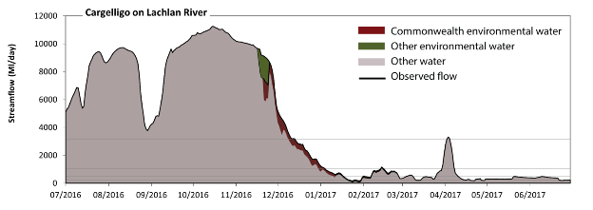
Figure LCH11. Contribution of environmental water delivery at Cargelligo. Horizontal lines indicate thresholds for very low flows, low flows, low freshes, medium freshes and high freshes (from lowest to highest).
At Cargelligo on the Lachlan River environmental water contributed 3% of the total streamflow volume (much of which was Commonwealth environmental water). Environmental watering actions affected streamflows for 29% of days between 1 July 2016 and 30 June 2017. Flow regulation does not substantially increase the duration of very low flows (i.e. < 42 ML/day) compared to an average year in the natural flow regime. Flow regulation does not substantially increase the duration of medium low flows (i.e. < 210 ML/day) compared to an average year in the natural flow regime. There was at least one low fresh (i.e. > 520 ML/day) in the periods July to September, October to December, January to March and April to June. Environmental water made little change to the duration of these low freshes. In the absence of environmental water there would have been at least one medium fresh (i.e. > 1000 ML/day) in the periods July to September, October to December, January to March and April to June. Environmental water increased the duration of the longest medium fresh during the period January to March (from 2 days to 3 days). Commonwealth environmental water was entirely responsible for these increased durations of medium freshes. In the absence of environmental water there would have been at least one high fresh in the periods July to September, October to December and April to June. Environmental water made little change to the duration of these high freshes.
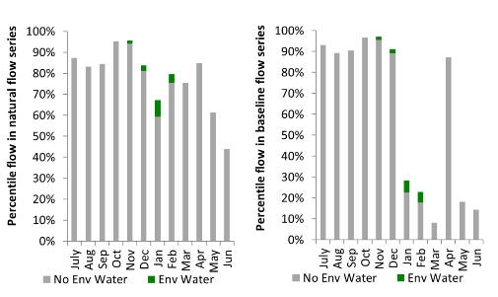
Figure LCH12. Contribution of environmental water delivery at Cargelligo as percentiles in the natural and baseline flow series.
Jemalong
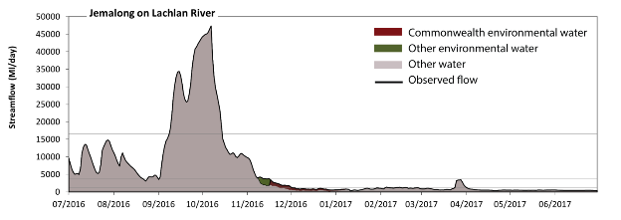Figure LCH13. Contribution of environmental water delivery at Jemalong. Horizontal lines indicate thresholds for very low flows, low flows, low freshes, medium freshes and high freshes (from lowest to highest).
At Jemalong on the Lachlan River environmental water contributed 2% of the total streamflow volume (much of which was Commonwealth environmental water). Environmental watering actions affected streamflows for 30% of days between 1 July 2016 and 30 June 2017. Flow regulation does not substantially increase the duration of very low flows (i.e. < 54 ML/day) compared to an average year in the natural flow regime. Flow regulation does not substantially increase the duration of medium low flows (i.e. < 270 ML/day) compared to an average year in the natural flow regime. There was at least one low fresh (i.e. > 1300 ML/day) in the periods July to September, October to December and January to March. Environmental water made little change to the duration of these low freshes. There was at least one medium fresh (i.e. > 3700 ML/day) in the periods July to September and October to December. Environmental water made little change to the duration of these medium freshes. In the absence of environmental water there would have been at least one high fresh in the periods July to September and October to December. Environmental water made no change to the duration of these high freshes.
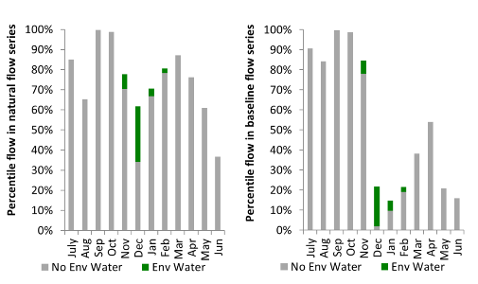
Figure LCH14. Contribution of environmental water delivery at Jemalong as percentiles in the natural and baseline flow series.
Willandra
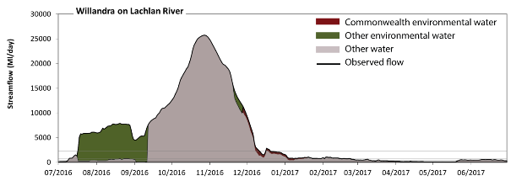 Figure LCH15. Contribution of environmental water delivery at Willandra. Horizontal lines indicate thresholds for very low flows, low flows, low freshes, medium freshes and high freshes (from lowest to highest).
At Willandra on the Lachlan River environmental water contributed 20% of the total streamflow volume (with a relatively small contribution of Commonwealth environmental water). Environmental watering actions affected streamflows for 46% of days between 1 July 2016 and 30 June 2017. Flow regulation does not substantially increase the duration of very low flows (i.e. < 31 ML/day) compared to an average year in the natural flow regime. However, without environmental water, the durations of medium low flows (i.e. < 160 ML/day) in the periods July to September and April to June would have substantially exceeded durations expected in an average year in the natural flow regime. Environmental water mitigated these impacts by reducing the cumulative duration of medium low flow spells from 17% to 14% of the year, with greatest influence in the period July to September. Commonwealth environmental water made little or no contribution to these enhancements of environmental baseflows at this site. In the absence of environmental water there would have been at least one low fresh (i.e. > 380 ML/day) in the periods July to September, October to December, January to March and April to June. Environmental water increased the duration of the longest low fresh during the period July to September (from 22 days to 84 days). Commonwealth environmental water made little or no contribution to these increased durations of low freshes. In the absence of environmental water there would have been at least one medium fresh (i.e. > 770 ML/day) in the periods July to September, October to December and January to March. Environmental water increased the duration of the longest medium fresh during the periods July to September (from 19 days to 83 days) and January to March (from 5 days to 21 days). Commonwealth environmental water made a modest contribution to these increased durations of medium freshes. In the absence of environmental water there would have been at least one high fresh in the periods July to September and October to December. Environmental water increased the duration of the longest medium fresh during the period July to September (from 19 days to 76 days). Commonwealth environmental water made little or no contribution to these increased durations of high freshes.
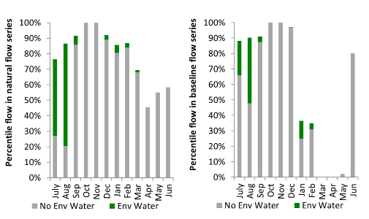
Figure LCH16. Contribution of environmental water delivery at Willandra as percentiles in the natural and baseline flow series.

Brewster
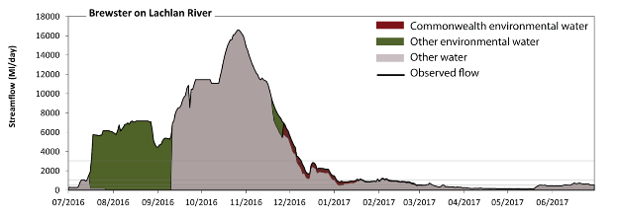 Figure LCH17. Contribution of environmental water delivery at Brewster. Horizontal lines indicate thresholds for very low flows, low flows, low freshes, medium freshes and high freshes (from lowest to highest).
At Brewster on the Lachlan River environmental water contributed 26% of the total streamflow volume (with a relatively small contribution of Commonwealth environmental water). Environmental watering actions affected streamflows for 46% of days between 1 July 2016 and 30 June 2017. Without environmental water, the duration of very low flows (i.e. < 43 ML/day) in the period July to September would have substantially exceeded durations expected in an average year in the natural flow regime. Environmental water mitigated these impacts by reducing the cumulative duration of very low flow spells from 13% to 0% of the year, with greatest influence in the period July to September. Similarly, without environmental water, the duration of medium low flows (i.e. < 220 ML/day) in the period July to September would have substantially exceeded durations expected in an average year in the natural flow regime. Environmental water mitigated these impacts by reducing the cumulative duration of medium low flow spells from 28% to 12% of the year, with greatest influence in the period July to September. Environmental water increased the magnitude of flows below this medium low flow threshold. Commonwealth environmental water made little or no contribution to these enhancements of environmental baseflows at this site. In the absence of environmental water there would have been at least one low fresh (i.e. > 510 ML/day) in the periods July to September, October to December, January to March and April to June. Environmental water increased the duration of the longest low fresh during the periods July to September (from 20 days to 84 days) and January to March (from 49 days to 69 days). Commonwealth environmental water equally shared responsibility with other environmental water holders for these increased durations of low freshes. In the absence of environmental water there would have been at least one medium fresh (i.e. > 1000 ML/day) in the periods July to September, October to December and January to March. Environmental water increased the duration of the longest medium fresh during the periods July to September (from 20 days to 79 days) and January to March (from 2 days to 6 days). Commonwealth environmental water made little or no contribution to these increased durations of medium freshes. In the absence of environmental water there would have been at least one high fresh in the periods July to September and October to December. Environmental water increased the duration of the longest medium fresh during the period July to September (from 20 days to 76 days). Commonwealth environmental water made little or no contribution to these increased durations of high freshes.
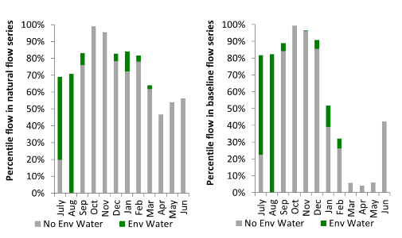
Figure LCH18. Contribution of environmental water delivery at Brewster as percentiles in the natural and baseline flow series.
Hillston
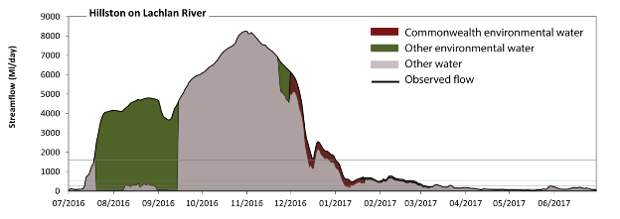 Figure LCH19. Contribution of environmental water delivery at Hillston. Horizontal lines indicate thresholds for very low flows, low flows, low freshes, medium freshes and high freshes (from lowest to highest).
At Hillston on the Lachlan River environmental water contributed 30% of the total streamflow volume (with a relatively small contribution of Commonwealth environmental water). Environmental watering actions affected streamflows for 45% of days between 1 July 2016 and 30 June 2017. Without environmental water, the duration of very low flows (i.e. < 23 ML/day) in the period July to September would have substantially exceeded durations expected in an average year in the natural flow regime. Environmental water mitigated these impacts by reducing the cumulative duration of very low flow spells from 7% to 0% of the year, with greatest influence in the period July to September. Similarly, without environmental water, the durations of medium low flows (i.e. < 120 ML/day) in the periods July to September and April to June would have substantially exceeded durations expected in an average year in the natural flow regime. Environmental water mitigated these impacts by reducing the cumulative duration of medium low flow spells from 28% to 19% of the year, with greatest influence in the period July to September. Commonwealth environmental water made little or no contribution to these enhancements of environmental baseflows at this site. In the absence of environmental water there would have been at least one low fresh (i.e. > 270 ML/day) in the periods July to September, October to December and January to March. Environmental water increased the duration of the longest low fresh during the periods July to September (from 16 days to 81 days) and January to March (from 48 days to 61 days). Commonwealth environmental water equally shared responsibility with other environmental water holders for these increased durations of low freshes. In the absence of environmental water there would have been at least one medium fresh (i.e. > 550 ML/day) in the periods July to September, October to December and January to March. Environmental water increased the duration of the longest medium fresh during the periods July to September (from 16 days to 80 days) and January to March (from 6 days to 16 days). Commonwealth environmental water made a modest contribution to these increased durations of medium freshes. In the absence of environmental water there would have been at least one high fresh in the periods July to September and October to December. Environmental water increased the duration of the longest medium fresh during the periods July to September (from 16 days to 74 days), October to December (from 73 days to 92 days) and January to March (from 0 days to 1 days). Commonwealth environmental water made the dominant contribution to these increased durations of high freshes.
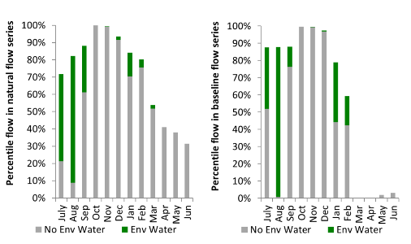
Figure LCH20. Contribution of environmental water delivery at Hillston as percentiles in the natural and baseline flow series.

Whealbah
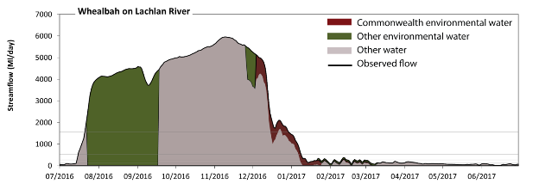 Figure LCH21. Contribution of environmental water delivery at Whealbah. Horizontal lines indicate thresholds for very low flows, low flows, low freshes, medium freshes and high freshes (from lowest to highest).
At Whealbah on the Lachlan River environmental water contributed 36% of the total streamflow volume (with a relatively small contribution of Commonwealth environmental water). Environmental watering actions affected streamflows for 45% of days between 1 July 2016 and 30 June 2017. Without environmental water, the durations of very low flows (i.e. < 23 ML/day) in the periods July to September and January to March would have substantially exceeded durations expected in an average year in the natural flow regime. Environmental water mitigated these impacts by reducing the cumulative duration of very low flow spells from 22% to 1% of the year, with greatest influence in the period July to September. Similarly, without environmental water, the durations of medium low flows (i.e. < 120 ML/day) in the periods July to September, January to March and April to June would have substantially exceeded durations expected in an average year in the natural flow regime. Environmental water mitigated these impacts by reducing the cumulative duration of medium low flow spells from 52% to 28% of the year, with greatest influence in the periods July to September and January to March. Commonwealth environmental water made a modest contribution to these enhancements of environmental baseflows at this site. In the absence of environmental water there would have been at least one low fresh (i.e. > 270 ML/day) in the periods July to September, October to December and January to March. Environmental water increased the duration of the longest low fresh during the periods July to September (from 13 days to 78 days) and January to March (from 7 days to 12 days). Commonwealth environmental water equally shared responsibility with other environmental water holders for these increased durations of low freshes. In the absence of environmental water there would have been at least one medium fresh (i.e. > 540 ML/day) in the periods July to September, October to December and January to March. Environmental water increased the duration of the longest medium fresh during the periods July to September (from 13 days to 77 days) and January to March (from 6 days to 8 days). Commonwealth environmental water equally shared responsibility with other environmental water holders for these increased durations of medium freshes. In the absence of environmental water there would have been at least one high fresh in the periods July to September and October to December. Environmental water increased the duration of the longest medium fresh during the period July to September (from 13 days to 72 days). Commonwealth environmental water made little or no contribution to these increased durations of high freshes.
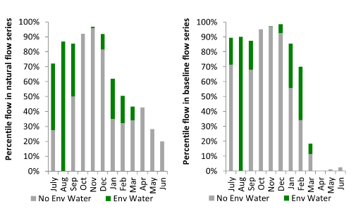
Figure LCH22. Contribution of environmental water delivery at Whealbah as percentiles in the natural and baseline flow series.
Booligal
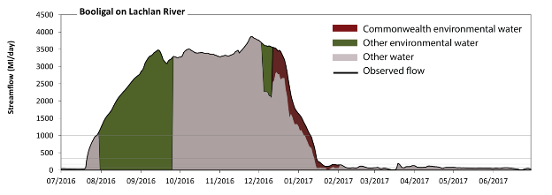 Figure LCH23. Contribution of environmental water delivery at Booligal. Horizontal lines indicate thresholds for very low flows, low flows, low freshes, medium freshes and high freshes (from lowest to highest).
At Booligal on the Lachlan River environmental water contributed 35% of the total streamflow volume (with a relatively small contribution of Commonwealth environmental water). Environmental watering actions affected streamflows for 32% of days between 1 July 2016 and 30 June 2017. Without environmental water, the duration of very low flows (i.e. < 15 ML/day) in the period July to September would have substantially exceeded durations expected in an average year in the natural flow regime. Environmental water mitigated these impacts by reducing the cumulative duration of very low flow spells from 17% to 2% of the year, with greatest influence in the period July to September. Similarly, without environmental water, the durations of medium low flows (i.e. < 76 ML/day) in the periods July to September, January to March and April to June would have substantially exceeded durations expected in an average year in the natural flow regime. Environmental water mitigated these impacts by reducing the cumulative duration of medium low flow spells from 53% to 33% of the year, with greatest influence in the period July to September. Commonwealth environmental water made a small contribution to these enhancements of environmental baseflows at this site. In the absence of environmental water there would have been at least one low fresh (i.e. > 180 ML/day) in the periods July to September, October to December and January to March. Environmental water increased the duration of the longest low fresh during the periods July to September (from 10 days to 72 days) and January to March (from 14 days to 18 days). Commonwealth environmental water equally shared responsibility with other environmental water holders for these increased durations of low freshes. In the absence of environmental water there would have been at least one medium fresh (i.e. > 350 ML/day) in the periods July to September, October to December and January to March. Environmental water increased the duration of the longest medium fresh during the period July to September (from 10 days to 72 days). Commonwealth environmental water made little or no contribution to these increased durations of medium freshes. In the absence of environmental water there would have been at least one high fresh in the periods July to September, October to December and January to March. Environmental water increased the duration of the longest medium fresh during the periods July to September (from 5 days to 64 days) and January to March (from 5 days to 10 days). Commonwealth environmental water equally shared responsibility with other environmental water holders for these increased durations of high freshes.
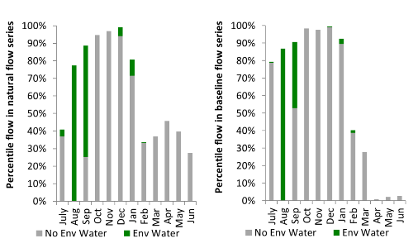
Figure LCH24. Contribution of environmental water delivery at Booligal as percentiles in the natural and baseline flow series.

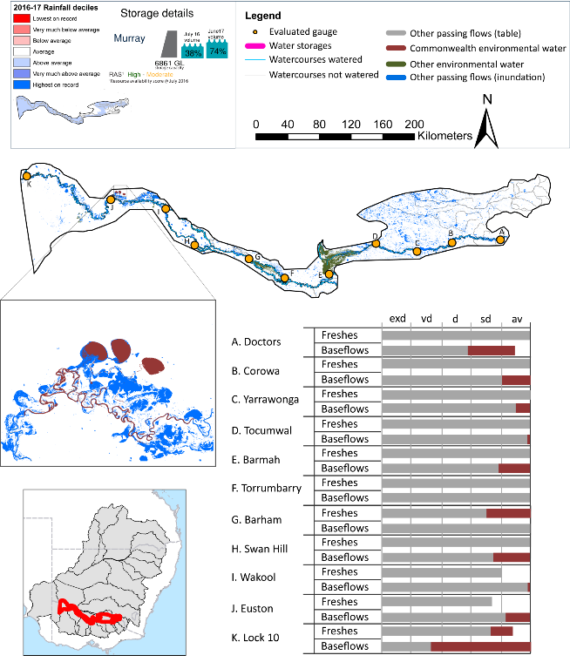
Central Murray
exd: extremely dry | vd: very dry | d: dry
sd: somewhat dry | av: average
Figure CNM1. Watercourses influenced, areas inundated (where applicable) and gauge stations evaluated in the Central Murray valley during the 2016-17 water year. Inset bar graphs report the condition of annual flow regimes by showing the improvements in hydrological condition with the addition of the water reform and environmental water as well as the hypothetical scenario in “grey” (if no environmental flow had been delivered). Rainfall conditions (rainfall deciles) and trend in storage levels for the water year are also shown.

Summary
Environmental water delivery for the 2016-17 year in the Central Murray valley is evaluated using data for 11 sites. This evaluation only considers the contribution of held environmental water, which is a primary focus for the Australian Government. The contributions of planned environmental water (e.g. passing flows), unregulated tributary inflows and clever use of irrigation flows for environmental benefits can all be very important but these are outside the scope of this report. Environmental watering actions lasted on average 230 days over the course of the year. The volume of environmental water at these 11 sites was between 8% and 16% of the total streamflow. Environmental water contributed on average 100% of this environmental water¹. Ideally, baseflows should be maintained and long periods of excessively low flows avoided. In this valley, the baseflow regime was generally considered to be average relative to the pre-development flow regime. In our analysis, a low fresh refers to a period of increased flow, when the water level rises at least one eighth of the way up the river bank (above the low flow level). These low freshes are a regular part of the natural flow regime and support a range of natural processes. In the Central Murray valley, in terms of the occurrence and duration of low freshes, the year was assessed as being average. In our analysis, a medium fresh refers to a period of increased flow, when the water level rises at least one quarter of the way up the river bank. These medium freshes are not as frequent as low freshes but are also a regular and important part of the natural flow regime. In the Central Murray valley, in terms of the occurrence of medium freshes, the year was assessed as being average. In our analysis, a high fresh refers to a period of increased flow, when the water level rises more than half way up the river. A high fresh may not occur every year but they are still important and long periods without major freshes can have serious consequences for floodplains and their contribution to river ecosystem health. Delivering high in channel flows normally requires that all risks to riparian landholders and infrastructure have been resolved. In the Central Murray valley, in terms of the occurrence of high freshes, the year was assessed as being average.
¹The evaluation of Murray River hydrology has been derived from the msm-BigMod river model. The modelling compares a pre-buyback scenario with a run delivering the environmental water use observed in 2016-17. The difference between the two runs includes the cumulative impact of behavioural change in use and demand of water since 2009. We have identified these differences as “environmental water” and “irrigation releases eliminated due to buyback”. The “environmental water” component will include flows resulting from behavioural change not just directly managed deliveries. As a consequence, environmental water may appear to be delivered in River Murray graphics, when it wasn’t and vice versa.

Water delivery context
During the 2016-17, the Commonwealth Environmental Water Holder (CEWH) held water entitlements of up to 746 385 ML for environmental use in the Central Murray valley. Each year, water utilities allocate water entitlement holders a percentage of water based on their holding, license type and carryover (the exact rules vary among Jurisdictions). In 2016-17, the Central Murray entitlements held by the CEWH were allocated 568 423 ML of water, representing 89% of the Long term average annual yield for the Central Murray valley (642 076 ML). Information and data relating to the portfolio of held Commonwealth environmental water is shown in Table CNM1.
The 2016-17 water allocation (568 423 ML) together with the carryover volume of 186 162 ML of water meant the CEWH had 754 585 ML of water available for delivery. A total of 187 487 ML of Commonwealth environmental water was delivered in the Central Murray valley. A total of 0 ML of Commonwealth environmental water was traded to consumptive users and 198 362 ML (26%) of available Commonwealth environmental water was carried over for environmental use into the 2017-18 water year.

Environmental conditions and resource availability
The water available for environmental delivery combined with the present and antecedent environmental conditions are key inputs used by environmental water managers in planning and implementing watering actions. Post hoc, this information provides important context when evaluating the effectiveness and appropriateness of environmental water use with respect to hydrological outputs.
The rainfall conditions in the Central Murray valley were classified as above average, based on rainfall percentile data for the entire record held by the Bureau of Meteorology for this valley. The water held in major storages in the Central Murray valley increased over the water year, for example Dartmouth and Hume dam was 38% full at the beginning of the water year and 74% full by the end of the year (Figure CNM1).
The Commonwealth Environmental Water Office (CEWO) calculates resource availability scenarios (RAS) to guide the use and prioritisation of held environmental water. The RAS are progressively calculated over the year as part of the continual adaptive management planning processes. The RAS are based on the availability of held environmental water (including progressive license acquisitions and allocations) as well as the potential for unregulated or planned environmental flows. The outcome is then used to determine the demand for environmental water across The Basin.
In 2016-17, the resource availability of held Commonwealth environmental water was classified as medium to low in this valley, whilst the potential for unregulated or planned environmental flow was classified as high to medium. The antecedent and forecasted physical conditions meant that Commonwealth environmental water was being planned to protect and/or maintain the condition of environmental assets. The overall demand for environmental water was deemed moderate (water predominantly needed this year and or next).

Watering actions
A total of 3 watering actions were delivered over the 2016-17 water year, the duration of these actions varied (range of individual actions: 180 - 364 days) and Commonwealth environmental water was delivered for a total of 365 days. The count of actions commencing in each season was; winter (2) and summer(1). The flow component types delivered were; (1) baseflow, (1) freshes, (0) bankfull, (1) overbank and (0) wetland.
There were 10 expected outcomes across the three watering actions in the Central Murray. The percentage of expected outcomes across the nine main themes were as follows: fish (30%), vegetation (20%), waterbirds (0.0%), frogs (0.0%), other biota (0.0%), connectivity (10%), process (30%), resilience (0.0%) and water quality (10%).
Table CNM2. Commonwealth environmental water accounting information for the Central Murray valley over 2016-17 water year (LTAAY = long-term average annual yield).
Total registered volume (ML) | Allocated volume (ML) | Carry over + allocated volume (ML) | Delivered (ML) | LTAAY (ML) | Trade (ML) | Carried over to 2016-17 | Forfeited (ML)
746 385 | 568 423 | 754 585 | 187 487 | 642 076 | 0 | 198 362 | 0

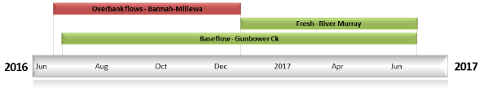
Figure CNM2. Timing and duration of Commonwealth environmental water actions delivered in the Central Murray valley.

Contribution of Commonwealth Environmental Water to Flow Regimes
Doctors
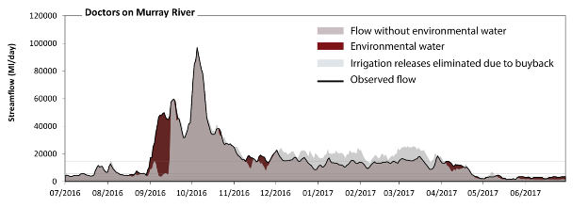
Figure CNM3. Contribution of the water reform and environmental water delivery at Doctors. Horizontal lines indicate thresholds for very low flows, low flows, low freshes, medium freshes and high freshes (from lowest to highest).
At Doctors on the Murray River the water reform and environmental water contributed 12% of the total streamflow volume. The water reform and environmental watering actions affected streamflows for 35% of days between 1 July 2016 and 30 June 2017. Flow regulation does not substantially increase the duration of very low flows (i.e. < 410 ML/day) compared to an average year in the natural flow regime. However, without the water reform and environmental water, the duration of medium low flows (i.e. < 1700 ML/day) in the period April to June would have substantially exceeded durations expected in an average year in the natural flow regime. The water reform and environmental water mitigated these impacts by reducing the cumulative duration of medium low flow spells from 11% to 2% of the year, with greatest influence in the period April to June. There was at least one low fresh (i.e. > 3300 ML/day) in the periods July to September, October to December, January to March and April to June. The water reform and environmental water made little change to the duration of these low freshes. In the absence of the water reform and environmental water there would have been at least one medium fresh (i.e. > 5800 ML/day) in the periods July to September, October to December, January to March and April to June. Environmental water increased the duration of the longest medium fresh during the period July to September (from 17 days to 32 days). In the absence of the water reform and environmental water there would have been at least one high fresh in the periods July to September, October to December, January to March and April to June. The water reform and environmental water increased the duration of the longest medium fresh during the period July to September (from 16 days to 30 days).
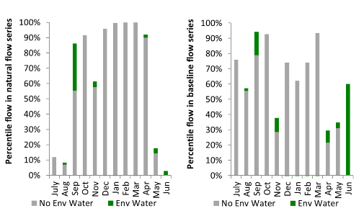
Figure CNM4. Contribution of the water reform and environmental water delivery at Doctors as percentiles in the natural and baseline flow series.
Corowa
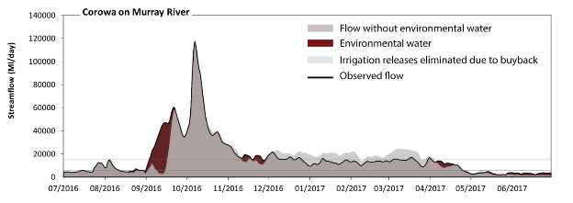
Figure CNM5. Contribution of the water reform and environmental water delivery at Corowa. Horizontal lines indicate thresholds for very low flows, low flows, low freshes, medium freshes and high freshes (from lowest to highest).
At Corowa on the Murray River the water reform and environmental water contributed 11% of the total streamflow volume. The water reform and environmental watering actions affected streamflows for 36% of days between 1 July 2016 and 30 June 2017. Flow regulation does not substantially increase the duration of very low flows (i.e. < 380 ML/day) compared to an average year in the natural flow regime. However, without water reform and environmental water, the duration of medium low flows (i.e. < 1600 ML/day) in the period April to June would have substantially exceeded durations expected in an average year in the natural flow regime. The water reform and environmental water mitigated these impacts by reducing the cumulative duration of medium low flow spells from 6% to 0% of the year, with greatest influence in the period April to June. In the absence of water reform and environmental water there would have been at least one low fresh (i.e. > 3200 ML/day) in the periods July to September, October to December, January to March and April to June. The water reform and environmental water increased the duration of the longest low fresh during the period July to September (from 61 days to 92 days). In the absence of the water reform and environmental water there would have been at least one medium fresh (i.e. > 5800 ML/day) in the periods July to September, October to December, January to March and April to June. The water reform and environmental water increased the duration of the longest medium fresh during the period July to September (from 19 days to 30 days). In the absence of the water reform and environmental water there would have been at least one high fresh in the periods July to September, October to December, January to March and April to June. The water reform and environmental water increased the duration of the longest medium fresh during the period July to September (from 14 days to 28 days).
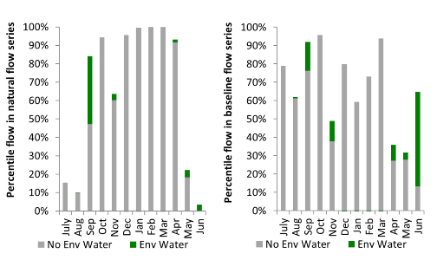
Figure CNM6. Contribution of the water reform and environmental water delivery at Corowa as percentiles in the natural and baseline flow series.

Yarrawonga
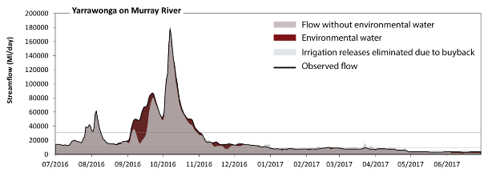
Figure CNM7. Contribution of the water reform and environmental water delivery at Yarrawonga. Horizontal lines indicate thresholds for very low flows, low flows, low freshes, medium freshes and high freshes (from lowest to highest).
At Yarrawonga on the Murray River the water reform and environmental water contributed 11% of the total streamflow volume. The water reform and environmental watering actions affected streamflows for 52% of days between 1 July 2016 and 30 June 2017. Flow regulation does not substantially increase the duration of very low flows (i.e. < 340 ML/day) compared to an average year in the natural flow regime. However, without the water reform and environmental water, the duration of medium low flows (i.e. < 1700 ML/day) in the period April to June would have substantially exceeded durations expected in an average year in the natural flow regime. The water reform and environmental water mitigated these impacts by reducing the cumulative duration of medium low flow spells from 4% to 0% of the year, with greatest influence in the period April to June. There was at least one low fresh (i.e. > 4600 ML/day) in the periods July to September, October to December, January to March and April to June. The water reform and environmental water made little change to the duration of these low freshes. In the absence of the water reform and environmental water there would have been at least one medium fresh (i.e. > 9800 ML/day) in the periods July to September, October to December and January to March. The water reform and environmental water increased the duration of the longest medium fresh during the period October to December (from 53 days to 91 days). In the absence of the water reform and environmental water there would have been at least one high fresh in the periods July to September and October to December. The water reform and environmental water increased the duration of the longest medium fresh during the period July to September (from 14 days to 27 days).
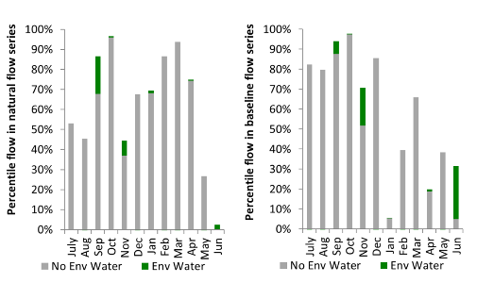
Figure CNM8. Contribution of the water reform and environmental water delivery at Yarrawonga as percentiles in the natural and baseline flow series.
Tocumwal
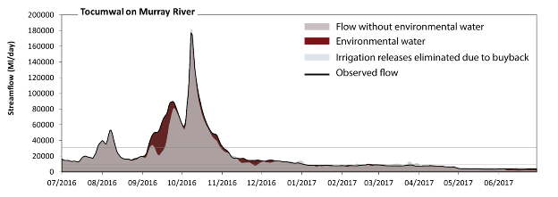
Figure CNM9. Contribution of the water reform and environmental water delivery at Tocumwal. Horizontal lines indicate thresholds for very low flows, low flows, low freshes, medium freshes and high freshes (from lowest to highest).
At Tocumwal on the Murray River the water reform and environmental water contributed 11% of the total streamflow volume. The water reform and environmental watering actions affected streamflows for 58% of days between 1 July 2016 and 30 June 2017. Flow regulation does not substantially increase the duration of very low flows (i.e. < 340 ML/day) compared to an average year in the natural flow regime. Flow regulation does not substantially increase the duration of medium low flows (i.e. < 1700 ML/day) compared to an average year in the natural flow regime. There was at least one low fresh (i.e. > 4600 ML/day) in the periods July to September, October to December, January to March and April to June. The water reform and environmental water made little change to the duration of these low freshes. In the absence of the water reform and environmental water there would have been at least one medium fresh (i.e. > 9700 ML/day) in the periods July to September, October to December and January to March. The water reform and environmental water increased the duration of the longest medium fresh during the period October to December (from 55 days to 92 days). In the absence of the water reform and environmental water there would have been at least one high fresh in the periods July to September and October to December. The water reform and environmental water increased the duration of the longest medium fresh during the period July to September (from 14 days to 25 days).
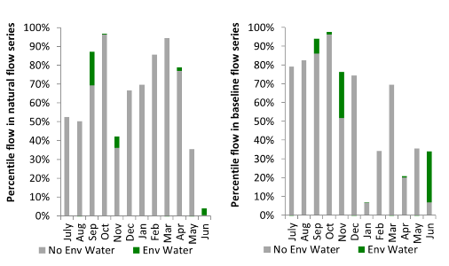
Figure CNM10. Contribution of the water reform and environmental water delivery at Tocumwal as percentiles in the natural and baseline flow series.

Barmah
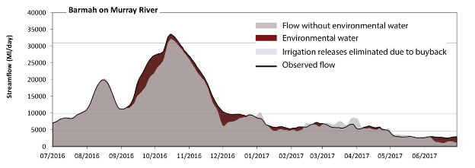
Figure CNM11. Contribution of the water reform and environmental water delivery at Barmah. Horizontal lines indicate thresholds for very low flows, low flows, low freshes, medium freshes and high freshes (from lowest to highest).
At Barmah on the Murray River the water reform and environmental water contributed 8% of the total streamflow volume. The water reform and environmental watering actions affected streamflows for 62% of days between 1 July 2016 and 30 June 2017. Flow regulation does not substantially increase the duration of very low flows (i.e. < 340 ML/day) compared to an average year in the natural flow regime. However, without the water reform and environmental water, the duration of medium low flows (i.e. < 1700 ML/day) in the period April to June would have substantially exceeded durations expected in an average year in the natural flow regime. The water reform and environmental water mitigated these impacts by reducing the cumulative duration of medium low flow spells from 6% to 0% of the year, with greatest influence in the period April to June. There was at least one low fresh (i.e. > 4600 ML/day) in the periods July to September, October to December, January to March and April to June. The water reform and environmental water made little change to the duration of these low freshes. There was at least one medium fresh (i.e. > 9700 ML/day) in the periods July to September, October to December and January to March. The water reform and environmental water made little change to the duration of these medium freshes. In the absence of the water reform and environmental water there would have been at least one high fresh in the period October to December. The water reform and environmental water increased the duration of the longest medium fresh during the period October to December (from 8 days to 11 days).
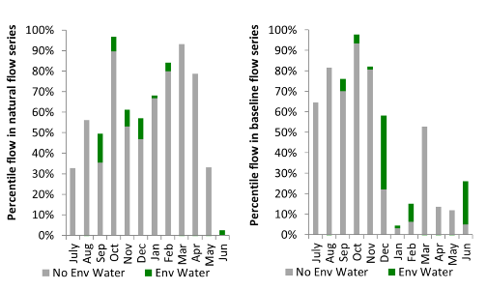
Figure CNM12. Contribution of the water reform and environmental water delivery at Barmah as percentiles in the natural and baseline flow series.

Torrumbarry
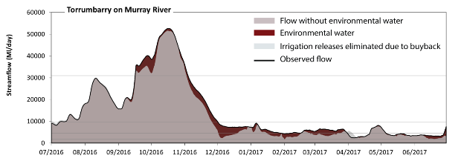Figure CNM13. Contribution of the water reform and environmental water delivery at Torrumbarry. Horizontal lines indicate thresholds for very low flows, low flows, low freshes, medium freshes and high freshes (from lowest to highest).
At Torrumbarry on the Murray River the water reform and environmental water contributed 9% of the total streamflow volume. The water reform and environmental watering actions affected streamflows for 75% of days between 1 July 2016 and 30 June 2017. Flow regulation does not substantially increase the duration of very low flows (i.e. < 340 ML/day) compared to an average year in the natural flow regime. Flow regulation does not substantially increase the duration of medium low flows (i.e. < 1700 ML/day) compared to an average year in the natural flow regime. In the absence of the water reform and environmental water there would have been at least one low fresh (i.e. > 4600 ML/day) in the periods July to September, October to December, January to March and April to June. The water reform and environmental water increased the duration of the longest low fresh during the periods October to December (from 62 days to 92 days) and January to March (from 15 days to 51 days). There was at least one medium fresh (i.e. > 9700 ML/day) in the periods July to September and October to December. The water reform and environmental water made little change to the duration of these medium freshes. In the absence of environmental water there would have been at least one high fresh in the periods July to September and October to December. The water reform and environmental water made little change to the duration of these high freshes.
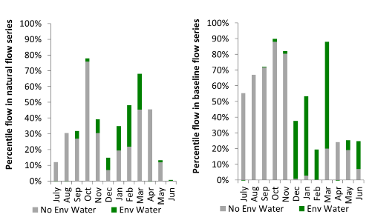
Figure CNM14. Contribution of the water reform and environmental water delivery at Torrumbarry as percentiles in the natural and baseline flow series.
Barham
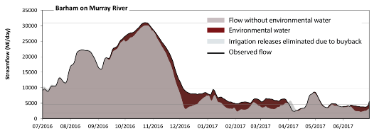 Figure CNM15. Contribution of the water reform and environmental water delivery at Barham. Horizontal lines indicate thresholds for very low flows, low flows, low freshes, medium freshes and high freshes (from lowest to highest).
At Barham on the Murray River the water reform and environmental water contributed 10% of the total streamflow volume. The water reform and environmental watering actions affected streamflows for 77% of days between 1 July 2016 and 30 June 2017. Flow regulation does not substantially increase the duration of very low flows (i.e. < 340 ML/day) compared to an average year in the natural flow regime. Flow regulation does not substantially increase the duration of medium low flows (i.e. < 1700 ML/day) compared to an average year in the natural flow regime. In the absence of the water reform and environmental water there would have been at least one low fresh (i.e. > 4600 ML/day) in the periods July to September, October to December, January to March and April to June. The water reform and environmental water increased the duration of the longest low fresh during the periods October to December (from 65 days to 92 days) and January to March (from 17 days to 90 days). There was at least one medium fresh (i.e. > 9700 ML/day) in the periods July to September and October to December. The water reform and environmental water made little change to the duration of these medium freshes. There was no high freshes (i.e. > 31000 ML/day) this year. The water reform and environmental water increased the duration of the longest medium fresh during the period October to December (from 0 days to 3 days).
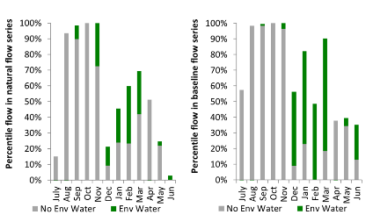
Figure CNM16. Contribution of the water reform and environmental water delivery at Barham as percentiles in the natural and baseline flow series.

Swan Hill
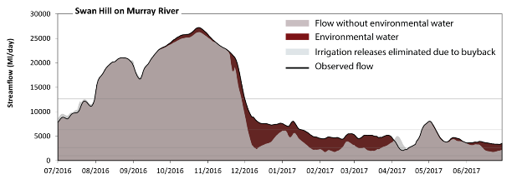 Figure CNM17. Contribution of the water reform and environmental water delivery at Swan Hill. Horizontal lines indicate thresholds for very low flows, low flows, low freshes, medium freshes and high freshes (from lowest to highest).
At Swan Hill on the Murray River the water reform and environmental water contributed 10% of the total streamflow volume. The water reform and environmental watering actions affected streamflows for 73% of days between 1 July 2016 and 30 June 2017. Flow regulation does not substantially increase the duration of very low flows (i.e. < 980 ML/day) compared to an average year in the natural flow regime. However, without The water reform and environmental water, the durations of medium low flows (i.e. < 2600 ML/day) in the periods January to March and April to June would have substantially exceeded durations expected in an average year in the natural flow regime. The water reform and environmental water mitigated these impacts by reducing the cumulative duration of medium low flow spells from 19% to 2% of the year, with greatest influence in the period January to March. In the absence of the water reform and environmental water there would have been at least one low fresh (i.e. > 6300 ML/day) in the periods July to September, October to December and April to June. The water reform and environmental water increased the duration of the longest low fresh during the periods October to December (from 64 days to 92 days) and January to March (from 0 days to 16 days). There was at least one medium fresh (i.e. > 13000 ML/day) in the periods July to September and October to December. The water reform and environmental water made little change to the duration of these medium freshes. In the absence of the water reform and environmental water there would have been at least one high fresh in the periods July to September and October to December. The water reform and environmental water made little change to the duration of these high freshes.
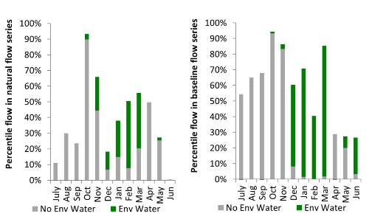
Figure CNM18. Contribution of the water reform and environmental water delivery at Swan Hill as percentiles in the natural and baseline flow series.
Wakool
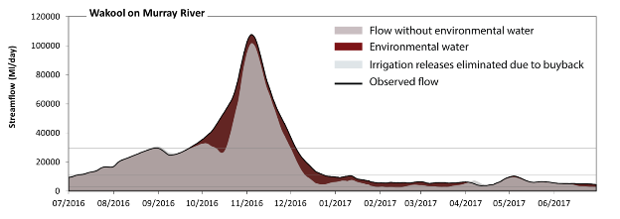 Figure CNM19. Contribution of the water reform and environmental water delivery at Wakool. Horizontal lines indicate thresholds for very low flows, low flows, low freshes, medium freshes and high freshes (from lowest to highest).
At Wakool on the Murray River the water reform and environmental water contributed 15% of the total streamflow volume. The water reform and environmental watering actions affected streamflows for 73% of days between 1 July 2016 and 30 June 2017. Flow regulation does not substantially increase the duration of very low flows (i.e. < 1000 ML/day) compared to an average year in the natural flow regime. Flow regulation does not substantially increase the duration of medium low flows (i.e. < 2800 ML/day) compared to an average year in the natural flow regime. There was at least one low fresh (i.e. > 11000 ML/day) in the periods July to September and October to December. The water reform and environmental water made little change to the duration of these low freshes. In the absence of the water reform and environmental water there would have been at least one medium fresh (i.e. > 29000 ML/day) in the periods July to September and October to December. The water reform and environmental water increased the duration of the longest medium fresh during the period October to December (from 45 days to 65 days). In the absence of the water reform and environmental water there would have been at least one high fresh in the periods July to September and October to December. The water reform and environmental water increased the duration of the longest medium fresh during the period October to December (from 45 days to 65 days).
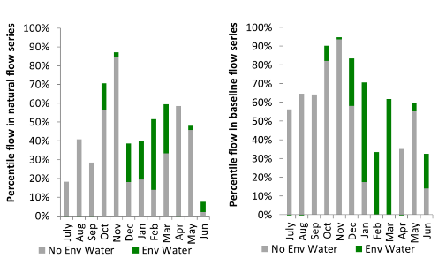
Figure CNM20. Contribution of the water reform and environmental water delivery at Wakool as percentiles in the natural and baseline flow series.

Euston
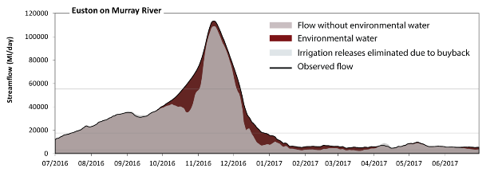 Figure CNM21. Contribution of the water reform and environmental water delivery at Euston. Horizontal lines indicate thresholds for very low flows, low flows, low freshes, medium freshes and high freshes (from lowest to highest).
At Euston on the Murray River the water reform and environmental water contributed 13% of the total streamflow volume. The water reform and environmental watering actions affected streamflows for 72% of days between 1 July 2016 and 30 June 2017. Flow regulation does not substantially increase the duration of very low flows (i.e. < 910 ML/day) compared to an average year in the natural flow regime. However, without the water reform and environmental water, the duration of medium low flows (i.e. < 3200 ML/day) in the period January to March would have substantially exceeded durations expected in an average year in the natural flow regime. The water reform and environmental water mitigated these impacts by reducing the cumulative duration of medium low flow spells from 8% to 0% of the year, with greatest influence in the period January to March. There was at least one low fresh (i.e. > 18000 ML/day) in the periods July to September and October to December. The water reform and environmental water made little change to the duration of these low freshes. In the absence of the water reform and environmental water there would have been at least one medium fresh (i.e. > 55000 ML/day) in the period October to December. The water reform and environmental water increased the duration of the longest medium fresh during the period October to December (from 32 days to 50 days). In the absence of the water reform and environmental water there would have been at least one high fresh in the period October to December. The water reform and environmental water increased the duration of the longest medium fresh during the period October to December (from 32 days to 50 days).
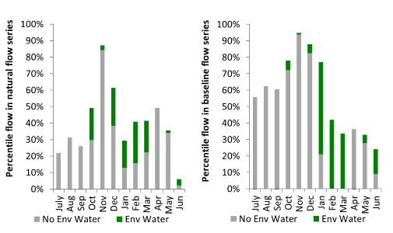
Figure CNM22. Contribution of the water reform and environmental water delivery at Euston as percentiles in the natural and baseline flow series.
Lock 10
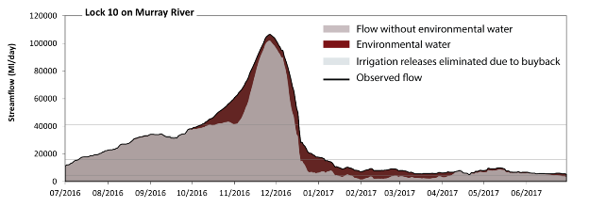 Figure CNM23. Contribution of the water reform and environmental water delivery at Lock 10. Horizontal lines indicate thresholds for very low flows, low flows, low freshes, medium freshes and high freshes (from lowest to highest).
At Lock 10 on the Murray River the water reform and environmental water contributed 16% of the total streamflow volume. The water reform and environmental watering actions affected streamflows for 79% of days between 1 July 2016 and 30 June 2017. Flow regulation does not substantially increase the duration of very low flows (i.e. < 940 ML/day) compared to an average year in the natural flow regime. However, without the water reform and environmental water, the durations of medium low flows (i.e. < 4300 ML/day) in the periods January to March and April to June would have substantially exceeded durations expected in an average year in the natural flow regime. The water reform and environmental water mitigated these impacts by reducing the cumulative duration of medium low flow spells from 23% to 0% of the year, with greatest influence in the period January to March. In the absence of the water reform and environmental water there would have been at least one low fresh (i.e. > 16000 ML/day) in the periods July to September and October to December. The water reform and environmental water increased the duration of the longest low fresh during the period January to March (from 0 days to 5 days). There was at least one medium fresh (i.e. > 41000 ML/day) in the period October to December. The water reform and environmental water made little change to the duration of these medium freshes. In the absence of environmental water there would have been at least one high fresh in the period October to December. The water reform and environmental water made little change to the duration of these high freshes.
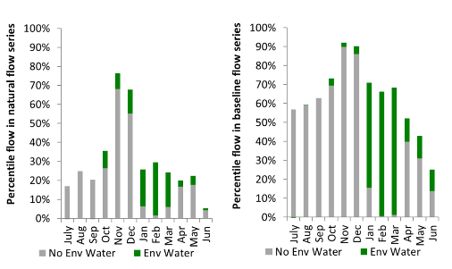
Figure CNM24. Contribution of the water reform and environmental water delivery at Lock 10 as percentiles in the natural and baseline flow series.

Edward Wakool
exd: extremely dry | vd: very dry | d: dry
sd: somewhat dry | av: average
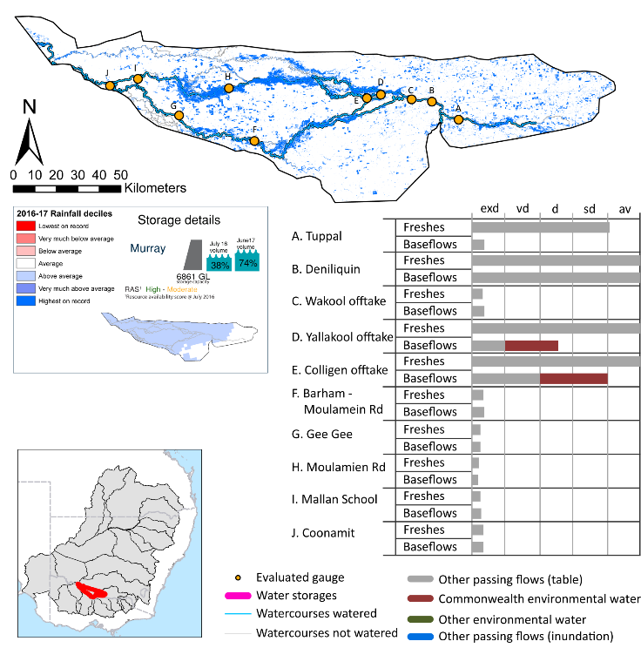
Figure EWK1. Watercourses influenced, areas inundated (where applicable) and gauge stations evaluated in the Edward Wakool valley during the 2016-17 water year. Inset bar graphs report the condition of annual flow regimes by showing the improvements in hydrological condition with the addition of environmental water as well as the hypothetical scenario in “grey” (if no environmental flow had been delivered). Rainfall conditions (rainfall deciles) and trend in storage levels for the water year are also shown.

Summary
Environmental water delivery for the 2016-17 year in the Edward Wakool valley is evaluated using data for 10 sites. This evaluation only considers the contribution of held environmental water, which is a primary focus for the Australian Government. The contributions of planned environmental water (e.g. passing flows), unregulated tributary inflows and clever use of irrigation flows for environmental benefits can all be very important but these are outside the scope of this report. Environmental watering actions lasted on average 171 days over the course of the year. The volume of environmental water at these 10 sites was between 0% and 7% of the total streamflow. Commonwealth environmental water contributed on average 90% of this environmental water. Ideally, baseflows should be maintained and long periods of excessively low flows avoided. In this valley, the baseflow regime was generally considered to be somewhat dry relative to the pre-development flow regime. In our analysis, a low fresh refers to a period of increased flow, when the water level rises at least one eighth of the way up the river bank (above the low flow level). These low freshes are a regular part of the natural flow regime and support a range of natural processes. In the Edward Wakool valley, in terms of the occurrence and duration of low freshes, the year was assessed as being average. In our analysis, a medium fresh refers to a period of increased flow, when the water level rises at least one quarter of the way up the river bank. These medium freshes are not as frequent as low freshes but are also a regular and important part of the natural flow regime. In the Edward Wakool valley, in terms of the occurrence of medium freshes, the year was assessed as being average. In our analysis, a high fresh refers to a period of increased flow, when the water level rises more than half way up the river. A high fresh may not occur every year but they are still important and long periods without major freshes can have serious consequences for floodplains and their contribution to river ecosystem health. Delivering high in channel flows normally requires that all risks to riparian landholders and infrastructure have been resolved. In the Edward Wakool valley, in terms of the occurrence of high freshes, the year was assessed as being average.

Water delivery context
During the 2016-17, the Commonwealth Environmental Water Holder (CEWH) used water held in the Murray and tributaries to deliver water in the Edward Wakool. For more information on the availability of held environmental water and its use please see the Central Murray.

Environmental conditions and resource availability
The water available for environmental delivery combined with the present and antecedent environmental conditions are key inputs used by environmental water managers in planning and implementing watering actions. Post hoc, this information provides important context when evaluating the effectiveness and appropriateness of environmental water use with respect to hydrological outputs.
The rainfall conditions in the Edward Wakool valley were classified as above average, based on rainfall percentile data for the entire record held by the Bureau of Meteorology for this valley. The water held in major storages in the Edward Wakool valley increased over the water year, for example Dartmouth and Hume dam was 38% full at the beginning of the water year and 74% full by the end of the year (Figure EWK1).
The Commonwealth Environmental Water Office (CEWO) calculates resource availability scenarios (RAS) to guide the use and prioritisation of held environmental water. The RAS are progressively calculated over the year as part of the continual adaptive management planning processes. The RAS are based on the availability of held environmental water (including progressive license acquisitions and allocations) as well as the potential for unregulated or planned environmental flows. The outcome is then used to determine the demand for environmental water across The Basin.
In 2016-17, the resource availability of held Commonwealth environmental water was classified as medium to low in this valley, whilst the potential for unregulated or planned environmental flow was classified as high to medium. The antecedent and forecasted physical conditions meant that Commonwealth environmental water was being planned to protect and/or maintain the condition of environmental assets. The overall demand for environmental water was deemed moderate (water predominantly needed this year and or next).

Watering actions
A total of 8 watering actions were delivered over the 2016-17 water year, the duration of these actions varied (range of individual actions: 40 - 180 days) and Commonwealth environmental water was delivered for a total of 181 days. The count of actions commencing in each season was; spring (3), summer (3) and autumn (2). The flow component types delivered were; (4) baseflow, (4) freshes, (0) bankfull, (0) overbank and (0) wetland.
There were 15 expected outcomes across the eight watering actions in the Central Murray. The percentage of expected outcomes across the nine main themes were as follows: fish (40%), vegetation (26.67%), waterbirds (0.0%), frogs (0.0%), other biota (0.0%), connectivity (6.67%), process (0.0%), resilience (0.0%) and water quality (26.67%).

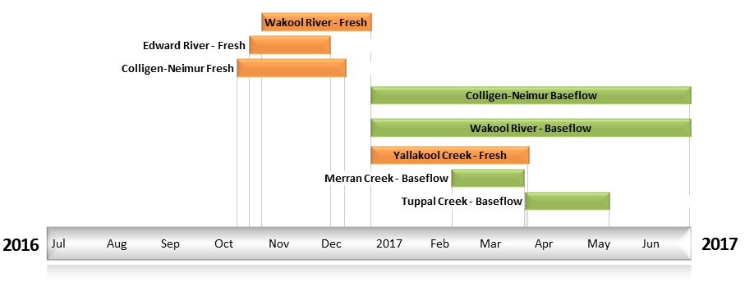
Figure EWK2. Timing and duration of Commonwealth environmental water actions delivered in the Edward Wakool valley.

Contribution of Commonwealth Environmental Water to Flow Regimes
Deniliquin
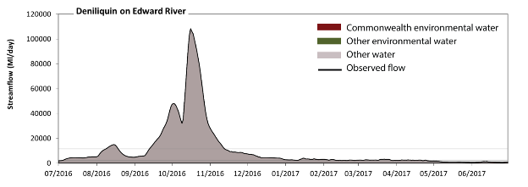
Figure EWK3. Contribution of environmental water delivery at Deniliquin. Horizontal lines indicate thresholds for very low flows, low flows, low freshes, medium freshes and high freshes (from lowest to highest).
At Deniliquin on the Edward River environmental water contributed 1% of the total streamflow volume (all of which was Commonwealth environmental water). Environmental watering actions affected streamflows for 50% of days between 1 July 2016 and 30 June 2017. Flow regulation does not substantially increase the duration of very low flows (i.e. < 24 ML/day) compared to an average year in the natural flow regime. Flow regulation does not substantially increase the duration of medium low flows (i.e. < 120 ML/day) compared to an average year in the natural flow regime. In the absence of environmental water there would have been at least one low fresh (i.e. > 710 ML/day) in the periods July to September, October to December, January to March and April to June. Environmental water increased the duration of the longest low fresh during the period April to June (from 38 days to 54 days). Commonwealth environmental water was entirely responsible for these increased durations of low freshes. In the absence of environmental water there would have been at least one medium fresh (i.e. > 2300 ML/day) in the periods July to September, October to December, January to March and April to June. Environmental water increased the duration of the longest medium fresh during the periods January to March (from 23 days to 30 days) and April to June (from 1 days to 8 days). Commonwealth environmental water was entirely responsible for these increased durations of medium freshes. In the absence of environmental water there would have been at least one high fresh in the periods July to September and October to December. Environmental water made no change to the duration of these high freshes.
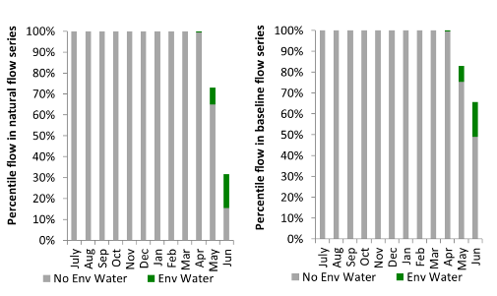
Figure EWK4. Contribution of environmental water delivery at Deniliquin as percentiles in the natural and baseline flow series.
Tuppal
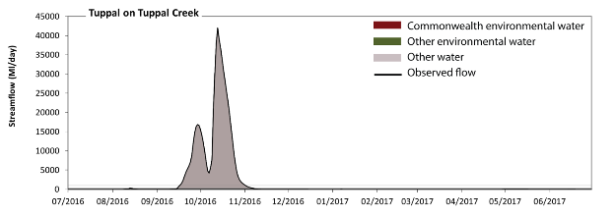
Figure EWK5. Contribution of environmental water delivery at Tuppal. Horizontal lines indicate thresholds for very low flows, low flows, low freshes, medium freshes and high freshes (from lowest to highest).
At Tuppal on the Tuppal Creek environmental water contributed less than 1% of the total streamflow volume (none of which was Commonwealth environmental water). Environmental watering actions affected streamflows for 12% of days between 1 July 2016 and 30 June 2017. Without environmental water, the durations of very low flows (i.e. < 24 ML/day) in the periods July to September, October to December, January to March and April to June would have all substantially exceeded durations expected in an average year in the natural flow regime. Environmental water mitigated these impacts by reducing the cumulative duration of very low flow spells from 80% to 75% of the year, with greatest influence in the period April to June. Similarly, without environmental water, the durations of medium low flows (i.e. < 120 ML/day) in the periods July to September, October to December, January to March and April to June would have all substantially exceeded durations expected in an average year in the natural flow regime. However, environmental water had little effect on the duration of these medium low flows, which occurred for 84% of the year. Commonwealth environmental water made no contribution to these enhancements of environmental baseflows at this site. There was at least one low fresh (i.e. > 230 ML/day) in the periods July to September and October to December. Environmental water made no change to the duration of these low freshes. There was at least one medium fresh (i.e. > 400 ML/day) in the periods July to September and October to December. Environmental water made no change to the duration of these medium freshes. In the absence of environmental water there would have been at least one high fresh in the periods July to September and October to December. Environmental water made no change to the duration of these high freshes.
Figure EWK6. Contribution of environmental water delivery at Tuppal as percentiles in the natural and baseline flow series.
Yallakool Offtake
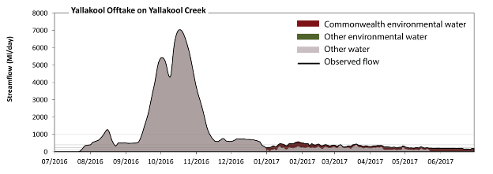
Figure EWK7. Contribution of environmental water delivery at Yallakool Offtake. Horizontal lines indicate thresholds for very low flows, low flows, low freshes, medium freshes and high freshes (from lowest to highest).
At Yallakool Offtake on the Yallakool Creek environmental water contributed 7% of the total streamflow volume (all of which was Commonwealth environmental water). Environmental watering actions affected streamflows for 49% of days between 1 July 2016 and 30 June 2017. Without environmental water, the durations of very low flows (i.e. < 24 ML/day) in the periods July to September and April to June would have substantially exceeded durations expected in an average year in the natural flow regime. Environmental water mitigated these impacts by reducing the cumulative duration of very low flow spells from 16% to 6% of the year, with greatest influence in the period April to June. Similarly, without environmental water, the durations of medium low flows (i.e. < 120 ML/day) in the periods July to September and April to June would have substantially exceeded durations expected in an average year in the natural flow regime. Environmental water mitigated these impacts by reducing the cumulative duration of medium low flow spells from 24% to 7% of the year, with greatest influence in the period April to June. Commonwealth environmental water was entirely responsible for these enhancements of environmental baseflows at this site. In the absence of environmental water there would have been at least one low fresh (i.e. > 230 ML/day) in the periods July to September, October to December, January to March and April to June. Environmental water increased the duration of the longest low fresh during the periods January to March (from 9 days to 90 days) and April to June (from 6 days to 23 days). Commonwealth environmental water was entirely responsible for these increased durations of low freshes. In the absence of environmental water there would have been at least one medium fresh (i.e. > 400 ML/day) in the periods July to September, October to December and January to March. Environmental water increased the duration of the longest medium fresh during the period January to March (from 1 days to 18 days). Commonwealth environmental water was entirely responsible for these increased durations of medium freshes. In the absence of environmental water there would have been at least one high fresh in the periods July to September and October to December. Environmental water made no change to the duration of these high freshes.
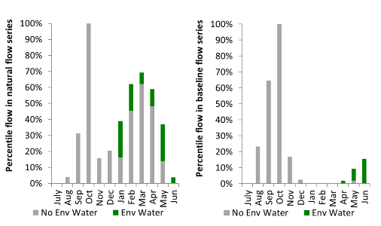
Figure EWK8. Contribution of environmental water delivery at Yallakool Offtake as percentiles in the natural and baseline flow series.

Colligen Offtake
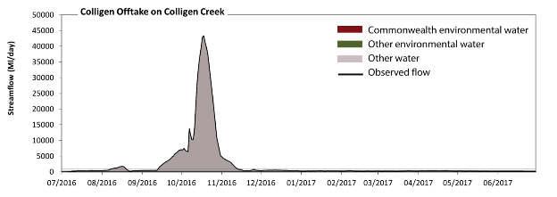
Figure EWK9. Contribution of environmental water delivery at Colligen Offtake. Horizontal lines indicate thresholds for very low flows, low flows, low freshes, medium freshes and high freshes (from lowest to highest).
At Colligen Offtake on the Colligen Creek environmental water contributed 2% of the total streamflow volume (all of which was Commonwealth environmental water). Environmental watering actions affected streamflows for 50% of days between 1 July 2016 and 30 June 2017. Without environmental water, the durations of very low flows (i.e. < 24 ML/day) in the periods July to September and April to June would have substantially exceeded durations expected in an average year in the natural flow regime. Environmental water mitigated these impacts by reducing the cumulative duration of very low flow spells from 10% to 2% of the year, with greatest influence in the period April to June. Similarly, without environmental water, the durations of medium low flows (i.e. < 120 ML/day) in the periods July to September and April to June would have substantially exceeded durations expected in an average year in the natural flow regime. Environmental water mitigated these impacts by reducing the cumulative duration of medium low flow spells from 11% to 2% of the year, with greatest influence in the period April to June. Commonwealth environmental water was entirely responsible for these enhancements of environmental baseflows at this site. In the absence of environmental water there would have been at least one low fresh (i.e. > 230 ML/day) in the periods July to September, October to December and January to March. Environmental water increased the duration of the longest low fresh during the periods January to March (from 5 days to 43 days) and April to June (from 0 days to 48 days). Commonwealth environmental water was entirely responsible for these increased durations of low freshes. In the absence of environmental water there would have been at least one medium fresh (i.e. > 400 ML/day) in the periods July to September and October to December. Environmental water increased the duration of the longest medium fresh during the period January to March (from 0 days to 1 days). Commonwealth environmental water was entirely responsible for these increased durations of medium freshes. In the absence of environmental water there would have been at least one high fresh in the periods July to September and October to December. Environmental water made no change to the duration of these high freshes.
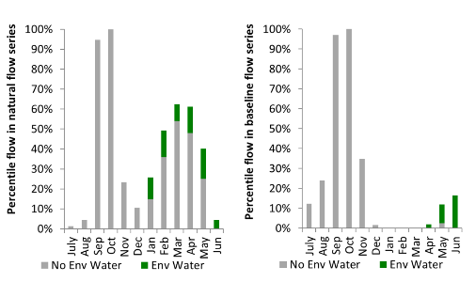
Figure EWK10. Contribution of environmental water delivery at Colligen Offtake as percentiles in the natural and baseline flow series.
Wakool Offtake
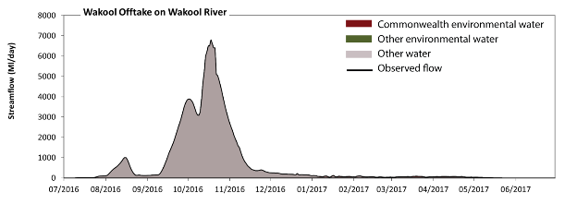
Figure EWK11. Contribution of environmental water delivery at Wakool Offtake.
At Wakool Offtake on the Wakool River environmental water contributed 1% of the total streamflow volume (all of which was Commonwealth environmental water). Environmental watering actions affected streamflows for 33% of days between 1 July 2016 and 30 June 2017. However, environmental water had little effect on the duration of these very low flows, which occurred for 100% of the year.
Figure EWK12. Contribution of environmental water delivery at Wakool Offtake as percentiles in the natural and baseline flow series.
Barham Moulamien
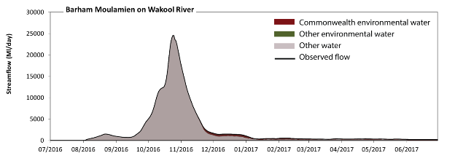Figure EWK13. Contribution of environmental water delivery at Barham Moulamien.
At Barham Moulamien on the Wakool River environmental water contributed 6% of the total streamflow volume (all of which was Commonwealth environmental water). Environmental watering actions affected streamflows for 64% of days between 1 July 2016 and 30 June 2017. However, environmental water had little effect on the duration of these very low flows, which occurred for 100% of the year.
Figure EWK14. Contribution of environmental water delivery at Barham Moulamien as percentiles in the natural and baseline flow series.

Gee Gee Bridge
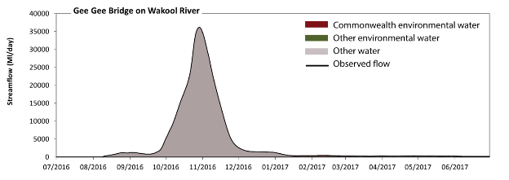 Figure EWK15. Contribution of environmental water delivery at Gee Gee Bridge.
At Gee Gee Bridge on the Wakool River environmental water contributed 2% of the total streamflow volume (all of which was Commonwealth environmental water). Environmental watering actions affected streamflows for 45% of days between 1 July 2016 and 30 June 2017. However, environmental water had little effect on the duration of these very low flows, which occurred for 100% of the year.
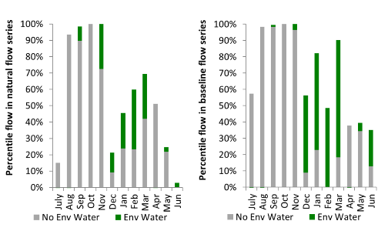
Figure EWK16. Contribution of environmental water delivery at Gee Gee Bridge as percentiles in the natural and baseline flow series.
Coonamit
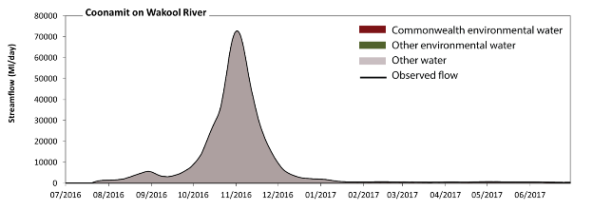 Figure EWK17. Contribution of environmental water delivery at Coonamit.
At Coonamit on the Wakool River environmental water contributed 2% of the total streamflow volume (all of which was Commonwealth environmental water). Environmental watering actions affected streamflows for 55% of days between 1 July 2016 and 30 June 2017. However, environmental water had little effect on the duration of these very low flows, which occurred for 100% of the year.
Figure EWK18. Contribution of environmental water delivery at Coonamit as percentiles in the natural and baseline flow series.
Moulamien Rd
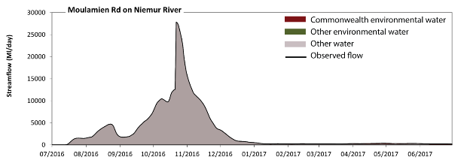 Figure EWK19. Contribution of environmental water delivery at Moulamien Rd.
At Moulamien Rd on the Niemur River environmental water contributed 2% of the total streamflow volume (all of which was Commonwealth environmental water). Environmental watering actions affected streamflows for 56% of days between 1 July 2016 and 30 June 2017. However, environmental water had little effect on the duration of these very low flows, which occurred for 100% of the year.
Figure EWK20. Contribution of environmental water delivery at Moulamien Rd as percentiles in the natural and baseline flow series.
Mallan School
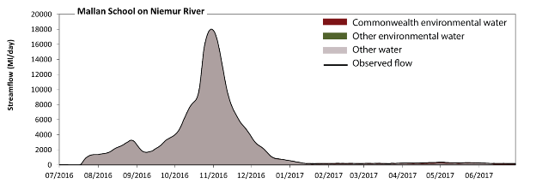 Figure EWK21. Contribution of environmental water delivery at Mallan School.
At Mallan School on the Niemur River environmental water contributed 2% of the total streamflow volume (all of which was Commonwealth environmental water). Environmental watering actions affected streamflows for 55% of days between 1 July 2016 and 30 June 2017. However, environmental water had little effect on the duration of these very low flows, which occurred for 100% of the year.
Figure EWK22. Contribution of environmental water delivery at Mallan School as percentiles in the natural and baseline flow series.

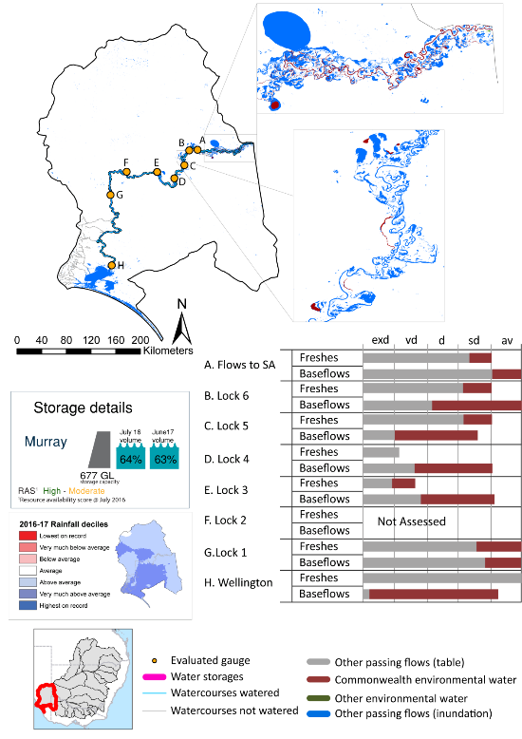
Lower Murray

exd: extremely dry | vd: very dry | d: dry | sd: somewhat dry | av: average

Figure LWM1. Watercourses influenced, areas inundated (where applicable) and gauge stations evaluated in the Lower Murray valley during the 2016-17 water year. Inset bar graphs report the condition of annual flow regimes by showing the improvements in hydrological condition with the addition of environmental water as well as the hypothetical scenario in “grey” (if no environmental flow had been delivered). Rainfall conditions (rainfall deciles) and trend in storage levels for the water year are also shown.

Summary
The water reform and environmental water delivery for the 2016-17 year in the Lower Murray valley is evaluated using data for 7 sites. This evaluation only considers the contribution of held environmental water, which is a primary focus for the Australian Government. The contributions of planned environmental water (e.g. passing flows), unregulated tributary inflows and clever use of irrigation flows for environmental benefits can all be very important but these are outside the scope of this report. Environmental watering actions lasted on average 346 days over the course of the year. The volume of environmental water at these 7 sites was between 9% and 16% of the total streamflow. Environmental water contributed on average 100% of this environmental water¹. Ideally, baseflows should be maintained and long periods of excessively low flows avoided. In this valley, the baseflow regime was generally considered to be somewhat dry relative to the pre-development flow regime. In our analysis, a low fresh refers to a period of increased flow, when the water level rises at least one eighth of the way up the river bank (above the low flow level). These low freshes are a regular part of the natural flow regime and support a range of natural processes. In the Lower Murray valley, in terms of the occurrence and duration of low freshes, the year was assessed as being average. In our analysis, a medium fresh refers to a period of increased flow, when the water level rises at least one quarter of the way up the river bank. These medium freshes are not as frequent as low freshes but are also a regular and important part of the natural flow regime. In the Lower Murray valley, in terms of the occurrence of medium freshes, the year was assessed as being dry. In our analysis, a high fresh refers to a period of increased flow, when the water level rises more than half way up the river. A high fresh may not occur every year but they are still important and long periods without major freshes can have serious consequences for floodplains and their contribution to river ecosystem health. Delivering high in channel flows normally requires that all risks to riparian landholders and infrastructure have been resolved. In the Lower Murray valley, in terms of the occurrence of high freshes, the year was assessed as being somewhat dry.
¹The evaluation of Murray River hydrology has been derived from the msm-BigMod river model. The modelling compares a pre-buyback scenario with a run delivering the environmental water use observed in 2016/17. The difference between the two runs includes the cumulative impact of behavioural change in use and demand of water since 2009. We have identified these differences as “environmental water” and “irrigation releases eliminated due to buyback”. The “environmental water” component will include flows resulting from behavioural change not just directly managed deliveries. As a consequence, environmental water may appear to be delivered in River Murray graphics, when it wasn’t and vice versa.

Water delivery context
During the 2016-17, the Commonwealth Environmental Water Holder (CEWH) held water entitlements of up to 154 329 ML for environmental use in the Lower Murray valley. Each year, water utilities allocate water entitlement holders a percentage of water based on their holding, license type and carryover (the exact rules vary among Jurisdictions). In 2016-17, the Lower Murray entitlements held by the CEWH were allocated 151 104 ML of water, representing 109% of the Long term average annual yield for the Lower Murray valley (138 896 ML). Information and data relating to the portfolio of held Commonwealth environmental water is shown in Table LWM1.
The CEWH had 151 104 ML of water available for delivery, along with New South Wales and Victorian allocations that can be delivered to South Australia either directly or as return flows from upstream watering events. A total of 621 GL of Commonwealth environmental water was delivered in the Lower Murray valley. No Commonwealth environmental water was traded to consumptive users or carried over for environmental use into the 2017-18 water year.

Environmental conditions and resource availability
The water available for environmental delivery combined with the present and antecedent environmental conditions are key inputs used by environmental water managers in planning and implementing watering actions. Post hoc, this information provides important context when evaluating the effectiveness and appropriateness of environmental water use with respect to hydrological outputs.
The rainfall conditions in the Lower Murray valley were classified as above average, based on rainfall percentile data for the entire record held by the Bureau of Meteorology for this valley. The water held in major storages in the Lower Murray valley stayed the same over the water year, for example Lake Victoria, Lake Alexandrina, Lake Albert and Lower Lakes dam was 64% full at the beginning of the water year and 63% full by the end of the year (Figure LWM1).
The Commonwealth Environmental Water Office (CEWO) calculates resource availability scenarios (RAS) to guide the use and prioritisation of held environmental water. The RAS are progressively calculated over the year as part of the continual adaptive management planning processes. The RAS are based on the availability of held environmental water (including progressive license acquisitions and allocations) as well as the potential for unregulated or planned environmental flows. The outcome is then used to determine the demand for environmental water across The Basin.
In 2016-17, the resource availability of held Commonwealth environmental water was classified as medium to low in this valley, whilst the potential for unregulated or planned environmental flow was classified as high to medium. The antecedent and forecasted physical conditions meant that Commonwealth environmental water was being planned to to protect and/or maintain the condition of most environmental assets The overall demand for environmental water was deemed moderate (water predominantly needed this year and or next).

Watering actions
A total of 22 watering actions were delivered over the 2016-17 water year, the duration of these actions varied (range of individual actions: 15 - 365 days) and Commonwealth environmental water was delivered for a total of 365 days. The count of actions commencing in each season was; winter (8), summer (4), autumn (8) and unknown (2). The flow component types delivered were; (0) baseflow, (11) freshes, (0) bankfull, (0) overbank and (11) wetland.
There were 68 expected outcomes across the 22 watering actions in the Lower Murray. The percentage expected outcomes across the nine main themes were: fish (17.65%), vegetation (29.41%), waterbirds (22.06%), frogs (13.24%), other biota (0.0%), connectivity (1.47%), process (16.18%), resilience (0.0%) and water quality (0.0%).
Table LWM1. Commonwealth environmental water accounting information for the Lower Murray valley over 2016-17 water year (LTAAY = long-term average annual yield).
Total registered volume (ML) | Allocated volume (ML) | Carry over + allocated volume (ML) | Delivered (ML) | LTAAY (ML) | Trade (ML) | Carried over to 2016-17 | Forfeited (ML)
154 329 | 151 104 | 151 104 | 618 000 | 138 896 | 0 | - | 0

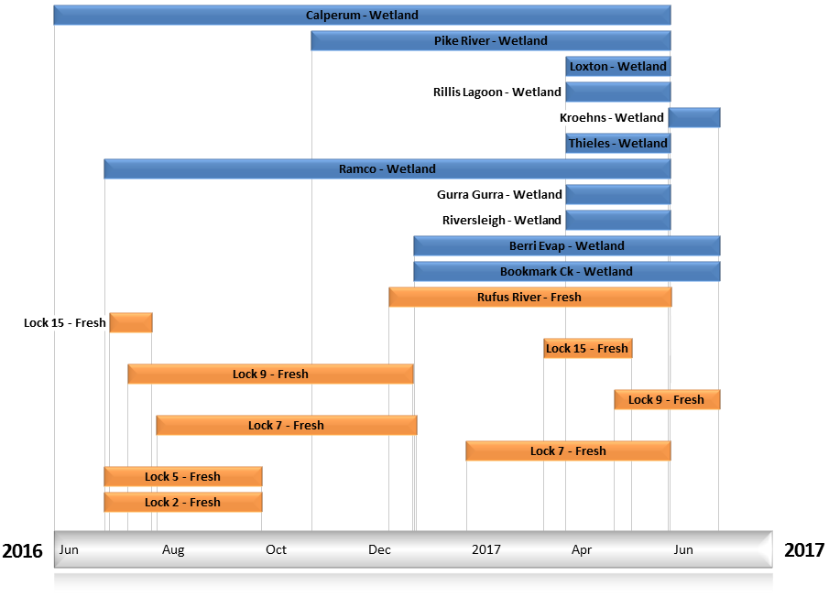
Figure LWM2. Timing and duration of Commonwealth environmental water actions delivered in the Lower Murray valley.

Contribution of Commonwealth Environmental Water to Flow Regimes
SA Border
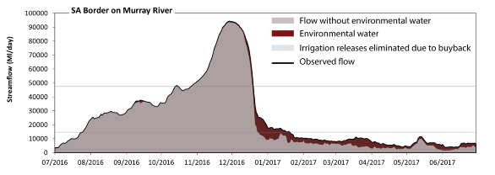
Figure LWM3. Contribution of the water reform and environmental water delivery at SA Border. Horizontal lines indicate thresholds for very low flows, low flows, low freshes, medium freshes and high freshes (from lowest to highest).
At SA Border on the Murray River the water reform and environmental contributed 9% of the total streamflow volume. The water reform and environmental watering actions affected streamflows for 91% of days between 1 July 2016 and 30 June 2017. Flow regulation does not substantially increase the duration of very low flows (i.e. < 430 ML/day) compared to an average year in the natural flow regime. However, without the water reform and environmental water, the duration of medium low flows (i.e. < 2500 ML/day) in the period April to June would have substantially exceeded durations expected in an average year in the natural flow regime. The water reform and environmental water mitigated these impacts by reducing the cumulative duration of medium low flow spells from 5% to 0% of the year, with greatest influence in the period April to June. In the absence of the water reform and environmental water there would have been at least one low fresh (i.e. > 15000 ML/day) in the periods July to September and October to December. The water reform and environmental water increased the duration of the longest low fresh during the period January to March (from 0 days to 20 days). There was at least one medium fresh (i.e. > 47000 ML/day) in the period October to December. The water reform and environmental water made little change to the duration of these medium freshes. In the absence of the water reform and environmental water there would have been at least one high fresh in the period October to December. The water reform and environmental water made little change to the duration of these high freshes.
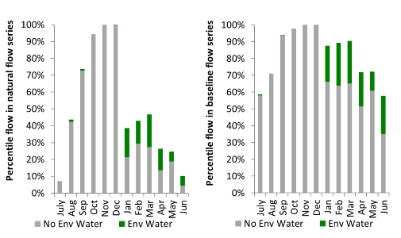
Figure LWM4. Contribution of the water reform and environmental water delivery at SA Border as percentiles in the natural and baseline flow series.

Lock 6
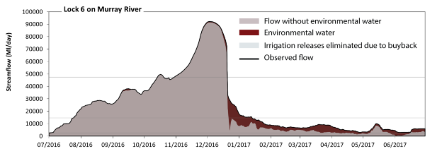
Figure LWM5. Contribution of the water reform and environmental water delivery at Lock 6. Horizontal lines indicate thresholds for very low flows, low flows, low freshes, medium freshes and high freshes (from lowest to highest).
At Lock 6 on the Murray River the water reform and environmental water contributed 9% of the total streamflow volume. The water reform and environmental watering actions affected streamflows for 89% of days between 1 July 2016 and 30 June 2017. Flow regulation does not substantially increase the duration of very low flows (i.e. < 430 ML/day) compared to an average year in the natural flow regime. In the absence of the water reform and environmental water there would have been at least one low fresh (i.e. > 15000 ML/day) in the periods July to September and October to December. The water reform and environmental water increased the duration of the longest low fresh during the period January to March (from 0 days to 13 days). There was at least one medium fresh (i.e. > 47000 ML/day) in the period October to December. The water reform and environmental water made no change to the duration of these medium freshes. In the absence of the water reform and environmental water there would have been at least one high fresh in the period October to December. The water reform and environmental water made no change to the duration of these high freshes.
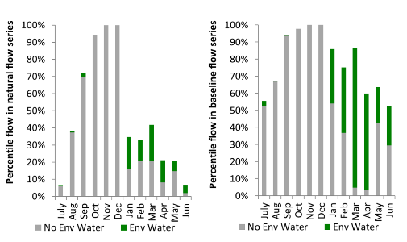
Figure LWM6. Contribution of the water reform and environmental water delivery at Lock 6 as percentiles in the natural and baseline flow series.
Lock 5
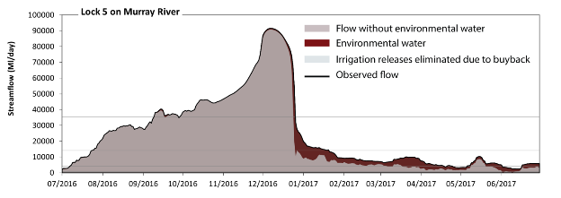
Figure LWM7. Contribution of the water reform and environmental water delivery at Lock 5. Horizontal lines indicate thresholds for very low flows, low flows, low freshes, medium freshes and high freshes (from lowest to highest).
At Lock 5 on the Murray River the water reform and environmental contributed 9% of the total streamflow volume. The water reform and environmental watering actions affected streamflows for 99% of days between 1 July 2016 and 30 June 2017. Without the water reform and environmental water, the duration of very low flows (i.e. < 700 ML/day) in the period April to June would have substantially exceeded durations expected in an average year in the natural flow regime. The water reform and environmental water mitigated these impacts by reducing the cumulative duration of very low flow spells from 2% to 0% of the year, with greatest influence in the period April to June. Similarly, without the water reform and environmental water, the durations of medium low flows (i.e. < 4100 ML/day) in the periods July to September, January to March and April to June would have substantially exceeded durations expected in an average year in the natural flow regime. The water reform and environmental water mitigated these impacts by reducing the cumulative duration of medium low flow spells from 27% to 9% of the year, with greatest influence in the period April to June. In the absence of the water reform and environmental water there would have been at least one low fresh (i.e. > 14000 ML/day) in the periods July to September and October to December. The water reform and environmental water increased the duration of the longest low fresh during the period January to March (from 0 days to 20 days). In the absence of the water reform and environmental water there would have been at least one medium fresh (i.e. > 36000 ML/day) in the periods July to September and October to December. The water reform and environmental water increased the duration of the longest medium fresh during the period July to September (from 9 days to 18 days). In the absence of the water reform and environmental water there would have been at least one high fresh in the periods July to September and October to December. The water reform and environmental water increased the duration of the longest medium fresh during the period July to September (from 9 days to 18 days).
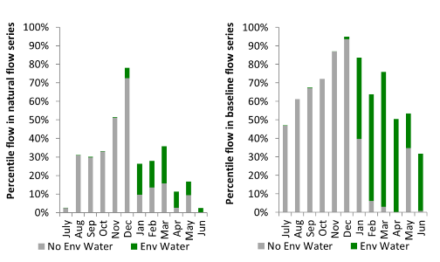
Figure LWM8. Contribution of the water reform and environmental water delivery at Lock 5 as percentiles in the natural and baseline flow series.
Lock 4
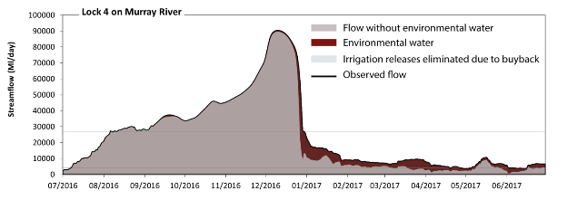
Figure LWM9. Contribution of the water reform and environmental water delivery at Lock 4. Horizontal lines indicate thresholds for very low flows, low flows and low freshes (from lowest to highest).
At Lock 4 on the Murray River the water reform and environmental contributed 9% of the total streamflow volume. The water reform and environmental watering actions affected streamflows for 100% of days between 1 July 2016 and 30 June 2017. Flow regulation does not substantially increase the duration of very low flows (i.e. < 700 ML/day) compared to an average year in the natural flow regime. However, without the water reform and environmental water, the durations of medium low flows (i.e. < 4100 ML/day) in the periods July to September, January to March and April to June would have substantially exceeded durations expected in an average year in the natural flow regime. The water reform and environmental water mitigated these impacts by reducing the cumulative duration of medium low flow spells from 23% to 7% of the year, with greatest influence in the periods January to March and April to June. There was at least one low fresh (i.e. > 27000 ML/day) in the periods July to September and October to December. The water reform and environmental water made no change to the duration of these low freshes. There was no medium or high freshes this year.
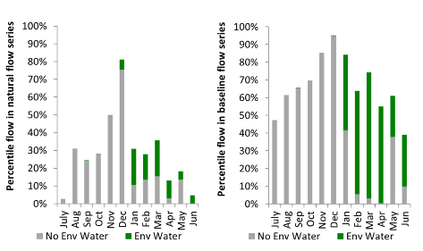
Figure LWM10. Contribution of the water reform and environmental water delivery at Lock 4 as percentiles in the natural and baseline flow series.
Lock 3
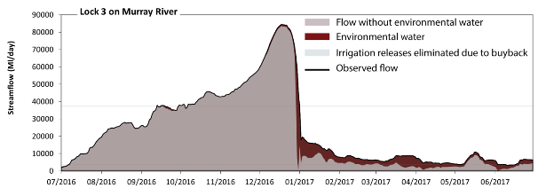
Figure LWM11. Contribution of the water reform and environmental water delivery at Lock 3. Horizontal lines indicate thresholds for very low flows, low flows and low freshes (from lowest to highest).
At Lock 3 on the Murray River the water reform and environmental contributed 10% of the total streamflow volume. The water reform and environmental watering actions affected streamflows for 100% of days between 1 July 2016 and 30 June 2017. Flow regulation does not substantially increase the duration of very low flows (i.e. < 690 ML/day) compared to an average year in the natural flow regime. However, without the water reform and environmental water, the durations of medium low flows (i.e. < 3900 ML/day) in the periods July to September, January to March and April to June would have substantially exceeded durations expected in an average year in the natural flow regime. The water reform and environmental water mitigated these impacts by reducing the cumulative duration of medium low flow spells from 30% to 7% of the year, with greatest influence in the periods January to March and April to June. In the absence of the water reform and environmental water there would have been at least one low fresh (i.e. > 37000 ML/day) in the periods July to September and October to December. The water reform and environmental water increased the duration of the longest low fresh during the period July to September (from 1 days to 4 days). There was no medium or high freshes this year.
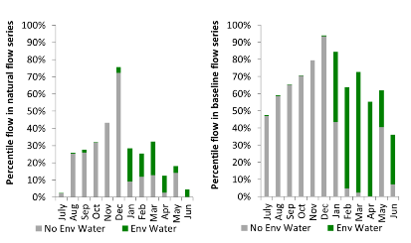
Figure LWM12. Contribution of the water reform and environmental water delivery at Lock 3 as percentiles in the natural and baseline flow series.
Lock 1
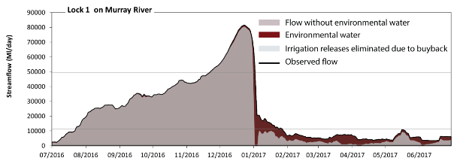 Figure LWM13. Contribution of the water reform and environmental water delivery at Lock 1. Horizontal lines indicate thresholds for very low flows, low flows, low freshes, medium freshes and high freshes (from lowest to highest).
At Lock 1 on the Murray River the water reform and environmental contributed 10% of the total streamflow volume. The water reform and environmental watering actions affected streamflows for 100% of days between 1 July 2016 and 30 June 2017. Without the water reform and environmental water, the duration of very low flows (i.e. < 690 ML/day) in the period April to June would have substantially exceeded durations expected in an average year in the natural flow regime. The water reform and environmental water mitigated these impacts by reducing the cumulative duration of very low flow spells from 4% to 0% of the year, with greatest influence in the period April to June. Similarly, without the water reform and environmental water, the durations of medium low flows (i.e. < 900 ML/day) in the periods January to March and April to June would have substantially exceeded durations expected in an average year in the natural flow regime. The water reform and environmental water mitigated these impacts by reducing the cumulative duration of medium low flow spells from 6% to 0% of the year, with greatest influence in the periods January to March and April to June. In the absence of the water reform and environmental water there would have been at least one low fresh (i.e. > 11000 ML/day) in the periods July to September, October to December and January to March. The water reform and environmental water increased the duration of the longest low fresh during the period January to March (from 1 days to 23 days). In the absence of the water reform and environmental water there would have been at least one medium fresh (i.e. > 50000 ML/day) in the period October to December. The water reform and environmental water increased the duration of the longest medium fresh during the period January to March (from 0 days to 2 days). In the absence of the water reform and environmental water there would have been at least one high fresh in the period October to December. The water reform and environmental water increased the duration of the longest medium fresh during the period January to March (from 0 days to 2 days).
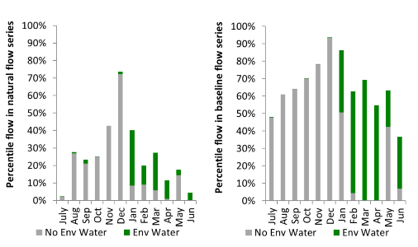
Figure LWM14. Contribution of the water reform and environmental water delivery at Lock 1 as percentiles in the natural and baseline flow series.

Wellington
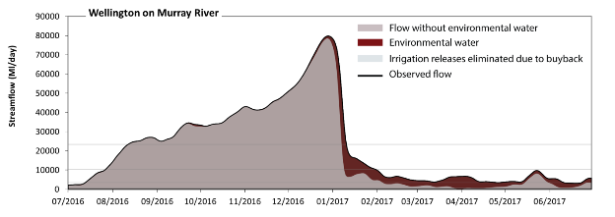 Figure LWM15. Contribution of the water reform and environmental water delivery at Wellington. Horizontal lines indicate thresholds for very low flows, low flows, low freshes, medium freshes and high freshes (from lowest to highest).
At Wellington on the Murray River the water reform and environmental contributed 11% of the total streamflow volume. The water reform and environmental watering actions affected streamflows for 100% of days between 1 July 2016 and 30 June 2017. Without the water reform and environmental water, the duration of very low flows (i.e. < 690 ML/day) in the period April to June would have substantially exceeded durations expected in an average year in the natural flow regime. The water reform and environmental water mitigated these impacts by reducing the cumulative duration of very low flow spells from 6% to 0% of the year, with greatest influence in the period April to June. Similarly, without the water reform and environmental water, the durations of medium low flows (i.e. < 3500 ML/day) in the periods July to September, January to March and April to June would have substantially exceeded durations expected in an average year in the natural flow regime. The water reform and environmental water mitigated these impacts by reducing the cumulative duration of medium low flow spells from 39% to 8% of the year, with greatest influence in the periods January to March and April to June. In the absence of the water reform and environmental water there would have been at least one low fresh (i.e. > 10000 ML/day) in the periods July to September, October to December and January to March. The water reform and environmental water increased the duration of the longest low fresh during the period January to March (from 8 days to 31 days). In the absence of the water reform and environmental water there would have been at least one medium fresh (i.e. > 23000 ML/day) in the periods July to September, October to December and January to March. The water reform and environmental water increased the duration of the longest medium fresh during the period January to March (from 7 days to 10 days). In the absence of the water reform and environmental water there would have been at least one high fresh in the periods July to September, October to December and January to March. The water reform and environmental water increased the duration of the longest medium fresh during the period January to March (from 7 days to 10 days).
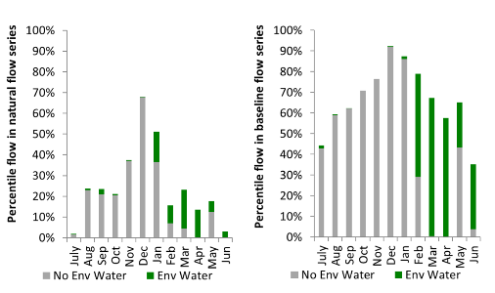
Figure LWM16. Contribution of the water reform and environmental water delivery at Wellington as percentiles in the natural and baseline flow series.

Macquarie
exd: extremely dry | vd: very dry | d: dry | sd: somewhat dry | av: average
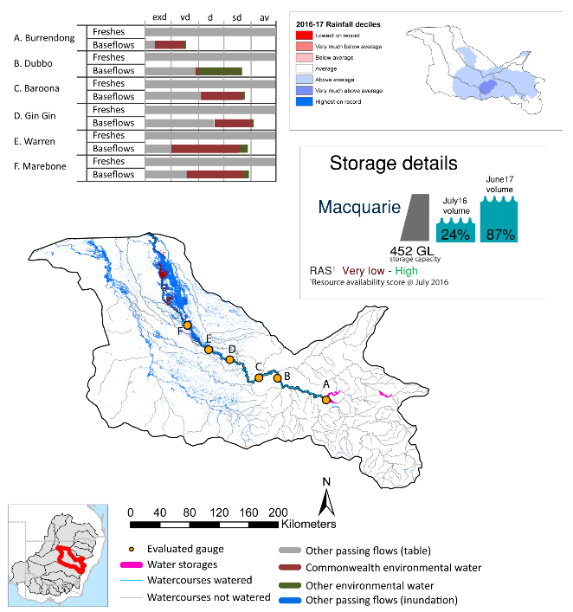
Figure MCQ1. Watercourses influenced, areas inundated (where applicable) and gauge stations evaluated in the Macquarie valley during the 2016-17 water year. Inset bar graphs report the condition of annual flow regimes by showing the improvements in hydrological condition with the addition of environmental water as well as the hypothetical scenario in “grey” (if no environmental flow had been delivered). Rainfall conditions (rainfall deciles) and trend in storage levels for the water year are also shown.

Summary
Environmental water delivery for the 2016-17 year in the Macquarie valley is evaluated using data for 7 sites. This evaluation only considers the contribution of held environmental water, which is a primary focus for the Australian Government. The contributions of planned environmental water (e.g. passing flows), unregulated tributary inflows and clever use of irrigation flows for environmental benefits can all be very important but these are outside the scope of this report, but where this data was made availalable (for planned ewater only) it has been included. Environmental watering actions lasted on average 70 days over the course of the year. The volume of environmental water at these 7 sites was between 0% and 9% of the total streamflow. Commonwealth environmental water contributed on average 53% of this environmental water. Ideally, baseflows should be maintained and long periods of excessively low flows avoided. In this valley, the baseflow regime was generally considered to be dry relative to the pre-development flow regime. In our analysis, a low fresh refers to a period of increased flow, when the water level rises at least one eighth of the way up the river bank (above the low flow level). These low freshes are a regular part of the natural flow regime and support a range of natural processes. In the Macquarie valley, in terms of the occurrence and duration of low freshes, the year was assessed as being average. In our analysis, a medium fresh refers to a period of increased flow, when the water level rises at least one quarter of the way up the river bank. These medium freshes are not as frequent as low freshes but are also a regular and important part of the natural flow regime. In the Macquarie valley, in terms of the occurrence of medium freshes, the year was assessed as being average. In our analysis, a high fresh refers to a period of increased flow, when the water level rises more than half way up the river. A high fresh may not occur every year but they are still important and long periods without major freshes can have serious consequences for floodplains and their contribution to river ecosystem health. Delivering high in channel flows normally requires that all risks to riparian landholders and infrastructure have been resolved. In the Macquarie valley, in terms of the occurrence of high freshes, the year was assessed as being average.

Water delivery context
During the 2016-17, the Commonwealth Environmental Water Holder (CEWH) held water entitlements of up to 134 516 ML (General Security and Supplementary) for environmental use in the Macquarie valley. Each year, water utilities allocate water entitlement holders a percentage of water based on their holding, license type and carryover (the exact rules vary among Jurisdictions). In 2016-17, the Macquarie entitlements held by the CEWH were allocated 133 474 ML of water, representing 244% of the Long term average annual yield for the Macquarie valley (54 756 ML). Information and data relating to the portfolio of held Commonwealth environmental water is shown in Table MCQ1.
In 2016–17, 7 847 ML was carried over from 2015–16, however, this volume was withdrawn when Burrendong Dam spilt. Accounts were reset to 100 per cent (126 224 ML) following dam spill which water meant the CEWH had 126 224 ML of General Security water available for delivery in 2016–17. A number of supplementary events were announced in 2016-17, during which the CEWH accessed 7 250ML of water. A total of 54 520 ML of Commonwealth environmental water was delivered in the Macquarie valley. A total of 0 ML of Commonwealth environmental water was traded to consumptive users and 7847 ML of available Commonwealth environmental water was carried over for environmental use into the 2017-18 water year.

Environmental conditions and resource availability
The water available for environmental delivery combined with the present and antecedent environmental conditions are key inputs used by environmental water managers in planning and implementing watering actions. Post hoc, this information provides important context when evaluating the effectiveness and appropriateness of environmental water use with respect to hydrological outputs.
The rainfall conditions in the Macquarie valley were classified as average, based on rainfall percentile data for the entire record held by the Bureau of Meteorology for this valley. The water held in major storages in the Macquarie valley increased over the water year, for example Burrendong dam was 24% full at the beginning of the water year, spilling in September, remaining above 100 per cent capacity for over three and a half months and was 87% full by the end of the year (Figure MCQ1).
The Commonwealth Environmental Water Office (CEWO) calculates resource availability scenarios (RAS) to guide the use and prioritisation of held environmental water. The RAS are progressively calculated over the year as part of the continual adaptive management planning processes. The RAS are based on the availability of held environmental water (including progressive license acquisitions and allocations) as well as the potential for unregulated or planned environmental flows. The outcome is then used to determine the demand for environmental water across The Basin.
In 2016-17, the resource availability of held Commonwealth environmental water was classified as very low in this valley, whilst the potential for unregulated or planned environmental flow was classified as high to medium. The antecedent and forecasted physical conditions meant that Commonwealth environmental water was being planned to avoid damage and protect core areas of the Macquarie Marshes, and assets in the Macquarie River, to ensure ecological capacity for recovery. The overall demand for environmental water was deemed high (water predominantly needed this year).

Watering actions
A total of 6 watering actions were delivered over the 2016-17 water year, the duration of these actions varied (range of individual actions: 2 - 29 days) and Commonwealth environmental water was delivered for a total of 63 days. The count of actions commencing in each season was; winter (1), spring (1), summer (2) and autumn (2). The flow component types delivered were; (0) baseflow, (2) freshes, (0) bankfull, (0) overbank and (4) wetland.
There were six expected outcomes across the 17 watering actions in the Macquarie valley. The percentage of expected outcomes across the nine main themes were as follows: fish (23.53%), vegetation (29.41%), waterbirds (17.65%), frogs (0.0%), other biota (0.0%), connectivity (23.53%), process (5.88%), resilience (0.0%) and water quality (0.0%).
Table MCQ1. Commonwealth environmental water accounting information for the Macquarie valley over 2016-17 water year (LTAAY = long-term average annual yield).
Total registered volume¹ (ML) | Allocated volume (ML) | Carry over² + allocated volume (ML) | Delivered (ML) | LTAAY (ML) | Trade (ML) | Carried over to 2016-17³ | Forfeited (ML)
134 516 | 133 474 | 133 474 | 54 520 | 54 756 | 0 | 7 847 | 0
¹ General security and supplementary
^{2,3} Volumes carried over to 2016-17 were withdrawn when Burrendong Dam spilled. General Security accounts were reset to 100%.

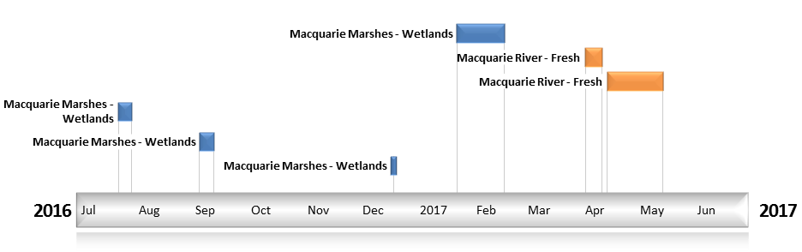
Figure MCQ2. Timing and duration of Commonwealth environmental water actions delivered in the Macquarie valley.

Contribution of Commonwealth Environmental Water to Flow Regimes
Burrendong
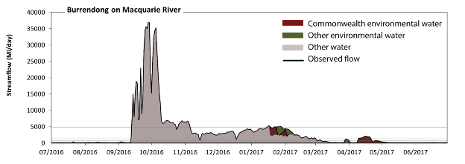
Figure MCQ3. Contribution of environmental water delivery at Burrendong. Horizontal lines indicate thresholds for very low flows, low flows, low freshes, medium freshes and high freshes (from lowest to highest).
At Burrendong on the Macquarie River environmental water contributed 7% of the total streamflow volume (much of which was Commonwealth environmental water). Environmental watering actions affected streamflows for 19% of days between 1 July 2016 and 30 June 2017. Without environmental water, the duration of very low flows (i.e. < 55 ML/day) in the period April to June would have substantially exceeded durations expected in an average year in the natural flow regime. Environmental water mitigated these impacts by reducing the cumulative duration of very low flow spells from 11% to 0% of the year, with greatest influence in the period April to June. Similarly, without environmental water, the durations of medium low flows (i.e. < 270 ML/day) in the periods July to September and April to June would have substantially exceeded durations expected in an average year in the natural flow regime. Environmental water mitigated these impacts by reducing the cumulative duration of medium low flow spells from 49% to 42% of the year, with greatest influence in the period April to June. Commonwealth environmental water was almost entirely responsible for these enhancements of environmental baseflows at this site. In the absence of environmental water there would have been at least one low fresh (i.e. > 720 ML/day) in the periods July to September, October to December and January to March. Environmental water increased the duration of the longest low fresh during the period April to June (from 0 days to 13 days). Commonwealth environmental water was entirely responsible for these increased durations of low freshes. In the absence of environmental water there would have been at least one medium fresh (i.e. > 1500 ML/day) in the periods July to September, October to December and January to March. Environmental water increased the duration of the longest medium fresh during the period April to June (from 0 days to 9 days). Environmental water was entirely responsible for these increased durations of medium freshes. In the absence of environmental water there would have been at least one high fresh in the periods July to September, October to December and January to March. Environmental water increased the duration of the longest medium fresh during the period January to March (from 2 days to 7 days). Commonwealth environmental water equally shared responsibility with other environmental water holders for these increased durations of high freshes.
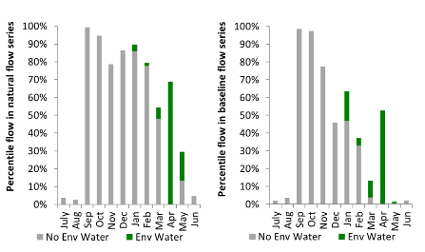
Figure MCQ4. Contribution of environmental water delivery at Burrendong as percentiles in the natural and baseline flow series.
Dubbo
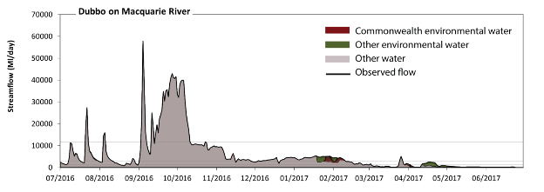
Figure MCQ5. Contribution of environmental water delivery at Dubbo. Horizontal lines indicate thresholds for very low flows, low flows, low freshes, medium freshes and high freshes (from lowest to highest).
At Dubbo on the Macquarie River environmental water contributed 4% of the total streamflow volume (with a medium contribution of Commonwealth environmental water). Environmental watering actions affected streamflows for 23% of days between 1 July 2016 and 30 June 2017. Without environmental water, the duration of very low flows (i.e. < 68 ML/day) in the period April to June would have substantially exceeded durations expected in an average year in the natural flow regime. Environmental water mitigated these impacts by reducing the cumulative duration of very low flow spells from 7% to 2% of the year, with greatest influence in the period April to June. Similarly, without environmental water, the duration of medium low flows (i.e. < 340 ML/day) in the period April to June would have substantially exceeded durations expected in an average year in the natural flow regime. Environmental water mitigated these impacts by reducing the cumulative duration of medium low flow spells from 24% to 19% of the year, with greatest influence in the period April to June. Commonwealth environmental water made little or no contribution to these enhancements of environmental baseflows at this site. In the absence of environmental water there would have been at least one low fresh (i.e. > 1200 ML/day) in the periods July to September, October to December and January to March. Environmental water increased the duration of the longest low fresh during the period April to June (from 0 days to 11 days). Commonwealth environmental water made a small contribution to these increased durations of low freshes. In the absence of environmental water there would have been at least one medium fresh (i.e. > 3000 ML/day) in the periods July to September, October to December and January to March. Environmental water increased the duration of the longest medium fresh during the period January to March (from 18 days to 41 days). Commonwealth environmental water made a modest contribution to the increased durations of medium freshes. In the absence of environmental water there would have been at least one high fresh in the periods July to September and October to December. Environmental water made no change to the duration of these high freshes.
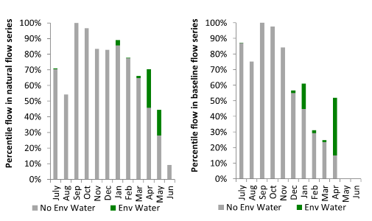
Figure MCQ6. Contribution of environmental water delivery at Dubbo as percentiles in the natural and baseline flow series.

Baroona
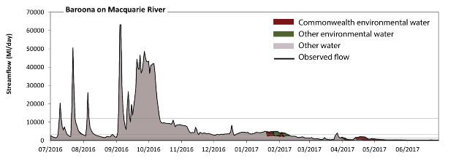
Figure MCQ7. Contribution of environmental water delivery at Baroona. Horizontal lines indicate thresholds for very low flows, low flows, low freshes, medium freshes and high freshes (from lowest to highest).
At Baroona on the Macquarie River environmental water contributed 4% of the total streamflow volume (much of which was Commonwealth environmental water). Environmental watering actions affected streamflows for 23% of days between 1 July 2016 and 30 June 2017. Without environmental water, the duration of very low flows (i.e. < 77 ML/day) in the period April to June would have substantially exceeded durations expected in an average year in the natural flow regime. Environmental water mitigated these impacts by reducing the cumulative duration of very low flow spells from 5% to 0% of the year, with greatest influence in the period April to June. Similarly, without environmental water, the duration of medium low flows (i.e. < 390 ML/day) in the period April to June would have substantially exceeded durations expected in an average year in the natural flow regime. Environmental water mitigated these impacts by reducing the cumulative duration of medium low flow spells from 23% to 16% of the year, with greatest influence in the period April to June. Commonwealth environmental water was almost entirely responsible for these enhancements of environmental baseflows at this site. In the absence of environmental water there would have been at least one low fresh (i.e. > 1300 ML/day) in the periods July to September, October to December and January to March. Environmental water increased the duration of the longest low fresh during the period April to June (from 0 days to 11 days). Commonwealth environmental water was almost entirely responsible for these increased durations of low freshes. In the absence of environmental water there would have been at least one medium fresh (i.e. > 3200 ML/day) in the periods July to September, October to December and January to March. Environmental water increased the duration of the longest medium fresh during the period January to March (from 19 days to 39 days). Environmental water was entirely responsible for the increased durations of medium freshes. In the absence of environmental water there would have been at least one high fresh in the periods July to September and October to December. Environmental water made no change to the duration of these high freshes.
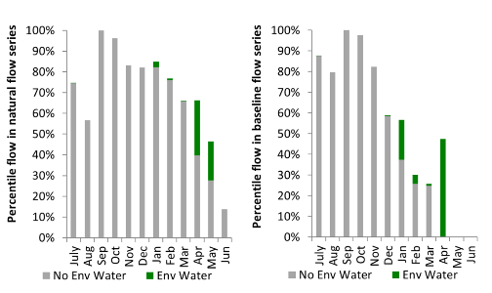
Figure MCQ8. Contribution of environmental water delivery at Baroona as percentiles in the natural and baseline flow series.
Gin Gin
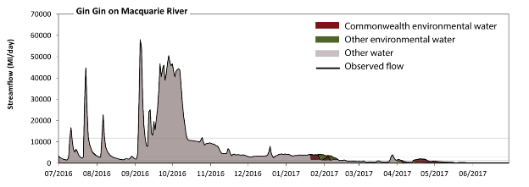
Figure MCQ9. Contribution of environmental water delivery at Gin Gin. Horizontal lines indicate thresholds for very low flows, low flows, low freshes, medium freshes and high freshes (from lowest to highest).
At Gin Gin on the Macquarie River environmental water contributed 4% of the total streamflow volume (much of which was Commonwealth environmental water). Environmental watering actions affected streamflows for 23% of days between 1 July 2016 and 30 June 2017. Flow regulation does not substantially increase the duration of very low flows (i.e. < 69 ML/day) compared to an average year in the natural flow regime. However, without environmental water, the duration of medium low flows (i.e. < 350 ML/day) in the period April to June would have substantially exceeded durations expected in an average year in the natural flow regime. Environmental water mitigated these impacts by reducing the cumulative duration of medium low flow spells from 21% to 13% of the year, with greatest influence in the period April to June. Commonwealth environmental water was almost entirely responsible for these enhancements of environmental baseflows at this site. In the absence of environmental water there would have been at least one low fresh (i.e. > 1200 ML/day) in the periods July to September, October to December and January to March. Environmental water increased the duration of the longest low fresh during the periods January to March (from 32 days to 49 days) and April to June (from 0 days to 12 days). Commonwealth environmental water equally shared responsibility with other environmental water holders for these increased durations of low freshes. In the absence of environmental water there would have been at least one medium fresh (i.e. > 3100 ML/day) in the periods July to September, October to December and January to March. Environmental water increased the duration of the longest medium fresh during the period January to March (from 20 days to 38 days). Environmental water was entirely responsible for the increased durations of medium freshes. In the absence of environmental water there would have been at least one high fresh in the periods July to September and October to December. Environmental water made no change to the duration of these high freshes.
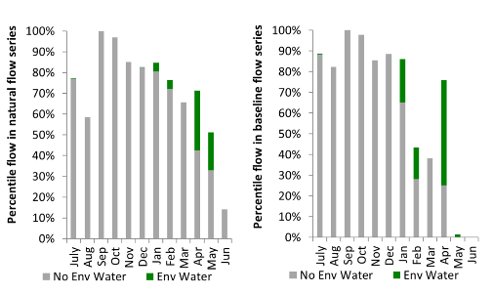
Figure MCQ10. Contribution of environmental water delivery at Gin Gin as percentiles in the natural and baseline flow series.
Warren
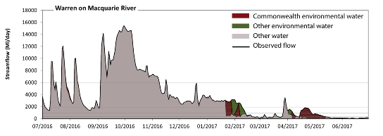
Figure MCQ11. Contribution of environmental water delivery at Warren. Horizontal lines indicate thresholds for very low flows, low flows, low freshes, medium freshes and high freshes (from lowest to highest).
At Warren on the Macquarie River environmental water contributed 7% of the total streamflow volume (much of which was Commonwealth environmental water). Environmental watering actions affected streamflows for 23% of days between 1 July 2016 and 30 June 2017. Without environmental water, the duration of very low flows (i.e. < 69 ML/day) in the period April to June would have substantially exceeded durations expected in an average year in the natural flow regime. Environmental water mitigated these impacts by reducing the cumulative duration of very low flow spells from 10% to 4% of the year, with greatest influence in the period April to June. Similarly, without environmental water, the duration of medium low flows (i.e. < 350 ML/day) in the period April to June would have substantially exceeded durations expected in an average year in the natural flow regime. Environmental water mitigated these impacts by reducing the cumulative duration of medium low flow spells from 32% to 22% of the year, with greatest influence in the period April to June. Commonwealth environmental water was almost entirely responsible for these enhancements of environmental baseflows at this site. In the absence of environmental water there would have been at least one low fresh (i.e. > 900 ML/day) in the periods July to September, October to December, January to March and April to June. Environmental water increased the duration of the longest low fresh during the periods January to March (from 21 days to 43 days) and April to June (from 1 days to 13 days). Commonwealth environmental water was almost entirely responsible for these increased durations of low freshes. In the absence of environmental water there would have been at least one medium fresh (i.e. > 1900 ML/day) in the periods July to September, October to December and January to March. Environmental water increased the duration of the longest medium fresh during the period January to March (from 21 days to 40 days). Environmental water was entirely responsible for these increased durations of medium freshes. In the absence of environmental water there would have been at least one high fresh in the periods July to September and October to December. Environmental water made no change to the duration of these high freshes.
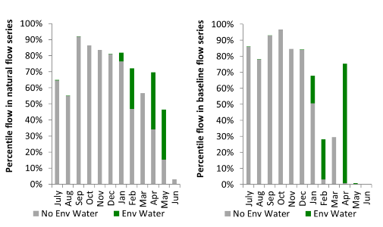
Figure MCQ12. Contribution of environmental water delivery at Warren as percentiles in the natural and baseline flow series.

Marebone
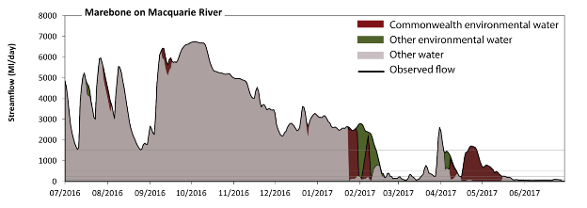Figure MCQ13. Contribution of environmental water delivery at Marebone. Horizontal lines indicate thresholds for very low flows, low flows, low freshes, medium freshes and high freshes (from lowest to highest).
At Marebone on the Macquarie River environmental water contributed 9% of the total streamflow volume (much of which was Commonwealth environmental water). Environmental watering actions affected streamflows for 23% of days between 1 July 2016 and 30 June 2017. Without environmental water, the duration of very low flows (i.e. < 20 ML/day) in the period April to June would have substantially exceeded durations expected in an average year in the natural flow regime. Environmental water mitigated these impacts by reducing the cumulative duration of very low flow spells from 8% to 1% of the year, with greatest influence in the period April to June. Similarly, without environmental water, the duration of medium low flows (i.e. < 98 ML/day) in the period April to June would have substantially exceeded durations expected in an average year in the natural flow regime. Environmental water mitigated these impacts by reducing the cumulative duration of medium low flow spells from 21% to 12% of the year, with greatest influence in the period April to June. Commonwealth environmental water was almost entirely responsible for these enhancements of environmental baseflows at this site. In the absence of environmental water there would have been at least one low fresh (i.e. > 240 ML/day) in the periods July to September, October to December, January to March and April to June. Environmental water increased the duration of the longest low fresh during the periods January to March (from 23 days to 49 days) and April to June (from 7 days to 31 days). Commonwealth environmental water was entirely responsible for these increased durations of low freshes. In the absence of environmental water there would have been at least one medium fresh (i.e. > 500 ML/day) in the periods July to September, October to December, January to March and April to June. Environmental water increased the duration of the longest medium fresh during the periods January to March (from 23 days to 47 days) and April to June (from 7 days to 23 days). Environmental water was entirely responsible for these increased durations of medium freshes. In the absence of environmental water there would have been at least one high fresh in the periods July to September, October to December, January to March and April to June. Environmental water increased the duration of the longest medium fresh during the periods January to March (from 23 days to 43 days) and April to June (from 2 days to 7 days). Environmental water contributed to these increased durations of high freshes.
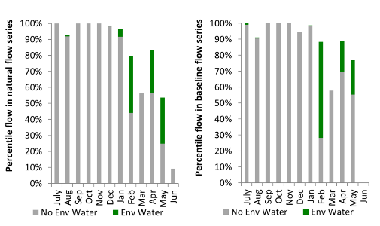
Figure MCQ14. Contribution of environmental water delivery at Marebone as percentiles in the natural and baseline flow series.

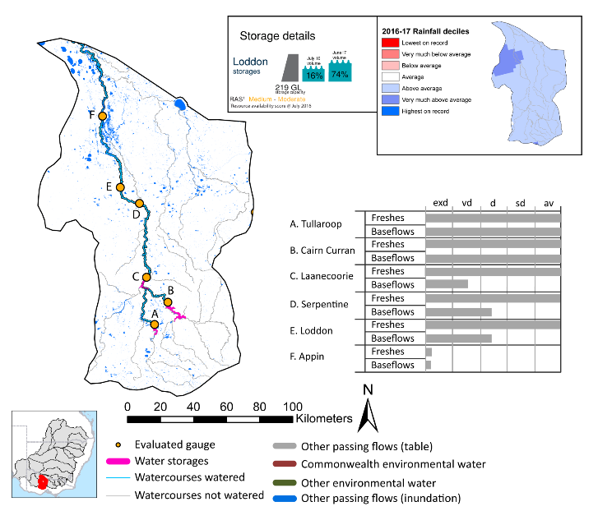
Loddon
exd: extremely dry | vd: very dry | d: dry | sd: somewhat dry | av: average

Figure LOD1. Watercourses influenced, areas inundated (where applicable) and gauge stations evaluated in the Loddon valley during the 2016-17 water year. Inset bar graphs report the condition of annual flow regimes by showing the improvements in hydrological condition with the addition of environmental water as well as the hypothetical scenario in “grey” (if no environmental flow had been delivered). Rainfall conditions (rainfall deciles) and trend in storage levels for the water year are also shown.

Summary
Environmental water delivery for the 2016-17 year in the Loddon valley is evaluated using data for 6 sites. This evaluation only considers the contribution of held environmental water, which is a primary focus for the Australian Government. The contributions of planned environmental water (e.g. passing flows), unregulated tributary inflows and clever use of irrigation flows for environmental benefits can all be very important but these are outside the scope of this report. Environmental watering actions lasted on average 192 days over the course of the year. The volume of environmental water at these 6 sites was between 1% and 5% of the total streamflow. Commonwealth environmental water contributed on average 11% of this environmental water. Ideally, baseflows should be maintained and long periods of excessively low flows avoided. In this valley, the baseflow regime was generally considered to be somewhat dry relative to the pre-development flow regime. In our analysis, a low fresh refers to a period of increased flow, when the water level rises at least one eighth of the way up the river bank (above the low flow level). These low freshes are a regular part of the natural flow regime and support a range of natural processes. In the Loddon valley, in terms of the occurrence and duration of low freshes, the year was assessed as being average. In our analysis, a medium fresh refers to a period of increased flow, when the water level rises at least one quarter of the way up the river bank. These medium freshes are not as frequent as low freshes but are also a regular and important part of the natural flow regime. In the Loddon valley, in terms of the occurrence of medium freshes, the year was assessed as being average. In our analysis, a high fresh refers to a period of increased flow, when the water level rises more than half way up the river. A high fresh may not occur every year but they are still important and long periods without major freshes can have serious consequences for floodplains and their contribution to river ecosystem health. Delivering high in channel flows normally requires that all risks to riparian landholders and infrastructure have been resolved. In the Loddon valley, in terms of the occurrence of high freshes, the year was assessed as being average.

Water delivery context
During the 2016-17, the Commonwealth Environmental Water Holder (CEWH) held water entitlements of up to 3883 ML for environmental use in the Loddon valley. Each year, water utilities allocate water entitlement holders a percentage of water based on their holding, license type and carryover (the exact rules vary among Jurisdictions). In 2016-17, the Loddon entitlements held by the CEWH were allocated 2081 ML of water, representing 62% of the Long term average annual yield for the Loddon valley (3331 ML). Information and data relating to the portfolio of held Commonwealth environmental water is shown in Table LOD1.
The 2016-17 water allocation (2081 ML) together with the carryover volume of 1275 ML of water meant the CEWH had 3356 ML of water available for delivery. A total of 1678 ML of Commonwealth environmental water was delivered in the Loddon valley. A total of 0 ML of Commonwealth environmental water was traded to consumptive users and no available Commonwealth environmental water was carried over for environmental use into the 2017-18 water year.

Environmental conditions and resource availability
The water available for environmental delivery combined with the present and antecedent environmental conditions are key inputs used by environmental water managers in planning and implementing watering actions. Post hoc, this information provides important context when evaluating the effectiveness and appropriateness of environmental water use with respect to hydrological outputs.
The rainfall conditions in the Loddon valley were classified as above average, based on rainfall percentile data for the entire record held by the Bureau of Meteorology for this valley. The water held in major storages in the Loddon valley increased over the water year, for example Cairn Curran and Tullaroop dam was 16% full at the beginning of the water year and 74% full by the end of the year (Figure LOD1).
The Commonwealth Environmental Water Office (CEWO) calculates resource availability scenarios (RAS) to guide the use and prioritisation of held environmental water. The RAS are progressively calculated over the year as part of the continual adaptive management planning processes. The RAS are based on the availability of held environmental water (including progressive license acquisitions and allocations) as well as the potential for unregulated or planned environmental flows. The outcome is then used to determine the demand for environmental water across The Basin.
In 2016-17, the resource availability of held Commonwealth environmental water was classified as medium in this valley, whilst the potential for unregulated or planned environmental flow was classified as medium to low. The antecedent and forecasted physical conditions meant that Commonwealth environmental water was being planned to maintain and protect ongoing recovery of native riparian and in-stream vegetation condition, native fish reproduction and condition, platypus breeding and habitat, hydrological connectivity and water quality The overall demand for environmental water was deemed high (water predominantly needed this year).

Watering actions
A total of 2 watering actions were delivered over the 2016-17 water year, the duration of these actions varied (range of individual actions: 12 - 17 days) and Commonwealth environmental water was delivered for a total of 31 days. The count of actions commencing in each season was; autumn (1) and winter (1). The flow component types delivered were; (1) baseflow, (1) freshes, (0) bankfull, (0) overbank and (0) wetland.
There were five expected outcomes across the two watering actions in the Loddon valley. The percentage of expected outcomes across the nine main themes were as follows: fish (20%), vegetation (20%), waterbirds (0.0%), frogs (0.0%), other biota (40%), connectivity (20%), process (0.0%), resilience (0.0%) and water quality (0.0%).
Table LOD1. Commonwealth environmental water accounting information for the Loddon valley over 2016-17 water year (LTAAY = long-term average annual yield).
Total registered volume (ML) | Allocated volume (ML) | Carry over + allocated volume (ML) | Delivered (ML) | LTAAY (ML) | Trade (ML) | Carried over to 2016-17 | Forfeited (ML)
3883 | 2081 | 3356 | 1678 | 3331 | 0 | - | 0

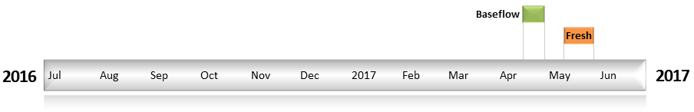
Figure LOD2. Timing and duration of Commonwealth environmental water actions delivered in the Loddon valley.

Contribution of Commonwealth Environmental Water to Flow Regimes
Cairn Curran
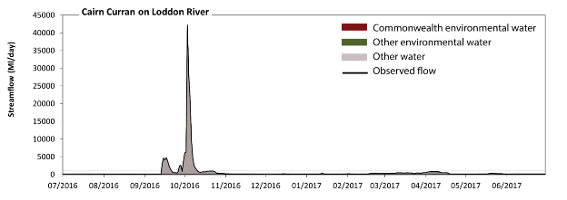
Figure LOD3. Contribution of environmental water delivery at Cairn Curran. Horizontal lines indicate thresholds for very low flows, low flows, low freshes, medium freshes and high freshes (from lowest to highest).
At Cairn Curran on the Loddon River environmental water contributed 2% of the total streamflow volume (with a relatively small contribution of Commonwealth environmental water). Environmental watering actions affected streamflows for 50% of days between 1 July 2016 and 30 June 2017. Flow regulation does not substantially increase the duration of very low flows (i.e. < 6.2 ML/day) compared to an average year in the natural flow regime. Flow regulation does not substantially increase the duration of medium low flows (i.e. < 31 ML/day) compared to an average year in the natural flow regime. There was at least one low fresh (i.e. > 110 ML/day) in the periods July to September, October to December, January to March and April to June. Environmental water made little change to the duration of these low freshes. In the absence of environmental water there would have been at least one medium fresh (i.e. > 270 ML/day) in the periods July to September, October to December, January to March and April to June. Environmental water increased the duration of the longest medium fresh during the period January to March (from 21 days to 31 days). Commonwealth environmental water made little or no contribution to these increased durations of medium freshes. In the absence of environmental water there would have been at least one high fresh in the periods July to September and October to December. Environmental water made no change to the duration of these high freshes.
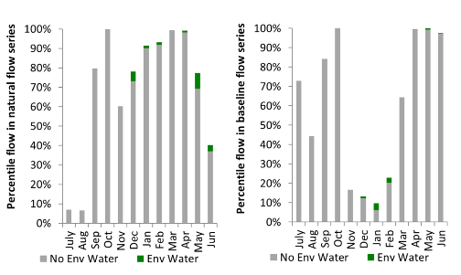
Figure LOD4. Contribution of environmental water delivery at Cairn Curran as percentiles in the natural and baseline flow series.
Tullaroop
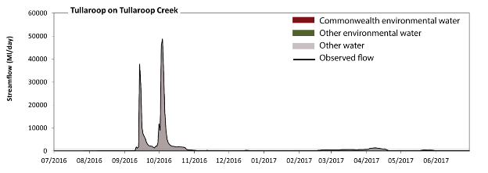
Figure LOD5. Contribution of environmental water delivery at Tullaroop. Horizontal lines indicate thresholds for very low flows, low flows, low freshes, medium freshes and high freshes (from lowest to highest).
At Tullaroop on the Tullaroop Creek environmental water contributed 1% of the total streamflow volume (with a relatively small contribution of Commonwealth environmental water). Environmental watering actions affected streamflows for 38% of days between 1 July 2016 and 30 June 2017. Flow regulation does not substantially increase the duration of very low flows (i.e. < 2.9 ML/day) compared to an average year in the natural flow regime. Flow regulation does not substantially increase the duration of medium low flows (i.e. < 14 ML/day) compared to an average year in the natural flow regime. There was at least one low fresh (i.e. > 67 ML/day) in the periods July to September, October to December, January to March and April to June. Environmental water made no change to the duration of these low freshes. There was at least one medium fresh (i.e. > 200 ML/day) in the periods July to September, October to December, January to March and April to June. Environmental water made no change to the duration of these medium freshes. In the absence of environmental water there would have been at least one high fresh in the periods July to September, October to December and April to June. Environmental water increased the duration of the longest medium fresh during the period April to June (from 10 days to 13 days). Commonwealth environmental water made little or no contribution to these increased durations of high freshes.
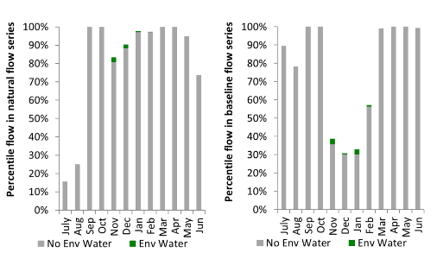
Figure LOD6. Contribution of environmental water delivery at Tullaroop as percentiles in the natural and baseline flow series.
Laanecoorie
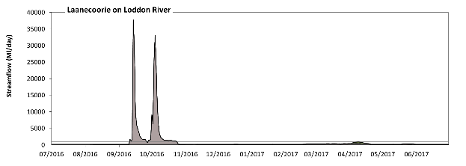
Figure LOD7. Contribution of environmental water delivery at Laanecoorie. Horizontal lines indicate thresholds for very low flows, low flows, low freshes, medium freshes and high freshes (from lowest to highest).
At Laanecoorie on the Loddon River environmental water contributed 4% of the total streamflow volume (with a relatively small contribution of Commonwealth environmental water). Environmental watering actions affected streamflows for 57% of days between 1 July 2016 and 30 June 2017. Without environmental water, the duration of very low flows (i.e. < 12 ML/day) in the period July to September would have substantially exceeded durations expected in an average year in the natural flow regime. However, environmental water had little effect on the duration of these very low flows, which occurred for 7% of the year. Similarly, without environmental water, the durations of medium low flows (i.e. < 60 ML/day) in the periods July to September and October to December would have substantially exceeded durations expected in an average year in the natural flow regime. Environmental water mitigated these impacts by reducing the cumulative duration of medium low flow spells from 33% to 14% of the year, with greatest influence in the periods October to December and January to March. Commonwealth environmental water made little or no contribution to these enhancements of environmental baseflows at this site. There was at least one low fresh (i.e. > 150 ML/day) in the periods July to September, October to December, January to March and April to June. Environmental water made little change to the duration of these low freshes. In the absence of environmental water there would have been at least one medium fresh (i.e. > 310 ML/day) in the periods July to September, October to December, January to March and April to June. Environmental water increased the duration of the longest medium fresh during the period April to June (from 11 days to 18 days). Commonwealth environmental water made little or no contribution to these increased durations of medium freshes. In the absence of environmental water there would have been at least one high fresh in the periods July to September and October to December. Environmental water made no change to the duration of these high freshes.
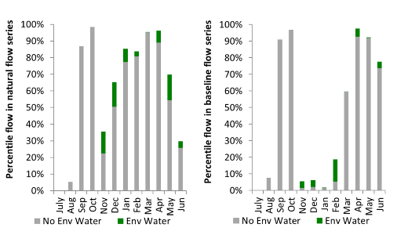
Figure LOD8. Contribution of environmental water delivery at Laanecoorie as percentiles in the natural and baseline flow series.

Serpentine
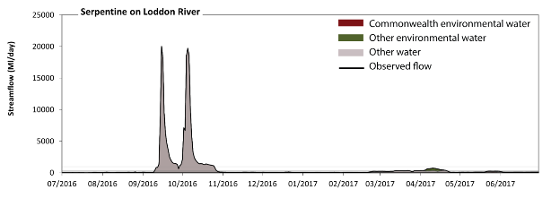
Figure LOD9. Contribution of environmental water delivery at Serpentine. Horizontal lines indicate thresholds for very low flows, low flows, low freshes, medium freshes and high freshes (from lowest to highest).
At Serpentine on the Loddon River environmental water contributed 5% of the total streamflow volume (with a relatively small contribution of Commonwealth environmental water). Environmental watering actions affected streamflows for 57% of days between 1 July 2016 and 30 June 2017. Without environmental water, the duration of very low flows (i.e. < 12 ML/day) in the period July to September would have substantially exceeded durations expected in an average year in the natural flow regime. Environmental water reduced the cumulative duration of very low flow spells from 6% to 1% of the year, with greatest influence in the periods October to December and January to March. Similarly, without environmental water, the durations of medium low flows (i.e. < 60 ML/day) in the periods July to September and October to December would have substantially exceeded durations expected in an average year in the natural flow regime. Environmental water mitigated these impacts by reducing the cumulative duration of medium low flow spells from 41% to 23% of the year, with greatest influence in the periods October to December and January to March. Commonwealth environmental water made a small contribution to these enhancements of environmental baseflows at this site. There was at least one low fresh (i.e. > 150 ML/day) in the periods July to September, October to December, January to March and April to June. Environmental water made little change to the duration of these low freshes. In the absence of environmental water there would have been at least one medium fresh (i.e. > 310 ML/day) in the periods July to September, October to December, January to March and April to June. Environmental water increased the duration of the longest medium fresh during the period April to June (from 3 days to 20 days). Commonwealth environmental water made a small contribution to these increased durations of medium freshes. In the absence of environmental water there would have been at least one high fresh in the periods July to September and October to December. Environmental water made no change to the duration of these high freshes.
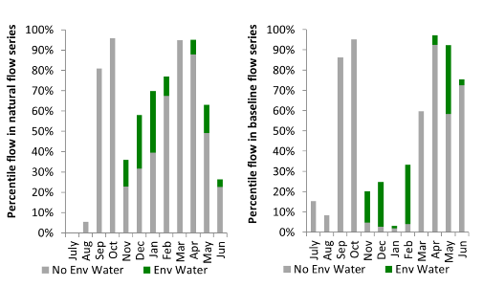
Figure LOD10. Contribution of environmental water delivery at Serpentine as percentiles in the natural and baseline flow series.

Loddon
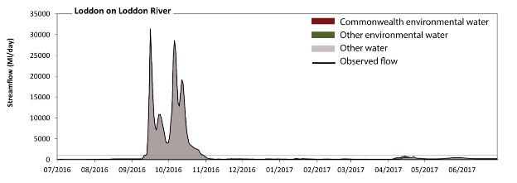
Figure LOD11. Contribution of environmental water delivery at Loddon. Horizontal lines indicate thresholds for very low flows, low flows, low freshes, medium freshes and high freshes (from lowest to highest).
At Loddon on the Loddon River environmental water contributed 3% of the total streamflow volume (with a relatively small contribution of Commonwealth environmental water). Environmental watering actions affected streamflows for 57% of days between 1 July 2016 and 30 June 2017. Without environmental water, the duration of very low flows (i.e. < 11 ML/day) in the period July to September would have substantially exceeded durations expected in an average year in the natural flow regime. However, environmental water had little effect on the duration of these very low flows, which occurred for 3% of the year. Similarly, without environmental water, the duration of medium low flows (i.e. < 56 ML/day) in the period July to September would have substantially exceeded durations expected in an average year in the natural flow regime. Environmental water reduced the cumulative duration of medium low flow spells from 17% to 14% of the year, with greatest influence in the period April to June. Commonwealth environmental water made little or no contribution to these enhancements of environmental baseflows at this site. In the absence of environmental water there would have been at least one low fresh (i.e. > 150 ML/day) in the periods July to September, October to December, January to March and April to June. Environmental water increased the duration of the longest low fresh during the period January to March (from 2 days to 5 days). Commonwealth environmental water made little or no contribution to these increased durations of low freshes. In the absence of environmental water there would have been at least one medium fresh (i.e. > 320 ML/day) in the periods July to September, October to December and April to June. Environmental water increased the duration of the longest medium fresh during the period April to June (from 10 days to 18 days). Commonwealth environmental water equally shared responsibility with other environmental water holders for these increased durations of medium freshes. In the absence of environmental water there would have been at least one high fresh in the periods July to September and October to December. Environmental water made no change to the duration of these high freshes.
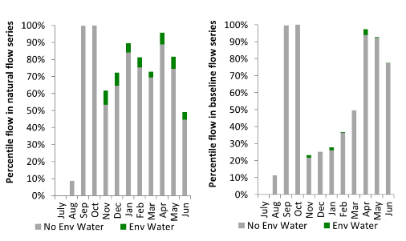
Figure LOD12. Contribution of environmental water delivery at Loddon as percentiles in the natural and baseline flow series.

Appin
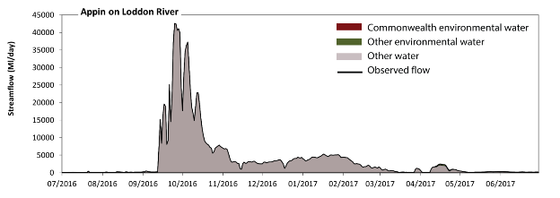Figure LOD13. Contribution of environmental water delivery at Appin. Horizontal lines indicate thresholds for #N/A (from lowest to highest).
At Appin on the Loddon River environmental water contributed 1% of the total streamflow volume (with a relatively small contribution of Commonwealth environmental water). Environmental watering actions affected streamflows for 56% of days between 1 July 2016 and 30 June 2017. However, environmental water had little effect on the duration of these very low flows, which occurred for 100% of the year.
Figure LOD14. Contribution of environmental water delivery at Appin as percentiles in the natural and baseline flow series.

Darling

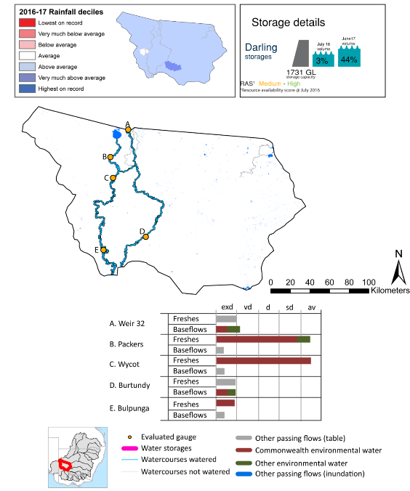

exd: extremely dry | vd: very dry
d: dry | sd: somewhat dry | av: average

Figure LDL1. Watercourses influenced, areas inundated (where applicable) and gauge stations evaluated in the Lower Darling valley during the 2016-17 water year. Inset bar graphs report the condition of annual flow regimes by showing the improvements in hydrological condition with the addition of environmental water as well as the hypothetical scenario in “grey” (if no environmental flow had been delivered). Rainfall conditions (rainfall deciles) and trend in storage levels for the water year are also shown.

Summary
Environmental water delivery for the 2016-17 year in the Lower Darling valley is evaluated using data for 5 sites. This evaluation only considers the contribution of held environmental water, which is a primary focus for the Australian Government. The contributions of planned environmental water (e.g. passing flows), unregulated tributary inflows and clever use of irrigation flows for environmental benefits can all be very important but these are outside the scope of this report. Environmental watering actions lasted on average 137 days over the course of the year. The volume of environmental water at these 5 sites was between 23% and 100% of the total streamflow. Commonwealth environmental water contributed on average 77% of this environmental water. Ideally, baseflows should be maintained and long periods of excessively low flows avoided. In this valley, the baseflow regime was generally considered to be extremely dry relative to the pre-development flow regime. In our analysis, a low fresh refers to a period of increased flow, when the water level rises at least one eighth of the way up the river bank (above the low flow level). These low freshes are a regular part of the natural flow regime and support a range of natural processes. In the Lower Darling valley, in terms of the occurrence and duration of low freshes, the year was assessed as being dry. In our analysis, a medium fresh refers to a period of increased flow, when the water level rises at least one quarter of the way up the river bank. These medium freshes are not as frequent as low freshes but are also a regular and important part of the natural flow regime. In the Lower Darling valley, in terms of the occurrence of medium freshes, the year was assessed as being dry. In our analysis, a high fresh refers to a period of increased flow, when the water level rises more than half way up the river. A high fresh may not occur every year but they are still important and long periods without major freshes can have serious consequences for floodplains and their contribution to river ecosystem health. Delivering high in channel flows normally requires that all risks to riparian landholders and infrastructure have been resolved. In the Lower Darling valley, in terms of the occurrence of high freshes, the year was assessed as being dry.

Water delivery context
During the 2016-17, the Commonwealth Environmental Water Holder (CEWH) held water entitlements of up to 2738 ML for environmental use in the Lower Darling valley. Each year, water utilities allocate water entitlement holders a percentage of water based on their holding, license type and carryover (the exact rules vary among Jurisdictions). In 2016-17, the Lower Darling entitlements held by the CEWH were allocated 2012 ML of water, representing 90% of the Long term average annual yield for the Lower Darling valley (2233 ML). Information and data relating to the portfolio of held Commonwealth environmental water is shown in Table LDL1.
The 2016-17 water allocation (2012 ML) together with the carryover volume of 727 ML of water meant the CEWH had 2738 ML of water available for delivery. A total of 160 453 ML of Commonwealth environmental water was delivered in the Lower Darling valley. A total of 0 ML of Commonwealth environmental water was traded to consumptive users and no available Commonwealth environmental water was carried over for environmental use into the 2017-18 water year.

Environmental conditions and resource availability
The water available for environmental delivery combined with the present and antecedent environmental conditions are key inputs used by environmental water managers in planning and implementing watering actions. Post hoc, this information provides important context when evaluating the effectiveness and appropriateness of environmental water use with respect to hydrological outputs.
The rainfall conditions in the Lower Darling valley were classified as above average, based on rainfall percentile data for the entire record held by the Bureau of Meteorology for this valley. The water held in major storages in the Lower Darling valley increased over the water year, for example Meninde dam was 3% full at the beginning of the water year and 44% full by the end of the year (Figure LDL1).
The Commonwealth Environmental Water Office (CEWO) calculates resource availability scenarios (RAS) to guide the use and prioritisation of held environmental water. The RAS are progressively calculated over the year as part of the continual adaptive management planning processes. The RAS are based on the availability of held environmental water (including progressive license acquisitions and allocations) as well as the potential for unregulated or planned environmental flows. The outcome is then used to determine the demand for environmental water across The Basin.
In 2016-17, the resource availability of held Commonwealth environmental water was classified as medium in this valley, whilst the potential for unregulated or planned environmental flow was classified as high to medium. The antecedent and forecasted physical conditions meant that Commonwealth environmental water was being planned to protect and/or maintain the condition of most environmental assets, while seeking to avoid irreversible damage or decline to the Lower Darling The overall demand for environmental water was deemed high (water predominantly needed this year).

Watering actions
A total of 2 watering actions were delivered over the 2016-17 water year, the duration of these actions varied (range of individual actions: 134 - 271 days) and Commonwealth environmental water was delivered for a total of 171 days. The count of actions commencing in each season was; spring (1) and autumn (1). The flow component types delivered were; (1) baseflow, (2) freshes, (0) bankfull, (0) overbank and (0) wetland.
There were 10 expected outcomes across the two watering actions in the Lower Darling. The percentage of expected outcomes across the nine main themes included fish (20%), vegetation (20%), waterbirds (10%), frogs (10%), other biota (0.0%), connectivity (20%), process (0.0%), resilience (0.0%) and water quality (20%).
Table LDL1. Commonwealth environmental water accounting information for the Lower Darling valley over 2016-17 water year (LTAAY = long-term average annual yield).
Total registered volume (ML) | Allocated volume (ML) | Carry over + allocated volume (ML) | Delivered (ML) | LTAAY (ML) | Trade (ML) | Carried over to 2016-17 | Forfeited (ML)
2738 | 2012 | 2738 | 160 453 | 2233 | 0 | - | 0

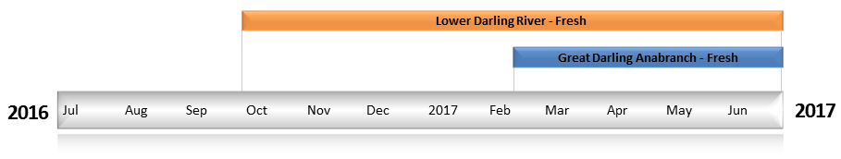
Figure LDL2. Timing and duration of Commonwealth environmental water actions delivered in the Lower Darling valley.

Contribution of Commonwealth Environmental Water to Flow Regimes
Weir 32
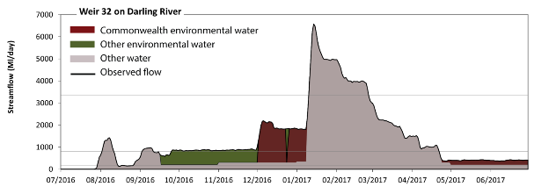
Figure LDL3. Contribution of environmental water delivery at Weir 32. Horizontal lines indicate thresholds for very low flows, low flows and low freshes (from lowest to highest).
At Weir 32 on the Darling River environmental water contributed 23% of the total streamflow volume (with approximately half contributed by Commonwealth environmental water). Environmental watering actions affected streamflows for 50% of days between 1 July 2016 and 30 June 2017. Without environmental water, the duration of very low flows (i.e. < 160 ML/day) in the period July to September would have substantially exceeded durations expected in an average year in the natural flow regime. However, environmental water had little effect on the duration of these very low flows, which occurred for 10% of the year. Similarly, without environmental water, the durations of medium low flows (i.e. < 810 ML/day) in the periods July to September, October to December and April to June would have substantially exceeded durations expected in an average year in the natural flow regime. Environmental water mitigated these impacts by reducing the cumulative duration of medium low flow spells from 67% to 38% of the year, with greatest influence in the period October to December. Commonwealth environmental water made a modest contribution to these enhancements of environmental baseflows at this site. There was at least one low fresh (i.e. > 3400 ML/day) in the period January to March. Environmental water made no change to the duration of these low freshes. There was no medium or high freshes this year.
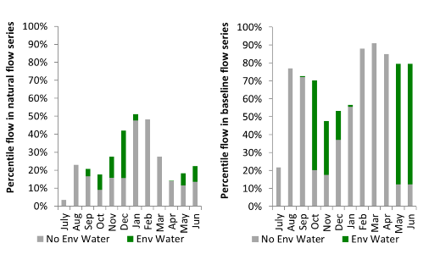
Figure LDL4. Contribution of environmental water delivery at Weir 32 as percentiles in the natural and baseline flow series.
Burtundy
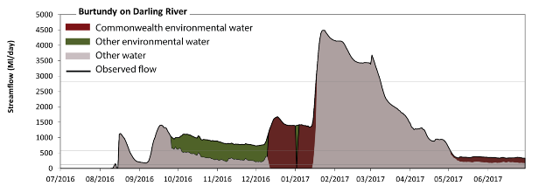
Figure LDL5. Contribution of environmental water delivery at Burtundy. Horizontal lines indicate thresholds for very low flows, low flows and low freshes (from lowest to highest).
At Burtundy on the Darling River environmental water contributed 23% of the total streamflow volume (with approximately half contributed by Commonwealth environmental water). Environmental watering actions affected streamflows for 47% of days between 1 July 2016 and 30 June 2017. Without environmental water, the durations of very low flows (i.e. < 120 ML/day) in the periods July to September, October to December and January to March would have substantially exceeded durations expected in an average year in the natural flow regime. Environmental water mitigated these impacts by reducing the cumulative duration of very low flow spells from 22% to 12% of the year, with greatest influence in the periods October to December and January to March. Similarly, without environmental water, the durations of medium low flows (i.e. < 590 ML/day) in the periods July to September, October to December and April to June would have substantially exceeded durations expected in an average year in the natural flow regime. Environmental water mitigated these impacts by reducing the cumulative duration of medium low flow spells from 62% to 34% of the year, with greatest influence in the period October to December. Commonwealth environmental water equally shared responsibility with other environmental water holders for these enhancements of environmental baseflows at this site. There was at least one low fresh (i.e. > 2800 ML/day) in the period January to March. Environmental water made no change to the duration of these low freshes. There was no medium or high freshes this year.
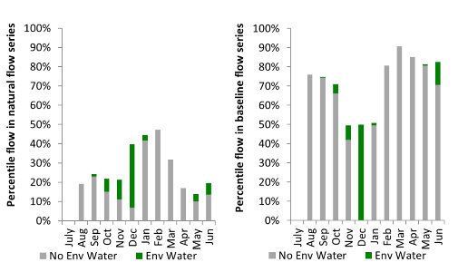
Figure LDL6. Contribution of environmental water delivery at Burtundy as percentiles in the natural and baseline flow series.
Packers Crossing
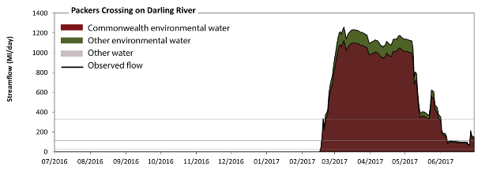
Figure LDL7. Contribution of environmental water delivery at Packers Crossing. Horizontal lines indicate thresholds for very low flows, low flows, low freshes, medium freshes and high freshes (from lowest to highest).
At Packers Crossing on the Darling River environmental water contributed 100% of the total streamflow volume (most of which was Commonwealth environmental water). Environmental watering actions affected streamflows for 37% of days between 1 July 2016 and 30 June 2017. Without environmental water, the durations of very low flows (i.e. < 0.08 ML/day) in the periods July to September, October to December, January to March and April to June would have all substantially exceeded durations expected in an average year in the natural flow regime. Environmental water mitigated these impacts by reducing the cumulative duration of very low flow spells from 100% to 63% of the year, with greatest influence in the periods January to March and April to June. Similarly, without environmental water, the durations of medium low flows (i.e. < 25 ML/day) in the periods July to September, October to December and January to March would have substantially exceeded durations expected in an average year in the natural flow regime. Environmental water mitigated these impacts by reducing the cumulative duration of medium low flow spells from 100% to 63% of the year, with greatest influence in the periods January to March and April to June. Commonwealth environmental water equally shared responsibility with other environmental water holders for these enhancements of environmental baseflows at this site. Environmental water increased the duration of the longest low fresh during the periods January to March (from 0 days to 42 days) and April to June (from 0 days to 67 days). Commonwealth environmental water made the dominant contribution to these increased durations of low freshes. Environmental water increased the duration of the longest medium fresh during the periods January to March (from 0 days to 39 days) and April to June (from 0 days to 62 days). Commonwealth environmental water was entirely responsible for these increased durations of medium freshes. Environmental water increased the duration of the longest medium fresh during the periods January to March (from 0 days to 39 days) and April to June (from 0 days to 62 days). Commonwealth environmental water was entirely responsible for these increased durations of high freshes.
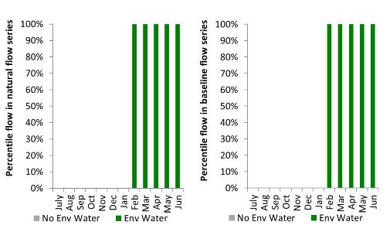
Figure LDL8. Contribution of environmental water delivery at Packers Crossing as percentiles in the natural and baseline flow series.

Wycot
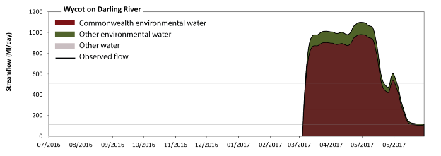
Figure LDL9. Contribution of environmental water delivery at Wycot. Horizontal lines indicate thresholds for very low flows, low flows, low freshes, medium freshes and high freshes (from lowest to highest).
At Wycot on the Darling River environmental water contributed 100% of the total streamflow volume (most of which was Commonwealth environmental water). Environmental watering actions affected streamflows for 33% of days between 1 July 2016 and 30 June 2017. Without environmental water, the durations of very low flows (i.e. < 0.63 ML/day) in the periods July to September, October to December, January to March and April to June would have all substantially exceeded durations expected in an average year in the natural flow regime. Environmental water mitigated these impacts by reducing the cumulative duration of very low flow spells from 100% to 67% of the year, with greatest influence in the period April to June. Similarly, without environmental water, the durations of medium low flows (i.e. < 110 ML/day) in the periods July to September and October to December would have substantially exceeded durations expected in an average year in the natural flow regime. Environmental water reduced the cumulative duration of medium low flow spells from 100% to 68% of the year, with greatest influence in the period April to June. Commonwealth environmental water made the dominant contribution to these enhancements of environmental baseflows at this site. Environmental water increased the duration of the longest low fresh during the periods January to March (from 0 days to 26 days) and April to June (from 0 days to 71 days). Commonwealth environmental water was entirely responsible for these increased durations of low freshes. Environmental water increased the duration of the longest medium fresh during the periods January to March (from 0 days to 25 days) and April to June (from 0 days to 51 days). Commonwealth environmental water was entirely responsible for these increased durations of medium freshes. Environmental water increased the duration of the longest medium fresh during the periods January to March (from 0 days to 25 days) and April to June (from 0 days to 51 days). Commonwealth environmental water was entirely responsible for these increased durations of high freshes.
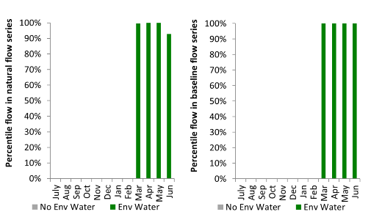
Figure LDL10. Contribution of environmental water delivery at Wycot as percentiles in the natural and baseline flow series.
Bulpunga
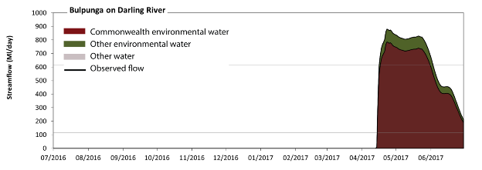
Figure LDL11. Contribution of environmental water delivery at Bulpunga. Horizontal lines indicate thresholds for very low flows, low flows and low freshes (from lowest to highest).
At Bulpunga on the Darling River environmental water contributed 100% of the total streamflow volume (most of which was Commonwealth environmental water). Environmental watering actions affected streamflows for 21% of days between 1 July 2016 and 30 June 2017. Without environmental water, the durations of very low flows (i.e. < 0.35 ML/day) in the periods July to September, October to December, January to March and April to June would have all substantially exceeded durations expected in an average year in the natural flow regime. Environmental water mitigated these impacts by reducing the cumulative duration of very low flow spells from 100% to 79% of the year, with greatest influence in the period April to June. Similarly, without environmental water, the duration of medium low flows (i.e. < 120 ML/day) in the period July to September would have substantially exceeded durations expected in an average year in the natural flow regime. Environmental water reduced the cumulative duration of medium low flow spells from 100% to 79% of the year, with greatest influence in the period April to June. Commonwealth environmental water made the dominant contribution to these enhancements of environmental baseflows at this site. Environmental water increased the duration of the longest low fresh during the period April to June (from 0 days to 47 days). Commonwealth environmental water was entirely responsible for these increased durations of low freshes.
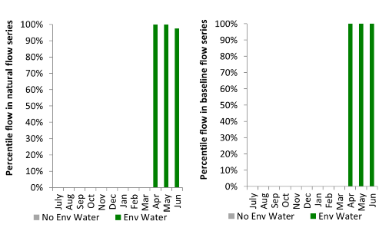
Figure LDL12. Contribution of environmental water delivery at Bulpunga as percentiles in the natural and baseline flow series.

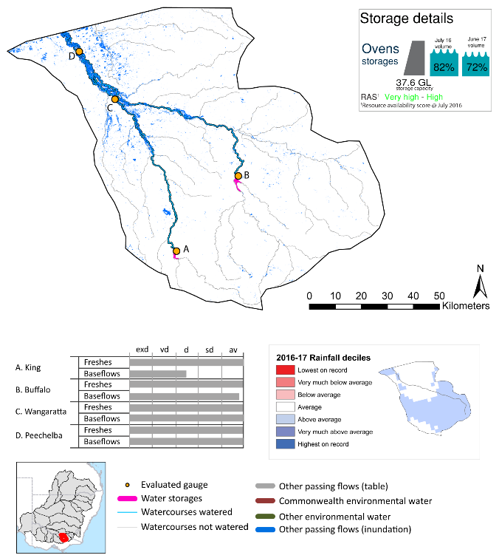
Ovens
exd: extremely dry | vd: very dry | d: dry | sd: somewhat dry | av: average
Figure OVN1. Watercourses influenced, areas inundated (where applicable) and gauge stations evaluated in the Ovens valley during the 2016-17 water year. Inset bar graphs report the condition of annual flow regimes by showing the improvements in hydrological condition with the addition of environmental water as well as the hypothetical scenario in “grey” (if no environmental flow had been delivered). Rainfall conditions (rainfall deciles) and trend in storage levels for the water year are also shown.
exd: extremely dry | vd: very dry
d: dry | sd: somewhat dry | av: average

Summary
Environmental water delivery for the 2016-17 year in the Ovens valley is evaluated using data for 4 sites. This evaluation only considers the contribution of held environmental water, which is a primary focus for the Australian Government. The contributions of planned environmental water (e.g. passing flows), unregulated tributary inflows and clever use of irrigation flows for environmental benefits can all be very important but these are outside the scope of this report. Environmental watering actions lasted on average 2 days over the course of the year. The volume of environmental water at these 4 sites was less than 1% of the total streamflow. Commonwealth environmental water contributed on average 100% of this environmental water. Ideally, baseflows should be maintained and long periods of excessively low flows avoided. In this valley, the baseflow regime was generally considered to be somewhat dry relative to the pre-development flow regime. In our analysis, a low fresh refers to a period of increased flow, when the water level rises at least one eighth of the way up the river bank (above the low flow level). These low freshes are a regular part of the natural flow regime and support a range of natural processes. In the Ovens valley, in terms of the occurrence and duration of low freshes, the year was assessed as being average. In our analysis, a medium fresh refers to a period of increased flow, when the water level rises at least one quarter of the way up the river bank. These medium freshes are not as frequent as low freshes but are also a regular and important part of the natural flow regime. In the Ovens valley, in terms of the occurrence of medium freshes, the year was assessed as being average. In our analysis, a high fresh refers to a period of increased flow, when the water level rises more than half way up the river. A high fresh may not occur every year but they are still important and long periods without major freshes can have serious consequences for floodplains and their contribution to river ecosystem health. Delivering high in channel flows normally requires that all risks to riparian landholders and infrastructure have been resolved. In the Ovens valley, in terms of the occurrence of high freshes, the year was assessed as being average.

Water delivery context
During the 2016-17, the Commonwealth Environmental Water Holder (CEWH) held water entitlements of up to 123 ML for environmental use in the Ovens valley. Each year, water utilities allocate water entitlement holders a percentage of water based on their holding, license type and carryover (the exact rules vary among Jurisdictions). In 2016-17, the Ovens entitlements held by the CEWH were allocated 70 ML of water, representing 60% of the Long term average annual yield for the Ovens valley (117 ML). Information and data relating to the portfolio of held Commonwealth environmental water is shown in Table OVN1.
The 2016-17 water allocation (70 ML) together with the carryover volume of 0 ML of water meant the CEWH had 70 ML of water available for delivery. A total of 70 ML of Commonwealth environmental water was delivered in the Ovens valley. A total of 0 ML of Commonwealth environmental water was traded to consumptive users and no available Commonwealth environmental water was carried over for environmental use into the 2017-18 water year.

Environmental conditions and resource availability
The water available for environmental delivery combined with the present and antecedent environmental conditions are key inputs used by environmental water managers in planning and implementing watering actions. Post hoc, this information provides important context when evaluating the effectiveness and appropriateness of environmental water use with respect to hydrological outputs.
The rainfall conditions in the Ovens valley were classified as above average, based on rainfall percentile data for the entire record held by the Bureau of Meteorology for this valley. The water held in major storages in the Ovens valley decreased over the water year, for example Buffalo and William Hovell dam were 82% full at the beginning of the water year and 72% full by the end of the year (Figure OVN1).
The Commonwealth Environmental Water Office (CEWO) calculates resource availability scenarios (RAS) to guide the use and prioritisation of held environmental water. The RAS are progressively calculated over the year as part of the continual adaptive management planning processes. The RAS are based on the availability of held environmental water (including progressive license acquisitions and allocations) as well as the potential for unregulated or planned environmental flows. The outcome is then used to determine the demand for environmental water across The Basin.
In 2016-17, the resource availability of held Commonwealth environmental water was classified as very high in this valley, whilst the potential for unregulated or planned environmental flow was classified as high to medium. The antecedent and forecasted physical conditions meant that Commonwealth environmental water was being planned to protect in channel habitats and conditions/survival of native fish, vegetation and other biota, primarily through the provision of baseflows. The overal purpose also seeks to maintain the ecological health and resilience of the river systems by providing freshes that maintain appropriate habitat and provide opportunities for breeding and recruitment. The overall demand for environmental water was deemed high (water predominantly needed this year).

Watering actions
A total of 2 watering actions were delivered over the 2016-17 water year, the duration of these actions varied (range of individual actions: 1 - 8 days) and Commonwealth environmental water was delivered for a total of 9 days. The count of actions commencing in each season was; autumn (2). The flow component types delivered were; (1) baseflow, (1) freshes, (0) bankfull, (0) overbank and (0) wetland.
There were two expected outcomes across the two watering actions in the Ovens valley. The percentage of expected outcomes across the nine main themes were: fish (0.0%), vegetation (0.0%), waterbirds (0.0%), frogs (0.0%), other biota (0.0%), connectivity (100%), process (0.0%), resilience (0.0%) and water quality (0.0%).
Table OVN1. Commonwealth environmental water accounting information for the Ovens valley over 2016-17 water year (LTAAY = long-term average annual yield).
Total registered volume (ML) | Allocated volume (ML) | Carry over + allocated volume (ML) | Delivered (ML) | LTAAY (ML) | Trade (ML) | Carried over to 2016-17 | Forfeited (ML)
123 | 70 | 70 | 70 | 117 | 0 | - | 0

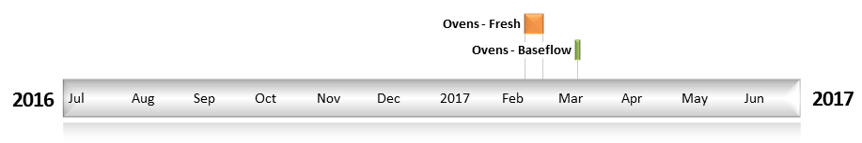
Figure OVN2. Timing and duration of Commonwealth environmental water actions delivered in the Ovens valley.

Contribution of Commonwealth Environmental Water to Flow Regimes
King
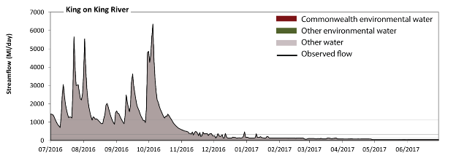
Figure OVN3. Contribution of environmental water delivery at King. Horizontal lines indicate thresholds for very low flows, low flows, low freshes, medium freshes and high freshes (from lowest to highest).
At King on the King River environmental water contributed less than 1% of the total streamflow volume (all of which was Commonwealth environmental water). Environmental watering actions affected streamflows for 1% of days between 1 July 2016 and 30 June 2017. Flow regulation does not substantially increase the duration of very low flows (i.e. < 10 ML/day) compared to an average year in the natural flow regime. However, without environmental water, the duration of medium low flows (i.e. < 50 ML/day) in the period April to June would have substantially exceeded durations expected in an average year in the natural flow regime. However, environmental water had little effect on the duration of these medium low flows, which occurred for 17% of the year. There was at least one low fresh (i.e. > 150 ML/day) in the periods July to September, October to December and January to March. Environmental water made no change to the duration of these low freshes. There was at least one medium fresh (i.e. > 330 ML/day) in the periods July to September, October to December and January to March. Environmental water made no change to the duration of these medium freshes. In the absence of environmental water there would have been at least one high fresh in the periods July to September and October to December. Environmental water made no change to the duration of these high freshes.
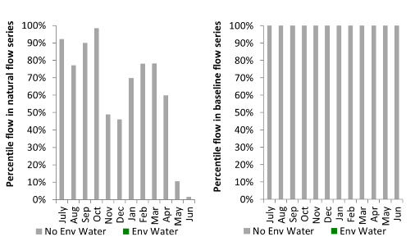
Figure OVN4. Contribution of environmental water delivery at King as percentiles in the natural and baseline flow series.
Wangaratta
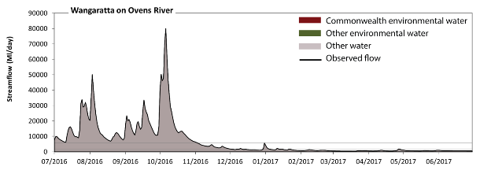
Figure OVN5. Contribution of environmental water delivery at Wangaratta. Horizontal lines indicate thresholds for very low flows, low flows, low freshes, medium freshes and high freshes (from lowest to highest).
At Wangaratta on the Ovens River environmental water contributed 0% of the total streamflow volume (all of which was Commonwealth environmental water). Environmental watering actions affected streamflows for 1% of days between 1 July 2016 and 30 June 2017. Flow regulation does not substantially increase the duration of very low flows (i.e. < 86 ML/day) compared to an average year in the natural flow regime. Flow regulation does not substantially increase the duration of medium low flows (i.e. < 430 ML/day) compared to an average year in the natural flow regime. There was at least one low fresh (i.e. > 1000 ML/day) in the periods July to September, October to December, January to March and April to June. Environmental water made no change to the duration of these low freshes. There was at least one medium fresh (i.e. > 2000 ML/day) in the periods July to September, October to December and January to March. Environmental water made no change to the duration of these medium freshes. In the absence of environmental water there would have been at least one high fresh in the periods July to September and October to December. Environmental water made no change to the duration of these high freshes.
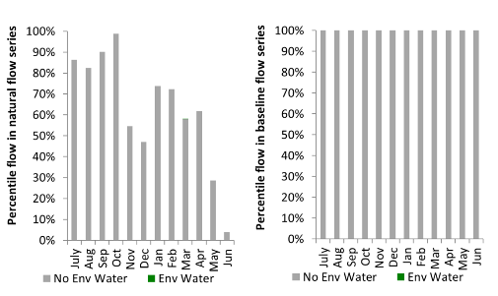
Figure OVN6. Contribution of environmental water delivery at Wangaratta as percentiles in the natural and baseline flow series.
Buffalo
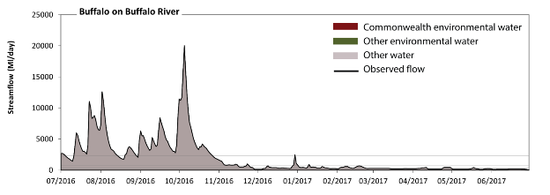
Figure OVN7. Contribution of environmental water delivery at Buffalo. Horizontal lines indicate thresholds for very low flows, low flows, low freshes, medium freshes and high freshes (from lowest to highest).
At Buffalo on the Buffalo River environmental water contributed 0% of the total streamflow volume (all of which was Commonwealth environmental water). Environmental watering actions affected streamflows for 0% of days between 1 July 2016 and 30 June 2017. Flow regulation does not substantially increase the duration of very low flows (i.e. < 22 ML/day) compared to an average year in the natural flow regime. Flow regulation does not substantially increase the duration of medium low flows (i.e. < 110 ML/day) compared to an average year in the natural flow regime. There was at least one low fresh (i.e. > 310 ML/day) in the periods July to September, October to December, January to March and April to June. Environmental water made no change to the duration of these low freshes. There was at least one medium fresh (i.e. > 700 ML/day) in the periods July to September, October to December and January to March. Environmental water made no change to the duration of these medium freshes. In the absence of environmental water there would have been at least one high fresh in the periods July to September and October to December. Environmental water made no change to the duration of these high freshes.
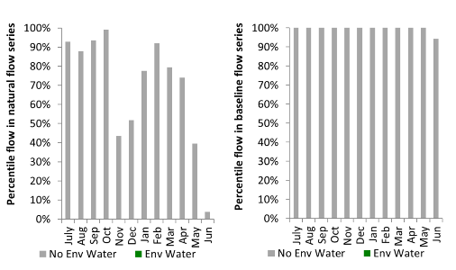
Figure OVN8. Contribution of environmental water delivery at Buffalo as percentiles in the natural and baseline flow series.
Peechelba
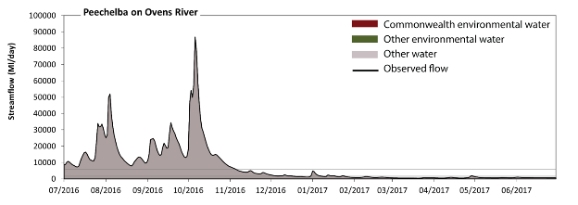
Figure OVN9. Contribution of environmental water delivery at Peechelba. Horizontal lines indicate thresholds for very low flows, low flows, low freshes, medium freshes and high freshes (from lowest to highest).
At Peechelba on the Ovens River environmental water contributed 0% of the total streamflow volume (all of which was Commonwealth environmental water). Environmental watering actions affected streamflows for 1% of days between 1 July 2016 and 30 June 2017. Flow regulation does not substantially increase the duration of very low flows (i.e. < 94 ML/day) compared to an average year in the natural flow regime. Flow regulation does not substantially increase the duration of medium low flows (i.e. < 470 ML/day) compared to an average year in the natural flow regime. There was at least one low fresh (i.e. > 1100 ML/day) in the periods July to September, October to December, January to March and April to June. Environmental water made no change to the duration of these low freshes. There was at least one medium fresh (i.e. > 2100 ML/day) in the periods July to September, October to December and January to March. Environmental water made no change to the duration of these medium freshes. In the absence of environmental water there would have been at least one high fresh in the periods July to September and October to December. Environmental water made no change to the duration of these high freshes.
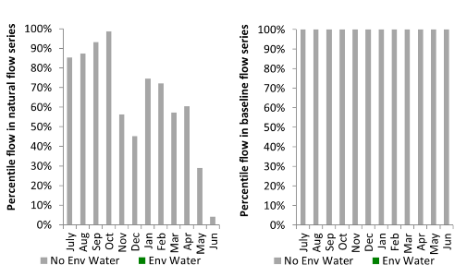
Figure OVN10. Contribution of environmental water delivery at Peechelba as percentiles in the natural and baseline flow series.

Broken
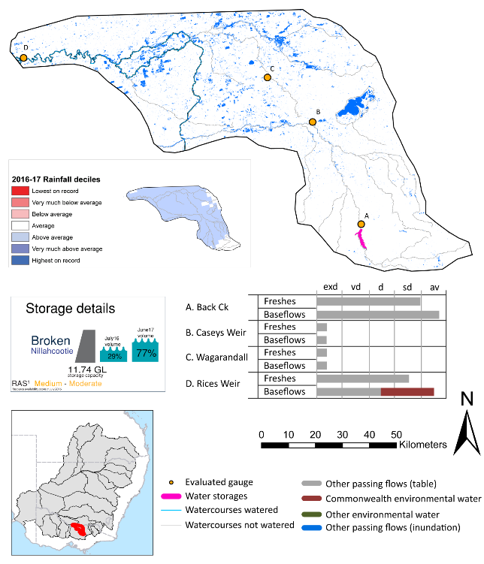

exd: extremely dry | vd: very dry | d: dry | sd: somewhat dry | av: average

Figure BRK1. Watercourses influenced, areas inundated (where applicable) and gauge stations evaluated in the Broken valley during the 2016-17 water year. Inset bar graphs report the condition of annual flow regimes by showing the improvements in hydrological condition with the addition of environmental water as well as the hypothetical scenario in “grey” (if no environmental flow had been delivered). Rainfall conditions (rainfall deciles) and trend in storage levels for the water year are also shown.

Summary
Environmental water delivery for the 2016-17 year in the Broken valley is evaluated using data for 4 sites. This evaluation only considers the contribution of held environmental water, which is a primary focus for the Australian Government. The contributions of planned environmental water (e.g. passing flows), unregulated tributary inflows and clever use of irrigation flows for environmental benefits can all be very important but these are outside the scope of this report. Environmental watering actions lasted on average 59 days over the course of the year. The volume of environmental water at these 4 sites was between 0% and 11% of the total streamflow. Commonwealth environmental water contributed on average 25% of this environmental water. Ideally, baseflows should be maintained and long periods of excessively low flows avoided. In this valley, the baseflow regime was generally considered to be dry relative to the pre-development flow regime. In our analysis, a low fresh refers to a period of increased flow, when the water level rises at least one eighth of the way up the river bank (above the low flow level). These low freshes are a regular part of the natural flow regime and support a range of natural processes. In the Broken valley, in terms of the occurrence and duration of low freshes, the year was assessed as being very dry. In our analysis, a medium fresh refers to a period of increased flow, when the water level rises at least one quarter of the way up the river bank. These medium freshes are not as frequent as low freshes but are also a regular and important part of the natural flow regime. In the Broken valley, in terms of the occurrence of medium freshes, the year was assessed as being very dry. In our analysis, a high fresh refers to a period of increased flow, when the water level rises more than half way up the river. A high fresh may not occur every year but they are still important and long periods without major freshes can have serious consequences for floodplains and their contribution to river ecosystem health. Delivering high in channel flows normally requires that all risks to riparian landholders and infrastructure have been resolved. In the Broken valley, in terms of the occurrence of high freshes, the year was assessed as being dry.

Water delivery context
During the 2016-17, the Commonwealth Environmental Water Holder (CEWH) held water entitlements of up to 257 ML for environmental use in the Broken valley. Each year, water utilities allocate water entitlement holders a percentage of water based on their holding, license type and carryover (the exact rules vary among Jurisdictions). In 2016-17, the Broken entitlements held by the CEWH were allocated 192 ML of water, representing 79% of the Long term average annual yield for the Broken valley (244 ML). Information and data relating to the portfolio of held Commonwealth environmental water is shown in Table BRK1.
The 2016-17 water allocation (192 ML) together with the carryover volume of 65 ML of water meant the CEWH had 257 ML of water available for delivery. A total of 31 367 ML of Commonwealth environmental water was delivered in the Broken valley. A total of 0 ML of Commonwealth environmental water was traded to consumptive users and 257 ML (100%) of available Commonwealth environmental water was carried over for environmental use into the 2017-18 water year.

Environmental conditions and resource availability
The water available for environmental delivery combined with the present and antecedent environmental conditions are key inputs used by environmental water managers in planning and implementing watering actions. Post hoc, this information provides important context when evaluating the effectiveness and appropriateness of environmental water use with respect to hydrological outputs.
The rainfall conditions in the Broken valley were classified as above average, based on rainfall percentile data for the entire record held by the Bureau of Meteorology for this valley. The water held in major storages in the Broken valley increased over the water year, for example Nilahcootie dam was 29% full at the beginning of the water year and 77% full by the end of the year (Figure BRK1).
The Commonwealth Environmental Water Office (CEWO) calculates resource availability scenarios (RAS) to guide the use and prioritisation of held environmental water. The RAS are progressively calculated over the year as part of the continual adaptive management planning processes. The RAS are based on the availability of held environmental water (including progressive license acquisitions and allocations) as well as the potential for unregulated or planned environmental flows. The outcome is then used to determine the demand for environmental water across The Basin.
In 2016-17, the resource availability of held Commonwealth environmental water was classified as medium in this valley, whilst the potential for unregulated or planned environmental flow was classified as high to medium. The antecedent and forecasted physical conditions meant that Commonwealth environmental water was being planned to protect and maintain in-stream flows to support vegetation condition, native fish reproduction and condition, macroinvertebrates, disruption of biofilms, channel maintenance, hydrological connectivity and water quality. The priority demand is for small-moderate size freshes in spring as these demands have not been met in several years. The overall demand for environmental water was deemed moderate (water predominantly needed this year and or next).

Watering actions
A total of 3 watering actions were delivered over the 2016-17 water year, the duration of these actions varied (range of individual actions: 29 - 63 days) and Commonwealth environmental water was delivered for a total of 242 days. The count of actions commencing in each season was; winter (1), spring (1) and summer (1). The flow component types delivered were; (3) baseflow, (0) freshes, (0) bankfull, (0) overbank and (0) wetland.
There were three expected outcomes across the three watering actions in the Broken valley. The percentage of watering actions delivered across the nine main themes included fish (66.67%), vegetation (0.0%), waterbirds (0.0%), frogs (0.0%), other biota (0.0%), connectivity (0.0%), process (0.0%), resilience (0.0%) and water quality (33.33%).
Table BRK1. Commonwealth environmental water accounting information for the Broken valley over 2016-17 water year (LTAAY = long-term average annual yield). The net delivered volume is
Total registered volume (ML) | Allocated volume (ML) | Carry over + allocated volume (ML) | Delivered (ML) | LTAAY (ML) | Trade (ML) | Carried over to 2016-17 | Forfeited (ML)
257 | 192 | 257 | 31 367¹ | 244 | 0 | 257 | 0
¹The net volume of Commonwealth environmental water attributed to the three watering actions. The total volume of Commonwealth environmental water delivered in the Broken was 36 364 ML.
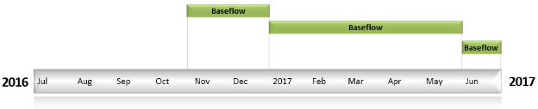
Figure BRK2. Timing and duration of Commonwealth environmental water actions delivered in the Broken valley.

Contribution of Commonwealth Environmental Water to Flow Regimes
Rices
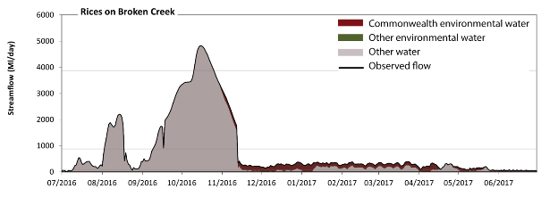
Figure BRK3. Contribution of environmental water delivery at Rices. Horizontal lines indicate thresholds for very low flows, low flows, low freshes, medium freshes and high freshes (from lowest to highest).
At Rices on the Broken Creek environmental water contributed 11% of the total streamflow volume (all of which was Commonwealth environmental water). Environmental watering actions affected streamflows for 64% of days between 1 July 2016 and 30 June 2017. Without environmental water, the duration of very low flows (i.e. < 13 ML/day) in the period October to December would have substantially exceeded durations expected in an average year in the natural flow regime. Environmental water mitigated these impacts by reducing the cumulative duration of very low flow spells from 6% to 0% of the year, with greatest influence in the periods October to December, January to March and April to June. Similarly, without environmental water, the durations of medium low flows (i.e. < 65 ML/day) in the periods July to September, October to December and April to June would have substantially exceeded durations expected in an average year in the natural flow regime. Environmental water mitigated these impacts by reducing the cumulative duration of medium low flow spells from 31% to 11% of the year, with greatest influence in the periods October to December and April to June. Commonwealth environmental water was entirely responsible for these enhancements of environmental baseflows at this site. There was at least one low fresh (i.e. > 880 ML/day) in the periods July to September and October to December. Environmental water made no change to the duration of these low freshes. There was at least one medium fresh (i.e. > 3900 ML/day) in the period October to December. Environmental water made no change to the duration of these medium freshes. In the absence of environmental water there would have been at least one high fresh in the period October to December. Environmental water made no change to the duration of these high freshes.
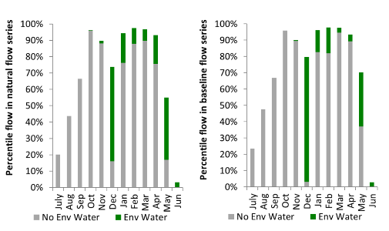
Figure BRK4. Contribution of environmental water delivery at Rices as percentiles in the natural and baseline flow series.
Back Ck
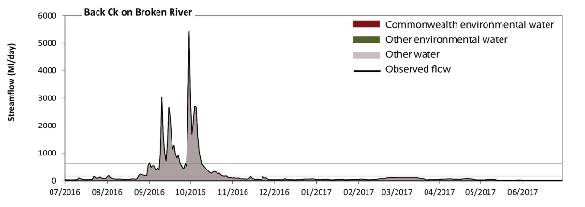
Figure BRK5. Contribution of environmental water delivery at Back Ck. Horizontal lines indicate thresholds for very low flows, low flows, low freshes, medium freshes and high freshes (from lowest to highest).
There was no Commonwealth environmental water delivered at Back Ck on the Broken River. Flow regulation does not substantially increase the duration of very low flows (i.e. < 3.4 ML/day) compared to an average year in the natural flow regime. Flow regulation does not substantially increase the duration of medium low flows (i.e. < 17 ML/day) compared to an average year in the natural flow regime. There was at least one low fresh (i.e. > 160 ML/day) in the periods July to September and October to December. There was at least one medium fresh (i.e. > 630 ML/day) in the periods July to September and October to December. In the absence of environmental water there was at least one high fresh in the periods July to September and October to December.
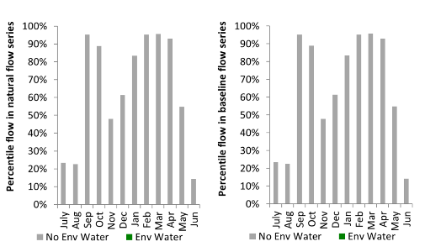
Figure BRK6. Contribution of environmental water delivery at Back Ck as percentiles in the natural and baseline flow series.
Caseys Weir
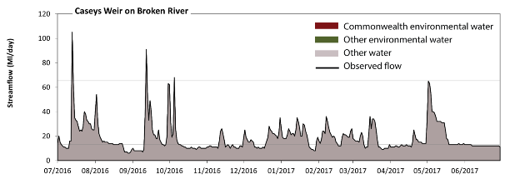
Figure BRK7. Contribution of environmental water delivery at Caseys Weir. Horizontal lines indicate thresholds for very low flows and low flows (from lowest to highest).
There was no Commonwealth environmental water delivered at Caseys Weir on the Broken River. Without environmental water, the durations of very low flows (i.e. < 13 ML/day) in the periods July to September, October to December, January to March and April to June was substantially in excess of durations expected in an average year in the natural flow regime. Similarly, without environmental water, the durations of medium low flows (i.e. < 65 ML/day) in the periods July to September, October to December, January to March and April to June was substantially in excess of durations expected in an average year in the natural flow regime.
Figure BRK8. Contribution of environmental water delivery at Caseys Weir as percentiles in the natural and baseline flow series.
Wagarandall
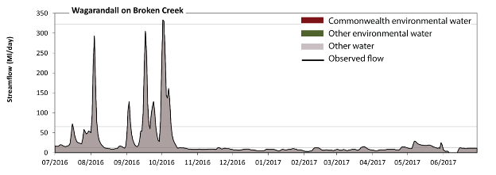
Figure BRK9. Contribution of environmental water delivery at Wagarandall. Horizontal lines indicate thresholds for very low flows, low flows and low freshes (from lowest to highest).
There was no Commonwealth environmental water delivered at Wagarandall on the Broken Creek. Without environmental water, the durations of very low flows (i.e. < 13 ML/day) in the periods July to September, October to December, January to March and April to June was substantially in excess of durations expected in an average year in the natural flow regime. Similarly, without environmental water, the durations of medium low flows (i.e. < 65 ML/day) in the periods July to September, October to December, January to March and April to June was substantially in excess of durations expected in an average year in the natural flow regime. There was at least one low fresh (i.e. > 320 ML/day) in the period October to December. There was no medium or high freshes this year.
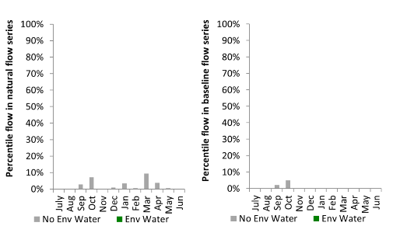
Figure BRK10. Contribution of environmental water delivery at Wagarandall as percentiles in the natural and baseline flow series.

Goulburn
exd: extremely dry | vd: very dry | d: dry | sd: somewhat dry | av: average
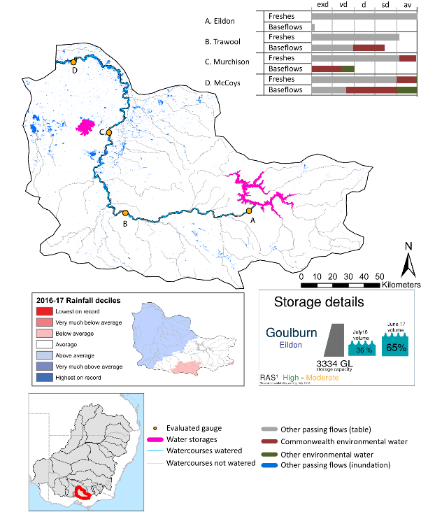

Figure GLB1. Watercourses influenced, areas inundated (where applicable) and gauge stations evaluated in the Goulburn valley during the 2016-17 water year. Inset bar graphs report the condition of annual flow regimes by showing the improvements in hydrological condition with the addition of environmental water as well as the hypothetical scenario in “grey” (if no environmental flow had been delivered). Rainfall conditions (rainfall deciles) and trend in storage levels for the water year are also shown.

Summary
Environmental water delivery for the 2016-17 year in the Goulburn valley is evaluated using data for 4 sites. This evaluation only considers the contribution of held environmental water, which is a primary focus for the Australian Government. The contributions of planned environmental water (e.g. passing flows), unregulated tributary inflows and clever use of irrigation flows for environmental benefits can all be very important but these are outside the scope of this report. Environmental watering actions lasted on average 212 days over the course of the year. The volume of environmental water at these 4 sites was between 11% and 27% of the total streamflow. Commonwealth environmental water contributed on average 78% of this environmental water. Ideally, baseflows should be maintained and long periods of excessively low flows avoided. In this valley, the baseflow regime was generally considered to be very dry relative to the pre-development flow regime. In our analysis, a low fresh refers to a period of increased flow, when the water level rises at least one eighth of the way up the river bank (above the low flow level). These low freshes are a regular part of the natural flow regime and support a range of natural processes. In the Goulburn valley, in terms of the occurrence and duration of low freshes, the year was assessed as being average. In our analysis, a medium fresh refers to a period of increased flow, when the water level rises at least one quarter of the way up the river bank. These medium freshes are not as frequent as low freshes but are also a regular and important part of the natural flow regime. In the Goulburn valley, in terms of the occurrence of medium freshes, the year was assessed as being average. In our analysis, a high fresh refers to a period of increased flow, when the water level rises more than half way up the river. A high fresh may not occur every year but they are still important and long periods without major freshes can have serious consequences for floodplains and their contribution to river ecosystem health. Delivering high in channel flows normally requires that all risks to riparian landholders and infrastructure have been resolved. In the Goulburn valley, in terms of the occurrence of high freshes, the year was assessed as being average.

Water delivery context
During the 2016-17, the Commonwealth Environmental Water Holder (CEWH) held water entitlements of up to 307 844 ML for environmental use in the Goulburn valley. Each year, water utilities allocate water entitlement holders a percentage of water based on their holding, license type and carryover (the exact rules vary among Jurisdictions). In 2016-17, the Goulburn entitlements held by the CEWH were allocated 275 979 ML of water, representing 100% of the Long term average annual yield for the Goulburn valley (276 748 ML). Information and data relating to the portfolio of held Commonwealth environmental water is shown in Table GLB1.
The 2016-17 water allocation (275 979 ML) together with the carryover volume of 46 191 ML of water meant the CEWH had 322 170 ML of water available for delivery. A total of 142 444 ML of Commonwealth environmental water was delivered in the Goulburn valley. A total of 0 ML of Commonwealth environmental water was traded to consumptive users and 57 303 ML (18%) of available Commonwealth environmental water was carried over for environmental use into the 2017-18 water year.

Environmental conditions and resource availability
The water available for environmental delivery combined with the present and antecedent environmental conditions are key inputs used by environmental water managers in planning and implementing watering actions. Post hoc, this information provides important context when evaluating the effectiveness and appropriateness of environmental water use with respect to hydrological outputs.
The rainfall conditions in the Goulburn valley were classified as average, based on rainfall percentile data for the entire record held by the Bureau of Meteorology for this valley. The water held in major storages in the Goulburn valley increased over the water year, for example Eildon dam was 36% full at the beginning of the water year and 65% full by the end of the year (Figure GLB1).
The Commonwealth Environmental Water Office (CEWO) calculates resource availability scenarios (RAS) to guide the use and prioritisation of held environmental water. The RAS are progressively calculated over the year as part of the continual adaptive management planning processes. The RAS are based on the availability of held environmental water (including progressive license acquisitions and allocations) as well as the potential for unregulated or planned environmental flows. The outcome is then used to determine the demand for environmental water across The Basin.
In 2016-17, the resource availability of held Commonwealth environmental water was classified as low in this valley, whilst the potential for unregulated or planned environmental flow was classified as high to medium. The antecedent and forecasted physical conditions meant that Commonwealth environmental water was being planned to protect in channel habitats and conditions/survival of native fish, vegetation and other biota, primarily through the provision of baseflows. The overal purpose also seeks to maintain the ecological health and resilience of the river systems by providing freshes that maintain appropriate habitat and provide opportunities for breeding and recruitment. The overall demand for environmental water was deemed moderate to high (water predominantly needed this year and or next).

Watering actions
A total of 5 watering actions were delivered over the 2016-17 water year, the duration of these actions varied (range of individual actions: 4 - 82 days) and Commonwealth environmental water was delivered for a total of 149 days. The count of actions commencing in each season was; winter (2), summer (1) and autumn (2). The flow component types delivered were; (3) baseflow, (2) freshes, (0) bankfull, (0) overbank and (0) wetland.
There were 16 expected outcomes across the five watering actions in the Goulburn valley. The percentage of expected outcomes across the nine main themes were as follows: fish (25%), vegetation (18.75%), waterbirds (0.0%), frogs (0.0%), other biota (25%), connectivity (0.0%), process (18.75%), resilience (0.0%) and water quality (12.5%).
Table GLB1. Commonwealth environmental water accounting information for the Goulburn valley over 2016-17 water year (LTAAY = long-term average annual yield).
Total registered volume (ML) | Allocated volume (ML) | Carry over + allocated volume (ML) | Delivered¹ (ML) | LTAAY (ML) | Trade (ML) | Carried over to 2016-17 | Forfeited (ML)
307 844 | 275 979 | 322 170 | 142 444 | 276 748 | 0 | 57 303 | 0
¹The net volume of Commonwealth environmental water attributed to the five watering actions. The total volume of Commonwealth environmental water delivered in the Goulburn was 182 253 ML.
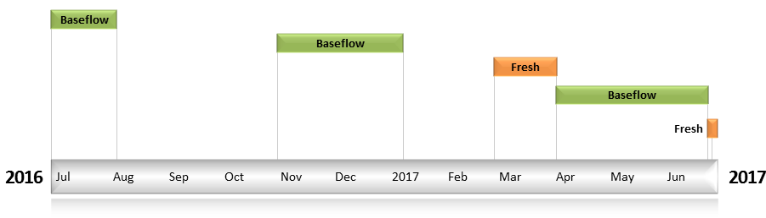
Figure GLB2. Timing and duration of Commonwealth environmental water actions delivered in the Goulburn valley.

Contribution of Commonwealth Environmental Water to Flow Regimes
Eildon
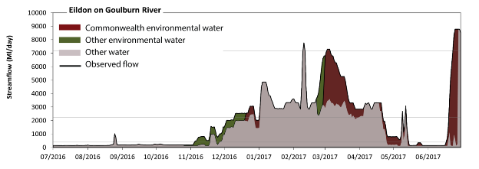
Figure GLB3. Contribution of environmental water delivery at Eildon. Horizontal lines indicate thresholds for very low flows, low flows, low freshes, medium freshes and high freshes (from lowest to highest).
At Eildon on the Goulburn River environmental water contributed 27% of the total streamflow volume (much of which was Commonwealth environmental water). Environmental watering actions affected streamflows for 58% of days between 1 July 2016 and 30 June 2017. Flow regulation does not substantially increase the duration of very low flows (i.e. < 79 ML/day) compared to an average year in the natural flow regime. However, without environmental water, the durations of medium low flows (i.e. < 400 ML/day) in the periods July to September, October to December and April to June would have substantially exceeded durations expected in an average year in the natural flow regime. Environmental water mitigated these impacts by reducing the cumulative duration of medium low flow spells from 51% to 43% of the year, with greatest influence in the period April to June. Commonwealth environmental water made the dominant contribution to these enhancements of environmental baseflows at this site. In the absence of environmental water there would have been at least one low fresh (i.e. > 2200 ML/day) in the periods October to December, January to March and April to June. Environmental water increased the duration of the longest low fresh during the period October to December (from 10 days to 23 days). Commonwealth environmental water made the dominant contribution to these increased durations of low freshes. In the absence of environmental water there would have been at least one medium fresh (i.e. > 7200 ML/day) in the periods January to March and April to June. Environmental water increased the duration of the longest medium fresh during the periods January to March (from 1 days to 3 days) and April to June (from 3 days to 7 days). Commonwealth environmental water was entirely responsible for these increased durations of medium freshes. In the absence of environmental water there would have been at least one high fresh in the periods January to March and April to June. Environmental water increased the duration of the longest medium fresh during the periods January to March (from 1 days to 3 days) and April to June (from 3 days to 7 days). Commonwealth environmental water was entirely responsible for these increased durations of high freshes.
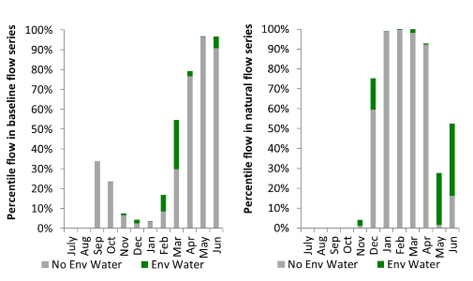
Figure GLB4. Contribution of environmental water delivery at Eildon as percentiles in the natural and baseline flow series.
Trawool
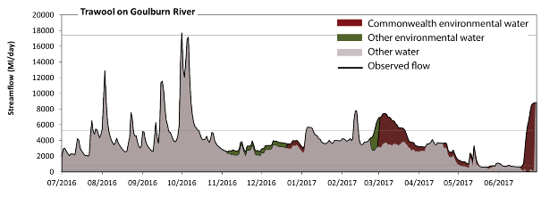
Figure GLB5. Contribution of environmental water delivery at Trawool. Horizontal lines indicate thresholds for very low flows, low flows, low freshes, medium freshes and high freshes (from lowest to highest).
At Trawool on the Goulburn River environmental water contributed 13% of the total streamflow volume (much of which was Commonwealth environmental water). Environmental watering actions affected streamflows for 58% of days between 1 July 2016 and 30 June 2017. Without environmental water, the duration of very low flows (i.e. < 250 ML/day) in the period April to June would have substantially exceeded durations expected in an average year in the natural flow regime. Environmental water mitigated these impacts by reducing the cumulative duration of very low flow spells from 2% to 0% of the year, with greatest influence in the period April to June. Similarly, without environmental water, the duration of medium low flows (i.e. < 870 ML/day) in the period April to June would have substantially exceeded durations expected in an average year in the natural flow regime. Environmental water mitigated these impacts by reducing the cumulative duration of medium low flow spells from 13% to 8% of the year, with greatest influence in the period April to June. Commonwealth environmental water was entirely responsible for these enhancements of environmental baseflows at this site. In the absence of environmental water there would have been at least one low fresh (i.e. > 5300 ML/day) in the periods July to September, October to December, January to March and April to June. Environmental water increased the duration of the longest low fresh during the periods January to March (from 5 days to 24 days) and April to June (from 2 days to 8 days). Commonwealth environmental water was entirely responsible for these increased durations of low freshes. There was at least one medium fresh (i.e. > 17000 ML/day) in the period October to December. Environmental water made no change to the duration of these medium freshes. In the absence of environmental water there would have been at least one high fresh in the period October to December. Environmental water made no change to the duration of these high freshes.
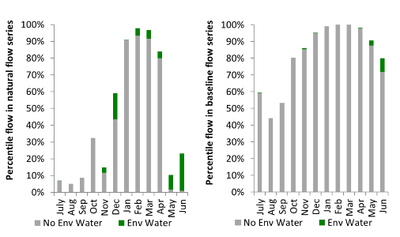
Figure GLB6. Contribution of environmental water delivery at Trawool as percentiles in the natural and baseline flow series.

Murchison
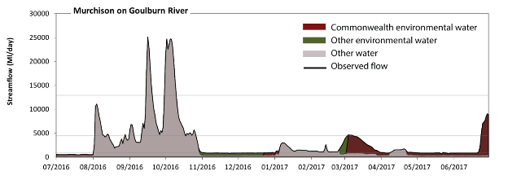
Figure GLB7. Contribution of environmental water delivery at Murchison. Horizontal lines indicate thresholds for very low flows, low flows, low freshes, medium freshes and high freshes (from lowest to highest).
At Murchison on the Goulburn River environmental water contributed 20% of the total streamflow volume (much of which was Commonwealth environmental water). Environmental watering actions affected streamflows for 58% of days between 1 July 2016 and 30 June 2017. Without environmental water, the durations of very low flows (i.e. < 310 ML/day) in the periods July to September, October to December and April to June would have substantially exceeded durations expected in an average year in the natural flow regime. Environmental water mitigated these impacts by reducing the cumulative duration of very low flow spells from 34% to 0% of the year, with greatest influence in the periods July to September and April to June. Similarly, without environmental water, the durations of medium low flows (i.e. < 960 ML/day) in the periods July to September, October to December, January to March and April to June would have all substantially exceeded durations expected in an average year in the natural flow regime. Environmental water mitigated these impacts by reducing the cumulative duration of medium low flow spells from 57% to 34% of the year, with greatest influence in the periods October to December and January to March. Environmental water increased the magnitude of flows below this medium low flow threshold. Commonwealth environmental water made the dominant contribution to these enhancements of environmental baseflows at this site. In the absence of environmental water there would have been at least one low fresh (i.e. > 4400 ML/day) in the periods July to September and October to December. Environmental water increased the duration of the longest low fresh during the periods January to March (from 0 days to 5 days) and April to June (from 0 days to 7 days). Commonwealth environmental water was entirely responsible for these increased durations of low freshes. There was at least one medium fresh (i.e. > 13000 ML/day) in the periods July to September and October to December. Environmental water made no change to the duration of these medium freshes. In the absence of environmental water there would have been at least one high fresh in the periods July to September and October to December. Environmental water made no change to the duration of these high freshes.
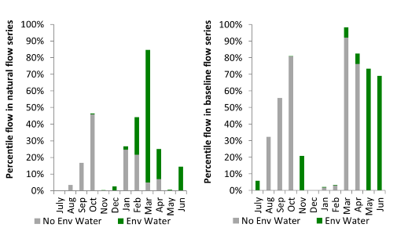
Figure GLB8. Contribution of environmental water delivery at Murchison as percentiles in the natural and baseline flow series.
McCoys
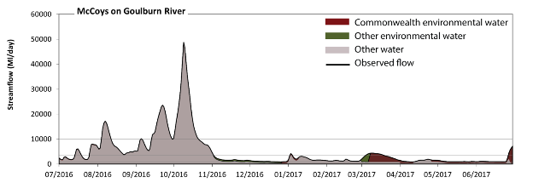
Figure GLB9. Contribution of environmental water delivery at McCoys. Horizontal lines indicate thresholds for very low flows, low flows, low freshes, medium freshes and high freshes (from lowest to highest).
At McCoys on the Goulburn River environmental water contributed 11% of the total streamflow volume (much of which was Commonwealth environmental water). Environmental watering actions affected streamflows for 58% of days between 1 July 2016 and 30 June 2017. Flow regulation does not substantially increase the duration of very low flows (i.e. < 130 ML/day) compared to an average year in the natural flow regime. However, without environmental water, the durations of medium low flows (i.e. < 770 ML/day) in the periods October to December, January to March and April to June would have substantially exceeded durations expected in an average year in the natural flow regime. Environmental water mitigated these impacts by reducing the cumulative duration of medium low flow spells from 35% to 0% of the year, with greatest influence in the period April to June. Commonwealth environmental water made the dominant contribution to these enhancements of environmental baseflows at this site. In the absence of environmental water there would have been at least one low fresh (i.e. > 3500 ML/day) in the periods July to September, October to December and January to March. Environmental water increased the duration of the longest low fresh during the periods January to March (from 1 days to 14 days) and April to June (from 0 days to 4 days). Commonwealth environmental water was almost entirely responsible for these increased durations of low freshes. There was at least one medium fresh (i.e. > 9900 ML/day) in the periods July to September and October to December. Environmental water made no change to the duration of these medium freshes. In the absence of environmental water there would have been at least one high fresh in the periods July to September and October to December. Environmental water made no change to the duration of these high freshes.
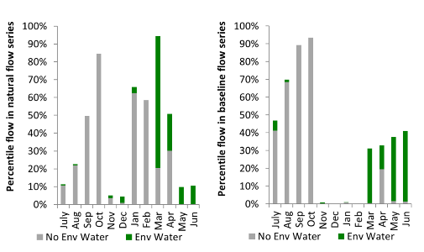
Figure GLB10. Contribution of environmental water delivery at McCoys as percentiles in the natural and baseline flow series.

Border Rivers
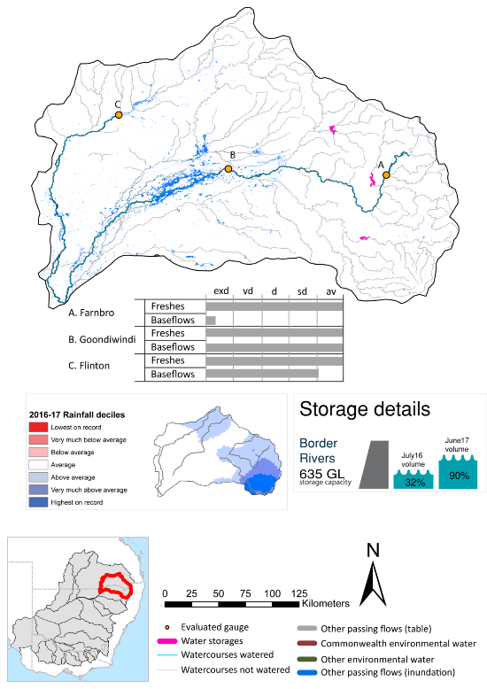

exd: extremely dry | vd: very dry
d: dry | sd: somewhat dry | av: average

Figure BRD1. Watercourses influenced, areas inundated (where applicable) and gauge stations evaluated in the Border Rivers valley during the 2016-17 water year. Inset bar graphs report the condition of annual flow regimes by showing the improvements in hydrological condition with the addition of environmental water as well as the hypothetical scenario in “grey” (if no environmental flow had been delivered). Rainfall conditions (rainfall deciles) and trend in storage levels for the water year are also shown.

Summary
Environmental water delivery for the 2016-17 year in the Border Rivers valley is evaluated using data for 3 sites. This evaluation only considers the contribution of held environmental water, which is a primary focus for the Australian Government. The contributions of planned environmental water (e.g. passing flows), unregulated tributary inflows and clever use of irrigation flows for environmental benefits can all be very important but these are outside the scope of this report. Environmental watering actions lasted on average 24 days over the course of the year. The volume of environmental water at these 3 sites was between 1% and 2% of the total streamflow. Commonwealth environmental water contributed on average 100% of this environmental water. Ideally, baseflows should be maintained and long periods of excessively low flows avoided. In this valley, the baseflow regime was generally considered to be somewhat dry relative to the pre-development flow regime. In our analysis, a low fresh refers to a period of increased flow, when the water level rises at least one eighth of the way up the river bank (above the low flow level). These low freshes are a regular part of the natural flow regime and support a range of natural processes. In the Border Rivers valley, in terms of the occurrence and duration of low freshes, the year was assessed as being average. In our analysis, a medium fresh refers to a period of increased flow, when the water level rises at least one quarter of the way up the river bank. These medium freshes are not as frequent as low freshes but are also a regular and important part of the natural flow regime. In the Border Rivers valley, in terms of the occurrence of medium freshes, the year was assessed as being average. In our analysis, a high fresh refers to a period of increased flow, when the water level rises more than half way up the river. A high fresh may not occur every year but they are still important and long periods without major freshes can have serious consequences for floodplains and their contribution to river ecosystem health. Delivering high in channel flows normally requires that all risks to riparian landholders and infrastructure have been resolved. In the Border Rivers valley, in terms of the occurrence of high freshes, the year was assessed as being average.

Water delivery context
During the 2016-17, the Commonwealth Environmental Water Holder (CEWH) held water entitlements of up to 47 940 ML for environmental use in the Border Rivers valley. Each year, water utilities allocate water entitlement holders a percentage of water based on their holding, license type and carryover (the exact rules vary among Jurisdictions). In 2016-17, the Border Rivers entitlements held by the CEWH were allocated 30 528 ML of water, representing 153% of the Long term average annual yield for the Border Rivers valley (19 999 ML). Information and data relating to the portfolio of held Commonwealth environmental water is shown in Table BRD1.
The 2016-17 water allocation (30 528 ML) together with the carryover volume of 8 817 ML of water meant the CEWH had 39 345 ML of water available for delivery. A total of 24 941 ML of Commonwealth environmental water was delivered in the Border Rivers valley. A total of 0 ML of Commonwealth environmental water was traded to consumptive users and 14 404 ML (37%) of available Commonwealth environmental water was carried over for environmental use into the 2017-18 water year.

Environmental conditions and resource availability
The water available for environmental delivery combined with the present and antecedent environmental conditions are key inputs used by environmental water managers in planning and implementing watering actions. Post hoc, this information provides important context when evaluating the effectiveness and appropriateness of environmental water use with respect to hydrological outputs.
The rainfall conditions in the Border Rivers valley were classified as average, based on rainfall percentile data for the entire record held by the Bureau of Meteorology for this valley. The water held in major storages in the Border Rivers valley increased over the water year, for example Glynlyon, Pindari, and Coolmunda dam was 32% full at the beginning of the water year and 88% full by the end of the year (Figure BRD1).
The Commonwealth Environmental Water Office (CEWO) calculates resource availability scenarios (RAS) to guide the use and prioritisation of held environmental water. The RAS are progressively calculated over the year as part of the continual adaptive management planning processes. The RAS are based on the availability of held environmental water (including progressive license acquisitions and allocations) as well as the potential for unregulated or planned environmental flows. The outcome is then used to determine the demand for environmental water across The Basin.
In 2016-17, the resource availability of held Commonwealth environmental water was classified as medium in this valley, whilst the potential for unregulated or planned environmental flow was classified as high. The antecedent and forecasted physical conditions meant that Commonwealth environmental water was being planned to maintain the health and resilience of near channel wetlands and ecological processes in the lower Macintyre River, and fish habitat and life cycles in the Dumaresq River. The overall demand for environmental water was deemed high (water predominantly needed this year).

Watering actions
A total of six watering actions were delivered over the 2016-17 water year, the duration of these actions varied (range of individual actions: 6 - 364 days) and Commonwealth environmental water was delivered for a total of 71 days. The count of actions commencing in each season was; winter (4), spring (1) and autumn (1). The flow component types delivered were; (0) baseflow, (3) freshes, (3) bankfull, (0) overbank and (0) wetland.
There were 15 expected outcomes across the six watering actions in the Border Rivers. The percentage of expected outcomes across the nine main themes were: fish (40%), vegetation (6.67%), waterbirds (0.0%), frogs (0.0%), other biota (13.33%), connectivity (13.33%), process (6.67%), resilience (20%) and water quality (0.0%).
Table BRD1. Commonwealth environmental water accounting information for the Border Rivers valley over 2016-17 water year (LTAAY = long-term average annual yield).
Total registered volume (ML) | Allocated volume (ML) | Carry over + allocated volume (ML) | Delivered (ML) | LTAAY (ML) | Trade (ML) | Carried over to 2016-17 | Forfeited (ML)
47 940 | 30 528 | 39 345 | 24 941 | 19 999 | 0 | 14 404 | 0

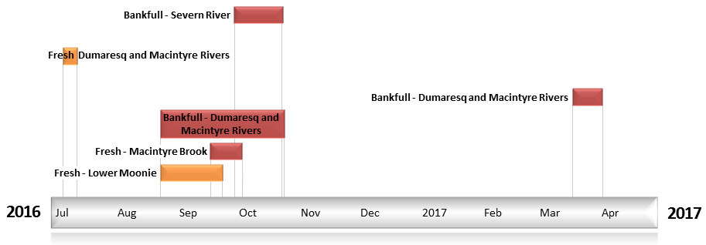
Figure BRD2. Timing and duration of Commonwealth environmental water actions delivered in the Border Rivers valley.

Contribution of Commonwealth Environmental Water to Flow Regimes
Flinton
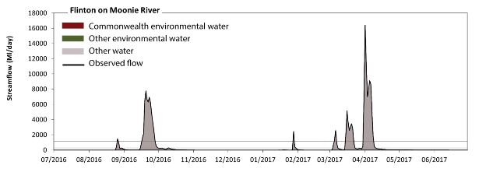
Figure BRD3. Contribution of environmental water delivery at Flinton. Horizontal lines indicate thresholds for very low flows, low flows, low freshes, medium freshes and high freshes (from lowest to highest).
At Flinton on the Moonie River environmental water contributed 1% of the total streamflow volume (all of which was Commonwealth environmental water). Environmental watering actions affected streamflows for 5% of days between 1 July 2016 and 30 June 2017. Without environmental water, the duration of very low flows (i.e. < 5.1 ML/day) in the period January to March would have substantially exceeded durations expected in an average year in the natural flow regime. However, environmental water had little effect on the duration of these very low flows, which occurred for 58% of the year. Flow regulation does not substantially increase the duration of medium low flows (i.e. < 25 ML/day) compared to an average year in the natural flow regime. There was at least one low fresh (i.e. > 280 ML/day) in the periods July to September, October to December, January to March and April to June. Environmental water made no change to the duration of these low freshes. There was at least one medium fresh (i.e. > 1200 ML/day) in the periods July to September, January to March and April to June. Environmental water made no change to the duration of these medium freshes. In the absence of environmental water there would have been at least one high fresh in the periods July to September, January to March and April to June. Environmental water made no change to the duration of these high freshes.
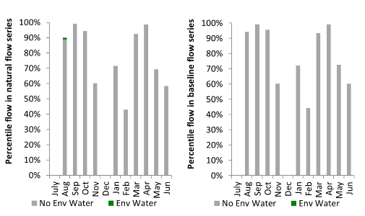
Figure BRD4. Contribution of environmental water delivery at Flinton as percentiles in the natural and baseline flow series.
Farnbro
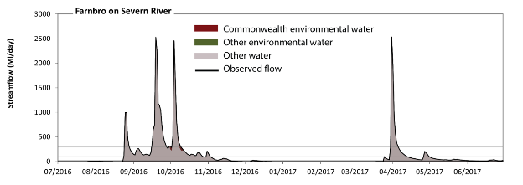
Figure BRD5. Contribution of environmental water delivery at Farnbro. Horizontal lines indicate thresholds for very low flows, low flows, low freshes, medium freshes and high freshes (from lowest to highest).
At Farnbro on Severn River environmental water contributed 2% of the total streamflow volume (all of which was Commonwealth environmental water). Environmental watering actions affected streamflows for 3% of days between 1 July 2016 and 30 June 2017. Without environmental water, the durations of very low flows (i.e. < 3.9 ML/day) in the periods July to September and January to March would have substantially exceeded durations expected in an average year in the natural flow regime. However, environmental water had little effect on the duration of these very low flows, which occurred for 45% of the year. Similarly, without environmental water, the durations of medium low flows (i.e. < 19 ML/day) in the periods July to September and January to March would have substantially exceeded durations expected in an average year in the natural flow regime. However, environmental water had little effect on the duration of these medium low flows, which occurred for 55% of the year. There was at least one low fresh (i.e. > 97 ML/day) in the periods July to September, October to December, January to March and April to June. Environmental water made little change to the duration of these low freshes. There was at least one medium fresh (i.e. > 290 ML/day) in the periods July to September, October to December, January to March and April to June. Environmental water made little change to the duration of these medium freshes. In the absence of environmental water there would have been at least one high fresh in the periods July to September, October to December, January to March and April to June. Environmental water made little change to the duration of these high freshes.
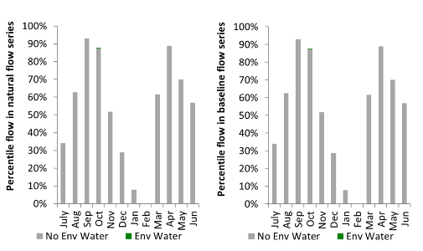
Figure BRD6. Contribution of environmental water delivery at Farnbro as percentiles in the natural and baseline flow series.
Goondiwindi
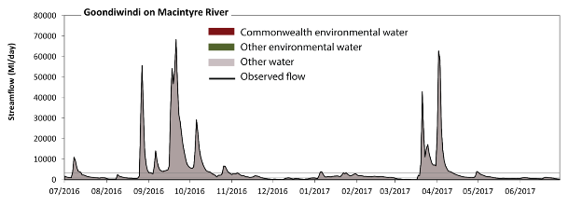
Figure BRD7. Contribution of environmental water delivery at Goondiwindi. Horizontal lines indicate thresholds for very low flows, low flows, low freshes, medium freshes and high freshes (from lowest to highest).
At Goondiwindi on the Macintyre River environmental water contributed 1% of the total streamflow volume (all of which was Commonwealth environmental water). Environmental watering actions affected streamflows for 11% of days between 1 July 2016 and 30 June 2017. Flow regulation does not substantially increase the duration of very low flows (i.e. < 48 ML/day) compared to an average year in the natural flow regime. Flow regulation does not substantially increase the duration of medium low flows (i.e. < 240 ML/day) compared to an average year in the natural flow regime. There was at least one low fresh (i.e. > 1100 ML/day) in the periods July to September, October to December, January to March and April to June. Environmental water made no change to the duration of these low freshes. There was at least one medium fresh (i.e. > 3400 ML/day) in the periods July to September, October to December, January to March and April to June. Environmental water made no change to the duration of these medium freshes. In the absence of environmental water there would have been at least one high fresh in the periods July to September, October to December, January to March and April to June. Environmental water made no change to the duration of these high freshes.
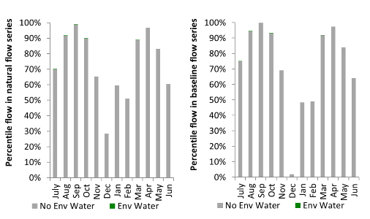
Figure BRD8. Contribution of environmental water delivery at Goondiwindi as percentiles in the natural and baseline flow series.

Campaspe
exd: extremely dry | vd: very dry | d: dry | sd: somewhat dry | av: average
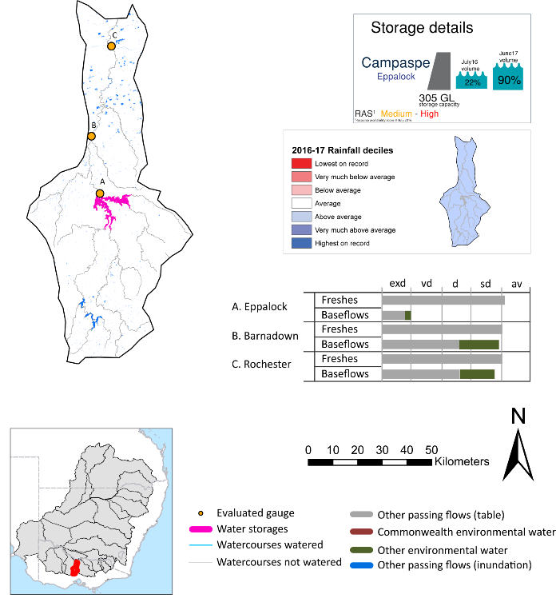
Figure CMP1. Watercourses influenced, areas inundated (where applicable) and gauge stations evaluated in the Campaspe valley during the 2016-17 water year. Inset bar graphs report the condition of annual flow regimes by showing the improvements in hydrological condition with the addition of environmental water as well as the hypothetical scenario in “grey” (if no environmental flow had been delivered). Rainfall conditions (rainfall deciles) and trend in storage levels for the water year are also shown.

Summary
Environmental water delivery for the 2016-17 year in the Campaspe valley is evaluated using data for 3 sites. This evaluation only considers the contribution of held environmental water, which is a primary focus for the Australian Government. The contributions of planned environmental water (e.g. passing flows), unregulated tributary inflows and clever use of irrigation flows for environmental benefits can all be very important but these are outside the scope of this report. Environmental watering actions lasted on average 229 days over the course of the year. The volume of environmental water at these 3 sites was between 4% and 6% of the total streamflow. Commonwealth environmental water contributed on average 0% of this environmental water. Ideally, baseflows should be maintained and long periods of excessively low flows avoided. In this valley, the baseflow regime was generally considered to be dry relative to the pre-development flow regime. In our analysis, a low fresh refers to a period of increased flow, when the water level rises at least one eighth of the way up the river bank (above the low flow level). These low freshes are a regular part of the natural flow regime and support a range of natural processes. In the Campaspe valley, in terms of the occurrence and duration of low freshes, the year was assessed as being somewhat dry. In our analysis, a medium fresh refers to a period of increased flow, when the water level rises at least one quarter of the way up the river bank. These medium freshes are not as frequent as low freshes but are also a regular and important part of the natural flow regime. In the Campaspe valley, in terms of the occurrence of medium freshes, the year was assessed as being average. In our analysis, a high fresh refers to a period of increased flow, when the water level rises more than half way up the river. A high fresh may not occur every year but they are still important and long periods without major freshes can have serious consequences for floodplains and their contribution to river ecosystem health. Delivering high in channel flows normally requires that all risks to riparian landholders and infrastructure have been resolved. In the Campaspe valley, in terms of the occurrence of high freshes, the year was assessed as being average.

Water delivery context
During the 2016-17, the Commonwealth Environmental Water Holder (CEWH) held water entitlements of up to 7,020 ML for environmental use in the Campaspe valley. Each year, water utilities allocate water entitlement holders a percentage of water based on their holding, license type and carryover (the exact rules vary among Jurisdictions). In 2016-17, the Campaspe entitlements held by the CEWH were allocated 5,952 ML of water, representing 92% of the Long term average annual yield for the Campaspe valley (6,485 ML). Information and data relating to the portfolio of held Commonwealth environmental water is shown in Table CMP1.
The 2016-17 water allocation (5952 ML) together with the carryover volume of 991 ML of water meant the CEWH had 6943 ML of water available for delivery. A total of 0 ML of Commonwealth environmental water was delivered in the Campaspe valley. A total of 6912 ML of Commonwealth environmental water was traded into the River Murray and no Commonwealth environmental water was carried over for environmental use into the 2017-18 water year.

Environmental conditions and resource availability
The water available for environmental delivery combined with the present and antecedent environmental conditions are key inputs used by environmental water managers in planning and implementing watering actions. Post hoc, this information provides important context when evaluating the effectiveness and appropriateness of environmental water use with respect to hydrological outputs.
The rainfall conditions in the Campaspe valley were classified as above average, based on rainfall percentile data for the entire record held by the Bureau of Meteorology for this valley. The water held in major storages in the Campaspe valley increased over the water year, for example Eppalock dam was 22% full at the beginning of the water year and 90% full by the end of the year (Figure CMP1).
The Commonwealth Environmental Water Office (CEWO) calculates resource availability scenarios (RAS) to guide the use and prioritisation of held environmental water. The RAS are progressively calculated over the year as part of the continual adaptive management planning processes. The RAS are based on the availability of held environmental water (including progressive license acquisitions and allocations) as well as the potential for unregulated or planned environmental flows. The outcome is then used to determine the demand for environmental water across The Basin.
In 2016-17, the resource availability of held Commonwealth environmental water was classified as medium in this valley, whilst the potential for unregulated or planned environmental flow was classified as medium. The antecedent and forecasted physical conditions meant that Commonwealth environmental water was being planned to maintain the ongoing recovery and protection of aquatic, fringing and riparian vegetation and native fish reproduction and condition The overall demand for environmental water was deemed high (water predominantly needed this year).

Watering actions
No Commonwealth environmental water was delivered in the Campaspe valley during the 2016-17 water year. Of the volume of Commonwealth environmental water available for delivery, approximately 6 913 ML was traded into the Murray for environmental use.
Table CMP1. Commonwealth environmental water accounting information for the Campaspe valley over 2016-17 water year (LTAAY = long-term average annual yield).
Total registered volume (ML) | Allocated volume (ML) | Carry over + allocated volume (ML) | Delivered (ML) | LTAAY (ML) | Trade (ML) | Carried over to 2016-17 | Forfeited (ML)
7020 | 5952 | 6943 | 0 | 6485 | 6 913 | - | 30

Contribution of Commonwealth Environmental Water to Flow Regimes
Eppalock
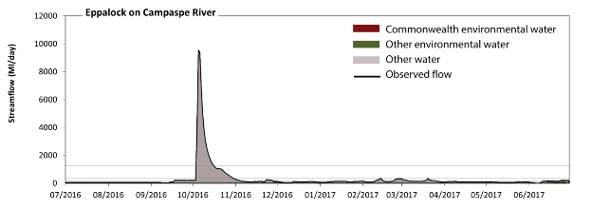
Figure CMP3. Contribution of environmental water delivery at Eppalock. Horizontal lines indicate thresholds for very low flows, low flows, low freshes, medium freshes and high freshes (from lowest to highest).
At Eppalock on the Campaspe River environmental water contributed 6% of the total streamflow volume (none of which was Commonwealth environmental water). Environmental watering actions affected streamflows for 44% of days between 1 July 2016 and 30 June 2017. Flow regulation does not substantially increase the duration of very low flows (i.e. < 12 ML/day) compared to an average year in the natural flow regime. However, without environmental water, the duration of medium low flows (i.e. < 61 ML/day) in the period July to September would have substantially exceeded durations expected in an average year in the natural flow regime. Environmental water reduced the cumulative duration of medium low flow spells from 36% to 30% of the year, with greatest influence in the period April to June. Environmental water increased the magnitude of flows below this medium low flow threshold with the result that low flows were generally far below the medium low flow threshold. Commonwealth environmental water made little or no contribution to these enhancements of environmental baseflows at this site. In the absence of environmental water there would have been at least one low fresh (i.e. > 170 ML/day) in the periods July to September, October to December, January to March and April to June. Environmental water increased the duration of the longest low fresh during the period April to June (from 1 days to 7 days). Commonwealth environmental water made little or no contribution to these increased durations of low freshes. There was at least one medium fresh (i.e. > 370 ML/day) in the period October to December. Environmental water made no change to the duration of these medium freshes. In the absence of environmental water there would have been at least one high fresh in the period October to December. Environmental water made no change to the duration of these high freshes.
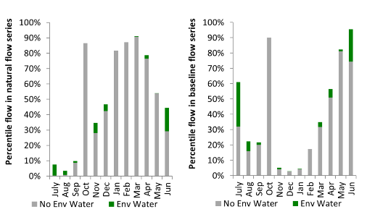
Figure CMP4. Contribution of environmental water delivery at Eppalock as percentiles in the natural and baseline flow series.
Barnadown
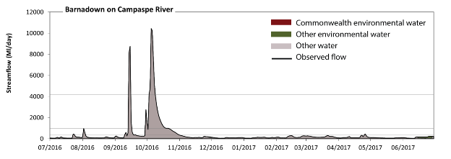
Figure CMP5. Contribution of environmental water delivery at Barnadown. Horizontal lines indicate thresholds for very low flows, low flows, low freshes, medium freshes and high freshes (from lowest to highest).
At Barnadown on the Campaspe River environmental water contributed 4% of the total streamflow volume (none of which was Commonwealth environmental water). Environmental watering actions affected streamflows for 45% of days between 1 July 2016 and 30 June 2017. Flow regulation does not substantially increase the duration of very low flows (i.e. < 15 ML/day) compared to an average year in the natural flow regime. However, without environmental water, the durations of medium low flows (i.e. < 77 ML/day) in the periods July to September and April to June would have substantially exceeded durations expected in an average year in the natural flow regime. Environmental water mitigated these impacts by reducing the cumulative duration of medium low flow spells from 34% to 21% of the year, with greatest influence in the periods July to September and April to June. Commonwealth environmental water made little or no contribution to these enhancements of environmental baseflows at this site. There was at least one low fresh (i.e. > 340 ML/day) in the periods July to September, October to December and April to June. Environmental water made no change to the duration of these low freshes. There was at least one medium fresh (i.e. > 970 ML/day) in the periods July to September and October to December. Environmental water made no change to the duration of these medium freshes. In the absence of environmental water there would have been at least one high fresh in the periods July to September and October to December. Environmental water made no change to the duration of these high freshes.
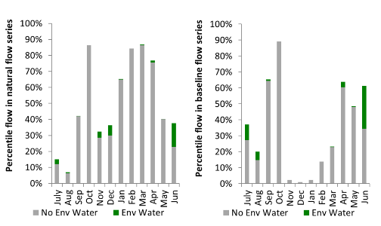
Figure CMP6. Contribution of environmental water delivery at Barnadown as percentiles in the natural and baseline flow series.
Rochester
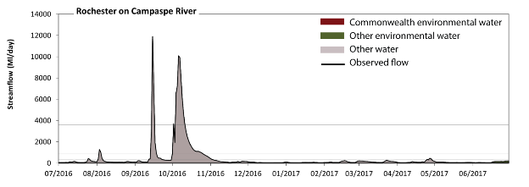
Figure CMP7. Contribution of environmental water delivery at Rochester. Horizontal lines indicate thresholds for very low flows, low flows, low freshes, medium freshes and high freshes (from lowest to highest).
At Rochester on the Campaspe River environmental water contributed 2495% of the total streamflow volume (none of which was Commonwealth environmental water). Environmental watering actions affected streamflows for 100% of days between 1 July 2016 and 30 June 2017. Without environmental water, the durations of very low flows (i.e. < 15 ML/day) in the periods July to September, October to December, January to March and April to June would have all substantially exceeded durations expected in an average year in the natural flow regime. Environmental water mitigated these impacts by reducing the cumulative duration of very low flow spells from 100% to 0% of the year, with greatest influence in the periods July to September, January to March and April to June. Similarly, without environmental water, the durations of medium low flows (i.e. < 77 ML/day) in the periods July to September, October to December, January to March and April to June would have all substantially exceeded durations expected in an average year in the natural flow regime. Environmental water mitigated these impacts by reducing the cumulative duration of medium low flow spells from 100% to 42% of the year, with greatest influence in the periods July to September and October to December. Environmental water increased the magnitude of flows below this medium low flow threshold. Commonwealth environmental water made little or no contribution to these enhancements of environmental baseflows at this site. Environmental water increased the duration of the longest low fresh during the periods July to September (from 0 days to 12 days), October to December (from 0 days to 34 days) and April to June (from 0 days to 2 days). Commonwealth environmental water made little or no contribution to these increased durations of low freshes. Environmental water increased the duration of the longest medium fresh during the periods July to September (from 0 days to 5 days) and October to December (from 0 days to 25 days). Commonwealth environmental water made little or no contribution to these increased durations of medium freshes. Environmental water increased the duration of the longest medium fresh during the periods July to September (from 0 days to 2 days) and October to December (from 0 days to 8 days). Commonwealth environmental water made little or no contribution to these increased durations of high freshes.
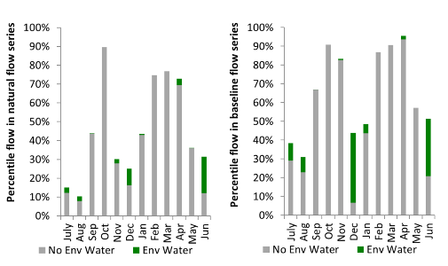
Figure CMP8. Contribution of environmental water delivery at Rochester as percentiles in the natural and baseline flow series.

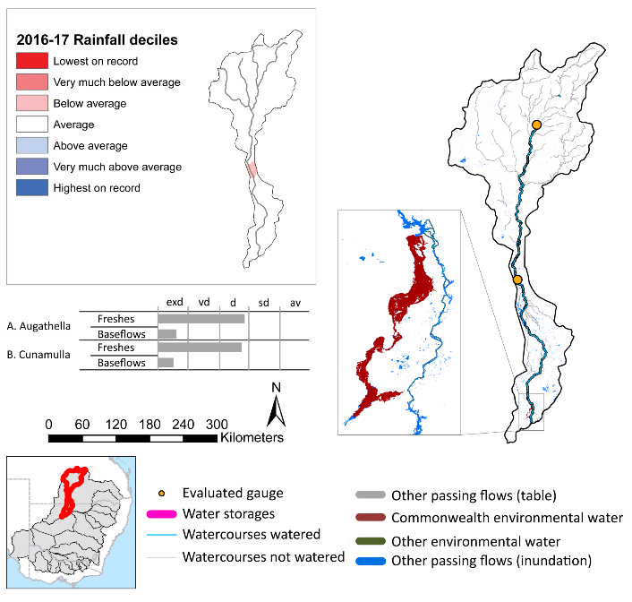
Warrego
Figure WRG1. Watercourses influenced, areas inundated (where applicable) and gauge stations evaluated in the Warrego valley during the 2016-17 water year. Inset bar graphs report the condition of annual flow regimes by showing the improvements in hydrological condition with the addition of environmental water as well as the hypothetical scenario in “grey” (if no environmental flow had been delivered). Rainfall conditions (rainfall deciles) and trend in storage levels for the water year are also shown.
exd: extremely dry | vd: very dry | d: dry
sd: somewhat dry | av: average

Summary
Environmental water delivery for the 2016-17 year in the Warrego valley is evaluated using data for 2 sites. This evaluation only considers the contribution of held environmental water, which is a primary focus for the Australian Government. The contributions of planned environmental water (e.g. passing flows), unregulated tributary inflows and clever use of irrigation flows for environmental benefits can all be very important but these are outside the scope of this report. Environmental watering actions lasted on average 21 days over the course of the year. The volume of environmental water at these 2 sites was between 3% and 6% of the total streamflow. Commonwealth environmental water contributed on average 100% of this environmental water. Ideally, baseflows should be maintained and long periods of excessively low flows avoided. In this valley, the baseflow regime was generally considered to be extremely dry relative to the pre-development flow regime. In our analysis, a low fresh refers to a period of increased flow, when the water level rises at least one eighth of the way up the river bank (above the low flow level). These low freshes are a regular part of the natural flow regime and support a range of natural processes. In the Warrego valley, in terms of the occurrence and duration of low freshes, the year was assessed as being very dry. In our analysis, a medium fresh refers to a period of increased flow, when the water level rises at least one quarter of the way up the river bank. These medium freshes are not as frequent as low freshes but are also a regular and important part of the natural flow regime. In the Warrego valley, in terms of the occurrence of medium freshes, the year was assessed as being dry. In our analysis, a high fresh refers to a period of increased flow, when the water level rises more than half way up the river. A high fresh may not occur every year but they are still important and long periods without major freshes can have serious consequences for floodplains and their contribution to river ecosystem health. Delivering high in channel flows normally requires that all risks to riparian landholders and infrastructure have been resolved. In the Warrego valley, in terms of the occurrence of high freshes, the year was assessed as being average.

Water delivery context
During the 2016-17, the Commonwealth Environmental Water Holder (CEWH) held water entitlements of up to 57 281 ML for environmental use in the Warrego valley. Each year, water utilities allocate water entitlement holders a percentage of water based on their holding, license type and carryover (the exact rules vary among Jurisdictions). In 2016-17, the Warrego entitlements held by the CEWH were allocated 26 997 ML of water, representing 71% of the Long term average annual yield for the Warrego valley (37 922 ML). Information and data relating to the portfolio of held Commonwealth environmental water is shown in Table WRG1.
The 2016-17 water allocation (26,997 ML) together with the carryover volume of 0 ML of water meant the CEWH had 26 997 ML of water available for delivery. A total of 26 997 ML of Commonwealth environmental water was delivered in the Warrego valley. A total of 0 ML of Commonwealth environmental water was traded to consumptive users and no Commonwealth environmental water was carried over for environmental use into the 2017-18 water year.

Environmental conditions and resource availability
The water available for environmental delivery combined with the present and antecedent environmental conditions are key inputs used by environmental water managers in planning and implementing watering actions. Post hoc, this information provides important context when evaluating the effectiveness and appropriateness of environmental water use with respect to hydrological outputs.
The rainfall conditions in the Warrego valley were classified as average, based on rainfall percentile data for the entire record held by the Bureau of Meteorology for this valley (Figure WRG1).

Watering actions
A total of 8 watering actions were delivered over the 2016-17 water year, the duration of these actions varied (range of individual actions: 1 - 55 days) and Commonwealth environmental water was delivered for a total of 119 days. The count of actions commencing in each season was; winter (3) and spring (5). The flow component types delivered were; (0) baseflow, (5) freshes, (1) bankfull, (0) overbank and (2) wetland.
There were 18 expected outcomes across the eight watering actions in the Warrego valley. The percentage of expected outcomes across the nine main themes were as follows: fish (11.11%), vegetation (11.11%), waterbirds (11.11%), frogs (0.0%), other biota (0.0%), connectivity (33.33%), process (5.56%), resilience (27.78%) and water quality (0.0%).
Table WRG1. Commonwealth environmental water accounting information for the Warrego valley over 2016-17 water year (LTAAY = long-term average annual yield).
Total registered volume (ML) | Allocated volume (ML) | Carry over + allocated volume (ML) | Delivered (ML) | LTAAY (ML) | Trade (ML) | Carried over to 2016-17 | Forfeited (ML)
57 281 | 26 997 | 26 997 | 26 997 | 37 922 | 0 | - | 0

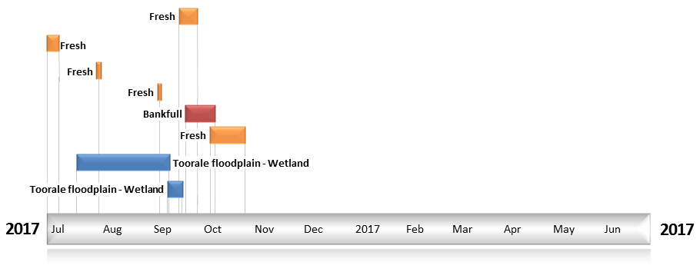
Figure WRG2. Timing and duration of Commonwealth environmental water actions delivered in the Warrego valley.

Contribution of Commonwealth Environmental Water to Flow Regimes
Augathella
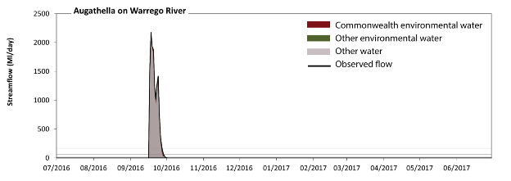
Figure WRG3. Contribution of environmental water delivery at Augathella. Horizontal lines indicate thresholds for very low flows, low flows, low freshes, medium freshes and high freshes (from lowest to highest).
At Augathella on the Warrego River environmental water contributed 6% of the total streamflow volume (all of which was Commonwealth environmental water). Environmental watering actions affected streamflows for 3% of days between 1 July 2016 and 30 June 2017. Without environmental water, the durations of very low flows (i.e. < 2.7 ML/day) in the periods October to December, January to March and April to June would have substantially exceeded durations expected in an average year in the natural flow regime. However, environmental water had little effect on the duration of these very low flows, which occurred for 96% of the year. Similarly, without environmental water, the durations of medium low flows (i.e. < 14 ML/day) in the periods October to December, January to March and April to June would have substantially exceeded durations expected in an average year in the natural flow regime. However, environmental water had little effect on the duration of these medium low flows, which occurred for 96% of the year. There was at least one low fresh (i.e. > 59 ML/day) in the period July to September. Environmental water made little change to the duration of these low freshes. There was at least one medium fresh (i.e. > 170 ML/day) in the period July to September. Environmental water made little change to the duration of these medium freshes. In the absence of environmental water there would have been at least one high fresh in the period July to September. Environmental water made little change to the duration of these high freshes.
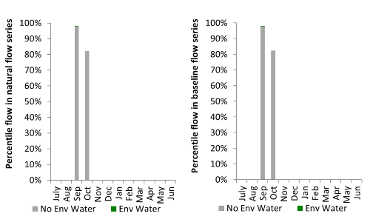
Figure WRG4. Contribution of environmental water delivery at Augathella as percentiles in the natural and baseline flow series.
Cunamulla
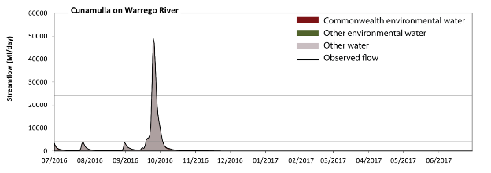
Figure WRG5. Contribution of environmental water delivery at Cunamulla. Horizontal lines indicate thresholds for very low flows, low flows, low freshes, medium freshes and high freshes (from lowest to highest).
At Cunamulla on the Warrego River environmental water contributed 3% of the total streamflow volume (all of which was Commonwealth environmental water). Environmental watering actions affected streamflows for 8% of days between 1 July 2016 and 30 June 2017. Without environmental water, the durations of very low flows (i.e. < 20 ML/day) in the periods January to March and April to June would have substantially exceeded durations expected in an average year in the natural flow regime. However, environmental water had little effect on the duration of these very low flows, which occurred for 61% of the year. Similarly, without environmental water, the durations of medium low flows (i.e. < 99 ML/day) in the periods January to March and April to June would have substantially exceeded durations expected in an average year in the natural flow regime. However, environmental water had little effect on the duration of these medium low flows, which occurred for 69% of the year. There was at least one low fresh (i.e. > 4100 ML/day) in the periods July to September and October to December. Environmental water made no change to the duration of these low freshes. There was at least one medium fresh (i.e. > 24000 ML/day) in the period July to September. Environmental water made no change to the duration of these medium freshes. In the absence of environmental water there would have been at least one high fresh in the period July to September. Environmental water made no change to the duration of these high freshes.
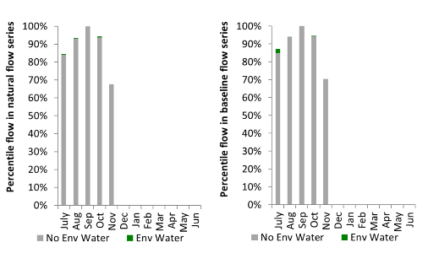
Figure WRG6. Contribution of environmental water delivery at Cunamulla as percentiles in the natural and baseline flow series.

Barwon Darling
exd: extremely dry | vd: very dry | d: dry
sd: somewhat dry | av: average
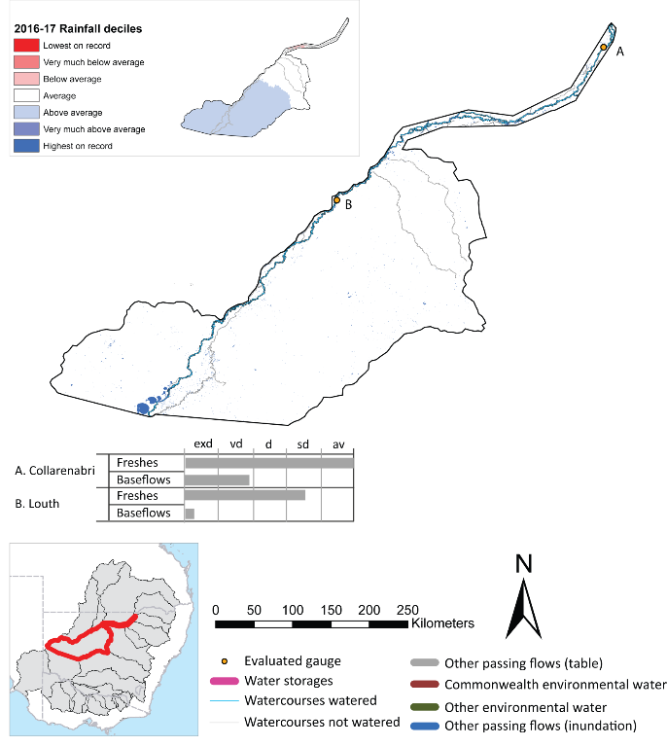
Figure BDL1. Watercourses influenced, areas inundated (where applicable) and gauge stations evaluated in the Barwon Darling valley during the 2016-17 water year. Inset bar graphs report the condition of annual flow regimes by showing the improvements in hydrological condition with the addition of environmental water as well as the hypothetical scenario in “grey” (if no environmental flow had been delivered). Rainfall conditions (rainfall deciles) and trend in storage levels for the water year are also shown.

Summary
The volume of environmental water delivery for the 2016-17 year in the Barwon Darling valley is quantified using data for 2 sites. This evaluation only considers the contribution of held environmental water, which is a primary focus for the Australian Government. The contributions of planned environmental water (e.g. passing flows), unregulated tributary inflows and clever use of irrigation flows for environmental benefits can all be very important but these are outside the scope of this report. Environmental watering actions lasted on average 52 days over the course of the year. The volume of environmental water at these 2 sites was between 0% and 3% of the total streamflow. Commonwealth environmental water contributed on average 100% of this environmental water. Ideally, baseflows should be maintained and long periods of excessively low flows avoided. In this valley, the baseflow regime was generally considered to be extremely dry relative to the pre-development flow regime. In our analysis, a low fresh refers to a period of increased flow, when the water level rises at least one eighth of the way up the river bank (above the low flow level). These low freshes are a regular part of the natural flow regime and support a range of natural processes. In the Barwon Darling valley, in terms of the occurrence and duration of low freshes, the year was assessed as being average. In our analysis, a medium fresh refers to a period of increased flow, when the water level rises at least one quarter of the way up the river bank. These medium freshes are not as frequent as low freshes but are also a regular and important part of the natural flow regime. In the Barwon Darling valley, in terms of the occurrence of medium freshes, the year was assessed as being somewhat dry. In our analysis, a high fresh refers to a period of increased flow, when the water level rises more than half way up the river. A high fresh may not occur every year but they are still important and long periods without major freshes can have serious consequences for floodplains and their contribution to river ecosystem health. Delivering high in channel flows normally requires that all risks to riparian landholders and infrastructure have been resolved. In the Barwon Darling valley, in terms of the occurrence of high freshes, the year was assessed as being average.

Water delivery context
During the 2016-17, the Commonwealth Environmental Water Holder (CEWH) held water entitlements of up to 27 796 ML for environmental use in the Barwon Darling valley. Each year, water utilities allocate water entitlement holders a percentage of water based on their holding, license type and carryover (the exact rules vary among Jurisdictions). In 2016-17, the Barwon Darling entitlements held by the CEWH were allocated 26 796 ML of water, representing 96% of the Long term average annual yield for the Barwon Darling valley (27 796 ML). Information and data relating to the portfolio of held Commonwealth environmental water is shown in Table BDL1.
The 2016-17 water allocation (26 796 ML) together with the carryover volume of 0 ML of water meant the CEWH had 26,796 ML of water available for delivery. A total of 26 796 ML of Commonwealth environmental water was delivered in the Barwon Darling valley. A total of 0 ML of Commonwealth environmental water was traded to consumptive users no Commonwealth environmental water was carried over for environmental use into the 2017-18 water year.

Environmental conditions and resource availability
The water available for environmental delivery combined with the present and antecedent environmental conditions are key inputs used by environmental water managers in planning and implementing watering actions. Post hoc, this information provides important context when evaluating the effectiveness and appropriateness of environmental water use with respect to hydrological outputs.
The rainfall conditions in the Barwon Darling valley were classified as average, based on rainfall percentile data for the entire record held by the Bureau of Meteorology for this valley. The water held in major storages in the Barwon Darling valley increased over the water year, for example Meninde dam was 3% full at the beginning of the water year and 44% full by the end of the year (Figure BDL1).

Watering actions
A total of three watering actions were delivered over the 2016-17 water year, the duration of these actions varied (range of individual actions: 11 - 45 days) and Commonwealth environmental water was delivered for a total of 74 days. The count of actions commencing in each season was; winter (2) and spring (1). The flow component types delivered were; (0) baseflow, (3) freshes, (0) bankfull, (0) overbank and (0) wetland.
There were nine expected outcomes across the three watering actions in the Barwon-Darling valley. The percentage of expected outcomes across the nine main themes were: fish (0.0%), vegetation (0.0%), waterbirds (0.0%), frogs (0.0%), other biota (0.0%), connectivity (0.0%), process (33.33%), resilience (33.33%) and water quality (33.33%).
Table BDL1. Commonwealth environmental water accounting information for the Barwon Darling valley over 2016-17 water year (LTAAY = long-term average annual yield).
Total registered volume (ML) | Allocated volume (ML) | Carry over + allocated volume (ML) | Delivered (ML) | LTAAY (ML) | Trade (ML) | Carried over to 2016-17 | Forfeited (ML)
27 796 | 26 796 | 26 796 | 26 796 | 27 796 | 0 | - | 0

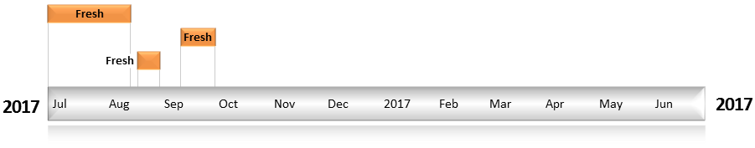
Figure BDL2. Timing and duration of Commonwealth environmental water actions delivered in the Barwon Darling valley.

Contribution of Commonwealth Environmental Water to Flow Regimes
Louth
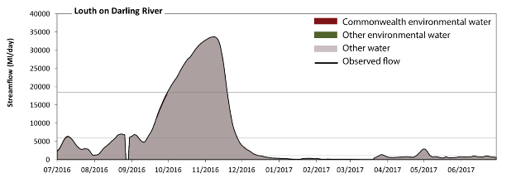
Figure BDL3. Contribution of environmental water delivery at Louth. Horizontal lines indicate thresholds for very low flows, low flows, low freshes, medium freshes and high freshes (from lowest to highest).
At Louth on the Darling River environmental water contributed less than 1% of the total streamflow volume (all of which was Commonwealth environmental water). Environmental watering actions affected streamflows for 16% of days between 1 July 2016 and 30 June 2017. Without environmental water, the duration of very low flows (i.e. < 220 ML/day) in the period January to March would have substantially exceeded durations expected in an average year in the natural flow regime. However, environmental water had little effect on the duration of these very low flows, which occurred for 16% of the year. Similarly, without environmental water, the durations of medium low flows (i.e. < 1100 ML/day) in the periods January to March and April to June would have substantially exceeded durations expected in an average year in the natural flow regime. However, environmental water had little effect on the duration of these medium low flows, which occurred for 51% of the year. There was at least one low fresh (i.e. > 5900 ML/day) in the periods July to September and October to December. Environmental water made no change to the duration of these low freshes. There was at least one medium fresh (i.e. > 18000 ML/day) in the period October to December. Environmental water made no change to the duration of these medium freshes. In the absence of environmental water there would have been at least one high fresh in the period October to December. Environmental water made no change to the duration of these high freshes.
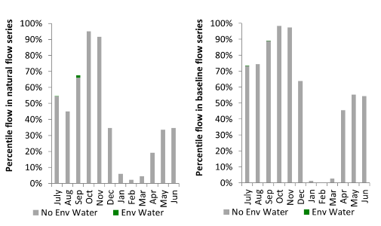
Figure BDL4. Contribution of environmental water delivery at Louth as percentiles in the natural and baseline flow series.
Collarenebri
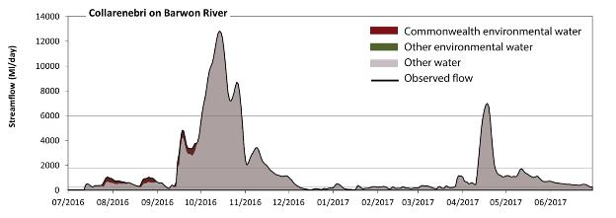
Figure BDL5. Contribution of environmental water delivery at Collarenebri. Horizontal lines indicate thresholds for very low flows, low flows, low freshes, medium freshes and high freshes (from lowest to highest).
At Collarenebri on the Barwon River environmental water contributed 3% of the total streamflow volume (all of which was Commonwealth environmental water). Environmental watering actions affected streamflows for 13% of days between 1 July 2016 and 30 June 2017. Without environmental water, the duration of very low flows (i.e. < 55 ML/day) in the period July to September would have substantially exceeded durations expected in an average year in the natural flow regime. However, environmental water had little effect on the duration of these very low flows, which occurred for 5% of the year. Similarly, without environmental water, the duration of medium low flows (i.e. < 270 ML/day) in the period January to March would have substantially exceeded durations expected in an average year in the natural flow regime. Environmental water reduced the cumulative duration of medium low flow spells from 28% to 28% of the year, with greatest influence in the period July to September. There was at least one low fresh (i.e. > 1800 ML/day) in the periods July to September, October to December and April to June. Environmental water made no change to the duration of these low freshes. There was at least one medium fresh (i.e. > 6000 ML/day) in the periods October to December and April to June. Environmental water made no change to the duration of these medium freshes. In the absence of environmental water there would have been at least one high fresh in the periods October to December and April to June. Environmental water made no change to the duration of these high freshes.
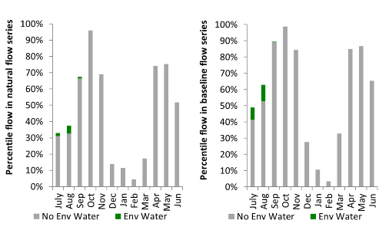
Figure BDL6. Contribution of environmental water delivery at Collarenebri as percentiles in the natural and baseline flow series.

Condamine Balonne
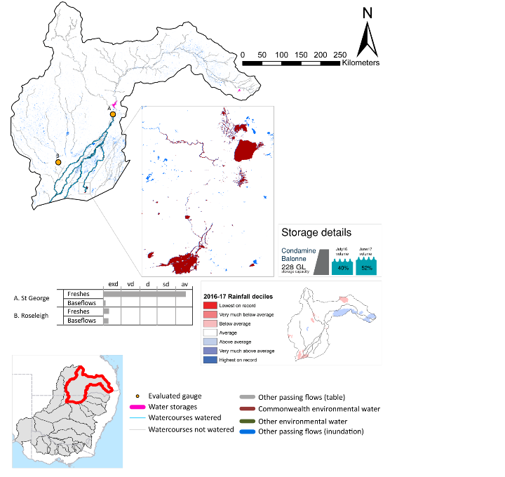
Figure CDB1. Watercourses influenced, areas inundated (where applicable) and gauge stations evaluated in the Condamine Balonne valley during the 2016-17 water year. Inset bar graphs report the condition of annual flow regimes by showing the improvements in hydrological condition with the addition of environmental water as well as the hypothetical scenario in “grey” (if no environmental flow had been delivered). Rainfall conditions (rainfall deciles) and trend in storage levels for the water year are also shown.
exd: extremely dry | vd: very dry | d: dry
sd: somewhat dry | av: average

Summary
Environmental water delivery for the 2016-17 year in the Condamine Balonne valley is evaluated using data for two sites. This evaluation only considers the contribution of held environmental water, which is a primary focus for the Australian Government. The contributions of planned environmental water (e.g. passing flows), unregulated tributary inflows and clever use of irrigation flows for environmental benefits can all be very important but these are outside the scope of this report. Environmental watering actions lasted on average 11 days over the course of the year. The volume of environmental water at these two sites was between 0% and 10% of the total streamflow. Commonwealth environmental water contributed on average 50% of this environmental water. Ideally, baseflows should be maintained and long periods of excessively low flows avoided. In this valley, the baseflow regime was generally considered to be extremely dry relative to the pre-development flow regime. In our analysis, a low fresh refers to a period of increased flow, when the water level rises at least one eighth of the way up the river bank (above the low flow level). These low freshes are a regular part of the natural flow regime and support a range of natural processes. In the Condamine Balonne valley, in terms of the occurrence and duration of low freshes, the year was assessed as being somewhat dry. In our analysis, a medium fresh refers to a period of increased flow, when the water level rises at least one quarter of the way up the river bank. These medium freshes are not as frequent as low freshes but are also a regular and important part of the natural flow regime. In the Condamine Balonne valley, in terms of the occurrence of medium freshes, the year was assessed as being average. In our analysis, a high fresh refers to a period of increased flow, when the water level rises more than half way up the river. A high fresh may not occur every year but they are still important and long periods without major freshes can have serious consequences for floodplains and their contribution to river ecosystem health. Delivering high in channel flows normally requires that all risks to riparian landholders and infrastructure have been resolved. In the Condamine Balonne valley, in terms of the occurrence of high freshes, the year was assessed as being average.

Water delivery context
During the 2016-17, the Commonwealth Environmental Water Holder (CEWH) held water entitlements of up to 92 460 ML for environmental use in the Condamine Balonne valley. Each year, water utilities allocate water entitlement holders a percentage of water based on their holding, license type and carryover (the exact rules vary among Jurisdictions). In 2016-17, the Condamine Balonne entitlements held by the CEWH were allocated 43 927 ML of water, representing 75% of the long-term average annual yield for the Condamine Balonne valley (58 776 ML). Information and data relating to the portfolio of held Commonwealth environmental water is shown in Table CDB1.
The 2016-17 water allocation (43 918 ML) together with the carryover volume of 46 ML of water meant the CEWH had 43 964 ML of water available for delivery. A total of 43 918 ML of Commonwealth environmental water was delivered in the Condamine Balonne valley. A total of 0 ML of Commonwealth environmental water was traded to consumptive users and 46 ML of available Commonwealth environmental water was carried over for environmental use into the 2017-18 water year.

Environmental conditions and resource availability
The water available for environmental delivery combined with the present and antecedent environmental conditions are key inputs used by environmental water managers in planning and implementing watering actions. Post hoc, this information provides important context when evaluating the effectiveness and appropriateness of environmental water use with respect to hydrological outputs.
The rainfall conditions in the Condamine Balonne valley were classified as average, based on rainfall percentile data for the entire record held by the Bureau of Meteorology for this valley. The water held in major storages in the Condamine Balonne valley increased over the water year, for example Leslie, Cooby, Chinchilla, Beardmore and Jack Taylor dam were 40% full at the beginning of the water year and 52% full by the end of the year (Figure CDB1).

Watering actions
A total of two watering actions were delivered over the 2016-17 water year, the duration of these actions varied (range of individual actions: 10 - 12 days) and Commonwealth environmental water was delivered for a total of 22 days. The count of actions commencing in each season was; spring (1) and autumn (1). The flow component types delivered were; (0) baseflow, (1) freshes, (1) bankfull, (0) overbank and (0) wetland.
There were five expected outcomes across the two watering actions in the Condamine Balonne valley. The percentage of expected outcomes across the nine main themes were: fish (20%), vegetation (20%), waterbirds (20%), frogs (0.0%), other biota (0.0%), connectivity (20%), process (0.0%), resilience (20%) and water quality (0.0%).
Table CDB1. Commonwealth environmental water accounting information for the Condamine Balonne valley over 2016-17 water year (LTAAY = long-term average annual yield).
Total registered volume (ML) | Allocated volume (ML) | Carry over + allocated volume (ML) | Delivered (ML) | LTAAY (ML) | Trade (ML) | Carried over to 2016-17 | Forfeited (ML)
92 460 | 43 918 | 43 964 | 43 918 | 58 776 | 0 | 46 | 0

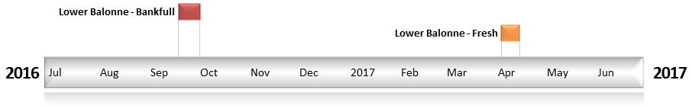
Figure CDB2. Timing and duration of Commonwealth environmental water actions delivered in the Condamine Balonne valley.

Contribution of Commonwealth Environmental Water to Flow Regimes
St George
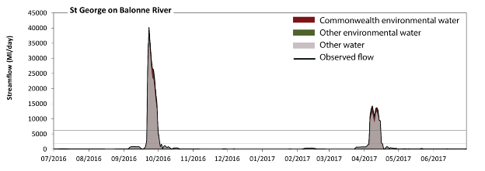
Figure CDB3. Contribution of environmental water delivery at St George. Horizontal lines indicate thresholds for very low flows, low flows, low freshes, medium freshes and high freshes (from lowest to highest).
At St George on the Balonne River environmental water contributed 10% of the total streamflow volume (all of which was Commonwealth environmental water). Environmental watering actions affected streamflows for 6% of days between 1 July 2016 and 30 June 2017. Without environmental water, the durations of very low flows (i.e. < 71 ML/day) in the periods July to September, October to December, January to March and April to June would have all substantially exceeded durations expected in an average year in the natural flow regime. However, environmental water had little effect on the duration of these very low flows, which occurred for 73% of the year. Similarly, without environmental water, the durations of medium low flows (i.e. < 350 ML/day) in the periods July to September, October to December, January to March and April to June would have all substantially exceeded durations expected in an average year in the natural flow regime. However, environmental water had little effect on the duration of these medium low flows, which occurred for 81% of the year. There was at least one low fresh (i.e. > 2000 ML/day) in the periods July to September, October to December and April to June. Environmental water made no change to the duration of these low freshes. There was at least one medium fresh (i.e. > 6200 ML/day) in the periods July to September and April to June. Environmental water made no change to the duration of these medium freshes. In the absence of environmental water there would have been at least one high fresh in the periods July to September and April to June. Environmental water made no change to the duration of these high freshes.
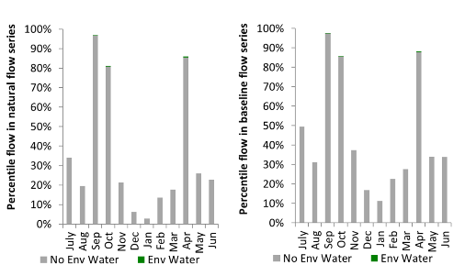
Figure CDB4. Contribution of environmental water delivery at St George as percentiles in the natural and baseline flow series.
Roseleigh
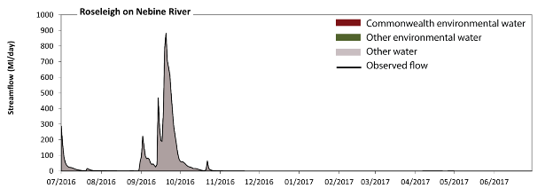
Figure CDB5. Contribution of environmental water delivery at Roseleigh.
There was no environmental water delivered at Roseleigh on the Nebine River

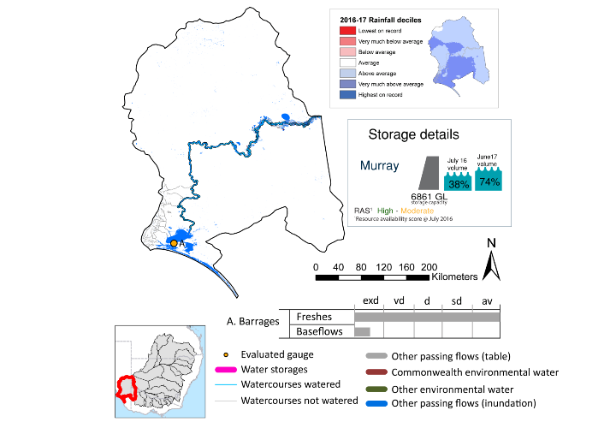
Coorong
Figure CLM1. Watercourses influenced, areas inundated (where applicable) and gauge stations evaluated in the Coorong Lower Lakes valley during the 2016-17 water year. Inset bar graphs report the condition of annual flow regimes by showing the improvements in hydrological condition with the addition of environmental water as well as the hypothetical scenario in “grey” (if no environmental flow had been delivered). Rainfall conditions (rainfall deciles) and trend in storage levels for the water year are also shown.
exd: extremely dry | vd: very dry
d: dry | sd: somewhat dry
av: average

Summary
Environmental water delivery for the 2016-17 year in the Coorong Lower Lakes valley is evaluated using data for 1 sites. This evaluation only considers the contribution of held environmental water, which is a primary focus for the Australian Government. The contributions of planned environmental water (e.g. passing flows), unregulated tributary inflows and clever use of irrigation flows for environmental benefits can all be very important but these are outside the scope of this report. Environmental watering actions lasted on average 351 days over the course of the year. The volume of environmental water at this site was 12% of the total streamflow. Commonwealth environmental water contributed on average 100% of this environmental water. Ideally, baseflows should be maintained and long periods of excessively low flows avoided. In this valley, the baseflow regime was generally considered to be extremely dry relative to the pre-development flow regime. In our analysis, a low fresh refers to a period of increased flow, when the water level rises at least one eighth of the way up the river bank (above the low flow level). These low freshes are a regular part of the natural flow regime and support a range of natural processes. In the Coorong Lower Lakes valley, in terms of the occurrence and duration of low freshes, the year was assessed as being average. In our analysis, a medium fresh refers to a period of increased flow, when the water level rises at least one quarter of the way up the river bank. These medium freshes are not as frequent as low freshes but are also a regular and important part of the natural flow regime. In the Coorong Lower Lakes valley, in terms of the occurrence of medium freshes, the year was assessed as being average. In our analysis, a high fresh refers to a period of increased flow, when the water level rises more than half way up the river. A high fresh may not occur every year but they are still important and long periods without major freshes can have serious consequences for floodplains and their contribution to river ecosystem health. Delivering high in channel flows normally requires that all risks to riparian landholders and infrastructure have been resolved. In the Coorong Lower Lakes valley, in terms of the occurrence of high freshes, the year was assessed as being average.

Environmental conditions and resource availability
The water available for environmental delivery combined with the present and antecedent environmental conditions are key inputs used by environmental water managers in planning and implementing watering actions. Post hoc, this information provides important context when evaluating the effectiveness and appropriateness of environmental water use with respect to hydrological outputs.
The rainfall conditions in the Coorong Lower Lakes valley were classified as above average, based on rainfall percentile data for the entire record held by the Bureau of Meteorology for this valley. The water held in major storages in the Coorong Lower Lakes valley stayed the same over the water year, for example Lake Victoria, Lake Alexander, Lake Albert and Lower Lakes dam was 64% full at the beginning of the water year and 63% full by the end of the year (Figure CLM1).

Watering actions
A total of 1 watering actions were delivered over the 2016-17 water year, the duration of these actions varied (range of individual actions: 365 days) and Commonwealth environmental water was delivered for a total of 365 days. The count of actions commencing in each season was; delivered continously throughout the year. The flow component types delivered were; (1) baseflow, (1) freshes, (0) bankfull, (0) overbank and (0) wetland.
There were 6 expected outcomes from the one watering action in the Coorong lower lakes. The percentage of expected outcomes across the nine main themes were: fish (16.67%), vegetation (16.67%), waterbirds (16.67%), frogs (0.0%), other biota (0.0%), connectivity (16.67%), process (16.67%), resilience (0.0%) and water quality (16.67%).

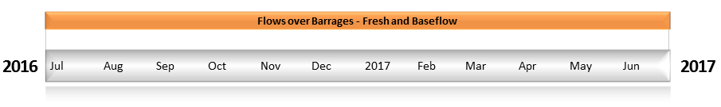
Figure CLM2. Timing and duration of Commonwealth environmental water actions delivered in the Coorong Lower Lakes valley.

Contribution of Commonwealth Environmental Water to Flow Regimes
Barrages
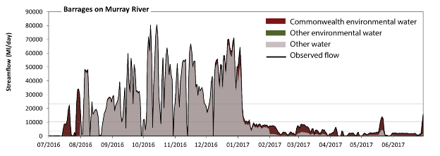
Figure CLM3. Contribution of environmental water delivery at Barrages. Horizontal lines indicate thresholds for very low flows, low flows, low freshes, medium freshes and high freshes (from lowest to highest).
At the Barrages on the Murray River environmental water contributed 12% of the total streamflow volume (all of which was Commonwealth environmental water). Environmental watering actions affected streamflows for 96% of days between 1 July 2016 and 30 June 2017. Without environmental water, the durations of very low flows (i.e. < 690 ML/day) in the periods July to September, January to March and April to June would have substantially exceeded durations expected in an average year in the natural flow regime. Environmental water mitigated these impacts by reducing the cumulative duration of very low flow spells from 36% to 13% of the year, with greatest influence in the period April to June. Similarly, without environmental water, the durations of medium low flows (i.e. < 3500 ML/day) in the periods July to September, January to March and April to June would have substantially exceeded durations expected in an average year in the natural flow regime. Environmental water mitigated these impacts by reducing the cumulative duration of medium low flow spells from 52% to 38% of the year, with greatest influence in the period January to March. Commonwealth environmental water was entirely responsible for these enhancements of environmental baseflows at this site. In the absence of environmental water there would have been at least one low fresh (i.e. > 10000 ML/day) in the periods July to September, October to December and January to March. Environmental water increased the duration of the longest low fresh during the period April to June (from 0 days to 3 days). Commonwealth environmental water was entirely responsible for these increased durations of low freshes. There was at least one medium fresh (i.e. > 23000 ML/day) in the periods July to September, October to December and January to March. Environmental water made no change to the duration of these medium freshes. In the absence of environmental water there would have been at least one high fresh in the periods July to September, October to December and January to March. Environmental water made no change to the duration of these high freshes.

