

**2017–18 Basin-scale evaluation of Commonwealth environmental water – Ecosystem Diversity**

**Prepared by:** Shane Brooks

Final Report

**La Trobe Publication 234/2019**

2017–18 Basin-scale evaluation of Commonwealth environmental water — Ecosystem Diversity

Report prepared for the Commonwealth Environmental Water Office by La Trobe University

For further information contact:

**Professor Nick Bond**

Centre for Freshwater Ecosystems  
La Trobe University  
PO Box 821   
Wodonga VIC 3689

Ph: (02) 6024 9650

Email: [N.Bond@latrobe.edu.au](mailto:N.Bond@latrobe.edu.au)   
Web: [www.latrobe.edu.au/freshwater-ecosystems](http://www.latrobe.edu.au/freshwater-ecosystems)   
Enquiries: [cfe@latrobe.edu.au](mailto:mdfrc@latrobe.edu.au)

**Report Citation:** Brooks S (2019) 2017–18 Basin-scale evaluation of Commonwealth environmental water – Ecosystem Diversity. Final Report prepared for the Commonwealth Environmental Water Office by La Trobe University, Publication 234/2019, September, 44pp.

This monitoring project was commissioned and funded by Commonwealth Environmental Water Office.

**Copyright**

© Copyright Commonwealth of Australia, 2019



2017–18 Basin-scale evaluation of Commonwealth environmental water – Ecosystem Diversity (2019) is licensed by the Commonwealth of Australia for use under a Creative Commons By Attribution 3.0 Australia licence with the exception of the Coat of Arms of the Commonwealth of Australia, the logo of the agency responsible for publishing the report, content supplied by third parties, and any images depicting people. For licence conditions see: <http://creativecommons.org/licenses/by/3.0/au/>

This report should be attributed as: Brooks S (2019) 2017–18 Basin-scale evaluation of Commonwealth environmental water – Ecosystem Diversity. Final Report prepared for the Commonwealth Environmental Water Office by La Trobe University, Publication 234/2019, September, 44pp.

**Disclaimer**

The views and opinions expressed in this publication are those of the authors and do not necessarily reflect those of the Australian Government or the Minister for the Environment.

**While reasonable efforts have been made to ensure that the contents of this publication are factually correct, the Commonwealth does not accept responsibility for the accuracy or completeness of the contents, and shall not be liable for any loss or damage that may be occasioned directly or indirectly through the use of, or reliance on, the contents of this publication.**

**The material contained in this publication represents the opinion of the author(s) only. While every effort has been made to ensure that the information in this publication is accurate, the author(s) and La Trobe University do not accept any liability for any loss or damage howsoever arising whether in contract, tort or otherwise which may be incurred by any person as a result of any reliance or use of any statement in this publication. The author(s) and La Trobe University do not give any warranties in relation to the accuracy, completeness and up-to-date status of the information in this publication.**

Where legislation implies any condition or warranty which cannot be excluded restricted or modified, such condition or warranty shall be deemed to be included provided that the author’s and La Trobe University’s liability for a breach of such condition or warranty is, at the option of La Trobe University, limited to the supply of the services again or the cost of supplying the services again.

Document history and status

|  |  |  |  |  |
| --- | --- | --- | --- | --- |
| **Version** | **Date Issued** | **Reviewed by** | **Approved by** | **Revision type** |
| Final | 14/8/2019 | S. Brooks | N. Thurgate | Final |
| Final | 1/10/2019 | S. Brooks | K Stuart-Williams | Final |

Distribution of copies

|  |  |  |
| --- | --- | --- |
| **Version** | **Quantity** | **Issued to** |
| Draft | 1 word doc | CEWO |
| Final | 1 word doc and 1 pdf | CEWO |

**Filename and path:** Projects\CEWO\CEWH Long Term Monitoring Project\499 LTIM Stage 2 2014-19 Basin evaluation\Final Reports

**Author(s):** Shane Brooks

**Author affiliation(s):** LitePC Technologies Pty Ltd

**Project Manager:** Nicole Thurgate

**Client:** Commonwealth Environmental Water Office

**Project Title:** Basin evaluation of the contribution of Commonwealth environmental water to the environmental objectives of the Murray‒Darling Basin Plan

**Document Version:** Final

**Project Number:** M/BUS/499

**Contract Number:** PRN 1213-0427

**Acknowledgements:**

This project was undertaken using data collected for the Commonwealth Environmental Water Office Long Term Intervention Monitoring Project. The assistance provided by the Monitoring and Evaluation Providers into interpretation of data and report review is greatly appreciated. The author would also like to thank Commonwealth Environmental Water Office staff, State water agency staff, and LTIM Monitoring and Evaluation Providers who contributed to detailed mapping of inundation from watering actions that is a core input to this report. Thank you to the LTIM Hydrology team for compiling the inundation maps.

The La Trobe University offices are located on the land of the Latje Latje and Wiradjuri peoples. We undertake work throughout the Murray–Darling Basin and acknowledge the traditional owners of this land and water. We pay respect to Elders past, present and future.

Contents

1 Preface 1

2 Introduction 1

3 Method 3

3.1 Data 3

3.2 Approach 8

4 Ecosystem Diversity Basin-scale evaluation 9

4.1 Highlights 9

4.2 Basin-scale evaluation 2017–18 10

4.3 Cumulative Basin-scale evaluation (2014–18) 15

4.4 Adaptive management 19

5 Contribution to achievement of Basin Plan objectives 22

References 23

Annex A. GIS Workflow 25

Annex B. Ongoing evolution of the Basin ANAE classification 26

Annex C. ANAE wetland types influenced by Commonwealth environmental water by valley 27

Annex D. ANAE floodplain types inundated by Commonwealth environmental water by valley 35

Annex E. ANAE river channel types influenced by Commonwealth environmental water by valley 39

List of tables

**Table 1.** Area of each LTIM catchment inundated by Commonwealth environmental water in 2017–18, including both floodplain and wetland ecosystem types. 11

Table 2. Contribution of Commonwealth environmental water to ecosystem diversity of lakes and wetlands at the basin-scale. Ecosystem types are sorted by the area influenced by Commonwealth environmental water. 12

Table 3. Contribution of Commonwealth environmental water to ecosystem diversity of floodplains at the Basin-scale, sorted by the area inundated. 13

Table 4. Contribution of Commonwealth environmental water to ecosystem diversity within river channels of the Basin sorted by the area influenced by Commonwealth environmental water. 13

Table 5. Ecosystem types in the Coorong, Lower Lakes and Murray Mouth that are influenced by Commonwealth environmental water. Ecosystem types are sorted by the area inundated by Commonwealth environmental water. 14

Table 6. Comparison of the contribution of Commonwealth environmental water to ecosystem diversity of lakes and palustrine wetlands from 2014-18 (sorted by the magnitude of watering in the 2017-18 water year). Ecosystem types with more than 5% of their total Basin area inundated in any one year are shaded pale blue. Ecosystem types that have not received Commonwealth environmental water during the period of LTIM are shaded red. Large differences (>10%) from previous years are highlighted in dark blue. 17

Table 7. Comparison of the contribution of Commonwealth environmental water to ecosystem diversity of floodplains from 2014-18 (sorted by the magnitude of watering in the 2017-18 water year). Ecosystem types with more than 5% of their total Basin area inundated in any one year are shaded pale blue. Ecosystem types that have not received Commonwealth environmental water during the period of LTIM are shaded red. Large differences (>10%) among years are highlighted in dark blue. 19

Table 8. Commonwealth Environmental Outcomes framework for ecosystem diversity. 22

Table C1. Area of each lake and wetland ecosystem type and the contribution of Commonwealth environmental water to supporting wetland ecosystem diversity within each valley, sorted by the area influenced with inundation highlighted in blue (excludes in-channel flows presented in Annex E). 27

Table D1. Area of each floodplain ecosystem type and the contribution of Commonwealth environmental water to supporting floodplain ecosystem diversity within each valley, sorted by the area inundated with inundation highlighted in blue. 35

Table E1. Length of river and stream ecosystem types influenced by the delivery of Commonwealth environmental water (shaded blue) as represented by the Basin ANAE waterways data set in each valley 39

List of figures

Figure 1. Hierarchical levels of biodiversity in aquatic ecosystems (Geist 2011) 1

Figure 2. Cause-and-effect diagram depicting the influence of flow on landscape ecosystem diversity (MDFRC 2013). 2

Figure 3. Structure and levels of the Interim Australian National Aquatic Ecosystem Classification Framework (Aquatic Ecosystems Task Group 2012). 3

Figure 4. Aquatic ecosystems of the Murray-Darling Basin (ANAE 2018 mapping). 4

Figure 5. Revision history for the ANAE mapping in the Basin. 5

Figure 6. Commonwealth environmental water 2017–18. 6

Figure 7. Valley boundaries within the Murray–Darling Basin used in this evaluation. 7

Figure 8. Wetland ecosystem types that have not been represented in Commonwealth environmental water inundation extents during the period of LTIM are predominantly located in unregulated valleys or higher in the catchments above water storages. 18

Abbreviations

ANAE Australian National Aquatic Ecosystem (classification)

CEWO Commonwealth Environmental Water Office

GIS geographical information system

ha hectare

LTIM Long Term Intervention Monitoring

MDBA Murray–Darling Basin Authority

# Preface

This report uses the 2017 update of the Australian National Aquatic Ecosystem (ANAE) classification of the Basin to evaluate the contribution of Commonwealth environmental water to Ecosystem Diversity in the Basin. The 2017 update revised the ecosystem typology and substantially changed the number and extent of mapped aquatic ecosystems in areas that receive Commonwealth environmental water (Brooks 2017a). Results presented herein should not be compared to those in LTIM Ecosystem Diversity reports from the first two years of the project that used the obsolete “interim” ANAE classification (Brooks 2016, 2017b).

A cumulative comparison across the full duration of the LTIM project was achieved in 2018 by re-evaluating the contribution of Commonwealth environmental water delivered in each of the previous years against the revised ANAE classification (Brooks 2018). This current report extends that cumulative evaluation to include the 2017-18 water year.

Changes to the ANAE classification are expected as new and improved mapping and knowledge to classify ecosystem types becomes available. When this occurs, the cumulative evaluation of Ecosystem Diversity outcomes across years can be repeated against the revised classification to provide a consistent long-term LTIM Ecosystem Diversity data set.

Much of the introductory text and methods is repeated from previous LTIM Ecosystem Diversity evaluation reports to enable this report to stand alone for the convenience of the reader.

# Introduction

Biological diversity describes the variety of living organisms and ecosystems on Earth. The concept of biodiversity is often understood in terms of numbers of species of microbes, plants and animals but increasingly the definition is expanded to include other forms of natural variation such as genetic diversity, ecosystem diversity and diversity of ecosystem function (Figure 1). Conservation biology is often focused on protecting and restoring ecosystems on the basis that this also preserves the communities and species within them in addition to critical ecosystem functions and services that ecosystems may provide to us (Cadotte *et al.* 2011; Pollock *et al.* 2017)

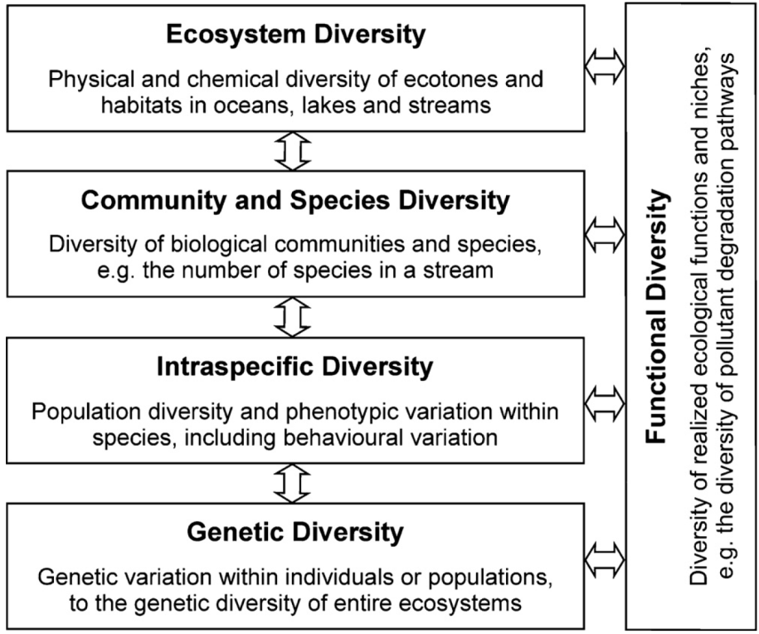

Figure 1. Hierarchical levels of biodiversity in aquatic ecosystems (Geist 2011)

There is increasing recognition globally that conserving biodiversity is critically important to maintain the functioning of natural ecosystems and for the sustainability of resources and ecosystem services on which human survival depends. Australia has joined 195 other countries as signatories to the United Nations Convention on Biological Diversity (1993, <https://www.cbd.int>) which provides guidance and impetus for conserving biodiversity and promoting sustainable development and sharing of genetic resources. The Basin Plan (Commonwealth of Australia 2012) is consistent with these objectives as it balances the need for sustainable water resource use with the environmental imperative to protect and restore biodiversity that is dependent on those same water resources.

Managed delivery of Commonwealth environmental water to aquatic ecosystems in the Basin supports water-dependent flora and fauna and provides the physical and chemical conditions that determine how those ecosystems function (Junk *et al.* 1989; Poff 1997; Thorp *et al.* 2006). Over decadal time scales, environmental water has potential to influence physical landscape diversity through geomorphological processes (Figure 2). In practice, however, the frequency and volumes of Commonwealth environmental water that are delivered are constrained by storage volumes, infrastructure, and land use to volumes that complement natural hydrological regimes and therefore large changes to the distribution and abundance of ecosystem types in the Basin are not expected within the duration of the LTIM project (5 years).

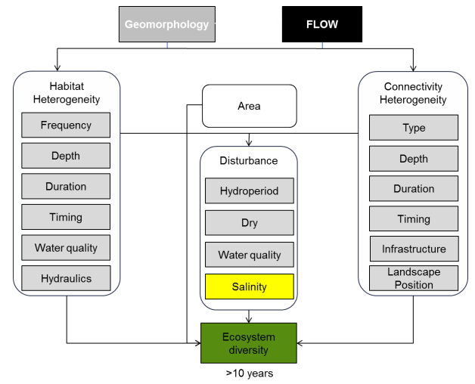

Figure 2. Cause-and-effect diagram depicting the influence of flow on landscape ecosystem diversity (MDFRC 2013).

This evaluation catalogues the different ecosystem types in the Basin that received Commonwealth environmental water during the 2017–18 water year. Evaluating the extent to which water-dependent ecosystem types have been supported by Commonwealth environmental water contributes to assessing the contribution of Commonwealth environmental water to Basin Plan biodiversity objectives as outlined in the Commonwealth Environmental Water Outcomes Framework (CEWH 2013).

# Method

Ecosystem types in the Basin are defined using the interim ANAE Classification Framework (Aquatic Ecosystems Task Group 2012). The framework provides a consistent ecosystem type classification that can inform cross-jurisdictional adaptive management of aquatic ecosystems (

Figure 3).

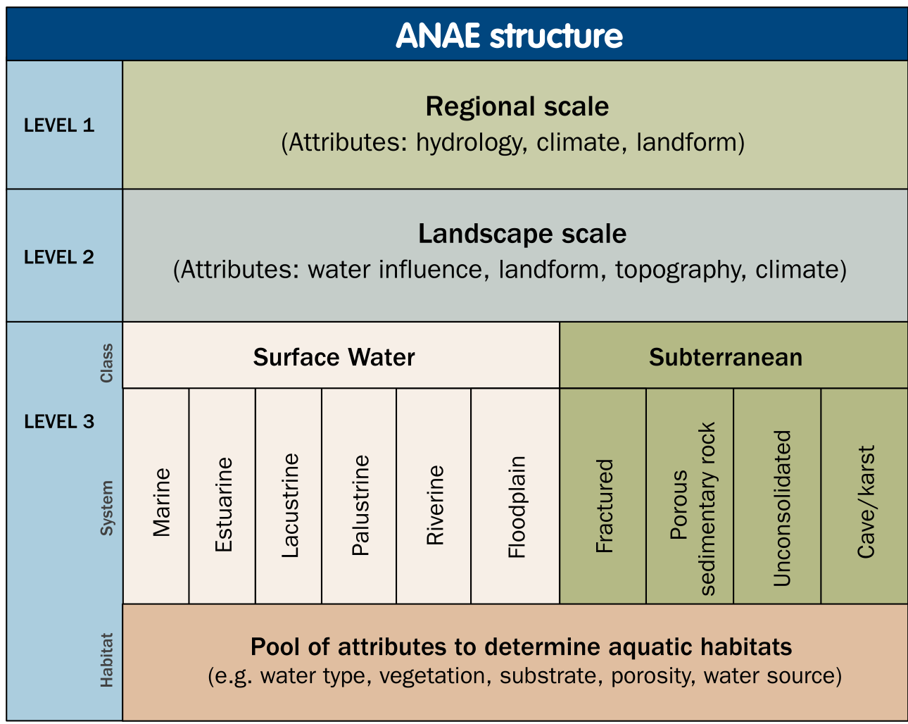

Figure 3. Structure and levels of the Interim Australian National Aquatic Ecosystem Classification Framework (Aquatic Ecosystems Task Group 2012).

The ANAE classification framework was applied to the best available jurisdictional mapping for Basin wetlands, floodplains and rivers by Brooks *et al.* (2014) to produce the interim Murray-Darling Basin Aquatic Ecosystem Classification data set. With subsequent updates (Brooks 2017a), this data set provides the LTIM project with relevant and contemporary ecosystem type definitions and mapping of their distribution throughout the Basin.

Overlaying the ANAE ecosystem map with the distribution of Commonwealth environmental water that was delivered in the Basin can then identify which ecosystem types received Commonwealth environmental water to answer the following short-term (1-year) and long-term (5-year) Basin-scale evaluation question:

1. *What did Commonwealth environmental water contribute to ecosystem diversity?*

## Data

Data inputs to the evaluation of ecosystem diversity include:

The Murray-Darling Basin ANAE data set (Brooks *et al.* 2014; Brooks 2017a) (Figure 4). In 2017 the ANAE classification of the Basin underwent a substantial revision designed to improve the accuracy and currency of aquatic ecosystem mapping and to integrate all ecosystem types into a single aquatic ecosystem map for the Basin (Brooks 2017a). Additional changes were made in 2018 to further refine the classification of floodplains and to add new mapping for floodplains in QLD to improve consistency of mapping across state borders (Figure 5).   
  
As a result of all the changes to the ecosystem mapping, the Ecosystem Diversity evaluation results presented in this report are not comparable to those presented in the first two years of the LTIM project (Brooks 2016, 2017b). A cumulative comparison across the full duration of the LTIM project was made in 2018 using the revised classification and is extended to include the 2017-18 water year below (Section 4.3).

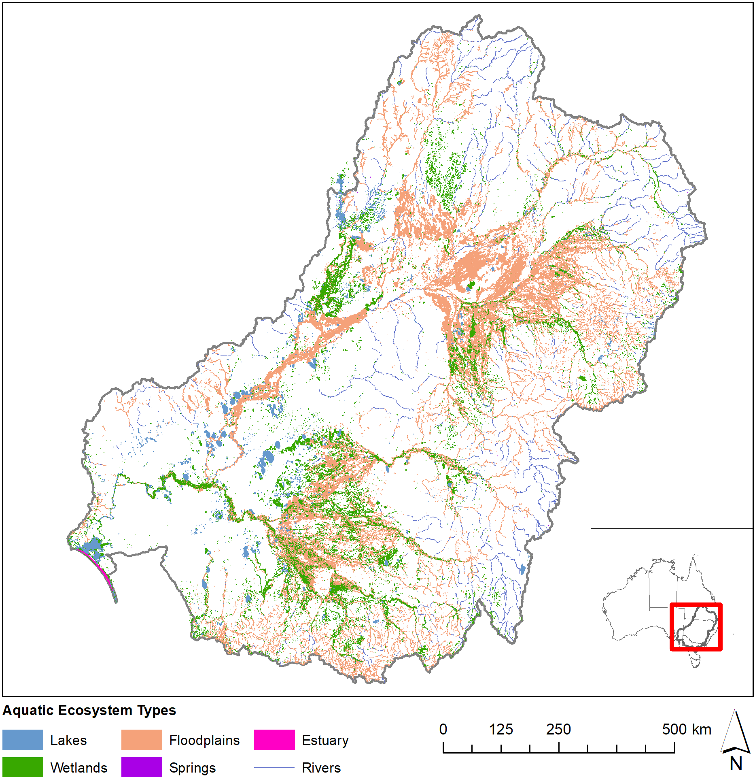

Figure 4. Aquatic ecosystems of the Murray-Darling Basin (ANAE 2018 mapping).

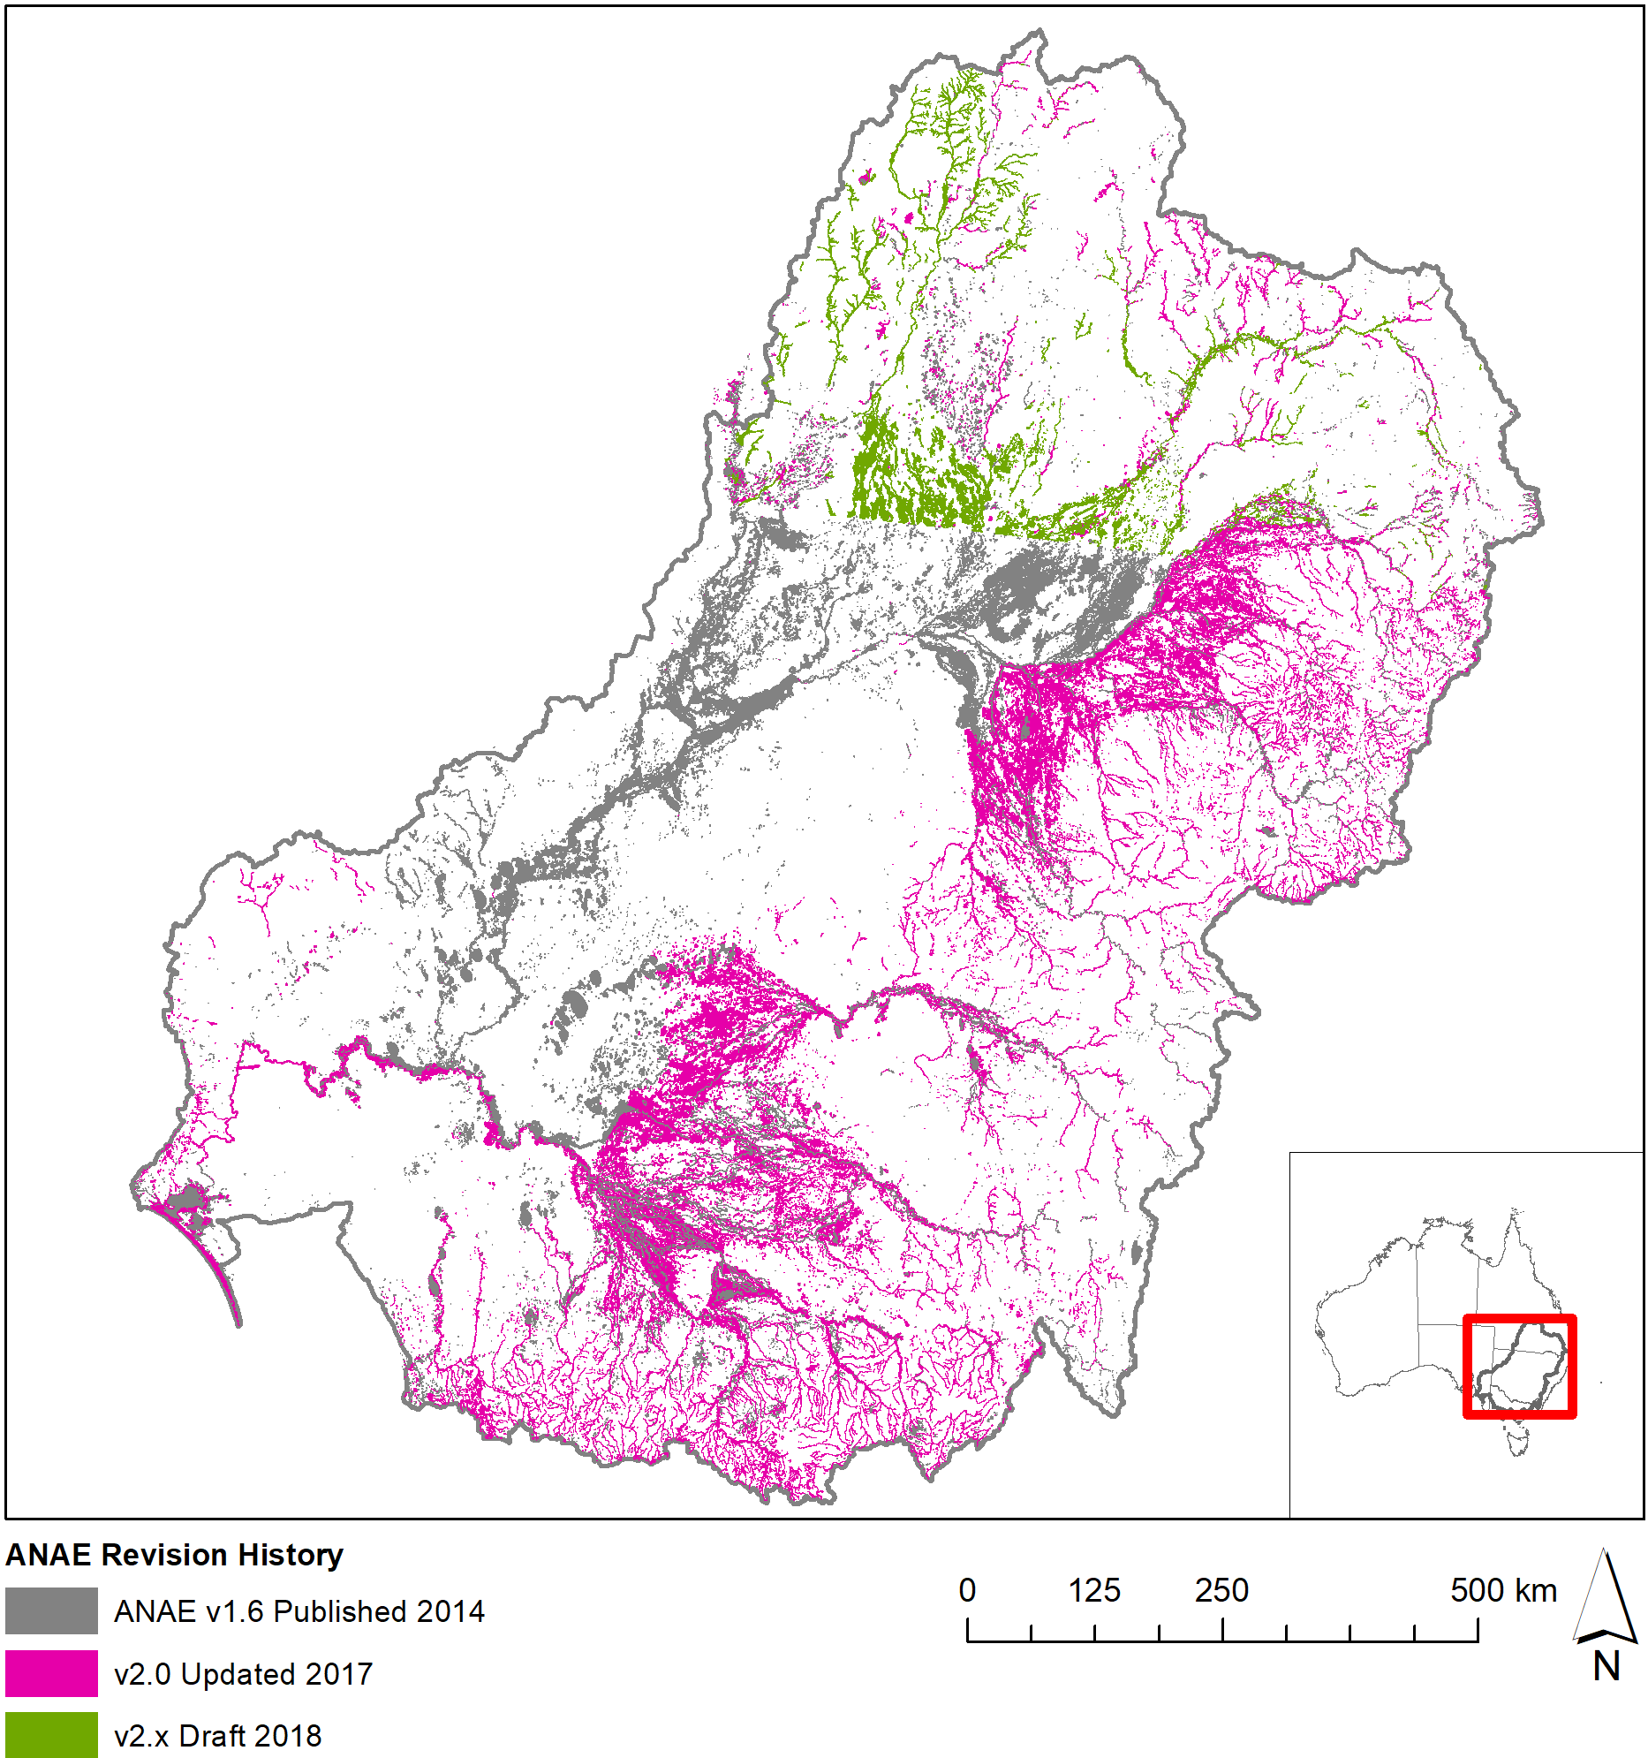

Figure 5. Revision history for the ANAE mapping in the Basin.

Commonwealth environmental water Inundation 2017–18 — a spatial representation of watering extent for Commonwealth environmental water delivered in the 2017–18 water year (Stewardson & Guarino 2019) (Figure 6). Commonwealth environmental water may include other environmental water (e.g. from State agencies) in a combined delivery and the extent mapped is the combined extent.

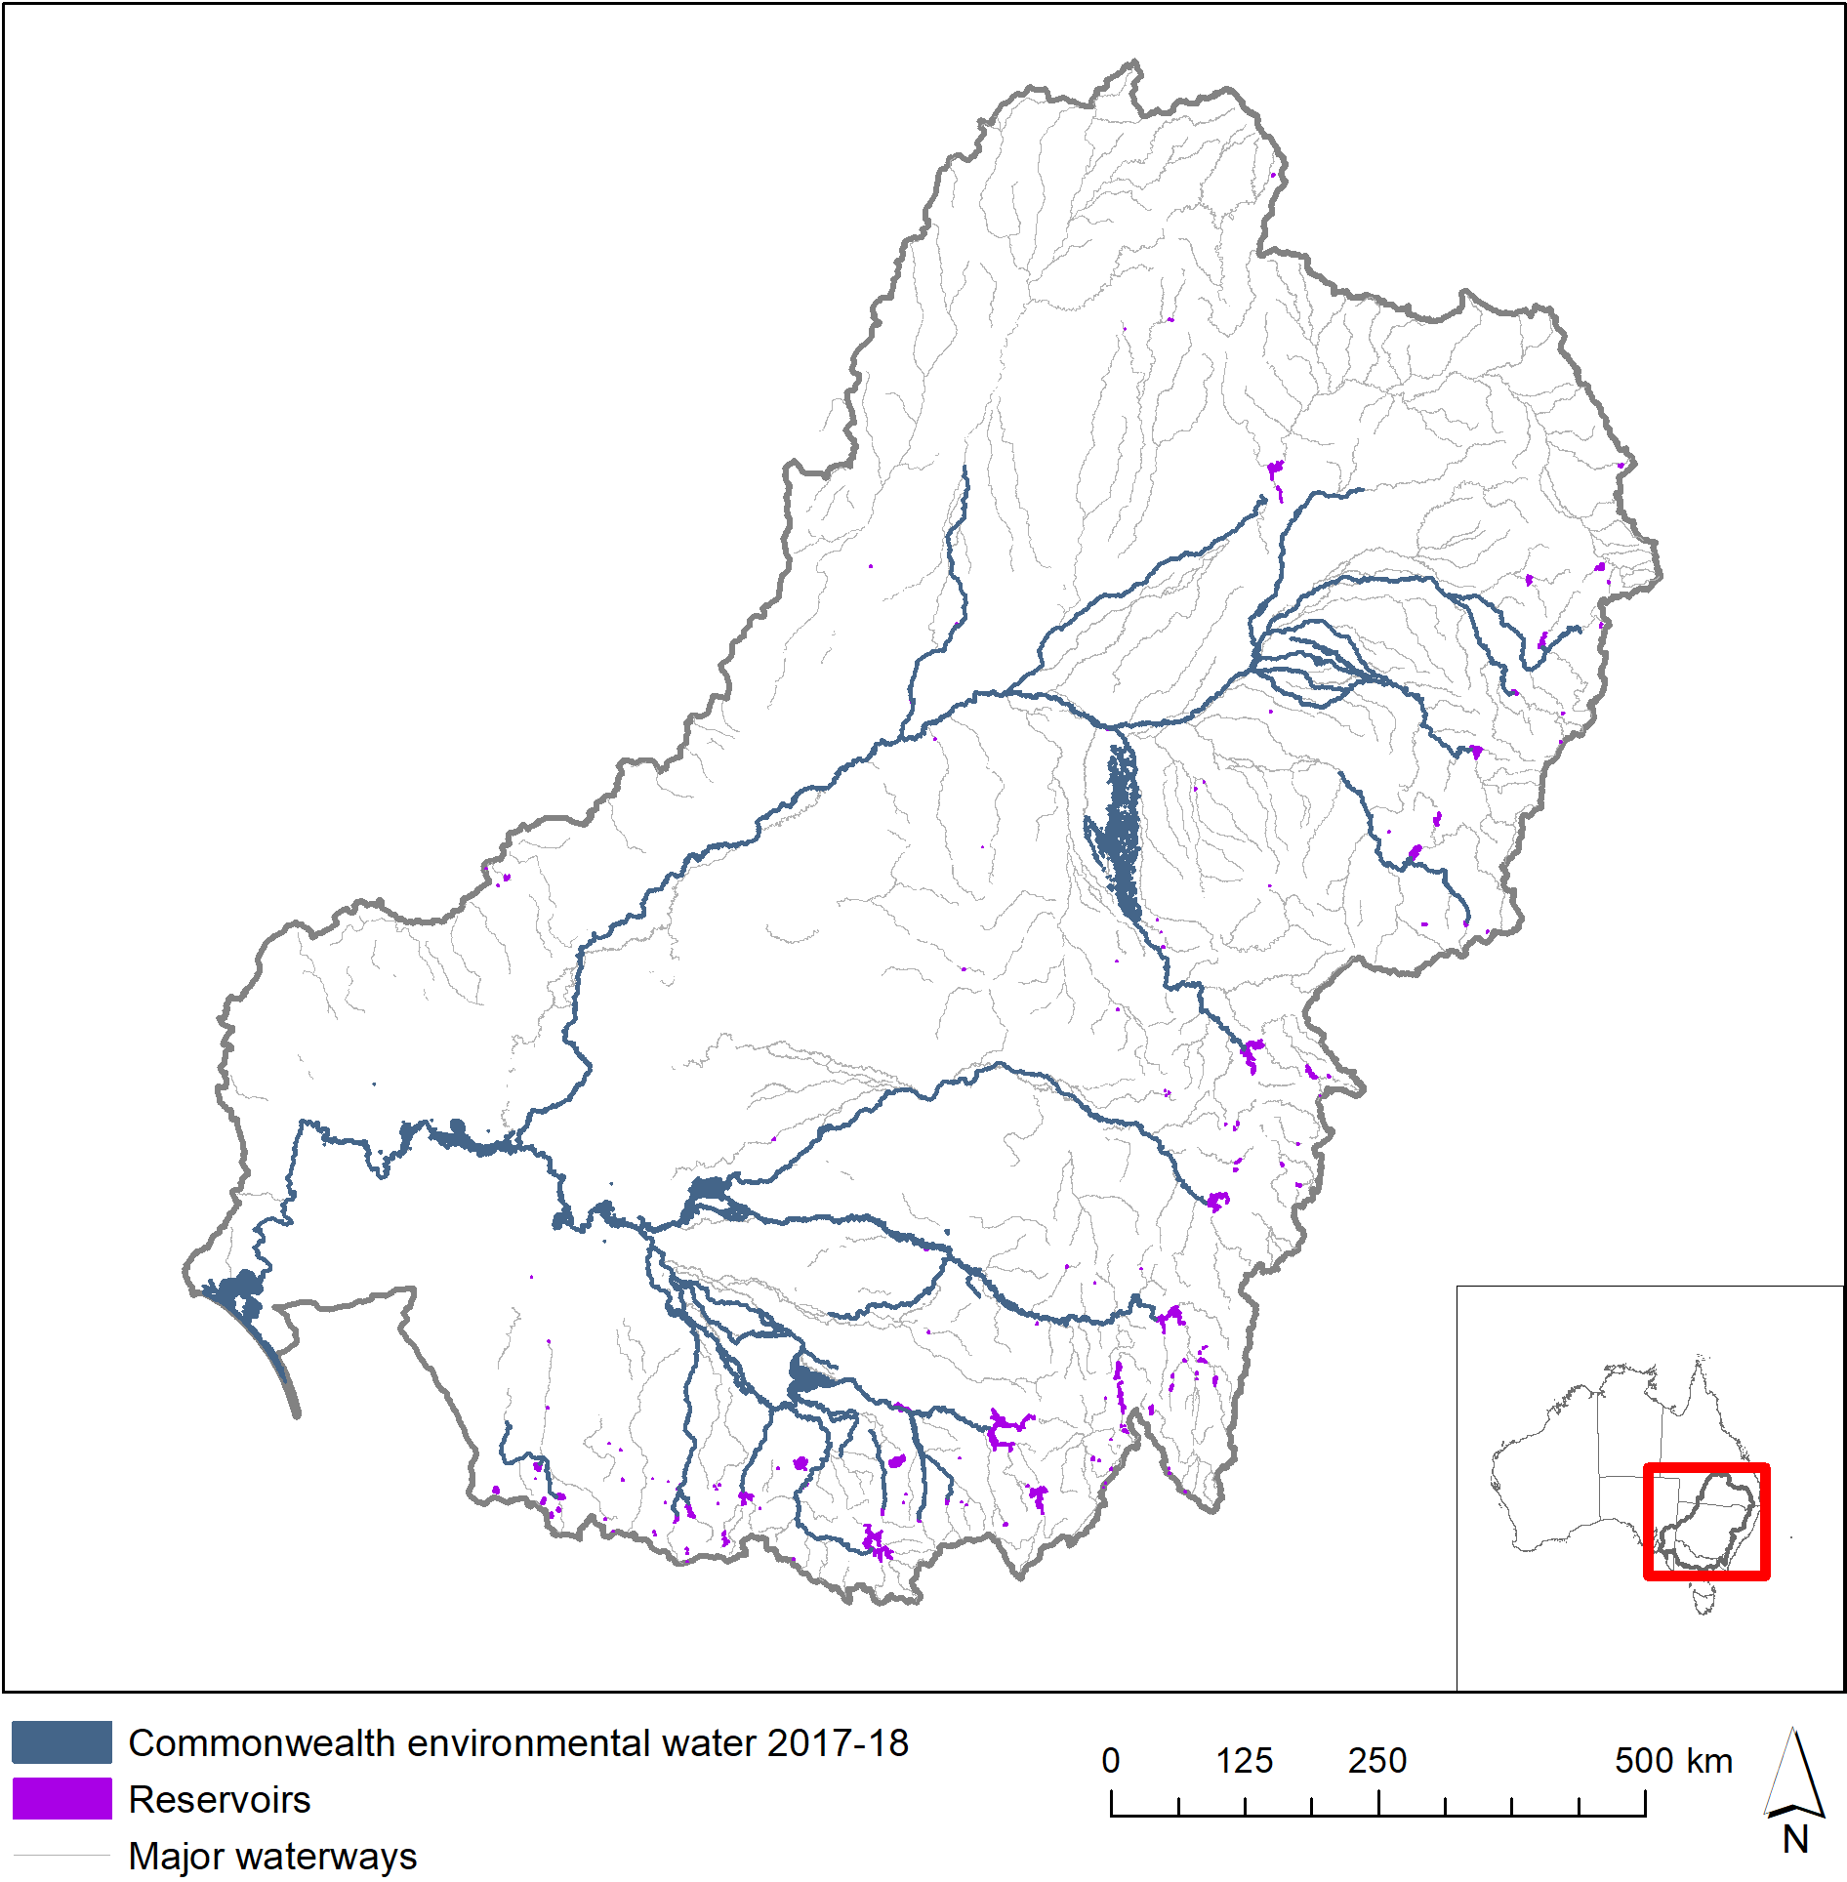

Figure 6. Commonwealth environmental water 2017–18.

LTIM valleys — a spatial layer developed for the LTIM project that subdivides the Basin into the major river valleys (Figure 7). These boundaries were derived from the Sustainable Rivers Audit (SRA) catchment boundaries with a modification to separate the Edward-Wakool Catchment from the Central Murray. The boundaries were adjusted slightly to improve the assignment of wetlands near valley boundaries to the watersheds in which managers and Commonwealth environmental water accounting allocate them. Mostly these changes affect the Central Murray area with a widening along the Murray River corridor to encompass fringing wetlands and the Gunbower and Barmah forests, and southern expansion of the Murrumbidgee valley to include Yanco Creek within the Murrumbidgee valley.

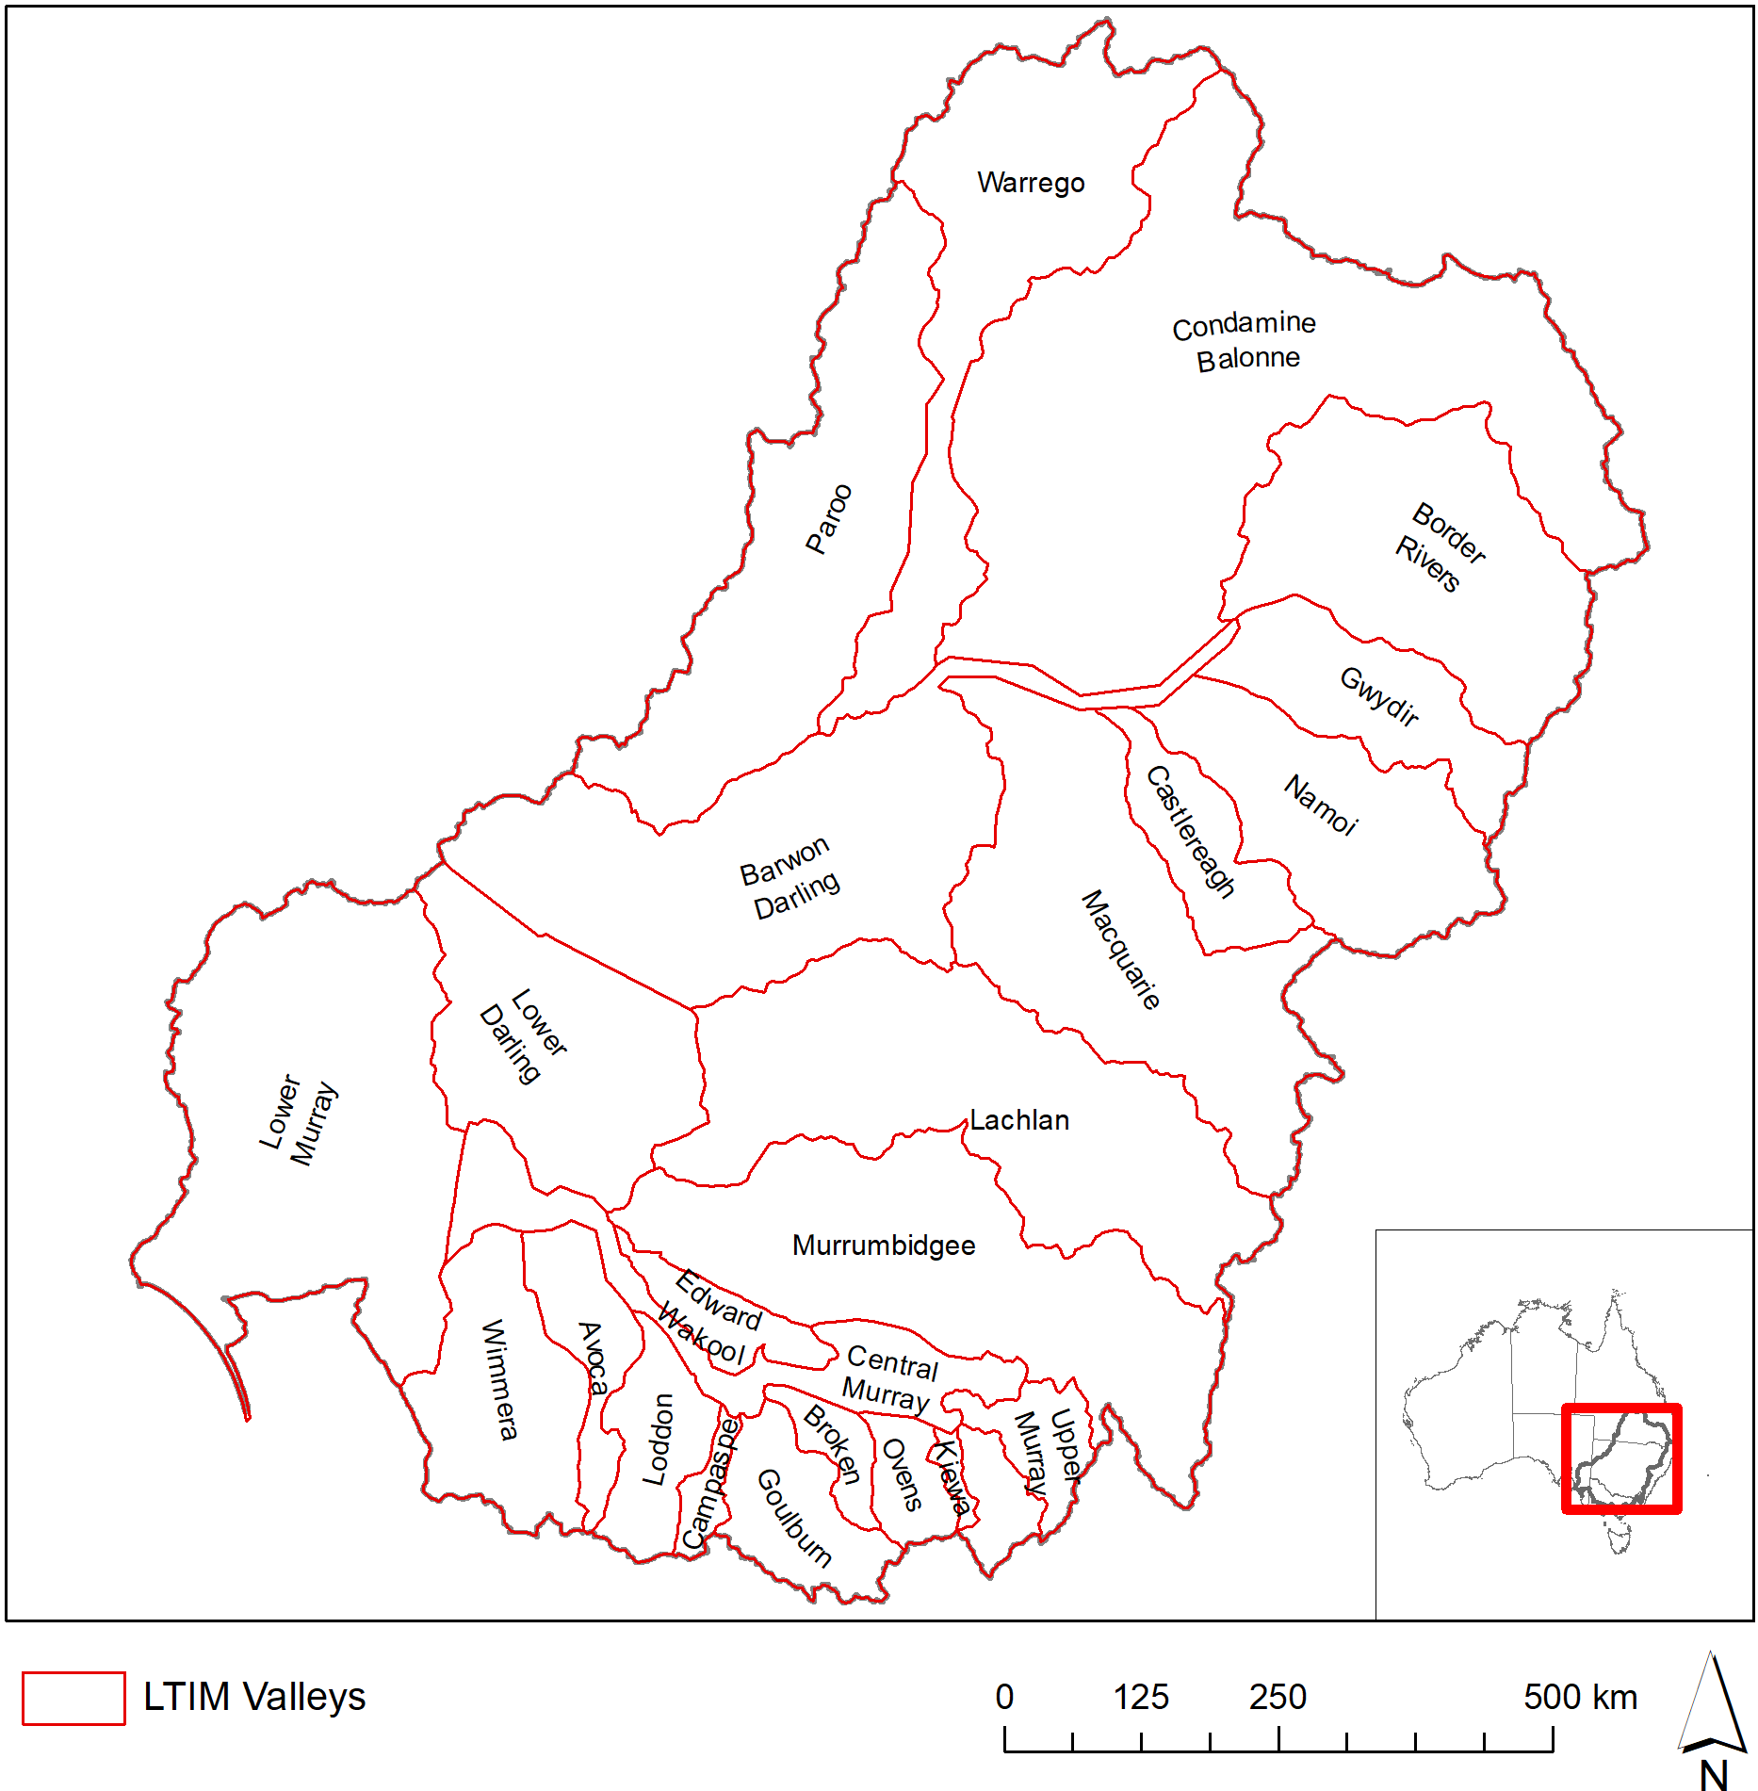

Figure 7. Valley boundaries within the Murray–Darling Basin used in this evaluation.

Geofabric v3 River Lines — new in this year’s report is the mapping of river lines using the new Australian Geofabric v3 Network river lines (BOM 2019). This newly released beta product is still under development however the river line mapping is complete and provides more accurate and more consistent mapping for rivers than is available in the spatial maps compiled from jurisdiction data in the ANAE data set. The Basin ANAE waterway mapping compiles state data that varies in resolution from 1:25 000 to 1:250 000 (equivalent to 25m to 250m accuracy) The Geofabric v2 Network Streams were generated from a 1 second DEM (30m) resolution consistently for the entire Basin. The consistent resolution is important because river length measurement is highly dependent on the level of detail in the mapping with higher resolution mapping capturing more twists and turns in the river that increase the measured river length along the flow path between two points.

## Approach

As in previous years, two different approaches were used to quantify the area of different ecosystem types that received Commonwealth environmental water:

1. Area inundated by Commonwealth environmental water = the sum of only the inundated areas of each wetland type, excluding the areas of wetlands that were not inundated.
2. Area influenced by Commonwealth environmental water = the sum of the all wetland areas that received water even if the inundation mapping showed that only a portion of the wetland was inundated.

The area *inundated* by Commonwealth environmental water is a ‘literal’ definition that represents the minimum contribution of Commonwealth environmental water in the landscape. The area *influenced* by Commonwealth environmental water acknowledges that aquatic ecosystems are complex interconnected systems and delivering water to part of a wetland contributes benefits to the entire wetland system. For example, filling a wetland depression may raise local water tables and benefit fringing vegetation, or provide feeding habitat for waterbirds that roost elsewhere in the wetland vegetation that was not inundated.

For lakes and palustrine wetlands, the total area *influenced* by Commonwealth environmental water is the appropriate measure of the contribution of Commonwealth environmental water to ecosystem diversity because water entering one part of a wetland depression is likely to raise water levels or the local water table across the extent.

For floodplains, the area *inundated* by Commonwealth environmental water is used to measure the contribution of Commonwealth environmental water to ecosystem diversity. This more conservative measure is used for floodplains because floodplains occur as broad continuous expanses and the ecosystem response is generally limited to the wetted area. Depressional wetlands and channels that hold or convey water through floodplains are considered as separate entities.

GIS methodologies for calculating these areas are provided attached in Annex A.

The spatial representation of watering extent for Commonwealth environmental water delivered in 2017–18 includes all watering actions that resulted in inundation beyond the river channel (Stewardson & Guarino 2019). River reaches that received in-channel pulses, freshes and passing flows are also identified (Figure 6); however, the river channel inundation mapping is not of sufficient resolution to identify inundation of river banks and fringing habitats along the channels.

Commonwealth environmental water reaching the end of the system contributes to the maintenance of the Coorong, Lake Alexandrina, Lake Albert and the Murray Mouth ecosystems. Reliable inundation models for this area do not exist at this time so the extent of inundation is estimated from the mapped extent of the Coorong, Lake Alexandrina, Lake Albert and the Murray Mouth. This estimate is considered reliable because the lakes are managed for a relatively constant water level of 0.5 to 0.8m AHD by regulating outflows through the barrages. Below the barrages, water levels in the Murray Mouth and Coorong are maintained near sea level.

# Ecosystem Diversity Basin-scale evaluation

## Highlights

**In the 2017–18 water year:**

* In 2017–18 there were approximately 104 500 ha of lakes and wetlands, nearly 40 000 ha of floodplains and 19 000 km of rivers in the Basin upstream of the Lower Lakes that was supported by Commonwealth environmental water.
* Commonwealth environmental water supported another 118 000 ha of Lake Alexandrina and Lake Albert and their fringing wetlands and 24 000 ha of estuarine habitat in the Coorong and Murray Mouth.
* All seven LTIM Selected Areas received Commonwealth environmental water with substantial areas also being inundated in the Macquarie, Murrumbidgee and Central Murray valleys (watering of Macquarie Marshes, Murrumbidgee river wetlands and Barmah-Millewa Forest).
* 70% of the different wetland ecosystem types and 83% of floodplain ecosystem types in the Basin were represented in the area inundated by Commonwealth environmental water.
* Of the wetland and floodplains receiving Commonwealth environmental water, 43% of the inundated area was dominated by temporary river red gum swamps and riparian floodplain (65 500 ha) along the Murrumbidgee River, the Barmah-MIllewa forest and then further downstream an the Murray-River floodplains in South Australia . This is 6% of the area of these ecosystem types in the Basin.
* Many permanent wetlands and lakes were also supported (38 000 ha excluding Lake Alexandrina and Albert or approximately 121 000 ha when the lower lakes are included) and 18% were meadows and marshes (27 000 ha) primarily in Gwydir and Macquarie valleys.
* Approximately 42% of the wetland areas that received Commonwealth environmental water were classed as temporary (intermittent) ecosystem types. These areas can be hot-spots for diversity if they support different suites of species in the dry and wet phases.
* As in previous years, Commonwealth environmental water contributed to all estuarine ecosystem types in the Basin during 2017–18 as environmental flows passed through to the Murray Mouth and Coorong.
* Thirteen of the rarest aquatic ecosystem types in the Basin, which include various types of paperback swamp, peat bogs and fens, lakes with aquatic macrophyte beds and saline marshes are mostly located in unmanaged catchments or above major storages. These ecosystem types may be outside the scope of Commonwealth environmental water releases from storages and can only be supported by Commonwealth environmental water where unregulated entitlements can be used to facilitate passing flows.

**Comparing the four watering years 2014–15 to 2017–18:**

* The broad pattern of watering across ecosystem types is similar across all the four years with 50% of ecosystem types supported to some extent by Commonwealth environmental water in all four years and 40% of ecosystem types not receiving any Commonwealth environmental water in any year over the same period. Gwydir wetlands, Macquarie Marshes, the Lowbidgee have received Commonwealth water in all years as has the Coorong, Lower Lakes and Murray mouth at the end of the system.
* 2017–18 was characterised by the large environmental flows down the Murrumbidgee River that inundated many permanent wetlands and lakes, temporary red gum swamps and marshes adjacent to the Murrumbidgee before then inundating river red gum floodplains along the Murray River into South Australia. Commonwealth water was also used to flood a greater extent of temporary red gum forest in the Barmah-Millewa forest this year than any previous year. This is a similar distribution of supported ecosystem types to that of 2015–16 albeit with less inundation of lignum swamps along the Lachlan river system and more inundation of temporary red gum swamps along the Murrumbidgee.
* The 2014–15 and 2016–17 water years did not include inundation of red gum swamps of the Barmah Millewa forest however these areas were supported by environmental water from NSW and Victoria.

## Basin-scale evaluation 2017–18

This evaluation does not consider the details of individual watering events and is ignorant of the specific timing and duration of Commonwealth environmental water in different areas of the landscape. The inundation map (Figure 6) collapses the maximum wetted extent of all watering actions during 2017–18 that included Commonwealth environmental water. The area inundated in each valley, and the length of river channels influenced by Commonwealth environmental water is presented in Table 1.

The contribution of Commonwealth environmental water to Ecosystem Diversity upstream of the Lower Lakes is presented under the broad system type categories: lakes and wetlands (Table 2), floodplains (Table 3), river channels (Table 4). The contribution of Commonwealth environmental water to Ecosystem Diversity in the Coorong and Lakes Alexandrina and Albert and the Murray Mouth are presented separately in (Table 5) for two reasons: the large areas of Lakes Alexandrina and Albert (82 500 ha) from masking finer scale patterns of inundation of lakes in the rest of the Lower Murray valley; and the constant managed water levels of the Lakes inundating the same ecosystems each year may hinder evaluation of more variable inter-annual differences in the use of Commonwealth environmental water in other areas of the Basin.

Commonwealth environmental watering actions contributed to the inundation of a wide range of ecosystem types within the Basin that included 51% of the different wetland types and 83% of the different floodplain types, and all (100%) of the river channel and estuarine ecosystem types.

A more detailed breakdown by valley is provided in Annex C (wetlands and estuarine ecosystems), Annex D (floodplains) and Annex E (river channels).

**Table 1.** Area of each LTIM catchment inundated by Commonwealth environmental water in 2017–18, including both floodplain and wetland ecosystem types.

|  |  |  |  |  |
| --- | --- | --- | --- | --- |
| Catchment name | LTIM Selected Area | Lakes and wetland area influenced (ha) | Floodplain area inundated (ha) | Length of waterways influenced (km) |
| Avoca |  | – | – | – |
| Barwon Darling |  | – | – | 1899 |
| Border Rivers |  | - | – | 1349 |
| Broken |  | 181 | – | 347 |
| Campaspe |  | – | – | 114 |
| Castlereagh |  | – | – | - |
| Central Murray |  | 35 783 | 7716 | 2460 |
| Condamine Balonne |  | – | – | 505 |
| Edward–Wakool | Edward–Wakool river system | 104 | 23 | 976 |
| Goulburn | Goulburn River | – | – | 415 |
| Gwydir | Gwydir river system | 5303 | 2074 | 1149 |
| Kiewa |  | – | – | - |
| Lachlan | Lachlan river system | 5822 | 3437 | 1423 |
| Loddon |  | – | – | 374 |
| Lower Darling |  | 335 | 37 | 624 |
| Lower Murray* | Lower Murray River* | 31 223* | 2135 | 1451 |
| Lower Murray  (Coorong Lakes Alexandrina and Albert and Murray Mouth) |  | Fresh: 100 614 Estuary: 23 123 | 9 |  |
| Macquarie |  | 38 509 | 6130 | 2300 |
| Mitta Mitta |  | – | – | - |
| Murrumbidgee | Murrumbidgee river system | 18 416 | 15 390 | 2319 |
| Namoi |  | – | – | 537 |
| Ovens |  | – | – | 319 |
| Paroo |  | – | – | - |
| Upper Murray |  | – | – | - |
| Warrego | Junction of the Warrego and Darling rivers | – | – | 401 |
| Wimmera |  | – | – | 180 |
| **Total** | | **259 413** | **36 951** | **19 142** |

* excludes the Coorong, Lakes Alexandrina and Albert and the Murray Mouth.

Table 2. Contribution of Commonwealth environmental water to ecosystem diversity of lakes and wetlands at the basin-scale. Ecosystem types are sorted by the area influenced by Commonwealth environmental water.

| Australian National Aquatic Ecosystem (ANAE) wetland type | Total ex Coorong and Lower Lakes | Inundated* | | Influenced* | |
| --- | --- | --- | --- | --- | --- |
| area (ha) | Area (ha) | % of total | Area (ha) | % of total |
| Pt1.1.2: Temporary river red gum swamp | 74 721 | 8035 | 10.8 | 34 910 | 46.7 |
| Pp4.2: Permanent wetland | 77 300 | 11 945 | 15.5 | 23 018 | 29.8 |
| Pt2.2.2: Temporary sedge/grass/forb marsh | 135 475 | 5198 | 3.8 | 15 776 | 11.6 |
| Lp1.1: Permanent lake | 127 660 | 14 518 | 11.4 | 15 292 | 12.0 |
| Pt2.1.2: Temporary tall emergent marsh | 68 622 | 2884 | 4.2 | 4154 | 6.1 |
| Lt1.1: Temporary lake | 459 347 | 717 | 0.2 | 3730 | 0.8 |
| Pt2.3.2: Freshwater meadow | 125 128 | 719 | 0.6 | 3620 | 2.9 |
| Pp2.1.2: Permanent tall emergent marsh | 7995 | 409 | 5.1 | 3451 | 43.2 |
| Pt4.1: Floodplain or riparian wetland | 10 494 | 389 | 3.7 | 2495 | 23.8 |
| Pt1.8.2: Temporary shrub swamp | 234 393 | 648 | 0.3 | 2218 | 0.9 |
| Pt3.1.2: Clay pan | 129 736 | 335 | 0.3 | 1654 | 1.3 |
| Psp4: Permanent saline wetland | 2114 | 495 | 23.4 | 629 | 29.8 |
| Pt4.2: Temporary wetland | 26 892 | 170 | 0.6 | 602 | 2.2 |
| Pt1: Temporary swamp | 3767 | 384 | 10.2 | 576 | 15.3 |
| Pt1.6.2: Temporary woodland swamp | 216 625 | 323 | 0.1 | 494 | 0.2 |
| Pt1.7.2: Temporary lignum swamp | 49 962 | 4 | 0.0 | 446 | 0.9 |
| Lst1.1: Temporary saline lake | 27 897 | 0 | 0.0 | 307 | 1.1 |
| Pt1.2.2: Temporary black box swamp | 60 272 | 106 | 0.2 | 239 | 0.4 |
| Pu1: Unspecified wetland | 1763 | 0 | 0.0 | 95 | 5.4 |
| Pp2.3.2: Permanent grass marsh | 1507 | 11 | 0.7 | 85 | 5.6 |
| Pp2.4.2: Permanent forb marsh | 738 | 1 | 0.1 | 22 | 3.0 |
| Pp2.2.2: Permanent sedge/grass/forb marsh | 3590 | 20 | 0.6 | 21 | 0.6 |
| Pst2.2: Temporary salt marsh | 40 294 | 3 | 0.0 | 4 | 0.0 |
| Lsp1.1: Permanent saline lake | 9229 | 0 | 0.0 | 0 | 0.0 |
| Lt1.2: Temporary lake with aquatic bed | 9052 | 0 | 0.0 | 0 | 0.0 |
| Pst4: Temporary saline wetland | 6118 | 0 | 0.0 | 0 | 0.0 |
| Pst1.1: Temporary saline swamp | 5728 | 0 | 0.0 | 0 | 0.0 |
| Pp3: Peat bog or fen marsh | 4425 | 0 | 0.0 | 0 | 0.0 |
| Pst3.2: Salt pan or salt flat | 3201 | 0 | 0.0 | 0 | 0.0 |
| Lst1.2: Temporary saline lake with aquatic bed | 2238 | 0 | 0.0 | 0 | 0.0 |
| Lp1.2: Permanent lake with aquatic bed | 2067 | 0 | 0.0 | 0 | 0.0 |
| Pt1.5.2: Temporary paperbark swamp | 412 | 0 | 0.0 | 0 | 0.0 |
| Psp2.1: Permanent salt marsh | 248 | 0 | 0.0 | 0 | 0.0 |
| Lsp1.2: Permanent saline lake with aquatic bed | 181 | 0 | 0.0 | 0 | 0.0 |
| Psp1.1: Saline paperbark swamp | 163 | 0 | 0.0 | 0 | 0.0 |
| Pps5: Permanent spring | 130 | 0 | 0.0 | 0 | 0.0 |
| Pp1.1.2: Permanent paperbark swamp | 1 | 0 | 0.0 | 0 | 0.0 |

* Area inundated/influenced by Commonwealth environmental water: see Section 3.2 for definitions.

Table 3. Contribution of Commonwealth environmental water to ecosystem diversity of floodplains at the Basin-scale, sorted by the area inundated.

|  |  |  |  |
| --- | --- | --- | --- |
| Australian National Aquatic Ecosystem (ANAE) floodplain type | Total  area (ha) | Inundated*  area (ha) | % of total |
| F1.2: River red gum forest riparian zone or floodplain | 639 022 | 25 708 | 4.0 |
| F1.4: River red gum woodland riparian zone or floodplain | 325 221 | 4887 | 1.5 |
| F1.8: Black box woodland riparian zone or floodplain | 779 639 | 1830 | 0.2 |
| F2.2: Lignum shrubland riparian zone or floodplain | 143 886 | 1474 | 1.0 |
| F1.10: Coolabah woodland and forest riparian zone or floodplain | 1 215 726 | 1335 | 0.1 |
| F1.11: River cooba woodland riparian zone or floodplain | 11 541 | 840 | 7.3 |
| F2.4: Shrubland riparian zone or floodplain | 408 614 | 473 | 0.1 |
| F1.6: Black box forest riparian zone or floodplain | 131 442 | 265 | 0.2 |
| F1.12: Woodland riparian zone or floodplain | 318 686 | 93 | <0.1 |
| F4: Unspecified riparian zone or floodplain | 201 086 | 36 | <0.1 |
| F3.2: Sedge/forb/grassland riparian zone or floodplain | 833 102 | 0 | 0.0 |
| F1.13: Paperbark riparian zone or floodplain | 17 | 0 | 0.0 |

* Area inundated/influenced by Commonwealth environmental water: see Section 3.2 for definitions.

Table 4. Contribution of Commonwealth environmental water to ecosystem diversity within river channels of the Basin sorted by the area influenced by Commonwealth environmental water.

| Australian National Aquatic Ecosystem (ANAE) waterway type | Total | Inundated* | |
| --- | --- | --- | --- |
| Length (km) | Length (km) | % of total |
| Rp1.4: Permanent lowland stream | 40 783 | 11 533 | 28.3 |
| Rt1.4: Temporary lowland stream | 198 613 | 2109 | 1.1 |
| Rp1.2: Permanent transitional zone stream | 17 920 | 633 | 3.5 |
| Rp1.1: Permanent high energy upland stream | 59 080 | 587 | 1.0 |
| Rp1.3: Permanent low energy upland stream | 545 | 148 | 27.2 |
| Rt1: Temporary stream | 174 | 101 | 58.0 |
| Rt1.1: Temporary high energy upland stream | 167 220 | 89 | 0.1 |
| Rp1: Permanent stream | 293 | 69 | 23.5 |
| Rt1.2: Temporary transitional zone stream | 116 557 | 26 | <0.1 |
| Rt1.3: Temporary low energy upland stream | 2795 | 24 | 0.9 |
| Rw1: Permanent river (landform unknown) | 308 | 3 | 1.0 |

* Area inundated/influenced by Commonwealth environmental water: see Section 3.2 for definitions.

Table 5. Ecosystem types in the Coorong, Lower Lakes and Murray Mouth that are influenced by Commonwealth environmental water. Ecosystem types are sorted by the area inundated by Commonwealth environmental water.

| Australian National Aquatic Ecosystem (ANAE) wetland type | Total | Inundated* | |
| --- | --- | --- | --- |
| area (ha) | Area (ha) | % of total |
| Lp1.1: Permanent lake | 82 533 | 82 580 | 100 |
| Ewd1.3.2: Coastal lagoon | 18 912 | 18 832 | 100 |
| Pt3.1.2: Clay pan | 8990 | 7735 | 86 |
| Pt2.1.2: Temporary tall emergent marsh | 7717 | 5912 | 77 |
| Pt2.2.2: Temporary sedge/grass/forb marsh | 7042 | 2517 | 36 |
| Etd1.3.3: Tide dominated estuary | 2240 | 2230 | 100 |
| Ewd1.2.4: Intertidal mudflat or sand bar | 960 | 830 | 86 |
| Pst1.1: Temporary saline swamp | 2215 | 407 | 18 |
| Ewd1.2.3: Intertidal saltmarsh | 478 | 332 | 69 |
| Etd1.2.1: Tide dominated saltmarsh | 321 | 320 | 100 |
| Ewd1.2.5: Intertidal rocky shoreline | 284 | 284 | 100 |
| Etd1.2.2: Tide dominated mudflats and sandbar | 629 | 269 | 43 |
| Pt4.1: Floodplain or riparian wetland | 994 | 235 | 24 |
| Pp4.2: Permanent wetland | 107 | 149 | 139 |
| Pt2.3.2: Freshwater meadow | 64 | 59 | 92 |
| Pst4: Temporary saline wetland | 513 | 38 | 7 |
| Pt1: Temporary swamp | 0 | 24 | - |
| Etd1.2.3: Tide dominated forest | 19 | 19 | 100 |
| Pt4.2: Temporary wetland | 4295 | 15 | <0.1 |
| Pp2.1.2: Permanent tall emergent marsh | 9 | 10 | 111 |
| Pt1.8.2: Temporary shrub swamp | 26 | 7 | 27 |
| Etd1.1.1: Tide dominated rocky shoreline | 7 | 7 | 100 |
| Pt1.7.2: Temporary lignum swamp | 3 | 3 | 100 |
| Pp2.4.2: Permanent forb marsh | 2 | 2 | 100 |
| Lsp1.1: Permanent saline lake | 2432 | 0 | 0 |
| F2.4: Shrubland riparian zone or floodplain | 632 | 0 | 0 |
| Psp4: Permanent saline wetland | 595 | 0 | 0 |
| Pst2.2: Temporary salt marsh | 412 | 0 | 0 |
| Pst3.2: Salt pan or salt flat | 169 | 0 | 0 |
| F1.12: Woodland riparian zone or floodplain | 57 | 0 | 0 |
| F2.2: Lignum shrubland riparian zone or floodplain | 33 | 0 | 0 |
| Lt1.1: Temporary lake | 28 | 0 | 0 |
| F1.8: Black box woodland riparian zone or floodplain | 3 | 0 | 0 |
| Psp2.1: Permanent salt marsh | 2 | 0 | 0 |

* Area inundated/influenced by Commonwealth environmental water: see Section 3.2 for definitions.

## Cumulative Basin-scale evaluation (2014–18)

The cumulative evaluation compares the area of each floodplain ecosystem type that was inundated, and each wetland that was influenced by Commonwealth environmental water (i.e. the whole wetland area if part of the wetland was inundated) in each of the LTIM water years. The inter-annual comparisons presented in Table 6 and Table 7 should be viewed as indicative only as there are some differences in the way inundation extents were mapped in each year. The 2014–15 inundation likely over-estimates the extent of Commonwealth environmental water in the Macquarie Marshes, Gwydir wetlands and Lower Murrumbidgee (Lowbidgee) due to poor discrimination of Commonwealth environmental water from other water in satellite imagery. Improvements to the data assembly process increased the accuracy and confidence in the inundation mapping from 2015–16 onwards.

Commonwealth environmental water contributed to inundation of the Gwydir wetlands, Macquarie Marshes and Lowbidgee in all four years of LTIM 2014–18 whereas Commonwealth water was used to inundate the Barmah-Millewa forest only in 2015–16 and 2017–18. The broad pattern of ecosystem types supported by Commonwealth environmental water reflects the similarity in the distribution of watering actions among years with 50% of wetland, lake and floodplain ecosystem types in the Basin receiving Commonwealth environmental water in all four years and conversely 40% of ecosystem types have not received any Commonwealth environmental water during the same period (Table 6). Ecosystem types not supported by Commonwealth environmental water occupy only 2.4% of the wetland area in the Basin (51 000 ha) and are mostly located in unregulated valleys or in tributaries above water storages (Figure 8). Some of the ecosystem types that have not been supported by Commonwealth environmental water since 2014 may be included in areas targeted for watering by state-based delivery partners but it is currently beyond the scope of the of LTIM to evaluate all environmental water delivered by other jurisdictions.

Combining the inundation extents from the four years of LTIM to 2019, Commonwealth environmental water (outside of river channels) has supported 380 600 ha of lakes, wetlands and floodplains in the Basin. This is a small proportion (0.3%) of the total Basin area, but represents a larger proportion (5.2%) of the area maps as aquatic dependent ecosystems by the ANAE classification. Approximately 20% (74 200 ha) of the combined 380 600 ha of aquatic ecosystems supported by Commonwealth environmental water in the first four years of LTIM lies outside of the area currently mapped as managed floodplain by MDBA suggesting there is additional work required to confidently map the full extent of ecosystems that can be supported by Commonwealth environmental water.

The area and diversity of ecosystem types supported by Commonwealth environmental water in 2017–18 (year 4) was similar to the 2015–16 water year (LTIM year 2) albeit with less inundation of freshwater meadows and lignum and blackbox swamps along the Lachlan river system where smaller volumes were largely restricted to the channel. Both years included extensive inundation of temporary red gum swamps along the Murrumbidgee River and Murray River and of permanent tall emergent marsh in the Great Cumbung Swamp.

The 2014–15 and 2016–17 water years did not include inundation of red gum swamps of the Barmah Millewa forest however these areas were supported by environmental water from NSW and Victoria.

Over the duration of LTIM, Commonwealth environmental water has influenced more than 5% of the total Basin area of 14 different lake and wetland ecosystem types in at least one year (36% of these types present in the Basin). Another 10 lake and wetland ecosystem types have had only small areas (<5% of their area) supported by Commonwealth environmental water.

Inundation of floodplain ecosystems has been similar across all years (Table 7) with the total area of floodplain inundated by Commonwealth environmental water ranging from 110 000 ha in 2016–17 up to 196 000 ha in 2015–16. In 2017–18 the total area of floodplain inundated was 151 000 ha. As a proportion of floodplain in the Basin these extents are relatively small (often less than 1%). Inundation of floodplain ecosystems has been as high as 10% of total extent for “river cooba woodland riparian zone or floodplain” which is the second most restricted aquatic ecosystem type in the Basin occupying only 11 541 ha. By comparison, the most extensive floodplain type is coolabah woodland and forest riparian zone or floodplain with more than 1 million ha. The very restricted 17 ha of paperbark riparian zone or floodplain has not received Commonwealth environmental water during LTIM is mostly located on an unregulated tributary of the Namoi River in the Pilliga State Conservation Area that is out of scope for Commonwealth environmental water. Floodplain inundation is rarely an objective for Commonwealth environmental water because volumes are limited and delivery constraints imposed by infrastructure and built assets often restrict watering actions to volumes that are contained within river channels and wetlands. Extensive floodplain inundation is not expected unless Commonwealth environmental water is delivered to augment natural floods.

Table 6. Comparison of the contribution of Commonwealth environmental water to ecosystem diversity of lakes and palustrine wetlands from 2014-18 (sorted by the magnitude of watering in the 2017-18 water year). Ecosystem types with more than 5% of their total Basin area inundated in any one year are shaded pale blue. Ecosystem types that have not received Commonwealth environmental water during the period of LTIM are shaded red. Large differences (>10%) from previous years are highlighted in dark blue.

| Australian National Aquatic Ecosystem (ANAE) wetland type | Total  area (ha) | % receiving Cew | | | | Differences | | |
| --- | --- | --- | --- | --- | --- | --- | --- | --- |
| Y1  14-15 | Y2  15–16 | Y3  16–17 | Y4  17-18 | Y4-Y3 | Y4-Y2 | Y4-1 |
| Pt1.1.2: Temporary river red gum swamp | 74 721 | 13.3 | 56.1 | 10.1 | 46.7 | 36.7 | -9.4 | 33.4 |
| Pp2.1.2: Permanent tall emergent marsh | 8005 | 43.1 | 51.9 | 0.0 | 43.1 | 43.1 | -8.8 | 0.0 |
| Pp4.2: Permanent wetland | 77 406 | 26.1 | 28.1 | 26.0 | 29.7 | 3.8 | 1.6 | 3.6 |
| Psp4: Permanent saline wetland | 2709 | 8.5 | 37.9 | 6.3 | 23.2 | 16.9 | -14.7 | 14.7 |
| Pt4.1: Floodplain or riparian wetland | 11 489 | 7.6 | 19.2 | 8.8 | 21.7 | 12.9 | 2.6 | 14.2 |
| Pt1: Temporary swamp | 3767 | 7.4 | 18.5 | 3.5 | 15.3 | 11.8 | -3.2 | 7.9 |
| Lp1.1: Permanent lake | 127 660 | 1.1 | 3.9 | 5.4 | 12.0 | 6.6 | 8.1 | 10.9 |
| Pt2.2.2: Temporary sedge/grass/forb marsh | 142 517 | 11.5 | 14.3 | 11.9 | 11.1 | -0.8 | -3.3 | -0.4 |
| Pp2.3.2: Permanent grass marsh | 1507 | 1.5 | 1.7 | 6.4 | 5.6 | -0.7 | 4.0 | 4.1 |
| Pt2.1.2: Temporary tall emergent marsh | 76 339 | 4.1 | 5.7 | 4.1 | 5.4 | 1.4 | -0.2 | 1.4 |
| Pu1: Unspecified wetland | 1763 | 0.0 | 0.0 | 0.0 | 5.4 | 5.4 | 5.4 | 5.4 |
| Pp2.4.2: Permanent forb marsh | 740 | 1.4 | 0.7 | 4.1 | 3.0 | -1.1 | 2.3 | 1.6 |
| Pt2.3.2: Freshwater meadow | 125 192 | 15.1 | 16.8 | 16.4 | 2.9 | -13.5 | -13.9 | -12.2 |
| Pt4.2: Temporary wetland | 22 916 | <0.1 | 2.5 | 0.0 | 2.6 | 2.6 | 0.1 | 2.6 |
| Pt3.1.2: Clay pan | 138 725 | 2.3 | 2.7 | 1.2 | 1.2 | 0.0 | -1.5 | -1.1 |
| Lst1.1: Temporary saline lake | 27 897 | 0.0 | 0.5 | 0.0 | 1.1 | 1.1 | 0.6 | 1.1 |
| Pt1.8.2: Temporary shrub swamp | 234 419 | 0.7 | 3.2 | 0.9 | 0.9 | 0.0 | -2.2 | 0.3 |
| Pt1.7.2: Temporary lignum swamp | 49 965 | 1.1 | 7.0 | 24.9 | 0.9 | -24.0 | -6.1 | -0.2 |
| Lt1.1: Temporary lake | 459 375 | 0.6 | 1.7 | 0.5 | 0.8 | 0.3 | -0.8 | 0.2 |
| Pp2.2.2: Permanent sedge/grass/forb marsh | 3590 | 0.4 | 0.5 | 0.4 | 0.6 | 0.2 | 0.1 | 0.2 |
| Pt1.2.2: Temporary black box swamp | 60 272 | 1.8 | 10.4 | 0.4 | 0.4 | 0.0 | -10.0 | -1.4 |
| Pt1.6.2: Temporary woodland swamp | 216 625 | <0.1 | 0.3 | <0.1 | 0.2 | 0.1 | 0.0 | 0.2 |
| Pst2.2: Temporary salt marsh | 40 706 | <0.1 | 1.6 | <0.1 | <0.1 | 0.0 | -1.6 | -0.1 |
| Pst1.1: Temporary saline swamp | 7942 | 1.2 | 0.0 | 0.0 | 0.0 | 0.0 | 0.0 | -1.2 |
| Lsp1.1: Permanent saline lake | 9229 | 0.0 | 0.0 | 0.0 | 0.0 | 0.0 | 0.0 | 0.0 |
| Lt1.2: Temporary lake with aquatic bed | 9052 | 0.0 | 0.0 | 0.0 | 0.0 | 0.0 | 0.0 | 0.0 |
| Pt1.3.2: Temporary coolabah swamp | 8271 | 0.0 | 0.0 | 0.0 | 0.0 | 0.0 | 0.0 | 0.0 |
| Pst4: Temporary saline wetland | 6631 | 0.0 | 0.0 | 0.0 | 0.0 | 0.0 | 0.0 | 0.0 |
| Pp3: Peat bog or fen marsh | 4425 | 0.0 | 0.0 | 0.0 | 0.0 | 0.0 | 0.0 | 0.0 |
| Pst3.2: Salt pan or salt flat | 3370 | 0.0 | 0.0 | 0.0 | 0.0 | 0.0 | 0.0 | 0.0 |
| Lst1.2: Temporary saline lake with aquatic bed | 2238 | 0.0 | 0.0 | 0.0 | 0.0 | 0.0 | 0.0 | 0.0 |
| Lp1.2: Permanent lake with aquatic bed | 2067 | 0.0 | 0.0 | 0.0 | 0.0 | 0.0 | 0.0 | 0.0 |
| Pt1.5.2: Temporary paperbark swamp | 412 | 0.0 | 0.0 | 0.0 | 0.0 | 0.0 | 0.0 | 0.0 |
| Psp2.1: Permanent salt marsh | 249 | 0.0 | 0.0 | 0.0 | 0.0 | 0.0 | 0.0 | 0.0 |
| Lsp1.2: Perm. saline lake with aquatic bed | 181 | 0.0 | 0.0 | 0.0 | 0.0 | 0.0 | 0.0 | 0.0 |
| Psp1.1: Saline paperbark swamp | 163 | 0.0 | 0.0 | 0.0 | 0.0 | 0.0 | 0.0 | 0.0 |
| Pps5: Permanent spring | 130 | 0.0 | 0.0 | 0.0 | 0.0 | 0.0 | 0.0 | 0.0 |

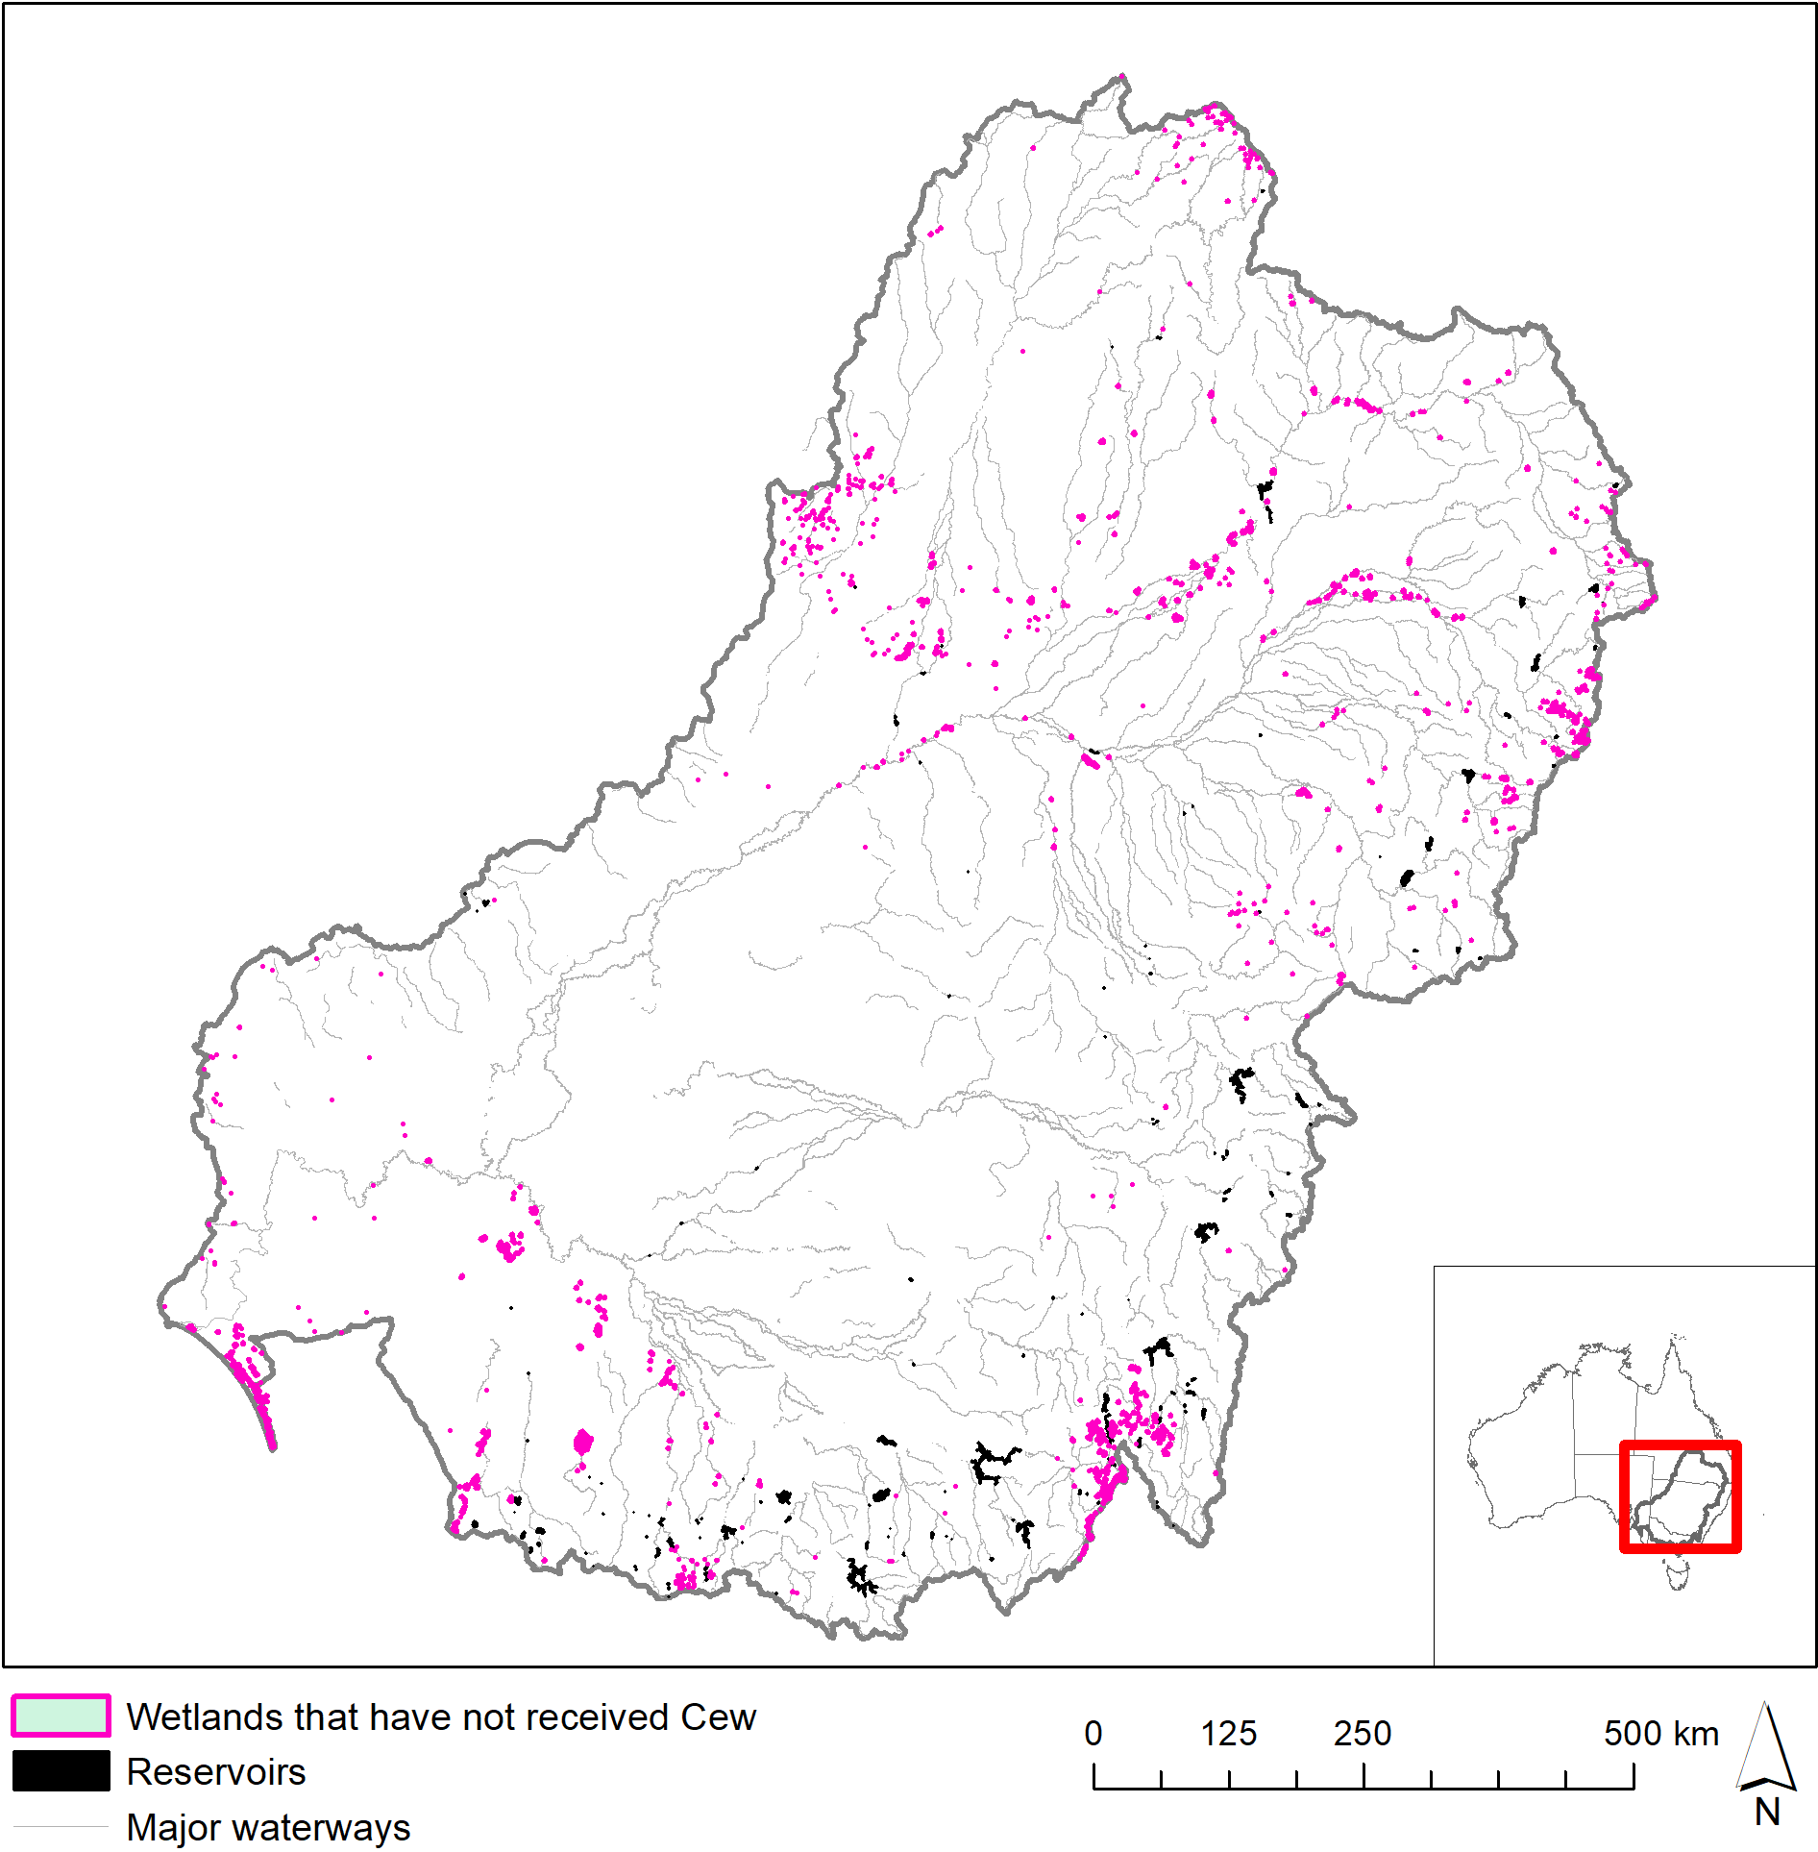

Figure 8. Wetland ecosystem types that have not been represented in Commonwealth environmental water inundation extents during the period of LTIM are predominantly located in unregulated valleys or higher in the catchments above water storages.

Table 7. Comparison of the contribution of Commonwealth environmental water to ecosystem diversity of floodplains from 2014-18 (sorted by the magnitude of watering in the 2017-18 water year). Ecosystem types with more than 5% of their total Basin area inundated in any one year are shaded pale blue. Ecosystem types that have not received Commonwealth environmental water during the period of LTIM are shaded red. Large differences (>10%) among years are highlighted in dark blue.

| Australian National Aquatic Ecosystem (ANAE) wetland type | Total  area (ha) | % receiving Cew | | | | Differences | | |
| --- | --- | --- | --- | --- | --- | --- | --- | --- |
| Y1 14-15 | Y2 15–16 | Y3  16–17 | Y4  17–18 | Y4-Y3 | Y4-Y2 | Y4-Y1 |
| F1.11: River cooba woodland riparian zone or floodplain | 11 541 | 9.8 | 2.0 | 6.7 | 7.3 | 0.5 | 5.2 | -2.6 |
| F1.2: River red gum forest riparian zone or floodplain | 639 022 | 3.8 | 4.1 | 1.0 | 4.0 | 3.0 | -0.1 | 0.2 |
| F1.4: River red gum woodland riparian zone or floodplain | 325 221 | 1.1 | 0.4 | 0.4 | 1.5 | 1.1 | 1.1 | 0.4 |
| F2.2: Lignum shrubland riparian zone or floodplain | 143 886 | 3.8 | 1.5 | 0.8 | 1.0 | 0.2 | -0.5 | -2.7 |
| F1.8: Black box woodland riparian zone or floodplain | 779 639 | 0.3 | 0.7 | 0.1 | 0.2 | 0.1 | -0.4 | -0.1 |
| F1.6: Black box forest riparian zone or floodplain | 131 442 | 0.4 | 1.0 | <0.1 | 0.2 | 0.1 | -0.8 | -0.2 |
| F2.4: Shrubland riparian zone or floodplain | 408 614 | 0.3 | 1.5 | 0.6 | 0.1 | -0.5 | -1.3 | -0.2 |
| F1.10: Coolabah woodland and forest riparian zone or floodplain | 1 215 726 | 0.3 | <0.1 | <0.1 | 0.1 | 0.0 | 0.1 | -0.2 |
| F1.12: Woodland riparian zone or floodplain | 318 686 | <0.1 | <0.1 | <0.1 | <0.1 | 0.0 | 0.0 | 0.0 |
| F4: Unspecified riparian zone or floodplain | 201 086 | <0.1 | <0.1 | <0.1 | <0.1 | 0.0 | 0.0 | 0.0 |
| F3.2: Sedge/forb/grassland riparian zone or floodplain | 833 102 | 0.0 | 0.0 | <0.1 | 0.0 | 0.0 | 0.0 | 0.0 |
| F1.13: Paperbark riparian zone or floodplain | 17 | 0.0 | 0.0 | 0.0 | 0.0 | 0.0 | 0.0 | 0.0 |

## Adaptive management

There are a number of avenues by which the Ecosystem Diversity evaluation can foster improvements in Commonwealth environmental water management and evaluation that have been identified in previous Ecosystem Diversity evaluation reports (Brooks 2016, 2017b, 2018). These recommendations are reproduced below. Progress on completing the update of the ANAE classification is expected during the latter half of 2019, and progress in developing expected outcomes for Ecosystem Diversity is planned for the CEWO Monitoring, Evaluation and Research (MER) project (2019-2022).

1. Improving confidence in the evaluation of the contribution of Commonwealth environmental water to Ecosystem Diversity. Completing the revision of the ANAE classification to include the new NSW state vegetation mapping for Western NSW and the Central Tablelands (Figure 9) will further improve the evaluation of the contribution of Commonwealth environmental water to Ecosystem Diversity in tributaries of the Darling River including the Junction of the Warrego and Darling rivers LTIM Selected Area.
2. Improving understanding of the landscape context at monitoring sites to inform extrapolation of observed outcomes to unmonitored sites. Understanding how biotic and functional responses vary among ecosystem types that are monitored within Selected Areas may permit extrapolation of Selected Area and Basin matter outcomes to watering events in the same ecosystem types located in other areas of the Basin.
3. The CEWO currently does not have 1-year or 5-year expected outcomes for ecosystem diversity but it is hoped that this evaluation and other lessons learned from the LTIM project will seed thinking towards an appropriate approach for draft ecosystem objectives that can be trialed within the MER project. Understanding how key ecosystem types influence patterns of Basin biodiversity, resilience, ecosystem function and ecosystem services paves the way towards delivering Commonwealth environmental water for ecosystem objectives that move beyond counting ecosystem watering targets. For example, shaping flow regimes to preserve patterns of spatio-temporal variability along a river, or delivering water at critical times to maintain life forms or processes *because* they characterise ecosystem types that are to be preserved or improved. Managing to prevent or promote ecosystem turnover to new types may require long-term management frameworks with institutional memory and conviction to stay the course over decadal time scales and that allow some temporary systems to remain dry for sufficient duration to support the dry-phase ecosystem processes.
4. Developing watering objectives and expected outcomes for specific ecosystem types will require a collaborative approach with CEWO delivery managers to identify where and when management triggers are linked to particular ecosystem types. For example when priorities direct water to maintain permanent waterbodies as refugia in dry years, or where over-bank flows target freshwater meadows to protect vulnerable seasonal herbaceous wetlands.
5. Reducing the risks of implementing inappropriate watering regimes. Too much water, too frequently or consistently missing particular ecosystems types are all scenarios that are potentially deleterious to biodiversity in the Basin. Improving understanding of watering requirements at the aquatic ecosystem level should complement and enhance existing approaches that focus on the requirements of key species or communities. Through LTIM, we are assembling a library of Basin wide watering frequencies from Commonwealth environmental water. Ecosystems types (and locations) that are consistently not watered, or watered with too much regularity, can then be identified and an informed assessment of risks can then take place to determine if there is a need and capability to adjust management planning to ensure Basin Plan objectives are met.

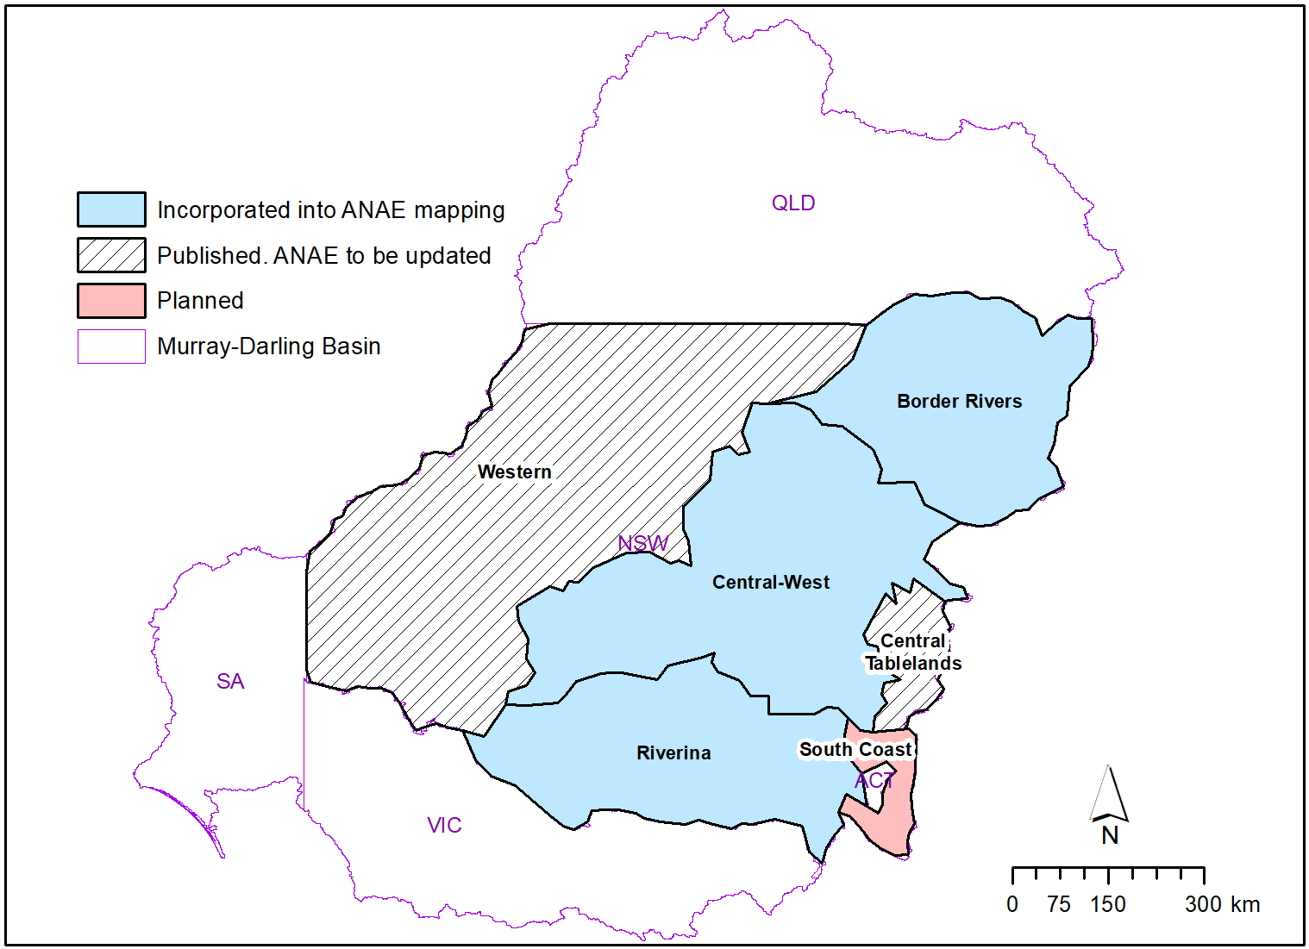

Figure 9: Extent and status of the new NSW state vegetation mapping. Published regions (blue) were used to update the ANAE classification in 2017. The Western region and Central Tablelands have been published and can be used to further improve the ANAE classification and LTIM Ecosystem Diversity evaluation.

# Contribution to achievement of Basin Plan objectives

The Ecosystem Diversity component of the Basin evaluation contributes to the Basin Plan objective for Biodiversity under Section 8.05 of the Basin Plan and contributes indirectly to additional Basin Plan objectives by informing the evaluation of the Vegetation and Generic Diversity Basin Matters within the LTIM Project (Capon & Campbell 2016, 2017, 2019; Hale 2016, 2017, 2019).

The Commonwealth does not yet have 1-year or 5-year expected outcomes for ecosystem diversity (Table 8) and water is not currently delivered with direct understanding of the contribution of Commonwealth environmental watering to ecosystem diversity at the Basin-scale. However, this evaluation provides a foundation from which expected outcomes for ecosystem diversity may be developed in the future as the spatial and temporal patterns of watering to different ecosystem types under current management regimes is better understood.

Table 8. Commonwealth Environmental Outcomes framework for ecosystem diversity.

| **Basin Plan objectives** | **Basin outcomes** | **5–year expected outcomes** | **1–year expected outcomes** | **Measured and predicted 1-year outcomes 2017–18** | **Measured and predicted 1–4 year outcomes 2014–18** |
| --- | --- | --- | --- | --- | --- |
| Biodiversity  (Basin Plan S. 8.05) | Ecosystem diversity | None identified | None identified | Over 296 000 hectares of mapped wetland and floodplain inundated  71% of the different aquatic ecosystem types represented in areas influenced by Commonwealth environmental water | 75% of the different aquatic ecosystem types inundated with Commonwealth environmental water. |

References

Aquatic Ecosystems Task Group (2012) *Aquatic Ecosystems Toolkit. Module 2 Interim Australian National Aquatic Ecosystems (ANAE) Classification Framework*. Department of Sustainability, Environment, Water Population and Communities, Canberra, Australia.

BOM (2019) Australian Hydrological Geospatial Fabric (Geofabric) beta v3.0.5.

Brooks SS (2016) *Final Ecosystem Diversity Basin Matter Evaluation Report 2014-15* ( No. MDFRC Publication 144/2017, May). Final Report prepared for the Commonwealth Environmental Water Office. Murray–Darling Freshwater Research Centre.

Brooks SS (2017a) *Classification of aquatic ecosystems in the Murray-Darling Basin: 2017 update*. Report to the Murray-Darling Basin Authority and Commonwealth Environmental Water Office, Canberra, Australia.

Brooks SS (2017b) *Final Ecosystem Diversity Basin Matter Evaluation Report 2015-16* ( No. MDFRC Publication 144/2017, May). Final Report prepared for the Commonwealth Environmental Water Office. Murray–Darling Freshwater Research Centre.

Brooks SS (2018) *Final Ecosystem Diversity Basin Matter Evaluation Report 2016-17* ( No. Publication 190/2018, September). Final Report prepared for the Commonwealth Environmental Water Office. La Trobe University Centre for Freshwater Ecosystems, Wodonga, Victoria.

Brooks SS, Cottingham P, Butcher R, Hale J (2014) *Murray-Darling Basin aquatic ecosystem classification: Stage 2 report*. Peter Cottingham & Associates report to the Commonwealth Environmental Water Office and Murray-Darling Basin Authority. Canberra, Australia.

Cadotte MW, Carscadden K, Mirotchnick N (2011) Beyond species: functional diversity and the maintenance of ecological processes and services: Functional diversity in ecology and conservation. *Journal of Applied Ecology* **48(5)**, 1079–1087.

Capon SJ, Campbell C (2016) *2014–15 Basin-scale evaluation of Commonwealth environmental water - Vegetation Diversity*. Final Report prepared for the Commonwealth Environmental Water Office by The Murray–Darling Freshwater Research Centre, MDFRC Publication 107/2016, September, 85pp.

Capon SJ, Campbell C (2017) *2015–16 Basin-scale evaluation of Commonwealth environmental water - Vegetation Diversity*. Final Report prepared for the Commonwealth Environmental Water Office by The Murray–Darling Freshwater Research Centre, MDFRC Publication 145/2017, May.

Capon SJ, Campbell C (2019) *2017–18 Basin-scale evaluation of Commonwealth environmental water - Vegetation Diversity*. Final Report prepared for the Commonwealth Environmental Water Office by The Murray–Darling Freshwater Research Centre, MDFRC Publication 2019, May.

CBD (1993) The Convention on Biological Diversity.

CEWH (2013) Commonwealth Environmental Water – The Environmental Water Outcomes Framework v1.1.

Commonwealth of Australia (2012) Water Act 2007 Basin Plan.

Geist J (2011) Integrative freshwater ecology and biodiversity conservation. *Ecological Indicators* **11(6)**, 1507–1516.

Hale J (2016) *2014–15 Basin-scale evaluation of Commonwealth environmental water – Generic Diversity.* Final report prepared for the Commonwealth Environmental Water Office by The Murray–Darling Freshwater Research Centre, MDFRC Publication 109/2016, October, 48pp.

Hale J (2017) *2015–16 Basin-scale evaluation of Commonwealth environmental water – Generic Diversity.* Final report prepared for the Commonwealth Environmental Water Office by The Murray–Darling Freshwater Research Centre, MDFRC Publication 147/2017.

Hale J (2019) *2017–18 Basin-scale evaluation of Commonwealth environmental water – Generic Diversity.* Final report prepared for the Commonwealth Environmental Water Office by The Murray–Darling Freshwater Research Centre, MDFRC Publication 2019.

Junk J, Bayley P, Sparks R (1989) The flood pulse concept in river floodplain systems. *Canadian Special Publications of Fisheries and Aquatic Sciences* **106**, 110–127.

MDFRC (2013) *Long-term Intervention Monitoring - Generic Cause and Effect Diagrams* ( No. 01.5/2013). The Murray-Darling Freshwater Research Centre, Albury.

Miles M, Eckert G (2013) Murray‐Darling Basin ANAE dataset – Manual edits to SA component.

Poff NL (1997) Landscape filters and species traits: towards mechanistic understanding and prediction in stream ecology. *Journal of the North American Benthological Society* **16(2)**, 391–409.

Pollock LJ, Thuiller W, Jetz W (2017) Large conservation gains possible for global biodiversity facets. *Nature* **546(7656)**, 141–144.

Stewardson MJ, Guarino F (2019) *2017–18 Basin-scale evaluation of Commonwealth environmental water — Hydrology* (Final Report prepared for the Commonwealth Environmental Water Office). Latrobe University Publication 2018. La Trobe University Centre for Freshwater Ecosystems, Wodonga, Victoria.

Thorp JH, Thoms MC, Delong MD (2006) The riverine ecosystem synthesis: biocomplexity in river networks across space and time. *River Research and Applications* **22(2)**, 123–147.

# Annex A. GIS Workflow

All spatial layers use the 1994 Geocentric Datum of Australia (GDA94). Areas in this report are in hectares and have been calculated in the Australia Albers Equal Area Conic projection to report accurate area measurements across the Basin.

*The area of ecosystems inundated by Commonwealth environmental water is the fraction of the wetland area that intersects the Commonwealth environmental water inundation extent.*

GIS Workflow:

1. Intersect:
   1. The Basin ANAE classification mapping;
   2. Commonwealth environmental water Inundation; and
   3. LTIM Valleys
2. Calculate polygon area in hectares using equal area GDA94 Australian Albers projection.
3. Sum the area of each ANAE wetland type per valley.

*The area of ecosystems influenced by Commonwealth environmental water is defined as the sum of the areas of mapped features that are partially or fully overlapped by Commonwealth environmental water inundation extent.*

GIS Workflow:

1. Select by location all ANAE wetland polygons that intersect the Commonwealth environmental water Inundation.
2. Intersect the selected wetlands with the catchment boundaries.
3. Calculate polygon area in hectares using equal area GDA94 Australian Albers projection.
4. Sum the area of each ANAE wetland type per valley.

*Length of waterways influenced by Commonwealth environmental water*

GIS Workflow:

1. Intersect:
   1. The Basin ANAE Geofabric v3 Waterways
   2. Commonwealth environmental water Inundation
   3. LTIM Valleys
2. Calculate the channel length inundated for each riverine ecosystem type in kilometres using equal area GDA94 Australian Albers projection.
3. Calculate summary statistics to sum the length of each river ecosystem type per valley.

# Annex B. Ongoing evolution of the Basin ANAE classification

Confidence in the accuracy of mapping and the Basin ANAE classification was examined in a previous LTIM ecosystem diversity evaluation (Brooks 2016a) and in the development of the ANAE classification (Brooks *et al.* 2014). In South Australia, ANAE types were manually ascribed to wetlands and riverine reaches along the full length of the Murray River to improve confidence and alignment of the classification to ecosystem types used by South Australian wetland managers. Some additional limitations of the ANAE classification in South Australia that influence the findings in this report are noted in Miles and Eckert (2013) and include: farm dams classified as natural wetland ecosystems, temporary wetlands to the south-east of the south lagoon of the Coorong being classified as permanent, and wetland boundaries adjacent to the Lake Alexandrina that encompass multiple ecosystem types. These errors are mainly associated with wetland types around Lake Alexandrina and the Coorong (M Miles, pers. comm., 2017) but similar examples can be found in all states in areas where fundamental hydrological data and vegetation mapping are limited. The recent update to the ANAE addressed some of these issues but a comprehensive evaluation against the issues raised by Miles and Eckert (2013) has not been conducted.

There was generally good agreement between the ecosystem types identified by the Basin ANAE classification when ground-truthed at Selected Area sampling sites (Brooks 2016). Most discrepancies were related to inaccuracies in the mapping of wetland boundaries rather than fundamental disagreement with the ANAE classification itself. The poorest representation of ecosystem types by the ANAE classification was in the Lachlan river system, Gwydir river system and Junction of the Warrego and Darling rivers Selected Areas (Brooks 2016). The Lachlan and Gwydir valleys were included in the 2017 major update to the ANAE classification which greatly improved the mapping for this and subsequent evaluations of the contribution of Commonwealth environmental water to Ecosystem Diversity in these Valleys (Brooks 2017a). Ecosystem mapping in the Central Murray Forests, the Macquarie Marshes, and Murrumbidgee were also improved in the revision.

A major component of the 2017 ANAE update relied on NSW State vegetation mapping that was incomplete at the time. Mapping for Western NSW and the Central Tablelands (Figure 9) has now been published by the NSW Office of Environment and Heritage (now Department of Planning, Industry and Environment). Integration of these updated maps into the ANAE classification of the Basin will greatly improve wetland and floodplain ecosystem mapping in the Junction of the Warrego and Darling rivers Selected Area and in southwestern NSW along the Darling and Murray River floodplains. These areas all regularly receive Commonwealth environmental water and updating the ANAE classification in these areas to improve the accuracy and consistency of aquatic ecosystem mapping is a high priority. The cumulative evaluation of Ecosystem Diversity can then be retrospectively brought up to date using the revised ANAE maps and inundation mapping collated by LTIM to date.

# Annex C. ANAE wetland types influenced by Commonwealth environmental water by valley

Lake and wetland types influenced by Commonwealth environmental water are represented by the entire wetland when any portion of the wetland was recorded as having been inundated. The contribution of Commonwealth environmental water to supporting wetland ecosystem diversity within each valley is presented below in Table C1 excluding the Coorong, Lower Lakes and Murray Mouth which are presented in Table 5.

Table C1. Area of each lake and wetland ecosystem type and the contribution of Commonwealth environmental water to supporting wetland ecosystem diversity within each valley, sorted by the area influenced with inundation highlighted in blue (excludes in-channel flows presented in Annex E).

| Valley name | Australian National Aquatic Ecosystem (ANAE) lake and wetland types | Total  area (ha) | Cew  Area (ha) | Percent |
| --- | --- | --- | --- | --- |
| Avoca | Lst1.1: Temporary saline lake | 19 829 | 0 | 0.0 |
| Avoca | Pt3.1.2: Clay pan | 18 824 | 0 | 0.0 |
| Avoca | Lt1.1: Temporary lake | 4400 | 0 | 0.0 |
| Avoca | Pt1.2.2: Temporary black box swamp | 4382 | 0 | 0.0 |
| Avoca | Lst1.2: Temporary saline lake with aquatic bed | 1820 | 0 | 0.0 |
| Avoca | Pst1.1: Temporary saline swamp | 1544 | 0 | 0.0 |
| Avoca | Pst2.2: Temporary salt marsh | 1174 | 0 | 0.0 |
| Avoca | Pt1.6.2: Temporary woodland swamp | 814 | 0 | 0.0 |
| Avoca | Pt2.3.2: Freshwater meadow | 798 | 0 | 0.0 |
| Avoca | Pt1.7.2: Temporary lignum swamp | 773 | 0 | 0.0 |
| Avoca | Pst3.2: Salt pan or salt flat | 309 | 0 | 0.0 |
| Avoca | Psp2.1: Permanent salt marsh | 209 | 0 | 0.0 |
| Avoca | Pt4.2: Temporary wetland | 208 | 0 | 0.0 |
| Avoca | Pt1.1.2: Temporary river red gum swamp | 145 | 0 | 0.0 |
| Avoca | Lsp1.1: Permanent saline lake | 137 | 0 | 0.0 |
| Avoca | Lp1.1: Permanent lake | 61 | 0 | 0.0 |
| Avoca | Pt1.8.2: Temporary shrub swamp | 51 | 0 | 0.0 |
| Avoca | Pp4.2: Permanent wetland | 50 | 0 | 0.0 |
| Avoca | Pst4: Temporary saline wetland | 50 | 0 | 0.0 |
| Avoca | Pt4.1: Floodplain or riparian wetland | 1 | 0 | 0.0 |
| Barwon Darling | Lt1.1: Temporary lake | 57 153 | 0 | 0.0 |
| Barwon Darling | Lp1.1: Permanent lake | 31 496 | 0 | 0.0 |
| Barwon Darling | Pt1.6.2: Temporary woodland swamp | 16 384 | 0 | 0.0 |
| Barwon Darling | Pt1.8.2: Temporary shrub swamp | 11 011 | 0 | 0.0 |
| Barwon Darling | Pp4.2: Permanent wetland | 3586 | 0 | 0.0 |
| Barwon Darling | Pt1.2.2: Temporary black box swamp | 2955 | 0 | 0.0 |
| Barwon Darling | Pt2.2.2: Temporary sedge/grass/forb marsh | 1893 | 0 | 0.0 |
| Barwon Darling | Pt2.3.2: Freshwater meadow | 895 | 0 | 0.0 |
| Barwon Darling | Pt1.1.2: Temporary river red gum swamp | 378 | 0 | 0.0 |
| Barwon Darling | Pt3.1.2: Clay pan | 179 | 0 | 0.0 |
| Barwon Darling | Pt1.3.2: Temporary coolabah swamp | 88 | 0 | 0.0 |
| Border Rivers | Pt2.2.2: Temporary sedge/grass/forb marsh | 8829 | 0 | 0.0 |
| Border Rivers | Pt4.2: Temporary wetland | 3009 | 0 | 0.0 |
| Border Rivers | Pt1.6.2: Temporary woodland swamp | 2487 | 0 | 0.0 |
| Border Rivers | Pp2.2.2: Permanent sedge/grass/forb marsh | 1455 | 0 | 0.0 |
| Border Rivers | Pp4.2: Permanent wetland | 1124 | 0 | 0.0 |
| Border Rivers | Lp1.1: Permanent lake | 944 | 0 | 0.0 |
| Border Rivers | Pt1.1.2: Temporary river red gum swamp | 718 | 0 | 0.0 |
| Border Rivers | Lt1.1: Temporary lake | 671 | 0 | 0.0 |
| Border Rivers | Pp3: Peat bog or fen marsh | 652 | 0 | 0.0 |
| Border Rivers | Pt2.3.2: Freshwater meadow | 592 | 0 | 0.0 |
| Border Rivers | Pt1.3.2: Temporary coolabah swamp | 493 | 0 | 0.0 |
| Border Rivers | Pt3.1.2: Clay pan | 268 | 0 | 0.0 |
| Border Rivers | Lp1.2: Permanent lake with aquatic bed | 227 | 0 | 0.0 |
| Border Rivers | Pt2.1.2: Temporary tall emergent marsh | 96 | 0 | 0.0 |
| Border Rivers | Pp2.3.2: Permanent grass marsh | 26 | 0 | 0.0 |
| Border Rivers | Pt1.2.2: Temporary black box swamp | 15 | 0 | 0.0 |
| Border Rivers | Lt1.2: Temporary lake with aquatic bed | 12 | 0 | 0.0 |
| Border Rivers | Pt1.8.2: Temporary shrub swamp | 11 | 0 | 0.0 |
| Border Rivers | Pst1.1: Temporary saline swamp | 2 | 0 | 0.0 |
| Broken | Pt2.3.2: Freshwater meadow | 268 | 181 | 67.5 |
| Broken | Lp1.1: Permanent lake | 3305 | 0 | 0.0 |
| Broken | Pt3.1.2: Clay pan | 3033 | 0 | 0.0 |
| Broken | Pt1.1.2: Temporary river red gum swamp | 1907 | 0 | 0.0 |
| Broken | Pt1.6.2: Temporary woodland swamp | 427 | 0 | 0.0 |
| Broken | Pt1.7.2: Temporary lignum swamp | 192 | 0 | 0.0 |
| Broken | Lt1.1: Temporary lake | 104 | 0 | 0.0 |
| Broken | Pt2.1.2: Temporary tall emergent marsh | 97 | 0 | 0.0 |
| Broken | Pt1.2.2: Temporary black box swamp | 79 | 0 | 0.0 |
| Broken | Pt2.2.2: Temporary sedge/grass/forb marsh | 77 | 0 | 0.0 |
| Broken | Pt4.1: Floodplain or riparian wetland | 66 | 0 | 0.0 |
| Broken | Pp4.2: Permanent wetland | 43 | 0 | 0.0 |
| Campaspe | Pt3.1.2: Clay pan | 1903 | 0 | 0.0 |
| Campaspe | Pt1.1.2: Temporary river red gum swamp | 280 | 0 | 0.0 |
| Campaspe | Pt1.6.2: Temporary woodland swamp | 232 | 0 | 0.0 |
| Campaspe | Lt1.1: Temporary lake | 49 | 0 | 0.0 |
| Campaspe | Pt2.1.2: Temporary tall emergent marsh | 24 | 0 | 0.0 |
| Campaspe | Lp1.1: Permanent lake | 12 | 0 | 0.0 |
| Campaspe | Pt2.3.2: Freshwater meadow | 10 | 0 | 0.0 |
| Campaspe | Pp4.2: Permanent wetland | 4 | 0 | 0.0 |
| Campaspe | Pps5: Permanent spring | 1 | 0 | 0.0 |
| Castlereagh | Pt2.2.2: Temporary sedge/grass/forb marsh | 10 598 | 0 | 0.0 |
| Castlereagh | Lt1.1: Temporary lake | 406 | 0 | 0.0 |
| Castlereagh | Pt1.8.2: Temporary shrub swamp | 49 | 0 | 0.0 |
| Castlereagh | Pt1.6.2: Temporary woodland swamp | 35 | 0 | 0.0 |
| Castlereagh | Pt1.2.2: Temporary black box swamp | 30 | 0 | 0.0 |
| Castlereagh | Pt3.1.2: Clay pan | 30 | 0 | 0.0 |
| Castlereagh | Pp4.2: Permanent wetland | 18 | 0 | 0.0 |
| Castlereagh | Pt2.1.2: Temporary tall emergent marsh | 16 | 0 | 0.0 |
| Castlereagh | Pp2.2.2: Permanent sedge/grass/forb marsh | 8 | 0 | 0.0 |
| Castlereagh | Lp1.1: Permanent lake | 6 | 0 | 0.0 |
| Castlereagh | Pps5: Permanent spring | 1 | 0 | 0.0 |
| Castlereagh | Pt1.1.2: Temporary river red gum swamp | 1 | 0 | 0.0 |
| Castlereagh | Pt2.3.2: Freshwater meadow | 1 | 0 | 0.0 |
| Central Murray | Pt1.1.2: Temporary river red gum swamp | 38 459 | 23602 | 61.4 |
| Central Murray | Lp1.1: Permanent lake | 4111 | 2231 | 54.3 |
| Central Murray | Lt1.1: Temporary lake | 12 925 | 1822 | 14.1 |
| Central Murray | Pp4.2: Permanent wetland | 9187 | 1149 | 12.5 |
| Central Murray | Pt2.1.2: Temporary tall emergent marsh | 1444 | 709 | 49.1 |
| Central Murray | Pt2.2.2: Temporary sedge/grass/forb marsh | 2802 | 672 | 24.0 |
| Central Murray | Pt2.3.2: Freshwater meadow | 5157 | 586 | 11.4 |
| Central Murray | Pt4.2: Temporary wetland | 606 | 586 | 96.7 |
| Central Murray | Pt1.6.2: Temporary woodland swamp | 1540 | 461 | 29.9 |
| Central Murray | Pt1.2.2: Temporary black box swamp | 4166 | 141 | 3.4 |
| Central Murray | Pt3.1.2: Clay pan | 17 404 | 114 | 0.7 |
| Central Murray | Pt1.8.2: Temporary shrub swamp | 584 | 73 | 12.5 |
| Central Murray | Pt1.7.2: Temporary lignum swamp | 1575 | 24 | 1.5 |
| Central Murray | Pt4.1: Floodplain or riparian wetland | 461 | 7 | 1.5 |
| Central Murray | Pp2.4.2: Permanent forb marsh | 133 | 4 | 3.0 |
| Central Murray | Pp2.1.2: Permanent tall emergent marsh | 1169 | 2 | 0.2 |
| Central Murray | Pp2.3.2: Permanent grass marsh | 80 | 2 | 2.5 |
| Central Murray | Pp2.2.2: Permanent sedge/grass/forb marsh | 45 | 2 | 4.4 |
| Central Murray | Pst2.2: Temporary salt marsh | 2122 | 0 | 0.0 |
| Central Murray | Pst4: Temporary saline wetland | 2114 | 0 | 0.0 |
| Central Murray | Lst1.1: Temporary saline lake | 1286 | 0 | 0.0 |
| Central Murray | Pst3.2: Salt pan or salt flat | 732 | 0 | 0.0 |
| Central Murray | Psp4: Permanent saline wetland | 642 | 0 | 0.0 |
| Central Murray | Lsp1.1: Permanent saline lake | 461 | 0 | 0.0 |
| Central Murray | Pst1.1: Temporary saline swamp | 23 | 0 | 0.0 |
| Condamine Balonne | Pt2.1.2: Temporary tall emergent marsh | 38 236 | 0 | 0.0 |
| Condamine Balonne | Pt1.8.2: Temporary shrub swamp | 29 291 | 0 | 0.0 |
| Condamine Balonne | Pt1.6.2: Temporary woodland swamp | 13 223 | 0 | 0.0 |
| Condamine Balonne | Pt1.7.2: Temporary lignum swamp | 11 804 | 0 | 0.0 |
| Condamine Balonne | Lt1.1: Temporary lake | 11 535 | 0 | 0.0 |
| Condamine Balonne | Lp1.1: Permanent lake | 6454 | 0 | 0.0 |
| Condamine Balonne | Pt4.2: Temporary wetland | 6392 | 0 | 0.0 |
| Condamine Balonne | Pt1.2.2: Temporary black box swamp | 4683 | 0 | 0.0 |
| Condamine Balonne | Pt2.2.2: Temporary sedge/grass/forb marsh | 4248 | 0 | 0.0 |
| Condamine Balonne | Pt2.3.2: Freshwater meadow | 4020 | 0 | 0.0 |
| Condamine Balonne | Pp4.2: Permanent wetland | 3750 | 0 | 0.0 |
| Condamine Balonne | Pp2.1.2: Permanent tall emergent marsh | 2522 | 0 | 0.0 |
| Condamine Balonne | Pt1.3.2: Temporary coolabah swamp | 2423 | 0 | 0.0 |
| Condamine Balonne | Pt3.1.2: Clay pan | 1821 | 0 | 0.0 |
| Condamine Balonne | Lp1.2: Permanent lake with aquatic bed | 1648 | 0 | 0.0 |
| Condamine Balonne | Lst1.1: Temporary saline lake | 1624 | 0 | 0.0 |
| Condamine Balonne | Pt1.1.2: Temporary river red gum swamp | 1116 | 0 | 0.0 |
| Condamine Balonne | Lt1.2: Temporary lake with aquatic bed | 684 | 0 | 0.0 |
| Condamine Balonne | Pt1.5.2: Temporary paperbark swamp | 95 | 0 | 0.0 |
| Condamine Balonne | Pp2.3.2: Permanent grass marsh | 23 | 0 | 0.0 |
| Condamine Balonne | Pps5: Permanent spring | 6 | 0 | 0.0 |
| Condamine Balonne | Lsp1.1: Permanent saline lake | 3 | 0 | 0.0 |
| Condamine Balonne | Pst4: Temporary saline wetland | 1 | 0 | 0.0 |
| Edward Wakool | Pp4.2: Permanent wetland | 819 | 3 | 0.4 |
| Edward Wakool | Pt3.1.2: Clay pan | 3643 | 0 | 0.0 |
| Edward Wakool | Pt1.2.2: Temporary black box swamp | 1585 | 0 | 0.0 |
| Edward Wakool | Pt1.1.2: Temporary river red gum swamp | 1321 | 0 | 0.0 |
| Edward Wakool | Lt1.1: Temporary lake | 985 | 0 | 0.0 |
| Edward Wakool | Pt2.3.2: Freshwater meadow | 621 | 0 | 0.0 |
| Edward Wakool | Pt1.6.2: Temporary woodland swamp | 421 | 0 | 0.0 |
| Edward Wakool | Pt1.8.2: Temporary shrub swamp | 280 | 0 | 0.0 |
| Edward Wakool | Pt2.2.2: Temporary sedge/grass/forb marsh | 211 | 0 | 0.0 |
| Edward Wakool | Pt1.7.2: Temporary lignum swamp | 168 | 0 | 0.0 |
| Edward Wakool | Lp1.1: Permanent lake | 131 | 0 | 0.0 |
| Edward Wakool | Pt2.1.2: Temporary tall emergent marsh | 59 | 0 | 0.0 |
| Edward Wakool | Pp2.3.2: Permanent grass marsh | 19 | 0 | 0.0 |
| Edward Wakool | Pp2.1.2: Permanent tall emergent marsh | 7 | 0 | 0.0 |
| Edward Wakool | Psp4: Permanent saline wetland | 6 | 0 | 0.0 |
| Edward Wakool | Pst1.1: Temporary saline swamp | 5 | 0 | 0.0 |
| Edward Wakool | Pp2.2.2: Permanent sedge/grass/forb marsh | 1 | 0 | 0.0 |
| Goulburn | Pt3.1.2: Clay pan | 10 948 | 0 | 0.0 |
| Goulburn | Pt1.1.2: Temporary river red gum swamp | 5180 | 0 | 0.0 |
| Goulburn | Lt1.1: Temporary lake | 1598 | 0 | 0.0 |
| Goulburn | Lp1.1: Permanent lake | 1086 | 0 | 0.0 |
| Goulburn | Pp4.2: Permanent wetland | 1060 | 0 | 0.0 |
| Goulburn | Pt1.6.2: Temporary woodland swamp | 869 | 0 | 0.0 |
| Goulburn | Pt2.1.2: Temporary tall emergent marsh | 861 | 0 | 0.0 |
| Goulburn | Pt2.3.2: Freshwater meadow | 815 | 0 | 0.0 |
| Goulburn | Pt1.7.2: Temporary lignum swamp | 631 | 0 | 0.0 |
| Goulburn | Pp2.4.2: Permanent forb marsh | 571 | 0 | 0.0 |
| Goulburn | Lst1.2: Temporary saline lake with aquatic bed | 238 | 0 | 0.0 |
| Goulburn | Pt2.2.2: Temporary sedge/grass/forb marsh | 189 | 0 | 0.0 |
| Goulburn | Pt4.1: Floodplain or riparian wetland | 184 | 0 | 0.0 |
| Goulburn | Pt1.2.2: Temporary black box swamp | 124 | 0 | 0.0 |
| Goulburn | Lsp1.1: Permanent saline lake | 46 | 0 | 0.0 |
| Goulburn | Lst1.1: Temporary saline lake | 25 | 0 | 0.0 |
| Goulburn | Pt4.2: Temporary wetland | 19 | 0 | 0.0 |
| Goulburn | Pp2.1.2: Permanent tall emergent marsh | 4 | 0 | 0.0 |
| Goulburn | Pst4: Temporary saline wetland | 2 | 0 | 0.0 |
| Goulburn | Pt1.8.2: Temporary shrub swamp | 2 | 0 | 0.0 |
| Gwydir | Pt2.2.2: Temporary sedge/grass/forb marsh | 9881 | 4643 | 47.0 |
| Gwydir | Pt2.1.2: Temporary tall emergent marsh | 373 | 373 | 100.0 |
| Gwydir | Pt3.1.2: Clay pan | 236 | 42 | 17.8 |
| Gwydir | Lp1.1: Permanent lake | 70 | 26 | 37.1 |
| Gwydir | Lt1.1: Temporary lake | 1199 | 15 | 1.3 |
| Gwydir | Pp4.2: Permanent wetland | 293 | 1 | 0.3 |
| Gwydir | Pp2.2.2: Permanent sedge/grass/forb marsh | 1549 | 0 | 0.0 |
| Gwydir | Pt4.2: Temporary wetland | 392 | 0 | 0.0 |
| Gwydir | Pt1.6.2: Temporary woodland swamp | 182 | 0 | 0.0 |
| Gwydir | Pp3: Peat bog or fen marsh | 181 | 0 | 0.0 |
| Gwydir | Pt1.8.2: Temporary shrub swamp | 89 | 0 | 0.0 |
| Gwydir | Pt1.1.2: Temporary river red gum swamp | 13 | 0 | 0.0 |
| Gwydir | Pt1.3.2: Temporary coolabah swamp | 9 | 0 | 0.0 |
| Gwydir | Pt2.3.2: Freshwater meadow | 6 | 0 | 0.0 |
| Gwydir | Pt1.2.2: Temporary black box swamp | 4 | 0 | 0.0 |
| Gwydir | Pp1.1.2: Permanent paperbark swamp | 1 | 0 | 0.0 |
| Kiewa | Pp4.2: Permanent wetland | 723 | 0 | 0.0 |
| Kiewa | Pt3.1.2: Clay pan | 321 | 0 | 0.0 |
| Kiewa | Pt1.6.2: Temporary woodland swamp | 39 | 0 | 0.0 |
| Kiewa | Lp1.1: Permanent lake | 37 | 0 | 0.0 |
| Kiewa | Pt1.1.2: Temporary river red gum swamp | 23 | 0 | 0.0 |
| Kiewa | Pt2.2.2: Temporary sedge/grass/forb marsh | 12 | 0 | 0.0 |
| Kiewa | Pt2.1.2: Temporary tall emergent marsh | 3 | 0 | 0.0 |
| Lachlan | Pp2.1.2: Permanent tall emergent marsh | 3450 | 3449 | 100.0 |
| Lachlan | Pt2.1.2: Temporary tall emergent marsh | 588 | 451 | 76.7 |
| Lachlan | Pt1.1.2: Temporary river red gum swamp | 2206 | 442 | 20.0 |
| Lachlan | Lt1.1: Temporary lake | 32 307 | 345 | 1.1 |
| Lachlan | Pt2.3.2: Freshwater meadow | 21 005 | 123 | 0.6 |
| Lachlan | Pt2.2.2: Temporary sedge/grass/forb marsh | 13 504 | 40 | 0.3 |
| Lachlan | Pp4.2: Permanent wetland | 2914 | 16 | 0.5 |
| Lachlan | Lp1.1: Permanent lake | 7405 | 7 | 0.1 |
| Lachlan | Pst2.2: Temporary salt marsh | 30 315 | 0 | 0.0 |
| Lachlan | Pt1.7.2: Temporary lignum swamp | 22 220 | 0 | 0.0 |
| Lachlan | Pt1.8.2: Temporary shrub swamp | 16 460 | 0 | 0.0 |
| Lachlan | Pt1.2.2: Temporary black box swamp | 15 298 | 0 | 0.0 |
| Lachlan | Pt3.1.2: Clay pan | 14 938 | 0 | 0.0 |
| Lachlan | Pt1.6.2: Temporary woodland swamp | 3305 | 0 | 0.0 |
| Lachlan | Pt4.2: Temporary wetland | 348 | 0 | 0.0 |
| Lachlan | Pp2.2.2: Permanent sedge/grass/forb marsh | 63 | 0 | 0.0 |
| Lachlan | Pp2.3.2: Permanent grass marsh | 44 | 0 | 0.0 |
| Lachlan | Pps5: Permanent spring | 7 | 0 | 0.0 |
| Loddon | Pt3.1.2: Clay pan | 12 075 | 0 | 0.0 |
| Loddon | Lp1.1: Permanent lake | 6382 | 0 | 0.0 |
| Loddon | Pt1.2.2: Temporary black box swamp | 5724 | 0 | 0.0 |
| Loddon | Pt1.7.2: Temporary lignum swamp | 3941 | 0 | 0.0 |
| Loddon | Pt2.3.2: Freshwater meadow | 3408 | 0 | 0.0 |
| Loddon | Lst1.1: Temporary saline lake | 1478 | 0 | 0.0 |
| Loddon | Pt1.6.2: Temporary woodland swamp | 1404 | 0 | 0.0 |
| Loddon | Pst1.1: Temporary saline swamp | 1375 | 0 | 0.0 |
| Loddon | Pt1.1.2: Temporary river red gum swamp | 1256 | 0 | 0.0 |
| Loddon | Lsp1.1: Permanent saline lake | 1252 | 0 | 0.0 |
| Loddon | Lt1.1: Temporary lake | 417 | 0 | 0.0 |
| Loddon | Pp4.2: Permanent wetland | 314 | 0 | 0.0 |
| Loddon | Lsp1.2: Permanent saline lake with aquatic bed | 181 | 0 | 0.0 |
| Loddon | Pst3.2: Salt pan or salt flat | 109 | 0 | 0.0 |
| Loddon | Pt1.8.2: Temporary shrub swamp | 109 | 0 | 0.0 |
| Loddon | Lt1.2: Temporary lake with aquatic bed | 55 | 0 | 0.0 |
| Loddon | Pst4: Temporary saline wetland | 55 | 0 | 0.0 |
| Loddon | Pt2.1.2: Temporary tall emergent marsh | 54 | 0 | 0.0 |
| Loddon | Psp2.1: Permanent salt marsh | 37 | 0 | 0.0 |
| Loddon | Pst2.2: Temporary salt marsh | 28 | 0 | 0.0 |
| Loddon | Pps5: Permanent spring | 4 | 0 | 0.0 |
| Lower Darling | Pt1.1.2: Temporary river red gum swamp | 879 | 31 | 3.5 |
| Lower Darling | Pp4.2: Permanent wetland | 317 | 30 | 9.5 |
| Lower Darling | Pt1.8.2: Temporary shrub swamp | 107 971 | 26 | 0.0 |
| Lower Darling | Lt1.1: Temporary lake | 187 316 | 0 | 0.0 |
| Lower Darling | Lp1.1: Permanent lake | 9677 | 0 | 0.0 |
| Lower Darling | Pt2.3.2: Freshwater meadow | 8109 | 0 | 0.0 |
| Lower Darling | Pt1.6.2: Temporary woodland swamp | 4340 | 0 | 0.0 |
| Lower Darling | Pt1.2.2: Temporary black box swamp | 1920 | 0 | 0.0 |
| Lower Darling | Pt3.1.2: Clay pan | 1344 | 0 | 0.0 |
| Lower Darling | Lst1.1: Temporary saline lake | 509 | 0 | 0.0 |
| Lower Darling | Pt4.2: Temporary wetland | 53 | 0 | 0.0 |
| Lower Darling | Pp2.3.2: Permanent grass marsh | 26 | 0 | 0.0 |
| Lower Darling | Pst2.2: Temporary salt marsh | 4 | 0 | 0.0 |
| Lower Murray | Lp1.1: Permanent lake | 104 190 | 12389 | 11.9 |
| Lower Murray | Pt4.1: Floodplain or riparian wetland | 10 641 | 2488 | 23.4 |
| Lower Murray | Pt2.3.2: Freshwater meadow | 9007 | 2432 | 27.0 |
| Lower Murray | Pp4.2: Permanent wetland | 4474 | 2282 | 51.0 |
| Lower Murray | Lt1.1: Temporary lake | 30 782 | 825 | 2.7 |
| Lower Murray | Psp4: Permanent saline wetland | 2045 | 629 | 30.8 |
| Lower Murray | Pt1: Temporary swamp | 3767 | 576 | 15.3 |
| Lower Murray | Pt1.7.2: Temporary lignum swamp | 2651 | 422 | 15.9 |
| Lower Murray | Pt3.1.2: Clay pan | 17 674 | 392 | 2.2 |
| Lower Murray | Lst1.1: Temporary saline lake | 1546 | 307 | 19.9 |
| Lower Murray | Pt1.1.2: Temporary river red gum swamp | 503 | 213 | 42.3 |
| Lower Murray | Pt2.1.2: Temporary tall emergent marsh | 11 504 | 188 | 1.6 |
| Lower Murray | Pt1.8.2: Temporary shrub swamp | 3013 | 179 | 5.9 |
| Lower Murray | Pu1: Unspecified wetland | 1763 | 95 | 5.4 |
| Lower Murray | Pp2.3.2: Permanent grass marsh | 109 | 82 | 75.2 |
| Lower Murray | Pp2.4.2: Permanent forb marsh | 36 | 18 | 50.0 |
| Lower Murray | Pt1.2.2: Temporary black box swamp | 418 | 16 | 3.8 |
| Lower Murray | Pt2.2.2: Temporary sedge/grass/forb marsh | 7082 | 13 | 0.2 |
| Lower Murray | Pt4.2: Temporary wetland | 4982 | 0 | 0.0 |
| Lower Murray | Pst1.1: Temporary saline swamp | 2759 | 0 | 0.0 |
| Lower Murray | Lsp1.1: Permanent saline lake | 2674 | 0 | 0.0 |
| Lower Murray | Pt1.6.2: Temporary woodland swamp | 863 | 0 | 0.0 |
| Lower Murray | Pst4: Temporary saline wetland | 803 | 0 | 0.0 |
| Lower Murray | Pst3.2: Salt pan or salt flat | 586 | 0 | 0.0 |
| Lower Murray | Pst2.2: Temporary salt marsh | 438 | 0 | 0.0 |
| Lower Murray | Psp1.1: Saline paperbark swamp | 132 | 0 | 0.0 |
| Lower Murray | Pt1.5.2: Temporary paperbark swamp | 132 | 0 | 0.0 |
| Lower Murray | Pp2.1.2: Permanent tall emergent marsh | 11 | 0 | 0.0 |
| Lower Murray | Psp2.1: Permanent salt marsh | 3 | 0 | 0.0 |
| Lower Murray | Pps5: Permanent spring | 2 | 0 | 0.0 |
| Macquarie | Pp4.2: Permanent wetland | 18 961 | 18017 | 95.0 |
| Macquarie | Pt2.2.2: Temporary sedge/grass/forb marsh | 41 274 | 9219 | 22.3 |
| Macquarie | Pt1.1.2: Temporary river red gum swamp | 5783 | 5136 | 88.8 |
| Macquarie | Pt2.1.2: Temporary tall emergent marsh | 3014 | 2397 | 79.5 |
| Macquarie | Pt1.8.2: Temporary shrub swamp | 1704 | 781 | 45.8 |
| Macquarie | Lt1.1: Temporary lake | 9214 | 249 | 2.7 |
| Macquarie | Pt1.2.2: Temporary black box swamp | 1915 | 55 | 2.9 |
| Macquarie | Pt1.6.2: Temporary woodland swamp | 2636 | 31 | 1.2 |
| Macquarie | Pp2.2.2: Permanent sedge/grass/forb marsh | 46 | 15 | 32.6 |
| Macquarie | Pt3.1.2: Clay pan | 1895 | 1 | 0.1 |
| Macquarie | Pt2.3.2: Freshwater meadow | 2348 | 0 | 0.0 |
| Macquarie | Pt1.3.2: Temporary coolabah swamp | 1414 | 0 | 0.0 |
| Macquarie | Lp1.1: Permanent lake | 814 | 0 | 0.0 |
| Macquarie | Pps5: Permanent spring | 15 | 0 | 0.0 |
| Macquarie | Pp3: Peat bog or fen marsh | 9 | 0 | 0.0 |
| Mitta Mitta | Pp4.2: Permanent wetland | 1012 | 0 | 0.0 |
| Mitta Mitta | Pt2.3.2: Freshwater meadow | 626 | 0 | 0.0 |
| Mitta Mitta | Pt3.1.2: Clay pan | 594 | 0 | 0.0 |
| Mitta Mitta | Pt1.6.2: Temporary woodland swamp | 562 | 0 | 0.0 |
| Mitta Mitta | Pt1.8.2: Temporary shrub swamp | 449 | 0 | 0.0 |
| Mitta Mitta | Lp1.1: Permanent lake | 86 | 0 | 0.0 |
| Mitta Mitta | Pt4.2: Temporary wetland | 57 | 0 | 0.0 |
| Mitta Mitta | Pt1.1.2: Temporary river red gum swamp | 3 | 0 | 0.0 |
| Murrumbidgee | Pt1.1.2: Temporary river red gum swamp | 7359 | 5486 | 74.5 |
| Murrumbidgee | Pp4.2: Permanent wetland | 8981 | 1520 | 16.9 |
| Murrumbidgee | Pt2.2.2: Temporary sedge/grass/forb marsh | 30 950 | 1188 | 3.8 |
| Murrumbidgee | Pt1.8.2: Temporary shrub swamp | 23 125 | 1159 | 5.0 |
| Murrumbidgee | Pt3.1.2: Clay pan | 17 314 | 1105 | 6.4 |
| Murrumbidgee | Lp1.1: Permanent lake | 1484 | 638 | 43.0 |
| Murrumbidgee | Lt1.1: Temporary lake | 30 457 | 474 | 1.6 |
| Murrumbidgee | Pt2.3.2: Freshwater meadow | 35 226 | 297 | 0.8 |
| Murrumbidgee | Pt2.1.2: Temporary tall emergent marsh | 855 | 35 | 4.1 |
| Murrumbidgee | Pt1.2.2: Temporary black box swamp | 4870 | 27 | 0.6 |
| Murrumbidgee | Pt4.2: Temporary wetland | 1502 | 16 | 1.1 |
| Murrumbidgee | Pp2.2.2: Permanent sedge/grass/forb marsh | 31 | 5 | 16.1 |
| Murrumbidgee | Pst2.2: Temporary salt marsh | 1735 | 4 | 0.2 |
| Murrumbidgee | Pt1.6.2: Temporary woodland swamp | 1619 | 1 | 0.1 |
| Murrumbidgee | Pp3: Peat bog or fen marsh | 1832 | 0 | 0.0 |
| Murrumbidgee | Pt1.7.2: Temporary lignum swamp | 1500 | 0 | 0.0 |
| Murrumbidgee | Pp2.1.2: Permanent tall emergent marsh | 186 | 0 | 0.0 |
| Murrumbidgee | Pp2.3.2: Permanent grass marsh | 36 | 0 | 0.0 |
| Murrumbidgee | Pps5: Permanent spring | 19 | 0 | 0.0 |
| Namoi | Pp4.2: Permanent wetland | 11 288 | 0 | 0.0 |
| Namoi | Pt3.1.2: Clay pan | 5300 | 0 | 0.0 |
| Namoi | Pt2.2.2: Temporary sedge/grass/forb marsh | 5158 | 0 | 0.0 |
| Namoi | Lp1.1: Permanent lake | 5123 | 0 | 0.0 |
| Namoi | Pt1.6.2: Temporary woodland swamp | 3393 | 0 | 0.0 |
| Namoi | Pt4.2: Temporary wetland | 2909 | 0 | 0.0 |
| Namoi | Lt1.1: Temporary lake | 2604 | 0 | 0.0 |
| Namoi | Pt1.2.2: Temporary black box swamp | 1771 | 0 | 0.0 |
| Namoi | Pt1.1.2: Temporary river red gum swamp | 1618 | 0 | 0.0 |
| Namoi | Pt2.3.2: Freshwater meadow | 622 | 0 | 0.0 |
| Namoi | Pt1.3.2: Temporary coolabah swamp | 609 | 0 | 0.0 |
| Namoi | Pt1.8.2: Temporary shrub swamp | 568 | 0 | 0.0 |
| Namoi | Pp2.2.2: Permanent sedge/grass/forb marsh | 391 | 0 | 0.0 |
| Namoi | Pp3: Peat bog or fen marsh | 17 | 0 | 0.0 |
| Namoi | Pt1.7.2: Temporary lignum swamp | 16 | 0 | 0.0 |
| Namoi | Pps5: Permanent spring | 1 | 0 | 0.0 |
| Ovens | Pt3.1.2: Clay pan | 2029 | 0 | 0.0 |
| Ovens | Pt2.3.2: Freshwater meadow | 925 | 0 | 0.0 |
| Ovens | Pt1.6.2: Temporary woodland swamp | 818 | 0 | 0.0 |
| Ovens | Pt1.1.2: Temporary river red gum swamp | 441 | 0 | 0.0 |
| Ovens | Pp4.2: Permanent wetland | 213 | 0 | 0.0 |
| Ovens | Pt4.2: Temporary wetland | 154 | 0 | 0.0 |
| Ovens | Lp1.1: Permanent lake | 80 | 0 | 0.0 |
| Ovens | Pt2.1.2: Temporary tall emergent marsh | 47 | 0 | 0.0 |
| Ovens | Pt2.2.2: Temporary sedge/grass/forb marsh | 45 | 0 | 0.0 |
| Ovens | Pp2.1.2: Permanent tall emergent marsh | 30 | 0 | 0.0 |
| Ovens | Pt4.1: Floodplain or riparian wetland | 24 | 0 | 0.0 |
| Ovens | Lt1.1: Temporary lake | 4 | 0 | 0.0 |
| Paroo | Pt1.6.2: Temporary woodland swamp | 152 703 | 0 | 0.0 |
| Paroo | Lt1.1: Temporary lake | 44 847 | 0 | 0.0 |
| Paroo | Pt1.8.2: Temporary shrub swamp | 29 703 | 0 | 0.0 |
| Paroo | Lp1.1: Permanent lake | 18 283 | 0 | 0.0 |
| Paroo | Pt2.1.2: Temporary tall emergent marsh | 12 490 | 0 | 0.0 |
| Paroo | Pt1.2.2: Temporary black box swamp | 8427 | 0 | 0.0 |
| Paroo | Pt2.3.2: Freshwater meadow | 7398 | 0 | 0.0 |
| Paroo | Lsp1.1: Permanent saline lake | 5868 | 0 | 0.0 |
| Paroo | Pp4.2: Permanent wetland | 4470 | 0 | 0.0 |
| Paroo | Pt2.2.2: Temporary sedge/grass/forb marsh | 4165 | 0 | 0.0 |
| Paroo | Pt1.7.2: Temporary lignum swamp | 3471 | 0 | 0.0 |
| Paroo | Pt1.3.2: Temporary coolabah swamp | 2399 | 0 | 0.0 |
| Paroo | Pst2.2: Temporary salt marsh | 1449 | 0 | 0.0 |
| Paroo | Pp2.1.2: Permanent tall emergent marsh | 586 | 0 | 0.0 |
| Paroo | Lst1.1: Temporary saline lake | 371 | 0 | 0.0 |
| Paroo | Pt1.1.2: Temporary river red gum swamp | 111 | 0 | 0.0 |
| Paroo | Pst4: Temporary saline wetland | 77 | 0 | 0.0 |
| Paroo | Pt4.2: Temporary wetland | 34 | 0 | 0.0 |
| Paroo | Pt3.1.2: Clay pan | 31 | 0 | 0.0 |
| Paroo | Pps5: Permanent spring | 9 | 0 | 0.0 |
| Upper Murray | Pp3: Peat bog or fen marsh | 1729 | 0 | 0.0 |
| Upper Murray | Pt3.1.2: Clay pan | 1457 | 0 | 0.0 |
| Upper Murray | Pp2.3.2: Permanent grass marsh | 1144 | 0 | 0.0 |
| Upper Murray | Pt2.2.2: Temporary sedge/grass/forb marsh | 725 | 0 | 0.0 |
| Upper Murray | Pp4.2: Permanent wetland | 419 | 0 | 0.0 |
| Upper Murray | Pt1.1.2: Temporary river red gum swamp | 290 | 0 | 0.0 |
| Upper Murray | Pt1.6.2: Temporary woodland swamp | 137 | 0 | 0.0 |
| Upper Murray | Lp1.1: Permanent lake | 94 | 0 | 0.0 |
| Upper Murray | Pps5: Permanent spring | 63 | 0 | 0.0 |
| Upper Murray | Lt1.1: Temporary lake | 50 | 0 | 0.0 |
| Upper Murray | Pt4.2: Temporary wetland | 50 | 0 | 0.0 |
| Upper Murray | Pt2.3.2: Freshwater meadow | 24 | 0 | 0.0 |
| Upper Murray | Pp2.1.2: Permanent tall emergent marsh | 16 | 0 | 0.0 |
| Upper Murray | Pt2.1.2: Temporary tall emergent marsh | 3 | 0 | 0.0 |
| Upper Murray | Pp2.2.2: Permanent sedge/grass/forb marsh | 1 | 0 | 0.0 |
| Warrego | Pt2.3.2: Freshwater meadow | 19 542 | 0 | 0.0 |
| Warrego | Pt1.6.2: Temporary woodland swamp | 4611 | 0 | 0.0 |
| Warrego | Pt2.1.2: Temporary tall emergent marsh | 4392 | 0 | 0.0 |
| Warrego | Pt1.8.2: Temporary shrub swamp | 3703 | 0 | 0.0 |
| Warrego | Lp1.1: Permanent lake | 3267 | 0 | 0.0 |
| Warrego | Pp4.2: Permanent wetland | 3223 | 0 | 0.0 |
| Warrego | Lt1.1: Temporary lake | 2234 | 0 | 0.0 |
| Warrego | Pt2.2.2: Temporary sedge/grass/forb marsh | 875 | 0 | 0.0 |
| Warrego | Pt1.3.2: Temporary coolabah swamp | 836 | 0 | 0.0 |
| Warrego | Pt3.1.2: Clay pan | 653 | 0 | 0.0 |
| Warrego | Pt4.2: Temporary wetland | 265 | 0 | 0.0 |
| Warrego | Pp2.1.2: Permanent tall emergent marsh | 23 | 0 | 0.0 |
| Warrego | Pt1.1.2: Temporary river red gum swamp | 12 | 0 | 0.0 |
| Warrego | Pps5: Permanent spring | 2 | 0 | 0.0 |
| Warrego | Pst1.1: Temporary saline swamp | 2 | 0 | 0.0 |
| Wimmera | Lt1.1: Temporary lake | 25 070 | 0 | 0.0 |
| Wimmera | Lt1.2: Temporary lake with aquatic bed | 8300 | 0 | 0.0 |
| Wimmera | Pt1.8.2: Temporary shrub swamp | 5885 | 0 | 0.0 |
| Wimmera | Pt3.1.2: Clay pan | 4811 | 0 | 0.0 |
| Wimmera | Pt1.1.2: Temporary river red gum swamp | 4715 | 0 | 0.0 |
| Wimmera | Pt2.3.2: Freshwater meadow | 3738 | 0 | 0.0 |
| Wimmera | Pst4: Temporary saline wetland | 3311 | 0 | 0.0 |
| Wimmera | Pt1.6.2: Temporary woodland swamp | 3267 | 0 | 0.0 |
| Wimmera | Pst1.1: Temporary saline swamp | 2232 | 0 | 0.0 |
| Wimmera | Pt1.2.2: Temporary black box swamp | 1906 | 0 | 0.0 |
| Wimmera | Pst3.2: Salt pan or salt flat | 1633 | 0 | 0.0 |
| Wimmera | Lp1.1: Permanent lake | 1541 | 0 | 0.0 |
| Wimmera | Lst1.1: Temporary saline lake | 1132 | 0 | 0.0 |
| Wimmera | Pt4.2: Temporary wetland | 724 | 0 | 0.0 |
| Wimmera | Pst2.2: Temporary salt marsh | 404 | 0 | 0.0 |
| Wimmera | Lp1.2: Permanent lake with aquatic bed | 192 | 0 | 0.0 |
| Wimmera | Pt1.5.2: Temporary paperbark swamp | 185 | 0 | 0.0 |
| Wimmera | Lst1.2: Temporary saline lake with aquatic bed | 180 | 0 | 0.0 |
| Wimmera | Pt1.7.2: Temporary lignum swamp | 174 | 0 | 0.0 |
| Wimmera | Pp4.2: Permanent wetland | 145 | 0 | 0.0 |
| Wimmera | Pt2.1.2: Temporary tall emergent marsh | 127 | 0 | 0.0 |
| Wimmera | Pt4.1: Floodplain or riparian wetland | 111 | 0 | 0.0 |
| Wimmera | Psp1.1: Saline paperbark swamp | 31 | 0 | 0.0 |
| Wimmera | Lsp1.1: Permanent saline lake | 24 | 0 | 0.0 |
| Wimmera | Psp4: Permanent saline wetland | 16 | 0 | 0.0 |

# Annex D. ANAE floodplain types inundated by Commonwealth environmental water by valley

For floodplains, the area inundated by out-of-channel delivery of Commonwealth environmental water is presented in Table D1.

Table D1. Area of each floodplain ecosystem type and the contribution of Commonwealth environmental water to supporting floodplain ecosystem diversity within each valley, sorted by the area inundated with inundation highlighted in blue.

| Valley name | Australian National Aquatic Ecosystem (ANAE) floodplain type | Total  area (ha) | Cew  Area (ha) | Percent |
| --- | --- | --- | --- | --- |
| Avoca | F1.4: River red gum woodland riparian zone or floodplain | 3126 | 0 | 0.0 |
| Avoca | F1.8: Black box woodland riparian zone or floodplain | 2988 | 0 | 0.0 |
| Avoca | F1.6: Black box forest riparian zone or floodplain | 977 | 0 | 0.0 |
| Avoca | F1.12: Woodland riparian zone or floodplain | 891 | 0 | 0.0 |
| Avoca | F2.2: Lignum shrubland riparian zone or floodplain | 80 | 0 | 0.0 |
| Avoca | F2.4: Shrubland riparian zone or floodplain | 4 | 0 | 0.0 |
| Avoca | F1.2: River red gum forest riparian zone or floodplain | 1 | 0 | 0.0 |
| Barwon Darling | F1.8: Black box woodland riparian zone or floodplain | 76 393 | 0 | 0.0 |
| Barwon Darling | F1.10: Coolabah woodland and forest riparian zone or floodplain | 61 778 | 0 | 0.0 |
| Barwon Darling | F2.4: Shrubland riparian zone or floodplain | 38 256 | 0 | 0.0 |
| Barwon Darling | F1.6: Black box forest riparian zone or floodplain | 24 713 | 0 | 0.0 |
| Barwon Darling | F4: Unspecified riparian zone or floodplain | 12 492 | 0 | 0.0 |
| Barwon Darling | F3.2: Sedge/forb/grassland riparian zone or floodplain | 7238 | 0 | 0.0 |
| Barwon Darling | F1.2: River red gum forest riparian zone or floodplain | 4985 | 0 | 0.0 |
| Barwon Darling | F1.12: Woodland riparian zone or floodplain | 4535 | 0 | 0.0 |
| Barwon Darling | F2.2: Lignum shrubland riparian zone or floodplain | 1152 | 0 | 0.0 |
| Barwon Darling | F1.4: River red gum woodland riparian zone or floodplain | 356 | 0 | 0.0 |
| Barwon Darling | F1.11: River cooba woodland riparian zone or floodplain | 17 | 0 | 0.0 |
| Border Rivers | F1.10: Coolabah woodland and forest riparian zone or floodplain | 72 864 | 0 | 0.0 |
| Border Rivers | F1.2: River red gum forest riparian zone or floodplain | 26 220 | 0 | 0.0 |
| Border Rivers | F1.12: Woodland riparian zone or floodplain | 24 909 | 0 | 0.0 |
| Border Rivers | F3.2: Sedge/forb/grassland riparian zone or floodplain | 14 320 | 0 | 0.0 |
| Border Rivers | F4: Unspecified riparian zone or floodplain | 2816 | 0 | 0.0 |
| Border Rivers | F2.2: Lignum shrubland riparian zone or floodplain | 2375 | 0 | 0.0 |
| Border Rivers | F1.11: River cooba woodland riparian zone or floodplain | 2322 | 0 | 0.0 |
| Border Rivers | F1.8: Black box woodland riparian zone or floodplain | 1887 | 0 | 0.0 |
| Border Rivers | F1.6: Black box forest riparian zone or floodplain | 1029 | 0 | 0.0 |
| Border Rivers | F1.4: River red gum woodland riparian zone or floodplain | 655 | 0 | 0.0 |
| Border Rivers | F2.4: Shrubland riparian zone or floodplain | 323 | 0 | 0.0 |
| Broken | F1.4: River red gum woodland riparian zone or floodplain | 4497 | 0 | 0.0 |
| Broken | F1.12: Woodland riparian zone or floodplain | 1335 | 0 | 0.0 |
| Broken | F1.8: Black box woodland riparian zone or floodplain | 61 | 0 | 0.0 |
| Broken | F2.2: Lignum shrubland riparian zone or floodplain | 6 | 0 | 0.0 |
| Broken | F1.2: River red gum forest riparian zone or floodplain | 1 | 0 | 0.0 |
| Campaspe | F1.4: River red gum woodland riparian zone or floodplain | 2970 | 0 | 0.0 |
| Campaspe | F1.12: Woodland riparian zone or floodplain | 2062 | 0 | 0.0 |
| Campaspe | F1.2: River red gum forest riparian zone or floodplain | 17 | 0 | 0.0 |
| Campaspe | F2.2: Lignum shrubland riparian zone or floodplain | 1 | 0 | 0.0 |
| Castlereagh | F1.10: Coolabah woodland and forest riparian zone or floodplain | 41 695 | 0 | 0.0 |
| Castlereagh | F1.8: Black box woodland riparian zone or floodplain | 32 351 | 0 | 0.0 |
| Castlereagh | F1.2: River red gum forest riparian zone or floodplain | 11 973 | 0 | 0.0 |
| Castlereagh | F1.6: Black box forest riparian zone or floodplain | 4601 | 0 | 0.0 |
| Castlereagh | F1.12: Woodland riparian zone or floodplain | 4165 | 0 | 0.0 |
| Castlereagh | F2.4: Shrubland riparian zone or floodplain | 1706 | 0 | 0.0 |
| Castlereagh | F1.4: River red gum woodland riparian zone or floodplain | 215 | 0 | 0.0 |
| Castlereagh | F2.2: Lignum shrubland riparian zone or floodplain | 102 | 0 | 0.0 |
| Castlereagh | F1.11: River cooba woodland riparian zone or floodplain | 61 | 0 | 0.0 |
| Central Murray | F1.2: River red gum forest riparian zone or floodplain | 161 261 | 3991 | 2.5 |
| Central Murray | F1.4: River red gum woodland riparian zone or floodplain | 23 758 | 2,550 | 10.7 |
| Central Murray | F1.8: Black box woodland riparian zone or floodplain | 48 626 | 1062 | 2.2 |
| Central Murray | F1.12: Woodland riparian zone or floodplain | 6802 | 89 | 1.3 |
| Central Murray | F2.4: Shrubland riparian zone or floodplain | 1244 | 11 | 0.9 |
| Central Murray | F2.2: Lignum shrubland riparian zone or floodplain | 7200 | 10 | 0.1 |
| Central Murray | F4: Unspecified riparian zone or floodplain | 668 | 2 | 0.3 |
| Central Murray | F1.6: Black box forest riparian zone or floodplain | 4422 | 0 | 0.0 |
| Condamine Balonne | F1.10: Coolabah woodland and forest riparian zone or floodplain | 319 222 | 0 | 0.0 |
| Condamine Balonne | F3.2: Sedge/forb/grassland riparian zone or floodplain | 293 190 | 0 | 0.0 |
| Condamine Balonne | F4: Unspecified riparian zone or floodplain | 181 014 | 0 | 0.0 |
| Condamine Balonne | F1.12: Woodland riparian zone or floodplain | 68 277 | 0 | 0.0 |
| Condamine Balonne | F1.8: Black box woodland riparian zone or floodplain | 30 994 | 0 | 0.0 |
| Condamine Balonne | F1.2: River red gum forest riparian zone or floodplain | 18 032 | 0 | 0.0 |
| Condamine Balonne | F1.4: River red gum woodland riparian zone or floodplain | 13 901 | 0 | 0.0 |
| Condamine Balonne | F2.4: Shrubland riparian zone or floodplain | 9419 | 0 | 0.0 |
| Condamine Balonne | F2.2: Lignum shrubland riparian zone or floodplain | 3474 | 0 | 0.0 |
| Edward Wakool | F1.2: River red gum forest riparian zone or floodplain | 58 502 | 13 | <0.1 |
| Edward Wakool | F1.4: River red gum woodland riparian zone or floodplain | 7721 | 9 | 0.1 |
| Edward Wakool | F1.8: Black box woodland riparian zone or floodplain | 77 969 | 0 | 0.0 |
| Edward Wakool | F1.6: Black box forest riparian zone or floodplain | 4193 | 0 | 0.0 |
| Edward Wakool | F2.4: Shrubland riparian zone or floodplain | 2471 | 0 | 0.0 |
| Edward Wakool | F2.2: Lignum shrubland riparian zone or floodplain | 1857 | 0 | 0.0 |
| Goulburn | F1.12: Woodland riparian zone or floodplain | 26 261 | 0 | 0.0 |
| Goulburn | F1.4: River red gum woodland riparian zone or floodplain | 17 945 | 0 | 0.0 |
| Goulburn | F1.2: River red gum forest riparian zone or floodplain | 5721 | 0 | 0.0 |
| Goulburn | F1.8: Black box woodland riparian zone or floodplain | 130 | 0 | 0.0 |
| Goulburn | F2.4: Shrubland riparian zone or floodplain | 35 | 0 | 0.0 |
| Goulburn | F2.2: Lignum shrubland riparian zone or floodplain | 27 | 0 | 0.0 |
| Gwydir | F1.2: River red gum forest riparian zone or floodplain | 15 515 | 911 | 5.9 |
| Gwydir | F1.11: River cooba woodland riparian zone or floodplain | 4501 | 639 | 14.2 |
| Gwydir | F1.10: Coolabah woodland and forest riparian zone or floodplain | 161 353 | 524 | 0.3 |
| Gwydir | F1.12: Woodland riparian zone or floodplain | 15 193 | 0 | 0.0 |
| Gwydir | F1.6: Black box forest riparian zone or floodplain | 14 093 | 0 | 0.0 |
| Gwydir | F1.8: Black box woodland riparian zone or floodplain | 5112 | 0 | 0.0 |
| Gwydir | F1.4: River red gum woodland riparian zone or floodplain | 859 | 0 | 0.0 |
| Gwydir | F2.2: Lignum shrubland riparian zone or floodplain | 656 | 0 | 0.0 |
| Gwydir | F2.4: Shrubland riparian zone or floodplain | 87 | 0 | 0.0 |
| Kiewa | F1.12: Woodland riparian zone or floodplain | 2715 | 0 | 0.0 |
| Kiewa | F1.4: River red gum woodland riparian zone or floodplain | 1391 | 0 | 0.0 |
| Lachlan | F1.2: River red gum forest riparian zone or floodplain | 97 333 | 3252 | 3.3 |
| Lachlan | F1.8: Black box woodland riparian zone or floodplain | 100 750 | 83 | 0.1 |
| Lachlan | F2.2: Lignum shrubland riparian zone or floodplain | 9706 | 56 | 0.6 |
| Lachlan | F1.6: Black box forest riparian zone or floodplain | 22 919 | 35 | 0.2 |
| Lachlan | F1.4: River red gum woodland riparian zone or floodplain | 4123 | 8 | 0.2 |
| Lachlan | F2.4: Shrubland riparian zone or floodplain | 224 941 | 2 | <0.1 |
| Lachlan | F1.12: Woodland riparian zone or floodplain | 2259 | 0 | 0.0 |
| Lachlan | F1.11: River cooba woodland riparian zone or floodplain | 3 | 0 | 0.0 |
| Lachlan | F3.2: Sedge/forb/grassland riparian zone or floodplain | 1 | 0 | 0.0 |
| Loddon | F1.4: River red gum woodland riparian zone or floodplain | 8027 | 0 | 0.0 |
| Loddon | F1.8: Black box woodland riparian zone or floodplain | 7842 | 0 | 0.0 |
| Loddon | F2.2: Lignum shrubland riparian zone or floodplain | 6611 | 0 | 0.0 |
| Loddon | F1.12: Woodland riparian zone or floodplain | 2546 | 0 | 0.0 |
| Loddon | F2.4: Shrubland riparian zone or floodplain | 104 | 0 | 0.0 |
| Loddon | F1.2: River red gum forest riparian zone or floodplain | 101 | 0 | 0.0 |
| Loddon | F1.6: Black box forest riparian zone or floodplain | 33 | 0 | 0.0 |
| Lower Darling | F1.2: River red gum forest riparian zone or floodplain | 12 688 | 27 | 0.2 |
| Lower Darling | F2.4: Shrubland riparian zone or floodplain | 10 646 | 6 | 0.1 |
| Lower Darling | F1.6: Black box forest riparian zone or floodplain | 20 532 | 4 | <0.1 |
| Lower Darling | F1.8: Black box woodland riparian zone or floodplain | 71 385 | 0 | 0.0 |
| Lower Darling | F1.12: Woodland riparian zone or floodplain | 1272 | 0 | 0.0 |
| Lower Darling | F4: Unspecified riparian zone or floodplain | 281 | 0 | 0.0 |
| Lower Darling | F3.2: Sedge/forb/grassland riparian zone or floodplain | 106 | 0 | 0.0 |
| Lower Darling | F2.2: Lignum shrubland riparian zone or floodplain | 8 | 0 | 0.0 |
| Lower Murray | F1.4: River red gum woodland riparian zone or floodplain | 35 793 | 712 | 2.0 |
| Lower Murray | F1.2: River red gum forest riparian zone or floodplain | 11 835 | 589 | 5.0 |
| Lower Murray | F1.8: Black box woodland riparian zone or floodplain | 35 795 | 441 | 1.2 |
| Lower Murray | F2.2: Lignum shrubland riparian zone or floodplain | 20 415 | 201 | 1.0 |
| Lower Murray | F2.4: Shrubland riparian zone or floodplain | 27 813 | 153 | 0.6 |
| Lower Murray | F4: Unspecified riparian zone or floodplain | 567 | 27 | 4.8 |
| Lower Murray | F1.6: Black box forest riparian zone or floodplain | 109 | 5 | 4.6 |
| Lower Murray | F1.11: River cooba woodland riparian zone or floodplain | 348 | 4 | 1.1 |
| Lower Murray | F1.12: Woodland riparian zone or floodplain | 1586 | 2 | 0.1 |
| Macquarie | F1.2: River red gum forest riparian zone or floodplain | 73 188 | 3272 | 4.5 |
| Macquarie | F1.4: River red gum woodland riparian zone or floodplain | 14 799 | 1282 | 8.7 |
| Macquarie | F1.10: Coolabah woodland and forest riparian zone or floodplain | 157 431 | 811 | 0.5 |
| Macquarie | F2.4: Shrubland riparian zone or floodplain | 41 153 | 228 | 0.6 |
| Macquarie | F1.11: River cooba woodland riparian zone or floodplain | 2752 | 197 | 7.2 |
| Macquarie | F1.8: Black box woodland riparian zone or floodplain | 158 156 | 167 | 0.1 |
| Macquarie | F2.2: Lignum shrubland riparian zone or floodplain | 6048 | 97 | 1.6 |
| Macquarie | F1.6: Black box forest riparian zone or floodplain | 20 301 | 75 | 0.4 |
| Macquarie | F1.12: Woodland riparian zone or floodplain | 6898 | 0 | 0.0 |
| Macquarie | F4: Unspecified riparian zone or floodplain | 1061 | 0 | 0.0 |
| Macquarie | F3.2: Sedge/forb/grassland riparian zone or floodplain | 142 | 0 | 0.0 |
| Mitta Mitta | F1.12: Woodland riparian zone or floodplain | 7472 | 0 | 0.0 |
| Mitta Mitta | F1.4: River red gum woodland riparian zone or floodplain | 320 | 0 | 0.0 |
| Mitta Mitta | F2.4: Shrubland riparian zone or floodplain | 37 | 0 | 0.0 |
| Murrumbidgee | F1.2: River red gum forest riparian zone or floodplain | 126 459 | 13652 | 10.8 |
| Murrumbidgee | F2.2: Lignum shrubland riparian zone or floodplain | 70 408 | 1,110 | 1.6 |
| Murrumbidgee | F1.4: River red gum woodland riparian zone or floodplain | 5153 | 325 | 6.3 |
| Murrumbidgee | F1.6: Black box forest riparian zone or floodplain | 9094 | 145 | 1.6 |
| Murrumbidgee | F1.8: Black box woodland riparian zone or floodplain | 94 712 | 76 | 0.1 |
| Murrumbidgee | F2.4: Shrubland riparian zone or floodplain | 27 982 | 73 | 0.3 |
| Murrumbidgee | F4: Unspecified riparian zone or floodplain | 80 | 7 | 8.8 |
| Murrumbidgee | F1.12: Woodland riparian zone or floodplain | 51 | 2 | 3.9 |
| Murrumbidgee | F1.11: River cooba woodland riparian zone or floodplain | 24 | 0 | 0.0 |
| Murrumbidgee | F1.10: Coolabah woodland and forest riparian zone or floodplain | 23 | 0 | 0.0 |
| Namoi | F1.10: Coolabah woodland and forest riparian zone or floodplain | 88 097 | 0 | 0.0 |
| Namoi | F1.12: Woodland riparian zone or floodplain | 26 664 | 0 | 0.0 |
| Namoi | F1.8: Black box woodland riparian zone or floodplain | 12 405 | 0 | 0.0 |
| Namoi | F1.2: River red gum forest riparian zone or floodplain | 10 917 | 0 | 0.0 |
| Namoi | F1.6: Black box forest riparian zone or floodplain | 3053 | 0 | 0.0 |
| Namoi | F2.2: Lignum shrubland riparian zone or floodplain | 2624 | 0 | 0.0 |
| Namoi | F1.11: River cooba woodland riparian zone or floodplain | 1513 | 0 | 0.0 |
| Namoi | F1.4: River red gum woodland riparian zone or floodplain | 599 | 0 | 0.0 |
| Namoi | F2.4: Shrubland riparian zone or floodplain | 153 | 0 | 0.0 |
| Namoi | F1.13: Paperbark riparian zone or floodplain | 17 | 0 | 0.0 |
| Ovens | F1.12: Woodland riparian zone or floodplain | 11 380 | 0 | 0.0 |
| Ovens | F1.4: River red gum woodland riparian zone or floodplain | 6837 | 0 | 0.0 |
| Ovens | F1.2: River red gum forest riparian zone or floodplain | 1916 | 0 | 0.0 |
| Paroo | F3.2: Sedge/forb/grassland riparian zone or floodplain | 506 857 | 0 | 0.0 |
| Paroo | F1.4: River red gum woodland riparian zone or floodplain | 98 545 | 0 | 0.0 |
| Paroo | F1.12: Woodland riparian zone or floodplain | 62 642 | 0 | 0.0 |
| Paroo | F1.10: Coolabah woodland and forest riparian zone or floodplain | 31 982 | 0 | 0.0 |
| Paroo | F2.4: Shrubland riparian zone or floodplain | 20 115 | 0 | 0.0 |
| Paroo | F1.8: Black box woodland riparian zone or floodplain | 17 227 | 0 | 0.0 |
| Paroo | F4: Unspecified riparian zone or floodplain | 1210 | 0 | 0.0 |
| Upper Murray | F1.12: Woodland riparian zone or floodplain | 3847 | 0 | 0.0 |
| Upper Murray | F1.2: River red gum forest riparian zone or floodplain | 2261 | 0 | 0.0 |
| Upper Murray | F1.4: River red gum woodland riparian zone or floodplain | 1475 | 0 | 0.0 |
| Upper Murray | F2.4: Shrubland riparian zone or floodplain | 265 | 0 | 0.0 |
| Upper Murray | F2.2: Lignum shrubland riparian zone or floodplain | 10 | 0 | 0.0 |
| Warrego | F1.10: Coolabah woodland and forest riparian zone or floodplain | 281 281 | 0 | 0.0 |
| Warrego | F1.4: River red gum woodland riparian zone or floodplain | 60 118 | 0 | 0.0 |
| Warrego | F1.12: Woodland riparian zone or floodplain | 18 777 | 0 | 0.0 |
| Warrego | F3.2: Sedge/forb/grassland riparian zone or floodplain | 11 249 | 0 | 0.0 |
| Warrego | F2.2: Lignum shrubland riparian zone or floodplain | 10 980 | 0 | 0.0 |
| Warrego | F2.4: Shrubland riparian zone or floodplain | 1048 | 0 | 0.0 |
| Warrego | F4: Unspecified riparian zone or floodplain | 896 | 0 | 0.0 |
| Warrego | F1.8: Black box woodland riparian zone or floodplain | 441 | 0 | 0.0 |
| Warrego | F1.2: River red gum forest riparian zone or floodplain | 96 | 0 | 0.0 |
| Wimmera | F1.12: Woodland riparian zone or floodplain | 16 128 | 0 | 0.0 |
| Wimmera | F1.4: River red gum woodland riparian zone or floodplain | 12 038 | 0 | 0.0 |
| Wimmera | F1.8: Black box woodland riparian zone or floodplain | 4416 | 0 | 0.0 |
| Wimmera | F1.6: Black box forest riparian zone or floodplain | 1373 | 0 | 0.0 |
| Wimmera | F2.4: Shrubland riparian zone or floodplain | 811 | 0 | 0.0 |
| Wimmera | F2.2: Lignum shrubland riparian zone or floodplain | 146 | 0 | 0.0 |
| Wimmera | F1.13: Paperbark riparian zone or floodplain | 1 | 0 | 0.0 |

# Annex E. ANAE river channel types influenced by Commonwealth environmental water by valley

The lengths of river and stream channels of differing ANAE type influenced by the delivery of Commonwealth environmental water are presented in Table E1 as an in indicator of the contribution of Commonwealth environmental water towards riverine ecosystem diversity within each valley. River length measurement is highly dependent on the resolution of the mapping with higher resolution mapping capturing more twists and turns in the river that increase the measured river length along the flow path between two points. The Geofabric v3 beta Network Streams were used which are based on a 1 arc-second DEM with an approximate resolution of 30m.

Commonwealth environmental water is typically delivered from storages into lowland rivers. In hilly landscapes and where rivers cut through gorges the ANAE classification often identifies individual river sections as high energy streams. These transition into low energy lowland rivers as the valleys widen and flatten further downstream. The different ANAE ecosystem types in Table E1 are mostly distributed along the same major river within each valley rather than separate watercourses (refer Figure 6).

Table E1. Length of river and stream ecosystem types influenced by the delivery of Commonwealth environmental water (shaded blue) as represented by the Basin ANAE waterways data set in each valley

| Valley name | Australian National Aquatic Ecosystem (ANAE) waterway type | Total  Length (km) | Cew  Length (km) | Percent |
| --- | --- | --- | --- | --- |
| Avoca | Rt1.4: Temporary lowland stream | 1752 | 0 | 0.0 |
| Avoca | Rt1.2: Temporary transitional zone stream | 1086 | 0 | 0.0 |
| Avoca | Rt1.1: Temporary high energy upland stream | 511 | 0 | 0.0 |
| Avoca | Rp1.4: Permanent lowland stream | 66 | 0 | 0.0 |
| Avoca | Rp1.2: Permanent transitional zone stream | 23 | 0 | 0.0 |
| Avoca | Rt1.3: Temporary low energy upland stream | 21 | 0 | 0.0 |
| Barwon Darling | Rp1.4: Permanent lowland stream | 4575 | 1867 | 40.8 |
| Barwon Darling | Rt1.4: Temporary lowland stream | 20 412 | 29 | 0.1 |
| Barwon Darling | Rp1.2: Permanent transitional zone stream | 36 | 2 | 5.6 |
| Barwon Darling | Rp1.1: Permanent high energy upland stream | 3 | 1 | 33.3 |
| Barwon Darling | Rp1.3: Permanent low energy upland stream | 1 | 1 | 100.0 |
| Barwon Darling | Rt1.2: Temporary transitional zone stream | 4715 | 0 | 0.0 |
| Barwon Darling | Rt1.1: Temporary high energy upland stream | 874 | 0 | 0.0 |
| Barwon Darling | Rt1.3: Temporary low energy upland stream | 178 | 0 | 0.0 |
| Barwon Darling | Ru1: Unspecified river (landform unknown) | 32 | 0 | 0.0 |
| Barwon Darling | Rw1: Permanent river (landform unknown) | 1 | 0 | 0.0 |
| Border Rivers | Rp1.4: Permanent lowland stream | 2431 | 616 | 25.3 |
| Border Rivers | Rt1.4: Temporary lowland stream | 13 996 | 491 | 3.5 |
| Border Rivers | Rp1.2: Permanent transitional zone stream | 2349 | 120 | 5.1 |
| Border Rivers | Rt1.1: Temporary high energy upland stream | 7129 | 61 | 0.9 |
| Border Rivers | Rp1.1: Permanent high energy upland stream | 2844 | 48 | 1.7 |
| Border Rivers | Rt1.2: Temporary transitional zone stream | 8963 | 13 | 0.1 |
| Border Rivers | Rt1.3: Temporary low energy upland stream | 92 | 0 | 0.0 |
| Border Rivers | Ru1: Unspecified river (landform unknown) | 39 | 0 | 0.0 |
| Border Rivers | Rw1: Permanent river (landform unknown) | 9 | 0 | 0.0 |
| Broken | Rt1.4: Temporary lowland stream | 1342 | 270 | 20.1 |
| Broken | Rp1.4: Permanent lowland stream | 53 | 37 | 69.8 |
| Broken | Rp1.1: Permanent high energy upland stream | 61 | 9 | 14.8 |
| Broken | Rp1.2: Permanent transitional zone stream | 67 | 8 | 11.9 |
| Broken | Rt1.1: Temporary high energy upland stream | 906 | 4 | 0.4 |
| Broken | Rt1.2: Temporary transitional zone stream | 394 | 0 | 0.0 |
| Broken | Rt1.3: Temporary low energy upland stream | 67 | 0 | 0.0 |
| Broken | Ru1: Unspecified river (landform unknown) | 10 | 0 | 0.0 |
| Broken | Rw1: Permanent river (landform unknown) | 5 | 0 | 0.0 |
| Campaspe | Rp1.4: Permanent lowland stream | 66 | 52 | 78.8 |
| Campaspe | Rp1.3: Permanent low energy upland stream | 38 | 37 | 97.4 |
| Campaspe | Rp1.2: Permanent transitional zone stream | 61 | 14 | 23.0 |
| Campaspe | Rp1.1: Permanent high energy upland stream | 86 | 6 | 7.0 |
| Campaspe | Rt1.4: Temporary lowland stream | 610 | 4 | 0.7 |
| Campaspe | Rt1.1: Temporary high energy upland stream | 1042 | 1 | 0.1 |
| Campaspe | Rt1.2: Temporary transitional zone stream | 1410 | 0 | 0.0 |
| Campaspe | Rt1.3: Temporary low energy upland stream | 37 | 0 | 0.0 |
| Campaspe | Rw1: Permanent river (landform unknown) | 15 | 0 | 0.0 |
| Campaspe | Ru1: Unspecified river (landform unknown) | 2 | 0 | 0.0 |
| Castlereagh | Rt1.4: Temporary lowland stream | 4076 | 0 | 0.0 |
| Castlereagh | Rt1.2: Temporary transitional zone stream | 3078 | 0 | 0.0 |
| Castlereagh | Rt1.1: Temporary high energy upland stream | 1731 | 0 | 0.0 |
| Castlereagh | Rp1.4: Permanent lowland stream | 596 | 0 | 0.0 |
| Castlereagh | Rp1.2: Permanent transitional zone stream | 482 | 0 | 0.0 |
| Castlereagh | Rp1.1: Permanent high energy upland stream | 169 | 0 | 0.0 |
| Castlereagh | Rt1.3: Temporary low energy upland stream | 164 | 0 | 0.0 |
| Castlereagh | Rp1.3: Permanent low energy upland stream | 45 | 0 | 0.0 |
| Central Murray | Rp1.4: Permanent lowland stream | 3271 | 1790 | 54.7 |
| Central Murray | Rt1.4: Temporary lowland stream | 3470 | 529 | 15.2 |
| Central Murray | Rp1.3: Permanent low energy upland stream | 108 | 71 | 65.7 |
| Central Murray | Rp1.2: Permanent transitional zone stream | 143 | 24 | 16.8 |
| Central Murray | Rp1.1: Permanent high energy upland stream | 306 | 17 | 5.6 |
| Central Murray | Rt1.3: Temporary low energy upland stream | 93 | 17 | 18.3 |
| Central Murray | Rt1.2: Temporary transitional zone stream | 869 | 11 | 1.3 |
| Central Murray | Ru1: Unspecified river (landform unknown) | 5 | 1 | 20.0 |
| Central Murray | Rt1.1: Temporary high energy upland stream | 1467 | 0 | 0.0 |
| Condamine Balonne | Rt1.4: Temporary lowland stream | 33 874 | 332 | 1.0 |
| Condamine Balonne | Rp1.4: Permanent lowland stream | 1163 | 173 | 14.9 |
| Condamine Balonne | Rt1.2: Temporary transitional zone stream | 16 518 | 0 | 0.0 |
| Condamine Balonne | Rt1.1: Temporary high energy upland stream | 3421 | 0 | 0.0 |
| Condamine Balonne | Rt1.3: Temporary low energy upland stream | 111 | 0 | 0.0 |
| Condamine Balonne | Rp1.2: Permanent transitional zone stream | 48 | 0 | 0.0 |
| Condamine Balonne | Ru1: Unspecified river (landform unknown) | 37 | 0 | 0.0 |
| Condamine Balonne | Rp1.1: Permanent high energy upland stream | 27 | 0 | 0.0 |
| Condamine Balonne | Rp1.3: Permanent low energy upland stream | 2 | 0 | 0.0 |
| Condamine Balonne | Rw1: Permanent river (landform unknown) | 0 | 0 | - |
| Edward Wakool | Rp1.4: Permanent lowland stream | 2304 | 912 | 39.6 |
| Edward Wakool | Rt1.4: Temporary lowland stream | 904 | 64 | 7.1 |
| Goulburn | Rp1.4: Permanent lowland stream | 528 | 302 | 57.2 |
| Goulburn | Rp1.1: Permanent high energy upland stream | 965 | 63 | 6.5 |
| Goulburn | Rp1.2: Permanent transitional zone stream | 313 | 30 | 9.6 |
| Goulburn | Rt1.4: Temporary lowland stream | 2065 | 9 | 0.4 |
| Goulburn | Rt1.1: Temporary high energy upland stream | 7563 | 6 | 0.1 |
| Goulburn | Rt1.2: Temporary transitional zone stream | 2529 | 3 | 0.1 |
| Goulburn | Rt1.3: Temporary low energy upland stream | 230 | 2 | 0.9 |
| Goulburn | Rp1.3: Permanent low energy upland stream | 51 | 0 | 0.0 |
| Goulburn | Ru1: Unspecified river (landform unknown) | 24 | 0 | 0.0 |
| Goulburn | Rw1: Permanent river (landform unknown) | 22 | 0 | 0.0 |
| Gwydir | Rp1.4: Permanent lowland stream | 1753 | 673 | 38.4 |
| Gwydir | Rt1.4: Temporary lowland stream | 3288 | 233 | 7.1 |
| Gwydir | Rp1.2: Permanent transitional zone stream | 3049 | 134 | 4.4 |
| Gwydir | Rp1.1: Permanent high energy upland stream | 2508 | 55 | 2.2 |
| Gwydir | Rp1.3: Permanent low energy upland stream | 118 | 33 | 28.0 |
| Gwydir | Rt1.3: Temporary low energy upland stream | 131 | 20 | 15.3 |
| Gwydir | Rt1.1: Temporary high energy upland stream | 4098 | 0 | 0.0 |
| Gwydir | Rt1.2: Temporary transitional zone stream | 2616 | 0 | 0.0 |
| Gwydir | Rw1: Permanent river (landform unknown) | 23 | 0 | 0.0 |
| Gwydir | Ru1: Unspecified river (landform unknown) | 6 | 0 | 0.0 |
| Kiewa | Rt1.1: Temporary high energy upland stream | 1266 | 0 | 0.0 |
| Kiewa | Rt1.2: Temporary transitional zone stream | 135 | 0 | 0.0 |
| Kiewa | Rp1.1: Permanent high energy upland stream | 104 | 0 | 0.0 |
| Kiewa | Rp1.4: Permanent lowland stream | 96 | 0 | 0.0 |
| Kiewa | Rt1.4: Temporary lowland stream | 68 | 0 | 0.0 |
| Kiewa | Rp1.2: Permanent transitional zone stream | 5 | 0 | 0.0 |
| Kiewa | Rt1.3: Temporary low energy upland stream | 1 | 0 | 0.0 |
| Kiewa | Rp1.3: Permanent low energy upland stream | 0 | 0 | - |
| Kiewa | Ru1: Unspecified river (landform unknown) | 0 | 0 | - |
| Lachlan | Rp1.4: Permanent lowland stream | 4877 | 1246 | 25.5 |
| Lachlan | Rp1.1: Permanent high energy upland stream | 6095 | 75 | 1.2 |
| Lachlan | Rt1.4: Temporary lowland stream | 15 336 | 60 | 0.4 |
| Lachlan | Rp1.2: Permanent transitional zone stream | 2215 | 38 | 1.7 |
| Lachlan | Rp1.3: Permanent low energy upland stream | 40 | 4 | 10.0 |
| Lachlan | Rt1.1: Temporary high energy upland stream | 10 526 | 0 | 0.0 |
| Lachlan | Rt1.2: Temporary transitional zone stream | 7848 | 0 | 0.0 |
| Lachlan | Rt1.3: Temporary low energy upland stream | 172 | 0 | 0.0 |
| Lachlan | Rw1: Permanent river (landform unknown) | 27 | 0 | 0.0 |
| Lachlan | Ru1: Unspecified river (landform unknown) | 20 | 0 | 0.0 |
| Loddon | Rp1.4: Permanent lowland stream | 405 | 326 | 80.5 |
| Loddon | Rt1.4: Temporary lowland stream | 3931 | 27 | 0.7 |
| Loddon | Rp1.2: Permanent transitional zone stream | 39 | 11 | 28.2 |
| Loddon | Rt1.2: Temporary transitional zone stream | 2684 | 9 | 0.3 |
| Loddon | Rp1.1: Permanent high energy upland stream | 71 | 2 | 2.8 |
| Loddon | Rt1.1: Temporary high energy upland stream | 1156 | 0 | 0.0 |
| Loddon | Rt1.3: Temporary low energy upland stream | 87 | 0 | 0.0 |
| Loddon | Ru1: Unspecified river (landform unknown) | 4 | 0 | 0.0 |
| Lower Darling | Rp1.4: Permanent lowland stream | 1852 | 616 | 33.3 |
| Lower Darling | Rt1.4: Temporary lowland stream | 3158 | 8 | 0.3 |
| Lower Darling | Rt1.2: Temporary transitional zone stream | 285 | 0 | 0.0 |
| Lower Darling | Rt1.3: Temporary low energy upland stream | 68 | 0 | 0.0 |
| Lower Darling | Rp1.2: Permanent transitional zone stream | 35 | 0 | 0.0 |
| Lower Darling | Rt1.1: Temporary high energy upland stream | 19 | 0 | 0.0 |
| Lower Murray | Rp1.4: Permanent lowland stream | 1402 | 839 | 59.8 |
| Lower Murray | Rt1.4: Temporary lowland stream | 9129 | 282 | 3.1 |
| Lower Murray | Rp1: Permanent stream | 360 | 170 | 47.2 |
| Lower Murray | Rt1: Temporary stream | 156 | 90 | 57.7 |
| Lower Murray | Rp1.3: Permanent low energy upland stream | 63 | 21 | 33.3 |
| Lower Murray | Rp1.1: Permanent high energy upland stream | 17 | 16 | 94.1 |
| Lower Murray | Rw1: Permanent river (landform unknown) | 10 | 7 | 70.0 |
| Lower Murray | Ru1: Unspecified river (landform unknown) | 48 | 6 | 12.5 |
| Lower Murray | Rt1.2: Temporary transitional zone stream | 5123 | 5 | 0.1 |
| Lower Murray | Pt1: Temporary swamp | 12 | 5 | 41.7 |
| Lower Murray | Rt1.1: Temporary high energy upland stream | 4048 | 3 | 0.1 |
| Lower Murray | Rp1.2: Permanent transitional zone stream | 36 | 2 | 5.6 |
| Lower Murray | Rt1.3: Temporary low energy upland stream | 370 | 1 | 0.3 |
| Lower Murray | Pp4.1: Permanent floodplain wetland | 3 | 1 | 33.3 |
| Lower Murray | Lp2: Permanent floodplain lake | 2 | 1 | 50.0 |
| Lower Murray | Pt2.1.2: Temporary tall emergent marsh | 6 | 0 | 0.0 |
| Lower Murray | Lp1: Permanent lake | 3 | 0 | 0.0 |
| Lower Murray | Psp4: Permanent saline wetland | 2 | 0 | 0.0 |
| Macquarie | Rp1.4: Permanent lowland stream | 5458 | 1539 | 28.2 |
| Macquarie | Rt1.4: Temporary lowland stream | 12 345 | 627 | 5.1 |
| Macquarie | Rp1.2: Permanent transitional zone stream | 2962 | 96 | 3.2 |
| Macquarie | Rp1.1: Permanent high energy upland stream | 7953 | 38 | 0.5 |
| Macquarie | Rt1.1: Temporary high energy upland stream | 13 036 | 0 | 0.0 |
| Macquarie | Rt1.2: Temporary transitional zone stream | 8679 | 0 | 0.0 |
| Macquarie | Rt1.3: Temporary low energy upland stream | 113 | 0 | 0.0 |
| Macquarie | Rw1: Permanent river (landform unknown) | 40 | 0 | 0.0 |
| Macquarie | Rp1.3: Permanent low energy upland stream | 8 | 0 | 0.0 |
| Macquarie | Ru1: Unspecified river (landform unknown) | 5 | 0 | 0.0 |
| Mitta Mitta | Rt1.1: Temporary high energy upland stream | 4235 | 0 | 0.0 |
| Mitta Mitta | Rp1.1: Permanent high energy upland stream | 519 | 0 | 0.0 |
| Mitta Mitta | Rt1.2: Temporary transitional zone stream | 144 | 0 | 0.0 |
| Mitta Mitta | Rp1.4: Permanent lowland stream | 97 | 0 | 0.0 |
| Mitta Mitta | Rp1.2: Permanent transitional zone stream | 57 | 0 | 0.0 |
| Mitta Mitta | Rt1.4: Temporary lowland stream | 38 | 0 | 0.0 |
| Mitta Mitta | Rw1: Permanent river (landform unknown) | 18 | 0 | 0.0 |
| Mitta Mitta | Ru1: Unspecified river (landform unknown) | 17 | 0 | 0.0 |
| Mitta Mitta | Rt1.3: Temporary low energy upland stream | 3 | 0 | 0.0 |
| Murrumbidgee | Rp1.4: Permanent lowland stream | 4192 | 1547 | 36.9 |
| Murrumbidgee | Rt1.4: Temporary lowland stream | 8283 | 449 | 5.4 |
| Murrumbidgee | Rp1.1: Permanent high energy upland stream | 9992 | 146 | 1.5 |
| Murrumbidgee | Rp1.2: Permanent transitional zone stream | 1996 | 81 | 4.1 |
| Murrumbidgee | Rp1.3: Permanent low energy upland stream | 122 | 77 | 63.1 |
| Murrumbidgee | Rt1.1: Temporary high energy upland stream | 12 939 | 10 | 0.1 |
| Murrumbidgee | Rt1.3: Temporary low energy upland stream | 56 | 9 | 16.1 |
| Murrumbidgee | Rt1.2: Temporary transitional zone stream | 5841 | 0 | 0.0 |
| Murrumbidgee | Rw1: Permanent river (landform unknown) | 41 | 0 | 0.0 |
| Namoi | Rp1.4: Permanent lowland stream | 2324 | 306 | 13.2 |
| Namoi | Rp1.1: Permanent high energy upland stream | 3594 | 141 | 3.9 |
| Namoi | Rp1.2: Permanent transitional zone stream | 1552 | 87 | 5.6 |
| Namoi | Rp1.3: Permanent low energy upland stream | 25 | 3 | 12.0 |
| Namoi | Rw1: Permanent river (landform unknown) | 25 | 1 | 4.0 |
| Namoi | Rt1.1: Temporary high energy upland stream | 9412 | 0 | 0.0 |
| Namoi | Rt1.4: Temporary lowland stream | 7502 | 0 | 0.0 |
| Namoi | Rt1.2: Temporary transitional zone stream | 5744 | 0 | 0.0 |
| Namoi | Rt1.3: Temporary low energy upland stream | 251 | 0 | 0.0 |
| Namoi | Ru1: Unspecified river (landform unknown) | 3 | 0 | 0.0 |
| Ovens | Rp1.4: Permanent lowland stream | 388 | 174 | 44.8 |
| Ovens | Rt1.4: Temporary lowland stream | 1017 | 90 | 8.8 |
| Ovens | Rp1.1: Permanent high energy upland stream | 344 | 24 | 7.0 |
| Ovens | Rp1.2: Permanent transitional zone stream | 82 | 18 | 22.0 |
| Ovens | Rt1.1: Temporary high energy upland stream | 3885 | 11 | 0.3 |
| Ovens | Rp1.3: Permanent low energy upland stream | 2 | 2 | 100.0 |
| Ovens | Rt1.2: Temporary transitional zone stream | 579 | 0 | 0.0 |
| Ovens | Rt1.3: Temporary low energy upland stream | 50 | 0 | 0.0 |
| Ovens | Rw1: Permanent river (landform unknown) | 1 | 0 | 0.0 |
| Paroo | Rt1.4: Temporary lowland stream | 26 096 | 0 | 0.0 |
| Paroo | Rt1.2: Temporary transitional zone stream | 4115 | 0 | 0.0 |
| Paroo | Rp1.4: Permanent lowland stream | 1167 | 0 | 0.0 |
| Paroo | Rt1.1: Temporary high energy upland stream | 297 | 0 | 0.0 |
| Paroo | Rt1.3: Temporary low energy upland stream | 142 | 0 | 0.0 |
| Paroo | Rp1.2: Permanent transitional zone stream | 40 | 0 | 0.0 |
| Paroo | Ru1: Unspecified river (landform unknown) | 25 | 0 | 0.0 |
| Paroo | Rw1: Permanent river (landform unknown) | 3 | 0 | 0.0 |
| Upper Murray | Rt1.1: Temporary high energy upland stream | 4829 | 0 | 0.0 |
| Upper Murray | Rp1.1: Permanent high energy upland stream | 3674 | 0 | 0.0 |
| Upper Murray | Rp1.4: Permanent lowland stream | 423 | 0 | 0.0 |
| Upper Murray | Rt1.2: Temporary transitional zone stream | 406 | 0 | 0.0 |
| Upper Murray | Rp1.2: Permanent transitional zone stream | 324 | 0 | 0.0 |
| Upper Murray | Rt1.4: Temporary lowland stream | 233 | 0 | 0.0 |
| Upper Murray | Rw1: Permanent river (landform unknown) | 25 | 0 | 0.0 |
| Upper Murray | Rt1.3: Temporary low energy upland stream | 9 | 0 | 0.0 |
| Upper Murray | Rp1.3: Permanent low energy upland stream | 4 | 0 | 0.0 |
| Upper Murray | Ru1: Unspecified river (landform unknown) | 2 | 0 | 0.0 |
| Warrego | Rp1.4: Permanent lowland stream | 599 | 241 | 40.2 |
| Warrego | Rt1.4: Temporary lowland stream | 20 641 | 144 | 0.7 |
| Warrego | Rw1: Permanent river (landform unknown) | 7 | 7 | 100.0 |
| Warrego | Rt1.3: Temporary low energy upland stream | 268 | 6 | 2.2 |
| Warrego | Rt1.2: Temporary transitional zone stream | 5797 | 3 | 0.1 |
| Warrego | Rt1.1: Temporary high energy upland stream | 493 | 0 | 0.0 |
| Warrego | Rp1.3: Permanent low energy upland stream | 6 | 0 | 0.0 |
| Warrego | Ru1: Unspecified river (landform unknown) | 1 | 0 | 0.0 |
| Wimmera | Rt1.4: Temporary lowland stream | 3531 | 177 | 5.0 |
| Wimmera | Rt1.2: Temporary transitional zone stream | 1965 | 2 | 0.1 |
| Wimmera | Rt1.1: Temporary high energy upland stream | 1353 | 2 | 0.1 |
| Wimmera | Rt1.3: Temporary low energy upland stream | 68 | 0 | 0.0 |
| Wimmera | Rp1.4: Permanent lowland stream | 45 | 0 | 0.0 |
| Wimmera | Rp1.2: Permanent transitional zone stream | 43 | 0 | 0.0 |
| Wimmera | Ru1: Unspecified river (landform unknown) | 13 | 0 | 0.0 |