

2017–18 Basin-scale evaluation of Commonwealth environmental water — Fish

**Prepared by: Alison King, Luke McPhan, Nicole Thurgate, Nick Bond**



**La Trobe Publication 236/2019**

2017–18 Basin-scale evaluation of Commonwealth environmental water – Fish

Report prepared for the Commonwealth Environmental Water Office by La Trobe University

For further information contact:

**Nick Bond**

La Trobe University  
PO Box 991   
Wodonga VIC 3689

Ph: (02) 6024 9650

Email: [N.Bond@latrobe.edu.au](mailto:N.Bond@latrobe.edu.au)   
Web: [www.la](http://www.la)trobe.edu.au  
Enquiries: [cfe@latrobe.edu.au](mailto:mdfrc@latrobe.edu.au)

**Report Citation:** King A.J., McPhan, L., Thurgate, N. Y., Bond, N. (2019). 2017–18 Basin-scale evaluation of Commonwealth environmental water – Fish. Report prepared for the Commonwealth Environmental Water Office by La Trobe University, Publication 236/2019, November, pp 73.

This monitoring project was commissioned and funded by Commonwealth Environmental Water Office.

**Copyright**

© Copyright Commonwealth of Australia, 2019



2017–18 Basin-scale evaluation of Commonwealth environmental water — Fish (2019) is licensed by the Commonwealth of Australia for use under a Creative Commons By Attribution 3.0 Australia licence with the exception of the Coat of Arms of the Commonwealth of Australia, the logo of the agency responsible for publishing the report, content supplied by third parties, and any images depicting people. For licence conditions see: <http://creativecommons.org/licenses/by/3.0/au/>

This report should be attributed as King AJ, McPhan, L., Thurgate, N., Bond, N. (2019) 2017–18 Basin-scale evaluation of Commonwealth environmental water – Fish. Report prepared for the Commonwealth Environmental Water Office by La Trobe University, Publication 236/2019, November, pp 73.

**Disclaimer**

The views and opinions expressed in this publication are those of the authors and do not necessarily reflect those of the Australian Government or the Minister for the Environment.

**While reasonable efforts have been made to ensure that the contents of this publication are factually correct, the Commonwealth does not accept responsibility for the accuracy or completeness of the contents and shall not be liable for any loss or damage that may be occasioned directly or indirectly through the use of, or reliance on, the contents of this publication.**

**The material contained in this publication represents the opinion of the author(s) only. While every effort has been made to ensure that the information in this publication is accurate, the author(s) and La Trobe University do not accept any liability for any loss or damage howsoever arising whether in contract, tort or otherwise which may be incurred by any person as a result of any reliance or use of any statement in this publication. The author(s) and La Trobe University do not give any warranties in relation to the accuracy, completeness and up-to-date status of the information in this publication.**

Where legislation implies any condition or warranty which cannot be excluded restricted or modified, such condition or warranty shall be deemed to be included provided that the author’s and La Trobe University’s liability for a breach of such condition or warranty is, at the option of La Trobe University, limited to the supply of the services again or the cost of supplying the services again.

Document history and status

|  |  |  |  |  |
| --- | --- | --- | --- | --- |
| Version | Date Issued | Reviewed by | Approved by | Revision type |
| Draft | 6/9/19 | Nick Bond | Nick Bond | Internal Review |
| Draft | 9/9/19 | CEWO |  | External review |
| Revised Draft | 28/10/19 | Nick Bond | Nick Bond | Internal review |
| Final |  |  |  |  |

Distribution of copies

|  |  |  |
| --- | --- | --- |
| Version | Quantity | Issued to |
| Draft | 1 x PDF | CEWO |
| Final | 1 x PDF 1 x Word | CEWO |

**Filename and path:** Projects\CEWO\CEWH Long Term Monitoring Project\499 LTIM Stage 2 2014-19 Basin evaluation\Final Reports

**Author(s):**

**Author affiliation(s): CSIRO,** La Trobe University

**Project Manager:** Nicole Thurgate

**Client:** Commonwealth Environmental Water Office

**Project Title:** Basin evaluation of the contribution of Commonwealth environmental water to the environmental objectives of the Murray‒Darling Basin Plan

**Document Version:** Draft

**Project Number:** M/BUS/499

**Contract Number:** PRN 1213-0427

**Acknowledgements:**

This project was undertaken using data collected for the Commonwealth Environmental Water Office Long Term Intervention Monitoring project. We acknowledge the considerable input of the fish leads of the Selected Area Monitoring and Evaluation Providers into data collation, interpretation of data and report review is greatly appreciated. We also like to thank all Selected Area staff involved in the collection and management of data.

La Trobe University offices are located on the land of the Latje Latje and Wiradjuri peoples. We undertake work throughout the Murray–Darling Basin and acknowledge the traditional owners of this land and water. We pay respect to Elders past, present and future.

Contents

Executive summary 1

1 Introduction 3

1.1 Background 3

1.2 Objectives 3

1.2.1 Overarching objectives of the Fish Basin Matter 3

1.2.2 Objectives for 2017–18 evaluation report 4

2 Basin context and Selected Area summary for 2017-18 4

**2.1** **Climate** 4

2.2 **Environmental watering** 4

3 Summary of Basin scale activities 14

3.1 Summary 14

4 Summary of 2015–2018 fish data at the Basin scale 15

4.1 Summary 15

4.2 Fish diversity and occurrence 17

4.3 Assemblage dynamics 24

4.4 Spawning outcomes 31

4.5 Population dynamics 46

4.6 Individual fish body condition 56

5 Next steps 62

References 63

List of Tables

**Table 2.2.1.** Summary of observations and other information from monitored watering actions with expected outcomes for fish in 2016–17. Note that many of these actions involved multiple water sources (in addition to Commonwealth environmental water). Additional information on the portfolio of environmental water can be found in the Basin Matter Hydrology report (Stewardson & Guarino 2018). Also note, that this table does not include monitoring of fish in LTIM Selected Areas that was not directly linked to a Commonwealth environmental watering action. 8

Table 4.2.1 Fish species encountered as adults in surveys using Category 1 methodology across all Selected Areas. The species name of a taxa is shown with its common name, origin, and body size. 18

Table 4.4.1. Total catch of all larval fish per species, across Selected Areas and sampling years, all methods combined. Note no larval collections occur in the Gwydir Selected Area. 32

Table 4.5.2. Total catch of all larval fish per species in each method type, across Selected Areas and sampling years. Note Lower Murray Selected Area only used trawl net sampling. 33

List of Figures

**Figure 2.2.1.** Commonwealth environmental watering actions in 2017–18 with expected outcomes for fish. 5

Figure 4.2.1. Fish species occurrence at each Selected Area. The detection of a species using both electrofishing for large-bodied and fyke netting for small-bodied species shows if a species was absent (white) or present (grey) within any sample from the Selected Area. 19

Figure 4.2.2. Fish species occurrence at each Selected Area across years of sampling 2015–2018. The detection of a species using electrofishing for large-bodied and fyke netting for small-bodied species shows if a species was absent (white) or present (grey) within any sample from each year within a Selected Area. 20

Figure 4.2.3. Mean CPUE (±1SE) of large-bodied native fish species at each Selected Area across years of sampling 2015–2018. 21

Figure 4.2.4. Mean abundance (±1SE) of small-bodied native fish species at each Selected Area across years of sampling 2015–2018. 22

Figure 4.2.5. Mean abundance (±1SE) of introduced fish species at each Selected Area across years of sampling 2015–2018. Eastern gambusia were collected using fine-mesh fyke nets, while common carp, goldfish and redfin perch were collected using boat and backpack electrofishing. Note: y-axis scales differ between species. 23

Figure 4.3.1. Ordination plot (nMDS) exploring similarities or differences among fish assemblages across Selected Areas. Analysis uses log(x+1) transformed data from standardised electrofishing and fyke net catches. 25

Figure 4.3.2. Ordination (nMDS) of exploring similarities or differences of fish assemblages for each Selected Area across sampling years. 27

Figure 4.3.3. Abundance (mean log (CPUE+1)) of small and large bodied species by Selected Area. Note different y-axis scales. 29

Figure 4.3.4. Percentage composition of fish assemblage across Selected Areas. Note different y-axis scales and the two panels are additive, i.e. both panels combined represent the total percent composition at each Selected Area. 30

Figure 4.4.1. Density of golden perch and silver perchlarvae collected in drift nets or trawl nets across Selected Areas and years. Note: Trawl nets only used in Lower Murray; no collection of these species in Lachlan River; and note different y-axes scales. 34

Figure 4.4.2. Density of Murray cod and Trout cod species larvae collected in drift nets or trawl nets across Selected Areas and sampling years. Note trawl nets only used in Lower Murray; and note different y-axes scales. 35

Figure 4.4.3. Density of bony herring and freshwater catfishlarvae collected in drift nets or trawl nets across Selected Areas and sampling years. Note: trawl nets only used in Lower Murray; these species were not captured in Goulburn or Lachlan Selected Areas; note different y-axes scales. 36

Figure 4.4.4. Density of carp gudgeon spp. larvae collected in drift nets or trawl nets across Selected Areas and years. Note: trawl nets only used in Lower Murray and note different y-axes scales. 37

Figure 4.4.5. Abundance of unspecked hardyhead*, r*iver blackfish andobscure galaxias larvae collected in light traps. Note different y-axes scales. 38

Figure 4.4.6. Abundance of flat-headed gudgeon species collected in light traps across Selected Areas and years. Note not collected in Lower Murray and note different y-axes scales. 39

Figure 4.4.7. Density of Flat-headed gudgeon larvae collected in drift nets or trawl nets across Selected Areas and years. Note: trawl nets only used in Lower Murray, note different y-axes scales. 40

Figure 4.4.8. Density of Australian smelt larvae collected in drift nets or trawl nets across Selected Areas and years. Note: trawl nets only used in Lower Murray and note different y-axes scales. 41

Figure 4.4.9. Density of common carp larvae collected in drift nets or trawl nets across Selected Areas and years. Note: trawl nets only used in Lower Murray and note different y-axes scales. 42

Figure 4.4.10. Abundance of common carp larvae collected light traps across Selected Areas and years. Note different y-axes scales 43

Figure 4.4.11. Abundance of eastern gambusialarvae collected light traps across Selected Areas and years. Note not collected in Goulburn or Lower Murray, note different y-axes scales. 44

Figure 4.4.12 Density of eggs collected in drift nets or trawl nets across Selected Areas and years. Note Trawl nets only used in Lower Murray; not collected in Goulburn or Lachlan Selected Areas; and note different y-axes scales. 45

Figure 4.5.1. Length-frequency plots of all measured Murray cod individuals across Selected Areas and sampling years. 48

Figure 4.5.2. Length-frequency plots of all measured golden perch individuals across Selected Areas and sampling years. 49

Figure 4.5.3. Length-frequency plots of all measured bony herring individuals across Selected Areas and sampling years. Note different y-axis scale on Lachlan River System Selected Area. 50

Figure 4.5.4. Length-frequency plots of all measured unspecked hardyhead individuals across Selected Areas and sampling years. 51

Figure 4.5.5. Length-frequency plots of all measuredcarp gudgeon individuals across Selected Areas and sampling years. 52

Figure 4.5.6. Length-frequency plots of all measured Australian smeltindividuals across Selected Areas and sampling years. 53

Figure 4.5.7. Length-frequency plots of all measured common carp individuals across Selected Areas and sampling years. Note no common carp were measured in the Goulburn River. 54

Figure 4.5.8. Length-frequency plots of all measured eastern gambusiaindividuals across Selected Areas and sampling years. 55

Figure 4.6.1. Mean normalised relative condition (Kn) (±1SE) of all measured Murray cod individuals from each Selected Area across years. Number of individuals within years are shown above upper SE bar. 57

Figure 4.6.2. Mean normalised relative condition (Kn) (±1SE) each year for 0+ Murray cod individuals only (<150mm length) from each Selected Area across years. Number of individuals within years are shown above upper SE bar. 58

Figure 4.6.3. Mean normalised relative condition (Kn) (±1SE) of measured golden perch individuals from each Selected Area across years. Note: individuals weighing <2g were removed from this analysis. Number of individuals within years are shown above upper SE bar. 59

Figure 4.6.4. Mean normalised relative condition (Kn) (±1SE) of measured bony herring individuals from each Selected Area across years. Note: individuals weighing <2g were removed from this analysis. Number of individuals within years are shown above upper SE bar. 60

Figure 4.6.5. Mean normalised relative condition (Kn) (±1SE) each year for measured common carp individuals from each Selected Area across years. Note: individuals weighing <2g were removed from this analysis. Number of individuals within years are shown above upper SE bar. 61

Executive summary

The Long-Term Intervention Monitoring (LTIM) Project aims to understand the impacts of Commonwealth environmental water in the Murray–Darling Basin (the Basin) and seeks to improve capacity to support flow allocation decisions. This report represents the 2017–18 Basin Matter report for fish monitoring and evaluation within the LTIM Project.

In 2017–18, much of the Basin experienced very much below average to average rainfall conditions and low river discharges. This included the valleys where Commonwealth environmental watering occurred. This was a return to the dry conditions that occurred prior to the wet water year of 2016–17.

During 2017–18, a total of 83 Commonwealth environmental water actions were delivered throughout the Basin, with expected outcomes for fish.

This report summarises 2017–18 environmental watering activities and associated outcomes for fish, as well as providing an overview of all fish data collected across Selected Areas from the first four years of the LTIM project (2015–2018). Notable observations include:

* Thirteen native and four introduced fish species have been collected across all Selected Areas over the four years. Highest overall abundance and species diversity occurred in the Lower Murray River Selected Area.
* Three native species (Murray cod, golden perch, carp gudgeons) and two introduced species (common carp and goldfish) were collected in all Selected Areas and sampling years, indicating a maintenance of populations through time.
* Fish sampling in 2017–2018 continues to show the legacy of the 2016–17 high flow year.
  + This is evidenced by low numbers of mature Murray cod continuing to occur in the Edward-Wakool River System, Murrumbidgee River, Lachlan River and Gwydir River Selected Areas, where Murray cod deaths were reported in 2016–2017 due to blackwater. This highlights the susceptibility of large-bodied native species to fish kills associated with blackwater events.
  + Conversely, abundances of some small bodied fishes in these same rivers have remained relatively consistent in 2017–2018, and in some cases increased after the 2016–17 high flow year.
* Fish that survived the 2016–2017 flood events increased in condition (weight at length) suggesting higher growth rates following those higher flows. This was evident for Murray cod, golden perch and common carp in multiple Selected Areas.
* In 2017–2018 this increase in body condition was maintained, which suggests high flow years may have some benefits that persist. This may relate to reduced competition due to greater food availability but also may have been influenced by the drop in numbers of adult fish due to the fish deaths following the blackwater event.
* There is widespread evidence of native fish successfully spawning, although this varies in intensity between species, between Selected Areas and between times of the year.
* Golden perch spawning is highly variable from year to year, but is associated with flow pulses, providing other conditions are also met (temperature, fish condition). Several flow actions have targeted fish spawning, and these actions appear successful.
* Murray cod spawning has occurred in most years and most rivers but did not occur during the 2016–17 high flow year in the Edward-Wakool River System or Lachlan River. With less evidence for flow being important watering actions have not targeted the spawning of this species.
* Recruitment of fish from egg to juvenile (i.e. post spawning) is variable.
* Successful recruitment of small-bodied native species is occurring in most years.
* Despite spawning in most years, recruitment of Murray Cod was low in 2017–18. This likely reflects the low numbers of breeding adults.
* Golden perch recruitment has also been low, despite spawning being detected in three Selected Areas (Goulburn River, Lower Murray River and the Murrumbidgee River).
* Increasing recruitment success of golden perch and other native species is an important goal and is a focus of ongoing monitoring and research.
* Recruitment pulses of common carp were evident from the 2016–17 high flow year in all Selected Areas. This was strongest in the Lachlan River system (30X increase), however, they were not present as a distinct cohort in 2017–18, suggesting that they either did not survive or moved out of the sampling area.

The 2017–18 fish Basin Matters report is an important milestone in data quality and assurance of all available data across the first four years of LTIM, before undertaking detailed modelling within the year five (2018–19) report, of the effect Commonwealth environmental water and, more broadly, river flows, on native fish responses across the Basin.

# Introduction

## Background

The Long-Term Intervention Monitoring (LTIM) Project aims to understand the impacts of Commonwealth environmental water in the Murray–Darling Basin (the Basin) and seeks to improve capacity to support flow allocation decisions. It does this through the monitoring and evaluation of the response of six ecological indicators to managed flows in the Basin. While this document focuses on outcomes for fish, the other Basin Matters are: hydrology, vegetation diversity, stream metabolism, ecosystem diversity and biodiversity. These Basin Matter indicators are being monitored across seven LTIM ‘Selected Areas’ throughout the Basin.

Fish are a target in all but one of these Selected Areas (Junction of the Warrego and Darling rivers), and so this document commonly refers to fish data collected across six Selected Areas:

1. Edward-Wakool River System
2. Goulburn River
3. Gwydir River System
4. Lachlan River System
5. Lower Murray River
6. Murrumbidgee River

The Selected Areas are monitoring sites which can be used to infer outcomes of environmental watering more broadly across the Basin. Further details on sampling methods and experimental design are provided in Stoffels & Bond (2016).

Fish are an important ecological component of the Basin and can also provide a valuable indicator for understanding flow response. Evaluation of native fish diversity, condition, reproduction and recruitment contribute to understanding the benefit of environmental water and to the biodiversity outcomes sought by the Murray–Darling Basin Plan. Fish have substantial cultural, social and economic value and play important roles in food web and ecosystem processes (Holmlund & Hammer 1999).

This report represents the 2017–18 Basin Matter report for fish monitoring and evaluation within the LTIM Project; and is the fourth of five Fish Basin Matter reports to be delivered. This report is different from previous reports, as for the first time we have a clean data set that can explore fish outcomes across years, rather than focussing on a single year, however, summaries from this monitoring year are also included. This document reflects an important step in reaching the final objectives of the Fish Basin Matter in Year 5.

## Objectives

### Overarching objectives of the Fish Basin Matter

A key objective of LTIM is to improve our capacity to predict ecological response to flow events and regimes (Gawne *et al.* 2013, 2014). The overarching LTIM evaluation question is:

**What did Commonwealth environmental water contribute to sustaining native fish at the Basin-scale?**

This question is being examined in a stage approach. In the first instance, research and monitoring is seeking to understand the effects of all flow on native fish populations. This reflects all the water that flows down the river system and reflects the environmental conditions that fish actually experience. The second stage is to undertake additional modelling to attribute the observed trends in fish populations to the influence of Commonwealth environmental water delivery. That is, to understand how population dynamics would have differed had water not been delivered to strategically support fish populations and other ecological outcomes.

To that end, the fish Basin Matters reporting therefore aims to determine:

1. What is the influence of flow events and flow regimes across all Selected Areas, on:

* Spawning success of native flow-cued species?
* Recruitment strength of all native fish species?
* Population composition (structure and condition) of abundant native species?
* Native fish community structure and persistence?

1. Does CEWO water contribute to any flow linked response to these fish metrics?
2. Can any detected fish responses to flows be used to predict fish response to hypothesised flow events?

### Objectives for 2017–18 evaluation report

The focus for this Year 4 LTIM Basin Matters fish report is to present and provide an overview of all fish data collected across Selected Areas and first four years of the program. This is a critical first step in understanding data structure and sampling design constraints, data issues to be resolved, and analysis and modelling approaches that will be suitable for the Year 5 final reporting.

This differs from previous Basin Matter annual reports which provided preliminary analysis on the impacts of flow and Commonwealth environmental water specifically, on fish responses.

We also include summary information for the Selected Area’s 2017–18 environmental watering activities for fish as context of this year.

1. **Basin context and Selected Area summary for 2017–18**
   1. **Climate**

In 2017–18, valleys where Commonwealth environmental watering occurred experienced very much below average to average rainfall conditions. Average to below-average rainfall occurred throughout much of the southern basin catchment, while the northern basin catchment was below to very much below average.

* 1. **Environmental watering**

Environmental conditions across the Basin during 2017–18 were similar to the first two years of LTIM (2014–15 and 2015–16). As for the first two years of LTIM, 2017–18 was characterised by lower than average rainfall and low river discharges, a major flooding event that spanned much of the Basin was a salient feature of 2016–17 and some influences from this event were still evident this year.

During 2017–18 a total of 83 Commonwealth environmental water actions were delivered throughout the Basin, with expected outcomes for fish. Together, these water actions comprised about 1, 825, 518 ML of Commonwealth environmental water[1]. Of these actions, over half targeted fish habitat and / or movement, and one third targeting spawning and / or recruitment noting that most watering actions have multiple expected outcomes. Of the 83 Commonwealth environmental watering actions delivered in 2017–18, the most common expected outcomes related to movement, habitat maintenance or diversity for native fish, followed by habitat improvement and recruitment (**Figure 2.2.1**).

**Figure 2.2.1.** Commonwealth environmental watering actions in 2017–18 with expected outcomes for fish.

## Selected Area Fish Outcomes

Of the 83 watering actions that were delivered with expected outcomes for fish, 20 were monitored as part of LTIM and other CEWO commissioned monitoring programs (**Table 2.2.1**). In general, populations of Murray cod were either stable or declining across the Basin. Golden perch and Murray cod were both observed spawning in some parts of the Basin, however, there was little evidence found of recruitment. The reason for this is not well understood but will be elucidated in the full suite of models in year 5. In many Selected Areas environmental water was crucial in allowing fish movement along rivers and into and out of wetlands where food availability is likely to be high. This activity is important in maintaining population health.

Across the Selected Areas wetland inundation was important in maintaining good habitat for fish (e.g. Lachlan, Lower Murray). Where wetland inundation occurred, there were increases in the mean length of larval fish as well as successful spawning outcomes for the more abundant species within floodplain habitats such as Australian smelt (*Retropinna semoni*). In the Edward-Wakool more Australian smelt larvae were also detected within river reaches where environmental watering occurred. Commonwealth environmental water also allowed significant movement of species such as Murray cod, golden perch, silver perch (*Bidyanus bidyanus*) and freshwater catfish (*Tandanus tandanus*).

Murray cod, golden perch, carp gudgeons (*Hypseleotris klunzingeri*), common carp (*Cyprinus carpio*) and goldfish (*Carassius auratus*) were detected in each Selected Area annually, indicating a maintenance of those populations through time. Given low water availability across all years (except 2016–17) Commonwealth environmental water is arguably important in maintaining local populations of these species across the Basin.

Key findings from the Selected Area monitoring are summarised in Table 2.2.1, including the expected and observed ecological outcomes. Highlights from this monitoring include the following;

* In the Edward-Wakool River System,
  + the delivery of winter baseflows and spring freshes contributed to habitat maintenance and longitudinal connectivity. This connectivity is important in helping long-term recolonization of fish following the deaths of mature Murray cod and golden perch during the 2016–17 blackwater event.
  + Spring freshes assisted in the successful breeding of silver perch and golden perch, although recruitment success (i.e. survival of the eggs and larvae to juveniles) was low. This remains an important area for further monitoring.
* In the Goulburn system,
  + The delivery of spring and summer baseflows, and spring and summer freshes coincided with long distance movements of golden perch. This is important for the maintenance of populations through the movement of individual adults into suitable breeding areas.
  + The recorded abundance of many fish species was lower in 2017–18 than previous years, probably due to a reduction in sampling efficiency because of inter-valley transfers elevating flows. Currently the monitoring does not address potential capture bias under different flow conditions, except for flooding, when sampling would cease. This is an important issue to consider in future monitoring.
* In the Gwydir system,
  + Baseflows and freshes contributed to better water quality in the region through the dilution of nutrients, the reduction of pH and conductivity, and through increases in dissolved oxygen. This is important for maintaining healthy fish populations within the system and brought conditions within the Australian and New Zealand Environment and Conservation Council (ANZECC) water quality guidelines.
  + Spring freshes contributed to significant movement of Murray cod and freshwater catfish as well as some recruitment for these species. These freshes may increase the chances of recruitment.
  + Wetland habitats were inundated to increase ecosystem productivity and provide food resources (algae, zooplankton) into the river system to support fish growth and survival.
* In the Lachlan system,
  + Despite limited water availability, environmental water was used to maintain access to high quality habitat (snags, undercut banks) during the winter operational baseflow period. These habitats are important nesting sites.
  + Spring freshes and baseflows supported spawning and recruitment in small bodied species, although larval abundance was relatively low.
  + Successive surveys observed survival and growth of larval Australian smelt and flatheaded gudgeon *(Philypnodon grandiceps*), indicating suitable conditions were being provided to allow these species to undergo recruitment.
* In the Lower Murray system,
  + Winter pulse flows supported golden perch spawning, however there was limited evidence of recruitment.
  + In weir pools Commonwealth environmental water increased hydraulic diversity by up to 50 percent through the creation of lotic conditions. These conditions are critical for the rehabilitation of riverine biota.
  + Increased variability in stream depth (0.1-0.8m) was created by Commonwealth environmental water. Variability is known to increase productivity, a key component of the foodwebs that support fish.
* In the Murrumbidgee system,
  + Wetland inundation from environmental water delivery helped maintain critical refuge habitats for floodplain specialists and prolonged the period of inundation. This benefited species including including catfish in Coonancoocabil wetland.
  + Wetland inundation increased primary production providing increased food availability for fish in these productive floodplain wetland habitats. This in turn supports fish condition.

**Table 2.2.1.** Summary of observations and other information from monitored watering actions with expected outcomes for fish in 2016–17. Note that many of these actions involved multiple water sources (in addition to Commonwealth environmental water). Additional information on the portfolio of environmental water can be found in the Basin Matter Hydrology report (Stewardson & Guarino 2018). Also note, that this table does not include monitoring of fish in LTIM Selected Areas that was not directly linked to a Commonwealth environmental watering action.

| **Surface water region/asset** | **Commonwealth environmental water volume (ML)1** | **Dates1** | **Flow component** | **Expected ecological outcome1** | **Observed ecological outcome** | **Influences** | **Source of information** |
| --- | --- | --- | --- | --- | --- | --- | --- |
| Edward Wakool- Yallakool Creek and Colligen Creek | 22,800 | 01/05/17-  23/08/17 | Baseflow- winter | To contribute to connectivity and fish recruitment. | Connectivity: facilitated movement of silver perch.  Recruitment: no response detected due to low fish abundance. | Fish populations in recovery from hypoxic blackwater events in 2016 | Watts *et al.* (2018) |
| Edward Wakool- Yallakool and Colligen Creeks, Niemur River | 15,000 | 07/09/17-  22/10/17 | Small fresh and flow recession | To contribute to connectivity, pre-spawning condition of native fish and early spawning. | Enabled movement of golden and silver perch, silver perch eggs detected, and more smelt larvae caught in regions that received freshes. No noticeable effect on Murray cod movement, however this may have been missed by monitoring. | Spawning was influenced by increased unregulated inflows. |
| Edward Wakool- Yallakool and Colligen Creeks, Niemur River | 18,523 | 03/01/18- 29/01/18 | Small fresh and flow recession | To encourage fish movement and assist dispersal of larvae and juveniles of fish species. | Enabled movement of golden and silver perch adults. No detectable effect on adult abundance, adult population is still recovering from blackwater. | Fish populations in recovery from hypoxic blackwater events in 2016 |
| Edward Wakool- Yallakool Creek and Colligen Creek | 16,000 | 28/03/18 - 01/05/18 | Small fresh | To encourage fish movement and dispersal of juveniles of a number of fish species. |
| Goulburn – Murchinson/McCoys | 85,437 | 22/06/17 - 2/07/17 | Baseflow | Contribute to baseflows to maintain water quality and provide suitable habitat and food resources for native fish and macroinvertebrates and to water bank vegetation. | The abundance of numerous species (Murray cod, silver perch, Murray River rainbowfish (*Melanotaenia fluviatilis*), Australian smelt, carp gudgeon, common carp and eastern gambusia (*Gambusia holbrooki*)) in the annual electrofishing / netting surveys was reduced in 2018, possibly because of reduced sampling efficiency associated with elevated flows due to inter-valley-transfers throughout autumn 2018. | Dry year. Intervalley transfers influenced sampling time. | Webb *et al.* (2018) |
| Goulburn – Murchinson/McCoys | 3,487 | 08/10/17-19/11/17 | Baseflow | Contribute to a late winter fresh to achieve pre-spawning migration and increase food availability and fish condition prior to the Nov/Dec fish spawning flow. | Golden perch undertook long-distance movements coinciding with a spring ‘fresh’ environmental flow release in early October 2017. |
| Goulburn- lower | 11,543 | 16/11/17-30/11/2017 | Fresh | Contribute to short-duration freshes during Nov-Dec to stimulate breeding of native fish (flow cued spawners), particularly golden perch. | Golden perch undertook long-distance movements coinciding with a spring ‘fresh’ environmental flow release in late November 2017. |
| Goulburn – Murchinson/McCoys | 852 | 27/11/17-05/12/17 | Baseflow | Contribute to baseflows to maintain water quality and provide suitable habitat and food resources for native fish and macroinvertebrate and to water bank vegetation. | The abundance of numerous species (Murray cod, silver perch, Murray River rainbowfish, Australian smelt, carp gudgeon, common carp and eastern gambusia) in the annual electrofishing / netting surveys was reduced in 2018, possibly because of reduced sampling efficiency associated with elevated flows due to inter-valley-transfers throughout autumn 2018. |
| Goulburn – Murchinson/McCoys | 49,989 | 22/06/18-30/06/18 | Fresh | To facilitate fish migration.  Contribute to baseflows to maintain water quality and provide suitable habitat and food resources for native fish and macroinvertebrate and to water bank vegetation. |
| Gwydir-  Gwydir River, Carole Creek, lower Gwydir River, Mehi River and Gingham watercourse | 7,000 | 26/08/17 - 04/09/17 | Fresh | To improve movement, breeding and recruitment activity of fish, particularly freshwater catfish. | Significant movement of Murray cod and freshwater catfish within and between the Gwydir and Mehi channels.  Small-scale fish recruitment was observed during fish diversity sampling in these systems in 2017–18, however, recruitment could not be specifically related to this flow event. | Extreme low flow, watering actions contribute to population maintenance not improvement. | Southwell *et al.* (2018) |
| Gwydir- lower Gwydir wetlands and Gingham Watercourse | 1,351 | 19/12/17-03/01/18 | Infllow | Support the survival of flora and fauna, ecosystem diversity and resilience of Gingham and lower Gwydir wetlands. | Notable increases in wetland inundation. Inundated the lower Gwydir wetland to the greatest extent over the 2017–18 water year (119 ha). |
| Gwydir- Crole Creek, Mehi River, Northern Connectivity event | 5,000 | 04/04/17 - 25/06/17 | Baseflow | To improve tributary conditions to maintain native fish populations | This flow improved water quality, in particular dissolved oxygen concentrations within the Gwydir and Mehi channels. |
| Lachlan- mid Lachlan River, lower Lachlan River | 31,151 | 23/09/17-13/11/17 | Fresh, Base flow | To inundate areas of the river channel containing large woody habitat (snags) which is the preferred spawning habitat for nesting native fish such as Murray cod, river blackfish and freshwater catfish.  Avoid rapid drops in water level from late September to early December to prevent nest abandonment by native fish. | Hydrological success in inundating important habitat. The presence of some young individuals in samples suggest recruitment and survival occurring but insufficient data to report on. | Flow variability masking responses. Very little environmental water available in this year | Dyer *et al.* (2018) |
| Lower Lachlan River, main channel below Lake Brewster terminating in Great Cumbung Swamp | 1,665 | 22/05/18 - 02/06/17 | Fresh | To create and maintain refugia as the Lachlan River enters the winter operational base (low) flow period.  To flush fine sediment and organic material from the river bed, encourage mixing, improve water quality, and increase available habitat for water bugs and fish species.  To provide a rise in flow (increased river height) to cover benches in the river channel, creating more food, access to more habitats and better breeding opportunities for fish. | Hydrological success in inundating important habitat and improving water quality.  Increases in mean length of larval fish captures were observed per sampling trip for Australian smelt and flatheaded gudgeon indicating that conditions during early development of these species were suitable for survival and growth. | Flow variability masking responses. Very little environmental water available in this year |
| Lower Murray – Channel of LMR, Lower Lakes and Coorong | 894,000 | 01/07/2017-01/06/18 | In channel pulse flows | Increased flow (nominally >15,000 ML/d) in spring–summer will promote the spawning and recruitment (to young-of-year, YOY).  Multiple years of enhanced spring–summer flow will increase the resilience of golden perch and silver perch populations in the LMR. | Delivery of CEW to the lower River Murray in 2017–18 coincided with golden perch spawning, but no detectable recruitment of golden perch (to young-of-year, age 0+). Very low abundance of larvae. | Without environmental water, flow would have been at entitlement for the year. | Ye *et al.* (2018) |
| Murrumbidgee wetlands reconnection | 159,283 | 24/07/17 - 01/09/17 | Wetland inundation | Support reproduction and improved condition vegetation, waterbirds, native fish and other biota. | The diversity of native wetland fish declined in 2017–18 compared with previous monitoring years, with two fewer native species (silver perch and unspecked hardyhead (*Craterocephalus stercusmuscarum fulvus*)) than 2016–17.  More abundant species are spawning, growing and recruiting in wetland habitats. For most species, the data suggest a single spawning event early in the year, with increasing size classes on subsequent sampling trips. Some exceptions include both common carp and goldfish, which appeared to have spawned between September and November. |  | Wassens *et al.* (2018) |
| Murrumbidgee – Yarradda Lagoon | 326 | 04/07/17-01/08/17 | Wetland inundation | Support the habitat requirements of waterbirds, native fish and other aquatic animals. | The mid-Murrumbidgee wetland reconnection and associated pumping actions prolonging the period of fish occupation in target wetlands and may have created opportunities for resident fish to leave the floodplain wetlands and return to the river.  The diversity of native wetland fish declined in 2017–18 compared with previous monitoring years, with two fewer native species (silver perch and unspecked hardyhead) than 2016–17. |  | Wassens *et al.* (2018) |
| Murrumbidgee River and Floodplain Creek | 620 | 28/12/17-02/01/18 | Wetland inundation | Maintain critical refuge habitat for a range of native fish, waterbirds frogs and turtles. Oak Creek and Coonancoocabil have been found to contain a relatively high diversity of native fish compared to other wetlands in the mid-Murrumbidgee, including catfish in Coonancoocabil, which are rare in the Murrumbidgee River. | The overall wetland fish communities across the Murrumbidgee remain in poor condition and are dominated by highly abundant opportunistic generalist species while more sensitive floodplain specialist species, such as Murray hardyhead (*Craterocephalus fluviatilis*) are typically absent.  The diversity of native wetland fish declined in 2017–18 compared with previous monitoring years, with two fewer native species (silver perch and unspecked hardyhead) than 2016–17. |  | Southwell *et al.* (2018) |
| Murrumbidgee – Gooragool pumping | 1,426 | 18/07/17-31/07/17 | Wetland  inundation | Support the habitat requirements of waterbirds, native fish and other aquatic animals. |
| Murrumbidgee- Tuckerbill Swamp | 600 | 09/04/18-16/04/18 | Wetland inundation | Targeting wetland vegetation and habitat for native fish, frogs, turtles and waterbirds, including supporting significant waterbird breeding events to completion |

# Summary of Basin scale activities

## Summary

|  |
| --- |
|  |
| The 2017–18 fish Basin Matters report is an important milestone in data quality and assurance of all four years of available data across all Selected Areas, before undertaking detailed modelling of the effect of flows on fish responses across the Basin for the Year 5 report.  A significant challenge for the Fish Basin Matters project team has been to resolve data quality assurance and control issues in the main database. More specifically activities have included:   * Holding meetings with Selected Area fish leads * Understanding experimental design limitations that impact on both Year 4 and Year 5 reporting (e.g. method standardisation, reporting of zero catches) * Undertaking detailed summaries of preliminary Basin Matters data * Presenting preliminary Basin Matters data to Selected Area fish leads for their review * Liaising with Selected Area fish leads to resolve data issues * Resolving missing, multiple and other obvious erroneous data entries (e.g. outliers in standardised catch)   We have made significant progress in improving the quality of the fish LTIM data, and we now have greater confidence in our reporting and future analyses.  We will also be working with Selected Areas to report fish catches for Basin Matters level reporting at the replicate level (i.e. catch of individuals per sampling effort (electrofishing shot or fyke net), not as is currently reported as a mean standardised CPUE across sampling effort). This will ensure that all data are being treated in a standardised manner at the Basin Scale.  This report is the first time we have had a clean data set to explore patterns across Selected Areas and can explore fish outcomes across years rather than focussing on a single year. This reflects a significant step in reaching the final objectives of the Fish Basin Matter in Year 5. |

# Summary of 2015–2018 fish data at the Basin scale

## Summary

|  |
| --- |
| Summary of Key Findings from 2015–2018 fish data at Basin Scale.  *Fish diversity and occurrence*   * 13 native and four introduced fish species have been detected in the first four years of sampling of LTIM across all Selected Areas. The highest diversity of native species was found in the Lower Murray River Selected Area, where 11 of the 13 native species expected were detected. * Murray cod, golden perch, carp gudgeons, common carp and goldfish were detected in each Selected Area annually, indicating a maintenance of those populations through time. * The 2016–17 high flow year was associated with both positive and negative trends in fish populations. For example, Murray cod abundance declined in Edward-Wakool River System, Murrumbidgee River, Lachlan River and Gwydir River Selected Areas in 2017. This highlights the susceptibility of large-bodied native species (particularly Murray cod) to fish kills associated with blackwater events. Conversely, abundances of some small bodied fishes were either only marginally affected or increased after the 2016–17 high flow year. * Common carp was the most abundant large-bodied introduced species captured across all Selected Areas. The abundance of common carp increased in five of the six catchments (Gwydir River System being the exception) after the 2016–17 high flow year, but then decreased in following 2018 sampling event. This is likely due to an increase in juvenile carp (recruitment) during the high flow year, and also highlights their relative less susceptibility to the effects of blackwater.   *Fish assemblage dynamics*   * Fish assemblages differed among Selected Areas, with the largest differences between the Lower Murray and Murrumbidgee, Lachlan and the Lower Murray, the Edward-Wakool and Murrumbidgee. The greatest differences in fish assemblage across sampling events occurred between Year 1 (2015) and Year 4 (2018) sampling events. This highlights the importance of the flood year (2016) for re-shaping the fish assemblage. * The greatest abundance of all fish across all Selected Areas was in the Lower Murray River, having the highest CPUE of both large-bodied and small-bodied species. * Carp gudgeons were the most common species collected in Selected Areas, ranging from 95 percent in the Edward-Wakool River System to ~20 percent in the Goulburn River.   *Fish spawning outcomes*   * Larvae from 15 native species and four introduced species were collected across all Selected Areas. Larvae of carp gudgeons, Murray cod, Australian smelt and common carp were the most commonly collected species. * Detection of spawning and spawning intensity varied among Selected Area and sampling times. For example, golden perch spawning was detected in only three Selected Areas and intensity varied considerably over the years and sampling periods. In contrast, Murray cod spawning was detected in most years across most Selected Areas. But did not occur during the 2016–17 high flow year in the Edward-Wakool River System or Lachlan River. * Common carp were detected spawning in all years and at all five Selected Areas, with spawning intensity increasing substantially during the 2016–17 high flow year at Edward-Wakool River System, Lachlan River System and the Murrumbidgee River.   *Fish population dynamics*   * Little or no recruitment of Murray cod occurred after the 2016–17 high flow year in the Edward-Wakool and Lachlan Rivers, presumably a result of blackwater associated fish kills. Whilst overall numbers of Murray cod continued to be low in 2018 sampling event, there was evidence of some recruitment at these two Selected Areas. * Little to no recruitment of golden perch occurred in most Selected Areas across the first four years of LTIM. This is despite golden perch spawning being detected in three Selected Areas (Goulburn River, Lower Murray River and the Murrumbidgee River). Reasons for this recruitment failure is currently unknown but may be due to the predominantly low water conditions. * Large recruitment pulses of common carp were evident from the 2016–17 high flow year in all Selected Areas. This was strongest in the Lachlan River System (30X increase), however, these young-of-year carp were not present as a distinct cohort in 2017–18, suggesting that they either did not survive or moved out of the sampling area.   *Individual fish body condition*   * Improved fish body condition for was evident from the 2016–17 high flow year for:   - Murray codin Edward-Wakool River System, Lachlan River System and Lower Murray River  - Golden perch in most Selected Areas (except the Gwydir River System).  *-* Common carpin all Selected Areas (except Gwydir River System).   * In many cases this increased body condition also continued into 2017–18. |

## Fish diversity and occurrence

This section describes the occurrence and diversity of fish species that were encountered during the first four years of monitoring across the six Selected Areas where annual sampling of category one (Cat 1) methods took place. Herein we list the species that were encountered, their origin as either a native species of the Murray–Darling Basin (MDB) or one that has been introduced to the MDB. Species have been grouped into large-bodied species (e.g. Murray cod or small-bodied (e.g. carp gudgeon), each of which have been sampled using boat or backpack electrofishing for large-bodied and fine mesh (2mm) fyke netting for small-bodied fishes (see Hale et al. 2014).

The ‘catch’ of each species using one of these two methods has been made comparable between Selected Areas and catch methods (electro-fishing to fyke-netting) by calculating the ‘catch per unit effort’ (CPUE). The CPUE accounts for the effort of the sampling method by measuring the ‘effort’ of the method, for electrofishing this is the number of fishing seconds and fyke nets this was the duration the net was submerged. CPUE allows the comparison of individual densities between species and among the same species from different Selected Areas.

We evaluate the detection (presence and absence) of fish species across Selected Areas and within each year of the first four years of monitoring. Additionally, we describe changes to the diversity of species across years and the proportion of native to introduced species for large-bodied and small-bodied fish collected. Finally, we presented how densities of individual species changed between flow years in each catchment.

*Summary of main findings for diversity and occurrence*

* 13 native and four introduced fish species have been detected in the first four years of sampling of LTIM across all Selected Areas.
* The highest diversity of native species was found in the Lower Murray River Selected Area, where 11 of the 13 native species were detected.
* Murray cod, golden perch, carp gudgeons, common carp and goldfish were detected in each Selected Area annually. The occurrence of all other species varied with both time and Selected Area.
* The 2016–17 high flow year was associated with both positive and negative trends in fish populations. A common trend across Selected Areas was a decline in the abundance of some large-bodied and small-bodied native species at the 2017 sampling event (post high flows, blackwater events and associated fish kills in several Selected Areas). Although increased abundances were observed for some species such as Australian smelt in some Selected Areas.
* Common carp was the most abundant large-bodied introduced species captured across all Selected Areas. In five of the six catchments (Gwydir River System being the exception), common carp had their highest CPUE in the 2017 sampling year, but then decreased in the 2018 sampling event.

Table 4.2.2 Fish species encountered as adults in surveys using Category 1 methodology across all Selected Areas. The species name of a taxa is shown with its common name, origin, and body size.



During the first four years of the LTIM program across all Selected Areas, standardised sampling detected 13 native (seven large-bodied, six small-bodied) and four introduced fish species (three large-bodied, one small-bodied) (Table 4.2.1).

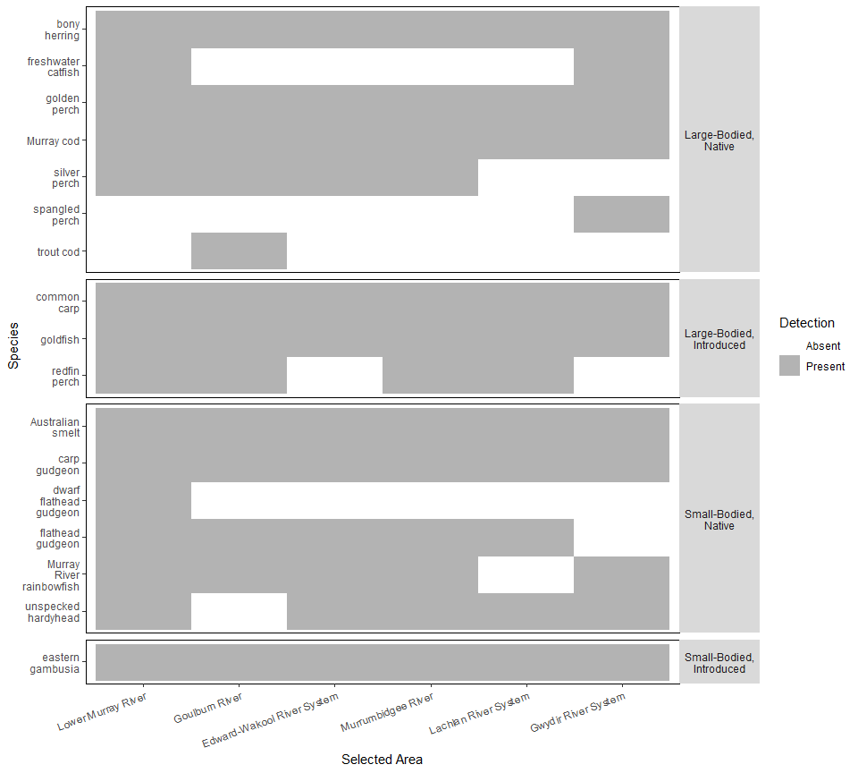

Figure 4.2.1. Fish species occurrence at each Selected Area. The detection of a species using both electrofishing for large-bodied and fyke netting for small-bodied species shows if a species was absent (white) or present (grey) within any sample from the Selected Area.

Murray cod, golden perch, carp gudgeons, bony herring, Australian smelt, common carp, goldfish and eastern gambusia were present in all Selected Areas (Figure 4.2.1). Three species were unique to a single Selected Area, showing limited distribution of those species (spangled perch (Gwydir River), trout cod (Goulburn River), dwarf flathead gudgeon (Lower Murray River).

The highest diversity of native species was found in the Lower Murray River, where 11 of the 13 native species were detected.

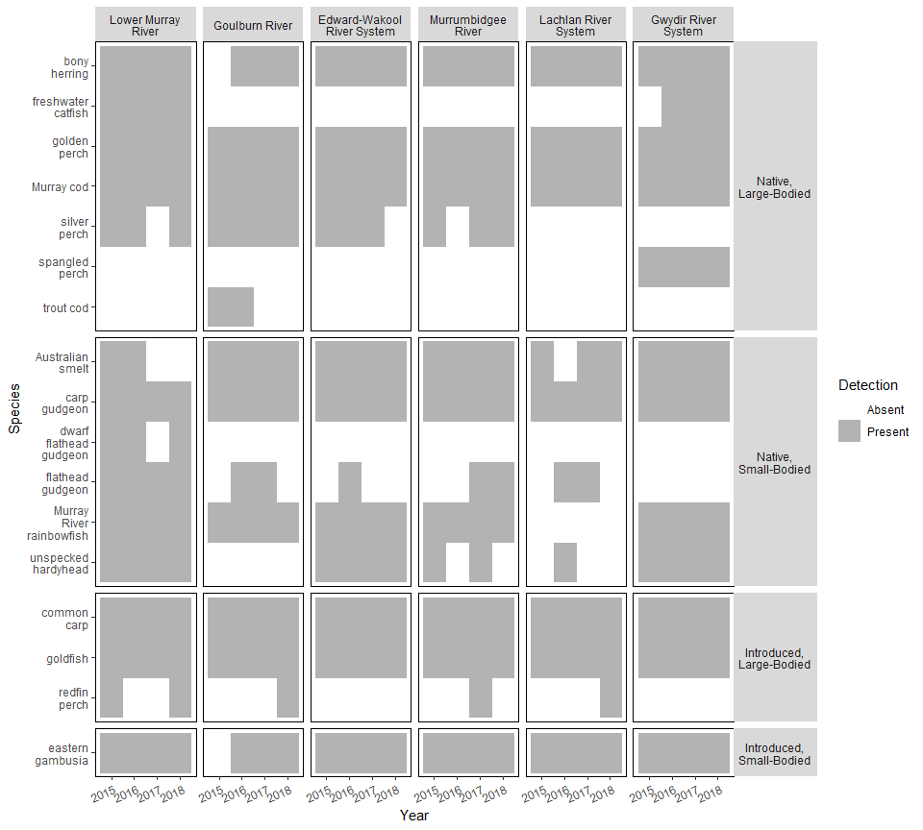

Figure 4.2.2. Fish species occurrence at each Selected Area across years of sampling 2015–2018. The detection of a species using electrofishing for large-bodied and fyke netting for small-bodied species shows if a species was absent (white) or present (grey) within any sample from each year within a Selected Area.

There were no visible generalisable trends for individual species detection within a Selected Area across years (Figure 4.2.2). However, the focal species (Murray cod, golden perch, carp gudgeons) and common carp and goldfish were detected in each Selected Area annually. Bony herring and eastern gambusia were recorded in all years and Selected Area combinations except in 2015 for the Goulburn River. Conversely, the presence of trout cod, which was only detected in the Goulburn River, only appeared in 2015 and 2016 sampling events. Similarly, dwarf flathead gudgeon was not recorded in 2017 in the Lower Murray was recorded in other years.

Redfin perch were detected only in 2015 in the Lower Murray River, and were then detected after the 2016–17 high flow year in four Selected Areas (Lower Murray River, Goulburn River, Murrumbidgee River and Lachlan River System).

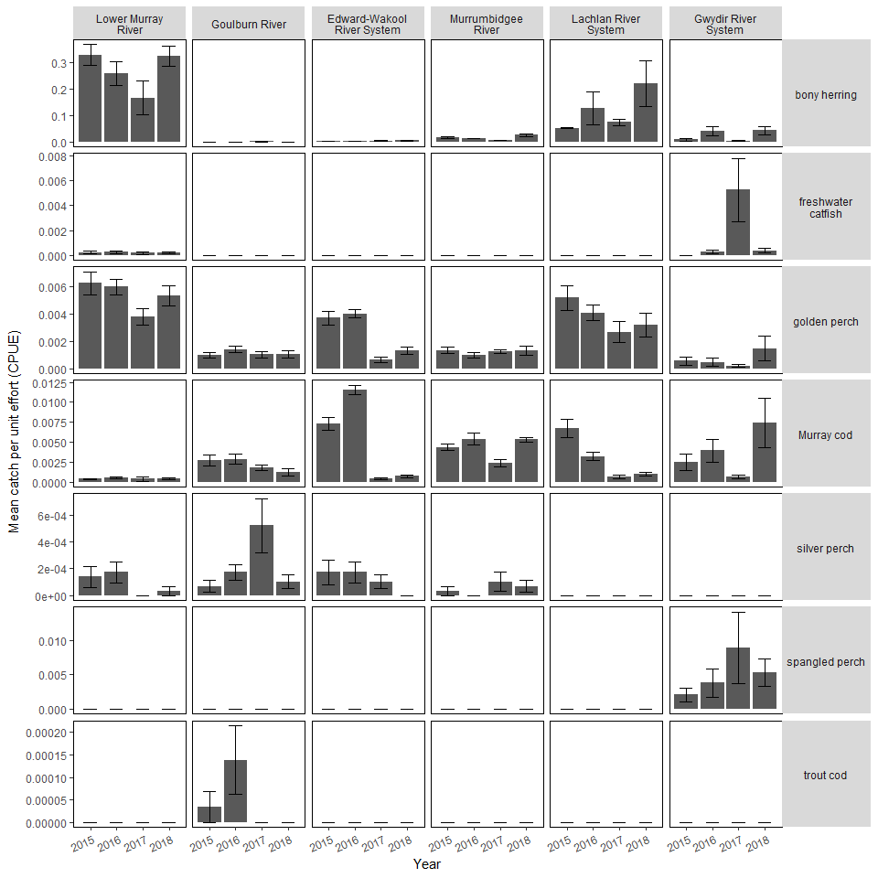

Figure 4.2.3. Mean CPUE (±1SE) of large-bodied native fish species at each Selected Area across years of sampling 2015–2018.

The abundance (catch per unit effort, CPUE) of large-bodied native species was variable between Selected Areas. However, the 2016–17 high flow year was associated with both positive and negative trends in fish populations (Figure 4.2.3).

A common trend across Selected Areas was a decline in the abundance of some large-bodied native species at the 2017 sampling event (post high flows, blackwater events and associated fish kills in several Selected Areas). For example, Murray cod abundance declined in Edward-Wakool River System, Murrumbidgee River, Lachlan River and Gwydir River Selected Areas in 2017.

Exceptions to this were, increases in abundance in 2017 of silver perch in the Goulburn River, and spangled perch and freshwater catfish in the Gwydir River System.

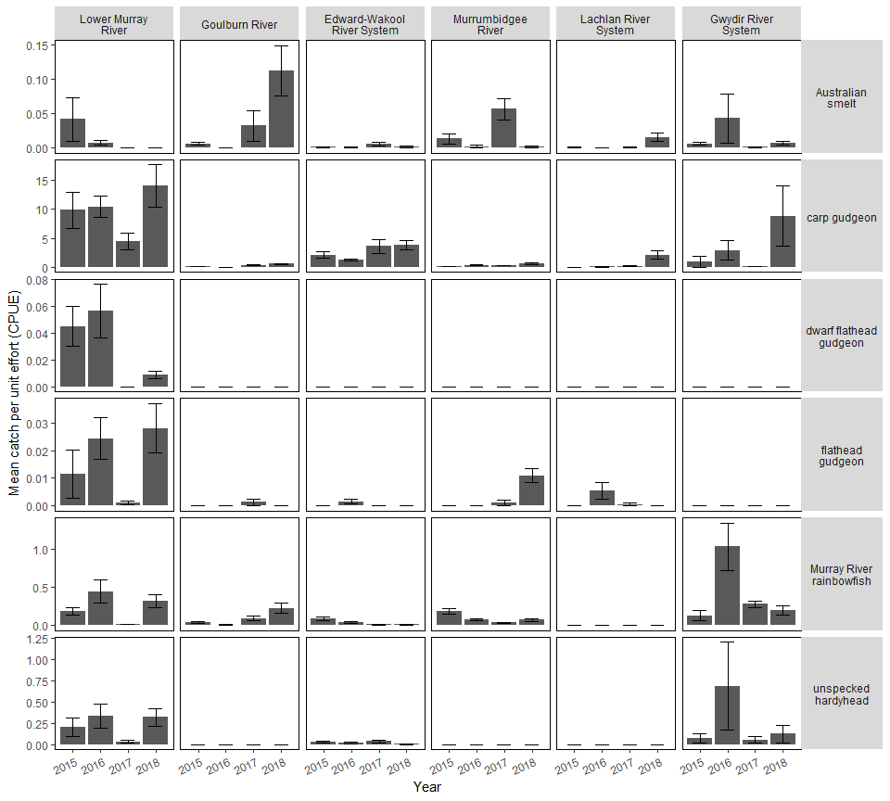

Figure 4.2.4. Mean abundance (±1SE) of small-bodied native fish species at each Selected Area across years of sampling 2015–2018.

As with the large-bodied native species, small-bodied native species trended towards decreases in abundance from the 2016 to 2017 sampling events (Figure 4.2.4). Again, this was not uniform and some catchments (Goulburn River) had increases in the catch of some species across this period (Australian smelt and Murray River rainbowfish). 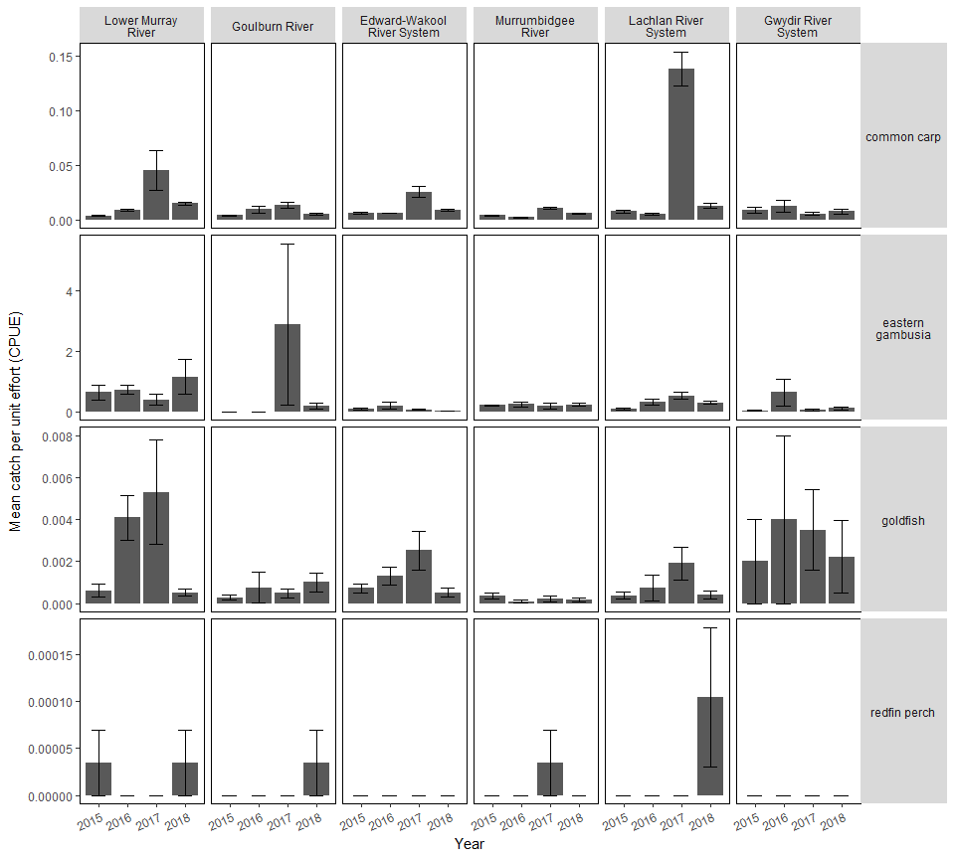

Figure 4.2.5. Mean abundance (±1SE) of introduced fish species at each Selected Area across years of sampling 2015–2018. Eastern gambusia were collected using fine-mesh fyke nets, while common carp, goldfish and redfin perch were collected using boat and backpack electrofishing. Note: y-axis scales differ between species.

Common carp was the most abundant large-bodied introduced species captured across all Selected Areas (Figure 4.2.5). In five of the six catchments (Gwydir River System being the exception), common carp had their highest CPUE in the 2017 sampling year, but then decreased in the 2018 sampling event.

Abundance of eastern gambusia were at their highest CPUE during the 2017 sampling event on the Goulburn River. In the Lower Murray River, Edward-Wakool River System and Lachlan River System, abundances of goldfish steadily increased from 2015–2017 then decreased to approximately 2015 abundances. Responses in other Selected Areas were variable and non-uniform. Redfin perch presence was highly variable, and they were not caught in the Edward-Wakool River System or the Gwydir River.

## Assemblage dynamics

Fish assemblage (sometimes also referred to as the fish community) refers to the diversity and abundance of species in a given location or time. In LTIM, differences in fish assemblages could be expected among Selected Areas or across years and could reflect significant environmental differences or changes.

To analyse differences in fish assemblages across Selected Areas and across the first four years of LTIM monitoring, data was collected and organised into a multivariate dataset, where the abundance of each species is recorded for each sample. This is then analysed using a statistical technique called non-metric dimensional scaling. This is a visual technique to observe similarity or differences between assemblages and a statistical test (permutational analysis of variance) is used to test for differences among designated factors (in our case Selected Area and Year).

Additionally, simple bar plots showing the mean CPUE and percentage composition bar plots for each species were conducted to view the species diversity and proportion of each species.

It should also be noted, that other environmental factors are likely to influence the assemblage, independent of the Selected Area or year in which they were collected (e.g. flow, temperature, dissolved oxygen, etc.). This requires a more extensive statistical analysis that will conducted and presented in the Year 5 report.

*Summary of main findings for fish assemblage dynamics*

* Fish assemblages differed among Selected Areas, particularly between the Lower Murray River and the Murrumbidgee River, the Lachlan River System and the Lower Murray River, and the Edward-Wakool River System and the Murrumbidgee River Selected Areas. The greatest assemblage differences in time occurred between Year 1 (2015) and Year 4 (2018) sampling events.
* Fish assemblages varied among year within most Selected Areas, for example in the Edward-Wakool River System and Goulburn River System before and after the 2016–17 flow year.
* The highest mean abundances for total fish across all Selected Areas was found in the Lower Murray River, having the highest CPUE of both large-bodied and small-bodied species from any Selected Area.
* Carp gudgeons were the most common species collected in Selected Areas, ranging from 95 percent in the Edward-Wakool River System to ~20 percent in the Goulburn River.

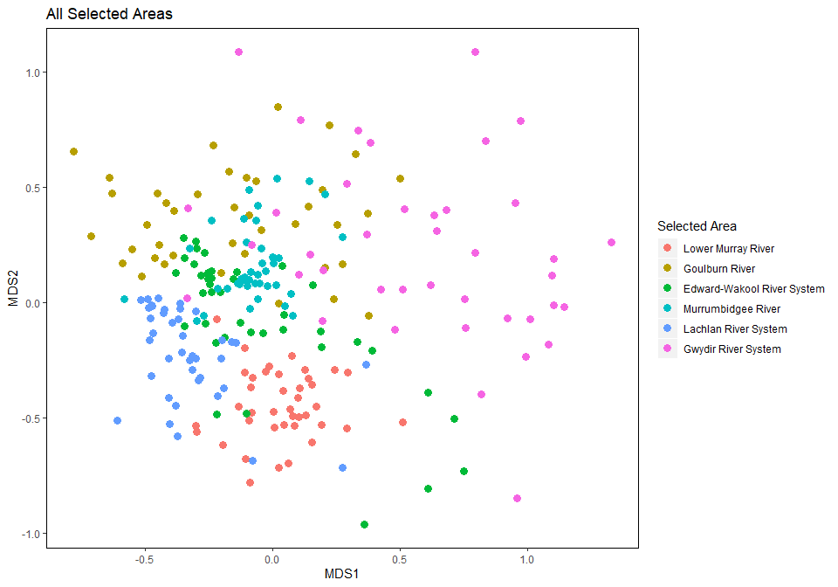

Figure 4.3.1. Ordination plot (nMDS) exploring similarities or differences among fish assemblages across Selected Areas. Analysis uses log(x+1) transformed data from standardised electrofishing and fyke net catches.

Non-Metric Dimensional Scaling (nMDS) was used to visually inspect how similar fish assemblages are among Selected Areas and years. Where points are close together within this space (e.g. the Lower Murray River or Lachlan River System, Fig. 4.3.1) assemblages are more similar, and points that are further spread (e.g. Gwydir River System) assemblages are less similar.

Selected Area (f-stat = 23.86, P = 0.001; Table 4.3.1) and year (f-stat = 9.45, P = 0.001) were both significant descriptors of differences in the sampled fish assemblages. Fish assemblages were the most different between the Lower Murray River and the Murrumbidgee River (f-stat = 70.67, P = 0.015), the Lachlan River System and the Lower Murray River (f-stat = 43.05, P = 0.015), and the Edward-Wakool River System and the Murrumbidgee River (f-stat = 42.46, P = 0.015) Selected Areas.

A comparison of years showed that the largest time period between sampling events (2015–2018) had the largest significant differences in assemblages (f-stat = 6.07, P = 0.006), followed by significant differences in the communities from 2016 vs 2018 (f-stat = 3.79, P = 0.018) and those from 2015 vs 2017 (f-stat = 3.23, P = 0.036).

While the main effects of differences between years is informative, the interaction between year and Selected Area shows more varied differences in fish communities between years at the Selected Area level.

Table 4.3.1. Summary statistics (PERMANOVA) for fish assemblage differences among Selected Areas and sampling year.



A second PERMANOVA was completed to determine the significance of years within a Selected Area (Table 4.3.1). This showed that fish assemblages varied significantly among years for most Selected Areas, exceptions were the Gwydir River (f-stat = 1.28, P = 0.236) and Lower Murray River (f-stat = 0.32, P = 0.839). This highlights that fish assemblages from these two Selected Areas were more consistent among years than other Selected Areas (Figure 4.3.1) and is represented well when visually inspecting the nMDS plots. Differences between specific years were significant, however, between 2015 vs 2016 (f-stat = 3.88, P = 0.024 Table 4.3.1) and 2015 vs 2017 (f-stat = 2.50, P = 0.006) in the Gwydir River and 2016 vs 2017 (f-stat = 9.36, P = 0.012) and 2017 vs 2018 (f-stat = 8.60, P = 0.006) in the Lower Murray River.

The Edward-Wakool River only showed significant differences in assemblage between the 2016 vs 2018 years (f-stat = 5.59, P = 0.036). The Goulburn River showed a change in the fish assemblage mostly between years before and after 2017 (2015 vs 2018, 2016 vs 2017, 2016 vs 2018; Table 4.3.2).

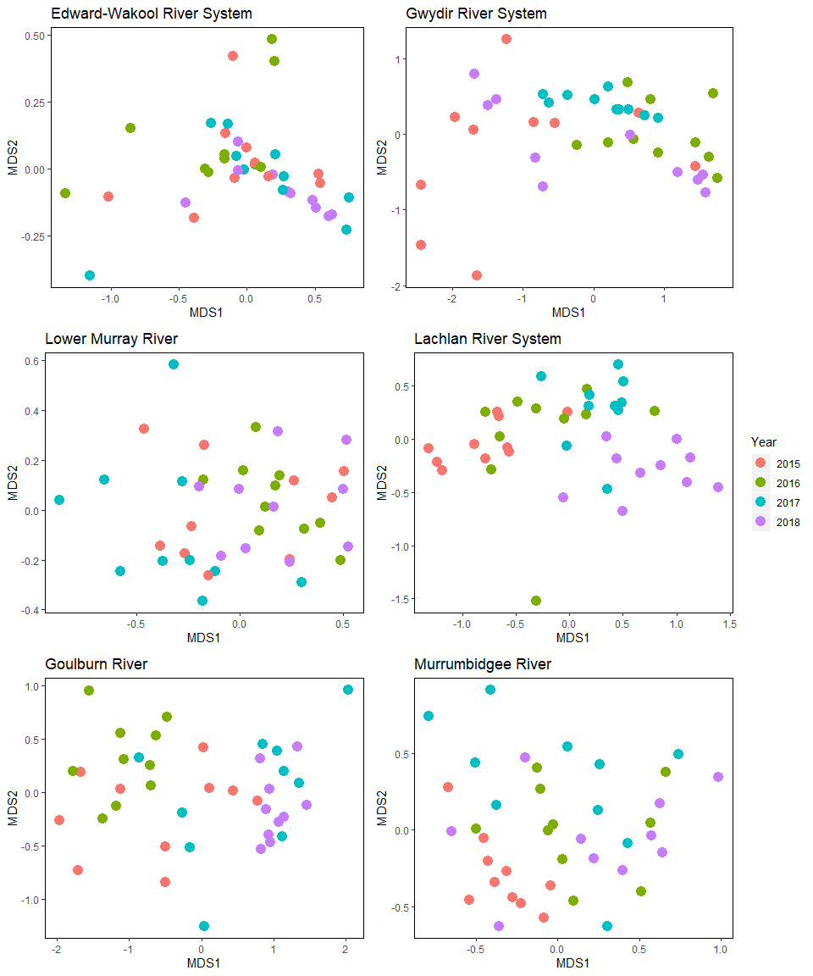

Figure 4.3.2. Ordination (nMDS) of exploring similarities or differences of fish assemblages for each Selected Area across sampling years.

The Lachlan River System had close grouping of samples from each year (Figure 4.3.2), indicating there was low variability between fish assemblages across sites. Significant differences were generally found between nonconsecutive years in the Lachlan River System (Table 4.3.2), although also there was also a significant difference between 2017 and 2018 (f-stat = 9.02, P = 0.006). In the Murrumbidgee River significant differences in fish assemblages were found between 2015 and all other years of sampling.

Table 4.3.2. Summary statistics (PERMANOVA) for fish assemblage differences for each Selected Area among sampling years.



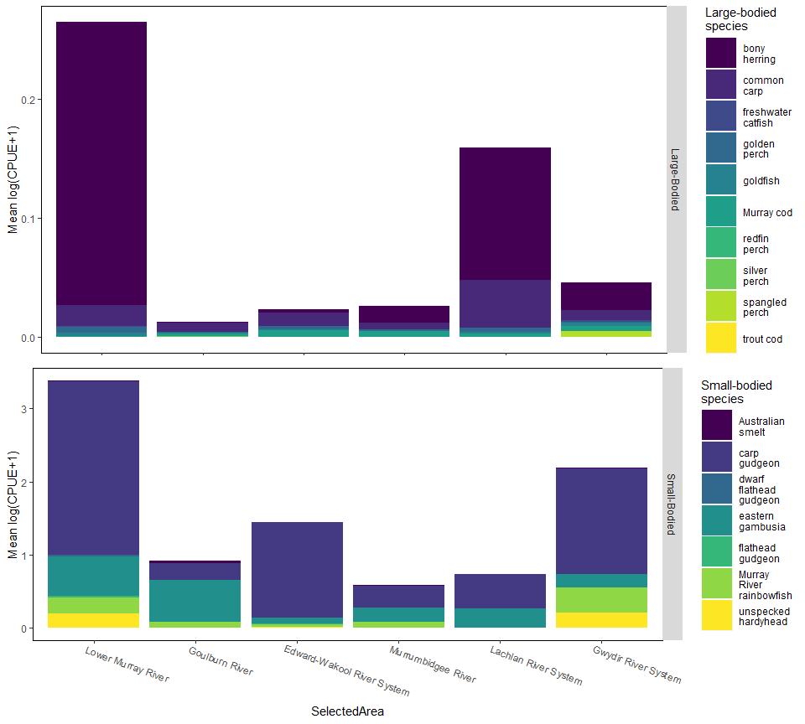

Figure 4.3.3. Abundance (mean log (CPUE+1)) of small and large bodied species by Selected Area. Note different y-axis scales.

The highest mean abundances for total fish across all Selected Areas was found in the Lower Murray River (Figure 4.3.3), having the highest CPUE of both large-bodied and small-bodied species from any Selected Area. The next highest average CPUE of large-bodied species were from the Lachlan River System and then the Gwydir River System. The next highest mean CPUE for small-bodied species were encountered in the Gwydir River System and Edward-Wakool Rivers System.

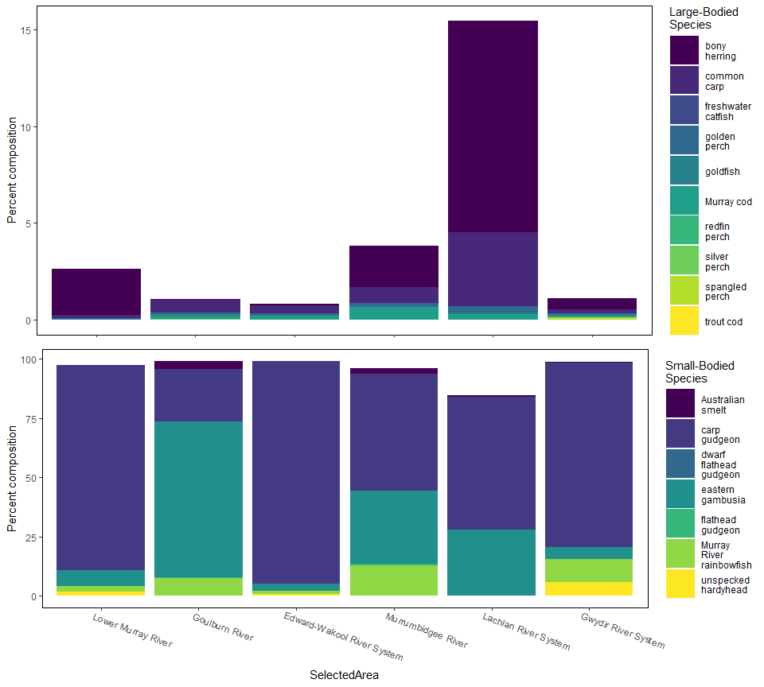

Figure 4.3.4. Percentage composition of fish assemblage across Selected Areas. Note different y-axis scales and the two panels are additive, i.e. both panels combined represent the total percent composition at each Selected Area.

Carp gudgeons were the most common species collected. The highest percentage of large-bodied species within a Selected Area was found in the Lachlan River System, with ~ 10 percent being bony herring (Figure 4.3.4). The Lachlan River System had the highest percentage of common carp (approx. 4%). Carp gudgeons were generally the most dominant small-bodied species, ranging between approximately 95 percent of the community in the Edward-Wakool River System to approximately 20 percent of fish in the Goulburn River (where the most dominant species was eastern gambusia (~ 65 percent)).

## Spawning outcomes

Spawning of both native and introduced species was measured by collecting eggs and fish larvae using drift nets and light traps at five Selected Areas, during the known spawning period (see Hale et al. 2014 for full description of methods).

Here we report the abundance of eggs and larvae for each species collected in each sampling event from each Selected Area and across years.

*Summary of main findings for spawning outcomes*

* Larvae from 15 native species and four introduced species were collected across all Selected Areas. Larvae of carp gudgeons, Murray cod, Australian smelt and common carp were the most commonly collected species.
* Occurrence and density of eggs or larvae (spawning activity) varied among Selected Area and sampling occasion (Section 4.4). For example, golden perch spawning was detected in only three Selected Areas and intensity varied considerably over the years and sampling periods. In contrast, Murray cod spawning was detected in most years across the five Selected Areas, but notably did not occur during the 2016–17 high flow year in the Edward-Wakool River System or Lachlan River. There was also no evidence of spawning of Murray cod in 2017–18 in the Lower Murray River.
* Common carp were detected spawning in all years and at all five Selected Areas that monitored spawning, however spawning intensity increased substantially in the 2016–17 high flow year at Edward-Wakool River System, Lachlan River System and the Murrumbidgee River Selected Areas.
* Further statistical analyses being conducted for the Year 5 report linking spawning outcomes to flow variables will elucidate the influence of flow on fish spawning activity.

Table 3.4.1. Total catch of all larval fish per species, across Selected Areas and sampling years, all methods combined. Note no larval collections occur in the Gwydir Selected Area.

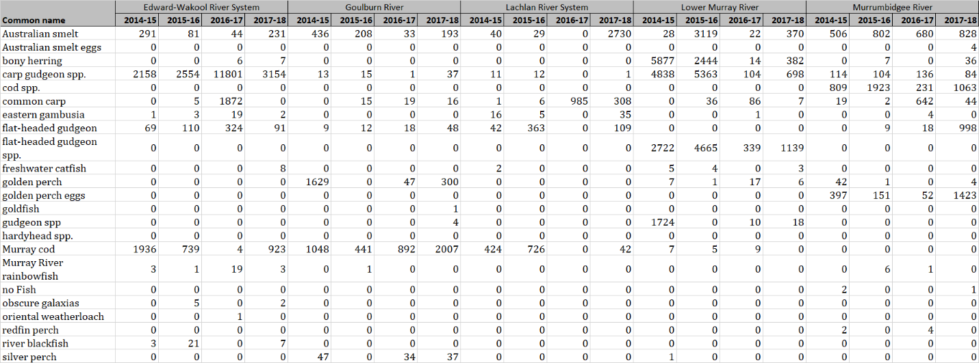

Table 4.4.2. Total catch of all larval fish per species in each method type, across Selected Areas and sampling years. Note Lower Murray Selected Area only used trawl net sampling.



Larvae from 15 native species and four introduced species were collected across all Selected Areas (Table 4.4.1). Larvae of carp gudgeons, Murray cod, Australian smelt and common carp were the most commonly collected species.

Light traps captured the most larvae in the Edward-Wakool River System, while other Selected Areas were either comparable between methods or had higher catches in drift nets (Table 4.5.2).

Total abundances of both light trap and drift net caught larvae increased substantially in the Edward-Wakool River System during the 2016-17 high flow period, but a similar pattern was not observed at other Selected Areas.

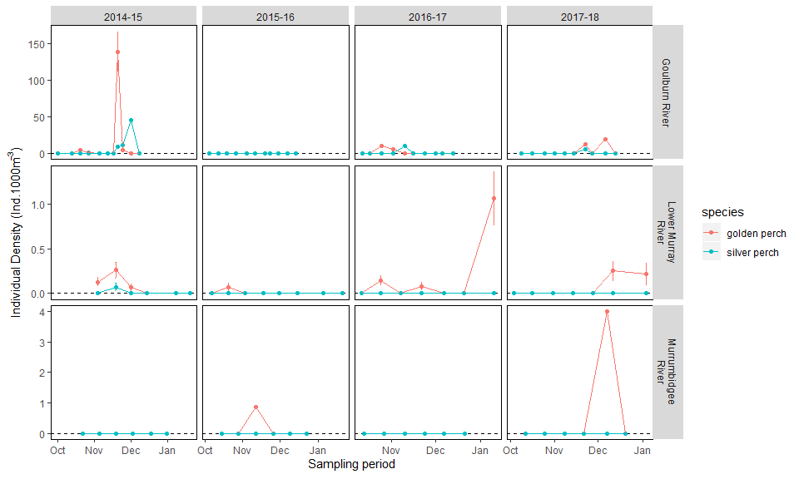

Figure 4.4.1. Density of golden perch and silver perchlarvae collected in drift nets or trawl nets across Selected Areas and years. Note: Trawl nets only used in Lower Murray; no collection of these species in Lachlan River; and note different y-axes scales.

Golden perch showed evidence of spawning in the Goulburn River, the Lower Murray River and the Murrumbidgee River Selected Areas. The largest spawning intensity was seen in the Goulburn River during the 2014–15 sampling season while far lower abundances were seen in other Selected Areas and years.

Silver perch showed evidence of spawning in the Goulburn River and the Lower Murray River (although only one individual collected), where the highest abundance was seen in the 2014–15 year in the Goulburn River.

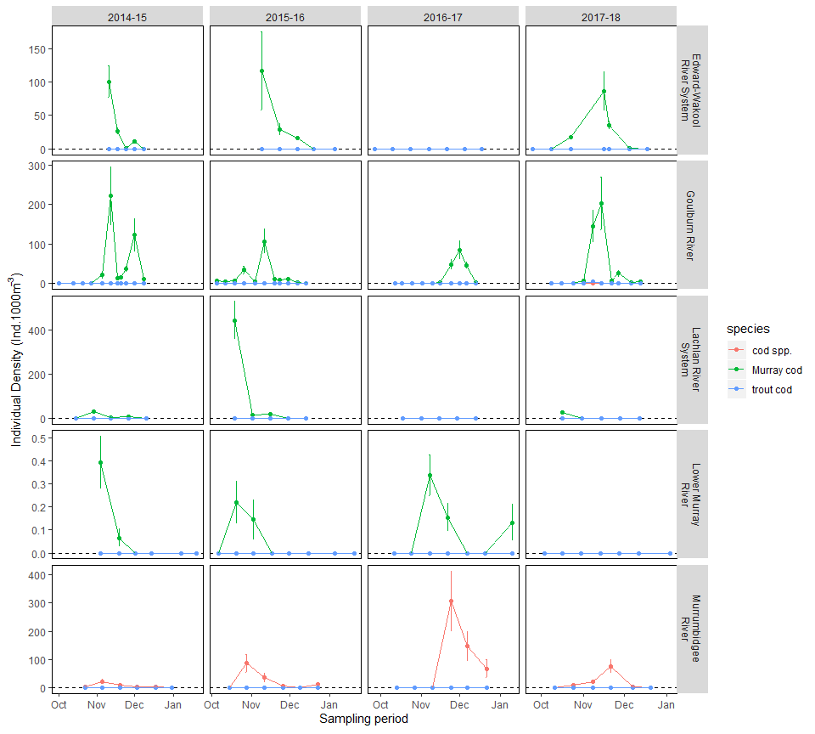

Figure 4.4.2. Density of Murray cod and Trout cod species larvae collected in drift nets or trawl nets across Selected Areas and sampling years. Note trawl nets only used in Lower Murray; and note different y-axes scales.

There was inconsistency across the Selected Areas ability to confidently identify between larval Murray cod and trout cod, with some Selected Areas recording ‘Cod spp.’ in systems where both species are present and larval identification could be confirmed. Cod species were detected spawning in all Selected Areas and within most years, however, sampling in the Edward-Wakool River System and the Lachlan River in the 2016–17 sampling events showed no evidence of spawning for cod species. Similarly, there was no evidence of spawning in the Lower Murray River in the 2017–18 year of sampling. Highest densities were found in the Goulburn River in 2014–15 and 2017–18 and in the Murrumbidgee River in 2016–17.

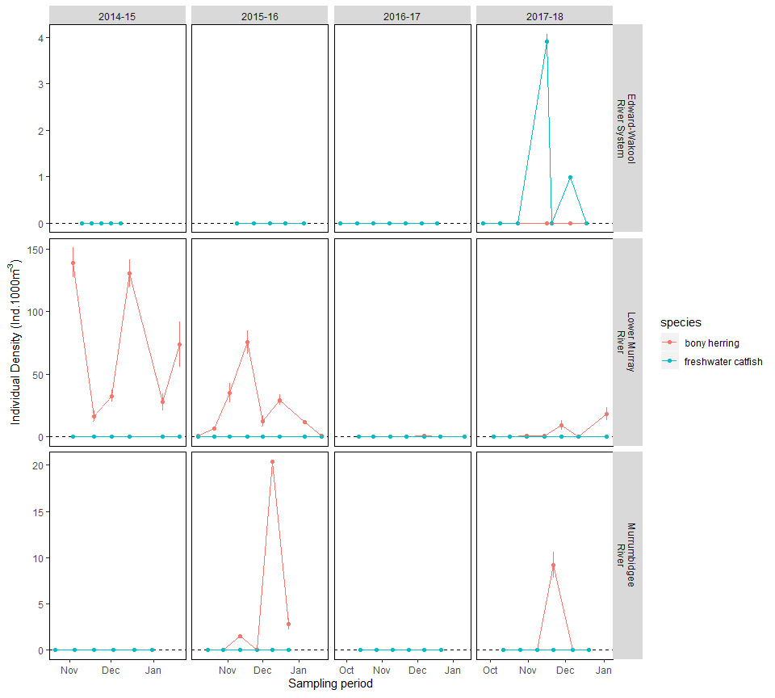

Figure 4.4.3. Density of bony herring and freshwater catfishlarvae collected in drift nets or trawl nets across Selected Areas and sampling years. Note: trawl nets only used in Lower Murray; these species were not captured in Goulburn or Lachlan Selected Areas; note different y-axes scales.

Bony herring spawning was detected in the Edward Wakool River System, Lower Murray River and the Murrumbidgee River (Figure 4.4.3). Bony herring were present in the sampling events that occurred in 2016–17 and 2017–18 while they spawned annually in the Lower Murray River and were present in 2015–16 and 2017-18 sampling events in the Murrumbidgee River. Freshwater catfish only showed evidence of a significant spawning event in the 2017–18 year in the Edward-Wakool River System.

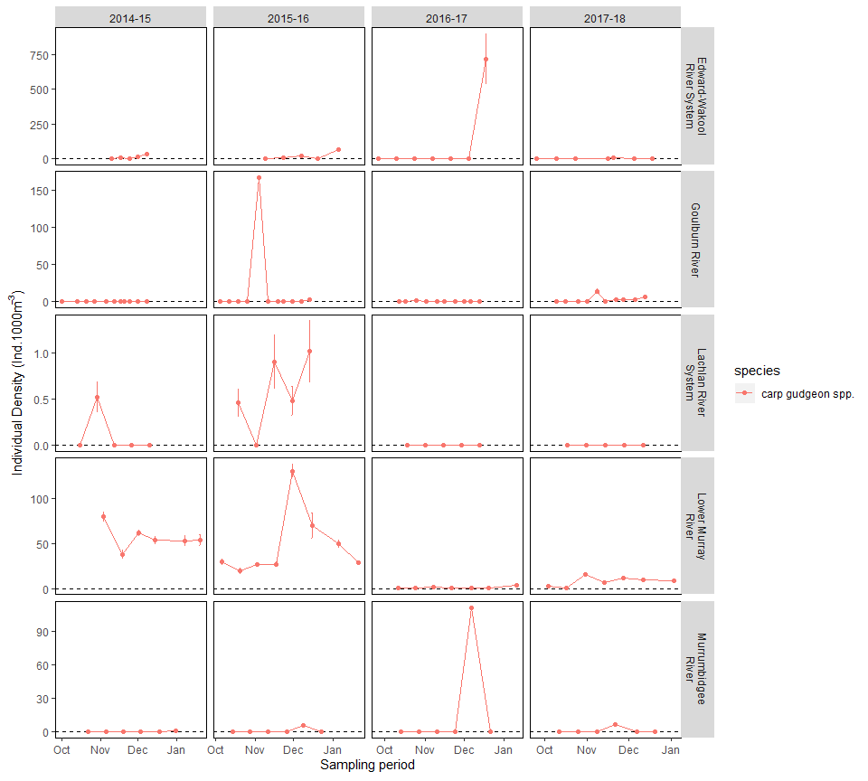

Figure 4.4.4. Density of carp gudgeon spp. larvae collected in drift nets or trawl nets across Selected Areas and years. Note: trawl nets only used in Lower Murray and note different y-axes scales.

Carp gudgeons were detected spawning in all Selected Areas and appeared in highest abundance (approx. 750 individuals) in the Edward-Wakool River System during late December in 2016–17 (Figure 4.4.4). This pattern of increased abundance was also seen in the Murrumbidgee River though in the Goulburn River, Lachlan River and Lower Murray River.

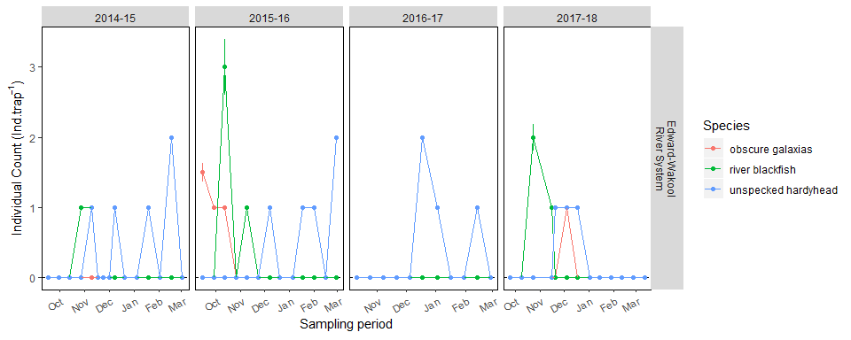

Figure 4.4.5. Abundance of unspecked hardyhead*, r*iver blackfish andobscure galaxias larvae collected in light traps. Note different y-axes scales.

Unspecked hardyhead) larvae were only collected using light traps in the Edward-Wakool River where Low abundances were sampled in all years (Figure 4.4.5). River blackfish (*Gadopsis marmota*) were only collected using light traps in the Edward-Wakool River, however, there was no catch of river blackfish larvae in the 2016–17 sampling events. Obscure galaxias (*Galaxias oliros*) were only collected using light traps in the Edward-Wakool River where low abundances were sampled in the 2015–16 and 2017–18 years of sampling.

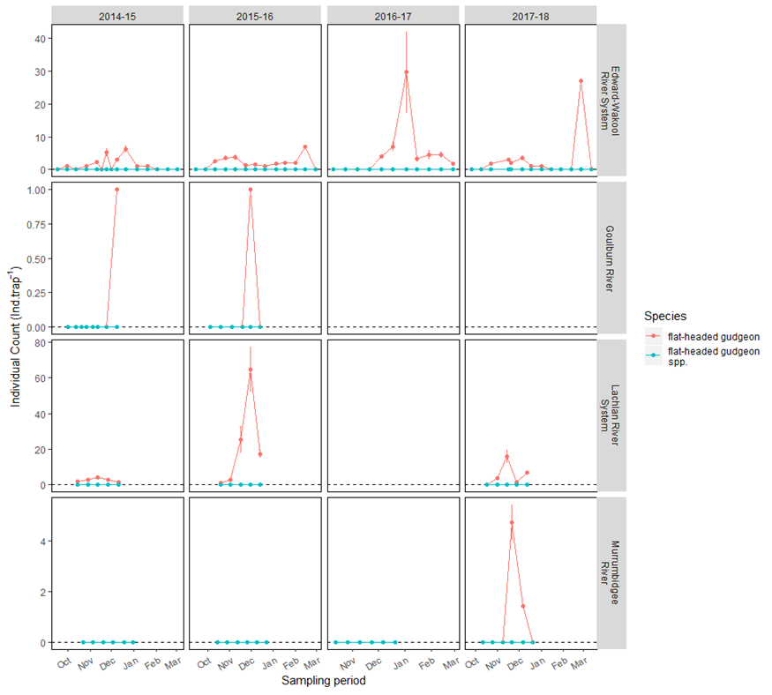

Figure 4.4.6. Abundance of flat-headed gudgeon species collected in light traps across Selected Areas and years. Note not collected in Lower Murray and note different y-axes scales.

Flathead gudgeon species showed evidence of spawning across all Selected Areas, although were only observed each year in the Edward-Wakool River System in light traps (Figure 4.4.6) and in the Goulburn River and Lower Murray River within drift nets and trawl sampling respectively. Samples from the Lower Murray River showed a decrease in total abundances from 2015–16 to 2016–17 sampling events (Figure 4.4.7). The highest total abundance of larval flathead gudgeon species (approx. 1000 individuals) was found in drift nets from the Lachlan River System in the 2017–18 sampling events.

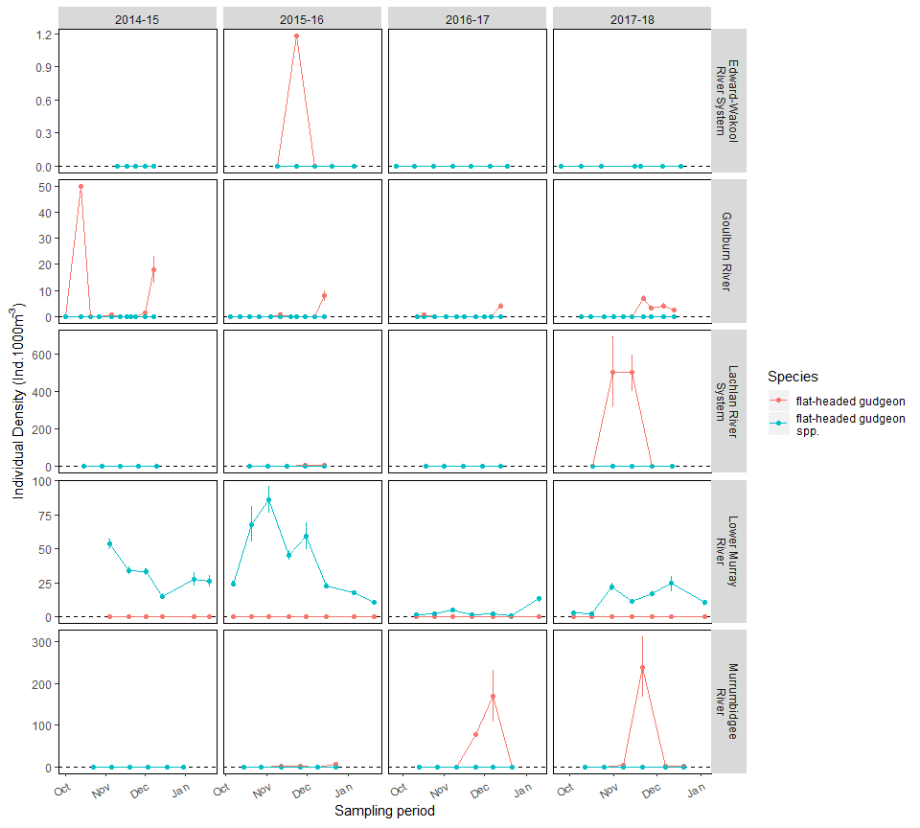

Figure 4.4.7. Density of Flat-headed gudgeon larvae collected in drift nets or trawl nets across Selected Areas and years. Note: trawl nets only used in Lower Murray, note different y-axes scales.

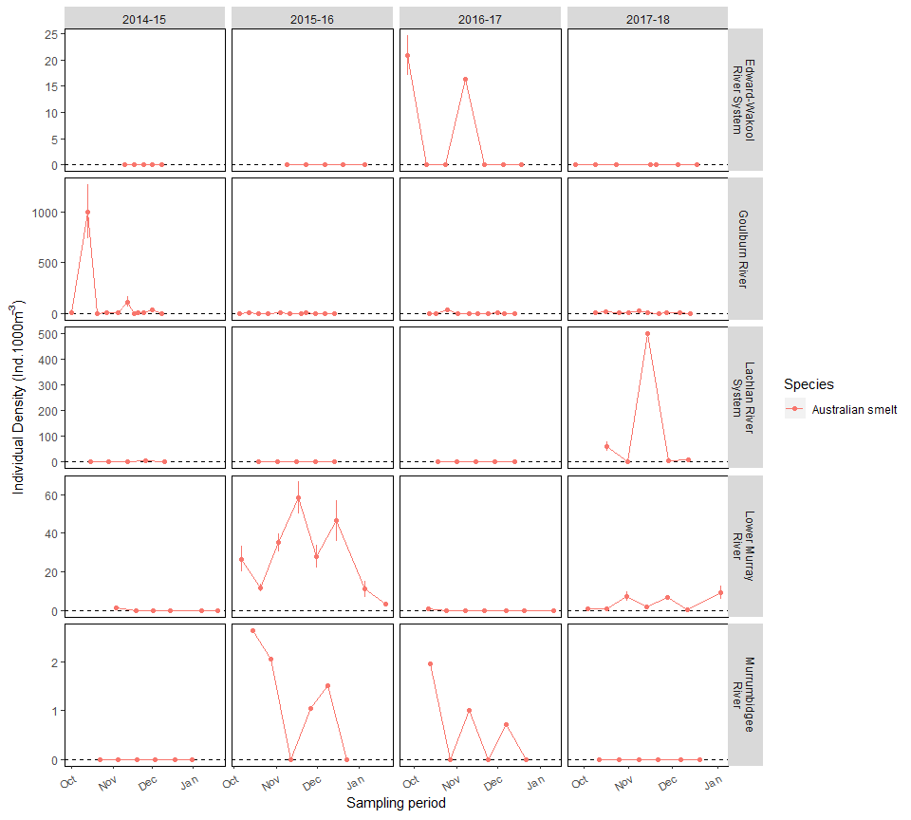

Figure 4.4.8. Density of Australian smelt larvae collected in drift nets or trawl nets across Selected Areas and years. Note: trawl nets only used in Lower Murray and note different y-axes scales.

Australian smelt were collected in both drift nets and trawl nets across all Selected Areas and showed greatest intensity of spawning during the 2014–15 sampling events in the Goulburn River (Figure 4.4.8). Significant spawning effort was also seen in the Lower Murray River and the Lachlan River System in the 2015–16 and 2017–18 sampling years respectively. Spawning was observed in all years in the Lower Murray River and the Goulburn River while spawning was more variable in other Selected Areas.

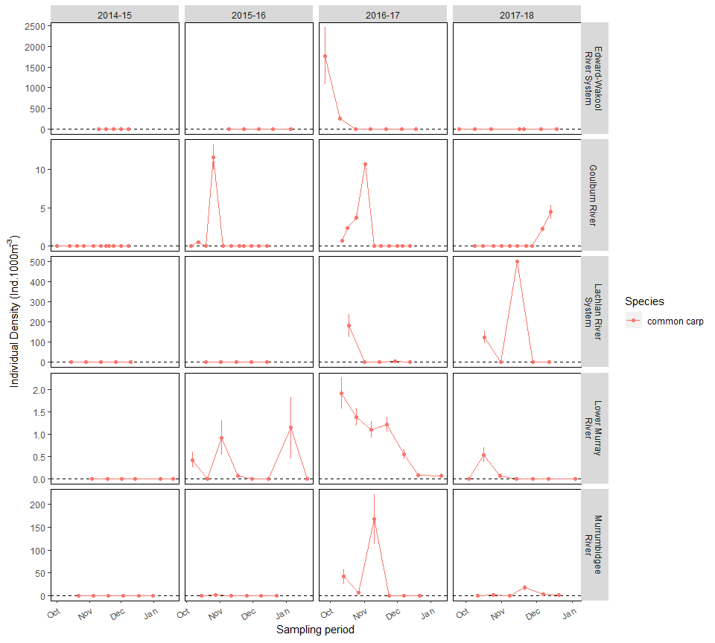

Figure 4.4.9. Density of common carp larvae collected in drift nets or trawl nets across Selected Areas and years. Note: trawl nets only used in Lower Murray and note different y-axes scales.

Common carp were detected spawning at all five Selected Areas, being collected in both drift nets (Figure 4.4.9) and light traps (Figure 4.4.10). There was an increase of between 2 and 3 orders of magnitude in total abundance from the 2015–16 to the 2016–17 sampling events on the Edward-Wakool River System, Lachlan River System and the Murrumbidgee River.

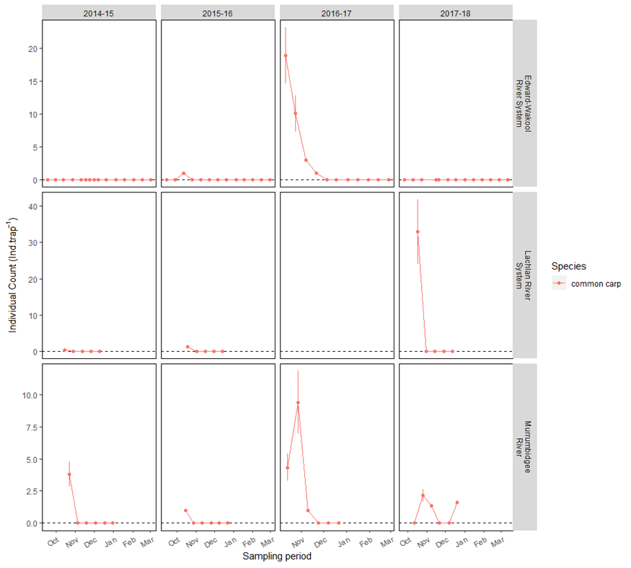

Figure 4.4.10. Abundance of common carp larvae collected light traps across Selected Areas and years. Note different y-axes scales

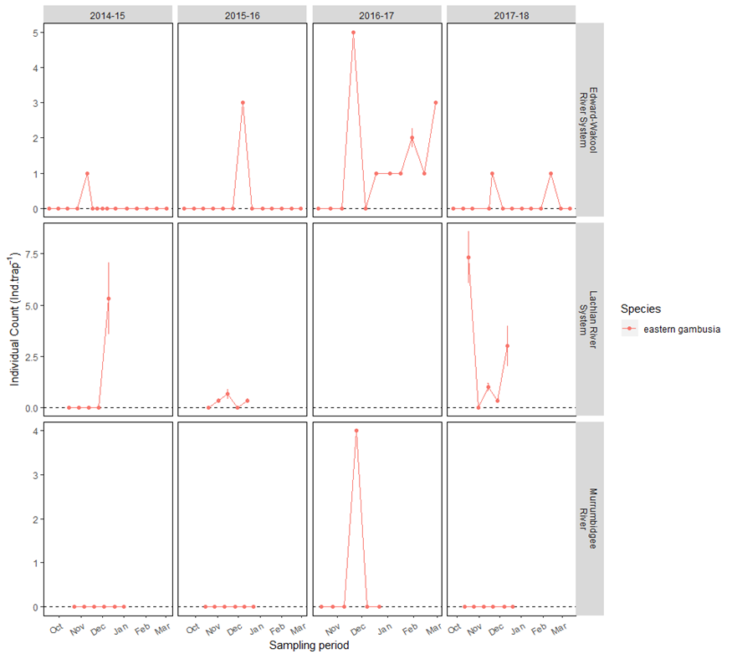

Figure 4.4.11. Abundance of eastern gambusialarvae collected light traps across Selected Areas and years. Note not collected in Goulburn or Lower Murray, note different y-axes scales.

Eastern gambusia were detected spawning at various times in the Edward-Wakool River System, Lachlan River System, and Murrumbidgee River (Figure 4.4.11). The largest spawning effort appeared to be on the Edward-Wakool River System during the 2016–17 year followed closely by sampling in the Lachlan River System during the 2017–18 sampling year. Eastern gambusia were only sampled in the Murrumbidgee River during the 2016–17 sampling events, not in any other year.

Other introduced species goldfish and redfin perch only showed minimal evidence of spawning. During the 2017–18 year in the Goulburn River a single larval goldfish was encountered during sampling. Redfin perch showed small evidence of spawning in the Murrumbidgee River during 2014–15 (two individuals collected Table 4.4.1).

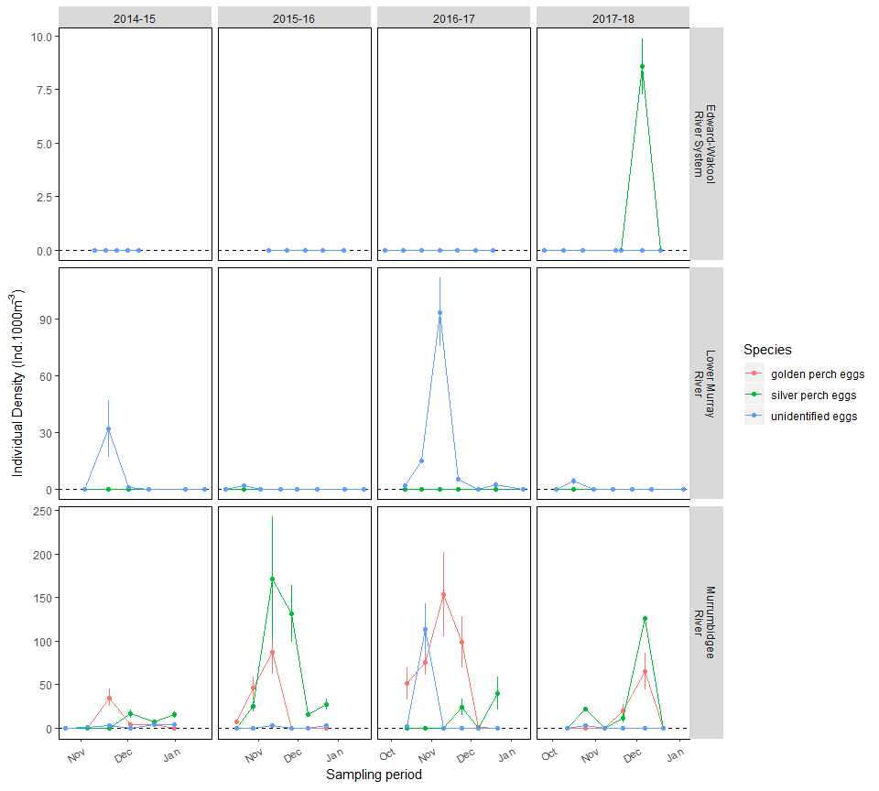

Figure 4.4.12 Density of eggs collected in drift nets or trawl nets across Selected Areas and years. Note Trawl nets only used in Lower Murray; not collected in Goulburn or Lachlan Selected Areas; and note different y-axes scales.

Densities of eggs from various species were encountered annually within samples from the Murrumbidgee River and Lower Murray River, although, higher densities were generally found in the Murrumbidgee River when comparing annual densities between Selected Areas (Figure 4.4.12). The Murrumbidgee River Selected Area also has identified the eggs of golden perch and silver perch separately in each year, in addition to eggs not allocated to any species. While the catch of larval individuals for both golden and silver perch on the Murrumbidgee River found very low densities of golden perch and no silver perch larvae (Figure 4.4.1), this data suggests that spawning occurred annually in the Murrumbidgee River for both species from late October to early December.

## Population dynamics

The majority of individual fish that were collected during LTIM standard monitoring were also measured for total length (TL) or fork length (FL) and body weight before being released back into the reach where it was caught.

These measures of length were used to generate length-frequency plots for each species across Selected Area and year. Length-frequency plots are useful for investigating the population dynamics (population change) as the abundance of individuals within a specific length range are most likely to be a similar age. This allows us to investigate the progression of a cohort of individuals through time as they grow, identify if a breeding event lead to subsequent recruitment of individuals into the ‘adult’ population, and identify mortality events at a population scale just by measuring their length.

*Summary of main findings for population dynamics*

* There was evidence of little or no recruitment of (presence of young-of-year) Murray cod after the 2016–17 high flow year in the Edward-Wakool and Lachlan Rivers, presumably a result of blackwater associated fish kills. Whilst overall numbers of Murray cod continued to be low in 2018 sampling event, there was evidence of some recruitment at these two Selected Areas.
* There is little to no evidence of recruitment of golden perch in most Selected Areas across the first four years of LTIM. This is despite golden perch spawning being detected in three Selected Areas (Goulburn River, Lower Murray River and the Murrumbidgee River). Reasons for this recruitment failure is currently unknown.
* There was evidence of strong recruitment of bony herring and strong year classes across all years and most Selected Areas (excluding the Goulburn River where only few bony herring were captured).
* There were large pulses of recruitment of common carp evident from the 2016–17 high flow year in all Selected Areas. This was strongest in the Lachlan River System, where there was a near 30-fold increase in the abundance of common carp from 2015–16 to 2016–17. However, this massive influx of young-of-year carp were not present as a distinct cohort in 2017–18, suggesting that they either did not survive or moved out of the sampling area.

Table 4.5.1. Number of individual records for total length (TL), fork length (FL) and weight (W) for all species across Selected Areas.

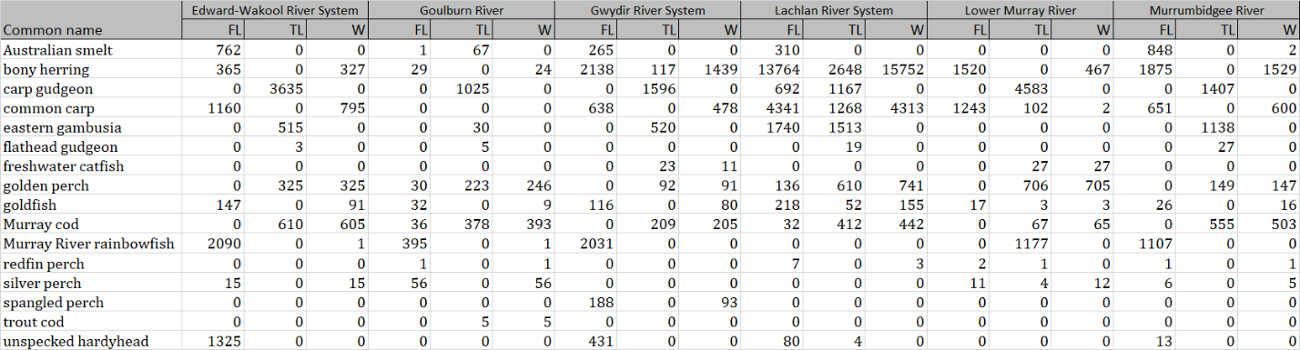

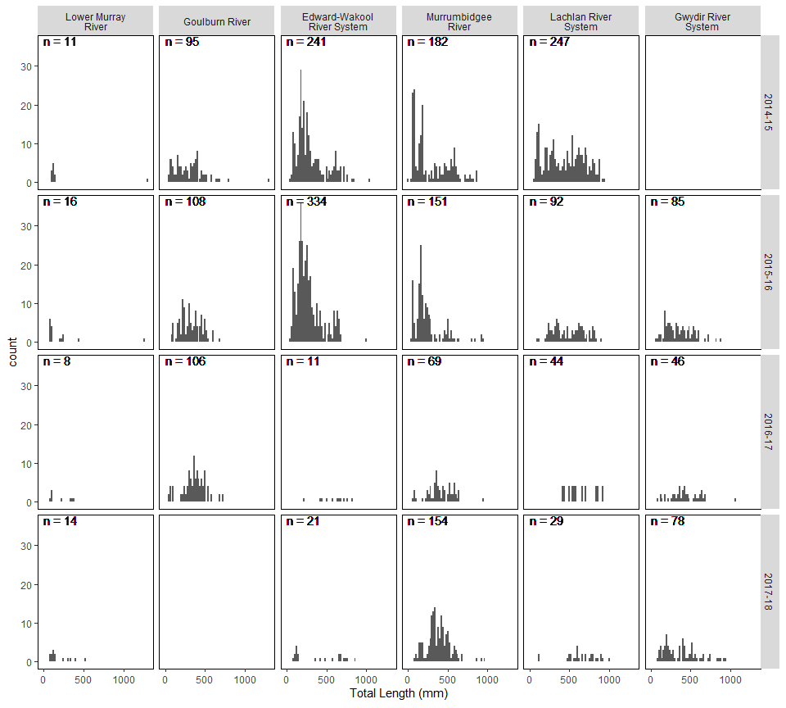

Figure 4.5.1. Length-frequency plots of all measured Murray cod individuals across Selected Areas and sampling years.

There was evidence of Murray cod recruitment (presence of young-of year age classes, TL <150mm) in all Selected Areas in the first two sampling years (Figure 4.5.1), however this pattern changed after the high flow year. Both adult and young-of-year individuals were either absent or substantially reduced in 2016–17 in several Selected Areas, including a total absence of recruits in Edward-Wakool River System and Lachlan River.

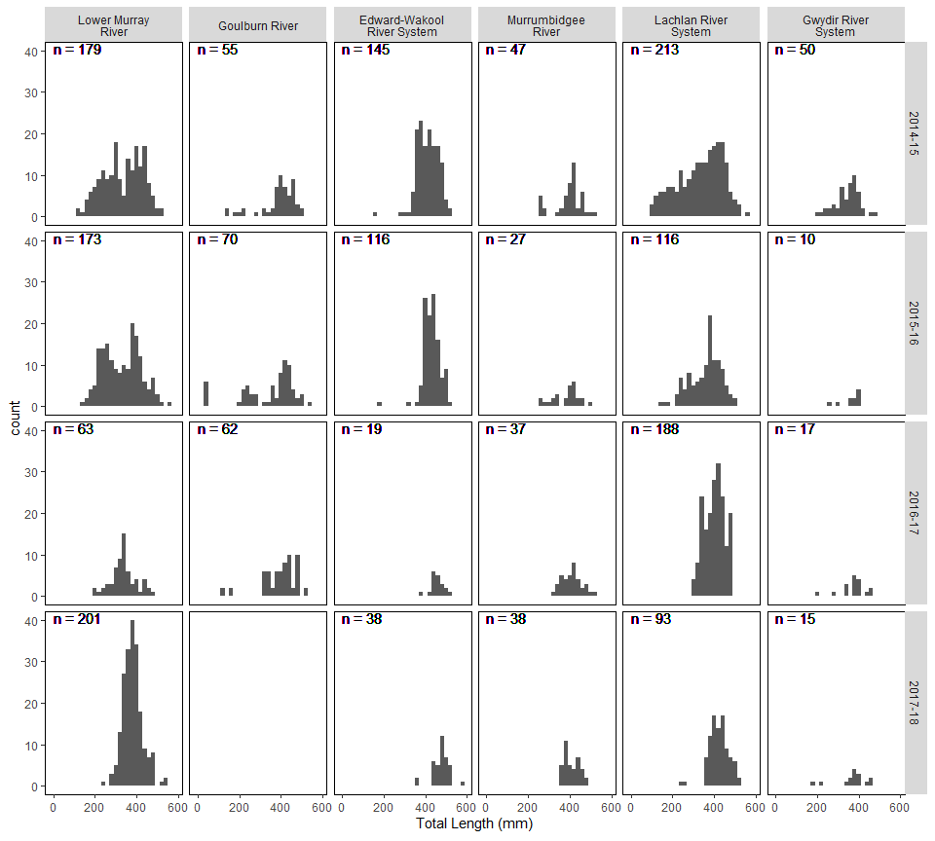

Figure 4.5.2. Length-frequency plots of all measured golden perch individuals across Selected Areas and sampling years.

There is little to no evidence of recruitment of golden perch in most Selected Areas across the first four years of LTIM (the exception being a small number of individuals detected in the Goulburn River in 2016) (Figure 4.5.2). Size distributions of golden perch from the Edward Wakool River System, Lachlan River System, Lower Murray River and Murrumbidgee River indicate an aging population (i.e. size is increasing between years, but not being replaced by smaller size classes).

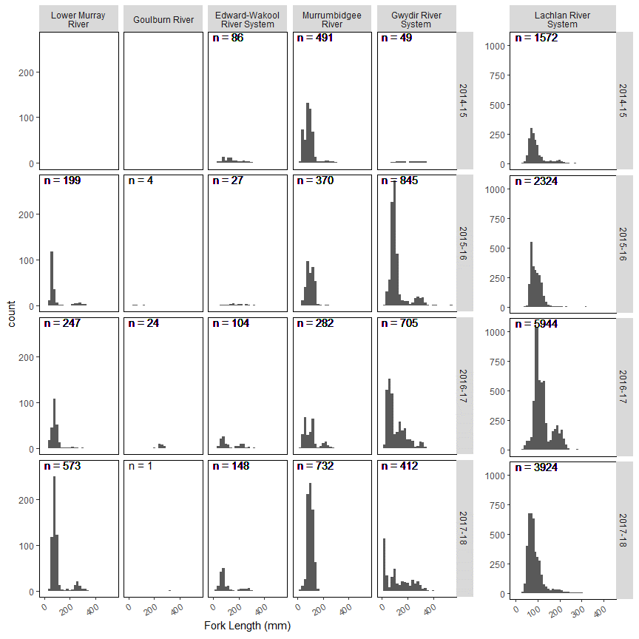

Figure 4.5.3. Length-frequency plots of all measured bony herring individuals across Selected Areas and sampling years. Note different y-axis scale on Lachlan River System Selected Area.

Bony herring length-frequency plots show evidence of strong recruiting size classes annually in most Selected Areas (excluding the Goulburn River where only few bony herring were captured) (Figure 4 .5.3). Populations of bony herring had highly variable abundances of adults, though the largest breeding population was found in the Lachlan River during the 2016–17 sampling event.

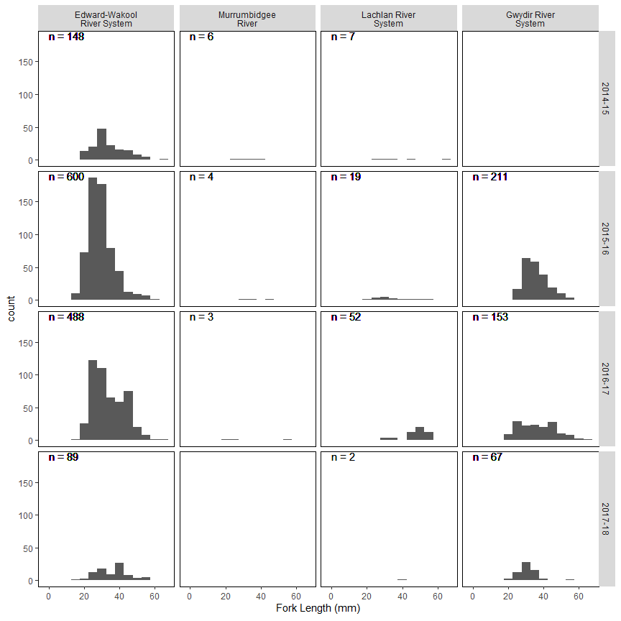

Figure 4.5.4. Length-frequency plots of all measured unspecked hardyhead individuals across Selected Areas and sampling years.

Unspecked hardyhead were uncommon in most Selected Areas, though had large populations in the Edward-Wakool River System and the Gwydir River System (Figure 4.5.4).

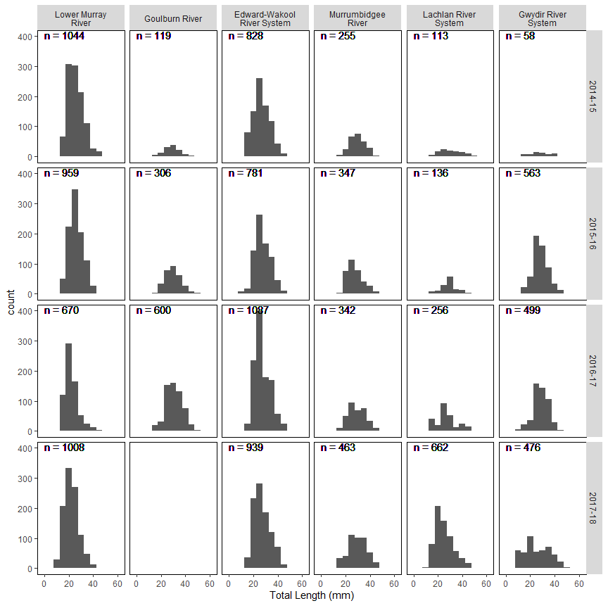

Figure 4.5.5. Length-frequency plots of all measuredcarp gudgeon individuals across Selected Areas and sampling years.

Carp gudgeons, while present in all Selected Areas, showed no consistent trends across Selected Areas (Figure 4.5.5).

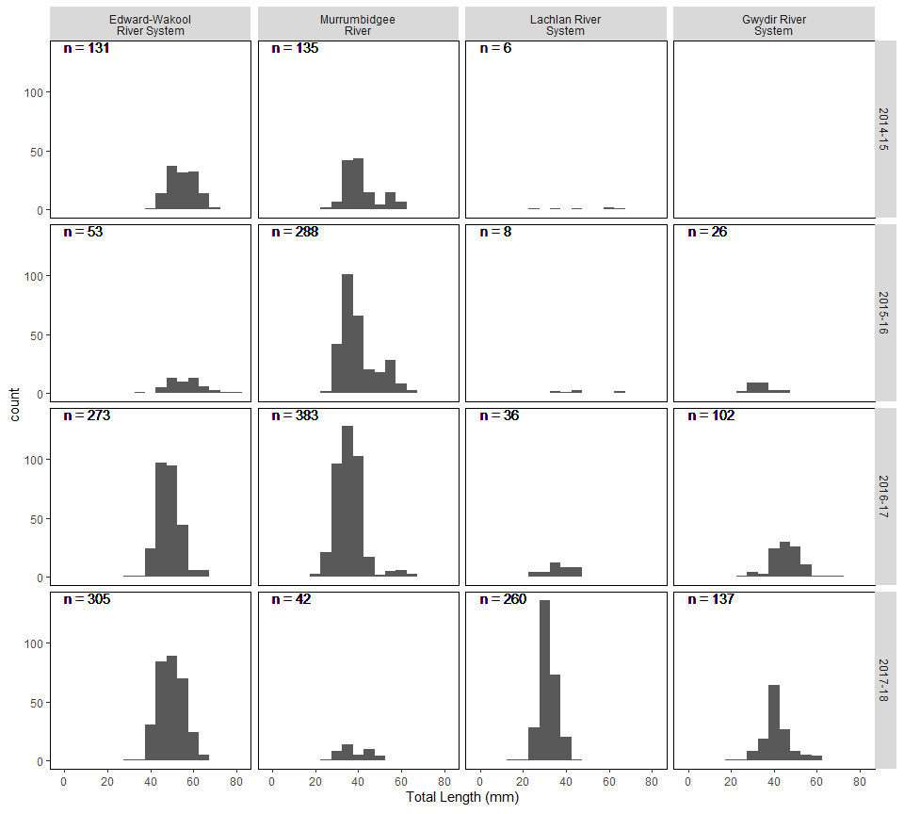

Figure 4.5.6. Length-frequency plots of all measured Australian smeltindividuals across Selected Areas and sampling years.

Australian smelt were present in four of the six Selected Areas, but there were no consistent trends between years or Selected Areas (Figure 4.5.6).

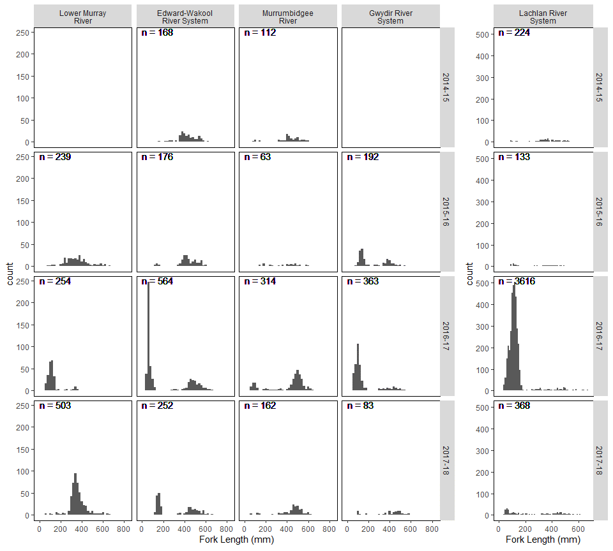

Figure 4.5.7. Length-frequency plots of all measured common carp individuals across Selected Areas and sampling years. Note no common carp were measured in the Goulburn River.

Common carp population structures are quite variable among Selected Areas (Figure 4.5.7). There were large pulses of recruitment of common carp evident from the 2016–17 high flow year in all Selected Areas. This was strongest in the Lachlan River System, where there was a near 30-fold increase in the abundance of common carp from the 2015-16 to 2016–17 samples. Interestingly, these individuals appear not have survived in the system, as abundances in 2017–18 were approximately 10 percent of the 2016–17 abundances.

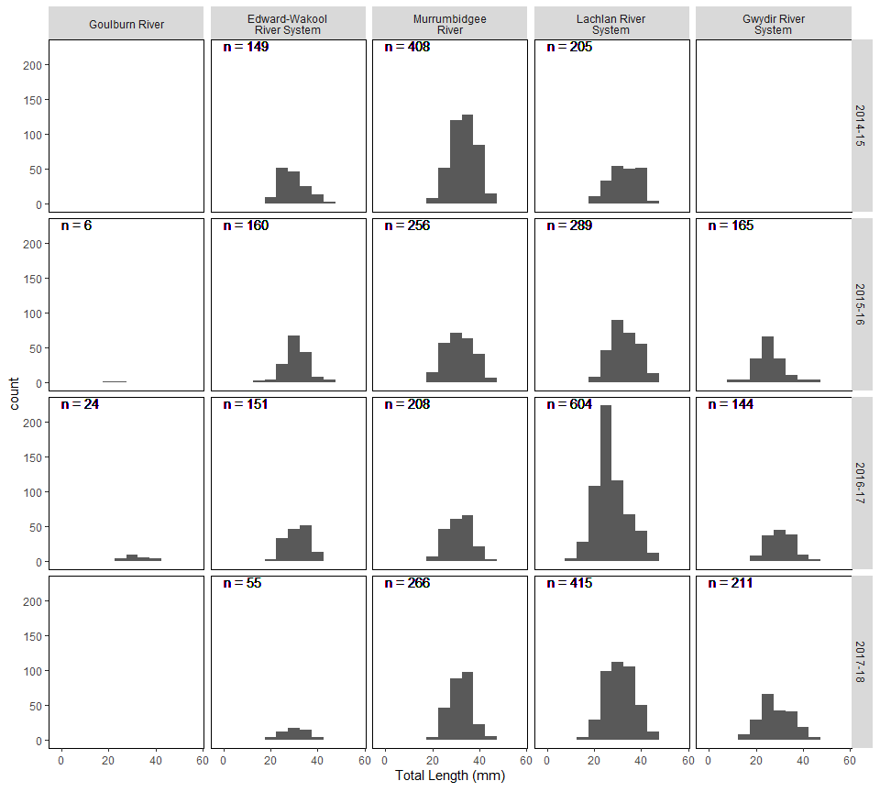

Figure 4.5.8. Length-frequency plots of all measured eastern gambusiaindividuals across Selected Areas and sampling years.

Eastern gambusia were also present in all Selected Areas and showed no consistent trends in their population dynamics (Figure 4.5.8). There was, however, a strong shift from the 2015–16 year to the 2016–17 year towards smaller individuals in the length frequency distribution, before shifting back towards a larger mean size 2017–18 sampling event.

## Individual fish body condition

The analysis of individual fish body condition is a standard fishery practice, where the physical condition of individuals, cohorts or populations is assessed for their health or physiological state.

Here we use standard metrics of individual body length relative to body weight, to report on the condition of fish populations from Selected Areas across sampled years. The mean normalised condition index used shows the spread of condition for a group of fish relative to the average condition across all years and Selected Areas. Groups of fish with above mean condition (mean Kn) weigh more at a given length, and are presumably healthier, compared with groups with lower mean condition that are less healthy.

*Summary of main findings*

* Improved body condition for was evident from the 2016–17 high flow year for:

- Murray codin Edward-Wakool River System, Lachlan River System and Lower Murray River

- Golden perch in most Selected Areas (except the Gwydir River System).

*-* Common carpin all Selected Areas (except Gwydir River System).

In many cases this increased body condition was also present in 2017–18 as well.

* Lower than average mean condition was recorded in 2016–17 for bony herringin Edward-Wakool River System, Lachlan River, Lower Murray River and the Murrumbidgee River.

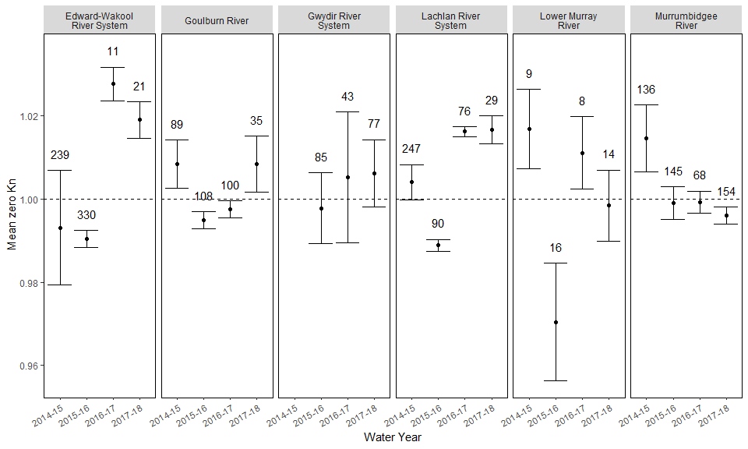

Figure 4.6.1. Mean normalised relative condition (Kn) (±1SE) of all measured Murray cod individuals from each Selected Area across years. Number of individuals within years are shown above upper SE bar.

Higher mean condition for Murray cod was often found during 2016–17 high flow year and was retained in some Selected Areas in 2017–18 (Figure 4.6.1).

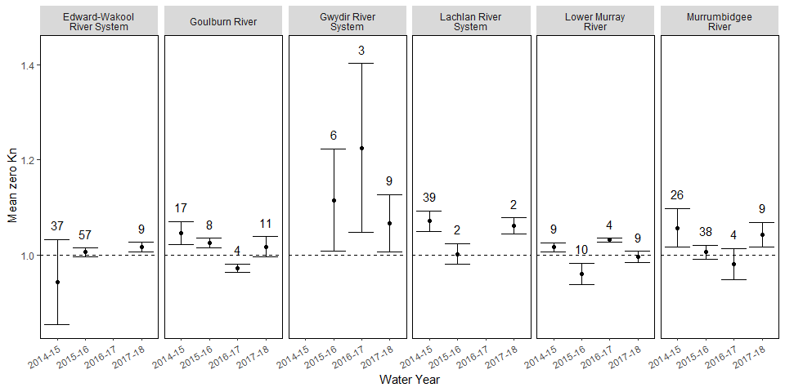

Figure 4.6.2. Mean normalised relative condition (Kn) (±1SE) each year for 0+ Murray cod individuals only (<150mm length) from each Selected Area across years. Number of individuals within years are shown above upper SE bar.

Young-of-year Murray cod (length <150mm) were in far lower abundances and no general trends were clear (Figure 4.6.2). The first (2014–15) and most recent (2017–18) years of sampling were often the highest condition individuals within a Selected Area (Goulburn River, Lachlan River, Murrumbidgee River), however this data requires further statistical analysis to determine relationships between condition, Selected Area, flow or other environmental factors.

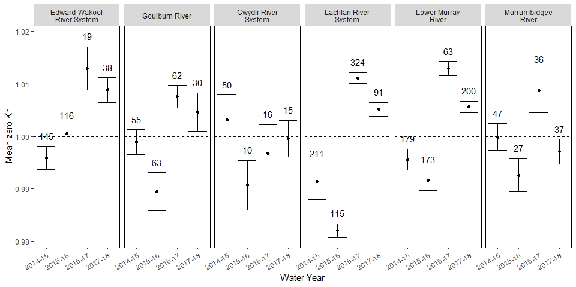

Figure 4.6.3. Mean normalised relative condition (Kn) (±1SE) of measured golden perch individuals from each Selected Area across years. Note: individuals weighing <2g were removed from this analysis. Number of individuals within years are shown above upper SE bar.

Golden perch had improved body condition in the 2016–17 the high flow year in most Selected Areas (Gwydir River the exception) (Figure 4.6.3).

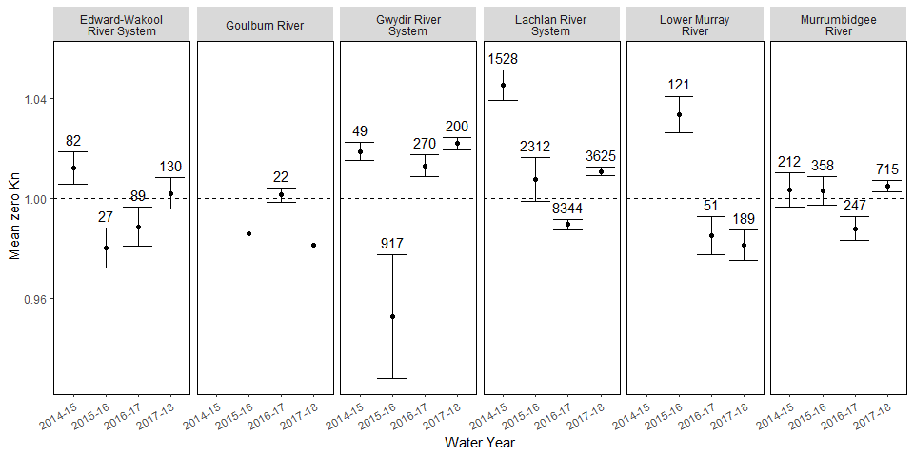

Figure 4.6.4. Mean normalised relative condition (Kn) (±1SE) of measured bony herring individuals from each Selected Area across years. Note: individuals weighing <2g were removed from this analysis. Number of individuals within years are shown above upper SE bar.

Bony herring body condition was more variable than other species between years (0.96 < Kn < 1.04; Figure 4.6.4). Notable changes to condition occurred at different times in each catchment with large decreases in condition between 2014–15 and 2015–16 in the Edward-Wakool River System, Gwydir River System, and Lachlan River System. Returning to a mean condition or greater than average condition however had variable times across these systems. Additionally, decreases in condition of bony herring were seen in the Lachlan River System, Lower Murray River and Murrumbidgee River between 2015–16 and 2016–17. Body condition increased again in the subsequent year in the Lachlan River System and the Murrumbidgee River, however remained below average in the Lower Murray River System.

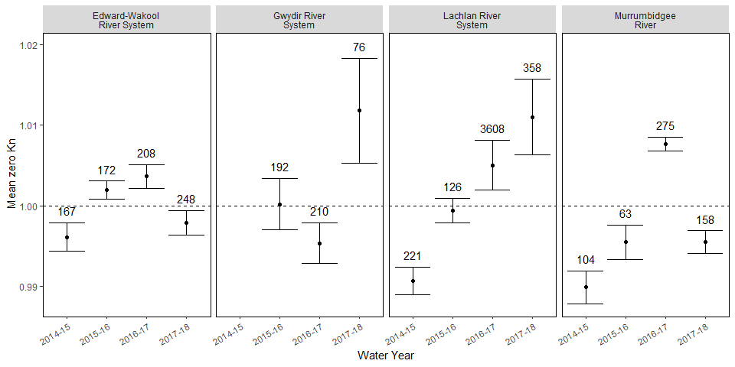

Figure 4.6.5. Mean normalised relative condition (Kn) (±1SE) each year for measured common carp individuals from each Selected Area across years. Note: individuals weighing <2g were removed from this analysis. Number of individuals within years are shown above upper SE bar.

The lengths and weights of carp were not collected in all Selected Areas (absent from Goulburn River and Lower Murray River Selected Areas).

There was variability of body condition of common carp both among Selected Areas and years (Figure 4.6.5). The Edward-Wakool System, Lachlan River System and Murrumbidgee River had low body condition during the 2014–15 year. In the Edward-Wakool System and Murrumbidgee River mean condition increased to a maximum in 2016–17 and decreased again in 2017–18 sampling. The Lachlan River, however, appears to have increasing condition through the entire sampling period. Individuals from the Gwydir River had the lowest mean condition in the 2016–17 year though this increased again in 2017–18.

# Next steps

The key objective of the final (Year 5) LTIM Fish Basin Matter report is to present analyses of the effect of Commonwealth environmental water and, more broadly, river flows, on native fish responses. This will occur by developing quantitative models linking observed fish responses across all fish metrics (diversity and occurrence, assemblage dynamics, spawning outcomes, population dynamics, individual condition) to all sources of flow regime variability. This will then be used to test differences in fish outcomes using flow scenarios that include/exclude Commonwealth environmental water.

The LTIM Fish Basin Matters report will aim to understand:

1. What is the influence of flow events and flow regimes across all Selected Areas, on:

* Spawning success of native flow-cued species?
* Recruitment strength of all native fish species?
* Population composition (structure and condition) of abundant native species?
* Native fish community structure and persistence?

1. Does CEWO water contribute to any flow linked response to these fish metrics?
2. Can any detected fish responses to flows be used predict fish response to hypothesised flow events?

Specifically, our next activities will:

* Establish fish metrics to be analysed
* Establish hydrological metrics to be included in modelling
* Establish ecologically based hypotheses linking fish metrics to hydrological metrics
* Consider the inclusion of other non-flow metrics e.g. water temperature, standing stock
* Undertake preliminary analyses on available four years of data using different modelling approaches to test their utility
* Undertake final modelling and presentation of outcomes in Year 5 report

References

Dyer, F., Broadhurst, B., Tschierschke, A., Thiem, J., Thompson, R., Driver, P., and Bowen, S. (2018). Commonwealth Environmental Water Office Long Term Intervention Monitoring Project: Lower Lachlan River System Selected Area 2017–18 Monitoring and Evaluation Technical Report. Commonwealth of Australia, 2018.

Gawne, B., Brooks S., Butcher R., Cottingham P., Everingham P., Hale J., Nielsen D.L., Stewardson M., Stoffels R. (2013). *Long Term Intervention Monitoring Logic and Rationale Document Final Report prepared for the Commonwealth Environmental Water Office by The Murray-Darling Freshwater Research Centre*.

Gawne, B., Roots J., Hale J., Stewardson M. (2014) *Commonwealth Environmental Water Office Long–Term Intervention Monitoring Project: Basin Evaluation Plan*. MDFRC Publication 29/2014. MDFRC, Albury, NSW.

Hale, J., Stoffels R., Butcher R., Shackleton M., Brooks S., Gawne B., Stewardson M. (2014). Commonwealth Environmental Water Office Long Term Intervention Monitoring Project – Standard Methods. Final Report prepared for the Commonwealth Environmental Water Office by The Murray-Darling Freshwater Research Centre, MDFRC Publication 29.2/2014, January, 175 pp.

Holmlund, C.M., Hammer M. (1999). Ecosystem services generated by fish populations. *Ecological economics* **29(2)**, 253–268.

Stoffels, R., Bond N. (2016) Commonwealth Environmental Water Office Long Term Intervention Monitoring Basin Matter - Fish Foundation Report*.* Final Report prepared for the Commonwealth Environmental Water Office by The Murray-Darling Freshwater Research Centre.

Southwell, M., Frazier, P., Ryder, D., Tsoi, W., Butler, G., Carpenter-Bundhoo, L, Hill, R., Burch, L., Henderson, T., Mace, N. (2018). Commonwealth Environmental Water Office Long Term Intervention Monitoring Project Gwydir River System Selected Area – 2017–18 Annual Evaluation Report, Report prepared for Commonwealth Environmental Water Office. Commonwealth of Australia.

Wassens, S., Spencer, J., Wolfenden, B., Thiem, J., Thomas, R., Jenkins, K., Hall, A., Ocock, J., Kobayashi, T, Bino, G., Davis, T., Heath, J., Kuo, W. and Amos, C. (2018). Commonwealth Environmental Water Office Long-Term Intervention Monitoring project Murrumbidgee River System Selected Area evaluation. Technical Report, 2014–18. Report prepared for the Commonwealth Environmental Water Office. Commonwealth of Australia

Watts, R.J., McCasker, N., Howitt, J.A., Thiem, J., Grace, M., Kopf, R.K., Healy, S., Bond, N. (2018). ‘Commonwealth Environmental Water Office Long Term Intervention Monitoring Project: Edward-Wakool River System Selected Area Evaluation Report, 2017–18. Report prepared for Commonwealth Environmental Water Office. Commonwealth of Australia.

Webb, A., Danlu, G., Baker, B., Casanelia, S., Grace, M., Koster, W., Lovell, D., Morris, K., Pettigrove, W., Townsend, K., Treadwell, S., Vietz, G. (2018). Commonwealth Environmental Water Office Long Term Intervention Monitoring Project Goulburn River Selected Area: Scientific Report 2017–18. Report prepared for the Commonwealth Environmental Water Office. Commonwealth of Australia

Ye, Q., Giatas, G., Aldridge, K, Busch, B., Brookes, J., Gibbs, M., Hipsey, M., Lorenz, Z., Maas, R, Oliver, R., Shiel, R., Woodhead, J. and Zampatti, B. (2018). Long-term Intervention Monitoring of the Ecological Responses to Commonwealth Environmental Water Delivered to the Lower Murray River Selected Area in 2017–18. Report prepared for Commonwealth Environmental Water Office. Commonwealth of Australia.

1. Note that this figure includes watering actions where water was reused and so accounted for more than once. Many watering actions also included other sources of environmental water.