2017–18 Basin-scale evaluation of Commonwealth environmental water — Hydrology: Annex A – Valley Report Cards

Prepared by: Michael Stewardson and Fiorenzo Guarino

Final Report

La Trobe Publication 242/2019

2017–18 Basin-scale evaluation of Commonwealth environmental water — Hydrology: Annex A Valley Report Cards
Report prepared for the Commonwealth Environmental Water Office by La Trobe University

For further information contact:
Nick Bond
La Trobe University
PO Box 991
Wodonga VIC 3689
Ph: (02) 6024 9650

Email: N.Bond@latrobe.edu.au
Web: www.latrobe.edu.au
Enquiries: cfe@latrobe.edu.au

Report Citation: Stewardson MJ, Guarino F (2019) 2017–87 Basin-scale evaluation of Commonwealth environmental water — Hydrology: Annex A Valley Report Cards. Final Report prepared for the Commonwealth Environmental Water Office by La Trobe University, Publication 242/2019, November, 255pp.

This monitoring project was commissioned and funded by Commonwealth Environmental Water Office.
Copyright
© Copyright Commonwealth of Australia, 2019

2017–18 Basin-scale evaluation of Commonwealth environmental water — Hydrology Annex A Valley Report Cards (2019) is licensed by the Commonwealth of Australia for use under a Creative Commons By Attribution 3.0 Australia licence with the exception of the Coat of Arms of the Commonwealth of Australia, the logo of the agency responsible for publishing the report, content supplied by third parties, and any images depicting people. For licence conditions see: http://creativecommons.org/licenses/by/3.0/au/
This report should be attributed as Stewardson MJ, Guarino F (2018) 2017–18 Basin-scale evaluation of Commonwealth environmental water — Hydrology Annex A. Report prepared for the Commonwealth Environmental Water Office by La Trobe University, Publication 242/2019, November, 255pp.
Disclaimer
The views and opinions expressed in this publication are those of the authors and do not necessarily reflect those of the Australian Government or the Minister for the Environment.
While reasonable efforts have been made to ensure that the contents of this publication are factually correct, the Commonwealth does not accept responsibility for the accuracy or completeness of the contents, and shall not be liable for any loss or damage that may be occasioned directly or indirectly through the use of, or reliance on, the contents of this publication.
The material contained in this publication represents the opinion of the author(s) only. While every effort has been made to ensure that the information in this publication is accurate, the author(s) and La Trobe University do not accept any liability for any loss or damage howsoever arising whether in contract, tort or otherwise which may be incurred by any person as a result of any reliance or use of any statement in this publication. The author(s) and La Trobe University do not give any warranties in relation to the accuracy, completeness and up-to-date status of the information in this publication.
Where legislation implies any condition or warranty which cannot be excluded restricted or modified, such condition or warranty shall be deemed to be included provided that the author’s and La Trobe University’s liability for a breach of such condition or warranty is, at the option of La Trobe University, limited to the supply of the services again or the cost of supplying the services again.

Document history and status
Version | Date Issued | Reviewed by | Approved by | Revision type
Draft | 19/9/2019 | Mike Stewardson & Fiorenzo Guarino | Nikki Thurgate | Internal
Final | 21/11/19 | CEWO | Nikki Thurgate | External

Distribution of copies
Version | Quantity | Issued to
Draft | 1 x PDF 1 x Word | Irene Wegener
Final | 1 x PDF 1 x Word | Irene Wegener

Filename and path: Projects\CEWO\CEWH Long Term Monitoring Project\499 LTIM Stage 2 2014-19 Basin evaluation\Final Reports
Author(s): Michael Stewardson and Fiorenzo Guarino
Author affiliation(s): The University of Melbourne and The University of Canberra.
Project Manager: Nicole Thurgate
Client: Commonwealth Environmental Water Office
Project Title: Basin evaluation of the contribution of Commonwealth environmental water to the environmental objectives of the Murray‒Darling Basin Plan
Document Version: Final
Project Number: M/BUS/499
Contract Number: PRN 1213-0427

Contents
2017–18 Basin-scale evaluation of Commonwealth environmental water — Hydrology: Annex A Valley Report Cards 0
1 Gwydir 7
1.1.1 Summary 8
1.1.2 Water delivery context 8
1.1.3 Environmental conditions and resource availability 8
1.1.4 Watering actions 9
1.1.5 Contribution of Commonwealth Environmental Water to Flow Regimes 10
2 Namoi 39
2.1.1 Summary 40
2.1.2 Water delivery context 40
2.1.3 Environmental conditions and resource availability 40
2.1.4 Watering actions 41
2.1.5 Contribution of Commonwealth Environmental Water to Flow Regimes 42
3 Murrumbidgee 56
3.1.1 Summary 57
3.1.2 Water delivery context 57
3.1.3 Environmental conditions and resource availability 57
3.1.4 Watering actions 58
3.1.5 Contribution of Commonwealth Environmental Water to Flow Regimes 59
4 Lachlan 77
4.1.1 Summary 78
4.1.2 Water delivery context 78
4.1.3 Environmental conditions and resource availability 78
4.1.4 Watering actions 79
4.1.5 Contribution of Commonwealth Environmental Water to Flow Regimes 80
5 Central Murray 95
5.1.1 Summary 96
5.1.2 Water delivery context 96
5.1.3 Environmental conditions and resource availability 96
5.1.4 Watering actions 97
5.1.5 Contribution of Commonwealth Environmental Water to Flow Regimes 98
6 Edward Wakool 114
6.1.1 Summary 115
6.1.2 Water delivery context 115
6.1.3 Environmental conditions and resource availability 115
6.1.4 Watering actions 116
6.1.5 Contribution of Commonwealth Environmental Water to Flow Regimes 117
7 Lower Murray 132
7.1.1 Summary 133
7.1.2 Water delivery context 133
7.1.3 Environmental conditions and resource availability 133
7.1.4 Watering actions 134
7.1.5 Contribution of Commonwealth Environmental Water to Flow Regimes 135
8 Macquarie 148
8.1.1 Summary 148
8.1.2 Water delivery context 149
8.1.3 Environmental conditions and resource availability 149
8.1.4 Watering actions 150
8.1.5 Contribution of Commonwealth Environmental Water to Flow Regimes 151
9 Loddon 160
9.1.1 Summary 161
9.1.2 Water delivery context 161
9.1.3 Environmental conditions and resource availability 161
9.1.4 Watering actions 162
9.1.5 Contribution of Commonwealth Environmental Water to Flow Regimes 163
10 Barwon Darling 172
10.1.1 Summary 173
10.1.2 Water delivery context 173
10.1.3 Environmental conditions and resource availability 173
10.1.4 Watering actions 174
10.1.5 Contribution of Commonwealth Environmental Water to Flow Regimes 175
11 Ovens 186
11.1.1 Summary 187
11.1.2 Water delivery context 187
11.1.3 Environmental conditions and resource availability 187
11.1.4 Watering actions 188
11.1.5 Contribution of Commonwealth Environmental Water to Flow Regimes 189
12 Broken 194
12.1.1 Summary 195
12.1.2 Water delivery context 195
12.1.3 Environmental conditions and resource availability 195
12.1.4 Watering actions 196
12.1.5 Contribution of Commonwealth Environmental Water to Flow Regimes 197
13 Goulburn 203
13.1.1 Summary 204
13.1.2 Water delivery context 204
13.1.3 Environmental conditions and resource availability 204
13.1.4 Watering actions 205
13.1.5 Contribution of Commonwealth Environmental Water to Flow Regimes 206
14 Border Rivers 213
14.1.1 Summary 214
14.1.2 Water delivery context 214
14.1.3 Environmental conditions and resource availability 214
14.1.4 Watering actions 215
14.1.5 Contribution of Commonwealth Environmental Water to Flow Regimes 216
15 Campaspe 223
15.1.1 Summary 224
15.1.2 Water delivery context 224
15.1.3 Environmental conditions and resource availability 224
15.1.4 Watering actions 225
15.1.5 Contribution of Commonwealth Environmental Water to Flow Regimes 226
16 Lower Darling 231
16.1.1 Summary 232
16.1.2 Water delivery context 232
16.1.3 Environmental conditions and resource availability 232
16.1.4 Watering actions 233
16.1.5 Contribution of Commonwealth Environmental Water to Flow Regimes 234
17 Condamine Balonne 237
17.1.1 Summary 238
17.1.2 Water delivery context 238
17.1.3 Environmental conditions and resource availability 238
17.1.4 Watering actions 239
17.1.5 Contribution of Commonwealth Environmental Water to Flow Regimes 239
18 Wimmera 243
18.1.1 Summary 244
18.1.2 Water delivery context 244
18.1.3 Environmental conditions and resource availability 244
18.1.4 Watering actions 245
18.1.5 Contribution of Commonwealth Environmental Water to Flow Regimes 246
19 Warrego 249
19.1.1 Summary 250
19.1.2 Water delivery context 250
19.1.3 Environmental conditions and resource availability 250
19.1.4 Watering actions 251
19.1.5 Contribution of Commonwealth Environmental Water to Flow Regimes 252

Gwydir
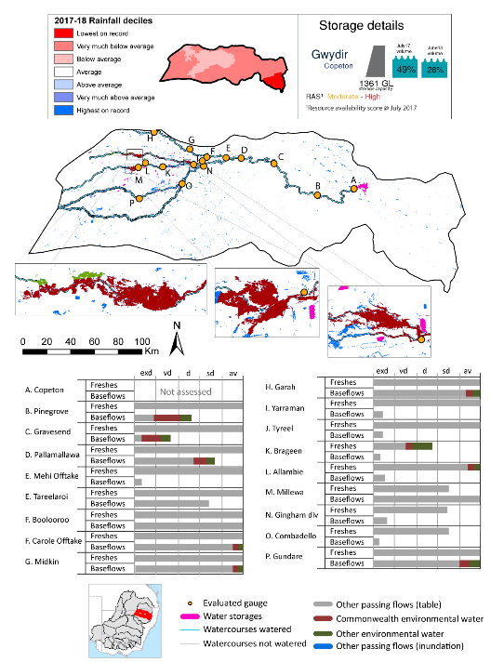
Figure GWY1: Watercourses influenced, areas inundated (where applicable) and gauge stations evaluated in the Gwydir valley during the 2017–18 water year. Inset bar graphs report the condition of annual flow regimes by showing the improvements in hydrological condition with the addition of environmental water as well as the hypothetical scenario in “grey” (if no environmental flow had been delivered); where exd=extremely dry, vd=very dry, d=dry, sd=somewhat dry and av=average. Rainfall conditions (rainfall deciles) and trend in storage levels for the water year are also shown.

Summary
The volume of environmental water delivery for the 2017–18 year in the Gwydir valley is quantified using data for 22 sites. This evaluation only considers the contribution of held environmental water, which is a primary focus for the Commonwealth. The contributions of planned environmental water (e.g. passing flows), unregulated tributary inflows and clever use of irrigation flows for environmental benefits can all be very important but these are outside the scope of this report. Environmental watering actions lasted on average 61 days over the course of the year. The volume of environmental water at these 22 sites was between 0% and 51% of the total streamflow. Commonwealth environmental water contributed on average 41% of this environmental water. The contribution of environmental water delivery to improved flow regimes is evaluated using data for 20 sites. Ideally, baseflows should be maintained and long periods of excessively low flows avoided. In this valley, the baseflow regime was generally considered to be dry relative to the pre-development flow regime. In our analysis, a low fresh refers to a period of increased flow, when the water level rises at least one eighth of the way up the river bank (above the low flow level). These low freshes are a regular part of the natural flow regime and support a range of natural processes. In the Gwydir valley, in terms of the occurrence and duration of low freshes, the year was assessed as being average. In our analysis, a medium fresh refers to a period of increased flow, when the water level rises at least one quarter of the way up the river bank. These medium freshes are not as frequent as low freshes but are also a regular and important part of the natural flow regime. In the Gwydir valley, in terms of the occurrence of medium freshes, the year was assessed as being average. In our analysis, a high fresh refers to a period of increased flow, when the water level rises more than half way up the river. A high fresh may not occur every year but they are still important and long periods without major freshes can have serious consequences for floodplains and their contribution to river ecosystem health. Delivering environmental high in channel flows normally requires that all risks to riparian landholders and infrastructure have been resolved. In the Gwydir valley, in terms of the occurrence of high freshes, the year was assessed as being somewhat dry.

Water delivery context
During the 2017–18, the Commonwealth Environmental Water Holder (CEWH) held water entitlements of up to 114,484 Ml for environmental use in the Gwydir valley. Each year, water utilities allocate water entitlement holders a percentage of water based on their holding, license type and carryover (the exact rules vary among Jurisdictions). In 2017–18, the Gwydir entitlements held by the CEWH were allocated 20,255 Ml of water, representing 50% of the Long-term average annual yield for the Gwydir valley (40,623 Ml). Information and data relating to the portfolio of held Commonwealth environmental water is shown in Table GWY2.
The 2017–18 water allocation (20,255 Ml) together with the carryover volume of 83,965 Ml of water meant the CEWH had 104,220 Ml of water available for delivery. A total of 28,290 Ml of Commonwealth environmental water was delivered in the Gwydir valley. A total of 6,700 Ml of Commonwealth environmental water was traded to consumptive users and 69,231 Ml (66%) of available Commonwealth environmental water was carried over for environmental use into the 2018–19 water year.

Environmental conditions and resource availability
The water available for environmental delivery combined with the present and antecedent environmental conditions are key inputs used by environmental water managers in planning and implementing watering actions. Post hoc, this information provides important context when evaluating the effectiveness and appropriateness of environmental water use with respect to hydrological outputs.
The rainfall conditions in the Gwydir valley were classified as very much below average, based on rainfall percentile data for the entire record held by the Bureau of Meteorology for this valley. The water held in major storages in the Gwydir valley decreased over the water year, for example Copeton dam was 49% full at the beginning of the water year and 28% full by the end of the year (Figure GWY1).
The Commonwealth Environmental Water Office (CEWO) calculates resource availability scenarios (RAS) to guide the use and prioritisation of held environmental water. The RAS are progressively calculated over the year as part of the continual adaptive management planning processes. The RAS are based on the availability of held environmental water (including progressive license acquisitions and allocations) as well as the potential for unregulated or planned environmental flows. The outcome is then used to determine the demand for environmental water across the basin.
In 2017–18, the resource availability of held Commonwealth environmental water was classified as moderate to high in this valley. The physical conditions meant that the CEWO was managing to protect wetland vegetation of the Gwydir wetlands and ensuring their ecological capacity for recovery, while maintaining the ecological health and resilience of other important sites in the catchment, including in stream aquatic ecology. The overall demand for environmental water was deemed low to moderate.

Watering actions
A total of 4 watering actions were delivered over the 2017–18 water year, the duration of these actions varied (range of individual actions: 9 - 34 days) and Commonwealth environmental water was delivered for a total of 92 days. The count of actions commencing in each season was; winter (1), spring (1), summer (1) and autumn (1). The flow component types delivered were; (1) baseflow, (2) freshes, (0) bankfull, (0) overbank and (1) wetland.
Commonwealth environmental water was delivered in the Gwydir valley for specified objectives. Although, the majority of watering actions were delivered for fish purposes, water was also delivered for other purposes too. The percentage of watering actions delivered across the nine main themes included fish (23.53%), vegetation (5.88%), waterbirds (5.88%), frogs (0.0%), other biota (5.88%), connectivity (23.53%), process (17.65%), resilience (5.88%) and water quality (11.76%).
Table GWY2. Commonwealth environmental water accounting information for the Gwydir valley over 2017-18 water year.
Total registered volume (Ml) | Allocated volume (Ml) | Carry over + allocated volume (Ml) | Delivered (Ml) | LTAAY (Ml) | Trade (Ml) | Carried over to 2018-19 | Forfeited (Ml)
114,484¹ | 20,255 | 104,220 | 28,290 | 40,623 | 6,700 | 69,231 | 0
¹Includes 20 451 Ml of supplementary water which is only available by announcement

Figure GWY2. Timing and duration of Commonwealth environmental water actions delivered in the Gwydir valley

Contribution of Commonwealth Environmental Water to Flow Regimes
Pinegrove
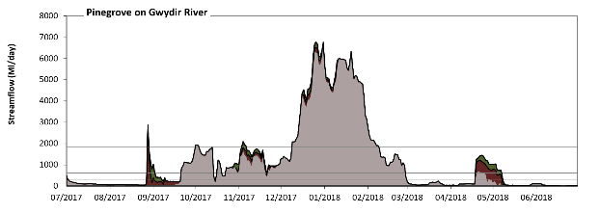
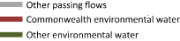
Figure GWY3: Contribution of environmental water delivery at Pinegrove. Horizontal lines indicate thresholds for very low flows, low flows, low freshes, medium freshes and high freshes (from lowest to highest).
At Pinegrove on Gwydir River environmental water contributed 10% of the total streamflow volume (with approximately half contributed by Commonwealth environmental water). Environmental watering actions affected streamflows for 33% of days between 1 July 2017 and 30 June 2018. Without environmental water, the durations of very low flows (i.e. < 25 Ml/day) in the periods July to September and April to June would have substantially exceeded durations expected in an average year in the natural flow regime. Environmental water mitigated these impacts by reducing the cumulative duration of very low flow spells from 17% to 8% of the year, with greatest influence in the periods July to September and April to June. Similarly, without environmental water, the durations of medium low flows (i.e. < 120 Ml/day) in the periods July to September and April to June would have substantially exceeded durations expected in an average year in the natural flow regime. Environmental water mitigated these impacts by reducing the cumulative duration of medium low flow spells from 46% to 39% of the year, with greatest influence in the period July to September. Commonwealth environmental water made the dominant contribution to these enhancements of environmental baseflows at this site. In the absence of environmental water there would have been at least one low fresh (i.e. > 300 Ml/day) in the periods July to September, October to December, January to March and April to June. Environmental water increased the duration of the longest low fresh during the period April to June (from 8 days to 19 days). Commonwealth environmental water made the dominant contribution to these increased durations of low freshes. In the absence of environmental water there would have been at least one medium fresh (i.e. > 610 Ml/day) in the periods July to September, October to December, January to March and April to June. Environmental water increased the duration of the longest medium fresh during the period April to June (from 5 days to 19 days). Commonwealth environmental water made the dominant contribution to these increased durations of medium freshes. In the absence of environmental water there would have been at least one high fresh in the periods October to December and January to March. Environmental water increased the duration of the longest high fresh during the period July to September (from 0 days to 1 days). Commonwealth environmental water was entirely responsible for the increased duration of the high fresh.
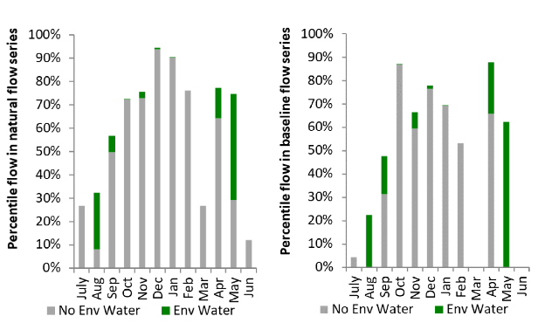
Figure GWY4: Contribution of environmental water delivery at Pinegrove as percentiles in the natural and baseline flow series.

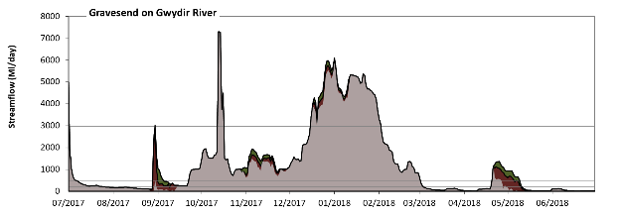
Gravesend

Figure GWY5: Contribution of environmental water delivery at Gravesend. Horizontal lines indicate thresholds for very low flows, low flows, low freshes, medium freshes and high freshes (from lowest to highest).
At Gravesend on Gwydir River environmental water contributed 10% of the total streamflow volume (with approximately half contributed by Commonwealth environmental water). Environmental watering actions affected streamflows for 32% of days between 1 July 2017 and 30 June 2018. Without environmental water, the duration of very low flows (i.e. < 40 Ml/day) in the period April to June would have substantially exceeded durations expected in an average year in the natural flow regime. Environmental water mitigated these impacts by reducing the cumulative duration of very low flow spells from 17% to 13% of the year, with greatest influence in the periods July to September and April to June. Similarly, without environmental water, the durations of medium low flows (i.e. < 200 Ml/day) in the periods July to September, January to March and April to June would have substantially exceeded durations expected in an average year in the natural flow regime. Environmental water mitigated these impacts by reducing the cumulative duration of medium low flow spells from 44% to 36% of the year, with greatest influence in the periods July to September and April to June. Commonwealth environmental water equally shared responsibility with other environmental water holders for these enhancements of environmental baseflows at this site. In the absence of environmental water there would have been at least one low fresh (i.e. > 490 Ml/day) in the periods July to September, October to December, January to March and April to June. Environmental water increased the duration of the longest low fresh during the period April to June (from 6 days to 19 days). Commonwealth environmental water was almost entirely responsible for these increased durations of low freshes. In the absence of environmental water there would have been at least one medium fresh (i.e. > 990 Ml/day) in the periods July to September, October to December, January to March and April to June. Environmental water increased the duration of the longest medium fresh during the period April to June (from 1 days to 8 days). Commonwealth environmental water was entirely responsible for these increased durations of medium freshes. In the absence of environmental water there would have been at least one high fresh in the periods July to September, October to December and January to March. Environmental water increased the duration of the longest high fresh during the period October to December (from 11 days to 16 days). Commonwealth environmental water equally shared responsibility with other environmental water holders for these increased durations of high freshes.
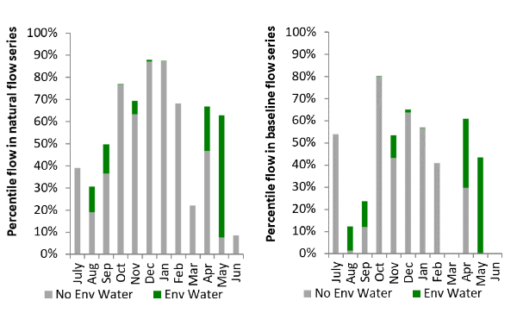
Figure GWY6: Contribution of environmental water delivery at Gravesend as percentiles in the natural and baseline flow series.
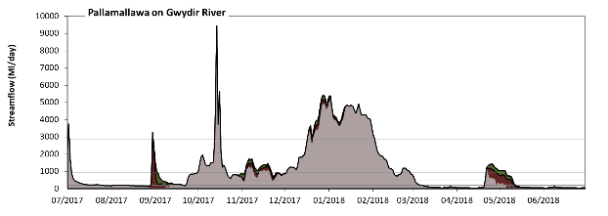
Pallamallawa

Figure GWY7: Contribution of environmental water delivery at Pallamallawa. Horizontal lines indicate thresholds for very low flows, low flows, low freshes, medium freshes and high freshes (from lowest to highest).
At Pallamallawa on Gwydir River environmental water contributed 11% of the total streamflow volume (with approximately half contributed by Commonwealth environmental water). Environmental watering actions affected streamflows for 32% of days between 1 July 2017 and 30 June 2018. Without environmental water, the durations of very low flows (i.e. < 39 Ml/day) in the periods July to September and April to June would have substantially exceeded durations expected in an average year in the natural flow regime. Environmental water mitigated these impacts by reducing the cumulative duration of very low flow spells from 9% to 3% of the year, with greatest influence in the periods July to September and April to June. Similarly, without environmental water, the durations of medium low flows (i.e. < 200 Ml/day) in the periods July to September, January to March and April to June would have substantially exceeded durations expected in an average year in the natural flow regime. Environmental water mitigated these impacts by reducing the cumulative duration of medium low flow spells from 41% to 35% of the year, with greatest influence in the periods July to September and April to June. Commonwealth environmental water equally shared responsibility with other environmental water holders for these enhancements of environmental baseflows at this site. In the absence of environmental water there would have been at least one low fresh (i.e. > 470 Ml/day) in the periods July to September, October to December, January to March and April to June. Environmental water increased the duration of the longest low fresh during the periods October to December (from 39 days to 92 days) and April to June (from 8 days to 20 days). Commonwealth environmental water made the dominant contribution to these increased durations of low freshes. In the absence of environmental water there would have been at least one medium fresh (i.e. > 950 Ml/day) in the periods July to September, October to December, January to March and April to June. Environmental water increased the duration of the longest medium fresh during the periods July to September (from 3 days to 4 days) and April to June (from 1 days to 14 days). Commonwealth environmental water equally shared responsibility with other environmental water holders for these increased durations of medium freshes. In the absence of environmental water there would have been at least one high fresh in the periods July to September, October to December and January to March. Environmental water increased the duration of the longest high fresh during the period October to December (from 11 days to 15 days). Commonwealth environmental water equally shared responsibility with other environmental water holders for these increased durations of high freshes.
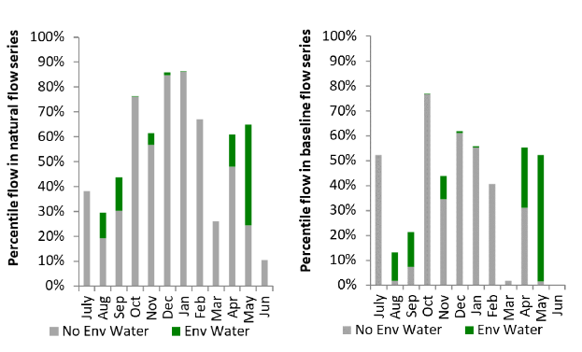
Figure GWY8: Contribution of environmental water delivery at Pallamallawa as percentiles in the natural and baseline flow series.
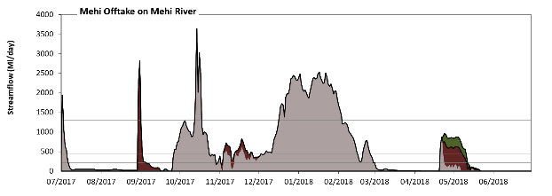
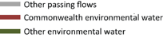
Mehi Offtake

Figure GWY9: Contribution of environmental water delivery at Mehi Offtake. Horizontal lines indicate thresholds for very low flows, low flows, low freshes, medium freshes and high freshes (from lowest to highest).
At Mehi Offtake on Mehi River environmental water contributed 12% of the total streamflow volume (most of which was Commonwealth environmental water). Environmental watering actions affected streamflows for 22% of days between 1 July 2017 and 30 June 2018. Without environmental water, the durations of very low flows (i.e. < 18 Ml/day) in the periods July to September, January to March and April to June would have substantially exceeded durations expected in an average year in the natural flow regime. Environmental water mitigated these impacts by reducing the cumulative duration of very low flow spells from 31% to 22% of the year, with greatest influence in the periods July to September and April to June. Similarly, without environmental water, the durations of medium low flows (i.e. < 90 Ml/day) in the periods July to September, January to March and April to June would have substantially exceeded durations expected in an average year in the natural flow regime. Environmental water mitigated these impacts by reducing the cumulative duration of medium low flow spells from 52% to 44% of the year, with greatest influence in the periods July to September and April to June. Commonwealth environmental water made the dominant contribution to these enhancements of environmental baseflows at this site. In the absence of environmental water there would have been at least one low fresh (i.e. > 220 Ml/day) in the periods July to September, October to December, January to March and April to June. Environmental water increased the duration of the longest low fresh during the period April to June (from 3 days to 21 days). Commonwealth environmental water equally shared responsibility with other environmental water holders for these increased durations of low freshes. In the absence of environmental water there would have been at least one medium fresh (i.e. > 440 Ml/day) in the periods July to September, October to December, January to March and April to June. Environmental water increased the duration of the longest medium fresh during the period April to June (from 2 days to 20 days). Commonwealth environmental water was almost entirely responsible for these increased durations of medium freshes. In the absence of environmental water there would have been at least one high fresh in the periods July to September, October to December and January to March. Environmental water increased the duration of the longest high fresh during the period July to September (from 1 days to 2 days). Commonwealth environmental water was entirely responsible for these increased durations of high freshes.
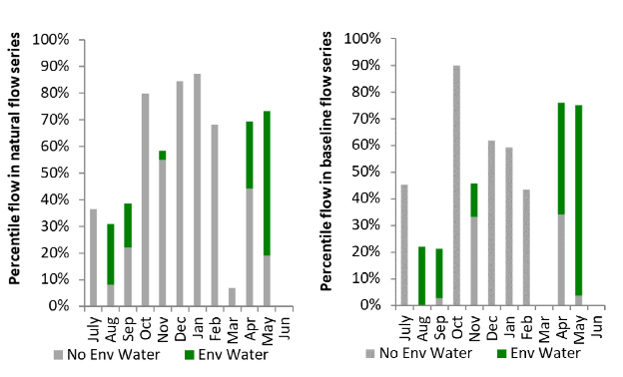
Figure GWY10: Contribution of environmental water delivery at Mehi Offtake as percentiles in the natural and baseline flow series.

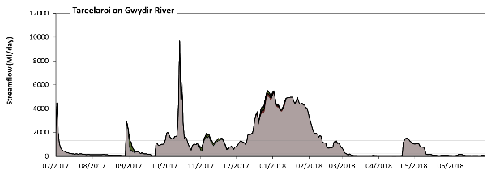
Tareelaroi

Figure GWY11: Contribution of environmental water delivery at Tareelaroi. Horizontal lines indicate thresholds for very low flows, low flows, low freshes, medium freshes and high freshes (from lowest to highest).
At Tareelaroi on Gwydir River environmental water contributed 4% of the total streamflow volume (with a medium contribution of Commonwealth environmental water). Environmental watering actions affected streamflows for 18% of days between 1 July 2017 and 30 June 2018. Without environmental water, the duration of very low flows (i.e. < 18 Ml/day) in the period April to June would have substantially exceeded durations expected in an average year in the natural flow regime. However, environmental water had little effect on the duration of these very low flows, which occurred for 6% of the year. Similarly, without environmental water, the durations of medium low flows (i.e. < 90 Ml/day) in the periods January to March and April to June would have substantially exceeded durations expected in an average year in the natural flow regime. However, environmental water had little effect on the duration of these medium low flows, which occurred for 26% of the year. There was at least one low fresh (i.e. > 220 Ml/day) in the periods July to September, October to December, January to March and April to June. Environmental water made little change to the duration of these low freshes. In the absence of environmental water there would have been at least one medium fresh (i.e. > 440 Ml/day) in the periods July to September, October to December, January to March and April to June. Environmental water increased the duration of the longest medium fresh during the period October to December (from 59 days to 92 days). Commonwealth environmental water made little or no contribution to these increased durations of medium freshes. In the absence of environmental water there would have been at least one high fresh in the periods July to September, October to December, January to March and April to June. Environmental water made no change to the duration of these high freshes.
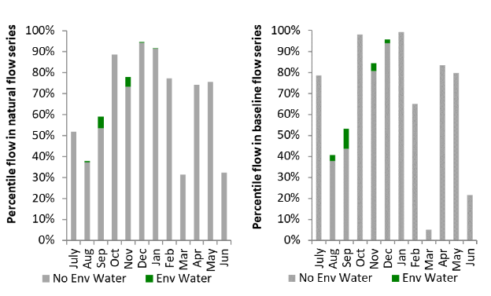
Figure GWY12: Contribution of environmental water delivery at Tareelaroi as percentiles in the natural and baseline flow series.

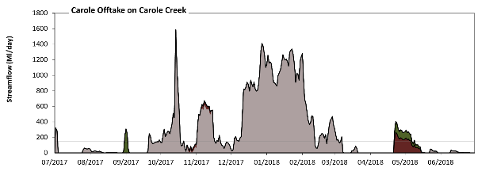
Carole Offtake
Figure GWY13: Contribution of environmental water delivery at Carole Offtake. Horizontal lines indicate thresholds for very low flows, low flows, low freshes, medium freshes and high freshes (from lowest to highest).
At Carole Offtake on Carole Creek environmental water contributed 7% of the total streamflow volume (much of which was Commonwealth environmental water). Environmental watering actions affected streamflows for 14% of days between 1 July 2017 and 30 June 2018. Without environmental water, the duration of very low flows (i.e. < 2.1 Ml/day) in the period July to September would have substantially exceeded durations expected in an average year in the natural flow regime. Environmental water reduced the cumulative duration of very low flow spells from 42% to 33% of the year, with greatest influence in the period April to June. Flow regulation does not substantially increase the duration of medium low flows (i.e. < 10 Ml/day) compared to an average year in the natural flow regime. Commonwealth environmental water equally shared responsibility with other environmental water holders for these enhancements of environmental baseflows at this site. In the absence of environmental water there would have been at least one low fresh (i.e. > 49 Ml/day) in the periods July to September, October to December and January to March. Environmental water increased the duration of the longest low fresh during the period April to June (from 0 days to 23 days). Commonwealth environmental water equally shared responsibility with other environmental water holders for these increased durations of low freshes. In the absence of environmental water there would have been at least one medium fresh (i.e. > 150 Ml/day) in the periods July to September, October to December and January to March. Environmental water increased the duration of the longest medium fresh during the periods July to September (from 2 days to 3 days) and April to June (from 0 days to 16 days). Commonwealth environmental water equally shared responsibility with other environmental water holders for these increased durations of medium freshes. In the absence of environmental water there would have been at least one high fresh in the periods October to December and January to March. Environmental water made no change to the duration of these high freshes.
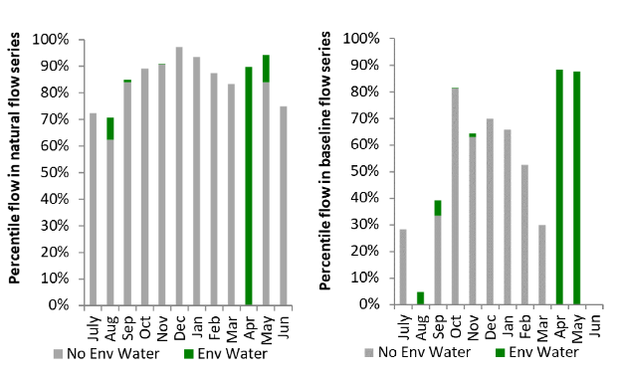
Figure GWY14: Contribution of environmental water delivery at Carole Offtake as percentiles in the natural and baseline flow series.

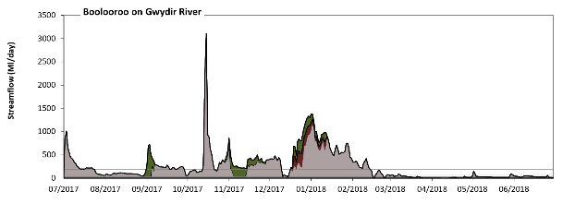
Boolooroo
Figure GWY15: Contribution of environmental water delivery at Boolooroo. Horizontal lines indicate thresholds for very low flows, low flows, low freshes, medium freshes and high freshes (from lowest to highest).
At Boolooroo on Gwydir River environmental water contributed 18% of the total streamflow volume (with a medium contribution of Commonwealth environmental water). Environmental watering actions affected streamflows for 18% of days between 1 July 2017 and 30 June 2018. Flow regulation does not substantially increase the duration of very low flows (i.e. < 2.1 Ml/day) compared to an average year in the natural flow regime. Flow regulation does not substantially increase the duration of medium low flows (i.e. < 10 Ml/day) compared to an average year in the natural flow regime. Commonwealth environmental water made little or no contribution to these enhancements of environmental baseflows at this site. In the absence of environmental water there would have been at least one low fresh (i.e. > 28 Ml/day) in the periods July to September, October to December, January to March and April to June. Environmental water increased the duration of the longest low fresh during the periods July to September (from 60 days to 92 days) and October to December (from 35 days to 75 days). Commonwealth environmental water made little or no contribution to these increased durations of low freshes. In the absence of environmental water there would have been at least one medium fresh (i.e. > 59 Ml/day) in the periods July to September, October to December, January to March and April to June. Environmental water increased the duration of the longest medium fresh during the period October to December (from 34 days to 70 days). Commonwealth environmental water made little or no contribution to these increased durations of medium freshes. In the absence of environmental water there would have been at least one high fresh in the periods July to September, October to December and January to March. Environmental water increased the duration of the longest high fresh during the period October to December (from 25 days to 47 days). Commonwealth environmental water made little or no contribution to these increased durations of high freshes.
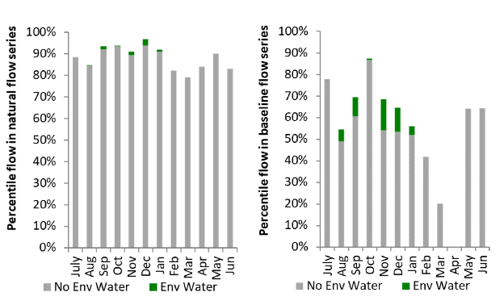
Figure GWY16: Contribution of environmental water delivery at Boolooroo as percentiles in the natural and baseline flow series.

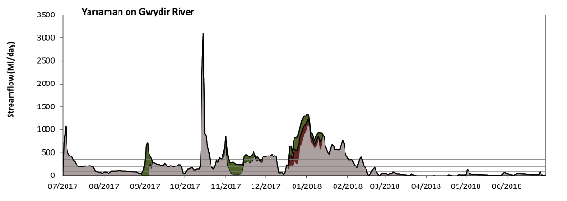
Yarraman
Figure GWY17: Contribution of environmental water delivery at Yarraman. Horizontal lines indicate thresholds for very low flows, low flows, low freshes, medium freshes and high freshes (from lowest to highest).
At Yarraman on Gwydir River environmental water contributed 18% of the total streamflow volume (with a medium contribution of Commonwealth environmental water). Environmental watering actions affected streamflows for 18% of days between 1 July 2017 and 30 June 2018. Without environmental water, the durations of very low flows (i.e. < 19 Ml/day) in the periods January to March and April to June would have substantially exceeded durations expected in an average year in the natural flow regime. Environmental water reduced the cumulative duration of very low flow spells from 18% to 16% of the year, with greatest influence in the period July to September. Similarly, without environmental water, the durations of medium low flows (i.e. < 94 Ml/day) in the periods July to September, January to March and April to June would have substantially exceeded durations expected in an average year in the natural flow regime. Environmental water mitigated these impacts by reducing the cumulative duration of medium low flow spells from 50% to 46% of the year, with greatest influence in the periods July to September and October to December. Commonwealth environmental water made little or no contribution to these enhancements of environmental baseflows at this site. In the absence of environmental water there would have been at least one low fresh (i.e. > 190 Ml/day) in the periods July to September, October to December and January to March. Environmental water increased the duration of the longest low fresh during the periods July to September (from 13 days to 17 days) and October to December (from 26 days to 48 days). Commonwealth environmental water made little or no contribution to these increased durations of low freshes. There was at least one medium fresh (i.e. > 340 Ml/day) in the periods July to September, October to December and January to March. Environmental water made little change to the duration of these medium freshes. In the absence of environmental water there would have been at least one high fresh in the periods July to September, October to December and January to March. Environmental water increased the duration of the longest high fresh during the periods October to December (from 3 days to 6 days) and January to March (from 3 days to 5 days). Commonwealth environmental water equally shared responsibility with other environmental water holders for these increased durations of high freshes.
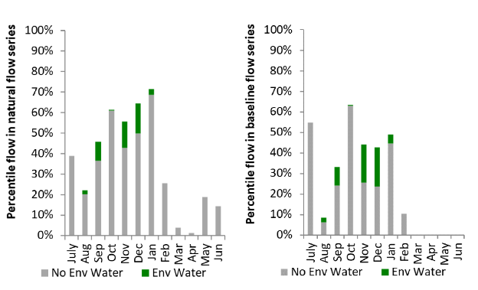
Figure GWY18: Contribution of environmental water delivery at Yarraman as percentiles in the natural and baseline flow series.

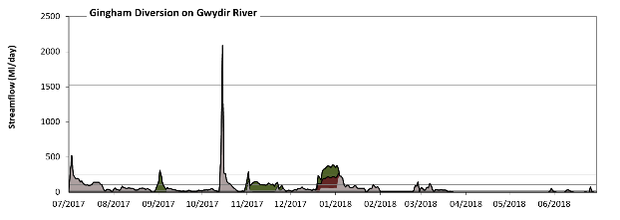
Gingham Diversion
Figure GWY19: Contribution of environmental water delivery at Gingham Diversion. Horizontal lines indicate thresholds for very low flows, low flows, low freshes, medium freshes and high freshes (from lowest to highest).
At Gingham Diversion on Gwydir River environmental water contributed 32% of the total streamflow volume (with a medium contribution of Commonwealth environmental water). Environmental watering actions affected streamflows for 14% of days between 1 July 2017 and 30 June 2018. Without environmental water, the durations of very low flows (i.e. < 21 Ml/day) in the periods July to September, October to December, January to March and April to June would have all substantially exceeded durations expected in an average year in the natural flow regime. Environmental water mitigated these impacts by reducing the cumulative duration of very low flow spells from 52% to 44% of the year, with greatest influence in the periods July to September and October to December. Similarly, without environmental water, the durations of medium low flows (i.e. < 100 Ml/day) in the periods July to September, October to December, January to March and April to June would have all substantially exceeded durations expected in an average year in the natural flow regime. Environmental water mitigated these impacts by reducing the cumulative duration of medium low flow spells from 90% to 81% of the year, with greatest influence in the period October to December. Commonwealth environmental water made a modest contribution to these enhancements of environmental baseflows at this site. In the absence of environmental water there would have been at least one low fresh (i.e. > 250 Ml/day) in the periods July to September and October to December. Environmental water increased the duration of the longest low fresh during the periods October to December (from 4 days to 9 days) and January to March (from 0 days to 3 days). Commonwealth environmental water equally shared responsibility with other environmental water holders for these increased durations of low freshes. There was at least one medium fresh (i.e. > 510 Ml/day) in the periods July to September and October to December. Environmental water made no change to the duration of these medium freshes. In the absence of environmental water there would have been at least one high fresh in the period October to December. Environmental water made no change to the duration of these high freshes.
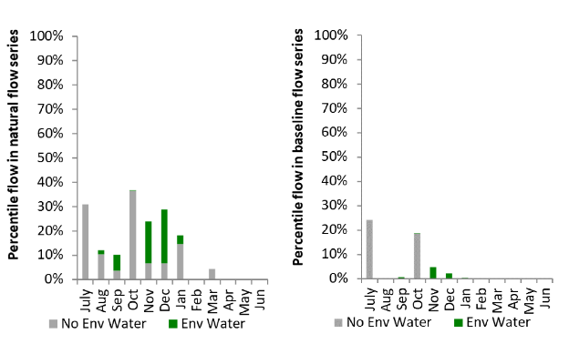
Figure GWY20: Contribution of environmental water delivery at Gingham Diversion as percentiles in the natural and baseline flow series.
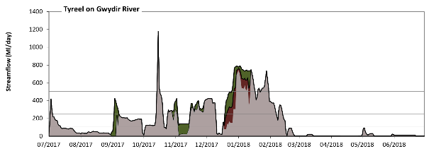
Tyreel
Figure GWY21: Contribution of environmental water delivery at Tyreel. Horizontal lines indicate thresholds for very low flows, low flows, low freshes, medium freshes and high freshes (from lowest to highest).
At Tyreel on Gwydir River environmental water contributed 16% of the total streamflow volume (with a medium contribution of Commonwealth environmental water). Environmental watering actions affected streamflows for 18% of days between 1 July 2017 and 30 June 2018. Without environmental water, the durations of very low flows (i.e. < 21 Ml/day) in the periods January to March and April to June would have substantially exceeded durations expected in an average year in the natural flow regime. Environmental water reduced the cumulative duration of very low flow spells from 35% to 33% of the year, with greatest influence in the periods July to September and October to December. Similarly, without environmental water, the durations of medium low flows (i.e. < 100 Ml/day) in the periods July to September, January to March and April to June would have substantially exceeded durations expected in an average year in the natural flow regime. Environmental water reduced the cumulative duration of medium low flow spells from 59% to 55% of the year, with greatest influence in the period October to December. Commonwealth environmental water made a small contribution to these enhancements of environmental baseflows at this site. There was at least one low fresh (i.e. > 170 Ml/day) in the periods July to September, October to December and January to March. Environmental water made little change to the duration of these low freshes. In the absence of environmental water there would have been at least one medium fresh (i.e. > 250 Ml/day) in the periods July to September, October to December and January to March. Environmental water increased the duration of the longest medium fresh during the period July to September (from 2 days to 4 days). Commonwealth environmental water made little or no contribution to these increased durations of medium freshes. In the absence of environmental water there would have been at least one high fresh in the periods October to December and January to March. Environmental water increased the duration of the longest high fresh during the periods October to December (from 3 days to 6 days) and January to March (from 10 days to 16 days). Commonwealth environmental water equally shared responsibility with other environmental water holders for these increased durations of high freshes.
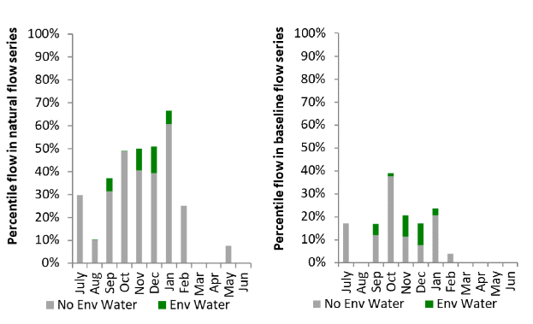
Figure GWY22: Contribution of environmental water delivery at Tyreel as percentiles in the natural and baseline flow series.

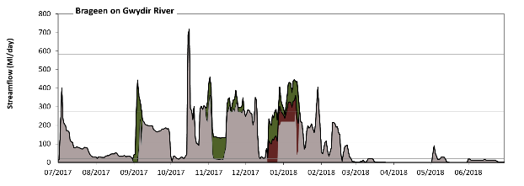
Brageen
Figure GWY23: Contribution of environmental water delivery at Brageen. Horizontal lines indicate thresholds for very low flows, low flows, low freshes and medium freshes (from lowest to highest).
At Brageen on Gwydir River environmental water contributed 21% of the total streamflow volume (with a medium contribution of Commonwealth environmental water). Environmental watering actions affected streamflows for 18% of days between 1 July 2017 and 30 June 2018. Without environmental water, the durations of very low flows (i.e. < 21 Ml/day) in the periods October to December, January to March and April to June would have substantially exceeded durations expected in an average year in the natural flow regime. Environmental water mitigated these impacts by reducing the cumulative duration of very low flow spells from 40% to 34% of the year, with greatest influence in the period October to December. Similarly, without environmental water, the durations of medium low flows (i.e. < 100 Ml/day) in the periods July to September, October to December, January to March and April to June would have all substantially exceeded durations expected in an average year in the natural flow regime. Environmental water mitigated these impacts by reducing the cumulative duration of medium low flow spells from 68% to 61% of the year, with greatest influence in the period October to December. Commonwealth environmental water made a modest contribution to these enhancements of environmental baseflows at this site. In the absence of environmental water there would have been at least one low fresh (i.e. > 270 Ml/day) in the periods July to September, October to December and January to March. Environmental water increased the duration of the longest low fresh during the periods July to September (from 1 days to 4 days), October to December (from 5 days to 15 days) and January to March (from 3 days to 12 days). Commonwealth environmental water made a small contribution to these increased durations of low freshes. There was at least one medium fresh (i.e. > 580 Ml/day) in the period October to December. Environmental water made no change to the duration of these medium freshes. There was no high freshes (i.e. > 1900 Ml/day) this year.
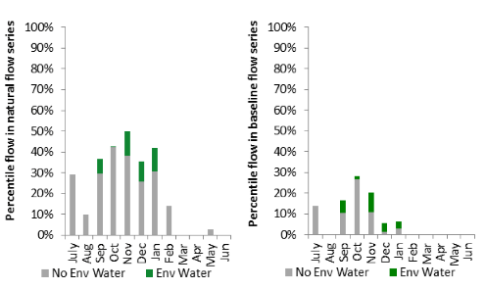
Figure GWY24: Contribution of environmental water delivery at Brageen as percentiles in the natural and baseline flow series.
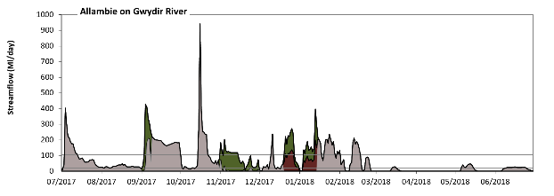
Allambie
Figure GWY25: Contribution of environmental water delivery at Allambie. Horizontal lines indicate thresholds for very low flows, low flows, low freshes, medium freshes and high freshes (from lowest to highest).
At Allambie on Gwydir River environmental water contributed 29% of the total streamflow volume (with a medium contribution of Commonwealth environmental water). Environmental watering actions affected streamflows for 18% of days between 1 July 2017 and 30 June 2018. Without environmental water, the durations of very low flows (i.e. < 21 Ml/day) in the periods October to December, January to March and April to June would have substantially exceeded durations expected in an average year in the natural flow regime. Environmental water mitigated these impacts by reducing the cumulative duration of very low flow spells from 49% to 35% of the year, with greatest influence in the period October to December. Similarly, without environmental water, the durations of medium low flows (i.e. < 100 Ml/day) in the periods July to September, October to December, January to March and April to June would have all substantially exceeded durations expected in an average year in the natural flow regime. Environmental water mitigated these impacts by reducing the cumulative duration of medium low flow spells from 82% to 73% of the year, with greatest influence in the periods October to December and January to March. Commonwealth environmental water made a modest contribution to these enhancements of environmental baseflows at this site. In the absence of environmental water there would have been at least one low fresh (i.e. > 190 Ml/day) in the periods July to September, October to December and January to March. Environmental water increased the duration of the longest low fresh during the periods July to September (from 8 days to 13 days) and January to March (from 2 days to 4 days). Commonwealth environmental water equally shared responsibility with other environmental water holders for these increased durations of low freshes. In the absence of environmental water there would have been at least one medium fresh (i.e. > 310 Ml/day) in the periods July to September and October to December. Environmental water increased the duration of the longest medium fresh during the periods July to September (from 1 days to 3 days) and January to March (from 0 days to 1 days). Commonwealth environmental water equally shared responsibility with other environmental water holders for these increased durations of medium freshes. In the absence of environmental water there would have been at least one high fresh in the period October to December. Environmental water made no change to the duration of these high freshes.
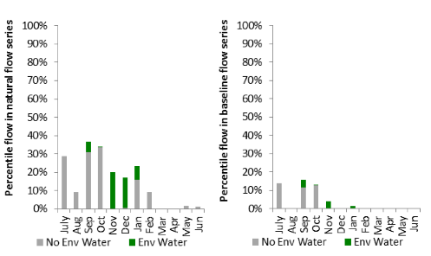
Figure GWY26: Contribution of environmental water delivery at Allambie as percentiles in the natural and baseline flow series.

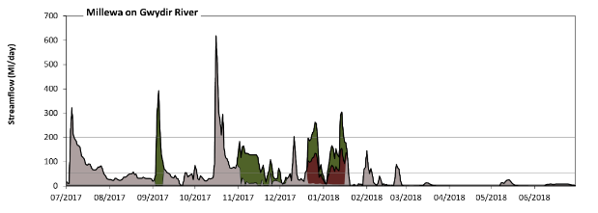
Millewa

Figure GWY27: Contribution of environmental water delivery at Millewa. Horizontal lines indicate thresholds for very low flows, low flows, low freshes and medium freshes (from lowest to highest).
At Millewa on Gwydir River environmental water contributed 39% of the total streamflow volume (with a medium contribution of Commonwealth environmental water). Environmental watering actions affected streamflows for 18% of days between 1 July 2017 and 30 June 2018. Flow regulation does not substantially increase the duration of very low flows (i.e. < 1.1 Ml/day) compared to an average year in the natural flow regime. Flow regulation does not substantially increase the duration of medium low flows (i.e. < 5.7 Ml/day) compared to an average year in the natural flow regime. Commonwealth environmental water made a small contribution to these enhancements of environmental baseflows at this site. In the absence of environmental water there would have been at least one low fresh (i.e. > 52 Ml/day) in the periods July to September, October to December and January to March. Environmental water increased the duration of the longest low fresh during the periods October to December (from 19 days to 36 days) and January to March (from 6 days to 15 days). Commonwealth environmental water made a modest contribution to these increased durations of low freshes. In the absence of environmental water there would have been at least one medium fresh (i.e. > 200 Ml/day) in the periods July to September and October to December. Environmental water increased the duration of the longest medium fresh during the period January to March (from 0 days to 3 days). Commonwealth environmental water equally shared responsibility with other environmental water holders for these increased durations of medium freshes. There was no high freshes (i.e. > 1200 Ml/day) this year.
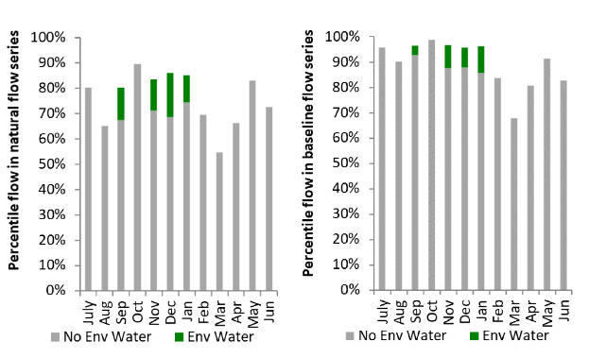
Figure GWY28: Contribution of environmental water delivery at Millewa as percentiles in the natural and baseline flow series.
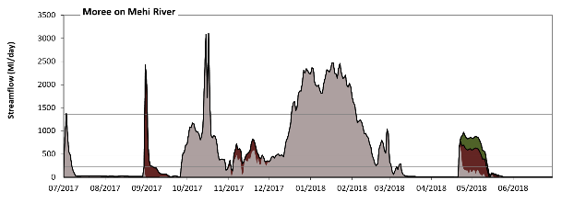
Moree
Figure GWY29: Contribution of environmental water delivery at Moree. Horizontal lines indicate thresholds for very low flows, low flows, low freshes, medium freshes and high freshes (from lowest to highest).
At Moree on Mehi River environmental water contributed 12% of the total streamflow volume (most of which was Commonwealth environmental water). Environmental watering actions affected streamflows for 22% of days between 1 July 2017 and 30 June 2018. Without environmental water, the durations of very low flows (i.e. < 19 Ml/day) in the periods July to September, January to March and April to June would have substantially exceeded durations expected in an average year in the natural flow regime. Environmental water mitigated these impacts by reducing the cumulative duration of very low flow spells from 31% to 24% of the year, with greatest influence in the periods July to September and April to June. Similarly, without environmental water, the durations of medium low flows (i.e. < 95 Ml/day) in the periods July to September and April to June would have substantially exceeded durations expected in an average year in the natural flow regime. Environmental water mitigated these impacts by reducing the cumulative duration of medium low flow spells from 50% to 43% of the year, with greatest influence in the periods July to September and April to June. Commonwealth environmental water made the dominant contribution to these enhancements of environmental baseflows at this site. In the absence of environmental water there would have been at least one low fresh (i.e. > 230 Ml/day) in the periods July to September, October to December, January to March and April to June. Environmental water increased the duration of the longest low fresh during the period April to June (from 3 days to 21 days). Commonwealth environmental water equally shared responsibility with other environmental water holders for these increased durations of low freshes. In the absence of environmental water there would have been at least one medium fresh (i.e. > 460 Ml/day) in the periods July to September, October to December, January to March and April to June. Environmental water increased the duration of the longest medium fresh during the period April to June (from 2 days to 20 days). Commonwealth environmental water was almost entirely responsible for these increased durations of medium freshes. In the absence of environmental water there would have been at least one high fresh in the periods July to September, October to December and January to March. Environmental water increased the duration of the longest high fresh during the period July to September (from 1 days to 2 days). Commonwealth environmental water was entirely responsible for these increased durations of high freshes.

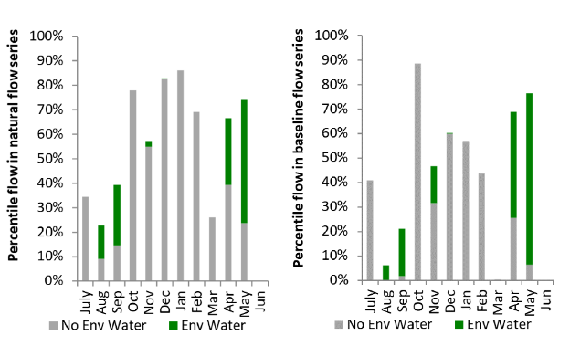
Figure GWY30: Contribution of environmental water delivery at Moree as percentiles in the natural and baseline flow series.

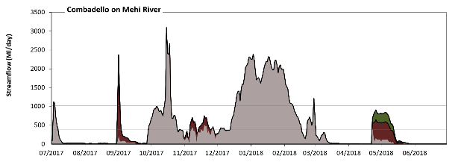
Combadello
Figure GWY31: Contribution of environmental water delivery at Combadello. Horizontal lines indicate thresholds for very low flows, low flows, low freshes and medium freshes (from lowest to highest).
At Combadello on Mehi River environmental water contributed 12% of the total streamflow volume (most of which was Commonwealth environmental water). Environmental watering actions affected streamflows for 22% of days between 1 July 2017 and 30 June 2018. Without environmental water, the durations of very low flows (i.e. < 20 Ml/day) in the periods July to September, January to March and April to June would have substantially exceeded durations expected in an average year in the natural flow regime. Environmental water mitigated these impacts by reducing the cumulative duration of very low flow spells from 32% to 29% of the year, with greatest influence in the period April to June. Similarly, without environmental water, the durations of medium low flows (i.e. < 99 Ml/day) in the periods July to September and April to June would have substantially exceeded durations expected in an average year in the natural flow regime. Environmental water mitigated these impacts by reducing the cumulative duration of medium low flow spells from 50% to 44% of the year, with greatest influence in the periods July to September and April to June. Commonwealth environmental water made the dominant contribution to these enhancements of environmental baseflows at this site. In the absence of environmental water there would have been at least one low fresh (i.e. > 380 Ml/day) in the periods July to September, October to December, January to March and April to June. Environmental water increased the duration of the longest low fresh during the period April to June (from 1 days to 20 days). Commonwealth environmental water was entirely responsible for these increased durations of low freshes. There was at least one medium fresh (i.e. > 1000 Ml/day) in the periods July to September, October to December and January to March. Environmental water made no change to the duration of these medium freshes. There was no high freshes (i.e. > 4100 Ml/day) this year.
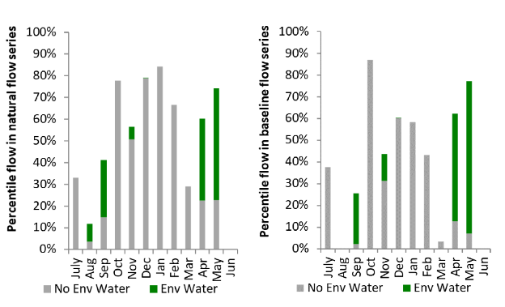
Figure GWY32: Contribution of environmental water delivery at Combadello as percentiles in the natural and baseline flow series.
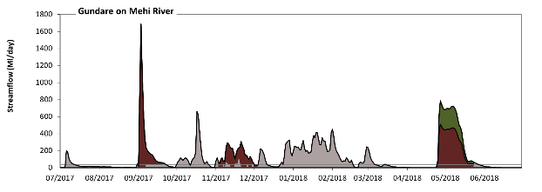
Gundare
Figure GWY33: Contribution of environmental water delivery at Gundare. Horizontal lines indicate thresholds for very low flows, low flows, low freshes, medium freshes and high freshes (from lowest to highest).
At Gundare on Mehi River environmental water contributed 51% of the total streamflow volume (much of which was Commonwealth environmental water). Environmental watering actions affected streamflows for 22% of days between 1 July 2017 and 30 June 2018. Without environmental water, the duration of very low flows (i.e. < 0.43 Ml/day) in the period April to June would have substantially exceeded durations expected in an average year in the natural flow regime. Environmental water mitigated these impacts by reducing the cumulative duration of very low flow spells from 22% to 11% of the year, with greatest influence in the period April to June. Similarly, without environmental water, the duration of medium low flows (i.e. < 2.1 Ml/day) in the period April to June would have substantially exceeded durations expected in an average year in the natural flow regime. Environmental water mitigated these impacts by reducing the cumulative duration of medium low flow spells from 27% to 14% of the year, with greatest influence in the periods October to December and April to June. Commonwealth environmental water made the dominant contribution to these enhancements of environmental baseflows at this site. In the absence of environmental water there would have been at least one low fresh (i.e. > 5.5 Ml/day) in the periods July to September, October to December, January to March and April to June. Environmental water increased the duration of the longest low fresh during the periods October to December (from 28 days to 62 days) and April to June (from 15 days to 44 days). Commonwealth environmental water made the dominant contribution to these increased durations of low freshes. In the absence of environmental water there would have been at least one medium fresh (i.e. > 11 Ml/day) in the periods July to September, October to December, January to March and April to June. Environmental water increased the duration of the longest medium fresh during the periods October to December (from 27 days to 46 days) and April to June (from 10 days to 39 days). Commonwealth environmental water made the dominant contribution to these increased durations of medium freshes. In the absence of environmental water there would have been at least one high fresh in the periods July to September, October to December, January to March and April to June. Environmental water increased the duration of the longest high fresh during the periods July to September (from 7 days to 21 days), October to December (from 14 days to 31 days) and April to June (from 4 days to 33 days). Commonwealth environmental water was almost entirely responsible for these increased durations of high freshes.
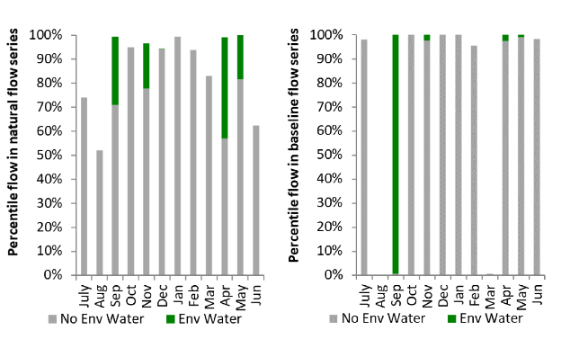
Figure GWY34: Contribution of environmental water delivery at Gundare as percentiles in the natural and baseline flow series.

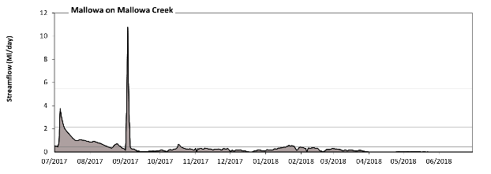
Mallowa
Figure GWY35: Contribution of environmental water delivery at Mallowa. Horizontal lines indicate thresholds for very low flows, low flows and low freshes (from lowest to highest).
There was no environmental water delivered at Mallowa on Mallowa Creek.
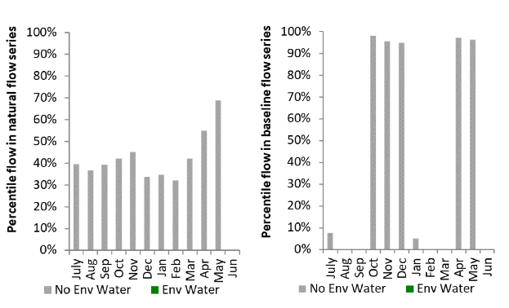
Figure GWY36: Contribution of environmental water delivery at Mallowa as percentiles in the natural and baseline flow series.

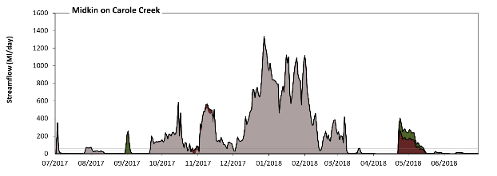
Midkin
Figure GWY37: Contribution of environmental water delivery at Midkin. Horizontal lines indicate thresholds for very low flows, low flows, low freshes, medium freshes and high freshes (from lowest to highest).
At Midkin on Carole Creek environmental water contributed 8% of the total streamflow volume (much of which was Commonwealth environmental water). Environmental watering actions affected streamflows for 15% of days between 1 July 2017 and 30 June 2018. Flow regulation does not substantially increase the duration of very low flows (i.e. < 2.1 Ml/day) compared to an average year in the natural flow regime. However, without environmental water, the duration of medium low flows (i.e. < 10 Ml/day) in the period April to June would have substantially exceeded durations expected in an average year in the natural flow regime. Environmental water mitigated these impacts by reducing the cumulative duration of medium low flow spells from 45% to 37% of the year, with greatest influence in the period April to June. Commonwealth environmental water equally shared responsibility with other environmental water holders for these enhancements of environmental baseflows at this site. In the absence of environmental water there would have been at least one low fresh (i.e. > 28 Ml/day) in the periods July to September, October to December and January to March. Environmental water increased the duration of the longest low fresh during the period April to June (from 0 days to 23 days). Commonwealth environmental water equally shared responsibility with other environmental water holders for these increased durations of low freshes. In the absence of environmental water there would have been at least one medium fresh (i.e. > 59 Ml/day) in the periods July to September, October to December and January to March. Environmental water increased the duration of the longest medium fresh during the period April to June (from 0 days to 22 days). Commonwealth environmental water equally shared responsibility with other environmental water holders for these increased durations of medium freshes. In the absence of environmental water there would have been at least one high fresh in the periods July to September, October to December and January to March. Environmental water increased the duration of the longest high fresh during the periods July to September (from 1 days to 2 days) and April to June (from 0 days to 14 days). Commonwealth environmental water equally shared responsibility with other environmental water holders for these increased durations of high freshes.
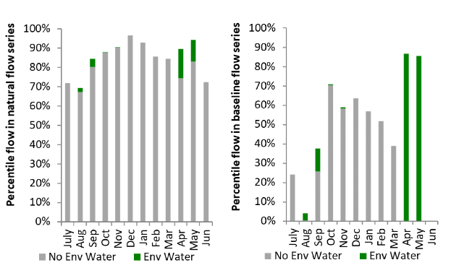
Figure GWY38: Contribution of environmental water delivery at Midkin as percentiles in the natural and baseline flow series.
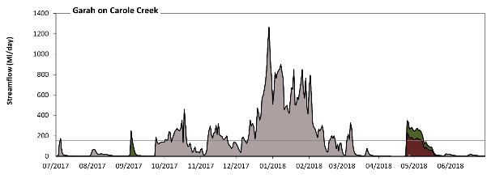
Garah
Figure GWY39: Contribution of environmental water delivery at Garah. Horizontal lines indicate thresholds for very low flows, low flows, low freshes, medium freshes and high freshes (from lowest to highest).
At Garah on Carole Creek environmental water contributed 9% of the total streamflow volume (with approximately half contributed by Commonwealth environmental water). Environmental watering actions affected streamflows for 12% of days between 1 July 2017 and 30 June 2018. Flow regulation does not substantially increase the duration of very low flows (i.e. < 1.7 Ml/day) compared to an average year in the natural flow regime. However, without environmental water, the durations of medium low flows (i.e. < 8.3 Ml/day) in the periods July to September and April to June would have substantially exceeded durations expected in an average year in the natural flow regime. Environmental water mitigated these impacts by reducing the cumulative duration of medium low flow spells from 40% to 31% of the year, with greatest influence in the period April to June. Commonwealth environmental water equally shared responsibility with other environmental water holders for these enhancements of environmental baseflows at this site. In the absence of environmental water there would have been at least one low fresh (i.e. > 22 Ml/day) in the periods July to September, October to December, January to March and April to June. Environmental water increased the duration of the longest low fresh during the period April to June (from 1 days to 24 days). Commonwealth environmental water equally shared responsibility with other environmental water holders for these increased durations of low freshes. In the absence of environmental water there would have been at least one medium fresh (i.e. > 48 Ml/day) in the periods July to September, October to December and January to March. Environmental water increased the duration of the longest medium fresh during the period April to June (from 0 days to 23 days). Commonwealth environmental water equally shared responsibility with other environmental water holders for these increased durations of medium freshes. In the absence of environmental water there would have been at least one high fresh in the periods July to September, October to December and January to March. Environmental water increased the duration of the longest high fresh during the period April to June (from 0 days to 14 days). Commonwealth environmental water was entirely responsible for these increased durations of high freshes.
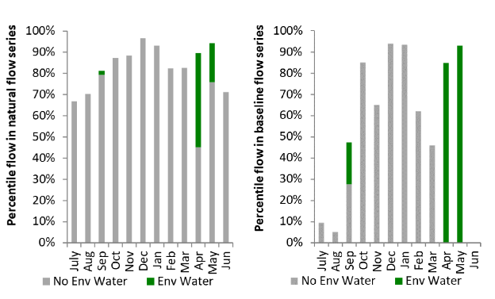
Figure GWY40: Contribution of environmental water delivery at Garah as percentiles in the natural and baseline flow series.

Namoi
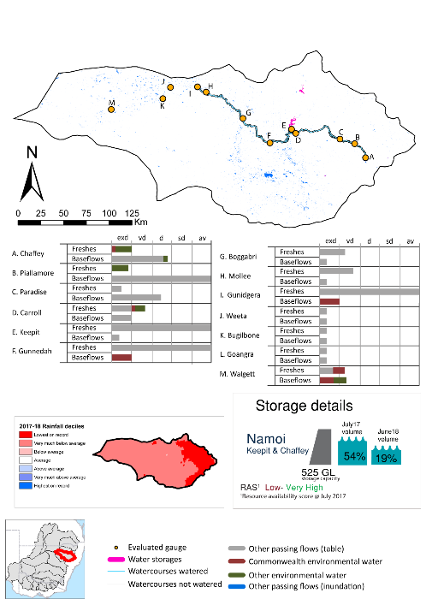
exd = extremely dry
vd = very dry
d = dry
sd = somewhat dry
av = average

Figure NAM1: Watercourses influenced, areas inundated (where applicable) and gauge stations evaluated in the Namoi valley during the 2017–18 water year. Inset bar graphs report the condition of annual flow regimes by showing the improvements in hydrological condition with the addition of environmental water as well as the hypothetical scenario in “grey” (if no environmental flow had been delivered); where exd=extremely dry, vd=very dry, d=dry, sd=somewhat dry and av=average. Rainfall conditions (rainfall deciles) and trend in storage levels for the water year are also shown.

Summary
The volume of environmental water delivery for the 2017–18 year in the Namoi valley (which includes the Peel River) is quantified using data for 10 sites. This evaluation only considers the contribution of held environmental water, which is a primary focus for the Commonwealth. The contributions of planned environmental water (e.g. passing flows), unregulated tributary inflows and clever use of irrigation flows for environmental benefits can all be very important but these are outside the scope of this report. Environmental watering actions lasted on average 32 days over the course of the year. The volume of environmental water at these 10 sites was between 0% and 17% of the total streamflow. Commonwealth environmental water contributed on average 51% of this environmental water. The contribution of environmental water delivery to improved flow regimes is evaluated using data for 10 sites. Ideally, baseflows should be maintained and long periods of excessively low flows avoided. In this valley, the baseflow regime was generally considered to be extremely dry relative to the pre-development flow regime. In our analysis, a low fresh refers to a period of increased flow, when the water level rises at least one eighth of the way up the river bank (above the low flow level). These low freshes are a regular part of the natural flow regime and support a range of natural processes. In the Namoi valley, in terms of the occurrence and duration of low freshes, the year was assessed as being dry. In our analysis, a medium fresh refers to a period of increased flow, when the water level rises at least one quarter of the way up the river bank. These medium freshes are not as frequent as low freshes but are also a regular and important part of the natural flow regime. In the Namoi valley, in terms of the occurrence of medium freshes, the year was assessed as being extremely dry. In our analysis, a high fresh refers to a period of increased flow, when the water level rises more than half way up the river. A high fresh may not occur every year but they are still important and long periods without major freshes can have serious consequences for floodplains and their contribution to river ecosystem health. Delivering environmental high in channel flows normally requires that all risks to riparian landholders and infrastructure have been resolved. In the Namoi valley, in terms of the occurrence of high freshes, the year was assessed as being very dry.

Water delivery context
During the 2017–18, the Commonwealth Environmental Water Holder (CEWH) held water entitlements of up to 12,404 Ml for environmental use in the Namoi valley. Each year, water utilities allocate water entitlement holders a percentage of water based on their holding, license type and carryover (the exact rules vary among Jurisdictions). In 2017–18, the Namoi entitlements held by the CEWH were allocated 887 Ml of water, representing 10% of the Long-term average annual yield for the Namoi valley (8,909 Ml). Information and data relating to the portfolio of held Commonwealth environmental water is shown in Table NAM2.
The 2017–18 water allocation (887 Ml) together with the carryover volume of 9,160 Ml of water meant the CEWH had 10,047 Ml of water available for delivery. A total of 4,100 Ml of Commonwealth environmental water was delivered in the Namoi valley. A total of 0 Ml of Commonwealth environmental water was traded to consumptive users and 5947 Ml (59%) of available Commonwealth environmental water was carried over for environmental use into the 2018–19 water year.

Environmental conditions and resource availability
The water available for environmental delivery combined with the present and antecedent environmental conditions are key inputs used by environmental water managers in planning and implementing watering actions. Post hoc, this information provides important context when evaluating the effectiveness and appropriateness of environmental water use with respect to hydrological outputs.
The rainfall conditions in the Namoi valley were classified as Very Much Below Average, based on rainfall percentile data for the entire record held by the Bureau of Meteorology for this valley. The water held in major storages in the Namoi valley decreased over the water year, for example the combined storages Keepit and Chaffey dam were 54% full at the beginning of the water year and 19% full by the end of the year (Figure NAM1).
The Commonwealth Environmental Water Office (CEWO) calculates resource availability scenarios (RAS) to guide the use and prioritisation of held environmental water. The RAS are progressively calculated over the year as part of the continual adaptive management planning processes. The RAS are based on the availability of held environmental water (including progressive license acquisitions and allocations) as well as the potential for unregulated or planned environmental flows. The outcome is then used to determine the demand for environmental water across the basin.
In 2017-18, the resource availability of held Commonwealth environmental water was classified as low to very high in this valley. The physical conditions meant that the CEWO was managing to maintain ecological health and resilience in the Lower Namoi River channel, wetlands and anabranches, and the Peel River. The overall demand for environmental water was deemed low to very high.

Watering actions
A total of 2 watering actions were delivered over the 2017-18 water year, the duration of these actions varied (range of individual actions: 13 - 64 days) and Commonwealth environmental water was delivered for a total of 77 days. The count of actions commencing in each season was; autumn (1) and winter (1). The flow component types delivered were; (1) baseflow, (1) freshes, (0) bankfull, (0) overbank and (0) wetland.
Commonwealth environmental water was delivered in the Namoi valley for specified objectives. Although most of the watering actions were delivered for fish purposes, water was also delivered for other purposes too. The percentage of watering actions delivered across the nine main themes included fish (29%), vegetation (14%), waterbirds (0%), frogs (0%), other biota (0), connectivity (14), process (29%), resilience (0.0%) and water quality (14.29%).
Table NAM2. Commonwealth environmental water accounting information for the Namoi valley over 2017–18 water year.
Total registered volume (Ml) | Allocated volume (Ml) | Carry over + allocated volume (Ml) | Delivered (Ml) | LTAAY (Ml) | Trade (Ml) | Carried over to 2018-19 | Forfeited (Ml)
12,404 | 887 | 10,047 | 4,100 | 8,909 | 0 | 5,947 | 0
Figure NAM2. Timing and duration of Commonwealth environmental water actions delivered in the Namoi valley.

Contribution of Commonwealth Environmental Water to Flow Regimes

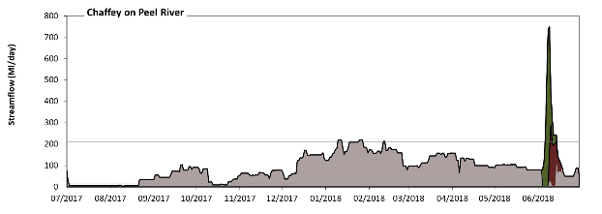
Chaffey
Figure NAM3: Contribution of environmental water delivery at Chaffey. Horizontal lines indicate thresholds for very low flows, low flows and low freshes (from lowest to highest).
At Chaffey on Peel River environmental water contributed 11% of the total streamflow volume (with a medium contribution of Commonwealth environmental water). Environmental watering actions affected streamflows for 4% of days between 1 July 2017 and 30 June 2018. Flow regulation does not substantially increase the duration of very low flows (i.e. < 2.9 Ml/day) compared to an average year in the natural flow regime. However, without environmental water, the duration of medium low flows (i.e. < 14 Ml/day) in the period July to September would have substantially exceeded durations expected in an average year in the natural flow regime. Environmental water reduced the cumulative duration of medium low flow spells from 19% to 17% of the year, with greatest influence in the period April to June. Commonwealth environmental water made a modest contribution to these enhancements of environmental baseflows at this site. In the absence of environmental water there would have been at least one low fresh (i.e. > 210 Ml/day) in the period January to March. Environmental water increased the duration of the longest low fresh during the period April to June (from 0 days to 9 days). Commonwealth environmental water made a modest contribution to these increased durations of low freshes. There was no medium or high freshes this year. However, environmental water increased peak flows substantially below the medium fresh threshold.
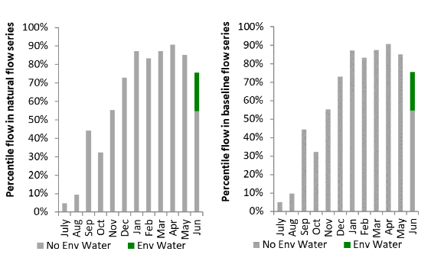
Figure NAM4: Contribution of environmental water delivery at Chaffey as percentiles in the natural and baseline flow series.

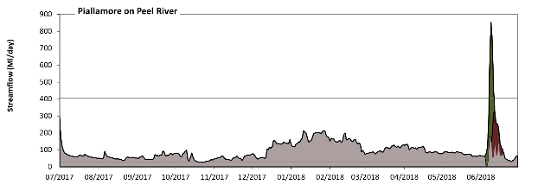
Piallamore
Figure NAM5: Contribution of environmental water delivery at Piallamore. Horizontal lines indicate thresholds for very low flows, low flows and low freshes (from lowest to highest).
At Piallamore on Peel River environmental water contributed 10% of the total streamflow volume (with a medium contribution of Commonwealth environmental water). Environmental watering actions affected streamflows for 4% of days between 1 July 2017 and 30 June 2018. Flow regulation does not substantially increase the duration of very low flows (i.e. < 5.7 Ml/day) compared to an average year in the natural flow regime. Flow regulation does not substantially increase the duration of medium low flows (i.e. < 29 Ml/day) compared to an average year in the natural flow regime. Environmental water increased the duration of the longest low fresh during the period April to June (from 0 days to 4 days). Commonwealth environmental water made little or no contribution to these increased durations of low freshes.
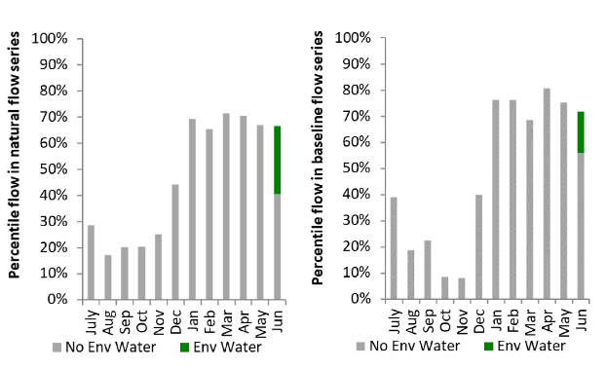
Figure NAM6: Contribution of environmental water delivery at Piallamore as percentiles in the natural and baseline flow series.

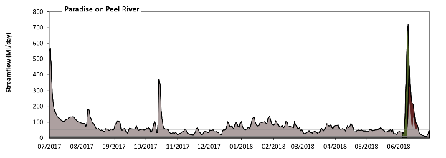
Paradise
Figure NAM7: Contribution of environmental water delivery at Paradise. Horizontal lines indicate thresholds for very low flows, low flows and low freshes (from lowest to highest).
At Paradise on Peel River environmental water contributed 10% of the total streamflow volume (with a medium contribution of Commonwealth environmental water). Environmental watering actions affected streamflows for 4% of days between 1 July 2017 and 30 June 2018. Flow regulation does not substantially increase the duration of very low flows (i.e. < 11 Ml/day) compared to an average year in the natural flow regime. However, without environmental water, the durations of medium low flows (i.e. < 53 Ml/day) in the periods July to September, October to December and April to June would have substantially exceeded durations expected in an average year in the natural flow regime. Environmental water mitigated these impacts by reducing the cumulative duration of medium low flow spells from 42% to 41% of the year, with greatest influence in the period April to June. In the absence of environmental water there would have been at least one low fresh (i.e. > 510 Ml/day) in the period July to September. Environmental water increased the duration of the longest low fresh during the period April to June (from 0 days to 2 days). Commonwealth environmental water made little or no contribution to these increased durations of low freshes. There was no medium or high freshes this year.
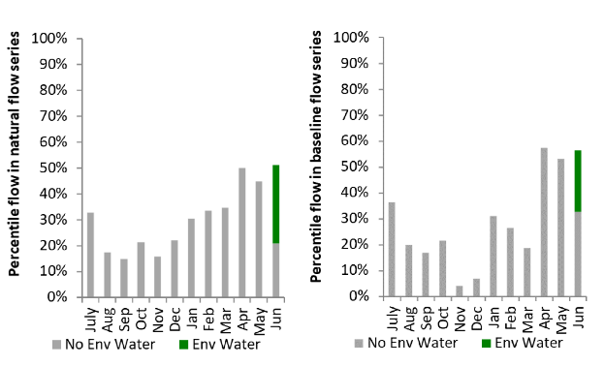
Figure NAM8: Contribution of environmental water delivery at Paradise as percentiles in the natural and baseline flow series.

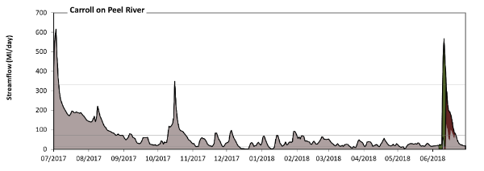
Carroll

Figure NAM9: Contribution of environmental water delivery at Carroll. Horizontal lines indicate thresholds for very low flows, low flows and low freshes (from lowest to highest).
At Carroll on Peel River environmental water contributed 10% of the total streamflow volume (with a medium contribution of Commonwealth environmental water). Environmental watering actions affected streamflows for 4% of days between 1 July 2017 and 30 June 2018. Without environmental water, the durations of very low flows (i.e. < 14 Ml/day) in the periods October to December, January to March and April to June would have substantially exceeded durations expected in an average year in the natural flow regime. Environmental water mitigated these impacts by reducing the cumulative duration of very low flow spells from 9% to 8% of the year, with greatest influence in the period April to June. Similarly, without environmental water, the durations of medium low flows (i.e. < 70 Ml/day) in the periods July to September, October to December, January to March and April to June would have all substantially exceeded durations expected in an average year in the natural flow regime. Environmental water mitigated these impacts by reducing the cumulative duration of medium low flow spells from 73% to 71% of the year, with greatest influence in the period April to June. In the absence of environmental water there would have been at least one low fresh (i.e. > 330 Ml/day) in the periods July to September and October to December. Environmental water increased the duration of the longest low fresh during the period April to June (from 0 days to 4 days). Commonwealth environmental water made a modest contribution to these increased durations of low freshes. There was no medium or high freshes this year.
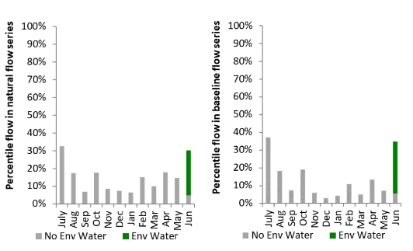
Figure NAM10: Contribution of environmental water delivery at Carroll as percentiles in the natural and baseline flow series.
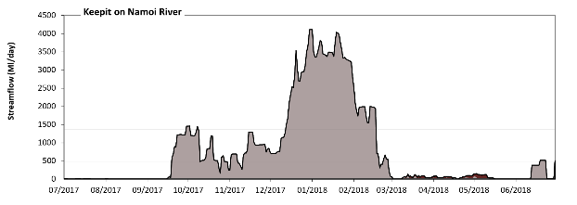
Keepit

Figure NAM11: Contribution of environmental water delivery at Keepit. Horizontal lines indicate thresholds for very low flows, low flows, low freshes, medium freshes and high freshes (from lowest to highest).
At Keepit on Namoi River environmental water contributed 1% of the total streamflow volume (all of which was Commonwealth environmental water). Environmental watering actions affected streamflows for 19% of days between 1 July 2017 and 30 June 2018. Without environmental water, the durations of very low flows (i.e. < 20 Ml/day) in the periods July to September, January to March and April to June would have substantially exceeded durations expected in an average year in the natural flow regime. Environmental water mitigated these impacts by reducing the cumulative duration of very low flow spells from 44% to 33% of the year, with greatest influence in the periods January to March and April to June. Similarly, without environmental water, the durations of medium low flows (i.e. < 99 Ml/day) in the periods July to September, January to March and April to June would have substantially exceeded durations expected in an average year in the natural flow regime. Environmental water mitigated these impacts by reducing the cumulative duration of medium low flow spells from 52% to 49% of the year, with greatest influence in the period April to June. Commonwealth environmental water was entirely responsible for these enhancements of environmental baseflows at this site. There was at least one low fresh (i.e. > 470 Ml/day) in the periods July to September, October to December, January to March and April to June. Environmental water made no change to the duration of these low freshes. There was at least one medium fresh (i.e. > 1400 Ml/day) in the periods July to September, October to December and January to March. Environmental water made no change to the duration of these medium freshes. In the absence of environmental water there would have been at least one high fresh in the periods July to September, October to December and January to March. Environmental water made no change to the duration of these high freshes.
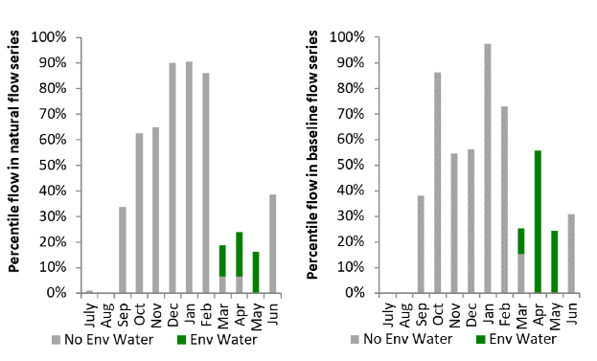
Figure NAM12: Contribution of environmental water delivery at Keepit as percentiles in the natural and baseline flow series.

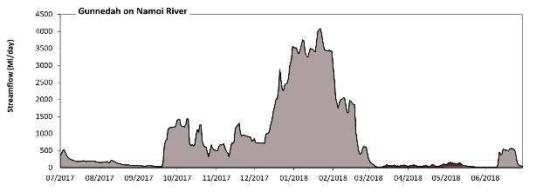
Gunnedah
Figure NAM13: Contribution of environmental water delivery at Gunnedah. Horizontal lines indicate thresholds for very low flows, low flows, low freshes, medium freshes and high freshes (from lowest to highest).
At Gunnedah on Namoi River environmental water contributed 1% of the total streamflow volume (all of which was Commonwealth environmental water). Environmental watering actions affected streamflows for 19% of days between 1 July 2017 and 30 June 2018. Without environmental water, the durations of very low flows (i.e. < 41 Ml/day) in the periods January to March and April to June would have substantially exceeded durations expected in an average year in the natural flow regime. Environmental water mitigated these impacts by reducing the cumulative duration of very low flow spells from 28% to 14% of the year, with greatest influence in the periods January to March and April to June. Similarly, without environmental water, the durations of medium low flows (i.e. < 210 Ml/day) in the periods July to September and April to June would have substantially exceeded durations expected in an average year in the natural flow regime. However, environmental water had little effect on the duration of these medium low flows, which occurred for 48% of the year. Commonwealth environmental water was entirely responsible for these enhancements of environmental baseflows at this site. There was at least one low fresh (i.e. > 970 Ml/day) in the periods July to September, October to December and January to March. Environmental water made no change to the duration of these low freshes. There was at least one medium fresh (i.e. > 2900 Ml/day) in the periods October to December and January to March. Environmental water made no change to the duration of these medium freshes. In the absence of environmental water there would have been at least one high fresh in the periods October to December and January to March. Environmental water made no change to the duration of these high freshes.
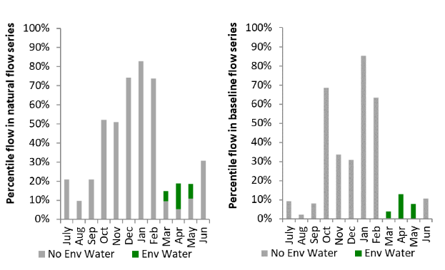
Figure NAM14: Contribution of environmental water delivery at Gunnedah as percentiles in the natural and baseline flow series.
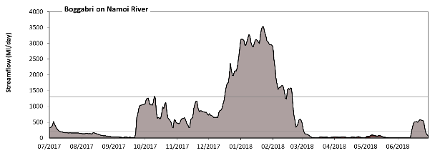
Boggabri

Figure NAM15: Contribution of environmental water delivery at Boggabri. Horizontal lines indicate thresholds for very low flows, low flows and low freshes (from lowest to highest).
At Boggabri on Namoi River environmental water contributed 1% of the total streamflow volume (all of which was Commonwealth environmental water). Environmental watering actions affected streamflows for 20% of days between 1 July 2017 and 30 June 2018. Without environmental water, the durations of very low flows (i.e. < 42 Ml/day) in the periods July to September, January to March and April to June would have substantially exceeded durations expected in an average year in the natural flow regime. Environmental water mitigated these impacts by reducing the cumulative duration of very low flow spells from 33% to 28% of the year, with greatest influence in the period April to June. Similarly, without environmental water, the durations of medium low flows (i.e. < 210 Ml/day) in the periods July to September and April to June would have substantially exceeded durations expected in an average year in the natural flow regime. However, environmental water had little effect on the duration of these medium low flows, which occurred for 49% of the year. Commonwealth environmental water was entirely responsible for these enhancements of environmental baseflows at this site. There was at least one low fresh (i.e. > 1300 Ml/day) in the periods October to December and January to March. Environmental water made no change to the duration of these low freshes. There was no medium or high freshes this year.
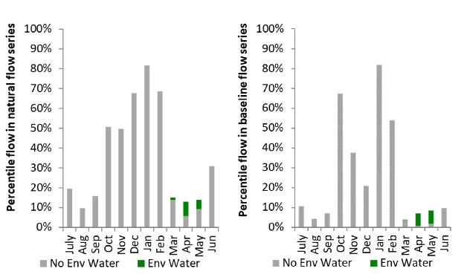
Figure NAM16: Contribution of environmental water delivery at Boggabri as percentiles in the natural and baseline flow series.

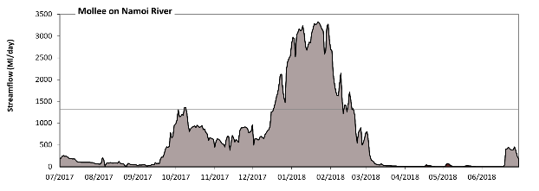
Mollee

Figure NAM17: Contribution of environmental water delivery at Mollee. Horizontal lines indicate thresholds for very low flows, low flows and low freshes (from lowest to highest).
At Mollee on Namoi River environmental water contributed less than 1% of the total streamflow volume (all of which was Commonwealth environmental water). Environmental watering actions affected streamflows for 20% of days between 1 July 2017 and 30 June 2018. Without environmental water, the durations of very low flows (i.e. < 44 Ml/day) in the periods July to September, January to March and April to June would have substantially exceeded durations expected in an average year in the natural flow regime. Environmental water mitigated these impacts by reducing the cumulative duration of very low flow spells from 30% to 29% of the year, with greatest influence in the period April to June. Similarly, without environmental water, the durations of medium low flows (i.e. < 220 Ml/day) in the periods July to September and April to June would have substantially exceeded durations expected in an average year in the natural flow regime. However, environmental water had little effect on the duration of these medium low flows, which occurred for 50% of the year. There was at least one low fresh (i.e. > 1300 Ml/day) in the periods October to December and January to March. Environmental water made no change to the duration of these low freshes. There was no medium or high freshes this year.
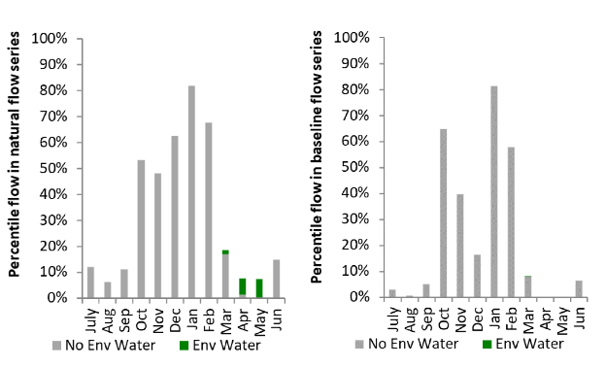
Figure NAM18: Contribution of environmental water delivery at Mollee as percentiles in the natural and baseline flow series.

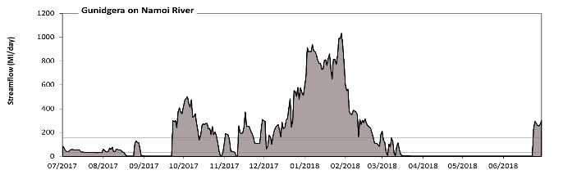
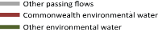
Gunidgera
Figure NAM19: Contribution of environmental water delivery at Gunidgera. Horizontal lines indicate thresholds for very low flows and low flows (from lowest to highest).
There was no environmental water delivered at Gunidgera on Namoi River.
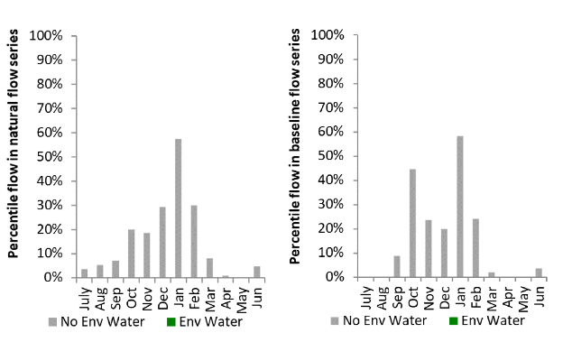
Figure NAM20: Contribution of environmental water delivery at Gunidgera as percentiles in the natural and baseline flow series.
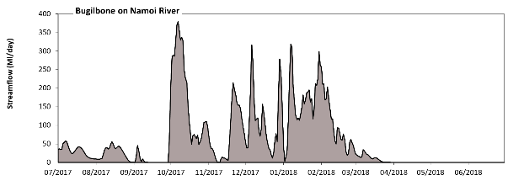
Bugilbone
Figure NAM21: Contribution of environmental water delivery at Bugilbone.
There was no environmental water delivered at Bugilbone on Namoi River.
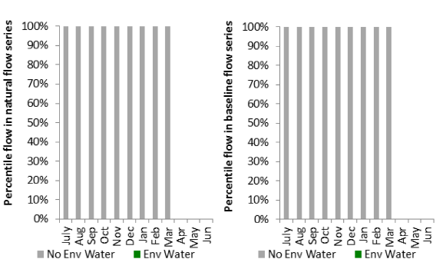
Figure NAM22: Contribution of environmental water delivery at Bugilbone as percentiles in the natural and baseline flow series.

Murrumbidgee
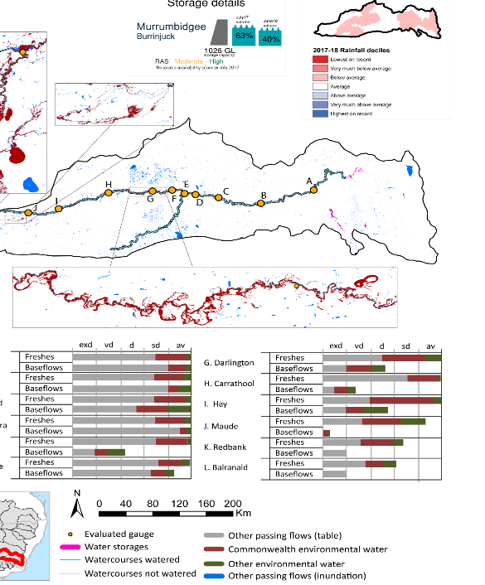
Figure MBG1: Watercourses influenced, areas inundated (where applicable) and gauge stations evaluated in the Murrumbidgee valley during the 2017-18 water year. Inset bar graphs report the condition of annual flow regimes by showing the improvements in hydrological condition with the addition of environmental water as well as the hypothetical scenario in “grey” (if no environmental flow had been delivered); where exd=extremely dry, vd=very dry, d=dry, sd=somewhat dry and av=average. Rainfall conditions (rainfall deciles) and trend in storage levels for the water year are also shown.

Summary
The volume of environmental water delivery for the 2017–18 year in the Murrumbidgee valley is quantified using data for 12 sites. This evaluation only considers the contribution of held environmental water, which is a primary focus for the Commonwealth. The contributions of planned environmental water (e.g. passing flows), unregulated tributary inflows and clever use of irrigation flows for environmental benefits can all be very important but these are outside the scope of this report. Environmental watering actions lasted on average 172 days over the course of the year. The volume of environmental water at these 12 sites was between 10% and 33% of the total streamflow. Commonwealth environmental water contributed on average 71% of this environmental water. The contribution of environmental water delivery to improved flow regimes is evaluated using data for 12 sites. Ideally, baseflows should be maintained and long periods of excessively low flows avoided. In this valley, the baseflow regime was generally considered to be dry relative to the pre-development flow regime. In our analysis, a low fresh refers to a period of increased flow, when the water level rises at least one eighth of the way up the river bank (above the low flow level). These low freshes are a regular part of the natural flow regime and support a range of natural processes. In the Murrumbidgee valley, in terms of the occurrence and duration of low freshes, the year was assessed as being average. In our analysis, a medium fresh refers to a period of increased flow, when the water level rises at least one quarter of the way up the river bank. These medium freshes are not as frequent as low freshes but are also a regular and important part of the natural flow regime. In the Murrumbidgee valley, in terms of the occurrence of medium freshes, the year was assessed as being average. In our analysis, a high fresh refers to a period of increased flow, when the water level rises more than half way up the river. A high fresh may not occur every year but they are still important and long periods without major freshes can have serious consequences for floodplains and their contribution to river ecosystem health. Delivering environmental high in channel flows normally requires that all risks to riparian landholders and infrastructure have been resolved. In the Murrumbidgee valley, in terms of the occurrence of high freshes, the year was assessed as being average.

Water delivery context
During the 2017–18, the Commonwealth Environmental Water Holder (CEWH) held water entitlements of up to 740,013 Ml for environmental use in the Murrumbidgee valley. Each year, water utilities allocate water entitlement holders a percentage of water based on their holding, license type and carryover (the exact rules vary among Jurisdictions). In 2017–18, the Murrumbidgee entitlements held by the CEWH were allocated 158,604 Ml of water, representing 40% of the Long-term average annual yield for the Murrumbidgee valley (401,020 Ml). Information and data relating to the portfolio of held Commonwealth environmental water is shown in Table MBG2.
The 2017–18 water allocation (158,604 Ml) together with the carryover volume of 78,509 Ml of water meant the CEWH had 237,113 Ml of water available for delivery. A total of 195,932 Ml of Commonwealth environmental water was delivered in the Murrumbidgee valley. A total of 0 Ml of Commonwealth environmental water was traded to consumptive users and 41181 Ml (17%) of available Commonwealth environmental water was carried over for environmental use into the 2018–19 water year.

Environmental conditions and resource availability
The water available for environmental delivery combined with the present and antecedent environmental conditions are key inputs used by environmental water managers in planning and implementing watering actions. Post hoc, this information provides important context when evaluating the effectiveness and appropriateness of environmental water use with respect to hydrological outputs.
The rainfall conditions in the Murrumbidgee valley were classified as Below Average, based on rainfall percentile data for the entire record held by the Bureau of Meteorology for this valley. The water held in major storages in the Murrumbidgee valley decreased over the water year, for example Burrinjuck dam was 63% full at the beginning of the water year and 40% full by the end of the year (Figure MBG1).
The Commonwealth Environmental Water Office (CEWO) calculates resource availability scenarios (RAS) to guide the use and prioritisation of held environmental water. The RAS are progressively calculated over the year as part of the continual adaptive management planning processes. The RAS are based on the availability of held environmental water (including progressive license acquisitions and allocations) as well as the potential for unregulated or planned environmental flows. The outcome is then used to determine the demand for environmental water across the basin.
In 2017–18, the resource availability of held Commonwealth environmental water was classified as moderate to high in this valley. The physical conditions meant that the CEWO was managing to protect the mid-Murrumbidgee wetlands and ensure their ecological capacity for recovery, while maintaining and where possible improving the ecological health and resilience of other important sites in the catchment. The overall demand for environmental water was deemed high.

Watering actions
A total of 14 watering actions were delivered over the 2017–18 water year, the duration of these actions varied (range of individual actions: 3 - 206 days) and Commonwealth environmental water was delivered for a total of 565 days. The count of actions commencing in each season was; winter (4), spring (3), summer (5) and autumn (2). The flow component types delivered were; (1) baseflow, (1) freshes, (0) bankfull, (0) overbank and (12) wetland.
Commonwealth environmental water was delivered in the Murrumbidgee valley for specified objectives. Although the majority of watering actions were delivered for vegetation purposes, water was also delivered for other purposes too. The percentage of watering actions delivered across the nine main themes included fish (15%), vegetation (16%), waterbirds (15%), frogs (12%), other biota (16%), connectivity (1%), process (1%), resilience (15%) and water quality (11%).
Table MBG2. Commonwealth environmental water accounting information for the Murrumbidgee valley over 2017–18 water year.
Total registered volume (Ml) | Allocated volume (Ml) | Carry over + allocated volume (Ml) | Delivered (Ml) | LTAAY (Ml) | Trade (Ml) | Carried over to 2018-19 | Forfeited (Ml)
740,013 | 158,604 | 237,113 | 179,249 | 401,020 | 0 | 41,181 | 0
Figure MBG2. Timing and duration of Commonwealth environmental water actions delivered in the Murrumbidgee valley.

Contribution of Commonwealth Environmental Water to Flow Regimes
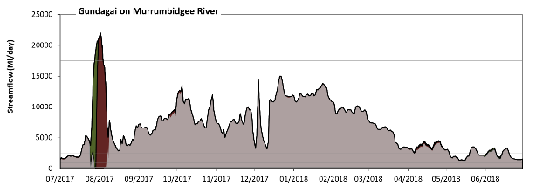
Gundagai

Figure MBG3: Contribution of environmental water delivery at Gundagai. Horizontal lines indicate thresholds for very low flows, low flows, low freshes, medium freshes and high freshes (from lowest to highest).
At Gundagai on Murrumbidgee River environmental water contributed 11% of the total streamflow volume (much of which was Commonwealth environmental water). Environmental watering actions affected streamflows for 59% of days between 1 July 2017 and 30 June 2018. Without environmental water, the duration of very low flows (i.e. < 190 Ml/day) in the period July to September would have substantially exceeded durations expected in an average year in the natural flow regime. Environmental water mitigated these impacts by reducing the cumulative duration of very low flow spells from 2% to 0% of the year, with greatest influence in the period July to September. Similarly, without environmental water, the duration of medium low flows (i.e. < 930 Ml/day) in the period July to September would have substantially exceeded durations expected in an average year in the natural flow regime. Environmental water mitigated these impacts by reducing the cumulative duration of medium low flow spells from 3% to 0% of the year, with greatest influence in the period July to September. Commonwealth environmental water made the dominant contribution to these enhancements of environmental baseflows at this site. In the absence of environmental water there would have been at least one low fresh (i.e. > 2500 Ml/day) in the periods July to September, October to December, January to March and April to June. Environmental water increased the duration of the longest low fresh during the period July to September (from 53 days to 75 days). Commonwealth environmental water was entirely responsible for these increased durations of low freshes. There was at least one medium fresh (i.e. > 5400 Ml/day) in the periods July to September, October to December and January to March. Environmental water made no change to the duration of these medium freshes. There was at least one high fresh (i.e. > 17500 Ml/day) this year. Environmental water increased the duration of the longest high fresh during the period July to September (from 0 days to 6 days). Commonwealth environmental water was almost entirely responsible for these increased durations of high freshes.
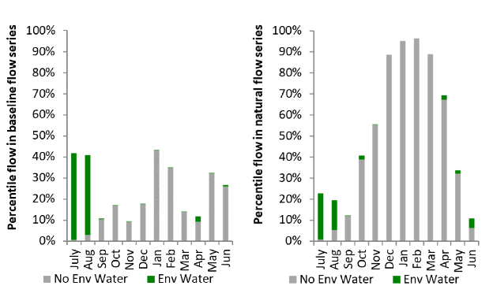
Figure MBG4: Contribution of environmental water delivery at Gundagai as percentiles in the natural and baseline flow series.
Wagga
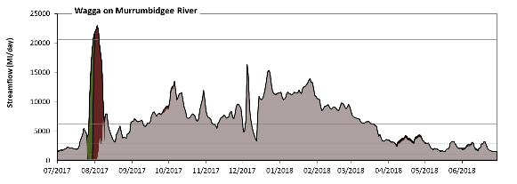

Figure MBG5: Contribution of environmental water delivery at Wagga. Horizontal lines indicate thresholds for very low flows, low flows, low freshes, medium freshes and high freshes (from lowest to highest).
At Wagga on Murrumbidgee River environmental water contributed 10% of the total streamflow volume (much of which was Commonwealth environmental water). Environmental watering actions affected streamflows for 60% of days between 1 July 2017 and 30 June 2018. Without environmental water, the duration of very low flows (i.e. < 210 Ml/day) in the period July to September would have substantially exceeded durations expected in an average year in the natural flow regime. Environmental water mitigated these impacts by reducing the cumulative duration of very low flow spells from 2% to 0% of the year, with greatest influence in the period July to September. Similarly, without environmental water, the duration of medium low flows (i.e. < 1000 Ml/day) in the period July to September would have substantially exceeded durations expected in an average year in the natural flow regime. Environmental water mitigated these impacts by reducing the cumulative duration of medium low flow spells from 2% to 0% of the year, with greatest influence in the period July to September. Commonwealth environmental water equally shared responsibility with other environmental water holders for these enhancements of environmental baseflows at this site. In the absence of environmental water there would have been at least one low fresh (i.e. > 2900 Ml/day) in the periods July to September, October to December, January to March and April to June. Environmental water increased the duration of the longest low fresh during the periods July to September (from 55 days to 73 days) and April to June (from 12 days to 26 days). Commonwealth environmental water made the dominant contribution to these increased durations of low freshes. There was at least one medium fresh (i.e. > 6300 Ml/day) in the periods July to September, October to December and January to March. Environmental water made no change to the duration of these medium freshes. There was one high fresh (i.e. > 21000 Ml/day) this year. Environmental water increased the duration of the longest high fresh during the period July to September (from 0 days to 5 days). Commonwealth environmental water was entirely responsible for the increased duration of high freshes.
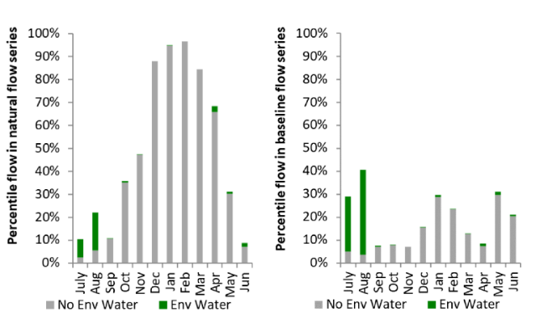
Figure MBG6: Contribution of environmental water delivery at Wagga as percentiles in the natural and baseline flow series.
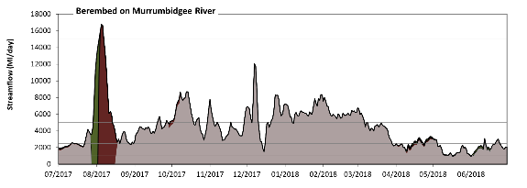
Berembed

Figure MBG7: Contribution of environmental water delivery at Berembed. Horizontal lines indicate thresholds for very low flows, low flows, low freshes, medium freshes and high freshes (from lowest to highest).
At Berembed on Murrumbidgee River environmental water contributed 14% of the total streamflow volume (much of which was Commonwealth environmental water). Environmental watering actions affected streamflows for 61% of days between 1 July 2017 and 30 June 2018. Without environmental water, the duration of very low flows (i.e. < 210 Ml/day) in the period July to September would have substantially exceeded durations expected in an average year in the natural flow regime. Environmental water mitigated these impacts by reducing the cumulative duration of very low flow spells from 5% to 0% of the year, with greatest influence in the period July to September. Similarly, without environmental water, the duration of medium low flows (i.e. < 1000 Ml/day) in the period July to September would have substantially exceeded durations expected in an average year in the natural flow regime. Environmental water mitigated these impacts by reducing the cumulative duration of medium low flow spells from 7% to 1% of the year, with greatest influence in the period July to September. Commonwealth environmental water made the dominant contribution to these enhancements of environmental baseflows at this site. There was at least one low fresh (i.e. > 2500 Ml/day) in the periods July to September, October to December, January to March and April to June. Environmental water made little change to the duration of these low freshes. In the absence of environmental water there would have been at least one medium fresh (i.e. > 5000 Ml/day) in the periods July to September, October to December and January to March. Environmental water increased the duration of the longest medium fresh during the period July to September (from 3 days to 15 days). Commonwealth environmental water was almost entirely responsible for these increased durations of medium freshes. There was one high fresh (i.e. > 15000 Ml/day) this year. Environmental water increased the duration of the longest high fresh during the period July to September (from 0 days to 3 days). Commonwealth environmental water was entirely responsible for these increased durations of high freshes.
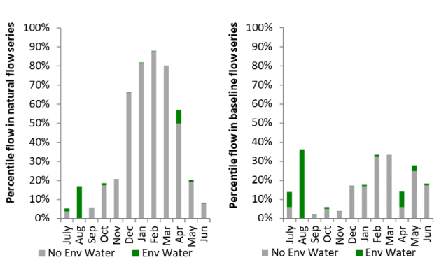
Figure MBG8: Contribution of environmental water delivery at Berembed as percentiles in the natural and baseline flow series.

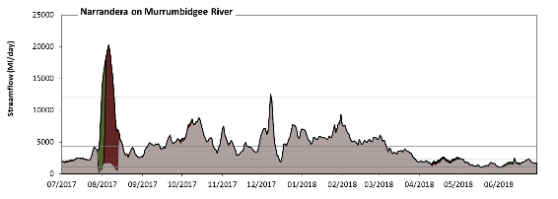
Narrandera

Figure MBG9: Contribution of environmental water delivery at Narrandera. Horizontal lines indicate thresholds for very low flows, low flows, low freshes, medium freshes and high freshes (from lowest to highest).
At Narrandera on Murrumbidgee River environmental water contributed 14% of the total streamflow volume (much of which was Commonwealth environmental water). Environmental watering actions affected streamflows for 60% of days between 1 July 2017 and 30 June 2018. Flow regulation does not substantially increase the duration of very low flows (i.e. < 210 Ml/day) compared to an average year in the natural flow regime. However, without environmental water, the duration of medium low flows (i.e. < 1000 Ml/day) in the period July to September would have substantially exceeded durations expected in an average year in the natural flow regime. Environmental water mitigated these impacts by reducing the cumulative duration of medium low flow spells from 3% to 0% of the year, with greatest influence in the periods July to September and April to June. Commonwealth environmental water equally shared responsibility with other environmental water holders for these enhancements of environmental baseflows at this site. In the absence of environmental water there would have been at least one low fresh (i.e. > 2300 Ml/day) in the periods July to September, October to December, January to March and April to June. Environmental water increased the duration of the longest low fresh during the periods July to September (from 48 days to 70 days) and April to June (from 1 days to 7 days). Commonwealth environmental water made the dominant contribution to these increased durations of low freshes. In the absence of environmental water there would have been at least one medium fresh (i.e. > 4300 Ml/day) in the periods July to September, October to December and January to March. Environmental water increased the duration of the longest medium fresh during the period July to September (from 12 days to 18 days). Commonwealth environmental water was entirely responsible for these increased durations of medium freshes. There were two high freshes (i.e. > 12000 Ml/day) this year. Environmental water increased the duration of the longest high fresh during the periods July to September (from 0 days to 9 days) and October to December (from 0 days to 1 days). Commonwealth environmental water was almost entirely responsible for these increased durations of high freshes.
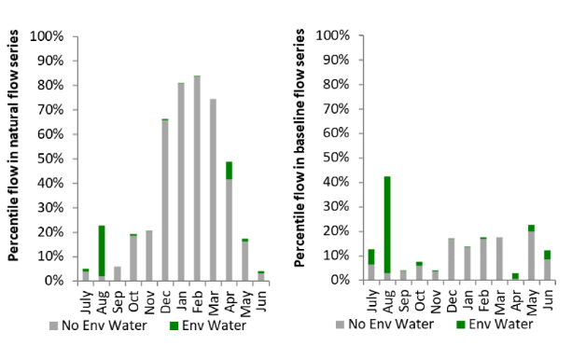
Figure MBG10: Contribution of environmental water delivery at Narrandera as percentiles in the natural and baseline flow series.
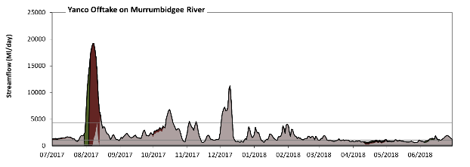
Yanco Offtake

Figure MBG11: Contribution of environmental water delivery at Yanco Offtake. Horizontal lines indicate thresholds for very low flows, low flows, low freshes, medium freshes and high freshes (from lowest to highest).
At Yanco Offtake on Murrumbidgee River environmental water contributed 26% of the total streamflow volume (much of which was Commonwealth environmental water). Environmental watering actions affected streamflows for 58% of days between 1 July 2017 and 30 June 2018. Without environmental water, the duration of very low flows (i.e. < 210 Ml/day) in the period July to September would have substantially exceeded durations expected in an average year in the natural flow regime. Environmental water mitigated these impacts by reducing the cumulative duration of very low flow spells from 2% to 0% of the year, with greatest influence in the period July to September. Similarly, without environmental water, the durations of medium low flows (i.e. < 1000 Ml/day) in the periods July to September, October to December and April to June would have substantially exceeded durations expected in an average year in the natural flow regime. Environmental water mitigated these impacts by reducing the cumulative duration of medium low flow spells from 33% to 27% of the year, with greatest influence in the periods July to September and April to June. Commonwealth environmental water equally shared responsibility with other environmental water holders for these enhancements of environmental baseflows at this site. In the absence of environmental water there would have been at least one low fresh (i.e. > 2300 Ml/day) in the periods July to September, October to December and January to March. Environmental water increased the duration of the longest low fresh during the period July to September (from 6 days to 20 days). Commonwealth environmental water was entirely responsible for these increased durations of low freshes. In the absence of environmental water there would have been at least one medium fresh (i.e. > 4400 Ml/day) in the periods July to September and October to December. Environmental water increased the duration of the longest medium fresh during the period July to September (from 1 days to 14 days). Commonwealth environmental water made the dominant contribution to these increased durations of medium freshes. There was one high fresh (i.e. > 12000 Ml/day) this year. Environmental water increased the duration of the longest high fresh during the period July to September (from 0 days to 9 days). Commonwealth environmental water was almost entirely responsible for these increased durations of high freshes.
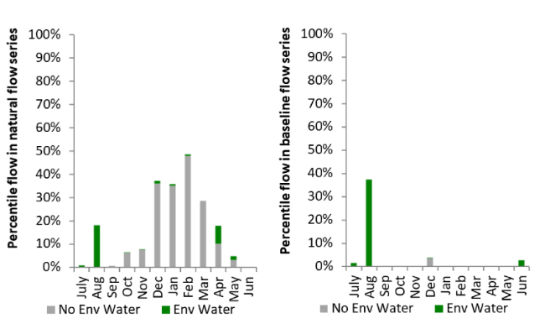
Figure MBG12: Contribution of environmental water delivery at Yanco Offtake as percentiles in the natural and baseline flow series.

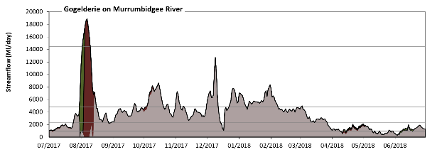
Gogelderie
Figure MBG13: Contribution of environmental water delivery at Gogelderie. Horizontal lines indicate thresholds for very low flows, low flows, low freshes, medium freshes and high freshes (from lowest to highest).
At Gogelderie on Murrumbidgee River environmental water contributed 15% of the total streamflow volume (much of which was Commonwealth environmental water). Environmental watering actions affected streamflows for 58% of days between 1 July 2017 and 30 June 2018. Without environmental water, the duration of very low flows (i.e. < 190 Ml/day) in the period July to September would have substantially exceeded durations expected in an average year in the natural flow regime. Environmental water mitigated these impacts by reducing the cumulative duration of very low flow spells from 2% to 0% of the year, with greatest influence in the period July to September. Similarly, without environmental water, the durations of medium low flows (i.e. < 960 Ml/day) in the periods July to September and April to June would have substantially exceeded durations expected in an average year in the natural flow regime. Environmental water mitigated these impacts by reducing the cumulative duration of medium low flow spells from 15% to 7% of the year, with greatest influence in the periods July to September and April to June. Commonwealth environmental water made the dominant contribution to these enhancements of environmental baseflows at this site. There was at least one low fresh (i.e. > 2300 Ml/day) in the periods July to September, October to December and January to March. Environmental water made little change to the duration of these low freshes. In the absence of environmental water there would have been at least one medium fresh (i.e. > 4800 Ml/day) in the periods July to September, October to December and January to March. Environmental water increased the duration of the longest medium fresh during the period July to September (from 3 days to 16 days). Commonwealth environmental water was almost entirely responsible for these increased durations of medium freshes. There was one high fresh (i.e. > 14000 Ml/day) this year. Environmental water increased the duration of the longest medium fresh during the period July to September (from 0 days to 7 days). Commonwealth environmental water was almost entirely responsible for these increased durations of high freshes.
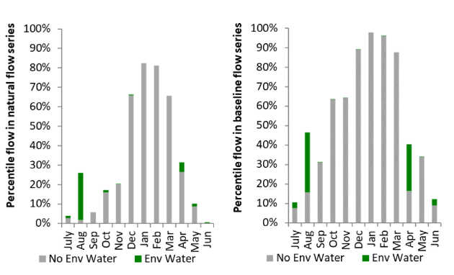
Figure MBG14: Contribution of environmental water delivery at Gogelderie as percentiles in the natural and baseline flow series.

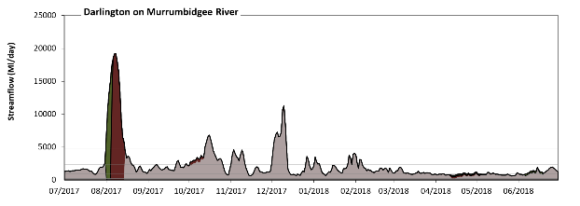
Darlington
Figure MBG15: Contribution of environmental water delivery at Darlington. Horizontal lines indicate thresholds for very low flows, low flows, low freshes, medium freshes and high freshes (from lowest to highest).
At Darlington on Murrumbidgee River environmental water contributed 25% of the total streamflow volume (much of which was Commonwealth environmental water). Environmental watering actions affected streamflows for 49% of days between 1 July 2017 and 30 June 2018. Without environmental water, the duration of very low flows (i.e. < 190 Ml/day) in the period July to September would have substantially exceeded durations expected in an average year in the natural flow regime. Environmental water mitigated these impacts by reducing the cumulative duration of very low flow spells from 4% to 0% of the year, with greatest influence in the period July to September. Similarly, without environmental water, the durations of medium low flows (i.e. < 960 Ml/day) in the periods July to September, October to December and April to June would have substantially exceeded durations expected in an average year in the natural flow regime. Environmental water mitigated these impacts by reducing the cumulative duration of medium low flow spells from 30% to 22% of the year, with greatest influence in the periods July to September and April to June. Commonwealth environmental water equally shared responsibility with other environmental water holders for these enhancements of environmental baseflows at this site. In the absence of environmental water there would have been at least one low fresh (i.e. > 2300 Ml/day) in the periods July to September, October to December and January to March. Environmental water increased the duration of the longest low fresh during the period July to September (from 5 days to 20 days). Commonwealth environmental water was almost entirely responsible for these increased durations of low freshes. In the absence of environmental water there would have been at least one medium fresh (i.e. > 4800 Ml/day) in the period October to December. Environmental water increased the duration of the longest medium fresh during the period July to September (from 0 days to 14 days). Commonwealth environmental water made the dominant contribution to these increased durations of medium freshes. There was one high fresh (i.e. > 14000 Ml/day) this year. Environmental water increased the duration of the longest high fresh during the period July to September (from 0 days to 7 days). Commonwealth environmental water was almost entirely responsible for these increased durations of high freshes.
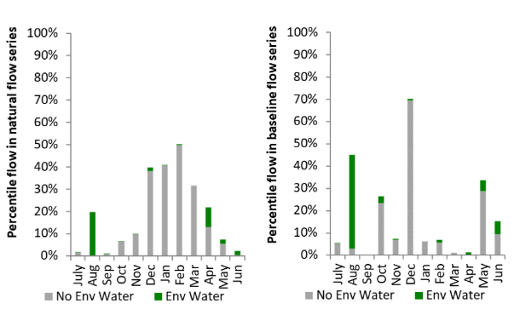
Figure MBG16: Contribution of environmental water delivery at Darlington as percentiles in the natural and baseline flow series.
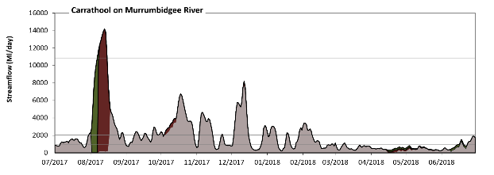
Carrathool
Figure MBG17: Contribution of environmental water delivery at Carrathool. Horizontal lines indicate thresholds for very low flows, low flows, low freshes, medium freshes and high freshes (from lowest to highest).
At Carrathool on Murrumbidgee River environmental water contributed 25% of the total streamflow volume (much of which was Commonwealth environmental water). Environmental watering actions affected streamflows for 46% of days between 1 July 2017 and 30 June 2018. Without environmental water, the durations of very low flows (i.e. < 190 Ml/day) in the periods July to September and April to June would have substantially exceeded durations expected in an average year in the natural flow regime. Environmental water mitigated these impacts by reducing the cumulative duration of very low flow spells from 7% to 0% of the year, with greatest influence in the periods July to September and April to June. Similarly, without environmental water, the durations of medium low flows (i.e. < 930 Ml/day) in the periods July to September, October to December, January to March and April to June would have all substantially exceeded durations expected in an average year in the natural flow regime. Environmental water mitigated these impacts by reducing the cumulative duration of medium low flow spells from 50% to 45% of the year, with greatest influence in the period July to September. Commonwealth environmental water equally shared responsibility with other environmental water holders for these enhancements of environmental baseflows at this site. In the absence of environmental water there would have been at least one low fresh (i.e. > 2000 Ml/day) in the periods July to September, October to December and January to March. Environmental water increased the duration of the longest low fresh during the period July to September (from 8 days to 26 days). Commonwealth environmental water was entirely responsible for these increased durations of low freshes. In the absence of environmental water there would have been at least one medium fresh (i.e. > 3900 Ml/day) in the periods July to September and October to December. Environmental water increased the duration of the longest medium fresh during the period July to September (from 3 days to 18 days). Commonwealth environmental water was almost entirely responsible for these increased durations of medium freshes. There was one high fresh (i.e. > 11000 Ml/day) this year. Environmental water increased the duration of the longest high fresh during the period July to September (from 0 days to 9 days). Commonwealth environmental water was almost entirely responsible for these increased durations of high freshes.
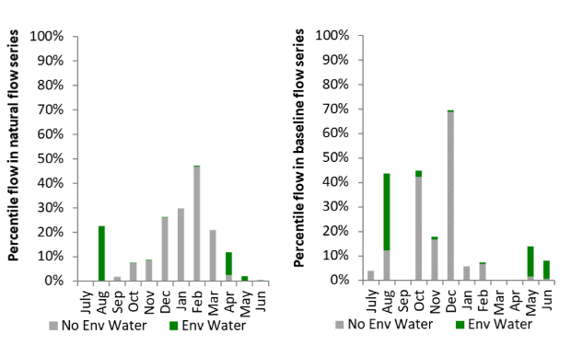
Figure MBG18: Contribution of environmental water delivery at Carrathool as percentiles in the natural and baseline flow series.
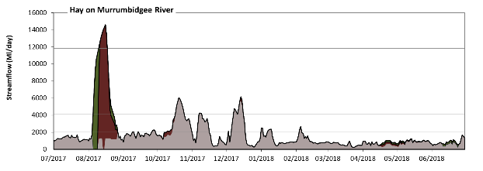
Hay
Figure MBG19: Contribution of environmental water delivery at Hay. Horizontal lines indicate thresholds for very low flows, low flows, low freshes, medium freshes and high freshes (from lowest to highest).
At Hay on Murrumbidgee River environmental water contributed 29% of the total streamflow volume (much of which was Commonwealth environmental water). Environmental watering actions affected streamflows for 47% of days between 1 July 2017 and 30 June 2018. Without environmental water, the duration of very low flows (i.e. < 180 Ml/day) in the period July to September would have substantially exceeded durations expected in an average year in the natural flow regime. Environmental water mitigated these impacts by reducing the cumulative duration of very low flow spells from 2% to 0% of the year, with greatest influence in the period July to September. Similarly, without environmental water, the durations of medium low flows (i.e. < 900 Ml/day) in the periods July to September, October to December, January to March and April to June would have all substantially exceeded durations expected in an average year in the natural flow regime. Environmental water mitigated these impacts by reducing the cumulative duration of medium low flow spells from 48% to 39% of the year, with greatest influence in the period April to June. Commonwealth environmental water made a modest contribution to these enhancements of environmental baseflows at this site. In the absence of environmental water there would have been at least one low fresh (i.e. > 2100 Ml/day) in the periods July to September, October to December and January to March. Environmental water increased the duration of the longest low fresh during the periods July to September (from 3 days to 22 days) and October to December (from 17 days to 22 days). Commonwealth environmental water was almost entirely responsible for these increased durations of low freshes. In the absence of environmental water there would have been at least one medium fresh (i.e. > 4100 Ml/day) in the period October to December. Environmental water increased the duration of the longest medium fresh during the period July to September (from 0 days to 18 days). Commonwealth environmental water made the dominant contribution to these increased durations of medium freshes. There was one high fresh (i.e. > 12000 Ml/day) this year. Environmental water increased the duration of the longest high fresh during the period July to September (from 0 days to 8 days). Commonwealth environmental water was entirely responsible for these increased durations of high freshes.
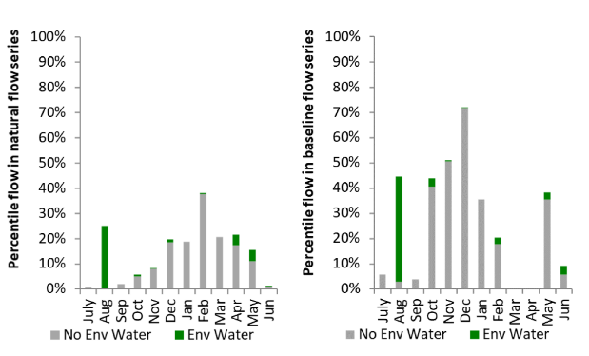
Figure MBG20: Contribution of environmental water delivery at Hay as percentiles in the natural and baseline flow series.

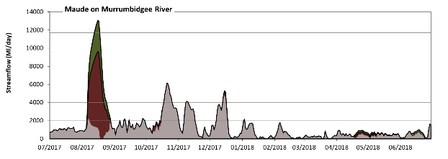
Maude
Figure MBG21: Contribution of environmental water delivery at Maude. Horizontal lines indicate thresholds for very low flows, low flows, low freshes, medium freshes and high freshes (from lowest to highest).
At Maude on Murrumbidgee River environmental water contributed 33% of the total streamflow volume (much of which was Commonwealth environmental water). Environmental watering actions affected streamflows for 34% of days between 1 July 2017 and 30 June 2018. Without environmental water, the durations of very low flows (i.e. < 170 Ml/day) in the periods October to December, January to March and April to June would have substantially exceeded durations expected in an average year in the natural flow regime. Environmental water mitigated these impacts by reducing the cumulative duration of very low flow spells from 15% to 12% of the year, with greatest influence in the periods July to September and April to June. Similarly, without environmental water, the durations of medium low flows (i.e. < 860 Ml/day) in the periods July to September, October to December, January to March and April to June would have all substantially exceeded durations expected in an average year in the natural flow regime. Environmental water mitigated these impacts by reducing the cumulative duration of medium low flow spells from 57% to 52% of the year, with greatest influence in the periods July to September and April to June. Commonwealth environmental water equally shared responsibility with other environmental water holders for these enhancements of environmental baseflows at this site. In the absence of environmental water there would have been at least one low fresh (i.e. > 2000 Ml/day) in the periods July to September, October to December and January to March. Environmental water increased the duration of the longest low fresh during the period July to September (from 3 days to 23 days). Commonwealth environmental water made the dominant contribution to these increased durations of low freshes. In the absence of environmental water there would have been at least one medium fresh (i.e. > 4000 Ml/day) in the period October to December. Environmental water increased the duration of the longest medium fresh during the period July to September (from 0 days to 18 days). Commonwealth environmental water made the dominant contribution to these increased durations of medium freshes. There was one high fresh (i.e. > 12000 Ml/day) this year. Environmental water increased the duration of the longest high fresh during the period July to September (from 0 days to 5 days). Commonwealth environmental water equally shared responsibility with other environmental water holders for these increased durations of high freshes.
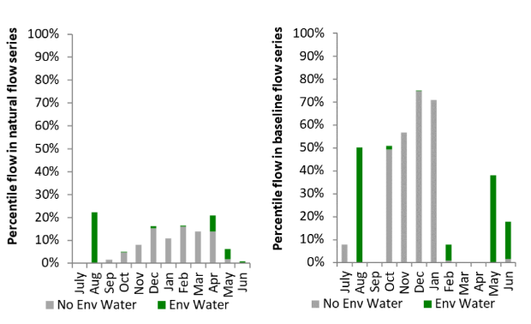
Figure MBG22: Contribution of environmental water delivery at Maude as percentiles in the natural and baseline flow series.

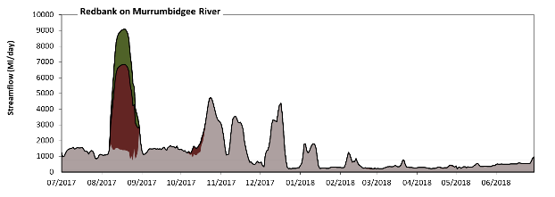
Redbank
Figure MBG23: Contribution of environmental water delivery at Redbank. Horizontal lines indicate thresholds for very low flows, low flows, low freshes and medium freshes (from lowest to highest).
At Redbank on Murrumbidgee River environmental water contributed 26% of the total streamflow volume (much of which was Commonwealth environmental water). Environmental watering actions affected streamflows for 19% of days between 1 July 2017 and 30 June 2018. Flow regulation does not substantially increase the duration of very low flows (i.e. < 150 Ml/day) compared to an average year in the natural flow regime. However, without environmental water, the durations of medium low flows (i.e. < 740 Ml/day) in the periods October to December, January to March and April to June would have substantially exceeded durations expected in an average year in the natural flow regime. However, environmental water had little effect on the duration of these medium low flows, which occurred for 51% of the year. In the absence of environmental water there would have been at least one low fresh (i.e. > 1800 Ml/day) in the periods July to September and October to December. Environmental water increased the duration of the longest low fresh during the period July to September (from 2 days to 24 days). Commonwealth environmental water equally shared responsibility with other environmental water holders for these increased durations of low freshes. In the absence of environmental water there would have been at least one medium fresh (i.e. > 3700 Ml/day) in the period October to December. Environmental water increased the duration of the longest medium fresh during the period July to September (from 0 days to 19 days). Commonwealth environmental water was entirely responsible for these increased durations of medium freshes. There was no high freshes (i.e. > 11000 Ml/day) this year.
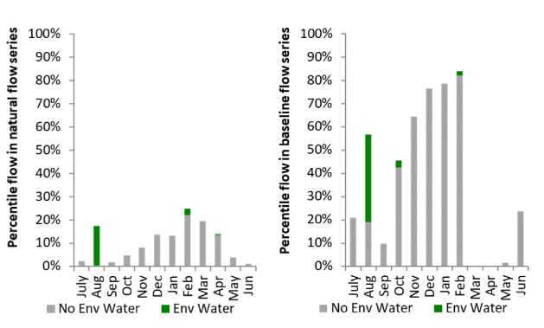
Figure MBG24: Contribution of environmental water delivery at Redbank as percentiles in the natural and baseline flow series.

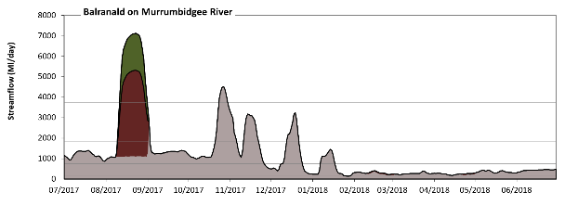
Balranald
Figure MBG25: Contribution of environmental water delivery at Balranald. Horizontal lines indicate thresholds for very low flows, low flows, low freshes and medium freshes (from lowest to highest).
At Balranald on Murrumbidgee River environmental water contributed 26% of the total streamflow volume (much of which was Commonwealth environmental water). Environmental watering actions affected streamflows for 15% of days between 1 July 2017 and 30 June 2018. Flow regulation does not substantially increase the duration of very low flows (i.e. < 150 Ml/day) compared to an average year in the natural flow regime. However, without environmental water, the durations of medium low flows (i.e. < 740 Ml/day) in the periods October to December, January to March and April to June would have substantially exceeded durations expected in an average year in the natural flow regime. However, environmental water had little effect on the duration of these medium low flows, which occurred for 52% of the year. In the absence of environmental water there would have been at least one low fresh (i.e. > 1800 Ml/day) in the periods July to September and October to December. Environmental water increased the duration of the longest low fresh during the period July to September (from 1 days to 24 days). Commonwealth environmental water equally shared responsibility with other environmental water holders for these increased durations of low freshes. In the absence of environmental water there would have been at least one medium fresh (i.e. > 3700 Ml/day) in the period October to December. Environmental water increased the duration of the longest medium fresh during the period July to September (from 0 days to 21 days). Commonwealth environmental water was entirely responsible for these increased durations of medium freshes. There was no high freshes (i.e. > 11000 Ml/day) this year.
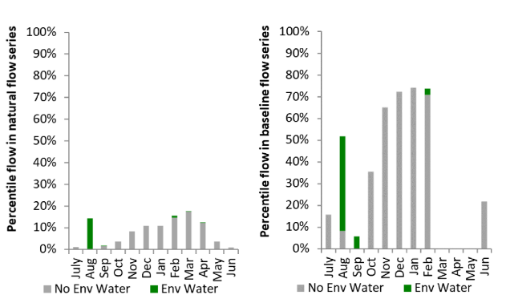
Figure MBG26: Contribution of environmental water delivery at Balranald as percentiles in the natural and baseline flow series.

Lachlan
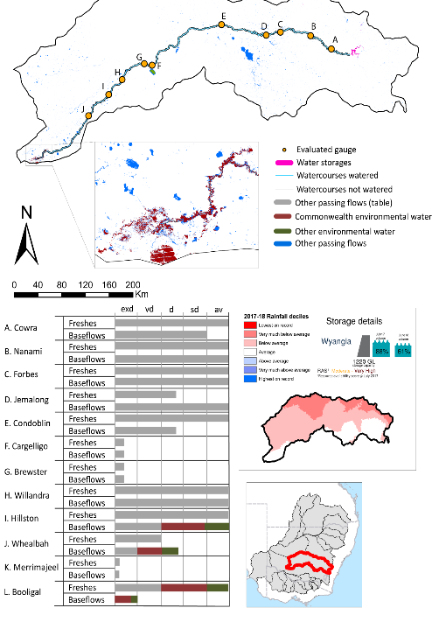
Figure LCH1: Watercourses influenced, areas inundated (where applicable) and gauge stations evaluated in the Lachlan valley during the 2017-18 water year. Inset bar graphs report the condition of annual flow regimes by showing the improvements in hydrological condition with the addition of environmental water as well as the hypothetical scenario in “grey” (if no environmental flow had been delivered); where exd=extremely dry, vd=very dry, d=dry, sd=somewhat dry and av=average. Rainfall conditions (rainfall deciles) and trend in storage levels for the water year are also shown.

Summary
The volume of environmental water delivery for the 2017–18 year in the Lachlan valley is quantified using data for 13 sites. This evaluation only considers the contribution of held environmental water, which is a primary focus for the Commonwealth. The contributions of planned environmental water (e.g. passing flows), unregulated tributary inflows and clever use of irrigation flows for environmental benefits can all be very important but these are outside the scope of this report. Environmental watering actions lasted on average 70 days over the course of the year. The volume of environmental water at these 13 sites was between 0% and 56% of the total streamflow. Commonwealth environmental water contributed on average 63% of this environmental water. The contribution of environmental water delivery to improved flow regimes is evaluated using data for 13 sites. Ideally, baseflows should be maintained and long periods of excessively low flows avoided. In this valley, the baseflow regime was generally considered to be dry relative to the pre-development flow regime. In our analysis, a low fresh refers to a period of increased flow, when the water level rises at least one eighth of the way up the river bank (above the low flow level). These low freshes are a regular part of the natural flow regime and support a range of natural processes. In the Lachlan valley, in terms of the occurrence and duration of low freshes, the year was assessed as being somewhat dry. In our analysis, a medium fresh refers to a period of increased flow, when the water level rises at least one quarter of the way up the river bank. These medium freshes are not as frequent as low freshes but are also a regular and important part of the natural flow regime. In the Lachlan valley, in terms of the occurrence of medium freshes, the year was assessed as being somewhat dry. In our analysis, a high fresh refers to a period of increased flow, when the water level rises more than half way up the river. A high fresh may not occur every year but they are still important and long periods without major freshes can have serious consequences for floodplains and their contribution to river ecosystem health. Delivering environmental high in channel flows normally requires that all risks to riparian landholders and infrastructure have been resolved. In the Lachlan valley, in terms of the occurrence of high freshes, the year was assessed as being somewhat dry.

Water delivery context
During the 2017–18, the Commonwealth Environmental Water Holder (CEWH) held water entitlements of up to 87,856 Ml for environmental use in the Lachlan valley. Each year, water utilities allocate water entitlement holders a percentage of water based on their holding, license type and carryover (the exact rules vary among Jurisdictions). In 2017-18, the Lachlan entitlements held by the CEWH were allocated 2,672 Ml of water, representing 7% of the Long-term average annual yield for the Lachlan valley (37,441 Ml). Information and data relating to the portfolio of held Commonwealth environmental water is shown in Table LCH2.
The 2017-18 water allocation (2,672 Ml) together with the carryover volume of 85,310 Ml of water meant the CEWH had 87,982 Ml of water available for delivery. A total of 33,523 Ml of Commonwealth environmental water was delivered in the Lachlan valley. A total of 0 Ml of Commonwealth environmental water was traded to consumptive users and 54459 Ml (62%) of available Commonwealth environmental water was carried over for environmental use into the 2018–19 water year.

Environmental conditions and resource availability
The water available for environmental delivery combined with the present and antecedent environmental conditions are key inputs used by environmental water managers in planning and implementing watering actions. Post hoc, this information provides important context when evaluating the effectiveness and appropriateness of environmental water use with respect to hydrological outputs.
The rainfall conditions in the Lachlan valley were classified as Below Average, based on rainfall percentile data for the entire record held by the Bureau of Meteorology for this valley. The water held in major storages in the Lachlan valley decreased over the water year, for example Wyangla dam was 88% full at the beginning of the water year and 61% full by the end of the year (Figure LCH1).
The Commonwealth Environmental Water Office (CEWO) calculates resource availability scenarios (RAS) to guide the use and prioritisation of held environmental water. The RAS are progressively calculated over the year as part of the continual adaptive management planning processes. The RAS are based on the availability of held environmental water (including progressive license acquisitions and allocations) as well as the potential for unregulated or planned environmental flows. The outcome is then used to determine the demand for environmental water across the basin.
In 2017-18, the resource availability of held Commonwealth environmental water was classified as moderate to very high water in this valley. The physical conditions meant that the CEWO was managing to maintain and improve the health and resilience of aquatic ecosystems and build future capacity to support ecological health and resilience. The overall demand for environmental water was deemed low.

Watering actions
A total of 3 watering actions were delivered over the 2017–18 water year, the duration of these actions varied (range of individual actions: 16 - 53 days) and Commonwealth environmental water was delivered for a total of 88 days. The count of actions commencing in each season was; spring (2) and autumn (1). The flow component types delivered were; (2) baseflow, (1) freshes, (0) bankfull, (0) overbank and (0) wetland.
Commonwealth environmental water was delivered in the Lachlan valley for specified objectives. Although most of the watering actions were delivered for Fish purposes, water was also delivered for other purposes too. The percentage of watering actions delivered across the nine main themes included fish (50%), vegetation (0%), waterbirds (0%), frogs (0%), other biota (0%), connectivity (0%), process (50%), resilience (0%) and water quality (0%).
Table LCH2. Commonwealth environmental water accounting information for the Lachlan valley over 2017–18 water year.
Total registered volume (Ml) | Allocated volume (Ml) | Carry over + allocated volume (Ml) | Delivered (Ml) | LTAAY (Ml) | Trade (Ml) | Carried over to 2018-19 | Forfeited (Ml)
87,856 | 2,672 | 87,982 | 33,523 | 37,441 | 0 | 54,459 | 0

Figure LCH2. Timing and duration of Commonwealth environmental water actions delivered in the Lachlan valley.

Contribution of Commonwealth Environmental Water to Flow Regimes
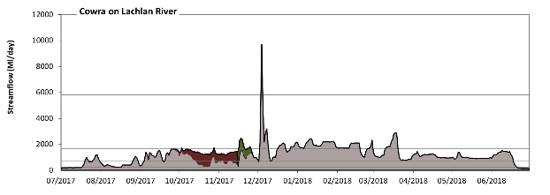
Cowra

Figure LCH3: Contribution of environmental water delivery at Cowra. Horizontal lines indicate thresholds for very low flows, low flows, low freshes, medium freshes and high freshes (from lowest to highest).
At Cowra on Lachlan River environmental water contributed 9% of the total streamflow volume (much of which was Commonwealth environmental water). Environmental watering actions affected streamflows for 16% of days between 1 July 2017 and 30 June 2018. Flow regulation does not substantially increase the duration of very low flows (i.e. < 47 Ml/day) compared to an average year in the natural flow regime. However, without environmental water, the duration of medium low flows (i.e. < 240 Ml/day) in the period July to September would have substantially exceeded durations expected in an average year in the natural flow regime. However, environmental water had little effect on the duration of these medium low flows, which occurred for 8% of the year. In the absence of environmental water there would have been at least one low fresh (i.e. > 710 Ml/day) in the periods July to September, October to December, January to March and April to June. Environmental water increased the duration of the longest low fresh during the period October to December (from 20 days to 62 days). Commonwealth environmental water was entirely responsible for these increased durations of low freshes. There was at least one medium fresh (i.e. > 1700 Ml/day) in the periods October to December and January to March. Environmental water made no change to the duration of these medium freshes. In the absence of environmental water there would have been at least one high fresh in the period October to December. Environmental water made no change to the duration of these high freshes.
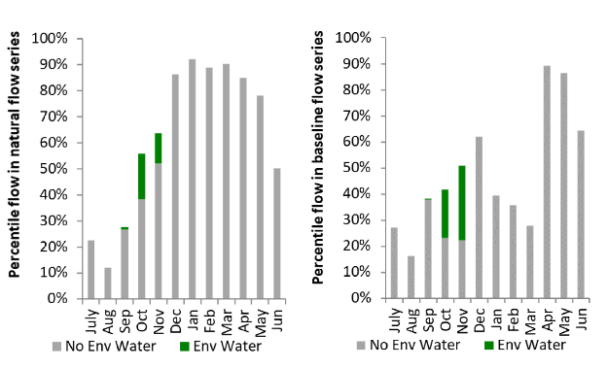
Figure LCH4: Contribution of environmental water delivery at Cowra as percentiles in the natural and baseline flow series.
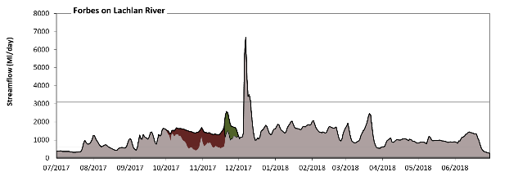
Forbes

Figure LCH5: Contribution of environmental water delivery at Forbes. Horizontal lines indicate thresholds for very low flows, low flows, low freshes, medium freshes and high freshes (from lowest to highest).
At Forbes on Lachlan River environmental water contributed 9% of the total streamflow volume (much of which was Commonwealth environmental water). Environmental watering actions affected streamflows for 16% of days between 1 July 2017 and 30 June 2018. Flow regulation does not substantially increase the duration of very low flows (i.e. < 54 Ml/day) compared to an average year in the natural flow regime. Flow regulation does not substantially increase the duration of medium low flows (i.e. < 270 Ml/day) compared to an average year in the natural flow regime. In the absence of environmental water there would have been at least one low fresh (i.e. > 590 Ml/day) in the periods July to September, October to December, January to March and April to June. Environmental water increased the duration of the longest low fresh during the period October to December (from 45 days to 92 days). Commonwealth environmental water was entirely responsible for these increased durations of low freshes. In the absence of environmental water there would have been at least one medium fresh (i.e. > 1100 Ml/day) in the periods July to September, October to December, January to March and April to June. Environmental water increased the duration of the longest medium fresh during the period October to December (from 13 days to 62 days). Commonwealth environmental water was entirely responsible for these increased durations of medium freshes. In the absence of environmental water there would have been at least one high fresh in the period October to December. Environmental water made no change to the duration of these high freshes.
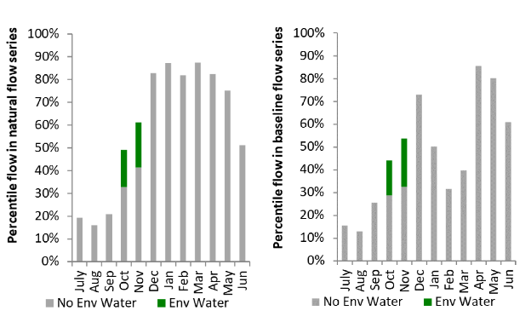
Figure LCH6: Contribution of environmental water delivery at Forbes as percentiles in the natural and baseline flow series.

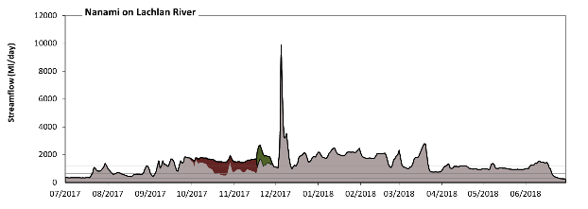
Nanami

Figure LCH7: Contribution of environmental water delivery at Nanami. Horizontal lines indicate thresholds for very low flows, low flows, low freshes, medium freshes and high freshes (from lowest to highest).
At Nanami on Lachlan River environmental water contributed 8% of the total streamflow volume (much of which was Commonwealth environmental water). Environmental watering actions affected streamflows for 16% of days between 1 July 2017 and 30 June 2018. Flow regulation does not substantially increase the duration of very low flows (i.e. < 61 Ml/day) compared to an average year in the natural flow regime. Flow regulation does not substantially increase the duration of medium low flows (i.e. < 300 Ml/day) compared to an average year in the natural flow regime. In the absence of environmental water there would have been at least one low fresh (i.e. > 650 Ml/day) in the periods July to September, October to December, January to March and April to June. Environmental water increased the duration of the longest low fresh during the period October to December (from 44 days to 92 days). Commonwealth environmental water was entirely responsible for these increased durations of low freshes. In the absence of environmental water there would have been at least one medium fresh (i.e. > 1200 Ml/day) in the periods July to September, October to December, January to March and April to June. Environmental water increased the duration of the longest medium fresh during the period October to December (from 15 days to 60 days). Commonwealth environmental water was entirely responsible for these increased durations of medium freshes. In the absence of environmental water there would have been at least one high fresh in the period October to December. Environmental water made no change to the duration of these high freshes.
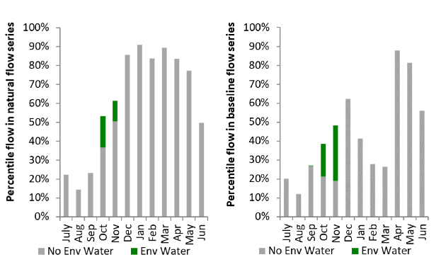
Figure LCH8: Contribution of environmental water delivery at Nanami as percentiles in the natural and baseline flow series.
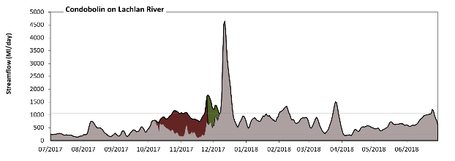
Condobolin

Figure LCH9: Contribution of environmental water delivery at Condobolin. Horizontal lines indicate thresholds for very low flows, low flows, low freshes, medium freshes and high freshes (from lowest to highest).
At Condobolin on Lachlan River environmental water contributed 14% of the total streamflow volume (much of which was Commonwealth environmental water). Environmental watering actions affected streamflows for 16% of days between 1 July 2017 and 30 June 2018. Flow regulation does not substantially increase the duration of very low flows (i.e. < 46 Ml/day) compared to an average year in the natural flow regime. However, without environmental water, the duration of medium low flows (i.e. < 230 Ml/day) in the period July to September would have substantially exceeded durations expected in an average year in the natural flow regime. Environmental water reduced the cumulative duration of medium low flow spells from 15% to 11% of the year, with greatest influence in the period October to December. Commonwealth environmental water was entirely responsible for these enhancements of environmental baseflows at this site. In the absence of environmental water there would have been at least one low fresh (i.e. > 530 Ml/day) in the periods July to September, October to December, January to March and April to June. Environmental water increased the duration of the longest low fresh during the period October to December (from 23 days to 82 days). Commonwealth environmental water was almost entirely responsible for these increased durations of low freshes. There was at least one medium fresh (i.e. > 1100 Ml/day) in the periods October to December, January to March and April to June. Environmental water made little change to the duration of these medium freshes. In the absence of environmental water there would have been at least one high fresh in the period October to December. Environmental water made no change to the duration of these high freshes.
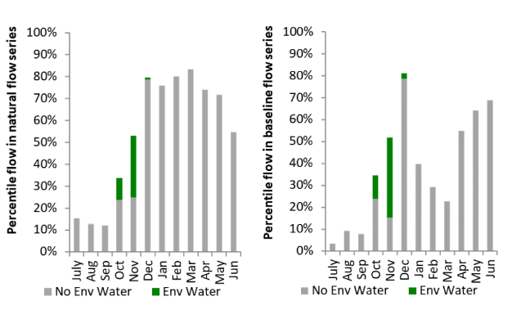
Figure LCH10: Contribution of environmental water delivery at Condobolin as percentiles in the natural and baseline flow series.

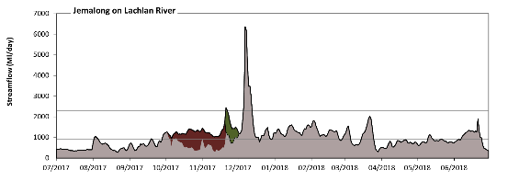
Jemalong

Figure LCH11: Contribution of environmental water delivery at Jemalong. Horizontal lines indicate thresholds for very low flows, low flows, low freshes and medium freshes (from lowest to highest).
At Jemalong on Lachlan River environmental water contributed 10% of the total streamflow volume (much of which was Commonwealth environmental water). Environmental watering actions affected streamflows for 16% of days between 1 July 2017 and 30 June 2018. Flow regulation does not substantially increase the duration of very low flows (i.e. < 54 Ml/day) compared to an average year in the natural flow regime. Flow regulation does not substantially increase the duration of medium low flows (i.e. < 270 Ml/day) compared to an average year in the natural flow regime. In the absence of environmental water there would have been at least one low fresh (i.e. > 920 Ml/day) in the periods July to September, October to December, January to March and April to June. Environmental water increased the duration of the longest low fresh during the period October to December (from 21 days to 79 days). Commonwealth environmental water was almost entirely responsible for these increased durations of low freshes. There was at least one medium fresh (i.e. > 2300 Ml/day) in the period October to December. Environmental water made no change to the duration of these medium freshes. There was no high freshes (i.e. > 8600 Ml/day) this year.
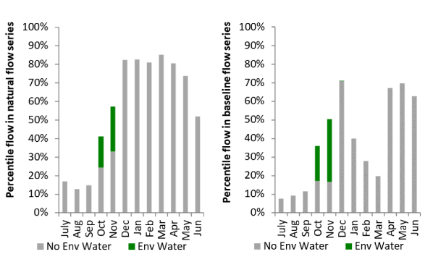
Figure LCH12: Contribution of environmental water delivery at Jemalong as percentiles in the natural and baseline flow series.
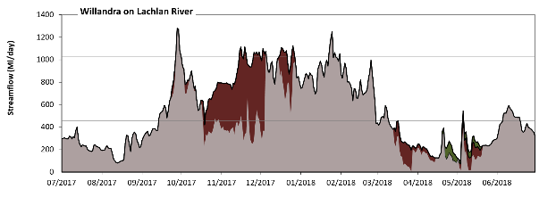
Willandra
Figure LCH13: Contribution of environmental water delivery at Willandra. Horizontal lines indicate thresholds for very low flows, low flows, low freshes, medium freshes and high freshes (from lowest to highest).
At Willandra on Lachlan River environmental water contributed 16% of the total streamflow volume (most of which was Commonwealth environmental water). Environmental watering actions affected streamflows for 37% of days between 1 July 2017 and 30 June 2018. Flow regulation does not substantially increase the duration of very low flows (i.e. < 31 Ml/day) compared to an average year in the natural flow regime. Flow regulation does not substantially increase the duration of medium low flows (i.e. < 160 Ml/day) compared to an average year in the natural flow regime. Commonwealth environmental water equally shared responsibility with other environmental water holders for these enhancements of environmental baseflows at this site. In the absence of environmental water there would have been at least one low fresh (i.e. > 280 Ml/day) in the periods July to September, October to December, January to March and April to June. Environmental water increased the duration of the longest low fresh during the period October to December (from 35 days to 92 days). Commonwealth environmental water was entirely responsible for these increased durations of low freshes. In the absence of environmental water there would have been at least one medium fresh (i.e. > 450 Ml/day) in the periods July to September, October to December, January to March and April to June. Environmental water increased the duration of the longest medium fresh during the period October to December (from 27 days to 73 days). Commonwealth environmental water was entirely responsible for these increased durations of medium freshes. In the absence of environmental water there would have been at least one high fresh in the periods July to September, October to December and January to March. Environmental water increased the duration of the longest high fresh during the periods July to September (from 3 days to 4 days) and October to December (from 1 days to 6 days). Commonwealth environmental water was entirely responsible for these increased durations of high freshes.
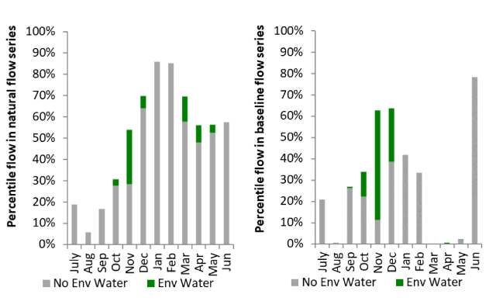
Figure LCH14: Contribution of environmental water delivery at Willandra as percentiles in the natural and baseline flow series.
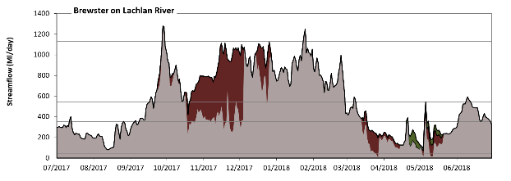
Brewster
Figure LCH15: Contribution of environmental water delivery at Brewster. Horizontal lines indicate thresholds for very low flows, low flows, low freshes, medium freshes and high freshes (from lowest to highest).
At Brewster on Lachlan River environmental water contributed 16% of the total streamflow volume (most of which was Commonwealth environmental water). Environmental watering actions affected streamflows for 37% of days between 1 July 2017 and 30 June 2018. Flow regulation does not substantially increase the duration of very low flows (i.e. < 43 Ml/day) compared to an average year in the natural flow regime. However, without environmental water, the durations of medium low flows (i.e. < 220 Ml/day) in the periods July to September and April to June would have substantially exceeded durations expected in an average year in the natural flow regime. Environmental water mitigated these impacts by reducing the cumulative duration of medium low flow spells from 23% to 14% of the year, with greatest influence in the periods January to March and April to June. Commonwealth environmental water made the dominant contribution to these enhancements of environmental baseflows at this site. In the absence of environmental water there would have been at least one low fresh (i.e. > 350 Ml/day) in the periods July to September, October to December, January to March and April to June. Environmental water increased the duration of the longest low fresh during the period October to December (from 29 days to 92 days). Commonwealth environmental water was entirely responsible for these increased durations of low freshes. In the absence of environmental water there would have been at least one medium fresh (i.e. > 540 Ml/day) in the periods July to September, October to December, January to March and April to June. Environmental water increased the duration of the longest medium fresh during the period October to December (from 19 days to 73 days). Commonwealth environmental water was entirely responsible for these increased durations of medium freshes. In the absence of environmental water there would have been at least one high fresh in the periods July to September and January to March. Environmental water made no change to the duration of these high freshes.
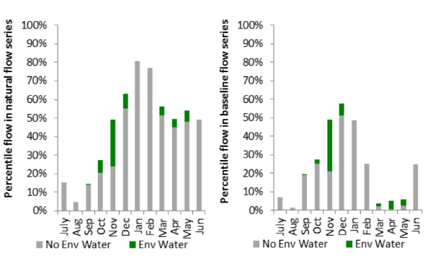
Figure LCH16: Contribution of environmental water delivery at Brewster as percentiles in the natural and baseline flow series.
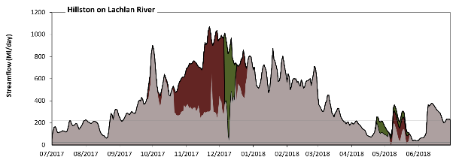
Hillston
Figure LCH17: Contribution of environmental water delivery at Hillston. Horizontal lines indicate thresholds for very low flows, low flows, low freshes, medium freshes and high freshes (from lowest to highest).
At Hillston on Lachlan River environmental water contributed 22% of the total streamflow volume (much of which was Commonwealth environmental water). Environmental watering actions affected streamflows for 30% of days between 1 July 2017 and 30 June 2018. Flow regulation does not substantially increase the duration of very low flows (i.e. < 23 Ml/day) compared to an average year in the natural flow regime. However, without environmental water, the durations of medium low flows (i.e. < 120 Ml/day) in the periods July to September and April to June would have substantially exceeded durations expected in an average year in the natural flow regime. Environmental water mitigated these impacts by reducing the cumulative duration of medium low flow spells from 16% to 12% of the year, with greatest influence in the period April to June. Commonwealth environmental water made a modest contribution to these enhancements of environmental baseflows at this site. In the absence of environmental water there would have been at least one low fresh (i.e. > 220 Ml/day) in the periods July to September, October to December, January to March and April to June. Environmental water increased the duration of the longest low fresh during the period October to December (from 69 days to 92 days). Commonwealth environmental water made little or no contribution to these increased durations of low freshes. In the absence of environmental water there would have been at least one medium fresh (i.e. > 390 Ml/day) in the periods July to September, October to December and January to March. Environmental water increased the duration of the longest medium fresh during the period October to December (from 18 days to 92 days). Commonwealth environmental water was almost entirely responsible for these increased durations of medium freshes. There was one high fresh (i.e. > 940 Ml/day) this year. Environmental water increased the duration of the longest high fresh during the period October to December (from 0 days to 7 days). Commonwealth environmental water made the dominant contribution to these increased durations of high freshes.
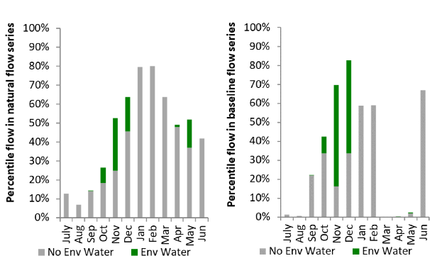
Figure LCH18: Contribution of environmental water delivery at Hillston as percentiles in the natural and baseline flow series.

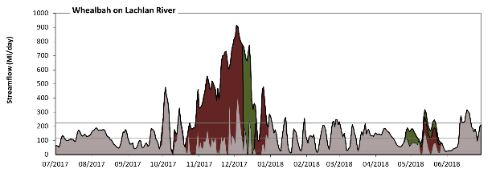
Whealbah
Figure LCH19: Contribution of environmental water delivery at Whealbah. Horizontal lines indicate thresholds for very low flows, low flows, low freshes and medium freshes (from lowest to highest).
At Whealbah on Lachlan River environmental water contributed 44% of the total streamflow volume (much of which was Commonwealth environmental water). Environmental watering actions affected streamflows for 31% of days between 1 July 2017 and 30 June 2018. Without environmental water, the duration of very low flows (i.e. < 23 Ml/day) in the period October to December would have substantially exceeded durations expected in an average year in the natural flow regime. Environmental water mitigated these impacts by reducing the cumulative duration of very low flow spells from 11% to 2% of the year, with greatest influence in the period October to December. Similarly, without environmental water, the durations of medium low flows (i.e. < 120 Ml/day) in the periods July to September, October to December, January to March and April to June would have all substantially exceeded durations expected in an average year in the natural flow regime. Environmental water mitigated these impacts by reducing the cumulative duration of medium low flow spells from 54% to 34% of the year, with greatest influence in the periods October to December and April to June. Commonwealth environmental water made the dominant contribution to these enhancements of environmental baseflows at this site. In the absence of environmental water there would have been at least one low fresh (i.e. > 220 Ml/day) in the periods October to December, January to March and April to June. Environmental water increased the duration of the longest low fresh during the period October to December (from 5 days to 53 days). Commonwealth environmental water was almost entirely responsible for these increased durations of low freshes. In the absence of environmental water there would have been at least one medium fresh (i.e. > 390 Ml/day) in the period October to December. Environmental water increased the duration of the longest medium fresh during the period October to December (from 3 days to 29 days). Commonwealth environmental water was almost entirely responsible for these increased durations of medium freshes. There was no high freshes (i.e. > 940 Ml/day) this year.
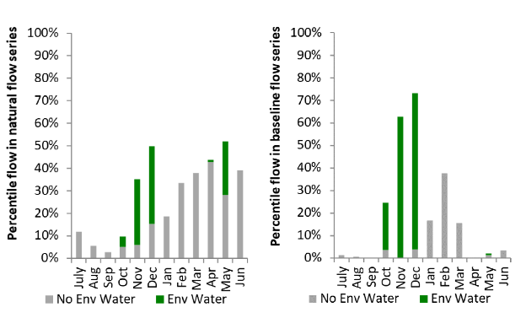
Figure LCH20: Contribution of environmental water delivery at Whealbah as percentiles in the natural and baseline flow series.
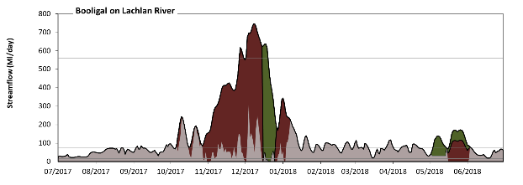
Booligal
Figure LCH21: Contribution of environmental water delivery at Booligal. Horizontal lines indicate thresholds for very low flows, low flows, low freshes, medium freshes and high freshes (from lowest to highest).
At Booligal on Lachlan River environmental water contributed 56% of the total streamflow volume (much of which was Commonwealth environmental water). Environmental watering actions affected streamflows for 31% of days between 1 July 2017 and 30 June 2018. Without environmental water, the duration of very low flows (i.e. < 15 Ml/day) in the period October to December would have substantially exceeded durations expected in an average year in the natural flow regime. Environmental water mitigated these impacts by reducing the cumulative duration of very low flow spells from 11% to 0% of the year, with greatest influence in the periods October to December and April to June. Similarly, without environmental water, the durations of medium low flows (i.e. < 76 Ml/day) in the periods July to September, October to December, January to March and April to June would have all substantially exceeded durations expected in an average year in the natural flow regime. Environmental water mitigated these impacts by reducing the cumulative duration of medium low flow spells from 70% to 48% of the year, with greatest influence in the periods October to December and April to June. Commonwealth environmental water made the dominant contribution to these enhancements of environmental baseflows at this site. In the absence of environmental water there would have been at least one low fresh (i.e. > 140 Ml/day) in the periods October to December and January to March. Environmental water increased the duration of the longest low fresh during the periods October to December (from 4 days to 63 days), January to March (from 7 days to 12 days) and April to June (from 0 days to 11 days). Commonwealth environmental water equally shared responsibility with other environmental water holders for these increased durations of low freshes. In the absence of environmental water there would have been at least one medium fresh (i.e. > 240 Ml/day) in the period October to December. Environmental water increased the duration of the longest medium fresh during the periods October to December (from 1 days to 51 days) and January to March (from 0 days to 6 days). Commonwealth environmental water was almost entirely responsible for these increased durations of medium freshes. There was one high fresh (i.e. > 560 Ml/day) this year. Environmental water increased the duration of the longest high fresh during the period October to December (from 0 days to 18 days). Commonwealth environmental water made the dominant contribution to these increased durations of high freshes.
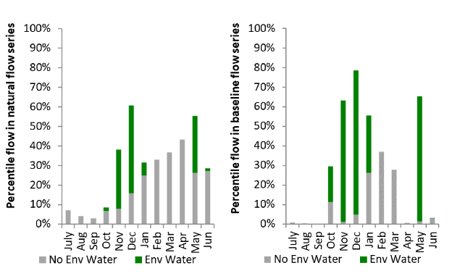
Figure LCH22: Contribution of environmental water delivery at Booligal as percentiles in the natural and baseline flow series.

Central Murray
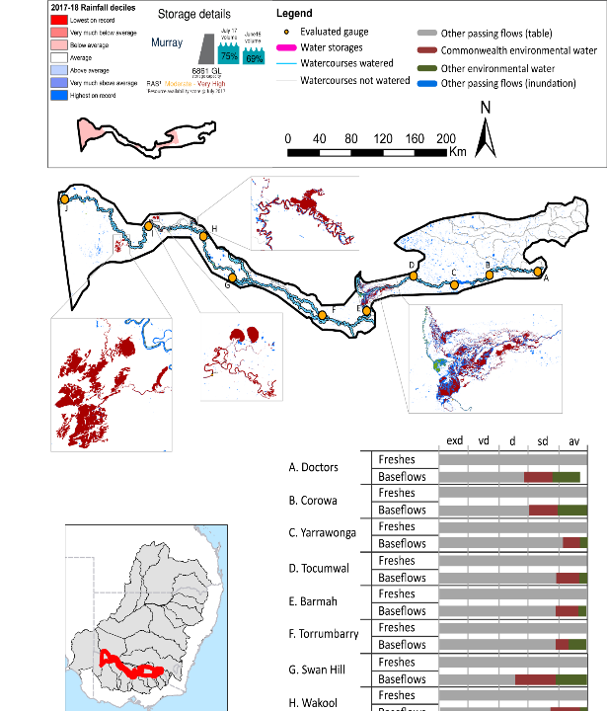Figure CNM1: Watercourses influenced, areas inundated (where applicable) and gauge stations evaluated in the Central Murray valley during the 2017-18 water year. Inset bar graphs report the condition of annual flow regimes by showing the improvements in hydrological condition with the addition of environmental water as well as the hypothetical scenario in “grey” (if no environmental flow had been delivered); where exd=extremely dry, vd=very dry, d=dry, sd=somewhat dry and av=average. Rainfall conditions (rainfall deciles) and trend in storage levels for the water year are also shown.

Summary
The volume of environmental water delivery for the 2017–18 year in the Central Murray valley is quantified using data for 14 sites. This evaluation only considers the contribution of held environmental water, which is a primary focus for the Commonwealth. The contributions of planned environmental water (e.g. passing flows), unregulated tributary inflows and clever use of irrigation flows for environmental benefits can all be very important but these are outside the scope of this report. Environmental watering actions lasted on average 242 days over the course of the year. The volume of environmental water at these 14 sites was between 0% and 29% of the total streamflow. Commonwealth environmental water contributed on average 49% of this environmental water. The contribution of environmental water delivery to improved flow regimes is evaluated using data for 14 sites. Ideally, baseflows should be maintained and long periods of excessively low flows avoided. In this valley, the baseflow regime was generally considered to be somewhat dry relative to the pre-development flow regime. In our analysis, a low fresh refers to a period of increased flow, when the water level rises at least one eighth of the way up the river bank (above the low flow level). These low freshes are a regular part of the natural flow regime and support a range of natural processes. In the Central Murray valley, in terms of the occurrence and duration of low freshes, the year was assessed as being somewhat dry. In our analysis, a medium fresh refers to a period of increased flow, when the water level rises at least one quarter of the way up the river bank. These medium freshes are not as frequent as low freshes but are also a regular and important part of the natural flow regime. In the Central Murray valley, in terms of the occurrence of medium freshes, the year was assessed as being somewhat dry. In our analysis, a high fresh refers to a period of increased flow, when the water level rises more than half way up the river. A high fresh may not occur every year but they are still important and long periods without major freshes can have serious consequences for floodplains and their contribution to river ecosystem health. Delivering environmental high in channel flows normally requires that all risks to riparian landholders and infrastructure have been resolved. In the Central Murray valley, in terms of the occurrence of high freshes, the year was assessed as being somewhat dry.

Water delivery context
During the 2017–18, the Commonwealth Environmental Water Holder (CEWH) held water entitlements of up to 757,507 Ml for environmental use in the Central Murray valley. Each year, water utilities allocate water entitlement holders a percentage of water based on their holding, license type and carryover (the exact rules vary among Jurisdictions). In 2017–18, the Central Murray entitlements held by the CEWH were allocated 491,013 Ml of water, representing 75% of the Long-term average annual yield for the Central Murray valley (650,823 Ml). Information and data relating to the portfolio of held Commonwealth environmental water is shown in Table CNM2.
The 2017-18 water allocation (491,013 Ml) together with the carryover volume of 186,547 Ml of water meant the CEWH had 677,560 Ml of water available for delivery. A total of 496,747 Ml of Commonwealth environmental water was delivered in the Central Murray valley. A total of 0 Ml of Commonwealth environmental water was traded to consumptive users and 174520 Ml (26%) of available Commonwealth environmental water was carried over for environmental use into the 2018–19 water year.

Environmental conditions and resource availability
The water available for environmental delivery combined with the present and antecedent environmental conditions are key inputs used by environmental water managers in planning and implementing watering actions. Post hoc, this information provides important context when evaluating the effectiveness and appropriateness of environmental water use with respect to hydrological outputs.
The rainfall conditions in the Central Murray valley were classified as Average, based on rainfall percentile data for the entire record held by the Bureau of Meteorology for this valley. The water held in major storages in the Central Murray valley decreased over the water year, for example Dartmouth and Hume dam was 75% full at the beginning of the water year and 69% full by the end of the year (Figure CNM1).
The Commonwealth Environmental Water Office (CEWO) calculates resource availability scenarios (RAS) to guide the use and prioritisation of held environmental water. The RAS are progressively calculated over the year as part of the continual adaptive management planning processes. The RAS are based on the availability of held environmental water (including progressive license acquisitions and allocations) as well as the potential for unregulated or planned environmental flows. The outcome is then used to determine the demand for environmental water across the basin.
In 2017-18, the resource availability of held Commonwealth environmental water was classified as moderate to very high in this valley. The physical conditions meant that the CEWO was managing to maintain and/or improve the condition of environmental assets. The overall demand for environmental water was deemed moderate to high.

Watering actions
A total of 5 watering actions were delivered over the 2017-18 water year, the duration of these actions varied (range of individual actions: 59 - 364 days) and Commonwealth environmental water was delivered for a total of 991 days. The count of actions commencing in each season was; winter (4) and summer (1). The flow component types delivered were; (1) baseflow, (1) freshes, (0) bankfull, (0) overbank and (3) wetland.
Commonwealth environmental water was delivered in the Central Murray valley for specified objectives. Although the majority of watering actions were delivered for Fish purposes, water was also delivered for other purposes too. The percentage of watering actions delivered across the nine main themes included fish (29.41%), vegetation (17.65%), waterbirds (17.65%), frogs (5.88%), other biota (0.0%), connectivity (11.76%), process (11.76%), resilience (0.0%) and water quality (5.88%).
Table CNM2. Commonwealth environmental water accounting information for the Central Murray valley over 2017–18 water year.
Total registered volume (Ml) | Allocated volume (Ml) | Carry over + allocated volume (Ml) | Delivered (Ml) | LTAAY (Ml) | Trade (Ml) | Carried over to 2018-19 | Forfeited (Ml)
757,507 | 491,013 | 677,560 | 496,747 | 650,823 | 0 | 174,520 | 6,293

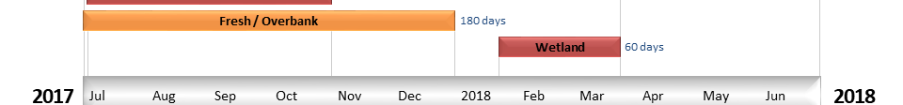
Figure CNM2. Timing and duration of Commonwealth environmental water actions delivered in the Central Murray valley.

Contribution of Commonwealth Environmental Water to Flow Regimes
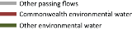
Doctors
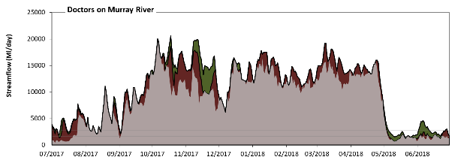
Figure CNM3: Contribution of environmental water delivery at Doctors. Horizontal lines indicate thresholds for very low flows, low flows, low freshes, medium freshes and high freshes (from lowest to highest).
At Doctors on Murray River environmental water contributed 17% of the total streamflow volume. Environmental watering actions affected streamflows for 78% of days between 1 July 2017 and 30 June 2018. Flow regulation does not substantially increase the duration of very low flows (i.e. < 410 Ml/day) compared to an average year in the natural flow regime. However, without environmental water, the durations of medium low flows (i.e. < 1700 Ml/day) in the periods July to September and April to June would have substantially exceeded durations expected in an average year in the natural flow regime. Environmental water mitigated these impacts by reducing the cumulative duration of medium low flow spells from 19% to 3% of the year, with greatest influence in the periods July to September and April to June. There was at least one low fresh (i.e. > 2700 Ml/day) in the periods July to September, October to December, January to March and April to June. Environmental water made little change to the duration of these low freshes. There was at least one medium fresh (i.e. > 4200 Ml/day) in the periods July to September, October to December, January to March and April to June. Environmental water made little change to the duration of these medium freshes. In the absence of environmental water there would have been at least one high fresh in the periods July to September, October to December, January to March and April to June. Environmental water increased the duration of the longest medium fresh during the periods July to September (from 6 days to 11 days) and October to December (from 43 days to 62 days).
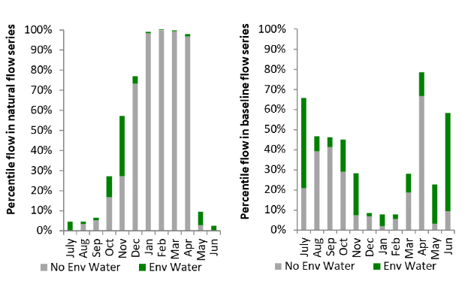
Figure CNM4: Contribution of environmental water delivery at Doctors as percentiles in the natural and baseline flow series.
Corowa
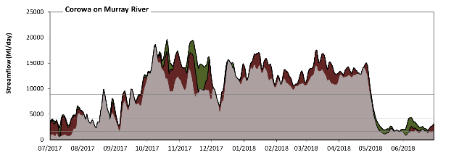
Figure CNM5: Contribution of environmental water delivery at Corowa. Horizontal lines indicate thresholds for very low flows, low flows, low freshes, medium freshes and high freshes (from lowest to highest).
At Corowa on Murray River environmental water contributed 18% of the total streamflow volume. Environmental watering actions affected streamflows for 93% of days between 1 July 2017 and 30 June 2018. Flow regulation does not substantially increase the duration of very low flows (i.e. < 380 Ml/day) compared to an average year in the natural flow regime. However, without environmental water, the durations of medium low flows (i.e. < 1600 Ml/day) in the periods July to September and April to June would have substantially exceeded durations expected in an average year in the natural flow regime. Environmental water mitigated these impacts by reducing the cumulative duration of medium low flow spells from 15% to 0% of the year, with greatest influence in the periods July to September and April to June. In the absence of environmental water there would have been at least one low fresh (i.e. > 2700 Ml/day) in the periods July to September, October to December, January to March and April to June. Environmental water increased the duration of the longest low fresh during the period July to September (from 24 days to 47 days). There was at least one medium fresh (i.e. > 4200 Ml/day) in the periods July to September, October to December, January to March and April to June. Environmental water made little change to the duration of these medium freshes. In the absence of environmental water there would have been at least one high fresh in the periods July to September, October to December, January to March and April to June. Environmental water increased the duration of the longest medium fresh during the periods July to September (from 3 days to 5 days) and October to December (from 46 days to 66 days).
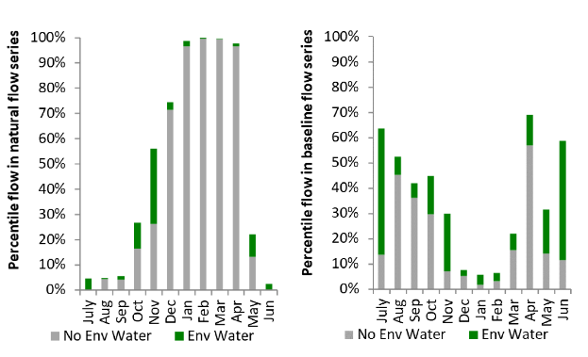
Figure CNM6: Contribution of environmental water delivery at Corowa as percentiles in the natural and baseline flow series.

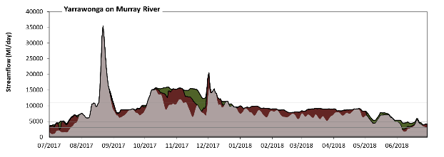
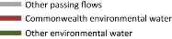
Yarrawonga

Figure CNM7: Contribution of environmental water delivery at Yarrawonga. Horizontal lines indicate thresholds for very low flows, low flows, low freshes, medium freshes and high freshes (from lowest to highest).
At Yarrawonga on Murray River environmental water contributed 19% of the total streamflow volume. Environmental watering actions affected streamflows for 94% of days between 1 July 2017 and 30 June 2018. Flow regulation does not substantially increase the duration of very low flows (i.e. < 340 Ml/day) compared to an average year in the natural flow regime. However, without environmental water, the duration of medium low flows (i.e. < 1700 Ml/day) in the period July to September would have substantially exceeded durations expected in an average year in the natural flow regime. Environmental water mitigated these impacts by reducing the cumulative duration of medium low flow spells from 4% to 0% of the year, with greatest influence in the period July to September. In the absence of environmental water there would have been at least one low fresh (i.e. > 3100 Ml/day) in the periods July to September, October to December, January to March and April to June. Environmental water increased the duration of the longest low fresh during the periods July to September (from 71 days to 92 days) and April to June (from 66 days to 91 days). In the absence of environmental water there would have been at least one medium fresh (i.e. > 4900 Ml/day) in the periods July to September, October to December, January to March and April to June. Environmental water increased the duration of the longest medium fresh during the period April to June (from 37 days to 66 days). In the absence of environmental water there would have been at least one high fresh in the periods July to September and October to December. Environmental water increased the duration of the longest high fresh during the period October to December (from 16 days to 78 days).
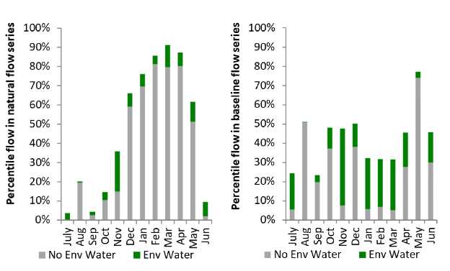
Figure CNM8: Contribution of environmental water delivery at Yarrawonga as percentiles in the natural and baseline flow series.
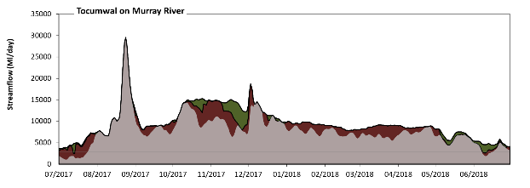
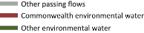
Tocumwal

Figure CNM9: Contribution of environmental water delivery at Tocumwal. Horizontal lines indicate thresholds for very low flows, low flows, low freshes, medium freshes and high freshes (from lowest to highest).
At Tocumwal on Murray River environmental water contributed 19% of the total streamflow volume. Environmental watering actions affected streamflows for 96% of days between 1 July 2017 and 30 June 2018. Flow regulation does not substantially increase the duration of very low flows (i.e. < 340 Ml/day) compared to an average year in the natural flow regime. However, without environmental water, the duration of medium low flows (i.e. < 1700 Ml/day) in the period July to September would have substantially exceeded durations expected in an average year in the natural flow regime. Environmental water mitigated these impacts by reducing the cumulative duration of medium low flow spells from 4% to 0% of the year, with greatest influence in the period July to September. In the absence of environmental water there would have been at least one low fresh (i.e. > 2800 Ml/day) in the periods July to September, October to December, January to March and April to June. Environmental water increased the duration of the longest low fresh during the periods July to September (from 68 days to 92 days) and April to June (from 68 days to 91 days). In the absence of environmental water there would have been at least one medium fresh (i.e. > 4400 Ml/day) in the periods July to September, October to December, January to March and April to June. Environmental water increased the duration of the longest medium fresh during the period April to June (from 66 days to 87 days). In the absence of environmental water there would have been at least one high fresh in the periods July to September and October to December. Environmental water increased the duration of the longest high fresh during the periods October to December (from 19 days to 92 days) and January to March (from 0 days to 31 days).
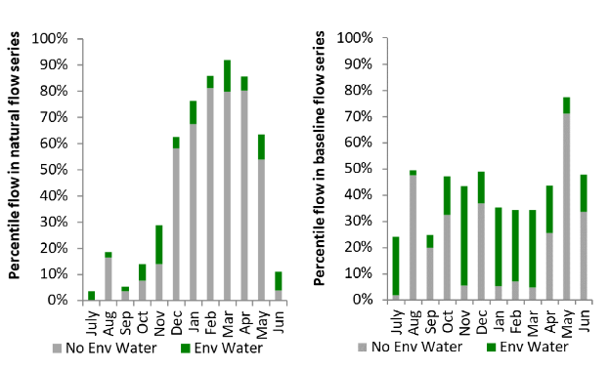
Figure CNM10: Contribution of environmental water delivery at Tocumwal as percentiles in the natural and baseline flow series.

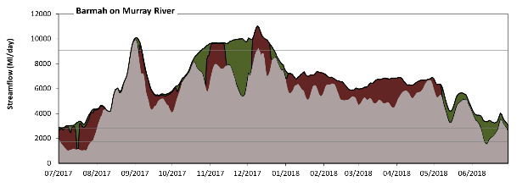
Barmah

Figure CNM11: Contribution of environmental water delivery at Barmah. Horizontal lines indicate thresholds for very low flows, low flows, low freshes, medium freshes and high freshes (from lowest to highest).
At Barmah on Murray River environmental water contributed 19% of the total streamflow volume. Environmental watering actions affected streamflows for 100% of days between 1 July 2017 and 30 June 2018. Flow regulation does not substantially increase the duration of very low flows (i.e. < 340 Ml/day) compared to an average year in the natural flow regime. However, without environmental water, the duration of medium low flows (i.e. < 1700 Ml/day) in the period July to September would have substantially exceeded durations expected in an average year in the natural flow regime. Environmental water mitigated these impacts by reducing the cumulative duration of medium low flow spells from 8% to 0% of the year, with greatest influence in the period July to September. In the absence of environmental water there would have been at least one low fresh (i.e. > 2800 Ml/day) in the periods July to September, October to December, January to March and April to June. Environmental water increased the duration of the longest low fresh during the periods July to September (from 60 days to 92 days) and April to June (from 69 days to 91 days). In the absence of environmental water there would have been at least one medium fresh (i.e. > 4400 Ml/day) in the periods July to September, October to December, January to March and April to June. Environmental water increased the duration of the longest medium fresh during the period July to September (from 32 days to 49 days). In the absence of environmental water there would have been at least one high fresh in the periods July to September and October to December. Environmental water increased the duration of the longest high fresh during the periods July to September (from 6 days to 9 days) and October to December (from 2 days to 59 days).
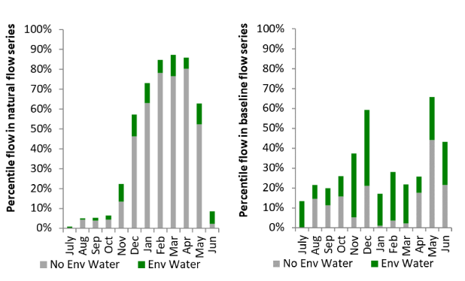
Figure CNM12: Contribution of environmental water delivery at Barmah as percentiles in the natural and baseline flow series.
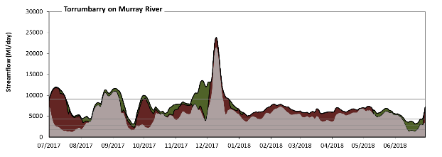
Torrumbarry
Figure CNM13: Contribution of environmental water delivery at Torrumbarry. Horizontal lines indicate thresholds for very low flows, low flows, low freshes, medium freshes and high freshes (from lowest to highest).
At Torrumbarry on Murray River environmental water contributed 29% of the total streamflow volume. Environmental watering actions affected streamflows for 100% of days between 1 July 2017 and 30 June 2018. Flow regulation does not substantially increase the duration of very low flows (i.e. < 340 Ml/day) compared to an average year in the natural flow regime. However, without environmental water, the durations of medium low flows (i.e. < 1700 Ml/day) in the periods July to September and April to June would have substantially exceeded durations expected in an average year in the natural flow regime. Environmental water mitigated these impacts by reducing the cumulative duration of medium low flow spells from 7% to 0% of the year, with greatest influence in the periods July to September and April to June. In the absence of environmental water there would have been at least one low fresh (i.e. > 2800 Ml/day) in the periods July to September, October to December, January to March and April to June. Environmental water increased the duration of the longest low fresh during the periods July to September (from 41 days to 92 days) and April to June (from 71 days to 91 days). In the absence of environmental water there would have been at least one medium fresh (i.e. > 4400 Ml/day) in the periods July to September, October to December, January to March and April to June. Environmental water increased the duration of the longest medium fresh during the periods October to December (from 31 days to 92 days) and January to March (from 56 days to 90 days). In the absence of environmental water there would have been at least one high fresh in the periods July to September and October to December. Environmental water increased the duration of the longest high fresh during the period October to December (from 12 days to 35 days).
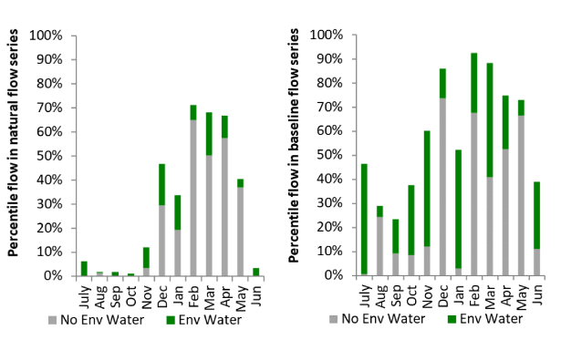
Figure CNM14: Contribution of environmental water delivery at Torrumbarry as percentiles in the natural and baseline flow series.

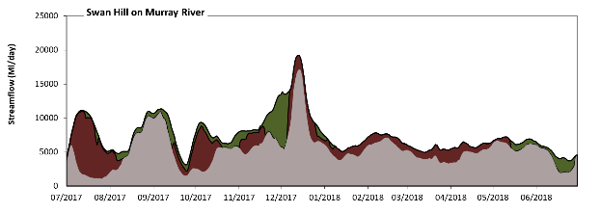
Swan Hill
Figure CNM15: Contribution of environmental water delivery at Swan Hill. Horizontal lines indicate thresholds for very low flows, low flows, low freshes, medium freshes and high freshes (from lowest to highest).
At Swan Hill on Murray River environmental water contributed 29% of the total streamflow volume. Environmental watering actions affected streamflows for 99% of days between 1 July 2017 and 30 June 2018. Flow regulation does not substantially increase the duration of very low flows (i.e. < 980 Ml/day) compared to an average year in the natural flow regime. However, without environmental water, the durations of medium low flows (i.e. < 2600 Ml/day) in the periods July to September, October to December and April to June would have substantially exceeded durations expected in an average year in the natural flow regime. Environmental water mitigated these impacts by reducing the cumulative duration of medium low flow spells from 17% to 0% of the year, with greatest influence in the period July to September. In the absence of environmental water there would have been at least one low fresh (i.e. > 5100 Ml/day) in the periods July to September, October to December, January to March and April to June. Environmental water increased the duration of the longest low fresh during the periods October to December (from 53 days to 92 days), January to March (from 34 days to 55 days) and April to June (from 25 days to 73 days). In the absence of environmental water there would have been at least one medium fresh (i.e. > 8900 Ml/day) in the periods July to September and October to December. Environmental water increased the duration of the longest medium fresh during the period October to December (from 13 days to 39 days). In the absence of environmental water there would have been at least one high fresh in the periods July to September and October to December. Environmental water increased the duration of the longest high fresh during the period October to December (from 13 days to 39 days).
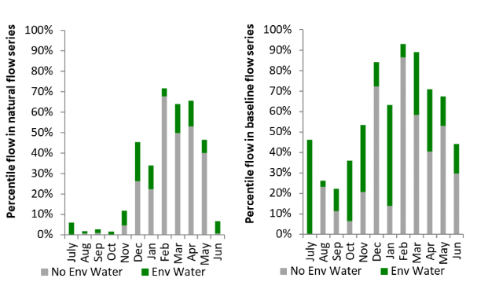
Figure CNM16: Contribution of environmental water delivery at Swan Hill as percentiles in the natural and baseline flow series.
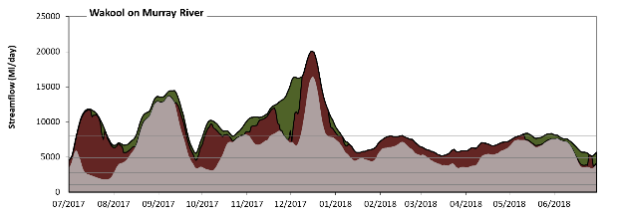
Wakool
Figure CNM17: Contribution of environmental water delivery at Wakool. Horizontal lines indicate thresholds for very low flows, low flows, low freshes, medium freshes and high freshes (from lowest to highest).
At Wakool on Murray River environmental water contributed 29% of the total streamflow volume. Environmental watering actions affected streamflows for 100% of days between 1 July 2017 and 30 June 2018. Flow regulation does not substantially increase the duration of very low flows (i.e. < 1000 Ml/day) compared to an average year in the natural flow regime. However, without environmental water, the duration of medium low flows (i.e. < 2800 Ml/day) in the period July to September would have substantially exceeded durations expected in an average year in the natural flow regime. Environmental water mitigated these impacts by reducing the cumulative duration of medium low flow spells from 5% to 0% of the year, with greatest influence in the period July to September. In the absence of environmental water there would have been at least one low fresh (i.e. > 4900 Ml/day) in the periods July to September, October to December, January to March and April to June. Environmental water increased the duration of the longest low fresh during the periods July to September (from 43 days to 90 days), January to March (from 36 days to 90 days) and April to June (from 66 days to 91 days). In the absence of environmental water there would have been at least one medium fresh (i.e. > 8000 Ml/day) in the periods July to September and October to December. Environmental water increased the duration of the longest medium fresh during the periods October to December (from 19 days to 70 days), January to March (from 0 days to 5 days) and April to June (from 0 days to 10 days). In the absence of environmental water there would have been at least one high fresh in the periods July to September and October to December. Environmental water increased the duration of the longest high fresh during the periods October to December (from 19 days to 70 days), January to March (from 0 days to 5 days) and April to June (from 0 days to 10 days).
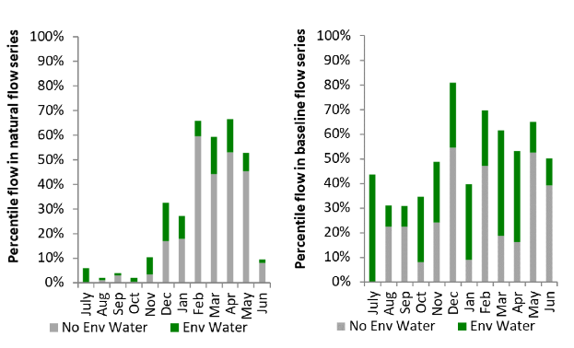
Figure CNM18: Contribution of environmental water delivery at Wakool as percentiles in the natural and baseline flow series.
Euston
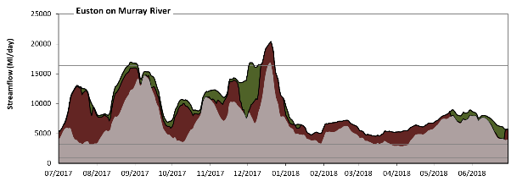
Figure CNM19: Contribution of environmental water delivery at Euston. Horizontal lines indicate thresholds for very low flows, low flows, low freshes, medium freshes and high freshes (from lowest to highest).
At Euston on Murray River environmental water contributed 29% of the total streamflow volume. Environmental watering actions affected streamflows for 100% of days between 1 July 2017 and 30 June 2018. Flow regulation does not substantially increase the duration of very low flows (i.e. < 910 Ml/day) compared to an average year in the natural flow regime. Flow regulation does not substantially increase the duration of medium low flows (i.e. < 3200 Ml/day) compared to an average year in the natural flow regime. In the absence of environmental water there would have been at least one low fresh (i.e. > 7900 Ml/day) in the periods July to September, October to December and April to June. Environmental water increased the duration of the longest low fresh during the periods July to September (from 35 days to 79 days), October to December (from 18 days to 90 days), January to March (from 0 days to 3 days) and April to June (from 4 days to 28 days). In the absence of environmental water there would have been at least one medium fresh (i.e. > 16000 Ml/day) in the period October to December. Environmental water increased the duration of the longest medium fresh during the periods July to September (from 0 days to 8 days) and October to December (from 3 days to 14 days). In the absence of environmental water there would have been at least one high fresh in the period October to December. Environmental water increased the duration of the longest high fresh during the periods July to September (from 0 days to 8 days) and October to December (from 3 days to 14 days).
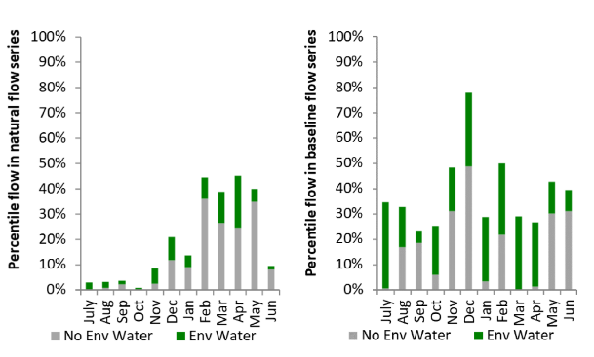
Figure CNM20: Contribution of environmental water delivery at Euston as percentiles in the natural and baseline flow series.

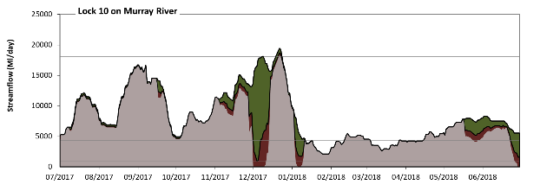
Lock 10
Figure CNM21: Contribution of environmental water delivery at Lock 10. Horizontal lines indicate thresholds for very low flows, low flows, low freshes, medium freshes and high freshes (from lowest to highest).
At Lock 10 on Murray River environmental water contributed 18% of the total streamflow volume. Environmental watering actions affected streamflows for 67% of days between 1 July 2017 and 30 June 2018. Without environmental water, the durations of very low flows (i.e. < 940 Ml/day) in the periods October to December and January to March would have substantially exceeded durations expected in an average year in the natural flow regime. Environmental water mitigated these impacts by reducing the cumulative duration of very low flow spells from 6% to 0% of the year, with greatest influence in the periods October to December and January to March. Similarly, without environmental water, the durations of medium low flows (i.e. < 4300 Ml/day) in the periods October to December, January to March and April to June would have substantially exceeded durations expected in an average year in the natural flow regime. Environmental water mitigated these impacts by reducing the cumulative duration of medium low flow spells from 28% to 19% of the year, with greatest influence in the periods October to December and April to June. In the absence of environmental water there would have been at least one low fresh (i.e. > 9500 Ml/day) in the periods July to September and October to December. Environmental water increased the duration of the longest low fresh during the periods October to December (from 17 days to 62 days) and January to March (from 0 days to 1 days). In the absence of environmental water there would have been at least one medium fresh (i.e. > 18000 Ml/day) in the period October to December. Environmental water increased the duration of the longest medium fresh during the period October to December (from 2 days to 6 days). In the absence of environmental water there would have been at least one high fresh in the period October to December. Environmental water increased the duration of the longest high fresh during the period October to December (from 2 days to 6 days).
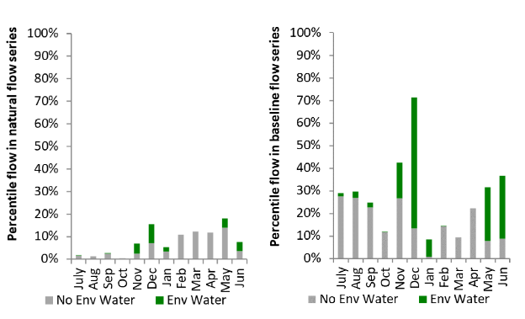
Figure CNM22: Contribution of environmental water delivery at Lock 10 as percentiles in the natural and baseline flow series.

Edward Wakool

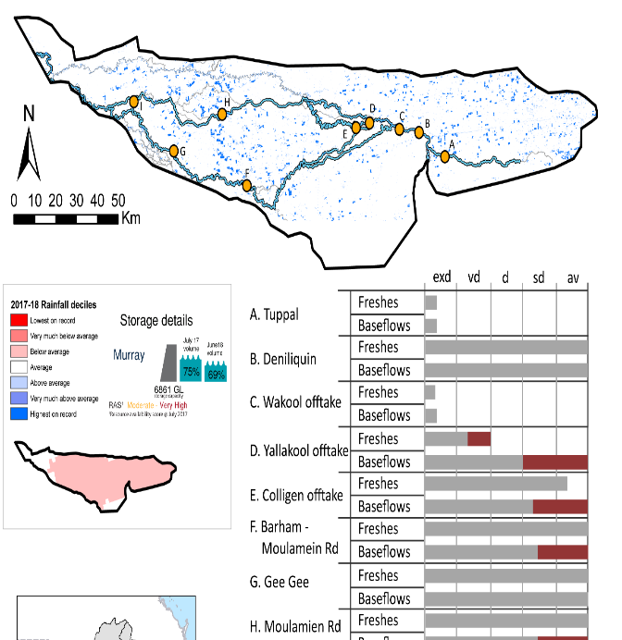
Figure EWK1: Watercourses influenced, areas inundated (where applicable) and gauge stations evaluated in the Edward Wakool valley during the 2017–18 water year. Inset bar graphs report the condition of annual flow regimes by showing the improvements in hydrological condition with the addition of environmental water as well as the hypothetical scenario in “grey” (if no environmental flow had been delivered). Where exd= extremely dry, vd=very dry, d=dry, sd=somewhat dry and av=average. Rainfall conditions (rainfall deciles) and trend in storage levels for the water year are also shown.

Summary
The volume of environmental water delivery for the 2017–18 year in the Edward Wakool valley is quantified using data for 10 sites. This evaluation only considers the contribution of held environmental water, which is a primary focus for the Commonwealth. The contributions of planned environmental water (e.g. passing flows), unregulated tributary inflows and clever use of irrigation flows for environmental benefits can all be very important but these are outside the scope of this report. Environmental watering actions lasted on average 190 days over the course of the year. The volume of environmental water at these 10 sites was between 4% and 96% of the total streamflow. Commonwealth environmental water contributed on average 93% of this environmental water. The contribution of environmental water delivery to improved flow regimes is evaluated using data for 10 sites. Ideally, baseflows should be maintained and long periods of excessively low flows avoided. In this valley, the baseflow regime was generally considered to be average relative to the pre-development flow regime. In our analysis, a low fresh refers to a period of increased flow, when the water level rises at least one eighth of the way up the river bank (above the low flow level). These low freshes are a regular part of the natural flow regime and support a range of natural processes. In the Edward Wakool valley, in terms of the occurrence and duration of low freshes, the year was assessed as being average. In our analysis, a medium fresh refers to a period of increased flow, when the water level rises at least one quarter of the way up the river bank. These medium freshes are not as frequent as low freshes but are also a regular and important part of the natural flow regime. In the Edward Wakool valley, in terms of the occurrence of medium freshes, the year was assessed as being somewhat dry. In our analysis, a high fresh refers to a period of increased flow, when the water level rises more than half way up the river. A high fresh may not occur every year but they are still important and long periods without major freshes can have serious consequences for floodplains and their contribution to river ecosystem health. Delivering environmental high in channel flows normally requires that all risks to riparian landholders and infrastructure have been resolved. In the Edward Wakool valley, in terms of the occurrence of high freshes, the year was assessed as being somewhat dry.

Water delivery context
Details on water delivery context are described in the Central Murray section.

Environmental conditions and resource availability
The water available for environmental delivery combined with the present and antecedent environmental conditions are key inputs used by environmental water managers in planning and implementing watering actions. Post hoc, this information provides important context when evaluating the effectiveness and appropriateness of environmental water use with respect to hydrological outputs.
The rainfall conditions in the Edward Wakool valley were classified as Below Average, based on rainfall percentile data for the entire record held by the Bureau of Meteorology for this valley. The water held in major storages in the Edward Wakool valley decreased over the water year, for example Dartmouth and Hume dam was 75% full at the beginning of the water year and 69% full by the end of the year (Figure EWK1).
The Commonwealth Environmental Water Office (CEWO) calculates resource availability scenarios (RAS) to guide the use and prioritisation of held environmental water. The RAS are progressively calculated over the year as part of the continual adaptive management planning processes. The RAS are based on the availability of held environmental water (including progressive license acquisitions and allocations) as well as the potential for unregulated or planned environmental flows. The outcome is then used to determine the demand for environmental water across the basin.
In 2017–18, the resource availability of held Commonwealth environmental water was classified as moderate to very high in this valley. The physical conditions meant that the CEWO was managing to maintain and/or improve the condition of environmental assets. The overall demand for environmental water was deemed moderate to high.

Watering actions
A total of 6 watering actions were delivered over the 2017–18 water year, the duration of these actions varied (range of individual actions: 37 - 242 days) and Commonwealth environmental water was delivered for a total of 722 days. The count of actions commencing in each season was; winter (3), spring (2) and autumn (1). The flow component types delivered were; (4) baseflow, (2) freshes, (0) bankfull, (0) overbank and (0) wetland.
Commonwealth environmental water was delivered in the Edward Wakool valley for specified objectives. Although the majority of watering actions were delivered for Fish purposes, water was also delivered for other purposes too. The percentage of watering actions delivered across the nine main themes included fish (13%), vegetation (13%), waterbirds (0%), frogs (13%), other biota (13%), connectivity (13%), process (13%), resilience (13%) and water quality (13%).

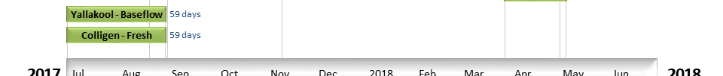
Figure EWK2. Timing and duration of Commonwealth environmental water actions delivered in the Edward Wakool valley.

Contribution of Commonwealth Environmental Water to Flow Regimes
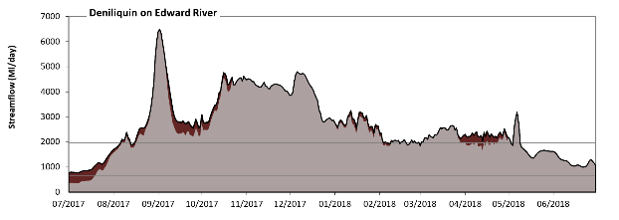
Deniliquin

Figure EWK3: Contribution of environmental water delivery at Deniliquin. Horizontal lines indicate thresholds for very low flows, low flows, low freshes, medium freshes and high freshes (from lowest to highest).
At Deniliquin on Edward River environmental water contributed 5% of the total streamflow volume (most of which was Commonwealth environmental water). Environmental watering actions affected streamflows for 78% of days between 1 July 2017 and 30 June 2018. Flow regulation does not substantially increase the duration of very low flows (i.e. < 13 Ml/day) compared to an average year in the natural flow regime. Flow regulation does not substantially increase the duration of medium low flows (i.e. < 130 Ml/day) compared to an average year in the natural flow regime. In the absence of environmental water there would have been at least one low fresh (i.e. > 650 Ml/day) in the periods July to September, October to December, January to March and April to June. Environmental water increased the duration of the longest low fresh during the period July to September (from 73 days to 92 days). Commonwealth environmental water was entirely responsible for these increased durations of low freshes. In the absence of environmental water there would have been at least one medium fresh (i.e. > 2000 Ml/day) in the periods July to September, October to December, January to March and April to June. Environmental water increased the duration of the longest medium fresh during the period April to June (from 9 days to 32 days). Commonwealth environmental water was entirely responsible for these increased durations of medium freshes. In the absence of environmental water there would have been at least one high fresh in the periods July to September, October to December, January to March and April to June. Environmental water increased the duration of the longest high fresh during the period April to June (from 9 days to 32 days). Commonwealth environmental water was entirely responsible for these increased durations of high freshes.
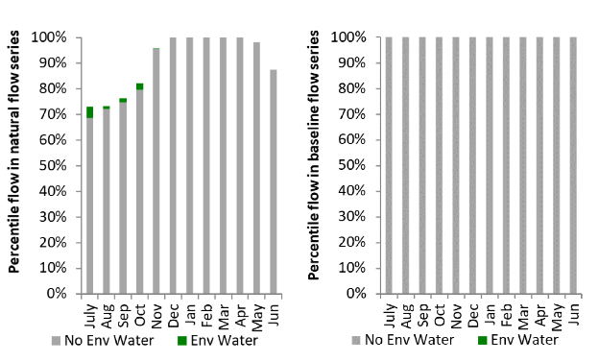
Figure EWK4: Contribution of environmental water delivery at Deniliquin as percentiles in the natural and baseline flow series.
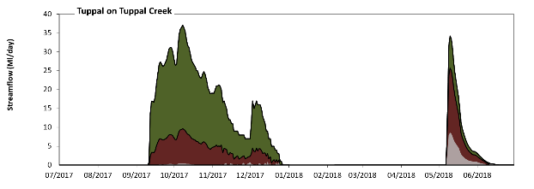
Tuppal

Figure EWK5: Contribution of environmental water delivery at Tuppal. Horizontal lines indicate thresholds for very low flows and low flows (from lowest to highest).
At Tuppal on Tuppal Creek environmental water contributed 96% of the total streamflow volume (with a medium contribution of Commonwealth environmental water). Environmental watering actions affected streamflows for 39% of days between 1 July 2017 and 30 June 2018. Without environmental water, the durations of very low flows (i.e. < 13 Ml/day) in the periods July to September, October to December and April to June would have substantially exceeded durations expected in an average year in the natural flow regime. Environmental water mitigated these impacts by reducing the cumulative duration of very low flow spells from 100% to 78% of the year, with greatest influence in the period October to December. Similarly, without environmental water, the durations of medium low flows (i.e. < 130 Ml/day) in the periods July to September, October to December and April to June would have substantially exceeded durations expected in an average year in the natural flow regime. However, environmental water had little effect on the duration of these medium low flows, which occurred for 100% of the year. Commonwealth environmental water made a small contribution to these enhancements of environmental baseflows at this site.
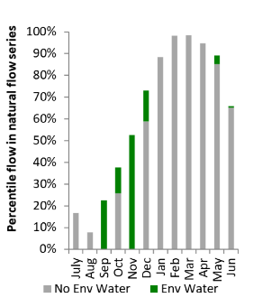
Figure EWK6: Contribution of environmental water delivery at Tuppal as percentiles in the natural flow series.

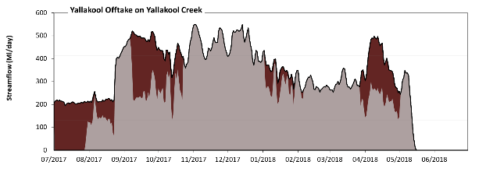
Yallakool Offtake

Figure EWK7: Contribution of environmental water delivery at Yallakool Offtake. Horizontal lines indicate thresholds for very low flows, low flows and low freshes (from lowest to highest).
At Yallakool Offtake on Yallakool Creek environmental water contributed 21% of the total streamflow volume (all of which was Commonwealth environmental water). Environmental watering actions affected streamflows for 45% of days between 1 July 2017 and 30 June 2018. Flow regulation does not substantially increase the duration of very low flows (i.e. < 13 Ml/day) compared to an average year in the natural flow regime. However, without environmental water, the duration of medium low flows (i.e. < 130 Ml/day) in the period July to September would have substantially exceeded durations expected in an average year in the natural flow regime. Environmental water mitigated these impacts by reducing the cumulative duration of medium low flow spells from 24% to 13% of the year, with greatest influence in the period July to September. Commonwealth environmental water was entirely responsible for these enhancements of environmental baseflows at this site. In the absence of environmental water there would have been at least one low fresh (i.e. > 410 Ml/day) in the periods July to September, October to December and January to March. Environmental water increased the duration of the longest low fresh during the periods July to September (from 10 days to 33 days) and April to June (from 0 days to 13 days). Commonwealth environmental water was entirely responsible for these increased durations of low freshes. There was no medium or high freshes this year.
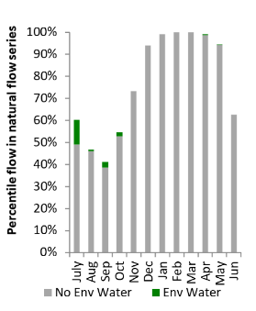
Figure EWK8: Contribution of environmental water delivery at Yallakool Offtake as percentiles in the natural flow series.

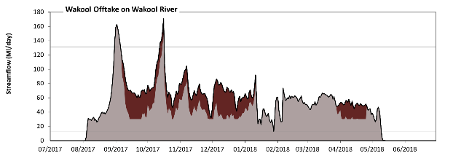
Wakool Offtake

Figure EWK9: Contribution of environmental water delivery at Wakool Offtake. Horizontal lines indicate thresholds for very low flows and low flows (from lowest to highest).
At Wakool Offtake on Wakool River environmental water contributed 22% of the total streamflow volume (all of which was Commonwealth environmental water). Environmental watering actions affected streamflows for 43% of days between 1 July 2017 and 30 June 2018. Flow regulation does not substantially increase the duration of very low flows (i.e. < 13 Ml/day) compared to an average year in the natural flow regime. However, without environmental water, the durations of medium low flows (i.e. < 130 Ml/day) in the periods July to September, October to December and April to June would have substantially exceeded durations expected in an average year in the natural flow regime. Environmental water mitigated these impacts by reducing the cumulative duration of medium low flow spells from 98% to 97% of the year, with greatest influence in the period October to December.
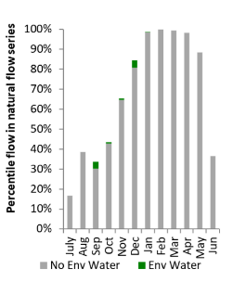
Figure EWK10: Contribution of environmental water delivery at Wakool Offtake as percentiles in the natural flow series.
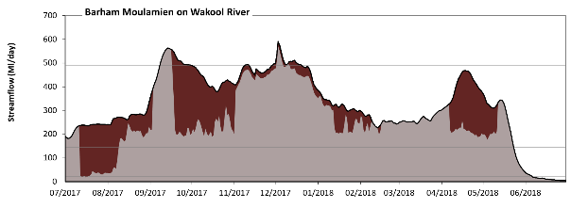
Barham Moulamien

Figure EWK11: Contribution of environmental water delivery at Barham Moulamien. Horizontal lines indicate thresholds for very low flows, low flows, low freshes, medium freshes and high freshes (from lowest to highest).
At Barham Moulamien on Wakool River environmental water contributed 24% of the total streamflow volume (all of which was Commonwealth environmental water). Environmental watering actions affected streamflows for 64% of days between 1 July 2017 and 30 June 2018. Without environmental water, the duration of very low flows (i.e. < 59 Ml/day) in the period July to September would have substantially exceeded durations expected in an average year in the natural flow regime. Environmental water mitigated these impacts by reducing the cumulative duration of very low flow spells from 16% to 9% of the year, with greatest influence in the period July to September. Similarly, without environmental water, the duration of medium low flows (i.e. < 22 Ml/day) in the period July to September would have substantially exceeded durations expected in an average year in the natural flow regime. Environmental water mitigated these impacts by reducing the cumulative duration of medium low flow spells from 8% to 7% of the year, with greatest influence in the period July to September. Commonwealth environmental water was entirely responsible for these enhancements of environmental baseflows at this site. In the absence of environmental water there would have been at least one low fresh (i.e. > 140 Ml/day) in the periods July to September, October to December, January to March and April to June. Environmental water increased the duration of the longest low fresh during the period July to September (from 53 days to 92 days). Commonwealth environmental water was entirely responsible for these increased durations of low freshes. In the absence of environmental water there would have been at least one medium fresh (i.e. > 490 Ml/day) in the periods July to September and October to December. Environmental water increased the duration of the longest medium fresh during the periods July to September (from 9 days to 23 days) and October to December (from 5 days to 22 days). Commonwealth environmental water was entirely responsible for these increased durations of medium freshes. In the absence of environmental water there would have been at least one high fresh in the periods July to September and October to December. Environmental water increased the duration of the longest high fresh during the periods July to September (from 9 days to 23 days) and October to December (from 5 days to 22 days). Commonwealth environmental water was entirely responsible for these increased durations of high freshes.
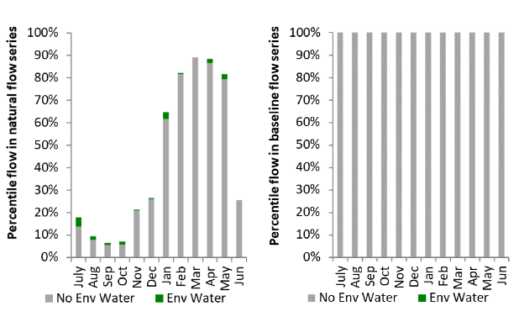
Figure EWK12: Contribution of environmental water delivery at Barham Moulamien as percentiles in the natural and baseline flow series.
Gee Gee Bridge
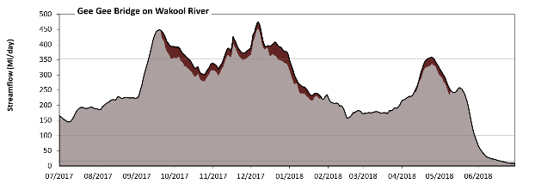
Figure EWK13: Contribution of environmental water delivery at Gee Gee Bridge. Horizontal lines indicate thresholds for very low flows, low flows, low freshes, medium freshes and high freshes (from lowest to highest).
At Gee Gee Bridge on Wakool River environmental water contributed 4% of the total streamflow volume (all of which was Commonwealth environmental water). Environmental watering actions affected streamflows for 43% of days between 1 July 2017 and 30 June 2018. Flow regulation does not substantially increase the duration of very low flows (i.e. < 100 Ml/day) compared to an average year in the natural flow regime. Flow regulation does not substantially increase the duration of medium low flows (i.e. < 16 Ml/day) compared to an average year in the natural flow regime. There was at least one low fresh (i.e. > 100 Ml/day) in the periods July to September, October to December, January to March and April to June. Environmental water made little change to the duration of these low freshes. In the absence of environmental water there would have been at least one medium fresh (i.e. > 350 Ml/day) in the periods July to September and October to December. Environmental water increased the duration of the longest medium fresh during the periods October to December (from 25 days to 52 days) and April to June (from 0 days to 5 days). Commonwealth environmental water was entirely responsible for these increased durations of medium freshes. In the absence of environmental water there would have been at least one high fresh in the periods July to September and October to December. Environmental water increased the duration of the longest high fresh during the periods October to December (from 25 days to 52 days) and April to June (from 0 days to 5 days). Commonwealth environmental water was entirely responsible for these increased durations of high freshes.
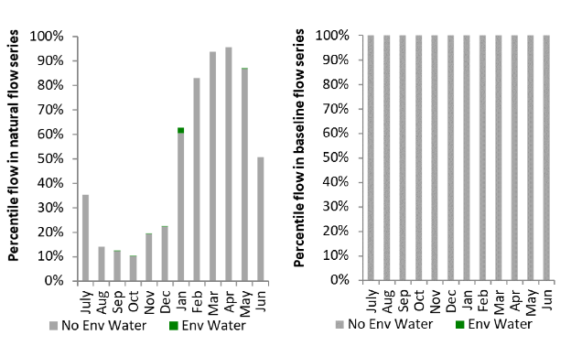
Figure EWK14: Contribution of environmental water delivery at Gee Gee Bridge as percentiles in the natural and baseline flow series.

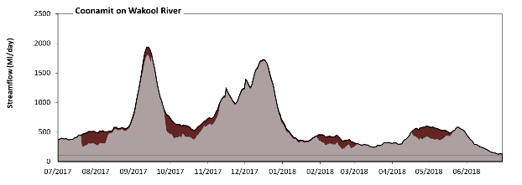
Coonamit
Figure EWK15: Contribution of environmental water delivery at Coonamit. Horizontal lines indicate thresholds for very low flows, low flows, low freshes, medium freshes and high freshes (from lowest to highest).
At Coonamit on Wakool River environmental water contributed 10% of the total streamflow volume (all of which was Commonwealth environmental water). Environmental watering actions affected streamflows for 69% of days between 1 July 2017 and 30 June 2018. Flow regulation does not substantially increase the duration of very low flows (i.e. < 100 Ml/day) compared to an average year in the natural flow regime. Flow regulation does not substantially increase the duration of medium low flows (i.e. < 16 Ml/day) compared to an average year in the natural flow regime. There was at least one low fresh (i.e. > 100 Ml/day) in the periods July to September, October to December, January to March and April to June. Environmental water made little change to the duration of these low freshes. In the absence of environmental water there would have been at least one medium fresh (i.e. > 350 Ml/day) in the periods July to September, October to December, January to March and April to June. Environmental water increased the duration of the longest medium fresh during the periods July to September (from 52 days to 92 days) and January to March (from 13 days to 27 days). Commonwealth environmental water was entirely responsible for these increased durations of medium freshes. In the absence of environmental water there would have been at least one high fresh in the periods July to September, October to December, January to March and April to June. Environmental water increased the duration of the longest high fresh during the periods July to September (from 52 days to 92 days) and January to March (from 13 days to 27 days). Commonwealth environmental water was entirely responsible for these increased durations of high freshes.
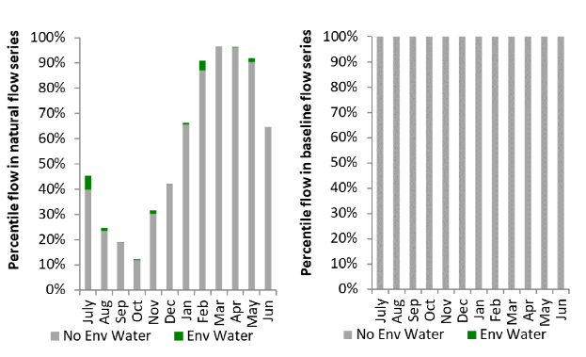
Figure EWK16: Contribution of environmental water delivery at Coonamit as percentiles in the natural and baseline flow series.
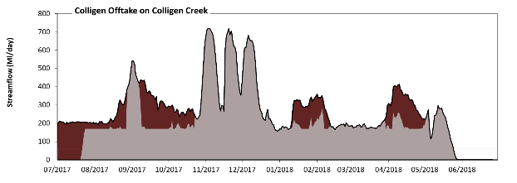
Colligen Offtake
Figure EWK17: Contribution of environmental water delivery at Colligen Offtake. Horizontal lines indicate thresholds for very low flows, low flows, low freshes, and medium freshes (from lowest to highest).
At Colligen Offtake on Colligen Creek environmental water contributed 20% of the total streamflow volume (all of which was Commonwealth environmental water). Environmental watering actions affected streamflows for 47% of days between 1 July 2017 and 30 June 2018. Without environmental water, the duration of very low flows (i.e. < 59 Ml/day) in the period July to September would have substantially exceeded durations expected in an average year in the natural flow regime. Environmental water mitigated these impacts by reducing the cumulative duration of very low flow spells from 16% to 10% of the year, with greatest influence in the period July to September. Similarly, without environmental water, the duration of medium low flows (i.e. < 22 Ml/day) in the period July to September would have substantially exceeded durations expected in an average year in the natural flow regime. Environmental water mitigated these impacts by reducing the cumulative duration of medium low flow spells from 15% to 10% of the year, with greatest influence in the period July to September. Commonwealth environmental water was entirely responsible for these enhancements of environmental baseflows at this site. In the absence of environmental water there would have been at least one low fresh (i.e. > 180 Ml/day) in the periods July to September, October to December, January to March and April to June. Environmental water increased the duration of the longest low fresh during the periods July to September (from 12 days to 92 days), October to December (from 66 days to 88 days), January to March (from 9 days to 33 days) and April to June (from 12 days to 34 days). Commonwealth environmental water was entirely responsible for these increased durations of low freshes. There was at least one medium fresh (i.e. > 680 Ml/day) in the period October to December. Environmental water made no change to the duration of these medium freshes. In the absence of environmental water there would have been at least one high fresh in the period October to December. Environmental water made no change to the duration of these high freshes.
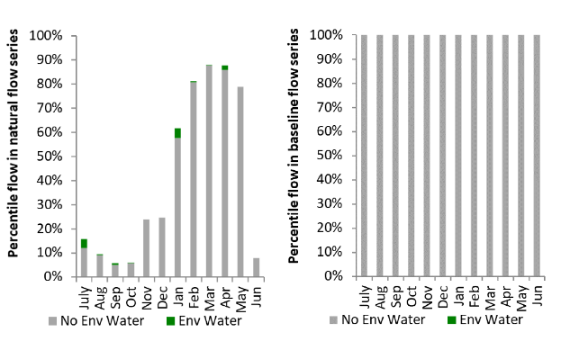
Figure EWK18: Contribution of environmental water delivery at Colligen Offtake as percentiles in the natural and baseline flow series.

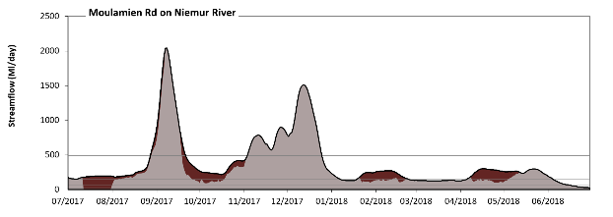
Moulamien Rd
Figure EWK19: Contribution of environmental water delivery at Moulamien Rd. Horizontal lines indicate thresholds for very low flows, low flows, low freshes, medium freshes and high freshes (from lowest to highest).
At Moulamien Rd on Niemur River environmental water contributed 15% of the total streamflow volume (all of which was Commonwealth environmental water). Environmental watering actions affected streamflows for 47% of days between 1 July 2017 and 30 June 2018. Without environmental water, the duration of very low flows (i.e. < 59 Ml/day) in the period July to September would have substantially exceeded durations expected in an average year in the natural flow regime. Environmental water mitigated these impacts by reducing the cumulative duration of very low flow spells from 9% to 4% of the year, with greatest influence in the period July to September. Similarly, without environmental water, the duration of medium low flows (i.e. < 22 Ml/day) in the period July to September would have substantially exceeded durations expected in an average year in the natural flow regime. Environmental water mitigated these impacts by reducing the cumulative duration of medium low flow spells from 5% to 0% of the year, with greatest influence in the period July to September. Commonwealth environmental water was entirely responsible for these enhancements of environmental baseflows at this site. In the absence of environmental water there would have been at least one low fresh (i.e. > 140 Ml/day) in the periods July to September, October to December, January to March and April to June. Environmental water increased the duration of the longest low fresh during the periods July to September (from 54 days to 92 days), January to March (from 7 days to 36 days) and April to June (from 32 days to 61 days). Commonwealth environmental water was entirely responsible for these increased durations of low freshes. There was at least one medium fresh (i.e. > 490 Ml/day) in the periods July to September and October to December. Environmental water made little change to the duration of these medium freshes. In the absence of environmental water there would have been at least one high fresh in the periods July to September and October to December. Environmental water made little change to the duration of these high freshes.
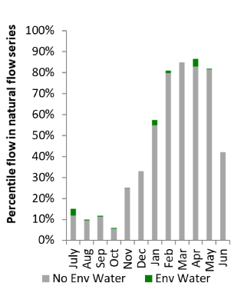
Figure EWK20: Contribution of environmental water delivery at Moulamien Rd as percentiles in the natural and baseline flow series.
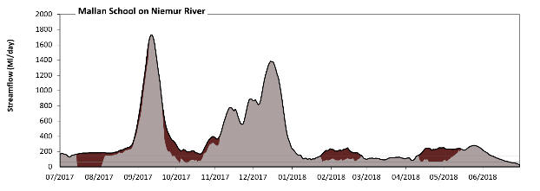
Mallan School
Figure EWK21: Contribution of environmental water delivery at Mallan School. Horizontal lines indicate thresholds for very low flows, low flows, low freshes, medium freshes and high freshes (from lowest to highest).
At Mallan School on Niemur River environmental water contributed 16% of the total streamflow volume (all of which was Commonwealth environmental water). Environmental watering actions affected streamflows for 47% of days between 1 July 2017 and 30 June 2018. Without environmental water, the duration of very low flows (i.e. < 59 Ml/day) in the period July to September would have substantially exceeded durations expected in an average year in the natural flow regime. Environmental water mitigated these impacts by reducing the cumulative duration of very low flow spells from 8% to 2% of the year, with greatest influence in the period July to September. Similarly, without environmental water, the duration of medium low flows (i.e. < 22 Ml/day) in the period July to September would have substantially exceeded durations expected in an average year in the natural flow regime. Environmental water mitigated these impacts by reducing the cumulative duration of medium low flow spells from 5% to 0% of the year, with greatest influence in the period July to September. Commonwealth environmental water was entirely responsible for these enhancements of environmental baseflows at this site. In the absence of environmental water there would have been at least one low fresh (i.e. > 140 Ml/day) in the periods July to September, October to December, January to March and April to June. Environmental water increased the duration of the longest low fresh during the periods July to September (from 48 days to 82 days), October to December (from 70 days to 92 days), January to March (from 8 days to 33 days) and April to June (from 31 days to 60 days). Commonwealth environmental water was entirely responsible for these increased durations of low freshes. There was at least one medium fresh (i.e. > 490 Ml/day) in the periods July to September and October to December. Environmental water made little change to the duration of these medium freshes. In the absence of environmental water there would have been at least one high fresh in the periods July to September and October to December. Environmental water made little change to the duration of these high freshes.
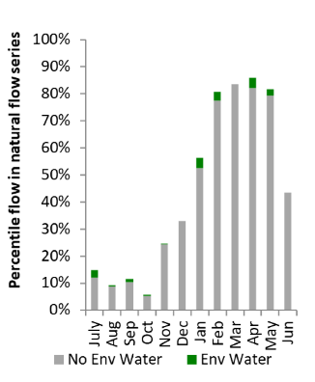
Figure EWK22: Contribution of environmental water delivery at Mallan School as percentiles in the natural and baseline flow series.

Lower Murray
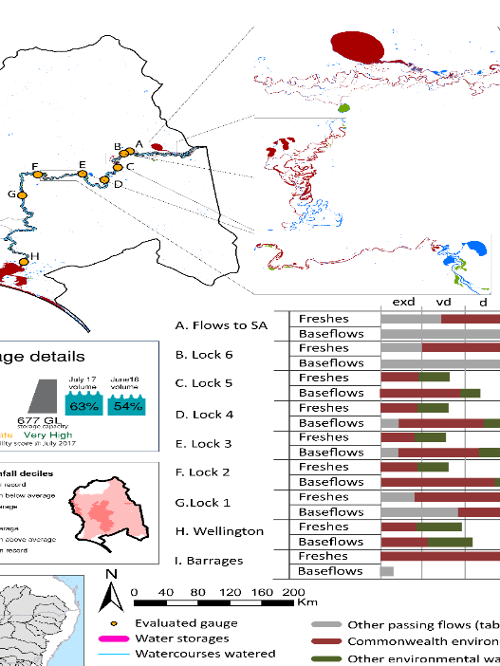
Figure LWM1: Watercourses influenced, areas inundated (where applicable) and gauge stations evaluated in the Lower Murray valley during the 2017–18 water year. Inset bar graphs report the condition of annual flow regimes by showing the improvements in hydrological condition with the addition of environmental water as well as the hypothetical scenario in “grey” (if no environmental flow had been delivered); where exd=extremely dry, vd=very dry, d=dry, sd=somewhat dry and av=average. Rainfall conditions (rainfall deciles) and trend in storage levels for the water year are also shown.

Summary
The volume of environmental water delivery for the 2017-18 year in the Lower Murray valley is quantified using data for 9 sites. This evaluation only considers the contribution of held environmental water, which is a primary focus for the Commonwealth. The contributions of planned environmental water (e.g. passing flows), unregulated tributary inflows and clever use of irrigation flows for environmental benefits can all be very important but these are outside the scope of this report. Environmental watering actions lasted on average 359 days over the course of the year. The volume of environmental water at these 9 sites varied between 36% and 89% of the total streamflow. Commonwealth environmental water contributed on average 75% of this environmental water. The contribution of environmental water delivery to improved flow regimes is evaluated using data for 9 sites. Ideally, baseflows should be maintained and long periods of excessively low flows avoided. In this valley, the baseflow regime was generally considered to be dry relative to the pre-development flow regime. In our analysis, a low fresh refers to a period of increased flow, when the water level rises at least one eighth of the way up the river bank (above the low flow level). These low freshes are a regular part of the natural flow regime and support a range of natural processes. In the Lower Murray valley, in terms of the occurrence and duration of low freshes, the year was assessed as being average. In our analysis, a medium fresh refers to a period of increased flow, when the water level rises at least one quarter of the way up the river bank. These medium freshes are not as frequent as low freshes but are also a regular and important part of the natural flow regime. In the Lower Murray valley, in terms of the occurrence of medium freshes, the year was assessed as being very dry. In our analysis, a high fresh refers to a period of increased flow, when the water level rises more than half way up the river. A high fresh may not occur every year but they are still important and long periods without major freshes can have serious consequences for floodplains and their contribution to river ecosystem health. Delivering environmental high in channel flows normally requires that all risks to riparian landholders and infrastructure have been resolved. In the Lower Murray valley, in terms of the occurrence of high freshes, the year was assessed as being very dry.

Water delivery context
During 2017-18, the Commonwealth Environmental Water Holder (CEWH) held water entitlements of up to 155,492 Ml for environmental use in the Lower Murray valley. Each year, water utilities allocate water entitlement holders a percentage of water based on their holding, license type and carryover (the exact rules vary among Jurisdictions). In 2017-18, the Lower Murray entitlements held by the CEWH were allocated 154,329 Ml of water, representing 110% of the Long-term average annual yield for the Lower Murray valley (139,943 Ml). Information and data relating to the portfolio of held Commonwealth environmental water is shown in Table LWM2.
The 2017-18 water allocation (154,329 Ml) together with the carryover volume of 0 Ml of water meant the CEWH had 154,329 Ml of water available for delivery. A total of 154,329 Ml of Commonwealth environmental water was delivered in the Lower Murray valley. A total of 0 Ml of Commonwealth environmental water was traded to consumptive users and 0 Ml (0%) of available Commonwealth environmental water was carried over for environmental use into the 2018–19 water year.

Environmental conditions and resource availability
The water available for environmental delivery combined with the present and antecedent environmental conditions are key inputs used by environmental water managers in planning and implementing watering actions. Post hoc, this information provides important context when evaluating the effectiveness and appropriateness of environmental water use with respect to hydrological outputs.
The rainfall conditions in the Lower Murray valley were classified as Below Average, based on rainfall percentile data for the entire record held by the Bureau of Meteorology for this valley. The water held in Lake Victoria decreased over the water year from 63% at the beginning of the water year to 54% by the end of the year (Figure LWM1).
The Commonwealth Environmental Water Office (CEWO) calculates resource availability scenarios (RAS) to guide the use and prioritisation of held environmental water. The RAS are progressively calculated over the year as part of the continual adaptive management planning processes. The RAS are based on the availability of held environmental water (including progressive license acquisitions and allocations) as well as the potential for unregulated or planned environmental flows. The outcome is then used to determine the demand for environmental water across the basin.
In 2017-18, the resource availability of held Commonwealth environmental water was classified as moderate to very high in this valley. The physical conditions meant that the CEWO was managing to protect and/or improve the condition of most environmental assets, while seeking to avoid irreversible damage or decline to the Coorong (where feasible). The overall demand for environmental water was deemed moderate to high.

Watering actions
A total of 41 watering actions were delivered in the Lower Murray over the 2017–18 water year, the duration of these actions varied (range of individual actions: 13 - 364 days) and Commonwealth environmental water was delivered for a total of 4073 days. The count of actions commencing in each season was; winter (9), spring (10), summer (12) and autumn (10). The flow component types delivered were; (8) baseflow, (2) freshes, (0) bankfull, (6) overbank and (25) wetland.
Commonwealth environmental water was delivered in the Lower Murray valley for specified objectives. Although the majority of watering actions were delivered for waterbird outcomes, water was also delivered for other purposes too. The percentage of watering actions delivered across the nine main themes included fish (13%), vegetation (25%), waterbirds (26%), frogs (13%), other biota (5%), connectivity (4%), process (11%), resilience (4%) and water quality (0%).
Table LWM2. Commonwealth environmental water accounting information for the Lower Murray valley over 2017-18 water year.
Total registered volume (Ml) | Allocated volume (Ml) | Carry over + allocated volume (Ml) | Delivered (Ml) | LTAAY (Ml) | Trade (Ml) | Carried over to 2018-19 | Forfeited (Ml)
155,492 | 154,329 | 154,329 | 154,329 | 139,943 | 0 | 0 | 0

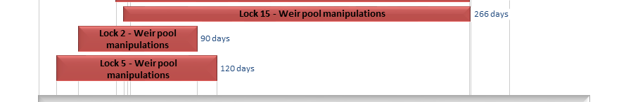
Figure LWM2. Timing and duration of Commonwealth environmental water actions delivered in the Lower Murray valley.

Contribution of Commonwealth Environmental Water to Flow Regimes
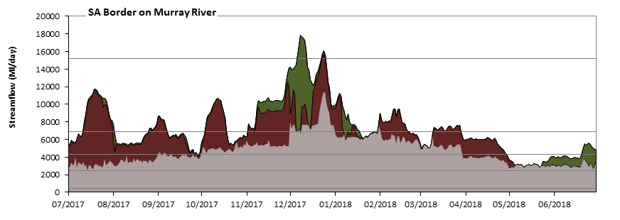
SA Border

Figure LWM3: Contribution of environmental water delivery at SA Border. Horizontal lines indicate thresholds for very low flows, medium low flows, low freshes, medium freshes and high freshes (from lowest to highest).
At SA Border on Murray River environmental water contributed 36% of the total streamflow volume. Environmental watering actions affected streamflows for 96% of days between 1 July 2017 and 30 June 2018. Flow regulation does not substantially increase the duration of very low flows (i.e. < 430 Ml/day) compared to an average year in the natural flow regime. Flow regulation does not substantially increase the duration of medium low flows (i.e. < 2500 Ml/day) compared to an average year in the natural flow regime. In the absence of environmental water there would have been at least one low fresh (i.e. > 4100 Ml/day) in the periods October to December and January to March. Environmental water increased the duration of the longest low fresh during the periods July to September (from 0 days to 22 days), October to December (from 31 days to 60 days) and January to March (from 7 days to 31 days). In the absence of environmental water there would have been no medium (i.e. <6600 Ml/day) or high (i.e. <1400 Ml/day) freshes this year. Environmental water increased the duration of the longest high fresh during the period October to December (from 0 days to 10 days). Environmental water increased the duration of the longest medium fresh during the period October to December (from 0 days to 10 days).
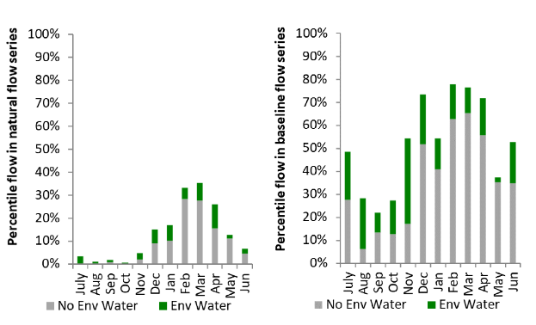
Figure LWM4: Contribution of environmental water delivery at SA Border as percentiles in the natural and baseline flow series.
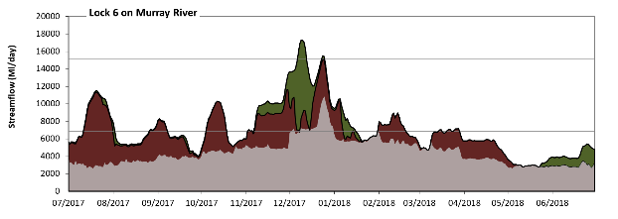
Lock 6

Figure LWM5: Contribution of environmental water delivery at Lock 6. Horizontal lines indicate thresholds for very low flows, medium low flows, low freshes, medium freshes and high freshes (from lowest to highest).
At Lock 6 on Murray River environmental water contributed 38% of the total streamflow volume. Environmental watering actions affected streamflows for 97% of days between 1 July 2017 and 30 June 2018. Flow regulation does not substantially increase the duration of very low flows (i.e. < 430 Ml/day) compared to an average year in the natural flow regime. Flow regulation does not substantially increase the duration of medium low flows (i.e. < 2500 Ml/day) compared to an average year in the natural flow regime. In the absence of environmental water there would have been at least one low fresh (i.e. > 6900 Ml/day) in the period October to December. Environmental water increased the duration of the longest low fresh during the periods July to September (from 0 days to 22 days), October to December (from 16 days to 55 days) and January to March (from 0 days to 19 days). In the absence of environmental water there would have been no medium or high freshes this year. Environmental water increased the duration of the longest medium fresh during the period October to December (from 0 days to 6 days).
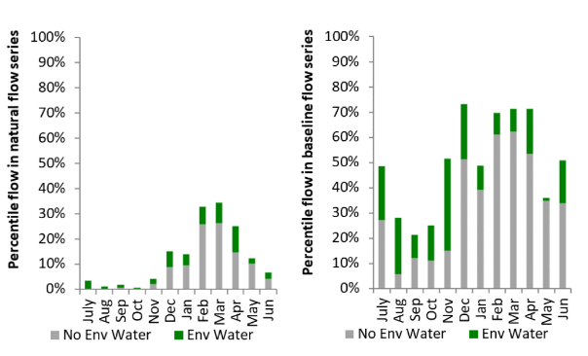
Figure LWM6: Contribution of environmental water delivery at Lock 6 as percentiles in the natural and baseline flow series.

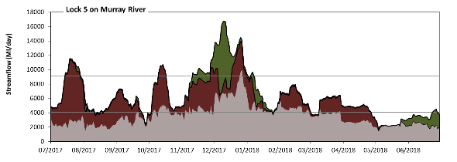
Lock 5

Figure LWM7: Contribution of environmental water delivery at Lock 5. Horizontal lines indicate thresholds for very low flows, medium low flows and low freshes (from lowest to highest).
At Lock 5 on Murray River environmental water contributed 44% of the total streamflow volume. Environmental watering actions affected streamflows for 100% of days between 1 July 2017 and 30 June 2018. Flow regulation does not substantially increase the duration of very low flows (i.e. < 700 Ml/day) compared to an average year in the natural flow regime. However, without environmental water, the durations of medium low flows (i.e. < 4100 Ml/day) in the periods July to September, October to December, January to March and April to June would have all substantially exceeded durations expected in an average year in the natural flow regime. Environmental water mitigated these impacts by reducing the cumulative duration of medium low flow spells from 66% to 23% of the year, with greatest influence in the period July to September. In the absence of environmental water there would have been at least one low fresh (i.e. > 9100 Ml/day) in the period October to December. Environmental water increased the duration of the longest low fresh during the periods July to September (from 0 days to 14 days), October to December (from 3 days to 51 days) and January to March (from 0 days to 3 days). There were no medium or high freshes this year.
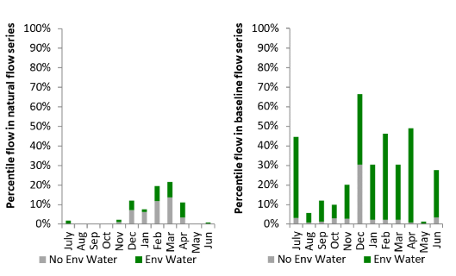
Figure LWM8: Contribution of environmental water delivery at Lock 5 as percentiles in the natural and baseline flow series.
Lock 4
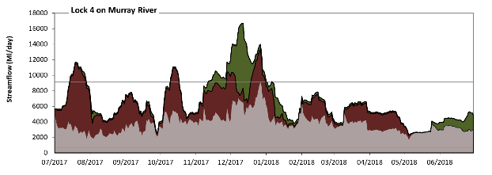
Figure LWM9: Contribution of environmental water delivery at Lock 4. Horizontal lines indicate thresholds for very low flows, medium low flows and low freshes (from lowest to highest).
At Lock 4 on Murray River environmental water contributed 43% of the total streamflow volume. Environmental watering actions affected streamflows for 100% of days between 1 July 2017 and 30 June 2018. Flow regulation does not substantially increase the duration of very low flows (i.e. < 700 Ml/day) compared to an average year in the natural flow regime. However, without environmental water, the durations of medium low flows (i.e. < 4100 Ml/day) in the periods July to September, October to December, January to March and April to June would have all substantially exceeded durations expected in an average year in the natural flow regime. Environmental water mitigated these impacts by reducing the cumulative duration of medium low flow spells from 67% to 15% of the year, with greatest influence in the periods July to September and April to June. In the absence of environmental water there would have been at least one low fresh (i.e. > 9100 Ml/day) in the period October to December. Environmental water increased the duration of the longest low fresh during the periods July to September (from 0 days to 14 days), October to December (from 1 days to 50 days) and January to March (from 0 days to 1 days). There were no medium or high freshes this year.
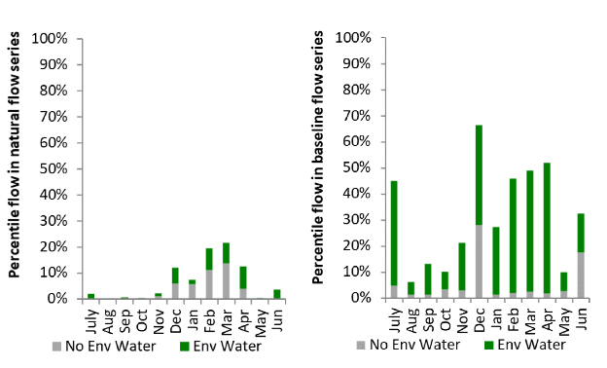
Figure LWM10: Contribution of environmental water delivery at Lock 4 as percentiles in the natural and baseline flow series.
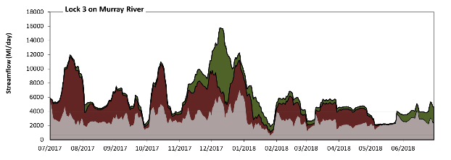
Lock 3
Figure LWM11: Contribution of environmental water delivery at Lock 3. Horizontal lines indicate thresholds for very low flows, medium low flows and low freshes (from lowest to highest).
At Lock 3 on Murray River environmental water contributed 52% of the total streamflow volume. Environmental watering actions affected streamflows for 100% of days between 1 July 2017 and 30 June 2018. Flow regulation does not substantially increase the duration of very low flows (i.e. < 690 Ml/day) compared to an average year in the natural flow regime. However, without environmental water, the durations of medium low flows (i.e. < 3900 Ml/day) in the periods July to September, October to December, January to March and April to June would have all substantially exceeded durations expected in an average year in the natural flow regime. Environmental water mitigated these impacts by reducing the cumulative duration of medium low flow spells from 86% to 22% of the year, with greatest influence in the periods July to September and January to March. Environmental water increased the duration of the longest low fresh during the periods July to September (from 0 days to 17 days), October to December (from 0 days to 34 days) and January to March (from 0 days to 2 days). There were no medium or high freshes this year.
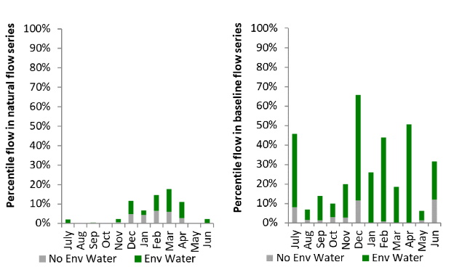
Figure LWM12: Contribution of environmental water delivery at Lock 3 as percentiles in the natural and baseline flow series.

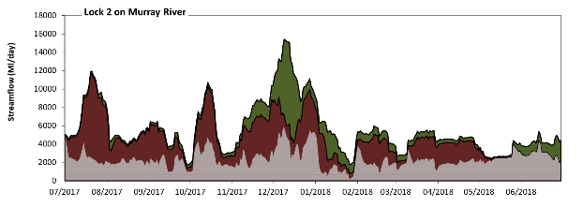
Lock 2
Figure LWM13: Contribution of environmental water delivery at Lock 2. Horizontal lines indicate thresholds for very low flows, low flows and low freshes (from lowest to highest).
At Lock 2 on Murray River environmental water contributed 58% of the total streamflow volume. Environmental watering actions affected streamflows for 100% of days between 1 July 2017 and 30 June 2018. Flow regulation does not substantially increase the duration of very low flows (i.e. < 690 Ml/day) compared to an average year in the natural flow regime. However, without environmental water, the durations of medium low flows (i.e. < 3800 Ml/day) in the periods July to September, October to December, January to March and April to June would have all substantially exceeded durations expected in an average year in the natural flow regime. Environmental water mitigated these impacts by reducing the cumulative duration of medium low flow spells from 90% to 20% of the year, with greatest influence in the periods July to September and January to March. Environmental water increased the duration of the longest low fresh during the periods July to September (from 0 days to 15 days), October to December (from 0 days to 22 days) and January to March (from 0 days to 1 days). However, environmental water increased peak flows substantially below the medium fresh threshold.
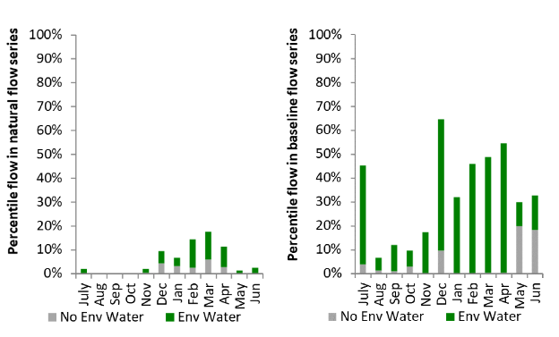
Figure LWM14: Contribution of environmental water delivery at Lock 2 as percentiles in the natural and baseline flow series.

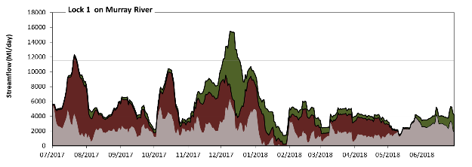
Lock 1
Figure LWM15: Contribution of environmental water delivery at Lock 1. Horizontal lines indicate thresholds for very low medium lows, low flows, low freshes, medium freshes and high freshes (from lowest to highest).
At Lock 1 on Murray River environmental water contributed 60% of the total streamflow volume. Environmental watering actions affected streamflows for 100% of days between 1 July 2017 and 30 June 2018. Without environmental water, the duration of very low flows (i.e. < 690 Ml/day) in the period January to March would have substantially exceeded durations expected in an average year in the natural flow regime. Environmental water mitigated these impacts by reducing the cumulative duration of very low flow spells from 8% to 0% of the year, with greatest influence in the period January to March. Similarly, without environmental water, the duration of medium low flows (i.e. < 900 Ml/day) in the period January to March would have substantially exceeded durations expected in an average year in the natural flow regime. Environmental water mitigated these impacts by reducing the cumulative duration of medium low flow spells from 10% to 0% of the year, with greatest influence in the period January to March. In the absence of environmental water there would have been at least one low fresh (i.e. > 4000 Ml/day) in the periods July to September, October to December, January to March and April to June. Environmental water increased the duration of the longest low fresh during the periods July to September (from 3 days to 46 days), October to December (from 9 days to 58 days), January to March (from 2 days to 23 days) and April to June (from 1 days to 9 days). In the absence of environmental water there would have been no medium or high freshes this year. Environmental water increased the duration of the longest high fresh during the periods July to September (from 0 days to 4 days) and October to December (from 0 days to 15 days). Environmental water increased the duration of the longest medium fresh during the periods July to September (from 0 days to 4 days) and October to December (from 0 days to 15 days).
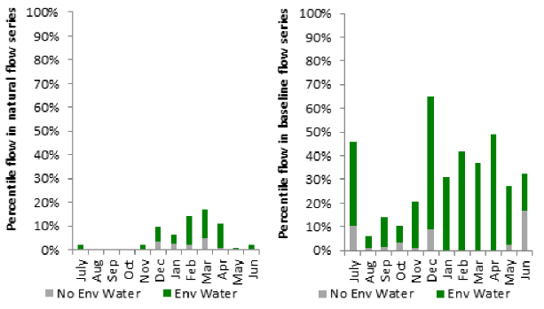
Figure LWM16: Contribution of environmental water delivery at Lock 1 as percentiles in the natural and baseline flow series.

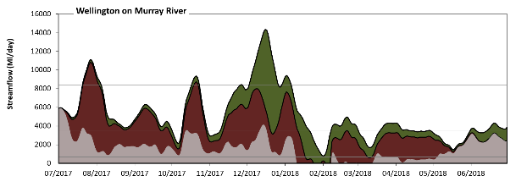
Wellington
Figure LWM17: Contribution of environmental water delivery at Wellington. Horizontal lines indicate thresholds for very low flows, medium low flows and low freshes (from lowest to highest).
At Wellington on Murray River environmental water contributed 71% of the total streamflow volume. Environmental watering actions affected streamflows for 100% of days between 1 July 2017 and 30 June 2018. Without environmental water, the durations of very low flows (i.e. < 690 Ml/day) in the periods January to March and April to June would have substantially exceeded durations expected in an average year in the natural flow regime. Environmental water mitigated these impacts by reducing the cumulative duration of very low flow spells from 27% to 0% of the year, with greatest influence in the periods January to March and April to June. Similarly, without environmental water, the durations of medium low flows (i.e. < 3500 Ml/day) in the periods July to September, October to December, January to March and April to June would have all substantially exceeded durations expected in an average year in the natural flow regime. Environmental water mitigated these impacts by reducing the cumulative duration of medium low flow spells from 95% to 31% of the year, with greatest influence in the periods July to September and October to December. Environmental water increased the magnitude of flows below this medium low flow threshold. Environmental water increased the duration of the longest low fresh during the periods July to September (from 0 days to 15 days), October to December (from 0 days to 24 days) and January to March (from 0 days to 5 days).
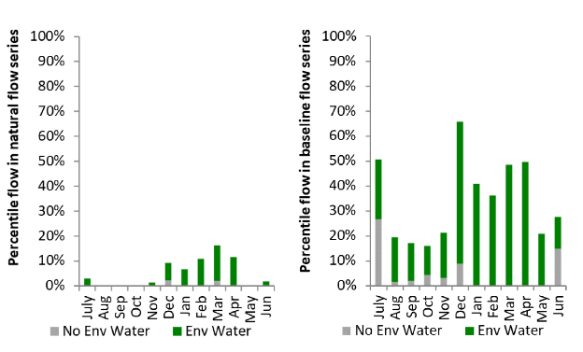
Figure LWM18: Contribution of environmental water delivery at Wellington as percentiles in the natural and baseline flow series.

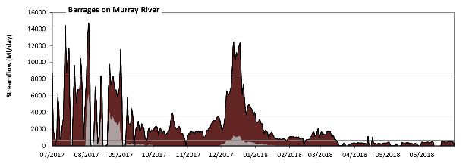
Barrages
Figure LWM19: Contribution of environmental water delivery at Barrages. Horizontal lines indicate thresholds for very low flows, low flows and low freshes (from lowest to highest).
At Barrages on Murray River environmental water contributed 89% of the total streamflow volume (all of which was Commonwealth environmental water). Environmental watering actions affected streamflows for 93% of days between 1 July 2017 and 30 June 2018. Without environmental water, the durations of very low flows (i.e. < 690 Ml/day) in the periods July to September, October to December, January to March and April to June would have all substantially exceeded durations expected in an average year in the natural flow regime. Environmental water mitigated these impacts by reducing the cumulative duration of very low flow spells from 91% to 34% of the year, with greatest influence in the periods July to September, October to December and January to March. Similarly, without environmental water, the durations of medium low flows (i.e. < 3500 Ml/day) in the periods July to September, October to December, January to March and April to June would have all substantially exceeded durations expected in an average year in the natural flow regime. Environmental water mitigated these impacts by reducing the cumulative duration of medium low flow spells from 98% to 80% of the year, with greatest influence in the periods July to September and October to December. Commonwealth environmental water was entirely responsible for these enhancements of environmental baseflows at this site. Environmental water increased the duration of the longest low fresh during the periods July to September (from 0 days to 5 days) and October to December (from 0 days to 9 days). Commonwealth environmental water was entirely responsible for these increased durations of low freshes. However, environmental water increased peak flows substantially below the medium fresh threshold.
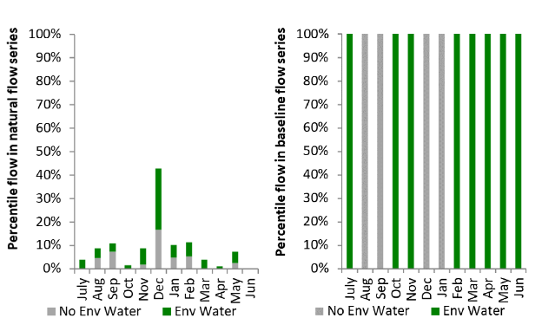
Figure LWM20: Contribution of environmental water delivery at Barrages as percentiles in the natural and baseline flow series.

Macquarie
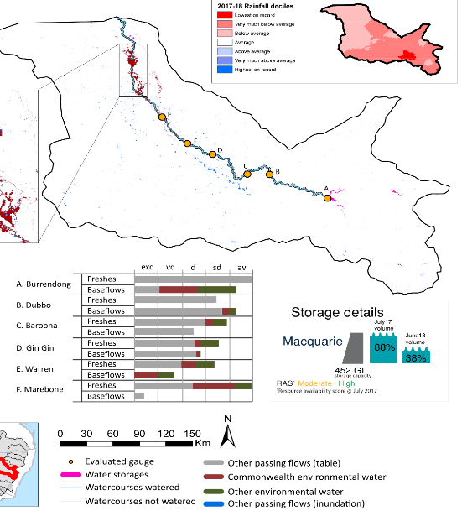
Figure MCQ1: Watercourses influenced, areas inundated (where applicable) and gauge stations evaluated in the Macquarie valley during the 2017–18 water year. Inset bar graphs report the condition of annual flow regimes by showing the improvements in hydrological condition with the addition of environmental water as well as the hypothetical scenario in “grey” (if no environmental flow had been delivered); where exd=extremely dry, vd=very dry, d=dry, sd=somewhat dry and av=average. Rainfall conditions (rainfall deciles) and trend in storage levels for the water year are also shown.

Summary
The volume of environmental water delivery for the 2017–18 year in the Macquarie valley is quantified using data for 7 sites. This evaluation only considers the contribution of held environmental water, which is a primary focus for the Commonwealth. The contributions of planned environmental water (e.g. passing flows), unregulated tributary inflows and clever use of irrigation flows for environmental benefits can all be very important but these are outside the scope of this report. Environmental watering actions lasted on average 100 days over the course of the year. The volume of environmental water at these 7 sites was between 0% and 94% of the total streamflow. Commonwealth environmental water contributed on average 36% of this environmental water. The contribution of environmental water delivery to improved flow regimes is evaluated using data for 6 sites. Ideally, baseflows should be maintained and long periods of excessively low flows avoided. In this valley, the baseflow regime was generally considered to be very dry relative to the pre-development flow regime. In our analysis, a low fresh refers to a period of increased flow, when the water level rises at least one eighth of the way up the river bank (above the low flow level). These low freshes are a regular part of the natural flow regime and support a range of natural processes. In the Macquarie valley, in terms of the occurrence and duration of low freshes, the year was assessed as being average. In our analysis, a medium fresh refers to a period of increased flow, when the water level rises at least one quarter of the way up the river bank. These medium freshes are not as frequent as low freshes but are also a regular and important part of the natural flow regime. In the Macquarie valley, in terms of the occurrence of medium freshes, the year was assessed as being average. In our analysis, a high fresh refers to a period of increased flow, when the water level rises more than half way up the river. A high fresh may not occur every year but they are still important and long periods without major freshes can have serious consequences for floodplains and their contribution to river ecosystem health. Delivering environmental high in channel flows normally requires that all risks to riparian landholders and infrastructure have been resolved. In the Macquarie valley, in terms of the occurrence of high freshes, the year was assessed as being very dry.

Water delivery context
During the 2017–18, the Commonwealth Environmental Water Holder (CEWH) held water entitlements of up to 134,516 Ml for environmental use in the Macquarie valley. Each year, water utilities allocate water entitlement holders a percentage of water based on their holding, license type and carryover (the exact rules vary among Jurisdictions). In 2017-18, the Macquarie entitlements held by the CEWH were allocated 47,965 Ml of water, representing 88% of the Long-term average annual yield for the Macquarie valley (54,755 Ml). Information and data relating to the portfolio of held Commonwealth environmental water is shown in Table MCQ2.
The 2017-18 water allocation (47,965 Ml) together with the carryover volume of 78,955 Ml of water meant the CEWH had 126,508 Ml of water available for delivery. A total of 50,660 Ml of Commonwealth environmental water was delivered in the Macquarie valley. A total of 0 Ml of Commonwealth environmental water was traded to consumptive users and 74893 Ml (59%) of available Commonwealth environmental water was carried over for environmental use into the 2018–19 water year.

Environmental conditions and resource availability
The water available for environmental delivery combined with the present and antecedent environmental conditions are key inputs used by environmental water managers in planning and implementing watering actions. Post hoc, this information provides important context when evaluating the effectiveness and appropriateness of environmental water use with respect to hydrological outputs.
The rainfall conditions in the Macquarie valley were classified as Below Average, based on rainfall percentile data for the entire record held by the Bureau of Meteorology for this valley. The water held in major storages in the Macquarie valley decreased over the water year, for example Burrendong dam was 88% full at the beginning of the water year and 38% full by the end of the year (Figure MCQ1).
The Commonwealth Environmental Water Office (CEWO) calculates resource availability scenarios (RAS) to guide the use and prioritisation of held environmental water. The RAS are progressively calculated over the year as part of the continual adaptive management planning processes. The RAS are based on the availability of held environmental water (including progressive license acquisitions and allocations) as well as the potential for unregulated or planned environmental flows. The outcome is then used to determine the demand for environmental water across the basin.
In 2017-18, the resource availability of held Commonwealth environmental water was classified as moderate to high in this valley. The physical conditions meant that the CEWO was managing to maintain and improve the health and resilience of aquatic ecosystems in the Macquarie River and Macquarie Marshes. The overall demand for environmental water was deemed high.

Watering actions
A total of 2 watering actions were delivered over the 2017–18 water year, the duration of these actions varied (range of individual actions: 26 - 89 days) and Commonwealth environmental water was delivered for a total of 115 days. The count of actions commencing in each season was; winter (2). The flow component types delivered were; (1) baseflow and (1) fresh / wetland.
Commonwealth environmental water was delivered in the Macquarie valley for specified objectives. Although the majority of watering actions were delivered for Fish purposes, water was also delivered for other purposes too. The percentage of watering actions delivered across the nine main themes included fish (16.67%), vegetation (17%), waterbirds (17%), frogs (0%), other biota (17%), connectivity (17%), process (17%), resilience (0%) and water quality (0%).
Table MCQ2. Commonwealth environmental water accounting information for the Macquarie valley over 2017–18 water year.
Total registered volume (Ml) | Allocated volume (Ml) | Carry over + allocated volume (Ml) | Delivered (Ml) | LTAAY (Ml) | Trade (Ml) | Carried over to 2018-19 | Forfeited (Ml)
134,516¹ | 47,965 | 126,508 | 50,660 | 54,755 | 0 | 74,893 | 0
¹Includes 8,292 Ml of supplementary water which is only available by announcement.
Figure MCQ2. Timing and duration of Commonwealth environmental water actions delivered in the Macquarie valley.

Contribution of Commonwealth Environmental Water to Flow Regimes
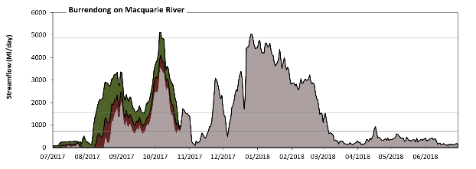
Burrendong

Figure MCQ3: Contribution of environmental water delivery at Burrendong. Horizontal lines indicate thresholds for very low flows, low flows, low freshes, medium freshes and high freshes (from lowest to highest).
At Burrendong on Macquarie River environmental water contributed 23% of the total streamflow volume (with a medium contribution of Commonwealth environmental water). Environmental watering actions affected streamflows for 32% of days between 1 July 2017 and 30 June 2018. Without environmental water, the duration of very low flows (i.e. < 55 Ml/day) in the period July to September would have substantially exceeded durations expected in an average year in the natural flow regime. Environmental water mitigated these impacts by reducing the cumulative duration of very low flow spells from 11% to 0% of the year, with greatest influence in the period July to September. Similarly, without environmental water, the duration of medium low flows (i.e. < 270 Ml/day) in the period July to September would have substantially exceeded durations expected in an average year in the natural flow regime. Environmental water mitigated these impacts by reducing the cumulative duration of medium low flow spells from 27% to 22% of the year, with greatest influence in the period July to September. Environmental water increased the magnitude of flows below this medium low flow threshold. Commonwealth environmental water equally shared responsibility with other environmental water holders for these enhancements of environmental baseflows at this site. In the absence of environmental water there would have been at least one low fresh (i.e. > 720 Ml/day) in the periods July to September, October to December, January to March and April to June. Environmental water increased the duration of the longest low fresh during the periods July to September (from 20 days to 55 days) and October to December (from 26 days to 33 days). Commonwealth environmental water equally shared responsibility with other environmental water holders for these increased durations of low freshes. In the absence of environmental water there would have been at least one medium fresh (i.e. > 1500 Ml/day) in the periods July to September, October to December and January to March. Environmental water increased the duration of the longest medium fresh during the period July to September (from 3 days to 43 days). Commonwealth environmental water made a modest contribution to these increased durations of medium freshes. In the absence of environmental water there would have been at least one high fresh in the period October to December. Environmental water made no change to the duration of these high freshes.
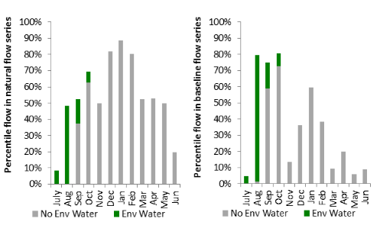
Figure MCQ4: Contribution of environmental water delivery at Burrendong as percentiles in the natural and baseline flow series.
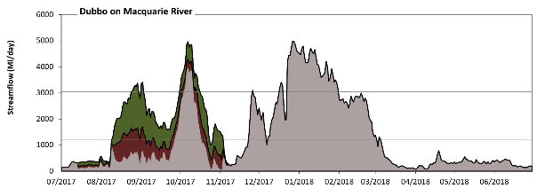
Dubbo

Figure MCQ5: Contribution of environmental water delivery at Dubbo. Horizontal lines indicate thresholds for very low flows, low flows, low freshes and medium freshes (from lowest to highest).
At Dubbo on Macquarie River environmental water contributed 23% of the total streamflow volume (with a medium contribution of Commonwealth environmental water). Environmental watering actions affected streamflows for 32% of days between 1 July 2017 and 30 June 2018. Flow regulation does not substantially increase the duration of very low flows (i.e. < 68 Ml/day) compared to an average year in the natural flow regime. However, without environmental water, the durations of medium low flows (i.e. < 340 Ml/day) in the periods July to September and April to June would have substantially exceeded durations expected in an average year in the natural flow regime. Environmental water mitigated these impacts by reducing the cumulative duration of medium low flow spells from 35% to 25% of the year, with greatest influence in the periods July to September and October to December. Commonwealth environmental water equally shared responsibility with other environmental water holders for these enhancements of environmental baseflows at this site. In the absence of environmental water there would have been at least one low fresh (i.e. > 1200 Ml/day) in the periods July to September, October to December and January to March. Environmental water increased the duration of the longest low fresh during the period July to September (from 4 days to 52 days). Commonwealth environmental water made a modest contribution to these increased durations of low freshes. In the absence of environmental water there would have been at least one medium fresh (i.e. > 3000 Ml/day) in the periods October to December and January to March. Environmental water increased the duration of the longest medium fresh during the periods July to September (from 0 days to 6 days) and October to December (from 9 days to 16 days). Commonwealth environmental water equally shared responsibility with other environmental water holders for these increased durations of medium freshes. There was no high freshes (i.e. > 12000 Ml/day) this year.
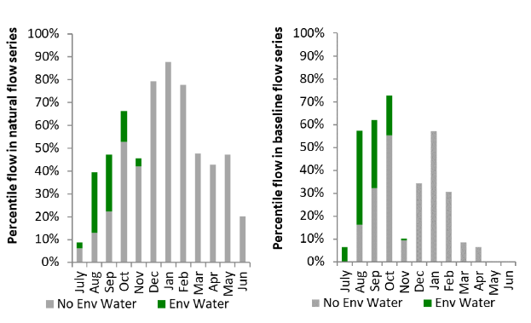
Figure MCQ6: Contribution of environmental water delivery at Dubbo as percentiles in the natural and baseline flow series.

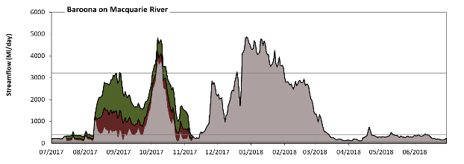
Baroona

Figure MCQ7: Contribution of environmental water delivery at Baroona. Horizontal lines indicate thresholds for very low flows, low flows, low freshes and medium freshes (from lowest to highest).
At Baroona on Macquarie River environmental water contributed 23% of the total streamflow volume (with a medium contribution of Commonwealth environmental water). Environmental watering actions affected streamflows for 32% of days between 1 July 2017 and 30 June 2018. Flow regulation does not substantially increase the duration of very low flows (i.e. < 77 Ml/day) compared to an average year in the natural flow regime. However, without environmental water, the durations of medium low flows (i.e. < 390 Ml/day) in the periods July to September and April to June would have substantially exceeded durations expected in an average year in the natural flow regime. Environmental water mitigated these impacts by reducing the cumulative duration of medium low flow spells from 47% to 39% of the year, with greatest influence in the periods July to September and October to December. Commonwealth environmental water equally shared responsibility with other environmental water holders for these enhancements of environmental baseflows at this site. In the absence of environmental water there would have been at least one low fresh (i.e. > 1300 Ml/day) in the periods July to September, October to December and January to March. Environmental water increased the duration of the longest low fresh during the period July to September (from 2 days to 51 days). Commonwealth environmental water made a small contribution to these increased durations of low freshes. In the absence of environmental water there would have been at least one medium fresh (i.e. > 3200 Ml/day) in the periods October to December and January to March. Environmental water increased the duration of the longest medium fresh during the periods July to September (from 0 days to 1 days) and October to December (from 8 days to 13 days). Commonwealth environmental water equally shared responsibility with other environmental water holders for these increased durations of medium freshes. There was no high freshes (i.e. > 12000 Ml/day) this year.
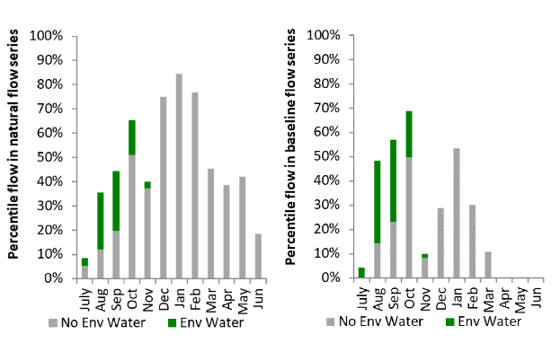
Figure MCQ8: Contribution of environmental water delivery at Baroona as percentiles in the natural and baseline flow series.
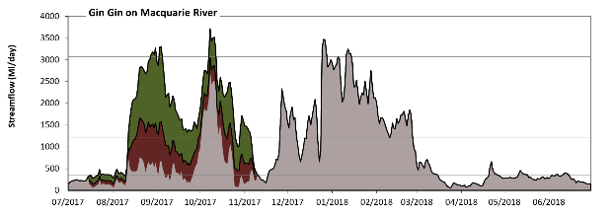
Gin Gin

Figure MCQ9: Contribution of environmental water delivery at Gin Gin. Horizontal lines indicate thresholds for very low flows, low flows, low freshes and medium freshes (from lowest to highest).
At Gin Gin on Macquarie River environmental water contributed 31% of the total streamflow volume (with a medium contribution of Commonwealth environmental water). Environmental watering actions affected streamflows for 32% of days between 1 July 2017 and 30 June 2018. Flow regulation does not substantially increase the duration of very low flows (i.e. < 69 Ml/day) compared to an average year in the natural flow regime. However, without environmental water, the durations of medium low flows (i.e. < 350 Ml/day) in the periods July to September and April to June would have substantially exceeded durations expected in an average year in the natural flow regime. Environmental water mitigated these impacts by reducing the cumulative duration of medium low flow spells from 43% to 32% of the year, with greatest influence in the periods July to September and October to December. Commonwealth environmental water equally shared responsibility with other environmental water holders for these enhancements of environmental baseflows at this site. In the absence of environmental water there would have been at least one low fresh (i.e. > 1200 Ml/day) in the periods October to December and January to March. Environmental water increased the duration of the longest low fresh during the periods July to September (from 0 days to 50 days) and October to December (from 15 days to 25 days). Commonwealth environmental water made a modest contribution to these increased durations of low freshes. In the absence of environmental water there would have been at least one medium fresh (i.e. > 3100 Ml/day) in the periods October to December and January to March. Environmental water increased the duration of the longest medium fresh during the period July to September (from 0 days to 4 days). Commonwealth environmental water equally shared responsibility with other environmental water holders for these increased durations of medium freshes. There was no high freshes (i.e. > 12000 Ml/day) this year.
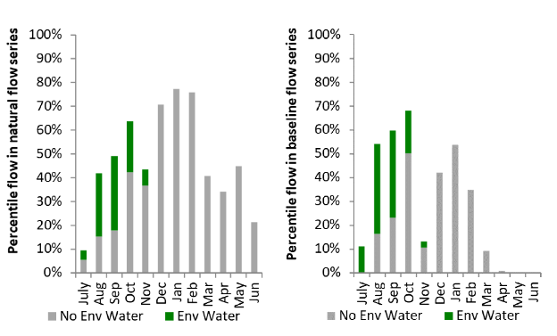
Figure MCQ10: Contribution of environmental water delivery at Gin Gin as percentiles in the natural and baseline flow series.

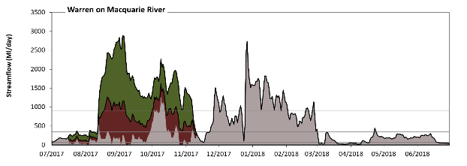
Warren

Figure MCQ11: Contribution of environmental water delivery at Warren. Horizontal lines indicate thresholds for very low flows, low flows, low freshes and medium freshes (from lowest to highest).
At Warren on Macquarie River environmental water contributed 47% of the total streamflow volume (with a medium contribution of Commonwealth environmental water). Environmental watering actions affected streamflows for 32% of days between 1 July 2017 and 30 June 2018. Without environmental water, the durations of very low flows (i.e. < 69 Ml/day) in the periods July to September, January to March and April to June would have substantially exceeded durations expected in an average year in the natural flow regime. Environmental water mitigated these impacts by reducing the cumulative duration of very low flow spells from 21% to 12% of the year, with greatest influence in the period July to September. Similarly, without environmental water, the durations of medium low flows (i.e. < 350 Ml/day) in the periods July to September, October to December and April to June would have substantially exceeded durations expected in an average year in the natural flow regime. Environmental water mitigated these impacts by reducing the cumulative duration of medium low flow spells from 66% to 47% of the year, with greatest influence in the periods July to September and October to December. Commonwealth environmental water equally shared responsibility with other environmental water holders for these enhancements of environmental baseflows at this site. In the absence of environmental water there would have been at least one low fresh (i.e. > 900 Ml/day) in the periods October to December and January to March. Environmental water increased the duration of the longest low fresh during the periods July to September (from 0 days to 49 days) and October to December (from 6 days to 38 days). Commonwealth environmental water equally shared responsibility with other environmental water holders for these increased durations of low freshes. In the absence of environmental water there would have been at least one medium fresh (i.e. > 1900 Ml/day) in the period October to December. Environmental water increased the duration of the longest medium fresh during the periods July to September (from 0 days to 19 days) and October to December (from 3 days to 4 days). Commonwealth environmental water equally shared responsibility with other environmental water holders for these increased durations of medium freshes. There was no high freshes (i.e. > 6000 Ml/day) this year.
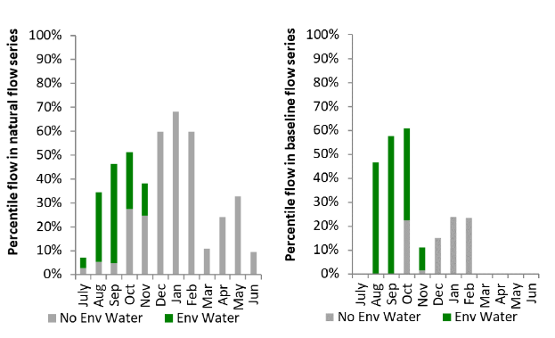
Figure MCQ12: Contribution of environmental water delivery at Warren as percentiles in the natural and baseline flow series.
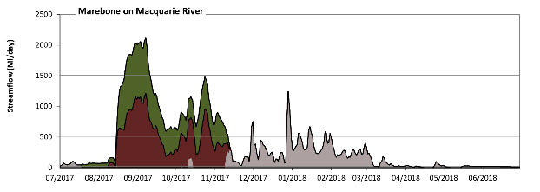
Marebone
Figure MCQ13: Contribution of environmental water delivery at Marebone. Horizontal lines indicate thresholds for very low flows, low flows, low freshes, medium freshes and high freshes (from lowest to highest).
At Marebone on Macquarie River environmental water contributed 94% of the total streamflow volume (much of which was Commonwealth environmental water). Environmental watering actions affected streamflows for 32% of days between 1 July 2017 and 30 June 2018. Without environmental water, the durations of very low flows (i.e. < 20 Ml/day) in the periods July to September, October to December and April to June would have substantially exceeded durations expected in an average year in the natural flow regime. Environmental water mitigated these impacts by reducing the cumulative duration of very low flow spells from 42% to 12% of the year, with greatest influence in the periods July to September and October to December. Similarly, without environmental water, the durations of medium low flows (i.e. < 98 Ml/day) in the periods July to September, October to December, January to March and April to June would have all substantially exceeded durations expected in an average year in the natural flow regime. Environmental water mitigated these impacts by reducing the cumulative duration of medium low flow spells from 68% to 44% of the year, with greatest influence in the periods July to September and October to December. Environmental water increased the magnitude of flows below this medium low flow threshold. Commonwealth environmental water equally shared responsibility with other environmental water holders for these enhancements of environmental baseflows at this site. In the absence of environmental water there would have been at least one low fresh (i.e. > 240 Ml/day) in the periods October to December and January to March. Environmental water increased the duration of the longest low fresh during the periods July to September (from 0 days to 47 days) and October to December (from 7 days to 45 days). Commonwealth environmental water made the dominant contribution to these increased durations of low freshes. In the absence of environmental water there would have been at least one medium fresh (i.e. > 500 Ml/day) in the periods October to December and January to March. Environmental water increased the duration of the longest medium fresh during the periods July to September (from 0 days to 47 days) and October to December (from 4 days to 42 days). Commonwealth environmental water was almost entirely responsible for these increased durations of medium freshes. There was one high fresh (i.e. > 1500 Ml/day) this year. Environmental water increased the duration of the longest high fresh during the period July to September (from 0 days to 20 days). Commonwealth environmental water equally shared responsibility with other environmental water holders for these increased durations of high freshes.
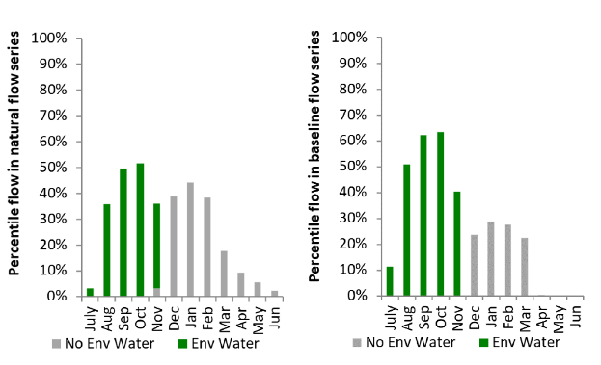
Figure MCQ14: Contribution of environmental water delivery at Marebone as percentiles in the natural and baseline flow series.

Loddon
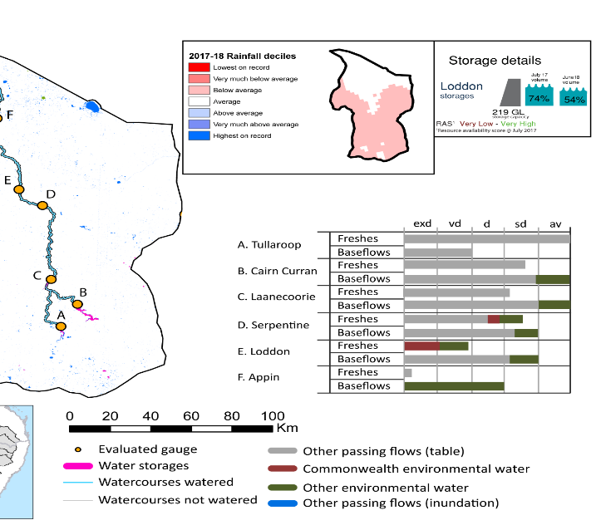
Figure LOD1: Watercourses influenced, areas inundated (where applicable) and gauge stations evaluated in the Loddon valley during the 2017–18 water year. Inset bar graphs report the condition of annual flow regimes by showing the improvements in hydrological condition with the addition of environmental water as well as the hypothetical scenario in “grey” (if no environmental flow had been delivered); where exd=extremely dry, vd=very dry, d=dry, sd=somewhat dry and av=average. Rainfall conditions (rainfall deciles) and trend in storage levels for the water year are also shown.

Summary
The volume of environmental water delivery for the 2017-18 year in the Loddon valley is quantified using data for 6 sites. This evaluation only considers the contribution of held environmental water, which is a primary focus for the Commonwealth. The contributions of planned environmental water (e.g. passing flows), unregulated tributary inflows and clever use of irrigation flows for environmental benefits can all be very important but these are outside the scope of this report. Environmental watering actions lasted on average 214 days over the course of the year. The volume of environmental water at these 6 sites was between 3% and 41% of the total streamflow. Commonwealth environmental water contributed on average 23% of this environmental water. The contribution of environmental water delivery to improved flow regimes is evaluated using data for 6 sites. Ideally, baseflows should be maintained and long periods of excessively low flows avoided. In this valley, the baseflow regime was generally considered to be dry relative to the pre-development flow regime. In our analysis, a low fresh refers to a period of increased flow, when the water level rises at least one eighth of the way up the river bank (above the low flow level). These low freshes are a regular part of the natural flow regime and support a range of natural processes. In the Loddon valley, in terms of the occurrence and duration of low freshes, the year was assessed as being somewhat dry. In our analysis, a medium fresh refers to a period of increased flow, when the water level rises at least one quarter of the way up the river bank. These medium freshes are not as frequent as low freshes but are also a regular and important part of the natural flow regime. In the Loddon valley, in terms of the occurrence of medium freshes, the year was assessed as being somewhat dry. In our analysis, a high fresh refers to a period of increased flow, when the water level rises more than half way up the river. A high fresh may not occur every year but they are still important and long periods without major freshes can have serious consequences for floodplains and their contribution to river ecosystem health. Delivering environmental high in channel flows normally requires that all risks to riparian landholders and infrastructure have been resolved. In the Loddon valley, in terms of the occurrence of high freshes, the year was assessed as being extremely dry.

Water delivery context
During the 2017–18, the Commonwealth Environmental Water Holder (CEWH) held water entitlements of up to 3,883 Ml for environmental use in the Loddon valley. Each year, water utilities allocate water entitlement holders a percentage of water based on their holding, license type and carryover (the exact rules vary among Jurisdictions). In 2017–18, the Loddon entitlements held by the CEWH were allocated 3,356 Ml of water, representing 101% of the Long-term average annual yield for the Loddon valley (3,331 Ml). Information and data relating to the portfolio of held Commonwealth environmental water is shown in Table LOD2.
The 2017–18 water allocation (3,356 Ml) together with the carryover volume of 0 Ml of water meant the CEWH had 3,356 Ml of water available for delivery. A total of 3,095 Ml of Commonwealth environmental water was delivered in the Loddon valley. A total of 0 Ml of Commonwealth environmental water was traded to consumptive users and 287 Ml (9%) of available Commonwealth environmental water was carried over for environmental use into the 2018–19 water year.

Environmental conditions and resource availability
The water available for environmental delivery combined with the present and antecedent environmental conditions are key inputs used by environmental water managers in planning and implementing watering actions. Post hoc, this information provides important context when evaluating the effectiveness and appropriateness of environmental water use with respect to hydrological outputs.
The rainfall conditions in the Loddon valley were classified as Below Average, based on rainfall percentile data for the entire record held by the Bureau of Meteorology for this valley. The water held in major storages in the Loddon valley decreased over the water year, for example Cairn Curran and Tullaroop dam was 75% full at the beginning of the water year and 54% full by the end of the year (Figure LOD1).
The Commonwealth Environmental Water Office (CEWO) calculates resource availability scenarios (RAS) to guide the use and prioritisation of held environmental water. The RAS are progressively calculated over the year as part of the continual adaptive management planning processes. The RAS are based on the availability of held environmental water (including progressive license acquisitions and allocations) as well as the potential for unregulated or planned environmental flows. The outcome is then used to determine the demand for environmental water across the basin.
In 2017–18, the resource availability of held Commonwealth environmental water was classified as very low to very high in this valley, whilst the potential for unregulated or planned environmental flow was classified as . The physical conditions meant that the CEWO was managing to protect and improve the aquatic and riparian vegetation, maintain water quality, and support native fish and other biota via habitat provision. The overall demand for environmental water was deemed high.

Watering actions
One watering action was delivered for 29 days over the 2017–18 water year. The type of flow component delivered was a baseflow and it was delivered in the spring for supporting fish.
Table LOD2. Commonwealth environmental water accounting information for the Loddon valley over 2017-18 water year.
Total registered volume (Ml) | Allocated volume (Ml) | Carry over + allocated volume (Ml) | Delivered (Ml) | LTAAY (Ml) | Trade (Ml) | Carried over to 2018-19 | Forfeited (Ml)
3,883 | 3,356 | 3,356 | 3,095 | 3,331 | 0 | 287 | 15

Figure LOD2. Timing and duration of Commonwealth environmental water actions delivered in the Loddon valley.

Contribution of Commonwealth Environmental Water to Flow Regimes

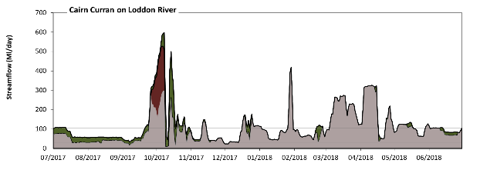
Cairn Curran

Figure LOD3: Contribution of environmental water delivery at Cairn Curran. Horizontal lines indicate thresholds for very low flows, low flows, low freshes and medium freshes (from lowest to highest).
At Cairn Curran on Loddon River environmental water contributed 18% of the total streamflow volume (with a medium contribution of Commonwealth environmental water). Environmental watering actions affected streamflows for 51% of days between 1 July 2017 and 30 June 2018. Flow regulation does not substantially increase the duration of very low flows (i.e. < 6.2 Ml/day) compared to an average year in the natural flow regime. However, without environmental water, the duration of medium low flows (i.e. < 31 Ml/day) in the period July to September would have substantially exceeded durations expected in an average year in the natural flow regime. Environmental water mitigated these impacts by reducing the cumulative duration of medium low flow spells from 9% to 2% of the year, with greatest influence in the period July to September. Commonwealth environmental water made little or no contribution to these enhancements of environmental baseflows at this site. In the absence of environmental water there would have been at least one low fresh (i.e. > 110 Ml/day) in the periods July to September, October to December, January to March and April to June. Environmental water increased the duration of the longest low fresh during the period July to September (from 6 days to 10 days). Commonwealth environmental water made little or no contribution to these increased durations of low freshes. In the absence of environmental water there would have been at least one medium fresh (i.e. > 270 Ml/day) in the periods July to September, October to December, January to March and April to June. Environmental water increased the duration of the longest medium fresh during the periods July to September (from 1 days to 5 days) and October to December (from 3 days to 9 days). Commonwealth environmental water was almost entirely responsible for these increased durations of medium freshes. There was no high freshes (i.e. > 1000 Ml/day) this year.
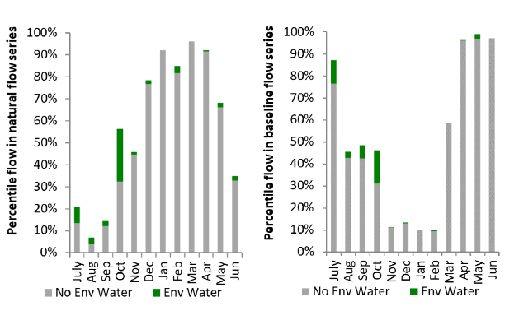
Figure LOD4: Contribution of environmental water delivery at Cairn Curran as percentiles in the natural and baseline flow series.
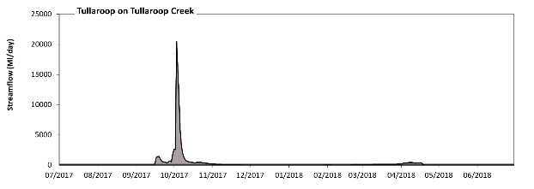
Tullaroop

Figure LOD5: Contribution of environmental water delivery at Tullaroop. Horizontal lines indicate thresholds for very low flows, low flows, low freshes, medium freshes and high freshes (from lowest to highest).
At Tullaroop on Tullaroop Creek environmental water contributed 3% of the total streamflow volume (with a relatively small contribution of Commonwealth environmental water). Environmental watering actions affected streamflows for 38% of days between 1 July 2017 and 30 June 2018. Flow regulation does not substantially increase the duration of very low flows (i.e. < 2.9 Ml/day) compared to an average year in the natural flow regime. However, without environmental water, the duration of medium low flows (i.e. < 14 Ml/day) in the period July to September would have substantially exceeded durations expected in an average year in the natural flow regime. Environmental water reduced the cumulative duration of medium low flow spells from 28% to 22% of the year, with greatest influence in the period October to December. Commonwealth environmental water made little or no contribution to these enhancements of environmental baseflows at this site. There was at least one low fresh (i.e. > 67 Ml/day) in the periods July to September, October to December, January to March and April to June. Environmental water made no change to the duration of these low freshes. There was at least one medium fresh (i.e. > 200 Ml/day) in the periods July to September, October to December and April to June. Environmental water made no change to the duration of these medium freshes. In the absence of environmental water there would have been at least one high fresh in the periods July to September and October to December. Environmental water made no change to the duration of these high freshes.
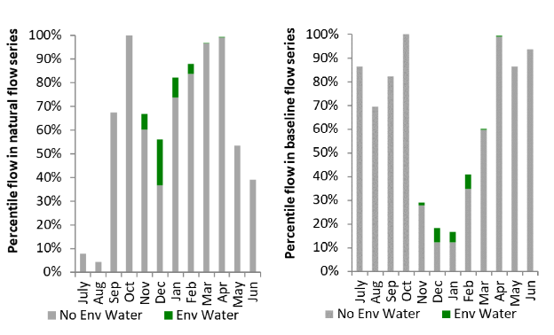
Figure LOD6: Contribution of environmental water delivery at Tullaroop as percentiles in the natural and baseline flow series.

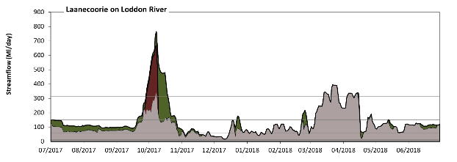
Laanecoorie

Figure LOD7: Contribution of environmental water delivery at Laanecoorie. Horizontal lines indicate thresholds for very low flows, low flows, low freshes and medium freshes (from lowest to highest).
At Laanecoorie on Loddon River environmental water contributed 22% of the total streamflow volume (with a medium contribution of Commonwealth environmental water). Environmental watering actions affected streamflows for 51% of days between 1 July 2017 and 30 June 2018. Flow regulation does not substantially increase the duration of very low flows (i.e. < 12 Ml/day) compared to an average year in the natural flow regime. However, without environmental water, the duration of medium low flows (i.e. < 60 Ml/day) in the period October to December would have substantially exceeded durations expected in an average year in the natural flow regime. Environmental water mitigated these impacts by reducing the cumulative duration of medium low flow spells from 16% to 13% of the year, with greatest influence in the period October to December. Commonwealth environmental water made little or no contribution to these enhancements of environmental baseflows at this site. In the absence of environmental water there would have been at least one low fresh (i.e. > 150 Ml/day) in the periods July to September, October to December, January to March and April to June. Environmental water increased the duration of the longest low fresh during the periods July to September (from 5 days to 11 days) and October to December (from 10 days to 26 days). Commonwealth environmental water made little or no contribution to these increased durations of low freshes. In the absence of environmental water there would have been at least one medium fresh (i.e. > 310 Ml/day) in the periods October to December, January to March and April to June. Environmental water increased the duration of the longest medium fresh during the periods July to September (from 0 days to 2 days) and October to December (from 2 days to 18 days). Commonwealth environmental water made the dominant contribution to these increased durations of medium freshes. There was no high freshes (i.e. > 970 Ml/day) this year.
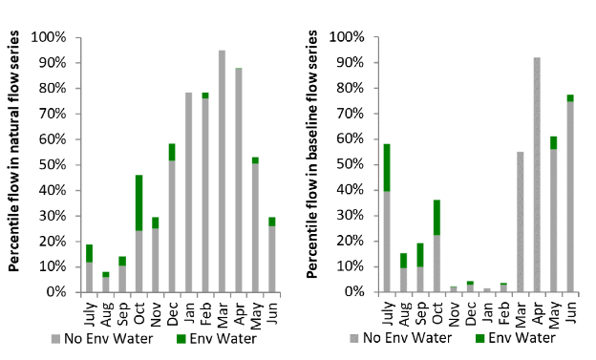
Figure LOD8: Contribution of environmental water delivery at Laanecoorie as percentiles in the natural and baseline flow series.
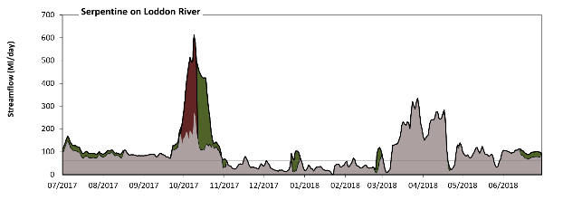
Serpentine

Figure LOD9: Contribution of environmental water delivery at Serpentine. Horizontal lines indicate thresholds for very low flows, low flows, low freshes and medium freshes (from lowest to highest).
At Serpentine on Loddon River environmental water contributed 21% of the total streamflow volume (with a medium contribution of Commonwealth environmental water). Environmental watering actions affected streamflows for 35% of days between 1 July 2017 and 30 June 2018. Flow regulation does not substantially increase the duration of very low flows (i.e. < 12 Ml/day) compared to an average year in the natural flow regime. However, without environmental water, the duration of medium low flows (i.e. < 60 Ml/day) in the period October to December would have substantially exceeded durations expected in an average year in the natural flow regime. Environmental water mitigated these impacts by reducing the cumulative duration of medium low flow spells from 36% to 32% of the year, with greatest influence in the period October to December. Commonwealth environmental water made little or no contribution to these enhancements of environmental baseflows at this site. In the absence of environmental water there would have been at least one low fresh (i.e. > 150 Ml/day) in the periods July to September, October to December, January to March and April to June. Environmental water increased the duration of the longest low fresh during the periods July to September (from 2 days to 3 days) and October to December (from 12 days to 23 days). Commonwealth environmental water made a modest contribution to these increased durations of low freshes. In the absence of environmental water there would have been at least one medium fresh (i.e. > 310 Ml/day) in the period January to March. Environmental water increased the duration of the longest medium fresh during the period October to December (from 0 days to 18 days). Commonwealth environmental water equally shared responsibility with other environmental water holders for these increased durations of medium freshes. There was no high freshes (i.e. > 970 Ml/day) this year.
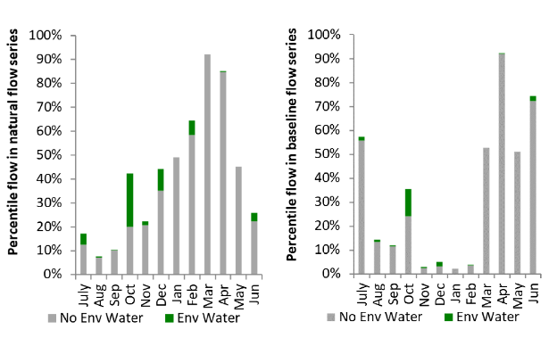
Figure LOD10: Contribution of environmental water delivery at Serpentine as percentiles in the natural and baseline flow series.

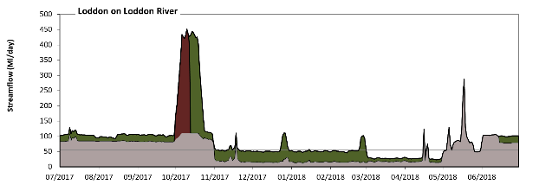
Loddon

Figure LOD11: Contribution of environmental water delivery at Loddon. Horizontal lines indicate thresholds for very low flows, low flows, low freshes and medium freshes (from lowest to highest).
At Loddon on Loddon River environmental water contributed 41% of the total streamflow volume (with a medium contribution of Commonwealth environmental water). Environmental watering actions affected streamflows for 88% of days between 1 July 2017 and 30 June 2018. Flow regulation does not substantially increase the duration of very low flows (i.e. < 11 Ml/day) compared to an average year in the natural flow regime. However, without environmental water, the durations of medium low flows (i.e. < 56 Ml/day) in the periods October to December, January to March and April to June would have substantially exceeded durations expected in an average year in the natural flow regime. Environmental water mitigated these impacts by reducing the cumulative duration of medium low flow spells from 52% to 45% of the year, with greatest influence in the periods October to December and January to March. Environmental water increased the magnitude of flows below this medium low flow threshold. Commonwealth environmental water made little or no contribution to these enhancements of environmental baseflows at this site. In the absence of environmental water there would have been at least one low fresh (i.e. > 150 Ml/day) in the period April to June. Environmental water increased the duration of the longest low fresh during the period October to December (from 0 days to 23 days). Commonwealth environmental water equally shared responsibility with other environmental water holders for these increased durations of low freshes. In the absence of environmental water there would have been no medium or high freshes this year. Environmental water increased the duration of the longest medium fresh during the period October to December (from 0 days to 16 days). Commonwealth environmental water equally shared responsibility with other environmental water holders for these increased durations of medium freshes.
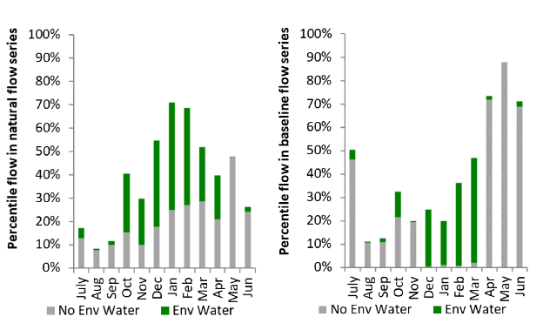
Figure LOD12: Contribution of environmental water delivery at Loddon as percentiles in the natural and baseline flow series.
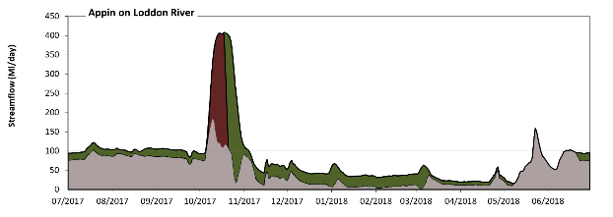
Appin
Figure LOD13: Contribution of environmental water delivery at Appin. Horizontal lines indicate thresholds for very low flows and low flows (from lowest to highest).
At Appin on Loddon River environmental water contributed 39% of the total streamflow volume (with a medium contribution of Commonwealth environmental water). Environmental watering actions affected streamflows for 88% of days between 1 July 2017 and 30 June 2018. Without environmental water, the duration of very low flows (i.e. < 7.9 Ml/day) in the period January to March would have substantially exceeded durations expected in an average year in the natural flow regime. Environmental water mitigated these impacts by reducing the cumulative duration of very low flow spells from 12% to 0% of the year, with greatest influence in the period January to March. Similarly, without environmental water, the durations of medium low flows (i.e. < 100 Ml/day) in the periods July to September, October to December, January to March and April to June would have all substantially exceeded durations expected in an average year in the natural flow regime. Environmental water mitigated these impacts by reducing the cumulative duration of medium low flow spells from 92% to 72% of the year, with greatest influence in the period July to September. Commonwealth environmental water made little or no contribution to these enhancements of environmental baseflows at this site.
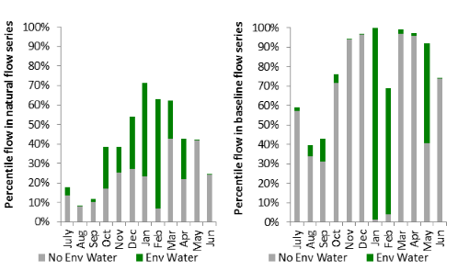
Figure LOD14: Contribution of environmental water delivery at Appin as percentiles in the natural and baseline flow series.

Barwon Darling
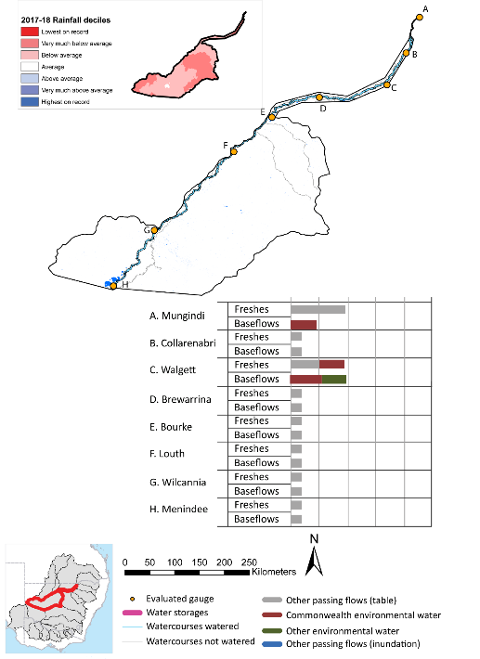
Figure BDL1: Watercourses influenced, areas inundated (where applicable) and gauge stations evaluated in the Barwon Darling valley during the 2017–18 water year. Inset bar graphs report the condition of annual flow regimes by showing the improvements in hydrological condition with the addition of environmental water as well as the hypothetical scenario in “grey” (if no environmental flow had been delivered); where exd=extremely dry, vd=very dry, d=dry, sd=somewhat dry and av=average. Rainfall conditions (rainfall deciles) and trend in storage levels for the water year are also shown.

Summary
The volume of environmental water delivery for the 2017–18 year in the Barwon Darling valley is quantified using data for 6 sites. This evaluation only considers the contribution of held environmental water, which is a primary focus for the Commonwealth. The contributions of planned environmental water (e.g. passing flows), unregulated tributary inflows and clever use of irrigation flows for environmental benefits can all be very important but these are outside the scope of this report. Environmental watering actions lasted on average 52 days over the course of the year. The volume of environmental water at these 6 sites was between 6% and 27% of the total streamflow. Commonwealth environmental water contributed on average 82% of this environmental water. The contribution of environmental water delivery to improved flow regimes is evaluated using data for 6 sites. Ideally, baseflows should be maintained and long periods of excessively low flows avoided. In this valley, the baseflow regime was generally considered to be extremely dry relative to the pre-development flow regime. In our analysis, a low fresh refers to a period of increased flow, when the water level rises at least one eighth of the way up the river bank (above the low flow level). These low freshes are a regular part of the natural flow regime and support a range of natural processes. In the Barwon Darling valley, in terms of the occurrence and duration of low freshes, the year was assessed as being extremely dry. In our analysis, a medium fresh refers to a period of increased flow, when the water level rises at least one quarter of the way up the river bank. These medium freshes are not as frequent as low freshes but are also a regular and important part of the natural flow regime. In the Barwon Darling valley, in terms of the occurrence of medium freshes, the year was assessed as being extremely dry. In our analysis, a high fresh refers to a period of increased flow, when the water level rises more than half way up the river. A high fresh may not occur every year but they are still important and long periods without major freshes can have serious consequences for floodplains and their contribution to river ecosystem health. Delivering environmental high in channel flows normally requires that all risks to riparian landholders and infrastructure have been resolved. In the Barwon Darling valley, in terms of the occurrence of high freshes, the year was assessed as being extremely dry.

Water delivery context
During the 2017–18, the Commonwealth Environmental Water Holder (CEWH) held water entitlements of up to 28,004 Ml for environmental use in the Barwon Darling valley. Each year, water utilities allocate water entitlement holders a percentage of water based on their holding, license type and carryover (the exact rules vary among Jurisdictions). In 2017–18, the Barwon Darling entitlements held by the CEWH were allocated 11,030 Ml of water, representing 39% of the Long-term average annual yield for the Barwon Darling valley (28,004 Ml). Information and data relating to the portfolio of held Commonwealth environmental water is shown in Table BDL2.
The 2017-18 water allocation (11,030 Ml) together with the carryover volume of 0 Ml of water meant the CEWH had 11,030 Ml of water available for delivery. A total of 11,030 Ml of Commonwealth environmental water was delivered in the Barwon Darling valley. A total of 0 Ml of Commonwealth environmental water was traded to consumptive users and 0 Ml (0%) of available Commonwealth environmental water was carried over for environmental use into the 2018–19 water year.

Environmental conditions and resource availability
The water available for environmental delivery combined with the present and antecedent environmental conditions are key inputs used by environmental water managers in planning and implementing watering actions. Post hoc, this information provides important context when evaluating the effectiveness and appropriateness of environmental water use with respect to hydrological outputs.
The rainfall conditions in the Barwon Darling valley were classified as Below Average, based on rainfall percentile data for the entire record held by the Bureau of Meteorology for this valley. The water held in major storages in the Barwon Darling valley decreased over the water year, for example Meninde dam was 44% full at the beginning of the water year and 12% full by the end of the year (Figure BDL1).

Watering actions
A total of 4 watering actions were delivered over the 2017-18 water year, the duration of these actions varied (range of individual actions: 2 - 45 days) and Commonwealth environmental water was delivered for a total of 54 days. The count of actions commencing in each season was; winter (1), spring (1) and summer (2). The flow component types delivered were; (0) baseflow, (4) freshes, (0) bankfull, (0) overbank and (0) wetland.
Commonwealth environmental water was delivered in the Barwon Darling valley for specified objectives. The percentage of watering actions delivered across the nine main themes included fish (33.33%), vegetation (0.0%), waterbirds (0.0%), frogs (0.0%), other biota (0.0%), connectivity (0.0%), process (0.0%), resilience (33.33%) and water quality (33.33%).
Table BDL2. Commonwealth environmental water accounting information for the Barwon Darling valley over 2017–18 water year.
Total registered volume (Ml) | Allocated volume (Ml) | Carry over + allocated volume (Ml) | Delivered (Ml) | LTAAY (Ml) | Trade (Ml) | Carried over to 2018-19 | Forfeited (Ml)
28,004 | 11,030 | 11,030 | 11,030 | 28,004 | 0 | 0 | 0

Figure BDL2. Timing and duration of Commonwealth environmental water actions delivered in the Barwon Darling valley.

Contribution of Commonwealth Environmental Water to Flow Regimes
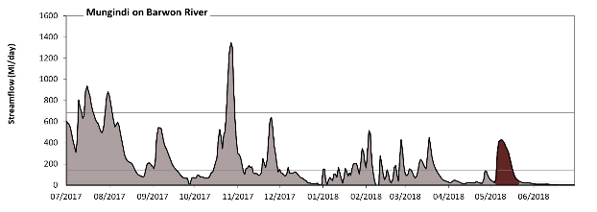
Mungindi

Figure BDL3: Contribution of environmental water delivery at Mungindi. Horizontal lines indicate thresholds for very low flows, low flows and low freshes (from lowest to highest).
At Mungindi on Barwon River environmental water contributed 6% of the total streamflow volume (all of which was Commonwealth environmental water). Environmental watering actions affected streamflows for 5% of days between 1 July 2017 and 30 June 2018. Without environmental water, the duration of very low flows (i.e. < 28 Ml/day) in the period April to June would have substantially exceeded durations expected in an average year in the natural flow regime. Environmental water mitigated these impacts by reducing the cumulative duration of very low flow spells from 26% to 22% of the year, with greatest influence in the period April to June. Similarly, without environmental water, the durations of medium low flows (i.e. < 140 Ml/day) in the periods October to December, January to March and April to June would have substantially exceeded durations expected in an average year in the natural flow regime. Environmental water mitigated these impacts by reducing the cumulative duration of medium low flow spells from 58% to 55% of the year, with greatest influence in the period April to June. Commonwealth environmental water was entirely responsible for these enhancements of environmental baseflows at this site. There was at least one low fresh (i.e. > 690 Ml/day) in the periods July to September and October to December. Environmental water made no change to the duration of these low freshes. There was no medium or high freshes this year.
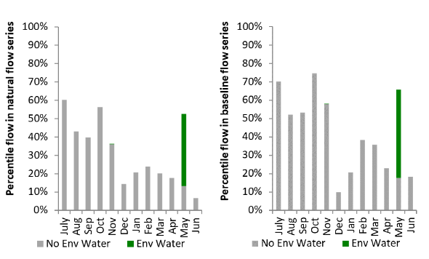
Figure BDL4: Contribution of environmental water delivery at Mungindi as percentiles in the natural and baseline flow series.
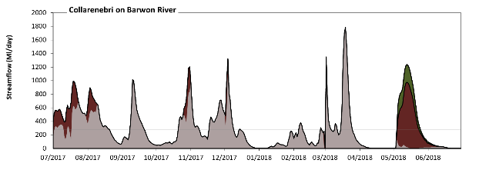
Collarenebri

Figure BDL5: Contribution of environmental water delivery at Collarenebri. Horizontal lines indicate thresholds for very low flows, low flows and low freshes (from lowest to highest).
At Collarenebri on Barwon River environmental water contributed 27% of the total streamflow volume (most of which was Commonwealth environmental water). Environmental watering actions affected streamflows for 24% of days between 1 July 2017 and 30 June 2018. Without environmental water, the durations of very low flows (i.e. < 55 Ml/day) in the periods October to December, January to March and April to June would have substantially exceeded durations expected in an average year in the natural flow regime. Environmental water mitigated these impacts by reducing the cumulative duration of very low flow spells from 35% to 27% of the year, with greatest influence in the period April to June. Similarly, without environmental water, the durations of medium low flows (i.e. < 270 Ml/day) in the periods July to September, October to December, January to March and April to June would have all substantially exceeded durations expected in an average year in the natural flow regime. Environmental water mitigated these impacts by reducing the cumulative duration of medium low flow spells from 67% to 59% of the year, with greatest influence in the period April to June. Commonwealth environmental water made the dominant contribution to these enhancements of environmental baseflows at this site. There was at least one low fresh (i.e. > 1800 Ml/day) in the period January to March. Environmental water made no change to the duration of these low freshes. There was no medium or high freshes this year.
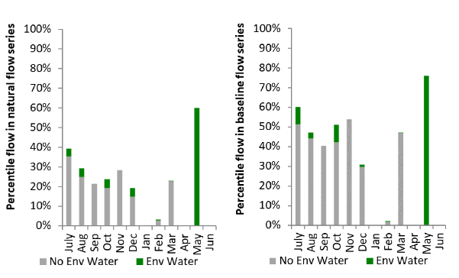
Figure BDL6: Contribution of environmental water delivery at Collarenebri as percentiles in the natural and baseline flow series.

Walgett
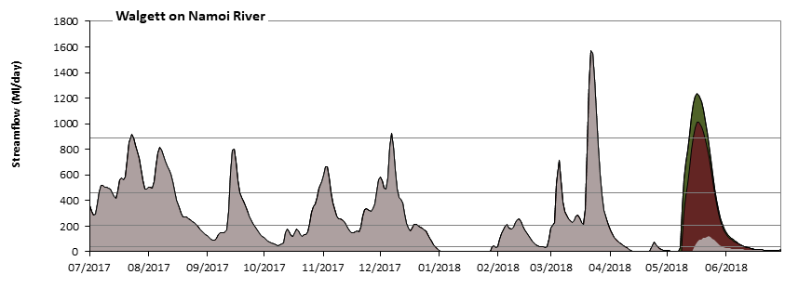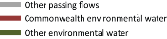
Walgett on Barwon River
Figure BDL7: Contribution of environmental water delivery at Walgett. Horizontal lines indicate thresholds for very low flows, low flows and low freshes (from lowest to highest).
At Walgett on Barwon River environmental water contributed 17% of the total streamflow volume (much of which was Commonwealth environmental water). Environmental watering actions affected streamflows for 11% of days between 1 July 2017 and 30 June 2018. Without environmental water, the durations of very low flows (i.e. < 41 Ml/day) in the periods January to March and April to June would have substantially exceeded durations expected in an average year in the natural flow regime. Environmental water mitigated these impacts by reducing the cumulative duration of very low flow spells from 32% to 23% of the year, with greatest influence in the period April to June. Similarly, without environmental water, the durations of medium low flows (i.e. < 200 Ml/day) in the periods October to December, January to March and April to June would have substantially exceeded durations expected in an average year in the natural flow regime. Environmental water mitigated these impacts by reducing the cumulative duration of medium low flow spells from 58% to 52% of the year, with greatest influence in the period April to June. Commonwealth environmental water made the dominant contribution to these enhancements of environmental baseflows at this site. In the absence of environmental water there would have been at least one low fresh (i.e. > 890 Ml/day) in the periods July to September, October to December and January to March. Environmental water increased the duration of the longest low fresh during the period April to June (from 0 days to 10 days). Commonwealth environmental water was entirely responsible for these increased durations of low freshes. There was no medium or high freshes this year.
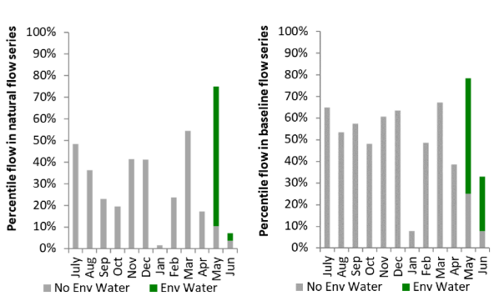
Figure BDL8: Contribution of environmental water delivery at Walgett as percentiles in the natural and baseline flow series.
Brewarrina
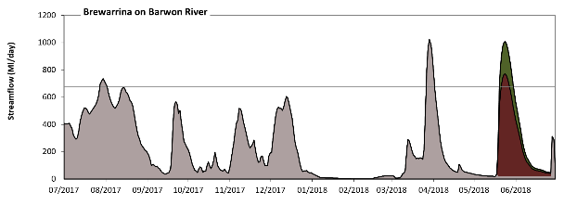
Figure BDL9: Contribution of environmental water delivery at Brewarrina. Horizontal lines indicate thresholds for very low flows and low flows (from lowest to highest).
At Brewarrina on Barwon River environmental water contributed 16% of the total streamflow volume (much of which was Commonwealth environmental water). Environmental watering actions affected streamflows for 11% of days between 1 July 2017 and 30 June 2018. Without environmental water, the durations of very low flows (i.e. < 140 Ml/day) in the periods July to September, October to December, January to March and April to June would have all substantially exceeded durations expected in an average year in the natural flow regime. Environmental water mitigated these impacts by reducing the cumulative duration of very low flow spells from 57% to 50% of the year, with greatest influence in the period April to June. Similarly, without environmental water, the durations of medium low flows (i.e. < 680 Ml/day) in the periods July to September, October to December, January to March and April to June would have all substantially exceeded durations expected in an average year in the natural flow regime. Environmental water mitigated these impacts by reducing the cumulative duration of medium low flow spells from 97% to 94% of the year, with greatest influence in the period April to June. Commonwealth environmental water made the dominant contribution to these enhancements of environmental baseflows at this site.
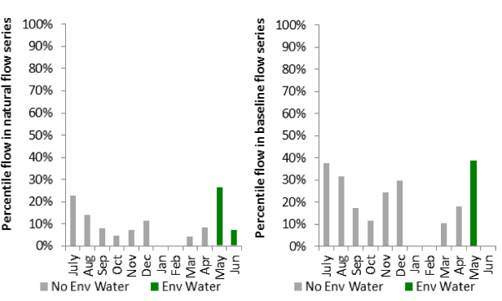
Figure BDL10: Contribution of environmental water delivery at Brewarrina as percentiles in the natural and baseline flow series.

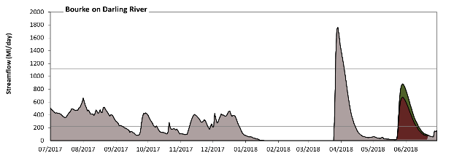
Bourke

Figure BDL11: Contribution of environmental water delivery at Bourke. Horizontal lines indicate thresholds for very low flows and low flows (from lowest to highest).
At Bourke on Darling River environmental water contributed 13% of the total streamflow volume (much of which was Commonwealth environmental water). Environmental watering actions affected streamflows for 21% of days between 1 July 2017 and 30 June 2018. Without environmental water, the durations of very low flows (i.e. < 220 Ml/day) in the periods July to September, October to December, January to March and April to June would have all substantially exceeded durations expected in an average year in the natural flow regime. Environmental water mitigated these impacts by reducing the cumulative duration of very low flow spells from 61% to 55% of the year, with greatest influence in the period April to June. Similarly, without environmental water, the durations of medium low flows (i.e. < 1100 Ml/day) in the periods July to September, October to December, January to March and April to June would have all substantially exceeded durations expected in an average year in the natural flow regime. However, environmental water had little effect on the duration of these medium low flows, which occurred for 98% of the year. Commonwealth environmental water was almost entirely responsible for these enhancements of environmental baseflows at this site.
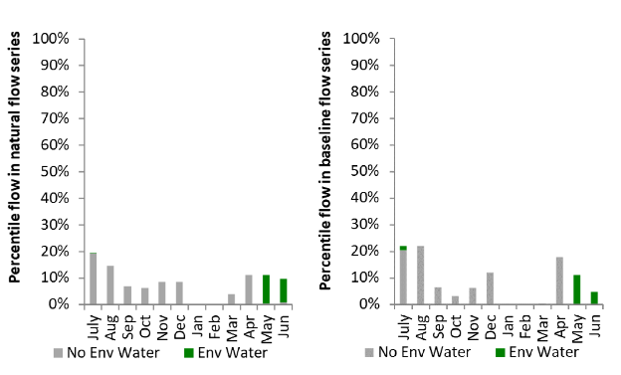
Figure BDL12: Contribution of environmental water delivery at Bourke as percentiles in the natural and baseline flow series.

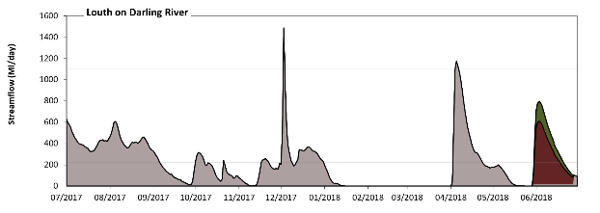
Louth

Figure BDL13: Contribution of environmental water delivery at Louth. Horizontal lines indicate thresholds for very low flows and low flows (from lowest to highest).
At Louth on Darling River environmental water contributed 15% of the total streamflow volume (much of which was Commonwealth environmental water). Environmental watering actions affected streamflows for 21% of days between 1 July 2017 and 30 June 2018. Without environmental water, the durations of very low flows (i.e. < 220 Ml/day) in the periods July to September, October to December, January to March and April to June would have all substantially exceeded durations expected in an average year in the natural flow regime. Environmental water mitigated these impacts by reducing the cumulative duration of very low flow spells from 65% to 59% of the year, with greatest influence in the period April to June. Similarly, without environmental water, the durations of medium low flows (i.e. < 1100 Ml/day) in the periods July to September, October to December, January to March and April to June would have all substantially exceeded durations expected in an average year in the natural flow regime. However, environmental water had little effect on the duration of these medium low flows, which occurred for 99% of the year. Commonwealth environmental water was entirely responsible for these enhancements of environmental baseflows at this site.
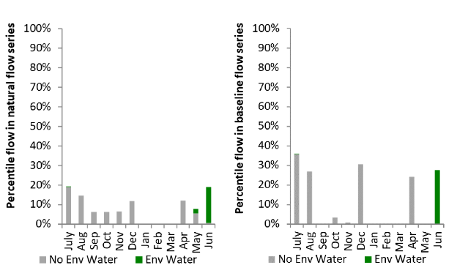
Figure BDL14: Contribution of environmental water delivery at Louth as percentiles in the natural and baseline flow series.

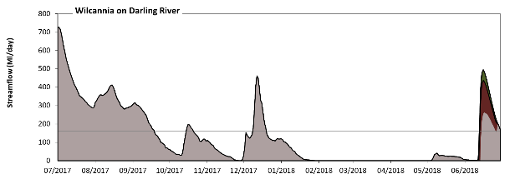
Wilcannia
Figure BDL15: Contribution of environmental water delivery at Wilcannia. Horizontal lines indicate thresholds for very low flows and low flows (from lowest to highest).
At Wilcannia on Darling River environmental water contributed 6% of the total streamflow volume (much of which was Commonwealth environmental water). Environmental watering actions affected streamflows for 4% of days between 1 July 2017 and 30 June 2018. Without environmental water, the durations of very low flows (i.e. < 160 Ml/day) in the periods October to December, January to March and April to June would have substantially exceeded durations expected in an average year in the natural flow regime. Environmental water mitigated these impacts by reducing the cumulative duration of very low flow spells from 69% to 68% of the year, with greatest influence in the period April to June. Similarly, without environmental water, the durations of medium low flows (i.e. < 810 Ml/day) in the periods July to September, October to December, January to March and April to June would have all substantially exceeded durations expected in an average year in the natural flow regime. However, environmental water had little effect on the duration of these medium low flows, which occurred for 100% of the year.
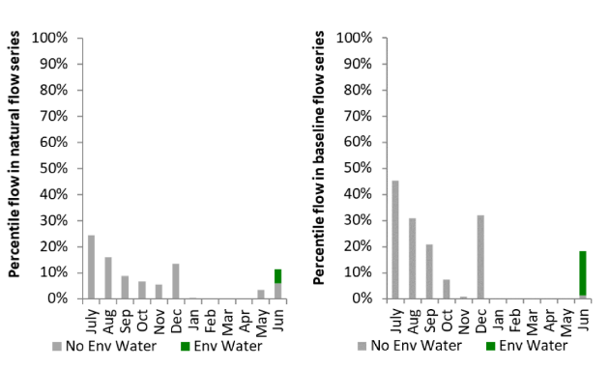
Figure BDL16: Contribution of environmental water delivery at Wilcannia as percentiles in the natural and baseline flow series. Ovens.

Ovens
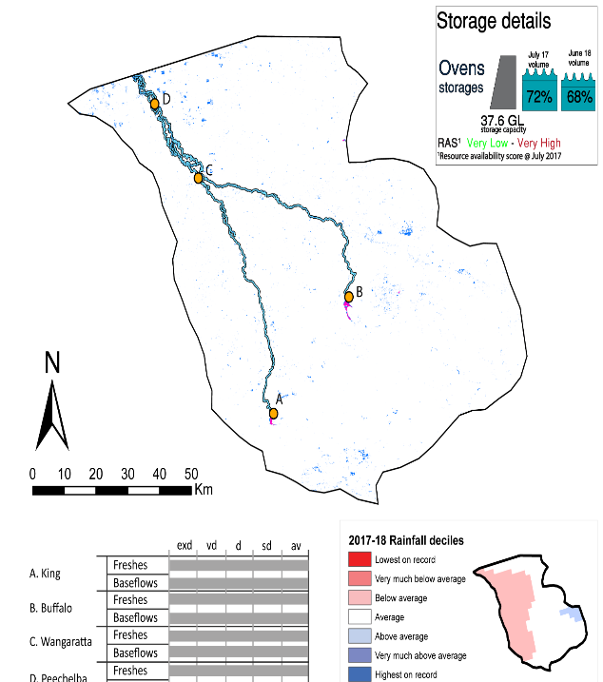Figure OVN1: Watercourses influenced, areas inundated (where applicable) and gauge stations evaluated in the Ovens valley during the 2017–18 water year. Inset bar graphs report the condition of annual flow regimes by showing the improvements in hydrological condition with the addition of environmental water as well as the hypothetical scenario in “grey” (if no environmental flow had been delivered); where exd=extremely dry, vd=very dry, d=dry, sd=somewhat dry and av=average. Rainfall conditions (rainfall deciles) and trend in storage levels for the water year are also shown.

Summary
The volume of environmental water delivery for the 2017–18 year in the Ovens valley is quantified using data for 4 sites. This evaluation only considers the contribution of held environmental water, which is a primary focus for the Commonwealth. The contributions of planned environmental water (e.g. passing flows), unregulated tributary inflows and clever use of irrigation flows for environmental benefits can all be very important but these are outside the scope of this report. Environmental watering actions lasted on average 1 days over the course of the year. The volume of environmental water at these 4 sites was between 0% and 0% of the total streamflow. Commonwealth environmental water contributed on average 50% of this environmental water. The contribution of environmental water delivery to improved flow regimes is evaluated using data for 4 sites. Ideally, baseflows should be maintained and long periods of excessively low flows avoided. In this valley, the baseflow regime was generally considered to be average relative to the pre-development flow regime. In our analysis, a low fresh refers to a period of increased flow, when the water level rises at least one eighth of the way up the river bank (above the low flow level). These low freshes are a regular part of the natural flow regime and support a range of natural processes. In the Ovens valley, in terms of the occurrence and duration of low freshes, the year was assessed as being average. In our analysis, a medium fresh refers to a period of increased flow, when the water level rises at least one quarter of the way up the river bank. These medium freshes are not as frequent as low freshes but are also a regular and important part of the natural flow regime. In the Ovens valley, in terms of the occurrence of medium freshes, the year was assessed as being average. In our analysis, a high fresh refers to a period of increased flow, when the water level rises more than half way up the river. A high fresh may not occur every year but they are still important and long periods without major freshes can have serious consequences for floodplains and their contribution to river ecosystem health. Delivering environmental high in channel flows normally requires that all risks to riparian landholders and infrastructure have been resolved. In the Ovens valley, in terms of the occurrence of high freshes, the year was assessed as being average.

Water delivery context
During the 2017–18, the Commonwealth Environmental Water Holder (CEWH) held water entitlements of up to 123 Ml for environmental use in the Ovens valley. Each year, water utilities allocate water entitlement holders a percentage of water based on their holding, license type and carryover (the exact rules vary among Jurisdictions). In 2017-18, the Ovens entitlements held by the CEWH were allocated 123 Ml of water, representing 105% of the Long-term average annual yield for the Ovens valley (117 Ml). Information and data relating to the portfolio of held Commonwealth environmental water is shown in Table OVN2.
The 2017–18 water allocation (123 Ml) together with the carryover volume of 0 Ml of water meant the CEWH had 123 Ml of water available for delivery. A total of 123 Ml of Commonwealth environmental water was delivered in the Ovens valley. A total of 0 Ml of Commonwealth environmental water was traded to consumptive users and 0 Ml (0%) of available Commonwealth environmental water was carried over for environmental use into the 2018–19 water year.

Environmental conditions and resource availability
The water available for environmental delivery combined with the present and antecedent environmental conditions are key inputs used by environmental water managers in planning and implementing watering actions. Post hoc, this information provides important context when evaluating the effectiveness and appropriateness of environmental water use with respect to hydrological outputs.
The rainfall conditions in the Ovens valley were classified as Average, based on rainfall percentile data for the entire record held by the Bureau of Meteorology for this valley. The water held in major storages in the Ovens valley decreased over the water year, for example Buffalo and William Hovell dam was 72% full at the beginning of the water year and 68% full by the end of the year (Figure OVN1).
The Commonwealth Environmental Water Office (CEWO) calculates resource availability scenarios (RAS) to guide the use and prioritisation of held environmental water. The RAS are progressively calculated over the year as part of the continual adaptive management planning processes. The RAS are based on the availability of held environmental water (including progressive license acquisitions and allocations) as well as the potential for unregulated or planned environmental flows. The outcome is then used to determine the demand for environmental water across the basin.
In 2017-18, the resource availability of held Commonwealth environmental water was classified as very low to very high in this valley. The physical conditions meant that the CEWO was managing to protect and improve the aquatic and riparian vegetation, maintain water quality, and support native fish and other biota via habitat provision. The overall demand for environmental water was deemed high.

Watering actions
One watering action was delivered over the 2017–18 water year. This action was delivered as a baseflow for three days during Autumn. The percentage of watering actions delivered across the nine main themes included fish (50%), vegetation (0.0%), waterbirds (0.0%), frogs (0.0%), other biota (0.0%), connectivity (50%), process (0.0%), resilience (0.0%) and water quality (0.0%).
Table OVN2. Commonwealth environmental water accounting information for the Ovens valley over 2017–18 water year.
Total registered volume (Ml) | Allocated volume (Ml) | Carry over + allocated volume (Ml) | Delivered (Ml) | LTAAY (Ml) | Trade (Ml) | Carried over to 2018-19 | Forfeited (Ml)
123 | 123 | 123 | 123 | 117 | 0 | 0 | 0

Figure OVN2. Timing and duration of Commonwealth environmental water actions delivered in the Ovens valley.

Contribution of Commonwealth Environmental Water to Flow Regimes
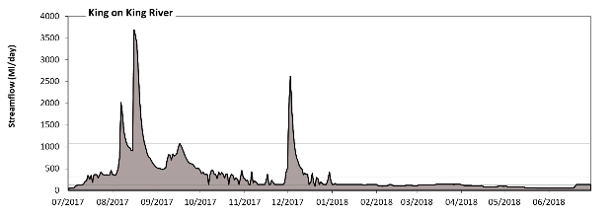
King

Figure OVN3: Contribution of environmental water delivery at King. Horizontal lines indicate thresholds for very low flows, low flows, low freshes, medium freshes and high freshes (from lowest to highest).
At King on King River environmental water contributed less than 1% of the total streamflow volume (all of which was Commonwealth environmental water). Environmental watering actions affected streamflows for 1% of days between 1 July 2017 and 30 June 2018. Flow regulation does not substantially increase the duration of very low flows (i.e. < 7.9 Ml/day) compared to an average year in the natural flow regime. Flow regulation does not substantially increase the duration of medium low flows (i.e. < 39 Ml/day) compared to an average year in the natural flow regime. There was at least one low fresh (i.e. > 130 Ml/day) in the periods July to September, October to December, January to March and April to June. Environmental water made no change to the duration of these low freshes. There was at least one medium fresh (i.e. > 300 Ml/day) in the periods July to September and October to December. Environmental water made no change to the duration of these medium freshes. In the absence of environmental water there would have been at least one high fresh in the periods July to September and October to December. Environmental water made no change to the duration of these high freshes.
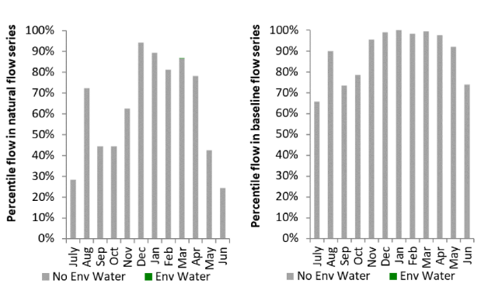
Figure OVN4: Contribution of environmental water delivery at King as percentiles in the natural and baseline flow series.

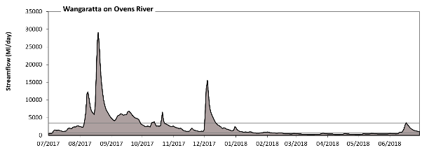
Wangaratta

Figure OVN5: Contribution of environmental water delivery at Wangaratta. Horizontal lines indicate thresholds for very low flows, low flows, low freshes, medium freshes and high freshes (from lowest to highest).
There was no environmental water delivered at Wangaratta.
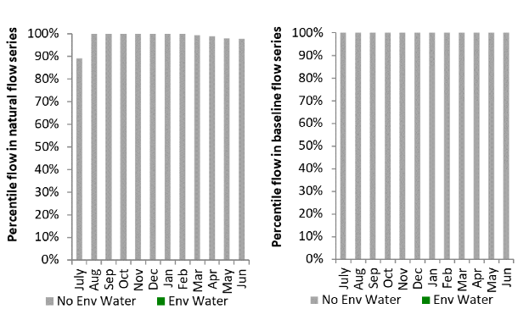
Figure OVN6: Contribution of environmental water delivery at Wangaratta as percentiles in the natural and baseline flow series.

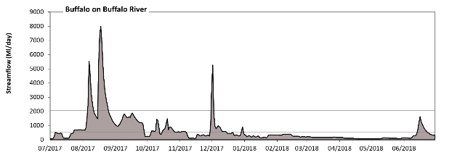
Buffalo

Figure OVN7: Contribution of environmental water delivery at Buffalo. Horizontal lines indicate thresholds for very low flows, low flows, low freshes, medium freshes and high freshes (from lowest to highest).
At Buffalo on Buffalo River environmental water contributed less than 1% of the total streamflow volume (all of which was Commonwealth environmental water). Environmental watering actions affected streamflows for 1% of days between 1 July 2017 and 30 June 2018. Flow regulation does not substantially increase the duration of very low flows (i.e. < 11 Ml/day) compared to an average year in the natural flow regime. Flow regulation does not substantially increase the duration of medium low flows (i.e. < 56 Ml/day) compared to an average year in the natural flow regime. There was at least one low fresh (i.e. > 200 Ml/day) in the periods July to September, October to December, January to March and April to June. Environmental water made no change to the duration of these low freshes. There was at least one medium fresh (i.e. > 530 Ml/day) in the periods July to September, October to December and April to June. Environmental water made no change to the duration of these medium freshes. In the absence of environmental water there would have been at least one high fresh in the periods July to September and October to December. Environmental water made no change to the duration of these high freshes.
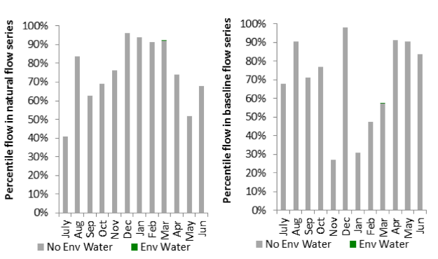
Figure OVN8: Contribution of environmental water delivery at Buffalo as percentiles in the natural and baseline flow series.
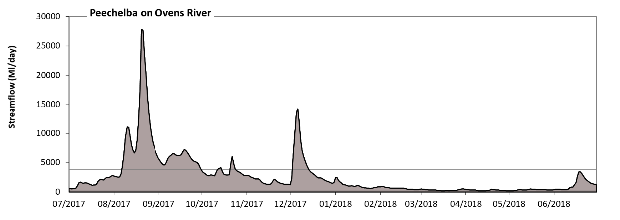
Peechelba

Figure OVN9: Contribution of environmental water delivery at Peechelba. Horizontal lines indicate thresholds for very low flows, low flows, low freshes, medium freshes and high freshes (from lowest to highest).
There was no environmental water delivered at Peechelba on Ovens River.
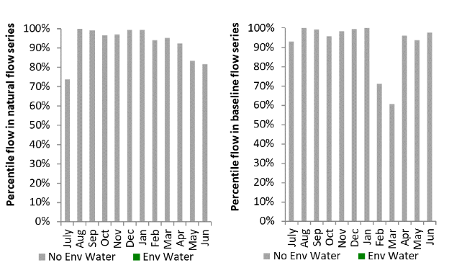
Figure OVN10: Contribution of environmental water delivery at Peechelba as percentiles in the natural and baseline flow series.

Broken
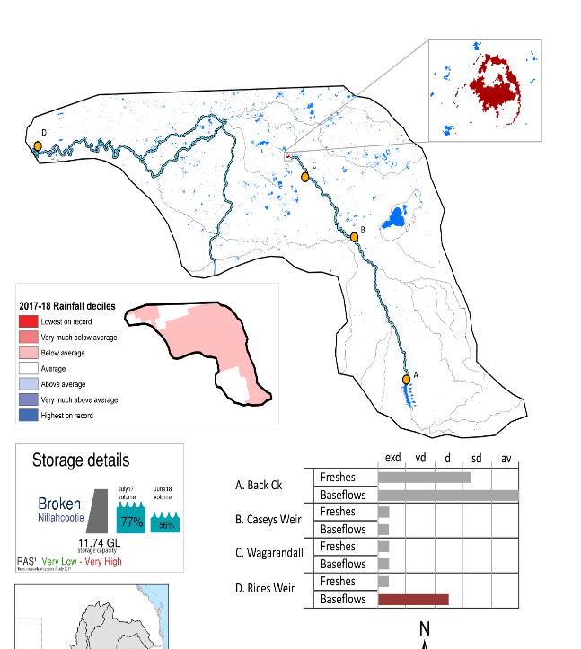Figure BRK1: Watercourses influenced, areas inundated (where applicable) and gauge stations evaluated in the Broken valley during the 2017–18 water year. Inset bar graphs report the condition of annual flow regimes by showing the improvements in hydrological condition with the addition of environmental water as well as the hypothetical scenario in “grey” (if no environmental flow had been delivered); where exd=extremely dry, vd=very dry, d=dry, sd=somewhat dry and av=average. Rainfall conditions (rainfall deciles) and trend in storage levels for the water year are also shown.

Summary
The volume of environmental water delivery for the 2017–18 year in the Broken valley is quantified using data for 4 sites. This evaluation only considers the contribution of held environmental water, which is a primary focus for the Commonwealth. The contributions of planned environmental water (e.g. passing flows), unregulated tributary inflows and clever use of irrigation flows for environmental benefits can all be very important but these are outside the scope of this report. Environmental watering actions lasted on average 130 days over the course of the year. The volume of environmental water at these 4 sites was between 0% and 47% of the total streamflow. Commonwealth environmental water contributed on average 50% of this environmental water. The contribution of environmental water delivery to improved flow regimes is evaluated using data for 4 sites. Ideally, baseflows should be maintained and long periods of excessively low flows avoided. In this valley, the baseflow regime was generally considered to be very dry relative to the pre-development flow regime. In our analysis, a low fresh refers to a period of increased flow, when the water level rises at least one eighth of the way up the river bank (above the low flow level). These low freshes are a regular part of the natural flow regime and support a range of natural processes. In the Broken valley, in terms of the occurrence and duration of low freshes, the year was assessed as being extremely dry. In our analysis, a medium fresh refers to a period of increased flow, when the water level rises at least one quarter of the way up the river bank. These medium freshes are not as frequent as low freshes but are also a regular and important part of the natural flow regime. In the Broken valley, in terms of the occurrence of medium freshes, the year was assessed as being extremely dry. In our analysis, a high fresh refers to a period of increased flow, when the water level rises more than half way up the river. A high fresh may not occur every year but they are still important and long periods without major freshes can have serious consequences for floodplains and their contribution to river ecosystem health. Delivering environmental high in channel flows normally requires that all risks to riparian landholders and infrastructure have been resolved. In the Broken valley, in terms of the occurrence of high freshes, the year was assessed as being very dry.

Water delivery context
During the 2017–18, the Commonwealth Environmental Water Holder (CEWH) held water entitlements of up to 538 Ml for environmental use in the Broken valley. Each year, water utilities allocate water entitlement holders a percentage of water based on their holding, license type and carryover (the exact rules vary among Jurisdictions). In 2017–18, the Broken entitlements held by the CEWH were allocated 418 Ml of water, representing 82% of the Long-term average annual yield for the Broken valley (511 Ml). Information and data relating to the portfolio of held Commonwealth environmental water is shown in Table BRK2.
The 2017–18 water allocation (418 Ml) together with the carryover volume of 120 Ml of water meant the CEWH had 538 Ml of water available for delivery. A total of 462 Ml of Commonwealth environmental water was delivered in the Broken valley. A total of 0 Ml of Commonwealth environmental water was traded to consumptive users and 72 Ml (13%) of available Commonwealth environmental water was carried over for environmental use into the 2018–19 water year.

Environmental conditions and resource availability
The water available for environmental delivery combined with the present and antecedent environmental conditions are key inputs used by environmental water managers in planning and implementing watering actions. Post hoc, this information provides important context when evaluating the effectiveness and appropriateness of environmental water use with respect to hydrological outputs.
The rainfall conditions in the Broken valley were classified as Below Average, based on rainfall percentile data for the entire record held by the Bureau of Meteorology for this valley. The water held in major storages in the Broken valley decreased over the water year, for example Nilahcootie dam was 77% full at the beginning of the water year and 56% full by the end of the year (Figure BRK1).
The Commonwealth Environmental Water Office (CEWO) calculates resource availability scenarios (RAS) to guide the use and prioritisation of held environmental water. The RAS are progressively calculated over the year as part of the continual adaptive management planning processes. The RAS are based on the availability of held environmental water (including progressive license acquisitions and allocations) as well as the potential for unregulated or planned environmental flows. The outcome is then used to determine the demand for environmental water across the basin.
In 2017–18, the resource availability of held Commonwealth environmental water was classified as very low to very high in this valley. The physical conditions meant that the CEWO was managing to protect and improve the aquatic and riparian vegetation, maintain water quality, and support native fish and other biota via habitat provision. The overall demand for environmental water was deemed moderate to high.

Watering actions
A total of 8 watering actions were delivered over the 2017-18 water year, the duration of these actions varied (range of individual actions: 13 - 158 days) and Commonwealth environmental water was delivered for a total of 408 days. The count of actions commencing in each season was; winter (2), spring (3), summer (1) and autumn (2). The flow component types delivered were; (6) baseflow, (1) freshes, (0) bankfull, (0) overbank and (1) wetland.
Commonwealth environmental water was delivered in the Broken valley for specified objectives. Although most of the watering actions were delivered for fish purposes, water was also delivered for other purposes too. The percentage of watering actions delivered across the nine main themes included fish (37.5%), vegetation (18.75%), waterbirds (6.25%), frogs (0.0%), other biota (6.25%), connectivity (0.0%), process (0.0%), resilience (0.0%) and water quality (31.25%).
Table BRK2. Commonwealth environmental water accounting information for the Broken valley over 2017–18 water year.
Total registered volume (Ml) | Allocated volume (Ml) | Carry over + allocated volume (Ml) | Delivered (Ml) | LTAAY (Ml) | Trade (Ml) | Carried over to 2018-19 | Forfeited (Ml)
538 | 418 | 538 | 462 | 511 | 0 | 72 | 4

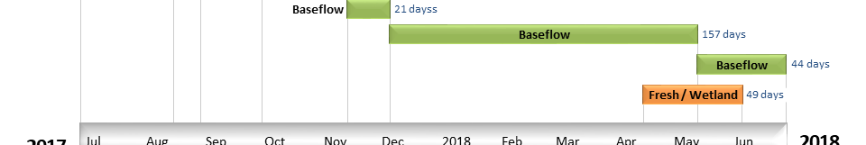
Figure BRK2. Timing and duration of Commonwealth environmental water actions delivered in the Broken valley.=

Contribution of Commonwealth Environmental Water to Flow Regimes
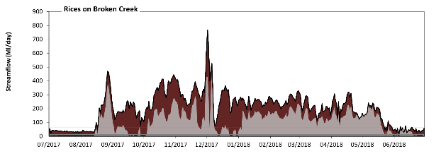
Rices

Figure BRK3: Contribution of environmental water delivery at Rices. Horizontal lines indicate thresholds for very low flows and low flows (from lowest to highest).
At Rices on Broken Creek environmental water contributed 47% of the total streamflow volume (all of which was Commonwealth environmental water). Environmental watering actions affected streamflows for 97% of days between 1 July 2017 and 30 June 2018. Without environmental water, the durations of very low flows (i.e. < 13 Ml/day) in the periods July to September, October to December and April to June would have substantially exceeded durations expected in an average year in the natural flow regime. Environmental water mitigated these impacts by reducing the cumulative duration of very low flow spells from 23% to 0% of the year, with greatest influence in the period July to September. Similarly, without environmental water, the durations of medium low flows (i.e. < 65 Ml/day) in the periods July to September, October to December and April to June would have substantially exceeded durations expected in an average year in the natural flow regime. Environmental water mitigated these impacts by reducing the cumulative duration of medium low flow spells from 38% to 22% of the year, with greatest influence in the periods July to September and October to December. Environmental water increased the magnitude of flows below this medium low flow threshold. Commonwealth environmental water was entirely responsible for these enhancements of environmental baseflows at this site.
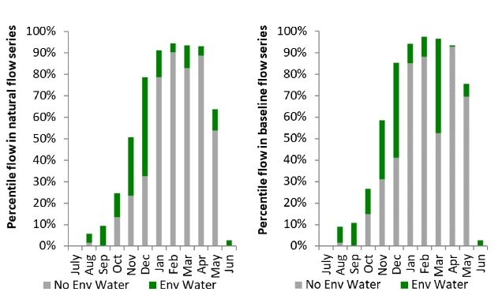
Figure BRK4: Contribution of environmental water delivery at Rices as percentiles in the natural and baseline flow series.
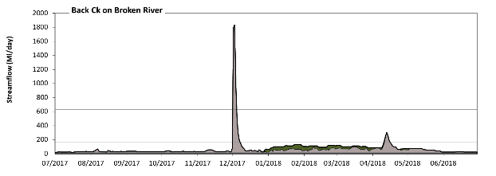
Back Ck
Figure BRK5: Contribution of environmental water delivery at Back Ck. Horizontal lines indicate thresholds for very low flows, low flows, low freshes, medium freshes and high freshes (from lowest to highest).
At Back Ck on Broken River environmental water contributed 17% of the total streamflow volume (none of which was Commonwealth environmental water). Environmental watering actions affected streamflows for 32% of days between 1 July 2017 and 30 June 2018. Flow regulation does not substantially increase the duration of very low flows (i.e. < 3.4 Ml/day) compared to an average year in the natural flow regime. Flow regulation does not substantially increase the duration of medium low flows (i.e. < 17 Ml/day) compared to an average year in the natural flow regime. There was at least one low fresh (i.e. > 160 Ml/day) in the periods October to December and April to June. Environmental water made no change to the duration of these low freshes. There was at least one medium fresh (i.e. > 630 Ml/day) in the period October to December. Environmental water made no change to the duration of these medium freshes. In the absence of environmental water there would have been at least one high fresh in the period October to December. Environmental water made no change to the duration of these high freshes.
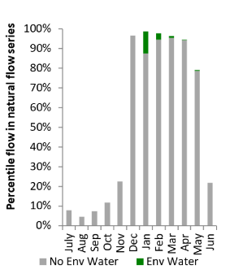
Figure BRK6: Contribution of environmental water delivery at Back Ck as percentiles in the natural flow series.

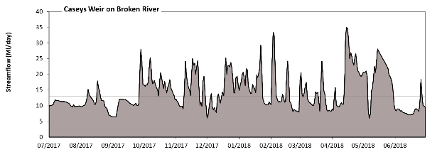
Caseys Weir

Figure BRK7: Contribution of environmental water delivery at Caseys Weir. Horizontal lines indicate thresholds for very low flows and low flows (from lowest to highest).
There was no environmental water delivered at Caseys Weir on Broken River.
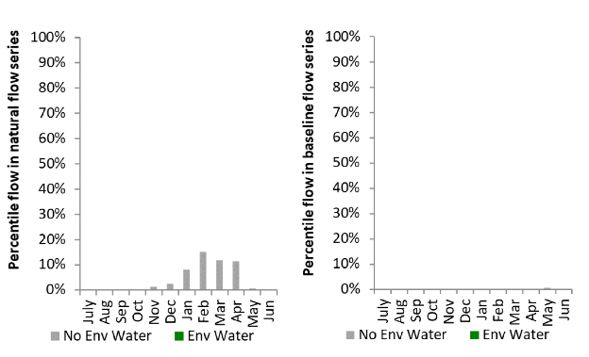
Figure BRK8: Contribution of environmental water delivery at Caseys Weir as percentiles in the natural and baseline flow series.
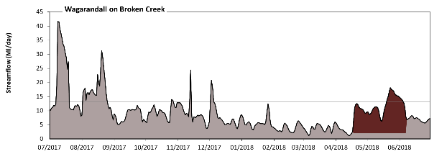
Wagarandall

Figure BRK9: Contribution of environmental water delivery at Wagarandall. Horizontal lines indicate thresholds for very low flows and low flows (from lowest to highest).
At Wagarandall on Broken Creek environmental water contributed 15% of the total streamflow volume (all of which was Commonwealth environmental water). Environmental watering actions affected streamflows for 14% of days between 1 July 2017 and 30 June 2018. Without environmental water, the durations of very low flows (i.e. < 13 Ml/day) in the periods July to September, October to December, January to March and April to June would have all substantially exceeded durations expected in an average year in the natural flow regime. Environmental water mitigated these impacts by reducing the cumulative duration of very low flow spells from 88% to 84% of the year, with greatest influence in the period April to June. Similarly, without environmental water, the durations of medium low flows (i.e. < 65 Ml/day) in the periods July to September, October to December, January to March and April to June would have all substantially exceeded durations expected in an average year in the natural flow regime. However, environmental water had little effect on the duration of these medium low flows, which occurred for 100% of the year. Commonwealth environmental water was entirely responsible for these enhancements of environmental baseflows at this site.
Figure BRK10: Contribution of environmental water delivery at Wagarandall as percentiles in the natural and baseline flow series. Goulburn.

Goulburn
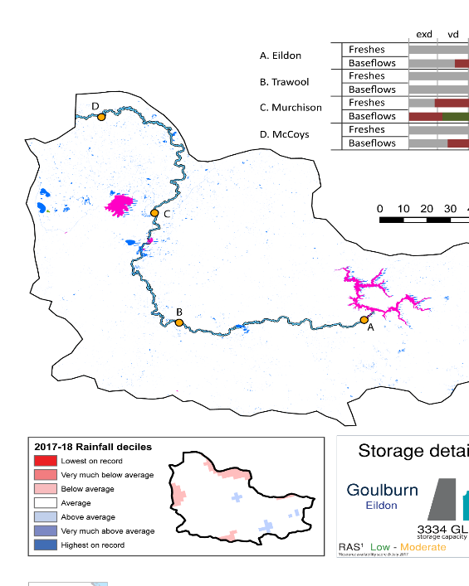
Figure GLB1: Watercourses influenced, areas inundated (where applicable) and gauge stations evaluated in the Goulburn valley during the 2017–18 water year. Inset bar graphs report the condition of annual flow regimes by showing the improvements in hydrological condition with the addition of environmental water as well as the hypothetical scenario in “grey” (if no environmental flow had been delivered); where exd=extremely dry, vd=very dry, d=dry, sd=somewhat dry and av=average. Rainfall conditions (rainfall deciles) and trend in storage levels for the water year are also shown.

Summary
The volume of environmental water delivery for the 2017–18 year in the Goulburn valley is quantified using data for 5 sites. This evaluation only considers the contribution of held environmental water, which is a primary focus for the Commonwealth. The contributions of planned environmental water (e.g. passing flows), unregulated tributary inflows and clever use of irrigation flows for environmental benefits can all be very important but these are outside the scope of this report. Environmental watering actions lasted on average 157 days over the course of the year. The volume of environmental water at these 5 sites was between 0% and 46% of the total streamflow. Commonwealth environmental water contributed on average 57% of this environmental water. The contribution of environmental water delivery to improved flow regimes is evaluated using data for 5 sites. Ideally, baseflows should be maintained and long periods of excessively low flows avoided. In this valley, the baseflow regime was generally considered to be dry relative to the pre-development flow regime. In our analysis, a low fresh refers to a period of increased flow, when the water level rises at least one eighth of the way up the river bank (above the low flow level). These low freshes are a regular part of the natural flow regime and support a range of natural processes. In the Goulburn valley, in terms of the occurrence and duration of low freshes, the year was assessed as being somewhat dry. In our analysis, a medium fresh refers to a period of increased flow, when the water level rises at least one quarter of the way up the river bank. These medium freshes are not as frequent as low freshes but are also a regular and important part of the natural flow regime. In the Goulburn valley, in terms of the occurrence of medium freshes, the year was assessed as being dry. In our analysis, a high fresh refers to a period of increased flow, when the water level rises more than half way up the river. A high fresh may not occur every year but they are still important and long periods without major freshes can have serious consequences for floodplains and their contribution to river ecosystem health. Delivering environmental high in channel flows normally requires that all risks to riparian landholders and infrastructure have been resolved. In the Goulburn valley, in terms of the occurrence of high freshes, the year was assessed as being somewhat dry.

Water delivery context
During the 2017–18, the Commonwealth Environmental Water Holder (CEWH) held water entitlements of up to 327,672 Ml for environmental use in the Goulburn valley. Each year, water utilities allocate water entitlement holders a percentage of water based on their holding, license type and carryover (the exact rules vary among Jurisdictions). In 2017–18, the Goulburn entitlements held by the CEWH were allocated 280,091 Ml of water, representing 97% of the Long-term average annual yield for the Goulburn valley (289,505 Ml). Information and data relating to the portfolio of held Commonwealth environmental water is shown in Table GLB2.
The 2017–18 water allocation (280,091 Ml) together with the carryover volume of 54,438 Ml of water meant the CEWH had 334,529 Ml of water available for delivery. A total of 263,343 Ml of Commonwealth environmental water was delivered in the Goulburn valley. A total of 0 Ml of Commonwealth environmental water was traded to consumptive users and 73913 Ml (22%) of available Commonwealth environmental water was carried over for environmental use into the 2018–19 water year.

Environmental conditions and resource availability
The water available for environmental delivery combined with the present and antecedent environmental conditions are key inputs used by environmental water managers in planning and implementing watering actions. Post hoc, this information provides important context when evaluating the effectiveness and appropriateness of environmental water use with respect to hydrological outputs.
The rainfall conditions in the Goulburn valley were classified as Average, based on rainfall percentile data for the entire record held by the Bureau of Meteorology for this valley. The water held in major storages in the Goulburn valley decreased over the water year, for example Eildon dam was 64% full at the beginning of the water year and 55% full by the end of the year (Figure GLB1).
The Commonwealth Environmental Water Office (CEWO) calculates resource availability scenarios (RAS) to guide the use and prioritisation of held environmental water. The RAS are progressively calculated over the year as part of the continual adaptive management planning processes. The RAS are based on the availability of held environmental water (including progressive license acquisitions and allocations) as well as the potential for unregulated or planned environmental flows. The outcome is then used to determine the demand for environmental water across the basin.
In 2017–18, the resource availability of held Commonwealth environmental water was classified as very low to very high in this valley. The physical conditions meant that the CEWO was managing to protect and improve the aquatic and riparian vegetation, maintain water quality, and support native fish and other biota via habitat provision. The overall demand for environmental water was deemed low to moderate.

Watering actions
A total of 8 watering actions were delivered over the 2017–18 water year, the duration of these actions varied (range of individual actions: 8 - 42 days) and Commonwealth environmental water was delivered for a total of 161 days. The count of actions commencing in each season was; winter (2), spring (4) and summer (2). The flow component types delivered were; (4) baseflow, (4) freshes, (0) bankfull, (0) overbank and (0) wetland.
Commonwealth environmental water was delivered in the Goulburn valley for specified objectives. Although most of the watering actions were delivered for fish purposes, water was also delivered for other purposes too. The percentage of watering actions delivered across the nine main themes included fish (29.17%), vegetation (29.17%), waterbirds (0.0%), frogs (0.0%), other biota (25%), connectivity (0.0%), process (0.0%), resilience (0.0%) and water quality (16.67%).
Table GLB2. Commonwealth environmental water accounting information for the Goulburn valley over 2017–18 water year.
Total registered volume (Ml) | Allocated volume (Ml) | Carry over + allocated volume (Ml) | Delivered (Ml) | LTAAY (Ml) | Trade (Ml) | Carried over to 2018-19 | Forfeited (Ml)
327,672 | 280,091 | 334,529 | 263,343 | 289,505 | 0 | 73,913 | 3,890

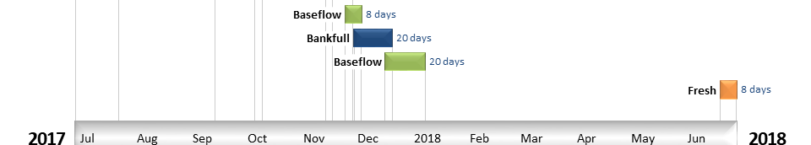
Figure GLB2. Timing and duration of Commonwealth environmental water actions delivered in the Goulburn valley.

Contribution of Commonwealth Environmental Water to Flow Regimes
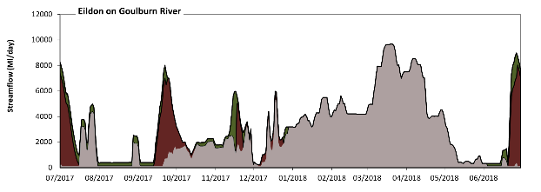
Eildon

Figure GLB3: Contribution of environmental water delivery at Eildon. Horizontal lines indicate thresholds for very low flows, low flows, low freshes, medium freshes and high freshes (from lowest to highest).
At Eildon on Goulburn River environmental water contributed 25% of the total streamflow volume (much of which was Commonwealth environmental water). Environmental watering actions affected streamflows for 55% of days between 1 July 2017 and 30 June 2018. Flow regulation does not substantially increase the duration of very low flows (i.e. < 79 Ml/day) compared to an average year in the natural flow regime. However, without environmental water, the durations of medium low flows (i.e. < 400 Ml/day) in the periods July to September and April to June would have substantially exceeded durations expected in an average year in the natural flow regime. Environmental water mitigated these impacts by reducing the cumulative duration of medium low flow spells from 28% to 10% of the year, with greatest influence in the period July to September. Environmental water increased the magnitude of flows below this medium low flow threshold with the result that low flows were generally far below the medium low flow threshold. Commonwealth environmental water made a modest contribution to these enhancements of environmental baseflows at this site. In the absence of environmental water there would have been at least one low fresh (i.e. > 2200 Ml/day) in the periods July to September, October to December, January to March and April to June. Environmental water increased the duration of the longest low fresh during the periods July to September (from 5 days to 15 days) and October to December (from 6 days to 19 days). Commonwealth environmental water equally shared responsibility with other environmental water holders for these increased durations of low freshes. In the absence of environmental water there would have been at least one medium fresh (i.e. > 7200 Ml/day) in the periods January to March and April to June. Environmental water increased the duration of the longest medium fresh during the period July to September (from 0 days to 3 days). Commonwealth environmental water was entirely responsible for these increased durations of medium freshes. In the absence of environmental water there would have been at least one high fresh in the periods January to March and April to June. Environmental water increased the duration of the longest high fresh during the period July to September (from 0 days to 3 days). Commonwealth environmental water was entirely responsible for these increased durations of high freshes.
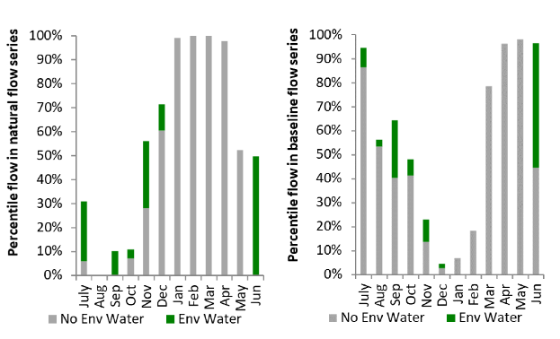
Figure GLB4: Contribution of environmental water delivery at Eildon as percentiles in the natural and baseline flow series.

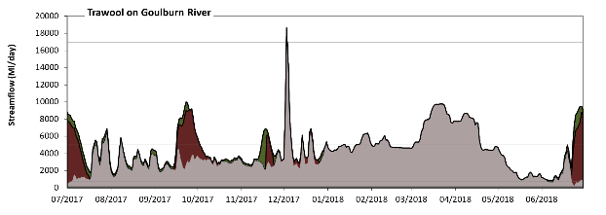
Trawool

Figure GLB5: Contribution of environmental water delivery at Trawool. Horizontal lines indicate thresholds for very low flows, low flows, low freshes, medium freshes and high freshes (from lowest to highest).
At Trawool on Goulburn River environmental water contributed 18% of the total streamflow volume (much of which was Commonwealth environmental water). Environmental watering actions affected streamflows for 55% of days between 1 July 2017 and 30 June 2018. Flow regulation does not substantially increase the duration of very low flows (i.e. < 130 Ml/day) compared to an average year in the natural flow regime. However, without environmental water, the duration of medium low flows (i.e. < 770 Ml/day) in the period April to June would have substantially exceeded durations expected in an average year in the natural flow regime. Environmental water mitigated these impacts by reducing the cumulative duration of medium low flow spells from 4% to 0% of the year, with greatest influence in the periods July to September and April to June. Commonwealth environmental water equally shared responsibility with other environmental water holders for these enhancements of environmental baseflows at this site. In the absence of environmental water there would have been at least one low fresh (i.e. > 5000 Ml/day) in the periods July to September, October to December, January to March and April to June. Environmental water increased the duration of the longest low fresh during the period July to September (from 4 days to 14 days). Commonwealth environmental water was almost entirely responsible for these increased durations of low freshes. There was at least one medium fresh (i.e. > 17000 Ml/day) in the period October to December. Environmental water made no change to the duration of these medium freshes. In the absence of environmental water there would have been at least one high fresh in the period October to December. Environmental water made no change to the duration of these high freshes.
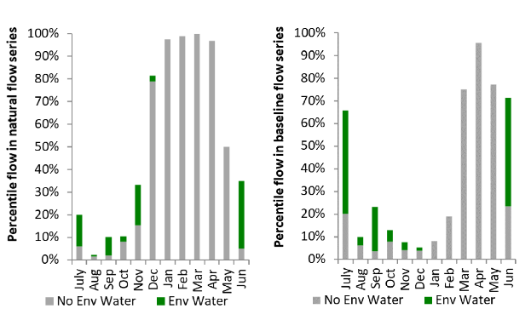
Figure GLB6: Contribution of environmental water delivery at Trawool as percentiles in the natural and baseline flow series.
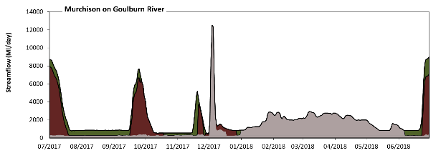
Murchison

Figure GLB7: Contribution of environmental water delivery at Murchison. Horizontal lines indicate thresholds for very low flows, low flows and low freshes (from lowest to highest).
At Murchison on Goulburn River environmental water contributed 46% of the total streamflow volume (much of which was Commonwealth environmental water). Environmental watering actions affected streamflows for 55% of days between 1 July 2017 and 30 June 2018. Without environmental water, the durations of very low flows (i.e. < 250 Ml/day) in the periods October to December and April to June would have substantially exceeded durations expected in an average year in the natural flow regime. Environmental water mitigated these impacts by reducing the cumulative duration of very low flow spells from 9% to 0% of the year, with greatest influence in the periods October to December and April to June. Similarly, without environmental water, the durations of medium low flows (i.e. < 870 Ml/day) in the periods July to September, October to December and April to June would have substantially exceeded durations expected in an average year in the natural flow regime. Environmental water mitigated these impacts by reducing the cumulative duration of medium low flow spells from 58% to 36% of the year, with greatest influence in the periods July to September and October to December. Environmental water increased the magnitude of flows below this medium low flow threshold with the result that low flows were generally far below the medium low flow threshold. Commonwealth environmental water equally shared responsibility with other environmental water holders for these enhancements of environmental baseflows at this site. In the absence of environmental water there would have been at least one low fresh (i.e. > 4200 Ml/day) in the period October to December. Environmental water increased the duration of the longest low fresh during the periods July to September (from 0 days to 13 days) and April to June (from 0 days to 6 days). Commonwealth environmental water was entirely responsible for these increased durations of low freshes. There was no medium or high freshes this year.
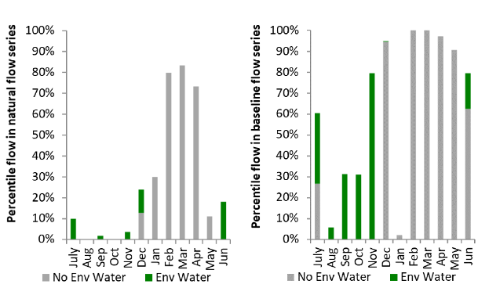
Figure GLB8: Contribution of environmental water delivery at Murchison as percentiles in the natural and baseline flow series.

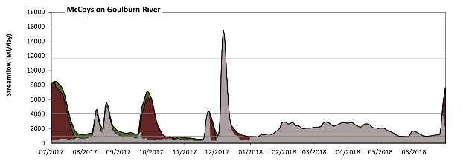
McCoys

Figure GLB9: Contribution of environmental water delivery at McCoys. Horizontal lines indicate thresholds for very low flows, low flows, low freshes, medium freshes and high freshes (from lowest to highest).
At McCoys on Goulburn River environmental water contributed 33% of the total streamflow volume (much of which was Commonwealth environmental water). Environmental watering actions affected streamflows for 50% of days between 1 July 2017 and 30 June 2018. Flow regulation does not substantially increase the duration of very low flows (i.e. < 310 Ml/day) compared to an average year in the natural flow regime. However, without environmental water, the durations of medium low flows (i.e. < 960 Ml/day) in the periods July to September and October to December would have substantially exceeded durations expected in an average year in the natural flow regime. Environmental water mitigated these impacts by reducing the cumulative duration of medium low flow spells from 40% to 15% of the year, with greatest influence in the periods July to September and October to December. Commonwealth environmental water equally shared responsibility with other environmental water holders for these enhancements of environmental baseflows at this site. In the absence of environmental water there would have been at least one low fresh (i.e. > 4200 Ml/day) in the periods July to September and October to December. Environmental water increased the duration of the longest low fresh during the periods July to September (from 4 days to 17 days) and April to June (from 0 days to 3 days). Commonwealth environmental water was entirely responsible for these increased durations of low freshes. There was at least one medium fresh (i.e. > 12000 Ml/day) in the period October to December. Environmental water made no change to the duration of these medium freshes. In the absence of environmental water there would have been at least one high fresh in the period October to December. Environmental water made no change to the duration of these high freshes.
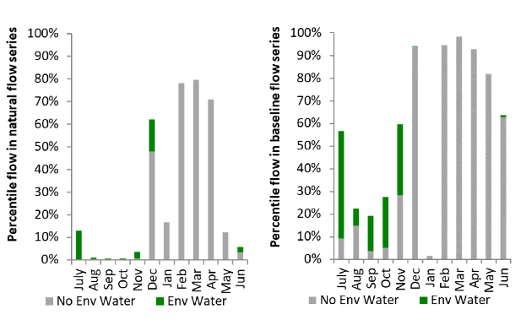
Figure GLB10: Contribution of environmental water delivery at McCoys as percentiles in the natural and baseline flow series.

Border Rivers
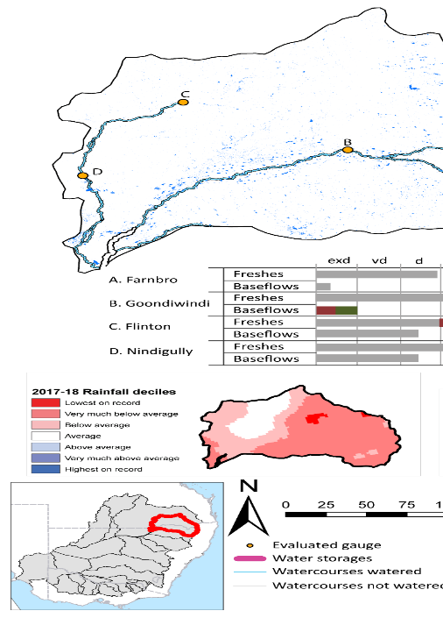
Figure BRD1: Watercourses influenced, areas inundated (where applicable) and gauge stations evaluated in the Border Rivers valley during the 2017–18 water year. Inset bar graphs report the condition of annual flow regimes by showing the improvements in hydrological condition with the addition of environmental water as well as the hypothetical scenario in “grey” (if no environmental flow had been delivered); where exd=extremely dry, vd=very dry, d=dry, sd=somewhat dry and av=average. Rainfall conditions (rainfall deciles) and trend in storage levels for the water year are also shown.

Summary
The volume of environmental water delivery for the 2017–18 year in the Border Rivers valley is quantified using data for 4 sites. This evaluation only considers the contribution of held environmental water, which is a primary focus for the Commonwealth. The contributions of planned environmental water (e.g. passing flows), unregulated tributary inflows and clever use of irrigation flows for environmental benefits can all be very important but these are outside the scope of this report. Environmental watering actions lasted on average 44 days over the course of the year. The volume of environmental water at these 4 sites was between 3% and 7% of the total streamflow. Commonwealth environmental water contributed on average 88% of this environmental water. Ideally, baseflows should be maintained and long periods of excessively low flows avoided. In this valley, the baseflow regime was generally considered to be very dry relative to the pre-development flow regime. In our analysis, a low fresh refers to a period of increased flow, when the water level rises at least one eighth of the way up the river bank (above the low flow level). These low freshes are a regular part of the natural flow regime and support a range of natural processes. In the Border Rivers valley, in terms of the occurrence and duration of low freshes, the year was assessed as being dry. In our analysis, a medium fresh refers to a period of increased flow, when the water level rises at least one quarter of the way up the river bank. These medium freshes are not as frequent as low freshes but are also a regular and important part of the natural flow regime. In the Border Rivers valley, in terms of the occurrence of medium freshes, the year was assessed as being average. In our analysis, a high fresh refers to a period of increased flow, when the water level rises more than half way up the river. A high fresh may not occur every year but they are still important and long periods without major freshes can have serious consequences for floodplains and their contribution to river ecosystem health. Delivering environmental high in channel flows normally requires that all risks to riparian landholders and infrastructure have been resolved. In the Border Rivers valley, in terms of the occurrence of high freshes, the year was assessed as being average.

Water delivery context
During the 2017-18, the Commonwealth Environmental Water Holder (CEWH) held water entitlements of up to 50,524 Ml for environmental use in the Border Rivers valley. Each year, water utilities allocate water entitlement holders a percentage of water based on their holding, license type and carryover (the exact rules vary among Jurisdictions). In 2017-18, the Border Rivers entitlements held by the CEWH were allocated 3,259 Ml of water, representing 16% of the Long-term average annual yield for the Border Rivers valley (20,871 Ml). Information and data relating to the portfolio of held Commonwealth environmental water is shown in Table BRD2.
The 2017-18 water allocation (3,259 Ml) together with the carryover volume of 14,535 Ml of water meant the CEWH had 17,794 Ml of water available for delivery. A total of 11,488 Ml of Commonwealth environmental water was delivered in the Border Rivers valley. A total of 0 Ml of Commonwealth environmental water was traded to consumptive users and 6717 Ml (38%) of available Commonwealth environmental water was carried over for environmental use into the 2018–19 water year.

Environmental conditions and resource availability
The water available for environmental delivery combined with the present and antecedent environmental conditions are key inputs used by environmental water managers in planning and implementing watering actions. Post hoc, this information provides important context when evaluating the effectiveness and appropriateness of environmental water use with respect to hydrological outputs.
The rainfall conditions in the Border Rivers valley were classified as Below Average, based on rainfall percentile data for the entire record held by the Bureau of Meteorology for this valley. The water held in major storages in the Border Rivers valley decreased over the water year, for example Glenlyon, Pindari, and Coolmunda dam combined was 90% full at the beginning of the water year and 53% full by the end of the year (Figure BRD1).
The Commonwealth Environmental Water Office (CEWO) calculates resource availability scenarios (RAS) to guide the use and prioritisation of held environmental water. The RAS are progressively calculated over the year as part of the continual adaptive management planning processes. The RAS are based on the availability of held environmental water (including progressive license acquisitions and allocations) as well as the potential for unregulated or planned environmental flows. The outcome is then used to determine the demand for environmental water across the basin.
In 2017-18, the resource availability of held Commonwealth environmental water was classified as low to high in this valley. The physical conditions meant that the CEWO was managing to protect the health and resilience of near channel wetlands and ecological processes in the lower Macintyre River, and fish habitat and life cycles in the Dumaresq and Severn and Macintyre rivers. The overall demand for environmental water was deemed low to high.

Watering actions
A total of 9 watering actions were delivered over the 2017-18 water year, the duration of these actions varied (range of individual actions: 1 - 70 days) and Commonwealth environmental water was delivered for a total of 218 days. The count of actions commencing in each season was; winter (2), spring (4), summer (2) and autumn (1). The flow component types delivered were; (2) baseflow, (7) freshes, (0) bankfull, (0) overbank and (0) wetland.
Commonwealth environmental water was delivered in the Border Rivers valley for specified objectives. Although most of the watering actions were delivered for fish purposes, water was also delivered for other purposes too. The percentage of watering actions delivered across the nine main themes included fish (39.13%), vegetation (0.0%), waterbirds (0.0%), frogs (0.0%), other biota (13.04%), connectivity (8.7%), process (4.35%), resilience (4.35%) and water quality (30.43%).
Table BRD2. Commonwealth environmental water accounting information for the Border Rivers valley over 2017-18 water year.
Total registered volume (Ml) | Allocated volume (Ml) | Carry over + allocated volume (Ml) | Delivered (Ml) |  | LTAAY (Ml) | Trade (Ml) | Carried over to 2018-19 | Forfeited (Ml)
50,524 | 3,259 | 17,794 | 11,077 |  | 20,871 | 0 | 6,717 | 0

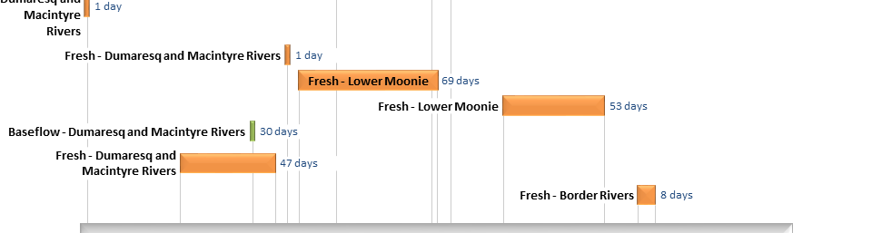
Figure BRD2. Timing and duration of Commonwealth environmental water actions delivered in the Border Rivers valley.

Contribution of Commonwealth Environmental Water to Flow Regimes
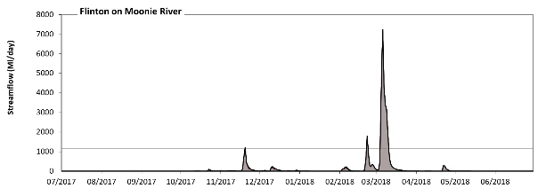
Flinton

Figure BRD3: Contribution of environmental water delivery at Flinton. Horizontal lines indicate thresholds for very low flows, low flows, low freshes, medium freshes and high freshes (from lowest to highest).
At Flinton on Moonie River environmental water contributed 4% of the total streamflow volume (all of which was Commonwealth environmental water). Environmental watering actions affected streamflows for 6% of days between 1 July 2017 and 30 June 2018. Without environmental water, the durations of very low flows (i.e. < 5.1 Ml/day) in the periods July to September and April to June would have substantially exceeded durations expected in an average year in the natural flow regime. However, environmental water had little effect on the duration of these very low flows, which occurred for 69% of the year. Similarly, without environmental water, the durations of medium low flows (i.e. < 25 Ml/day) in the periods July to September and April to June would have substantially exceeded durations expected in an average year in the natural flow regime. However, environmental water had little effect on the duration of these medium low flows, which occurred for 81% of the year. There was at least one low fresh (i.e. > 280 Ml/day) in the periods October to December, January to March and April to June. Environmental water made little change to the duration of these low freshes. In the absence of environmental water there would have been at least one medium fresh (i.e. > 1200 Ml/day) in the period January to March. Environmental water increased the duration of the longest medium fresh during the period October to December (from 0 days to 1 days). Commonwealth environmental water was entirely responsible for these increased durations of medium freshes. In the absence of environmental water there would have been at least one high fresh in the period January to March. Environmental water increased the duration of the longest high fresh during the period October to December (from 0 days to 1 days). Commonwealth environmental water was entirely responsible for these increased durations of high freshes.
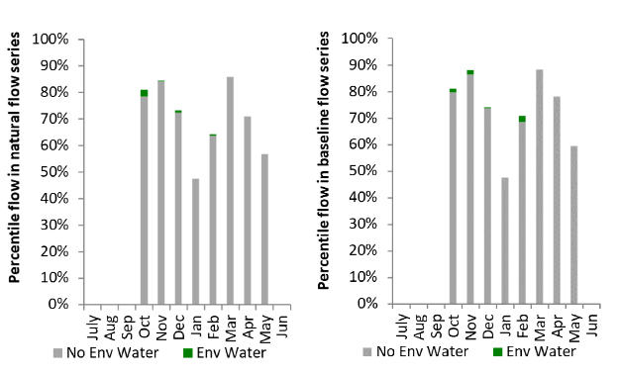
Figure BRD4: Contribution of environmental water delivery at Flinton as percentiles in the natural and baseline flow series.

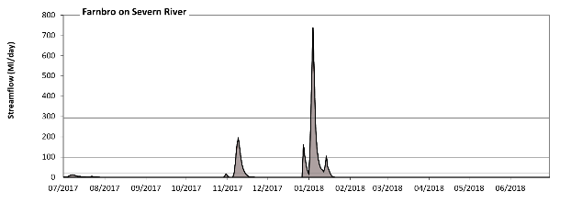
Farnbro

Figure BRD5: Contribution of environmental water delivery at Farnbro. Horizontal lines indicate thresholds for very low flows, low flows, low freshes, medium freshes and high freshes (from lowest to highest).
At Farnbro on Severn River environmental water contributed 7% of the total streamflow volume (all of which was Commonwealth environmental water). Environmental watering actions affected streamflows for 2% of days between 1 July 2017 and 30 June 2018. Without environmental water, the durations of very low flows (i.e. < 3.9 Ml/day) in the periods July to September, October to December, January to March and April to June would have all substantially exceeded durations expected in an average year in the natural flow regime. However, environmental water had little effect on the duration of these very low flows, which occurred for 88% of the year. Similarly, without environmental water, the durations of medium low flows (i.e. < 19 Ml/day) in the periods July to September, October to December, January to March and April to June would have all substantially exceeded durations expected in an average year in the natural flow regime. However, environmental water had little effect on the duration of these medium low flows, which occurred for 93% of the year. There was at least one low fresh (i.e. > 97 Ml/day) in the periods October to December and January to March. Environmental water made no change to the duration of these low freshes. There was at least one medium fresh (i.e. > 290 Ml/day) in the period January to March. Environmental water made no change to the duration of these medium freshes. In the absence of environmental water there would have been at least one high fresh in the period January to March. Environmental water made no change to the duration of these high freshes.
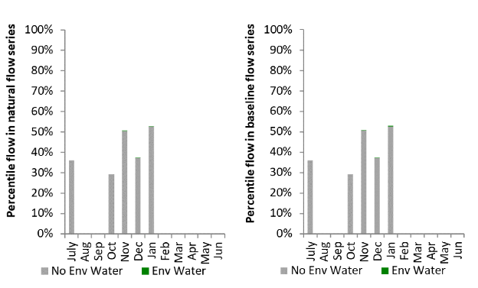
Figure BRD6: Contribution of environmental water delivery at Farnbro as percentiles in the natural and baseline flow series.
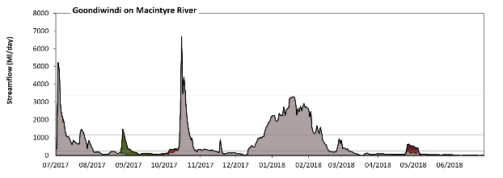
Goondiwindi

Figure BRD7: Contribution of environmental water delivery at Goondiwindi. Horizontal lines indicate thresholds for very low flows, low flows, low freshes, medium freshes and high freshes (from lowest to highest).
At Goondiwindi on Macintyre River environmental water contributed 7% of the total streamflow volume (with approximately half contributed by Commonwealth environmental water). Environmental watering actions affected streamflows for 24% of days between 1 July 2017 and 30 June 2018. Without environmental water, the durations of very low flows (i.e. < 48 Ml/day) in the periods July to September and April to June would have substantially exceeded durations expected in an average year in the natural flow regime. Environmental water mitigated these impacts by reducing the cumulative duration of very low flow spells from 26% to 16% of the year, with greatest influence in the period July to September. Similarly, without environmental water, the durations of medium low flows (i.e. < 240 Ml/day) in the periods July to September, October to December, January to March and April to June would have all substantially exceeded durations expected in an average year in the natural flow regime. Environmental water mitigated these impacts by reducing the cumulative duration of medium low flow spells from 60% to 53% of the year, with greatest influence in the periods July to September, October to December and April to June. Commonwealth environmental water equally shared responsibility with other environmental water holders for these enhancements of environmental baseflows at this site. There was at least one low fresh (i.e. > 1100 Ml/day) in the periods July to September, October to December and January to March. Environmental water made little change to the duration of these low freshes. In the absence of environmental water there would have been at least one medium fresh (i.e. > 3400 Ml/day) in the periods July to September and October to December. Environmental water increased the duration of the longest medium fresh during the period October to December (from 2 days to 4 days). Commonwealth environmental water was entirely responsible for these increased durations of medium freshes. In the absence of environmental water there would have been at least one high fresh in the periods July to September and October to December. Environmental water increased the duration of the longest high fresh during the period October to December (from 2 days to 4 days). Commonwealth environmental water was entirely responsible for these increased durations of high freshes.
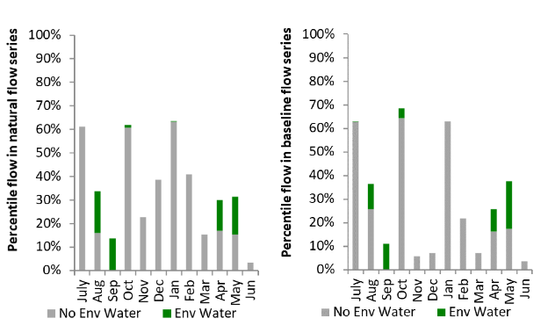
Figure BRD8: Contribution of environmental water delivery at Goondiwindi as percentiles in the natural and baseline flow series.

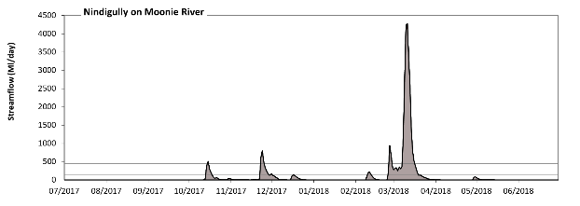
Nindigully

Figure BRD9: Contribution of environmental water delivery at Nindigully. Horizontal lines indicate thresholds for very low flows, low flows, low freshes, medium freshes and high freshes (from lowest to highest).
At Nindigully on Moonie River environmental water contributed 3% of the total streamflow volume (all of which was Commonwealth environmental water). Environmental watering actions affected streamflows for 16% of days between 1 July 2017 and 30 June 2018. Without environmental water, the durations of very low flows (i.e. < 5.1 Ml/day) in the periods July to September and April to June would have substantially exceeded durations expected in an average year in the natural flow regime. However, environmental water had little effect on the duration of these very low flows, which occurred for 73% of the year. Similarly, without environmental water, the durations of medium low flows (i.e. < 25 Ml/day) in the periods July to September and April to June would have substantially exceeded durations expected in an average year in the natural flow regime. However, environmental water had little effect on the duration of these medium low flows, which occurred for 80% of the year. There was at least one low fresh (i.e. > 140 Ml/day) in the periods October to December and January to March. Environmental water made no change to the duration of these low freshes. There was at least one medium fresh (i.e. > 440 Ml/day) in the periods October to December and January to March. Environmental water made no change to the duration of these medium freshes. In the absence of environmental water there would have been at least one high fresh in the periods October to December and January to March. Environmental water made no change to the duration of these high freshes.
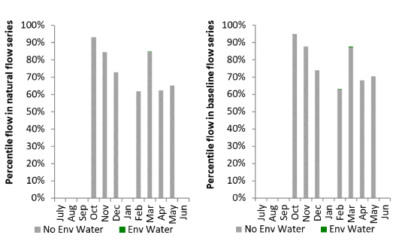
Figure BRD10: Contribution of environmental water delivery at Nindigully as percentiles in the natural and baseline flow series.

Campaspe
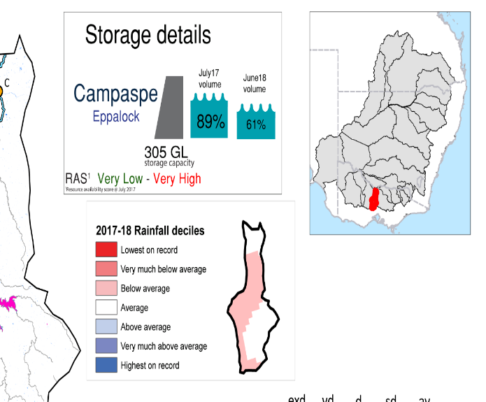
Figure CMP1: Watercourses influenced, areas inundated (where applicable) and gauge stations evaluated in the Campaspe valley during the 2017–18 water year. Inset bar graphs report the condition of annual flow regimes by showing the improvements in hydrological condition with the addition of environmental water as well as the hypothetical scenario in “grey” (if no environmental flow had been delivered); where exd=extremely dry, vd=very dry, d=dry, sd=somewhat dry and av=average. Rainfall conditions (rainfall deciles) and trend in storage levels for the water year are also shown.

Summary
The volume of environmental water delivery for the 2017–18 year in the Campaspe valley is quantified using data for 3 sites. This evaluation only considers the contribution of held environmental water, which is a primary focus for the Commonwealth. The contributions of planned environmental water (e.g. passing flows), unregulated tributary inflows and clever use of irrigation flows for environmental benefits can all be very important but these are outside the scope of this report. Environmental watering actions lasted on average 139 days over the course of the year. The volume of environmental water at these 3 sites was between 26% and 29% of the total streamflow. Commonwealth environmental water contributed on average 23% of this environmental water. The contribution of environmental water delivery to improved flow regimes is evaluated using data for 3 sites. Ideally, baseflows should be maintained and long periods of excessively low flows avoided. In this valley, the baseflow regime was generally considered to be average relative to the pre-development flow regime. In our analysis, a low fresh refers to a period of increased flow, when the water level rises at least one eighth of the way up the river bank (above the low flow level). These low freshes are a regular part of the natural flow regime and support a range of natural processes. In the Campaspe valley, in terms of the occurrence and duration of low freshes, the year was assessed as being average. In our analysis, a medium fresh refers to a period of increased flow, when the water level rises at least one quarter of the way up the river bank. These medium freshes are not as frequent as low freshes but are also a regular and important part of the natural flow regime. In the Campaspe valley, in terms of the occurrence of medium freshes, the year was assessed as being average. In our analysis, a high fresh refers to a period of increased flow, when the water level rises more than half way up the river. A high fresh may not occur every year but they are still important and long periods without major freshes can have serious consequences for floodplains and their contribution to river ecosystem health. Delivering environmental high in channel flows normally requires that all risks to riparian landholders and infrastructure have been resolved. In the Campaspe valley, in terms of the occurrence of high freshes, the year was assessed as being very dry.

Water delivery context
During the 2017–18, the Commonwealth Environmental Water Holder (CEWH) held water entitlements of up to 7,020 Ml for environmental use in the Campaspe valley. Each year, water utilities allocate water entitlement holders a percentage of water based on their holding, license type and carryover (the exact rules vary among Jurisdictions). In 2017–18, the Campaspe entitlements held by the CEWH were allocated 6,858 Ml of water, representing 106% of the Long-term average annual yield for the Campaspe valley (6,485 Ml). Information and data relating to the portfolio of held Commonwealth environmental water is shown in Table CMP2.
The 2017–18 water allocation (6,858 Ml) together with the carryover volume of 0 Ml of water meant the CEWH had 6,858 Ml of water available for delivery. A total of 6,632 Ml of Commonwealth environmental water was delivered in the Campaspe valley. A total of 0 Ml of Commonwealth environmental water was traded to consumptive users and 186 Ml (3%) of available Commonwealth environmental water was carried over for environmental use into the 2018–19 water year.

Environmental conditions and resource availability
The water available for environmental delivery combined with the present and antecedent environmental conditions are key inputs used by environmental water managers in planning and implementing watering actions. Post hoc, this information provides important context when evaluating the effectiveness and appropriateness of environmental water use with respect to hydrological outputs.
The rainfall conditions in the Campaspe valley were classified as Average, based on rainfall percentile data for the entire record held by the Bureau of Meteorology for this valley. The water held in major storages in the Campaspe valley decreased over the water year, for example Eppalock dam was 89% full at the beginning of the water year and 61% full by the end of the year (Figure CMP1).
The Commonwealth Environmental Water Office (CEWO) calculates resource availability scenarios (RAS) to guide the use and prioritisation of held environmental water. The RAS are progressively calculated over the year as part of the continual adaptive management planning processes. The RAS are based on the availability of held environmental water (including progressive license acquisitions and allocations) as well as the potential for unregulated or planned environmental flows. The outcome is then used to determine the demand for environmental water across the basin.
In 2017–18, the resource availability of held Commonwealth environmental water was classified as very low to very high in this valley. The physical conditions meant that the CEWO was managing to protect and improve the aquatic and riparian vegetation, maintain water quality, and support native fish and other biota via habitat provision. The overall demand for environmental water was deemed high.

Watering actions
One watering actions of 15 days was delivered during the 2017–18 water year. The environmental water was delivered as fresh during spring. This watering action was delivered for the following purposes: fish (33.33%), vegetation (33.33%), waterbirds (0.0%), frogs (0.0%), other biota (33.33%), connectivity (0.0%), process (0.0%), resilience (0.0%) and water quality (0.0%).
Table CMP2. Commonwealth environmental water accounting information for the Campaspe valley over 2017–18 water year.
Total registered volume (Ml) | Allocated volume (Ml) | Carry over + allocated volume (Ml) | Delivered (Ml) | LTAAY (Ml) | Trade (Ml) | Carried over to 2018-19 | Forfeited (Ml)
7,020 | 6,858 | 6,858 | 6,632 | 6,485 | 0 | 186 | 40

Figure CMP2. Timing and duration of Commonwealth environmental water actions delivered in the Campaspe valley.

Contribution of Commonwealth Environmental Water to Flow Regimes
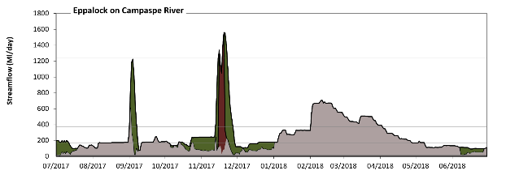
Eppalock

Figure CMP3: Contribution of environmental water delivery at Eppalock. Horizontal lines indicate thresholds for very low flows, low flows, low freshes, medium freshes and high freshes (from lowest to highest).
At Eppalock on Campaspe River environmental water contributed 27% of the total streamflow volume (with a medium contribution of Commonwealth environmental water). Environmental watering actions affected streamflows for 38% of days between 1 July 2017 and 30 June 2018. Flow regulation does not substantially increase the duration of very low flows (i.e. < 12 Ml/day) compared to an average year in the natural flow regime. However, without environmental water, the duration of medium low flows (i.e. < 61 Ml/day) in the period July to September would have substantially exceeded durations expected in an average year in the natural flow regime. Environmental water mitigated these impacts by reducing the cumulative duration of medium low flow spells from 13% to 0% of the year, with greatest influence in the periods July to September and April to June. Commonwealth environmental water made little or no contribution to these enhancements of environmental baseflows at this site. In the absence of environmental water there would have been at least one low fresh (i.e. > 170 Ml/day) in the periods July to September, October to December, January to March and April to June. Environmental water increased the duration of the longest low fresh during the period October to December (from 3 days to 38 days). Commonwealth environmental water made a small contribution to these increased durations of low freshes. In the absence of environmental water there would have been at least one medium fresh (i.e. > 370 Ml/day) in the periods July to September, January to March and April to June. Environmental water increased the duration of the longest medium fresh during the periods July to September (from 1 days to 6 days) and October to December (from 0 days to 15 days). Commonwealth environmental water made a modest contribution to these increased durations of medium freshes. In the absence of environmental water there would have been at least one high fresh this year. Environmental water increased the duration of the longest high fresh during the period October to December (from 0 days to 4 days). Commonwealth environmental water equally shared responsibility with other environmental water holders for these increased durations of high freshes.
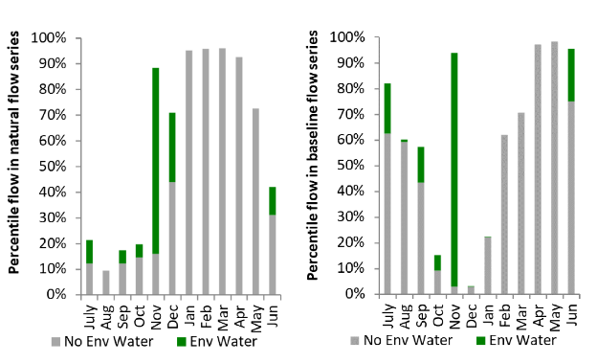
Figure CMP4: Contribution of environmental water delivery at Eppalock as percentiles in the natural and baseline flow series.
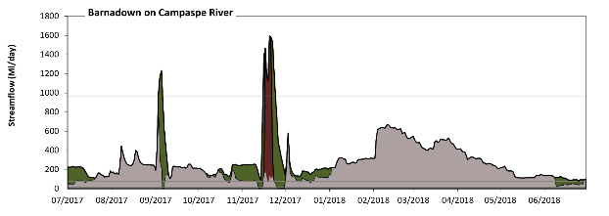
Barnadown

Figure CMP5: Contribution of environmental water delivery at Barnadown. Horizontal lines indicate thresholds for very low flows, low flows, low freshes and medium freshes (from lowest to highest).
At Barnadown on Campaspe River environmental water contributed 26% of the total streamflow volume (with a medium contribution of Commonwealth environmental water). Environmental watering actions affected streamflows for 38% of days between 1 July 2017 and 30 June 2018. Flow regulation does not substantially increase the duration of very low flows (i.e. < 15 Ml/day) compared to an average year in the natural flow regime. However, without environmental water, the duration of medium low flows (i.e. < 77 Ml/day) in the period October to December would have substantially exceeded durations expected in an average year in the natural flow regime. Environmental water mitigated these impacts by reducing the cumulative duration of medium low flow spells from 16% to 0% of the year, with greatest influence in the periods October to December and April to June. Commonwealth environmental water made little or no contribution to these enhancements of environmental baseflows at this site. In the absence of environmental water there would have been at least one low fresh (i.e. > 340 Ml/day) in the periods July to September, October to December, January to March and April to June. Environmental water increased the duration of the longest low fresh during the periods July to September (from 2 days to 7 days) and October to December (from 1 days to 14 days). Commonwealth environmental water made a modest contribution to these increased durations of low freshes. In the absence of environmental water there would have been no medium freshes this year. Environmental water increased the duration of the longest medium fresh during the periods July to September (from 0 days to 3 days) and October to December (from 0 days to 9 days). Commonwealth environmental water made a modest contribution to these increased durations of medium freshes.
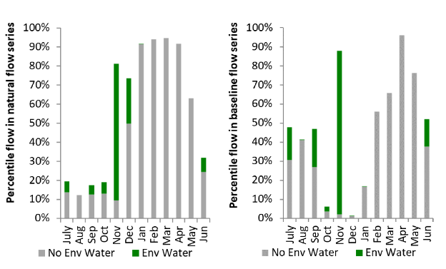
Figure CMP6: Contribution of environmental water delivery at Barnadown as percentiles in the natural and baseline flow series.

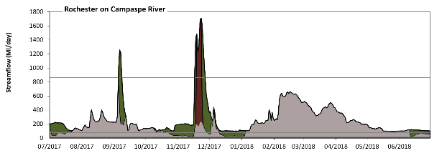
Rochester

Figure CMP7: Contribution of environmental water delivery at Rochester. Horizontal lines indicate thresholds for very low flows, low flows, low freshes and medium freshes (from lowest to highest).
At Rochester on Campaspe River environmental water contributed 29% of the total streamflow volume (with a medium contribution of Commonwealth environmental water). Environmental watering actions affected streamflows for 38% of days between 1 July 2017 and 30 June 2018. Without environmental water, the duration of very low flows (i.e. < 15 Ml/day) in the period October to December would have substantially exceeded durations expected in an average year in the natural flow regime. Environmental water mitigated these impacts by reducing the cumulative duration of very low flow spells from 5% to 0% of the year, with greatest influence in the period October to December. Similarly, without environmental water, the durations of medium low flows (i.e. < 77 Ml/day) in the periods July to September and October to December would have substantially exceeded durations expected in an average year in the natural flow regime. Environmental water mitigated these impacts by reducing the cumulative duration of medium low flow spells from 25% to 0% of the year, with greatest influence in the period October to December. Commonwealth environmental water made little or no contribution to these enhancements of environmental baseflows at this site. In the absence of environmental water there would have been at least one low fresh (i.e. > 310 Ml/day) in the periods July to September, October to December, January to March and April to June. Environmental water increased the duration of the longest low fresh during the periods July to September (from 3 days to 8 days) and October to December (from 1 days to 16 days). Commonwealth environmental water made a small contribution to these increased durations of low freshes. In the absence of environmental water there would have been no medium freshes this year. Environmental water increased the duration of the longest medium fresh during the periods July to September (from 0 days to 4 days) and October to December (from 0 days to 10 days). Commonwealth environmental water made a modest contribution to these increased durations of medium freshes.
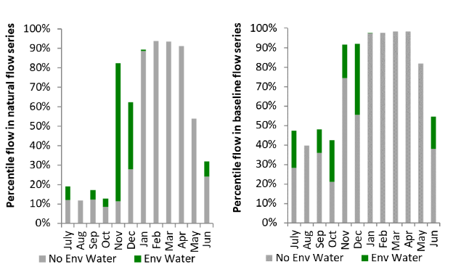
Figure CMP8: Contribution of environmental water delivery at Rochester as percentiles in the natural and baseline flow series.

Lower Darling
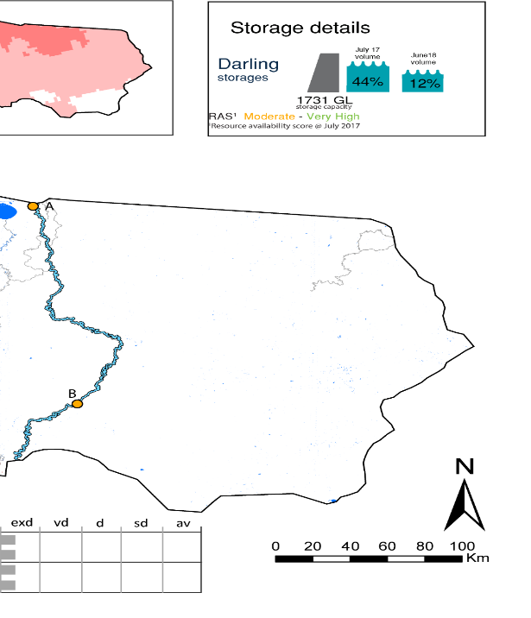Figure LDL1: Watercourses influenced, areas inundated (where applicable) and gauge stations evaluated in the Lower Darling valley during the 2017–18 water year. Inset bar graphs report the condition of annual flow regimes by showing the improvements in hydrological condition with the addition of environmental water as well as the hypothetical scenario in “grey” (if no environmental flow had been delivered); where exd=extremely dry, vd=very dry, d=dry, sd=somewhat dry and av=average. Rainfall conditions (rainfall deciles) and trend in storage levels for the water year are also shown.

Summary
The volume of environmental water delivery for the 2017-18 year in the Lower Darling valley is quantified using data for 5 sites. This evaluation only considers the contribution of held environmental water, which is a primary focus for the Commonwealth. The contributions of planned environmental water (e.g. passing flows), unregulated tributary inflows and clever use of irrigation flows for environmental benefits can all be very important but these are outside the scope of this report. Environmental watering actions lasted on average 142 days over the course of the year. The volume of environmental water at these 5 sites was between 0% and 72% of the total streamflow. Commonwealth environmental water contributed on average 1% of this environmental water. The contribution of environmental water delivery to improved flow regimes is evaluated using data for 5 sites. Ideally, baseflows should be maintained and long periods of excessively low flows avoided. In this valley, the baseflow regime was generally considered to be extremely dry relative to the pre-development flow regime. In our analysis, a low fresh refers to a period of increased flow, when the water level rises at least one eighth of the way up the river bank (above the low flow level). These low freshes are a regular part of the natural flow regime and support a range of natural processes. In the Lower Darling valley, in terms of the occurrence and duration of low freshes, the year was assessed as being extremely dry. In our analysis, a medium fresh refers to a period of increased flow, when the water level rises at least one quarter of the way up the river bank. These medium freshes are not as frequent as low freshes but are also a regular and important part of the natural flow regime. In the Lower Darling valley, in terms of the occurrence of medium freshes, the year was assessed as being extremely dry. In our analysis, a high fresh refers to a period of increased flow, when the water level rises more than half way up the river. A high fresh may not occur every year but they are still important and long periods without major freshes can have consequences for floodplains and their contribution to river ecosystem health. Delivering high in channel environmental flows normally requires that all risks to riparian landholders and infrastructure have been resolved. In the Lower Darling valley, in terms of the occurrence of high freshes, the year was assessed as being extremely dry.

Water delivery context
During the 2017–18, the Commonwealth Environmental Water Holder (CEWH) held water entitlements of up to 24,639 Ml for environmental use in the Lower Darling valley. Each year, water utilities allocate water entitlement holders a percentage of water based on their holding, license type and carryover (the exact rules vary among Jurisdictions). In 2017–18, the Lower Darling entitlements held by the CEWH were allocated 3,271 Ml of water, representing 16% of the Long-term average annual yield for the Lower Darling valley (20,044 Ml). Information and data relating to the portfolio of held Commonwealth environmental water is shown in Table LDL2.
The 2017-18 water allocation (3,271 Ml) together with the carryover volume of 0 Ml of water meant the CEWH had 3,271 Ml of water available for delivery. A total of 2,738 Ml of Commonwealth environmental water was delivered in the Lower Darling valley. A total of 0 Ml of Commonwealth environmental water was traded to consumptive users and 533 Ml (16%) of available Commonwealth environmental water was carried over for environmental use into the 2018–19 water year.

Environmental conditions and resource availability
The water available for environmental delivery combined with the present and antecedent environmental conditions are key inputs used by environmental water managers in planning and implementing watering actions. Post hoc, this information provides important context when evaluating the effectiveness and appropriateness of environmental water use with respect to hydrological outputs.
The rainfall conditions in the Lower Darling valley were classified as Below Average, based on rainfall percentile data for the entire record held by the Bureau of Meteorology for this valley. The water held in major storages in the Lower Darling valley decreased over the water year, for example Meninde dam was 44% full at the beginning of the water year and 12% full by the end of the year (Figure LDL1).
The Commonwealth Environmental Water Office (CEWO) calculates resource availability scenarios (RAS) to guide the use and prioritisation of held environmental water. The RAS are progressively calculated over the year as part of the continual adaptive management planning processes. The RAS are based on the availability of held environmental water (including progressive license acquisitions and allocations) as well as the potential for unregulated or planned environmental flows. The outcome is then used to determine the demand for environmental water across the basin.
In 2017-18, the resource availability of held Commonwealth environmental water was classified as moderate to very high in this valley. The physical conditions meant that the CEWO was managing to protect and/or improve the condition of most environmental assets, while seeking to avoid irreversible damage or decline to the Coorong and Lower Darling Region (where feasible). The overall demand for environmental water was deemed high.

Watering actions
One watering actions was delivered for 7 days during the 2017–18 water year. The watering action was delivered as a spring fresh. The watering action was delivered for the following purposes: fish (25%), vegetation (0%), waterbirds (0%), frogs (0%), other biota (0%), connectivity (25%), process (25%), resilience (0%) and water quality (25%).
Table LDL2. Commonwealth environmental water accounting information for the Lower Darling valley over 2017-18 water year.
Total registered volume (Ml) | Allocated volume (Ml) | Carry over + allocated volume (Ml) | Delivered (Ml) | LTAAY (Ml) | Trade (Ml) | Carried over to 2018-19 | Forfeited (Ml)
24,639 | 3,271 | 3,271 | 2,738 | 20,044 | 0 | 533 | 0

Figure LDL2. Timing and duration of Commonwealth environmental water actions delivered in the Lower Darling valley.

Contribution of Commonwealth Environmental Water to Flow Regimes
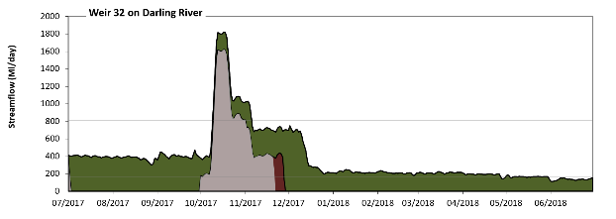
Weir 32

Figure LDL3: Contribution of environmental water delivery at Weir 32. Horizontal lines indicate thresholds for very low flows and low flows (from lowest to highest).
At Weir 32 on Darling River environmental water contributed 72% of the total streamflow volume (with a relatively small contribution of Commonwealth environmental water). Environmental watering actions affected streamflows for 100% of days between 1 July 2017 and 30 June 2018. Without environmental water, the durations of very low flows (i.e. < 160 Ml/day) in the periods July to September, October to December, January to March and April to June would have all substantially exceeded durations expected in an average year in the natural flow regime. Environmental water mitigated these impacts by reducing the cumulative duration of very low flow spells from 85% to 11% of the year, with greatest influence in the periods July to September and January to March. Similarly, without environmental water, the durations of medium low flows (i.e. < 810 Ml/day) in the periods July to September, October to December, January to March and April to June would have all substantially exceeded durations expected in an average year in the natural flow regime. Environmental water mitigated these impacts by reducing the cumulative duration of medium low flow spells from 94% to 93% of the year, with greatest influence in the period October to December. Environmental water increased the magnitude of flows below this medium low flow threshold. Commonwealth environmental water made little or no contribution to these enhancements of environmental baseflows at this site.
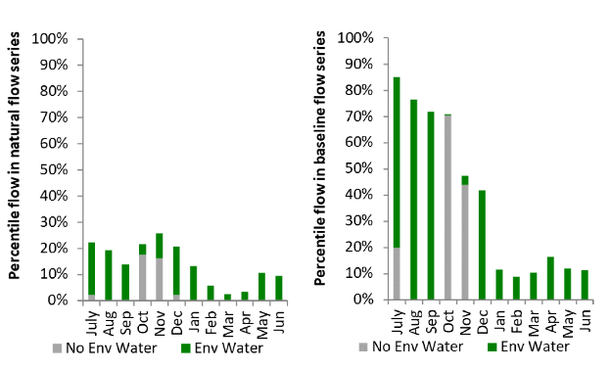
Figure LDL4: Contribution of environmental water delivery at Weir 32 as percentiles in the natural and baseline flow series.
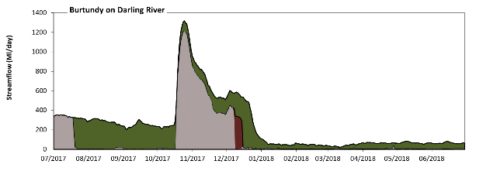
Burtundy

Figure LDL5: Contribution of environmental water delivery at Burtundy. Horizontal lines indicate thresholds for very low flows and low flows (from lowest to highest).
At Burtundy on Darling River environmental water contributed 54% of the total streamflow volume (with a relatively small contribution of Commonwealth environmental water). Environmental watering actions affected streamflows for 95% of days between 1 July 2017 and 30 June 2018. Without environmental water, the durations of very low flows (i.e. < 120 Ml/day) in the periods July to September, October to December, January to March and April to June would have all substantially exceeded durations expected in an average year in the natural flow regime. Environmental water mitigated these impacts by reducing the cumulative duration of very low flow spells from 81% to 50% of the year, with greatest influence in the periods July to September and October to December. Similarly, without environmental water, the durations of medium low flows (i.e. < 590 Ml/day) in the periods July to September, October to December, January to March and April to June would have all substantially exceeded durations expected in an average year in the natural flow regime. Environmental water mitigated these impacts by reducing the cumulative duration of medium low flow spells from 93% to 91% of the year, with greatest influence in the period October to December. Commonwealth environmental water made a small contribution to these enhancements of environmental baseflows at this site.
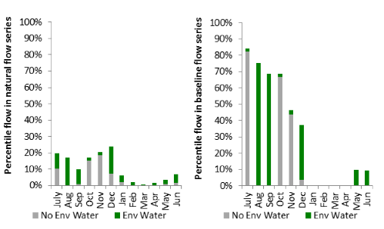
Figure LDL6: Contribution of environmental water delivery at Burtundy as percentiles in the natural and baseline flow series.

Condamine Balonne
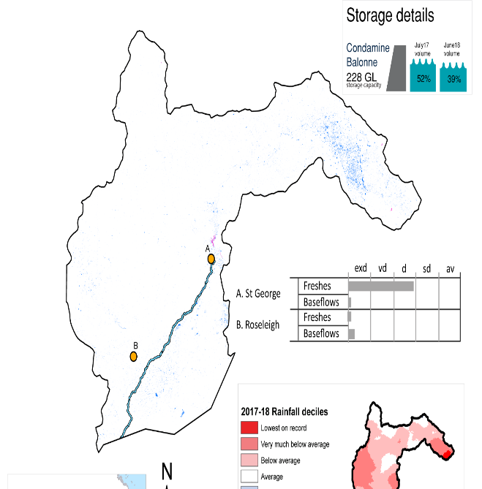Figure CON1: Watercourses influenced, areas inundated (where applicable) and gauge stations evaluated in the Condamine Balonne valley during the 2017–18 water year. Inset bar graphs report the condition of annual flow regimes by showing the improvements in hydrological condition with the addition of environmental water as well as the hypothetical scenario in “grey” (if no environmental flow had been delivered); where exd=extremely dry, vd=very dry, d=dry, sd=somewhat dry and av=average. Rainfall conditions (rainfall deciles) and trend in storage levels for the water year are also shown.

Summary
The volume of environmental water delivery for the 2017–18 year in the Condamine Balonne valley is quantified using data for 2 sites. This evaluation only considers the contribution of held environmental water, which is a primary focus for the Commonwealth. The contributions of planned environmental water (e.g. passing flows), unregulated tributary inflows and clever use of irrigation flows for environmental benefits can all be very important but these are outside the scope of this report. Environmental watering actions lasted on average 3 days over the course of the year. The volume of environmental water at these 2 sites was between 0% and 5% of the total streamflow. Commonwealth environmental water contributed on average 50% of this environmental water. The contribution of environmental water delivery to improved flow regimes is evaluated using data for 1 sites. Ideally, baseflows should be maintained and long periods of excessively low flows avoided. In this valley, the baseflow regime was generally considered to be extremely dry relative to the pre-development flow regime. In our analysis, a low fresh refers to a period of increased flow, when the water level rises at least one eighth of the way up the river bank (above the low flow level). These low freshes are a regular part of the natural flow regime and support a range of natural processes. In the Condamine Balonne valley, in terms of the occurrence and duration of low freshes, the year was assessed as being very dry. In our analysis, a medium fresh refers to a period of increased flow, when the water level rises at least one quarter of the way up the river bank. These medium freshes are not as frequent as low freshes but are also a regular and important part of the natural flow regime. In the Condamine Balonne valley, in terms of the occurrence of medium freshes, the year was assessed as being dry. In our analysis, a high fresh refers to a period of increased flow, when the water level rises more than half way up the river. A high fresh may not occur every year but they are still important and long periods without major freshes can have serious consequences for floodplains and their contribution to river ecosystem health. Delivering environmental high in channel flows normally requires that all risks to riparian landholders and infrastructure have been resolved. In the Condamine Balonne valley, in terms of the occurrence of high freshes, the year was assessed as being average.

Water delivery context
During the 2017-18, the Commonwealth Environmental Water Holder (CEWH) held water entitlements of up to 169,598 Ml for environmental use in the Condamine Balonne valley. Each year, water utilities allocate water entitlement holders a percentage of water based on their holding, licence type and carryover (the exact rules vary among Jurisdictions). In 2017–18, the Condamine Balonne entitlements held by the CEWH were allocated 3,985 Ml of water, representing 4% of the Long-term average annual yield for the Condamine Balonne valley (89,909 Ml). Information and data relating to the portfolio of held Commonwealth environmental water is shown in Table CON2.
The 2017-18 water allocation (3,985 Ml) together with the carryover volume of 45 Ml of water meant the CEWH had 4,040 Ml of water available for delivery. A total of 3,985 Ml of Commonwealth environmental water was delivered in the Condamine Balonne valley. A total of 0 Ml of Commonwealth environmental water was traded to consumptive users and 45 Ml (1%) of available Commonwealth environmental water was carried over for environmental use into the 2018–19 water year.

Environmental conditions and resource availability
The water available for environmental delivery combined with the present and antecedent environmental conditions are key inputs used by environmental water managers in planning and implementing watering actions. Post hoc, this information provides important context when evaluating the effectiveness and appropriateness of environmental water use with respect to hydrological outputs.
The rainfall conditions in the Condamine Balonne valley were classified as Below Average, based on rainfall percentile data for the entire record held by the Bureau of Meteorology for this valley. The water held in major storages in the Condamine Balonne valley decreased over the water year, for example Leslie, Cooby, Chinchilla, Beardmore and Jack Taylor dam was 52% full at the beginning of the water year and 39% full by the end of the year (Figure CON1).

Watering actions
One watering actions was delivered for 7 days over the 2017-18 water year. The watering action was delivered as a baseflow during winter for connectivity and and resilience purposes (Figure CON2).
Table CON2. Commonwealth environmental water accounting information for the Condamine Balonne valley over 2017-18 water year.
Total registered volume (Ml) | Allocated volume (Ml) | Carry over + allocated volume (Ml) | Delivered (Ml) | LTAAY (Ml) | Trade (Ml) | Carried over to 2018-19 | Forfeited (Ml)
169,598 | 3,985 | 4,040 | 3,985 | 89,909 | 0 | 45 | 10

Figure CON2. Timing and duration of Commonwealth environmental water actions delivered in the Condamine Balonne valley.

Contribution of Commonwealth Environmental Water to Flow Regimes
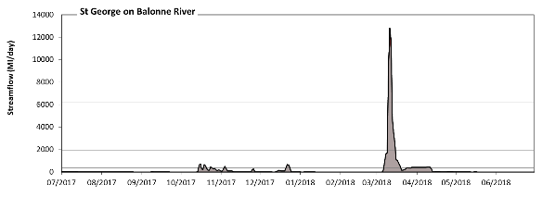
St George
Figure CON3: Contribution of environmental water delivery at St George. Horizontal lines indicate thresholds for very low flows, low flows, low freshes, medium freshes and high freshes (from lowest to highest).
At St George on Balonne River environmental water contributed 5% of the total streamflow volume (all of which was Commonwealth environmental water). Environmental watering actions affected streamflows for 2% of days between 1 July 2017 and 30 June 2018. Without environmental water, the durations of very low flows (i.e. < 71 Ml/day) in the periods July to September, October to December, January to March and April to June would have all substantially exceeded durations expected in an average year in the natural flow regime. However, environmental water had little effect on the duration of these very low flows, which occurred for 79% of the year. Similarly, without environmental water, the durations of medium low flows (i.e. < 350 Ml/day) in the periods July to September, October to December, January to March and April to June would have all substantially exceeded durations expected in an average year in the natural flow regime. However, environmental water had little effect on the duration of these medium low flows, which occurred for 88% of the year. There was at least one low fresh (i.e. > 2000 Ml/day) in the period January to March. Environmental water made no change to the duration of these low freshes. There was at least one medium fresh (i.e. > 6200 Ml/day) in the period January to March. Environmental water made no change to the duration of these medium freshes. In the absence of environmental water there would have been at least one high fresh in the period January to March. Environmental water made no change to the duration of these high freshes.
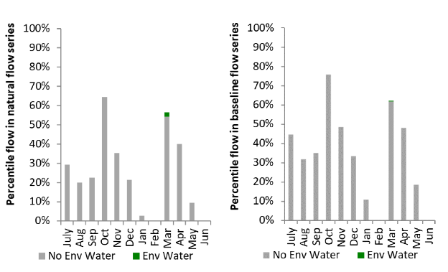
Figure CON4: Contribution of environmental water delivery at St George as percentiles in the natural and baseline flow series.

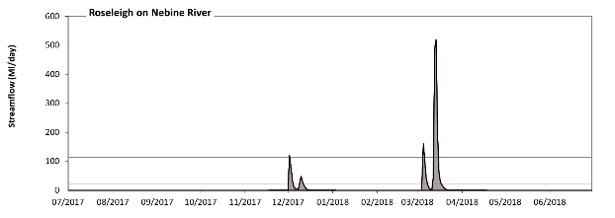
Roseleigh

Figure CON5: Contribution of environmental water delivery at Roseleigh. Horizontal lines indicate thresholds for (from lowest to highest).
There was no environmental water delivered at Roseleigh on Nebine River.
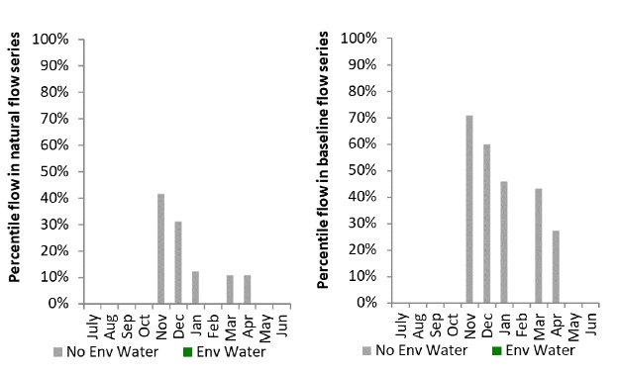
Figure CON6: Contribution of environmental water delivery at Roseleigh as percentiles in the natural and baseline flow series.

Wimmera
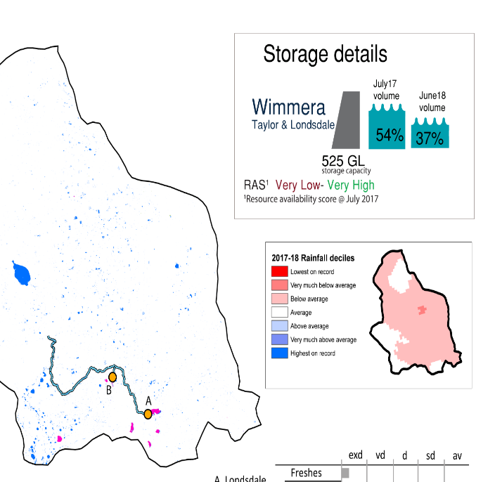
Figure WIM1: Watercourses influenced, areas inundated (where applicable) and gauge stations evaluated in the Wimmera valley during the 2017–18 water year. Inset bar graphs report the condition of annual flow regimes by showing the improvements in hydrological condition with the addition of environmental water as well as the hypothetical scenario in “grey” (if no environmental flow had been delivered); where exd=extremely dry, vd=very dry, d=dry, sd=somewhat dry and av=average. Rainfall conditions (rainfall deciles) and trend in storage levels for the water year are also shown.

Summary
The volume of environmental water delivery for the 2017–18 year in the Wimmera valley is quantified using data for 2 sites. This evaluation only considers the contribution of held environmental water, which is a primary focus for the Commonwealth. The contributions of planned environmental water (e.g. passing flows), unregulated tributary inflows and clever use of irrigation flows for environmental benefits can all be very important but these are outside the scope of this report. Environmental watering actions lasted on average 170 days over the course of the year. The volume of environmental water at these 2 sites was between 70% and 84% of the total streamflow. Commonwealth environmental water contributed on average 31% of this environmental water. The contribution of environmental water delivery to improved flow regimes is evaluated using data for 2 sites. Ideally, baseflows should be maintained and long periods of excessively low flows avoided. In this valley, the baseflow regime was generally considered to be extremely dry relative to the pre-development flow regime. In our analysis, a low fresh refers to a period of increased flow, when the water level rises at least one eighth of the way up the river bank (above the low flow level). These low freshes are a regular part of the natural flow regime and support a range of natural processes. In the Wimmera valley, in terms of the occurrence and duration of low freshes, the year was assessed as being extremely dry. In our analysis, a medium fresh refers to a period of increased flow, when the water level rises at least one quarter of the way up the river bank. These medium freshes are not as frequent as low freshes but are also a regular and important part of the natural flow regime. In the Wimmera valley, in terms of the occurrence of medium freshes, the year was assessed as being extremely dry. In our analysis, a high fresh refers to a period of increased flow, when the water level rises more than half way up the river. A high fresh may not occur every year but they are still important and long periods without major freshes can have serious consequences for floodplains and their contribution to river ecosystem health. Delivering environmental high in channel flows normally requires that all risks to riparian landholders and infrastructure have been resolved. In the Wimmera valley, in terms of the occurrence of high freshes, the year was assessed as being extremely dry.

Water delivery context
During the 2017–18, the Commonwealth Environmental Water Holder (CEWH) held water entitlements of up to 28,000 Ml for environmental use in the Wimmera valley. Each year, water utilities allocate water entitlement holders a percentage of water based on their holding, license type and carryover (the exact rules vary among Jurisdictions). In 2017–18, the Wimmera entitlements held by the CEWH were allocated 0 Ml of water, representing 0% of the Long-term average annual yield for the Wimmera valley (22,568 Ml). Information and data relating to the portfolio of held Commonwealth environmental water is shown in Table WIM2.
The 2017-18 water allocation (0 Ml) together with the carryover volume of 12,138 Ml of water meant the CEWH had 12,138 Ml of water available for delivery. A total of 3,108 Ml of Commonwealth environmental water was delivered in the Wimmera valley. A total of 0 Ml of Commonwealth environmental water was traded to consumptive users and 7676 Ml (63%) of available Commonwealth environmental water was carried over for environmental use into the 2018–19 water year.

Environmental conditions and resource availability
The water available for environmental delivery combined with the present and antecedent environmental conditions are key inputs used by environmental water managers in planning and implementing watering actions. Post hoc, this information provides important context when evaluating the effectiveness and appropriateness of environmental water use with respect to hydrological outputs.
The rainfall conditions in the Wimmera valley were classified as Below Average, based on rainfall percentile data for the entire record held by the Bureau of Meteorology for this valley. The water held in major storages in the Wimmera valley decreased over the water year, for example Lake Taylor and Lake Lonsdale dam was 54% full at the beginning of the water year and 37% full by the end of the year (Figure WIM1).
The Commonwealth Environmental Water Office (CEWO) calculates resource availability scenarios (RAS) to guide the use and prioritisation of held environmental water. The RAS are progressively calculated over the year as part of the continual adaptive management planning processes. The RAS are based on the availability of held environmental water (including progressive license acquisitions and allocations) as well as the potential for unregulated or planned environmental flows. The outcome is then used to determine the demand for environmental water across the basin.
In 2017-18, the resource availability of held Commonwealth environmental water was classified as very low to very high in this valley. The physical conditions meant that the CEWO was managing to protect and improve the aquatic and riparian vegetation, maintain water quality, and support native fish and other biota via habitat provision. The overall demand for environmental water was deemed high.

Watering actions
A total of 2 watering actions were delivered over the 2017-18 water year, the duration of these actions varied (range of individual actions: 9 - 138 days) and Commonwealth environmental water was delivered for a total of 147 days. The count of actions commencing in each season was; summer (1) and autumn (1). The flow component types delivered were; (1) baseflow, (1) freshes, (0) bankfull, (0) overbank and (0) wetland (Figure WIM2).
Commonwealth environmental water was delivered in the Wimmera valley for specified objectives. Although the majority of watering actions were delivered for Fish purposes, water was also delivered for other purposes too. The percentage of watering actions delivered across the nine main themes included fish (18.18%), vegetation (18.18%), waterbirds (18.18%), frogs (0.0%), other biota (18.18%), connectivity (9.09%), process (0.0%), resilience (0.0%) and water quality (18.18%).
Table WIM2. Commonwealth environmental water accounting information for the Wimmera valley over 2017-18 water year.
Total registered volume (Ml) | Allocated volume (Ml) | Carry over + allocated volume (Ml) | Delivered (Ml) | LTAAY (Ml) | Trade (Ml) | Carried over to 2018-19 | Forfeited (Ml)
28,000 | 0 | 12,138 | 3,108 | 22,568 | 0 | 7,676 | 1,355

Figure WIM2. Timing and duration of Commonwealth environmental water actions delivered in the Wimmera valley.

Contribution of Commonwealth Environmental Water to Flow Regimes
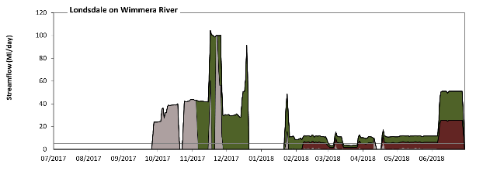
Londsdale

Figure WIM3: Contribution of environmental water delivery at Londsdale. Horizontal lines indicate thresholds for very low flows and low flows (from lowest to highest).
At Londsdale on Wimmera River environmental water contributed 70% of the total streamflow volume (with a medium contribution of Commonwealth environmental water). Environmental watering actions affected streamflows for 54% of days between 1 July 2017 and 30 June 2018. Without environmental water, the durations of very low flows (i.e. < 4.9 Ml/day) in the periods July to September, October to December, January to March and April to June would have all substantially exceeded durations expected in an average year in the natural flow regime. Environmental water mitigated these impacts by reducing the cumulative duration of very low flow spells from 87% to 41% of the year, with greatest influence in the periods January to March and April to June. Similarly, without environmental water, the durations of medium low flows (i.e. < 120 Ml/day) in the periods July to September, October to December, January to March and April to June would have all substantially exceeded durations expected in an average year in the natural flow regime. However, environmental water had little effect on the duration of these medium low flows, which occurred for 100% of the year. Commonwealth environmental water equally shared responsibility with other environmental water holders for these enhancements of environmental baseflows at this site.
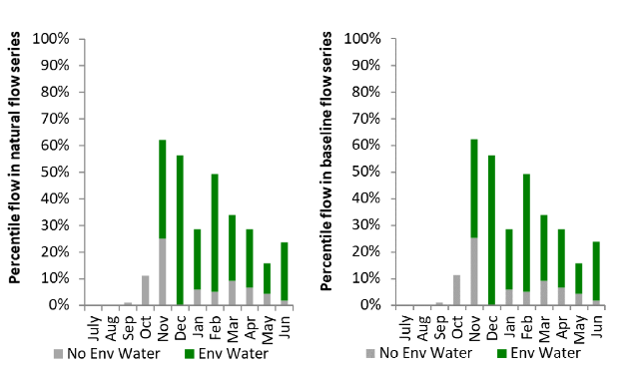
Figure WIM4: Contribution of environmental water delivery at Londsdale as percentiles in the natural and baseline flow series.
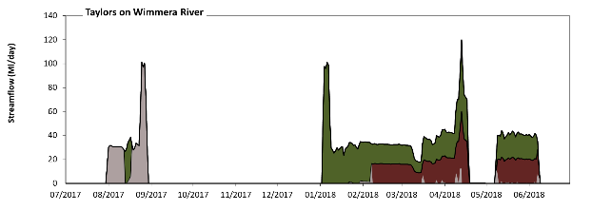
Taylors

Figure WIM5: Contribution of environmental water delivery at Taylors. Horizontal lines indicate thresholds for very low flows and low flows (from lowest to highest).
At Taylors on Wimmera River environmental water contributed 84% of the total streamflow volume (with a medium contribution of Commonwealth environmental water). Environmental watering actions affected streamflows for 39% of days between 1 July 2017 and 30 June 2018. Without environmental water, the durations of very low flows (i.e. < 9.7 Ml/day) in the periods July to September, October to December, January to March and April to June would have all substantially exceeded durations expected in an average year in the natural flow regime. Environmental water mitigated these impacts by reducing the cumulative duration of very low flow spells from 92% to 54% of the year, with greatest influence in the periods January to March and April to June. Similarly, without environmental water, the durations of medium low flows (i.e. < 48 Ml/day) in the periods July to September, October to December, January to March and April to June would have all substantially exceeded durations expected in an average year in the natural flow regime. Environmental water mitigated these impacts by reducing the cumulative duration of medium low flow spells from 99% to 95% of the year, with greatest influence in the periods January to March and April to June. Commonwealth environmental water made a modest contribution to these enhancements of environmental baseflows at this site.
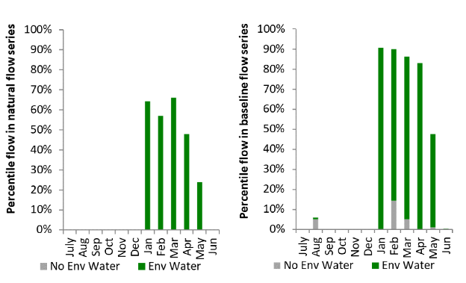
Figure WIM6: Contribution of environmental water delivery at Taylors as percentiles in the natural and baseline flow series.

Warrego
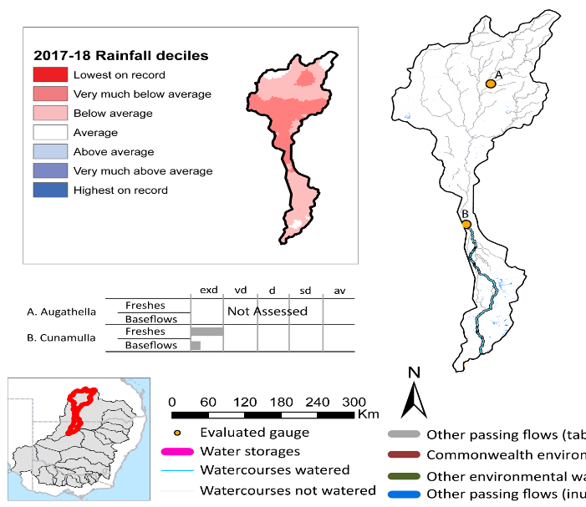
Figure WAR1: Watercourses influenced, areas inundated (where applicable) and gauge stations evaluated in the Warrego valley during the 2017–18 water year. Inset bar graphs report the condition of annual flow regimes by showing the improvements in hydrological condition with the addition of environmental water as well as the hypothetical scenario in “grey” (if no environmental flow had been delivered); where exd=extremely dry, vd=very dry, d=dry, sd=somewhat dry and av=average. Rainfall conditions (rainfall deciles) and trend in storage levels for the water year are also shown.

Summary
The volume of environmental water delivery for the 2017–18 year in the Warrego valley is quantified using data for 1 site. This evaluation only considers the contribution of held environmental water, which is a primary focus for the Commonwealth. The contributions of planned environmental water (e.g. passing flows), unregulated tributary inflows and clever use of irrigation flows for environmental benefits can all be very important but these are outside the scope of this report. Environmental watering actions lasted on average 8 days over the course of the year. The volume of environmental water at this site was 5% of the total streamflow. Commonwealth environmental water contributed on average 50% of this environmental water. The contribution of environmental water delivery to improved flow regimes is evaluated using data for 1 site. Ideally, baseflows should be maintained and long periods of excessively low flows avoided. In this valley, the baseflow regime was generally considered to be extremely dry relative to the pre-development flow regime. In our analysis, a low fresh refers to a period of increased flow, when the water level rises at least one eighth of the way up the river bank (above the low flow level). These low freshes are a regular part of the natural flow regime and support a range of natural processes. In the Warrego valley, in terms of the occurrence and duration of low freshes, the year was assessed as being extremely dry. In our analysis, a medium fresh refers to a period of increased flow, when the water level rises at least one quarter of the way up the river bank. These medium freshes are not as frequent as low freshes but are also a regular and important part of the natural flow regime. In the Warrego valley, in terms of the occurrence of medium freshes, the year was assessed as being extremely dry. In our analysis, a high fresh refers to a period of increased flow, when the water level rises more than half way up the river. A high fresh may not occur every year but they are still important and long periods without major freshes can have serious consequences for floodplains and their contribution to river ecosystem health. In the Warrego valley, in terms of the occurrence of high freshes, the year was assessed as being extremely dry.

Water delivery context
During the 2017–18, the Commonwealth Environmental Water Holder (CEWH) held water entitlements of up to 57,281 Ml for environmental use in the Warrego valley. Each year, water utilities allocate water entitlement holders a percentage of water based on their holding, license type and carryover (the exact rules vary among Jurisdictions). In 2017–18, the Warrego entitlements held by the CEWH were allocated 3,347 Ml of water, representing 7% of the Long-term average annual yield for the Warrego valley (37,922 Ml). Information and data relating to the portfolio of held Commonwealth environmental water is shown in Table WAR2.
The 2017–18 water allocation (2,500 Ml) together with the carryover volume of 0 Ml of water meant the CEWH had 2,500 Ml of water available for delivery. A total of 2,500 Ml of Commonwealth environmental water was delivered in the Warrego valley. A total of 0 Ml of Commonwealth environmental water was traded to consumptive users and 0 Ml (0%) of available Commonwealth environmental water was carried over for environmental use into the 2018–19 water year.

Environmental conditions and resource availability
The water available for environmental delivery combined with the present and antecedent environmental conditions are key inputs used by environmental water managers in planning and implementing watering actions. Post hoc, this information provides important context when evaluating the effectiveness and appropriateness of environmental water use with respect to hydrological outputs.
The rainfall conditions in the Warrego valley were classified as Below Average, based on rainfall percentile data for the entire record held by the Bureau of Meteorology for this valley. The water held in major storages in the Warrego valley is not applicable in this valley over the water year, for example Not applicable dam was 0% full at the beginning of the water year and 0% full by the end of the year (Figure WAR1).

Watering actions
A total of 2 watering actions were delivered over the 2017–18 water year, the duration of these actions varied (range of individual actions: 5 - 11 days) and Commonwealth environmental water was delivered for a total of 16 days. The count of actions commencing in each season was; winter (1) and spring (1). The flow component types delivered were; (0) baseflow, (2) freshes, (0) bankfull, (0) overbank and (0) wetland.
Commonwealth environmental water was delivered in the Warrego valley for specified objectives. Although most of the watering actions were delivered for fish purposes, water was also delivered for other purposes too. The percentage of watering actions delivered across the nine main themes included fish (50%), vegetation (0.0%), waterbirds (0.0%), frogs (0.0%), other biota (0.0%), connectivity (25%), process (0.0%), resilience (25%) and water quality (0.0%).
Table WAR2. Commonwealth environmental water accounting information for the Warrego valley over 2017-18 water year.
Total registered volume (Ml) | Allocated volume (Ml) | Carry over + allocated volume (Ml) | Delivered (Ml) | LTAAY (Ml) | Trade (Ml) | Carried over to 2018-19 | Forfeited (Ml)
57,281 | 2,500 | 3,347 | 2,500 | 37,922 | 0 | 0 | 0

Figure WAR2. Timing and duration of Commonwealth environmental water actions delivered in the Warrego valley.

Contribution of Commonwealth Environmental Water to Flow Regimes
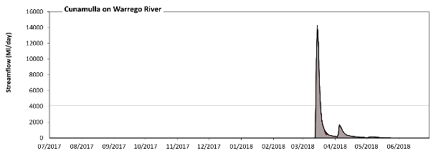
Cunamulla

Figure WAR5: Contribution of environmental water delivery at Cunamulla. Horizontal lines indicate thresholds for very low flows, low flows and low freshes (from lowest to highest).
At Cunamulla on Warrego River environmental water contributed 5% of the total streamflow volume (all of which was Commonwealth environmental water). Environmental watering actions affected streamflows for 4% of days between 1 July 2017 and 30 June 2018. Without environmental water, the durations of very low flows (i.e. < 20 Ml/day) in the periods July to September, October to December and January to March would have substantially exceeded durations expected in an average year in the natural flow regime. However, environmental water had little effect on the duration of these very low flows, which occurred for 81% of the year. Similarly, without environmental water, the durations of medium low flows (i.e. < 99 Ml/day) in the periods July to September, October to December, January to March and April to June would have all substantially exceeded durations expected in an average year in the natural flow regime. However, environmental water had little effect on the duration of these medium low flows, which occurred for 87% of the year. There was at least one low fresh (i.e. > 4100 Ml/day) in the period January to March. Environmental water made no change to the duration of these low freshes. There was no medium or high freshes this year.
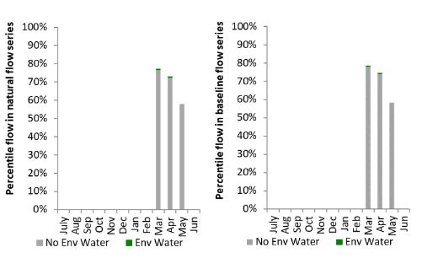
Figure WAR6: Contribution of environmental water delivery at Cunamulla as percentiles in the natural and baseline flow series.

