Murray–Darling Basin Long Term Intervention Monitoring Project

2018–19 Basin-scale evaluation of Commonwealth environmental water – Ecosystem Diversity

Contributors: Shane Brooks

Final Report
CFE Publication 248
May 2020

Murray–Darling Basin Long Term Intervention Monitoring Project
2018–19 Basin-scale evaluation of Commonwealth environmental water — Ecosystem Diversity
Report prepared for the Department of Agriculture, Water and the Environment, Commonwealth Environmental Water Office by La Trobe University, Centre for Freshwater Ecosystems.

Department of Department of Agriculture, Water and the Environment, Commonwealth Environmental Water Office
John Gorton Building
Parkes ACT 2600
Ph: (02) 6274 1111

For further information contact:
Nick Bond Nikki Thurgate
Project Leader Project Co-ordinator
Centre for Freshwater Ecosystems
(formerly Murray–Darling Freshwater Research Centre)
PO Box 821
Wodonga VIC 3689
Ph: (02) 6024 9640 (02) 6024 9647
Email: n.bond@latrobe.edu.au n.thurgate@latrobe.edu.au
Web: https://www.latrobe.edu.au/freshwater-ecosystems/research/projects/ltim
Enquiries: cfe@latrobe.edu.au

Report Citation: Brooks S., (2020) Murray–Darling Basin Long Term Intervention Monitoring Project — 2018–19 Basin-scale evaluation of Commonwealth environmental water – Ecosystem Diversity. Report prepared for the Department of Agriculture, Water and the Environment, Commonwealth Environmental Water Office by La Trobe University, Centre for Freshwater Ecosystems, CFE Publication 248 May 2020 54p.

Cover Image: Australian National Aquatic Ecosystem mapping of the Chowilla floodplain, South Australia.

Traditional Owner acknowledgement:
La Trobe University Albury-Wodonga and Mildura campuses are located on the land of the Latje Latje and Wiradjuri peoples. The Research Centre undertakes work throughout the Murray–Darling Basin and acknowledge the traditional custodians of this land and water. We pay respect to Elders past, present and future.

Acknowledgements:
This project was undertaken using data collected for the Commonwealth Environmental Water Office Long Term Intervention Monitoring Project. The assistance provided by the Monitoring and Evaluation Providers into interpretation of data and report review is greatly appreciated. The author would also like to thank Commonwealth Environmental Water Office staff, State water agency staff, and LTIM Monitoring and Evaluation Providers who contributed to detailed mapping of inundation from watering actions that is a core input to this report. Thank you to the LTIM Hydrology team for compiling the annual inundation maps and to Bex Dunn (Geoscience Australia) for participating in our collaboration workshop and for providing background information and wetland inundation data from the Wetland Insight Tool.

Document history and status
Version | Date Issued | Reviewed by | Approved by | Revision type
1 | 31/03/20 | CEWO |  | general
2 | 30/6/2020 | S Brooks | N. Thurgate | final

Distribution of copies
Version | Quantity | Issued to
1 | 1 x word, 1 x pdf | CEWO

Contents
Summary of annual Basin-scale evaluation 2018–19 1
Summary of multi-year Basin-scale evaluation outcomes 2014–19 2
1 Preface 3
2 Introduction 3
3 Method 5
3.1 Data 6
3.2 Approach 10
4 Basin-scale evaluation 2018–19 11
4.1 Key findings 11
4.2 Contribution of Commonwealth environmental water towards Ecosystem Diversity in 2018–19 12
5 Cumulative Basin-scale evaluation 2014–19 16
5.1 Key findings 16
5.2 Contribution of Commonwealth environmental water towards Ecosystem Diversity 2014–2019 16
6 Contribution to achievement of Basin Plan objectives and adaptive management 30
6.1 Adaptive management 30
6.2 Contribution to Basin Plan objectives 33
7 References 34
Appendix 1: GIS Workflow 36
Appendix 2. Ongoing evolution of the Basin ANAE classification 37
Appendix 3: ANAE wetland types influenced by Commonwealth environmental water by valley 38
Appendix 4. ANAE floodplain types inundated by Commonwealth environmental water by valley 46
Appendix 5: ANAE river channel types influenced by Commonwealth environmental water by valley 50

Summary of annual Basin-scale evaluation 2018–19
Key Basin-scale evaluation findings
- In 2018–19, there were approximately 92 475 ha of lakes and wetlands, 26 568 ha of floodplains and 14 379 km of rivers in the Basin upstream of the Lower Lakes that was supported by Commonwealth environmental water.
- Commonwealth environmental water supported another 103 335 ha of Lake Alexandrina and Lake Albert and their fringing wetlands and 23 802 ha of estuarine habitat in the Coorong and Murray Mouth.
- Commonwealth environmental water supported 58% of the different wetland ecosystem types and 83% of floodplain ecosystem types in the Basin in 2018–19.
- Many permanent wetlands and lakes were supported by the delivery of Commonwealth environmental water (30 118 ha excluding Lake Alexandrina and Albert or 115 374 ha when the lower lakes are included).
- Approximately 58% of the wetland areas (59 000 ha) and all floodplains (26 568 ha) that received Commonwealth environmental water were classed as temporary (intermittent) ecosystem types. These areas can be hot-spots for diversity if they support different suites of species in the dry and wet phases.
- As in previous years, Commonwealth environmental water contributed to all estuarine and river ecosystem types in the Basin during 2018–19 as environmental flows passed through to the Murray Mouth and Coorong.
- River red gum ecosystems dominated 44% of the area supported by Commonwealth environmental water in 2018–19. This is comprised of more than 33 000 ha of temporary river red gum swamp (45% of this ecosystem type in the Basin) and 19 000 ha of river red gum dominated floodplain (3% of this ecosystem type in the Basin). The largest extents of inundated red gum wetlands and floodplains occurred along the Murrumbidgee River, in the Barmah-Millewa forest and then further downstream along the Murray River into South Australia.
- Commonwealth environmental water also supported extensive areas of permanent wetlands (unknown vegetation) and permanent and temporary meadows and marshes (45 604 ha total) primarily in the Gwydir Wetlands and Macquarie Marshes.
- Sixteen of the 62 aquatic ecosystem types in the Basin (25%) did not receive any Commonwealth environmental water in 2018–19. These include permanently wet ecosystems (e.g. permanent springs, paperback swamps, peat bogs and fens, permanent lakes with aquatic macrophyte beds) and temporary saline wetlands and salt-pans that may not require additional water management. Many of these ecosystems also occur in unregulated catchments or above storages and may be outside the scope of Commonwealth environmental water delivery.
Key contribution to Basin Plan objectives
- 8.05 Protection and restoration of water-dependent ecosystems.
  - In 2018–19, Commonwealth environmental water supported 92 475 ha of lakes and wetlands, 26 568 ha of floodplains and 14 379 km of rivers in the Basin upstream of the Lower Lakes; an additional 103 335 ha of Lake Alexandrina and Lake Albert and their fringing wetlands and 23 802 ha of estuarine habitat in the Coorong and Murray Mouth.
  - 75% of the different water dependent ecosystem types in the Basin were represented in areas receiving Commonwealth environmental water.

Summary of multi-year Basin-scale evaluation outcomes 2014–19
Key Basin-scale evaluation findings
- A total of 68 ANAE ecosystem types are mapped in the Basin with 57 ecosystem types being supported by Commonwealth environmental water at least once during the past five years. Five of nine ecosystem types that did not receive Commonwealth environmental water in this period were not located on the Basin-wide Watering Strategy managed floodplain.
- During the five years of LTIM:
  - 28 291 ha of lakes were supported by Commonwealth environmental water.
  - 158 487 ha of palustrine wetlands from 24 ecosystem types were supported by Commonwealth environmental water; most commonly temporary river red gum swamp, temporary sedge/grass/forb marsh, permanent wetland, freshwater meadow and temporary lignum swamp.
  - 101 735 ha of ten different floodplain ecosystems were inundated by Commonwealth environmental water; dominated by river red gum forest riparian zone or floodplain but totalling only 2% of the floodplain area in the Basin.
  - 25 856 km of rivers and streams with flows containing Commonwealth environmental water, of which 91% were lowland rivers.
  - Commonwealth environmental water supported 103 335 ha of Lake Alexandrina and Lake Albert and their fringing wetlands and 23 802 ha of estuarine habitat in the Coorong and Murray Mouth in each of the five years.
- The broad pattern of watering across ecosystem types is similar across all the five years with 50% of ecosystem types supported to some extent by Commonwealth environmental water in all four years and 40% of ecosystem types not receiving any Commonwealth environmental water in any year over the same period. Gwydir wetlands, Macquarie Marshes, the Lowbidgee have received Commonwealth water in all years as has the Coorong, Lower Lakes and Murray mouth at the end of the system.
- The 2014–15 and 2016–17 water years did not include inundation of red gum swamps of the Barmah Millewa forest however these areas were supported by environmental water from NSW and Victoria.

Key contributions to Basin Plan objectives
- 8.05 Protection and restoration of water-dependent ecosystems is supported in principle for 288 513 ha of lakes, wetlands and floodplain and 25 856 km of waterways representing 57 ecosystem types (83 % of the ecosystem types currently mapped in the basin).

Preface
This report is a product of the Commonwealth Environmental Water Office (CEWO) Long-Term Intervention Monitoring (LTIM) project Basin-scale team. The evaluation is conducted at a whole-of-basin scale to assess the contribution of Commonwealth environmental water to Ecosystem Diversity in the Murray–Darling Basin. This report uses a draft revision to the 2017 Australian National Aquatic Ecosystem (ANAE) classification that includes improvements to the river line mapping and some additional riparian vegetation mapping in the northern part of the Basin. The 2017 ANAE update revised the ecosystem typology and substantially changed the number and extent of mapped aquatic ecosystems in areas that receive Commonwealth environmental water (Brooks 2017b). Results presented herein should not be compared to those in earlier Ecosystem Diversity reports from the first two years of the project that used the obsolete “interim” ANAE classification (Brooks 2016, 2017a). There may be some additional differences in this report when reporting on riverine ecosystems compared to the 2017–18 water year (Brooks 2019) due to recent improvements in the ANAE river line mapping.
The cumulative comparison across the full five-year duration of the LTIM project is achieved in this report by re-evaluating the contribution of Commonwealth environmental water delivered in each of the previous years of the LTIM project against the current ANAE classification. Further changes to the ANAE classification are expected as new and improved mapping and knowledge to classify ecosystem types becomes available. When this occurs, the cumulative evaluation of Ecosystem Diversity outcomes across years can be repeated against the revised classification to provide a consistent long-term perspective on the contribution of Commonwealth environmental water to Ecosystem Diversity.
Much of the introductory text and methods is repeated from previous LTIM Project Basin-scale Ecosystem Diversity evaluation reports to enable this report to stand alone for the convenience of the reader.

Introduction
Biological diversity describes the variety of living organisms and ecosystems on Earth. The concept of biodiversity is often understood in terms of numbers of species of microbes, plants and animals but increasingly the definition is expanded to include other forms of natural variation such as genetic diversity, ecosystem diversity and diversity of ecosystem function (Figure 1). Conservation biology is often focused on protecting and restoring ecosystems on the basis that this also preserves the communities and species within them in addition to critical ecosystem functions and services that ecosystems may provide to us (Cadotte et al. 2011; Pollock et al. 2017).
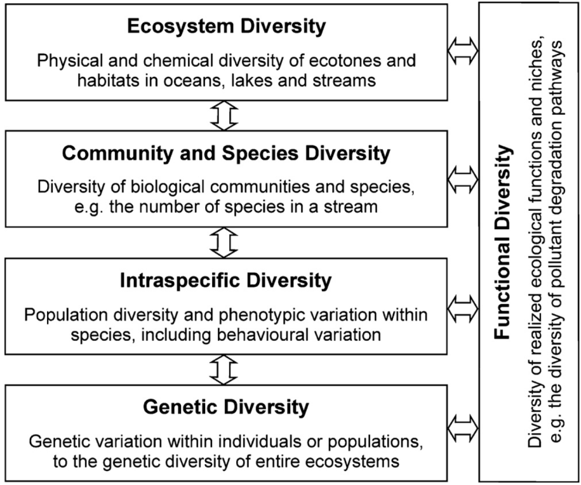
Figure 1. Hierarchical levels of biodiversity in aquatic ecosystems (Geist 2011)
There is increasing recognition globally that conserving biodiversity is critically important to maintain the functioning of natural ecosystems and for the sustainability of resources and ecosystem services on which human survival depends. Australia has joined 196 other countries as signatories to the United Nations Convention on Biological Diversity (1993, https://www.cbd.int) which provides guidance and impetus for conserving biodiversity and promoting sustainable development and sharing of genetic resources. The Murray–Darling Basin Plan (Commonwealth of Australia 2012) is consistent with these objectives as it balances the need for sustainable water resource use with the environmental imperative to protect and restore biodiversity that is dependent on those same water resources.
Managed delivery of Commonwealth environmental water to aquatic ecosystems in the Basin supports water-dependent flora and fauna and provides the physical and chemical conditions that determine how those ecosystems function (Junk et al. 1989; Poff 1997; Thorp et al. 2006). Over decadal time scales, environmental water has potential to influence physical landscape diversity through geomorphological processes (Figure 2). In practice, however, the frequency and volumes of Commonwealth environmental water that are delivered are constrained by storage volumes, infrastructure, and land use to volumes that augment natural hydrology without radically altering the hydrological regime. Large changes to the distribution and abundance of ecosystem types in the Basin are not expected within the duration of the LTIM project (5 years).

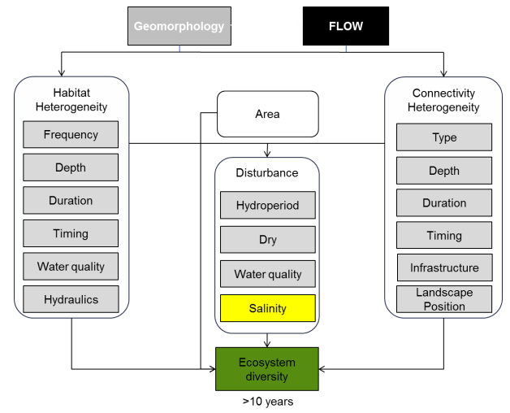
Figure 2. Cause-and-effect diagram depicting the influence of flow on landscape ecosystem diversity (MDFRC 2013).
This evaluation catalogues the different ecosystem types in the Basin that received Commonwealth environmental water during the 2018–19 water year and over the five-year duration of the project. Evaluating the extent to which water-dependent ecosystem types have been supported by Commonwealth environmental water contributes to assessing the contribution of Commonwealth environmental water to Basin Plan biodiversity objectives as outlined in the Commonwealth Environmental Water Outcomes Framework (CEWH 2013).

Method
Ecosystem types in the Basin are defined using the interim ANAE Classification Framework (Aquatic Ecosystems Task Group 2012). The framework provides a consistent ecosystem type classification that can inform cross-jurisdictional adaptive management of aquatic ecosystems (Figure 3).
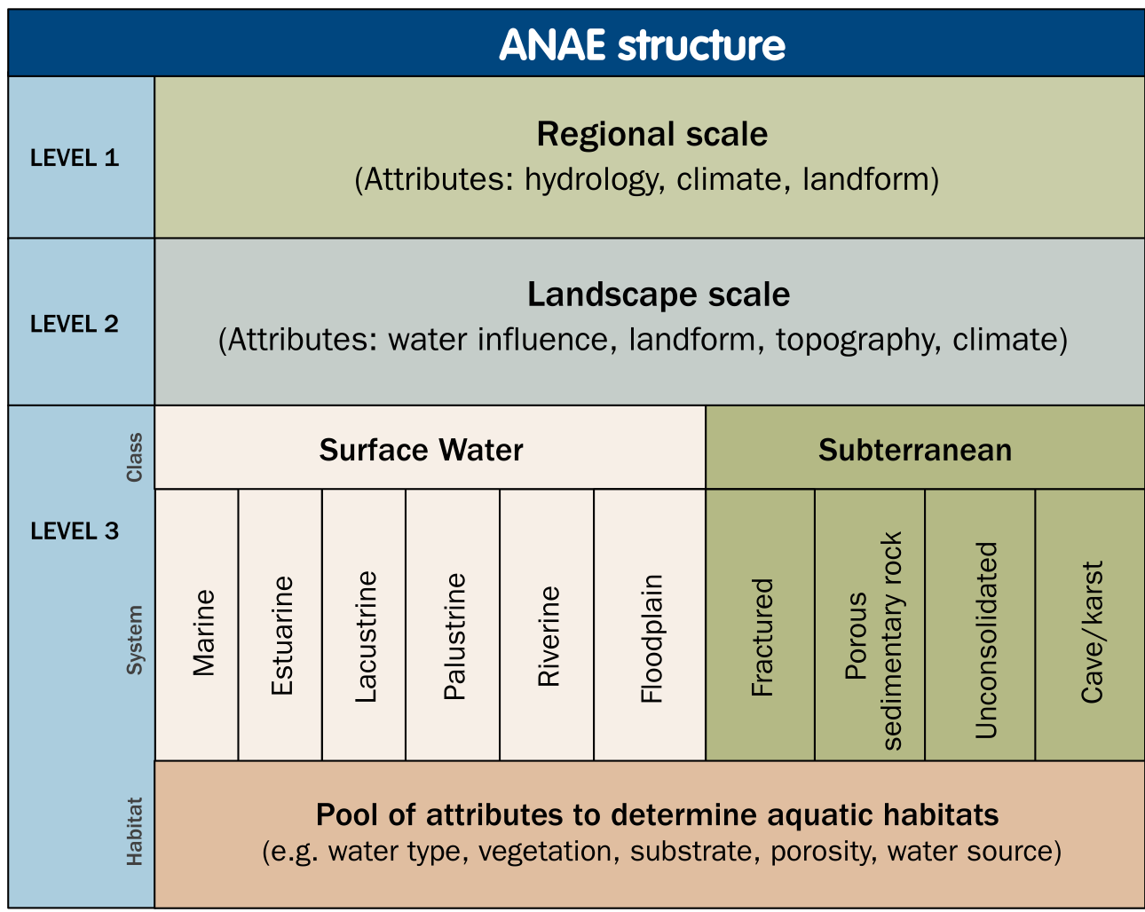
Figure 3. Structure and levels of the Interim Australian National Aquatic Ecosystem Classification Framework (Aquatic Ecosystems Task Group 2012).
The ANAE classification framework was applied to the best available jurisdictional mapping for Basin wetlands, floodplains and rivers by Brooks et al. (2014) to produce the interim Murray–Darling Basin Aquatic Ecosystem Classification data set. With subsequent updates (Brooks 2017b), this data set provides the LTIM project with relevant and contemporary ecosystem type definitions and mapping of their distribution throughout the Basin.
Overlaying the ANAE ecosystem map with the distribution of Commonwealth environmental water that was delivered in the Basin can then identify which ecosystem types received Commonwealth environmental water to answer the following short-term (one-year) and long-term (five-year) Basin-scale evaluation question:
- What did Commonwealth environmental water contribute to ecosystem diversity?

Data
Data inputs to the evaluation of ecosystem diversity include:
The Murray–Darling Basin ANAE data set (Brooks et al. 2014; Brooks 2017b) (Figure 4). In 2017 the ANAE classification of the Basin underwent a substantial revision designed to improve the accuracy and currency of aquatic ecosystem mapping and to integrate all ecosystem types into a single aquatic ecosystem map for the Basin (Brooks 2017b). Additional changes were made in 2018 to further refine the classification of floodplains and to add new mapping for floodplains in Queensland to improve consistency of mapping across state borders (Figure 5).
As a result of all the changes to the ecosystem mapping, the Ecosystem Diversity evaluation results presented in this report are not comparable to those presented in the first two years of the LTIM project (Brooks 2016, 2017a). A cumulative comparison across the full duration of the LTIM project was made in 2018 and 2019 using the revised classification and is extended to include the 2018–19 water year below (Section 5).

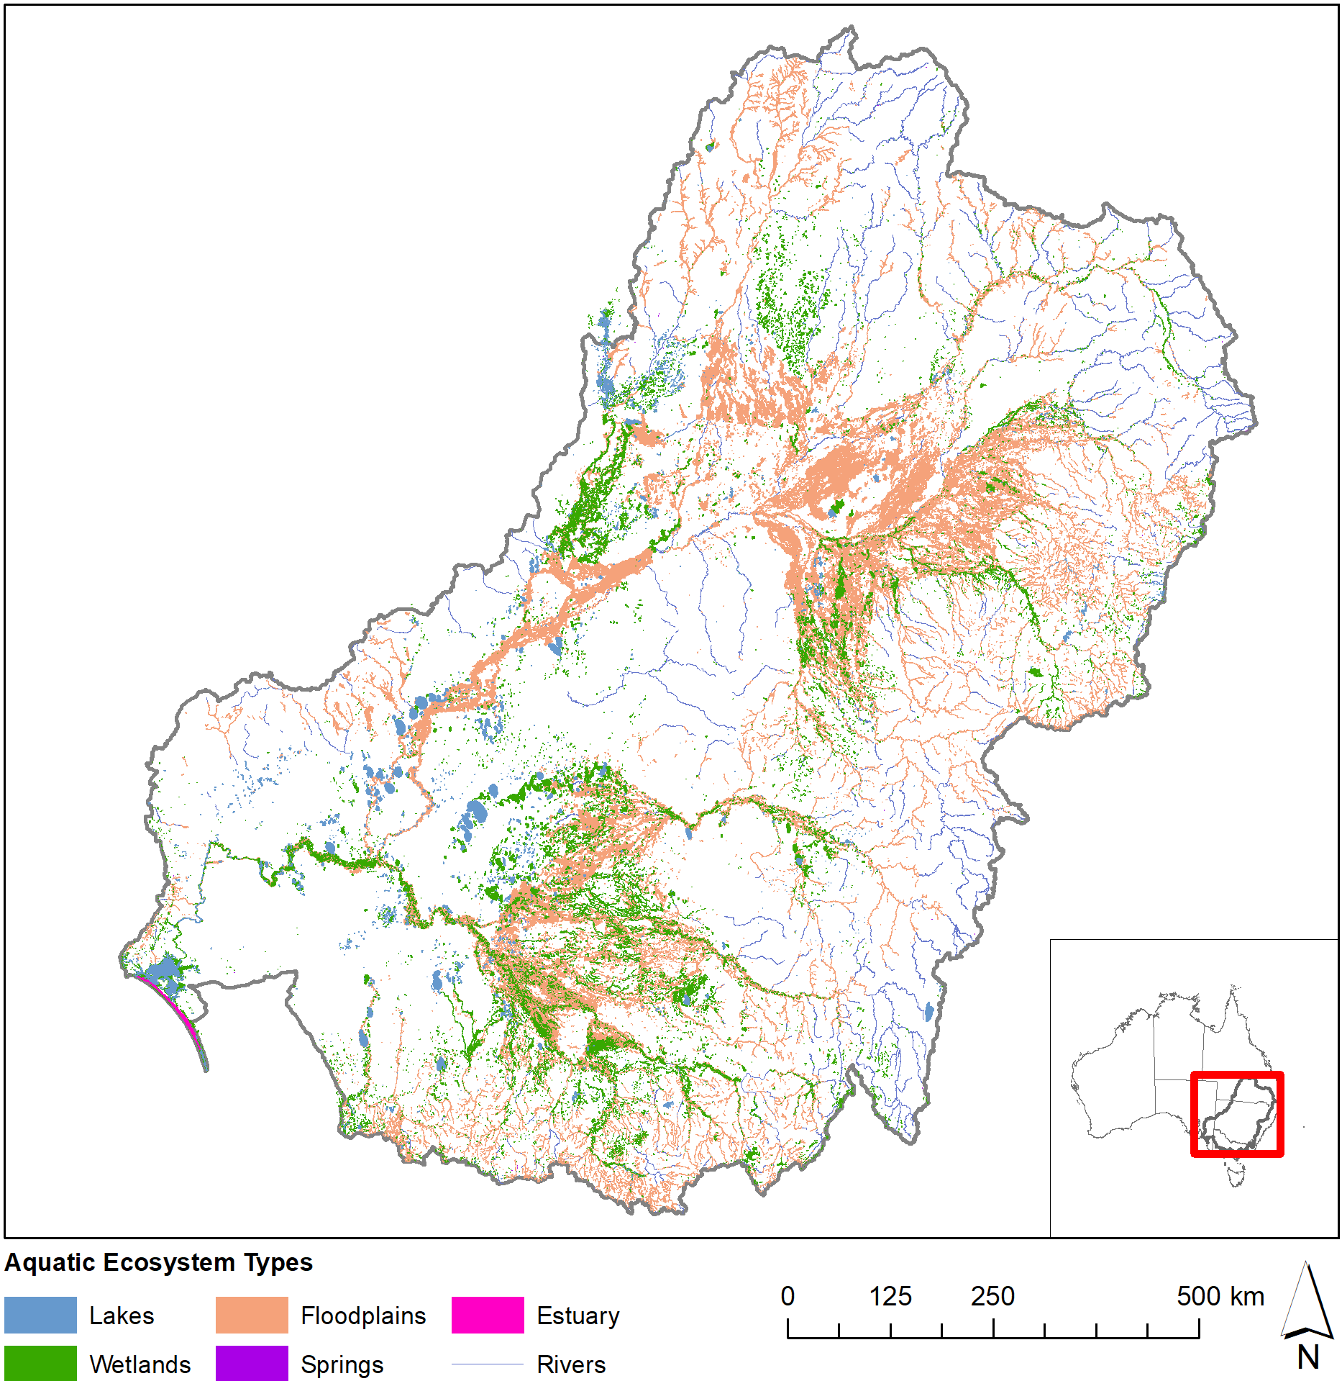
Figure 4. Aquatic ecosystems of the Murray–Darling Basin (ANAE 2018 mapping).

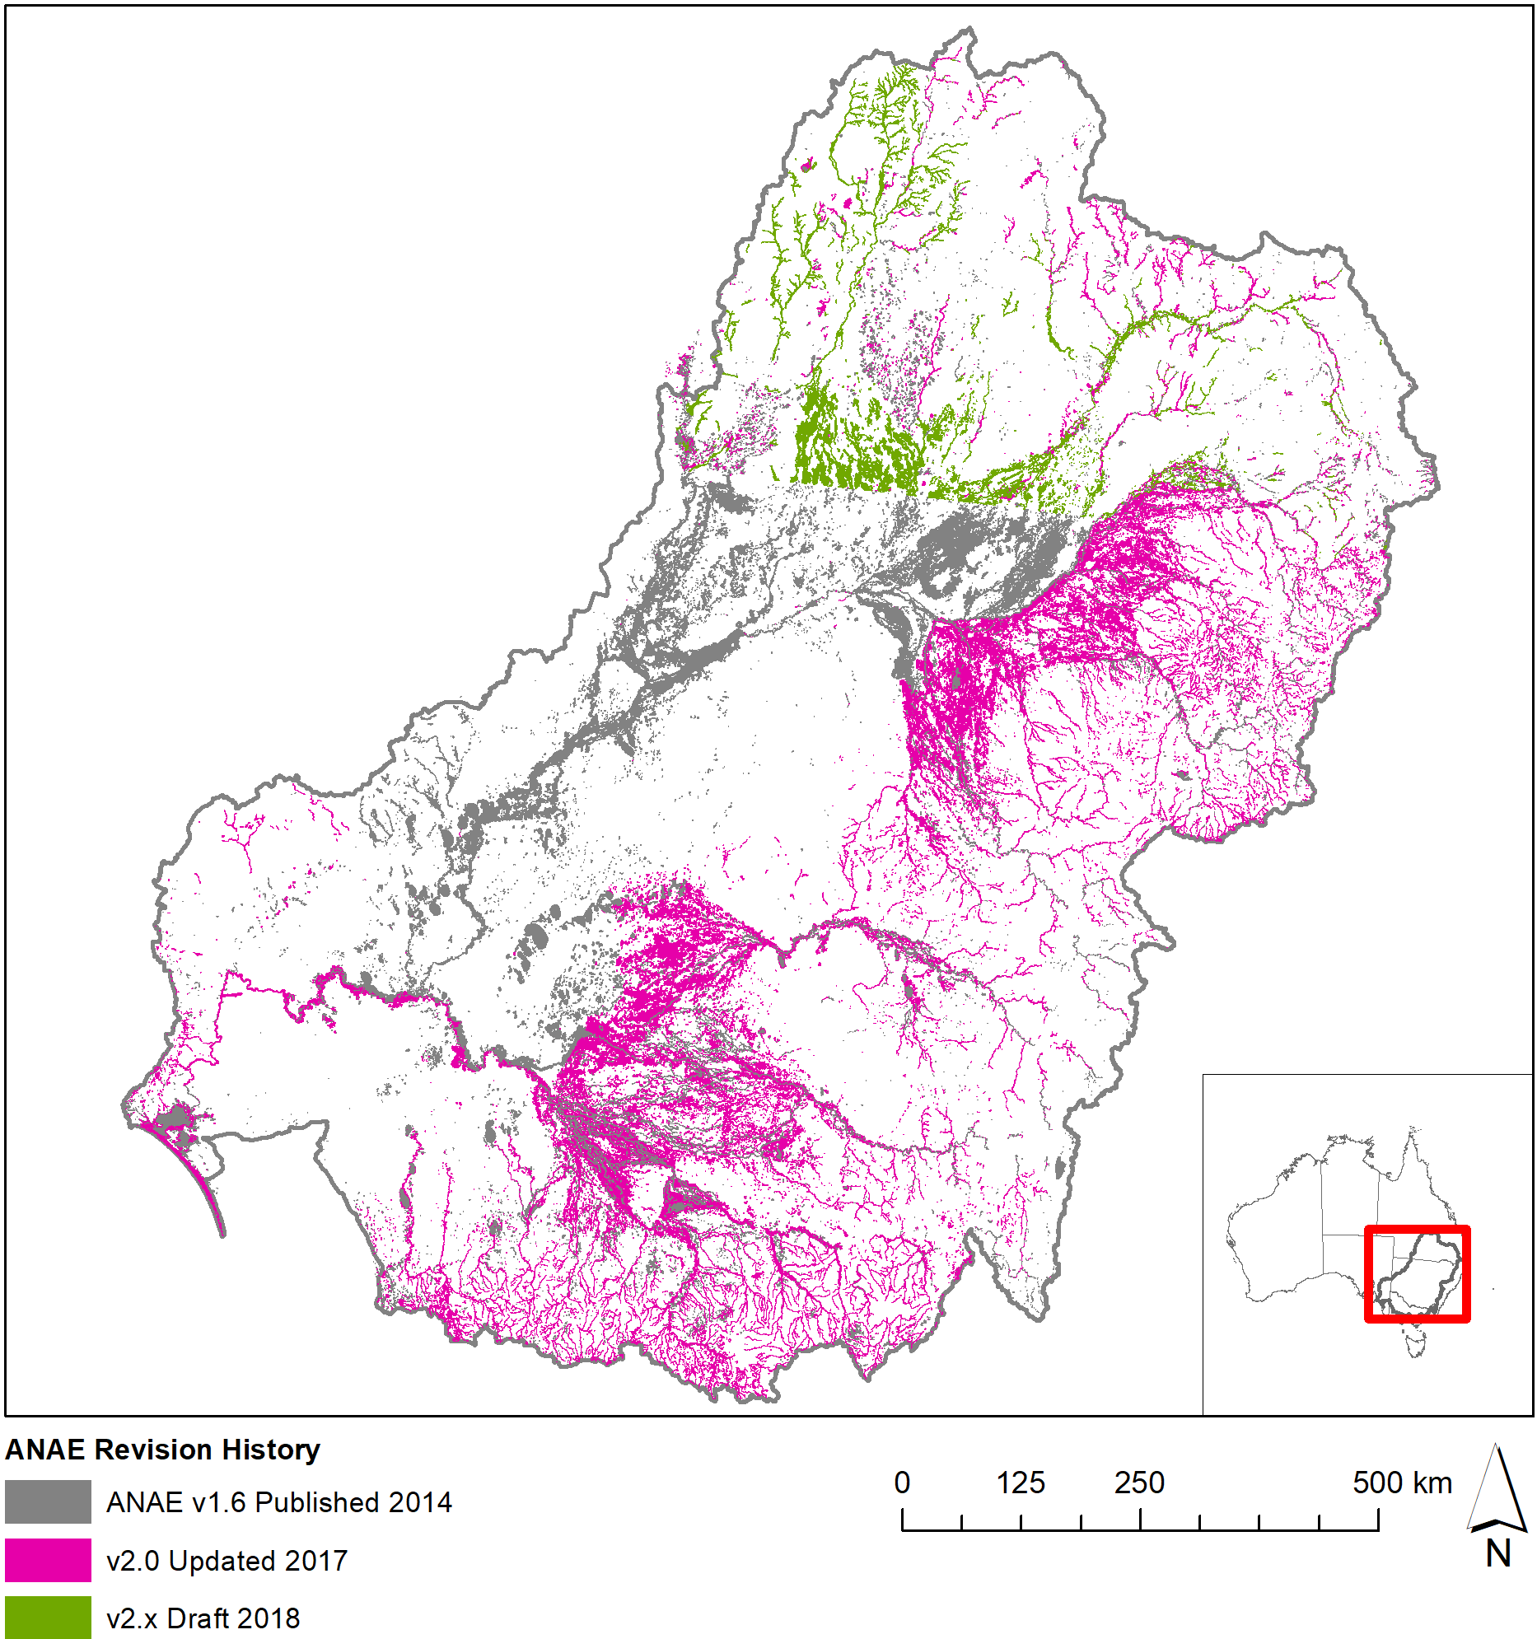
Figure 5. Revision history for the ANAE mapping in the Basin.

Commonwealth environmental water Inundation 2018–19 — a spatial representation of watering extent for Commonwealth environmental water delivered in the 2018–19 water year (Stewardson & Guarino 2020) (Figure 6). Commonwealth environmental water may include other environmental water (e.g. from State agencies) in a combined delivery and the extent mapped is the combined extent.

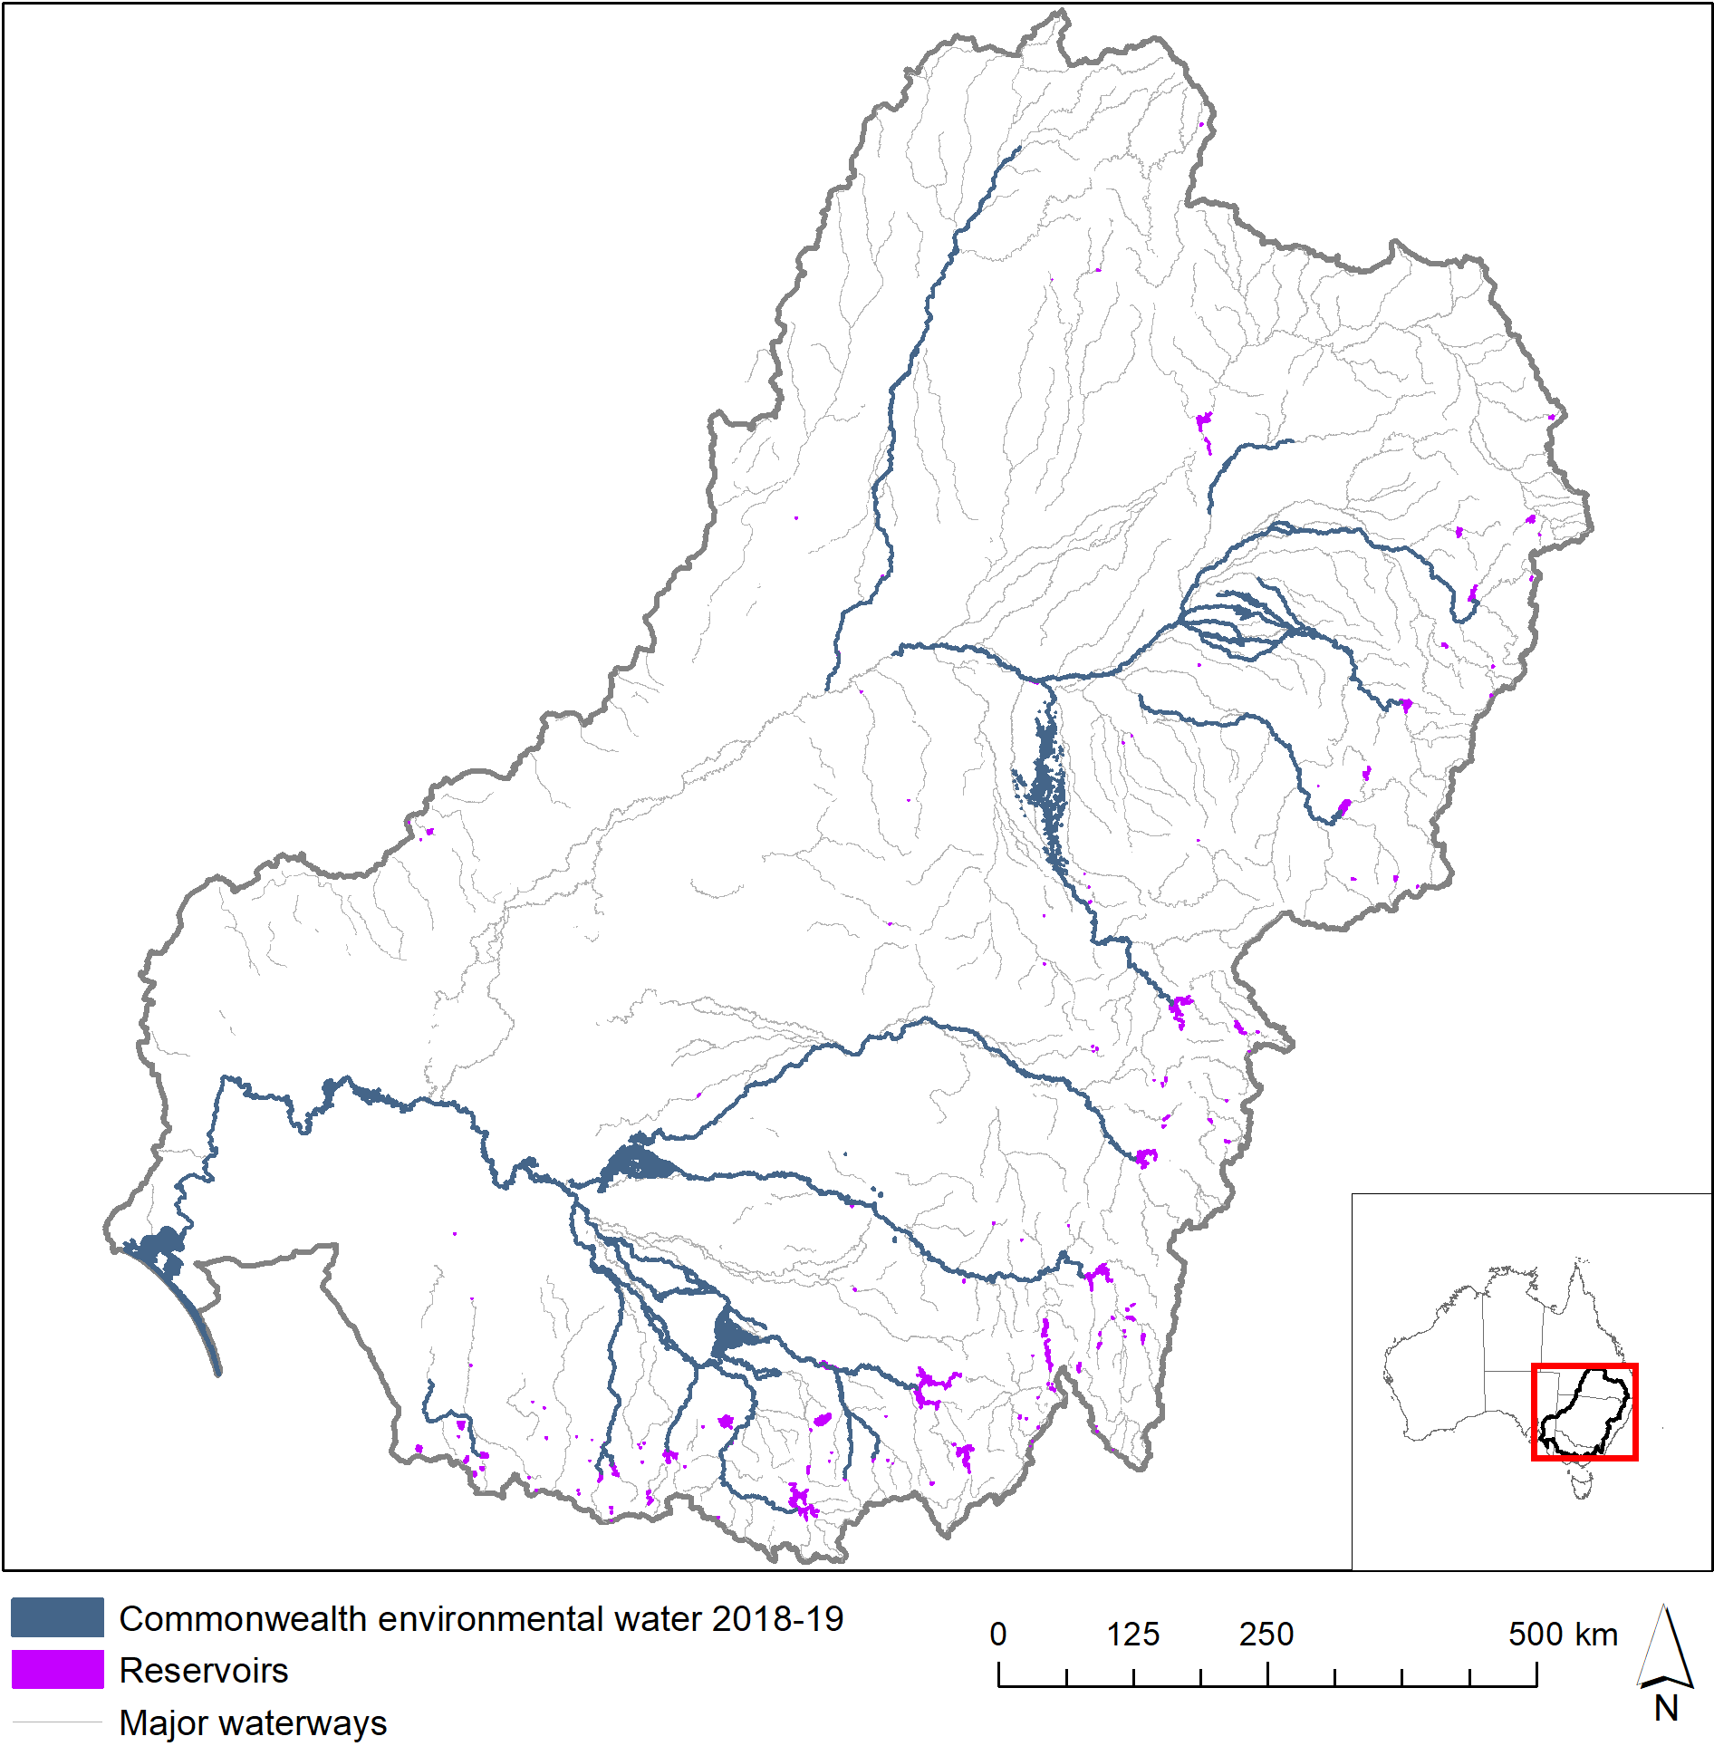
Figure 6. Commonwealth environmental water 2018–19.

LTIM valleys — a spatial layer developed for the LTIM project that subdivides the Basin into the major river valleys (Figure 7). These boundaries were derived from the Sustainable Rivers Audit (SRA) catchment boundaries with a modification to separate the Edward-Wakool Catchment from the Central Murray. The boundaries were adjusted slightly to improve the assignment of wetlands near valley boundaries to the watersheds in which managers and Commonwealth environmental water accounting allocate them. Mostly these changes affect the Central Murray area with a widening along the Murray River corridor to encompass fringing wetlands and the Gunbower and Barmah forests, and southern expansion of the Murrumbidgee valley to include Yanco Creek within the Murrumbidgee valley.
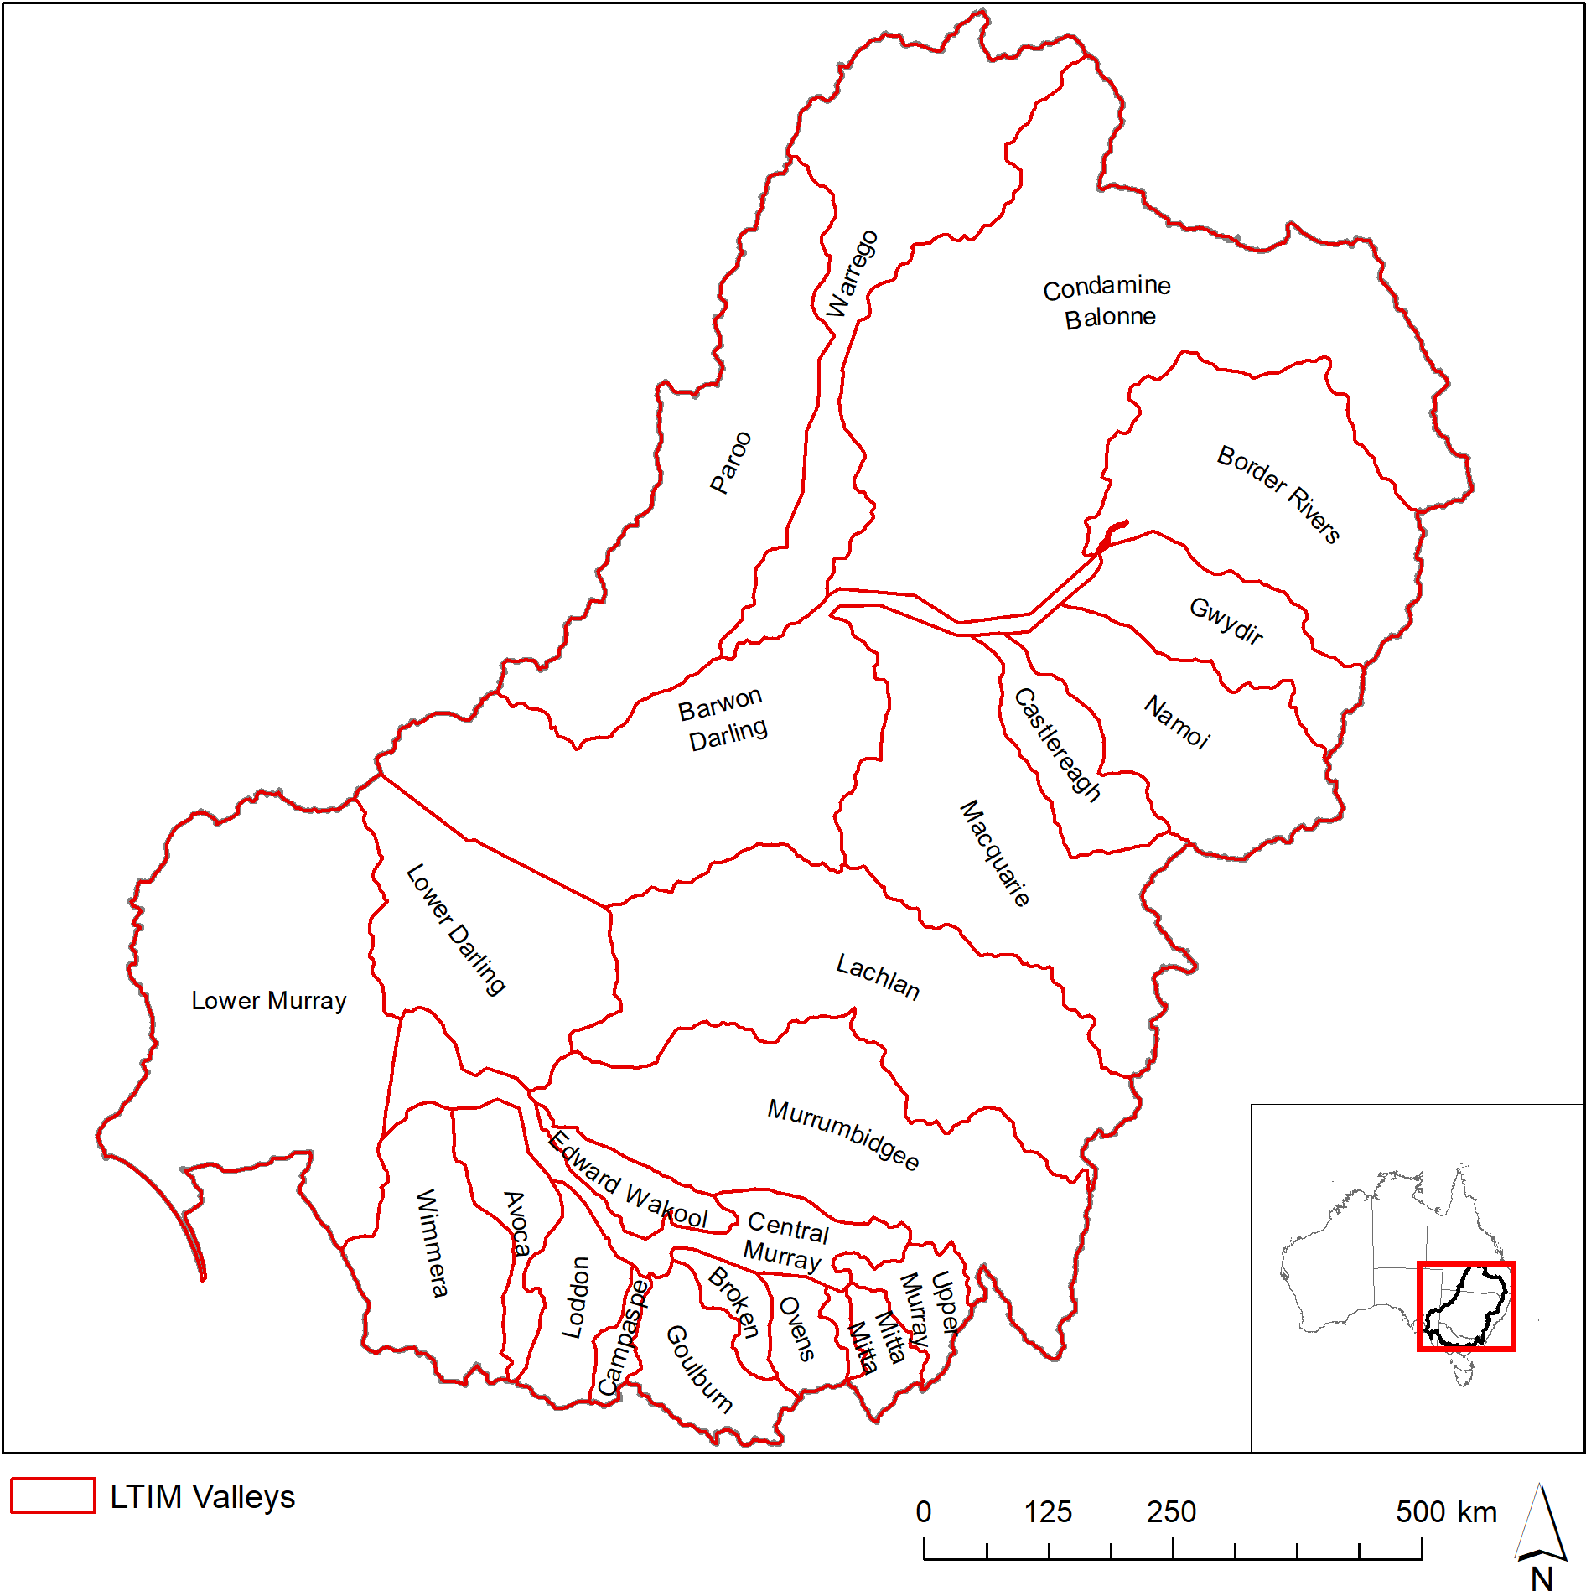
Figure 7. Valley boundaries within the Murray–Darling Basin used in this evaluation.

Geofabric v3 River Lines — River lines are mapped using the new Australian Geofabric v3 Network river lines (BOM 2019). This newly released beta product is still under development however the river line mapping is complete and provides more accurate and more consistent mapping for rivers than is available in the spatial maps compiled from jurisdiction data in the ANAE data set. The Basin ANAE waterway mapping compiles state data that varies in resolution from 1:25 000 to 1:250 000 (equivalent to 25m to 250m accuracy) The Geofabric v3 Network Streams were generated from a 1 second DEM (30m) resolution consistently for the entire Basin. The consistent resolution is important because river length measurement is highly dependent on the level of detail in the mapping with higher resolution mapping capturing more twists and turns in the river that increase the measured river length along the flow path between two points. The ANAE river typology and attributes were assigned to the nearest Geofabric v3 Network Streams in GIS for the purpose of this evaluation. It is expected that the ANAE classification of the Basin data set will formally adopt this new mapping in the near future.

Approach
As in previous years, two different approaches were used to quantify the area of different ecosystem types that received Commonwealth environmental water:
- Area inundated by Commonwealth environmental water = the sum of only the inundated areas of each wetland type, excluding the areas of wetlands that were not inundated.
- Area influenced by Commonwealth environmental water = the sum of the all wetland areas that received water even if the inundation mapping showed that only a portion of the wetland was inundated.
The area inundated by Commonwealth environmental water is a ‘literal’ definition that represents the minimum contribution of Commonwealth environmental water in the landscape. The area influenced by Commonwealth environmental water acknowledges that aquatic ecosystems are complex interconnected systems and delivering water to part of a wetland contributes benefits to the entire wetland system. For example, filling a wetland depression may raise local water tables and benefit fringing vegetation, or provide feeding habitat for waterbirds that roost elsewhere in the wetland vegetation that was not inundated.
For lakes and palustrine wetlands, the total area influenced by Commonwealth environmental water is the appropriate measure of the contribution of Commonwealth environmental water to ecosystem diversity because water entering one part of a wetland depression is likely to raise water levels or the local water table across the extent.
For floodplains, the area inundated by Commonwealth environmental water is used to measure the contribution of Commonwealth environmental water to ecosystem diversity. This more conservative measure is used for floodplains because floodplains occur as broad continuous expanses and the ecosystem response is generally limited to the wetted area. Depressional wetlands and channels that hold or convey water through floodplains are considered as separate entities.
GIS methodologies for calculating these areas are provided attached in Appendix 1.
The spatial representation of watering extent for Commonwealth environmental water delivered in 2018–19 includes all watering actions that resulted in inundation beyond the river channel (Stewardson & Guarino 2020). River reaches that received in-channel pulses, freshes and passing flows are also identified (Figure 6); however, the river channel inundation mapping is not of sufficient resolution to identify inundation of river banks and fringing habitats along the channels.
Commonwealth environmental water reaching the end of the system contributes to the maintenance of the Coorong, Lake Alexandrina, Lake Albert and the Murray Mouth ecosystems. Reliable inundation models for this area do not exist at this time so the extent of inundation is estimated from the mapped extent of the Coorong, Lake Alexandrina, Lake Albert and the Murray Mouth. This estimate is considered reliable because the lakes are managed for a relatively constant water level of 0.5 to 0.8m AHD by regulating outflows through the barrages. Below the barrages, water levels in the Murray Mouth and Coorong are maintained near sea level.

Basin-scale evaluation 2018–19

Key findings
In the 2018–19 water year:
- In 2018–19, there were approximately 92 475 ha of lakes and wetlands, 26 568 ha of floodplains and 14 379 km of rivers in the Basin upstream of the Lower Lakes that was supported by Commonwealth environmental water.
- Commonwealth environmental water supported another 103 335 ha of Lake Alexandrina and Lake Albert and their fringing wetlands and 23 802 ha of estuarine habitat in the Coorong and Murray Mouth.
- Commonwealth environmental water supported 58% of the different wetland ecosystem types and 83% of floodplain ecosystem types in the Basin in 2018–19.
- Many permanent wetlands and lakes were supported by the delivery of Commonwealth environmental water (30 118 ha excluding Lake Alexandrina and Albert or 115 374 ha when the lower lakes are included).
- Approximately 58% of the wetland areas (59 000 ha) and all floodplains (26 568 ha) that received Commonwealth environmental water were classed as temporary (intermittent) ecosystem types. These areas can be hot-spots for diversity if they support different suites of species in the dry and wet phases.
- As in previous years, Commonwealth environmental water contributed to all estuarine and river ecosystem types in the Basin during 2018–19 as environmental flows passed through to the Murray Mouth and Coorong.
- River red gum ecosystems dominated 44% of the area supported by Commonwealth environmental water in 2018–19. This is comprised of more than 33 000 ha of temporary river red gum swamp (45% of this ecosystem type in the Basin) and 19 000 ha of river red gum dominated floodplain (3% of this ecosystem type in the Basin). The largest extents of inundated red gum wetlands and floodplains occurred along the Murrumbidgee River, in the Barmah-Millewa forest and then further downstream along the Murray River into South Australia.
- Commonwealth environmental water also supported extensive areas of permanent wetlands (unknown vegetation) and permanent and temporary meadows and marshes (45 604 ha total) primarily in the Gwydir Wetlands and Macquarie Marshes.
- Sixteen of the 62 aquatic ecosystem types in the Basin (25%) did not receive any Commonwealth environmental water in 2018–19. These include permanently wet ecosystems (e.g. permanent springs, paperback swamps, peat bogs and fens, permanent lakes with aquatic macrophyte beds) and temporary saline wetlands and salt-pans that may not require additional water management. Many of these ecosystems also occur in unregulated catchments or above storages and may be outside the scope of Commonwealth environmental water delivery.

Contribution of Commonwealth environmental water towards Ecosystem Diversity in 2018–19
LTIM inundation mapping (Figure 6) collapses the maximum wetted extent of all watering actions during 2018–19 that included Commonwealth environmental water. Therefore this evaluation is not able to consider the details of individual watering events and is ignorant of the specific timing and duration of Commonwealth environmental water in different areas of the landscape. The area inundated in each valley, and the length of river channels influenced by Commonwealth environmental water is presented in Table 1.
Watering actions targeting floodplains and floodplain wetlands occurred in 6 of the 25 valleys of the Basin (Table 1) with the small amount of floodplain inundation recorded in the Edward–Wakool being the northern extension of inundation of the Barmah-Millewa Forest in the Central Murray valley. Commonwealth environmental water was used more extensively for in-channel delivery in 17 of the 25 valleys (refer Stewardson & Guarino 2020 for details of specific watering actions).

Table 1. Major categories of aquatic ecosystems in each LTIM catchment inundated or influenced by Commonwealth environmental water (Cew) in 2018–19.
Catchment name | LTIM Selected Area | Lakes and wetland area influenced by Cew (ha) | Floodplain inundated by Cew (ha) | Length of waterways containing Cew (km)
Avoca |  | - | - | -
Barwon Darling |  | - | - | 833
Border Rivers |  | - | - | 819
Broken |  | - | - | 172
Campaspe |  | - | - | 117
Castlereagh |  | - | - | -
Central Murray |  | 30 606 | 4135 | 2196
Condamine Balonne |  | - | - | -
Edward–Wakool | Edward–Wakool river system | 3 | 33 | 970
Goulburn | Goulburn River | - | - | 395
Gwydir | Gwydir river system | 7096 | 3238 | 1132
Kiewa |  | - | - | -
Lachlan | Lachlan river system | 4054 | 1183 | 1363
Loddon |  | - | - | 365
Lower Darling |  | - | - | -
Lower Murray* | Lower Murray River* | 7270 | 766 | 1123
Lower Murray  (Coorong Lakes Alexandrina and Albert and Murray Mouth) |  | Fresh: 103 335  Estuarine: 23 802 | 22 | -
Macquarie |  | 32237 | 3208 | 1054
Mitta Mitta |  | - | - | -
Murrumbidgee | Murrumbidgee river system | 11 209 | 13 983 | 1626
Namoi |  | - | - | 506
Ovens |  | - | - | 320
Paroo |  | - | - | -
Upper Murray |  | - | - | -
Warrego | Junction of the Warrego and Darling rivers | - | - | 1208
Wimmera |  | - | - | 180
Total |  | 219 612 | 26 568 | 14 379
* excludes the Coorong, Lakes Alexandrina and Albert and the Murray Mouth.

Commonwealth environmental watering actions contributed to the inundation of 92 475 ha of lakes and wetlands, 26 568 ha of floodplains and 14 379 km of rivers in the Basin upstream of the Lower Lakes. This includes a wide range of ecosystem types within the Basin that included 58% of the different wetland types (Table 2) and 83% of the different floodplain ecosystem types (Table 3), and all (100%) of the river channel (Table 4) and estuarine ecosystem types in the Coorong and Murray Mouth (Table 5).
The contribution of Commonwealth environmental water to Ecosystem Diversity in the Coorong and Lakes Alexandrina and Albert and the Murray Mouth are presented separately in (Table 5) for two reasons: to prevent the large areas of Lakes Alexandrina and Albert (82 500 ha) from masking finer scale patterns of inundation of lakes in the rest of the Lower Murray valley; and the constant managed water levels of the Lakes inundating the same ecosystems each year may hinder evaluation of more variable inter-annual differences in the use of Commonwealth environmental water in other areas of the Basin.
A more detailed breakdown by valley is provided in Appendix 3 (wetlands and estuarine ecosystems), Appendix 4 (floodplains) and Appendix 5 (river channels).
Table 2. Contribution of Commonwealth environmental water to ecosystem diversity of lakes and wetlands at the basin-scale. Ecosystem types are sorted by the area influenced by Commonwealth environmental water.
Australian National Aquatic Ecosystem (ANAE) wetland type | Total ex Coorong and Lower Lakes | Inundated* |  | Influenced*
 | area (ha) | Area (ha) | % of total | Area (ha) | % of total
Pt1.1.2: Temporary river red gum swamp | 74 721 | 9359 | 12.5 | 33 432 | 44.7
Pp4.2: Permanent wetland | 77 314 | 8558 | 11.1 | 21 885 | 28.3
Pt2.2.2: Temporary sedge/grass/forb marsh | 139 937 | 5724 | 4.1 | 15 476 | 11.1
Pp2.1.2: Permanent tall emergent marsh | 8005 | 649 | 8.1 | 4156 | 51.9
Pt2.1.2: Temporary tall emergent marsh | 70 837 | 2747 | 3.9 | 4030 | 5.7
Lp1.1: Permanent lake | 127 388 | 2914 | 2.3 | 3389 | 2.7
Pt4.1: Floodplain or riparian wetland | 11 214 | 83 | 0.7 | 2082 | 18.6
Pt1.8.2: Temporary shrub swamp | 234 412 | 776 | 0.3 | 1507 | 0.6
Lt1.1: Temporary lake | 459 359 | 157 | <0.1 | 1291 | 0.3
Pt3.1.2: Clay pan | 130 927 | 384 | 0.3 | 1143 | 0.9
Pt2.3.2: Freshwater meadow | 125 165 | 323 | 0.3 | 932 | 0.7
Pt1: Temporary swamp | 3767 | 507 | 13.5 | 675 | 17.9
Psp4: Permanent saline wetland | 2093 | 534 | 25.5 | 639 | 30.5
Pt4.2: Temporary wetland | 22 888 | 313 | 1.4 | 586 | 2.6
Pt1.6.2: Temporary woodland swamp | 216 625 | 370 | 0.2 | 579 | 0.3
Pst1.1: Temporary saline swamp | 7157 | 54 | 0.8 | 316 | 4.4
Pt1.2.2: Temporary black box swamp | 60 272 | 94 | 0.2 | 294 | 0.5
Pp2.3.2: Permanent grass marsh | 1507 | 10 | 0.7 | 25 | 1.7
Pp2.2.2: Permanent sedge/grass/forb marsh | 3590 | 17 | 0.5 | 17 | 0.5
Pst2.2: Temporary salt marsh | 40 335 | 3 | <0.1 | 8 | <0.1
Pt1.7.2: Temporary lignum swamp | 49 962 | 0 | 0.0 | 8 | <0.1
Pp2.4.2: Permanent forb marsh | 740 | 2 | 0.3 | 7 | 0.9
Lp1.2: Permanent lake with aquatic bed | 2067 | 0 | 0.0 | 0 | 0.0
Lsp1.1: Permanent saline lake | 9419 | 0 | 0.0 | 0 | 0.0
Lsp1.2: Permanent saline lake with aquatic bed | 181 | 0 | 0.0 | 0 | 0.0
Lst1.1: Temporary saline lake | 27 897 | 0 | 0.0 | 0 | 0.0
Lst1.2: Temporary saline lake with aquatic bed | 2238 | 0 | 0.0 | 0 | 0.0
Lt1.2: Temporary lake with aquatic bed | 9052 | 0 | 0.0 | 0 | 0.0
Pp1.1.2: Permanent paperbark swamp | 1 | 0 | 0.0 | 0 | 0.0
Pp3: Peat bog or fen marsh | 4425 | 0 | 0.0 | 0 | 0.0
Pps5: Permanent spring | 130 | 0 | 0.0 | 0 | 0.0
Psp1.1: Saline paperbark swamp | 31 | 0 | 0.0 | 0 | 0.0
Psp2.1: Permanent salt marsh | 246 | 0 | 0.0 | 0 | 0.0
Pst3.2: Salt pan or salt flat | 3249 | 0 | 0.0 | 0 | 0.0
Pst4: Temporary saline wetland | 6180 | 0 | 0.0 | 0 | 0.0
Pt1.3.2: Temporary coolibah swamp | 8271 | 0 | 0.0 | 0 | 0.0
Pt1.5.2: Temporary paperbark swamp | 412 | 0 | 0.0 | 0 | 0.0
Pu1: Unspecified wetland | 1763 | 0 | 0.0 | 0 | 0.0
* Area inundated/influenced by Commonwealth environmental water: see Section 3.2 for definitions.

Table 3. Contribution of Commonwealth environmental water to ecosystem diversity of floodplains at the Basin-scale, sorted by the area inundated.
Australian National Aquatic Ecosystem (ANAE) floodplain type | Total  area (ha) | Inundated*  area (ha) | % of total
F1.2: River red gum forest riparian zone or floodplain | 639 022 | 19 092 | 3.0
F1.10: Coolibah woodland and forest riparian zone or floodplain | 1 215 726 | 2300 | 0.2
F2.2: Lignum shrubland riparian zone or floodplain | 143 880 | 1538 | 1.1
F1.4: River red gum woodland riparian zone or floodplain | 325 221 | 1247 | 0.4
F1.11: River cooba woodland riparian zone or floodplain | 11 541 | 1137 | 9.9
F2.4: Shrubland riparian zone or floodplain | 408 019 | 485 | 0.1
F1.8: Black box woodland riparian zone or floodplain | 779 639 | 432 | <0.1
F1.6: Black box forest riparian zone or floodplain | 131 442 | 256 | 0.2
F1.12: Woodland riparian zone or floodplain | 318 645 | 57 | <0.1
F4: Unspecified riparian zone or floodplain | 201 086 | 3 | <0.1
F3.2: Sedge/forb/grassland riparian zone or floodplain | 833 102 | 0 | 0.0
F1.13: Paperbark riparian zone or floodplain | 17 | 0 | 0.0
* Area inundated/influenced by Commonwealth environmental water: see Section 3.2 for definitions.

Table 4. Contribution of Commonwealth environmental water to ecosystem diversity within river channels of the Basin sorted by the length of channel inundated by Commonwealth environmental water.
Australian National Aquatic Ecosystem (ANAE) waterway type | Total | Inundated*
 | Length (km) | Length (km) | % of total
Rp1.4: Permanent lowland stream | 40 133 | 10 143 | 25.3
Rt1.4: Temporary lowland stream | 198 551 | 3179 | 1.6
Rp1.2: Permanent transitional zone stream | 15 962 | 484 | 3.0
Rp1.1: Permanent high energy upland stream | 39 421 | 453 | 1.1
Rp1.3: Permanent low energy upland stream | 633 | 266 | 42.0
Rp1: Permanent stream | 360 | 167 | 46.4
Rt1.2: Temporary transitional zone stream | 91 873 | 84 | <0.1
Rt1: Temporary stream | 156 | 79 | 50.6
Rt1.3: Temporary low energy upland stream | 2783 | 49 | 1.8
Rt1.1: Temporary high energy upland stream | 96 565 | 31 | <0.1
Rw1: Permanent river (landform unknown) | 271 | 14 | 5.2
Ru1: Unspecified river (landform unknown) | 293 | 9 | 3.1
* Area inundated/influenced by Commonwealth environmental water: see Section 3.2 for definitions.

Table 5. Ecosystem types in the Coorong Lower Lakes and Murray Mouth that are influenced or inundated (Floodplains only) by Commonwealth environmental water. Ecosystem types are sorted by the area inundated/influenced by Commonwealth environmental water.
Australian National Aquatic Ecosystem (ANAE) wetland type | Total | Inundated*
 | area (ha) | Area (ha) | % of total
Lp1.1: Permanent lake | 82 303 | 82 303 | 100.0
Ewd1.3.2: Coastal lagoon | 18 912 | 18 912 | 100.0
Pt3.1.2: Clay pan | 7798 | 7783 | 99.8
Pt2.1.2: Temporary tall emergent marsh | 5502 | 5502 | 100.0
Pt2.2.2: Temporary sedge/grass/forb marsh | 2580 | 2580 | 100.0
Lsp1.1: Permanent saline lake | 2242 | 2242 | 100.0
Etd1.3.3: Tide dominated estuary | 2234 | 2234 | 100.0
Ewd1.2.4: Intertidal mudflat or sand bar | 918 | 918 | 100.0
Pst1.1: Temporary saline swamp | 786 | 786 | 100.0
Etd1.2.2: Tide dominated mudflats and sandbar | 628 | 628 | 100.0
Psp4: Permanent saline wetland | 616 | 616 | 100.0
Ewd1.2.3: Intertidal saltmarsh | 478 | 478 | 100.0
Pst4: Temporary saline wetland | 451 | 451 | 100.0
Pst2.2: Temporary salt marsh | 371 | 371 | 100.0
Etd1.2.1: Tide dominated saltmarsh | 321 | 321 | 100.0
Ewd1.2.5: Intertidal rocky shoreline | 284 | 284 | 100.0
Pt4.1: Floodplain or riparian wetland | 275 | 275 | 100.0
Psp1.1: Saline paperbark swamp | 132 | 132 | 100.0
Pst3.2: Salt pan or salt flat | 121 | 121 | 100.0
Pp4.2: Permanent wetland | 92 | 92 | 100.0
Pt4.2: Temporary wetland | 28 | 28 | 100.0
Pt2.3.2: Freshwater meadow | 27 | 27 | 100.0
F2.4: Shrubland riparian zone or floodplain | 595 | 20 | 3.4
Etd1.2.3: Tide dominated forest | 19 | 19 | 100.0
Lt1.1: Temporary lake | 16 | 16 | 100.0
Etd1.1.1: Tide dominated rocky shoreline | 7 | 7 | 100.0
Pt1.8.2: Temporary shrub swamp | 7 | 7 | 100.0
Pt1.7.2: Temporary lignum swamp | 3 | 3 | 100.0
Psp2.1: Permanent salt marsh | 3 | 3 | 100.0
F1.12: Woodland riparian zone or floodplain | 40 | 2 | 5.0
F2.2: Lignum shrubland riparian zone or floodplain | 6 | 1 | 16.7
* Area inundated/influenced by Commonwealth environmental water: see Section 3.2 for definitions.

Cumulative Basin-scale evaluation 2014–19

Key findings
- A total of 68 ANAE ecosystem types are mapped in the Basin with 57 ecosystem types being supported by Commonwealth environmental water at least once during the past five years. Five of nine ecosystem types that did not receive Commonwealth environmental water in this period were not located on the Basin-wide Watering Strategy managed floodplain.
- During the five years of LTIM:
  - 28 291 ha of lakes were supported by Commonwealth environmental water.
  - 158 487 ha of palustrine wetlands from 24 ecosystem types were supported by Commonwealth environmental water; most commonly temporary river red gum swamp, temporary sedge/grass/forb marsh, permanent wetland, freshwater meadow and temporary lignum swamp.
  - 101 735 ha of ten different floodplain ecosystems were inundated by Commonwealth environmental water; dominated by river red gum forest riparian zone or floodplain but totalling only 2% of the floodplain area in the Basin.
  - 25 856 km of rivers and streams with flows containing Commonwealth environmental water, of which 91% were lowland rivers.
- The broad pattern of watering across ecosystem types is similar across all the five years with 50% of ecosystem types supported to some extent by Commonwealth environmental water in all four years and 40% of ecosystem types not receiving any Commonwealth environmental water in any year over the same period. Gwydir wetlands, Macquarie Marshes, the Lowbidgee have received Commonwealth water in all years as has the Coorong, Lower Lakes and Murray mouth at the end of the system.
- The 2014–15 and 2016–17 water years did not include inundation of red gum swamps of the Barmah Millewa forest however these areas were supported by environmental water from NSW and Victoria.

Contribution of Commonwealth environmental water towards Ecosystem Diversity 2014–2019
This cumulative evaluation qualitatively compares the distribution of Commonwealth environmental water among aquatic ecosystem types in the Basin over the duration of the LTIM project from July 2014 to June 2019. The inter-annual comparisons of watering extents presented should be viewed as indicative only as there are some differences in the way inundation extents were mapped in each year. The 2014–15 inundation likely over-estimates the extent of Commonwealth environmental water in the Macquarie Marshes, Gwydir wetlands and Lower Murrumbidgee (Lowbidgee) due to poor discrimination of Commonwealth environmental water from other water in satellite imagery. Improvements to the hydrological data assembly process increased the accuracy and confidence in the inundation mapping from 2015–16 onwards.
The Basin Plan (Commonwealth of Australia 2012) Section 8.05 (3b) states “An objective is to protect and restore biodiversity that is dependent on Basin water resources by ensuring that representative populations and communities of native biota are protected and, if necessary, restored.”
This objective can be extended to ecosystem types to evaluate whether ecosystem types supported by Commonwealth environmental water are representative of those types found within the Basin. It is important to consider that Commonwealth environmental water is only one instrument among many working towards achieving Basin Plan objectives. There are many rain-fed aquatic ecosystems that may be out of scope for water management as they are located too far from water sources and/or lack channels or infrastructure to support water management. The current best estimate of the area of the Basin that is in scope for environmental water management is the Basin-wide watering strategy managed floodplain (MDBA 2014, 2019). The managed floodplain (Figure 8) maps the area where floodplain vegetation can be influenced with the 2075 GL of environmental water under the Basin Plan (MDBA 2019). It includes actively managed areas that can receive environmental water via large headwater storages or via The Murray–Darling Basin Authority’s The Living Murray ‘environmental works’ sites on the River Murray floodplain, and passively managed areas that receive environmental water via flow rules in water resource plans or via natural events.
This evaluation therefore considers whether the ecosystem diversity supported by Commonwealth environmental water is representative of the whole Basin, or representative of the subset of ecosystems that intersect the Basin-wide watering strategy managed floodplain (Figure 8).

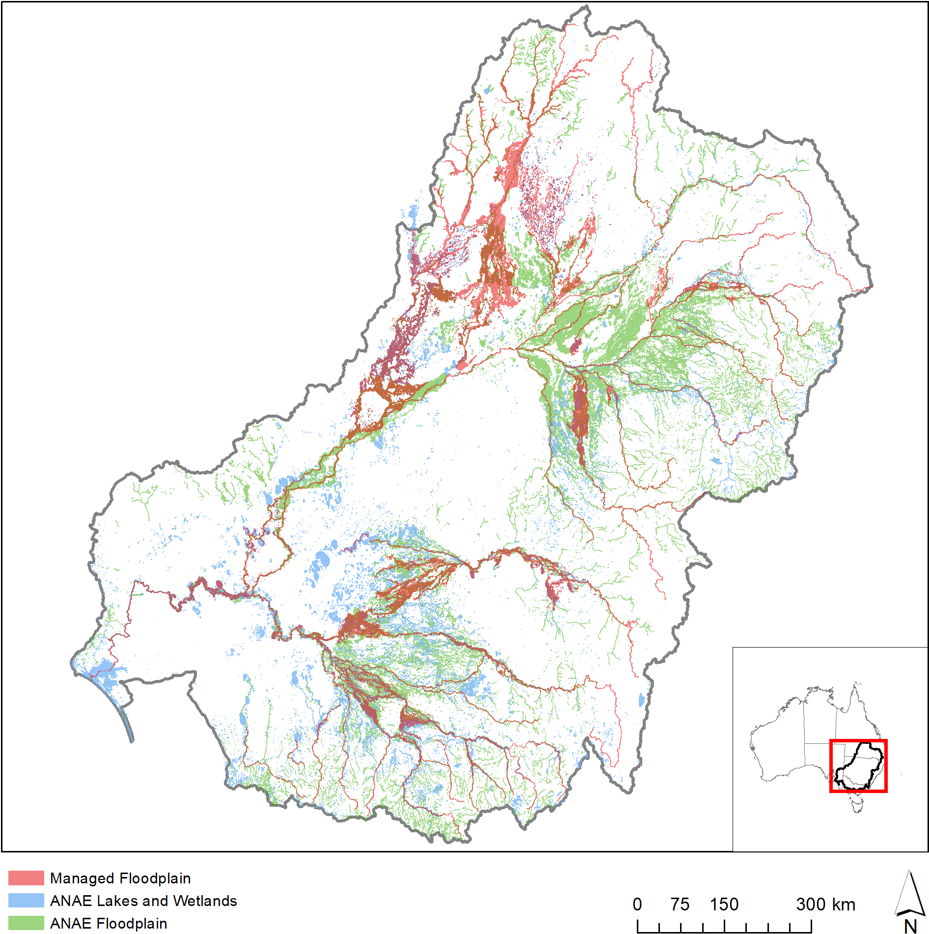
Figure 8. Spatial extent of the Basin-wide watering strategy managed floodplain compared to the extent of ANAE wetland and floodplain ecosystem types.

Lake Ecosystems
Thirty-one percent of the combined area of Basin lakes occurs on the managed floodplain where seven of the eight ANAE lake ecosystem types are represented (Figure 9). The managed floodplain contains a higher proportion of permanent lakes (34% vs 20% in the Basin) perhaps because floodplain lakes are more frequently topped up from rivers via channel and floodplain connections. Commonwealth environmental water was consistently delivered to only two fresh water lake types (temporary and permanent lakes) (Table 6) which comprise 92% of the lake area in the Basin and on the managed floodplain (Figure 9). The distribution of Commonwealth environmental water favoured the maintenance of permanent lakes (relative to their representation in the landscape) over temporary lakes in four out of the five LTIM years (Figure 10). This is consistent with the hydrological needs of these systems. Four of the five lake types that did not receive Commonwealth environmental water were ecosystem types that are classified by the presence of submerged aquatic macrophytes covering large extents of the lake bed (“aquatic bed” in the ANAE type name). Submerged aquatic vegetation may indicate a naturally dependable water supply that perhaps has not been in need of additional support from environmental water to date. Further investigation of individual lakes is required to determine whether Commonwealth environmental water should prioritise these systems higher, or whether their water needs are being met by natural rainfall and groundwater.
An increase in lake inundation is seen in 2017–18 when weir pool manipulations of Loch 8 and Loch 9 on the Murray River pushed Commonwealth environmental water into Lake Victoria (10738 ha).

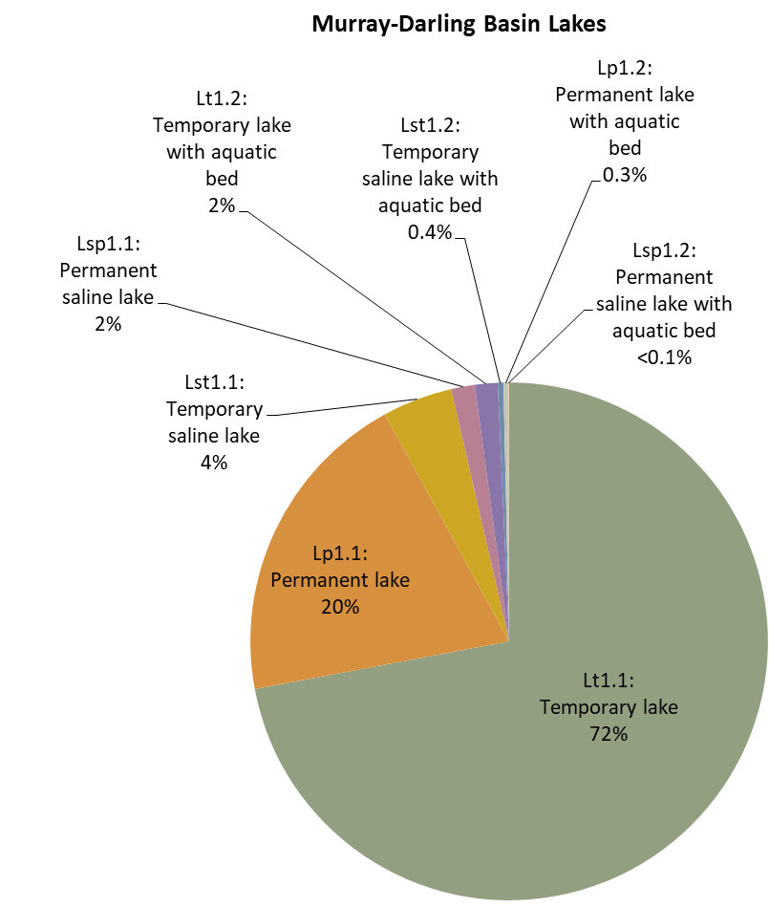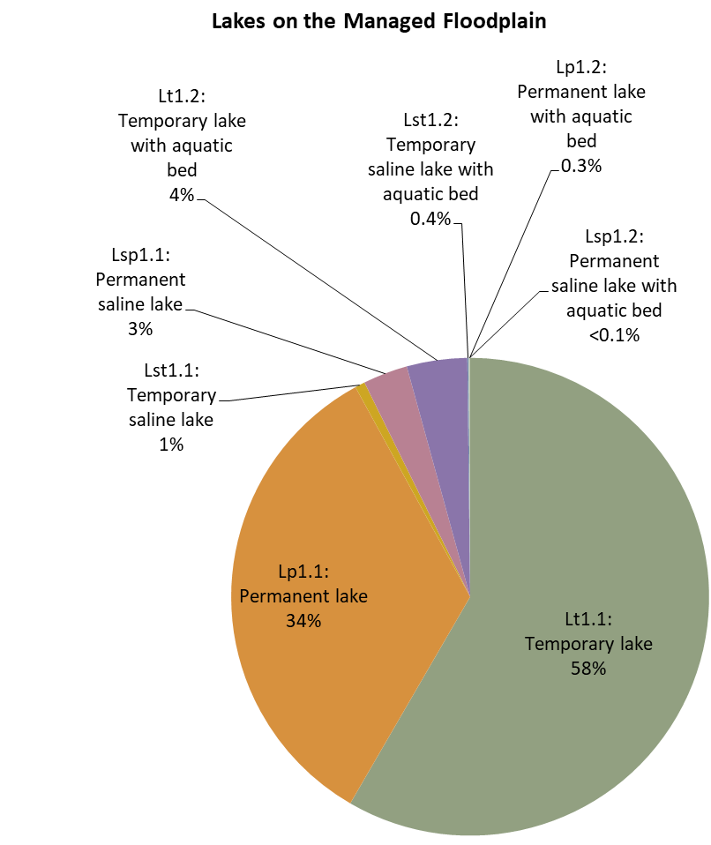
31%
Figure 9. Comparison of the proportional representation of ANAE lake ecosystem types in the Basin to the subset (31%) that occurs on the managed floodplain that is potentially in scope for Commonwealth environmental water management.

Table 6. Comparison of the contribution of Commonwealth environmental water to ecosystem diversity of lakes from 2014–19. Ecosystem types that have received Commonwealth environmental water in every year of the LTIM project are shaded blue. Ecosystem types that have not received Commonwealth environmental water during the period of LTIM are shaded red.
Australian National Aquatic Ecosystem (ANAE) wetland type | Total area in Basin (ha) | Area on Managed Floodplain (ha) | Area receiving Commonwealth environmental water (ha)
 |  |  | Y1  '14-'15 | Y2  '15-'16 | Y3  '16-'17 | Y4  '17-'18 | Y5  '18-'19
Lt1.1: Temporary lake | 459 359 | 116 742 | 2593 | 4505 | 2485 | 3730 | 1291
Lp1.1: Permanent lake | 127 388 | 67 334 | 1440 | 4755 | 6840 | 15292 | 3389
Lst1.1: Temporary saline lake | 27 897 | 1349 | 0 | 0 | 0 | 307 | 0
Lsp1.1: Permanent saline lake | 9419 | 6039 | 0 | 0 | 0 | 0 | 0
Lt1.2: Temporary lake with aquatic bed | 9052 | 8177 | 0 | 0 | 0 | 0 | 0
Lst1.2: Temporary saline lake with aquatic bed | 2238 | 180 | 0 | 0 | 0 | 0 | 0
Lp1.2: Permanent lake with aquatic bed | 2067 | 196 | 0 | 0 | 0 | 0 | 0
Lsp1.2: Permanent saline lake with aquatic bed | 181 | 0 | 0 | 0 | 0 | 0 | 0
TOTAL | 637 601 | 200 017 | 4 033 | 9 260 | 9 325 | 19 329 | 4 680
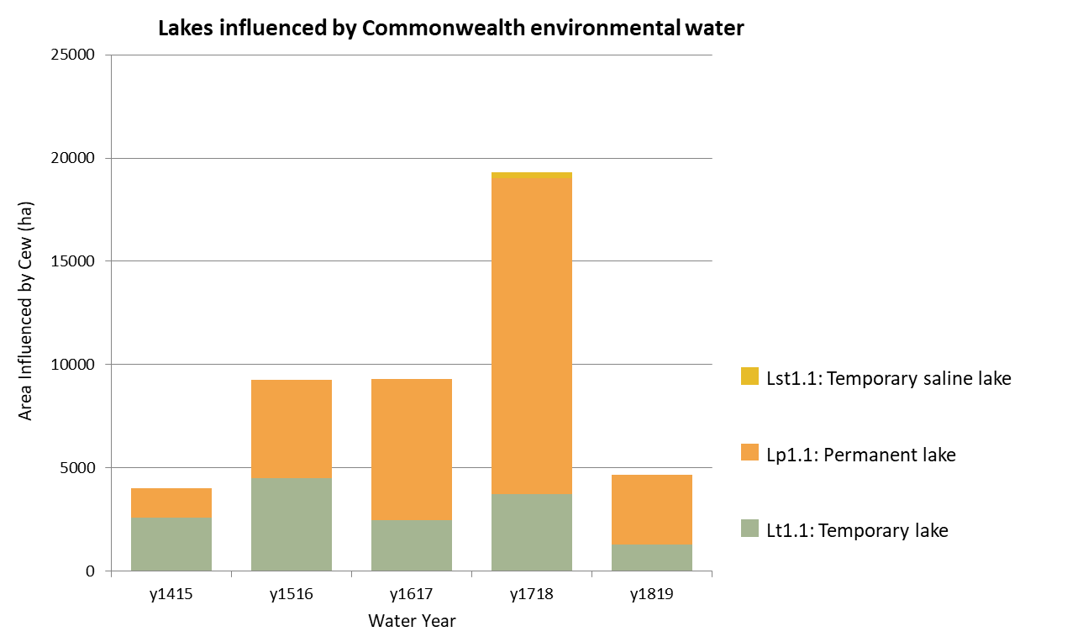
Figure 10. The extent of lake ecosystem types supported by Commonwealth environmental water in each year of the LTIM project.
Over the five years of LTIM Commonwealth environmental water supported 28 291 ha of lake ecosystems. Only two small unnamed lakes received Commonwealth environmental water in all 5 years totalling just 17 ha (Table 7). Seventy percent of the lake ecosystem that received Commonwealth environmental water did so once (Table 7), with the majority in 2017–18 as a result of the northern connectivity flows and topping up of Lake Victoria. The relatively small area of lake ecosystem supported by Commonwealth environmental water annually may reflects a combination of lower water requirements (lakes are typically deeper than wetlands and hold water for longer) and above-average rainfall in 2016–17 (Stewardson & Guarino 2020) that helped maintain lake levels in the Basin naturally. Additionally, a number of lakes in internationally significant Ramsar sites (Hattah Lakes, Kerang Lakes and Barmah Lake) were supported by Victoria and The Living Murray environmental water reserves in years when Commonwealth environmental water was not delivered to these sites (Hale et al. 2020).

Table 7. Total area of lakes influenced by Commonwealth environmental water at differing frequencies during the five years of the LTIM project (2014–19).
Australian National Aquatic Ecosystem (ANAE) wetland type | 1in5 | 2in5 | 3in5 | 4in5 | 5in5 | Total  (All years)
Lp1.1: Permanent lake | 17 801 | 155 | 2059 | 2000 | 2 | 22 017
Lt1.1: Temporary lake | 1533 | 1991 | 1853 | 287 | 15 | 5679
Lsp1.1: Permanent saline lake | 214 | 74 | 0 | 0 | 0 | 288
Lst1.1: Temporary saline lake | 307 | 0 | 0 | 0 | 0 | 307
Lt1.2: Temporary lake with aquatic bed | 0 | 0 | 0 | 0 | 0 | 0
Lst1.2: Temporary saline lake with aquatic bed | 0 | 0 | 0 | 0 | 0 | 0
Lp1.2: Permanent lake with aquatic bed | 0 | 0 | 0 | 0 | 0 | 0
Lsp1.2: Permanent saline lake with aquatic bed | 0 | 0 | 0 | 0 | 0 | 0
TOTAL | 19 855 | 2220 | 3912 | 2287 | 17 | 28 291

Wetland Ecosystems (Palustrine)
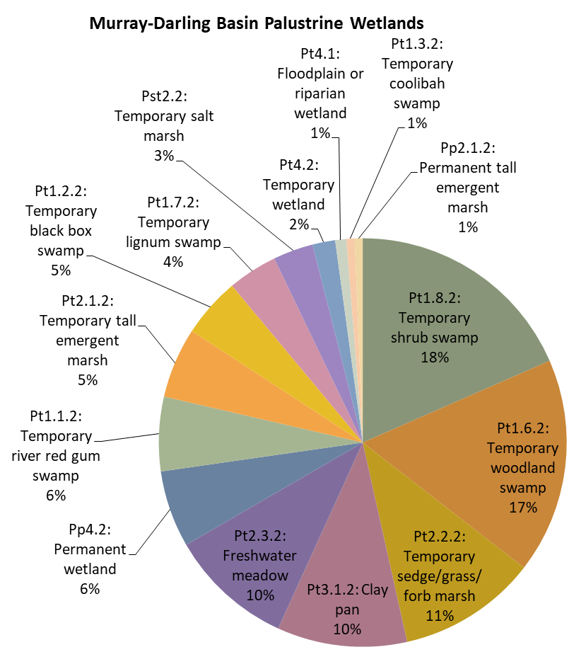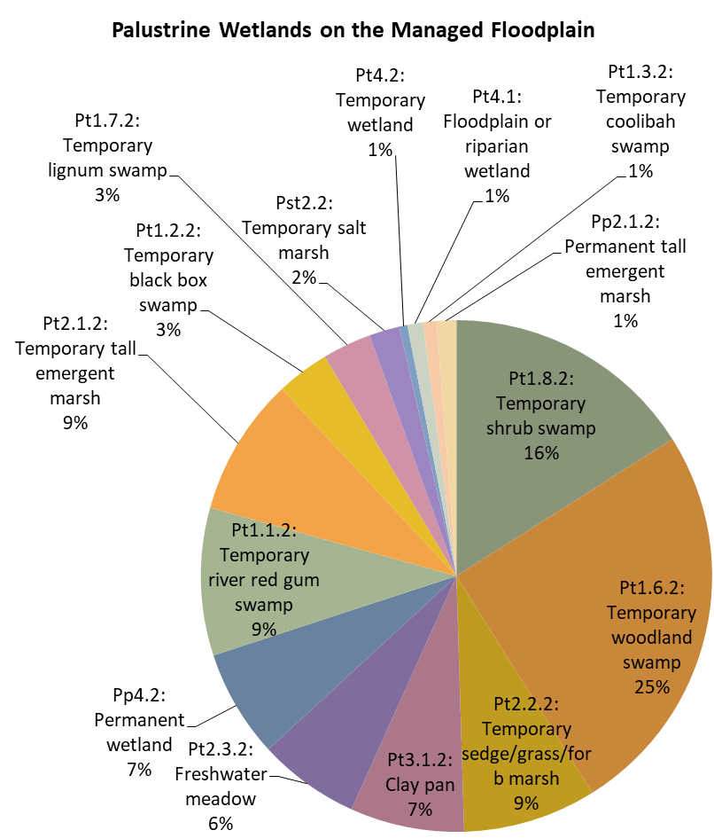
47%
Figure 11. Comparison of the proportional representation of ANAE wetland (palustrine) ecosystem types in the Basin to the subset (47%) that occurs on the managed floodplain that is potentially in scope for Commonwealth environmental water management. For clarity only the 15 most common wetland types are represented that together occupy 99% of the Basin wetland area. There are an additional 15 rare wetland types not shown that make up the remaining 1% (refer Table 8).

There are 30 ANAE palustrine wetland types in the Basin with 15 of the most common representing 99% of the total wetland area in the Basin. The managed floodplain contains 47% of the Basin wetland area. This is made up of the same 15 common types in similar proportion to the whole of the Basin (Figure 11).

Over the five years of LTIM project, Commonwealth environmental water supported 158 487 ha of palustrine wetlands of 22 different ANAE wetland types. Sixteen wetland types received Commonwealth environmental water in each of the five years with another six types supported more irregularly (Table 8). Most commonly, water is delivered to permanent wetlands, freshwater meadows and temporary grass/sedge/forb marshes. These wetland types are common in the Gwydir wetlands and Macquarie Marshes. Both locations are priority assets in the Basin that have been supported by Commonwealth environmental water annually to maintain their Ramsar values (refer LTIM Biodiveristy report, Hale et al. 2020). Temporary river red gum swamps are also commonly recipients of Commonwealth environmental water (7517 to 34 910 ha each year totalling 72 810 ha supported by Commonwealth environmental water over the five years). This ecosystem type is common on the managed floodplain predominantly along watercourses. Eight wetland types did not receive any Commonwealth environmental water during the period 2014–19. These include salt flats and salt marsh for which delivery of fresh water is likely inappropriate (Table 8), and very wet ecosystems (e.g. permanent springs, paperback swamps, peat bogs and fens) that may not require additional support/protection from environmental water management.
Table 8. Comparison of the contribution of Commonwealth environmental water to ecosystem diversity of palustrine wetlands in the basin from 2014–19. Ecosystem types that have received Commonwealth environmental water in every year of the LTIM project are shaded blue. Ecosystem types that have not received Commonwealth environmental water during the period of LTIM are shaded red.
Australian National Aquatic Ecosystem (ANAE) wetland type | Total area in Basin (ha) | Area on Managed Floodplain (ha) | Area receiving Commonwealth environmental water (ha)
 |  |  | Y1  '14-'15 | Y2  '15-'16 | Y3  '16-'17 | Y4  '17-'18 | Y5  '18-'19
Pt1.8.2: Temporary shrub swamp | 234 412 | 96 598 | 1552 | 2567 | 2122 | 2218 | 1507
Pt1.6.2: Temporary woodland swamp | 216 625 | 151 170 | 99 | 417 | 186 | 494 | 579
Pt2.2.2: Temporary sedge/grass/forb marsh | 139 937 | 50 902 | 17 018 | 9773 | 16 917 | 15 776 | 15 476
Pt3.1.2: Clay pan | 130 927 | 43 524 | 3048 | 3673 | 1698 | 1654 | 1143
Pt2.3.2: Freshwater meadow | 125 165 | 38 747 | 18 960 | 1401 | 20 508 | 3620 | 932
Pp4.2: Permanent wetland | 77 314 | 41 111 | 20 267 | 21 044 | 20 095 | 23 018 | 21 885
Pt1.1.2: Temporary river red gum swamp | 74 721 | 56 254 | 9940 | 28 052 | 7517 | 34 910 | 33 432
Pt2.1.2: Temporary tall emergent marsh | 70 837 | 52 720 | 3100 | 3509 | 3116 | 4154 | 4030
Pt1.2.2: Temporary black box swamp | 60 272 | 20 173 | 1069 | 1260 | 228 | 239 | 294
Pt1.7.2: Temporary lignum swamp | 49 962 | 18 681 | 522 | 33 | 12 427 | 446 | 8
Pst2.2: Temporary salt marsh | 40 335 | 11 575 | 19 | 8 | 1 | 4 | 8
Pt4.2: Temporary wetland | 22 888 | 3111 | 0 | 578 | 0 | 602 | 586
Pt4.1: Floodplain or riparian wetland | 11 214 | 5944 | 1118 | 2469 | 1008 | 2495 | 2082
Pt1.3.2: Temporary coolibah swamp | 8271 | 5146 | 2 | 0 | 0 | 0 | 0
Pp2.1.2: Permanent tall emergent marsh | 8005 | 7496 | 3449 | 4156 | 0 | 3451 | 4156
Pst1.1: Temporary saline swamp | 7157 | 9 | 94 | 0 | 0 | 0 | 316
Pst4: Temporary saline wetland | 6180 | 50 | 0 | 0 | 0 | 0 | 0
Pp3: Peat bog or fen marsh | 4425 | 173 | 0 | 0 | 0 | 0 | 0
Pt1: Temporary swamp | 3767 | 2822 | 280 | 690 | 132 | 576 | 675
Pp2.2.2: Permanent sedge/grass/forb marsh | 3590 | 176 | 15 | 15 | 15 | 21 | 17
Pst3.2: Salt pan or salt flat | 3249 | 253 | 0 | 0 | 0 | 0 | 0
Psp4: Permanent saline wetland | 2093 | 1222 | 231 | 811 | 172 | 629 | 639
Pu1: Unspecified wetland | 1763 | 130 | 0 | 0 | 0 | 95 | 0
Pp2.3.2: Permanent grass marsh | 1507 | 248 | 23 | 25 | 96 | 85 | 25
Pp2.4.2: Permanent forb marsh | 740 | 146 | 10 | 0 | 30 | 22 | 7
Pt1.5.2: Temporary paperbark swamp | 412 | 0 | 0 | 0 | 0 | 0 | 0
Psp2.1: Permanent salt marsh | 246 | 0 | 0 | 0 | 0 | 0 | 0
Pps5: Permanent spring | 130 | 3 | 0 | 0 | 0 | 0 | 0
Psp1.1: Saline paperbark swamp | 31 | 0 | 0 | 0 | 0 | 0 | 0
Pp1.1.2: Permanent paperbark swamp | 1 | 1 | 0 | 0 | 0 | 0 | 0
TOTAL | 1 306 176 | 608 385 | 80 816 | 80 481 | 86 268 | 94 509 | 87 797

The proportion of wetland types supported by Commonwealth environmental water is remarkably similar among the years of the LTIM project (Figure 12). The major differences among years are the result of:
- increased watering of freshwater meadows in 2014-15 and 2016-17 when water was delivered from the Warrego River to the western floodplain at Toorale,
- increased watering of temporary river redgum in swamp in 2015–16, 2017–18 and 2018–19 when Commonwealth environmental water was used to flood the red gum dominated Barmah-Millewa Forest,
- increased watering of temporary lignum swamp in 2016–17 when Commonwealth environmental water was delivered to Narran lakes.
Temporary woodland swamps comprise 11% of the Basin wetlands and are the most extensive wetland type on the managed floodplain (151 000 ha) however only a small proportion has received Commonwealth environmental water in the last five years (99 ha-579 ha). This is an arid-land wetland type that is found most commonly the Paroo River and Condamine-Balonne and in other valleys located away from the river channels.

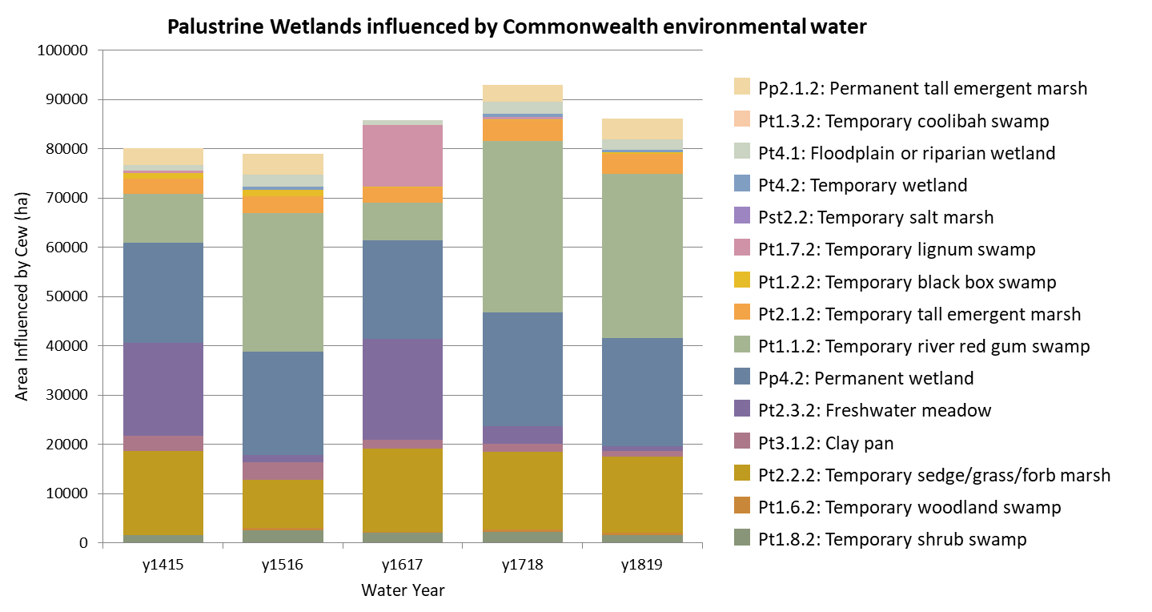
Figure 12. The extent of palustrine wetland ecosystem types supported by Commonwealth environmental water in each year of the LTIM project.

Many wetland areas received repeated inundation by Commonwealth environmental water over multiple years (Table 9). In total, 158 487 ha of wetlands were supported by Commonwealth environmental water from 2014-19. There are 30 259 ha of wetlands that have been supported by Commonwealth environmental water in every year of the project, with the majority located in the Macquarie Marshes and Gwydir Wetlands. A further 15 230 ha of wetlands have been supported by Commonwealth environmental water in four of the last five years (Table 9). 18 062 ha (60%) of the area that is inundated annually is classified as permanent wetland. The remaining 40% includes 7079 ha of temporary sedge/grass/forb marsh, 2130 ha of temporary tall emergent marsh and 1767 ha of temporary river red gum swamp for which ongoing annual inundation may be inappropriate. For example, refer to Figure 13 which shows a side-by-side comparison of the distribution of ANAE ecosystem types and watering frequencies in the Macquarie Marshes. Continued regular watering may convert naturally intermittent ecosystems into more permanent wetland types and promote drought sensitive species that increase the dependency on ongoing environmental water management. For example, regular water may allow the encroachment of reed beds into areas previously dominated by sedges and/or redgum.
In the Macquarie marshes, the temporary tall emergent marsh may be seasonally inundated with a dry phase in late summer despite annual watering. It is also possible that some of the tall emergent marshes are misclassified permanently wet ecosystems. An update to the ANAE classification planned for late 2020 will further examine the use of wetness indices derived from satellite data (Dunn et al. 2019) to improve the classification of hydrological regime that is used to distinguish “temporary” and “permanent” ecosystem types.
The large area of temporary lignum swamp supported by Commonwealth environmental water delivered to Narran lakes in 2016–17 represents 40% of the wetland area watered just once in the five years. Watering of the Western Floodplain at Toorale (freshwater meadow) in 2014–15 and 2016–17 is 43% of the 45 937 ha of wetlands that were supported by Commonwealth environmental water twice during LTIM (Table 9). It is expected that improvements to the ANAE mapping expected in late 2020 will re-map much of the western floodplain as a floodplain ecosystem type and require these results to be recast.

Table 9. Total area of palustrine wetland ecosystems influenced by Commonwealth environmental water at differing frequencies during the five years of the LTIM project (2014–19).
Australian National Aquatic Ecosystem (ANAE) wetland type | 1in5 | 2in5 | 3in5 | 4in5 | 5in5 | Total  (All years)
Pt1.1.2: Temporary river red gum swamp | 2951 | 1287 | 23 161 | 7239 | 1767 | 36 405
Pt2.2.2: Temporary sedge/grass/forb marsh | 4050 | 8968 | 3440 | 1611 | 7079 | 25 148
Pp4.2: Permanent wetland | 2635 | 1116 | 2293 | 1016 | 17902 | 24 962
Pt2.3.2: Freshwater meadow | 1249 | 19 692 | 810 | 108 | 34 | 21 893
Pt1.7.2: Temporary lignum swamp | 13 082 | 7 | 8 | 0 | 0 | 13 097
Pt3.1.2: Clay pan | 4157 | 2165 | 985 | 183 | 44 | 7534
Pt2.1.2: Temporary tall emergent marsh | 563 | 2054 | 1198 | 930 | 2130 | 6875
Pt4.2: Temporary wetland | 29 | 4277 | 576 | 0 | 0 | 4882
Pp2.1.2: Permanent tall emergent marsh | 1 | 705 | 11 | 3449 | 0 | 4166
Pt1.8.2: Temporary shrub swamp | 1875 | 1044 | 17 | 88 | 1087 | 4111
Pt4.1: Floodplain or riparian wetland | 381 | 1522 | 898 | 537 | 0 | 3338
Pt1.2.2: Temporary black box swamp | 657 | 795 | 91 | 0 | 55 | 1598
Pst1.1: Temporary saline swamp | 1 | 1388 | 41 | 0 | 0 | 1430
Pt1: Temporary swamp | 267 | 381 | 377 | 33 | 1 | 1059
Psp4: Permanent saline wetland | 147 | 91 | 452 | 27 | 138 | 855
Pt1.6.2: Temporary woodland swamp | 81 | 182 | 416 | 0 | 0 | 679
Pp2.3.2: Permanent grass marsh | 14 | 86 | 2 | 0 | 9 | 111
Pu1: Unspecified wetland | 95 | 0 | 0 | 0 | 0 | 95
Pst4: Temporary saline wetland | 3 | 82 | 0 | 0 | 0 | 85
Pst3.2: Salt pan or salt flat | 1 | 48 | 0 | 0 | 0 | 49
Pst2.2: Temporary salt marsh | 2 | 42 | 0 | 4 | 0 | 48
Pp2.4.2: Permanent forb marsh | 26 | 3 | 11 | 3 | 0 | 43
Pp2.2.2: Permanent sedge/grass/forb marsh | 5 | 2 | 0 | 2 | 13 | 22
Pt1.3.2: Temporary coolibah swamp | 2 | 0 | 0 | 0 | 0 | 2
Pp3: Peat bog or fen marsh | 0 | 0 | 0 | 0 | 0 | 0
Pt1.5.2: Temporary paperbark swamp | 0 | 0 | 0 | 0 | 0 | 0
Psp2.1: Permanent salt marsh | 0 | 0 | 0 | 0 | 0 | 0
Pps5: Permanent spring | 0 | 0 | 0 | 0 | 0 | 0
Psp1.1: Saline paperbark swamp | 0 | 0 | 0 | 0 | 0 | 0
Pp1.1.2: Permanent paperbark swamp | 0 | 0 | 0 | 0 | 0 | 0
TOTAL | 32 274 | 45 937 | 34 787 | 15 230 | 30 259 | 158 487

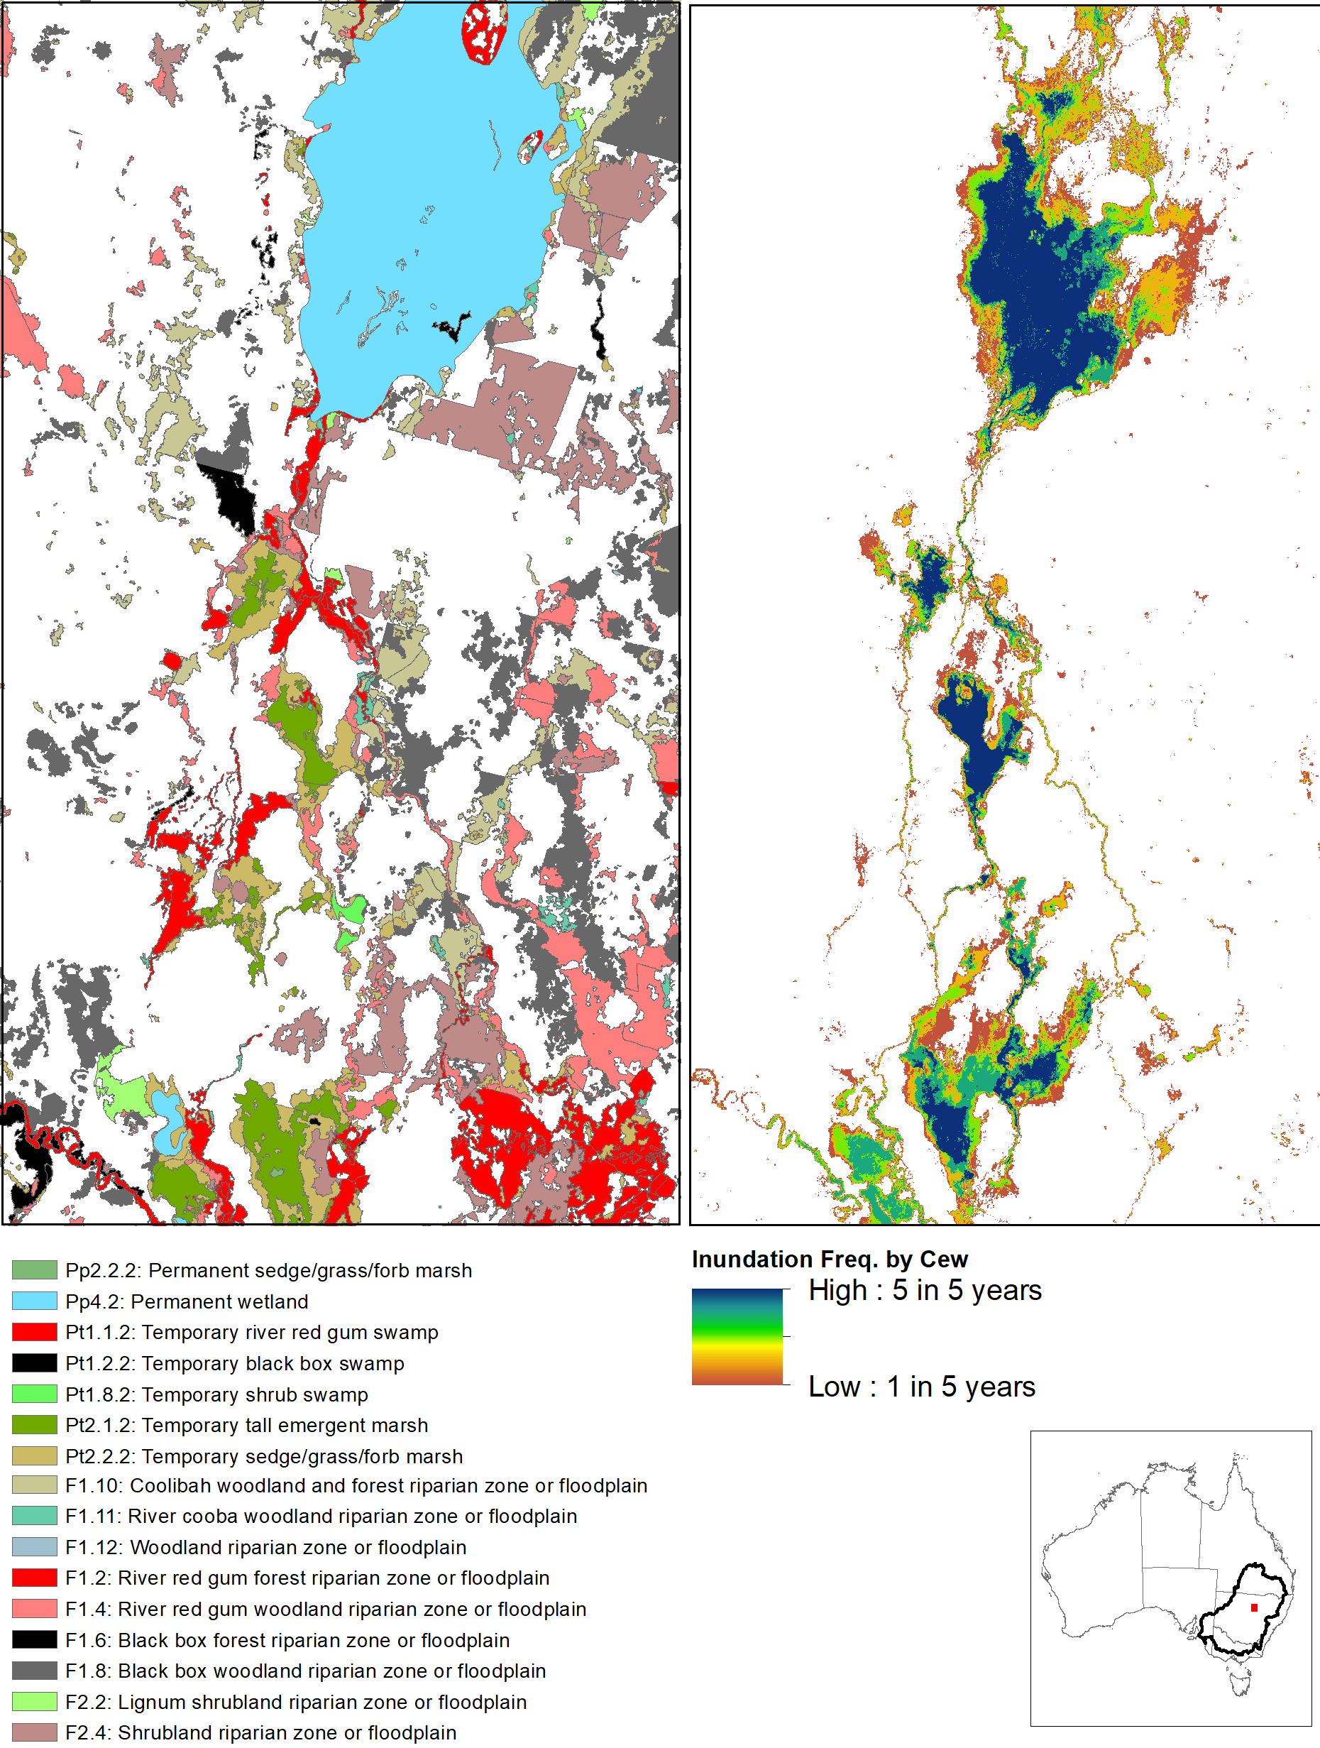
Figure 13. Side-by-side comparison of wetland and floodplain ecosystem mapping in the Macquarie Marshes with the inundation frequency by Commonwealth environmental water (Cew) in the 5 years of the LTIM project to 2019.

Floodplain Ecosystems
Approximately 28% of floodplains in the basin align with the Basin-wide watering strategy managed floodplain (Figure 14) and there is a high degree of congruence in the proportional representation of floodplain types on the managed floodplain vs at the Basin-scale.
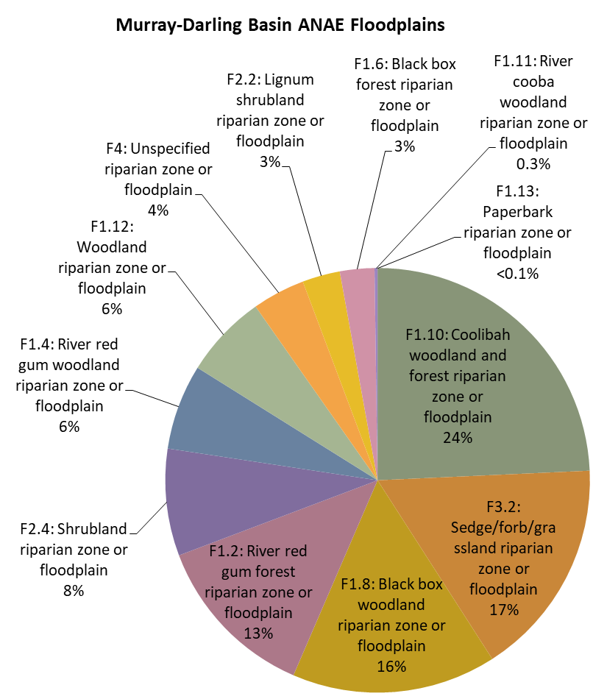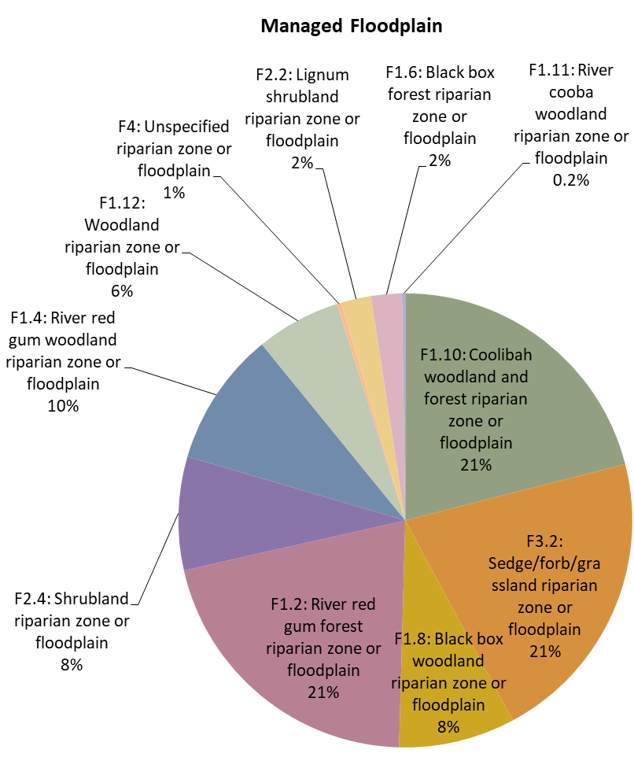
28%
Figure 14. Comparison of the proportional representation of ANAE floodplain ecosystem types in the Basin to the subset (28%) that occurs on the managed floodplain that is potentially in scope for Commonwealth environmental water management.
The rare paperbark riparian zone or floodplain type only occurs along small area of the Namoi River in NSW and the Wimmera River in Victoria (17 ha total). Both areas are not on the managed floodplain and they have not received Commonwealth environmental water during the period of LTIM (Table 10). Sedge/forb/grassland riparian zone or floodplain is the second most common floodplain type in the Basin (833 102 ha) but it almost exclusively distributed in the unregulated Paroo River valley and Condamine Balonne with only a small area (32 ha) receiving Commonwealth environmental water when water was delivered to Narran lakes in 2016–17 (Table 10).
On average, only 1.2% of the total extent of the Basin floodplain receives Commonwealth environmental water. Floodplain inundation is rarely an objective for Commonwealth environmental water because volumes are limited and constraints imposed by infrastructure, built assets and policy often restricts watering actions to volumes that are contained within river channels and wetlands. Extensive floodplain inundation is not expected unless Commonwealth environmental water is delivered to augment natural floods. River red gum forest riparian zone/floodplain was inundated to the greatest extent with 3.1% to 4.8% of the total area of this type in the Basin inundated by Commonwealth environmental water in 2014–15, 2015–16, 2017–18 and 2018–19 (Table 10, Figure 15).
Less than 15 000 ha of floodplain was inundated by Commonwealth environmental water in 2006-17 as this was wet year with extensive natural flooding (Figure 15). River red gum forest riparian zone or floodplain received the most Commonwealth environmental water (45%-72% of the area watered) representing 13% of this ecosystem type in the basin and 21% on the managed floodplain. The apparent bias towards watering redgum floodplain likely reflects the distribution of this ecosystem type in priority assets (e.g. Barmah-Millewa Forest, the Lowbidgee floodplain and along the Murray-River channel) and the alignment of red gum forest along other river channels receiving Commonwealth environmental water in the southern Basin.
Table 10. Comparison of the contribution of Commonwealth environmental water to ecosystem diversity of floodplains in the basin from 2014–19. . Ecosystem types that have received Commonwealth environmental water in every year of the LTIM project are shaded blue. Ecosystem types that have not received Commonwealth environmental water during the period of LTIM are shaded red.
Australian National Aquatic Ecosystem (ANAE) wetland type | Total area in Basin (ha) | Area on Managed Floodplain (ha) | Area receiving Commonwealth environmental water (ha)
 |  |  | Y1  '14-'15 | Y2  '15-'16 | Y3  '16-'17 | Y4  '17-'18 | Y5  '18-'19
F1.10: Coolibah woodland and forest riparian zone or floodplain | 1 215 726 | 294 586 | 3388 | 633 | 1007 | 1335 | 2300
F3.2: Sedge/forb/grassland riparian zone or floodplain | 833 102 | 296 420 | 0 | 0 | 32 | 0 | 0
F1.8: Black box woodland riparian zone or floodplain | 779 639 | 116 222 | 2273 | 5322 | 844 | 1830 | 432
F1.2: River red gum forest riparian zone or floodplain | 639 022 | 294 854 | 24 589 | 26 210 | 6 525 | 25 708 | 19 092
F2.4: Shrubland riparian zone or floodplain | 408 019 | 113 257 | 1115 | 5973 | 2554 | 473 | 485
F1.4: River red gum woodland riparian zone or floodplain | 325 221 | 134 242 | 3509 | 1358 | 1237 | 4887 | 1247
F1.12: Woodland riparian zone or floodplain | 318 645 | 84 203 | 14 | 10 | 136 | 93 | 57
F4: Unspecified riparian zone or floodplain | 201 086 | 4613 | 2 | 10 | 9 | 36 | 3
F2.2: Lignum shrubland riparian zone or floodplain | 143 880 | 29 764 | 5430 | 2154 | 1164 | 1474 | 1538
F1.6: Black box forest riparian zone or floodplain | 131 442 | 30 711 | 489 | 1299 | 118 | 265 | 256
F1.11: River cooba woodland riparian zone or floodplain | 11 541 | 3320 | 1135 | 236 | 779 | 840 | 1137
F1.13: Paperbark riparian zone or floodplain | 17 | 0 | 0 | 0 | 0 | 0 | 0
TOTAL | 5 007 340 | 1 402 192 | 41 944 | 43 205 | 14 405 | 36 941 | 26 547

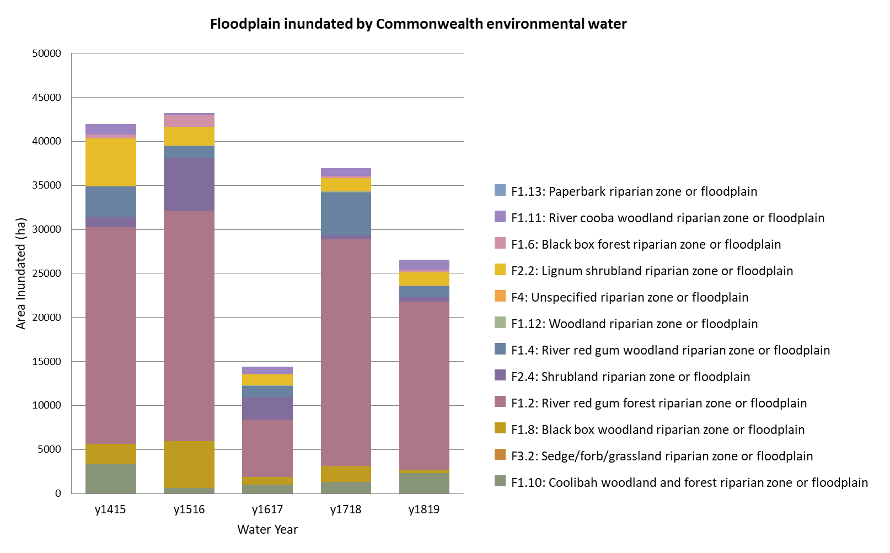
Figure 15. The extent of floodplain ecosystem types supported by Commonwealth environmental water in each year of the LTIM project.

Over the five years of LTIM, 101 735 ha of floodplain was inundated by Commonwealth environmental water with 60% of this area being classed as river red gum forest riparian zone or floodplain (Table 11). Only 831 ha was repeatedly inundated in every year, mostly fringing wetlands and channels in the Macquarie Marshes. The majority of floodplains (61%) receiving Commonwealth environmental water only did so once during the project. The 101 735 ha receiving Commonwealth environmental water over the duration of the project represents 2% of the floodplains in the Basin. The contribution of Commonwealth environmental water to Ecosystem Diversity of floodplains may be small at the Basin-scale, however the inundated areas are adjacent to wetlands and channels and are likely to be locally important to biodiversity by providing feeding and nesting habitat.

Table 11. Total area of floodplain ecosystems influenced by Commonwealth environmental water at differing frequencies during the five years of the LTIM project (2014–19).
Australian National Aquatic Ecosystem (ANAE) wetland type | 1in5 | 2in5 | 3in5 | 4in5 | 5in5 | Total  (All years)
F1.2: River red gum forest riparian zone or floodplain | 35 279 | 12 754 | 8907 | 3230 | 366 | 60 536
F1.8: Black box woodland riparian zone or floodplain | 6897 | 1630 | 139 | 31 | 2 | 8699
F2.4: Shrubland riparian zone or floodplain | 5951 | 1970 | 164 | 45 | 25 | 8155
F2.2: Lignum shrubland riparian zone or floodplain | 5397 | 1519 | 594 | 249 | 121 | 7880
F1.4: River red gum woodland riparian zone or floodplain | 3085 | 2641 | 678 | 247 | 195 | 6846
F1.10: Coolibah woodland and forest riparian zone or floodplain | 3218 | 1541 | 489 | 205 | 15 | 5468
F1.6: Black box forest riparian zone or floodplain | 1636 | 216 | 102 | 13 | 1 | 1968
F1.11: River cooba woodland riparian zone or floodplain | 708 | 559 | 281 | 230 | 106 | 1884
F1.12: Woodland riparian zone or floodplain | 223 | 42 | 2 | 0 | 0 | 267
F3.2: Sedge/forb/grassland riparian zone or floodplain | 32 | 0 | 0 | 0 | 0 | 32
F1.13: Paperbark riparian zone or floodplain | 0 | 0 | 0 | 0 | 0 | 0
TOTAL | 62 426 | 22 872 | 11 356 | 4250 | 831 | 101 735

River Ecosystems
The managed floodplain contains approximately 10% of the river length in the Basin. Lowland rivers and streams dominate the managed floodplain area representing 88% of the near 50 000 km of rivers that are potentially in scope for water management (Figure 16, Table 12). Commonwealth environmental water is typically managed from storages; however there is some regulation of flows upstream of storages and in unregulated valleys through management of entitlements and extraction rules. The 11% (5464 km) of transitional and high energy stream lengths on the managed floodplain (Figure 16) is a mixture of these upland areas and high-energy outflow channels from storages before they flow out into the flat lowlands of the central and western Basin.
Commonwealth environmental water primarily supported permanent and temporary lowland rivers during the 5 years of LTIM. Approximately 90% of the flows in any one year were in lowland sections including 48% to 74% of the permanent river reaches and 10% to 17% of the temporary reaches on the managed floodplain (Table 12). The pattern of watering has been very consistent from 2014-2019 supporting 12 744 to 19 083 km of waterways with flows containing Commonwealth environmental water annually (Table 12). The increase in river length supported by Commonwealth environmental water in 2017–18 (Figure 17) reflects the success of the northern rivers connectivity event. This large environmental flow in early 2018 was delivered to support more than 2000 km of drought impacted lowland river along the Barwon-Darling from Glenlyon and Copeton dams near the Queensland / NSW border down to the Menindee Lakes.
Across all five years of LTIM 25 856 km of river were supported by Commonwealth environmental water. The same 5980 km was inundated in every year along permanent lowland sections of the Barwon, Macquarie, Lachlan, Murrumbidgee, Edward, Wakool, Murray, Ovens, Broken, Goulburn and Loddon Rivers. Permanent reaches in the Culgoa, Darling and Campaspe Rivers received Commonwealth environmental water in four of the five years. Temporary rivers received water less frequently, with the Warrego and Wimmera Rivers supported by Commonwealth environmental water twice in five years and the Nebine River and parts of Broken Creek in Victoria receiving Commonwealth environmental water only once. The upland streams that received Commonwealth environmental water during the project were mostly outflows from storages into the upper reaches of the Murrumbidgee, Lachlan, Macquarie, Gwydir, and Severn Rivers however there were some unregulated entitlements used infrequently to deliver Commonwealth environmental water once in the Peel River above Chaffy dam, the Namoi River above Split Rock Dam, and three times in the Severn River above Glenlyon Dam.
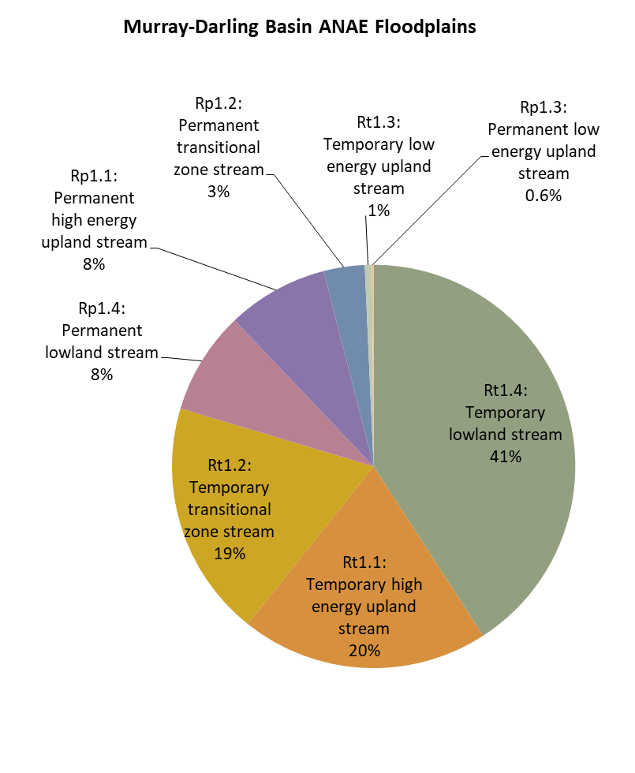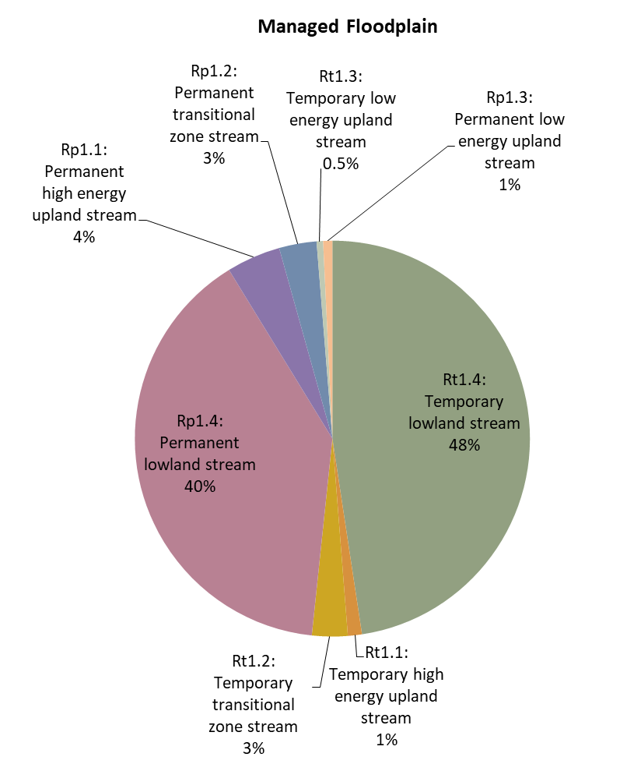
10%
Figure 16. Comparison of the proportional representation of ANAE river ecosystem types in the Basin to the subset (10%) that occurs on the managed floodplain that is potentially in scope for Commonwealth environmental water management. There are an additional 2 river types not shown that make up less than 1% of the total and are an artefact of missing data (refer Table 12).

Table 12. Comparison of the contribution of Commonwealth environmental water to ecosystem diversity of rivers in the basin from 2014–19. Ecosystem types that have received Commonwealth environmental water in every year of the LTIM project are shaded blue.
Australian National Aquatic Ecosystem (ANAE) wetland type | Total length in Basin (km) | Length on Managed Floodplain (km) | Length receiving Commonwealth environmental water (km)
 |  |  | Y1  '14-'15 | Y2  '15-'16 | Y3  '16-'17 | Y4  '17-'18 | Y5  '18-'19
Rt1.4: Temporary lowland stream | 198 551 | 22 516 | 2922 | 3030 | 2141 | 3793 | 3091
Rt1.1: Temporary high energy upland stream | 96 565 | 544 | 89 | 49 | 3 | 96 | 31
Rt1.2: Temporary transitional zone stream | 91 873 | 1379 | 22 | 22 | 59 | 45 | 80
Rp1.4: Permanent lowland stream | 40 133 | 18 714 | 9068 | 8620 | 9501 | 13 256 | 9665
Rp1.1: Permanent high energy upland stream | 39 421 | 2092 | 534 | 313 | 311 | 640 | 446
Rp1.2: Permanent transitional zone stream | 15 962 | 1449 | 426 | 397 | 383 | 665 | 483
Rt1.3: Temporary low energy upland stream | 2783 | 251 | 34 | 22 | 22 | 56 | 48
Rp1.3: Permanent low energy upland stream | 633 | 355 | 191 | 177 | 168 | 250 | 263
Ru1: Unspecified river (landform unknown) | 293 | 63 | 0 | 7 | 0 | 7 | 7
Rw1: Permanent river (landform unknown) | 271 | 106 | 0 | 5 | 9 | 15 | 14
Total | 487 002 | 47 919 | 13 286 | 12 814 | 12 755 | 19 083 | 14 374

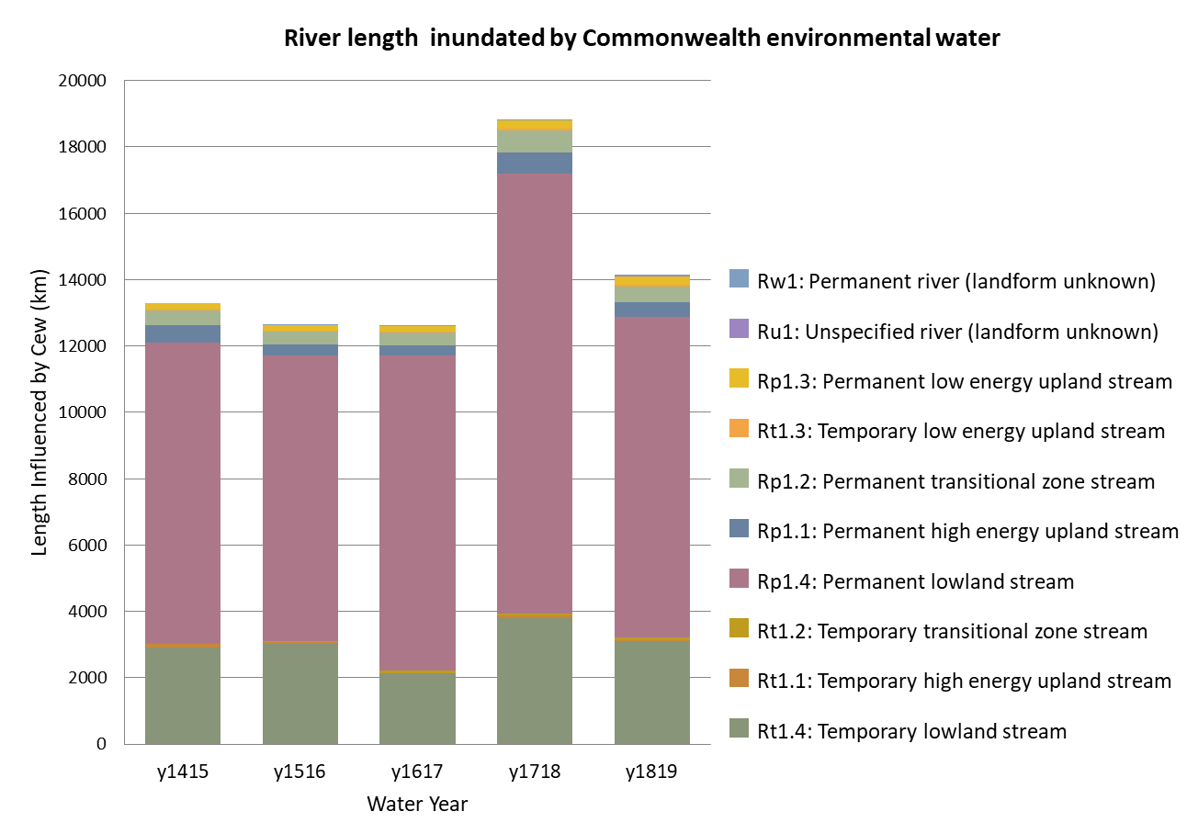
Figure 17. The length of rivers ecosystem types supported by Commonwealth environmental water in each year of the LTIM project.

Table 13. Total length of river and stream channels with flows containing Commonwealth environmental water at differing frequencies during the five years of the LTIM project (2014–19).
Australian National Aquatic Ecosystem (ANAE) wetland type | 1in5 | 2in5 | 3in5 | 4in5 | 5in5 | Total  (All years)
Rp1.4: Permanent lowland stream | 2732 | 2667 | 1898 | 1738 | 5980 | 15 015
Rt1.4: Temporary lowland stream | 2130 | 3210 | 1660 | 1036 | 591 | 8627
Rp1.1: Permanent high energy upland stream | 223 | 151 | 75 | 54 | 283 | 786
Rp1.2: Permanent transitional zone stream | 208 | 122 | 68 | 40 | 319 | 757
Rt1.1: Temporary high energy upland stream | 62 | 46 | 47 | 49 | 11 | 215
Rp1.3: Permanent low energy upland stream | 27 | 20 | 12 | 10 | 123 | 192
Rt1.2: Temporary transitional zone stream | 17 | 94 | 37 | 12 | 2 | 162
Rt1.3: Temporary low energy upland stream | 16 | 23 | 9 | 19 | 19 | 86
Rw1: Permanent river (landform unknown) | 2 | 0 | 0 | 0 | 7 | 9
Ru1: Unspecified river (landform unknown) | 0 | 7 | 0 | 0 | 0 | 7
TOTAL | 5417 | 6340 | 3806 | 2958 | 7335 | 25 856

Contribution to achievement of Basin Plan objectives and adaptive management

Adaptive management
There are a number of avenues by which the Ecosystem Diversity evaluation can foster improvements in Commonwealth environmental water management and evaluation that have been identified in previous Ecosystem Diversity evaluation reports (Brooks 2016, 2017a, 2018, 2019). These recommendations are reproduced below. Completing the update of the ANAE classification is now expected during the second half of 2020, and progress in developing expected outcomes for Ecosystem Diversity is planned for the CEWO Monitoring, Evaluation and Research (Flow-MER) project (2019-2022).
- Improving confidence in the evaluation of the contribution of Commonwealth environmental water to Ecosystem Diversity. Completing the revision of the ANAE classification to include the new NSW state vegetation mapping for Western NSW and the Central Tablelands (Figure 18) will further improve the evaluation of the contribution of Commonwealth environmental water to Ecosystem Diversity in tributaries of the Darling River including the Junction of the Warrego and Darling rivers LTIM Selected Area.
- Reducing the risks of implementing inappropriate watering regimes. Too much water, too frequently or consistently missing particular ecosystems types are all scenarios that are potentially deleterious to biodiversity in the Basin. Improving understanding of watering requirements at the aquatic ecosystem level should complement and enhance existing approaches that focus on the requirements of key species or communities. This evaluation highlighted the annually watered temporary wetlands in the Macquarie Marshes and further investigation is warranted beginning with the accuracy of the ecosystem classification during the planned 2020 update. Promotion of permanent wetlands to redress years of drought may also be a legitimate management objective for the Macquarie Marshes.
- An authoritative, unambiguous resource for the timing, duration and extent of water management in the Basin is required. Through LTIM, we have assembled a library documenting the Basin wide watering by Commonwealth environmental water over the five years but the record of water from natural inundation and other sources of environmental water is still incomplete and sometimes conflicting. Evaluating Commonwealth environmental water in isolation ignores the fact that water planning includes consideration of the capacity for other water holders to meet environmental requirements with or without Commonwealth environmental water. For example, Barmah Forest and Hattah Lakes are two priority assets in the Basin that were watered using Victorian environmental water and MDBA (The Living Murray) water in years when Commonwealth environmental water was not used (Figure 19). The Flow-MER project that continues form LTIM has taken a step in the right direction to consider environmental water more broadly. Improved inter-agency communication and provision of a timely authoritative resource for all environmental water actions in the Basin to support Basin-scale evaluation is needed.
- The CEWO currently does not have 1-year or 5-year expected outcomes for ecosystem diversity but it is hoped that this evaluation and other lessons learned from the LTIM project will seed thinking towards draft ecosystem objectives. Understanding how key ecosystem types influence patterns of Basin biodiversity, resilience, ecosystem function and ecosystem services paves the way towards delivering Commonwealth environmental water for ecosystem objectives that move beyond counting ecosystem watering targets. For example, shaping flow regimes to preserve patterns of spatio-temporal variability along a river, or delivering water at critical times to maintain life forms or processes because they characterise ecosystem types that are to be preserved or improved. Managing to prevent or promote ecosystem turnover to new types may require long-term management frameworks with institutional memory and conviction to stay the course over decadal time scales and that allow temporary systems to remain dry for sufficient duration to support critical dry-phase ecosystem processes.

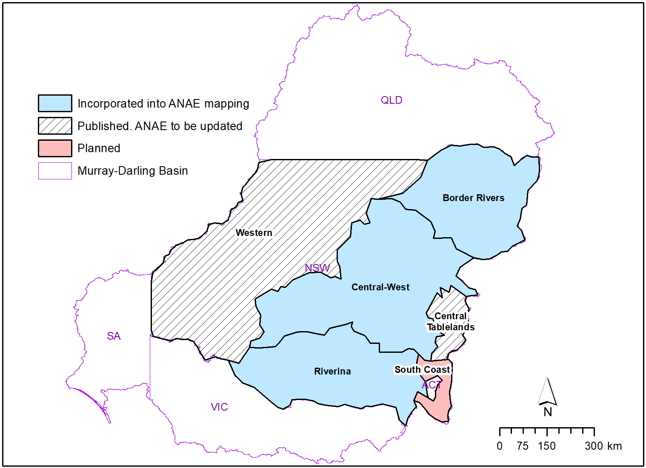
Figure 18: Extent and status of the new NSW state vegetation mapping. Published regions (blue) were used to update the ANAE classification in 2017. The Western region and Central Tablelands have now been published and are expected to improve the ANAE classification in 2020 to support evaluation of Ecosystem Diversity during the Flow-MER project.

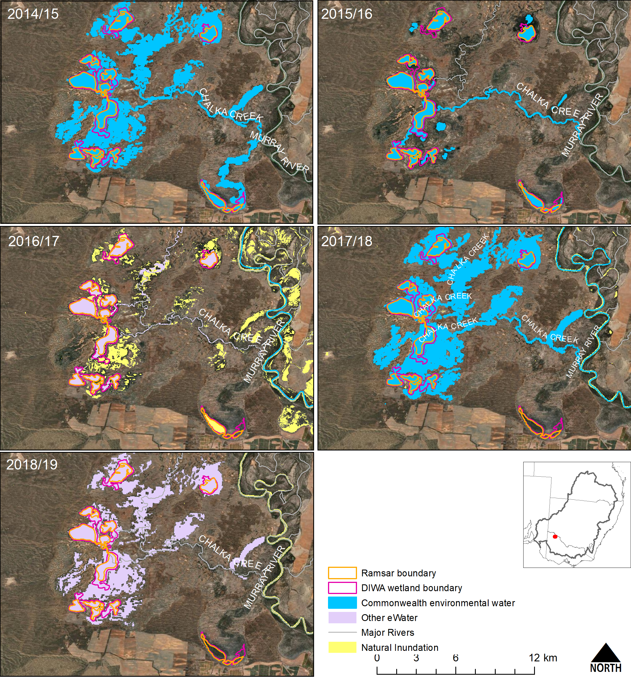
Figure 19. Annual inundation of Hattah Lakes. Interpreting the role of Commonwealth environmental water in supporting Ecosystem Diversity requires knowledge of water from other sources. In this case natural rainfall inundated the floodplains around the lakes in 2016–17 and environmental water from the Victorian Environmental Water inundated the floodplains in 2018–19.

Contribution to Basin Plan objectives
The Ecosystem Diversity component of the Basin evaluation contributes to the Basin Plan objective for Biodiversity under Section 8.05 of the Basin Plan. The evaluation also contributes indirectly to additional Basin Plan objectives by informing the evaluation of the Vegetation and Generic Diversity Basin Matters within the LTIM Project (Capon & Campbell 2020; Hale et al. 2020).
The Commonwealth does not yet have 1-year or 5-year expected outcomes for ecosystem diversity (Table 14) and water is not currently delivered with explicit understanding of the contribution of Commonwealth environmental watering to ecosystem diversity at the Basin-scale. This evaluation provides a foundation from which expected outcomes for ecosystem diversity may be developed in the future as the spatial and temporal patterns of watering to different ecosystem types under current management regimes are better understood.
8.05 Protection and restoration of water-dependent ecosystems is supported in principle for 288 513 ha of lakes, wetlands and floodplain and 25 856 km of waterways representing 57 ecosystem types (83 % of the ecosystem types currently mapped in the basin).

Table 14. Commonwealth Environmental Outcomes framework for ecosystem diversity.
Basin Plan objectives | Basin outcomes | 5–year expected outcomes | 1–year expected outcomes | Measured and predicted 1-year outcomes 2018–19 | Measured and predicted 1–5 year outcomes 2014–19
Biodiversity  (Basin Plan S. 8.05) | Ecosystem diversity | None identified | None identified | Over 246 000 hectares of mapped wetland and floodplain inundated  74% of the different aquatic ecosystem types represented in areas supported by Commonwealth environmental water | 288 513 ha of lakes, wetlands and floodplain and 25 856 km of waterways supported by Commonwealth environmental water representing 57 ecosystem types; 83 % of the water dependent ecosystem types

References
Aquatic Ecosystems Task Group (2012) Aquatic Ecosystems Toolkit. Module 2 Interim Australian National Aquatic Ecosystems (ANAE) Classification Framework. Department of Sustainability, Environment, Water Population and Communities, Canberra, Australia.
BOM (2019) Australian Hydrological Geospatial Fabric (Geofabric) beta v3.0.5.
Brooks SS (2016) 2014–15 Basin-scale evaluation of Commonwealth environmental water – Ecosystem Diversity ( No. MDFRC Publication 144/2017, May). Final Report prepared for the Commonwealth Environmental Water Office. Murray–Darling Freshwater Research Centre.
Brooks SS (2017a) 2015–16 Basin-scale evaluation of Commonwealth environmental water – Ecosystem Diversity ( No. MDFRC Publication 144/2017, May). Final Report prepared for the Commonwealth Environmental Water Office. Murray–Darling Freshwater Research Centre.
Brooks SS (2017b) Classification of aquatic ecosystems in the Murray-Darling Basin: 2017 update. Report to the Murray-Darling Basin Authority and Commonwealth Environmental Water Office, Canberra, Australia.
Brooks SS (2018) 2016–17 Basin-scale evaluation of Commonwealth environmental water – Ecosystem Diversity ( No. Publication 190/2018, September). Final Report prepared for the Commonwealth Environmental Water Office. La Trobe University Centre for Freshwater Ecosystems, Wodonga, Victoria.
Brooks SS (2019) 2017–18 Basin-scale evaluation of Commonwealth environmental water – Ecosystem Diversity ( No. Publication 234/2019, September). Final Report prepared for the Commonwealth Environmental Water Office. La Trobe University Centre for Freshwater Ecosystems, Wodonga, Victoria.
Brooks SS, Cottingham P, Butcher R, Hale J (2014) Interim classification of aquatic ecosystems in the Murray-Darling Basin: Stage 2 report. Peter Cottingham & Associates report to the Commonwealth Environmental Water Office and Murray-Darling Basin Authority. Canberra, Australia.
Cadotte MW, Carscadden K, Mirotchnick N (2011) Beyond species: functional diversity and the maintenance of ecological processes and services: Functional diversity in ecology and conservation. J. Appl. Ecol. 48(5), 1079–1087.
Capon SJ, Campbell C (2020) 2018–19 Basin-scale evaluation of Commonwealth environmental water - Vegetation Diversity (Final Report prepared for the Commonwealth Environmental Water Office). CFE Publication 249. La Trobe University Centre for Freshwater Ecosystems, Wodonga, Victoria.
CBD (1993) The Convention on Biological Diversity.
CEWH (2013) Commonwealth Environmental Water – The Environmental Water Outcomes Framework v1.1.
Commonwealth of Australia (2012) Water Act 2007 Basin Plan.
Dunn B, Lymburner L, Newey V, Hicks A, Carey H (2019) Developing a Tool for Wetland Characterization Using Fractional Cover, Tasseled Cap Wetness And Water Observations From Space. In: IGARSS 2019-2019 IEEE International Geoscience and Remote Sensing Symposium. IEEE, pp. 6095–6097.
Geist J (2011) Integrative freshwater ecology and biodiversity conservation. Ecol. Indic. 11(6), 1507–1516.
Hale J, Bond, Nick, Brooks, Shane (2020) 2018–19 Basin-scale evaluation of Commonwealth environmental water – Biodiversity. (Final Report prepared for the Commonwealth Environmental Water Office). CFE Publication 252. La Trobe University Centre for Freshwater Ecosystems, Wodonga, Victoria.
Junk J, Bayley P, Sparks R (1989) The flood pulse concept in river floodplain systems. Can. Spec. Publ. Fish. Aquat. Sci. 106, 110–127.
MDBA (2014) Basin-wide environmental watering strategy. Murray-Darling Basin Auth. Canberra.
MDBA (2019) Basin-wide environmental watering strategy ( No. 42/19). Murray–Darling Basin Authority, Canberra, ACT.
MDFRC (2013) Long-term Intervention Monitoring - Generic Cause and Effect Diagrams ( No. 01.5/2013). The Murray-Darling Freshwater Research Centre, Albury.
Miles M, Eckert G (2013) Murray‐Darling Basin ANAE dataset – Manual edits to SA component.
Poff NL (1997) Landscape filters and species traits: towards mechanistic understanding and prediction in stream ecology. J. North Am. Benthol. Soc. 16(2), 391–409.
Pollock LJ, Thuiller W, Jetz W (2017) Large conservation gains possible for global biodiversity facets. Nature 546(7656), 141–144.
Stewardson MJ, Guarino F (2020) 2018–19 Basin-scale evaluation of Commonwealth environmental water — Hydrology (Final Report prepared for the Commonwealth Environmental Water Office). CFE Publication 246. La Trobe University Centre for Freshwater Ecosystems, Wodonga, Victoria.
Thorp JH, Thoms MC, Delong MD (2006) The riverine ecosystem synthesis: biocomplexity in river networks across space and time. River Res. Appl. 22(2), 123–147.

Appendix 1: GIS Workflow
All spatial layers use the 1994 Geocentric Datum of Australia (GDA94). Areas in this report are in hectares and have been calculated in the Australia Albers Equal Area Conic projection to report accurate area measurements across the Basin.
The area of ecosystems inundated by Commonwealth environmental water is the fraction of the wetland area that intersects the Commonwealth environmental water inundation extent.
GIS Workflow:
- Intersect:
  - The Basin ANAE classification mapping;
  - Commonwealth environmental water Inundation; and
  - LTIM Valleys
- Calculate polygon area in hectares using equal area GDA94 Australian Albers projection.
- Sum the area of each ANAE wetland type per valley.
The area of ecosystems influenced by Commonwealth environmental water is defined as the sum of the areas of mapped features that are partially or fully overlapped by Commonwealth environmental water inundation extent.
GIS Workflow:
- Select by location all ANAE wetland polygons that intersect the Commonwealth environmental water Inundation.
- Intersect the selected wetlands with the catchment boundaries.
- Calculate polygon area in hectares using equal area GDA94 Australian Albers projection.
- Sum the area of each ANAE wetland type per valley.
Length of waterways influenced by Commonwealth environmental water
GIS Workflow:
- Intersect:
  - The Basin ANAE Geofabric v3 Waterways
  - Commonwealth environmental water Inundation
  - LTIM Valleys
- Calculate the channel length inundated for each riverine ecosystem type in kilometres using equal area GDA94 Australian Albers projection.
- Calculate summary statistics to sum the length of each river ecosystem type per valley.

Appendix 2. Ongoing evolution of the Basin ANAE classification
Confidence in the accuracy of mapping and the Basin ANAE classification was examined in a previous LTIM ecosystem diversity evaluation (Brooks 2016a) and in the development of the ANAE classification (Brooks et al. 2014). In South Australia, ANAE types were manually ascribed to wetlands and riverine reaches along the full length of the Murray River to improve confidence and alignment of the classification to ecosystem types used by South Australian wetland managers. Some additional limitations of the ANAE classification in South Australia that influence the findings in this report are noted in Miles and Eckert (2013) and include: farm dams classified as natural wetland ecosystems, temporary wetlands to the south-east of the south lagoon of the Coorong being classified as permanent, and wetland boundaries adjacent to the Lake Alexandrina that encompass multiple ecosystem types. These errors are mainly associated with wetland types around Lake Alexandrina and the Coorong (M Miles, pers. comm., 2017) but similar examples can be found in all states in areas where fundamental hydrological data and vegetation mapping are limited. The recent update to the ANAE addressed some of these issues but a comprehensive evaluation against the issues raised by Miles and Eckert (2013) has not been conducted.
There was generally good agreement between the ecosystem types identified by the Basin ANAE classification when ground-truthed at Selected Area sampling sites (Brooks 2016). Most discrepancies were related to inaccuracies in the mapping of wetland boundaries rather than fundamental disagreement with the ANAE classification itself. The poorest representation of ecosystem types by the ANAE classification was in the Lachlan river system, Gwydir river system and Junction of the Warrego and Darling rivers Selected Areas (Brooks 2016). The Lachlan and Gwydir valleys were included in the 2017 major update to the ANAE classification which greatly improved the mapping for this and subsequent evaluations of the contribution of Commonwealth environmental water to Ecosystem Diversity in these Valleys (Brooks 2017b). Ecosystem mapping in the Central Murray Forests, the Macquarie Marshes, and Murrumbidgee were also improved in the revision.
A major component of the 2017 ANAE update relied on NSW State vegetation mapping that was incomplete at the time. Mapping for Western NSW and the Central Tablelands (Figure 18) has now been published by the NSW Office of Environment and Heritage (now Department of Planning, Industry and Environment). Integration of these updated maps into the ANAE classification of the Basin will greatly improve wetland and floodplain ecosystem mapping in the Junction of the Warrego and Darling rivers Selected Area and in southwestern NSW along the Darling and Murray River floodplains. These areas all regularly receive Commonwealth environmental water and updating the ANAE classification in these areas to improve the accuracy and consistency of aquatic ecosystem mapping is a high priority. The cumulative evaluation of Ecosystem Diversity can then be retrospectively brought up to date using the revised ANAE maps and inundation mapping collated by LTIM to date.

Appendix 3: ANAE wetland types influenced by Commonwealth environmental water by valley
Lake and wetland types influenced by Commonwealth environmental water are represented by the entire wetland when any portion of the wetland was recorded as having been inundated. The contribution of Commonwealth environmental water to supporting wetland ecosystem diversity within each valley is presented below in Table C1 excluding the Coorong, Lower Lakes and Murray Mouth which are presented in Table 5.

Table A3_1. Area of each lake and wetland ecosystem type and the contribution of Commonwealth environmental water to supporting wetland ecosystem diversity within each valley in 2018–19 (shaded blue).
Valley name | Australian National Aquatic Ecosystem (ANAE) lake and wetland types | Total Area (ha) | Cew Area (ha) | Percent
Avoca | Lst1.1: Temporary saline lake | 19 829 | 0 | 0.0
Avoca | Pt3.1.2: Clay pan | 18 587 | 0 | 0.0
Avoca | Pt1.2.2: Temporary black box swamp | 4372 | 0 | 0.0
Avoca | Lt1.1: Temporary lake | 4232 | 0 | 0.0
Avoca | Lst1.2: Temporary saline lake with aquatic bed | 1820 | 0 | 0.0
Avoca | Pst1.1: Temporary saline swamp | 1541 | 0 | 0.0
Avoca | Pst2.2: Temporary salt marsh | 1174 | 0 | 0.0
Avoca | Pt1.6.2: Temporary woodland swamp | 805 | 0 | 0.0
Avoca | Pt2.3.2: Freshwater meadow | 723 | 0 | 0.0
Avoca | Pt1.7.2: Temporary lignum swamp | 720 | 0 | 0.0
Avoca | Pst3.2: Salt pan or salt flat | 309 | 0 | 0.0
Avoca | Psp2.1: Permanent salt marsh | 209 | 0 | 0.0
Avoca | Pt4.2: Temporary wetland | 208 | 0 | 0.0
Avoca | Pt1.1.2: Temporary river red gum swamp | 145 | 0 | 0.0
Avoca | Lsp1.1: Permanent saline lake | 137 | 0 | 0.0
Avoca | Lp1.1: Permanent lake | 61 | 0 | 0.0
Avoca | Pt1.8.2: Temporary shrub swamp | 51 | 0 | 0.0
Avoca | Pp4.2: Permanent wetland | 50 | 0 | 0.0
Avoca | Pst4: Temporary saline wetland | 50 | 0 | 0.0
Avoca | Pt4.1: Floodplain or riparian wetland | 1 | 0 | 0.0
Barwon Darling | Lt1.1: Temporary lake | 56 914 | 0 | 0.0
Barwon Darling | Lp1.1: Permanent lake | 31 479 | 0 | 0.0
Barwon Darling | Pt1.6.2: Temporary woodland swamp | 16 271 | 0 | 0.0
Barwon Darling | Pt1.8.2: Temporary shrub swamp | 10 922 | 0 | 0.0
Barwon Darling | Pt1.2.2: Temporary black box swamp | 2961 | 0 | 0.0
Barwon Darling | Pp4.2: Permanent wetland | 2566 | 0 | 0.0
Barwon Darling | Pt2.3.2: Freshwater meadow | 1225 | 0 | 0.0
Barwon Darling | Pt2.2.2: Temporary sedge/grass/forb marsh | 1217 | 0 | 0.0
Barwon Darling | Pt1.1.2: Temporary river red gum swamp | 378 | 0 | 0.0
Barwon Darling | Pt3.1.2: Clay pan | 151 | 0 | 0.0
Barwon Darling | Pt1.3.2: Temporary coolibah swamp | 64 | 0 | 0.0
Barwon Darling | Pps5: Permanent spring | 0 | 0 | 0.0
Border Rivers | Pt2.2.2: Temporary sedge/grass/forb marsh | 8659 | 0 | 0.0
Border Rivers | Pt4.2: Temporary wetland | 3001 | 0 | 0.0
Border Rivers | Pt1.6.2: Temporary woodland swamp | 2484 | 0 | 0.0
Border Rivers | Pp2.2.2: Permanent sedge/grass/forb marsh | 1405 | 0 | 0.0
Border Rivers | Pp4.2: Permanent wetland | 1097 | 0 | 0.0
Border Rivers | Lp1.1: Permanent lake | 936 | 0 | 0.0
Border Rivers | Pt1.1.2: Temporary river red gum swamp | 718 | 0 | 0.0
Border Rivers | Lt1.1: Temporary lake | 655 | 0 | 0.0
Border Rivers | Pp3: Peat bog or fen marsh | 633 | 0 | 0.0
Border Rivers | Pt2.3.2: Freshwater meadow | 592 | 0 | 0.0
Border Rivers | Pt1.3.2: Temporary coolibah swamp | 493 | 0 | 0.0
Border Rivers | Lp1.2: Permanent lake with aquatic bed | 227 | 0 | 0.0
Border Rivers | Pt3.1.2: Clay pan | 214 | 0 | 0.0
Border Rivers | Pt2.1.2: Temporary tall emergent marsh | 96 | 0 | 0.0
Border Rivers | Pp2.3.2: Permanent grass marsh | 26 | 0 | 0.0
Border Rivers | Lt1.2: Temporary lake with aquatic bed | 12 | 0 | 0.0
Border Rivers | Pt1.2.2: Temporary black box swamp | 9 | 0 | 0.0
Border Rivers | Pt1.8.2: Temporary shrub swamp | 3 | 0 | 0.0
Border Rivers | Pst1.1: Temporary saline swamp | 2 | 0 | 0.0
Border Rivers | Pps5: Permanent spring | 0 | 0 | 0.0
Broken | Lp1.1: Permanent lake | 3305 | 0 | 0.0
Broken | Pt3.1.2: Clay pan | 2998 | 0 | 0.0
Broken | Pt1.1.2: Temporary river red gum swamp | 1911 | 0 | 0.0
Broken | Pt1.6.2: Temporary woodland swamp | 427 | 0 | 0.0
Broken | Pt2.3.2: Freshwater meadow | 268 | 0 | 0.0
Broken | Pt1.7.2: Temporary lignum swamp | 192 | 0 | 0.0
Broken | Lt1.1: Temporary lake | 104 | 0 | 0.0
Broken | Pt2.1.2: Temporary tall emergent marsh | 98 | 0 | 0.0
Broken | Pt1.2.2: Temporary black box swamp | 84 | 0 | 0.0
Broken | Pt2.2.2: Temporary sedge/grass/forb marsh | 77 | 0 | 0.0
Broken | Pt4.1: Floodplain or riparian wetland | 66 | 0 | 0.0
Broken | Pp4.2: Permanent wetland | 43 | 0 | 0.0
Broken | Pps5: Permanent spring | 0 | 0 | 0.0
Campaspe | Pt3.1.2: Clay pan | 1887 | 0 | 0.0
Campaspe | Pt1.1.2: Temporary river red gum swamp | 280 | 0 | 0.0
Campaspe | Pt1.6.2: Temporary woodland swamp | 232 | 0 | 0.0
Campaspe | Lt1.1: Temporary lake | 49 | 0 | 0.0
Campaspe | Pt2.1.2: Temporary tall emergent marsh | 24 | 0 | 0.0
Campaspe | Lp1.1: Permanent lake | 12 | 0 | 0.0
Campaspe | Pt2.3.2: Freshwater meadow | 10 | 0 | 0.0
Campaspe | Pp4.2: Permanent wetland | 4 | 0 | 0.0
Campaspe | Pps5: Permanent spring | 1 | 0 | 0.0
Castlereagh | Pt2.2.2: Temporary sedge/grass/forb marsh | 10 737 | 0 | 0.0
Castlereagh | Lt1.1: Temporary lake | 456 | 0 | 0.0
Castlereagh | Pt1.8.2: Temporary shrub swamp | 51 | 0 | 0.0
Castlereagh | Pt1.6.2: Temporary woodland swamp | 35 | 0 | 0.0
Castlereagh | Pt3.1.2: Clay pan | 30 | 0 | 0.0
Castlereagh | Pt1.2.2: Temporary black box swamp | 26 | 0 | 0.0
Castlereagh | Pp4.2: Permanent wetland | 18 | 0 | 0.0
Castlereagh | Pt2.1.2: Temporary tall emergent marsh | 16 | 0 | 0.0
Castlereagh | Pp2.2.2: Permanent sedge/grass/forb marsh | 8 | 0 | 0.0
Castlereagh | Lp1.1: Permanent lake | 6 | 0 | 0.0
Castlereagh | Pt1.1.2: Temporary river red gum swamp | 1 | 0 | 0.0
Castlereagh | Pt2.3.2: Freshwater meadow | 1 | 0 | 0.0
Castlereagh | Pps5: Permanent spring | 1 | 0 | 0.0
Central Murray | Pt1.1.2: Temporary river red gum swamp | 38 447 | 23 879 | 62.1
Central Murray | Lp1.1: Permanent lake | 4518 | 1778 | 39.4
Central Murray | Pp4.2: Permanent wetland | 9222 | 971 | 10.5
Central Murray | Pt2.2.2: Temporary sedge/grass/forb marsh | 2856 | 820 | 28.7
Central Murray | Pt2.1.2: Temporary tall emergent marsh | 1475 | 711 | 48.2
Central Murray | Pp2.1.2: Permanent tall emergent marsh | 1169 | 707 | 60.5
Central Murray | Pt4.2: Temporary wetland | 654 | 586 | 89.6
Central Murray | Pt1.6.2: Temporary woodland swamp | 1543 | 437 | 28.3
Central Murray | Lt1.1: Temporary lake | 13 062 | 301 | 2.3
Central Murray | Pt2.3.2: Freshwater meadow | 5185 | 198 | 3.8
Central Murray | Pt1.2.2: Temporary black box swamp | 4137 | 97 | 2.3
Central Murray | Pt1.8.2: Temporary shrub swamp | 638 | 56 | 8.8
Central Murray | Pt3.1.2: Clay pan | 17 536 | 46 | 0.3
Central Murray | Pt4.1: Floodplain or riparian wetland | 462 | 9 | 1.9
Central Murray | Pp2.4.2: Permanent forb marsh | 133 | 7 | 5.3
Central Murray | Pp2.3.2: Permanent grass marsh | 80 | 2 | 2.5
Central Murray | Pp2.2.2: Permanent sedge/grass/forb marsh | 45 | 2 | 4.4
Central Murray | Pst2.2: Temporary salt marsh | 2122 | 0 | 0.0
Central Murray | Pst4: Temporary saline wetland | 2114 | 0 | 0.0
Central Murray | Pt1.7.2: Temporary lignum swamp | 1602 | 0 | 0.0
Central Murray | Lst1.1: Temporary saline lake | 1303 | 0 | 0.0
Central Murray | Pst3.2: Salt pan or salt flat | 732 | 0 | 0.0
Central Murray | Psp4: Permanent saline wetland | 642 | 0 | 0.0
Central Murray | Lsp1.1: Permanent saline lake | 461 | 0 | 0.0
Central Murray | Pst1.1: Temporary saline swamp | 22 | 0 | 0.0
Condamine Balonne | Pt2.1.2: Temporary tall emergent marsh | 38 236 | 0 | 0.0
Condamine Balonne | Pt1.8.2: Temporary shrub swamp | 29 303 | 0 | 0.0
Condamine Balonne | Pt1.6.2: Temporary woodland swamp | 13 223 | 0 | 0.0
Condamine Balonne | Pt1.7.2: Temporary lignum swamp | 11 804 | 0 | 0.0
Condamine Balonne | Lt1.1: Temporary lake | 11 526 | 0 | 0.0
Condamine Balonne | Lp1.1: Permanent lake | 6454 | 0 | 0.0
Condamine Balonne | Pt4.2: Temporary wetland | 6399 | 0 | 0.0
Condamine Balonne | Pt1.2.2: Temporary black box swamp | 4684 | 0 | 0.0
Condamine Balonne | Pt2.2.2: Temporary sedge/grass/forb marsh | 4248 | 0 | 0.0
Condamine Balonne | Pt2.3.2: Freshwater meadow | 4102 | 0 | 0.0
Condamine Balonne | Pp4.2: Permanent wetland | 3754 | 0 | 0.0
Condamine Balonne | Pp2.1.2: Permanent tall emergent marsh | 2522 | 0 | 0.0
Condamine Balonne | Pt1.3.2: Temporary coolibah swamp | 2423 | 0 | 0.0
Condamine Balonne | Pt3.1.2: Clay pan | 1872 | 0 | 0.0
Condamine Balonne | Lp1.2: Permanent lake with aquatic bed | 1648 | 0 | 0.0
Condamine Balonne | Lst1.1: Temporary saline lake | 1624 | 0 | 0.0
Condamine Balonne | Pt1.1.2: Temporary river red gum swamp | 1116 | 0 | 0.0
Condamine Balonne | Lt1.2: Temporary lake with aquatic bed | 684 | 0 | 0.0
Condamine Balonne | Pt1.5.2: Temporary paperbark swamp | 95 | 0 | 0.0
Condamine Balonne | Pp2.3.2: Permanent grass marsh | 23 | 0 | 0.0
Condamine Balonne | Pps5: Permanent spring | 6 | 0 | 0.0
Condamine Balonne | Lsp1.1: Permanent saline lake | 3 | 0 | 0.0
Condamine Balonne | Pst4: Temporary saline wetland | 1 | 0 | 0.0
Edward Wakool | Pp4.2: Permanent wetland | 814 | 3 | 0.4
Edward Wakool | Pt3.1.2: Clay pan | 3581 | 0 | 0.0
Edward Wakool | Pt1.2.2: Temporary black box swamp | 1663 | 0 | 0.0
Edward Wakool | Pt1.1.2: Temporary river red gum swamp | 1318 | 0 | 0.0
Edward Wakool | Lt1.1: Temporary lake | 886 | 0 | 0.0
Edward Wakool | Pt2.3.2: Freshwater meadow | 628 | 0 | 0.0
Edward Wakool | Pt1.6.2: Temporary woodland swamp | 421 | 0 | 0.0
Edward Wakool | Pt1.8.2: Temporary shrub swamp | 280 | 0 | 0.0
Edward Wakool | Pt2.2.2: Temporary sedge/grass/forb marsh | 213 | 0 | 0.0
Edward Wakool | Pt1.7.2: Temporary lignum swamp | 175 | 0 | 0.0
Edward Wakool | Lp1.1: Permanent lake | 131 | 0 | 0.0
Edward Wakool | Pt2.1.2: Temporary tall emergent marsh | 59 | 0 | 0.0
Edward Wakool | Pp2.3.2: Permanent grass marsh | 19 | 0 | 0.0
Edward Wakool | Pp2.1.2: Permanent tall emergent marsh | 7 | 0 | 0.0
Edward Wakool | Psp4: Permanent saline wetland | 6 | 0 | 0.0
Edward Wakool | Pst1.1: Temporary saline swamp | 5 | 0 | 0.0
Edward Wakool | Pp2.2.2: Permanent sedge/grass/forb marsh | 1 | 0 | 0.0
Goulburn | Pt3.1.2: Clay pan | 10 949 | 0 | 0.0
Goulburn | Pt1.1.2: Temporary river red gum swamp | 5177 | 0 | 0.0
Goulburn | Lt1.1: Temporary lake | 1598 | 0 | 0.0
Goulburn | Lp1.1: Permanent lake | 1086 | 0 | 0.0
Goulburn | Pp4.2: Permanent wetland | 1060 | 0 | 0.0
Goulburn | Pt1.6.2: Temporary woodland swamp | 869 | 0 | 0.0
Goulburn | Pt2.1.2: Temporary tall emergent marsh | 828 | 0 | 0.0
Goulburn | Pt2.3.2: Freshwater meadow | 815 | 0 | 0.0
Goulburn | Pt1.7.2: Temporary lignum swamp | 631 | 0 | 0.0
Goulburn | Pp2.4.2: Permanent forb marsh | 571 | 0 | 0.0
Goulburn | Lst1.2: Temporary saline lake with aquatic bed | 238 | 0 | 0.0
Goulburn | Pt2.2.2: Temporary sedge/grass/forb marsh | 189 | 0 | 0.0
Goulburn | Pt4.1: Floodplain or riparian wetland | 184 | 0 | 0.0
Goulburn | Pt1.2.2: Temporary black box swamp | 118 | 0 | 0.0
Goulburn | Lsp1.1: Permanent saline lake | 46 | 0 | 0.0
Goulburn | Lst1.1: Temporary saline lake | 25 | 0 | 0.0
Goulburn | Pt4.2: Temporary wetland | 19 | 0 | 0.0
Goulburn | Pp2.1.2: Permanent tall emergent marsh | 4 | 0 | 0.0
Goulburn | Pst4: Temporary saline wetland | 2 | 0 | 0.0
Goulburn | Pt1.8.2: Temporary shrub swamp | 2 | 0 | 0.0
Goulburn | Pps5: Permanent spring | 0 | 0 | 0.0
Gwydir | Pt2.2.2: Temporary sedge/grass/forb marsh | 10 051 | 6626 | 65.9
Gwydir | Pt2.1.2: Temporary tall emergent marsh | 373 | 373 | 100.0
Gwydir | Pt3.1.2: Clay pan | 236 | 42 | 17.8
Gwydir | Lp1.1: Permanent lake | 77 | 26 | 33.8
Gwydir | Lt1.1: Temporary lake | 1142 | 26 | 2.3
Gwydir | Pt1.6.2: Temporary woodland swamp | 183 | 1 | 0.5
Gwydir | Pp4.2: Permanent wetland | 354 | 1 | 0.3
Gwydir | Pp2.2.2: Permanent sedge/grass/forb marsh | 1579 | 0 | 0.0
Gwydir | Pt4.2: Temporary wetland | 365 | 0 | 0.0
Gwydir | Pp3: Peat bog or fen marsh | 185 | 0 | 0.0
Gwydir | Pt1.8.2: Temporary shrub swamp | 92 | 0 | 0.0
Gwydir | Pt1.1.2: Temporary river red gum swamp | 13 | 0 | 0.0
Gwydir | Pt1.3.2: Temporary coolibah swamp | 9 | 0 | 0.0
Gwydir | Pt2.3.2: Freshwater meadow | 6 | 0 | 0.0
Gwydir | Pt1.2.2: Temporary black box swamp | 4 | 0 | 0.0
Gwydir | Pp1.1.2: Permanent paperbark swamp | 1 | 0 | 0.0
Gwydir | Pps5: Permanent spring | 0 | 0 | 0.0
Kiewa | Pp4.2: Permanent wetland | 749 | 0 | 0.0
Kiewa | Pt3.1.2: Clay pan | 323 | 0 | 0.0
Kiewa | Pt1.6.2: Temporary woodland swamp | 39 | 0 | 0.0
Kiewa | Lp1.1: Permanent lake | 37 | 0 | 0.0
Kiewa | Pt1.1.2: Temporary river red gum swamp | 25 | 0 | 0.0
Kiewa | Pt2.2.2: Temporary sedge/grass/forb marsh | 12 | 0 | 0.0
Kiewa | Pt2.1.2: Temporary tall emergent marsh | 3 | 0 | 0.0
Kiewa | Pps5: Permanent spring | 0 | 0 | 0.0
Lachlan | Pp2.1.2: Permanent tall emergent marsh | 3450 | 3449 | 100.0
Lachlan | Pt2.1.2: Temporary tall emergent marsh | 588 | 408 | 69.4
Lachlan | Pt2.3.2: Freshwater meadow | 21 013 | 104 | 0.5
Lachlan | Lt1.1: Temporary lake | 32 280 | 45 | 0.1
Lachlan | Pt2.2.2: Temporary sedge/grass/forb marsh | 13 535 | 39 | 0.3
Lachlan | Pp4.2: Permanent wetland | 2914 | 10 | 0.3
Lachlan | Pst2.2: Temporary salt marsh | 30 311 | 0 | 0.0
Lachlan | Pt1.7.2: Temporary lignum swamp | 22 220 | 0 | 0.0
Lachlan | Pt1.8.2: Temporary shrub swamp | 21 194 | 0 | 0.0
Lachlan | Pt1.2.2: Temporary black box swamp | 15 294 | 0 | 0.0
Lachlan | Pt3.1.2: Clay pan | 14 938 | 0 | 0.0
Lachlan | Lp1.1: Permanent lake | 7405 | 0 | 0.0
Lachlan | Pt1.6.2: Temporary woodland swamp | 3305 | 0 | 0.0
Lachlan | Pt1.1.2: Temporary river red gum swamp | 2206 | 0 | 0.0
Lachlan | Pt4.2: Temporary wetland | 348 | 0 | 0.0
Lachlan | Pp2.2.2: Permanent sedge/grass/forb marsh | 63 | 0 | 0.0
Lachlan | Pp2.3.2: Permanent grass marsh | 44 | 0 | 0.0
Lachlan | Pps5: Permanent spring | 7 | 0 | 0.0
Loddon | Pt3.1.2: Clay pan | 12 139 | 0 | 0.0
Loddon | Lp1.1: Permanent lake | 5976 | 0 | 0.0
Loddon | Pt1.2.2: Temporary black box swamp | 5762 | 0 | 0.0
Loddon | Pt1.7.2: Temporary lignum swamp | 3995 | 0 | 0.0
Loddon | Pt2.3.2: Freshwater meadow | 3483 | 0 | 0.0
Loddon | Lst1.1: Temporary saline lake | 1478 | 0 | 0.0
Loddon | Pt1.6.2: Temporary woodland swamp | 1404 | 0 | 0.0
Loddon | Pst1.1: Temporary saline swamp | 1379 | 0 | 0.0
Loddon | Pt1.1.2: Temporary river red gum swamp | 1256 | 0 | 0.0
Loddon | Lsp1.1: Permanent saline lake | 1252 | 0 | 0.0
Loddon | Lt1.1: Temporary lake | 417 | 0 | 0.0
Loddon | Pp4.2: Permanent wetland | 314 | 0 | 0.0
Loddon | Lsp1.2: Permanent saline lake with aquatic bed | 181 | 0 | 0.0
Loddon | Pt1.8.2: Temporary shrub swamp | 109 | 0 | 0.0
Loddon | Pst3.2: Salt pan or salt flat | 109 | 0 | 0.0
Loddon | Pst4: Temporary saline wetland | 55 | 0 | 0.0
Loddon | Lt1.2: Temporary lake with aquatic bed | 55 | 0 | 0.0
Loddon | Pt2.1.2: Temporary tall emergent marsh | 54 | 0 | 0.0
Loddon | Psp2.1: Permanent salt marsh | 37 | 0 | 0.0
Loddon | Pst2.2: Temporary salt marsh | 28 | 0 | 0.0
Loddon | Pps5: Permanent spring | 4 | 0 | 0.0
Lower Darling | Lt1.1: Temporary lake | 187 338 | 0 | 0.0
Lower Darling | Pt1.8.2: Temporary shrub swamp | 103 569 | 0 | 0.0
Lower Darling | Lp1.1: Permanent lake | 9685 | 0 | 0.0
Lower Darling | Pt2.3.2: Freshwater meadow | 8082 | 0 | 0.0
Lower Darling | Pt1.6.2: Temporary woodland swamp | 4422 | 0 | 0.0
Lower Darling | Pt1.2.2: Temporary black box swamp | 1921 | 0 | 0.0
Lower Darling | Pt3.1.2: Clay pan | 1470 | 0 | 0.0
Lower Darling | Pp4.2: Permanent wetland | 1221 | 0 | 0.0
Lower Darling | Pt1.1.2: Temporary river red gum swamp | 879 | 0 | 0.0
Lower Darling | Lst1.1: Temporary saline lake | 509 | 0 | 0.0
Lower Darling | Pt4.2: Temporary wetland | 53 | 0 | 0.0
Lower Darling | Pp2.3.2: Permanent grass marsh | 26 | 0 | 0.0
Lower Darling | Pst2.2: Temporary salt marsh | 4 | 0 | 0.0
Lower Murray | Pt4.1: Floodplain or riparian wetland | 10 366 | 2073 | 20.0
Lower Murray | Lp1.1: Permanent lake | 21 883 | 923 | 4.2
Lower Murray | Lt1.1: Temporary lake | 30 741 | 825 | 2.7
Lower Murray | Pt1: Temporary swamp | 3767 | 675 | 17.9
Lower Murray | Psp4: Permanent saline wetland | 1430 | 639 | 44.7
Lower Murray | Pt2.3.2: Freshwater meadow | 8976 | 627 | 7.0
Lower Murray | Pp4.2: Permanent wetland | 4377 | 625 | 14.3
Lower Murray | Pst1.1: Temporary saline swamp | 1974 | 316 | 16.0
Lower Murray | Pt3.1.2: Clay pan | 9909 | 291 | 2.9
Lower Murray | Pt2.1.2: Temporary tall emergent marsh | 6002 | 132 | 2.2
Lower Murray | Pt1.1.2: Temporary river red gum swamp | 503 | 71 | 14.1
Lower Murray | Pt2.2.2: Temporary sedge/grass/forb marsh | 4502 | 24 | 0.5
Lower Murray | Pp2.3.2: Permanent grass marsh | 109 | 22 | 20.2
Lower Murray | Pt1.8.2: Temporary shrub swamp | 3006 | 13 | 0.4
Lower Murray | Pt1.7.2: Temporary lignum swamp | 2651 | 8 | 0.3
Lower Murray | Pt1.2.2: Temporary black box swamp | 412 | 6 | 1.5
Lower Murray | Pp2.1.2: Permanent tall emergent marsh | 11 | 0 | 0.0
Lower Murray | Pt4.2: Temporary wetland | 4954 | 0 | 0.0
Lower Murray | Pu1: Unspecified wetland | 1763 | 0 | 0.0
Lower Murray | Lst1.1: Temporary saline lake | 1529 | 0 | 0.0
Lower Murray | Pt1.6.2: Temporary woodland swamp | 862 | 0 | 0.0
Lower Murray | Pst3.2: Salt pan or salt flat | 465 | 0 | 0.0
Lower Murray | Lsp1.1: Permanent saline lake | 432 | 0 | 0.0
Lower Murray | Pst4: Temporary saline wetland | 187 | 0 | 0.0
Lower Murray | Pt1.5.2: Temporary paperbark swamp | 132 | 0 | 0.0
Lower Murray | Pst2.2: Temporary salt marsh | 67 | 0 | 0.0
Lower Murray | Pp2.4.2: Permanent forb marsh | 36 | 0 | 0.0
Lower Murray | Pps5: Permanent spring | 2 | 0 | 0.0
Macquarie | Pp4.2: Permanent wetland | 18 998 | 17 994 | 94.7
Macquarie | Pt2.2.2: Temporary sedge/grass/forb marsh | 41 785 | 6406 | 15.3
Macquarie | Pt1.1.2: Temporary river red gum swamp | 5783 | 5018 | 86.8
Macquarie | Pt2.1.2: Temporary tall emergent marsh | 3014 | 2379 | 78.9
Macquarie | Pt1.8.2: Temporary shrub swamp | 1704 | 194 | 11.4
Macquarie | Pt1.6.2: Temporary woodland swamp | 2636 | 141 | 5.3
Macquarie | Pt1.2.2: Temporary black box swamp | 1919 | 55 | 2.9
Macquarie | Lt1.1: Temporary lake | 9214 | 30 | 0.3
Macquarie | Pp2.2.2: Permanent sedge/grass/forb marsh | 46 | 15 | 32.6
Macquarie | Pt3.1.2: Clay pan | 1895 | 4 | 0.2
Macquarie | Pt2.3.2: Freshwater meadow | 2348 | 0 | 0.0
Macquarie | Pt1.3.2: Temporary coolibah swamp | 1434 | 0 | 0.0
Macquarie | Lp1.1: Permanent lake | 814 | 0 | 0.0
Macquarie | Pps5: Permanent spring | 15 | 0 | 0.0
Macquarie | Pp3: Peat bog or fen marsh | 9 | 0 | 0.0
Macquarie | Pt4.2: Temporary wetland | 8 | 0 | 0.0
Mitta Mitta | Pp4.2: Permanent wetland | 984 | 0 | 0.0
Mitta Mitta | Pt2.3.2: Freshwater meadow | 626 | 0 | 0.0
Mitta Mitta | Pt3.1.2: Clay pan | 594 | 0 | 0.0
Mitta Mitta | Pt1.6.2: Temporary woodland swamp | 562 | 0 | 0.0
Mitta Mitta | Pt1.8.2: Temporary shrub swamp | 449 | 0 | 0.0
Mitta Mitta | Lp1.1: Permanent lake | 86 | 0 | 0.0
Mitta Mitta | Pt4.2: Temporary wetland | 57 | 0 | 0.0
Mitta Mitta | Pt1.1.2: Temporary river red gum swamp | 3 | 0 | 0.0
Murrumbidgee | Pt1.1.2: Temporary river red gum swamp | 7371 | 4465 | 60.6
Murrumbidgee | Pp4.2: Permanent wetland | 8910 | 2280 | 25.6
Murrumbidgee | Pt2.2.2: Temporary sedge/grass/forb marsh | 30 863 | 1561 | 5.1
Murrumbidgee | Pt1.8.2: Temporary shrub swamp | 22 695 | 1244 | 5.5
Murrumbidgee | Pt3.1.2: Clay pan | 17 188 | 760 | 4.4
Murrumbidgee | Lp1.1: Permanent lake | 1484 | 662 | 44.6
Murrumbidgee | Pt1.2.2: Temporary black box swamp | 4795 | 136 | 2.8
Murrumbidgee | Lt1.1: Temporary lake | 30 616 | 64 | 0.2
Murrumbidgee | Pt2.1.2: Temporary tall emergent marsh | 855 | 26 | 3.0
Murrumbidgee | Pst2.2: Temporary salt marsh | 1739 | 8 | 0.5
Murrumbidgee | Pt2.3.2: Freshwater meadow | 35 225 | 3 | <0.1
Murrumbidgee | Pp2.3.2: Permanent grass marsh | 36 | 0 | 0.0
Murrumbidgee | Pp2.2.2: Permanent sedge/grass/forb marsh | 31 | 0 | 0.0
Murrumbidgee | Pp3: Peat bog or fen marsh | 1784 | 0 | 0.0
Murrumbidgee | Pt1.6.2: Temporary woodland swamp | 1611 | 0 | 0.0
Murrumbidgee | Pt4.2: Temporary wetland | 1475 | 0 | 0.0
Murrumbidgee | Pt1.7.2: Temporary lignum swamp | 1464 | 0 | 0.0
Murrumbidgee | Pp2.1.2: Permanent tall emergent marsh | 186 | 0 | 0.0
Murrumbidgee | Pps5: Permanent spring | 19 | 0 | 0.0
Namoi | Pp4.2: Permanent wetland | 11 298 | 0 | 0.0
Namoi | Pt3.1.2: Clay pan | 5331 | 0 | 0.0
Namoi | Pt2.2.2: Temporary sedge/grass/forb marsh | 5183 | 0 | 0.0
Namoi | Lp1.1: Permanent lake | 5123 | 0 | 0.0
Namoi | Pt1.6.2: Temporary woodland swamp | 3427 | 0 | 0.0
Namoi | Pt4.2: Temporary wetland | 2900 | 0 | 0.0
Namoi | Lt1.1: Temporary lake | 2604 | 0 | 0.0
Namoi | Pt1.2.2: Temporary black box swamp | 1771 | 0 | 0.0
Namoi | Pt1.1.2: Temporary river red gum swamp | 1618 | 0 | 0.0
Namoi | Pt2.3.2: Freshwater meadow | 622 | 0 | 0.0
Namoi | Pt1.3.2: Temporary coolibah swamp | 609 | 0 | 0.0
Namoi | Pt1.8.2: Temporary shrub swamp | 567 | 0 | 0.0
Namoi | Pp2.2.2: Permanent sedge/grass/forb marsh | 392 | 0 | 0.0
Namoi | Pp3: Peat bog or fen marsh | 17 | 0 | 0.0
Namoi | Pt1.7.2: Temporary lignum swamp | 16 | 0 | 0.0
Namoi | Pps5: Permanent spring | 1 | 0 | 0.0
Ovens | Pt3.1.2: Clay pan | 2015 | 0 | 0.0
Ovens | Pt2.3.2: Freshwater meadow | 915 | 0 | 0.0
Ovens | Pt1.6.2: Temporary woodland swamp | 818 | 0 | 0.0
Ovens | Pt1.1.2: Temporary river red gum swamp | 441 | 0 | 0.0
Ovens | Pp4.2: Permanent wetland | 213 | 0 | 0.0
Ovens | Pt4.2: Temporary wetland | 106 | 0 | 0.0
Ovens | Lp1.1: Permanent lake | 80 | 0 | 0.0
Ovens | Pt2.1.2: Temporary tall emergent marsh | 47 | 0 | 0.0
Ovens | Pt2.2.2: Temporary sedge/grass/forb marsh | 45 | 0 | 0.0
Ovens | Pp2.1.2: Permanent tall emergent marsh | 30 | 0 | 0.0
Ovens | Pt4.1: Floodplain or riparian wetland | 23 | 0 | 0.0
Ovens | Lt1.1: Temporary lake | 4 | 0 | 0.0
Ovens | Pps5: Permanent spring | 0 | 0 | 0.0
Paroo | Pt1.6.2: Temporary woodland swamp | 152 703 | 0 | 0.0
Paroo | Lt1.1: Temporary lake | 44 652 | 0 | 0.0
Paroo | Pt1.8.2: Temporary shrub swamp | 29 765 | 0 | 0.0
Paroo | Lp1.1: Permanent lake | 18 283 | 0 | 0.0
Paroo | Pt2.1.2: Temporary tall emergent marsh | 12 485 | 0 | 0.0
Paroo | Pt1.2.2: Temporary black box swamp | 8427 | 0 | 0.0
Paroo | Pt2.3.2: Freshwater meadow | 7398 | 0 | 0.0
Paroo | Lsp1.1: Permanent saline lake | 5868 | 0 | 0.0
Paroo | Pp4.2: Permanent wetland | 4470 | 0 | 0.0
Paroo | Pt2.2.2: Temporary sedge/grass/forb marsh | 4165 | 0 | 0.0
Paroo | Pt1.7.2: Temporary lignum swamp | 3471 | 0 | 0.0
Paroo | Pt1.3.2: Temporary coolibah swamp | 1932 | 0 | 0.0
Paroo | Pst2.2: Temporary salt marsh | 1449 | 0 | 0.0
Paroo | Pp2.1.2: Permanent tall emergent marsh | 586 | 0 | 0.0
Paroo | Lst1.1: Temporary saline lake | 371 | 0 | 0.0
Paroo | Pt1.1.2: Temporary river red gum swamp | 111 | 0 | 0.0
Paroo | Pst4: Temporary saline wetland | 77 | 0 | 0.0
Paroo | Pt3.1.2: Clay pan | 31 | 0 | 0.0
Paroo | Pt4.2: Temporary wetland | 17 | 0 | 0.0
Paroo | Pps5: Permanent spring | 9 | 0 | 0.0
Upper Murray | Pp3: Peat bog or fen marsh | 1611 | 0 | 0.0
Upper Murray | Pt3.1.2: Clay pan | 1457 | 0 | 0.0
Upper Murray | Pp2.3.2: Permanent grass marsh | 1144 | 0 | 0.0
Upper Murray | Pt2.2.2: Temporary sedge/grass/forb marsh | 725 | 0 | 0.0
Upper Murray | Pp4.2: Permanent wetland | 408 | 0 | 0.0
Upper Murray | Pt1.1.2: Temporary river red gum swamp | 290 | 0 | 0.0
Upper Murray | Pt1.6.2: Temporary woodland swamp | 137 | 0 | 0.0
Upper Murray | Lp1.1: Permanent lake | 94 | 0 | 0.0
Upper Murray | Pps5: Permanent spring | 63 | 0 | 0.0
Upper Murray | Lt1.1: Temporary lake | 50 | 0 | 0.0
Upper Murray | Pt4.2: Temporary wetland | 50 | 0 | 0.0
Upper Murray | Pt2.3.2: Freshwater meadow | 24 | 0 | 0.0
Upper Murray | Pp2.1.2: Permanent tall emergent marsh | 16 | 0 | 0.0
Upper Murray | Pt2.1.2: Temporary tall emergent marsh | 3 | 0 | 0.0
Upper Murray | Pp2.2.2: Permanent sedge/grass/forb marsh | 1 | 0 | 0.0
Warrego | Pt2.3.2: Freshwater meadow | 19 130 | 0 | 0.0
Warrego | Pt1.6.2: Temporary woodland swamp | 4611 | 0 | 0.0
Warrego | Pt2.1.2: Temporary tall emergent marsh | 4389 | 0 | 0.0
Warrego | Pt1.8.2: Temporary shrub swamp | 3691 | 0 | 0.0
Warrego | Lp1.1: Permanent lake | 3277 | 0 | 0.0
Warrego | Pp4.2: Permanent wetland | 3227 | 0 | 0.0
Warrego | Lt1.1: Temporary lake | 2330 | 0 | 0.0
Warrego | Pt1.3.2: Temporary coolibah swamp | 1307 | 0 | 0.0
Warrego | Pt2.2.2: Temporary sedge/grass/forb marsh | 875 | 0 | 0.0
Warrego | Pt3.1.2: Clay pan | 653 | 0 | 0.0
Warrego | Pt4.2: Temporary wetland | 265 | 0 | 0.0
Warrego | Pp2.1.2: Permanent tall emergent marsh | 23 | 0 | 0.0
Warrego | Pt1.1.2: Temporary river red gum swamp | 12 | 0 | 0.0
Warrego | Pps5: Permanent spring | 2 | 0 | 0.0
Warrego | Pst1.1: Temporary saline swamp | 2 | 0 | 0.0
Wimmera | Lt1.1: Temporary lake | 25 070 | 0 | 0.0
Wimmera | Lt1.2: Temporary lake with aquatic bed | 8300 | 0 | 0.0
Wimmera | Pt1.8.2: Temporary shrub swamp | 5885 | 0 | 0.0
Wimmera | Pt3.1.2: Clay pan | 4918 | 0 | 0.0
Wimmera | Pt1.1.2: Temporary river red gum swamp | 4712 | 0 | 0.0
Wimmera | Pt2.3.2: Freshwater meadow | 3729 | 0 | 0.0
Wimmera | Pst4: Temporary saline wetland | 3311 | 0 | 0.0
Wimmera | Pt1.6.2: Temporary woodland swamp | 3222 | 0 | 0.0
Wimmera | Pst1.1: Temporary saline swamp | 2232 | 0 | 0.0
Wimmera | Pt1.2.2: Temporary black box swamp | 1912 | 0 | 0.0
Wimmera | Pst3.2: Salt pan or salt flat | 1633 | 0 | 0.0
Wimmera | Lp1.1: Permanent lake | 1541 | 0 | 0.0
Wimmera | Lst1.1: Temporary saline lake | 1132 | 0 | 0.0
Wimmera | Pt4.2: Temporary wetland | 559 | 0 | 0.0
Wimmera | Pst2.2: Temporary salt marsh | 404 | 0 | 0.0
Wimmera | Lp1.2: Permanent lake with aquatic bed | 192 | 0 | 0.0
Wimmera | Pt1.5.2: Temporary paperbark swamp | 185 | 0 | 0.0
Wimmera | Lst1.2: Temporary saline lake with aquatic bed | 180 | 0 | 0.0
Wimmera | Pt1.7.2: Temporary lignum swamp | 174 | 0 | 0.0
Wimmera | Pp4.2: Permanent wetland | 145 | 0 | 0.0
Wimmera | Pt2.1.2: Temporary tall emergent marsh | 127 | 0 | 0.0
Wimmera | Pt4.1: Floodplain or riparian wetland | 111 | 0 | 0.0
Wimmera | Psp1.1: Saline paperbark swamp | 31 | 0 | 0.0
Wimmera | Lsp1.1: Permanent saline lake | 24 | 0 | 0.0
Wimmera | Psp4: Permanent saline wetland | 16 | 0 | 0.0

Appendix 4. ANAE floodplain types inundated by Commonwealth environmental water by valley
For floodplains, the area inundated by out-of-channel delivery of Commonwealth environmental water is presented in Table D1.

Table A4_1. Area of each floodplain ecosystem type and the contribution of Commonwealth environmental water to supporting floodplain ecosystem diversity within each valley in 2018–19 (shaded blue).
Valley name | Australian National Aquatic Ecosystem (ANAE) lake and wetland types | Total Area (ha) | Cew Area (ha) | Percent
Avoca | F1.4: River red gum woodland riparian zone or floodplain | 3128 | 0 | 0.0
Avoca | F1.8: Black box woodland riparian zone or floodplain | 2988 | 0 | 0.0
Avoca | F1.6: Black box forest riparian zone or floodplain | 977 | 0 | 0.0
Avoca | F1.12: Woodland riparian zone or floodplain | 891 | 0 | 0.0
Avoca | F2.2: Lignum shrubland riparian zone or floodplain | 80 | 0 | 0.0
Avoca | F2.4: Shrubland riparian zone or floodplain | 4 | 0 | 0.0
Avoca | F1.2: River red gum forest riparian zone or floodplain | 1 | 0 | 0.0
Barwon Darling | F3.2: Sedge/forb/grassland riparian zone or floodplain | 238 710 | 0 | 0.0
Barwon Darling | F1.8: Black box woodland riparian zone or floodplain | 76 020 | 0 | 0.0
Barwon Darling | F1.10: Coolibah woodland and forest riparian zone or floodplain | 65 076 | 0 | 0.0
Barwon Darling | F2.4: Shrubland riparian zone or floodplain | 38 493 | 0 | 0.0
Barwon Darling | F1.6: Black box forest riparian zone or floodplain | 26 563 | 0 | 0.0
Barwon Darling | F4: Unspecified riparian zone or floodplain | 19 854 | 0 | 0.0
Barwon Darling | F1.2: River red gum forest riparian zone or floodplain | 4951 | 0 | 0.0
Barwon Darling | F1.12: Woodland riparian zone or floodplain | 4545 | 0 | 0.0
Barwon Darling | F2.2: Lignum shrubland riparian zone or floodplain | 1154 | 0 | 0.0
Barwon Darling | F1.4: River red gum woodland riparian zone or floodplain | 357 | 0 | 0.0
Barwon Darling | F1.11: River cooba woodland riparian zone or floodplain | 17 | 0 | 0.0
Border Rivers | F1.10: Coolibah woodland and forest riparian zone or floodplain | 73 063 | 0 | 0.0
Border Rivers | F1.2: River red gum forest riparian zone or floodplain | 26 218 | 0 | 0.0
Border Rivers | F1.12: Woodland riparian zone or floodplain | 24 908 | 0 | 0.0
Border Rivers | F3.2: Sedge/forb/grassland riparian zone or floodplain | 14 098 | 0 | 0.0
Border Rivers | F4: Unspecified riparian zone or floodplain | 2749 | 0 | 0.0
Border Rivers | F2.2: Lignum shrubland riparian zone or floodplain | 2383 | 0 | 0.0
Border Rivers | F1.11: River cooba woodland riparian zone or floodplain | 2322 | 0 | 0.0
Border Rivers | F1.8: Black box woodland riparian zone or floodplain | 1788 | 0 | 0.0
Border Rivers | F1.6: Black box forest riparian zone or floodplain | 803 | 0 | 0.0
Border Rivers | F1.4: River red gum woodland riparian zone or floodplain | 655 | 0 | 0.0
Border Rivers | F2.4: Shrubland riparian zone or floodplain | 323 | 0 | 0.0
Broken | F1.4: River red gum woodland riparian zone or floodplain | 4503 | 0 | 0.0
Broken | F1.12: Woodland riparian zone or floodplain | 1355 | 0 | 0.0
Broken | F1.8: Black box woodland riparian zone or floodplain | 61 | 0 | 0.0
Broken | F1.2: River red gum forest riparian zone or floodplain | 20 | 0 | 0.0
Broken | F2.2: Lignum shrubland riparian zone or floodplain | 6 | 0 | 0.0
Campaspe | F1.4: River red gum woodland riparian zone or floodplain | 2961 | 0 | 0.0
Campaspe | F1.12: Woodland riparian zone or floodplain | 1966 | 0 | 0.0
Campaspe | F1.2: River red gum forest riparian zone or floodplain | 17 | 0 | 0.0
Campaspe | F2.2: Lignum shrubland riparian zone or floodplain | 1 | 0 | 0.0
Castlereagh | F1.10: Coolibah woodland and forest riparian zone or floodplain | 41 417 | 0 | 0.0
Castlereagh | F1.8: Black box woodland riparian zone or floodplain | 31 874 | 0 | 0.0
Castlereagh | F1.2: River red gum forest riparian zone or floodplain | 11 973 | 0 | 0.0
Castlereagh | F1.6: Black box forest riparian zone or floodplain | 4553 | 0 | 0.0
Castlereagh | F1.12: Woodland riparian zone or floodplain | 4156 | 0 | 0.0
Castlereagh | F2.4: Shrubland riparian zone or floodplain | 1725 | 0 | 0.0
Castlereagh | F1.4: River red gum woodland riparian zone or floodplain | 214 | 0 | 0.0
Castlereagh | F2.2: Lignum shrubland riparian zone or floodplain | 102 | 0 | 0.0
Castlereagh | F1.11: River cooba woodland riparian zone or floodplain | 61 | 0 | 0.0
Central Murray | F1.2: River red gum forest riparian zone or floodplain | 161 186 | 3881 | 2.4
Central Murray | F1.4: River red gum woodland riparian zone or floodplain | 23 554 | 175 | 0.7
Central Murray | F1.12: Woodland riparian zone or floodplain | 6760 | 56 | 0.8
Central Murray | F1.8: Black box woodland riparian zone or floodplain | 48 213 | 20 | <0.1
Central Murray | F2.4: Shrubland riparian zone or floodplain | 1245 | 2 | 0.2
Central Murray | F1.6: Black box forest riparian zone or floodplain | 4414 | 0 | 0.0
Central Murray | F2.2: Lignum shrubland riparian zone or floodplain | 7212 | 0 | 0.0
Central Murray | F4: Unspecified riparian zone or floodplain | 671 | 0 | 0.0
Condamine Balonne | F1.10: Coolibah woodland and forest riparian zone or floodplain | 327 426 | 0 | 0.0
Condamine Balonne | F3.2: Sedge/forb/grassland riparian zone or floodplain | 290 499 | 0 | 0.0
Condamine Balonne | F4: Unspecified riparian zone or floodplain | 173 655 | 0 | 0.0
Condamine Balonne | F1.12: Woodland riparian zone or floodplain | 68 315 | 0 | 0.0
Condamine Balonne | F1.8: Black box woodland riparian zone or floodplain | 30 578 | 0 | 0.0
Condamine Balonne | F1.2: River red gum forest riparian zone or floodplain | 18 032 | 0 | 0.0
Condamine Balonne | F1.4: River red gum woodland riparian zone or floodplain | 13 901 | 0 | 0.0
Condamine Balonne | F2.4: Shrubland riparian zone or floodplain | 9419 | 0 | 0.0
Condamine Balonne | F2.2: Lignum shrubland riparian zone or floodplain | 3474 | 0 | 0.0
Edward Wakool | F1.2: River red gum forest riparian zone or floodplain | 58 568 | 24 | <0.1
Edward Wakool | F1.4: River red gum woodland riparian zone or floodplain | 7710 | 8 | 0.1
Edward Wakool | F1.8: Black box woodland riparian zone or floodplain | 77 935 | 0 | 0.0
Edward Wakool | F1.6: Black box forest riparian zone or floodplain | 4196 | 0 | 0.0
Edward Wakool | F2.4: Shrubland riparian zone or floodplain | 2484 | 0 | 0.0
Edward Wakool | F2.2: Lignum shrubland riparian zone or floodplain | 1858 | 0 | 0.0
Goulburn | F1.12: Woodland riparian zone or floodplain | 26 248 | 0 | 0.0
Goulburn | F1.4: River red gum woodland riparian zone or floodplain | 18 088 | 0 | 0.0
Goulburn | F1.2: River red gum forest riparian zone or floodplain | 5721 | 0 | 0.0
Goulburn | F1.8: Black box woodland riparian zone or floodplain | 130 | 0 | 0.0
Goulburn | F2.4: Shrubland riparian zone or floodplain | 35 | 0 | 0.0
Goulburn | F2.2: Lignum shrubland riparian zone or floodplain | 27 | 0 | 0.0
Gwydir | F1.10: Coolibah woodland and forest riparian zone or floodplain | 161 514 | 2126 | 1.3
Gwydir | F1.11: River cooba woodland riparian zone or floodplain | 4501 | 1050 | 23.3
Gwydir | F2.2: Lignum shrubland riparian zone or floodplain | 656 | 53 | 8.1
Gwydir | F1.2: River red gum forest riparian zone or floodplain | 15 550 | 9 | <0.1
Gwydir | F2.4: Shrubland riparian zone or floodplain | 87 | 0 | 0.0
Gwydir | F1.12: Woodland riparian zone or floodplain | 15 189 | 0 | 0.0
Gwydir | F1.6: Black box forest riparian zone or floodplain | 12 186 | 0 | 0.0
Gwydir | F1.8: Black box woodland riparian zone or floodplain | 5679 | 0 | 0.0
Gwydir | F1.4: River red gum woodland riparian zone or floodplain | 859 | 0 | 0.0
Kiewa | F1.12: Woodland riparian zone or floodplain | 2713 | 0 | 0.0
Kiewa | F1.4: River red gum woodland riparian zone or floodplain | 1436 | 0 | 0.0
Lachlan | F1.2: River red gum forest riparian zone or floodplain | 96 919 | 1067 | 1.1
Lachlan | F1.8: Black box woodland riparian zone or floodplain | 100 711 | 55 | <0.1
Lachlan | F2.2: Lignum shrubland riparian zone or floodplain | 9694 | 47 | 0.5
Lachlan | F1.6: Black box forest riparian zone or floodplain | 22 898 | 14 | <0.1
Lachlan | F1.4: River red gum woodland riparian zone or floodplain | 4123 | 1 | <0.1
Lachlan | F2.4: Shrubland riparian zone or floodplain | 222 840 | 0 | 0.0
Lachlan | F1.12: Woodland riparian zone or floodplain | 2260 | 0 | 0.0
Lachlan | F1.11: River cooba woodland riparian zone or floodplain | 3 | 0 | 0.0
Lachlan | F3.2: Sedge/forb/grassland riparian zone or floodplain | 1 | 0 | 0.0
Loddon | F1.4: River red gum woodland riparian zone or floodplain | 8031 | 0 | 0.0
Loddon | F1.8: Black box woodland riparian zone or floodplain | 7835 | 0 | 0.0
Loddon | F2.2: Lignum shrubland riparian zone or floodplain | 6600 | 0 | 0.0
Loddon | F1.12: Woodland riparian zone or floodplain | 2524 | 0 | 0.0
Loddon | F2.4: Shrubland riparian zone or floodplain | 104 | 0 | 0.0
Loddon | F1.2: River red gum forest riparian zone or floodplain | 100 | 0 | 0.0
Loddon | F1.6: Black box forest riparian zone or floodplain | 33 | 0 | 0.0
Lower Darling | F1.8: Black box woodland riparian zone or floodplain | 71 157 | 0 | 0.0
Lower Darling | F1.6: Black box forest riparian zone or floodplain | 20 532 | 0 | 0.0
Lower Darling | F1.2: River red gum forest riparian zone or floodplain | 13 158 | 0 | 0.0
Lower Darling | F2.4: Shrubland riparian zone or floodplain | 11 441 | 0 | 0.0
Lower Darling | F1.12: Woodland riparian zone or floodplain | 1270 | 0 | 0.0
Lower Darling | F4: Unspecified riparian zone or floodplain | 279 | 0 | 0.0
Lower Darling | F3.2: Sedge/forb/grassland riparian zone or floodplain | 106 | 0 | 0.0
Lower Darling | F2.2: Lignum shrubland riparian zone or floodplain | 8 | 0 | 0.0
Lower Murray | F1.4: River red gum woodland riparian zone or floodplain | 35 798 | 242 | 0.7
Lower Murray | F1.8: Black box woodland riparian zone or floodplain | 35 566 | 208 | 0.6
Lower Murray | F1.2: River red gum forest riparian zone or floodplain | 11 190 | 136 | 1.2
Lower Murray | F2.2: Lignum shrubland riparian zone or floodplain | 20 410 | 114 | 0.6
Lower Murray | F2.4: Shrubland riparian zone or floodplain | 27 221 | 60 | 0.2
Lower Murray | F4: Unspecified riparian zone or floodplain | 567 | 3 | 0.5
Lower Murray | F1.11: River cooba woodland riparian zone or floodplain | 348 | 3 | 0.9
Lower Murray | F1.12: Woodland riparian zone or floodplain | 1545 | 1 | <0.1
Lower Murray | F1.6: Black box forest riparian zone or floodplain | 109 | 0 | 0.0
Macquarie | F1.2: River red gum forest riparian zone or floodplain | 73 188 | 2034 | 2.8
Macquarie | F1.4: River red gum woodland riparian zone or floodplain | 14 799 | 688 | 4.6
Macquarie | F1.10: Coolibah woodland and forest riparian zone or floodplain | 154 377 | 175 | 0.1
Macquarie | F2.4: Shrubland riparian zone or floodplain | 41 097 | 107 | 0.3
Macquarie | F1.11: River cooba woodland riparian zone or floodplain | 2752 | 84 | 3.1
Macquarie | F1.6: Black box forest riparian zone or floodplain | 20 284 | 67 | 0.3
Macquarie | F2.2: Lignum shrubland riparian zone or floodplain | 6048 | 31 | 0.5
Macquarie | F1.8: Black box woodland riparian zone or floodplain | 158 447 | 22 | <0.1
Macquarie | F1.12: Woodland riparian zone or floodplain | 6905 | 0 | 0.0
Macquarie | F4: Unspecified riparian zone or floodplain | 1146 | 0 | 0.0
Macquarie | F3.2: Sedge/forb/grassland riparian zone or floodplain | 142 | 0 | 0.0
Mitta Mitta | F1.12: Woodland riparian zone or floodplain | 7466 | 0 | 0.0
Mitta Mitta | F1.4: River red gum woodland riparian zone or floodplain | 320 | 0 | 0.0
Mitta Mitta | F2.4: Shrubland riparian zone or floodplain | 37 | 0 | 0.0
Mitta Mitta | F1.2: River red gum forest riparian zone or floodplain | 0 | 0 | 0.0
Murrumbidgee | F1.2: River red gum forest riparian zone or floodplain | 127 050 | 11 940 | 9.4
Murrumbidgee | F2.2: Lignum shrubland riparian zone or floodplain | 70 420 | 1292 | 1.8
Murrumbidgee | F2.4: Shrubland riparian zone or floodplain | 29 070 | 316 | 1.1
Murrumbidgee | F1.6: Black box forest riparian zone or floodplain | 9120 | 175 | 1.9
Murrumbidgee | F1.4: River red gum woodland riparian zone or floodplain | 5154 | 133 | 2.6
Murrumbidgee | F1.8: Black box woodland riparian zone or floodplain | 95 432 | 127 | 0.1
Murrumbidgee | F4: Unspecified riparian zone or floodplain | 80 | 0 | 0.0
Murrumbidgee | F1.12: Woodland riparian zone or floodplain | 49 | 0 | 0.0
Murrumbidgee | F1.11: River cooba woodland riparian zone or floodplain | 24 | 0 | 0.0
Murrumbidgee | F1.10: Coolibah woodland and forest riparian zone or floodplain | 23 | 0 | 0.0
Namoi | F1.10: Coolibah woodland and forest riparian zone or floodplain | 87 799 | 0 | 0.0
Namoi | F1.12: Woodland riparian zone or floodplain | 26 612 | 0 | 0.0
Namoi | F1.8: Black box woodland riparian zone or floodplain | 13 142 | 0 | 0.0
Namoi | F1.2: River red gum forest riparian zone or floodplain | 10 920 | 0 | 0.0
Namoi | F1.6: Black box forest riparian zone or floodplain | 3401 | 0 | 0.0
Namoi | F2.2: Lignum shrubland riparian zone or floodplain | 2614 | 0 | 0.0
Namoi | F1.11: River cooba woodland riparian zone or floodplain | 1513 | 0 | 0.0
Namoi | F1.4: River red gum woodland riparian zone or floodplain | 599 | 0 | 0.0
Namoi | F2.4: Shrubland riparian zone or floodplain | 153 | 0 | 0.0
Namoi | F1.13: Paperbark riparian zone or floodplain | 17 | 0 | 0.0
Ovens | F1.12: Woodland riparian zone or floodplain | 11 406 | 0 | 0.0
Ovens | F1.4: River red gum woodland riparian zone or floodplain | 6845 | 0 | 0.0
Ovens | F1.2: River red gum forest riparian zone or floodplain | 1903 | 0 | 0.0
Paroo | F3.2: Sedge/forb/grassland riparian zone or floodplain | 258 815 | 0 | 0.0
Paroo | F1.4: River red gum woodland riparian zone or floodplain | 98 116 | 0 | 0.0
Paroo | F1.12: Woodland riparian zone or floodplain | 62 686 | 0 | 0.0
Paroo | F1.10: Coolibah woodland and forest riparian zone or floodplain | 32 524 | 0 | 0.0
Paroo | F2.4: Shrubland riparian zone or floodplain | 20 116 | 0 | 0.0
Paroo | F1.8: Black box woodland riparian zone or floodplain | 17 227 | 0 | 0.0
Paroo | F4: Unspecified riparian zone or floodplain | 1210 | 0 | 0.0
Upper Murray | F1.12: Woodland riparian zone or floodplain | 3845 | 0 | 0.0
Upper Murray | F1.2: River red gum forest riparian zone or floodplain | 2261 | 0 | 0.0
Upper Murray | F1.4: River red gum woodland riparian zone or floodplain | 1475 | 0 | 0.0
Upper Murray | F2.4: Shrubland riparian zone or floodplain | 265 | 0 | 0.0
Upper Murray | F2.2: Lignum shrubland riparian zone or floodplain | 10 | 0 | 0.0
Warrego | F1.10: Coolibah woodland and forest riparian zone or floodplain | 272 507 | 0 | 0.0
Warrego | F1.4: River red gum woodland riparian zone or floodplain | 60 448 | 0 | 0.0
Warrego | F3.2: Sedge/forb/grassland riparian zone or floodplain | 30 732 | 0 | 0.0
Warrego | F1.12: Woodland riparian zone or floodplain | 18 687 | 0 | 0.0
Warrego | F2.2: Lignum shrubland riparian zone or floodplain | 10 980 | 0 | 0.0
Warrego | F2.4: Shrubland riparian zone or floodplain | 1048 | 0 | 0.0
Warrego | F4: Unspecified riparian zone or floodplain | 835 | 0 | 0.0
Warrego | F1.8: Black box woodland riparian zone or floodplain | 441 | 0 | 0.0
Warrego | F1.2: River red gum forest riparian zone or floodplain | 96 | 0 | 0.0
Wimmera | F1.12: Woodland riparian zone or floodplain | 16 032 | 0 | 0.0
Wimmera | F1.4: River red gum woodland riparian zone or floodplain | 12 038 | 0 | 0.0
Wimmera | F1.8: Black box woodland riparian zone or floodplain | 4416 | 0 | 0.0
Wimmera | F1.6: Black box forest riparian zone or floodplain | 1373 | 0 | 0.0
Wimmera | F2.4: Shrubland riparian zone or floodplain | 809 | 0 | 0.0
Wimmera | F2.2: Lignum shrubland riparian zone or floodplain | 146 | 0 | 0.0
Wimmera | F1.13: Paperbark riparian zone or floodplain | 1 | 0 | 0.0
Wimmera | F1.2: River red gum forest riparian zone or floodplain | 0 | 0 | 0.0

Appendix 5: ANAE river channel types influenced by Commonwealth environmental water by valley
The lengths of river and stream channels of differing ANAE type influenced by the delivery of Commonwealth environmental water are presented in Table E1 as an in indicator of the contribution of Commonwealth environmental water towards riverine ecosystem diversity within each valley. River length measurement is highly dependent on the resolution of the mapping with higher resolution mapping capturing more twists and turns in the river that increase the measured river length along the flow path between two points. The Geofabric v3 beta Network Streams were used which are based on a 1 arc-second DEM with an approximate resolution of 30m.
Commonwealth environmental water is typically delivered from storages into lowland rivers. In hilly landscapes and where rivers cut through gorges the ANAE classification often identifies individual river sections as high energy streams. These transition into low energy lowland rivers as the valleys widen and flatten further downstream. The different ANAE ecosystem types in Table A5_1 are mostly distributed along the same major river within each valley rather than separate watercourses (refer Figure 6).

Table A5_1. Length of river and stream ecosystem types influenced by the delivery of Commonwealth environmental water in 2018–19 (shaded blue) as represented by the Basin ANAE waterways data set in each valley.
Valley name | Australian National Aquatic Ecosystem (ANAE) lake and wetland types | Total Length (km) | Cew Length (km) | Percent
Avoca | Rt1.4: Temporary lowland stream | 1752 | 0 | 0.0
Avoca | Rt1.2: Temporary transitional zone stream | 1086 | 0 | 0.0
Avoca | Rt1.1: Temporary high energy upland stream | 511 | 0 | 0.0
Avoca | Rp1.4: Permanent lowland stream | 66 | 0 | 0.0
Avoca | Rp1.2: Permanent transitional zone stream | 23 | 0 | 0.0
Avoca | Rt1.3: Temporary low energy upland stream | 21 | 0 | 0.0
Barwon Darling | Rp1.4: Permanent lowland stream | 4575 | 821 | 17.9
Barwon Darling | Rt1.4: Temporary lowland stream | 20 412 | 9 | <0.1
Barwon Darling | Rp1.2: Permanent transitional zone stream | 36 | 2 | 5.6
Barwon Darling | Rp1.3: Permanent low energy upland stream | 1 | 1 | 100.0
Barwon Darling | Rp1.1: Permanent high energy upland stream | 3 | 1 | 33.3
Barwon Darling | Rt1.2: Temporary transitional zone stream | 4715 | 0 | 0.0
Barwon Darling | Rt1.1: Temporary high energy upland stream | 874 | 0 | 0.0
Barwon Darling | Rt1.3: Temporary low energy upland stream | 178 | 0 | 0.0
Barwon Darling | Ru1: Unspecified river (landform unknown) | 32 | 0 | 0.0
Barwon Darling | Rw1: Permanent river (landform unknown) | 1 | 0 | 0.0
Border Rivers | Rp1.4: Permanent lowland stream | 2431 | 454 | 18.7
Border Rivers | Rt1.4: Temporary lowland stream | 13 996 | 315 | 2.3
Border Rivers | Rp1.2: Permanent transitional zone stream | 2349 | 30 | 1.3
Border Rivers | Rp1.1: Permanent high energy upland stream | 2844 | 8 | 0.3
Border Rivers | Rt1.1: Temporary high energy upland stream | 7129 | 8 | 0.1
Border Rivers | Rt1.2: Temporary transitional zone stream | 8963 | 4 | <0.1
Border Rivers | Rt1.3: Temporary low energy upland stream | 92 | 0 | 0.0
Border Rivers | Ru1: Unspecified river (landform unknown) | 39 | 0 | 0.0
Border Rivers | Rw1: Permanent river (landform unknown) | 9 | 0 | 0.0
Broken | Rt1.4: Temporary lowland stream | 1342 | 190 | 14.2
Broken | Rt1.1: Temporary high energy upland stream | 906 | 0 | 0.0
Broken | Rt1.2: Temporary transitional zone stream | 394 | 0 | 0.0
Broken | Rt1.3: Temporary low energy upland stream | 67 | 0 | 0.0
Broken | Rp1.2: Permanent transitional zone stream | 67 | 0 | 0.0
Broken | Rp1.1: Permanent high energy upland stream | 61 | 0 | 0.0
Broken | Rp1.4: Permanent lowland stream | 53 | 0 | 0.0
Broken | Ru1: Unspecified river (landform unknown) | 10 | 0 | 0.0
Broken | Rw1: Permanent river (landform unknown) | 5 | 0 | 0.0
Campaspe | Rp1.4: Permanent lowland stream | 66 | 52 | 78.8
Campaspe | Rp1.3: Permanent low energy upland stream | 38 | 37 | 97.4
Campaspe | Rp1.2: Permanent transitional zone stream | 61 | 14 | 23.0
Campaspe | Rp1.1: Permanent high energy upland stream | 86 | 6 | 7.0
Campaspe | Rt1.4: Temporary lowland stream | 610 | 4 | 0.7
Campaspe | Rt1.1: Temporary high energy upland stream | 1042 | 1 | <0.1
Campaspe | Rt1.2: Temporary transitional zone stream | 1410 | 0 | 0.0
Campaspe | Rt1.3: Temporary low energy upland stream | 37 | 0 | 0.0
Campaspe | Rw1: Permanent river (landform unknown) | 15 | 0 | 0.0
Campaspe | Ru1: Unspecified river (landform unknown) | 2 | 0 | 0.0
Castlereagh | Rt1.4: Temporary lowland stream | 4076 | 0 | 0.0
Castlereagh | Rt1.2: Temporary transitional zone stream | 3078 | 0 | 0.0
Castlereagh | Rt1.1: Temporary high energy upland stream | 1731 | 0 | 0.0
Castlereagh | Rp1.4: Permanent lowland stream | 596 | 0 | 0.0
Castlereagh | Rp1.2: Permanent transitional zone stream | 482 | 0 | 0.0
Castlereagh | Rp1.1: Permanent high energy upland stream | 169 | 0 | 0.0
Castlereagh | Rt1.3: Temporary low energy upland stream | 164 | 0 | 0.0
Castlereagh | Rp1.3: Permanent low energy upland stream | 45 | 0 | 0.0
Central Murray | Rp1.4: Permanent lowland stream | 3271 | 1616 | 49.4
Central Murray | Rt1.4: Temporary lowland stream | 3470 | 398 | 11.5
Central Murray | Rp1.3: Permanent low energy upland stream | 108 | 71 | 65.7
Central Murray | Rp1.2: Permanent transitional zone stream | 143 | 24 | 16.8
Central Murray | Rp1.1: Permanent high energy upland stream | 306 | 17 | 5.6
Central Murray | Rt1.3: Temporary low energy upland stream | 93 | 15 | 16.1
Central Murray | Rt1.2: Temporary transitional zone stream | 869 | 9 | 1.0
Central Murray | Ru1: Unspecified river (landform unknown) | 5 | 1 | 20.0
Central Murray | Rt1.1: Temporary high energy upland stream | 1467 | 0 | 0.0
Condamine Balonne | Rt1.4: Temporary lowland stream | 33 874 | 0 | 0.0
Condamine Balonne | Rt1.2: Temporary transitional zone stream | 16 518 | 0 | 0.0
Condamine Balonne | Rt1.1: Temporary high energy upland stream | 3421 | 0 | 0.0
Condamine Balonne | Rp1.4: Permanent lowland stream | 1163 | 0 | 0.0
Condamine Balonne | Rt1.3: Temporary low energy upland stream | 111 | 0 | 0.0
Condamine Balonne | Rp1.2: Permanent transitional zone stream | 48 | 0 | 0.0
Condamine Balonne | Ru1: Unspecified river (landform unknown) | 37 | 0 | 0.0
Condamine Balonne | Rp1.1: Permanent high energy upland stream | 27 | 0 | 0.0
Condamine Balonne | Rp1.3: Permanent low energy upland stream | 2 | 0 | 0.0
Condamine Balonne | Rw1: Permanent river (landform unknown) | 0 | 0 | 0.0
Edward Wakool | Rp1.4: Permanent lowland stream | 2304 | 911 | 39.5
Edward Wakool | Rt1.4: Temporary lowland stream | 904 | 64 | 7.1
Goulburn | Rp1.4: Permanent lowland stream | 528 | 302 | 57.2
Goulburn | Rp1.1: Permanent high energy upland stream | 965 | 61 | 6.3
Goulburn | Rp1.2: Permanent transitional zone stream | 313 | 30 | 9.6
Goulburn | Rt1.4: Temporary lowland stream | 2065 | 9 | 0.4
Goulburn | Rt1.1: Temporary high energy upland stream | 7563 | 6 | <0.1
Goulburn | Rt1.2: Temporary transitional zone stream | 2529 | 3 | 0.1
Goulburn | Rt1.3: Temporary low energy upland stream | 230 | 1 | 0.4
Goulburn | Rp1.3: Permanent low energy upland stream | 51 | 0 | 0.0
Goulburn | Ru1: Unspecified river (landform unknown) | 24 | 0 | 0.0
Goulburn | Rw1: Permanent river (landform unknown) | 22 | 0 | 0.0
Gwydir | Rp1.4: Permanent lowland stream | 1753 | 669 | 38.2
Gwydir | Rt1.4: Temporary lowland stream | 3288 | 208 | 6.3
Gwydir | Rp1.2: Permanent transitional zone stream | 3049 | 127 | 4.2
Gwydir | Rp1.1: Permanent high energy upland stream | 2508 | 55 | 2.2
Gwydir | Rp1.3: Permanent low energy upland stream | 118 | 50 | 42.4
Gwydir | Rt1.3: Temporary low energy upland stream | 131 | 24 | 18.3
Gwydir | Rt1.1: Temporary high energy upland stream | 4098 | 0 | 0.0
Gwydir | Rt1.2: Temporary transitional zone stream | 2616 | 0 | 0.0
Gwydir | Rw1: Permanent river (landform unknown) | 23 | 0 | 0.0
Gwydir | Ru1: Unspecified river (landform unknown) | 6 | 0 | 0.0
Kiewa | Rt1.1: Temporary high energy upland stream | 1266 | 0 | 0.0
Kiewa | Rt1.2: Temporary transitional zone stream | 135 | 0 | 0.0
Kiewa | Rp1.1: Permanent high energy upland stream | 104 | 0 | 0.0
Kiewa | Rp1.4: Permanent lowland stream | 96 | 0 | 0.0
Kiewa | Rt1.4: Temporary lowland stream | 68 | 0 | 0.0
Kiewa | Rp1.2: Permanent transitional zone stream | 5 | 0 | 0.0
Kiewa | Rt1.3: Temporary low energy upland stream | 1 | 0 | 0.0
Kiewa | Ru1: Unspecified river (landform unknown) | 0 | 0 | 0.0
Kiewa | Rp1.3: Permanent low energy upland stream | 0 | 0 | 0.0
Lachlan | Rp1.4: Permanent lowland stream | 4877 | 1225 | 25.1
Lachlan | Rp1.1: Permanent high energy upland stream | 6095 | 75 | 1.2
Lachlan | Rp1.2: Permanent transitional zone stream | 2215 | 38 | 1.7
Lachlan | Rt1.4: Temporary lowland stream | 15 336 | 20 | 0.1
Lachlan | Rp1.3: Permanent low energy upland stream | 40 | 4 | 10.0
Lachlan | Rt1.1: Temporary high energy upland stream | 10 526 | 0 | 0.0
Lachlan | Rt1.2: Temporary transitional zone stream | 7848 | 0 | 0.0
Lachlan | Rt1.3: Temporary low energy upland stream | 172 | 0 | 0.0
Lachlan | Rw1: Permanent river (landform unknown) | 27 | 0 | 0.0
Lachlan | Ru1: Unspecified river (landform unknown) | 20 | 0 | 0.0
Loddon | Rp1.4: Permanent lowland stream | 405 | 325 | 80.2
Loddon | Rt1.4: Temporary lowland stream | 3931 | 27 | 0.7
Loddon | Rp1.2: Permanent transitional zone stream | 39 | 11 | 28.2
Loddon | Rt1.2: Temporary transitional zone stream | 2684 | 9 | 0.3
Loddon | Rp1.1: Permanent high energy upland stream | 71 | 2 | 2.8
Loddon | Rt1.1: Temporary high energy upland stream | 1156 | 0 | 0.0
Loddon | Rt1.3: Temporary low energy upland stream | 87 | 0 | 0.0
Loddon | Ru1: Unspecified river (landform unknown) | 4 | 0 | 0.0
Lower Darling | Rt1.4: Temporary lowland stream | 3158 | 0 | 0.0
Lower Darling | Rp1.4: Permanent lowland stream | 1852 | 0 | 0.0
Lower Darling | Rt1.2: Temporary transitional zone stream | 285 | 0 | 0.0
Lower Darling | Rt1.3: Temporary low energy upland stream | 68 | 0 | 0.0
Lower Darling | Rp1.2: Permanent transitional zone stream | 35 | 0 | 0.0
Lower Darling | Rt1.1: Temporary high energy upland stream | 19 | 0 | 0.0
Lower Murray | Rp1.4: Permanent lowland stream | 1402 | 685 | 48.9
Lower Murray | Rp1: Permanent stream | 360 | 165 | 45.8
Lower Murray | Rt1.4: Temporary lowland stream | 9129 | 131 | 1.4
Lower Murray | Rt1: Temporary stream | 156 | 80 | 51.3
Lower Murray | Rp1.3: Permanent low energy upland stream | 63 | 18 | 28.6
Lower Murray | Rp1.1: Permanent high energy upland stream | 17 | 15 | 88.2
Lower Murray | Rw1: Permanent river (landform unknown) | 10 | 7 | 70.0
Lower Murray | Ru1: Unspecified river (landform unknown) | 48 | 6 | 12.5
Lower Murray | Rt1.2: Temporary transitional zone stream | 5123 | 5 | <0.1
Lower Murray | Rt1.1: Temporary high energy upland stream | 4048 | 3 | <0.1
Lower Murray | Rp1.2: Permanent transitional zone stream | 36 | 2 | 5.6
Lower Murray | Rt1.3: Temporary low energy upland stream | 370 | 1 | 0.3
Macquarie | Rp1.4: Permanent lowland stream | 5458 | 734 | 13.4
Macquarie | Rt1.4: Temporary lowland stream | 12 345 | 186 | 1.5
Macquarie | Rp1.2: Permanent transitional zone stream | 2962 | 96 | 3.2
Macquarie | Rp1.1: Permanent high energy upland stream | 7953 | 38 | 0.5
Macquarie | Rt1.1: Temporary high energy upland stream | 13 036 | 0 | 0.0
Macquarie | Rt1.2: Temporary transitional zone stream | 8679 | 0 | 0.0
Macquarie | Rt1.3: Temporary low energy upland stream | 113 | 0 | 0.0
Macquarie | Rw1: Permanent river (landform unknown) | 40 | 0 | 0.0
Macquarie | Rp1.3: Permanent low energy upland stream | 8 | 0 | 0.0
Macquarie | Ru1: Unspecified river (landform unknown) | 5 | 0 | 0.0
Mitta Mitta | Rt1.1: Temporary high energy upland stream | 4235 | 0 | 0.0
Mitta Mitta | Rp1.1: Permanent high energy upland stream | 519 | 0 | 0.0
Mitta Mitta | Rt1.2: Temporary transitional zone stream | 144 | 0 | 0.0
Mitta Mitta | Rp1.4: Permanent lowland stream | 97 | 0 | 0.0
Mitta Mitta | Rp1.2: Permanent transitional zone stream | 57 | 0 | 0.0
Mitta Mitta | Rt1.4: Temporary lowland stream | 38 | 0 | 0.0
Mitta Mitta | Rw1: Permanent river (landform unknown) | 18 | 0 | 0.0
Mitta Mitta | Ru1: Unspecified river (landform unknown) | 17 | 0 | 0.0
Mitta Mitta | Rt1.3: Temporary low energy upland stream | 3 | 0 | 0.0
Murrumbidgee | Rp1.4: Permanent lowland stream | 4192 | 1003 | 23.9
Murrumbidgee | Rt1.4: Temporary lowland stream | 8283 | 359 | 4.3
Murrumbidgee | Rp1.1: Permanent high energy upland stream | 9992 | 126 | 1.3
Murrumbidgee | Rp1.2: Permanent transitional zone stream | 1996 | 72 | 3.6
Murrumbidgee | Rp1.3: Permanent low energy upland stream | 122 | 69 | 56.6
Murrumbidgee | Rt1.1: Temporary high energy upland stream | 12 939 | 1 | <0.1
Murrumbidgee | Rt1.2: Temporary transitional zone stream | 5841 | 0 | 0.0
Murrumbidgee | Rt1.3: Temporary low energy upland stream | 56 | 0 | 0.0
Murrumbidgee | Rw1: Permanent river (landform unknown) | 41 | 0 | 0.0
Namoi | Rp1.4: Permanent lowland stream | 2324 | 456 | 19.6
Namoi | Rp1.2: Permanent transitional zone stream | 1552 | 20 | 1.3
Namoi | Rp1.1: Permanent high energy upland stream | 3594 | 19 | 0.5
Namoi | Rp1.3: Permanent low energy upland stream | 25 | 12 | 48.0
Namoi | Rt1.1: Temporary high energy upland stream | 9412 | 0 | 0.0
Namoi | Rt1.4: Temporary lowland stream | 7502 | 0 | 0.0
Namoi | Rt1.2: Temporary transitional zone stream | 5744 | 0 | 0.0
Namoi | Rt1.3: Temporary low energy upland stream | 251 | 0 | 0.0
Namoi | Rw1: Permanent river (landform unknown) | 25 | 0 | 0.0
Namoi | Ru1: Unspecified river (landform unknown) | 3 | 0 | 0.0
Ovens | Rp1.4: Permanent lowland stream | 388 | 174 | 44.8
Ovens | Rt1.4: Temporary lowland stream | 1017 | 90 | 8.8
Ovens | Rp1.1: Permanent high energy upland stream | 344 | 24 | 7.0
Ovens | Rp1.2: Permanent transitional zone stream | 82 | 18 | 22.0
Ovens | Rt1.1: Temporary high energy upland stream | 3885 | 11 | 0.3
Ovens | Rp1.3: Permanent low energy upland stream | 2 | 2 | 100.0
Ovens | Rt1.2: Temporary transitional zone stream | 579 | 0 | 0.0
Ovens | Rt1.3: Temporary low energy upland stream | 50 | 0 | 0.0
Ovens | Rw1: Permanent river (landform unknown) | 1 | 0 | 0.0
Paroo | Rt1.4: Temporary lowland stream | 26 096 | 0 | 0.0
Paroo | Rt1.2: Temporary transitional zone stream | 4115 | 0 | 0.0
Paroo | Rp1.4: Permanent lowland stream | 1167 | 0 | 0.0
Paroo | Rt1.1: Temporary high energy upland stream | 297 | 0 | 0.0
Paroo | Rt1.3: Temporary low energy upland stream | 142 | 0 | 0.0
Paroo | Rp1.2: Permanent transitional zone stream | 40 | 0 | 0.0
Paroo | Ru1: Unspecified river (landform unknown) | 25 | 0 | 0.0
Paroo | Rw1: Permanent river (landform unknown) | 3 | 0 | 0.0
Upper Murray | Rt1.1: Temporary high energy upland stream | 4829 | 0 | 0.0
Upper Murray | Rp1.1: Permanent high energy upland stream | 3674 | 0 | 0.0
Upper Murray | Rp1.4: Permanent lowland stream | 423 | 0 | 0.0
Upper Murray | Rt1.2: Temporary transitional zone stream | 406 | 0 | 0.0
Upper Murray | Rp1.2: Permanent transitional zone stream | 324 | 0 | 0.0
Upper Murray | Rt1.4: Temporary lowland stream | 233 | 0 | 0.0
Upper Murray | Rw1: Permanent river (landform unknown) | 25 | 0 | 0.0
Upper Murray | Rt1.3: Temporary low energy upland stream | 9 | 0 | 0.0
Upper Murray | Rp1.3: Permanent low energy upland stream | 4 | 0 | 0.0
Upper Murray | Ru1: Unspecified river (landform unknown) | 2 | 0 | 0.0
Warrego | Rt1.4: Temporary lowland stream | 20 641 | 905 | 4.4
Warrego | Rp1.4: Permanent lowland stream | 599 | 241 | 40.2
Warrego | Rt1.2: Temporary transitional zone stream | 5797 | 49 | 0.8
Warrego | Rt1.3: Temporary low energy upland stream | 268 | 7 | 2.6
Warrego | Rw1: Permanent river (landform unknown) | 7 | 7 | 100.0
Warrego | Rt1.1: Temporary high energy upland stream | 493 | 0 | 0.0
Warrego | Rp1.3: Permanent low energy upland stream | 6 | 0 | 0.0
Warrego | Ru1: Unspecified river (landform unknown) | 1 | 0 | 0.0
Wimmera | Rt1.4: Temporary lowland stream | 3531 | 177 | 5.0
Wimmera | Rt1.2: Temporary transitional zone stream | 1965 | 2 | 0.1
Wimmera | Rt1.1: Temporary high energy upland stream | 1353 | 2 | 0.1
Wimmera | Rt1.3: Temporary low energy upland stream | 68 | 0 | 0.0
Wimmera | Rp1.4: Permanent lowland stream | 45 | 0 | 0.0
Wimmera | Rp1.2: Permanent transitional zone stream | 43 | 0 | 0.0
Wimmera | Ru1: Unspecified river (landform unknown) | 13 | 0 | 0.0

