Murray–Darling Basin Long Term Intervention Monitoring Project

2018–19 Basin-scale evaluation of Commonwealth Environmental Water – Fish

Contributors: Alison King, Luke McPhan, Nick Bond, Nikki Thurgate

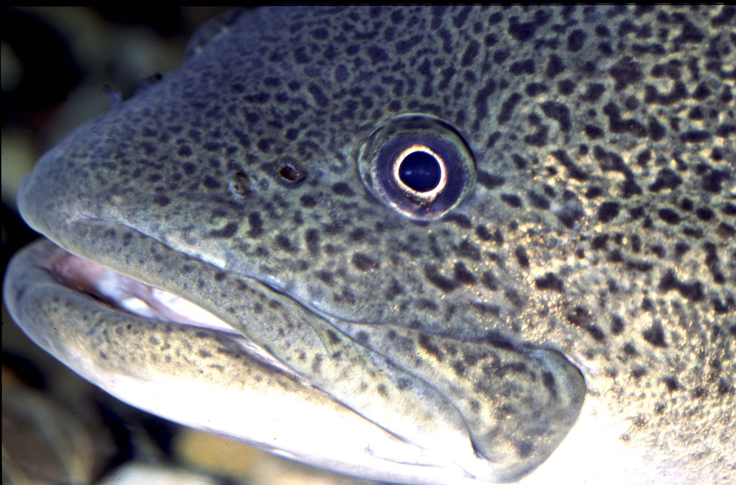

Final Report
CFE Publication 250

Murray-Darling Basin Long Term Intervention Monitoring Project
2018–19 Basin-scale evaluation of Commonwealth environmental water — Fish Report
Report prepared for the Department of Agriculture, Water and the Environment, Commonwealth Environmental Water Office by La Trobe University, Centre for Freshwater Ecosystems.

Department of Agriculture, Water and the Environment, Commonwealth Environmental Water Office
Canberra ACT 2601
Ph: (02) 6274 1111

For further information contact:
Nick Bond Nikki Thurgate
Project Leader Project Co-ordinator
Centre for Freshwater Ecosystems
(formerly Murray-Darling Freshwater Research Centre)
PO Box 821
Wodonga VIC 3689
Ph: (02) 6024 9640 (02) 6024 9647
Email: n.bond@latrobe.edu.au n.thurgate@latrobe.edu.au
Web: https://www.latrobe.edu.au/freshwater-ecosystems/research/projects/ewkr
Enquiries: cfe@latrobe.edu.au

Report Citation: King A.J., McPhan L., Bond N., Thurgate, N. (2020) Murray–Darling Basin Long Term Intervention Monitoring Project — 2018–19 Basin-scale evaluation of Commonwealth environmental water – Fish Report. Report prepared for the Department of Agriculture, Water and the Environment, Commonwealth Environmental Water Office by La Trobe University, Centre for Freshwater Ecosystems, CFE Publication 250, May 2020, 82pp.

Cover Image: Murray Cod
Photographer: Centre for Freshwater Ecosystems

Acknowledgements
This project was undertaken using data collected for the Commonwealth Environmental Water Office Long Term Intervention Monitoring project. We acknowledge the considerable input into the development of the project by Rick Stoffels and Ben Gawne. We also thank the fish leads of the Selected Area Monitoring and Evaluation Providers who undertook all field work and data collation, data entry and management, technical input and report review. These fish experts are: Gavin Butler, Ben Broadhurst, Jason Thiem, Daniel Wright, Nicole McCasker, Wayne Koster, Qifeng Ye, Brenton Zampatti and George Giatas. We also acknowledge all Selected Area staff involved in the collection and management of data. We thank Shane Brooks and Julia Mynott for their considerable time, patience and energy devoted to data curation, management and quality assurance checks. We also thank input and advice on hydrology from Enzo Guarino and Michael Stewardson.
La Trobe University’s Albury/Wodonga offices are located on the land of the Latje Latje and Wiradjuri peoples. We undertake work throughout the Murray–Darling Basin and acknowledge the traditional custodians of this land and water. We pay respect to Elders past, present and future.

Document history and status
Version | Date Issued | Reviewed by | Approved by | Revision type
Draft | 31/03/2020 | N. Thurgate, N. Bond | N. Bond | internal
Final Draft | 20/5/2020 | N. Thurgate, N. Bond | N. Bond | internal

Distribution of copies
Version | Quantity | Issued to
Draft | 1 x word, 1 x pdf | CEWO via MS Teams
Final | 1 x word, 1 x pdf | CEWO via MS teams

Contents
Contents iii
Executive Summary 5
Basin-scale evaluation outcomes 2018–19 5
Multi-year Basin-scale evaluation outcomes 2014–19 5
1 Introduction 7
1.1 Context 7
1.2 Evaluating the contribution of Commonwealth Environmental Water on fish at the Basin-scale 8
2 Basin-scale evaluation 2018–19 9
2.1 Key findings 9
2.2 2018–19 Basin climatic and hydrological context 9
2.3 2018–19 Environmental watering with fish objectives 9
2.4 Effects of Commonwealth Environmental Water on fish within and across Selected Areas in 2018–19 9
3 Cumulative Basin-scale evaluation 2014–19 18
3.1 Key findings 18
3.1.1 General findings 18
3.1.2 Effects of flow on fish 19
3.1.3 Effects of Commonwealth environmental water on fish 20
3.2 Methods 21
3.2.1 Evaluation approach 21
3.2.2 Data and metrics used in this evaluation 24
3.2.1 2014–19 Basin-scale hydrological context 27
3.2.2 Analysis 32
3.3 Effects of flow and Commonwealth Environmental Water on fish diversity and occurrence 34
3.3.1 General patterns 34
3.3.2 Effects of flow on abundance of focal species 40
3.3.3 Effects of CEW on total abundance 44
3.4 Effects of flow and Commonwealth Environmental Water on fish spawning outcomes 47
3.4.1 General patterns 47
3.4.2 Effects of flow on spawning outcomes 48
3.4.3 Effects of CEW on spawning outcomes 52
3.5 Effects of flow and Commonwealth Environmental Water on fish population dynamics 59
3.5.1 General patterns 59
3.5.2 Effects of flow on recruitment outcomes 67
3.5.3 Effects of CEW on recruitment outcomes 71
4 Contribution to achievement of Basin Plan objectives and adaptive management 75
4.1 Adaptive management 75
4.1.1 Monitoring and future research recommendations 76
4.2 Contribution to Basin Plan objectives 76
5 References 78

Executive Summary

Basin-scale evaluation outcomes 2018–19
- The 2018–19 period was characterised by low rainfall, ongoing drought and above average temperatures.
- 59 Commonwealth environmental watering actions specified expected outcomes for fish, comprising approximately 663,047 ML of Commonwealth environmental water.
- The watering actions targeted at fish had objectives of maintaining fish habitat, enhancing movement and spawning/recruitment.
- There was no systematic change in adult abundance across species in 2018–19 compared with other water years.
- Large-bodied species were observed spawning in some parts of the Basin, however, there was little evidence found of recruitment for golden perch and limited recruitment of Murray cod, bony herring and common carp.
- Small-bodied species (e.g. Australian smelt) showed some success in spawning and recruitment.
- In many Selected Areas, environmental water allowed fish movement along rivers, and into and out of wetlands where food availability is likely to be high.

Multi-year Basin-scale evaluation outcomes 2014–19
Key Basin-scale evaluation findings
- Throughout the five-year LTIM project (2014–2019) drought conditions have dominated most of the Basin. Flow conditions at all Selected Areas were very low and highly regulated in four of the five years, with higher flow conditions in only 2016–17 (which also coincided with hypoxia and fish kill events at a number of Selected Areas). The predominance of low flow conditions limits the extent to which inferences can be made about the effects of higher flow conditions.
- Higher flows are expected to influence fish populations, but this remains untested in the context of the LTIM program.
- 13 native and four introduced fish species were collected in LTIM sampling. The highest number of native species was found in the Lower Murray River (11 of 13 species) and the lowest number in the Lachlan River System (7 of 13 species).
- Despite predominantly below average flow conditions, Murray cod, golden perch, carp gudgeons and common carp were detected in each Selected Area annually. Several other native species were also consistently recorded each year at specific Selected Areas. The addition of CEW is likely to have contributed to maintaining these populations.
- Modelling demonstrated that the population metrics total abundance, annual recruit abundance and spawning effort were associated with base flow, fresh flow thresholds, the time since fish kill and an index of average runoff conditions (SRI) at the Basin-scale.
- At the Basin-scale, the modelling indicates that delivery of CEW was associated with improved conditions for some native species, such as greater numbers of Australian smelt, increases in larval and recruit abundance of bony herring, and an increase in recruitment of carp gudgeons.
- The predicted 3-fold increase in bony herring recruitment was due to a reduction in the proportion of base flow days, by increasing fresh flows with the use of CEW.
- Counterfactual modelling also suggests that the use of CEW, reduced the total abundance of common carp, compared to modelled predictions without CEW.
- At the Basin-scale, golden perch and Murray cod population abundances were both significantly reduced after the incidence of hypoxia events and fish kills in 2016. However, populations have shown some evidence of recovery, and modelling suggests population increases are occurring over time.
- There was limited evidence of recruitment of golden perch, despite golden perch spawning and recruitment being a common target for managed flows. This was most likely due to the predominance of low flow conditions.
Key adaptive management outcomes
- Baseflows or above should be maintained to promote native fish persistence. We now have evidence that this poses little risk of enhancing and may even reduce common carp populations.
- Allocation of environmental water to increase fresh flows improves the abundance of some native fish species, including Australian smelt, bony herring and carp gudgeon.
- After fish kills and hypoxia events, priority should be given to providing flows that protect and maintain refuge habitats and promote connectivity and movement among populations.
- Manipulation of base flow and fresh flows by the provision of environmental water can be used to enhance species with strong flow responses such as bony herring and carp gudgeon.
- This report demonstrates the successful use of LTIM monitoring data and Basin-scale analytical approaches to assess how fish respond to the use CEW. We recommend the continuation of this important monitoring program to increase longitudinal temporal studies linking biotic responses to watering and flow conditions.
Key contribution to Basin Plan objectives
- CEW has contributed to the maintenance (no loss) of native species diversity at the six Selected Areas.
- There has been limited spawning and recruitment of golden perch across most Selected Areas during the LTIM time period. Whilst this is likely due to the dry conditions experienced throughout much of the Basin, this is an alarming issue and one that should be targeted in future years of the project.
- Murray cod spawned in all Selected Areas in most years. However, the total abundance and recruitment strength was significantly reduced in many Selected Areas due to the widespread fish kill events of 2016-17. This was particularly noticeable in the Edward/Kolety-Wakool and Lachlan River Systems. Abundances are slowly increasing since the fish kill and should increase in future years as adult breeding populations increase and with appropriate flow conditions.
- Other Basin Plan objectives were not assessed as part of LTIM.

Introduction

Context
The Long Term Intervention Monitoring (LTIM) Project aimed to understand the effects of Commonwealth environmental water (CEW) delivery in the Murray–Darling Basin (the Basin), and sought to inform the management of Commonwealth water holdings. It did this through the monitoring and evaluation of the response of six ecological indicators to managed flows in the Basin. While this document focuses on outcomes for fish, the other Basin Matters indicators are: hydrology, vegetation diversity, water quality and stream metabolism, ecosystem diversity and biodiversity. These Basin Matter indicators were monitored across seven ‘Selected Areas’ throughout the Basin from 2014–15 to 2018–19. The Selected Areas are monitoring sites which can be used to infer outcomes of environmental watering more broadly across the Basin.
Fish are a target indicator for Basin Matters reporting in all Selected Areas, though due to the use of different methods to collect data in the Warrego and Darling rivers Selected Area (see later discussion on methods) this data has been excluded from the Basin scale analysis however fish general outcomes are reported for this Selected Area. This document commonly refers to fish data collected across six Selected Areas: 1. Edward/Kolety-Wakool River System, 2. Goulburn River, 3. Gwydir River System, 4. Lachlan River System, 5. Lower Murray River, 6. Murrumbidgee River (Figure 1).
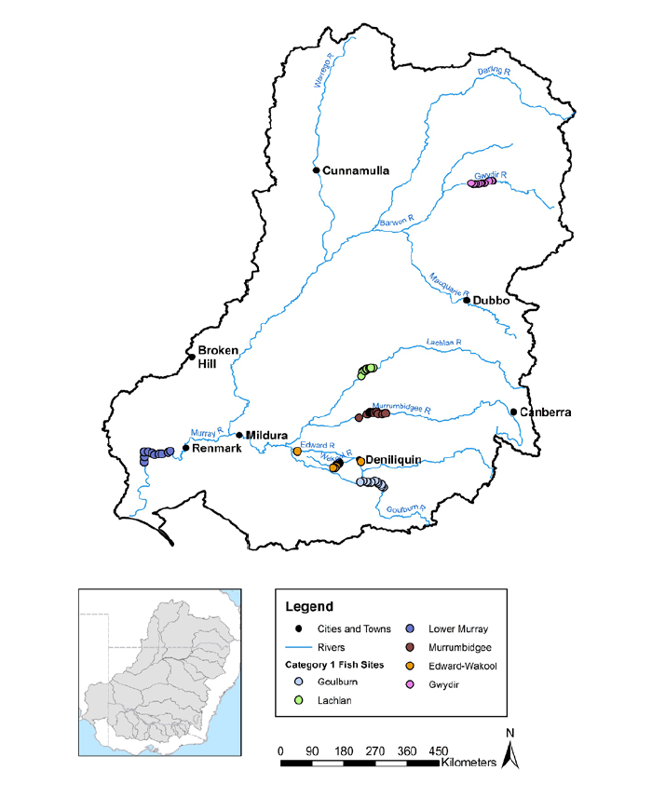
Figure 1: Map of the Murray–Darling Basin showing the location of the six Selected Areas of LTIM focusing on fish response to flows. The six Selected Areas are the Lower Murray River, Edward/Kolety–Wakool River System, Murrumbidgee River, Goulburn River, Lachlan River System and Gwydir River.

Fish are an important ecological component of the Basin and are intrinsically linked to riverine flows and environmental conditions. Fish have substantial cultural, social and economic value and play important roles in the food web and ecosystem processes (Holmlund & Hammer 1999). Evaluation of native fish diversity, condition, reproduction and recruitment contribute to understanding the benefit of environmental water and to the biodiversity outcomes sought by the Murray–Darling Basin Plan (Commonwealth of Australia, Basin Plan 2012). Murray–Darling Basin fishes are thought to be highly dependent on various aspects of flow and other environmental conditions (e.g. temperature) for spawning, survival of young (recruitment), habitat maintenance (including refuges), generation of suitable food, and dispersal and movement of all life stages (see for example Humphries et al. 1999, 2020; Koehn et al. 2014; Ellis et al. 2016). Fishes therefore provide a valuable indicator for understanding flow responses.

Evaluating the contribution of Commonwealth Environmental Water on fish at the Basin-scale
A key objective of LTIM was to improve our capacity to predict ecological response to flow events and regimes (Gawne et al. 2013, 2014). The overarching LTIM evaluation question for fish was:
What did Commonwealth environmental water contribute to sustaining native fish at the Basin-scale?
This question is being examined in a staged approach, where firstly an analysis is undertaken on observed responses of fish to prevailing environmental conditions, using the five years of monitoring data from the Selected Areas. We can then use these predictive models to make inferences about the effects of environmental water contributions using flow scenarios that include/exclude Commonwealth environmental water. Developing predictive models facilitates the separation of the effects of Commonwealth watering actions from the effects of the background (non-environmental water) hydrological variability. Selected Area reports present several analyses of localised fish responses to natural and managed flows.
To that end, the fish Basin Matter reporting therefore aimed to determine:
(i) What is the influence of flow events and flow regimes across all Selected Areas, on:
- Spawning success of native flow-cued species?
- Recruitment strength of all native fish species?
- Population composition (structure and condition) of abundant native species?
- Native fish community structure and persistence?
(ii) Does CEW contribute to any flow linked response to these fish metrics?
(iii) Can any detected fish responses to flows be used to predict fish response to hypothesised flow events?

This evaluation report is the culmination of five years of fish monitoring from six Selected Areas across the Murray–Darling Basin. It presents fish outcomes from 2018–19 watering year and importantly evaluates the response of CEW at the Basin scale across the five years.

Basin-scale evaluation 2018–19

Key findings
The 2018–19 period was characterised by low rainfall, ongoing drought and above average temperatures. The provision of CEW was targeted at maintaining fish habitat, movement and spawning/recruitment. Large-bodied species (e.g. Murray cod, silver perch) were observed spawning (i.e. the presence of larval fish was used as a proxy for spawning) in some parts of the Basin, however, there was little evidence found of recruitment for most species. Small-bodied species (e.g. Australian smelt and flatheaded gudgeon) exhibited some success in recruitment. In many Selected Areas, environmental water supported fish movement along rivers, and into and out of wetlands where food availability is likely to be high. This activity is important in maintaining population health. In general, those species that spawn annually, with spawning not related to flow, were least affected by CEW, as long as low flows were maintained. Species that really on high flows to stimulate breeding were most likely to exhibit a response to CEW.

2018–19 Basin climatic and hydrological context
During 2018–19, averaged rainfall across the nation was well below average, and 2019 was the warmest year recorded by the BOM, with drought affecting large parts of the Basin (http://www.bom.gov.au/climate/current/annual/aus/). During this time period, environmental conditions of the Basin were similar to the first three years of LTIM. In 2018–19, valleys where Commonwealth Environmental Watering occurred experienced very below average to below average rainfall. Average to below-average rainfall occurred throughout much of the southern basin catchment, while the northern basin catchment was below to very below average (Stewardson & Guarino 2020).

2018–19 Environmental watering with fish objectives
The drought conditions of 2018–19 meant that many systems throughout the Basin were reliant on Commonwealth environmental water to avoid cease to flow events to improve water quality, such as increasing dissolved oxygen.
During 2018–19, a total of 59 Commonwealth environmental watering actions specified expected outcomes for fish. Together, these watering actions comprised approximately 663,047 ML of Commonwealth environmental water. Of water delivered, over half targeted fish habitat and/or movement, and one third targeted spawning and/or recruitment, noting that most watering actions have multiple expected outcomes. The most common expected outcomes of water delivery related to movement, habitat maintenance or diversity for native fish, followed by habitat improvement and recruitment.

Effects of Commonwealth Environmental Water on fish within and across Selected Areas in 2018–19
Of the 59 watering actions that were delivered with expected outcomes for fish, 19 were monitored as part of LTIM and other CEWO commissioned monitoring programs (Table 1). Findings from these programs suggested that in general, populations of Murray cod were either stable or declined over the period 2014–2019. Golden perch and Murray cod larvae were both found in some parts of the Basin, however, there was little evidence of recruitment for either species. The reason for this is not well understood but is likely to related to low flows. Environmental water facilitated fish movement along rivers and into and out of wetlands where food availability tends to be high during periods of inundation. This activity is important in maintaining population health and persistence.
For some Selected Areas, Commonwealth Environmental water allowed significant movement of key species such as Murray cod, golden perch, silver perch and freshwater catfish, such movement is important in the community dynamics of these species across the Basin. Wetland inundation was important in maintaining suitable floodplain habitats for fish in some Selected Areas (e.g. Lachlan River). Where wetland inundation occurred, there was successful spawning outcomes for the most abundant species.
Key findings from the Selected Area monitoring are summarised in Table 1, including the expected and observed ecological outcomes. Highlights from this monitoring include the following;
- In the Edward/Kolety–Wakool River system,
  - Spring flows facilitated silver perch and golden perch movements.
  - Murray cod larvae were detected in greatest abundance in 2018–19 compared to the four previous years of LTIM.
  - Murray cod and silver perch recruits were detected in the highest abundance since the hypoxic blackwater event of 2016–17 – an indicator of a positive recovery trajectory.
- In the Goulburn system,
  - The delivery of spring and summer freshes coincided with long distance movements of golden perch. Such movements are important for the maintenance of populations through the movement of individual adults into suitable breeding areas.
  - There was very little recruitment of Murray cod and Murray River rainbowfish in the system (although YOY were found annually for both species. This was potentially related to prolonged high summer flow conditions due to inter-valley transfer (IVT) flows.
- In the Gwydir system,
  - The fish community of the lower Gwydir system was under stress due to prolonged drought. The Northern Connectivity Event and Northern Fish Flow events were essential actions that reconnected channel habitats, maintained refuge waterholes, improved water quality and promoted fish movement among the channels of the lower Gwydir system.
  - Environmental water increased the persistence time and quality of waterhole refuges, allowing iconic species such as Murray cod and golden perch to persist in the lower Gwydir despite record drought conditions.
- In the Lachlan system,
  - Watering actions were timed to support the spawning movements of Murray cod but only a modest response in terms of larval fish abundance was observed.
  - Delivery of spring freshes coincided with increases in the length of larval Australian smelt and flatheaded gudgeon, indicating higher growth rates suggesting a positive effects of the flow releases on these species.
  - The spring flow pulse delivered in spring 2018 coincided with a large spawning event for flatheaded gudgeon, with larval abundances in 2018 nearly 8-fold the next most abundant year.
- In the Lower Murray system,
  - Spring pulse flows supported golden perch spawning, however there was low larval abundance and no evidence of successful recruitment.
  - Abundance of golden perch declined from 2015 to 2019.
  - The community is dominated by a low-flow fish assemblage characterised by generalist species.
  - No lamprey or congollis, which migrate to and from the ocean, were observed in 2018/19.
- In the Murrumbidgee system,
  - Wetland inundations sustained habitat for fish and prolonged the period in which fish occupied the wetlands, which may support improved body condition. Recruitment of small-bodied native species was recorded in most years within these habitats. Overall wetland and riverine communities in the region had the highest abundance of opportunistic, generalist species; and less flow-specialist species.
  - As in previous years, native riverine fish continued to spawn in the Murrumbidgee River with spawning closely linked to water temperature.
  - The reasons contributing to the poor survival of larval fish, particularly of large-bodied species, through to the juvenile stage remains unknown and requires further investigation.
- In the Warrego–Darling system
  - Commonwealth Environmental Water contributed to fish movement, diversity and reproduction. However, connectivity and retention of water to maintain habitat in this system remains an important issue during drought conditions.

Table 1: Summary of results and other information from monitored watering actions with expected outcomes for fish in 2018–19. Note that many of these actions involved multiple water sources (in addition to Commonwealth Environmental Water). Additional information on the portfolio of environmental water can be found in the Basin Matter Hydrology report (Stewardson & Guarino 2020). Also note, that this table does not include monitoring of fish in LTIM Selected Areas that was not directly linked to a Commonwealth environmental watering action. It is likely this table is incomplete as information was not presented by all Selected Areas regarding 2018-19 only, statistics were averaged across five years.
Surface water region/asset | Commonwealth environmental water volume (ML)¹ | Dates¹ | Flow component | Expected ecological outcome¹ | Observed ecological outcome | Influences | Source of information
Edward/Kolety–Wakool- Yallakool Creek and mid and lower Wakool River, Colligen-Niemur | 19,365 | 21/8/18 - 30/6/19 | Small fresh | To contribute to pre-spawning condition of native fish and/or spawning in early spawning species | Facilitated movement of silver perch and golden perch.  Murray cod larvae were detected at the highest levels recorded in LTIM.  Silver perch eggs were found. | Fish populations in recovery but drought impacting all life stages | Watts et al. (2019)
Yallakool Creek, mid- and lower Wakool River, Colligen-Niemur | 13,943 | 21/8/18 - 30/6/19 | Baseflow  /fresh | To improve connectivity, condition and fish recruitment into 2019-20 | No improvement in condition for all species.  Facilitated movement of silver perch and golden perch.  Some evidence of improved recruitment for all native species except golden perch. | Drought | Watts et al. (2019)
Goulburn: Lower Goulburn River | 113,131 | 1/7/18 - 2/8/18 | Baseflow | Contribute to baseflows to maintain water quality and provide suitable habitat and food resources for native fish. Benefits to downstream ecological targets, including lamprey migration. | Golden perch undertook long-distance movements coinciding with a spring ‘fresh’. | Dry year. Intervalley transfers influenced sampling time. Many (70%) of the transmitters have also expired | Webb et al. (2019)
Goulburn: Lower Goulburn River | 60,471 | 29/9/18 - 4/11/18 | Fresh | Establishment and maintenance of native fish habitat | Golden perch undertook long-distance movements coinciding with a spring ‘fresh’. |  | Webb et al. (2019)
Gwydir: Gwydir Wetlands | 30,000 | 18/7/18 - 7/2/19 | Fresh, wetland | Support opportunities for the movement and breeding of native fish, particularly freshwater catfish in the Gwydir River above Tareelaroi. | Some evidence of movement and breeding but overall very low numbers observed. Recruitment at lowest levels observed in 2018-19. Low number of Murray cod, bony herring and spangled perch observed. | Low rainfall and drought | Southwell et al. (2019)
Gwydir: Ballin Boora | 600 | 12/12/18 - 31/1/19 | Wetland | Provide habitat for and support the survival of fish. | Larvae and adult fish observed after flow of Murray cod, bony herring and spangled perch observed after flow | Low rainfall and drought | Southwell et al. (2019)
Gwydir: Mehi River; Barwon River | 10,600 | 2/5/19 - 30/6/19 | Fresh, baseflow | Protect and support native fish survival. Improve access to habitat and food resources for native fish. Support opportunities for native fish movement. | Improved connectivity and prevented no flow conditions | Low rainfall and drought | Southwell et al. (2019)
Mid Lachlan River, main channel and Booberoi Creek, main channel | 10,391 | 29/8/18-23/10/18 | Fresh | To support the movement of native fish prior to the spawning season and support the ability of native fish to achieve good pre-spawning condition | New recruits (juveniles) were detected of: bony herring (at 2 of 3 sites) and Murray cod (8 of 9 sites), and three native short-lived species (Australian smelt (2 of 4 sites), carp gudgeon (8 of 9 sites) and flatheaded gudgeon (8 of 8 sites). No golden perch or silver perch new recruits were captured | Flow variability masking responses. Very little environmental water available in this year  Hot and dry conditions | Dyer et al. (2019)
Mid Lachlan River, main channel | 2,032 | 17/10/18-3/12/18 | Baseflow | - To inundate areas of the river channel containing large woody habitat (snags) which is the preferred spawning habitat for nesting native fish such as Murray cod, River blackfish and freshwater catfish.  - Avoid rapid drops in water level from late September to early December to prevent nest abandonment by native fish.  - Promote the dispersal of larval/juvenile Murray cod, River blackfish and freshwater catfish with a short rise in flows at the end of November as fish leave their nest site within days-weeks post-hatching. It may also provide an additional productivity boost and hence replenish food sources for larvae as they begin to feed on their own.  - Recede flows towards the end of this period to extend duration of downstream dispersal by larval and juvenile fish and extend upstream movement opportunities for adolescents and adult fish | Seven native fish species were captured in the mid-Lachlan fish community sampling in 2019. Despite being captured in the larval fish monitoring, freshwater catfish were not captured in 2019, despite extra effort being deployed to target this species (large-mesh fyke nets). Larvae of this species were captured in the larval sampling in 2018 at one site confirming this species is present, but probably low densities.  Other species that historically were present in the reach that weren’t captured in 2019 were flathead galaxias, unspecked hardyhead, olive perchlet, southern purple spotted gudgeon and southern pygmy perch. Unspecked hardyhead and olive perchlet are the only two of these species that were captured within the catchment recently.  Murray cod recruits were detected at 80% of sites sampled, and overall recruits comprised > 50% of the Murray cod population captured in 2019, which constitutes a significant recruitment event |  | Dyer et al. (2019)
Lower Lachlan River, main channel below Lake Brewster terminating in Great Cumbung Swamp | 5,338 | 9/6/19-28/6/19 | Fresh | - Encourage native fish movement in the lower Lachlan River and improve the condition of native fish before winter.  - Limit the opportunity for carp breeding, particularly in the river channel (carp are spring-summer spawners). | Movement not monitored. It would be useful to monitor such actions in future years to better understand the system
Lower Murray – Channel of LMR, Lower Lakes and Coorong | 594,000 | 01/07/2018-01/06/19 | In channel pulse flows | Maintaining current species diversity, extending distributions and improving breeding success and numbers of short, moderate and long-lived native fish species by:  - Increasing the presence of fast flowing fish habitat along the River Murray and, where feasible, increased lateral connectivity with anabranches and low elevation floodplain wetlands.  - Providing in-stream habitat for fish and thereby supporting recruitment of fish, (including golden and silver perch spawned in 2016–17 and 2017–18), particularly by increasing the availability of food resources and habitat during periods where flows would be unnaturally low.  - Improving the body condition of mature fish during winter/spring (‘pre-spawning conditioning’) and providing opportunities for spawning during spring (subject to appropriate seasonal conditions).  - Maintaining sufficient flows through the barrage fishways to provide connectivity between the River Murray channel, Lower Lakes and Coorong enabling the seasonal movement of diadromous fish species.  - Maintaining suitable habitat conditions (salinity) for estuarine fish species within the Coorong North Lagoon.  - Contributing to the maintenance of critical habitat, water quality and the provision where possible of localised refuge sites as required. | Delivery of CEW to the lower River Murray in 2017-18 coincided with golden perch spawning, but no detectable recruitment of golden perch (to young-of-year, age 0+). Very low abundance of larvae. | Without environmental water flow would have been at entitlement for the year. | Ye et al. (2020)
Warrego River | 8,106 | 23/6/18-29/7/18 | Fresh | Fish reproduction  Biotic dispersal and movement | There was evidence of breeding and recruitment in native fish species within the Warrego River zone including common carp, spangled perch, golden perch and and Hyrtl’s tandan catfish. These species were observed breeding in waterholes that had been dry the previous sampling year. | Minimal inflows, only one waterhole contained water before moderate inflows in late 2018. | Southwell et al. (2019)
Murrumbidgee Yanga National Park | 40,500 | 28/8/18-31/1/19 | Wetland inundation | There was evidence of breeding and recruitment in native fish, frog and invertebrate species within the Warrego River zone. | The overall wetland fish communities across the Murrumbidgee remain in poor condition and are dominated by highly abundant opportunistic generalist species while more sensitive floodplain specialist species, such as Murray hardyhead are typically absent.  The diversity of native wetland fish declined compared with previous monitoring years | Low flow availability  Predominantly wetland watering and monitoring therefore data not reflective of status of channel species | Wassens et al. (2019)
Murrumbidgee – Nimmie-Caira | 1505 | 1/12/18 - 23/5/19 | Wetland inundation | Support the habitat requirements of waterbirds, native fish and other aquatic animals. |  |  | Wassens et al. (2019)
Murrumbidgee – Gooragool Lagoon | 83 | 23/1/19 - 24/1/19 | Wetland inundation | Maintain important refuge habitat for native fish, turtles and other water dependent biota. |  |  | Wassens et al. (2019)
Murrumbidgee – North Redbank | 6500 | 18/9/18 - 19/11/18  17/12/18 - 18/1/19 | Wetland  inundation | Support the habitat requirements of waterbirds, native fish and other aquatic animals. |  |  | Wassens et al. (2019)
Murrumbidgee- Sandy Creek | 400 | 29/9/18 - 12/1/19 | Wetland inundation | Maintain refuge habitat and support their ecological resilience to support wetland vegetation, waterbirds, native, fish, frogs and other water dependent species. |  |  | Wassens et al. (2019)
Murrumbidgee- Lower Murrumbidgee River | 3300 | 30/1/19 - 9/4/19 | Fresh | Support the movement of native fish and other aquatic animals into refuge areas. |  |  | Wassens et al. (2019)

Cumulative Basin-scale evaluation 2014–19

Key findings

General findings
- A total of 13 native and four introduced fish species were collected as part of the LTIM Selected Area fish population surveys. The highest number of native species was found in the Lower Murray River, where 11 of the 13 native species were detected. The Lachlan River System had the lowest number of native species (7 of 13 species detected).
- Abundance for each species varied across Selected Areas. However, a common trend across Selected Areas was a decline in the abundance of some large-bodied native species in 2017 following the occurrence of hypoxic blackwater events and associated fish kills within several Selected Areas in late 2016. For example, Murray cod abundance declined in the Edward/Kolety–Wakool River System, Murrumbidgee River, Lachlan River, Goulburn River and Gwydir River Selected Areas in 2017.
- Bony herring was the most abundant large-bodied species, with particularly high abundances in the Lower Murray River and Lachlan River System. Common carp was the most abundant large-bodied introduced species and was captured across all Selected Areas in all years. In five of the six Selected Areas (Gwydir River System being the exception), common carp had their highest CPUE in the 2016–17 sampling year.
- Spawning was observed for 15 native and four introduced species across Selected Areas (river blackfish and obscure galaxias were collected in larval sampling larvae but not collected in population sampling). Larvae of common carp, carp gudgeons and Australian smelt were collected within all Selected Areas and in most sampling years, all other species showed variable detection across water years and among Selected Areas.
- Surveys suggest that recruitment of golden perch has been extremely limited across all Selected Areas throughout LTIM program. A small number of golden perch recruits were collected in the Goulburn River, but were subsequently identified as artificially stocked fish. This lack of recruitment is most likely due to the broader impacts of river regulation decreasing flow pulses, changing hydraulic conditions and the generally dry environmental conditions experienced throughout the Basin during this time.
- Murray cod recruitment occurred in all Selected Areas in the first two sampling years, however after the higher flow year (2016–17) recruitment was patchy across Selected Areas and recruit abundances were low. This was particularly noticeable in the Edward/Kolety–Wakool and Lachlan River systems.
- Strong recruitment of bony herring occurred annually in four Selected Areas (excluding the Edward/Kolety–Wakool River System and Goulburn River where reduced abundances were recorded in all years).
- Common and short-lived species such as carp gudgeons, Australian smelt and eastern gambusia recruited across all Selected Areas and in most sampling years.
- Large pulses of episodic recruitment of common carp were evident in the 2016–17 higher flow year in all Selected Areas. This was strongest in the Lachlan River system, where there was a near 30-fold increase in the abundance of common carp recruits from 2015–16 to 2016–17. These individuals were not detected in subsequent years, suggesting that either they did not survive or have emigrated out of the system.

Effects of flow on fish
- We examined the effect of flow parameters, population abundance and time since fish kill on the total number of individuals (population size), total number of fish <1 year old (recruit abundance) and the number of larval fish (spawning effort) caught each year for seven fish species at the Basin-scale. The model predictions are inherently restricted to the environmental conditions experienced during LTIM and this should be considered when interpreting reported relationships. Population abundance of large-bodied, long-lived native species Murray cod and golden perch was strongly related to the previous years’ population size.
- Murray cod, golden perch, carp gudgeons and common carp were detected annually in all Selected Areas. Several native species were also consistently recorded each year within specific Selected Areas. The addition of CEW is likely to have contributed to the maintenance of populations within Selected Areas, against a backdrop of predominantly severe drought and low flow conditions across the Basin.
- At the Basin-scale, golden perch and Murray cod populations both after the incidence of hypoxia events and fish kills, and populations increased with time since event. This highlights the severity of impact of these events on populations, and the importance of maintaining habitats, refugia and connectivity to improve population recovery post event. Bony herring and common carp abundances were higher immediately post-fish kill event and then slowly declined with increasing time. These differential responses to fish kills have been reported in other systems, and require further investigation for these species.
- Higher abundances of Murray cod and bony herring tended to occur in years with drier than average conditions; and higher numbers of carp gudgeon and common carp tended to occur in years with wetter than average conditions at the Basin-scale.
- Fewer days of base flows and fresh flows increased the abundance of bony herring, while around 50% of fresh flows resulted in a predicted peak of Australian smelt. Common carp abundance was higher when fewer base flow days occurred. Whilst these findings should be treated with some caution due to the limited range of flow conditions experienced during the LTIM program, they suggest some interesting counter findings on the effects of flows between native and introduced fish species.
- The probability that common carp, bony herring and golden perch would successfully spawn was positively associated with larger spawning stocks (adult abundance). Golden perch was positively associated with a combination of higher number of days of spring base and fresh flows. Similarly, carp gudgeon spawning probability increased with higher number of spring fresh flow days.
- At the Basin-scale, a higher total adult abundance from the previous year was related to increased larval fish abundance for bony herring and carp gudgeon. Murray cod larval abundance was related to both base flows and fresh flows, with abundance reaching a maximum when spring flow conditions were ~ 40% days as base flows and 60% days as freshes. This finding is supported by previous studies which highlight the importance of base flows and fresh flows for supporting spawning and larval survival for Murray cod. The abundance of carp gudgeon larvae was also maximised when around 70% of spring flows were freshes. Increased abundances of common carp larvae occurred in wetter than average conditions.
- The abundance of recruits for a number of species was affected by the time since occurrence of fish kills. A higher abundance of Murray cod, carp gudgeon and eastern gambusia recruits occurred with increasing time since fish kill or hypoxia, while the abundance of Australian smelt and common carp recruits was highest closer to the fish kill event and then decreased with time. This highlights that the effects of hypoxia and fish kills can alter fish population structure and can occur in both directions (positive and negative impacts), for many years after the fish kill has occurred.
- Bony herring recruitment was enhanced when more base flow conditions occurred. Carp gudgeon recruitment was higher in wetter years and when ~50% flows were freshes. Common carp recruitment was maximised when fresh flows occurred ~60% of the time. These results highlight the delicate balance of managing for both native and introduced species with watering, with a reduction in fresh flows likely to lead to reduced common carp recruitment, but also likely to decrease recruitment of native species, and therefore other complimentary management techniques will also be required to manage carp recruitment.

Effects of Commonwealth environmental water on fish
- To evaluate the effects of CEW on populations of the seven focal species, statistical models were used to predict fish responses to flow regimes that included (with CEW) and excluded (without CEW) environmental flows. The comparison between these scenarios provides a counterfactual comparison for inferring he effects of CEW on fish populations.
- Across the Selected Areas, the use of CEW resulted in only a small increase in total abundance of one species; Australian smelt; and decline in total abundance of carp gudgeon and common carp. The response to CEW for these species also varied considerably across Selected Areas. Increased abundances of Australian smelt were related to an increase in the proportion of flows in the freshes band due to the addition of CEW in all water years.
- Counterfactual modelling suggests common carp populations wold have been larger without the delivery of CEW. This was due to an increase in the proportion of fresh flows with the use of CEW, particularly in the drier years (i.e. not the 2016–17 water year).
- Across the Selected Areas, the use of CEW during the LTIM program resulted in an increase in larval abundance of only bony herring. Counterfactual modelling also demonstrates that the abundance of carp gudgeon larvae would have been greater without the use of CEW. There was no significant predicted response in spawning probability for any species with the use of CEW. The limited range of flow conditions experienced during LTIM project and the range of CEW flow delivery types that occurred during LTIM is a likely cause for the limited evidence of a spawning response to CEW at the Basin-scale. Analysis at the Selected Area scale and with more biologically relevant hydrological periods for spawning are necessary areas for further investigation.
- The use of CEW at the Basin-scale increased the abundance of bony herring and carp gudgeon recruits relative to the counterfactual without CEW scenario, primarly due to the greater proportion of non-baseflow days. This effect was relatively small for carp gudgeon, but much larger (3-fold increase) for bony herring.

Methods

Evaluation approach
The sampling approach and experimental design used to monitor fish at a Basin and Selected Area scale is described in detail in Hale et al. (2014) and Stoffels & Bond (2016).
Briefly, abundance and diversity of riverine fish populations are monitored annually at fixed sites within six Selected Areas using a standardised sampling regime, involving boat or backpack electrofishing and fine mesh fyke nets (referred to as Category 1 sampling). These methods target large-bodied and small-bodied fish species respectively (Table 2). The abundance, diversity, length and weight of all captured fish (both native and introduced species) were recorded. All fish were returned to the water after capture and measurement. Measurements of length and weight allowed for description of population dynamics allowing the analysis of species recruitment and individual body condition.
Spawning of both native and introduced species was measured by collecting eggs and fish larvae using drift nets and light traps during the known spawning period at five Selected Areas (Edward/Kolety –Wakool River System, Goulburn River, Lachlan River System, Lower Murray River, Murrumbidgee River). Due to differences in sampling intensity and methods across the Selected Areas, Category 3 sampling methodologies and Category 1 methods to analyse fish spawning at the basin scale. For example, bongo tow nets, rather than drift nets, were used to sample pelagic fish in the Lower Murray River due to very slow flow velocities and they were deemed equivalent methods for the analysis of ‘drift net’ data.
Additional sampling (Category 2 and 3 sampling) of fish movement and fish occurrence on floodplain habitats also occurred at various Selected Areas. These data are not included in this Basin-scale analysis of fish response to CEW, but can be found within relevant Selected Area reports.
Generic and species-specific conceptual models linking fish response to flows were used to inform the initial experimental design and analytical approach (Hale et al. 2016). This report presents information on all species captured in LTIM (Table 2), but focusses on seven focal species for detailed statistical analysis on the influence of flows on fish outcomes (Table 3). These seven focal species were chosen as they:
- Have been previously identified in LTIM as responding to flows (Hale et al. 2016),
- Represent a range of life history strategies or guilds,
- Common as adults and larvae in data and therefore able to be analysed with confidence,
- Represent both native and introduced species.

Table 2: Fish species collected in standard fish population surveys using Category 1 methods across all Selected Areas.
Species Name | Common Name | Native or Introduced | Body Size | Fish population collection method
Bidyanus bidyanus | silver perch | Native | Large-bodied | Electrofishing
Carassius auratus | goldfish | Introduced | Large-bodied | Electrofishing
Craterocephalus stercusmuscarum fulvus | unspecked hardyhead | Native | Small-bodied | Fine mesh fyke net
Cyprinus carpio | common carp | Introduced | Large-bodied | Electrofishing
Gambusia holbrooki | eastern gambusia | Introduced | Small-bodied | Fine mesh fyke net
Hypseleotris spp | carp gudgeon | Native | Small-bodied | Fine mesh fyke net
Leiopotherapon unicolor | spangled perch | Native | Large-bodied | Electrofishing
Maccullochella macquariensis | trout cod | Native | Large-bodied | Electrofishing
Maccullochella peelii | Murray cod | Native | Large-bodied | Electrofishing
Macquaria ambigua | golden perch | Native | Large-bodied | Electrofishing
Melanotaenia fluviatilis | Murray River rainbowfish | Native | Small-bodied | Fine mesh fyke net
Nematalosa erebi | bony herring | Native | Large-bodied | Electrofishing
Perca fluviatilis | redfin perch | Introduced | Large-bodied | Electrofishing
Philypnodon grandiceps | flathead gudgeon | Native | Small-bodied | Fine mesh fyke net
Philypnodon macrostomus | dwarf flathead gudgeon | Native | Small-bodied | Fine mesh fyke net
Retropinna semoni | Australian Smelt | Native | Small-bodied | Fine mesh fyke net
Tandanus tandanus | freshwater catfish | Native | Large-bodied | Electrofishing

Table 3: Relevant ecological information on seven focal species.
Common Name | Life History Strategy | Ecology Summary | Known or hypothesised fish response - flow relationship
Murray cod | Equilibrium | Native. Large adult body size, long-lived, low fecundity, large investment in young | Base flows: * habitat maintenance flows for adults (Balcombe et al. 2006, Price et al. 2019) *increased spawning (Humphries et al. 2002, 2020, Humphries 2005)  Fresh flows: * potentially some increased spawning due to freshes (King et al. 2016), but also evidence suggesting no influence. * some increase of recruitment (King et al. 2009, 2010; Humphries et al. 2020) * improved body condition  Overbank flows: * improved body condition due to increased food resources (Bayley 1991, Hunt et al. 2012, Baldwin et al. 2013, 2014) * strong recruitment and increased abundances (Rowland 1989; Ye et al. 2000).
golden perch | Periodic | Native. Large adult body size, long-lived, very high fecundity, little investment per young | Base flows: * habitat maintenance flows for adults (Balcombe et al. 2006, Price et al. 2019)  Fresh flows: * increase spawning and recruitment (Vilizzi 2012; King et al. 2009, 2016, Zampatti & Leigh 2013a; Stuart & Sharpe 2020), but also absence has been noted (Mallen-Cooper & Stuart 2003, Ebner et al. 2009), * increased recruitment and total abundance (Humphries et al. 2008) * improved body condition due to increased food resources  Overbank flows: *increase spawning and recruitment (King et al. 2009, 2016, Ye et al. 2013; Humphries et al. 2020; Stuart & Sharpe 2020). * increase lateral movements of juveniles possibly for feeding (Balcombe et al. 2007, Stoffels et al. 2014, 2015; Stuart & Sharpe 2020), * increased recruitment and total abundance (Humphries et al. 2008, Zampatti and Leigh 2013b, Bice et al. 2014) * improved body condition due to increased food resources (Bayley 1991, Hunt et al. 2012, Baldwin et al. 2013, 2014).
bony herring | Periodic - opportunistic | Native. Medium adult body size, medium longevity, moderate fecundity, little investment per young | Base flows: * habitat maintenance flows for adults (Balcombe et al. 2006, Price et al. 2019),  Fresh flows: * increased recruitment and body condition (Balcombe et al. 2006, 2012; Sternberg et al. 2008; Balcombe & Arthington 2009).  Overbank flows: * increase lateral movements possibly for feeding, increased survival and body condition (Puckridge et al. 2000, Balcombe et al. 2007, Kerezy et al. 2013, Stoffels et al. 2014, 2015) * possible for spawning and recruitment (Balcombe et al. 2005, 2007; Rolls & Wilson 2010; Humphries et al. 2020). * improved body condition due to increased food resources (Bayley 1991, Hunt et al. 2012, Baldwin et al. 2013, 2014).
common carp | Periodic | Introduced. Large adult body size, long-lived, very high fecundity, little investment per young | Base flows: * habitat maintenance flows for adults (Balcombe et al. 2006, Price et al. 2019),  Fresh flows: * increased spawning and recruitment (Humphries et al. 2002, 2008)  Overbank flows: * increased spawning and recruitment (Stuart & Jones 2006; King et al. 2003, 2009, 2016; Macdonald & Crook 2014; Bice et al. 2014; Humphries et al. 2020) * improved body condition due to increased food resources (Bayley 1991, Hunt et al. 2012, Baldwin et al. 2013, 2014).
carp gudgeon | Opportunistic | Native. Small adult body size, short longevity, low fecundity, little investment per young | Base flows: * habitat maintenance flows for adults (Balcombe et al. 2006, Price et al. 2019, Bice et al. 2014),  Fresh flows: * unknown response * potential increased spawning (Vilizzi 2012) or no difference (Humphries et al. 2002, King et al. 2003) *potentially increased recruitment (Humphries et al. 2020) and increased abundance  Overbank flows: * unknown response * potentially negative impact on abundance (Bice et al. 2014) or increase (Puckridge et al. 2000, Beesley et al. 2014, Ho et al. 2012), *potentially increased recruitment (Humphries et al. 2020) and increased abundance * improved body condition due to increased food resources (Bayley 1991, Hunt et al. 2012, Baldwin et al. 2013, 2014).
Australian smelt | Opportunistic | Native. Small adult body size, short longevity, low fecundity, little investment per young | Base flows: * habitat maintenance flows for adults (Balcombe et al. 2006, Price et al. 2019),  Fresh flows: * Increased spawning and recruitment potentially linked to fresh flows (Vilizzi 2012; Humphries et al. 2002; Humphries et al. 2020) and increased abundance  Overbank flows: * potentially increased spawning and recruitment (Pusey et al. 2004, Tonkin et al. 2011, Beesley et al. 2014, Humphries et al. 2020) and increased abundance* improved body condition due to increased food resources (Bayley 1991, Hunt et al. 2012, Baldwin et al. 2013, 2014).
eastern gambusia | Opportunistic | Introduced. Small adult body size, short longevity, low fecundity, little investment per young | Base flows: * habitat maintenance flows for adults (Balcombe et al. 2006, Price et al. 2019),  Fresh flows: * potentially increased recruitment (Humphries et al. 2020) and increased abundance  Overbank flows: * potentially increased recruitment (Cruz et al. 2020; Humphries et al. 2020) and increased abundance * improved body condition due to increased food resources (Bayley 1991, Hunt et al. 2012, Baldwin et al. 2013, 2014).

Data and metrics used in this evaluation

Fish data
All fish data were entered by Selected Area teams into the LTIM Project database, and then thoroughly reviewed for errors and inconsistencies, and only deemed final once all issues had been resolved. The final data used in this report was downloaded on 11th March 2020. All data was entered and analysed at the lowest level of replication available. Monitoring data collected in all five years at each Selected Area includes:
- Fish catch per electrofishing sample for each species collected
- Fish catch per fyke net sample for each species collected
- Individual fish length for each sampling method for species collected
- Individual fish weight for each sampling method for species collected. (This data was not fully validated in time for this analysis and was not used in this evaluation)
- Egg and larval catch per drift net sample for each species collected
- Egg and larval catch per light trap sample for each species collected
- Estimated age of a small subset individuals (age was measured using otoliths for a limited number of species and individuals and was collected to construct age-length relationships for population-style modelling. This data was not fully validated in time for this analysis, and was not used in this evaluation).

Hydrological and other data used
All observed hydrological data was provided by the Commonwealth Environmental Water Office (CEWO) or downloaded from the Bureau of Meteorology website. The CEWO also provided modelled flow data without CEW (often termed the counterfactual flow). Counterfactual flow data provides a modelled reference scenario to generate predictions of what would have occurred without environmental flows, to then infer the influence of CEW. Using both actual and counterfactual flow scenarios to test the response from environmental flows has gained attention in recent years (e.g. Webb et al. 2010, Stewardson & Skinner 2018), and is a useful alternative where other comparisons with or without the intervention is not possible - a common situation for experimental environmental flow manipulation studies (Webb et al. 2010). However, this approach inherently relies on predictions from the modelled data and making them susceptible to model errors, which do not occur if comparisons are made on actual measurements alone. Additionally, within these counterfactual modelled scenarios it can be difficult to account for other flow dependant ecosystem processes that may influence species (e.g. ecosystem productivity, hypoxic events under low flows).
We used simple hydrological metrics to summarise important aspects of the flow regime that are likely to influence fish population processes based on life history traits. The adopted hydrologic metrics included: proportion of base flow days, proportion of fresh flow days, proportion of overbank flow days and the standardised runoff index (SRI) (see Table 4). To enable standardisation of discharge across the Selected Areas and allow for comparison across such diverse channel morphologies, we used defined flow thresholds at each gauging site to classify the flow on each day into a series of flow classes. Flow thresholds were based on those proposed by the LTIM Hydrology team (Stewardson & Guarino 2020) (Figure 2), and were grouped as:
- Overbank flows: estimated as either the 5th percentile exceedance in unimpacted monthly flow series or from known channel dimensions. This flow threshold corresponds to floodplain and wetland habitat inundation.
- Fresh flows: flow events occurring above one-eighth of the bank height, and less than overbank flows. These flow thresholds correspond to within channel flows but above base flow conditions.
- Base flows: flows below the 95th percentile exceedance in unimpacted monthly flow series or 10% mean unimpacted flow, whichever is the greater. This flow threshold corresponds to minimum flows to maintain base flow habitats.
The number of days within each flow class for a set period divided by the number of days in the period was used in statistical analysis (Table 4). These flow variables were assessed on biologically relevant time scales for each response variable. For example, the response of adult fish was assessed against metrics derived over a window that included the previous 12 months. Larval catch was assessed against flow metrics derived for the spring period that coincided with the spring-summer sampling period. It should also be noted when interpreting these parameters that by their calculation freshes and base flows do not account for all within bank flows. The definition of these flow thresholds means that flows that were above base flow could occur which were not large enough to be considered fresh flows.

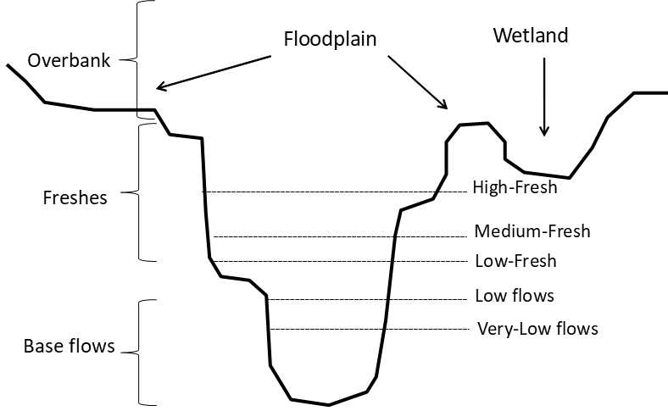
Figure 2: Conceptual diagram indicating water levels corresponding to the flow freshes and base flows used in this evaluation (see Stewardson and Guarino (2020).

Table 4: Description of hydrological and other descriptive metrics used in this evaluation.
Metric | Summary code used in analysis | Description and calculation | Metric use
Proportion of base flows | B_flow_prop | Number of days where mean daily flow was within base flow thresholds across a set period divided by the total number of days of the period. | Total fish abundance  Recruit abundance  Larval fish catch (Spawning likelihood and abundance)
Proportion of fresh flows | FR_flow_prop | Number of days where mean daily flow was within fresh flow thresholds across a set period divided by the total number of days in the period. | Total fish abundance  Recruit abundance  Larval fish catch (Spawning likelihood and abundance)
Proportion of fresh flows | FR_flow_prop² | Metric as above but fitted as a quadratic term to allow for non-linear relationships | Total fish abundance  Recruit abundance  Larval fish catch (Spawning likelihood and abundance)
Proportion of overbank flows | OB_flow_prop | Number of days where mean daily flow was in overbank flow threshold across a set period divided by the total number of days in the period. | Not used in fish evaluation
Standardised Runoff Index (SRI) | SRI_sc | SRI is calculated in the following way. The mean flows for a specific month (Jan) over a reference period (2001-2019) is calculated. These values are centre scaled (mean SRI = 0) and a log-normal distribution is fit to the data. SRI values are then derived for each month based on the position of that month in the distribution of all months. Individual SRI values thus represent the number of standard deviations each month sits above or below the long-term average for that month. Interpretation is that positive values indicate wetter conditions | Total fish abundance  Recruit abundance
Time since fish kill | month_fishkill | Number of months since the last recorded fish kill (either from the NSW fish kill database or Selected Area reports). Used to capture the influence of recent fish kills on populations and track the recovery trajectory after fish kills occur (Table 5). | Total fish abundance  Recruit abundance
Standing stock | adult_abundance_1 | Mean population size of that species recorded at that site in the previous year. Used to estimated abundance of breeding fish potentially contributing to spawning. | Larval fish catch (Spawning likelihood and abundance)

2014–19 Basin-scale hydrological context
Most of the Selected Areas experienced drought conditions throughout the entire five-year LTIM project (2014–2019). River flow conditions varied across Selected Areas in terms of volumes and timing of flow events, but flow conditions at all Selected Areas were very low and highly regulated in four of the five years (2014–15, 2015–16, 2017–18, 2018–19) (Figure 3). High flow conditions occurred in only one year (2016–17) at all Selected Areas (Figure 3). CEW was used in all water years across the Selected Areas, with the majority of CEW being delivered in base flow years (Figure 3 and Figure 4), and smaller amounts in the higher flow year (2016–17). Across all Selected Areas, CEW increased the proportion of fresh flows and reduced the number of base flow days in all years (Figure 5). Importantly, CEW increased the average flow conditions (as measured by SRI) in all water years but this was especially noticeable in the four base flow years (Figure 5) where the allocation of CEW shifted the mean standardised runoff index (SRI) from below average to above average flow conditions in the context of flows in the previous 19 years. The frequency distribution of base flows and freshes during the LTIM period was relatively similar when compared to a longer reference period (2000–2019), however the number and range of overbank flows was greatly reduced in the LTIM period compared to the reference period (Figure 6).
Fish population sizes can be significantly affected by the occurrence of a fish kill or hypoxia event (e.g. King et al. 2012). Several fish kill or hypoxia events occurred at the Selected Areas during, or shortly before LTIM project began (Table 5). This data was compiled from the NSW fish kill database, and from Selected Area reporting. A descriptor variable for time since fish kill was included in the models to represent the amount of time fish populations have had to recover since any fish kill or hypoxia event.
Table 5: Reported fish kills or hypoxia events at the Selected Areas. Data sourced from NSW fish kills database or Selected Area annual reports.
Selected Area | Date | Reference
Gwydir River System | 06-Nov-09 | NSW fish kills database
Lachlan River System | 03-Oct-15 | NSW fish kills database
 | 08-Nov-16 | NSW fish kills database
Murrumbidgee River | 31-Jan-11 | 2016–17 Annual Report (Hypoxia, Sept - December 2016; Wassens et al. 2017)
Edward/Kolety–Wakool River System | 29-Nov-10 | 2016–17 Annual Report (Fish Kill; Oct 2016; Watts et al. 2017)
 | 06-Nov-16 | NSW fish kills database
Goulburn River | Apr-11 | 2016–17 Annual Report (Hypoxia Fish Kill, Dec 2016; Webb et al. 2017)
Lower Murray River System | Apr-11 | 2016–17 Annual Report (Blackwater, Nov - Dec 2016; Ye et al. 2018)

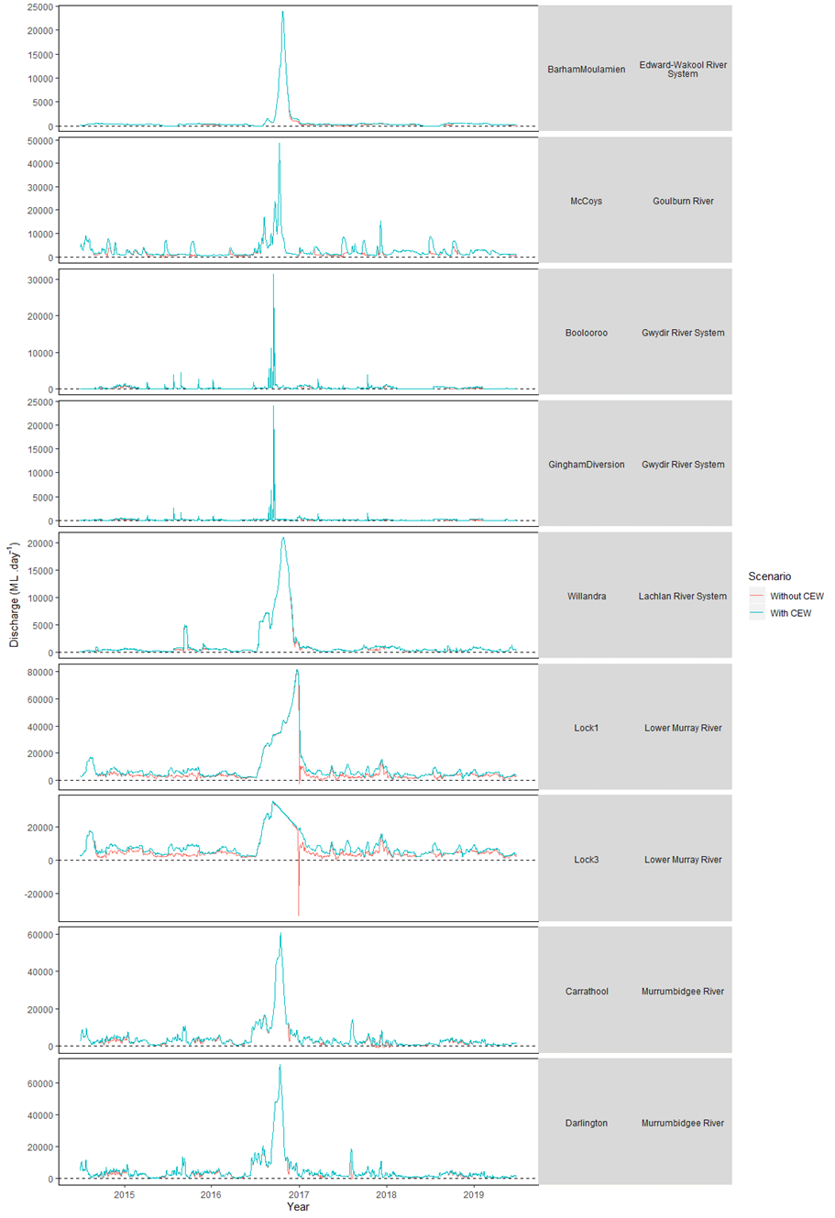
Figure 3: Mean daily discharge (ML day⁻¹) for relevant gauges from each Selected Area 2014–2019 showing discharge with CEW and without CEW.
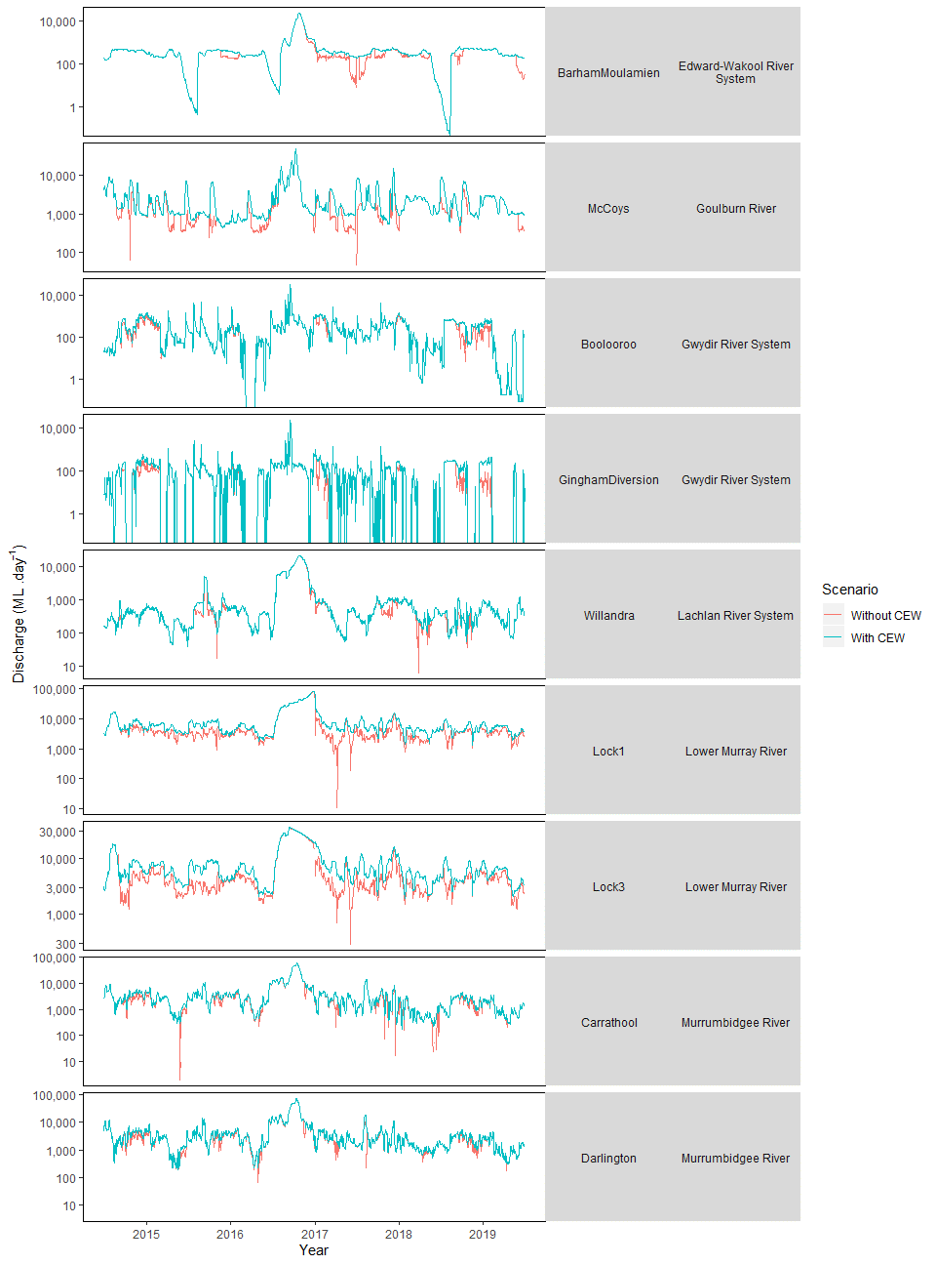
Figure 4: Mean daily discharge (ML day⁻¹ on log scale) for relevant gauges from each Selected Area 2014–2019 showing discharge with CEW and without CEW.

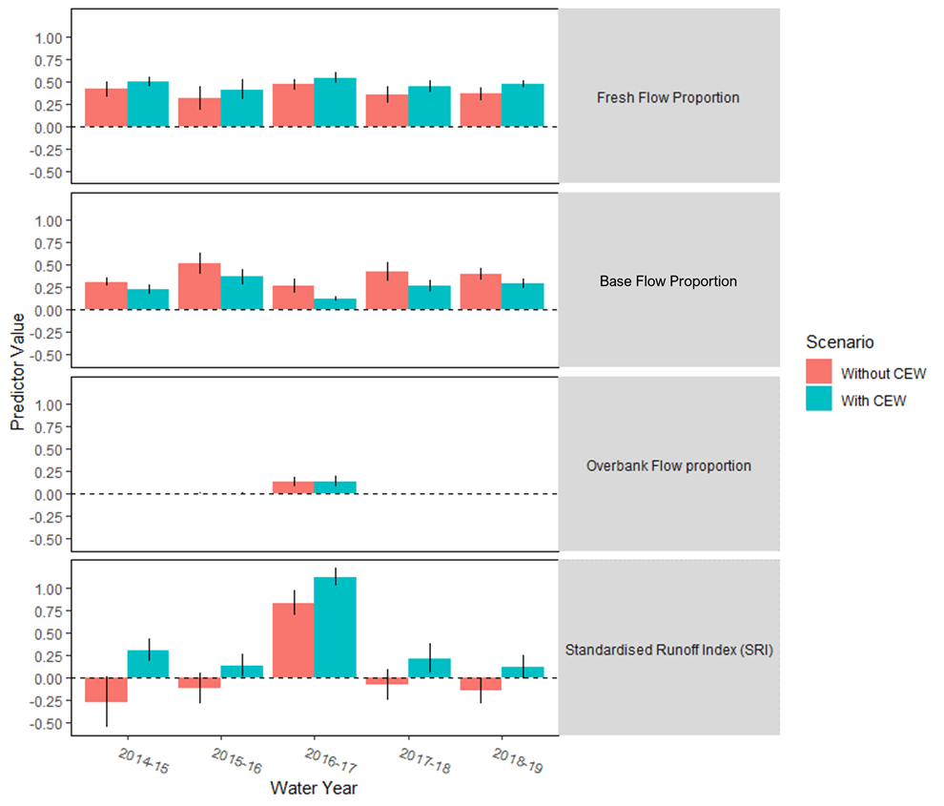
Figure 5: Mean (+/- SE) predicted flow metrics (proportion of time flows were in the freshes, base flow and overbank flow bands, and the SRI values) among water years and Selected Areas. See Table 4 for description of each metric.

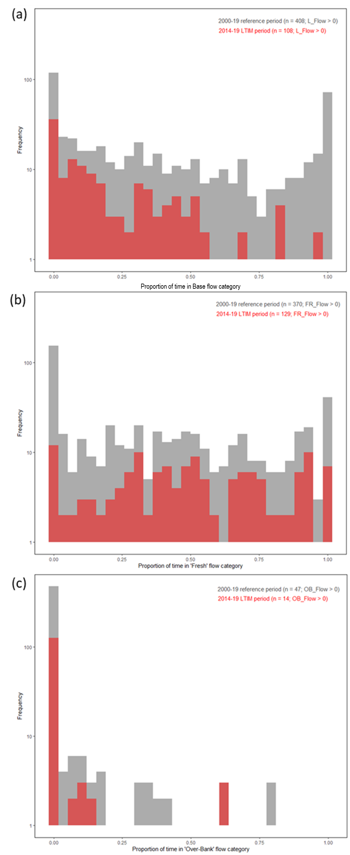
Figure 6: Frequency histograms for (a) base flow (b) freshes and (c) overbank proportion of flows in reference period (2000–2019) compared to the LTIM study years (2014–19).

Analysis
To analyse the response of the collected fish metrics to Commonwealth environmental water; population estimates, recruit abundance, larval spawning probability and larval abundance were modeled by a hierarchical generalized mixed effect model. This was selected to account for both the spatial hierarchy of sample points within Selected Areas and the temporal nature of the datasets. Models for all fish metrics contained three of the same core hydrological parameters; proportion of base flows, proportion of fresh flows and the standardized runoff index. In addition, the previous year’s standing stock (population abundance) and the number months since a potential fish kill were also used as fixed effects in the model. Initial model runs included the proportion of overbank flows, however upon observation of the modelled trends it became clear that sparse data from infrequent overbank flow events was heavily influencing relationships. To have any confidence in the relationship between fish metrics and overbank flows, greater replication is needed across these conditions. As the relationships between abundance and overbank flows was influenced highly by the few overbank events that occurred the term was removed as a descriptor from the analysis. Prior to analysis, all parameters were centre scaled to reduce residual variance, excluding base and fresh flow proportion’s which both had a sample space between 0 and 1.

Model structure
The spatial distribution of the collected data dictated that all fish metrics were analysed within a model framework that included a nested random intercept effect. Sampling sites within a Selected Area therefore have individual intercepts accounting for differences between sites. In determining the final model structure random slope effect models were also investigated to allow for varying responses (unique coefficients) to hydrological parameters between Selected Areas, though when tested, model results were non-convergent, indicating that the available data at the time of analysis was depauperate for this type of structural component and greater replication is needed.
The temporal component of the data structure (year of sampling) was handled based on if the fish metric was considered temporally correlated or a batch process. For batch processes (spawning probability, larval fish and recruit abundance) the year of capture was included as a random intercept to allow for varying responses between years. In the case of the population abundance however the data is temporally correlated and an autoregressive process of order 1 (AR(1) random process) was included in the model structure to account for the influence (correlation estimate) of the previous year’s population estimate on the current year’s estimate.

Population abundance
Analysis of the population estimates for focal species (here after this refers to data collected using electrofishing and fyke netting in standardised Category 1 methods, and does not include larval catches) required the separation of small-bodied and large-bodied species due to difference in sampling methods (Hale et al. 2013). Briefly, the catches from electrofishing data focussed on large-bodied species, and fine mesh fyke net data being used for the small-bodied species. The total catch from all fishing operations of each type (10 fine fyke nets and 32 x 90 second ‘shot’ of electrofishing) was one replicate for our analysis and was standardised for variable sampling effort using an offset term of the total sampling effort in hours. This allowed for variable sampling effort in sampling events to be compared where complications arose meaning the total sampling effort could not be made (e.g. lost net’s, lack of access to sample locations).
Population estimates were modelled in a generalised linear mixed model (GLMM) framework using the analysis package glmmTMB (version 1.0.0, Magnusson, 2019) using R statistical analysis environment. A Poisson distribution was used in models for all focal species as this distribution resulted in the best observed vs expected residual fits. After models were run the AR(1) correlation was recorded and the summary function was used to determine significantly influential factors. When relationships between flow and abundance were found to be significant the marginal effect of the flow parameter was calculated using ggemmeans from the ggeffects package (Lüdecke D., 2018). Marginal and conditional population estimates were also plotted with overlaid predicted values based on the with and without CEW scenarios to show the influence of CEW water via each parameter.

Species diversity
To assess whether the allocation of CEW across the program was influential on the persistence and detection of native species in the Selected Areas native species presence was analysed in a GLMM framework as with recruit abundances. This analysis differed from the recruitment model approach in two ways. First, the model did not include an offset term for sampling effort. Second, the residual distribution across sites was gaussian and not negative binomial. Model results were interpreted in the same fashion as described above (i.e., marginal correlations).

Recruit abundance
To generate the necessary data for the analysis of recruit abundances across selected areas the following steps were taken. Length-frequency data collected at each site from the fishing operations used to estimate population size was compared to a table of length limits for young of year recruits, below which an individual was termed a recruit. The proportion of recruits calculated from the total individuals measured in the length frequency dataset was multiplied by the total population abundance from that site and rounded to generate a recruit abundance estimate.
Once generated, the recruit abundances were analysed in a GLMM framework as described for the population abundance analysis, though the model structure differed. As recruitment is not temporally autocorrelated, water year in this set of models was included as a random intercept allowing varying responses between years. A negative binomial distribution generated the best observed vs expected residual fits and was used in all model outputs. As with population abundances, marginal effects for significant factors were plotted to visualise the relationship between the predicted recruit abundances and the hydrological parameters.

Larval metrics
As in the case of the population abundance estimates, for the larval fish metrics, focal species were also separated by method with small bodied species being collected via light traps and large bodied species collected via drift nets. Across Selected Areas larval data was included from both category 1 methods and category 3 methods. These decisions were made to make inferences about the spawning behavior of species at a basin level and it should be noted that there was variable sampling effort in the method employed and the intensity of sampling due to the inclusion of both methodologies (Cat 1 and Cat 3). As such consideration of the larval findings for a species within this report should be made in the context of the sampling effort made in each Selected Area. Marginal effects were plotted as with the population estimate and recruit abundance datasets.
Spawning probability: To analyse spawning probability our response was ‘detection’. When a larval individual or egg of a species was collected in a sample, the species was recorded as present, if a species was not within the sample it was recorded as absent. This data was used as the binary response for modelling (using a binomial distribution) the spawning probability for a species. As mentioned previously the hydrological parameters used in all models, that is, base and fresh flow proportions and standardised runoff index were modelled in addition to the previous year’s population abundance for the site. In both the spawning probability and larval abundance modelling we included this term describing the mean total abundance from a Selected Area for the previous year’s sampling. For this reason, only four water years (2015-16 to 2018-19) were able to be included in this analysis.
Larval abundance: To analyse the larval abundance data, when a species was present in a sample, the total count of individuals of that species in the sample was recorded. These recorded values were analysed as counts of the larval abundance and analysed with relation to the same hydrological parameters as for adult models. Larval abundances were analysed as count data with a negative binomial distribution and offset by sample count, rather than volume filtered to avoid the influence of river morphology (e.g. cross-sectional area) on diluting or concentration estimates of larval abundance and to avoid comparing volumes filtered by larval net trawls (conducted in the Lower Murray River) with passively filtering nets.

Effects of flow and Commonwealth Environmental Water on fish diversity and occurrence

General patterns
Standardised fish sampling across all Selected Areas detected 13 native (seven large-bodied, six small-bodied) and four introduced fish species (three large-bodied, one small-bodied) (Table 2).
Murray cod, golden perch, carp gudgeons, bony herring, Australian smelt, common carp, goldfish and eastern gambusia were present in all Selected Areas (Figure 7). Three species were unique to a single Selected Area, showing limited distribution of those species (spangled perch (Gwydir River), trout cod (Goulburn River), dwarf flathead gudgeon (Lower Murray River)). The highest diversity (number of species) of native species was found in the Lower Murray River, where 11 of the 13 native species were detected (Figure 7). The Lachlan River System had the lowest number of native species (7 of 13 species detected).
Murray cod, golden perch, carp gudgeons and common carp were detected in each Selected Area across all sampling years (Figure 8). The addition of CEW is likely to have contributed to the maintenance of these populations at the Basin-scale, but whether they would’ve been lost without the addition of CEW is unknown. Bony herring and eastern gambusia were recorded in all years and Selected Area combinations, except in 2015 and 2019 for the Goulburn River. Several native species were also consistently recorded through time at specific Selected Areas, again the addition of CEW is likely to have contributed to the maintenance of these populations at specific Selected Areas: freshwater catfish and flathead gudgeon (Lower Murray River), silver perch (Goulburn River, Edward/Kolety –Wakool River system), spangled perch (Gwydir River System), Australian smelt (Goulburn River, Edward/Kolety–Wakool River system, Gwydir River System), Murray River rainbowfish (all Selected Areas, except Lachlan River system) and unspecked hardyhead (Lower Murray River, Edward/Kolety–Wakool River system, Gwydir River System).
The Nationally threatened species trout cod was only detected in the Goulburn River and only in 2015 and 2016 sampling surveys using Category 1 methods. Trout cod have also been detected in the Edward/Kolety–Wakool River and Murrumbidgee River Systems using other LTIM sampling categories. Dwarf flathead gudgeon was only recorded in the Lower Murray, but in all years except 2017 (Figure 8).
The abundance (catch per unit effort, CPUE) of large-bodied native species was variable between Selected Areas; with both positive and negative responses to the 2016–17 high flow year (Figure 9). A common trend across Selected Areas was a decline in the abundance of some large-bodied native species in 2017 following the occurrence of hypoxic blackwater events and associated fish kills within several Selected Areas. For example, Murray cod abundance declined in the Edward/Kolety–Wakool River System, Murrumbidgee River, Lachlan River, Goulburn River and Gwydir River Selected Areas in 2017. Exceptions to this were, increases in abundance in 2017 of silver perch in the Goulburn River, and spangled perch in the Gwydir River System. Lower Murray River reported a consistently lower catch of several small-bodied natives in 2016–17 compared to other sampling years, but other responses across Selected Areas and species were variable (Figure 10).
Common carp was the most abundant large-bodied introduced species captured across all Selected Areas (Figure 11). In five of the six Selected Areas (Gwydir River System being the exception), common carp had their highest CPUE in the 2016–17 sampling year (following the 2016 floods), but then decreased in the following two years. This peak in common carp abundance in 2016–17 was largely driven by high numbers of young-of year at several Selected Areas (see section 3.5). Abundance of eastern gambusia were highest during the 2017 sampling event in the Goulburn River, but were relatively similar across years for other Selected Areas. In the Lower Murray River, Edward/Kolety–Wakool River System and Lachlan River System, abundances of goldfish steadily increased from 2015–2017, then lower catches were recorded in the last two sampling years. Responses in other Selected Areas were variable and non-uniform. Redfin perch presence was highly variable and they were not caught in the Edward/Kolety–Wakool River System or the Gwydir River.
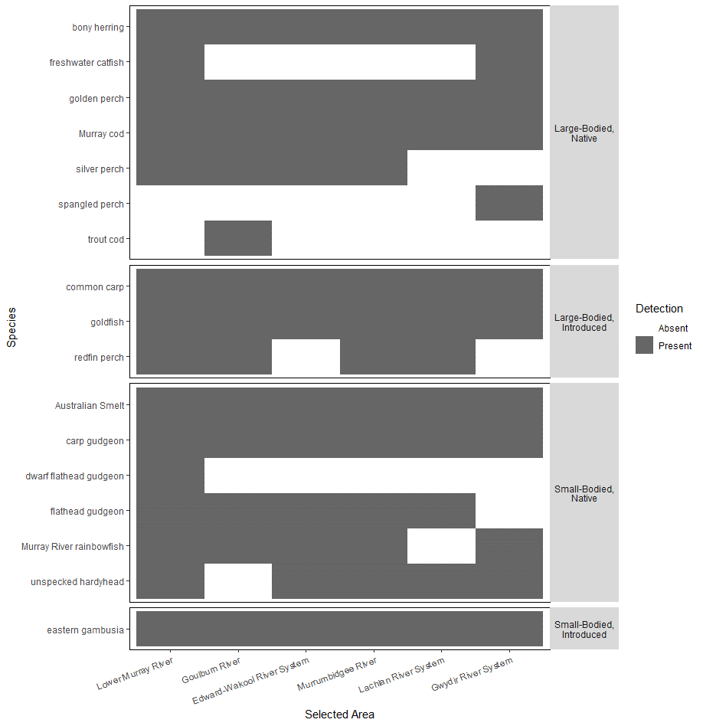
Figure 7: Fish species occurrence at each Selected Area across all five water years. The detection of a species using both electrofishing for large-bodied and fyke netting for small-bodied species shows if a species was absent (white) or present (grey) within any sample from the Selected Area.

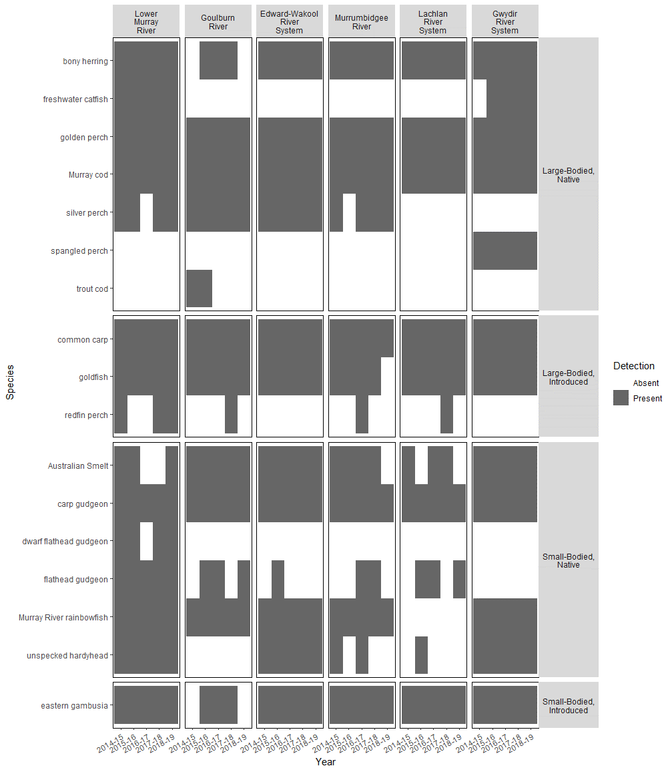
Figure 8: Fish species occurrence at each Selected Area across all sample years. The detection of a species using electrofishing for large-bodied and fyke netting for small-bodied species shows if a species was absent (white) or present (grey) within any sample from each year within a Selected Area.

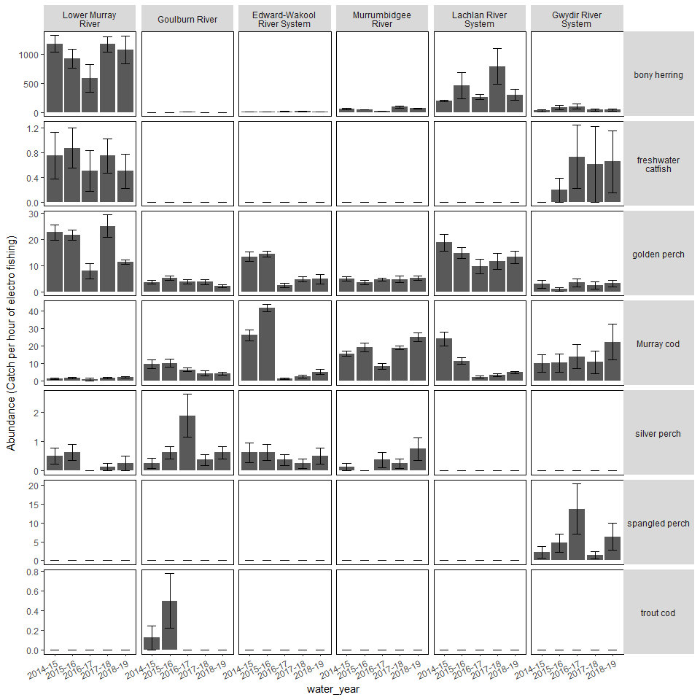
Figure 9: Mean CPUE (±1SE) of large-bodied native fish species at each Selected Area across all sampling years. Note some sampling in the Lower Murray River was delayed from autumn to winter in 2016–17, and catches are likely to be lower as a result and should be treated with some caution.

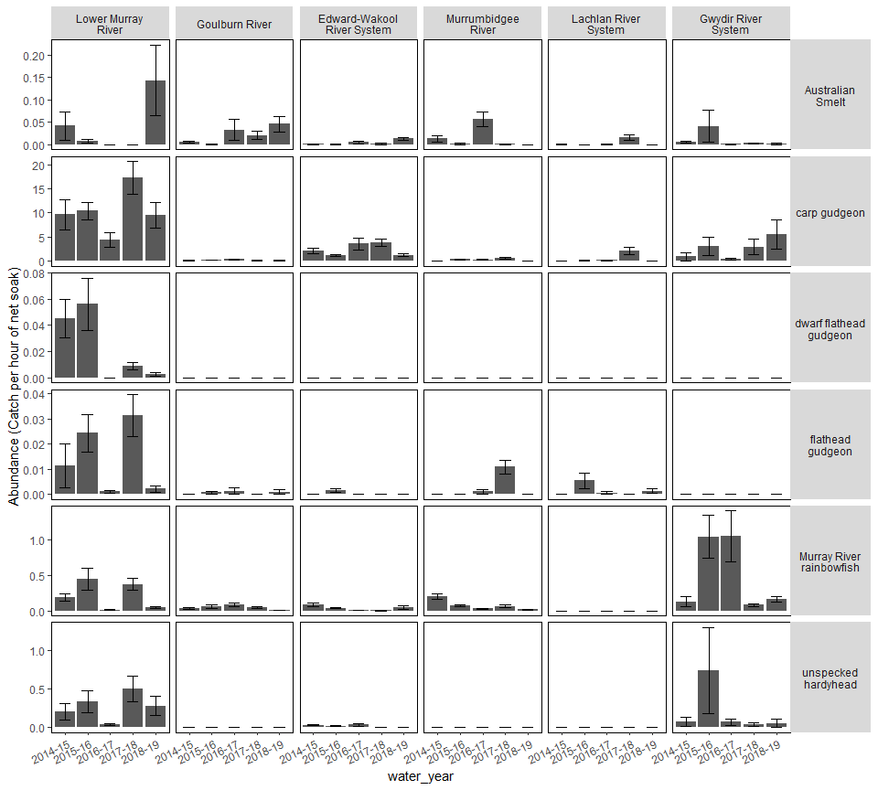
Figure 10: Mean abundance (±1SE) of small-bodied native fish species at each Selected Area across all sampling years. Note: y-axis scales differ between species.

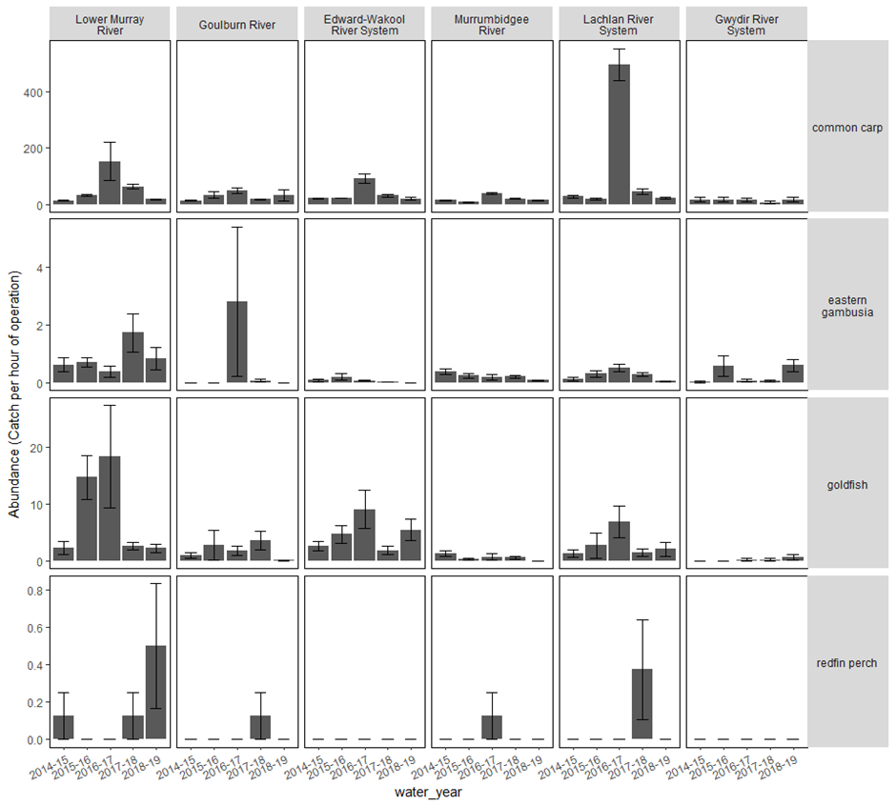
Figure 11: Mean abundance (±1SE) of introduced fish species at each Selected Area across years of sampling 2015–2018. Eastern gambusia were collected using fine-mesh fyke nets, while common carp, goldfish and redfin perch were collected using boat and backpack electrofishing. Note: y-axis scales differ between species; also some sampling in the Lower Murray River was delayed from autumn to winter in 2016–17, and catches are likely to be lower as a result and should be treated with some caution

Effects of flow on abundance of focal species
Abundance modelling for all focal species generated varying temporal correlations across species (AR1) (Table 6). Large-bodied, long-lived, native species Murray cod and golden perch had abundance in any one year that were highly dependent upon abundance in the previous year (AR1 correlation coefficients >0.8 Table 6).
At the Basin-scale, native species richness was significantly influenced by only the proportion of base flow days, with a slight decrease in the number of native species predicted to occur as the proportion of base flow days increased (Table 6, Figure 12).
Although the relationships with the parameters varied across species, all flow parameters and time since the last fish kill were found to be important predictors of total abundance of six focal species at the Basin scale (Table 6, Figure 13). No significant relationship with any modelled parameter was found for eastern gambusia abundance.
At the Basin-scale, golden perch abundance was related to only one predictor variable, the time since fish kill occurrence; with an increasing abundance of golden perch being predicted the more time has passed since a fish kill occurrence (Figure 13). This positive association with time since fish kill also occurred for Murray cod. This highlights the significant detrimental impact fish kill events have had on Murray cod and golden perch populations within the Selected Areas. It also demonstrates the importance of time in determining the degree of recovery post-fish kill events, and the need to provide flows targeted at maintaining habitats and refuges, and connecting populations to enhance movement and dispersal. The abundance of Murray cod was also related to the SRI index, with higher abundances predicted in drier than average conditions for all flow reference periods (Figure 13). This lends some support to the notion that Murray cod recruitment and survival is greater during base flow conditions compared to wetter periods.
The abundance of bony herring was related to all predictor variables considered in our model (Table 6, Figure 13). The abundance of bony herring was higher closer to the fish kill and declining marginally with increasing time from the event. Bony herring abundance was also highest during drier than average runoff conditions (SRI). The abundance of bony herring was increased with both fewer base flow days and fewer fresh flow conditions. This may suggest that bony herring abundance may be related to mid flows (between lows and freshes) or overbank flows that were not able to be included in this analysis.
Carp gudgeon abundance significantly increased with wetter than average runoff conditions (Figure 13). Australian smelt abundance was related to the only the proportion of fresh flow days, with a small rise in abundance predicted to occur with ~50% fresh days (Figure 13). This suggests that both these short-lived species, respond quickly to favourable flows conditions resulting in higher abundances during wetter conditions.
Similarly to bony herring, common carp abundance was higher closer to the fish kill and decreased with time from the fish kill (Figure 13). The survival of common carp through a hypoxia event, and even an increase post event through increased survival of recruits was also found by King et al. (2012) at a fish kill on the Murray River at Barmah-Millewa Forest. These differential immediate and longer-term responses of fishes to fish kill events have also been observed in northern Australia (King et al. in prep), and suggests our understanding of the impacts and recovery of fish populations from hypoxic events requires further investigation.
The abundance of common carp was also increased in wetter than average runoff conditions and with lower proportions of fresh flows (Figure 13). Common carp are widely considered to increase in abundance due to flooding and higher flow events (Table 3), our results lend some support to this, although future monitoring during contrasting environmental conditions is required.

Table 6: Statistically significant covariate effects for predictor variables of native species richness and the total abundance of focal species. + indicates significant positive effect, - indicates significant negative effect. Statistical significance was determined by examination of the Wald statistic and when 95% confidence intervals do not overlap with zero. NA: Not applicable as model did not converge. month_fishkill = months since fish kill, B_flow_prop = Proportion of base flows in spring, FR_flow_prop = Proportion of fresh flows in spring, SRI_sc = scaled Standardised Runoff Index. * = introduced species.
Species | (Intercept) | month_fishkill | B_flow_prop | FR_flow_prop | FR_flow_prop² | SRI_sc | AR1 correlation
native species richness | + |  | - |  |  |  | NA
golden perch | + | + |  |  |  |  | 0.855
Murray cod |  | + |  |  |  | - | 0.835
bony herring | + | - | - | - | + | - | -0.003
carp gudgeon |  |  |  |  |  | + | -0.102
Australian smelt | - |  |  | + | - |  | -0.109
eastern gambusia* | - |  |  |  |  |  | -0.001
common carp* | + | - |  | - |  | + | -0.094

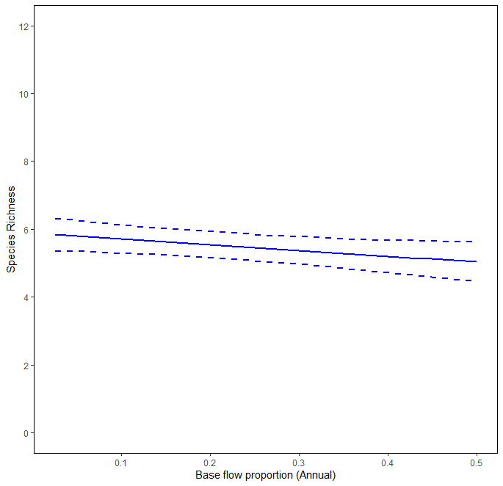

Figure 12: Marginal effect predictions of species richness for proportion of base flows as a significant variable in model (See Table 6).

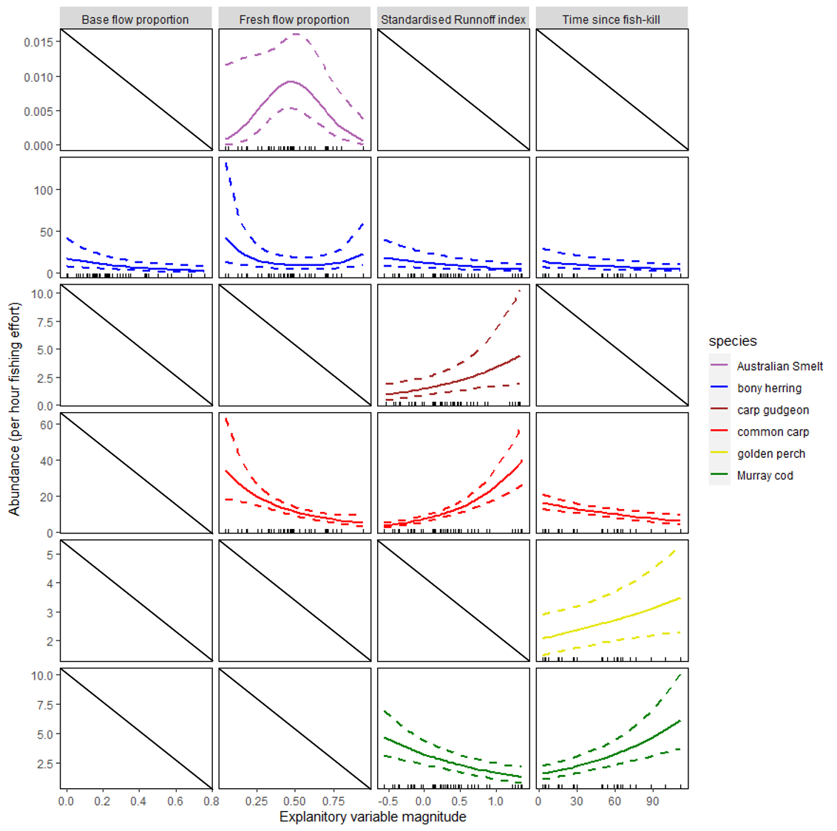

Figure 13: Marginal effect predictions of abundance of all focal species for statistically significant variables in autoregressive models (See Table 6). Note there was no significant effect of any variable in the gambusia model.

Effects of CEW on total abundance
At the Basin-scale, the addition of CEW resulted in a significant but small predicted increase in the total abundance of Australian smelt, and a significant predicted decline in abundance of carp gudgeon and common carp (Figure 14, Figure 15). There was no significant difference in abundance with the addition of CEW for other species, although Murray cod and eastern gambusia showed an increased trend with the use of CEW, and golden perch a decreasing trend in abundance with the use of CEW. Bony herring demonstrated a large decrease in total abundance across the Basin-scale, but the response was highly variable across the Selected Areas (Figure 16). In contrast, there was less variation in responses across Selected Areas for common carp. This may suggest Selected Area differences in responses for individual species such as bony herring and should be evaluated further in future years of the program.

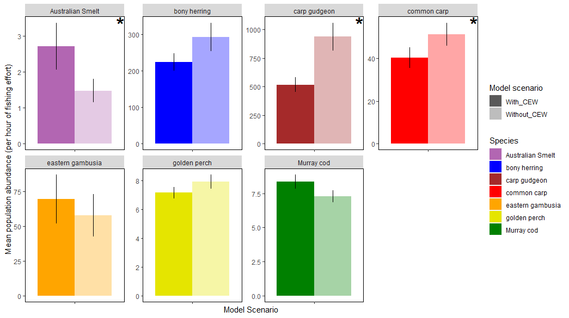
Figure 14: Annual mean total abundance (+/- 1 standard error) of each focal species with and without the addition of Commonwealth environmental water at the Basin-scale. * indicates significant difference at p<0.05 significance level.

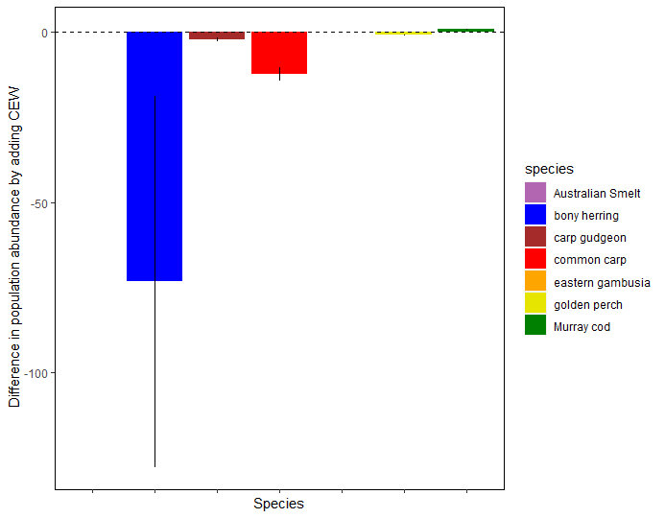
Figure 15: Predicted difference in total abundance for each focal species with the addition of Commonwealth environmental water (CEW) at the Basin-scale.

a)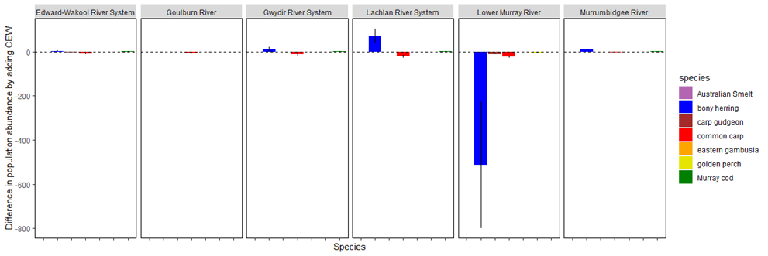b)
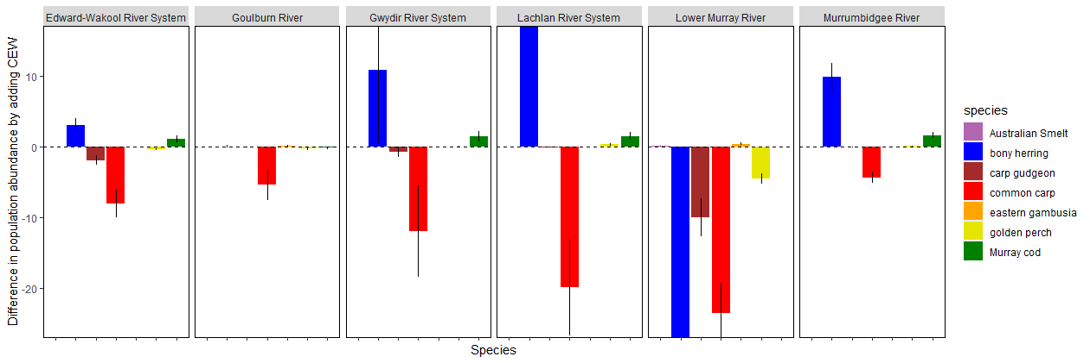
Figure 16: Predicted difference in total abundance for each focal species with the addition of CEW across Selected Areas showing a) all values and b) small magnitude responses.

The total abundance of Australian smelt across the Basin-scale increased with the addition of CEW (Figure 14). This increase is due to an increase in the proportion of fresh flows with CEW in all water years, which provided a small increase in the predicted abundance of Australian smelt (Figure 17). This analysis suggests that the use of CEW targeting fresh flows has maximised the response possible for Australian smelt abundance.
The use of CEW significantly decreased the total abundance of common carp at the Basin-scale (Figure 14). This was due to an increase in the proportion of fresh flows with CEW, particularly in the drier (lower SRI) years (i.e. excluding 2016-17 water year) (Figure 18). In the wetter conditions of 2016-17, the use of CEW did not alter the total abundance of common carp. This modelling suggests that in wetter conditions the response of common carp abundance will be dependent upon the proportion of fresh flow days, and as such future use of CEW should aim to increase fresh flows to reduce common carp total abundance.
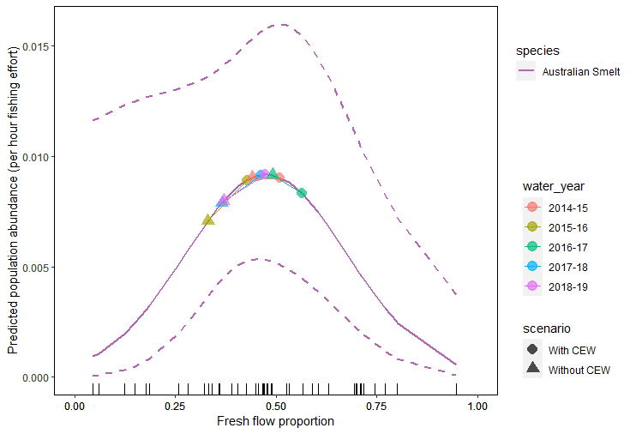
Figure 17: Predicted marginal relationship between Australian smelt total abundance and the proportion of annual fresh flow days. Points on the plot show predicted influence on abundance for scenario’s with (circles) and without (triangles) CEW between water years (coloured).
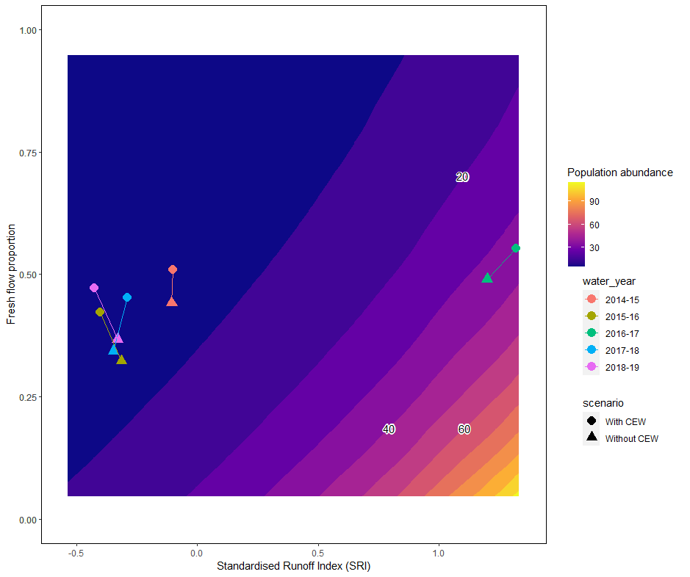
Figure 18: Conditional predicted total abundance of common carp given their significant response to proportion of fresh flows and Standardised Runoff Index. Points on the plot show predicted influence on populations for scenario’s with (circles) and without (triangles) CEW between water years (coloured).

Effects of flow and Commonwealth Environmental Water on fish spawning outcomes

General patterns
Larvae from 15 native species and four introduced species were collected across five Selected Areas (Figure 19). Two species, river blackfish and obscure galaxias, were collected as larvae in the larval sampling methods, but were not collected in standardised electrofishing or fyke netting surveys (Category 1 sampling methods). Larvae of common carp, carp gudgeons and Australian smelt were collected at all Selected Areas and in most sampling years (Figure 19). This reflects these species’ known life histories and their general spawning requirements (Table 3). All other species showed varied occurrence among water years and Selected Area.

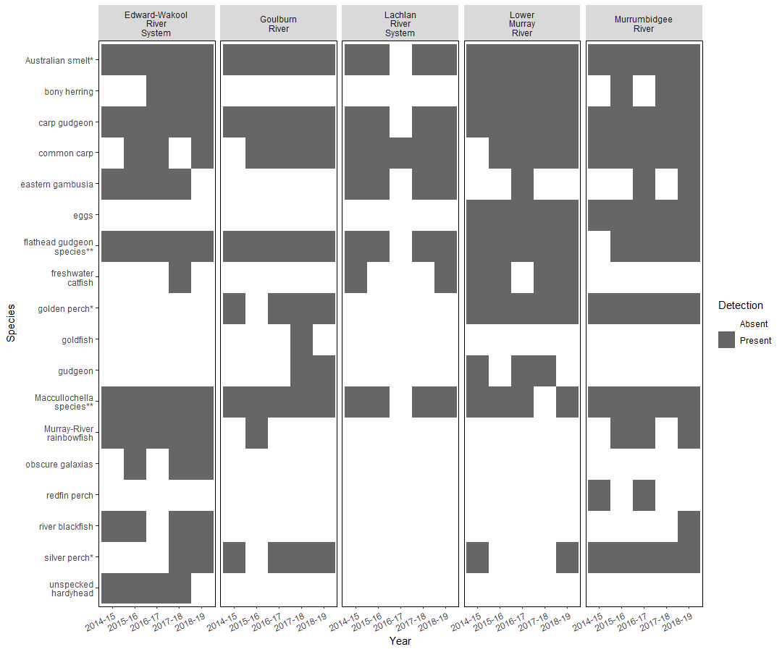
Figure 19: Species occurrence of egg and larval fish at each Selected Area across all five water years. * denotes species collected as both larvae and eggs, ** denotes genus names represents the aggregation of any species recorded within that genus, but were unable to confirmed at the species level. The detection of a taxa within any sample is shown as present (grey) or absent (white).

Effects of flow on spawning outcomes
Spring base flows and fresh flows, SRI and the abundance of adults were all important determinants of both spawning probability and larval abundance, but the influence of these variables differs markedly among species (Table 7 & Table 8, Figure 20 & Figure 21).
The probability of spawning was significantly influenced by the abundance of adults for three species, with spawning probability increasing rapidly with increasing numbers of adults for common carp, bony herring, and golden perch (Table 7, Figure 20). A higher probability of golden perch spawning occurred when 30-50% of flow days in spring are within the base flow band and also when >70% spring fresh days (Figure 20). However, we caution against this result, as golden perch have been widely shown to require peak flows in overbank and fresh flow bands to trigger spawning responses in other studies (Table 3), and the LTIM program did not include enough overbank flow conditions to include in this modelling nor does our modelling describe flow events. Further investigation of these relationships should be a high priority for future analysis. A higher probability of carp gudgeon spawning was also significantly related to an increase in the proportion of spring fresh flows (Figure 20). While there has been little investigation into the spawning requirements of this species, it is mostly considered to be a flow-spawning generalist (Table 3).
Larval abundance of all focal species (see Table 3) was significantly influenced by all of the predictor variables (Table 8 & Figure 21). The abundance of adults was an important factor for predicting the abundance of three species, golden perch, bony herring and carp gudgeon (Figure 20), with positive relationships found for bony herring and carp gudgeon larvae, and a very small negative relationship found for golden perch larvae.
The abundance of Murray cod larvae increased with higher proportion spring base flow days and fresh flows (Figure 20), reaching a maximum when spring flow conditions were ~ 40% days as base flows and 60% days as freshes. This finding is supported by previous studies which highlight the importance of base flows and fresh flows for supporting spawning and larval survival. The abundance of carp gudgeon larvae was maximised when around 70% of spring flows were fresh flows. Whilst significant, there was only a very small increase in larval abundance of bony herring related to both SRI and the proportion of spring fresh days. Increased abundances of common carp larvae occurred in wetter than average conditions.
Many of these findings support the outcomes of previous studies, and our broad understanding of riverine fish spawning and recruitment patterns. For example, previous studies have suggested that common carp spawning events and larval abundance increased during within bank freshes and overbank flow events (see Table 3). However, whilst the current study period did not include enough high flows years to examine the effect of overbank flows on spawning, our results show increased larval abundance of common carp occurs during wetter conditions. These analyses also demonstrated that the abundance of Murray cod larvae was related to both a high proportion of fresh flows and a moderate number of spring base flow days. This supports previous research suggesting that Murray cod spawn under base flow or within bankflow conditions (Humphries et al. 2002, King et al. 2016).
Adult abundance is seemingly an obvious predictor of the likelihood of spawning probability and larval abundance; more adults increasing both the likelihood of spawning and the abundance of larvae. This analysis showed a relationship with four species, bony herring, carp gudgeons, golden perch and common carp. Spawning probability was positively correlated with the abundance of adults for all three species, larval abundance of bony herring and carp gudgeons demonstrated a positive response, while there was a small negative response of Golden perch larval abundances with increasing numbers of adults. The relationships described here should be treated with caution due to the sparsity of larval data and limited range of environmental conditions that occurred during the LTIM project study period.

Table 7: Statistically significant covariate effects on the spawning probability in larval catch methods for predictor variables. + indicates significant positive effect, - indicates significant negative effect. - indicates significant negative effect. Statistical significance was determined by examination of the Wald statistic and when 95% confidence intervals do not overlap with zero. NA: Not applicable as model did not converge. adult_abundance_1 = abundance of adults from previous year, B_flow_prop = Proportion of base flows in spring, FR_flow_prop = Proportion of fresh flows in spring, SRI_sc = scaled Standardised Runoff Index. * = introduced species.
 | (Intercept) | adult_abundance_1 | B_flow_prop | FR_flow_prop | FR_flow_prop² | SRI_sc
golden perch | - | + | + | + | -
Murray cod | -
bony herring |  | +
carp gudgeons |  |  |  | + | -
Australian smelt
gambusia*
common carp* |  | +
Table 8: Statistically significant covariate effects on larval abundance in larval catch methods for predictor variables. + indicates significant positive effect, - indicates significant negative effect- indicates significant negative effect. Statistical significance was determined by examination of the Wald statistic and when 95% confidence intervals do not overlap with zero. NA: Not applicable as model did not converge. adult_abundance_1 = abundance of adults from previous year, B_flow_prop = Proportion of base flows in spring, FR_flow_prop = Proportion of fresh flows in spring, SRI_sc = scaled Standardised Runoff Index. * = introduced species.
 | (Intercept) | adult_abundance_1 | B_flow_prop | FR_flow_prop | FR_flow_prop² | SRI_sc
golden perch | - | -
Murray cod | - |  | + | + | -
bony herring | - | + |  | + | - | -
carp gudgeons |  | + |  | + | -
Australian smelt | NA | NA | NA | NA | NA | NA
gambusia* | NA | NA | NA | NA | NA | NA
common carp* |  |  |  |  |  | +

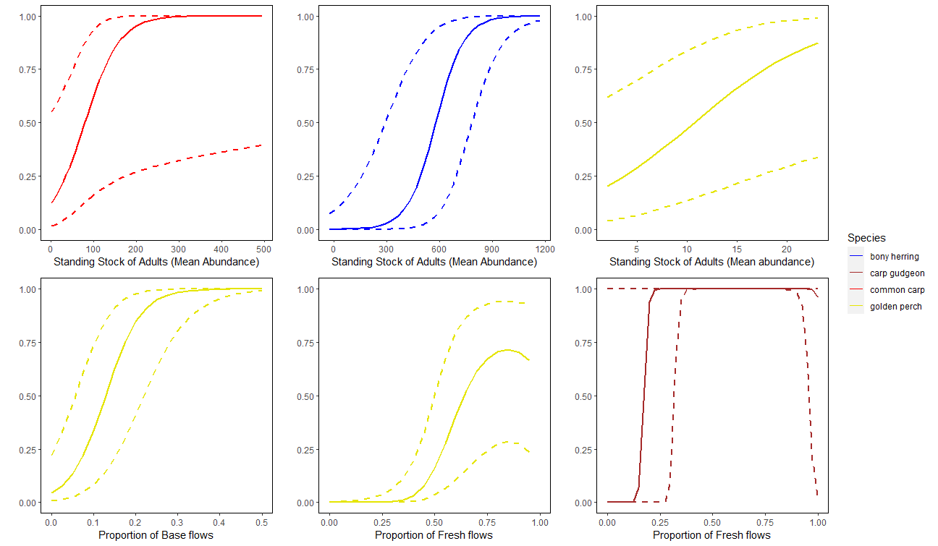
Figure 20: Species-specific marginal effect predictions of spawning probability for each species for statistically significant variables of proportion of base flows in spring, proportion of fresh flows in spring, standing stock of adults, and Standardised Runoff Index. Note different x axis scale amongst plots.

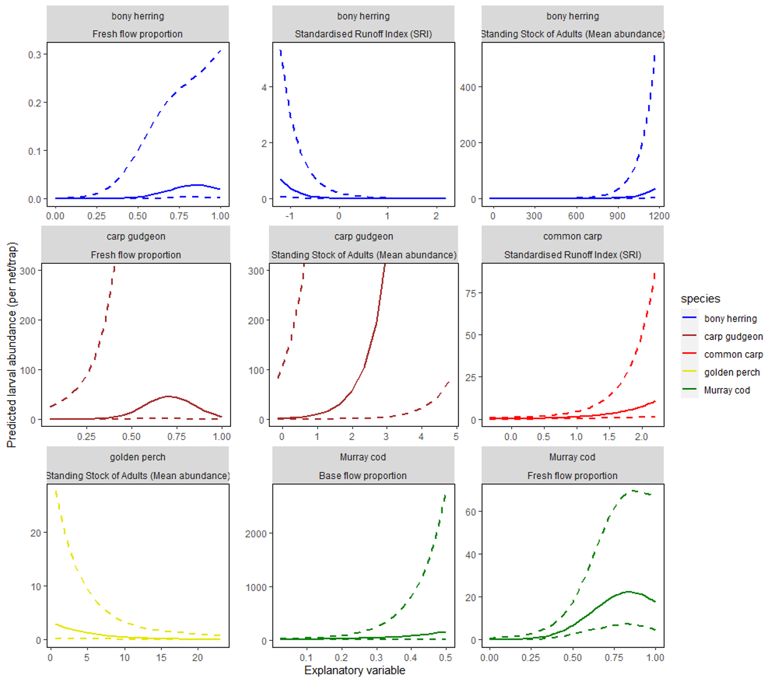
Figure 21: Species-specific marginal effect predictions of larval abundance for each species for statistically significant variables of proportion of base flows in spring, proportion of fresh flows in spring, standing stock of adults, and Standardised Runoff Index. Note different x and y axis scales amongst plots of the same parameter.

Effects of CEW on spawning outcomes
Over the time frame of LTIM, our modelling predicted that the addition of CEW at the Basin-scale resulted in a significant increase in only bony herring larval abundance (Figure 22).
All focal species showed no significant differences in spawning probabilities with and without the use of CEW; although there was an increase in probability for Murray cod, and a decrease for golden perch with the use of CEW, but these differences were not significant (Figure 22a). We note though that the highest flow year (2016–17) had the lowest use of CEW which is likely to be affecting this outcome.
The addition of CEW at the whole of Basin-scale, significantly increased the abundance of bony herring larvae, but the abundance of carp gudgeon larvae was significantly greater without the use of CEW (Figure 22b, Figure 21).
The pattern and strength of predicted spawning probability and larval abundance among species also varied among water years and across Selected Areas (Figure 24 - Figure 27). Murray cod spawning probability was increased in three of the four water years examined, with no difference detected in the wetter year (2016-17) (Figure 24). However, the likelihood of Murray cod spawning also increased in the Lower Murray by 30%, but made little difference to spawning probability at other Selected Areas (Figure 25). Modelling predicted that the addition of CEW would result in an increase in golden perch spawning probability in the Goulburn River, but a decline in probability in the Edward/Kolety–Wakool River System (Figure 25). However, golden perch spawning has not been observed in this Edward/Kolety–Wakool River System during the LTIM program, so this result is an extrapolation from prevailing flow conditions and responses from other Selected Areas to this system.
The addition of CEW resulted in an increase in the abundance of bony herring larvae in 2015-16, but not in other years (Figure 26); and was also increased at only the Lower Murray River Selected Area (Figure 27). The largest predicted decrease in larval abundance in a water year was for Australian smelt and carp gudgeons in the wetter year (2016-17) (Figure 26). Murray cod larval abundance was predicted to be reduced with the addition of CEW in the Edward/Kolety–Wakool River System, but was increased in the Goulburn River (Figure 27).
It is likely that the limited number of sampling years, the low variation in flow conditions during LTIM project and the range of CEW flow delivery types that occurred during LTIM resulted in the limited evidence of a spawning response to CEW at the Basin-scale. Further sampling years with more varied flow conditions may tighten these relationships.

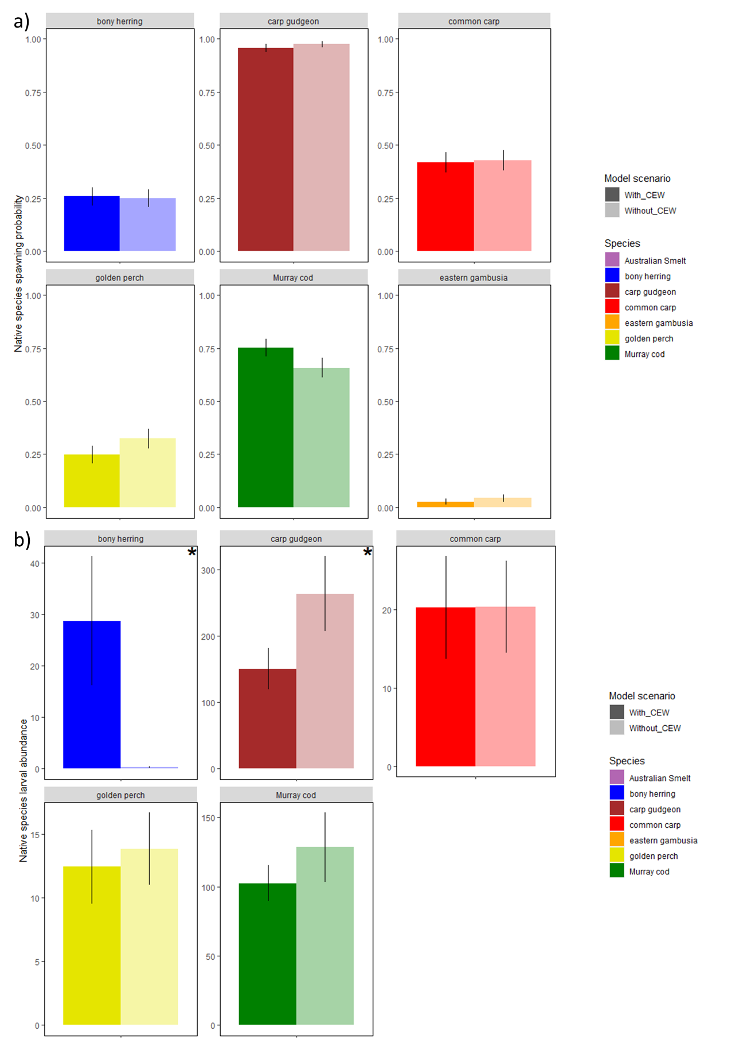
Figure 22: (a) Mean predicted spawning probability and (b) larval abundance (+/- 1 standard error) of each species with and without the addition of Commonwealth Environmental Water at the Basin scale. * indicates significant difference at p<0.05 significance level.

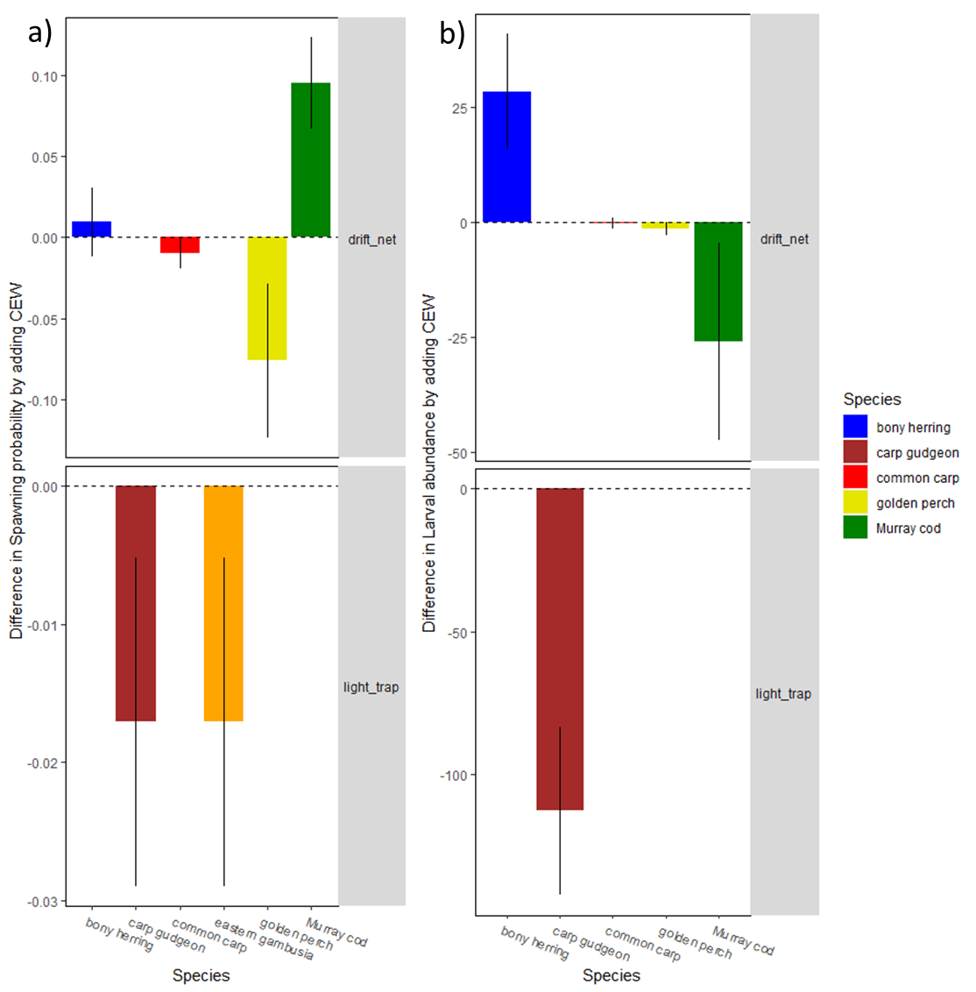
Figure 23: Predicted difference in (a) spawning probability and (b) larval abundance for each focal species with the addition of CEW.

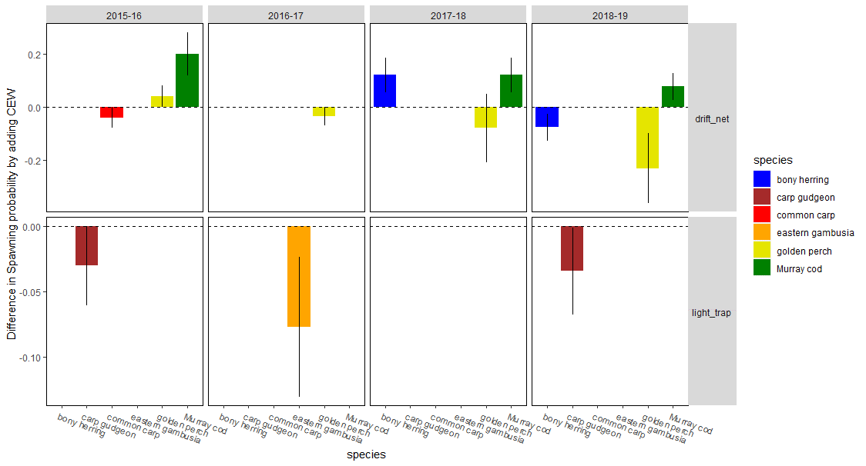
Figure 24: Predicted difference in spawning probability for each focal species with the addition of CEW across water years.

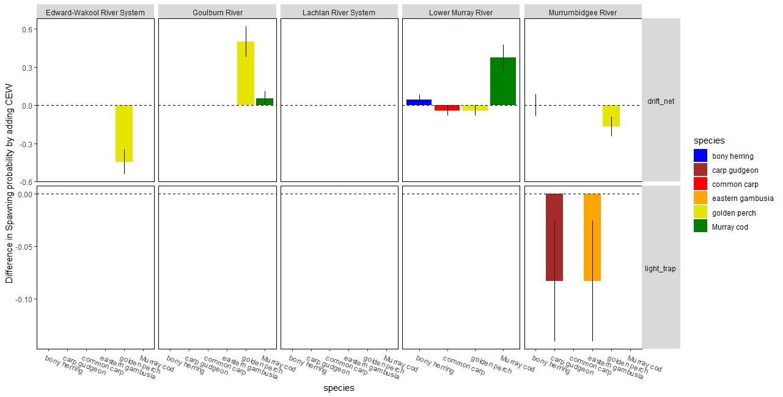
Figure 25: Predicted difference in spawning probability for each focal species with the addition of CEW across Selected Areas.

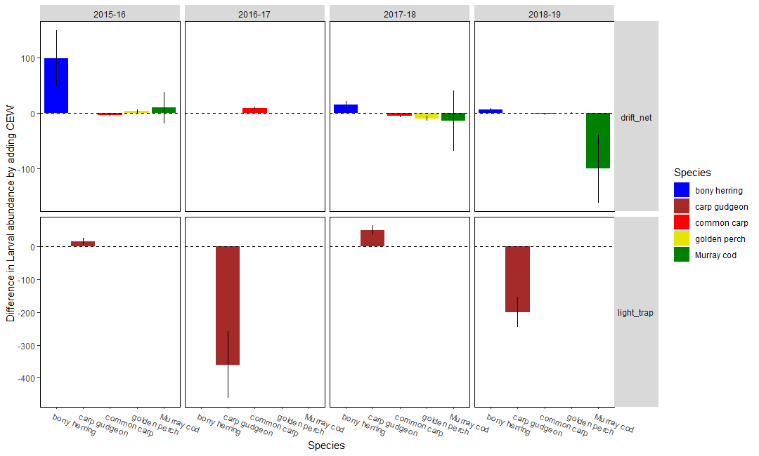
Figure 26: Predicted difference in larval abundance for each focal species with the addition of CEW across water years.

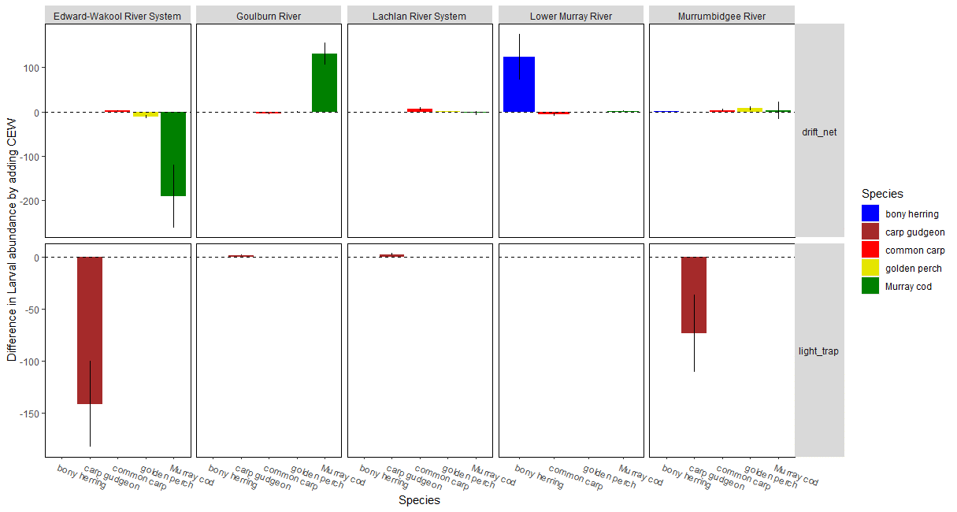
Figure 27: Predicted difference in larval abundance for each focal species with the addition of CEW across Selected Areas.

Effects of flow and Commonwealth Environmental Water on fish population dynamics

General patterns
Length-frequency plots or histograms are a simple and widely used tool in fisheries science (Neumann & Allen 2007). They display the abundance of individuals within a specified length range, and are commonly used to interpret population dynamics or length (and often inferring age-class) structure of the population. A healthy population would have high numbers of fish in cohorts of mature adults and recruits through multiple years (Neumann & Allen 2007). It also allows us to investigate the progression of a cohort of individuals through time as they grow, identify if a breeding event lead to subsequent recruitment of individuals into the ‘adult’ population, and identify mortality events at a population scale. Gaps in length-structure or missing years of recruitment or dwindling adult age classes can be early warnings of populations in decline.
There was little to no evidence of golden perch recruitment most Selected Areas in all years of LTIM. A small number of golden perch recruits were collected in the Goulburn River in 2015–2016 (Figure 28), however, these were subsequently identified as artificially stocked fish (pers. comm. Wayne Koster, DELWP). This lack of golden perch recruitment is most likely due to the impacts of river regulation removing any natural spring flow pulses that are thought to trigger spawning and increased recruitment (see for example Zampatti & Leigh 2013, King et al. 2016), and generally dry environmental conditions experienced throughout the Basin. Golden perch populations across most Selected Areas also showed skewed population structures to more adults, with little size range of smaller/younger cohorts.
Murray cod recruitment occurred in all Selected Areas in the first two sampling years, however post 2016-17 when widespread high flows and coinciding hypoxia events occurred, Murray cod recruitment was patchy across Selected Areas and abundances were small (Figure 29). This was particularly noticeable in the Edward/Kolety–Wakool and Lachlan River systems. The abundance, and sometimes the range of length classes was also reduced after 2016–17 (after widespread fish kills, see above) at all Selected Areas, except the Gwydir River System and the Murrumbidgee River.
Populations of bony herring had highly variable abundances of adult size classes, though the largest breeding population was found in the Lachlan river (Figure 30). Strong recruiting size classes (< 65mm fork length) of bony herring occurred annually in four Selected Areas (excluding the Edward/Kolety–Wakool River System and Goulburn River where reduced abundances were captured in all years) (Figure 30).
As expected for common and short-lived species, carp gudgeons, Australian smelt and eastern gambusia recruitment occurred across all sampling years and Selected Areas, and a broad range of adult size classes was also present (Figure 31, Figure 32, Figure 33).
Common carp population structures were quite variable among Selected Areas and water years (Figure 34). There were large pulses of episodic recruitment of common carp in the 2016–17 high flow year in all Selected Areas. This was strongest in the Lachlan River system, where there was a near 30-fold increase in the abundance of common carp recruits from 2015–16 to 2016–17. Interestingly, these individuals were not detected in subsequent years, suggesting that either they did not survive or have emigrated out of the system. A similar pattern was also seen in the Lower Murray River System Selected Area.

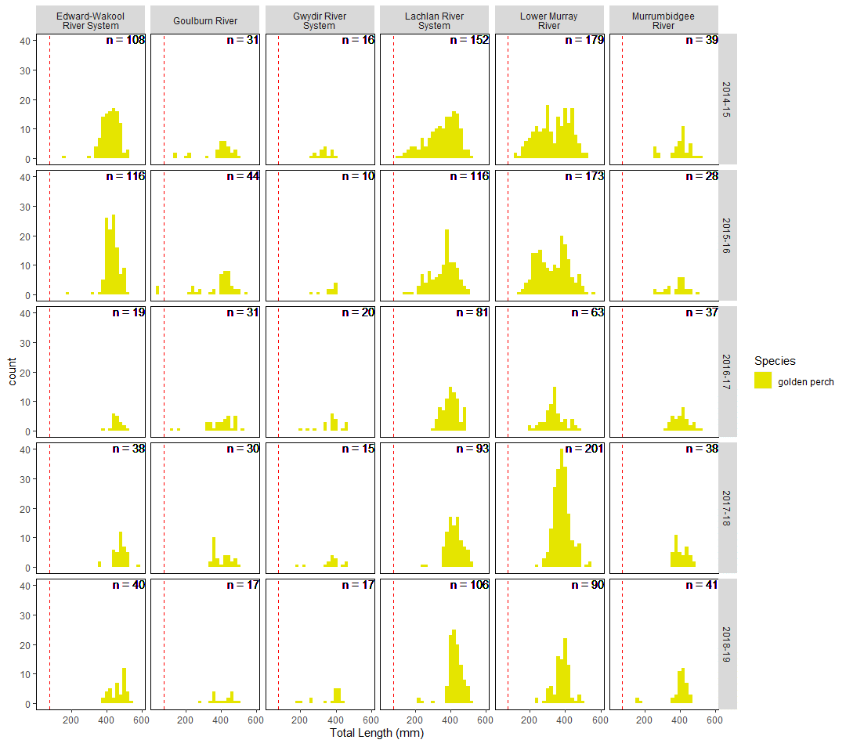
Figure 28: Length-frequency histogram of measured golden perch across Selected Areas and water years. Dotted line represents cut-off length used for recruits (<75 mm).

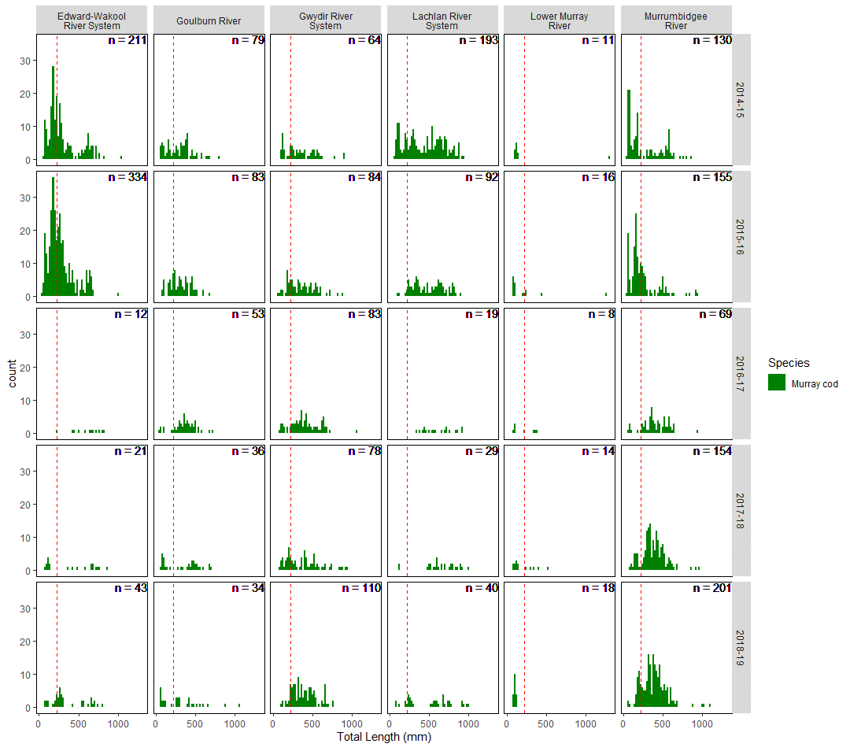
Figure 29: Length-frequency histogram of measured Murray cod across Selected Areas and water years. Dotted line represents cut-off length used for recruits (<220 mm).

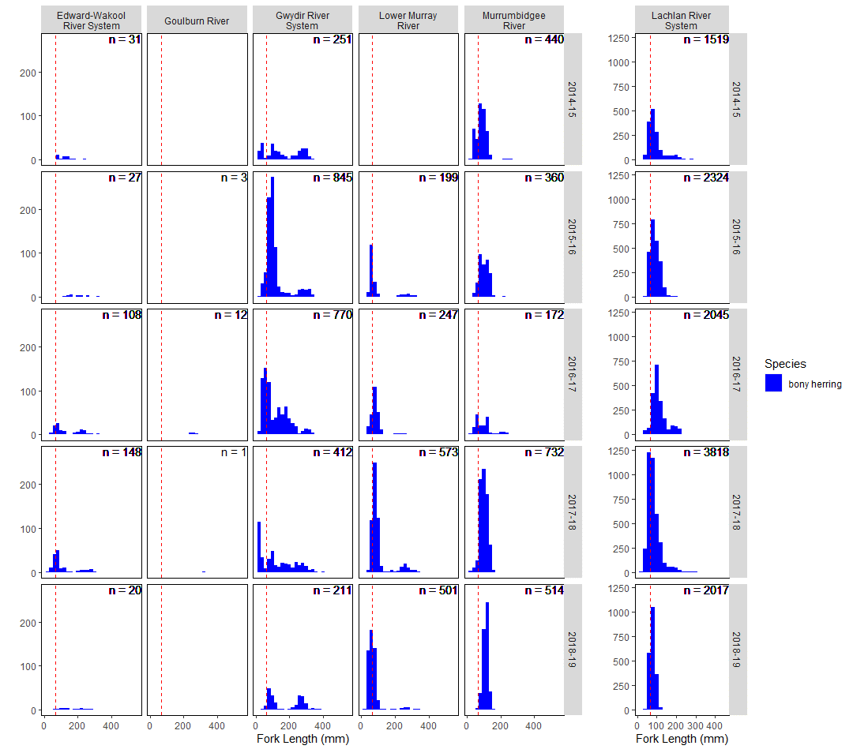
Figure 30: Length-frequency histogram of measured bony herring across Selected Areas and water years. Dotted line represents cut-off length used for recruits (< 65 mm).

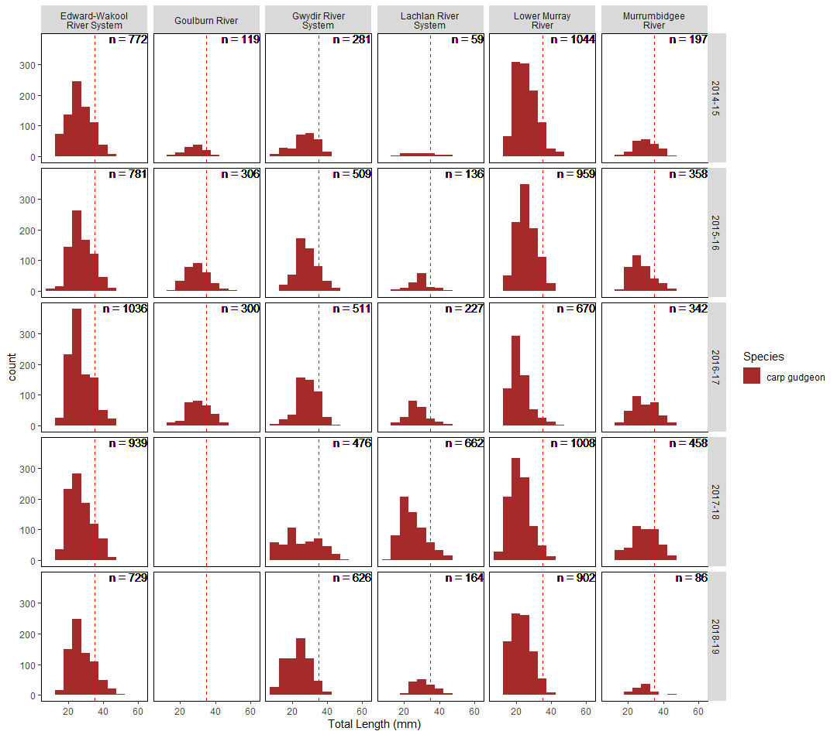
Figure 31: Length-frequency histogram of measured carp gudgeon across Selected Areas and water years. Dotted line represents cut-off length used for recruits (< 35 mm). Note: lengths of small-bodied species were not recorded in the Goulburn River from 2017–18 sampling event.

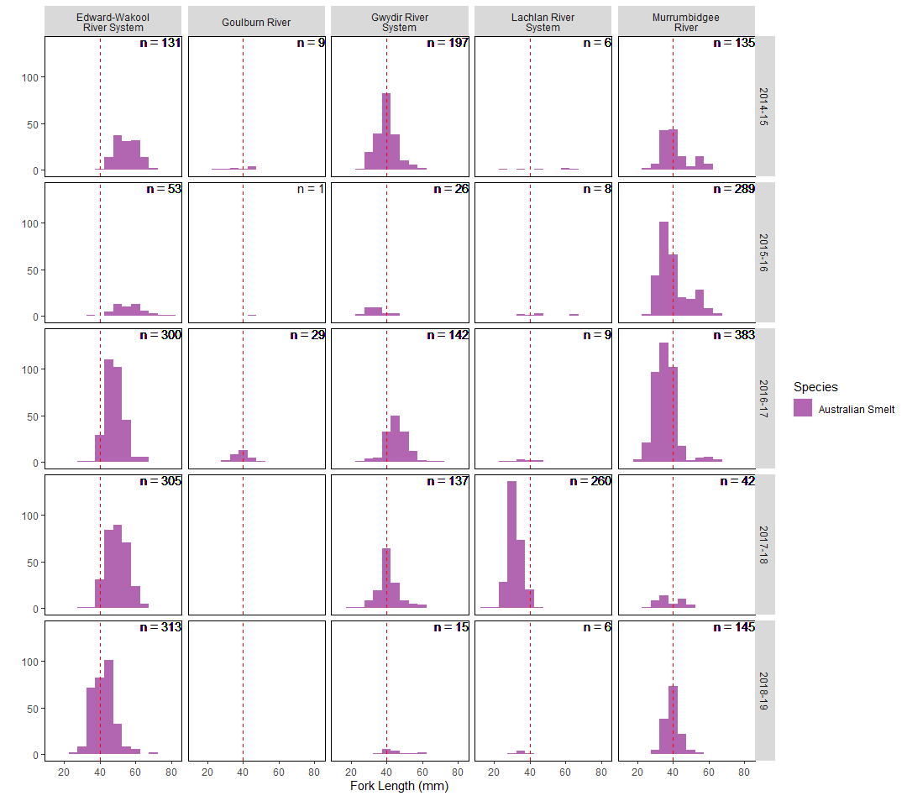
Figure 32: Length-frequency histogram of measured Australian smelt across Selected Areas and water years. Dotted line represents cut-off length used for recruits (<40 mm). Note: lengths of small-bodied species were not measured in the Lower Murray River, nor in the Goulburn River for 2017–18 and 2018–19 sampling event.

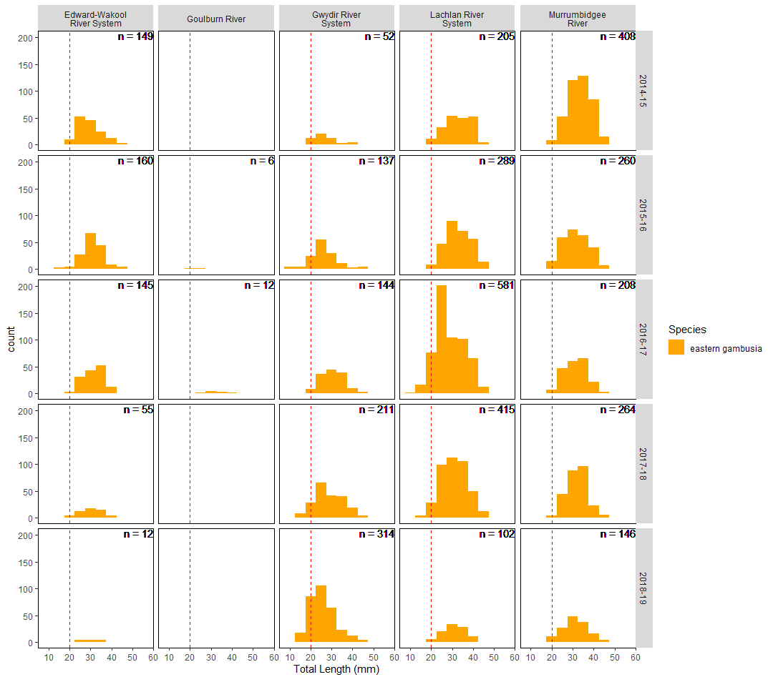
Figure 33: Length-frequency histogram of measured eastern gambusia across Selected Areas and water years. Dotted line represents cut-off length used for recruits (<20 mm). Note: lengths of small-bodied species were not measured in the Lower Murray River, nor in the Goulburn River for 2017–18 and 2018–19 sampling event.

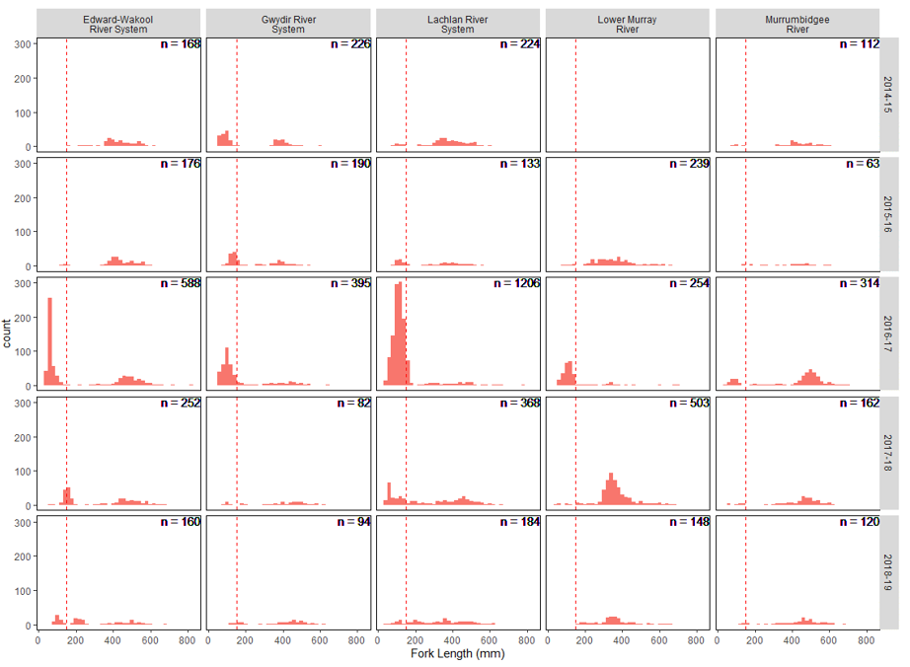
Figure 34: Length-frequency histogram of measured common carp across Selected Areas and water years. Dotted line represents cut-off length used for recruits (<150 mm). Note: lengths of common carp were not measured in the Goulburn River, nor in the Lower Murray in 2014–15.

Effects of flow on recruitment outcomes
Due to the very low numbers of young-of-year (recruit) golden perch we were unable to model the effects of flow on golden perch recruitment, but the models were successfully run for all other focal species.
The time since fish kill was an important predictor of recruit abundance for five of the focal species (Table 9). A higher abundance of Murray cod, carp gudgeon and eastern gambusia recruits occurred with increasing time since fish kill or hypoxia, while the abundance of common carp recruits was highest closer to the fish kill event and then decreased with time (Figure 35 - Figure 40). The varied responses to hypoxia demonstrated here are likely to reflect either initial mortality or tolerance to hypoxia of breeding adult fish or young, and then the recovery time required for successful spawning and recruitment to occur as numbers of breeding adults increases. This highlights that the effects of hypoxia and fish kills can alter fish population structure, particularly the amount of recruitment, for many years after the fish kill has occurred. Enhancing connectivity and movement, and maintaining refugia for remaining individuals after these events is critical for enhancing population recovery. Environmental watering strategies may be best targeted at enhancing movement and maintaining refugia immediately post fish kill events for heavily impacted species, such as golden perch, Murray cod and carp gudgeon.
The abundance of Murray cod recruits was only affected by the time since fish kill parameter in the model (Table 9), with Murray cod recruit abundance predicted to be at its highest 100 months from the fish kill and almost zero directly after fish kills (Figure 35). Bony herring recruit abundance was significantly influenced by the proportion of base flow days in the water year, with higher abundances predicted to occur with <10% base flow days (Figure 36). The abundance of carp gudgeon recruits was strongly influenced by the proportion of fresh flows, SRI and months since fish kill (Table 9). More carp gudgeon recruits were predicted to occur in wetter conditions, with ~50% fresh flows and increasing time since fish kill (Figure 37). The abundance of gambusia recruits was only marginally, but significantly, influenced by the proportion of fresh flows and time since fish kill (Figure 38). The abundance of common carp recruits was higher closer to fish kills and when the proportion of fresh flows was ~60% (Figure 39). This supports previous studies demonstrating both enhanced recruitment of common carp during freshes, and also an ability to survive through hypoxic events (Table 3, King et al. 2012).
These results demonstrate that the flow parameters examined in this study were influencing the recruitment outcomes of only two native species, bony herring and carp gudgeons. Bony herring recruitment was enhanced with higher proportions of base flows, and carp gudgeon recruitment was higher in wetter years and when ~50% flows were freshes. Previous studies are inconsistent in the flow requirements for enhanced recruitment of these species (Table 3), and future monitoring within LTIM project with more varied flow conditions will contribute substantially to this knowledge base. The abundance of Murray cod and Australian smelt recruits was not influenced by the flow parameters. Our findings also support many previous studies, demonstrating that enhanced recruitment of common carp occurs with higher flow conditions (Table 3). These results highlight the delicate balance of managing for both native and introduced fish species with watering, with a reduction in fresh flows likely to lead to reduced common carp recruitment, but also likely to decrease recruitment of native species. Therefore, other complimentary management techniques will also be required to manage carp recruitment.

Table 9: Statistically significant covariate effects for predictor variables of the total abundance of recruits of the focal species. + indicates significant positive effect, - indicates significant negative effect. Statistical significance was determined by examination of the Wald statistic and when 95% confidence intervals do not overlap with zero. NA: Not applicable as model did not converge due to very low numbers of individuals. month_fishkill = months since fish kill, B_flow_prop = Proportion of base flows in spring, FR_flow_prop = Proportion of fresh flows in spring, SRI_sc = scaled Standardised Runoff Index. * = introduced species.
Species | (Intercept) | month_fishkill | B_flow_prop | FR_flow_prop | FR_flow_prop² | SRI_sc
golden perch | NA | NA | NA | NA | NA | NA
Murray cod |  | +
bony herring | + |  | -
carp gudgeon |  | + |  | + | - | +
Australian smelt | NA | NA | NA | NA | NA | NA
eastern gambusia* | - | + |  |  | -
common carp* |  | - |  | + | -

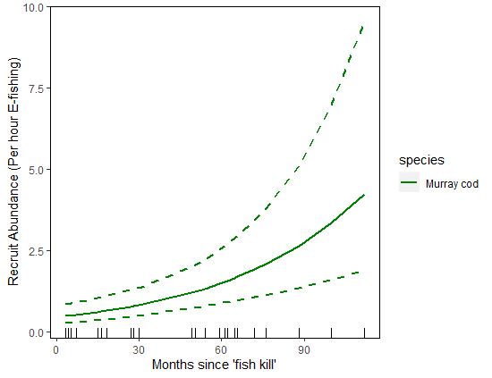
Figure 35: Marginal effect predictions of Murray cod recruit abundance for statistically significant variables in predictive model (See Table 9).

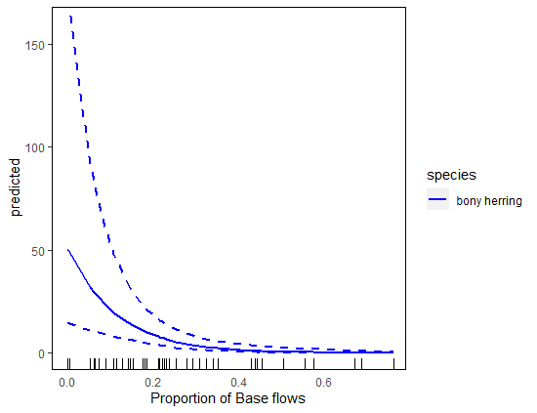
Figure 36: Marginal effect predictions of bony herring recruit abundance for statistically significant variables in predictive model (See Table 9).

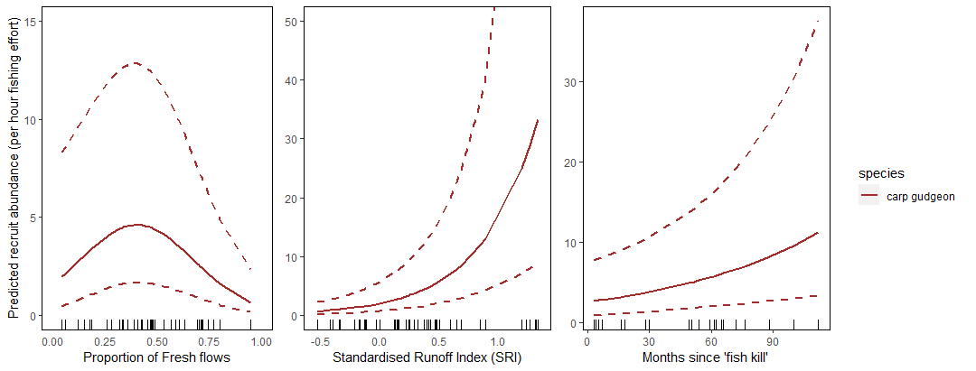
Figure 37: Marginal effect predictions of carp gudgeon recruit abundance for statistically significant variables in predictive model (See Table 9).

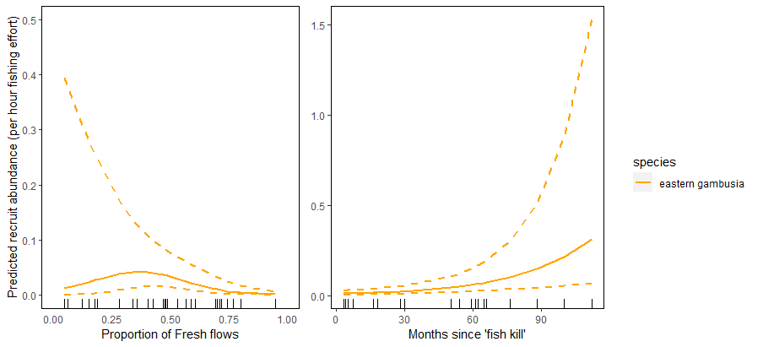
Figure 38: Marginal effect predictions of eastern gambusia recruit abundance for statistically significant variables in predictive model (See Table 9).

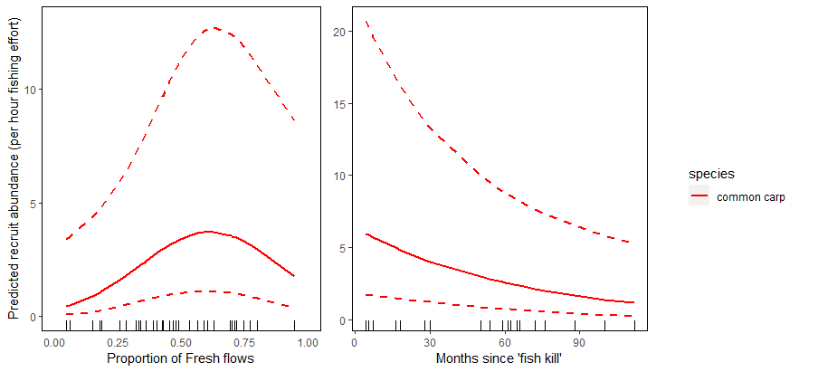
Figure 39: Marginal effect predictions of common carp recruit abundance for statistically significant variables in predictive model (See Table 9).

Effects of CEW on recruitment outcomes
Across the Basin-scale, the addition of CEW resulted in a significant predicted increase in the abundance of young-of-year (recruits) of Australian smelt, bony herring and carp gudgeon than compared with the without CEW scenario (Figure 40). The addition of CEW resulted in a predicted 3-fold increase in recruit abundance of bony herring (Figure 41), with the increase occurring across all water years but a far greater predicted response occurring at the Lower Murray River Selected Area (Figure 42). There was also a significant but only very small relative increase in the abundance of Australian smelt and carp gudgeon recruits with the addition of CEW (Figure 40 and Figure 41). There was no significant difference in recruit abundance of common carp, eastern gambusia or Murray cod with the addition of CEW at the Basin-scale.
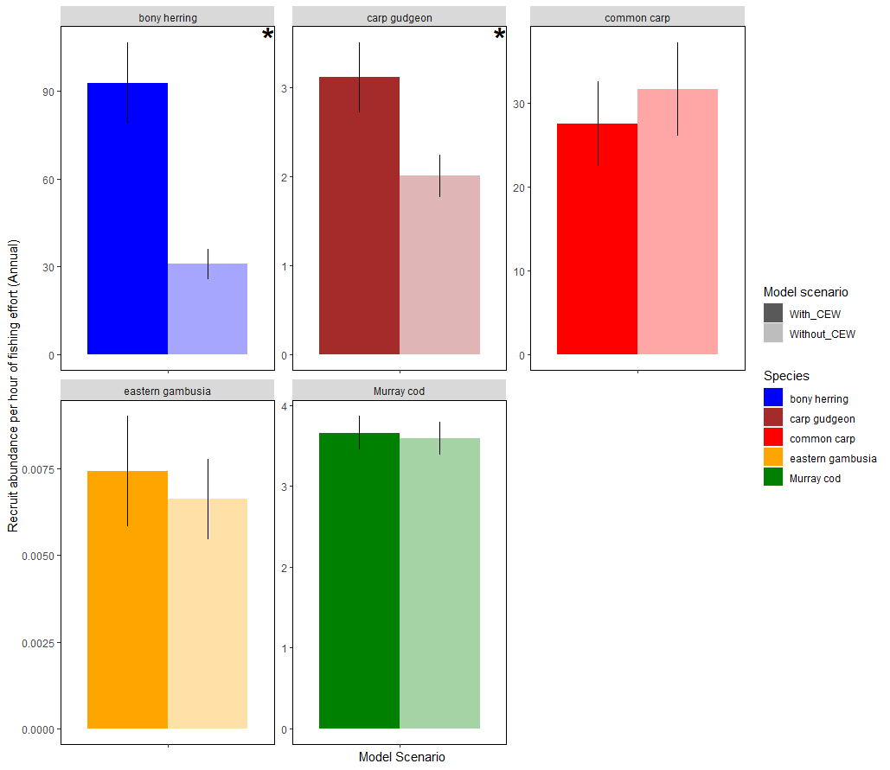
Figure 40: Mean abundance of recruits (+/- 1 standard error) for each focal species with and without the addition of Commonwealth environmental water (CEW) at the Basin-scale. * indicates significant difference at p<0.05 significance level. Note: there were very low numbers of golden perch recruits and analysis is not appropriate for this species.

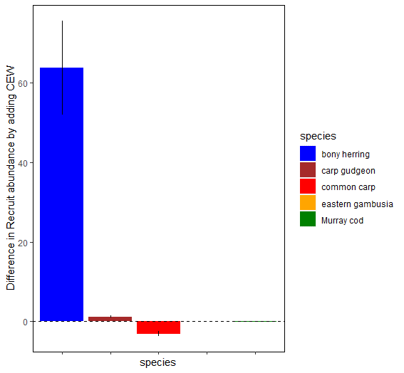

Figure 41: Predicted difference in recruit abundance for each focal species with the addition of Commonwealth environmental water (CEW) at the Basin-scale.

(a)
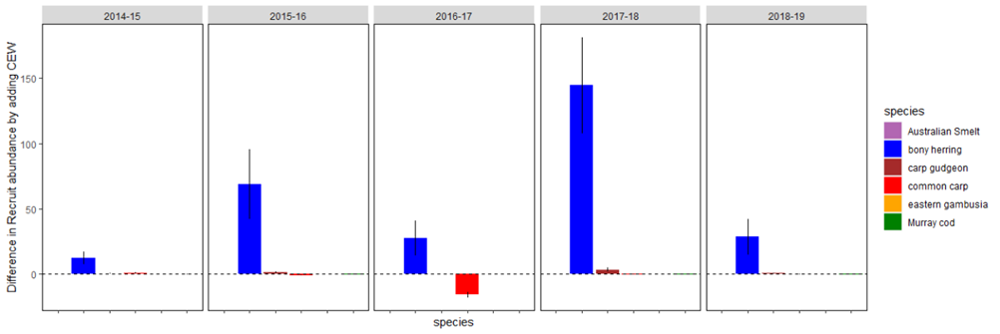
(b)
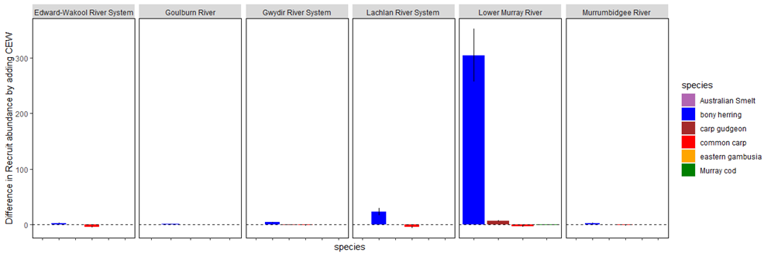
Figure 42: Predicted difference in recruit abundance for each focal species with the addition of CEW across (a) water years and (b) Selected Areas.

The abundance of Australian smelt recruits was predicted to only marginally increase with the addition of CEW, but was not significantly related to any measured flow parameter, and is not considered further here.
The use of CEW significantly increased the abundance of bony herring and carp gudgeon recruits at the Basin-scale (Figure 41). For bony herring, this was predominantly due to the decrease in the proportion of base flow days with the addition of CEW (Figure 44). For carp gudgeon, this was due to an increase in the proportion of fresh flows with the addition of CEW (Figure 45)
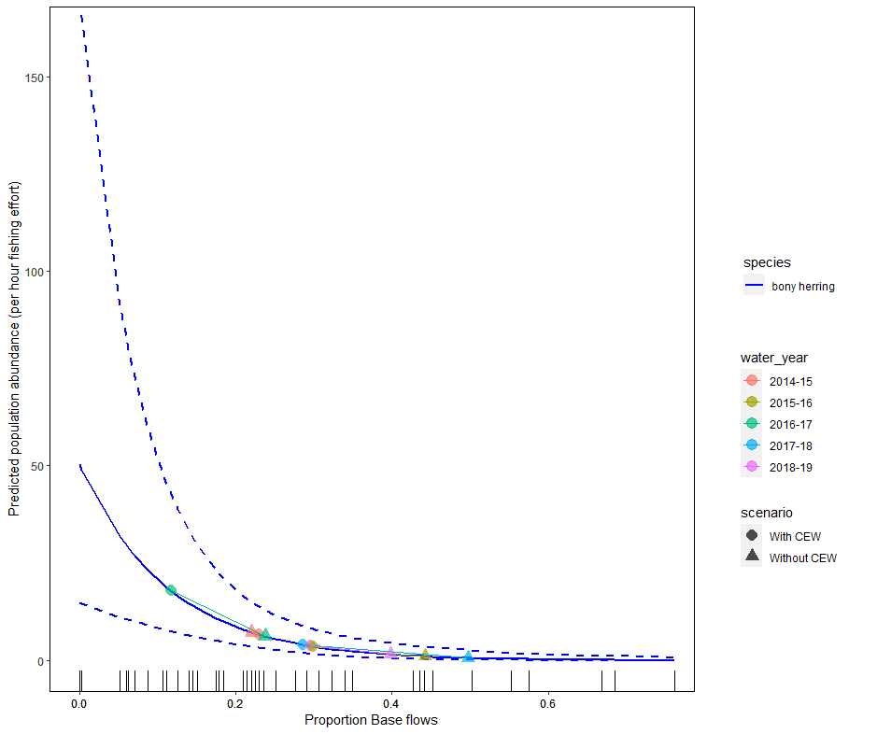
Figure 43: Predicted marginal relationship of bony herring recruit abundance and the proportion of annual base flows. Points on the plot show predicted influence on abundance for scenario’s with (circles) and without (triangles) CEW between water years (coloured).
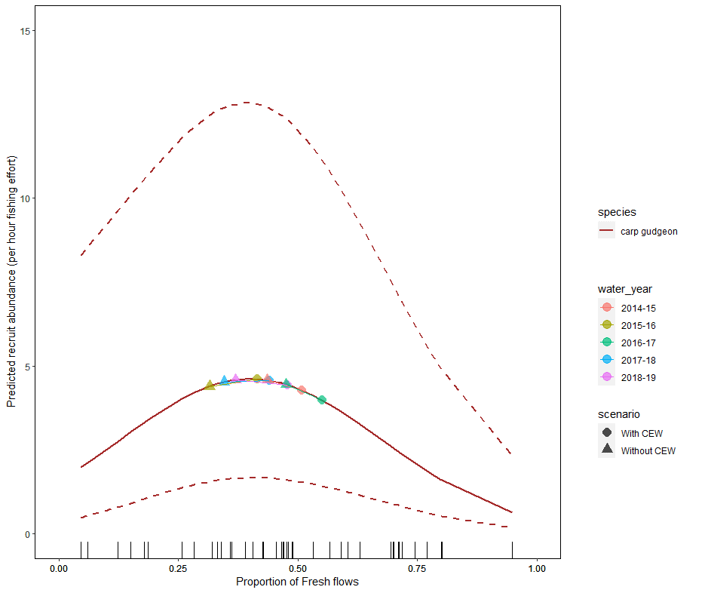
Figure 44: Predicted marginal relationship between carp gudgeon recruit abundance and the proportion of annual fresh flow days. Points on the plot show predicted influence on abundance for scenario’s with (circles) and without (triangles) CEW between water years (coloured).

Contribution to achievement of Basin Plan objectives and adaptive management

Adaptive management
Most of the Selected Areas experienced drought conditions throughout the five-year LTIM project (2014–2019). River flow conditions at all Selected Area were low in four of the five years, with high flow conditions observed in only one year (2016–17) although this coincided with extensive hypoxic blackwater events at a number of Selected Areas. The dominance of low flow conditions throughout LTIM reduce the ability for general inferences across higher flow conditions, for example in wetter periods. Our modelling occurred across all Selected Areas and highlighted the variability in predicted outcomes of adding CEW at different Selected Areas. This suggests that there may be only limited adaptive management lessons that can be generalised across all Selected Areas or outside of these Selected Areas within the Basin. Therefore, the adaptive management lessons provided here are given in the context of limited flow variability and the dominance of southern Basin Selected Areas in our findings. There remains a need for further refinement and testing of these modelled relationships in future years capturing a greater range of flow variability and if possible sampling locations in the Northern Basin.
The use of CEW during LTIM maintained baseflow and fresh flow conditions which supported the persistence of fish habitat, and likely contributed to the maintenance of several native fish populations. The use of CEW increased the proportion of fresh flow conditions, increasing the total abundance of Australian smelt, and the abundance of recruits of bony herring and carp gudgeon relative to the non-CEW scenario. Furthermore, the use of CEW also resulted in a modelled decline in total abundance of the introduced common carp. These outcomes demonstrate that providing environmental water to support baseflows or above baseflow conditions, not only has significant benefits for maintaining native fish populations during drought conditions (e.g. 2014–19), but that effective management of baseflows may also decrease common carp populations. Our results also demonstrate that during years with higher than average runoff conditions, the response of common carp populations will be dependent upon the proportion of fresh flow days, and as such future use of CEW should aim to increase fresh flows to reduce common carp total abundance. Other management strategies for common carp (i.e. exclusion screens, separation cages, etc.) should also be employed.
Despite significant declines in some native species (especially Murray cod and golden perch) associated with fish kills at some Selected Areas, the modelling demonstrated the importance of time in determining the degree of recovery post-fish kill events. The total abundance of long-lived species such as Murray cod and golden perch in any one year, is highly dependent on the abundance from the previous year; as such the recovery of these populations is unlikely to be observed at short-time scales (i.e. the five years of LTIM). To support populations after such events, priority should be given to providing flows that target maintaining refuge habitats and connecting populations post hypoxia events.
At the Basin-scale, there were several important fish responses (both adult and spawning outcomes) to the flow thresholds, that could be trialled further within an adaptive management framework. Bony herring were predicted to have increased total abundances as base flows reduced to below 20% of annual flows and carp gudgeon abundance was predicted to peak when 50% of annual flows were freshes. Both findings are promising and identify that manipulation of base flow and fresh flows by the provision of environmental water can be used to achieve targets for species with strong flow responses at these coarse hydrographic threshold levels. These should also be tested in future monitoring and analyses. Furthermore, our modelling was undertaken at the Basin-scale, and as such required uniform and strong responses among Selected Areas. Further examination of fish responses to flow thresholds at the Selected Area scale could reveal additional catchment specific responses.
This evaluation demonstrated little benefit of CEW to golden perch populations for either adult abundance or spawning responses; and there was also limited recruitment occurring for golden perch at Selected Areas during this time. The Goulburn River has had some success in eliciting spawning responses of golden perch with the use of CEW, but again this has resulted in limited recruitment. Whilst this is most likely due to the predominantly dry and base flow conditions experienced across the Basin, this presents an important management focus for future years. We recommend managing spring and summer flows to increase the probability of spawning for golden perch and the survival of larval and juvenile golden perch. This includes creating in-channel flow pulses and overbank flows and allowing first flush events to pass down through the system connecting floodplain habitats such as wetlands and lake systems. In dry years maintaining refuge habitat for adult populations, and if possible, connectivity should be the priority for watering actions.

Monitoring and future research recommendations
- This report demonstrates the successful use of LTIM monitoring data and Basin-scale analytical approaches to assess how fish respond to the use CEW. This provides confidence in the design and data collection and monitoring techniques of the LTIM. We recommend the continuation of this important monitoring program to increase long-term studies linking biotic responses to watering and flow conditions.
- A limitation of this study was the need to use flow metrics applicable to all Selected Areas. We suggest that future analysis should also explore alternative more discrete flow metrics such as the number of peak flows, flow duration etc.
- Due to time constraints and availability of validated data at the time of writing, we were unable to analyse individual fish body condition and also develop age-length relationships. These metrics should be utilised in future assessments.
- Whilst these results are informative for considering how the addition of CEW has influenced total abundance of the focal species, these models are only considering the relationship with flow, runoff and time since fish kill as predictors. Therefore, these models do not incorporate the influence of other factors, such as predation, competition, productivity, prey availability and drivers of fish population dynamics (e.g. spawning and recruitment). Further research on the contribution of other drivers, either operating independently or interactively with flow conditions is needed.
- Our modelling creates a foundation for flow responses at a Basin-scale, within an annual time step. An idealised fish-flow response model would incorporate predicted responses for key life history events (recruitment and mortality) and be used to provide predicted outcomes to various short-term and longer-term future flow conditions.

Contribution to Basin Plan objectives
No loss of native fish species currently present within the Basin
There has been no loss of native fish species at any of the Selected Areas during the first five years of the LTIM project. No loss of native species has occurred despite significant drought across the Basin. Commonwealth environmental watering during the LTIM period increased the proportion of fresh flows and maintained baseflows and is likely to have supported the maintenance of fish population health and persistence by preventing adverse environmental conditions that may have caused a greater loss of population abundances and potential species loss.
Improved population structure of key fish species through regular recruitment
The Basin-wide Environmental Watering strategy outlines species-specific recruitment targets for golden perch and Murray cod of: “annual recruitment events in at least eight out of 10 years at 80% of key sites, with at least four of these being ‘strong’ recruitment events (MDBA 2019)”.
Golden perch – Evidence of some golden perch spawning was found in the Goulburn River, Lower Murray River and Murrumbidgee Selected Areas in most years. However, there was little to no evidence of golden perch recruitment occurring in most Selected Areas in all years of LTIM (the exception being a small number of individuals detected in the Goulburn River in 2015–2016, that were subsequently confirmed as artificially stocked fish). This is most likely due to the limited amount of flooding and pulse fresh events that occurred throughout the Basin during LTIM, and despite CEW and other environmental flows being targeted at both elucidating a spawning and rearing response across the Basin.
Murray cod – Evidence of Murray cod spawning was found in all Selected Areas in most years. Murray cod recruitment occurred in all Selected Areas in the first two sampling years, however after 2016–17 when a number of fish kills occurred, recruitment was patchy across Selected Areas and young-of-year abundances were low. This was particularly noticeable in two of the hardest hit Selected Areas - the Edward/Kolety–Wakool and Lachlan River Systems. Modelling revealed that abundances are increasing since the occurrence of a fish kill. Murray cod recruitment should naturally start to increase again in future years as adult breeding populations increase and with appropriate flow conditions.
Increased movement of key fish species
This was not assessed in this Basin-scale evaluation. However, individual Selected Areas have undertaken movement studies and have described the results within their annual reports. For example, the Goulburn River Selected Area reported that golden perch movement between the Goulburn and the Murray Rivers can be promoted by managing for higher flows in spring-early summer, including bankfull flows and within-channel freshes (Webb et al. 2017). Outside of periods of flooding, movements of golden perch and Murray cod in the Edward/Kolety–Wakool River System were generally over 10’s of kilometres and movements of silver perch over 100’s of kilometres (Watts et al. 2017). Winter base flows supported the movement of silver perch throughout the Edward/Kolety–Wakool River System, and elevated flows in spring and summer enabled silver perch to move among all four LTIM focal zones within the Selected Area.
Expanded distribution of key fish species and populations in the northern and southern Basin
The LTIM project was not designed to inform this objective. However, populations of all native fish have been maintained, and some populations enhanced with CEW at the Selected Areas. Data from LTIM could be used alongside other monitoring or collection data at non-LTIM sites to explore whether distributions have been expanded during the life of the Basin Plan.
Improved community structure of key native fish species.
This was not assessed directly in this evaluation but could be undertaken within the timeframe and spatial structure of LTIM. However, there was no loss of native species, or addition of new native species at Selected Areas; so, we do not believe that community structure has been changed in any measurable manner during LTIM. Future analysis should include assessing any difference in community structure.

References
Balcombe, S. R., Bunn, S. E., Arthington, A. H., Fawcett, J. H., McKenzie-Smith, F. J., & Wright, A. (2007). Fish larvae, growth and biomass relationships in an Australian arid zone river: Links between floodplains and waterholes. Freshwater Biology, 52(12), 2385–2398. https://doi.org/10.1111/j.1365-2427.2007.01855.x
Balcombe, S. R., Bunn, S. E., McKenzie-Smith, F. J., & Davies, P. M. (2005). Variability of fish diets between dry and flood periods in an arid zone floodplain river. Journal of Fish Biology, 67(6), 1552–1567. https://doi.org/10.1111/j.1095-8649.2005.00858.x
Balcombe, Stephen R., & Arthington, A. H. (2009). Temporal changes in fish abundance in response to hydrological variability in a dryland floodplain river. Marine and Freshwater Research, 60(2), 146–159. https://doi.org/10.1071/MF08118
Balcombe, Stephen R., Arthington, A. H., Foster, N. D., Thoms, M. C., Wilson, G. G., & Bunn, S. E. (2006). Fish assemblages of an Australian dryland river: Abundance, assemblage structure and recruitment patterns in the Warrego River, Murray-Darling Basin. Marine and Freshwater Research, 57(6), 619–633. https://doi.org/10.1071/MF06025
Baldwin, D. S., Rees, G. N., Wilson, J. S., Colloff, M. J., Whitworth, K. L., Pitman, T. L., & Wallace, T. A. (2013). Provisioning of bioavailable carbon between the wet and dry phases in a semi-arid floodplain. Oecologia, 172(2), 539–550. https://doi.org/10.1007/s00442-012-2512-8
Baldwin, D. S., Whitworth, K. L., & Hockley, C. L. (2014). Uptake of dissolved organic carbon by biofilms provides insights into the potential impact of loss of large woody debris on the functioning of lowland rivers. Freshwater Biology, 59(4), 692–702. https://doi.org/10.1111/fwb.12296
Bayley, P. B. (1991). The flood pulse advantage and the restoration of river‐floodplain systems. Regulated Rivers: Research & Management, 6(2), 75–86. https://doi.org/10.1002/rrr.3450060203
Beesley, L. S., Gwinn, D. C., Price, A., King, A. J., Gawne, B., Koehn, J. D., & Nielsen, D. L. (2014). Juvenile fish response to wetland inundation: How antecedent conditions can inform environmental flow policies for native fish. Journal of Applied Ecology, 51(6), 1613–1621. https://doi.org/10.1111/1365-2664.12342
Bice, C. M., Gehrig, S. L., Zampatti, B. P., Nicol, J. M., Wilson, P., Leigh, S. L., & Marsland, K. (2014). Flow-induced alterations to fish assemblages, habitat and fish-habitat associations in a regulated lowland river. Hydrobiologia, 722(1), 205–222. https://doi.org/10.1007/s10750-013-1701-8
Commonwealth of Australia. (2012). Basin Plan 2012. Retrieved from https://www.legislation.gov.au/Details/F2018C00451
Cruz, D. O., Kingsford, R. T., Suthers, I. M., Rayner, T. S., Smith, J. A., & Arthington, A. H. (2020). Connectivity but not recruitment: Response of the fish community to a large-scale flood on a heavily regulated floodplain. Ecohydrology, 13(3). https://doi.org/10.1002/eco.2194
Ebner, B. C., Scholz, O., & Gawne, B. (2009). Golden perch macquaria ambigua are flexible spawners in the Darling River, Australia. New Zealand Journal of Marine and Freshwater Research, 43(2), 571–578. https://doi.org/10.1080/00288330909510023
Ellis, I., Cheshire K, Townsend A, Copeland C, Danaher K and Webb L (2016). Fish and Flows in the Murray River Catchment - A review of environmental water requirements for native fish in the Murray River Catchment. NSW Department of Primary Industries, Queanbeyan.
Gawne B, Brooks S, Butcher R, Cottingham P, Everingham P, Hale J, Nielson D, Stewardson M and Stoffels R (2013) Long Term Intervention Monitoring Logic and Rationale Document. Final Report prepared for the Commonwealth Environmental Water Office by The Murray-Darling Freshwater Research Centre, MDFRC Publication 01/2013, 109pp.
Gawne B, Roots J, Hale J, Stewardson M (2014) Commonwealth Environmental Water Office Long– Term Intervention Monitoring Project: Basin Evaluation Plan. Report prepared for the Commonwealth Environmental Water Office by the Murray–Darling Freshwater Research Centre, MDFRC Publication 42/2014, December, 55pp
Hale J, Stoffels R, Butcher R, Shackleton M, Brooks S, Gawne B, Stewardson M (2014) Commonwealth Environmental Water Office Long Term Intervention Monitoring Project – Standard Methods. Final Report prepared for the Commonwealth Environmental Water Office by The Murray Darling Freshwater Research Centre, MDFRC Publication 29.2/2014, 175 pp.
Ho, S. S., Bond, N. R., & Thompson, R. M. (2013). Does seasonal flooding give a native species an edge over a global invader? Freshwater Biology, 58(1), 159–170. https://doi.org/10.1111/fwb.12047
Holmlund, C. M., & Hammer, M. (1999). Ecosystem services generated by fish populations. Ecological Economics, 29(2), 253–268. https://doi.org/10.1016/S0921-8009(99)00015-4
Humphries, P. (2005). Spawning time and early life history of Murray cod, Maccullochella peelii peelii (Mitchell) in an Australian river. Environmental Biology of Fishes, 72(4), 393–407. https://doi.org/10.1007/s10641-004-2596-z
Humphries, P., Brown, P., Douglas, J., Pickworth, A., Strongman, R., Hall, K., & Serafini, L. (2008). Flow-related patterns in abundance and composition of the fish fauna of a degraded Australian lowland river. Freshwater Biology, 53(4), 789–813. https://doi.org/10.1111/j.1365-2427.2007.01904.x
Humphries, P., King, A. J., & Koehn, J. D. (1999). Fish, flows and flood plains: Links between freshwater fishes and their environment in the Murray-Darling River system, Australia. Environmental Biology of Fishes, 56(1–2), 129–151. https://doi.org/10.1007/978-94-017-3678-7_10
Humphries, P., King, A., McCasker, N., Kopf, R. K., Stoffels, R., Zampatti, B., & Price, A. (2020). Riverscape recruitment: A conceptual synthesis of drivers of fish recruitment in rivers. Canadian Journal of Fisheries and Aquatic Sciences, 77(2), 213–225. https://doi.org/10.1139/cjfas-2018-0138
Humphries, P., Serafini, L. G., & King, A. J. (2002). River regulation and fish larvae: Variation through space and time. Freshwater Biology, 47(7), 1307–1331. https://doi.org/10.1046/j.1365-2427.2002.00871.x
Hunt, R. J., Jardine, T. D., Hamilton, S. K., & Bunn, S. E. (2012). Temporal and spatial variation in ecosystem metabolism and food web carbon transfer in a wet-dry tropical river. Freshwater Biology, 57(3), 435–450. https://doi.org/10.1111/j.1365-2427.2011.02708.x
Kerezsy, A., Balcombe, S. R., Tischler, M., & Arthington, A. H. (2013). Fish movement strategies in an ephemeral river in the Simpson Desert, Australia. Austral Ecology, 38(7), 798–808. https://doi.org/10.1111/aec.12075
King, A. J., Humphries, P., & Lake, P. S. (2003). Fish recruitment on floodplains: The roles of patterns of flooding and life history characteristics. Canadian Journal of Fisheries and Aquatic Sciences, 60(7), 773–786. https://doi.org/10.1139/f03-057
King, A. J., Tonkin, Z., & Lieshcke, J. (2012). Short-term effects of a prolonged blackwater event on aquatic fauna in the Murray River, Australia: Considerations for future events. Marine and Freshwater Research, 63(7), 576–586. https://doi.org/10.1071/MF11275
King, A. J., Tonkin, Z., & Mahoney, J. (2009). Environmental flow enhances native fish spawning and recruitment in the Murray River, Australia. River Research and Applications, 25(10), 1205–1218. https://doi.org/10.1002/rra.1209
King, A. J., Ward, K. A., O’Connor, P., Green, D., Tonkin, Z., & Mahoney, J. (2010). Adaptive management of an environmental watering event to enhance native fish spawning and recruitment. Freshwater Biology, 55(1), 17–31. https://doi.org/10.1111/j.1365-2427.2009.02178.x
King, Alison J., Gwinn, D. C., Tonkin, Z., Mahoney, J., Raymond, S., & Beesley, L. (2016). Using abiotic drivers of fish spawning to inform environmental flow management. Journal of Applied Ecology, 53(1), 34–43. https://doi.org/10.1111/1365-2664.12542
Koehn, J. D., King, A. J., Beesley, L., Copeland, C., Zampatti, B. P., & Mallen-Cooper, M. (2014). Flows for native fish in the Murray-Darling Basin: Lessons and considerations for future management. Ecological Management and Restoration, 15(S1), 40–50. https://doi.org/10.1111/emr.12091
Macdonald, J. I., & Crook, D. A. (2014). Nursery sources and cohort strength of young-of-the-year common carp (Cyprinus carpio) under differing flow regimes in a regulated floodplain river. Ecology of Freshwater Fish, 23(2), 269–282. https://doi.org/10.1111/eff.12075
Mallen-Cooper, M., & Stuart, I. G. (2003). Age, growth and non-flood recruitment of two potamodromous fishes in a large semi-arid/temperate river system. River Research and Applications, 19(7), 697–719. https://doi.org/10.1002/rra.714
MDBA (2019). Basin-wide environmental watering strategy. Second Edition, 22 November 2019. Revised February 2020. Canberra, Murray-Darling Basin Authority, 145 pp.
Neumann, R.M. & Allen, M.S. (2007) Chapter 9: Size structure In: Analysis and interpretation of freshwater fisheries data, Guy C.S. & Brown M.L. American Fisheries Society, Bethesda, USA. Pp 375-422.
Price A, Balcombe S, Humphries P, King A, Zampatti B. (2019) Murray‒Darling Basin Environmental Water Knowledge and Research Project — Fish Theme Research Report. Report prepared for the Department of the Environment and Energy, Commonwealth Environmental Water Office by La Trobe University, Centre for Freshwater, CFE Publication 223/2019, June, 41p.
Puckridge JT, Walker KF, Costelloe JF (2000) Hydrological persistence and the ecology of dryland rivers. Regulated Rivers: Research and Management 16, 385–402.
Pusey B, Kennard M, Arthington AH (2004) Freshwater fishes of north-eastern Australia. CSIRO Publishing, Melbourne.
Rolls RJ, Wilson GG (2010) Spatial and temporal patterns in fish assemblages following an artificially extended floodplain inundation event, northern Murray–Darling Basin, Australia. Environmental Management 45, 822–833.
Sternberg, D., Balcombe, S., Marshall, J., & Lobegeiger, J. (2008). Food resource variability in an Australian dryland river: Evidence from the diet of two generalist native fish species. Marine and Freshwater Research, 59(2), 137–144. https://doi.org/10.1071/MF07125
Stewardson MJ, Guarino F (2020) 2018–19 Basin scale evaluation of Commonwealth environmental water — Hydrology. Final Report prepared for the Commonwealth Environmental Water Office by La Trobe University, Publication 246/2020, 58pp, plus annex.
Stewardson, M. J., & Skinner, D. (2018). Evaluating Use of Environmental Flows to Aerate Streams by Modelling the Counterfactual Case. Environmental Management, 61(3), 390–397. https://doi.org/10.1007/s00267-017-0955-8
Stoffels, R. J., Clarke, K. R., & Linklater, D. S. (2015). Temporal dynamics of a local fish community are strongly affected by immigration from the surrounding metacommunity. Ecology and Evolution, 5(1), 200–212. https://doi.org/10.1002/ece3.1369
Stoffels, R. J., Clarke, K. R., Rehwinkel, R. A., & McCarthy, B. J. (2014). Response of a floodplain fish community to river-floodplain connectivity: Natural versus managed reconnection. Canadian Journal of Fisheries and Aquatic Sciences, 71(2), 236–245. https://doi.org/10.1139/cjfas-2013-0042
Stoffels R., Bond N., Pollino C., Broadhurst B., Butler G., Kopf R.K., Koster W., McCasker N., Thiem J., Zampatti B., Ye Q. (2016) Long Term Intervention Monitoring Basin Matter - Fish foundation report. Final Report prepared for the Commonwealth Environmental Water Office by The Murray-Darling Freshwater Research Centre, MDFRC Publication 65/2015, May, 11pp.
Stuart, I. G., & Jones, M. (2006). Large, regulated forest floodplain is an ideal recruitment zone for non-native common carp (Cyprinus carpio L.). Marine and Freshwater Research, 57(3), 333–347. https://doi.org/10.1071/MF05035
Stuart, I. G., & Sharpe, C. P. (2020). Riverine spawning, long distance larval drift, and floodplain recruitment of a pelagophilic fish: A case study of golden perch (Macquaria ambigua) in the arid Darling River, Australia. Aquatic Conservation: Marine and Freshwater Ecosystems, 30(4), 675–690. https://doi.org/10.1002/aqc.3311
Tonkin, Z. D., King, A. J., Robertson, A. I., & Ramsey, D. S. L. (2011). Early fish growth varies in response to components of the flow regime in a temperate floodplain river. Freshwater Biology, 56(9), 1769–1782. https://doi.org/10.1111/j.1365-2427.2011.02612.x
Vilizzi, L. (2012). Abundance trends in floodplain fish larvae: The role of annual flow characteristics in the absence of overbank flooding. Fundamental and Applied Limnology, 181(3), 215–227. https://doi.org/10.1127/1863-9135/2012/0394
Wassens, S., Spencer, J., Wolfenden, B., Thiem, J., Thomas, R., Jenkins, K., Brandis, K., Lenon, E., Hall, A., Ocock, J., Kobayashi, T., Bino, G., Heath, J. and Callaghan, D. (2017). Commonwealth Environmental Water Office Long-Term Intervention Monitoring project Murrumbidgee River System Selected Area evaluation report, 2014-17. Report prepared for Commonwealth Environmental Water Office.
Watts, R. J., McCasker, N., Howitt, J. A., Thiem, J., Grace, M., Kopf, R. K., Healy S., Bond, N. (2017). Commonwealth Environmental Water Office Long Term Intervention Monitoring Project: Edward-Wakool River System Selected Area Evaluation Report, 2016-17. Report prepared for Commonwealth Environmental Water Office.
Webb, A., King, E., Treadwell, S., Lintern, A., Baker, B., Casanelia, S., Grace M., Koster W., Lovell D., Morris K., Pettigrove V., Townsend K., Vietz, G. (2017). Commonwealth Environmental Water Office Long-Term Intervention Monitoring Project – Goulburn River Selected Area evaluation report 2016–17. Report prepared for the Commonwealth Environmental Water Office.
Webb, J. A., Stewardson, M. J., & Koster, W. M. (2010). Detecting ecological responses to flow variation using Bayesian hierarchical models. Freshwater Biology, 55(1), 108–126. https://doi.org/10.1111/j.1365-2427.2009.02205.x
Ye, Q., Giatis, G., Aldridge, K., Busch, B., Brookes, J., Gibbs, M., … Zampatti, B. (2018). Commonwealth Environmental Water Office Long-Term Intervention Monitoring Project – Goulburn River Selected Area evaluation report 2016–17. Report prepared for the Commonwealth Environmental Water Office.
Zampatti, B. P., & Leigh, S. J. (2013). Within-channel flows promote spawning and recruitment of golden perch, Macquaria ambigua ambigua -implications for environmental flow management in the River Murray, Australia. Marine and Freshwater Research, 64(7), 618–630. https://doi.org/10.1071/MF12321

Note that this figure includes watering actions where water was reused and so accounted for more than once. Many watering actions also included other sources of environmental water.

