

2018–19 Basin-scale evaluation of Commonwealth environmental water — Hydrology: Annex A – Valley Report Cards

Prepared by: Michael Stewardson and Fiorenzo Guarino

Final Report

La Trobe Publication 253/2020

2018–19 Basin-scale evaluation of Commonwealth environmental water — Hydrology: Annex A Valley Report Cards
Report prepared for the Commonwealth Environmental Water Office by La Trobe University

For further information contact:
Nick Bond
La Trobe University
PO Box 991
Wodonga VIC 3689
Ph: (02) 6024 9650

Email: N.Bond@latrobe.edu.au
Web: www.latrobe.edu.au
Enquiries: cfe@latrobe.edu.au

Report Citation: Stewardson MJ, Guarino F (2020) 2018–19 Basin-scale evaluation of Commonwealth environmental water — Hydrology: Annex A Valley Report Cards. Final Report prepared for the Commonwealth Environmental Water Office by La Trobe University, Publication 253/2020, July, 258pp.

This monitoring project was commissioned and funded by Commonwealth Environmental Water Office.
Copyright
© Copyright Commonwealth of Australia, 2020


2018–19 Basin-scale evaluation of Commonwealth environmental water — Hydrology Annex A Valley Report Cards (2019) is licensed by the Commonwealth of Australia for use under a Creative Commons By Attribution 3.0 Australia licence with the exception of the Coat of Arms of the Commonwealth of Australia, the logo of the agency responsible for publishing the report, content supplied by third parties, and any images depicting people. For licence conditions see: http://creativecommons.org/licenses/by/3.0/au/
This report should be attributed as Stewardson MJ, Guarino F (2020) 2018–19 Basin-scale evaluation of Commonwealth environmental water — Hydrology Annex A. Report prepared for the Commonwealth Environmental Water Office by La Trobe University, Publication 253/2020, July, 258pp.
Disclaimer
The views and opinions expressed in this publication are those of the authors and do not necessarily reflect those of the Australian Government or the Minister for the Environment.
While reasonable efforts have been made to ensure that the contents of this publication are factually correct, the Commonwealth does not accept responsibility for the accuracy or completeness of the contents, and shall not be liable for any loss or damage that may be occasioned directly or indirectly through the use of, or reliance on, the contents of this publication.
The material contained in this publication represents the opinion of the author(s) only. While every effort has been made to ensure that the information in this publication is accurate, the author(s) and La Trobe University do not accept any liability for any loss or damage howsoever arising whether in contract, tort or otherwise which may be incurred by any person as a result of any reliance or use of any statement in this publication. The author(s) and La Trobe University do not give any warranties in relation to the accuracy, completeness and up-to-date status of the information in this publication.
Where legislation implies any condition or warranty which cannot be excluded restricted or modified, such condition or warranty shall be deemed to be included provided that the author’s and La Trobe University’s liability for a breach of such condition or warranty is, at the option of La Trobe University, limited to the supply of the services again or the cost of supplying the services again.

Document history and status
Version | Date Issued | Reviewed by | Approved by | Revision type
Draft | 18/3/2020 | Fiorenzo Guarino | Nikki Thurgate | Internal
Final | 3/5/2020 | CEWO | N Thurgate | final

Distribution of copies
Version | Quantity | Issued to
Draft | 1 x PDF 1 x Word | CEWO
Final | 1 x PDF 1 x Word | CEWO

Filename and path:
Author(s): Michael Stewardson and Fiorenzo Guarino
Author affiliation(s): The University of Melbourne and The University of Canberra.
Project Manager: Nicole Thurgate
Client: Commonwealth Environmental Water Office
Project Title: Basin evaluation of the contribution of Commonwealth environmental water to the environmental objectives of the Murray‒Darling Basin Plan
Document Version: Draft
Project Number: M/BUS/499
Contract Number: PRN 1213-0427

Contents
1 Gwydir 9
1.1 Summary 10
1.2 Water delivery context 10
1.3 Environmental conditions and resource availability 11
1.4 Watering actions 11
2 Namoi 40
2.1 Summary 41
2.2 Water delivery context 41
2.3 Environmental conditions and resource availability 41
2.4 Watering actions 42
2.5 Contribution of Commonwealth environmental water to flow regimes 43
3 Lachlan 64
3.1 Summary 65
3.2 Water delivery context 65
3.3 Environmental conditions and resource availability 65
3.4 Watering actions 66
3.5 Contribution of Commonwealth environmental water to flow regimes 67
4 Central Murray 85
4.1 Summary 86
4.2 Water delivery context 86
4.3 Environmental conditions and resource availability 86
4.4 Watering actions 87
4.5 Contribution of Commonwealth environmental water to flow regimes 88
5 Murrumbidgee 105
5.1 Summary 106
5.2 Water delivery context 106
5.3 Environmental conditions and resource availability 106
5.4 Watering actions 107
5.5 Contribution of Commonwealth environmental water to flow regimes 108
6 Edward Wakool 125
6.1 Summary 126
6.2 Water delivery context 126
6.3 Environmental conditions and resource availability 126
6.4 Watering actions 127
6.5 Contribution of Commonwealth environmental water to flow regimes 128
7 Lower Murray 143
7.1 Summary 144
7.2 Water delivery context 144
7.3 Environmental conditions and resource availability 144
7.4 Watering actions 145
7.5 Contribution of Commonwealth environmental water to flow regimes 146
8 Macquarie 159
8.1 Summary 160
8.2 Water delivery context 160
8.3 Environmental conditions and resource availability 160
8.4 Watering actions 161
8.5 Contribution of Commonwealth environmental water to flow regimes 162
9 Barwon Darling 172
9.1 Summary 173
9.2 Water delivery context 173
9.3 Environmental conditions and resource availability 173
9.4 Watering actions 173
9.5 Contribution of Commonwealth environmental water to flow regimes 174
10 Loddon 181
10.1 Summary 182
10.2 Water delivery context 182
10.3 Environmental conditions and resource availability 182
10.4 Watering actions 183
10.5 Contribution of Commonwealth environmental water to flow regimes 184
11 Border Rivers 193
11.1 Summary 194
11.2 Water delivery context 194
11.3 Environmental conditions and resource availability 194
11.4 Watering actions 195
11.5 Contribution of Commonwealth environmental water to flow regimes 196
12 Lower Darling 202
12.1 Summary 203
12.2 Water delivery context 203
12.3 Environmental conditions and resource availability 203
12.4 Watering actions 204
12.5 Contribution of Commonwealth environmental water to flow regimes 204
13 Goulburn 207
13.1 Summary 208
13.2 Water delivery context 208
13.3 Environmental conditions and resource availability 208
13.4 Watering actions 209
13.5 Contribution of Commonwealth environmental water to flow regimes 210
14 Broken 216
14.1 Summary 217
14.2 Water delivery context 217
14.3 Environmental conditions and resource availability 217
14.4 Watering actions 218
14.5 Contribution of Commonwealth environmental water to flow regimes 219
15 Campaspe 224
15.1 Summary 225
15.2 Water delivery context 225
15.3 Environmental conditions and resource availability 225
15.4 Watering actions 226
15.5 Contribution of Commonwealth environmental water to flow regimes 227
16 Ovens 232
16.1 Summary 233
16.2 Water delivery context 233
16.3 Environmental conditions and resource availability 233
16.4 Watering actions 234
16.5 Contribution of Commonwealth environmental water to flow regimes 235
17 Warrego 240
17.1 Summary 241
17.2 Water delivery context 241
17.3 Environmental conditions and resource availability 241
17.4 Watering actions 242
17.5 Contribution of Commonwealth environmental water to flow regimes 243
18 Wimmera 246
18.1 Summary 247
18.2 Water delivery context 247
18.3 Environmental conditions and resource availability 247
18.4 Watering actions 248
18.5 Contribution of Commonwealth environmental water to flow regimes 249
19 Condamine 252
19.1 Summary 253
19.2 Water delivery context 253
19.3 Environmental conditions and resource availability 253
19.4 Watering actions 254
19.5 Contribution of Commonwealth environmental water to flow regimes 254

Gwydir
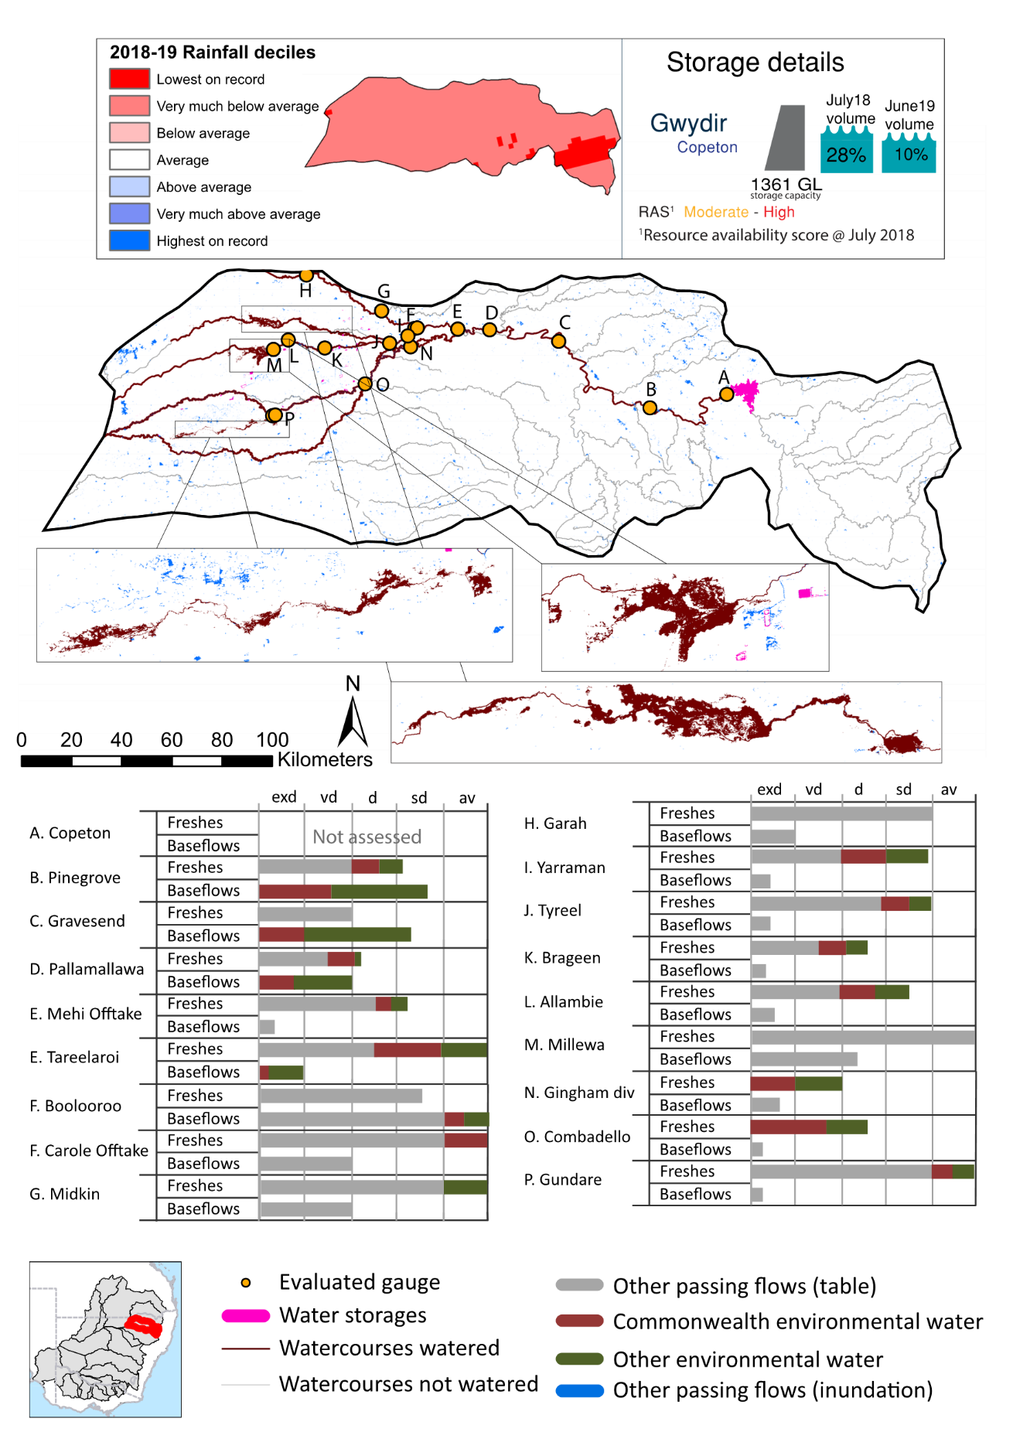
Figure GWY1: Watercourses influenced, areas inundated (where applicable) and gauge stations evaluated in the Gwydir valley during the 2018-19 water year. Inset bar graphs report the condition of annual flow regimes by showing the improvements in hydrological condition with the addition of environmental water as well as the hypothetical scenario in “grey” (if no environmental flow had been delivered) where exd=extremely dry, vd=very dry, d=dry, sd=somewhat dry and av=average. Rainfall conditions (rainfall deciles) and trend in storage levels for the water year are also shown.

Summary
The volume of environmental water delivery for the 2018-19 year in the Gwydir valley is quantified using data for 22 sites. This evaluation only considers the contribution of held environmental water, which is a primary focus for the Commonwealth. The contributions of planned environmental water (e.g. passing flows), unregulated tributary inflows and clever use of irrigation flows for environmental benefits can all be very important but these are outside the scope of this report. Environmental watering actions lasted on average 142 days over the course of the year. The volume of environmental water at these 22 sites was between 0% and 100% of the total streamflow. Commonwealth environmental water contributed on average 38% of this environmental water. The contribution of environmental water delivery to improved flow regimes is evaluated using data for 22 sites. Ideally, baseflows should be maintained consistent with the natural hydrology. In this valley, the baseflow regime was generally considered to be very dry relative to the pre-development flow regime. In our analysis, a low fresh refers to a period of increased flow, when the water level rises at least one eighth of the way up the river bank (above the low flow level). These low freshes are a regular part of the natural flow regime and support a range of natural processes. In the Gwydir valley, in terms of the occurrence and duration of low freshes, the year was assessed as being average. In our analysis, a medium fresh refers to a period of increased flow, when the water level rises at least one quarter of the way up the river bank. These medium freshes are not as frequent as low freshes but are also a regular and important part of the natural flow regime. In the Gwydir valley, in terms of the occurrence of medium freshes, the year was assessed as being somewhat dry. In our analysis, a high fresh refers to a period of increased flow, when the water level rises more than half way up the river. A high fresh may not occur every year but they are still important and long periods without major freshes can have serious consequences for floodplains and their contribution to river connectivity. Delivering high in channel environmental flows normally requires that all risks to riparian landholders and infrastructure have been resolved. In the Gwydir valley, in terms of the occurrence of high freshes, the year was assessed as being very dry.

Water delivery context
In 2018-19, the Commonwealth Environmental Water Holder (CEWH) held water entitlements of up to 114,484 ML for environmental use in the Gwydir valley. In the Gwydir high security accounts receive a 100% allocation in most years. For the general security (and EWA) the Gwydir is run on a continuous accounting system where water allocations are announced on the basis of a share of inflows that occur into Copeton Dam or for supplementary licences for a share of natural flow events (over thresholds) in downstream tributary flows (supplementary events). Each year, water utilities allocate water entitlement holders a percentage of water based on their holding, license type and carryover (the exact rules vary among Jurisdictions). In 2018-19, the Gwydir entitlements held by the CEWH were allocated 4,508 ML of water on high security accounts, representing 9% of the long-term average annual yield for the Gwydir valley (47,932 ML). Information and data relating to the portfolio of held Commonwealth environmental water is shown in Table GWY2.
The 2018-19 water allocation of 4,508 ML (high security) together with the carryover volume of 69,231 ML (general security) of water meant the CEWH had 73,739 ML of water available for delivery. A total of 62,150 ML of Commonwealth environmental water was delivered in the Gwydir valley. A total of 0 ML of Commonwealth environmental water was traded to consumptive users and 11588 ML (16%) of available Commonwealth environmental water was carried over for environmental use into the 2019-20 water year.

Environmental conditions and resource availability
The water available for environmental delivery combined with the present and antecedent environmental conditions are key inputs used by environmental water managers in planning and implementing watering actions. Post hoc, this information provides important context when evaluating the effectiveness and appropriateness of environmental water use with respect to hydrological outputs.
The rainfall conditions in the Gwydir valley were classified as very much below average, based on rainfall percentile data for the entire record held by the Bureau of Meteorology for this valley. The water held in major storages in the Gwydir valley decreased over the water year, for example Copeton dam was 27.6% full at the beginning of the water year and 10.2% full by the end of the year (Figure GWY1).
The Commonwealth Environmental Water Office (CEWO) calculates resource availability scenarios (RAS) to guide the use and prioritisation of held environmental water. The RAS are progressively calculated over the year as part of the continual adaptive management planning processes. The RAS are based on the availability of held environmental water (including progressive license acquisitions and allocations) as well as the potential for unregulated or planned environmental flows. The outcome is then used to determine the demand for environmental water across the basin.
In 2018-19, the resource availability of held Commonwealth environmental water was classified as moderate to high in this valley. The physical conditions of Gwydir Wetlands that the overall demand for environmental water was deemed moderate.

Watering actions
A total of five watering actions were delivered over the 2018-19 water year, the duration of these actions varied (range of individual actions: 30 - 199 days) and Commonwealth environmental water was delivered throughout much of the year. The number of water actions commencing in each season included, Autumn (2), Spring (1), Summer (1), Winter (1). Similarly, the count of flow component types delivered in the Gwydir valley were; (1) baseflow, (0) baseflow-fresh, (0) fresh, (1) fresh-baseflow, (0) bankfull, (0) overbank, (1) wetland and (2) wetland-fresh.
In this valley, primary objectives of most watering actions was related to to fish, but water was also delivered for other outcomes too. The percentage of watering actions delivered across the nine main themes had primary objectives for fish (18.18%), vegetation (13.64%), waterbirds (13.64%), frogs (9.09%), other biota (9.09%), connectivity (9.09%), process (4.55%), resilience (13.64%) and water quality (9.09%).
Table GWY2. Commonwealth environmental water accounting information for the Gwydir valley over 2018-19 water year.

Entitlement type | Total registered volume (ML) | Allocated volume (ML) 2018-2019 | Carry over volume (ML) | Delivered (ML) | LTAAY (ML) | Trade (ML) | Carried over to 2019-20 | Forfeited (ML)
Total (put at bottom) | 114,484 | 4,508 | Assume was 69,231 | 62,150 | 47,932 | 0 | 11,589 | 0
HS | 4,508 | 4,508 | Not applicable | 4,508* | 3,994 | 0 | Not applicable | 0
GS | 89,451 | 0 | 69,231 | 57,642* | 34,020 | 0 | 11,589 | Not applicable
Sup | 20,451 | 0 | Not applicable | 0 | 9,918 | 0 | Not applicable

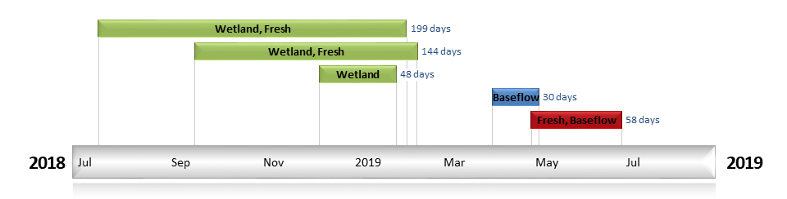
Figure GWY2. Timing and duration of Commonwealth environmental water actions delivered in the Gwydir valley.

Pinegrove
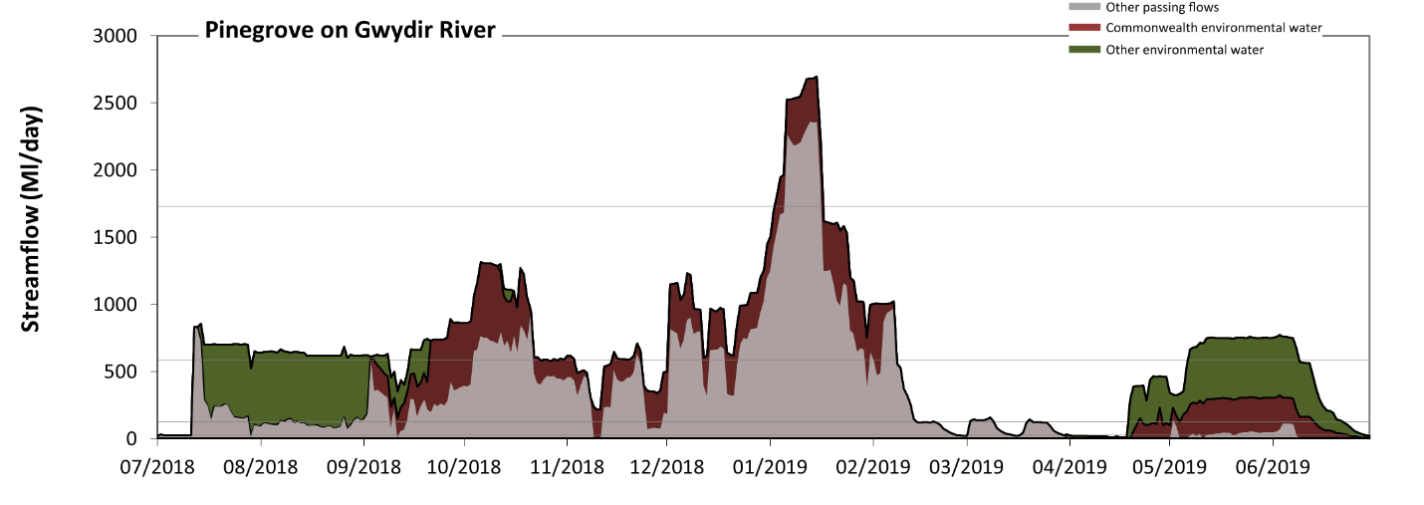
Figure GWY5: Contribution of environmental water delivery at Pinegrove. Horizontal lines indicate thresholds for very low flows, low flows, low freshes and medium freshes (from lowest to highest).
At Pinegrove on Gwydir River, environmental water contributed 47% of the total streamflow volume (with approximately half contributed by Commonwealth environmental water). Environmental watering actions affected streamflows for 83% of days between 1 July 2018 and 30 June 2019. Without environmental water, the duration of very low flows (i.e. < 25 Ml/day) in the period April to June would have substantially exceeded durations expected in an average year, in the natural flow regime. Environmental water mitigated these impacts by reducing the cumulative duration of very low flow spells from 19% to 6% of the year, with greatest influence in the period April to June. Similarly, without environmental water, the durations of medium low flows (i.e. < 120 Ml/day) in the periods July to September, January to March and April to June would have substantially exceeded durations expected in an average year in the natural flow regime. Environmental water mitigated these impacts by reducing the cumulative duration of medium low flow spells from 47% to 20% of the year, with greatest influence in the periods July to September and April to June. Commonwealth environmental water equally shared responsibility with other environmental water holders for these enhancements of environmental baseflows at this site. In the absence of environmental water there would have been at least one low fresh (i.e. > 590 Ml/day) in the periods July to September, October to December and January to March. Environmental water increased the duration of the longest low fresh during the periods July to September (from 3 days to 41 days), October to December (from 18 days to 30 days), January to March (from 29 days to 38 days) and April to June (from 0 days to 33 days). Commonwealth environmental water equally shared responsibility with other environmental water holders for these increased durations of low freshes. In the absence of environmental water there would have been at least one medium fresh (i.e. > 1700 Ml/day) in the period January to March. Environmental water increased the duration of the longest medium fresh during the period January to March (from 11 days to 14 days). Commonwealth environmental water was entirely responsible for these increased durations of medium freshes. There was no high freshes (i.e. > 7700 Ml/day) this year.
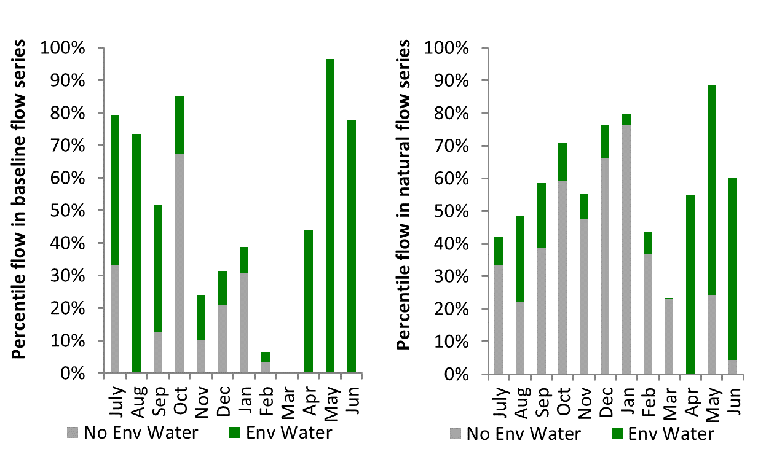
Figure GWY6: Contribution of environmental water delivery at Pinegrove as percentiles in the natural and baseline flow series.

Gravesend
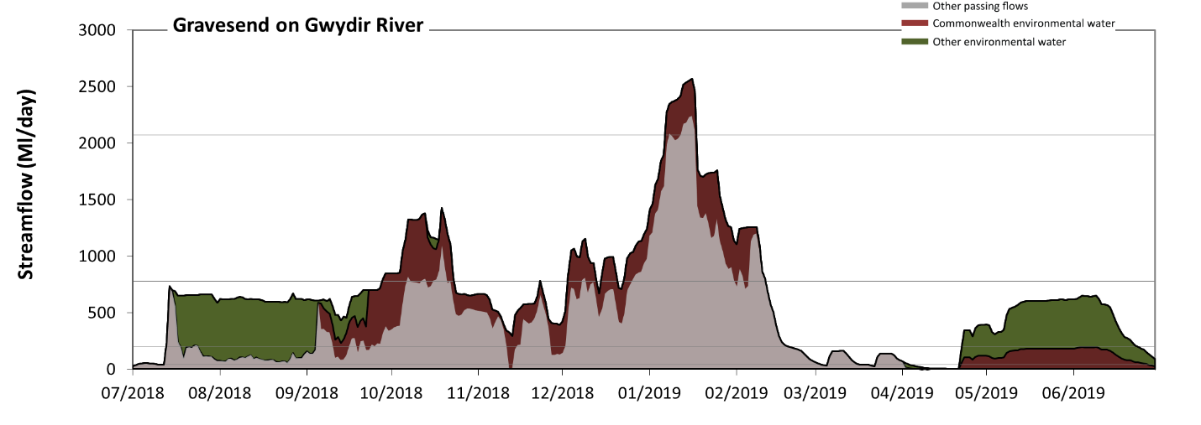
Figure GWY7: Contribution of environmental water delivery at Gravesend. Horizontal lines indicate thresholds for very low flows, low flows, low freshes and medium freshes (from lowest to highest).
At Gravesend on Gwydir River, environmental water contributed 45% of the total streamflow volume (with approximately half contributed by Commonwealth environmental water). Environmental watering actions affected streamflows for 82% of days between 1 July 2018 and 30 June 2019. Without environmental water, the duration of very low flows (i.e. < 40 Ml/day) in the period April to June would have substantially exceeded durations expected in an average year in the natural flow regime. Environmental water mitigated these impacts by reducing the cumulative duration of very low flow spells from 27% to 7% of the year, with greatest influence in the period April to June. Similarly, without environmental water, the durations of medium low flows (i.e. < 200 Ml/day) in the periods July to September, January to March and April to June would have substantially exceeded durations expected in an average year in the natural flow regime. Environmental water mitigated these impacts by reducing the cumulative duration of medium low flow spells from 56% to 22% of the year, with greatest influence in the periods July to September and April to June. Commonwealth environmental water made a modest contribution to these enhancements of environmental baseflows at this site. In the absence of environmental water there would have been at least one low fresh (i.e. > 780 Ml/day) in the periods October to December and January to March. Environmental water increased the duration of the longest low fresh during the periods July to September (from 0 days to 3 days), October to December (from 6 days to 23 days) and January to March (from 31 days to 42 days). Commonwealth environmental water was almost entirely responsible for these increased durations of low freshes. In the absence of environmental water there would have been at least one medium fresh (i.e. > 2100 Ml/day) in the period January to March. Environmental water increased the duration of the longest medium fresh during the period January to March (from 6 days to 11 days). Commonwealth environmental water was entirely responsible for these increased durations of medium freshes. There was no high freshes (i.e. > 8400 Ml/day) this year.
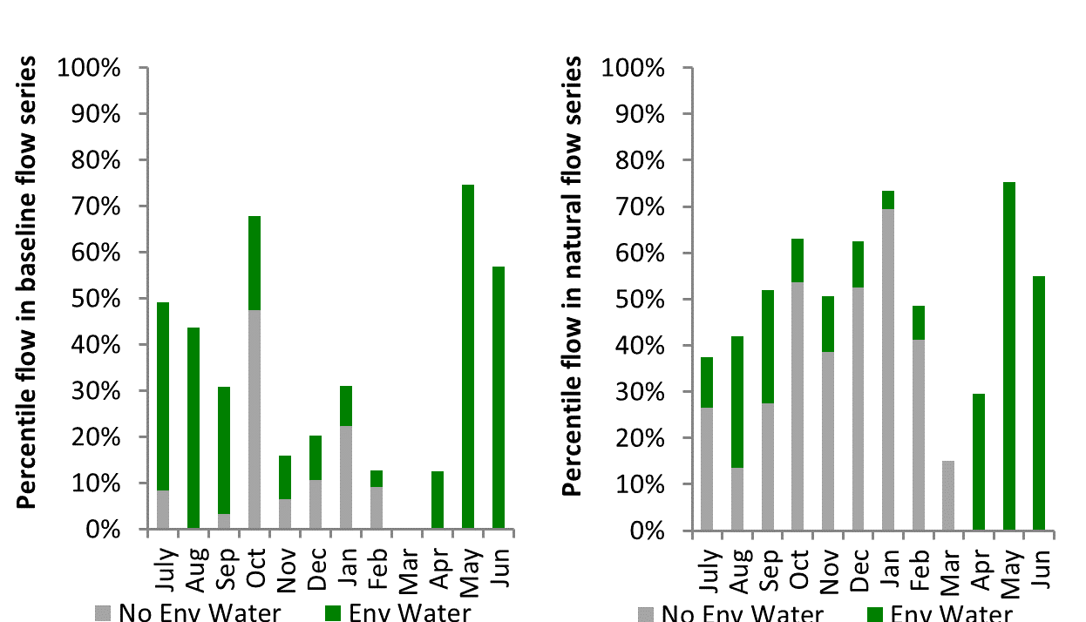
Figure GWY8: Contribution of environmental water delivery at Gravesend as percentiles in the natural and baseline flow series.
Pallamallawa
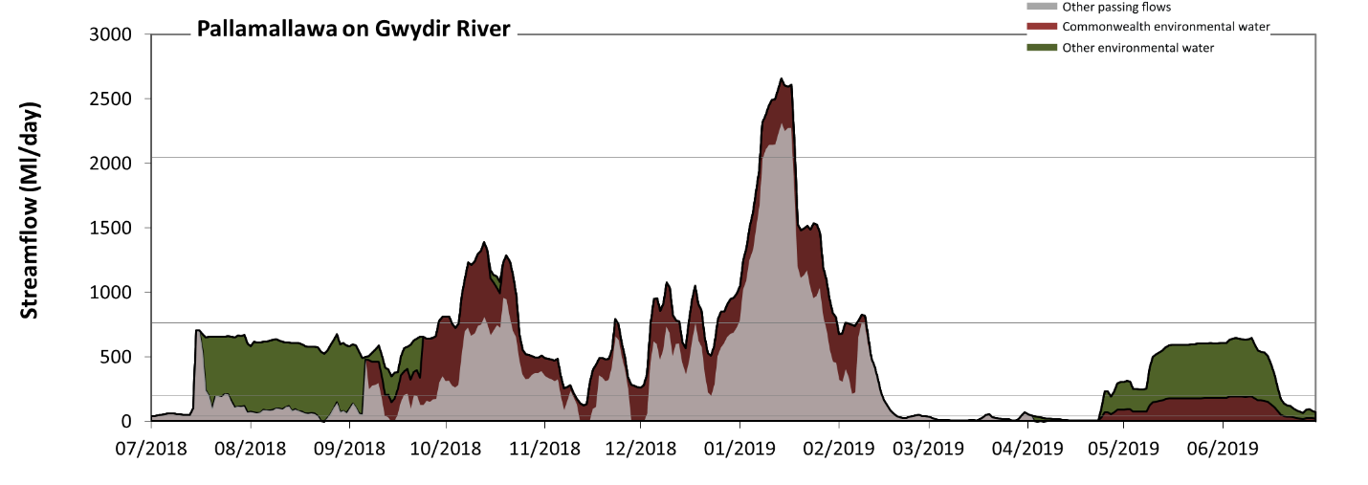
Figure GWY9: Contribution of environmental water delivery at Pallamallawa. Horizontal lines indicate thresholds for very low flows, low flows, low freshes and medium freshes (from lowest to highest).
At Pallamallawa on Gwydir River, environmental water contributed 50% of the total streamflow volume (with approximately half contributed by Commonwealth environmental water). Environmental watering actions affected streamflows for 80% of days between 1 July 2018 and 30 June 2019. Without environmental water, the durations of very low flows (i.e. < 39 Ml/day) in the periods October to December, January to March and April to June would have substantially exceeded durations expected in an average year, in the natural flow regime. Environmental water mitigated these impacts by reducing the cumulative duration of very low flow spells from 37% to 14% of the year, with greatest influence in the period April to June. Similarly, without environmental water, the durations of medium low flows (i.e. < 200 Ml/day) in the periods July to September, January to March and April to June would have substantially exceeded durations expected in an average year in the natural flow regime. Environmental water mitigated these impacts by reducing the cumulative duration of medium low flow spells from 62% to 27% of the year, with greatest influence in the periods July to September and April to June. Commonwealth environmental water made a modest contribution to these enhancements of environmental baseflows at this site. In the absence of environmental water there would have been at least one low fresh (i.e. > 770 Ml/day) in the periods October to December and January to March. Environmental water increased the duration of the longest low fresh during the periods July to September (from 0 days to 2 days) and October to December (from 3 days to 18 days). Commonwealth environmental water was almost entirely responsible for these increased durations of low freshes. There was at least one medium fresh (i.e. > 2000 Ml/day) in the period January to March. Environmental water made little change to the duration of these medium freshes. There was no high freshes (i.e. > 8400 Ml/day) this year.
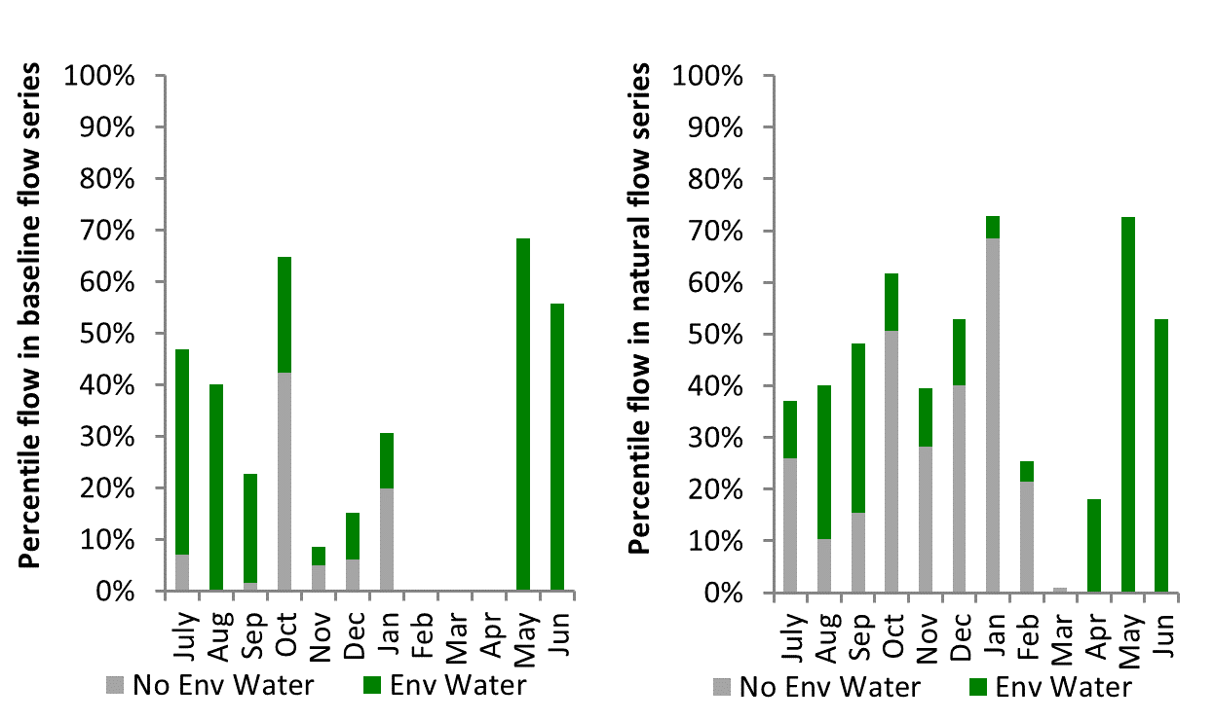
Figure GWY10: Contribution of environmental water delivery at Pallamallawa as percentiles in the natural and baseline flow series.

Mehi Offtake
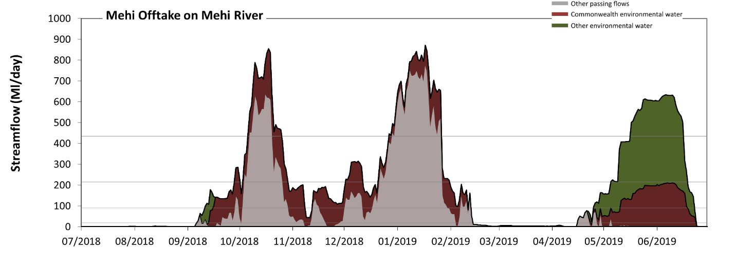
Figure GWY11: Contribution of environmental water delivery at Mehi Offtake. Horizontal lines indicate thresholds for very low flows, low flows, low freshes and medium freshes (from lowest to highest).
At Mehi Offtake on Mehi River, environmental water contributed 53% of the total streamflow volume (with approximately half contributed by Commonwealth environmental water). Environmental watering actions affected streamflows for 62% of days between 1 July 2018 and 30 June 2019. Without environmental water, the durations of very low flows (i.e. < 18 Ml/day) in the periods July to September, October to December, January to March and April to June would have all substantially exceeded durations expected in an average year in the natural flow regime. Environmental water mitigated these impacts by reducing the cumulative duration of very low flow spells from 60% to 37% of the year, with greatest influence in the period April to June. Similarly, without environmental water, the durations of medium low flows (i.e. < 90 Ml/day) in the periods July to September, October to December, January to March and April to June would have all substantially exceeded durations expected in an average year in the natural flow regime. Environmental water mitigated these impacts by reducing the cumulative duration of medium low flow spells from 75% to 43% of the year, with greatest influence in the periods October to December and April to June. Commonwealth environmental water equally shared responsibility with other environmental water holders for these enhancements of environmental baseflows at this site. In the absence of environmental water there would have been at least one low fresh (i.e. > 220 Ml/day) in the periods October to December and January to March. Environmental water increased the duration of the longest low fresh during the periods July to September (from 0 days to 2 days) and April to June (from 0 days to 45 days). Commonwealth environmental water equally shared responsibility with other environmental water holders for these increased durations of low freshes. In the absence of environmental water there would have been at least one medium fresh (i.e. > 440 Ml/day) in the periods October to December and January to March. Environmental water increased the duration of the longest medium fresh during the periods October to December (from 13 days to 20 days) and April to June (from 0 days to 31 days). Commonwealth environmental water equally shared responsibility with other environmental water holders for these increased durations of medium freshes. There was no high freshes (i.e. > 1300 Ml/day) this year.
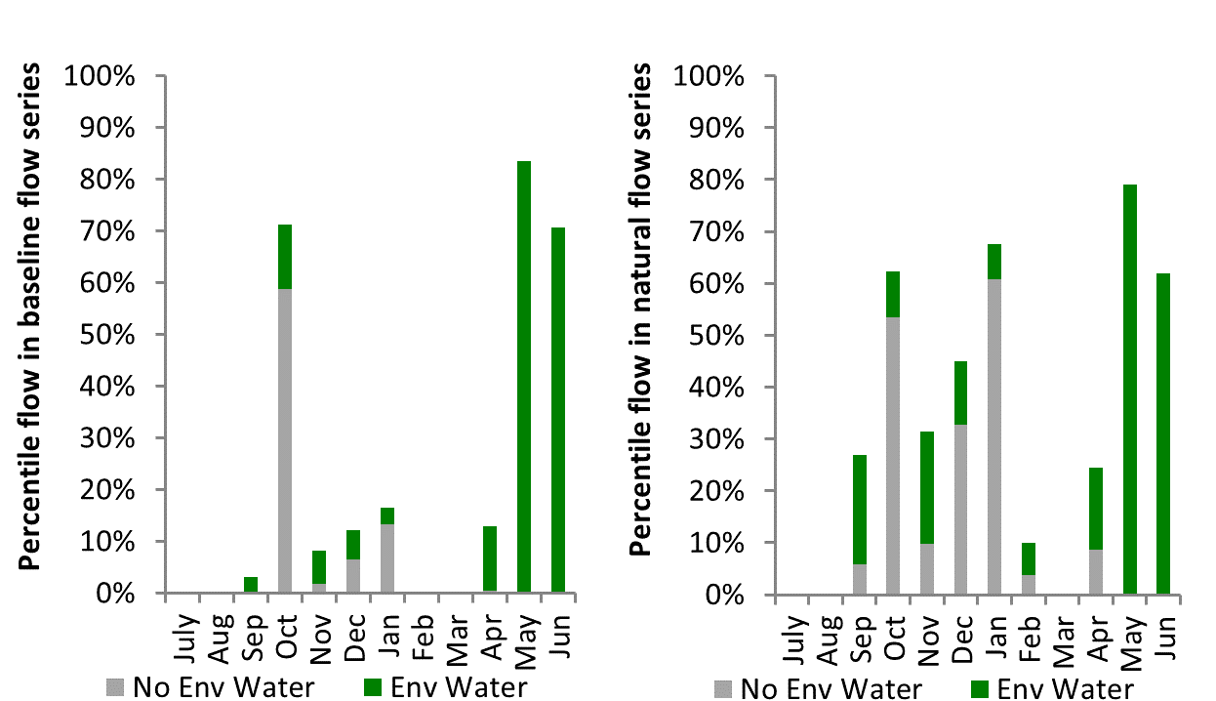
Figure GWY12: Contribution of environmental water delivery at Mehi Offtake as percentiles in the natural and baseline flow series.
Tareelaroi
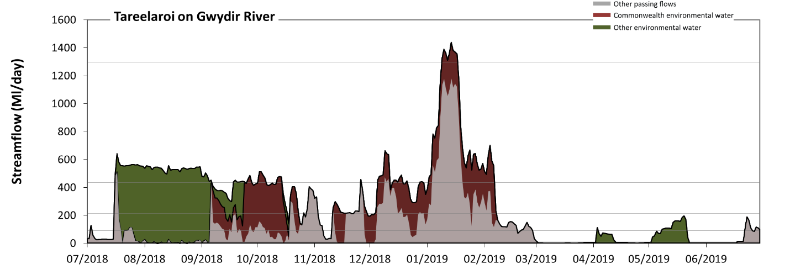Figure GWY13: Contribution of environmental water delivery at Tareelaroi. Horizontal lines indicate thresholds for very low flows, low flows, low freshes, medium freshes and high freshes (from lowest to highest).
At Tareelaroi on Gwydir River, environmental water contributed 57% of the total streamflow volume (with approximately half contributed by Commonwealth environmental water). Environmental watering actions affected streamflows for 59% of days between 1 July 2018 and 30 June 2019. Without environmental water, the durations of very low flows (i.e. < 18 Ml/day) in the periods July to September, October to December, January to March and April to June would have all substantially exceeded durations expected in an average year in the natural flow regime. Environmental water mitigated these impacts by reducing the cumulative duration of very low flow spells from 44% to 23% of the year, with greatest influence in the periods July to September and April to June. Similarly, without environmental water, the durations of medium low flows (i.e. < 90 Ml/day) in the periods July to September, October to December, January to March and April to June would have all substantially exceeded durations expected in an average year in the natural flow regime. Environmental water mitigated these impacts by reducing the cumulative duration of medium low flow spells from 60% to 33% of the year, with greatest influence in the periods July to September and October to December. Commonwealth environmental water made a modest contribution to these enhancements of environmental baseflows at this site. In the absence of environmental water there would have been at least one low fresh (i.e. > 220 Ml/day) in the periods July to September, October to December and January to March. Environmental water increased the duration of the longest low fresh during the periods July to September (from 2 days to 77 days), October to December (from 11 days to 28 days) and January to March (from 23 days to 38 days). Commonwealth environmental water made the dominant contribution to these increased durations of low freshes. In the absence of environmental water there would have been at least one medium fresh (i.e. > 440 Ml/day) in the periods July to September, October to December and January to March. Environmental water increased the duration of the longest medium fresh during the periods July to September (from 2 days to 53 days), October to December (from 3 days to 7 days) and January to March (from 17 days to 36 days). Commonwealth environmental water made the dominant contribution to these increased durations of medium freshes. Environmental water increased the duration of the longest high fresh (i.e. > 1300 Ml/day) this year. Environmental water increased the duration of the longest medium fresh during the period January to March (from 0 days to 9 days). Commonwealth environmental water was entirely responsible for these increased durations of high freshes.
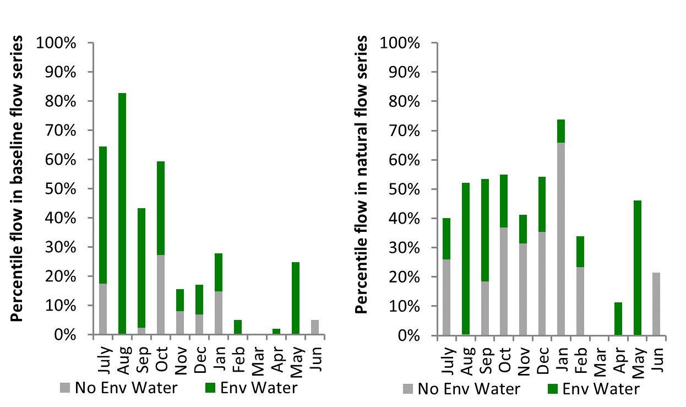
Figure GWY14: Contribution of environmental water delivery at Tareelaroi as percentiles in the natural and baseline flow series.

Carole Offtake
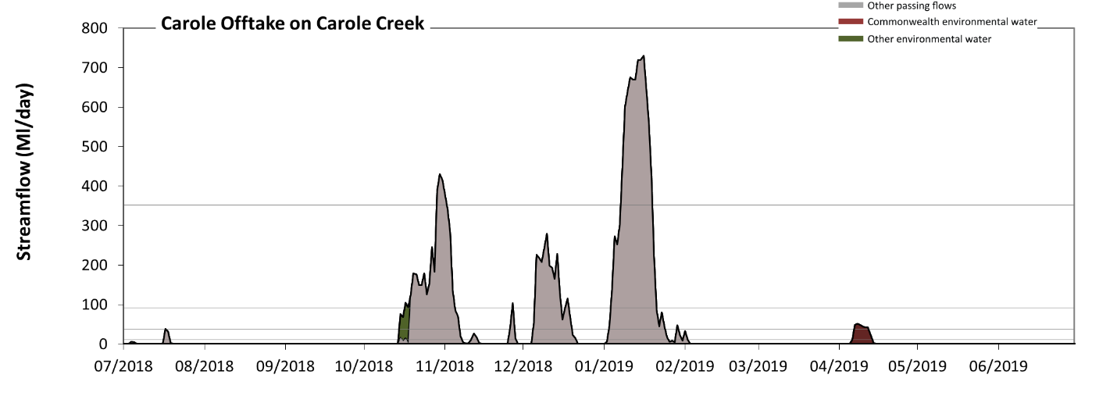 Figure GWY15: Contribution of environmental water delivery at Carole Offtake. Horizontal lines indicate thresholds for very low flows, low flows, low freshes, medium freshes and high freshes (from lowest to highest).
At Carole Offtake on Carole Creek, environmental water contributed 4% of the total streamflow volume (none of which was Commonwealth environmental water). Environmental watering actions affected streamflows for 4% of days between 1 July 2018 and 30 June 2019. Without environmental water, the durations of very low flows (i.e. < 2.1 Ml/day) in the periods July to September and April to June would have substantially exceeded durations expected in an average year in the natural flow regime. Environmental water mitigated these impacts by reducing the cumulative duration of very low flow spells from 76% to 74% of the year, with greatest influence in the period April to June. Similarly, without environmental water, the durations of medium low flows (i.e. < 10 Ml/day) in the periods July to September and April to June would have substantially exceeded durations expected in an average year in the natural flow regime. Environmental water mitigated these impacts by reducing the cumulative duration of medium low flow spells from 80% to 77% of the year, with greatest influence in the period April to June. Commonwealth environmental water made little or no contribution to these enhancements of environmental baseflows at this site. In the absence of environmental water there would have been at least one low fresh (i.e. > 36 Ml/day) in the periods July to September, October to December and January to March. Environmental water increased the duration of the longest low fresh during the period April to June (from 0 days to 6 days). Commonwealth environmental water made little or no contribution to these increased durations of low freshes. There was at least one medium fresh (i.e. > 92 Ml/day) in the periods October to December and January to March. Environmental water made little change to the duration of these medium freshes. In the absence of environmental water there would have been at least one high fresh in the periods October to December and January to March. Environmental water made no change to the duration of these high freshes.
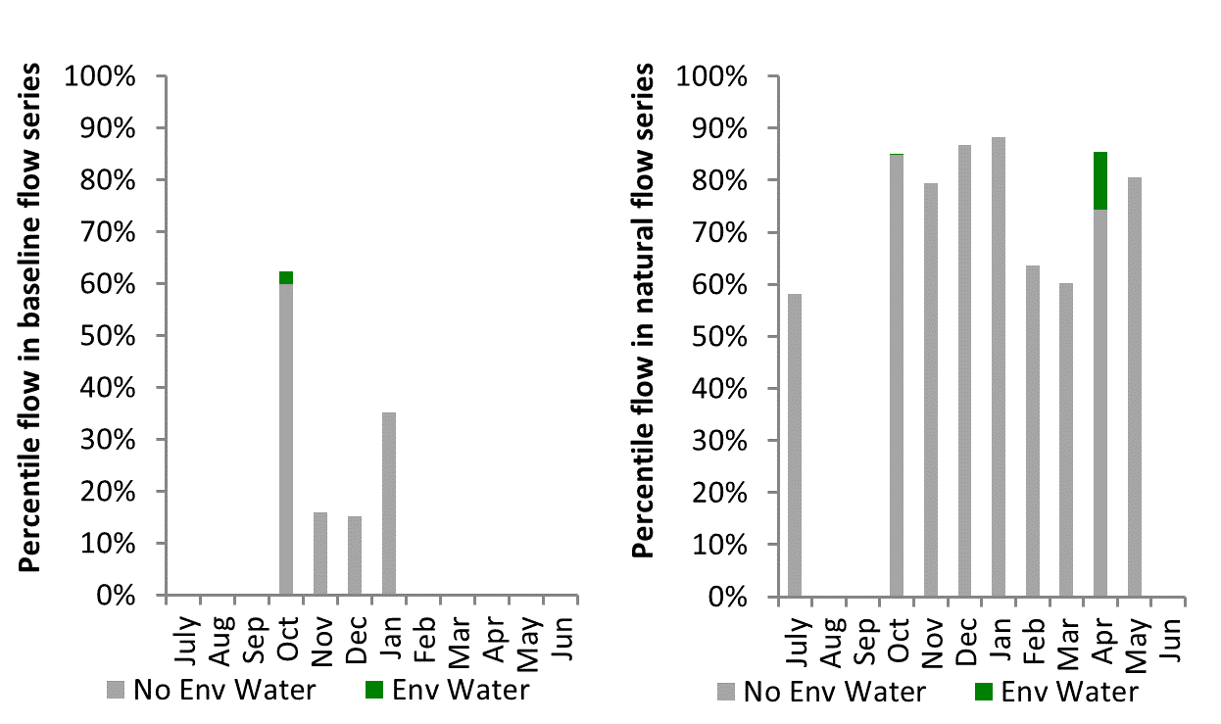
Figure GWY16: Contribution of environmental water delivery at Carole Offtake as percentiles in the natural and baseline flow series.

Boolooroo
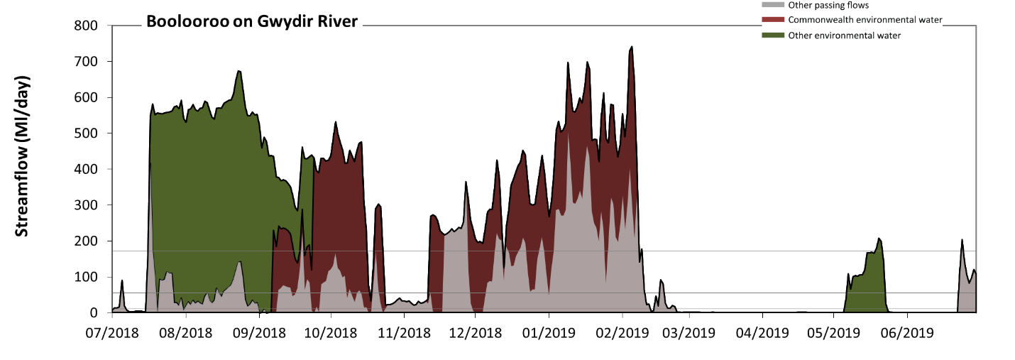 Figure GWY17: Contribution of environmental water delivery at Boolooroo. Horizontal lines indicate thresholds for very low flows, low flows, low freshes and medium freshes (from lowest to highest).
At Boolooroo on Gwydir River, environmental water contributed 70% of the total streamflow volume (with approximately half contributed by Commonwealth environmental water). Environmental watering actions affected streamflows for 54% of days between 1 July 2018 and 30 June 2019. Without environmental water, the duration of very low flows (i.e. < 2.1 Ml/day) in the period April to June would have substantially exceeded durations expected in an average year in the natural flow regime. Environmental water mitigated these impacts by reducing the cumulative duration of very low flow spells from 37% to 27% of the year, with greatest influence in the periods October to December and April to June. Similarly, without environmental water, the duration of medium low flows (i.e. < 10 Ml/day) in the period April to June would have substantially exceeded durations expected in an average year in the natural flow regime. Environmental water mitigated these impacts by reducing the cumulative duration of medium low flow spells from 43% to 31% of the year, with greatest influence in the periods July to September, October to December and April to June. Commonwealth environmental water made a modest contribution to these enhancements of environmental baseflows at this site. In the absence of environmental water there would have been at least one low fresh (i.e. > 56 Ml/day) in the periods July to September, October to December, January to March and April to June. Environmental water increased the duration of the longest low fresh during the periods July to September (from 9 days to 77 days), October to December (from 26 days to 50 days) and April to June (from 8 days to 16 days). Commonwealth environmental water made a modest contribution to these increased durations of low freshes. In the absence of environmental water there would have been at least one medium fresh (i.e. > 170 Ml/day) in the periods July to September, October to December, January to March and April to June. Environmental water increased the duration of the longest medium fresh during the periods July to September (from 1 days to 76 days), October to December (from 10 days to 31 days), January to March (from 21 days to 38 days) and April to June (from 1 days to 3 days). Commonwealth environmental water equally shared responsibility with other environmental water holders for these increased durations of medium freshes. There was no high freshes (i.e. > 820 Ml/day) this year.
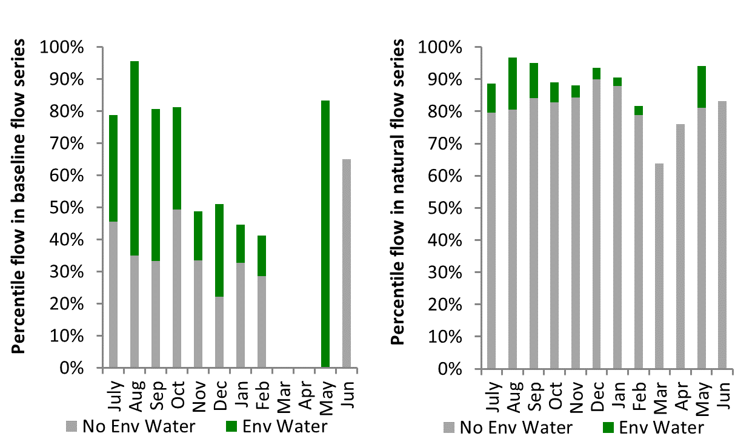
Figure GWY18: Contribution of environmental water delivery at Boolooroo as percentiles in the natural and baseline flow series.

Yarraman
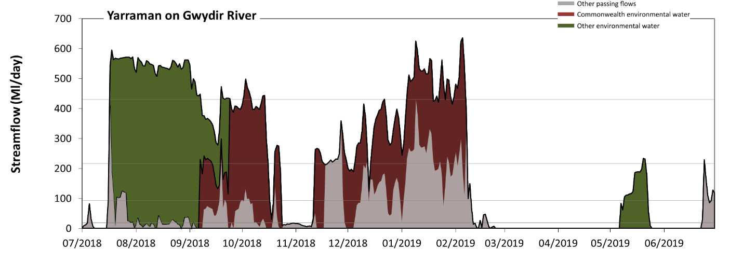 Figure GWY19: Contribution of environmental water delivery at Yarraman. Horizontal lines indicate thresholds for very low flows, low flows, low freshes and medium freshes (from lowest to highest).
At Yarraman on Gwydir River, environmental water contributed 74% of the total streamflow volume (with approximately half contributed by Commonwealth environmental water). Environmental watering actions affected streamflows for 54% of days between 1 July 2018 and 30 June 2019. Without environmental water, the durations of very low flows (i.e. < 19 Ml/day) in the periods July to September, October to December, January to March and April to June would have all substantially exceeded durations expected in an average year in the natural flow regime. Environmental water mitigated these impacts by reducing the cumulative duration of very low flow spells from 58% to 39% of the year, with greatest influence in the periods July to September and October to December. Similarly, without environmental water, the durations of medium low flows (i.e. < 94 Ml/day) in the periods July to September, October to December, January to March and April to June would have all substantially exceeded durations expected in an average year in the natural flow regime. Environmental water mitigated these impacts by reducing the cumulative duration of medium low flow spells from 76% to 44% of the year, with greatest influence in the periods July to September and October to December. Commonwealth environmental water equally shared responsibility with other environmental water holders for these enhancements of environmental baseflows at this site. In the absence of environmental water there would have been at least one low fresh (i.e. > 220 Ml/day) in the periods July to September, October to December, January to March and April to June. Environmental water increased the duration of the longest low fresh during the periods July to September (from 1 days to 76 days), October to December (from 8 days to 18 days), January to March (from 16 days to 38 days) and April to June (from 1 days to 2 days). Commonwealth environmental water equally shared responsibility with other environmental water holders for these increased durations of low freshes. In the absence of environmental water there would have been at least one medium fresh (i.e. > 430 Ml/day) in the period January to March. Environmental water increased the duration of the longest medium fresh during the periods July to September (from 0 days to 53 days), October to December (from 0 days to 5 days) and January to March (from 1 days to 15 days). Commonwealth environmental water made the dominant contribution to these increased durations of medium freshes. There was no high freshes (i.e. > 1200 Ml/day) this year.
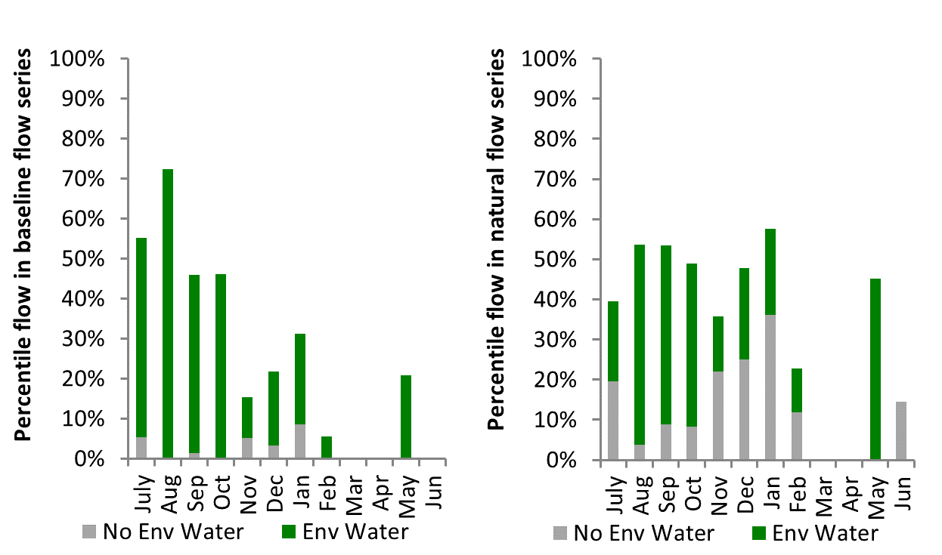
Figure GWY20: Contribution of environmental water delivery at Yarraman as percentiles in the natural and baseline flow series.

Gingham Diversion
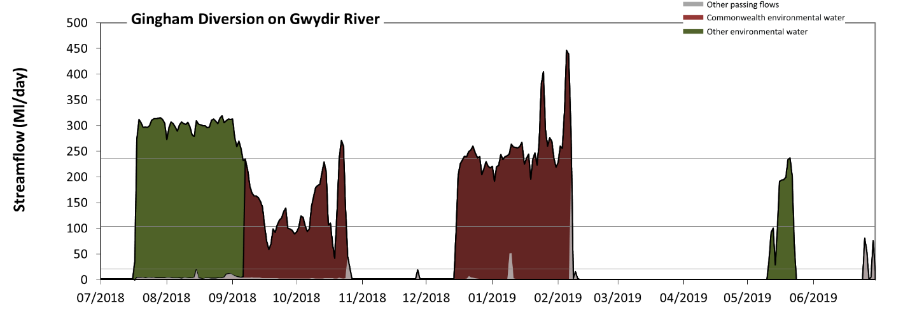 Figure GWY21: Contribution of environmental water delivery at Gingham Diversion. Horizontal lines indicate thresholds for very low flows, low flows and low freshes (from lowest to highest).
At Gingham Diversion on Gwydir River, environmental water contributed 97% of the total streamflow volume (with approximately half contributed by Commonwealth environmental water). Environmental watering actions affected streamflows for 46% of days between 1 July 2018 and 30 June 2019. Without environmental water, the durations of very low flows (i.e. < 21 Ml/day) in the periods July to September, October to December, January to March and April to June would have all substantially exceeded durations expected in an average year in the natural flow regime. Environmental water mitigated these impacts by reducing the cumulative duration of very low flow spells from 98% to 53% of the year, with greatest influence in the period July to September. Similarly, without environmental water, the durations of medium low flows (i.e. < 100 Ml/day) in the periods July to September, October to December, January to March and April to June would have all substantially exceeded durations expected in an average year in the natural flow regime. Environmental water mitigated these impacts by reducing the cumulative duration of medium low flow spells from 100% to 61% of the year, with greatest influence in the periods July to September and January to March. Commonwealth environmental water made the dominant contribution to these enhancements of environmental baseflows at this site. Environmental water increased the duration of the longest low fresh during the periods July to September (from 0 days to 50 days), October to December (from 0 days to 8 days), January to March (from 0 days to 9 days) and April to June (from 0 days to 1 days). Commonwealth environmental water equally shared responsibility with other environmental water holders for these increased durations of low freshes. However, environmental water increased peak flows substantially below the medium fresh threshold.
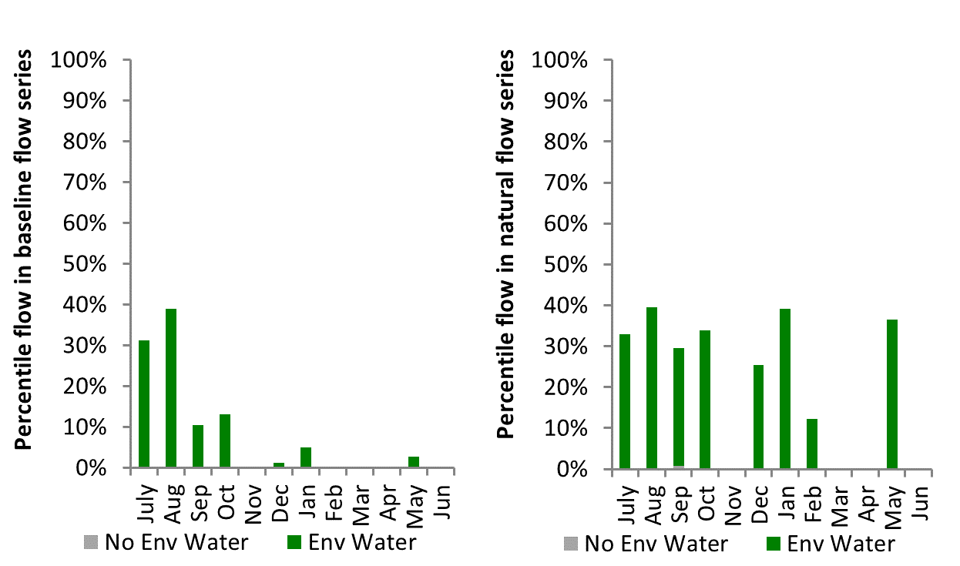
Figure GWY22: Contribution of environmental water delivery at Gingham Diversion as percentiles in the natural and baseline flow series.

Tyreel
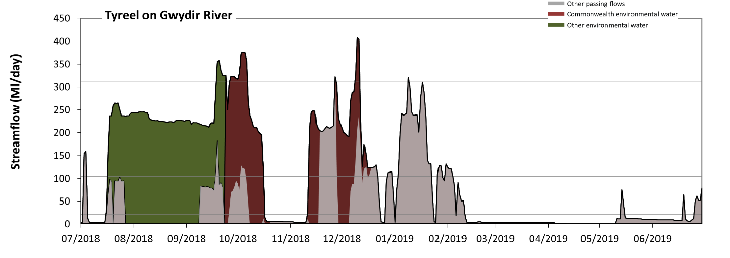 Figure GWY23: Contribution of environmental water delivery at Tyreel. Horizontal lines indicate thresholds for very low flows, low flows, low freshes and medium freshes (from lowest to highest).
At Tyreel on Gwydir River, environmental water contributed 60% of the total streamflow volume (with approximately half contributed by Commonwealth environmental water). Environmental watering actions affected streamflows for 34% of days between 1 July 2018 and 30 June 2019. Without environmental water, the durations of very low flows (i.e. < 21 Ml/day) in the periods July to September, October to December, January to March and April to June would have all substantially exceeded durations expected in an average year in the natural flow regime. Environmental water mitigated these impacts by reducing the cumulative duration of very low flow spells from 68% to 48% of the year, with greatest influence in the periods July to September and October to December. Similarly, without environmental water, the durations of medium low flows (i.e. < 100 Ml/day) in the periods July to September, October to December, January to March and April to June would have all substantially exceeded durations expected in an average year in the natural flow regime. Environmental water mitigated these impacts by reducing the cumulative duration of medium low flow spells from 84% to 55% of the year, with greatest influence in the periods July to September and October to December. Commonwealth environmental water made a modest contribution to these enhancements of environmental baseflows at this site. In the absence of environmental water there would have been at least one low fresh (i.e. > 190 Ml/day) in the periods October to December and January to March. Environmental water increased the duration of the longest low fresh during the periods July to September (from 0 days to 75 days) and October to December (from 10 days to 31 days). Commonwealth environmental water equally shared responsibility with other environmental water holders for these increased durations of low freshes. In the absence of environmental water there would have been at least one medium fresh (i.e. > 310 Ml/day) in the periods October to December and January to March. Environmental water increased the duration of the longest medium fresh during the periods July to September (from 0 days to 6 days) and October to December (from 1 days to 6 days). Commonwealth environmental water made the dominant contribution to these increased durations of medium freshes. There was no high freshes (i.e. > 720 Ml/day) this year.
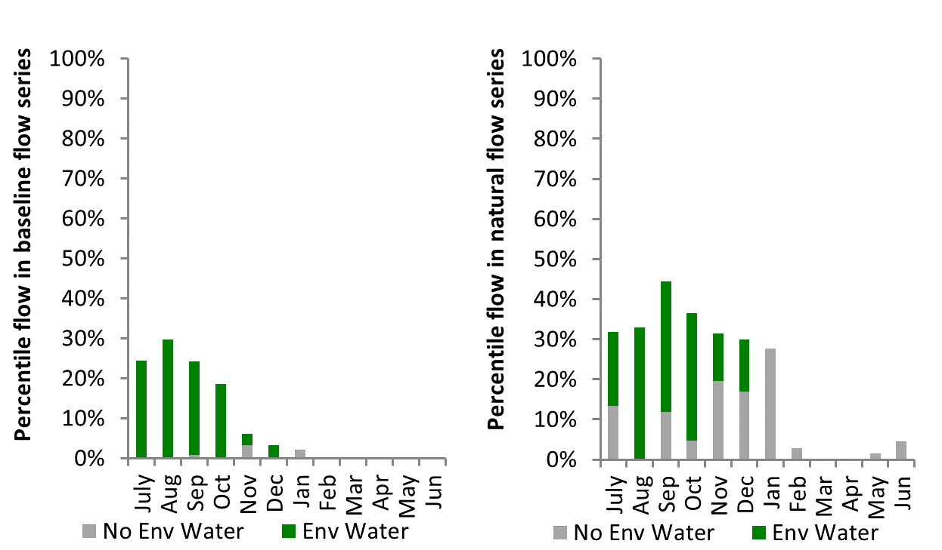
Figure GWY24: Contribution of environmental water delivery at Tyreel as percentiles in the natural and baseline flow series.
Brageen
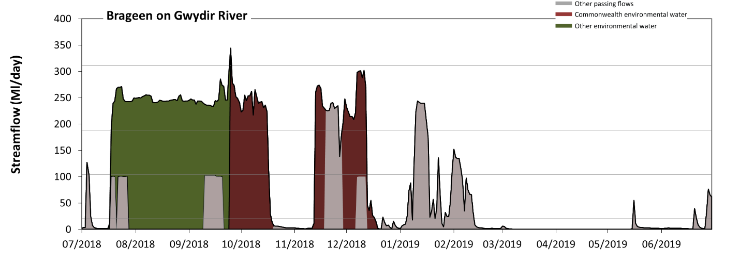 Figure GWY25: Contribution of environmental water delivery at Brageen. Horizontal lines indicate thresholds for very low flows, low flows, low freshes and medium freshes (from lowest to highest).
At Brageen on Gwydir River, environmental water contributed 72% of the total streamflow volume (with approximately half contributed by Commonwealth environmental water). Environmental watering actions affected streamflows for 34% of days between 1 July 2018 and 30 June 2019. Without environmental water, the durations of very low flows (i.e. < 21 Ml/day) in the periods July to September, October to December, January to March and April to June would have all substantially exceeded durations expected in an average year in the natural flow regime. Environmental water mitigated these impacts by reducing the cumulative duration of very low flow spells from 78% to 52% of the year, with greatest influence in the periods July to September and October to December. Similarly, without environmental water, the durations of medium low flows (i.e. < 100 Ml/day) in the periods July to September, October to December, January to March and April to June would have all substantially exceeded durations expected in an average year in the natural flow regime. Environmental water mitigated these impacts by reducing the cumulative duration of medium low flow spells from 93% to 62% of the year, with greatest influence in the periods July to September and October to December. Commonwealth environmental water equally shared responsibility with other environmental water holders for these enhancements of environmental baseflows at this site. In the absence of environmental water there would have been at least one low fresh (i.e. > 190 Ml/day) in the periods October to December and January to March. Environmental water increased the duration of the longest low fresh during the periods July to September (from 0 days to 75 days) and October to December (from 8 days to 16 days). Commonwealth environmental water equally shared responsibility with other environmental water holders for these increased durations of low freshes. In the absence of environmental water there would have been no medium or high freshes this year. Environmental water increased the duration of the longest medium fresh during the period July to September (from 0 days to 1 days). Commonwealth environmental water was entirely responsible for these increased durations of medium freshes.
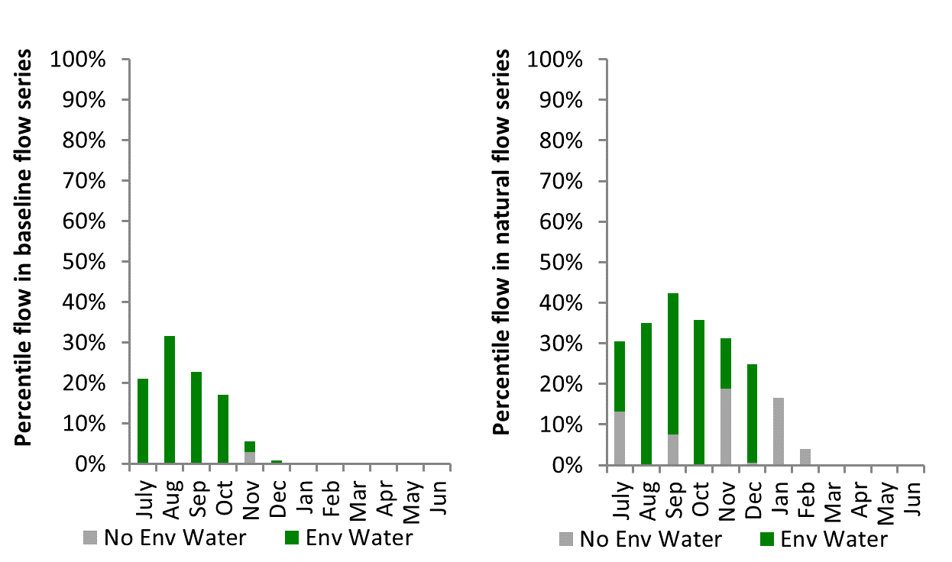
Figure GWY26: Contribution of environmental water delivery at Brageen as percentiles in the natural and baseline flow series.

Allambie
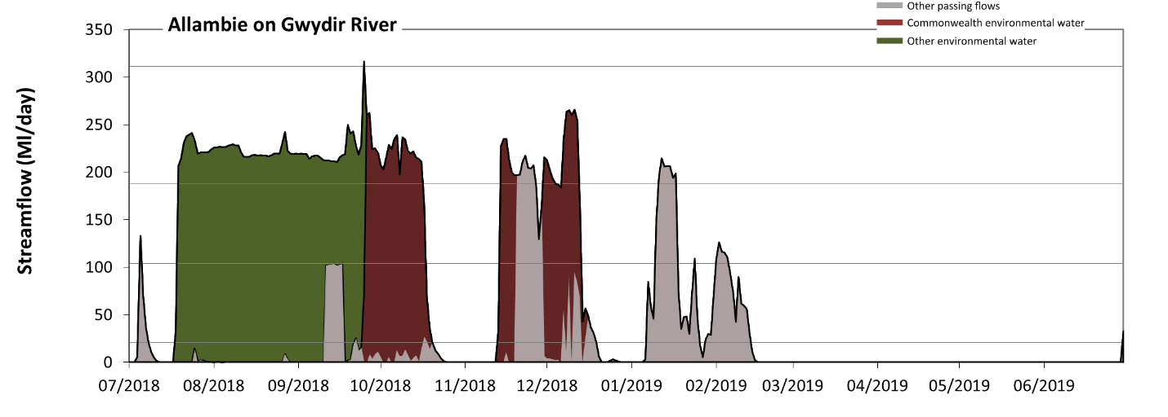 Figure GWY27: Contribution of environmental water delivery at Allambie. Horizontal lines indicate thresholds for very low flows, low flows, low freshes and medium freshes (from lowest to highest).
At Allambie on Gwydir River, environmental water contributed 76% of the total streamflow volume (with a medium contribution of Commonwealth environmental water). Environmental watering actions affected streamflows for 32% of days between 1 July 2018 and 30 June 2019. Without environmental water, the durations of very low flows (i.e. < 21 Ml/day) in the periods July to September, October to December, January to March and April to June would have all substantially exceeded durations expected in an average year in the natural flow regime. Environmental water mitigated these impacts by reducing the cumulative duration of very low flow spells from 81% to 53% of the year, with greatest influence in the periods July to September and October to December. Similarly, without environmental water, the durations of medium low flows (i.e. < 100 Ml/day) in the periods July to September, October to December, January to March and April to June would have all substantially exceeded durations expected in an average year in the natural flow regime. Environmental water mitigated these impacts by reducing the cumulative duration of medium low flow spells from 93% to 63% of the year, with greatest influence in the periods July to September and October to December. Commonwealth environmental water made a modest contribution to these enhancements of environmental baseflows at this site. In the absence of environmental water there would have been at least one low fresh (i.e. > 190 Ml/day) in the periods October to December and January to March. Environmental water increased the duration of the longest low fresh during the periods July to September (from 0 days to 74 days) and October to December (from 7 days to 16 days). Commonwealth environmental water equally shared responsibility with other environmental water holders for these increased durations of low freshes. In the absence of environmental water there would have been no medium or high freshes this year. Environmental water increased the duration of the longest medium fresh during the period July to September (from 0 days to 1 days). Commonwealth environmental water equally shared responsibility with other environmental water holders for these increased durations of medium freshes.
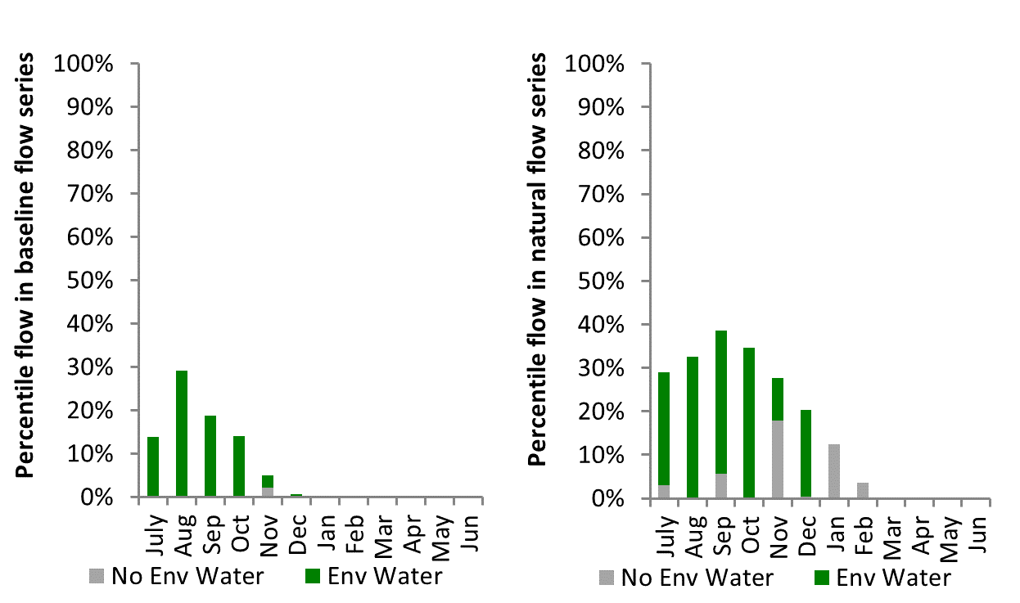
Figure GWY28: Contribution of environmental water delivery at Allambie as percentiles in the natural and baseline flow series.
Millewa
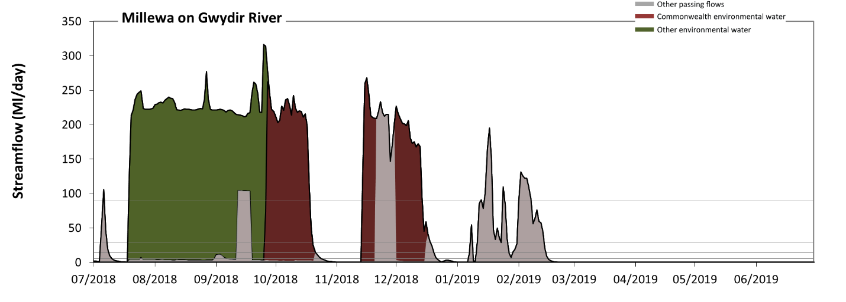 Figure GWY29: Contribution of environmental water delivery at Millewa. Horizontal lines indicate thresholds for very low flows, low flows, low freshes, medium freshes and high freshes (from lowest to highest).
At Millewa on Gwydir River, environmental water contributed 79% of the total streamflow volume (with a medium contribution of Commonwealth environmental water). Environmental watering actions affected streamflows for 32% of days between 1 July 2018 and 30 June 2019. Without environmental water, the duration of very low flows (i.e. < 1.1 Ml/day) in the period April to June would have substantially exceeded durations expected in an average year in the natural flow regime. Environmental water reduced the cumulative duration of very low flow spells from 45% to 44% of the year, with greatest influence in the period October to December. Similarly, without environmental water, the durations of medium low flows (i.e. < 5.7 Ml/day) in the periods July to September, October to December and April to June would have substantially exceeded durations expected in an average year in the natural flow regime. Environmental water mitigated these impacts by reducing the cumulative duration of medium low flow spells from 79% to 51% of the year, with greatest influence in the periods July to September and October to December. Commonwealth environmental water equally shared responsibility with other environmental water holders for these enhancements of environmental baseflows at this site. In the absence of environmental water there would have been at least one low fresh (i.e. > 14 Ml/day) in the periods July to September, October to December and January to March. Environmental water increased the duration of the longest low fresh during the periods July to September (from 7 days to 74 days) and October to December (from 10 days to 37 days). Commonwealth environmental water equally shared responsibility with other environmental water holders for these increased durations of low freshes. In the absence of environmental water there would have been at least one medium fresh (i.e. > 29 Ml/day) in the periods July to September, October to December and January to March. Environmental water increased the duration of the longest medium fresh during the periods July to September (from 7 days to 74 days) and October to December (from 10 days to 35 days). Commonwealth environmental water equally shared responsibility with other environmental water holders for these increased durations of medium freshes. In the absence of environmental water there would have been at least one high fresh in the periods July to September, October to December and January to March. Environmental water increased the duration of the longest high fresh during the periods July to September (from 7 days to 74 days) and October to December (from 10 days to 31 days). Commonwealth environmental water equally shared responsibility with other environmental water holders for these increased durations of high freshes.

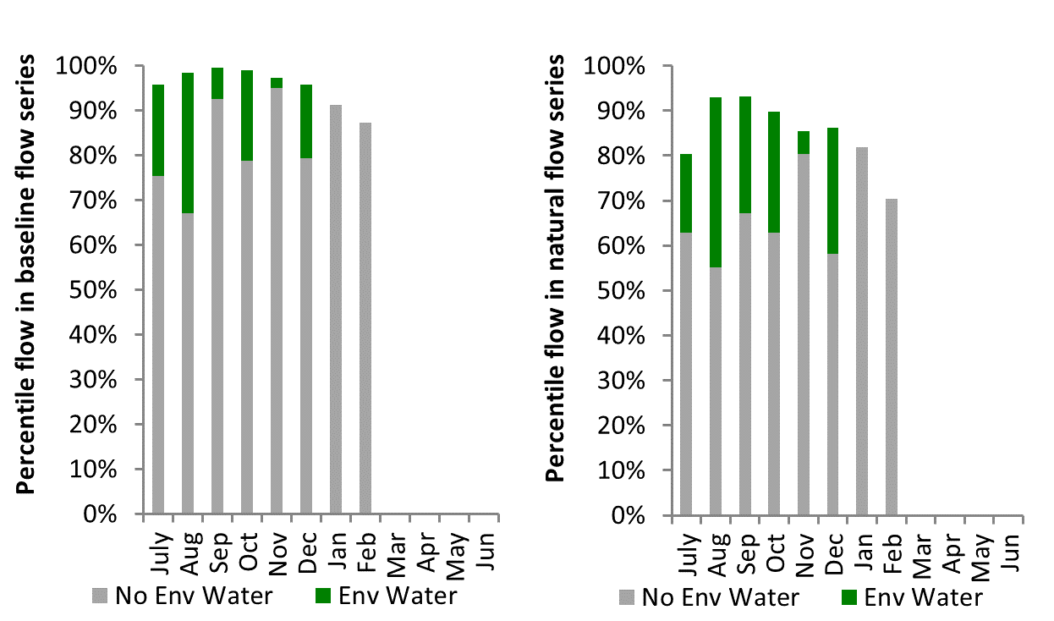
Figure GWY30: Contribution of environmental water delivery at Millewa as percentiles in the natural and baseline flow series.
Moree
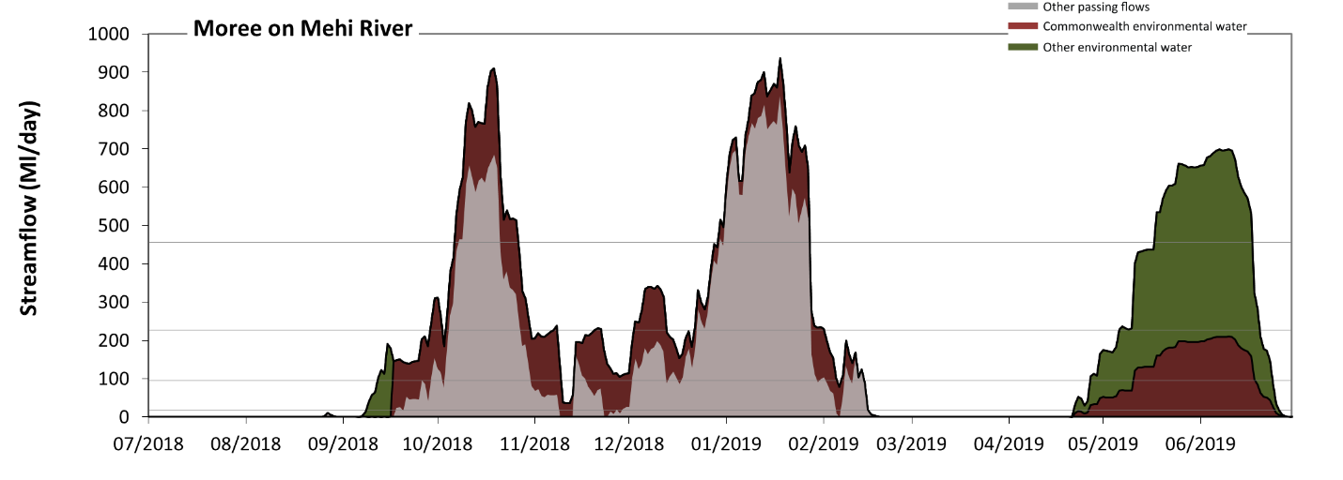 Figure GWY31: Contribution of environmental water delivery at Moree. Horizontal lines indicate thresholds for very low flows, low flows, low freshes and medium freshes (from lowest to highest).
At Moree on Mehi River, environmental water contributed 52% of the total streamflow volume (with approximately half contributed by Commonwealth environmental water). Environmental watering actions affected streamflows for 63% of days between 1 July 2018 and 30 June 2019. Without environmental water, the durations of very low flows (i.e. < 19 Ml/day) in the periods July to September, October to December, January to March and April to June would have all substantially exceeded durations expected in an average year in the natural flow regime. Environmental water mitigated these impacts by reducing the cumulative duration of very low flow spells from 62% to 39% of the year, with greatest influence in the period April to June. Similarly, without environmental water, the durations of medium low flows (i.e. < 95 Ml/day) in the periods July to September, October to December, January to March and April to June would have all substantially exceeded durations expected in an average year in the natural flow regime. Environmental water mitigated these impacts by reducing the cumulative duration of medium low flow spells from 73% to 43% of the year, with greatest influence in the period April to June. Commonwealth environmental water equally shared responsibility with other environmental water holders for these enhancements of environmental baseflows at this site. In the absence of environmental water there would have been at least one low fresh (i.e. > 230 Ml/day) in the periods October to December and January to March. Environmental water increased the duration of the longest low fresh during the periods July to September (from 0 days to 2 days) and April to June (from 0 days to 45 days). Commonwealth environmental water equally shared responsibility with other environmental water holders for these increased durations of low freshes. In the absence of environmental water there would have been at least one medium fresh (i.e. > 460 Ml/day) in the periods October to December and January to March. Environmental water increased the duration of the longest medium fresh during the periods October to December (from 13 days to 20 days) and April to June (from 0 days to 31 days). Commonwealth environmental water equally shared responsibility with other environmental water holders for these increased durations of medium freshes. There was no high freshes (i.e. > 1400 Ml/day) this year.
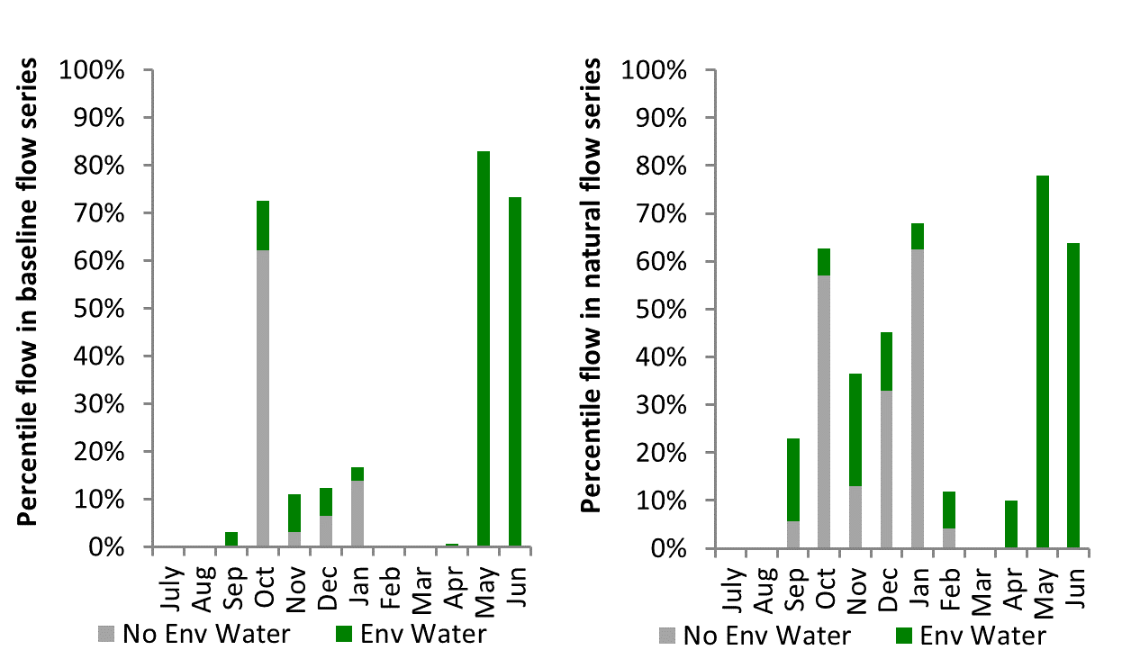
Figure GWY32: Contribution of environmental water delivery at Moree as percentiles in the natural and baseline flow series.

Combadello
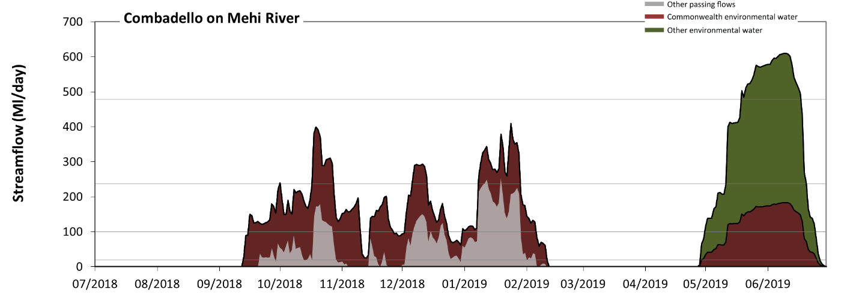 Figure GWY33: Contribution of environmental water delivery at Combadello. Horizontal lines indicate thresholds for very low flows, low flows, low freshes and medium freshes (from lowest to highest).
At Combadello on Mehi River, environmental water contributed 80% of the total streamflow volume (with approximately half contributed by Commonwealth environmental water). Environmental watering actions affected streamflows for 59% of days between 1 July 2018 and 30 June 2019. Without environmental water, the durations of very low flows (i.e. < 20 Ml/day) in the periods July to September, October to December, January to March and April to June would have all substantially exceeded durations expected in an average year in the natural flow regime. Environmental water mitigated these impacts by reducing the cumulative duration of very low flow spells from 72% to 42% of the year, with greatest influence in the periods October to December and April to June. Similarly, without environmental water, the durations of medium low flows (i.e. < 99 Ml/day) in the periods July to September, October to December, January to March and April to June would have all substantially exceeded durations expected in an average year in the natural flow regime. Environmental water mitigated these impacts by reducing the cumulative duration of medium low flow spells from 89% to 50% of the year, with greatest influence in the periods October to December and April to June. Commonwealth environmental water made the dominant contribution to these enhancements of environmental baseflows at this site. In the absence of environmental water there would have been at least one low fresh (i.e. > 240 Ml/day) in the period January to March. Environmental water increased the duration of the longest low fresh during the periods October to December (from 0 days to 10 days), January to March (from 2 days to 21 days) and April to June (from 0 days to 40 days). Commonwealth environmental water made the dominant contribution to these increased durations of low freshes. In the absence of environmental water there would have been no medium or high freshes this year. Environmental water increased the duration of the longest medium fresh during the period April to June (from 0 days to 30 days). Commonwealth environmental water equally shared responsibility with other environmental water holders for these increased durations of medium freshes.
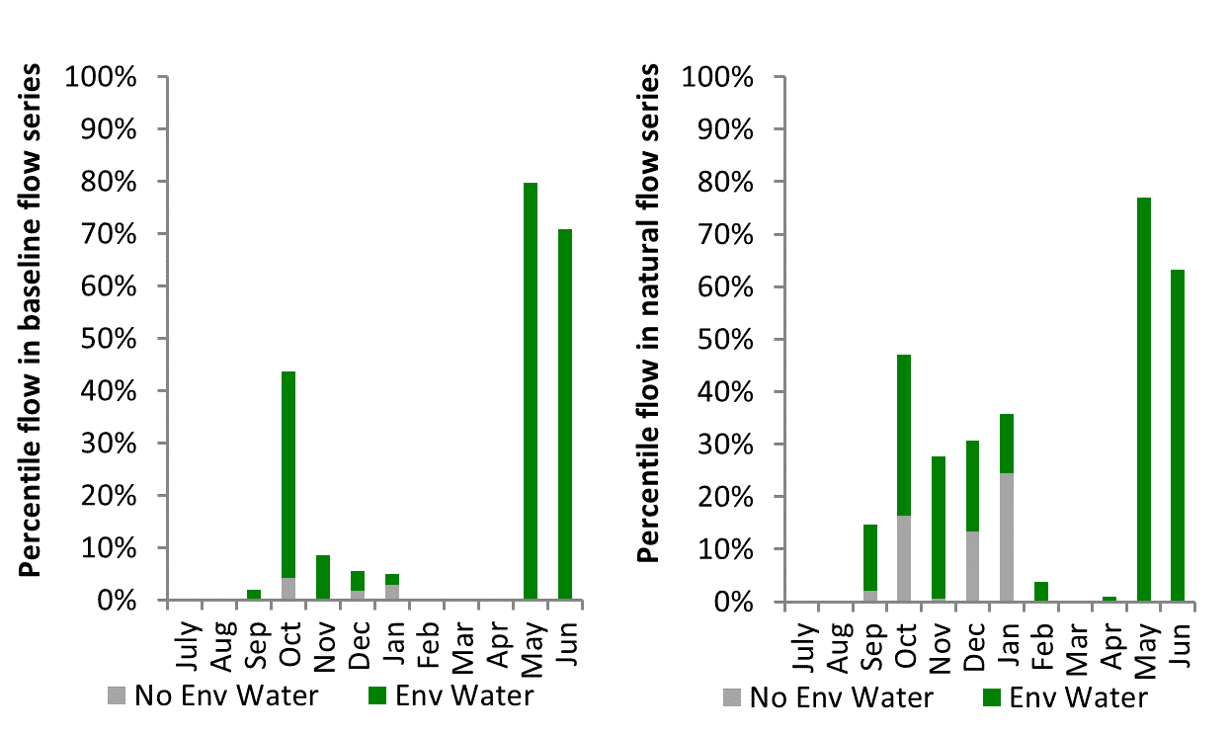
Figure GWY34: Contribution of environmental water delivery at Combadello as percentiles in the natural and baseline flow series.

Gundare
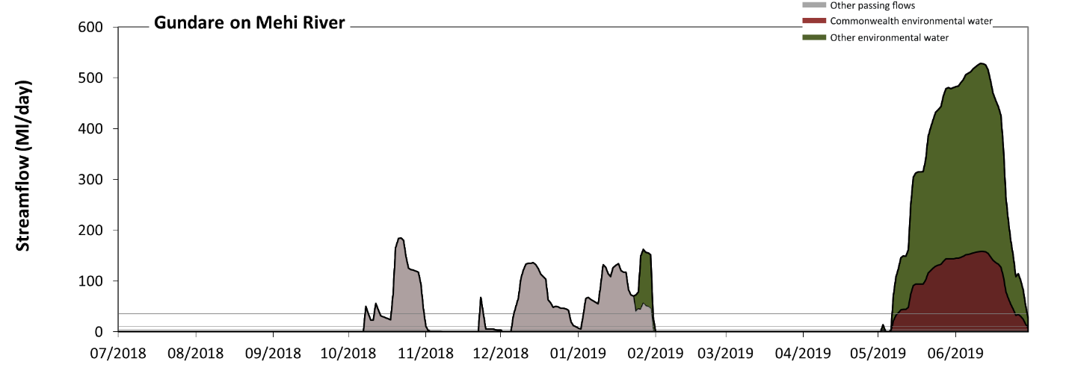 Figure GWY35: Contribution of environmental water delivery at Gundare. Horizontal lines indicate thresholds for very low flows, low flows, low freshes, medium freshes and high freshes (from lowest to highest).
At Gundare on Mehi River environmental water contributed 75% of the total streamflow volume (with a medium contribution of Commonwealth environmental water). Environmental watering actions affected streamflows for 18% of days between 1 July 2018 and 30 June 2019. Without environmental water, the durations of very low flows (i.e. < 0.43 Ml/day) in the periods July to September, January to March and April to June would have substantially exceeded durations expected in an average year in the natural flow regime. Environmental water mitigated these impacts by reducing the cumulative duration of very low flow spells from 73% to 57% of the year, with greatest influence in the period April to June. Similarly, without environmental water, the durations of medium low flows (i.e. < 2.1 Ml/day) in the periods July to September, January to March and April to June would have substantially exceeded durations expected in an average year in the natural flow regime. Environmental water mitigated these impacts by reducing the cumulative duration of medium low flow spells from 75% to 59% of the year, with greatest influence in the period April to June. Commonwealth environmental water equally shared responsibility with other environmental water holders for these enhancements of environmental baseflows at this site. In the absence of environmental water there would have been at least one low fresh (i.e. > 5.5 Ml/day) in the periods October to December and January to March. Environmental water increased the duration of the longest low fresh during the period April to June (from 0 days to 55 days). Commonwealth environmental water equally shared responsibility with other environmental water holders for these increased durations of low freshes. In the absence of environmental water there would have been at least one medium fresh (i.e. > 11 Ml/day) in the periods October to December and January to March. Environmental water increased the duration of the longest medium fresh during the period April to June (from 0 days to 55 days). Commonwealth environmental water equally shared responsibility with other environmental water holders for these increased durations of medium freshes. In the absence of environmental water there would have been at least one high fresh in the periods October to December and January to March. Environmental water increased the duration of the longest high fresh during the period April to June (from 0 days to 54 days). Commonwealth environmental water equally shared responsibility with other environmental water holders for these increased durations of high freshes.
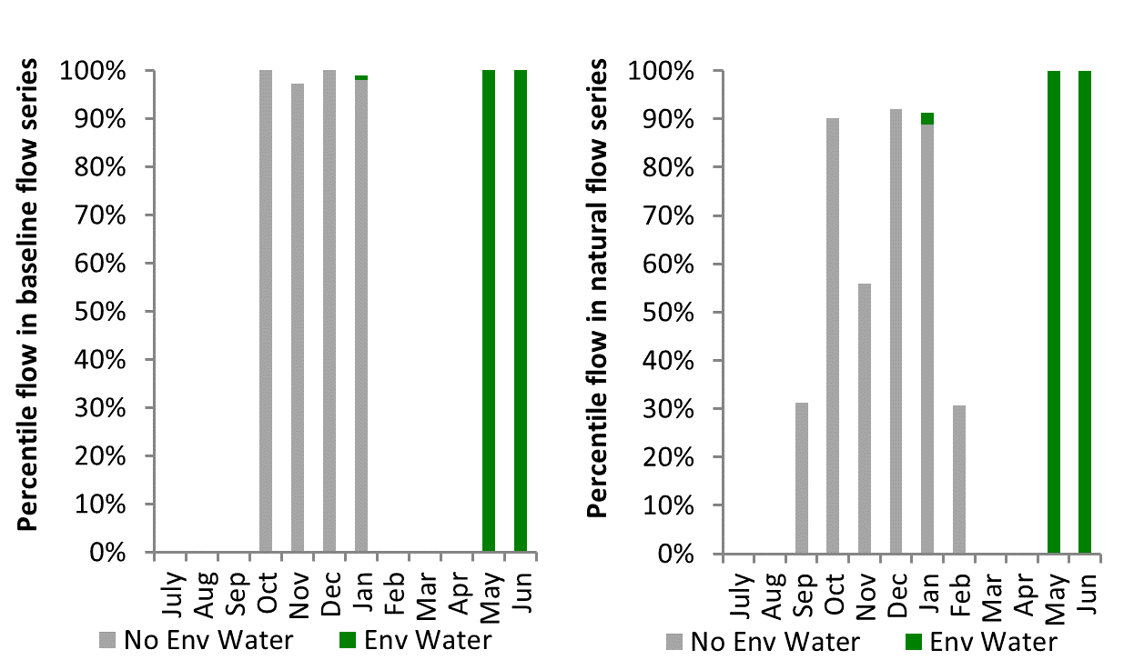
Figure GWY36: Contribution of environmental water delivery at Gundare as percentiles in the natural and baseline flow series.
Mallowa
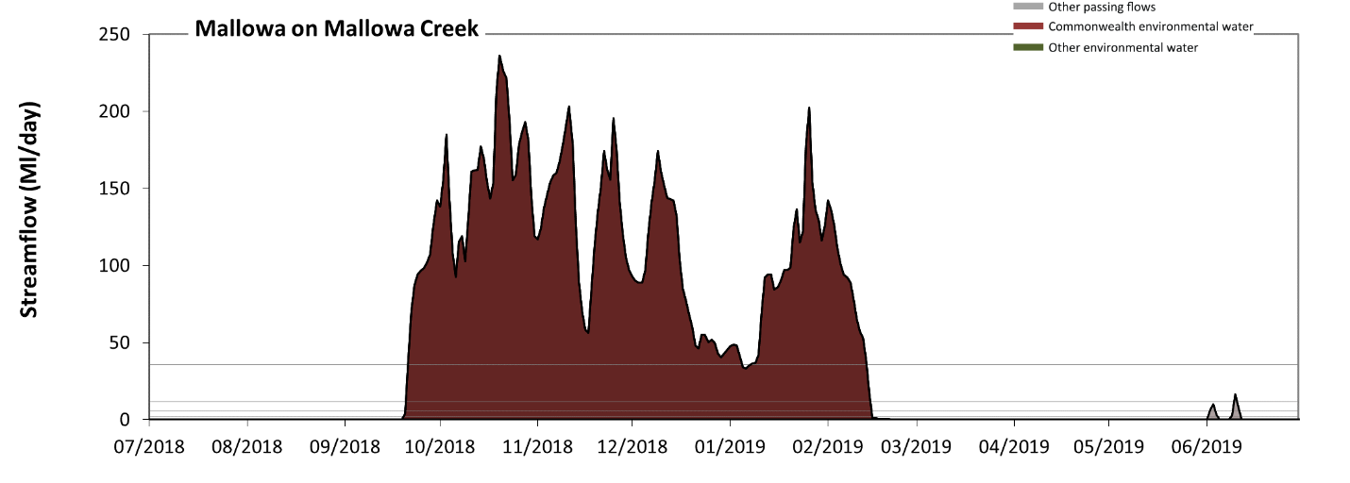 Figure GWY37: Contribution of environmental water delivery at Mallowa. Horizontal lines indicate thresholds for very low flows, low flows, low freshes, medium freshes and high freshes (from lowest to highest).
At Mallowa on Mallowa Creek, environmental water contributed 100% of the total streamflow volume (all of which was Commonwealth environmental water). Environmental watering actions affected streamflows for 41% of days between 1 July 2018 and 30 June 2019. Without environmental water, the durations of very low flows (i.e. < 0.43 Ml/day) in the periods July to September, October to December, January to March and April to June would have all substantially exceeded durations expected in an average year in the natural flow regime. Environmental water mitigated these impacts by reducing the cumulative duration of very low flow spells from 94% to 56% of the year, with greatest influence in the periods October to December and January to March. Similarly, without environmental water, the durations of medium low flows (i.e. < 2.1 Ml/day) in the periods July to September, October to December, January to March and April to June would have all substantially exceeded durations expected in an average year in the natural flow regime. Environmental water mitigated these impacts by reducing the cumulative duration of medium low flow spells from 98% to 58% of the year, with greatest influence in the periods October to December and January to March. Commonwealth environmental water was entirely responsible for these enhancements of environmental baseflows at this site. In the absence of environmental water there would have been at least one low fresh (i.e. > 5.5 Ml/day) in the period April to June. Environmental water increased the duration of the longest low fresh during the periods July to September (from 0 days to 10 days), October to December (from 0 days to 92 days) and January to March (from 0 days to 45 days). Commonwealth environmental water was entirely responsible for these increased durations of low freshes. In the absence of environmental water there would have been at least one medium fresh (i.e. > 11 Ml/day) in the period April to June. Environmental water increased the duration of the longest medium fresh during the periods July to September (from 0 days to 10 days), October to December (from 0 days to 92 days) and January to March (from 0 days to 45 days). Commonwealth environmental water was entirely responsible for these increased durations of medium freshes. Environmental water increased the duration of the longest high fresh during the periods July to September (from 0 days to 10 days), October to December (from 0 days to 92 days) and January to March (from 0 days to 37 days). Commonwealth environmental water was entirely responsible for these increased durations of high freshes.
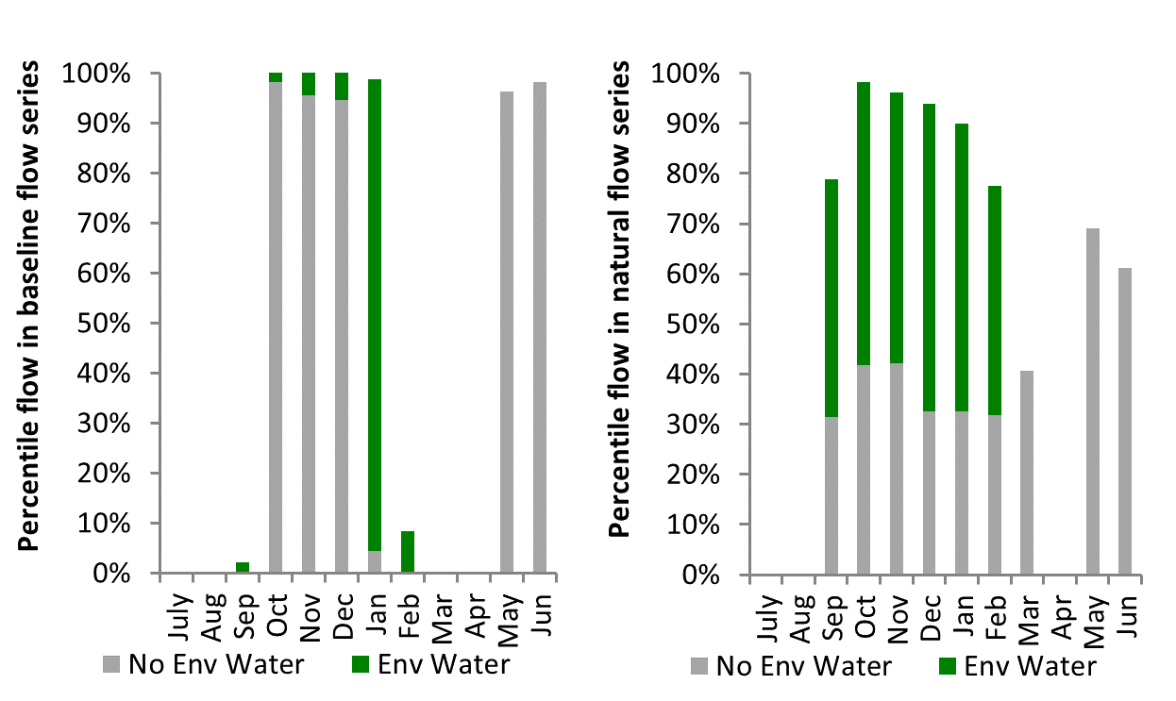
Figure GWY38: Contribution of environmental water delivery at Mallowa as percentiles in the natural and baseline flow series.

Midkin
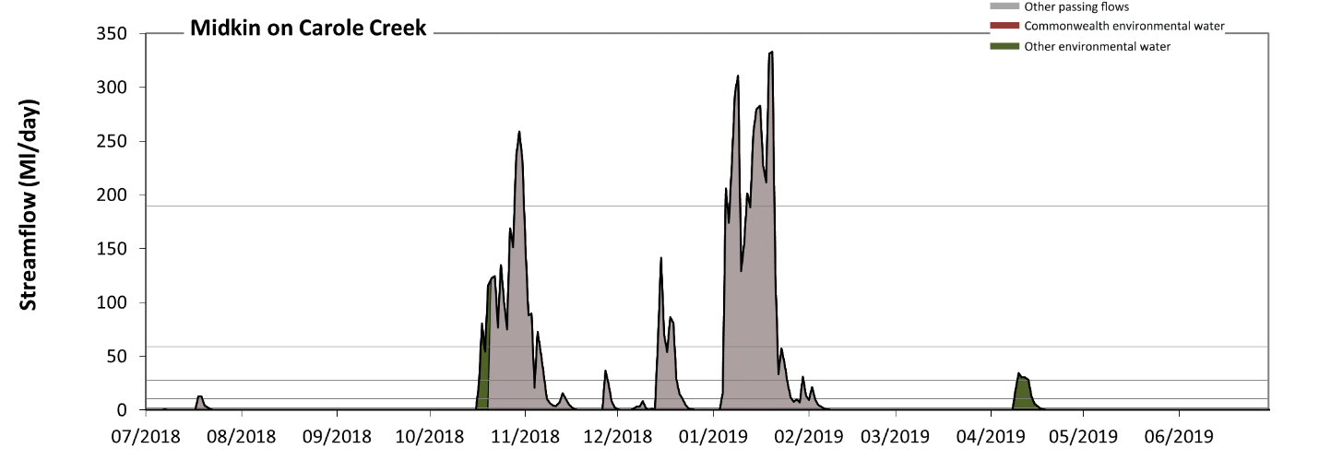 Figure GWY39: Contribution of environmental water delivery at Midkin. Horizontal lines indicate thresholds for very low flows, low flows, low freshes, medium freshes and high freshes (from lowest to highest).
At Midkin on Carole Creek, environmental water contributed 6% of the total streamflow volume (none of which was Commonwealth environmental water). Environmental watering actions affected streamflows for 4% of days between 1 July 2018 and 30 June 2019. Without environmental water, the durations of very low flows (i.e. < 2.1 Ml/day) in the periods July to September and April to June would have substantially exceeded durations expected in an average year in the natural flow regime. Environmental water mitigated these impacts by reducing the cumulative duration of very low flow spells from 78% to 75% of the year, with greatest influence in the periods October to December and April to June. Similarly, without environmental water, the durations of medium low flows (i.e. < 10 Ml/day) in the periods July to September and April to June would have substantially exceeded durations expected in an average year in the natural flow regime. Environmental water mitigated these impacts by reducing the cumulative duration of medium low flow spells from 84% to 81% of the year, with greatest influence in the periods October to December and April to June. Commonwealth environmental water made little or no contribution to these enhancements of environmental baseflows at this site. In the absence of environmental water there would have been at least one low fresh (i.e. > 28 Ml/day) in the periods October to December and January to March. Environmental water increased the duration of the longest low fresh during the period April to June (from 0 days to 4 days). Commonwealth environmental water made little or no contribution to these increased durations of low freshes. There was at least one medium fresh (i.e. > 59 Ml/day) in the periods October to December and January to March. Environmental water made little change to the duration of these medium freshes. In the absence of environmental water there would have been at least one high fresh in the periods October to December and January to March. Environmental water made no change to the duration of these high freshes.
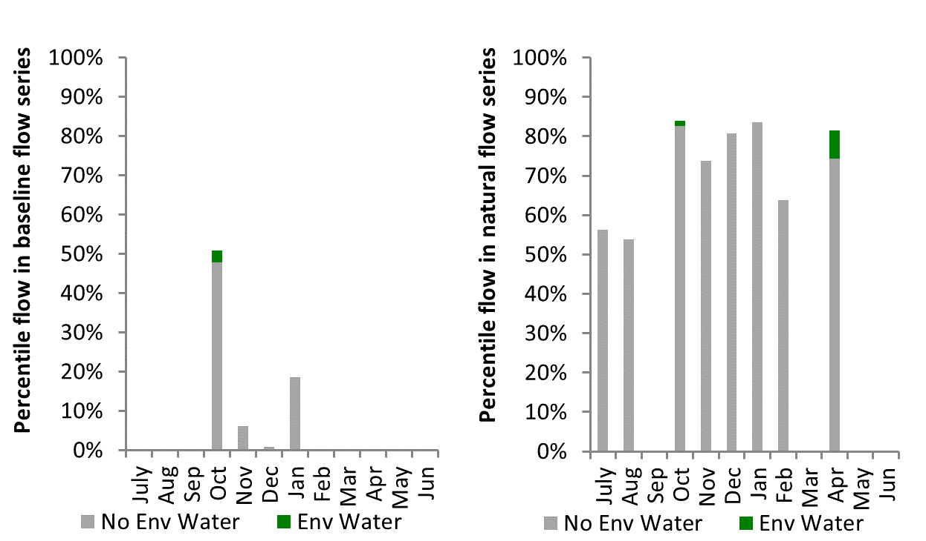
Figure GWY40: Contribution of environmental water delivery at Midkin as percentiles in the natural and baseline flow series.

Namoi
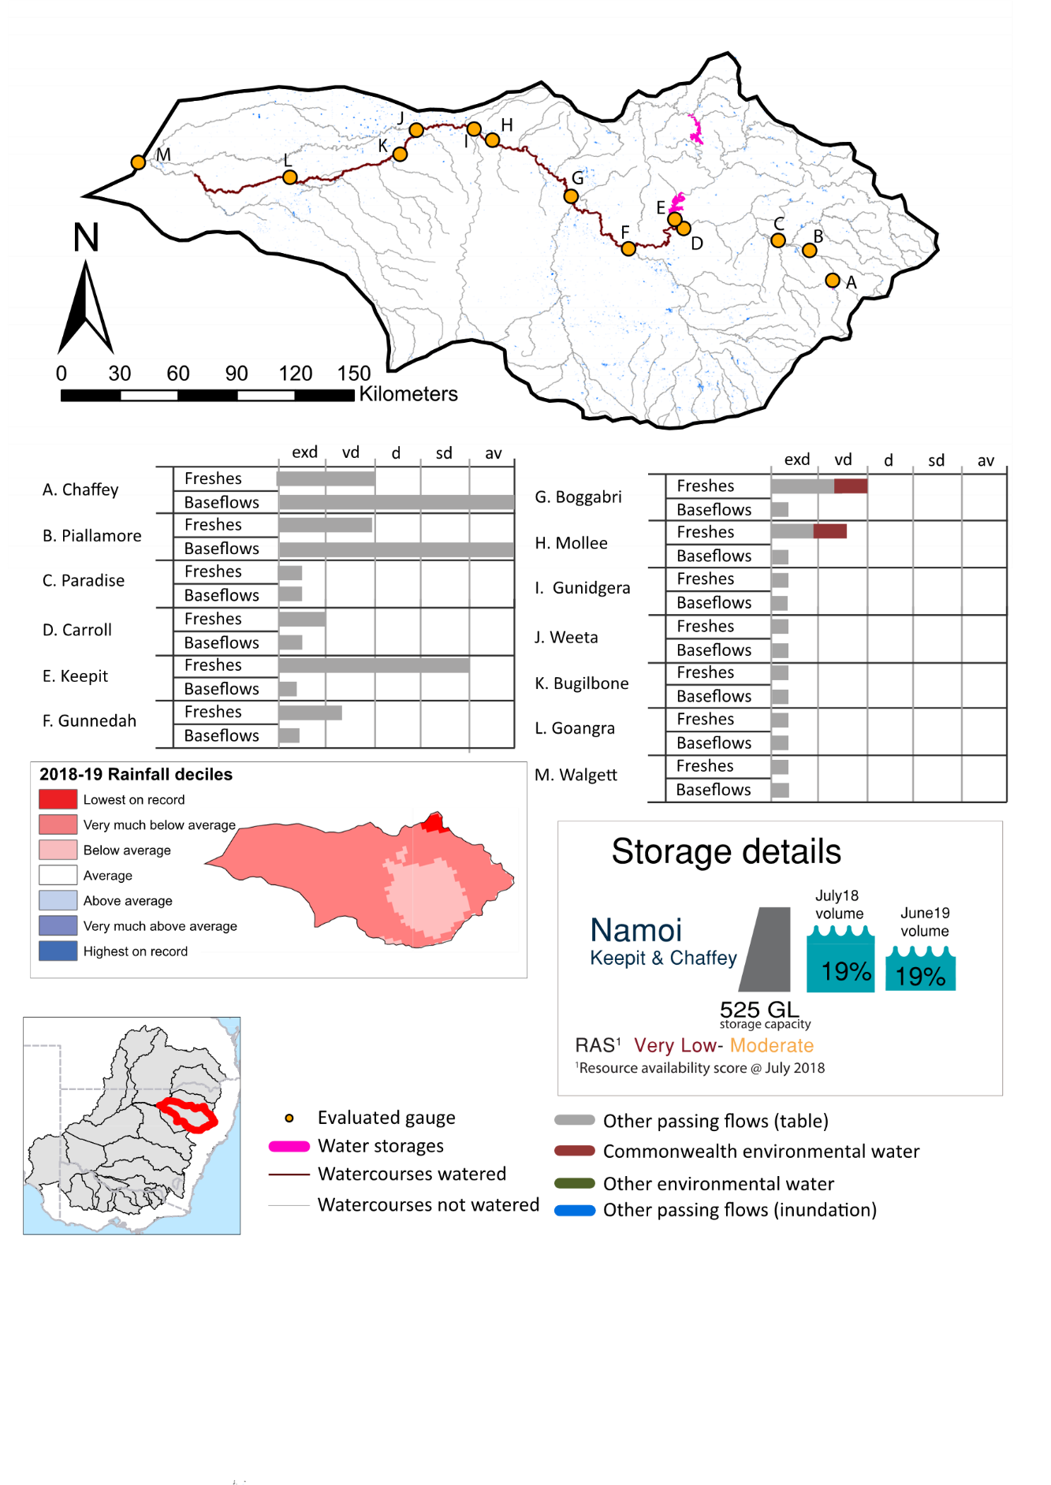
Figure NAM1: Watercourses influenced, areas inundated (where applicable) and gauge stations evaluated in the Namoi valley during the 2018-19 water year. Inset bar graphs report the condition of annual flow regimes by showing the improvements in hydrological condition with the addition of environmental water as well as the hypothetical scenario in “grey” (if no environmental flow had been delivered) where exd=extremely dry, vd=very dry, d=dry, sd=somewhat dry and av=average. Rainfall conditions (rainfall deciles) and trend in storage levels for the water year are also shown.

Summary
The volume of environmental water delivery for the 2018-19 year in the Namoi valley is quantified using data for 15 sites. This evaluation only considers the contribution of held environmental water, which is a primary focus for the Commonwealth. The contributions of planned environmental water (e.g. passing flows), unregulated tributary inflows and clever use of irrigation flows for environmental benefits can all be very important but these are outside the scope of this report. Environmental watering actions lasted on average 24 days over the course of the year. The volume of environmental water at these 15 sites was between 0% and 51% of the total streamflow. Commonwealth environmental water contributed on average 67% of this environmental water. The contribution of environmental water delivery to improved flow regimes is evaluated using data for 15 sites. Ideally, baseflows should be maintained and long periods of excessively low flows avoided. In this valley, the baseflow regime was generally considered to be extremely dry relative to the pre-development flow regime. In our analysis, a low fresh refers to a period of increased flow, when the water level rises at least one eighth of the way up the river bank (above the low flow level). These low freshes are a regular part of the natural flow regime and support a range of natural processes. In the Namoi valley, in terms of the occurrence and duration of low freshes, the year was assessed as being very dry. In our analysis, a medium fresh refers to a period of increased flow, when the water level rises at least one quarter of the way up the river bank. These medium freshes are not as frequent as low freshes but are also a regular and important part of the natural flow regime. In the Namoi valley, in terms of the occurrence of medium freshes, the year was assessed as being very dry. In our analysis, a high fresh refers to a period of increased flow, when the water level rises more than half way up the river. A high fresh may not occur every year but they are still important and long periods without major freshes can have serious consequences for floodplains and their contribution to river connectivity. Delivering high in channel environmental flows normally requires that all risks to riparian landholders and infrastructure have been resolved. In the Namoi valley, in terms of the occurrence of high freshes, the year was assessed as being extremely dry.

Water delivery context
Information in this valley pools information from both the Namoi and Peel catchments under the valley name Namoi.
During the 2018-19, the Commonwealth Environmental Water Holder (CEWH) held water entitlements of up to 14,910 ML for environmental use in the Namoi valley. Each year, water utilities allocate water entitlement holders a percentage of water based on their holding, license type and carryover (the exact rules vary among Jurisdictions). In 2018-19, the Namoi entitlements held by the CEWH were allocated 583 ML of water, representing 6% of the Long-term average annual yield for the Namoi valley (10,543 ML). Information and data relating to the portfolio of held Commonwealth environmental water is shown in Table NAM2.
The 2018-19 water allocation (583 ML) together with the carryover volume of 5,947 ML of water meant the CEWH had 6,530 ML of water available for delivery. A total of 5,500 ML of Commonwealth environmental water was delivered in the Namoi valley. A total of 0 ML of Commonwealth environmental water was traded to consumptive users and 552 ML (8%) of available Commonwealth environmental water was carried over for environmental use into the 2019-20 water year.

Environmental conditions and resource availability
The water available for environmental delivery combined with the present and antecedent environmental conditions are key inputs used by environmental water managers in planning and implementing watering actions. Post hoc, this information provides important context when evaluating the effectiveness and appropriateness of environmental water use with respect to hydrological outputs.
The rainfall conditions in the Namoi valley were classified as Very much below average, based on rainfall percentile data for the entire record held by the Bureau of Meteorology for this valley. The water held in major storages in the Namoi valley decreased over the water year, for example Keepit and Chaffey dam was 18.6% full at the beginning of the water year and 5.2% full by the end of the year (Figure NAM1).
The Commonwealth Environmental Water Office (CEWO) calculates resource availability scenarios (RAS) to guide the use and prioritisation of held environmental water. The RAS are progressively calculated over the year as part of the continual adaptive management planning processes. The RAS are based on the availability of held environmental water (including progressive license acquisitions and allocations) as well as the potential for unregulated or planned environmental flows. The outcome is then used to determine the demand for environmental water across the basin.
In 2018-19, the resource availability of held Commonwealth environmental water was classified as very low to moderate. The physical conditions meant that the CEWO was managing to maintain ecological health and resilience in the Lower Namoi River channel, wetlands and anabranches, and the Peel River. The overall demand for environmental water was deemed high.

Watering actions
One watering actions was delivered over the 2018-19 water year for a total of 36 days and was undertaken in the Lower Namoi. No watering actions were delivered in the Peel or Upper Namoi. The number of water actions commencing in each season included, Autumn (0), Spring (1), Summer (0), and Winter (0). Similarly, the count of flow component types delivered in the Namoi valley were; (0) baseflow, (0) baseflow-fresh, (1) fresh, (0) fresh-overbank, (0) bankfull, (0) overbank, (0) wetland and (0) wetland-fresh.
In this valley, primary objectives of most watering actions was related to water quality, resilience, connectivity and fish purposes, but water was also delivered for other purposes too. The percentage of watering actions delivered across the nine main themes included primary objectives for fish (25%), vegetation (0.0%), waterbirds (0.0%), frogs (0.0%), other biota (0.0%), connectivity (25%), process (0.0%), resilience (25%) and water quality (25%). It needs to be recognising that these percentages are nominal as many actions were delivered for multiple themes.
Table NAM2. Commonwealth environmental water accounting information for the Namoi valley over 2018-19 water year.
Total registered volume (ML) | Allocated volume (ML) | Carry over + allocated volume (ML) | Delivered (ML) | LTAAY (ML) | Trade (ML) | Carried over to 2019-20 | Forfeited (ML)
14,910 | 583 | 6,530 | 5,500 | 10,543 | 0 | 552 | 478

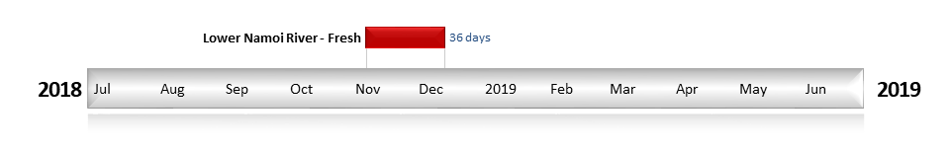
Figure NAM2. Timing and duration of Commonwealth environmental water actions delivered in the Namoi valley.

Contribution of Commonwealth environmental water to flow regimes
Keepit
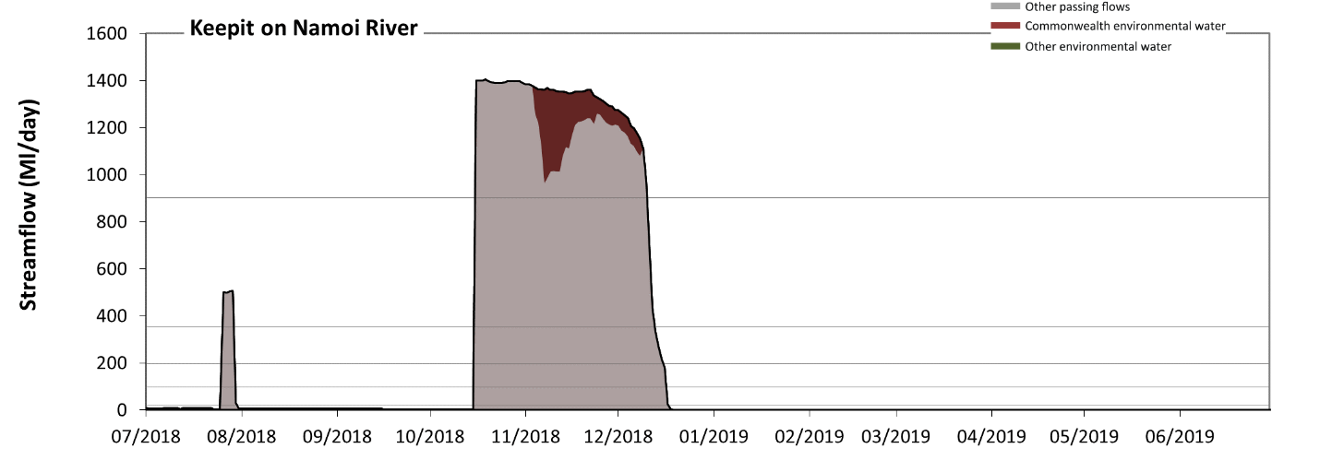
Figure NAM3: Contribution of environmental water delivery at Keepit. Horizontal lines indicate thresholds for very low flows, low flows, low freshes, medium freshes and high freshes (from lowest to highest).
At Keepit on Namoi River, environmental water contributed 7% of the total streamflow volume (all of which was Commonwealth environmental water). Environmental watering actions affected streamflows for 10% of days between 1 July 2018 and 30 June 2019. Without environmental water, the durations of very low flows (i.e. < 20 Ml/day) in the periods July to September, October to December, January to March and April to June would have all substantially exceeded durations expected in an average year in the natural flow regime. However, environmental water had little effect on the duration of these very low flows, which occurred for 81% of the year. Similarly, without environmental water, the durations of medium low flows (i.e. < 99 Ml/day) in the periods July to September, October to December, January to March and April to June would have all substantially exceeded durations expected in an average year in the natural flow regime. However, environmental water had little effect on the duration of these medium low flows, which occurred for 82% of the year. There was at least one low fresh (i.e. > 200 Ml/day) in the periods July to September and October to December. Environmental water made no change to the duration of these low freshes. There was at least one medium fresh (i.e. > 350 Ml/day) in the periods July to September and October to December. Environmental water made no change to the duration of these medium freshes. In the absence of environmental water there would have been at least one high fresh in the period October to December. Environmental water made no change to the duration of these high freshes.
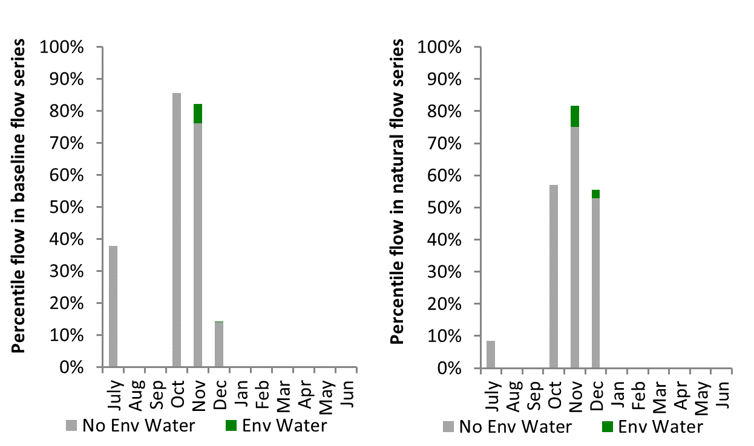
Figure NAM4: Contribution of environmental water delivery at Keepit as percentiles in the natural and baseline flow series.
Gunnedah
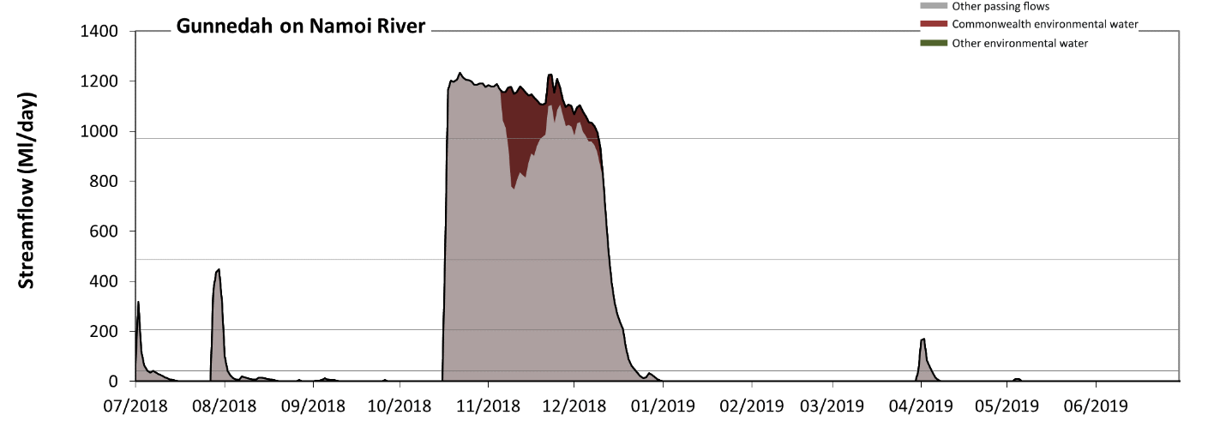
Figure NAM5: Contribution of environmental water delivery at Gunnedah. Horizontal lines indicate thresholds for very low flows, low flows, low freshes and medium freshes (from lowest to highest).
At Gunnedah on Namoi River, environmental water contributed 8% of the total streamflow volume (all of which was Commonwealth environmental water). Environmental watering actions affected streamflows for 10% of days between 1 July 2018 and 30 June 2019. Without environmental water, the durations of very low flows (i.e. < 41 Ml/day) in the periods July to September, October to December, January to March and April to June would have all substantially exceeded durations expected in an average year in the natural flow regime. However, environmental water had little effect on the duration of these very low flows, which occurred for 77% of the year. Similarly, without environmental water, the durations of medium low flows (i.e. < 210 Ml/day) in the periods July to September, October to December, January to March and April to June would have all substantially exceeded durations expected in an average year in the natural flow regime. However, environmental water had little effect on the duration of these medium low flows, which occurred for 81% of the year. There was at least one low fresh (i.e. > 490 Ml/day) in the period October to December. Environmental water made little change to the duration of these low freshes. In the absence of environmental water there would have been at least one medium fresh (i.e. > 970 Ml/day) in the period October to December. Environmental water increased the duration of the longest medium fresh during the period October to December (from 21 days to 53 days). Commonwealth environmental water was entirely responsible for these increased durations of medium freshes. There was no high freshes (i.e. > 2900 Ml/day) this year.
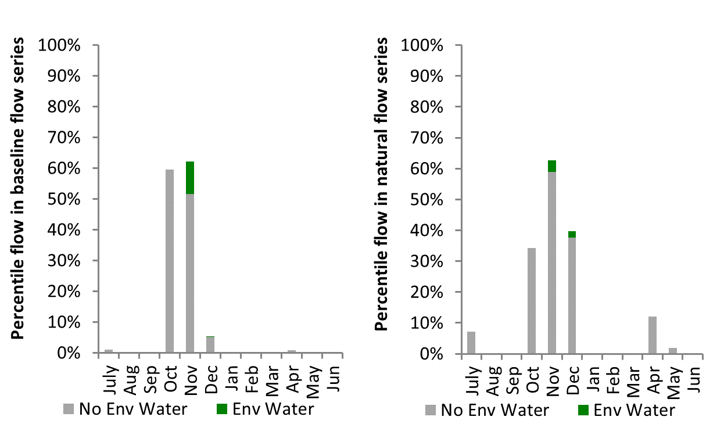
Figure NAM6: Contribution of environmental water delivery at Gunnedah as percentiles in the natural and baseline flow series.

Boggabri
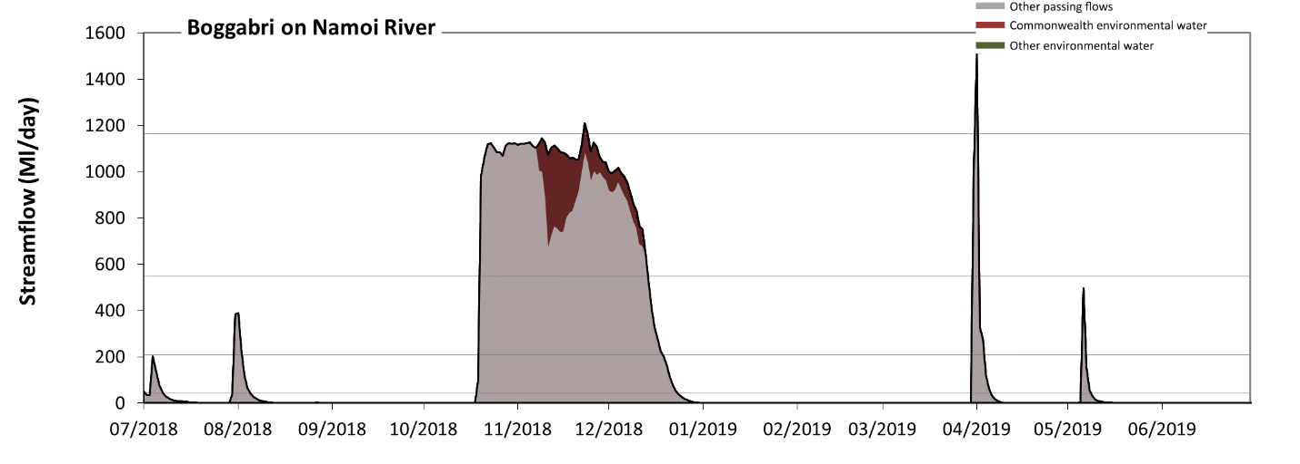
Figure NAM7: Contribution of environmental water delivery at Boggabri. Horizontal lines indicate thresholds for very low flows, low flows, low freshes and medium freshes (from lowest to highest).
At Boggabri on Namoi River, environmental water contributed 8% of the total streamflow volume (all of which was Commonwealth environmental water). Environmental watering actions affected streamflows for 10% of days between 1 July 2018 and 30 June 2019. Without environmental water, the durations of very low flows (i.e. < 42 Ml/day) in the periods July to September, October to December, January to March and April to June would have all substantially exceeded durations expected in an average year in the natural flow regime. However, environmental water had little effect on the duration of these very low flows, which occurred for 76% of the year. Similarly, without environmental water, the durations of medium low flows (i.e. < 210 Ml/day) in the periods July to September, October to December, January to March and April to June would have all substantially exceeded durations expected in an average year in the natural flow regime. However, environmental water had little effect on the duration of these medium low flows, which occurred for 81% of the year. There was at least one low fresh (i.e. > 550 Ml/day) in the periods October to December, January to March and April to June. Environmental water made little change to the duration of these low freshes. In the absence of environmental water there would have been at least one medium fresh (i.e. > 1200 Ml/day) in the period April to June. Environmental water increased the duration of the longest medium fresh during the period October to December (from 0 days to 1 days). Commonwealth environmental water was entirely responsible for these increased durations of medium freshes. There was no high freshes (i.e. > 3700 Ml/day) this year.
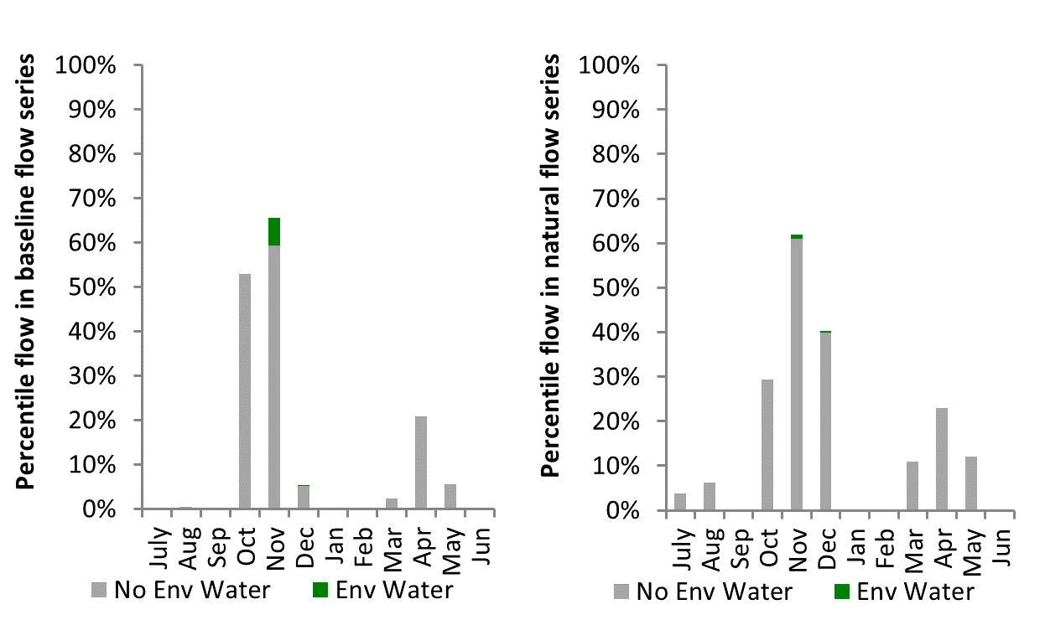
Figure NAM8: Contribution of environmental water delivery at Boggabri as percentiles in the natural and baseline flow series.
Narrabri
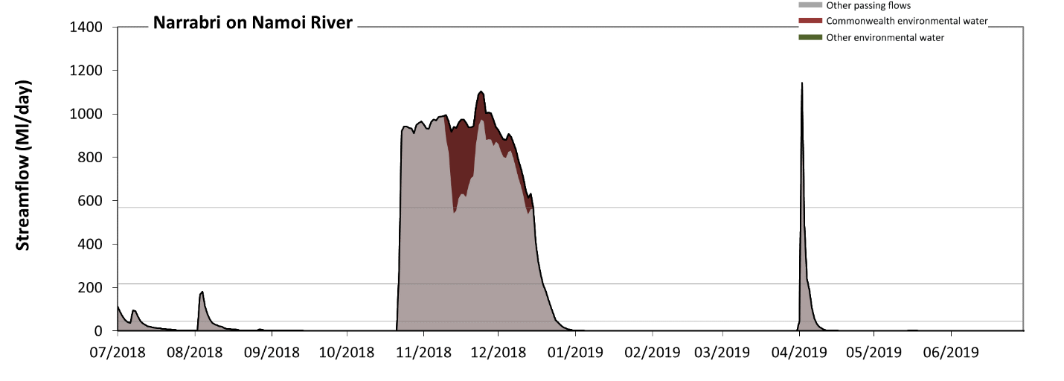
Figure NAM9: Contribution of environmental water delivery at Narrabri. Horizontal lines indicate thresholds for very low flows, low flows and low freshes (from lowest to highest).
At Narrabri on Namoi River, environmental water contributed 10% of the total streamflow volume (all of which was Commonwealth environmental water). Environmental watering actions affected streamflows for 10% of days between 1 July 2018 and 30 June 2019. Without environmental water, the durations of very low flows (i.e. < 44 Ml/day) in the periods July to September, October to December, January to March and April to June would have all substantially exceeded durations expected in an average year in the natural flow regime. However, environmental water had little effect on the duration of these very low flows, which occurred for 77% of the year. Similarly, without environmental water, the durations of medium low flows (i.e. < 220 Ml/day) in the periods July to September, October to December, January to March and April to June would have all substantially exceeded durations expected in an average year in the natural flow regime. However, environmental water had little effect on the duration of these medium low flows, which occurred for 83% of the year. In the absence of environmental water there would have been at least one low fresh (i.e. > 570 Ml/day) in the periods October to December and April to June. Environmental water increased the duration of the longest low fresh during the period October to December (from 28 days to 53 days). Commonwealth environmental water was entirely responsible for these increased durations of low freshes. There was no medium or high freshes this year.
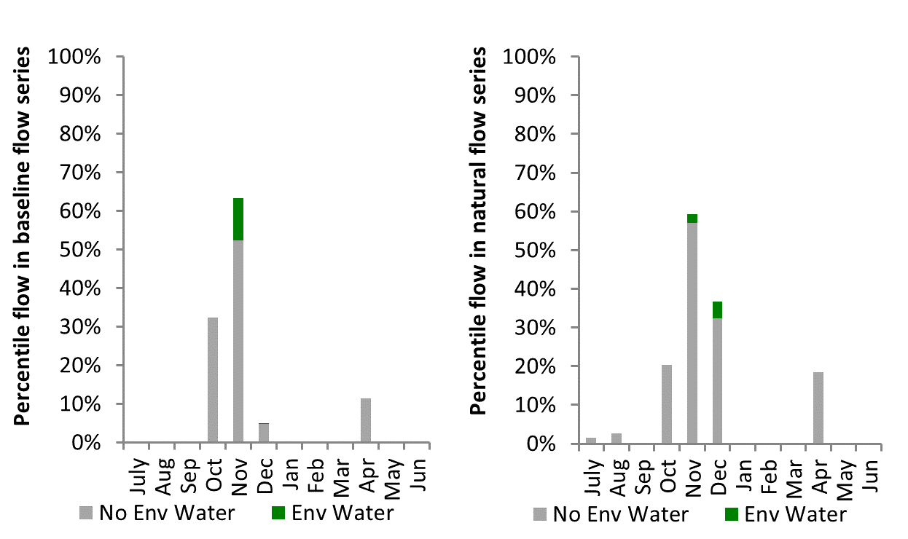
Figure NAM10: Contribution of environmental water delivery at Narrabri as percentiles in the natural and baseline flow series.

Mollee
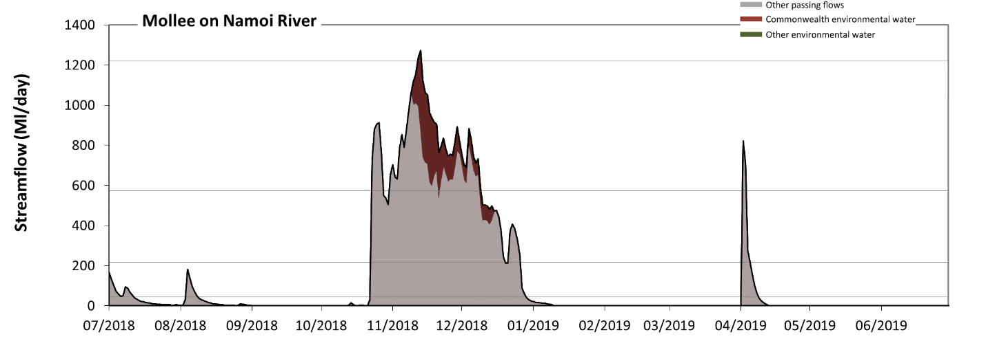
Figure NAM11: Contribution of environmental water delivery at Mollee. Horizontal lines indicate thresholds for very low flows, low flows, low freshes and medium freshes (from lowest to highest).
At Mollee on Namoi River, environmental water contributed 11% of the total streamflow volume (all of which was Commonwealth environmental water). Environmental watering actions affected streamflows for 10% of days between 1 July 2018 and 30 June 2019. Without environmental water, the durations of very low flows (i.e. < 44 Ml/day) in the periods July to September, October to December, January to March and April to June would have all substantially exceeded durations expected in an average year in the natural flow regime. However, environmental water had little effect on the duration of these very low flows, which occurred for 75% of the year. Similarly, without environmental water, the durations of medium low flows (i.e. < 220 Ml/day) in the periods July to September, October to December, January to March and April to June would have all substantially exceeded durations expected in an average year in the natural flow regime. However, environmental water had little effect on the duration of these medium low flows, which occurred for 82% of the year. In the absence of environmental water there would have been at least one low fresh (i.e. > 570 Ml/day) in the periods October to December and April to June. Environmental water increased the duration of the longest low fresh during the period October to December (from 21 days to 40 days). Commonwealth environmental water was entirely responsible for these increased durations of low freshes. In the absence of environmental water there would have been no medium or high freshes this year. Environmental water increased the duration of the longest medium fresh during the period October to December (from 0 days to 2 days). Commonwealth environmental water was entirely responsible for these increased durations of medium freshes.
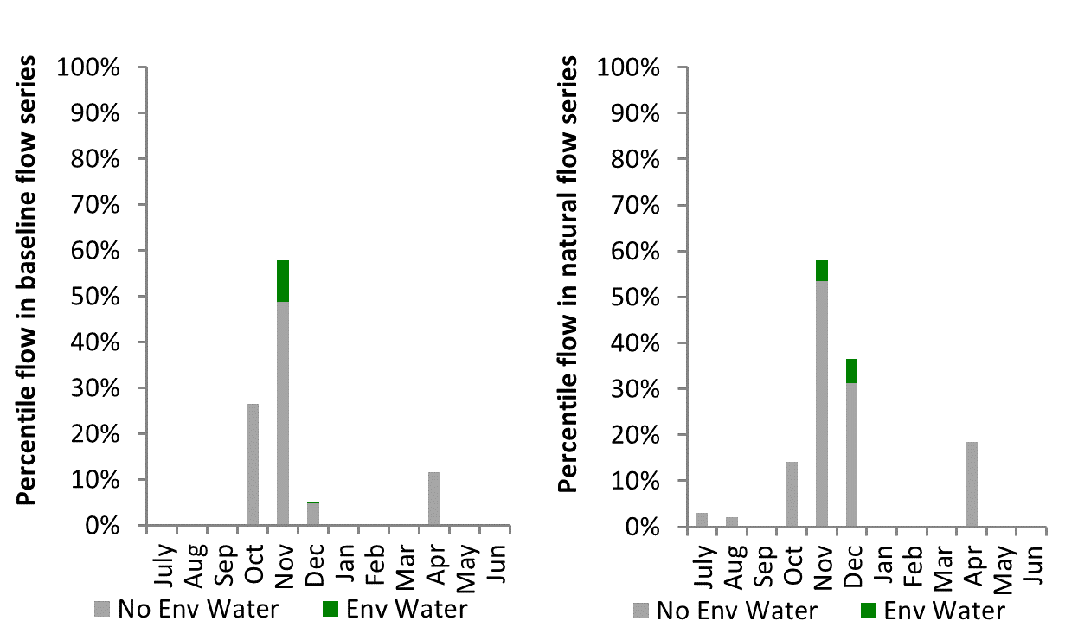
Figure NAM12: Contribution of environmental water delivery at Mollee as percentiles in the natural and baseline flow series.

Gunidgera
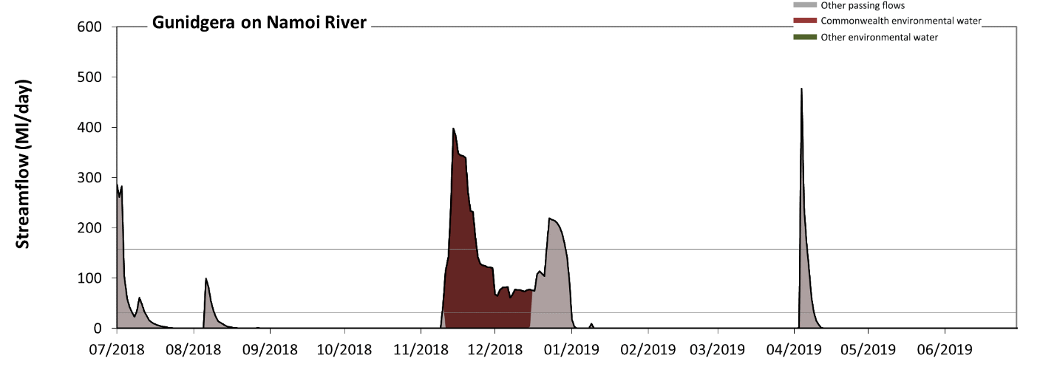Figure NAM13: Contribution of environmental water delivery at Gunidgera. Horizontal lines indicate thresholds for very low flows and low flows (from lowest to highest).
At Gunidgera on Namoi River, environmental water contributed 51% of the total streamflow volume (all of which was Commonwealth environmental water). Environmental watering actions affected streamflows for 10% of days between 1 July 2018 and 30 June 2019. Without environmental water, the durations of very low flows (i.e. < 32 Ml/day) in the periods July to September, October to December, January to March and April to June would have all substantially exceeded durations expected in an average year in the natural flow regime. Environmental water mitigated these impacts by reducing the cumulative duration of very low flow spells from 90% to 80% of the year, with greatest influence in the period October to December. Similarly, without environmental water, the durations of medium low flows (i.e. < 160 Ml/day) in the periods July to September, October to December, January to March and April to June would have all substantially exceeded durations expected in an average year in the natural flow regime. Environmental water mitigated these impacts by reducing the cumulative duration of medium low flow spells from 96% to 93% of the year, with greatest influence in the period October to December. Commonwealth environmental water was entirely responsible for these enhancements of environmental baseflows at this site.
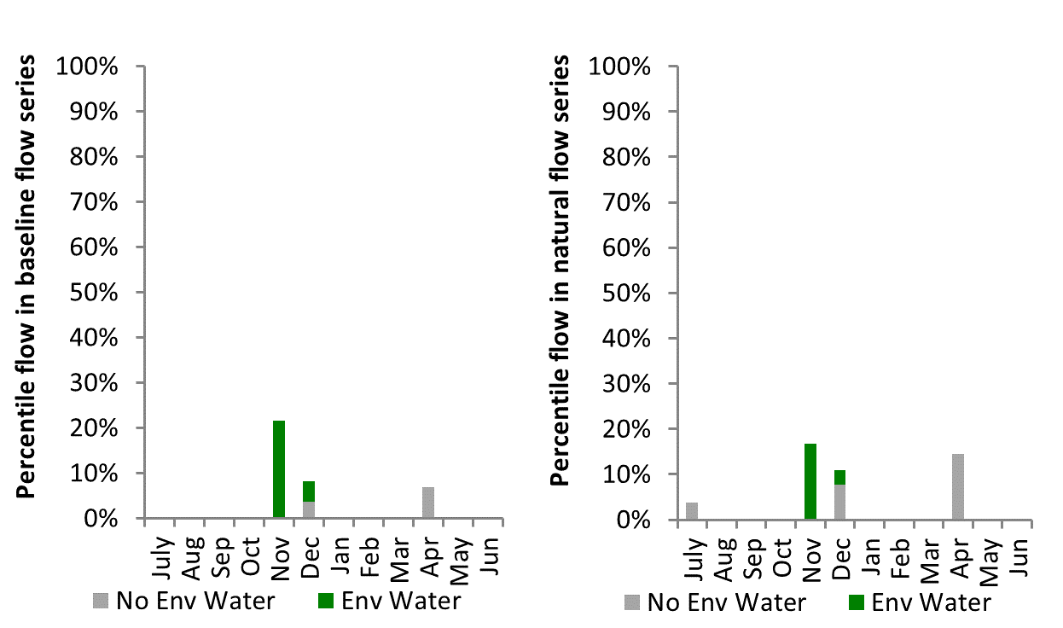
Figure NAM14: Contribution of environmental water delivery at Gunidgera as percentiles in the natural and baseline flow series.

Weeta
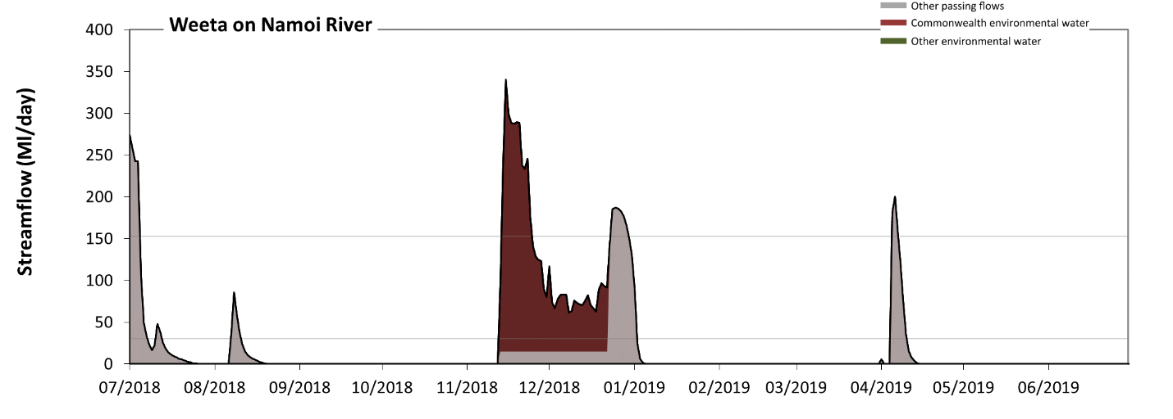 Figure NAM15: Contribution of environmental water delivery at Weeta. Horizontal lines indicate thresholds for very low flows and low flows (from lowest to highest).
At Weeta on the Namoi River, environmental water contributed 50% of the total streamflow volume (all of which was Commonwealth environmental water). Environmental watering actions affected streamflows for 11% of days between 1 July 2018 and 30 June 2019. Without environmental water, the durations of very low flows (i.e. < 31 Ml/day) in the periods July to September, October to December, January to March and April to June would have all substantially exceeded durations expected in an average year in the natural flow regime. Environmental water mitigated these impacts by reducing the cumulative duration of very low flow spells from 92% to 81% of the year, with greatest influence in the period October to December. Similarly, without environmental water, the durations of medium low flows (i.e. < 150 Ml/day) in the periods July to September, October to December, January to March and April to June would have all substantially exceeded durations expected in an average year in the natural flow regime. Environmental water mitigated these impacts by reducing the cumulative duration of medium low flow spells from 96% to 93% of the year, with greatest influence in the period October to December. Commonwealth environmental water was entirely responsible for these enhancements of environmental baseflows at this site.
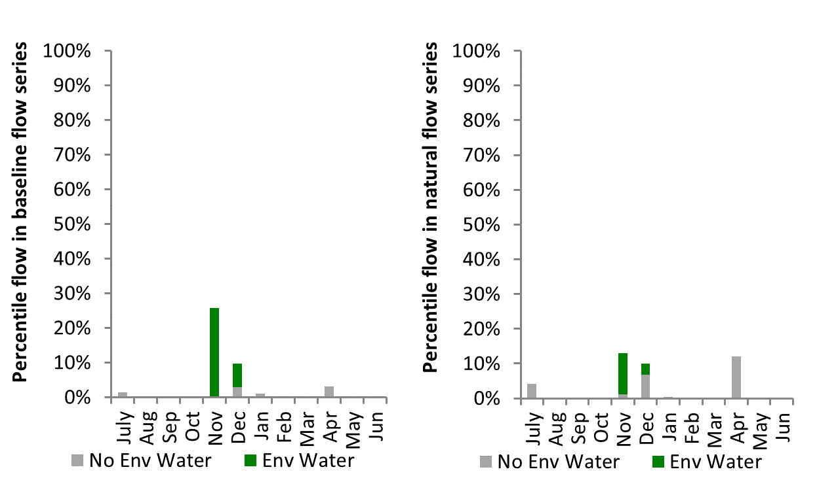
Figure NAM16: Contribution of environmental water delivery at Weeta as percentiles in the natural and baseline flow series.

Bullawa
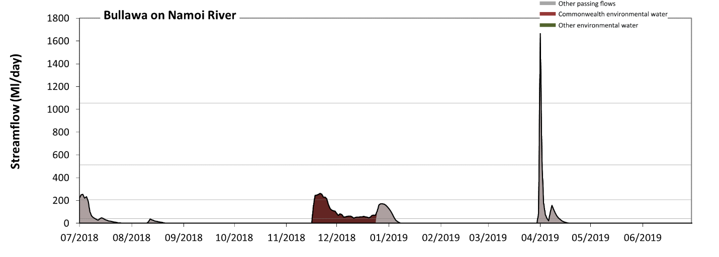 Figure NAM17: Contribution of environmental water delivery at Bullawa. Horizontal lines indicate thresholds for very low flows, low flows, low freshes and medium freshes (from lowest to highest).
At Bullawa on Namoi River, environmental water contributed 38% of the total streamflow volume (all of which was Commonwealth environmental water). Environmental watering actions affected streamflows for 10% of days between 1 July 2018 and 30 June 2019. Without environmental water, the durations of very low flows (i.e. < 41 Ml/day) in the periods July to September, October to December, January to March and April to June would have all substantially exceeded durations expected in an average year in the natural flow regime. Environmental water mitigated these impacts by reducing the cumulative duration of very low flow spells from 90% to 80% of the year, with greatest influence in the period October to December. Similarly, without environmental water, the durations of medium low flows (i.e. < 210 Ml/day) in the periods July to September, October to December, January to March and April to June would have all substantially exceeded durations expected in an average year in the natural flow regime. Environmental water mitigated these impacts by reducing the cumulative duration of medium low flow spells from 98% to 96% of the year, with greatest influence in the period October to December. Commonwealth environmental water was entirely responsible for these enhancements of environmental baseflows at this site. There was at least one low fresh (i.e. > 510 Ml/day) in the period April to June. Environmental water made no change to the duration of these low freshes. There was at least one medium fresh (i.e. > 1100 Ml/day) in the period April to June. Environmental water made no change to the duration of these medium freshes. There were no high freshes (i.e. > 3200 Ml/day) this year.
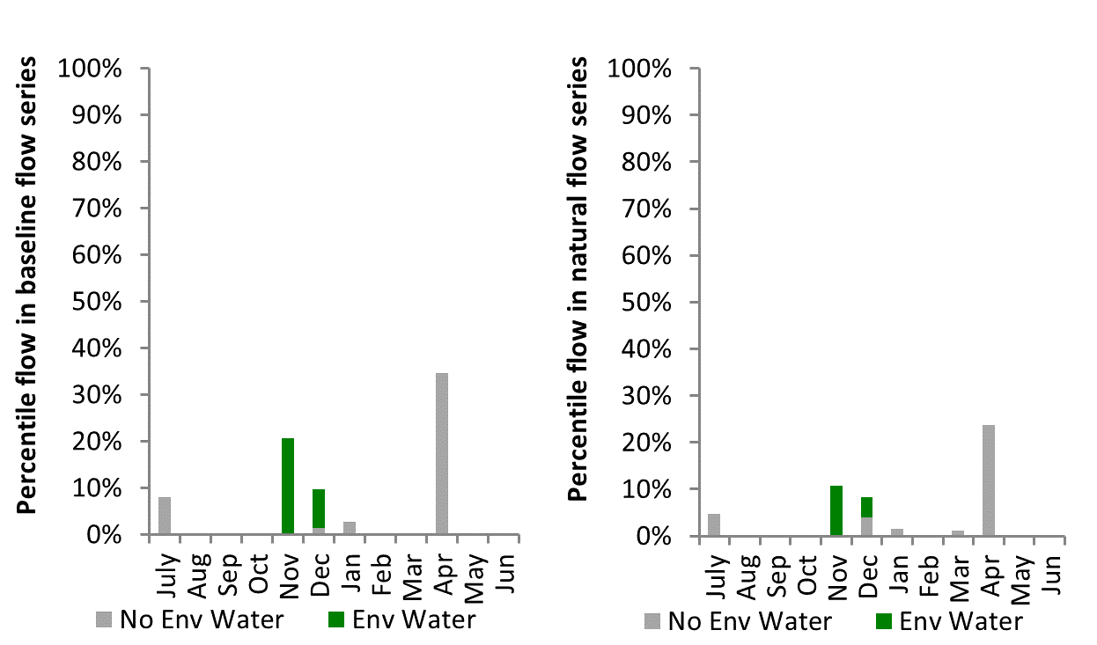
Figure NAM18: Contribution of environmental water delivery at Bullawa as percentiles in the natural and baseline flow series.

Bugilbone
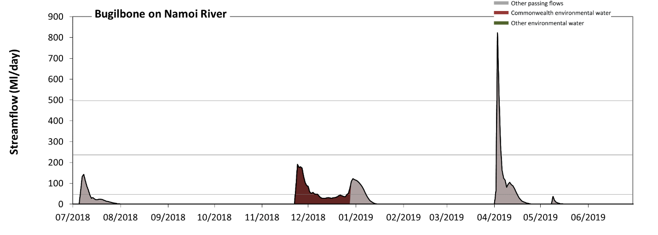 Figure NAM19: Contribution of environmental water delivery at Bugilbone. Horizontal lines indicate thresholds for very low flows, low flows and low freshes (from lowest to highest).
At Bugilbone on Namoi River, environmental water contributed 32% of the total streamflow volume (all of which was Commonwealth environmental water). Environmental watering actions affected streamflows for 10% of days between 1 July 2018 and 30 June 2019. Without environmental water, the durations of very low flows (i.e. < 47 Ml/day) in the periods July to September, October to December, January to March and April to June would have all substantially exceeded durations expected in an average year in the natural flow regime. Environmental water mitigated these impacts by reducing the cumulative duration of very low flow spells from 92% to 87% of the year, with greatest influence in the period October to December. Similarly, without environmental water, the durations of medium low flows (i.e. < 240 Ml/day) in the periods July to September, October to December, January to March and April to June would have all substantially exceeded durations expected in an average year in the natural flow regime. However, environmental water had little effect on the duration of these medium low flows, which occurred for 99% of the year. Commonwealth environmental water was entirely responsible for these enhancements of environmental baseflows at this site. There was at least one low fresh (i.e. > 500 Ml/day) in the period April to June. Environmental water made no change to the duration of these low freshes. There were no medium or high freshes this year.
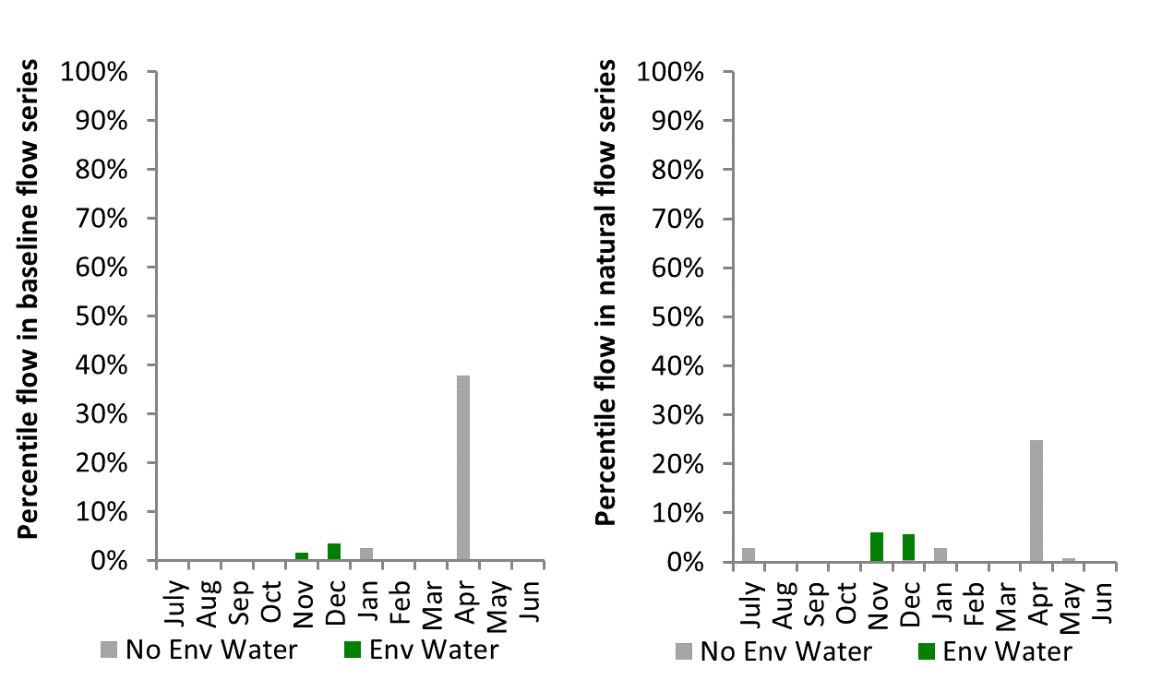
Figure NAM20: Contribution of environmental water delivery at Bugilbone as percentiles in the natural and baseline flow series.

Goangra
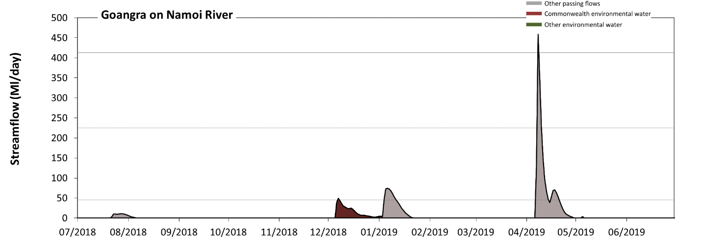 Figure NAM21: Contribution of environmental water delivery at Goangra. Horizontal lines indicate thresholds for very low flows, low flows and low freshes (from lowest to highest).
At Goangra on Namoi River, environmental water contributed 14% of the total streamflow volume (all of which was Commonwealth environmental water). Environmental watering actions affected streamflows for 8% of days between 1 July 2018 and 30 June 2019. Without environmental water, the durations of very low flows (i.e. < 45 Ml/day) in the periods July to September, October to December, January to March and April to June would have all substantially exceeded durations expected in an average year in the natural flow regime. However, environmental water had little effect on the duration of these very low flows, which occurred for 94% of the year. Similarly, without environmental water, the durations of medium low flows (i.e. < 220 Ml/day) in the periods July to September, October to December, January to March and April to June would have all substantially exceeded durations expected in an average year in the natural flow regime. However, environmental water had little effect on the duration of these medium low flows, which occurred for 99% of the year. There was at least one low fresh (i.e. > 410 Ml/day) in the period April to June. Environmental water made no change to the duration of these low freshes. There were no medium or high freshes this year.
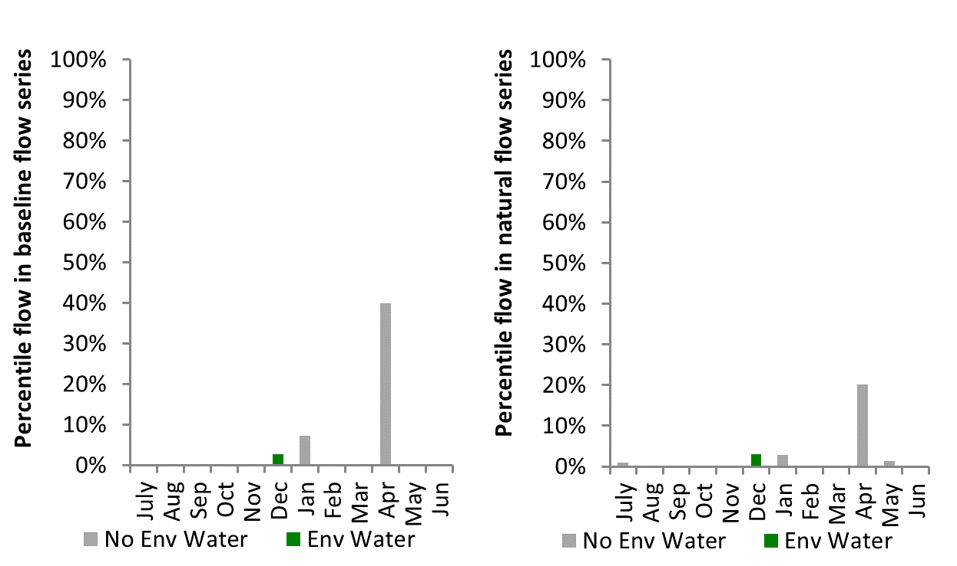
Figure NAM22: Contribution of environmental water delivery at Goangra as percentiles in the natural and baseline flow series.

Walgett
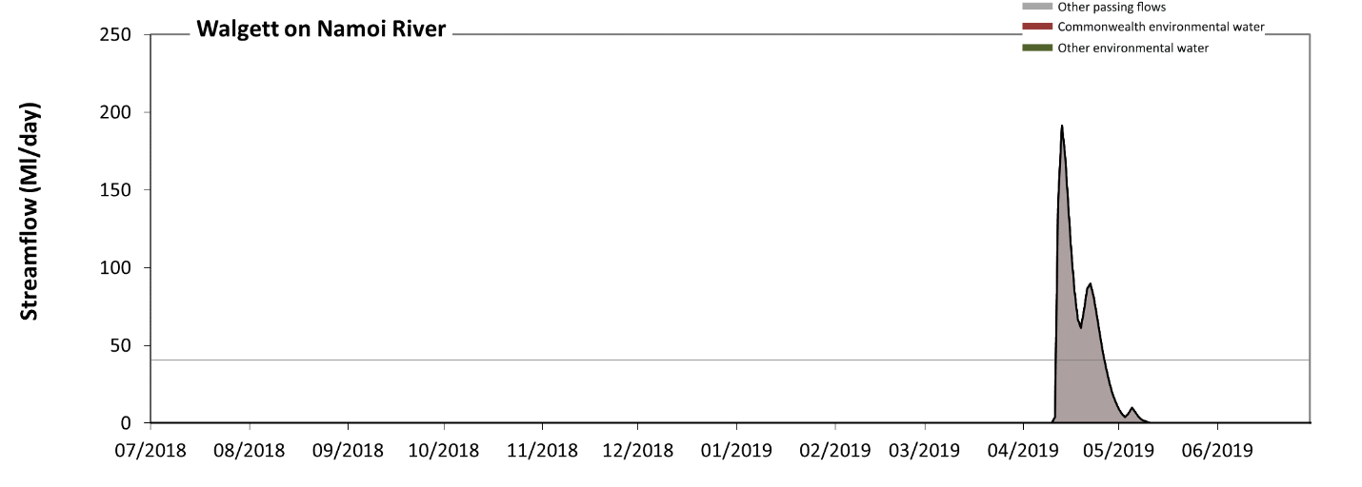 Figure NAM23: Contribution of environmental water delivery at Walgett. Horizontal lines indicate thresholds for very low flows and low flows (from lowest to highest).
There was no environmental water delivered at Walgett on Namoi River. Without environmental water, the durations of very low flows (i.e. < 41 Ml/day) in the periods July to September, October to December, January to March and April to June was substantially in excess of durations expected in an average year in the natural flow regime. Similarly, without environmental water, the durations of medium low flows (i.e. < 200 Ml/day) in the periods July to September, October to December, January to March and April to June was substantially in excess of durations expected in an average year in the natural flow regime.
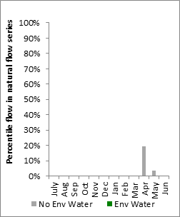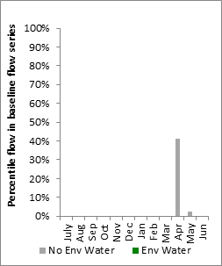
Figure NAM24: Contribution of environmental water delivery at Walgett as percentiles in the natural and baseline flow series.

Chaffey
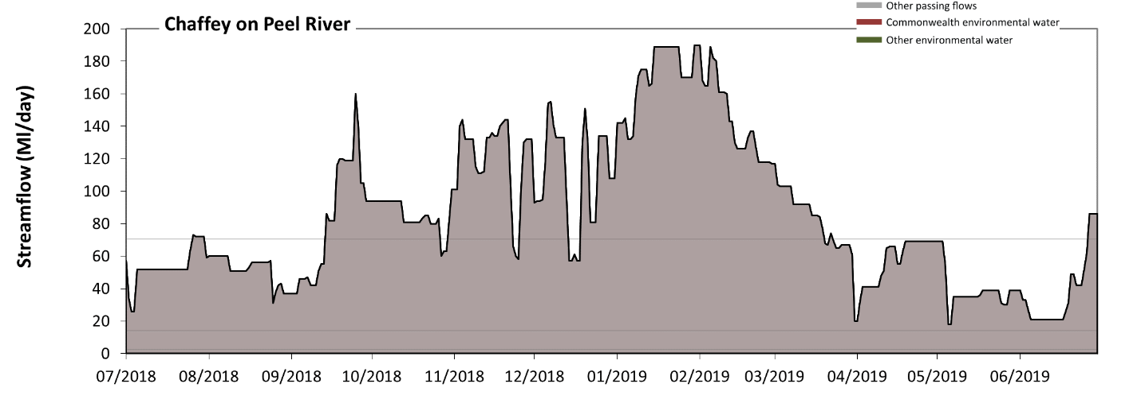 Figure NAM25: Contribution of environmental water delivery at Chaffey. Horizontal lines indicate thresholds for very low flows, low flows and low freshes (from lowest to highest).
There was no environmental water delivered at Chaffey on Peel River. Flow regulation does not substantially increase the duration of very low flows (i.e. < 2.9 Ml/day) compared to an average year in the natural flow regime. Flow regulation does not substantially increase the duration of medium low flows (i.e. < 14 Ml/day) compared to an average year in the natural flow regime. There was at least one low fresh (i.e. > 71 Ml/day) in the periods July to September, October to December, January to March and April to June. There was no medium or high freshes this year.

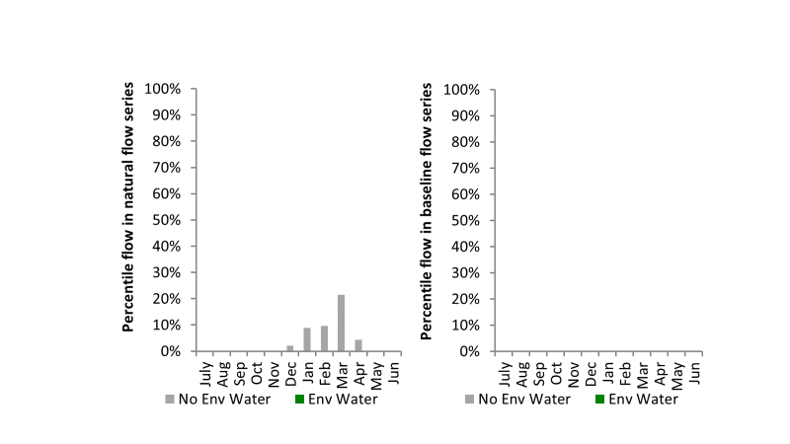
Figure NAM26: Contribution of environmental water delivery at Chaffey as percentiles in the natural and baseline flow series.

Piallamore
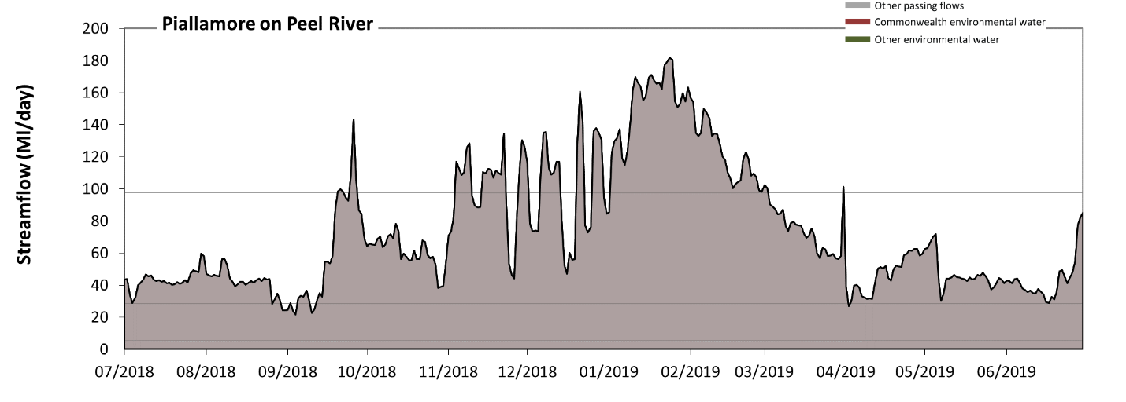 Figure NAM27: Contribution of environmental water delivery at Piallamore. Horizontal lines indicate thresholds for very low flows, low flows and low freshes (from lowest to highest).
There was no environmental water delivered at Piallamore on Peel River. Flow regulation does not substantially increase the duration of very low flows (i.e. < 5.7 Ml/day) compared to an average year in the natural flow regime. Flow regulation does not substantially increase the duration of medium low flows (i.e. < 29 Ml/day) compared to an average year in the natural flow regime. There was at least one low fresh (i.e. > 98 Ml/day) in the periods July to September, October to December and January to March. There was no medium or high freshes this year.
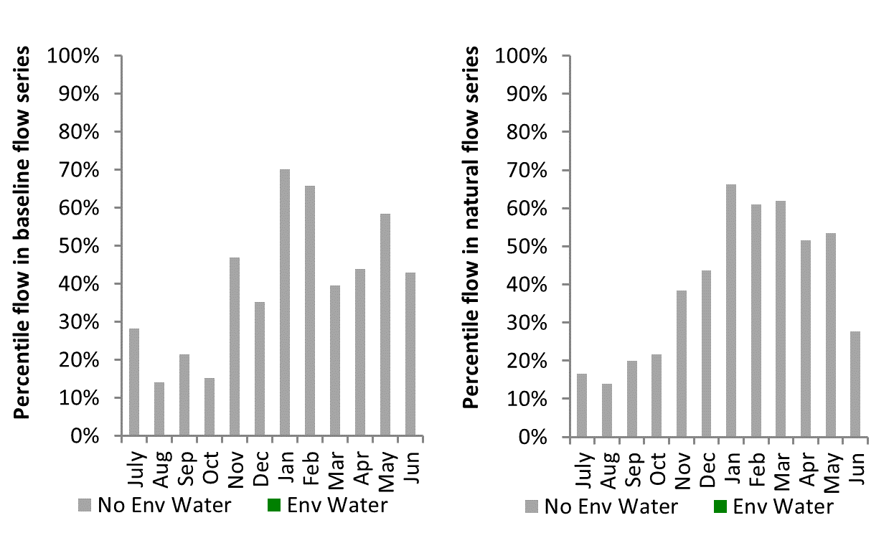
Figure NAM28: Contribution of environmental water delivery at Piallamore as percentiles in the natural and baseline flow series.
Paradise
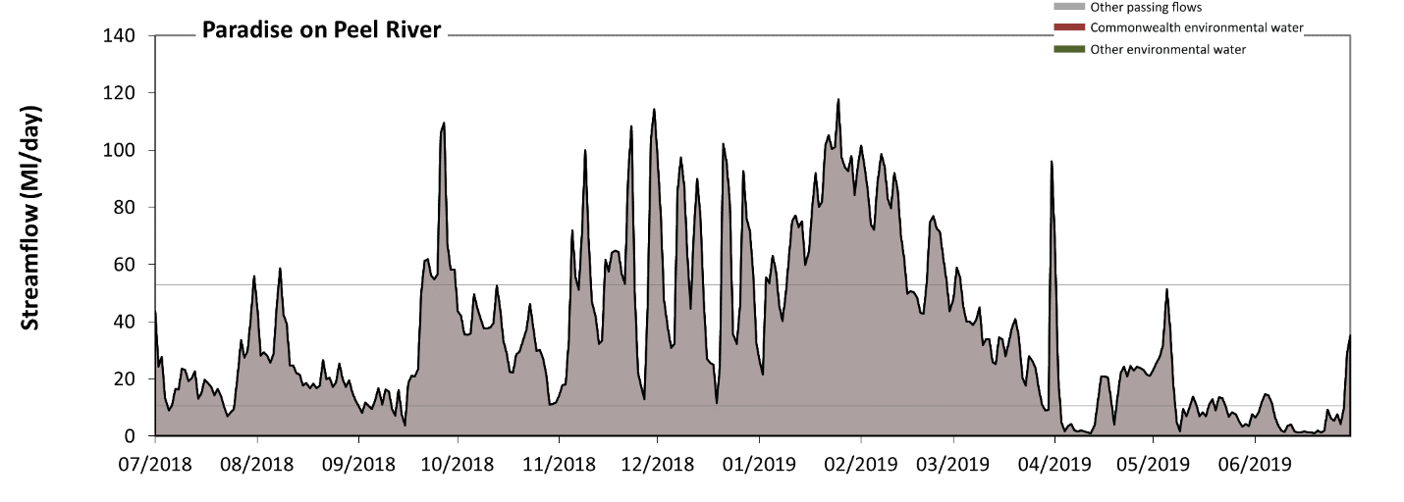 Figure NAM29: Contribution of environmental water delivery at Paradise. Horizontal lines indicate thresholds for very low flows and low flows (from lowest to highest).
There was no environmental water delivered at Paradise on Peel River. Without environmental water, the durations of very low flows (i.e. < 11 Ml/day) in the periods July to September and April to June was substantially in excess of durations expected in an average year in the natural flow regime. Similarly, without environmental water, the durations of medium low flows (i.e. < 53 Ml/day) in the periods July to September, October to December, January to March and April to June was substantially in excess of durations expected in an average year in the natural flow regime.

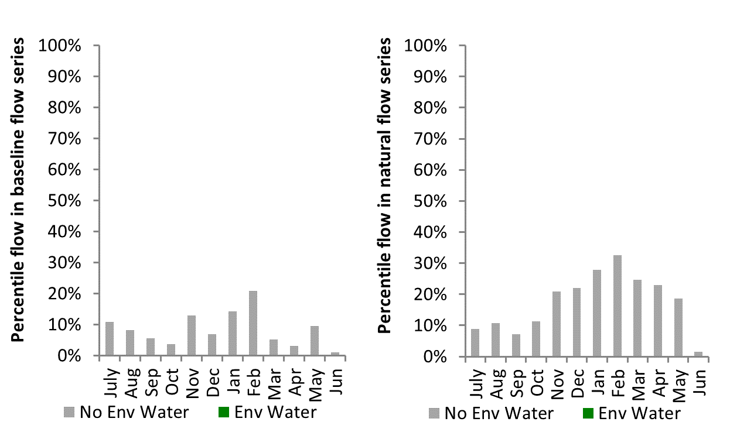
Figure NAM30: Contribution of environmental water delivery at Paradise as percentiles in the natural and baseline flow series.
Carroll
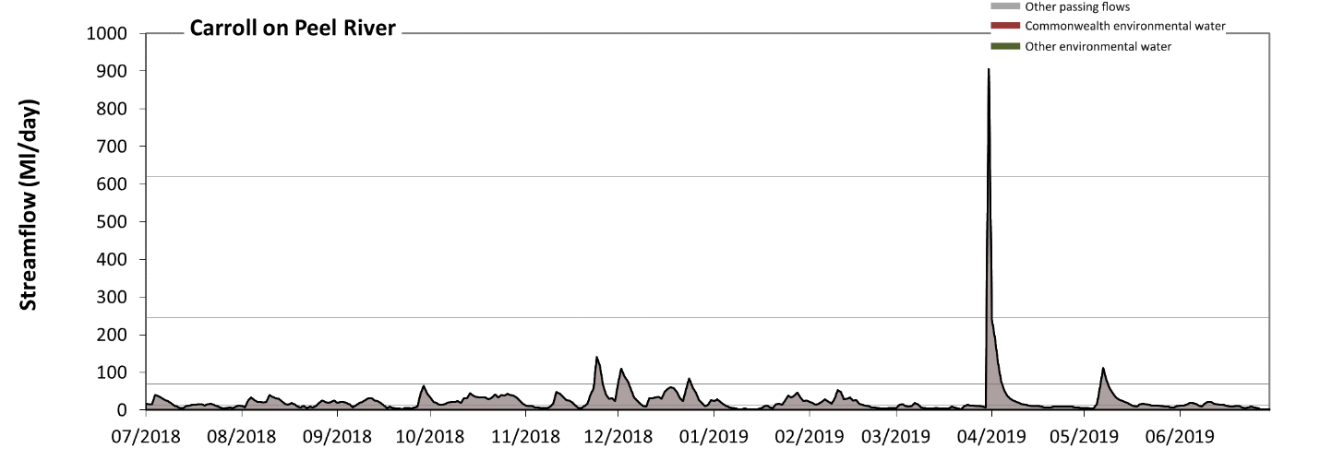 Figure NAM31: Contribution of environmental water delivery at Carroll. Horizontal lines indicate thresholds for very low flows, low flows, low freshes and medium freshes (from lowest to highest).
There was no environmental water delivered at Carroll on Peel River. Without environmental water, the durations of very low flows (i.e. < 14 Ml/day) in the periods July to September, October to December, January to March and April to June was substantially in excess of durations expected in an average year in the natural flow regime. Similarly, without environmental water, the durations of medium low flows (i.e. < 70 Ml/day) in the periods July to September, October to December, January to March and April to June was substantially in excess of durations expected in an average year in the natural flow regime. There was at least one low fresh (i.e. > 240 Ml/day) in the period January to March. There was at least one medium fresh (i.e. > 620 Ml/day) in the period January to March. There was no high freshes (i.e. > 2400 Ml/day) this year.
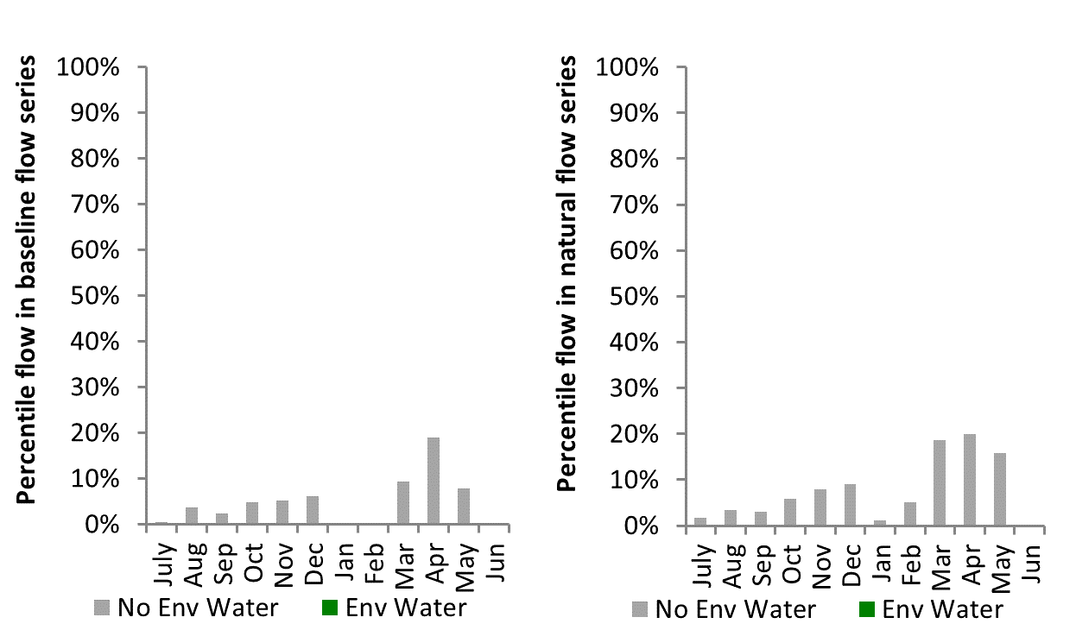
Figure NAM32: Contribution of environmental water delivery at Carroll as percentiles in the natural and baseline flow series.

Lachlan
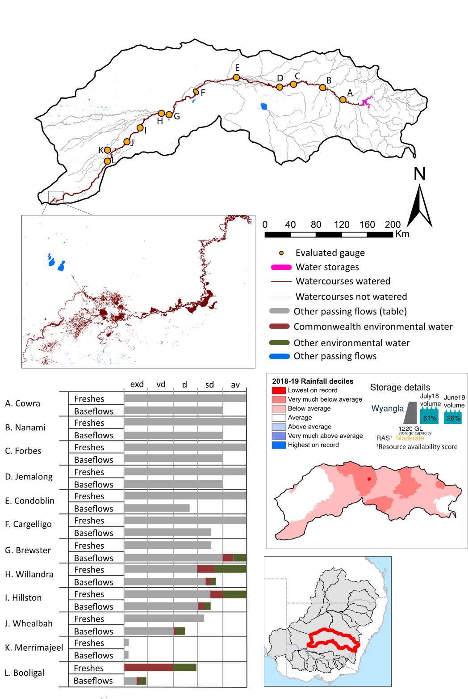
Figure LCH1: Watercourses influenced, areas inundated (where applicable) and gauge stations evaluated in the Lachlan valley during the 2018-19 water year. Inset bar graphs report the condition of annual flow regimes by showing the improvements in hydrological condition with the addition of environmental water as well as the hypothetical scenario in “grey” (if no environmental flow had been delivered) where exd=extremely dry, vd=very dry, d=dry, sd=somewhat dry and av=average. Rainfall conditions (rainfall deciles) and trend in storage levels for the water year are also shown.

Summary
The volume of environmental water delivery for the 2018-19 year in the Lachlan valley is quantified using data for 13 sites. This evaluation only considers the contribution of held environmental water, which is a primary focus for the Commonwealth. The contributions of planned environmental water (e.g. passing flows), unregulated tributary inflows and clever use of irrigation flows for environmental benefits can all be very important but these are outside the scope of this report. Environmental watering actions lasted on average 93 days over the course of the year. The volume of environmental water at these 13 sites was between 0% and 51% of the total streamflow. Commonwealth environmental water contributed on average 31% of this environmental water. The contribution of environmental water delivery to improved flow regimes is evaluated using data for 12 sites. Ideally, baseflows should be maintained and long periods of excessively low flows avoided. In this valley, the baseflow regime was generally considered to be dry relative to the pre-development flow regime. In our analysis, a low fresh refers to a period of increased flow, when the water level rises at least one eighth of the way up the river bank (above the low flow level). These low freshes are a regular part of the natural flow regime and support a range of natural processes. In the Lachlan valley, in terms of the occurrence and duration of low freshes, the year was assessed as being average. In our analysis, a medium fresh refers to a period of increased flow, when the water level rises at least one quarter of the way up the river bank. These medium freshes are not as frequent as low freshes but are also a regular and important part of the natural flow regime. In the Lachlan valley, in terms of the occurrence of medium freshes, the year was assessed as being average. In our analysis, a high fresh refers to a period of increased flow, when the water level rises more than half way up the river. A high fresh may not occur every year but they are still important and long periods without major freshes can have serious consequences for floodplains and their contribution to river connectivity. Delivering high in channel environmental flows normally requires that all risks to riparian landholders and infrastructure have been resolved. In the Lachlan valley, in terms of the occurrence of high freshes, the year was assessed as being somewhat dry.

Water delivery context
During the 2018-19, the Commonwealth Environmental Water Holder (CEWH) held water entitlements of up to 87,856 ML for environmental use in the Lachlan valley. Each year, water utilities allocate water entitlement holders a percentage of water based on their holding, license type and carryover (the exact rules vary among Jurisdictions). In 2018-19, the Lachlan entitlements held by the CEWH were allocated 933 ML of water. Information and data relating to the portfolio of held Commonwealth environmental water is shown in Table LCH2.
The 2018-19 water allocation (933 ML) together with the carryover volume of 54,459 ML of water meant the CEWH had 55,392 ML of water available for delivery. A total of 18,173 ML of Commonwealth environmental water was delivered in the Lachlan valley. A total of 0 ML of Commonwealth environmental water was traded to consumptive users and 37,219 ML (67%) of available Commonwealth environmental water was carried over for environmental use into the 2019-20 water year.

Environmental conditions and resource availability
The water available for environmental delivery combined with the present and antecedent environmental conditions are key inputs used by environmental water managers in planning and implementing watering actions. Post hoc, this information provides important context when evaluating the effectiveness and appropriateness of environmental water use with respect to hydrological outputs.
The rainfall conditions in the Lachlan valley were classified as Below average, based on rainfall percentile data for the entire record held by the Bureau of Meteorology for this valley. The water held in major storages in the Lachlan valley decreased over the water year, for example Wyangla dam was 61.1% full at the beginning of the water year and 26.3% full by the end of the year (Figure LCH1).
The Commonwealth Environmental Water Office (CEWO) calculates resource availability scenarios (RAS) to guide the use and prioritisation of held environmental water. The RAS are progressively calculated over the year as part of the continual adaptive management planning processes. The RAS are based on the availability of held environmental water (including progressive license acquisitions and allocations) as well as the potential for unregulated or planned environmental flows. The outcome is then used to determine the demand for environmental water across the basin.
In 2018-19, the resource availability of held Commonwealth environmental water was classified as low to moderate. The physical conditions meant that the CEWO was managing to maintain and improve the health and resilience of aquatic ecosystems and build future capacity to support ecological health and resilience. The overall demand for environmental water was deemed moderate.

Watering actions
A total of 4 watering actions were delivered over the 2018-19 water year, the duration of these actions varied (range of individual actions: 19 - 76 days) and Commonwealth environmental water was delivered for a total of 212 days. The number of water actions commencing in each season included, Autumn (1), Spring (1), Summer (0), and Winter (2). Similarly, the count of flow component types delivered in the Lachlan valley were; (1) baseflow, (0) baseflow-fresh, (1) fresh, (0) fresh-overbank, (0) bankfull, (0) overbank, (2) wetland and (0) wetland-fresh.
In this valley, primary objectives of most watering actions was related to fish, but water was also delivered for other purposes too. The percentage of watering actions delivered across the nine main themes included primary objectives for fish (33.33%), vegetation (16.67%), waterbirds (8.33%), frogs (8.33%), other biota (0.0%), connectivity (8.33%), process (16.67%), resilience (8.33%) and water quality (0.0%). These percentages are indicative only since many actions are delivered for multiple purposes.
Table LCH2. Commonwealth environmental water accounting information for the Lachlan valley over 2018-19 water year.
Total registered volume (ML) | Allocated volume (ML) | Carry over + allocated volume (ML) | Delivered (ML) | LTAAY (ML) | Trade (ML) | Carried over to 2019-20 | Forfeited (ML)
87,856 | 933 | 55,392 | 18,173 | 35,286 | 0 | 37,219 | 0

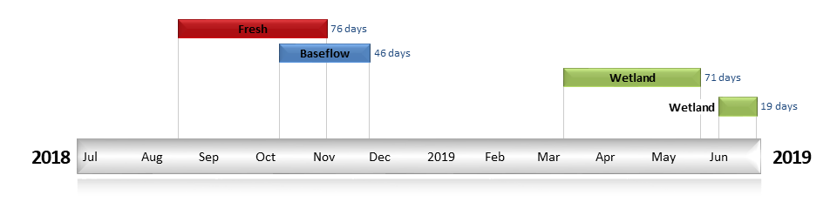
Figure LCH2. Timing and duration of Commonwealth environmental water actions delivered in the Lachlan valley.

Contribution of Commonwealth environmental water to flow regimes
Cowra
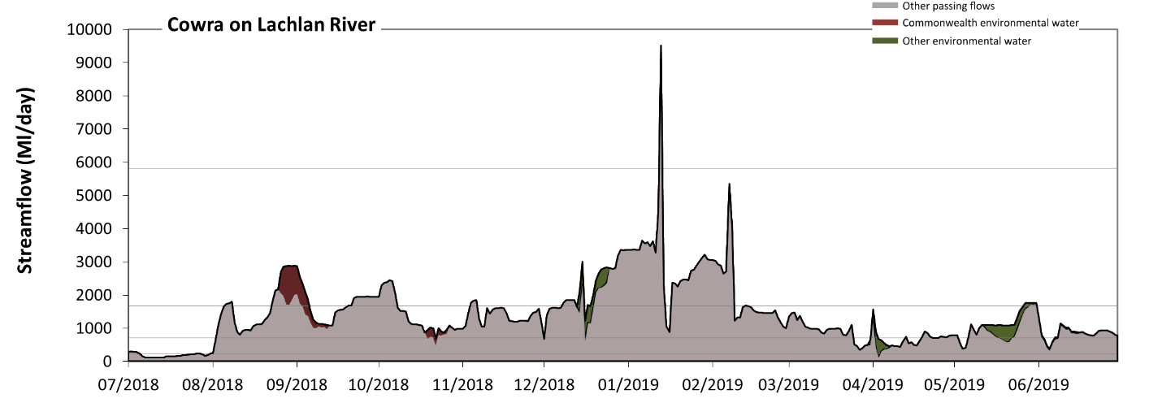
Figure LCH3: Contribution of environmental water delivery at Cowra. Horizontal lines indicate thresholds for very low flows, low flows, low freshes, medium freshes and high freshes (from lowest to highest).
At Cowra on the Lachlan River environmental water contributed 5% of the total streamflow volume (with approximately half contributed by Commonwealth environmental water). Environmental watering actions affected streamflows for 23% of days between 1 July 2018 and 30 June 2019. Flow regulation does not substantially increase the duration of very low flows (i.e. < 47 Ml/day) compared to an average year in the natural flow regime. However, without environmental water, the duration of medium low flows (i.e. < 240 Ml/day) in the period July to September would have substantially exceeded durations expected in an average year in the natural flow regime. However, environmental water had little effect on the duration of these medium low flows, which occurred for 7% of the year. In the absence of environmental water there would have been at least one low fresh (i.e. > 710 Ml/day) in the periods July to September, October to December, January to March and April to June. Environmental water increased the duration of the longest low fresh during the period April to June (from 22 days to 28 days). Commonwealth environmental water made little or no contribution to these increased durations of low freshes. In the absence of environmental water there would have been at least one medium fresh (i.e. > 1700 Ml/day) in the periods July to September, October to December, January to March and April to June. Environmental water increased the duration of the longest medium fresh during the period April to June (from 3 days to 5 days). Commonwealth environmental water made little or no contribution to these increased durations of medium freshes. In the absence of environmental water there would have been at least one high fresh in the period January to March. Environmental water made no change to the duration of these high freshes.
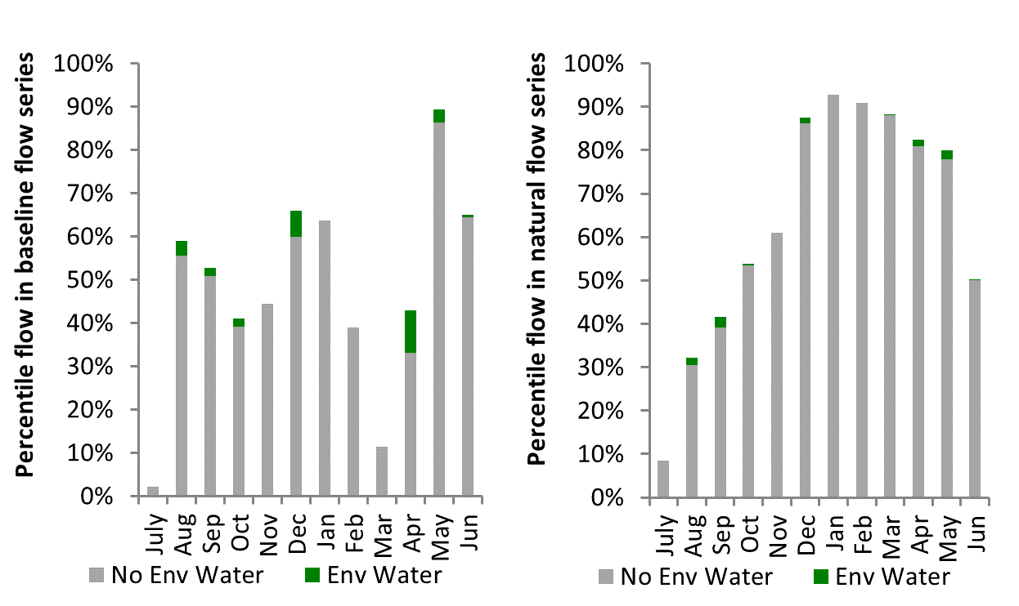
Figure LCH4: Contribution of environmental water delivery at Cowra as percentiles in the natural and baseline flow series.
Nanami
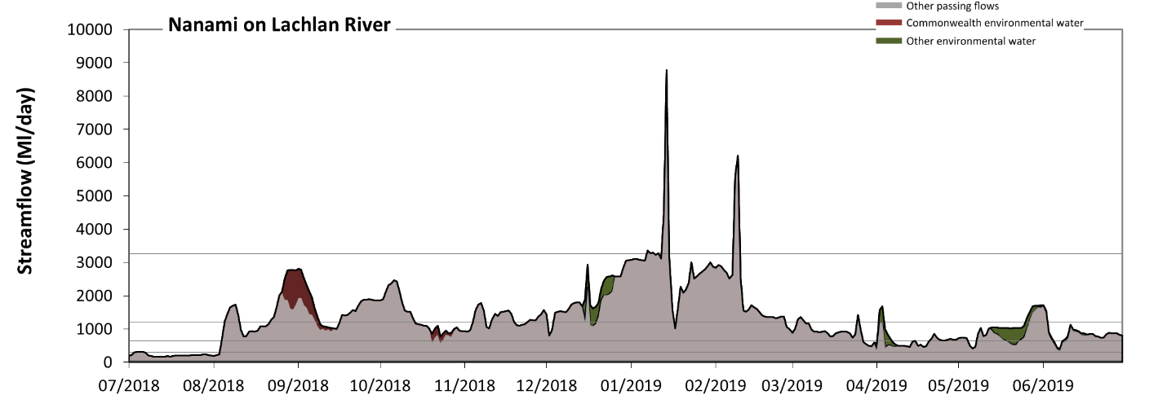
Figure LCH5: Contribution of environmental water delivery at Nanami. Horizontal lines indicate thresholds for very low flows, low flows, low freshes, medium freshes and high freshes (from lowest to highest).
At Nanami on Lachlan River environmental water contributed 5% of the total streamflow volume (with approximately half contributed by Commonwealth environmental water). Environmental watering actions affected streamflows for 23% of days between 1 July 2018 and 30 June 2019. Flow regulation does not substantially increase the duration of very low flows (i.e. < 61 Ml/day) compared to an average year in the natural flow regime. However, without environmental water, the duration of medium low flows (i.e. < 300 Ml/day) in the period July to September would have substantially exceeded durations expected in an average year in the natural flow regime. However, environmental water had little effect on the duration of these medium low flows, which occurred for 8% of the year. In the absence of environmental water there would have been at least one low fresh (i.e. > 650 Ml/day) in the periods July to September, October to December, January to March and April to June. Environmental water increased the duration of the longest low fresh during the periods October to December (from 69 days to 92 days) and April to June (from 21 days to 28 days). Commonwealth environmental water equally shared responsibility with other environmental water holders for these increased durations of low freshes. In the absence of environmental water there would have been at least one medium fresh (i.e. > 1200 Ml/day) in the periods July to September, October to December, January to March and April to June. Environmental water increased the duration of the longest medium fresh during the period October to December (from 13 days to 28 days). Commonwealth environmental water made little or no contribution to these increased durations of medium freshes. In the absence of environmental water there would have been at least one high fresh in the period January to March. Environmental water made no change to the duration of these high freshes.
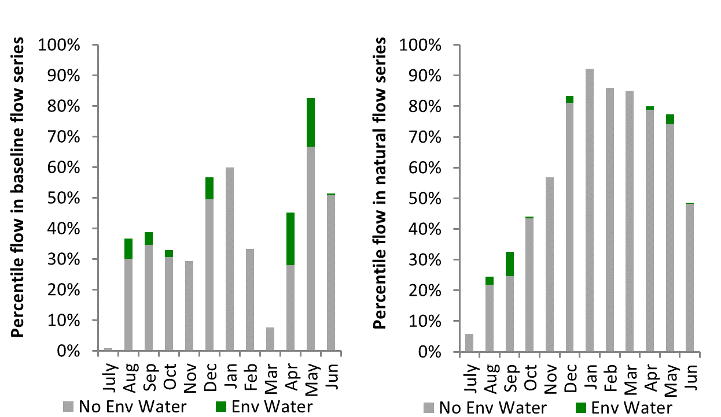
Figure LCH6: Contribution of environmental water delivery at Nanami as percentiles in the natural and baseline flow series.

Forbes
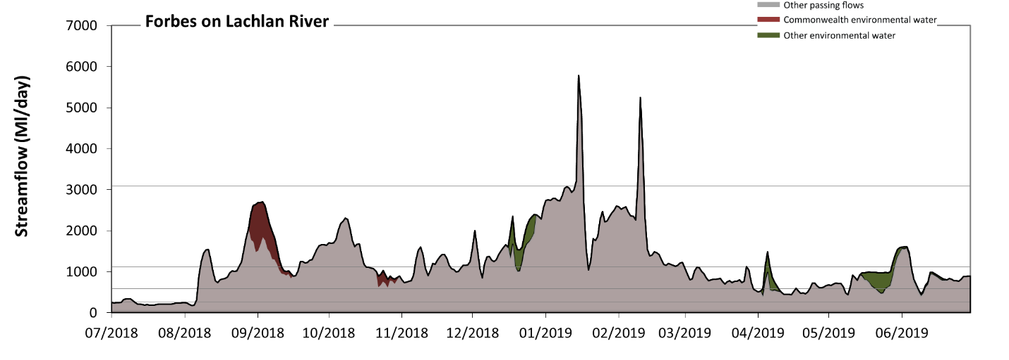
Figure LCH7: Contribution of environmental water delivery at Forbes. Horizontal lines indicate thresholds for very low flows, low flows, low freshes, medium freshes and high freshes (from lowest to highest).
At Forbes on Lachlan River environmental water contributed 6% of the total streamflow volume (with approximately half contributed by Commonwealth environmental water). Environmental watering actions affected streamflows for 23% of days between 1 July 2018 and 30 June 2019. Flow regulation does not substantially increase the duration of very low flows (i.e. < 54 Ml/day) compared to an average year in the natural flow regime. However, without environmental water, the duration of medium low flows (i.e. < 270 Ml/day) in the period July to September would have substantially exceeded durations expected in an average year in the natural flow regime. However, environmental water had little effect on the duration of these medium low flows, which occurred for 8% of the year. In the absence of environmental water there would have been at least one low fresh (i.e. > 590 Ml/day) in the periods July to September, October to December, January to March and April to June. Environmental water increased the duration of the longest low fresh during the period April to June (from 20 days to 29 days). Commonwealth environmental water made little or no contribution to these increased durations of low freshes. In the absence of environmental water there would have been at least one medium fresh (i.e. > 1100 Ml/day) in the periods July to September, October to December, January to March and April to June. Environmental water increased the duration of the longest medium fresh during the period October to December (from 16 days to 26 days). Commonwealth environmental water made little or no contribution to these increased durations of medium freshes. In the absence of environmental water there would have been at least one high fresh in the period January to March. Environmental water made no change to the duration of these high freshes.
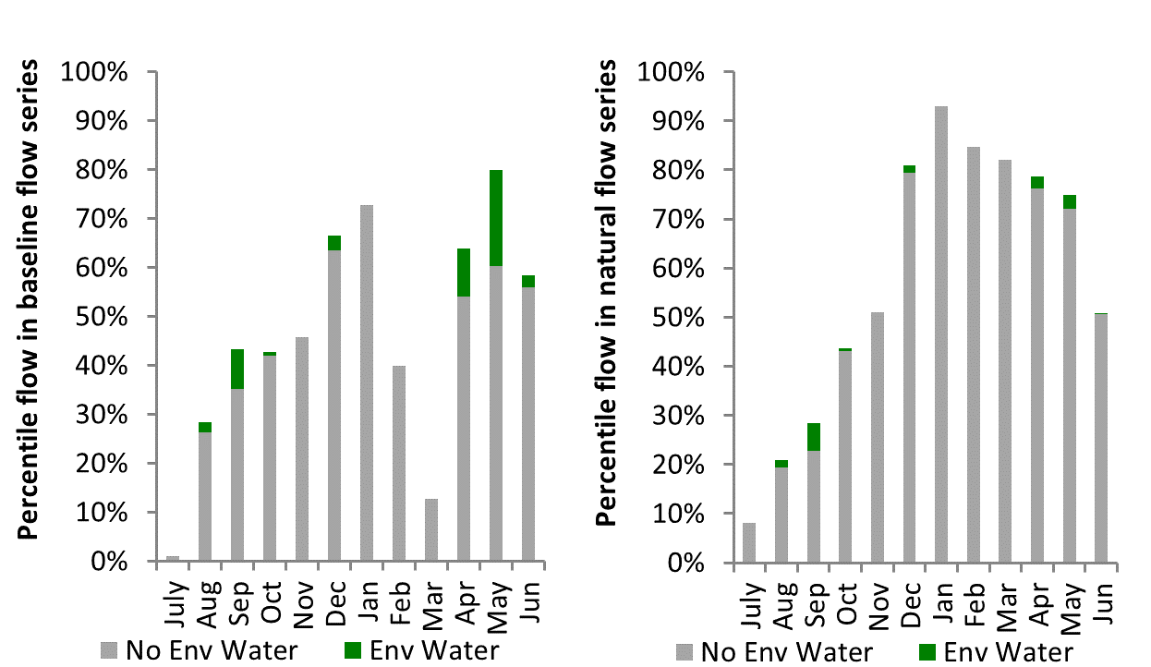
Figure LCH8: Contribution of environmental water delivery at Forbes as percentiles in the natural and baseline flow series.
Jemalong
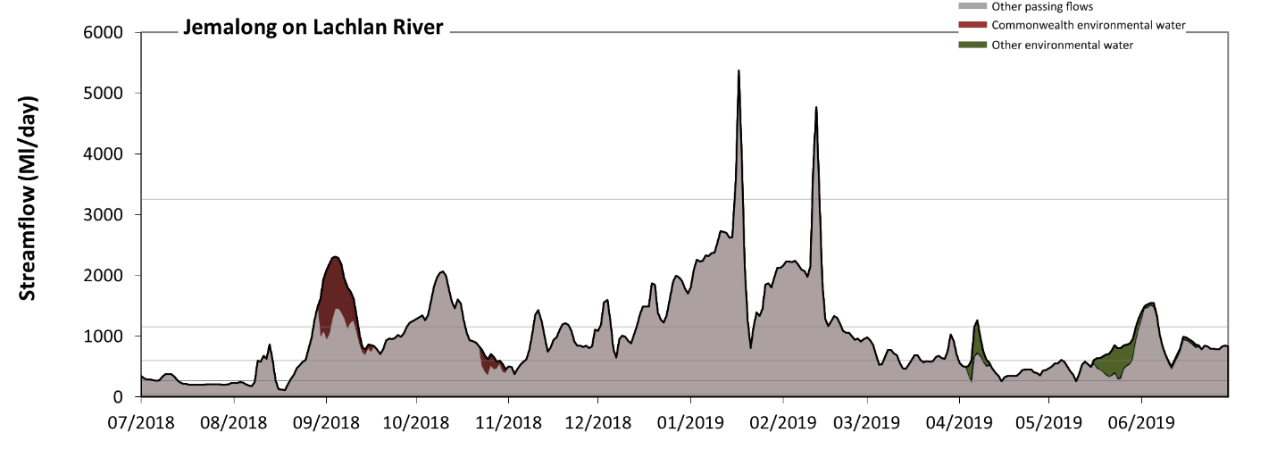
Figure LCH9: Contribution of environmental water delivery at Jemalong. Horizontal lines indicate thresholds for very low flows, low flows, low freshes, medium freshes and high freshes (from lowest to highest).
At Jemalong on Lachlan River environmental water contributed 5% of the total streamflow volume (with approximately half contributed by Commonwealth environmental water). Environmental watering actions affected streamflows for 20% of days between 1 July 2018 and 30 June 2019. Flow regulation does not substantially increase the duration of very low flows (i.e. < 54 Ml/day) compared to an average year in the natural flow regime. However, without environmental water, the duration of medium low flows (i.e. < 270 Ml/day) in the period July to September would have substantially exceeded durations expected in an average year in the natural flow regime. However, environmental water had little effect on the duration of these medium low flows, which occurred for 9% of the year. In the absence of environmental water there would have been at least one low fresh (i.e. > 600 Ml/day) in the periods July to September, October to December, January to March and April to June. Environmental water increased the duration of the longest low fresh during the period April to June (from 18 days to 25 days). Commonwealth environmental water made little or no contribution to these increased durations of low freshes. In the absence of environmental water there would have been at least one medium fresh (i.e. > 1200 Ml/day) in the periods July to September, October to December, January to March and April to June. Environmental water increased the duration of the longest medium fresh during the period July to September (from 5 days to 15 days). Commonwealth environmental water was entirely responsible for these increased durations of medium freshes. In the absence of environmental water there would have been at least one high fresh in the period January to March. Environmental water made no change to the duration of these high freshes.
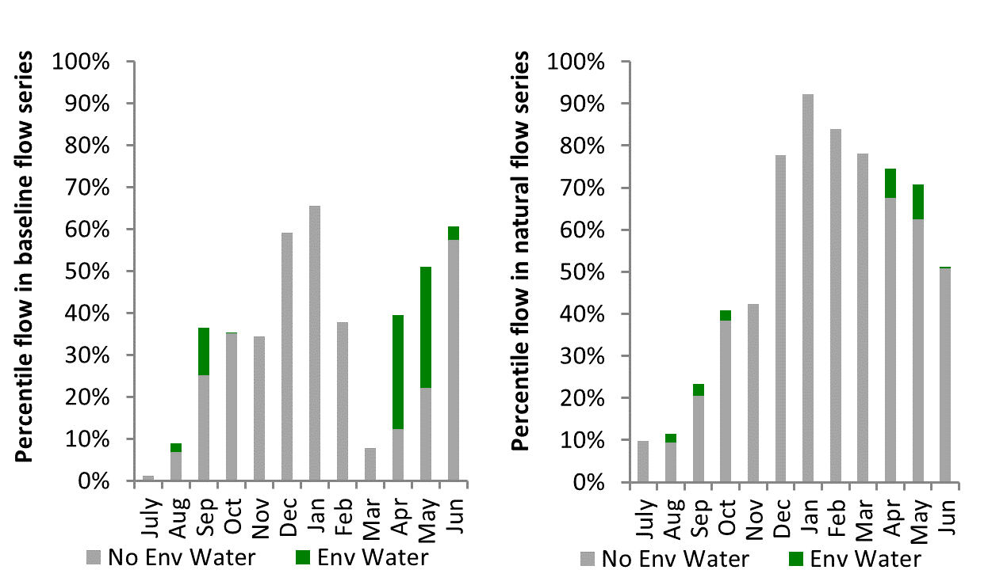
Figure LCH10: Contribution of environmental water delivery at Jemalong as percentiles in the natural and baseline flow series.

Condobolin
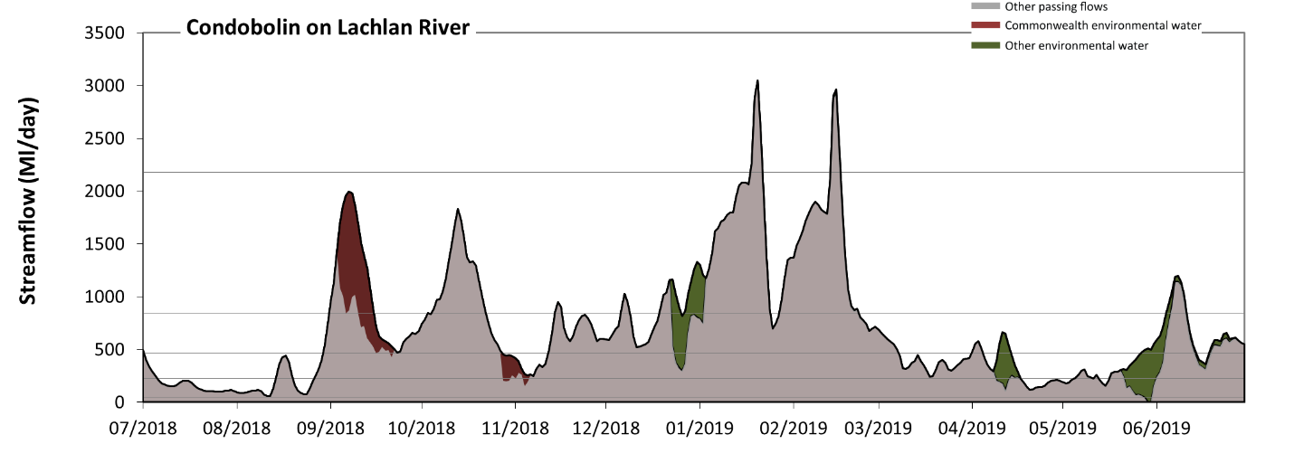
Figure LCH11: Contribution of environmental water delivery at Condobolin. Horizontal lines indicate thresholds for very low flows, low flows, low freshes, medium freshes and high freshes (from lowest to highest).
At Condobolin on Lachlan River environmental water contributed 10% of the total streamflow volume (with approximately half contributed by Commonwealth environmental water). Environmental watering actions affected streamflows for 26% of days between 1 July 2018 and 30 June 2019. Flow regulation does not substantially increase the duration of very low flows (i.e. < 46 Ml/day) compared to an average year in the natural flow regime. However, without environmental water, the duration of medium low flows (i.e. < 230 Ml/day) in the period July to September would have substantially exceeded durations expected in an average year in the natural flow regime. Environmental water reduced the cumulative duration of medium low flow spells from 24% to 19% of the year, with greatest influence in the period April to June. Commonwealth environmental water made a modest contribution to these enhancements of environmental baseflows at this site. In the absence of environmental water there would have been at least one low fresh (i.e. > 460 Ml/day) in the periods July to September, October to December, January to March and April to June. Environmental water increased the duration of the longest low fresh during the periods July to September (from 22 days to 32 days) and April to June (from 12 days to 19 days). Commonwealth environmental water equally shared responsibility with other environmental water holders for these increased durations of low freshes. In the absence of environmental water there would have been at least one medium fresh (i.e. > 840 Ml/day) in the periods July to September, October to December, January to March and April to June. Environmental water increased the duration of the longest medium fresh during the period July to September (from 10 days to 15 days). Commonwealth environmental water was entirely responsible for these increased durations of medium freshes. In the absence of environmental water there would have been at least one high fresh in the period January to March. Environmental water made no change to the duration of these high freshes.
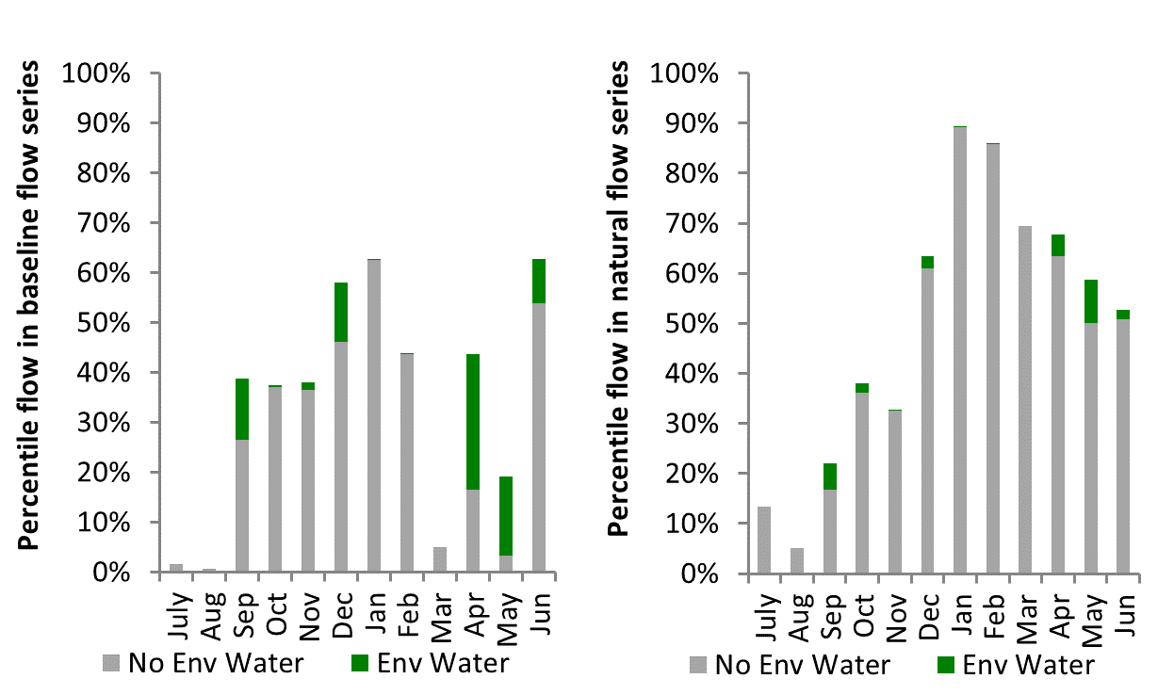
Figure LCH12: Contribution of environmental water delivery at Condobolin as percentiles in the natural and baseline flow series.

Cargelligo
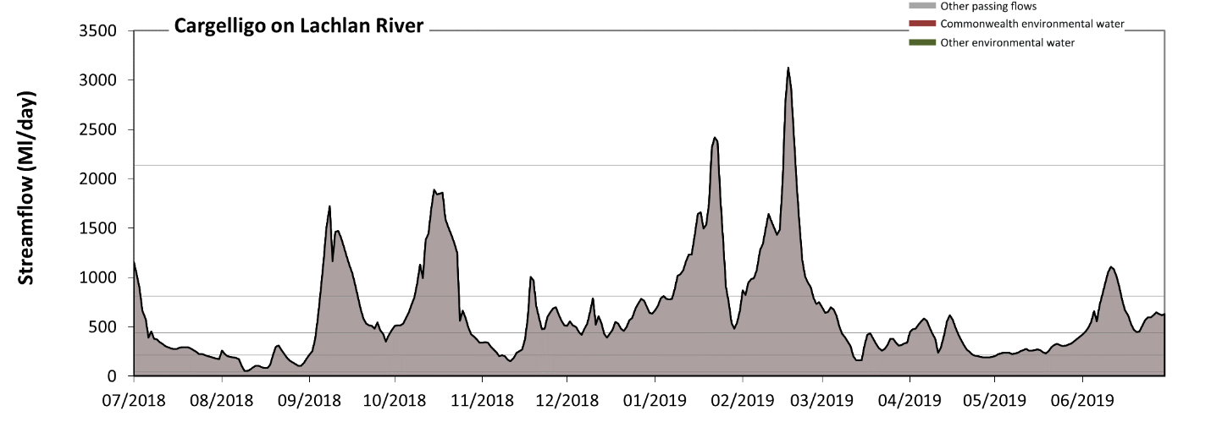Figure LCH13: Contribution of environmental water delivery at Cargelligo. Horizontal lines indicate thresholds for very low flows, low flows, low freshes, medium freshes and high freshes (from lowest to highest).
This site was not assessed in the 2018-19 water year.
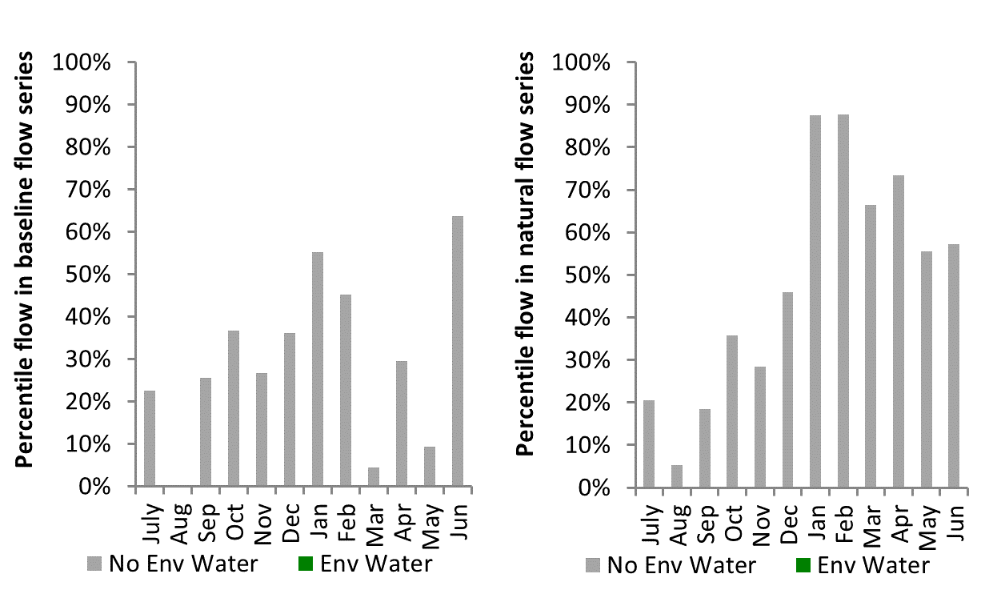
Figure LCH14: Contribution of environmental water delivery at Cargelligo as percentiles in the natural and baseline flow series.

Brewster
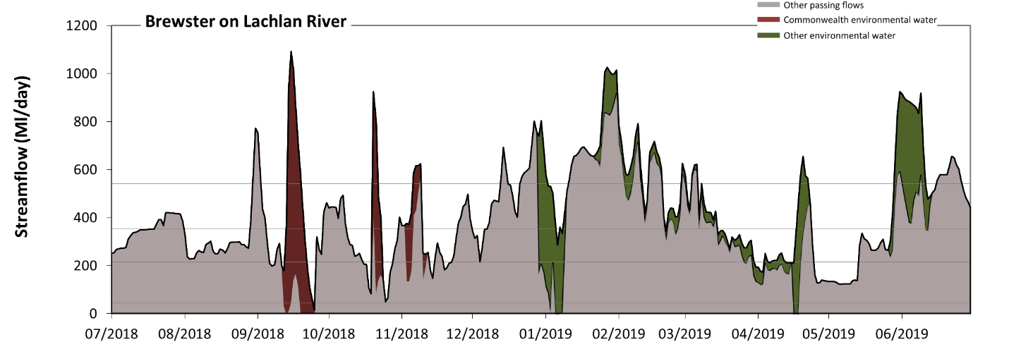 Figure LCH15: Contribution of environmental water delivery at Brewster. Horizontal lines indicate thresholds for very low flows, low flows, low freshes and medium freshes (from lowest to highest).
At Brewster on Lachlan River environmental water contributed 17% of the total streamflow volume (with a medium contribution of Commonwealth environmental water). Environmental watering actions affected streamflows for 40% of days between 1 July 2018 and 30 June 2019. Without environmental water, the duration of very low flows (i.e. < 43 Ml/day) in the period July to September would have substantially exceeded durations expected in an average year in the natural flow regime. Environmental water mitigated these impacts by reducing the cumulative duration of very low flow spells from 5% to 0% of the year, with greatest influence in the periods July to September and January to March. Similarly, without environmental water, the durations of medium low flows (i.e. < 220 Ml/day) in the periods July to September and October to December would have substantially exceeded durations expected in an average year in the natural flow regime. Environmental water mitigated these impacts by reducing the cumulative duration of medium low flow spells from 26% to 14% of the year, with greatest influence in the periods October to December, January to March and April to June. Commonwealth environmental water equally shared responsibility with other environmental water holders for these enhancements of environmental baseflows at this site. In the absence of environmental water there would have been at least one low fresh (i.e. > 350 Ml/day) in the periods July to September, October to December, January to March and April to June. Environmental water increased the duration of the longest low fresh during the period April to June (from 18 days to 34 days). Commonwealth environmental water made little or no contribution to these increased durations of low freshes. In the absence of environmental water there would have been at least one medium fresh (i.e. > 540 Ml/day) in the periods July to September, October to December, January to March and April to June. Environmental water increased the duration of the longest medium fresh during the periods July to September (from 4 days to 6 days), October to December (from 7 days to 10 days) and January to March (from 24 days to 31 days). Commonwealth environmental water made a modest contribution to these increased durations of medium freshes. There was no high freshes (i.e. > 1100 Ml/day) this year.
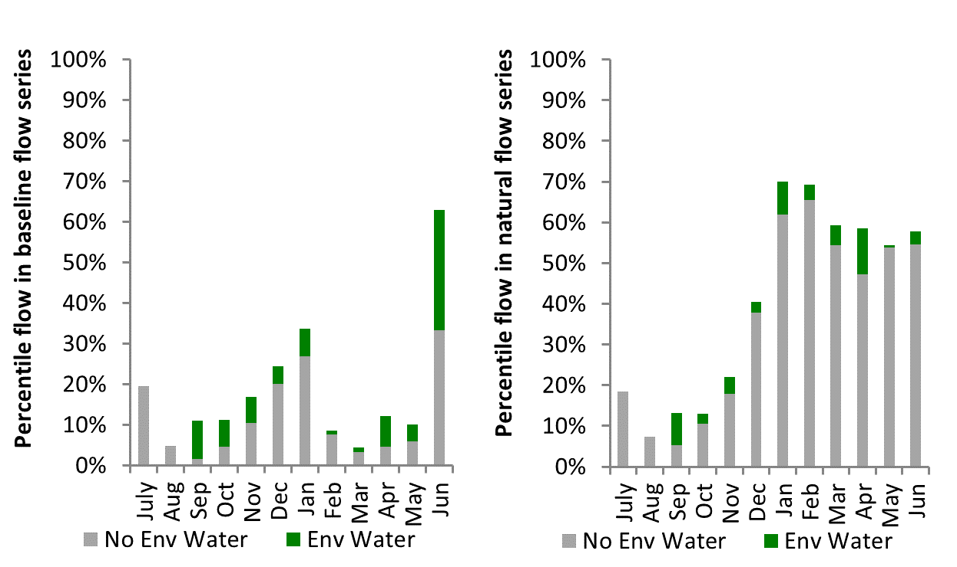
Figure LCH16: Contribution of environmental water delivery at Brewster as percentiles in the natural and baseline flow series.

Willandra
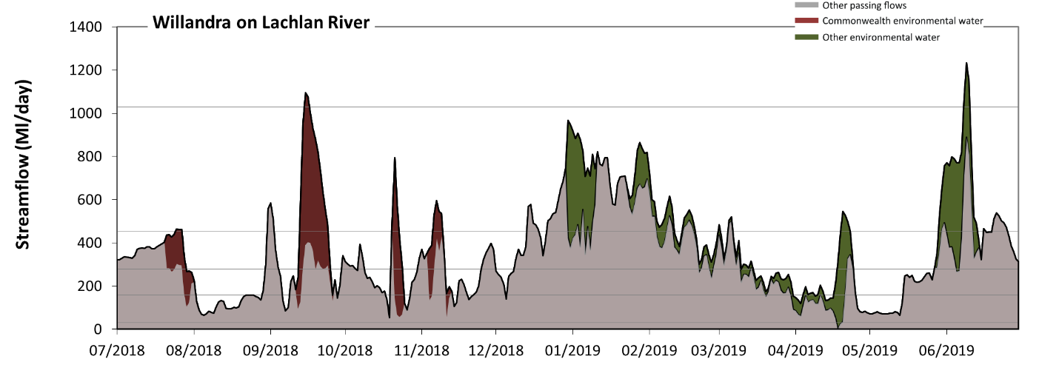 Figure LCH17: Contribution of environmental water delivery at Willandra. Horizontal lines indicate thresholds for very low flows, low flows, low freshes, medium freshes and high freshes (from lowest to highest).
At Willandra on Lachlan River environmental water contributed 20% of the total streamflow volume (with a medium contribution of Commonwealth environmental water). Environmental watering actions affected streamflows for 45% of days between 1 July 2018 and 30 June 2019. Flow regulation does not substantially increase the duration of very low flows (i.e. < 31 Ml/day) compared to an average year in the natural flow regime. However, without environmental water, the durations of medium low flows (i.e. < 160 Ml/day) in the periods July to September and October to December would have substantially exceeded durations expected in an average year in the natural flow regime. Environmental water mitigated these impacts by reducing the cumulative duration of medium low flow spells from 25% to 18% of the year, with greatest influence in the periods October to December and April to June. Commonwealth environmental water equally shared responsibility with other environmental water holders for these enhancements of environmental baseflows at this site. In the absence of environmental water there would have been at least one low fresh (i.e. > 280 Ml/day) in the periods July to September, October to December, January to March and April to June. Environmental water increased the duration of the longest low fresh during the periods July to September (from 22 days to 28 days), January to March (from 51 days to 73 days) and April to June (from 24 days to 35 days). Commonwealth environmental water made a modest contribution to these increased durations of low freshes. In the absence of environmental water there would have been at least one medium fresh (i.e. > 450 Ml/day) in the periods July to September, October to December, January to March and April to June. Environmental water increased the duration of the longest medium fresh during the periods July to September (from 3 days to 12 days), January to March (from 26 days to 41 days) and April to June (from 6 days to 16 days). Commonwealth environmental water made a modest contribution to these increased durations of medium freshes. Environmental water increased the duration of the longest high fresh during the periods July to September (from 0 days to 2 days) and April to June (from 0 days to 3 days). Commonwealth environmental water equally shared responsibility with other environmental water holders for these increased durations of high freshes.
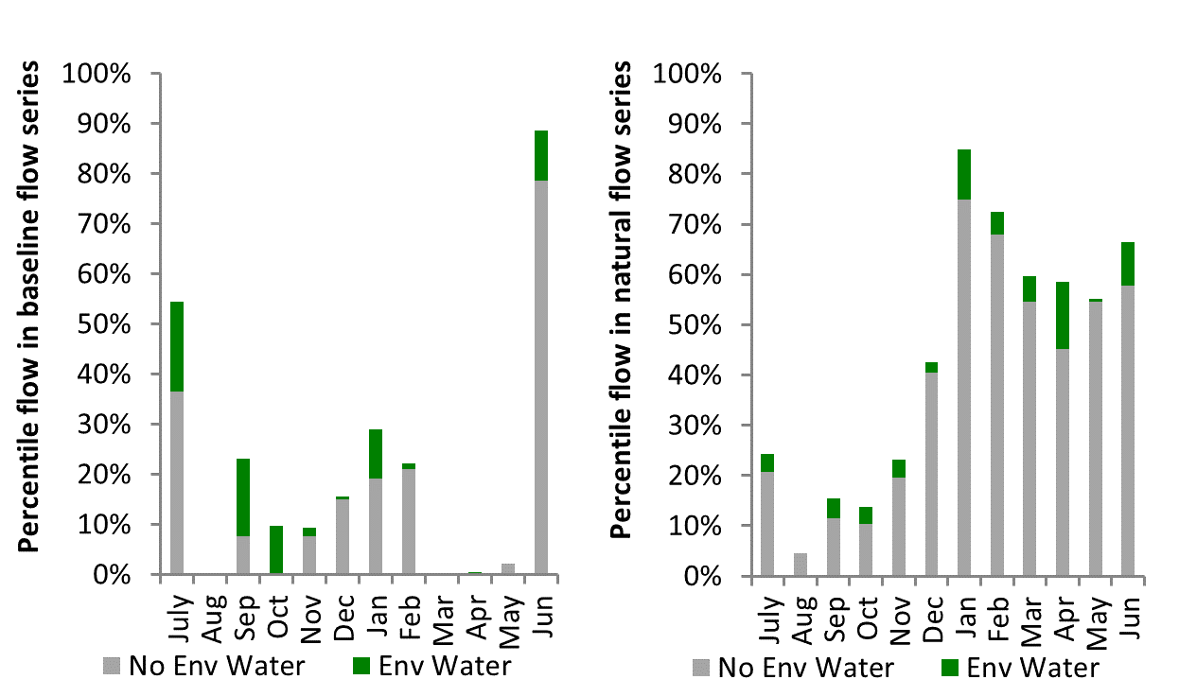
Figure LCH18: Contribution of environmental water delivery at Willandra as percentiles in the natural and baseline flow series.
Hillston
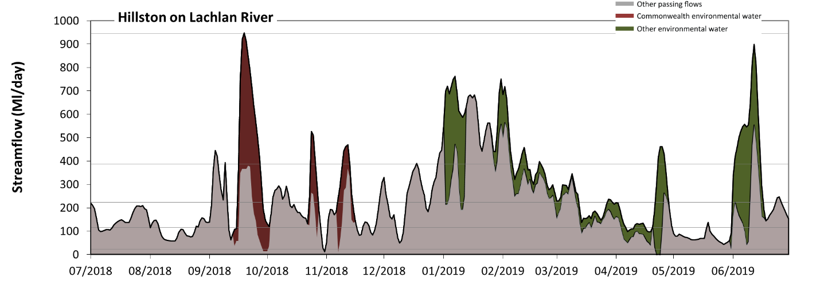 Figure LCH19: Contribution of environmental water delivery at Hillston. Horizontal lines indicate thresholds for very low flows, low flows, low freshes, medium freshes and high freshes (from lowest to highest).
At Hillston on Lachlan River environmental water contributed 26% of the total streamflow volume (with a medium contribution of Commonwealth environmental water). Environmental watering actions affected streamflows for 42% of days between 1 July 2018 and 30 June 2019. Flow regulation does not substantially increase the duration of very low flows (i.e. < 23 Ml/day) compared to an average year in the natural flow regime. However, without environmental water, the durations of medium low flows (i.e. < 120 Ml/day) in the periods July to September, October to December and April to June would have substantially exceeded durations expected in an average year in the natural flow regime. Environmental water mitigated these impacts by reducing the cumulative duration of medium low flow spells from 32% to 23% of the year, with greatest influence in the period April to June. Commonwealth environmental water made a modest contribution to these enhancements of environmental baseflows at this site. In the absence of environmental water there would have been at least one low fresh (i.e. > 220 Ml/day) in the periods July to September, October to December, January to March and April to June. Environmental water increased the duration of the longest low fresh during the periods July to September (from 8 days to 13 days), January to March (from 47 days to 71 days) and April to June (from 6 days to 16 days). Commonwealth environmental water made a modest contribution to these increased durations of low freshes. In the absence of environmental water there would have been at least one medium fresh (i.e. > 390 Ml/day) in the periods July to September, October to December, January to March and April to June. Environmental water increased the duration of the longest medium fresh during the periods July to September (from 2 days to 11 days), January to March (from 15 days to 36 days) and April to June (from 3 days to 14 days). Commonwealth environmental water made a modest contribution to these increased durations of medium freshes. Environmental water increased the duration of the longest high fresh during the period July to September (from 0 days to 1 days). Commonwealth environmental water was entirely responsible for these increased durations of high freshes.
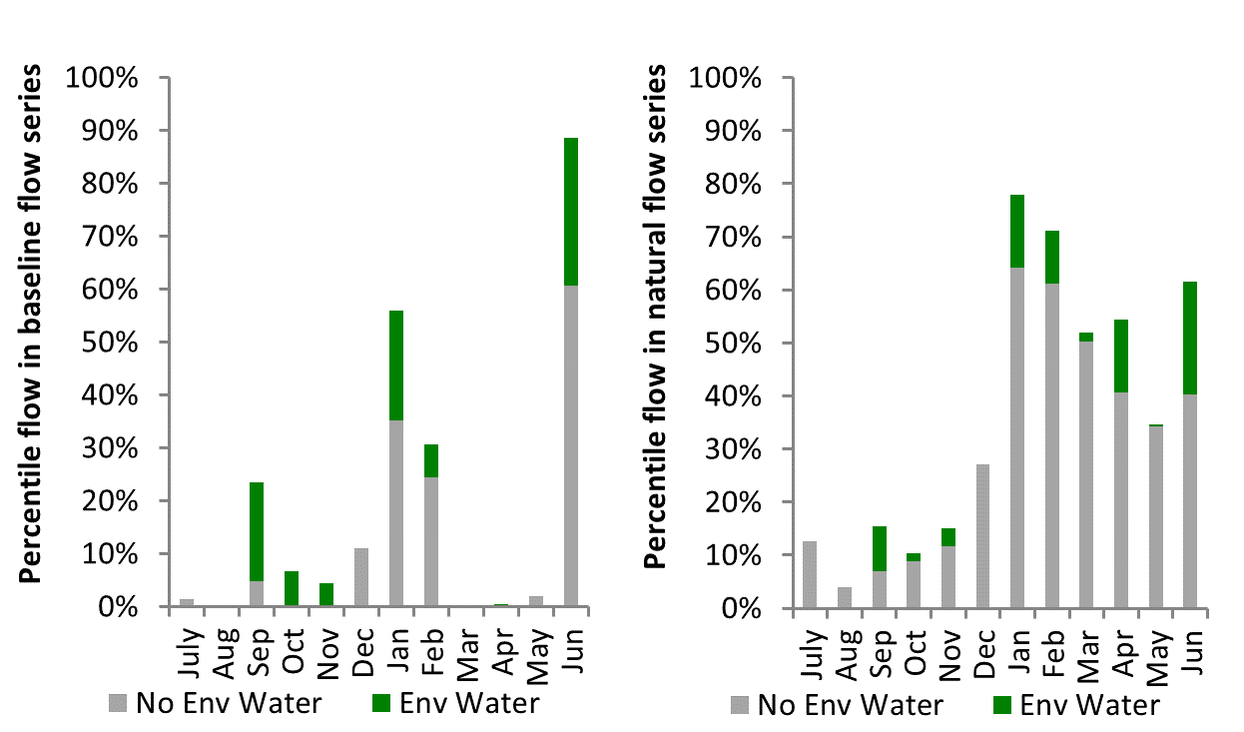
Figure LCH20: Contribution of environmental water delivery at Hillston as percentiles in the natural and baseline flow series.

Whealbah
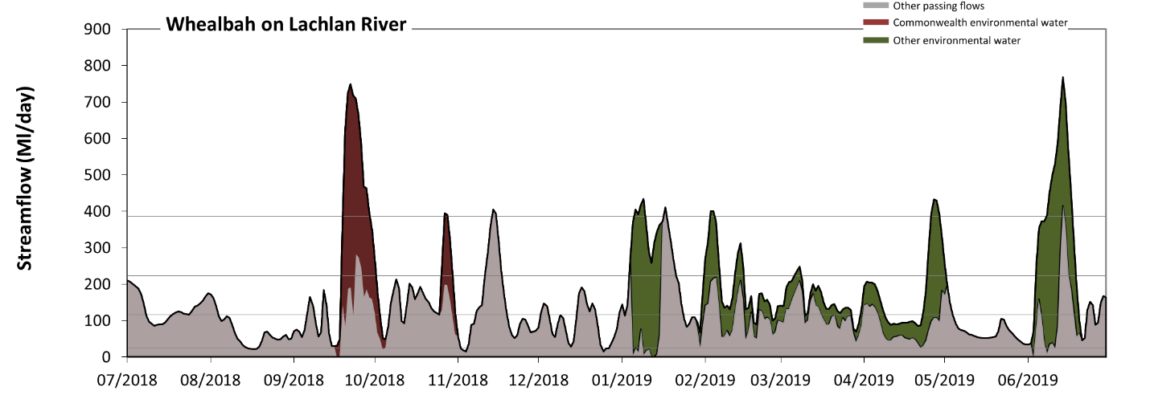 Figure LCH21: Contribution of environmental water delivery at Whealbah. Horizontal lines indicate thresholds for very low flows, low flows, low freshes and medium freshes (from lowest to highest).
At Whealbah on Lachlan River environmental water contributed 35% of the total streamflow volume (with a medium contribution of Commonwealth environmental water). Environmental watering actions affected streamflows for 40% of days between 1 July 2018 and 30 June 2019. Flow regulation does not substantially increase the duration of very low flows (i.e. < 23 Ml/day) compared to an average year in the natural flow regime. However, without environmental water, the durations of medium low flows (i.e. < 120 Ml/day) in the periods July to September, October to December, January to March and April to June would have all substantially exceeded durations expected in an average year in the natural flow regime. Environmental water mitigated these impacts by reducing the cumulative duration of medium low flow spells from 61% to 45% of the year, with greatest influence in the periods January to March and April to June. Commonwealth environmental water made a small contribution to these enhancements of environmental baseflows at this site. In the absence of environmental water there would have been at least one low fresh (i.e. > 220 Ml/day) in the periods July to September, October to December, January to March and April to June. Environmental water increased the duration of the longest low fresh during the periods July to September (from 3 days to 12 days), January to March (from 6 days to 18 days) and April to June (from 4 days to 15 days). Commonwealth environmental water made a modest contribution to these increased durations of low freshes. In the absence of environmental water there would have been at least one medium fresh (i.e. > 390 Ml/day) in the periods October to December, January to March and April to June. Environmental water increased the duration of the longest medium fresh during the periods July to September (from 0 days to 10 days), January to March (from 1 days to 4 days) and April to June (from 1 days to 10 days). Commonwealth environmental water made a modest contribution to these increased durations of medium freshes. There was no high freshes (i.e. > 940 Ml/day) this year.
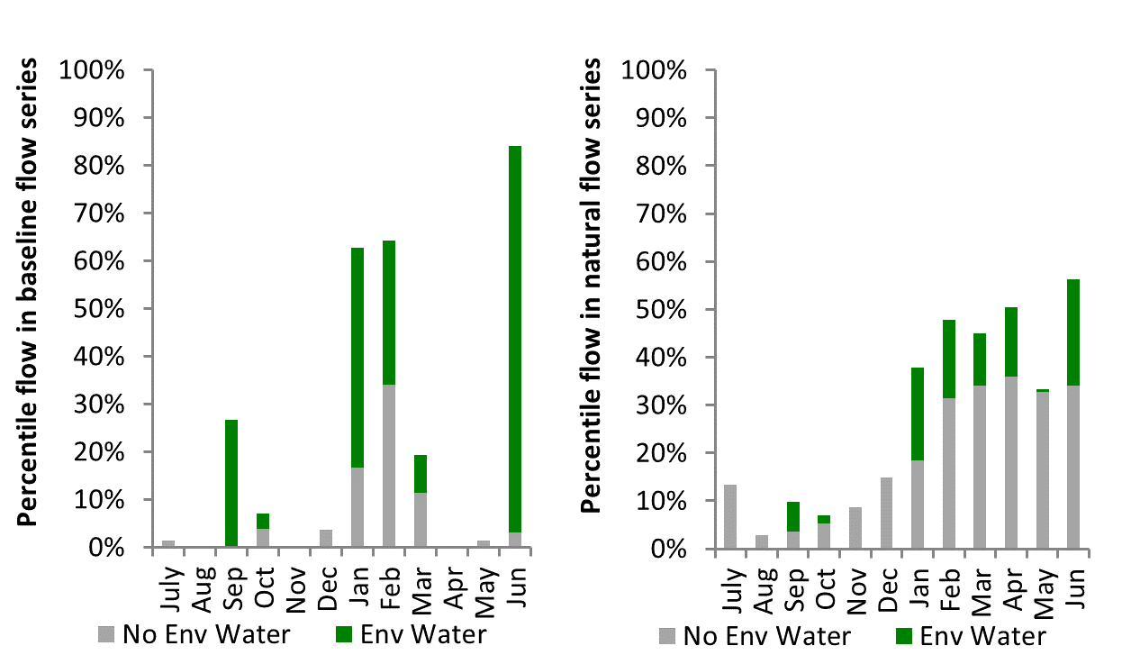
Figure LCH22: Contribution of environmental water delivery at Whealbah as percentiles in the natural and baseline flow series.
Booligal
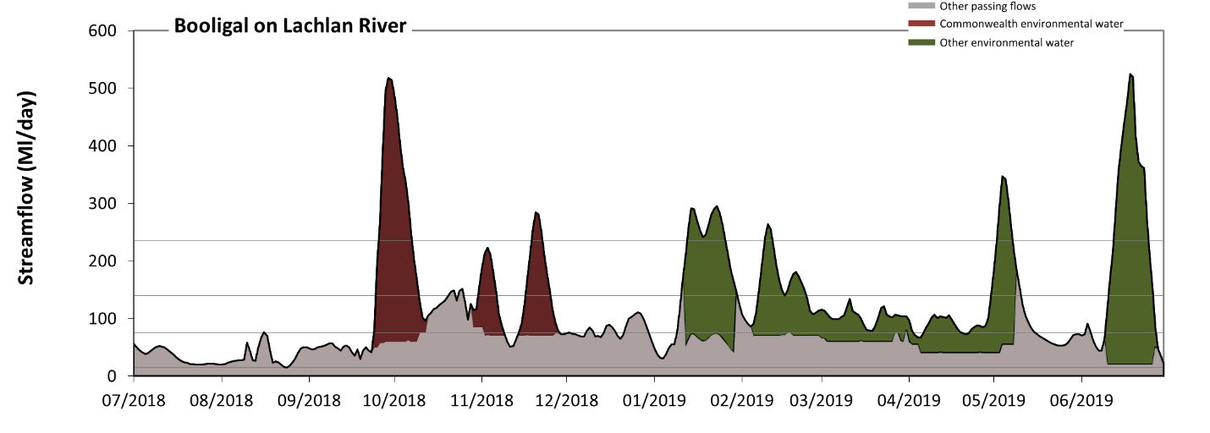 Figure LCH23: Contribution of environmental water delivery at Booligal. Horizontal lines indicate thresholds for very low flows, low flows, low freshes and medium freshes (from lowest to highest).
At Booligal on Lachlan River environmental water contributed 51% of the total streamflow volume (with a medium contribution of Commonwealth environmental water). Environmental watering actions affected streamflows for 48% of days between 1 July 2018 and 30 June 2019. Flow regulation does not substantially increase the duration of very low flows (i.e. < 15 Ml/day) compared to an average year in the natural flow regime. However, without environmental water, the durations of medium low flows (i.e. < 76 Ml/day) in the periods July to September, October to December, January to March and April to June would have all substantially exceeded durations expected in an average year in the natural flow regime. Environmental water mitigated these impacts by reducing the cumulative duration of medium low flow spells from 85% to 40% of the year, with greatest influence in the periods January to March and April to June. Commonwealth environmental water made a modest contribution to these enhancements of environmental baseflows at this site. In the absence of environmental water there would have been at least one low fresh (i.e. > 140 Ml/day) in the periods October to December, January to March and April to June. Environmental water increased the duration of the longest low fresh during the periods July to September (from 0 days to 6 days), October to December (from 2 days to 9 days), January to March (from 1 days to 20 days) and April to June (from 2 days to 16 days). Commonwealth environmental water equally shared responsibility with other environmental water holders for these increased durations of low freshes. In the absence of environmental water there would have been no medium or high freshes this year. Environmental water increased the duration of the longest medium fresh during the periods July to September (from 0 days to 5 days), October to December (from 0 days to 7 days), January to March (from 0 days to 14 days) and April to June (from 0 days to 12 days). Commonwealth environmental water equally shared responsibility with other environmental water holders for these increased durations of medium freshes.
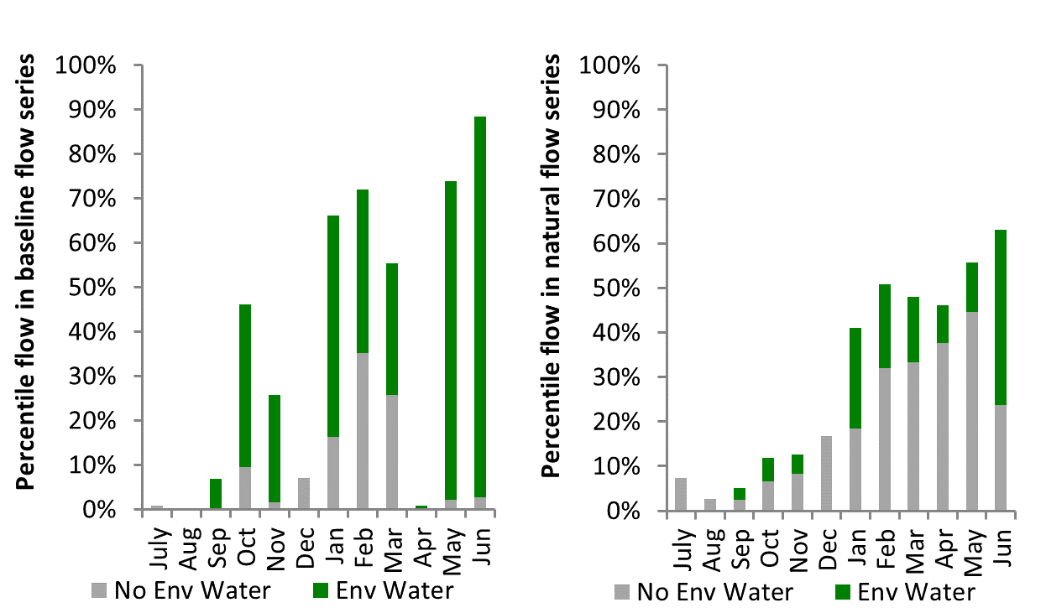
Figure LCH24: Contribution of environmental water delivery at Booligal as percentiles in the natural and baseline flow series.

Corrong
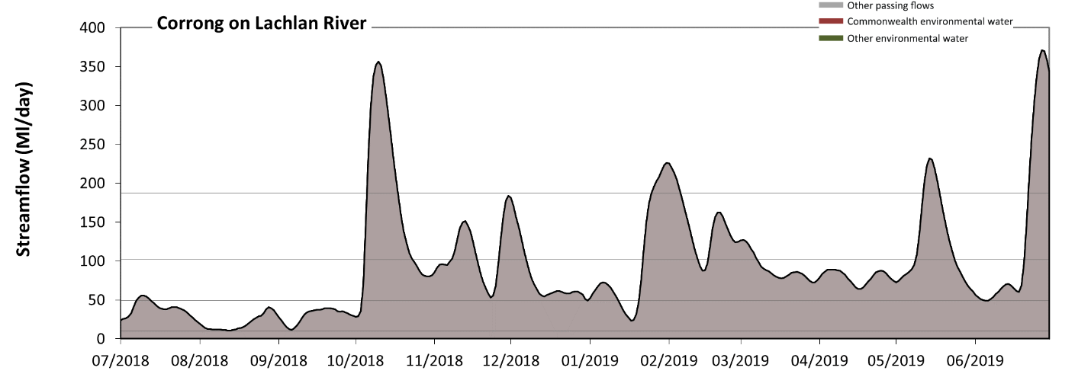 Figure LCH25: Contribution of environmental water delivery at Corrong. Horizontal lines indicate thresholds for very low flows, low flows, low freshes and medium freshes (from lowest to highest).
There was no environmental water delivered at Corrong on Lachlan RiverFlow regulation does not substantially increase the duration of very low flows (i.e. < 9.8 Ml/day) compared to an average year in the natural flow regime. However, without environmental water, the duration of medium low flows (i.e. < 49 Ml/day) in the period July to September was substantially in excess of durations expected in an average year in the natural flow regime. There was at least one low fresh (i.e. > 100 Ml/day) in the periods October to December, January to March and April to June. There was at least one medium fresh (i.e. > 190 Ml/day) in the periods October to December, January to March and April to June. There was no high freshes (i.e. > 500 Ml/day) this year.
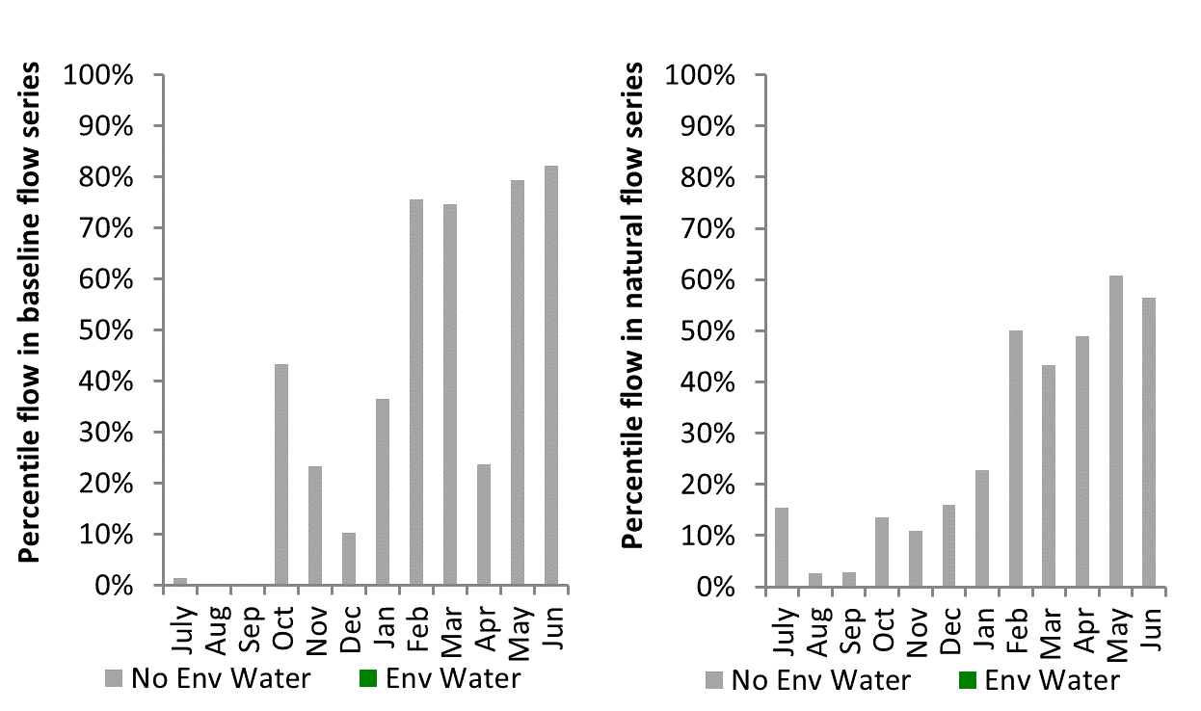
Figure LCH26: Contribution of environmental water delivery at Corrong as percentiles in the natural and baseline flow series.
Merrimajeel
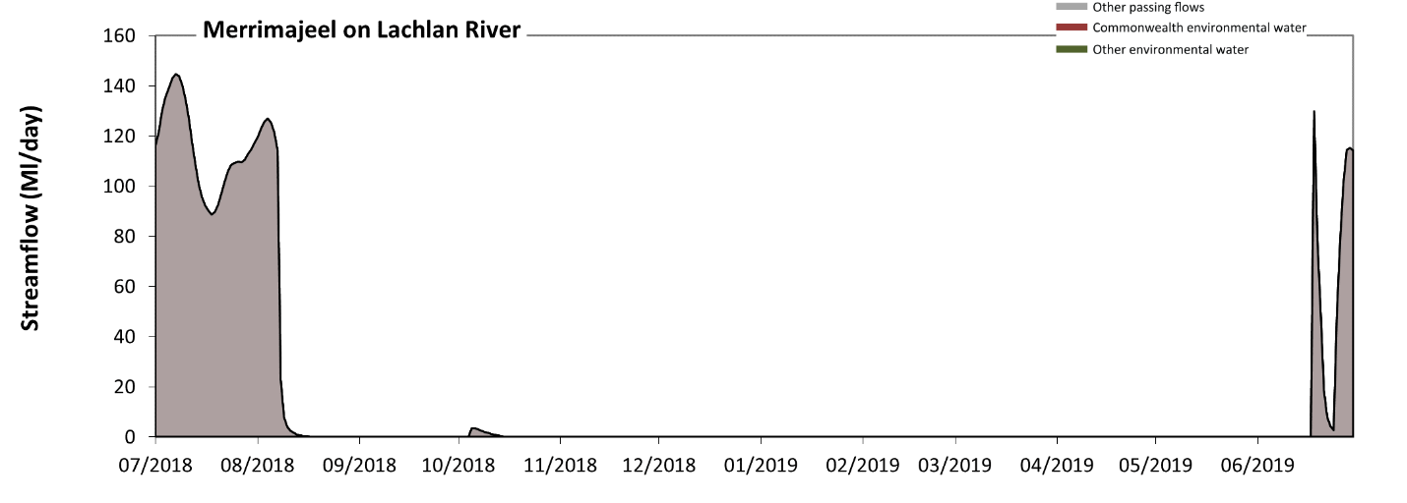 Figure LCH27: Contribution of environmental water delivery at Merrimajeel.
There was no environmental water delivered at Merrimajeel on Lachlan River
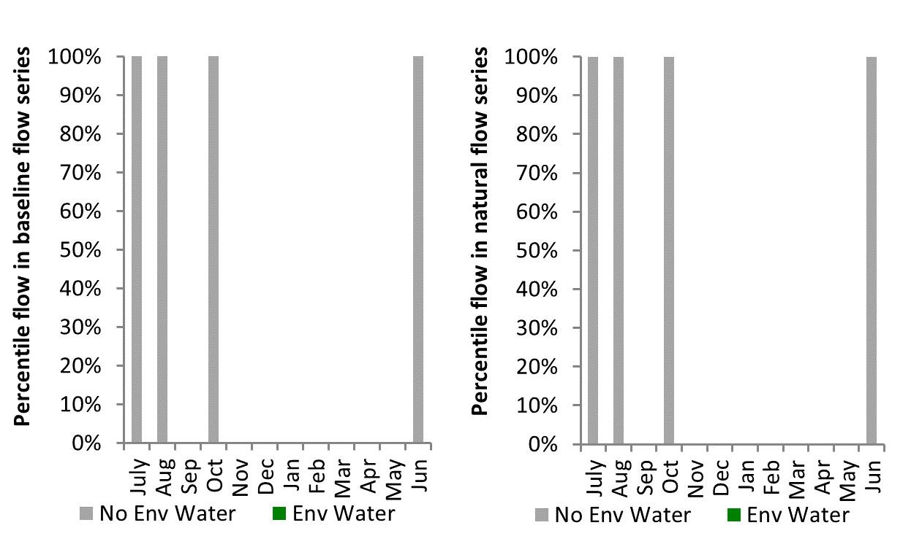
Figure LCH28: Contribution of environmental water delivery at Merrimajeel as percentiles in the natural and baseline flow series.

Central Murray
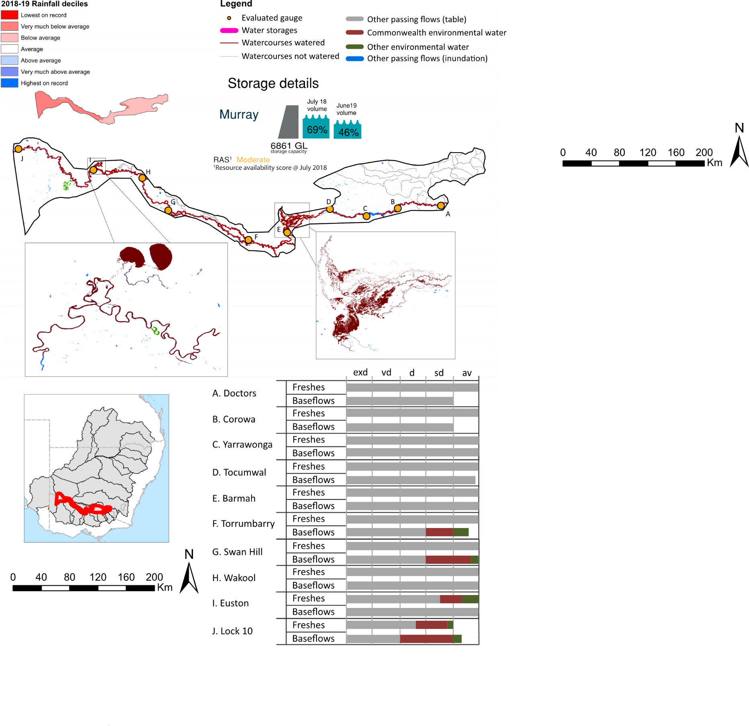
Figure CNM1: Watercourses influenced, areas inundated (where applicable) and gauge stations evaluated in the Central Murray valley during the 2018-19 water year. Inset bar graphs report the condition of annual flow regimes by showing the improvements in hydrological condition with the addition of environmental water as well as the hypothetical scenario in “grey” (if no environmental flow had been delivered) where exd=extremely dry, vd=very dry, d=dry, sd=somewhat dry and av=average. Rainfall conditions (rainfall deciles) and trend in storage levels for the water year are also shown.

Summary
The volume of environmental water delivery for the 2018-19 year in the Central Murray valley is quantified using data for 14 sites. This evaluation only considers the contribution of held environmental water, which is a primary focus for the Commonwealth. The contributions of planned environmental water (e.g. passing flows), unregulated tributary inflows and clever use of irrigation flows for environmental benefits can all be very important but these are outside the scope of this report. Environmental watering actions lasted on average 248 days over the course of the year. The volume of environmental water at these 14 sites was between 0% and 82% of the total streamflow. Commonwealth environmental water contributed on average 55% of this environmental water. The contribution of environmental water delivery to improved flow regimes is evaluated using data for 14 sites. Ideally, baseflows should be maintained and long periods of excessively low flows avoided. In this valley, the baseflow regime was generally considered to be somewhat dry relative to the pre-development flow regime. In our analysis, a low fresh refers to a period of increased flow, when the water level rises at least one eighth of the way up the river bank (above the low flow level). These low freshes are a regular part of the natural flow regime and support a range of natural processes. In the Central Murray valley, in terms of the occurrence and duration of low freshes, the year was assessed as being somewhat dry. In our analysis, a medium fresh refers to a period of increased flow, when the water level rises at least one quarter of the way up the river bank. These medium freshes are not as frequent as low freshes but are also a regular and important part of the natural flow regime. In the Central Murray valley, in terms of the occurrence of medium freshes, the year was assessed as being somewhat dry. In our analysis, a high fresh refers to a period of increased flow, when the water level rises more than half way up the river. A high fresh may not occur every year but they are still important and long periods without major freshes can have serious consequences for floodplains and their contribution to river connectivity. Delivering high in channel environmental flows normally requires that all risks to riparian landholders and infrastructure have been resolved. In the Central Murray valley, in terms of the occurrence of high freshes, the year was assessed as being somewhat dry.

Water delivery context
During the 2018-19, the Commonwealth Environmental Water Holder (CEWH) held water entitlements of up to 805,816 ML for environmental use in the Central Murray valley. Each year, water utilities allocate water entitlement holders a percentage of water based on their holding, license type and carryover (the exact rules vary among Jurisdictions). In 2018-19, the Central Murray entitlements held by the CEWH were allocated 351,547 ML of water, representing 54% of the Long term average annual yield for the Central Murray valley (653,016 ML). Information and data relating to the portfolio of held Commonwealth environmental water is shown in Table CNM2.
The 2018-19 water allocation (351,547 ML) together with the carryover volume of 174,520 ML of water meant the CEWH had 526,067 ML of water available for delivery. A total of 97,433 ML of Commonwealth environmental water was delivered in the Central Murray valley. A total of 0 ML of Commonwealth environmental water was traded to consumptive users and 24,6907 ML (47%) of available Commonwealth environmental water was carried over for environmental use into the 2019-20 water year.

Environmental conditions and resource availability
The water available for environmental delivery combined with the present and antecedent environmental conditions are key inputs used by environmental water managers in planning and implementing watering actions. Post hoc, this information provides important context when evaluating the effectiveness and appropriateness of environmental water use with respect to hydrological outputs.
The rainfall conditions in the Central Murray valley were classified as Very much below average, based on rainfall percentile data for the entire record held by the Bureau of Meteorology for this valley. The water held in major storages in the Central Murray valley decreased over the water year, for example Dartmouth and Hume dam was 68.8% full at the beginning of the water year and 46.4% full by the end of the year (Figure CNM1).
The Commonwealth Environmental Water Office (CEWO) calculates resource availability scenarios (RAS) to guide the use and prioritisation of held environmental water. The RAS are progressively calculated over the year as part of the continual adaptive management planning processes. The RAS are based on the availability of held environmental water (including progressive license acquisitions and allocations) as well as the potential for unregulated or planned environmental flows. The outcome is then used to determine the demand for environmental water across the basin.
In 2018-19, the resource availability of held Commonwealth environmental water was classified as low to very high. The physical conditions meant that the CEWO was managing to maintain and/or improve the condition of environmental assets. The overall demand for environmental water was deemed moderate.

Watering actions
A total of 4 watering actions were delivered over the 2018-19 water year, the duration of these actions varied (range of individual actions: 12 - 359 days) and Commonwealth environmental water was delivered for a total of 365 days. The number of water actions commencing in each season included, Autumn (0), Spring (2), Summer (0), Winter(2). Similarly, the count of flow component types delivered in the Central Murray valley were; (1) baseflow, (0) baseflow-fresh, (0) fresh, (1) fresh-overbank, (0) bankfull, (2) overbank, (0) wetland and (0) wetland-fresh.
In this valley, primary objectives of most watering actions was related to fish, but water was also delivered for other purposes too. The percentage of watering actions delivered across the nine main themes included primary objectives for fish (33.33%), vegetation (16.67%), waterbirds (16.67%), frogs (0.0%), other biota (8.33%), connectivity (8.33%), process (8.33%), resilience (0.0%) and water quality (8.33%).
Table CNM2. Commonwealth environmental water accounting information for the Central Murray valley over 2018-19 water year.
Total registered volume (ML) | Allocated volume (ML) | Carry over + allocated volume (ML) | Delivered (ML) | LTAAY (ML) | Trade (ML) | Carried over to 2019-20 | Forfeited (ML)
805,816 | 351,547 | 526,067 | 97,433 | 653,016 | 0 | 246,907 | 0

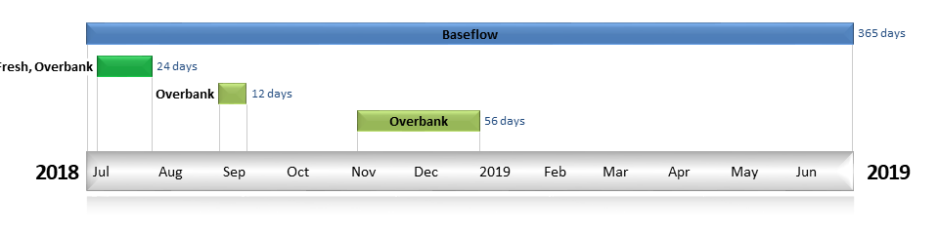
Figure CNM2. Timing and duration of Commonwealth environmental water actions delivered in the Central Murray valley.

Contribution of Commonwealth environmental water to flow regimes
Doctors
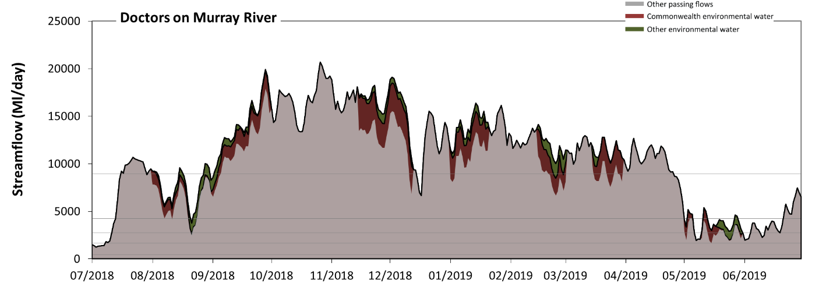
Figure CNM3: Contribution of environmental water delivery at Doctors. Horizontal lines indicate thresholds for very low flows, low flows, low freshes, medium freshes and high freshes (from lowest to highest).
At Doctors on Murray River, environmental water contributed 10% of the total streamflow volume. Environmental watering actions affected streamflows for 47% of days between 1 July 2018 and 30 June 2019. Flow regulation does not substantially increase the duration of very low flows (i.e. < 410 Ml/day) compared to an average year in the natural flow regime. However, without environmental water, the duration of medium low flows (i.e. < 1700 Ml/day) in the period July to September would have substantially exceeded durations expected in an average year in the natural flow regime. However, environmental water had little effect on the duration of these medium low flows, which occurred for 2% of the year. In the absence of environmental water there would have been at least one low fresh (i.e. > 2700 Ml/day) in the periods July to September, October to December, January to March and April to June. Environmental water increased the duration of the longest low fresh during the period July to September (from 41 days to 82 days). There was at least one medium fresh (i.e. > 4200 Ml/day) in the periods July to September, October to December, January to March and April to June. Environmental water made little change to the duration of these medium freshes. In the absence of environmental water there would have been at least one high fresh in the periods July to September, October to December, January to March and April to June. Environmental water increased the duration of the longest high fresh during the period January to March (from 48 days to 90 days).
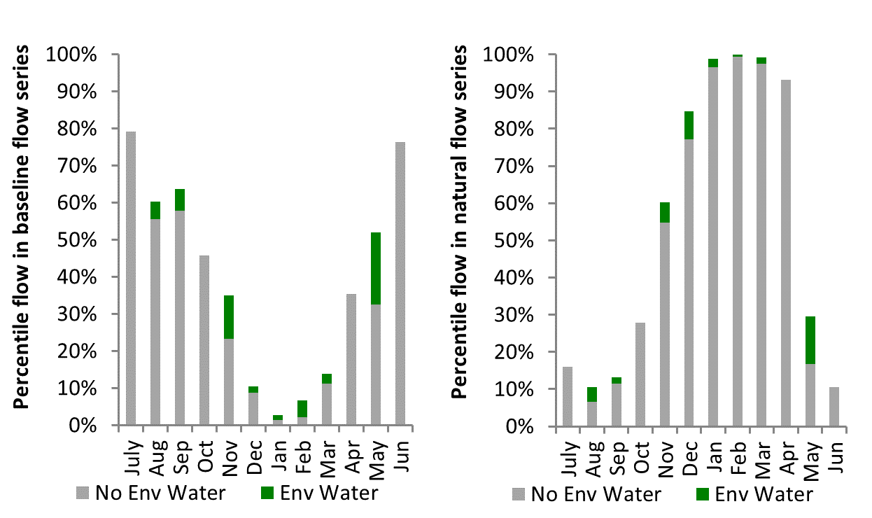
Figure CNM4: Contribution of environmental water delivery at Doctors as percentiles in the natural and baseline flow series.
Corowa
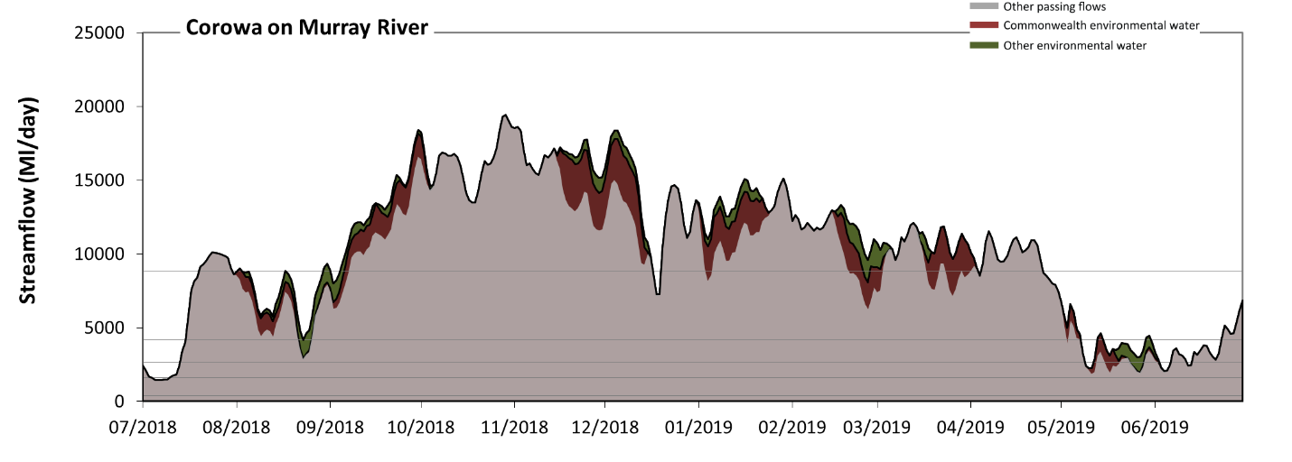
Figure CNM5: Contribution of environmental water delivery at Corowa. Horizontal lines indicate thresholds for very low flows, low flows, low freshes, medium freshes and high freshes (from lowest to highest).
At Corowa on Murray River, environmental water contributed 10% of the total streamflow volume. Environmental watering actions affected streamflows for 64% of days between 1 July 2018 and 30 June 2019. Flow regulation does not substantially increase the duration of very low flows (i.e. < 380 Ml/day) compared to an average year in the natural flow regime. However, without environmental water, the duration of medium low flows (i.e. < 1600 Ml/day) in the period July to September would have substantially exceeded durations expected in an average year in the natural flow regime. However, environmental water had little effect on the duration of these medium low flows, which occurred for 2% of the year. There was at least one low fresh (i.e. > 2700 Ml/day) in the periods July to September, October to December, January to March and April to June. Environmental water made little change to the duration of these low freshes. In the absence of environmental water there would have been at least one medium fresh (i.e. > 4200 Ml/day) in the periods July to September, October to December, January to March and April to June. Environmental water increased the duration of the longest medium fresh during the period July to September (from 37 days to 77 days). In the absence of environmental water there would have been at least one high fresh in the periods July to September, October to December, January to March and April to June. Environmental water increased the duration of the longest high fresh during the period January to March (from 45 days to 90 days).
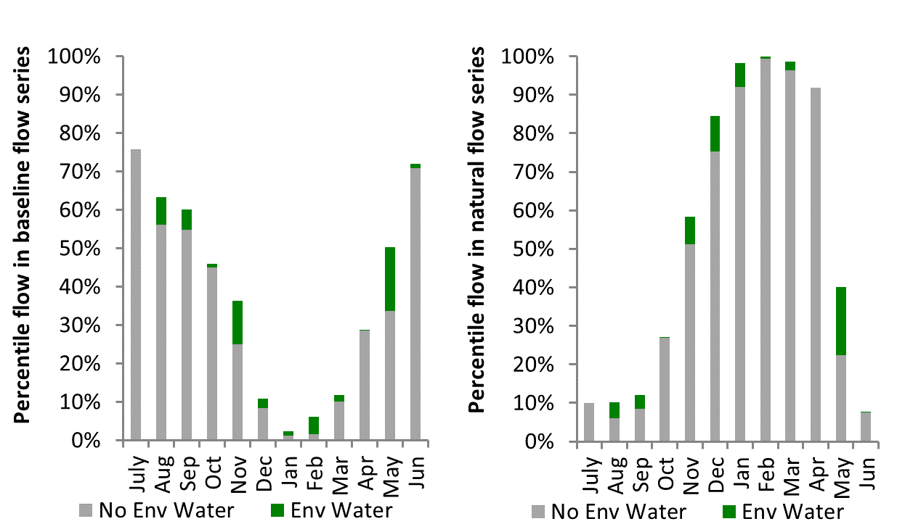
Figure CNM6: Contribution of environmental water delivery at Corowa as percentiles in the natural and baseline flow series.

Yarrawonga
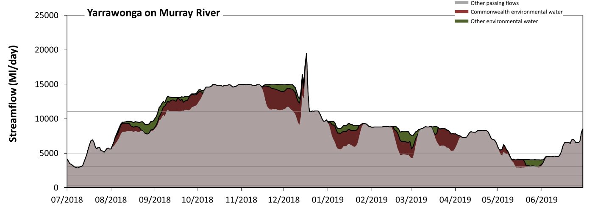
Figure CNM7: Contribution of environmental water delivery at Yarrawonga. Horizontal lines indicate thresholds for very low flows, low flows, low freshes, medium freshes and high freshes (from lowest to highest).
At Yarrawonga on Murray River, environmental water contributed 11% of the total streamflow volume. Environmental watering actions affected streamflows for 68% of days between 1 July 2018 and 30 June 2019. Flow regulation does not substantially increase the duration of very low flows (i.e. < 340 Ml/day) compared to an average year in the natural flow regime. Flow regulation does not substantially increase the duration of medium low flows (i.e. < 1700 Ml/day) compared to an average year in the natural flow regime. In the absence of environmental water there would have been at least one low fresh (i.e. > 3100 Ml/day) in the periods July to September, October to December, January to March and April to June. Environmental water increased the duration of the longest low fresh during the period April to June (from 43 days to 91 days). In the absence of environmental water there would have been at least one medium fresh (i.e. > 4900 Ml/day) in the periods July to September, October to December, January to March and April to June. Environmental water increased the duration of the longest medium fresh during the period January to March (from 51 days to 90 days). In the absence of environmental water there would have been at least one high fresh in the periods July to September and October to December. Environmental water increased the duration of the longest high fresh during the period July to September (from 21 days to 27 days).
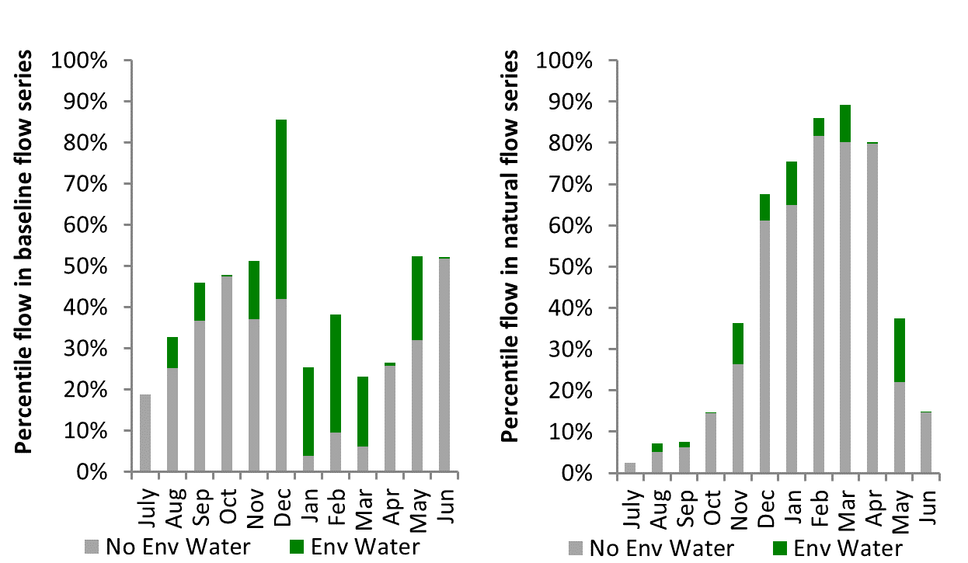
Figure CNM8: Contribution of environmental water delivery at Yarrawonga as percentiles in the natural and baseline flow series.
Tocumwal
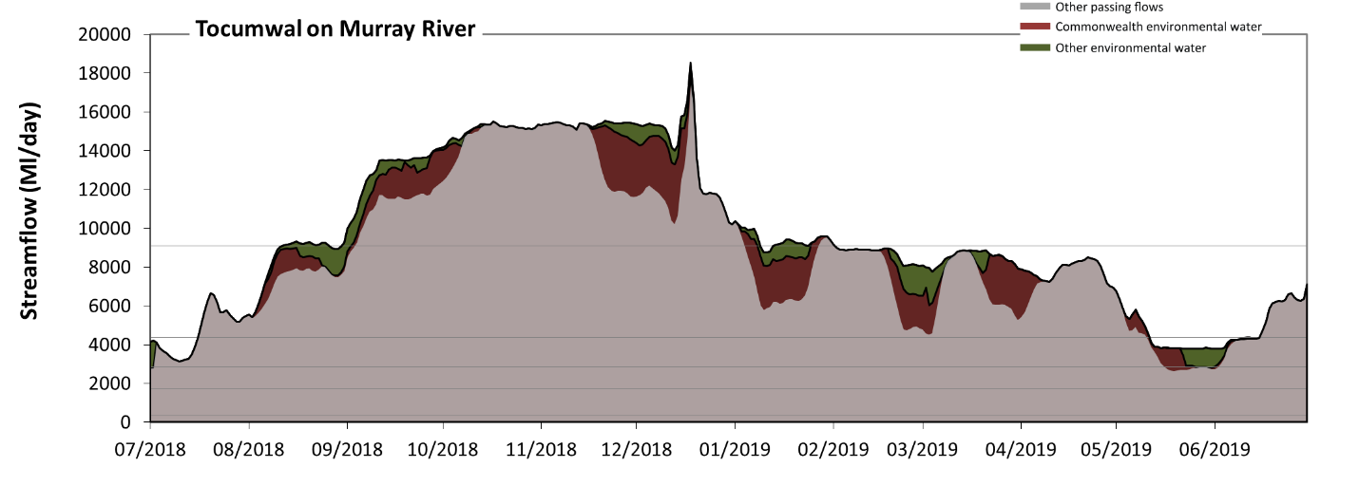
Figure CNM9: Contribution of environmental water delivery at Tocumwal. Horizontal lines indicate thresholds for very low flows, low flows, low freshes, medium freshes and high freshes (from lowest to highest).
At Tocumwal on Murray River, environmental water contributed 11% of the total streamflow volume. Environmental watering actions affected streamflows for 74% of days between 1 July 2018 and 30 June 2019. Flow regulation does not substantially increase the duration of very low flows (i.e. < 340 Ml/day) compared to an average year in the natural flow regime. Flow regulation does not substantially increase the duration of medium low flows (i.e. < 1700 Ml/day) compared to an average year in the natural flow regime. In the absence of environmental water there would have been at least one low fresh (i.e. > 2800 Ml/day) in the periods July to September, October to December, January to March and April to June. Environmental water increased the duration of the longest low fresh during the period April to June (from 46 days to 91 days). There was at least one medium fresh (i.e. > 4400 Ml/day) in the periods July to September, October to December, January to March and April to June. Environmental water made little change to the duration of these medium freshes. In the absence of environmental water there would have been at least one high fresh in the periods July to September, October to December and January to March. Environmental water increased the duration of the longest high fresh during the period January to March (from 5 days to 20 days).
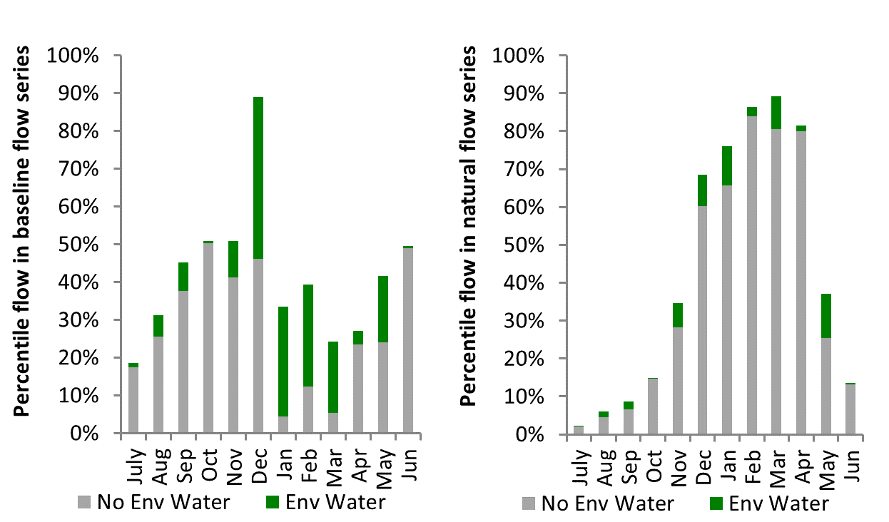
Figure CNM10: Contribution of environmental water delivery at Tocumwal as percentiles in the natural and baseline flow series.

Barmah
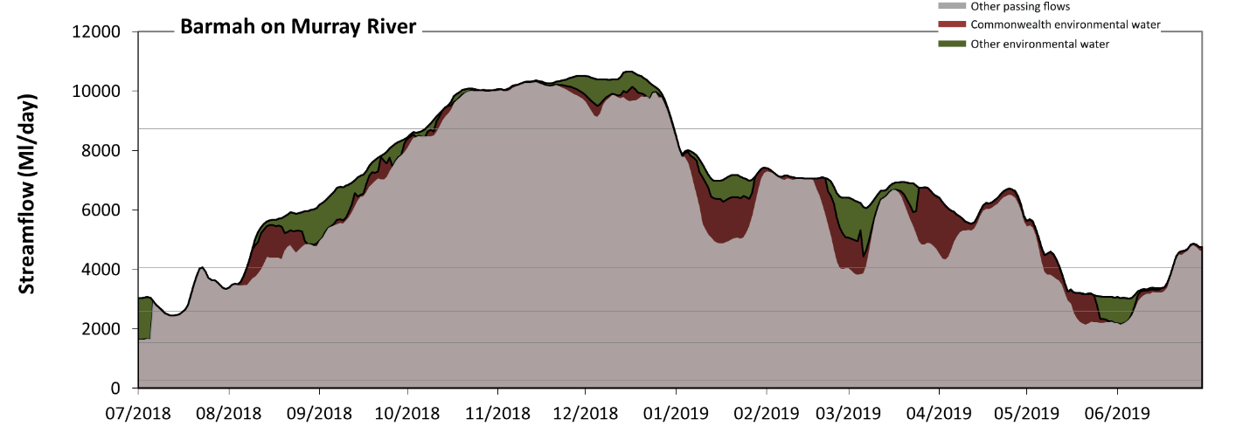
Figure CNM11: Contribution of environmental water delivery at Barmah. Horizontal lines indicate thresholds for very low flows, low flows, low freshes, medium freshes and high freshes (from lowest to highest).
At Barmah on Murray River, environmental water contributed 10% of the total streamflow volume. Environmental watering actions affected streamflows for 100% of days between 1 July 2018 and 30 June 2019. Flow regulation does not substantially increase the duration of very low flows (i.e. < 260 Ml/day) compared to an average year in the natural flow regime. Flow regulation does not substantially increase the duration of medium low flows (i.e. < 1500 Ml/day) compared to an average year in the natural flow regime. In the absence of environmental water there would have been at least one low fresh (i.e. > 2600 Ml/day) in the periods July to September, October to December, January to March and April to June. Environmental water increased the duration of the longest low fresh during the period April to June (from 46 days to 91 days). In the absence of environmental water there would have been at least one medium fresh (i.e. > 4100 Ml/day) in the periods July to September, October to December, January to March and April to June. Environmental water increased the duration of the longest medium fresh during the period January to March (from 56 days to 90 days). In the absence of environmental water there would have been at least one high fresh in the period October to December. Environmental water made little change to the duration of these high freshes.
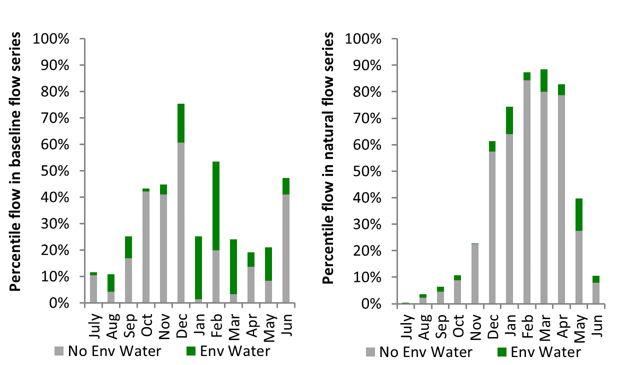
Figure CNM12: Contribution of environmental water delivery at Barmah as percentiles in the natural and baseline flow series.

Torrumbarry
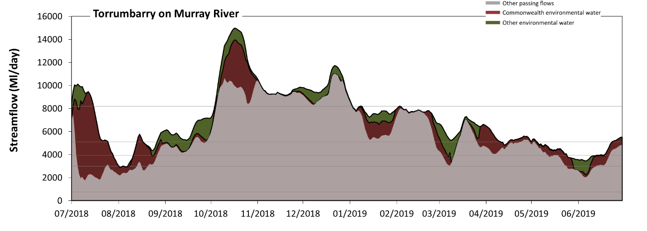Figure CNM13: Contribution of environmental water delivery at Torrumbarry. Horizontal lines indicate thresholds for very low flows, low flows, low freshes, medium freshes and high freshes (from lowest to highest).
At Torrumbarry on Murray River environmental water contributed 19% of the total streamflow volume. Environmental watering actions affected streamflows for 100% of days between 1 July 2018 and 30 June 2019. Flow regulation does not substantially increase the duration of very low flows (i.e. < 760 Ml/day) compared to an average year in the natural flow regime. However, without environmental water, the durations of medium low flows (i.e. < 3000 Ml/day) in the periods July to September and April to June would have substantially exceeded durations expected in an average year in the natural flow regime. Environmental water mitigated these impacts by reducing the cumulative duration of medium low flow spells from 16% to 1% of the year, with greatest influence in the periods July to September and April to June. In the absence of environmental water there would have been at least one low fresh (i.e. > 3900 Ml/day) in the periods July to September, October to December, January to March and April to June. Environmental water increased the duration of the longest low fresh during the periods July to September (from 35 days to 51 days), January to March (from 62 days to 90 days) and April to June (from 41 days to 54 days). In the absence of environmental water there would have been at least one medium fresh (i.e. > 5100 Ml/day) in the periods July to September, October to December, January to March and April to June. Environmental water increased the duration of the longest medium fresh during the periods July to September (from 5 days to 35 days), January to March (from 57 days to 90 days) and April to June (from 6 days to 19 days). In the absence of environmental water there would have been at least one high fresh in the periods October to December and January to March. Environmental water increased the duration of the longest high fresh during the period July to September (from 0 days to 15 days).
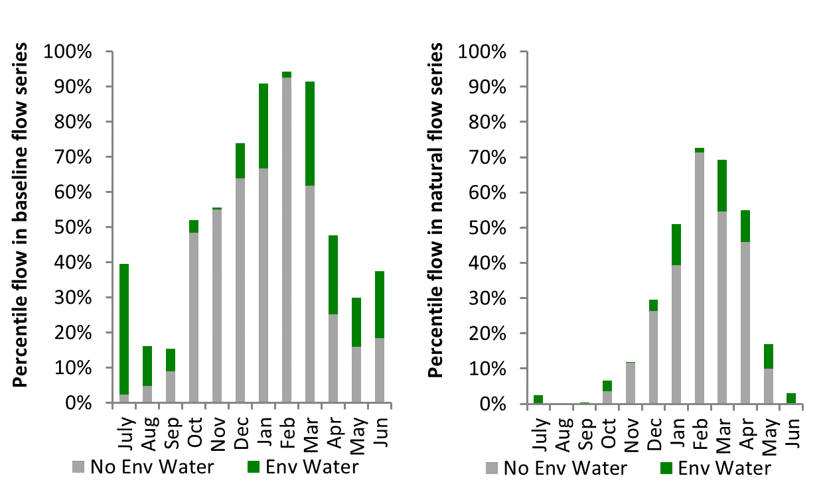
Figure CNM14: Contribution of environmental water delivery at Torrumbarry as percentiles in the natural and baseline flow series.

Barham
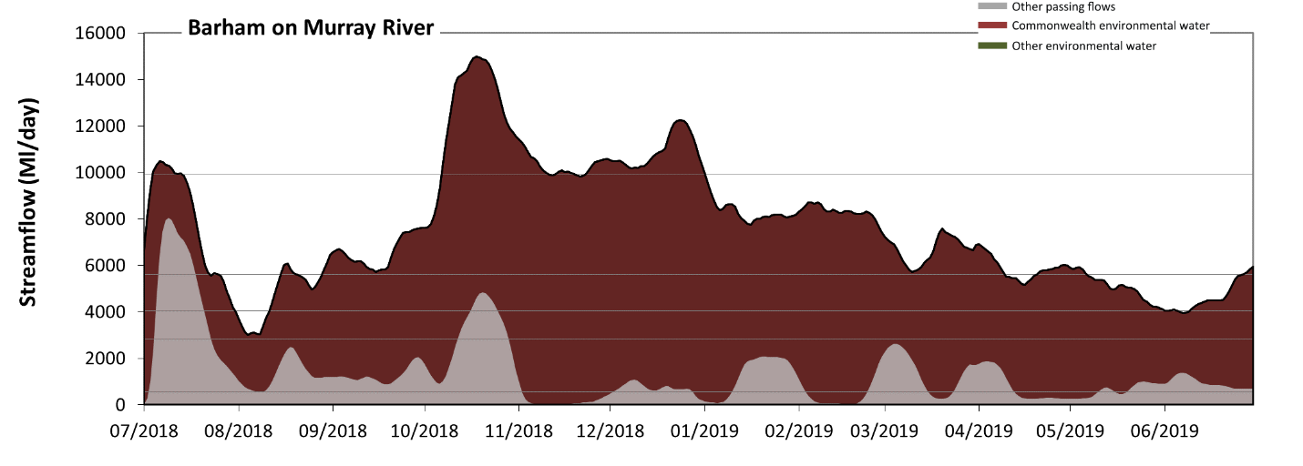 Figure CNM15: Contribution of environmental water delivery at Barham. Horizontal lines indicate thresholds for very low flows, low flows, low freshes, medium freshes and high freshes (from lowest to highest).
At Barham on Murray River, environmental water contributed 82% of the total streamflow volume. Environmental watering actions affected streamflows for 100% of days between 1 July 2018 and 30 June 2019. Without environmental water, the durations of very low flows (i.e. < 550 Ml/day) in the periods October to December, January to March and April to June would have substantially exceeded durations expected in an average year in the natural flow regime. Environmental water mitigated these impacts by reducing the cumulative duration of very low flow spells from 29% to 0% of the year, with greatest influence in the periods October to December, January to March and April to June. Similarly, without environmental water, the durations of medium low flows (i.e. < 2800 Ml/day) in the periods July to September, October to December, January to March and April to June would have all substantially exceeded durations expected in an average year in the natural flow regime. Environmental water mitigated these impacts by reducing the cumulative duration of medium low flow spells from 90% to 0% of the year, with greatest influence in the periods January to March and April to June. In the absence of environmental water there would have been at least one low fresh (i.e. > 4000 Ml/day) in the periods July to September and October to December. Environmental water increased the duration of the longest low fresh during the periods July to September (from 16 days to 50 days), October to December (from 9 days to 92 days), January to March (from 0 days to 90 days) and April to June (from 0 days to 65 days). In the absence of environmental water there would have been at least one medium fresh (i.e. > 5600 Ml/day) in the period July to September. Environmental water increased the duration of the longest medium fresh during the periods July to September (from 12 days to 33 days), October to December (from 0 days to 92 days), January to March (from 0 days to 90 days) and April to June (from 0 days to 17 days). There was no high freshes (i.e. > 9900 Ml/day) this year. Environmental water increased the duration of the longest medium fresh during the periods July to September (from 0 days to 10 days), October to December (from 0 days to 39 days) and January to March (from 0 days to 1 days). Note this output has been based on the prebuyback model as such the grey colour represents flows with Commonwealth environmental water, whilst the red colour represents the impact of the basin plan including Commonwealth environmental water.
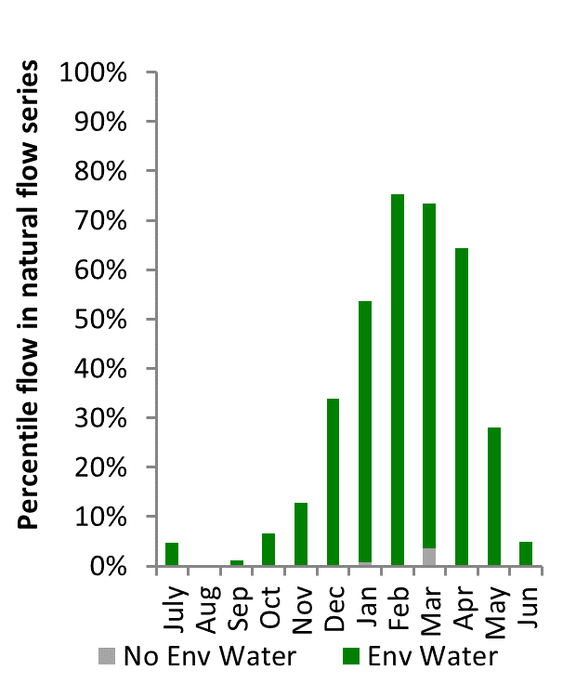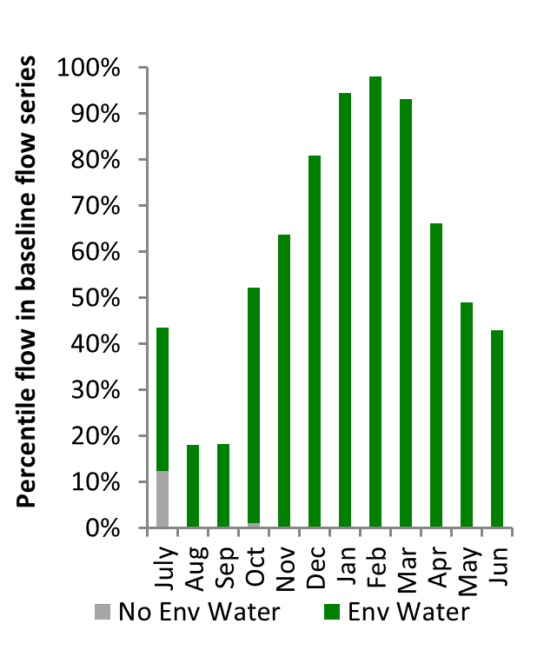
Figure CNM16: Contribution of environmental water delivery at Barham as percentiles in the natural and baseline flow series.
Swan Hill
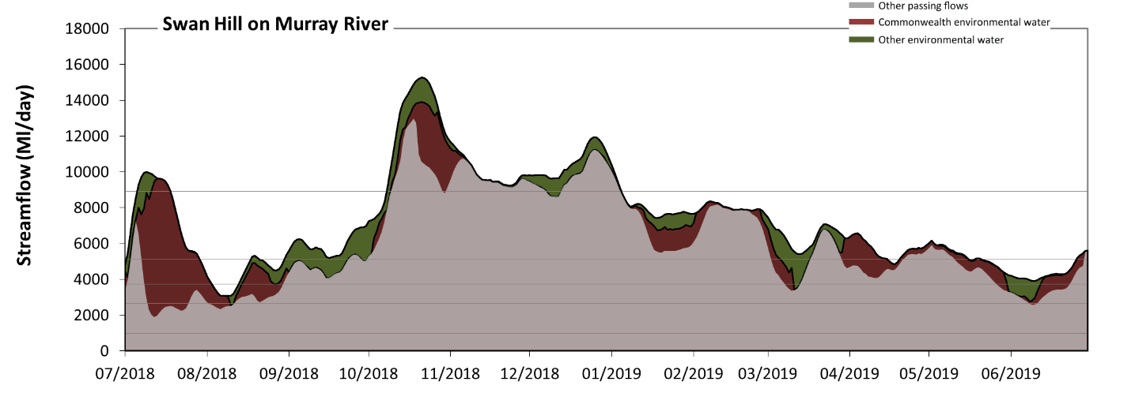 Figure CNM17: Contribution of environmental water delivery at Swan Hill. Horizontal lines indicate thresholds for very low flows, low flows, low freshes, medium freshes and high freshes (from lowest to highest).
At Swan Hill on Murray River, environmental water contributed 18% of the total streamflow volume. Environmental watering actions affected streamflows for 99% of days between 1 July 2018 and 30 June 2019. Flow regulation does not substantially increase the duration of very low flows (i.e. < 980 Ml/day) compared to an average year in the natural flow regime. However, without environmental water, the duration of medium low flows (i.e. < 2600 Ml/day) in the period July to September would have substantially exceeded durations expected in an average year in the natural flow regime. Environmental water mitigated these impacts by reducing the cumulative duration of medium low flow spells from 8% to 0% of the year, with greatest influence in the period July to September. In the absence of environmental water there would have been at least one low fresh (i.e. > 3700 Ml/day) in the periods July to September, October to December, January to March and April to June. Environmental water increased the duration of the longest low fresh during the periods July to September (from 32 days to 49 days), January to March (from 66 days to 90 days) and April to June (from 56 days to 91 days). In the absence of environmental water there would have been at least one medium fresh (i.e. > 5100 Ml/day) in the periods July to September, October to December, January to March and April to June. Environmental water increased the duration of the longest medium fresh during the periods July to September (from 5 days to 31 days), January to March (from 61 days to 90 days) and April to June (from 19 days to 27 days). In the absence of environmental water there would have been at least one high fresh in the periods October to December and January to March. Environmental water increased the duration of the longest high fresh during the periods July to September (from 0 days to 13 days) and October to December (from 38 days to 85 days).
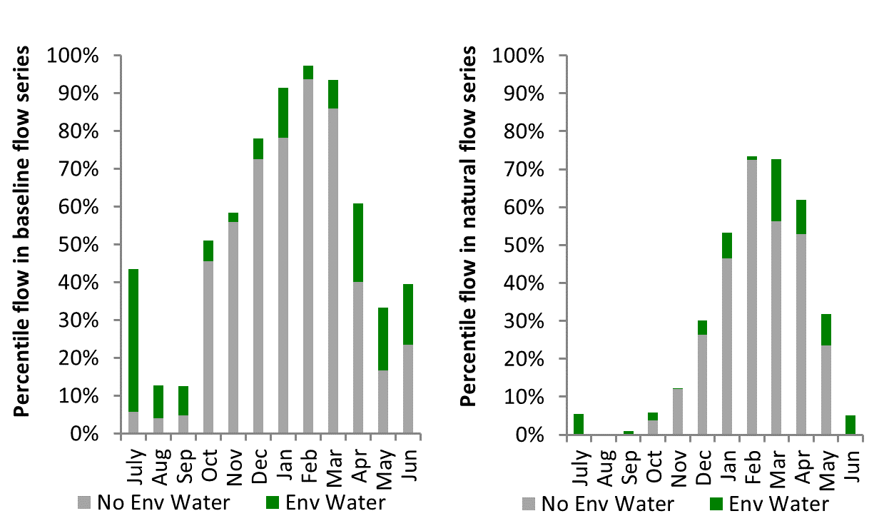
Figure CNM18: Contribution of environmental water delivery at Swan Hill as percentiles in the natural and baseline flow series.
Wakool
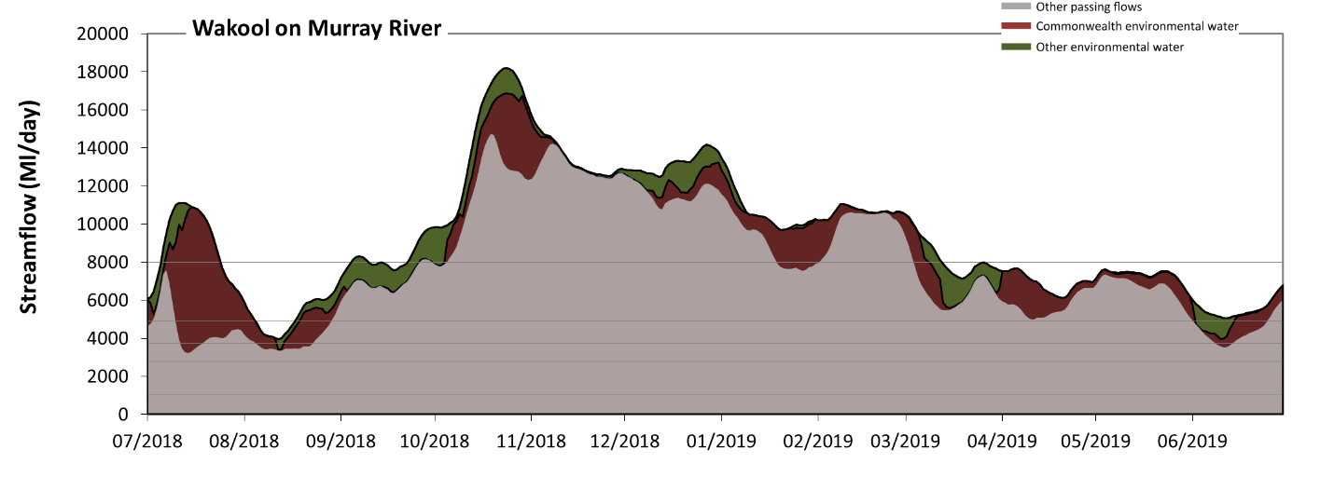
Figure CNM19: Contribution of environmental water delivery at Wakool. Horizontal lines indicate thresholds for very low flows, low flows, low freshes, medium freshes and high freshes (from lowest to highest).
At Wakool on Murray River, environmental water contributed 17% of the total streamflow volume. Environmental watering actions affected streamflows for 100% of days between 1 July 2018 and 30 June 2019. Flow regulation does not substantially increase the duration of very low flows (i.e. < 1000 Ml/day) compared to an average year in the natural flow regime. Flow regulation does not substantially increase the duration of medium low flows (i.e. < 2800 Ml/day) compared to an average year in the natural flow regime. In the absence of environmental water there would have been at least one low fresh (i.e. > 3700 Ml/day) in the periods July to September, October to December, January to March and April to June. Environmental water increased the duration of the longest low fresh during the periods July to September (from 38 days to 92 days) and April to June (from 69 days to 91 days). In the absence of environmental water there would have been at least one medium fresh (i.e. > 4900 Ml/day) in the periods July to September, October to December, January to March and April to June. Environmental water increased the duration of the longest medium fresh during the periods July to September (from 33 days to 44 days) and April to June (from 62 days to 91 days). In the absence of environmental water there would have been at least one high fresh in the periods July to September, October to December and January to March. Environmental water increased the duration of the longest high fresh during the periods July to September (from 4 days to 19 days) and January to March (from 30 days to 71 days).

Figure CNM20: Contribution of environmental water delivery at Wakool as percentiles in the natural and baseline flow series.
Euston
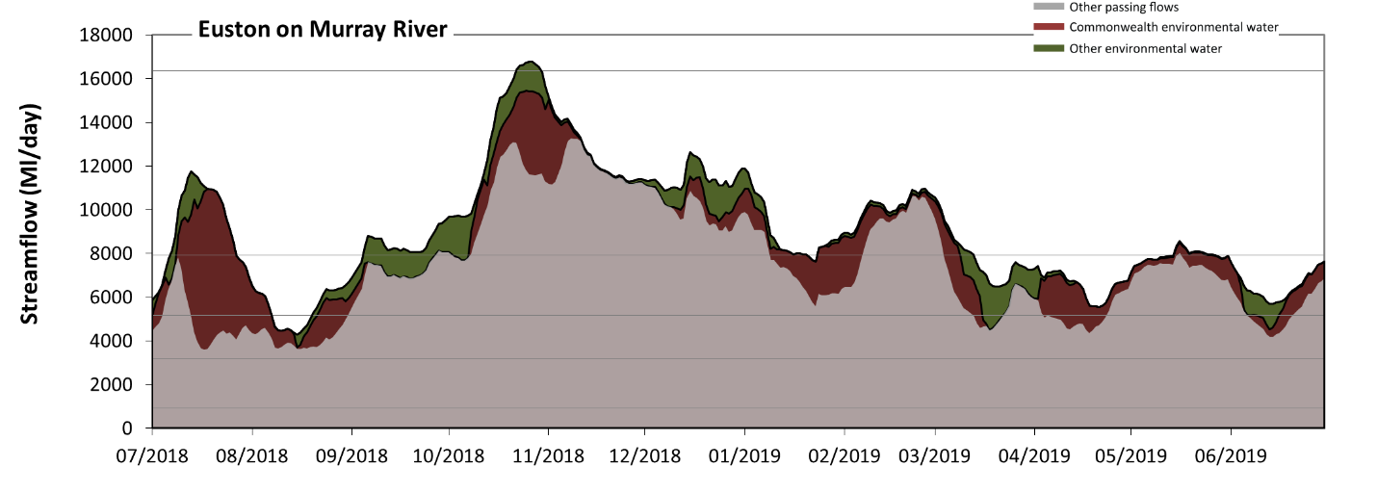 Figure CNM21: Contribution of environmental water delivery at Euston. Horizontal lines indicate thresholds for very low flows, low flows, low freshes, medium freshes and high freshes (from lowest to highest).
At Euston on Murray River, environmental water contributed 18% of the total streamflow volume. Environmental watering actions affected streamflows for 100% of days between 1 July 2018 and 30 June 2019. Flow regulation does not substantially increase the duration of very low flows (i.e. < 910 Ml/day) compared to an average year in the natural flow regime. Flow regulation does not substantially increase the duration of medium low flows (i.e. < 3200 Ml/day) compared to an average year in the natural flow regime. In the absence of environmental water there would have been at least one low fresh (i.e. > 5200 Ml/day) in the periods July to September, October to December, January to March and April to June. Environmental water increased the duration of the longest low fresh during the periods July to September (from 31 days to 42 days), January to March (from 71 days to 90 days) and April to June (from 43 days to 91 days). In the absence of environmental water there would have been at least one medium fresh (i.e. > 7900 Ml/day) in the periods July to September, October to December, January to March and April to June. Environmental water increased the duration of the longest medium fresh during the periods July to September (from 4 days to 26 days), January to March (from 25 days to 49 days) and April to June (from 1 days to 13 days). In the absence of environmental water there would have been at least one high freshes (i.e. > 16000 Ml/day) this year. Environmental water increased the duration of the longest medium fresh during the period October to December (from 0 days to 8 days).
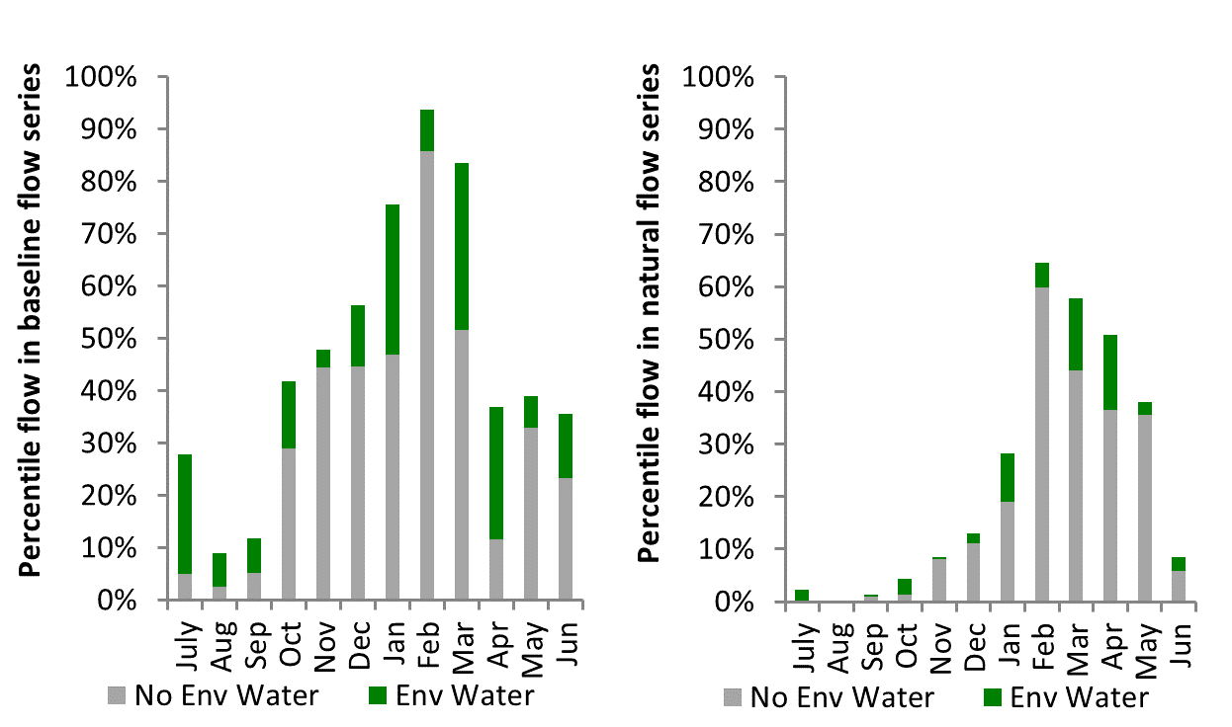
Figure CNM22: Contribution of environmental water delivery at Euston as percentiles in the natural and baseline flow series.

Lock 10
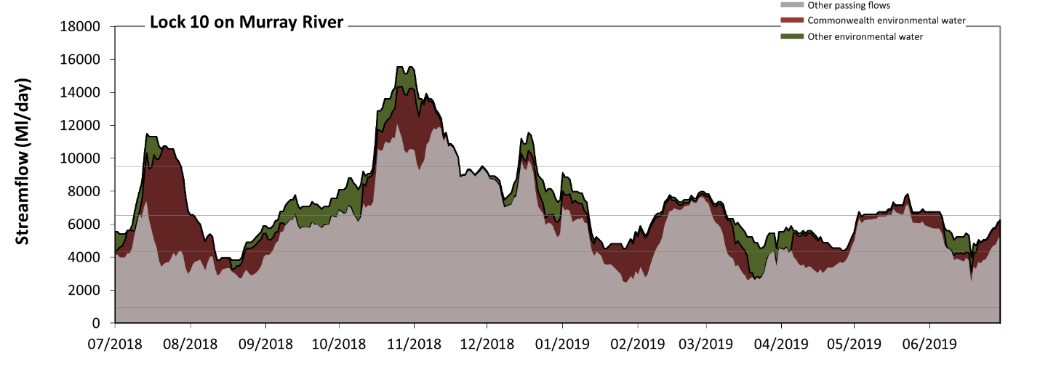
Figure CNM23: Contribution of environmental water delivery at Lock 10. Horizontal lines indicate thresholds for very low flows, low flows, low freshes and medium freshes (from lowest to highest).
At Lock 10 on Murray River, environmental water contributed 22% of the total streamflow volume. Environmental watering actions affected streamflows for 100% of days between 1 July 2018 and 30 June 2019. Flow regulation does not substantially increase the duration of very low flows (i.e. < 940 Ml/day) compared to an average year in the natural flow regime. However, without environmental water, the durations of medium low flows (i.e. < 4300 Ml/day) in the periods July to September, January to March and April to June would have substantially exceeded durations expected in an average year in the natural flow regime. Environmental water mitigated these impacts by reducing the cumulative duration of medium low flow spells from 38% to 3% of the year, with greatest influence in the periods July to September, January to March and April to June. In the absence of environmental water there would have been at least one low fresh (i.e. > 6600 Ml/day) in the periods July to September, October to December, January to March and April to June. Environmental water increased the duration of the longest low fresh during the periods July to September (from 2 days to 25 days), January to March (from 18 days to 29 days) and April to June (from 10 days to 32 days). In the absence of environmental water there would have been at least one medium fresh (i.e. > 9500 Ml/day) in the period October to December. Environmental water increased the duration of the longest medium fresh during the periods July to September (from 0 days to 15 days) and October to December (from 17 days to 35 days). There was no high freshes (i.e. > 18000 Ml/day) this year.
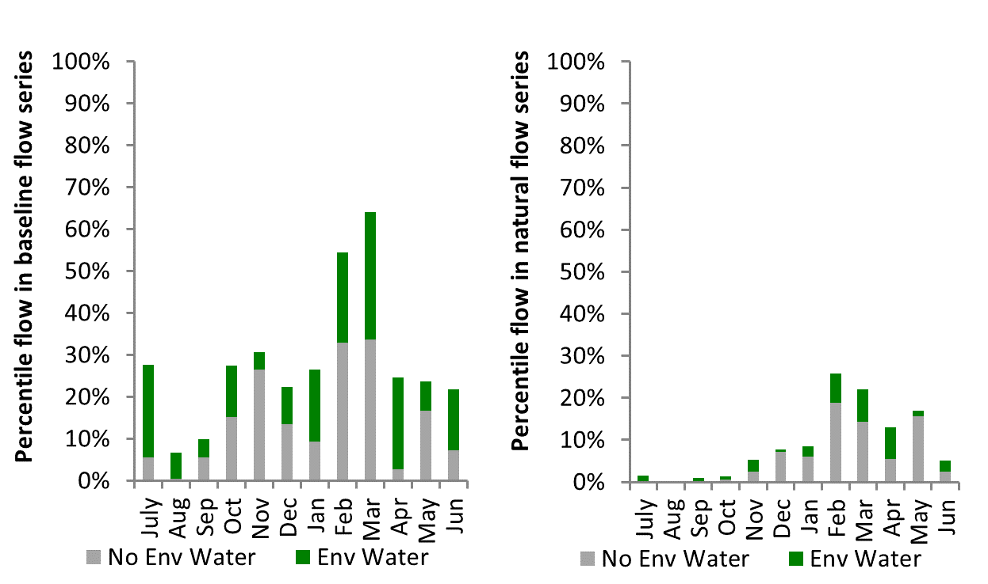
Figure CNM24: Contribution of environmental water delivery at Lock 10 as percentiles in the natural and baseline flow series.

Murrumbidgee
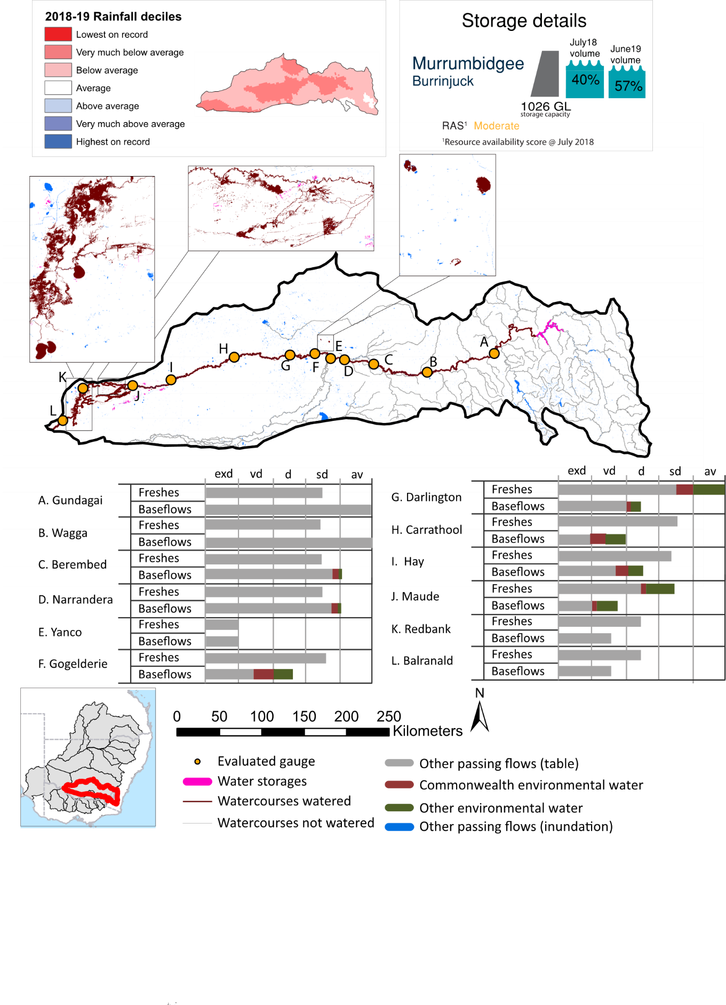Figure MBG1: Watercourses influenced, areas inundated (where applicable) and gauge stations evaluated in the Murrumbidgee valley during the 2018-19 water year. Inset bar graphs report the condition of annual flow regimes by showing the improvements in hydrological condition with the addition of environmental water as well as the hypothetical scenario in “grey” (if no environmental flow had been delivered) where exd=extremely dry, vd=very dry, d=dry, sd=somewhat dry and av=average. Rainfall conditions (rainfall deciles) and trend in storage levels for the water year are also shown.

Summary
The volume of environmental water delivery for the 2018-19 year in the Murrumbidgee valley is quantified using data for 12 sites. This evaluation only considers the contribution of held environmental water, which is a primary focus for the Commonwealth. The contributions of planned environmental water (e.g. passing flows), unregulated tributary inflows and clever use of irrigation flows for environmental benefits can all be very important but these are outside the scope of this report. Environmental watering actions lasted on average 223 days over the course of the year. The volume of environmental water at these 12 sites was between 0% and 34% of the total streamflow. Commonwealth environmental water contributed on average 27% of this environmental water. The contribution of environmental water delivery to improved flow regimes is evaluated using data for 12 sites. Ideally, baseflows should be maintained and long periods of excessively low flows avoided. In this valley, the baseflow regime was generally considered to be very dry relative to the pre-development flow regime. In our analysis, a low fresh refers to a period of increased flow, when the water level rises at least one eighth of the way up the river bank (above the low flow level). These low freshes are a regular part of the natural flow regime and support a range of natural processes. In the Murrumbidgee valley, in terms of the occurrence and duration of low freshes, the year was assessed as being average. In our analysis, a medium fresh refers to a period of increased flow, when the water level rises at least one quarter of the way up the river bank. These medium freshes are not as frequent as low freshes but are also a regular and important part of the natural flow regime. In the Murrumbidgee valley, in terms of the occurrence of medium freshes, the year was assessed as being average. In our analysis, a high fresh refers to a period of increased flow, when the water level rises more than half way up the river. A high fresh may not occur every year but they are still important and long periods without major freshes can have serious consequences for floodplains and their contribution to river connectivity. Delivering high in channel environmental flows normally requires that all risks to riparian landholders and infrastructure have been resolved. In the Murrumbidgee valley, in terms of the occurrence of high freshes, the year was assessed as being extremely dry.

Water delivery context
During the 2018-19, the Commonwealth Environmental Water Holder (CEWH) held water entitlements of up to 753,326 ML for environmental use in the Murrumbidgee valley. Each year, water utilities allocate water entitlement holders a percentage of water based on their holding, license type and carryover (the exact rules vary among Jurisdictions). In 2018-19, the Murrumbidgee entitlements held by the CEWH were allocated 49,671 ML of water, representing 12% of the Long term average annual yield for the Murrumbidgee valley (402,122 ML). Information and data relating to the portfolio of held Commonwealth environmental water is shown in Table MBG2.
The 2018-19 water allocation (49,671 ML) together with the carryover volume of 41,181 ML of water meant the CEWH had 90,852 ML of water available for delivery. A total of 61,796 ML of Commonwealth environmental water was delivered in the Murrumbidgee valley. A total of 0 ML of Commonwealth environmental water was traded to consumptive users and 36,926 ML (41%) of available Commonwealth environmental water was carried over for environmental use into the 2019-20 water year.

Environmental conditions and resource availability
The water available for environmental delivery combined with the present and antecedent environmental conditions are key inputs used by environmental water managers in planning and implementing watering actions. Post hoc, this information provides important context when evaluating the effectiveness and appropriateness of environmental water use with respect to hydrological outputs.
The rainfall conditions in the Murrumbidgee valley were classified as Very much below average, based on rainfall percentile data for the entire record held by the Bureau of Meteorology for this valley. The water held in major storages in the Murrumbidgee valley decreased over the water year, for example Burrinjuck dam was 57.3% full at the beginning of the water year and 39.2% full by the end of the year (Figure MBG1).
The Commonwealth Environmental Water Office (CEWO) calculates resource availability scenarios (RAS) to guide the use and prioritisation of held environmental water. The RAS are progressively calculated over the year as part of the continual adaptive management planning processes. The RAS are based on the availability of held environmental water (including progressive license acquisitions and allocations) as well as the potential for unregulated or planned environmental flows. The outcome is then used to determine the demand for environmental water across the basin.
In 2018-19, the resource availability of held Commonwealth environmental water was classified as low to moderate. The physical conditions meant that the CEWO was managing to protect the mid-Murrumbidgee wetlands and ensure their ecological capacity for recovery, while maintaining and where possible improving the ecological health and resilience of other important sites in the catchment. The overall demand for environmental water was deemed moderate.

Watering actions
A total of 16 watering actions were delivered over the 2018-19 water year, the duration of these actions varied (range of individual actions: 1 - 195 days) and Commonwealth environmental water was delivered for a total of 268 days. The number of water actions commencing in each season included, Autumn (0), Spring (10), Summer (5), Winter(1). Similarly, the count of flow component types delivered in the Murrumbidgee valley were; (0) baseflow, (0) baseflow-fresh, (1) fresh, (0) fresh-overbank, (0) bankfull, (0) overbank, (15) wetland and (0) wetland-fresh.
In this valley, primary objectives of most watering actions was related to fish, but water was also delivered for other purposes too. The percentage of watering actions delivered across the nine main themes included primary objectives for fish (33.33%), vegetation (11.11%), waterbirds (11.11%), frogs (11.11%), other biota (11.11%), connectivity (0.0%), process (0.0%), resilience (0.0%) and water quality (22.22%).
Table MBG2. Commonwealth environmental water accounting information for the Murrumbidgee valley over 2018-19 water year.
Total registered volume (ML) | Allocated volume (ML) | Carry over + allocated volume (ML) | Delivered (ML) | LTAAY (ML) | Trade (ML) | Carried over to 2019-20 | Forfeited (ML)
753,326 | 49,671 | 90,852 | 62,296 | 402,122 | 0 | 36,926 | 0

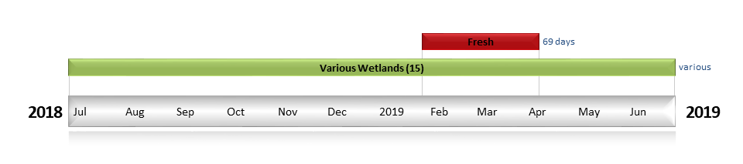
Figure MBG2. Timing and duration of Commonwealth environmental water actions delivered in the Murrumbidgee valley.

Contribution of Commonwealth environmental water to flow regimes

Gundagai
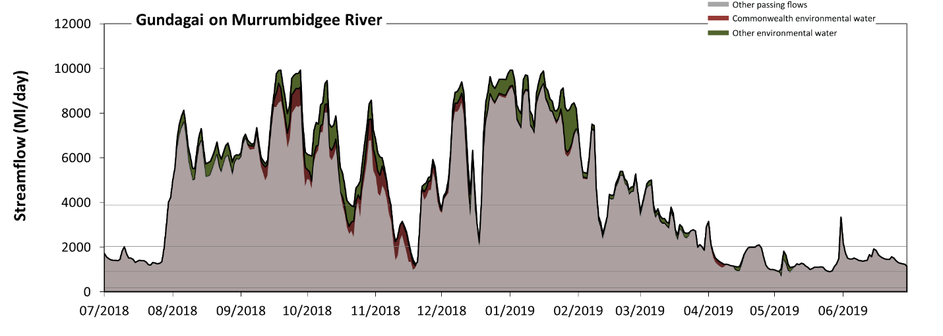
Figure MBG3: Contribution of environmental water delivery at Gundagai. Horizontal lines indicate thresholds for very low flows, low flows, low freshes and medium freshes (from lowest to highest).
At Gundagai on Murrumbidgee River environmental water contributed 10% of the total streamflow volume (with a medium contribution of Commonwealth environmental water). Environmental watering actions affected streamflows for 72% of days between 1 July 2018 and 30 June 2019. Flow regulation does not substantially increase the duration of very low flows (i.e. < 190 Ml/day) compared to an average year in the natural flow regime. Flow regulation does not substantially increase the duration of medium low flows (i.e. < 930 Ml/day) compared to an average year in the natural flow regime. There was at least one low fresh (i.e. > 2000 Ml/day) in the periods July to September, October to December, January to March and April to June. Environmental water made little change to the duration of these low freshes. There was at least one medium fresh (i.e. > 3900 Ml/day) in the periods July to September, October to December and January to March. Environmental water made little change to the duration of these medium freshes. Commonwealth environmental water made little or no contribution to these increased durations of medium freshes. There was no high freshes (i.e. > 11000 Ml/day) this year.
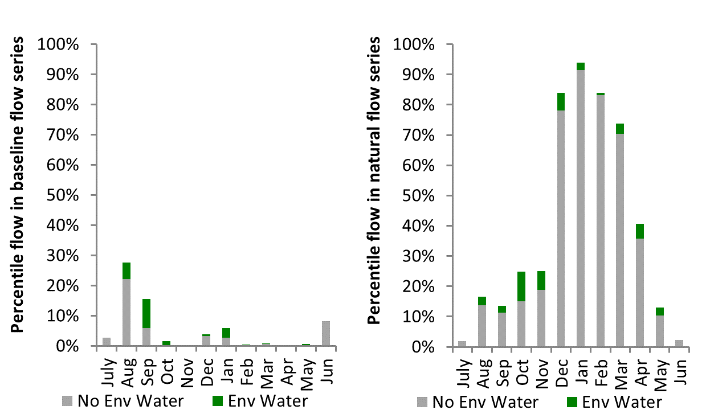
Figure MBG4: Contribution of environmental water delivery at Gundagai as percentiles in the natural and baseline flow series.
Wagga
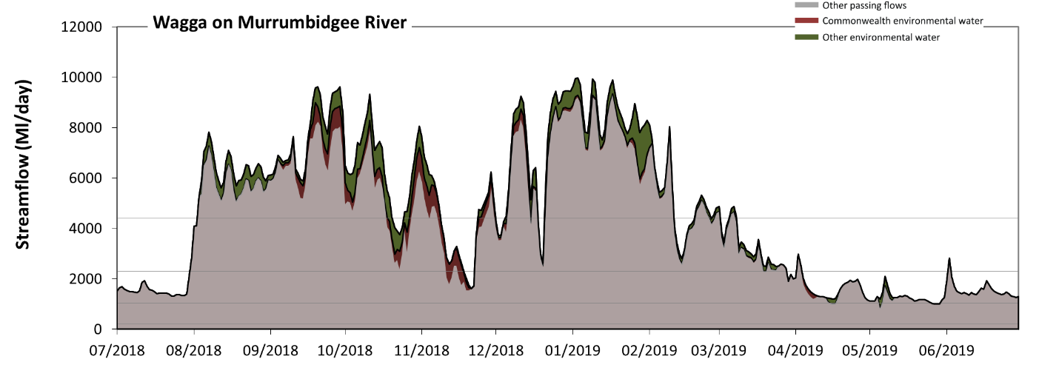
Figure MBG5: Contribution of environmental water delivery at Wagga. Horizontal lines indicate thresholds for very low flows, low flows, low freshes and medium freshes (from lowest to highest).
At Wagga on Murrumbidgee River environmental water contributed 10% of the total streamflow volume (with a medium contribution of Commonwealth environmental water). Environmental watering actions affected streamflows for 72% of days between 1 July 2018 and 30 June 2019. Flow regulation does not substantially increase the duration of very low flows (i.e. < 210 Ml/day) compared to an average year in the natural flow regime. Flow regulation does not substantially increase the duration of medium low flows (i.e. < 1000 Ml/day) compared to an average year in the natural flow regime. There was at least one low fresh (i.e. > 2300 Ml/day) in the periods July to September, October to December, January to March and April to June. Environmental water made little change to the duration of these low freshes. There was at least one medium fresh (i.e. > 4400 Ml/day) in the periods July to September, October to December and January to March. Environmental water made little change to the duration of these medium freshes. There was no high freshes (i.e. > 12000 Ml/day) this year.
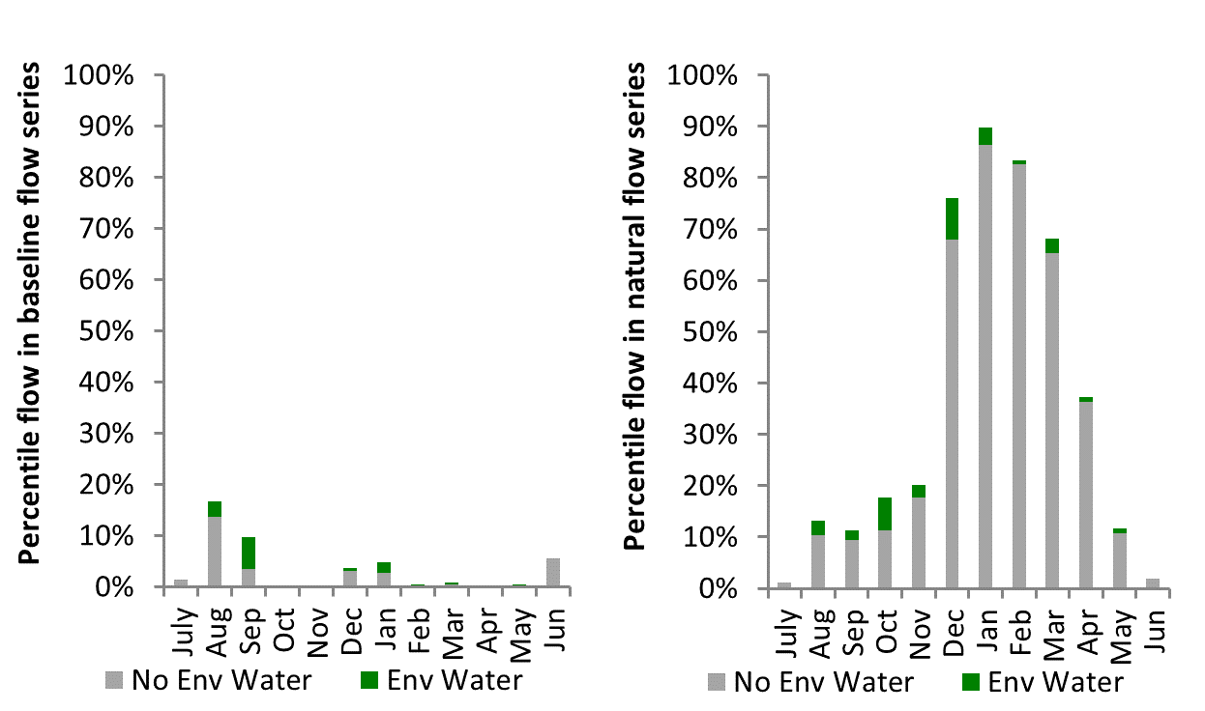
Figure MBG 6: Contribution of environmental water delivery at Wagga as percentiles in the natural and baseline flow series.
Berembed
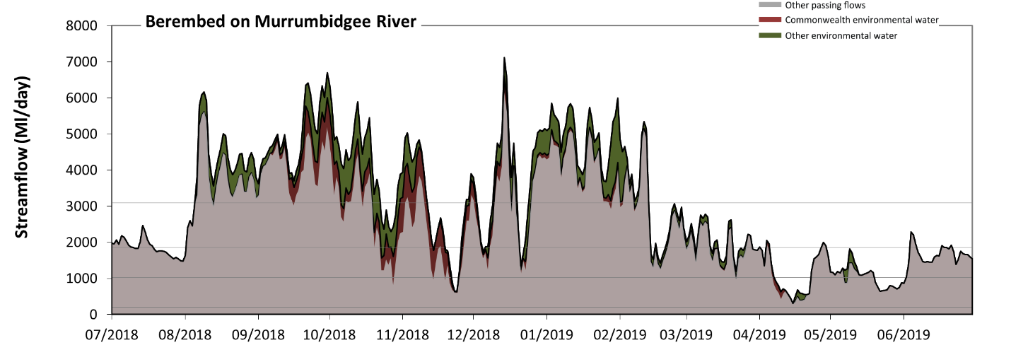
Figure MBG7: Contribution of environmental water delivery at Berembed. Horizontal lines indicate thresholds for very low flows, low flows, low freshes and medium freshes (from lowest to highest).
At Berembed on Murrumbidgee River environmental water contributed 16% of the total streamflow volume (with a medium contribution of Commonwealth environmental water). Environmental watering actions affected streamflows for 72% of days between 1 July 2018 and 30 June 2019. Flow regulation does not substantially increase the duration of very low flows (i.e. < 210 Ml/day) compared to an average year in the natural flow regime. However, without environmental water, the duration of medium low flows (i.e. < 1000 Ml/day) in the period April to June would have substantially exceeded durations expected in an average year in the natural flow regime. Environmental water mitigated these impacts by reducing the cumulative duration of medium low flow spells from 11% to 8% of the year, with greatest influence in the periods October to December and April to June. Commonwealth environmental water equally shared responsibility with other environmental water holders for these enhancements of environmental baseflows at this site. In the absence of environmental water there would have been at least one low fresh (i.e. > 1900 Ml/day) in the periods July to September, October to December, January to March and April to June. Environmental water increased the duration of the longest low fresh during the period October to December (from 19 days to 44 days). Commonwealth environmental water made a modest contribution to these increased durations of low freshes. In the absence of environmental water there would have been at least one medium fresh (i.e. > 3100 Ml/day) in the periods July to September, October to December and January to March. Environmental water increased the duration of the longest medium fresh during the periods July to September (from 33 days to 56 days), October to December (from 7 days to 22 days) and January to March (from 27 days to 44 days). Commonwealth environmental water made a modest contribution to these increased durations of medium freshes. There was no high freshes (i.e. > 7200 Ml/day) this year.
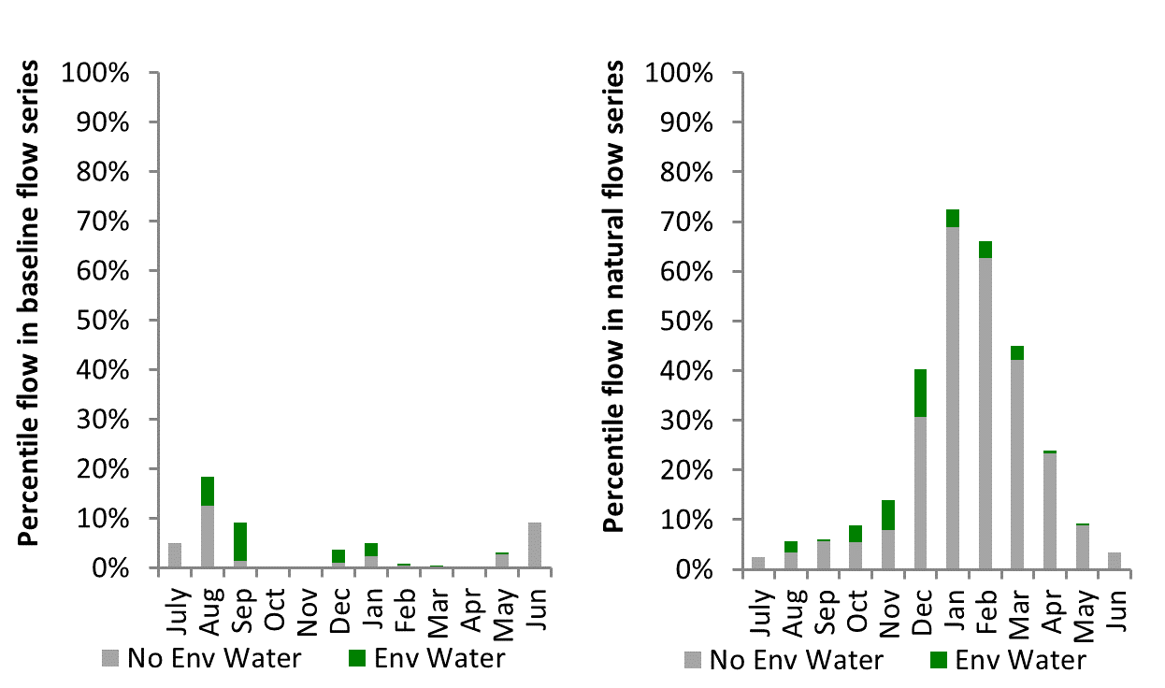
Figure MBG8: Contribution of environmental water delivery at Berembed as percentiles in the natural and baseline flow series.

Narrandera
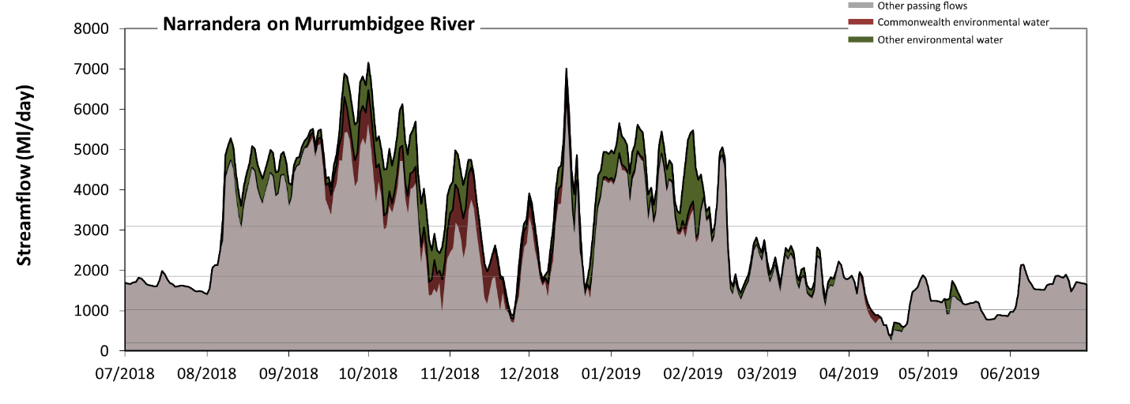
Figure MBG9: Contribution of environmental water delivery at Narrandera. Horizontal lines indicate thresholds for very low flows, low flows, low freshes and medium freshes (from lowest to highest).
At Narrandera on Murrumbidgee River environmental water contributed 16% of the total streamflow volume (with a medium contribution of Commonwealth environmental water). Environmental watering actions affected streamflows for 72% of days between 1 July 2018 and 30 June 2019. Flow regulation does not substantially increase the duration of very low flows (i.e. < 210 Ml/day) compared to an average year in the natural flow regime. However, without environmental water, the duration of medium low flows (i.e. < 1000 Ml/day) in the period April to June would have substantially exceeded durations expected in an average year in the natural flow regime. Environmental water mitigated these impacts by reducing the cumulative duration of medium low flow spells from 10% to 8% of the year, with greatest influence in the periods October to December and April to June. In the absence of environmental water there would have been at least one low fresh (i.e. > 1900 Ml/day) in the periods July to September, October to December, January to March and April to June. Environmental water increased the duration of the longest low fresh during the period October to December (from 23 days to 51 days). Commonwealth environmental water made little or no contribution to these increased durations of low freshes. In the absence of environmental water there would have been at least one medium fresh (i.e. > 3100 Ml/day) in the periods July to September, October to December and January to March. Environmental water increased the duration of the longest medium fresh during the periods October to December (from 12 days to 23 days) and January to March (from 25 days to 38 days). Commonwealth environmental water made a modest contribution to these increased durations of medium freshes. There was no high freshes (i.e. > 7200 Ml/day) this year.
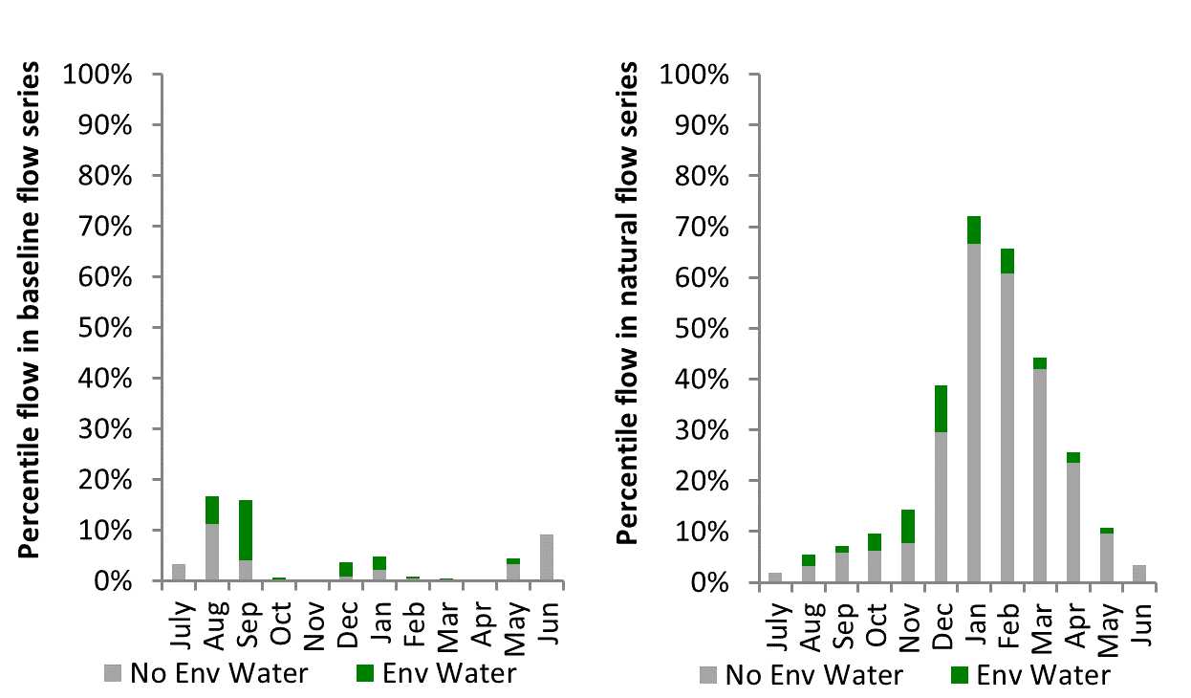
Figure MBG10: Contribution of environmental water delivery at Narrandera as percentiles in the natural and baseline flow series.

Yanco Offtake
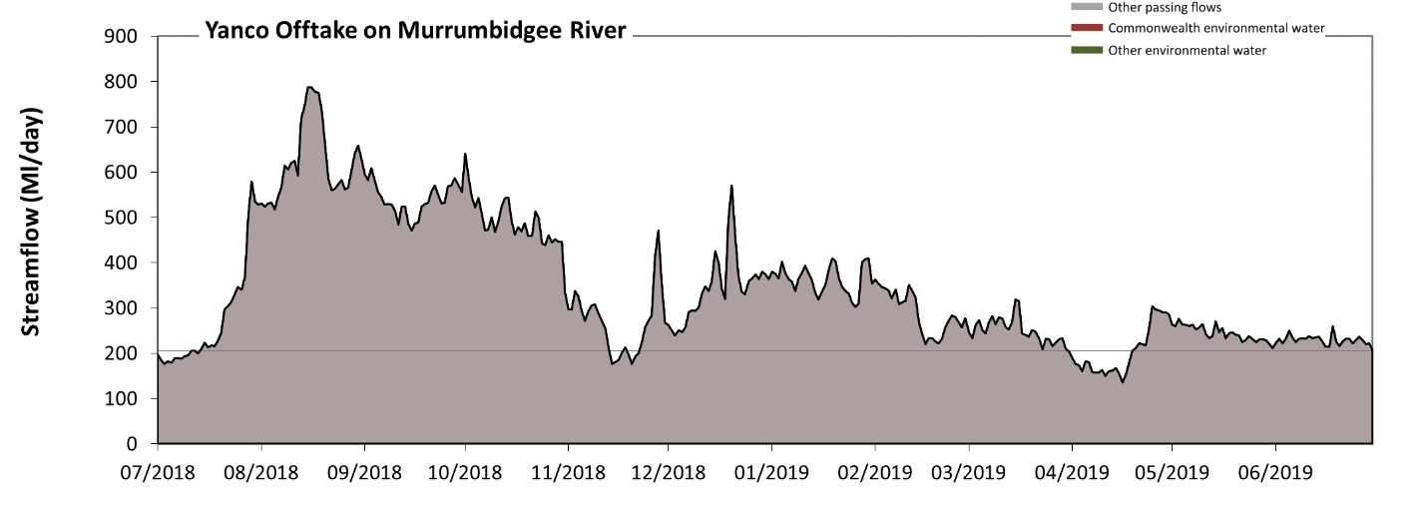
Figure MBG11: Contribution of environmental water delivery at Yanco Offtake. Horizontal lines indicate thresholds for very low flows and low flows (from lowest to highest).
There was no environmental water delivered at Yanco Offtake on Yanco Creek. Without environmental water, the durations of very low flows (i.e. < 210 Ml/day) in the periods July to September, October to December and April to June was substantially in excess of durations expected in an average year in the natural flow regime. Similarly, without environmental water, the durations of medium low flows (i.e. < 1000 Ml/day) in the periods July to September, October to December, January to March and April to June was substantially in excess of durations expected in an average year in the natural flow regime.
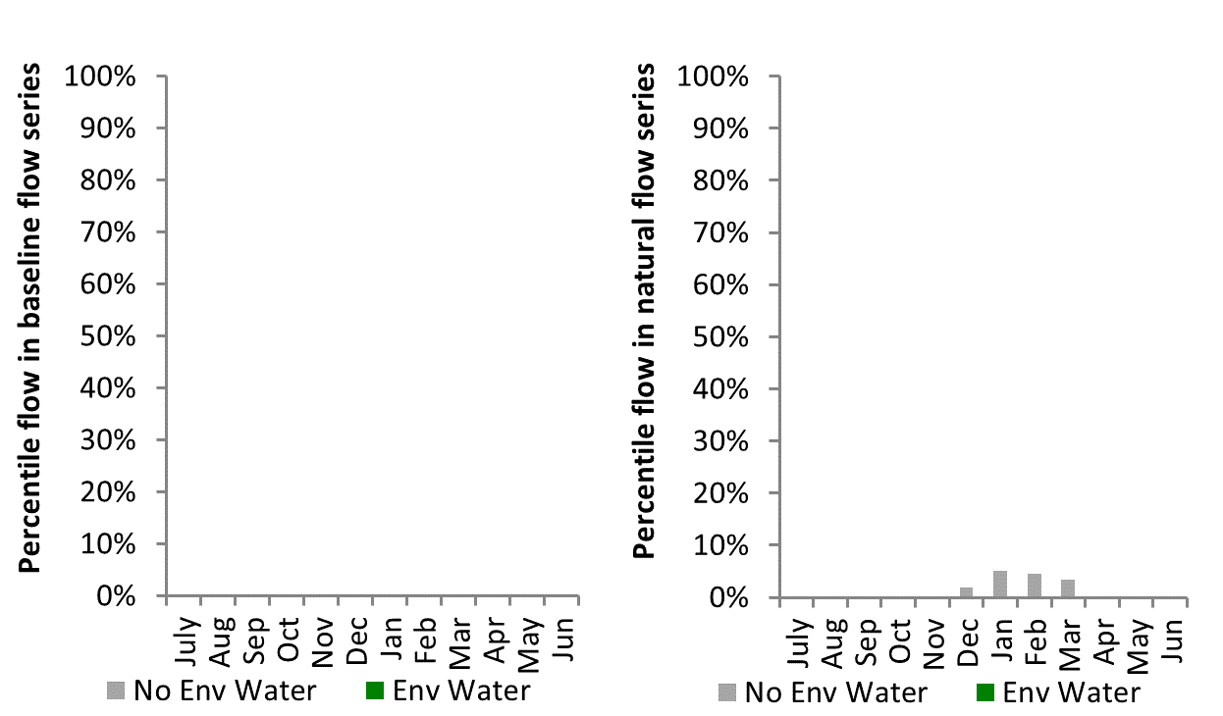
Figure MBG12: Contribution of environmental water delivery at Yanco Offtake as percentiles in the natural and baseline flow series.

Gogelderie
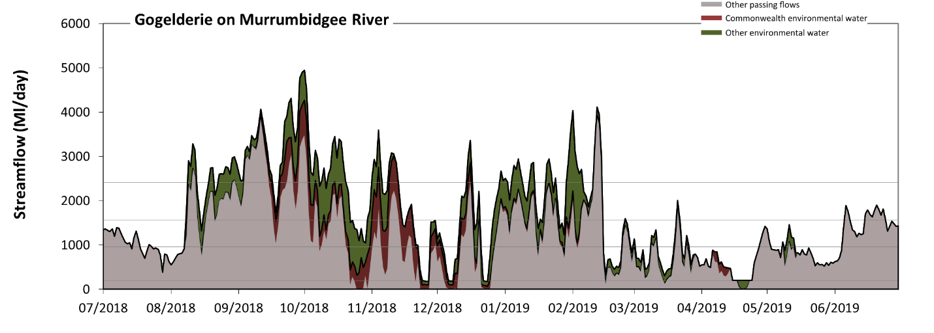Figure MBG13: Contribution of environmental water delivery at Gogelderie. Horizontal lines indicate thresholds for very low flows, low flows, low freshes and medium freshes (from lowest to highest).
At Gogelderie on Murrumbidgee River environmental water contributed 28% of the total streamflow volume (with a medium contribution of Commonwealth environmental water). Environmental watering actions affected streamflows for 71% of days between 1 July 2018 and 30 June 2019. Without environmental water, the durations of very low flows (i.e. < 190 Ml/day) in the periods October to December and April to June would have substantially exceeded durations expected in an average year in the natural flow regime. Environmental water mitigated these impacts by reducing the cumulative duration of very low flow spells from 9% to 2% of the year, with greatest influence in the periods October to December and April to June. Similarly, without environmental water, the durations of medium low flows (i.e. < 960 Ml/day) in the periods July to September, October to December, January to March and April to June would have all substantially exceeded durations expected in an average year in the natural flow regime. Environmental water mitigated these impacts by reducing the cumulative duration of medium low flow spells from 45% to 34% of the year, with greatest influence in the period October to December. Commonwealth environmental water equally shared responsibility with other environmental water holders for these enhancements of environmental baseflows at this site. In the absence of environmental water there would have been at least one low fresh (i.e. > 1600 Ml/day) in the periods July to September, October to December, January to March and April to June. Environmental water increased the duration of the longest low fresh during the periods July to September (from 26 days to 46 days), October to December (from 5 days to 21 days) and January to March (from 10 days to 17 days). Commonwealth environmental water made a small contribution to these increased durations of low freshes. In the absence of environmental water there would have been at least one medium fresh (i.e. > 2400 Ml/day) in the periods July to September, October to December and January to March. Environmental water increased the duration of the longest medium fresh during the periods July to September (from 11 days to 25 days), October to December (from 2 days to 9 days) and January to March (from 4 days to 8 days). Commonwealth environmental water made a small contribution to these increased durations of medium freshes. There was no high freshes (i.e. > 5000 Ml/day) this year.
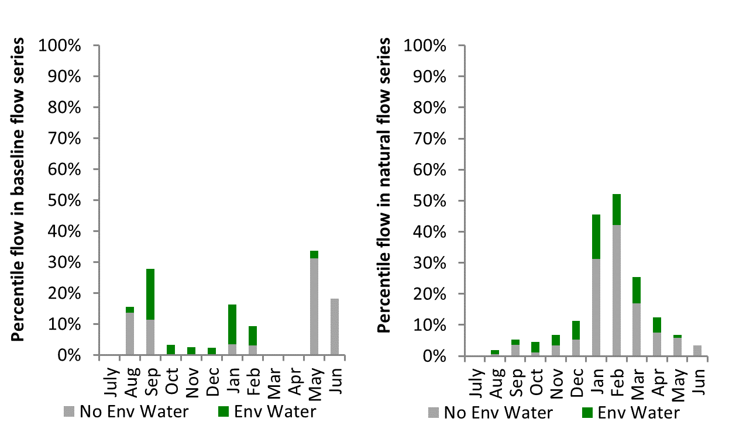
Figure MBG14: Contribution of environmental water delivery at Gogelderie as percentiles in the natural and baseline flow series.

Darlington
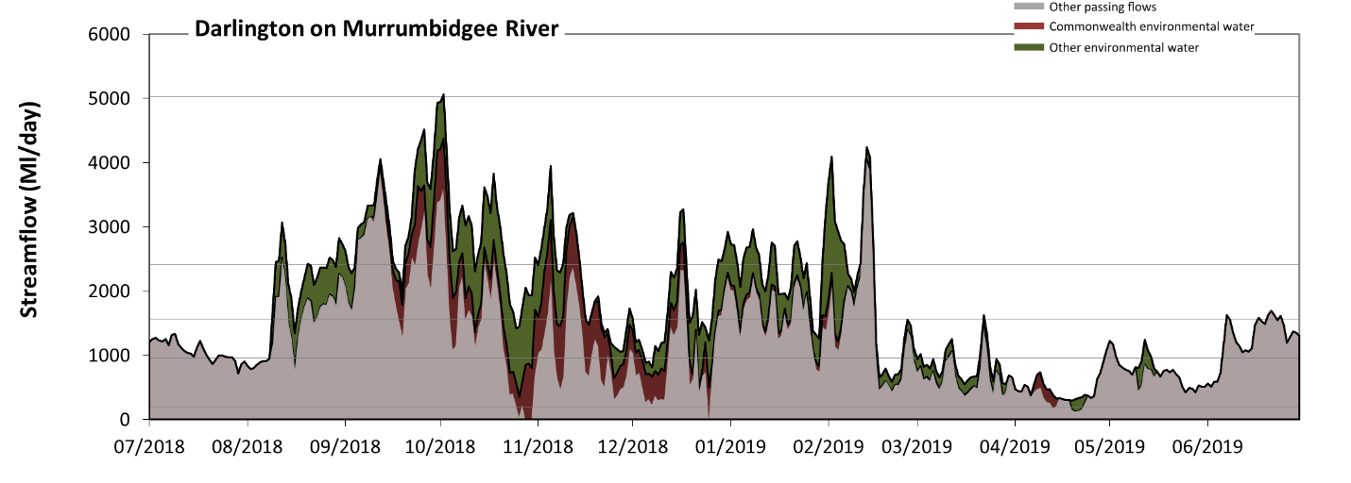 Figure MBG15: Contribution of environmental water delivery at Darlington. Horizontal lines indicate thresholds for very low flows, low flows, low freshes, medium freshes and high freshes (from lowest to highest).
At Darlington on Murrumbidgee River environmental water contributed 28% of the total streamflow volume (with a medium contribution of Commonwealth environmental water). Environmental watering actions affected streamflows for 71% of days between 1 July 2018 and 30 June 2019. Without environmental water, the durations of very low flows (i.e. < 190 Ml/day) in the periods October to December and April to June would have substantially exceeded durations expected in an average year in the natural flow regime. Environmental water mitigated these impacts by reducing the cumulative duration of very low flow spells from 3% to 0% of the year, with greatest influence in the periods October to December and April to June. Similarly, without environmental water, the durations of medium low flows (i.e. < 960 Ml/day) in the periods July to September, October to December, January to March and April to June would have all substantially exceeded durations expected in an average year in the natural flow regime. Environmental water mitigated these impacts by reducing the cumulative duration of medium low flow spells from 43% to 30% of the year, with greatest influence in the period October to December. Commonwealth environmental water made a modest contribution to these enhancements of environmental baseflows at this site. In the absence of environmental water there would have been at least one low fresh (i.e. > 1600 Ml/day) in the periods July to September, October to December, January to March and April to June. Environmental water increased the duration of the longest low fresh during the periods July to September (from 26 days to 45 days), October to December (from 7 days to 24 days) and January to March (from 10 days to 26 days). Commonwealth environmental water made a modest contribution to these increased durations of low freshes. In the absence of environmental water there would have been at least one medium fresh (i.e. > 2400 Ml/day) in the periods July to September, October to December and January to March. Environmental water increased the duration of the longest medium fresh during the periods October to December (from 3 days to 11 days) and January to March (from 4 days to 8 days). Commonwealth environmental water made a small contribution to these increased durations of medium freshes. There was one high fresh (i.e. > 5000 Ml/day) this year. Environmental water increased the duration of the longest high fresh during the period October to December (from 0 days to 1 days). Commonwealth environmental water equally shared responsibility with other environmental water holders for these increased durations of high freshes.
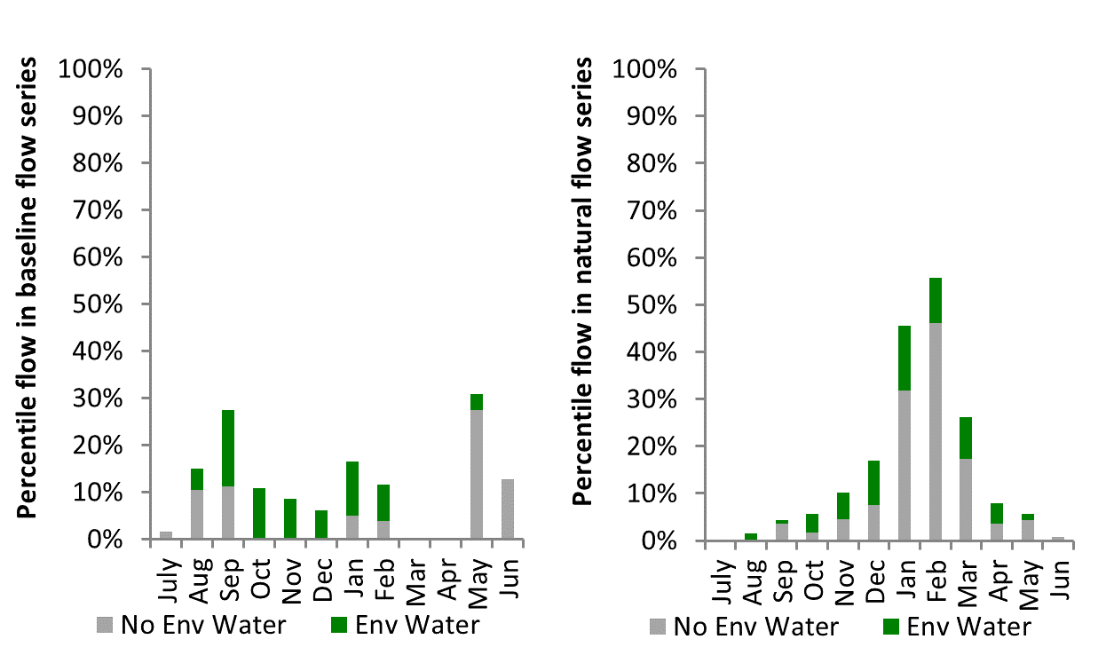
Figure MBG16: Contribution of environmental water delivery at Darlington as percentiles in the natural and baseline flow series.

Carrathool
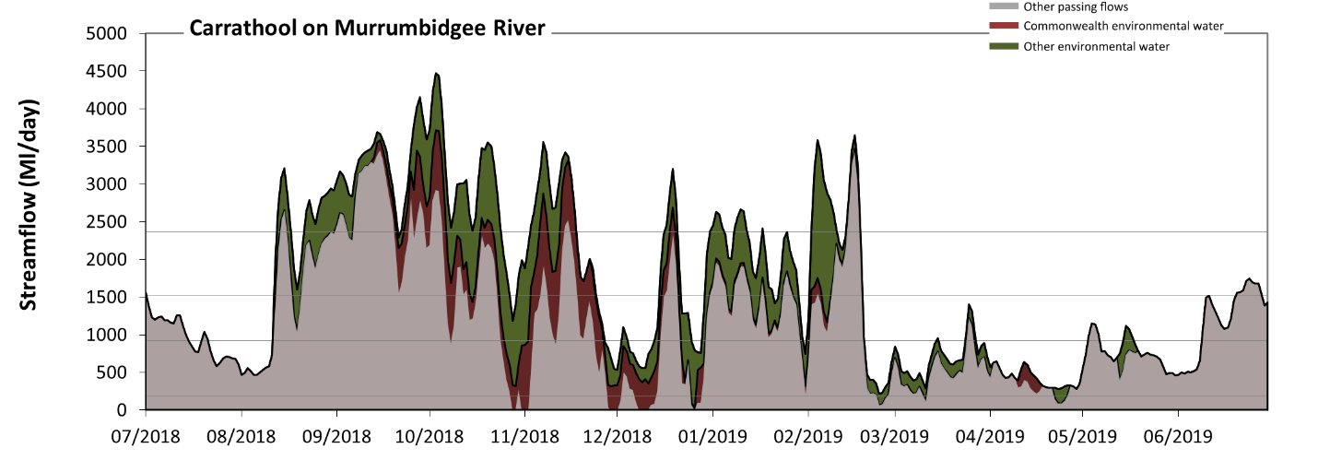 Figure MBG17: Contribution of environmental water delivery at Carrathool. Horizontal lines indicate thresholds for very low flows, low flows, low freshes and medium freshes (from lowest to highest).
At Carrathool on Murrumbidgee River environmental water contributed 29% of the total streamflow volume (with a medium contribution of Commonwealth environmental water). Environmental watering actions affected streamflows for 69% of days between 1 July 2018 and 30 June 2019. Without environmental water, the duration of very low flows (i.e. < 190 Ml/day) in the period October to December would have substantially exceeded durations expected in an average year in the natural flow regime. Environmental water mitigated these impacts by reducing the cumulative duration of very low flow spells from 8% to 0% of the year, with greatest influence in the period October to December. Similarly, without environmental water, the durations of medium low flows (i.e. < 930 Ml/day) in the periods July to September, October to December, January to March and April to June would have all substantially exceeded durations expected in an average year in the natural flow regime. Environmental water mitigated these impacts by reducing the cumulative duration of medium low flow spells from 48% to 39% of the year, with greatest influence in the period October to December. Commonwealth environmental water made a modest contribution to these enhancements of environmental baseflows at this site. In the absence of environmental water there would have been at least one low fresh (i.e. > 1500 Ml/day) in the periods July to September, October to December, January to March and April to June. Environmental water increased the duration of the longest low fresh during the periods October to December (from 7 days to 26 days) and January to March (from 10 days to 20 days). Commonwealth environmental water made a modest contribution to these increased durations of low freshes. In the absence of environmental water there would have been at least one medium fresh (i.e. > 2400 Ml/day) in the periods July to September, October to December and January to March. Environmental water increased the duration of the longest medium fresh during the periods July to September (from 13 days to 30 days), October to December (from 4 days to 24 days) and January to March (from 4 days to 9 days). Commonwealth environmental water made a small contribution to these increased durations of medium freshes. There was no high freshes (i.e. > 5000 Ml/day) this year.
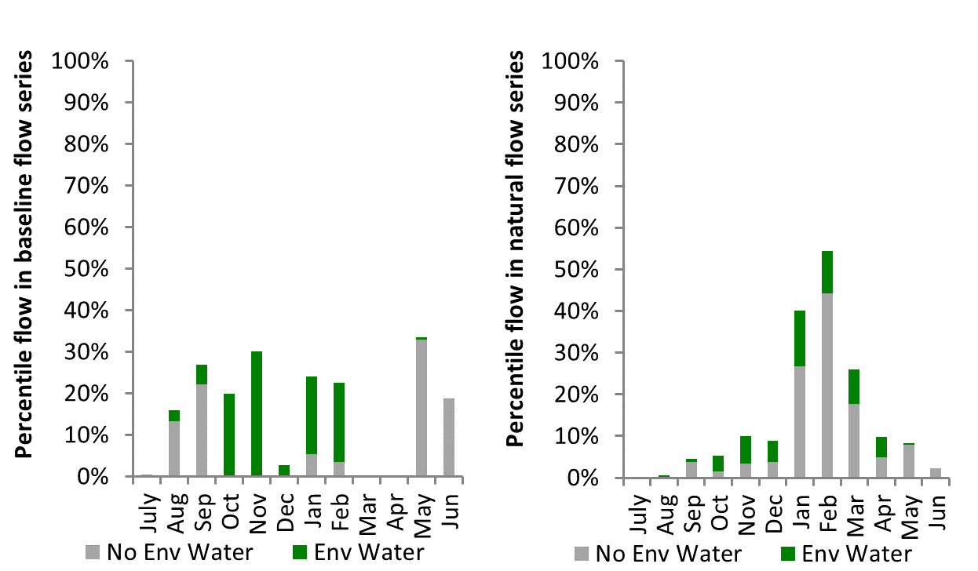
Figure MBG18: Contribution of environmental water delivery at Carrathool as percentiles in the natural and baseline flow series.

Hay
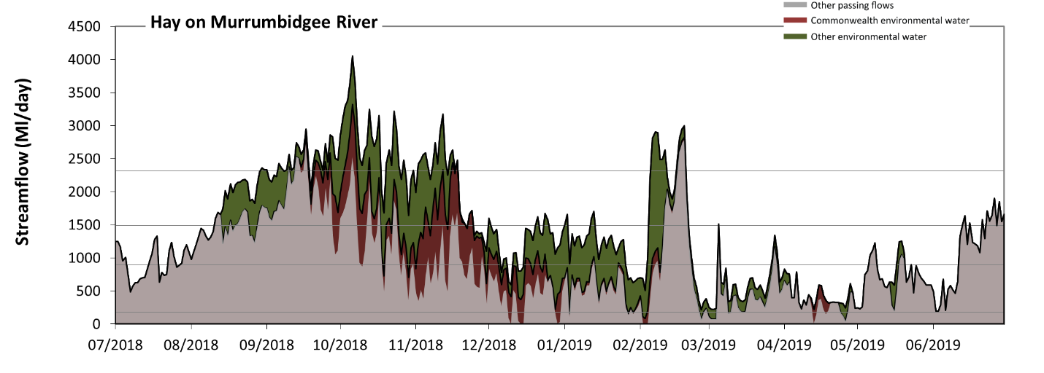 Figure MBG19: Contribution of environmental water delivery at Hay. Horizontal lines indicate thresholds for very low flows, low flows, low freshes and medium freshes (from lowest to highest).
At Hay on Murrumbidgee River environmental water contributed 34% of the total streamflow volume (with a medium contribution of Commonwealth environmental water). Environmental watering actions affected streamflows for 69% of days between 1 July 2018 and 30 June 2019. Without environmental water, the durations of very low flows (i.e. < 180 Ml/day) in the periods October to December, January to March and April to June would have substantially exceeded durations expected in an average year in the natural flow regime. Environmental water mitigated these impacts by reducing the cumulative duration of very low flow spells from 7% to 0% of the year, with greatest influence in the periods October to December and January to March. Similarly, without environmental water, the durations of medium low flows (i.e. < 900 Ml/day) in the periods July to September, October to December, January to March and April to June would have all substantially exceeded durations expected in an average year in the natural flow regime. Environmental water mitigated these impacts by reducing the cumulative duration of medium low flow spells from 56% to 35% of the year, with greatest influence in the periods October to December and January to March. Commonwealth environmental water made a modest contribution to these enhancements of environmental baseflows at this site. In the absence of environmental water there would have been at least one low fresh (i.e. > 1500 Ml/day) in the periods July to September, October to December, January to March and April to June. Environmental water increased the duration of the longest low fresh during the periods July to September (from 30 days to 51 days), October to December (from 8 days to 52 days) and January to March (from 10 days to 16 days). Commonwealth environmental water made a small contribution to these increased durations of low freshes. In the absence of environmental water there would have been at least one medium fresh (i.e. > 2300 Ml/day) in the periods July to September, October to December and January to March. Environmental water increased the duration of the longest medium fresh during the periods July to September (from 2 days to 11 days), October to December (from 1 days to 17 days) and January to March (from 3 days to 6 days). Commonwealth environmental water made a modest contribution to these increased durations of medium freshes. There was no high freshes (i.e. > 4900 Ml/day) this year.
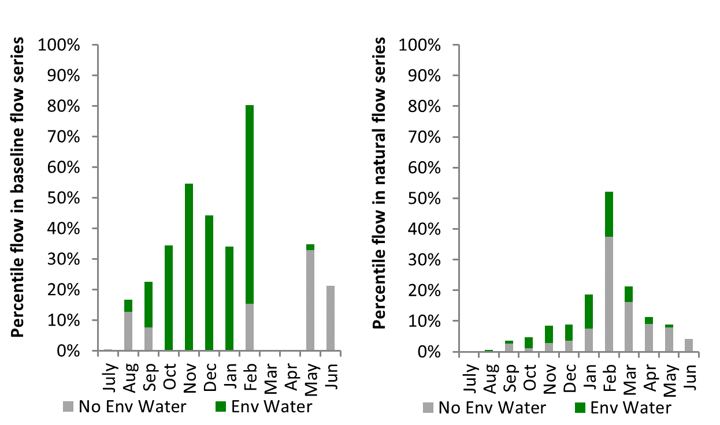
Figure MBG20: Contribution of environmental water delivery at Hay as percentiles in the natural and baseline flow series.
Maude
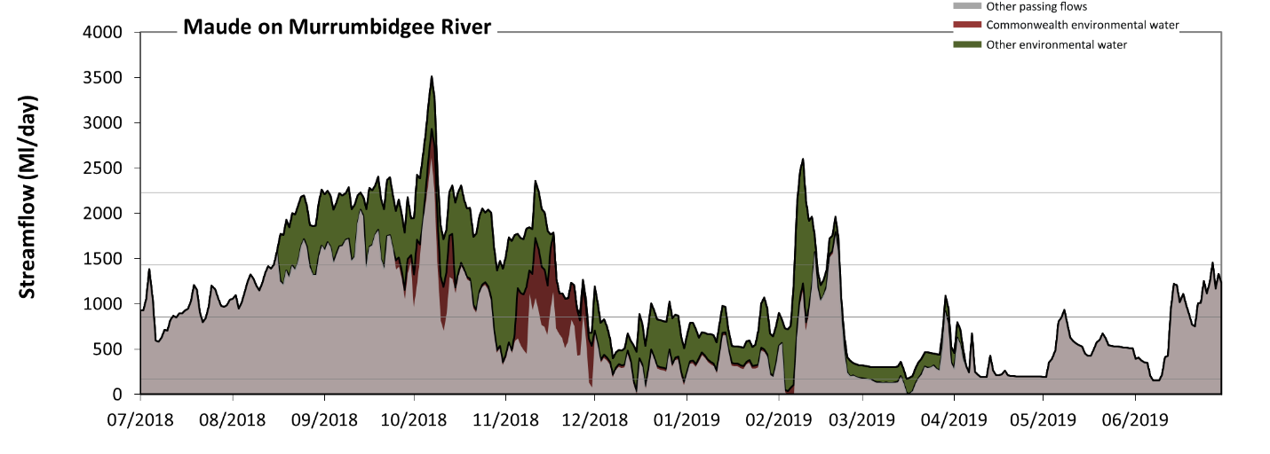 Figure MBG21: Contribution of environmental water delivery at Maude. Horizontal lines indicate thresholds for very low flows, low flows, low freshes and medium freshes (from lowest to highest).
At Maude on Murrumbidgee River environmental water contributed 31% of the total streamflow volume (with a relatively small contribution of Commonwealth environmental water). Environmental watering actions affected streamflows for 63% of days between 1 July 2018 and 30 June 2019. Without environmental water, the durations of very low flows (i.e. < 170 Ml/day) in the periods October to December and January to March would have substantially exceeded durations expected in an average year in the natural flow regime. Environmental water mitigated these impacts by reducing the cumulative duration of very low flow spells from 8% to 1% of the year, with greatest influence in the period January to March. Similarly, without environmental water, the durations of medium low flows (i.e. < 860 Ml/day) in the periods July to September, October to December, January to March and April to June would have all substantially exceeded durations expected in an average year in the natural flow regime. Environmental water mitigated these impacts by reducing the cumulative duration of medium low flow spells from 60% to 47% of the year, with greatest influence in the period October to December. Commonwealth environmental water made a modest contribution to these enhancements of environmental baseflows at this site. In the absence of environmental water there would have been at least one low fresh (i.e. > 1400 Ml/day) in the periods July to September, October to December, January to March and April to June. Environmental water increased the duration of the longest low fresh during the periods July to September (from 16 days to 47 days), October to December (from 7 days to 28 days) and January to March (from 4 days to 7 days). Commonwealth environmental water made little or no contribution to these increased durations of low freshes. In the absence of environmental water there would have been at least one medium fresh (i.e. > 2200 Ml/day) in the period October to December. Environmental water increased the duration of the longest medium fresh during the periods July to September (from 0 days to 4 days), October to December (from 3 days to 8 days) and January to March (from 0 days to 2 days). Commonwealth environmental water made a small contribution to these increased durations of medium freshes. There was no high freshes (i.e. > 4700 Ml/day) this year.
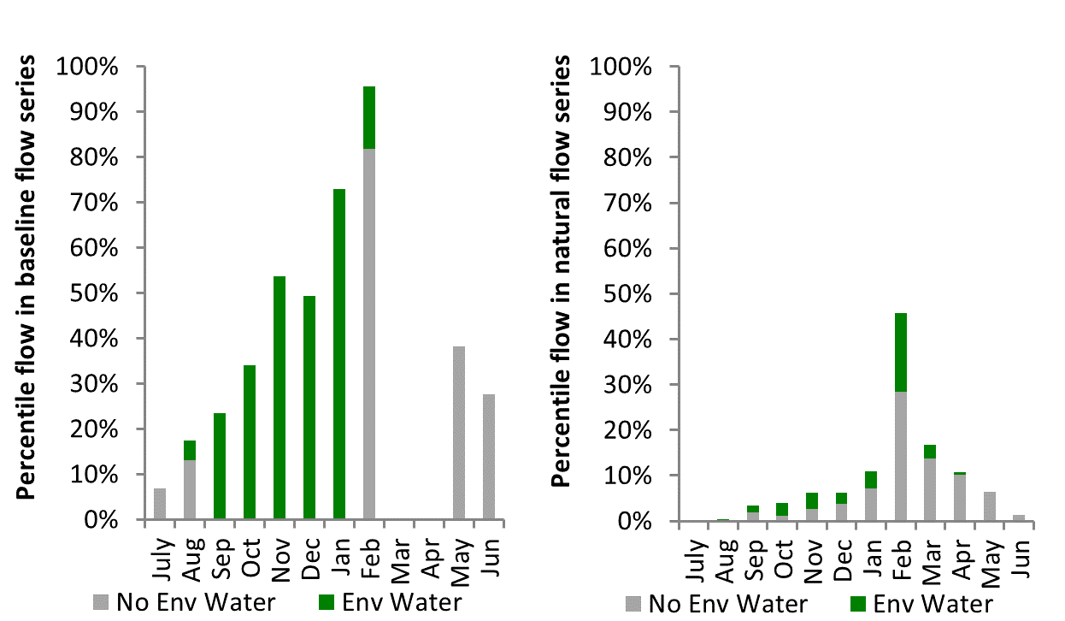
Figure MBG22: Contribution of environmental water delivery at Maude as percentiles in the natural and baseline flow series.

Redbank
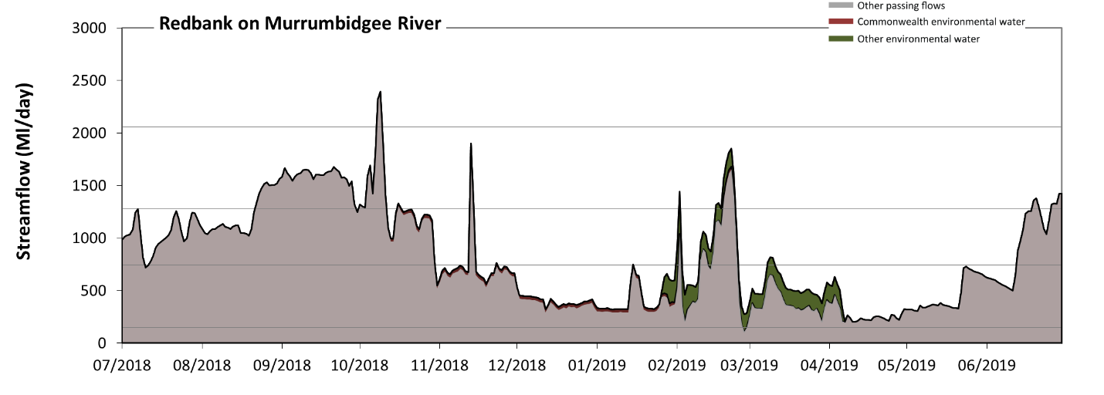 Figure MBG23: Contribution of environmental water delivery at Redbank. Horizontal lines indicate thresholds for very low flows, low flows, low freshes and medium freshes (from lowest to highest).
At Redbank on Murrumbidgee River environmental water contributed 5% of the total streamflow volume (with a medium contribution of Commonwealth environmental water). Environmental watering actions affected streamflows for 50% of days between 1 July 2018 and 30 June 2019. Flow regulation does not substantially increase the duration of very low flows (i.e. < 150 Ml/day) compared to an average year in the natural flow regime. However, without environmental water, the durations of medium low flows (i.e. < 740 Ml/day) in the periods October to December, January to March and April to June would have substantially exceeded durations expected in an average year in the natural flow regime. Environmental water mitigated these impacts by reducing the cumulative duration of medium low flow spells from 58% to 56% of the year, with greatest influence in the period January to March. Commonwealth environmental water made a modest contribution to these enhancements of environmental baseflows at this site. In the absence of environmental water there would have been at least one low fresh (i.e. > 1300 Ml/day) in the periods July to September, October to December, January to March and April to June. Environmental water increased the duration of the longest low fresh during the period January to March (from 5 days to 8 days). Commonwealth environmental water made little or no contribution to these increased durations of low freshes. There was at least one medium fresh (i.e. > 2100 Ml/day) in the period October to December. Environmental water made no change to the duration of these medium freshes. There was no high freshes (i.e. > 4500 Ml/day) this year.
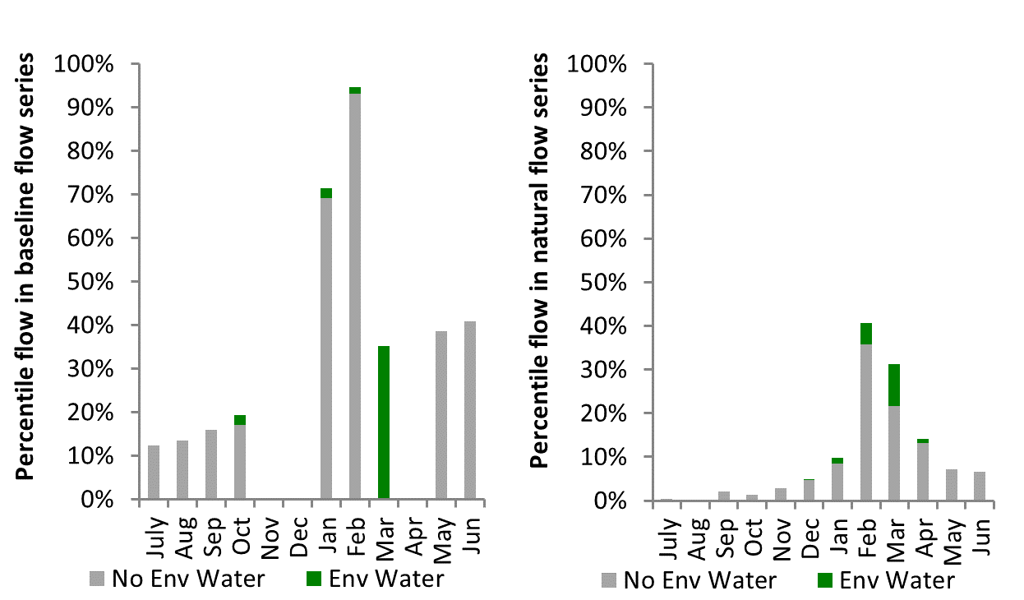
Figure MBG24: Contribution of environmental water delivery at Redbank as percentiles in the natural and baseline flow series.

Balranald
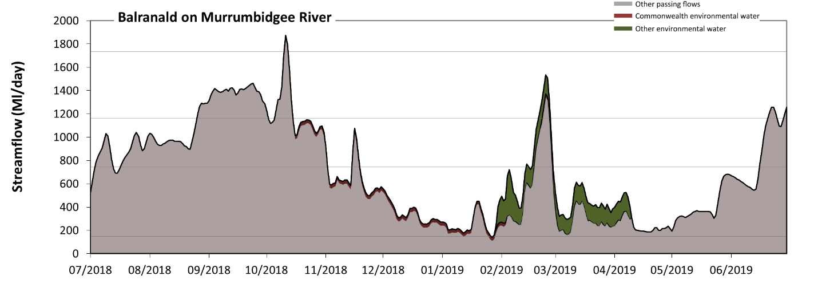 Figure MBG25: Contribution of environmental water delivery at Balranald. Horizontal lines indicate thresholds for very low flows, low flows, low freshes and medium freshes (from lowest to highest).
At Balranald on Murrumbidgee River environmental water contributed 6% of the total streamflow volume (with a medium contribution of Commonwealth environmental water). Environmental watering actions affected streamflows for 50% of days between 1 July 2018 and 30 June 2019. Flow regulation does not substantially increase the duration of very low flows (i.e. < 150 Ml/day) compared to an average year in the natural flow regime. However, without environmental water, the durations of medium low flows (i.e. < 740 Ml/day) in the periods July to September, October to December, January to March and April to June would have all substantially exceeded durations expected in an average year in the natural flow regime. Environmental water mitigated these impacts by reducing the cumulative duration of medium low flow spells from 60% to 59% of the year, with greatest influence in the period January to March. In the absence of environmental water there would have been at least one low fresh (i.e. > 1200 Ml/day) in the periods July to September, October to December, January to March and April to June. Environmental water increased the duration of the longest low fresh during the period January to March (from 3 days to 6 days). Commonwealth environmental water made little or no contribution to these increased durations of low freshes. There was at least one medium fresh (i.e. > 1700 Ml/day) in the period October to December. Environmental water made no change to the duration of these medium freshes. There was no high freshes (i.e. > 3400 Ml/day) this year.
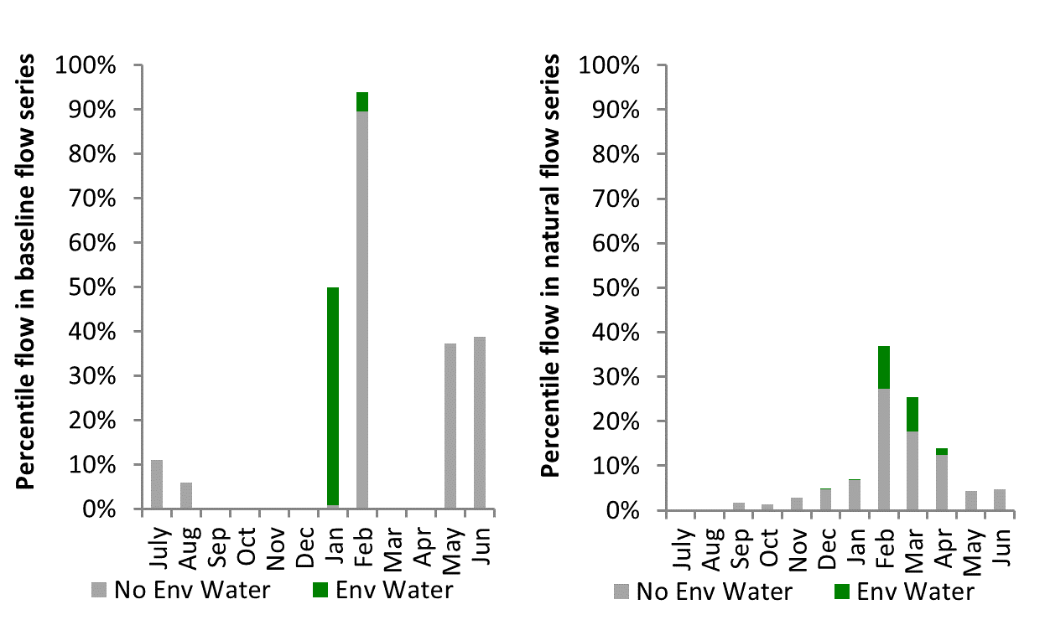
Figure MBG26: Contribution of environmental water delivery at Balranald as percentiles in the natural and baseline flow series.

Edward Wakool
Figure EWK1: Watercourses influenced, areas inundated (where applicable) and gauge stations evaluated in the Edward Wakool valley during the 2018-19 water year. Inset bar graphs report the condition of annual flow regimes by showing the improvements in hydrological condition with the addition of environmental water as well as the hypothetical scenario in “grey” (if no environmental flow had been delivered) where exd=extremely dry, vd=very dry, d=dry, sd=somewhat dry and av=average. Rainfall conditions (rainfall deciles) and trend in storage levels for the water year are also shown.

Summary
The volume of environmental water delivery for the 2018-19 year in the Edward Wakool valley is quantified using data for 10 sites. This evaluation only considers the contribution of held environmental water, which is a primary focus for the Commonwealth. The contributions of planned environmental water (e.g. passing flows), unregulated tributary inflows and clever use of irrigation flows for environmental benefits can all be very important but these are outside the scope of this report. Environmental watering actions lasted on average 110 days over the course of the year. The volume of environmental water at these 10 sites was between 3% and 100% of the total streamflow. Commonwealth environmental water contributed on average 95% of this environmental water. The contribution of environmental water delivery to improved flow regimes is evaluated using data for 10 sites. Ideally, baseflows should be maintained and long periods of excessively low flows avoided. In this valley, the baseflow regime was generally considered to be extremely dry relative to the pre-development flow regime. In our analysis, a low fresh refers to a period of increased flow, when the water level rises at least one eighth of the way up the river bank (above the low flow level). These low freshes are a regular part of the natural flow regime and support a range of natural processes. In the Edward Wakool valley, in terms of the occurrence and duration of low freshes, the year was assessed as being dry. In our analysis, a medium fresh refers to a period of increased flow, when the water level rises at least one quarter of the way up the river bank. These medium freshes are not as frequent as low freshes but are also a regular and important part of the natural flow regime. In the Edward Wakool valley, in terms of the occurrence of medium freshes, the year was assessed as being very dry. In our analysis, a high fresh refers to a period of increased flow, when the water level rises more than half way up the river. A high fresh may not occur every year but they are still important and long periods without major freshes can have serious consequences for floodplains and their contribution to river connectivity. Delivering high in channel environmental flows normally requires that all risks to riparian landholders and infrastructure have been resolved. In the Edward Wakool valley, in terms of the occurrence of high freshes, the year was assessed as being very dry.

Water delivery context
During the 2018-19, the Commonwealth Environmental Water Holder (CEWH) held water entitlements of up to 805,816 ML for environmental use in the Edward Wakool valley. Each year, water utilities allocate water entitlement holders a percentage of water based on their holding, license type and carryover (the exact rules vary among Jurisdictions). In 2018-19, the Edward Wakool entitlements held by the CEWH were allocated 351,547 ML of water, representing 54% of the Long-term average annual yield for the Edward Wakool valley (653,016 ML). Information and data relating to the portfolio of held Commonwealth environmental water is shown in Table EWK2.
The 2018-19 water allocation (351,547 ML) together with the carryover volume of 174,520 ML of water meant the CEWH had 526,067 ML of water available for delivery. A total of 38,178 ML of Commonwealth environmental water was delivered in the Edward Wakool valley.

Environmental conditions and resource availability
The water available for environmental delivery combined with the present and antecedent environmental conditions are key inputs used by environmental water managers in planning and implementing watering actions. Post hoc, this information provides important context when evaluating the effectiveness and appropriateness of environmental water use with respect to hydrological outputs.
The rainfall conditions in the Edward Wakool valley were classified as Very much below average, based on rainfall percentile data for the entire record held by the Bureau of Meteorology for this valley.
The Commonwealth Environmental Water Office (CEWO) calculates resource availability scenarios (RAS) to guide the use and prioritisation of held environmental water. The RAS are progressively calculated over the year as part of the continual adaptive management planning processes. The RAS are based on the availability of held environmental water (including progressive license acquisitions and allocations) as well as the potential for unregulated or planned environmental flows. The outcome is then used to determine the demand for environmental water across the basin.
In 2018-19, the resource availability of held Commonwealth environmental water was classified as low to very high. The physical conditions meant that the CEWO was managing to maintain and/or improve the condition of environmental assets. The overall demand for environmental water was deemed moderate.

Watering actions
A total of 4 watering actions were delivered over the 2018-19 water year, the duration of these actions varied (range of individual actions: 107 - 309 days) and Commonwealth environmental water was delivered throughout most of the year. The number of water actions commencing in each season included, Autumn (0), Spring (2), Summer (0), Winter(2). Similarly, the count of flow component types delivered in the Edward Wakool valley were; (0) baseflow, (3) baseflow-fresh, (0) fresh, (0) fresh-overbank, (0) bankfull, (0) overbank, (1) wetland and (0) wetland-fresh.
In this valley, primary objectives of most watering actions was related to vegetation purposes, but water was also delivered for other purposes too. The percentage of watering actions delivered across the nine main themes included primary objectives for fish (18.18%), vegetation (36.36%), waterbirds (9.09%), frogs (0.0%), other biota (0.0%), connectivity (9.09%), process (0.0%), resilience (0.0%) and water quality (27.27%).
Table EWK2. Commonwealth environmental water accounting information for the Edward Wakool valley over 2018-19 water year (based on Central Murray entitlements).
Total registered volume (ML) | Allocated volume (ML) | Carry over + allocated volume (ML) | Delivered (ML) | LTAAY (ML) | Trade (ML) | Carried over to 2019-20 | Forfeited (ML)
805,816 | 351,547 | 526,067 | 38,178 | 653,016

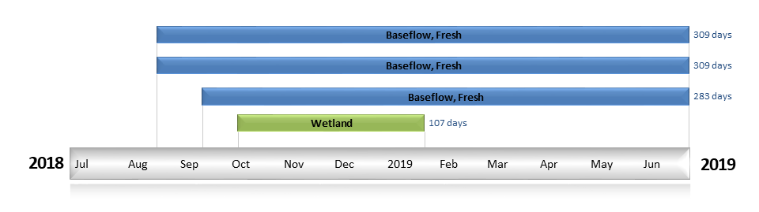
Figure EWK2. Timing and duration of Commonwealth environmental water actions delivered in the Edward Wakool valley.

Contribution of Commonwealth environmental water to flow regimes
Deniliquin
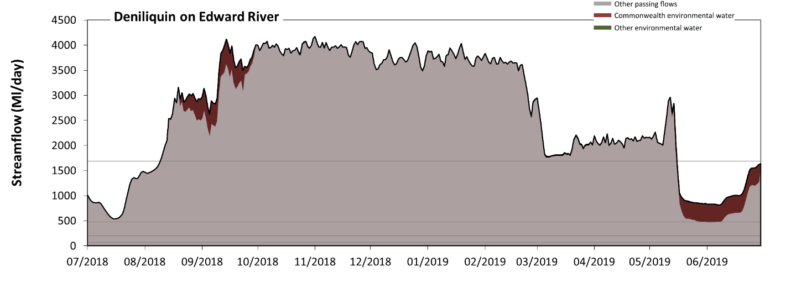
Figure EWK3: Contribution of environmental water delivery at Deniliquin. Horizontal lines indicate thresholds for very low flows, low flows, low freshes, medium freshes and high freshes (from lowest to highest).
At Deniliquin on Edward River environmental water contributed 3% of the total streamflow volume (most of which was Commonwealth environmental water). Environmental watering actions affected streamflows for 80% of days between 1 July 2018 and 30 June 2019. Flow regulation does not substantially increase the duration of very low flows (i.e. < 13 Ml/day) compared to an average year in the natural flow regime. Flow regulation does not substantially increase the duration of medium low flows (i.e. < 66 Ml/day) compared to an average year in the natural flow regime. There was at least one low fresh (i.e. > 200 Ml/day) in the periods July to September, October to December, January to March and April to June. Environmental water made little change to the duration of these low freshes. In the absence of environmental water there would have been at least one medium fresh (i.e. > 480 Ml/day) in the periods July to September, October to December, January to March and April to June. Environmental water increased the duration of the longest medium fresh during the period April to June (from 61 days to 91 days). Commonwealth environmental water was entirely responsible for these increased durations of medium freshes. In the absence of environmental water there would have been at least one high fresh in the periods July to September, October to December, January to March and April to June. Environmental water made no change to the duration of these high freshes.
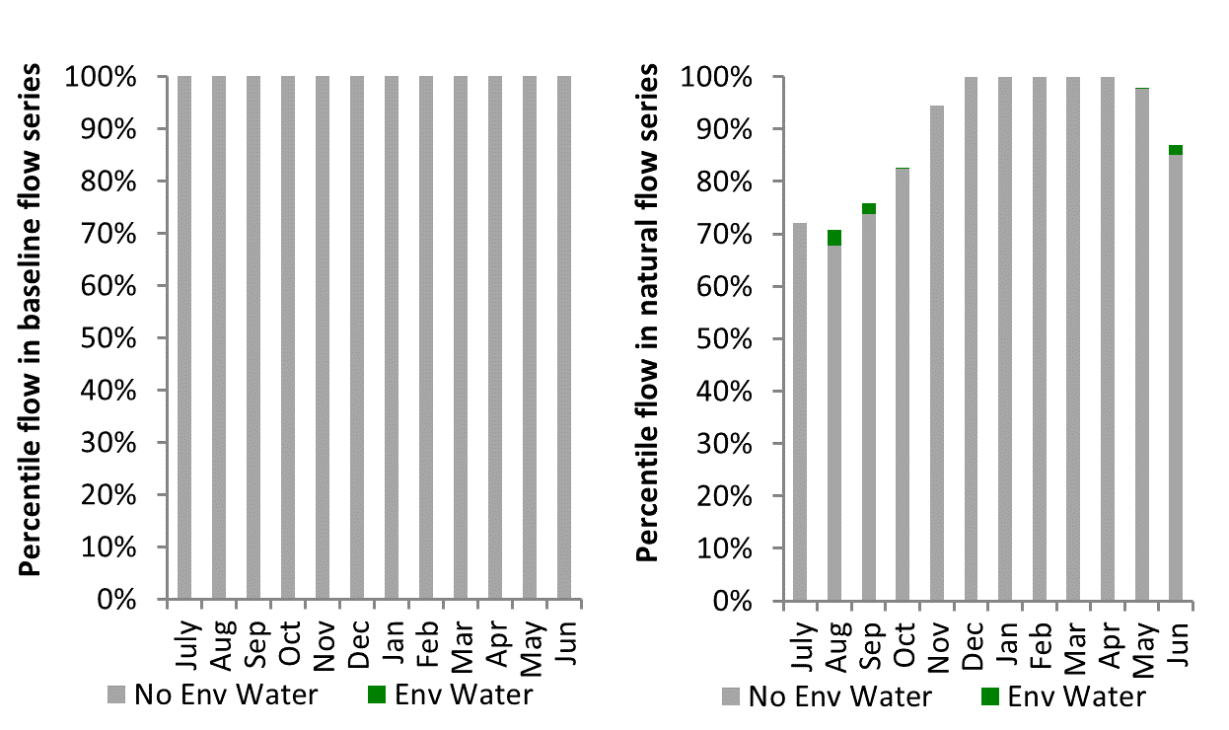
Figure EWK4: Contribution of environmental water delivery at Deniliquin as percentiles in the natural and baseline flow series.

Tuppal
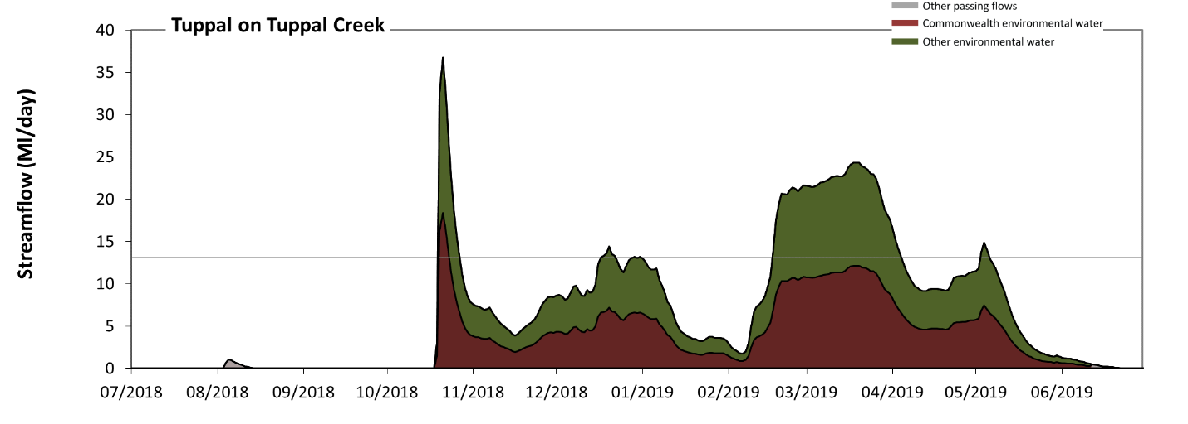
Figure EWK5: Contribution of environmental water delivery at Tuppal. Horizontal lines indicate thresholds for very low flows and low flows (from lowest to highest).
At Tuppal on Tuppal Creek environmental water contributed 100% of the total streamflow volume (with approximately half contributed by Commonwealth environmental water). Environmental watering actions affected streamflows for 65% of days between 1 July 2018 and 30 June 2019. Without environmental water, the durations of very low flows (i.e. < 13 Ml/day) in the periods July to September, October to December and April to June would have substantially exceeded durations expected in an average year in the natural flow regime. Environmental water reduced the cumulative duration of very low flow spells from 100% to 82% of the year, with greatest influence in the period January to March. Similarly, without environmental water, the durations of medium low flows (i.e. < 66 Ml/day) in the periods July to September, October to December and April to June would have substantially exceeded durations expected in an average year in the natural flow regime. However, environmental water had little effect on the duration of these medium low flows, which occurred for 100% of the year. Commonwealth environmental water equally shared responsibility with other environmental water holders for these enhancements of environmental baseflows at this site.
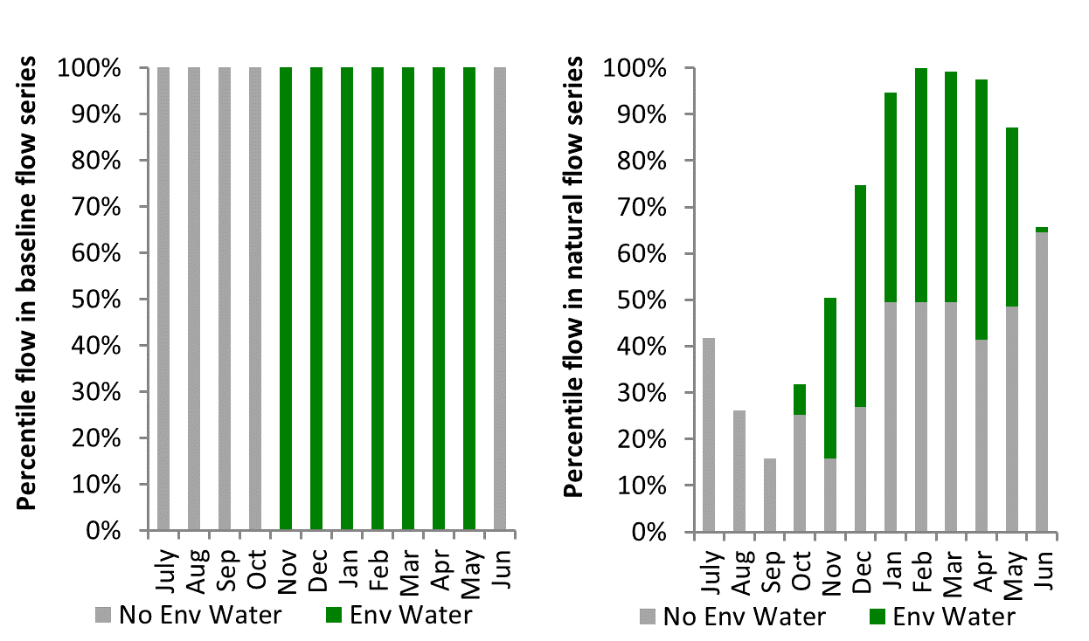
Figure EWK6: Contribution of environmental water delivery at Tuppal as percentiles in the natural and baseline flow series.
Yallakool Offtake
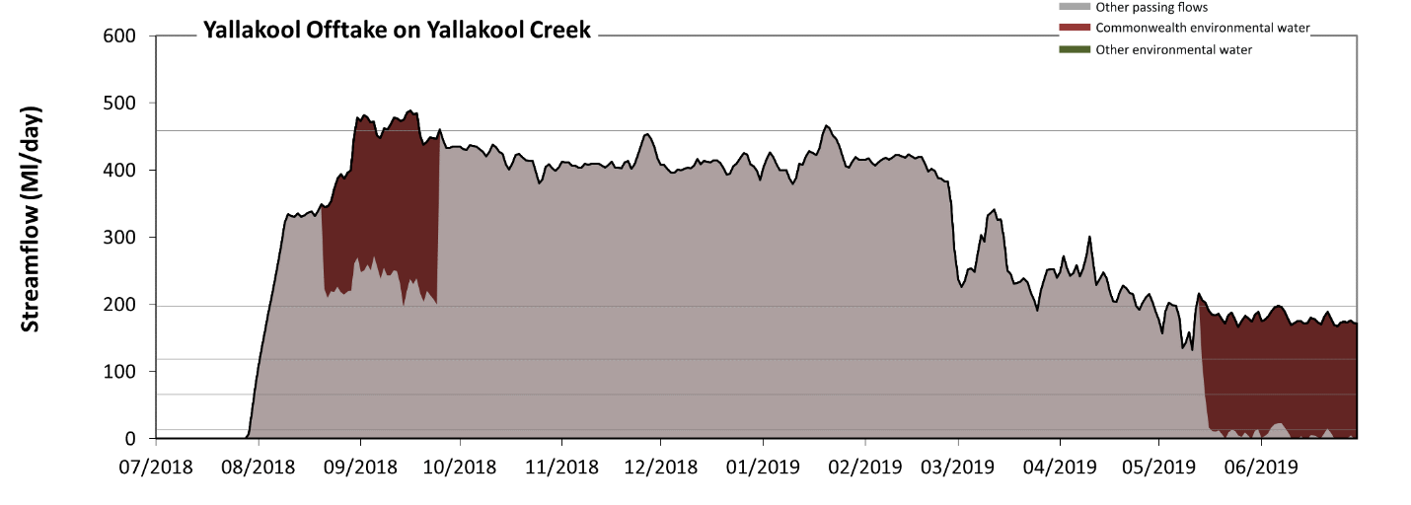
Figure EWK7: Contribution of environmental water delivery at Yallakool Offtake. Horizontal lines indicate thresholds for very low flows, low flows, low freshes, medium freshes and high freshes (from lowest to highest).
At Yallakool Offtake on Yallakool Creek environmental water contributed 14% of the total streamflow volume (all of which was Commonwealth environmental water). Environmental watering actions affected streamflows for 23% of days between 1 July 2018 and 30 June 2019. Flow regulation does not substantially increase the duration of very low flows (i.e. < 13 Ml/day) compared to an average year in the natural flow regime. However, without environmental water, the duration of medium low flows (i.e. < 66 Ml/day) in the period July to September would have substantially exceeded durations expected in an average year in the natural flow regime. Environmental water reduced the cumulative duration of medium low flow spells from 21% to 8% of the year, with greatest influence in the period April to June. Commonwealth environmental water was entirely responsible for these enhancements of environmental baseflows at this site. In the absence of environmental water there would have been at least one low fresh (i.e. > 120 Ml/day) in the periods July to September, October to December, January to March and April to June. Environmental water increased the duration of the longest low fresh during the period April to June (from 44 days to 91 days). Commonwealth environmental water was entirely responsible for these increased durations of low freshes. In the absence of environmental water there would have been at least one medium fresh (i.e. > 200 Ml/day) in the periods July to September, October to December, January to March and April to June. Environmental water increased the duration of the longest medium fresh during the period July to September (from 40 days to 57 days). Commonwealth environmental water was entirely responsible for these increased durations of medium freshes. In the absence of environmental water there would have been at least one high fresh in the periods July to September and January to March. Environmental water increased the duration of the longest high fresh during the period July to September (from 1 days to 11 days). Commonwealth environmental water was entirely responsible for these increased durations of high freshes.
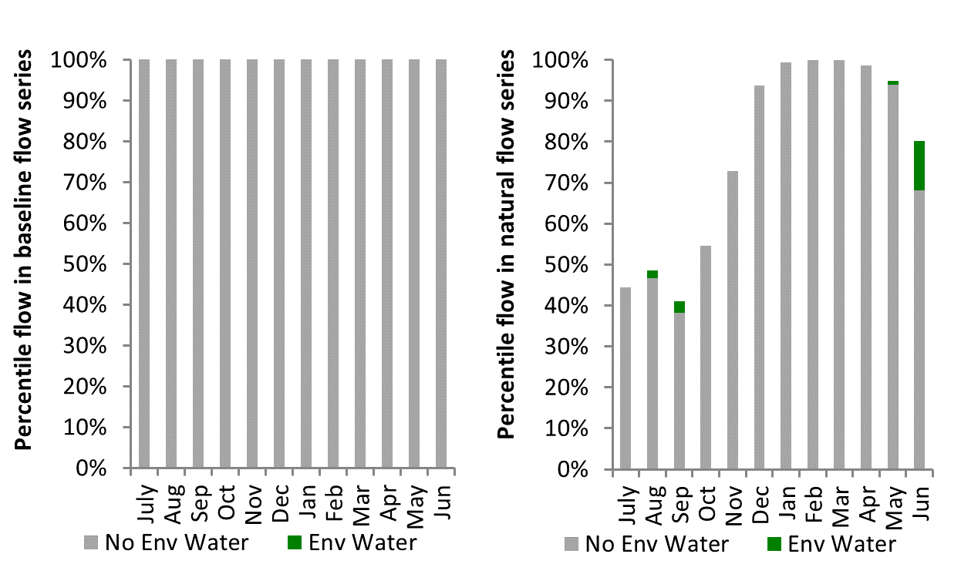
Figure EWK8: Contribution of environmental water delivery at Yallakool Offtake as percentiles in the natural and baseline flow series.
Wakool Offtake
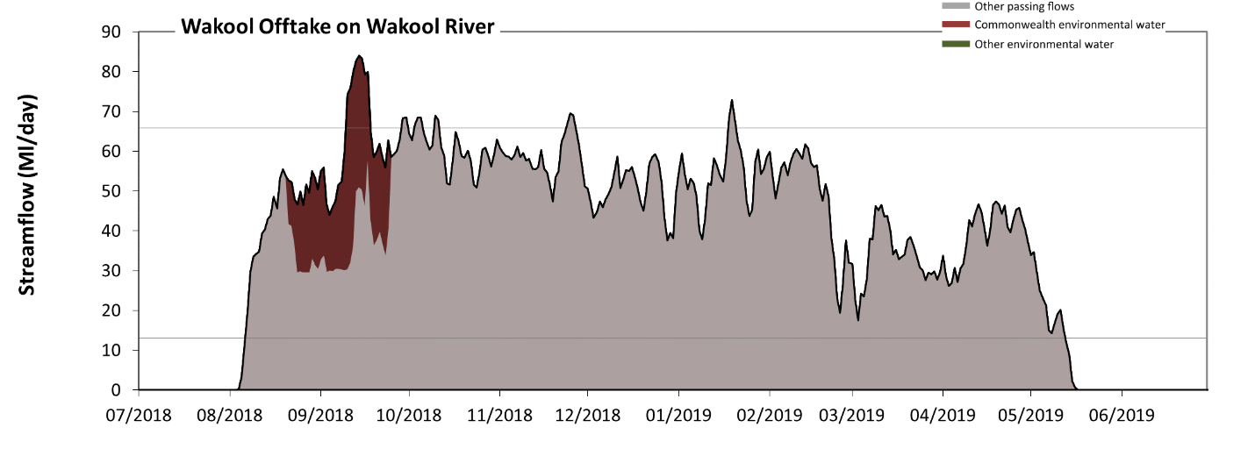
Figure EWK9: Contribution of environmental water delivery at Wakool Offtake. Horizontal lines indicate thresholds for very low flows and low flows (from lowest to highest).
At Wakool Offtake on Wakool River environmental water contributed 6% of the total streamflow volume (all of which was Commonwealth environmental water). Environmental watering actions affected streamflows for 10% of days between 1 July 2018 and 30 June 2019. Without environmental water, the duration of very low flows (i.e. < 13 Ml/day) in the period July to September would have substantially exceeded durations expected in an average year in the natural flow regime. However, environmental water had little effect on the duration of these very low flows, which occurred for 24% of the year. Similarly, without environmental water, the durations of medium low flows (i.e. < 66 Ml/day) in the periods July to September, October to December and April to June would have substantially exceeded durations expected in an average year in the natural flow regime. Environmental water mitigated these impacts by reducing the cumulative duration of medium low flow spells from 96% to 94% of the year, with greatest influence in the period July to September. Commonwealth environmental water was entirely responsible for these enhancements of environmental baseflows at this site.
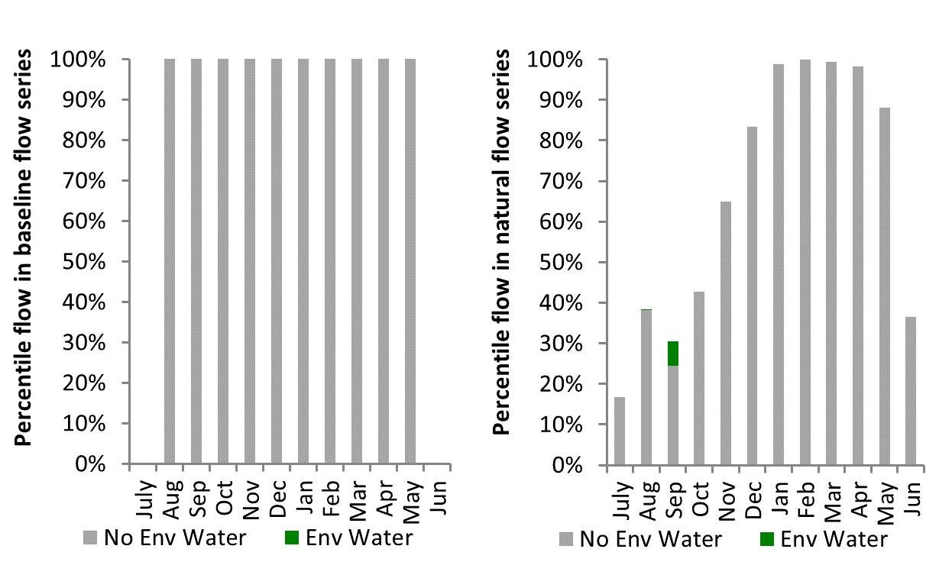
Figure EWK10: Contribution of environmental water delivery at Wakool Offtake as percentiles in the natural and baseline flow series.

Barham Moulamien
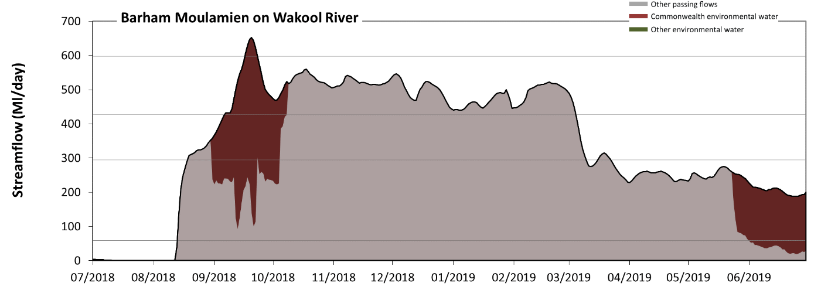
Figure EWK11: Contribution of environmental water delivery at Barham Moulamien. Horizontal lines indicate thresholds for very low flows, low flows, low freshes and medium freshes (from lowest to highest).
At Barham Moulamien on Wakool River environmental water contributed 13% of the total streamflow volume (all of which was Commonwealth environmental water). Environmental watering actions affected streamflows for 21% of days between 1 July 2018 and 30 June 2019. Without environmental water, the duration of very low flows (i.e. < 59 Ml/day) in the period July to September would have substantially exceeded durations expected in an average year in the natural flow regime. Environmental water reduced the cumulative duration of very low flow spells from 20% to 12% of the year, with greatest influence in the period April to June. Similarly, without environmental water, the durations of medium low flows (i.e. < 290 Ml/day) in the periods July to September and April to June would have substantially exceeded durations expected in an average year in the natural flow regime. Environmental water mitigated these impacts by reducing the cumulative duration of medium low flow spells from 52% to 42% of the year, with greatest influence in the period July to September. Commonwealth environmental water was entirely responsible for these enhancements of environmental baseflows at this site. In the absence of environmental water there would have been at least one low fresh (i.e. > 430 Ml/day) in the periods October to December and January to March. Environmental water increased the duration of the longest low fresh during the period July to September (from 0 days to 24 days). Commonwealth environmental water was entirely responsible for these increased durations of low freshes. In the absence of environmental water there would have been no medium or high freshes this year. Environmental water increased the duration of the longest medium fresh during the period July to September (from 0 days to 7 days). Commonwealth environmental water was entirely responsible for these increased durations of medium freshes.
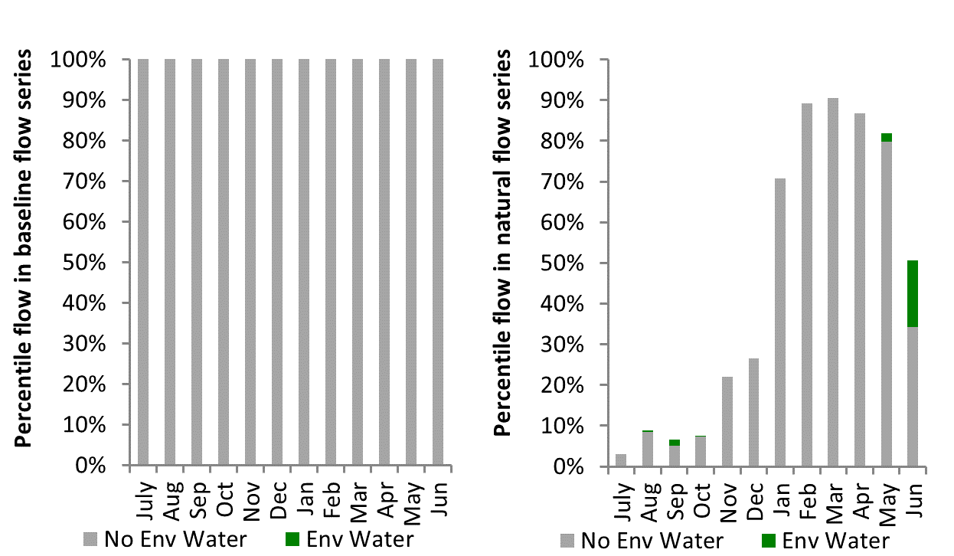
Figure EWK12: Contribution of environmental water delivery at Barham Moulamien as percentiles in the natural and baseline flow series.

Gee Gee Bridge
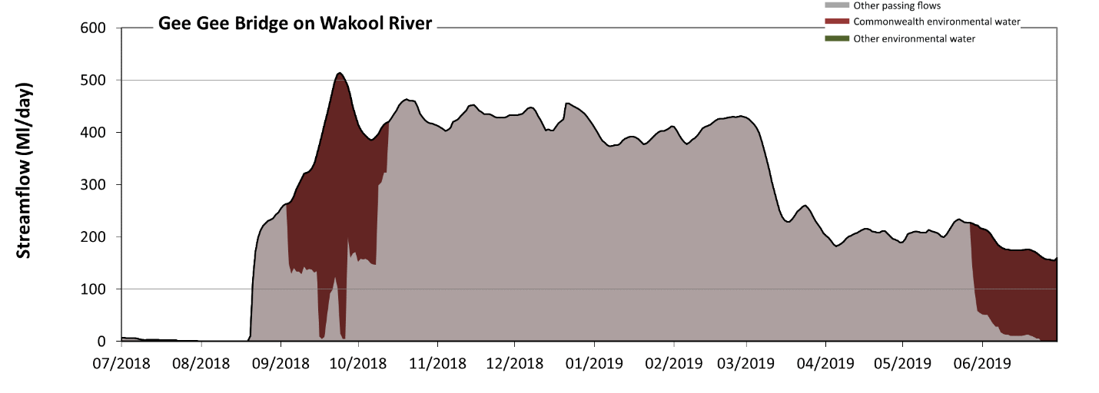Figure EWK13: Contribution of environmental water delivery at Gee Gee Bridge. Horizontal lines indicate thresholds for very low flows and low flows (from lowest to highest).
At Gee Gee Bridge on Wakool River environmental water contributed 15% of the total streamflow volume (all of which was Commonwealth environmental water). Environmental watering actions affected streamflows for 20% of days between 1 July 2018 and 30 June 2019. Without environmental water, the duration of very low flows (i.e. < 100 Ml/day) in the period July to September would have substantially exceeded durations expected in an average year in the natural flow regime. Environmental water reduced the cumulative duration of very low flow spells from 25% to 14% of the year, with greatest influence in the period April to June. Similarly, without environmental water, the durations of medium low flows (i.e. < 500 Ml/day) in the periods July to September, October to December, January to March and April to June would have all substantially exceeded durations expected in an average year in the natural flow regime. Environmental water mitigated these impacts by reducing the cumulative duration of medium low flow spells from 100% to 99% of the year, with greatest influence in the period July to September. Commonwealth environmental water was entirely responsible for these enhancements of environmental baseflows at this site.
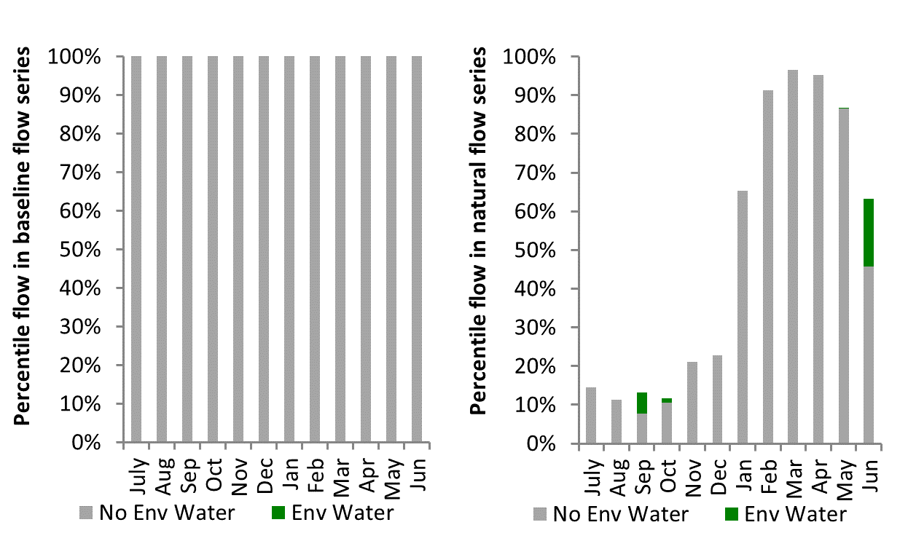
Figure EWK14: Contribution of environmental water delivery at Gee Gee Bridge as percentiles in the natural and baseline flow series.
Coonamit
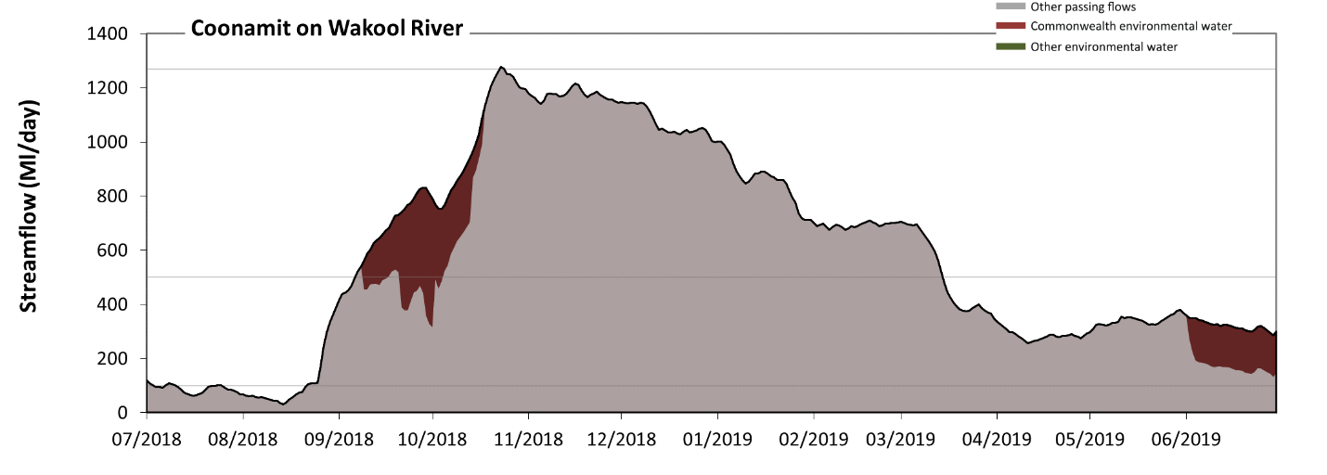 Figure EWK15: Contribution of environmental water delivery at Coonamit. Horizontal lines indicate thresholds for very low flows, low flows and low freshes (from lowest to highest).
At Coonamit on Wakool River environmental water contributed 6% of the total streamflow volume (all of which was Commonwealth environmental water). Environmental watering actions affected streamflows for 19% of days between 1 July 2018 and 30 June 2019. Without environmental water, the duration of very low flows (i.e. < 100 Ml/day) in the period July to September would have substantially exceeded durations expected in an average year in the natural flow regime. However, environmental water had little effect on the duration of these very low flows, which occurred for 12% of the year. Similarly, without environmental water, the durations of medium low flows (i.e. < 500 Ml/day) in the periods July to September and April to June would have substantially exceeded durations expected in an average year in the natural flow regime. Environmental water mitigated these impacts by reducing the cumulative duration of medium low flow spells from 54% to 48% of the year, with greatest influence in the period July to September. Commonwealth environmental water was entirely responsible for these enhancements of environmental baseflows at this site. There was at least one low fresh (i.e. > 1300 Ml/day) in the period October to December. Environmental water made no change to the duration of these low freshes. There was no medium or high freshes this year.
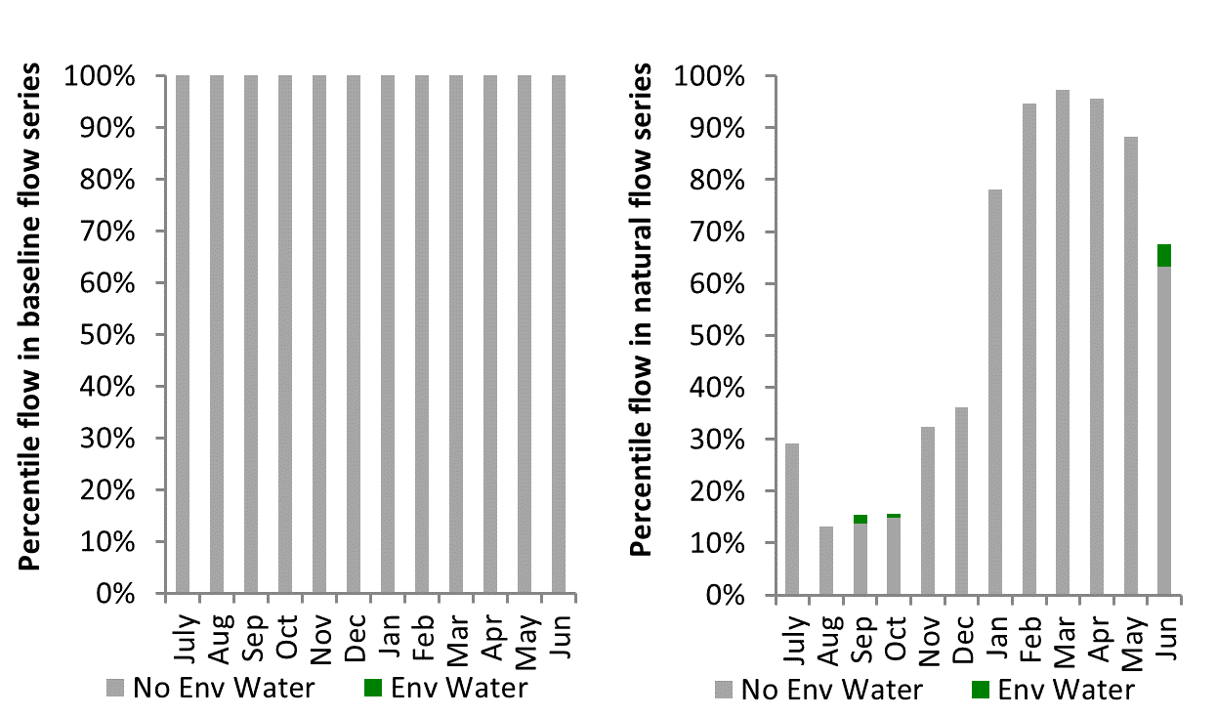
Figure EWK16: Contribution of environmental water delivery at Coonamit as percentiles in the natural and baseline flow series.

Colligen Offtake
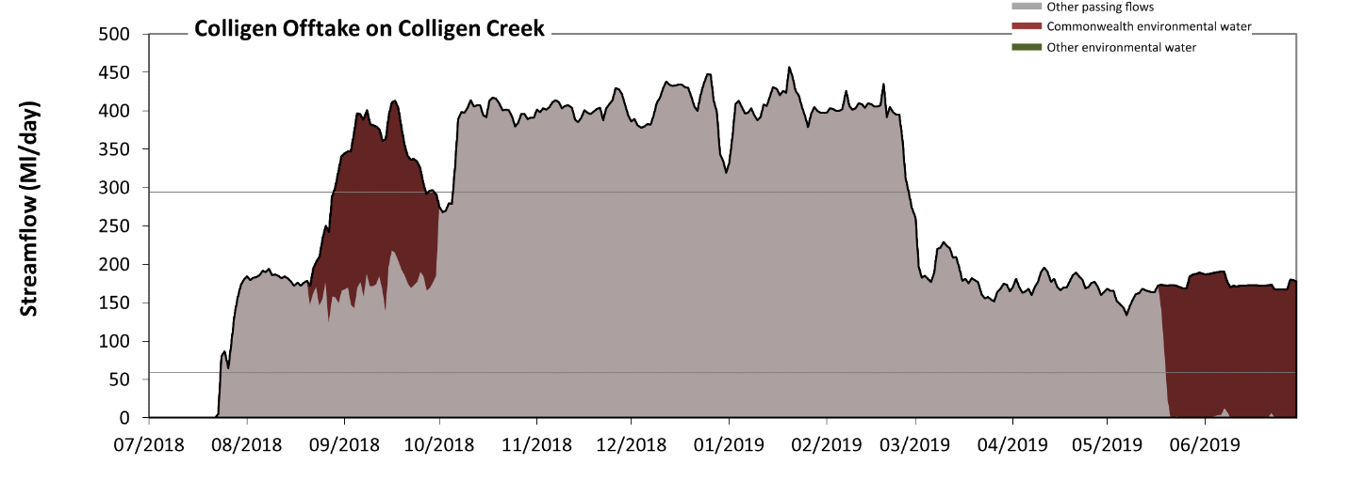 Figure EWK17: Contribution of environmental water delivery at Colligen Offtake. Horizontal lines indicate thresholds for very low flows and low flows (from lowest to highest).
At Colligen Offtake on Colligen Creek environmental water contributed 14% of the total streamflow volume (all of which was Commonwealth environmental water). Environmental watering actions affected streamflows for 23% of days between 1 July 2018 and 30 June 2019. Without environmental water, the duration of very low flows (i.e. < 59 Ml/day) in the period July to September would have substantially exceeded durations expected in an average year in the natural flow regime. Environmental water reduced the cumulative duration of very low flow spells from 18% to 6% of the year, with greatest influence in the period April to June. Similarly, without environmental water, the durations of medium low flows (i.e. < 290 Ml/day) in the periods July to September and April to June would have substantially exceeded durations expected in an average year in the natural flow regime. Environmental water mitigated these impacts by reducing the cumulative duration of medium low flow spells from 61% to 52% of the year, with greatest influence in the period July to September. Commonwealth environmental water was entirely responsible for these enhancements of environmental baseflows at this site.
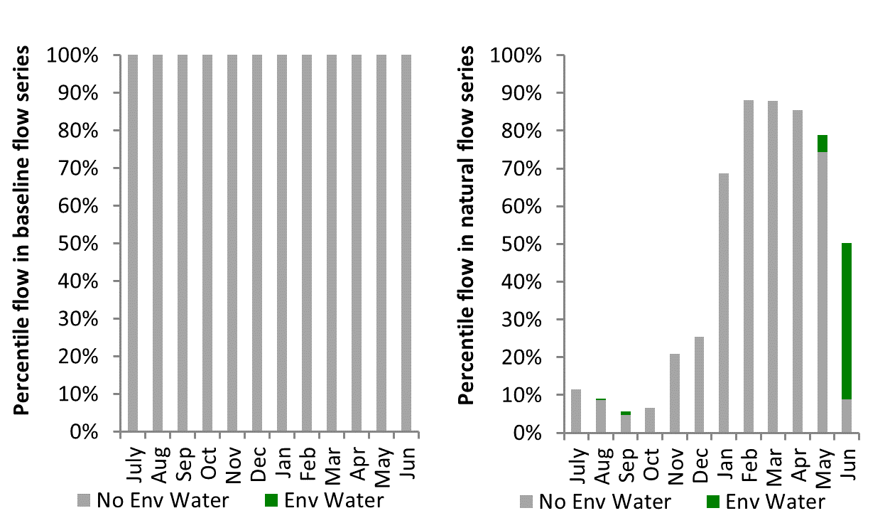
Figure EWK18: Contribution of environmental water delivery at Colligen Offtake as percentiles in the natural and baseline flow series.
Moulamien Rd
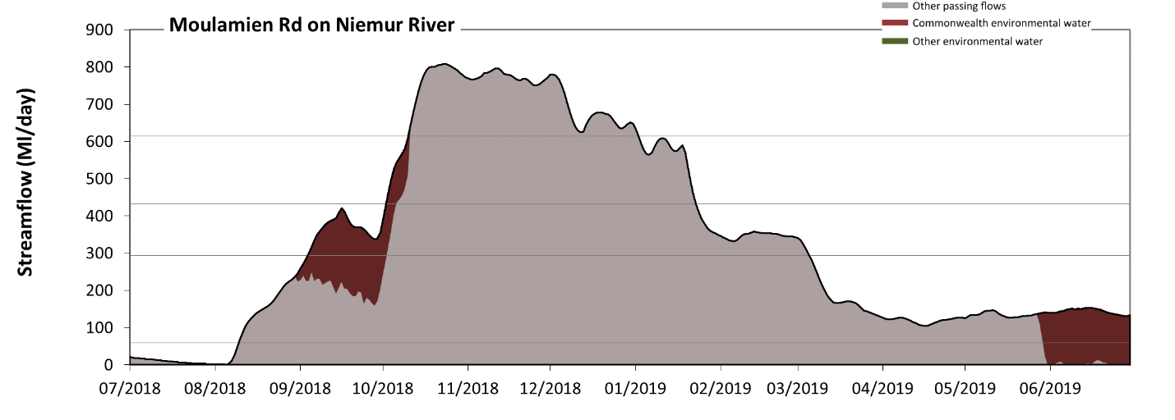 Figure EWK19: Contribution of environmental water delivery at Moulamien Rd. Horizontal lines indicate thresholds for very low flows, low flows, low freshes and medium freshes (from lowest to highest).
At Moulamien Rd on Niemur River environmental water contributed 8% of the total streamflow volume (all of which was Commonwealth environmental water). Environmental watering actions affected streamflows for 21% of days between 1 July 2018 and 30 June 2019. Without environmental water, the duration of very low flows (i.e. < 59 Ml/day) in the period July to September would have substantially exceeded durations expected in an average year in the natural flow regime. Environmental water reduced the cumulative duration of very low flow spells from 20% to 11% of the year, with greatest influence in the period April to June. Similarly, without environmental water, the durations of medium low flows (i.e. < 290 Ml/day) in the periods July to September and April to June would have substantially exceeded durations expected in an average year in the natural flow regime. Environmental water mitigated these impacts by reducing the cumulative duration of medium low flow spells from 58% to 50% of the year, with greatest influence in the period July to September. Commonwealth environmental water was entirely responsible for these enhancements of environmental baseflows at this site. There was at least one low fresh (i.e. > 430 Ml/day) in the periods October to December and January to March. Environmental water made no change to the duration of these low freshes. There was at least one medium fresh (i.e. > 610 Ml/day) in the periods October to December and January to March. Environmental water made no change to the duration of these medium freshes. There was no high freshes (i.e. > 1100 Ml/day) this year.
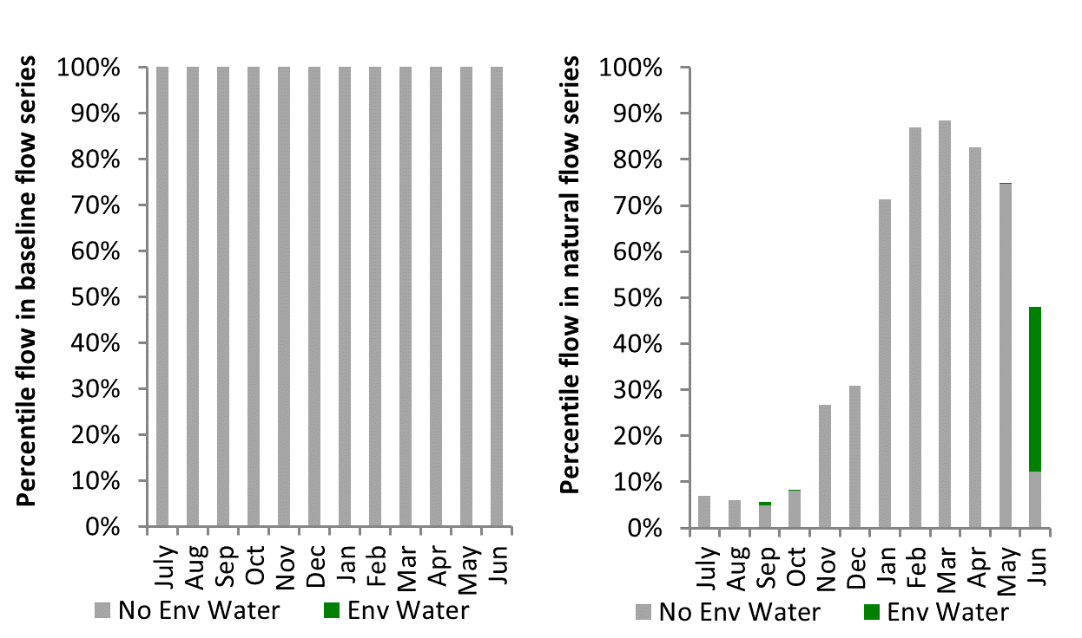
Figure EWK20: Contribution of environmental water delivery at Moulamien Rd as percentiles in the natural and baseline flow series.

MallanSchool
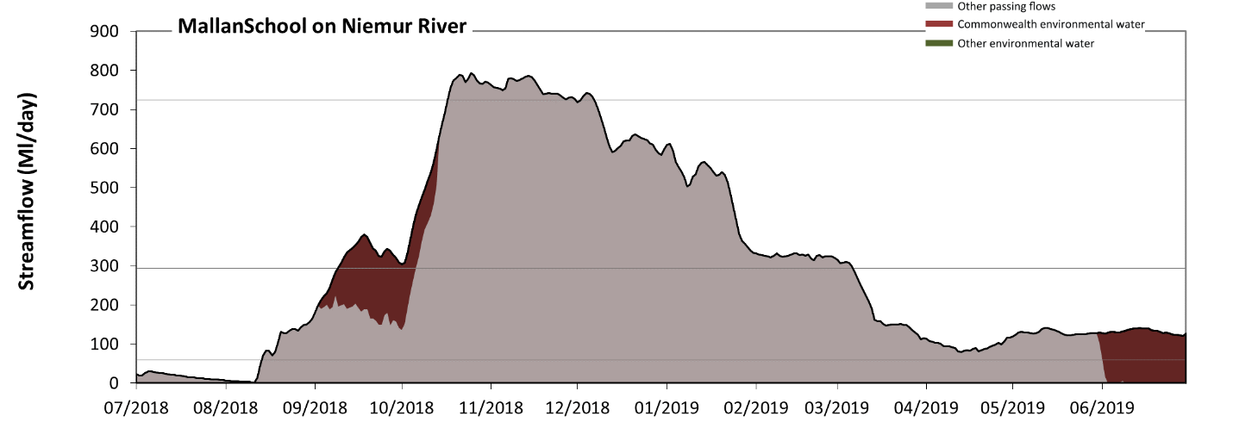
Figure EWK21: Contribution of environmental water delivery at MallanSchool. Horizontal lines indicate thresholds for very low flows, low flows and low freshes (from lowest to highest).
At MallanSchool on Niemur River environmental water contributed 8% of the total streamflow volume (all of which was Commonwealth environmental water). Environmental watering actions affected streamflows for 20% of days between 1 July 2018 and 30 June 2019. Without environmental water, the duration of very low flows (i.e. < 59 Ml/day) in the period July to September would have substantially exceeded durations expected in an average year in the natural flow regime. Environmental water reduced the cumulative duration of very low flow spells from 20% to 12% of the year, with greatest influence in the period April to June. Similarly, without environmental water, the durations of medium low flows (i.e. < 290 Ml/day) in the periods July to September and April to June would have substantially exceeded durations expected in an average year in the natural flow regime. Environmental water mitigated these impacts by reducing the cumulative duration of medium low flow spells from 58% to 51% of the year, with greatest influence in the period July to September. Commonwealth environmental water was entirely responsible for these enhancements of environmental baseflows at this site. There was at least one low fresh (i.e. > 720 Ml/day) in the period October to December. Environmental water made no change to the duration of these low freshes. There was no medium or high freshes this year.
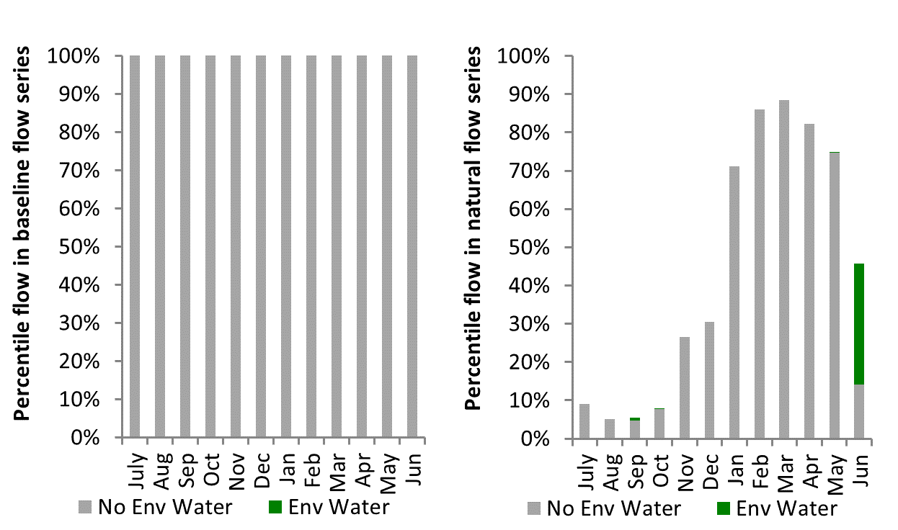
Figure EWK22: Contribution of environmental water delivery at MallanSchool as percentiles in the natural and baseline flow series.

Lower Murray
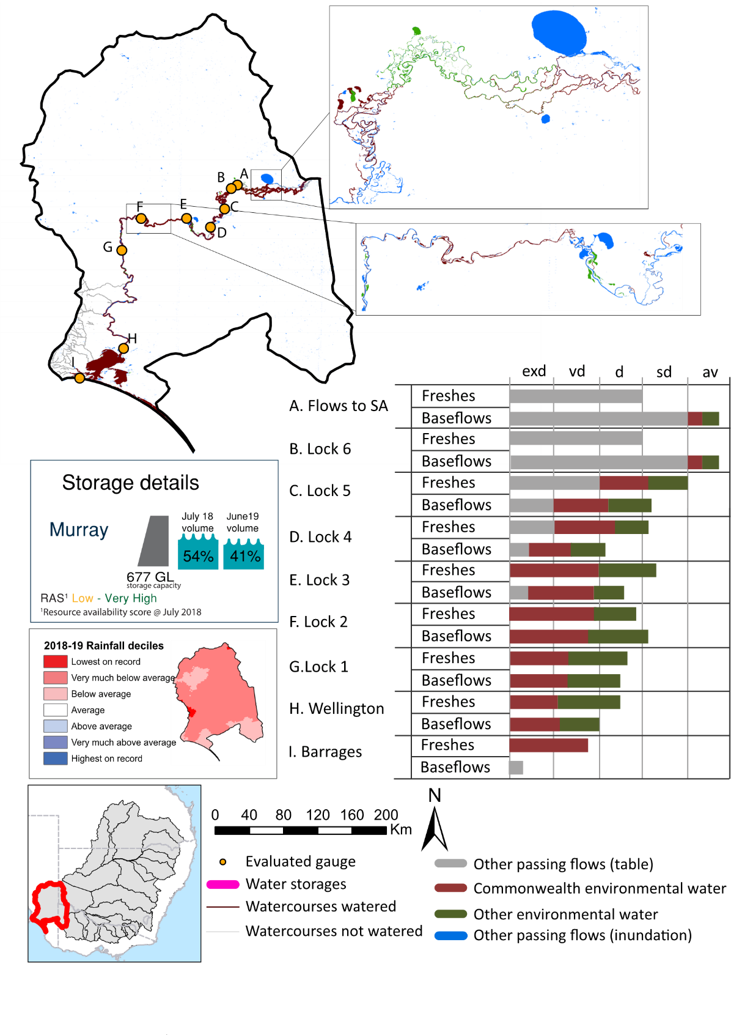
Figure LWM1: Watercourses influenced, areas inundated (where applicable) and gauge stations evaluated in the Lower Murray valley during the 2018-19 water year. Inset bar graphs report the condition of annual flow regimes by showing the improvements in hydrological condition with the addition of environmental water as well as the hypothetical scenario in “grey” (if no environmental flow had been delivered) where exd=extremely dry, vd=very dry, d=dry, sd=somewhat dry and av=average. Rainfall conditions (rainfall deciles) and trend in storage levels for the water year are also shown.

Summary
The volume of environmental water delivery for the 2018-19 year in the Lower Murray valley is quantified using data for 9 sites. This evaluation only considers the contribution of held environmental water, which is a primary focus for the Commonwealth. The contributions of planned environmental water (e.g. passing flows), unregulated tributary inflows and clever use of irrigation flows for environmental benefits can all be very important but these are outside the scope of this report. Environmental watering actions lasted on average 365 days over the course of the year. The volume of environmental water at these 9 sites was between 24% and 100% of the total streamflow. Commonwealth environmental water contributed on average 65% of this environmental water. The contribution of environmental water delivery to improved flow regimes is evaluated using data for 9 sites. Ideally, baseflows should be maintained and long periods of excessively low flows avoided. In this valley, the baseflow regime was generally considered to be very dry relative to the pre-development flow regime. In our analysis, a low fresh refers to a period of increased flow, when the water level rises at least one eighth of the way up the river bank (above the low flow level). These low freshes are a regular part of the natural flow regime and support a range of natural processes. In the Lower Murray valley, in terms of the occurrence and duration of low freshes, the year was assessed as being average. In our analysis, a medium fresh refers to a period of increased flow, when the water level rises at least one quarter of the way up the river bank. These medium freshes are not as frequent as low freshes but are also a regular and important part of the natural flow regime. In the Lower Murray valley, in terms of the occurrence of medium freshes, the year was assessed as being somewhat dry. In our analysis, a high fresh refers to a period of increased flow, when the water level rises more than half way up the river. A high fresh may not occur every year but they are still important and long periods without major freshes can have serious consequences for floodplains and their contribution to river connectivity. Delivering high in channel environmental flows normally requires that all risks to riparian landholders and infrastructure have been resolved. In the Lower Murray valley, in terms of the occurrence of high freshes, the year was assessed as being extremely dry.

Water delivery context
During the 2018-19, the Commonwealth Environmental Water Holder (CEWH) held water entitlements of up to 161,417 ML for environmental use in the Lower Murray valley. Each year, water utilities allocate water entitlement holders a percentage of water based on their holding, license type and carryover (the exact rules vary among Jurisdictions). In 2018-19, the Lower Murray entitlements held by the CEWH were allocated 155,493 ML of water, representing 107% of the Long term average annual yield for the Lower Murray valley (145,276 ML). Information and data relating to the portfolio of held Commonwealth environmental water is shown in Table LWM2.
The 2018-19 water allocation (155,493 ML) together with the carryover volume of 0 ML of water meant the CEWH had 155,493 ML of water available for delivery. A total of 561,829 ML of Commonwealth environmental water was delivered in the Lower Murray valley. A total of 0 ML of Commonwealth environmental water was traded to consumptive users and 0 ML (0%) of available Commonwealth environmental water was carried over for environmental use into the 2019-20 water year.

Environmental conditions and resource availability
The water available for environmental delivery combined with the present and antecedent environmental conditions are key inputs used by environmental water managers in planning and implementing watering actions. Post hoc, this information provides important context when evaluating the effectiveness and appropriateness of environmental water use with respect to hydrological outputs.
The rainfall conditions in the Lower Murray valley were classified as Very much below average, based on rainfall percentile data for the entire record held by the Bureau of Meteorology for this valley. The water held in major storages in the Lower Murray valley decreased over the water year, for example Lake Victoria dam was 53.8% full at the beginning of the water year and 41.3% full by the end of the year (Figure LWM1).
The Commonwealth Environmental Water Office (CEWO) calculates resource availability scenarios (RAS) to guide the use and prioritisation of held environmental water. The RAS are progressively calculated over the year as part of the continual adaptive management planning processes. The RAS are based on the availability of held environmental water (including progressive license acquisitions and allocations) as well as the potential for unregulated or planned environmental flows. The outcome is then used to determine the demand for environmental water across the basin.
In 2018-19, the resource availability of held Commonwealth environmental water was classified as low to very high. The physical conditions meant that the CEWO was managing to protect and/or improve the condition of most environmental assets, while seeking to avoid irreversible damage or decline to the Coorong and Lower Darling Region (where feasible). The overall demand for environmental water was deemed moderate.

Watering actions
A total of 66 watering actions were delivered over the 2018-19 water year, the duration of these actions varied (range of individual actions: 2 - 359 days) and Commonwealth environmental water was delivered for a total of 365 days. The number of water actions commencing in each season included, Autumn (15), Spring (30), Summer (10), Winter(11). Similarly, the count of flow component types delivered in the Lower Murray valley were; (2) baseflow, (1) baseflow-fresh, (9) fresh, (0) fresh-overbank, (0) bankfull, (0) overbank, (54) wetland and (0) wetland-fresh.
In this valley, primary objectives of most watering actions was related to vegetation purposes, but water was also delivered for other purposes too. The percentage of watering actions delivered across the nine main themes included primary objectives for fish (9.25%), vegetation (34.68%), waterbirds (23.12%), frogs (15.61%), other biota (1.16%), connectivity (2.31%), process (5.2%), resilience (0.58%) and water quality (8.09%).
Table LWM2. Commonwealth environmental water accounting information for the Lower Murray valley over 2018-19 water year.
Total registered volume (ML) | Allocated volume (ML) | Carry over + allocated volume (ML) | Delivered (ML) | LTAAY (ML) | Trade (ML) | Carried over to 2019-20 | Forfeited (ML)
161,417 | 155,493 | 155,493 | 561,829 | 145,276 | 0 | 0 | 0

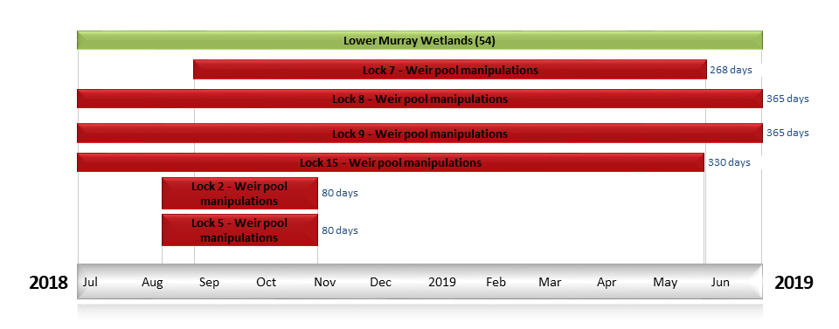
Figure LWM2. Timing and duration of Commonwealth environmental water actions delivered in the Lower Murray valley.

Contribution of Commonwealth environmental water to flow regimes
SA Border
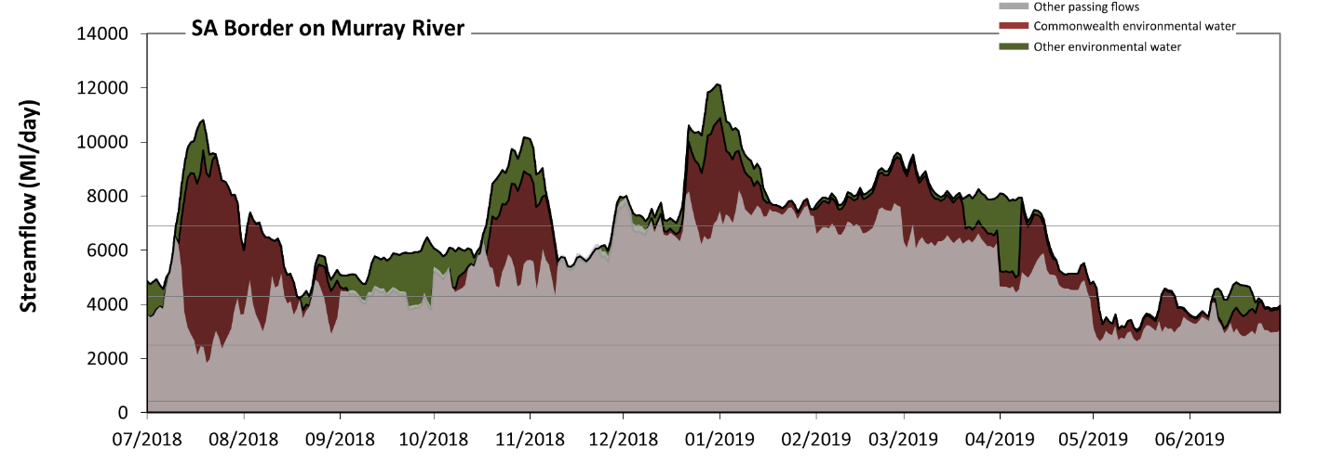
Figure LWM3: Contribution of environmental water delivery at SA Border. Horizontal lines indicate thresholds for very low flows, low flows, low freshes and medium freshes (from lowest to highest).
At SA Border on Murray River environmental water contributed 24% of the total streamflow volume. Environmental watering actions affected streamflows for 100% of days between 1 July 2018 and 30 June 2019. Flow regulation does not increase the duration of very low flows (i.e. < 430 Ml/day) compared to an average year in the natural flow regime. However, without environmental water, a short duration of medium low flows (i.e. < 2500 Ml/day) in the period July to September would have occurred which would have been unusual in the natural flow regime. Environmental water mitigated these impacts by reducing the cumulative duration of medium low flow spells from 2% to 0% of the year in the period July to September. In the absence of environmental water there would have been at least one low fresh (i.e. > 4300 Ml/day) in the periods July to September, October to December, January to March and April to June. Environmental water increased the duration of the longest low fresh during the period July to September (from 13 days to 48 days). In the absence of environmental water there would have been at least one medium fresh (i.e. > 6900 Ml/day) in the periods October to December and January to March. Environmental water increased the duration of the longest medium fresh during the periods July to September (from 0 days to 20 days), October to December (from 9 days to 34 days), January to March (from 31 days to 90 days) and April to June (from 0 days to 15 days). There was no high freshes (i.e. > 15000 Ml/day) this year.
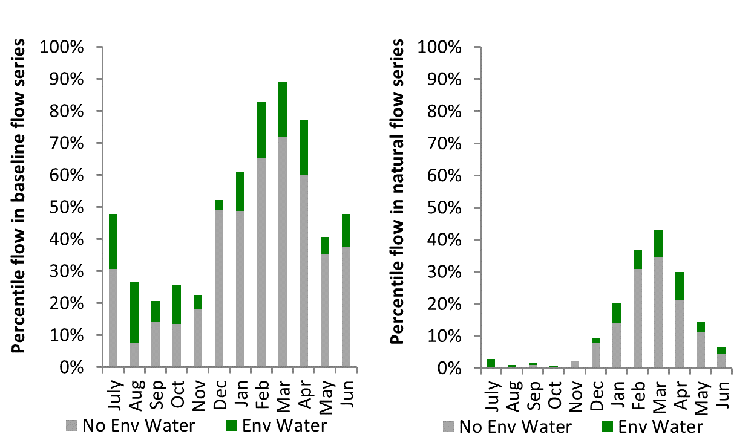
Figure LWM4: Contribution of environmental water delivery at SA Border as percentiles in the natural and baseline flow series.
Lock 6
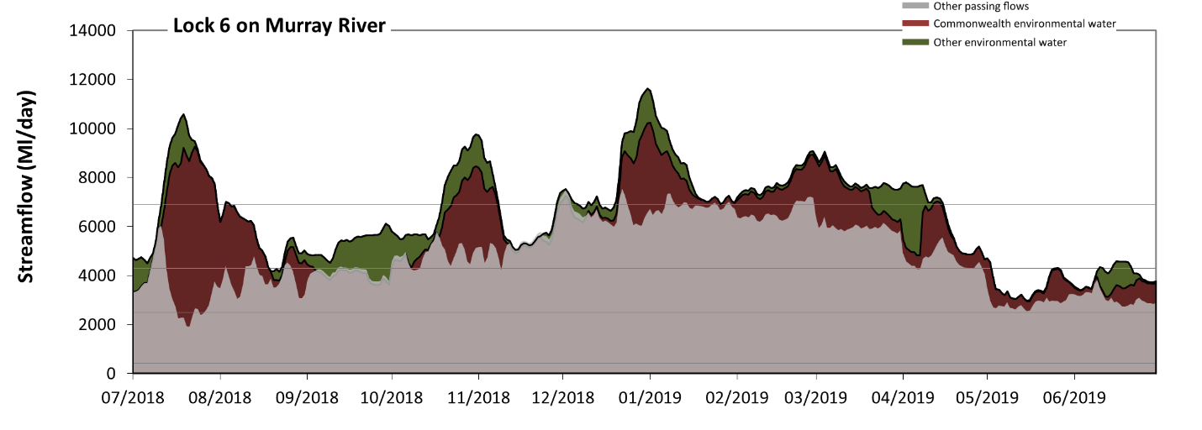
Figure LWM5: Contribution of environmental water delivery at Lock 6. Horizontal lines indicate thresholds for very low flows, low flows, low freshes and medium freshes (from lowest to highest).
At Lock 6 on Murray River environmental water contributed 26% of the total streamflow volume. Environmental watering actions affected streamflows for 100% of days between 1 July 2018 and 30 June 2019. Flow regulation does not substantially However, without environmental water, a short duration of medium low flows (i.e. < 2500 Ml/day) in the period July to September would have occurred which would have been unusual in the natural flow regime. Environmental water mitigated these impacts by reducing the cumulative duration of medium low flow spells from 2% to 0% of the year in the period July to September. In the absence of environmental water there would have been at least one low fresh (i.e. > 4300 Ml/day) in the periods July to September, October to December, January to March and April to June. Environmental water increased the duration of the longest low fresh during the periods July to September (from 5 days to 49 days), October to December (from 52 days to 92 days) and April to June (from 17 days to 32 days). In the absence of environmental water there would have been at least one medium fresh (i.e. > 6900 Ml/day) in the periods October to December and January to March. Environmental water increased the duration of the longest medium fresh during the periods July to September (from 0 days to 20 days), October to December (from 4 days to 21 days), January to March (from 8 days to 90 days) and April to June (from 0 days to 15 days). There was no high freshes (i.e. > 15000 Ml/day) this year.
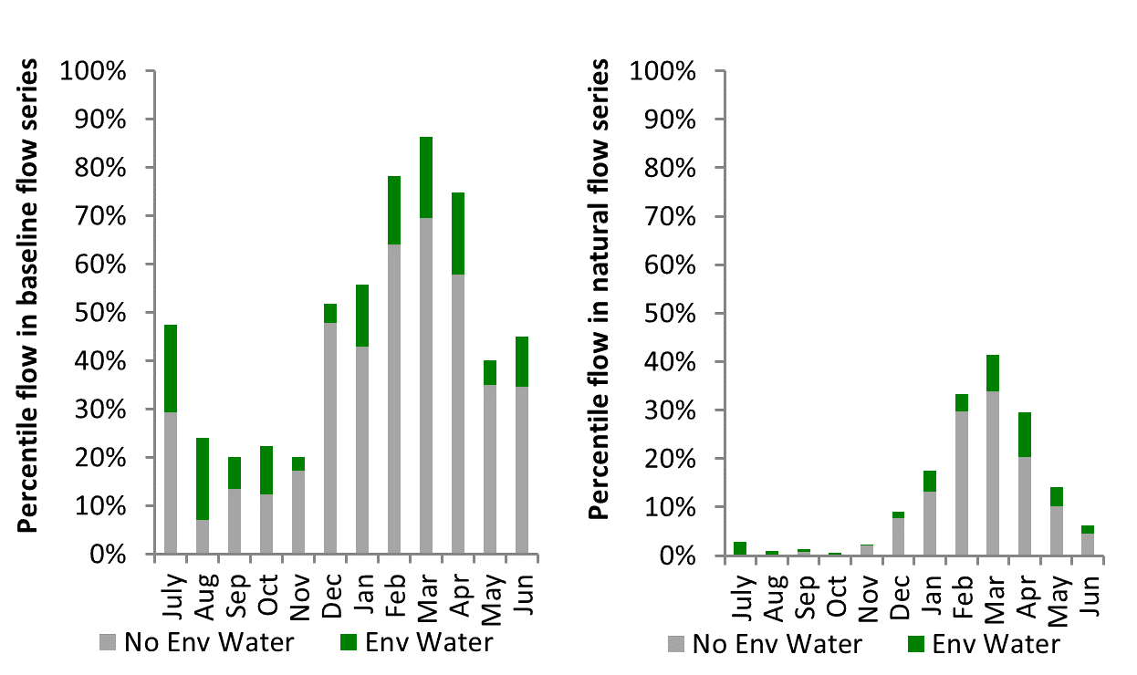
Figure LWM6: Contribution of environmental water delivery at Lock 6 as percentiles in the natural and baseline flow series.

Lock 5
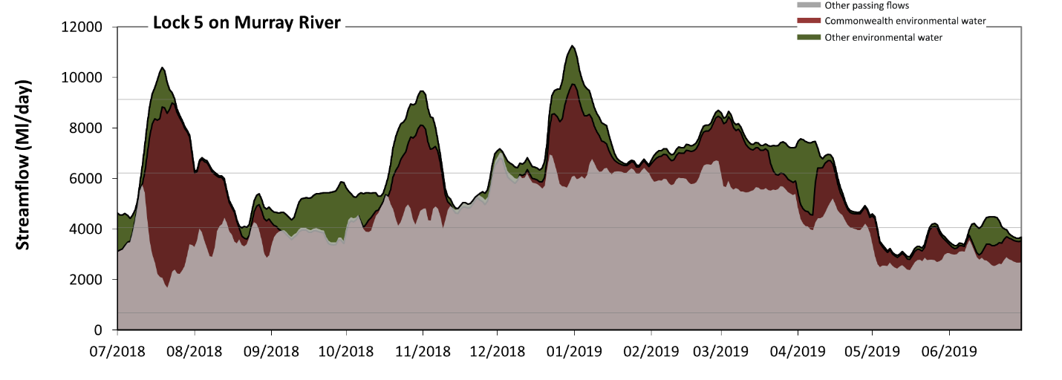
Figure LWM7: Contribution of environmental water delivery at Lock 5. Horizontal lines indicate thresholds for very low flows, low flows, low freshes and medium freshes (from lowest to highest).
At Lock 5 on Murray River environmental water contributed 28% of the total streamflow volume. Environmental watering actions affected streamflows for 100% of days between 1 July 2018 and 30 June 2019. Flow regulation does not substantially increase the duration of very low flows (i.e. < 700 Ml/day) compared to an average year in the natural flow regime. However, without environmental water, the durations of medium low flows (i.e. < 4100 Ml/day) in the periods July to September and April to June would have substantially exceeded durations expected in an average year in the natural flow regime. Environmental water mitigated these impacts by reducing the cumulative duration of medium low flow spells from 42% to 12% of the year, with greatest influence in the period July to September. In the absence of environmental water there would have been at least one low fresh (i.e. > 6200 Ml/day) in the periods October to December and January to March. Environmental water increased the duration of the longest low fresh during the periods July to September (from 0 days to 30 days), October to December (from 7 days to 33 days), January to March (from 9 days to 90 days) and April to June (from 0 days to 16 days). In the absence of environmental water there would have been no medium or high freshes this year. Environmental water increased the duration of the longest medium fresh during the periods July to September (from 0 days to 10 days), October to December (from 0 days to 9 days) and January to March (from 0 days to 8 days).
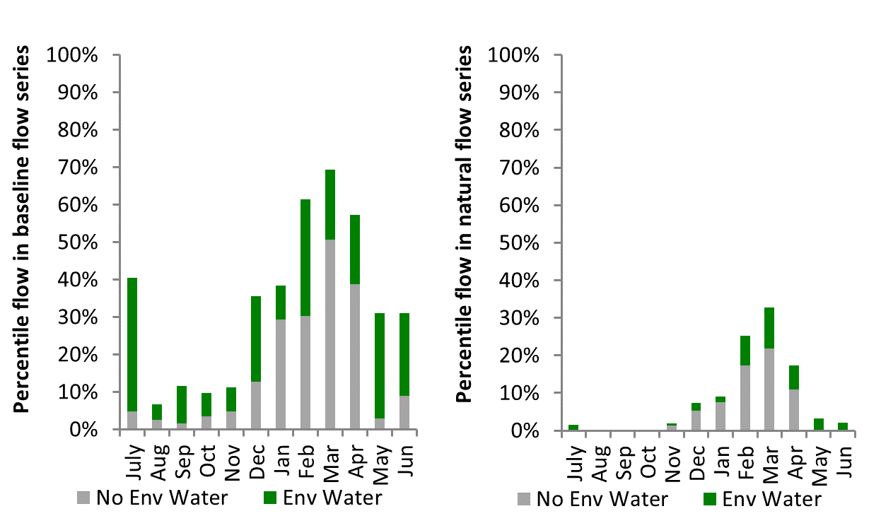
Figure LWM8: Contribution of environmental water delivery at Lock 5 as percentiles in the natural and baseline flow series.
Lock 4
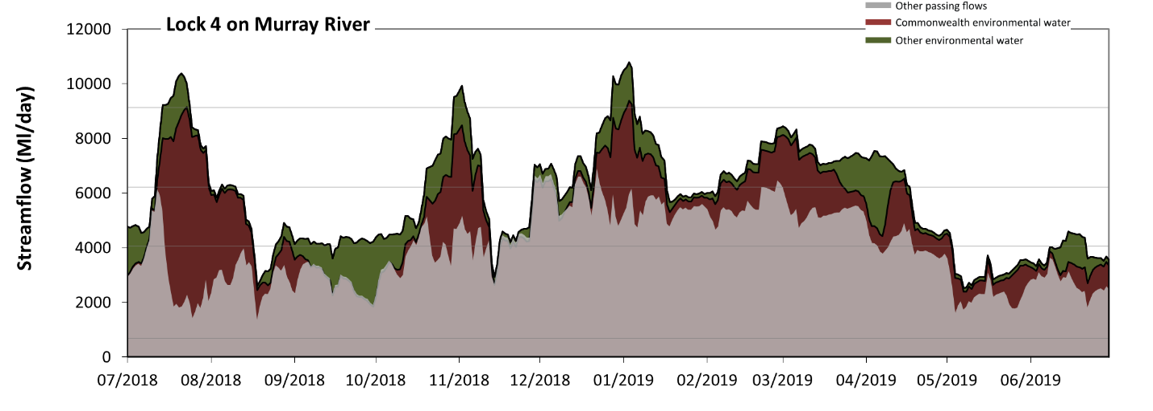
Figure LWM9: Contribution of environmental water delivery at Lock 4. Horizontal lines indicate thresholds for very low flows, low flows, low freshes and medium freshes (from lowest to highest).
At Lock 4 on Murray River environmental water contributed 32% of the total streamflow volume. Environmental watering actions affected streamflows for 100% of days between 1 July 2018 and 30 June 2019. Flow regulation does not increase the duration of very low flows (i.e. < 700 Ml/day) compared to an average year in the natural flow regime. However, without environmental water, the durations of medium low flows (i.e. < 4100 Ml/day) in the periods July to September, October to December and April to June would have substantially exceeded durations expected in an average year in the natural flow regime. Environmental water mitigated these impacts by reducing the cumulative duration of medium low flow spells from 52% to 18% of the year, with greatest influence in the period July to September. In the absence of environmental water there would have been at least one low fresh (i.e. > 6200 Ml/day) in the periods October to December and January to March. Environmental water increased the duration of the longest low fresh during the periods July to September (from 0 days to 20 days), October to December (from 8 days to 21 days), January to March (from 2 days to 54 days) and April to June (from 0 days to 17 days). In the absence of environmental water there would have been no medium or high freshes this year. Environmental water increased the duration of the longest medium fresh during the periods July to September (from 0 days to 11 days), October to December (from 0 days to 5 days) and January to March (from 0 days to 4 days).
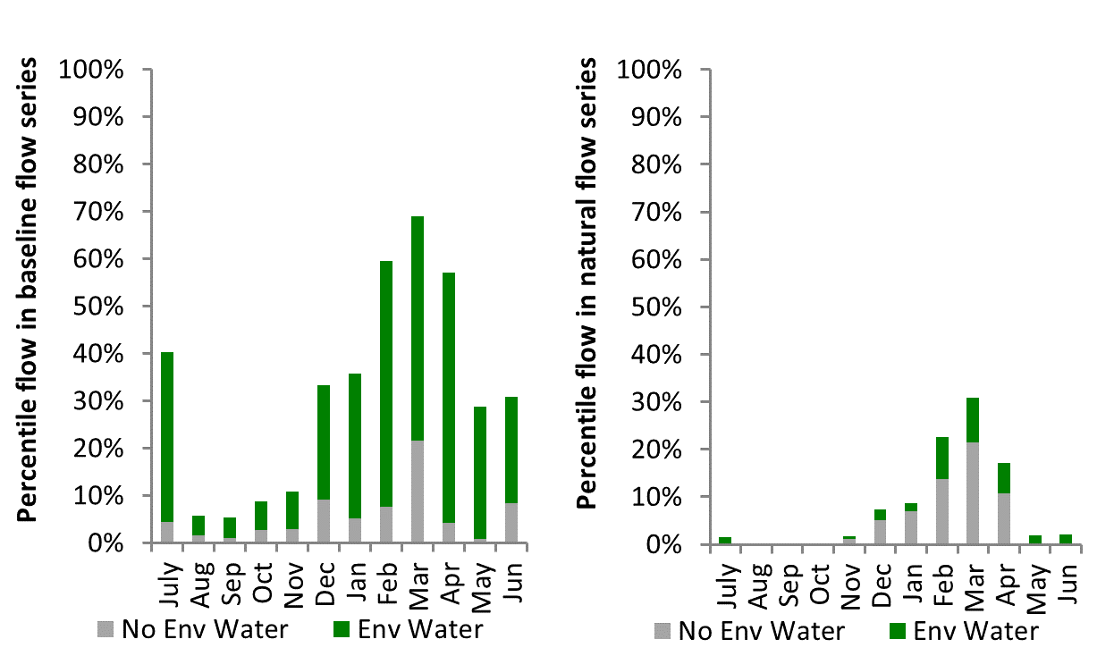
Figure LWM10: Contribution of environmental water delivery at Lock 4 as percentiles in the natural and baseline flow series.

Lock 3
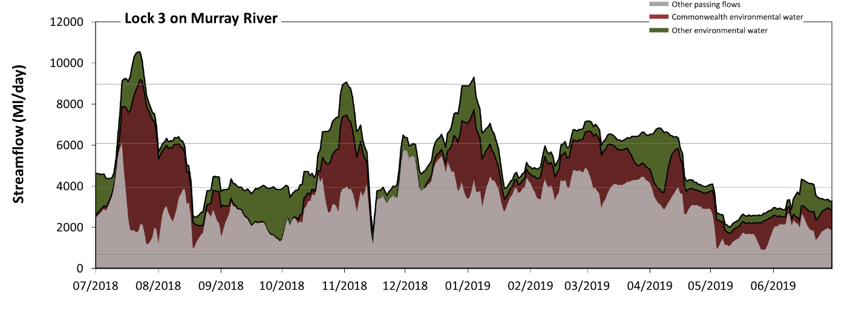
Figure LWM11: Contribution of environmental water delivery at Lock 3. Horizontal lines indicate thresholds for very low flows, low flows, low freshes and medium freshes (from lowest to highest).
At Lock 3 on Murray River environmental water contributed 41% of the total streamflow volume. Environmental watering actions affected streamflows for 100% of days between 1 July 2018 and 30 June 2019. Flow regulation does not substantially increase the duration of very low flows (i.e. < 690 Ml/day) compared to an average year in the natural flow regime. However, without environmental water, the durations of medium low flows (i.e. < 3900 Ml/day) in the periods July to September, October to December, January to March and April to June would have all substantially exceeded durations expected in an average year in the natural flow regime. Environmental water mitigated these impacts by reducing the cumulative duration of medium low flow spells from 76% to 27% of the year, with greatest influence in the period July to September. In the absence of environmental water there would have been at least one low fresh (i.e. > 6100 Ml/day) in the period July to September. Environmental water increased the duration of the longest low fresh during the periods July to September (from 1 days to 20 days), October to December (from 0 days to 21 days), January to March (from 0 days to 23 days) and April to June (from 0 days to 15 days). In the absence of environmental water there would have been no medium or high freshes this year. Environmental water increased the duration of the longest medium fresh during the periods July to September (from 0 days to 12 days), October to December (from 0 days to 2 days) and January to March (from 0 days to 2 days).
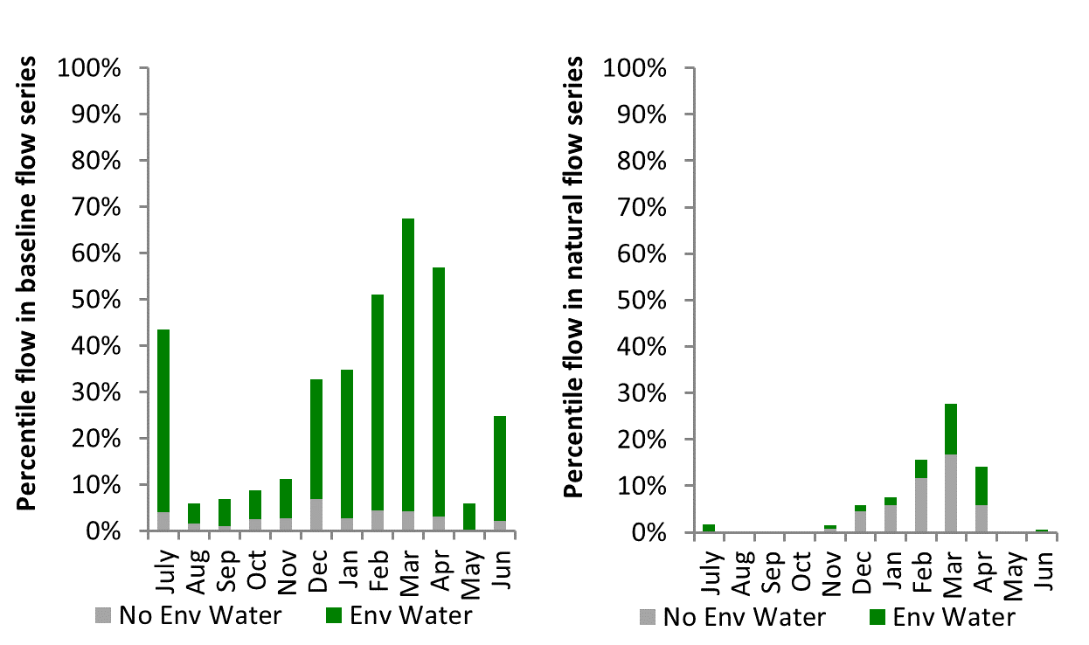
Figure LWM12: Contribution of environmental water delivery at Lock 3 as percentiles in the natural and baseline flow series.
Lock 2
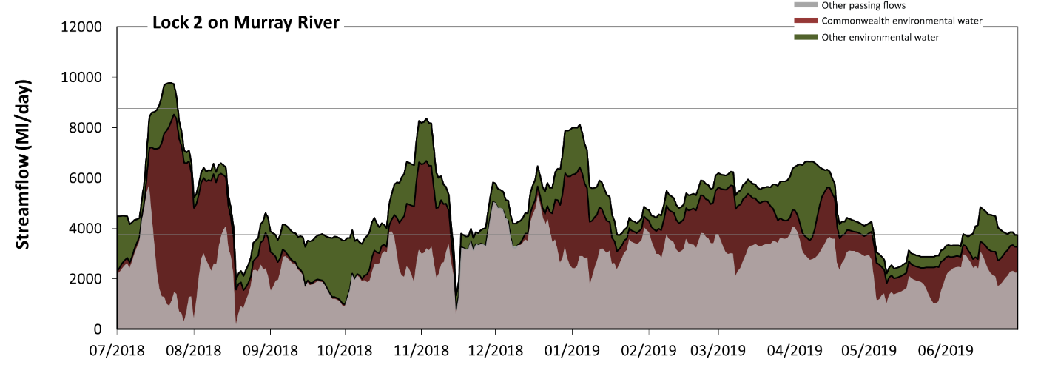Figure LWM13: Contribution of environmental water delivery at Lock 2. Horizontal lines indicate thresholds for very low flows, low flows, low freshes and medium freshes (from lowest to highest).
At Lock 2 on Murray River environmental water contributed 46% of the total streamflow volume. Environmental watering actions affected streamflows for 100% of days between 1 July 2018 and 30 June 2019. Without environmental water, the duration of very low flows (i.e. < 690 Ml/day) in the period July to September would have substantially exceeded durations expected in an average year in the natural flow regime. Environmental water mitigated these impacts by reducing the cumulative duration of very low flow spells from 2% to 0% of the year, with greatest influence in the period July to September. Similarly, without environmental water, the durations of medium low flows (i.e. < 3800 Ml/day) in the periods July to September, October to December, January to March and April to June would have all substantially exceeded durations expected in an average year in the natural flow regime. Environmental water mitigated these impacts by reducing the cumulative duration of medium low flow spells from 90% to 25% of the year, with greatest influence in the period January to March. Environmental water increased the duration of the longest low fresh during the periods July to September (from 0 days to 19 days), October to December (from 0 days to 17 days), January to March (from 0 days to 8 days) and April to June (from 0 days to 16 days). Environmental water increased the duration of the longest medium fresh during the period July to September (from 0 days to 8 days).
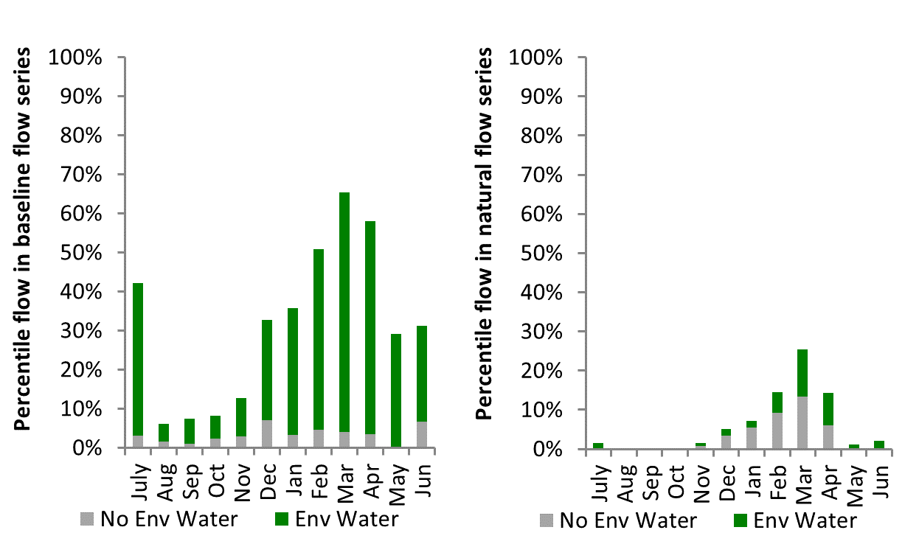
Figure LWM14: Contribution of environmental water delivery at Lock 2 as percentiles in the natural and baseline flow series.

Lock 1
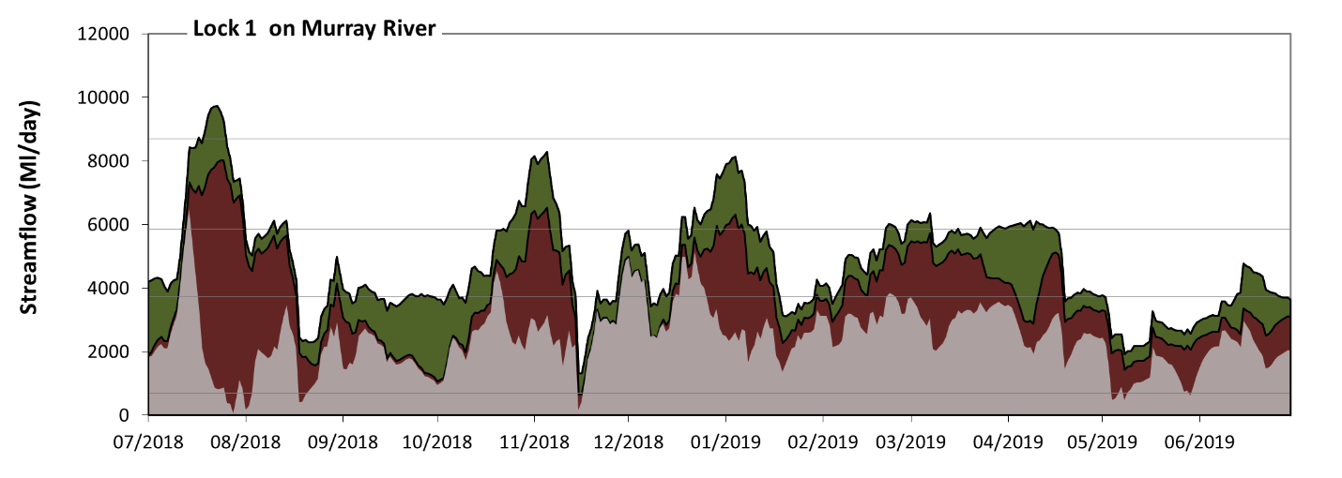 Figure LWM15: Contribution of environmental water delivery at Lock 1. Horizontal lines indicate thresholds for very low flows, low flows, low freshes and medium freshes (from lowest to highest).
At Lock 1 on Murray River environmental water contributed 50% of the total streamflow volume. Environmental watering actions affected streamflows for 100% of days between 1 July 2018 and 30 June 2019. Without environmental water, the durations of very low flows (i.e. < 690 Ml/day) in the periods July to September and April to June would have substantially exceeded durations expected in an average year in the natural flow regime. Environmental water mitigated these impacts by reducing the cumulative duration of very low flow spells from 5% to 0% of the year, with greatest influence in the periods July to September and April to June. Similarly, without environmental water, the durations of medium low flows (i.e. < 3700 Ml/day) in the periods July to September, October to December, January to March and April to June would have all substantially exceeded durations expected in an average year in the natural flow regime. Environmental water mitigated these impacts by reducing the cumulative duration of medium low flow spells from 92% to 30% of the year, with greatest influence in the periods July to September and January to March. In the absence of environmental water there would have been at least one low fresh (i.e. > 5900 Ml/day) in the period July to September. Environmental water increased the duration of the longest low fresh during the periods July to September (from 1 days to 20 days), October to December (from 0 days to 17 days), January to March (from 0 days to 9 days) and April to June (from 0 days to 8 days). In the absence of environmental water there would have been no medium or high freshes this year. Environmental water increased the duration of the longest medium fresh during the period July to September (from 0 days to 7 days).
Wellington
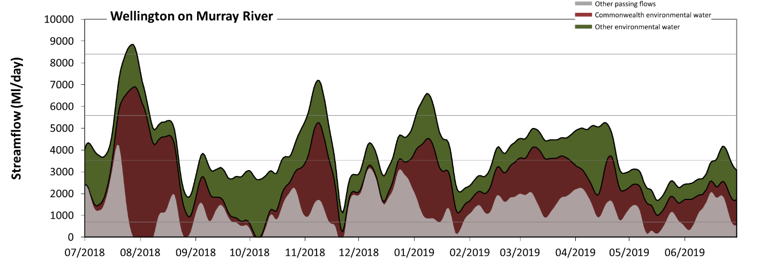 Figure LWM17: Contribution of environmental water delivery at Wellington. Horizontal lines indicate thresholds for very low flows, low flows, low freshes and medium freshes (from lowest to highest).
At Wellington on Murray River environmental water contributed 68% of the total streamflow volume. Environmental watering actions affected streamflows for 100% of days between 1 July 2018 and 30 June 2019. Without environmental water, the durations of very low flows (i.e. < 690 Ml/day) in the periods July to September, October to December and April to June would have substantially exceeded durations expected in an average year in the natural flow regime. Environmental water mitigated these impacts by reducing the cumulative duration of very low flow spells from 22% to 0% of the year, with greatest influence in the periods July to September and April to June. Similarly, without environmental water, the durations of medium low flows (i.e. < 3500 Ml/day) in the periods July to September, October to December, January to March and April to June would have all substantially exceeded durations expected in an average year in the natural flow regime. Environmental water mitigated these impacts by reducing the cumulative duration of medium low flow spells from 99% to 43% of the year, with greatest influence in the periods July to September and January to March. Environmental water increased the magnitude of flows below this medium low flow threshold. Environmental water increased the duration of the longest low fresh during the periods July to September (from 0 days to 20 days), October to December (from 0 days to 11 days) and January to March (from 0 days to 11 days). Environmental water increased the duration of the longest medium fresh during the period July to September (from 0 days to 7 days).
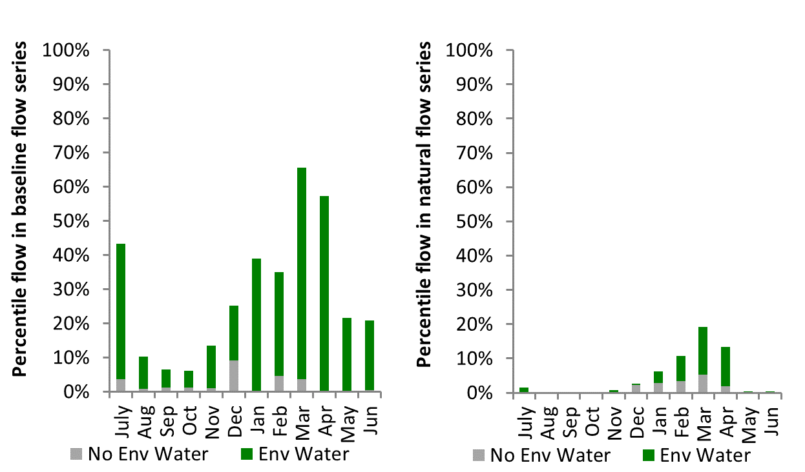
Figure LWM18: Contribution of environmental water delivery at Wellington as percentiles in the natural and baseline flow series.
Barrages
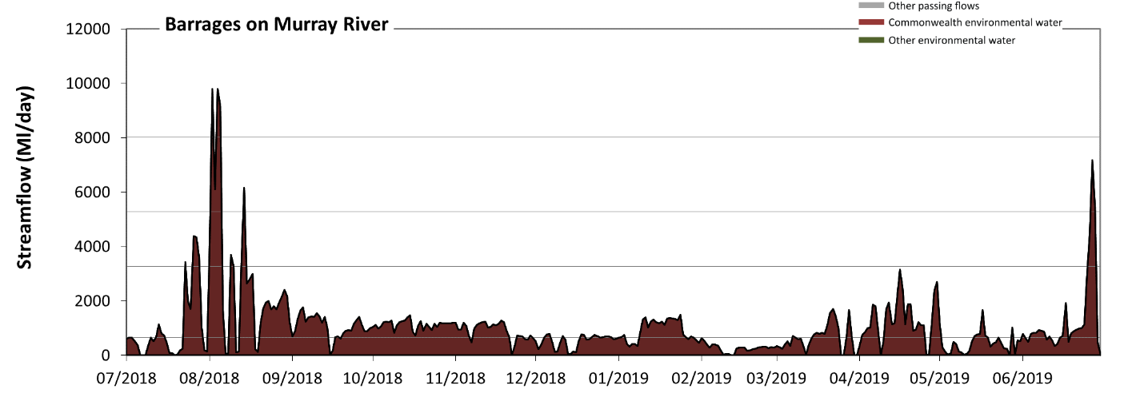 Figure LWM19: Contribution of environmental water delivery at Barrages. Horizontal lines indicate thresholds for very low flows, low flows, low freshes and medium freshes (from lowest to highest).
At Barrages on Murray River environmental water contributed 100% of the total streamflow volume. Environmental watering actions affected streamflows for 99% of days between 1 July 2018 and 30 June 2019. Without environmental water, the durations of very low flows (i.e. < 650 Ml/day) in the periods July to September, October to December, January to March and April to June would have all substantially exceeded durations expected in an average year in the natural flow regime. Environmental water mitigated these impacts by reducing the cumulative duration of very low flow spells from 100% to 39% of the year, with greatest influence in the periods July to September and October to December. Similarly, without environmental water, the durations of medium low flows (i.e. < 3300 Ml/day) in the periods July to September, October to December, January to March and April to June would have all substantially exceeded durations expected in an average year in the natural flow regime. Environmental water mitigated these impacts by reducing the cumulative duration of medium low flow spells from 100% to 96% of the year, with greatest influence in the period July to September. Environmental water increased the duration of the longest low fresh during the periods July to September (from 0 days to 4 days) and April to June (from 0 days to 2 days). Environmental water increased the duration of the longest medium fresh during the period July to September (from 0 days to 2 days).
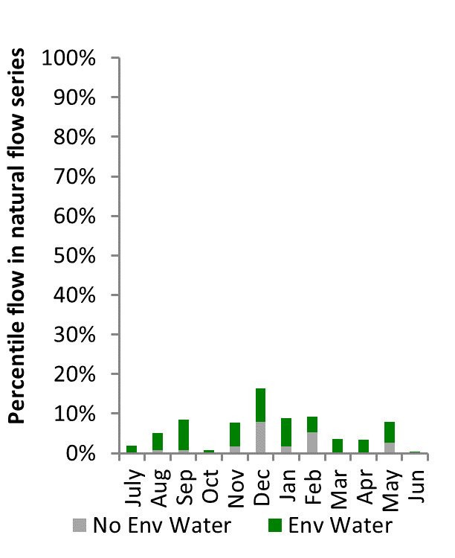
Figure LWM20: Contribution of environmental water delivery at Barrages as percentiles in the natural flow series.

Macquarie
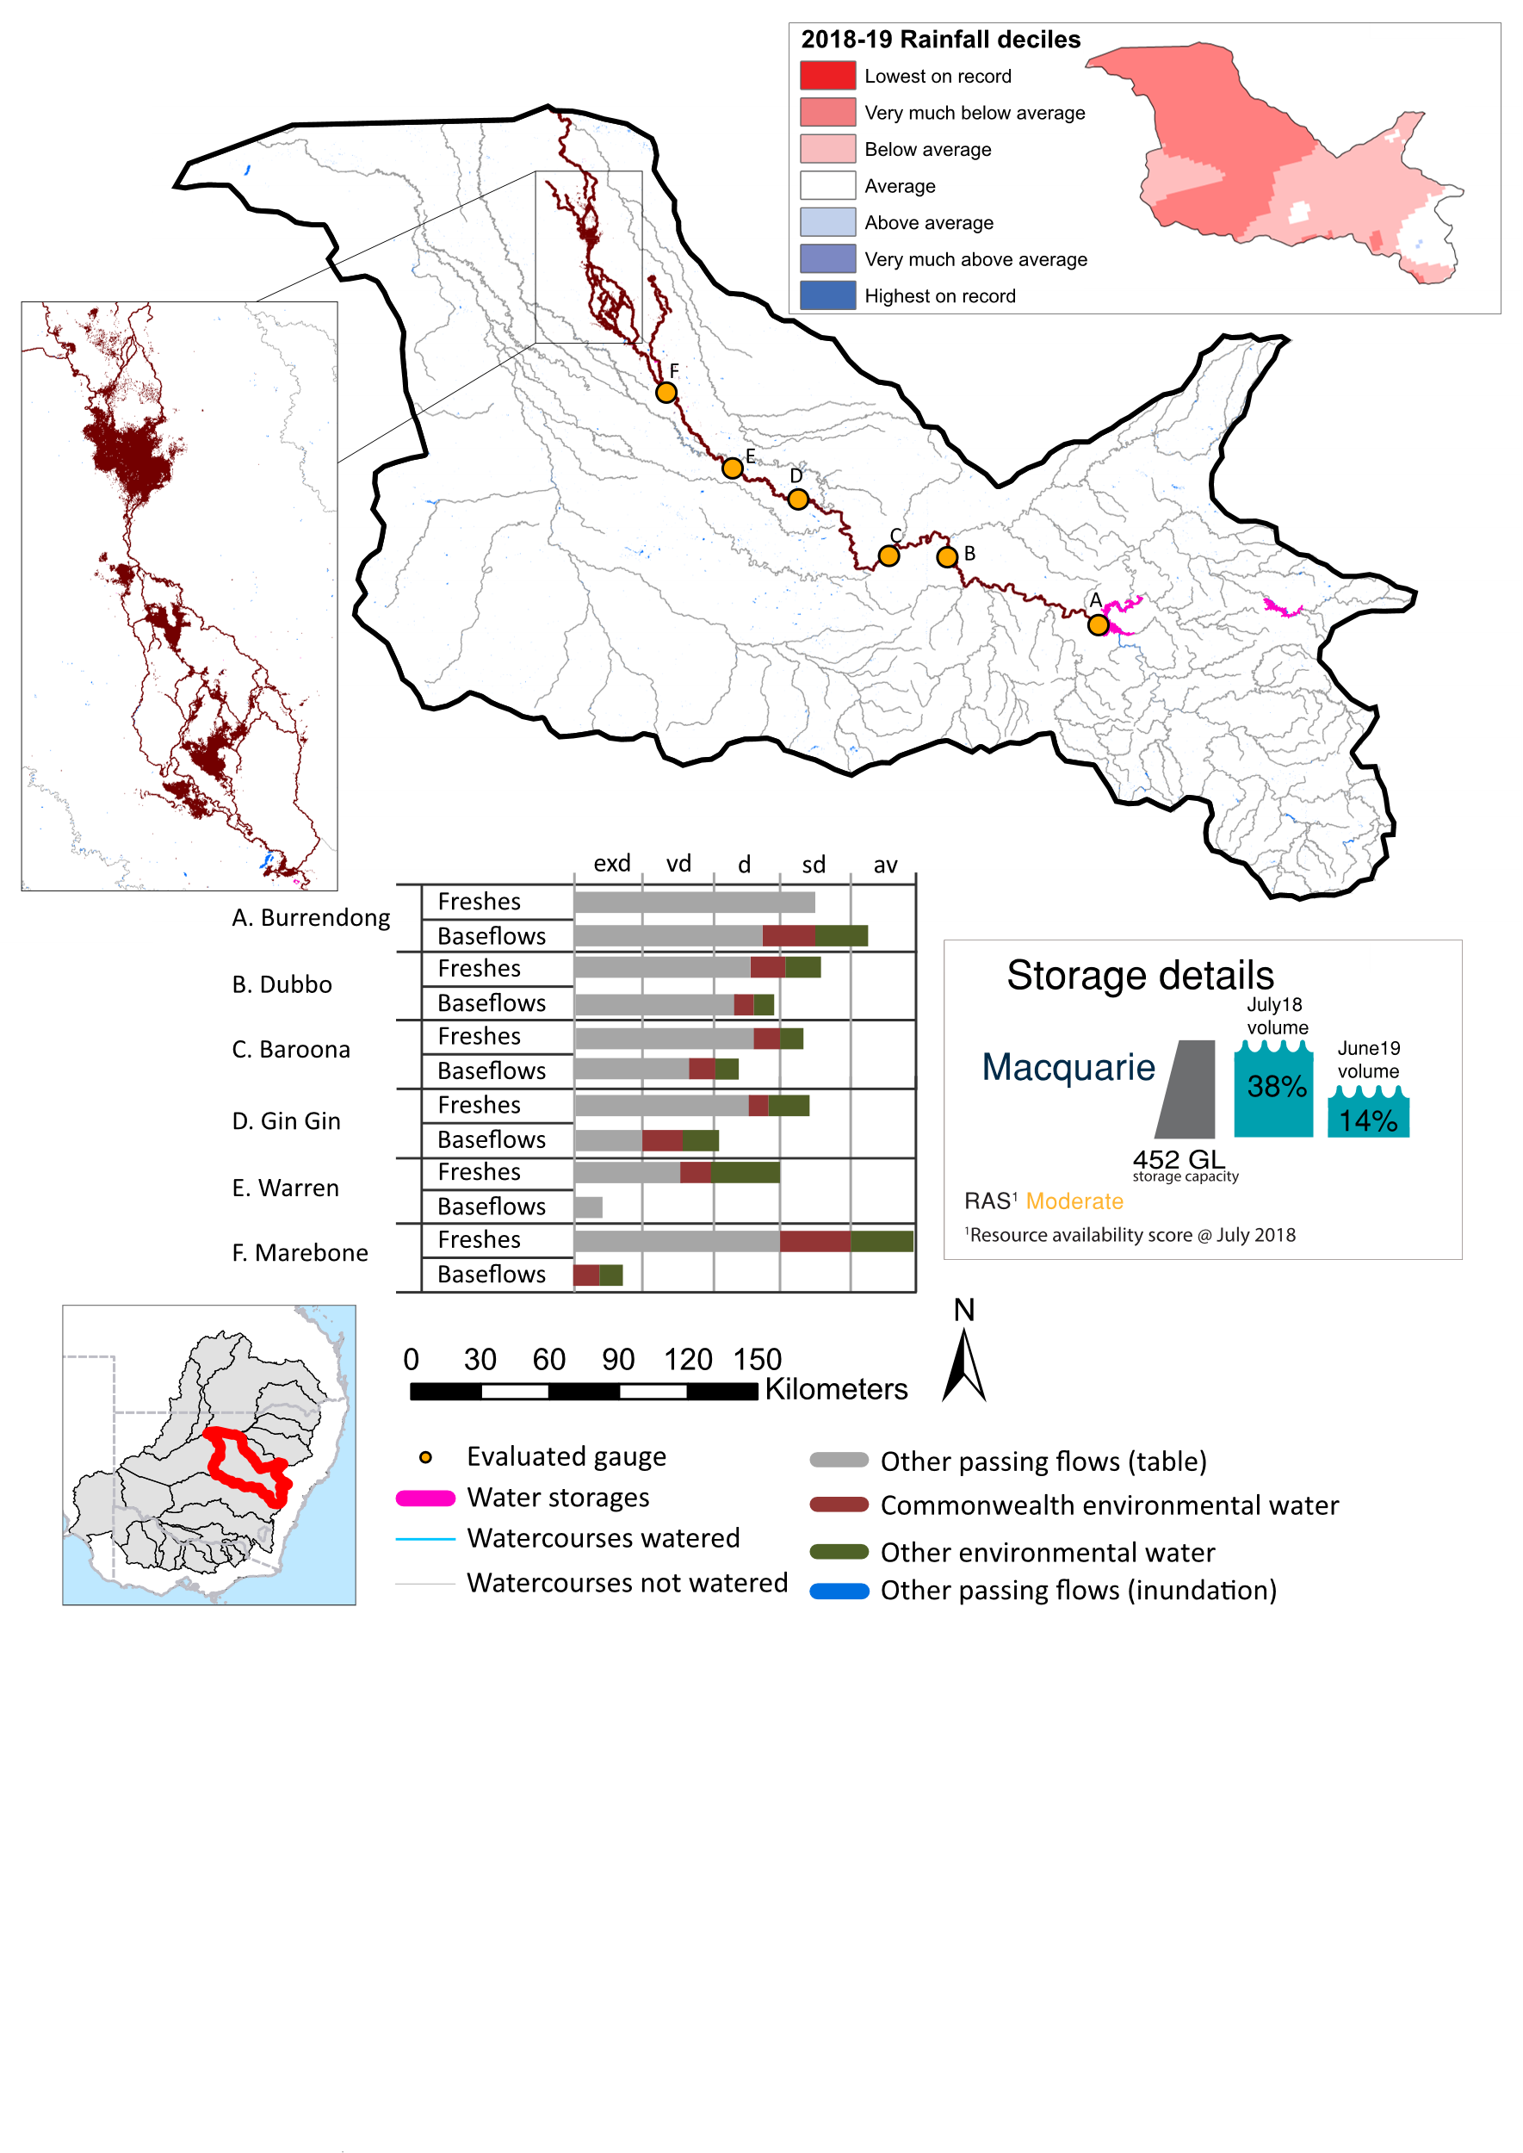Figure MCQ1: Watercourses influenced, areas inundated (where applicable) and gauge stations evaluated in the Macquarie valley during the 2018-19 water year. Inset bar graphs report the condition of annual flow regimes by showing the improvements in hydrological condition with the addition of environmental water as well as the hypothetical scenario in “grey” (if no environmental flow had been delivered) where exd=extremely dry, vd=very dry, d=dry, sd=somewhat dry and av=average. Rainfall conditions (rainfall deciles) and trend in storage levels for the water year are also shown.

Summary
The volume of environmental water delivery for the 2018-19 year in the Macquarie valley is quantified using data for 7 sites. This evaluation only considers the contribution of held environmental water, which is a primary focus for the Commonwealth. The contributions of planned environmental water (e.g. passing flows), unregulated tributary inflows and clever use of irrigation flows for environmental benefits can all be very important but these are outside the scope of this report. Environmental watering actions lasted on average 139 days over the course of the year. The volume of environmental water at these 7 sites was between 0% and 76% of the total streamflow. Commonwealth environmental water contributed on average 38% of this environmental water. The contribution of environmental water delivery to improved flow regimes is evaluated using data for 7 sites. Ideally, baseflows should be maintained and long periods of excessively low flows avoided. In this valley, the baseflow regime was generally considered to be extremely dry relative to the pre-development flow regime. In our analysis, a low fresh refers to a period of increased flow, when the water level rises at least one eighth of the way up the river bank (above the low flow level). These low freshes are a regular part of the natural flow regime and support a range of natural processes. In the Macquarie valley, in terms of the occurrence and duration of low freshes, the year was assessed as being average. In our analysis, a medium fresh refers to a period of increased flow, when the water level rises at least one quarter of the way up the river bank. These medium freshes are not as frequent as low freshes but are also a regular and important part of the natural flow regime. In the Macquarie valley, in terms of the occurrence of medium freshes, the year was assessed as being average. In our analysis, a high fresh refers to a period of increased flow, when the water level rises more than half way up the river. A high fresh may not occur every year but they are still important and long periods without major freshes can have serious consequences for floodplains and their contribution to river connectivity. Delivering high in channel environmental flows normally requires that all risks to riparian landholders and infrastructure have been resolved. In the Macquarie valley, in terms of the occurrence of high freshes, the year was assessed as being very dry.

Water delivery context
During the 2018-19, the CEWH held water entitlements of up to 134,516 ML for environmental use in the Macquarie valley. Each year, water utilities allocate water entitlement holders a percentage of water based on their holding, license type and carryover (the exact rules vary among Jurisdictions). In 2018-19, the Macquarie entitlements held by the CEWH were allocated 0 ML of water, representing 0% of the Long-term average annual yield for the Macquarie valley (70,008 ML). Information and data relating to the portfolio of held Commonwealth environmental water is shown in Table MCQ2.
The 2018-19 water allocation (0 ML) together with the carryover volume of 74,893 ML of water meant the CEWH had 74,893 ML of water available for delivery. NSW Department of Industry (DoI) – Water imposed a 70 per cent restriction on the availability of carryover water for use in 2018-19. A total of 52,071 ML of Commonwealth environmental water was delivered in the Macquarie valley. A total of 0 ML of Commonwealth environmental water was traded to consumptive users and 22,663 ML (30%) of available Commonwealth environmental water was carried over for environmental use into the 2019-20 water year.

Environmental conditions and resource availability
The water available for environmental delivery combined with the present and antecedent environmental conditions are key inputs used by environmental water managers in planning and implementing watering actions. Post hoc, this information provides important context when evaluating the effectiveness and appropriateness of environmental water use with respect to hydrological outputs.
The rainfall conditions in the Macquarie valley were classified as Below average, based on rainfall percentile data for the entire record held by the Bureau of Meteorology for this valley. The water held in major storages in the Macquarie valley decreased over the water year, for example Burrendong dam was 38.4% full at the beginning of the water year and 13.7% full by the end of the year (Figure MCQ1).
The Commonwealth Environmental Water Office (CEWO) calculates resource availability scenarios (RAS) to guide the use and prioritisation of held environmental water. The RAS are progressively calculated over the year as part of the continual adaptive management planning processes. The RAS are based on the availability of held environmental water (including progressive license acquisitions and allocations) as well as the potential for unregulated or planned environmental flows. The outcome is then used to determine the demand for environmental water across the basin.
In 2018-19, the resource availability of held Commonwealth environmental water was classified as low to moderate. The physical conditions meant that the CEWO was managing to maintain and improve the health and resilience of aquatic ecosystems in the Macquarie River and Macquarie Marshes. The overall demand for environmental water was deemed moderate.

Watering actions
A total of 4 watering actions were delivered over the 2018-19 water year, the duration of these actions varied (range of individual actions: 30 - 106 days) and Commonwealth environmental water was delivered throughout much of the year. The number of water actions commencing in each season included, Autumn (2), Spring (0), Summer (0), Winter(2). Similarly, the count of flow component types delivered in the Macquarie valley were; (3) baseflow, (0) baseflow-fresh, (0) fresh, (0) fresh-overbank, (0) bankfull, (0) overbank, (1) wetland and (0) wetland-fresh.
In this valley, primary objectives of most watering actions was related to frogs, but water was also delivered for other purposes too. The percentage of watering actions delivered across the nine main themes included primary objectives for fish (11.59%), vegetation (14.49%), waterbirds (15.94%), frogs (18.84%), other biota (14.49%), connectivity (2.9%), process (0.0%), resilience (17.39%) and water quality (4.35%).
Table MCQ2. Commonwealth environmental water accounting information for the Macquarie valley over 2018-19 water year.
Total registered volume (ML) | Allocated volume (ML) | Carry over + allocated volume (ML) | Delivered (ML) | LTAAY (ML) | Trade (ML) | Carried over to 2019-20 | Forfeited (ML)
134,516 | 0 | 74,893 | 52,071 | 70,008 | 0 | 22,663 | 0

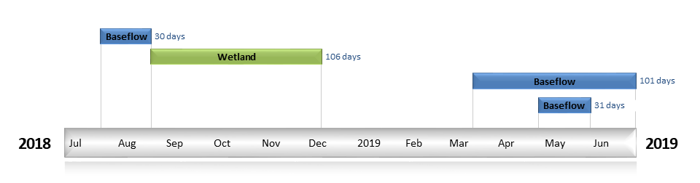
Figure MCQ2. Timing and duration of Commonwealth environmental water actions delivered in the Macquarie valley.

Contribution of Commonwealth environmental water to flow regimes
Burrendong
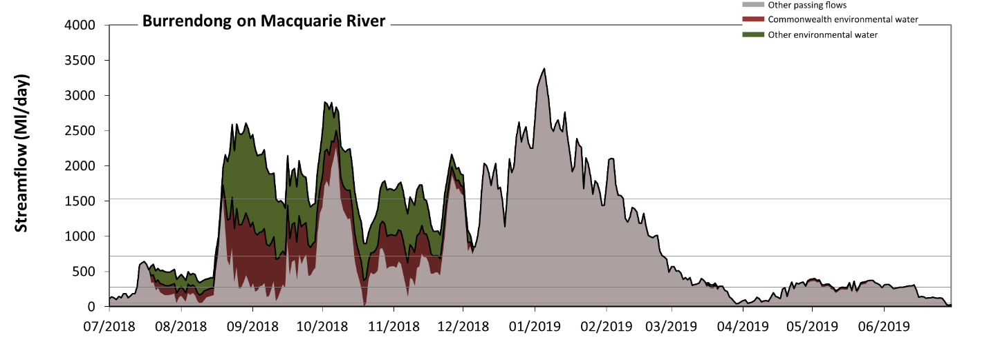
Figure MCQ3: Contribution of environmental water delivery at Burrendong. Horizontal lines indicate thresholds for very low flows, low flows, low freshes and medium freshes (from lowest to highest).
At Burrendong on Macquarie River environmental water contributed 31% of the total streamflow volume (with approximately half contributed by Commonwealth environmental water). Environmental watering actions affected streamflows for 47% of days between 1 July 2018 and 30 June 2019. Flow regulation does not substantially increase the duration of very low flows (i.e. < 55 Ml/day) compared to an average year in the natural flow regime. However, without environmental water, the durations of medium low flows (i.e. < 270 Ml/day) in the periods July to September and April to June would have substantially exceeded durations expected in an average year in the natural flow regime. Environmental water mitigated these impacts by reducing the cumulative duration of medium low flow spells from 33% to 19% of the year, with greatest influence in the period July to September. Commonwealth environmental water equally shared responsibility with other environmental water holders for these enhancements of environmental baseflows at this site. In the absence of environmental water there would have been at least one low fresh (i.e. > 720 Ml/day) in the periods July to September, October to December and January to March. Environmental water increased the duration of the longest low fresh during the periods July to September (from 4 days to 46 days) and October to December (from 39 days to 92 days). Commonwealth environmental water made a small contribution to these increased durations of low freshes. In the absence of environmental water there would have been at least one medium fresh (i.e. > 1500 Ml/day) in the periods July to September, October to December and January to March. Environmental water increased the duration of the longest medium fresh during the period July to September (from 1 days to 23 days). Commonwealth environmental water made little or no contribution to these increased durations of medium freshes. There was no high freshes (i.e. > 4900 Ml/day) this year.
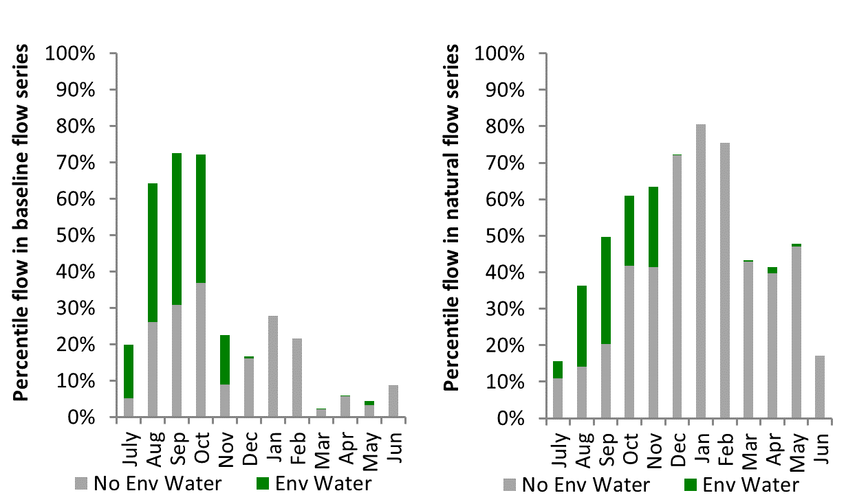
Figure MCQ4: Contribution of environmental water delivery at Burrendong as percentiles in the natural and baseline flow series.
Dubbo
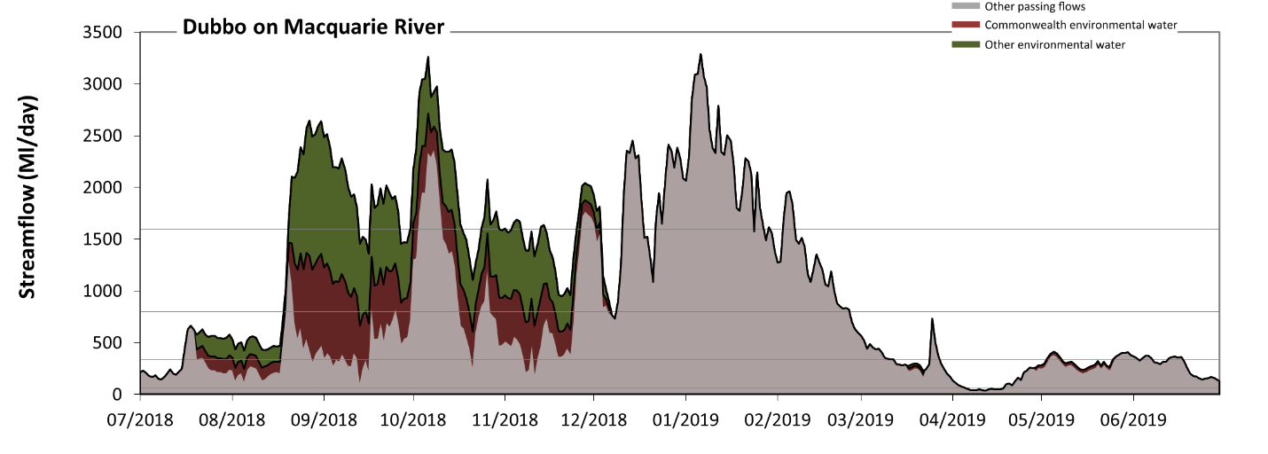
Figure MCQ5: Contribution of environmental water delivery at Dubbo. Horizontal lines indicate thresholds for very low flows, low flows, low freshes and medium freshes (from lowest to highest).
At Dubbo on Macquarie River environmental water contributed 31% of the total streamflow volume (with approximately half contributed by Commonwealth environmental water). Environmental watering actions affected streamflows for 47% of days between 1 July 2018 and 30 June 2019. Without environmental water, the duration of very low flows (i.e. < 68 Ml/day) in the period April to June would have substantially exceeded durations expected in an average year in the natural flow regime. However, environmental water had little effect on the duration of these very low flows, which occurred for 4% of the year. Similarly, without environmental water, the durations of medium low flows (i.e. < 340 Ml/day) in the periods July to September and April to June would have substantially exceeded durations expected in an average year in the natural flow regime. Environmental water mitigated these impacts by reducing the cumulative duration of medium low flow spells from 39% to 28% of the year, with greatest influence in the period July to September. Commonwealth environmental water equally shared responsibility with other environmental water holders for these enhancements of environmental baseflows at this site. In the absence of environmental water there would have been at least one low fresh (i.e. > 800 Ml/day) in the periods July to September, October to December and January to March. Environmental water increased the duration of the longest low fresh during the periods July to September (from 2 days to 43 days) and October to December (from 23 days to 67 days). Commonwealth environmental water made a small contribution to these increased durations of low freshes. In the absence of environmental water there would have been at least one medium fresh (i.e. > 1600 Ml/day) in the periods October to December and January to March. Environmental water increased the duration of the longest medium fresh during the periods July to September (from 0 days to 24 days) and October to December (from 10 days to 17 days). Commonwealth environmental water made a modest contribution to these increased durations of medium freshes. There was no high freshes (i.e. > 4700 Ml/day) this year.
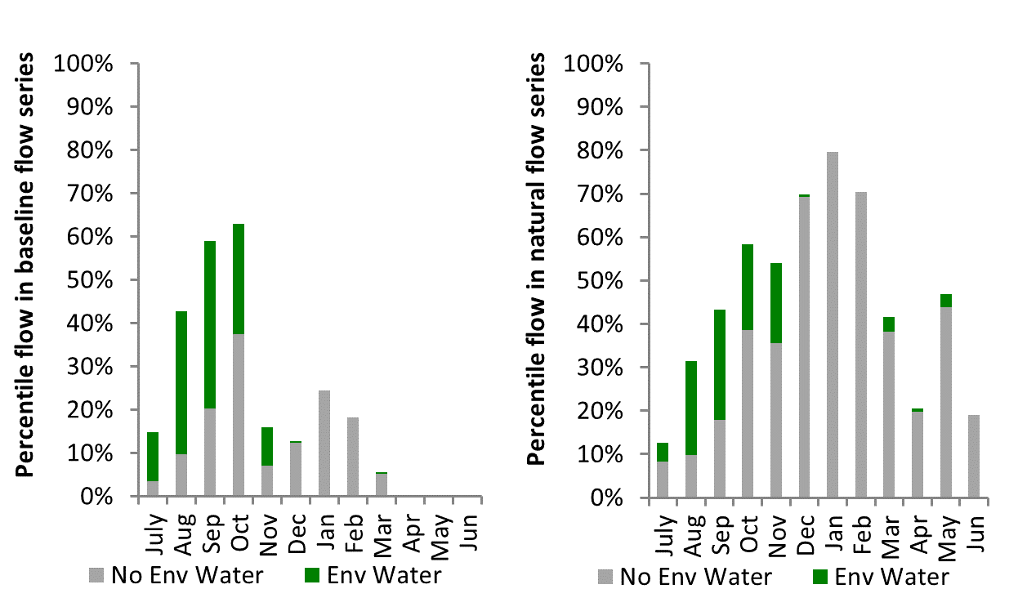
Figure MCQ6: Contribution of environmental water delivery at Dubbo as percentiles in the natural and baseline flow series.
Baroona
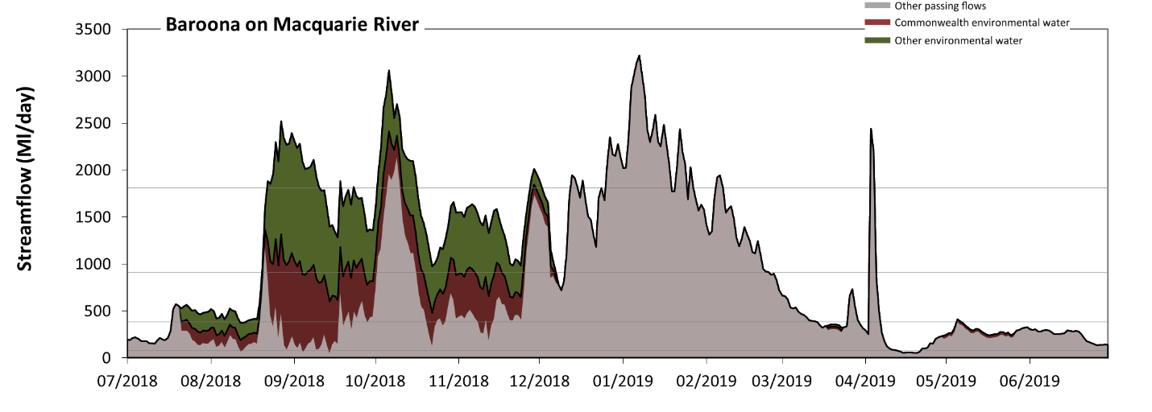
Figure MCQ7: Contribution of environmental water delivery at Baroona. Horizontal lines indicate thresholds for very low flows, low flows, low freshes and medium freshes (from lowest to highest).
At Baroona on Macquarie River environmental water contributed 32% of the total streamflow volume (with approximately half contributed by Commonwealth environmental water). Environmental watering actions affected streamflows for 47% of days between 1 July 2018 and 30 June 2019. Flow regulation does not substantially increase the duration of very low flows (i.e. < 77 Ml/day) compared to an average year in the natural flow regime. However, without environmental water, the durations of medium low flows (i.e. < 390 Ml/day) in the periods July to September and April to June would have substantially exceeded durations expected in an average year in the natural flow regime. Environmental water mitigated these impacts by reducing the cumulative duration of medium low flow spells from 50% to 32% of the year, with greatest influence in the period July to September. Commonwealth environmental water equally shared responsibility with other environmental water holders for these enhancements of environmental baseflows at this site. In the absence of environmental water there would have been at least one low fresh (i.e. > 910 Ml/day) in the periods July to September, October to December, January to March and April to June. Environmental water increased the duration of the longest low fresh during the periods July to September (from 1 days to 42 days) and October to December (from 21 days to 68 days). Commonwealth environmental water equally shared responsibility with other environmental water holders for these increased durations of low freshes. In the absence of environmental water there would have been at least one medium fresh (i.e. > 1800 Ml/day) in the periods October to December, January to March and April to June. Environmental water increased the duration of the longest medium fresh during the periods July to September (from 0 days to 20 days) and October to December (from 6 days to 15 days). Commonwealth environmental water equally shared responsibility with other environmental water holders for these increased durations of medium freshes. There was no high freshes (i.e. > 5300 Ml/day) this year.
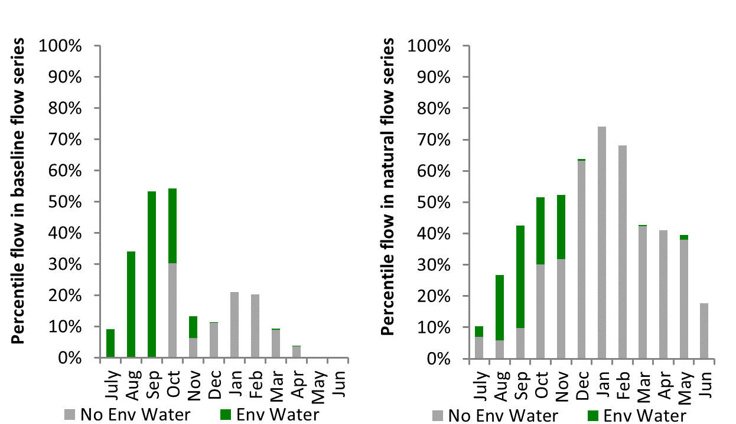
Figure MCQ8: Contribution of environmental water delivery at Baroona as percentiles in the natural and baseline flow series.
Gin Gin
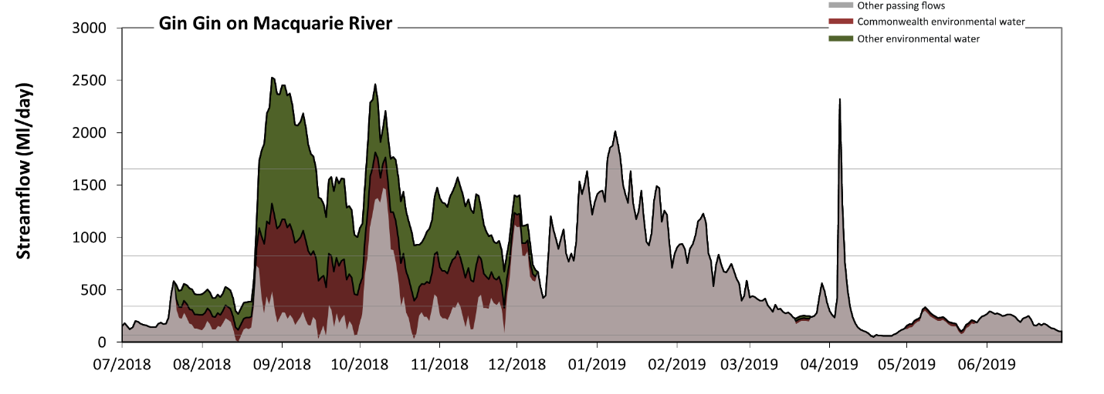
Figure MCQ9: Contribution of environmental water delivery at Gin Gin. Horizontal lines indicate thresholds for very low flows, low flows, low freshes and medium freshes (from lowest to highest).
At Gin Gin on Macquarie River environmental water contributed 42% of the total streamflow volume (with approximately half contributed by Commonwealth environmental water). Environmental watering actions affected streamflows for 47% of days between 1 July 2018 and 30 June 2019. Without environmental water, the duration of very low flows (i.e. < 69 Ml/day) in the period July to September would have substantially exceeded durations expected in an average year in the natural flow regime. Environmental water mitigated these impacts by reducing the cumulative duration of very low flow spells from 4% to 2% of the year, with greatest influence in the period July to September. Similarly, without environmental water, the durations of medium low flows (i.e. < 350 Ml/day) in the periods July to September, October to December and April to June would have substantially exceeded durations expected in an average year in the natural flow regime. Environmental water mitigated these impacts by reducing the cumulative duration of medium low flow spells from 60% to 35% of the year, with greatest influence in the periods July to September and October to December. Commonwealth environmental water equally shared responsibility with other environmental water holders for these enhancements of environmental baseflows at this site. In the absence of environmental water there would have been at least one low fresh (i.e. > 820 Ml/day) in the periods October to December, January to March and April to June. Environmental water increased the duration of the longest low fresh during the periods July to September (from 0 days to 40 days) and October to December (from 10 days to 56 days). Commonwealth environmental water equally shared responsibility with other environmental water holders for these increased durations of low freshes. In the absence of environmental water there would have been at least one medium fresh (i.e. > 1700 Ml/day) in the periods January to March and April to June. Environmental water increased the duration of the longest medium fresh during the periods July to September (from 0 days to 23 days) and October to December (from 0 days to 12 days). Commonwealth environmental water made a small contribution to these increased durations of medium freshes. There was no high freshes (i.e. > 4900 Ml/day) this year.
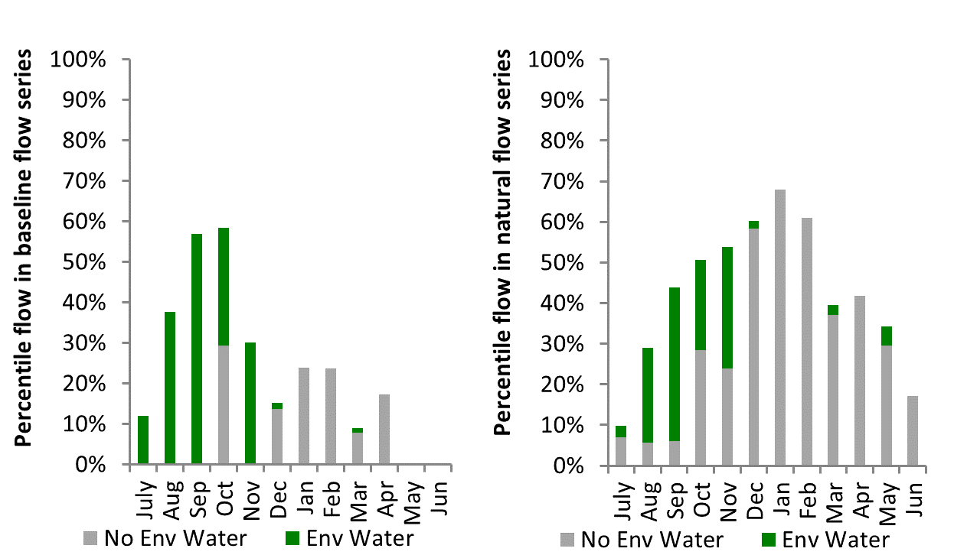
Figure MCQ10: Contribution of environmental water delivery at Gin Gin as percentiles in the natural and baseline flow series.

Warren
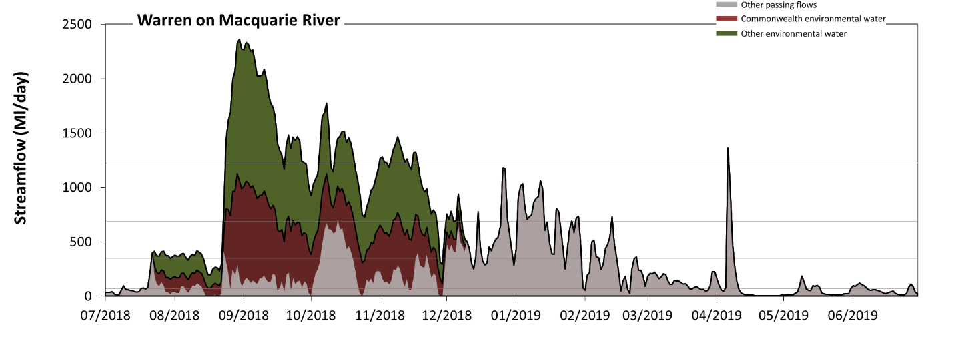
Figure MCQ11: Contribution of environmental water delivery at Warren. Horizontal lines indicate thresholds for very low flows, low flows, low freshes and medium freshes (from lowest to highest).
At Warren on Macquarie River environmental water contributed 61% of the total streamflow volume (with approximately half contributed by Commonwealth environmental water). Environmental watering actions affected streamflows for 38% of days between 1 July 2018 and 30 June 2019. Without environmental water, the durations of very low flows (i.e. < 69 Ml/day) in the periods July to September and April to June would have substantially exceeded durations expected in an average year in the natural flow regime. Environmental water mitigated these impacts by reducing the cumulative duration of very low flow spells from 34% to 25% of the year, with greatest influence in the periods July to September and October to December. Similarly, without environmental water, the durations of medium low flows (i.e. < 350 Ml/day) in the periods July to September, October to December, January to March and April to June would have all substantially exceeded durations expected in an average year in the natural flow regime. Environmental water mitigated these impacts by reducing the cumulative duration of medium low flow spells from 76% to 48% of the year, with greatest influence in the periods July to September and October to December. Commonwealth environmental water equally shared responsibility with other environmental water holders for these enhancements of environmental baseflows at this site. In the absence of environmental water there would have been at least one low fresh (i.e. > 690 Ml/day) in the periods October to December, January to March and April to June. Environmental water increased the duration of the longest low fresh during the periods July to September (from 0 days to 39 days) and October to December (from 3 days to 57 days). Commonwealth environmental water made a modest contribution to these increased durations of low freshes. In the absence of environmental water there would have been at least one medium fresh (i.e. > 1200 Ml/day) in the period April to June. Environmental water increased the duration of the longest medium fresh during the periods July to September (from 0 days to 26 days) and October to December (from 0 days to 9 days). Commonwealth environmental water made little or no contribution to these increased durations of medium freshes. There was no high freshes (i.e. > 3100 Ml/day) this year.
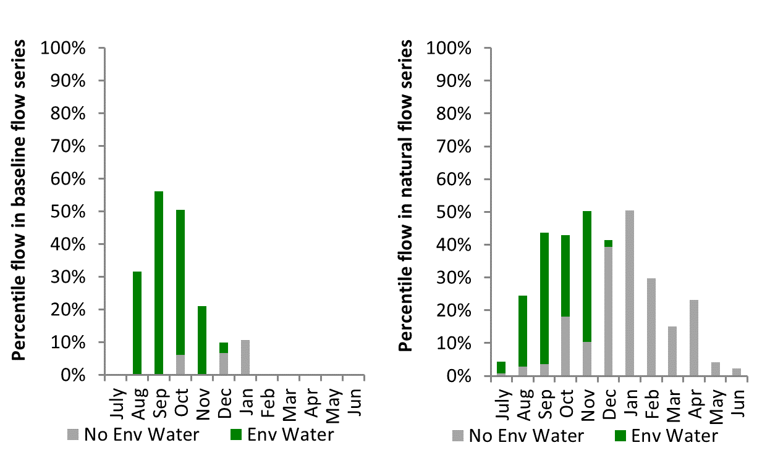
Figure MCQ12: Contribution of environmental water delivery at Warren as percentiles in the natural and baseline flow series.
Marebone
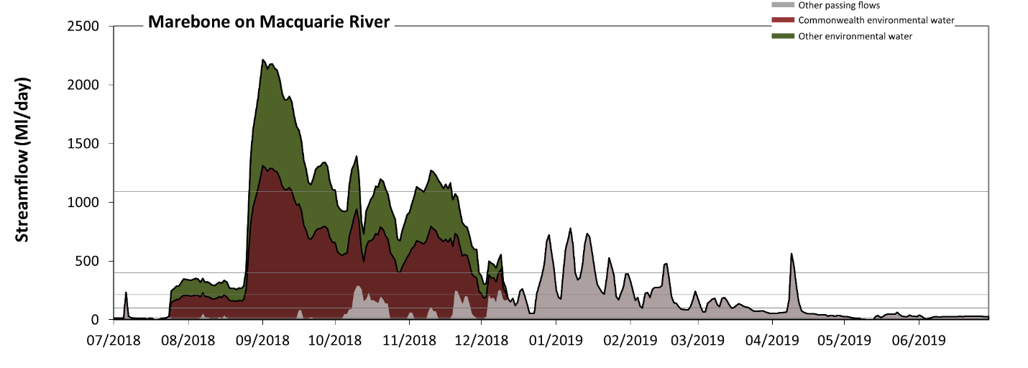Figure MCQ13: Contribution of environmental water delivery at Marebone. Horizontal lines indicate thresholds for very low flows, low flows, low freshes, medium freshes and high freshes (from lowest to highest).
At Marebone on Macquarie River environmental water contributed 76% of the total streamflow volume (with approximately half contributed by Commonwealth environmental water). Environmental watering actions affected streamflows for 38% of days between 1 July 2018 and 30 June 2019. Without environmental water, the durations of very low flows (i.e. < 20 Ml/day) in the periods July to September, October to December and April to June would have substantially exceeded durations expected in an average year in the natural flow regime. Environmental water mitigated these impacts by reducing the cumulative duration of very low flow spells from 34% to 10% of the year, with greatest influence in the periods July to September and October to December. Similarly, without environmental water, the durations of medium low flows (i.e. < 98 Ml/day) in the periods July to September, October to December and April to June would have substantially exceeded durations expected in an average year in the natural flow regime. Environmental water mitigated these impacts by reducing the cumulative duration of medium low flow spells from 65% to 35% of the year, with greatest influence in the periods July to September and October to December. Commonwealth environmental water equally shared responsibility with other environmental water holders for these enhancements of environmental baseflows at this site. In the absence of environmental water there would have been at least one low fresh (i.e. > 210 Ml/day) in the periods July to September, October to December, January to March and April to June. Environmental water increased the duration of the longest low fresh during the periods July to September (from 1 days to 68 days) and October to December (from 8 days to 72 days). Commonwealth environmental water equally shared responsibility with other environmental water holders for these increased durations of low freshes. In the absence of environmental water there would have been at least one medium fresh (i.e. > 400 Ml/day) in the periods October to December, January to March and April to June. Environmental water increased the duration of the longest medium fresh during the periods July to September (from 0 days to 37 days) and October to December (from 5 days to 61 days). Commonwealth environmental water made the dominant contribution to these increased durations of medium freshes. In the absence of environmental water there would have been at least one high fresh (i.e. > 1100 Ml/day) this year. Environmental water increased the duration of the longest high fresh during the periods July to September (from 0 days to 35 days) and October to December (from 0 days to 11 days). Commonwealth environmental water equally shared responsibility with other environmental water holders for these increased durations of high freshes.
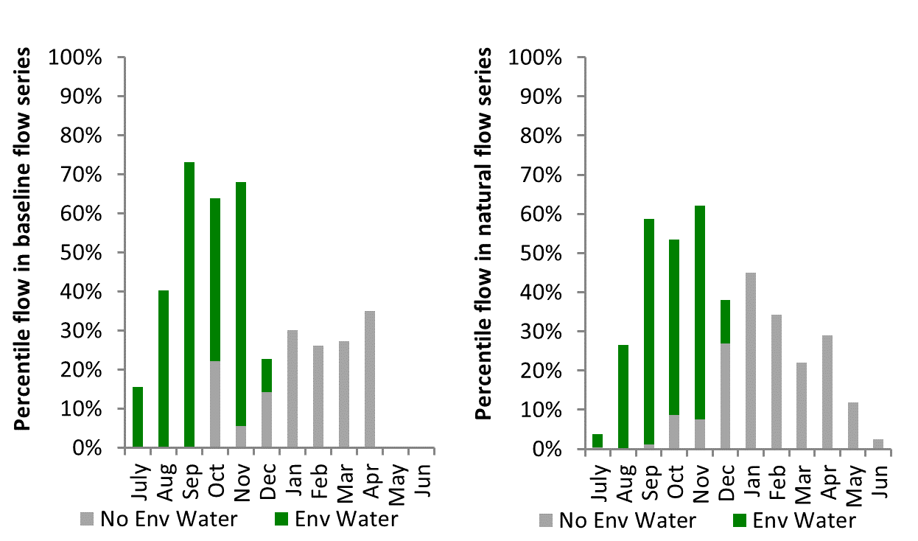
Figure MCQ14: Contribution of environmental water delivery at Marebone as percentiles in the natural and baseline flow series.

Barwon Darling
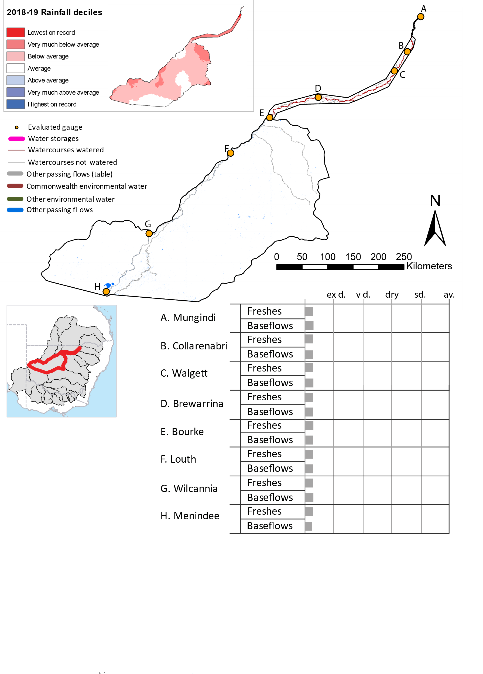
Figure BDL1: Watercourses influenced, areas inundated (where applicable) and gauge stations evaluated in the Barwon Darling valley during the 2018-19 water year. Inset bar graphs report the condition of annual flow regimes by showing the improvements in hydrological condition with the addition of environmental water as well as the hypothetical scenario in “grey” (if no environmental flow had been delivered) where exd=extremely dry, vd=very dry, d=dry, sd=somewhat dry and av=average. Rainfall conditions (rainfall deciles) and trend in storage levels for the water year are also shown.

Summary
The volume of environmental water delivery for the 2018-19 year in the Barwon Darling valley is quantified using data for 7 sites. This evaluation only considers the contribution of held environmental water, which is a primary focus for the Commonwealth. The contributions of planned environmental water (e.g. passing flows), unregulated tributary inflows and clever use of irrigation flows for environmental benefits can all be very important but these are outside the scope of this report. Environmental watering actions lasted on average 14 days over the course of the year. The volume of environmental water at these 7 sites was between 0% and 99% of the total streamflow. Commonwealth environmental water contributed on average 34% of this environmental water. The contribution of environmental water delivery to improved flow regimes is evaluated using data for 7 sites. Ideally, baseflows should be maintained and long periods of excessively low flows avoided. In this valley, the baseflow regime was generally considered to be extremely dry relative to the pre-development flow regime. In our analysis, a low fresh refers to a period of increased flow, when the water level rises at least one eighth of the way up the river bank (above the low flow level). These low freshes are a regular part of the natural flow regime and support a range of natural processes. In the Barwon Darling valley, in terms of the occurrence and duration of low freshes, the year was assessed as being extremely dry. In our analysis, a medium fresh refers to a period of increased flow, when the water level rises at least one quarter of the way up the river bank. These medium freshes are not as frequent as low freshes but are also a regular and important part of the natural flow regime. In the Barwon Darling valley, in terms of the occurrence of medium freshes, the year was assessed as being extremely dry. In our analysis, a high fresh refers to a period of increased flow, when the water level rises more than half way up the river. A high fresh may not occur every year but they are still important and long periods without major freshes can have serious consequences for floodplains and their contribution to river connectivity. Delivering high in channel environmental flows normally requires that all risks to riparian landholders and infrastructure have been resolved. In the Barwon Darling valley, in terms of the occurrence of high freshes, the year was assessed as being extremely dry.

Water delivery context
During the 2018-19, the Commonwealth Environmental Water Holder (CEWH) held water entitlements of up to 28,631 ML for environmental use in the Barwon Darling valley within the Barwon-Darling system. Water entitlements in upstream systems were used to provide flows to the Barwon-Darling, through the Northern Fish Flow.

Environmental conditions and resource availability
The rainfall conditions in the Barwon Darling valley were classified as Below average, based on rainfall percentile data for the entire record held by the Bureau of Meteorology for this valley.

Watering actions
Barwon-Darling licenses were not triggered in the 2018-19 water year. However, a connectivity pulse was achieved in this valley via held water releases from the Border Rivers and Gwydir valley. This pulse was the ‘Northern Fish Flow’. During early May 2019 a large natural flow event moved from the lower section of the Warrego system into the Darling River. Within the lower section of the Warrego system, CEW entitlements contributed 8,106 ML to the flow event between 7 - 20 May 2019. Flows from the Warrego reached Louth in early May, resulting in 23,296 ML flowing past the Louth gauge.

Contribution of Commonwealth environmental water to flow regimes

Mungindi
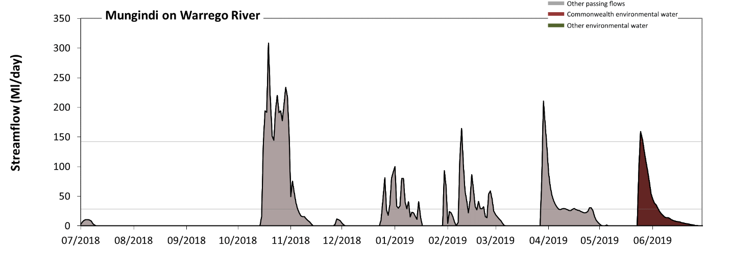
Figure BDL3: Contribution of environmental water delivery at Mungindi. Horizontal lines indicate thresholds for very low flows and low flows (from lowest to highest).
At Mungindi on Barwon River environmental water contributed 14% of the total streamflow volume (all of which was Commonwealth environmental water). Environmental watering actions affected streamflows for 10% of days between 1 July 2018 and 30 June 2019. Without environmental water, the durations of very low flows (i.e. < 28 Ml/day) in the periods July to September, October to December, January to March and April to June would have all substantially exceeded durations expected in an average year in the natural flow regime. Environmental water mitigated these impacts by reducing the cumulative duration of very low flow spells from 81% to 78% of the year, with greatest influence in the period April to June. Similarly, without environmental water, the durations of medium low flows (i.e. < 140 Ml/day) in the periods July to September, October to December, January to March and April to June would have all substantially exceeded durations expected in an average year in the natural flow regime. Environmental water mitigated these impacts by reducing the cumulative duration of medium low flow spells from 95% to 95% of the year, with greatest influence in the period April to June. Commonwealth environmental water was entirely responsible for these enhancements of environmental baseflows at this site.
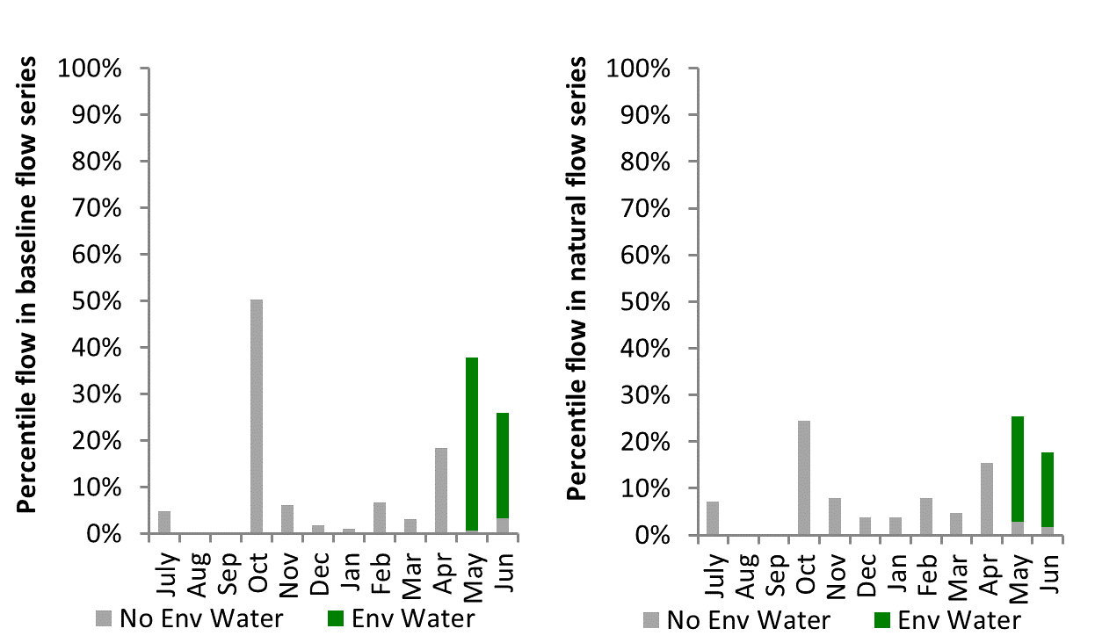
Figure BDL4: Contribution of environmental water delivery at Mungindi as percentiles in the natural and baseline flow series.
Collarenebri
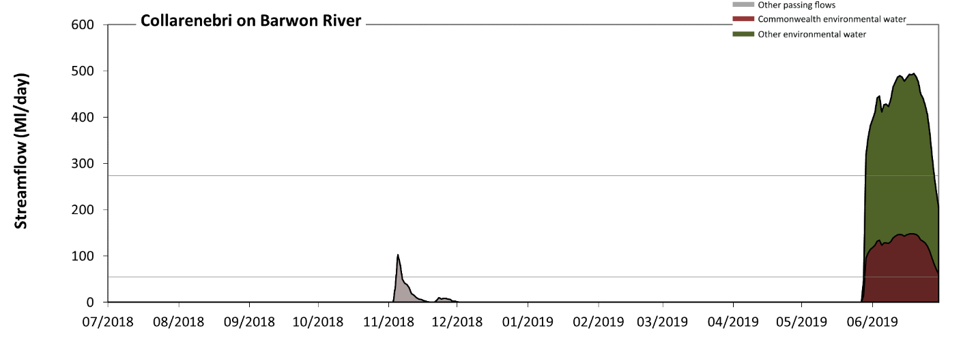
Figure BDL5: Contribution of environmental water delivery at Collarenebri. Horizontal lines indicate thresholds for very low flows and low flows (from lowest to highest).
At Collarenebri on Barwon River environmental water contributed 96% of the total streamflow volume (with a medium contribution of Commonwealth environmental water). Environmental watering actions affected streamflows for 9% of days between 1 July 2018 and 30 June 2019. Without environmental water, the durations of very low flows (i.e. < 55 Ml/day) in the periods July to September, October to December, January to March and April to June would have all substantially exceeded durations expected in an average year in the natural flow regime. Environmental water mitigated these impacts by reducing the cumulative duration of very low flow spells from 99% to 90% of the year, with greatest influence in the period April to June. Similarly, without environmental water, the durations of medium low flows (i.e. < 270 Ml/day) in the periods July to September, October to December, January to March and April to June would have all substantially exceeded durations expected in an average year in the natural flow regime. Environmental water mitigated these impacts by reducing the cumulative duration of medium low flow spells from 100% to 92% of the year, with greatest influence in the period April to June. Commonwealth environmental water made a modest contribution to these enhancements of environmental baseflows at this site.
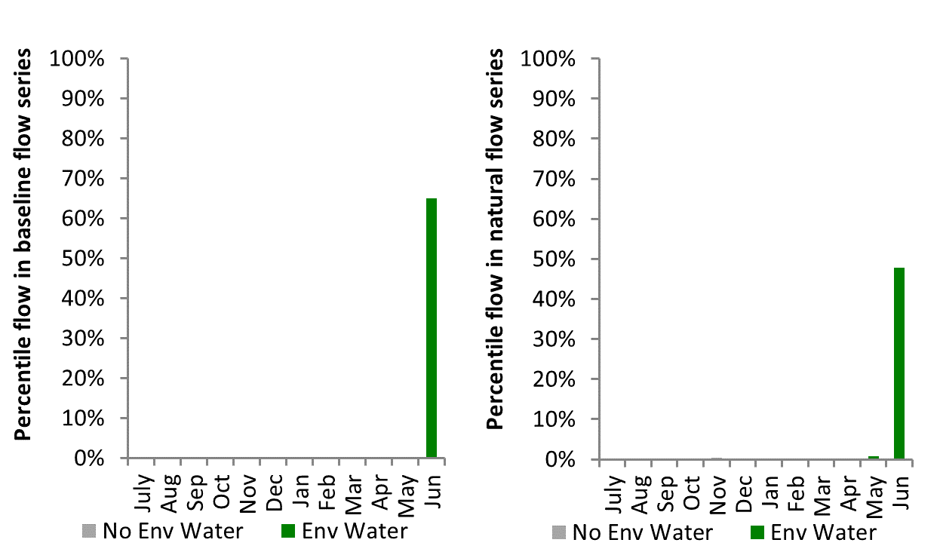
Figure BDL6: Contribution of environmental water delivery at Collarenebri as percentiles in the natural and baseline flow series.
Walgett
Figure BDL7: Contribution of environmental water delivery at Walgett. Horizontal lines indicate thresholds for very low flows and low flows (from lowest to highest).
At Walgett on Barwon River environmental water contributed 99% of the total streamflow volume (with a medium contribution of Commonwealth environmental water). Environmental watering actions affected streamflows for 5% of days between 1 July 2018 and 30 June 2019. Without environmental water, the durations of very low flows (i.e. < 160 Ml/day) in the periods July to September, October to December, January to March and April to June would have all substantially exceeded durations expected in an average year in the natural flow regime. Environmental water mitigated these impacts by reducing the cumulative duration of very low flow spells from 100% to 95% of the year, with greatest influence in the period April to June. Similarly, without environmental water, the durations of medium low flows (i.e. < 780 Ml/day) in the periods July to September, October to December, January to March and April to June would have all substantially exceeded durations expected in an average year in the natural flow regime. However, environmental water had little effect on the duration of these medium low flows, which occurred for 100% of the year. Commonwealth environmental water made little or no contribution to these enhancements of environmental baseflows at this site.

Brewarrina
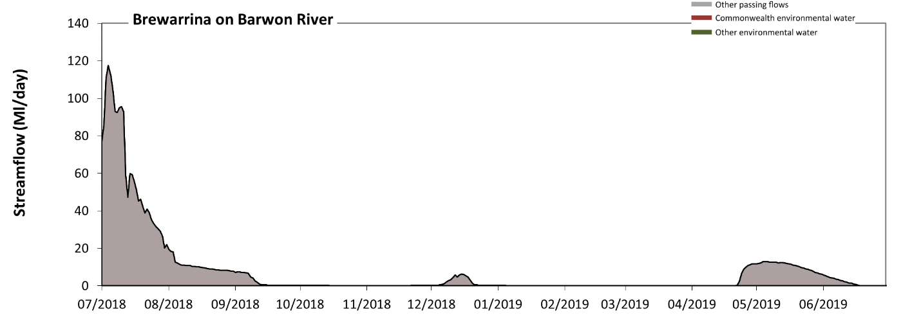
Figure BDL8: Contribution of environmental water delivery at Brewarrina. Horizontal lines indicate thresholds for very low flows and low flows (from lowest to highest).
There was no environmental water delivered at Brewarrina on Barwon River. Without environmental water, the durations of very low flows (i.e. < 140 Ml/day) in the periods July to September, October to December, January to March and April to June was substantially in excess of durations expected in an average year in the natural flow regime. Similarly, without environmental water, the durations of medium low flows (i.e. < 680 Ml/day) in the periods July to September, October to December, January to March and April to June was substantially in excess of durations expected in an average year in the natural flow regime.

Bourke
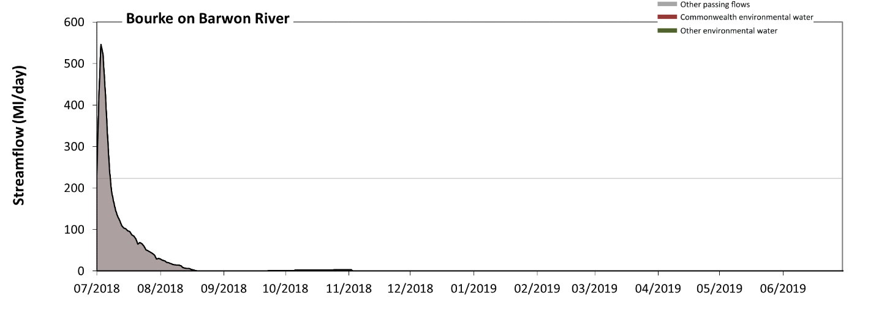
Figure BDL9: Contribution of environmental water delivery at Bourke. Horizontal lines indicate thresholds for very low flows and low flows (from lowest to highest).
There was no apparent environmental water delivered at Bourke on Darling River although the Northern Fish Flow progressed someway towards Bourke and anecdotal reports indicate it may have reached the Bourke Weir Pool. Without environmental water, the durations of very low flows (i.e. < 220 Ml/day) in the periods July to September, October to December, January to March and April to June was substantially in excess of durations expected in an average year in the natural flow regime. Similarly, without environmental water, the durations of medium low flows (i.e. < 1100 Ml/day) in the periods July to September, October to December, January to March and April to June was substantially in excess of durations expected in an average year in the natural flow regime.

Louth
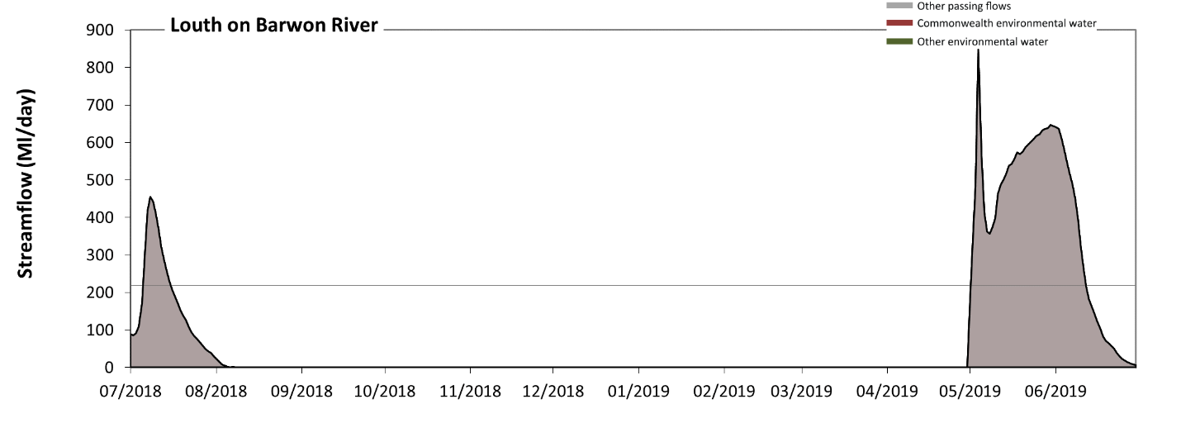Figure BDL10: Contribution of environmental water delivery at Louth. Horizontal lines indicate thresholds for very low flows and low flows (from lowest to highest).
There was no environmental water delivered at Louth on the Darling River. Without environmental water, the durations of very low flows (i.e. < 220 Ml/day) in the periods July to September, October to December, January to March and April to June was substantially in excess of durations expected in an average year in the natural flow regime. Similarly, without environmental water, the durations of medium low flows (i.e. < 1100 Ml/day) in the periods July to September, October to December, January to March and April to June was substantially in excess of durations expected in an average year in the natural flow regime.
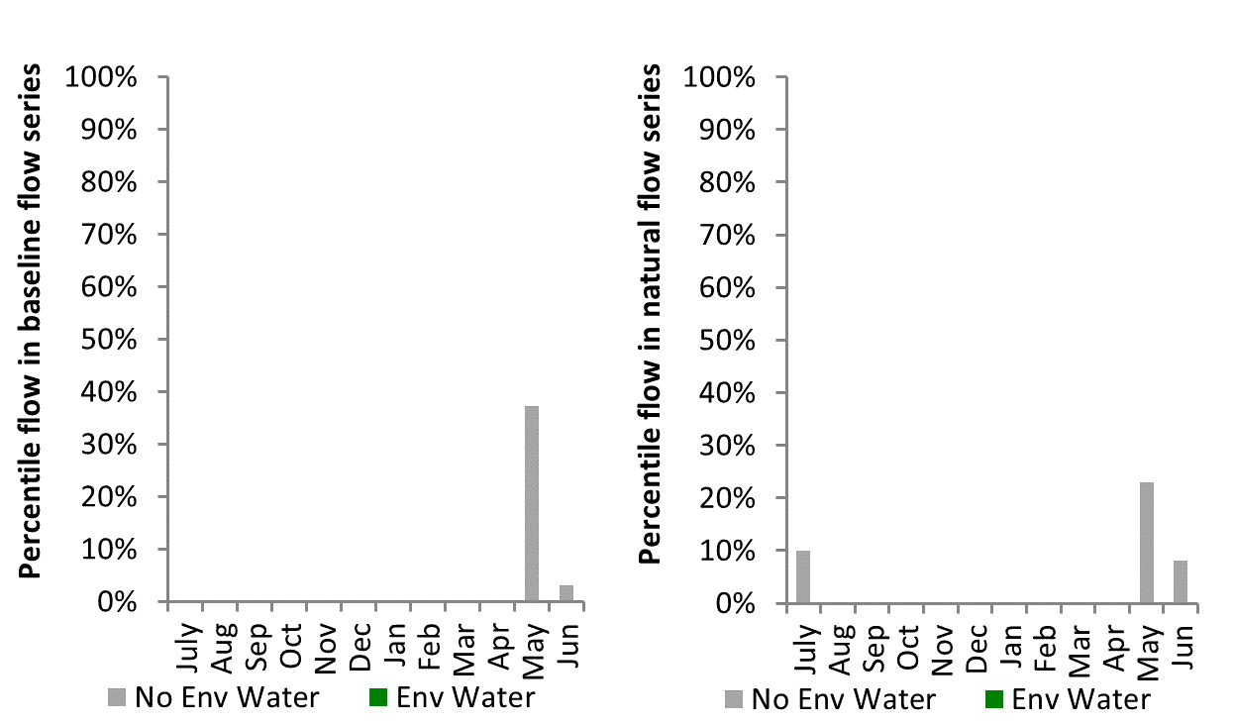
Figure BDL11: Contribution of environmental water delivery at Louth as percentiles in the natural and baseline flow series.
Wilcannia
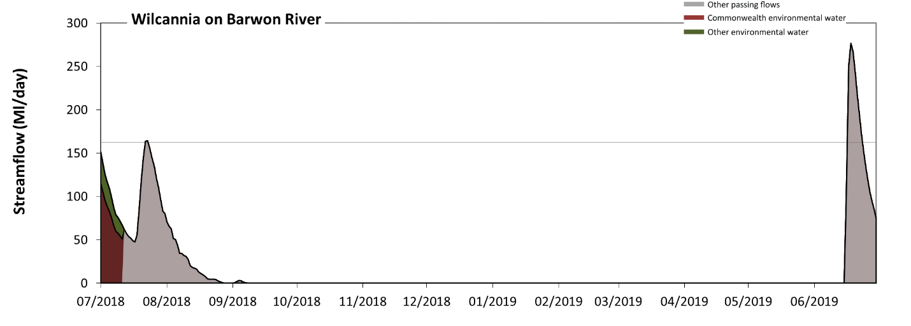 Figure BDL12: Contribution of environmental water delivery at Wilcannia. Horizontal lines indicate thresholds for very low flows and low flows (from lowest to highest).
At Wilcannia on Darling River environmental water contributed 18% of the total streamflow volume (much of which was Commonwealth environmental water). This was the remainder of the Northern Connectivity Event. Environmental watering actions affected streamflows for 3% of days between 1 July 2018 and 30 June 2019. Without environmental water, the durations of very low flows (i.e. < 160 Ml/day) in the periods July to September, October to December, January to March and April to June would have all substantially exceeded durations expected in an average year in the natural flow regime. However, environmental water had little effect on the duration of these very low flows, which occurred for 98% of the year. Similarly, without environmental water, the durations of medium low flows (i.e. < 810 Ml/day) in the periods July to September, October to December, January to March and April to June would have all substantially exceeded durations expected in an average year in the natural flow regime. However, environmental water had little effect on the duration of these medium low flows, which occurred for 100% of the year.

Loddon
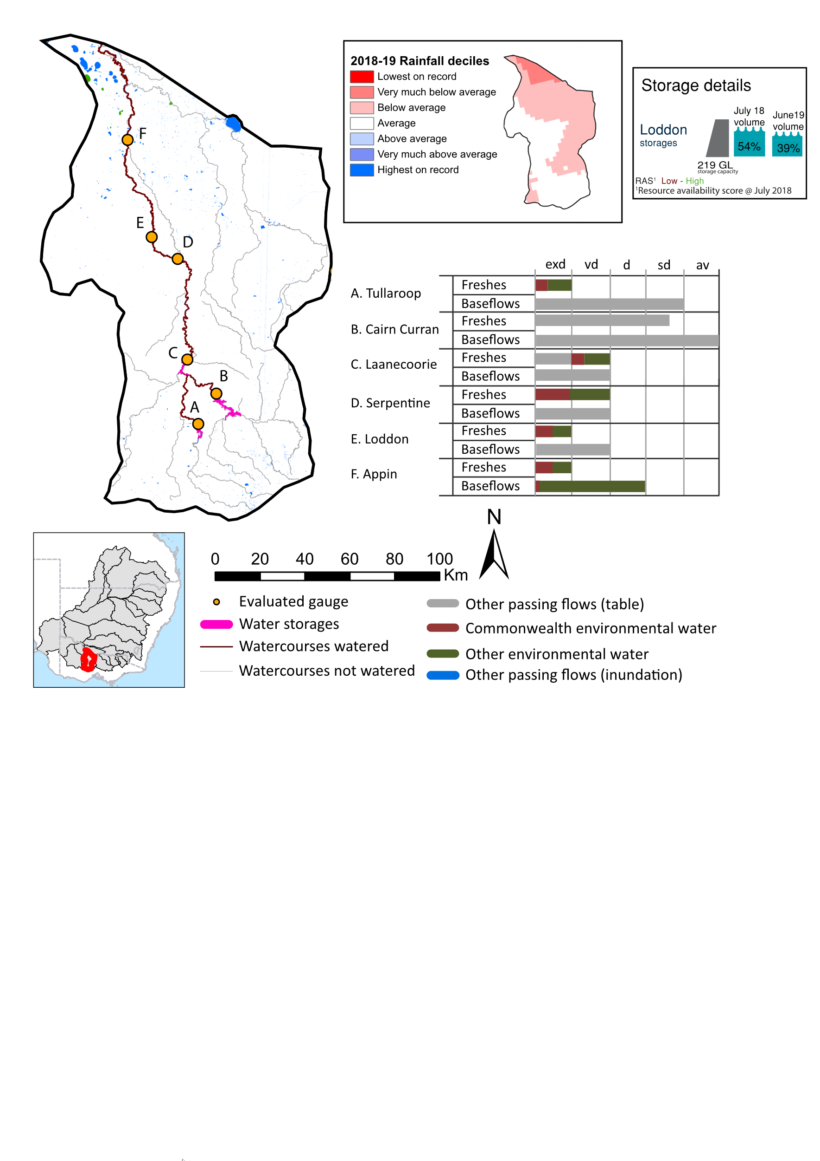Figure LOD1: Watercourses influenced, areas inundated (where applicable) and gauge stations evaluated in the Loddon valley during the 2018-19 water year. Insert bar graphs report the condition of annual flow regimes by showing the improvements in hydrological condition with the addition of environmental water as well as the hypothetical scenario in “grey” (if no environmental flow had been delivered) where exd=extremely dry, vd=very dry, d=dry, sd=somewhat dry and av=average. Rainfall conditions (rainfall deciles) and trend in storage levels for the water year are also shown.

Summary
The volume of environmental water delivery for the 2018-19 year in the Loddon valley is quantified using data for 6 sites. This evaluation only considers the contribution of held environmental water, which is a primary focus for the Commonwealth. The contributions of planned environmental water (e.g. passing flows), unregulated tributary inflows and clever use of irrigation flows for environmental benefits can all be very important but these are outside the scope of this report. Environmental watering actions lasted 214 days over the course of the year. The volume of environmental water at these 6 sites was between 12% and 53% of the total streamflow. Commonwealth environmental water contributed on average 25% of this environmental water. The contribution of environmental water delivery to improved flow regimes is evaluated using data for 6 sites. Ideally, baseflows should be maintained and long periods of excessively low flows avoided. In this valley, the baseflow regime was generally considered to be dry relative to the pre-development flow regime. In our analysis, a low fresh refers to a period of increased flow, when the water level rises at least one eighth of the way up the river bank (above the low flow level). These low freshes are a regular part of the natural flow regime and support a range of natural processes. In the Loddon valley, in terms of the occurrence and duration of low freshes, the year was assessed as being dry. In our analysis, a medium fresh refers to a period of increased flow, when the water level rises at least one quarter of the way up the river bank. These medium freshes are not as frequent as low freshes but are also a regular and important part of the natural flow regime. In the Loddon valley, in terms of the occurrence of medium freshes, the year was assessed as being very dry. In our analysis, a high fresh refers to a period of increased flow, when the water level rises more than half way up the river. A high fresh may not occur every year but they are still important and long periods without major freshes can have serious consequences for floodplains and their contribution to river connectivity. Delivering high in channel environmental flows normally requires that all risks to riparian landholders and infrastructure have been resolved. In the Loddon valley, in terms of the occurrence of high freshes, the year was assessed as being extremely dry.

Water delivery context
During the 2018-19, the Commonwealth Environmental Water Holder (CEWH) held water entitlements of up to 3,883 ML for environmental use in the Loddon valley. Each year, water utilities allocate water entitlement holders a percentage of water based on their holding, license type and carryover (the exact rules vary among Jurisdictions). In 2018-19, the Loddon entitlements held by the CEWH were allocated 3,069 ML of water, representing 92% of the Long term average annual yield for the Loddon valley (3,331 ML). Information and data relating to the portfolio of held Commonwealth environmental water is shown in Table LOD2.
The 2018-19 water allocation (3,069 ML) together with the carryover volume of 287 ML of water meant the CEWH had 3,356 ML of water available for delivery. A total of 2,636 ML of Commonwealth environmental water was delivered in the Loddon valley. A total of 0 ML of Commonwealth environmental water was traded to consumptive users and 684 ML (20%) of available Commonwealth environmental water was carried over for environmental use into the 2019-20 water year.

Environmental conditions and resource availability
The water available for environmental delivery combined with the present and antecedent environmental conditions are key inputs used by environmental water managers in planning and implementing watering actions. Post hoc, this information provides important context when evaluating the effectiveness and appropriateness of environmental water use with respect to hydrological outputs.
The rainfall conditions in the Loddon valley were classified as Below average, based on rainfall percentile data for the entire record held by the Bureau of Meteorology for this valley. The water held in major storages in the Loddon valley decreased over the water year, for example Cairn Curran and Tullaroop dam was 54.3% full at the beginning of the water year and 38.6% full by the end of the year (Figure LOD1).
The Commonwealth Environmental Water Office (CEWO) calculates resource availability scenarios (RAS) to guide the use and prioritisation of held environmental water. The RAS are progressively calculated over the year as part of the continual adaptive management planning processes. The RAS are based on the availability of held environmental water (including progressive license acquisitions and allocations) as well as the potential for unregulated or planned environmental flows. The outcome is then used to determine the demand for environmental water across the basin.
In 2018-19, the resource availability of held Commonwealth environmental water was classified as low to high in this valley. The physical conditions meant that the CEWO was managing to protect and improve the aquatic and riparian vegetation, maintain water quality, and support native fish and other biota via habitat provision. The overall demand for environmental water was deemed very high to moderate.

Watering actions
One watering action which lasted 22 days was delivered over the 2018-19 water year. The number of water actions commencing in each season included, Autumn (0), Spring (1), Summer (0), Winter(0). Similarly, the count of flow component types delivered in the Loddon valley were; (0) baseflow, (0) baseflow-fresh, (1) fresh, (0) fresh-overbank, (0) bankfull, (0) overbank, (0) wetland and (0) wetland-fresh. In this valley, watering actions were delivered for ecosystem processes and fish purposes.
Table LOD2. Commonwealth environmental water accounting information for the Loddon valley over 2018-19 water year.
Total registered volume (ML) | Allocated volume (ML) | Carry over + allocated volume (ML) | Delivered (ML) | LTAAY (ML) | Trade (ML) | Carried over to 2019-20 | Forfeited (ML)
3,883 | 3,069 | 3,356 | 2,636 | 3,331 | 0 | 684 | 0

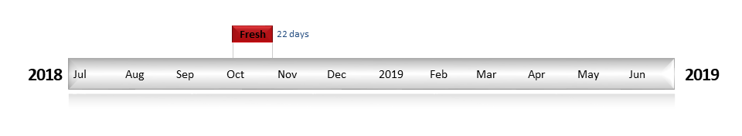
Figure LOD2. Timing and duration of Commonwealth environmental water actions delivered in the Loddon valley.

Contribution of Commonwealth environmental water to flow regimes

Cairn Curran
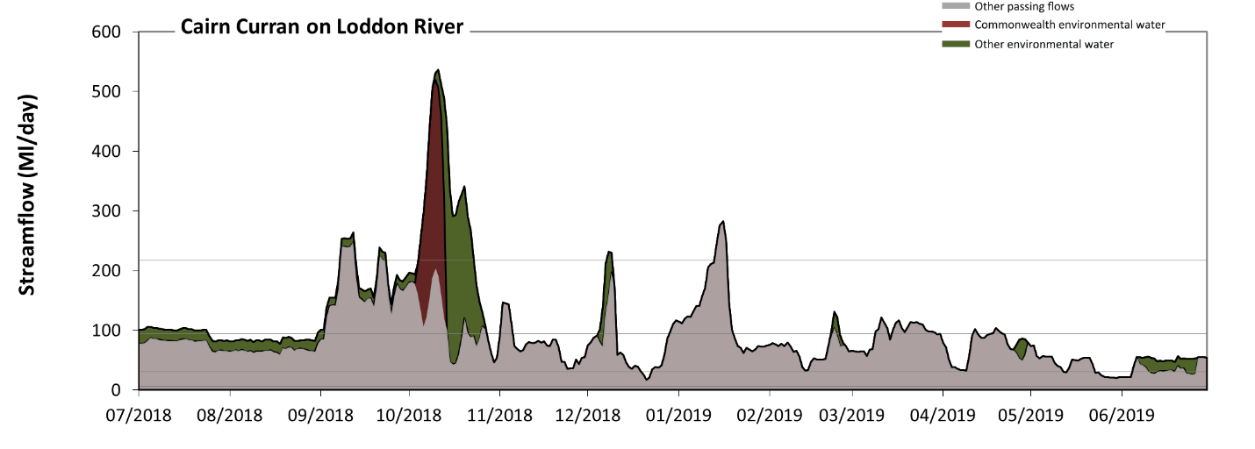
Figure LOD3: Contribution of environmental water delivery at Cairn Curran. Horizontal lines indicate thresholds for very low flows, low flows, low freshes and medium freshes (from lowest to highest).
At Cairn Curran on Loddon River environmental water contributed 20% of the total streamflow volume (with a medium contribution of Commonwealth environmental water). Environmental watering actions affected streamflows for 42% of days between 1 July 2018 and 30 June 2019. Flow regulation does not substantially increase the duration of very low flows (i.e. < 6.2 Ml/day) compared to an average year in the natural flow regime. Flow regulation does not substantially increase the duration of medium low flows (i.e. < 31 Ml/day) compared to an average year in the natural flow regime. Commonwealth environmental water made little or no contribution to these enhancements of environmental baseflows at this site. In the absence of environmental water there would have been at least one low fresh (i.e. > 94 Ml/day) in the periods July to September, October to December, January to March and April to June. Environmental water increased the duration of the longest low fresh during the period October to December (from 14 days to 27 days). Commonwealth environmental water made little or no contribution to these increased durations of low freshes. In the absence of environmental water there would have been at least one medium fresh (i.e. > 220 Ml/day) in the periods July to September and January to March. Environmental water increased the duration of the longest medium fresh during the period October to December (from 0 days to 19 days). Commonwealth environmental water equally shared responsibility with other environmental water holders for these increased durations of medium freshes. There was no high freshes (i.e. > 760 Ml/day) this year.
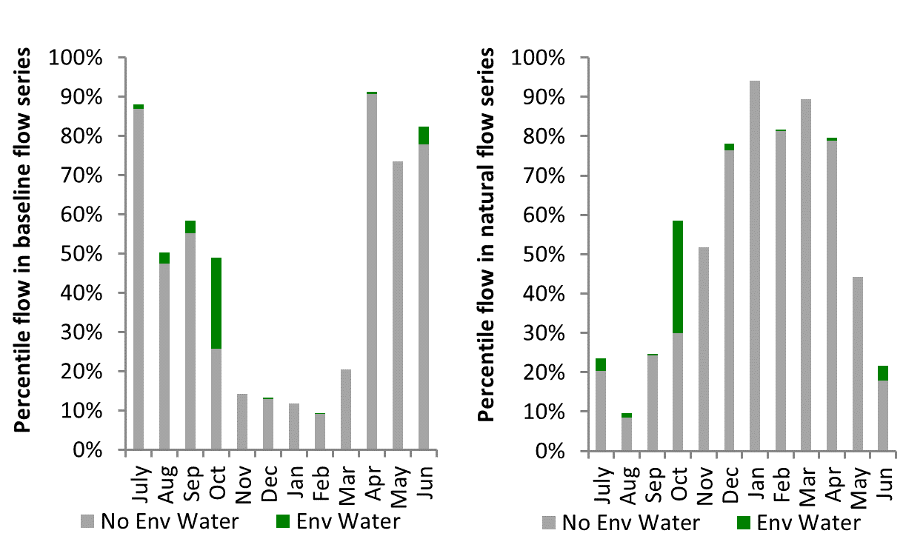
Figure LOD4: Contribution of environmental water delivery at Cairn Curran as percentiles in the natural and baseline flow series.
Tullaroop
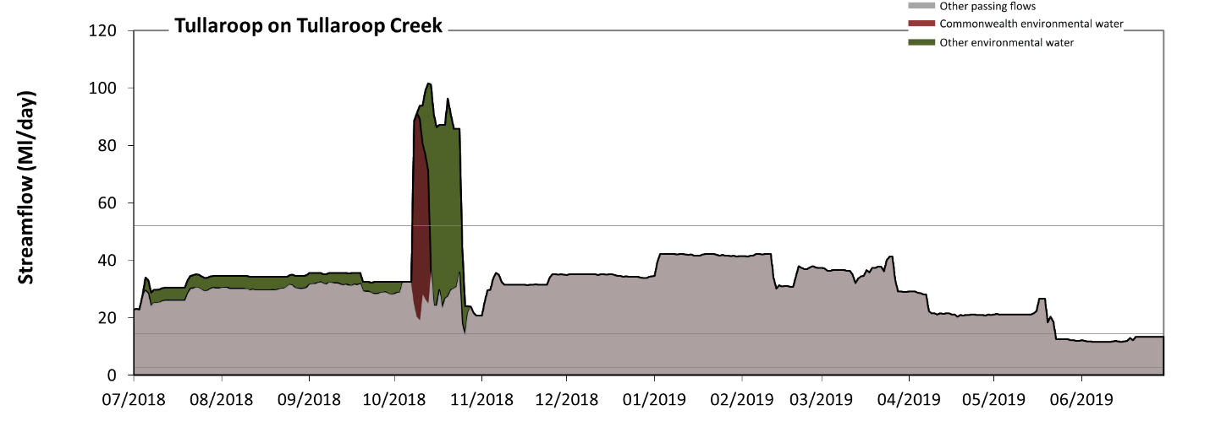
Figure LOD5: Contribution of environmental water delivery at Tullaroop. Horizontal lines indicate thresholds for very low flows, low flows and low freshes (from lowest to highest).
At Tullaroop on Tullaroop Creek environmental water contributed 12% of the total streamflow volume (with a medium contribution of Commonwealth environmental water). Environmental watering actions affected streamflows for 30% of days between 1 July 2018 and 30 June 2019. Flow regulation does not substantially increase the duration of very low flows (i.e. < 2.9 Ml/day) compared to an average year in the natural flow regime. However, without environmental water, the duration of medium low flows (i.e. < 14 Ml/day) in the period April to June would have substantially exceeded durations expected in an average year in the natural flow regime. However, environmental water had little effect on the duration of these medium low flows, which occurred for 11% of the year. Environmental water increased the duration of the longest low fresh during the period October to December (from 0 days to 17 days). Commonwealth environmental water made a modest contribution to these increased durations of low freshes.
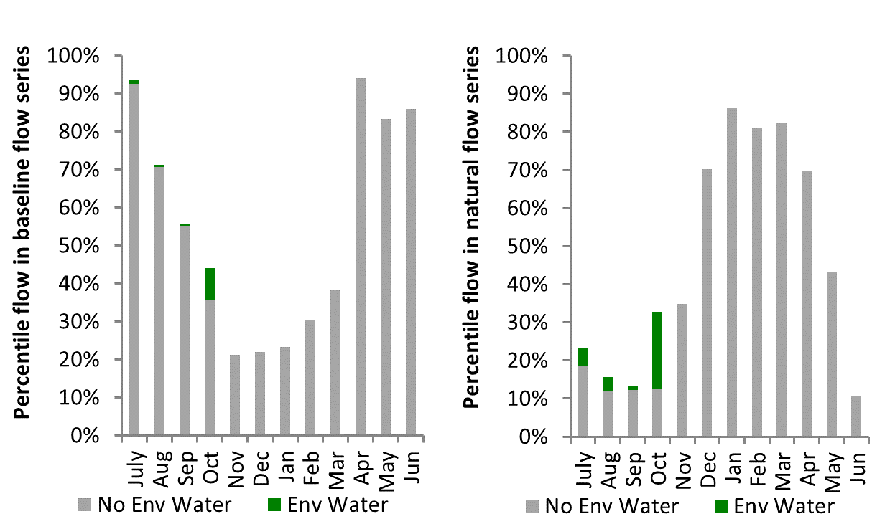
Figure LOD6: Contribution of environmental water delivery at Tullaroop as percentiles in the natural and baseline flow series.
Laanecoorie
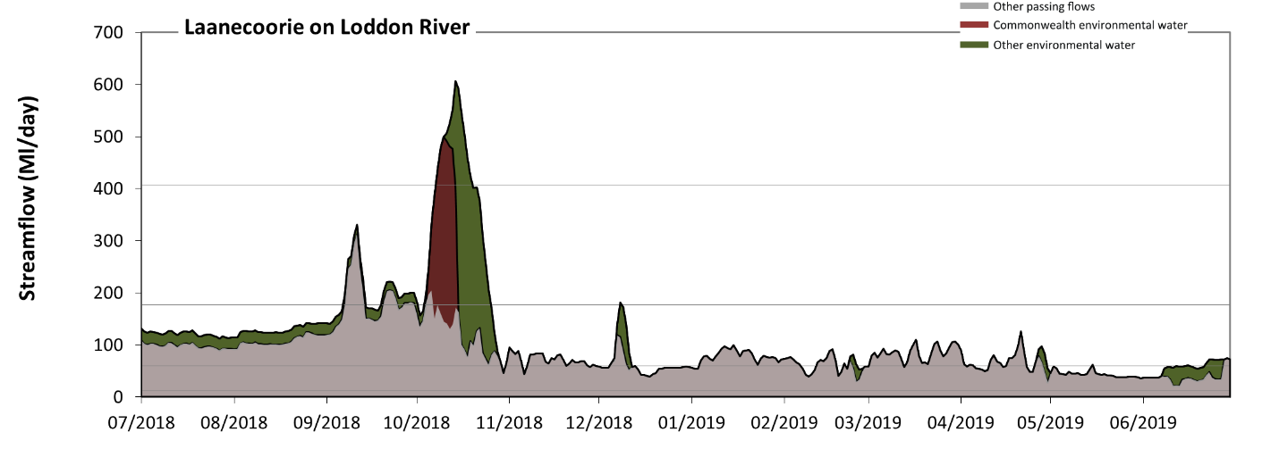
Figure LOD7: Contribution of environmental water delivery at Laanecoorie. Horizontal lines indicate thresholds for very low flows, low flows, low freshes and medium freshes (from lowest to highest).
At Laanecoorie on Loddon River environmental water contributed 24% of the total streamflow volume (with a medium contribution of Commonwealth environmental water). Environmental watering actions affected streamflows for 42% of days between 1 July 2018 and 30 June 2019. Flow regulation does not substantially increase the duration of very low flows (i.e. < 12 Ml/day) compared to an average year in the natural flow regime. However, without environmental water, the duration of medium low flows (i.e. < 60 Ml/day) in the period April to June would have substantially exceeded durations expected in an average year in the natural flow regime. Environmental water mitigated these impacts by reducing the cumulative duration of medium low flow spells from 32% to 29% of the year, with greatest influence in the period April to June. Commonwealth environmental water made little or no contribution to these enhancements of environmental baseflows at this site. In the absence of environmental water there would have been at least one low fresh (i.e. > 180 Ml/day) in the periods July to September and October to December. Environmental water increased the duration of the longest low fresh during the periods July to September (from 7 days to 11 days) and October to December (from 3 days to 22 days). Commonwealth environmental water made a modest contribution to these increased durations of low freshes. In the absence of environmental water there would have been no medium or high freshes this year. Environmental water increased the duration of the longest medium fresh during the period October to December (from 0 days to 12 days). Commonwealth environmental water equally shared responsibility with other environmental water holders for these increased durations of medium freshes.
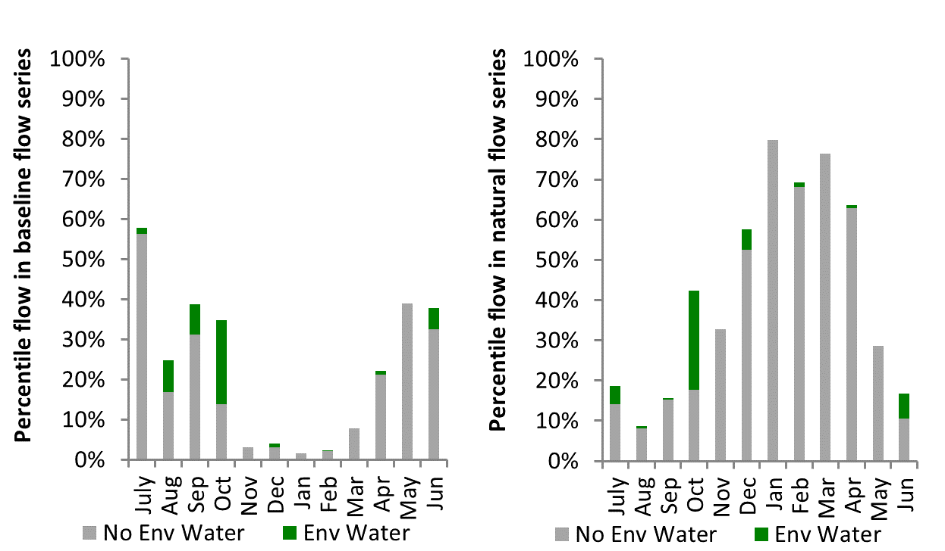
Figure LOD8: Contribution of environmental water delivery at Laanecoorie as percentiles in the natural and baseline flow series.

Serpentine
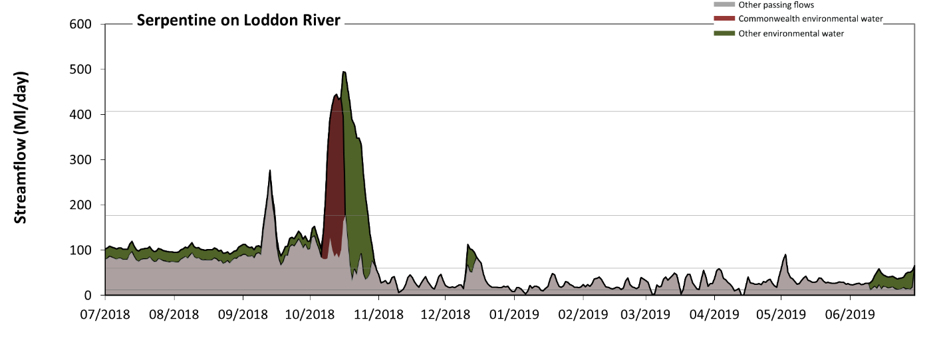
Figure LOD9: Contribution of environmental water delivery at Serpentine. Horizontal lines indicate thresholds for very low flows, low flows, low freshes and medium freshes (from lowest to highest).
At Serpentine on Loddon River environmental water contributed 33% of the total streamflow volume (with a medium contribution of Commonwealth environmental water). Environmental watering actions affected streamflows for 40% of days between 1 July 2018 and 30 June 2019. Flow regulation does not substantially increase the duration of very low flows (i.e. < 12 Ml/day) compared to an average year in the natural flow regime. However, without environmental water, the durations of medium low flows (i.e. < 60 Ml/day) in the periods October to December, January to March and April to June would have substantially exceeded durations expected in an average year in the natural flow regime. Environmental water mitigated these impacts by reducing the cumulative duration of medium low flow spells from 66% to 64% of the year, with greatest influence in the period October to December. Commonwealth environmental water made little or no contribution to these enhancements of environmental baseflows at this site. In the absence of environmental water there would have been at least one low fresh (i.e. > 180 Ml/day) in the periods July to September and October to December. Environmental water increased the duration of the longest low fresh during the periods July to September (from 3 days to 5 days) and October to December (from 1 days to 20 days). Commonwealth environmental water made a modest contribution to these increased durations of low freshes. In the absence of environmental water there would have been no medium or high freshes this year. Environmental water increased the duration of the longest medium fresh during the period October to December (from 0 days to 9 days). Commonwealth environmental water made the dominant contribution to these increased durations of medium freshes.
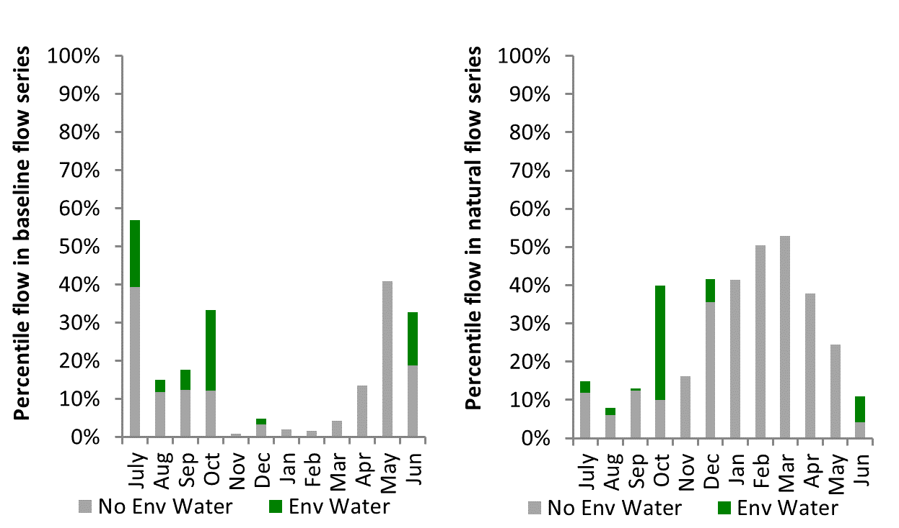
Figure LOD10: Contribution of environmental water delivery at Serpentine as percentiles in the natural and baseline flow series.
Loddon
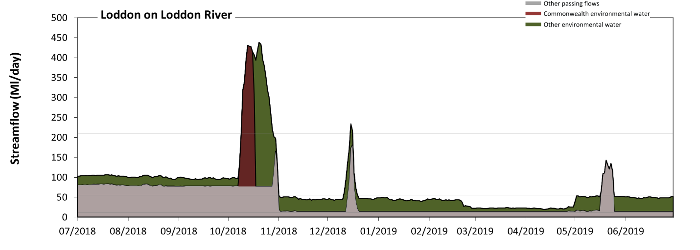
Figure LOD11: Contribution of environmental water delivery at Loddon. Horizontal lines indicate thresholds for very low flows, low flows and low freshes (from lowest to highest).
At Loddon on Loddon River environmental water contributed 49% of the total streamflow volume (with a relatively small contribution of Commonwealth environmental water). Environmental watering actions affected streamflows for 98% of days between 1 July 2018 and 30 June 2019. Flow regulation does not substantially increase the duration of very low flows (i.e. < 11 Ml/day) compared to an average year in the natural flow regime. However, without environmental water, the durations of medium low flows (i.e. < 56 Ml/day) in the periods October to December, January to March and April to June would have substantially exceeded durations expected in an average year in the natural flow regime. Environmental water slightly mitigated these impacts by reducing the cumulative duration of medium low flow spells from 63% to 62% of the year, with greatest influence in the period October to December. Environmental water increased the magnitude of flows below this medium low flow threshold. Environmental water increased the duration of the longest low fresh during the period October to December (from 0 days to 19 days). Commonwealth environmental water equally shared responsibility with other environmental water holders for these increased durations of low freshes.
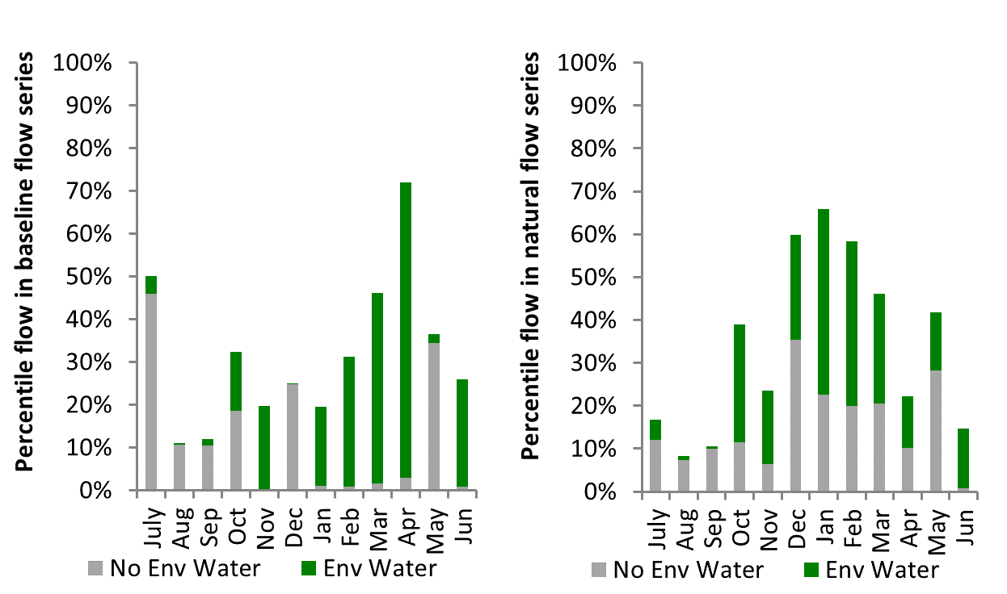
Figure LOD12: Contribution of environmental water delivery at Loddon as percentiles in the natural and baseline flow series.

Appin
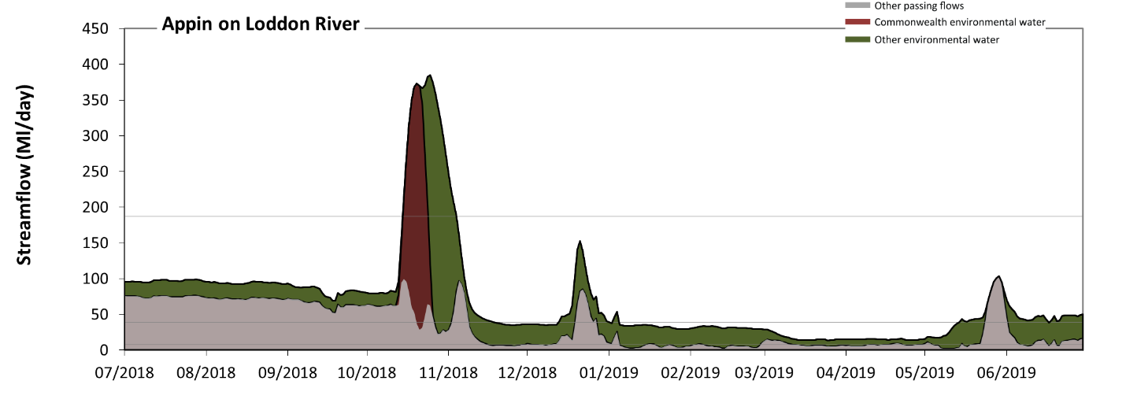Figure LOD13: Contribution of environmental water delivery at Appin. Horizontal lines indicate thresholds for very low flows, low flows and low freshes (from lowest to highest).
At Appin on Loddon River environmental water contributed 53% of the total streamflow volume (with a relatively small contribution of Commonwealth environmental water). Environmental watering actions affected streamflows for 98% of days between 1 July 2018 and 30 June 2019. Without environmental water, the durations of very low flows (i.e. < 7.9 Ml/day) in the periods October to December, January to March and April to June would have substantially exceeded durations expected in an average year in the natural flow regime. Environmental water mitigated these impacts by reducing the cumulative duration of very low flow spells from 38% to 0% of the year, with greatest influence in the periods January to March and April to June. Similarly, without environmental water, the durations of medium low flows (i.e. < 39 Ml/day) in the periods October to December, January to March and April to June would have substantially exceeded durations expected in an average year in the natural flow regime. Environmental water mitigated these impacts by reducing the cumulative duration of medium low flow spells from 62% to 43% of the year, with greatest influence in the periods October to December and April to June. Environmental water increased the magnitude of flows below this medium low flow threshold. Commonwealth environmental water made little or no contribution to these enhancements of environmental baseflows at this site. Environmental water increased the duration of the longest low fresh during the period October to December (from 0 days to 21 days). Commonwealth environmental water equally shared responsibility with other environmental water holders for these increased durations of low freshes. However, environmental water increased peak flows substantially below the medium fresh threshold.
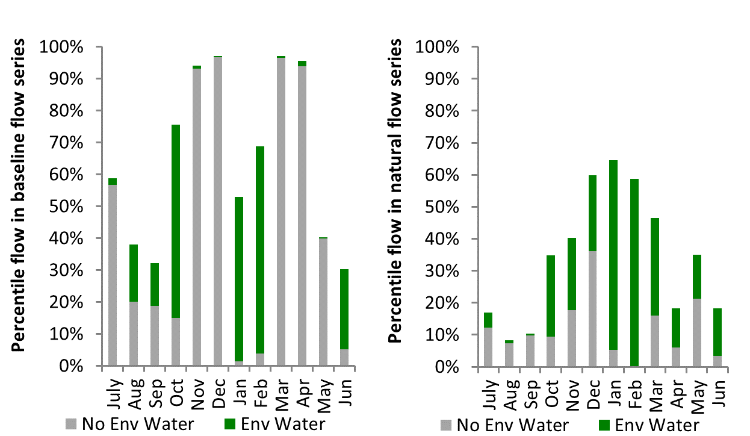
Figure LOD14: Contribution of environmental water delivery at Appin as percentiles in the natural and baseline flow series.

Border Rivers
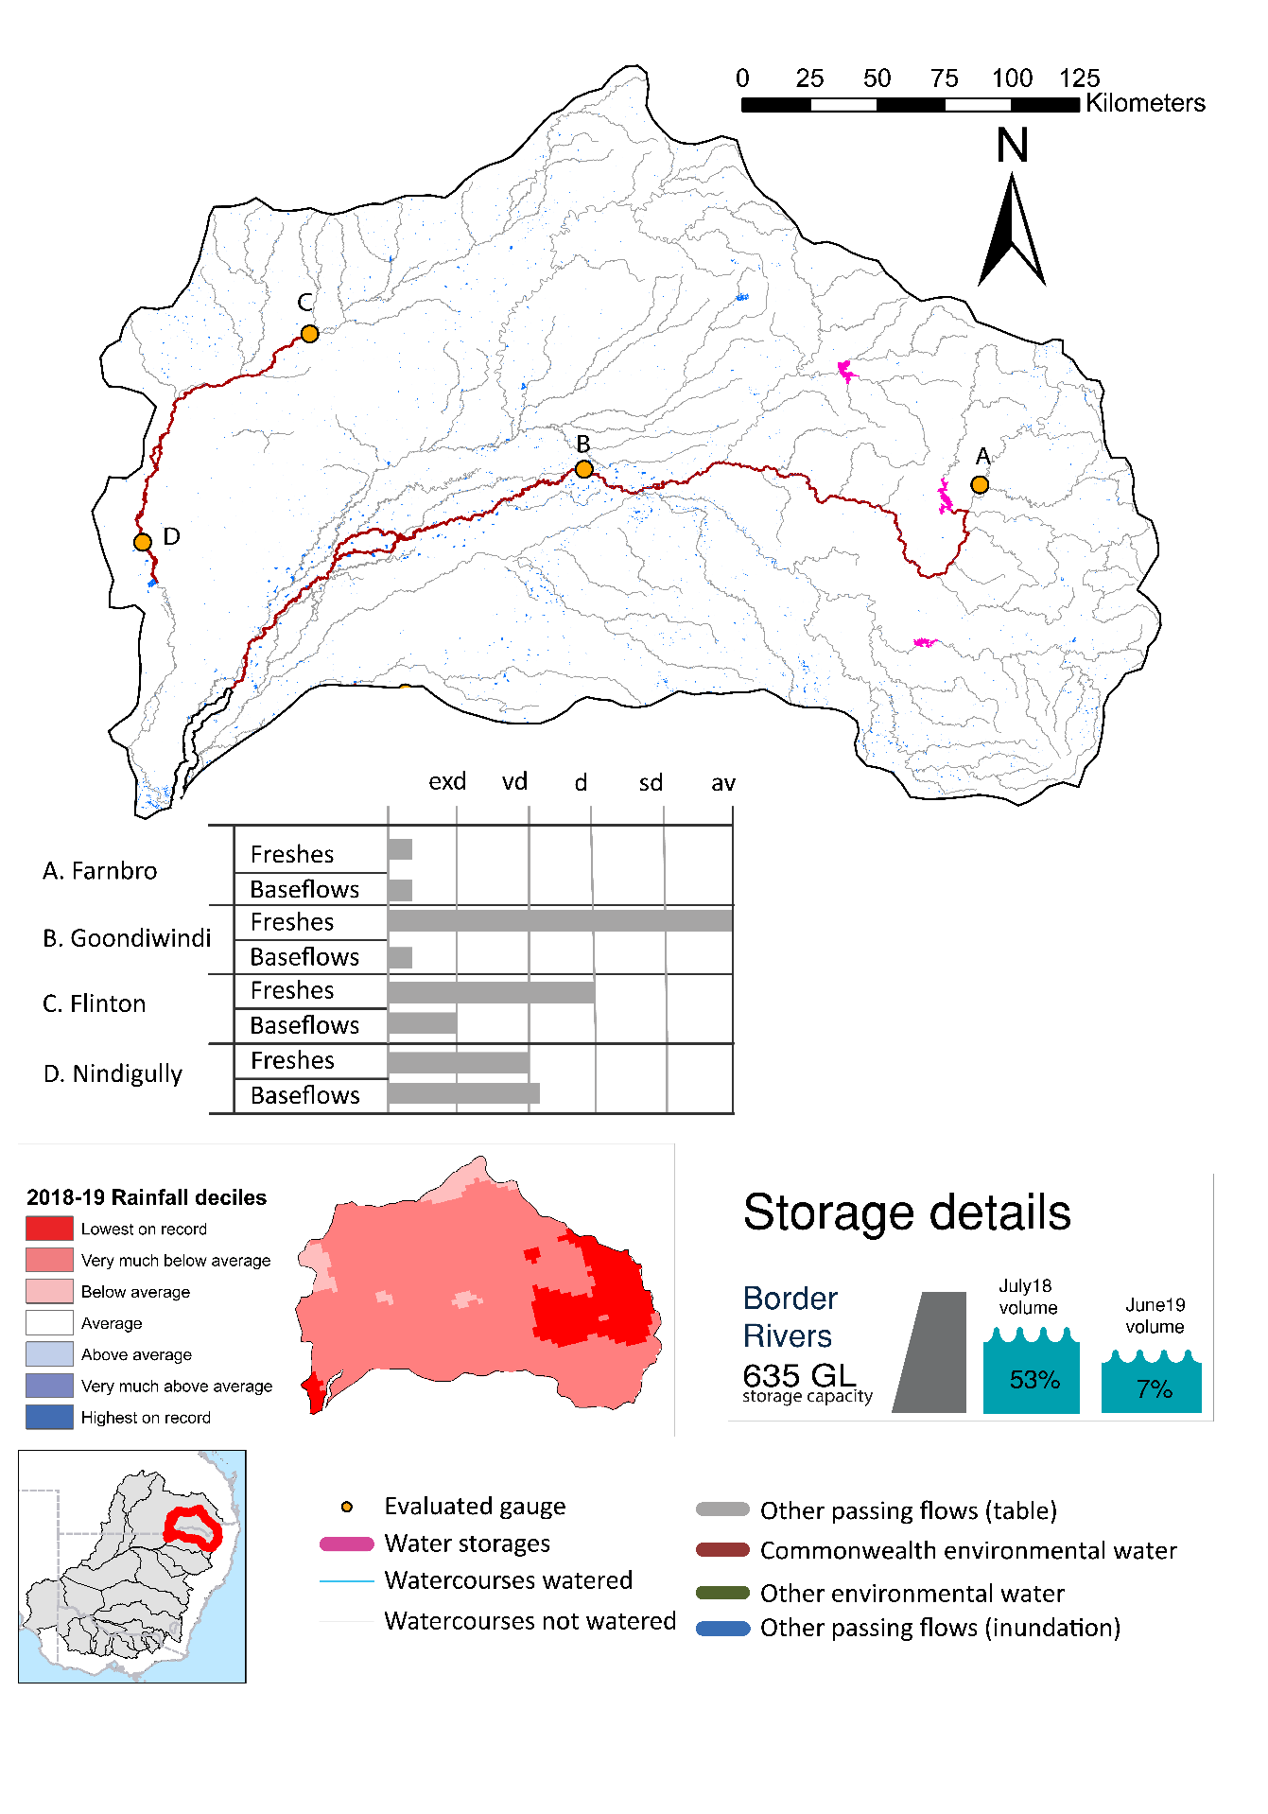
Figure BRD1: Watercourses influenced, areas inundated (where applicable) and gauge stations evaluated in the Border Rivers valley during the 2018-19 water year. Inset bar graphs report the condition of annual flow regimes by showing the improvements in hydrological condition with the addition of environmental water as well as the hypothetical scenario in “grey” (if no environmental flow had been delivered) where exd=extremely dry, vd=very dry, d=dry, sd=somewhat dry and av=average. Rainfall conditions (rainfall deciles) and trend in storage levels for the water year are also shown.

Summary
The volume of environmental water delivery for the 2018-19 year in the Border Rivers valley is quantified using data for 5 sites. This evaluation only considers the contribution of held environmental water, which is a primary focus for the Commonwealth. The contributions of planned environmental water (e.g. passing flows), unregulated tributary inflows and clever use of irrigation flows for environmental benefits can all be very important but these are outside the scope of this report. Environmental watering actions lasted on average 11 days over the course of the year. The volume of environmental water at these 5 sites was between 0% and 26% of the total streamflow. Commonwealth environmental water contributed on average 40% of this environmental water. The contribution of environmental water delivery to improved flow regimes is evaluated using data for 5 sites. Ideally, baseflows should be maintained and long periods of excessively low flows avoided. In this valley, the baseflow regime was generally considered to be extremely dry relative to the pre-development flow regime. In our analysis, a low fresh refers to a period of increased flow, when the water level rises at least one eighth of the way up the river bank (above the low flow level). These low freshes are a regular part of the natural flow regime and support a range of natural processes. In the Border Rivers valley, in terms of the occurrence and duration of low freshes, the year was assessed as being dry. In our analysis, a medium fresh refers to a period of increased flow, when the water level rises at least one quarter of the way up the river bank. These medium freshes are not as frequent as low freshes but are also a regular and important part of the natural flow regime. In the Border Rivers valley, in terms of the occurrence of medium freshes, the year was assessed as being dry. In our analysis, a high fresh refers to a period of increased flow, when the water level rises more than half way up the river. A high fresh may not occur every year but they are still important and long periods without major freshes can have serious consequences for floodplains and their contribution to river connectivity. Delivering high in channel environmental flows normally requires that all risks to riparian landholders and infrastructure have been resolved. In the Border Rivers valley, in terms of the occurrence of high freshes, the year was assessed as being dry.

Water delivery context
The CEWH holds water entitlements of up to 45,440 ML for the environment in the Border Rivers valley. Each year, water utilities allocate water entitlement holders a percentage of water based on their holding, license type and carryover (the exact rules vary among Jurisdictions). In 2018-19, the Border Rivers entitlements held by the CEWH were allocated 1,211 ML of water, representing 7% of the Long term average annual yield for the Border Rivers valley (17,806 ML). Information and data relating to the portfolio of held Commonwealth environmental water is shown in Table BRD2.
The 2018-19 water allocation (1,211 ML) together with the carryover volume of 9,775 ML of water meant the CEWH had 10,986 ML of water available for delivery. A total of 8,422 ML of Commonwealth environmental water was delivered in the Border Rivers valley and onto the Barwon. A total of 0 ML of Commonwealth environmental water was traded to consumptive users and 2190 ML (20%) of available Commonwealth environmental water was carried over for environmental use into the 2019-20 water year.

Environmental conditions and resource availability
The water available for environmental delivery combined with the present and antecedent environmental conditions are key inputs used by environmental water managers in planning and implementing watering actions. Post hoc, this information provides important context when evaluating the effectiveness and appropriateness of environmental water use with respect to hydrological outputs.
The rainfall conditions in the Border Rivers valley were classified as Very much below average, based on rainfall percentile data for the entire record held by the Bureau of Meteorology for this valley. The water held in major storages in the Border Rivers valley decreased over the water year, for example Glynlyon, Pindari, and Coolmunda dam was 52.8% full at the beginning of the water year and 7.2% full by the end of the year (Figure BRD1).
The Commonwealth Environmental Water Office (CEWO) calculates resource availability scenarios (RAS) to guide the use and prioritisation of held environmental water. The RAS are progressively calculated over the year as part of the continual adaptive management planning processes. The RAS are based on the availability of held environmental water (including progressive license acquisitions and allocations) as well as the potential for unregulated or planned environmental flows. The outcome is then used to determine the demand for environmental water across the basin.
In 2018-19, the resource availability of held Commonwealth environmental water was classified as low to moderate. The physical conditions meant that the CEWO was managing to protect the health and resilience of near channel wetlands and ecological processes in the lower Macintyre River, and fish habitat and life cycles in the Dumaresq River. The overall demand for environmental water was deemed high.

Watering actions
A total of 3 watering actions were delivered over the 2018-19 water year, the duration of these actions varied (range of individual actions: 2 - 21 days) and Commonwealth environmental water was delivered for a total of 36 days. The number of water actions commencing in each season included, Autumn (1), Spring (1), Summer (1), Winter(0). Similarly, the count of flow component types delivered in the Border Rivers valley were; (1) baseflow, (0) baseflow-fresh, (2) fresh, (0) fresh-overbank, (0) bankfull, (0) overbank, (0) wetland and (0) wetland-fresh.
In this valley, primary objectives of most watering actions was related to fish, but water was also delivered for other purposes too. The percentage of watering actions delivered across the nine main themes included primary objectives for fish (42.86%), vegetation (0.0%), waterbirds (0.0%), frogs (0.0%), other biota (0.0%), connectivity (28.57%), process (0.0%), resilience (28.57%) and water quality (0.0%). These Percentages are indicative only. Watering actions were provided for multiple objectives.
Table BRD2. Commonwealth environmental water accounting information for the Border Rivers valley over 2018-19 water year.
Total registered volume (ML) | Allocated volume (ML) | Carry over + allocated volume (ML) | Delivered (ML) | LTAAY (ML) | Trade (ML) | Carried over to 2019-20 | Forfeited (ML)
45,440 | 1,211 | 10,986 | 8,422 | 17,806 | 0 | 2,191 | 0

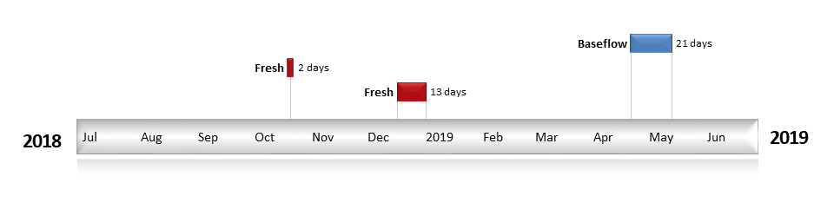
Figure BRD2. Timing and duration of Commonwealth environmental water actions delivered in the Border Rivers valley.

Contribution of Commonwealth environmental water to flow regimes
Nindigully
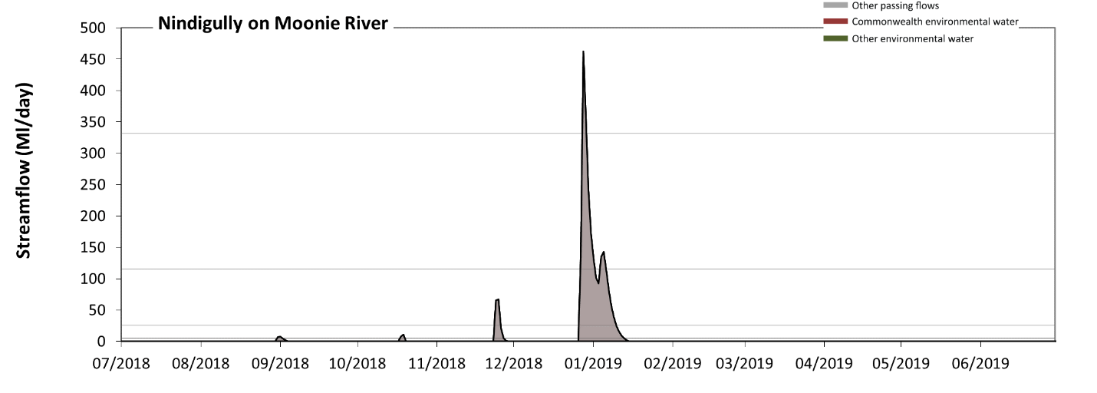
Figure BRD3: Contribution of environmental water delivery at Nindigully. Horizontal lines indicate thresholds for very low flows, low flows, low freshes and medium freshes (from lowest to highest).
There was no environmental water delivered at Nindigully on Moonie River. Without environmental water, the durations of very low flows (i.e. < 5.1 Ml/day) in the periods July to September, October to December, January to March and April to June was substantially in excess of durations expected in an average year in the natural flow regime. Similarly, without environmental water, the durations of medium low flows (i.e. < 25 Ml/day) in the periods July to September, October to December, January to March and April to June was substantially in excess of durations expected in an average year in the natural flow regime. There was at least one low fresh (i.e. > 120 Ml/day) in the periods October to December and January to March. There was at least one medium fresh (i.e. > 330 Ml/day) in the period October to December. There was no high freshes (i.e. > 1500 Ml/day) this year.
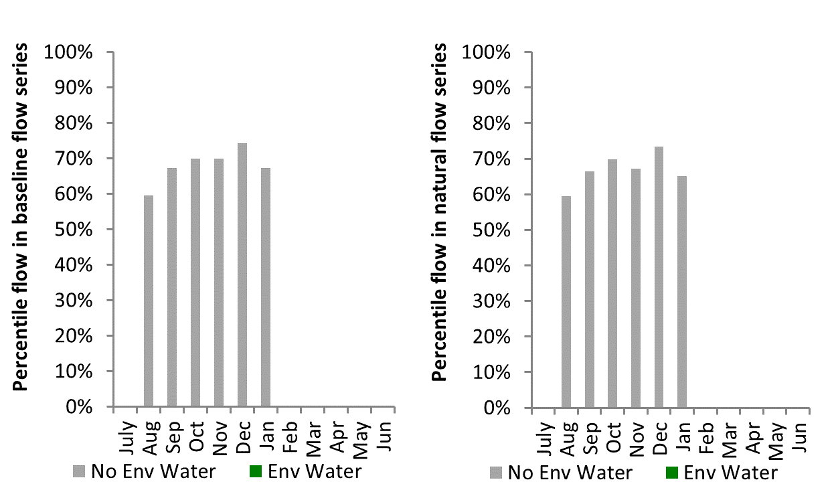
Figure BRD4: Contribution of environmental water delivery at Nindigully as percentiles in the natural and baseline flow series.
Roseleigh
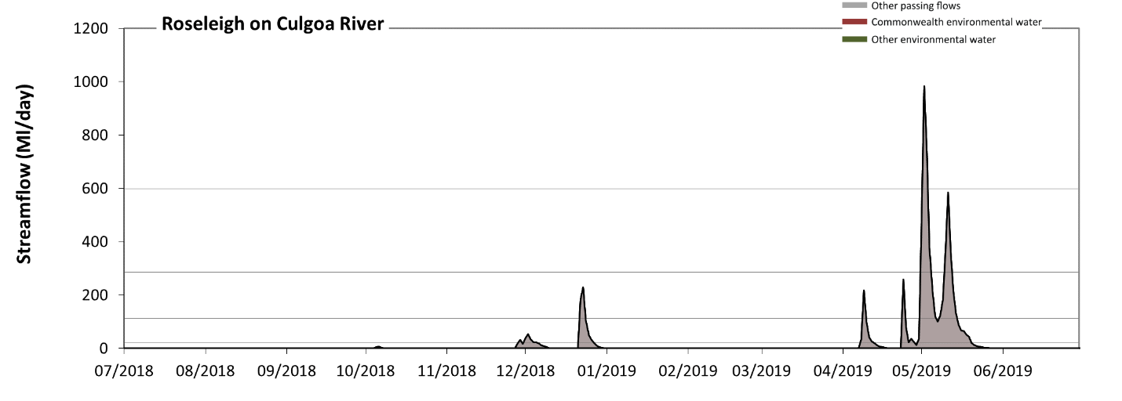
Figure BRD5: Contribution of environmental water delivery at Roseleigh. Horizontal lines indicate thresholds for very low flows, low flows, low freshes and medium freshes (from lowest to highest).
There was no environmental water delivered at Roseleigh on Culgoa River. Without environmental water, the durations of very low flows (i.e. < 23 Ml/day) in the periods July to September, October to December, January to March and April to June was substantially in excess of durations expected in an average year in the natural flow regime. Similarly, without environmental water, the durations of medium low flows (i.e. < 110 Ml/day) in the periods July to September, October to December, January to March and April to June was substantially in excess of durations expected in an average year in the natural flow regime. There was at least one low fresh (i.e. > 290 Ml/day) in the period April to June. There was at least one medium fresh (i.e. > 600 Ml/day) in the period April to June. There was no high freshes (i.e. > 1900 Ml/day) this year.
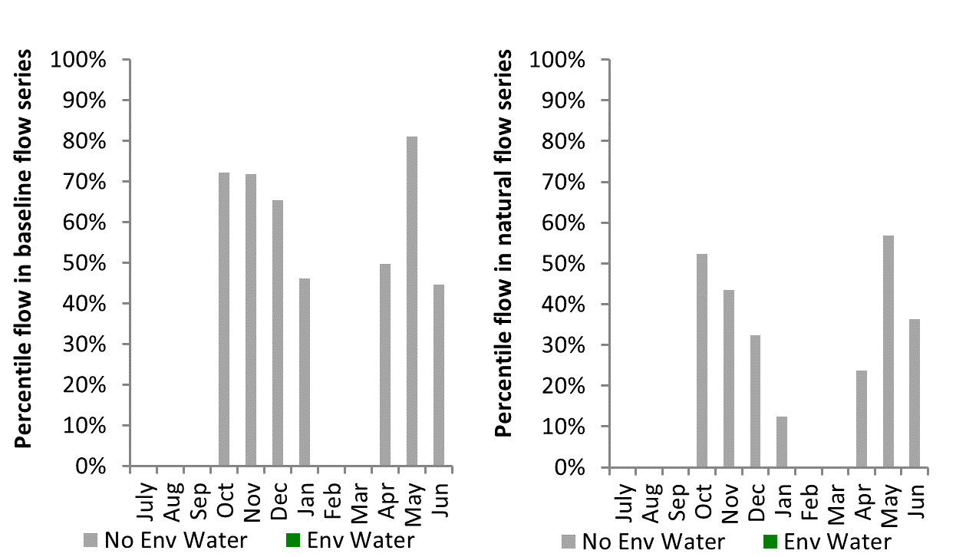
Figure BRD6: Contribution of environmental water delivery at Roseleigh as percentiles in the natural and baseline flow series.

Flinton
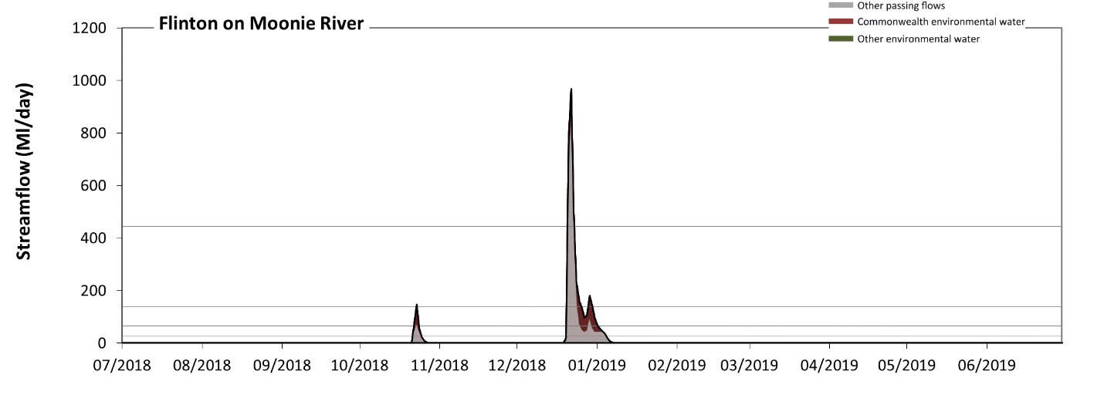
Figure BRD7: Contribution of environmental water delivery at Flinton. Horizontal lines indicate thresholds for very low flows, low flows, low freshes, medium freshes and high freshes (from lowest to highest).
At Flinton on Moonie River environmental water contributed 26% of the total streamflow volume (all of which was Commonwealth environmental water). Environmental watering actions affected streamflows for 5% of days between 1 July 2018 and 30 June 2019. Without environmental water, the durations of very low flows (i.e. < 5.1 Ml/day) in the periods July to September, October to December, January to March and April to June would have all substantially exceeded durations expected in an average year in the natural flow regime. However, environmental water had little effect on the duration of these very low flows, which occurred for 94% of the year. Similarly, without environmental water, the durations of medium low flows (i.e. < 25 Ml/day) in the periods July to September, October to December, January to March and April to June would have all substantially exceeded durations expected in an average year in the natural flow regime. However, environmental water had little effect on the duration of these medium low flows, which occurred for 95% of the year. In the absence of environmental water there would have been at least one low fresh (i.e. > 66 Ml/day) in the period October to December. Environmental water increased the duration of the longest low fresh during the periods October to December (from 5 days to 11 days) and January to March (from 0 days to 1 days). Commonwealth environmental water was entirely responsible for these increased durations of low freshes. There was at least one medium fresh (i.e. > 140 Ml/day) in the period October to December. Environmental water made little change to the duration of these medium freshes. Commonwealth environmental water made little or no contribution to these increased durations of medium freshes. In the absence of environmental water there would have been at least one high fresh in the period October to December. Environmental water increased the duration of the longest high fresh during the period October to December (from 2 days to 3 days). Commonwealth environmental water was entirely responsible for these increased durations of high freshes.
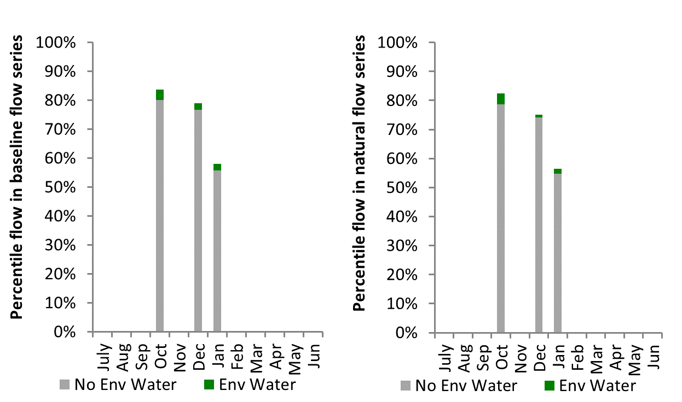
Figure BRD8: Contribution of environmental water delivery at Flinton as percentiles in the natural and baseline flow series.

Farnbro
No streamflow occurred at Farnbro in the 2018-19 water year.

Goondiwindi
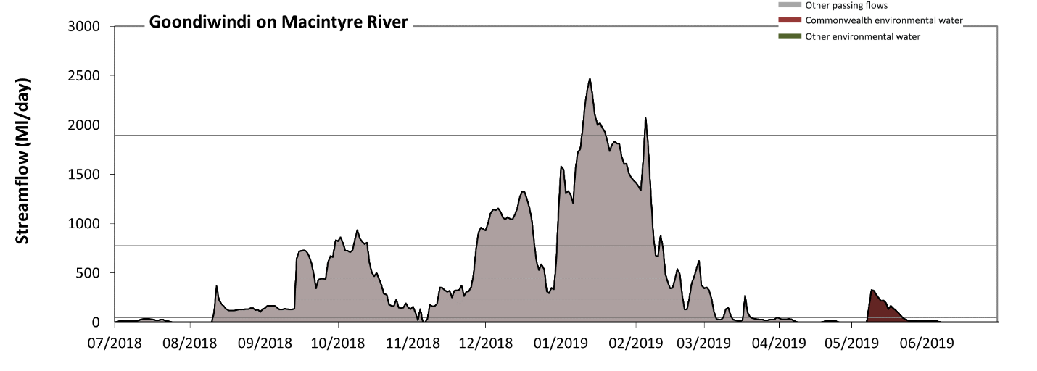
Figure BRD11: Contribution of environmental water delivery at Goondiwindi. Horizontal lines indicate thresholds for very low flows, low flows, low freshes, medium freshes and high freshes (from lowest to highest).
At Goondiwindi on Macintyre River environmental water contributed 2% of the total streamflow volume (all of which was Commonwealth environmental water). Environmental watering actions affected streamflows for 10% of days between 1 July 2018 and 30 June 2019. Without environmental water, the durations of very low flows (i.e. < 48 Ml/day) in the periods July to September, January to March and April to June would have substantially exceeded durations expected in an average year in the natural flow regime. Environmental water mitigated these impacts by reducing the cumulative duration of very low flow spells from 42% to 38% of the year, with greatest influence in the period April to June. Similarly, without environmental water, the durations of medium low flows (i.e. < 240 Ml/day) in the periods July to September, January to March and April to June would have substantially exceeded durations expected in an average year in the natural flow regime. Environmental water mitigated these impacts by reducing the cumulative duration of medium low flow spells from 59% to 58% of the year, with greatest influence in the period April to June. Commonwealth environmental water was entirely responsible for these enhancements of environmental baseflows at this site. There was at least one low fresh (i.e. > 450 Ml/day) in the periods July to September, October to December and January to March. Environmental water made no change to the duration of these low freshes. There was at least one medium fresh (i.e. > 780 Ml/day) in the periods July to September, October to December and January to March. Environmental water made no change to the duration of these medium freshes. In the absence of environmental water there would have been at least one high fresh in the period January to March. Environmental water made no change to the duration of these high freshes.
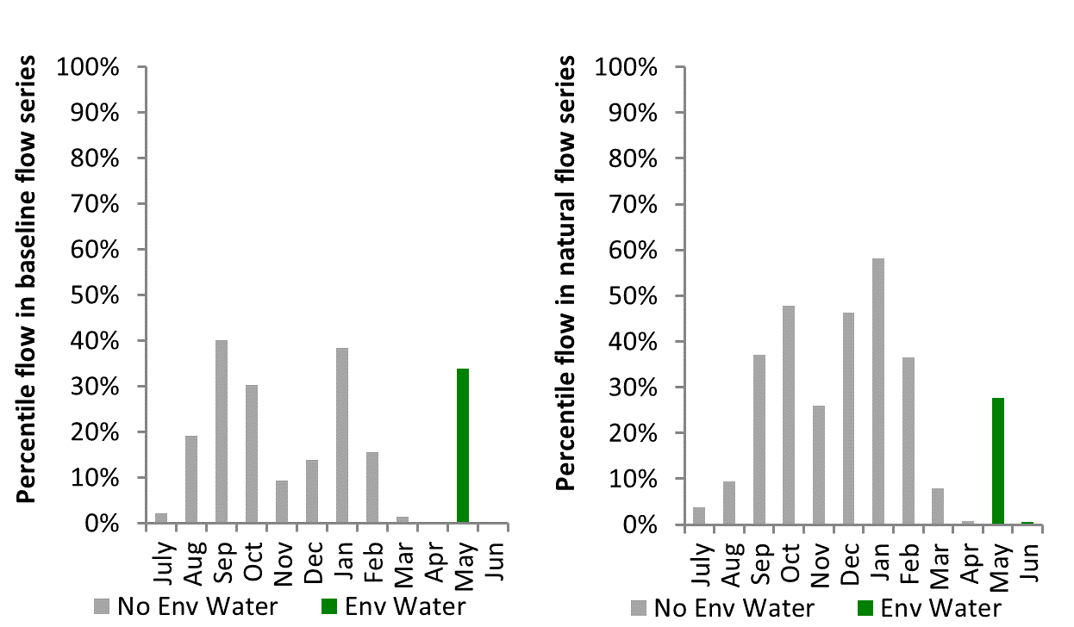
Figure BRD12: Contribution of environmental water delivery at Goondiwindi as percentiles in the natural and baseline flow series.

Lower Darling
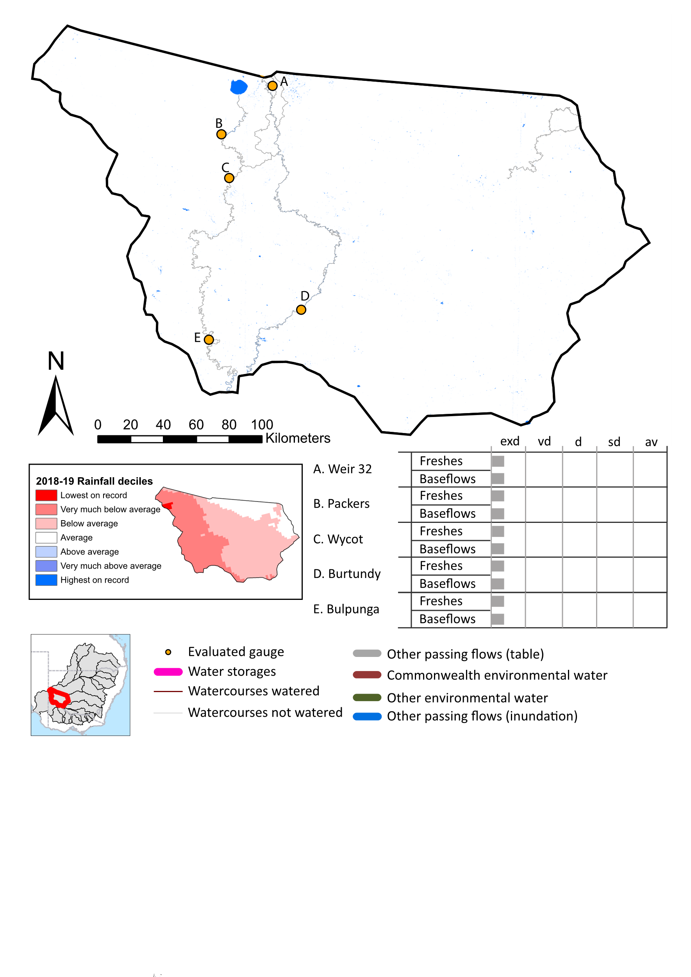Figure LDL1: Watercourses influenced, areas inundated (where applicable) and gauge stations evaluated in the Lower Darling valley during the 2018-19 water year. Inset bar graphs report the condition of annual flow regimes by showing the improvements in hydrological condition with the addition of environmental water as well as the hypothetical scenario in “grey” (if no environmental flow had been delivered) where exd=extremely dry, vd=very dry, d=dry, sd=somewhat dry and av=average. Rainfall conditions (rainfall deciles) and trend in storage levels for the water year are also shown.

Summary
The volume of environmental water delivery for the 2018-19 year in the Lower Darling valley is quantified using data for 5 sites. This evaluation only considers the contribution of held environmental water, which is a primary focus for the Commonwealth. The contributions of planned environmental water (e.g. passing flows), unregulated tributary inflows and clever use of irrigation flows for environmental benefits can all be very important but these are outside the scope of this report. Environmental watering actions lasted on average 0 days over the course of the year. The volume of environmental water at these 5 sites was between 0% and 0% of the total streamflow. Commonwealth environmental water contributed on average 0% of this environmental water. The contribution of environmental water delivery to improved flow regimes is evaluated using data for 5 sites. Ideally, baseflows should be maintained and long periods of excessively low flows avoided. In this valley, the baseflow regime was generally considered to be very dry relative to the pre-development flow regime. In our analysis, a low fresh refers to a period of increased flow, when the water level rises at least one eighth of the way up the river bank (above the low flow level). These low freshes are a regular part of the natural flow regime and support a range of natural processes. In the Lower Darling valley, in terms of the occurrence and duration of low freshes, the year was assessed as being extremely dry. In our analysis, a medium fresh refers to a period of increased flow, when the water level rises at least one quarter of the way up the river bank. These medium freshes are not as frequent as low freshes but are also a regular and important part of the natural flow regime. In the Lower Darling valley, in terms of the occurrence of medium freshes, the year was assessed as being extremely dry. In our analysis, a high fresh refers to a period of increased flow, when the water level rises more than half way up the river. A high fresh may not occur every year but they are still important and long periods without major freshes can have serious consequences for floodplains and their contribution to river connectivity. Delivering high in channel environmental flows normally requires that all risks to riparian landholders and infrastructure have been resolved. In the Lower Darling valley, in terms of the occurrence of high freshes, the year was assessed as being extremely dry.

Water delivery context
During the 2018-19, the Commonwealth Environmental Water Holder (CEWH) held water entitlements of up to 24,639 ML for environmental use in the Lower Darling valley. Each year, water utilities allocate water entitlement holders a percentage of water based on their holding, license type and carryover (the exact rules vary among Jurisdictions). In 2018-19, the Lower Darling entitlements held by the CEWH were allocated 3,075 ML of water, representing 14% of the Long term average annual yield for the Lower Darling valley (22,333 ML). Information and data relating to the portfolio of held Commonwealth environmental water is shown in Table LDL2.
The 2018-19 water allocation (3,075 ML) together with the carryover volume of 533 ML of water meant the CEWH had 3,608 ML of water available for delivery. A total of 0 ML of Commonwealth environmental water was delivered in the Lower Darling valley. A total of 0 ML of Commonwealth environmental water was traded to consumptive users and 3607 ML (100%) of available Commonwealth environmental water was carried over for environmental use into the 2019-20 water year.

Environmental conditions and resource availability
The water available for environmental delivery combined with the present and antecedent environmental conditions are key inputs used by environmental water managers in planning and implementing watering actions. Post hoc, this information provides important context when evaluating the effectiveness and appropriateness of environmental water use with respect to hydrological outputs.
The rainfall conditions in the Lower Darling valley were classified as Below average, based on rainfall percentile data for the entire record held by the Bureau of Meteorology for this valley. The water held in major storages in the Lower Darling valley decreased over the water year, for example Meninde dam was 11.9% full at the beginning of the water year and 0.9% full by the end of the year (Figure LDL1).
The Commonwealth Environmental Water Office (CEWO) calculates resource availability scenarios (RAS) to guide the use and prioritisation of held environmental water. The RAS are progressively calculated over the year as part of the continual adaptive management planning processes. The RAS are based on the availability of held environmental water (including progressive license acquisitions and allocations) as well as the potential for unregulated or planned environmental flows. The outcome is then used to determine the demand for environmental water across the basin.
In 2018-19, the resource availability of held Commonwealth environmental water was classified as very low in this valley. The physical conditions meant that the CEWO was managing to protect and/or improve the condition of most environmental assets, while seeking to avoid irreversible damage or decline to the Coorong and Lower Darling Region (where feasible). The overall demand for environmental water was deemed moderate.

Watering actions

Commonwealth environmental water was not delivered in the Lower Darling during the 2018-19 water year.

Contribution of Commonwealth environmental water to flow regimes

Weir32
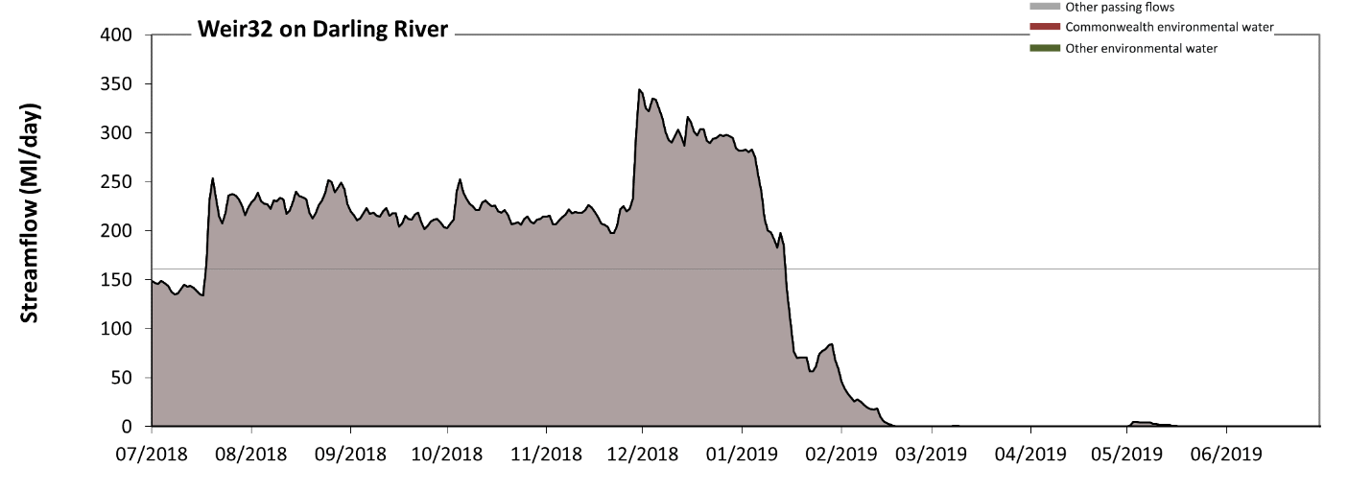
Figure LDL1: Contribution of environmental water delivery at Weir 32. Horizontal lines indicate thresholds for very low flows and low flows (from lowest to highest).
There was no environmental water delivered at Weir32 on Darling River. Without environmental water, the durations of very low flows (i.e. < 160 Ml/day) in the periods July to September, January to March and April to June was substantially in excess of durations expected in an average year in the natural flow regime. Similarly, without environmental water, the durations of medium low flows (i.e. < 810 Ml/day) in the periods July to September, October to December, January to March and April to June was substantially in excess of durations expected in an average year in the natural flow regime.
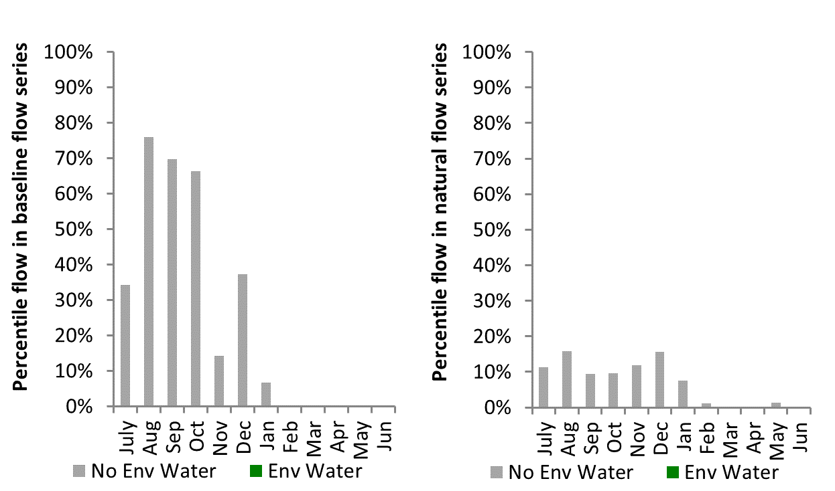
Figure LDL2: Contribution of environmental water delivery at Weir 32 as percentiles in the natural and baseline flow series.
Burtundy
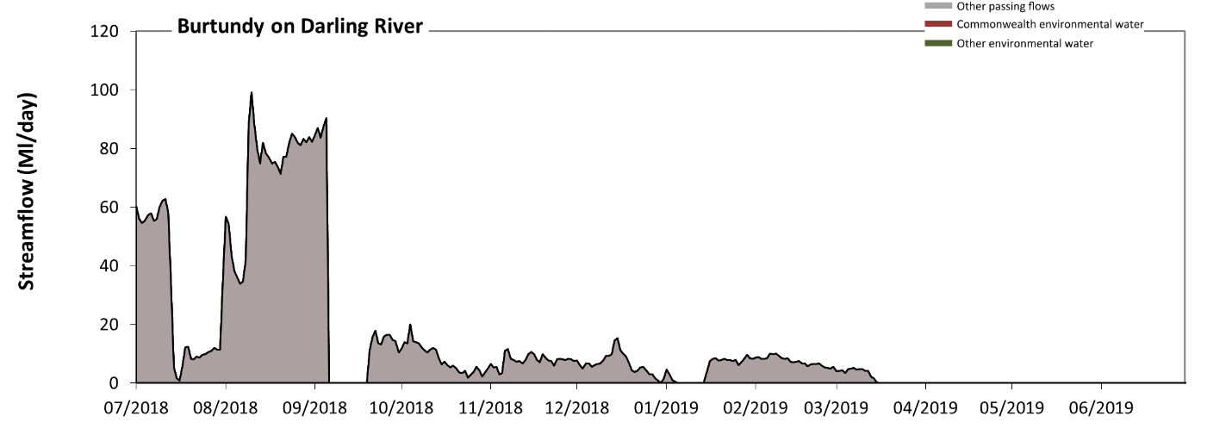
Figure LDL3: Contribution of environmental water delivery at Burtundy. Horizontal lines indicate thresholds for very low flows and low flows (from lowest to highest).
There was no environmental water delivered at Burtundy on Darling River. Without environmental water, the durations of very low flows (i.e. < 120 Ml/day) in the periods July to September, October to December, January to March and April to June was substantially in excess of durations expected in an average year in the natural flow regime. Similarly, without environmental water, the durations of medium low flows (i.e. < 590 Ml/day) in the periods July to September, October to December, January to March and April to June was substantially in excess of durations expected in an average year in the natural flow regime.
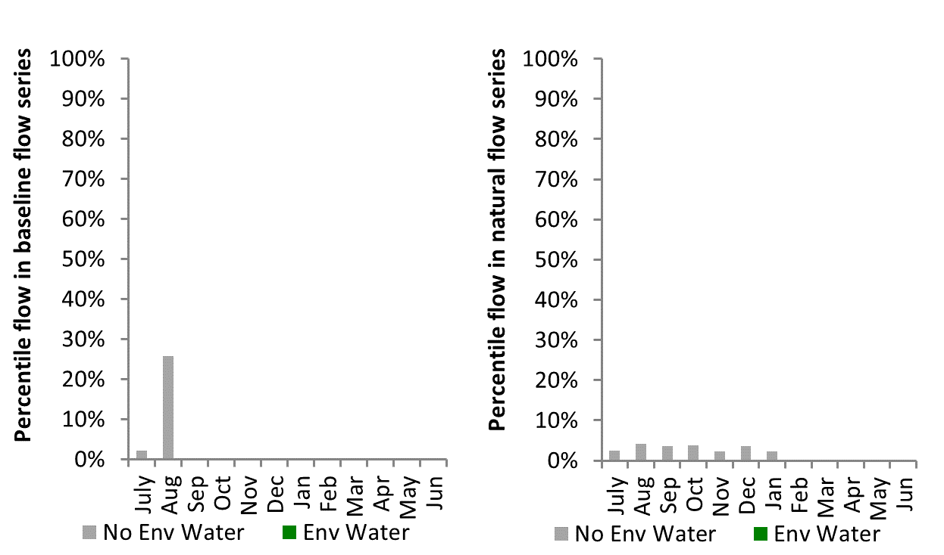
Figure LDL4: Contribution of environmental water delivery at Burtundy as percentiles in the natural and baseline flow series.

Packers
No streamflow occurred at Packers in the 2018-19 water year.
Wycot
No streamflow occurred at Wycot in the 2018-19 water year.
Bulpunga
No streamflow occurred at Bulpunga in the 2018-19 water year.

Goulburn
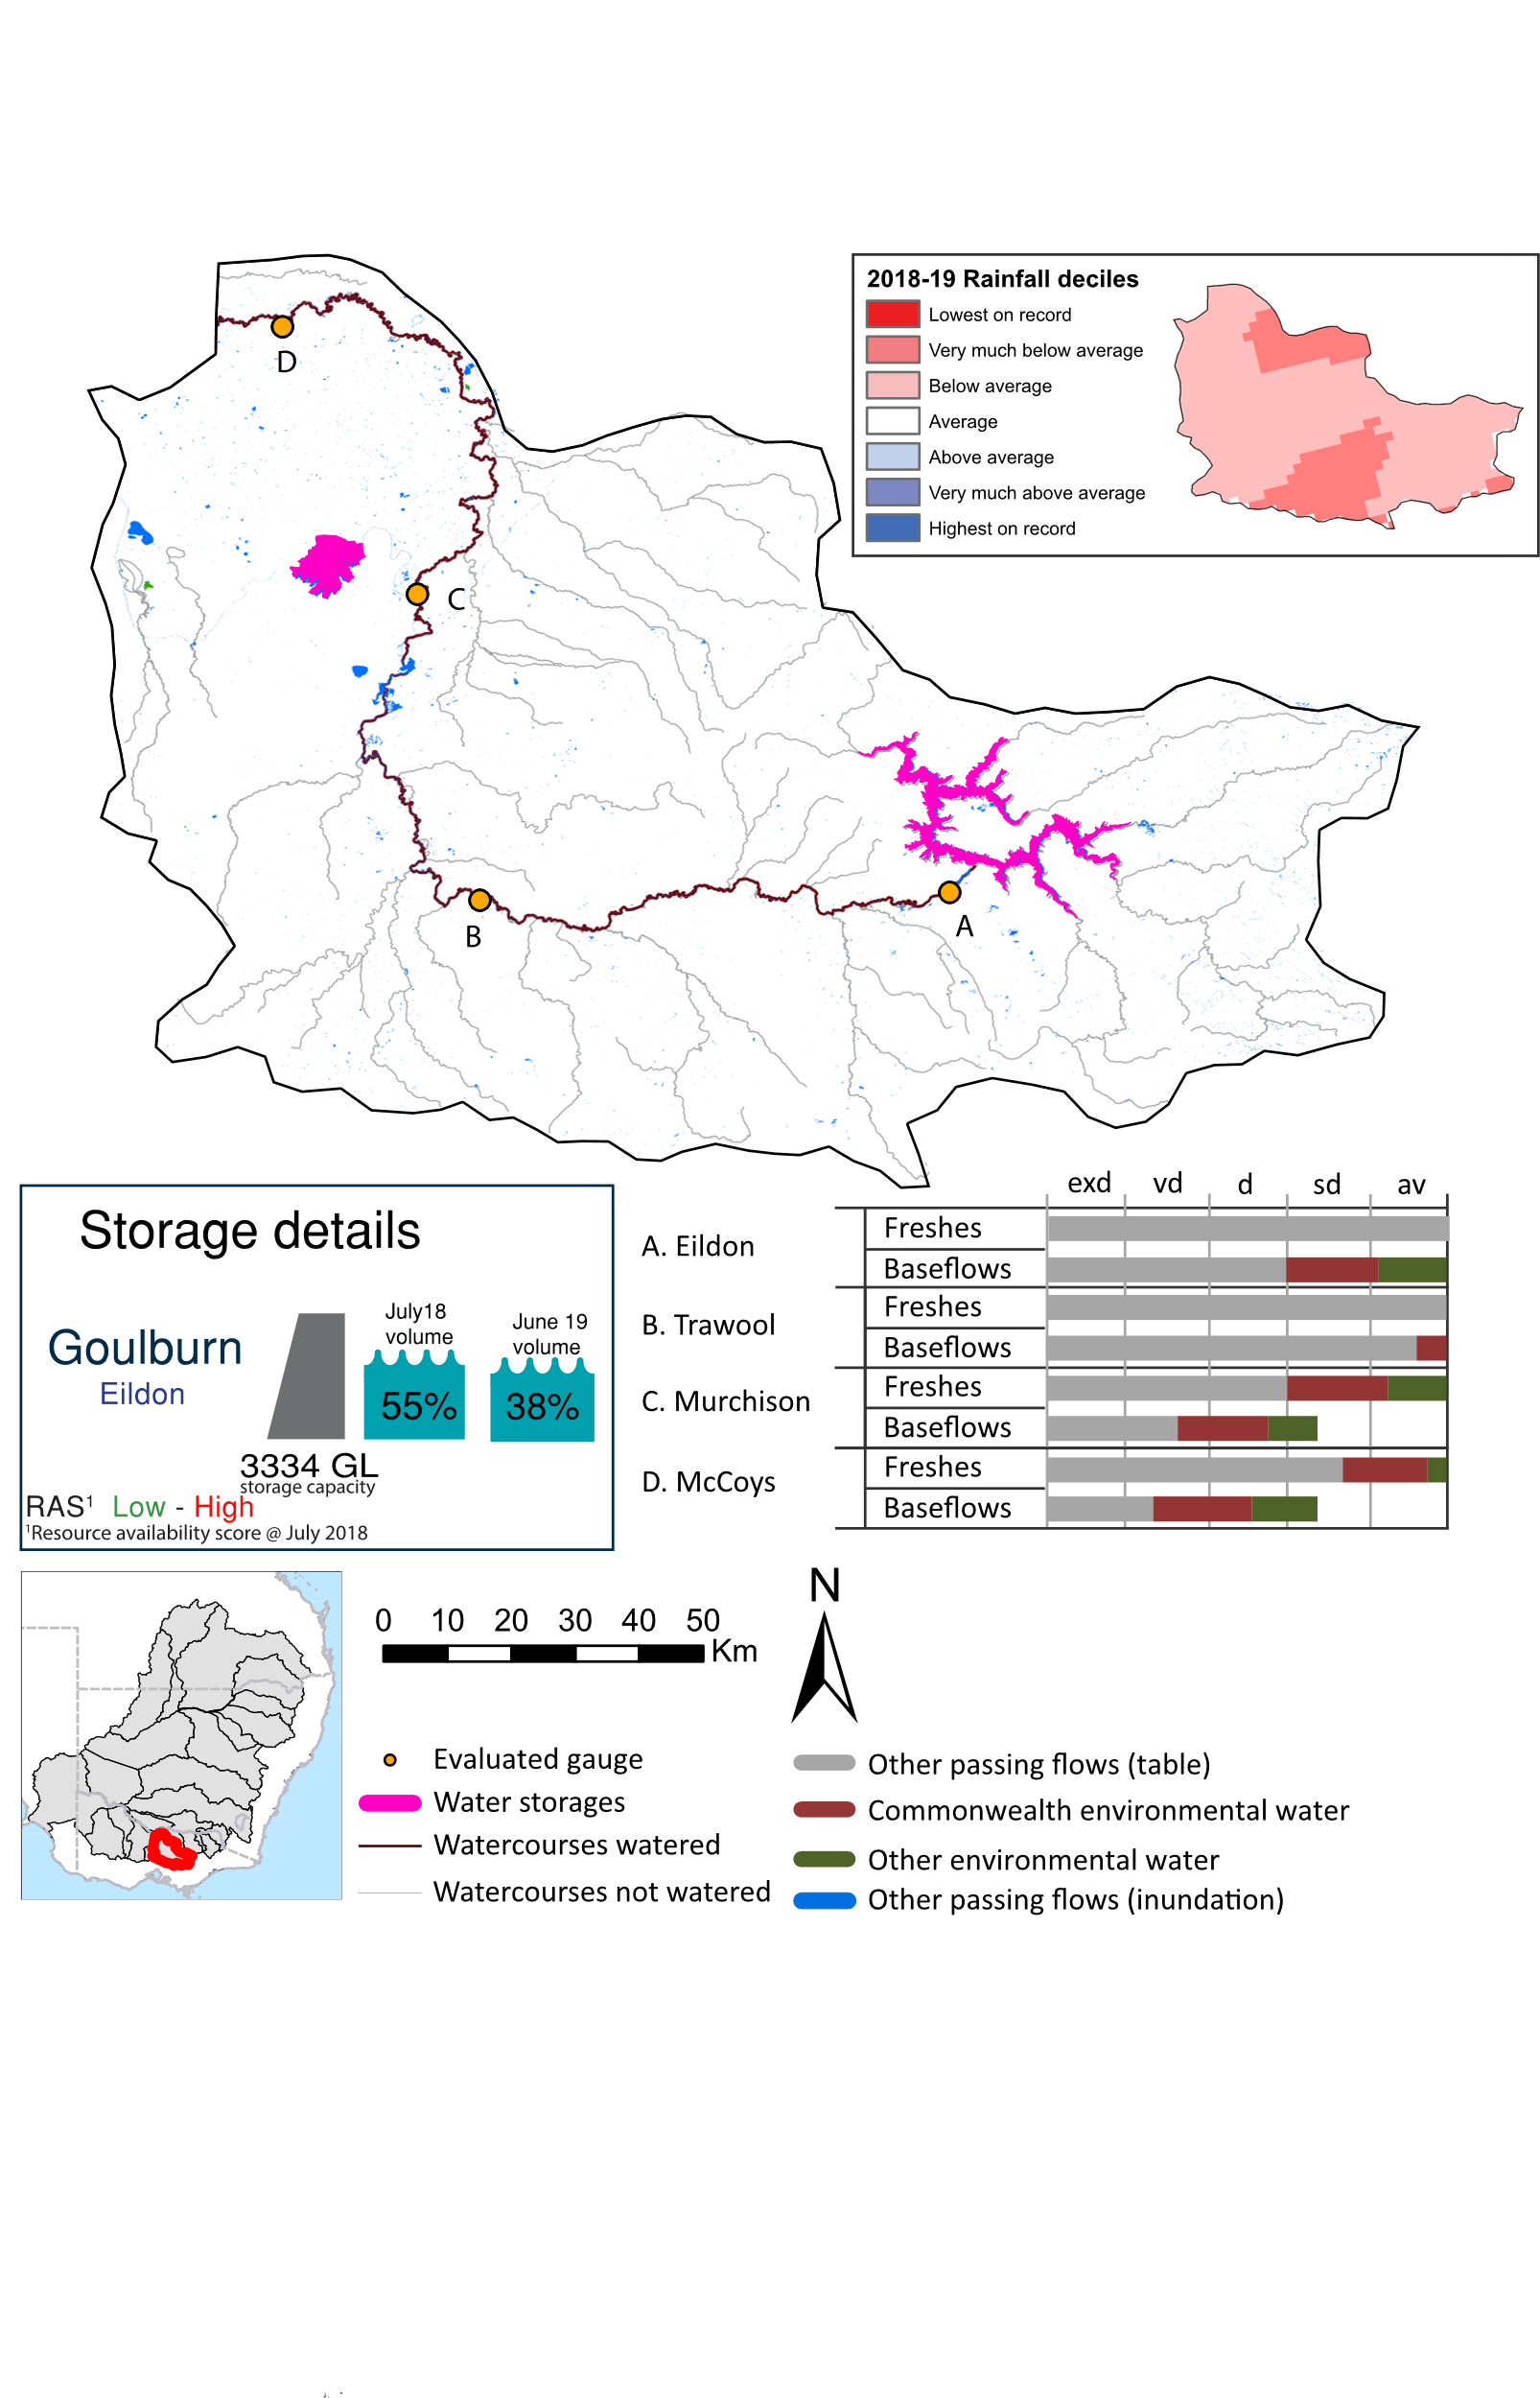Figure GLB1: Watercourses influenced, areas inundated (where applicable) and gauge stations evaluated in the Goulburn valley during the 2018-19 water year. Inset bar graphs report the condition of annual flow regimes by showing the improvements in hydrological condition with the addition of environmental water as well as the hypothetical scenario in “grey” (if no environmental flow had been delivered) where exd=extremely dry, vd=very dry, d=dry, sd=somewhat dry and av=average. Rainfall conditions (rainfall deciles) and trend in storage levels for the water year are also shown.

Summary
The volume of environmental water delivery for the 2018-19 year in the Goulburn valley is quantified using data for 4 sites. This evaluation only considers the contribution of held environmental water, which is a primary focus for the Commonwealth. The contributions of planned environmental water (e.g. passing flows), unregulated tributary inflows and clever use of irrigation flows for environmental benefits can all be very important but these are outside the scope of this report. Environmental watering actions lasted on average 109 days over the course of the year. The volume of environmental water at these 4 sites was between 11% and 31% of the total streamflow. Commonwealth environmental water contributed on average 80% of this environmental water. The contribution of environmental water delivery to improved flow regimes is evaluated using data for 4 sites. Ideally, baseflows should be maintained and long periods of excessively low flows avoided. In this valley, the baseflow regime was generally considered to be somewhat dry relative to the pre-development flow regime. In our analysis, a low fresh refers to a period of increased flow, when the water level rises at least one eighth of the way up the river bank (above the low flow level). These low freshes are a regular part of the natural flow regime and support a range of natural processes. In the Goulburn valley, in terms of the occurrence and duration of low freshes, the year was assessed as being average. In our analysis, a medium fresh refers to a period of increased flow, when the water level rises at least one quarter of the way up the river bank. These medium freshes are not as frequent as low freshes but are also a regular and important part of the natural flow regime. In the Goulburn valley, in terms of the occurrence of medium freshes, the year was assessed as being average. In our analysis, a high fresh refers to a period of increased flow, when the water level rises more than half way up the river. A high fresh may not occur every year but they are still important and long periods without major freshes can have serious consequences for floodplains and their contribution to river connectivity. Delivering high in channel environmental flows normally requires that all risks to riparian landholders and infrastructure have been resolved. In the Goulburn valley, in terms of the occurrence of high freshes, the year was assessed as being average.

Water delivery context
During the 2018-19, the Commonwealth Environmental Water Holder (CEWH) held water entitlements of up to 359,920 ML for environmental use in the Goulburn valley. Each year, water utilities allocate water entitlement holders a percentage of water based on their holding, license type and carryover (the exact rules vary among Jurisdictions). In 2018-19, the Goulburn entitlements held by the CEWH were allocated 285,205 ML of water, representing 89% of the Long term average annual yield for the Goulburn valley (319,786 ML). Information and data relating to the portfolio of held Commonwealth environmental water is shown in Table GLB2.
The 2018-19 water allocation (285,205 ML) together with the carryover volume of 73,913 ML of water meant the CEWH had 359,119 ML of water available for delivery. A total of 200,166 ML of Commonwealth environmental water was delivered in the Goulburn valley. A total of 0 ML of Commonwealth environmental water was traded to consumptive users and 128,923 ML (36%) of available Commonwealth environmental water was carried over for environmental use into the 2019-20 water year.

Environmental conditions and resource availability
The water available for environmental delivery combined with the present and antecedent environmental conditions are key inputs used by environmental water managers in planning and implementing watering actions. Post hoc, this information provides important context when evaluating the effectiveness and appropriateness of environmental water use with respect to hydrological outputs.
The rainfall conditions in the Goulburn valley were classified as Below average, based on rainfall percentile data for the entire record held by the Bureau of Meteorology for this valley. The water held in major storages in the Goulburn valley decreased over the water year, for example Eildon dam was 54.0% full at the beginning of the water year and 38.1% full by the end of the year (Figure GLB1).
The Commonwealth Environmental Water Office (CEWO) calculates resource availability scenarios (RAS) to guide the use and prioritisation of held environmental water. The RAS are progressively calculated over the year as part of the continual adaptive management planning processes. The RAS are based on the availability of held environmental water (including progressive license acquisitions and allocations) as well as the potential for unregulated or planned environmental flows. The outcome is then used to determine the demand for environmental water across the basin.
In 2018-19, the resource availability of held Commonwealth environmental water was classified as low to high. The physical conditions meant that the CEWO was managing to protect and improve the aquatic and riparian vegetation, maintain water quality, and support native fish and other biota via habitat provision. The overall demand for environmental water was deemed high to moderate.

Watering actions
A total of 4 watering actions were delivered over the 2018-19 water year, the duration of these actions varied (range of individual actions: 31 - 74 days) and Commonwealth environmental water was delivered for a total of 195 days. The number of water actions commencing in each season included, Autumn (1), Spring (1), Summer (0), Winter(2). Similarly, the count of flow component types delivered in the Goulburn valley were; (2) baseflow, (0) baseflow-fresh, (2) fresh, (0) fresh-overbank, (0) bankfull, (0) overbank, (0) wetland and (0) wetland-fresh.
In this valley, primary objectives of most watering actions was related to other biota and vegetation purposes, but water was also delivered for other purposes too. The percentage of watering actions delivered across the nine main themes included primary objectives for fish (25%), vegetation (37.5%), waterbirds (0%), frogs (0%), other biota (37.5%), connectivity (0%), process (0%), resilience (0%) and water quality (0%).
Table GLB2. Commonwealth environmental water accounting information for the Goulburn valley over 2018-19 water year.
Total registered volume (ML) | Allocated volume (ML) | Carry over + allocated volume (ML) | Delivered (ML) | LTAAY (ML) | Trade (ML) | Carried over to 2019-20 | Forfeited (ML)
359,920 | 285,205 | 359,119 | 200,166 | 319,786 | 0 | 128,924 | 0

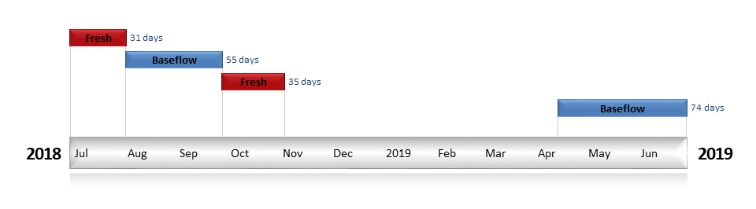
Figure GLB2. Timing and duration of Commonwealth environmental water actions delivered in the Goulburn valley.

Contribution of Commonwealth environmental water to flow regimes

Eildon
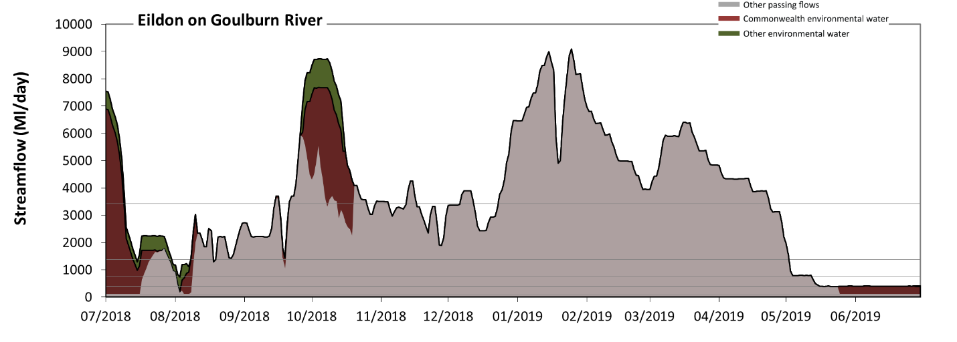
Figure GLB3: Contribution of environmental water delivery at Eildon. Horizontal lines indicate thresholds for very low flows, low flows, low freshes, medium freshes and high freshes (from lowest to highest).
At Eildon on Goulburn River, environmental water contributed 13% of the total streamflow volume (much of which was Commonwealth environmental water). Environmental watering actions affected streamflows for 30% of days between 1 July 2018 and 30 June 2019. Flow regulation does not substantially increase the duration of very low flows (i.e. < 79 Ml/day) compared to an average year in the natural flow regime. However, without environmental water, the durations of medium low flows (i.e. < 400 Ml/day) in the periods July to September and April to June would have substantially exceeded durations expected in an average year in the natural flow regime. Environmental water mitigated these impacts by reducing the cumulative duration of medium low flow spells from 18% to 3% of the year, with greatest influence in the periods July to September and April to June. Commonwealth environmental water made the dominant contribution to these enhancements of environmental baseflows at this site. There was at least one low fresh (i.e. > 780 Ml/day) in the periods July to September, October to December, January to March and April to June. Environmental water made little change to the duration of these low freshes. In the absence of environmental water there would have been at least one medium fresh (i.e. > 1400 Ml/day) in the periods July to September, October to December, January to March and April to June. Environmental water increased the duration of the longest medium fresh during the period July to September (from 31 days to 43 days). Commonwealth environmental water was entirely responsible for these increased durations of medium freshes. In the absence of environmental water there would have been at least one high fresh in the periods July to September, October to December, January to March and April to June. Environmental water increased the duration of the longest medium fresh during the period October to December (from 8 days to 25 days). Commonwealth environmental water made the dominant contribution to these increased durations of high freshes.
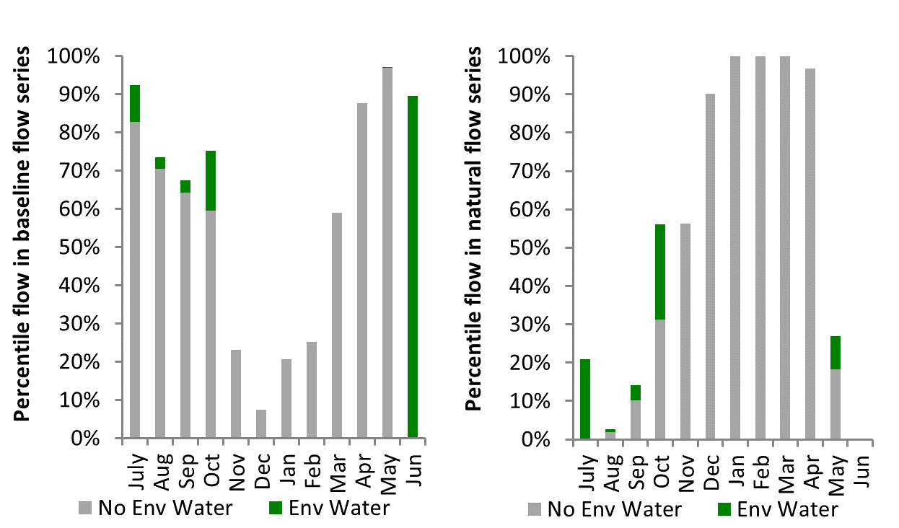
Figure GLB4: Contribution of environmental water delivery at Eildon as percentiles in the natural and baseline flow series.
Trawool
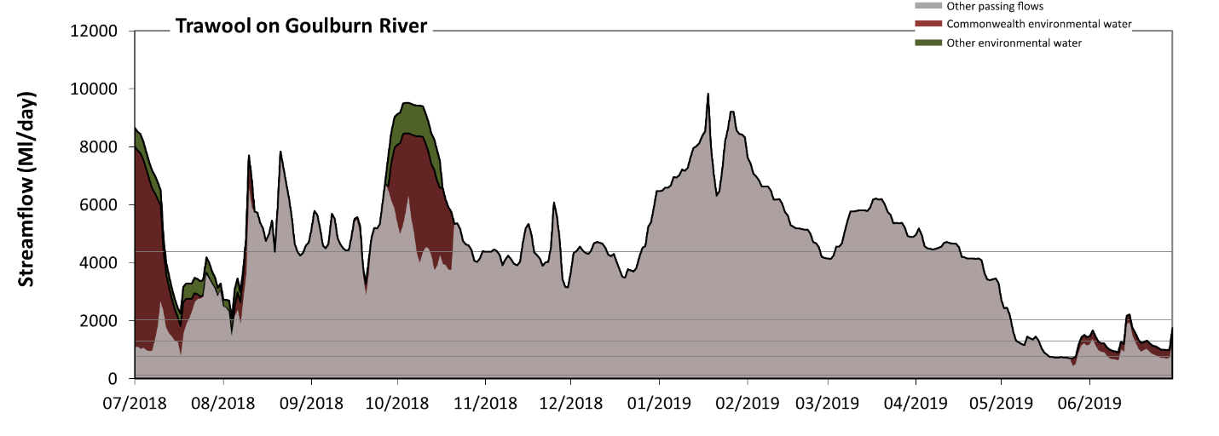
Figure GLB5: Contribution of environmental water delivery at Trawool. Horizontal lines indicate thresholds for very low flows, low flows, low freshes, medium freshes and high freshes (from lowest to highest).
At Trawool on Goulburn River, environmental water contributed 11% of the total streamflow volume (much of which was Commonwealth environmental water). Environmental watering actions affected streamflows for 30% of days between 1 July 2018 and 30 June 2019. Flow regulation does not substantially increase the duration of very low flows (i.e. < 130 Ml/day) compared to an average year in the natural flow regime. However, without environmental water, the duration of medium low flows (i.e. < 770 Ml/day) in the period April to June would have substantially exceeded durations expected in an average year in the natural flow regime. Environmental water mitigated these impacts by reducing the cumulative duration of medium low flow spells from 5% to 2% of the year, with greatest influence in the period April to June. Commonwealth environmental water was entirely responsible for these enhancements of environmental baseflows at this site. There was at least one low fresh (i.e. > 1300 Ml/day) in the periods July to September, October to December, January to March and April to June. Environmental water made little change to the duration of these low freshes. In the absence of environmental water there would have been at least one medium fresh (i.e. > 2000 Ml/day) in the periods July to September, October to December, January to March and April to June. Environmental water increased the duration of the longest medium fresh during the period July to September (from 54 days to 92 days). Commonwealth environmental water equally shared responsibility with other environmental water holders for these increased durations of medium freshes. In the absence of environmental water there would have been at least one high fresh in the periods July to September, October to December, January to March and April to June. Environmental water increased the duration of the longest medium fresh during the period October to December (from 7 days to 27 days). Commonwealth environmental water made the dominant contribution to these increased durations of high freshes.
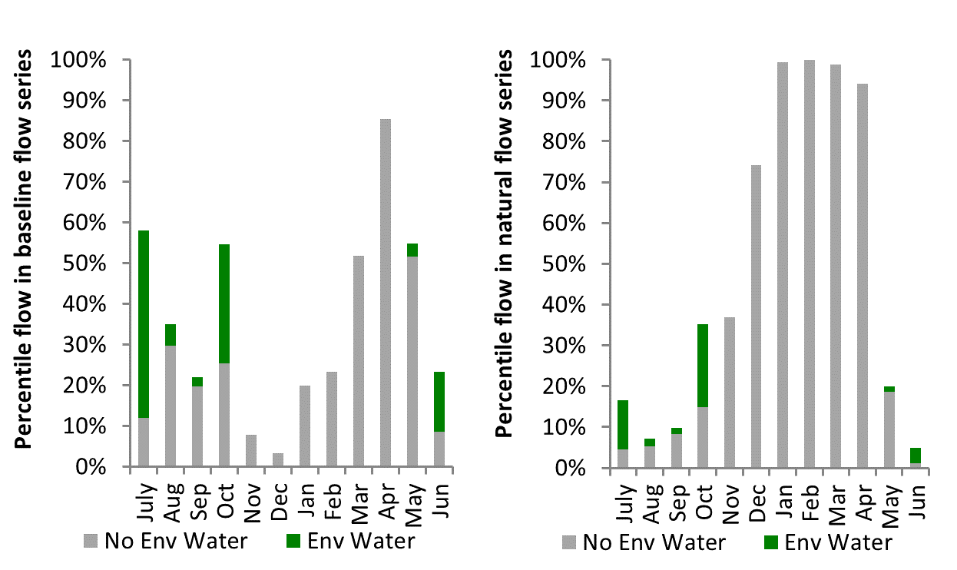
Figure GLB6: Contribution of environmental water delivery at Trawool as percentiles in the natural and baseline flow series.
Murchison
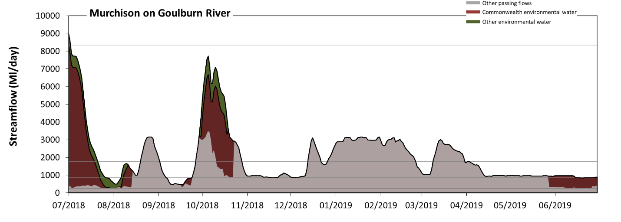
Figure GLB7: Contribution of environmental water delivery at Murchison. Horizontal lines indicate thresholds for very low flows, low flows, low freshes, medium freshes and high freshes (from lowest to highest).
At Murchison on Goulburn River, environmental water contributed 30% of the total streamflow volume (most of which was Commonwealth environmental water). Environmental watering actions affected streamflows for 30% of days between 1 July 2018 and 30 June 2019. Flow regulation does not substantially increase the duration of very low flows (i.e. < 250 Ml/day) compared to an average year in the natural flow regime. However, without environmental water, the durations of medium low flows (i.e. < 870 Ml/day) in the periods July to September, October to December and April to June would have substantially exceeded durations expected in an average year in the natural flow regime. Environmental water mitigated these impacts by reducing the cumulative duration of medium low flow spells from 28% to 14% of the year, with greatest influence in the periods July to September and April to June. Environmental water increased the magnitude of flows below this medium low flow threshold with the result that low flows were generally far below the medium low flow threshold. Commonwealth environmental water made the dominant contribution to these enhancements of environmental baseflows at this site. In the absence of environmental water there would have been at least one low fresh (i.e. > 1800 Ml/day) in the periods July to September, October to December, January to March and April to June. Environmental water increased the duration of the longest low fresh during the periods July to September (from 13 days to 20 days) and October to December (from 10 days to 28 days). Commonwealth environmental water was almost entirely responsible for these increased durations of low freshes. In the absence of environmental water there would have been at least one medium fresh (i.e. > 3200 Ml/day) in the period October to December. Environmental water increased the duration of the longest medium fresh during the periods July to September (from 0 days to 14 days) and October to December (from 3 days to 19 days). Commonwealth environmental water made the dominant contribution to these increased durations of medium freshes. There was no high freshes (i.e. > 8300 Ml/day) this year. Environmental water increased the duration of the longest medium fresh during the period July to September (from 0 days to 2 days). Commonwealth environmental water equally shared responsibility with other environmental water holders for these increased durations of high freshes.
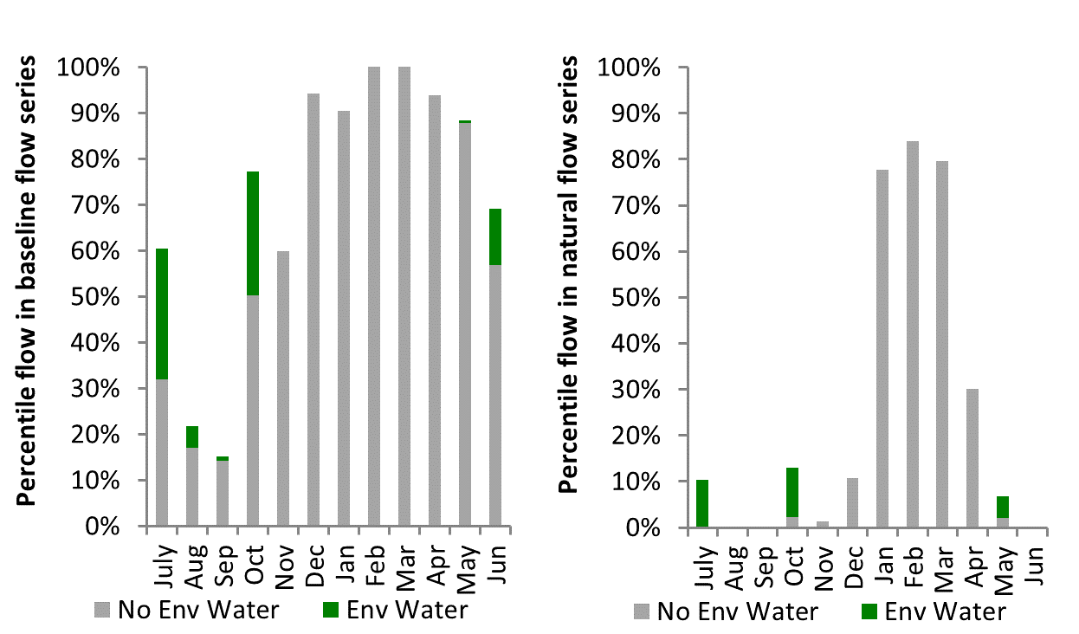
Figure GLB8: Contribution of environmental water delivery at Murchison as percentiles in the natural and baseline flow series.
McCoys
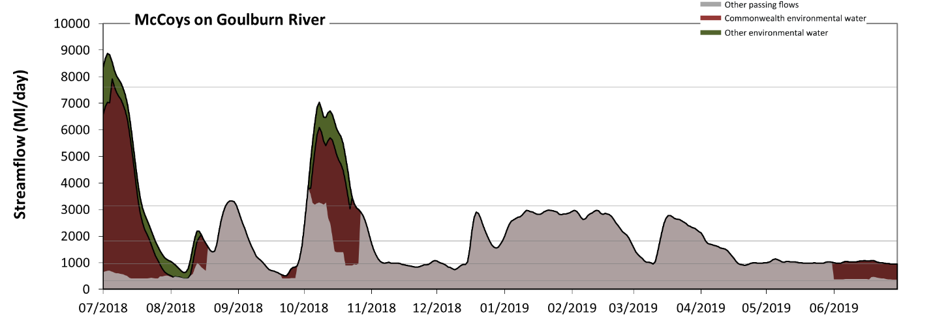
Figure GLB9: Contribution of environmental water delivery at McCoys. Horizontal lines indicate thresholds for very low flows, low flows, low freshes, medium freshes and high freshes (from lowest to highest).
At McCoys on Goulburn River, environmental water contributed 31% of the total streamflow volume (most of which was Commonwealth environmental water). Environmental watering actions affected streamflows for 30% of days between 1 July 2018 and 30 June 2019. Flow regulation does not substantially increase the duration of very low flows (i.e. < 310 Ml/day) compared to an average year in the natural flow regime. However, without environmental water, the durations of medium low flows (i.e. < 960 Ml/day) in the periods July to September, October to December and April to June would have substantially exceeded durations expected in an average year in the natural flow regime. Environmental water mitigated these impacts by reducing the cumulative duration of medium low flow spells from 35% to 16% of the year, with greatest influence in the periods July to September and April to June. Commonwealth environmental water made the dominant contribution to these enhancements of environmental baseflows at this site. In the absence of environmental water there would have been at least one low fresh (i.e. > 1800 Ml/day) in the periods July to September, October to December, January to March and April to June. Environmental water increased the duration of the longest low fresh during the periods July to September (from 14 days to 24 days) and October to December (from 14 days to 31 days). Commonwealth environmental water was almost entirely responsible for these increased durations of low freshes. In the absence of environmental water there would have been at least one medium fresh (i.e. > 3100 Ml/day) in the periods July to September and October to December. Environmental water increased the duration of the longest medium fresh during the periods July to September (from 5 days to 18 days) and October to December (from 9 days to 22 days). Commonwealth environmental water was almost entirely responsible for these increased durations of medium freshes. There was no high freshes (i.e. > 7600 Ml/day) this year. Environmental water increased the duration of the longest medium fresh during the period July to September (from 0 days to 9 days). Commonwealth environmental water was entirely responsible for these increased durations of high freshes.
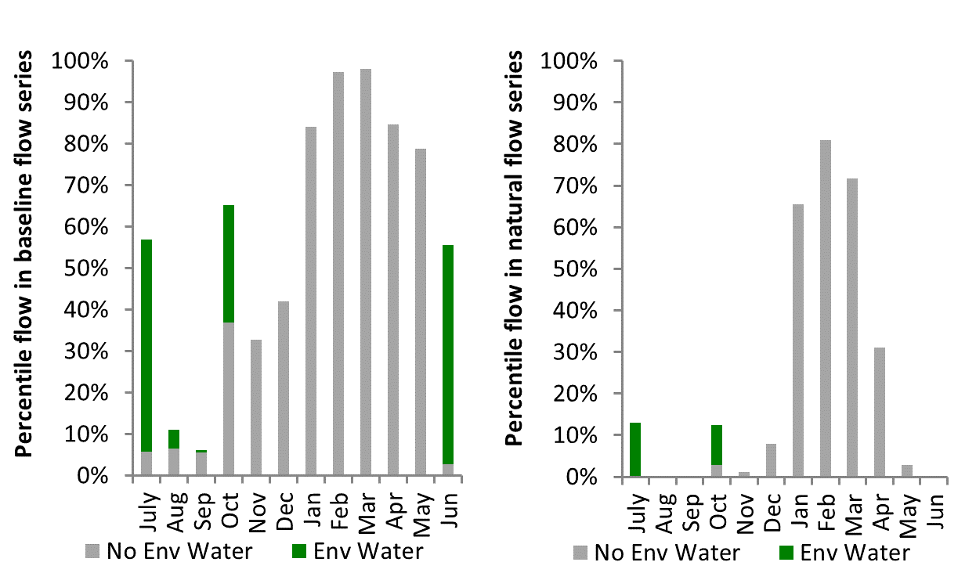
Figure GLB10: Contribution of environmental water delivery at McCoys as percentiles in the natural and baseline flow series.

Broken
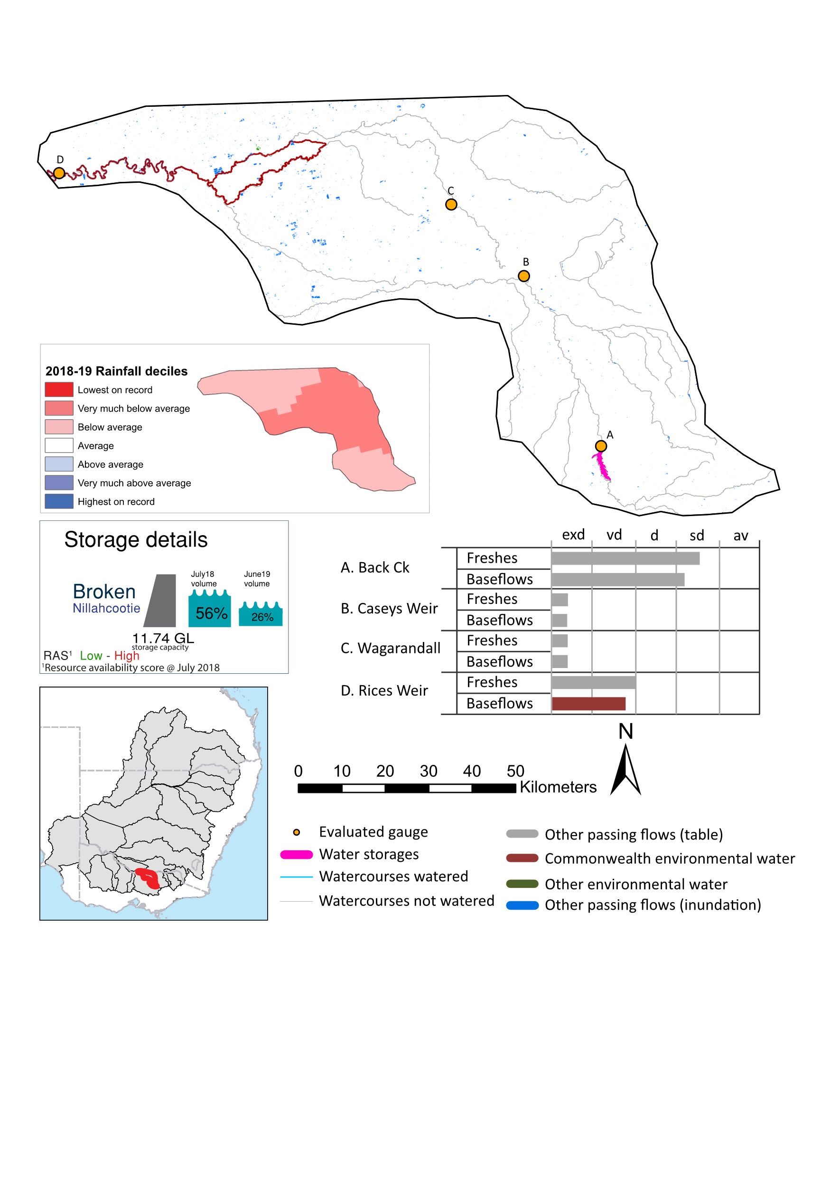
Figure BRK1: Watercourses influenced, areas inundated (where applicable) and gauge stations evaluated in the Broken valley during the 2018-19 water year. Inset bar graphs report the condition of annual flow regimes by showing the improvements in hydrological condition with the addition of environmental water as well as the hypothetical scenario in “grey” (if no environmental flow had been delivered) where exd=extremely dry, vd=very dry, d=dry, sd=somewhat dry and av=average. Rainfall conditions (rainfall deciles) and trend in storage levels for the water year are also shown.

Summary
The volume of environmental water delivery for the 2018-19 year in the Broken valley is quantified using data for 4 sites. This evaluation only considers the contribution of held environmental water, which is a primary focus for the Commonwealth. The contributions of planned environmental water (e.g. passing flows), unregulated tributary inflows and clever use of irrigation flows for environmental benefits can all be very important but these are outside the scope of this report. Environmental watering actions lasted on average 61 days over the course of the year. The volume of environmental water at these 4 sites was between 0% and 29% of the total streamflow. Commonwealth environmental water contributed on average 25% of this environmental water. The contribution of environmental water delivery to improved flow regimes is evaluated using data for 4 sites. Ideally, baseflows should be maintained and long periods of excessively low flows avoided. In this valley, the baseflow regime was generally considered to be very dry relative to the pre-development flow regime. In our analysis, a low fresh refers to a period of increased flow, when the water level rises at least one eighth of the way up the river bank (above the low flow level). These low freshes are a regular part of the natural flow regime and support a range of natural processes. In the Broken valley, in terms of the occurrence and duration of low freshes, the year was assessed as being dry. In our analysis, a medium fresh refers to a period of increased flow, when the water level rises at least one quarter of the way up the river bank. These medium freshes are not as frequent as low freshes but are also a regular and important part of the natural flow regime. In the Broken valley, in terms of the occurrence of medium freshes, the year was assessed as being very dry. In our analysis, a high fresh refers to a period of increased flow, when the water level rises more than half way up the river. A high fresh may not occur every year but they are still important and long periods without major freshes can have serious consequences for floodplains and their contribution to river connectivity. Delivering high in channel environmental flows normally requires that all risks to riparian landholders and infrastructure have been resolved. In the Broken valley, in terms of the occurrence of high freshes, the year was assessed as being extremely dry.

Water delivery context
During the 2018-19, the Commonwealth Environmental Water Holder (CEWH) held water entitlements of up to 538 ML for environmental use in the Broken valley. This entitlement is for use in the Broken River, Upper Broken Creek and Moodie Swamp only. Lower Broken Creek sources its CEW from Goulburn and Murray entitlements and is delivered via irrigation infrastructure. Each year, water utilities allocate water entitlement holders a percentage of water based on their holding, license type and carryover (the exact rules vary among Jurisdictions). In 2018-19, the Broken entitlements held by the CEWH were allocated 198 ML of water, representing 39% of the Long term average annual yield for the Broken valley (511 ML). Information and data relating to the portfolio of held Commonwealth environmental water is shown in Table BRK2.
The 2018-19 water allocation (198 ML) together with the carryover volume of 72 ML of water meant the CEWH had 270 ML of water available for delivery. A total of 27,539 ML of Commonwealth environmental water was delivered in the Broken valley including water sourced from the Goulburn and Murray entitlements and delivered in the lower Broken Creek. A total of 0 ML of Commonwealth environmental water was traded to consumptive users and 207 ML (77%) of available Commonwealth environmental water was carried over for environmental use into the 2019-20 water year.

Environmental conditions and resource availability
The water available for environmental delivery combined with the present and antecedent environmental conditions are key inputs used by environmental water managers in planning and implementing watering actions. Post hoc, this information provides important context when evaluating the effectiveness and appropriateness of environmental water use with respect to hydrological outputs.
The rainfall conditions in the Broken valley were classified as Very much below average, based on rainfall percentile data for the entire record held by the Bureau of Meteorology for this valley. The water held in major storages in the Broken valley decreased over the water year, for example Nilahcootie dam was 55.6% full at the beginning of the water year and 26.0% full by the end of the year (Figure BRK1).
The Commonwealth Environmental Water Office (CEWO) calculates resource availability scenarios (RAS) to guide the use and prioritisation of held environmental water. The RAS are progressively calculated over the year as part of the continual adaptive management planning processes. The RAS are based on the availability of held environmental water (including progressive license acquisitions and allocations) as well as the potential for unregulated or planned environmental flows. The outcome is then used to determine the demand for environmental water across the basin.
In 2018-19, the resource availability of held Commonwealth environmental water was classified as low to high. The physical conditions meant that the CEWO was managing to protect and improve the aquatic and riparian vegetation, maintain water quality, and support native fish and other biota via habitat provision. The overall demand for environmental water was deemed high to moderate.

Watering actions
A total of 5 watering actions were delivered over the 2018-19 water year, the duration of these actions varied (range of individual actions: 10 - 149 days) and Commonwealth environmental water was delivered for a total of 355 days. The number of water actions commencing in each season included, Autumn (0), Spring (0), Summer (1), Winter(4). Similarly, the count of flow component types delivered in the Broken valley were; (4) baseflow, (0) baseflow-fresh, (1) fresh, (0) fresh-overbank, (0) bankfull, (0) overbank, (0) wetland and (0) wetland-fresh.
In this valley, primary objectives of most watering actions was related to vegetation purposes, but water was also delivered for other purposes too. The percentage of watering actions delivered across the nine main themes included primary objectives for fish (0.0%), vegetation (57.14%), waterbirds (28.57%), frogs (0.0%), other biota (0.0%), connectivity (0.0%), process (0.0%), resilience (0.0%) and water quality (14.29%).
Table BRK2. Commonwealth environmental water accounting information for the Broken valley over 2018-19 water year.
Total registered volume (ML) | Allocated volume (ML) | Carry over + allocated volume (ML) | Delivered (ML) | LTAAY (ML) | Trade (ML) | Carried over to 2019-20 | Forfeited (ML)
538 | 198 | 270 | 27,539¹ | 511 | 0 | 208 | 46
¹ Includes water sourced from Murray and Goulburn entitlements.
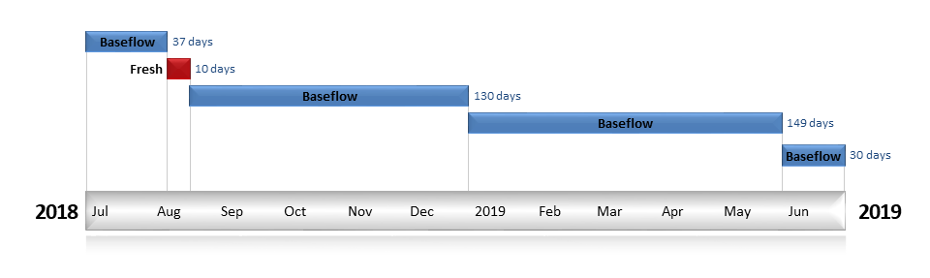
Figure BRK2. Timing and duration of Commonwealth environmental water actions delivered in the Broken valley.

Contribution of Commonwealth environmental water to flow regimes

Rices on the Lower Broken Creek
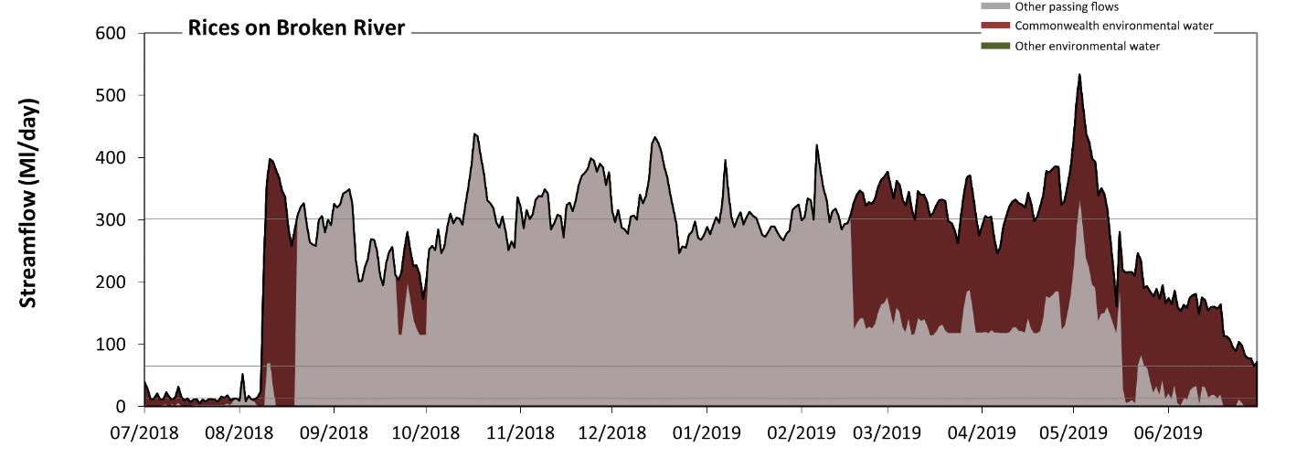
Figure BRK3: Contribution of environmental water delivery at Rices. Horizontal lines indicate thresholds for very low flows, low flows and low freshes (from lowest to highest).
At Rices on Broken Creek environmental water contributed 29% of the total streamflow volume (all of which was Commonwealth environmental water). Environmental watering actions affected streamflows for 51% of days between 1 July 2018 and 30 June 2019. Note that Rices Weir benefits from environmental water sourced from CEW entitlements in the Goulburn and Murray. Without environmental water, the durations of very low flows (i.e. < 13 Ml/day) in the periods July to September and April to June would have substantially exceeded durations expected in an average year in the natural flow regime. Environmental water mitigated these impacts by reducing the cumulative duration of very low flow spells from 18% to 6% of the year, with greatest influence in the periods July to September and April to June. Similarly, without environmental water, the durations of medium low flows (i.e. < 65 Ml/day) in the periods July to September and April to June would have substantially exceeded durations expected in an average year in the natural flow regime. Environmental water mitigated these impacts by reducing the cumulative duration of medium low flow spells from 25% to 11% of the year, with greatest influence in the period April to June. Commonwealth environmental water was entirely responsible for these enhancements of environmental baseflows at this site. In the absence of environmental water there would have been at least one low fresh (i.e. > 300 Ml/day) in the periods July to September, October to December, January to March and April to June. Environmental water increased the duration of the longest low fresh during the periods January to March (from 4 days to 21 days) and April to June (from 1 days to 24 days). Commonwealth environmental water was entirely responsible for these increased durations of low freshes. There was no medium or high freshes this year.
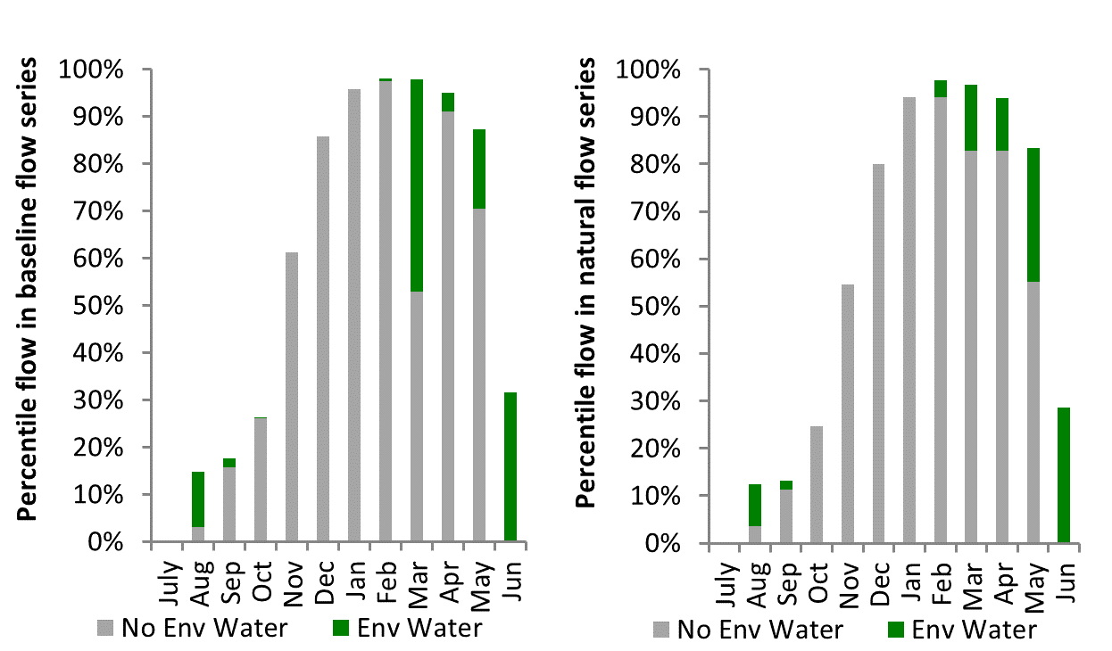
Figure BRK4: Contribution of environmental water delivery at Rices as percentiles in the natural and baseline flow series.
BackCk
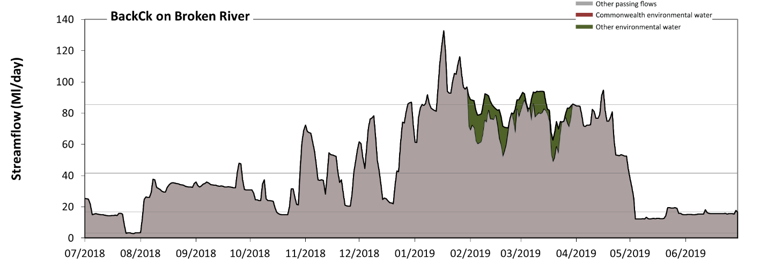
Figure BRK5: Contribution of environmental water delivery at BackCk. Horizontal lines indicate thresholds for very low flows, low flows, low freshes and medium freshes (from lowest to highest).
At BackCk, environmental water contributed 4% of the total streamflow volume (none of which was Commonwealth environmental water). Environmental watering actions affected streamflows for 15% of days between 1 July 2018 and 30 June 2019. Without environmental water, the duration of very low flows (i.e. < 3.4 Ml/day) in the period July to September would have substantially exceeded durations expected in an average year in the natural flow regime. However, environmental water had little effect on the duration of these very low flows, which occurred for 2% of the year. Similarly, without environmental water, the durations of medium low flows (i.e. < 17 Ml/day) in the periods July to September and April to June would have substantially exceeded durations expected in an average year in the natural flow regime. However, environmental water had little effect on the duration of these medium low flows, which occurred for 24% of the year. There was at least one low fresh (i.e. > 42 Ml/day) in the periods July to September, October to December, January to March and April to June. Environmental water made little change to the duration of these low freshes. There was at least one medium fresh (i.e. > 85 Ml/day) in the periods October to December, January to March and April to June. Environmental water made little change to the duration of these medium freshes. There was no high freshes (i.e. > 260 Ml/day) this year.
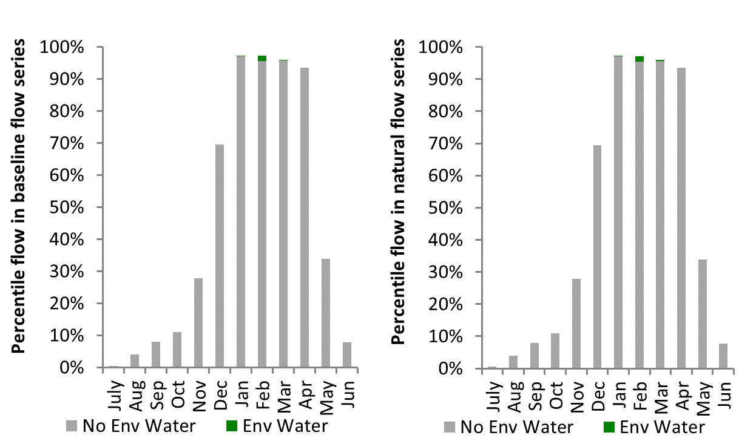
Figure BRK6: Contribution of environmental water delivery at BackCk as percentiles in the natural and baseline flow series.

CaseysWeir
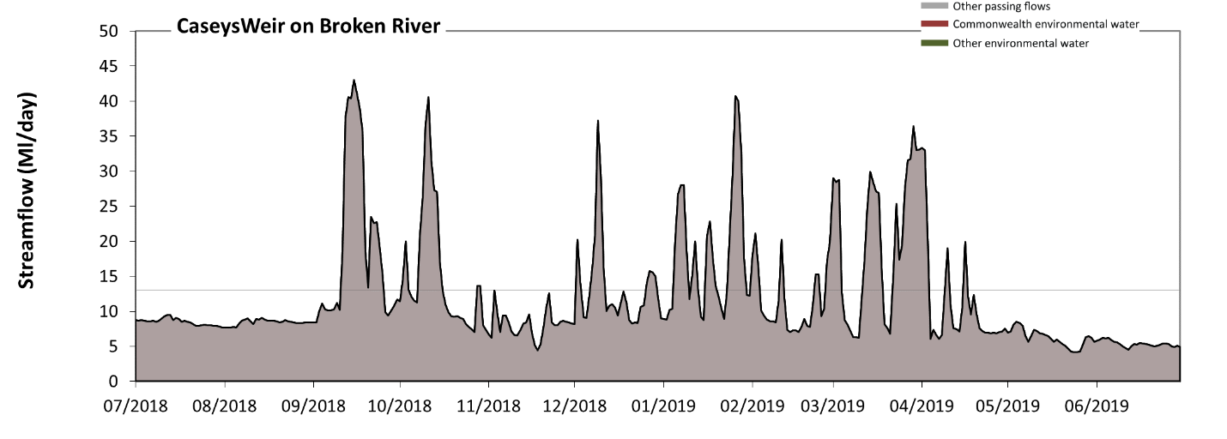
Figure BRK7: Contribution of environmental water delivery at CaseysWeir. Horizontal lines indicate thresholds for very low flows and low flows (from lowest to highest).
There was no environmental water delivered at Caseys Weir on Broken River. Without environmental water, the durations of very low flows (i.e. < 13 Ml/day) in the periods July to September, October to December, January to March and April to June was substantially in excess of durations expected in an average year in the natural flow regime. Similarly, without environmental water, the durations of medium low flows (i.e. < 65 Ml/day) in the periods July to September, October to December, January to March and April to June was substantially in excess of durations expected in an average year in the natural flow regime.
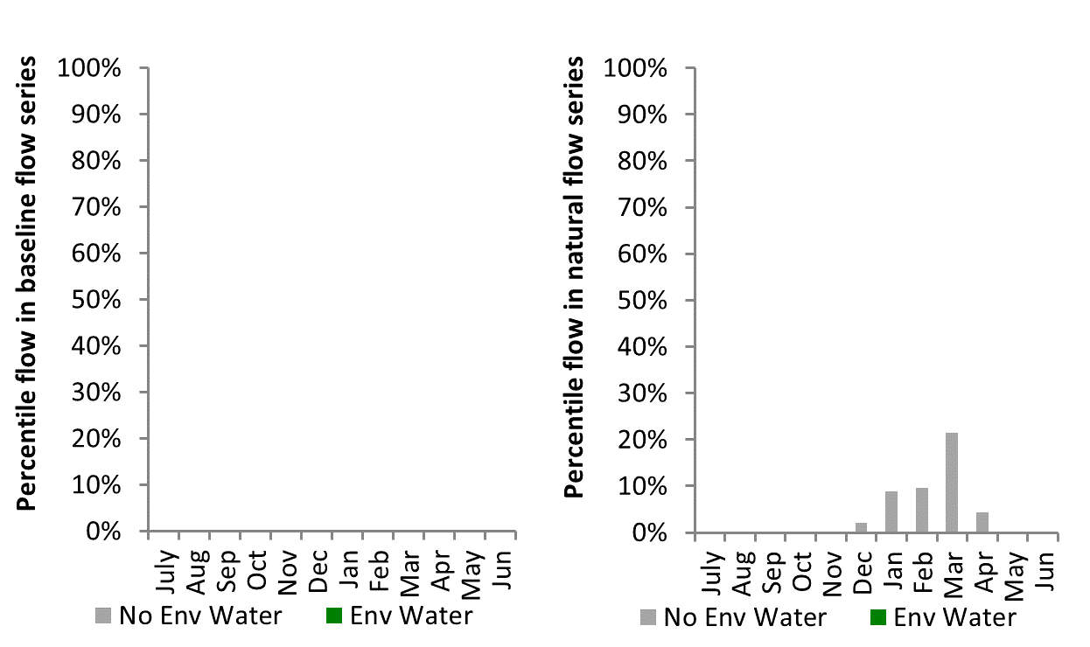
Figure BRK8: Contribution of environmental water delivery at CaseysWeir as percentiles in the natural and baseline flow series.
Wagarandall
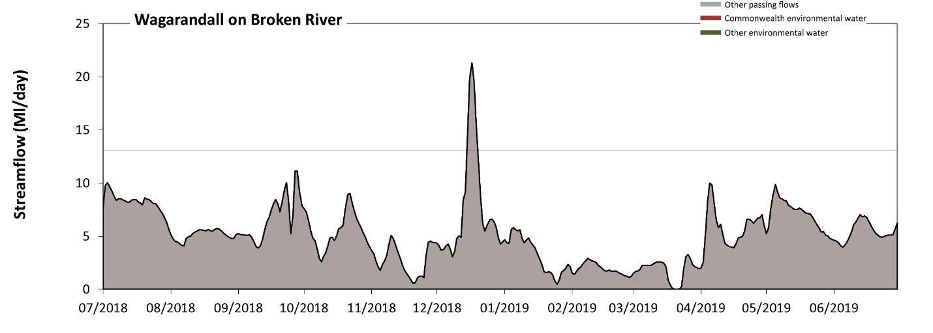
Figure BRK9: Contribution of environmental water delivery at Wagarandall. Horizontal lines indicate thresholds for very low flows and low flows (from lowest to highest).
There was no environmental water delivered at Wagarandall on Broken River. Without environmental water, the durations of very low flows (i.e. < 13 Ml/day) in the periods July to September, October to December, January to March and April to June was substantially in excess of durations expected in an average year in the natural flow regime. Similarly, without environmental water, the durations of medium low flows (i.e. < 65 Ml/day) in the periods July to September, October to December, January to March and April to June was substantially in excess of durations expected in an average year in the natural flow regime.
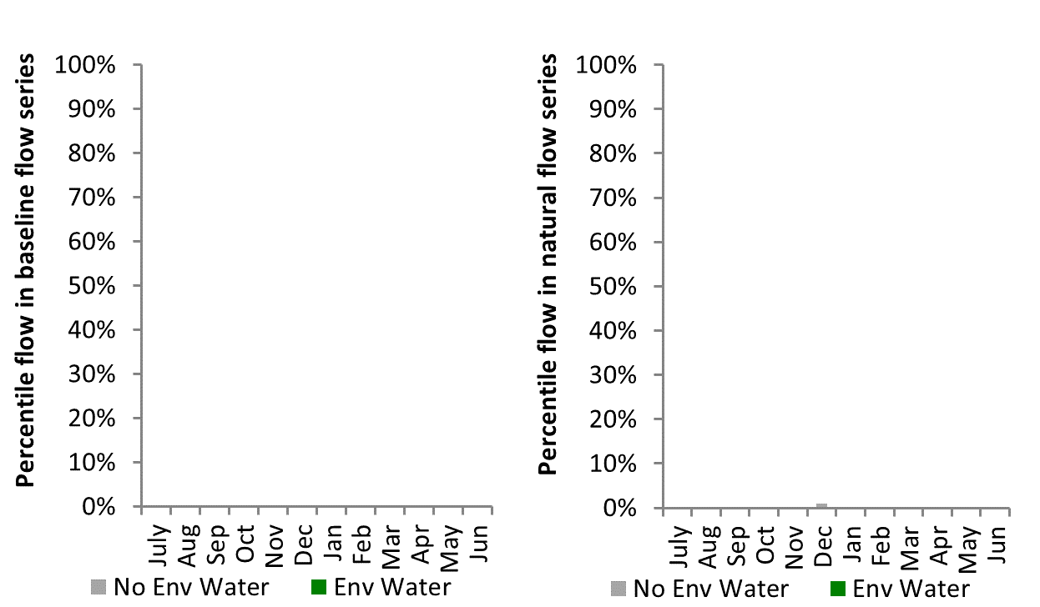
Figure BRK10: Contribution of environmental water delivery at Wagarandall as percentiles in the natural and baseline flow series

Campaspe
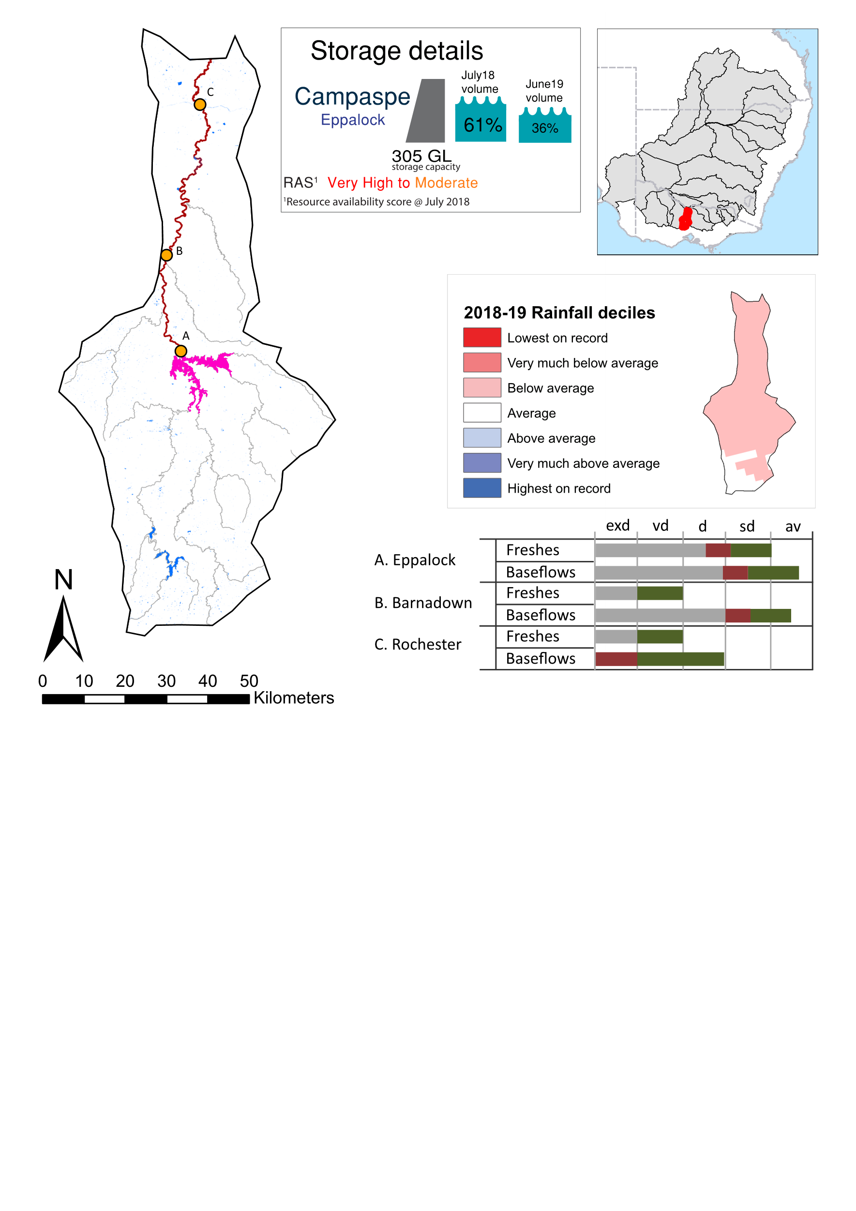Figure CMP1: Watercourses influenced, areas inundated (where applicable) and gauge stations evaluated in the Campaspe valley during the 2018-19 water year. Inset bar graphs report the condition of annual flow regimes by showing the improvements in hydrological condition with the addition of environmental water as well as the hypothetical scenario in “grey” (if no environmental flow had been delivered) where exd=extremely dry, vd=very dry, d=dry, sd=somewhat dry and av=average. Rainfall conditions (rainfall deciles) and trend in storage levels for the water year are also shown.

Summary
The volume of environmental water delivery for the 2018-19 year in the Campaspe valley is quantified using data for 3 sites. This evaluation only considers the contribution of held environmental water, which is a primary focus for the Commonwealth. The contributions of planned environmental water (e.g. passing flows), unregulated tributary inflows and clever use of irrigation flows for environmental benefits can all be very important but these are outside the scope of this report. Environmental watering actions lasted on average 173 days over the course of the year. The volume of environmental water at these 3 sites was between 35% and 46% of the total streamflow. Commonwealth environmental water contributed on average 16% of this environmental water. The contribution of environmental water delivery to improved flow regimes is evaluated using data for 3 sites. Ideally, baseflows should be maintained and long periods of excessively low flows avoided. In this valley, the baseflow regime was generally considered to be dry relative to the pre-development flow regime. In our analysis, a low fresh refers to a period of increased flow, when the water level rises at least one eighth of the way up the river bank (above the low flow level). These low freshes are a regular part of the natural flow regime and support a range of natural processes. In the Campaspe valley, in terms of the occurrence and duration of low freshes, the year was assessed as being dry. In our analysis, a medium fresh refers to a period of increased flow, when the water level rises at least one quarter of the way up the river bank. These medium freshes are not as frequent as low freshes but are also a regular and important part of the natural flow regime. In the Campaspe valley, in terms of the occurrence of medium freshes, the year was assessed as being dry. In our analysis, a high fresh refers to a period of increased flow, when the water level rises more than half way up the river. A high fresh may not occur every year but they are still important and long periods without major freshes can have serious consequences for floodplains and their contribution to river connectivity. Delivering high in channel environmental flows normally requires that all risks to riparian landholders and infrastructure have been resolved. In the Campaspe valley, in terms of the occurrence of high freshes, the year was assessed as being very dry.

Water delivery context
During the 2018-19, the Commonwealth Environmental Water Holder (CEWH) held water entitlements of up to 7,020 ML for environmental use in the Campaspe valley. Each year, water utilities allocate water entitlement holders a percentage of water based on their holding, license type and carryover (the exact rules vary among Jurisdictions). In 2018-19, the Campaspe entitlements held by the CEWH were allocated 6,624 ML of water, representing 102% of the Long term average annual yield for the Campaspe valley (6,485 ML). Information and data relating to the portfolio of held Commonwealth environmental water is shown in Table CMP2.
The 2018-19 water allocation (6,624 ML) together with the carryover volume of 186 ML of water meant the CEWH had 6,811 ML of water available for delivery. A total of 3,611 ML of Commonwealth environmental water was delivered in the Campaspe valley. A total of 0 ML of Commonwealth environmental water was traded to consumptive users and 2,898 ML (43%) of available Commonwealth environmental water was carried over for environmental use into the 2019-20 water year.

Environmental conditions and resource availability
The water available for environmental delivery combined with the present and antecedent environmental conditions are key inputs used by environmental water managers in planning and implementing watering actions. Post hoc, this information provides important context when evaluating the effectiveness and appropriateness of environmental water use with respect to hydrological outputs.
The rainfall conditions in the Campaspe valley were classified as Below average, based on rainfall percentile data for the entire record held by the Bureau of Meteorology for this valley. The water held in major storages in the Campaspe valley decreased over the water year, for example Eppalock dam was 61.3% full at the beginning of the water year and 36.1% full by the end of the year (Figure CMP1).
The Commonwealth Environmental Water Office (CEWO) calculates resource availability scenarios (RAS) to guide the use and prioritisation of held environmental water. The RAS are progressively calculated over the year as part of the continual adaptive management planning processes. The RAS are based on the availability of held environmental water (including progressive license acquisitions and allocations) as well as the potential for unregulated or planned environmental flows. The outcome is then used to determine the demand for environmental water across the basin.
In 2018-19, the resource availability of held Commonwealth environmental water was classified as low to high. The physical conditions meant that the CEWO was managing to protect and improve the aquatic and riparian vegetation, maintain water quality, and support native fish and other biota via habitat provision. The overall demand for environmental water was deemed very high to moderate.

Watering actions
A total of 3 watering actions were delivered over the 2018-19 water year, the duration of these actions varied (range of individual actions: 16 - 149 days) and Commonwealth environmental water was delivered for a total of 226 days. The number of water actions commencing in each season included, Autumn (0), Spring (2), Summer (1), Winter(0). Similarly, the count of flow component types delivered in the Campaspe valley were; (2) baseflow, (0) baseflow-fresh, (1) fresh, (0) fresh-overbank, (0) bankfull, (0) overbank, (0) wetland and (0) wetland-fresh.
In this valley, primary objectives of most watering actions was related to vegetation purposes, but water was also delivered for other purposes too. The percentage of watering actions delivered across the nine main themes included primary objectives for fish (33.33%), vegetation (33.33%), waterbirds (0.0%), frogs (0.0%), other biota (11.11%), connectivity (0.0%), process (0.0%), resilience (0.0%) and water quality (22.22%).
Table CMP2. Commonwealth environmental water accounting information for the Campaspe valley over 2018-19 water year.
Total registered volume (ML) | Allocated volume (ML) | Carry over + allocated volume (ML) | Delivered (ML) | LTAAY (ML) | Trade (ML) | Carried over to 2019-20 | Forfeited (ML)
7,020 | 6,624 | 6,811 | 3,611 | 6,485 | 0 | 2,898 | 30

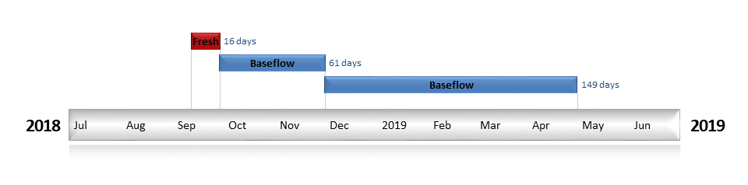
Figure CMP2. Timing and duration of Commonwealth environmental water actions delivered in the Campaspe valley.

Contribution of Commonwealth environmental water to flow regimes
Eppalock
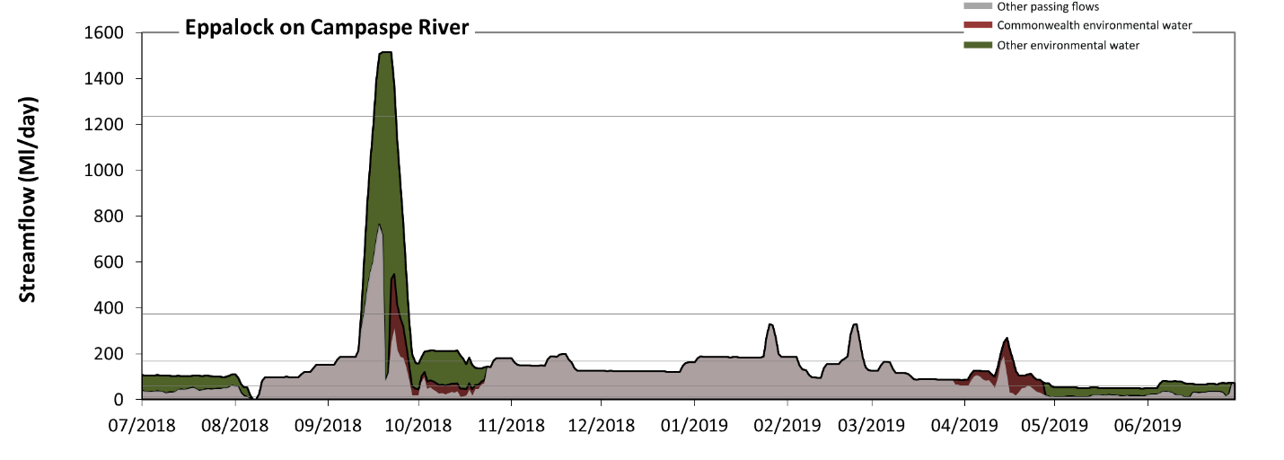
Figure CMP3: Contribution of environmental water delivery at Eppalock. Horizontal lines indicate thresholds for very low flows, low flows, low freshes, medium freshes and high freshes (from lowest to highest).
At Eppalock on Campaspe River, environmental water contributed 35% of the total streamflow volume (with a relatively small contribution of Commonwealth environmental water). Environmental watering actions affected streamflows for 47% of days between 1 July 2018 and 30 June 2019. Flow regulation does not substantially increase the duration of very low flows (i.e. < 12 Ml/day) compared to an average year in the natural flow regime. However, without environmental water, the durations of medium low flows (i.e. < 61 Ml/day) in the periods July to September and April to June would have substantially exceeded durations expected in an average year in the natural flow regime. Environmental water mitigated these impacts by reducing the cumulative duration of medium low flow spells from 38% to 12% of the year, with greatest influence in the periods July to September and April to June. Environmental water increased the magnitude of flows below this medium low flow threshold. Commonwealth environmental water made a modest contribution to these enhancements of environmental baseflows at this site. In the absence of environmental water there would have been at least one low fresh (i.e. > 170 Ml/day) in the periods July to September, October to December, January to March and April to June. Environmental water increased the duration of the longest low fresh during the periods July to September (from 16 days to 26 days), October to December (from 8 days to 15 days) and April to June (from 1 day to 5 days). Commonwealth environmental water made a modest contribution to these increased durations of low freshes. In the absence of environmental water there would have been at least one medium fresh (i.e. > 370 Ml/day) in the period July to September. Environmental water increased the duration of the longest medium fresh during the period July to September (from 7 days to 16 days). Commonwealth environmental water made little or no contribution to these increased durations of medium freshes. Environmental water increased the duration of the longest high fresh during the period July to September (from 0 days to 7 days). Commonwealth environmental water made little or no contribution to these increased durations of high freshes.
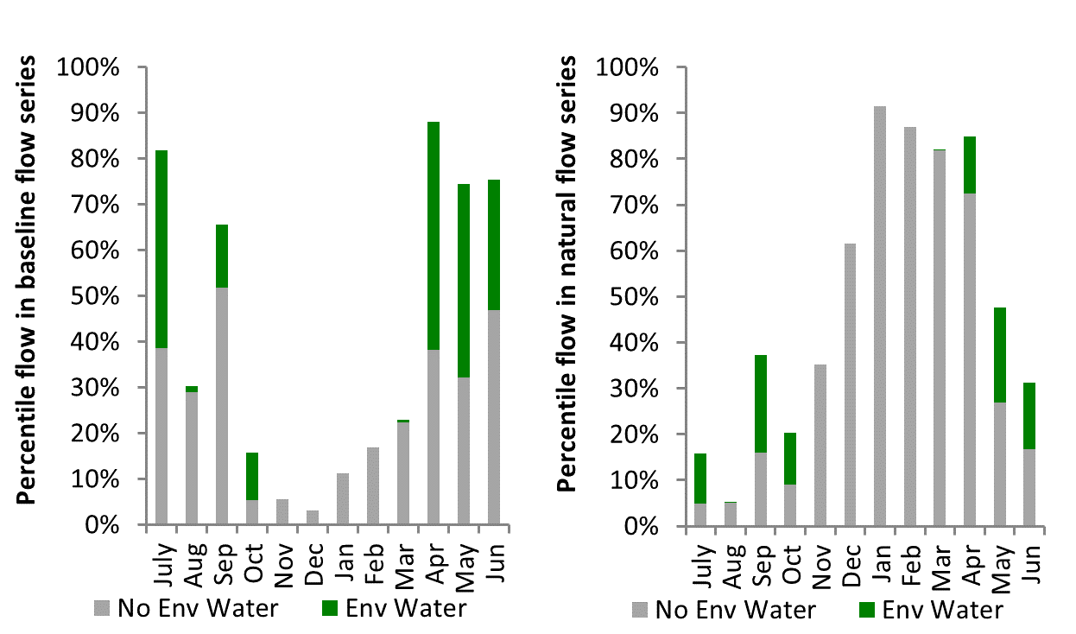
Figure CMP4: Contribution of environmental water delivery at Eppalock as percentiles in the natural and baseline flow series.
Barnadown
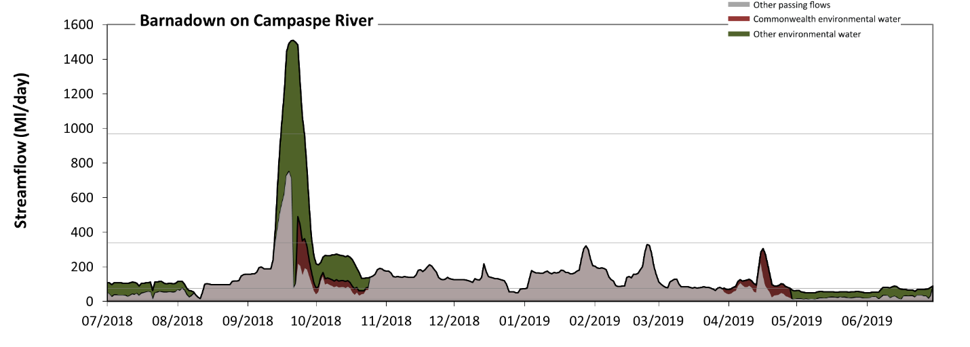
Figure CMP5: Contribution of environmental water delivery at Barnadown. Horizontal lines indicate thresholds for very low flows, low flows, low freshes and medium freshes (from lowest to highest).
At Barnadown on Campaspe River, environmental water contributed 36% of the total streamflow volume (with a relatively small contribution of Commonwealth environmental water). Environmental watering actions affected streamflows for 47% of days between 1 July 2018 and 30 June 2019. Flow regulation does not substantially increase the duration of very low flows (i.e. < 15 Ml/day) compared to an average year in the natural flow regime. However, without environmental water, the durations of medium low flows (i.e. < 77 Ml/day) in the periods July to September and April to June would have substantially exceeded durations expected in an average year in the natural flow regime. Environmental water mitigated these impacts by reducing the cumulative duration of medium low flow spells from 41% to 22% of the year, with greatest influence in the periods July to September and April to June. Commonwealth environmental water made a modest contribution to these enhancements of environmental baseflows at this site. In the absence of environmental water there would have been at least one low fresh (i.e. > 340 Ml/day) in the period July to September. Environmental water increased the duration of the longest low fresh during the period July to September (from 7 days to 17 days). Commonwealth environmental water made little or no contribution to these increased durations of low freshes. In the absence of environmental water there would have been no medium or high freshes this year. Environmental water increased the duration of the longest medium fresh during the period July to September (from 0 days to 10 days). Commonwealth environmental water made little or no contribution to these increased durations of medium freshes.
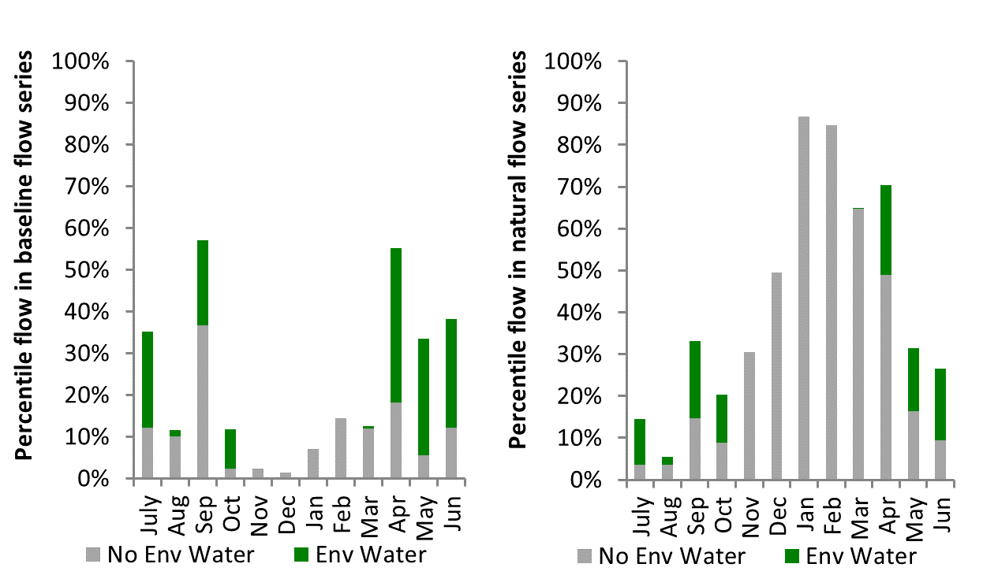
Figure CMP6: Contribution of environmental water delivery at Barnadown as percentiles in the natural and baseline flow series.

Rochester
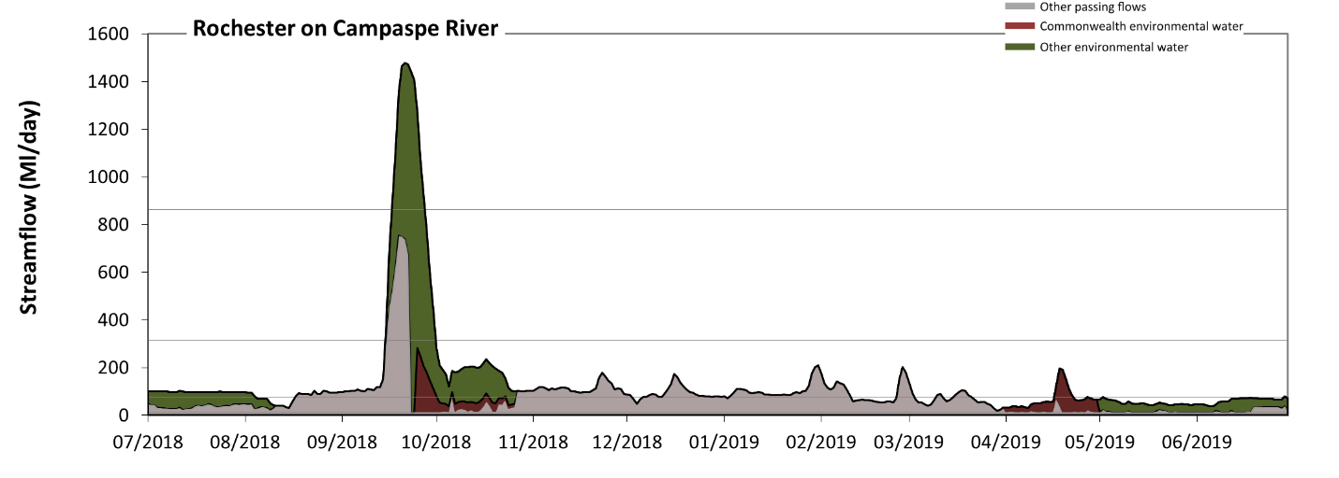
Figure CMP7: Contribution of environmental water delivery at Rochester. Horizontal lines indicate thresholds for very low flows, low flows, low freshes and medium freshes (from lowest to highest).
At Rochester on Campaspe River, environmental water contributed 46% of the total streamflow volume (with a relatively small contribution of Commonwealth environmental water). Environmental watering actions affected streamflows for 48% of days between 1 July 2018 and 30 June 2019. Without environmental water, the durations of very low flows (i.e. < 15 Ml/day) in the periods July to September and April to June would have substantially exceeded durations expected in an average year in the natural flow regime. Environmental water mitigated these impacts by reducing the cumulative duration of very low flow spells from 23% to 0% of the year, with greatest influence in the period April to June. Similarly, without environmental water, the durations of medium low flows (i.e. < 77 Ml/day) in the periods July to September, October to December and April to June would have substantially exceeded durations expected in an average year in the natural flow regime. Environmental water mitigated these impacts by reducing the cumulative duration of medium low flow spells from 59% to 38% of the year, with greatest influence in the periods July to September and October to December. Environmental water increased the magnitude of flows below this medium low flow threshold. Commonwealth environmental water made a modest contribution to these enhancements of environmental baseflows at this site. In the absence of environmental water there would have been at least one low fresh (i.e. > 310 Ml/day) in the period July to September. Environmental water increased the duration of the longest low fresh during the period July to September (from 7 days to 16 days). Commonwealth environmental water made little or no contribution to these increased durations of low freshes. In the absence of environmental water there would have been no medium or high freshes this year. Environmental water increased the duration of the longest medium fresh during the period July to September (from 0 days to 11 days). Commonwealth environmental water made little or no contribution to these increased durations of medium freshes.
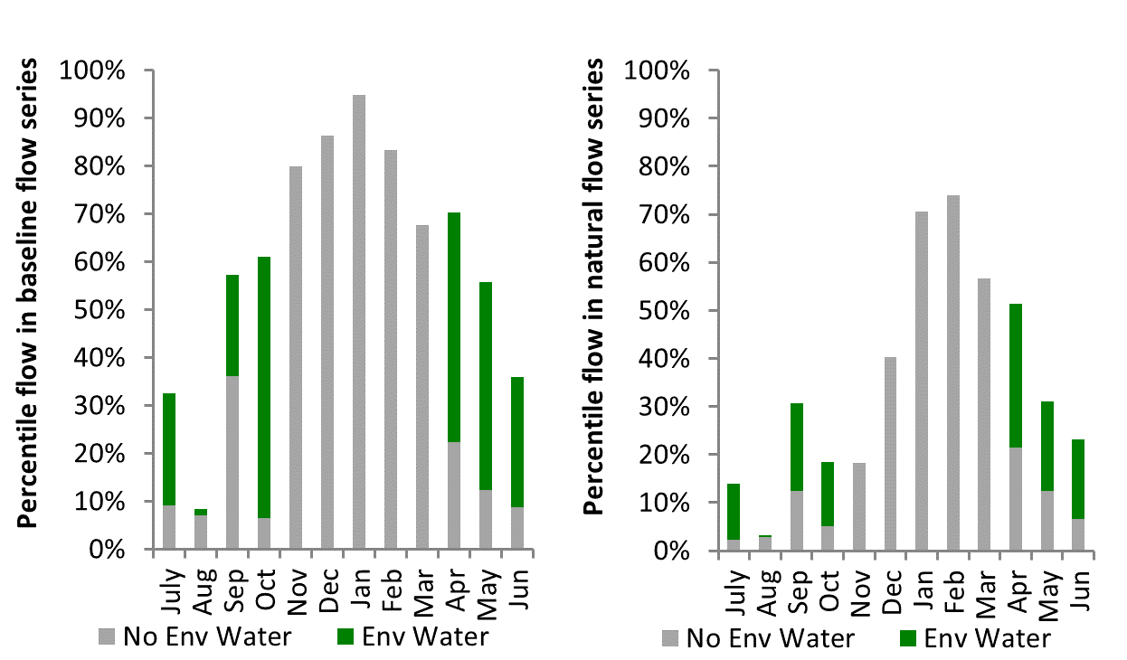
Figure CMP8: Contribution of environmental water delivery at Rochester as percentiles in the natural and baseline flow series.

Ovens
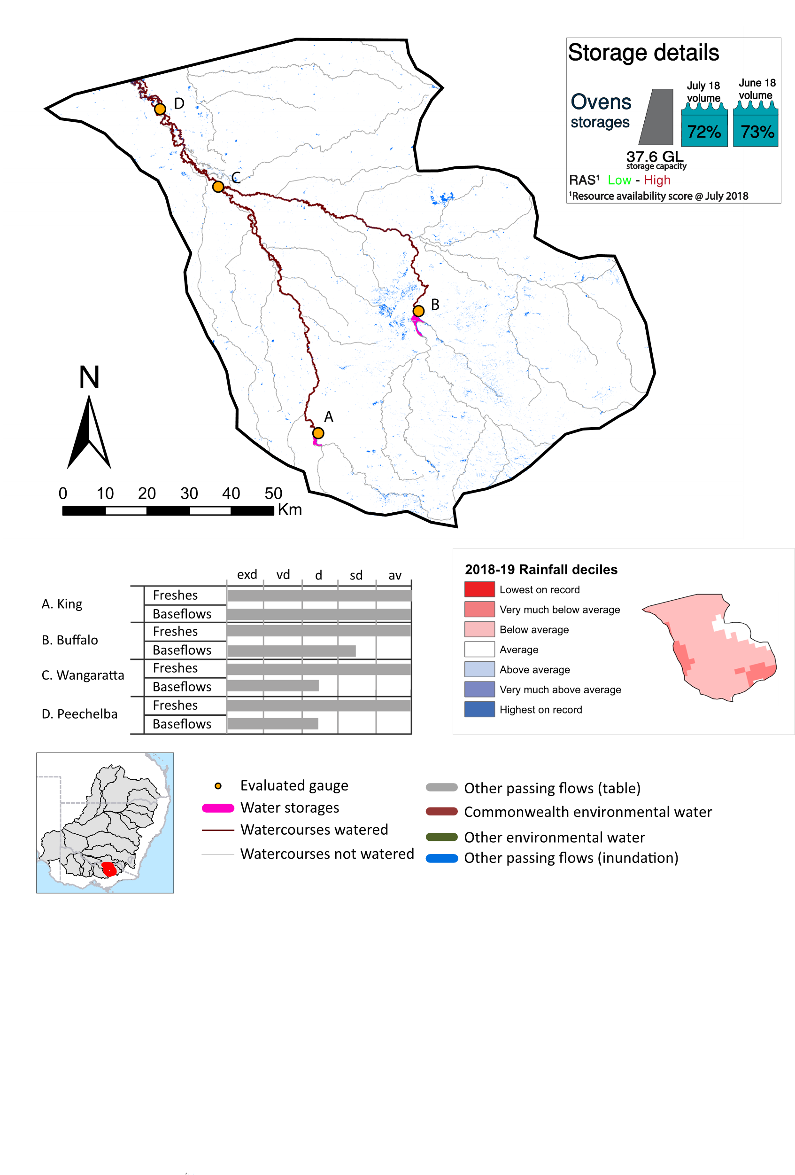Figure OVN1: Watercourses influenced, areas inundated (where applicable) and gauge stations evaluated in the Ovens valley during the 2018-19 water year. Inset bar graphs report the condition of annual flow regimes by showing the improvements in hydrological condition with the addition of environmental water as well as the hypothetical scenario in “grey” (if no environmental flow had been delivered) where exd=extremely dry, vd=very dry, d=dry, sd=somewhat dry and av=average. Rainfall conditions (rainfall deciles) and trend in storage levels for the water year are also shown.

Summary
The volume of environmental water delivery for the 2018-19 year in the Ovens valley is quantified using data for 4 sites. This evaluation only considers the contribution of held environmental water, which is a primary focus for the Commonwealth. The contributions of planned environmental water (e.g. passing flows), unregulated tributary inflows and clever use of irrigation flows for environmental benefits can all be very important but these are outside the scope of this report. Environmental watering actions lasted on average 1 day over the course of the year. The volume of environmental water at these 4 sites was between <1% of the total streamflow. Commonwealth environmental water contributed on average 39% of this environmental water. The contribution of environmental water delivery to improved flow regimes is evaluated using data for 4 sites. Ideally, baseflows should be maintained and long periods of excessively low flows avoided. In this valley, the baseflow regime was generally considered to be dry relative to the pre-development flow regime. In our analysis, a low fresh refers to a period of increased flow, when the water level rises at least one eighth of the way up the river bank (above the low flow level). These low freshes are a regular part of the natural flow regime and support a range of natural processes. In the Ovens valley, in terms of the occurrence and duration of low freshes, the year was assessed as being average. In our analysis, a medium fresh refers to a period of increased flow, when the water level rises at least one quarter of the way up the river bank. These medium freshes are not as frequent as low freshes but are also a regular and important part of the natural flow regime. In the Ovens valley, in terms of the occurrence of medium freshes, the year was assessed as being average. In our analysis, a high fresh refers to a period of increased flow, when the water level rises more than half way up the river. A high fresh may not occur every year but they are still important and long periods without major freshes can have serious consequences for floodplains and their contribution to river connectivity. Delivering high in channel environmental flows normally requires that all risks to riparian landholders and infrastructure have been resolved. In the Ovens valley, in terms of the occurrence of high freshes, the year was assessed as being average.

Water delivery context
During the 2018-19, the Commonwealth Environmental Water Holder (CEWH) held water entitlements of up to 123 ML for environmental use in the Ovens valley. Each year, water utilities allocate water entitlement holders a percentage of water based on their holding, license type and carryover (the exact rules vary among Jurisdictions). In 2018-19, the Ovens entitlements held by the CEWH were allocated 123 ML of water, representing 105% of the Long term average annual yield for the Ovens valley (117 ML). Information and data relating to the portfolio of held Commonwealth environmental water is shown in Table OVN2.
The 2018-19 water allocation (123 ML) together with the carryover volume of 0 ML of water meant the CEWH had 123 ML of water available for delivery. A total of 123 ML of Commonwealth environmental water was delivered in the Ovens valley. A total of 0 ML of Commonwealth environmental water was traded to consumptive users and 0 ML (0%) of available Commonwealth environmental water was carried over for environmental use into the 2019-20 water year.

Environmental conditions and resource availability
The water available for environmental delivery combined with the present and antecedent environmental conditions are key inputs used by environmental water managers in planning and implementing watering actions. Post hoc, this information provides important context when evaluating the effectiveness and appropriateness of environmental water use with respect to hydrological outputs.
The rainfall conditions in the Ovens valley were classified as Below average, based on rainfall percentile data for the entire record held by the Bureau of Meteorology for this valley. The water held in major storages in the Ovens valley stable over the water year, for example Buffalo and William Hovell dam was 72.0% full at the beginning of the water year and 73.5% full by the end of the year (Figure OVN1).
The Commonwealth Environmental Water Office (CEWO) calculates resource availability scenarios (RAS) to guide the use and prioritisation of held environmental water. The RAS are progressively calculated over the year as part of the continual adaptive management planning processes. The RAS are based on the availability of held environmental water (including progressive license acquisitions and allocations) as well as the potential for unregulated or planned environmental flows. The outcome is then used to determine the demand for environmental water across the basin.
In 2018-19, the resource availability of held Commonwealth environmental water was classified as low to high. The physical conditions meant that the CEWO was managing to protect and improve the aquatic and riparian vegetation, maintain water quality, and support native fish and other biota via habitat provision. The overall demand for environmental water was deemed moderate.

Watering actions
One watering action was delivered over the 2018-19 water year, for a total of 1 day. The number of water actions commencing in each season included, Autumn (1), Spring (0), Summer (0), Winter(0). Similarly, the count of flow component types delivered in the Ovens valley were; (1) baseflow, (0) baseflow-fresh, (0) fresh, (0) fresh-overbank, (0) bankfull, (0) overbank, (0) wetland and (0) wetland-fresh. In this valley, watering actions were equally split for connectivity and fish purposes.
Table OVN2. Commonwealth environmental water accounting information for the Ovens valley over 2018-19 water year.
Total registered volume (ML) | Allocated volume (ML) | Carry over + allocated volume (ML) | Delivered (ML) | LTAAY (ML) | Trade (ML) | Carried over to 2019-20 | Forfeited (ML)
123 | 123 | 123 | 123 | 117 | 0 | 0 | 0

Figure OVN2. Timing and duration of Commonwealth environmental water actions delivered in the Ovens valley.

Contribution of Commonwealth environmental water to flow regimes

Buffalo
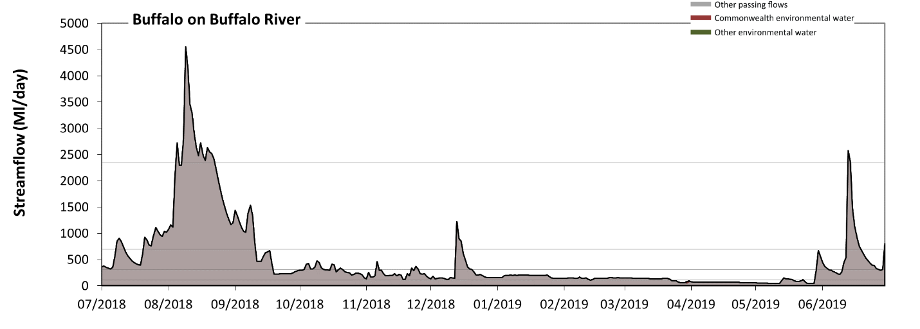
Figure OVN3: Contribution of environmental water delivery at Buffalo. Horizontal lines indicate thresholds for very low flows, low flows, low freshes, medium freshes and high freshes (from lowest to highest).
At Buffalo on Buffalo River, environmental water contributed less than 1% of the total streamflow volume (all of which was Commonwealth environmental water). Environmental watering actions affected streamflows for 1% of days between 1 July 2018 and 30 June 2019. Flow regulation does not substantially increase the duration of very low flows (i.e. < 22 Ml/day) compared to an average year in the natural flow regime. However, without environmental water, the duration of medium low flows (i.e. < 110 Ml/day) in the period April to June would have substantially exceeded durations expected in an average year in the natural flow regime. However, environmental water had little effect on the duration of these medium low flows, which occurred for 17% of the year. There was at least one low fresh (i.e. > 310 Ml/day) in the periods July to September, October to December and April to June. Environmental water made no change to the duration of these low freshes. There was at least one medium fresh (i.e. > 700 Ml/day) in the periods July to September, October to December and April to June. Environmental water made no change to the duration of these medium freshes. In the absence of environmental water there would have been at least one high fresh in the periods July to September and April to June. Environmental water made no change to the duration of these high freshes.
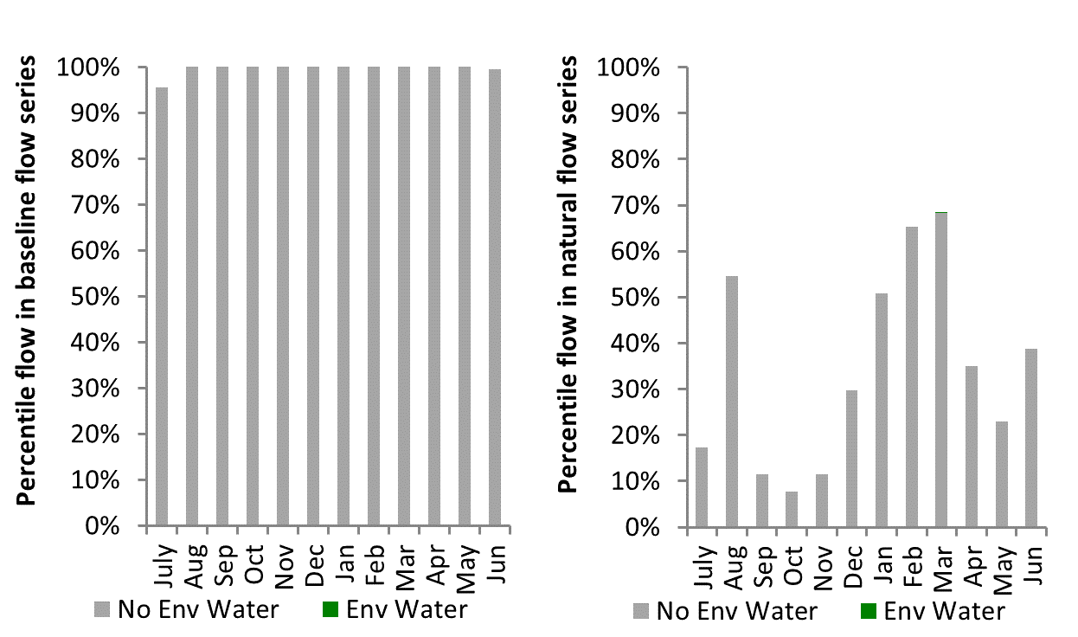
Figure OVN4: Contribution of environmental water delivery at Buffalo as percentiles in the natural and baseline flow series.
Peechelba
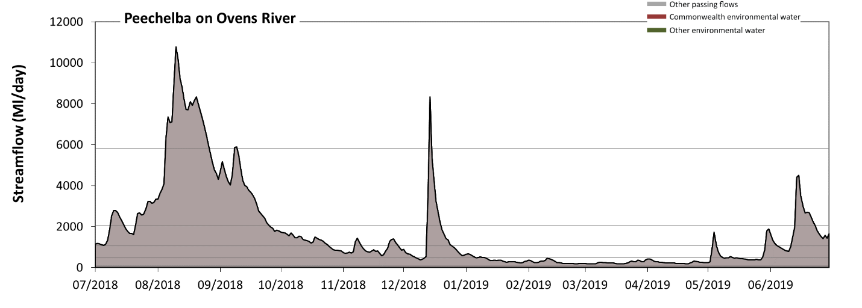
Figure OVN5: Contribution of environmental water delivery at Peechelba. Horizontal lines indicate thresholds for very low flows, low flows, low freshes, medium freshes and high freshes (from lowest to highest).

There was no environmental water delivered at Peechelba on Ovens RiverFlow regulation does not substantially increase the duration of very low flows (i.e. < 94 Ml/day) compared to an average year in the natural flow regime. However, without environmental water, the durations of medium low flows (i.e. < 470 Ml/day) in the periods January to March and April to June was substantially in excess of durations expected in an average year in the natural flow regime. There was at least one low fresh (i.e. > 1100 Ml/day) in the periods July to September, October to December and April to June. There was at least one medium fresh (i.e. > 2100 Ml/day) in the periods July to September, October to December and April to June. In the absence of environmental water there was at least one high fresh in the periods July to September and October to December.
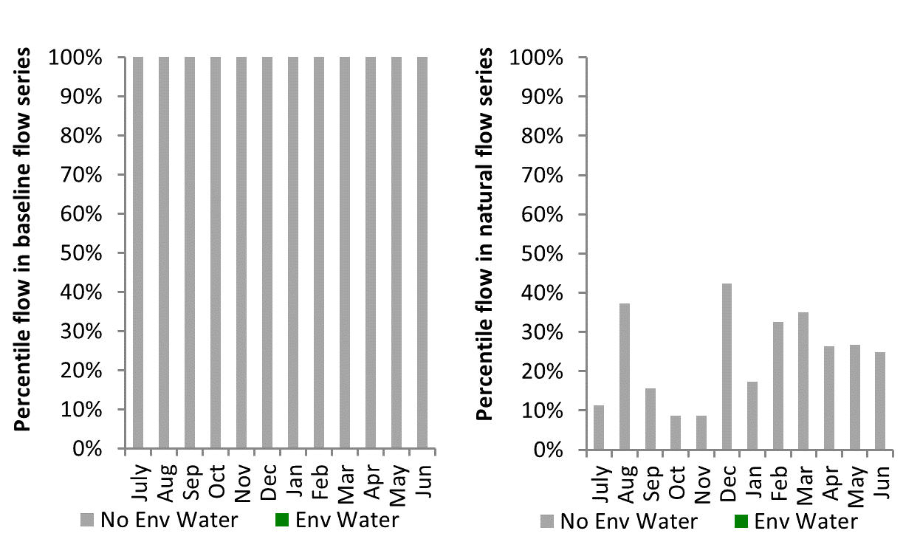
Figure OVN6: Contribution of environmental water delivery at Peechelba as percentiles in the natural and baseline flow series.
King
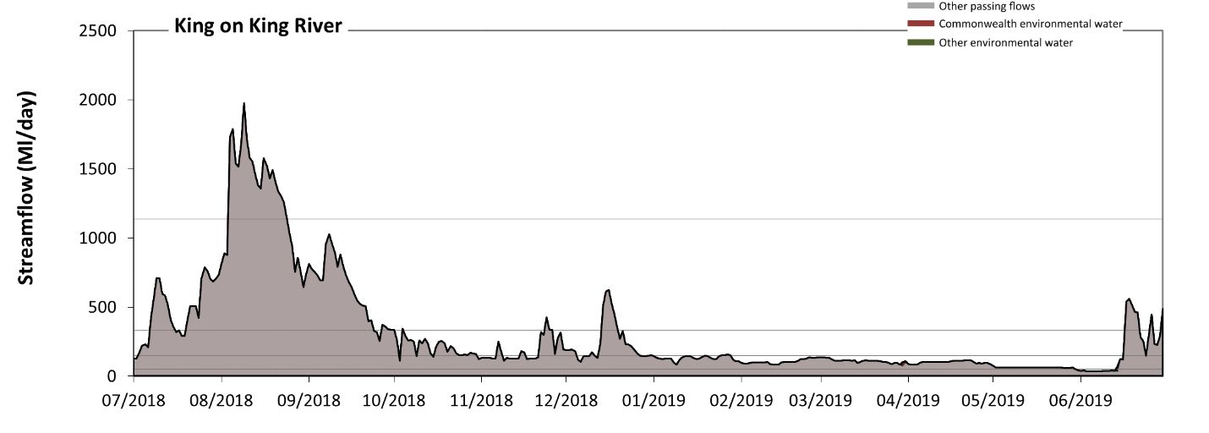
Figure OVN7: Contribution of environmental water delivery at King. Horizontal lines indicate thresholds for very low flows, low flows, low freshes, medium freshes and high freshes (from lowest to highest).
At King on King River, environmental water contributed less than 1% of the total streamflow volume. Environmental watering actions affected streamflows for 1% of days between 1 July 2018 and 30 June 2019. Flow regulation does not substantially increase the duration of very low flows (i.e. < 10 Ml/day) compared to an average year in the natural flow regime. Flow regulation does not substantially increase the duration of medium low flows (i.e. < 50 Ml/day) compared to an average year in the natural flow regime. There was at least one low fresh (i.e. > 150 Ml/day) in the periods July to September, October to December, January to March and April to June. Environmental water made no change to the duration of these low freshes. There was at least one medium fresh (i.e. > 330 Ml/day) in the periods July to September, October to December and April to June. Environmental water made no change to the duration of these medium freshes. In the absence of environmental water there would have been at least one high fresh in the period July to September. Environmental water made no change to the duration of these high freshes.
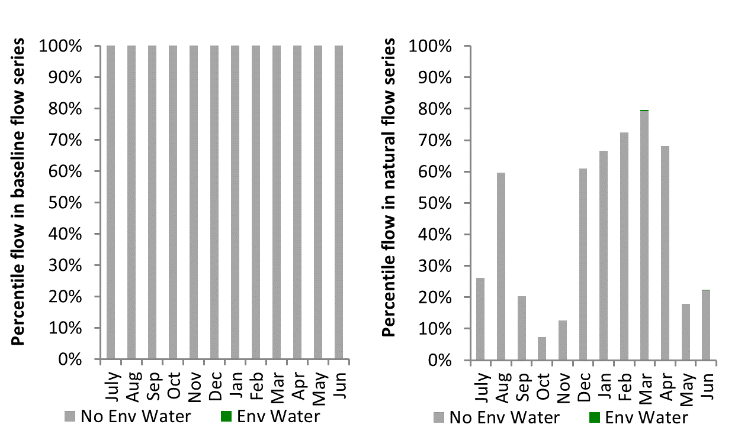
Figure OVN8: Contribution of environmental water delivery at King as percentiles in the natural and baseline flow series.

Wangaratta
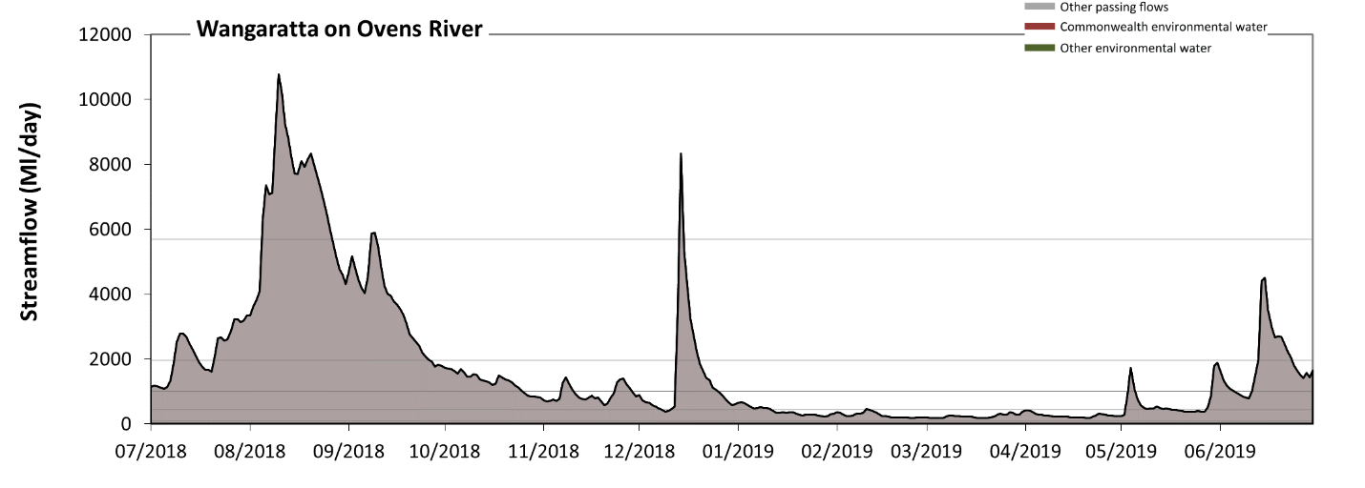
Figure OVN9: Contribution of environmental water delivery at Wangaratta. Horizontal lines indicate thresholds for very low flows, low flows, low freshes, medium freshes and high freshes (from lowest to highest).
There was no environmental water delivered at Wangaratta on Ovens River. Flow regulation does not substantially increase the duration of very low flows (i.e. < 86 Ml/day) compared to an average year in the natural flow regime. However, without environmental water, the durations of medium low flows (i.e. < 430 Ml/day) in the periods January to March and April to June was substantially in excess of durations expected in an average year in the natural flow regime. There was at least one low fresh (i.e. > 1000 Ml/day) in the periods July to September, October to December and April to June. There was at least one medium fresh (i.e. > 2000 Ml/day) in the periods July to September, October to December and April to June. In the absence of environmental water there was at least one high fresh in the periods July to September and October to December.
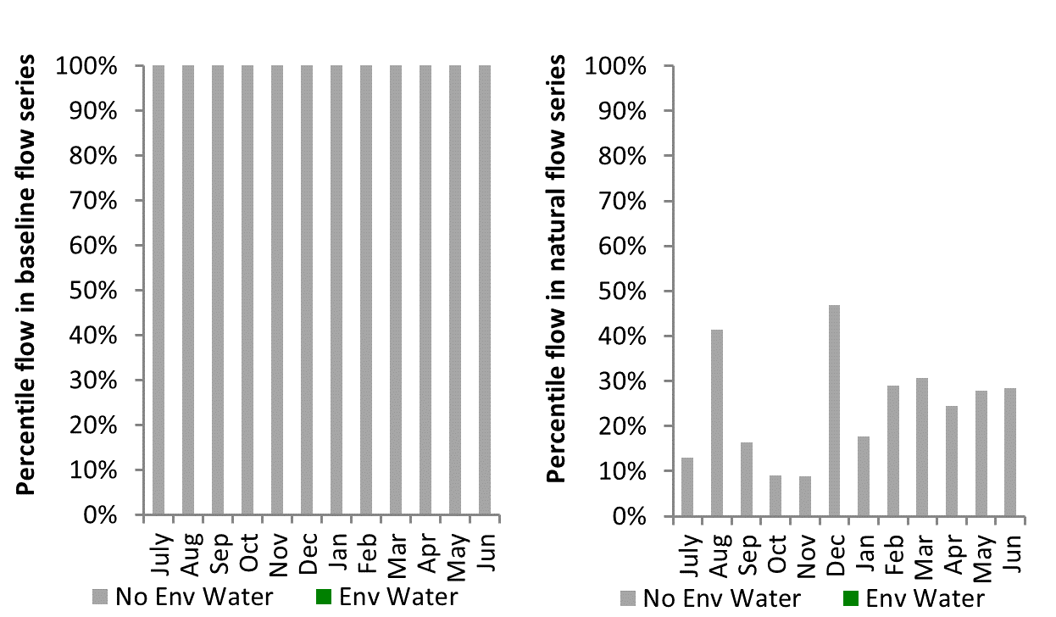
Figure OVN10: Contribution of environmental water delivery at Wangaratta as percentiles in the natural and baseline flow series.

Warrego
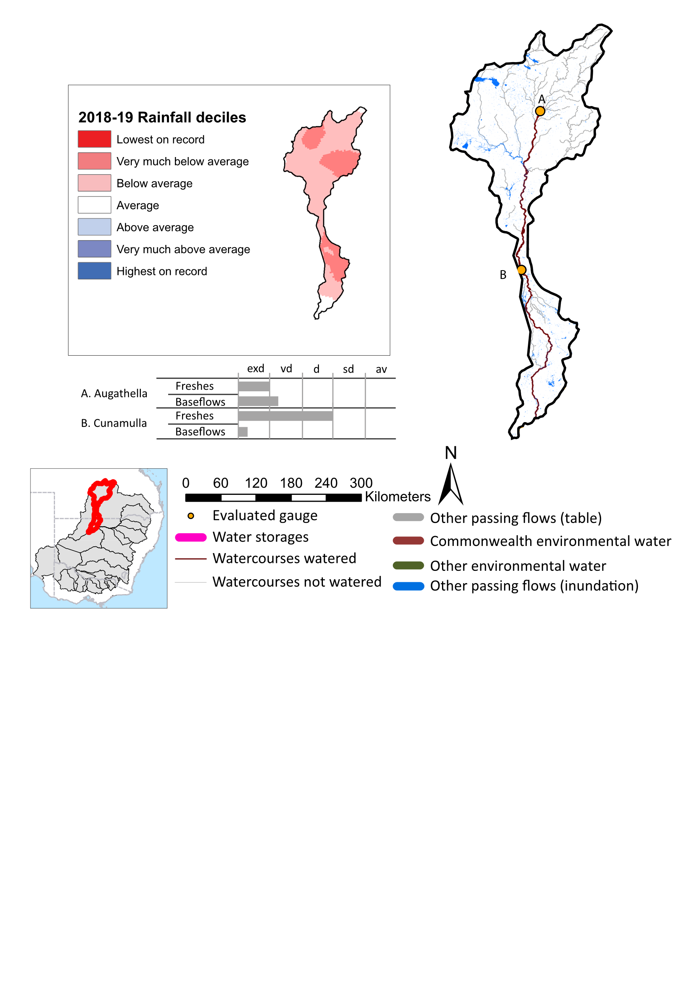
Figure WAR1: Watercourses influenced, areas inundated (where applicable) and gauge stations evaluated in the Warrego valley during the 2018-19 water year. Inset bar graphs report the condition of annual flow regimes by showing the improvements in hydrological condition with the addition of environmental water as well as the hypothetical scenario in “grey” (if no environmental flow had been delivered) where exd=extremely dry, vd=very dry, d=dry, sd=somewhat dry and av=average. Rainfall conditions (rainfall deciles) and trend in storage levels for the water year are also shown.

Summary
The volume of environmental water delivery for the 2018-19 year in the Warrego valley is quantified using data for 2 sites. This evaluation only considers the contribution of held environmental water, which is a primary focus for the Commonwealth. The contributions of planned environmental water (e.g. passing flows), unregulated tributary inflows and clever use of irrigation flows for environmental benefits can all be very important but these are outside the scope of this report. Environmental watering actions lasted on average 15 days over the course of the year. The volume of environmental water at these 2 sites was between 2% and 3% of the total streamflow. Commonwealth environmental water contributed on average 100% of this environmental water. The contribution of environmental water delivery to improved flow regimes is evaluated using data for 2 sites. Ideally, baseflows should be maintained and long periods of excessively low flows avoided. In this valley, the baseflow regime was generally considered to be extremely dry relative to the pre-development flow regime. In our analysis, a low fresh refers to a period of increased flow, when the water level rises at least one eighth of the way up the river bank (above the low flow level). These low freshes are a regular part of the natural flow regime and support a range of natural processes. In the Warrego valley, in terms of the occurrence and duration of low freshes, the year was assessed as being extremely dry. In our analysis, a medium fresh refers to a period of increased flow, when the water level rises at least one quarter of the way up the river bank. These medium freshes are not as frequent as low freshes but are also a regular and important part of the natural flow regime. In the Warrego valley, in terms of the occurrence of medium freshes, the year was assessed as being dry. In our analysis, a high fresh refers to a period of increased flow, when the water level rises more than half way up the river. A high fresh may not occur every year but they are still important and long periods without major freshes can have serious consequences for floodplains and their contribution to river connectivity. Delivering high in channel environmental flows normally requires that all risks to riparian landholders and infrastructure have been resolved. In the Warrego valley, in terms of the occurrence of high freshes, the year was assessed as being dry.

Water delivery context
During the 2018-19, the Commonwealth Environmental Water Holder (CEWH) held water entitlements of up to 57,281 ML for environmental use in the Warrego valley. Each year, water utilities allocate water entitlement holders a percentage of water based on their holding, license type and carryover (the exact rules vary among Jurisdictions). In 2018-19, the Warrego entitlements held by the CEWH were allocated 15,825 ML of water, representing 47% of the Long term average annual yield for the Warrego valley (33,869 ML). Information and data relating to the portfolio of held Commonwealth environmental water is shown in Table WAR2.
The 2018-19 water allocation (15,825 ML) together with the carryover volume of 0 ML of water meant the CEWH had 15,825 ML of water available for delivery. A total of 15,824 ML of Commonwealth environmental water was delivered in the Warrego valley. A total of 0 ML of Commonwealth environmental water was traded to consumptive users and 0 ML (0%) of available Commonwealth environmental water was carried over for environmental use into the 2019-20 water year.

Environmental conditions and resource availability
The rainfall conditions in the Warrego valley were classified as Below average, based on rainfall percentile data for the entire record held by the Bureau of Meteorology for this valley.

Watering actions
A total of 5 watering actions were delivered over the 2018-19 water year, the duration of these actions varied (range of individual actions: 3 - 13 days) and Commonwealth environmental water was delivered for a total of 39 days. The number of water actions commencing in each season included, Autumn (5), Spring (0), Summer (0), Winter(0). Similarly, the count of flow component types delivered in the Warrego valley were; (5) baseflow, (0) baseflow-fresh, (0) fresh, (0) fresh-overbank, (0) bankfull, (0) overbank, (0) wetland and (0) wetland-fresh.
In this valley, primary objectives of most watering actions was related to resilience and fish, but water was also delivered for other purposes too. The percentage of watering actions delivered across the nine main themes included primary objectives for fish (40%), vegetation (0.0%), waterbirds (0.0%), frogs (0.0%), other biota (0.0%), connectivity (10%), process (10%), resilience (40%) and water quality (0.0%).
Table WAR2. Commonwealth environmental water accounting information for the Warrego valley over 2018-19 water year.
Total registered volume (ML) | Allocated volume (ML) | Carry over + allocated volume (ML) | Delivered (ML) | LTAAY (ML) | Trade (ML) | Carried over to 2019-20 | Forfeited (ML)
57,281 | 15,825 | 15,825 | 15,824 | 33,869 | 0 | 0 | 0

Figure WAR2. Timing and duration of Commonwealth environmental water actions delivered in the Warrego valley.
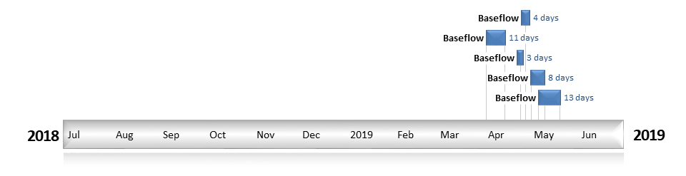

Contribution of Commonwealth environmental water to flow regimes
Augathella
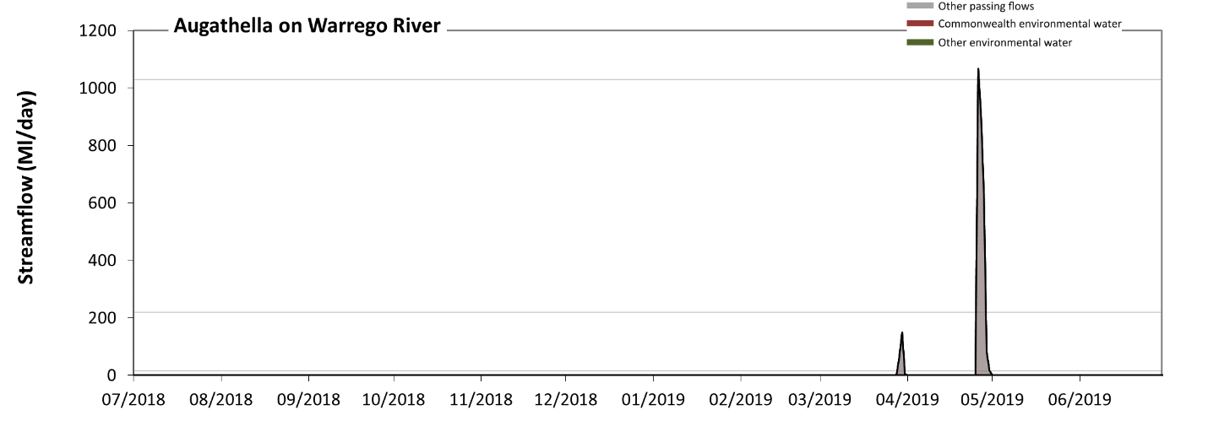
Figure WAR3: Contribution of environmental water delivery at Augathella. Horizontal lines indicate thresholds for very low flows, low flows, low freshes and medium freshes (from lowest to highest).
At Augathella on Warrego River environmental water contributed 3% of the total streamflow volume (all of which was Commonwealth environmental water). Environmental watering actions affected streamflows for 1% of days between 1 July 2018 and 30 June 2019. Without environmental water, the durations of very low flows (i.e. < 2.7 Ml/day) in the periods July to September, October to December, January to March and April to June would have all substantially exceeded durations expected in an average year in the natural flow regime. However, environmental water had little effect on the duration of these very low flows, which occurred for 98% of the year. Similarly, without environmental water, the durations of medium low flows (i.e. < 14 Ml/day) in the periods July to September, October to December, January to March and April to June would have all substantially exceeded durations expected in an average year in the natural flow regime. However, environmental water had little effect on the duration of these medium low flows, which occurred for 98% of the year. There was at least one low fresh (i.e. > 220 Ml/day) in the period April to June. Environmental water made no change to the duration of these low freshes. There was at least one medium fresh (i.e. > 1000 Ml/day) in the period April to June. Environmental water made no change to the duration of these medium freshes. There was no high freshes (i.e. > 6900 Ml/day) this year.
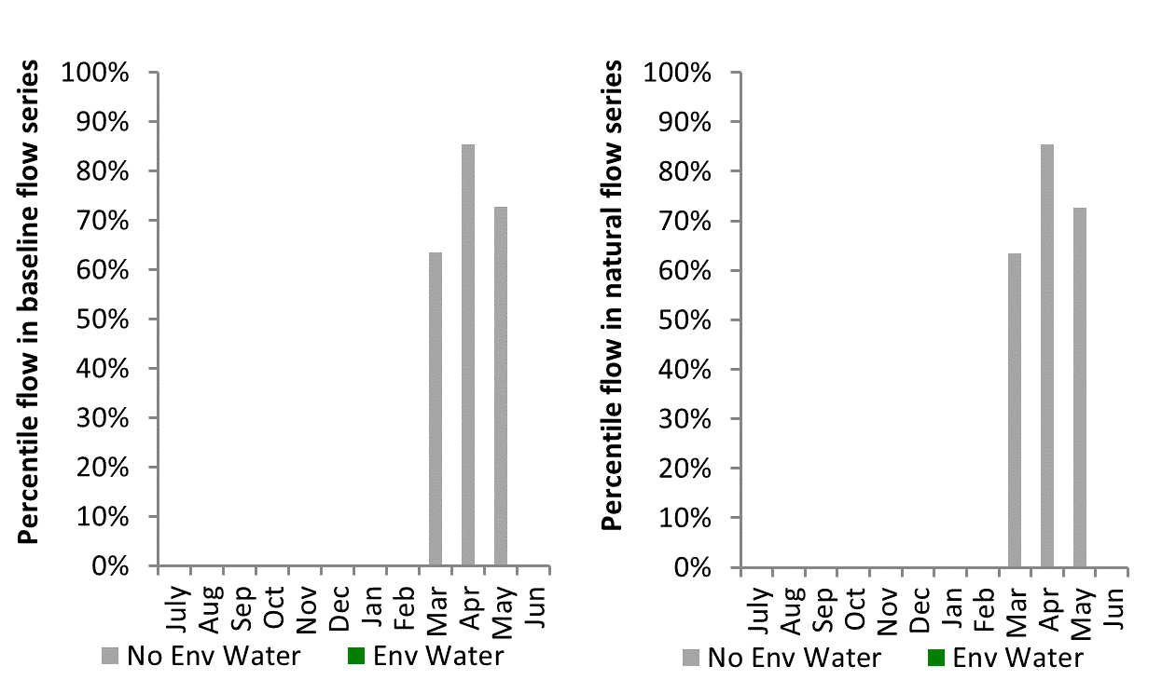
Figure WAR4: Contribution of environmental water delivery at Augathella as percentiles in the natural and baseline flow series.
Cunnamulla
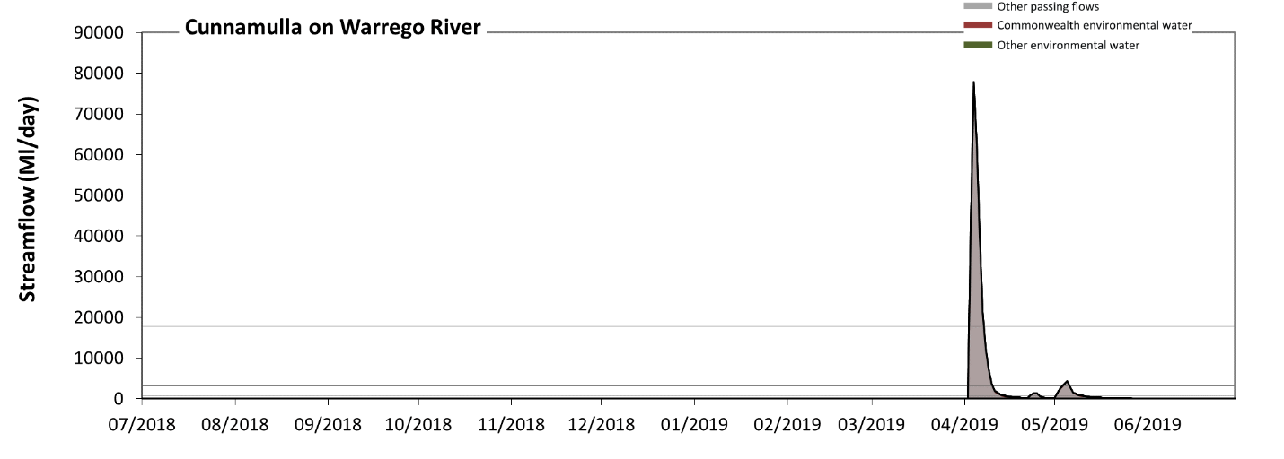
Figure WAR5: Contribution of environmental water delivery at Cunnamulla. Horizontal lines indicate thresholds for very low flows, low flows, low freshes, medium freshes and high freshes (from lowest to highest).
At Cunnamulla on Warrego River, environmental water contributed 2% of the total streamflow volume (all of which was Commonwealth environmental water). Environmental watering actions affected streamflows for 7% of days between 1 July 2018 and 30 June 2019. Without environmental water, the durations of very low flows (i.e. < 20 Ml/day) in the periods July to September, October to December and January to March would have substantially exceeded durations expected in an average year in the natural flow regime. However, environmental water had little effect on the duration of these very low flows, which occurred for 81% of the year. Similarly, without environmental water, the durations of medium low flows (i.e. < 99 Ml/day) in the periods July to September, October to December and January to March would have substantially exceeded durations expected in an average year in the natural flow regime. However, environmental water had little effect on the duration of these medium low flows, which occurred for 84% of the year. There was at least one low fresh (i.e. > 840 Ml/day) in the period April to June. Environmental water made no change to the duration of these low freshes. There was at least one medium fresh (i.e. > 3200 Ml/day) in the period April to June. Environmental water made no change to the duration of these medium freshes. In the absence of environmental water there would have been at least one high fresh in the period April to June. Environmental water made no change to the duration of these high freshes.
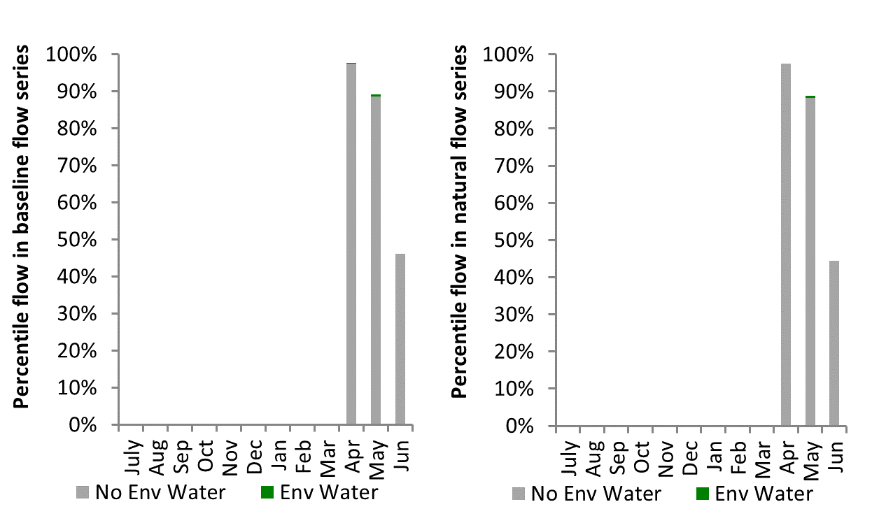
Figure WAR6: Contribution of environmental water delivery at Cunnamulla as percentiles in the natural and baseline flow series.

Wimmera
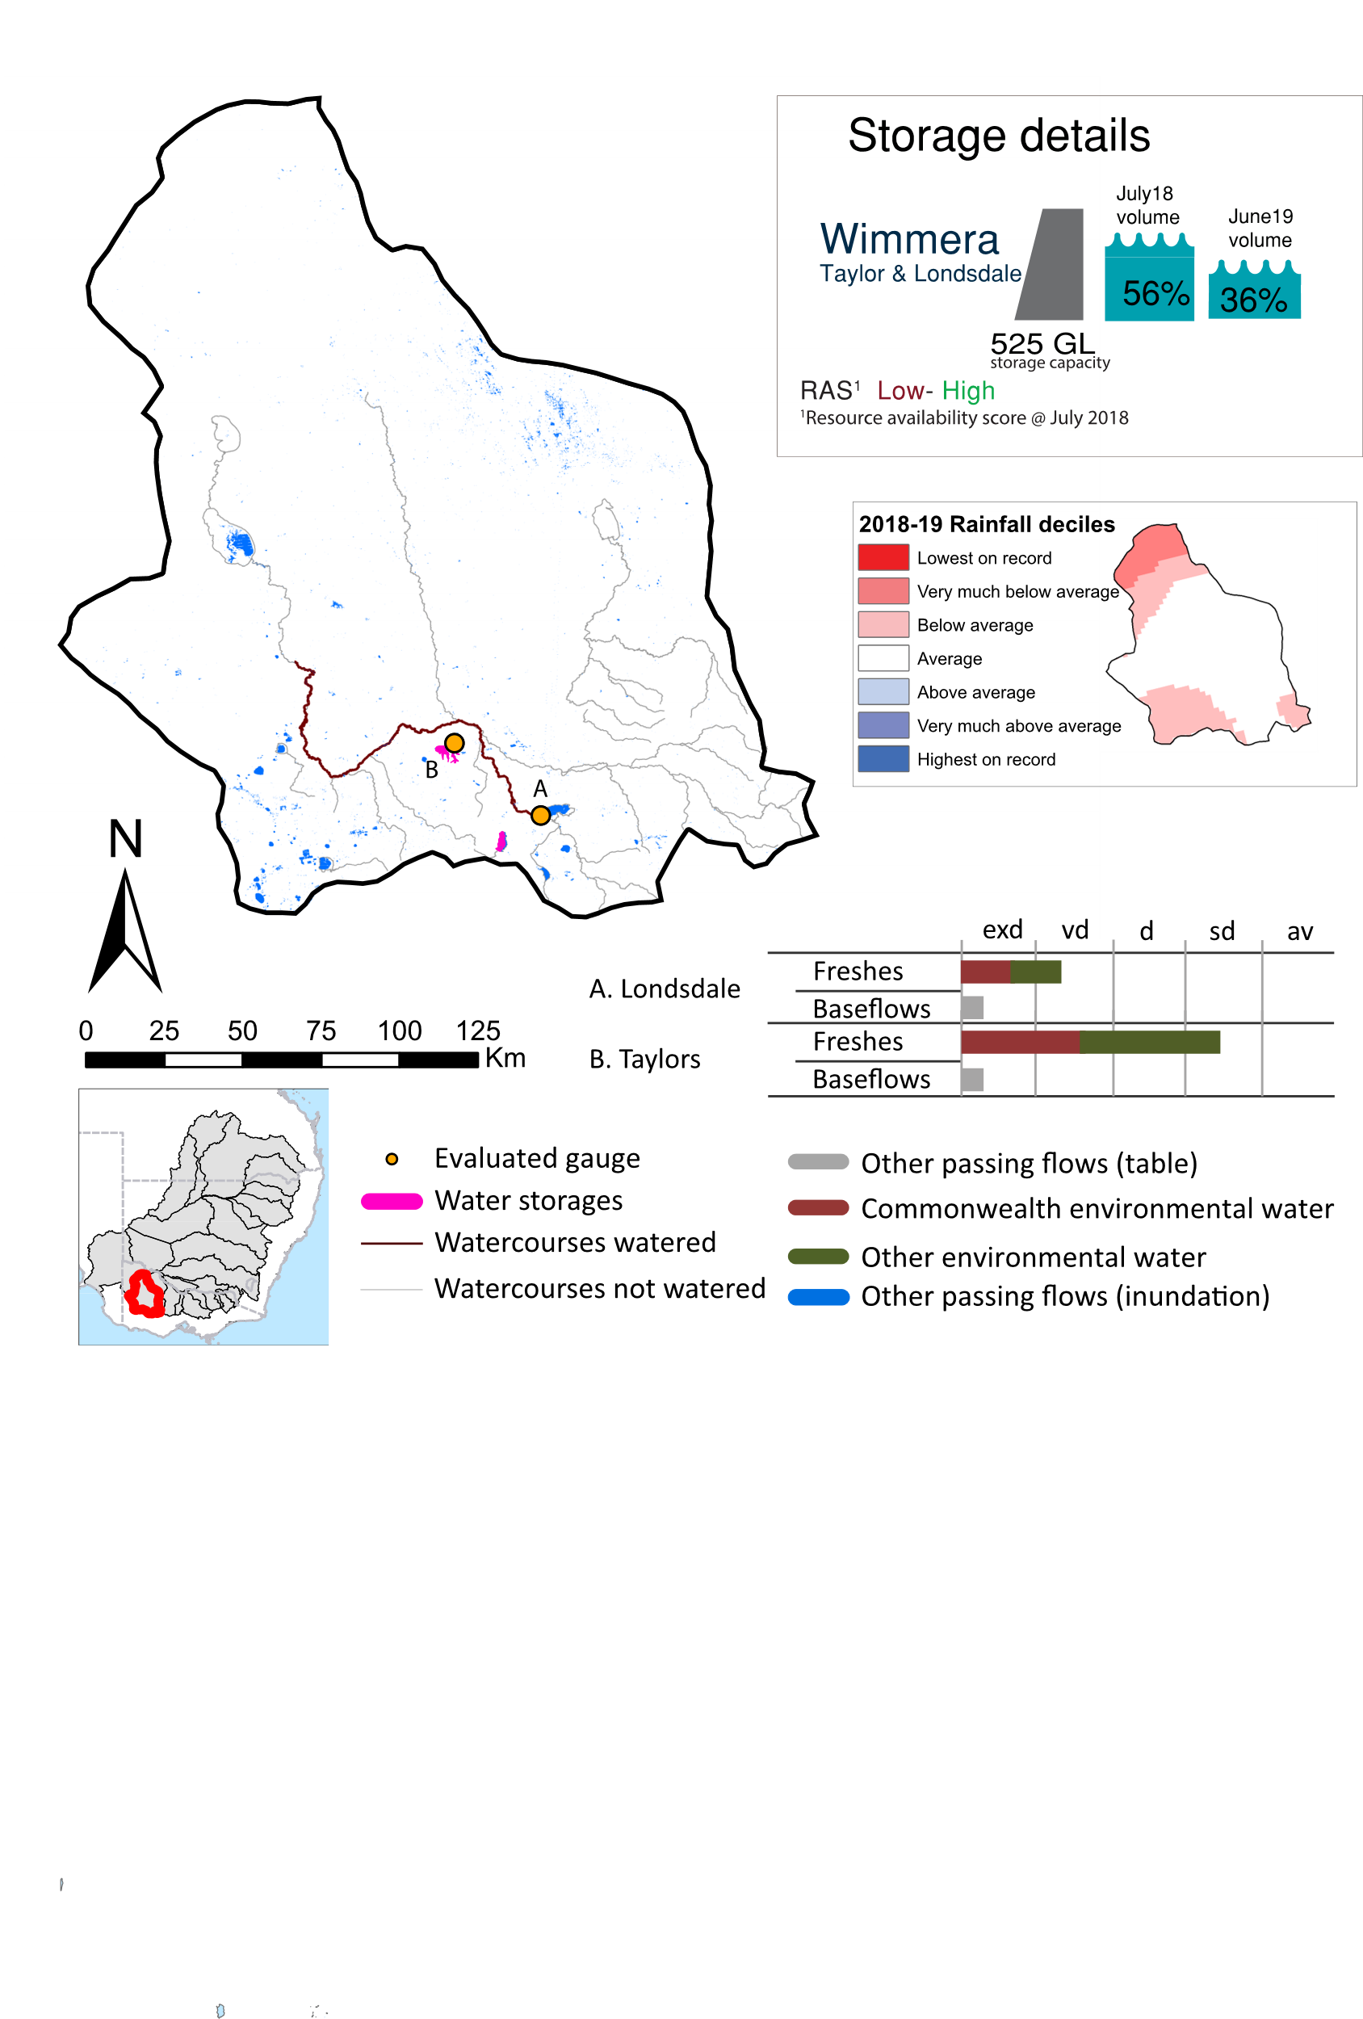Figure WIM1: Watercourses influenced, areas inundated (where applicable) and gauge stations evaluated in the Wimmera valley during the 2018-19 water year. Inset bar graphs report the condition of annual flow regimes by showing the improvements in hydrological condition with the addition of environmental water as well as the hypothetical scenario in “grey” (if no environmental flow had been delivered) where exd=extremely dry, vd=very dry, d=dry, sd=somewhat dry and av=average. Rainfall conditions (rainfall deciles) and trend in storage levels for the water year are also shown.

Summary
The volume of environmental water delivery for the 2018-19 year in the Wimmera valley is quantified using data for 2 sites. This evaluation only considers the contribution of held environmental water, which is a primary focus for the Commonwealth. The contributions of planned environmental water (e.g. passing flows), unregulated tributary inflows and clever use of irrigation flows for environmental benefits can all be very important but these are outside the scope of this report. Environmental watering actions lasted on average 153 days over the course of the year. The volume of environmental water at these 2 sites was between 78% and 99% of the total streamflow. Commonwealth environmental water contributed on average 50% of this environmental water. The contribution of environmental water delivery to improved flow regimes is evaluated using data for 2 sites. Ideally, baseflows should be maintained and long periods of excessively low flows avoided. In this valley, the baseflow regime was generally considered to be extremely dry relative to the pre-development flow regime. In our analysis, a low fresh refers to a period of increased flow, when the water level rises at least one eighth of the way up the river bank (above the low flow level). These low freshes are a regular part of the natural flow regime and support a range of natural processes. In the Wimmera valley, in terms of the occurrence and duration of low freshes, the year was assessed as being somewhat dry. In our analysis, a medium fresh refers to a period of increased flow, when the water level rises at least one quarter of the way up the river bank. These medium freshes are not as frequent as low freshes but are also a regular and important part of the natural flow regime. In the Wimmera valley, in terms of the occurrence of medium freshes, the year was assessed as being somewhat dry. In our analysis, a high fresh refers to a period of increased flow, when the water level rises more than half way up the river. A high fresh may not occur every year but they are still important and long periods without major freshes can have serious consequences for floodplains and their contribution to river connectivity. Delivering high in channel environmental flows normally requires that all risks to riparian landholders and infrastructure have been resolved. In the Wimmera valley, in terms of the occurrence of high freshes, the year was assessed as being extremely dry.

Water delivery context
During the 2018-19, the Commonwealth Environmental Water Holder (CEWH) held water entitlements of up to 28,000 ML for environmental use in the Wimmera valley. Each year, water utilities allocate water entitlement holders a percentage of water based on their holding, license type and carryover (the exact rules vary among Jurisdictions). In 2018-19, the Wimmera entitlements held by the CEWH were allocated 0 ML of water, representing 0% of the Long term average annual yield for the Wimmera valley (22,568 ML). Information and data relating to the portfolio of held Commonwealth environmental water is shown in Table WIM2.
The 2018-19 water allocation (0 ML) together with the carryover volume of 7,676 ML of water meant the CEWH had 7,676 ML of water available for delivery. A total of 5,838 ML of Commonwealth environmental water was delivered in the Wimmera valley. A total of 0 ML of Commonwealth environmental water was traded to consumptive users and 1,561 ML (20%) of available Commonwealth environmental water was carried over for environmental use into the 2019-20 water year.

Environmental conditions and resource availability
The water available for environmental delivery combined with the present and antecedent environmental conditions are key inputs used by environmental water managers in planning and implementing watering actions. Post hoc, this information provides important context when evaluating the effectiveness and appropriateness of environmental water use with respect to hydrological outputs.
The rainfall conditions in the Wimmera valley were classified as Average, based on rainfall percentile data for the entire record held by the Bureau of Meteorology for this valley. The water held in major storages in the Wimmera valley decreased over the water year, for example Lake Taylor and Lake Lonsdale dam was 56.4% full at the beginning of the water year and 36.1% full by the end of the year (Figure WIM1).
The Commonwealth Environmental Water Office (CEWO) calculates resource availability scenarios (RAS) to guide the use and prioritisation of held environmental water. The RAS are progressively calculated over the year as part of the continual adaptive management planning processes. The RAS are based on the availability of held environmental water (including progressive license acquisitions and allocations) as well as the potential for unregulated or planned environmental flows. The outcome is then used to determine the demand for environmental water across the basin.
In 2018-19, the resource availability of held Commonwealth environmental water was classified as low to high. The physical conditions meant that the CEWO was managing to protect and improve the aquatic and riparian vegetation, maintain water quality, and support native fish and other biota via habitat provision. The overall demand for environmental water was deemed not calculated.

Watering actions
A total of four watering actions were delivered over the 2018-19 water year, the duration of these actions varied (range of individual actions: 5 - 170 days) and Commonwealth environmental water was delivered for a total of 250 days. The number of water actions commencing in each season included, Autumn (0), Spring (3), Summer (1), Winter(0). Similarly, the count of flow component types delivered in the Wimmera valley were; (0) baseflow, (3) baseflow-fresh, (1) fresh, (0) fresh-overbank, (0) bankfull, (0) overbank, (0) wetland and (0) wetland-fresh.
In this valley, primary objectives of most watering actions was related to water quality, biota, fish and vegetation purposes, but water was also delivered for other purposes too. The percentage of watering actions delivered across the nine main themes included primary objectives for fish (22.22%), vegetation (22.22%), waterbirds (0.0%), frogs (0.0%), other biota (22.22%), connectivity (11.11%), process (0.0%), resilience (0.0%) and water quality (22.22%).
Table WIM2. Commonwealth environmental water accounting information for the Wimmera valley over 2018-19 water year.
Total registered volume (ML) | Allocated volume (ML) | Carry over + allocated volume (ML) | Delivered (ML) | LTAAY (ML) | Trade (ML) | Carried over to 2019-20 | Forfeited (ML)
28,000 | 0 | 7,676 | 5,838 | 22,568 | 0 | 1,561 | 0

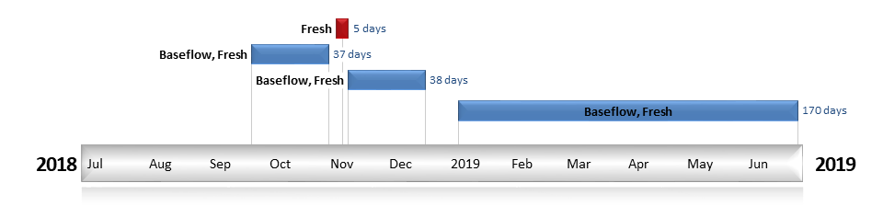
Figure WIM2. Timing and duration of Commonwealth environmental water actions delivered in the Wimmera valley.

Contribution of Commonwealth environmental water to flow regimes
Londsdale
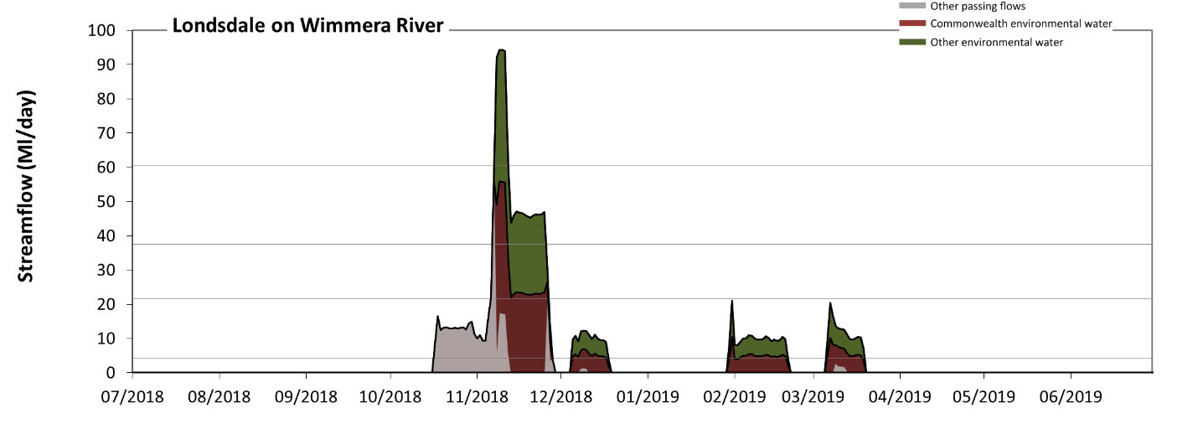
Figure WIM3: Contribution of environmental water delivery at Londsdale. Horizontal lines indicate thresholds for very low flows, low flows, low freshes and medium freshes (from lowest to highest).
At Londsdale on Wimmera River, environmental water contributed 78% of the total streamflow volume (with approximately half contributed by Commonwealth environmental water). Environmental watering actions affected streamflows for 19% of days between 1 July 2018 and 30 June 2019. Without environmental water, the durations of very low flows (i.e. < 4.3 Ml/day) in the periods July to September, October to December, January to March and April to June would have all substantially exceeded durations expected in an average year in the natural flow regime. Environmental water mitigated these impacts by reducing the cumulative duration of very low flow spells from 92% to 75% of the year, with greatest influence in the periods October to December and January to March. Similarly, without environmental water, the durations of medium low flows (i.e. < 22 Ml/day) in the periods July to September, October to December, January to March and April to June would have all substantially exceeded durations expected in an average year in the natural flow regime. Environmental water mitigated these impacts by reducing the cumulative duration of medium low flow spells from 99% to 94% of the year, with greatest influence in the period October to December. Commonwealth environmental water equally shared responsibility with other environmental water holders for these enhancements of environmental baseflows at this site. In the absence of environmental water there would have been at least one low fresh (i.e. > 37 Ml/day) in the period October to December. Environmental water increased the duration of the longest low fresh during the period October to December (from 1 days to 19 days). Commonwealth environmental water equally shared responsibility with other environmental water holders for these increased durations of low freshes. In the absence of environmental water there would have been no medium or high freshes this year. Environmental water increased the duration of the longest medium fresh during the period October to December (from 0 days to 5 days). Commonwealth environmental water equally shared responsibility with other environmental water holders for these increased durations of medium freshes.
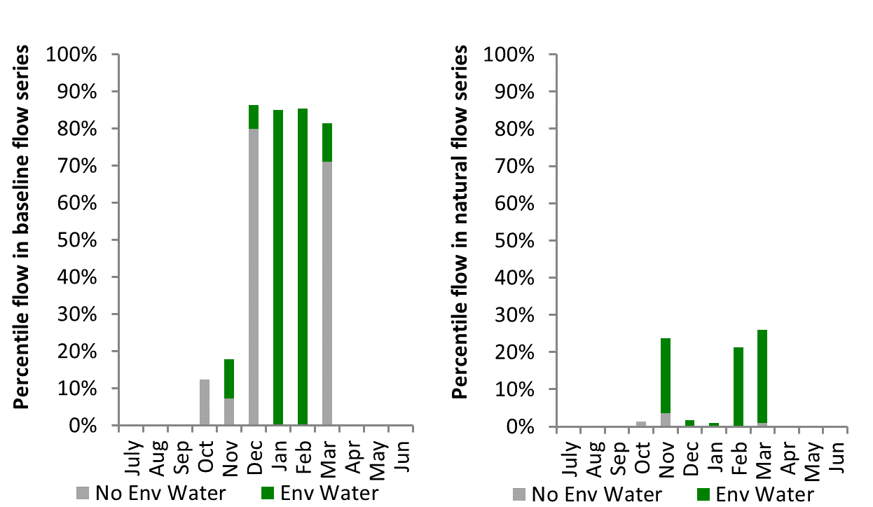
Figure WIM4: Contribution of environmental water delivery at Londsdale as percentiles in the natural and baseline flow series.
Taylors
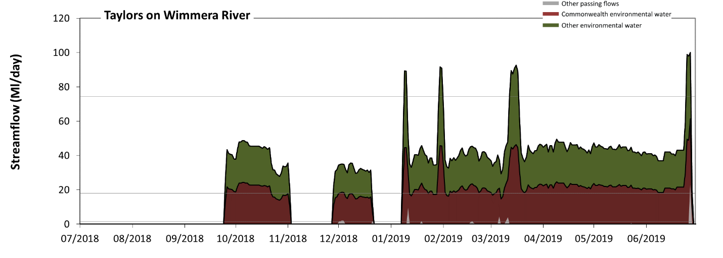
Figure WIM5: Contribution of environmental water delivery at Taylors. Horizontal lines indicate thresholds for very low flows, low flows, low freshes and medium freshes (from lowest to highest).
At Taylors on Wimmera River, environmental water contributed 99% of the total streamflow volume (with approximately half contributed by Commonwealth environmental water). Environmental watering actions affected streamflows for 64% of days between 1 July 2018 and 30 June 2019. Without environmental water, the durations of very low flows (i.e. < 0.33 Ml/day) in the periods July to September, October to December, January to March and April to June would have all substantially exceeded durations expected in an average year in the natural flow regime. Environmental water mitigated these impacts by reducing the cumulative duration of very low flow spells from 96% to 36% of the year, with greatest influence in the periods January to March and April to June. Similarly, without environmental water, the durations of medium low flows (i.e. < 1.7 Ml/day) in the periods July to September, October to December, January to March and April to June would have all substantially exceeded durations expected in an average year in the natural flow regime. Environmental water mitigated these impacts by reducing the cumulative duration of medium low flow spells from 97% to 36% of the year, with greatest influence in the periods January to March and April to June. Commonwealth environmental water equally shared responsibility with other environmental water holders for these enhancements of environmental baseflows at this site. In the absence of environmental water there would have been at least one low fresh (i.e. > 18 Ml/day) in the period April to June. Environmental water increased the duration of the longest low fresh during the periods July to September (from 0 days to 6 days), October to December (from 0 days to 33 days), January to March (from 0 days to 83 days) and April to June (from 1 days to 89 days). Commonwealth environmental water equally shared responsibility with other environmental water holders for these increased durations of low freshes. In the absence of environmental water there would have been no medium or high freshes this year. Environmental water increased the duration of the longest medium fresh during the periods January to March (from 0 days to 5 days) and April to June (from 0 days to 3 days). Commonwealth environmental water equally shared responsibility with other environmental water holders for these increased durations of medium freshes.
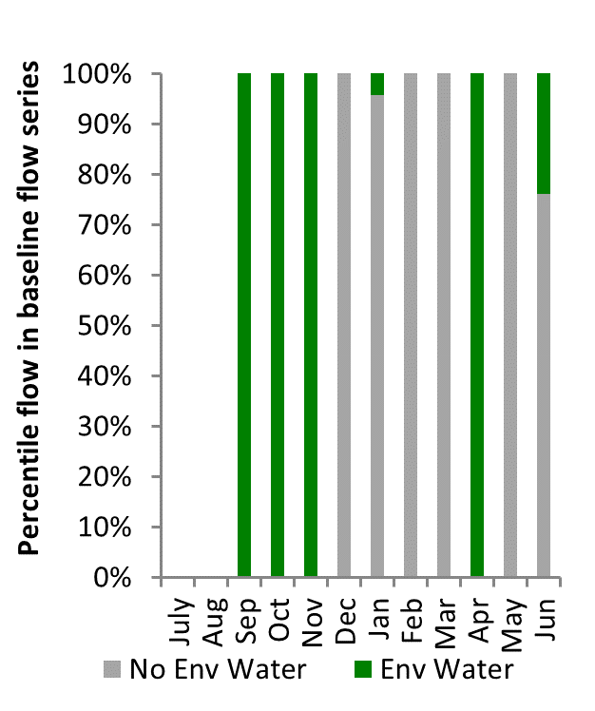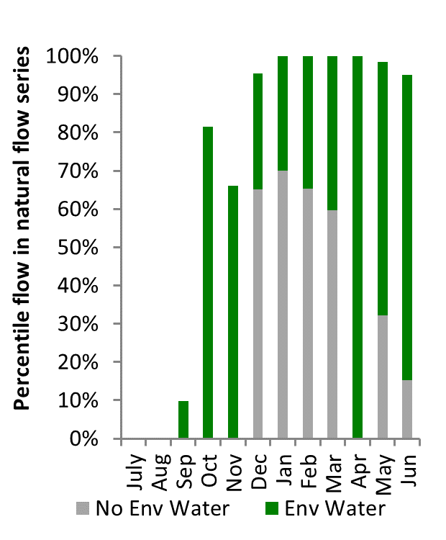
Figure WIM6: Contribution of environmental water delivery at Taylors as percentiles in the natural and baseline flow series.

Condamine
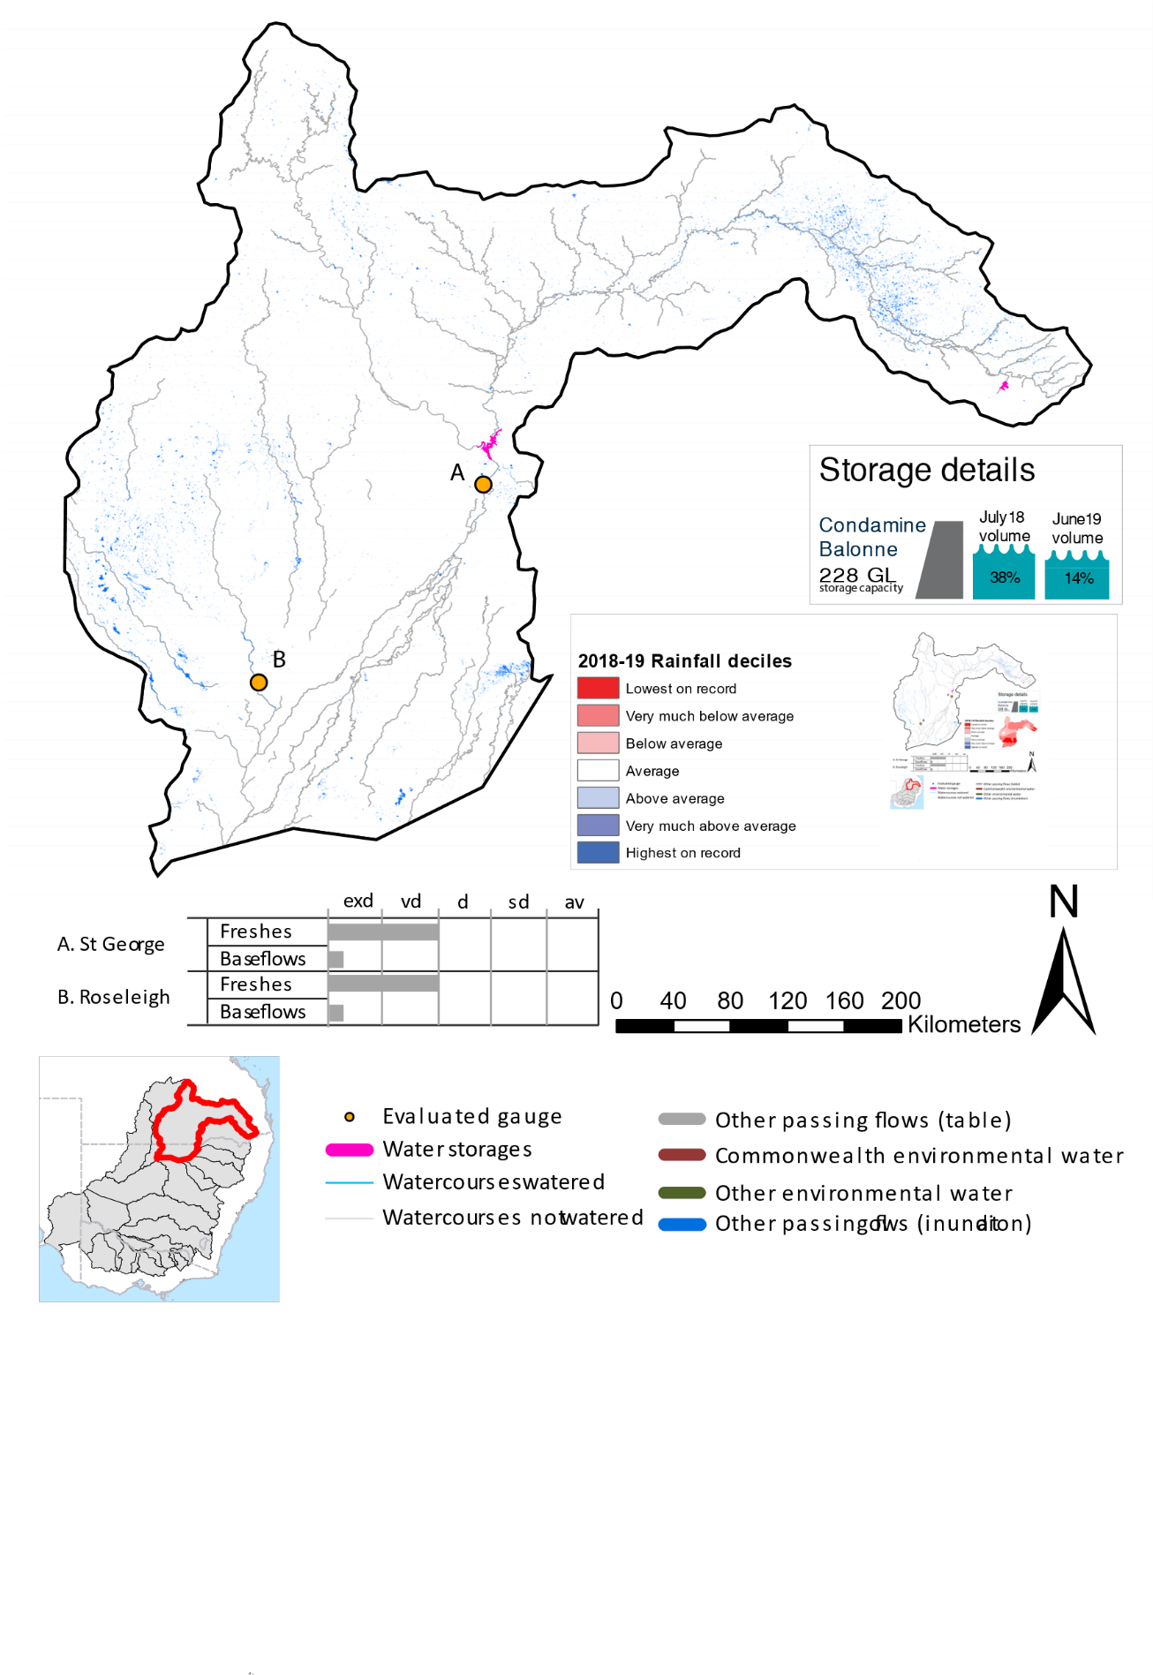
Figure CON1: Watercourses influenced, areas inundated (where applicable) and gauge stations evaluated in the Condamine Balonne valley during the 2018-19 water year. Inset bar graphs report the condition of annual flow regimes by showing the improvements in hydrological condition with the addition of environmental water as well as the hypothetical scenario in “grey” (if no environmental flow had been delivered) where exd=extremely dry, vd=very dry, d=dry, sd=somewhat dry and av=average. Rainfall conditions (rainfall deciles) and trend in storage levels for the water year are also shown.

Summary
The volume of environmental water delivery for the 2018-19 year in the Condamine Balonne valley is quantified using data for 1 sites. This evaluation only considers the contribution of held environmental water, which is a primary focus for the Commonwealth. The contributions of planned environmental water (e.g. passing flows), unregulated tributary inflows and clever use of irrigation flows for environmental benefits can all be very important but these are outside the scope of this report. Environmental watering actions lasted on average 0 days over the course of the year. The volume of environmental water at this site was 0% of the total streamflow. Commonwealth environmental water contributed on average 0% of this environmental water. The contribution of environmental water delivery to improved flow regimes is evaluated using data for 1 sites. Ideally, baseflows should be maintained and long periods of excessively low flows avoided. In this valley, the baseflow regime was generally considered to be extremely dry relative to the pre-development flow regime. In our analysis, a low fresh refers to a period of increased flow, when the water level rises at least one eighth of the way up the river bank (above the low flow level). These low freshes are a regular part of the natural flow regime and support a range of natural processes. In the Condamine Balonne valley, in terms of the occurrence and duration of low freshes, the year was assessed as being very dry. In our analysis, a medium fresh refers to a period of increased flow, when the water level rises at least one quarter of the way up the river bank. These medium freshes are not as frequent as low freshes but are also a regular and important part of the natural flow regime. In the Condamine Balonne valley, in terms of the occurrence of medium freshes, the year was assessed as being dry. In our analysis, a high fresh refers to a period of increased flow, when the water level rises more than half way up the river. A high fresh may not occur every year but they are still important and long periods without major freshes can have serious consequences for floodplains and their contribution to river connectivity. Delivering high in channel environmental flows normally requires that all risks to riparian landholders and infrastructure have been resolved. In the Condamine Balonne valley, in terms of the occurrence of high freshes, the year was assessed as being extremely dry.

Water delivery context
During the 2018-19, the Commonwealth Environmental Water Holder (CEWH) held unregulated water entitlements of up to 172,926 ML for environmental use in the Condamine Balonne valley. In 2018-19, the Condamine Balonne entitlements held by the CEWH were allocated 1,259 ML of water, representing 1% of the Long term average annual yield for the Condamine Balonne valley (91,241 ML). Information and data relating to the portfolio of held Commonwealth environmental water is shown in Table CON2.
The 2018-19 water allocation (1,259 ML) together with the carryover volume of 45 ML of water meant the CEWH had 1,304 ML of water available for delivery. A total of 1,259 ML of Commonwealth environmental water was delivered in the Condamine Balonne valley. A total of 0 ML of Commonwealth environmental water was traded to consumptive users and 25 ML (2%) of available Commonwealth environmental water was carried over for environmental use into the 2019-20 water year.

Environmental conditions and resource availability
The rainfall conditions in the Condamine Balonne valley were classified as Very much below average, based on rainfall percentile data for the entire record held by the Bureau of Meteorology for this valley. The water held in major storages in the Condamine Balonne valley decreased over the water year, for example Leslie, Cooby, Chinchilla, Beardmore and Jack Taylor dam was 38.8% full at the beginning of the water year and 14.0% full by the end of the year (Figure CON1).

Watering actions
One watering actions was delivered over the 2018-19 water year. This action was delivered in an ungauged section of the upper Condamine and as such was not assessed. However, the action delivered was classed as a baseflow and was delivered during winter for resilience purposes.
Table CON2. Commonwealth environmental water accounting information for the Condamine Balonne valley over 2018-19 water year.
Total registered volume (ML) | Allocated volume (ML) | Carry over + allocated volume (ML) | Delivered (ML) | LTAAY (ML) | Trade (ML) | Carried over to 2019-20 | Forfeited (ML)
172,926 | 1,259 | 1,304 | 1,259 | 91,241 | 0 | 25 | 0

Contribution of Commonwealth environmental water to flow regimes

StGeorge
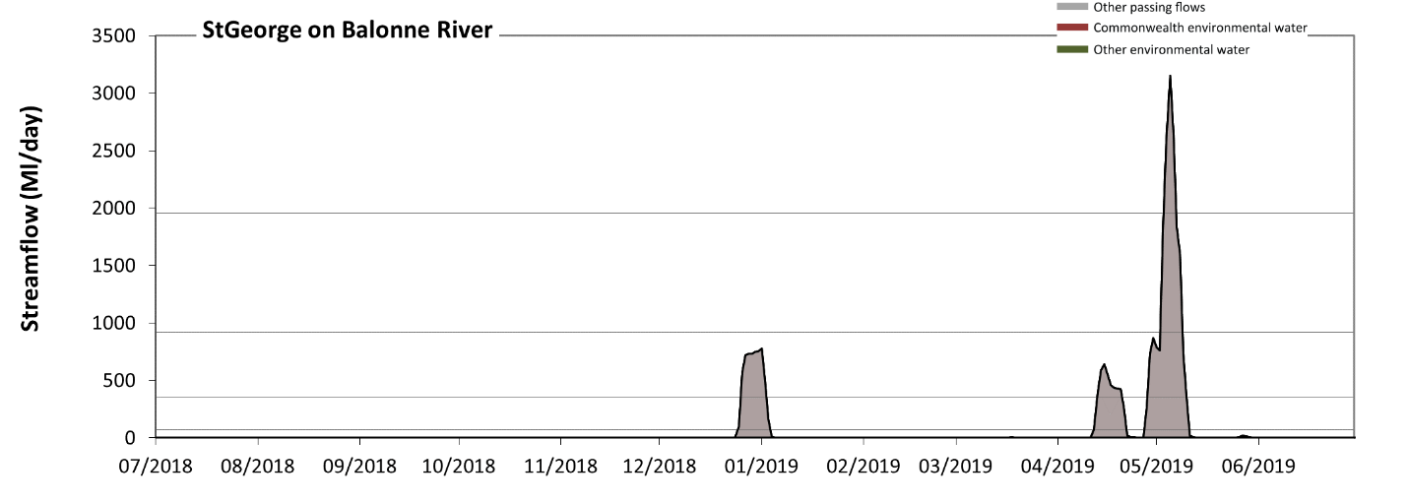
Figure CON2: Contribution of environmental water delivery at StGeorge. Horizontal lines indicate thresholds for very low flows, low flows, low freshes and medium freshes (from lowest to highest).
There was no environmental water delivered at St George on Balonne River. Without environmental water, the durations of very low flows (i.e. < 71 Ml/day) in the periods July to September, October to December, January to March and April to June was substantially in excess of durations expected in an average year in the natural flow regime. Similarly, without environmental water, the durations of medium low flows (i.e. < 350 Ml/day) in the periods July to September, October to December, January to March and April to June was substantially in excess of durations expected in an average year in the natural flow regime. There was at least one low fresh (i.e. > 920 Ml/day) in the period April to June. There was at least one medium fresh (i.e. > 2000 Ml/day) in the period April to June. There were no high freshes (i.e. > 6200 Ml/day) this year.
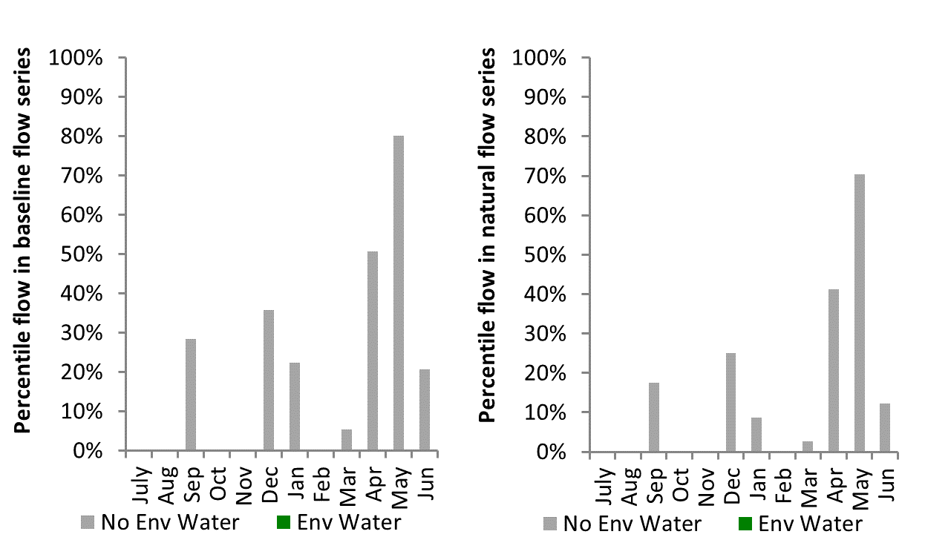
Figure CON3: Contribution of environmental water delivery at StGeorge as percentiles in the natural and baseline flow series.

https://www.environment.gov.au/water/cewo/publications/report-warrego-river-flow-darling-april-june-2019

