Murray–Darling Basin Long Term Intervention Monitoring Project

2018–19 Basin-scale evaluation of Commonwealth environmental water – Synthesis Report

Contributors: Jennifer Hale, Nick Bond, Shane Brooks, Samantha Capon, Mike Grace, Fiorenzo Guarino, Cassandra James, Alison King, Luke McPhan, Julia Mynott, Michael Stewardson and Nicole Thurgate

Final Report
CFE Publication 252
June 2020

Murray–Darling Basin Long Term Intervention Monitoring Project
2018–19 Basin-scale evaluation of Commonwealth environmental water — Synthesis Report
Report prepared for the Agriculture, Water and the Environment, Commonwealth Environmental Water Office by La Trobe University, Centre for Freshwater Ecosystems.

Department of Agriculture, Water and the Environment, Commonwealth Environmental Water Office
John Gorton Building
Parkes ACT 2600
Ph: (02) 6274 1111

For further information contact:
Nick Bond Nikki Thurgate
Project Leader Project Co-ordinator
Centre for Freshwater Ecosystems
(formerly Murray–Darling Freshwater Research Centre)
PO Box 821
Wodonga VIC 3689
Ph: (02) 6024 9640 (02) 6024 9647
Email: n.bond@latrobe.edu.au n.thurgate@latrobe.edu.au
Web: https://www.latrobe.edu.au/freshwater-ecosystems/research/projects/ewkr
Enquiries: cfe@latrobe.edu.au

Report Citation: Hale J, Bond N, Brooks S, Capon S, Grace M, Guarino F, James C, King A, McPhan L, Mynott J, Stewardson M, Thurgate N, (2020) Murray–Darling Basin Long Term Intervention Monitoring Project — Basin Synthesis Report. Report prepared for the Agriculture, Water and the Environment, Commonwealth Environmental Water Office by La Trobe University, Centre for Freshwater Ecosystems, CFE Publication 252. May 2020 59p.

Traditional Owner acknowledgement:
La Trobe University Albury-Wodonga and Mildura campuses are located on the land of the Latje Latje and Wiradjuri peoples. The Research Centre undertakes work throughout the Murray–Darling Basin and acknowledge the traditional owners of this land and water. We pay respect to Elders past, present and future.

Document history and status
Version | Date Issued | Reviewed by | Approved by | Revision type
Draft | 5/6/2020 | CEWO | N. Thurgate | Draft
Draft | 29/06/2020 | BM team | N. Thurgate | Draft

Distribution of copies
Version | Quantity | Issued to
Draft | 1 word doc | CEWO

Contents
Summary of annual Basin-scale evaluation 2018–19 4
Summary of multi-year Basin-scale evaluation outcomes 2014–19 5
1 Background 7
1.1 The Commonwealth Water Act 2007 7
1.2 Roles and responsibilities under the Basin Plan 7
1.3 Monitoring aquatic ecosystem responses to environmental flows 8
2 Introduction 10
2.1 What is the Long Term Intervention Monitoring Project? 10
2.2 How are we evaluating outcomes at the Basin scale? 11
2.3 Context 12
3 Basin-scale evaluation 2018–19 16
3.1 Key findings 16
3.2 Biodiversity 17
3.3 Ecosystem function 19
3.4 Resilience 20
4 Cumulative Basin-scale evaluation 2014–19 21
4.1 Key findings 21
4.2 Context 22
4.3 Baseflows 22
4.4 Freshes 28
4.5 Wetland inundation 35
5 Contribution to achievement of Basin Plan objectives and adaptive management 44
5.1 Adaptive management 44
5.2 Basin Plan objectives 48
6 References 52
Appendix 1: 2018–19 Commonwealth environmental watering actions 53
Appendix B – 2018–19 Basin-scale evaluation of Commonwealth environmental water – Hydrology report 60
Appendix C – 2018–19 Basin-scale evaluation of Commonwealth environmental water – Stream Metabolism & Water Quality report 60
Appendix D – 2018–19 Basin-scale evaluation of Commonwealth environmental water – Ecosystem Diversity report 60
Appendix E – 2018–19 Basin-scale evaluation of Commonwealth environmental water – Vegetation Diversity report 60
Appendix F – 2018–19 Basin-scale evaluation of Commonwealth environmental water – Fish report 60
Appendix G – 2018–19 Basin-scale evaluation of Commonwealth environmental water – Biodiversity report 60

Summary of annual Basin-scale evaluation 2018–19
Key Basin-scale evaluation findings
- Commonwealth environmental water supported 58% of the different wetland ecosystem types and 83% of floodplain ecosystem types in the Basin in 2018–19.
- Over three hundred plant taxa were recorded in 2018–19 in the Selected Areas, comprising 214 and 86 identifiable native and introduced species respectively.
- Sixteen plant taxa, mostly native perennial forbs, were only recorded in 2018–19 from Sample Points that received Commonwealth environmental water delivered in 2018–19.
- Commonwealth environmental water appears to have had a positive effect on species richness of groundcover vegetation in the two Selected Areas, where the effects of inundation were monitored, the Gwydir and Murrumbidgee river systems.
- There was no systematic change in adult fish abundance across species in 2018–19 compared with other water years. Large-bodied species were observed spawning in some parts of the Basin, however, there was little evidence found of recruitment for golden perch and limited recruitment of Murray cod, bony herring and common carp. Small-bodied species exhibited some success in spawning and recruitment.
- In many Selected Areas, environmental water allowed fish movement along rivers, and into and out of wetlands where food availability is likely to be high.
- Commonwealth environmental water was delivered to maintain refuge habitats in a drying landscape in 2018–19. This resulted in sustained records for waterbird and frog diversity in the Gwydir and Murrumbidgee Selected Areas.
Key contribution to Basin Plan objectives
- 8.05(2) protect and restore a subset of all water-dependent ecosystems..(a) declared Ramsar wetlands that depend on Basin water resources maintain their ecological character – by delivering environmental water to nine of the 16 Ramsar Wetlands in the Basin.
- 8.05(2) protect and restore a subset of all water-dependent ecosystems..(b) species listed under the Bonn Convention, CAMBA, JAMBA or ROKAMBA – by supporting a small number of migratory shorebirds at inland sites and a large number in the Coorong.
- 8.05(3) protect and restore biodiversity..(a) listed threatened species – by supporting threatened native fish species, waterbirds (Australasian bittern, regent parrot, superb parrot) and the southern bell frog.
- 8.05(3) protect and restore biodiversity..(b) representative populations and communities of native biota – by supporting greater than one percent of the population of eight species of waterbird.
- 8.06 (3) protect and restore connectivity…(b) longitudinally along watercourses – by inundating 14 379 km of rivers.
- 8.06 (3) protect and restore connectivity…(b) laterally between watercourses and their floodplains (and associated wetlands) – by inundating 92 475 ha of lakes and wetlands, 26 568 ha of floodplains.
- 8.06 (3) protect and restore connectivity…(e) maintaining water levels in the lower lakes – target achieved largely due to Commonwealth environmental water.
- 8.07 (7) protect and restore… primary production and respiration – by contributing to increased production of carbon through the delivery of baseflows and freshes.

Summary of multi-year Basin-scale evaluation outcomes 2014–19
Key Basin-scale evaluation findings
Throughout the five-year LTIM project (2014–2019) drought conditions predominated across most the Basin. The Basin-scale evaluation for this final LTIM year has summarised the effects of Commonwealth environmental water through its effects on different aspects of the flow regime.
Baseflows
- Commonwealth environmental water contributed significantly to ensuring that very low flows were avoided across much of the southern Basin, despite continued dry conditions. Commonwealth environmental water contributed little, however, in the northern Basin, with the exception of the two Northern Connectivity events (2017–18 and 2018–19), which were critical in maintaining refuges.
- Baseflows have sustained native fish populations by maintaining connectivity and water quality in dry conditions, but baseflows alone are insufficient to maintain fish populations in the long term
- Commonwealth environmental water is likely to have contributed to increased productivity through baseflows as even small rises in flow from very low baseflows to low flows, can introduce more organic carbon into the food web.
Freshes
- Although Commonwealth environmental water has contributed to the provision of freshes across many valleys, particularly in the Southern Basin, moderate and high freshes are lacking in many valleys across the Basin.
- Commonwealth environmental water delivered as freshes has resulted in stimulating primary productivity, especially when delivered in spring–summer when temperatures are warmer.
- Commonwealth environmental water has contributed to improving the abundance of the native fish Australian smelt, through improved freshes in the flow regime and that these freshes also resulted in a decline in the introduced common carp.
- While some of the delivered freshes may have resulted in fish spawning, there is more to be done in delivering water for fish reproductive outcomes.
Wetland inundation
- During the five years of LTIM Commonwealth environmental water supported 28 291 ha of lakes, 158 487 ha of palustrine wetlands and 101 735 ha of floodplain ecosystems.
- Commonwealth environmental water has promoted heterogeneity of vegetation communities at landscape and Basin scales by generating a mosaic of plant habitats that vary in their inundation histories.
- Commonwealth environmental water has contributed to maintaining the ecological character of 11 of the 16 Ramsar sites in the Basin over the five years of the LTIM project.
- Fifty-two significant species were recorded at sites that received environmental water in 2014–19. This includes international migratory waterbird species, nationally listed threatened species and species listed under state legislation.
- Waterbird abundance and to a lesser extent, diversity, is greater in wetlands than are partially full rather than completely inundated, indicating the importance of wetting and drying cycles of wetland ecosystems.

Adaptive management messages
- All environmental water will enhance plant species and vegetation community diversity, due to the different water regime tolerances of different taxa and communities.
- Baseflows or above should be maintained to maintain adequate water quality and promote native fish persistence.
- Allocation of environmental water to increase fresh flows improves the abundance of some native fish species, including Australian smelt, bony herring and carp gudgeon.
- Given the lack of golden perch recruitment, where possible spring and summer overbank flows, freshes or pulse events should be used to trigger golden perch spawning, recruitment and dispersal of young. Flows should also be provided to support longitudinal and lateral connectivity and promote population connectivity.
- After fish kills, priority should be given to providing flows that target maintaining refuge habitats and connecting populations post hypoxia events.
- Environmental water delivered to promote a variety of water regimes at the site and landscape scale will promote biodiversity.
- The first fresh following winter to inundate dry sediment has the greatest potential to enhance metabolic rates, particularly in spring and summer as temperatures increase.
- Even small flow increases retained within the main channel from environmental water can generate higher loads of organic carbon (‘fish food’) in the water flowing past a point each day.
Key contributions to Basin Plan objectives
- 8.05(2) protect and restore a subset of all water-dependent ecosystems..(a) declared Ramsar wetlands that depend on Basin water resources maintain their ecological character – by delivering environmental water to 11 of the 16 Ramsar wetlands in the Basin.
- 8.05(2) protect and restore a subset of all water-dependent ecosystems..(b) species listed under the Bonn Convention, CAMBA, JAMBA or ROKAMBA – by supporting a small number of migratory shorebirds at inland sites and a large number in the Coorong.
- 8.05(3) protect and restore biodiversity..(a) listed threatened species – by supporting 54 listed threatened species over the five years of LTIM.
- 8.05(3) protect and restore biodiversity..(b) representative populations and communities of native biota
- By supporting over 1 million individual waterbirds and greater than one percent of the population of 22 species of waterbird
- By promoting diversity of wetland plants and vegetation communities
- By maintaining native fish species diversity (no loss of species).
- 8.06 (3) protect and restore connectivity…(b) longitudinally along watercourses – by inundating 25 856 km of rivers.
- 8.06 (3) protect and restore connectivity…(b) laterally between watercourses and their floodplains (and associated wetlands) – by inundating 28 291 ha of lakes, 158 487 ha of palustrine wetlands and 101 735 ha of floodplain ecosystems over the five years.
- 8.06 (3) protect and restore connectivity…(c) Murray Mouth remains open…. – by contributing approximately 79% of the total flow over the barrages 2014–19.
- 8.06 (3) protect and restore connectivity…(e) maintaining water levels in the lower lakes – target achieved largely due to Commonwealth environmental water.
- 8.07 (7) protect and restore… primary production and respiration – by contributing to increased production of carbon through the delivery of baseflows and freshes.

Background

The Commonwealth Water Act 2007
The Water Act 2007 (Cwlth) (The Act) provides the legal basis for the determination of sustainable water extraction limits within the Basin. The Act establishes the Murray–Darling Basin Authority (MDBA) to develop the Basin Plan 2012 (Basin Plan), which defines these limits, and the Commonwealth Environmental Water Holder (CEWH) to manage the environmental flows that result and gives greater powers to the Bureau of Meteorology to obtain and disseminate water information across the country.
To support the implementation of these arrangements and rebalance the system between the environment and consumptive use, the Australian Government is investing in recovering water through investment in irrigation efficiency and the buyback of entitlements from irrigators.
The CEWH is a statutory position responsible for managing the water that the Australian Government acquires for the purpose of protecting or restoring environmental assets so as to give effect to international agreements (The Act s105). In undertaking this role, there are three options available to the CEWH at any given time in managing the portfolio:
- use the environmental water which accrues to the entitlement, with the release of water from storage or the manipulation of other in-stream or floodplain infrastructure (with the timing, flow rate and volume released designed to have maximum environmental benefit)
- carryover the water in storage for use in a future year (under the same rules that apply to irrigators)
- trade (buy or sell water) with irrigators in order to improve environmental outcomes at a future time or in a different valley (e.g. sell water when it is not needed and buy when it is).
The MDBA is an independent, expertise-based agency responsible for leading the planning and management of Basin water resources. It has key roles in:
- developing and overseeing the implementation of all aspects of the Basin Plan
- coordinating state and federal agencies in the management of the water resources
- evaluating and auditing the implementation of the Basin Plan.

Roles and responsibilities under the Basin Plan
The Basin Plan, a legislative instrument, sets out the roles and responsibilities for reporting on environmental outcomes of the MDBA, state governments and the CEWH:
- the MDBA is responsible for reporting on achievements against the environmental objectives of the Basin Plan at the Basin scale (i.e. whole of drainage basin)
- state governments are responsible for reporting on achievements against the environmental objectives of the Basin Plan at an asset scale (i.e. rivers, wetlands, floodplains)
- the CEWH is responsible for reporting on the contribution of Commonwealth environmental water to the environmental objectives of the Basin Plan (at multiple scales).
These reporting obligations set up the architecture for the monitoring and evaluation that is required to enable a determination by the MDBA of overall Basin Plan outcomes, as indicated in Figure 1.

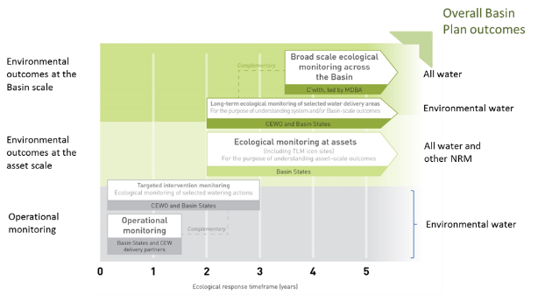
Figure 1. Monitoring and evaluation reporting obligations (adapted from Commonwealth Environmental Water Office 2013).

Monitoring aquatic ecosystem responses to environmental flows
Within this framework, the CEWH needs to ensure that its monitoring and evaluation activities will enable it to meet is reporting obligations and demonstrate both value for money from the Australian Government’s investment and support adaptive environmental flow management over time.
The common elements of all reporting requirements are the Basin Plan environmental objectives, or more specifically, the environmental objectives contained within the Environmental Watering Plan (Chapter 8 of the Basin Plan). These objectives are Basin scale and long term. For example (S8.05(3)):
- An objective is to protect and restore biodiversity that is dependent on Basin water resources by ensuring that:
- water-dependent ecosystems that support the life cycles of a listed threatened species or listed threatened ecological community, or species treated as threatened or endangered (however described) in State law, are protected and, if necessary, restored so that they continue to support those life cycles; and
- representative populations and communities of native biota are protected and, if necessary, restored.
However, environmental flows are delivered at an asset scale in the short term. To bridge this gap, the Commonwealth Environmental Water Office’s (CEWO’s) Long Term Intervention Monitoring (LTIM) Project is based around an Outcomes Framework (CEWO 2013) which describes the outcomes expected from environmental flows at 1- and 5-year time scales that will contribute to the longer term objectives of the Environmental Watering Plan.
These outcomes help guide the monitoring that needs to take place to support an evaluation of the impact of environmental flows and are based on cause-and-effect diagrams that describe the relationships between different parameters in response to environmental flows, reflecting current scientific knowledge.
This Outcomes Framework also ensures that the monitoring undertaken by the CEWO is aligned with the broader scale monitoring undertaken by the MDBA for vegetation, fish, waterbirds and hydrological connectivity and for which there are quantified environmental targets described in a Basin-wide Watering Strategy (MDBA 2019) – one of the key planning documents that guides all environmental water use within the Basin.
The Basin-wide Environmental Watering Strategy provides the next level of detail on the environmental objectives and targets, with ‘quantified expected outcomes’ identified for four components: river flows and connectivity; native vegetation; waterbirds; and native fish. Examples of the expected outcomes include:
- a 20–25% increase in waterbirds by 2024
- a 10–15% increase in mature Murray cod and golden perch at key sites
- maintenance of the current area and condition (and in some regions, improved condition) of river red gum, black box, coolabah and lignum communities
- improved overall flow, such as 10% more flow in the Barwon–Darling river system, 30% more flow in the Murray River and 30–40% more flow to the Murray Mouth.
These outcomes are the MDBA’s best assessment of how the Basin’s environment will respond over the next decade as a result of implementing the Basin Plan and associated water reforms. It is the responsibility of the MDBA to evaluate the contribution of Basin Plan reforms to achieving these targets using its own monitoring information and that obtained from Basin States and the CEWO.

Introduction

What is the Long Term Intervention Monitoring Project?
The LTIM Project is assessing the ecological effects of Commonwealth environmental water and its contribution to Basin Plan environmental objectives. The LTIM Project aligns with the CEWO Monitoring, Evaluation, Reporting and Improvement (MERI) Framework (CEWO 2013) and will provide information that will help improve the management of environmental water, through adaptive management. Monitoring is being conducted at seven areas (called Selected Areas) across the Basin (Figure 2) from 2014–15 to 2018–19 and the evaluation is undertaken across the entire Basin and includes all watering actions.
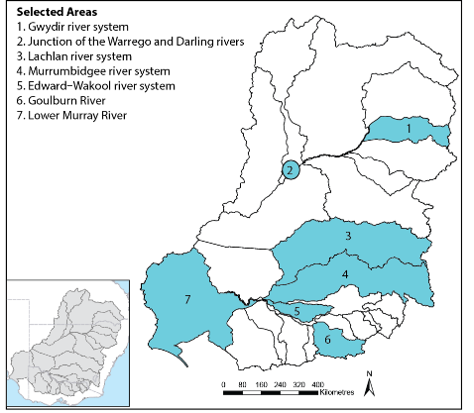
Figure 2. General location of the seven Selected Areas where the LTIM Project is measuring the effects of Commonwealth environmental water.
The five high-level objectives of the LTIM Project are to:
- evaluate the contribution of Commonwealth environmental watering to the objectives of the MDBA’s Environmental Watering Plan
- evaluate the ecological outcomes of Commonwealth environmental watering at each of the seven Selected Areas
- infer ecological outcomes of Commonwealth environmental watering in areas of the Basin not monitored
- support the adaptive management of Commonwealth environmental water
- monitor the ecological response to Commonwealth environmental watering at each of the seven Selected Areas.
The LTIM Project is evaluating the effect of Commonwealth environmental water at several spatial scales. Evaluation at the site and regional (Selected Area) scales is being completed by monitoring teams at each of the Selected Areas and is documented in individual reports that are published on the CEWO website annually. Evaluation is also being conducted at the Basin scale, which seeks to integrate information from monitoring at Selected Areas and other information sources to determine outcomes from the portfolio of Commonwealth environmental water across the Basin. This report documents the Basin-scale evaluation for the five years of the LTIM Project (2014–19), with a focus on the outcomes from Year 5 (2018–19) and cumulative outcomes from 2014–19.

How are we evaluating outcomes at the Basin scale?
- The development of the Basin-scale evaluation is described in the LTIM Project Logic and Rationale document (Gawne et al. 2013) and the Basin Evaluation Plan (Gawne et al. 2014). These documents provide an overview of the LTIM Project and the selection process for six ecological indicators or ‘matters’ for Basin evaluation:
- ecosystem diversity – the aquatic ecosystem types (e.g. wetlands, rivers, streams) that benefited from Commonwealth environmental water
- hydrology – river flow and wetland water regimes modelled with and without Commonwealth environmental water
- stream metabolism and water quality – rates of instream primary productivity and decomposition, salinity and pH
- vegetation diversity – plant species and vegetation community responses
- fish – short- and long-term responses of fish with respect to condition, abundance, diversity and reproduction
- biodiversity – effects on diversity of all biota from monitoring and observations.

This Basin-scale evaluation report draws together the results of each Basin Matter to provide an integrated assessment of the outcomes of Commonwealth environmental water. Evaluation of the 2018–19 watering year is provided as a summary of achievements of Commonwealth environmental water under three broad themes of the Basin Plan: biodiversity, ecological function and resilience (section 3). The cumulative findings across the five years of the LTIM project is provided in three parts (sections 4 and 5):
- cumulative Basin-scale evaluation – integration of outcomes across Basin Matters linked to the hydrological components influenced by Commonwealth environmental water (baseflows, freshes, end of system flows and wetland inundation)
- contributions to Basin Plan environmental objectives – a tabulation of progress toward these long-term goals
- adaptive management – a summary of key ‘lessons learned’ for improved environmental water outcomes and future evaluation.

Context

Climate and water availability
The 2018–19 water year was dry across the majority of the Basin with rainfall classified as “very much below average” in most catchments in the northern Basin (Figure 3). The five years of LTIM (2014–19) have been predominantly dry, particularly in the southern Basin, and 2018–19 was the driest of the five years. The 2016–17 water year was the wettest of the five year period, with above average rainfall across the southern Basin and average conditions in the north.
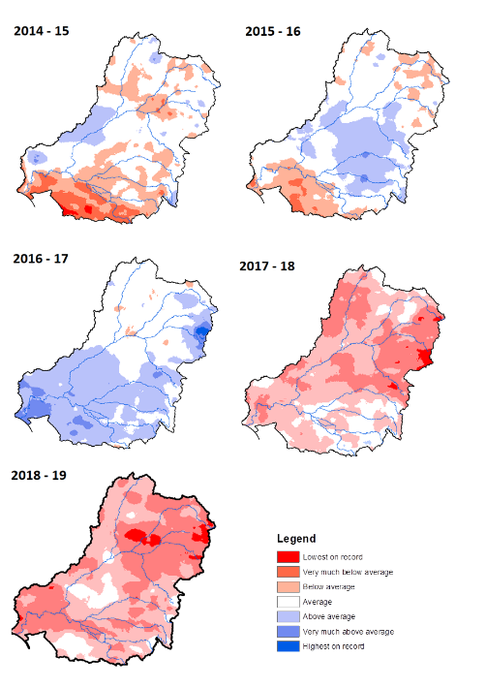
Figure 3. Annual rainfall conditions for period of LTIM monitoring (data from the Bureau of Meteorology).

Surface water inflows in the northern Basin in 2018–19 were the lowest since 2001; just 21% of the long-term average (Figure 4). This continues a six year period of very low inflows across the northern Basin. Average flows during the LTIM project have been the lowest for any five year period since 2001 in the northern Basin (Figure 4).
In the southern Basin, total inflows in 2018–19 were slightly below the average for the period since 2001 (Figure 4). The last 19 years has been a protracted dry period for the southern Basin. Persistent low inflows that characterised the Millennium Drought have continued after a brief respite for two wetter years in 2010–11 and 2011–12. Over the five years of LTIM, flows in the southern Basin were near the average for the period since 2001.

Figure 4. Annual surface water inflows in the Murray–Darling Basin (Source: BoM National Water Account).

Commonwealth environmental water delivery

Commonwealth environmental water delivery in 2018–19
Commonwealth environmental water contributed to 131 watering actions across 19 catchments in the 2018–19 watering year (Appendix A). A net total of 853 gigalitres of Commonwealth environmental water was delivered. Through the use of return flows, Commonwealth environmental water was used and reused, effectively contributing 1163 gigalitres of water towards environmental objectives in the Basin. Reflecting the dry conditions, the majority of water (80%) was delivered as baseflow or freshes in rivers and streams to protect and maintain in-channel habitats and water quality (Table 1). Many of these watering actions were undertaken collaboratively with state jurisdictional partners.
The objectives of watering actions are described in terms of ‘expected outcomes’, which describe the desired ecological effects of environmental watering for any given watering action. These are developed through a process that accounts for both conditions across the Basin in the months leading up to environmental water delivery and localised site-based conditions at target aquatic ecosystems. The majority of watering actions have multiple expected outcomes, with Commonwealth environmental water delivered to benefit a range of species, ecological functions and processes. In 2018–19, the majority of watering actions were planned with expected outcomes for fish, vegetation and waterbirds (Table 2). By volume, however, 92% of Commonwealth environmental water in 2018–19 was delivered with an expected outcome for fish and 60% for water quality; with 40% for vegetation and 20% for waterbirds (Appendix A).

Table 1. Summary of Commonwealth environmental watering actions 2018–19 (see Appendix A).
Valley | Flow type (no. of actions)
Valley | Base | Fresh | Bankfull | Overbank | Wetland | Fresh, baseflow | Fresh, wetland
Border Rivers | 1 | 2
Broken | 4 | 1
Campaspe | 2 | 1
Central Murray | 1 | 1 |  | 2
Condamine–Balonne | 1
Edward–Wakool |  |  |  |  | 1 | 3
Goulburn | 2 | 2
Gwydir | 1 | 1 |  |  | 1 |  | 2
Lachlan | 1 | 1 |  |  | 2
Loddon | 1
Lower Murray | 3 | 9 |  |  | 54
Macquarie | 3 |  |  |  | 1
Murrumbidgee |  |  |  |  | 15 | 1
Namoi |  | 1
Ovens | 1
Warrego | 5
Wimmera |  | 1 |  |  |  | 1

Table 2. Count of ‘expected outcomes’ for Commonwealth environmental watering actions 2018–19.
Valley | Fish | Vegetation | Birds | Frogs | Other biota | Connectivity | Processes | Resilience | Water quality
Border Rivers | 3 |  |  |  |  | 2 |  | 2
Broken | 4 | 2 |  |  |  |  |  |  | 1
Campaspe | 3 |  |  |  | 1 |  |  |  | 2
Central-Murray | 4 | 2 | 2 |  | 1 | 1 | 1 |  | 1
Condamine–Balonne |  |  |  |  |  |  |  | 1
Edward–Wakool | 2 | 4 | 1 |  |  | 1 |  |  | 3
Goulburn | 2 | 3 |  |  | 3
Gwydir | 4 | 3 | 3 | 2 | 2 | 2 | 2 | 2 | 2
Lachlan | 4 | 2 | 1 | 1 |  | 1 | 2 | 1
Loddon | 1 |  |  |  |  |  | 1
Lower Murray | 16 | 60 | 40 | 27 | 2 | 4 | 9 | 1 | 14
Macquarie | 3 | 1 | 1 | 1 |  |  |  |  | 2
Murrumbidgee | 8 | 10 | 11 | 13 | 10 | 2 |  | 12 | 3
Namoi | 1 |  |  |  |  | 1 |  | 1 | 1
Ovens | 1 |  |  |  |  | 1
Warrego | 4 |  |  |  |  | 1 | 1 | 4
Wimmera | 4 | 4 |  |  | 4 | 2 |  |  | 4
Total (% of all watering actions) | 46 | 73 | 47 | 33 | 18 | 14 | 11 | 19 | 25

Commonwealth environmental water delivery in 2014–19
Over the course of the five-year LTIM project, 541 independent watering actions were delivered. These actions targeted various flow component from low to high flows and both within and out of the channel. Between mid-2014 and mid-2019, 45% of all actions targeted delivery of water to wetlands, the most frequently targeted flow component. In addition, approximately 22% targeted baseflows, 29% provided freshes, while 1% and 3% of actions targeted bankfull and overbank flow components.
A different picture emerges when the volume of Commonwealth environmental water distributed across the flow components is reviewed. Of the 7805 gigalitres of Commonwealth environmental water delivered over five years, 47% supported baseflows, 38% supported freshes, 9% supported wetlands, 5% supported overbank deliveries and 1% supported bankfull flows.
Of the 19 river valleys that received Commonwealth environmental water, 45% of the delivered volume was attributed to actions in the Lower Murray, 14% in the Central Murray, 13% in the Goulburn and 10% in the Murrumbidgee. The remaining valleys received 4% or less of total delivered volume of Commonwealth environmental water.

The expected outcomes from Commonwealth environmental water have remained similar throughout the LTIM project with the majority of water delivered with expected outcomes for fish and vegetation followed by waterbirds (Figure 5). By volume, 92% of Commonwealth environmental water had an expected outcome for fish, 75% for vegetation, 60% for water quality and around 40% each for waterbirds and connectivity.

Figure 5. Expected outcomes for Commonwealth environmental watering actions 2014–19.

Basin-scale evaluation 2018–19
There are six Basin Matters (ecological indicators monitored using standard methods across Selected Areas and evaluated at the Basin scale) and the full details on the methods and the results of evaluations for each of these can be found in Appendices:
- B: Hydrology
- C: Stream Metabolism and Water Quality
- D: Ecosystem Diversity
- E: Vegetation Diversity
- F: Fish
- G: Biodiversity.
Provided here is an integrated assessment of the outcomes of Commonwealth environmental water in 2018–19, across the three broad themes of the Basin Plan as defined by the CEWO Outcomes Framework (CEWO 2013): biodiversity, ecosystem function and resilience. This section draws together the main findings of each of the Basin Matter evaluations in the context of prevailing climate in the Basin during the period of water delivery in 2018–19.

Key findings
- In 2018–19, there were approximately 92 475 ha of lakes and wetlands, 26 568 ha of floodplains and 14 379 km of rivers in the Basin upstream of the Lower Lakes that was supported by Commonwealth environmental water.
- Commonwealth environmental water supported another 103 335 ha of Lake Alexandrina and Lake Albert and their fringing wetlands and 23 802 ha of estuarine habitat in the Coorong and Murray Mouth.
- Commonwealth environmental water supported 58% of the different wetland ecosystem types and 83% of floodplain ecosystem types in the Basin in 2018–19.
- Over three hundred plant taxa were recorded in 2018–19 in the Selected Areas, comprising 214 native species and 86 introduced species.
- Sixteen plant taxa, mostly native perennial forbs, were only recorded from monitoring locations that received Commonwealth environmental water in 2018–19.
- Commonwealth environmental water appears to have had a positive effect on species richness of groundcover vegetation in the two Selected Areas, where the effects of inundation was monitored, the Gwydir and Murrumbidgee river systems.
- Total fish abundance in 2018–19 was similar to other water years. Large-bodied species were observed spawning in some parts of the Basin, however, there was little evidence of recruitment for golden perch and limited recruitment of Murray cod (Maccullochella peelii), bony herring (Nematalosa erebi) and common carp (Cyprinus carpio). Small-bodied species exhibited some success in spawning and recruitment.
- In many Selected Areas, environmental water allowed fish movement along rivers, and into and out of wetlands where food availability is likely to be high.
- Commonwealth environmental water was delivered to maintain refuge habitats in a drying landscape in 2018–19 with evidence this helped sustain waterbird and frog diversity in the Gwydir and Murrumbidgee Selected Areas.
- Commonwealth environmental water contributed to maintaining the ecological character of ten Ramsar listed wetlands in 2018–19.

Biodiversity
In the 2018–19 watering year, Commonwealth environmental water was delivered to 17 of 25 catchments across the Basin. Commonwealth environmental water, in conjunction with natural flows and other sources of environmental water, contributed to improved flow outcomes along approximately 14 400 kilometres of river channel, which accounted for over half of the total river channel on the managed floodplain in several catchments including the Central and Lower Murray, Edward-Wakool, Goulburn, Gwydir, Loddon, Namoi and Ovens (Figure 6). In addition, Commonwealth environmental water influenced almost 300 000 hectares of mapped wetland and floodplain ecosystems (Table 3).
Figure 6. Length of river where flow regimes were enhanced by the delivery of Commonwealth environmental water in the 2018–19 watering year.

Table 3. Area of floodplain and wetland inundation in the 2018–19 watering year.
Catchment name | Lakes and wetland area influenced (ha) | Floodplain area inundated (ha)
Central Murray | 30 606 | 4135
Edward–Wakool | 3 | 33
Gwydir | 7096 | 3238
Lachlan | 4054 | 1183
Lower Murray* | 7270* | 766
Lower Murray (Coorong Lakes Alexandrina and Albert and Murray Mouth) | Fresh: 103 335  Estuary: 23 802 | 22
Macquarie | 32 237 | 3208
Murrumbidgee | 11 209 | 13 983
Total | 219 612 | 26 568
* Excludes the Coorong, Lakes Alexandrina and Albert and the Murray Mouth which are listed separately.

Inundation mapping showed that large areas and significant proportions of the mapped extent of several vegetation communities were influenced by Commonwealth environmental water in 2018–19, including over 5% of the mapped extent of eight wetland types:
- Permanent wetland
- Temporary sedge/grass/forb marsh
- Permanent saline wetland
- Permanent tall emergent marsh
- Temporary tall emergent marsh
- Temporary river red gum swamp
- Floodplain or riparian wetland
- Temporary swamp.
A significant proportion of plant species recorded across all monitored Selected Areas in 2018–19 were only recorded from locations that were inundated by Commonwealth environmental water during this water year. These comprised 16 native species in the wetland areas monitored in the Murrumbidgee, Lachlan, Gwydir and Junction of the Warrego and Darling Selected Areas and 38 native species in the riverine environments of the Goulburn and Edward-Wakool Selected Areas. This represents around 18% of the total number of native plant species recorded in 2018–19. Many of these unique species likely benefitting from Commonwealth environmental water were aquatic or amphibious forbs.
Composition of vegetation communities subject to mixed watering regimes during this year were reasonably distinct from those experiencing dry conditions. Figure 7 provides the outputs of a statistical analysis based on the similarity of vegetation communities in terms of their species composition. The closer a point is to another point, the more similar the vegetation communities are to each other. Sites that had a mixed watering regime but did not receive Commonwealth environmental water during the year, supported vegetation communities more similar to those in dry locations, suggesting that Commonwealth environmental water contributed to greater diversity of vegetation communities across the Basin in 2018–19 (Figure 7).
Figure 7. nMDS ordination of wetland vegetation community composition at Sample Points surveyed during 2018-19 across four Selected Areas comparing the annual watering regime (left) to inundation by Commonwealth environmental water (right).
Monitoring of native fish in 2018–19, revealed that in general, populations of Murray cod were either stable or declining. Golden perch (Macquaria ambigua) and Murray cod were both observed spawning in some parts of the Basin, however, there was little evidence found of recruitment for either species. The reason for this is not well understood but is likely to be related to the prevailing low flow conditions due to the protracted drought conditions.

Ecosystem function
Ecosystem function is defined as the processes that occur within ecosystems and between species and communities (Jax 2005) and is considered with respect to hydrology and stream metabolism. In the 2018–19 water year Commonwealth environmental water contributed to the maintenance of hydrological regimes, improved hydrological connectivity, reduced salinity at the end of the system and fish movement.
The dry conditions in 2018–19 led to very low flows across much of the northern Basin including throughout the Barwon-Darling. In contrast, excessive periods of very-low flows were largely avoided throughout the southern Basin. Environmental water entitlements contributed to avoiding very-low flows in most southern Basin sites with important contributions from Commonwealth environmental water in the Lower Murray, Edward-Wakool, Goulburn, Broken and Murrumbidgee. In addition, while freshes were largely absent in the northern Basin, across the southern Basin (with the exception of the Broken) low freshes have been delivered with large contributions of Commonwealth environmental water from the Murray and Goulburn valleys.
Commonwealth environmental water contributed to maintaining hydrological connectivity along river systems in 2018–19. Commonwealth environmental water contributed 18% of the flow volume, in the Darling River at Louth and 16% of the flow volume in the Murray River at the South Australian border (see Appendix B for further details).
Salinity is an important determinant of ecological condition in the Coorong, Lower Lakes and Murray Mouth. Salinity influences the distribution, abundance and condition of several important species and communities (Chiew et al. 2020). Salinity at the end of the system is a product of freshwater inflows balanced against tidal incursion of marine water. Adequate freshwater inflows are vital for maintaining salinity in the system and in 2018–19, Commonwealth environmental water also contributed significantly to reduced salinity in the Coorong, Lower Lakes and Murray Mouth (Table 4).

Table 4. Modelled salinity concentrations for 2018–19, with and without the addition of Commonwealth environmental across the three management units of the Coorong Lower Lakes. Values are (mg/l) mean ± standard deviation, parentheses show the minimum and maximum.
Management unit | Without Commonwealth  environmental water | With Commonwealth  environmental water
Goolwa Channel | 25.0 ± 1.1 (23.2 – 27.0) | 6.8 ± 4.3 (0.0– 18.1)
South lagoon | 64.6 ± 12.5 (44.6 – 84.9) | 49.9 ± 9.0 (35.4 - 65.2)
North lagoon | 125.1 ± 26.8 (95.1 – 170.6) | 86.2 ± 20.6(50.0 – 121.0)

Movement of native fish is known to be stimulated by the flow regime. This can include movement of fish into and out of wetlands to find suitable habitats and food resources as well as longitudinal movements along rivers for reproduction and dispersal (Beesley et al. 2009; Koehn et al. 2014). There is evidence from the Murrumbidgee Selected Area that Commonwealth environmental water benefitted fish through increased connectivity to wetlands that provide higher quality feeding and breeding habitat. Commonwealth Environmental water also allowed significant upstream and downstream movement by iconic species such as Murray cod, golden perch, silver perch (Bidyanus bidyanus) and freshwater catfish (Tandanus tandanus). Such movement is important for populations dispersal, finding mates, finding optimal habitats in which to grow, to locate breeding and nursery areas and, for avoiding predators.

Resilience
Resilience can be defined as a system’s capacity to respond to disturbance (resist, recover and adapt) so as to still retain essentially the same function, structure and identity (Colloff & Baldwin 2010; Gawne et al. 2013). The 2018–19 water year was characterised as being very dry across the majority of the Basin and Commonwealth environmental water was used to maintain refuge habitats in this dry period. Specific examples of this include:
- Sustaining species and communities in the Gwydir river system, where environmental water accounted for 98% of the total volume of water in the system. Monitoring in the Selected Area indicated that Commonwealth environmental water contributed to maintaining vegetation condition, provision of habitat for waterbirds, prevention of no flow conditions and improved connectivity for native fish.
- Provision of refuge habitat for wetlands in the Murrumbidgee Selected Area, where waterbirds, turtles, frogs (including the nationally vulnerable southern bell frog) and native fish were sustained.
- Environmental watering of 10 of the Basin’s 16 Ramsar wetlands, maintaining the condition of ecological character at hotspots of biodiversity that would otherwise have remained largely dry.

Cumulative Basin-scale evaluation 2014–19

Key findings
Throughout the five-year LTIM project (2014–2019) drought conditions predominated across most the Basin. Flow conditions at all Selected Areas were very low and highly regulated in four of the five years, with higher flow conditions in only 2016–17. The Basin-scale evaluation has summarised the effects of Commonwealth environmental water by considering the various aspects of the flow regime.
Baseflows
- Commonwealth environmental water contributed significantly to ensuring that very low flows were avoided across much of the southern Basin, despite continued dry conditions. It had little effect, however, in the northern Basin, with the exception of the two Northern Connectivity events (2017–18 and 2018–19); which were critical for maintaining refuges.
- Baseflows have sustained native fish populations by maintaining connectivity and water quality in dry conditions, but baseflows alone are insufficient to maintain fish populations in the long term. Freshes, bankfull and overbank flows are required to boost productivity fish spawning and support recruitment.
- Commonwealth environmental water is likely to have contributed to increased productivity through baseflows as even small rises in flow from very low baseflows to low flows, can introduce more organic carbon into the food web.
Freshes
- Although Commonwealth environmental water has contributed to the provision of freshes across many valleys, particularly in the southern Basin, moderate and high freshes are lacking in many valleys across the Basin.
- Commonwealth environmental water delivered as freshes has resulted in stimulating primary productivity, especially when delivered in spring–summer when temperatures are warmer.
- Commonwealth environmental water has contributed to improving the abundance of the native fish Australian smelt, through improved freshes in the flow regime and that during drier years increased freshes delivered via environmental water also resulted in reduced abundances of the introduced common carp.
- While some of the delivered freshes may have resulted in fish spawning, there is more to be done in delivering water for fish reproductive outcomes. In particular an increase in higher in-channel and overbank flows which are likely required for golden perch recruitment and potentially improved recruitment in other species.
Wetland inundation
- During the five years of LTIM Commonwealth environmental water supported 28 291 ha of lakes, 158 487 ha of palustrine wetlands and 101 735 ha of floodplain ecosystems.
- Commonwealth environmental water has promoted heterogeneity of vegetation communities at landscape and Basin scales by generating a mosaic of plant habitats that vary in their inundation histories.
- Commonwealth environmental water has contributed to maintaining the ecological character of 11 of the 16 Ramsar sites in the Basin over the five years of the LTIM project.
- Fifty-two significant species were recorded at sites that received environmental water in 2014–19.
- Waterbird abundance and to a lesser extent, diversity, is greater in wetlands than are partially full rather than completely inundated, indicating the importance of wetting and drying cycles of wetland ecosystems.

Context
The contributions of Commonwealth environmental water to meeting Basin Plan objectives have been assessed at the Basin scale over the five years of the LTIM project (2014–19) through six indicators or “matters” (see section 2.2 above). This final Basin-scale evaluation draws together the outcomes of these six Basin matters in an integrated manner, based on the measured and modelled effects on hydrological regimes. Flow components have been classified into several types (Figure 8), with the fresh and baseflow component further divided into smaller sub-categories (Figure 9). Around 85% of the total volume of Commonwealth environmental water over the five years was delivered as baseflows or freshes, with a further 9% supporting wetland inundation.
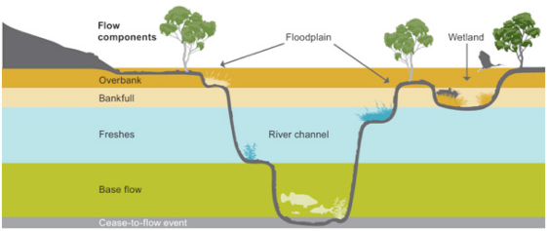
Figure 8. Five flow types and their influence on different parts of the river channel, wetlands and floodplains (MDBA 2011).
Figure 9. Further division of freshes and baseflows into small flow components (see Appendix B).

Baseflows
Baseflows are those that are confined to the low flow part of the channel. These flows would typically inundate geomorphic units such as pools and sustain riffle or shallow run areas between pools. Baseflows are important to obligate aquatic species and communities, including fish communities as they:
- Maintain a minimum diversity of habitats for shelter, feeding and spawning. They may create shallow riffle and run habitat which do not exist when flows cease.
- Establish connectivity and enable longitudinal movement of taxa between pools when depths are sufficient.
- Constantly dilute and refresh water in pools and thereby maintain reasonable water quality.

How did Commonwealth environmental water affect baseflows?
Commonwealth environmental water has made important contributions to improved baseflow conditions in some valleys including lower and central Murray, Edward-Wakool, Goulburn, and Macquarie (Figure 10). The contribution in the lower Murray, Macquarie and Goulburn Rivers is particularly important in avoiding severe low flow conditions in these valleys. Commonwealth environmental water has had a negligible effect on baseflow regime in the unregulated rivers of the northern Basin.
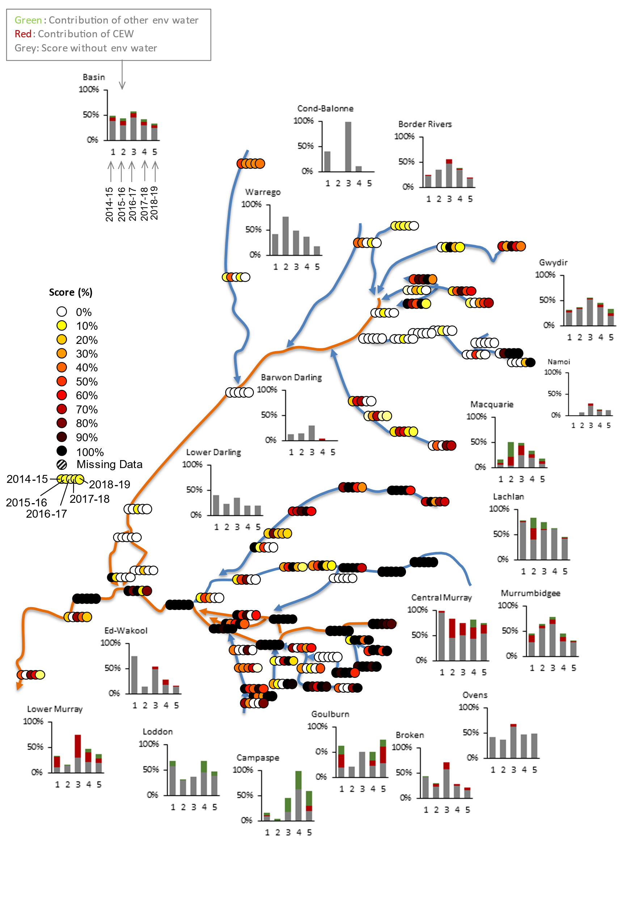
Figure 10. Annual low flow baseflow score from 0% (extremely dry) to 100% (average conditions).

What ecological responses would be expected?
The maintenance of baseflows within channels is expected to provide critical habitats for aquatic fauna during dry periods. Maintaining sufficient baseflows should reduce the potential for adverse water quality conditions to develop within these aquatic habitats and enable improved connectivity between them, facilitating the movement of some aquatic fauna within channels. Periods of stable baseflow are also expected to facilitate the establishment of aquatic vegetation within channel habitats. Additionally, baseflows are likely to provide important sources of water for riverbank vegetation during dry periods.
Baseflow conditions influence the composition and condition of aquatic ecosystems during dry phases and this can affect ecological responses to subsequent conditions when higher flows return. Without sufficient baseflows, many channel ecosystems will contract to disconnected pools that experience declining water quality which, in turn, can be expected to lead to local biodiversity loss, dominance of hardy introduced species (e.g. common carp) and declines in the condition of riparian and aquatic vegetation. Encroachment of terrestrial vegetation into channel habitats can also occur. Overall, very low baseflows can be expected to reduce the scope for ecological responses to other flow conditions.
Baseflows are often dominated by algal production as inputs of terrestrial organic matter are reduced due to the limited lateral connectivity and the increased distance between the water and riparian vegetation. Flow influences the amount of available habitat and also interacts with factors including substrate availability (sediment type, wood, macrophytes), nutrient availability and light availability (season, weather and turbidity) to determine productivity. Allocating environmental water to enhance baseflows can influence the amount of available habitat, but also prevent cease-to-flow conditions associated with declines in water quality.

What ecological responses occurred?

Stream metabolism
Stream metabolism comprises two ecological processes: primary production (use of light, nutrients and carbon dioxide to produce organic material through photosynthesis) and decomposition (recycling of organic matter). Stream metabolism is measured through changes in dissolved oxygen, as the process of primary production produces oxygen and decomposition uses it. Healthy aquatic ecosystems require both processes, with primary production providing the basis of food for organisms higher up the food chain, and decomposition providing essential nutrients to maintain plant growth.
There are four ways that water regimes can influence rates of primary production and decomposition in aquatic systems:
- By increasing suitable habitat for primary producers and decomposers, which is strongly influenced by flow.
- Entrainment, movement and exchange of nutrients and organic carbon from external sources to the river system. This includes streamside zones, floodplain wetlands, backwaters, and low-lying benches and bars within the channel, all of which are inundated and connected by different flow volumes.
- Mixing and resuspension of material within the river or stream. For example, organic material that accumulates in pools and other slow flowing habitats (e.g. backwaters, weir pools). Increasing flows may mobilise these organic material stores, increase rates of stream metabolism, and reduces excessive build-up of organic material.
- Disruption and scouring of biofilms – biofilms comprise algae, fungi and bacteria on sediments and plants in the river and can contribute significantly to stream metabolism. Over time they can senesce and become less active due to sedimentation. Very high flows can scour these older biofilms and sediments, allowing younger more productive biofilms to re-establish (Ryder et al. 2006).
The contribution of baseflows to primary productivity is comparably small (to in channel pulses and overbank flows). The results across the five years of LTIM suggest, however, that primary production in small rises in flow from very low baseflows to low flows, can introduce more organic carbon into the food web (see Figure 15 below). This was evidenced by a doubling of the organic carbon load (amount of organic carbon generated per day) on average, when flows increased from very low baseflows to low baseflows in the Lachlan River. In the Warrego-Darling Selected Area, there was a nine-fold increase in organic carbon load when very low baseflows were increased in spring (see Appendix C).
Using watering actions to maintain a baseflow in a reach can also be important in avoiding adverse water quality outcomes. There are several examples of environmental water delivered as baseflows to maintain water quality in river systems over the five-year LTIM period. For example, Commonwealth environmental water has been delivered as baseflows in the Lower Broken Creek every year 2014–2019 with the primary expected outcome of maintaining dissolved oxygen concentrations above 5 mg/L. While the target of 5 mg/L has not be achieved consistently dissolved oxygen levels have been improved and if baseflows can be maintained above 250 ML/day, then the risk of critically low DO (< 3 mg/L) is minimised (Goulburn Broken CMA 2018).

Ecosystem diversity
Commonwealth environmental water primarily supported permanent and temporary lowland rivers during the five years of LTIM, with almost 50% of the water delivered as baseflows. The pattern of watering has been very consistent from 2014–2019 supporting 12 744 to 19 083 km of waterways with flows containing Commonwealth environmental water annually. The increase in river length supported by Commonwealth environmental water in 2017–18 (Figure 11) reflects the success of the Northern Connectivity Event. This large environmental flow in early 2018 was designed to support more than 2000km of drought impacted lowland river along the Barwon-Darling from Glenlyon and Copeton dams near the Queensland/NSW border down to the Menindee Lakes (see Text box 1).
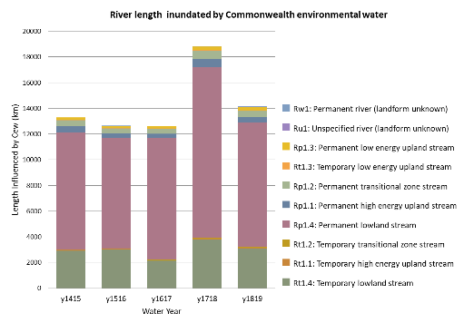
Figure 11. The length of rivers ecosystem types supported by Commonwealth environmental water in each year of the LTIM project.

Large baseflow events benefit fish in the Northern Basin
In response to the extended drought and increases in periods of cease to flow, Commonwealth environmental water, together with water from NSW was delivered across two large baseflow events in the northern Basin in 2017–18 and 2018–19. The primary purposes of both of these events was to benefit native fish and other aquatic biota, by providing longitudinal connectivity between refuge waterholes and to improve water quality to allow native fish to survive and move to better habitats.
The first “Northern Connectivity Event” occurred between April and July 2018 with 23.2 GL of environmental water (70% Commonwealth and 30% NSW) released from Glenlyon and Copeton Dams. The water connected over 2000 km of the Gwydir, Mehi, Dumaresq, Macintyre and Barwon-Darling Rivers (Figure 12). This large scale, complex flow was delivered successfully and resulted in improved water quality, inundated habitat such as large woody debris and opportunities for large-bodied native fish to move between water holes.
The “Northern Fish Flow” occurred between April and July 2019 with 36 GL of environmental water (50% Commonwealth and 50% NSW) again released from Glenlyon and Copeton Dams. The flow extended across 15000 km of river from the Gwydir to the Barwon River. The successful event result in marked improvement in water quality, particularly dissolved oxygen, in refuge pools.
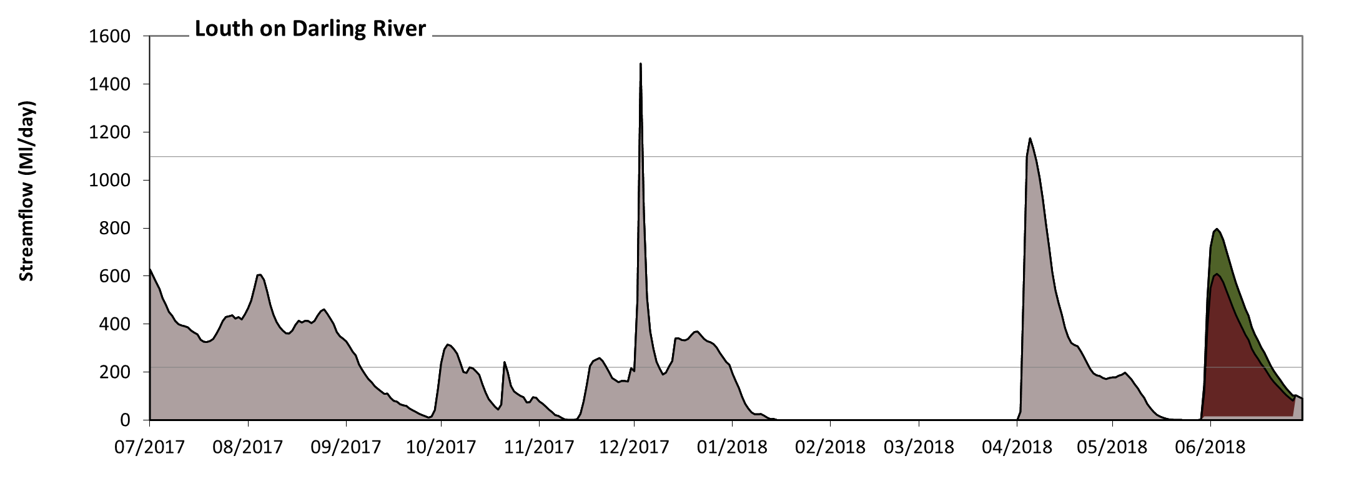
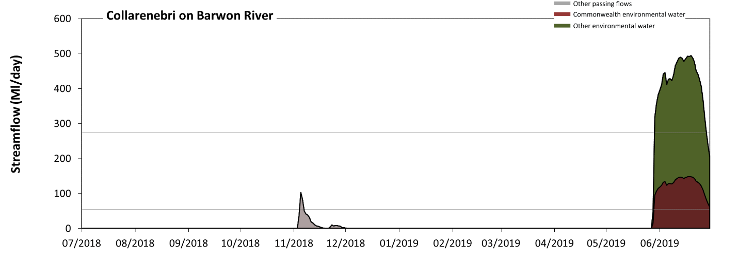
Figure 12: Flow in the Darling River at Louth 2017–18 (top) and Barwon River at Collarenebri 2018–19 (bottom). The ends of both of the graphs show the effect of the northern connectivity flows. Red = Commonwealth environmental water, green = other environmental water, grey = other water. Note the extended period of cease to flow, particularly in the Barwon River in 2018–19 (see Appendix B).
Text box 1: Northern connectivity flows (Department of Agriculture, Water and the Environment, 2020; Eco Logical Australia 2020).

Fish
Commonwealth environmental water contributions to maintaining baseflows has supported refuge habitats in areas that otherwise would have been dry (see Text box 1). This is undoubtedly contributed to the maintenance of fish species, with no loss of native fish species at any of the Selected Areas during LTIM program, despite significant drought across the Basin. The results of modelling, however, predict with certainty that native species richness was influenced by the proportion of baseflow days, with a slight decrease in the number of native species predicted to occur as the proportion of baseflow days increased (and higher flows such as freshes are decreased).
Bony herring were also influenced by baseflows, with a reduced number of baseflow days increasing abundance of this species. Bony herring recruit abundance was significantly influenced by the proportion of baseflow days in the water year, with higher abundances predicted to occur with < 10% baseflow days. Commonwealth environmental water increased bony herring recruitment 3-fold at the Basin-scale by reducing the proportion of baseflow days.
The high proportion of baseflow days is also likely to have affected golden perch populations at the Basin-scale by limiting breeding and recruitment. There was little to no evidence of golden perch recruitment most Selected Areas in all years of LTIM. A small number of golden perch recruits were collected in the Goulburn River in 2015–2016 (Figure 13), however, these were subsequently identified as artificially stocked fish (pers. comm. Wayne Koster, DELWP). This lack of golden perch recruitment is most likely due to dry environmental conditions and river regulation removing natural spring flow pulses that are thought to trigger spawning (see for example Zampatti & Leigh 2013, King et al. 2016). Golden perch populations across most Selected Areas also showed skewed population structures to a higher proportion of adults, with fewer smaller/younger cohorts.
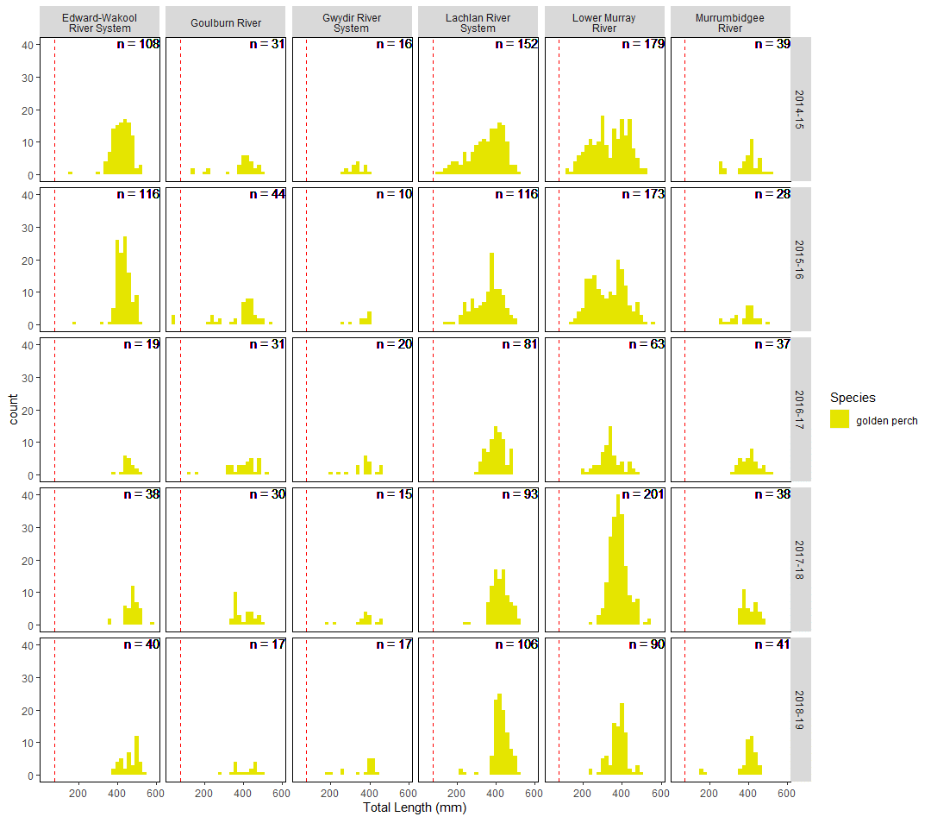
Figure 13: Length-frequency histogram of measured golden perch across Selected Areas and water years. Dotted line represents cut-off length used for recruits (<75 mm).

What have we learned about baseflows and water management?
There is evidence that baseflows are important in maintaining water quality, primary productivity and providing refuge for obligate aquatic biota during drought conditions. The five years of LTIM have been largely characterised by prolonged dry conditions, especially in the northern Basin. Commonwealth environmental water has played a significant role in ensuring adequate baseflows have been achieved in regulated rivers, particularly in the southern Basin. In addition, the two years of large-scale multi-river connectivity flows in the northern Basin have most likely resulted in the survival of native fish and other biota in these systems, that would otherwise have experienced continued cease to flow periods.
Baseflows, however, are insufficient to support many ecosystem functions, and rivers that experience a high proportion of baseflows are likely to also have low rates of native fish reproduction and recruitment.

Adaptive management
- During drought conditions, use of environmental water should be targeted at providing base and fresh flows to support native fish persistence.
- After fish kills, provide base and freshes flows to maintain habitats, refuges and connectivity to improve population recovery post event.
- From a water quality perspective, Commonwealth environmental water has the capacity to improve water quality in rivers by the provision of baseflows during dry times and when conditions are likely to result in low dissolved oxygen concentrations.

Freshes
Freshes are in-channel flow pulses that last several days to several weeks. Freshes provide inundation of additional habitat features such as in-channel benches, woody structural habitat and anabranches that connect at flows less than bank full but greater than baseflow. These flows provide a greater range of in-channel habitats and enhance nutrient cycling processes, including:
- longitudinal connection of habitats allowing aquatic species to move through the river system
- maintenance of drought refuges
- dilution within the river channel, refreshing water in pools and thereby maintaining reasonable water quality
- provision of flows to support fish movement, recruitment and spawning.

How did Commonwealth environmental water affect freshes?
Across the Southern Basin (with the exception of the Broken River) low freshes have been delivered with large contributions of Commonwealth environmental water in the Murray and Goulburn valleys. Moderate and high freshes are lacking in many valleys of both the southern and Northern Basin including the Edward-Wakool, Loddon Broken, Barwon-Darling, Namoi and Macquarie valleys (Figure 14).

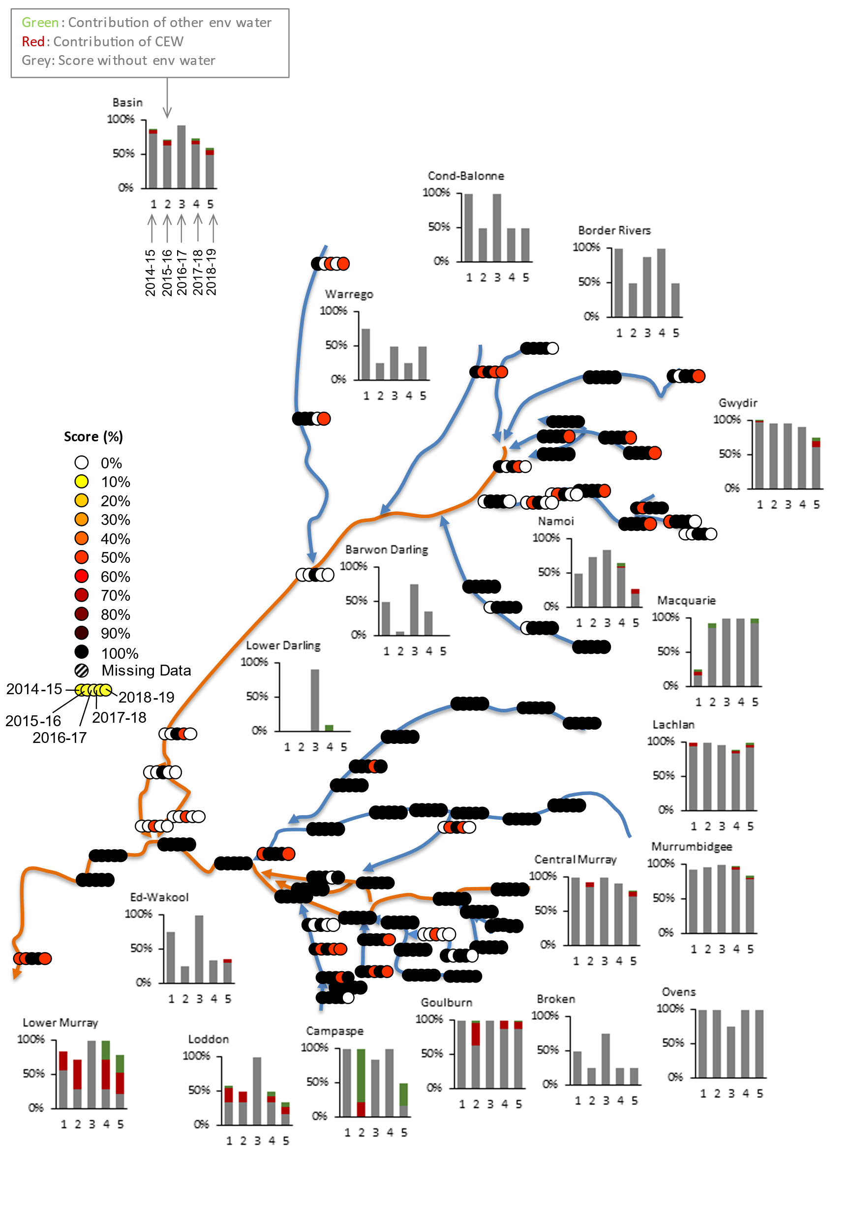 | 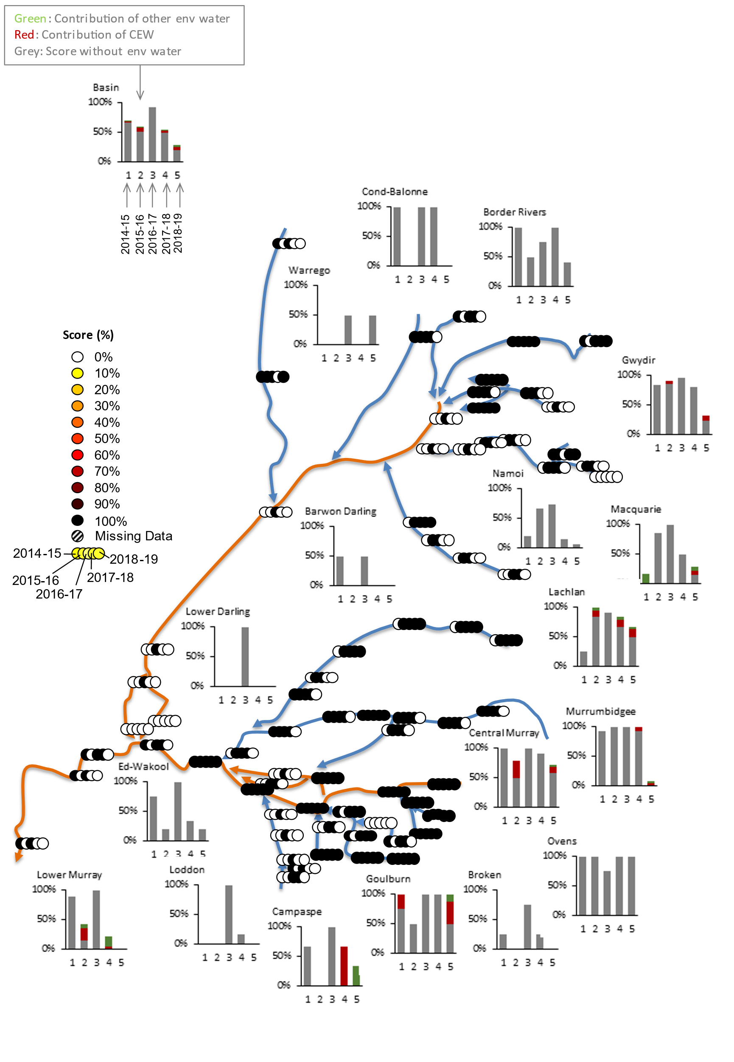
Figure 14. Annual medium fresh (left) and high fresh (right) score from 0% (extremely dry) to 100% (average conditions).

What ecological responses would be expected?
Given the provision of moderate fresh flows across most of the Basin, pulses of energy and materials (e.g. sediments, nutrients, propagules etc.) moving downstream within channel ecosystems would be expected. The types of freshes provided by Commonwealth environmental water, therefore, could be expected to boost aquatic primary productivity and support the establishment, growth and vigour of riverbank vegetation, and trigger fish reproduction and movement. Moderate freshes can also flush stagnant, disconnected aquatic habitats and improve their water quality as well as limit the encroachment of channel habitats by terrestrial vegetation. The types and frequency of fresh flows required to trigger fish reproduction and recruitment may have been augmented by Commonwealth environmental water in some valleys such as the Goulburn and Lachlan but are largely lacking along several valleys such as the Darling and Campaspe.

What ecological responses occurred?

Stream metabolism
Analysis of stream metabolism data, together with hydrological measures indicates that at times Commonwealth environmental water contributed significantly to the organic carbon production in streams (Figure 15). The first fresh following winter to inundate dry sediment has the greatest potential to enhance metabolic rates, but this is also dependent upon timing as freshes in winter – early spring will result in lower primary production due to colder temperatures and shorter hours of lower intensity sunlight than freshes that are delayed until late spring – summer.
Figure 15. Contribution of Commonwealth Environmental Water to the Mean Daily Organic Carbon Load produced in the water flowing past the monitoring point by Gross Primary Production (kg Org C/Day), stratified into seasons, using the full five-year data set. Plots are for the Lachlan Selected Area (see Appendix C for more details and other Selected Areas).

Fish
Commonwealth environmental water delivered as fresh flows had effects on both native and introduced fish species. For example, the total abundance of Australian smelt across the Basin-scale increased with the addition of Commonwealth environmental water. This increase is due to an increase in the proportion of fresh flows with Commonwealth environmental water in all water years, which provided a small increase in the predicted abundance of Australian smelt (Figure 16). This analysis suggests that the use of Commonwealth environmental water targeting fresh flows has maximised the response possible for Australian smelt abundance.
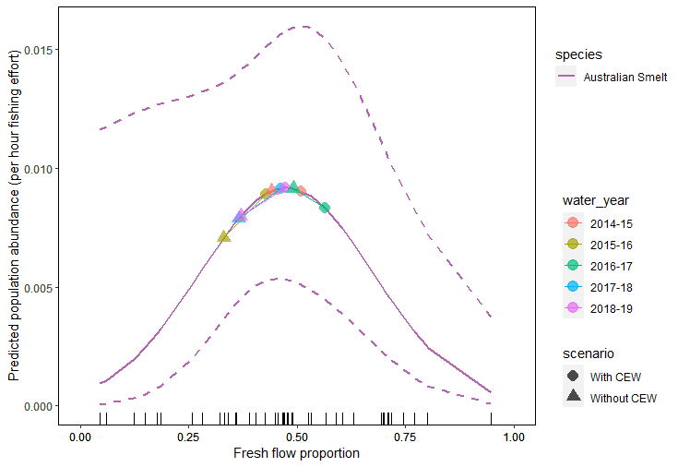
Figure 16: Predicted marginal relationship between Australian smelt total abundance and the proportion of annual fresh flow days. Points on the plot show predicted influence on abundance for scenario’s with (circles) and without (triangles) Commonwealth environmental water between water years (coloured).
The use of Commonwealth environmental water significantly decreased the total abundance of common carp at the Basin-scale. This was due to an increase in the proportion of fresh flows with Commonwealth environmental water, particularly in the drier years. In the wetter conditions of 2016-17, the use of Commonwealth environmental water did not alter the total abundance of common carp (Figure 17). This modelling suggests that in wetter conditions the response of common carp abundance will be dependent upon the proportion of fresh flow days, and as such future use of Commonwealth environmental water should aim to increase fresh flows to reduce common carp total abundance.
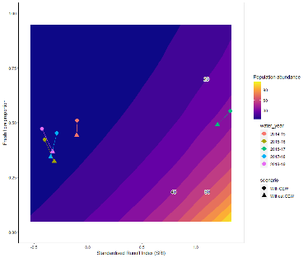
Figure 17: Conditional predicted total abundance of common carp given their significant response to proportion of fresh flows and Standardised Runoff Index. Points on the plot show predicted influence on populations for scenario’s with (circles) and without (triangles) CEW between water years (coloured).
The modelling undertaken for the Basin-Scale fish analysis predicted that golden perch (with a low degree of certainty) and carp gudgeon (with more certainty) were likely to spawn in response to fresh flows. However, no focal native fish species showed significant differences in spawning probabilities with and without the use of Commonwealth environmental water (see Appendix F for more details). There are a range of other factors that affect fish responses to the flow regime (Text box 2).

Vegetation
Contributions of Commonwealth environmental water to freshes in the Goulburn river and Edward-Wakool river system have contributed to greater aquatic and riverbank vegetation cover and diversity during the LTIM period. In the Goulburn river there also appears to have been a decline in the number of introduced plant species on the riverbank during the LTIM period.

What have we learned about freshes and water management?
Evaluation as part of the LTIM Project has shown that Commonwealth environmental water delivered as freshes has resulted in stimulating primary productivity, especially when delivered in spring–summer when temperatures are warmer. That Commonwealth environmental water has contributed to improving the abundance of the native fish Australian smelt, through improved freshes in the flow regime and that these freshes also resulted in a decline in the introduced common carp. While some of the delivered freshes may have resulted in fish spawning, there is more to be done in delivering water for fish reproductive outcomes.

Adaptive management
- During drought conditions, use of environmental water should be targeted at providing base and fresh flows to support native fish persistence.
- Where possible spring and summer freshes or pulse events should be used to trigger spawning of golden perch.
- Fresh flow events may result in an increased abundance of recruiting common carp but are also important for native species. Therefore, other carp management complimentary strategies need to be employed.
- When planning environmental flows, consideration of the trade-off between magnitude and duration may be influenced by consideration of metabolism outcomes. Two options may be worth considering:
  - If shortening the duration of the flow would significantly increase the extent of lateral connection, then it may be worth increasing magnitude and reducing duration.
  - If, however, there is limited scope to achieve significant lateral connectivity, then a longer smaller flow is likely to have a greater influence on metabolism as it will enable colonisation and accumulation of primary producers and decomposers. There will obviously be a balance here between promoting such biota and leaving the system too stable which may lead to declines due to senescence.
- Wherever possible, actions should ensure that water levels vary over the days-weeks of the watering action to prevent geomorphic degradation of the banks and to encourage growth of benthic biofilms, which are a major supply of organic carbon at the base of the aquatic foodweb

It’s not all about water – recovering from fish kills
The large natural floods in 2016–17 resulted in periods of low dissolved oxygen and the deaths of a large number of native fish at many Selected Areas. Modelling demonstrated that after a fish kill occurs, total abundance of golden perch and Murray cod, and recruits of Murray cod, carp gudgeons and introduced gambusia are at their lowest but then their abundances increase as the time since fish kill increases. Conversely, the total abundance of common carp recruits was highest closer to the fish kill event and then decreased with time. These varied responses to hypoxia demonstrated here are likely to reflect either initial mortality or tolerance to hypoxia of breeding adult fish or young, and then the recovery time required for successful spawning and recruitment to occur as numbers of breeding adults increases. This highlights that the effects of hypoxia and fish kills can alter fish population structure, particularly levels of recruitment, for many years after the fish kill has occurred. Enhancing connectivity and movement and maintaining refuges for remaining individuals after these events is critical for enhancing population recovery. Environmental watering strategies may be best targeted at enhancing movement and maintaining refuges immediately post fish kill events for heavily impacted species, such as golden perch, Murray cod and carp gudgeon.

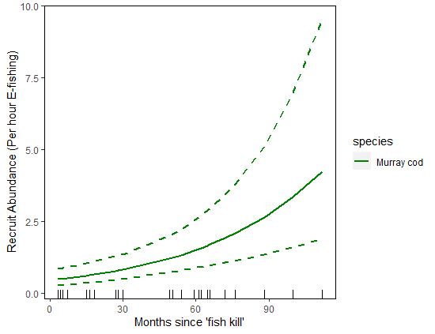
Figure 18: Marginal effect predictions of Murray cod recruit abundance for statistically significant variables in predictive model

Text box 2: Factors other than flow effect fish.

End of system flows
The Basin-wide environmental watering Strategy (MDBA 2019) includes expected outcomes for the Coorong, Lower Lakes and Murray Mouth (CLLMM) as an indicator of end-of-basin flows and Commonwealth environmental water has contributed significantly to these targets over the past five years (2014–19)
1. Barrage flows are greater than 2000 Gl/year on a three-year rolling average basis for 95% of the time, with a two year minimum of 600 Gl at any time.
- With the exception of the wet year (2016–17) Commonwealth environmental water has contributed on average 79% of the total flow over the barrages, effectively ensuring the 600GL target has been met. The 2000 GL three year average has been met for the past there years, but largely due to the natural high flows in 2016–17
2. Water levels in the Lower Lakes are maintained above sea level (0m AHD) and 0.4 metres AHD, for 95% of the time, as far as practicable, to allow for barrage releases
- Water levels in Lake Alexandrina have remained above the target 100% of the time. In the absence of Commonwealth environmental water this would have been the case just 26% of the time.
3. Salinity in the South Lagoon of the Coorong to be < 100 g/L 95% of the time.
- Salinity has been < 100 g/L in the South Lagoon 68% of the time (2014–19). In the absence of Commonwealth environmental water this would have been the case just 26% of the time (Figure 19).
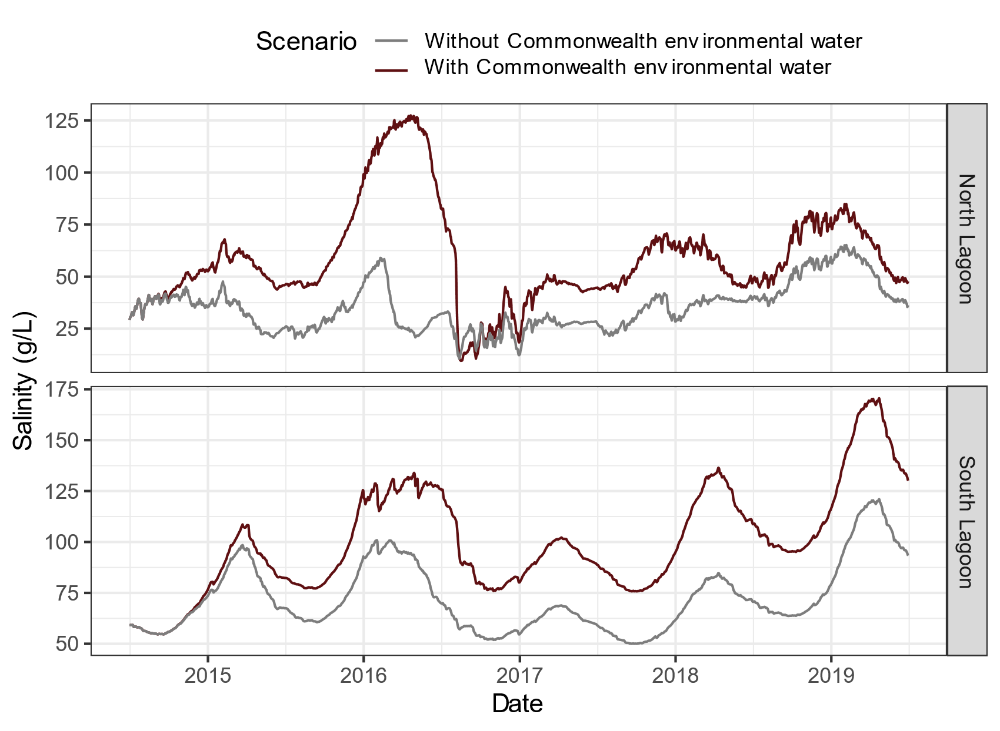
Figure 19: Salinity concentrations in the North and South Lagoon of the Coorong with and without Commonwealth environmental water.
Text box 3: Contribution of Commonwealth environmental water to end of system flows (see Appendix B for more details).

Wetland inundation
The structure, function and condition of wetland ecosystems are governed by hydrology. Inundation brings a pulse of water, nutrients and sediments to wetlands, generating a diverse range of aquatic and riparian habitats. While terrestrial plants that may have encroached wetlands during dry phases will be killed by prolonged induction, the influx of water and materials triggers primary productivity and aquatic plant growth as well as the emergence of aquatic fauna from egg banks in sediments. Where connectivity with watercourses permits, obligate aquatic organisms (e.g. fish) are also likely to enter the wetland while other species, such as insects and waterbirds, will arrive aerially to capitalise on the newly available habitat and food resources. Many organisms, including fish and waterbirds, especially colonially nesting waterbirds, will also breed in response to wetland inundation and such recruitment may be vital in sustaining populations across the broader landscape. Drawdown of floodwaters in wetlands can also promote gemination and establishment of a diverse range of amphibious and terrestrial plants, further contributing to the biological diversity and productivity generated by wetland inundation. The energy and diversity of habitats produced by wetland inundation are also likely to play a critical role in supporting terrestrial food webs, especially in arid and semi-arid landscapes. The scope and extent of ecological responses to wetland inundation will be strongly influenced by hydrological characteristics including the timing of inundation (e.g. season and time since previous inundation), its magnitude, duration and rates of rise and fall as well as many modifying factors (e.g. weather and other disturbances such as fire).

How did Commonwealth environmental water affect wetland inundation?
Over the course of the LTIM project, Commonwealth environmental water contributed to watering more than 250 000 ha (excluding the CLLMM) of wetlands, lakes and floodplains in 12 of the 19 valleys. The valleys influenced included the Central Murray, Border Rivers, Broken, Condamine Balonne, Gwydir, Lachlan, Lower Murray, Macquarie, Murrumbidgee, Warrego, Lower Darling and Edward Wakool.
The Basin-scale evaluation of Commonwealth environmental water uses the Australian National Aquatic Ecosystem (ANAE) classification (Aquatic Ecosystems Task Group 2012) to classify different wetland types. Commonwealth environmental water supported 28 291 ha of lake ecosystems (Figure 20), 158 487 ha of palustrine wetlands of 22 different ANAE wetland types (Figure 21) and 101 735 hectares of floodplain ecosystems representing 10 ANAE types (Figure 22). The broad pattern of watering across ecosystem types is similar across all the five years with 50% of ecosystem types supported to some extent by Commonwealth environmental water in all four years and 40% of ecosystem types not receiving any Commonwealth environmental water in any year over the same period. Gwydir wetlands, Macquarie Marshes, the Lowbidgee have received Commonwealth water in all years as has the CLLMM.
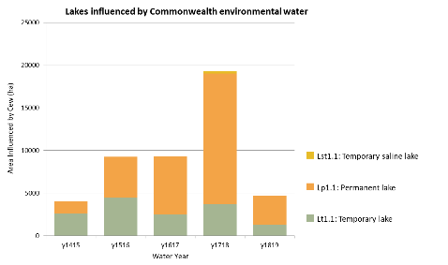
Figure 20. The extent of lake ecosystem types supported by Commonwealth environmental water in each year of the LTIM project.
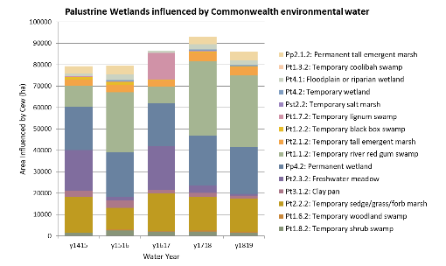
Figure 21. The extent of palustrine wetland ecosystem types supported by Commonwealth environmental water in each year of the LTIM project.
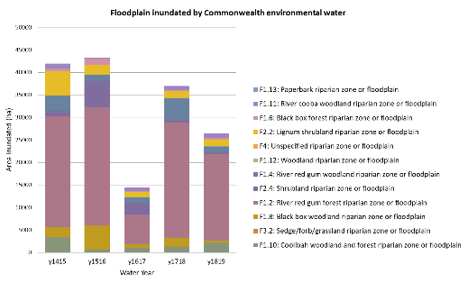
Figure 22. The extent of floodplain ecosystem types supported by Commonwealth environmental water in each year of the LTIM project.

What ecological responses would be expected?
Ecological responses to wetland inundation will be highly dependent on the characteristics and history of a particular wetland. In general, however, wetland inundation can be expected to improve water quality and create increases in primary production. Flood intolerant plants are likely to die in response to prolonged inundation while aquatic vegetation cover and diversity can be expected to increase, at least initially. Similarly, the abundance and diversity of aquatic fauna are likely to increase as energy production increases, food webs develop, and more species arrive in the wetland. With long durations of inundation, or very frequent inundation, however, the abundance and diversity of aquatic organisms may stabilise or even decline as favoured species begin to dominate. With drawdown of floodwater, reductions in the abundance and diversity of aquatic fauna can also be expected as food and habitat availability and condition decrease. The moist conditions which occur following the recession of floodwaters, however, are typically associated with an increase in the diversity and abundance of amphibious and terrestrial wetland plants.
Many of the contributions of Commonwealth environmental water delivered as wetland flows were through regulating structures and sometimes through pumps. While this provides much needed water for biota within the wetland, there are sometimes limited connectivity with river flows for movement of fish and propagules into wetlands and the movement of carbon, nutrients and biota back to the river system.
The current best estimate of the area of the Basin that is in scope for environmental water management is the Basin-wide watering strategy managed floodplain (MDBA 2019). The managed floodplain (Figure 23) maps the area where floodplain vegetation can be influenced with the water recovered under the Basin Plan. It includes actively managed areas that can receive environmental water via large headwater storages or via The Living Murray ‘environmental works’ sites on the River Murray floodplain, and passively managed areas that receive environmental water via flow rules in water resource plans or via natural events. Our expectation of what can be achieved with environmental water needs to be tempered by the constraints on where water can be delivered and how it can be delivered.
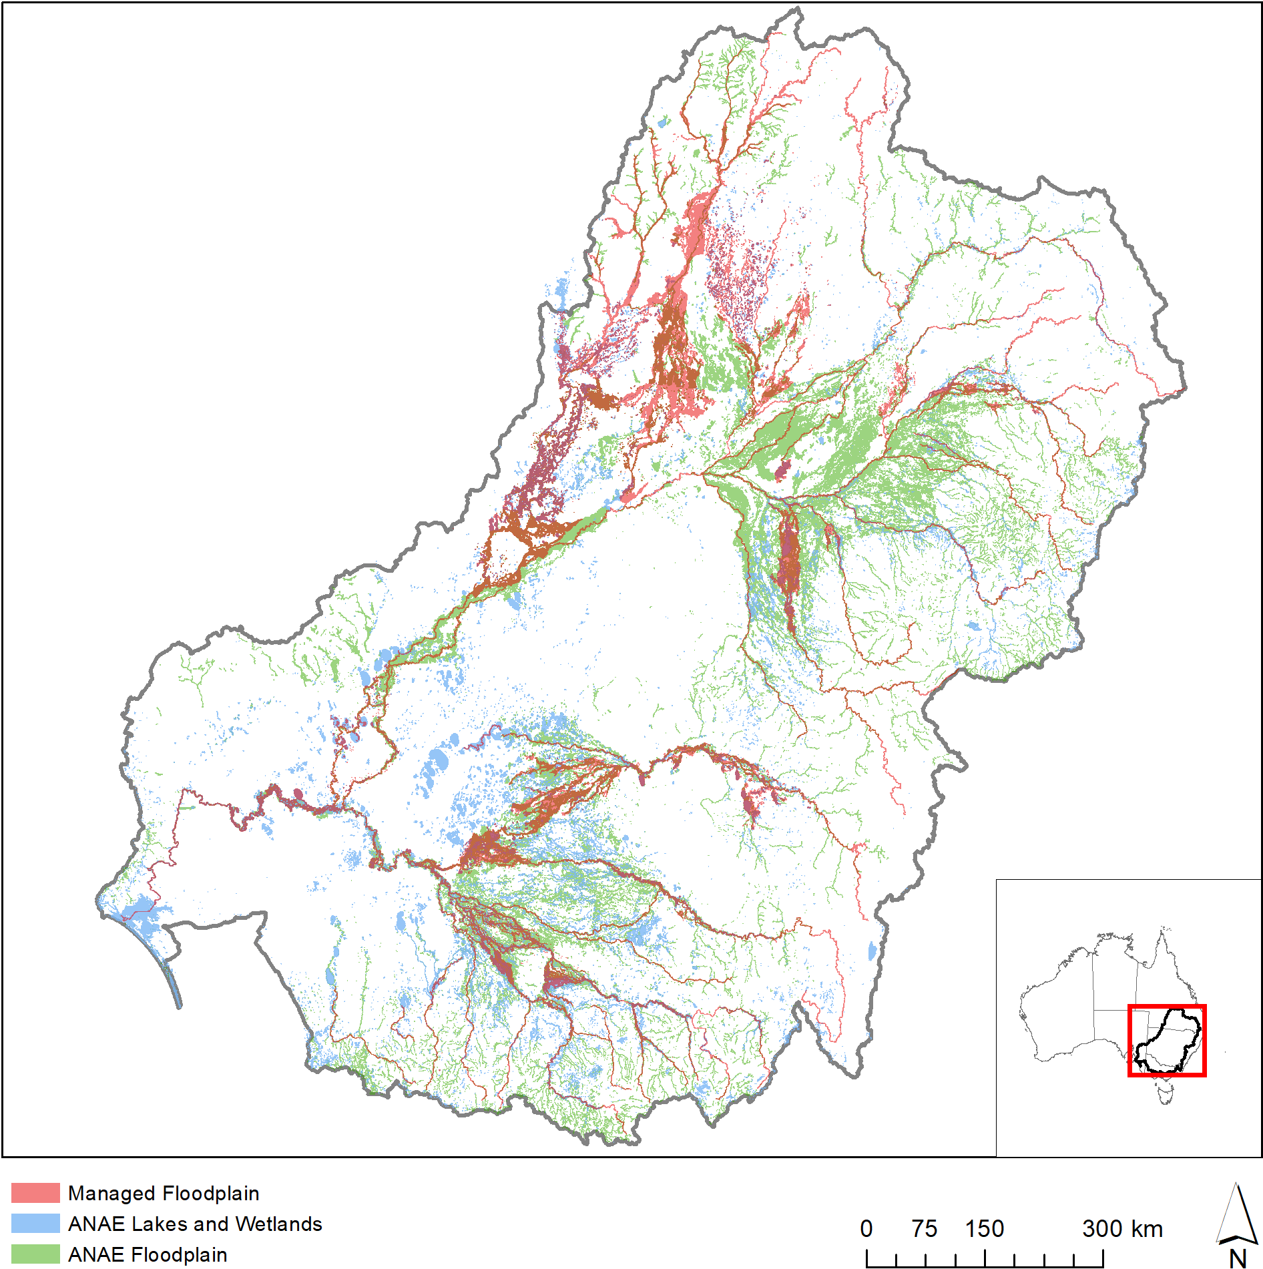
Figure 23. Spatial extent of the Basin-wide watering strategy managed floodplain compared to the extent of ANAE wetland and floodplain ecosystem types.

What ecological responses occurred?

Vegetation
A wide range of vegetation responses to inundation by Commonwealth environmental water have been observed in Selected Areas over the LTIM period, reflecting the diversity of wetland types examined. In general, inundation has resulted in increased vegetation cover and plant diversity in wetlands compared to those that have remained dry. During longer periods of inundation, such as have occurred in some wetlands in the Murrumbidgee and Gwydir river systems, the establishment and growth of aquatic plants have been promoted while spikes in the diversity and cover of more amphibious and terrestrial plant species have tended to occur following the drawdown of floodwaters or after shorter floods. In some cases, the cover of introduced species also appears to have been reduced as result of wetland inundation by Commonwealth environmental water. In the Gwydir river system, for example, inundation has been associated with greater cover of native water couch and reductions in the cover of introduced lippia.
By influencing plant cover and species diversity, inundation by Commonwealth environmental water has driven shifts in the composition of vegetation communities during the LTIM period. Because these responses vary considerably between wetlands, both within and between Selected Areas, inundation by Commonwealth environmental water has promoted heterogeneity of vegetation communities at landscape and Basin scales by generating a dynamic patchwork mosaic of plant habitats that vary in their inundation histories (Figure 24).
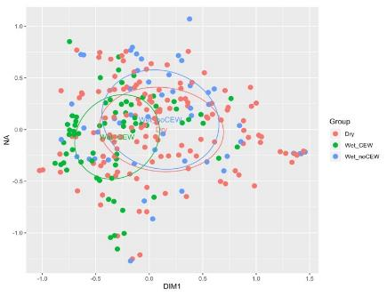
Figure 24. Ordination of annual vegetation communities surveyed in Selected Area wetlands in relation to annual watering regime with or without CEW over the LTIM period. Stress = 0.1824

Other fauna
Although waterbirds are not a Basin Matter, some evaluation of waterbird responses to Commonwealth environmental water have been evaluated under the biodiversity Basin Matter. More than one million individual waterbirds have been recorded at sites that received Commonwealth environmental water during the past five years (Figure 25). Cumulative totals (within a single year but across sites) indicate that Commonwealth environmental water is likely to have supported greater than one percent of the population of 22 waterbird species (Figure 26).
Figure 25. Total abundance of waterbirds from sites that received Commonwealth environmental water (source MDBA Aerial Waterbird Survey; data provided by MDBA).
Figure 26: Waterbirds for which Commonality environmental water has supported > 1% of the relevant population (see Appendix G for more details).
Waterbirds may prefer partially full wetlands
Disturbance regimes such as flood pulses and wetting and drying cycles in wetlands, drive biodiversity in Australian aquatic ecosystems (Kingsford et al. 1999; Leigh et al. 2010; Bino et al. 2015). The act of filling and drying a wetland stimulates a number of processes such as nutrient and carbon cycling, primary productivity and creates a range of habitat niches (Boon et al. 2014). The results of the LTIM preliminary analysis indicate that there is a greater abundance of waterbirds across most functional groups and broad ecosystem types in wetlands that are partially full. This would cover wetlands in both the filling and drying phase as well as wetlands for which only a portion of the wetland area is inundated regularly.
This is consistent with previous studies on waterbirds in arid zone lakes in Australia, where increased abundance and diversity was found in unregulated wetlands that filled and drained, compared to wetlands managed for water storages (Kingsford et al. 2004). In the Ramsar sites of the Basin, this result of increased abundance of waterbirds in partially filled wetlands was seen across groups and statistically significant for marshes and lakes (p < 0.004). The pattern is evident (and statistically significant) even for waterbirds such as gulls and terns (piscivore, aerial-diving deep open water), that prefer deeper water (Figure 26).
Figure 27: Average abundance of waterbirds that prefer to forage in deep water at Ramsar sites in the Basin (2007 to 2019). Waterbird data from MDBA aerial surveys (2007–2018), inundation from the Geoscience Australia WIT (Dunn et al. 2019).
Text box 4: Waterbirds, inundation and wetland type (see Appendix G for more details).

Threatened species
Fifty-four significant species were recorded at sites that received environmental water in 2014–19. This includes 18 international migratory waterbird species, 19 nationally listed threatened species and 21 species listed under state legislation.
Two iconic and nationally listed threatened bird species were recorded at inland sites that received Commonwealth environmental water. The Australasian bittern (Botaurus poiciloptilus) was recorded in all five years and the Australian painted snipe (Rostratula australis) in 2015–16 and 2017–18. There is very good evidence that Commonwealth environmental water is contributing to maintaining populations of Australasian bittern with over 10% of the estimated population of the species recorded at the Barmah-Millewa Forest sites. The species prefers shallow wetlands with emergent vegetation (Menkhorst 2012), which has been the target of environmental water at this Ramsar site in three of the past five years.
There are indications of benefits to Murray cod, in Gunbower Creek with a restoration of age structure in the population following the implementation of the “fish hydrograph” with Commonwealth environmental water (CPS Enviro 2018); and to freshwater catfish from a number of locations around the Basin including the Border Rivers.
There are a relatively large number of records for southern bell frog (Litoria raniformis) from several locations around the Basin that received Commonwealth environmental water including the Murrumbidgee wetlands, Banrock Station and other wetlands along the Lower Murray (CEWO unpublished; Thomas et al. 2020). This species of frog is considered “flow dependent” and has been shown to move in response to inundation of floodplain habitats, rather than rainfall (Wassens et al. 2010) indicating that it can benefit from environmental watering at key habitats.

Maintaining the ecological character of Ramsar sites
There are 16 Ramsar sites in the Basin and over the five years of the LTIM Project, Commonwealth environmental water has been delivered to 11 of these sites (Table 5). The sites that have not received Commonwealth environmental water over this period either represent sites for which environmental water cannot be delivered (e.g. Ginini Flats in the alpine region of the ACT) or which have been the target of other environmental water (e.g. Kerang Wetlands) by other water holders.
Table 5. Ramsar sites that have been the target of Commonwealth environmental watering actions in the five years of the LTIM Project.
Ramsar site | Commonwealth environmental water
Ramsar site | 2014–15 | 2015–16 | 2016–17 | 2017–18 | 2018–19
Banrock Station |  | X |  | X | X
Barmah Forest |  | X |  | X | X
Central Murray Forests |  | X | X | X | X
Coorong, Lakes Alexandrina and Albert | X | X | X | X | X
Fivebough and Tuckerbil Swamps |  |  |  | X | X
Gunbower Forest |  | X | X | X | X
Gwydir Wetlands | X | X | X | X | X
Hattah-Kulkyne Lakes | X | X |  | X
Macquarie Marshes | X | X | X | X | X
Narran Lakes |  |  | X
Riverland | X | X | X | X | X
There is very good evidence to suggest that Commonwealth environmental water has contributed significantly to maintaining the ecological character of the Basin’s Ramsar sites. Highlights over the five years of the LTIM Project include:
- Restoration of hydrological regimes at Hattah Lakes and Banrock Station with multi-year water strategies. This has resulted in improved vegetation, native fish and waterbird condition.
- Use of Commonwealth environmental water to improve waterbird breeding outcomes by extending duration of inundation under nests sites in the Macquarie Marshes.
- Restoring native fish population structure in Gunbower Creek through provision of flows according to a purpose designed “fish hydrograph”.
- Inundation of marshes for a variety of species, with several threatened waterbirds species supported (e.g. Australasian bittern, Australian painted snipe) in Barmah Forest, Central Murray Forest and the Macquarie Marshes.

What have we learned about wetland inundation and water management?
At both the wetland and landscape scales, variability in water regimes is important for maintaining (and restoring) biodiversity. Over the five years of the LTIM project, this has been evidenced by the responses observed in vegetation, waterbirds and at Ramsar Sites. The planning of environmental water over multi-year strategies and at a landscape scale to maintain diverse ecosystem types has resulted in improved biodiversity outcomes.
Connecting rivers, floodplains and wetlands, why is it important?
Large overbank flow events that connect rivers with their floodplains, are essential to the ecological diversity and functioning of our inland river systems. They are the ‘booms’ that are critical for the persistence of many organisms in these landscapes, enabling their survival through subsequent ‘bust’ periods. Connectivity of watercourses with their floodplains and wetlands distributes water, sediments, nutrients and organisms into newly connected habitats as well as vice versa as floodwaters recede. Floodplain inundation facilitates very high levels of primary production and the emergence of zooplankton from egg banks, providing abundant food resources for local and nomadic organisms (e.g. waterbirds) that often arrive in large numbers in response to flooding. In addition to increased food resources, lateral connectivity generates critical aquatic and wetland habitats for reproduction of many organisms (e.g. fish and waterbirds). While stressful for many flood-intolerant terrestrial plants, including many introduced species, inundation resets floodplain vegetation and triggers the regeneration of many plant species. Large lateral connectivity events also supply moisture to marginal floodplain habitats (e.g. black box woodlands) to which environmental water cannot typically be delivered.
Monitoring data obtained during the LTIM project clearly demonstrates that large natural floods have an overriding influence on vegetation dynamics of wetlands, floodplains and riverine ecosystems in the Basin. At any particular time, the responses of vegetation communities to Commonwealth environmental water actions will reflect their broader watering history. Expected outcomes of watering actions should therefore take this into account. For example, vegetation communities of floodplain habitats are likely to benefit from periods of drying following large natural floods to enable plants to set seed and replenish soil seed banks and for various soil processes to occur (e.g. renewal of soil biota). Environmental watering following large natural floods might therefore be best directed towards topping up semi-permanent and permanent wetlands.
The fact that some recent large floods have led to fish kills is also not a reason to consider such events as undesirable from the perspective of fisheries management. Quite the opposite is true, and in unregulated rivers it is regular flooding that promotes high levels of fisheries production. Instead, it is likely that the occurrence of blackwater events in 2016–17 floods for example, arose because of the long period without significant floodplain inundation in the years prior, which led to large accumulations of organic material, which naturally would be removed by more regular flooding. Given that our climate has generally entered a drier phase, risks of blackwater will no doubt continue, however, those risks are something that must be managed alongside the benefits that can arise as a result of flooding for fish, vegetation and waterbirds.

Text box 5: The importance of floods.

Adaptive management

All Commonwealth environmental water actions are likely to enhance plant species and vegetation community diversity at the Basin scale in any water year.
Monitoring data obtained during the LTIM project strongly suggests that the presence of plant species and vegetation communities in wetlands, floodplains and riverine ecosystems of the Basin varies considerably both within and between wetlands as well as between water years. At any particular time, only a small proportion of plant taxa are likely to occur with widespread distributions in wetland habitats across the Basin. Most plant taxa will instead only be present in relatively few places across the Basin. The dynamics of vegetation communities at particular places is also highly variable in the short- and long-term, with shifts in vegetation cover, species richness and composition tending to reflect watering regimes, albeit with complex response patterns. Consequently, it is highly likely that the delivery of any Commonwealth environmental water to these habitats will promote plant species and vegetation community diversity at the Basin-scale because different plant species will be present to respond to watering in different places. Additionally, because the species composition of vegetation communities is relatively distinctive between Selected Areas and among the different ecosystem types, plant species diversity at the Basin-scale is also likely to be enhanced when more Selected Areas and different ecosystem types are watered in any particular water year.

Biodiversity is enhanced across multiple scales by environmental watering that promotes a dynamic mosaic of watering regimes.
Diversity of both plant species and vegetation communities at local (i.e. wetland), Selected Area and Basin scales are promoted by watering regimes that are heterogeneous in both space and time. In general, higher plant species diversity tends to occur following the recession of floodwaters in response to intermittent wetting of floodplain habitats. In contrast, frequent, regular wetting (e.g. annually) tends to generate more stable vegetation communities dominated by fewer species than occur in wetlands subject to more hydrologically variable wetting and drying patterns. At landscape-scales, however, the diversity of vegetation communities (rather than plant species) is likely to be promoted by watering regimes that generate a mosaic of wetting and drying patterns that include some areas of frequently watered patches and other areas that are watered more intermittently. For some more aquatic vegetation communities, e.g. Moira grass (Pseudoraphis spinescens) wetlands, the duration, depth and frequency of inundation may be important for enabling key species to maintain their dominance as shorter, less frequent floods can permit invasion by more mesic species and a transition to a different community type (e.g. Collof et al. 2014). Consequently, there is a need to explore trade-offs in plant species and vegetation community diversity across multiple spatial and temporal scales through adaptive management and learning (see final point below). In the case of Moira grass wetlands in Barmah Forest, for example, is there a trade-off between meeting an objective to maintain vegetation communities dominated by swathes of Moira grass versus promoting landscape-scale plant species and vegetation diversity?
There are multiple lines of evidence suggesting that biodiversity of wetland fauna is promoted by variable water regimes at site and landscape scales. The results of the analysis of waterbirds, inundation extent and wetland type have indicated that waterbird abundance, and to a lesser extent diversity, is promoted by maintaining wetting and drying cycles. In addition, monitoring of waterbirds and frogs across Selected Areas and other locations in the Basin, noted that a mosaic of habitats not only increases diversity, but facilitates recruitment following breeding.
To maintain biodiversity outcomes, environmental watering actions should aim to generate a dynamic mosaic of wetting and drying regimes at the wetland and landscape scale, to provide for a full suite of habitats for waterbirds and other biota. Watering actions that act to maintain permanent inundation of lakes will eventually result in reduced habitat quality and diminishing use by biota.
Improving understanding of watering requirements at the aquatic ecosystem level should complement and enhance existing approaches that focus on the requirements of key species or communities. Through LTIM, we have begun assembling a library of Basin wide watering frequencies from Commonwealth environmental water. Ecosystems types (and locations) that are consistently not watered, or watered with too much regularity, can be identified and an informed assessment of risks (and opportunities) should inform water planning to promote a dynamic mosaic of watering regimes.

Supporting threatened species across the Basin may require identification of additional watering sites.
While there is strong evidence to suggest that Commonwealth environmental water is supporting many threatened and significant species such as Australasian bittern and southern bell frog, there is increasing evidence that the same locations are the target of environmental water each year. While biodiversity outcomes are undoubtedly being achieved at sites that receive Commonwealth environmental water, it is possible that some species occur largely at sites that do not benefit from Commonwealth environmental water. While it is likely that some locations that are known to support threatened species may be outside the managed floodplain and cannot be the recipient of environmental water, it is also likely that there are wetlands that could be watered but have not been identified as priorities. Strategic approaches that seek to identify critical habitat for vulnerable species at locations that can receive Commonwealth environmental water may improve outcomes for these threatened species.

Multi-year watering approaches are helping to maintain ecological character of Ramsar sites.
Over the five years of the LTIM Project there have been several examples of multi-year wetting and drying strategies aimed at maintaining the ecological character of Ramsar sites. Matching the delivery of environmental water with the needs of critical components, processes and services at wetland in the context of the current and antecedent climatic conditions has been very successful.

Contribution to achievement of Basin Plan objectives and adaptive management

Adaptive management
Adaptive management messages with respect to the management of environmental water related to flow components is provided in the sections above. Here we present some overarching lessons learned from the LTIM Basin-scale evaluation over the five years.

Commonwealth environmental water is reaching target assets that are representative of Basin ecosystems
Commonwealth environmental water has been delivered to a diverse array of lowland rivers, wetlands and floodplains that are representative of the range of ecosystem types that are found throughout the Basin. The pattern of watering has been consistent with the objectives of the Basin Plan focussing on protection of more permanent habitats during a period of significantly dryer than average conditions. The long-term monitoring of LTIM is demonstrating that Commonwealth environmental water is helping to maintain environmental values in the face of pervasive drought conditions.
Evidence to date suggests that the allocation and delivery of Commonwealth environmental water has broadly been appropriate for the chosen assets. The distribution of watering actions within the Basin does exhibit a high degree of uniformity with many of the same assets receiving Commonwealth environmental water each year. However, at local scales, the annual watering regimes of individual ecosystem types within those assets appear to be consistent with conventional understanding of the water requirements for those ecosystems.

Restoring only part of the flow regime restores only part of the ecology
Over the five years of the LTIM project, the overwhelming majority of Commonwealth environmental water has been delivered as base flows, lower level freshes and infrastructure-assisted wetland inundation. These interventions have made important contributions to maintaining many aquatic ecosystems and the biota they support, especially through the predominantly dry period. In channel flows alone, however, cannot protect and restore all of the biota and ecological functions of the Basin’s aquatic ecosystems. This is evidenced, perhaps most starkly, by the fate of golden perch, for which recruitment has been impaired and population structure is declining. This fish species, and silver perch, require high flows to promote spawning, recruitment and dispersal and, without such flows, is likely to continue to decline in abundance. We recognise that the delivery of environmental water is limited by constraints on overbank flows, however unless these constraints can be reduced it is inevitable that parts of the ecology of the Basin’s aquatic ecosystems cannot be protected or restored by water management.

Past and current conditions are important determinants of environmental water outcomes
Evaluations of several Basin Matters have indicated that the outcomes of environmental water are highly dependent on the condition of the ecosystem prior to water delivery and the history of watering at the site. For example, the evaluation of vegetation at the Basin-scale indicated that vegetation diversity responses to Commonwealth environmental water are highly dependent on the history of inundation at the site, hydrological characteristics of water delivery (e.g. timing, duration) and on local and Selected Area scale factors, such as the existing vegetation community and landscape configuration. On a shorter timeframe, it is also expected that a second inundation relatively soon after a major rewetting event will not have the same level of beneficial effects on energy and food supplies, as leaf detritus and nutrients have already been mobilized and utilized.
This suggests that setting realistic objectives (expected outcomes) of water actions and planning the type of water regime that would maximise ecological benefits requires careful consideration of both current and historical conditions. For example, expected outcomes for fish or waterbirds should not be targeting wide-scale recruitment if the population is in a depauperate or stressed state. Instead, improving condition of remaining adults is a more appropriate objective. The decline of Murray cod from hypoxia after the 2016–17 floods in various Selected Areas, and the subsequent drying of the lower Darling River are specific examples where watering objectives for Murray Cod need to be focussed on restoring connectivity for dispersal and improving condition of surviving adult fish. Multi-year strategies are likely to be required to iteratively build on the previous year’s outcomes.
Expected outcomes need to be documented or articulated in a way that enables others to understand the reasons why the objectives may or may not have been achieved so continued improvements in environmental water management can be made.

Environmental water needs to be managed with other activities to maximise ecological outcomes
Water regimes are undoubtedly one of the most important influencers of aquatic ecology, with the timing, magnitude, frequency, velocity and depth of water largely determining the communities and species that will be present in an aquatic ecosystem at any given time. The aquatic ecosystems of the Basin, however, are subject to a range of stressors in addition to reduced quantity of water. These include the quality of water (e.g. water temperature, salinity, dissolved oxygen, nutrients, pesticides and herbicides), pest plants and animals (i.e. grazing pressure, competition, predation) and human disturbance (e.g. recreational fishing, vehicle damage, human disturbance of waterbirds). These stressors influence responses to watering and increase uncertainty in setting and evaluating watering objectives. The ecological outcomes of environmental water may be improved though increased coordination with complementary management designed to reduce the impacts of stressors, and that contribute evidence and understanding on potential interactions with those stressors.

Evaluating the effect of Commonwealth environmental water would be enhanced with additional monitoring locations in the northern basin
Monitoring for the LTIM Project has been largely focussed on the southern connected Basin with five Selected Areas in the south providing multiple lines and levels of evidence for environmental watering outcomes. The northern Basin Selected Areas have been limited to the Gwydir River System, which provides information from one valley on environmental water delivery. The other northern Basin Selected Area (the Junction of the Warrego and Darling Rivers), while providing limited and novel evidence from a largely unregulated system, represents an anomaly that differs substantially from all other Selected Areas including the Gwydir River System. Our ability to draw inferences concerning environmental water in the northern Basin would be significantly improved with the addition of one or more Selected Areas. Addition of another regulated system, where Commonwealth environmental water is regularly delivered, is likely to provide for meaningful comparisons with the Gwydir River System Selected Area to facilitate a more representative evaluation of the northern Basin. The Macquarie River or Condamine Balonne system are potential candidates.

Reframing the questions for Basin-scale evaluation could benefit future LTIM projects
When the Basin-scale evaluation for the LTIM project was first scoped in 2012, the primary purpose was to assess the contribution of Commonwealth environmental water to Basin Plan objectives. To this end, the Water Outcomes Framework was developed (CEWO 2013) and guided the development of evaluation questions for the Basin-scale component of LTIM. Over the past eight years, encompassing stages 1 (planning) and 2 (implementation) of the LTIM project, we have learned much about environmental water monitoring and evaluation. There has also been a shift in information needs from demonstrating outcomes of environmental water (e.g. “what has Commonwealth environmental water contributed to…”) to adaptive management of Commonwealth environmental water planning, delivery and monitoring to improve ecological outcomes. To capitalise on this improved understanding, we recommend that evaluation questions be reframed to better meet the needs of environmental water policy makers and managers, at the appropriate scales at which they operate.

An authoritative, unambiguous resource for the timing, duration and extent of water management in the Basin is required
A critical input for the LTIM basin-scale evaluation has been an authoritative record of the Commonwealth’s environmental watering actions including the volumes of water used in each action, their timing and purpose. This is important for any future review and evaluation of the CEWO’s watering actions including the LTIM program. The CEWO has worked with the LTIM Basin-matter team to provide this account of watering actions each year with progressive improvements. It will be important to continue to improve and preserve this account of environmental watering actions into the future. Improvements in the timeliness of the report will assist with evaluation of outcomes from these watering actions as part of future intervention monitoring. Also, there could be ongoing effort to strengthen the record so that it is authoritative and consistent with other accounts of environmental watering such as Basin Plan Schedule 12 (Matter 9.3) reporting. Ongoing improvements in documenting targets for environmental watering actions will also support improvements in future intervention monitoring. The core principle of adaptive management is to reflect and learn from previous actions. For this to occur, it is important these actions are well documented in an enduring, authoritative and accessible form.

Improving the management of Commonwealth environmental water management, through improvements in Ecosystem Diversity evaluations
The CEWO currently does not have 1-year or 5-year expected outcomes for ecosystem diversity but it is hoped that this evaluation and other lessons learned from the LTIM project will seed thinking towards an appropriate approach for draft ecosystem objectives. Understanding how key ecosystem types influence patterns of Basin biodiversity, resilience, ecosystem function and ecosystem services paves the way towards delivering Commonwealth environmental water for ecosystem objectives that move beyond counting ecosystem watering targets. For example, shaping flow regimes to preserve patterns of spatio-temporal variability along a river, or delivering water at critical times to maintain life forms or processes because they characterise ecosystem types that are to be preserved or improved. Managing to prevent or promote ecosystem turnover to new types may require long-term management frameworks with institutional memory and conviction to stay the course over decadal time scales and that allow some temporary systems to remain dry for sufficient duration to support the dry-phase ecosystem processes.

Improved input data for predictive modelling will advance our understanding of fish responses to environmental water and better inform water delivery for native fish outcomes
The Basin-scale evaluation of fish (see Appendix F) demonstrated the successful use of LTIM monitoring data and Basin-scale analytical approaches to assess how fish respond to the use of Commonwealth environmental water. A small number of improvements are recommended:
- Future analysis should also explore alternative more discrete flow metrics such as the number of peak flows and flow duration.
- Metrics for individual fish body condition and age-length relationships should be utilised in future assessments.
- Further research on the contribution of other drivers, either operating independently or interactively with flow conditions is needed. Key drivers should then be incorporated into future predictive modelling.
- An idealised fish-flow response model would incorporate predicted responses for key life history events (recruitment and mortality) and be used to provide predicted outcomes to various short-term and longer-term future flow conditions.

Using multiple sources of data to evaluate the effects of environmental water at the Basin scale is promising.
The trial in the final LTIM year of matching waterbird survey data with inundation from the Wetland Insight Tool and aquatic ecosystem mapping of the ANAE has yielded promising results. While there were significant issues with respect to matching the scale of data collected, the available data products are likely to improve over time. As our understanding of the strength of biodiversity-water regime relationships is improved, the predictive capacity of inferring biodiversity outcomes at sites that receive environmental water but are not monitored will become more certain.

Basin Plan objectives
The relevant objectives of the Basin Plan were used as the basis for developing a framework that could be used to assess the contribution of Commonwealth environmental water to achieving those objectives (CEWO 2013). The Outcomes Framework is a nested hierarchy that links the overarching Basin Plan objectives of biodiversity, ecosystem function, resilience and water quality to indicators and outcomes that could be expected from environmental water at two time steps:
- within a 1-year time frame (1-year expected outcomes)
- within a 1–5-year time frame (5-year expected outcomes).

Despite the limitation of the data available in 2014–19, the Outcomes Framework provides a template for synthesising the effects of environmental water and progress towards meeting Basin Plan objectives. There is evidence across the Basin that Commonwealth environmental water is contributing to each of the broad Basin Plan objectives in a number of ways (Table 6).
It should be noted that while this framework is presented hierarchically, there is a degree of overlap and synergy between outcomes. For example, resilience outcomes influence other areas of the framework through ensuring survival of biota via the provision of refuges, for example; and are in turn influenced by other factors such as ecosystem diversity and connectivity between those ecosystems. This summary should be considered a snapshot of the contributions of Commonwealth environmental water to Basin Plan objectives, but be read in the context of the evaluations described in summary in the previous sections of this report and in detail in Appendices B to G.

Table 6. Contribution of Commonwealth Environmental Water Office (CEWO) watering in 2014–19 to Basin Plan objectives.
Basin Plan objectives | Basin outcomes |  | 5-year expected outcomes | 1-year expected outcomes | Measured and predicted 1-year outcomes 2018–19 | Measured and predicted 1–5-year outcomes 2014–19
Biodiversity  (Basin Plan S. 8.05) | Ecosystem diversity |  | None identified | None identified | Over 246 000 hectares of mapped wetland and floodplain inundated  74% of the different aquatic ecosystem types represented in areas supported by Commonwealth environmental water | 75% of the different aquatic ecosystem types supported by Commonwealth environmental water.
Biodiversity  (Basin Plan S. 8.05) | Species diversity | Vegetation | Vegetation diversity | Reproduction | A significant proportion of native species, especially perennial forbs, only present in wetland areas inundated by Commonwealth environmental water at a Basin-scale.  Higher species richness in wetlands inundated by Commonwealth environmental water than in dry wetlands at a Selected Area scale.  Higher diversity of vegetation communities due to inundation by Commonwealth environmental water at a Basin-scale. | Presence of some native species likely to have been dependent on inundation by Commonwealth environmental water during this period at a Basin-scale.  Higher diversity of vegetation communities due to inundation by Commonwealth environmental water at a Basin-scale.
 |  |  |  | Condition
Biodiversity  (Basin Plan S. 8.05) | Species diversity | Vegetation | Growth and survival | Germination  Dispersal | Greater plant growth and survival in wetlands inundated by Commonwealth environmental water than in dry wetlands at a Selected Area scale. | Greater plant growth and survival in wetlands inundated by Commonwealth environmental water than in dry wetlands at Selected Area scale and overall at a Basin-scales over this time period.
Biodiversity  (Basin Plan S. 8.05) | Species diversity | Macro-invertebrates | Macro-invertebrate diversity
Biodiversity  (Basin Plan S. 8.05) | Species diversity | Fish | Fish diversity | Condition | There was no systematic change in adult abundance across species in 2018–19 compared with other water years | No loss of native species has occurred despite significant drought across the Basin.
 |  |  |  | Larval abundance  Reproduction | Large-bodied species were observed spawning in some parts of the Basin, however, there was little evidence found of recruitment for golden perch and limited recruitment of Murray cod, bony herring and common carp. Small-bodied species exhibited some success in spawning and recruitment. | There has been limited spawning and recruitment of golden perch among all Selected Areas. Murray cod spawned in all Selected Areas in most years. However, the total abundance and recruitment strength was significantly reduced in many Selected Areas due to the widespread fish kill events of 2016-17, with recovery now slowly occurring.
Biodiversity  (Basin Plan S. 8.05) | Species diversity | Fish | Larval and juvenile recruitment
Biodiversity  (Basin Plan S. 8.05) | Species diversity | Waterbirds | Waterbird diversity |  | 70 species of waterbird recorded across all functional feeding groups | 101 waterbird species recorded at sites that have received Commonwealth environmental water.
Biodiversity  (Basin Plan S. 8.05) | Species diversity | Waterbirds | Waterbird diversity and population condition (abundance and population structure) | Survival and condition | Supporting greater than 1% of the relevant populations of eight species of waterbird. | Greater than 1% of the population of 22 species of waterbird.
 |  |  |  | Chicks | Breeding recorded for several species in low to moderate numbers. | Smaller scale breeding at localised sites that receive environmental water in drier years. Commonwealth environmental water augmenting large floods in wet periods to improve reproductive success.
 |  |  |  | Fledglings
Biodiversity  (Basin Plan S. 8.05) | Species diversity | Other vertebrate diversity |  | Young | Breeding of many frog species including some temporary wetland specialists. Some evidence of turtle breeding. | Breeding of frogs at several locations across the four years and turtles in the Murrumbidgee
Biodiversity  (Basin Plan S. 8.05) | Species diversity | Other vertebrate diversity | Adult abundance |  | Six species of frog recorded including the southern bell frog. | Continued foraging habitat provided.
Ecosystem Function  (Basin Plan S. 8.06) | Connectivity |  |  | Hydrological connectivity including end of system flows | Evidence of lateral and longitudinal connectivity in a number of river systems.  Maintained an open Murray Mouth. | Evidence of lateral, longitudinal connectivity in a number of river systems  Maintained an open Murray Mouth.
Ecosystem Function  (Basin Plan S. 8.06) | Connectivity |  |  | Biotic dispersal and movement | Movement of several species of native fish both longitudinally and laterally into and out of wetlands. | Goulburn River Selected Area reported that golden perch movement between the Goulburn and the Murray Rivers can be promoted by managing for higher flows in spring-early summer, including bankfull flows and within-channel freshes. Outside of periods of flooding, movements of golden perch and Murray cod in the Edward/Kolety–Wakool River System were generally over 10’s of kilometres and movements of silver perch over 100’s of kilometres.
Ecosystem Function  (Basin Plan S. 8.06) | Connectivity |  |  | Sediment transport
Ecosystem Function  (Basin Plan S. 8.06) | Process |  |  | Primary productivity (of aquatic ecosystems) | Evidence that in-channel freshes can result in increases in stream metabolism. | Evidence that in-channel freshes can result in increases in stream metabolism. In particular, the LTIM project has demonstrated that even small increases in discharge can result in the production of more organic carbon to sustain aquatic food webs. It is expected that reconnection with backwaters and the floodplain would result in much greater organic carbon production. The timing of water delivery is equally important.
Ecosystem Function  (Basin Plan S. 8.06) | Process |  |  | Decomposition
Ecosystem Function  (Basin Plan S. 8.06) | Process |  |  | Nutrient and carbon cycling
Resilience  (Basin Plan S. 8.07) | Ecosystem resilience |  | Population condition (individual refuges) | Individual survival and condition (individual refuges) | Large-scale inundation in several areas (e.g. Macquarie Marshes) by Commonwealth environmental water have maintained / improved condition of ecosystems and biota in what would have otherwise been a dry landscape.  Inundation of 40 – 50% of aquatic ecosystems that could receive water in a dry year. | A large proportion of aquatic ecosystem types in the Basin have been maintained through the use of environmental water.
Resilience  (Basin Plan S. 8.07) | Ecosystem resilience |  | Population condition (landscape refuges)
Resilience  (Basin Plan S. 8.07) | Ecosystem resilience |  |  | Individual condition (ecosystem resistance)
Resilience  (Basin Plan S. 8.07) | Ecosystem resilience |  | Population condition (ecosystem recovery) |  |  | Over 1% of the population of 22 water bird species have been supported by Commonwealth environmental water.
Water quality  (Basin Plan S. 9.04) | Chemical |  |  | Salinity |  | Commonwealth environmental water has contributed significantly to lowering salinity levels at the end of the system.
 |  |  |  | Dissolved oxygen |  | Commonwealth environmental water has helped to maintain dissolved oxygen levels in several river systems.
 |  |  |  | pH
 |  |  |  | Dissolved organic carbon
Water quality  (Basin Plan S. 9.04) | Biological |  |  | Algal blooms

References
Beesley L, Price A, King AJ, Gawne B, Nielsen DL, Koehn JD, Meredith S, Vilizzi L, Hladyz S, Arthur Rylah Institute for Environmental Research, Murray-Darling Freshwater Research Centre, Australia, National Water Commission (2009) Watering floodplain wetlands in the Murray-Darling Basin for native fish. National Water Commission, Canberra, A.C.T.
CEWO (2013a) Commonwealth Environmental Water - Monitoring, Evaluation, Reporting and Improvement Framework. V 2.0. Commonwealth Environmental Water Holder, Canberra, ACT.
CEWO (2013b) Commonwealth Environmental Water – The Environmental Water Outcomes Framework. Commonwealth Environmental Water Holder, Canberra, ACT.
Chiew F, Hale J, Joehnk K, Reid MA, Webster I (2020) Independent review of Lower Lakes science informing water management. Report for the Murray-Darling Basin Authority. Murray-Darling Basin Authority, Canberra, ACT.
Colloff MJ, Baldwin DS (2010) Resilience of floodplain ecosystems in a semi-arid environment. Rangeland J. 32(3), 305–314.
CPS Enviro (2018) Gunbower Island Annual TLM Condition Monitoring Fish Surveys: 2017. North Central Catchment Management Authority, Irymple, Victoria.
Department of Agriculture, Water and the Environment, (2020) Final Report on the Northern Connectivity Event (April – July 2018). Department of Agriculture, Water and the Environment, Canberra, ACT.
Eco Logical Australia (2020) Barwon Darling Water Quality during the Northern Fish Flow March-August 2019. Commonwealth Environmental Water Office, Canberra, ACT.
Gawne B, Brooks S, Butcher R, Cottingham P, Everingham P, Hale J, Nielsen DL, Stewardson M, Stoffels R (2013) Long Term Intervention Monitoring Logic and Rationale Document Final Report prepared for the Commonwealth Environmental Water Office by The Murray-Darling Freshwater Research Centre.
Gawne B, Roots J, Hale J, Stewardson M (2014) Commonwealth Environmental Water Office Long–Term Intervention Monitoring Project: Basin Evaluation Plan. MDFRC Publication 29/2014. MDFRC, Albury, NSW.
Goulburn Broken CMA (2018) Lower Broken Creek Seasonal Watering Proposal 2018-19. Goulburn Broken Catchment Management Authority.
Koehn JD, King AJ, Beesley L, Copeland C, Zampatti BP, Mallen-Cooper M (2014) Flows for native fish in the Murray-Darling Basin: lessons and considerations for future management. Ecological Management & Restoration 15, 40–50.
MDBA (2014) Basin-wide environmental watering strategy. Murray-Darling Basin Authority, Canberra.
Menkhorst P (2012) The food and foraging rate of an Australasian Bittern. Australian Field Ornithology 29(3), 133.
Ryder DS, Watts RJ, Nye E, Burns A (2006) Can flow velocity regulate epixylic biofilm structure in a regulated floodplain river? Marine and Freshwater Research 57(1), 29–36.
Thomas RF, Spencer J, Heath J, Walcott A, Amos C, Honeysett J, Mason T, Kuo W, Henderson M (2020) Monitoring outcomes of environmental water in NSW: Summary report for 2018-2019. NSW Department of Planning, Industry and Environment, Sydney, NSW.
Wassens S, Hall A, Osborne W, Watts RJ (2010) Habitat characteristics predict occupancy patterns of the endangered amphibian Litoria raniformis in flow-regulated flood plain wetlands. Austral Ecology 35(8), 944–955.
Wetlands International (2012) Waterbird Population Estimates, Fifth Edition. Wetlands International, Wageningen, The Netherlands.

Appendix 1: 2018–19 Commonwealth environmental watering actions
Table A1. Watering actions contributed to by Commonwealth environmental water in 2018–19. Expected outcomes have been translated into the categories of the Outcomes Framework for simplicity (Con. = connectivity; Proc. = processes (primary production/decomposition); Res. = resilience; WQ = water quality). *Indicates Ramsar Site. # Indicates Directory of Important Wetlands (DIWA) Site
Surface water region/asset | Watering Action Number | Commonwealth environmental water volume (ML) | Dates | Flow component | Expected outcomes (P = primary; S = secondary)
 |  |  |  |  | Fish | Veg | Birds | Frogs | Other  biota | Con. | Proc. | Res. | WQ
Border Rivers: Border Rivers system; Barwon-Darling: Barwon-Darling River and fringing wetlands (Mungindi to Menindee) | 10093-01 | 7400.00 | 24/4/19 - 15/5/19 | Baseflow | X
Border Rivers: Lower Moonie River and Fringing Wetlands | 00111-53 | 119.70 | 22/10/18 - 24/10/18 | Fresh | X |  |  |  |  | X |  | X
Border Rivers: Lower Moonie River and Fringing Wetlands | 00111-53 | 902.60 | 20/12/18 - 3/1/19 | Fresh | X |  |  |  |  | X |  | X
Broken: Lower Broken Creek | 10077-01 | 401.00 | 1/7/18 - 8/8/18 | Baseflow | X |  |  |  |  |  |  |  | X
Broken: Lower Broken Creek | 10077-01 | 3468.00 | 9/8/18 - 19/8/18 | Fresh | X | X |  |  |  |  |  |  | X
Broken: Lower Broken Creek | 10077-01 | 875.00 | 20/8/18 - 31/12/18 | Baseflow | X |  |  |  |  |  |  |  | X
Broken: Lower Broken Creek | 10077-01 | 19079.00 | 1/1/19 - 31/5/19 | Baseflow |  | X |  |  |  |  |  |  | X
Broken: Lower Broken Creek | 10077-01 | 3716.00 | 1/6/19 - 30/6/19 | Baseflow | X |  |  |  |  |  |  |  | X
Lower Murray: Coorong, Lower Lakes and Murray Mouth | 10078-02 | 174491.00 | 1/7/18 - 31/8/18 | Baseflow | X |  |  |  |  |  |  |  | X
Lower Murray: Coorong, Lower Lakes and Murray Mouth | 10078-02 | 133167.00 | 1/9/18 - 31/12/18 | Baseflow | X |  |  |  |  |  |  |  | X
Lower Murray: Coorong, Lower Lakes and Murray Mouth | 10078-02 | 241762.00 | 1/1/19 - 30/6/19 | Baseflow, fresh | X |  |  |  |  |  |  |  | X
Campaspe: Campaspe River | 10003-05 | 1189.00 | 12/9/18 - 28/9/18 | Fresh | X | X |  |  | X |  |  |  | X
Campaspe: Campaspe River | 10003-05 | 752.00 | 29/9/18 - 30/11/18 | Baseflow | X | X
Campaspe: Campaspe River | 10003-05 | 1670.00 | 1/12/18 - 30/4/19 | Baseflow | X | X |  |  |  |  |  |  | X
Central Murray: Gunbower Creek | 10079-01 | 18921.60 | 1/7/18 - 30/6/19 | Baseflow | X |  |  |  |  | X
Central Murray: River Murray Channel | 10078-01 | 24975.00 | 6/7/18 - 31/7/18 | Fresh, overbank | X | X | X |  |  |  | X |  | X
Central Murray: River Murray Channel | 10078-01 | 15009.40 | 2/9/18 - 14/9/18 | Overbank | X
Central Murray: Barmah-Millewa Forest | 10078-01 | 38527.00 | 7/11/18 - 3/1/19 | Overbank | X | X | X |  | X
Edward Wakool: Colligen-Neimur | 10083-01 | 13943.00 | 21/8/18 - 30/6/19 | Baseflow, fresh | X | X |  |  |  |  |  |  | X
Edward Wakool: Yallakool Wakool System | 10083-01 | 19365.00 | 21/8/18 - 30/6/19 | Baseflow, fresh | X | X |  |  |  |  |  |  | X
Edward Wakool: Tuppal Creek | 10083-03 | 2870.00 | 17/9/18 - 30/6/19 | Baseflow, fresh |  | X |  |  |  | X |  |  | X
Edward Wakool: Pollack Swamp | 10083-04 | 2000.00 | 8/10/18 - 25/1/19 | Wetland |  | X | X
Goulburn: Lower Goulburn River | 10075-01 | 113131.00 | 1/7/18 - 2/8/18 | Fresh | X | X |  |  | X
Goulburn: Lower Goulburn River | 10075-01 | 7888.00 | 3/8/18 - 28/9/18 | Baseflow
Goulburn: Lower Goulburn River | 10075-01 | 60471.00 | 29/9/18 - 4/11/18 | Fresh | X | X |  |  | X
Goulburn: Lower Goulburn River | 10075-01 | 18676.00 | 16/4/19 - 30/6/19 | Baseflow |  | X |  |  | X
Gwydir: Gwydir Wetlands | 10085-01 | 30000.00 | 18/7/18 - 7/2/19 | Wetland, fresh | X | X | X |  |  |  |  | X
Gwydir: Mallowa Wetlands | 10085-02 | 16950.00 | 20/9/18 - 14/2/19 | Wetland, fresh | X | X | X | X | X
Gwydir: Ballin Boora | 10085-04 | 600.00 | 12/12/18 - 31/1/19 | Wetland | X | X | X | X | X
Gwydir: Mehi River; Barwon River | 10093-01 | 10600.00 | 2/5/19 - 30/6/19 | Fresh, baseflow | X |  |  |  |  | X |  | X | X
Lachlan: Lachlan River | 10081-01 | 10391.00 | 24/8/18 - 10/11/18 | Fresh | X |  |  |  |  |  | X
Lachlan: Lachlan River | 10081-01 | 2032.00 | 17/10/18 - 3/12/18 | Baseflow | X
Lachlan: Yarrabandai Lagoon | 10081-02 | 412.00 | 18/3/19 - 29/5/19 | Wetland | X | X | X | X |  |  |  | X
Lachlan: Great Cumbung Swamp | 10081-03 | 5338.00 | 9/6/19 - 28/6/19 | Wetland | X | X |  |  |  | X | X
Loddon: Loddon River | 10001-05 | 2636.00 | 8/10/18 - 31/10/18 | Fresh | X |  |  |  |  |  | X
Lower Murray: Wingillie Station | 10073-01 | 59.00 | 16/11/18 - 28/12/18 | Wetland | X | X | X | X
Lower Murray: Calperum Station (Merreti East Floodplain) | 10078-07 | 331.02 | 18/4/19 - 21/5/19 | Wetland |  | X | X
Lower Murray: Calperum Station (Thookle Thookle) | 10078-07 | 273.52 | 15/4/19 - 8/5/19 | Wetland |  | X | X
Lower Murray: Calperum Station (Amazon floodplain) | 10078-07 | 174.74 | 16/5/19 - 3/6/19 | Wetland |  | X | X
Lower Murray: Calperum Station (Amazon upland woodlands) | 10078-07 | 6.06 | 8/5/19 - 11/6/19 | Wetland |  | X
Lower Murray: Calperum Station (Reny Lagoon) | 10078-07 | 68.95 | 9/5/19 - 3/6/19 | Wetland |  | X | X
Lower Murray: Banrock Station - Wigley Reach Depression | 10086-01 | 570.00 | 19/11/18 - 7/5/19 | Wetland |  | X | X | X
Lower Murray: Renmark Floodplain Wetlands (End Namoi St) | 10058-02 | 59.69 | 16/8/18 - 30/5/19 | Wetland |  | X | X | X |  | X
Lower Murray: Renmark Floodplain Wetlands (Johnson’s Waterhole) | 10058-02 | 72.01 | 20/7/18 - 16/10/18 | Wetland |  | X | X | X |  | X
Lower Murray: Renmark Floodplain Wetlands (Jane Eliza Woodlot) | 10058-02 | 38.94 | 15/8/18 - 23/9/18 | Wetland |  | X | X | X
Lower Murray: Renmark Floodplain Wetlands (Twentysixth St) | 10058-02 | 45.38 | 16/8/18 - 30/5/19 | Wetland |  | X | X | X |  | X
Lower Murray: Renmark Floodplain Wetlands (End Nelwart St) | 10058-02 | 27.21 | 17/7/18 - 22/9/18 | Wetland |  | X | X | X |  | X
Lower Murray: Teringie South | 10078-05 | 500.00 | 1/3/19 - 31/3/19 | Wetland |  | X | X | X
Lower Murray: Cadell Temporary Wetland | 10078-06 | 249.84 | 23/11/18 - 18/2/19 | Wetland |  | X | X | X | X |  |  | X
Lower Murray: Cadell Ephemeral Wetlands | 10078-06 | 73.49 | 3/5/19 - 16/5/19 | Wetland |  | X | X | X
Lower Murray: Clarks mature open black box woodland | 10078-06 | 2.31 | 26/2/19 - 31/5/19 | Wetland |  | X
Lower Murray: Clarks Floodplain | 10078-06 | 5.33 | 7/9/18 - 26/2/19 | Wetland |  | X
Lower Murray: Disher Creek Depression | 10078-06 | 23.62 | 27/11/18 - 29/11/18 | Wetland |  | X
Lower Murray: Loxton Floodplain lagoons | 10078-06 | 29.62 | 1/4/19 - 20/5/19 | Wetland |  | X
Lower Murray: Loxton Floodplain lagoons | 10078-06 | 0.84 | 1/4/19 - 31/5/19 | Wetland |  | X
Lower Murray: Greenways Landing | 10078-06 | 40.00 | 26/10/18 - 7/11/18 | Wetland | X | X | X | X | X
Lower Murray: Pike River | 10078-06 | 40.02 | 22/11/18 - 4/3/19 | Wetland |  | X |  | X
Lower Murray: Plush’s Bend | 10078-06 | 75.68 | 11/10/18 - 19/2/19 | Wetland |  | X
Lower Murray: Qualco main temporary lagoon | 10078-06 | 502.77 | 7/9/18 - 3/5/19 | Wetland |  | X | X | X
Lower Murray: Qualco temporary riparian swale wetlands | 10078-06 | 58.57 | 7/9/18 - 17/4/19 | Wetland |  | X | X | X
Lower Murray: Rilli Lagoons | 10078-06 | 2.48 | 11/9/18 - 26/11/18 | Wetland |  | X
Lower Murray: Westbrooks red gum & lignum swale | 10078-06 | 2.04 | 21/1/19 - 31/5/19 | Wetland |  | X
Lower Murray: Riversleigh Lagoon | 10078-06 | 199.62 | 7/9/18 - 13/11/18 | Wetland |  | X | X | X
Lower Murray: Riversleigh Black box woodland and lignum swamp | 10078-06 | 37.21 | 3/12/18 - 10/1/19 | Wetland |  | X
Lower Murray: Stanitzkis black box floodplain | 10078-06 | 5.26 | 21/1/19 - 21/2/19 | Wetland |  | X
Lower Murray: Milang Snipe Sanctuary | 10078-06 | 13.31 | 13/11/18 - 15/3/19 | Wetland |  | X | X | X
Lower Murray: Pike River Inner Mundic Flood-runner | 10078-06 | 48.85 | 30/4/19 - 6/5/19 | Wetland |  | X
Lower Murray: Pike River Mundic Wetland | 10078-06 | 38.11 | 14/5/19 - 21/5/19 | Wetland |  | X | X | X
Lower Murray: Pike Lagoon Flood-runner | 10078-06 | 31.05 | 10/5/19 - 15/5/19 | Wetland |  | X | X | X |  |  |  |  | X
Lower Murray: Berri Evaporation Basin | 10078-04 | 1007.00 | 8/10/18 - 23/4/19 | Wetland | X
Lower Murray: Disher Creek | 10078-04 | 54.00 | 4/3/19 - 26/3/19 | Wetland | X
Lower Murray: Wiela Temporary Wetlands | 10078-04 | 596.00 | 29/11/18 - 5/2/19 | Wetland |  | X | X | X
Lower Murray: Bookmark Creek | 10078-04 | 386.00 | 2/10/18 - 30/6/19 | Wetland |  | X | X | X
Lower Murray: Gerard Lignum Basin | 10078-04 | 147.00 | 22/11/18 - 23/4/19 | Wetland |  | X
Lower Murray: Overland Corner Wetlands | 10078-04 | 1045.00 | 9/10/18 - 22/4/19 | Wetland |  | X | X | X
Lower Murray: Wigley Reach | 10078-04 | 413.00 | 3/12/18 - 27/2/19 | Wetland |  | X |  | X
Lower Murray: Maize Island | 10078-04 | 150.00 | 11/12/18 - 11/2/19 | Wetland |  | X
Lower Murray: Markaranka Flat | 10078-04 | 1916.00 | 14/11/18 - 8/2/19 | Wetland |  | X | X
Lower Murray: Hogwash Bend | 10078-04 | 22.00 | 19/11/18 - 11/12/18 | Wetland |  | X | X
Lower Murray: Hogwash Bend | 10078-04 | 523.00 | 10/11/18 - 8/2/19 | Wetland |  | X | X
Lower Murray: Molo Flat | 10078-04 | 740.00 | 5/11/18 - 12/2/19 | Wetland |  | X
Lower Murray: Nikalapko Wetland | 10078-04 | 1036.00 | 26/11/18 - 23/2/19 | Wetland |  | X
Lower Murray: Morgan East | 10078-04 | 200.00 | 24/10/18 - 11/2/19 | Wetland |  | X | X | X
Lower Murray: Morgan South Lagoon | 10078-04 | 46.00 | 7/1/19 - 23/2/19 | Wetland |  | X | X | X
Lower Murray: Morgan North Lagoon | 10078-04 | 290.00 | 29/11/18 - 21/2/19 | Wetland |  | X | X | X
Lower Murray: Whirlpool Corner | 10078-04 | 22.00 | 10/10/18 - 19/11/18 | Wetland |  | X |  | X
Lower Murray: Templeton | 10078-04 | 38.00 | 10/10/18 - 19/11/18 | Wetland |  | X | X | X
Lower Murray: Murtho | 10078-04 | 4.00 | 12/10/18 - 19/11/18 | Wetland |  | X
Lower Murray: Lock 2 | 10078-02; 10078-08 | 0.00 | 15/8/18 - 5/11/18 | Fresh | X | X | X |  |  |  | X |  | X
Lower Murray: Lock 5 | 10078-02; 10078-08 | 0.00 | 15/8/18 - 5/11/18 | Fresh | X | X | X |  |  |  | X |  | X
Lower Murray: Lock 7 | 10078-02; 10078-08 | 0.00 | 1/9/18 - 31/12/18 | Fresh | X | X | X |  |  |  | X |  | X
Lower Murray: Lock 7 | 10078-02; 10078-08 | 0.00 | 1/1/19 - 31/5/19 | Fresh | X | X | X |  |  |  | X |  | X
Lower Murray: Lock 8 | 10078-02; 10078-08 | 0.00 | 1/7/18 - 30/6/19 | Fresh | X | X | X |  |  |  | X |  | X
Lower Murray: Lock 9 | 10078-02; 10078-08 | 0.00 | 1/7/18 - 30/6/19 | Fresh | X | X | X |  |  |  | X |  | X
Lower Murray: Lock 15 | 10078-02; 10078-08 | 0.00 | 1/7/18 - 1/9/18 | Fresh | X | X | X |  |  |  | X |  | X
Lower Murray: Lock 15 | 10078-02; 10078-08 | 0.00 | 25/12/18 - 3/3/19 | Fresh | X | X | X |  |  |  | X |  | X
Lower Murray: Lock 15 | 10078-02; 10078-08 | 0.00 | 1/5/2019 - 30/5/19 | Fresh | X | X | X |  |  |  | X |  | X
Murrumbidgee: Yanga National Park | 10082-02 | 10500.00 | 20/8/18 - 31/1/19 | Wetland | X | X | X | X | X | X |  | X | X
Murrumbidgee: Yanga National Park | 10082-03 | 30000.00 | 17/9/18 - 25/1/19 | Wetland | X | X | X | X | X | X |  | X | X
Murrumbidgee: Nimmie-Caira | 10082-04 | 1505.00 | 1/12/18 - 23/5/19 | Wetland | X |  | X | X | X |  |  | X
Murrumbidgee: Mainie Swamp (Junction Wetlands) | 10082-05 | 2000.00 | 10/10/18 - 25/2/19 | Wetland |  | X |  |  |  |  |  | X
Murrumbidgee: Toogimbie IPA | 10082-06 | 900.00 | 15/10/18 - 22/3/19 | Wetland |  | X |  | X |  |  |  | X
Murrumbidgee: Waldaira Lagoon | 10082-07 | 1700.00 | 24/10/18 - 15/3/19 | Wetland |  |  | X | X |  |  |  | X
Murrumbidgee: Yarradda Lagoon | 10082-08 | 2013.70 | 16/11/18 - 18/1/19 | Wetland |  | X |  | X |  |  |  | X
Murrumbidgee: Gooragool Lagoon | 10082-09 | 82.70 | 23/1/19 - 24/1/19 | Wetland | X |  |  | X | X |  |  | X
Murrumbidgee: North Redbank | 10082-10 | 6000.00 | 17/12/18 - 18/1/19 | Wetland | X | X | X | X | X |  |  | X
Murrumbidgee: Campbell’s Swamp McCaughey’s Lagoon and Turkey Flats Swamp | 10082-11 | 1594.00 | 8/11/18 - 18/2/19 | Wetland |  | X | X | X | X
Murrumbidgee: Fivebough Swamp | 10082-12 | 794.00 | 25/10/18 - 22/3/19 | Wetland |  |  | X | X | X
Murrumbidgee: Sandy Creek | 10082-13 | 400.00 | 29/9/18 - 12/1/19 | Wetland | X | X | X | X | X |  |  | X
Murrumbidgee: Tuckerbil Swamp | 10082-14 | 609.60 | 24/10/18 - 9/5/19 | Wetland |  |  | X | X | X
Murrumbidgee: Darlington Lagoon | 10082-15 | 396.90 | 20/12/18 - 1/5/19 | Wetland |  | X | X
Murrumbidgee: Lower Murrumbidgee River | 10082-16 | 3300.00 | 30/1/19 - 9/4/19 | Fresh | X |  |  |  |  |  |  | X | X
Murrumbidgee: North Redbank | 10082-10 | 500.00 | 18/9/18 - 19/11/18 | Wetland | X | X | X | X | X |  |  | X
Macquarie River: Mid-Macquarie River and Macquarie Marshes | 10084-01 | 45052.00 | 25/8/18 - 11/12/18 | Wetland | X | X | X | X | X
Macquarie River: Lower Nyngan Weir Pool (Bogan River) | 10084-02 | 150.00 | 19/3/19 - 30/6/19 | Baseflow | X |  |  |  |  |  |  |  | X
Macquarie River: Methalibah Reservce - Ewenmar Creek | 10084-03 | 520.00 | 30/4/19 - 1/6/19 | Baseflow | X |  |  |  |  |  |  |  | X
Namoi: Lower Namoi River | 10087 | 5500.00 | 9/11/18 - 15/12/18 | Fresh | X |  |  |  |  | X |  | X | X
Ovens: Ovens River | 10004-05 | 123.00 | 30/3/19 - 31/3/19 | Baseflow | X |  |  |  |  | X
Warrego: Lower Warrego River and fringing wetlands. | 0011-57 | 4480.00 | 3/4/19 - 14/4/19 | Baseflow | X |  |  |  |  |  |  | X
Warrego: Lower Warrego River and fringing wetlands. | 0011-57 | 253.00 | 23/4/19 - 26/4/19 | Baseflow | X |  |  |  |  |  |  | X
Warrego: Lower Warrego River and fringing wetlands. | 0011-57 | 2899.00 | 2/5/19 - 10/5/19 | Baseflow | X |  |  |  |  |  |  | X
Warrego: Toorale Western Floodplain | 00152-11 | 8106.00 | 7/5/19 - 20/5/19 | Baseflow | X |  |  |  |  | X | X
Wimmera: Wimmera River | 10007-02 | 186.00 | 7/11/18 - 12/11/18 | Fresh | X | X |  |  | X |  |  |  | X
Wimmera: Wimmera River | 10007-02 | 778.36 | 25/9/18 - 2/11/18 | Baseflow, fresh | X | X |  |  | X | X |  |  | X
Wimmera: Wimmera River | 10007-02 | 747.64 | 13/11/18 - 21/12/18 | Baseflow, fresh | X | X |  |  | X | X |  |  | X
Wimmera: Wimmera River | 10007-02 | 4126.00 | 8/1/19 - 28/6/19 | Baseflow, fresh | X | X |  |  | X |  |  |  | X

Appendix B – 2018–19 Basin-scale evaluation of Commonwealth environmental water – Hydrology report

Appendix C – 2018–19 Basin-scale evaluation of Commonwealth environmental water – Stream Metabolism & Water Quality report

Appendix D – 2018–19 Basin-scale evaluation of Commonwealth environmental water – Ecosystem Diversity report

Appendix E – 2018–19 Basin-scale evaluation of Commonwealth environmental water – Vegetation Diversity report

Appendix F – 2018–19 Basin-scale evaluation of Commonwealth environmental water – Fish report

Appendix G – 2018–19 Basin-scale evaluation of Commonwealth environmental water – Biodiversity report

http://www.environment.gov.au/water/cewo/publications/environmental-water-outcomes-framework
The Basin Plan has been prepared by the Murray–Darling Basin Authority for subparagraph 44 (2)(c)(ii) of the Water Act 2007 (Cwlth): http://www.mdba.gov.au/basin-plan
https://www.environment.gov.au/water/cewo/monitoring/ltim-project
http://www.environment.gov.au/water/cewo/publications/long-term-intervention-monitoring-project-logic-and-rationale-document
http://www.environment.gov.au/water/cewo/publications/cewo-ltim-basin-evaluation-plan
Managed floodplain is defined by the Basin-wide Watering Strategy (MDBA 2019) and approximates the area which could receive environmental water. See Appendix D for more details.
Area influenced by Commonwealth environmental water = the sum of the all wetland areas that received water even if the inundation mapping showed that only a portion of the wetland was inundated. The area influenced by Commonwealth environmental water acknowledges that aquatic ecosystems are complex interconnected systems and delivering water to part of a wetland contributes benefits to the entire wetland system.
Noting that these categories are not mutually exclusive. For example, several international migratory shorebirds are also listed as threatened under the EPBC Act.

