Murray-Darling Basin Long Term Intervention Monitoring Project

2018–19 Basin-scale evaluation of Commonwealth environmental water – Vegetation Diversity

Contributors:

Samantha J. Capon and Cassandra S. James

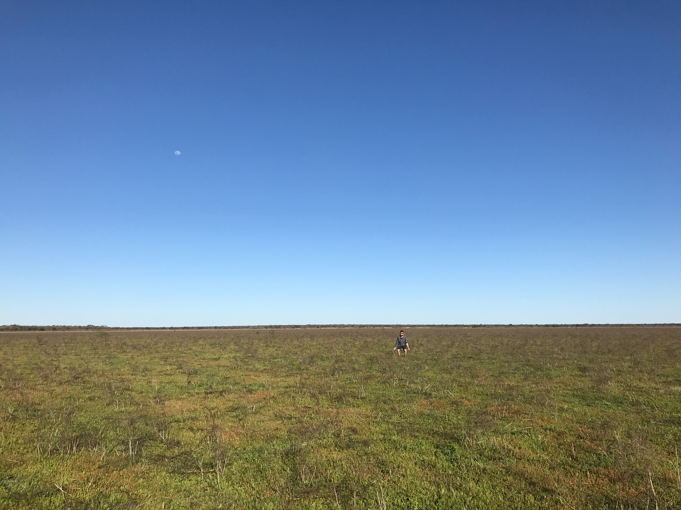

**Final Report**

**CFE Publication 249**

**May 2020**

Murray-Darling Basin Long Term Intervention Monitoring Project  
2018–19 Basin-scale evaluation of Commonwealth environmental water — Vegetation Diversity Report

Report prepared for the Department of Agriculture, Water and the Environment, Commonwealth Environmental Water Office by La Trobe University, Centre for Freshwater Ecosystems.

Department of the Agriculture, Water and Environment

Commonwealth Environmental Water Office  
John Gorton Building, King Edward Terrace,

Parkes ACT 2600

Ph: 1800 803 772

For further information contact:

**Nick Bond Nikki Thurgate  
Project Leader Project Co-ordinator**

Centre for Freshwater Ecosystems   
(formerly Murray-Darling Freshwater Research Centre)   
PO Box 821   
Wodonga VIC 3689   
Ph: (02) 6024 9640 (02) 6024 9647  
Email: [n.bond@latrobe.edu.au](mailto:n.bond@latrobe.edu.au) [n.thurgate@latrobe.edu.au](mailto:n.thurgate@latrobe.edu.au)

Web: <https://www.latrobe.edu.au/freshwater-ecosystems/research/projects/ewkr>

Enquiries: [cfe@latrobe.edu.au](mailto:cfe@latrobe.edu.au)

**Report Citation:** Capon, S.J. and James, C.S., (2020) Murray-Darling Basin Long Term Intervention Monitoring Project — Vegetation Diversity Report. Report prepared for the Department of the Agriculture, Environment and Water, Commonwealth Environmental Water Office by La Trobe University, Centre for Freshwater Ecosystems, CFE Publication 249 May 2020 129pp.

**Cover Image:** Clear Lake, Narran Lakes

**Photographer:** Samantha Capon

**Traditional Owner acknowledgement:**

La Trobe University Albury-Wodonga and Mildura campuses are located on the land of the Latje Latje and Wiradjuri peoples. The Research Centre undertakes work throughout the Murray-Darling Basin and acknowledge the traditional owners of this land and water. We pay respect to Elders past, present and future.

**Acknowledgements:**

We are grateful to the Basin Matters project team for their contributions to this evaluation report. Shane Brookes and Julia Mynott have provided critical data management support. Shane Brookes, Enzo Guarino and Jenny Hale have also contributed essential information regarding hydrology and environmental watering. We also acknowledge the efforts of Nick Bond, Nikki Thurgate and Rachel Gorman in leading and coordinating the Basin Matters team.

We also wish to thank all of the Monitoring and Evaluation Teams associated with the Selected Areas for their contributions, without which this evaluation would not be possible. In particular, we are grateful to Fiona Dyer and Cherie Campbell for their support in organising the collaborative workshop held in March 2020. Finally, we thank the staff of the Commonwealth Environmental Water Office for their support.

The La Trobe University offices are located on the land of the Latje Latje and Wiradjuri peoples. We undertake work throughout the Murray–Darling Basin and acknowledge the traditional owners of this land and water. We pay respect to Elders past, present and future.

Document history and status

|  |  |  |  |  |
| --- | --- | --- | --- | --- |
| **Version** | Date Issued | **Reviewed by** | **Approved by** | **Revision type** |
| Draft | 21/4/2020 | CEWO | N. Thurgate | draft |
| Final | 5/5/20 | S. Capon | N. Thurgate | final |
|  |  |  |  |  |
|  |  |  |  |  |

Distribution of copies

|  |  |  |
| --- | --- | --- |
| **Version** | **Quantity** | **Issued to** |
| Draft | 1 x word | CEWO |
| Final | 1 x word, 1 x pdf | CEWO |

Contents

Abbreviations 5

Summary of annual Basin-scale evaluation 2018–19 6

Summary of multi-year Basin-scale evaluation outcomes 2014–19 8

1 Project Details 13

1.1 Introduction 13

1.2 Evaluation objectives 13

1.3 Summary of previous Basin-scale outcomes (2014–15 to 2017–18) 14

1.4 Summary of watering actions 2018-19 for vegetation diversity outcomes 16

1.5 Methods 20

2 Basin-scale evaluation 2018–19 25

2.1 Key findings 25

2.2 Effects of Commonwealth environmental water for plant species diversity within and across Selected Areas in 2018–19 26

2.3 Effects of Commonwealth environmental water for vegetation community diversity within and across Selected Areas in 2018–19 28

2.4 Effects of Commonwealth environmental water for vegetation diversity in unmonitored areas in 2018–19 35

3 Cumulative Basin-scale evaluation 2014–19 38

3.1 Key findings 38

3.2 Effects of Commonwealth environmental water for plant species diversity between 2014 and 2019 41

3.3 Effects of Commonwealth environmental water for vegetation community diversity within and across Selected Areas between 2014 and 2019 43

4 Contribution to achievement of Basin Plan objectives and adaptive management 66

4.1 Adaptive management 66

4.2 Contribution to Basin Plan objectives 68

5 References 72

Appendix A: Watering actions contributed to byCommonwealth environmental water in 2018–19 with Expected Outcomes related to vegetation diversity 74

Appendix B: Plant taxa recorded in the LTIM project from monitored Selected Areas in each sampling year between 2014–15 and 2017–18 85

Appendix C: Wetland plant water response groups 104

Appendix D: Vegetation community clusters 112

Appendix E: Predictive model development 117

# Abbreviations

|  |  |
| --- | --- |
| ANAE | Refers to the Australian National Aquatic Ecosystem classification framework (https://www.environment.gov.au/system/files/resources/08bfcf1a-0030-45e0-8553-a0d58b36ee03/files/ae-toolkit-module-2-anae-classification.pdf) |
| AVCTs | Annual vegetation community types (see Appendix D for details) |
| AWR | Annual watering regime (see Table 3) |
| CEW_WR | Commonwealth environmental watering regime (see Table 3) |
| CEWO | Commonwealth Environmental Water Office (CEWO) |
| LHLF | Refers to plant groups classified on the basis of life history (LH), e.g. annual, perennial, and life form (LF), e.g. grasses, forbs, trees etc. |
| LTIM | Long-term Intervention Monitoring |
| LTIM_WR | 5-Yr watering regime (see Table 3) |
| PFGs | Plant functional groups. Refer here mainly to established water PFGs defined by Brock and Casanova (1997). |
| WAR | Water action number |

Summary of annual Basin-scale evaluation 2018–19

**Key Basin-scale evaluation findings**

Plant species diversity

* Over three hundred plant taxa were recorded in 2018–19 in the four wetland Selected Areas (i.e. the Gwydir river system, the Lachlan river system, the Murrumbidgee river system and the Junction of the Warrego and Darling rivers) and the Goulburn river system, comprising 214 and 86 identifiable native and exotic species respectively.
* **Sixteen taxa, mostly native perennial forbs, were only recorded in 2018–19 from Sample Points that received Commonwealth environmental water delivered in 2018–19** to the four wetland Selected Areas. Additionally, 29 taxa, including a mixture of annual and perennial forbs and grasses, were only recorded from the riverine Selected Areas during 2018–19, both of which received Commonwealth environmental water during the year.

Vegetation community diversity

* **Commonwealth environmental water contributed to inundation in five and six Sample Points in the Murrumbidgee river system and Gwydir river system respectively during 2018–19 as well as that of a single Sample Point in the Lachlan river system.** With the exception of one Sample Point in the Gwydir river system, all those receiving Commonwealth environmental water were classified as having a ‘mixed’ annual watering regime (i.e. comprising wet and dry conditions during survey times) while Sample Points that did not receive Commonwealth environmental water at these Selected Areas were all classified as having a ‘dry’ annual watering regime during this year. Commonwealth environmental water was also delivered to both riverine Selected Areas in 2018–19 for vegetation diversity outcomes.
* **Total cover of groundcover vegetation increased in most, but not all, wetland Sample Points receiving Commonwealth environmental water in 2018–19**. In the Murrumbidgee river system, total cover peaked and then fell in most of these Sample Points with the exception of Piggery Lake and Two Bridges Swamp for which total cover remained high. In contrast, total cover in most dry Sample Points tended to decline or remain relatively low and stable during the year.
* **Commonwealth environmental water appears to have had a positive effect on species richness of groundcover vegetation in the two inundated wetland Selected Areas**. In the Gwydir river system, for example, Sample Points receiving Commonwealth environmental water tended to retain relatively stable species numbers over the year in comparison to Sample Points that did not, in which species richness declined steeply. In the Murrumbidgee river system, species richness remained relatively stable or fell dramatically in dry Sample Points during the year while the number of species observed in Sample Points receiving Commonwealth environmental water tended to increase, at least initially, remaining high in as per total cover in Two Bridges Swamp.
* No clear patterns were detected in exotic groundcover or species richness in relation to watering in wetland Selected Areas during 2018–19.
* Vegetation community composition of Sample Points monitored in 2018–19 strongly reflected Selected Area and, to a lesser degree, ANAE ecosystem type. Composition of vegetation communities subject to mixed watering regimes during this year were reasonably distinct from those experiencing dry conditions. **Sample Points that had a mixed watering regime but did not receive Commonwealth** **environmental water during the year, supported vegetation communities more similar to those in dry Sample Points**, suggesting that Commonwealth environmental water contributed to greater diversity of vegetation communities across the Basin in 2018–19.
* **Twenty-two ANAE wetland ecosystem types, 10 floodplain ecosystem types and 12 watercourse ecosystem types were inundated, or influenced by, Commonwealth environmental water inundated during 2018–19**. Because of the strong influence of ANAE ecosystem type on vegetation community composition, it is likely that different responses to Commonwealth environmental watering occurred amongst these different ecosystem types.

**Key contribution to Basin Plan objectives**

* **Commonwealth environmental water delivered during 2018–19 almost certainly increased the diversity of wetland plant species present in the Basin as well as the diversity of vegetation communities present during the year**. A significant proportion of native species, especially perennial forbs, were only present at a Basin-scale, according to Selected Area monitoring data, during 2018–19 in wetland areas inundated by Commonwealth environmental water. In the Gwydir river system and Murrumbidgee rivers system, Commonwealth environmental water also appeared to generate vegetation communities with greater total cover and higher species richness in inundated wetlands compared with dry wetlands in which total cover and species richness either declined or remained relatively stable.

Summary of multi-year Basin-scale evaluation outcomes 2014–19

**Key Basin-scale evaluation findings**

Plant species diversity

* Over 640 plant taxa have been recorded between 2014–15 and 2018–19 from across the five Selected Areas for which plant species diversity has been recorded as a Category one variable (Hale et al. 2014), including at least 185 annual forbs, 32 annual grasses, 3 annual sedges/rushes, 36 annual sub-shrubs and shrubs, 162 perennial forbs, 56 perennial grasses, 16 perennial sedges/rushes, 71 perennial sub-shrubs and shrubs and 13 trees.
* Approximately 27 % of plant taxa were recorded in every year of the LTIM program from at least one Selected Area while around 32% of taxa were only recorded across these Selected Areas in a single year.
* Annual numbers of total recorded plant taxa, as well as those able to be identified to a species level and exotic species, declined overall between 2014–15 and 2018–19.
* The Lachlan river system and Murrumbidgee river system generally had higher numbers of plant taxa each year while the Junction of the Warrego and Darling rivers and Goulburn river Selected Areas tended to have the least.
* Most plant species recorded from Selected Areas during the five-year LTIM project were observed under a range of hydrological conditions with 175 taxa recorded from all four HydroStates allocated to Sample Points at the time of sampling (i.e. dry, mostly dry, mostly wet and wet) and a further 82 taxa from three of these HydroStates. There were 213 plant taxa which were only recorded under a single HydroState including 20 taxa that only occurred under wet conditions and a further 18 taxa exhibited only observed under wet or mostly wet conditions.
* Fifty-five plant taxa from the four wetland Selected Areas were identified by indicator species analysis as significantly associated with HydroStates at the time of sampling. No taxa were significantly associated solely with dry conditions and only two species were significantly associated with wet conditions: the native annual forb, *Ludwigia octovalvis*, and the exotic annual grass *Echinochloa colona*. The native perennial forb, *Myriophyllum verrucosum*, was strongly affiliated with mostly wet conditions.

Vegetation community diversity

* Total cover and species richness of groundcover vegetation at Sample Points varied considerably within and between years between 2014–15 and 2018–19 in all Selected Areas. Strong seasonal patterns are apparent in the two riverine Selected Areas, reflecting the dominant timing of flows (i.e. spring freshes). Overall species numbers in the riverine Selected Areas declined over this five-year period, partly due to a reduction in exotic species numbers.
* In wetland Selected Areas, few clear patterns in total cover or species richness of groundcover vegetation were apparent in relation to broad watering regimes over this period with trajectories largely reflecting the dynamics at Selected Areas. The exceptions were the dramatic spikes in total cover in drier Sample Points in the Lachlan river system and the Junction of the Warrego and Darling rivers in response to the large natural floods of 2016–17.
* Trends in exotic plant cover and species richness at Sample Points were also highly variable over the five-year period similarly reflecting the dynamics at a Selected Area rather than watering regime. A possible exception were drier Sample Points in the Gwydir river system where exotic plant cover and species richness tended to be higher overall than in other Sample Points at this Selected Area.
* Five Annual Vegetation Community Types (AVCTs) present in Sample Points across wetland Selected Areas between 2014–15 and 2018–19 were identified based on clustering of life history/life form (LHLF) plant groups. Cluster 1 comprised AVCTs with high proportions of annual and perennial forbs with significant perennial shrubs and sub-shrubs. Cluster 2 included AVCTs characterised by a large proportion of perennial sedges and rushes. Cluster 3 comprised AVCTs dominated by perennial grasses. Cluster 4 was characterised by a high proportion of perennial forbs and Cluster 5 by a high proportion of perennial shrubs and sub-shrubs.
* Clusters explained 68.6 % of total variance in the dataset and were relatively distinct from each other while not being aligned closely with specific Selected Areas indicating that these AVCTs could appear across the Basin. All AVCTs were present in the Basin in each year of the LTIM project but fluctuated in relative abundance between years. Cluster 5 vegetation communities (i.e. dominated by perennial shrubs and sub-shrubs) were substantially lower in 2016–17 than in other years, probably reflecting a negative response of this community type to the large natural floods which occurred during this year. The abundance of Cluster 4 vegetation communities (i.e. dominated by perennial forbs) was higher in the two wetter years (i.e. 2016–17 and 2017–18).
* Membership of Sample Points to the different AVCTs broadly reflected differences in annual watering regimes. Cluster 5 vegetation communities (i.e. dominated by perennial shrubs and sub-shrubs) mainly occurred under dry annual water regimes. Sample points that were wet during the year but did not receive Commonwealth environmental water in the year also tended to support Cluster 5 communities as well as Cluster 1 (i.e. dominated by forbs and some perennial shrubs and sub-shrubs) and Cluster 4 (i.e. dominated by perennial forbs). Sample Points inundated by Commonwealth environmental water during the year tended to have annual vegetation communities in Cluster 2 (i.e. dominated by perennial sedges and rushes), Cluster 3 (i.e. dominated by perennial grasses) and, to a lesser extent, Cluster 4.
* At a Selected Area scale, **shifts in membership of AVCTs between years of particular Sample Points was often associated with shifts in hydrological conditions, especially those involving Commonwealth environmental water**. However, patterns varied between Selected Areas.
* **Commonwealth environmental water has inundated, or influenced inundation, 35 ANAE ecosystem types between 2014–15 and 2018–19**: 24 wetland ecosystem types and 11 floodplain ecosystem types. Because of the strong relationship between ANAE ecosystem type and vegetation community composition at monitored Selected Areas, vegetation diversity responses to watering in unmonitored areas are likely to have differed between these ecosystem types. A greater diversity of vegetation responses at a Basin-scale in any water year will therefore very likely be generated by a greater diversity of ecosystem types inundated by Commonwealth environmental water.
* **Twenty-eight ecosystem types have received Commonwealth environmental water every year between 2014–15 and 2018–19 while two ecosystem types have only received by Commonwealth environmental water in a single year**. The number of ecosystem types receiving Commonwealth environmental water each year has consistently been between 25 and 29.
* Vegetation communities inundated by Commonwealth environmental water over significant proportions of their area (i.e. > 10 %) in most years include temporary river red gum swamp (Pt1.1.2), permanent tall emergent marsh (Pp2.12), permanent wetland (Pp4.2), temporary sedge/grass/forb marsh (Pt2.2.2) and freshwater meadow (Pt2.3.2).

**Key contribution to Basin Plan objectives**

* **Commonwealth environmental water delivered between 2014–15 and 2018–19 is very likely to have increased the diversity of wetland plant species present in the Basin as well as the diversity of vegetation communities present** over this period, as well as in any individual year during this period. A significant proportion of native species were only present at a Basin-scale, according to Selected Area monitoring data, in any single water year. Wetland inundation due to Commonwealth environmental water also increased the diversity of vegetation community types present in any year as well as over the entire period.

**Key adaptive management outcomes**

##### *All Commonwealth environmental water actions are likely to enhance plant species diversity at the Basin scale in any water year.*

##### Monitoring data obtained during the LTIM project strongly suggests that the presence of plant species in wetlands, floodplains and riverine ecosystems of the Basin varies considerably both within and between wetlands as well as water years. At any particular time, only a small proportion of plant taxa present in these habitats across the Basin are likely to occur with widespread distributions while most plant taxa present will be rare with limited Basin-scale extents. Consequently, it is highly likely that the delivery of any Commonwealth environmental water to these habitats will promote plant species diversity at the Basin-scale because different plant species will be present to respond to watering in different places. Additionally, because the species composition of vegetation communities is relatively distinctive between Selected Areas as well as ANAE ecosystem types, plant species diversity at the Basin-scale is also likely to be enhanced when more Selected Areas and ANAE ecosystem types are watered in any particular water year.

##### *All Commonwealth environmental water actions are likely to enhance vegetation community diversity at the Basin scale in any water year.*

Monitoring data obtained during the LTIM project clearly indicates that vegetation communities present in wetlands, floodplains and riverine ecosystems of the Basin vary considerably both within and between wetlands with vegetation community composition strongly influenced by regional location (i.e. Selected Area) as well as ANAE ecosystem type. The dynamics of vegetation communities at particular places is also highly variable in the short- and long-term with shifts in vegetation cover, species richness and composition tending to reflect watering regimes, albeit with complex response patterns. Consequently, it is highly likely that the delivery of any Commonwealth environmental water to these habitats will promote the diversity of vegetation communities at the Basin-scale because different vegetation communities will be present to respond to watering in different places and these are also likely to respond in different ways. Additionally, because the vegetation communities differ between Selected Areas as well as ANAE ecosystem types, vegetation community diversity at the Basin-scale is also likely to be enhanced when more Selected Areas and ANAE ecosystem types are watered in any particular water year.

##### *Vegetation diversity is enhanced across multiple scales by environmental watering that promotes a dynamic mosaic of watering regimes.*

Diversity of both plant species and vegetation communities at local (i.e. wetland), Selected Area and Basin scales are promoted by watering regimes that are heterogeneous in both space and time. Diverse wetting and drying patterns therefore enhance vegetation diversity at both levels because different plant species and vegetation communities are present in different places and times to respond to watering and also vary in their responses. In general, higher plant species diversity tends to occur following the recession of floodwaters in response to intermittent wetting of floodplain habitats. In contrast, frequent, regular wetting (e.g. annually) tends to generate more stable vegetation communities dominated by fewer species than occur in wetlands subject to more hydrologically variable wetting and drying patterns.

At landscape-scales, however, the diversity of vegetation communities (rather than plant species) is likely to be promoted by watering regimes that generate a mosaic of wetting and drying patterns that include some areas of frequently watered patches and other areas that are watered more intermittently. For some more aquatic vegetation communities, e.g. Moira grass wetlands, the duration, depth and frequency of inundation may be important for enabling key species to maintain their dominance as shorter, less frequent floods can permit invasion by more mesic species and a transition to a different community type (e.g. Collof et al. 2014). Consequently, there is a need to explore trade-offs in plant species and vegetation community diversity across multiple spatial and temporal scales through adaptive management and learning (see final point below). In the case of Moira grass wetlands in Barmah Forest, for example, is there a trade-off between meeting an objective to maintain vegetation communities dominated by swathes of Moira grass versus promoting landscape-scale plant species and vegetation diversity?

##### *Large natural floods have an overriding influence on vegetation dynamics.*

Monitoring data obtained during the LTIM project clearly demonstrates that large natural floods have an overriding influence on vegetation dynamics of wetlands, floodplains and riverine ecosystems in the Basin. At any particular time, therefore, the responses of vegetation communities to Commonwealth environmental water actions will reflect their broader watering history. Expected outcomes of watering actions should therefore take this into account. For example, vegetation communities of floodplain habitats are likely to benefit from periods of drying following large natural floods to enable plants to set seed and replenish soil seed banks and for various soil processes to occur (e.g. renewal of soil biota). Environmental watering following large natural floods might therefore be best directed towards topping up semi-permanent and permanent wetlands.

##### *Monitoring and evaluation vegetation diversity outcomes of environmental water requires a robust adaptive learning approach.*

Effective monitoring and evaluation of vegetation diversity outcomes of environmental watering actions needs to be underpinned by clearly defined, explicit management objectives and associated questions with sampling designs that enable robust scientific investigations. If management objectives were to optimise plant species diversity at any particular time, for example, the best approach would be to deliver environmental water in such a way that generated the greatest extent of inundation across the Basin. However, this would likely favour certain suites of ephemeral, floodplain plant species and disadvantage more aquatic plant species and vegetation communities that require more frequent wetting. Consequently, more nuanced management objectives are required that reflect our desire to conserve a diverse range of plant species and particular vegetation communities across the Basin.

Furthermore, solely monitoring a set number of fixed sampling sites over time, while interesting with respect to plant diversity and distributions, is unlikely to yield sufficient knowledge to answer important questions associated with the delivery of Commonwealth environmental water. A more informative approach could involve the delivery of watering actions following an experimental approach to address key adaptive management questions. For example, can semi-permanent wetland vegetation communities dominated by particular aquatic or amphibious taxa retain their character for certain periods without watering to enable environmental water to be instead delivered to less frequently flooded habitats (and thus promote plant species and vegetation community diversity at multiple scales)? Likewise, improved understanding of plant species and vegetation community responses to watering regimes across the Basin requires a more consistent, balanced and controlled sampling distribution which can facilitate more robust comparisons.

# Project Details

## Introduction

Conservation of riverine and wetland vegetation diversity is a key objective of the *Basin Plan 2012* (Basin Plan). Vegetation in riverine habitats is highly valued for a wide range of economic and cultural reaons and supports many critical ecological functions (Capon et al. 2013). Vegetation also tends to be very sensitive to hydrological conditions which often have an overriding inlfuence on the composition and structure of riparian and wetland vegetation communities, particularly in drier landscapes such as those comprising lowland regions of the Murray-Darling Basin (Capon et al. 2016). Vegetation diversity has therefore been a core element investigated in the suite of matters evaluated at the Basin-scale in the Long Term Intervention Monitoring (LTIM) project of the Commonwealth Environmental Water Office (CEWO) .

Hydrology influences vegetatation diversity over multiple temporal and spatial scales and across several levels of ecologial organisation (i.e. individual plants, plant populations and species, vegetation communities and vegetated landscapes or ‘vegscapes’). Survival, growth and reproduction of individual plants in these environments, for instance, are strongly influenced by recent hydrological conditions including flood pulse characteristics (e.g. timing, duration) and antecedent conditions (e.g. time since last flood event (Nilsson & Svedmark 2002; Brock *et al.* 2006; Capon 2003, 2016)). Different plant species respond to hydrology in different ways depending on their traits and tolerances, as well as historical and other local factors (e.g. grazing; Capon et al. 2017). Over longer periods of time, patterns of wetting and drying are therefore reflected by the composition and structure of riverine vegetation communities, as well as their distribution across the landscape (Stromberg 2001; Capon 2005, 2016).

The LTIM project has enabled the collection of vegetation diversity data from riverine and wetland habitats in the Murray-Darling Basin at an uprecedented scale. After five years, this project has now amassed a considerable data set providing a unique opportunity to investigate vegetation diversity responses to wetting and drying across multiple temporal and spatial scales and levels of ecologial organisation. Such knowledge is essential to informing the adaptive management of Commonwealth, and other, environmental water.

## Evaluation objectives

The Basin-scale evaluation of vegetation diversity addresses two major questions:

1. What did Commonwealth environmental water contribute to plant species diversity?

2. What did Commonwealth environmental water contribute to vegetation community diversity?

Annual Vegetation Diversity Basin Matter evaluations during the LTIM project address these questions with respect to both the relevant water year (i.e. 2018–19) and cumulatively since the beginning of the program (i.e. 2014–19), drawing mainly on analyses of vegetation monitoring data collected from six Selected Areas across the Murray-Darling Basin: the Gwydir river system, the Lachlan river system, the Murrumbidgee river system, the Junction of the Warrego and Darling rivers, the Edward-Wakool river system and the Goulburn River. Analyses of other available hydrologic and ecosystem mapping data are also incorporated where possible.

The specific questions addressed in this 2018–19 evaluation report are:

*Annual evaluation:*

1. What did Commonwealth environmental water contribute to plant species diversity across monitored Selected Areas during 2018–19?
2. What did Commonwealth environmental water contribute to vegetation community diversity across monitored Selected Areas during 2018–19 at local and landscape scales?
3. What did Commonwealth environmental water likely contribute to vegetation community diversity in unmonitored areas during 2018–19?

*Cumulative (i.e. 1-5 year) evaluation:*

1. What did Commonwealth environmental water contribute to plant species diversity across monitored Selected Areas between 2014–15 and 2018–19?
2. What did Commonwealth environmental water contribute to vegetation community diversity across monitored Selected Areas between 2014–15 and 2018–19 at local and landscape scales?
3. What did Commonwealth environmental water likely contribute to vegetation community diversity in unmonitored areas between 2014–15 and 2018–19?

#### Outputs

As the final annual evaluation report in the five-year LTIM program, this document presents and refers to outputs in addition to the assessment of annual and cumulative evaluation questions above. In particular, the following additional outputs are provided:

* A database of all plant taxa observed during the LTIM project with assignations according to status (native vs. exotic), life history and life form plant groups and water plant functional groups (PFGs) following the scheme of Brock and Casanova (1997);
* A classification of observed plant taxa to water response groups (Appendix C);
* Classification of annual vegetation community types (i.e. according to community composition over a water year) based on life history/life form groups and PFGs (Appendix D and accompanying datasets);
* A report on the development of predictive models relating both plant species responses and vegetation community responses to hydrology (Appendix E and accompanying datasets and results).

## Summary of previous Basin-scale outcomes (2014–15 to 2017–18)

Over 600 plant taxa were recorded from the groundlayer of vegetation in the six Selected Areas monitored for vegetation diversity under the LTIM project between 2014–15 and 2017–18. Over this period, the cumulative number of native plant species observed in Selected Areas increased by approximately 4 % while overall numbers of exotic plant species observed declined by nearly 22 %. Numbers of plant species observed across the Basin varied between years, however, with particularly low numbers in 2016–17 likely reflecting the very wet conditions generated by large natural floods in that year. Only a very small proportion (~ 2 %) of plant taxa recorded during this period have been strongly associated with specific hydrological conditions at the time of sampling.

The structure and composition of monitored vegetation communities exhibit significant differentiation between Selected Areas and have also varied considerably over the first four years of the LTIM program. Large natural flood events in 2016–17 exerted a dominant influence on temporal dynamics of vegetation communities in most cases. In all wetland Selected Areas other than the Gwydir river system, total vegetation cover exhibited a sharp increase following 2016–17 floods, declining with subsequent drying. Species richness in these Selected Areas, in contrast, fell following these natural floods and then tended to increase with drying. In the Murrumbidgee river system, such dramatic responses appeared to be buffered in those wetlands that had received more regular Commonwealth environmental water in the past four years. Overall species numbers have tended to decline over the four-year period in those wetlands with drier watering regimes in the Murrumbidgee river system as well as in the Gwydir river system in areas that have received more Commonwealth environmental water, reflecting a decline in exotic taxa over this period.

Amongst the riverine Selected Areas, vegetation diversity in the Edward-Wakool river system has been highly variable over the four-year period. In the Goulburn River, however, riverbank vegetation cover has increased over these four years by approximately 10 % overall. In contrast, there has been an overall decline in species richness at this Selected Area probably due to drier early conditions in this period promoting the establishment of plant species, the number of which has likely fallen as a result of high natural flows in 2016–17.

Exotic plant cover exhibited varying patterns over the four-year period across Selected Areas. In the Goulburn River, exotic plant cover has been relatively stable over the long-term while a gradual rise has been apparent in vegetation communities of the Edward-Wakool river system, the Junction of the Warrego and Darling rivers, the Lachlan river system and the Murrumbidgee river system – a trend which does not appear to be strongly associated with local hydrological regimes during this period. In the Gwydir river system, however, reductions in overall exotic plant cover appear to have been promoted by Commonwealth environmental water with wetter conditions in this Selected Area associated with relatively low, stable exotic plant cover during these four years contrasting with more variable patterns in exotic plant cover where drier conditions have prevailed.

The composition of vegetation communities across all Selected Areas between 2014 and 2018 has been strongly influenced by Selected Area and ecosystem type but also hydrological conditions over the short and longer term, reflecting broad gradients from drier to wetter conditions. Commonwealth environmental water regimes during this four-year period have also be significantly related to differences in vegetation community composition.

Between 2014–15 and 2017–18, 35 ANAE ecosystem types were inundated, or influenced by, Commonwealth environmental water including 24 wetland ecosystem types and 11 floodplain ecosystem types. Amongst these, 26 ecosystem types have received Commonwealth environmental water annually while three have only received Commonwealth environmental water in one year. In each year, the number of ecosystem types watered has been comparable (i.e. between 27-30) except in 2016–17 when Commonwealth environmental water when this only inundated or influenced 23 ecosystem types. Temporary river red gum swamp (Pt1.1.2), permanent tall emergent marsh (Pp2.12), permanent wetland (Pp4.2), temporary sedge/grass/forb marsh (Pt2.2.2) and freshwater meadow (Pt2.3.2) have had significant proportions (> 10%) of their area within the Basin inundated, or influenced by, Commonwealth environmental water in most years.

## Summary of watering actions 2018-19 for vegetation diversity outcomes

One hundred and twelve watering actions, comprising a total just over 397,334 ML, were delivered by the Commonwealth Environmental Water Office (CEWO) during 2018–19 for expected outcomes associated with vegetation diversity across the Basin (Appendix A). While a significant proportion (~ 85 %) of this Commonwealth environmental water was delivered in Selected Areas, via 23 watering actions (Table 1), only seven watering actions were evaluated by vegetation monitoring conducted under the LTIM program due to the sampling designs used at Selected Areas (Table 1). These monitored watering actions included freshes in both of the riverine Selected Areas and flows contributing to wetland inundation in the Gwydir river system and Murrumbidgee river system as well as that of a single vegetation sample point in the Lachlan river system. No wetland inundation occurred during 2018–19 at the Junction of the Warrego and Darling rivers.

Table 1. Summary of watering actions with expected outcomes related to vegetation diversity at Selected Areas monitored for vegetation diversity in 2018–19.

|  |  |  |  |  |  |  |  |  |
| --- | --- | --- | --- | --- | --- | --- | --- | --- |
| **Basin-scale Evaluation Water Action Reference** | **Water Action Number (WAR)** | **Surface water region: asset** | **Commonwealth environmental water volume (ML)** | **Total water action volume (ML)** | **Dates** | **Flow component** | **Expected ecological outcome1** | **Evaluated by LTIM in Selected Area** |
| 1819-EWK-01 | 10083-01 | Edward Wakool: Colligen-Neimur | 13943 | 13943 | 21/8/18 - 30/6/19 | Baseflow, fresh | Help native water plants including common reed, pondweed and milfoil recover after the 2016 flood. Provide habitat in winter 2019 to help native fish move and mature and protect native water plants from frost damage. | No |
| 1819-EWK-02 | 10083-01 | Edward Wakool: Yallakool Wakool System | 19365 | 19365 | 21/8/18 - 30/6/19 | Baseflow, fresh | Help native water plants including common reed, pondweed and milfoil recover after the 2016 flood. Provide habitat in winter 2019 to help native fish move and mature and protect native water plants from frost damage. | Yes |
| 1819-EWK-03 | 10083-03 | Edward Wakool: Tuppal Creek | 2870 | 2870 | 17/9/18 - 30/6/19 | Baseflow, fresh | Improve the condition of the fringing vegetation community including river red gums and black box. | No |
| 1819-EWK-04 | 10083-04 | Edward Wakool: Pollack Swamp | 2000 | 2000 | 8/10/18 - 25/1/19 | Wetland | Continue to improve wetland vegetation health and condition of nest trees. | No |
| 1819-GLB-01 | 10075-01 | Goulburn: Lower Goulburn River | 113131 | 153410 | 1/7/18 - 2/8/18 | Fresh | Contribute to a winter fresh to maintain bank vegetation and macroinvertebrate habitat. | No |
| 1819-GLB-03 | 10075-01 | Goulburn: Lower Goulburn River | 60471 | 156434 | 29/9/18 - 4/11/18 | Fresh | Contribute to a long-duration fresh in early spring to water bank vegetation, provide soil moisture to banks and benches and distribute seed for later germination. | Yes |
| 1819-GLB-04 | 10075-01 | Goulburn: Lower Goulburn River | 18676 | 77000 | 16/4/19 - 30/6/19 | Baseflow | Contribute to higher baseflows year-round, but especially in winter/spring to increase habitat area for instream flora and fauna and to water bank vegetation. | No |
| 1819-GWY-01 | 10085-01 | Gwydir: Gwydir Wetlands | 30000 | 60000 | 18/7/18 - 7/2/19 | Wetland, fresh | Protect and maintain the condition of over 10000 ha of wetland vegetation in the Gingham and lower Gwydir wetlands, including Ramsar listed parcels - Old Dromana and Goddards Lease. | Yes |
| 1819-GWY-02 | 10085-02 | Gwydir: Mallowa Wetlands | 16950 | 16950 | 20/9/18 - 14/2/19 | Wetland, fresh | Protect and maintain the condition of over 2000 ha of wetland vegetation in the Mallowa wetlands. | Yes |
| 1819-GWY-03 | 10085-04 | Gwydir: Ballin Boora | 600 | 600 | 12/12/18 - 31/1/19 | Wetland | Support the recovery of vegetation extent and condition (including of coolibah open woodland, which is an endangered ecological community). | No |
| 1819-LCH-03 | 10081-02 | Lachlan: Yarrabandai Lagoon | 412 | 412 | 18/3/19 - 29/5/19 | Wetland | Improve condition of fringing riparian vegetation. | No |
| 1819-LCH-04 | 10081-03 | Lachlan: Great Cumbung Swamp | 5338 | 5338 | 9/6/19 - 28/6/19 | Wetland | Protect core reed beds and the non-woody vegetation communities. | Yes (single site) |
| 1819-MBG-01 | 10082-02 | Murrumbidgee: Yanga National Park | 10500 | 79794 | 20/8/18 - 31/1/19 | Wetland | Contribute to native riparian, wetland and floodplain vegetation diversity and condition. | Yes |
| 1819-MBG-02 | 10082-03 | Murrumbidgee: Yanga National Park | 30000 | 30000 | 17/9/18 - 25/1/19 | Wetland | Contribute to native riparian, wetland and floodplain vegetation diversity and condition. | Yes |
| 1819-MBG-04 | 10082-05 | Murrumbidgee: Mainie Swamp (Junction Wetlands) | 2000 | 2000 | 10/10/18 - 25/2/19 | Wetland | Prevent further decline in wetland vegetation communities. | No |
| 1819-MBG-05 | 10082-06 | Murrumbidgee: Toogimbie IPA | 900 | 900 | 15/10/18 - 22/3/19 | Wetland | Maintain vegetation resilience and condition. | No |
| 1819-MBG-07 | 10082-08 | Murrumbidgee: Yarradda Lagoon | 2013.7 | 2013.7 | 16/11/18 - 18/1/19 | Wetland | Maintain vegetation resilience and condition. | Yes |
| 1819-MBG-09 | 10082-10 | Murrumbidgee: North Redbank | 6000 | 27000 | 17/12/18 - 18/1/19 | Wetland | Maintain critical refuge habitats, and supported their ecological resilience, to support native wetland vegetation, fish, waterbirds, frogs and other aquatic vertebrate species. | No |
| 1819-MBG-10 | 10082-11 | Murrumbidgee: Campbell’s Swamp McCaughey’s Lagoon and Turkey Flats Swamp | 1594 | 1594 | 8/11/18 - 18/2/19 | Wetland | Prevent further decline in wetland vegetation extent and condition. | No |
| 1819-MBG-12 | 10082-13 | Murrumbidgee: Sandy Creek | 400 | 400 | 29/9/18 - 12/1/19 | Wetland | Maintain refuge habitat and support their ecological resilience to support wetland vegetation, waterbirds, native, fish, frogs and other water dependent species. | No |
| 1819-MBG-14 | 10082-15 | Murrumbidgee: Darlington Lagoon | 396.9 | 396.9 | 20/12/18 - 1/5/19 | Wetland | Improve the ecological character, condition and resilience of vegetation communities. | No |
| 1819-MBG-16 | 10082-10 | Murrumbidgee: North Redbank | 500 | 500 | 18/9/18 - 19/11/18 | Wetland | Maintain critical refuge habitats, and supported their ecological resilience, to support native wetland vegetation, fish, waterbirds, frogs and other aquatic vertebrate species. | No |

1 As reported by CEWO.

## Methods

### General approach

This report provides an evaluation of vegetation diversity outcomes of Commonwealth environmental water for both the 2018–19 water year (i.e. annual evaluation) and over the duration of the LTIM project from 2014–15 to 2018–19 (i.e. cumulative evaluation). For each time period, the evaluation considers:

1. Plant species diversity:
   * + patterns in the presence and distribution of plant species across Selected Areas in relation to Commonwealth environmental water
2. Vegetation community diversity:
   * + patterns in ground cover, species richness, exotic species cover and composition of vegetation communities within and across Selected Areas
     + effects of Commonwealth environmental water on inundation of vegetation communities at a Basin-scale including unmonitored areas

### Data used in this evaluation

#### Vegetation data

Vegetation diversity data used in this evaluation were collected under the LTIM project from four wetland Selected Areas (the Gwydir river system, the Lachlan river system, the Murrumbidgee river system and the Junction of the Warrego and Darling rivers) and two riverine Selected Areas (the Edward–Wakool river system and the Goulburn River; Figure 1). Data collected from each Selected Area includes the percent cover of plant species present within three vegetation strata (groundlayer, understorey and overstorey), as well as a range of environmental variables including soil moisture at the time of sampling. Because of variation in methods used at each Selected Area, this evaluation only investigates data from the groundlayer which is also likely to be the most responsive layer to watering in the short-term. Spatial and temporal aspects of vegetation sampling also vary between Selected Areas, particularly between wetland and riverine Selected Areas (Table 2). It should be noted that vegetation diversity data collected from the Edward-Wakool river system is limited to Category 3 and does not, therefore, have the same taxonomic resolution or range of observations as that from the other Selected Areas.

To conduct this evaluation, plant species cover data recorded from each Selected Area were obtained from the LTIM project database and aggregated at the level of Sample Point for each sampling trip (Table 2). Where there were multiple replicate sampling units, mean values for each Sample Point at each sampling time were calculated.

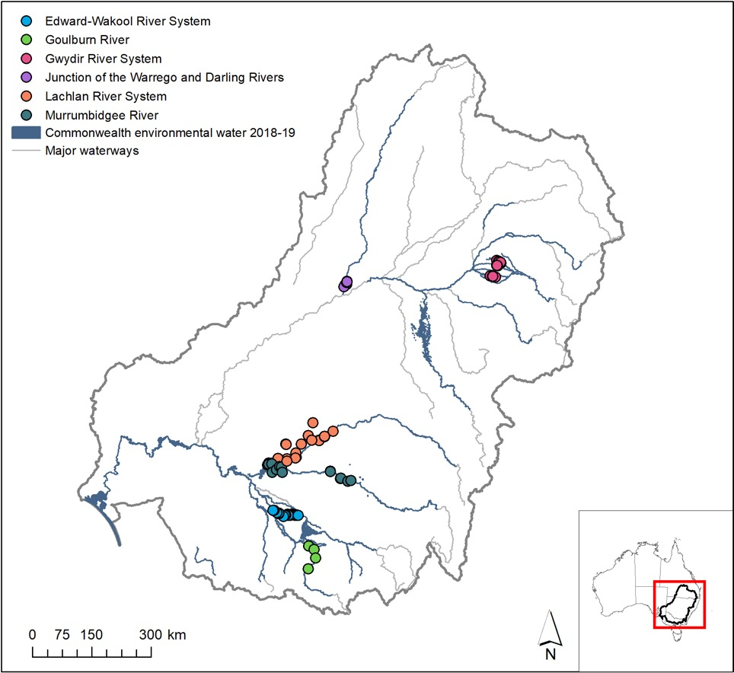

Figure 1. Map showing Selected Areas monitored for vegetation diversity under the LTIM project and the area inundated by Commonwealth environmental water in 2018–19.

Table 2. Vegetation diversity sampling design at the six Selected Areas monitored for vegetation diversity in the LTIM project.

|  |  |  |  |  |
| --- | --- | --- | --- | --- |
| **Selected Area** | **Annual sampling times** | **Number of Sample Points** | **Number of replicate plots / transects per Sample Point** | **Sampling unit description** |
| ***Riverine Selected Areas*** | | | | |
| Edward-Wakool | Monthly (since Jan 2016) | 16 | 6 x 20m long transects parallel to river up the bank | Entire 20 m transect |
| Goulburn | Sept/Oct/Dec; Dec/Feb/Apr | 2 | Up to 9 perpendicular transects on each riverbank | 20 x 2 m sub-transects along each perpendicular transect up the bank |
| ***Wetland / floodplain Selected Areas*** | | | | |
| Gwydir | Oct; Mar | 13 | 1-4 x 0.04 ha plots | Entire 0.04 ha plot |
| Lachlan | Oct/ Nov; May | 1-9 | 2-4 x 100 m transects | 1 m2 quadrats every 10 m along transect |
| 4-17 | 2-4 x 0.1 ha plots (trees) with nested 0.04 ha plots (groundlayer) | Entire 0.04 ha plot (Note: canopy cover recorded for 0.1 ha plot) |
| Murrumbidgee | Sept/Oct; Nov/Dec; Jan/Feb; Mar/May | 12 | 3-5 x 90 – 250 m long transects, depending on wetland bathymetry and area | 3 – 5 x 1 × 10 m2 quadrats along transect |
| Warrego | Feb/Aug/Dec/Sept; May/Mar/Apr | 8 | 3 x 0.04 ha plots | Entire 0.04 ha plot |

#### Hydrology data

Information concerning watering regimes and inundation by Commonwealth environmental water across Selected Areas and the Basin has been obtained from multiple sources (Table 3) including field observations made at Sample Points during sampling trips, consultation with Selected Area monitoring teams, annual maps of inundation extents across the Basin including extents inundated/influenced by Commonwealth environmental water, observations reported in annual Selected Area reports and information provided by the Commonwealth Environmental Water Office concerning watering actions (Table 1; Appendix A).

It should be noted that because of the contrasting nature of the sampling designs at the two riverine Selected Areas, similar hydrological attributes were not relevant at the level of Sample Points.

Table 3. Hydrological characteristics attributed to Sample Points for each sampling trip in the four wetland Selected Areas monitored for vegetation diversity in the LTIM project.

|  |  |  |  |  |  |
| --- | --- | --- | --- | --- | --- |
| **Code** | **Attribute** | **Source** | **Relevant time period** | **Levels** | **Notes** |
| HydroState | Soil moisture | Selected Area monitoring | Time of sampling (i.e. Trip) | dry; mostly dry, mostly wet, wet | Dominant condition across sampling units in Sample Point used |
| AWR | Annual watering regime | Selected Area monitoring, consultation with Selected Area teams | Relevant watering year of sampling (i.e. Year) | dry; mixed; wet | Distribution of HydroStates in relevant water year |
| CEW_WR | Commonwealth environmental watering regime | annual Basin-wide inundation extent maps | Relevant watering year of sampling (i.e. Year) | dry; wet with no CEW; wet with CEW | Inundated state defined as <= 50 m from inundation extent |
| LTIM_WR | 5-Yr watering regime | Selected Area monitoring, consultation with Selected Area teams | five-year period from 2014–15 to 2015-19 | dry; rarely wet; moderately wet; frequently wet; constantly wet | Distribution of annual watering regimes across the 5 years: dry (no wetting in any year); rarely wet (wetting in a single year); moderately wet(wetting in 2-3 years); frequently wet (wetting in 4 years); constantly wet (wetting in all 5 years) |

### Analysis

#### Plant species diversity

All plant taxa entered into the LTIM project database were classified according to their status (i.e. native or exotic), life history (i.e. annual, perennial or variable) and a life form (i.e. forb, grass, sedge/rush, sub-shrub, shrub, mistletoe, tree) based on information in PlantNet (<http://plantnet.rbgsyd.nsw.gov.au/>) and the Atlas of Living Australia (<https://www.ala.org.au/>). Plants were then grouped according to life history and life form, e.g. annual forb, perennial grass etc. (Appendix B). Plant species diversity responses to Commonwealth environmental water were explored by investigating patterns in the presence of recorded plant taxa, as well as various groups of plant taxa, within each time period (i.e. annual and cumulative) in relation to a range of grouping variables, e.g. Selected Area, Hydrostate, CEW_WR.

For the cumulative evaluation, plants species diversity responses at the Basin-scale were also assessed in relation to Hydrostate (Table 3) via indicator species analysis using the INDICSPECIES package in R (De Caceres and Legendre, 2009).

We also utilised the entire dataset to explore water response groups by evaluating the affinity of observed taxa to HydroStates at the time of sampling (see Appendix C).

#### Vegetation community diversity

Patterns in key vegetation community metrics (i.e. mean total vegetation cover, species richness, mean exotic plant cover and exotic species richness) per Sample Point were visually inspected for each Selected Area in both time periods. Where relevant (i.e. wetland Selected Areas), separate plots were created for Sample Points under different watering regimes (Table 3) to explore potential differences in temporal patterns in relation to watering.

Patterns in vegetation community composition were examined within individual Selected Areas and at a Basin-scale (i.e. across all Selected Areas) via non-metric multidimensional scaling (nMDS) based on Bray-Curtis dissimilarities of log(x+1) transformed cover matrices in the VEGAN package in R (Oksanen et al. 2019). For the annual evaluation, these analyses were conducted using species cover data. For the cumulative, Basin-scale evaluation, however, a relative paucity of common species across Sample Points necessitated a different approach to enable vegetation communities comprising different species assemblages to be compared at the Basin-scale. We investigated patterns in the composition of annual vegetation communities based on plant groups defined by life history and life form (LHLF groups; Appendix B). We also used K-means clustering in R to identify key types (i.e. clusters) of annual vegetation communities based on these LHLF plant groups (Appendix D) and explored patterns in the diversity of these vegetation community types at Selected Area and Basin-scales in relation to Selected Area and watering regimes.

#### Vegetation diversity in unmonitored areas

Inundation by Commonwealth environmental water of vegetation communities in unmonitored areas was evaluated using the results of the Basin-scale evaluation of Ecosystem Diversity (see Brooks 2020). We also investigated a range of predictive modelling approaches (Appendix E).

# Basin-scale evaluation 2018–19

## Key findings

### Plant species diversity

* Over three hundred plant taxa were recorded in 2018–19 in the four wetland Selected Areas and the Goulburn river system, comprising 214 and 86 identifiable native and exotic species, respectively.
* Sixteen taxa, mostly native perennial forbs, were only recorded in 2018–19 from Sample Points that received Commonwealth environmental water delivered in 2018–19 to the four wetland Selected Areas. Additionally, 29 taxa, including a mixture of annual and perennial forbs and grasses, were only recorded from the riverine Selected Areas during 2018–19, both of which received Commonwealth environmental water during the year.

### Vegetation community diversity

* **Commonwealth environmental water contributed to inundation in five and six Sample Points in the Murrumbidgee river system and Gwydir river system respectively during 2018–19 as well as that of a single Sample Point in the Lachlan river system**. With the exception of one Sample Point in the Gwydir river system, all those receiving Commonwealth environmental water were classified as having a ‘mixed’ annual watering regime (i.e. comprising wet and dry conditions during survey times) while Sample Points that did not receive Commonwealth environmental water at these Selected Areas were all classified as having a ‘dry’ annual watering regime during this year. Commonwealth environmental water was also delivered to both riverine Selected Areas in 2018–19 for vegetation diversity outcomes.
* **Total cover of groundcover vegetation increased in most, but not all, wetland Sample Points receiving Commonwealth environmental water in 2018–19**. In the Murrumbidgee river system, total cover peaked and then fell in most of these Sample Points with the exception of Piggery Lake and Two Bridges Swamp for which total cover remained high. In contrast, total cover in most dry Sample Points tended to decline or remain relatively low and stable during the year.
* **Commonwealth environmental water appears to have had a positive effect on species richness of groundcover vegetation in the two inundated wetland Selected Areas**. In the Gwydir river system, for example, Sample Points receiving Commonwealth environmental water tended to retain relatively stable species numbers over the year in comparison to Sample Points that did not, in which species richness declined steeply. In the Murrumbidgee river system, species richness remained relatively stable or fell dramatically in dry Sample Points during the year while the number of species observed in Sample Points receiving Commonwealth environmental water tended to increase, at least initially, remaining high in as per total cover in Two Bridges Swamp.
* No clear patterns were detected in exotic groundcover or species richness in relation to watering in wetland Selected Areas during 2018–19.
* Vegetation community composition of Sample Points monitored in 2018–19 strongly reflected Selected Area and, to a lesser degree, ANAE ecosystem type. Composition of vegetation communities subject to mixed watering regimes during this year were reasonably distinct from those experiencing dry conditions. **Sample Points that had a mixed watering regime but did not receive Commonwealth environmental water during the year, supported vegetation communities more similar to those in dry Sample Points, suggesting that Commonwealth environmental water contributed to greater diversity of vegetation communities across the Basin in 2018–19**.
* **Twenty-two ANAE wetland ecosystem types, 10 floodplain ecosystem types and 12 watercourse ecosystem types were inundated, or influenced by, Commonwealth environmental water during 2018–19**. Because of the strong influence of ANAE ecosystem type on vegetation community composition, it is likely that different responses to Commonwealth environmental watering occurred amongst these different ecosystem types.

## Effects of Commonwealth environmental water for plant species diversity within and across Selected Areas in 2018–19

Over three hundred plant taxa were recorded in 2018–19 in the four wetland Selected Areas and the Goulburn river system (Appendix B). These comprised 214 and 86 identifiable native and exotic species respectively. Most taxa were recorded from the Murrumbidgee river system (126) followed by the Lachlan (122), Gwydir (94) and Goulburn (76) river systems with the least taxa observed from the Junction of the Warrego and Darling rivers (62). Selected Areas ranked similarly with respect to the number of exotic taxa: Murrumbidgee (33), Lachlan (32), Gwydir (29), Goulburn (27), Junction of the Warrego and Darling rivers (16).

Of the plant taxa recorded from these five Selected Areas, 206 were recorded solely from a single Selected Area. Only four species were recorded during 2018–19 in all five of these Selected Areas: one native annual sub-shrub (*Alternanthera denticulata*), one native annual forb (*Eclipta platyglossa*), two native perennial grasses *Paspalidium jubiflorum*, *Cynodon dactylon*.

Amongst the four wetland Selected Areas, sixteen taxa, mostly native perennial forbs, were identified that were only recorded in 2018–19 from Sample Points that received CEW delivered in 2018–19 (Table 4). A further 29 taxa, largely comprising a mixture of annual and perennial forbs and grasses, were only recorded in 2018–19 from the riverine Selected Areas, both of which received Commonwealth environmental water (Table 4).

Table 4. Plant species only present in 2018–19 in Selected Areas with Sample Points inundated by Commonwealth environmental water delivered during 2018–19. N.B. For the partially inundated Wetland Selected Areas (i.e. Gwydir, Lachlan and Murrumbidgee river systems), only taxa present in Sample Points inundated by Commonwealth environmental water are shown while all taxa uniquely recorded from the Riverine Selected Areas (i.e. Goulburn and the Edward-Wakool river systems) in 2018–19 are listed. Note: asterisks (*) indicate exotic species.

|  |  |  |
| --- | --- | --- |
| **Plant group** | **Wetland Selected Areas** | **Riverine Selected Areas** |
| Annual forbs | *Ottelia ovalifolia* | *Cuscuta australis*  *Pseudognaphalium luteoalbum*  *Oxalis exilis*  *Persicaria hydropiper*  *Rorippa palustris\**  *Sigesbeckia australiensis*  *Stellaria media\** |
| Perennial forbs | *Acroptilon repens\**  *Azolla filiculoides*  *Calotis cuneifolia*  *Lemna spp.*  *Mimulus gracilis*  *Myriophyllum caput-medusae*  *Potamogeton crispus*  *Potamogeton octandrus*  *Potamogeton tricarinatus*  *Sagittaria montevidensis*  *Cycnogeton procerum (previously Triglochin procera)* | *Euchiton involucratus*  *Kickxia elatine\**  *Hypochaeris radicata\**  *Oxalis perennans*  *Persicaria decipiens*  *Romulea rosea\**  *Wahlenbergia gracilis* |
| Annual grasses |  | *Bromus diandrus\**  *Eragrostis elongata*  *Ehrharta longiflora\** |
| Annual sedges/rushes | *Cyperus pygmaeus* |  |
| Perennial grasses |  | *Anthosachne kingiana*  *Hemarthria uncinata*  *Panicum coloratum\**  *Poa labillardierei*  *Rytidosperma setaceum*  *Themeda triandra* |
| Perennial sedges/rushes | *Typha* spp. | *Carex tereticaulis*  *Cyperus exaltatus*  *Juncus amabilis*  *Juncus usitatus* |
| Perennial sub-shrubs and shrubs | *Atriplex pseudocampanulata* |  |
| Trees |  | *Acacia dealbata* |
| Variable forbs |  | *Silybum marianum\** |
| Variable sedge/rushes | *Isolepis* spp. |  |

## Effects of Commonwealth environmental water for vegetation community diversity within and across Selected Areas in 2018–19

This section evaluates responses of plant communities to Commonwealth environmental water in the wetland Selected Areas in 2018–19. In the Murrumbidgee river system, five out of twelve Sample Points (i.e. wetlands) received Commonwealth environmental water during this year: Eulimbah Swamp, Nap Nap Swamp, Piggery Lake, Two Bridges Swamp and Yarrada Lagoon. All of these Sample Points were also classified as having a mixed annual watering regime in 2018–19 based on soil moisture observations made during vegetation surveys while other Sample Points all had a dry annual watering regime.

In the Gwydir river system, six Sample Points experienced wetting during this year in association with Commonwealth environmental watering actions: GWY_BUN1, GWY_LYN1, GWY_MUNG1, GWY_ODR1, GWY_ODR2 and GWY_ODR3. All of these except GWY_BUN1 were classified as having a mixed annual watering regime in 2018–19 based on soil moisture observations. GWY_BUN1 and all other Sample Points were characterised as having a dry annual watering regime. This discrepancy suggests GWY_BUN1 may have been inundated between vegetation survey trips.

Specific responses in the Lachlan river system are not investigated as only a single Sample Point was inundated by Commonwealth environmental water in 2018–19. Vegetation diversity responses to Commonwealth environmental water in the two riverine Selected Areas are discussed in the relevant 2018–19 Selected Area reports (see Methods).

### Vegetation cover, species richness and exotic plants

Total cover of groundcover vegetation in the Gwydir river system increased over 2018–19 in four of the six Sample Points receiving Commonwealth environmental water (GWY_BUN1, GWY_MUNG1, GWY_ODR1 and GWY_ODR2) while tending to decline in other Sample Points (Figure 2). In Sample Points inundated by Commonwealth environmental water in 2018–19 in the Murrumbidgee river system, total cover of groundcover vegetation declined in Eulimbah Swamp but tended to increase and then decline in other Sample Points with a mixed watering regime, remaining relatively high in Piggery Lake and especially in Two Bridge Swamp (Figure 2). In contrast, total cover remained relatively low and stable in most Sample Points experiencing dry watering regimes during this year (Figure 2).

Species richness declined dramatically in Sample Points with a dry watering regime in the Gwydir river system increased over 2018–19 (Figure 3). In contrast, species richness remained stable in four of the six Sample Points receiving Commonwealth environmental water in this Selected Area during the year (Figure 3). In the Murrumbidgee river system, Sample Points receiving Commonwealth environmental water exhibited rises, some substantial, in species richness followed by falls although species richness remained high in some Sample Points (i.e. Two Bridges and Nap Nap swamps; Figure 3). As per total cover, species richness tended to be lower and more stable overall in Sample Points with a dry regime (Figure 3).

Exotic plant cover and species richness was relatively stable in all Sample Points in the Gwydir river system over 2018–19 with the exception of one dry Sample Point which exhibited a dramatic increase in exotic plant cover (Figures 4 and 5). Clear patterns in exotic plant cover or species richness were not apparent in relation to watering regime in the Murrumbidgee river system (Figures 4 and 5).

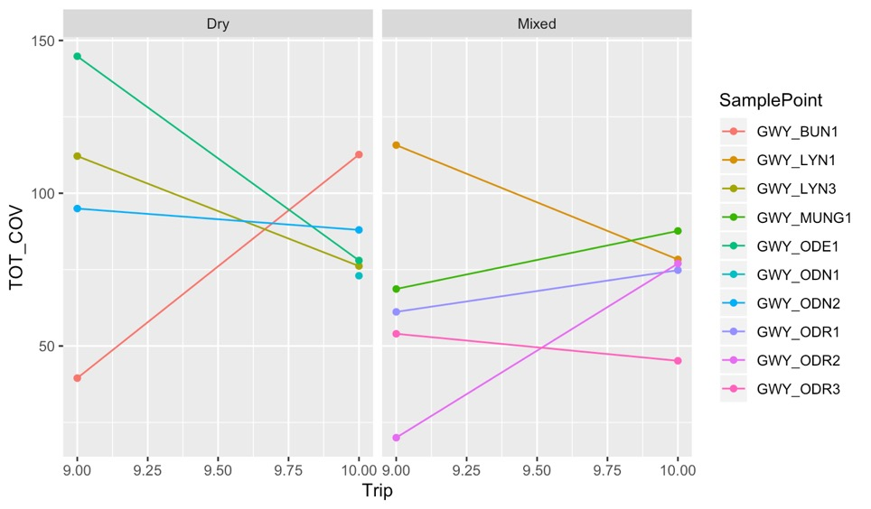

Total cover (%)

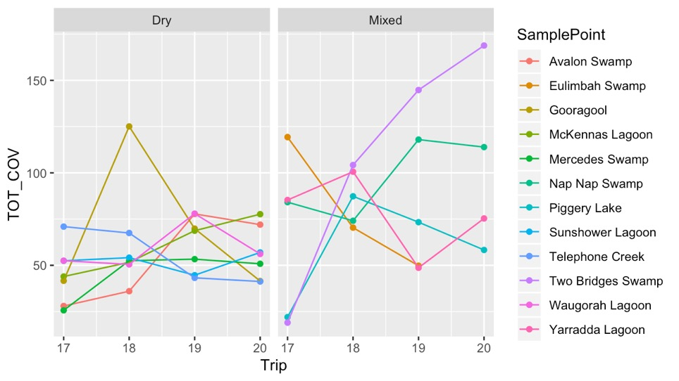

Total cover (%)

Figure 2. Mean % groundcover recorded at Sample Points in each sampling Trip in 2018–19 from the Gwydir river system (top) and Murrumbidgee river system (bottom) in relation to the annual watering regime (Table 3). N.B. Because % groundcover is recorded for each taxon, overlapping extents mean that total cover can exceed 100 %.

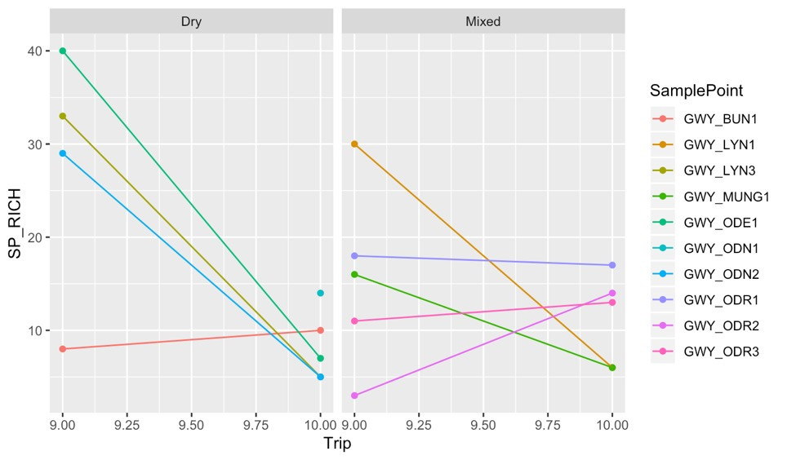

Number of taxa

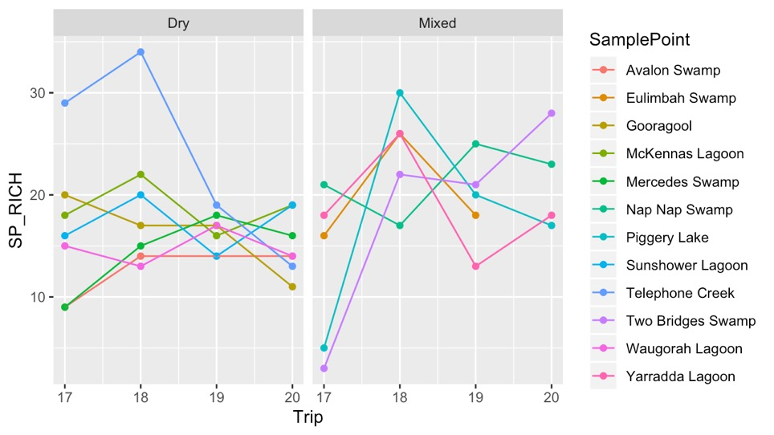

Number of taxa

Figure 3. Mean groundcover species richness recorded at Sample Points in each sampling Trip in 2018–19 from the Gwydir river system (top) and Murrumbidgee river system (bottom) in relation to the annual watering regime (Table 3). N.B. Because % groundcover is recorded for each taxon, overlapping extents mean that total cover can exceed 100 %.

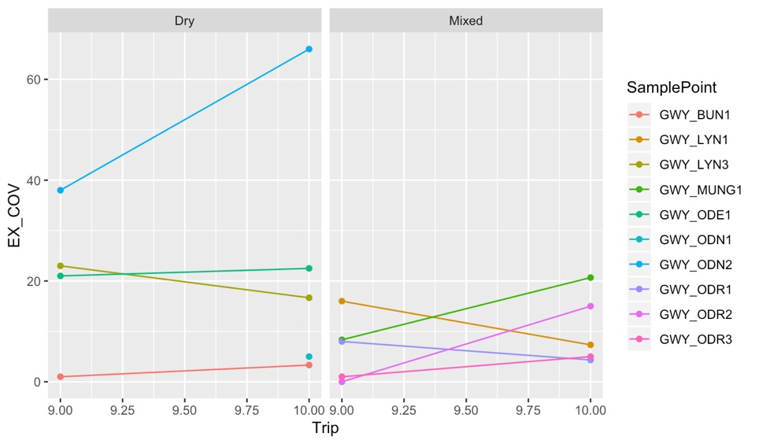

Exotic plant cover (%)

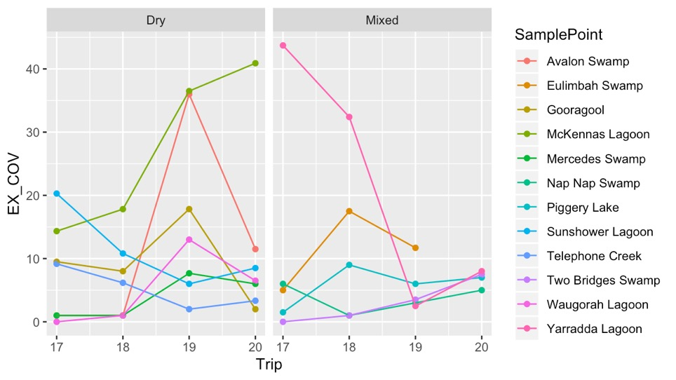

Exotic plant cover (%)

Figure 4. Mean % exotic plant cover recorded in the groundlayer at Sample Points in each sampling Trip in 2018–19 from the Gwydir river system (top) and Murrumbidgee river system (bottom) in relation to the annual watering regime (Table 3). N.B. Because % groundcover is recorded for each taxon, overlapping extents mean that total cover can exceed 100 %.

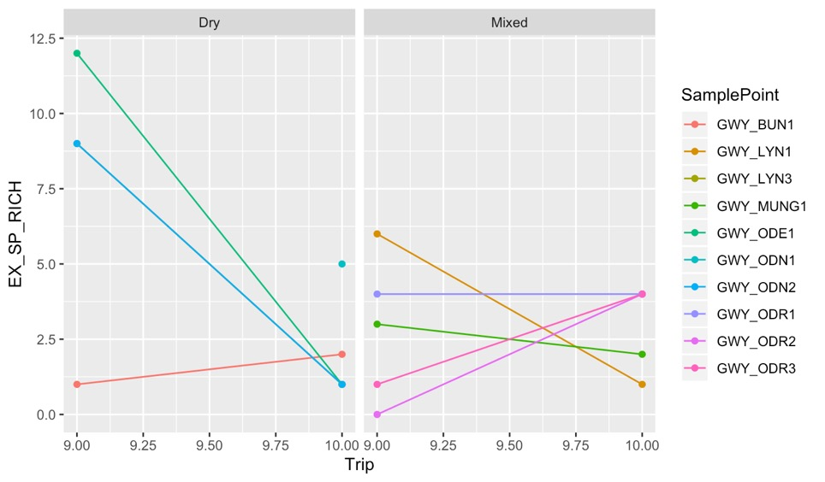

Number of taxa

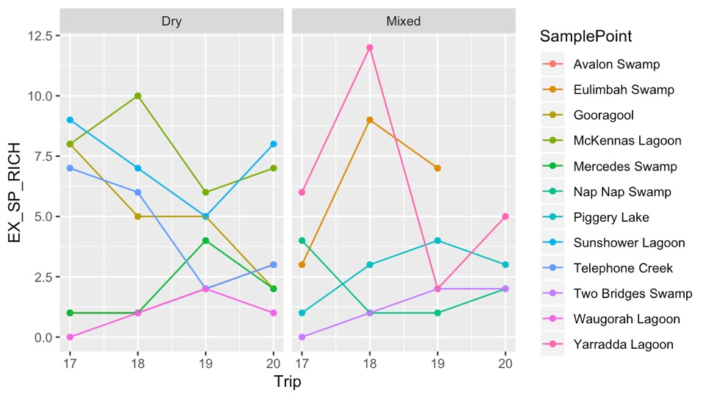

Number of taxa

Figure 5. Mean number of exotic plant species recorded in the groundlayer at Sample Points in each sampling Trip in 2018–19 from the Gwydir river system (top) and Murrumbidgee river system (bottom) in relation to the annual watering regime (Table 3).

### Vegetation community composition

The composition of vegetation communities at Sample Points in 2018–19 strongly reflected Selected Area and, to a lesser degree, ANAE ecosystem type (Figure 6). In general, a more diverse range of vegetation communities were present amongst surveyed Sample Points during the year in the Lachlan river system followed by the Gwydir river system, but this is probably mainly due to differences in sampling design, i.e. focus on surveying discrete wetlands in the Murrumbidgee river system.

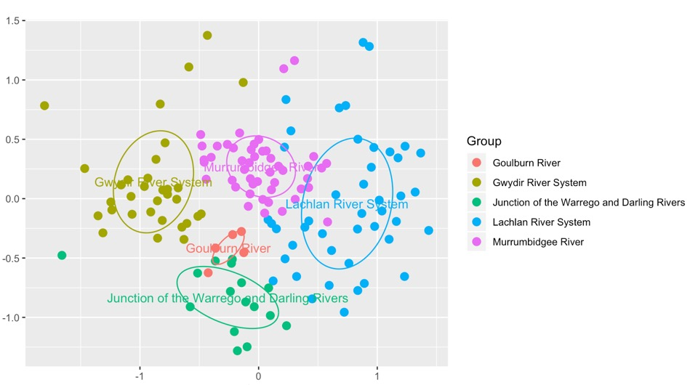

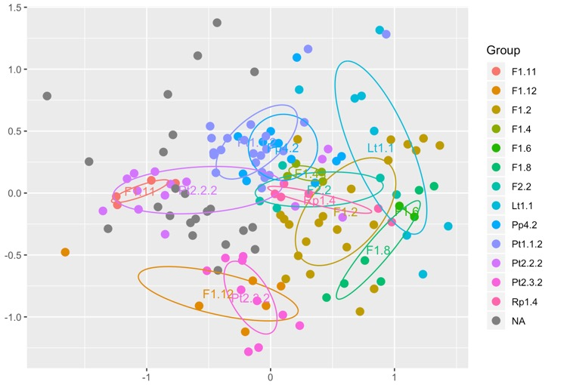

Figure 6. nMDS ordination of vegetation community species composition at Sample Points surveyed in each sampling Trip during 2018–19 across all Selected Areas in relation to Selected Area (top) and ANAE ecosystem types (bottom). Stress = 2.11.

A distinct difference in the composition of vegetation communities subject to dry versus mixed watering regimes was apparent in 2018–19 amongst the four wetland Selected Areas, i.e. the Gwydir river system, the Lachlan river system, the Murrumbidgee river system and the Junction of the Warrego and Darling rivers (Figure 7). Additionally, the few Sample Points that had a mixed watering regime but did not receive Commonwealth environmental water during the year, tended to have communities more similar to those in dry Sample Points (Figure 7). These differences in vegetation community composition cannot be clearly attributed to effects of environmental watering, however, as there is no counterfactual and this spatial variation may largely reflect regional differences in floristics. Nevertheless, **the results do indicate that environmental watering is promoting vegetation diversity at a Basin-scale by supporting different community types**.

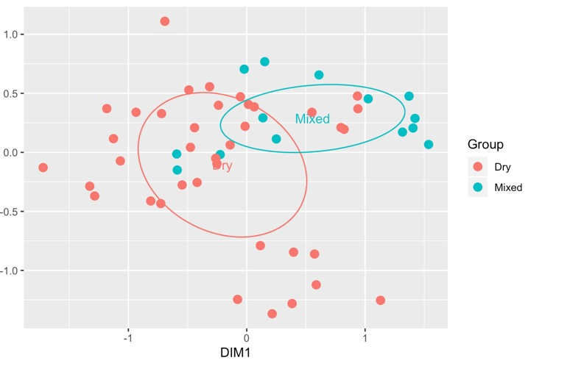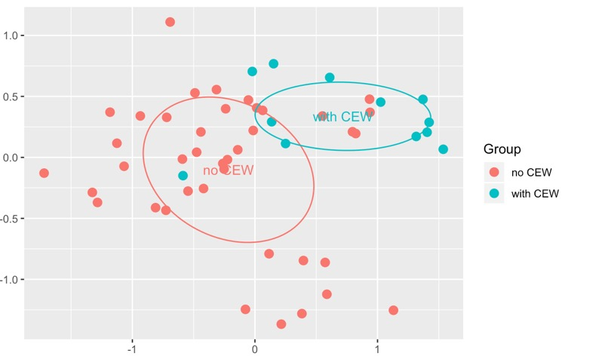

Figure 7. nMDS ordination of vegetation community species composition at Sample Points surveyed in each sampling Trip during 2018–19 across the four wetland Selected Areas in relation to annual watering regime (Table 3; top) and inundation by Commonwealth environmental water (bottom). Stress = 0.168.

## Effects of Commonwealth environmental water for vegetation diversity in unmonitored areas in 2018–19

Twenty-two ANAE wetland ecosystem types, 10 floodplain ecosystem types and 12 watercourse ecosystem types were inundated, or influenced, by Commonwealth environmental water during 2018–19 (Table 5). Significant proportions (> 10 %) of seven wetland ecosystem types and four watercourse ecosystem types were inundated, or influenced, by Commonwealth environmental water at a Basin-scale (Table 5), especially temporary red gum swamp (Pt1.1.2), permanent tall emergent marsh (Pt2.1.2), permanent wetland (Pp4.2), permanent saline wetland (Psp4) and floodplain or riparian wetland (Pt4.1).

Because of the strong influence of ANAE ecosystem type on vegetation community composition at monitored Selected Areas (Figure 6), different vegetation diversity responses to watering can be expected in unmonitored areas in different ecosystem types.

Table 5. Proportion of ANAE ecosystem types (by area or length) inundated or influenced by Commonwealth environmental water during 2018–19 (Source: Brooks 2020).

| Australian National Aquatic Ecosystem (ANAE) wetland type | Total ex Coorong and Lower Lakes | Inundated* | | Influenced* | |
| --- | --- | --- | --- | --- | --- |
| Area (ha) / length (km) + | Area (ha) | % of total | Area (ha) | % of total |
| ***Wetland ecosystems*** |  |  |  |  |  |
| Pt1.1.2: Temporary river red gum swamp | 74 721 | 9359 | 12.5 | 33 432 | 44.7 |
| Pp4.2: Permanent wetland | 77 314 | 8558 | 11.1 | 21 885 | 28.3 |
| Pt2.2.2: Temporary sedge/grass/forb marsh | 139 937 | 5724 | 4.1 | 15 476 | 11.1 |
| Pp2.1.2: Permanent tall emergent marsh | 8005 | 649 | 8.1 | 4156 | 51.9 |
| Pt2.1.2: Temporary tall emergent marsh | 70 837 | 2747 | 3.9 | 4030 | 5.7 |
| Lp1.1: Permanent lake | 127 388 | 2914 | 2.3 | 3389 | 2.7 |
| Pt4.1: Floodplain or riparian wetland | 11 214 | 83 | 0.7 | 2082 | 18.6 |
| Pt1.8.2: Temporary shrub swamp | 234 412 | 776 | 0.3 | 1507 | 0.6 |
| Lt1.1: Temporary lake | 459 359 | 157 | <0.1 | 1291 | 0.3 |
| Pt3.1.2: Clay pan | 130 927 | 384 | 0.3 | 1143 | 0.9 |
| Pt2.3.2: Freshwater meadow | 125 165 | 323 | 0.3 | 932 | 0.7 |
| Pt1: Temporary swamp | 3767 | 507 | 13.5 | 675 | 17.9 |
| Psp4: Permanent saline wetland | 2093 | 534 | 25.5 | 639 | 30.5 |
| Pt4.2: Temporary wetland | 22 888 | 313 | 1.4 | 586 | 2.6 |
| Pt1.6.2: Temporary woodland swamp | 216 625 | 370 | 0.2 | 579 | 0.3 |
| Pst1.1: Temporary saline swamp | 7157 | 54 | 0.8 | 316 | 4.4 |
| Pt1.2.2: Temporary black box swamp | 60 272 | 94 | 0.2 | 294 | 0.5 |
| Pp2.3.2: Permanent grass marsh | 1507 | 10 | 0.7 | 25 | 1.7 |
| Pp2.2.2: Permanent sedge/grass/forb marsh | 3590 | 17 | 0.5 | 17 | 0.5 |
| Pst2.2: Temporary salt marsh | 40 335 | 3 | <0.1 | 8 | <0.1 |
| Pt1.7.2: Temporary lignum swamp | 49 962 | 0 | 0.0 | 8 | <0.1 |
| Pp2.4.2: Permanent forb marsh | 740 | 2 | 0.3 | 7 | 0.9 |
| Lp1.2: Permanent lake with aquatic bed | 2067 | 0 | 0.0 | 0 | 0.0 |
| Lsp1.1: Permanent saline lake | 9419 | 0 | 0.0 | 0 | 0.0 |
| Lsp1.2: Permanent saline lake with aquatic bed | 181 | 0 | 0.0 | 0 | 0.0 |
| Lst1.1: Temporary saline lake | 27 897 | 0 | 0.0 | 0 | 0.0 |
| Lst1.2: Temporary saline lake with aquatic bed | 2238 | 0 | 0.0 | 0 | 0.0 |
| Lt1.2: Temporary lake with aquatic bed | 9052 | 0 | 0.0 | 0 | 0.0 |
| Pp1.1.2: Permanent paperbark swamp | 1 | 0 | 0.0 | 0 | 0.0 |
| Pp3: Peat bog or fen marsh | 4425 | 0 | 0.0 | 0 | 0.0 |
| Pps5: Permanent spring | 130 | 0 | 0.0 | 0 | 0.0 |
| Psp1.1: Saline paperbark swamp | 31 | 0 | 0.0 | 0 | 0.0 |
| Psp2.1: Permanent salt marsh | 246 | 0 | 0.0 | 0 | 0.0 |
| Pst3.2: Salt pan or salt flat | 3249 | 0 | 0.0 | 0 | 0.0 |
| Pst4: Temporary saline wetland | 6180 | 0 | 0.0 | 0 | 0.0 |
| Pt1.3.2: Temporary coolibah swamp | 8271 | 0 | 0.0 | 0 | 0.0 |
| Pt1.5.2: Temporary paperbark swamp | 412 | 0 | 0.0 | 0 | 0.0 |
| Pu1: Unspecified wetland | 1763 | 0 | 0.0 | 0 | 0.0 |
| ***Floodplain ecosystems*** |  |  |  |  |  |
| F1.2: River red gum forest riparian zone or floodplain | 639,022 | 19,092 | 3.0 |  |  |
| F1.10: Coolibah woodland and forest riparian zone or floodplain | 1,215,726 | 2,300 | 0.2 |  |  |
| F2.2: Lignum shrubland riparian zone or floodplain | 143,880 | 1,538 | 1.1 |  |  |
| F1.4: River red gum woodland riparian zone or floodplain | 325,221 | 1,247 | 0.4 |  |  |
| F1.11: River cooba woodland riparian zone or floodplain | 11,541 | 1,137 | 9.9 |  |  |
| F2.4: Shrubland riparian zone or floodplain | 408,019 | 485 | 0.1 |  |  |
| F1.8: Black box woodland riparian zone or floodplain | 779,639 | 432 | <0.1 |  |  |
| F1.6: Black box forest riparian zone or floodplain | 131,442 | 256 | 0.2 |  |  |
| F1.12: Woodland riparian zone or floodplain | 318,645 | 57 | <0.1 |  |  |
| F4: Unspecified riparian zone or floodplain | 201,086 | 3 | <0.1 |  |  |
| F3.2: Sedge/forb/grassland riparian zone or floodplain | 833,102 | 0 | 0.0 |  |  |
| F1.13: Paperbark riparian zone or floodplain | 17 | 0 | 0.0 |  |  |
| ***Watercourses*** |  |  |  |  |  |
| Rp1.4: Permanent lowland stream | 40,133 | 10,143 | 25.3 |  |  |
| Rt1.4: Temporary lowland stream | 198,551 | 3,179 | 1.6 |  |  |
| Rp1.2: Permanent transitional zone stream | 15,962 | 484 | 3.0 |  |  |
| Rp1.1: Permanent high energy upland stream | 39,421 | 453 | 1.1 |  |  |
| Rp1.3: Permanent low energy upland stream | 633 | 266 | 42.0 |  |  |
| Rp1: Permanent stream | 360 | 167 | 46.4 |  |  |
| Rt1.2: Temporary transitional zone stream | 91,873 | 84 | <0.1 |  |  |
| Rt1: Temporary stream | 156 | 79 | 50.6 |  |  |
| Rt1.3: Temporary low energy upland stream | 2,783 | 49 | 1.8 |  |  |
| Rt1.1: Temporary high energy upland stream | 96,565 | 31 | <0.1 |  |  |
| Rw1: Permanent river (landform unknown) | 271 | 14 | 5.2 |  |  |
| Ru1: Unspecified river (landform unknown) | 293 | 9 | 3.1 |  |  |

+ Numbers for Watercourses refer to length rather than area.

# Cumulative Basin-scale evaluation 2014–19

## Key findings

### Plant species diversity

* Over 640 plant taxa have been recorded between 2014–15 and 2018–19 from across the five Selected Areas for which plant species diversity has been recorded as a Category one variable, including at least 185 annual forbs, 32 annual grasses, 3 annual sedges/rushes, 36 annual sub-shrubs and shrubs, 162 perennial forbs, 56 perennial grasses, 16 perennial sedges/rushes, 71 perennial sub-shrubs and shrubs and 13 trees.
* Approximately 27 % of plant taxa were recorded in every year of the LTIM program from at least one Selected Area while around 32 % of taxa were only recorded across these Selected Areas in a single year.
* Annual numbers of total recorded plant taxa, as well as those able to be identified to a species level and exotic species, declined overall between 2014–15 and 2018–19.
* The Lachlan river system and Murrumbidgee river system generally had higher numbers of plant taxa each year while the Junction of the Warrego and Darling rivers and Goulburn River Selected Areas tended to have the least.
* Most plant species recorded from Selected Areas during the five-year LTIM project were observed under a range of hydrological conditions with 175 taxa recorded from all four HydroStates allocated to Sample Points at the time of sampling (i.e. dry, mostly dry, mostly wet and wet) and a further 82 taxa from three of these HydroStates. There were 213 plant taxa which were only recorded under a single HydroState including 20 taxa that only occurred under wet conditions and a further 18 taxa exhibited only observed under wet or mostly wet conditions.
* Fifty-five plant taxa from the four wetland Selected Areas were identified by indicator species analysis as significantly associated with HydroStates at the time of sampling. No taxa were significantly associated solely with dry conditions and only two species were significantly associated with wet conditions: the native annual forb, *Ludwigia octovalvis*, and the exotic annual grass *Echinochloa colona*. The native perennial forb, *Myriophyllum verrucosum*, was strongly affiliated with mostly wet conditions.

### Vegetation community diversity

* Total cover and species richness of groundcover vegetation at Sample Points varied considerably within and between years between 2014–15 and 2018–19 in all Selected Areas. Strong seasonal patterns are apparent in the two riverine Selected Areas, reflecting the dominant timing of flows (i.e. spring freshes). Overall species numbers in the riverine Selected Areas declined over this five-year period, partly due to a reduction in exotic species numbers.
* In wetland Selected Areas, few clear patterns in total cover or species richness of groundcover vegetation were apparent in relation to broad watering regimes over this period with trajectories largely reflecting the dynamics at Selected Areas. The exceptions were the dramatic spikes in total cover in drier Sample Points in the Lachlan river system and the Junction of the Warrego and Darling rivers in response to the large natural floods of 2016–17.
* Trends in exotic plant cover and species richness at Sample Points were also highly variable over the five-year period similarly reflecting the dynamics at a Selected Area rather than watering regime. A possible exception were drier Sample Points in the Gwydir river system where exotic plant cover and species richness tended to be higher overall than in other Sample Points at this Selected Area.
* Five Annual Vegetation Community Types (AVCTs) present in Sample Points across wetland Selected Areas between 2014–15 and 2018–19 were identified based on clustering of life history/life form (LHLF) plant groups. Cluster 1 comprised AVCTs with high proportions of annual and perennial forbs with significant perennial shrubs and sub-shrubs. Cluster 2 included AVCTs characterised by a large proportion of perennial sedges and rushes. Cluster 3 comprised AVCTs dominated by perennial grasses. Cluster 4 was characterised by a high proportion of perennial forbs and Cluster 5 by a high proportion of perennial shrubs and sub-shrubs.
* Clusters explained 68.6 % of total variance in the dataset and were relatively distinct from each other while not being aligned closely with specific Selected Areas indicating that these AVCTs could appear across the Basin. All AVCTs were present in the Basin in each year of the LTIM project but fluctuated in relative abundance between years. Cluster 5 vegetation communities (i.e. dominated by perennial shrubs and sub-shrubs) were substantially lower in 2016–17 than in other years, probably reflecting a negative response of this community type to the large natural floods which occurred during this year. The abundance of Cluster 4 vegetation communities (i.e. dominated by perennial forbs) was higher in the two wetter years (i.e. 2016–17 and 2017–18).
* Membership of Sample Points to the different AVCTs broadly reflected differences in annual watering regimes. Cluster 5 vegetation communities (i.e. dominated by perennial shrubs and sub-shrubs) mainly occurred under dry annual water regimes. Sample points that were wet during the year but did not receive Commonwealth environmental water in the year also tended to support Cluster 5 communities as well as Cluster 1 (i.e. dominated by forbs and some perennial shrubs and sub-shrubs) and Cluster 4 (i.e. dominated by perennial forbs). Sample Points inundated by Commonwealth environmental water during the year tended to have annual vegetation communities in Cluster 2 (i.e. dominated by perennial sedges and rushes), Cluster 3 (i.e. dominated by perennial grasses) and, to a lesser extent, Cluster 4.
* At a Selected Area scale, shifts in membership of AVCTs between years of particular Sample Points was often associated with shifts in hydrological conditions, especially those involving Commonwealth environmental water. In the Gwydir river system, for example, shifts in AVCT membership occurred in most Sample Points following the dry conditions of 2015-16 with further shifts apparent following subsequent wetting, including that by Commonwealth environmental water. These patterns varied, however, between Selected Areas.
* Commonwealth environmental water has inundated, or influenced inundation, of 35 ANAE ecosystem types between 2014–15 and 2018–19: 24 wetland ecosystem types and 11 floodplain ecosystem types. Because of the strong relationship between ANAE ecosystem type and vegetation community composition at monitored Selected Areas, vegetation diversity responses to watering in unmonitored areas are likely to have differed between these ecosystem types. A greater diversity of vegetation responses at a Basin-scale in any water year will therefore very likely be generated by a greater diversity of ecosystem types inundated by Commonwealth environmental water.
* Twenty-eight ecosystem types have received Commonwealth environmental water every year between 2014–15 and 2018–19 while two ecosystem types have only received Commonwealth environmental water in a single year. The number of ecosystem types receiving Commonwealth environmental water each year has consistently been between 25 and 29.
* Vegetation communities inundated by Commonwealth environmental water over significant proportions of their area (i.e. > 10%) in most years include temporary river red gum swamp (Pt1.1.2), permanent tall emergent marsh (Pp2.12), permanent wetland (Pp4.2), temporary sedge/grass/forb marsh (Pt2.2.2) and freshwater meadow (Pt2.3.2; Table 6).

## Effects of Commonwealth environmental water for plant species diversity between 2014 and 2019

### Plant species observed in Selected Areas

Over the five-year period of the LTIM project, 648 taxa have been recorded from across the five Selected Areas for which plant species diversity has been recorded as a Category one variable (Appendix B). These include 185 annual forbs, 32 annual grasses, 3 annual sedges/rushes, 36 annual sub-shrubs and shrubs, 162 perennial forbs, 56 perennial grasses, 16 perennial sedges/rushes, 71 perennial sub-shrubs and shrubs and 13 trees as well as 60 non-specific forbs, 10 non-specific grasses, 7 non-specific sedges/rushes as well as three mistletoes, several unidentifiable taxa and numerous non-vascular groups.

Approximately 27% of plant taxa were recorded in every year of the LTIM program from at least one Selected Area however more taxa (205) were only recorded in a single year at a Basin-scale. The overall number of plant taxa recorded in each year has declined over this period with 416 taxa recorded in 2014–15, 406 in 2015–16, 385 in 2016–17, 342 in 2017–18 and 312 in 2018–19. Amongst these plant taxa, the number of identifiable native plant species has similarly declined with 114 taxa recorded in 2014–15, 118 in 2015–16, 105 in 2016–17, 95 in 2017–18 and 86 in 2018–19. Numbers of identifiable exotic taxa have also declined overall: 286 taxa recorded in 2014–15, 273 in 2015–16, 265 in 2016–17, 239 in 2017–18 and 214 in 2018–19.

The highest numbers of plant taxa each year were typically recorded from the Lachlan river system and Murrumbidgee river system and the least from the Junction of the Warrego and Darling rivers and Goulburn river (Figure 8). Similar patterns are also apparent for exotic plant species as is an overall decline in the number of exotic species in each Selected Area over the five-year period (Figure 9).

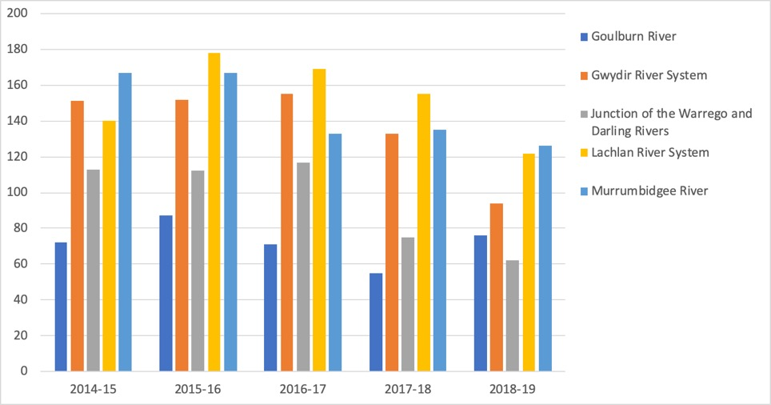

Number of taxa

Figure 8. Numbers of plant taxa recorded in each of five Selected Areas in each year of the LTIM project between 2014–15 and 2018–19.

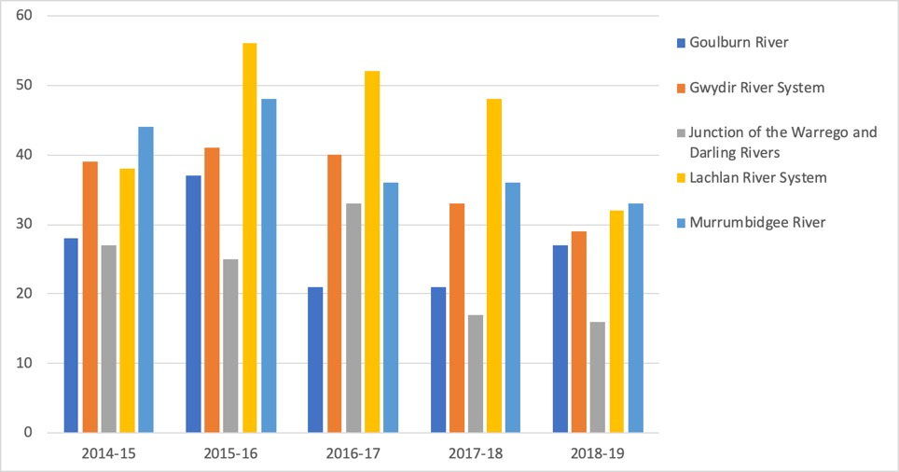

Number of taxa

Figure 9. Numbers of exotic plant taxa recorded in each of five Selected Areas in each year of the LTIM project between 2014–15 and 2018–19.

### Wetland plant response groups

Most plant species recorded from Selected Areas during the five-year LTIM project were observed under a range of hydrological conditions with 175 taxa recorded from all four HydroStates allocated to Sample Points at the time of sampling (i.e. dry, mostly dry, mostly wet and wet; Table 3) and a further 82 taxa from three of these HydroStates. There were 213 plant taxa which were only recorded under a single HydroState including 20 taxa that only occurred under wet conditions and 159 taxa only recorded under dry conditions at the time of sampling (Appendix C). A further 18 taxa exhibited a moderate affinity to wetting only being observed under wet or mostly wet HydroStates while 58 taxa were only observed under dry or mostly dry HydroStates.

Notably, assigned plant functional groups (PFGs) following the scheme of Brock and Casanova (1997) did not closely align with the affinity of taxa to HydroStates at the time of their observation (Appendix C). In particular, taxa that were only observed during wet conditions comprised a range of PFGs including those assigned to the Tdr (terrestrial dry) category.

Indicator species analysis detected 55 taxa from the four wetland Selected Areas which significantly associated with HydroStates at the time they were observed. Of these, only two species were significantly (p < 0.05) associated with wet conditions: the native annual forb, *Ludwigia octovalvis*, and the exotic annual grass *Echinochloa colona*. The native perennial forb, *Myriophyllum verrucosum*, was strongly (p < 0.0001) affiliated with mostly wet conditions. No taxa were significantly associated solely with dry conditions.

## Effects of Commonwealth environmental water for vegetation community diversity within and across Selected Areas between 2014 and 2019

### Vegetation cover, species richness and exotic plants

Total cover of groundcover vegetation at Sample Points varied considerably over time in all Selected Areas (Figures 10-12). In the two riverine Selected Areas (i.e. the Edward–Wakool river system and the Goulburn River), vegetation cover fluctuated seasonally, especially in the Goulburn river, reflecting positive responses to spring freshes but declines in relation to large natural floods (Figure 10). In the wetland Selected Areas, few clear patterns are apparent with respect to the five-year watering regime with the exception that total cover in drier Sample Points in the Lachlan river system and the Junction of the Warrego and Darling rivers exhibited dramatic spikes in response to the large natural floods of 2016–17 (Figures 11 and 12).

In the two riverine Selected Areas, there appears to have been a decline in overall species numbers over this five-year period (Figure 13) but this is likely due to a reduction in exotic species numbers – a trend that is clearly apparent from the Goulburn river (Figure 16). Species richness at wetland Sample Points between 2014–15 and 2018–19 has been similarly variable with trajectories over this period largely reflecting the dynamics at Selected Areas rather than differences in watering regimes (Figures 14-15).

Trends in exotic plant cover and species richness at Sample Points was similarly variable over the five-year period and again tended to reflect the dynamics at a Selected Area rather than watering regime (Figures 15 – 20). A possible exception was in the Gwydir river system where exotic plant cover and species richness tended to be higher overall in drier Sample Points (Figures 17 and 19).

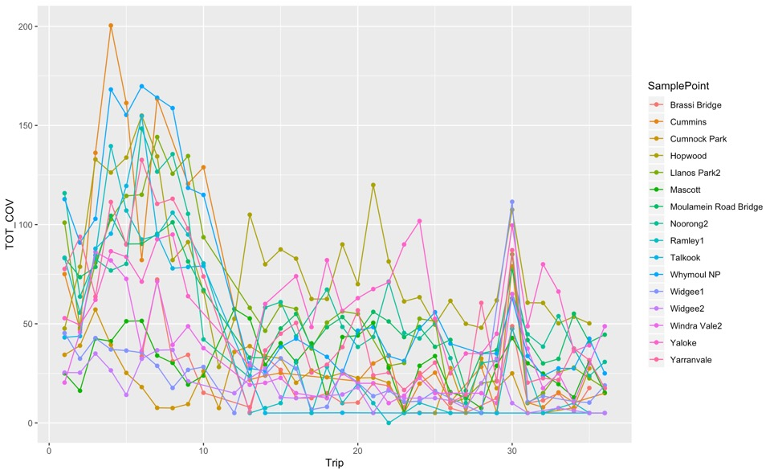

2015-16

2016-17

2017-18

2018-19

Total cover (%)

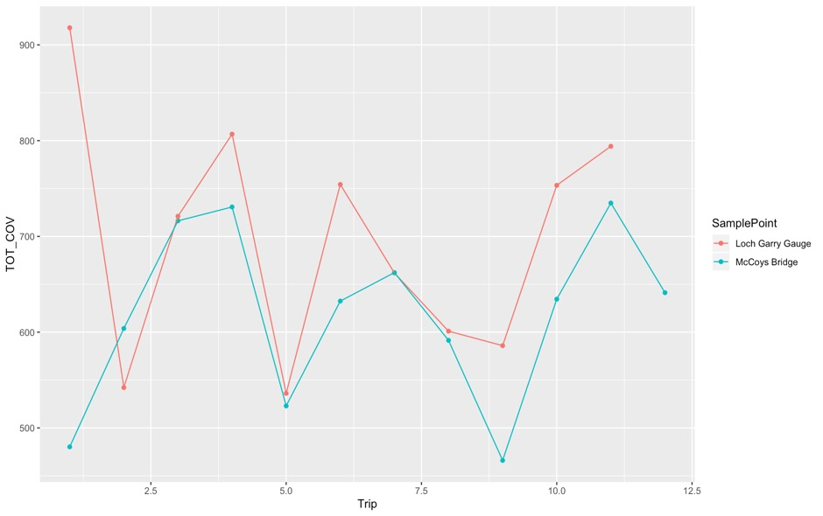

Total cover (%)

2014-15

22016-17

2017-18

2018-19

2015-16

Figure 10. Mean % groundcover recorded on each sampling Trip between 2014–15 and 2018–19 at Sample Points in the two riverine Selected areas: Edward-Wakool river system (top) and Goulburn river system (bottom). N.B. Because % groundcover is recorded for each taxon, overlapping extents mean that total cover can exceed 100%. Also, numbers of trips not evenly distributed across years in Edward-Wakool river system.

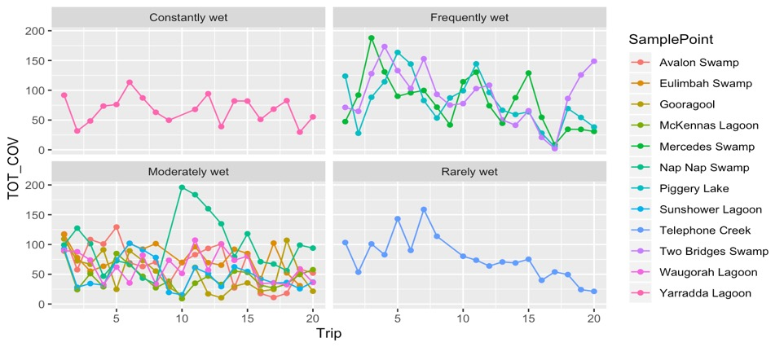

Total cover (%)

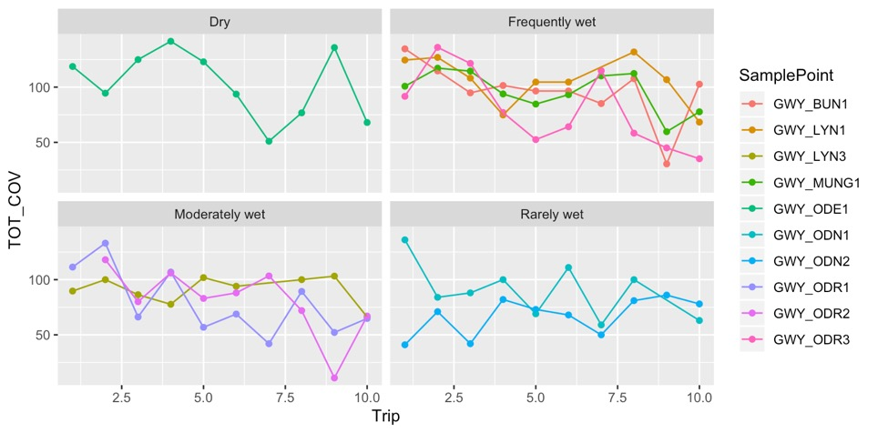

Total cover (%)

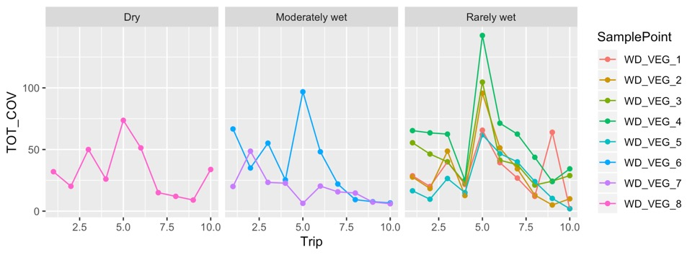

Total cover (%)

Figure 11. Mean % groundcover recorded during each sampling Trip between 2014–15 and 2018–19 at Sample Points in the Gwydir river system (top: two trips per year), Murrumbidgee river system (middle: four trips per year) and Junction of the Warrego and Darling rivers system (bottom: two trips per year) in relation to five-year watering regimes (i.e. LTIM_WR: Table 3). N.B. Because % groundcover is recorded for each taxon, overlapping extents mean that total cover can exceed 100%.

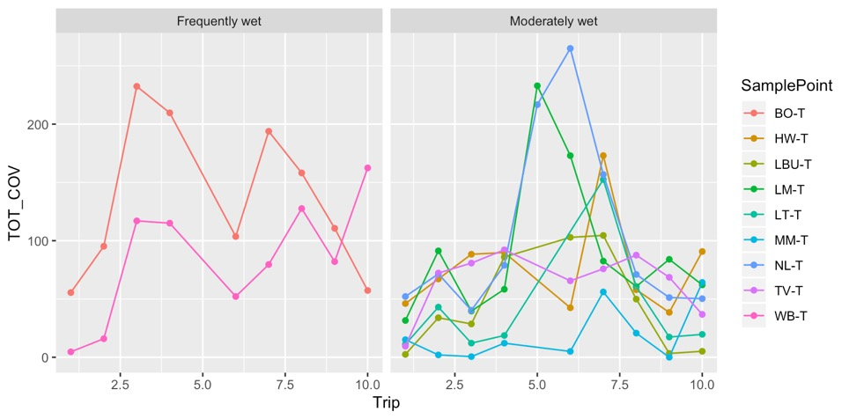

Total cover (%)

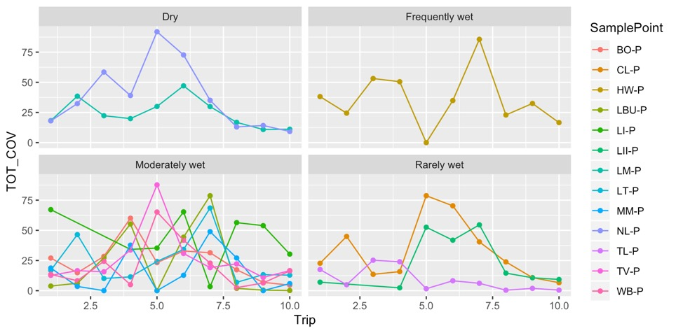

Total cover (%)

Figure 12. Mean % groundcover recorded during each sampling Trip between 2014–15 and 2018–19 in the Lachlan river system (two trips per year) from transect Sample Points (top) and plot Sample Points (bottom) in relation to five-year watering regimes (i.e. LTIM_WR: Table 3). N.B. Because % groundcover is recorded for each taxon, overlapping extents mean that total cover can exceed 100%.

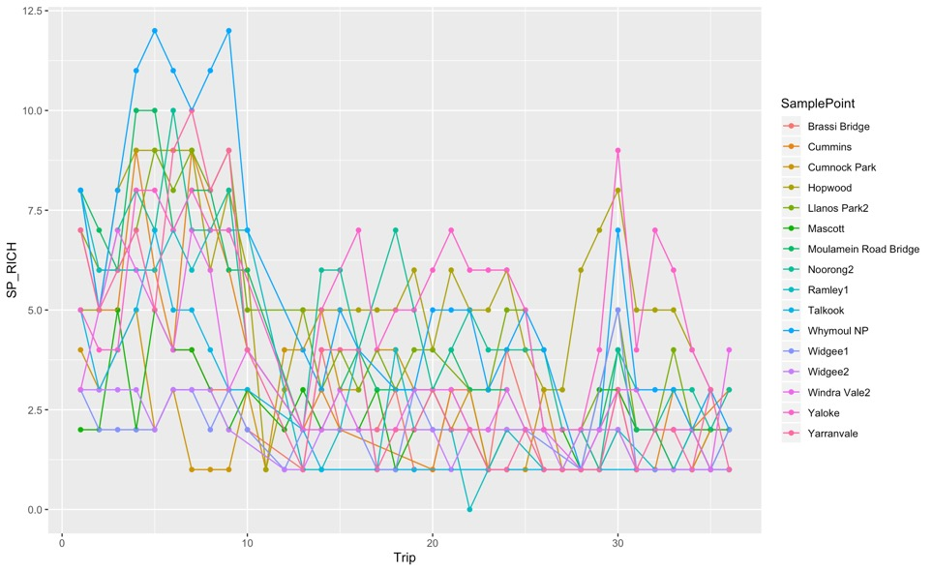

Number of taxa

2015-16

2016-17

2017-18

2018-19

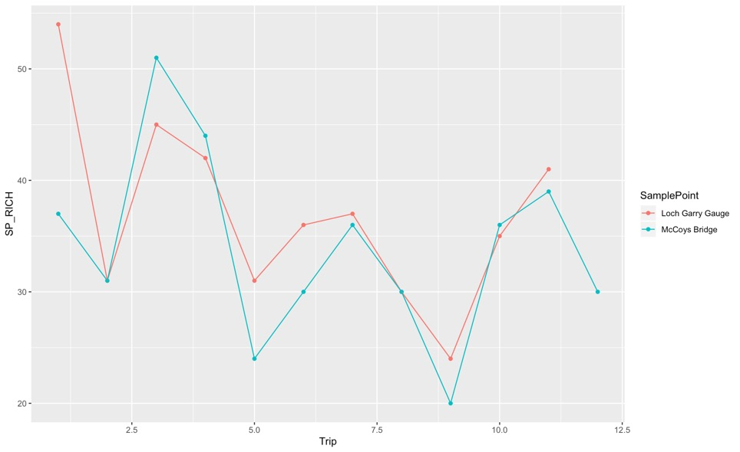

Number of taxa

2014-15

22016-17

2017-18

2018-19

2015-16

Figure 13. Mean species richness recorded on each sampling Trip between 2014–15 and 2018–19 at Sample Points in the two riverine Selected areas: Edward-Wakool river system (top) and Goulburn river system (bottom). N.B. numbers of trips not evenly distributed across years in Edward-Wakool river system.

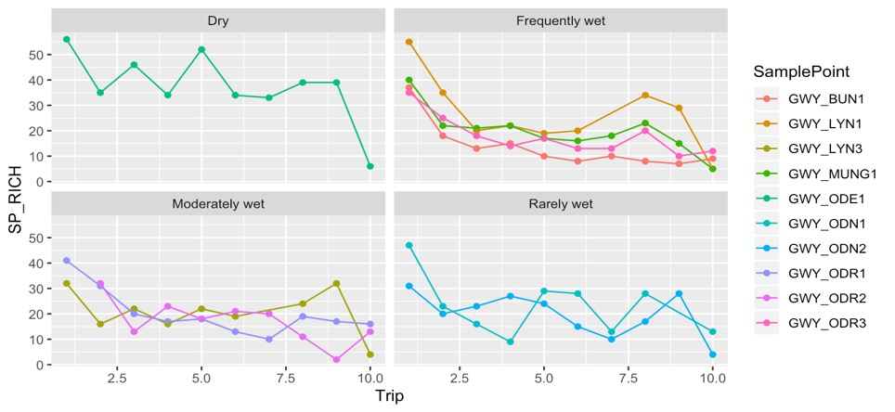

Number of taxa

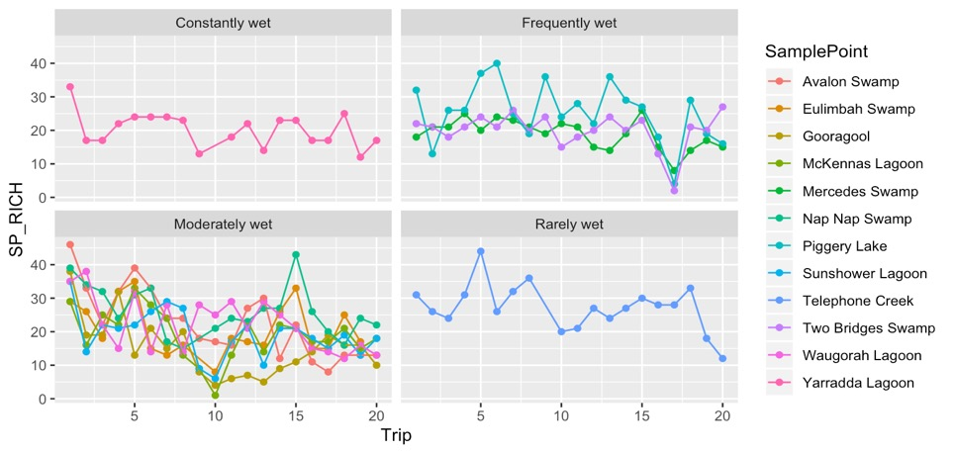

Number of taxa

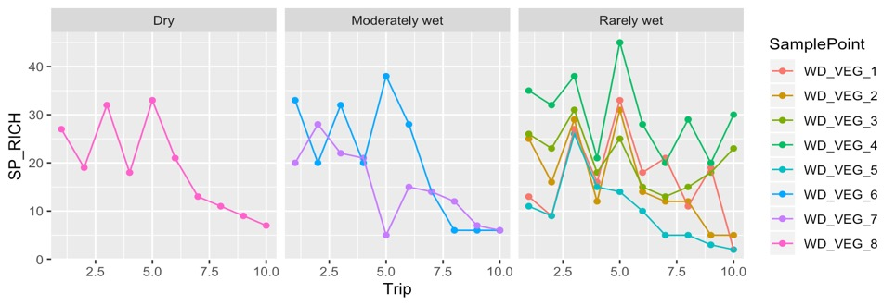

Number of taxa

Figure 14. Mean species richness recorded during each sampling Trip between 2014–15 and 2018–19 at Sample Points in the Gwydir river system (top: two trips per year), Murrumbidgee river system (middle: four trips per year) and Junction of the Warrego and Darling rivers system (bottom: two trips per year) in relation to five-year watering regimes (i.e. LTIM_WR: Table 3).

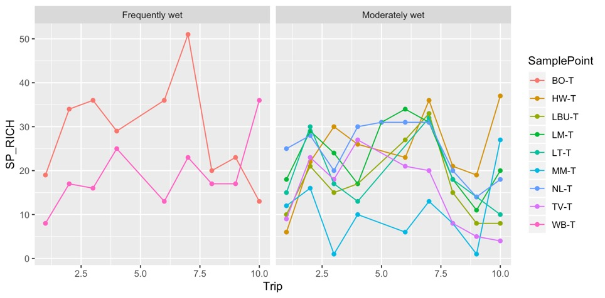

Number of taxa

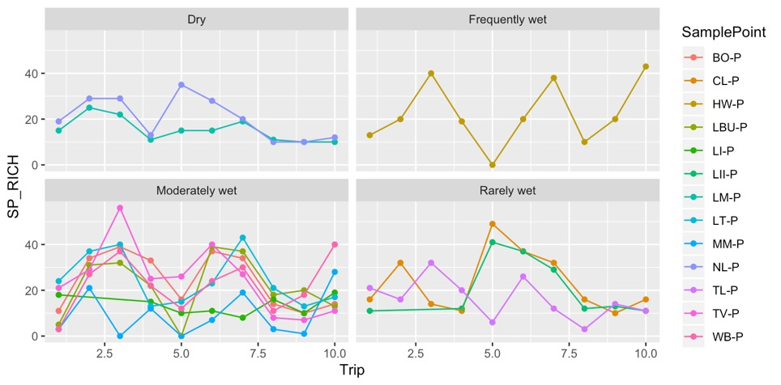

Number of taxa

Figure 15. Mean species richness recorded during each sampling Trip between 2014–15 and 2018–19 in the Lachlan river system (two trips per year) from transect Sample Points (top) and plot Sample Points (bottom) in relation to five-year watering regimes (i.e. LTIM_WR: Table 3).

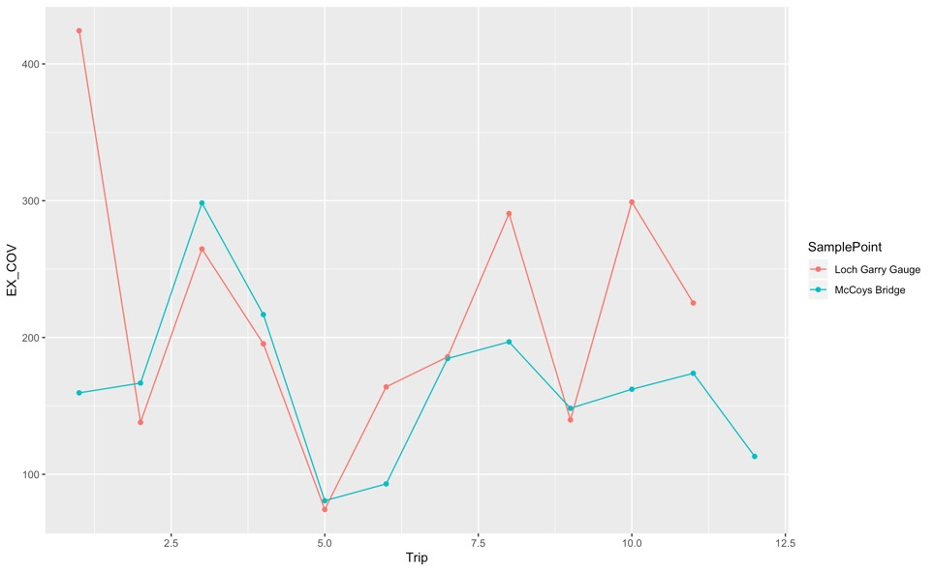

Exotic plant cover (%)

2014-15

22016-17

2017-18

2018-19

2015-16

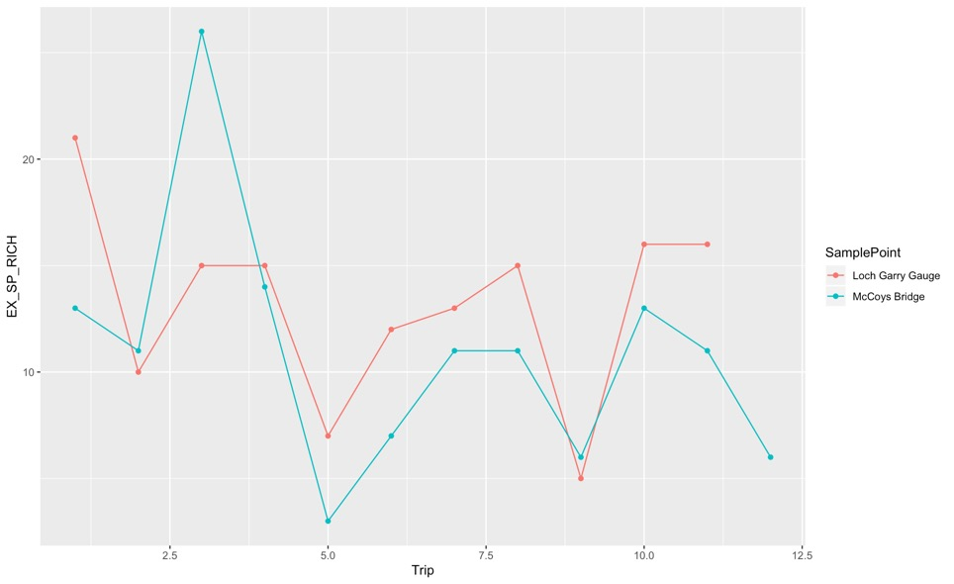

Exotic plant cover (%)

2014-15

22016-17

2017-18

2018-19

2015-16

Figure 16. Mean % exotic plant cover (top) and exotic species richness bottom) recorded on each sampling Trip between 2014–15 and 2018–19 at Sample Points in the Goulburn river system. N.B. Because % groundcover is recorded for each taxon, overlapping extents mean that total cover can exceed 100%.

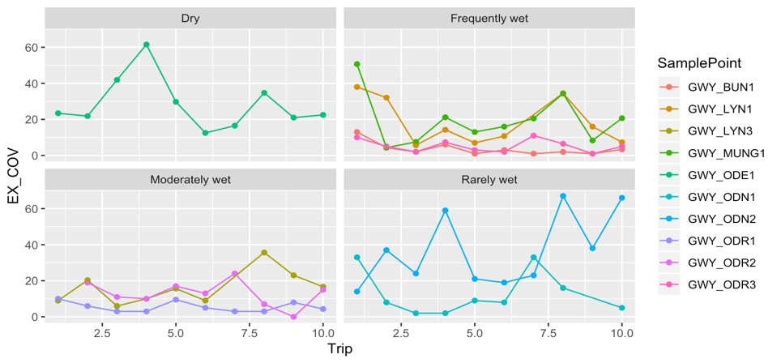

Exotic plant cover (%)

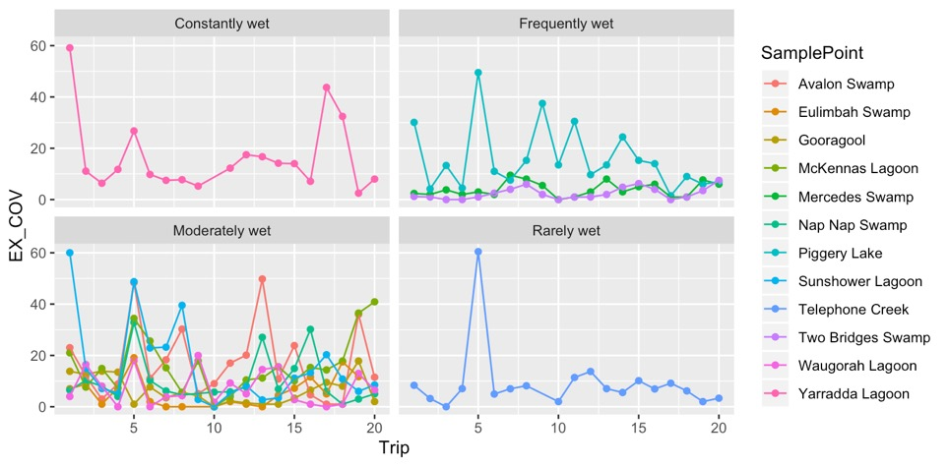

Exotic plant cover (%)

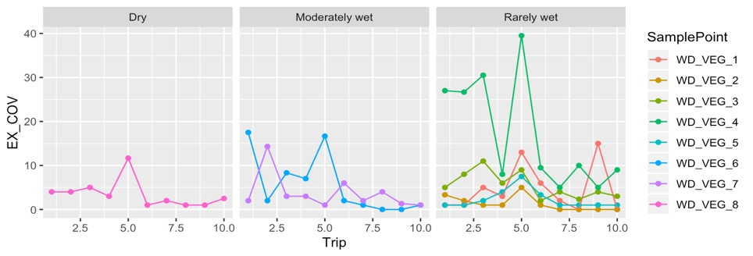

Exotic plant cover (%)

Figure 17. Mean % exotic plant cover recorded during each sampling Trip between 2014–15 and 2018–19 at Sample Points in the Gwydir river system (top: two trips per year), Murrumbidgee river system (middle: four trips per year) and Junction of the Warrego and Darling rivers system (bottom: two trips per year) in relation to five-year watering regimes (i.e. LTIM_WR: Table 3). N.B. Because % groundcover is recorded for each taxon, overlapping extents mean that total cover can exceed 100%.

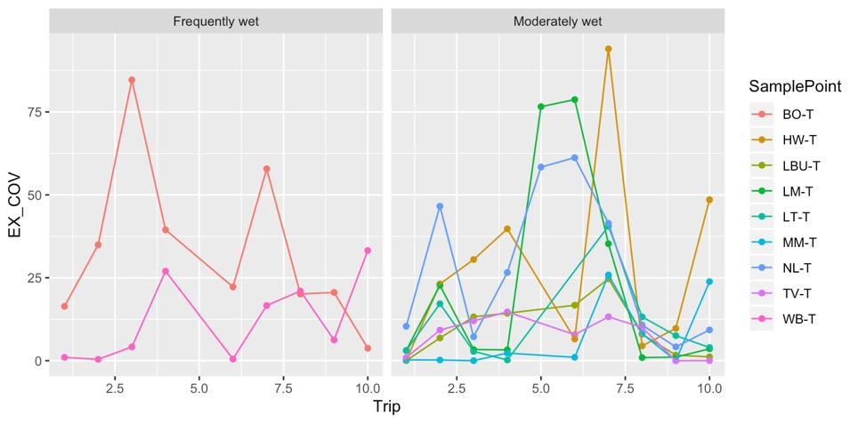

Exotic plant cover (%)

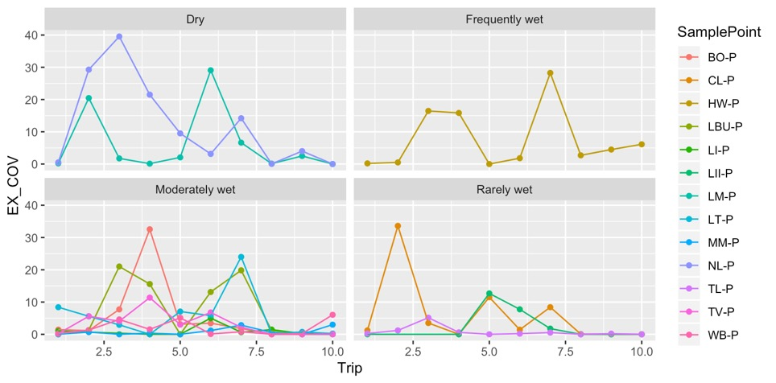

Exotic plant cover (%)

Figure 18. Mean % exotic plant cover recorded during each sampling Trip between 2014–15 and 2018–19 in the Lachlan river system (two trips per year) from transect Sample Points (top) and plot Sample Points (bottom) in relation to five-year watering regimes (i.e. LTIM_WR: Table 3). N.B. Because % groundcover is recorded for each taxon, overlapping extents mean that total cover can exceed 100%.

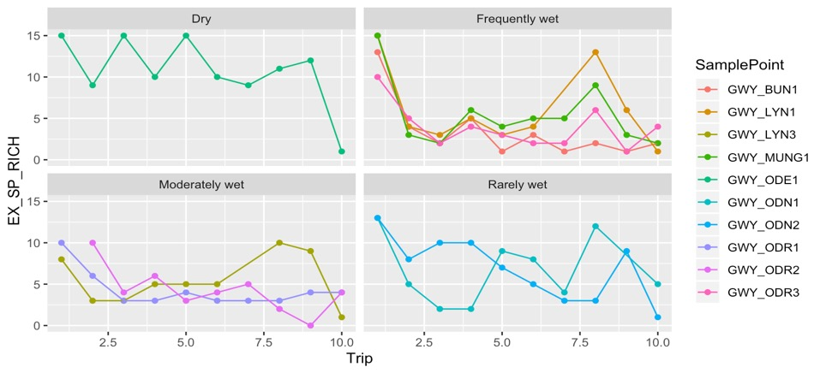

Number of species

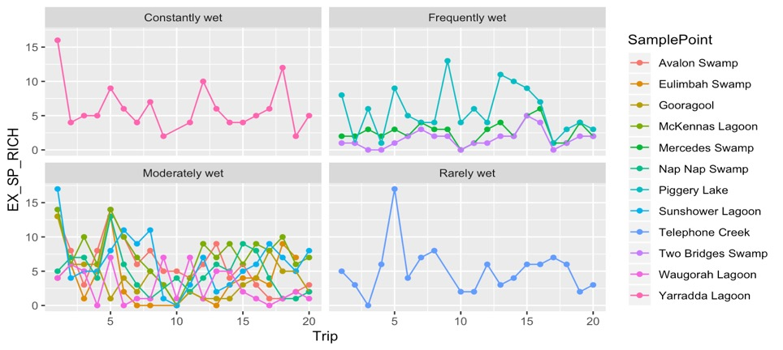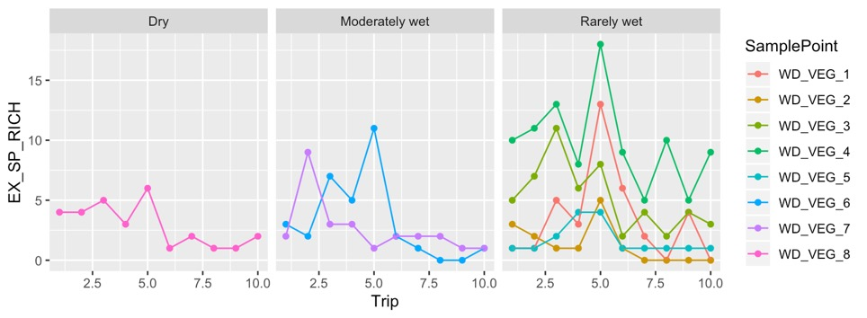

Number of species

Number of species

Figure 19. Mean exotic plant species richness recorded during each sampling Trip between 2014–15 and 2018–19 at Sample Points in the Gwydir river system (top: two trips per year), Murrumbidgee river system (middle: four trips per year) and Junction of the Warrego and Darling rivers system (bottom: two trips per year) in relation to five-year watering regimes (i.e. LTIM_WR: Table 3).

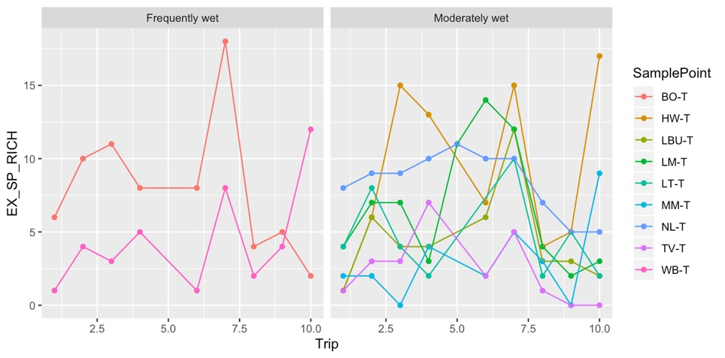

Number of species

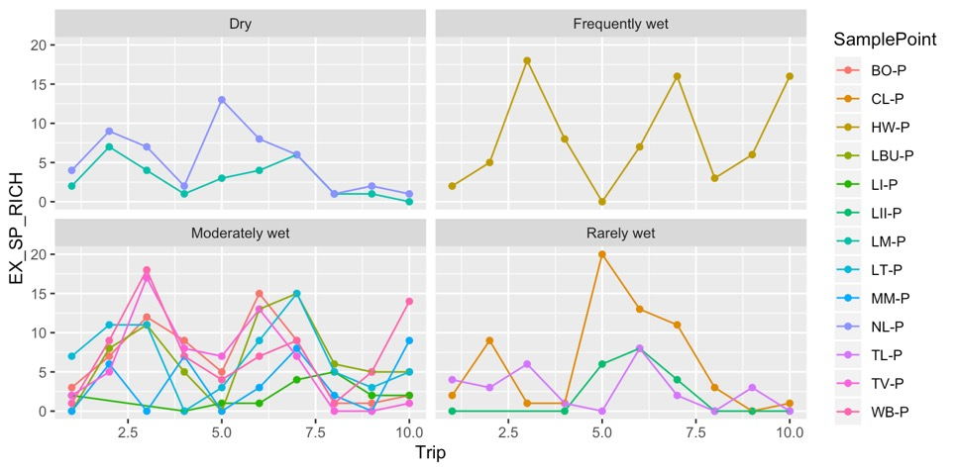

Number of species

Figure 20. Mean exotic plant species richness recorded during each sampling Trip between 2014–15 and 2018–19 at Sample Points in the Lachlan river system (two trips per year) from transect Sample Points (top) and plot Sample Points (bottom) in relation to five-year watering regimes (i.e. LTIM_WR: Table 3).

### Vegetation community composition

#### Vegetation community types

We identified five annual vegetation community types (AVCTs) present in Sample Points across wetland Selected Areas between 2014–15 and 2018–19 based on clustering of life history/life form (LHLF) plant groups (Appendix D). These AVCTs were defined by the presence at a Sample Point of taxa belonging to LHLF plant groups over an entire water year. AVCTs (i.e. clusters) were clearly characterised by the dominance of one or two LHLF plant groups (Figure 21). Cluster 1 comprised annual vegetation communities with high proportions of annual and perennial forbs with significant perennial shrubs and sub-shrubs while AVCTs belonging to Cluster 2 were characterised by a large proportion of perennial sedges and rushes (Figure 21). Cluster 3 comprised AVCTs dominated by perennial grasses while Cluster 4 was characterised by a high proportion of perennial forbs and Cluster 5 by a high proportion of perennial shrubs and sub-shrubs (Figure 21).

Clusters explained 68.6 % of total variance in the dataset and were relatively distinct from each but not aligned closely with specific Selected Areas suggesting that these community types could appear across the Basin (Figure 22). All AVCTs were present across wetland Selected Areas in each year of the LTIM Project, but relative proportions tended to fluctuate annually (Figure 23). In particular, the number of Sample Points expressing Cluster 5 vegetation communities (i.e. dominated by perennial shrubs and sub-shrubs) in 2016–17 was dramatically lower than that in other years, reflecting the likely negative response of this community type to the large natural floods which occurred during this year. The number of Sample Points exhibiting Cluster 4 vegetation communities (i.e. dominated by perennial forbs) was also higher in the two wetter years (i.e. 2016–17 and 2017–18; Figure 23).

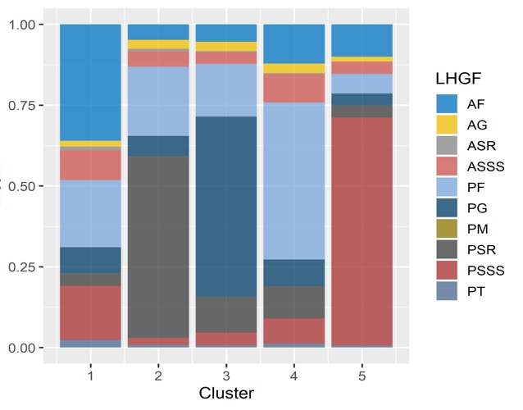

LHLF plant group

Figure 21. Mean proportions of each LHLF plant group in each annual vegetation community cluster. N.B. In the legend, LHLF groups are coded as annual (A) or perennial (P) in the first letter and by their Life Form in the remaining letters as follows: forb (F), grass (G), sedge/rush (SR), shrubs & sub-shrubs (SSS), tree (T).

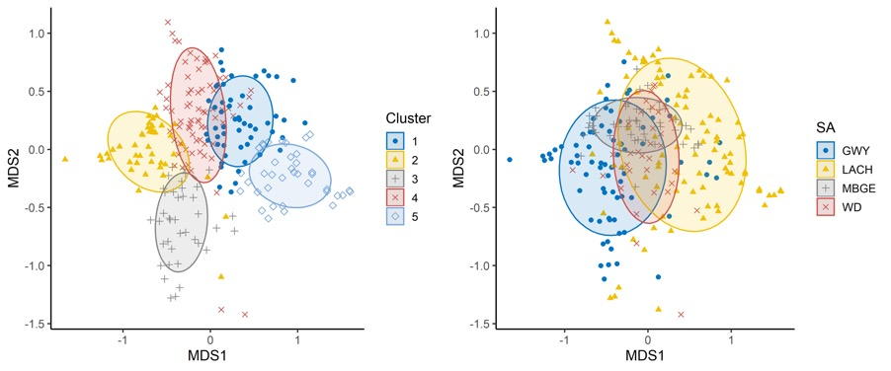

Figure 22. nMDS plot of LHLF vegetation data aggregated to water year with Sample Points coded by cluster membership (left) and Selected Area (right). Stress= 0.185.

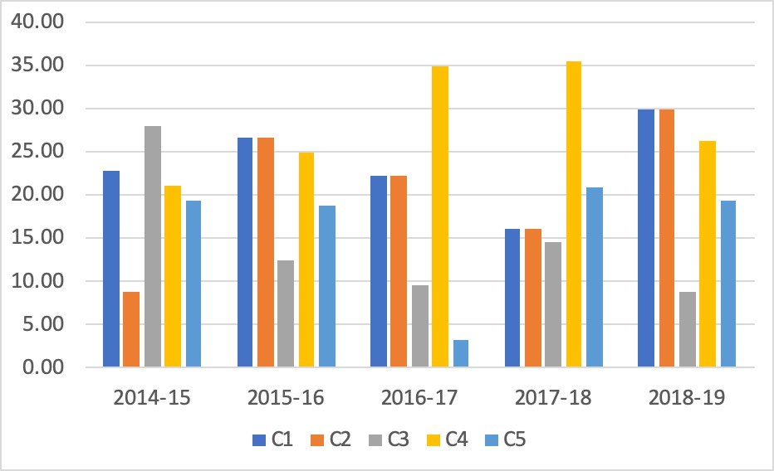

Number of Sample Points

Figure 23. Numbers of each LHLF vegetation cluster present in each year of the LTIM project across wetland Selected Areas.

The distribution of Sample Points belonging to each AVCT broadly reflected differences in annual watering regimes (Figure 24). In particular, Cluster 5 vegetation communities (i.e. dominated by perennial shrubs and sub-shrubs) were mainly apparent in Sample Points that had dry annual water regimes. Sample points that were wet during the year but did not receive Commonwealth environmental water in the year also tended to support annual vegetation community types belonging to Cluster 5 as well as Cluster 1 (i.e. dominated by forbs and some perennial shrubs and sub-shrubs) and Cluster 4 (i.e. dominated by perennial forbs). In contrast, Sample Points inundated by Commonwealth environmental water during the year tended to develop annual vegetation communities in Cluster 2 (i.e. dominated by perennial sedges and rushes) and Cluster 3 (i.e. dominated by perennial grasses) and, to a lesser extent, Cluster 4 (Figure 24).

At a Selected Area scale, there was also a strong association between the appearance of Cluster 5 annual vegetation communities and dry annual watering regimes, except in the Gwydir river system where no Sample Points were assigned to Cluster 5 during the five-year sampling period (Figures 25 to 28). In the Gwydir river system, Sample Points frequently inundated by Commonwealth environmental water during this period mainly had annual vegetation communities belonging to Clusters 2 (i.e. dominated by perennial sedges and rushes) or 3 (i.e. dominated by perennial grasses; Figure 25). The occurrence of dry years (e.g. 2015–16) within a sequence of watered years did not shift Sample Points at the Selected Area into different community types (Figure 25). In contrast, single years of watering within mostly dry sequences in Sample Points in the Gwydir river system were typically associated with a shift in AVCT membership (Figure 25).

In the Lachlan river system, wet annual watering regimes were mainly aligned with Sample Points with AVCTs belonging to Clusters 1 or 4 (Figure 26). In numerous cases, annual watering by Commonwealth environmental water, mainly during 2015–16, in this Selected Area was also associated with a shift in vegetation community type from Cluster 5 (i.e. dominance by perennial shrubs and sub-shrubs) to Clusters 1 or 4, either in the year of watering of in the following year (Figure 26).

In the Murrumbidgee river system, all Sample Points appeared to be influenced by Commonwealth environmental water in at least one year between 2014–15 and 2018–19 (Figure 27). Shifts to dry annual conditions were frequently associated with a corresponding shift in vegetation community types either in that year or the following year, **suggesting that Commonwealth environmental water played a role in maintaining wetland plant communities** (Figure 28).

In Sample Points at the Junction of the Warrego and Darling rivers, few annual samples were inundated by either Commonwealth environmental water or water from other sources (Figure 29). Where inundation did occur, especially during 2016–17, Sample Points tended to mainly express vegetation communities belonging to Clusters 4, followed by Cluster 2 and Cluster 1 (Figure 29).

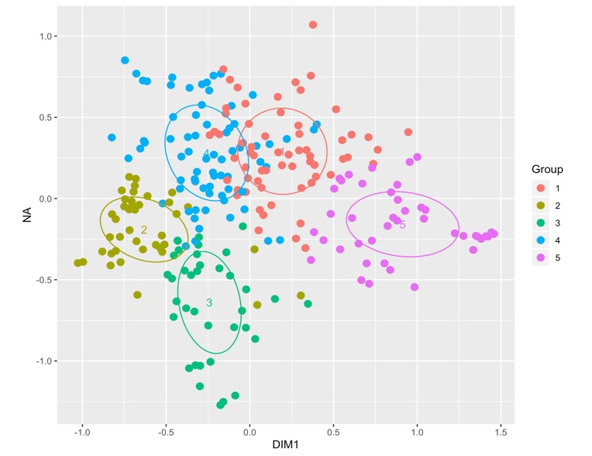

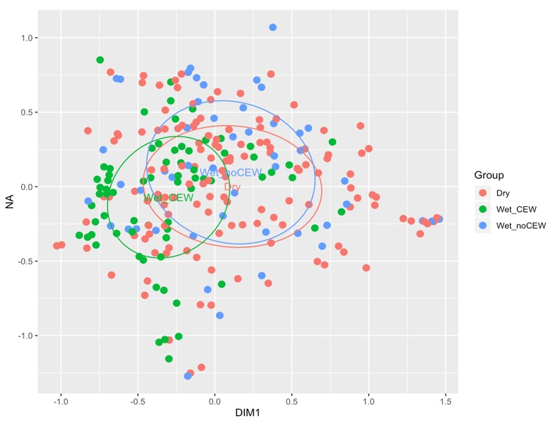

Figure 24. nMDS ordination of annual vegetation communities present at Sample Points surveyed in all wetland Selected Areas in relation to LHLF cluster (top) annual watering regime (AWR) with or without CEW (Table 3; bottom). Stress = 0.1824

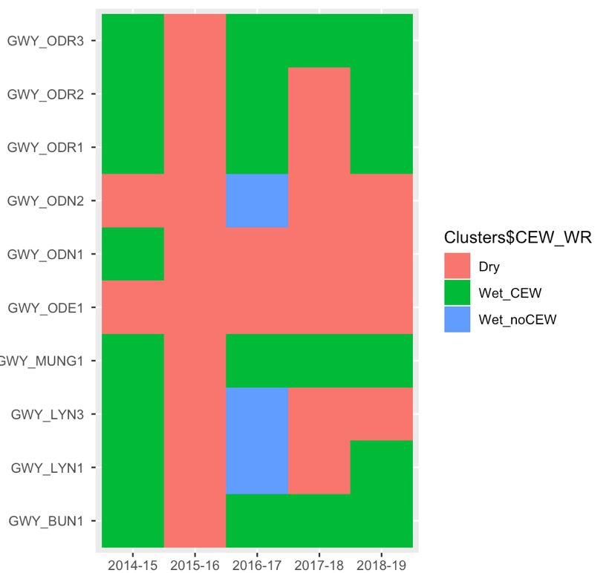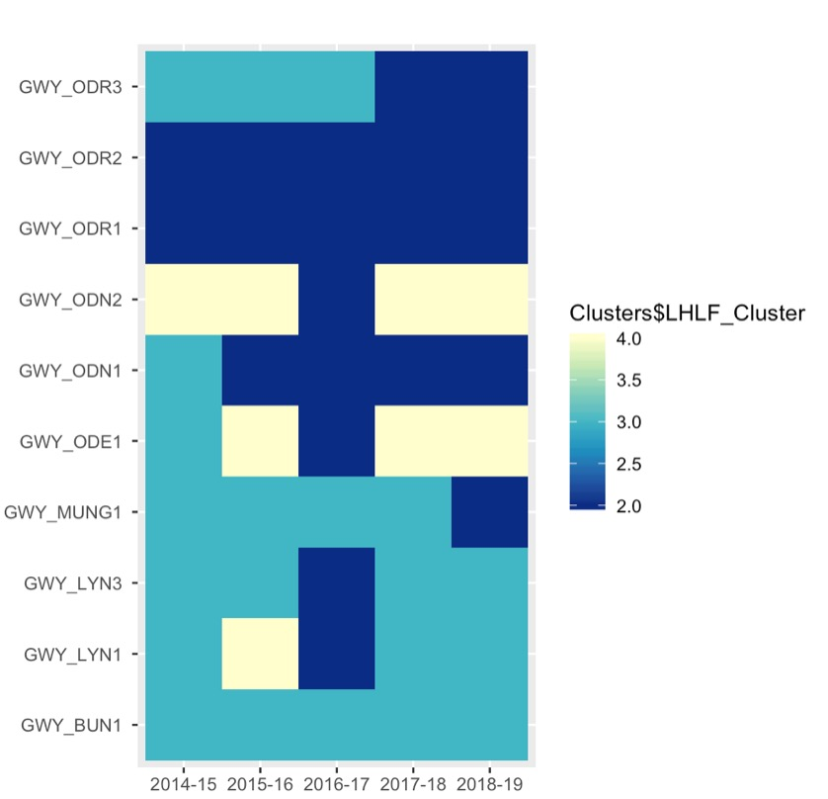

CEW_WR

Cluster

CEW_WR

Cluster

Figure 25. Heat maps illustrated the presence of each AVCT (i.e. cluster) at each Sample Point between 2014–15 and 2018–19 in the Gwydir river system (left) and the annual watering regime and presence of CEW (i.e. CEW_WR, see Table 3; right).

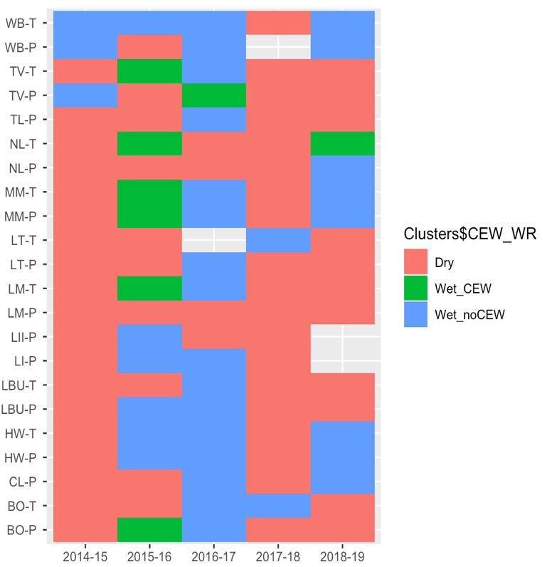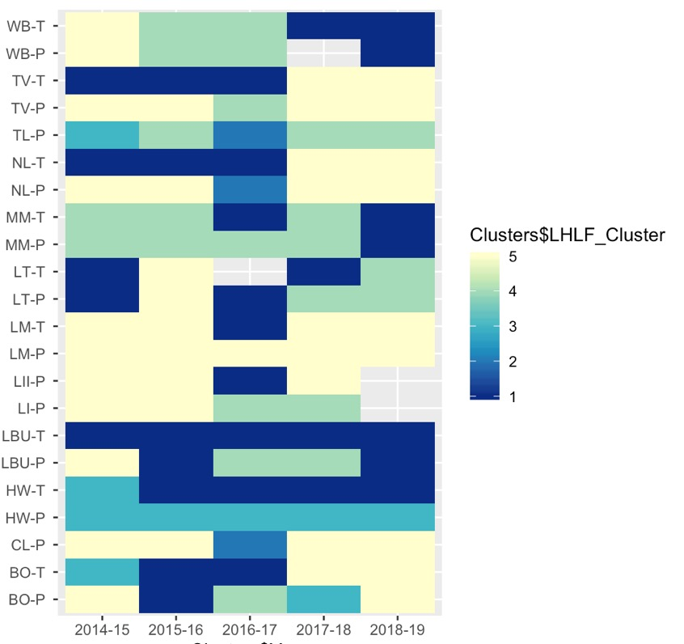

Cluster

CEW_WR

Figure 26. Heat maps illustrated the presence of each AVCT (i.e. cluster) at each Sample Point between 2014–15 and 2018–19 in the Lachlan river system (left) and the annual watering regime and presence of CEW (i.e. CEW_WR, see Table 3; right).

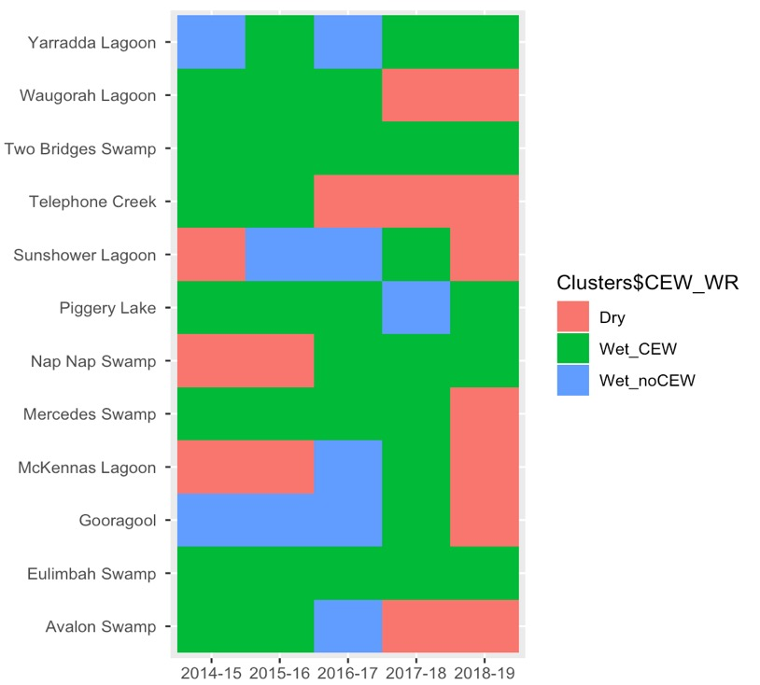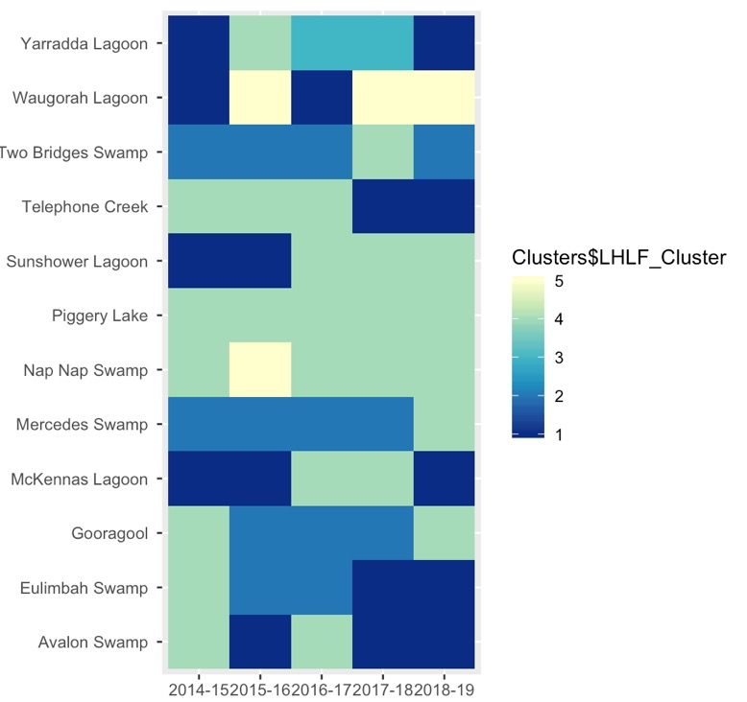

CEW_WR

Cluster

Figure 27. Heat maps illustrated the presence of each AVCT (i.e. cluster) at each Sample Point between 2014–15 and 2018–19 in the Murrumbidgee river system (left) and the annual watering regime and presence of CEW (i.e. CEW_WR, see Table 3; right).

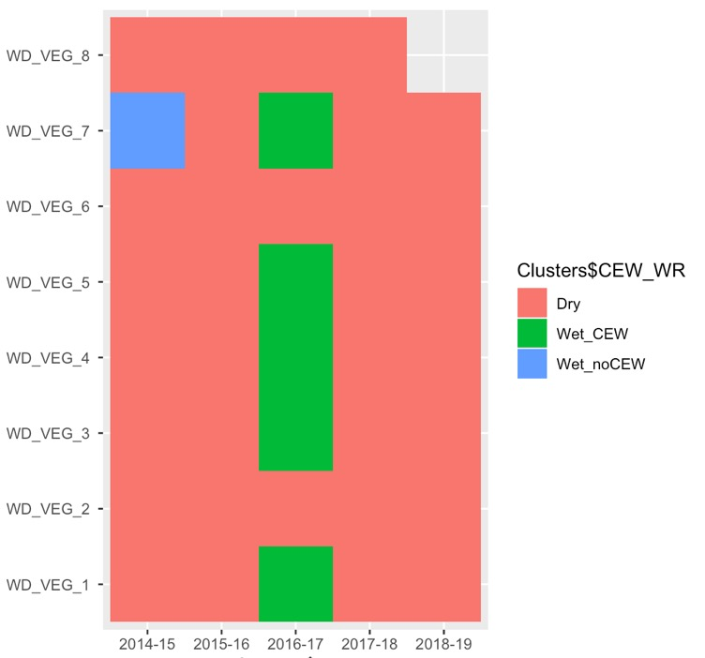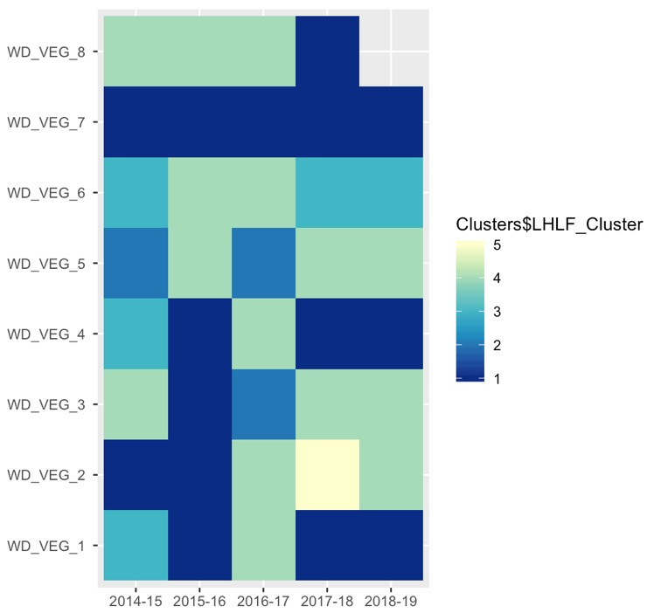

CEW_WR

Cluster

Figure 28. Heat maps illustrated the presence of each AVCT (i.e. cluster) at each Sample Point between 2014–15 and 2018–19 in the Junction of the Warrego and Darling rivers (left) and the annual watering regime and presence of CEW (i.e. CEW_WR, see Table 3; right).

### In unmonitored areas

Commonwealth environmental water inundated, or influenced inundation, in 35 ANAE ecosystem types over the five-year period of the LTIM project between 2014–15 and 2018–19: 24 wetland ecosystem types and 11 floodplain ecosystem types (Table 6). Because there is a strong relationship between ANAE ecosystem type and vegetation community composition at monitored Selected Areas (Figure 6), vegetation diversity responses to watering in unmonitored areas are very likely to have differed in relation to ecosystem type. It can therefore be expected that a greater diversity of vegetation responses at a Basin-scale in any water year will be generated by a greater diversity of ecosystem types being inundated by Commonwealth environmental water.

Twenty-eight ecosystem types received Commonwealth environmental water in every year project between 2014–15 and 2018–19 while two ecosystem types only received by Commonwealth environmental water in a single year. The number of ecosystem types receiving Commonwealth environmental water each year was consistently been between 25 and 29.

Vegetation communities inundated by Commonwealth environmental water over significant proportions of their area (i.e. > 10%) in most years include temporary river red gum swamp (Pt1.1.2), permanent tall emergent marsh (Pp2.12), permanent wetland (Pp4.2), temporary sedge/grass/forb marsh (Pt2.2.2) and freshwater meadow (Pt2.3.2; Table 6).

Table 6. Proportion of ANAE ecosystem types (by area or length) inundated or influence by Commonwealth environmental water in each sampling year of the LTIM project between 2014–15 and 2018–19 (Source: Brooks 2020).

| **Australian National Aquatic Ecosystem (ANAE) wetland type** | **Total area in Basin (ha)** | **Area on Managed Floodplain (ha)** | **Area receiving Commonwealth environmental water (ha)** | | | | |
| --- | --- | --- | --- | --- | --- | --- | --- |
| **Y1 '14-'15** | **Y2 '15-'16** | **Y3 '16-'17** | **Y4 '17-'18** | **Y5 '18-'19** |
| ***Wetland ecosystems*** |  |  |  |  |  |  |  |
| Lt1.1: Temporary lake | 459 359 | 116 742 | 2593 | 4505 | 2485 | 3730 | 1291 |
| Lp1.1: Permanent lake | 127 388 | 67 334 | 1440 | 4755 | 6840 | 15292 | 3389 |
| Lst1.1: Temporary saline lake | 27 897 | 1349 | 0 | 0 | 0 | 307 | 0 |
| Lsp1.1: Permanent saline lake | 9419 | 6039 | 0 | 0 | 0 | 0 | 0 |
| Lt1.2: Temporary lake with aquatic bed | 9052 | 8177 | 0 | 0 | 0 | 0 | 0 |
| Lst1.2: Temporary saline lake with aquatic bed | 2238 | 180 | 0 | 0 | 0 | 0 | 0 |
| Lp1.2: Permanent lake with aquatic bed | 2067 | 196 | 0 | 0 | 0 | 0 | 0 |
| Lsp1.2: Permanent saline lake with aquatic bed | 181 | 0 | 0 | 0 | 0 | 0 | 0 |
| Pt1.8.2: Temporary shrub swamp | 234 412 | 96 598 | 1552 | 2567 | 2122 | 2218 | 1507 |
| Pt1.6.2: Temporary woodland swamp | 216 625 | 151 170 | 99 | 417 | 186 | 494 | 579 |
| Pt2.2.2: Temporary sedge/grass/forb marsh | 139 937 | 50 902 | 17 018 | 9773 | 16 917 | 15 776 | 15 476 |
| Pt3.1.2: Clay pan | 130 927 | 43 524 | 3048 | 3673 | 1698 | 1654 | 1143 |
| Pt2.3.2: Freshwater meadow | 125 165 | 38 747 | 18 960 | 1401 | 20 508 | 3620 | 932 |
| Pp4.2: Permanent wetland | 77 314 | 41 111 | 20 267 | 21 044 | 20 095 | 23 018 | 21 885 |
| Pt1.1.2: Temporary river red gum swamp | 74 721 | 56 254 | 9940 | 28 052 | 7517 | 34 910 | 33 432 |
| Pt2.1.2: Temporary tall emergent marsh | 70 837 | 52 720 | 3100 | 3509 | 3116 | 4154 | 4030 |
| Pt1.2.2: Temporary black box swamp | 60 272 | 20 173 | 1069 | 1260 | 228 | 239 | 294 |
| Pt1.7.2: Temporary lignum swamp | 49 962 | 18 681 | 522 | 33 | 12 427 | 446 | 8 |
| Pst2.2: Temporary salt marsh | 40 335 | 11 575 | 19 | 8 | 1 | 4 | 8 |
| Pt4.2: Temporary wetland | 22 888 | 3111 | 0 | 578 | 0 | 602 | 586 |
| Pt4.1: Floodplain or riparian wetland | 11 214 | 5944 | 1118 | 2469 | 1008 | 2495 | 2082 |
| Pt1.3.2: Temporary coolibah swamp | 8271 | 5146 | 2 | 0 | 0 | 0 | 0 |
| Pp2.1.2: Permanent tall emergent marsh | 8005 | 7496 | 3449 | 4156 | 0 | 3451 | 4156 |
| Pst1.1: Temporary saline swamp | 7157 | 9 | 94 | 0 | 0 | 0 | 316 |
| Pst4: Temporary saline wetland | 6180 | 50 | 0 | 0 | 0 | 0 | 0 |
| Pp3: Peat bog or fen marsh | 4425 | 173 | 0 | 0 | 0 | 0 | 0 |
| Pt1: Temporary swamp | 3767 | 2822 | 280 | 690 | 132 | 576 | 675 |
| Pp2.2.2: Permanent sedge/grass/forb marsh | 3590 | 176 | 15 | 15 | 15 | 21 | 17 |
| Pst3.2: Salt pan or salt flat | 3249 | 253 | 0 | 0 | 0 | 0 | 0 |
| Psp4: Permanent saline wetland | 2093 | 1222 | 231 | 811 | 172 | 629 | 639 |
| Pu1: Unspecified wetland | 1763 | 130 | 0 | 0 | 0 | 95 | 0 |
| Pp2.3.2: Permanent grass marsh | 1507 | 248 | 23 | 25 | 96 | 85 | 25 |
| Pp2.4.2: Permanent forb marsh | 740 | 146 | 10 | 0 | 30 | 22 | 7 |
| Pt1.5.2: Temporary paperbark swamp | 412 | 0 | 0 | 0 | 0 | 0 | 0 |
| Psp2.1: Permanent salt marsh | 246 | 0 | 0 | 0 | 0 | 0 | 0 |
| Pps5: Permanent spring | 130 | 3 | 0 | 0 | 0 | 0 | 0 |
| Psp1.1: Saline paperbark swamp | 31 | 0 | 0 | 0 | 0 | 0 | 0 |
| Pp1.1.2: Permanent paperbark swamp | 1 | 1 | 0 | 0 | 0 | 0 | 0 |
| ***Floodplain ecosystems*** |  |  |  |  |  |  |  |
| F1.10: Coolibah woodland and forest riparian zone or floodplain | 1 215 726 | 294 586 | 3388 | 633 | 1007 | 1335 | 2300 |
| F3.2: Sedge/forb/grassland riparian zone or floodplain | 833 102 | 296 420 | 0 | 0 | 32 | 0 | 0 |
| F1.8: Black box woodland riparian zone or floodplain | 779 639 | 116 222 | 2273 | 5322 | 844 | 1830 | 432 |
| F1.2: River red gum forest riparian zone or floodplain | 639 022 | 294 854 | 24 589 | 26 210 | 6 525 | 25 708 | 19 092 |
| F2.4: Shrubland riparian zone or floodplain | 408 019 | 113 257 | 1115 | 5973 | 2554 | 473 | 485 |
| F1.4: River red gum woodland riparian zone or floodplain | 325 221 | 134 242 | 3509 | 1358 | 1237 | 4887 | 1247 |
| F1.12: Woodland riparian zone or floodplain | 318 645 | 84 203 | 14 | 10 | 136 | 93 | 57 |
| F4: Unspecified riparian zone or floodplain | 201 086 | 4613 | 2 | 10 | 9 | 36 | 3 |
| F2.2: Lignum shrubland riparian zone or floodplain | 143 880 | 29 764 | 5430 | 2154 | 1164 | 1474 | 1538 |
| F1.6: Black box forest riparian zone or floodplain | 131 442 | 30 711 | 489 | 1299 | 118 | 265 | 256 |
| F1.11: River cooba woodland riparian zone or floodplain | 11 541 | 3320 | 1135 | 236 | 779 | 840 | 1137 |
| F1.13: Paperbark riparian zone or floodplain | 17 | 0 | 0 | 0 | 0 | 0 | 0 |

# Contribution to achievement of Basin Plan objectives and adaptive management

## Adaptive management

##### All Commonwealth environmental water actions are likely to enhance plant species diversity at the Basin scale in any water year.

Monitoring data obtained during the LTIM project strongly suggests that the presence of plant species in wetlands, floodplains and riverine ecosystems of the Basin varies considerably both within and between wetlands as well as water years. At any particular time, only a small proportion of plant taxa present in these habitats across the Basin are likely to occur with widespread distributions while most plant taxa present will be rare with limited Basin-scale extents. Consequently, **it is highly likely that the delivery of any Commonwealth environmental water to these habitats will promote plant species diversity at the Basin-scale because different plant species will be present to respond to watering in different places**. Additionally, because the species composition of vegetation communities is relatively distinctive between Selected Areas as well as ANAE ecosystem types, plant species diversity at the Basin-scale is also likely to be enhanced when more Selected Areas and ANAE ecosystem types are watered in any particular water year.

##### All Commonwealth environmental water actions are likely to enhance vegetation community diversity at the Basin scale in any water year.

Monitoring data obtained during the LTIM project clearly indicates that vegetation communities present in wetlands, floodplains and riverine ecosystems of the Basin vary considerably both within and between wetlands with vegetation community composition strongly influenced by regional location (i.e. Selected Area) as well as ANAE ecosystem type. The dynamics of vegetation communities at particular places is also highly variable in the short- and long-term with shifts in vegetation cover, species richness and composition tending to reflect watering regimes, albeit with complex response patterns. Consequently, it is highly likely that the delivery of any Commonwealth environmental water to these habitats will promote the diversity of vegetation communities at the Basin-scale because different vegetation communities will be present to respond to watering in different places and these are also likely to respond in different ways. Additionally, because the vegetation communities differ between Selected Areas as well as ANAE ecosystem types, **vegetation community diversity at the Basin-scale is also likely to be enhanced when more Selected Areas and ANAE ecosystem types are watered in any particular water year**.

##### Vegetation diversity is enhanced across multiple scales by environmental watering that promotes a dynamic mosaic of watering regimes.

Diversity of both plant species and vegetation communities at local (i.e. wetland), Selected Area and Basin scales are promoted by watering regimes that are heterogeneous in both space and time. Diverse wetting and drying patterns therefore enhance vegetation diversity at both levels because different plant species and vegetation communities are present in different places and times to respond to watering and also vary in their responses. In general, higher plant species diversity tends to occur following the recession of floodwaters in response to intermittent wetting of floodplain habitats. In contrast, frequent, regular wetting (e.g. annually) tends to generate more stable vegetation communities dominated by fewer species than occur in wetlands subject to more hydrologically variable wetting and drying patterns. At landscape-scales, however, the diversity of vegetation communities (rather than plant species) is likely to be promoted by watering regimes that generate a mosaic of wetting and drying patterns that include some areas of frequently watered patches and other areas that are watered more intermittently. For some more aquatic vegetation communities, e.g. Moira grass wetlands, the duration, depth and frequency of inundation may be important for enabling key species to maintain their dominance as shorter, less frequent floods can permit invasion by more mesic species and a transition to a different community type (e.g. Collof et al. 2014). Consequently, there is a need to explore trade-offs in plant species and vegetation community diversity across multiple spatial and temporal scales through adaptive management and learning (see final point below). In the case of Moira grass wetlands in Barmah Forest, for example, is there a trade-off between meeting an objective to maintain vegetation communities dominated by swathes of Moira grass versus promoting landscape-scale plant species and vegetation diversity?

##### Large natural floods have an overriding influence on vegetation dynamics.

Monitoring data obtained during the LTIM project clearly demonstrates that large natural floods have an overriding influence on vegetation dynamics of wetlands, floodplains and riverine ecosystems in the Basin. At any particular time, therefore, the responses of vegetation communities to Commonwealth environmental water actions will reflect their broader watering history. Expected outcomes of watering actions should therefore take this into account. For example, vegetation communities of floodplain habitats are likely to benefit from periods of drying following large natural floods to enable plants to set seed and replenish soil seed banks and for various soil processes to occur (e.g. renewal of soil biota). Environmental watering following large natural floods might therefore be best directed towards topping up semi-permanent and permanent wetlands.

##### Monitoring and evaluation vegetation diversity outcomes of environmental water requires a robust adaptive learning approach.

Effective monitoring and evaluation of vegetation diversity outcomes of environmental watering actions needs to be underpinned by clearly defined, explicit management objectives and associated questions with sampling designs that enable robust scientific investigations. If management objectives were to optimise plant species diversity at any particular time, for example, the best approach would be to deliver environmental water in such a way that generated the greatest extent of inundation across the Basin. However, this would likely favour certain suites of ephemeral, floodplain plant species and disadvantage more aquatic plant species and vegetation communities that require more frequent wetting. Consequently, more nuanced management objectives are required that reflect our desire to conserve a diverse range of plant species and particular vegetation communities across the Basin.

Furthermore, solely monitoring a set number of fixed sampling sites over time, while interesting with respect to plant diversity and distributions, is unlikely to yield sufficient knowledge to answer important questions associated with the delivery of Commonwealth environmental water. A more informative approach could involve the delivery of watering actions following an experimental approach to address key adaptive management questions. For example, can semi-permanent wetland vegetation communities dominated by particular aquatic or amphibious taxa retain their character for certain periods without watering to enable environmental to be instead delivered to less frequently flooded habitats (and thus promote plant species and vegetation community diversity at multiple scales)? Likewise, improved understanding of plant species and vegetation community responses to watering regimes across the Basin requires a more consistent, balanced and controlled sampling distribution which can facilitate more robust comparisons.

## Contribution to Basin Plan objectives

**Measured and predicted one-year outcomes 2018–19**

Commonwealth environmental water delivered during 2018–19 almost certainly increased the diversity of wetland plant species present in the Basin as well as the diversity of vegetation communities present during the year (Table 7). A significant proportion of native species, especially perennial forbs, were only present at a Basin-scale, according to Selected Area monitoring data, during 2018–19 in wetland areas inundated by Commonwealth environmental water. In the Gwydir river system and Murrumbidgee rivers system, Commonwealth environmental water also appeared to generate vegetation communities with greater total cover and higher species richness in inundated wetlands compared with dry wetlands in which total cover and species richness either declined or remained relatively stable.

**Measured and predicted one to five-year outcomes 2014–19**

Commonwealth environmental water delivered between 2014–15 and 2018–19 is very likely to have increased the diversity of wetland plant species present in the Basin as well as the diversity of vegetation communities present over this period, as well as in any individual year during this period (Table 7). A significant proportion of native species were only present at a Basin-scale, according to Selected Area monitoring data, in any single water year. Wetland inundation due to Commonwealth environmental water also increased the diversity of vegetation community types present in any year as well as over the entire period.

Table 7. Contribution of Commonwealth Environmental Water Office (CEWO) watering in 2014–19 to relevant Basin Plan objectives.

| Basin Plan objectives | Basin outcomes | | five-year expected outcomes | 1-year expected outcomes | Measured and predicted 1-year outcomes 2018–19 | Measured and predicted 1–five-year outcomes 2014–19 |
| --- | --- | --- | --- | --- | --- | --- |
| Biodiversity (Basin Plan S. 8.05) | Ecosystem diversity | | None identified | None identified | Over 296 000 hectares of mapped wetland and floodplain inundated  71% of the different aquatic ecosystem types represented in areas influenced by Commonwealth environmental water | 75% of the different aquatic ecosystem types inundated with Commonwealth environmental water. |
| Species diversity | ***Vegetation*** | ***Vegetation diversity*** | ***Reproduction*** | ***A significant proportion of native species, especially perennial forbs, only present in wetland areas inundated by Commonwealth environmental water at a Basin-scale.***  ***Higher species richness in wetlands inundated by Commonwealth environmental water than in dry wetlands at a Selected Area scale.***  ***Higher diversity of vegetation communities due to inundation by Commonwealth environmental water at a Basin-scale.*** | ***Presence of some native species likely to have been dependent on inundation by Commonwealth environmental water during this period at a Basin-scale.***  ***Higher diversity of vegetation communities due to inundation by Commonwealth environmental water at a Basin-scale.*** |
| **Condition** |
| ***Growth and survival*** | ***Germination Dispersal*** | ***Greater plant growth and survival in wetlands inundated by Commonwealth environmental water than in dry wetlands at a Selected Area scale.*** | ***Greater plant growth and survival in wetlands inundated by Commonwealth environmental water than in dry wetlands at Selected Area scale and overall at a Basin-scales over this time period.*** |
| Macro-invertebrates | Macro-invertebrate diversity |  |  |  |
| Fish | Fish diversity | Condition | Improved condition of many native fish species. | Variable condition over time, but individuals that survived the 2016–17 floods improved in condition and this was maintained through 2017–18. |
| Larval abundance Reproduction | Golden perch and Murray cod were both observed spawning in some parts of the Basin. | Spawning of golden perch in most years. |
| Larval and juvenile recruitment |  | Maintenance of at least three species of native fish (Murray cod, golden perch, carp gudgeons) across all Selected Areas in all years. Successful recruitment of small bodied native fish in most years. |
| Waterbirds | Waterbird diversity |  | 70 species of waterbird recorded across all functional feeding groups | 101 waterbird species recorded at sites that have received Commonwealth environmental water. |
| Waterbird diversity and population condition (abundance and population structure) | Survival and condition | Supporting greater than 1% of the relevant populations of nine species of waterbird. | Greater than 1 % of the population of 21 species. |
| Chicks | Breeding recorded for several species in low to moderate numbers. | Smaller scale breeding at localised sites that receive environmental water in drier years. Commonwealth environmental water augmenting large floods in wet periods to improve reproductive success. |
| Fledglings |
| Other vertebrate diversity |  | Young | Breeding of many frog species including some temporary wetland specialists. Some evidence of turtle breeding. | Breeding of frogs at several locations across the four years. |
| Adult abundance |  | Large numbers of several species recorded including the southern bell frog. | Continued foraging habitat provided. |
| Ecosystem Function (Basin Plan S. 8.06) | Connectivity |  |  | Hydrological connectivity including end of system flows | Evidence of lateral and longitudinal connectivity in a number of river systems.  Maintained an open Murray Mouth. | Evidence of lateral, longitudinal connectivity in a number of river systems  Maintained an open Murray Mouth. |
|  | Biotic dispersal and movement |  |  |
|  | Sediment transport |  |  |
| Process |  |  | Primary productivity (of aquatic ecosystems) | Evidence that in-channel freshes can result in increases in stream metabolism. | Evidence that in-channel freshes can result in increases in stream metabolism. |
|  | Decomposition |
|  | Nutrient and carbon cycling |
| Resilience (Basin Plan S. 8.07) | Ecosystem resilience |  | Population condition (individual refuges) | Individual survival and condition (individual refuges) | Large-scale inundation in several areas (e.g. Hattah Lakes and Macquarie Marshes) by Commonwealth environmental water have maintained / improved condition of ecosystems and biota in what would have otherwise been a dry landscape.  Inundation of 40 – 50% of aquatic ecosystems that could receive water in a dry year. | A large proportion of aquatic ecosystem types in the Basin have been maintained through the use of environmental water. |
| Population condition (landscape refuges) |  |
|  | Individual condition (ecosystem resistance) |  |  |
| Population condition (ecosystem recovery) |  |  | Over the first four LTIM years over 1% of the population of 21 water bird species have been supported by Commonwealth environmental water. |
| Water quality (Basin Plan S. 9.04) | Chemical |  |  | Salinity |  |  |
| Dissolved oxygen |  | Commonwealth environmental water has helped to maintain dissolved oxygen levels in several river systems. |
| pH |  |  |
| Dissolved organic carbon |  |  |
| Biological |  |  | Algal blooms |  |  |

# References

Brock M.A. and Casanova M.T. (1997) Plant life at the edges of wetlands; ecological responses to wetting and drying patterns. In: Frontiers in Ecology; Building the Links (Eds N. Klomp & I. Lunt), pp. 181–192. Elsevier Science, Oxford.

Brock MA, Capon SJ, Porter JL (2006) Disturbance of plant communities dependent on desert rivers. In: Kingsford RT (ed) Ecology of desert rivers. Cambridge University Press, Cambridge, pp 100–132.

Brooks S., (2020) Murray-Darling Basin Long Term Intervention Monitoring Project — 2018–19 Basin-scale evaluation of Commonwealth environmental water – Ecosystem Diversity. Report prepared for the Department of the Environment and Energy, Commonwealth Environmental Water Office by La Trobe University, Centre for Freshwater Ecosystems, CFE Publication 248, March 2020, 49p.

Capon S, James C, Reid M (2016) Vegetation of Australian Riverine Landscapes. CSIRO Publishing, Melbourne.

Capon SJ (2003) Plant community responses to wetting and drying in a large arid floodplain. River Research and Applications 19(5–6), 509–520.

Capon SJ (2005) Flood variability and spatial variation in plant community composition and structure on a large arid floodplain. Journal of Arid Environments 60(2), 283–302.

Capon SJ, Brock MA (2006) Flooding, soil seed bank dynamics and vegetation resilience of a hydrologically variable desert floodplain. Freshwater Biology 51(2), 206–223.

Capon SJ, Chambers LE, Mac Nally R, Naiman RJ, Davies P, Marshall N, Pittock J, Reid M, Capon T, Douglas M, Catford J (2013) Riparian ecosystems in the 21st century: hotspots for climate change adaptation? Ecosystems 16(3), 359–381.

Capon SJ, Balcombe SR, McBroom J (2017) Environmental watering for vegetation diversity outcomes must account for local canopy conditions. Ecohydrology 10(6), p.e1859.

Colloff, M.J., Ward, K.A. and Roberts, J., 2014. Ecology and conservation of grassy wetlands dominated by spiny mud grass *Pseudoraphis spinescens* in the southern Murray–Darling Basin, Australia. Aquatic Conservation: Marine and Freshwater Ecosystems, 24(2), pp.238-255.

Core Team (2019). R: A language and environment for statistical computing. R Foundation for Statistical Computing, Vienna, Austria. URL https://www.R-project.org/.

Dawson, S.K., Catford, J.A., Berney, P., Kingsford, R.T., and Capon, S.J. (2020). Land-use alters soil propagule banks of wetlands down the soil depth profile.

Delgado, R. and Tibau, X-A. (2019) Why Cohen’s Kappa should be avoided as performance measure in classification. PLoS ONE 14(9): e0222916. https://doi.org/10.1371/journal.pone.0222916

De Caceres, M., Legendre, P. (2009). Associations between species and groups of sites: indices and statistical inference. Ecology, URL <http://sites.google.com/site/miqueldecaceres/>

Hale, J., Stoffels. R., Butcher, R., Shackleton, M., Brooks, S., Gawne, B., Stewardson, M. (2014) Commonwealth Environmental Water Office Long Term Intervention Monitoring Project – Standard Methods. Final Report prepared for the Commonwealth Environmental Water Office by The Murray-Darling Freshwater Research Centre, MDFRC Publication 29.2/2014, January, 175 pp.

Henning, C. (2007) Cluster-wise assessment of cluster stability. Comput. Stat. Data Anal. 52, 258–271.

Hennig, C. (2010) fpc: Flexible procedures for clustering. Rpackage version 2.0-3. <http://CRAN.R-project.org/package=fpc>.

Hothorn, K. Hornik, and Zeileis, A. (2006) Unbiased recursive partitioning: A conditional inferenceframework. Journal of Computational and Graphical Statistics, 15(3):651–674.

Kuhn, M. (2008). Caret package. Journal of Statistical Software, 28(5)

Oksanen J, Blanchet FG, Friendly M, Kindt R, Legendre P, McGlinn D, Minchin PR, O'Hara RB, Simpson GL, Solymos P, Henry M, Stevens H, Szoecs E and Wagner H (2019) Vegan: Community Ecology Package. R package version 2.5-5. <https://CRAN.R-project.org/package=vegan>

Oldén, A., Ovaskainen, O., Kotiaho, J.S., Laaka-Lindberg, S., Halme, P. (2014) Bryophyte Species Richness on Retention Aspens Recovers in Time but Community Structure Does Not. PLoS ONE 9(4): e93786. <https://doi.org/10.1371/journal.pone.0093786>

Ovaskainen, O., Abrego, N., Halme, P. and Dunson, D. (2016) Using latent variable models to identify large networks of species‐to‐species associations at different spatial scales. Methods Ecol Evol, 7: 549-555. doi:[10.1111/2041-210X.12501](https://doi.org/10.1111/2041-210X.12501)

Ovaskainen, O., Tikhonov, G., Norberg, A., Guillaume Blanchet, F., Duan, L., Dunson, D., Roslin, T. and Abrego, N. (2017) How to make more out of community data? A conceptual framework and its implementation as models and software. Ecol Lett, 20: 561-576.

Strobl, C., Boulesteix, A., Zeileis, A. and Hothorn, T. (2007). “Bias in Random Forest Variable Importance Measures: Illustrations, Sources and a Solution.” BMC Bioinformatics, 8(25). <http://www.biomedcentral.com/1471-2105/8/25>.

Strobl, C., Boulesteix, A., Kneib, T., Augustin, T. and Zeileis, A. (2008) Conditional Variable Importance for Random Forests. BMC Bioinformatics, 9(307). <http://www.biomedcentral.com/1471-2105/9/307>.

Stromberg JC (2001) Restoration of riparian vegetation in the south-western United States: importance of flow regimes and fluvial dynamism. Journal of Arid Environments 49(1), 17–34.

Tikhonov, G., Opedal, Ø.H., Abrego, N., et al. (2020) Joint species distribution modelling with the r‐package Hmsc. Methods Ecol Evol.

Wickham, H. (2016). ggplot2: Elegant Graphics for Data Analysis. Springer-Verlag New York. ISBN 978-3-319-24277-4, <https://ggplot2.tidyverse.org>.

# Appendix A: Watering actions contributed to byCommonwealth environmental water in 2018–19 with Expected Outcomes related to vegetation diversity

|  |  |  |  |  |  |  |  |
| --- | --- | --- | --- | --- | --- | --- | --- |
| **Basin-scale Evaluation Water Action Reference** | **Water Action Number (WAR)** | **Surface water region: asset** | **Commonwealth environmental water volume (ML)** | **Total water action volume (ML)** | **Dates** | **Flow component** | **Expected ecological outcome1** |
| 1819-BRK-01 | 10077-01 | Broken: Lower Broken Creek | 401 | 601 | 1/7/18 - 8/8/18 | Baseflow | Contribute to minimum baseflows all year to operate the fish ladders and provide native fish passage. |
| 1819-BRK-02 | 10077-01 | Broken: Lower Broken Creek | 3468 | 3637 | 9/8/18 - 19/8/18 | Fresh | Trigger fish migration. |
| 1819-BRK-03 | 10077-01 | Broken: Lower Broken Creek | 875 | 40678 | 20/8/18 - 31/12/18 | Baseflow | Contribute to high baseflows to increase native fish habitat during migration and breeding seasons. |
| 1819-BRK-05 | 10077-01 | Broken: Lower Broken Creek | 3716 | 4086 | 1/6/19 - 30/6/19 | Baseflow | Contribute to minimum baseflows all year to support native fish movement through fishways. |
| 1819-CMP-01 | 10003-05 | Campaspe: Campaspe River | 1189 | 18260 | 12/9/18 - 28/9/18 | Fresh | Contribute to winter high flows to maintain river red gum; native fish and macroinvertebrate populations; and emergent vegetation. |
| 1819-CMP-02 | 10003-05 | Campaspe: Campaspe River | 752 | 10689 | 29/9/18 - 30/11/18 | Baseflow | Contribute to winter low flows to maintain river red gum; native fish and macroinvertebrate populations; and emergent vegetation. |
| 1819-CMP-03 | 10003-05 | Campaspe: Campaspe River | 1670 | 21955 | 1/12/18 - 30/4/19 | Baseflow | Contribute to baseflows in summer to maintain connectivity for protecting instream and fringing vegetation; and pool habitat for native fish populations, especially with respect to dissolved oxygen and salinity levels. |
| 1819-CNM-02 | 10078-01 | Central Murray: River Murray Channel | 24975 | 24996 | 6/7/18 - 31/7/18 | Fresh, overbank | Support riparian and low-level floodplain vegetation including Moira Grass. |
| 1819-CNM-04 | 10078-01 | Central Murray: Barmah-Millewa Forest | 38527 | 86814.2 | 7/11/18 - 3/1/19 | Overbank | Support riparian and low-level floodplain vegetation including Moira Grass. |
| 1819-EWK-01 | 10083-01 | Edward Wakool: Colligen-Neimur | 13943 | 13943 | 21/8/18 - 30/6/19 | Baseflow, fresh | Help native water plants including common reed, pondweed and milfoil recover after the 2016 flood. Provide habitat in winter 2019 to help native fish move and mature and protect native water plants from frost damage. |
| 1819-EWK-02 | 10083-01 | Edward Wakool: Yallakool Wakool System | 19365 | 19365 | 21/8/18 - 30/6/19 | Baseflow, fresh | Help native water plants including common reed, pondweed and milfoil recover after the 2016 flood. Provide habitat in winter 2019 to help native fish move and mature and protect native water plants from frost damage. |
| 1819-EWK-03 | 10083-03 | Edward Wakool: Tuppal Creek | 2870 | 2870 | 17/9/18 - 30/6/19 | Baseflow, fresh | Improve the condition of the fringing vegetation community including river red gums and black box. |
| 1819-EWK-04 | 10083-04 | Edward Wakool: Pollack Swamp | 2000 | 2000 | 8/10/18 - 25/1/19 | Wetland | Continue to improve wetland vegetation health and condition of nest trees. |
| 1819-GLB-01 | 10075-01 | Goulburn: Lower Goulburn River | 113131 | 153410 | 1/7/18 - 2/8/18 | Fresh | Contribute to a winter fresh to maintain bank vegetation and macroinvertebrate habitat. |
| 1819-GLB-03 | 10075-01 | Goulburn: Lower Goulburn River | 60471 | 156434 | 29/9/18 - 4/11/18 | Fresh | Contribute to a long-duration fresh in early spring to water bank vegetation, provide soil moisture to banks and benches and distribute seed for later germination. |
| 1819-GLB-04 | 10075-01 | Goulburn: Lower Goulburn River | 18676 | 77000 | 16/4/19 - 30/6/19 | Baseflow | Contribute to higher baseflows year-round, but especially in winter/spring to increase habitat area for instream flora and fauna and to water bank vegetation. |
| 1819-GWY-01 | 10085-01 | Gwydir: Gwydir Wetlands | 30000 | 60000 | 18/7/18 - 7/2/19 | Wetland, fresh | Protect and maintain the condition of over 10000 ha of wetland vegetation in the Gingham and lower Gwydir wetlands, including Ramsar listed parcels - Old Dromana and Goddards Lease. |
| 1819-GWY-02 | 10085-02 | Gwydir: Mallowa Wetlands | 16950 | 16950 | 20/9/18 - 14/2/19 | Wetland, fresh | Protect and maintain the condition of over 2000 ha of wetland vegetation in the Mallowa wetlands. |
| 1819-GWY-03 | 10085-04 | Gwydir: Ballin Boora | 600 | 600 | 12/12/18 - 31/1/19 | Wetland | Support the recovery of vegetation extent and condition (including of coolibah open woodland, which is an endangered ecological community). |
| 1819-LCH-03 | 10081-02 | Lachlan: Yarrabandai Lagoon | 412 | 412 | 18/3/19 - 29/5/19 | Wetland | Improve condition of fringing riparian vegetation. |
| 1819-LCH-04 | 10081-03 | Lachlan: Great Cumbung Swamp | 5338 | 5338 | 9/6/19 - 28/6/19 | Wetland | Protect core reed beeds and the non-woody vegetation communities. |
| 1819-LWM-01 | 10073-01 | Lower Murray: Wingillie Station | 59 | 517 | 16/11/18 - 28/12/18 | Wetland | Maintain extent and condition of inundation dependant vegetation. |
| 1819-LWM-02 | 10078-07 | Lower Murray: Calperum Station (Merreti East Floodplain) | 331.02 | 331.02 | 18/4/19 - 21/5/19 | Wetland | Recovery/support for fringing black box woodland. |
| 1819-LWM-03 | 10078-07 | Lower Murray: Calperum Station (Thookle Thookle) | 273.52 | 273.52 | 15/4/19 - 8/5/19 | Wetland | Support/recovery of Red Gum/Black Box riparian vegetation. Recovery of lignum floodplain community across inundated area. |
| 1819-LWM-04 | 10078-07 | Lower Murray: Calperum Station (Amazon floodplain) | 174.74 | 174.74 | 16/5/19 - 3/6/19 | Wetland | Recovery/support for fringing black box woodland. |
| 1819-LWM-05 | 10078-07 | Lower Murray: Calperum Station (Amazon upland woodlands) | 6.06 | 6.06 | 8/5/19 - 11/6/19 | Wetland | Recovery/support for fringing black box woodland. |
| 1819-LWM-06 | 10078-07 | Lower Murray: Calperum Station (Reny Lagoon) | 68.95 | 68.95 | 9/5/19 - 3/6/19 | Wetland | Recovery/support for fringing black box woodland. |
| 1819-LWM-07 | 10086-01 | Lower Murray: Banrock Station - Wigley Reach Depression | 570 | 570 | 19/11/18 - 7/5/19 | Wetland | Protect the extent and condition of blackbox woodland and native riparian vegetation communities and provide reproduction and recruitment opportunities Improve cover and condition of understorey vegetation including lignum Enhance survival of seedlings arising from 2011 flood event. |
| 1819-LWM-08 | 10058-02 | Lower Murray: Renmark Floodplain Wetlands (End Namoi St) | 59.69 | 59.69 | 16/8/18 - 30/5/19 | Wetland | Maintain existing regeneration and provide opportunities for future regeneration events of long-lived plant species  Reduce soil salinity to disadvantage samphire and promote regeneration of less salt tolerant floodplain and aquatic plant species |
| 1819-LWM-09 | 10058-02 | Lower Murray: Renmark Floodplain Wetlands (Johnson’s Waterhole) | 72.01 | 72.01 | 20/7/18 - 16/10/18 | Wetland | Halt the decline and possible death of mature long-lived pant species Maintain existing regeneration and provide opportunities for future regeneration events of long lived plant species  Reduce soil salinity to disadvantage samphire and promote regeneration of less salt tolerant floodplain and aquatic plant species |
| 1819-LWM-10 | 10058-02 | Lower Murray: Renmark Floodplain Wetlands (Jane Eliza Woodlot) | 38.94 | 38.94 | 15/8/18 - 23/9/18 | Wetland | Reduce soil salinity to disadvantage samphire and promote regeneration of less salt tolerant floodplain and aquatic plant species |
| 1819-LWM-11 | 10058-02 | Lower Murray: Renmark Floodplain Wetlands (Twentysixth St) | 45.38 | 45.38 | 16/8/18 - 30/5/19 | Wetland | Halt the decline and possible death of mature long-lived pant species Maintain existing regeneration and provide opportunities for future regeneration events of long-lived plant species  Reduce soil salinity to disadvantage samphire and promote regeneration of less salt tolerant floodplain and aquatic plant species |
| 1819-LWM-12 | 10058-02 | Lower Murray: Renmark Floodplain Wetlands (End Nelwart St) | 27.21 | 27.21 | 17/7/18 - 22/9/18 | Wetland | Halt the decline and possible death of mature long-lived pant species Maintain existing regeneration and provide opportunities for future regeneration events of long-lived plant species. |
| 1819-LWM-13 | 10078-05 | Lower Murray: Teringie South | 500 | 500 | 1/3/19 - 31/3/19 | Wetland | Support and maintain native vegetation (lignum, shrubs and groundcovers). |
| 1819-LWM-14 | 10078-06 | Lower Murray: Cadell Temporary Wetland | 249.84 | 249.84 | 23/11/18 - 18/2/19 | Wetland | Provide food source for waterbirds, roosting and nesting sites, aquatic plants, macroinvertebrates and frogs. |
| 1819-LWM-15 | 10078-06 | Lower Murray: Cadell Ephemeral Wetlands | 73.49 | 73.49 | 3/5/19 - 16/5/19 | Wetland | Support temporary aquatic community & riparian vegetation, frogs, waterbirds |
| 1819-LWM-16 | 10078-06 | Lower Murray: Clarks mature open black box woodland | 2.31 | 2.31 | 26/2/19 - 31/5/19 | Wetland | Improve condition and crop production in open mature black box woodland, 2011 black box seedlings. |
| 1819-LWM-17 | 10078-06 | Lower Murray: Clarks Floodplain | 5.33 | 5.33 | 7/9/18 - 26/2/19 | Wetland | Improve condition and crop production in open mature black box woodland, 1990s black box woodland. |
| 1819-LWM-18 | 10078-06 | Lower Murray: Disher Creek Depression | 23.62 | 23.62 | 27/11/18 - 29/11/18 | Wetland | Improve condition of very stressed river red gum seedlings and poles. |
| 1819-LWM-19 | 10078-06 | Lower Murray: Loxton Floodplain lagoons | 29.62 | 29.62 | 1/4/19 - 20/5/19 | Wetland | Support condition of fringing black box trees and saplings. |
| 1819-LWM-20 | 10078-06 | Lower Murray: Loxton Floodplain lagoons | 0.84 | 0.84 | 1/4/19 - 31/5/19 | Wetland | Support red gum saplings, mature black box and ground cover. |
| 1819-LWM-21 | 10078-06 | Lower Murray: Greenways Landing | 40 | 40 | 26/10/18 - 7/11/18 | Wetland | Provide food source for waterbirds, roosting and nesting sites, aquatic plants, macroinvertebrates, native fish and frogs; improve condition of mature black box trees. |
| 1819-LWM-22 | 10078-06 | Lower Murray: Pike River | 40.02 | 40.02 | 22/11/18 - 4/3/19 | Wetland | Promote temporary aquatic community and riparian vegetation, frogs; improve condition of samphire |
| 1819-LWM-23 | 10078-06 | Lower Murray: Plush’s Bend | 75.68 | 75.68 | 11/10/18 - 19/2/19 | Wetland | Improve condition of river red gum saplings, lignum and samphire. |
| 1819-LWM-24 | 10078-06 | Lower Murray: Qualco main temporary lagoon | 502.77 | 502.77 | 7/9/18 - 3/5/19 | Wetland | Promote temporary aquatic community and riparian vegetation, frogs, waterbirds. |
| 1819-LWM-25 | 10078-06 | Lower Murray: Qualco temporary riparian swale wetlands | 58.57 | 58.57 | 7/9/18 - 17/4/19 | Wetland | Promote temporary aquatic community and riparian vegetation, frogs, waterbirds. |
| 1819-LWM-26 | 10078-06 | Lower Murray: Rilli Lagoons | 2.48 | 2.48 | 11/9/18 - 26/11/18 | Wetland | Improve condition mature black box trees and saplings. |
| 1819-LWM-27 | 10078-06 | Lower Murray: Westbrooks red gum & lignum swale | 2.04 | 2.04 | 21/1/19 - 31/5/19 | Wetland | Improve condition mature black box trees and saplings. |
| 1819-LWM-28 | 10078-06 | Lower Murray: Riversleigh Lagoon | 199.62 | 199.62 | 7/9/18 - 13/11/18 | Wetland | Promote temporary aquatic community and riparian vegetation, frogs, waterbirds. |
| 1819-LWM-29 | 10078-06 | Lower Murray: Riversleigh Black box woodland and lignum swamp | 37.21 | 37.21 | 3/12/18 - 10/1/19 | Wetland | Improve condition of mature black box trees. Improve condition of lignum shrubland. |
| 1819-LWM-30 | 10078-06 | Lower Murray: Stanitzkis black box floodplain | 5.26 | 5.26 | 21/1/19 - 21/2/19 | Wetland | Improve condition of mature black box trees. Improve condition of lignum shrubland. |
| 1819-LWM-31 | 10078-06 | Lower Murray: Milang Snipe Sanctuary | 13.31 | 13.31 | 13/11/18 - 15/3/19 | Wetland | Promote temporary aquatic community and riparian vegetation, frogs, waterbirds. |
| 1819-LWM-33 | 10078-06 | Lower Murray: Pike River Inner Mundic Flood-runner | 48.85 | 48.85 | 30/4/19 - 6/5/19 | Wetland | Promote riparian vegetation and improve condition of mature black box trees. |
| 1819-LWM-34 | 10078-06 | Lower Murray: Pike River Mundic Wetland | 38.11 | 38.11 | 14/5/19 - 21/5/19 | Wetland | Promote temporary aquatic community and riparian vegetation, frogs, waterbirds. |
| 1819-LWM-35 | 10078-06 | Lower Murray: Pike Lagoon Flood-runner | 31.05 | 31.05 | 10/5/19 - 15/5/19 | Wetland | Promote temporary aquatic community and riparian vegetation, frogs, waterbirds. |
| 1819-LWM-38 | 10078-04 | Lower Murray: Wiela Temporary Wetlands | 596 | 596 | 29/11/18 - 5/2/19 | Wetland | Supporting black box (Eucalyptus largiflorens), river red gum (E. camaldulensis var. camaldulensis) and lignum (Duma florulenta) floodplain communities. Maintaining mature river red gums, black box and lignum, and increasing the size and maintaining health of juvenile river red gums. |
| 1819-LWM-39 | 10078-04 | Lower Murray: Bookmark Creek | 386 | 386 | 2/10/18 - 30/6/19 | Wetland | Supporting black box (Eucalyptus largiflorens), river red gum (E. camaldulensis var. camaldulensis) and lignum (Duma florulenta) floodplain communities. |
| 1819-LWM-40 | 10078-04 | Lower Murray: Gerard Lignum Basin | 147 | 147 | 22/11/18 - 23/4/19 | Wetland | Maintaining mature river red gums, black box and lignum, and increasing the size and maintaining health of juvenile river red gums. |
| 1819-LWM-41 | 10078-04 | Lower Murray: Overland Corner Wetlands | 1045 | 1045 | 9/10/18 - 22/4/19 | Wetland | Supporting black box (Eucalyptus largiflorens), river red gum (E. camaldulensis var. camaldulensis) and lignum (Duma florulenta) floodplain communities. |
| 1819-LWM-42 | 10078-04 | Lower Murray: Wigley Reach | 413 | 413 | 3/12/18 - 27/2/19 | Wetland | Maintaining mature river red gums, black box and lignum, and increasing the size and maintaining health of juvenile river red gums. |
| 1819-LWM-43 | 10078-04 | Lower Murray: Maize Island | 150 | 150 | 11/12/18 - 11/2/19 | Wetland | Supporting black box (Eucalyptus largiflorens), river red gum (E. camaldulensis var. camaldulensis) and lignum (Duma florulenta) floodplain communities. |
| 1819-LWM-44 | 10078-04 | Lower Murray: Markaranka Flat | 1916 | 1916 | 14/11/18 - 8/2/19 | Wetland | Maintaining mature river red gums, black box and lignum, and increasing the size and maintaining health of juvenile river red gums. |
| 1819-LWM-45 | 10078-04 | Lower Murray: Hogwash Bend | 22 | 22 | 19/11/18 - 11/12/18 | Wetland | Supporting black box (Eucalyptus largiflorens), river red gum (E. camaldulensis var. camaldulensis) and lignum (Duma florulenta) floodplain communities. |
| 1819-LWM-46 | 10078-04 | Lower Murray: Hogwash Bend | 523 | 523 | 10/11/18 - 8/2/19 | Wetland | Supporting black box (Eucalyptus largiflorens), river red gum (E. camaldulensis var. camaldulensis) and lignum (Duma florulenta) floodplain communities. |
| 1819-LWM-47 | 10078-04 | Lower Murray: Molo Flat | 740 | 740 | 5/11/18 - 12/2/19 | Wetland | Maintaining mature river red gums, black box and lignum, and increasing the size and maintaining health of juvenile river red gums. |
| 1819-LWM-48 | 10078-04 | Lower Murray: Nikalapko Wetland | 1036 | 1036 | 26/11/18 - 23/2/19 | Wetland | Supporting black box (Eucalyptus largiflorens), river red gum (E. camaldulensis var. camaldulensis) and lignum (Duma florulenta) floodplain communities. |
| 1819-LWM-49 | 10078-04 | Lower Murray: Morgan East | 200 | 200 | 24/10/18 - 11/2/19 | Wetland | Maintaining mature river red gums, black box and lignum, and increasing the size and maintaining health of juvenile river red gums. |
| 1819-LWM-50 | 10078-04 | Lower Murray: Morgan South Lagoon | 46 | 46 | 7/1/19 - 23/2/19 | Wetland | Supporting black box (Eucalyptus largiflorens), river red gum (E. camaldulensis var. camaldulensis) and lignum (Duma florulenta) floodplain communities. |
| 1819-LWM-51 | 10078-04 | Lower Murray: Morgan North Lagoon | 290 | 290 | 29/11/18 - 21/2/19 | Wetland | Maintaining mature river red gums, black box and lignum, and increasing the size and maintaining health of juvenile river red gums. |
| 1819-LWM-52 | 10078-04 | Lower Murray: Whirlpool Corner | 22 | 22 | 10/10/18 - 19/11/18 | Wetland | Supporting black box (Eucalyptus largiflorens), river red gum (E. camaldulensis var. camaldulensis) and lignum (Duma florulenta) floodplain communities. |
| 1819-LWM-53 | 10078-04 | Lower Murray: Templeton | 38 | 38 | 10/10/18 - 19/11/18 | Wetland | Maintaining mature river red gums, black box and lignum, and increasing the size and maintaining health of juvenile river red gums. |
| 1819-LWM-54 | 10078-04 | Lower Murray: Murtho | 4 | 4 | 12/10/18 - 19/11/18 | Wetland | Supporting black box (Eucalyptus largiflorens), river red gum (E. camaldulensis var. camaldulensis) and lignum (Duma florulenta) floodplain communities. |
| 1819-LWM-55 | 10078-02; 10078-08 | Lower Murray: Lock 2 | 0 | 0 | 15/8/18 - 5/11/18 | Fresh | Maintaining the extent and condition of riparian and in-channel vegetation by: Increasing periods of growth for non-woody vegetation communities that closely fringe or occur within the River Murray channel, anabranches and low elevation floodplain wetlands. Enabling recruitment of trees and supporting growth of understorey species within river red gum, black box and coolibah communities on floodplains that received overbank flooding during 2016. |
| 1819-LWM-56 | 10078-02; 10078-08 | Lower Murray: Lock 5 | 0 | 0 | 15/8/18 - 5/11/18 | Fresh | Maintaining the extent and condition of riparian and in-channel vegetation by: Increasing periods of growth for non-woody vegetation communities that closely fringe or occur within the River Murray channel, anabranches and low elevation floodplain wetlands. Enabling recruitment of trees and supporting growth of understorey species within river red gum, black box and coolibah communities on floodplains that received overbank flooding during 2016. |
| 1819-LWM-57 | 10078-02; 10078-08 | Lower Murray: Lock 7 | 0 | 0 | 1/9/18 - 31/12/18 | Fresh | Maintaining the extent and condition of riparian and in-channel vegetation by: Increasing periods of growth for non-woody vegetation communities that closely fringe or occur within the River Murray channel, anabranches and low elevation floodplain wetlands. Enabling recruitment of trees and supporting growth of understorey species within river red gum, black box and coolibah communities on floodplains that received overbank flooding during 2016. |
| 1819-LWM-58 | 10078-02; 10078-08 | Lower Murray: Lock 7 | 0 | 0 | 1/1/19 - 31/5/19 | Fresh | Maintaining the extent and condition of riparian and in-channel vegetation by: Increasing periods of growth for non-woody vegetation communities that closely fringe or occur within the River Murray channel, anabranches and low elevation floodplain wetlands. Enabling recruitment of trees and supporting growth of understorey species within river red gum, black box and coolibah communities on floodplains that received overbank flooding during 2016. |
| 1819-LWM-59 | 10078-02; 10078-08 | Lower Murray: Lock 8 | 0 | 0 | 1/7/18 - 30/6/19 | Fresh | Maintaining the extent and condition of riparian and in-channel vegetation by: Increasing periods of growth for non-woody vegetation communities that closely fringe or occur within the River Murray channel, anabranches and low elevation floodplain wetlands. Enabling recruitment of trees and supporting growth of understorey species within river red gum, black box and coolibah communities on floodplains that received overbank flooding during 2016. |
| 1819-LWM-61 | 10078-02; 10078-08 | Lower Murray: Lock 9 | 0 | 0 | 1/7/18 - 30/6/19 | Fresh | Maintaining the extent and condition of riparian and in-channel vegetation by: Increasing periods of growth for non-woody vegetation communities that closely fringe or occur within the River Murray channel, anabranches and low elevation floodplain wetlands. Enabling recruitment of trees and supporting growth of understorey species within river red gum, black box and coolibah communities on floodplains that received overbank flooding during 2016. |
| 1819-LWM-63 | 10078-02; 10078-08 | Lower Murray: Lock 15 | 0 | 0 | 1/7/18 - 1/9/18 | Fresh | Maintaining the extent and condition of riparian and in-channel vegetation by: Increasing periods of growth for non-woody vegetation communities that closely fringe or occur within the River Murray channel, anabranches and low elevation floodplain wetlands. Enabling recruitment of trees and supporting growth of understorey species within river red gum, black box and coolibah communities on floodplains that received overbank flooding during 2016. |
| 1819-LWM-64 | 10078-02; 10078-08 | Lower Murray: Lock 15 | 0 | 0 | 25/12/18 - 3/3/19 | Fresh | Maintaining the extent and condition of riparian and in-channel vegetation by: Increasing periods of growth for non-woody vegetation communities that closely fringe or occur within the River Murray channel, anabranches and low elevation floodplain wetlands. Enabling recruitment of trees and supporting growth of understorey species within river red gum, black box and coolibah communities on floodplains that received overbank flooding during 2016. |
| 1819-LWM-65 | 10078-02; 10078-08 | Lower Murray: Lock 15 | 0 | 0 | 1/5/2019 - 30/5/19 | Fresh | Maintaining the extent and condition of riparian and in-channel vegetation by: Increasing periods of growth for non-woody vegetation communities that closely fringe or occur within the River Murray channel, anabranches and low elevation floodplain wetlands. Enabling recruitment of trees and supporting growth of understorey species within river red gum, black box and coolibah communities on floodplains that received overbank flooding during 2016. |
| 1819-MBG-01 | 10082-02 | Murrumbidgee: Yanga National Park | 10500 | 79794 | 20/8/18 - 31/1/19 | Wetland | Contribute to native riparian, wetland and floodplain vegetation diversity and condition. |
| 1819-MBG-02 | 10082-03 | Murrumbidgee: Yanga National Park | 30000 | 30000 | 17/9/18 - 25/1/19 | Wetland | Contribute to native riparian, wetland and floodplain vegetation diversity and condition. |
| 1819-MBG-04 | 10082-05 | Murrumbidgee: Mainie Swamp (Junction Wetlands) | 2000 | 2000 | 10/10/18 - 25/2/19 | Wetland | Prevent further decline in wetland vegetation communities. |
| 1819-MBG-05 | 10082-06 | Murrumbidgee: Toogimbie IPA | 900 | 900 | 15/10/18 - 22/3/19 | Wetland | Maintain vegetation resilience and condition. |
| 1819-MBG-07 | 10082-08 | Murrumbidgee: Yarradda Lagoon | 2013.7 | 2013.7 | 16/11/18 - 18/1/19 | Wetland | Maintain vegetation resilience and condition. |
| 1819-MBG-09 | 10082-10 | Murrumbidgee: North Redbank | 6000 | 27000 | 17/12/18 - 18/1/19 | Wetland | Maintain critical refuge habitats, and supported their ecological resilience, to support native wetland vegetation, fish, waterbirds, frogs and other aquatic vertebrate species. |
| 1819-MBG-10 | 10082-11 | Murrumbidgee: Campbell’s Swamp McCaughey’s Lagoon and Turkey Flats Swamp | 1594 | 1594 | 8/11/18 - 18/2/19 | Wetland | Prevent further decline in wetland vegetation extent and condition. |
| 1819-MBG-12 | 10082-13 | Murrumbidgee: Sandy Creek | 400 | 400 | 29/9/18 - 12/1/19 | Wetland | Maintain refuge habitat and support their ecological resilience to support wetland vegetation, waterbirds, native, fish, frogs and other water dependent species. |
| 1819-MBG-14 | 10082-15 | Murrumbidgee: Darlington Lagoon | 396.9 | 396.9 | 20/12/18 - 1/5/19 | Wetland | Improve the ecological character, condition and resilience of vegetation communities. |
| 1819-MBG-16 | 10082-10 | Murrumbidgee: North Redbank | 500 | 500 | 18/9/18 - 19/11/18 | Wetland | Maintain critical refuge habitats, and supported their ecological resilience, to support native wetland vegetation, fish, waterbirds, frogs and other aquatic vertebrate species. |
| 1819-MCQ-02 | 10084-01 | Macquarie River: Mid-Macquarie River and Macquarie Marshes | 45052 | 117407 | 25/8/18 - 11/12/18 | Wetland | Inundate up to 19,000 ha of the Macquarie Marshes to support the recruitment of semi-permanent wetland vegegation. |
| 1819-WIM-01 | 10007-02 | Wimmera: Wimmera River | 186 | 434 | 7/11/18 - 12/11/18 | Fresh | Maintain the extent and improve condition of vegetation. |
| 1819-WIM-02 | 10007-02 | Wimmera: Wimmera River | 778.36 | 778.4 | 25/9/18 - 2/11/18 | Baseflow, fresh | Maintain the extent and improve condition of vegetation. |
| 1819-WIM-03 | 10007-02 | Wimmera: Wimmera River | 747.64 | 2273.6 | 13/11/18 - 21/12/18 | Baseflow, fresh | Maintain the extent and improve condition of vegetation. |
| 1819-WIM-04 | 10007-02 | Wimmera: Wimmera River | 4126 | 8252 | 8/1/19 - 28/6/19 | Baseflow, fresh | Maintain the extent and improve condition of vegetation. |

Appendix B: Plant taxa recorded in the LTIM project from monitored Selected Areas in each sampling year between 2014–15 and 2017–18

N.B. numbers indicate the number of Selected Areas each species was recorded in in each year.

Also, please note that the nomenclature here reflects that in species list maintained in the LTIM database and may not, therefore, reflect recent changes to species names.

*\** denotes exotic species

|  |  |  |  |  |  |
| --- | --- | --- | --- | --- | --- |
|  | **2014–15** | **2015–16** | **2016–17** | **2017–18** | **2018–19** |
| **Annual Forbs** |  |  |  |  |  |
| *Amaranthus macrocarpus* | 2 | 1 | 0 | 0 | 1 |
| *Ammannia multiflora* | 2 | 1 | 3 | 2 | 2 |
| *Anagallis arvensis\** | 0 | 1 | 1 | 0 | 0 |
| *Arabidella nasturtium* | 1 | 0 | 0 | 0 | 0 |
| *Arctotheca calendula\** | 1 | 2 | 0 | 1 | 0 |
| *Argemone ochroleuca\** | 2 | 2 | 1 | 2 | 2 |
| *Bergia trimera* | 0 | 0 | 2 | 1 | 1 |
| *Bidens pilosa\** | 1 | 2 | 1 | 0 | 0 |
| *Brachyscome goniocarpa* | 1 | 0 | 0 | 0 | 0 |
| *Brassica tournefortii\** | 1 | 2 | 0 | 0 | 0 |
| *Bulbine semibarbata* | 2 | 2 | 1 | 1 | 0 |
| *Callitriche sonderi* | 0 | 0 | 1 | 0 | 0 |
| *Callitriche umbonata* | 1 | 1 | 0 | 1 | 0 |
| *Callitriche\** | 0 | 0 | 0 | 0 | 0 |
| *Calocephalus sonderi* | 0 | 0 | 0 | 1 | 0 |
| *Calotis hispidula* | 1 | 1 | 1 | 1 | 1 |
| *Capsella bursa pastoris\** | 1 | 1 | 1 | 0 | 0 |
| *Cardamine hirsuta\** | 1 | 0 | 0 | 0 | 0 |
| *Carduus pycnocephalus\** | 1 | 0 | 0 | 0 | 0 |
| *Carduus\** | 0 | 0 | 1 | 0 | 0 |
| *Carrichtera annua\** | 1 | 1 | 1 | 1 | 1 |
| *Carthamus lanatus\** | 1 | 0 | 1 | 0 | 0 |
| *Centaurea calcitrapa\** | 0 | 0 | 1 | 1 | 0 |
| *Centaurium tenuiflorum\** | 1 | 0 | 0 | 0 | 1 |
| *Centipeda minima* | 2 | 2 | 2 | 0 | 1 |
| *Centipeda pleiocephala* | 1 | 0 | 0 | 0 | 0 |
| *Chenopodium auricomum* | 0 | 0 | 0 | 0 | 1 |
| *Chenopodium melanocarpum* | 1 | 1 | 2 | 0 | 0 |
| *Chenopodium pumilio* | 1 | 1 | 0 | 0 | 0 |
| *Citrullus lanatus\** | 1 | 0 | 1 | 2 | 1 |
| *Cotula australis* | 1 | 1 | 0 | 1 | 1 |
| *Cotula bipinnata* | 0 | 0 | 1 | 0 | 1 |
| *Craspedia variabilis* | 0 | 0 | 0 | 1 | 0 |
| *Crassula* | 0 | 0 | 0 | 1 | 0 |
| *Crassula decumbens* | 0 | 1 | 0 | 0 | 0 |
| *Crassula helmsii* | 1 | 0 | 1 | 0 | 0 |
| *Cucumis melo* | 0 | 0 | 1 | 0 | 0 |
| *Cucumis myriocarpus\** | 2 | 2 | 2 | 3 | 1 |
| *Cuscuta* | 1 | 0 | 0 | 0 | 0 |
| *Cuscuta australis* | 0 | 0 | 1 | 0 | 1 |
| *Cuscuta campestris\** | 0 | 0 | 0 | 0 | 1 |
| *Cyclospermum leptophyllum\** | 1 | 1 | 1 | 1 | 1 |
| *Damasonium minus* | 2 | 2 | 3 | 2 | 2 |
| *Datura ferox\** | 0 | 0 | 0 | 0 | 1 |
| *Daucus glochidiatus* | 0 | 3 | 2 | 2 | 1 |
| *Dentella minutissima* | 0 | 0 | 1 | 1 | 0 |
| *Echium plantagineum\** | 3 | 3 | 3 | 3 | 3 |
| *Eclipta platyglossa* | 3 | 4 | 4 | 4 | 5 |
| *Elatine gratioloides* | 1 | 1 | 2 | 1 | 1 |
| *Emex australis\** | 0 | 1 | 0 | 0 | 0 |
| *Epaltes australis* | 1 | 0 | 1 | 1 | 1 |
| *Erodium botrys\** | 0 | 2 | 0 | 0 | 0 |
| *Erodium crinitum* | 0 | 0 | 0 | 0 | 1 |
| *Erodium malacoides\** | 1 | 0 | 0 | 1 | 0 |
| *Eryngium paludosum* | 0 | 0 | 1 | 0 | 0 |
| *Eryngium rostratum* | 0 | 1 | 0 | 0 | 0 |
| *Euchiton sphaericus* | 1 | 3 | 1 | 1 | 1 |
| *Euphorbia australis* | 1 | 0 | 0 | 0 | 0 |
| *Fumaria capreolata\** | 1 | 2 | 0 | 1 | 1 |
| *Fumaria\** | 1 | 1 | 1 | 1 | 0 |
| *Galium aparine\** | 2 | 4 | 1 | 2 | 2 |
| *Galium murale\** | 0 | 1 | 1 | 0 | 1 |
| *Geococcus pusillus* | 1 | 0 | 0 | 0 | 1 |
| *Glinus lotoides* | 3 | 4 | 3 | 4 | 2 |
| *Gnaphalium luteoalbum* | 0 | 0 | 0 | 0 | 0 |
| *Gnaphalium polycaulon\** | 0 | 1 | 0 | 0 | 1 |
| *Gnaphalium sphaericum* | 1 | 0 | 0 | 1 | 1 |
| *Goodenia cycloptera* | 1 | 0 | 0 | 0 | 0 |
| *Goodenia heteromera* | 1 | 3 | 3 | 3 | 3 |
| *Harmsiodoxa blennodioides* | 1 | 0 | 0 | 0 | 0 |
| *Hedypnois rhagadioloides\** | 0 | 0 | 1 | 0 | 0 |
| *Helichrysum luteoalbum* | 0 | 1 | 1 | 0 | 0 |
| *Heliotropium curassavicum\** | 1 | 1 | 1 | 1 | 1 |
| *Heliotropium europaeum\** | 1 | 3 | 2 | 2 | 2 |
| *Heliotropium supinum\** | 3 | 0 | 1 | 2 | 1 |
| *Helminthotheca echioides\** | 1 | 2 | 1 | 0 | 0 |
| *Hibiscus trionum* | 2 | 1 | 0 | 2 | 0 |
| *Hydrocotyle trachycarpa* | 1 | 0 | 0 | 0 | 0 |
| *Hypochaeris glabra\** | 0 | 0 | 1 | 0 | 0 |
| *Ixiolaena* | 0 | 1 | 0 | 0 | 0 |
| *Lactuca saligna\** | 0 | 1 | 3 | 1 | 1 |
| *Lactuca serriola\** | 3 | 3 | 5 | 4 | 4 |
| *Lactuca\** | 0 | 2 | 0 | 0 | 0 |
| *Lamium amplexicaule\** | 1 | 0 | 0 | 1 | 0 |
| *Leiocarpa* | 0 | 0 | 1 | 0 | 0 |
| *Lepidium africanum\** | 0 | 0 | 0 | 1 | 1 |
| *Lepidium bonariense\** | 1 | 1 | 2 | 0 | 0 |
| *Lepidium campestre\** | 0 | 1 | 1 | 0 | 0 |
| *Lepidium fasciculatum* | 0 | 1 | 0 | 0 | 0 |
| *Lepidium hyssopifolium* | 1 | 0 | 2 | 1 | 0 |
| *Ludwigia octovalvis* | 1 | 1 | 1 | 1 | 1 |
| *Lythrum* | 0 | 0 | 0 | 1 | 0 |
| *Lythrum hyssopifolia* | 3 | 4 | 4 | 2 | 3 |
| *Malva parviflora\** | 4 | 4 | 1 | 3 | 2 |
| *Malvastrum americanum\** | 2 | 1 | 1 | 1 | 0 |
| *Medicago arabica\** | 0 | 0 | 1 | 0 | 0 |
| *Medicago lupulina\** | 1 | 0 | 0 | 0 | 0 |
| *Medicago minima\** | 1 | 0 | 0 | 0 | 1 |
| *Medicago polymorpha\** | 3 | 4 | 4 | 3 | 3 |
| *Medicago praecox\** | 1 | 1 | 0 | 0 | 1 |
| *Medicago truncatula\** | 1 | 0 | 0 | 0 | 0 |
| *Medicago\** | 2 | 2 | 1 | 1 | 1 |
| *Melilotus indicus\** | 0 | 2 | 1 | 0 | 0 |
| *Myosurus australis* | 2 | 2 | 1 | 2 | 2 |
| *Nicotiana velutina* | 0 | 1 | 1 | 2 | 2 |
| *Osteocarpum acropterum* | 1 | 0 | 0 | 0 | 0 |
| *Ottelia* | 0 | 1 | 0 | 0 | 0 |
| *Ottelia ovalifolia* | 2 | 2 | 2 | 1 | 1 |
| *Oxalis corniculata\** | 3 | 2 | 2 | 2 | 3 |
| *Oxalis exilis* | 1 | 1 | 1 | 1 | 1 |
| *Oxalis pes caprae\** | 1 | 0 | 0 | 0 | 0 |
| *Persicaria hydropiper* | 1 | 0 | 1 | 1 | 1 |
| *Petrorhagia nanteuilii\** | 0 | 0 | 1 | 0 | 0 |
| *Phyllanthus fuernrohrii* | 0 | 0 | 0 | 1 | 0 |
| *Phyllanthus lacunarius* | 1 | 1 | 2 | 2 | 1 |
| *Physalis ixocarpa\** | 0 | 0 | 0 | 1 | 0 |
| *Physalis minima\** | 1 | 1 | 2 | 0 | 0 |
| *Physalis\** | 0 | 0 | 1 | 1 | 1 |
| *Picris angustifolia\** | 0 | 1 | 0 | 1 | 0 |
| *Plantago cunninghamii* | 1 | 0 | 3 | 1 | 1 |
| *Plantago debilis* | 0 | 1 | 1 | 0 | 0 |
| *Plantago lanceolata\** | 1 | 1 | 1 | 1 | 1 |
| *Polycarpon tetraphyllum\** | 1 | 0 | 0 | 0 | 0 |
| *Polygonum arenastrum\** | 2 | 1 | 3 | 1 | 1 |
| *Polygonum aviculare\** | 4 | 4 | 4 | 3 | 4 |
| *Polygonum plebeium* | 3 | 2 | 2 | 2 | 1 |
| *Portulaca oleracea* | 1 | 2 | 2 | 3 | 2 |
| *Pseudognaphalium luteoalbum* | 3 | 3 | 2 | 2 | 3 |
| *Pycnosorus chrysanthus* | 1 | 0 | 0 | 1 | 1 |
| *Ranunculus pentandrus* | 0 | 1 | 1 | 1 | 1 |
| *Ranunculus pumilio* | 2 | 3 | 2 | 2 | 2 |
| *Ranunculus sceleratus\** | 1 | 1 | 0 | 0 | 0 |
| *Ranunculus sessiliflorus* | 1 | 0 | 1 | 0 | 0 |
| *Raphanus raphanistrum\** | 1 | 2 | 0 | 1 | 2 |
| *Rapistrum rugosum\** | 2 | 3 | 2 | 3 | 2 |
| *Rhodanthe* | 0 | 0 | 0 | 1 | 0 |
| *Rhodanthe corymbiflora* | 0 | 2 | 1 | 1 | 0 |
| *Rhodanthe floribunda* | 0 | 1 | 0 | 0 | 0 |
| *Rhodanthe stricta* | 0 | 1 | 0 | 0 | 0 |
| *Rorippa eustylis* | 2 | 2 | 3 | 3 | 3 |
| *Rorippa palustris\** | 2 | 1 | 1 | 1 | 1 |
| *Rumex crystallinus* | 1 | 1 | 1 | 1 | 0 |
| *Schenkia australis* | 1 | 1 | 0 | 1 | 1 |
| *Scleroblitum atriplicinum* | 2 | 2 | 0 | 1 | 1 |
| *Senecio glossanthus* | 1 | 3 | 1 | 0 | 0 |
| *Senecio hispidulus* | 1 | 0 | 1 | 0 | 0 |
| *Senecio lautus* | 0 | 1 | 0 | 0 | 0 |
| *Senecio pinnatifolius* | 0 | 0 | 0 | 0 | 0 |
| *Senecio quadridentatus* | 2 | 4 | 4 | 4 | 2 |
| *Senecio runcinifolius* | 3 | 4 | 4 | 4 | 3 |
| *Sesbania cannabina* | 2 | 1 | 1 | 1 | 1 |
| *Sigesbeckia australiensis* | 0 | 0 | 1 | 0 | 1 |
| *Sisymbrium erysimoides\** | 1 | 2 | 2 | 1 | 1 |
| *Sisymbrium irio\** | 2 | 3 | 3 | 2 | 2 |
| *Sisymbrium officinale\** | 0 | 1 | 0 | 0 | 0 |
| *Soliva* | 0 | 0 | 0 | 1 | 0 |
| *Soliva anthemifolia* | 1 | 1 | 0 | 0 | 1 |
| *Sonchus asper\** | 1 | 1 | 1 | 1 | 0 |
| *Sonchus oleraceus\** | 4 | 5 | 5 | 5 | 4 |
| *Spergularia marina* | 0 | 0 | 1 | 0 | 0 |
| *Spirodela polyrhiza* | 1 | 0 | 0 | 0 | 0 |
| *Spirodela punctata* | 1 | 0 | 0 | 0 | 0 |
| *Stellaria media\** | 2 | 4 | 1 | 0 | 1 |
| *Tetragonia* | 0 | 0 | 0 | 1 | 0 |
| *Tetragonia eremaea* | 0 | 1 | 1 | 1 | 1 |
| *Tetragonia tetragonoides* | 1 | 3 | 1 | 1 | 0 |
| *Trianthema triquetra* | 1 | 0 | 0 | 1 | 1 |
| *Tribulus micrococcus* | 0 | 0 | 0 | 1 | 0 |
| *Tribulus terrestris\** | 1 | 1 | 2 | 1 | 2 |
| *Trifolium angustifolium\** | 1 | 1 | 0 | 0 | 0 |
| *Trifolium arvense\** | 1 | 1 | 0 | 0 | 1 |
| *Trifolium campestre\** | 1 | 1 | 0 | 0 | 0 |
| *Trifolium glomeratum\** | 0 | 1 | 0 | 0 | 0 |
| *Trifolium subterraneum\** | 1 | 0 | 0 | 0 | 0 |
| *Trifolium tomentosum\** | 1 | 0 | 0 | 0 | 0 |
| *Trigonella suavissima* | 0 | 1 | 1 | 0 | 0 |
| *Urtica urens\** | 1 | 0 | 1 | 0 | 0 |
| *Vellereophyton dealbatum\** | 0 | 0 | 0 | 1 | 0 |
| *Verbena supina\** | 3 | 2 | 3 | 3 | 3 |
| *Verbesina encelioides\** | 0 | 0 | 1 | 1 | 1 |
| *Veronica peregrina\** | 0 | 3 | 1 | 1 | 1 |
| *Vicia\** | 0 | 2 | 0 | 0 | 0 |
| *Wahlenbergia gracilenta* | 1 | 0 | 1 | 1 | 0 |
| *Xerochrysum viscosum* | 0 | 0 | 0 | 0 | 1 |
| *Zaleya galericulata* | 0 | 2 | 0 | 0 | 0 |
| **Annual grasses** |  |  |  |  |  |
| *Agrostis parviflora* | 0 | 1 | 0 | 0 | 0 |
| *Avena* | 1 | 2 | 1 | 0 | 1 |
| *Avena barbata* | 0 | 1 | 0 | 0 | 0 |
| *Brachyachne ciliaris* | 0 | 0 | 1 | 0 | 0 |
| *Bromus diandrus* | 1 | 1 | 0 | 1 | 1 |
| *Cenchrus ciliaris* | 1 | 0 | 0 | 0 | 0 |
| *Diplachne fusca* | 1 | 1 | 2 | 0 | 0 |
| *Echinochloa colona* | 2 | 1 | 1 | 1 | 1 |
| *Echinochloa crus galli* | 1 | 1 | 1 | 1 | 1 |
| *Echinochloa crus pavonis* | 0 | 0 | 0 | 1 | 0 |
| *Echinochloa inundata* | 2 | 1 | 1 | 0 | 0 |
| *Ehrharta longiflora* | 0 | 1 | 0 | 0 | 1 |
| *Eleusine indica* | 0 | 0 | 0 | 0 | 0 |
| *Eragrostis elongata* | 1 | 1 | 1 | 1 | 1 |
| *Eragrostis parviflora* | 2 | 0 | 0 | 0 | 0 |
| *Hordeum leporinum* | 1 | 1 | 2 | 1 | 0 |
| *Lachnagrostis filiformis* | 4 | 4 | 4 | 4 | 3 |
| *Lolium* | 1 | 2 | 2 | 2 | 2 |
| *Lolium loliaceum* | 0 | 1 | 0 | 0 | 0 |
| *Lolium perenne* | 1 | 0 | 1 | 1 | 0 |
| *Lolium rigidum* | 1 | 1 | 0 | 1 | 0 |
| *Phalaris* | 0 | 0 | 1 | 0 | 0 |
| *Phalaris aquatica* | 0 | 0 | 0 | 0 | 0 |
| *Phalaris paradoxa* | 0 | 1 | 1 | 1 | 1 |
| *Poa annua* | 0 | 1 | 0 | 0 | 0 |
| *Poa infirma* | 1 | 0 | 0 | 0 | 0 |
| *Polypogon monspeliensis* | 1 | 1 | 1 | 1 | 0 |
| *Schismus barbatus* | 0 | 0 | 1 | 1 | 0 |
| *Sporobolus caroli* | 1 | 1 | 1 | 0 | 0 |
| *Tragus australianus* | 1 | 0 | 0 | 0 | 0 |
| *Urochloa panicoides* | 0 | 0 | 0 | 1 | 0 |
| *Vulpia bromoides* | 2 | 0 | 0 | 0 | 0 |
| **Annual sedges/rushes** |  |  |  |  |  |
| *Cyperus difformis* | 2 | 2 | 3 | 2 | 2 |
| *Cyperus pygmaeus* | 0 | 0 | 1 | 1 | 1 |
| *Isolepis australiensis* | 0 | 0 | 0 | 1 | 0 |
| **Annual sub-shrubs & shrubs** |  |  |  |  |  |
| *Abutilon malvifolium* | 0 | 0 | 0 | 0 | 1 |
| *Abutilon theophrasti* | 2 | 2 | 2 | 2 | 2 |
| *Aeschynomene indica* | 1 | 2 | 2 | 1 | 2 |
| *Alternanthera denticulata* | 5 | 5 | 5 | 5 | 5 |
| *Alternanthera nodiflora* | 3 | 2 | 0 | 2 | 0 |
| *Aster subulatus* | 2 | 3 | 3 | 2 | 2 |
| *Atriplex lindleyi* | 1 | 0 | 0 | 0 | 0 |
| *Atriplex muelleri* | 1 | 0 | 0 | 0 | 0 |
| *Atriplex suberecta* | 0 | 1 | 0 | 1 | 0 |
| *Centaurea melitensis* | 1 | 2 | 2 | 1 | 0 |
| *Chenopodium album* | 2 | 2 | 1 | 2 | 1 |
| *Chenopodium murale* | 2 | 2 | 1 | 1 | 1 |
| *Cirsium vulgare* | 5 | 5 | 5 | 5 | 4 |
| *Conyza albida* | 0 | 2 | 0 | 1 | 0 |
| *Conyza bonariensis* | 3 | 2 | 4 | 3 | 2 |
| *Conyza sumatrensis* | 0 | 1 | 1 | 2 | 0 |
| *Cullen cinereum* | 1 | 0 | 1 | 1 | 0 |
| *Dissocarpus paradoxus* | 1 | 0 | 0 | 0 | 0 |
| *Dysphania pumilio* | 2 | 3 | 3 | 4 | 4 |
| *Einadia polygonoides* | 1 | 2 | 2 | 1 | 0 |
| *Einadia trigonos* | 0 | 0 | 2 | 2 | 2 |
| *Erigeron bonariense* | 0 | 1 | 1 | 1 | 0 |
| *Erigeron sumatrensis* | 1 | 1 | 0 | 0 | 0 |
| *Persicaria lapathifolia* | 2 | 3 | 1 | 3 | 1 |
| *Persicaria orientalis* | 2 | 3 | 1 | 2 | 0 |
| *Physalis angulata* | 1 | 0 | 0 | 0 | 0 |
| *Salsola australis* | 3 | 2 | 1 | 2 | 2 |
| *Salsola kali* | 2 | 2 | 2 | 2 | 1 |
| *Salvia reflexa* | 0 | 0 | 0 | 1 | 0 |
| *Sclerolaena brachyptera* | 2 | 2 | 0 | 2 | 0 |
| *Sida rhombifolia* | 1 | 0 | 0 | 0 | 0 |
| *Xanthium occidentale* | 3 | 3 | 3 | 3 | 2 |
| *Xanthium pungens* | 1 | 0 | 0 | 0 | 0 |
| *Xanthium spinosum* | 3 | 3 | 5 | 4 | 4 |
| *Zygophyllum* | 1 | 0 | 0 | 0 | 0 |
| *Zygophyllum apiculatum* | 1 | 1 | 1 | 1 | 0 |
| **Non-vascular** |  |  |  |  |  |
| *Bryophyta* | 0 | 0 | 0 | 0 | 0 |
| *Charophyta* | 0 | 0 | 0 | 0 | 0 |
| *Ricciocarpus* | 1 | 0 | 0 | 0 | 0 |
| **Perennial forbs** |  |  |  |  |  |
| *Acetosella vulgaris* | 0 | 0 | 1 | 0 | 0 |
| *Acroptilon repens* | 0 | 1 | 0 | 0 | 1 |
| *Asperula conferta* | 2 | 1 | 1 | 1 | 1 |
| *Asperula gemella* | 1 | 1 | 3 | 2 | 2 |
| *Asperula geminifolia* | 1 | 2 | 2 | 1 | 1 |
| *Azolla* | 0 | 0 | 1 | 0 | 0 |
| *Azolla filiculoides* | 2 | 3 | 3 | 2 | 2 |
| *Berula erecta* | 0 | 0 | 1 | 0 | 0 |
| *Boerhavia dominii* | 3 | 2 | 2 | 2 | 3 |
| *Brachyscome basaltica* | 2 | 2 | 3 | 2 | 2 |
| *Brachyscome ciliaris* | 0 | 1 | 0 | 0 | 0 |
| *Brachyscome dentata* | 0 | 1 | 1 | 0 | 0 |
| *Brachyscome melanocarpa* | 0 | 1 | 1 | 0 | 0 |
| *Brachyscome papillosa* | 0 | 1 | 1 | 2 | 0 |
| *Bulbine bulbosa* | 0 | 1 | 2 | 1 | 2 |
| *Calotis cuneata* | 0 | 0 | 1 | 0 | 0 |
| *Calotis cuneifolia* | 0 | 2 | 1 | 0 | 1 |
| *Calotis erinacea* | 1 | 1 | 0 | 0 | 1 |
| *Calotis lappulacea* | 0 | 1 | 1 | 0 | 0 |
| *Calotis latiuscula* | 0 | 0 | 1 | 1 | 1 |
| *Calotis scabiosifolia* | 1 | 1 | 1 | 1 | 1 |
| *Calotis scapigera* | 3 | 4 | 4 | 3 | 3 |
| *Carpobrotus* | 0 | 0 | 0 | 0 | 0 |
| *Centipeda cunninghamii* | 3 | 4 | 3 | 4 | 3 |
| *Centipeda thespidioides* | 0 | 1 | 1 | 0 | 0 |
| *Chamaesyce dallachyana* | 1 | 1 | 0 | 1 | 0 |
| *Chamaesyce drummondii* | 2 | 2 | 2 | 3 | 1 |
| *Chenopodium* | 4 | 2 | 1 | 0 | 1 |
| *Chenopodium ambrosioides* | 1 | 0 | 0 | 0 | 0 |
| *Chenopodium anidiophyllum* | 1 | 1 | 0 | 0 | 0 |
| *Chenopodium desertorum* | 0 | 0 | 0 | 1 | 1 |
| *Chondrilla juncea* | 1 | 0 | 0 | 0 | 1 |
| *Chrysocephalum apiculatum* | 0 | 1 | 0 | 0 | 0 |
| *Cichorium intybus* | 1 | 0 | 1 | 1 | 1 |
| *Citrullus colocynthis* | 0 | 0 | 0 | 0 | 1 |
| *Commelina cyanea* | 0 | 1 | 1 | 0 | 0 |
| *Convolvulus* | 1 | 0 | 0 | 1 | 2 |
| *Convolvulus arvensis* | 0 | 0 | 0 | 0 | 0 |
| *Convolvulus erubescens* | 2 | 2 | 0 | 0 | 1 |
| *Convolvulus graminetinus* | 1 | 0 | 1 | 0 | 0 |
| *Coronidium rutidolepis* | 0 | 1 | 0 | 0 | 0 |
| *Craspedia* | 0 | 1 | 0 | 0 | 0 |
| *Crinum flaccidum* | 2 | 2 | 1 | 1 | 0 |
| *Cullen tenax* | 1 | 1 | 1 | 1 | 1 |
| *Cynoglossum australe* | 0 | 1 | 1 | 0 | 0 |
| *Cynoglossum suaveolens* | 0 | 0 | 0 | 0 | 0 |
| *Dichondra* | 0 | 1 | 0 | 0 | 0 |
| *Dichondra repens* | 1 | 1 | 0 | 1 | 0 |
| *Eichhornia crassipes* | 1 | 1 | 0 | 0 | 0 |
| *Euchiton* | 1 | 1 | 1 | 0 | 0 |
| *Euchiton involucratus* | 1 | 0 | 1 | 1 | 1 |
| *Euphorbia dallachyana* | 1 | 0 | 0 | 0 | 1 |
| *Euphorbia drummondii* | 1 | 1 | 1 | 1 | 1 |
| *Euphorbia planiticola* | 0 | 0 | 1 | 0 | 0 |
| *Galium gaudichaudii* | 1 | 3 | 1 | 1 | 1 |
| *Gaura* | 1 | 0 | 0 | 0 | 0 |
| *Geranium solanderi* | 1 | 1 | 0 | 1 | 1 |
| *Glossostigma elatinoides* | 1 | 0 | 0 | 0 | 0 |
| *Glycine tabacina* | 0 | 0 | 2 | 0 | 0 |
| *Goodenia fascicularis* | 0 | 1 | 1 | 3 | 0 |
| *Goodenia glauca* | 1 | 0 | 1 | 0 | 0 |
| *Goodenia pinnatifida* | 0 | 1 | 1 | 0 | 0 |
| *Goodenia willisiana* | 0 | 0 | 0 | 0 | 1 |
| *Gratiola* | 0 | 0 | 0 | 0 | 0 |
| *Gratiola pedunculata* | 0 | 1 | 0 | 0 | 0 |
| *Haloragis aspera* | 2 | 1 | 1 | 0 | 0 |
| *Haloragis glauca* | 1 | 3 | 3 | 3 | 2 |
| *Haloragis heterophylla* | 2 | 3 | 1 | 1 | 2 |
| *Hypericum gramineum* | 0 | 0 | 1 | 0 | 0 |
| *Hypochaeris microcephala* | 1 | 1 | 1 | 0 | 1 |
| *Hypochaeris radicata* | 1 | 2 | 3 | 2 | 1 |
| *Kickxia elatine* | 0 | 0 | 1 | 1 | 1 |
| *Kickxia sieberi* | 1 | 1 | 0 | 0 | 1 |
| *Lemna* | 1 | 2 | 2 | 1 | 1 |
| *Lemna disperma* | 1 | 1 | 0 | 0 | 0 |
| *Lemna minor* | 0 | 1 | 1 | 0 | 0 |
| *Leontodon saxatilis* | 0 | 1 | 0 | 0 | 0 |
| *Lepidium pseudohyssopifolium* | 1 | 0 | 2 | 0 | 0 |
| *Limosella australis* | 1 | 0 | 1 | 1 | 1 |
| *Lobelia concolor* | 1 | 1 | 0 | 0 | 0 |
| *Lobelia darlingensis* | 0 | 0 | 0 | 1 | 1 |
| *Lobelia purpurascens* | 0 | 1 | 1 | 0 | 0 |
| *Lotus cruentus* | 0 | 1 | 0 | 0 | 0 |
| *Ludwigia peploides* | 2 | 2 | 4 | 2 | 3 |
| *Lysimachia* | 1 | 1 | 0 | 0 | 0 |
| *Lythrum salicaria* | 0 | 0 | 1 | 0 | 0 |
| *Malva* | 1 | 1 | 0 | 1 | 1 |
| *Marrubium vulgare* | 3 | 3 | 2 | 2 | 2 |
| *Marsilea* | 1 | 1 | 2 | 1 | 1 |
| *Marsilea costulifera* | 1 | 1 | 1 | 1 | 1 |
| *Marsilea drummondii* | 4 | 4 | 4 | 4 | 4 |
| *Marsilea hirsuta* | 1 | 1 | 1 | 1 | 1 |
| *Mentha* | 1 | 1 | 0 | 0 | 1 |
| *Mentha australis* | 3 | 3 | 4 | 3 | 4 |
| *Mimulus gracilis* | 1 | 2 | 3 | 2 | 1 |
| *Minuria denticulata* | 0 | 1 | 0 | 0 | 0 |
| *Minuria integerrima* | 0 | 0 | 1 | 0 | 0 |
| *Modiola caroliniana* | 1 | 0 | 2 | 0 | 0 |
| *Myriophyllum caput medusae* | 0 | 0 | 0 | 0 | 1 |
| *Myriophyllum crispatum* | 2 | 2 | 1 | 0 | 0 |
| *Myriophyllum papillosum* | 1 | 1 | 1 | 1 | 1 |
| *Myriophyllum propinquum* | 0 | 1 | 0 | 0 | 0 |
| *Myriophyllum verrucosum* | 1 | 2 | 1 | 2 | 1 |
| *Nymphoides crenata* | 2 | 2 | 1 | 1 | 1 |
| *Onopordum acanthium* | 0 | 2 | 1 | 1 | 1 |
| *Oxalis chnoodes* | 0 | 1 | 1 | 0 | 0 |
| *Oxalis perennans* | 2 | 2 | 3 | 2 | 1 |
| *Oxalis thompsoniae* | 1 | 1 | 0 | 0 | 0 |
| *Persicaria decipiens* | 3 | 4 | 3 | 2 | 2 |
| *Persicaria prostrata* | 3 | 3 | 3 | 4 | 4 |
| *Phyla canescens* | 2 | 3 | 3 | 3 | 3 |
| *Phyla nodiflora* | 2 | 2 | 3 | 1 | 1 |
| *Pluchea dentex* | 1 | 0 | 0 | 0 | 0 |
| *Polymeria pusilla* | 1 | 1 | 0 | 0 | 0 |
| *Potamogeton* | 0 | 0 | 1 | 0 | 0 |
| *Potamogeton crispus* | 0 | 0 | 1 | 1 | 1 |
| *Potamogeton octandrus* | 0 | 0 | 0 | 0 | 1 |
| *Potamogeton tricarinatus* | 1 | 1 | 1 | 1 | 1 |
| *Pratia* | 1 | 0 | 0 | 0 | 0 |
| *Pratia concolor* | 4 | 4 | 4 | 4 | 4 |
| *Psilocaulon tenue* | 1 | 1 | 1 | 0 | 0 |
| *Ranunculus* | 0 | 1 | 1 | 0 | 0 |
| *Ranunculus inundatus* | 0 | 0 | 0 | 1 | 0 |
| *Ranunculus undosus* | 2 | 2 | 3 | 3 | 3 |
| *Romulea rosea* | 0 | 0 | 0 | 1 | 1 |
| *Rorippa laciniata* | 0 | 0 | 2 | 0 | 0 |
| *Rumex brownii* | 3 | 4 | 4 | 2 | 3 |
| *Rumex crispus* | 2 | 2 | 2 | 0 | 0 |
| *Rumex tenax* | 2 | 2 | 2 | 2 | 2 |
| *Sagittaria montevidensis* | 1 | 0 | 0 | 0 | 1 |
| *Solanum ellipticum* | 1 | 0 | 0 | 0 | 0 |
| *Solanum esuriale* | 3 | 2 | 3 | 2 | 3 |
| *Spergularia rubra* | 0 | 1 | 0 | 0 | 0 |
| *Stellaria angustifolia* | 2 | 3 | 3 | 2 | 2 |
| *Stemodia florulenta* | 2 | 2 | 1 | 1 | 1 |
| *Swainsona* | 0 | 1 | 1 | 1 | 1 |
| *Swainsona procumbens* | 0 | 1 | 0 | 0 | 0 |
| *Taraxacum* | 1 | 0 | 0 | 0 | 0 |
| *Taraxacum officinale* | 0 | 0 | 1 | 0 | 0 |
| *Teucrium racemosum* | 1 | 2 | 1 | 1 | 1 |
| *Tragopogon porrifolius* | 1 | 0 | 1 | 0 | 1 |
| *Triglochin* | 0 | 0 | 0 | 0 | 1 |
| *Triglochin dubia* | 1 | 1 | 2 | 0 | 0 |
| *Triglochin procera* | 1 | 1 | 1 | 1 | 1 |
| *Urtica incisa* | 0 | 0 | 1 | 1 | 0 |
| *Utricularia gibba* | 1 | 1 | 1 | 1 | 0 |
| *Vallisneria australis* | 0 | 0 | 0 | 0 | 0 |
| *Vallisneria gigantea* | 1 | 1 | 1 | 1 | 0 |
| *Velleia paradoxa* | 1 | 0 | 0 | 0 | 0 |
| *Verbascum* | 1 | 0 | 0 | 0 | 0 |
| *Verbascum thapsus* | 0 | 0 | 0 | 1 | 0 |
| *Verbena bonariensis* | 0 | 0 | 1 | 0 | 0 |
| *Verbena gaudichaudii* | 1 | 3 | 2 | 2 | 0 |
| *Verbena officinalis* | 4 | 4 | 4 | 3 | 2 |
| *Veronica catenata* | 0 | 1 | 0 | 0 | 1 |
| *Veronica gracilis* | 1 | 0 | 0 | 0 | 0 |
| *Vittadinia* | 1 | 1 | 0 | 0 | 0 |
| *Vittadinia cuneata* | 3 | 3 | 3 | 3 | 2 |
| *Wahlenbergia communis* | 1 | 1 | 1 | 0 | 1 |
| *Wahlenbergia fluminalis* | 1 | 2 | 2 | 1 | 1 |
| *Wahlenbergia gracilis* | 1 | 1 | 1 | 1 | 1 |
| *Wurmbea dioica* | 1 | 0 | 0 | 0 | 0 |
| **Perennial grasses** |  |  |  |  |  |
| *Alopecurus geniculatus* | 0 | 2 | 0 | 0 | 0 |
| *Amphibromus neesii* | 0 | 0 | 1 | 0 | 0 |
| *Amphibromus nervosus* | 1 | 1 | 2 | 0 | 0 |
| *Anthosachne kingiana* | 1 | 0 | 0 | 0 | 1 |
| *Anthosachne scabra* | 0 | 1 | 0 | 0 | 0 |
| *Aristida leptopoda* | 0 | 1 | 0 | 0 | 0 |
| *Austrodanthonia* | 1 | 1 | 1 | 1 | 1 |
| *Austrodanthonia caespitosa* | 0 | 1 | 0 | 0 | 0 |
| *Austrostipa* | 0 | 1 | 1 | 0 | 0 |
| *Chloris truncata* | 0 | 1 | 1 | 0 | 0 |
| *Cynodon dactylon* | 4 | 5 | 4 | 4 | 5 |
| *Danthonia* | 1 | 0 | 0 | 0 | 0 |
| *Deyeuxia* | 0 | 0 | 1 | 0 | 0 |
| *Dichanthium sericeum* | 1 | 0 | 0 | 0 | 0 |
| *Digitaria ammophila* | 1 | 0 | 0 | 0 | 0 |
| *Enteropogon* | 0 | 0 | 0 | 1 | 0 |
| *Enteropogon acicularis* | 0 | 0 | 1 | 1 | 1 |
| *Eragrostis australasica* | 1 | 1 | 0 | 1 | 1 |
| *Eragrostis brownii* | 0 | 1 | 0 | 0 | 0 |
| *Eragrostis lacunaria* | 0 | 0 | 0 | 0 | 1 |
| *Eragrostis leptostachya* | 1 | 0 | 0 | 0 | 0 |
| *Eragrostis setifolia* | 0 | 1 | 0 | 1 | 1 |
| *Eriochloa crebra* | 1 | 1 | 0 | 0 | 0 |
| *Eriochloa procera* | 1 | 0 | 0 | 0 | 0 |
| *Eriochloa pseudoacrotricha* | 1 | 1 | 0 | 0 | 0 |
| *Glyceria* | 1 | 0 | 0 | 1 | 0 |
| *Hemarthria uncinata* | 0 | 0 | 0 | 0 | 1 |
| *Holcus* | 0 | 1 | 0 | 0 | 0 |
| *Leptochloa* | 1 | 1 | 0 | 0 | 1 |
| *Panicum* | 1 | 0 | 2 | 0 | 0 |
| *Panicum coloratum* | 1 | 1 | 1 | 1 | 1 |
| *Panicum decompositum* | 2 | 2 | 1 | 0 | 0 |
| *Panicum effusum* | 2 | 1 | 0 | 1 | 1 |
| *Paspalidium constrictum* | 1 | 0 | 1 | 0 | 0 |
| *Paspalidium jubiflorum* | 5 | 5 | 5 | 5 | 5 |
| *Paspalum dilatatum* | 1 | 2 | 2 | 2 | 2 |
| *Paspalum distichum* | 3 | 4 | 4 | 1 | 2 |
| *Pennisetum clandestinum* | 1 | 0 | 0 | 0 | 0 |
| *Phalaris minor* | 0 | 1 | 1 | 0 | 0 |
| *Phragmites australis* | 0 | 0 | 1 | 1 | 1 |
| *Piptatherum miliaceum* | 1 | 1 | 0 | 0 | 0 |
| *Poa* | 1 | 2 | 1 | 0 | 0 |
| *Poa fordeana* | 0 | 0 | 1 | 1 | 1 |
| *Poa labillardierei* | 1 | 1 | 1 | 1 | 1 |
| *Pseudoraphis spinescens* | 2 | 2 | 1 | 1 | 2 |
| *Rytidosperma* | 1 | 0 | 1 | 1 | 1 |
| *Rytidosperma caespitosum* | 0 | 0 | 1 | 0 | 0 |
| *Rytidosperma setaceum* | 0 | 0 | 0 | 0 | 1 |
| *Sorghum halepense* | 0 | 0 | 0 | 1 | 0 |
| *Sporobolus creber* | 1 | 0 | 0 | 0 | 0 |
| *Sporobolus mitchellii* | 1 | 1 | 2 | 2 | 0 |
| *Themeda triandra* | 1 | 1 | 1 | 1 | 1 |
| *Walwhalleya proluta* | 0 | 1 | 1 | 0 | 0 |
| **Mistletoes** |  |  |  |  |  |
| *Amyema miquelii* | 1 | 0 | 0 | 0 | 0 |
| *Amyema quandang* | 1 | 0 | 1 | 0 | 0 |
| *Lysiana* | 1 | 0 | 0 | 1 | 0 |
| **Perennial sedges/rushes** |  |  |  |  |  |
| *Bolboschoenus caldwellii* | 0 | 0 | 1 | 0 | 0 |
| *Bolboschoenus fluviatilis* | 1 | 1 | 1 | 1 | 0 |
| *Carex* | 1 | 2 | 1 | 1 | 1 |
| *Carex appressa* | 3 | 3 | 2 | 2 | 2 |
| *Carex inversa* | 1 | 1 | 1 | 1 | 2 |
| *Carex tereticaulis* | 1 | 1 | 1 | 1 | 1 |
| *Cyperus alterniflorus* | 0 | 0 | 0 | 1 | 0 |
| *Cyperus bifax* | 1 | 1 | 1 | 1 | 1 |
| *Cyperus concinnus* | 1 | 1 | 1 | 0 | 1 |
| *Cyperus eragrostis* | 2 | 2 | 2 | 1 | 2 |
| *Cyperus exaltatus* | 2 | 1 | 1 | 1 | 1 |
| *Cyperus gymnocaulos* | 1 | 1 | 1 | 1 | 1 |
| *Eleocharis acuta* | 1 | 2 | 2 | 3 | 2 |
| *Eleocharis pallens* | 2 | 2 | 2 | 2 | 2 |
| *Eleocharis plana* | 1 | 2 | 2 | 1 | 2 |
| *Eleocharis pusilla* | 2 | 4 | 4 | 3 | 2 |
| *Eleocharis sphacelata* | 2 | 2 | 2 | 2 | 2 |
| *Juncus amabilis* | 1 | 1 | 1 | 1 | 1 |
| *Juncus aridicola* | 2 | 4 | 2 | 2 | 2 |
| *Juncus flavidus* | 3 | 3 | 2 | 2 | 1 |
| *Juncus ingens* | 1 | 0 | 0 | 0 | 0 |
| *Juncus subsecundus* | 0 | 1 | 0 | 0 | 0 |
| *Juncus tenuis* | 0 | 1 | 0 | 0 | 0 |
| *Juncus usitatus* | 3 | 5 | 2 | 2 | 1 |
| *Typha* | 2 | 1 | 2 | 1 | 1 |
| *Typha domingensis* | 1 | 1 | 1 | 1 | 0 |
| **Perennial sub-shrubs & shrubs** |  |  |  |  |  |
| *Abutilon otocarpum* | 1 | 0 | 0 | 0 | 0 |
| *Abutilon oxycarpum* | 2 | 0 | 0 | 0 | 0 |
| *Atriplex* | 2 | 2 | 1 | 2 | 0 |
| *Atriplex angulata* | 0 | 1 | 1 | 0 | 0 |
| *Atriplex leptocarpa* | 3 | 3 | 1 | 1 | 1 |
| *Atriplex nummularia* | 2 | 1 | 1 | 2 | 2 |
| *Atriplex pseudocampanulata* | 0 | 1 | 0 | 3 | 1 |
| *Atriplex semibaccata* | 2 | 2 | 3 | 2 | 3 |
| *Atriplex vesicaria* | 1 | 1 | 1 | 1 | 1 |
| *Bassia* | 0 | 1 | 0 | 0 | 0 |
| *Bassia decurrens* | 1 | 1 | 0 | 1 | 1 |
| *Chenopodium curvispicatum* | 1 | 0 | 0 | 0 | 0 |
| *Chenopodium nitrariaceum* | 3 | 2 | 2 | 2 | 2 |
| *Dodonaea viscosa* | 1 | 1 | 1 | 1 | 1 |
| *Duma florulenta* | 3 | 3 | 3 | 4 | 2 |
| *Dysphania ambrosioides* | 1 | 1 | 1 | 0 | 0 |
| *Einadia* | 1 | 0 | 0 | 1 | 1 |
| *Einadia hastata* | 1 | 2 | 0 | 0 | 0 |
| *Einadia nutans* | 4 | 4 | 4 | 4 | 4 |
| *Enchylaena* | 0 | 0 | 1 | 0 | 0 |
| *Enchylaena tomentosa* | 2 | 3 | 3 | 4 | 2 |
| *Eremophila debilis* | 0 | 1 | 1 | 0 | 0 |
| *Eremophila desertii* | 0 | 0 | 0 | 1 | 0 |
| *Euphorbia stevenii* | 0 | 0 | 1 | 0 | 0 |
| *Euphorbia terracina* | 1 | 0 | 0 | 0 | 0 |
| *Glycyrrhiza acanthocarpa* | 0 | 0 | 0 | 1 | 1 |
| *Hibiscus sturtii* | 0 | 1 | 0 | 0 | 0 |
| *Lycium ferocissimum* | 2 | 3 | 3 | 3 | 1 |
| *Lysiana subfalcata* | 0 | 0 | 0 | 1 | 0 |
| *Maireana* | 2 | 2 | 1 | 1 | 1 |
| *Maireana aphylla* | 1 | 1 | 1 | 1 | 0 |
| *Maireana appressa* | 0 | 0 | 0 | 0 | 0 |
| *Maireana brevifolia* | 2 | 2 | 1 | 1 | 2 |
| *Maireana decalvans* | 1 | 2 | 0 | 0 | 1 |
| *Maireana enchylaenoides* | 0 | 0 | 0 | 1 | 0 |
| *Maireana pyramidata* | 0 | 0 | 1 | 0 | 0 |
| *Maireana trichoptera* | 0 | 1 | 0 | 0 | 0 |
| *Maireana triptera* | 1 | 0 | 0 | 0 | 0 |
| *Malva preissiana* | 1 | 1 | 0 | 0 | 0 |
| *Nitraria billardierei* | 0 | 0 | 0 | 1 | 1 |
| *Opuntia stricta* | 0 | 0 | 1 | 1 | 1 |
| *Radyera farragei* | 1 | 0 | 0 | 0 | 0 |
| *Rhagodia spinescens* | 2 | 4 | 3 | 3 | 1 |
| *Sclerolaena* | 1 | 0 | 0 | 0 | 0 |
| *Sclerolaena bicornis* | 1 | 0 | 0 | 1 | 0 |
| *Sclerolaena birchii* | 3 | 2 | 3 | 3 | 2 |
| *Sclerolaena calcarata* | 0 | 1 | 1 | 0 | 0 |
| *Sclerolaena constricta* | 0 | 0 | 1 | 0 | 0 |
| *Sclerolaena convexula* | 1 | 0 | 0 | 0 | 0 |
| *Sclerolaena cuneata* | 1 | 0 | 0 | 0 | 0 |
| *Sclerolaena diacantha* | 0 | 1 | 1 | 1 | 2 |
| *Sclerolaena divaricata* | 3 | 1 | 1 | 1 | 1 |
| *Sclerolaena intricata* | 1 | 0 | 1 | 1 | 1 |
| *Sclerolaena muricata* | 2 | 2 | 3 | 3 | 1 |
| *Sclerolaena parviflora* | 0 | 1 | 0 | 0 | 0 |
| *Sclerolaena stelligera* | 1 | 0 | 0 | 1 | 0 |
| *Sclerolaena tricuspis* | 2 | 2 | 2 | 2 | 2 |
| *Senecio cunninghamii* | 2 | 2 | 1 | 1 | 1 |
| *Senecio magnificus* | 1 | 1 | 0 | 1 | 1 |
| *Sida corrugata* | 1 | 1 | 4 | 2 | 2 |
| *Sida cunninghamii* | 1 | 0 | 1 | 0 | 0 |
| *Sida fibulifera* | 2 | 0 | 0 | 1 | 0 |
| *Sida glauca* | 1 | 0 | 0 | 0 | 0 |
| *Sida intricata* | 1 | 0 | 0 | 0 | 0 |
| *Sida trichopoda* | 1 | 1 | 0 | 0 | 0 |
| *Solanum nigrum* | 3 | 3 | 5 | 4 | 3 |
| *Solanum simile* | 0 | 0 | 0 | 0 | 0 |
| *Tecticornia triandra* | 1 | 0 | 0 | 0 | 0 |
| *Vachellia farnesiana* | 1 | 1 | 1 | 1 | 0 |
| *Verbascum virgatum* | 0 | 0 | 0 | 1 | 0 |
| *Vittadinia gracilis* | 1 | 1 | 0 | 0 | 0 |
| **Trees** |  |  |  |  |  |
| *Acacia dealbata* | 1 | 1 | 1 | 1 | 1 |
| *Acacia salicina* | 0 | 1 | 0 | 1 | 0 |
| *Acacia stenophylla* | 3 | 2 | 2 | 3 | 1 |
| *Acacia victoriae* | 0 | 1 | 0 | 1 | 0 |
| *Atalaya hemiglauca* | 0 | 0 | 1 | 0 | 0 |
| *Callistemon sieberi* | 0 | 0 | 1 | 0 | 1 |
| *Casuarina cristata* | 1 | 0 | 0 | 1 | 1 |
| *Eucalyptus* | 0 | 0 | 0 | 0 | 0 |
| *Eucalyptus camaldulensis* | 3 | 3 | 3 | 3 | 3 |
| *Eucalyptus coolabah* | 1 | 1 | 1 | 1 | 0 |
| *Eucalyptus largiflorens* | 1 | 1 | 1 | 2 | 2 |
| *Eucalyptus populnea* | 0 | 1 | 1 | 0 | 0 |
| *Myoporum montanum* | 0 | 1 | 2 | 3 | 1 |
| **Non-specific forbs** |  |  |  |  |  |
| *Abutilon* | 1 | 1 | 1 | 0 | 0 |
| *Asteraceae* | 2 | 4 | 2 | 0 | 1 |
| *Boerhavia* | 0 | 0 | 0 | 1 | 1 |
| *Brachyscome* | 2 | 3 | 2 | 3 | 1 |
| *Brassica* | 0 | 1 | 0 | 0 | 0 |
| *Brassicaceae* | 2 | 1 | 1 | 0 | 1 |
| *Bulbine* | 0 | 0 | 1 | 1 | 1 |
| *Cardamine* | 0 | 1 | 0 | 1 | 0 |
| *Caryophyllaceae* | 1 | 0 | 0 | 0 | 0 |
| *Centaurea* | 0 | 0 | 0 | 0 | 1 |
| *Centipeda* | 0 | 0 | 1 | 2 | 1 |
| *Cucumis* | 0 | 0 | 1 | 1 | 1 |
| *Cynoglossum* | 0 | 0 | 1 | 0 | 0 |
| *Daucus* | 0 | 1 | 0 | 0 | 0 |
| *Eclipta* | 0 | 0 | 0 | 0 | 1 |
| *Galium* | 1 | 0 | 0 | 1 | 0 |
| *Gamochaeta* | 0 | 1 | 0 | 0 | 0 |
| *Geraniaceae* | 1 | 0 | 0 | 0 | 0 |
| *Glinus* | 0 | 0 | 0 | 0 | 0 |
| *Gnaphalium* | 1 | 0 | 1 | 1 | 1 |
| *Goodenia* | 1 | 0 | 0 | 1 | 1 |
| *Haloragis* | 1 | 0 | 1 | 0 | 0 |
| *Heliotropium* | 0 | 0 | 1 | 1 | 0 |
| *Lepidium* | 4 | 2 | 1 | 1 | 1 |
| *Leptorhynchos* | 0 | 0 | 0 | 0 | 1 |
| *Leptorhynchos squamatus* | 0 | 1 | 0 | 0 | 0 |
| *Limosella* | 0 | 0 | 0 | 0 | 0 |
| *Malvaceae* | 0 | 1 | 1 | 1 | 2 |
| *Malvastrum* | 0 | 0 | 1 | 0 | 0 |
| *Melilotus* | 1 | 0 | 0 | 0 | 0 |
| *Myriophyllum* | 1 | 2 | 2 | 1 | 1 |
| *Oxalis* | 5 | 4 | 3 | 3 | 3 |
| *Persicaria* | 2 | 1 | 1 | 0 | 0 |
| *Phyllanthus* | 0 | 1 | 0 | 0 | 1 |
| *Plantago* | 0 | 1 | 0 | 0 | 0 |
| *Polycarpaea* | 0 | 0 | 0 | 1 | 0 |
| *Polygonum* | 1 | 0 | 0 | 1 | 0 |
| *Rorippa* | 0 | 2 | 1 | 1 | 1 |
| *Rumex* | 2 | 3 | 4 | 3 | 3 |
| *Senecio* | 3 | 3 | 2 | 1 | 1 |
| *Silene* | 0 | 0 | 1 | 0 | 0 |
| *Silybum marianum* | 0 | 0 | 0 | 0 | 1 |
| *Sisymbrium* | 2 | 3 | 3 | 1 | 2 |
| *Solanaceae* | 0 | 1 | 1 | 0 | 0 |
| *Solanum* | 0 | 1 | 2 | 1 | 1 |
| *Sonchus* | 1 | 1 | 1 | 0 | 0 |
| *Trifolium* | 1 | 1 | 0 | 0 | 0 |
| *Verbena* | 0 | 2 | 0 | 1 | 1 |
| *Veronica* | 0 | 0 | 0 | 0 | 1 |
| *Wahlenbergia* | 1 | 2 | 2 | 1 | 0 |
| **Non-specific grasses** |  |  |  |  |  |
| *Bromus* | 0 | 2 | 1 | 1 | 1 |
| *Chloris* | 1 | 0 | 0 | 0 | 0 |
| *Digitaria* | 1 | 0 | 0 | 0 | 0 |
| *Echinochloa* | 0 | 1 | 0 | 0 | 0 |
| *Eragrostis* | 2 | 2 | 2 | 0 | 3 |
| *Hordeum* | 1 | 1 | 1 | 0 | 2 |
| *Paspalidium* | 1 | 0 | 3 | 1 | 0 |
| *Pennisetum* | 0 | 1 | 0 | 0 | 0 |
| *Poaceae* | 5 | 4 | 4 | 3 | 3 |
| *Urochloa* | 1 | 0 | 0 | 0 | 0 |
| **Non-specific sedges/rushes** |  |  |  |  |  |
| *Cyperaceae* | 1 | 0 | 1 | 1 | 0 |
| *Cyperus* | 3 | 2 | 4 | 3 | 1 |
| *Eleocharis* | 1 | 2 | 2 | 1 | 1 |
| *Isolepis* | 0 | 1 | 2 | 1 | 1 |
| *Juncaceae* | 0 | 1 | 0 | 0 | 0 |
| *Juncus* | 4 | 4 | 5 | 5 | 4 |
| *Scirpus* | 0 | 0 | 0 | 0 | 0 |
| **Non-specific shrubs & sub-shrubs** |  |  |  |  |  |
| *Alternanthera* | 1 | 1 | 1 | 1 | 2 |
| *Conyza* | 1 | 0 | 1 | 2 | 0 |
| *Erigeron* | 1 | 1 | 0 | 1 | 1 |
| *Sida* | 2 | 1 | 2 | 2 | 1 |
| **Non-specific taxa** |  |  |  |  |  |
| *Calotis* | 1 | 1 | 1 | 1 | 1 |
| *Chamaesyce* | 0 | 1 | 1 | 1 | 0 |
| *Dysphania* | 0 | 0 | 1 | 1 | 1 |
| *Epilobium* | 0 | 1 | 0 | 0 | 0 |
| *Euphorbia* | 0 | 0 | 1 | 0 | 0 |
| *Fabaceae* | 1 | 0 | 1 | 0 | 1 |
| *Hypericum* | 0 | 0 | 0 | 0 | 0 |

Appendix C: Wetland plant water response groups

Species observed during the five-year LTIM project were assigned to the following wetland plant water response groups based on the HydroStates (see Table 3) at their time of sampling:

* *Taxa strongly affiliated with Wet conditions*; i.e. taxa only observed in SamplePoints with a wet HydroState at the time of sampling
* *Taxa moderately affiliated with Wet conditions*; i.e. taxa only observed in SamplePoints with a wet or mostly wet HydroState at the time of sampling
* *Taxa strongly affiliated with Dry conditions*; i.e. taxa only observed in SamplePoints with a dry HydroState at the time of sampling
* *Taxa moderately affiliated with Dry conditions*; i.e. taxa only observed in SamplePoints with a dry or mostly dry HydroState at the time of sampling

N.B. all other taxa were observed in SamplePoints across at least three different HydroStates at the time of sampling (e.g. wet, mostly wet and mostly dry; mostly wet, mostly dry and dry) suggesting a broader tolerance of conditions.

Also, please note that the nomenclature here reflects that in species list maintained in the LTIM database and may not, therefore, reflect recent changes to species names.

|  |  |  |  |
| --- | --- | --- | --- |
|  | **Family** | **LHLF\*** | **PFG\*** |
| **Taxa strongly affiliated with Wet conditions** | | | |
| *Azolla* | Salviniaceae | PF | Arf |
| *Bolboschoenus caldwellii* | Cyperaceae | PSR | Se |
| *Chenopodium ambrosioides* | Chenopodiaceae | PF | Tdr |
| *Chlorophyta* |  |  |  |
| *Commelina cyanea* | Commelinaceae | PF | Tda |
| *Cuscuta campestris* | Convolvulaceae | AF | Tdr |
| *Datura ferox* | Solanaceae | AF | Tdr |
| *Enchylaena* | Chenopodiaceae | PSSS | NA |
| *Euphorbia stevenii* | Euphorbiaceae | PSSS | Tdr |
| *Hedypnois rhagadioloides* | Asteraceae | AF | Tdr |
| *Hypericum gramineum* | Hypericaceae | PF | Tdr |
| *Juncus ingens* | Juncaceae | PSR | ATe |
| *Panicum* | Poaceae | PG | Tdr |
| *Persicaria hydropiper* | Polygonaceae | AF | ATe |
| *Phalaris* | Poaceae | AG | Tdr |
| *Silene* | Caryophyllaceae | VF | Tdr |
| *Spirodela polyrhiza* | Araceae | AF | Arf |
| *Spirodela punctata* | Araceae | AF | Arf |
| *Triglochin* | Juncaginaceae | PF | Atl |
| *Vicia* | Fabaceae | AF | Tdr |
| **Taxa moderately affiliated with Wet conditions** | | | |
| *Acroptilon repens* | Asteraceae | PF | Tdr |
| *Amphibromus neesii* | Poaceae | PG | ATe |
| *Berula erecta* | Apiaceae | PF | Se |
| *Callitriche sonderi* | Callitrichaceae | AF | Atl |
| *Emex australis* | Polygonaceae | AF | Tdr |
| *Erodium crinitum* | Geraniaceae | AF | Tda |
| *Helminthotheca echioides* | Asteraceae | AF | Tdr |
| *Lemna minor* | Araceae | PF | Arf |
| *Maireana pyramidata* | Chenopodiaceae | PSSS | Tdr |
| *Plantago lanceolata* | Plantaginaceae | AF | NA |
| *Potamogeton crispus* | Potamogetonaceae | PF | Sk |
| *Potamogeton octandrus* | Potamogetonaceae | PF | Arf |
| *Rorippa laciniata* | Brassicaceae | PF | Tda |
| *Sclerolaena constricta* | Chenopodiaceae | PSSS | Tdr |
| *Senecio lautus* | Asteraceae | AF | Tdr |
| *Spergularia marina* | Caryophyllaceae | AF | Tda |
| *Taraxacum officinale* | Asteraceae | PF | Tdr |
| *Wurmbea dioica* | Colchicaceae | PF | Tdr |
| **Taxa strongly affiliated with Dry conditions** | | | |
| *Abutilon malvifolium* | Malvaceae | ASSS | Tdr |
| *Abutilon otocarpum* | Malvaceae | PSSS | Tdr |
| *Abutilon oxycarpum* | Malvaceae | PSSS | Tdr |
| *Acacia salicina* | Fabaceae | PT | Tdr |
| *Acacia victoriae* | Fabaceae | PT | Tdr |
| *Agrostis parviflora* | Poaceae | AG | Tda |
| *Alopecurus geniculatus* | Poaceae | PG | Tdr |
| *Amyema miquelii* | Loranthaceae | PM | Tdr |
| *Arabidella nasturtium* | Brassicaceae | AF | Tdr |
| *Aristida leptopoda* | Poaceae | PG | Tdr |
| *Atriplex lindleyi* | Chenopodiaceae | ASSS | Tdr |
| *Atriplex muelleri* | Chenopodiaceae | ASSS | Tdr |
| *Atriplex suberecta* | Chenopodiaceae | ASSS | Tdr |
| *Austrodanthonia caespitosa* | Poaceae | PG | Tdr |
| *Bassia* | Chenopodiaceae | PSSS | Tdr |
| *Brachyachne ciliaris* | Poaceae | AG | Tdr |
| *Brachyscome melanocarpa* | Asteraceae | PF | Tdr |
| *Brassica* | Brassicaceae | VF | Tdr |
| *Calocephalus sonderi* | Asteraceae | AF | Tda |
| *Calotis* | Asteraceae | VV | Tdr |
| *Calotis latiuscula* | Asteraceae | PF | Tdr |
| *Cardamine* | Brassicaceae | VF | Tda |
| *Cardamine hirsuta* | Brassicaceae | AF | Tda |
| *Carex* | Cyperaceae | PSR | ATe |
| *Caryophyllaceae* | Caryophyllaceae | VF | Tdr |
| *Cenchrus ciliaris* | Poaceae | AG | Tdr |
| *Centaurea* | Asteraceae | VF | Tda |
| *Centipeda pleiocephala* | Asteraceae | AF | Tda |
| *Centipeda thespidioides* | Asteraceae | PF | Tda |
| *Chamaesyce* | Euphorbiaceae | VV | Tda |
| *Chamaesyce dallachyana* | Euphorbiaceae | PF | Tda |
| *Chenopodium anidiophyllum* | Chenopodiaceae | PF | Tdr |
| *Chenopodium auricomum* | Amaranthaceae | AF | Tdr |
| *Chenopodium desertorum* | Chenopodiaceae | PF | Tdr |
| *Chenopodium pumilio* | Chenopodiaceae | AF | Tdr |
| *Chloris* | Poaceae | VG | Tdr |
| *Chrysocephalum apiculatum* | Asteraceae | PF | Tda |
| *Citrullus colocynthis* | Cucurbitaceae | PF | Tdr |
| *Convolvulus* | Convulvulaceae | PF | Tdr |
| *Craspedia* | Asteraceae | PF | Tda |
| *Crassula* | Crassulaceae | AF | Arp |
| *Cucumis melo* | Cucurbitaceae | AF | Tdr |
| *Cuscuta* | Convolvulaceae | AF | Tdr |
| *Cynoglossum* | Boraginaceae | VF | Tdr |
| *Cyperus exaltatus* | Cyperaceae | PSR | ATe |
| *Daucus* | Apiaceae | VF | Tdr |
| *Dentella minutissima* | Rubiaceae | AF | Atl |
| *Deyeuxia* | Poaceae | PG | Tdr |
| *Dichanthium sericeum* | Poaceae | PG | Tda |
| *Dichondra* | Convulvulaceae | PF | Tdr |
| *Digitaria* | Poaceae | VG | Tdr |
| *Digitaria ammophila* | Poaceae | PG | Tdr |
| *Dissocarpus paradoxus* | Chenopodiaceae | ASSS | Tdr |
| *Dysphania* | Chenopodiaceae | VV | Tdr |
| *Enteropogon* | Poaceae | PG | NA |
| *Eragrostis lacunaria* | Poaceae | PG | Tda |
| *Eragrostis leptostachya* | Poaceae | PG | Tdr |
| *Eragrostis parviflora* | Poaceae | AG | Tda |
| *Eremophila desertii* | Scrophulariaceae | PSSS | Tdr |
| *Eriochloa crebra* | Poaceae | PG | Tda |
| *Eriochloa procera* | Poaceae | PG | Tda |
| *Eryngium paludosum* | Apiaceae | AF | Tdr |
| *Eryngium rostratum* | Apiaceae | AF | Tdr |
| *Eucalyptus coolabah* | Myrtaceae | PT | ATw |
| *Eucalyptus populnea* | Myrtaceae | PT | Tdr |
| *Euphorbia australis* | Euphorbiaceae | AF | Tdr |
| *Euphorbia dallachyana* | Euphorbiaceae | PF | Tdr |
| *Euphorbia terracina* | Euphorbiaceae | PSSS | Tdr |
| *Galium* | Rubiaceae | VF | Tdr |
| *Gaura* | Onagraceae | PF | Tdr |
| *Geraniaceae* | Geraniaceae | VF | Tdr |
| *Glycyrrhiza acanthocarpa* | Fabaceae | PSSS | Tda |
| *Gnaphalium* | Asteraceae | VF | Tdr |
| *Goodenia cycloptera* | Goodeniaceae | AF | Tdr |
| *Gratiola pedunculata* | Plantaginaceae | PF | Arp |
| *Haloragis aspera* | Haloragaceae | PF | Tda |
| *Harmsiodoxa blennodioides* | Brassicaceae | AF | Tdr |
| *Heliotropium supinum* | Boraginaceae | AF | Tda |
| *Hydrocotyle trachycarpa* | Araliaceae | AF | Tdr |
| *Ixiolaena* | Asteraceae | AF | ATe |
| *Kickxia sieberi* | Plantaginaceae | PF | Tdr |
| *Lactuca* | Asteraceae | AF | Tdr |
| *Leiocarpa* | Asteraceae | AF | Tdr |
| *Lepidium africanum* | Brassicaceae | AF | Tdr |
| *Lepidium hyssopifolium* | Brassicaceae | AF | Tda |
| *Leptorhynchos* | Asteraceae | VF | Tdr |
| *Leptorhynchos squamatus* | Asteraceae | VF | Tdr |
| *Lobelia darlingensis* | Campanulaceae | PF | Atl |
| *Lotus cruentus* | Fabaceae | PF | Tdr |
| *Lysiana* | Loranthaceae | PM | Tdr |
| *Lysiana subfalcata* | Loranthaceae | PSSS | Tdr |
| *Maireana enchylaenoides* | Chenopodiaceae | PSSS | Tdr |
| *Maireana trichoptera* | Chenopodiaceae | PSSS | Tdr |
| *Maireana triptera* | Chenopodiaceae | PSSS | Tdr |
| *Malvastrum* | Malvaceae | VF | Tdr |
| *Malvastrum americanum* | Malvaceae | AF | Tda |
| *Medicago arabica* | Fabaceae | AF | Tdr |
| *Medicago minima* | Fabaceae | AF | Tdr |
| *Medicago truncatula* | Fabaceae | AF | Tdr |
| *Melilotus* | Fabaceae | VF | Tdr |
| *Mentha* | Lamiaceae | PF | ATe |
| *Minuria denticulata* | Asteraceae | PF | Tdr |
| *Minuria integerrima* | Asteraceae | PF | Tdr |
| *Myriophyllum propinquum* | Haloragaceae | PF | Arp |
| *Opuntia stricta* | Cactaceae | PSSS | Tdr |
| *Ottelia* | Hydrocharitaceae | AF | Arf |
| *Paspalidium constrictum* | Poaceae | PG | Tdr |
| *Phyllanthus* | Phyllanthaceae | VF | Tda |
| *Plantago* | Plantaginaceae | VF | Tdr |
| *Pluchea dentex* | Asteraceae | PF | Tdr |
| *Polycarpon tetraphyllum* | Caryophyllaceae | AF | Tda |
| *Polymeria pusilla* | Convolvulaceae | PF | Tdr |
| *Pratia* | Campanulaceae | PF | Tdr |
| *Ranunculus* | Ranunculaceae | PF | Tda |
| *Ranunculus inundatus* | Ranunculaceae | PF | Tda |
| *Ranunculus sceleratus* | Ranunculaceae | AF | ATe |
| *Rhodanthe* | Asteraceae | AF | Tdr |
| *Rhodanthe floribunda* | Asteraceae | AF | Tdr |
| *Rhodanthe stricta* | Asteraceae | AF | Tda |
| *Rytidosperma caespitosum* | Poaceae | PG | Tdr |
| *Salvia reflexa* | Lamiaceae | ASSS | Tdr |
| *Sclerolaena convexula* | Chenopodiaceae | PSSS | Tdr |
| *Sclerolaena cuneata* | Chenopodiaceae | PSSS | Tdr |
| *Sclerolaena intricata* | Chenopodiaceae | PSSS | Tdr |
| *Sclerolaena stelligera* | Chenopodiaceae | PSSS | Tdr |
| *Senecio hispidulus* | Asteraceae | AF | Tdr |
| *Sida glauca* | Malvaceae | PSSS | Tdr |
| *Sida intricata* | Malvaceae | PSSS | Tdr |
| *Sida rhombifolia* | Malvaceae | ASSS | Tdr |
| *Sida trichopoda* | Malvaceae | PSSS | Tda |
| *Solanaceae* | Solanaceae | VF | Tdr |
| *Solanum ellipticum* | Solanaceae | PF | Tdr |
| *Soliva* | Asteraceae | AF | Tdr |
| *Sonchus asper* | Asteraceae | AF | Tdr |
| *Sorghum halepense* | Poaceae | PG | ATe |
| *Spergularia rubra* | Caryophyllaceae | PF | Tdr |
| *Swainsona procumbens* | Fabaceae | PF | Tda |
| *Tecticornia triandra* | Chenopodiaceae | PSSS | Tdr |
| *Tetragonia* | Aizoaceae | AF | Tdr |
| *Tragopogon porrifolius* | Asteraceae | PF | Tdr |
| *Tragus australianus* | Poaceae | AG | Tdr |
| *Trianthema triquetra* | Aizoaceae | AF | Tdr |
| *Trifolium* | Fabaceae | VF | Tdr |
| *Trifolium glomeratum* | Fabaceae | AF | Tdr |
| *Trigonella suavissima* | Fabaceae | AF | Tda |
| *Urochloa* | Poaceae | VG | Tdr |
| *Urochloa panicoides* | Poaceae | AG | Tdr |
| *Urtica incisa* | Urticaceae | PF | Tda |
| *Verbascum* | Scrophulariaceae | PF | Tdr |
| *Verbascum virgatum* | Scrophulariaceae | PSSS | Tdr |
| *Verbena* | Verbenaceae | VF | Tdr |
| *Verbena bonariensis* | Verbenaceae | PF | Tdr |
| *Verbesina encelioides* | Asteraceae | AF | Tda |
| *Veronica* | Plantaginaceae | VF | Tda |
| *Veronica catenata* | Plantaginaceae | PF | ATe |
| *Vulpia bromoides* | Poaceae | AG | Tdr |
| *Xanthium pungens* | Asteraceae | ASSS | Tdr |
| *Zaleya galericulata* | Aizoaceae | AF | Tdr |
| *Zygophyllum* | Zygophyllaceae | ASSS | Tdr |
| **Taxa moderately affiliated with Dry conditions** | | | |
| *Acroptilon repens* | Asteraceae | PF | Tdr |
| *Bidens pilosa* | Asteraceae | AF | Tdr |
| *Brachyscome goniocarpa* | Asteraceae | AF | Tda |
| *Callitriche sonderi* | Callitrichaceae | AF | Atl |
| *Calotis erinacea* | Asteraceae | PF | Tdr |
| *Casuarina cristata* | Casuarinaceae | PT | Tdr |
| *Centaurium tenuiflorum* | Gentianaceae | AF | Tdr |
| *Chenopodium curvispicatum* | Chenopodiaceae | PSSS | Tdr |
| *Chondrilla juncea* | Asteraceae | PF | Tdr |
| *Cichorium intybus* | Asteraceae | PF | Tdr |
| *Convolvulus erubescens* | Convulvulaceae | PF | Tdr |
| *Coronidium rutidolepis* | Asteraceae | PF | Tdr |
| *Craspedia variabilis* | Asteraceae | AF | Tda |
| *Cyperus alterniflorus* | Cyperaceae | PSR | ATe |
| *Cyperus pygmaeus* | Cyperaceae | ASR | Atl |
| *Dodonaea viscosa* | Sapindaceae | PSSS | Tdr |
| *Echinochloa crus-pavonis* | Poaceae | AG | Tda |
| *Einadia* | Chenopodiaceae | PSSS | Tdr |
| *Einadia hastata* | Chenopodiaceae | PSSS | Tda |
| *Erodium malacoides* | Geraniaceae | AF | Tdr |
| *Euphorbia planiticola* | Euphorbiaceae | PF | Tdr |
| *Glossostigma elatinoides* | Phrymaceae | PF | Atl |
| *Gnaphalium sphaericum* | Asteraceae | AF | Tda |
| *Goodenia willisiana* | Goodeniaceae | PF | Tdr |
| *Helminthotheca echioides* | Asteraceae | AF | Tdr |
| *Isolepis australiensis* | Cyperaceae | ASR | ATe |
| *Juncaceae* | Juncaceae | VSR | Tdr |
| *Lamium amplexicaule* | Lamiaceae | AF | Tdr |
| *Lemna minor* | Araceae | PF | Arf |
| *Lepidium* | Brassicaceae | VF | Tdr |
| *Lepidium fasciculatum* | Brassicaceae | AF | Tda |
| *Maireana aphylla* | Chenopodiaceae | PSSS | Tda |
| *Medicago lupulina* | Fabaceae | AF | Tdr |
| *Osteocarpum acropterum* | Chenopodiaceae | AF | Tdr |
| *Petrorhagia nanteuilii* | Caryophyllaceae | AF | ATe |
| *Phyllanthus fuernrohrii* | Phyllanthaceae | AF | Tda |
| *Physalis ixocarpa* | Solanaceae | AF | Tdr |
| *Plantago debilis* | Plantaginaceae | AF | Tdr |
| *Polycarpaea* | Caryophyllaceae | VF | Tda |
| *Potamogeton crispus* | Potamogentonaceae | PF | Sk |
| *Potamogeton octandrus* | Potamogetonaceae | PF | Arf |
| *Pycnosorus chrysanthus* | Asteraceae | AF | Tdr |
| *Radyera farragei* | Malvaceae | PSSS | Tdr |
| *Ricciocarpus* | Ricciaceae | NRNV | Arf |
| *Schismus barbatus* | Poaceae | AG | Tdr |
| *Sclerolaena bicornis* | Chenopodiaceae | PSSS | Tdr |
| *Sclerolaena brachyptera* | Chenopodiaceae | ASSS | Tdr |
| *Sclerolaena calcarata* | Chenopodiaceae | PSSS | Tdr |
| *Sida cunninghamii* | Malvaceae | PSSS | Tdr |
| *Sida fibulifera* | Malvaceae | PSSS | Tda |
| *Sonchus* | Asteraceae | VF | Tdr |
| *Sporobolus creber* | Poaceae | PG | Tdr |
| *Trifolium subterraneum* | Fabaceae | AF | Tdr |
| *Trifolium tomentosum* | Fabaceae | AF | Tdr |
| *Velleia paradoxa* | Goodeniaceae | PF | Tdr |
| *Verbascum thapsus* | Scrophulariaceae | PF | Tdr |
| *Wahlenbergia gracilenta* | Campanulaceae | AF | Tdr |
| *Xerochrysum viscosum* | Asteraceae | AF | Tdr |

* see Appendix D for explanation of Life history / Life Form (LHLF) groups and Plant Functional Groups (PFGs)

Appendix D: Vegetation community clusters

**Objectives**

To investigate and predict patterns in vegetation community responses to watering at a Basin-scale, we sought to identify vegetation community types that might be applicable across the Basin despite the marked differences in species composition apparent between regions. To do this, we conducted a range of cluster analyses on vegetation monitoring data from Selected Areas and tested these for suitability. The approach and findings are described here with respect to vegetation community types based both on life form / life history (LFLH) groups and water plant functional groups (PFGs) drawing on the classification of Brock and Casanova (1997).

**Vegetation data preparation**

For cluster analysis, vegetation data (% cover of taxa) from each Sample Point were first aggregated for each water year (July-June). Only data deemed wetland data was included in the datasets so riparian data collected from Edward-Wakool River System and the Goulburn River were excluded from further analysis. Where more than one sampling occasion occurred in a water year, data were averaged across samples within water years (final number of samples n=303 with five water years of data, 2014-2019). Data were then aggregated to various groupings based on life history and life form (LHLF), plant family, nativeness and the plant functional groups (PFG) of Brock and Casanova (1997) by summing the mean % cover values of species within each functional group for each water year. Taxa where life history and life form designations or PFG could not be assigned, such as those taxa identified only to family or genera level, were removed from further analysis. Finally, the vegetation data was standardized to relative abundances to account for the different field sampling methods employed.

**Statistical approach**

***Clustering***

Clustering was undertaken using k-means clustering, a commonly used hard partitioning method (non-hierarchical) that divides observations in data into *k* mutually exclusive cluster with each data point either belonging to a cluster completely or not at all. In k-means clustering the number of clusters needs to be defined in advance. A number of different methods were compared in determining the optimal number of clusters (the elbow method, silhouette method and the gap statistic) with general agreement between these methods indicating a robust clustering.

The stability of clusters was assessed using the clusterboot function of the ‘fpc’ package (Hennig 2010). The function evaluates how stable a given cluster is to variations in input data. The algorithm uses the Jaccard similarity coefficient to measure the similarity in clustering between the original clustering and clustering of the varied dataset – matching the most similar original and new clusters together such that the Jaccard coefficient is maximized (see Hennig 2007). Variations in data may be derived through, for example, bootstrapping with replacement, subsetting the data or adding ‘noise’. This process is repeated for a set number of iterations (~ 100). The mean Jaccard coefficient over all the iterations is given as a measure of cluster stability. As a general rule, Jaccard coefficient values of around 0.75 or above indicate valid and stable clusters with values of between 0.6 and 0.75 suggesting valid patterns within the data but a high degree of uncertainty as to cluster membership. Jaccard similarity coefficients of below 0.6 indicate that the cluster should not be trusted.

Clusters were visualized by undertaking nMDS using the Bray-Curtis dissimilarity on standardised vegetation data using the ‘Vegan’ package (Oksanen et al. 2019) in R. Cluster membership and Selected Area location information were superimposed on the nMDSs. Note that Selected Area was included here as the intention is to define vegetation types independent of sample location. If clustering results simply reflect geographic location, the clustering was not deemed to be useful. This is particularly important in the context of the current analysis where there are a large number of species are unique to the individual Selected Areas.

**Results**

K-means clustering was undertaken on various configurations of the vegetation data (e.g. species level or aggregated to family, life history and life form, Brock and Casanova (1997) plant functional groups and, exotic or native status) and combinations of these. Data were also variously aggregated to different time frames (trip, season and water year). Initial exploratory clustering revealed that many of these combinations did not result in a suitable clustering. For example, some resulted in only one or two clusters whilst others resulted in large numbers of clusters where the optimal number clusters could not be defined with different criteria tending to result in different numbers of clusters. Following these initial analyses, further analysis was undertaken on data aggregated to water year and summed to life history and life form (LHLF) and the plant functional groups (PFG) of Brock and Casanova (1997) with the full five-year LTIM vegetation dataset.

***Clustering – LHLF groups***

Using K-means clustering of LHLF data, five clusters were identified, explaining 68.6 % of the total variance in the dataset. When visualised using nMDS, these clusters were found to be relatively distinct in the nMDS space and were not strongly allied to particular Selected Areas - a desirable feature (Figure A4_1). The clusters were characterised by quite different LHLFs. For example, cluster 1 largely consisted of sites with high proportions of annual and perennial forbs whilst cluster 2 was characterised by sites with a large proportion of perennial sedges and rushes (Figure A4_2). Stability analysis, however, revealed that clusters 1, 2 and 5 were not stable and variations in input data resulted in sometimes quite dissimilar clustering outputs.

Figure A4_1. nMDS plot of LHLF vegetation data aggregated to water year with sample points coded by cluster membership (left hard plot) and Selected Area (right hand plot). nMDS in 2 dimensions, stress= 0.185.

Figure A4_2. Plots indicating stability of k-means clustering of LHLF data – numbers on bars indicate number of cluster members. Horizontal lines on plot indicate cluster trustworthiness with bars below 0.6 indicating unstable clusters. b) Mean proportions of each LHLF in the vegetation clusters.

***Clustering - PFGs***

Using K-means clustering of PFG data, five clusters were identified explaining 76.1 % of the total variance in the dataset. The optimal number of clusters, however, was difficult to determine with no agreement between the different criteria used suggesting that the clustering is not particularly robust. When these were visualised using nMDS, these clusters were found to be relatively distinct in the nMDS space and were not strongly allied to particular selected areas - a desirable feature (Figure A4_3). The clusters were characterised by quite different PFGs with, for example, cluster 1 dominated by species designated as terrestrial dry preferring species (Tdr; Figure A4_4). Cluster 2 was characterised by a high proportion of species designated as terrestrial damp species. The remaining clusters (3 to 5) consisted of sites with higher relative abundances of amphibious responder species (Arf and Arp) and amphibious tolerators (Ate and Atl). Submerged species (Se and Sk) were rare in the dataset and occurred in clusters 4 and 5). Stability analysis, however, revealed that clusters were not particularly stable and variations in input data resulted in sometimes quite dissimilar clustering outputs.

Figure A4_3. nMDS plot of PFG vegetation data aggregated to water year with sample points coded by cluster membership (left hard plot) and selected area (right hand plot). nMDS in 3 dimensions (only first two axes shown above), stress= 0.086.

Figure A4_4. Plots indicating stability of k-means clustering of PFG data – numbers on bars indicate number of cluster members. Horizontal lines on plot indicate cluster trustworthiness with bars below 0.6 indicating unstable clusters. b) Mean proportions of each PFG in the vegetation clusters.

***Conclusions***

Clustering of vegetation data presents a promising approach to investigating vegetation community dynamics and responses to watering at both Selected Area and Basin-scales. Clusters can be used, for example, to describe vegetation community diversity at both scales within particular time frames (in this case, for single or multiple water years) and relate these patterns to hydrology and environmental watering, as well as other drivers (e.g. rainfall). The clusters developed here provide an initial means of evaluating patterns of vegetation community diversity at a Basin-scale in relation to environmental watering (see Section 3.3.1). However, further work is warranted to develop more robust, stable clusters that are based on taxonomic classifications (as well as structural attributes of vegetation communities potentially) which are both supported by the data and reflect management objectives. We suggest this approach be further explored as more years of monitoring data are accumulated and as plant functional or response groups are further refined (see Appendices 3 and 5).

Appendix E: Predictive model development

**Objectives and overall approach**

We sought to utilise the LTIM vegetation diversity to develop predictive models to inform decision-making and adaptive management of environmental water. In particular, we wished to develop a capacity to predict likely vegetation diversity responses in unmonitored areas. To achieve this, vegetation diversity responses must be related to hydrological predictors for which data is available at a Basin-scale. This significantly limited our modelling capacity because at the time of this study, few sources of ecological relevant Basin-wide inundation data were available (see below).

We sought to relate hydrological predictor variables to meaningful vegetation diversity responses both at the level of both plant species and vegetation communities. For plant species responses, we investigated the applicability of Joint species distribution modelling (JSDM *sensu* Tikhonov et al. 2019). For vegetation community responses, we investigated relationships between hydrological predictor variables and membership to the annual vegetation community clusters described in Appendix D.

This Appendix describes the methods and results of the predictive modelling work conducting during the LTIM project. It should be noted that this was performed in a very short period due to the time and financial constraints involved.

**Vegetation diversity response variables**

To conduct Joint species distribution modelling (JSDM), LTIM vegetation monitoring data was retained at the level of the individual sampling trip (n=689). For this exploratory analysis, the species dataset was limited to species with > 19 occurrences. This reduced the dataset from > 600 to 156 species for modelling. Note that even in this reduced state the analysis took in excess of ten days to compute!

To model vegetation diversity response, annual vegetation community clusters (AVCTs) based on both life history/life form (LHLF) groups and plant functional groups (PFGs) of Brock and Casanova (1997), at the scale of a Sample Point in a water year, were used (see Appendix D).

**Predictor variables**

***Water observations from Space (WoFS)***

Hydrological predictor variables were calculated from the Water Observations from Space (WoFS) Fractional Cover product. WoFS are generated from Landsat satellites of Australia for a given area every 16 days but observations may be obscured by cloud or shadow, or there may be other quality issues, hence the number of observations for a given time period may differ between locations. For each Sample Point and sampling time step (i.e. years 1-5 of LTIM), a time series data set of % water, % wet, % green and % bare ground within a 250 m circumference of each LTIM Sampling Point ‘wetland’ was extracted. Negative values for WoFS observations were recorded on a few occasions. These will be computational artefacts of the algorithms used to determine cover classes and were converted to zero prior to determination of the metrics.

Various non-nested time frames and potential metrics derived from the WoFS were explored (minimum fraction cover, maximum fractional cover, % of times cover exceeded 0, 10 ,30 ,50 and 90%, coefficient of variation in fractional cover) and compared with field observations of HydroState (see Table 3). For a subset of the LTIM data (years 1-4 of the LTIM trips), the proportion of WoFS images recording fractional cover of either ‘wet’ or ‘water’ > 0 in the 3 months preceding each sampling trip were compared to the field observations made on that trip (Figure A5_1). This comparison revealed that field observations of HydroState and WoFS imagery were relatively consistent.

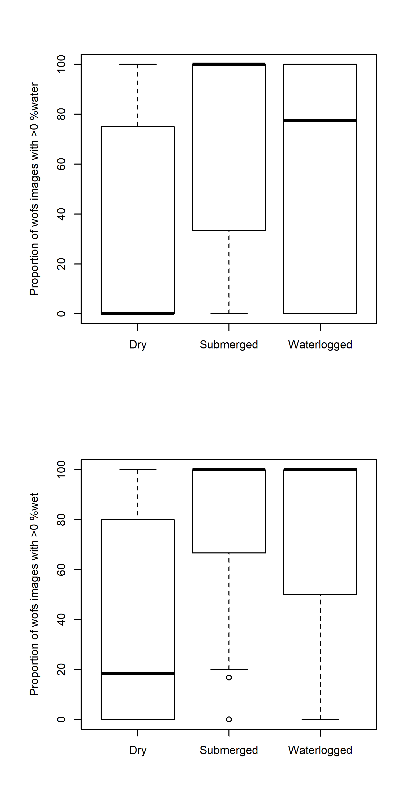

Figure A5_1 A comparison between the number of images in the 3 months leading up to each sampling trip recording ‘water’ and the field observations of HydroState recorded for the same sampling trip.

All predictor variables were calculated separately for % water and % wet. Predictor distributions and correlations between predictors were explored using heat maps and density plots with non-informative (invariant) or highly correlated predictors removed.

For the JSDM, WoFS metrics were calculated for a limited number of recent and long-term time frames due to the time required to run this exploratory analysis:

* + - Three months preceding sampling
    - Three months-12 months preceding sampling
    - 12 months-2 years preceding sampling
    - Long-term record (28 years), i.e. based on the maximum time frame available for all vegetation trips.

To relate the WoFS predictor variables to membership of Sample Points to vegetation community clusters (AVCTs), the WoFS metrics needed to match the resolution of the vegetation response data (i.e. aggregated to water year). Hence, the following timeframes were explored as potential predictors of cluster membership:

* + - Date of last vegetation sample for each site in each water year to start of the water year of interest (d265)
    - Preceding water year (dYR2)
    - Preceding three to 5 water years (d5YR)
    - Preceding 6-10 water years (d10YR)
    - Preceding 11-28 water years (d28YR)

***Climate predictor variables***

For the JSDM, we also accessed daily gridded precipitation and temperature data from Scientific Information for Land Owners (SILO; <https://www.longpaddock.qld.gov.au/silo/index.html>) database of the Queensland Government. SILO is a historical climate database for Australia constructed from observational records and provides daily weather data from 1889 to present. Gridded datasets are interpolated surfaces stored on a regular 0.05 by 0.05° grid. Antecedent rainfall totals (cumulative daily estimates) and average minimum daily temperatures in the 3 months prior to each sampling trip for each site were estimated by averaging across the grid points proximal to each site.

**Statistical approach**

***Joint Species Distribution Modelling***

We analysed the presence–absence of plant species at the level of Sample Points per sampling trip using a joint species distribution model with the Hierarchical Modelling of Species Communities (HMSC) R package (Ovaskainen et al., [2017](https://onlinelibrary.wiley.com/doi/full/10.1002/ece3.3923#ece33923-bib-0037)). The method and software are described in detail in Tikhonov et al. (2019).

We used the Bernoulli distribution with a probit link function to model species occurrence probabilities at each site. As described above, we included the following predictor variables:

* + - proportions of wet and water present in the 90 days preceding sampling;
    - the proportions of wet and water in the year (3 months-1 year) preceding sampling;
    - the proportions of wet and water in the year prior to sampling (1 – 2 years year) preceding sampling; and
    - the proportions of wet and water in long term record (28 years preceding sampling). Recent local rainfall and temperatures in the three months preceding sampling was estimated from gridded climate data.

To account for the nested structure of the data (i.e., repeated sampling of Sample Points over time), we included Sample Plot and Selected Area (SA) as random effects. We also included a random effect at the level of the sampling unit using a latent factor approach (Ovaskainen et al. 2016) which allows estimates of residual associations among species. These may be due to correlated responses to missing predictors and/or ecological interactions.

This modelling approach allows us to identify species-specific responses to environmental factors and can also be extended to functional groups as demonstrated by Dawson et al. (2020). For each species, the modelling process estimates a regression coefficient that measures the influence (strength and direction) of the covariate on the species occurrence. HMSC also enables variance portioning to explore the variance explained by predictors singularly and in groups such as hydrology and climate. The model was fitted with Bayesian inference using two Markov-Chain Monte Carlo (MCMC) chains with 1000 samples per chain. Thinning was set to 35 and the first 15,000 iterations were discarded. The chains were assessed visually by examining the convergence of the results and by exploring the effective sample size and potential scale reduction factors. The effective sample sizes were generally found to be close to theoretical value of the actual number of samples (2000) suggesting little autocorrelation amongst consecutive samples. The potential scale reduction factors were close to one suggesting that the two chains were consistent with one another.

All data manipulations, analysis and plotting was undertaken in R version 3.6.2 (R Core Team, 2019). All plots were drawn using the R package “ggplot2” (Wickham, 2016).

***Random Forest Classification***

The Random Forests (RF) machine learning classifier was used to predict cluster membership (i.e. AVCT; Appendix D) of each Sample Point using the WoFS predictors outlined above. Some modelling approaches are susceptible to multicollinearity (high correlations between predictors). Methods such as classification and regression trees perform well with correlated predictors, but these may still affect the interpretability of the model. For this reason, a conditional random forest classifier was used (cforest function from the ‘Party’ R package (Hothorn et al. 2006; Strobl et al. 2007; Strobl et al. 2008)) which results in unbiased forests where predictor variables are of different types or are highly correlated.

The train function in the ‘caret’ package (Kuhn, 2008) was used to select optimal model turning parameters specifically the mtry parameter which determines the number of predictor variables randomly chosen for each tree split. The number of trees (ntree) was set to 9999 after initial trials. The data was split 80/20 (training/test) with each model built using the training data (n=245) and validated on the test data (n=58). The data split was stratified across the clusters to ensure balanced representation of each cluster within the training and test datasets. Data were trained using ten-fold cross validation. The training was re-run with a number of different starting seed values and the results compared. Where results differed significantly between runs, the number of trees was increased and the analysis started again until different seed numbers resulted in similar results.

The predictive performance of the classification tree was evaluated using a confusion matrix which compares the observed cluster membership in the test data to the membership predicted from the random forest classification and determines the classification error (number of sites incorrectly allocated to a cluster based on the environmental predictors). The random forest output also includes a number of test statistics used in evaluation of model performance (accuracy: the proportion of samples that are correctly classified and Kappa). Note that if the groups are highly unbalanced then the accuracy can be misleading. The mcc function in the ‘mltools’ R package was also used to calculate the Matthews Correlation Coefficient (MCC) which is considered more appropriate than the accuracy assessment for unbalanced groups and a more robust measure compared to the Kappa statistic (Delgaado and Tibau, 2019). The MCC value is always between 1 (perfect classification correlation between actual and predicted), 0 meaning that the classifier is no better than a random flip of a fair coin and -1 (a perfect negative correlation). The ‘no information rate’ is simply the largest class percentage in the data. The principal behind this latter value is that a useful model should perform better that the naive classifier which would be to predict the most common or popular class. Conditional predictor variable importance was assessed using the varImp function of the ‘party’ package to assess the which predictors were important in determining cluster membership.

**Results**

***Joint Species Distribution Modelling***

Given the significant computational time required for this modelling (i.e. > 10 days for single run), the results presented here are preliminary and provide a short snapshot of what has been undertaken to date. A database of predictor and response variables as well as modelling results is available in accompaniment to this report.

Species-specific responses varied considerably amongst the predictor variables. Strong statistical support would normally be inferred at 95 % or 99 % posterior probability but few of the support values exceeded 95 % suggesting only weak or moderate support for any associations between species occurrences and the covariates. This supports the observation discussed in the evaluation report (see Section 3.3.2) that most plant taxa observed during the LTIM project occurred under a range of hydrological conditions.

Moderate and weak associations between species occurrences and the proportion of WoFS images in the recent antecedent period (90 days prior to sampling) with > 0 fractional cover of ‘wet’ (d90per0wet) were generally positive. In contrast, associations between species occurrences and the proportion of ‘water’ in the recent period were mixed with a number of species showing negative associations. Over longer time frames (i.e. 28 years), most species showed a negative association with variation in fractional cover predictors but positive associations with the proportion of WoFS images with > 0 fractional cover of ‘wet’ (d28YRper0wet). Recent climate (cumulative rainfall and average temperatures) associations were mixed with both positive and negative associations exhibited amongst the species.

The environmental predictors were found to explain a relatively low proportions of the explained variance relative to the random components (Sample, Plot and Selected Area). Species were grouped into their LHLF and PFGs to explore the results further. Most of the explained variance was attributed to the random components, particularly at the scale of sample and plot (Figure A5_2). Overall, the hydrological metrics explained only a small proportion of the explained variance. However, the long-term predictors explained a greater proportion of the variance relative to the short-term metrics for all the LHLF groups (Figure A5_3). Results were similar for the PFGs and are not presented here.

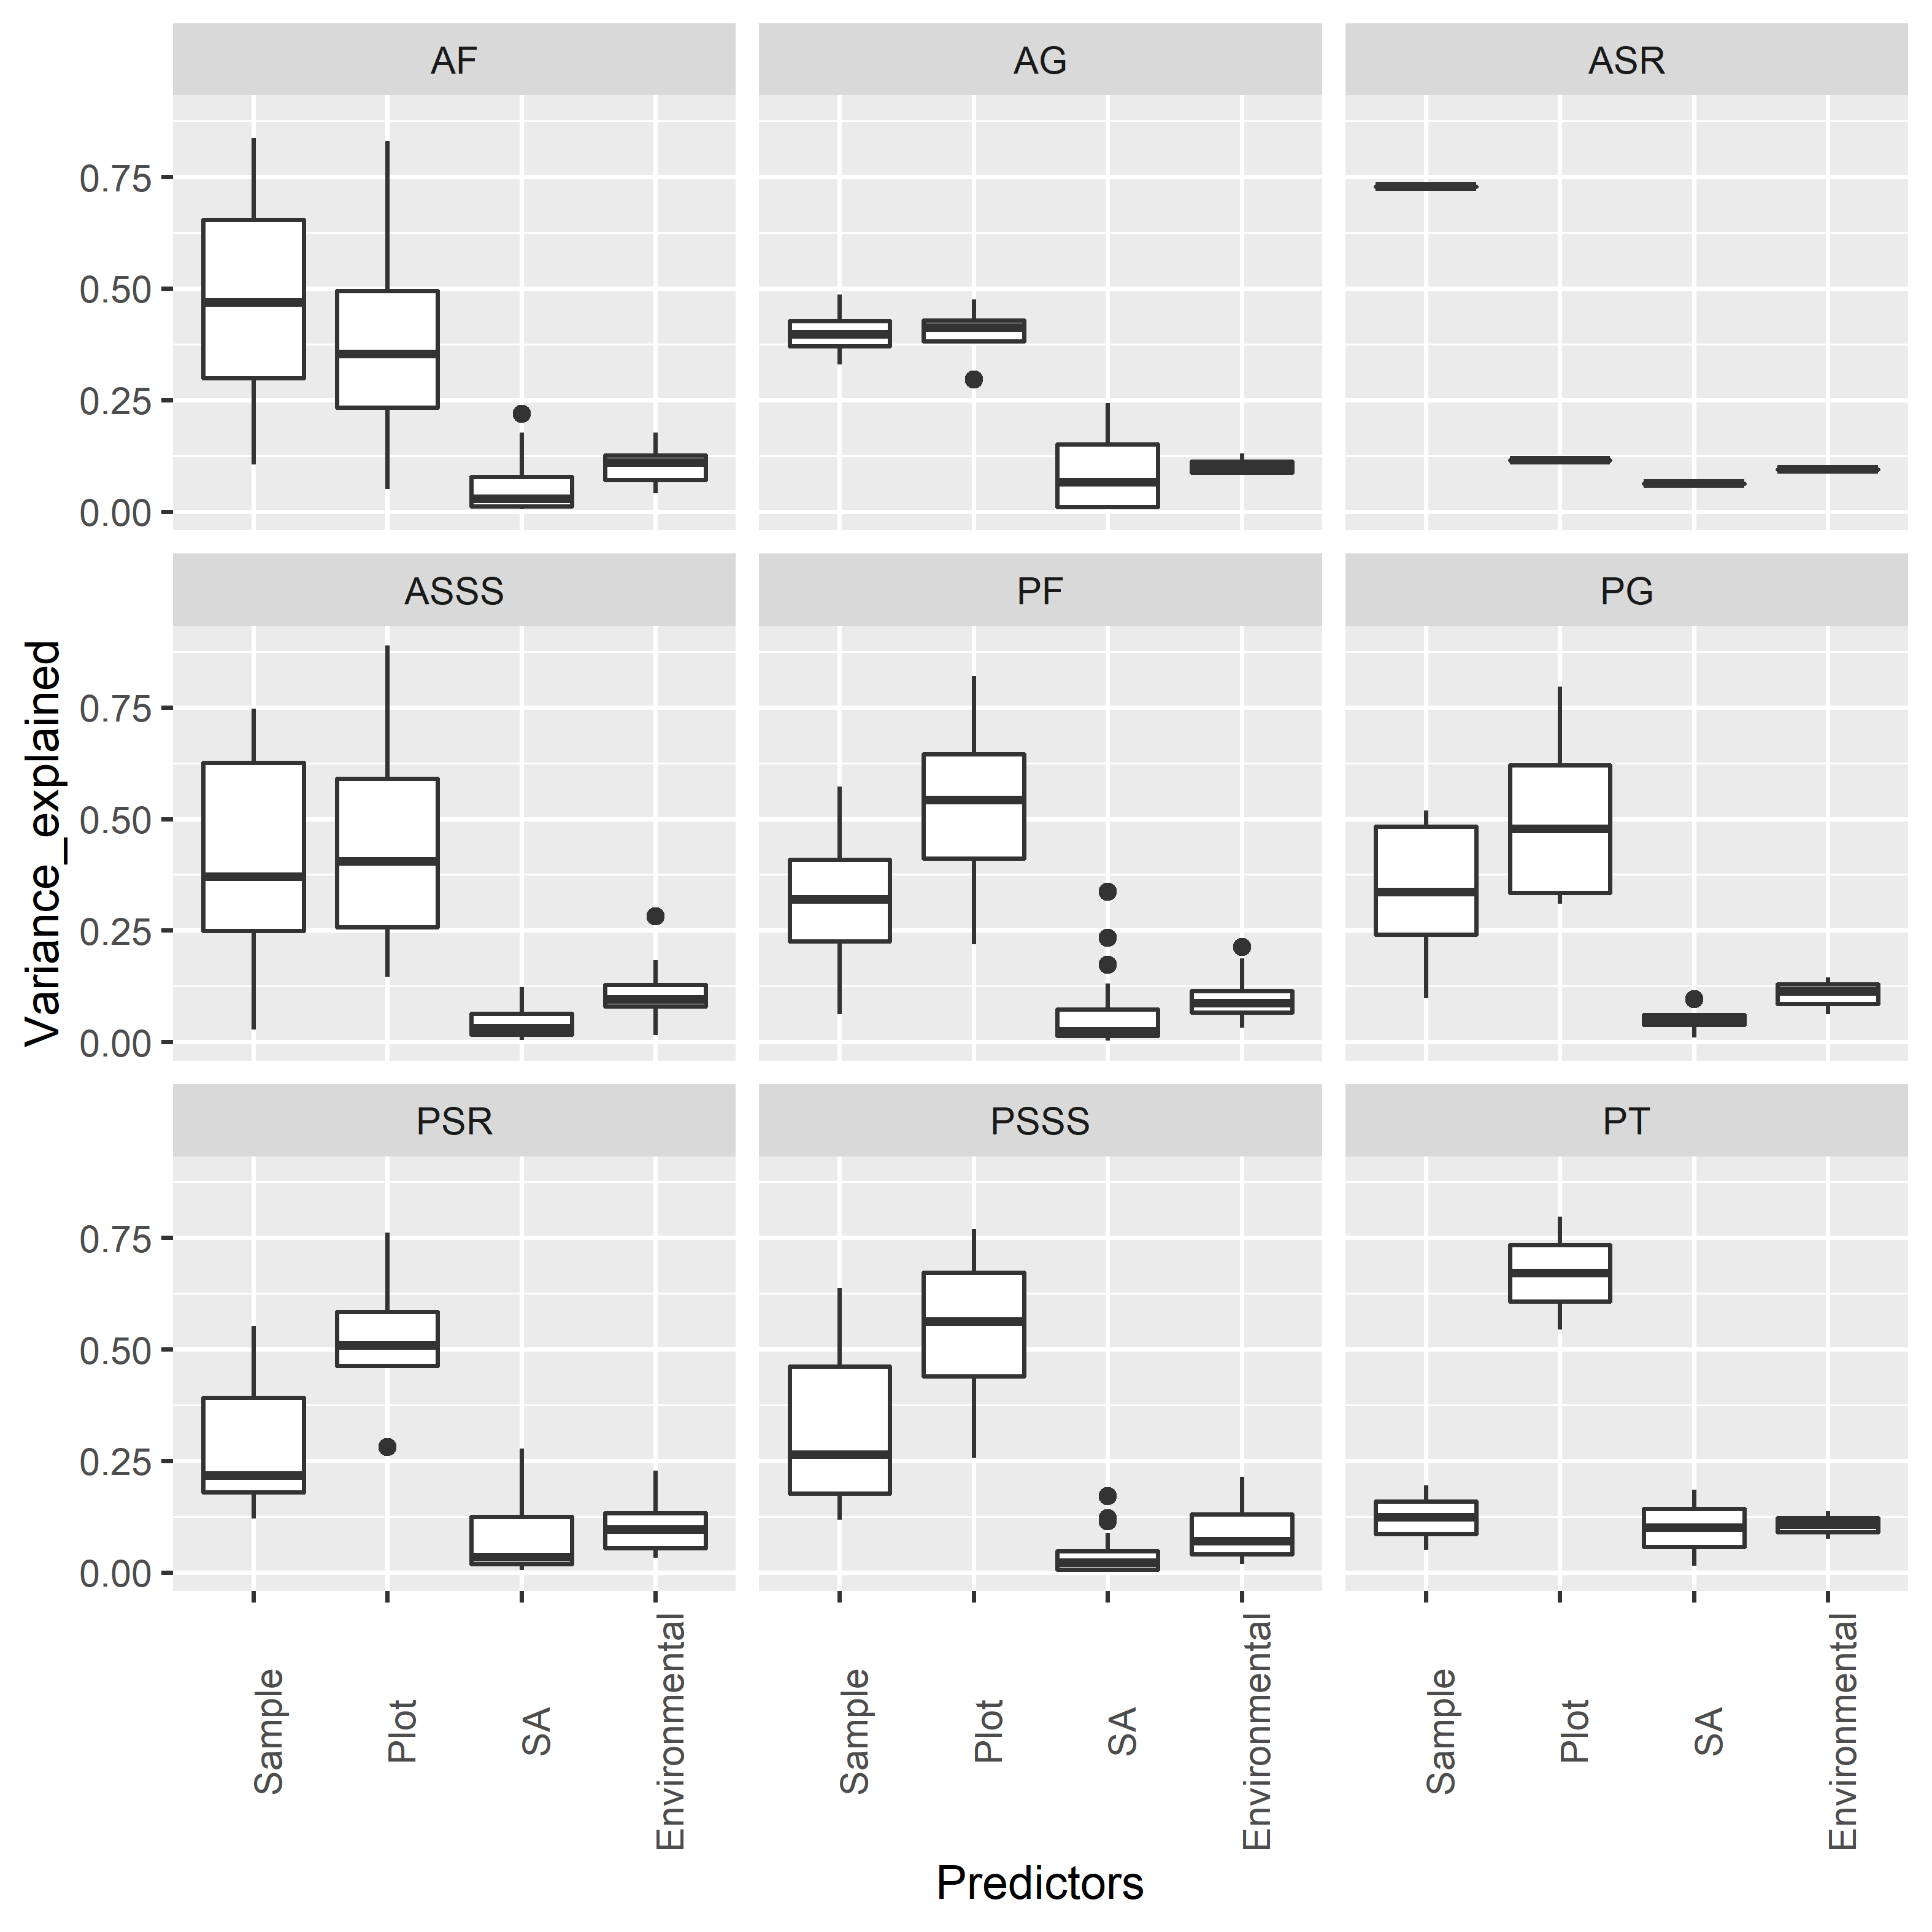

Figure A5_2. Variance partitioning plot, showing the proportion of explained variance partitioned into fixed (environmental effects including both hydrology and recent climate) and random effects at sample, plot and Selected Area scales. Box plots show median responses and the 25th and 75th percentiles across each LHLF group. Note that the total variance explained will be different for each plant group.

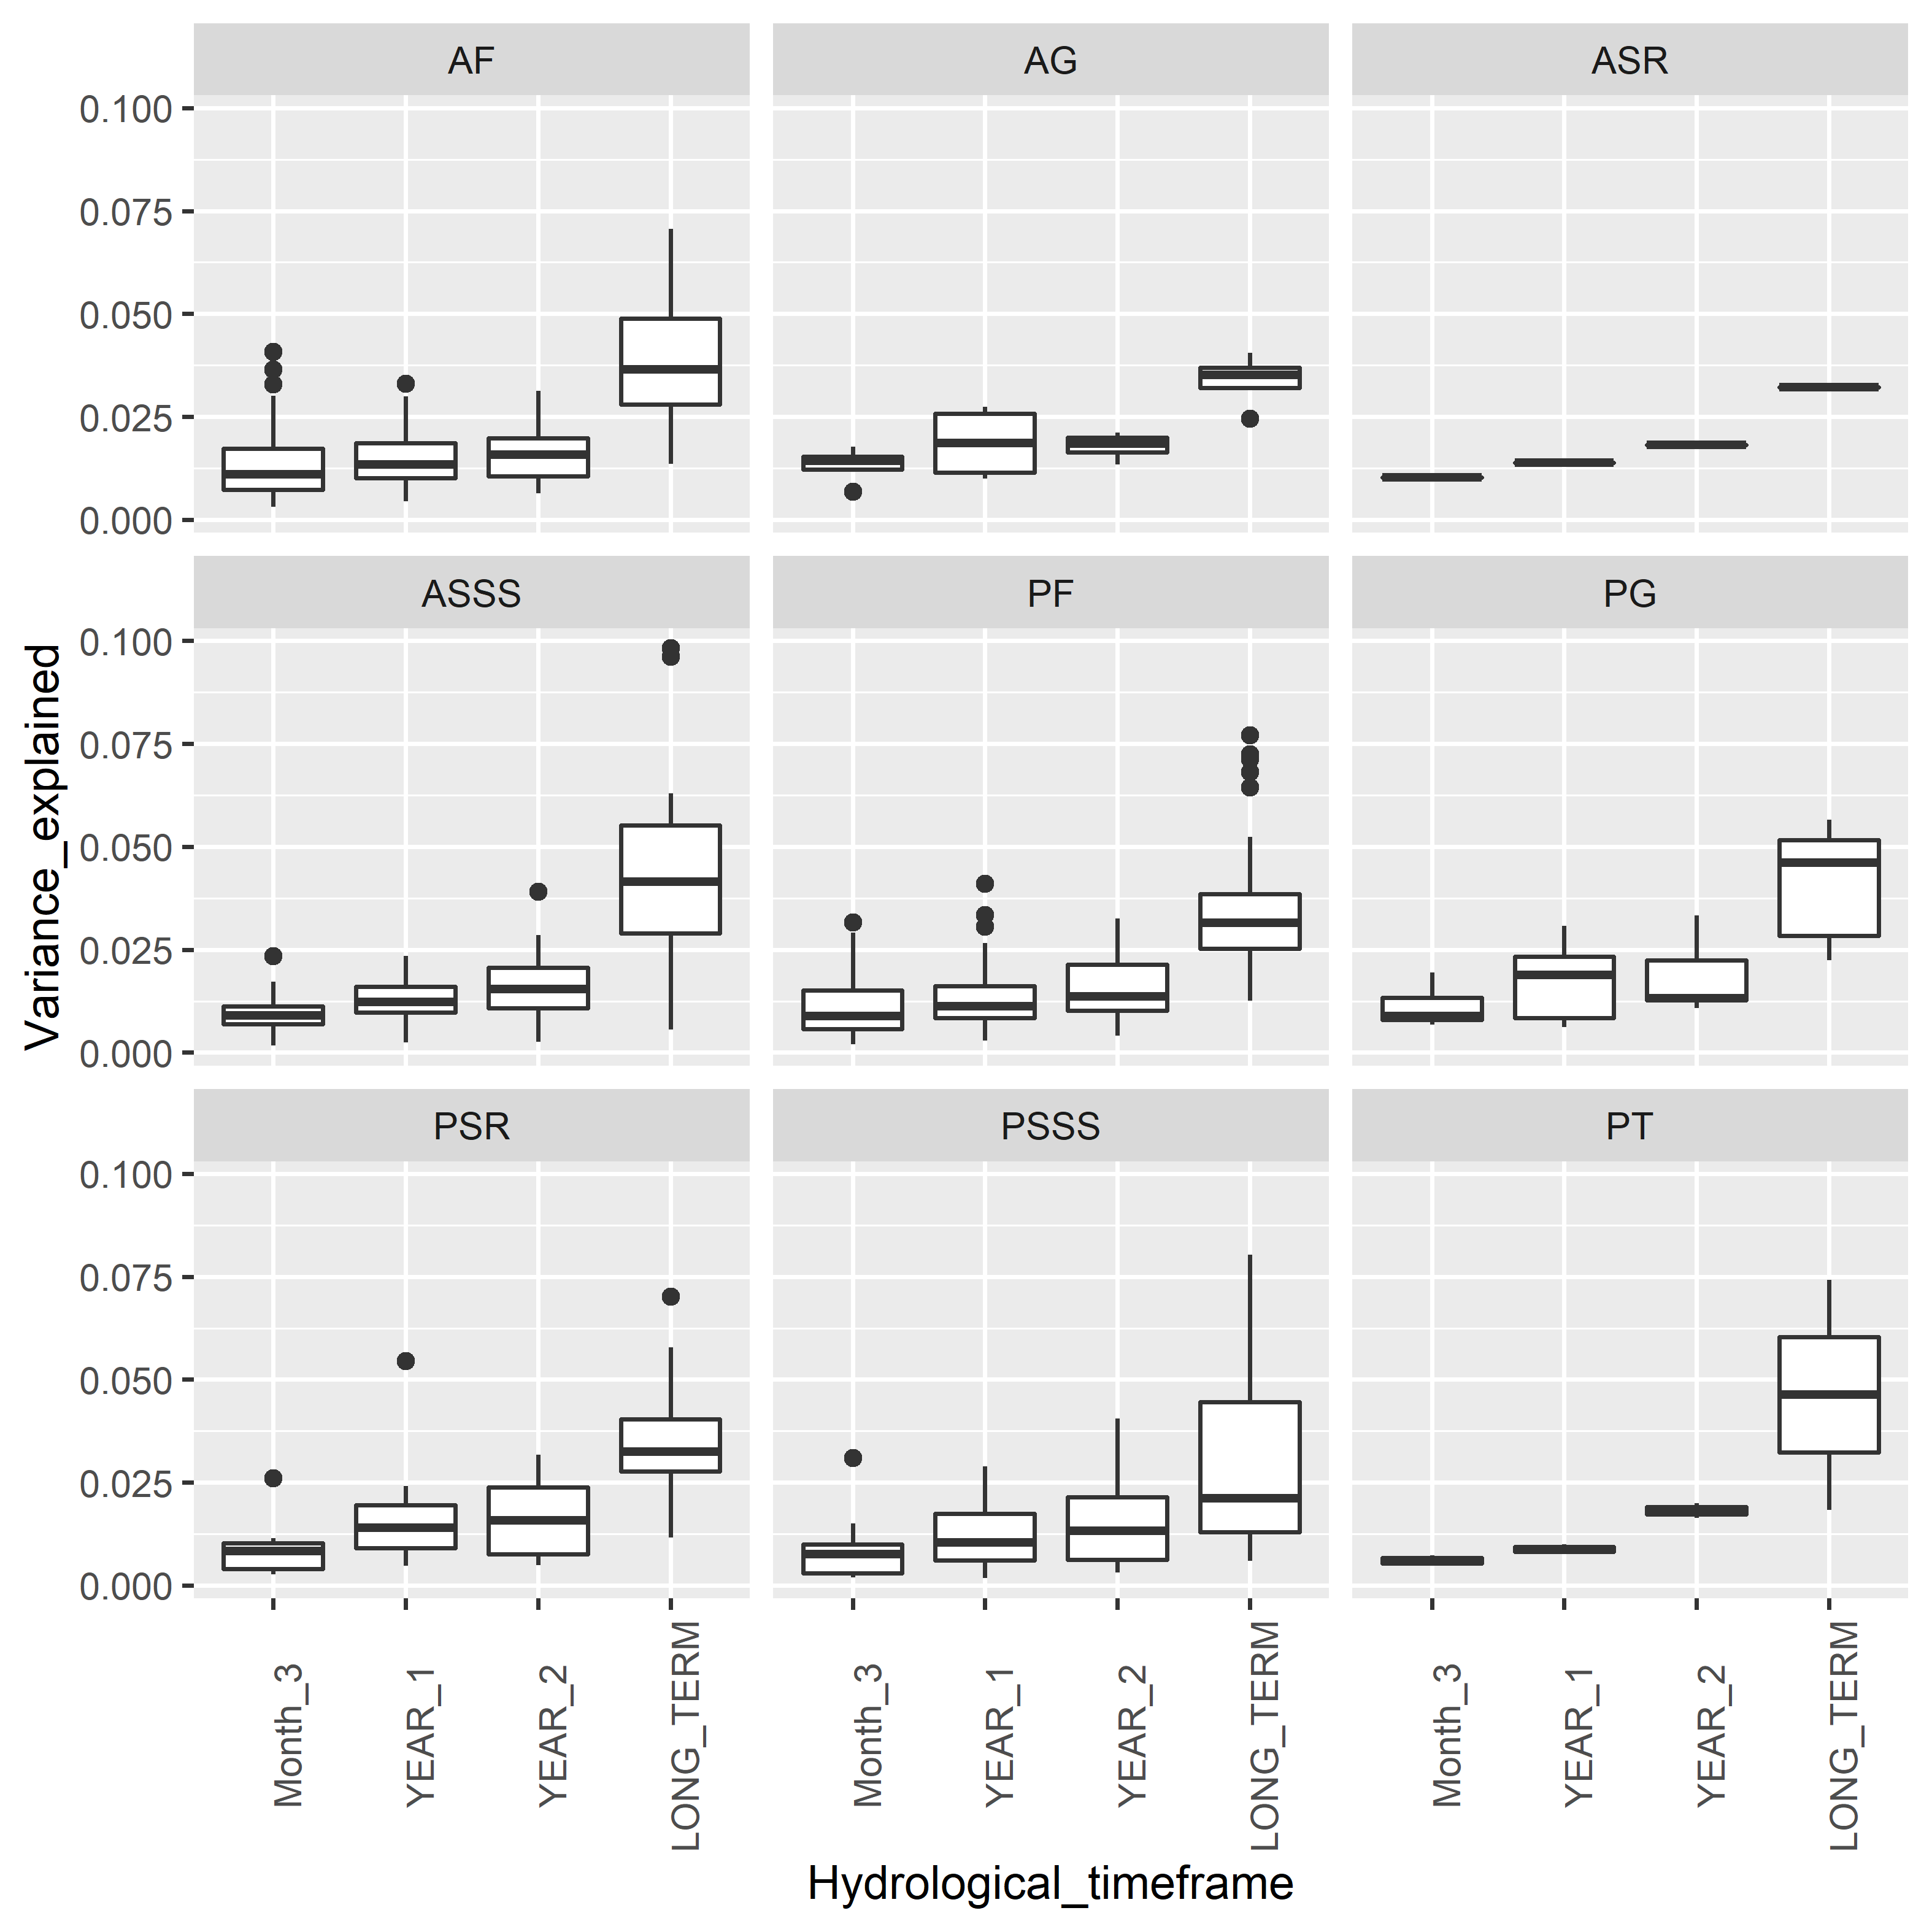

Figure A5_3. Variance partitioning plot, showing the proportion of explained variance partitioned into the short term (3 Months, 1 year and 2 years) and long term (28 years) hydrological metrics. Box plots show median responses and the 25th and 75th percentiles across LHLF. Note that the total variance explained will be different for each plant group.

***Random Forest Classification***

The WoFS predictors were generally poor at discriminating between the AVCTs based on the LHLF cluster groups (see Appendix D). The random forest classification results indicate low MCC scores with results only slightly better than a random allocation (1 indicates a perfect classification correlation between actual and predicted; Table A5_1). The confusion matrix also revealed that the cluster membership in the test data set were not predicted well with error rates of at least 40 % (Table A5_2).

Conditional variable importance measures suggested that the variable with the greatest influence on the classification was the proportion of WoFS images with ‘wet’ exceeding 10 % in the period 5-10 water years prior to sampling (d10YRper10wet; Figures A5_4 and A5_5). This variable distinguished sites dominated by perennial shrubs and sub-shrubs (PSSS) in cluster 5 with those sites in cluster 2 (dominated by perennial sedges and rushes), cluster 3 (dominated by perennial grasses) and cluster 4 (dominated by perennial forbs). Other WoFS predictors identified as influential included the proportion of WoFS images with ‘wet’ exceeding 10 % in the period in the current water year (d365per10wet). It was also notable that predictors relating to proportions of ‘wet’ rather than ‘water’ tended to be more influential and that both the short- and long-term time frames explored in this analysis are represented in the top five most important variables in predicting cluster membership.

Table A5_1. Results of random forest classification using WoFS predictors to predict LHLF cluster membership.

|  |  |  |  |  |  |  |  |  |
| --- | --- | --- | --- | --- | --- | --- | --- | --- |
| **Data set** | **Cluster No. &**  **Method** | **mtry** | **Training data set (80%)** | | | **Testing data set (20%)** | | |
| **Accuracy** | **No information rate** | **MCC statistic** | **Accuracy** | **No information rate** | **MCC statistic** |
| LHGF by wateryr | 5 clusters – k means | 6 | 0.445 | 0.286 | 0.285 | 0.465 | 0.293 | 0.309 |

Table A5_2. Confusion matrix showing the random forest model predictions for the test data versus observed cluster membership.

|  |
| --- |
| LHGF |
| Cluster No | 1 | 2 | 3 | 4 | 5 |
| Cluster predicted  By  random forest | 1 | 6 | 0 | 2 | 1 | 3 |
| 2 | 0 | 6 | 2 | 4 | 0 |
| 3 | 0 | 1 | 3 | 2 | 0 |
| 4 | 8 | 3 | 1 | 9 | 3 |
| 5 | 0 | 0 | 0 | 1 | 3 |
| Error (%) | | 57 | 40 | 63 | 47 | 67 |

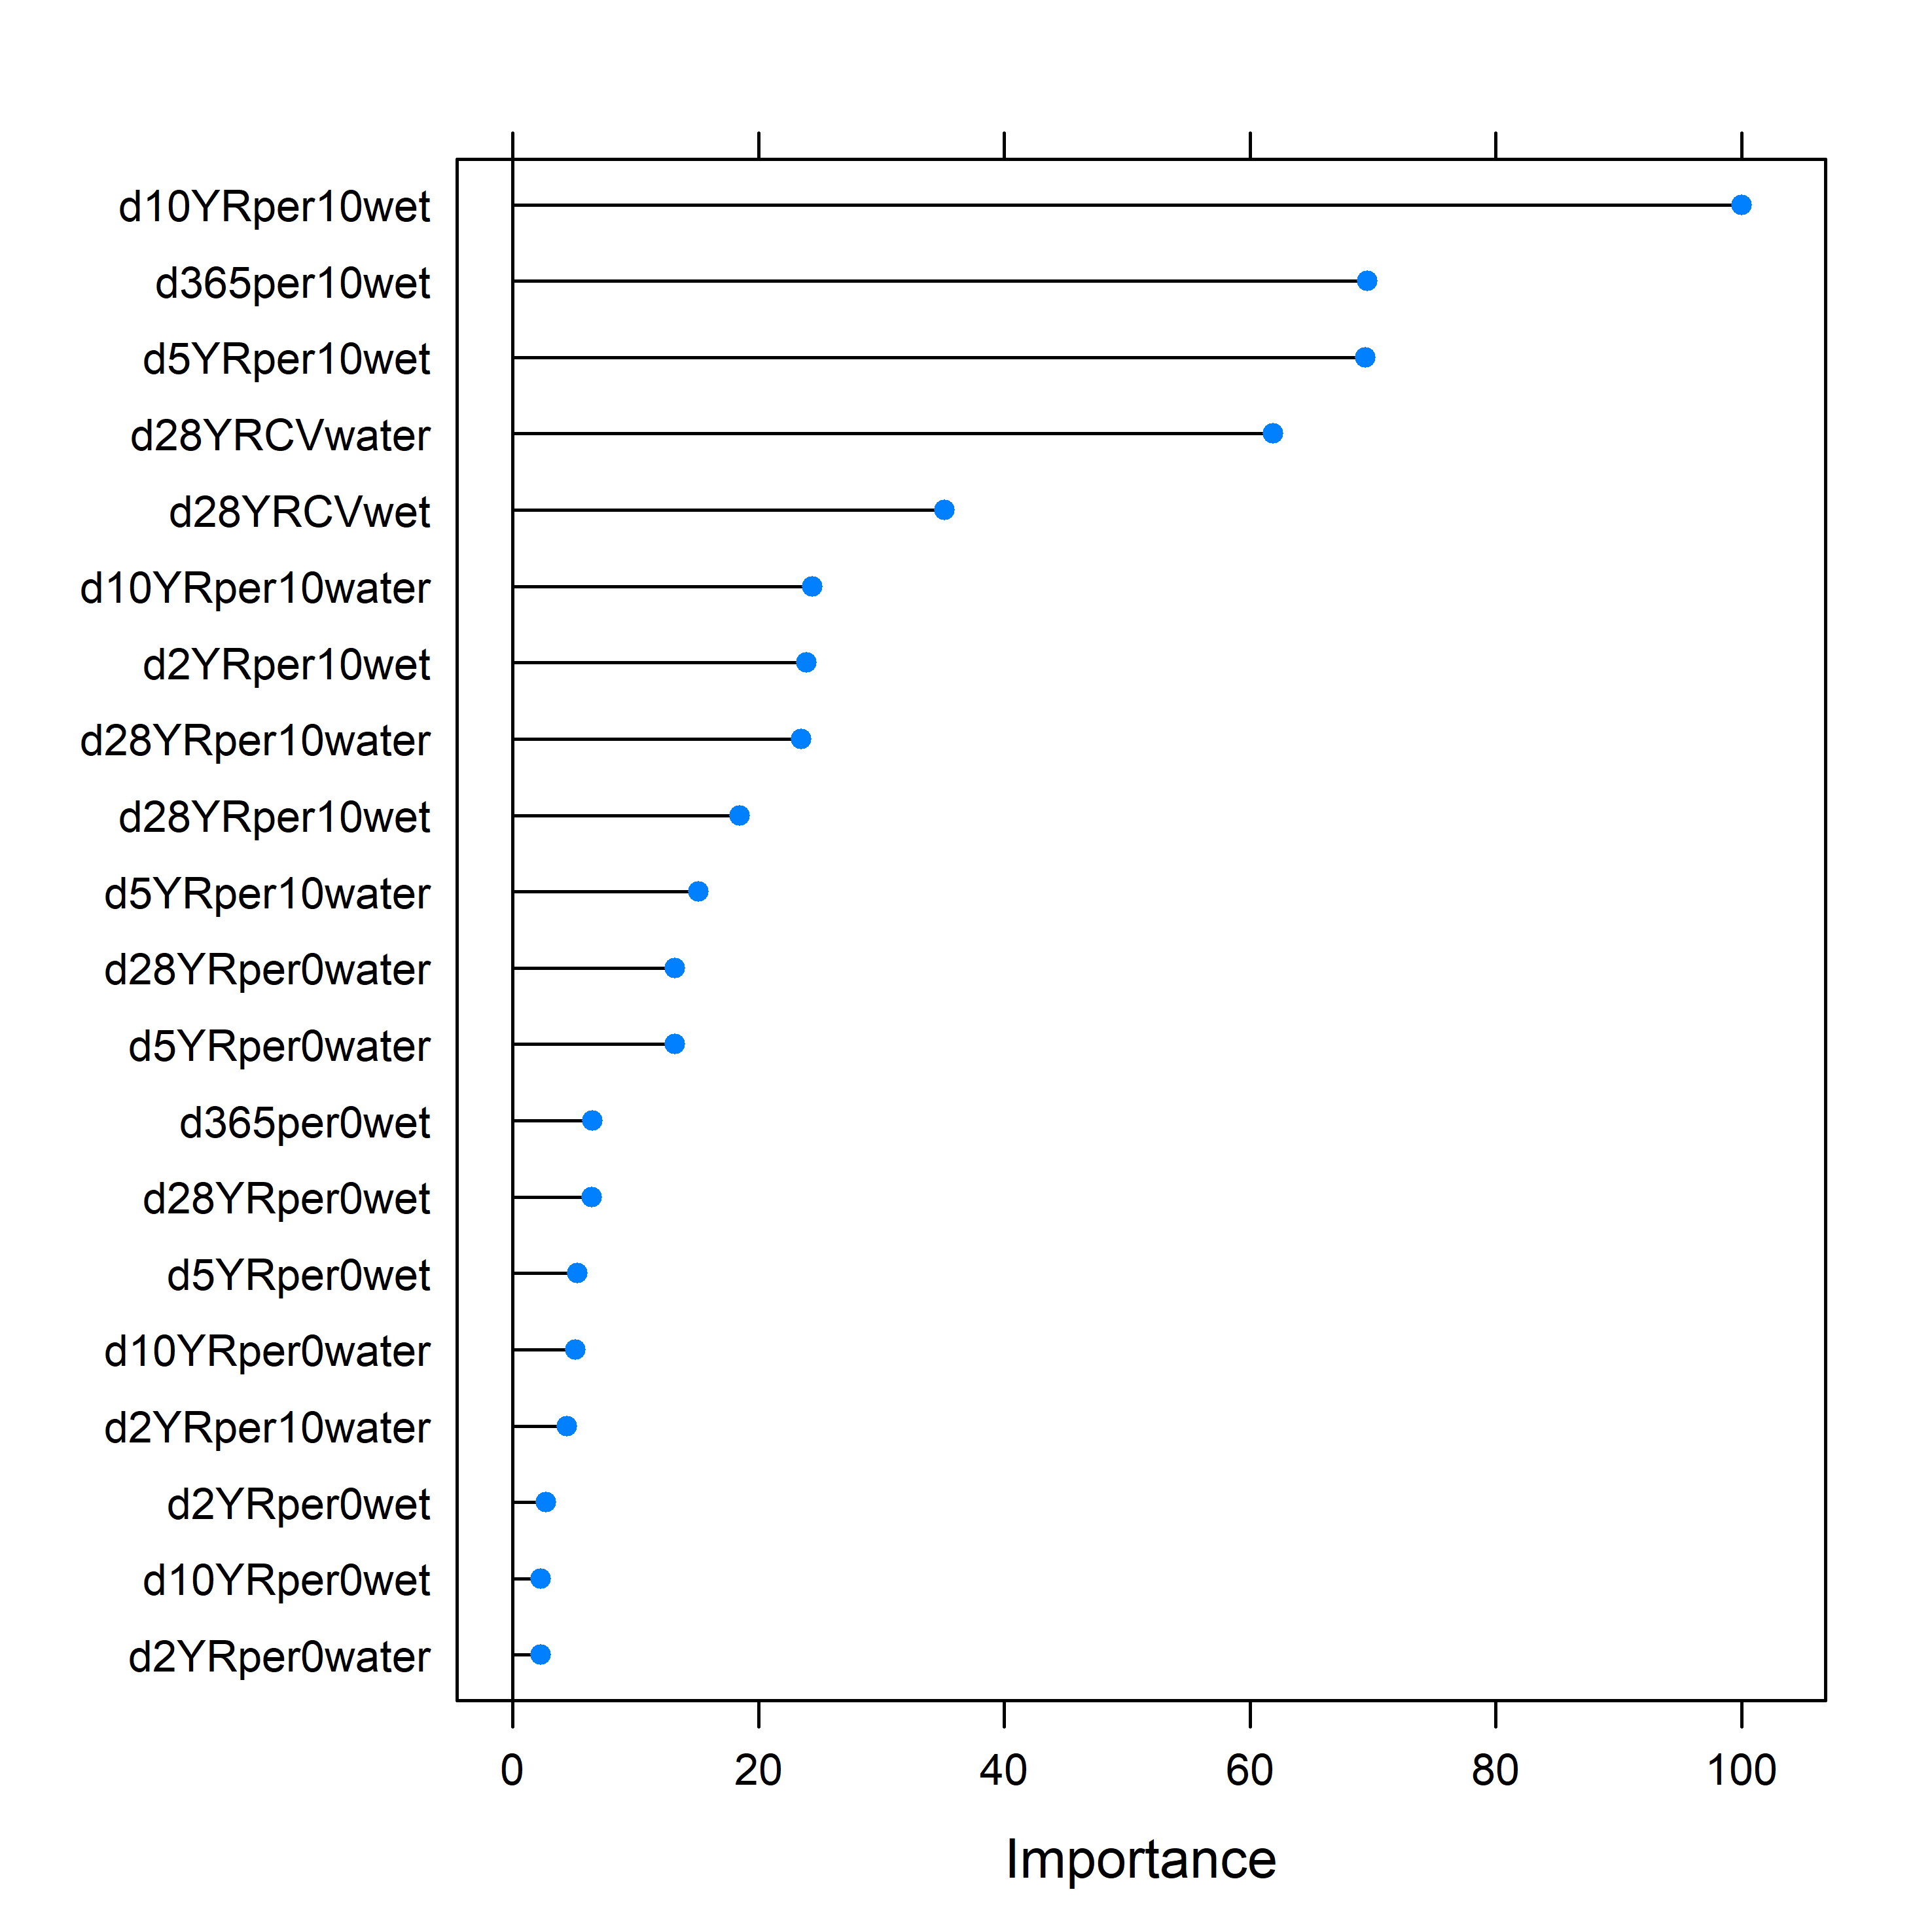

Figure A5_4. Random Forest predictor variable importance measures for LHLF clusters of LTIM monitoring data.

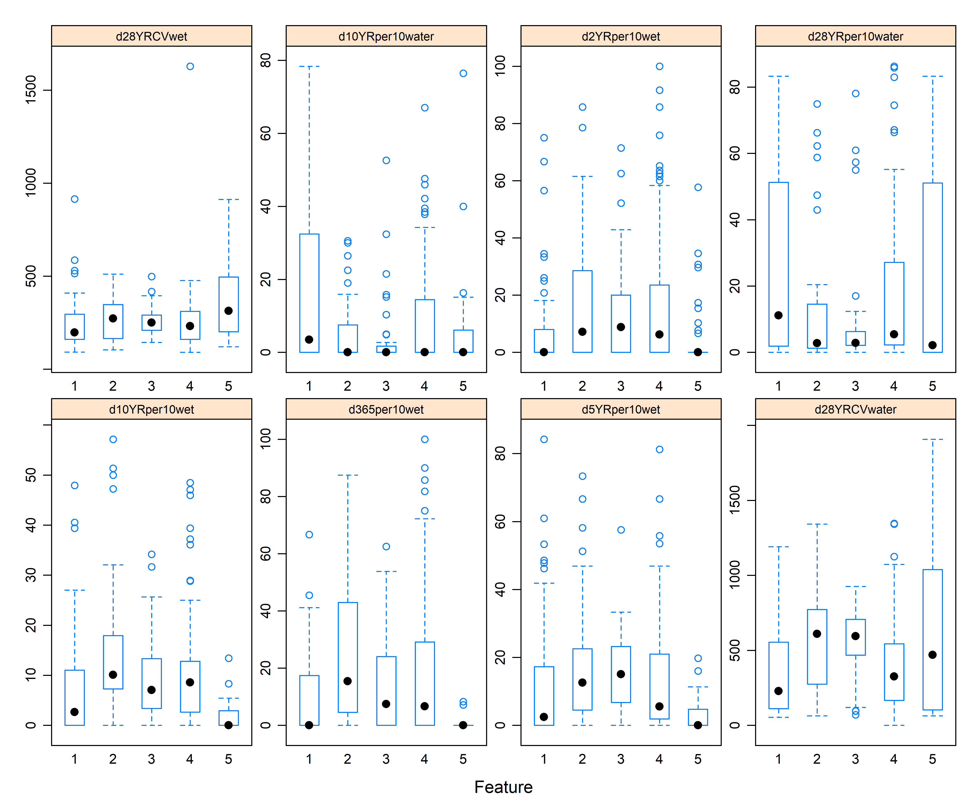

Figure A5_5. Variation in important predictor variables (top eight variables identified by the variable importance measures) across LHLF clusters.

Overall, the Random Forest classifier performed better for the PFG than for the LHLF vegetation groupings with higher accuracy and MCC values (Table A5_3). However, performance was very variable across clusters. The confusion matrix revealed that membership of cluster 1, 4 and 5 were predicted relatively well from the WoFS data (Table A5_4) with error rates in the region of 15-28 %. However, the error rates for clusters 2 and 3 were 75 % and 100 % respectively.

Conditional variable importance measures suggested that the variable with the greatest influence on the classification was the proportion of WoFS images with ‘wet’ exceeding 10 % in the recent period immediately preceding the sampling date (Figures A5_8 and A5_9). This predictor discriminated relatively well between samples in cluster 1 dominated by terrestrial dry species (Tdr) with generally no or low proportions of ‘wet’ exceeding 10 % cover compared to samples in the other clusters. Samples from cluster 5 conversely tended to be characterised by wetter conditions both in the short term and long term. Cluster 5 comprises samples characterised by high proportions of amphibious and submerged species and lower proportions of terrestrial species. Cluster 4 comprises quite a high diversity of plant functional groups. The WoFS predictors distinguishing this cluster tended to be those representing open water (e.g. d365per0water) and lower long-term variation in fractional cover of water (d28YRCVwater). This cluster included samples with Sk species present which are relatively rare within the dataset (true aquatic species that require flooding for at least 6 months for germination or sexual reproduction).

Table A5_3. Results of random forest classification using WoFS predictors to predict PFG cluster membership.

|  |  |  |  |  |  |  |  |  |
| --- | --- | --- | --- | --- | --- | --- | --- | --- |
| **Data set** | **Cluster No. &**  **Method** | **mtry** | **Training data set (80%)** | | | **Testing data set (20%)** | | |
| **Accuracy** | **No information rate** | **MCC statistic** | **Accuracy** | **No information rate** | **MCC statistic** |
| PFG by wateryr | 5 clusters – k means | 2 | 0.5021 | 0.292 | 0.312 | 0.65 | 0.383 | 0.516 |

Table A5_4. Confusion matrix showing the random forest model predictions for the test data versus observed cluster membership.

|  |
| --- |
| PFG |
| Cluster No | 1 | 2 | 3 | 4 | 5 |
| Cluster predicted  By  random forest | 1 | 11 | 1 | 1 | 5 | 1 |
| 2 | 0 | 1 | 0 | 0 | 0 |
| 3 | 0 | 0 | 0 | 0 | 0 |
| 4 | 2 | 2 | 0 | 13 | 2 |
| 5 | 0 | 0 | 2 | 5 | 14 |
| Error (%) | | 15 | 75 | 100 | 28 | 18 |

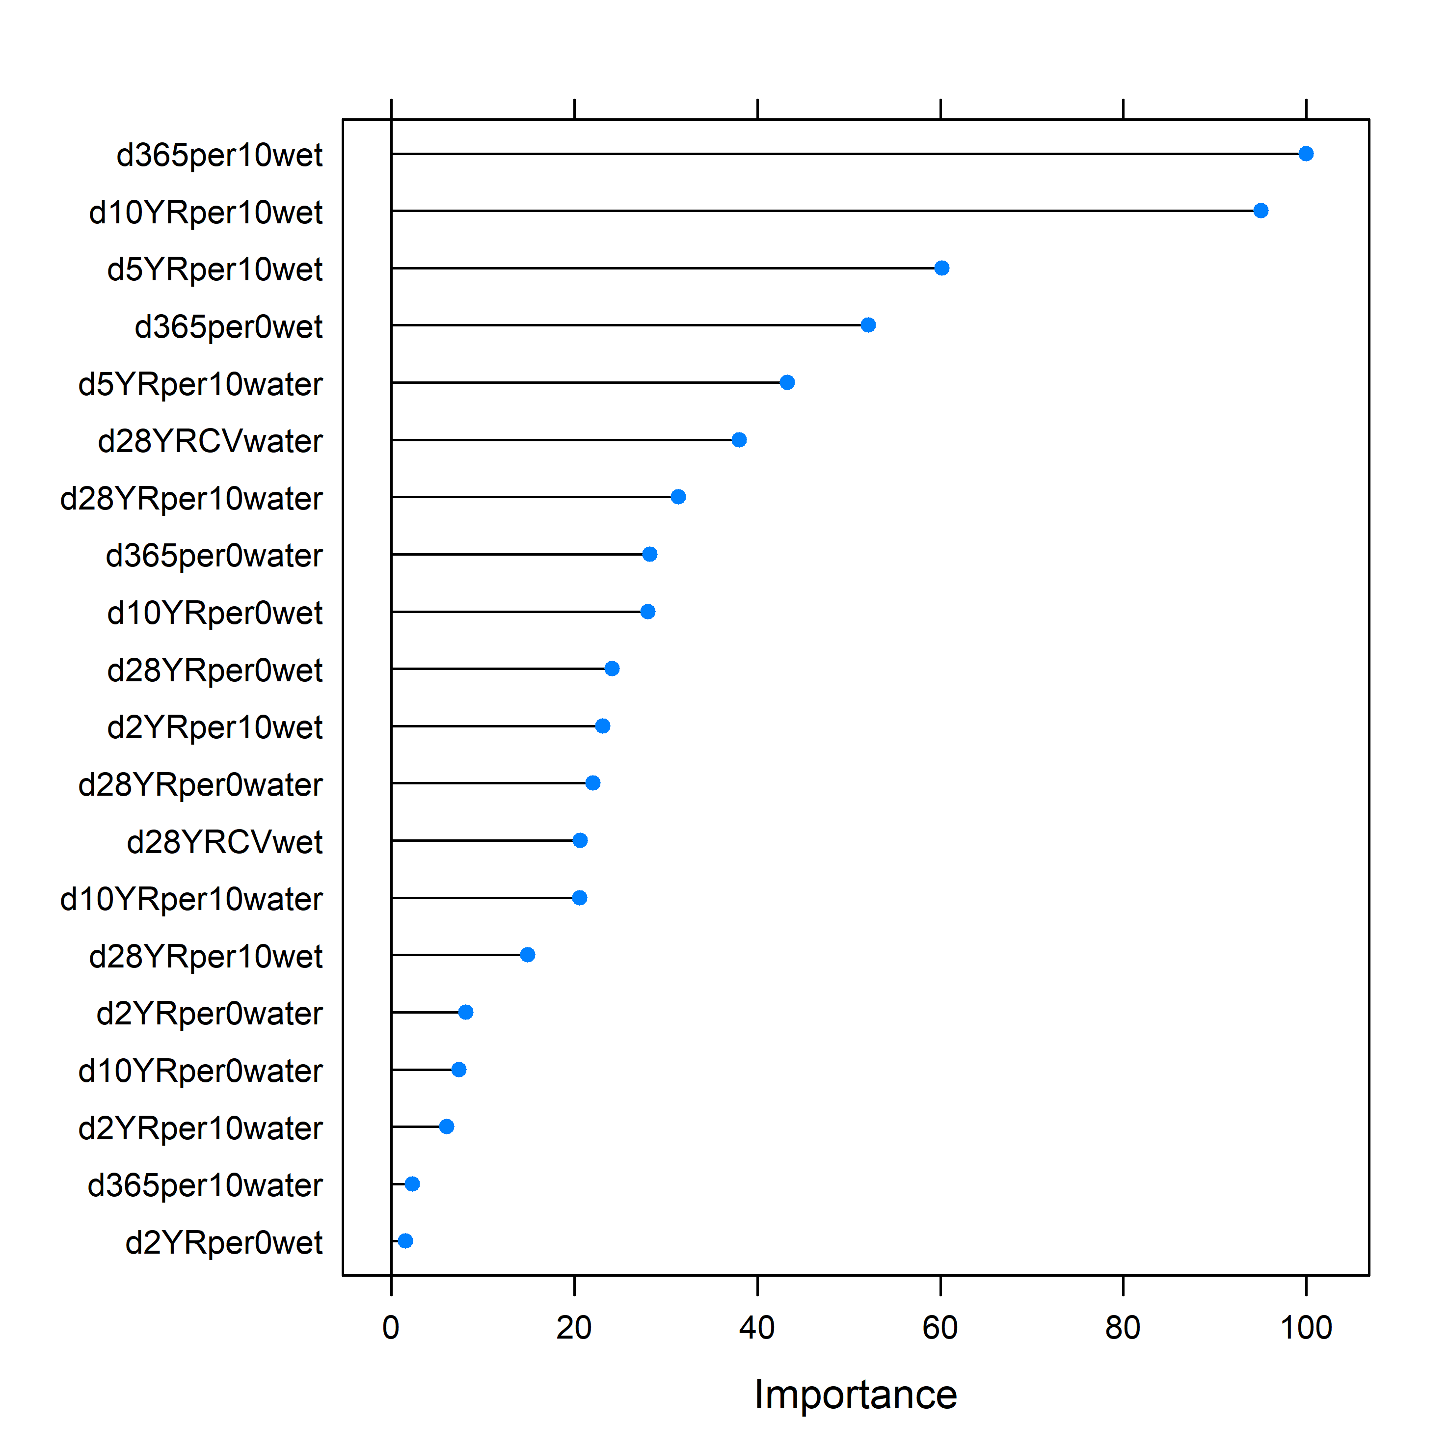

Figure A5_8. Random Forest predictor variable importance measures for PFG clusters of LTIM monitoring data.

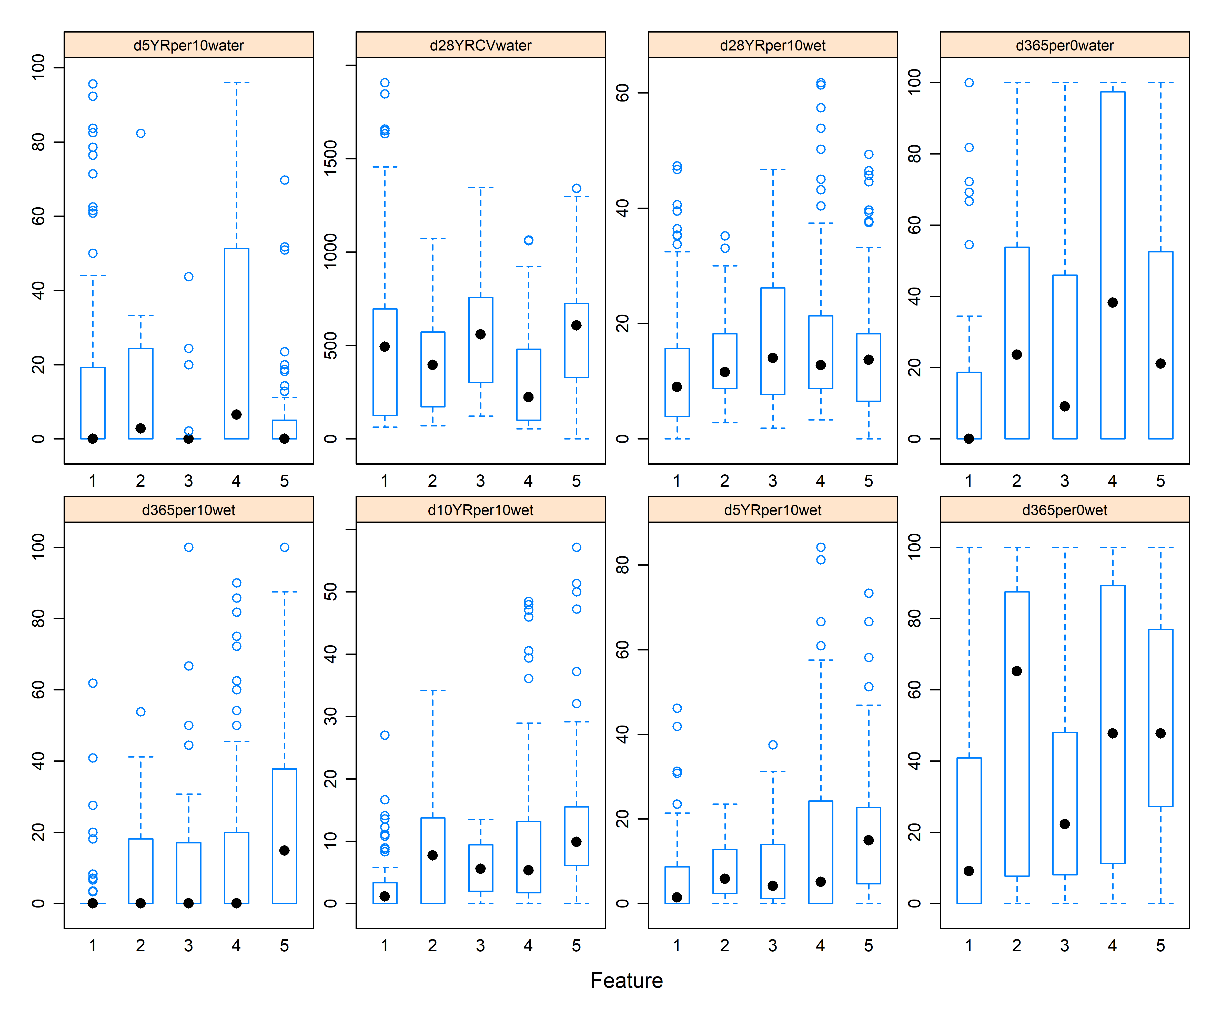 Figure A5_9. Variation in important predictor variables (top eight variables identified by the variable importance measures) across PFG clusters.

**Conclusions**

Both of the modelling approaches investigated here hold promise for developing a predictive capacity with regards to vegetation diversity responses to watering in unmonitored areas. In both cases, however, further development is required to produce effective tools to guide decision-making.

The clustering approach explored here to examine vegetation community diversity responses to watering may be particularly useful at a Basin-scale as it enables comparisons across floristically distinct wetlands. With further development, it is envisaged that a predictive tool might be developed to enable exploration of vegetation community diversity responses (e.g. richness, distributions and resilience) to different Basin-scale watering regimes. A key step towards achieving this, however, would be further development of vegetation community types with ecological and management relevance – a task best approached collaboratively. For instance, clusters based on a combination of LHLF and PFGs could be explored as could the inclusion of structural vegetation data).

The species-specific responses investigated by the JSDM can also be combined into community models and used to undertake scenario comparisons in a manner described by Olden et al. (2014). A further strength of this approach is that it allows us to identify species response groups (i.e. species that occur under similar hydrological conditions) when species do not co-occur as is the case with the vast majority of the species within the LTIM dataset. Furthermore, the modelling framework allows us to take into account the hierarchical structure of the monitoring datasets (repeated sampling over time). Further model development is required, however, to improve the models particularly through improved predictor variables (both hydrological and related to other potentially important factors such as soil types etc.).

The greatest constraint on the development of effective predictive tools for vegetation diversity, however, is the availability of robust, Basin-wide inundation data with spatial and temporal resolution appropriate to the model framework. Current products in development by GeoScience Australia are likely to enable significant improvements to vegetation modelling in the near future.