
—
Commonwealth Environmental Water Office
Monitoring, Evaluation and Research Project

2019-20 - Goulburn MER Annual Scientific Report
  - Simon Treadwell, Angus Webb, Xue Hou, Ben Baker, Simon Casanelia, Michael Grace, Joe Greet, Claudette Kellar, Wayne Koster, Daniel Lovell, Daniel McMahon, Kay Morris, Jackie Myers, Vin Pettigrove, Neil Sutton, Geoff Vietz
11 December 2020

Table of Contents
1. Preamble 1
2. Lower Goulburn River Selected Area Description and Monitoring Locations 2
2.1. Description 2
2.2. Monitoring sites and 2019-20 monitoring 2
3. Commonwealth Environmental Watering 6
3.1. Overview of Commonwealth environmental watering 6
3.2. Environmental water delivered in 2019-20 6
4. Physical habitat 10
4.1. Introduction 10
4.2. Area specific evaluation questions 10
4.3. Main findings from monitoring program 11
4.4. Monitoring methods and analytical techniques 13
4.5. Results 14
4.6. Discussion 20
5. Metabolism 24
5.1. Introduction 24
5.2. Area specific evaluation questions 25
5.3. Main findings from monitoring program 25
5.4. Monitoring methods and analytical techniques 28
5.5. Results 30
5.6. Discussion Summary 63
6. Macroinvertebrates 64
6.1. Introduction 64
6.2. Area specific evaluation questions 64
6.3. Main findings from monitoring program 65
6.4. Monitoring methods and analytical techniques 66
6.5. Results 68
6.6. Discussion 75
7. Vegetation 77
7.1. Introduction 77
7.2. Area specific evaluation questions 77
7.3. Main findings from the vegetation monitoring program 78
7.4. Monitoring methods and analytical techniques 81
7.5. Results 83
7.6. Discussion 90
8. Fish 92
8.1. Introduction 92
8.2. Basin and area specific evaluation questions 92
8.3. Main findings from monitoring program 93
8.4. Monitoring methods and analytical techniques 96
8.5. Results 97
8.6. Discussion 101
9. Contingency Monitoring 104
9.1. Turf mats 104
10. Research activities 115
10.1. Collaborative research project 115
11. Engagement and Communication and 117
11.1. Engagement 117
11.2. Communication 117
12. References 120
Appendix A: Detailed summary of watering actions and volumes delivered 123
Appendix B: Bank Condition Digital Elevation Models of Difference (DEMODs) 125
Appendix C: Summary metabolism data McCoy’s Bridge 132
Appendix D: Bank vegetation responses 133
Appendix E: Taxa recorded deposited on turf mats 137
Appendix F: Examples of media communications 140

List of Figures
Figure 2-1 Map of the lower Goulburn River, with all monitoring sites marked, along with flow gauges used to generate flow data to be used in the MER Program. Some sites extend into the Broken River. Colours denote different monitoring activities, with some sites being used for multiple activities. Sites are indicated with site numbers, with the key providing the site name. Monitoring Zone 1 runs from Goulburn Weir to the confluence of the Broken River near Shepparton, with Zone 2 downstream from this point to the confluence with the Murray River. 3
Figure 3-1 Relative sources of water contributing to total Goulburn River flows in 2019-20 at McCoy’s Bridge (https://fchMcCoy’s.hydronet.com/). 7
Figure 4-1 Infographic providing an over-view of the methodology applied to bank and vegetation condition analysis using UAV technology (Streamology et al. 2020). 14
Figure 4-2 Bank survey visits during the monitoring period in relation to daily mean discharge at McCoy’s Bridge (405232). 14
Figure 4-3 Site inundation effects on the probability of erosion. (a) significant erosion: >30 mm; (b) erosion: >0 mm; (c) deposition: <0 mm. For each erosion level, results are shown for three sites (Darcy’s Track, Loch Garry, and McCoy’s Bridge). 16
Figure 4-4 Site inundation effects on the probability of notching. (a) significant erosion: >30 mm; (b) erosion: >0 mm; (c) deposition: <0 mm. For each erosion level, results are shown for three sites (Darcy’s Track, Loch Garry, and McCoy’s Bridge). 17
Figure 4-5 Box and Whisker Plot illustrating erosion, deposition and net volume change (cm³/m²) in response to each flow event. 19
Figure 4-6 3 step process of notching resulting from sustained inundation period with limited variability. 23
Figure 5-1 Relationships between photosynthesis, respiration, organic matter, dissolved gases and nutrients. 24
Figure 5-2 Flow stages according to Stewardson et al. (2018). 30
Figure 5-3 Mean Daily Water Temperature and Dissolved Oxygen Concentration for the five study sites 2019-20. 33
Figure 5-4 Stream Metabolism-Flow Relationships for McCoy’s Bridge (Zone 2) from May 2019 to April 2020: Gross Primary Production and Ecosystem Respiration. 37
Figure 5-5 Annual variation in GPP stratified by the seasons spring, summer and autumn at the McCoy’s Bridge site, 2014-20. 39
Figure 5-6 Annual variation in ER stratified by the seasons spring, summer and autumn at the McCoy’s Bridge site, 2014-20. 40
Figure 5-7 Seasonal dependence of GPP, ER, P/R and NP for all sites combined, with data from 2014-20. 42
Figure 5-8 Variation in NOx concentrations in the Goulburn River, May 2019 – Apr 2020. Data combined from all 5 sites and taken from Table 5-13. 49
Figure 5-9 Variation in Turbidity (NTU) in the Goulburn River, May 2019 – Apr 2020. Data combined from all 5 sites and taken from Table 5-13. Daily Flow data over this period is from McCoy’s Bridge. 50
Figure 5-10 Effects of Environmental Flows (including watering actions) on rates of GPP and ER, using discharge (log(Q)) as the flow predictor. Y-axes show the differences in corresponding rates between with and without the environmental water delivered in 2019-20. These are presented as coefficients of variation (standard deviation over mean) to normalize results across the different sites. The error bars represent the 75% confidence intervals, summed for each site. 53
Figure 5-11 Box plot showing the Daily Organic Carbon Load (Tonnes/Day) created by GPP for the combined 6-year LTIM-MER data set, stratified by season and flow category: Very Low Flow, Moderately Low Flow, Low Fresh Flow and Medium Fresh Flow. Summary statistics are presented in Table 5-17. Note the log scale for the Y-axis. 56
Figure 5-12 Box plot showing the Daily Organic Carbon Load (Tonnes/Day) consumed by ER for the combined 6-year LTIM-MER data set, stratified by season and flow category: Very Low Flow, Moderately Low Flow, Low Fresh Flow and Medium Fresh Flow. Summary statistics are presented in Table 5-18. Note the log scale for the Y-axis. 57
Figure 5-13 Estimated daily loads of organic carbon created by GPP at McCoy’s Bridge during MER Year 1 (May 2019-April 2020) showing the total load and the load without the contribution of CEW. The visible orange section of each bar represents the contribution of CEW. This plot only shows data days when the model output met acceptance criteria. 59
Figure 5-14 Estimated daily loads of organic carbon created by GPP at McCoy’s Bridge showing the total load and the load without the contribution of CEW. The visible orange section of each bar represents the contribution of CEW. This plot estimates loads for every day over the period of record – October 2014 to April 2020. 60
Figure 5-15 Estimated mean daily loads of organic carbon created by GPP, stratified by season and flow category. Data from 2014-20, pooled across the Moss/Rd/Day Rd/Murchison, Darcy’s Track/Arcadia Downs and McCoy’s Bridge sites. 62
Figure 6-1 Macroinvertebrate sampling in 2019-2020 pre and post Commonwealth Environmental Water delivery and other flow events. 67
Figure 6-2 RBA macroinvertebrate sampling a) mean (± standard deviation) total abundance of all taxa caught per sample in different months. Orange colour: before spring fresh; blue colour: after spring fresh. b) mean (± standard deviation) total richness of all taxa caught per sample in different months. Orange colour: before spring fresh; blue colour: after spring fresh. c) mean (± standard deviation) abundance of all taxa caught per sample in different sites. d) mean (± standard deviation) total richness of taxa caught per sample in different sites. e) abundance (± standard deviation) of all taxa for all sites in different months. f) richness of all taxa for all site in different months. 69
Figure 6-3 RBA macroinvertebrate sampling a) mean (± standard deviation) biomass of crustaceans per sample in different months. Orange colour: before spring fresh; blue colour: after spring fresh. b) mean (± standard deviation) biomass of crustaceans caught per sample in different sites. c) biomass of crustaceans for all sites in different months. 70
Figure 6-4 RBA crustacean sampling a) mean (± standard deviation) abundance of immature crustaceans per sample in different months. Orange colour: before spring fresh; blue colour: after spring fresh. b) mean (± standard deviation) abundance of Atyidae per sample in different months. Orange colour: before spring fresh; blue colour: after spring fresh. c) mean (± standard deviation) abundance of Palaemonidae per sample in different months. Orange colour: before spring fresh; blue colour: after spring fresh. d) mean (± standard deviation) abundance of immature crustaceans caught per sample in different sites. e) mean (± standard deviation) abundance of Atyidae caught per sample in different sites. f) mean (± standard deviation) abundance of Palaemonidae caught per sample in different sites. g) abundance of immature crustaceans for all sites in different months. h) abundance of Atyidae for all sites in different months. i) abundance of Palaemonidae for all sites in different months. 71
Figure 6-5 Crustacean Bait Trap sampling a) mean (± standard deviation) total abundance of shrimps (Parataya australiensis) caught per sample in different months. Orange colour: before spring fresh; blue colour: after spring fresh. b) mean (± standard deviation) total biomass of shrimps caught per sample in different months. Orange colour: before spring fresh; blue colour: after spring fresh. c) mean (± standard deviation) abundance of shrimps caught per sample in different sites. d) mean (± standard deviation) total biomass of shrimps caught per sample in different sites. e) abundance of all shrimps for all sites in different months. f) biomass of shrimps for all site in different months. 73
Figure 6-6 Crustacean Bait Trap sampling a) mean (± standard deviation) total abundance of prawns (Macrobrachium australiense) caught per sample in different months. Orange colour: before spring fresh; blue colour: after spring fresh. b) mean (± standard deviation) total biomass of prawns caught per sample in different months. Orange colour: before spring fresh; blue colour: after spring fresh. c) mean (± standard deviation) abundance of prawns caught per sample in different sites. d) mean (± standard deviation) total biomass of prawns caught per sample in different sites. e) abundance of prawns for all sites in different months. f) biomass of prawns for all site in different months. 74
Figure 6-7 Crustacean Bait Trap sampling a) mean (± standard deviation) total crustacean abundance per bait trap vs percentage of macrophyte cover. b) mean (± standard deviation) total abundance per bait trap vs percentage of snags cover. c) mean (± standard deviation) abundance of Shrimps vs percentage of macrophyte cover d) mean (± standard deviation) abundance of Prawns vs percentage of macrophyte cover. 75
Figure 7-1 Mean foliage projected cover of ground layer vegetation at McCoy’s Bridge and Loch Garry at each survey and trend lines. 85
Figure 7-2 Annual rainfall at Bunbartha between 2013 and 2019 (http://www.bom.gov.au/water/landscape). 86
Figure 7-3 Bare lower banks at McCoy’s Bridge with Panicum coloratum (Coolah Grass) at high elevations (left) and Juncus spp. flowering/setting seed at higher elevations (right) in March 2020. 86
Figure 7-4 Signs of erosion along the lower bank. 86
Figure 7-5 Prolific growth of Phragmites australis across the elevation profile (left) and Persicaria lapathifolia on the bench (right) in March 2020. 87
Figure 7-6 Modelled probability of occurrence for grouped aquatic species in response to number of inundation days in the previous year. Note that four parameters for water dependent taxa are not converged when running this model (lines highlighted in red). 88
Figure 7-7 Modelled probability of occurrence for grouped aquatic species in response to number of inundation days in the previous IVT season. 89
Figure 7-8 Modelled foliage projected cover (FPC %) for grouped aquatic species in response to number of inundation days in the previous year. 90
Figure 8-1 Electrofishing and netting surveys on the Goulburn River 96
Figure 8-2 Drift netting surveys on the Goulburn River 96
Figure 8-3 Mean number (±se) per site of fish species collected during electrofishing surveys 2015 to 2020. * denotes exotic species. 97
Figure 8-4 Mean number (±se) per site of fish species collected during fyke netting surveys 2015 to 2020. * denotes exotic species. 98
Figure 8-5 Length frequency of golden perch, Murray cod, silver perch and trout cod collected in the Goulburn River 2015-2020. 99
Figure 8-6 Mean (±se) number of silver perch eggs per drift net (grey bars) collected in the Goulburn River in 2019. Mean daily discharge (blue line) and water temperature (broken red line) of the Goulburn River at McCoy Bridge. Triangles denote sampling trips. 100
Figure 8-7 Trout cod collected in the Goulburn River in 2020. 101
Figure 8-8 Relationship between the occurrence of golden perch spawning (y-axis, 0-1) and discharge (x-axis, ML/day). Results are based on the model of occurrence of spawning without antecedent flow effect, using discharge as the main predictor. 102
Figure 8-9 Flow effect in four sites, based on the alternative model of occurrence of spawning with 5-week antecedent flow effect, using discharge as the main predictor. Plots above the 0 line indicate that spawning is most likely to occur in response to a high flow event when there have been higher average flows over the 5-weeks prior to the spawning survey. 103
Figure 9-1 a) Sediment mats on low-level bars prior to inundation, b) mat collection following inundation, c) seedling growth in the nursery following collection, and d) sediment analysis. 106
Figure 9-2 Hydrograph of flows in the Goulburn River at McCoy’s Bridge with dates of mat deployment (yellow circle) and retrieval/deployment (red circles) indicated. 107
Figure 9-3 Mats redeployed on the bench (left) and bank (right) at Darcy’s Track after the winter fresh that were not present for retrieval after the spring fresh. Note these features were largely devoid of vegetation at the time of mat collection. 107
Figure 9-4 Effect of flows on total seed abundance (log count) in different sites, with peak inundation height as indicator. 108
Figure 9-5 Effect of flows on total seed abundance (log count) in different sites, with number of days inundated as indicator. 109
Figure 9-6 Effect of flows on total seed abundance (log count) in different sites, with maximum dry period as indicator. 109
Figure 9-7 Effect of flows on sediment mass in different sites, with peak inundation height as indicator. 110
Figure 9-8 Effect of flows on sediment mass in different sites, with number of days inundated as indicator. 110
Figure 9-9 Effect of flows on sediment mass in different sites, with maximum dry period as indicator. 111
Figure 9-10 Seed abundance of material deposited on turf mats across different geomorphic features (Bar, Bench, Ledge, Bank, Air) at three sites, Darcy’s Track, Loch Garry and McCoy’s Bridge for retrievals following a winter and spring fresh in 2019. 112
Figure 9-11 Taxa richness of material deposited on turf mats across different geomorphic features (Bar, Bench, Ledge, Bank, Air) at three sites, Darcy’s Track, Loch Garry and McCoy’s Bridge for retrievals following a winter and spring fresh in 2019. Mats were stolen and thus no samples were collected for Bench and Bank features at Darcy’s Track following the spring fresh. 112
Figure 9-12 Relationship between inundation duration and abundance of seeds deposited on mats across different geomorphic features (Bar, Bench, Ledge, Bank, Air) pooling across all three sites and both events. 113
Figure 9-13 Relationship between inundation duration and taxa richness of seeds deposited on mats across different geomorphic features (Bar, Bench, Ledge, Bank, Air) pooling across all three sites and both events. 113
Figure 9-14 Sediment (g/day), seed abundance (seeds/day) and taxa richness of material deposited on turf mats across different geomorphic features (Bar, Bench, Ledge, Bank) across all three sites, for the six events monitored to date (2018–2019). N.B. Sediment samples for the winter and spring freshes (2019) have been unable to be processed to COVID-related restrictions on lab access at The University of Melbourne. 114
Figure 10-1 Conceptual model for the Goulburn River. 116
Figure 12-1 DEMOD illustrating change in response to Spring Fresh event at Darcy’s Track bank D. 125
Figure 12-2 DEMOD illustrating change in response to Spring Fresh flow event at Lock Gary bank C. 126
Figure 12-3 DEMOD illustrating change in response to Recession Flow event at Loch Gary bank C. 126
Figure 12-4 DEMOD illustrating change in response to Spring Fresh event at McCoy’s Bridge bank C. 127
Figure 12-5 DEMOD illustrating change in response to Recession Flow event at McCoy’s Bridge bank C. 127
Figure 12-6 DEMOD illustrating change in response to Spring Fresh event at McCoy’s Bridge bank D. 128
Figure 12-7 DEMOD illustrating change in response to IVT period at Loch Garry bank C. 128
Figure 12-8 McCoy’s Bank C highlighting areas of major deposition hiding processing of major erosion during the IVT flow period. 129
Figure 12-9 Highlighting Zone 1 (upper) and zone 2 (lower) of major deposition hiding erosion on McCoy’s Bank C in response to IVT flow period. 129
Figure 12-10 Daily average rainfall by month (mm) at Shepparton airport. 130
Figure 12-11 DEMOD illustrating change at Darcy’s Track bank D in response to IVT and Recession flows. 130
Figure 12-12 DEMOD illustrating change at McCoy’s bank D in response to IVT and Recession flows. 131
Figure 12-13 Average foliage projected cover index of ground layer vegetation in each bank zone at McCoy’s Bridge across surveys. 133
Figure 12-14 Average foliage projected cover index of all grass species in each bank zone at McCoy’s Bridge across surveys. 134
Figure 12-15 Average foliage projected cover index of common tussock grass (Poa labillarderei) in each bank zone at McCoy’s Bridge across surveys. 134
Figure 12-16 Average foliage projected cover index of water dependent EVC species in each bank zone at McCoy’s Bridge across surveys. 134
Figure 12-17 Average foliage projected cover index of water dependent EVC species in each bank zone at Loch Garry across surveys. 135
Figure 12-18 Average foliage projected cover index of water dependent EVC species without common reed (Phragmites australis) in each bank zone at McCoy’s Bridge across surveys. 135
Figure 12-19 Average foliage projected cover index of creeping knotweed (Persicaria prostrata) in each bank zone at Loch Garry across surveys. 135
Figure 12-20 Average foliage projected cover index of sedge (Cyperus spp.) species in each bank zone at McCoy’s Bridge across surveys. 136
Figure 12-21 Average foliage projected cover index of Juncus species in each bank zone at McCoy’s Bridge across surveys. 136

List of Tables
Table 2-1 Goulburn MER monitoring sites in each zone and the monitoring activities undertaken at each site. 4
Table 2-2 Schedule of planned and actual monitoring activities by month for 2019-20. 5
Table 3-1 Commonwealth environmental water entitlements as at 30 September 2019. 6
Table 3-2 Summary of planned and actual environmental flows for the lower Goulburn River 2019–20. Information on planned delivery and expected outcomes from CEWO (2018) and GBCMA (2019) Information on actual delivery provided by CEWO (2020). More details on specific volumes delivered from various sources is provided in Appendix A. 8
Table 4-1 Physical habitat key evaluation questions for the Goulburn selected area and associated indicators and evaluation approaches. 10
Table 4-2 Flow event monitored and corresponding flow packets (ML/d) with duration (days). 15
Table 4-3 Hypothesis relating to hydrology summarised. 15
Table 4-4 95% credible intervals of regression coefficients (eff_inund) for three erosion levels at the three sites. Credible intervals that do not intersect zero are printed in blue and should be considered as ‘significant’ effects. 16
Table 4-5 95% credible intervals of regression coefficients (eff_inund) for three erosion levels of notching in three sites. Credible intervals that do not intersect zero are printed in blue and should be considered as ‘significant’ effects. 17
Table 4-6 Volume change (cm³/m² of erosion, deposition and net change) by bank and flow event. 18
Table 4-7 Site/bank details with the corresponding flow events available for analysis based on surveys completed and DEMODs available. 18
Table 4-8 Response to initial hypotheses. 21
Table 5-1 Metabolism key evaluation questions for the Goulburn selected area and associated indicators and evaluation approaches. 25
Table 5-2 Summary of Metabolism findings relevant to evaluation questions. 26
Table 5-3 Flow Thresholds (ML/Day) for Goulburn River stream metabolism monitoring sites. 30
Table 5-4 Summary of Data Collection and Acceptance Rates for BASE Results. MER (in green) & LTIM (blue). 32
Table 5-5 Summary Statistics for Daily Flow (ML/Day), stratified by Season, Site and Flow Category. All data from 2014-2020. 35
Table 5-6 Summary of primary production (GPP) and ecosystem respiration (ER) rates, P/R ratios and reaeration coefficients for the five study sites, 2019-20. 36
Table 5-7 Comparison across six years of median primary production (GPP) and ecosystem respiration (ER) rates, P/R ratios and reaeration coefficients at the McCoy’s Bridge site. 38
Table 5-8 Summary LTIM Stream Metabolism Statistics for all Goulburn Sites in LTIM & MER, combined and individually, 2014-2020. 41
Table 5-9 Summary LTIM Stream Metabolism Statistics for the five Southern MDB Selected Areas, 2014-19. 42
Table 5-10 Seasonal Dependence of GPP, ER, P/R and NEP – all sites combined. Data from 2014-2020. 43
Table 5-11 Summary Statistics for Gross Primary Productivity (mg O2/L/Day), stratified by Season, Site and Flow Category. All data from 2014-2020. 44
Table 5-12 Summary Statistics for Ecosystem Respiration (mg O2/L/Day), stratified by Season, Site and Flow Category. All data from 2014-2020. 44
Table 5-13 Turbidity and Nutrient (N, P & C) concentrations of water samples collected from the five study sites over the period May 2019 to April 2020. 47
Table 5-14 Summary of Nutrient (N, P & C) concentrations of water samples collected from all five MER study sites combined over the period May 2019 to April 2020. For comparison, the combined LTIM data (four sites, 2014-19) and separately measured data for the Murchison and McCoy’s Bridge sites were downloaded from the (Victorian) DELWP Water Measurement Information System covering the period July 2004 to June 2019. The number of single measurements in the LTIM data set that were below the Limit of Detection (LoD, 0.001 mg/L for dissolved nutrients, variable for Chlorophyll-a) are also noted. 48
Table 5-15 Summary of Turbidity and Electrical Conductivity pooled data from the 5 MER sites and DELWP WMIS data covering the period 1990-2020. 49
Table 5-16 Regression coefficients from Bayesian modelling of relationships between discharge and GPP or ER based on Equation 2, directly using log(Q) as the discharge indicator for data from 2019-20. “ac” is the coefficient of the autocorrelation term. Coloured rows show ‘significant’ positive (blue) or negative (red) effects. Here significance is assigned for any distribution for which the entire 95% credible interval (2.5% to 97.5%) lies either above or below zero. 52
Table 5-17 Summary Statistics for Daily Organic Carbon Load (kg Org C/Day) created by GPP, stratified by Season, Site and Flow Category. All data from 2014-2020. 54
Table 5-18 Summary Statistics for Daily Organic Carbon Load (kg Org C/Day) consumed by ER, stratified by Season, Site and Flow Category. All data from 2014-2020. 55
Table 5-19 Seasonal Loads of Organic Carbon Produced by GPP at McCoy’s Bridge showing total loads and the contribution made by Commonwealth environmental water (CEW) over the duration of this project (October 2014 to April 2020). The Seasonal Flows, including the CEW contribution are also shown. 61
Table 6-1 Macroinvertebrate key evaluation questions for the Goulburn selected area and associated indicators and evaluation approaches. 64
Table 6-2 Summary of macroinvertebrate findings relevant to evaluation questions. 65
Table 6-3 Macroinvertebrate and crustacean sampling times and significant events on the Goulburn River during 2019-20. CEW = Commonwealth Environmental Water delivered as spring freshes. Pre-CEW = pre-Commonwealth Environmental Water delivery (before spring fresh); Post-CEW = post-Commonwealth Environmental Water delivery (after spring fresh). 67
Table 7-1 Vegetation key evaluation questions for the Goulburn selected area and associated indicators and evaluation approaches. 77
Table 7-2 Summary of vegetation findings relevant to evaluation questions. 80
Table 7-3 Summary of vegetation survey dates, sampling locations and transects. 82
Table 7-4 Bank zone elevations and inundation of zone by Spring freshes and Inter Valley Transfers at McCoy’s Bridge and Loch Garry. 83
Table 8-1 Fish key evaluation questions for the Goulburn selected area and associated indicators and evaluation approaches. 92
Table 8-2 Summary of fish findings relevant to evaluation questions. 94
Table 8-3 Numbers of eggs (E) and larvae (L) of fish species collected in drift net surveys from the Goulburn River 2014-2019. Species with asterisk are exotic species. 100
Table 9-1 Summary of physical habitat findings relevant to evaluation questions. 105
Table 12-1 Bank zone elevations and inundation of zone by Spring freshes and Inter Valley Transfers at McCoy’s Bridge and Loch Garry. 133

Preamble
This Scientific Report is a companion volume to the Summary Report for the Goulburn River Monitoring, Evaluation and Research (MER) Program (Treadwell et al. 2020). The two documents complement each other and overlap very little.
The Summary Report:
- Introduces the lower Goulburn River selected area and describes how it is treated for monitoring purposes
- Describes the Commonwealth environmental watering actions that occurred in the lower Goulburn River during 2019-20
- Provides the key outcomes for the five different monitoring disciplines undertaken: Hydraulic and Physical Habitat, Stream Metabolism, Macroinvertebrates, Vegetation, and Fish
- Integrates these findings to update the conceptual model originally presented in the Monitoring and Evaluation Plan (Webb et al. 2019b) that describes links among the different monitoring disciplines and the effects of flow upon them
- Considers the implications of the monitoring results for future management of Commonwealth Environmental Water
The separate Summary Report stands alone, in that it provides enough detail on the background and detail of the Goulburn River MER Program to be understood without reference to other documents.
This Scientific Report, on the other hand, is intended to be read alongside the Summary Report for those readers seeking more detail on different aspects of the Goulburn River MER Program than is possible within the space constraints of the Summary Report. In the sections below, the Scientific Report includes:
- For context, a brief description of the Goulburn River and monitoring locations, a summary of environmental water delivery in 2019-20 and of monitoring for 2019-20 versus what was planned
- Detailed chapters on each of Physical Habitat, Stream Metabolism, Macroinvertebrates, Vegetation, and Fish. The chapters include:
  - Introduction, methods, results and discussion in the format of a standard report/paper
  - Evaluations of the area-specific monitoring questions being asked
  - Main findings from each of the monitoring disciplines for 2019-20 and how these build upon understanding developed in the 5 years of the predecessor to the MER, the Long-Term Intervention Monitoring (LTIM) Project
- Reports on research and contingency monitoring activities
- A report on our engagement and stakeholder communication activities for 2019-20
In this sense, the Scientific Report can be considered as a major appendix to the Summary Report.

Lower Goulburn River Selected Area Description and Monitoring Locations

Description
The Goulburn River extends from the northern slopes of the Great Dividing Range north to the Murray River near Echuca (Figure 2-1). The upper catchment lies within the lands of the Taungurung Nation and the lower reaches, across the northern plains, lies within the lands of the Yorta Yorta and Bangerang Nations. The lower Goulburn River is known as the Kaiela to the Yorta Yorta Nation. Mean annual flow for the catchment is approximately 3,200 GL (CSIRO 2008), and approximately half of that is on average diverted to meet agricultural, stock and domestic demand.
Two major flow regulating structures are located on the Goulburn River; Lake Eildon and Goulburn Weir. The reach from Lake Eildon to Goulburn Weir is referred to as the mid Goulburn and the reach from Goulburn Weir to the Murray River is the lower Goulburn. Flows in the mid-Goulburn River are now lower than natural in winter and spring (flow is stored in Lake Eildon) and higher than natural in summer and early autumn (flow is released from Lake Eildon and then mostly diverted from the river at Goulburn Weir to supply irrigation and consumptive needs).
Downstream of Goulburn Weir the overall flow volume is decreased compared to natural but inflows from tributaries such as the Broken River and Seven Creeks have helped to retain the natural seasonal flow patterns (i.e. higher winter flows and lower summer flows). However, more recently, there has been an increase in summer and autumn flows through the lower Goulburn River as a result of Inter-Valley Transfer (IVT) flows from Lake Eildon to supply consumptive users further downstream in the Murray River. Historical river regulation and more recent IVTs significantly impact the ecological condition of the river. Managing these impacts through environmental flows is a critical outcome for the environmental water management program.
The Lower Goulburn River Selected Area includes the main river channel and associated habitats connected to the river by in-channel flows up to bankfull between Goulburn Weir and the Murray River (235 km). Environmental flows in the lower Goulburn River are not currently used to deliver overbank flows or to water the floodplain.

Monitoring sites and 2019-20 monitoring

Sites
The Goulburn MER Program divides its monitoring locations by zones (Figure 2-1). These are equivalent to the reaches used in previous environmental flow assessments (e.g. Cottingham et al. 2011):
- Zone 1 – Main channel of the Goulburn River and associated wetlands and backwaters that are connected to the main channel at flows less than bankfull between Goulburn Weir and the confluence of the Broken River near Shepparton (i.e. Environmental Flow Reach 4).
- Zone 2 – Main channel of the Goulburn River and associated wetlands and backwaters that are connected to the main channel at flows less than bankfull between the confluence of the Broken River and the Murray River (i.e. Environmental Flow Reach 5).
- There is one ecological monitoring site (macroinvertebrates), along with a corresponding hydrological monitoring site outside these zones, being a site in the lower Broken River, and one macroinvertebrate site upstream of Zone 1 in Goulburn Weir.
Zone 1 and Zone 2 are physically similar, have similar hydrology and are not separated by significant barriers. Moreover, they are equally affected by Commonwealth environmental water, which is controlled by the regulator at Goulburn Weir.
Monitoring efforts are focused on Zone 2 to provide deeper understanding across a range of monitoring matters that would not be possible if the program were spread evenly over the two zones (Webb et al. 2019b). Monitoring sites are marked on Figure 2-1. Sites, apart from those where only hydrological data are collected, are detailed in Table 2-1.
Ecological Matters being investigated are: physical habitat - hydraulic (river flow and depth characteristics) and bank condition (erosion and sediment deposition); stream metabolism (photosynthesis and respiration as a potential source of food for macroinvertebrates and fish); macroinvertebrates (focusing on the biomass of larger bugs particularly crustaceans); bank vegetation (abundance and diversity of plant cover); and native fish spawning and populations (composition and abundance).

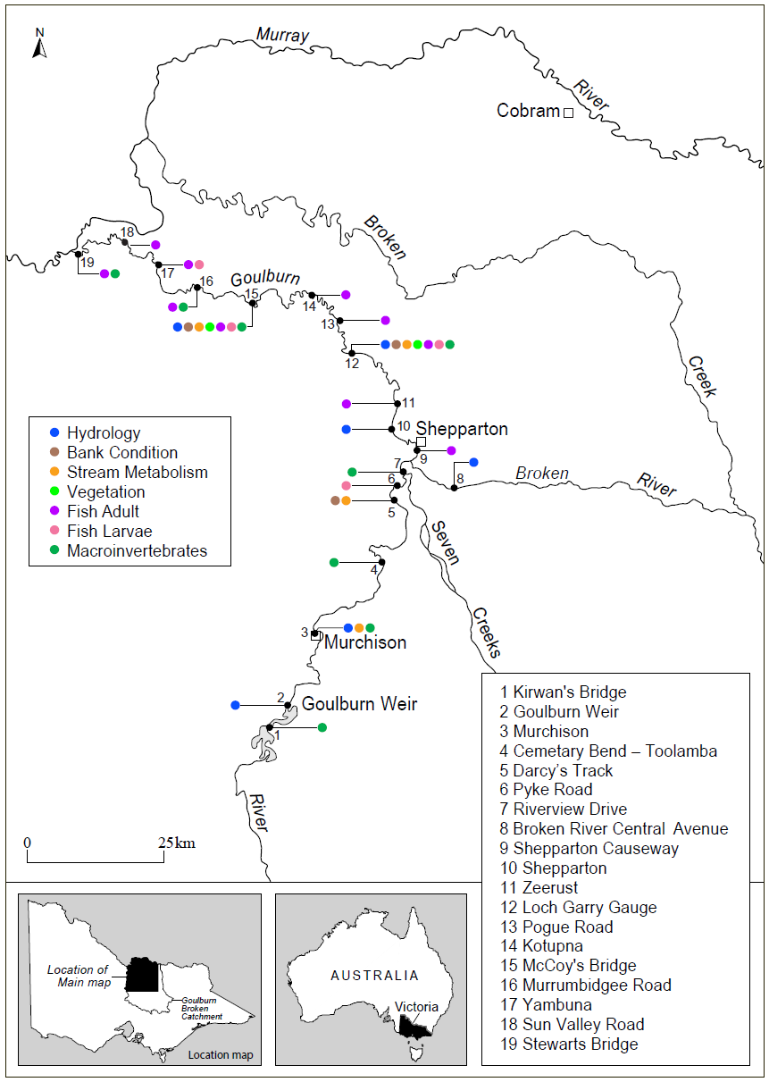
Figure 2-1 Map of the lower Goulburn River, with all monitoring sites marked, along with flow gauges used to generate flow data to be used in the MER Program. Some sites extend into the Broken River. Colours denote different monitoring activities, with some sites being used for multiple activities. Sites are indicated with site numbers, with the key providing the site name. Monitoring Zone 1 runs from Goulburn Weir to the confluence of the Broken River near Shepparton, with Zone 2 downstream from this point to the confluence with the Murray River.

Table 2-1 Goulburn MER monitoring sites in each zone and the monitoring activities undertaken at each site.
Site No. | Site Name |  | Adult Fish | Larval fish | Bank Condition | Turf mats* | Vegetation diversity | Stream metabolism | Macro-invertebrates
 |  | Zone 1 – Goulburn Weir to Broken River
2 | Goulburn Weir
3 | Salas Rd, Murchison
4 | Toolamba/Cemetery Bend
5 | Darcy’s Track
6 | Pyke Road
7 | Riverview Drive
 |  | Zone 2 – Broken River to Murray River
9 | Shepparton Causeway
10 | Shepparton
11 | Zeerust
12 | Loch Garry Gauge
13 | Pogue Road
14 | Kotpuna
15 | McCoy’s Bridge
16 | Murrumbidgee Road
17 | Yambuna
18 | Sun Valley Road
19 | Stewarts Bridge
 |  | Outside of zones 1 & 2
1 | Kirwans Bridge, Goulburn River
8 | Central Avenue, Broken River
* Note: Contingency monitoring

Monitoring in 2019-20
Monitoring in 2019-20 proceeded in line with the original MER plan (Webb et al. 2019b), but with some modifications to account for natural flood events and restrictions associated with COVID-19 requirements (Table 2-2). Core monitoring activities took place according to plan except for adult fish surveys that were originally scheduled for May 2020 but were delayed until June 2020 because of high flows in May due to significant rainfall in the catchment. Detailed discussions of monitoring activities, how they differed from planned activities, results and discussion, are presented separately for each discipline in the following chapters.
A feature of the 2019-20 monitoring was the continuation of turf mat monitoring for sediment deposition rates and seed growth. Turf mat monitoring was introduced in the 5th year of the Goulburn LTIM (2018-19) and is continuing under the MER as a Contingency Monitoring activity. After two successful deployments and retrievals, mats were deployed in October 2019 but were subsequently unable to be collected due to COVID-19 restriction on access to processing facilities. Mats have remained in place and will be collected once stage 4 COVID-19 restriction and flow conditions allow. More detail on turf mat monitoring is provide in Section 9.1.
Table 2-2 Schedule of planned and actual monitoring activities by month for 2019-20.
Monitoring activity | No of sites per Zone |  | Planned / Actual | Schedule of planned and actual activities in 2019-20
Monitoring activity | Zone 1 | Zone 2 | Planned / Actual | J | A | S | O | N | D | J | F | M | A | M | J
Core monitoring
Adult Fish |  | 10 | Planned |  |  |  |  |  |  |  |  |  | ✓ | ✓
Adult Fish |  | 10 | Actual |  |  |  |  |  |  |  |  |  |  | ✓ | ✓
Fish Larvae | 1 | 3 | Planned |  |  |  | ✓ | ✓ | ✓
Fish Larvae | 1 | 3 | Actual |  |  |  | ✓ | ✓ | ✓
Vegetation Diversity |  | 2 | Planned |  |  | ✓ |  | ✓ |  |  |  | ✓
Vegetation Diversity |  | 2 | Actual |  |  | ✓ |  | ✓ |  |  |  | ✓
Crustacean biomass (RESS) and bait traps | 3* | 4 | Planned |  |  | ✓ |  | ✓ |  | ✓ | ✓ | ✓
Crustacean biomass (RESS) and bait traps | 3* | 4 | Actual |  |  | ✓ |  |  | ✓ | ✓ | ✓ | ✓
Stream Metabolism | 2 | 2 | Planned | ✓ | ✓ | ✓ | ✓ | ✓ | ✓ | ✓ | ✓ | ✓ | ✓ | ✓ | ✓
Stream Metabolism | 2 | 2 | Actual | ✓ | ✓ | ✓ | ✓ | ✓ | ✓ | ✓ | ✓ | ✓ | ✓ | ✓ | ✓
Bank Condition | 2 | 2 | Planned |  |  | ✓ | ✓ |  |  |  |  | ✓ | ✓
Bank Condition | 2 | 2 | Actual |  |  | ✓ | ✓ |  |  |  |  | ✓ | ✓
Contingency monitoring
Turf mats: sediment and seed deposition | 1 | 2 | Planned | ✓ |  |  | ✓ |  | ✓ |  |  | ✓ |  |  | ✓
Turf mats: sediment and seed deposition | 1 | 2 | Actual | ✓ |  | ✓ |  | ✓ |  |  |  | - |  |  | -
* + 1 site u/s of Goulburn Weir and 1 site in the Broken River

Commonwealth Environmental Watering

Overview of Commonwealth environmental watering
As of 30 September 2019, the Commonwealth held 360 GL of environmental water entitlements in the Goulburn River (http://www.environment.gov.au/water/cewo/about/water-holdings and see Table 3-1). The Goulburn River receives other environmental flows including from the Victorian Environmental Water Holder and The Living Murray program, but the Commonwealth environmental water entitlement provides most of the environmental water used to meet specific environmental flow objectives in the lower Goulburn River channel. Inter-Valley Transfers have also previously been used to meet environmental flow targets when possible. Commonwealth environmental water for the lower Goulburn is stored in Lake Eildon and delivered via Goulburn Weir. Throughout the year river flows are assessed to see how well they are meeting identified flow targets in the lower Goulburn River. If required, environmental water can be used to increase flow rate and duration to meet these targets.
Table 3-1 Commonwealth environmental water entitlements as at 30 September 2019.
Entitlement type | Registered entitlements (GL) | Long term average annual yield (GL)
Goulburn (high reliability) | 317.4 | 300.5
Goulburn (low reliability) | 42.5 | 19.3

Environmental water delivered in 2019-20
High priority watering actions planned for 2019–20 in Reaches 4 and 5 included: continuous baseflows throughout the year to support habitat; winter variable baseflows; and freshes in winter, spring and autumn primarily to support bank vegetation (CEWO 2018, GBCMA 2019).
During 2019–20 around 369 GL of environmental water was delivered in the lower Goulburn River; the CEWO contributed 305.9 GL to this total (CEWO 2020) (Figure 3-1). Interim operating arrangements introduced by the Victorian Water Minister limited IVT delivery volumes to around 50 GL/month over the 2019-20 summer, a substantial reduction on the previous two summers. Total IVT flows of 162 GL were released, compared to the 387 delivered in 2018-19 and 258 GL in 2017–18, but still above IVT deliveries in earlier years of the LTIM Project. The IVTs completely prevented the delivery of environmental water over the period between October and March, but were released in a pulsed way to reduce the amount of damage caused to lower banks and riparian vegetation (VEWH 2020). Unregulated high flow events in autumn and winter provided greater than normal flow volumes in the lower Goulburn River over the period April-June. Environmental water was used to slow recession peaks for two of these events (Figure 3-1).
The planned delivery for environmental water in 2019-20 is summarised in Table 3-2 Summary of planned and actual environmental flows for the lower Goulburn River 2019–20. Information on planned delivery and expected outcomes from CEWO (2018) and GBCMA (2019), which also outlines the actual delivery and the conditions that influenced use decisions during the year. Appendix A provides a detailed breakdown of volumes used to deliver each planned event.

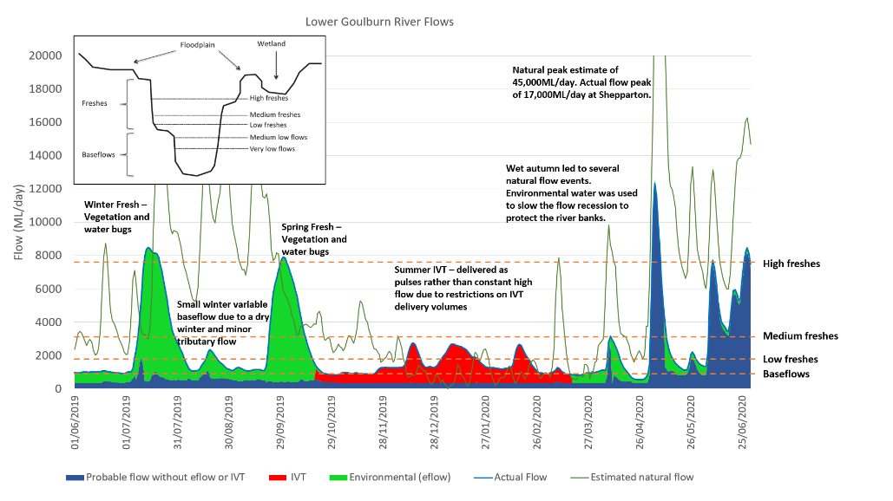
Figure 3-1 Relative sources of water contributing to total Goulburn River flows in 2019-20 at McCoy’s Bridge (https://fchMcCoy’s.hydronet.com/).
Table 3-2 Summary of planned and actual environmental flows for the lower Goulburn River 2019–20. Information on planned delivery and expected outcomes from CEWO (2018) and GBCMA (2019) Information on actual delivery provided by CEWO (2020). More details on specific volumes delivered from various sources is provided in Appendix A.
Flow component type and planned magnitude, duration, timing | Expected outcomes  (primary and secondary as at delivery) | Actual delivery details and any operational issues that may have affected expected outcomes  Comments
Winter fresh (Jun-Jul) of up to 15,000* ML/day at Murchison/McCoy’s with 14 days above 6,600 ML/day. | Contribute to a winter fresh: remove terrestrial vegetation and re-establish flood tolerant native vegetation, inundate benches to encourage plant germination, provide carbon (e.g. leaf litter) to the channel, and improve water quality and waterbug habitat. | Following baseflows finishing in the 2018/19 watering year the winter fresh started environmental water deliveries in 2019/20. Flows peaked at 9,549 ML/day at Murchison and 8,503 ML/day at McCoy’s Bridge and returned to baseflows in the first week of August 2019.  At both locations there were 12 days over the target of 6,600 ML/day.
Winter/spring variable low flows (July–Oct between the end of the winter fresh and the start of the spring fresh - between 800–2000 ML/day. | Contribute to variable baseflows: to increase sediment and seed deposition on banks and benches, support dispersal of native vegetation, and support nutrient cycling. | Following the trial of variable base flows in 2018-19, this approach was implemented again in 2019-20.  Environmental water was used to deliver baseflows following the winter period at a variable rate between 830 and 2,000 ML/day as planned. Due to dryer conditions, baseflow averaged around 1,000 ML/day at McCoy’s Bridge over August and September 2019 with one small fresh of approximately 2,000 ML/day at Murchison and 2,350 ML/day at McCoy’s Bridge at the end of August 2019.
Spring fresh (Aug-Sept) >6,000 ML/day for 14 days.  And When Possible  (Nov-Dec), up to 10,000 ML/day for 2 days to stimulate golden perch spawning. | Contribute to long-duration freshes in spring: to inundate vegetation on benches and the lower banks to facilitate recruitment, sustain growth, and encourage flowering, seed development and distribution.  Stimulate golden perch spawning if also delivered in Nov-Dec. | Due to ongoing dry conditions a single fresh was delivered mid-spring, rather than an early and late spring fresh as planned. This delivery was too early to trigger golden perch spawning, and this was not an expected outcome of the watering action.  The event started in late September 2019, peaked at around 8,000 ML/day and lasted for one month (14 days >6,000 ML/d). The fresh contributed to a co-ordinated Mid-Murray spring fresh and lower lakes objectives.
Spring/summer low flow after a spring fresh <1000 ML/day for 5–6 weeks. | Contribute to flows <1000 ML/day for 5–6 weeks: to allow newly grown plants to establish, provide bank stability, and provide habitat for small-bodied fish and waterbugs. | IVT demand was expected to be high across summer, so base flows were delivered ahead of this to achieve vegetation outcomes.  Flows below 1,000 ML/day were maintained for almost 5 weeks before commencing to rise with increased IVT demand over summer.
Summer/autumn low flows between pulses (especially relevant when intervalley transfer flows are expected to be high).  Flows are not to exceed 1000 ML/day for more than 20 consecutive days, with a minimum of 7 days between pulses. | Summer/autumn pulsed flows: to maintain vegetation for more than one season, to provide bank stability and to ensure habitat for small-bodied fish and waterbugs. | The summer/autumn period saw the introduction of an interim operating rule that limited IVT volumes to 50 GL a month. over summer and autumn 2019-20. This was achieved.  The target for flows of >1,000 ML/day for no more than 20 days was not met. Rather flows exceeded 1,000 ml/day for 99 consecutive days.  There were three pulses during this period with each peaking at 3,041, 2,870 and 2,907 respectively. The minimum of 7 days between pulses was exceeded, with flows averaging around 1,400 ml/day before the next pulse.  IVT delivery finished on 13 March 2020 at Murchison.
Summer/autumn fresh (Jan to Mar). Up to 4,600 ML/day for 10 days. | Contribute to summer autumn fresh: to stimulate the migration of juvenile native fish into the Goulburn River from the River Murray. | Conditions considered as precursors to the delivery of this flow did not eventuate during 2019–2020; i.e. suitable flow conditions in the Murray and the presence of juvenile native fish downstream. The flow action was not delivered.
Autumn fresh (Mar to April) of 6,000 ML/day at Murchison / McCoy’s for 2 days | Contribute to an autumn fresh: to encourage seed germination, reduce turbidity and mix water to improve water quality, flush fine sediment to encourage biofilm growth, and improve food and habitat for waterbugs. | With high IVT flows over most of the 2019/20 summer, and limited environmental water availability, this planned flow event was not needed.
Baseflow (April-Jun) 500–940 ML/day at Murchison / McCoy’s | Contribute to baseflows: to maintain water quality and provide suitable habitat and food resources for native fish and macroinvertebrate and to water bank vegetation. | With the completion of IVT, it was planned to continue to deliver low flows until the end of June 2020.  Low flows were delivered for 22 days from Murchison with an average flow of 992 ML/day during this period.  At McCoy’s Bridge low flows were maintained for 20 days with an average flow of 960 ML/day  Wet conditions from May onwards lead to multiple natural freshes between 3,100 and 12,350 ML/day at McCoy’s Bridge (see Figure 3-1 and below).  At the onset of unregulated conditions in the lower Goulburn, environmental water delivered in Reach 1 of the Mid-Goulburn flowed through to be available in the Murray.
Following natural flows | Provide water for a slower recession or add pulses following natural cues/unregulated flows to minimise the risk of bank erosion and hypoxic blackwater. | Environmental water was used to slow the rate of fall for two natural events in April and May 2020. With notching and bank erosion caused by IVT delivery these events were critical to protect form mass failure (slumping) that may have occurred due to rapid drops in river flow as GMW diverted water at Goulburn Weir.
*Note: the peak flow achievable with environmental water under current operating constraints is approximately 9,500 ML/d in the lower Goulburn. The full target flow of 15,000 ML/d can however be met with unregulated tributary inflows.

Physical habitat

Introduction
Bank condition is explicitly linked to Commonwealth Environmental Water (CEW) delivery and other variable flows. The risk to plants and animals from changes in bank morphology and sediment liberated from erosion make bank condition an important, and explanatory variable for assessing the value of these water delivery patterns for achieving ecosystem objectives.
Riverbanks influence the velocity of flow, depth of water, and provide the sediment conditions for a range of plants and animals (biota). Riverbank condition can alter conditions for biota, and this is often related to the extent of bank activity and river flow. For example, appropriate levels of erosion provide niches for vegetation establishment, yet, excessive erosion can lead to sediment smothering of bed habitat (as well as concerns for riparian infrastructure such as bridges and property).
Riverbank vegetation richness and diversity are also impacted by flows, including due to flow characteristics such as prolonged inundation, high velocities, and smothering. These vegetation changes can be independent of bank condition, or inextricably linked. There are considerable advantages to monitoring bank condition in concert with riverbank vegetation condition.
Quantifying the relationship between CEW and bank condition can assist with identifying critical flow ranges to support specific aquatic biota and ecological processes, vegetation density and resilience and the long-term condition of channel physical form.
Physical habitat monitoring, including hydraulic habitat (hydraulic modelling) and bank condition monitoring (including erosion pins) has been undertaken as part of the Goulburn River LTIM Project over the past 5 years. This is continuing for the Goulburn MER Program but with a change in some approaches, including using Unmanned Aerial Vehicle (UAV) technology and photogrammetry methods to generate Digital Elevation Models of Difference (DEMODs). These are produced by comparing two 3D models of bank condition at two different points in time. The output of these models enables highly accurate (<1 cm³) volume change analysis and the visual interpretation of patterns of erosion and deposition on the river bank.

Area specific evaluation questions
The key basin and area-scale evaluation questions and relevant indicators for physical habitat are listed in Table 4-1.
Table 4-1 Physical habitat key evaluation questions for the Goulburn selected area and associated indicators and evaluation approaches.
Key Evaluation Questions | Indicator | Evaluation Approaches
Basin Scale evaluation Questions
There are no basin-scale evaluation questions for physical habitat
Area-Specific evaluation questions
How do CEWH environmental/variable flows contribute to sustaining bank condition? | - Increased volumes of deposition at a bank level across the system  - Visual evidence of repair to historic damage due to sediment deposition | - Volume change analysis and visual interpretation of change using DEMOD outputs from drone surveys
Are CEWH environmental/variable flows adversely impacting the banks of the rivers? | - High erosion volume to lower bank zones  - Indication of notching and mass-failure (wide-spread bank erosion/slumping) events | - Volume change analysis and visual interpretation of change using DEMOD outputs from drone surveys
How do timing and delivery of CEWH environmental/variable flows affect bank condition of rivers? | - Increased erosion/deposition in response to particular rates of rise and fall.  - Increased erosion/deposition in response to flow delivery following different events of interest | - Volume and expression of change analysis on flows using different rates of rise and fall and in different sequences of delivery
What timing and delivery of CEWH environmental/variable flows best sustain or improve bank condition for vegetation growth? | - Increased/decreased vegetation cover following particular flow events  - Increased/decreased density/health of existing vegetation  - Increased/decreased bank steepness following flow events | - Volume and expression of change analysis on particular bank zones, considering bank profile and revegetation potential following flow events
How do vegetation responses to CEWH environmental/variable flows vary between sites with different channel features and different bank condition? | - Increased/decreased vegetation cover on benches and bars  - Increased/decreased vegetation cover on outside banks/inside banks  - Increased/decreased vegetation cover on steep/gentle banks | - Vegetation cover analysis on different banks throughout the system
Are bank erosion rates and processes impacting macroinvertebrate communities? | - Increased/decreased macroinvertebrate volumes in response to banks experiencing net a) erosion b) deposition | - Macroinvertebrate sampling in close proximity to different bank types

Main findings from monitoring program
The following sections provides a high-level summary of the outcomes of the 2019-20 monitoring and the implications of these findings to previous years outcomes.

2019/20 findings
- In the majority of cases increased bank erosion correlated with increased inundation duration. However, the pattern of a flow delivery (regarding the sequence of daily discharge volumes) is arguably a more critical factor when considering long-term bank condition. The Spring Fresh for example had similar total erosion rates to the IVT Period, however, the erosion evident in response to the latter was located in more defined zones (vertically) across the bank, was deeper (+5 cm on average), more consistent laterally, and ultimately lead to the steepening of the lower bank and in some cases the development of notching.
- Current environmental flow management approaches in the Goulburn River cause minor erosion. However, this erosion is expressed more evenly (vertically) across the bank, and with respect to the Spring Fresh, primarily on the upper half of the bank (correlating to flows above 3,000 ML/d) and at depths of less than 3 cm on average.
- Deposition volume did not correspond directly with inundation duration and appears more closely related to a) bank erosion apparent on zones directly above areas of deposition (particularly during the IVT flow period as erosion is deeper and more defined), b) seasonal variables (such as % of tributary flow contribution and sediment input resulting from rain events etc. (particularly apparent for the Recession flow in Autumn), and c) the vegetation cover at a bank level. The latter was particularly apparent when assessing results at several inside banks at Darcy’s Track and Loch Garry.
- Although IVT flows resulted in extensive areas (laterally) of deep, defined erosion, there was no evidence of mass-failure events as identified in the 2018/19 year. Erosion was deep (up to 10 cm) and in some cases there was evidence of the formation of notching at bank zones corresponding to the upper quartile of IVT deliveries (2,000-3,000 ML/d). This was more apparent on inside banks where vegetation had receded over the years. Erosion to outside banks was expressed with more vertical variability in zones correlating to flows.
- Sequencing of flow events played a key role at some banks. Clearly in some cases, deposition from previous events increased the erosion recorded at the following events. Additionally, the stress put on banks during the prolonged IVT period arguably enhanced the erosion volumes recorded from the final Recession flow event.
- The benefits of environmental flows may be offset by operational flows such as the IVT. The impact of the IVT on riverbanks in 2019-20 was evident. Retreat of the lower bank occurred during prolonged high flows in summer and autumn. This is evident from monitoring and the evidence of erosion to lower bank section
- Considerations for flow management (as noted in MER 2018/19 report) should include:
  - Maintaining variability in flows and water levels to maintain bank wetting at varying levels to avoid bank ‘notching’. It was confirmed that notching occurred during the IVT flows, including lower bank recession
  - Maintain ‘piggy backing’ on tributary inflows to draw upon sediment and seed supplies from tributaries. The role of tributary flows needs further analysis, but it is clear that increases in tributary percentage of flow lead to greater volumes of deposition (the data from 2019-20 supports data from 2018-19)
  - Manage maximum rates of flow recession within current levels to avoid bank surcharging and erosion, and to allow mud drapes to develop, as per current operational levels. Mud drapes on banks have been associated with vegetation growth.
  - Continue the modification of flow management as a collaborative effort between researchers and water managers.

Summary of previous findings and implications for any new finding
Previous findings:
- Peak magnitude and total flow volume are not significantly related to riverbank erosion. It can therefore be inferred that the dominant erosion mechanism is not related to high velocities but the influence of inundation on the bank and the process of sub-aerial preparation during summer irrigation months.
- The lack of correlation between seasons and erosion (>30 mm) suggest that processes occurring during summer/autumn months are preparing river banks for mass-failure events in response to later large flow events in autumn/winter months. This would occur as bank wetting from larger events is drawn down, leaving a saturated and unsupported bank above notching present in lower bank zones.
- Deposition was not linked to peak flow events and rather was determined by the sediment associated with the source of flows delivered (storage versus tributary in-flows).
Implications for new findings:
- All of these findings were supported in the data collected from the 2019-20 program, the only major difference was the reduction of evident mass-failure events recorded during the monitoring period.
- The additional data collected as a result of the drone surveys has allowed a greater understanding of processes occurring at a bank level driven by flows. The results have highlighted that although the summer irrigation flows resulted in minor notching, which is preparing banks for future mass-failure events, the more variable IVT deliveries helped to reduce the severity of this notching.
- The additional data allowed the clarification that larger environmental flows, if delivered with the rate of the receding limb in mind, can help to repair the damage done in the lower bank zones by flows >3,000 and >5,000 ML/d. This was particularly apparent at McCoy’s Bridge.
- Evidence from the monitoring of the IVT period from 2019-20 support the conclusion that changes to flow delivery, from a pattern of low variability (2018/19) to higher variability in the form of pulsing (2019/20), resulted in less notching and eventual mass-failure events

Summary of findings relevant to evaluation questions
Error! Reference source not found. provides a summary of the physical habitat findings relevant to the evaluation questions. A more detailed examination of each evaluation question is provided in section 4.5.
Question | Were appropriate flows provided? | Effect of environmental flows | What information was the evaluation based on?
How do CEWH environmental/variable flows contribute to sustaining (or adversely impacting) bank condition? | Spring freshes were appropriate but a longer duration for the Recession flow in April was needed to reduce the impact of the falling limb of this event on bank condition | Spring freshes resulted in an acceptable amount of erosion and deposition a wide area of the vertical bank zone. Erosion to the upper bank zone is natural and helps to reset erosion (and notching) in the lower bank zone caused by irrigation flows.  However, the April Recession flow lead to increased erosion due to its sequential position (directly after the IVT period). | Visual expressions of change through DEMODs  Volume metric change outputs
How do timing and delivery of CEWH environmental/variable flows affect bank condition of rivers? | The Recession Flow, which followed the IVT flow period, could have been increased to peak above 3,000 ML/d rather than mirroring the IVT flows of the summer months | As mentioned above, the Recession flows lead to increased erosion (due to the preparation from the IVT flow period), but also more deposition arguably due to increased tributary flow contribution | Visual expressions of change through DEMODs  Volume metric change outputs
What timing and delivery of CEWH environmental/variable flows best sustain or improve bank condition for vegetation growth? | To support vegetation growth flows should be delivered prior to, during and after the prolonged summer irrigation period | Prolonged inundation to the lower-mid bank during the IVT flow period is detrimental to vegetation growth during the hot dry months. The Spring Fresh was well timed to aid vegetation health prior to summer IVT period. | Visual expressions of change through DEMODs  Volume metric change outputs  On-ground observations during field visits
How do vegetation responses to CEWH environmental/variable flows vary between sites with different channel features and different bank condition? | NA | Inside banks collect more sediment due to reduced fluvial stresses and increased deposition. Areas of bank with existing vegetation have more resilience to the stresses of flow and conversely bare banks have less resilience. This highlights the positive feedback loop between vegetation cover and condition | Visual expressions of change through DEMODs  Volume metric change outputs  On-ground observations during field visits

Monitoring methods and analytical techniques
Outcomes of environmental water use were based on periodic monitoring and the resulting quantitative data combined with observations in the field and historic research and findings from past projects on the Goulburn.
Bank erosion was assessed in the LTIM Project using erosion pins and measurements of erosion and deposition. In 2019-20 the method has been updated to use an Unmanned Aerial Vehicle (UAV). Specifically, UAV flights are made before and after a flow event to create a Digital Elevation Model of Difference (DEMOD), which is the comparison of two 3D models of the same bank, before and after a flow event. The output of this method is far superior to the erosion pins method used previously, as it a) enables highly precise (<1 cm³) volume metric change analysis for the entire bank section being surveyed, and b) provides a visualisation of the change occurring on banks, therefore allowing the analysis of the geomorphic processes contributing to erosion and deposition in response to flow events.
The infographic below in Figure 4-1 provides an overview of the methodology used to monitor bank condition in response to hydrological events delivered within the Goulburn system during the last 12 months. For a more detailed description of these methods refer to the DEWLP IVT Monitoring report 2019/20 (Streamology et al. 2020).
Sites surveyed were Darcy’s Track, Loch Garry and McCoy’s Bridge (Figure 2-1).
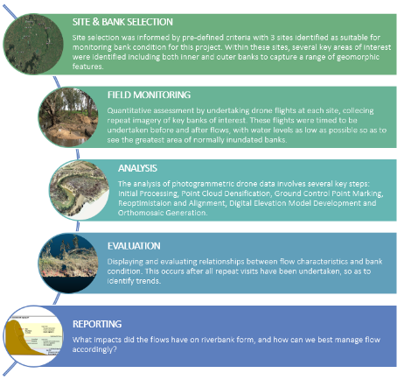
Figure 4-1 Infographic providing an over-view of the methodology applied to bank and vegetation condition analysis using UAV technology (Streamology et al. 2020).

Results
Bank condition was assessed by looking at change (erosion & deposition (cm³/m²)) in response to the three flow events captured throughout the 2019-2020 monitoring period (Figure 4-2.
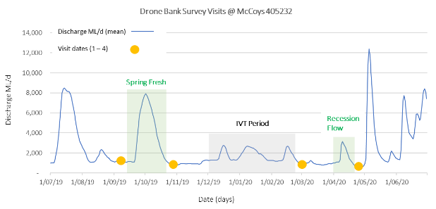
Figure 4-2 Bank survey visits during the monitoring period in relation to daily mean discharge at McCoy’s Bridge (405232).

Initial hypothesis linked to hydrology
We hypothesized that bank condition changes would correlate directly with the hydrology experienced during each monitoring period. Previous results have shown that inundation duration corresponds with extent of erosion and deposition.
The major differences between the flow deliveries across the monitoring period were that the Spring Fresh (between v1 – v2) resulted in the widest range of flow (1,200 – 8,000 ML/d) and was the only delivery that spent time above 3,200 ML/d (Table 4-2). Almost half (43%) of the total days experienced flows greater than 3,200 ML/d. Conversely, the IVT and the Recession flow periods were < 3,200 ML/d for 100% of the time. The major difference between these two events was the duration, with the IVT period delivering 22 days between 2,200-3,200 ML/d versus 6 days respectively for the Recession Flow period.
Table 4-3 summarises the hypotheses with regard to bank condition change with hydrology.
Table 4-2 Flow event monitored and corresponding flow packets (ML/d) with duration (days).
Monitoring Window and corresponding flow event | Days 1,200 (ML/d) / total days | Flow Categories (1,000-2,000 ML/d) and duration (days)
Spring Fresh (v1 – v2) | 31/49 (63%) | 1,200-3,200 (10 days), 3,200-5,200 (6 days), 5,200-7,200 (9 days), 7,200-8,200 (6 days)  43% above 3,200 (21/49 days)
IVT Period (v2 – v3) | 89/127 (70%) | 1,200 – 2,200 (67 days), 2,200 - 3,200 (22 days)
Recession Flow (v3 – v4) | 13/46 (28%) | 1,200 – 2,200 (7 days), 2,200 – 3,200 (6 days)

Table 4-3 Hypothesis relating to hydrology summarised.
Monitoring Window and corresponding flow event | Hypothesis
Spring Fresh (v1 – v2) | Max flow event will result in the 2nd largest volume of erosion, and the largest volume of deposition.  Change expressed in a large vertical range across the bank
IVT Period (v2 – v3) | Longest total flow duration (89 days) with 22 days duration between 2,200-3,200 ML/d. Where historic notching in the system is present, this will result in the largest volume of erosion and low deposition (due to cyclical nature of delivery)
Recession Flow (v3 – v4) | Short flow period with medium diversity resulting in the lowest volume of change, however potential for more deposition than the IVT period due to the source of delivery

Inundation linked to probability of erosion/deposition (all combined data)
There is a strong effect of inundation duration on erosion (both severe and minor) and deposition at Darcy’s Track and Loch Garry (Table 4-4 and Figure 4-3). For these sites, increased duration of inundation clearly increases the probability of both erosion and deposition, in agreement with the previous erosion pin-based analyses from the LTIM Project. The results for McCoy’s Bridge are less clear, even showing a negative effect of inundation duration on severe erosion.

Table 4-4 95% credible intervals of regression coefficients (eff_inund) for three erosion levels at the three sites. Credible intervals that do not intersect zero are printed in blue and should be considered as ‘significant’ effects.
Bank activity | Darcy |  |  | Loch |  |  | McCoy
Bank activity | 2.50% | 50% | 97.50% | 2.50% | 50% | 97.50% | 2.50% | 50% | 97.50%
Significant erosion  (> 30 mm) | 0.28 | 0.53 | 0.78 | 0.33 | 0.49 | 0.66 | -0.58 | -0.36 | -0.15
Erosion  (> 0 mm) | 0.74 | 0.9 | 1.06 | 0.42 | 0.55 | 0.69 | -0.07 | 0.04 | 0.15
Deposition (< 0 mm) | -1.05 | -0.9 | -0.75 | -0.69 | -0.55 | -0.42 | -0.15 | -0.04 | 0.08
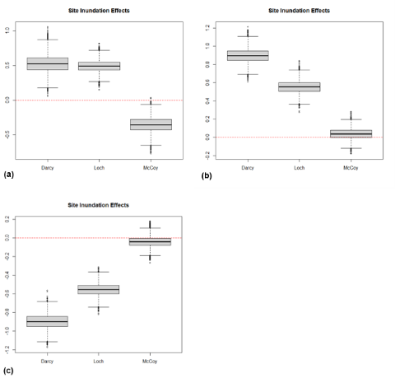
Figure 4-3 Site inundation effects on the probability of erosion. (a) significant erosion: >30 mm; (b) erosion: >0 mm; (c) deposition: <0 mm. For each erosion level, results are shown for three sites (Darcy’s Track, Loch Garry, and McCoy’s Bridge).
The results, mainly (ignoring McCoy’s Bridge, which did not demonstrate as strong an outcome) are in agreement with our hypothesis that the prolonged inundation experienced throughout the IVT period would result in the largest amount of erosion. However, to understand the impact this erosion is having on the physical form of riverbanks within the system, the location of this change must be considered. The more defined the area of erosion vertically along the bank, the higher the chance of detrimental impact to the physical form of the channel.

Inundation linked to probability of notching (all combined data)
Similar patterns are seen for the notching analysis results as compared to the overall inundation, particularly at Loch Garry, and Darcy’s Track for erosion >30 mm (Table 4-5 and Figure 4-4). It is noticeable that the clearest results emerge for severe erosion of >30 mm, which is the type of erosion usually indicative of notching. Results for McCoy’s Bridge are again equivocal for the notching analysis.
Table 4-5 95% credible intervals of regression coefficients (eff_inund) for three erosion levels of notching in three sites. Credible intervals that do not intersect zero are printed in blue and should be considered as ‘significant’ effects.
Bank activity | Darcy |  |  | Loch |  |  | McCoy
Bank activity | 2.50% | 50% | 97.50% | 2.50% | 50% | 97.50% | 2.50% | 50% | 97.50%
Significant erosion  (>30 mm) | 0.03 | 0.22 | 0.39 | 0.3 | 0.42 | 0.55 | -0.33 | -0.1 | 0.1
Erosion  (>0 mm) | -0.17 | -0.03 | 0.1 | 0.54 | 0.7 | 0.86 | -0.07 | 0.04 | 0.15
Deposition (<0 mm) | -0.11 | 0.03 | 0.16 | -0.86 | -0.69 | -0.55 | -0.15 | -0.04 | 0.06
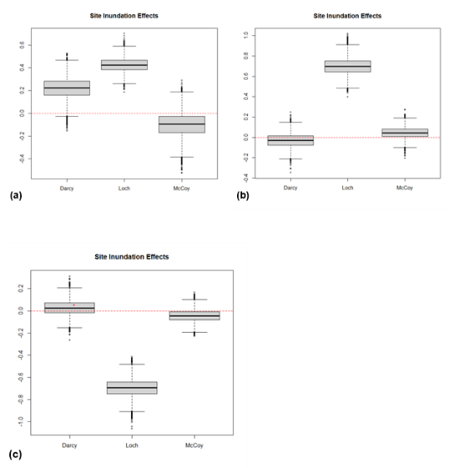
Figure 4-4 Site inundation effects on the probability of notching. (a) significant erosion: >30 mm; (b) erosion: >0 mm; (c) deposition: <0 mm. For each erosion level, results are shown for three sites (Darcy’s Track, Loch Garry, and McCoy’s Bridge).
As with previous data relating to general bank erosion, the probability of >30 mm notching (a) corresponds directly with inundation duration at Loch Garry and Darcy’s Track. McCoy’s Bridge, in both cases, is the outlier. To understand why this is, variables such as flow events and bank characteristics will be considered.

Volume change by flow event (bank specific data)
To accurately compare the bank condition responses to different flow events, the following results focus on volume and the pattern of change across the same banks across the monitoring period consisting of the 3 flow events.
Table 4-6 shows all data with reference to the corresponding flow event captured, the site, bank and volume change in cm³/m². It’s evident that not all banks have data for each flow event, this is due to technical/environmental limitations where some banks were not surveyed during certain visits or there were issues with post-processing of data.

Table 4-6 Volume change (cm³/m² of erosion, deposition and net change) by bank and flow event.
Flow Event | Site/Bank | Erosion (-)  (cm³/m²) | Deposition (+)  (cm³/m²) | Net Change  (cm³/m²) | Comments
Spring F | McCoy’s C | - 0.83 | 0.47 | - 0.37 | Low erosion volume for Spring F
Spring F | McCoy’s D | - 0.78 | 0.28 | - 0.49
Spring F | Loch Garry C | - 1.14 | 0.43 | - 0.72
Spring F | Loch Garry B | - 1.17 | 0.26 | - 0.91
Spring F | Darcy’s Track B | - 1.54 | 0.03 | - 1.51
Spring F | Darcy’s Track D | - 1.34 | 0.13 | - 1.21 | High net erosion for Spring F
IVT | McCoy’s C | - 0.72 | 1.40 | 0.67 | Low erosion high deposition for IVT
IVT | Loch Garry C | - 1.48 | 0.33 | -1.15
Recession Flow | McCoy’s C | - 1.45 | 0.39 | - 1.06 | High erosion for Recession F
Recession Flow | Loch Garry C | - 1.07 | 1.50 | 0.43 | High deposition for Recession F
Recession Flow | Darcy’s Track B | - 0.95 | 0.57 | - 0.38
IVT + Recession | McCoy’s D | -4.31 | 0.04 | -4.27 | Very high erosion for time period
IVT + Recession | Darcy’s Track D | -2.80 | 2.31 | -0.48 | High deposition

The following results section will focus on those banks that have consistent data across different monitoring periods to ensure that changes in response to different flow events are comparable. As such, the banks presented in Table 4-7 will primarily be used for bank condition response to flow events.
Table 4-7 Site/bank details with the corresponding flow events available for analysis based on surveys completed and DEMODs available.
Site/bank | Spring Fresh  (event 1) | IVT Period  (event 2) | Recession Flow (event 3) | Flow Events available for comparison
McCoy’s bank C | Y | Y | Y | All
Loch Garry bank C | Y | Y | Y | All
McCoy’s bank D | Y | N | Y | Spring Fresh, IVT + Recession
Darcy’s bank D | Y | N | Y | Spring Fresh, IVT + Recession

Figure 4-5 shows the volume change data for the banks detailed in Table 4-7. The left plot shows the combined average volume change in cm³/m² recorded at major outside banks at McCoy’s (bank C) and Loch Garry (Bank C). It’s evident that inundation duration does not fully align with erosion volume. Despite median erosion volumes being similar across each flow event, the Recession Flow period (event 3), which caused the fewest days of bank inundation, recorded the largest median erosion volume with strong alignment between the two banks. The variability in the volume change numbers across the IVT period is the largest of all events (regarding erosion and deposition and resulting net change). Also apparent is that the IVT and the Recession flow periods resulted in the highest deposition, both considerably higher than the Spring Fresh.
The plot on the right hand side (Figure 4-5) illustrates change in response to two (rather than 3) flow periods: Spring Fresh, and IVT and Recession Flow periods combined. It’s expected that there would be a clear correlation between inundation duration and erosion/deposition volume due to the clear difference in inundation days across each period (Spring Fresh 31 days, IVT + Recession flow period 102 days), this is overwhelmingly evident, particularly regarding erosion which shows +250% volume change when comparing the two periods. There is strong alignment between the two banks with regard to erosion change here, but less so when considering deposition.
Further analysis is needed to determine what is influencing these numbers to understand key drivers.

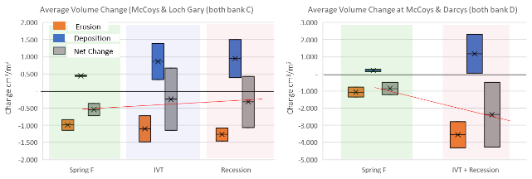
Figure 4-5 Box and Whisker Plot illustrating erosion, deposition and net volume change (cm³/m²) in response to each flow event.

Analysis of geomorphic processes relating to flow events
Digital Elevation Models of Difference (DEMODs) was used to assesses magnitude of erosion and deposition in response to freshes, IVT and recessions flows. Detailed analytical results are present in Appendix B and summarised below. Sites are from upstream to downstream (Darcy’s Track, Loch Garry and McCoy’s Bridge).
DEMOD analysis Spring Fresh & Recession Flow:
Summary of observations of Spring Fresh and Recession Flow
Spring Fresh:
- Erosion was the primary process with high diversity vertically across the bank face relating to flow in the range 1,100 – 8,000 ML/d. Erosion was laterally focussed on the bend apex where bank features experience the most hydrologic stress (for outside banks) and more evenly across the bank face (for inside banks). Erosion is expressed in patches and primarily as low to medium in depth (<3 cm - <5 cm).
- Deposition was variable vertically across banks and was primarily expressed in areas with increased roughness (roots or vegetation). For outside banks, deposits were more apparent in areas that received lower hydrologic stress (upstream of downstream of the bend apex). For inside banks deposition was primarily in areas responding to erosion above or with vegetation cover.
Recession Flow:
- Erosion was generally the primary process (with the exception of Loch Garry bank C), with medium variability across the vertical bank face (responding to lower flow in the range 1,100 – 3,000 ML/d) and was focussed around the bend apex where the majority of the hydrologic stress is exerted. Erosion was expressed in large patches, but primarily low in depth (<2 cm)
- Deposition, as with the Spring Fresh results, was located around areas of roughness, but with medium diversity vertically, and in some cases in higher volumes, due to changes in sediment inflows or seasonality factors.
Summary of observations in response to IVT period
IVT (McCoy’s bank C and Loch Garry bank C):
- Erosion was the primary process expressed in deep (up to 10 cm) defined lines, with low variability vertically across the bank face relating to IVT flows. This process was apparent laterally across the bank face, and in areas the development of notching is apparent. However, erosion effects at McCoy’s Bridge were masked by subsequent rainfall contributing to mud-draping post IVT flows.
- Ignoring rain-triggered mud-draping, deposition corresponded directly with areas of erosion and was a direct result of erosion within the bank or upstream. Deposition was also more apparent in areas of increased roughness.
IVT + Recession Flow:
- McCoy’s bank D showed consistent, deep (5-10 cm) erosion expressed as several lines of minor notching laterally across upper and lower sections of vertical bank corresponding to IVT flows and the following recession flow (which primarily sat between 2,000 – 3,000 ML/d). Deposition was not present in the model due to very low volumes of eroded sediment.
- Darcy’s Track bank D in contrast to McCoy’s bank D was balanced between processes of erosion and deposition. Both were expressed consistently across the lateral bank and consistently in depths between 5-10 cm. Erosion was located in the upper half of the bank in varying depths, but consistently deep, and resulted in deposited sediment in the zones directly beneath.

Discussion
    - Summary of 2019/20 results?
Table 4-8 provides a summary of outcomes associated with each event in relation to stated hypotheses. These are discussed more fully below.
The major driver of erosion in 2019-20 appears to be the influence of inundation on the bank and the process of sub-aerial preparation during summer irrigation months. When erosion does occur, it tends to occur across a large vertical range.
During IVT flows in 2019/20 there was evidence of notching but no evidence of mass-failure events. This could be due to the more variable irrigation delivery in 2019-20 compared to 2018-19. However, the results indicate that the processes occurring during summer/autumn IVT months are preparing the river banks for potential mass-failure events in response to later large flow events in autumn/winter months (e.g. recession events). Under these conditions, bank wetting from larger events is drawn down, leaving a saturated and unsupported bank above any notching present in lower bank zones.
Deposition was not linked to peak flow events and rather was determined by the sediment associated with the source of delivered flows and bank roughness or gradient (storage versus tributary in-flows). In 2019-20, areas of low vegetation cover showed signs of increased erosion in response to cyclical flow patterns and wetting/drying. In contrast, areas of higher vegetation cover appeared to resist erosion resulting from both wetting/drying and fluvial scour from larger events. Deposition was concentration around patches of vegetation highlighting the positive feedback loop between vegetation cover and bank resilience. Vegetation plays an important role in the resistance of banks to erosion. Sub-aerial preparation of banks (as a result of drying and cracking) is exacerbated when vegetation is not present to shade soils. In addition, root wads enhance structural integrity. Deposition is also enhanced by vegetation through increased roughness, encouraging further vegetation establishment.
Table 4-8 Response to initial hypotheses.
Flow event | Hypothesis | Supported or rejected
Spring Fresh (v1 – v2) | 1.Max flow event resulting in the 2nd largest volume of erosion, and the largest volume of deposition.  2.Change expressed in a large vertical range across the bank | 1. Rejected: it appears the Spring Fresh event resulted in the lowest volume of erosion when considering the anomaly at McCoy’s bank C. 1st IVT period, 2nd Recession  2. Supported: change was spread vertically across the banks
IVT Period (v2 – v3) | 2.Longest total flow duration (89 days) with 22 days duration between 2,200-3,200 ML/d. Where historic notching in the system is present, this will result in the largest volume of erosion and low deposition (due to cyclical nature of delivery) | 2.Partially supported: The IVT period appeared to result in the largest amount of erosion across most banks monitored, this was particularly evident when looking at main inside banks (D) at McCoy’s & Darcy’s Track  Deposition, however, was high due to high volumes of sediment deposited from erosion in bank sections above
Recession Flow (v3 – v4) | 3.Short flow period with medium diversity resulting in the lowest volume of change, however potential for more deposition than the IVT period due to the source of delivery | 3. Rejected: The Recession flow resulted in the 2nd largest volume of erosion and highest volume of deposition. This was arguably impacted by the sequential delivery of flow events throughout the flow period with deposited material from prior events leaded to increased erosion.

Response to evaluation questions:
The following section provides a summary of specific responses to evaluation questions.
How do CEWH environmental/variable flows contribute to sustaining bank condition?
Although the environmental flows monitored resulted in some areas of significant erosion (at some banks the highest across all events), this erosion was expressed with large vertical variability across banks, with primary areas located above the bank zone corresponding to 3,000 ML/d. Minor erosion to upper banks like this results in the resetting of steepening and in-filling of notches at the lower bank level and thus results in long term benefits to the physical form of the channel by stabilising the processes of notching and reducing future mass failure events.
The deposition recorded in response to environmental flows ranged from low to high (with the Spring Fresh contributing the least and the Recession flow the most). This is arguably due to a combination of a) the lack of defined erosion which can lead to deposition in the corresponding bank zone below, and b) the source of the water delivery with consideration of tributary flow contributions due to seasonality (rain and run-off etc.). Thus, the deposition-based benefits to bank condition are largely dependent on the source and timing of water delivery. Additionally, important is the extent of vegetation on the given bank, which determines a bank’s ability to secure and consolidate sediment during and after flow events.
Are CEWH environmental/variable flows adversely impacting the banks of the rivers? And, how do timing and delivery of CEWH environmental/variable flows affect bank condition of rivers?
In the case of the Recession flows, it appears there may be minor adverse impacts where existing notching is being aggravated. This was likely due to, a) the flow period’s sequencing (being directly after the IVT flow), b) the rapid rising and falling limb of the flow event, and c) the size of the delivery, which was very similar to the IVT flow events prior to it (all peaking around 3,000 ML/d). To minimise the adverse impacts of future environmental flows these factors should be considered.
What timing and delivery of CEWH environmental/variable flows best sustain or improve bank condition for vegetation growth?
Considering that Spring is the primary period for new vegetation growth, and that the most damage to bank condition generally occurs during the irrigation summer period, flows designed to repair areas of damage in lower steeper bank sections should be delivered in Summer (during the irrigation period), Autumn (after the irrigation period) and in Spring (prior to the irrigation period). These should vary in flow volume so as to spread the hydrological stress across greater vertical ranges and should be designed in consideration of the speed of the falling limb.
How do vegetation responses to CEWH environmental/variable flows vary between sites with different channel features and different bank condition?
Banks with a higher percentage of existing vegetation cover generally result in more stable bank conditions with lowest magnitudes of erosion in response to environmental flows, which in turn reinforces positive outcomes for vegetation. These tend to be more common on inside banks and sections of the reach with gentler bank slope, as this spreads the hydrological stresses from flow deliveries across more of the bank face. Banks where vegetation responds negatively to flow deliveries tend to be the apex of outer bends where stresses from fluvial scour are high and on inside bank sections where stresses from the cyclical rising/falling and corresponding wetting/drying appear to lead to the receding of existing vegetation.
Are bank erosion rates and processes impacting macroinvertebrate communities?
This is part of an ongoing project which we are waiting data on and is currently considered as knowledge gap.

Key takeaways and implications on future flow management
Environmental flows appear to lead to benefits regarding the long-term physical form of the channel, due to the vertical variability in erosion across the bank face. However, these positive responses were more evident in response to large flows of more than 5,000 ML/d (in this case the Spring Fresh) as these events reset processes of steepening and notching to lower banks caused by historic and current summer irrigation flows.
Flow sequence plays an important part in erosion response and thus bank condition cannot be assessed accurately through a single flow event; prior events must be considered. This is particularly true when considering the impact of flow events that follow summer irrigation periods (in this case the Recession flow). It is also apparent that flows that mimic the delivery of prior flow events (Recession flow in this case mimicked the IVT flows) can result in greater net erosion to the system.
Increased deposition directly corresponds to a) the source and timing of the water delivery (e.g. dam versus tributary delivered water percentage) and, b) the volume of vegetation apparent on the bank (more vegetation results in increased deposition and reduced erosion).
Ultimately, if these findings are considered during the design of future environmental flow deliveries, then the detrimental impact of delivering large flow events with rapid fall rates (as illustrated in Figure 4-6 can be minimised.
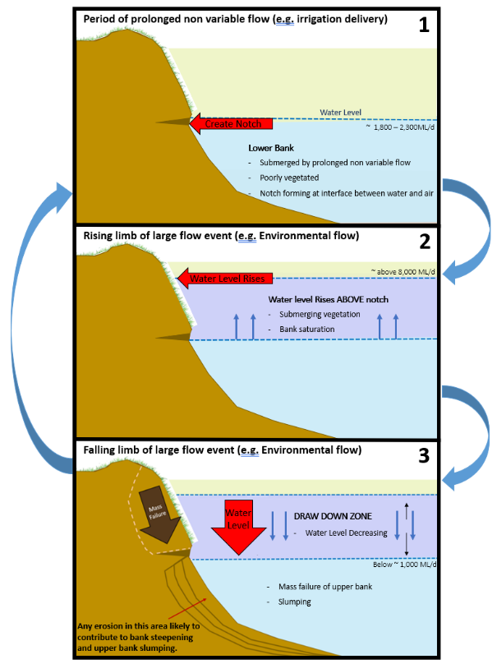
Figure 4-6 3 step process of notching resulting from sustained inundation period with limited variability.

Metabolism

Introduction
Whole stream metabolism measures the production and consumption of dissolved oxygen gas (DO) by the key ecological processes of photosynthesis and respiration (Odum 1956). Healthy aquatic ecosystems need both processes to generate new biomass (which becomes food for organisms higher up the food chain) and to break down plant and animal detritus to recycle nutrients to enable growth to occur. Hence metabolism assesses the energy base underpinning aquatic foodwebs (Figure 5-1).
Figure 5-1 Relationships between photosynthesis, respiration, organic matter, dissolved gases and nutrients.
Metabolism is expressed as the increase (photosynthesis) or decrease (respiration) of DO concentration over a given time frame; most commonly expressed as (change in) milligrams of dissolved oxygen per Litre per day (mg O₂/L/Day). Typical rates of primary production and ecosystem respiration range over two orders of magnitude, from around 0.2 to 20 mg O₂/L/Day with most measurements falling between 0.5 and 10 mg O₂/L/Day.
If process rates are too low, this will limit the amount of food resources (bacteria, algae and water plants) for consumers. This limitation will then constrain populations of larger organisms including fish and amphibians. Rates vary on a seasonal basis as warmer temperatures and more direct, and longer hours of, sunlight contribute to enhancing primary production. Warmer temperatures and a supply of organic carbon usually result in higher rates of ecosystem respiration (Roberts et al. 2007).
There is concern when process rates are too high. Greatly elevated primary production rates usually equate to algal bloom conditions (or excessive growth of plants, including duckweed and Azolla), which may block sunlight penetration, killing other submerged plants. Excessive production can also produce algal toxins and large diel DO swings. Overnight, elevated respiration rates can drive the DO to the point of anoxia (no dissolved oxygen in the water). Such conditions have been observed in several sites in the Goulburn River in previous years of the Long-Term Intervention Monitoring (LTIM) Project. When an algal bloom collapses, the large biomass of labile organic material is respired, often resulting in severe and extended anoxia. Very low (or no) DO in the water can result in fish kills and unpleasant odors. Bloom collapse often coincides with release of algal toxins; hence the water becomes unusable for stock and domestic purposes as well.
Sustainable rates of primary production will primarily depend on the characteristics of the aquatic ecosystem. Streams with naturally higher concentrations of nutrients (e.g. arising from the geology), especially those with very open canopies (and hence lots of sunlight on the water) will have much higher natural rates of primary production than forested streams, where rates might be extremely low due to heavy shading and low concentrations. Habitat availability, climate and many other factors also influence food web structure and function. Uehlinger (2000) demonstrated that freshes with sufficient stream power to cause scouring can ‘reset’ primary production to very low rates which are then maintained until biomass of primary producers is re-established.
Some, but not all, of the organic carbon created through gross primary production is respired within the first 24 hours. Such respiration is performed by the autotrophs (primary producers) themselves and closely associated heterotrophic communities. Although there is a large amount of variability in the proportion respired ‘immediately’, Hall Jr et al. (2013) estimate that on average 44% of new organic carbon created is respired before it can move into higher trophic levels.

Area specific evaluation questions
The key basin and area-scale evaluation questions and relevant indicators for metabolism are listed in Table 5-1.
Table 5-1 Metabolism key evaluation questions for the Goulburn selected area and associated indicators and evaluation approaches.
Key Evaluation Questions | Indicator | Evaluation Approaches
Basin Scale evaluation Questions
What did CEW contribute to patterns and rates of decomposition? | - Dissolved oxygen, light and water temperature measurements taken at 15-minute intervals every day over the year | - Estimation of Ecosystem Respiration using the BASEv2 Bayesian Model
What did CEW contribute to patterns and rates of primary productivity? | - Dissolved oxygen, light and water temperature measurements taken at 15-minute intervals every day over the year | - Estimation of Gross Primary Production using the BASEv2 Bayesian Model
Area Scale evaluation questions
How does the timing and magnitude of CEW delivery affect rates of Gross Primary Productivity and Ecosystem Respiration in the lower Goulburn River? | - Dissolved oxygen, light and water temperature measurements taken at 15-minute intervals every day over the year  - Daily Discharge including CEW contribution | - Estimation of Gross Primary Production and Ecosystem Respiration using the BASEv2 Bayesian Model  - Inclusion of Organic Loads and relationship with putative flow categories
How do stream metabolism responses to CEW in the lower Goulburn River differ from CEW responses in the Edward Wakool system where the likelihood of overbank flows is higher and nutrient concentrations are generally much lower? | - Similar methods and analysis performed in both the Goulburn and Edward-Wakool Selected Areas. Comparison including nutrient contrasts to be performed by the Basin Level Evaluation | - Estimation of Gross Primary Production and Ecosystem Respiration using the BASEv2 Bayesian Model

Main findings from monitoring program
The following sections provides a high-level summary of the outcomes of the 2019-20 monitoring and the implications of these findings to previous years outcomes.
- All rates found in the Goulburn Selected Area are typical of those in the southern Murray-Darling Basin, where usually low bioavailable nutrient concentrations constrain GPP. The rates are at the lower end of the ‘normal’ range found in global comparisons, but such comparisons are fraught due to the preponderance of clear water streams measured elsewhere. Reduced light availability due to turbidity is definitely also a major factor constraining GPP in the Goulburn and the MDB in general.
- The apparent ‘Goulburn Weir’ effect on stream metabolism (much higher metabolic rates, especially for ER) observed previously at the LTIM Project’s Day Road site was not observed at the Murchison site in 2019-20. It is likely this enhancement effect is due to the export of nutrients and organic carbon from Lake Nagambie (although this is not definite as there are no metabolism measurements further upstream). Any additional nutrients, including organic carbon, from the lake appear to be consumed in-river before Murchison as rates from this site in 2019-20 were extremely similar to the other four sites further downstream.
- Contrary to the prevailing thought at the start of the LTIM Project that water needed to reach backwaters, flood-runners and even the floodplain before any positive outcome would be seen in metabolism, by considering the amount of organic carbon created by GPP (and consumed by ER), this report again shows that even small increases in discharge that remain within channel can still have positive benefits for the energy (‘food’) underpinning aquatic foodwebs.
- Categorization of flows into ‘bands’ allowed the pooling of metabolism data, thereby averaging out variation due to season and daily weather conditions. This provided an excellent way of comparing metabolism in different flow regimes. After six years of data, there is also sufficient information to assess site-specific effects and inter-site differences.
  - The effect of increased flow on organic carbon load creation through GPP was strongly seasonally dependent:
    - During winter, increasing flows from low to moderate, then up to low and medium freshes had no discernible effect on the amount (load) or organic carbon produced
    - However, for spring, summer and autumn there was a substantial increase in organic carbon produced as the daily discharge moved up through the flow categories. The only ‘category changes’ not showing a statistically significant increase in organic carbon production were the very low to moderately low and low fresh to medium fresh transitions in summer. We conclude that flows targeting enhanced food production at the base of the aquatic foodweb should not be delivered during winter. Timing of water delivery to boost organic carbon loads should be managed to coincide with other objectives, including food resource peaks for sustaining native fish populations.
- Using the comprehensive set of data from McCoy’s Bridge, it was estimated that CEW produced nearly a quarter (22%) of the organic carbon produced over the six-year period (388 of 1778 Tonnes). From an ecological perspective, CEW-enhanced GPP was perhaps most important in spring when 35 – 73% (53% in 2019-20) of all GPP was associated with CEW (with the exception of 2016 when there was large flooding and CEW was only 2% of all flow). CEW also contributed around 60-65% of winter organic carbon load in the final three years of the LTIM Project. As noted above, this winter increase was independent of the flow category. The best outcomes for CEW-assisted creation of organic carbon are found in the ‘Medium Fresh’ flow category in spring and autumn where an average additional 800-1100 kg organic carbon is created. The benefit of flow in this category is highest in autumn, where CEW contributions in the lower flow categories are much more modest (an additional 100-200 kg of organic carbon). In spring, substantial increases occur in all flow categories above low flow.
- It is still suggested that larger flow increases that do move the water out of channel and then back again will provide even greater benefit due to the introduction of higher organic carbon and bioavailable nutrient concentrations.
- Dissolved Oxygen concentrations in 2017-18, as in 2015-16 and 2016-17, but not 2014-15, 2018-19 and 2019-20 dropped to very low levels that raise concerns about the immediate effects on aquatic biota. However, anoxia only occurred in 2016-17. The origin of the low DO regime is clearly water entering the Goulburn River from the tributaries downstream from Goulburn Weir (Seven Creeks system). These poor water quality events were of moderate duration (typically 1-2 weeks before DO levels reverted to normal) and appeared to be stochastic, arising from intense summer storms in the northern half of the Goulburn Catchment.

Table 5-2 Summary of Metabolism findings relevant to evaluation questions.
Question | Were appropriate flows provided? | Effect of environmental flows | What information was the evaluation based on?
Basin scale evaluation questions
What did CEW contribute to patterns and rates of decomposition? | Yes, with the exception of the highest flow categories | Apart from the initial dilution effect (as seen in all previous years), there was no consistent effect of flow increases (including those from CEW delivery) across the 5 sites on ER (mg O₂/L/Day). There was a marked positive effect of flow increases, even those constrained within channel, on total amounts of ER expressed as mass (load) of organic carbon consumed per day. As there is no change in water source, the major effect of CEW is to augment flow. | Consideration of daily and seasonal trends in Ecosystem Respiration, expressed in both volumetric (mg O₂/L/Day) and load (kg organic C/Day) units versus discharge in both flow category based on stage height and also nominal bins of equal numbers of points. This approach minimizes the effects of daily variability resulting from meteorological conditions. CEW flow contributions are a component of total flow in these analyses. Mean ER rates are determined by site, season and flow category for these analyses.
What did CEW contribute to patterns and rates of primary productivity? | Yes, with the exception of the highest flow categories | Apart from the initial dilution effect (as seen in all previous years), there was no consistent effect of flow increases (including those from CEW delivery) across the 5 sites on GPP (mg O₂/L/Day). There was a marked positive effect of flow increases, even those constrained within channel, on total amounts of ER expressed as mass (load) of organic carbon produced per day. As there is no change in water source, the major effect of CEW is to augment flow. | Consideration of daily and seasonal trends in Gross Primary Production, expressed in both volumetric (mg O₂/L/Day) and load (kg organic C/Day) units versus discharge in both flow category based on stage height and also nominal bins of equal numbers of points. This approach minimizes the effects of daily variability resulting from meteorological conditions. CEW flow contributions are a component of total flow in these analyses. Mean ER rates are determined by site, season and flow category for these analyses.
Area Scale evaluation questions
How does the timing and magnitude of CEW delivery affect rates of Gross Primary Productivity and Ecosystem Respiration in the lower Goulburn River? | Yes, with the exception of the highest flow categories | Apart from the initial dilution effect (as seen in all previous years), there was no consistent effect of flow increases (including those from CEW delivery) across the 5 sites on rates of either GPP or ER over the period of record when metabolism is expressed as mg O₂/L/Day. However, there was a marked positive effect of flow increases, even those constrained within channel, on total amounts of GPP and ER expressed as mass (load) of organic carbon per day. As there is no change in water source, the major effect of CEW is to augment flow. | Based on regression of daily discharge versus rates of GPP and ER, and on calculated loads of organic carbon. Flow was categorized according to Section 5.4.3. Data analysis showed statistically significant increases in organic carbon loads with flow categories in all seasons except winter, where no differences were detected. There was sufficient variability of flow levels (except High Freshes and Overbank Flows) to detect any significant effects.
How do stream metabolism responses to CEW in the lower Goulburn River differ from CEW responses in the Edward Wakool system where the likelihood of overbank flows is higher and nutrient concentrations are generally much lower? | Yes, with the exception of the highest flow categories in the Goulburn River. Basin Level analysis will describe the flow regime in the Edward-Wakool system. | It is expected that patterns in the Edward-Wakool will mimic those in the Goulburn River (based on the findings of the Basin Level Evaluation by Grace (2020). However, analysis of the 2109-20 results is the responsibility of the MER Basin Level Evaluation team. | This is the responsibility of the Basin Level Evaluation Team where the Edward-Wakool results (not available here) can be compared and contrasted with the Goulburn River findings and those of other Selected Areas.

Monitoring methods and analytical techniques
The stream metabolism and water quality measurements were performed in accordance with the LTIM Standard Operating Procedure (Hale et al. 2014), which has remained essentially unchanged for the MER program (Webb et al. 2019b).
Water temperature and dissolved oxygen were logged every fifteen minutes with a DO logger placed in each of the five sites in zones 1 (Murchison, Arcadia Downs, Shepparton Golf Club) and 2 (McCoy’s Bridge, Loch Garry). Data were downloaded and loggers calibrated approximately once per month depending on access by staff from Australian Laboratory Services (ALS). ALS is contracted via the Regional Water Monitoring Partnerships program to undertake water quality monitoring across Victoria. Light (PAR) loggers were also deployed in open fields at Shepparton Drain 12 and Nagambie (Tahbilk); these data were downloaded every few months.
Water samples were collected from the same two sites within each zone used for the metabolism measurements, to measure:
- Dissolved Organic Carbon (DOC)
- Water column Chlorophyll-a
- Nutrients (Ammonia (NH₄⁺), Filtered Reactive Phosphorus (FRP), Dissolved Nitrate and Nitrite (NOx), Total Nitrogen (TN) and Total Phosphorus (TP))
In accord with the MER Standard Protocol, water quality parameters (temperature (ºC), electrical conductivity (mS/cm), dissolved oxygen (%), pH, and turbidity (NTU)) were measured fortnightly.
After discussions at the annual LTIM forum in Sydney in July 2016, it was decided that an updated version of the BASE model (BASEv2) would be used for analysing the 2015-16 metabolism data and all data sets from that time onwards, including MER this year. This change was a result of the paper published by Song et al. (2016), which showed that our BASE model could be improved by changing from stepwise progression and fitting using each data point to integrated (whole data set) fitting and progression using modelled data.
Acceptance criteria for inclusion of daily results from the BASEv2 model (Grace et al. 2015) in the data analysis presented here were established at the July 2015 LTIM Workshop in Sydney and adjusted at the corresponding meeting in July 2016. These criteria were that the fitted model for a day must have an r² value of at least 0.90 and a coefficient of variation for GPP, ER and K parameters of < 50%; the convergence measure for parameter estimation, PPP, must lie between 0.1 and 0.9. A PPP value outside of this range means inadequate convergence a strong likelihood that the model parameters do not provide a robust fit to the data (an implausible model). Finally, to exclude occasional data days that meet all these requirements but produce unrealistically high (or) low estimates of GPP and ER, the reaeration coefficient, K, was constrained to the range 0.1 < K < 15 /Day. These very infrequent parameter excursions occur due to the high correlation between ER and K. A K value < 0.1 /Day is extremely unlikely as this would be a lower reaeration than from a completely undisturbed still water surface; values > 15 /Day indicate highly turbulent flow (which is common in small streams but very unusual in low gradient larger rivers such as the Goulburn.
As the BASE model evolved during the five years of LTIM, all of the earlier LTIM data used for stream metabolism, and incorporated in this MER report, was rerun during 2017-18 on the BASEv2 program to ensure a common method across time. This resulted in many more days that met the acceptance criteria for inclusion in the meta-analysis presented here. It is important to note however, that the fundamental model explaining how dissolved oxygen changes as a function of time due to primary production, respiration and reaeration has remained constant throughout (see the Stream Metabolism Foundation Report, (Grace et al. 2015), which was slightly modified in 2019 (Grace 2019) for further details).
Many data in this report are presented as boxplots. These provide a convenient and simple visual means of comparing the spread of data.

Daily Environmental Water Volumes at each site
The volume of environmental water at each of the 5 stream metabolism monitoring sites was determined in reference to McCoy’s Bridge data (Webb et al. 2018).
- Loch Garry was considered one day’s water travel time upstream from McCoy’s Bridge
- Shepparton Golf Club was considered two day’s water travel time upstream from McCoy’s Bridge
- Arcadia Downs was considered three day’s water travel time upstream from McCoy’s Bridge, and
- Murchison was considered four day’s water travel time upstream from McCoy’s Bridge

Derived Stream Metabolism Metrics
GPP and ER continue to be reported in the units from the BASEv2 modelling, namely mg O₂/L/Day. In addition, in this report a derived unit has also been calculated and forms the basis for investigating flow effects:
- The mass of oxygen (or organic carbon, see above) produced per day, which is effectively the daily load of organic carbon. This is calculated by multiplying the GPP or ER in mg O₂/L/Day by the daily discharge. Conversion from oxygen-based units to organic carbon involves a factor of 12/32 (ratio of atomic mass of C and molecular mass of O₂). This factor does not include any physiological efficiency factor for converting oxygen to organic carbon which typically is in the range 0.8-1. Given the exploratory use of this metric, concern over conversion efficiency at this stage is unwarranted. As has been noted in previous LTIM Basin-scale Evaluation Reports (e.g. Grace 2020), the most notable effect of increased discharge on metabolism is an immediate reduction due to the dilution effect of the additional water. However, the fact there is now more water may mean that the overall amount of oxygen (hence organic carbon) produced or consumed that day may increase.
This unit is intended to relate to the amount of organic carbon required by the food web in that stream reach each day, and eventually to the sustainable stocking capacity for native fish in that reach, on the assumption that this capacity is resource (food) limited. There is much to be done in the future to quantitatively establish this link between primary production and the energetic needs of fish.
One common question is “How much of the stream is involved in creating these x kg of organic carbon each day?”. It is the organic carbon created by all the water flowing past a fixed point or site e.g. the dissolved oxygen logger, or a stream gauging station in that 24-hour period. Hence the volume of water depends on the flow that day.

Flow ‘Categories’
As part of the ongoing development of hydrological descriptors of flow regimes undertaken in LTIM, discharge can be grouped according to the flow stages developed by Stewardson et al. (2018) (Figure 5-2). The various flow levels are established as:
- Very low flows: flows less than the lowest flow in the unimpacted monthly flow series or 2% of mean unimpacted flow, whichever is greater.
- Medium low flows: flows that fall below the 95th percentile exceedance flow in the unimpacted monthly flow series or 10% of the mean unimpacted flow, whichever is greater.
- Low freshes: flow spells that raise water levels at least 1/8th of the height of the bank above the medium low flow level.
- Medium freshes: flow spells that raise water levels at least 1/4 of the height of the bank above the medium low flow level
- High freshes flow spells that raise water levels at least 1/2 of the height of the bank above the medium low flow level.
Figure 5-2 Flow stages according to Stewardson et al. (2018).
The flow thresholds associated with these stages was provide by Guarino (2019) – the data relevant to the Goulburn River metabolism sites are presented in Table 5-3. No specific threshold data is available for Shepparton (Arcadia Downs, Shepparton Golf Club), so the Murchison thresholds were applied. No thresholds (or appropriate approximations thereof) are available for Loch Garry.
Table 5-3 Flow Thresholds (ML/Day) for Goulburn River stream metabolism monitoring sites.
Site Name | MER Site | Modelled Natural Flow Site Name | Very Low | Moderate Low | Low Fresh | Medium Fresh | High Fresh | Finalised Bankfull
Murchison | Murchison | 405200 – Goulburn River @ Murchison | 252 | 868 | 1772 | 3211 | 8347 | 33000
McCoy’s | McCoy's Bridge | 405232 – Goulburn @D/S McCoy's Bridge | 312 | 960 | 1822 | 3135 | 7613 | 28000

Statistical Modelling
Relationships between discharge and gross primary production (GPP) and ecosystem respiration (ER) were analysed using a hierarchical Bayesian linear regression of the metabolism endpoint against discharge and temperature. Detailed statistical modelling descriptions are provided in Webb et al. (2019a).
We have explored the following model predictands:
- GPP
- ER
The models were also used to simulate the corresponding rates of metabolism without environmental flow, and the results were then compared with those from the original models to assess the effects of environmental water on GPP and ER rates.
Note that over all the LTIM reports e.g. Webb et al. (2019a), this Bayesian modelling found no evidence for lag effects (increased metabolic rates from 1-15 days after the onset of the event) when metabolism was expressed as mg O₂/L/Day, hence it was not repeated this year.

Results
In this report, results are presented and analysed over two time-frames: the 2019-20 sampling year and where appropriate, the entire six-year period of record. Due to the change in the period used for the nominal year moving from LTIM (July 1 – June 30) to MER (May 1 – April 30), in most instances May and Jun 2019 are included in the MER year 1 data compilation and analysis rather than the LTIM data even though these two months were formally part of the LTIM project.
The periods of data logger deployments are listed in Table 5-4 along with the number of days’ data that meet the acceptance criteria (r² > 0.90, coefficient of variation for all of GPP, ER and K < 50%, 0.1 < PPP < 0.9, 0.1 < K < 15). The % compliance data for the five previous years are included for comparison.
Depending on the site, there was a minimum of 243 days data collected (Loch Garry) and a maximum 364 days (McCoy’s Bridge). There were considerable data gaps in the three new sites (Arcadia Downs, Murchison and Loch Garry – where the logger was relocated a small distance from the LTIM location) due to site establishment. These sites only commenced recording data in June. In addition, the Loch Garry logger was inoperative from the 29th September until the 29th November 2019 and the loggers at Arcadia Downs and Murchison both did not record data between the 21st October until the 29th November. The existing logger positioned in the river near the Shepparton Golf Club (site 405271) was added to help cover the missing data and will be used throughout the MER project.
The percentage of days in 2019-20 that met the acceptance criteria at each site was lower than in the corresponding previous two years including at McCoy’s Bridge fell to 67% of all days compared to the ca. 80% in2017-18 and 2018-19. More problematic was the relatively low number of days available at the upstream sites, where compliant days ranged from 38% at Arcadia Downs down to a low of 16% at Loch Garry. As will be shown below, the Loch Garry DO logger had significant problems for most of 2019. Close attention will be paid to this matter in 2020-21 to establish whether there are site specific phenomena (e.g. diel water column stratification) that result in poor model fits to the DO data.

Table 5-4 Summary of Data Collection and Acceptance Rates for BASE Results. MER (in green) & LTIM (blue).
Site | First Date | Last Date | Number of Days with data | Compliant Days using BASEv2 | 2019-20 % of total days in compliance | 2018-19 % of total days in compliance | 2017-18 % of total days in compliance | 2016-17 % of total days in compliance | 2015-16 % of total days in compliance | 2014-15 % of total days in compliance
Loch Garry | 6th June 2019 | 19th April 2020 | 243 | 41 | 16 | 23 | 46 | 51 | 33 | 38
McCoy’s Bridge | 1st May 2019 | 30th April 2020 | 364 | 244 | 67 | 79 | 81 | 56 | 48 | 66
Arcadia Downs | 12th June 2019 | 17th April 2020 | 274 | 102 | 38
Shepparton Golf Club | 1st May 2019 | 30th April 2020 | 353 | 65 | 19
Murchison | 28th June 2019 | 30th April 2020 | 267 | 67 | 25
Day Road |  |  |  |  | n/a | 44 | 46 | 54 | 27 | n/a
Darcy’s Track |  |  |  |  | n/a | 53 | 52 | 53 | 28 | 72
Notes: Murchison is a replacement for Day Rd, Arcadia Downs is a replacement for Darcy’s Track, Shepparton Golf Club is an additional site for MER

Water Temperature and Dissolved Oxygen
Figure 5-3 displays the mean daily water temperature and mean daily dissolved oxygen concentrations at all five sites over the 2019-20 deployment period. Gaps in the data reflect logger maintenance, site changeovers in May-June 2019 from LTIM sites, and logger inaccessibility resulting in battery failure. The DO panel of Figure 5-3 reveals a major problem with the DO logger at Loch Garry from its installation until early October 2019. The DO readings kept falling dramatically (including to 0 mg O₂/L in late September) shortly after it was reset during maintenance each time. It is highly unlikely that these very low readings are real given that there is no indication, before or after these anomalous readings, of hypoxic water moving down the river (i.e. Shepparton and McCoy’s Bridge readings do not show low values). The logger problem was rectified and started recording reliable data in late November 2019. There is a possibility that there was anomalous behaviour with the Murchison logger as well, but for a much shorter period (only up until late June 2019). These logger issues meant that no data days met the modelling acceptance criteria for these sites over those periods.
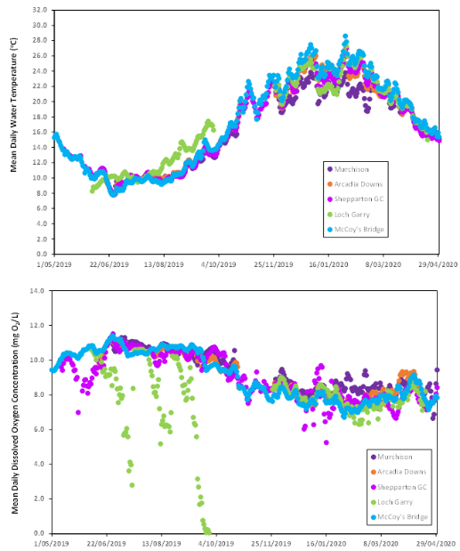
Figure 5-3 Mean Daily Water Temperature and Dissolved Oxygen Concentration for the five study sites 2019-20.
The temperature profiles shown in Figure 5-3 conform to expected behaviour with the warmest average daily temperatures occurring in mid-late summer. As noted above, the logger at Loch Garry was malfunctioning dramatically for DO and it this is probably the cause for the differences in daily temperatures for that site from June to October 2019. After November 2019, the temperature at this site tracked the other sites very well. In previous years it was noted that the water temperature was noticeably lower (often by several degrees) at Day Road during the warmer months when compared to the sites downstream. This was attributed to that site’s proximity to the underflow weir wall of Goulburn Weir, where colder bottom water from the lake is released. The similarity in 2019-20 of the temperature trace at Murchison with the sites further downstream suggests that the extent of this ‘cold water pollution’ does not extend to this site and hence is a localized issue downstream of the Goulburn Weir wall. This contrasts with the much more extensive cold-water effect arising from water releases from Lake Eildon further up the Goulburn River system where the colder water can still be measured Seymour, more than 90 km downstream.
The pattern of decline in mean daily dissolved oxygen concentrations in warmer months is expected due to the decreasing solubility of oxygen gas in water as the temperature of that water increases.
Unlike 2016–17 and 2017-18, there was no large anoxic flow entering the Goulburn from the Seven/Pranjip/Castle Creeks system during and after an intense, summertime thunderstorm. Hence there was no major drop in DO below the threshold of 4 mg O₂/L (apart from the logger failure at Loch Garry).

Seasonal Dependence of Flows and Flow Categorization
In order to examine the role of flow (and additional CEW) on metabolism, and in particular loads of organic carbon being created and consumed each day by GPP and ER respectively, it is first necessary to categorize the flows themselves according to the thresholds in Table 5-3. Table 5-5 presents this data for the four flow categories used in the subsequent loads analysis and these are stratified by site and season. There were no flows over the entire six-year period of record lower than the ‘Very Low’ flow threshold, but there were some ‘High Fresh’ and ‘Overbank’ flows (the latter in Spring 2016) but these are not included in this table due to the lack of corresponding metabolic rate data that met the acceptance criteria.

Table 5-5 Summary Statistics for Daily Flow (ML/Day), stratified by Season, Site and Flow Category. All data from 2014-2020.
Season | Site | Flow Cat | n | Mean | Std Dev | Min | Max | Median | 25% | 75% | Season | n | Mean | Std Dev | Min | Max | Median | 25% | 75%
Spring | Arcadia Downs / Darcy's Track | Very Low | 45 | 731 | 130 | 467 | 888 | 767 | 574 | 839 | Summer | 39 | 773 | 107 | 553 | 892 | 812 | 698 | 866
Spring | Arcadia Downs / Darcy's Track | Mod Low | 51 | 1237 | 207 | 928 | 1756 | 1239 | 1066 | 1341 | Summer | 123 | 1225 | 216 | 912 | 1761 | 1206 | 1028 | 1361
Spring | Arcadia Downs / Darcy's Track | Low Fresh | 23 | 2545 | 443 | 1857 | 3157 | 2535 | 2061 | 2976 | Summer | 91 | 2433 | 437 | 1781 | 3193 | 2414 | 2036 | 2772
Spring | Arcadia Downs / Darcy's Track | Med Fresh | 23 | 5411 | 1405 | 3364 | 7983 | 5320 | 4105 | 6547 | Summer | 20 | 3423 | 119 | 3225 | 3647 | 3417 | 3343 | 3506
Spring | McCoy's Bridge | Very Low | 97 | 813 | 125 | 504 | 958 | 860 | 724 | 915 | Summer | 65 | 834 | 131 | 551 | 960 | 901 | 701 | 929
Spring | McCoy's Bridge | Mod Low | 96 | 1279 | 237 | 964 | 1797 | 1246 | 1086 | 1503 | Summer | 178 | 1282 | 219 | 962 | 1805 | 1262 | 1092 | 1426
Spring | McCoy's Bridge | Low Fresh | 33 | 2505 | 418 | 1904 | 3126 | 2477 | 2061 | 2940 | Summer | 166 | 2522 | 362 | 1830 | 3062 | 2614 | 2189 | 2850
Spring | McCoy's Bridge | Med Fresh | 71 | 5378 | 1212 | 3137 | 7452 | 5637 | 4384 | 6424 | Summer | 2
Spring | Moss Rd / Day Rd / Murchison | Very Low | 40 | 688 | 145 | 469 | 862 | 639 | 545 | 839 | Summer | 26 | 770 | 63 | 702 | 863 | 777 | 710 | 841
Spring | Moss Rd / Day Rd / Murchison | Mod Low | 25 | 1085 | 235 | 876 | 1689 | 976 | 921 | 1226 | Summer | 100 | 1216 | 238 | 870 | 1768 | 1216 | 966 | 1374
Spring | Moss Rd / Day Rd / Murchison | Low Fresh | 18 | 2510 | 433 | 1851 | 3164 | 2587 | 2092 | 2943 | Summer | 88 | 2613 | 397 | 1785 | 3154 | 2692 | 2285 | 2953
Spring | Moss Rd / Day Rd / Murchison | Med Fresh | 19 | 5633 | 1494 | 3327 | 8071 | 5521 | 4434 | 7149 | Summer | 1
Autumn | Arcadia Downs / Darcy's Track | Very Low | 6 | 864 | 35 | 809 | 908 | 868 | 835 | 893 | Winter | 1
Autumn | Arcadia Downs / Darcy's Track | Mod Low | 53 | 1172 | 203 | 911 | 1689 | 1090 | 1048 | 1334 | Winter | 13 | 1265 | 214 | 1055 | 1665 | 1167 | 1113 | 1503
Autumn | Arcadia Downs / Darcy's Track | Low Fresh | 15 | 2274 | 416 | 1775 | 2983 | 2203 | 1920 | 2460 | Winter | 9 | 2172 | 391 | 1788 | 2854 | 2017 | 1798 | 2506
Autumn | Arcadia Downs / Darcy's Track | Med Fresh | 15 | 4086 | 333 | 3495 | 4480 | 4165 | 3834 | 4397 | Winter | 5 | 3764 | 550 | 3222 | 4658 | 3689 | 3328 | 4236
Autumn | McCoy's Bridge | Very Low | 95 | 870 | 79 | 684 | 958 | 891 | 827 | 937 | Winter | 10 | 803 | 124 | 632 | 960 | 818 | 669 | 930
Autumn | McCoy's Bridge | Mod Low | 158 | 1217 | 245 | 963 | 1801 | 1112 | 1016 | 1410 | Winter | 99 | 1165 | 195 | 965 | 1732 | 1091 | 1023 | 1255
Autumn | McCoy's Bridge | Low Fresh | 116 | 2475 | 321 | 1824 | 3128 | 2509 | 2223 | 2745 | Winter | 7 | 2233 | 326 | 1856 | 2746 | 2191 | 1922 | 2480
Autumn | McCoy's Bridge | Med Fresh | 28 | 3860 | 355 | 3162 | 4372 | 3895 | 3592 | 4160 | Winter | 3
Autumn | Moss Rd / Day Rd / Murchison | Very Low | 7 | 801 | 112 | 550 | 862 | 845 | 811 | 859 | Winter | 5 | 831 | 32 | 793 | 865 | 817 | 805 | 864
Autumn | Moss Rd / Day Rd / Murchison | Mod Low | 48 | 1049 | 225 | 871 | 1707 | 972 | 930 | 1032 | Winter | 14 | 1171 | 260 | 892 | 1646 | 1056 | 973 | 1383
Autumn | Moss Rd / Day Rd / Murchison | Low Fresh | 24 | 2644 | 390 | 1817 | 3116 | 2787 | 2319 | 2947 | Winter | 5 | 2336 | 527 | 1783 | 3175 | 2193 | 1929 | 2814
Autumn | Moss Rd / Day Rd / Murchison | Med Fresh | 14 | 4184 | 344 | 3554 | 4587 | 4265 | 3850 | 4496 | Winter | 1

Metabolic Parameters
MER 2019-20
From the results of modelling using BASEv2, the parameter estimates for GPP, ER, the reaeration coefficient K and the ratio of Gross Primary Production to Ecosystem Respiration ratio (P / R) for all 5 sites monitored, derived from all days meeting the acceptance criteria, are presented in Table 5-6.
Table 5-6 Summary of primary production (GPP) and ecosystem respiration (ER) rates, P/R ratios and reaeration coefficients for the five study sites, 2019-20.
Parameter | Murchison (n = 67) |  |  | Arcadia Downs (n = 102)
 | Median | Min | Max | Median | Min | Max
GPP (mg O₂/L/Day) | 0.86 | 0.05 | 3.3 | 1.35 | 0.19 | 10.9
ER (mg O₂/L/Day) | 2.52 | 0.13 | 11.9 | 2.92 | 0.50 | 12.3
P / R | 0.42 | 0.01 | 2.18 | 0.52 | 0.12 | 1.04
K (/Day) | 2.72 | 0.46 | 10.6 | 2.05 | 0.15 | 14.3
Parameter | Shepparton GC (n = 65) |  |  | Loch Garry (n = 41)
 | Median | Min | Max | Median | Min | Max
GPP (mg O₂/L/Day) | 1.10 | 0.03 | 6.60 | 1.57 | 0.48 | 3.79
ER (mg O₂/L/Day) | 3.39 | 0.22 | 22.8 | 3.17 | 1.23 | 25.7
P / R | 0.37 | 0.01 | 1.58 | 0.53 | 0.02 | 0.95
K (/Day) | 3.30 | 0.33 | 14.5 | 3.49 | 0.77 | 10.8
Parameter | McCoy's Bridge (n = 244) |  |  | All Combined (n = 519)
 | Median | Min | Max | Median | Min | Max
GPP (mg O₂/L/Day) | 1.22 | 0.14 | 2.17 | 1.22 | 0.03 | 10.9
ER (mg O₂/L/Day) | 2.37 | 0.35 | 6.70 | 2.59 | 0.13 | 25.7
P / R | 0.48 | 0.02 | 1.32 | 0.48 | 0.01 | 2.18
K (/Day) | 2.03 | 0.31 | 4.46 | 2.27 | 0.15 | 14.5

Each metabolic parameter in Table 5-6 is expressed as a median with minimum and maximum values also included. The median provides a more representative estimate without the bias in the mean arising from a relatively few much higher values. As previously found with the 2014-19 LTIM data set, the median GPP values from all five sites fall within a very narrow range of 0.86 (Murchison) to 1.57 (Loch Garry) mg O₂/L/Day. The range of median ER values for the five sites is also relatively constrained, varying from 2.37 mg O₂/L/Day at McCoy’s Bridge up to 3.39 mg O₂/L/Day at the Shepparton Golf Club site.
Of interest, the median ER Murchison (2.52 mg O₂/L/Day) is significantly lower than that previously measured at the LTIM Day Road site (4.09 mg O₂/L/Day in 2018-19 and higher in earlier years). This suggests that the postulated origin for this much higher respiration rate at Day Road i.e. relatively labile organic matter exported from the Goulburn Weir, is dissipated further downstream at Murchison. The median daily GPP at Day Rd was 1.98 mg O₂/L/Day, well above the other 3 LTIM sites where GPP medians ranged from 1.19 to 1.34 mg O₂/L/Day, and just over twice the median value at Murchison in 2018-19 (0.86). These data again suggest the localized effect of the Nagambie Lakes on metabolism in the Goulburn River.
The P/R ratios (medians 0.37 to 0.53) are similar to those found in 2017-19 (LTIM). These three years’ data have lower ratios than the first three years of LTIM with this difference being due to the inclusion of winter-time data from 2017-18 onwards. GPP rates are constrained much more by season than ER rates. The median values indicate that in in general, significantly more oxygen is consumed in these reaches than is produced. The maximum P/R ratios in Table 2-3 indicate that on some occasions, oxygen production is as high (Loch Garry, Arcadia Downs) or much higher (Shepparton, Murchison, McCoy’s Bridge) compared to consumption via ecosystem respiration. In most cases, as observed in previous years, these high P/R readings are typically due to lower ER rates rather than significantly increased GPP. This is exemplified by the large data set from McCoy’s Bridge where the maximum GPP rate was just 2.17 mg O₂/L/Day.
To put these metabolic rates into a global context, a summary of world-wide stream metabolism data (mostly from the USA) shows that GPP and ER values are each typically in the range 2-20 mg O₂/L/day (Bernot et al. 2010, Marcarelli et al. 2011) based on an assumption of an average water depth of 1 m (to convert the areal units of many reports to the volumetric units used in LTIM). Hence these Goulburn River data fall towards the bottom end of this global range. Whether these low rates, mirrored across the southern Basin, reflect a system under stress or are indicative of ‘normal’ rates for Australian lowland rivers should become more apparent as MER evolves, and is discussed further below. Publication of a significantly more extensive data set (from the USGS) covering many more biomes in the USA is (still!) imminent and will show that the Basin metabolic rates are low but not unusually low.
Figure 5-4 displays the daily rates of GPP and ER at McCoy’s Bridge – the site with the most data days in 2019-20 (Table 5-4). The daily flow data is also plotted in this figure.

Figure 5-4 Stream Metabolism-Flow Relationships for McCoy’s Bridge (Zone 2) from May 2019 to April 2020: Gross Primary Production and Ecosystem Respiration.
Figure 5-4 highlights one of the difficulties of establishing relationships between high flow events and stream metabolism. The two largest flow events in mid-July 2019 (Peak flow 8503 ML/Day on 14/7) and late September to early October (Peak flow 7902 ML/Day on 1/10) are both in the medium fresh category with peaks in the high fresh category (Figure 5-3). The underlying model used by BASEv2 and other stream metabolism models, including the USGS “streamMetabolizer” (Appling et al. 2018), assumes that flow in any one day remains “relatively constant”. Hence for days with rapidly changing, large flows, model fits are poor and do not meet the acceptance criteria, with r² typically much less than the 0.9 criterion. This figure does show the remarkable constancy in GPP values with small increases following the flow recessions, most notably in October 2019, mid-December 2019 and mid-February 2020. Conversely, the rising limb of the hydrograph tends to dampen GPP due probably to simple dilution. This effect is evident with the last four smaller flow peaks in the year’s hydrograph. The rising hydrographs of these four flow peaks also lowers ER rates, again due to dilution. Quantitative relationships between discharge and metabolism are explored in the statistical modelling results (Section 5.5.5).
Goulburn River stream metabolism across the years, 2014-2020
It is interesting to compare the metabolic data for 2019-20 with those found during the LTIM Project. This helps address the question “Was 2019-20 a typical year or unusual in any way?” McCoy’s Bridge is chosen as the exemplar site as it has the highest number of data days meeting acceptance criteria (see Table 5-4) and also the most winter data. The absence of winter data for much of the LTIM Project at the other sites means that there is an upward bias in the annual average since winter-time rates are typically the lowest. Seasonal effects on rates are explored later in this section. For that reason, the best years for comparison are those with full year data sets (2017-18 onwards).
Table 5-7 Comparison across six years of median primary production (GPP) and ecosystem respiration (ER) rates, P/R ratios and reaeration coefficients at the McCoy’s Bridge site.
Site | McCoy’s Bridge
Year | 14-15 | 15-16 | 16-17 | 17-18 | 18-19 | 19-20*
n | 141 | 134 | 210 | 264 | 272 | 244
GPP (mg O₂/L/Day) | 1.53 | 1.09 | 1.12 | 0.97 | 1.18 | 1.22
ER (mg O₂/L/Day) | 3.06 | 1.75 | 2.19 | 2.74 | 2.24 | 2.37
K (/Day) | 3.44 | 1.90 | 1.77 | 1.32 | 1.87 | 2.03
P/R | 0.55 | 0.65 | 0.45 | 0.37 | 0.54 | 0.49
*Data set includes May 2019 & June 2019 which are also included in the 2018-19 year just for this comparison
From 2015-16 onwards metabolism in the Goulburn River at McCoy’s Bridge has been remarkably consistent. Median GPP only varied from 0.97 to 1.22 mg O₂/L/Day (in 2019-20), while ER varied more but still by less than a factor of two across the five years (1.75-2.74 mg O₂/L/Day). Unsurprisingly, the reaeration coefficient was also relatively constant (1.32 – 2.03 /Day). Such behaviour in K is expected if similar flow regimes occur at the same site with no events that change the river topography, which is the case for the Goulburn River. There was also a small amount of variability in the median P to R ratio, ranging from 0.37 to 0.65; all values that indicate a heterotrophic dominance in metabolism. The higher values in 2014-15 are largely attributed to the shorter data collection period which did not included winter 2014 or late autumn 2015 and also missed the coolest of the spring months (September). Hence data were heavily biased towards the warmer months, leading to higher rates.
Figure 5-5 and Figure 5-6 use this most comprehensive site data (McCoy’s Bridge) to illustrate the variability in seasonal metabolism rates over the 6 years of LTIM and MER, but exclude winter due to the aforementioned paucity of data in the first three years of the LTIM Project.

Figure 5-5 Annual variation in GPP stratified by the seasons spring, summer and autumn at the McCoy’s Bridge site, 2014-20.
Although there initially appears to be a lot of inter-annual variability within each season, this figure shows that mean daily GPP remains remarkably constrained within the range of 1 - 2.5 mg O₂/L/Day. Mean values above 2 mg O₂/L/Day were only observed three times: Spring 2016-17 and the summers of 2015-16 and 2018-19. As discussed below, this constraint to a relatively narrow range is attributed to the chronic low nutrient concentrations (especially bioavailable phosphorus) within the river channel. Hall et al. (2016) found that 14 larger rivers in the western USA had a wide range of GPP rates (0.2–26.2 mg O₂/L/Day). However, for 10 of these 14 rivers, rates were < 5 mg O₂/L/Day, putting them in the same range as the rates as the Goulburn. Hall et al. (2016) suggested that the rates at the lower end of this range were in most cases constrained by low bioavailable nutrient concentrations (and in one case, the Colorado River, by extremely high turbidity).
Figure 5-6 Annual variation in ER stratified by the seasons spring, summer and autumn at the McCoy’s Bridge site, 2014-20.
There is considerably more interannual and inter-seasonal difference in Ecosystem Respiration rates (Figure 5-6). In general, summer rates were higher than the other two seasons although rates were suppressed in 2018-19 and 2019-2020 compared to the other four years. Not only were the median values lower, but the range of values was also more constrained. These two years also showed the least inter-seasonal variation across spring, summer and autumn. The similarity in 2018-19 and 2019-20 indicates that the replacement of the Day Road site with Murchison has not had a dramatic effect on the patterns in ER behaviour, although the effect is confounded by the relatively small proportion of the pooled data coming from those two sites. As for GPP however, the appearance of a large degree of inter-seasonal and inter-annual variability is an artefact of the Y-axis scale. If the ‘common’ (world-wide) range of ER values (0.2 – 20 mg O₂/L/Day) were used as the Y axis, these apparent differences would appear smaller. Consequently, we are looking for more subtle explanations for differences, including basal metabolic rates of microbes that increase with temperature and organic carbon availability and lability (reactiveness), both in dissolved form and as water-born and benthic particulate matter. Flows will increase accessible organic carbon supplies by inundating new areas as water levels rise; the amount of organic carbon introduced to the aquatic environment will also depend on antecedent flow conditions – when the area last was connected to the river. The effect of temperature and flow on ER is investigated further using the Bayesian statistical modelling (Section 5.5.5).

Metabolism across sites, 2014-2020
The relatively small amount of inter-annual variability in stream metabolism (Table 5-7) for McCoy’s Bridge has been removed by pooling all the data for each site over its period of record. This overall site-specific summary is presented below as Table 5-8. This table also includes a summary line ‘ALL’ for pooled data from all sites.
Table 5-8 Summary LTIM Stream Metabolism Statistics for all Goulburn Sites in LTIM & MER, combined and individually, 2014-2020.
Parameter | Site | n | Mean | Std Dev | Min | Max | Median | 25% | 75%
GPP | ALL | 2707 | 1.69 | 1.81 | 0.01 | 25.7 | 1.26 | 0.86 | 1.90
GPP | Darcy's Track | 464 | 1.53 | 1.15 | 0.03 | 7.1 | 1.30 | 0.75 | 1.92
GPP | Arcadia Downs | 102 | 1.62 | 1.48 | 0.19 | 10.9 | 1.35 | 1.00 | 1.73
GPP | Day Rd / Moss Rd | 369 | 3.42 | 3.61 | 0.15 | 22.9 | 2.17 | 1.11 | 4.06
GPP | Murchison | 67 | 1.08 | 0.77 | 0.05 | 3.3 | 0.86 | 0.50 | 1.49
GPP | Shepparton GC | 65 | 1.53 | 1.42 | 0.03 | 6.6 | 1.10 | 0.80 | 1.84
GPP | Loch Garry | 412 | 1.60 | 1.62 | 0.05 | 25.7 | 1.28 | 0.87 | 2.04
GPP | McCoy's Bridge | 1228 | 1.32 | 0.71 | 0.01 | 5.98 | 1.18 | 0.83 | 1.61
ER | ALL | 2707 | 3.53 | 3.64 | 0.03 | 48.1 | 2.45 | 1.54 | 4.21
ER | Darcy's Track | 464 | 2.91 | 2.65 | 0.03 | 18.1 | 2.09 | 1.25 | 3.48
ER | Arcadia Downs | 102 | 3.03 | 1.89 | 0.51 | 12.3 | 2.92 | 1.80 | 3.63
ER | Day Rd / Moss Rd | 369 | 7.04 | 6.40 | 0.21 | 40.7 | 5.31 | 2.49 | 9.35
ER | Murchison | 67 | 3.22 | 2.57 | 0.13 | 11.9 | 2.52 | 1.19 | 4.15
ER | Shepparton GC | 65 | 4.40 | 3.72 | 0.22 | 22.8 | 3.39 | 2.39 | 5.30
ER | Loch Garry | 412 | 3.07 | 3.71 | 0.12 | 48.1 | 2.29 | 1.18 | 3.62
ER | McCoy's Bridge | 1228 | 2.87 | 1.97 | 0.06 | 17.7 | 2.31 | 1.60 | 3.65

The pooled data highlights the significantly higher median and mean daily GPP and ER rates found at the Day Road site compared to the other six sites, among which differences are small (Table 5-8). Within an ecological context though, this difference in rates is still quite small. The drivers must be relatively subtle as there are no significant differences in the bioavailable nutrients from each site (see below).
The relatively small differences in median GPP and ER rates between the six sites other than Day Rd, plus the low number of results as yet from Arcadia Downs, Murchison and Shepparton Golf Club, mean that a site-based comparison of seasonal effects will be delayed until the next annual report in 2021.
To place the summary results from Table 5-8 into the context of the Murray-Darling Basin, Table 5-9 contains the statistics for GPP and ER from the five Selected Areas in the southern Murray-Darling Basin (Goulburn, Edward-Wakool, Lachlan, Murrumbidgee, Lower Murray) over the LTIM period 2014-2019. The one northern MDB Selected Area (Warrego-Darling) is excluded from this analysis due to both the much smaller data set and the different constraint on metabolism – light availability instead of nutrient limitation.

Table 5-9 Summary LTIM Stream Metabolism Statistics for the five Southern MDB Selected Areas, 2014-19.
 | n | Median | Mean | Std Dev | Std Error | 25th Percentile | 75th Percentile
GPP (mg O₂/L/Day) | 10577 | 1.6 | 2.2 | 2.0 | 0.02 | 1.0 | 2.6
ER (mg O₂/L/Day) | 10577 | 3.1 | 4.0 | 3.8 | 0.04 | 1.6 | 5.2
K (/Day) | 10577 | 1.8 | 2.3 | 2.1 | 0.02 | 1.1 | 2.8
P/R | 10577 | 0.6 | 0.8 | 1.2 | 0.01 | 0.4 | 0.9

In comparing results, it is important to note that Goulburn results make up around 21% of the overall database used to generate Table 5-9. Nevertheless, the range in median GPP over all Goulburn sites and the six years of data is slightly lower than the overall LTIM result (1.2 c.f. 1.6 mg O₂/L/Day). However, the LTIM data are skewed by the fact that along with the Goulburn, only the Lachlan Selected Area had a significant amount of winter data. For a similar reason the median Goulburn ER rate for all sites (2.45 mg O₂/L/Day) is slightly lower that the median value for all five selected areas (3.1 mg O₂/L/Day). Nevertheless, it is highly likely that the same factors constraining primary production (mainly nutrients) and ecosystem respiration (organic carbon supply) are important across the entire southern Basin.
Metabolism across seasons, 2014-2020
The box plots in the composite Figure 5-7 portray the seasonal dependence of GPP, ER, P/R and NEP (Net Ecosystem Production = GPP – ER) using the full six-year data set from all sites. The summary statistics for all of these parameters are presented in Table 5-10.
Figure 5-7 Seasonal dependence of GPP, ER, P/R and NP for all sites combined, with data from 2014-20.

Table 5-10 Seasonal Dependence of GPP, ER, P/R and NEP – all sites combined. Data from 2014-2020.
Parameter | Season | n | Mean | Std Dev | Min | Max | Median | 25% | 75%
GPP | Spring | 661 | 1.61 | 1.53 | 0.03 | 11.5 | 1.24 | 0.77 | 1.85
GPP | Summer | 1157 | 2.18 | 2.13 | 0.03 | 22.9 | 1.61 | 1.16 | 2.38
GPP | Autumn | 698 | 1.26 | 1.37 | 0.12 | 25.7 | 1.04 | 0.78 | 1.38
GPP | Winter | 191 | 0.63 | 0.73 | 0.01 | 6.60 | 0.54 | 0.32 | 0.75
ER | Spring | 661 | 3.43 | 3.76 | 0.03 | 24.3 | 2.07 | 1.14 | 4.27
ER | Summer | 1157 | 4.11 | 3.89 | 0.11 | 40.7 | 3.13 | 2.08 | 4.89
ER | Autumn | 698 | 2.63 | 2.90 | 0.20 | 48.1 | 1.95 | 1.29 | 2.93
ER | Winter | 191 | 3.56 | 3.39 | 0.13 | 25.7 | 2.36 | 1.65 | 4.80
P/R | Spring | 661 | 0.91 | 1.17 | 0.01 | 9.87 | 0.55 | 0.33 | 0.98
P/R | Summer | 1157 | 0.75 | 1.02 | 0.01 | 16.9 | 0.52 | 0.37 | 0.81
P/R | Autumn | 698 | 0.69 | 0.63 | 0.01 | 8.10 | 0.53 | 0.36 | 0.81
P/R | Winter | 191 | 0.36 | 1.16 | 0.01 | 11.6 | 0.15 | 0.10 | 0.37
NEP | Spring | 661 | -1.82 | 3.18 | -21.6 | 3.17 | -0.74 | -2.57 | -0.01
NEP | Summer | 1157 | -1.94 | 2.83 | -21.7 | 12.1 | -1.47 | -2.86 | -0.38
NEP | Autumn | 698 | -1.37 | 2.21 | -22.4 | 7.15 | -0.88 | -1.71 | -0.25
NEP | Winter | 191 | -2.93 | 3.09 | -25.2 | 1.69 | -1.85 | -4.27 | -1.06

Across the entire six-year data set, the highest GPP rates were found, unsurprisingly, during the summer. Median GPP rates were similar in spring and autumn and much lower during winter. The explanation for these findings is that the highest rates are found during the warmest temperatures and with the highest photosynthetically active radiation (sunlight) and the most hours of this sunshine. GPP is positively correlated with both mean daily water temperature and the amount of PAR each day (see below).
Unlike GPP, winter ER rates were not lower than spring and autumn. Winter showed the largest (most negative) values of NEP due to the decline of GPP in the colder, darker months as ER remained constant.
Metabolism across seasons and flow categories, 2014-2020
Consideration is now given to stratifying the same seasonal data by site and flow category (Table 5-3). Table 5-11 presents data for GPP and Table 5-12 for ER.

Table 5-11 Summary Statistics for Gross Primary Productivity (mg O2/L/Day), stratified by Season, Site and Flow Category. All data from 2014-2020.
Season | Site | Flow Cat | n | Mean | Std Dev | Min | Max | Median | 25% | 75% | Season | n | Mean | Std Dev | Min | Max | Median | 25% | 75%
Spring | Arcadia Downs / Darcy's Track | Very Low | 45 | 1.53 | 0.49 | 0.6 | 2.59 | 1.43 | 1.19 | 1.88 | Summer | 39 | 3.60 | 1.88 | 1.3 | 7.15 | 3.20 | 1.89 | 5.08
Spring | Arcadia Downs / Darcy's Track | Mod Low | 51 | 2.33 | 1.93 | 0.3 | 10.9 | 1.91 | 1.13 | 2.62 | Summer | 123 | 2.02 | 0.74 | 0.2 | 5.52 | 1.92 | 1.46 | 2.48
Spring | Arcadia Downs / Darcy's Track | Low Fresh | 23 | 0.65 | 0.34 | 0.2 | 1.61 | 0.56 | 0.45 | 0.83 | Summer | 91 | 1.28 | 0.48 | 0.1 | 3.97 | 1.23 | 1.00 | 1.48
Spring | Arcadia Downs / Darcy's Track | Med Fresh | 23 | 0.47 | 0.35 | 0.03 | 1.23 | 0.33 | 0.21 | 0.61 | Summer | 20 | 1.35 | 0.45 | 0.08 | 2.29 | 1.41 | 1.12 | 1.56
Spring | McCoy's Bridge | Very Low | 97 | 1.56 | 0.71 | 0.7 | 5.98 | 1.43 | 1.23 | 1.71 | Summer | 65 | 2.38 | 1.04 | 0.9 | 5.26 | 2.09 | 1.54 | 3.20
Spring | McCoy's Bridge | Mod Low | 96 | 1.63 | 0.79 | 0.4 | 4.09 | 1.44 | 1.11 | 1.89 | Summer | 178 | 1.43 | 0.60 | 0.2 | 4.87 | 1.34 | 1.09 | 1.60
Spring | McCoy's Bridge | Low Fresh | 33 | 1.43 | 0.52 | 0.6 | 2.65 | 1.38 | 1.05 | 1.79 | Summer | 166 | 1.60 | 0.68 | 0.1 | 3.13 | 1.45 | 1.00 | 2.16
Spring | McCoy's Bridge | Med Fresh | 71 | 0.74 | 0.35 | 0.14 | 2.00 | 0.70 | 0.49 | 0.94 | Summer | 2
Spring | Moss Rd / Day Rd / Murchison | Very Low | 40 | 3.83 | 3.43 | 0.7 | 11.5 | 2.08 | 1.11 | 6.38 | Summer | 26 | 7.81 | 4.88 | 1.7 | 20.8 | 6.90 | 2.90 | 10.0
Spring | Moss Rd / Day Rd / Murchison | Mod Low | 25 | 3.68 | 2.55 | 0.7 | 10.3 | 3.01 | 1.95 | 4.10 | Summer | 100 | 4.85 | 4.42 | 0.4 | 22.9 | 3.39 | 1.91 | 5.87
Spring | Moss Rd / Day Rd / Murchison | Low Fresh | 18 | 1.26 | 0.60 | 0.6 | 2.89 | 1.19 | 0.83 | 1.44 | Summer | 88 | 2.12 | 1.21 | 0.2 | 6.48 | 2.05 | 1.16 | 2.69
Spring | Moss Rd / Day Rd / Murchison | Med Fresh | 19 | 0.66 | 0.31 | 0.15 | 1.28 | 0.61 | 0.45 | 0.89 | Summer | 1
Autumn | Arcadia Downs / Darcy's Track | Very Low | 6 | 1.26 | 0.63 | 0.5 | 2.39 | 1.18 | 0.84 | 1.59 | Winter | 1
Autumn | Arcadia Downs / Darcy's Track | Mod Low | 53 | 1.17 | 0.82 | 0.4 | 5.4 | 0.88 | 0.71 | 1.46 | Winter | 13 | 0.35 | 0.15 | 0.2 | 0.66 | 0.32 | 0.23 | 0.38
Autumn | Arcadia Downs / Darcy's Track | Low Fresh | 15 | 0.80 | 0.32 | 0.3 | 1.35 | 0.71 | 0.56 | 1.09 | Winter | 9 | 0.26 | 0.13 | 0.1 | 0.47 | 0.22 | 0.14 | 0.40
Autumn | Arcadia Downs / Darcy's Track | Med Fresh | 15 | 0.70 | 0.22 | 0.30 | 1.08 | 0.73 | 0.54 | 0.89 | Winter | 5 | 0.18 | 0.02 | 0.16 | 0.20 | 0.17 | 0.16 | 0.20
Autumn | McCoy's Bridge | Very Low | 95 | 1.25 | 0.44 | 0.4 | 2.38 | 1.17 | 0.92 | 1.50 | Winter | 10 | 0.83 | 0.16 | 0.5 | 1.02 | 0.85 | 0.73 | 0.95
Autumn | McCoy's Bridge | Mod Low | 158 | 1.14 | 0.52 | 0.2 | 3.81 | 1.05 | 0.79 | 1.35 | Winter | 99 | 0.66 | 0.29 | 0.1 | 1.85 | 0.65 | 0.50 | 0.77
Autumn | McCoy's Bridge | Low Fresh | 116 | 1.06 | 0.35 | 0.6 | 2.10 | 1.03 | 0.77 | 1.23 | Winter | 7 | 0.20 | 0.13 | 0.0 | 0.38 | 0.15 | 0.13 | 0.37
Autumn | McCoy's Bridge | Med Fresh | 28 | 1.26 | 0.29 | 0.65 | 1.60 | 1.36 | 1.03 | 1.46 | Winter | 3
Autumn | Moss Rd / Day Rd / Murchison | Very Low | 7 | 3.56 | 4.05 | 0.5 | 11.5 | 1.21 | 0.75 | 5.92 | Winter | 5 | 0.87 | 0.47 | 0.5 | 1.7 | 0.81 | 0.52 | 1.3
Autumn | Moss Rd / Day Rd / Murchison | Mod Low | 48 | 1.71 | 2.12 | 0.1 | 14.3 | 1.02 | 0.92 | 1.68 | Winter | 14 | 0.41 | 0.14 | 0.2 | 0.7 | 0.40 | 0.33 | 0.51
Autumn | Moss Rd / Day Rd / Murchison | Low Fresh | 24 | 1.81 | 0.71 | 0.9 | 3.48 | 1.77 | 1.06 | 2.33 | Winter | 5 | 0.52 | 0.32 | 0.1 | 0.96 | 0.59 | 0.24 | 0.78
Autumn | Moss Rd / Day Rd / Murchison | Med Fresh | 14 | 1.06 | 0.24 | 0.35 | 1.35 | 1.12 | 1.01 | 1.17 | Winter | 1

Table 5-12 Summary Statistics for Ecosystem Respiration (mg O2/L/Day), stratified by Season, Site and Flow Category. All data from 2014-2020.
Season | Site | Flow Cat | n | Mean | Std Dev | Min | Max | Median | 25% | 75% | Season | n | Mean | Std Dev | Min | Max | Median | 25% | 75%
Spring | Arcadia Downs / Darcy's Track | Very Low | 45 | 4.31 | 2.70 | 1.2 | 10.7 | 3.12 | 2.36 | 5.78 | Summer | 39 | 6.81 | 4.50 | 1.8 | 18.1 | 6.10 | 2.86 | 8.37
Spring | Arcadia Downs / Darcy's Track | Mod Low | 51 | 3.28 | 3.35 | 0.4 | 12.3 | 1.83 | 1.02 | 3.59 | Summer | 123 | 3.51 | 1.68 | 0.9 | 10.9 | 3.21 | 2.29 | 4.55
Spring | Arcadia Downs / Darcy's Track | Low Fresh | 23 | 1.59 | 0.84 | 0.4 | 3.81 | 1.45 | 0.94 | 2.17 | Summer | 91 | 2.25 | 1.57 | 0.7 | 11.8 | 1.82 | 1.25 | 2.63
Spring | Arcadia Downs / Darcy's Track | Med Fresh | 23 | 0.93 | 0.67 | 0.03 | 2.16 | 1.01 | 0.25 | 1.45 | Summer | 20 | 2.45 | 1.01 | 1.21 | 5.60 | 2.21 | 1.70 | 2.89
Spring | McCoy's Bridge | Very Low | 97 | 4.22 | 2.59 | 0.7 | 17.7 | 3.68 | 2.57 | 5.27 | Summer | 65 | 5.84 | 2.55 | 1.6 | 12.3 | 5.80 | 3.81 | 7.50
Spring | McCoy's Bridge | Mod Low | 96 | 2.05 | 1.30 | 0.06 | 6.02 | 1.78 | 1.32 | 2.51 | Summer | 178 | 3.90 | 1.61 | 1.2 | 11.1 | 3.57 | 2.80 | 4.82
Spring | McCoy's Bridge | Low Fresh | 33 | 1.61 | 1.14 | 0.14 | 4.72 | 1.35 | 0.97 | 2.08 | Summer | 166 | 2.29 | 0.90 | 0.1 | 5.22 | 2.26 | 1.75 | 2.75
Spring | McCoy's Bridge | Med Fresh | 71 | 1.11 | 0.83 | 0.21 | 5.75 | 0.92 | 0.55 | 1.42 | Summer | 2
Spring | Moss Rd / Day Rd / Murchison | Very Low | 40 | 7.18 | 6.65 | 0.8 | 20 | 4.43 | 1.38 | 13.11 | Summer | 26 | 6.55 | 5.41 | 2.1 | 21.0 | 3.96 | 2.46 | 8.6
Spring | Moss Rd / Day Rd / Murchison | Mod Low | 25 | 8.38 | 5.52 | 1.1 | 24 | 8.31 | 4.12 | 11.57 | Summer | 100 | 8.75 | 8.54 | 1.8 | 40.7 | 5.87 | 3.53 | 9.09
Spring | Moss Rd / Day Rd / Murchison | Low Fresh | 18 | 8.03 | 3.63 | 0.42 | 14 | 9.14 | 5.87 | 10.62 | Summer | 88 | 4.17 | 4.02 | 0.2 | 17.3 | 2.84 | 0.98 | 6.52
Spring | Moss Rd / Day Rd / Murchison | Med Fresh | 19 | 12.07 | 4.74 | 3.61 | 22 | 11.6 | 9.06 | 16.26 | Summer | 1
Autumn | Arcadia Downs / Darcy's Track | Very Low | 6 | 3.19 | 1.72 | 1.3 | 6.40 | 2.86 | 2.15 | 4.07 | Winter | 1
Autumn | Arcadia Downs / Darcy's Track | Mod Low | 53 | 1.77 | 1.78 | 0.34 | 11 | 1.24 | 0.86 | 1.90 | Winter | 13 | 2.63 | 1.47 | 0.5 | 5.06 | 2.48 | 1.73 | 3.91
Autumn | Arcadia Downs / Darcy's Track | Low Fresh | 15 | 1.06 | 0.48 | 0.47 | 2.05 | 0.92 | 0.60 | 1.44 | Winter | 9 | 1.97 | 0.65 | 0.9 | 2.89 | 1.89 | 1.47 | 2.57
Autumn | Arcadia Downs / Darcy's Track | Med Fresh | 15 | 0.97 | 0.58 | 0.28 | 2.40 | 0.76 | 0.59 | 1.09 | Winter | 5 | 3.07 | 1.14 | 1.70 | 4.45 | 2.65 | 2.12 | 4.24
Autumn | McCoy's Bridge | Very Low | 95 | 2.84 | 1.25 | 0.9 | 6.69 | 2.77 | 1.75 | 3.78 | Winter | 10 | 5.05 | 4.02 | 1.2 | 11.2 | 3.54 | 1.65 | 9.76
Autumn | McCoy's Bridge | Mod Low | 158 | 2.57 | 1.42 | 0.34 | 8.74 | 2.16 | 1.72 | 3.17 | Winter | 99 | 3.41 | 2.30 | 0.2 | 10.8 | 2.35 | 1.80 | 5.08
Autumn | McCoy's Bridge | Low Fresh | 116 | 1.66 | 0.55 | 0.32 | 3.00 | 1.59 | 1.22 | 2.11 | Winter | 7 | 2.57 | 1.96 | 0.6 | 6.46 | 1.84 | 1.44 | 3.58
Autumn | McCoy's Bridge | Med Fresh | 28 | 1.44 | 0.50 | 0.51 | 2.31 | 1.59 | 0.91 | 1.81 | Winter | 3
Autumn | Moss Rd / Day Rd / Murchison | Very Low | 7 | 6.30 | 2.98 | 2.8 | 11.1 | 5.37 | 4.34 | 9.36 | Winter | 5 | 6.19 | 2.25 | 3.9 | 9.2 | 6.62 | 3.97 | 8.2
Autumn | Moss Rd / Day Rd / Murchison | Mod Low | 48 | 4.05 | 4.11 | 0.57 | 16.7 | 2.33 | 1.59 | 4.94 | Winter | 14 | 1.67 | 1.28 | 0.7 | 4.6 | 1.17 | 0.83 | 1.96
Autumn | Moss Rd / Day Rd / Murchison | Low Fresh | 24 | 7.02 | 3.96 | 0.34 | 15.6 | 8.19 | 4.05 | 9.30 | Winter | 5 | 4.08 | 2.83 | 1.0 | 7.76 | 3.40 | 1.52 | 6.98
Autumn | Moss Rd / Day Rd / Murchison | Med Fresh | 14 | 3.35 | 1.05 | 0.33 | 4.67 | 3.55 | 2.93 | 3.90 | Winter | 1

The major feature of the data is that increasing flow categories generally leads to decreased rates of oxygen production or consumption per litre of water. Without specific data to quantify these observations, it is expected that much of the primary production and ecosystem respiration occurs on the sediment surface and on other hard substrates in the water columns (e.g. snags). Biofilms, especially in the littoral zone (shallow, near bank region), are typically very important contributors to overall primary production. This sets the Goulburn (and Lachlan and Edward/Kolety-Wakool river systems) apart from the larger rivers (Murrumbidgee and Lower Murray) where water column primary production via phytoplankton is a more important contributor to overall GPP. These changes in oxygen concentration from GPP (& ER) arising from the sediment and other hard surfaces are then mixed through the water column. The shallower the overlying water, the more influence the sediment-based changes in DO will have on this overlying water. Hence when more water is added, this sediment-based signal is distributed into more water and hence is ‘diluted’. Of course, adding more water to the existing water column will also ‘dilute’ the extant phytoplankton population, thus reducing volumetric GPP rates, assuming that the ‘new’ water has lower phytoplankton populations. Attempting to better identify the relative contributions of benthic and water-column metabolism will be the subject of a contingency monitoring project to be undertaken over summer 2020-21.
Consideration of the origins of the decrease in GPP and ER with flow is important when determining the effectiveness of environmental water additions, as at first glance it might be assumed that adding water is achieving poor ecological outcomes. However, it is the overall increase in organic carbon load that is the major consideration when the effects of watering actions are considered.

Investigating the Basal Drivers for Metabolism
Previous LTIM reports have demonstrated that GPP is positively correlated with daily light and temperature and that ER is correlated with temperature as well. Unsurprisingly daily light and average daily water temperature are correlated with each other. Solar irradiance provides both light and heat to the water surface, so days of higher and more intense sunshine result in warmer water temperatures. This finding does mean that subsequent data analysis must take this covariance into account. These dependencies are explored in the Bayesian modelling described in Section 5.5.5.
Nutrient concentrations from the five sites in 2019-20 were determined on the samples that were collected during the DO probe deployment, downloading and maintenance. These data are presented in Table 5-13, along with the spot measurements of turbidity. Pooled nutrient data from all sites and across the six years of record (2014-2020) are presented in Table 5-14. Also included in this table are data from the LTIM program plus data from 2014-19 at Murchison and McCoy’s Bridge (DELWP 2015){DELWP, 2015 #62;DELWP, 2015 #62}.
The key finding is that, consistent with the five previous years, the concentrations of bioavailable nutrients in the Goulburn River at all sites were very low. In particular, the bioavailable phosphorus concentration FRP, was consistently below 0.01 mg P/L, with a couple of exceptions in April 2020 at Shepparton and Murchison. These slightly higher concentrations occurred in mid-autumn, possibly arise from breakdown of organic matter and plant detritus from the summer growth period. Similar mid-late autumn ‘peaks’ in FRP have been observed previously at McCoy’s Bridge. It is very difficult to draw any conclusions about the effects of flow events (including CEW) on nutrient concentrations as monitoring does not occur over the changing hydrograph.

Table 5-13 Turbidity and Nutrient (N, P & C) concentrations of water samples collected from the five study sites over the period May 2019 to April 2020.

Table 5-14 Summary of Nutrient (N, P & C) concentrations of water samples collected from all five MER study sites combined over the period May 2019 to April 2020. For comparison, the combined LTIM data (four sites, 2014-19) and separately measured data for the Murchison and McCoy’s Bridge sites were downloaded from the (Victorian) DELWP Water Measurement Information System covering the period July 2004 to June 2019. The number of single measurements in the LTIM data set that were below the Limit of Detection (LoD, 0.001 mg/L for dissolved nutrients, variable for Chlorophyll-a) are also noted.
Program | Parameter | NO_{x} | NH₃ | Total N | Total P | FRP | DOC (MER) / NPOC | Chl-a
Program |  | mg/L N | mg/L N | mg/L N | mg/L P | mg/L P | mg C/L | ug/L
MER 2019-20 | n | 48 | 24 | 48 | 48 | 48 | 30 | 22
MER 2019-20 | Median | 0.056 | 0.005 | 0.34 | 0.033 | 0.003 | 2.4 | 9.5
MER 2019-20 | Mean | 0.146 | 0.018 | 0.51 | 0.038 | 0.005 | 3.2 | 10.4
MER 2019-20 | Std Dev | 0.171 | 0.026 | 0.31 | 0.019 | 0.008 | 1.7 | 5.4
LTIM 2014-19 | n | 123 | 123 | 123 | 123 | 123 | 123 | 96
LTIM 2014-19 | n < LoD | 34 | 13 | 0 | 0 | 0 | 0 | 54
LTIM 2014-19 | Median | 0.029 | 0.004 | 0.33 | 0.030 | 0.003 | 4.2 | 8.5
LTIM 2014-19 | Mean | 0.055 | 0.006 | 0.37 | 0.035 | 0.004 | 5.5 | 9.6
LTIM 2014-19 | Std Dev | 0.070 | 0.009 | 0.18 | 0.019 | 0.004 | 4.1 | 4.5
DELWP | n | 733 |  |  | 733 | 732 | 509
July 2004 - June 2019 | Median | 0.077 |  |  | 0.049 | 0.003 | 5.0
McCoy's Bridge | Mean | 0.144 |  |  | 0.057 | 0.007 | 6.7
Murchison | Std Dev | 0.167 |  |  | 0.049 | 0.016 | 4.2

One interesting aspect of the data in Table 5-13 not evident in the summary of the pooled data (Table 5-14), is the seasonal variation in NO_{x} (nitrate + nitrite concentrations) (Figure 5-8).
The key aspect of this pattern is the major drawdown of NO_{x} concentrations during the warmer months (November 2019 – February 2020). This is consistent with the period of increased GPP, when the autotrophs require a source of bioavailable N. Ammonia concentrations are extremely low (< 0.005 mg N/L) during this ‘growing’ time as well, before increasing in March and April due to lower growth rates plus decay of detrital material. In addition to bioavailable N, the autotrophs require a source of bioavailable phosphorus, measured here as Filterable Reactive Phosphorus (FRP). Throughout the late spring-early autumn period, FRP also never exceeded 0.004 mg P/L. These findings support the earlier conclusions from the LTIM project that primary production is constrained in the Goulburn River by bioavailable nutrient concentrations. There is no upstream-downstream trend in FRP; it is low throughout Zones 1 and 2, indicating that there is no significant continual input of this nutrient into the river. It would be extremely insightful to follow nutrient concentrations a cross a flow event hydrograph, especially during the warmer months, but this is beyond the scope of this project.

Figure 5-8 Variation in NOx concentrations in the Goulburn River, May 2019 – Apr 2020. Data combined from all 5 sites and taken from Table 5-13.
In addition to nutrients, there is sufficient data on turbidity and electrical conductivity to compare the results during year 1 of the MER project with longer term data sets collected at Murchison, Shepparton and McCoy’s Bridge (Table 5-15).
Table 5-15 Summary of Turbidity and Electrical Conductivity pooled data from the 5 MER sites and DELWP WMIS data covering the period 1990-2020.
 | Site | n | Mean | Std Dev | Min | Max | Median | 25% | 75%
Turbidity (NTU) | MER | 48 | 22 | 18 | 8 | 87 | 16 | 12 | 21
Turbidity (NTU) | Murchison | 372 | 17 | 17 | 1 | 152 | 13 | 9 | 19
Turbidity (NTU) | Shepparton | 366 | 32 | 20 | 4 | 139 | 26 | 18 | 38
Turbidity (NTU) | McCoy's Bridge | 1297 | 42 | 21 | 8 | 257 | 38 | 28 | 52
EC (μs/cm) | MER | 48 | 83 | 28 | 49 | 150 | 74 | 62 | 86
EC (μs/cm) | Murchison | 374 | 116 | 51 | 46 | 310 | 108 | 76 | 150
EC (μs/cm) | Shepparton | 368 | 143 | 56 | 49 | 320 | 139 | 100 | 180
EC (μs/cm) | McCoy's Bridge | 1311 | 168 | 68 | 53 | 470 | 160 | 120 | 210

EC and turbidity were generally lower in 2019-20 compared to the long term (30 year) data sets from this region of the lower Goulburn River (Table 5-15). While no great ecological significance is attached to the differences in electrical conductivity, it is interesting to explore the turbidity data a little further. Turbidity will affect light penetration into the water column, hence the smaller the turbidity value, the more of the water column and sediment surface receive sufficient light to enable photosynthesis to occur. It is the PAR readings from light loggers in open fields that are investigated in the subsequent Bayesian modelling of metabolic drivers, as well as being the light term in BASEv2. Ideally, subsurface light would be measured and modelled but that is a very complex task due to how quickly it is attenuated. Thus, reliable turbidity measurements assist greatly in qualitative explanations of any changes in GPP-Surface Light relationships. As noted above with NO_{x} concentrations, annual summary statistics can sometimes hide patterns in the data; here in Figure 5-9, turbidity in 2019-20 is plotted against the date of sampling.
Figure 5-9 Variation in Turbidity (NTU) in the Goulburn River, May 2019 – Apr 2020. Data combined from all 5 sites and taken from Table 5-13. Daily Flow data over this period is from McCoy’s Bridge.
There was a substantial peak in turbidity in March and April 2020 when this parameter increased substantially over the typical 10-25 NTU measured during the rest of the year. It is difficult to attribute specific effects on GPP rates as rates would also be expected to fall due to the shorter number of hours and less intense sunlight during autumn compared to summer. The origin of the turbidity increase is not known but is almost certainly emanating from further upstream as the turbidity at the Goulburn Weir Wall (Station 405259) jumped from 10-20 NTU to over 60-90 NTU in early March. The McCoy’s Bridge discharge has been added to this figure and this data suggests that the origin of the higher turbidity is not the April 2020 higher flow event.

Statistical Modelling
As described in Section 5.4.4, a hierarchical Bayesian linear regression model, incorporating first-order auto-regression, examined the relationship of each metabolism endpoint (GPP and ER) against daily discharge, light and temperature. The predictor variable was daily discharge. This analysis used data from 2019-20 (MER), and only included data that met the acceptance criteria.
Results of the regression analyses, which (Table 5-16), may be summarized as:
- GPP
  - Flow has a positive effect at Shepparton but negative effects at Arcadia Downs, Murchison and McCoy’s Bridge.
  - Light has positive effects at all sites other than Murchison, where the credible interval (just) intercepts zero, but is largely positive.
  - Temperature has positive effects at Murchison and Shepparton, and a negative effect at Arcadia Downs. There is no discernible temperature effect at Loch Garry and McCoy’s Bridge.
- ER
  - Flow has a negative effect at Arcadia Downs, Murchison and McCoy’s Bridge, with no positive effects observed. The effect is also largely negative at Shepparton but the (95%) credible interval intercepts zero
  - Light has very little effect on ER.
  - Temperature has positive effects at McCoy's Bridge and Murchison but a negative effect at Loch Garry

These findings are largely consistent with previous years; in addition, modelling presented in the LTIM reports showed that no improvement to any model was achieved by adding in a lag period (in days) between flow and metabolic response.
In previous years it was found that light produced more regression coefficients different from zero than temperature and this was attributed to the much greater variability in daily total light whereas temperature only varies by around 10% (when expressed in degrees Kelvin). Using a Q₁₀ of 2 (i.e. rate doubles for every 10 degree increase in temperature) then a GPP variation due to temperature might at most be around a factor of 4. In contrast daily light varies much more – for example, in 2017-18, Daily PAR varied from a minimum of 0.28 Es/m²/Day up to a maximum of 10.56 Es/m²/Day, a factor of nearly 40.
The positive effect of flow on GPP at Shepparton is surprising given the previous findings (and supported here by results from Arcadia Downs, Murchison and McCoy’s Bridge) that additional water tends to dilute the GPP signal resulting in lower rates of GPP. The finding that additional light stimulates GPP in 4 of the 5 sites is unsurprising – the result at Murchison also indicates a positive, but not statistically significant, relationship as the lower (2.5%) credible interval is below zero. Temperature shows a strong positive effect on GPP for Shepparton and Murchison but no significant effect at Loch Garry and McCoy’s Bridge and a surprising, and not readily explicable, negative effect at Arcadia Downs.

Table 5-16 Regression coefficients from Bayesian modelling of relationships between discharge and GPP or ER based on Equation 2, directly using log(Q) as the discharge indicator for data from 2019-20. “ac” is the coefficient of the autocorrelation term. Coloured rows show ‘significant’ positive (blue) or negative (red) effects. Here significance is assigned for any distribution for which the entire 95% credible interval (2.5% to 97.5%) lies either above or below zero.
 | Predictor | Site | Discharge (log(Q))
 | Predictor | Site | 2.5% | median | 97.5%
GPP | Flow | Arcadia Downs | -3.308 | -2.630 | -1.960
GPP | Flow | Murchison | -0.866 | -0.511 | -0.153
GPP | Flow | Loch Garry | -2.529 | -1.240 | 0.036
GPP | Flow | McCoy's Bridge | -1.062 | -0.603 | -0.143
GPP | Flow | Shepparton | 0.224 | 0.736 | 1.251
GPP | Light | Arcadia Downs | 0.396 | 0.586 | 0.773
GPP | Light | Murchison | -0.083 | 0.161 | 0.404
GPP | Light | Loch Garry | 0.274 | 0.520 | 0.772
GPP | Light | McCoy's Bridge | 0.059 | 0.193 | 0.327
GPP | Light | Shepparton | 0.479 | 0.775 | 1.083
GPP | Temperature | Arcadia Downs | -1.503 | -1.044 | -0.584
GPP | Temperature | Murchison | 0.160 | 0.465 | 0.767
GPP | Temperature | Loch Garry | -1.133 | -0.434 | 0.257
GPP | Temperature | McCoy's Bridge | -0.080 | 0.124 | 0.337
GPP | Temperature | Shepparton | 0.564 | 1.069 | 1.576
GPP | ac | - | 0.947 | 0.990 | 1.000
ER | Flow | Arcadia Downs | -1.892 | -1.264 | -0.815
ER | Flow | Murchison | -1.830 | -1.395 | -0.936
ER | Flow | Loch Garry | -1.141 | -0.329 | 1.477
ER | Flow | McCoy's Bridge | -1.174 | -0.736 | -0.270
ER | Flow | Shepparton | -1.087 | -0.527 | 0.078
ER | Light | Arcadia Downs | -0.245 | -0.047 | 0.162
ER | Light | Murchison | -0.483 | -0.199 | 0.046
ER | Light | Loch Garry | -0.564 | -0.236 | 0.036
ER | Light | McCoy's Bridge | -0.264 | -0.121 | 0.024
ER | Light | Shepparton | -0.118 | 0.255 | 0.640
ER | Temperature | Arcadia Downs | -0.850 | -0.396 | 0.055
ER | Temperature | Murchison | 0.036 | 0.354 | 0.678
ER | Temperature | Loch Garry | -3.984 | -3.290 | -2.447
ER | Temperature | McCoy's Bridge | 0.103 | 0.307 | 0.502
ER | Temperature | Shepparton | -0.510 | 0.014 | 0.549
ER | ac | - | 0.765 | 0.930 | 0.997

ER was negatively related to flow at most sites (McCoy’s Bridge, Arcadia Downs and Murchison, Table 5-16) as expected due to the water dilution effect. The absence of any effect of light is also unsurprising – such an effect might occur if there is sufficient light-stimulated GPP that then measurably enhances ER through increased organic carbon exudate production. Such a statement remains speculative as there are as yet no data available to partition GPP (or ER) into the various contributing pools e.g. phytoplankton, macrophytes, benthic algae etc. If GPP were limited by light availability rather than low bioavailable nutrient concentrations, then a light-induced effect (on both GPP and ER) would be expected. The positive effect of temperature on ER at Murchison and McCoy’s Bridge is expected due to microbial metabolic rates increasing with temperature, although the observed negative effect at Loch Garry is more surprising.
The counterfactual models (run without environmental flows) demonstrate minor effects of flow on rates of GPP and ER (Figure 5-10). All modelled differences for GPP and ER intercept the zero line, indicating no strong effect of the additional environmental flows. This occurs even while medians are nearly all negative, reflecting the greater number of negative effects of flows seen in Table 5-16. Hence higher flows suppress volumetric rates of GPP and ER (i.e. per litre of water, the amount of gross primary production and ecosystem respiration) decreases. Unlike some other river systems in the MDB, there is only one source of environmental water, so differences of source water affecting metabolic rates is not relevant to the Goulburn. For example, regulated water returning from the Chowilla Floodplains has a measurable impact on GPP and ER in the Lower Murray River.
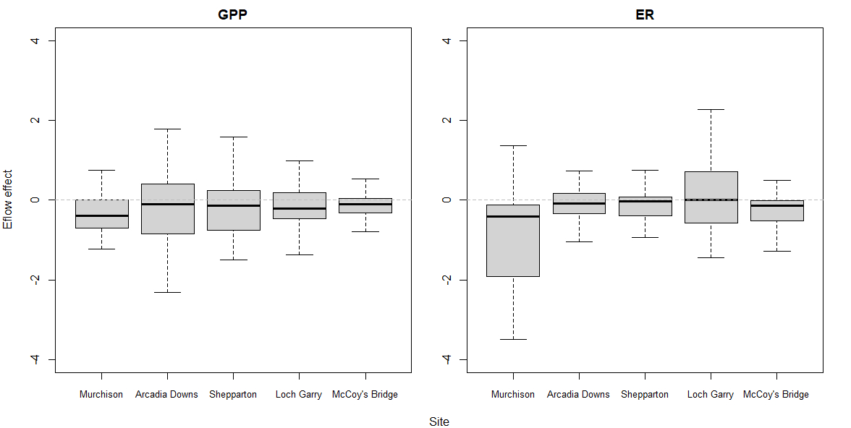
Figure 5-10 Effects of Environmental Flows (including watering actions) on rates of GPP and ER, using discharge (log(Q)) as the flow predictor. Y-axes show the differences in corresponding rates between with and without the environmental water delivered in 2019-20. These are presented as coefficients of variation (standard deviation over mean) to normalize results across the different sites. The error bars represent the 75% confidence intervals, summed for each site.

Organic Carbon Loads and Flow Categories
For the three sites (Day Rd/Murchison, Darcy’s Track/Arcadia Downs and McCoy’s Bridge) where flow categorization is possible according to Table 5-3, daily loads of organic carbon created by GPP and consumed by ER have been stratified into these categories using all five years of available data from the LTIM program. Almost all days (> 99%) with metabolic parameter estimates meeting acceptance criteria fall into four flow categories: Very Low Flow (VL), Moderately Low Flow (ML), Low Fresh Flow (LF) and Medium Fresh (MF). The summary statistics for these daily organic carbon load data are presented in Table 5-17 (GPP) and Table 5-18 (ER). The two respective box plots are Figure 5-11 (GPP) and Figure 5-12 (ER).

Table 5-17 Summary Statistics for Daily Organic Carbon Load (kg Org C/Day) created by GPP, stratified by Season, Site and Flow Category. All data from 2014-2020.
Season | Site | Flow Cat | n | Mean | Std Dev | Min | Max | Median | 25% | 75% | Season | n | Mean | Std Dev | Min | Max | Median | 25% | 75%
Spring | Arcadia Downs / Darcy's Track | Very Low | 45 | 423 | 159 | 131 | 724 | 432 | 274 | 549 | Summer | 39 | 1047 | 532 | 268 | 1871 | 893 | 581 | 1588
Spring | Arcadia Downs / Darcy's Track | Mod Low | 51 | 1042 | 761 | 173 | 3950 | 832 | 474 | 1314 | Summer | 123 | 906 | 317 | 139 | 1972 | 841 | 655 | 1119
Spring | Arcadia Downs / Darcy's Track | Low Fresh | 23 | 611 | 314 | 162 | 1369 | 552 | 398 | 721 | Summer | 91 | 1152 | 455 | 51 | 4006 | 1150 | 893 | 1413
Spring | Arcadia Downs / Darcy's Track | Med Fresh | 23 | 846 | 576 | 70 | 2272 | 657 | 431 | 997 | Summer | 20 | 1732 | 583 | 111 | 2833 | 1815 | 1404 | 2028
Spring | McCoy's Bridge | Very Low | 97 | 472 | 218 | 218 | 1615 | 426 | 335 | 516 | Summer | 65 | 736 | 337 | 293 | 1719 | 630 | 494 | 950
Spring | McCoy's Bridge | Mod Low | 96 | 812 | 506 | 197 | 2462 | 649 | 482 | 992 | Summer | 178 | 675 | 269 | 150 | 1934 | 625 | 513 | 784
Spring | McCoy's Bridge | Low Fresh | 33 | 1317 | 432 | 465 | 2567 | 1323 | 1007 | 1573 | Summer | 166 | 1558 | 784 | 57 | 3334 | 1387 | 909 | 2203
Spring | McCoy's Bridge | Med Fresh | 71 | 1411 | 528 | 332 | 2723 | 1528 | 883 | 1792 | Summer | 2
Spring | Moss Rd / Day Rd / Murchison | Very Low | 40 | 879 | 711 | 198 | 2357 | 591 | 299 | 1301 | Summer | 26 | 2299 | 1482 | 450 | 6192 | 2203 | 878 | 3137
Spring | Moss Rd / Day Rd / Murchison | Mod Low | 25 | 1473 | 1014 | 359 | 3970 | 1049 | 769 | 2113 | Summer | 100 | 2135 | 1862 | 238 | 7976 | 1440 | 908 | 2503
Spring | Moss Rd / Day Rd / Murchison | Low Fresh | 18 | 1148 | 440 | 425 | 2007 | 1156 | 825 | 1405 | Summer | 88 | 2090 | 1247 | 241 | 6960 | 1909 | 1110 | 2828
Spring | Moss Rd / Day Rd / Murchison | Med Fresh | 19 | 1264 | 450 | 429 | 2159 | 1137 | 923 | 1613 | Summer | 1
Autumn | Arcadia Downs / Darcy's Track | Very Low | 6 | 406 | 210 | 166 | 795 | 379 | 279 | 501 | Winter | 1
Autumn | Arcadia Downs / Darcy's Track | Mod Low | 53 | 502 | 318 | 144 | 2062 | 402 | 292 | 662 | Winter | 13 | 163 | 63 | 94 | 261 | 137 | 110 | 223
Autumn | Arcadia Downs / Darcy's Track | Low Fresh | 15 | 678 | 290 | 209 | 1117 | 552 | 459 | 965 | Winter | 9 | 196 | 80 | 114 | 340 | 164 | 130 | 272
Autumn | Arcadia Downs / Darcy's Track | Med Fresh | 15 | 1071 | 343 | 417 | 1581 | 1076 | 844 | 1388 | Winter | 5 | 250 | 34 | 205 | 284 | 248 | 219 | 283
Autumn | McCoy's Bridge | Very Low | 95 | 403 | 136 | 141 | 824 | 390 | 290 | 470 | Winter | 10 | 245 | 44 | 163 | 295 | 250 | 208 | 294
Autumn | McCoy's Bridge | Mod Low | 158 | 514 | 246 | 86 | 1591 | 449 | 349 | 601 | Winter | 99 | 280 | 107 | 68 | 735 | 276 | 229 | 320
Autumn | McCoy's Bridge | Low Fresh | 116 | 997 | 383 | 440 | 2262 | 937 | 710 | 1172 | Winter | 7 | 163 | 96 | 29 | 313 | 137 | 116 | 267
Autumn | McCoy's Bridge | Med Fresh | 28 | 1821 | 451 | 950 | 2345 | 1977 | 1521 | 2237 | Winter | 3
Autumn | Moss Rd / Day Rd / Murchison | Very Low | 7 | 1118 | 1281 | 105 | 3625 | 390 | 228 | 1876 | Winter | 5 | 272 | 143 | 148 | 507 | 262 | 157 | 392
Autumn | Moss Rd / Day Rd / Murchison | Mod Low | 48 | 689 | 861 | 42 | 5239 | 369 | 326 | 726 | Winter | 14 | 185 | 96 | 79 | 429 | 161 | 121 | 258
Autumn | Moss Rd / Day Rd / Murchison | Low Fresh | 24 | 1806 | 742 | 612 | 3723 | 1985 | 1166 | 2197 | Winter | 5 | 453 | 267 | 55 | 712 | 538 | 188 | 677
Autumn | Moss Rd / Day Rd / Murchison | Med Fresh | 14 | 1663 | 380 | 510 | 1970 | 1795 | 1555 | 1898 | Winter | 1

Table 5-18 Summary Statistics for Daily Organic Carbon Load (kg Org C/Day) consumed by ER, stratified by Season, Site and Flow Category. All data from 2014-2020.
Season | Site | Flow Cat | n | Mean | Std Dev | Min | Max | Median | 25% | 75% | Season | n | Mean | Std Dev | Min | Max | Median | 25% | 75%
Spring | Arcadia Downs / Darcy's Track | Very Low | 45 | 1234 | 862 | 325 | 3291 | 852 | 560 | 1878 | Summer | 39 | 2006 | 1410 | 505 | 5321 | 1836 | 814 | 2596
Spring | Arcadia Downs / Darcy's Track | Mod Low | 51 | 1393 | 1258 | 210 | 4638 | 974 | 535 | 1613 | Summer | 123 | 1597 | 749 | 357 | 3909 | 1488 | 1028 | 2072
Spring | Arcadia Downs / Darcy's Track | Low Fresh | 23 | 1475 | 724 | 450 | 2765 | 1215 | 889 | 2149 | Summer | 91 | 1968 | 1395 | 660 | 11936 | 1546 | 1249 | 2203
Spring | Arcadia Downs / Darcy's Track | Med Fresh | 23 | 1746 | 1294 | 83 | 4366 | 1491 | 581 | 2764 | Summer | 20 | 3133 | 1245 | 1524 | 6949 | 2859 | 2193 | 3792
Spring | McCoy's Bridge | Very Low | 97 | 1241 | 721 | 214 | 4774 | 1045 | 848 | 1470 | Summer | 65 | 1833 | 874 | 475 | 4379 | 1731 | 1109 | 2354
Spring | McCoy's Bridge | Mod Low | 96 | 992 | 652 | 32 | 3000 | 816 | 583 | 1315 | Summer | 178 | 1816 | 645 | 534 | 4073 | 1744 | 1390 | 2117
Spring | McCoy's Bridge | Low Fresh | 33 | 1515 | 1130 | 154 | 5419 | 1301 | 911 | 1691 | Summer | 166 | 2145 | 859 | 99 | 5498 | 2124 | 1594 | 2572
Spring | McCoy's Bridge | Med Fresh | 71 | 2154 | 1399 | 316 | 7337 | 1785 | 1166 | 2742 | Summer | 2
Spring | Moss Rd / Day Rd / Murchison | Very Low | 40 | 1606 | 1349 | 257 | 4558 | 1039 | 430 | 2672 | Summer | 26 | 1977 | 1765 | 557 | 6794 | 1098 | 666 | 2612
Spring | Moss Rd / Day Rd / Murchison | Mod Low | 25 | 3478 | 2458 | 377 | 9391 | 2893 | 1556 | 5235 | Summer | 100 | 3859 | 3561 | 610 | 18619 | 2593 | 1843 | 4111
Spring | Moss Rd / Day Rd / Murchison | Low Fresh | 18 | 7668 | 3751 | 347 | 12569 | 8687 | 4512 | 10780 | Summer | 88 | 3991 | 3947 | 248 | 15955 | 2156 | 1004 | 5456
Spring | Moss Rd / Day Rd / Murchison | Med Fresh | 19 | 26365 | 13753 | 6336 | 49225 | 27884 | 14447 | 37792 | Summer | 1
Autumn | Arcadia Downs / Darcy's Track | Very Low | 6 | 1035 | 576 | 459 | 2130 | 898 | 687 | 1329 | Winter | 1
Autumn | Arcadia Downs / Darcy's Track | Mod Low | 53 | 775 | 863 | 190 | 5868 | 513 | 384 | 829 | Winter | 13 | 1311 | 896 | 184 | 3054 | 1055 | 882 | 1918
Autumn | Arcadia Downs / Darcy's Track | Low Fresh | 15 | 910 | 474 | 423 | 1848 | 791 | 530 | 1251 | Winter | 9 | 1584 | 511 | 616 | 2425 | 1517 | 1316 | 1938
Autumn | Arcadia Downs / Darcy's Track | Med Fresh | 15 | 1474 | 865 | 466 | 3789 | 1219 | 776 | 1689 | Winter | 5 | 4447 | 2110 | 2358 | 7049 | 3413 | 2706 | 6705
Autumn | McCoy's Bridge | Very Low | 95 | 931 | 437 | 266 | 2325 | 799 | 580 | 1250 | Winter | 10 | 1525 | 1274 | 299 | 3727 | 991 | 565 | 3025
Autumn | McCoy's Bridge | Mod Low | 158 | 1153 | 679 | 198 | 4618 | 1021 | 740 | 1337 | Winter | 99 | 1520 | 1081 | 63 | 4383 | 1028 | 705 | 2425
Autumn | McCoy's Bridge | Low Fresh | 116 | 1524 | 509 | 361 | 2773 | 1367 | 1192 | 1930 | Winter | 7 | 2088 | 1586 | 638 | 5309 | 1301 | 1092 | 2579
Autumn | McCoy's Bridge | Med Fresh | 28 | 2094 | 762 | 633 | 3271 | 2268 | 1254 | 2723 | Winter | 3
Autumn | Moss Rd / Day Rd / Murchison | Very Low | 7 | 1813 | 668 | 888 | 2844 | 1735 | 1374 | 2292 | Winter | 5 | 1937 | 722 | 1174 | 2831 | 2147 | 1197 | 2574
Autumn | Moss Rd / Day Rd / Murchison | Mod Low | 48 | 1755 | 2336 | 343 | 10670 | 894 | 570 | 1715 | Winter | 14 | 724 | 502 | 271 | 1600 | 447 | 348 | 1208
Autumn | Moss Rd / Day Rd / Murchison | Low Fresh | 24 | 7194 | 4163 | 271 | 16702 | 8531 | 4051 | 9487 | Winter | 5 | 3469 | 2168 | 843 | 5704 | 4042 | 1205 | 5447
Autumn | Moss Rd / Day Rd / Murchison | Med Fresh | 14 | 5285 | 1704 | 472 | 7453 | 5309 | 4792 | 6547 | Winter | 1

Figure 5-11 Box plot showing the Daily Organic Carbon Load (Tonnes/Day) created by GPP for the combined 6-year LTIM-MER data set, stratified by season and flow category: Very Low Flow, Moderately Low Flow, Low Fresh Flow and Medium Fresh Flow. Summary statistics are presented in Table 5-17. Note the log scale for the Y-axis.
Wilks-Shapiro tests on both raw data and common transformations (square root, log) of the raw GPP load data indicated non-normality. Consequently, Mann-Whitney Rank Sum tests were performed between each pair of flow categories (VL-ML, ML-LF, LF-MF) within each season. These tests showed a strong statistical difference (p < 0.02, often <0.001) for all spring and autumn comparisons and for moderately low flow versus low fresh in summer. Despite the apparent visual difference between LF and MF in summer, this was not statistically significantly different (p=0.123). The summer VL-ML was not significantly different either. All the winter comparisons were all non-significant (p > 0.05).
In each case of a statistically significant difference between the flow categories, the organic carbon load created from GPP increased with increased flow. All four of these flow categories represent flows that are well constrained within the stream channel. This important point is developed further in the Discussion section below.
Figure 5-12 Box plot showing the Daily Organic Carbon Load (Tonnes/Day) consumed by ER for the combined 6-year LTIM-MER data set, stratified by season and flow category: Very Low Flow, Moderately Low Flow, Low Fresh Flow and Medium Fresh Flow. Summary statistics are presented in Table 5-18. Note the log scale for the Y-axis.
As with GPP, Wilks-Shapiro tests on both raw data and common transformations (square root, log) of the raw ER load data in Figure 5-12 indicated non-normality and Mann-Whitney Rank Sum tests were performed between each pair of flow categories at each site. Unlike GPP, the results showing statistically greater ER loads in the higher flow category were more equivocal although no comparison showed a lower load at the higher flow category. The comparisons showing strong statistically significant increases (p < 0.01) in load were: Spring ML-LF, Summer LF-MF, Autumn ML-LF and Autumn LF-MF. Weaker relationships (p < 0.1) were found with Spring LF-MF (p = 0.071), Summer VL-ML (p = 0.62), Summer ML-LF (p = 0.042) and Winter LF-MF (p = 0.094).
The key feature seen clearly in Figure 5-12 is that in most comparisons, increases in daily flow into the next higher flow category results in more organic carbon being consumed by ecosystem respiration, even with the caveat that some of these increases are not statistically significant when using the typical alpha value of 0.05.

The Contribution of CEW to Organic Carbon Production in the Goulburn River
Using the complete six-year data set at McCoy’s Bridge, we are now in the position to determine how CEW has contributed to the creation of organic carbon through Gross Primary Production. The method is described in more detail below but essentially involves estimating the amount of organic carbon created each day and apportioning that to either CEW or non-CEW flow. This is not as straight-forward as apportioning the daily organic carbon load on the relative amounts of CEW and non-CEW flow as the GPP rate is very dependent upon the actual discharge, with increasing discharge decreasing the amount of GPP per litre due to dilution. Hence the following method uses the actual data set for each season (as seasonal effects are very important as shown in Figure 5-11 then divides each season up into 6 ‘bins’ going from the lowest flow in that season to the highest, in all cases only using flows on days when the metabolism model results met the acceptance criteria. A summary of the McCoy’s Bridge site data in each bin is presented in Appendix C. The McCoy’s Bridge site was chosen as it was the only site with a significant number of winter days (135).
Briefly, using a method modified described in Watts et al. (2018), the calculations were performed using the following steps:
- Every date with metabolism results that passed the model acceptance criteria was then stratified into a season (summer, autumn, winter, spring) and flow quantile (6 groups or ‘bins’). Each of the six groups contained the same number of data days, or differed by one day based on the total number of acceptable data days in that season and whether that number divided exactly by six. The flow quantiles characterized data days by the daily discharge with the lowest quantile (bin) containing the lowest 1/6 of all data days, the second bin containing data days with flows from 1/6 to 2/6 etc
- For each season and bin the mean rate of organic carbon production per litre per day (g C/L/day) were calculated. These data are presented in Appendix C.
- The mean rate of production for each day was estimated by multiplying this mean rate of production for that day’s season and bin (in g C/L/day) by the observed discharge on that day (L). This provided an estimate of the total production on that day. This calculation was made for all days in that season.
- To calculate the discharge estimated to have occurred in the absence of Commonwealth Environmental Water (CEW), firstly the non-CEW discharge (observed discharge – CEW) was determined.
- The mean rate of production associated with that season and the bin in which the non-CEW discharge fell, was then used to determine the predicted rate of production (g C/L/day) for that day in the absence of CEW.
- This alternative rate of production was then multiplied by the non-CEW discharge volume to determine the total production predicted to have occurred on that day in the absence of CEW. This then provided a time-series of daily production rates with and without CEW.
- The daily estimates of CEW/non-CEW derived production were then summed to estimate the total additional production from CEW over each season for the full five years of this study.
Using the 2019-20 MER data, Figure 5-13 shows the GPP load from non-CEW water in blue and the visible orange colour indicates the additional organic carbon load emanating from the addition of CEW. This figure only uses the data days that met the acceptance criteria. The following figure (Figure 5-14) includes all days from 1st October 2014 through to 30th April 2020. The daily load for every day was calculated using the mean GPP rate for that flow bin and season. The resulting seasonal totals data are summarized in Table 5-19.

Figure 5-13 Estimated daily loads of organic carbon created by GPP at McCoy’s Bridge during MER Year 1 (May 2019-April 2020) showing the total load and the load without the contribution of CEW. The visible orange section of each bar represents the contribution of CEW. This plot only shows data days when the model output met acceptance criteria.

Figure 5-14 Estimated daily loads of organic carbon created by GPP at McCoy’s Bridge showing the total load and the load without the contribution of CEW. The visible orange section of each bar represents the contribution of CEW. This plot estimates loads for every day over the period of record – October 2014 to April 2020.

Table 5-19 Seasonal Loads of Organic Carbon Produced by GPP at McCoy’s Bridge showing total loads and the contribution made by Commonwealth environmental water (CEW) over the duration of this project (October 2014 to April 2020). The Seasonal Flows, including the CEW contribution are also shown.
Season | Seasonal Total Load | Seasonal Contribution from CEW | % Contribution | Total Flow | Total CEW Flow | % Contribution
 | (Tonnes Organic Carbon) | (Tonnes Organic Carbon) | from CEW | (GL) | (GL) | from CEW
Spring 2014* | 75.5 | 26.6 | 35 | 218 | 114 | 52
Spring 2015 | 64.3 | 37.7 | 59 | 165 | 120 | 73
Spring 2016 | 252.6 | 14.2 | 6 | 1022 | 16 | 2
Spring 2017 | 83.5 | 49.6 | 59 | 190 | 133 | 70
Spring 2018 | 81.6 | 11.4 | 14 | 213 | 81 | 38
Spring 2019 | 77.2 | 41.2 | 53 | 208 | 146 | 70
Summer 2014-15 | 94.0 | 18.1 | 19 | 145 | 18 | 12
Summer 2015-16 | 50.4 | 0.0 | 0 | 59 | 0 | 0
Summer 2016-17 | 81.2 | 11.9 | 15 | 138 | 23 | 17
Summer 2017-18 | 156.1 | 10.2 | 7 | 241 | 21 | 9
Summer 2018-19 | 135.6 | 0.0 | 0 | 205 | 0 | 0
Summer 2019-20 | 79.9 | 0.0 | 0 | 156 | 0 | 0
Autumn 2015 | 57.2 | 15.0 | 26 | 127 | 34 | 26
Autumn 2016 | 50.7 | 27.4 | 54 | 111 | 62 | 56
Autumn 2017 | 76.5 | 45.4 | 59 | 173 | 105 | 61
Autumn 2018 | 81.5 | 0.0 | 0 | 196 | 0 | 0
Autumn 2019 | 57 | 0.0 | 0 | 131 | 0 | 0
Autumn 2020 | 31.6 | 13.3 | 42 | 69 | 30 | 43
Winter 2015 | 30.7 | 5.9 | 19 | 152 | 28 | 19
Winter 2016 | 48.5 | 2.6 | 5 | 393 | 9 | 2
Winter 2017 | 39.5 | 18.8 | 48 | 292 | 151 | 52
Winter 2018 | 36.2 | 18.0 | 50 | 262 | 148 | 56
Winter 2019 | 36.3 | 20.2 | 56 | 236 | 164 | 70
Total | 1778 | 388 | 22 | 5102 | 1404 | 28
* Autumn 2014 data was only from October and November of that year. Autumn 2020 was only from March and April.
Table 5-19 shows that overall, CEW contributes to the generation of nearly one quarter of all organic carbon created from Gross Primary Production in the Goulburn around the McCoy’s Bridge site: 388 of 1778 Tonnes of organic carbon over the duration of the combined MER-LTIM monitoring (1st October 2014 to 30th April 2020). Table 5-19 also includes the amount of CEW and non-CEW water and this shows that Commonwealth environmental water made up 28% of the total flow in the Goulburn River at McCoy’s Bridge over the same time frame. This close congruence of load contribution and flow contribution is perhaps unsurprising because as shown in the binning data in Appendix C, there is generally only a small difference in GPP rates for the 6 bins, whereas the relative variation in flow is much greater.
From noting the position of the ‘orange colour’ in Figure 5-14 (corresponding to the CEW load contribution) and the data in Table 5-19 it is clear that CEW contributions in spring time are particularly important. With the exception of Spring 2016 when CEW only contributed 2% to flow due to the large flooding event, CEW contributed 35-59% of all organic carbon created by GPP in this season, including 53% in Spring 2019. This may be ecologically very significant as it will provide a food resource to support and perhaps sustain fish breeding.
CEW has also contributed around half (48-56%) of winter organic carbon creation over the last three years.
Finally, Figure 5-15 illustrates how the seasonal partitioning in organic carbon load created by GPP between non-CEW and CEW water is affected by the nominal flow category (Table 5-3).
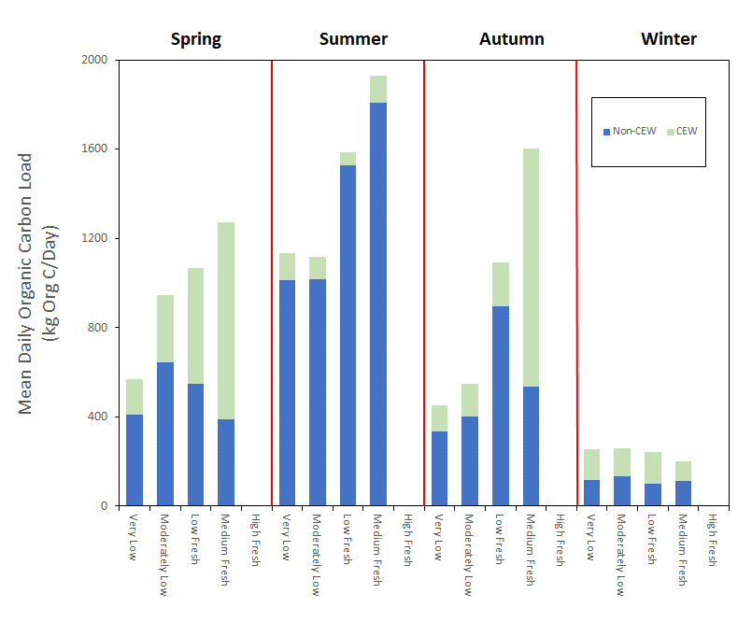
Figure 5-15 Estimated mean daily loads of organic carbon created by GPP, stratified by season and flow category. Data from 2014-20, pooled across the Moss/Rd/Day Rd/Murchison, Darcy’s Track/Arcadia Downs and McCoy’s Bridge sites.
There are several striking features shown in Figure 5-15:
- The importance of CEW contributions to organic carbon creation, especially in winter and spring,
- In winter, the same average daily organic carbon load is created at very low flows as it is for higher flows, hence from this organic carbon perspective, there is no additional benefit by increasing flows above the very low category,
- Summer-time CEW additions only provide a small increase in daily organic carbon loads, hence if water availability is low or there is the prospect of needing CEW to ameliorate the low DO events sometimes witnessed after large summer storm events then retaining that water in storage is a good management option,
- The best outcomes for CEW-assisted creation of organic carbon are found in the ‘Medium Fresh’ flow category in spring and autumn where an average additional 800-1100 kg organic carbon is created. The benefit of flow in this flow category is highest in autumn, where CEW contributions in the lower flow categories are much more modest (an additional 100-200 kg of organic carbon). In spring, substantial increases occur in all flow categories above low flow.
We stress that there are a lot of assumptions made to enable these calculations, most notably that the mean GPP for a particular flow band (bin) in any season is appropriate for any day in that season with a flow in that range. Daily variation in weather will ensure that the ‘mean GPP’ is not correct, but it will not be grossly wrong. Despite these caveats, the general conclusions drawn from this analysis should be robust and can certainly be validated with ongoing data collection.

Discussion Summary
The statistical modelling demonstrated a predominantly negative effect of increasing flow on rates of GPP and ER expressed on a per litre basis. This is consistent with findings from previous years. It is clear that the immediate effect of flow is to reduce GPP (and ER) rates, almost certainly by simple dilution with large amounts of water. Primary production is expected to respond to additional nutrients introduced via the higher flows on a perhaps 10-20 day time frame following flow events (this time frame is based on typical algal doubling rates of 1-2 days), as this corresponds to sufficient time post nutrient addition to generate a significantly higher biomass of primary producers. The key assumption is that an increase in flow will introduce nutrients into the river channel which will then stimulate biomass growth and hence higher rates of GPP. It is extremely likely that the absence of significant growth is due to the extremely low bioavailable nutrient concentrations, especially the extremely low levels of filterable reactive phosphorus (which essentially equates to bioavailable phosphate). Respiration rates did seem to increase slightly in the days to weeks following discharge events. A flow-based influx of organic matter will enhance respiration although the quality/palatability of that organic matter is just as important as the increase in concentration.

Impact of Daily Discharge on Stream Metabolism
Using the ‘load approach’ (Grace 2018), the mass of organic carbon created by GPP or consumed by ER per day in water flowing past the logger location, and incorporating the flow categorization of Stewardson et al. (2018), it has been clearly demonstrated that small increases in discharge introduce more organic carbon into the stream through photosynthetic production. As noted in the 2019 Report, this is a positive finding as the initial paradigm was that no benefit to metabolism would accrue unless the water levels were sufficient to reconnect flood runners, backwaters and even the floodplain. Hence increasing flow from the very low to moderately low category means more energy (‘food’) being created to support the aquatic foodweb. There is also an increase in respiration rate with flow category thus greater nutrient regeneration to sustain increased primary production.
Data from McCoy’s Bridge (the site with the largest LTIM data record) showed that the organic load enhancements were similar in magnitude in spring, summer and autumn. Hence further work should be undertaken to match this extra organic carbon production to the times of the year where it is most needed by native fish and other biota. There was negligible benefit in increasing discharge in winter from the perspective of organic carbon creation as the four flow categories all produced approximately the same amount of organic carbon (production is most likely constrained by low water temperatures, low sunlight intensity and the relatively short days (less overall sunshine to drive photosynthesis).
It was also estimated that CEW provided around 22% of all organic carbon created by GPP over the LTIM and first year of MER projects and this was closely related to the amount of CEW relative to non-CEW supply. The timing of the CEW delivery can be matched to ecological need (e.g. for fish) as well as operational constraints on such delivery.
From a management perspective, there is a positive benefit in increasing discharge, even by relatively small amounts when there are restrictions on the amount of water that can be delivered in watering actions. Nevertheless, it is likely that such increases in metabolic rates are still constrained by resources (nutrients) and much greater increases would be possible with reconnection of backwaters and other off-channel habitats.

Macroinvertebrates

Introduction
Macroinvertebrates are an essential part of healthy, functioning aquatic ecosystems, providing essential ecosystem services that range from nutrient cycling to provision of food for larger aquatic organisms such as fish. Macroinvertebrates are frequently monitored in aquatic ecosystem assessments to understand the health of those ecosystems. In large lowland rivers, such as the Goulburn River, the macroinvertebrate communities tend to be dominated by species that favour relatively simple habitats and are able to tolerate moderate to poor water quality. Environmental flows delivered to these rivers are more likely to influence macroinvertebrate abundance and biomass than diversity. Previous work from the Goulburn LTIM Project macroinvertebrate monitoring program have also shown that crustaceans seem to be particularly responsive to flows in the lower Goulburn River (e.g. Webb et al. 2019a). To have more of a focus on abundance and biomass of invertebrates, the new MER Program differs from the LTIM monitoring to include a rapid bioassessment of macroinvertebrates (to look at key families/taxa) and edge sampling and bait trapping of crustaceans at a number of sites in the Lower Goulburn. There is also more of a focus in the MER Program on looking how all freshes and water deliveries contribute to sustaining macroinvertebrate and crustacean populations rather than just the spring fresh.
The macroinvertebrate indicators measured at the area scale include:
- Macroinvertebrate composition and abundance – Rapid Bioassessment Methodology (RBA). The taxonomic groups (family level) presence and abundance will provide information on how these potential key food sources for fish respond to environmental flows. In particular, it will be important to monitor macroinvertebrates such as chironomids and trichopterans that may be an important food source for young Golden Perch or other smaller fish.
- Large bodied crustacean (shrimp, prawns, yabbies) life history (size, abundance, reproductive capability) and biomass – Bait traps. It is believed that crustaceans are an important food source for fish, including the Golden Perch (Macquaria ambigua), with literature confirming they may eat macroinvertebrates and large bodied crustaceans (Herbert 2005). The information specifically targeting large-bodied crustaceans will provide information on how these potential key food sources for fish respond to environmental flows.
These indicators will contribute to a better understanding of how environmental flow deliveries in the lower Goulburn River can affect the abundance and composition of macroinvertebrates and the lifecycle (reproduction and recruitment) of large bodied crustaceans. This has important implications for the river in terms of the services and functions provided by macroinvertebrates. The role of bank vegetation, macrophytes and biofilms play an important role in sustaining these populations, while it is likely large-bodied crustaceans are likely to be an important food source for other riverine species, especially Golden Perch.

Area specific evaluation questions
The key basin and area-scale evaluation questions and relevant indicators for macroinvertebrates are listed in Table 6-1.
Table 6-1 Macroinvertebrate key evaluation questions for the Goulburn selected area and associated indicators and evaluation approaches.
Key Evaluation Questions | Indicator |  | Evaluation Approaches
Basin Scale evaluation Questions
There are no basin-scale evaluation questions for macroinvertebrates
Area Scale evaluation questions
What did CEW contribute to the composition and abundance of macroinvertebrate groups in the lower Goulburn River? Specifically, what combination of freshes and low flows are required to maximise key macroinvertebrate groups in the river? | - Composition of families of macroinvertebrates  - Abundance of total macroinvertebrates and key groups | - Examining relationships between composition and abundance of families of macroinvertebrates across multiple sites and freshes and flows.  - Bayesian models to follow in subsequent years.
What does CEW and other natural flow events contribute to crustacean growth, reproduction and biomass in the Goulburn Catchment and exploitation of novel habitats by these large-bodies crustaceans? Specifically, what combination of flows are required to maximise large-bodied crustacean growth, reproduction and biomass in the river? | - Crustacean abundance, biomass and reproduction caught in bait traps  - Crustacean abundance, biomass and reproduction caught in sweep samples  - Assessment of habitat cover for crustaceans in bait traps | - Examining relationships between abundance and biomass of crustaceans across multiple sites and freshes and flows.  - Examine relationships between crustaceans and habitat.  - Bayesian models to follow in subsequent years.

Main findings from monitoring program
The following sections provides a high-level summary of the outcomes of the 2019-20 monitoring and the implications of these findings to previous years outcomes.

2019/20 findings
The main findings from the 2019-20 monitoring are:
- Overall the qualitative data showed macroinvertebrate abundance increased after the CEW spring fresh event and remained high from December-March. The pulses of flow received from the IVTs may also have been beneficial in sustaining high abundances of macroinvertebrates that were able to move from the main channel of the Goulburn river and into the more complex edge habitats (vegetation and snags). It is unclear how much of the observed increases in macroinvertebrate abundance is a result of changes in flow or changes in season.
- Immature crustaceans (shrimp - Parataya australiensis and prawns - Macrobrachium australiense) increased in abundance after the CEW spring fresh event in January and February, particularly at Cemetery Bend and Salas Road (Murchison). During these sampling times, the flow was high and crustaceans had access to slower flowing areas of vegetation and snag habitats, which may have contributed to their abundance. The recruitment of crustaceans may provide an important food source for native fish, including golden perch.
- Crustacean species have a clear preference for sections of the Goulburn River, with shrimps more abundant in the upstream reaches and prawns absent at Kirwans Bridge and only occurring in low abundances at Salas Road (Murchison) the two most upstream reaches of the Goulburn River.
- There was no clear relationship of habitat preference (increasing macrophyte or snag cover) with increasing abundances of shrimp although they are more likely found to be in areas where there is some complex habitat. In comparison prawns appeared to have a declining abundance with increasing macrophyte cover. However, both species were more abundant where there was some complex habitat present.
- Collection of data in subsequent years and statistical analysis will help to understand the trends observed in 2019-20 and how much of the observed trends can be attributed to flow. Future data will also help to identify the best combinations of freshes and low flows to maximise macroinvertebrate and crustacean populations.

Summary of previous findings and implications for any new finding
- While the results of the 2019-20 MER Program are not directly comparable to the previous LTIM Project results, this year’s findings are overall similar to the results observed throughout the LTIM Project, whereby spring freshes and other environmental water delivery appear to have small positive impacts on the macroinvertebrate fauna, particularly the large bodied crustaceans in the Goulburn River.

Summary of findings relevant to evaluation questions
Table 6-2 provide a summary of results with specific reference to the evaluation questions
Table 6-2 Summary of macroinvertebrate findings relevant to evaluation questions.
Question | Were appropriate flows provided? | Effect of environmental flows | What information was the evaluation based on?
What did CEW contribute to the composition and abundance of macroinvertebrate groups in the lower Goulburn River? Specifically, what combination of freshes and low flows are required to maximise key macroinvertebrate groups in the river? | Yes | An increase in overall macroinvertebrate abundance after CEW delivery that continued to be high throughout December-March. This is likely to be a combination of a seasonal increase and flow contributions. Further data are needed to understand the best combinations of freshes and low flows to maximise key macroinvertebrate groups. | Qualitative observations of macroinvertebrate taxa sampled across a number of sites along the lower Goulburn River during multiple time periods.
What does CEW and other natural flow events contribute to crustacean growth, reproduction and biomass in the Goulburn Catchment and exploitation of novel habitats by these large-bodies crustaceans? Specifically, what combination of flows are required to maximise large-bodied crustacean growth, reproduction and biomass in the river? | Yes | An increase in overall crustacean abundance and biomass after the CEW flow event that continued to be high throughout December-March. This is likely to be a combination of a seasonal increase and flow contributions.  Evidence of reproduction and recruitment after the CEW spring fresh delivery with high numbers of immature crustaceans observed in January and February. Further data are needed to understand the best combinations of freshes and low flows to maximise key macroinvertebrate groups. | Qualitative observations of crustacean taxa (abundance, biomass, reproduction) sampled across a number of sites along the lower Goulburn River during multiple time periods.

Monitoring methods and analytical techniques

Methods
The methods used for monitoring macroinvertebrates are given in the MER plan and the Standard Operating Procedures Macroinvertebrates v2.0 (The University of Melbourne 2019). Two methods were employed at eight sites along the Goulburn River; Rapid bioassessment edge sweep and Bait traps, as briefly described below. These methods vary from LTIM methods with a Rapid Bioassessment for invertebrates replacing artificial substrates and replicated edge samples. The number of sites has expanded from 2-3 sites to eight sites along the Lower Goulburn and the frequency of sampling has increased from 2 to 5 sampling occasions. The timing of monitoring, along with significant catchment events is given in Figure 6-1 and Table 6-3.
The first method, Rapid Bioassessment edge sweep (RBA) samples, were conducted at all sites, following the methodology outlined in the EPA Victoria Rapid Bioassessment protocols (2003). Sampling involves taking 10 meters of sweep samples across a representative selection of the edge habitats at each site. The contents of the sample were placed in a sampling tray, and picked for 30 minutes, with an emphasis on targeting macroinvertebrates >5 mm. The live pick sample, and remaining bulk sample were preserved in separate jars of 100% ethanol for analysis in the laboratory.
The second method, Bait Traps, specifically targeted large bodied crustaceans and was conducted at all sites. Five bait traps were deployed overnight at each site. The traps were placed among complex habitat, such as macrophytes or snags where possible. The surrounding habitat, depth and flow rate were recorded surrounding each bait trap. Upon retrieval, all crustaceans were removed from the bait traps and stored in 100% ethanol for analysis in laboratory except for yabbies (Cherax species), which were counted, measured, weighed and released back into the river.
The RBA live pick macroinvertebrates were processed in the laboratory by sorting and identifying macroinvertebrates within the samples to family level where possible, with the exceptions of chironomids, which were identified to sub-family, and immature or damaged specimens, which were identified to the lowest taxonomic level possible. Crustaceans were identified from the live pick as well as from the bulk samples to measure biomass of each of the families present. The crustaceans from the bait trap samples were identified to species in the laboratory and had their carapace lengths measured (from the tip of the rostrum to the end of the carapace). These were air dried for 24 hours, dried in the oven at 60°C for a further 24 hours and weighed.
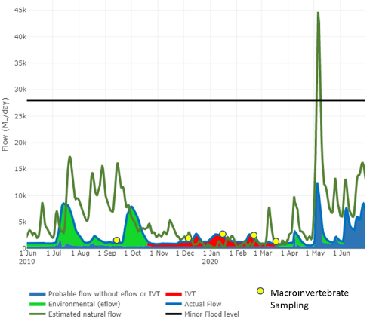
Figure 6-1 Macroinvertebrate sampling in 2019-2020 pre and post Commonwealth Environmental Water delivery and other flow events.
Table 6-3 Macroinvertebrate and crustacean sampling times and significant events on the Goulburn River during 2019-20. CEW = Commonwealth Environmental Water delivered as spring freshes. Pre-CEW = pre-Commonwealth Environmental Water delivery (before spring fresh); Post-CEW = post-Commonwealth Environmental Water delivery (after spring fresh).
 |  | Sampling dates
Activity / event | Site | September 2019 | October 2019 | December 2019 | January 2020 | February 2020 | March 2020
Events | Goulburn River | CEW start | CEW end | Elevated flows for consumptive demand | Elevated flows for consumptive demand | Elevated flows for consumptive demand | Elevated flows for consumptive demand
RBA | Kirwans Bridge  Salas Road (Murchison)  Cemetery Bend  Riverview Drive | Pre-CEW 11/9  Pre-CEW 11/9  Pre-CEW 11/9  Pre-CEW 12/9 |  | Post-CEW 4/12  Post-CEW 4/12  Post-CEW 4/12  Post-CEW 4/12 | 15/1  15/1  15/1  15/1 | 17/2  17/2  17/2  17/2 | 16/3  16/3  16/3  16/3
RBA | Lord Road (nr Loch Garry)  McCoy’s Bridge  Murrumbidgee Road  Stewarts Bridge | Pre-CEW 13/9  Pre-CEW 13/9  Pre-CEW 13/9  Pre-CEW 13/9 |  | Post-CEW 6/12  Post-CEW 6/12  Post-CEW 6/12  Post-CEW 6/12 | 17/1  17/1  17/1  17/1 | 19/2  19/2  19/2  19/2 | 18/3  18/3  18/3  18/3
Bait traps | Kirwans Bridge  Salas Road (Murchison)  Cemetery Bend  Riverview Drive | Pre-CEW 11/9-12/9  Pre-CEW 11/9-12/9  Pre-CEW 11/9-12/9  Pre-CEW 11/9-12/9 |  | Post-CEW 4/12-5/12  Post-CEW 4/12-5/12  Post-CEW 4/12-5/12  Post-CEW 4/12-5/12 | 15/1-16/1  15/1-16/1  15/1-16/1  15/1-16/1 | 17/2-18/2  17/2-18/2  17/2-18/2  17/2-18/2 | 16/3-17/3  16/3-17/3  16/3-17/3  16/3-17/3
Bait traps | Lord Road (nr Loch Garry)  McCoy’s Bridge  Murrumbidgee Road  Stewarts Bridge | Pre-CEW 12/9-13/9  Pre-CEW 12/9-13/9  Pre-CEW 12/9-13/9  Pre-CEW 12/9-13/9 |  | Post-CEW 5/12-6/12  Post-CEW 5/12-6/12  Post-CEW 5/12-6/12  Post-CEW 5/12-6/12 | 16/1-17/1  16/1-17/1  16/1-17/1  16/1-17/1 | 18/2-19/2  18/2-19/2  18/2-19/2  18/2-19/2 | 17/3-18/3  17/3-18/3  17/3-18/3  17/3-18/3

Statistical Analysis
Given the changes to the macroinvertebrate program in the MER Program compared to LTIM, there was no specific statistical analyses on the 2019-20 data. Instead, some exploratory plotting was undertaken to identify patterns of macroinvertebrates and flow. It is envisaged statistical analyses will be conducted in the remaining years of the MER Program to link macroinvertebrates and flow.
Total abundance and richness of all macroinvertebrate taxa were plotted from the RBA data. Averages and standard deviations are presented for sampling months and sites, as well as raw data for all sites over the five months of sampling. Similar bar graphs and line graphs were also plotted for RBA abundance and biomass of juvenile crustaceans, shrimps and prawns. Bait trap abundance and biomass of dominant crustaceans, shrimps and prawns were also plotted. The relationship between the mean value of abundance from bait traps and the percentages of macrophytes and snags were also respectively presented for crustaceans.

Results

RBA Macroinvertebrate Taxa
In 2019-20, a total of 49,147 macroinvertebrates from 57 taxa were collected in live picks from RBA sweep samples across all sampling periods. The most common taxa, where >100 individuals were collected across all sampling periods, included: mites; the water bugs (Micronectidae, Gerridae, Notonectiidae and Veliidae); the mayfly Baetidae; the caddisfly Leptoceridae; the chironomids, Chironominae and Tanypodinae; and the shrimp, Atyidae. All these taxa increased after the CEW spring fresh event with the highest abundances occurring in the summer months December-March.
Average total abundance across all sites was greater in December compared to September (after the CEW spring fresh event) and was highest in January, although there is high variability between sites (Figure 6-2a). Cemetery Bend had the highest abundance of all species, with a mean value >3000 individuals, followed by Riverview Drive with a mean value around 2000 (Figure 6-2c). In September, average total abundance was low across all sites. In January a very large increase in total abundance was observed at Cemetery Bend and Riverview Drive, reaching about 9000 and 6000 individuals, respectively. None of the other sites had such high total abundance in any of the months sampled, with total abundance less than 3000 individuals (Figure 6-2e).
There was no strong pattern of mean total richness of taxa over time. There was a small decrease in the mean total richness in December after the delivery of the CEW spring fresh, before increasing to approximately pre-fresh mean total richness in the following months (January-March) (Figure 6-2b). There were also no strong patterns for species richness among sites (Figure 6-2d). Kirwans Bridge and McCoy’s Bridge both had a mean value larger than 15, while Riverview Drive had the smallest species richness at about 10 (Figure 6-2f).
The results indicate that richness, the number of different taxa, remains relatively constant across the year and across sites, but that abundance, the number of individuals of any species, varies across the year and between sites. While the results show that abundance is generally higher following the spring fresh, this also coincides with warmer conditions (moving from spring to summer), so it is as yet unclear the extent to which abundance increases in response to flow or temperature / seasonal changes.
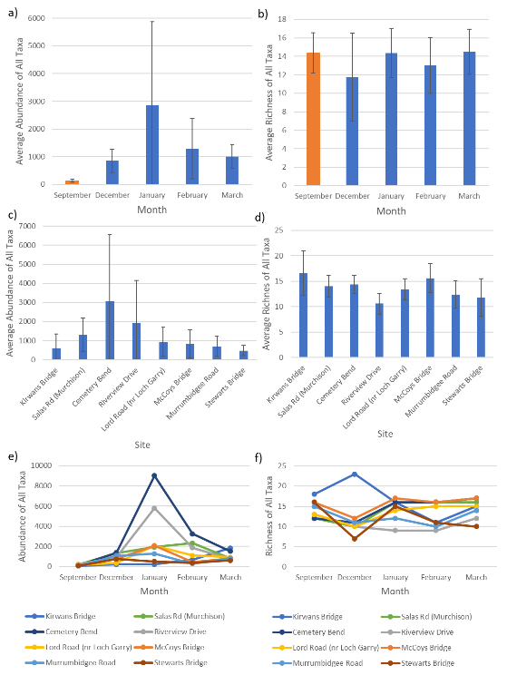
Figure 6-2 RBA macroinvertebrate sampling a) mean (± standard deviation) total abundance of all taxa caught per sample in different months. Orange colour: before spring fresh; blue colour: after spring fresh. b) mean (± standard deviation) total richness of all taxa caught per sample in different months. Orange colour: before spring fresh; blue colour: after spring fresh. c) mean (± standard deviation) abundance of all taxa caught per sample in different sites. d) mean (± standard deviation) total richness of taxa caught per sample in different sites. e) abundance (± standard deviation) of all taxa for all sites in different months. f) richness of all taxa for all site in different months.

RBA Crustaceans
A total of 1661 crustacean individuals were collected in the RBA samples across all sampling periods. Three groups of crustaceans were collected (shrimps, prawns and yabbies), with the shrimp the most abundant crustacean taxon within the lower Goulburn. A large number of immature crustaceans were also collected across all sites.
Mean biomass (g/m³) of crustaceans were similar in September and December, before and after the delivery of the CEW Spring Fresh, and increased in January-March (Figure 6-3a). There was little difference in mean crustacean biomass across sites with the highest mean biomass at Cemetery Bend and the lowest mean biomass at Lord Road (Loch Garry), but with high variability at all sites (Figure 6-3b). While mean biomass increased at a number of sites in January, the greatest increase occurred at Cemetery Bend. Mean crustacean biomass was greatest in February at Kirwans Bridge and greatest in March at Lord Road (Loch Garry) and Murrumbidgee Road (Figure 6-3c).
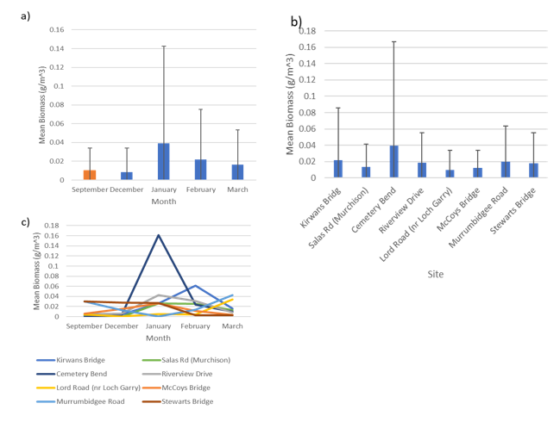
Figure 6-3 RBA macroinvertebrate sampling a) mean (± standard deviation) biomass of crustaceans per sample in different months. Orange colour: before spring fresh; blue colour: after spring fresh. b) mean (± standard deviation) biomass of crustaceans caught per sample in different sites. c) biomass of crustaceans for all sites in different months.
Very few immature crustaceans were collected in September before the delivery of the CEW spring fresh. An increase in immature crustaceans was observed after the CEW spring fresh, increasing substantially in January and February before decreasing in March, suggesting reproduction is occurring during these months (Figure 6-4a). Murchison and Cemetery Bend had the highest number of immature crustaceans, with the highest numbers occurring in January (Figure 6-4d, g). At Stewarts Bridge the highest number of immature crustaceans was collected in December (Figure 6-4g). Shrimp had low mean abundances in September and December (pre and post the delivery of the CEW Spring Fresh), increasing in January and February (Figure 6-4b). The highest mean abundances occurred in January which was mainly driven by shrimp collected at Kirwans Bridge (Figure 6-4e, h). Across all other sites, low mean abundances of shrimp were collected across all sampling times, with Salas Rd (Murchison), Riverview Drive and Stewarts Bridge having a higher mean averages of shrimp compared to other sites. At these sites shrimp abundances increased from September, with the highest abundances of shrimp occurring in January and February, except at Stewarts Bridge which had the highest abundances of shrimp in September and January (Figure 6-4e, h).
Prawns were similar to the shrimp, with low mean abundances in September and December (pre and post the delivery of the CEW Spring Fresh), and increasing in January through to March (Figure 6-4c). No prawns were found at Kirwans bridge and very few were found at Salas Road (Murchison). Cemetery Bend had the highest mean abundances of prawns which was driven by a large increase in abundances in January and February. Apart from Cemetery Bend, more prawns were collected at the lower sites within the Goulburn (Lord Road (Loch Garry) to Stewarts Bridge) (Figure 6-4f, i).
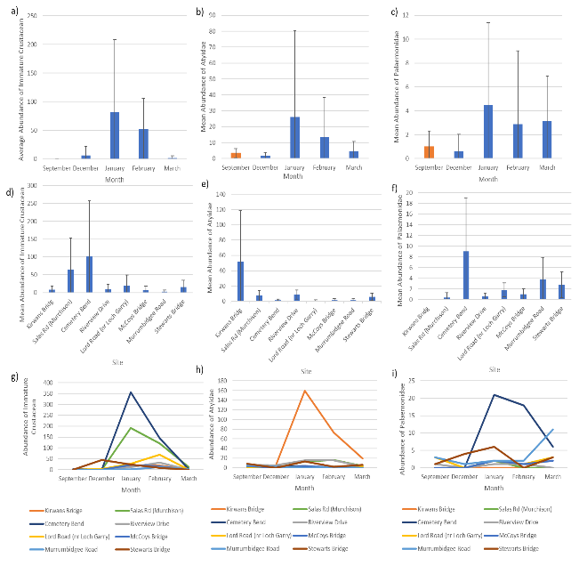
Figure 6-4 RBA crustacean sampling a) mean (± standard deviation) abundance of immature crustaceans per sample in different months. Orange colour: before spring fresh; blue colour: after spring fresh. b) mean (± standard deviation) abundance of Atyidae per sample in different months. Orange colour: before spring fresh; blue colour: after spring fresh. c) mean (± standard deviation) abundance of Palaemonidae per sample in different months. Orange colour: before spring fresh; blue colour: after spring fresh. d) mean (± standard deviation) abundance of immature crustaceans caught per sample in different sites. e) mean (± standard deviation) abundance of Atyidae caught per sample in different sites. f) mean (± standard deviation) abundance of Palaemonidae caught per sample in different sites. g) abundance of immature crustaceans for all sites in different months. h) abundance of Atyidae for all sites in different months. i) abundance of Palaemonidae for all sites in different months.

Crustaceans caught in bait traps
A total of 437 crustacean individuals were collected in the bait traps across all sampling periods. Three groups of crustaceans were collected (shrimps, prawns and yabbies). Prawns were the most abundant crustacean caught within the bait trap, while only four yabbies were caught during the sampling period. There is evidence of recruitment and breeding occurring of shrimps and prawns with a range of cohorts and females with eggs found across the sites within the lower Goulburn, particularly during the December – March sampling period.
There was very little difference in mean abundance and biomass of the shrimps across months and sites (Figure 6-5a, b). The highest abundances and biomass of shrimps was at Kirwans Bridge, Salas Road (Murchison), Riverview Drive and Stewarts Bridge (Figure 6-5c, d). There was no consistent trend in abundance or biomass of shrimps across sites and months (Figure 6-5e, f).
In comparison, the mean abundance of prawns was lowest in September, before the delivery of the CEW Spring Fresh. Mean abundance increased from December to March – although differences were not large (Figure 6-6a). No prawns were collected in the bait traps at Kirwans Bridge. Average abundance of prawns increased at all sites in December and January (Figure 6-6c, e). Like mean abundance, the mean biomass was lowest at about 4.5 g/m³ in September, before the delivery of the CEW Spring Fresh. Biomass increased to more than 18 g/m³ from December to March (Figure 6-6b). Biomass was highest in January at Lord Road (Loch Garry), 43.6 g/m³, and highest in February at Cemetery Bend, 49.2 g/m³, and Riverview Drive, 44 g/m³, before decreasing in March to below 20 g/m³ in March (Figure 6-6d, f).
While the results show that prawn abundance and biomass is generally higher following the Spring Fresh, this also coincides with warmer conditions (moving from spring to summer), so it is unclear the extent to which abundance and biomass increases in response to flow or temperature / seasonal changes.

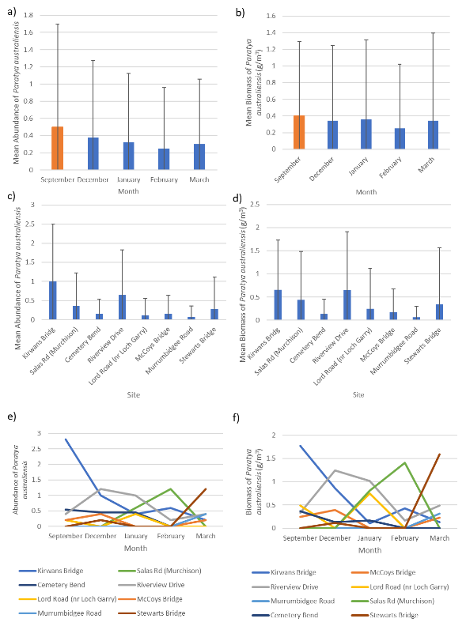

Figure 6-5 Crustacean Bait Trap sampling a) mean (± standard deviation) total abundance of shrimps (Parataya australiensis) caught per sample in different months. Orange colour: before spring fresh; blue colour: after spring fresh. b) mean (± standard deviation) total biomass of shrimps caught per sample in different months. Orange colour: before spring fresh; blue colour: after spring fresh. c) mean (± standard deviation) abundance of shrimps caught per sample in different sites. d) mean (± standard deviation) total biomass of shrimps caught per sample in different sites. e) abundance of all shrimps for all sites in different months. f) biomass of shrimps for all site in different months.

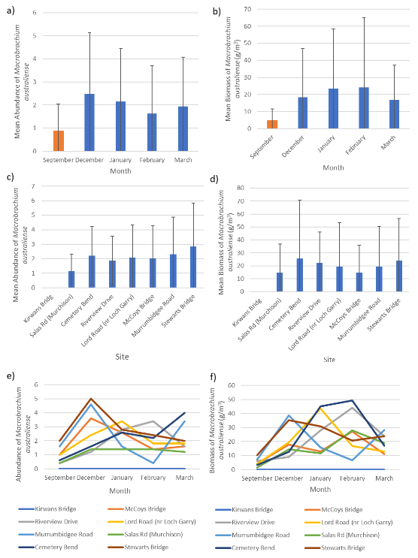

Figure 6-6 Crustacean Bait Trap sampling a) mean (± standard deviation) total abundance of prawns (Macrobrachium australiense) caught per sample in different months. Orange colour: before spring fresh; blue colour: after spring fresh. b) mean (± standard deviation) total biomass of prawns caught per sample in different months. Orange colour: before spring fresh; blue colour: after spring fresh. c) mean (± standard deviation) abundance of prawns caught per sample in different sites. d) mean (± standard deviation) total biomass of prawns caught per sample in different sites. e) abundance of prawns for all sites in different months. f) biomass of prawns for all site in different months.

There was a noticeable decrease in total crustacean abundance in bait traps with increasing macrophyte cover in the sampling location (Figure 6-7a), but there was also no obvious increasing or decreasing trend of total crustacean abundance as the percentage of snags changed (Figure 6-7b). Shrimps did not show an obvious increasing or decreasing trend of abundance as the percentage of macrophyte cover changed (Figure 6-7c), so the decrease observed in Figure 6a is attributed to the declining abundance of prawns with increasing macrophyte cover (Figure 6-7d). The decreased abundance of prawns with increasing macrophyte cover is probably not indicative that prawns are less common in macrophyte-rich areas. Rather, it is possible that the bait trap appears as safe ‘habitat’ to prawns in otherwise open areas. Conversely, in areas with high macrophyte cover, the bait trap does not offer any additional habitat value. We need to be careful when interpreting these relationships.

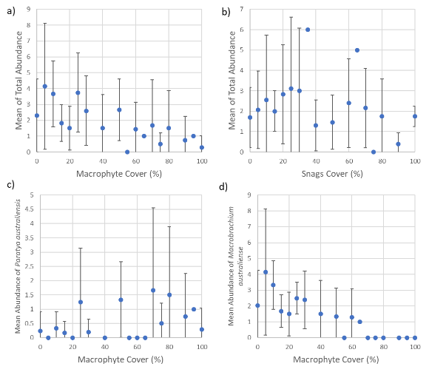
Figure 6-7 Crustacean Bait Trap sampling a) mean (± standard deviation) total crustacean abundance per bait trap vs percentage of macrophyte cover. b) mean (± standard deviation) total abundance per bait trap vs percentage of snags cover. c) mean (± standard deviation) abundance of Shrimps vs percentage of macrophyte cover d) mean (± standard deviation) abundance of Prawns vs percentage of macrophyte cover.

Discussion
The macroinvertebrate component of the MER Program has changed considerably compared to that in the previous LTIM Project. A change in the overall design has included changing macroinvertebrate sampling, and increasing the frequency and the number of sites sampled in the Lower Goulburn. Hence the first year of the MER program includes only exploratory plots to describe some of the trends observed. With subsequent years of monitoring, a more rigorous analysis of the data will be carried out to gain a better understanding as to how environmental flows influence macroinvertebrates, with the focus on the large bodied crustaceans.
The first year of the MER program continues to suggest that overall macroinvertebrate abundance across most taxa increases after the CEW Spring Fresh event, with the highest abundances occurring in the summer months December-March. The abundance and biomass of the key crustacean species increase after the CEW Spring Fresh event and other pulses of flow from other water deliveries (IVT transfers) particularly from December through to February. These results suggest that key crustaceans within the edge habitats are moving from the main channel and into slower moving habitats that contain some complex habitat (macrophytes and or snags). Flow pulses may increase access to these habitats depending on the height that the water reaches on the bank. After 2019-20 we are not able to determine how much of the increases are directly related to the flow events and how much is caused by seasonal changes, such as increased temperature. It is expected subsequent monitoring will help to disentangle these factors.
While the results of this year MER Program are not directly comparable to the previous LTIM Project, this year’s findings are overall similar to the results observed throughout the LTIM Project monitoring, whereby spring freshes and other environmental water deliveries had small positive impacts on the macroinvertebrate fauna, particularly the large bodied crustaceans in the Goulburn River, probably through the inundation and maintenance of important habitats.
There is evidence of crustaceans reproducing within the Goulburn River after the CEW Spring Fresh event with large increases in immature crustaceans (shrimp and prawns) occurring in January and February. During these periods of sampling, the flows were higher, allowing crustaceans to access bank vegetation and snag habitats in areas of slower flow that provided a sheltered environment to support numerous immature crustaceans (shrimps, prawns and yabbies). The increase in macroinvertebrates and crustaceans in December-February is likely to be beneficial to native fish which spawn around November-December, providing an abundant food source for larvae and juveniles.
Crustacean species have a clear preference for sections of the Goulburn River, with shrimp more abundant in the upstream reaches and prawns less so. It is still unclear as to why there are different distributions of crustacean species across the lower Goulburn. The 2019-20 data showed no clear relationship with habitat preference for shrimps (vegetation or snags), although there is a trend that shrimps are more likely to be detected in habitats where there is some complex habitat either macrophytes and snags rather than bare edge. Prawns appeared to have a declining abundance with increasing macrophyte cover. However, both species were more abundant where there was some complex habitat present. More data are needed to understand the links between these crustacean species, habitat (vegetation/snags) and the food resources associated with each habitat to understand the drivers of abundance and biomass. It is envisaged that with more data collected in the coming years, a greater understanding of the links between habitat, food resources, flow and these crustaceans will be determined. It is still hypothesised that the link between habitat (vegetation), flow and crustaceans is important for maintaining these populations.
While the 2019-20 data suggests that the CEW Spring Fresh and the consequent IVT deliveries may have contributed to the increase in abundance of macroinvertebrate taxa and abundance, biomass and reproduction of large bodied crustaceans, it is still unclear what proportion is driven by flows and what proportion is driven by seasonal changes. It is also unknown what combination of freshes and low flows are required to maximise production of these groups in the river. With the continued monitoring of macroinvertebrates and crustaceans over the duration of the MER Program, it will be important to understand if the observations from the first year change with different flow events over future years. It is also expected that there will be a greater understanding of the types of flows that are needed to maximise macroinvertebrates.

Vegetation

Introduction
Riparian and aquatic vegetation underpins aquatic systems by: (1) supplying energy to support food webs, (2) providing habitat and dispersal corridors for fauna, (3) reducing erosion and (4) enhancing water quality. In the Goulburn River, drought and floods have reduced the quantity, quality and diversity of riparian and bankside vegetation over the last 20 years. Minimum summer and winter low flows and periodic freshes are recommended to help rehabilitate and maintain vegetation along the lower Goulburn River. The recommended flow components shape aquatic plant assemblages by influencing (1) inundation patterns in different elevation zones on the bank and hence which plants are promoted in each zone; (2) the abundance and diversity of plant propagules dispersing in water; and (3) where those propagules are deposited and germinate.
Vegetation diversity was monitored at four sites in the lower Goulburn River as part of the Victorian Environmental Flows Monitoring and Assessment Program (VEFMAP; Miller et al. 2015) and the Commonwealth Short Term Monitoring Projects (STIM; Stewardson et al. 2014, Webb et al. 2015). Vegetation diversity monitoring in the LTIM Project and MER Program at two sites (Loch Garry and McCoy’s Bridge) in the lower Goulburn River is extending those data sets and allowing the effect of different flow components to be assessed in wet and dry climatic conditions. The results are being used to identify what flows are needed to maintain or rehabilitate riparian vegetation in the lower Goulburn River depending on its current condition and state of recovery. They can also be used to broadly inform appropriate water management in other systems recovering from extreme events.

Area specific evaluation questions
To determine the contribution of Commonwealth environmental water in selected areas, and to improve understanding of the relationship between specific watering actions and ecological objectives for assets, the following questions are being addressed. This information also forms the basis of Basin-scale evaluation – where area-level results are scaled up to the Basin level.
The key area-scale evaluation questions and relevant indicators for vegetation are listed in Table 7-1.
Table 7-1 Vegetation key evaluation questions for the Goulburn selected area and associated indicators and evaluation approaches.
Key Evaluation Questions | Indicator | Evaluation Approaches
Area Scale evaluation questions
Does the CEW contribution to spring freshes increase the abundance of riparian vegetation on the bank face? | - Cover of all ground layer vegetation  - Cover of focal plant groups  - Cover of focal taxa | - Visual comparison of pre and post spring fresh cover  - Visual comparison of the cover of focal taxa and plant groups across bank zones
Do flows shift the distribution of riparian vegetation communities on the bank face | - Cover of all ground layer vegetation  - Cover of focal plant groups  - Cover of focal taxa | - Visual comparison of the cover of focal taxa and plant groups across bank zones
What influence do hydraulic variables have on the abundance of riparian vegetation communities? | - Cover of all ground layer vegetation  - Cover of focal plant groups  - Cover of focal taxa | - Bayesian models
Is there a positive trend in the abundance of riparian vegetation communities over the medium-long term? | - Cover of all ground layer vegetation  - Cover of focal plant groups  - Cover of focal taxa | - Visual examination of changes over time and trend lines
How does the annual flow regime (natural, environmental or consumptive) influence the abundance of riparian vegetation communities at the end of the growth season? | - Cover of all ground layer vegetation  - Cover of focal plant groups  - Cover of focal taxa | - Visual examination of changes over time

Main findings from the vegetation monitoring program
The following sections provides a high-level summary of the outcomes of the 2019-20 monitoring and the implications of these findings to previous years outcomes.

2019-20 findings
The main findings from the 2019-20 monitoring are:
- Spring freshes appear to support water dependent species as their distribution on the bank continues to be greatest in bank zones inundated by spring freshes. In the context of this report water dependent is defined as species that depend on inundation from the river for some or all of their life history requirements.
- The mean summed cover of water dependent taxa again increased following spring freshes in 2019-20 at Loch Garry but not at McCoy’s Bridge. This may be because sampling occurred several weeks earlier than previous years due to the start of higher IVT discharge, and vegetation may respond more slowly at McCoy’s Bridge. While increases in cover are correlated with spring freshes it is not known what portion of the increase in cover can be attributed to seasonal patterns of plant growth that would have occurred without the delivery of spring freshes.
- The mean summed cover of ground layer vegetation shows a weak medium-term trend of increasing at both sites, but the rate of increase is greater at Loch Garry than at McCoy’s Bridge. At Loch Garry cover has increased by about 20% between 2014 and 2020 but only by about 10% at McCoy’s. Most of the observed increases in ground layer cover is due to increased cover of grasses, notably common tussock grass (Poa labillardierei).
- In contrast to increasing cover of grasses over time, the cover of water dependent species as a group has oscillated over time. However, in 2019-20 there were observable increases in water ribbon (Vallisineria australis) at McCoy’s Bridge, the first substantial observation of aquatic macrophytes since the inception of monitoring.
- Increased consumptive demand for water in 2018-19 resulted in the loss of water dependent vegetation in Zone 1a, the lowest elevation zone surveyed. Sampling prior to IVT delivery in September 2019 indicated that no recovery had occurred, although some new germinates were observed at some locations. IVT delivery in 2019-20 prevented re-establishment of vegetation in Zone 1a, but grasses at higher elevations increased (Zone 2). Benches may provide suitable hydraulic habitat for some plant taxa under higher summers flows associated with IVT delivery, but the spatial extent of these features is not well mapped.
- The narrowing of the littoral band of vegetation due to higher IVT demand is expected to reduce the resilience of vegetation by limiting propagule supply and reducing the buffering capacity that wider stands may offer to high flow velocities. This increases vulnerability to erosion and further loss of vegetation. The loss of vegetation at the toe of bank increases the risk of erosion and subsequent changes in channel geomorphology that are not easily reversed.
- Modelled relationships between the cover and occurrence of selected taxa and groups, and the duration of inundation the year prior to sampling again demonstrate differences in the hydraulic niche of the plant groups and taxa examined. The data collected in 2019-20 has contributed to refining these models.
- Modelled relationships of selected taxa and the duration of inundation over the IVT period generally show similar patterns as inundation over the year prior to sampling, but thresholds differ, reflecting the short temporal scale examined. The model outputs suggest that the probability of water dependent taxa occurring on the bank starts to steadily decline when the total duration of inundation over the IVT period exceeds 55 days. It is not clear to what extent antecedent conditions contribute to this response, and whether responses differ if the days inundated are continuous or intermittent. Further data and modelling are needed to (1) explore the relative importance of antecedent conditions and (2) to examine changes in vegetation abundance in response to specific watering actions.

Summary of previous findings and implications for any new finding
- The mean summed cover of water dependent vegetation across all sampling locations at both sites increased following spring freshes in 2014–15, 2015–16 and 2018-19. Increases were again observed at Loch Garry but not at McCoy’s Bridge in 2019-20. This may be because post spring fresh surveys occurred two weeks earlier than previous years and because responses at McCoy’s Bridge may be slower than at Loch Garry. While increases in cover are correlated with spring freshes it is not known what portion of the increase can be attributed to seasonal patterns of plant growth that would have occurred without the delivery of spring freshes.
- The extent and duration of inundation provided by spring freshes is correlated with the distribution and cover of vegetation along the bank. Water dependent taxa have higher cover in regions of the bank inundated by spring freshes. In contrast, the perennial native common tussock grass is more restricted in its distribution to elevations at the upper margins or above the level inundated by spring freshes. This pattern has persisted over time.
- The recruitment of woody species, specifically silver wattle (Acacia dealbata) and river red gum (Eucalyptus camaldulensis) is generally restricted to higher areas of the bank which experience shallow and less frequent inundation.
- Climatic conditions and non-regulated flows can exert a strong influence on vegetation and potentially influence the outcomes of environmental watering actions. Low flows in 2014–15 resulted in the recruitment of sedges along the river margin at base flow but a reduction in the cover and spatial extent of lesser joyweed (Alternanthera denticulata). In contrast, prolonged natural flooding in 2016–17 caused a substantial decline in the cover and occurrence of sedges and rushes, but increased the cover and distribution of lesser joyweed and to a lesser extent common sneezeweed (Centipeda cunninghamii) which colonised the exposed bare mud following flood recession. Flooding in 2016-17 also increased the cover of common tussock grass at elevations above that reached by the spring fresh, but cover at this elevation has since declined in 2018-19 and 2019-20. This is likely to be due to the reduced flooding and lower rainfall. Under these drier conditions spring freshes may contribute to maintaining this species through improving soil moisture.
- The cover of some species such as lesser joyweed and common sneezeweed can increase when exposed wet mud is available on the recession of high flows and show a dynamic pattern of occurrence and cover both spatially and temporally. Other species such as creeping knotweed (Persicaria prostrata) maintain a more stable position along the elevation gradient possibly supported by a persistent woody root stock.
- There was no evidence that the delivery of a fresh in March 2017 had any immediate negative outcome on bank vegetation. There is some evidence that grasses benefited from this late season watering.
- Prolonged high river discharges delivered for consumptive use as IVTs in 2018-19 eliminated much of the vegetation at the toe and lower bank and caused erosion. There was no evidence that vegetation was re-establishing in September prior to IVT delivery in 2019-20, although some patches of germination were observed. There were no further reductions in vegetation following IVT delivery in 2019-20 as most vegetation in this region had already been lost following IVT delivery in 2018-19. At higher elevations where IVT flows are likely to result in only very shallow inundation the cover of grasses increased.
- Modelled relationships between the cover of selected taxa and duration of inundation the year prior to sampling reveal that the hydrologic envelopes differ for various groups and taxa examined. The data collected in 2019-20 has contributed to refining these models.
- Changes in the cover of examined taxa over time are similar at Loch Garry and McCoy’s Bridge but the total cover of the ground layer was lower at McCoy’s Bridge and trends in the cover of vegetation show a slower rate of increase at McCoy’s than at Loch Garry. The reason for differences in cover and rates of recovery at the two sites is not known but may reflect differences in channel shape, the aspect of sampled transects, or differences in subsurface water inflows. Loch Garry potentially receives higher subsurface water inflows from the closer proximity of large wetlands compared to McCoy’s which experiences more human activity and goat grazing on creeping knotweed (pers. obs. D. Lovell, GBCMA).

Summary of findings relevant to evaluation questions
Table 7-2 provides a summary of the vegetation findings relevant to the evaluation questions. A more detailed examination of each evaluation question is provided in section 7.5.

Table 7-2 Summary of vegetation findings relevant to evaluation questions.
Question | Were appropriate flows provided? | Effect of environmental flows | What information was the evaluation based on?
Area scale evaluation questions
Does the CEW contribution to spring freshes increase the abundance of riparian vegetation on the bank face? | Spring freshes were appropriate.  Prolonged summer inundation by IVT flows resulted in negative outcomes | Spring freshes contribute to maintaining the cover of water dependent taxa. This is demonstrated by:  - Water dependent taxa generally increase in cover post spring freshes. In 2019-20 this increase was observed at Loch Garry but not at McCoy’s Bridge. This may be as post spring fresh surveys occurred 2 weeks earlier and response at McCoy’s may be slower.  - The distribution of water dependent taxa is limited to regions of the bank influenced by spring freshes | - Visual comparison of the cover of focal taxa and plant groups across bank zones  - Visual comparison of pre and post spring fresh cover
Do flows shift the distribution of riparian vegetation communities on the bank face | As above | The distribution of plant groups and species along the bank face reflects their hydraulic tolerances. The distribution of water dependent taxa is limited to regions of the bank influenced by spring freshes and the distribution of common tussock grass is limited to higher elevation where it experiences shallow and brief inundation. IVTs have eliminated water dependent species at the lowest elevations effectively narrowing the littoral zone and exposing the toe of the bank to erosion. | - Visual comparison of the cover of focal taxa and plant groups across bank zones
Do responses of bank vegetation differ among sites? | As above | Vegetation cover is consistently lower at McCoy’s Bridge compared with Loch Garry but responses of vegetation to environmental water and unregulated flows are generally similar. Although increased cover of water dependent vegetation in response to the spring fresh was not observed this year at McCoy’s, this was likely due to the earlier sampling and as vegetation may respond more slowly at this site. | - Visual comparison of the cover of focal taxa and plant groups across bank zones  - Visual comparison of pre and post spring fresh cover
What influence do hydraulic variables have on the abundance of riparian vegetation communities? | As above | The duration of inundation in the year prior to sampling and over the IVT period influences the abundance of plant groups and taxa differently and reflects their distribution on the bank. For water dependent taxa, inundation of more than 55 days over the IVT period is correlated with a steady decline in the probability of occurrence. It is not known if antecedent conditions influence this response or if responses differ if inundation is continuous or intermittent. | - Bayesian models
Is there a positive trend in the abundance of riparian vegetation communities over the medium-long term? | As above | The mean summed cover of ground layer vegetation shows a weak trend of increasing over time at both sites, but the rate of increase is greater at Loch Garry than at McCoy’s Bridge. At Loch Garry, cover has tended to increase by ~20% between 2014 and 2020 but by only 10% at McCoy’s Bridge. The increase is cover is mostly due to increase in the cover of grasses. In contrast the cover of water dependent vegetation has not increased but oscillated over time. Higher IVT delivery eliminated most plants from the toe and lower bank and prevented recovery. | - Visual examination of changes over time and trend lines
How does the annual flow regime (natural, environmental or consumptive) and weather conditions influence the abundance of riparian vegetation communities at the end of the growth season? | As above | The cover of vegetation at the end of the growing season reflects the cumulative response to the annual flow regime and weather conditions. In 2018 and 2019 vegetation cover declined slightly between December and March. This can be attributed to the impact of IVTs on vegetation at the toe of the bank and due to a decline in grasses at higher elevations, possibly due to the lack of natural floods that inundate higher elevations coupled with lower annual rainfall in 2018 and 2019. | - Visual comparison of cover over time

Monitoring methods and analytical techniques

Sampling
Vegetation has been sampled on both banks at Loch Garry and McCoy’s Bridge, before and after the delivery of spring freshes in 2014–15, 2015–16, 2017–18 2018-19, 2019-2020 (Table 7-3). In 2016 spring freshes were not delivered due to the large unregulated flows that persisted between June and November 2016, and vegetation was instead sampled in December 2016 after the recession of flood waters. Comparing vegetation cover measured in December 2016 with past surveys in December 2014 and 2015 provides insights into the influence of large natural flood events.
Vegetation was again sampled in February 2017 and April 2017, before and immediately after, a fresh delivered in March 2017 for instream vegetation and fish objectives. Vegetation monitoring was undertaken in this case to assess recovery of vegetation following the natural flooding and to assess responses of vegetation to the March fresh that could guide future flow planning. Vegetation sampling carried out in April 2017 was supported by the GBCMA with VEFMAP funds.
Due to increasing IVT demand, an additional survey was undertaken at McCoy’s Bridge in March 2019 to evaluate the responses to IVT delivery and was funded by the VEWH and GBCMA.
In 2019-20 surveys were carried out before and after the spring fresh and again in March at both McCoy’s Bridge and Loch Garry. Surveys in December 2019 allow an evaluation of the short-term responses to the spring fresh but also provide a baseline prior to higher IVT delivery. Surveys in March 2020 enable an evaluation of responses to IVT delivery as well as the end of growing season response to the annual flow regime.
At all sampling times vegetation was surveyed along transects that ran perpendicular to stream flow. Sampling was initially designed to survey regions of the bank that had previously been surveyed by other programs (i.e. VEFMAP and CEWO STIM). However, many quadrats sampled by these programs were at elevations well above the level expected to be inundated by spring freshes. As such, subsequent sampling did not attempt to match the spatial extent of these previous programs. Instead, surveys extended from around base flow to just above the level inundated by spring freshes (nominally a change in elevation of approximately 3 m). As transect elevation data were not available in the first year of sampling, a 3 m change in height from base flow was estimated visually.
Vegetation indicators were assessed using the line point intercept method at each sampling interval along the transect. This is done by placing a 2 m measuring tape perpendicular to the transect (i.e. parallel to streamflow) and recording every 10 cm along the tape all species that intercept a rod placed vertically through the vegetation. This gives a total of 20 sampling points at each sampling location. Foliage projected cover (%) for each species was then calculated by dividing the number hits per species by the total number of points sampled (see details in standard operating procedures, Webb et al. (2019b)).

Table 7-3 Summary of vegetation survey dates, sampling locations and transects.
Year | Trip  No. | Survey  Type | Date | Sites sampled | Transects sampled  North bank | Transects sampled  South bank
2014-15 | 1 | Pre spring fresh | 23 Sept & 3 Oct 2014 | Loch Garry | 1, 3, 5, 8, 9, 10, 12, 13, 15 | 9, 10, 11, 12, 13
2014-15 | 1 | Pre spring fresh | 24 Sept 2014 | McCoy’s Bridge | 1, 2, 3, 6, 8, 10, 12, 13, 15 | 1, 2, 3, 5, 10, 12, 13, 15
2014-15 | 2 | Post spring fresh | 16 Dec 2014 | Loch Garry | 1, 3, 5, 8, 9, 12, 13, 15 | 1,3,5,9,10,12,13,15
2014-15 | 2 | Post spring fresh | 17 Dec 2014 | McCoy’s Bridge | 1, 2, 3, 6, 10, 12, 13, 15 | 1, 2, 3, 6, 10, 12, 13, 15
2015-16 | 3 | Pre spring fresh | 16 Sept 2015 | Loch Garry | 1, 3, 5, 8, 9,10,12,13 | 1, 3, 5, 8, 9, 12, 13, 15
2015-16 | 3 | Pre spring fresh | 15 Sept 2015 | McCoy’s Bridge | 1, 2, 6, 10, 12, 13,15 | 2, 3, 6, 10, 12, 13, 15
2015-16 | 4 | Post-fresh | 16 Dec 2015 | Loch Garry | 1, 3, 5, 8, 9, 10, 12, 13 | 1, 3, 5, 8, 9, 12, 13, 15
2015-16 | 4 | Post-fresh | 17 Dec 2015 | McCoy’s Bridge | 1, 2, 3, 6, 10, 12, 13, 15 | 1, 2, 3, 6, 10, 12, 13, 15
2016-17 | 5 | Post natural flood | 12 Dec 2016 | Loch Garry | 1, 3, 5, 8, 9, 10, 12, 13 | 1, 3, 5, 8, 9, 12, 13, 15
2016-17 | 5 | Post natural flood | 13 Dec 2016 | McCoy’s Bridge | 1, 2, 3, 6, 10, 12, 13, 15 | 1, 2, 3, 6, 10, 12, 13, 15
2016-17 | 6 | Pre autumn fresh | 21 Feb 2017 | Loch Garry | 1, 3, 5, 8, 9,10,12,13 | 1, 3, 5, 8, 9, 12, 13, 15
2016-17 | 6 | Pre autumn fresh | 22 Feb 2017 | McCoy’s Bridge | 1, 2, 3, 6, 10, 12, 13, 15 | 1, 2, 3, 6, 10, 12, 13, 15
2016-17 | 7 | Post autumn fresh | 11 April 2017 | Loch Garry | 1, 3, 5, 8, 9, 10, 12, 13 | 1, 3, 5, 9, 12, 13, 15
2016-17 | 7 | Post autumn fresh | 10 April 2017 | McCoy’s Bridge | 1, 2, 3, 6,10,12,13,15 | 1, 2, 3, 6, 10, 12, 13, 15
2017-18 | 8 | Pre spring fresh | 7 Sept 2017 | Loch Garry | 1, 3, 5, 8, 10,12,13 | 1, 3, 5, 8, 9, 12, 13, 15
2017-18 | 8 | Pre spring fresh | 8 Sept 2017 | McCoy’s Bridge | 1, 2, 3, 6, 10, 12, 13,15 | 1, 2, 3, 6, 10, 12, 13, 15
2017-18 | 9 | Post spring fresh | 14 Dec 2017 | Loch Garry | 8, 9, 10, 12, 13 | 1, 3, 5, 8, 9, 12, 13, 15
2017-18 | 9 | Post spring fresh | 15 Dec 2017 | McCoy’s Bridge | 1, 2, 3, 6, 10, 12, 13, 15 | 1, 2, 3, 6, 10, 12, 13, 15
2018-19 | 10 | Pre spring fresh | 11 Sept 2018 | Loch Garry | 1, 3, 5, 8, 10, 12, 13 | 1, 3, 5, 8, 9,12,13,15
2018-19 | 10 | Pre spring fresh | 12 Sept 2018 | McCoy’s Bridge | 1, 2, 3, 6, 10, 12, 13, 15 | 1, 2, 3, 6, 10, 12, 13, 15
2018-19 | 11 | Post spring fresh  Pre IVT | 10 & 11 Dec 2018 | Loch Garry | 1, 3, 5, 8, 9, 10, 12, 13 | 1, 3, 5, 8, 9, 12, 13, 15
2018-19 | 11 | Post spring fresh  Pre IVT | 11 & 12 Dec 2018 | McCoy’s Bridge | 1, 2, 3, 10, 12, 13, 15 | 1, 2, 3, 6, 10, 12, 13, 15
2018-19 | 12 | Post IVT | 4-5 Mar 2019 | McCoy’s Bridge | 1, 2, 3, 6, 10, 12, 13, 15 | 1, 2, 3, 6, 10, 12, 13, 15
2019-20 | 13 | Pre spring fresh | 17 Sept 2019 | Loch Garry | 1, 3, 5, 8, 10, 12, 13 | 1, 3, 5, 8, 9, 12, 13, 15
2019-20 | 13 | Pre spring fresh | 16 Sept 2019 | McCoy’s Bridge | 1, 2, 3, 6, 10, 12, 13, 15 | 1, 2, 3, 6, 10, 12, 13, 15
2019-20 | 14 | Post spring fresh  Pre IVT | 28 Nov2018 | Loch Garry | 1, 3, 5, 8, 9, 10, 12, 13 | 1, 3, 5, 8, 9, 12, 13 ,15
2019-20 | 14 | Post spring fresh  Pre IVT | 27 Nov 2019 | McCoy’s Bridge | 1, 2, 3, 6, 10, 12, 13, 15 | 1, 2, 3, 6, 10, 12, 13, 15
2019-20 | 15 | Post IVT | 2 Mar 2020 | Loch Garry | 1, 3, 5, 8, 9, 10, 12, 13 | 1, 3, 5, 8, 9, 12, 13, 15
2019-20 | 15 | Post IVT | 3 Mar 2020 | McCoy’s Bridge | 1, 2, 3, 6, 10, 12, 13, 15 | 1, 2, 3, 6, 10, 12, 13, 15

Analyses
Monitoring data collected over the six years of the LITM and MER programs provides insights into the responses of vegetation to environmental flow events and to longer term hydrologic regimes. Qualitative and quantitative approaches have been applied to evaluate vegetation responses.
Qualitative approaches include the following:
- Examination of foliage projective cover of different taxa across all sampled locations at each site in relation to short and longer-term flow histories.
- Examination of the foliage projective cover of different taxa across the elevation gradient at each sample date at each site.
Quantitative approaches were developed to identify relationships between hydrologic variables and vegetation cover and occurrence that is more transferrable to other sites and support a more predictive approach. Models have been developed for (1) vegetation presence/absence and number of days inundated and (2) vegetation abundance and number of days inundated. Models are described in detail in previous annual reports (e.g. Webb et al. 2019a). The evaluation has concentrated on a subset of species with high enough occurrences to reveal responses to inundation. More specifically, creeping knotweed, lesser joyweed and common tussock grass are representative of ground-layer dominants of some Riverine floodplain Ecological Vegetation Classes (EVCs) relevant to the Goulburn River bankside assemblage (Cottingham et al. 2013). Drain flat-sedge (Cyperus eragrostis) was included even though it is an introduced species, as it is representative of key ground-layer dominants of Ecological Vegetation Class (EVC) 962 (Riparian Wetland), which develops in a band along the lower banks. The group "all grasses" included all annual and perennial, native and introduced grasses, but only common tussock grass occurred with high enough frequency to warrant species level analyses. Water dependent species were classified as those tolerant of flooding (Leck et al. 2000).

Results

Relevant flow components delivered to the lower Goulburn River in 2019–20
Commonwealth environmental water was delivered to the Goulburn River for vegetation objectives over approximately 4 weeks, commencing 23 September 2019 and finishing on the 22 October 2019 (at McCoy’s Bridge) in accordance with seasonal watering plans (Figure 3-1). Over this period river discharge reached a peak of around 8,000 ML/day. Following the spring fresh, intervalley transfers (IVTs) to meet consumptive demand increased river discharge until March 2020. IVTs over this period was delivered as a series of three pulses that each reached a peak of about 3000 ML/day. In between flow pulses IVT flows were around 1300 ML/day (see Figure 3-1).

Response of bank vegetation
Responses of bank vegetation to flows are examined in relation to the evaluation questions outlined in Table 7-2. To inform this evaluation the cover of vegetation across different bank zones that are variously influenced by spring freshes and IVT flows are examined. The zones are described in Table 7-4 in terms of their elevation and whether they are inundated by IVTs or spring freshes based on the elevations reached by different discharge volumes at each site informed by the GBCMA.
Table 7-4 Bank zone elevations and inundation of zone by Spring freshes and Inter Valley Transfers at McCoy’s Bridge and Loch Garry.
Site | Zone | Elevation AHD m | Spring fresh | IVT
McCoy’s Bridge | Zone 1a | >93.00-93.25 | √ | √
McCoy’s Bridge | Zone 1b | 93.25-93.5 | √ | √
McCoy’s Bridge | Zone 2 | 93.5-94.0 | √ | √
McCoy’s Bridge | Zone 3 | 94.0-95.5 | √ | x
McCoy’s Bridge | Zone 4 | >95.5 | x | x
Loch Garry | Zone 1a | <98.3-98.6 | √ | √
Loch Garry | Zone 1b | 98.6-99.05 | √ | √
Loch Garry | Zone 2 | 99.05-99.8 | √ | √
Loch Garry | Zone 3 | 99.8-101.6 | √ | x
Loch Garry | Zone 4 | >101.6 | x | x

Is there a positive trend in the abundance of riparian vegetation communities over the medium-long term?
The mean summed cover of ground layer vegetation shows a weak trend of increasing over time at both sites, but the rate of increase is greater at Loch Garry than at McCoy’s Bridge. At Loch Garry, cover has tended to increase by ~ 20% between 2014 and 2020 but by only 10% at McCoy’s Bridge (Figure 7-1).
The responses of different vegetation groups and taxa over time in each bank zone are summarised below with relevant graphical responses provided in Appendix D. Rates of change in vegetation cover over time varies across bank zones due to differences in the flow regimes experienced at different elevations. Most of the observed increases in the cover of ground layer vegetation is due to an increased cover of grasses, particularly common tussock grass at higher elevations represented by Zone 3 and Zone 4.
Although spring freshes do not reach Zone 4 it is likely that common tussock grass benefits from improved soil moisture provided by the spring fresh particularly in years of low rainfall. Other introduced and native grasses (e.g. Coolah grass (Panicum coloratum)) and Warrego summer-grass (Paspalidium jubiflorum) have increased steadily in Zone 2 since 2018 and shallow flooding by IVTs in this zone may have favoured these grasses.
In contrast to the observed increases in the cover of grasses at higher elevations, the cover of water dependent vegetation has not increased over time. Despite short-term increases following spring freshes the cover of water dependent vegetation has oscillated over time particularly at lower elevations. Although oscillations are expected, the cover of water dependent vegetation has not returned to levels observed in summer 2015-16. Unregulated flooding in 2016 followed by unseasonal prolonged high summer flows associated with high IVT demand has eliminated most vegetation from Zone 1a and continuing IVTs have prevented recovery and continues to cause erosion.
Does the CEW contribution to spring freshes increase the abundance of riparian vegetation on the bank face?
Spring freshes contribute to maintaining the summed cover of water dependent species in the ground layer vegetation that are representative of relevant riparian EVCs of the Goulburn River. The mean summed cover of all water dependent taxa typically increases between September and December following the delivery of the spring fresh at McCoy’s Bridge and Loch Garry. Spring freshes may also contribute to maintaining the abundance of common tussock grass through the growing season by contributing to soil moisture stores.
In 2019-20 increases in the cover of ground layer vegetation following the spring fresh were observed at Loch Garry but not at McCoy’s Bridge. This maybe as surveys were carried out two weeks earlier than previous years due to the commencement of higher IVT discharge and because responses at McCoy’s may be slower than at Loch Garry. Although the cover of vegetation increases following the recession of the spring fresh, the portion of this change that is due to seasonal patterns of plant growth that would occur without the spring fresh is not known.
Do responses of bank vegetation differ among sites?
Vegetation cover is consistently lower at McCoy’s Bridge compared with Loch Garry but responses of vegetation to environmental water and unregulated flows are generally similar. Although responses to the spring fresh were not observed at McCoy’s Bridge in 2019-20, this may be because post spring fresh surveys were two weeks early and response time may be slower at McCoy’s Bridge.
The reason for differences in cover at the two sites is not known but may reflect differences in channel shape, the aspect of sampled transects, or differences in subsurface water inflows. Loch Garry potentially receives higher subsurface water inflows from the closer proximity of large wetlands compared to McCoy’s which also experiences more human activity and goat grazing on creeping knotweed (pers. obs. D. Lovell, GBCMA).
Do flows shift the distribution of riparian vegetation communities on the bank face?
The distribution of focal plant groups and taxa along the bank face reflect their hydraulic tolerances. The distribution of water dependent taxa is limited to regions of the bank influenced by spring freshes (Zone 1a-Zone 3) and the distribution of common tussock grass is constrained to elevations where it experiences only shallow and brief inundation (Zone 3 and Zone 4).
Creeping knotweed has a broad distribution across the bank face, but its cover is highest in Zone 3 (the upper limits of the spring freshes) and is lowest cover in Zone 1a which experiences deeper and more prolonged inundation. Unregulated floods in 2016 increased the cover of creeping knotweed in Zone 4 (above the level reached by spring freshes) to match that achieved in Zone 3, but cover has since decreased to below that in Zone 3.
Water dependent vegetation in Zone 1a was mostly eliminated by IVT delivery in 2018-19 and only tall established species such as common reed (Phragmites australis) and some sedges (Cyperus spp.) persisted. Common reed, which was only present at one location, makes a significant contribution to the remaining vegetation cover in Zone 1a at McCoy’s Bridge. Few plants had re-established by September 2019 prior to IVT delivery, although germination was triggered at some locations indicating the capacity to recover if suitable flows are provided. Further declines in mean cover were not observed following IVT delivery in 2019-20, possibly as only tolerant plants remained.
The cover of sedges fell across all zones following natural flooding in 2016 but recovery under higher IVT delivery in subsequent years is limited and inconsistent. The cover of Juncus species was reduced in Zone 1 following natural flooding in 2016 (see rainfall in Figure 7-2), and recovery has been limited to higher elevations in Zone 2 where the influence of IVTs are less (Figure 7-3).
IVTs appear to have favoured the growth of grasses at higher elevations (Figure 7-4) and of pale knotweed (Persicaria lapathifolia) on benches where only shallow flooding would have been experienced (Figure 7-5).
Changes in the distribution of plant groups and common taxa across the elevation gradient suggest that littoral vegetation is being constrained to high elevations where inundation is more suitable. The narrowing of the littoral band of vegetation exposes the toe of the bank to erosion and is expected to reduce the resilience of vegetation by reducing propagule supply and potentially reducing the buffering capacity that wider stands may offer to high flow velocity.
How does the annual flow regime (natural, environmental or consumptive) and weather conditions influence the abundance of riparian vegetation communities at the end of the growth season?
The abundance of vegetation in March, near the end of the growing season, reflects the cumulative response to the annual flow regime and weather conditions. In 2018-19 and 2019-20 vegetation foliage project cover (FPC) declined slightly between December and March at McCoy’s Bridge and Loch Garry (Figure 7-1). This decline may be due to the impact of IVTs on vegetation in Zone 1a as well as the influence of decreased soil moisture at higher elevations (Figure 7-1 and see plots in Appendix D). The lack of natural flooding since 2016 and low annual rainfall in 2018 and 2019 has likely contributed to reduced vegetation cover in March at higher elevations (Figure 7-6)
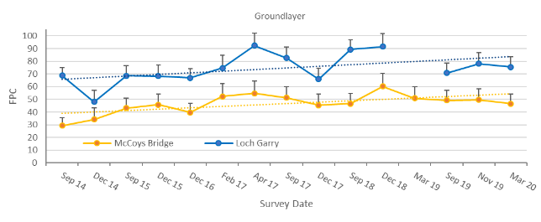
Figure 7-1 Mean (+/-Standard error) foliage projected cover (FPC) of ground layer vegetation (mean across bank zones) at McCoy’s Bridge and Loch Garry at each survey and trend lines.

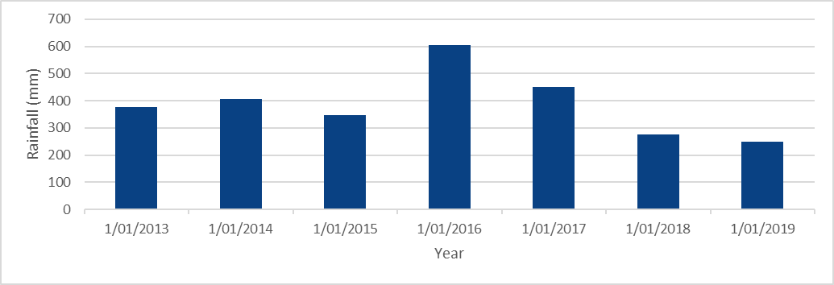
Figure 7-2 Annual rainfall at Bunbartha between 2013 and 2019 (http://www.bom.gov.au/water/landscape).

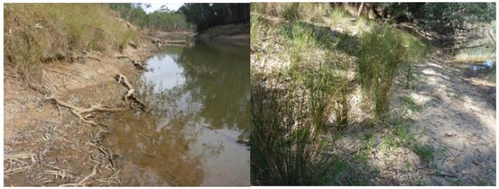
Figure 7-3 Bare lower banks at McCoy’s Bridge with Panicum coloratum (Coolah Grass) at high elevations (left) and Juncus spp. flowering/setting seed at higher elevations (right) in March 2020.
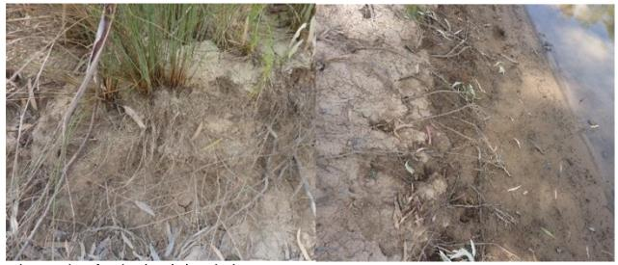
Figure 7-4 Signs of erosion along the lower bank.

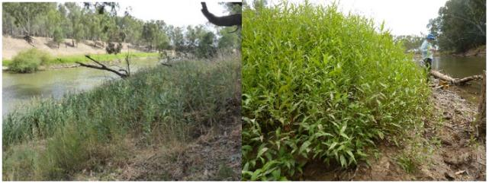
Figure 7-5 Prolific growth of Phragmites australis across the elevation profile (left) and Persicaria lapathifolia on the bench (right) in March 2020.
a.
b.
What influence do hydraulic variables have on the abundance of riparian vegetation communities?
The influence of two hydraulic variables on vegetation have been modelled: (1) the duration of inundation the year prior to sampling and (2) the duration of inundation over the IVT period.
All model outputs for the duration of inundation the year prior to sampling are based on both MER and LTIM data as inputs and uses vegetation data for all sampling events. Model outputs for the duration of inundation in the IVT season only is calculated based in days inundated over the IVT period, and only uses vegetation data sampled in March and April.
The modelled outputs are show in Figure 7-6 to Figure 7-8 and demonstrate that the duration of inundation over the year prior to sampling, and over the IVT period, influence the cover and occurrence of focal plant groups and taxa differently.
Probability of occurrence in response to days inundated over the year prior to sampling
Model outputs for the probability of occurrence for different taxa and plant groups to the number of days inundated in the year prior to sampling ae shown in Figure 7-6 and reveal differences across the taxa and groups examined.
- The probability of occurrence for all ground layer vegetation generally decreases with increasing inundation, and there is high uncertainty after about 300 days of inundation.
- The probability of occurrence for grasses, Juncus species and creeping knotweed (Persicaria prostrata) show mild declining responses to increasing inundation in the previous year.
- For water dependent taxa and sedges, there is an initial increase in the probability of occurrence as the inundation period increases until around 40 days and remains stable to about 100 days of inundation. After that, the probability of occurrence gradually decreases as inundation period increases.
- The probability of lesser joyweed (Alternanthera denticulate) occurrence shows an initial positive relationship with inundation period, which then changes to a negative relationship. This pattern is consistent with this species ability to rapidly colonise wet mud following flow recession. Longer period of inundation probably favour establishment following flow recession as this provides wet bare mud.
- For common tussock grass (Poa labillardierei), the probability of occurrence declines rapidly until approximately 130 days, after which the probability of occurrence reaches zero with very low uncertainty, until 300 days after which uncertainty increases. However, this observation after 300 days is probably a statistical artefact and should not be interpreted as any sign of increasing probability.

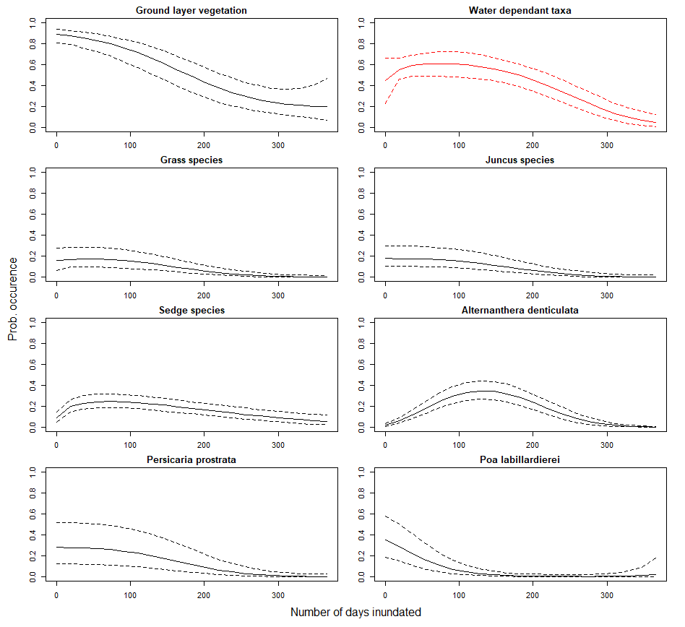
Figure 7-6 Modelled probability of occurrence for grouped aquatic species in response to number of inundation days in the previous year. Parameters for which figures that have been printed in red have not converged in the statistical model and estimates may be unreliable.
Probability of occurrence in response to days inundated over the IVT period
Model outputs for the probability of occurrence for different taxa and plant groups to the number of days inundated in the IVT period are shown in Figure 7-7.
- Patterns of responses for ground layer vegetation, total grasses, Juncus species, creeping knotweed (Persicaria prostrata) and common tussock grass (Poa labillardierei) are similar over the IVT period as found for inundation over the year prior to sampling.
- Water dependent taxa does not show the initial increase found in models of inundation in the previous year. Instead, its probability generally decreases as inundation duration increases over the IVT season. The probability of water dependent species occurring declines steadily after 55 day of inundation over the IVT period.
- There is no clear relationship between probability of occurrence and inundation in the IVT season for sedges, and there is slightly higher uncertainty after 70 days of inundation.
- For lesser joyweed (Alternanthera denticulate), there is a sharp increase in the probability occurrence within 5 days of inundation, which then decreases within an increasing IVT inundation period.

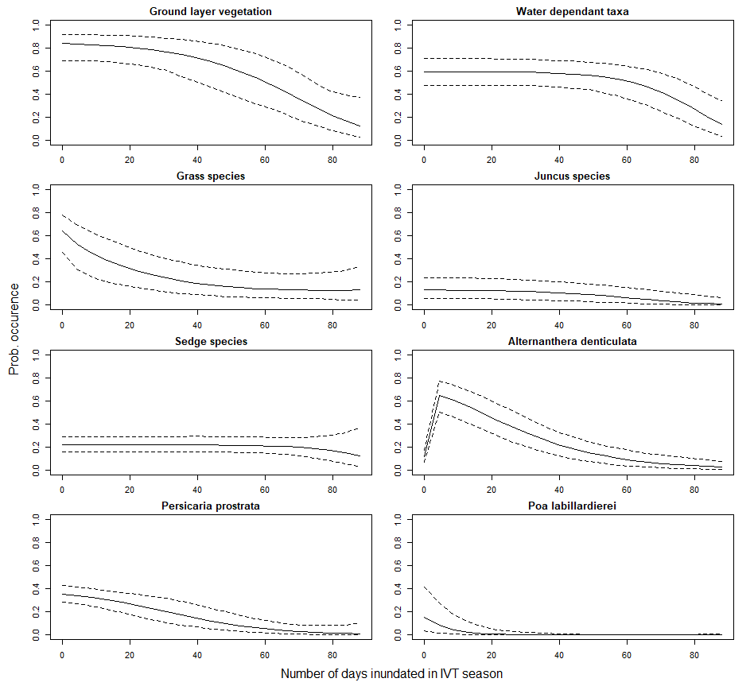
Figure 7-7 Modelled probability of occurrence for grouped aquatic species in response to number of inundation days in the previous IVT season.
Responses of plant foliage projected cover
Responses of precent foliage projected cover (FPC) to the period of inundation in the year prior to sampling is shown in Figure 7-8 and reveal different responses across taxa and plant groups.
- For all ground layer vegetation, water dependent taxa, Juncus species, sedges and creeping knotweed (Persicaria prostrata), FPC decreases with increasing duration of inundation in the year prior to sampling. There is high uncertainty after 300 days for Juncus species and sedges and so the apparent increases in the median predictions should not be over-interpreted.
- FPC of all grasses has a negative relationship with inundation less than about 100 days over the year prior to sampling. Where total inundation is greater than 100 days, the cover of grasses is close to zero.
- FPC of lesser joyweed (Alternanthera denticulate) demonstrates similar response pattern to inundation as its probability of occurrence, with the threshold being about 150 days.
- FPC of common tussock grass (Poa labillardierei) also presents similar decreasing pattern with increasing duration on inundation, as its probability of occurrence. Although there is a slight effect of increasing in cover after 200 days of inundation in previous year this is associated with high uncertainty.

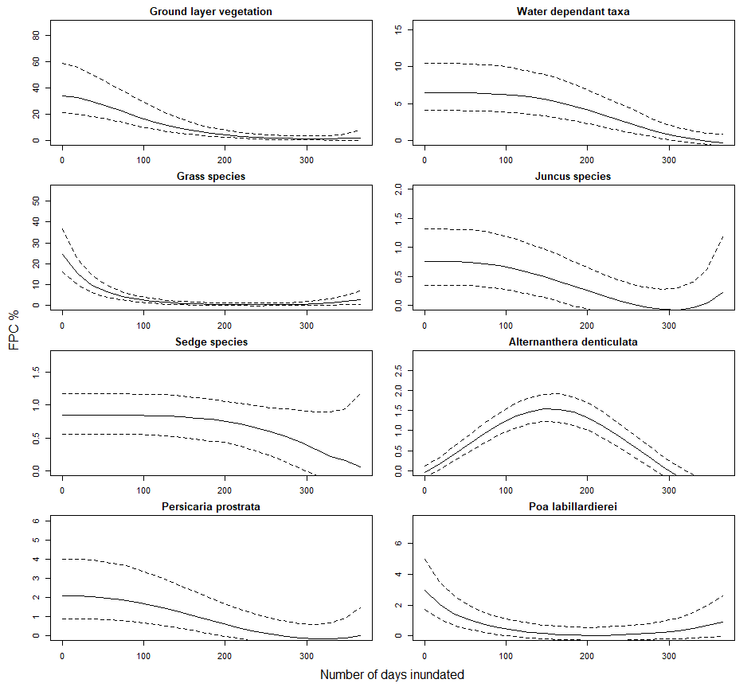
Figure 7-8 Modelled foliage projected cover (FPC %) for grouped aquatic species in response to number of inundation days in the previous year.

Discussion
Over the 5 years of the LTIM Project and one year so far of the MER Program, environmental, natural and consumptive flows have all influenced the occurrence, cover and distribution of vegetation on the banks of the Goulburn River. Spring freshes appear to support water dependent species as their distribution on the bank is greatest in areas inundated by spring freshes, and repeatedly increase in cover between pre and post spring fresh surveys. How seasonal patterns of plant growth contribute to this response is not known.
Medium-term trends show that while the cover of ground layer vegetation is increasing on the banks this increase is largely due to grasses, particularly common tussock grass at higher elevations. In contrast, water dependent vegetation does not show a long-term increase despite observed increases following spring freshes. Improving the abundance of vegetation at the toe and lower bank remains a management challenge and increases in IVT delivery to meet consumptive demand, which appears to negatively impact vegetation in this zone, adds to this challenge.
High IVT delivery reduced the cover of water dependent vegetation in Zone 1a with only tall established species such as common reed and Cyperus spp. persisting. There has been little recovery prior to or at the end of IVT delivery in 2019-20. However, germination was triggered on the recession of the spring fresh indicating the potential for recovery provided appropriate flows can be delivered following the spring fresh.
The loss of vegetation at the toe and lower bank has functional significance as vegetation reduces bank erosion by stabilising and trapping sediment and slowing flows (O'donnell et al. 2015).
LTIM and MER monitoring data collected since 2014 provides some insights into the conditions and time frames for vegetation recovery. The highest recorded cover of water dependent species at the lowest elevation occurred in December 2015 after a period of low flows following the recession of the Spring Fresh. During this period, plants occurred on more that 80% of surveyed transect at the lowest elevation. This suggests that suitable flows can improve the occurrence and cover of vegetation at the toe and lower bank.
Where vegetation has been eliminated, recovery will require germination of seeds either from the soil seedbank or deposited from local or upstream sources. Recovery of vegetation from seed will require extended period of low flows over the growing season to allow seeds to germinate and progress to more mature life stages before they are inundated. Multiple successive years of favourable hydraulic conditions over the growing season will be needed to allow re-established plants to expand vegetatively and to set seed. As plant populations mature and expand in extent, they are likely to show greater tolerance to unfavourable inundation events and to recover more rapidly following such events.
Adaptive management
To promote recovery of vegetation along the toe and lower bank flow management should consider the following:
- Synchronise freshes with tributary flows where possible to enhance propagule supply.
- Provide 6-8 weeks of low flows following the recession of the spring fresh to allow plants to germinate and reach greater maturity.
- Reduce the duration of IVTs by delivering IVTs as a series of pulses, each less than 20 days duration with recovery windows of low flows for at least 7 days to promote plant survival as proposed by Roberts (2018).
Analysis
- Modelled relationships provide insights into the influence of hydraulic variables on vegetation abundance. Although these models reveal clear differences in the tolerance of taxa to hydraulic variables, the influence of long-term flow histories on model responses are not known.
- The influence of inundation depth and duration should be examined for lower elevations on the bank face where inundation depth is not expected to be strongly correlated with duration of inundation as it is at higher elevations.
- Explore potential to assess the %FPC required to provide the desired functionality of stabilisation and sediment trapping.
Research
Adaptive flow management to promote the establishment of vegetation on the lower bank and toe would be supported by research to address the following knowledge gaps:
- How do fish spawning freshes delivered after the spring fresh influence the survival of young plants that have germinated along the toe and lower bank following the recession of the spring fresh?
- Does providing short intervals of low flow during IVT delivery improve plant survival?
- Do fine scale variations in inundation depth improve plant establishment and growth?
- What is the time frame for key taxa to germinate, mature and set seed in the field?
- What is the abundance and composition of the soil seed bank at different geomorphic features?
- What bank feature promote the retention of plant propagules.
- Does prolonged summer submergence deplete the soil seed bank?
- Does the availability of seeds limit plant establishment?
- How does the spatial extent of suitable hydraulic habitat for target vegetation with river reaches change with river discharge?

Fish

Introduction
Riverine ecosystems throughout the Murray-Darling Basin have been greatly modified by the construction of dams and weirs, and associated water regulation. These modifications are linked to major changes in river ecology, including reduced abundance and distribution of native fish populations. Water for the environment, complemented with additional recovery measures, are considered key to rehabilitating native fish populations in the Murray-Darling Basin. The MER Program ‘Fish Theme’, which continues the work undertaken through the LTIM Project, aims to evaluate the benefits of Commonwealth environmental water to native fish populations and improve understanding of flow-ecology and population dynamics of native fish to inform environmental water management for fish (https://flow-mer.org.au/basin-theme-fish/).
Two fish monitoring methods are employed in the MER Program monitoring in the Lower Goulburn River Selected Area: 1) Annual population surveys using electrofishing and netting, and 2) Surveys of eggs and larvae using drift nets. The annual population surveys provide data to be integrated and analysed across all seven Selected Areas in relation to the benefits of water for the environment to native fish populations using statistical models (https://flow-mer.org.au/basin-theme-fish/). The annual population surveys in the lower Goulburn River build upon annual surveys conducted since 2003 and represent one of the longest continuous sets of fish monitoring data collected in the Murray Darling Basin. Moreover, this covers a wide range of climatic conditions including record drought, record floods, and a major blackwater event that contributed to widespread fish kills.
The drift net surveys in the lower Goulburn River collect eggs and larvae of a range of fish species, but specifically aim to examine the influence of flow on spawning of golden perch and silver perch. Environmental flows aimed specifically at initiating spawning in golden perch (Macquaria ambigua) and silver perch (Bidyanus bidyanus) have been introduced into the management of regulated rivers in the Murray-Darling Basin in recent years by the Commonwealth Environmental Water Office, with planning and delivery in partnership with Catchment Management Authorities. Spawning of both species has been linked to flows, but there is a need for a more detailed understanding of how components of the flow regime such as timing, duration, and magnitude affect spawning in order to develop and refine environmental flow delivery strategies.

Basin and area specific evaluation questions
The key basin and area-scale evaluation questions and relevant indicators for fish are listed in Table 8-1.
Table 8-1 Fish key evaluation questions for the Goulburn selected area and associated indicators and evaluation approaches.
Key Evaluation Questions | Indicator | Evaluation Approaches
Basin Scale evaluation Questions
What did CEW contribute to sustaining native fish populations? | Fish species occurrence and abundance (Specific indicators to be confirmed at Basin Scale) | Annual population surveys (electrofishing and netting), and surveys of eggs and larvae (drift nets).  All data entered into the MDMS for use in statistical analysis at the Basin-Scale to examine relationships between fish population metrics and flow data.
What did CEW contribute to sustaining native fish reproduction? | Occurrence and counts of eggs and larval fish (Specific indicators to be confirmed at Basin Scale) | Observations based on surveys of eggs and larvae (drift nets).  Statistical models predicting the likelihood of spawning.
What did CEW contribute to sustaining native fish survival? | Fish species occurrence and abundance. (Specific indicators to be confirmed at Basin Scale) | Annual population surveys (electrofishing and netting).  All data entered into the MDMS for use in statistical analysis at the Basin-Scale to examine relationships between fish survival metrics and flow data.
Area Scale evaluation questions
What did CEW contribute to the recruitment of golden perch in the adult population in the lower Goulburn River? | Counts of young-of-year golden perch in annual surveys. | Annual population surveys (electrofishing and netting).
What did CEW contribute to golden perch or silver perch spawning? | Counts of golden perch eggs and larvae in drift net surveys. | Observations based on surveys of eggs and larvae (drift nets).  Statistical models predicting the likelihood of spawning.

Main findings from monitoring program
The following sections provides a high-level summary of the outcomes of the 2019-20 monitoring and the implications of these findings to previous years outcomes.

2019/20 findings
The main findings from the 2019-20 monitoring are:
- A significant finding of the 2019/20 surveys was the collection of the nationally threatened trout cod in both the drift surveys and electrofishing surveys in the Goulburn River Figure 8-7 Trout cod collected in the Goulburn River.
- Abundance of Murray cod (Maccullochella peelii) at sampling sites increased in the 2020 surveys, following a decrease in abundance in 2017 after a hypoxic blackwater event around Shepparton in the Goulburn River.
- Silver perch abundance also increased in 2020. This increase is likely due to fish immigrating into the Goulburn River from the Murray River.
- There was a marginal increase in abundance of Murray River rainbowfish (Melanotaenia fluviatilis) in 2020, following a decrease in abundance from 2017 to 2019.
- No spawning of golden perch was detected in the 2019 drift sampling. The absence of spawning by golden perch reflects a lack of suitable flow conditions and was expected.
- Several young-of-year golden perch were collected in the annual surveys in 2020. It is likely that these individuals represent stocked fish particularly given the lack of golden perch spawning in the Goulburn River in 2019.
- Low numbers of silver perch eggs were collected in December 2019 coinciding with elevated flows associated with an inter-valley water transfer (IVT).

Summary of previous findings and implications for any new finding
- Trout cod had not been collected in the annual surveys for three years (since 2016) but were collected again in 2020. Spawning of trout cod was also detected in the 2019 drift surveys and has now been detected in each of the last three (2017-2019) spawning seasons. Dispersal of trout cod from upstream reaches where they are more common may play an important role in shaping the distribution and abundance of this species within the lower Goulburn River.
- Following a decrease in abundance of Murray cod in 2017 after a fish kill event, there was an increase in abundance in 2020. The recent increase in abundance of Murray cod may indicate partial recovery of the population, although abundance remains lower than pre-2017 levels and may take many years to return to higher levels.
- In contrast to the reach below Shepparton, results from VEFMAP sampling indicate abundance of Murray cod in the reach upstream of Shepparton has generally been stable or increasing. This upstream reach may play an important role in facilitating recovery in lower reaches, for instance through immigration.
- Following a decrease in abundance of Murray River rainbowfish from 2017 to 2019, there was a marginal increase in abundance in 2020. Nonetheless, abundance remains lower than pre-2017 levels. The causes of these fluctuations are unclear but could be related to extended periods of high flow throughout summer.
- Elevated late spring-early summer flows promote spawning of golden perch and silver perch. Young-of-year fish are seldom collected, likely because early life stages (eggs, larvae) drift downstream long distances and into the Murray River. Indeed, recent analysis of otolith strontium shows that golden perch spawned in the Goulburn River act as a source of fish to the Murray River (and vice versa).
- Measuring or reporting ‘recruitment’ outcomes at a reach or river scale in this region may be unsuitable for species with early life stages that can drift or disperse long distances away from spawning locations.

Summary of findings relevant to evaluation questions
Table 8-2 provides a summary of the findings relevant to basin and areas scale evaluation questions. Key points are outlined below:
- No golden perch eggs or larvae were detected in 2019. This strengthens our model, which shows that the probability of spawning of golden perch is related to discharge, with spawning probability rising sharply at flows between about 3500–4000 ML/d coupled with appropriate water temperature (≥18.5 °C). Flows meeting these criteria where not delivered in 2019.
- Another important finding of the analysis is that increased flows prior to spawning were associated with increased spawning probability.
- These results support previous findings linking prior flows and golden perch spawning and suggest that it is important to provide adequate flows not just to cue spawning but throughout the reproductive season.
- To achieve the management objective of spawning of golden perch in the Goulburn River, elevated flows throughout spring, coupled with flow pulses of around at least 3500–4000 ML/d particularly in November when water temperatures become suitable, are needed.
- Like golden perch, spawning of silver perch in the Goulburn River appears dependent on elevated flows in late spring-summer coupled with appropriate water temperature (≥ 20 °C).
- For silver perch, the magnitude of flow events where spawning has occurred generally appears to be lower
(i.e. >2500 ML/d) compared to golden perch, although further sampling is needed to confirm this.
- Measuring or reporting recruitment outcomes at a reach or river scale in this region may be unsuitable for species with early life stages that can drift or disperse long distances away from spawning locations.
Table 8-2 Summary of fish findings relevant to evaluation questions.
Question | Were appropriate flows provided? | Effect of environmental flows | What information was the evaluation based on?
Basin scale evaluation questions
What did Commonwealth environmental water contribute to sustaining native fish populations? | Quantitative statistical analysis is needed to examine relationships between fish population metrics and flow data. | Key observations from surveys include:  Abundances of several large-bodied native species (Murray cod, trout cod and silver perch) and the exotic goldfish and oriental weatherloach increased in 2020.  There was also a marginal increase in abundances of golden perch and Murray River rainbowfish.  Two native (bony bream, flat-headed gudgeon) and two exotic (eastern gambusia, redfin perch) species collected in low numbers in previous surveys were not detected in 2020.  No spawning of golden perch was detected in the 2019 drift sampling. | Annual population surveys (electrofishing and netting), and surveys of eggs and larvae (drift nets).  All data was entered into the MDMS for use in statistical analysis at the Basin-Scale to examine relationships between fish survival metrics and flow data.
What did Commonwealth environmental water contribute to sustaining native fish reproduction? | Environmental water was not delivered specifically for spawning of golden perch or silver perch in 2019. | No spawning of golden perch was detected in the 2019 drift sampling.  Silver perch eggs were collected coinciding with an increase in flow in mid-December 2019 associated with IVT flows | Observations based on surveys of eggs and larvae (drift nets).
What did Commonwealth environmental water contribute to sustaining native fish survival? | Quantitative statistical analysis is needed to examine relationships between fish survival metrics and flow data. | Key observations from surveys include:  Abundances of several native and exotic species increased in 2020.  Two native and two exotic species collected in low numbers in previous surveys were not detected in 2020. | Annual population surveys (electrofishing and netting).  All data was entered into the MDMS for use in statistical analysis at the Basin-Scale to examine relationships between fish survival metrics and flow data.
Area scale evaluation questions
What did CEW contribute to the recruitment of golden perch in the adult population in the lower Goulburn River? | Environmental water was not delivered specifically for spawning of golden perch in 2019. | Several young-of-year golden perch were collected in the annual surveys in 2020. It is likely that these individuals represent stocked fish given the lack of golden perch spawning in the Goulburn River in 2019. | Qualitative observations based on drift netting and electrofishing and fyke netting data.  Previous monitoring shows that the Goulburn River supports spawning of golden perch if appropriate flows are provided. Young-of-year fish are rarely collected in the annual population surveys. This is likely because fish early life stages (eggs, larvae) drift downstream and into the Murray River.  Otolith strontium analysis as part of other projects shows golden perch spawning in the Goulburn River acts as a source of fish to both the Goulburn and Murray rivers.  Measuring or reporting ‘recruitment’ outcomes at a reach or river scale in this region may be unsuitable for species with early life stages that can drift or disperse long distances away from spawning locations.
What did CEW contribute to golden perch or silver perch spawning? | Environmental water was not delivered specifically for spawning of golden perch or silver perch in 2019. | No spawning of golden perch was detected in the 2019 drift sampling.  Silver perch eggs were collected coinciding with an increase in flow in mid-December 2019 associated with inter-valley transfer flows. | Observations based on surveys of eggs and larvae (drift nets).  Statistical models predicting the likelihood of spawning.

Monitoring methods and analytical techniques

Annual population surveys (electrofishing and netting)
Electrofishing was conducted at 10 sites in the Goulburn River during May and June 2020 using the same methods as previous years of the study (2015-2019) and as documented in the Standard Operating Procedures included in the Goulburn River MER plan 2019-2022 (Webb et al. 2019b). Briefly, sampling was conducted at each site during daylight hours using a Smith–Root model 5 GPP boat–mounted electrofishing unit (Figure 8-1). At each site the total time during which electrical current was applied to the water was 2880 seconds. Ten fyke nets were also set at each site (Figure 8-1). Nets were set in late afternoon and retrieved the following morning.
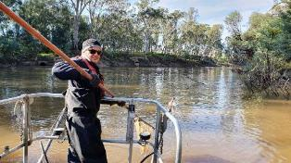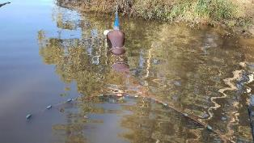
Figure 8-1 Electrofishing and netting surveys on the Goulburn River

Surveys of eggs and larvae (drift nets)
Fish eggs and larvae were sampled at four sites (Yambuna, McCoy’s Bridge, Loch Garry, Pyke Road) on the Goulburn River using three drift nets at each site using the same methods as per previous years of the study (2014-2018) (Figure 8-2). Sampling was conducted once per week from October to December 2019. Drift nets were of 500-µm mesh, 150 cm long with a 50 cm mouth diameter, and had flow meters (General Oceanics, Florida, USA) fitted to the mouth of the net to measure the volume of water filtered. Nets were set in late afternoon (1500–1800 hours) and retrieved the following morning (0800–1000 hours). Drift samples were inspected briefly in the field to obtain fertilised eggs so that these could be taken to the laboratory for hatching to assist identification. The remainder of the samples preserved in 90% ethanol and taken to the laboratory for processing and identification.
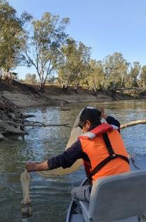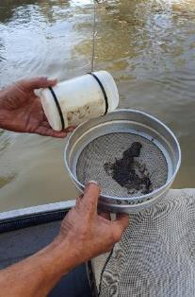
Figure 8-2 Drift netting surveys on the Goulburn River

Results

Annual population surveys (electrofishing and netting)
Seven native and three exotic species were collected from the ten survey sites in the Goulburn River in 2020
(Figure 8-3; Figure 8-4)Figure 8-3 . A significant finding was the collection of the nationally threatened trout cod, which had not been detected in the annual surveys since 2016. Other species of conservation significance collected were silver perch, Murray cod and Murray River rainbowfish. The small-bodied Australian smelt was the most abundant species collected, and the exotic carp was the most abundant large-bodied species collected, similar to the results of previous surveys.
Abundances (mean number per site) of several native (Murray cod, trout cod, silver perch, Murray River rainbowfish) and exotic (goldfish and oriental weatherloach) species were higher in 2020 compared to last year. Two native (bony bream, flat-headed gudgeon) and two exotic (eastern gambusia, redfin perch) species collected in low numbers in previous surveys were not detected in 2020.
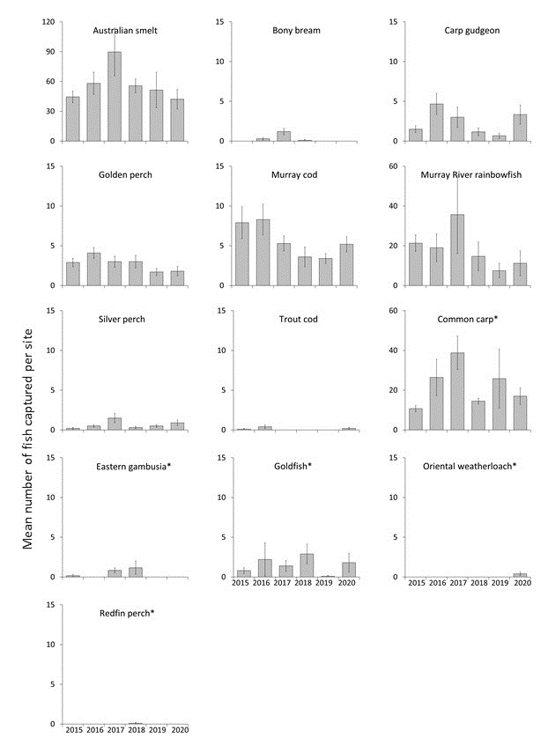
Figure 8-3 Mean number (±se) per site of fish species collected during electrofishing surveys 2015 to 2020. * denotes exotic species.

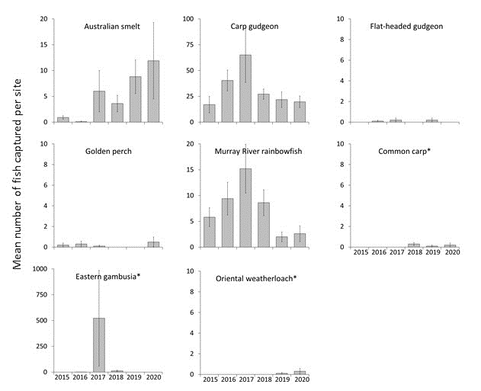
Figure 8-4 Mean number (±se) per site of fish species collected during fyke netting surveys 2015 to 2020. * denotes exotic species.
Length frequency histograms are presented below for four of the large-bodied species collected: Murray cod, trout cod, golden perch and silver perch (Figure 8-5).
The population structure of Murray cod collected in the 2020 surveys consisted of several cohorts, including young-of-year (YOY) fish (i.e. <100 mm in length). The increase in abundance of Murray cod in 2020 appears to be largely driven by fish 150-250 mm in length which represent immature individuals about 1-3 years old. The population structure of golden perch in 2020 consisted mostly of adult fish similar to previous years and a small number of YOY fish (i.e. <100 mm in length). For silver perch there were a range of cohorts captured representing immature and mature size classes. The population structure of trout cod in 2020 consisted of small numbers of immature fish.
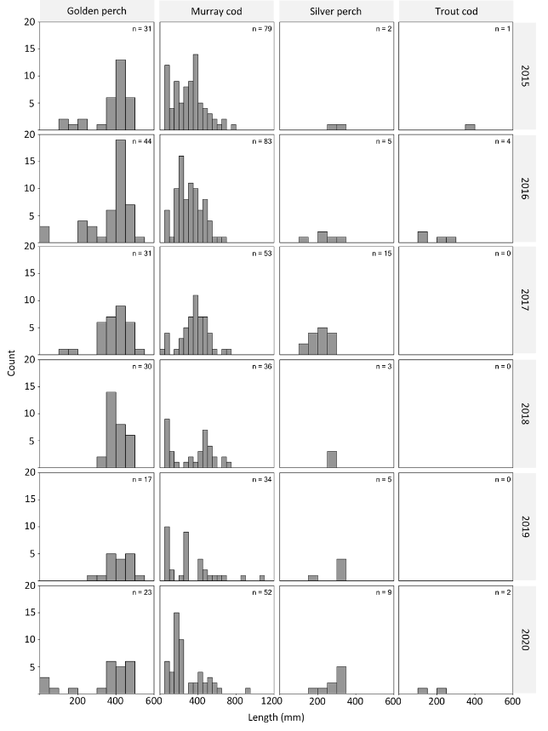
Figure 8-5 Length frequency of golden perch, Murray cod, silver perch and trout cod collected in the Goulburn River 2015-2020.

Surveys of eggs and larvae (drift nets)
Over 1400 individuals (eggs and larvae) representing 7 native species were collected from the four drift sampling sites in the Goulburn River in 2019 (Table 8-3). Murray cod was the most abundant species collected, comprising 64% of the total abundance for all species, similar to the results of previous surveys.
The drift sampling captured 7 eggs of silver perch, in mid-December 2019 coinciding with elevated flows associated with an IVT flow (Figure 8-6). Water temperature at this time was about 23°C. No golden perch were detected in drift samples. Spawning by trout cod was detected in 2019 with larvae collected from early to late November.
Table 8-3 Numbers of eggs (E) and larvae (L) of fish species collected in drift net surveys from the Goulburn River 2014-2019. Species with asterisk are exotic species.
Species | 2014 | 2015 | 2016 | 2017 | 2018 | 2019 | Total
Silver perch | 47E |  | 34E | 37E | 67E | 7E | 185
Murray cod | 942L | 355L | 892L | 2007L | 1939L | 1046L | 6135
Trout cod |  |  |  | 15L | 25L | 13L | 40
Unidentified cod sp. |  |  |  |  | 349L | 159L | 349
Golden perch | 1628E, 1L |  | 47E | 289E, 11L | 18E |  | 1994
Common carp* |  | 15L | 19L | 16L | 5L |  | 55
Australian smelt | 204E, 9L | 81E, 7L | 32E, 1L | 177E, 16L | 122E, 3L | 119E, 18L | 652
Flathead gudgeon | 8L | 11L | 18L | 48L | 85L | 65L | 170
Carp gudgeon |  | 11L | 1L | 37L | 5L | 2L | 54
Gudgeon sp. |  |  |  | 4L | 16L | 27L | 20
Goldfish* |  |  |  | 1L |  |  | 1
Unidentified perch |  |  |  |  | 1E |  | 1
Total number of individuals | 2839 | 480 | 1044 | 2658 | 2635 | 1456 | 9656

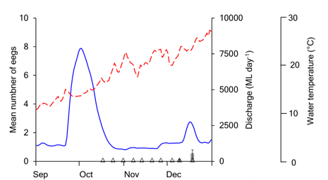
Figure 8-6 Mean (±se) number of silver perch eggs per drift net (grey bars) collected in the Goulburn River in 2019. Mean daily discharge (blue line) and water temperature (broken red line) of the Goulburn River at McCoy Bridge. Triangles denote sampling trips.

Discussion

Annual population surveys (electrofishing and netting)
A significant finding of the annual surveys was the collection of the nationally threatened trout cod in the Goulburn River in 2020 (Figure 8-7). Trout cod were collected in the annual surveys in 2015 and 2016 but had not been detected since. Evidence of spawning of trout cod was also detected in the drift surveys and has now been detected in each of the last three (2017-2019) spawning seasons. Results from VEFMAP sampling conducted by ARI show trout cod are more common in the Goulburn River in upstream reaches near Murchison (Tonkin et al. 2019a), but occasionally are found in low numbers in reaches downstream of Shepparton. Dispersal of trout cod between upstream and downstream reaches may play an important role in shaping the distribution and abundance of this species within the Goulburn River. Quantifying these movements and identifying their drivers (e.g. river discharge) would be valuable for understanding patterns in population dynamics and informing management actions such as environmental flows.
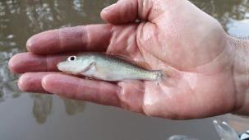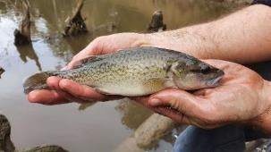
Figure 8-7 Trout cod collected in the Goulburn River in 2020.
Abundance of Murray cod at our sampling sites increased in the 2020 surveys, following a decrease in abundance in 2017 after a hypoxic blackwater event around Shepparton in the Goulburn River. The recent increase in abundance may indicate partial recovery of the population, although abundance in this reach remains lower than pre-2017 levels, and may take many years to return to higher levels (Koster et al. 2012). In contrast to the reach below Shepparton, results from VEFMAP sampling indicate abundance of Murray cod in the reach upstream of Shepparton has generally been stable or increasing (Tonkin et al. 2019a). This reach was less affected by the 2017 blackwater event, which originated in Seven Creeks. It may play an important role in facilitating recovery in lower reaches, for instance through immigration. While Murray cod typically occupy restricted ranges for extended periods (Koster et al. 2020a), immigration can be an important driver of populations at times especially following events such as fish kills (Thiem et al. 2017). Indeed, the increase in abundance in the 2020 surveys was largely driven by immature individuals about 1-3 years old, which have likely immigrated into the survey reach. Similar to trout cod, quantifying movements and their drivers for Murray cod would be valuable for understanding patterns in population dynamics within the Goulburn River and informing management actions.
Silver perch abundance also increased in 2020. This increase is likely due to fish immigrating into the Goulburn River from the Murray River. For instance, analysis of otolith strontium profiles of a sample of silver perch collected in surveys in the Goulburn River between 2014 and 2019 show most sampled individuals immigrated into the system from the Murray River (Koster unpublished data). Acoustically tagged silver perch have also been recorded moving from the Murray River into the Goulburn, Campaspe, and Edward rivers, with higher tributary discharge relative to the Murray River associated with increased probability of moving into a tributary (Koster et al. 2020b). These results highlight the importance of managing silver perch populations in a riverscape context rather than a focus on reach or river scales.
Currently, the greatest concentration of silver perch in the Murray-Darling Basin is centred in the lotic mid-Murray River (Yarrawonga to Euston) (Tonkin et al. 2019b), with self-sustaining populations now present in very few tributaries (Gilligan et al. 2019). Maintaining the existing population and facilitating range expansion (e.g. through movement of adults and juveniles) both in the main channel of the Murray River and tributary systems is a priority for conservation management (DoEE 2020). Restoring important suitable flow conditions for colonization, along with improving fish passage, will be important in recovering these populations.
Several young-of-year golden perch were collected in the annual surveys in 2020. It is likely that these individuals represent stocked fish given the lack of golden perch spawning in the Goulburn River in 2019. More broadly, surveys in the Goulburn River over the last 1-2 decades show that the golden perch population consists predominantly of larger, older fish, with few individuals below 300 mm. Although young-of-year golden perch are rarely collected in the annual population surveys, this is likely because fish early life stages (eggs, larvae) drift downstream and into the Murray River. Indeed, recent analysis of otolith strontium shows that fish spawned in the Goulburn River act as a source of fish to the Murray river (and vice versa) (Koster unpublished data; Zampatti et al. 2019). It is also possible that young-of-year golden perch may be under-sampled in the annual surveys - otolith strontium data for instance shows that some golden perch spawned in the Goulburn River remain there. Similar to silver perch, these findings emphasise the importance of managing golden perch populations within an integrated riverscape context. The findings also highlight how measuring or reporting ‘recruitment’ outcomes (i.e. presence of young-of-year fish) at a reach or river scale in this region can be unsuitable for species with early life stages that can drift or disperse long distances away from spawning locations.
There was a marginal increase in abundance of Murray River rainbowfish in 2020, following a decrease in abundance from 2017 to 2019. Nonetheless, abundance remains lower than pre-2017 levels. The causes of these fluctuations are unclear but could be related to flow conditions, which have been relatively high in the Goulburn River during summer due to inter-valley water transfers. Murray River rainbowfish spawn in summer (Humphries et al. 1999). Warm low flow conditions are thought to be favourable for recruitment (Milton et al. 1984, Humphries et al. 1999). If extended periods of high flow occur throughout summer, recruitment opportunities may be limited.

Spawning of golden perch and silver perch
Using Data collected during LTIM and MER monitoring our analyses show that the probability of spawning of golden perch was related to discharge, with greatly increased spawning probability at flows between about 3500–4000 ML day⁻¹ when water temperature exceeded ~18.5°C (Figure 8-8). Water velocity showed a similar pattern to discharge with the peak probability of spawning at velocity >0.2-0.3 m s⁻¹ when temperature was >18.5°C.
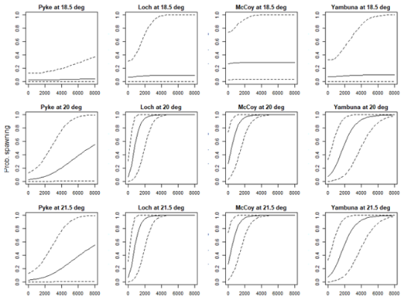
Figure 8-8 Relationship between the occurrence of golden perch spawning (y-axis, 0-1) and discharge (x-axis, ML/day). Results are based on the model of occurrence of spawning without antecedent flow effect, using discharge as the main predictor.
In 2019, no spawning of golden perch was detected in drift sampling. The absence of spawning by golden perch reflects a lack of suitable flow conditions (as defined by modelling). In October 2019 a large flow rise occurred (for vegetation objectives), but water temperatures around that time (15–16°C) were too low for golden perch spawning (Koster et al. 2017, Webb et al. 2019a). A smaller rise in flow also occurred in December 2019, but the magnitude of that flow event (peak discharge 2700 ML day⁻¹) was low compared to most previous events (i.e. >3500–4000 ML day⁻¹) where golden perch spawning has been detected in the Goulburn River (Webb et al. 2019a).
Another important finding of the analysis is that increased flows prior to spawning were associated with increased spawning probability, more so at the three sites in Reach 2 (Figure 8-9). These results support previous findings linking prior flows and golden perch spawning (Cockayne et al. 2013) and suggest that it is important to provide adequate flows not just to cue spawning but throughout the reproductive season. To achieve the management objective of spawning of golden perch in the Goulburn River (GBCMA 2017), elevated flows throughout spring, coupled with flow pulses of around at least 3500–4000 ML day⁻¹ particularly in November when water temperatures become suitable, are needed. Matching these flows to vegetation objectives will be challenging.
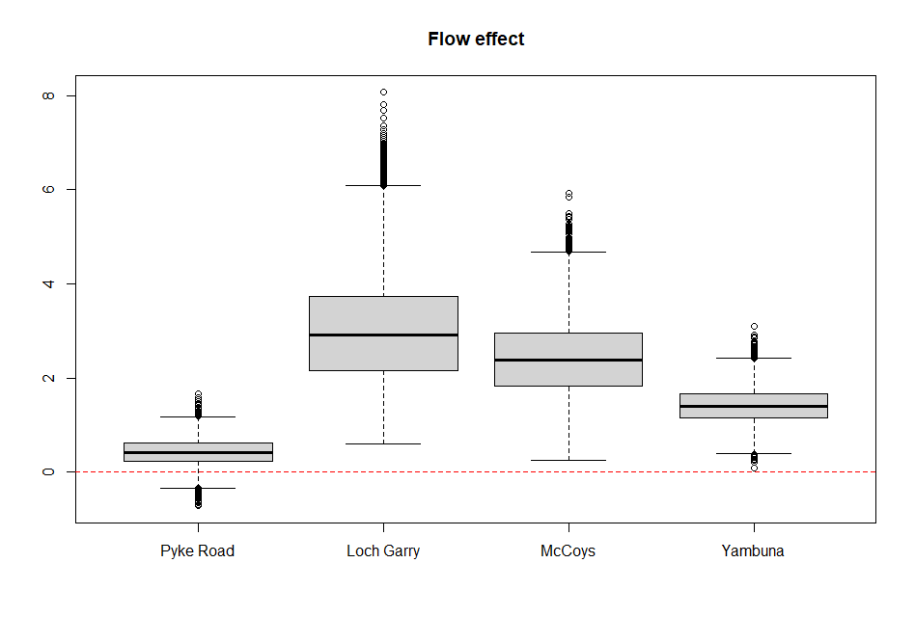
Figure 8-9 Flow effect in four sites, based on the alternative model of occurrence of spawning with 5-week antecedent flow effect, using discharge as the main predictor. Plots above the 0 line indicate that spawning is most likely to occur in response to a high flow event when there have been higher average flows over the 5-weeks prior to the spawning survey.
Low numbers of silver perch eggs were collected in December 2019 coinciding with elevated flows associated with an inter-valley water transfer. Silver perch spawning was also detected during an inter-valley water transfer in December 2018. Like golden perch, spawning of silver perch in the Goulburn River appears dependent on elevated flows in late spring-summer coupled with appropriate water temperature (≥20°C). For silver perch, the magnitude of flow events where spawning has occurred generally appears to be lower (i.e. >2500 ML day⁻¹) compared to golden perch, although further sampling is needed to confirm this. Additional sampling throughout the IVT period (i.e. into January) would also be valuable for improving our understanding of the influence of IVT flows (e.g. timing, magnitude, duration) on silver perch (and potentially golden perch) spawning in the Goulburn River. This information would be particularly valuable to support the design of Goulburn River operating rules for IVTs.

Contingency Monitoring
The main contingency monitoring activity in 2019-20 was the use of turf mats to assess differences in sediment and seed deposition under CEW and natural high flow events. The outcomes of the turf mat monitoring are described in more detail below.
In the 2020-21 year, several new contingency monitoring activities are planned. These are: assessment of habitat use by juvenile Murray cod using radio tracking, contribution of golden perch larvae to Murray River larval drift, and assessment of relative contributions of benthic metabolism to water column metabolism. These projects will be reported on in detail in subsequent annual reports.

Turf mats

Introduction
Maintaining a healthy Goulburn River to support ecological and social values requires ensuring that the system is adequately resilient to changes in flows. Part of this resilience is related to the riverbank condition which can experience erosion and changes in vegetation. An important part of resilience is the recovery of the system, and for riverbanks this includes how a river might repair, through patching banks with sediment drapes, and how seeds might be deposited and regenerate bank vegetation following flows. Understanding these sediment and seed dynamics has been the focus of this study which commenced initially commenced in 2018 to address sediment and seed response to flows for the LTIM project.

Main findings from monitoring program
The main findings from the turf mat monitoring are (Table 9-1):
- Maximum inundation height and inundation duration play a key role in sediment deposits when considering seed abundance, seed richness and sediment mass. This supports the need for more frequent freshes to meet support recovery of banks affected by IVT flows.
- The 2019 Spring fresh contributed to increased seed abundance and taxonomic richness compared to the Winter Fresh with 10,811/47 and 8,266/42, respectively. Considering the spring fresh is directly followed by IVTs there is little potential for the recruitment of these seeds/seedlings.
- Increased seed abundance correlates with both increases to peak inundation height and duration of inundation for all habitat types and sites (anomalies at McCoy’s Bridge notwithstanding). There is no correlation between maximum dry period and seed abundance. Bar features generally resulted in the largest volume of seeds, closely followed by benches, which highlights the need for more shallow profile areas on lower banks to improve seed consolidation.
- Increased seed taxonomic richness directly correlates with inundation duration for all habitat types and sites with ledges and banks showing the largest increase over time. Out of the average number of taxa across events (45) four species accounted for more than two thirds of seed volume; protecting the development of these species would be a critical step for improving revegetation in key areas of the system.
- Increased sediment mass correlates to increased peak inundation height and increased inundation duration for all habitat types, across all sites. Conversely, increased maximum dry period negatively correlated with sediment mass, resulting in reduced mass as dry periods increased in length. This supports the argument for increased freshes surrounding the irrigation period.
- Comparing the daily rates of seeds deposition recorded across all sites for the six events monitored to date, the spring fresh event in 2019 is notable for the large abundances of seeds deposited, particularly on Benches and Ledges
Previous turf mat monitoring showed:
- Environmental flows (the winter and spring freshes) provided around half of the sediment and seeds deposited on inundated features at sites in the lower Goulburn River. The environmental flows were the primary contributor of sediment and seeds to riverbanks, providing three-quarters of sediment and seed deposition on banks.
- Deposition has been identified as more prevalent during the colder months. In the 2018/19 period this finding was reinforced by the artificial turf mat study that highlights deposition of sediments on higher bank levels as a result of the winter and spring fresh. This may be linked to the role of tributary flows, though this hypothesis needs to be verified.
Implications for new findings/investigation:
- The 2019 Spring Fresh resulted in a greater abundance of seeds than winter events.
- The role of tributary flows, which increased significantly in March/April 2020, cannot be fully analysed until COVID-19 restrictions and flow conditions allow. Therefore, the role of tributary contributions is still yet to be fully understood and needs further investigation
Table 9-1 Summary of physical habitat findings relevant to evaluation questions.
Question | Were appropriate flows provided? | Effect of environmental flows | What information was the evaluation based on?
What did CEW contribute to riverbank sediment and seeds? | Yes, both the Spring Fresh and the Winter Fresh provided sediment and seeds, with bank and bench vegetation being best served by winter and spring freshes. | For both environmental flows (the winter and spring freshes) there was a strong correlation between inundation duration and seed abundance and taxonomic richness at all site except McCoy’s Bridge where results varied. Inundation duration also directly correlated to sediment mass volume across all habitat types and sites monitored. Conversely, maximum dry period, had a consistent negative effect on sediment mass at all sites (except certain features for retrieval 5). Seed taxonomic diversity was relatively similar across the winter and spring freshes with 42, and 47 difference species recorded respectively.  No comparison of these results relative to IVT flow events was possible due to travel restrictions in place due to COVID-19. | Artificial turf mats and analysis of deposited sediment and seeds under laboratory conditions

Methods
Field and laboratory protocol
From 2018 onwards, turf mats have been used to quantify sediment transport and propagule assemblages dispersed by flow events in the lower Goulburn River. Small synthetic turf mats (36 x 24cm) were fixed to the banks in groups of four (six during the 2018 monitoring) replicates per feature (Figure 9-1). Features were selected to capture a variety of geomorphic forms, including bars, banks, benches, and ledges. Mats were periodically retrieved during periods of low flow with seeds transported directly to the University of Melbourne, Burnley Campus nursery for germination and identification, and sediments were assessed within the laboratory for dry mass and sediment size.
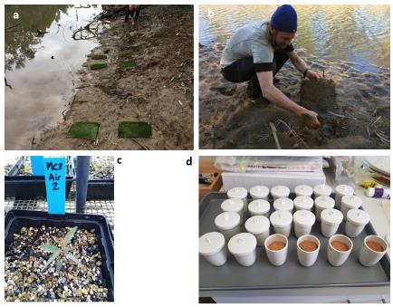
Figure 9-1 a) Sediment mats on low-level bars prior to inundation, b) mat collection following inundation, c) seedling growth in the nursery following collection, and d) sediment analysis.
Modelling Overview
The turf mat monitoring and modelling aims to test the following hypothesis:
The transport of seeds/sediments in waterway is affected by streamflow, which differs by habitat type (bank, bar, bench or ledge) and time of the year. The time of year also affects the percentage of tributary contribution to flow at the sampling point. This corresponds to a hierarchical model described as:
$y_{t} \sim Normal\left({mu}_{ijs}, σ\right)$ Equation 1
${mu}_{ijs}=int+{eff.Q}_{is}×Q_{ij}$ Equation 2
${eff.Q}_{is} \sim Normal({μ_effQ}_{is}, σ_effQ)$ Equation 3
${μ_effQ}_{is}=int_{effQ}+eff.trib*{trib}_{i}+eff.h{abitat}_{s}$ Equation 4
Where i, j and s represent survey event (retrieval), site and habitat type, respectively.
For the seed analysis, y_{t} represents the individual samples of seeds abundance captured by turf mats.
The mean seed abundance (log-transformed) for a particular combination of survey, site and habitat type, mu_{ijs}, is affected by flow condition (Q) represented by one of a) peak inundation height over sampling point, b) number of days inundated, and c) maximum dry period, during the sampling period (i.e. between deployment and retrieval of each sample). Flow effects (eff.Q_{is}) are modelled with the percentage tributary contribution corresponding to the particular survey event (trib), with eff.trib representing the tributary contribution effects. eff.habitat is a random effect to represent the influence of habitat type on the flow effects.
During the seed abundance sampling, some samples were taken at high elevations at McCoy’s Bridge, which were never inundated during the sampling period. The habitat type of these samples was thus denoted as ‘air samples’. Preliminary analysis indicated that very few seeds were deposited on these mats, highlighting the importance of hydrochory (flow dispersal) for seeds deposited on other lower elevation mats. These air samples were not included for further analyses which focused on flow effects.
The sediment analysis was conducted focusing on impacts of the above mentioned three flow indicators on the total mass of sediments deposited (y_{t} in Eqn. 1).

Winter and spring fresh turf mat retrievals 2019
Following on from four retrievals in 2018/19, turf mats were again deployed in mid-winter on the 27/6/2019. These mats were retrieved in early spring on the 12/9/2019 (retrieval event 5), after a period of 77 days (winter fresh), and another set of mats deployed. Mats were again retrieved and replaced later in spring on the 30/10/2019 after a period of 48 days (spring fresh) (retrieval event 6). Between deployment and retrievals, similar flow peaks of ~8,000 ML/day occurred, labelled here as winter fresh and spring fresh, respectively (Figure 9-2). The following results are presented based on retrieval event such that retrieval event 5 relates to outcomes associated with the Winter Fresh and retrieval event 6 relates to outcomes associated with the Spring Fresh.
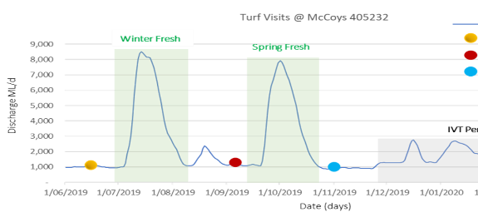
Figure 9-2 Hydrograph of flows in the Goulburn River at McCoy’s Bridge with dates of mat deployment (yellow circle) and retrieval/deployment (red circles) indicated.
Lower bank features were notably devoid of vegetation at the time of the winter fresh retrieval (Figure 9-3). During the retrieval following the spring fresh, several mats were missing, clearly due to theft (the tent pegs had been removed), as a result no samples were able to be collected for Bench and Bank features at Darcy’s Track for that retrieval.
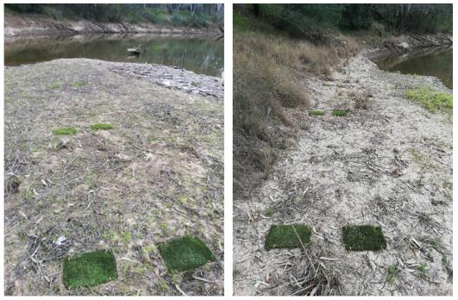
Figure 9-3 Mats redeployed on the bench (left) and bank (right) at Darcy’s Track after the winter fresh that were not present for retrieval after the spring fresh. Note these features were largely devoid of vegetation at the time of mat collection.
An intended retrieval and redeployment in March 2020 was cancelled due to COVID-19 restrictions placed on fieldwork activities by The University of Melbourne. Due to these restrictions, the mats have not since been retrieved and redeployed. Likewise, processing of the soil samples collected from the mats for the winter and spring freshes has been delayed due to restrictions on access to labs at the University of Melbourne. Thus, only data relating to retrieval 5 (Winter fresh) and retrieval 6 (Spring fresh) are reported here. This includes propagule abundance, taxa richness and sediment mass for each flow event.

Results and discussion
Seed and sediment mass
The following provides a summary of results related to seed and sediment outcomes:
- An increase in peak inundation height correlates to increasing seed abundance for all habitat types including bars, benches, banks and ledges, with ledges showing the greatest positive relationship across all sites (Figure 9-4).
- The influence of number of days inundated on total seed abundance is similar to that of peak inundation height, with an increasing trend of seed abundance observed across all habitat types at all sites. Ledges, again, appear to have the greatest positive relationship consistently across all sites. At Loch Garry, the impact of inundation on banks is relatively minor compared to other habitat types (Figure 9-5).
- As expected, there is no consistent pattern caused by increasing maximum dry period on total seed abundance, with mixed effects for different habitat types and at different sites (Figure 9-6).
- Increases in both peak height (Figure 9-7) and number of days inundated (Figure 9-8) show consistent increasing effects on sediment mass across all habitat types in all three sites. By contrast, maximum dry period (Figure 9-9) has a consistent decreasing effect on sediment mass in all sites, except that sediment mass increases as maximum dry period increases for bars at Darcy’s Track and Loch Garry for Retrieval 5.

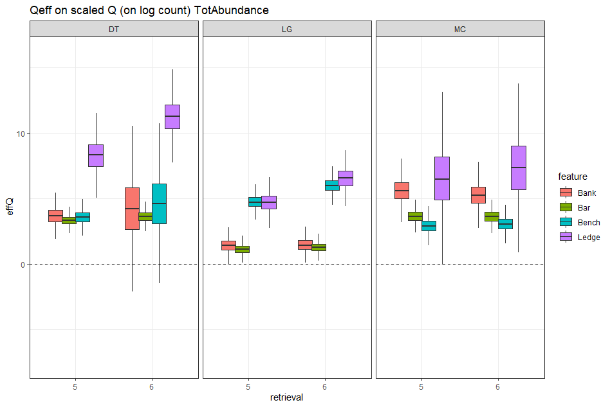
Figure 9-4 Effect of flows on total seed abundance (log count) in different sites, with peak inundation height as indicator.
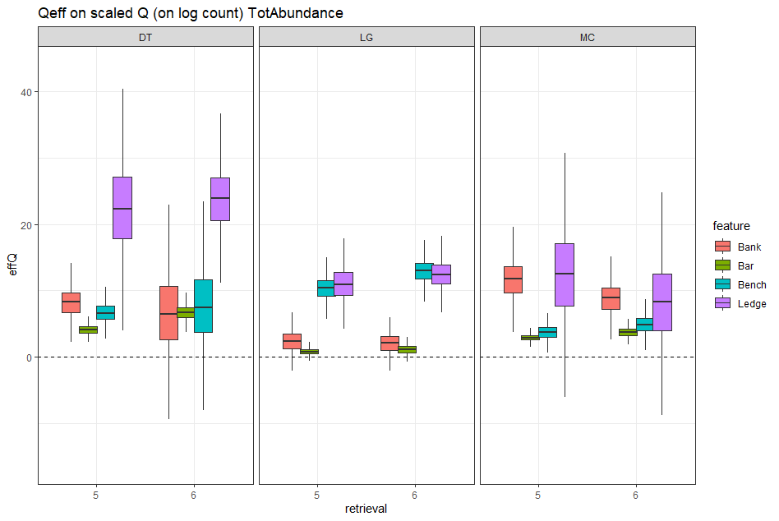
Figure 9-5 Effect of flows on total seed abundance (log count) in different sites, with number of days inundated as indicator.
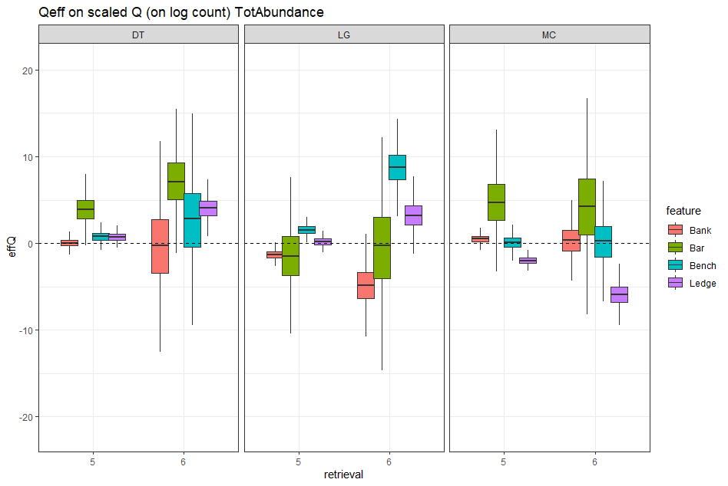
Figure 9-6 Effect of flows on total seed abundance (log count) in different sites, with maximum dry period as indicator.
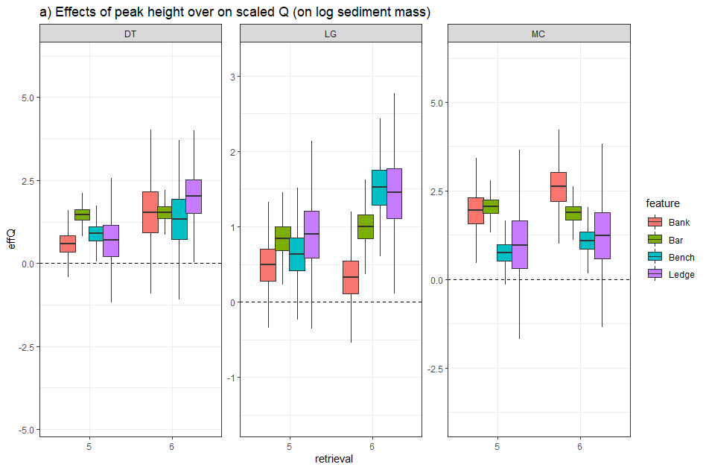
Figure 9-7 Effect of flows on sediment mass in different sites, with peak inundation height as indicator.
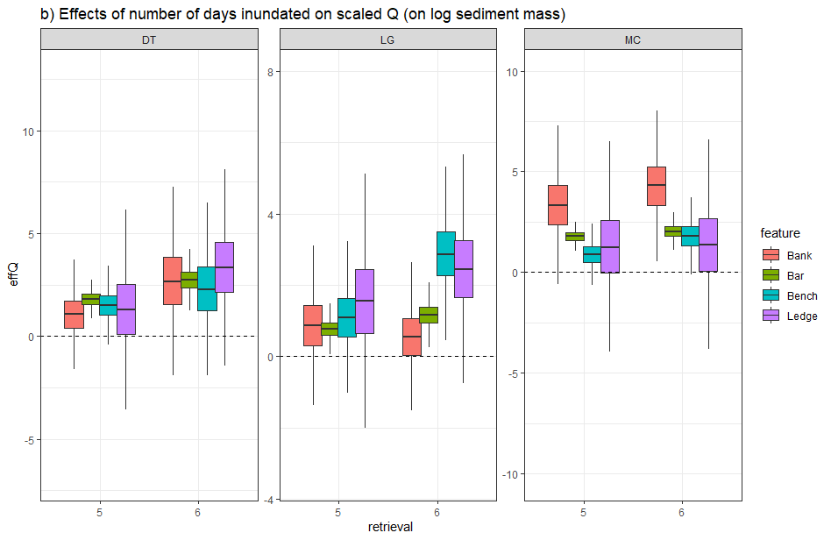
Figure 9-8 Effect of flows on sediment mass in different sites, with number of days inundated as indicator.
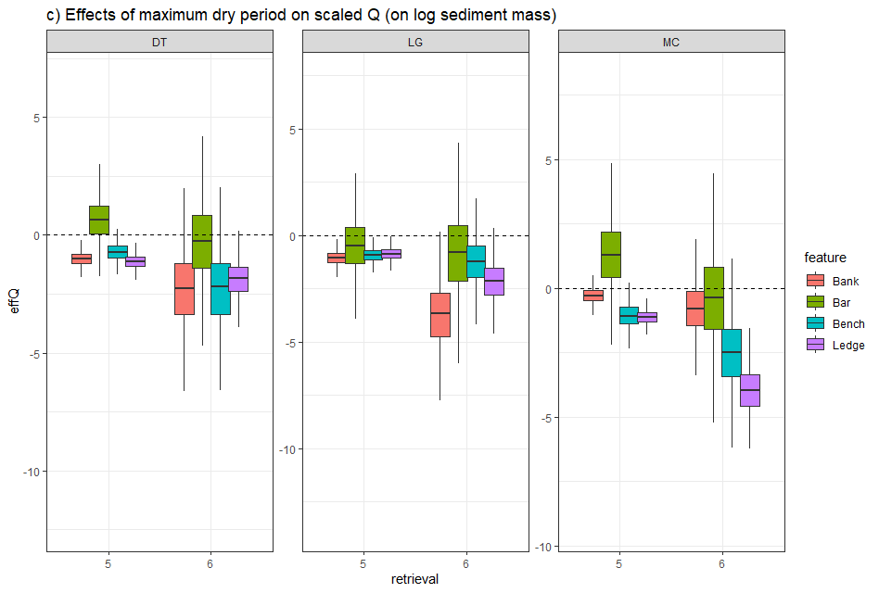
Figure 9-9 Effect of flows on sediment mass in different sites, with maximum dry period as indicator.
Propagule sample composition
A total of 8,266 (2,733/m²) and 10,811 (3,910/m²) seedlings were counted from the mat samples collected following the winter and spring fresh collections, respectively. More than two-thirds of all seedlings were accounted for by four species: Cyperus eragrostis*, C. exaltatus, Eragrostis parviflora* and Juncus amabilis. River Red Gum (Eucalyptus camaldulensis) seedlings were also relatively common in both the winter and spring fresh samples.
While greater abundances of propagules were generally observed for Bar samples at Darcy’s Track and McCoy’s Bridge, largest abundances of propagules were observed for Bench samples at Loch Garry (Figure 9-10).
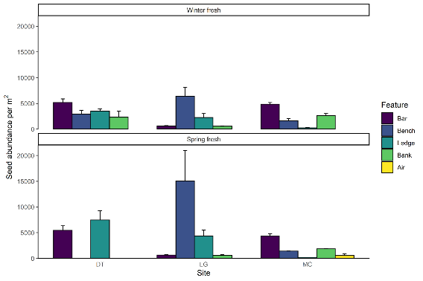
Figure 9-10 Seed abundance of material deposited on turf mats across different geomorphic features (Bar, Bench, Ledge, Bank, Air) at three sites, Darcy’s Track, Loch Garry and McCoy’s Bridge for retrievals following a winter and spring fresh in 2019.
A total of 42 and 47 different taxa germinated from the mat samples for the winter and spring fresh retrievals, respectively (species list provided in Appendix E). Bar samples tended to have the greatest taxa richness, except at Loch Garry where similar taxa richness was observed across all features (Figure 9-11).
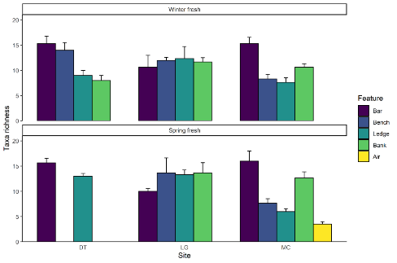
Figure 9-11 Taxa richness of material deposited on turf mats across different geomorphic features (Bar, Bench, Ledge, Bank, Air) at three sites, Darcy’s Track, Loch Garry and McCoy’s Bridge for retrievals following a winter and spring fresh in 2019. Mats were stolen and thus no samples were collected for Bench and Bank features at Darcy’s Track following the spring fresh.
Despite inundation versus seed abundance data showing correlations at a feature level in the modelling results (Figure 9-5 & Figure 9-6) when additional variables are not considered (such as tributary % and habitat type interactions with flow delivery), the relationship between inundation duration and abundance of seeds deposited is not clear (Figure 9-12). Some features inundated for long periods (e.g. bars) received similar abundances of propagules to those inundated for shorter periods (e.g. banks). Conversely, some features that were inundated for relatively short periods received high abundances of seeds (e.g. benches at Lock Garry). This highlights the value of the modelling that considers additional variables in the process of data analysis.

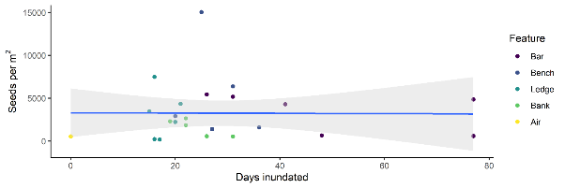
Figure 9-12 Relationship between inundation duration and abundance of seeds deposited on mats across different geomorphic features (Bar, Bench, Ledge, Bank, Air) pooling across all three sites and both events.
In contrast, the taxonomic richness of deposited seeds showed a distinct correlation between richness and inundation duration (Figure 9-13). These divergent relationships are in part a result of the tendency of some of the commonly observed species (e.g. Cyperus and Juncus spp.) to produce large abundances of light buoyant seeds that are deposited along ‘strandlines’. Thus, longer inundation generally increases the diversity of propagules (both floating and non-floating) arriving at a site, but not the abundance of propagules, because large numbers of floating seeds are deposited along 'strandlines' where inundation periods are actually relatively short.
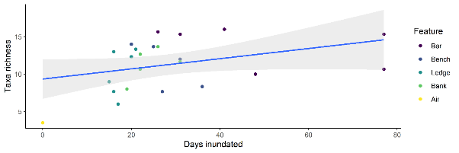
Figure 9-13 Relationship between inundation duration and taxa richness of seeds deposited on mats across different geomorphic features (Bar, Bench, Ledge, Bank, Air) pooling across all three sites and both events.
Comparing the daily rates of seeds deposition and numbers of taxa recorded across all sites for the six events monitored to date, the spring fresh event in 2019 is notable for the large abundances of seeds deposited, particularly on Benches and Ledges (Figure 9-14). Conversely, plant taxonomic richness of deposited material has remained fairly consistent across events.
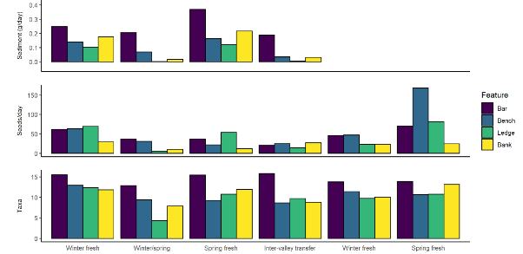
Figure 9-14 Sediment (g/day), seed abundance (seeds/day) and taxa richness of material deposited on turf mats across different geomorphic features (Bar, Bench, Ledge, Bank) across all three sites, for the six events monitored to date (2018–2019). N.B. Sediment samples for the winter and spring freshes (2019) have been unable to be processed to COVID-related restrictions on lab access at The University of Melbourne.

Research activities

Collaborative research project

Introduction
Through the development of the Goulburn MER plan a range of research questions were identified to help better understand the relationships between in-channel flow, hydraulic habitat conditions and ecological response:
- What are the in-channel / hydraulic habitat types (e.g. slack waters, backwaters, benches, etc. with different hydraulic characteristics) that are particularly important for ecological processes, specific organisms, or life history stages in the Goulburn River?
- Does the distribution and quality of these habitat types change with different flow rates?
- Can flow rates be manipulated to optimise the availability of habitat types that are shown to be important, or to minimise impacts on these habitats during river operations (e.g. IVT flows)?
These questions are important in the Goulburn River because evidence in the literature suggests that certain habitat types are important for various ecological processes, life history stages, etc. (e.g. as areas for organic carbon retention and processing, low-flow refuges for larval and juvenile fish, sites of sediment and seed deposition, etc.). Furthermore, EWKR research has identified the importance of slackwaters (in the form of anabranches and floodplain wetlands) as sources of carbon and zooplankton for fish food, and that these habitats generate more food than main channel habitats. These specific overbank slackwaters are not readily engaged in the Goulburn River, so we are interested in the extent to which similar habitats may be present within the main channel and if they can be manipulated to achieve benefits for biota and ecosystem processes
In this context, the proposed research program aims to identify which habitats in the Goulburn River are particularly critical to the river’s ecological function, and whether these habitats can be optimised through flow manipulation.

Project overview
We are developing a collaborative project with a focus on first understanding which particular habitats / characteristics are important for biota and ecological processes occurring in the lower Goulburn River and second, determining the distribution of important habitat types and identifying flows required to optimise these habitat types.
The following outlines our process for the project:
- Question refinement / hypotheses development. Convene a workshop to elicit the hydraulic conditions / physical characteristics that are expected to be important for plants, fish, macroinvertebrates, ecosystem processes etc. We can use our conceptual model (below) to reflect on our current understanding of important linkages and identify where there are still gaps, or where there is an apparent link but there is an opportunity to quantify that link more explicitly (i.e. a tick that needs more evidence to confirm). At this workshop we would refine our research questions and develop hypotheses for testing.
- Map habitats. Use existing hydraulic models to map hydraulic habitats identified in the workshop as important for each taxon or ecological process (at selected reaches).
- Field investigations. Use maps to target investigations at sites that span a range of hydraulic conditions ranging from optimal to sub-optimal for each taxa or ecological process to validate relationships.
- Analysis and reporting. Asses against hypotheses, validate relationships, update conceptual model, identify flow bands for optimising habitats / hydraulic conditions, incorporate outcomes into refinement of water delivery (both for environmental flows and water supply delivery).

Activities to date
To date we have undertaken a literature review of the importance of slackwater habitats, completed the expert workshop and developed a conceptual model for the Goulburn River (Figure 10-1).

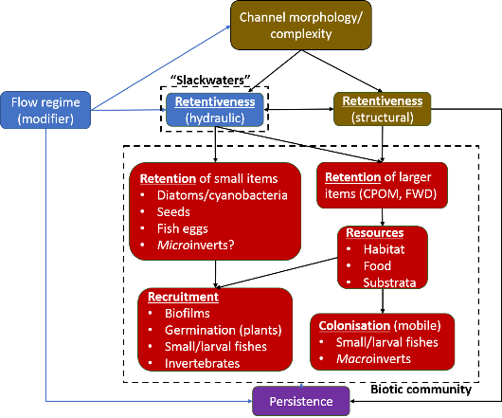
Figure 10-1 Conceptual model for the Goulburn River.
The outcomes of the literature review, expert workshop and conceptual model are being used to establish a number of hypothesis that will be tested through a program of field investigations and data analyses. A program of works is being development for implementation over the 2020-21 period, with the commencement of fieldwork partly dependent on when COVID-19 restrictions are relaxed in Victoria. Project outcomes will be reported through newsletters and subsequent annual reports in accordance with the following key project steps:
Stage 1: 2D models and pilot surveys – Pattern setting and context
- Establish hypotheses
- 2D modelling of depth and flow velocity to identify slackwaters and model changes in the size (area m²); mean depth; mean velocity of slackwaters with increasing discharge.
- Ground-truth models and identify suitable slackwaters for subsequent research (stage 2 and 3).
- Categorise slackwaters by: (a) physical form; (b) hydraulic persistence (c) structural retentiveness
- Conduct rapid surveys of structural retention and densities of detritus in slackwaters
Stage 2 – Major survey: Relate ecological endpoints to slackwater attributes at key points in the hydrograph
- Long term, repeated surveys of specific biological variables (fish, plants, micro- and macro-invertebrates, biofilms, metabolism). Test the presence and strength of ecological linkages within and between the slackwater categories established in Stage 1.
Stage 3 – Experiment to manipulate structural retentiveness to provide temporal stability.
    - “Reinforce” slackwaters and other target areas with snags and/or wooden stakes to enhance structural retentiveness and promote establishment of persistent and diverse biological communities.
Stage 3 – Analysis and reporting.

Engagement and Communication and

Engagement
The value and importance of the Goulburn River to the local and regional community – as well as the many visitors to the area – has always been high, but its health and ongoing management was front and centre as never before during 2019-20. The on-going dry conditions meant that every fluctuation of the river was noticed, questioned and commented on; particularly with regards to the increasing frequency of higher than usual summer flows to meet downstream demand. Anglers, local government, businesses and the broader community sought information from the GB CMA, collected as part of current and past monitoring programs, to back up their observations that the banks were being damaged by water being transferred to the Murray during summer. Using this information local media campaigned regularly on the issue and angling groups developed videos and other communication materials to highlight their concerns and lobby government. Their calls were heard, with interim operating rules brought in to limit IVT flows to 50GL/month during summer 2019/20; a moratorium on large-scale downstream horticultural developments; and a review of trading rules now under way. In June 2020, the MDBA agreed to the Victorian Government’s recommendation of a 40GL/month limit for 2020/21. Collaborating with and empowering the community to bring about these changes is a perfect example of best-practice community engagement (IAP2 public participation spectrum - https://www.iap2.org.au/resources/spectrum/).
The Victorian Government’s communication protocols during the coronavirus pandemic created challenges, however, the GB CMA was able to continue to communicate about the monitoring program, albeit slightly less frequently, by drawing on community networks and with support from the CEWO and VEWH. A winter fresh was not planned due to lack of water but fortunately rain arrived and we were instead able to tell a good story and increase community understanding of the benefits of high (natural) flows at this time of the year.
Through various advisory groups we have continued to involve and consult with Yorta Yorta Nation about environmental flows. Yorta Yorta helped with fish larvae monitoring, provided input about language for various communication materials, and contributed to the development of a new Lower Goulburn River Flows study, which will guide environmental water planning and management for the next 5-10 years.

Communication
The following communication and engagement actives were undertaken during 2019-20 to inform stakeholders and the broader community about the aims and results of the Goulburn River Flow-MER Project and the role of the Commonwealth Environmental Water Office in environmental water management. Selected examples of communications are included in Appendix F.

Media releases and other articles
Between July 2019 and June 2020 five media releases were prepared and 20 columns/advertisements were run in the Shepparton Advisor (free – circulation 60,000) and the Country News (paid - circulation 35,000). These promoted the project, Commonwealth environmental water use in the Goulburn River and ecological responses (native fish movement and breeding, bank vegetation growth and bank erosion) to environmental flows. There were 30 corresponding articles published in local newspapers including the Shepparton Advisor, Alexandra Standard, Riverine Herald and the Country News. ABC Goulburn Murray and local TV stations (WIN and Nine) also interviewed staff and/or ran the media releases in their news bulletins. Many of the articles focused on the impact of the high IVT flows on lower Goulburn River ecological values and how monitoring is informing mitigation measures. In response to community and GBCMA concerns the Victorian Government introduced interim operating rules limiting the amount of IVT transfers during summer 2019-20, which generated a great deal of “chatter” in the media and on social media. Articles were also included in the GB CMA electronic newsletter Connecting Community and Catchment, which has over 1100 subscribers. Streamology also promotes the Goulburn River Flow-MER Project research it undertakes on its website and through their electronic newsletter.
Anglers continue to be passionate advocates for river health activities and we continue to engage with them via a number of platforms, including fishing shows and expos. For example, in February GB CMA and CEWO staff filmed segments for the Merv Hughes Fishing show, which aired in July and August.

Technical publications
Technical communication and engagement activities were limited compared to prior years due to COVID-19 restrictions impacting the latter half of the year. However, several publications have appeared in or been submitted to the peer-reviewed scientific literature that incorporate aspects of the Goulburn River LTIM and MER projects. These including two papers that appeared in a special issue of the journal River Research and Applications to honour the life and memory of Professor Wayne Erskine:
- Watts et al. (2020), which examined how adaptive management is being applied across the LTIM/MER selected areas and how learnings from one Selected Area may be better captured to inform future management at other areas. (Watts RJ, Dyer F, Frazier P, Gawne B, Marsh P, Ryder DS, Southwell M, Wassens S, Webb JA, Ye Q (2020) Learning from concurrent adaptive management in multiple catchments within a large environmental flows program in Australia. Riv. Res. Appl. 36, 668-680.)

- Gawne et al. (2020), which provides an overview of the LTIM/MER approach to large-scale monitoring and evaluation of environmental flows, given that these programs have no parallel anywhere in the world (Gawne B, Hale J, Stewardson MJ, Webb JA, Ryder DS, Brooks SS, Campbell CJ, Capon SJ, Everingham P, Grace MR, Guarino F, Stoffels RJ (2020) Monitoring of environmental flow outcomes in a large river basin: The Commonwealth Environmental Water Holder's long‐term intervention in the Murray–Darling Basin, Australia. Riv. Res. Appl. 36, 630-644.)

Goulburn MER research was also used to contribute to the following external programs:
- GBCMA project options for EC5 (Environmental Contributions Levy)
- Goulburn Environmental Flow Study for the GBCMA
- Goulburn River Operations Guideline for DELWP and the MDBA

Social Media
Numerous Facebook and Instagram posts and tweets promoted the project and the benefits of environmental water. These were viewed thousands of times and are usually amongst GB CMA’s most popular and engaging posts. Currently, the GB CMA has over 4,700 social media followers.
https://www.facebook.com/gbcma
https://twitter.com/gbcma
https://www.instagram.com/goulburnbrokencma/
To acknowledging the Traditional Owners (Yorta Yorta Nation Aboriginal Corporation), they are usually tagged in social media and they along with MLDRIN, frequently share information about the monitoring program and outcomes among their networks.
Innovative approaches, such as Streamology using drones to monitor bank condition, continue to attract community and media attention, with posts on this topic among the most popular and engaging.

Websites
The Water for the Environment section of the Goulburn Broken CMA’s website was updated and given greater prominence in-line with an overall update and revamp of site. The development of the FLOW-MER website and the ability to link to it helps provide better context for how the Goulburn project aligns with the broader Basin monitoring activities as well as providing access to regularly updated science and information via newsletters and other material generated by CEWO.

Presentations
GB CMA staff presented/provided updates to a number of government, community and agency groups throughout the year on environmental water management and the Goulburn FLOW-MER project. These groups included:
- Yorta Yorta Nation Aboriginal Corporation;
- Taungurung Land and Waters Council;
- Parks Victoria;
- DELWP;
- Goulburn-Murray Water;
- Schools;
- Recreational fishing groups and fish management agencies;
- GB CMA partnership group; and
- Environmental Water Advisory Groups.

References
Appling, A. P., R. O. Hall Jr, C. B. Yackulic and M. Arroita (2018). "Overcoming equifinality: Leveraging long time series for stream metabolism estimation." Journal of Geophysical Research: Biogeosciences 123(2): 624-645.
Bernot, M. J., D. J. Sobota, R. O. Hall Jr, P. J. Mulholland, W. K. Dodds, J. R. Webster, J. L. Tank, L. R. Ashkenas, L. W. Cooper and C. N. Dahm (2010). "Inter‐regional comparison of land‐use effects on stream metabolism." Freshwater Biology 55(9): 1874-1890.
CEWO (2018). Commonwealth Environmental Water Portfolio Management Plan: Victorian Rivers in the Murray-Darling Basin 2017-18. Commonwealth of Australia. , Commonwealth of Australia.
CEWO (2020). Lower Goulburn Selected Area 2019/20 Acquittal report. Report prepeared by the Commonwealth Enviornmental Water Office. , Commonwealth Environmental Water Office.
Cockayne, B. J., A. J. McDougall, T. Espinoza, K. R. Burndred, C. L. Thrupp, C. D. Broadfoot and M. A. Finn (2013). "Riverine flow and spawning requirements of Macquaria ambigua oriens: implications for conservation and management." Marine and Freshwater Research 64(1): 42-53.
Cottingham, P. and SKM (2011). Environmental water delivery: lower Goulburn River, Report prepared for Commonwealth Environmental Water, Department of Sustainability, Environment, Water, Populations and Communities. Canberra.
Cottingham, P., G. Vietz, J. Roberts, D. Frood, A. Graesser, J. Kaye and A. Shields (2013). Lower Goulburn River: observations on managing water releases in light of recent bank slumping. Report prepared for the Goulburn Broken Catchment Management Authority. Melbourne, Peter Cottingham and Associates.
CSIRO (2008). Water availability in the Goulburn-Broken. Report for the Australian Government, Commonwealth Industrial and Scientific Research Organisation.
DELWP (2015). Water measurement information system, Department of Environment, Land, Water and Planning.
DoEE. (2020). "Bidyanus bidyanus in Species Profile and Threats Database, Department of the Environment, Canberra. Available from: http://www.environment.gov.au/sprat. Accessed Tue, 21 Jan 2020 10:18:56 +1100."
EPA Victoria (2003). Guideline for Environmental Management: Rapid Bioassessment Methodology for Rivers and Streams. Southbank, Victoria., Environment Protection Authority.
GBCMA (2017). "Goulburn River Seasonal Watering Proposal 2017-2018. Goulburn Broken Catchment Management Authority, Shepparton."
GBCMA (2019). Goulburn River seasonal watering proposal 2019-2020. Goulburn Broken Catchment Management Authority, Shepparton. , Goulburn Broken Catchment Management Authority, Shepparton.
Gilligan, D., M. Lintermans, Z. Tonkin, J. Koehn and G. Butler (2019). "The IUCN Red List of Threatened Species 2019: e.T2804A123377634. https://dx.doi.org/10.2305/IUCN.UK.2019-3.RLTS.T2804A123377634.en. Downloaded on 15 June 2020."
Grace, M. (2018). 2016–17 Basin-scale evaluation of Commonwealth environmental water — Stream Metabolism and Water Quality. Final report prepared for the Commonwealth Environmental Water Office by La Trobe University, Publication 189/2018, September, 82 pp., La Trobe University.
Grace, M. (2019). Long Term Intervention Monitoring Basin Matter Stream Metabolism and Water Quality foundation report- revision 2018. Final Report prepared for the Commonwealth Environmental Water Office by The Murray-Darling Freshwater Research Centre, La Trobe publication 209/2018, 11pp. .
Grace, M. (2020). 2018–19 Basin scale evaluation of Commonwealth environmental water — Stream Metabolism and Water Quality. Final Report prepared for the Commonwealth Environmental Water Office by La Trobe University, Publication 247/2020, 110 pp plus annexes.
Grace, M. R., D. P. Giling, S. Hladyz, V. Caron, R. M. Thompson and R. Mac Nally (2015). "Fast processing of diel oxygen curves: Estimating stream metabolism with BASE (BA yesian S ingle‐station E stimation)." Limnology and Oceanography: Methods 13(3): 103-114.
Hale, J., R. Stoffels, R. Butcher, M. Shackleton, S. Brooks, B. Gawne and M. Stewardson (2014). "Commonwealth Environmental Water Office Long Term Intervention Monitoring Project – standard methods: Report prepared for the Commonwealth Environmental Water Office p. 175. Murray-Darling Freshwater Research Centre, Albury.".
Hall Jr, R. O. and J. J. Beaulieu (2013). "Estimating autotrophic respiration in streams using daily metabolism data." Freshwater Science 32(2): 507-516.
Hall, R. O., J. L. Tank, M. A. Baker, E. J. Rosi-Marshall and E. R. Hotchkiss (2016). "Metabolism, gas exchange, and carbon spiraling in rivers." Ecosystems 19(1): 73-86.
Herbert, B. (2005). Feeding and growth of Golden Perch (Maquaria ambigua), and assessment of its potential for aquaculture PhD thesis, James Cook University.
Humphries, P., A. J. King and J. D. Koehn (1999). "Fish, flows and flood plains: links between freshwater fishes and their environment in the Murray-Darling River system, Australia." Environmental Biology of Fishes 56(1): 129-151.
Koster, W., D. Crook, D. Dawson and P. Moloney (2012). Status of fish populations in the lower Goulburn River (2003-2012). Heidelberg, Victoria, Arthur Rylah Institute for Environmental Research Client Report, Department of Sustainability and Environment.
Koster, W. M., D. R. Dawson, A. Kitchingman, P. D. Moloney and R. Hale (2020a). "Habitat use, movement and activity of two large-bodied native riverine fishes in a regulated lowland weir pool." Journal of Fish Biology 96(3): 782–794.
Koster, W. M., D. R. Dawson, C. Liu, P. D. Moloney, D. A. Crook and J. R. Thomson (2017). "Influence of streamflow on spawning-related movements of golden perch Macquaria ambigua in south-eastern Australia." Journal of Fish Biology 90: 93–108.
Koster, W. M., I. G. Stuart, Z. Tonkin, D. Dawson and B. Fanson (2020b). Environmental influences on migration patterns and pathways of a threatened potamodromous fish in a regulated lowland river network. Unpublished Client Report for Water and Catchments, Department of Environment, Land, Water and Planning. Arthur Rylah Institute for Environmental Research, Department of Environment, Land, Water and Planning, Heidelberg, Victoria.
Leck, M. A. and M. A. Brock (2000). "Ecological and evolutionary trends in wetlands: evidence from seeds and seed banks in New South Wales, Australia and New Jersey, USA." Plant Species Biology 15: 97-112.
Marcarelli, A. M., C. V. Baxter, M. M. Mineau and R. O. Hall Jr (2011). "Quantity and quality: unifying food web and ecosystem perspectives on the role of resource subsidies in freshwaters." Ecology 92(6): 1215-1225.
Miller, K. A., J. A. Webb, S. C. de Little, M. J. Stewardson and I. D. Rutherfurd (2015). How effective are environmental flows? Analyses of flow‐ecology relationships in the Victorian Environmental Flow Monitoring and Assessment Program (VEFMAP) from 2011‐2014. A report to the Department of Environment, Land, Water and Planning. Melbourne, University of Melbourne: xiv + 342.
Milton, D. and A. Arthington (1984). "Reproductive strategy and growth of the crimson-spotted rainbowfish, Melanotaenia splendida fluviatilis (Castelnau) (Pisces : Melanotaeniidae) in south-eastern Queensland." Marine and Freshwater Research 35(1): 75-83.
O'donnell, J., K. Fryirs and M. Leishman (2015). "Can the regeneration of vegetation from riparian seed banks support biogeomorphic succession and the geomorphic recovery of degraded river channels?" River Research and Applications 31(7): 834-846.
Odum, H. T. (1956). "Primary production in flowing waters." Limnology and Oceanography 1: 102-117.
Roberts, B. J. and J. P. Mulholland (2007). "In-stream biotic control on nutrient biogeochemistry in a forested stream, West Fork of Walker Branch." Journal of Geophysical Research 112: G04002.
Roberts, J. (2018). Vegetation objectives for the lower Goulburn River. Prepared for GBCMA.
Song, C., W. K. Dodds, M. T. Trentman, J. Rüegg and F. Ballantyne IV (2016). "Methods of approximation influence aquatic ecosystem metabolism estimates." Limnology and Oceanography: Methods 14(9): 557-569.
Stewardson, M., M. Jones, W. Koster, G. Rees, D. Skinner, R. Thompson, G. Vietz and A. Webb (2014). Monitoring of ecosystem responses to the delivery of environmental water in the lower Goulburn River and Broken Creek in 2012-13. Report prepared for the Commonwealth Environmental Water Office. Melbourne, The University of Melbourne: 244.
Stewardson, M. J. and F. Guarino (2018). "Basin‐scale environmental water delivery in the Murray–Darling, Australia: A hydrological perspective." Freshwater Biology 63(8): 969-985.
Streamology and A. R. Institute (2020). Influence of Intervalley Transfers (IVT) on Riverbanks and Bank Vegetation of the Goulburn and Campaspe Rivers. Prepared for the Department of Environment, Land, Water and Planning.
The University of Melbourne (2019). Lower Goulburn River Selected Area Monitoring, Evaluation and Research Plan (2019 - 2022). Standard Operating Procedures Macroinvertebrates v2.0. Monitoring, Evaluation and Research Program,, Commonwealth Environmental Water Office, .
Thiem, J. D., I. J. Wooden, L. J. Baumgartner, G. L. Butler, J. P. Forbes and J. Conallin (2017). "Recovery from a fish kill in a semi-arid Australian river: Can stocking augment natural recruitment processes?" Austral Ecology 42(2): 218-226.
Tonkin, Z., M. Jones, J. O’Connor, W. Koster, K. Stamation, A. Kitchingman, G. Hackett, D. Dawson, A. Harris, J. Yen, I. Stuart, P. Clunie and J. Lyon (2019a). "VEFMAP Stage 6: Monitoring fish response to environmental flow delivery in northern Victorian rivers, 2018/19. Unpublished Client Report for Water and Catchments, Department of Environment, Land, Water and Planning. Arthur Rylah Institute for Environmental Research, Department of Environment, Land, Water and Planning, Heidelberg, Victoria.".
Tonkin, Z., I. Stuart, A. Kitchingman, J. D. Thiem, B. Zampatti, G. Hackett, W. Koster, J. Koehn, J. Morrongiello, M. Mallen-Cooper and J. Lyon (2019b). "Hydrology and water temperature influence recruitment dynamics of the threatened silver perch Bidyanus bidyanus in a regulated lowland river." Marine and Freshwater Research 70: 1333–1344
Uehlinger, U. (2000). "Resistance and resilience of ecosystem metabolism in a flood-prone river system." Freshwater Biology 45(3): 319-332.
VEWH (2020). Seasonal Watering Plans 2019-20. Victorian Environmental Water Holder.
Watts, R., N. McCasker, J. Howitt, J. Thiem, M. Grace, R. Kopf, S. Healy and N. Bond (2018). Commonwealth Environmental Water Office Long Term Intervention Monitoring Project: Edward-Wakool River System Selected Area Evaluation Report, 2017-18. Report prepared for Commonwealth Environmental Water Office. Commonwealth of Australia, pp 159.
Webb, A., D. Guo, S. Treadwell, B. Baker, S. Casanelia, M. Grace, J. Greet, C. Kellar, W. Koster, D. Lovell, D. McMahon, K. Morris, J. Myers, V. Pettigrove and G. Vietz (2019a). Commonwealth Environmental Water Office Long Term Intervention Monitoring Project Goulburn River Selected Area Scientific Report 2018–19. Report prepared for the Commonwealth Environmental Water Office.
Webb, A., A. Sharpe, W. Koster, V. Pettigrove, M. Grace, G. Vietz, A. Woodman, G. Earl and S. Casanelia (2018). 2018. Long-term intervention monitoring program for the lower Goulburn River: final monitoring and evaluation plan. Report prepared forthe Commonwealth Environmental Water Office. University of Melborne Commercial.
Webb, A., S. Treadwell, G. Lakhanpal, B. Baker, S. Casanelia, M. Grace, W. Koster, D. Lovell, K. Morris, V. Pettigrove, Z. Tonkin and G. Vietz (2019b). Lower Goulburn River Selected Area Monitoring, Evaluation and Research Plan (2019-2022). Prepared for the Commonwealth Environmental Water Office.
Webb, A., G. Vietz, S. Windecker, S. Hladyz, R. Thompson, W. Koster and M. Jones (2015). Monitoring and reporting on the ecological outcomes of commonwealth environmental water delivered in the lower Goulburn River and Broken Creek in 2013/14. Report prepared for the Commonwealth Environmental Water Office. Melbourne, The University of Melbourne: ix + 177.

Appendix A: Detailed summary of watering actions and volumes delivered
The following table provides a breakdown of all water delivered to the lower Goulburn River in 2019-20. All releases are from Goulburn Weir (Murchison) and volumes are provided for Murchison (M) and McCoy’s (Mc). Travel time to McCoy’s Bridge is 4 days and differences in volumes between Murchison and McCoy’s Bridge are due to lag times and tributary inflows between the two locations (Source 2019-20 Goulburn Water Use Acquittal Report – CEWO unpublished, 2020).

Date (start/end of action) | Flow component type and planned magnitude, duration, timing | CEW volume used (ML) | Other environmental water (ML)  VEWH, TLM, WQR | Non-environmental water  IVT, Other (min, passing, trib and natural flows) | Total river flow (ML)
01 July to 05 Aug 2019 (5 days) Mc | Low flow (all year)  500–940 ML/day | CEW  2,459 Mc | VEWH  0 Mc  TLM  428 Mc | IVT  0 Mc  Other  2,395 Mc | Total  5,303 Mc
01 July to 01 Aug 2019 M (32 days)  06 July to 06 Aug 2019 (32 days) Mc | Winter fresh (June/July) of up to 15,000 ML/day* at Murchison/McCoy’s with 14 days above 6,600 ML/day | CEW  135,340 M  136,618 Mc | VEWH  0 M  0 Mc  TLM  0 M  3,838 Mc | IVT  0 M  0 Mc  Other  22,721 M  22,939 Mc | Total  161,722 M  163,395 Mc
02 Aug to 17 Sept 2019 M (47 days)  07 Aug to 22 Sept 2019 Mc (47 days) | Winter/spring variable low flows (July–Oct between the end of the winter fresh and start of the early spring fresh)  Between 800–2000 ML/day | CEW  27,776 M  28,719 Mc | VEWH  2,988 M  3,659 Mc  TLM  3,640 M  4,790 Mc | IVT  0 M  0 Mc  Other  13,948 M  27,436 Mc | Total  48,353 M  64,605 Mc
18 Sept to 17 Oct 2018 M (30 days)  23 Sept to 22 Oct 2018 Mc (30 days) | Spring fresh (Aug–Sept)  >6000 ML/day for 14 days  And  When possible (Nov-Dec), up to 10 000 ML/day for 2 days to stimulate golden perch spawning. | CEW  100,424 M  101,615 Mc | VEWH  13,220 M  13,325 Mc  TLM  15,058 M  14,967 Mc | IVT  1,218 M  1,722 Mc  Other  20,385 M  13,497 Mc | Total  150,305 M  145,126 Mc
18 Oct 2019 to 19 Nov 2019 M (33 days)  23 Oct 2019 to 24 Nov 2019 Mc (33 days) | Spring/summer low flow (after a spring fresh)  <1000 ML/day for 5–6 weeks | CEW  0 M  0 Mc | VEWH  115 M  208 Mc  TLM  0 M  0 Mc | IVT  17,830 M  17,963 Mc  Other  11,818 M  11,958 Mc | Total  29,763 M  30,130 Mc
20 Nov 2019 to 13 March 2020 M (115 days)  25 Nov 2019 to 18 March 2020 Mc (115 days) | Summer/autumn low flows between pulses. Flows are not to exceed 1000 ML/day for more than 20 consecutive days, with a minimum of 7 days between pulses. | CEW  0 M  0 Mc | VEWH  0 M  493 Mc  TLM  0 M  0 Mc | IVT  142,421 M  233,302 Mc  Other  48,371 M  40,662 Mc | Total  190,793 M  183,032 Mc
Not delivered | Summer/autumn fresh (Jan to March)  Up to 4 600 ML/day for 10 days.
Not delivered | Autumn fresh (March/April)  Up to 6000 ML/day for 2 days
14 March 2020 to 4 April 2020 M (22 days)  19 March 2020 to 7 April 2020 Mc (20 days) | Low flow (all year)  500–940 ML/day | CEW  515 M  794 Mc | VEWH  11,577 M  12,064 Mc  TLM  0 M  0 Mc | IVT  0 M  0 Mc  Other  9,728 M  12,327 Mc | Total  21,820 M  25,186 Mc
5 April 2020 to 30 June 2020 M (87 days)  8 April 2020 to 30 June 2020 Mc (84 days) | Following natural flows (all year)  Provide water for a slower recession or add pulses following natural cues/unregulated flows.  Between natural flows deliver  Low flow (all year)  500–940 ML/day | CEW  35,435 M  35,963 Mc | VEWH  9,901 M  9,996 Mc  TLM  0 M  0 Mc | IVT  0 M  0 Mc  Other  184,092 M  249,984 Mc | Total  225,454 M  295,943 Mc

Appendix B: Bank Condition Digital Elevation Models of Difference (DEMODs)
This appendix presents detailed evaluation of DEMODs for each flow events at each monitoring location.
Spring Fresh & Recession Flow:
Darcy’s Track Bank D (inside bank), Spring Fresh:
Figure 12-1 shows the DEMOD for the Spring Fresh (event 1) at Darcy’s Track bank D. The major process here is erosion which is of medium depth (<5 cm) and present laterally and vertically across the bank face (despite being covered in areas of this model). Deposition is more evident on the right bank half (upstream) where there is more vegetation and is expressed across a wide vertical range of the bank. The erosion volume is large compared to the outside banks monitored (e.g. Loch Garry C – see below), this is probably due to a higher percentage of eroded sediment being freshly provided by the previous Winter Fresh event.
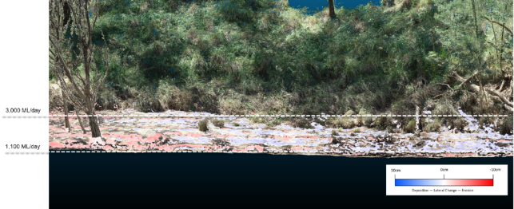
Figure 12-1 DEMOD illustrating change in response to Spring Fresh event at Darcy’s Track bank D.
Loch Garry Bank C (outside bank), Spring Fresh:
Figure 12-2 shows the DEMOD for the Spring Fresh (event 1) at Loch Garry bank C. It shows the major process here is erosion. The erosion is primarily focused on the right (upstream) side or the bend apex, where most hydrological stress is exerted. There also appears to be a collection of woody debris here which could exacerbate natural process of scour. The erosion is mainly minor in depth and is spread over a large area vertically across this bank section. It appears to be primarily the result of fluvial scour exerted on recent deposits (from the preceding Winter Fresh prior).
Deposition is minor and is located downstream (left) of the area of primary erosion. It appears this deposited sediment, in part, is sourced from erosion to the upstream section of the same bank and in part a result of deposits on the receding limb of the Spring Fresh event.
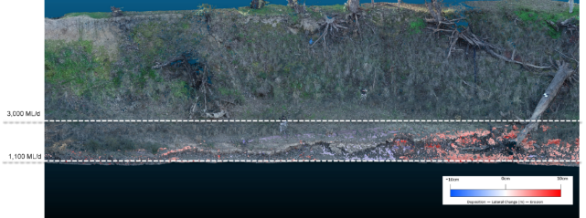
Figure 12-2 DEMOD illustrating change in response to Spring Fresh flow event at Lock Gary bank C.
Loch Garry Bank C (outside bank) Recession Flow:
Figure 12-3 shows the DEMOD for the Recession Flow (event 3) at Loch Garry bank C. In contrast to the results from the Spring Fresh, the major process here is deposition. This is present in areas laterally and vertically across the bank face, but primarily in areas of increased vegetation (downstream (left) of the bend apex). It is likely that the high volume of deposits here are driven from a combination of erosion upstream, sediment from the high % of tributary flow during this event and sediment input from high precipitation rates during this period.
Erosion is mainly minor (discounting the small area in the bottom left corner) and appears as a shaving primarily around the apex of the outer bend.
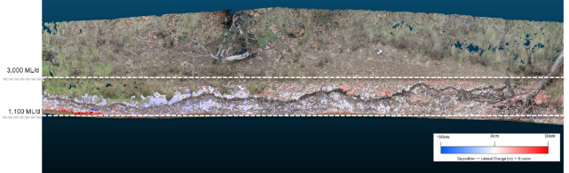
Figure 12-3 DEMOD illustrating change in response to Recession Flow event at Loch Gary bank C.
McCoy’s Bank C (outside bank), Spring Fresh:
Figure 12-4 shows the DEMOD for the Spring Fresh period (event 1) at McCoy’s bank C. Erosion, as hypothesised, is expressed over a large vertical and lateral range across the bank in response to a variable flow regime. This period largely shows erosion, as this was the primary driver of change and was driven by a combination of fluvial scour and sediment loss on the drawdown of the Spring Fresh event as the soil was saturated and then exposed.
The minor deposition is scattered around areas of roughness (roots mainly) and less steep bank sections.
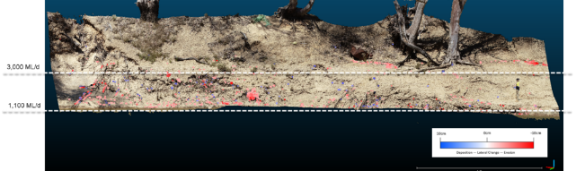
Figure 12-4 DEMOD illustrating change in response to Spring Fresh event at McCoy’s Bridge bank C.
McCoy’s Bank C (outside bank), Recession Flow:
Figure 12-5 shows the DEMOD for the Recession Flow (event 3) at McCoy’s bank C. It shows that again the major process here is erosion. The erosion is primarily focused on the right (downstream) side of the bank where the greatest sheer stress is exerted as the water wraps around the river bend. The erosion is minor in depth, but large in area - a thin shaving across a large area of the right bank side. It can be presumed the erosion process here is removal of recent deposits (from the preceding IVT period) on the receding limb of the Recession flow rather than scour.
Deposition is minor and located around areas of roughness and vegetation (see bottom left section of DEMOD).
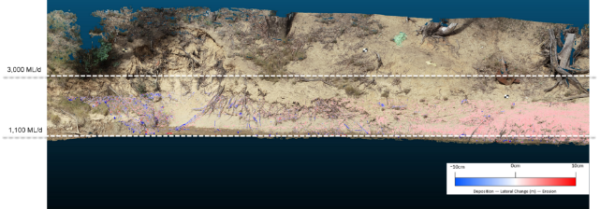
Figure 12-5 DEMOD illustrating change in response to Recession Flow event at McCoy’s Bridge bank C.
McCoy’s Bridge Bank D (inside bank), Spring Fresh:
Figure 12-6 shows the DEMOD for the Spring Fresh (event 1) at McCoy’s bank D. The major process here is erosion, which is medium in depth (<3 cm) and relatively minor compared to other banks monitored during this period. Mainly present in the upper sections of the bank (above 3,000 ML/d) the erosion is expressed in patches laterally across most of the bank face. Deposition is more evident in lower areas of the bank and arguably could be driven by the erosion processes above as there is little vegetation and the bank is relatively steep compared to other inside sections along the reach.
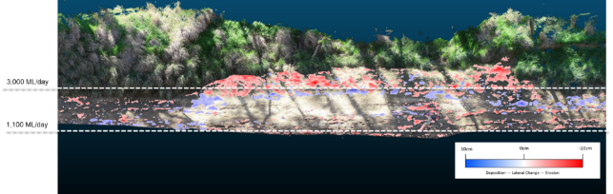
Figure 12-6 DEMOD illustrating change in response to Spring Fresh event at McCoy’s Bridge bank D.
DEMOD analysis IVT period:
Loch Garry Bank C (outside bank), IVT period
Figure 12-7 shows the DEMOD for the IVT period (event 2) at Loch Garry Bank C. Erosion is expressed across the entire bank laterally in defined lines and areas corresponding to flows within the range of 1,100- 3,000 ML/d. As expressed by dark areas of red, the depth of erosion in some areas reaches up to 10 cm. This pattern of defined erosion across the lower bank face is likely due to the cyclical rising/falling and wetting/drying experienced during the hot summer months of this period. The prolonged inundation period within a defined flow range is resulting in deep and defined areas of erosion which could lead to notching and mass failure.
Areas of deposition are also apparent (blue in Figure 12-7). These areas align with areas of roughness on the bank and in some cases could directly correspond with eroded material above (i.e. eroded material from the upper bank is deposited directly below on the lower bank). Some deposition in the upper bank zone appears to be distortion from long grasses and should be ignored.

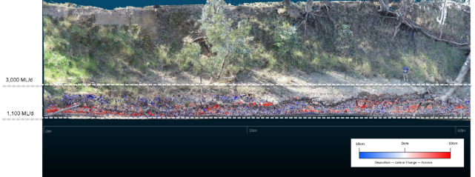
Figure 12-7 DEMOD illustrating change in response to IVT period at Loch Garry bank C.
McCoy’s Bridge Bank C (outside bank), IVT period:
In contrast to Loch Garry, deposition appears to dominate at McCoy’s Bridge bank C Figure 12-8). Deposition is expressed over a large vertical and lateral range across the bank, in zones corresponding to areas of more gentle bank profile. The range of deposition vertically across the bank does not align with the IVT flow deliveries during this period.
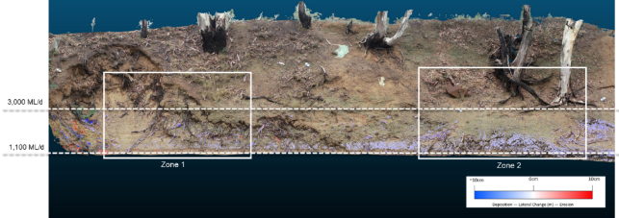
Figure 12-8 McCoy’s Bank C highlighting areas of major deposition hiding processing of major erosion during the IVT flow period.
A closer inspection of the expression of change within the DEMOD (Figure 12-9) reveals that a process of mud-draping is occurring, from areas of upper/steeper bank (represented by red) to sections of lower/flatter bank. This blanket of deposited sediment is evidently covering areas of deep erosion in the bank zone responding to the IVT flows (1,100 – 3,000 ML/d) as visible in the very lower section of the bank. These areas of erosion beneath the layer of deposited sediment correspond with the very dark red in Figure 12-9and relate to erosion greater than 10 cm in some cases and corresponding to flow zones aligned with the IVT deliveries (1,100 – 3,000 ML/d).
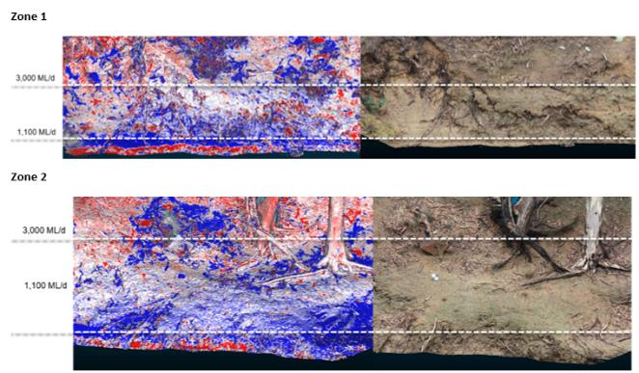
Figure 12-9 Highlighting Zone 1 (upper) and zone 2 (lower) of major deposition hiding erosion on McCoy’s Bank C in response to IVT flow period.
The process of mud-draping occurring at McCoy’s bank C is causing the anomaly in the volume of erosion in response to the IVT period. After further investigation of bank zones relative to daily discharge it appears that the cause of the mud-draping is rain rather flow events per se. Very significant precipitation (32mm (mean) on 5/03/2020 as illustrated in Figure 12-10 the highest recorded since July 2019) prior to the drone survey on the 6/03/2020 (post the IVT period).
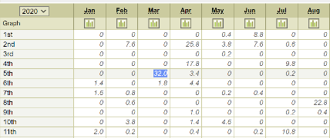
Figure 12-10 Daily average rainfall by month (mm) at Shepparton airport.
To summarise, the data from this event should be interpreted with caution. It is, however possible that the event resulted in significant (+10 cm) erosion to the lower bank responding to IVT flows, which was the major process, and the majority of which was hidden by rain triggered mud-draping to lower banks following the cessation of IVT flows.

DEMODS combining IVT + Recession Flow (periods 2+3)
Darcy’s Track Bank D (inside bank), IVT + Recession flow
Figure 12-11 shows the DEMOD relating to the IVT period (event 2+3) at Darcy’s Track bank D. The processes of erosion and deposition are relatively well balance on this bank, with erosion directly depositing sediment on the corresponding bank area below. Erosion is expressed across the upper half of the bank relating to the upper quartile of the IVT flows (2,500-3,000 ML/d), where the stresses from wetting/drying occur. It is represented consistently vertically and laterally within this upper zone with depths ranging from 5-10 cm. Deposition is expressed in the lower bank and corresponds directly to areas of erosion above, also in depths ranging from 5-10 cm.
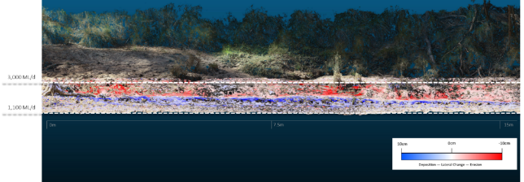
Figure 12-11 DEMOD illustrating change at Darcy’s Track bank D in response to IVT and Recession flows.
McCoy’s, Bank D (inside bank), IVT + Recession flow
Figure 12-12 shows the DEMOD for the IVT period (event 2+3) at McCoy’s bank D. This DEMOD illustrates that the prolonged inundation experienced during the IVT and Recession flow period is resulting in the formation of notching along this inside bank. Lateral lines of deep (up to 10 cm) erosion are present in the lower section of the bank responding to the IVT flows (1,100-3,000 ML/d). It is clear the cyclical nature of the flow regime during this extended period from November 2019 to May 2020 is negatively impacting the physical form of this reach.
Areas of deposition are barely visible in this model. Presumably eroded material from the IVT period was removed by recession flow.
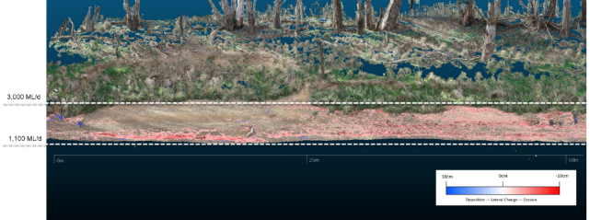
Figure 12-12 DEMOD illustrating change at McCoy’s bank D in response to IVT and Recession flows.

Appendix C: Summary metabolism data McCoy’s Bridge
Summary of McCoy’s Bridge Flow and Metabolism Data stratified by season, then divided into 6 equal-sized bins.
Season | Bin | n | Flow Min | Flow Max | Mean GPP | Mean ER | Median GPP | Median ER
 |  |  | (ML/Day) | (ML/Day) | (mg O₂/L/Day) | (mg O₂/L/Day) | (mg O₂/L/Day) | (mg O₂/L/Day)
Autumn | 1 | 69 | 684 | 934 | 1.28 | 2.76 | 1.18 | 2.55
Autumn | 2 | 69 | 935 | 997 | 1.23 | 2.33 | 1.19 | 2.05
Autumn | 3 | 69 | 1000 | 1125 | 1.29 | 2.42 | 1.20 | 2.27
Autumn | 4 | 69 | 1131 | 1801 | 1.13 | 2.48 | 1.03 | 1.99
Autumn | 5 | 69 | 1824 | 2617 | 1.01 | 1.74 | 0.98 | 1.67
Autumn | 6 | 69 | 2619 | 4372 | 1.21 | 1.50 | 1.19 | 1.54
Season | Bin | n | Flow Min | Flow Max | Mean GPP | Mean ER | Median GPP | Median ER
 |  |  | (ML/Day) | (ML/Day) | (mg O₂/L/Day) | (mg O₂/L/Day) | (mg O₂/L/Day) | (mg O₂/L/Day)
Spring | 1 | 50 | 504 | 865 | 1.60 | 5.14 | 1.44 | 4.72
Spring | 2 | 50 | 867 | 967 | 1.49 | 3.20 | 1.42 | 2.76
Spring | 3 | 50 | 968 | 1276 | 1.37 | 2.01 | 1.34 | 1.67
Spring | 4 | 50 | 1279 | 2034 | 1.91 | 2.04 | 1.74 | 2.09
Spring | 5 | 49 | 2049 | 4733 | 1.20 | 1.41 | 1.11 | 1.23
Spring | 6 | 49 | 4850 | 7673 | 0.60 | 0.98 | 0.60 | 0.82
Season | Bin | n | Flow Min | Flow Max | Mean GPP | Mean ER | Median GPP | Median ER
 |  |  | (ML/Day) | (ML/Day) | (mg O₂/L/Day) | (mg O₂/L/Day) | (mg O₂/L/Day) | (mg O₂/L/Day)
Summer | 1 | 67 | 551 | 965 | 2.35 | 5.87 | 2.01 | 5.73
Summer | 2 | 67 | 969 | 1214 | 1.63 | 4.62 | 1.40 | 4.56
Summer | 3 | 67 | 1217 | 1494 | 1.32 | 3.49 | 1.27 | 3.13
Summer | 4 | 67 | 1499 | 2119 | 1.28 | 2.84 | 1.25 | 2.82
Summer | 5 | 66 | 2146 | 2716 | 1.38 | 2.15 | 1.23 | 2.07
Summer | 6 | 66 | 2723 | 3317 | 1.98 | 2.19 | 2.06 | 2.29
Season | Bin | n | Flow Min | Flow Max | Mean GPP | Mean ER | Median GPP | Median ER
 |  |  | (ML/Day) | (ML/Day) | (mg O₂/L/Day) | (mg O₂/L/Day) | (mg O₂/L/Day) | (mg O₂/L/Day)
Winter | 1 | 23 | 632 | 973 | 0.89 | 2.91 | 0.88 | 1.61
Winter | 2 | 23 | 973 | 1002 | 0.90 | 2.19 | 0.87 | 1.85
Winter | 3 | 23 | 1010 | 1076 | 0.88 | 3.25 | 0.80 | 2.07
Winter | 4 | 22 | 1077 | 1230 | 0.67 | 4.05 | 0.69 | 3.77
Winter | 5 | 22 | 1245 | 1538 | 0.47 | 3.41 | 0.44 | 2.38
Winter | 6 | 22 | 1565 | 8050 | 0.30 | 2.40 | 0.28 | 1.44

Appendix D: Bank vegetation responses
The responses of different vegetation groups and taxa over time in each bank zone are summarised below with relevant graphical responses is provided in Table 12-1.
Table 12-1 Bank zone elevations and inundation of zone by Spring freshes and Inter Valley Transfers at McCoy’s Bridge and Loch Garry.
Site | Zone | Elevation AHD m | Spring fresh | IVT
McCoy’s Bridge | Zone 1a | >93.00-93.25 | √ | √
McCoy’s Bridge | Zone 1b | 93.25-93.5 | √ | √
McCoy’s Bridge | Zone 2 | 93.5-94.0 | √ | √
McCoy’s Bridge | Zone 3 | 94.0-95.5 | √ | x
McCoy’s Bridge | Zone 4 | >95.5 | x | x
Loch Garry | Zone 1a | <98.3-98.6 | √ | √
Loch Garry | Zone 1b | 98.6-99.05 | √ | √
Loch Garry | Zone 2 | 99.05-99.8 | √ | √
Loch Garry | Zone 3 | 99.8-101.6 | √ | x
Loch Garry | Zone 4 | >101.6 | x | x

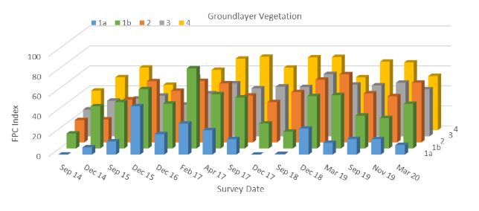
Figure 12-13 Average foliage projected cover index of ground layer vegetation in each bank zone at McCoy’s Bridge across surveys.
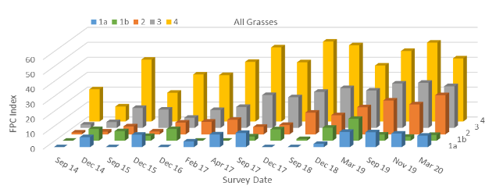
Figure 12-14 Average foliage projected cover index of all grass species in each bank zone at McCoy’s Bridge across surveys.
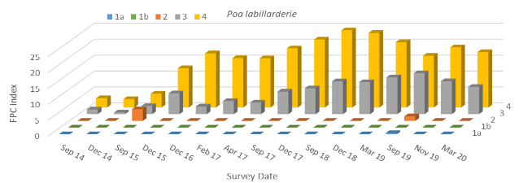
Figure 12-15 Average foliage projected cover index of common tussock grass (Poa labillarderei) in each bank zone at McCoy’s Bridge across surveys.
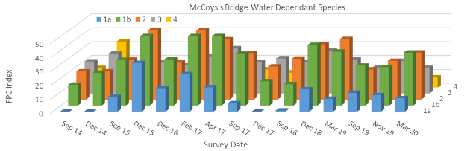
Figure 12-16 Average foliage projected cover index of water dependent EVC species in each bank zone at McCoy’s Bridge across surveys.
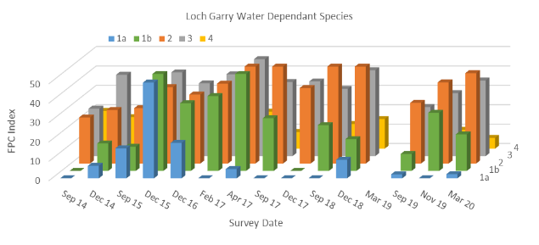
Figure 12-17 Average foliage projected cover index of water dependent EVC species in each bank zone at Loch Garry across surveys.

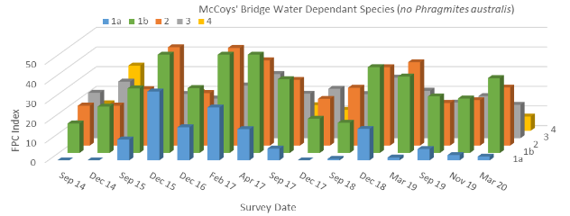
Figure 12-18 Average foliage projected cover index of water dependent EVC species without common reed (Phragmites australis) in each bank zone at McCoy’s Bridge across surveys.

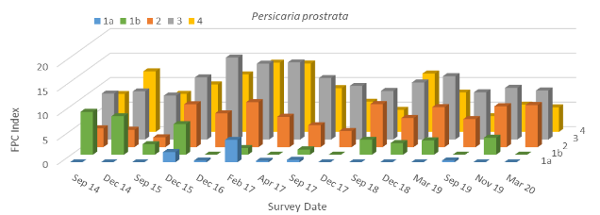
Figure 12-19 Average foliage projected cover index of creeping knotweed (Persicaria prostrata) in each bank zone at Loch Garry across surveys.
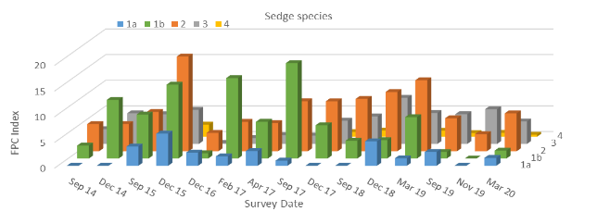
Figure 12-20 Average foliage projected cover index of sedge (Cyperus spp.) species in each bank zone at McCoy’s Bridge across surveys.
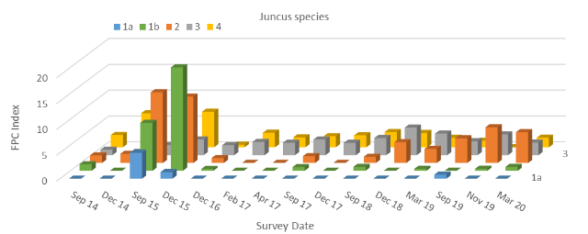
Figure 12-21 Average foliage projected cover index of Juncus species in each bank zone at McCoy’s Bridge across surveys.

Appendix E: Taxa recorded deposited on turf mats
All taxa recorded from material deposited on turf mats across different geomorphic features (Bar, Bench, Ledge, Bank, Air) at three sites, Darcy’s Track, Loch Garry and McCoy’s Bridge for retrievals following winter and spring freshes in 2019. An X denotes presence of a taxa at a particular site and geomorphic feature.
Species |  | DT |  |  |  | LG |  |  |  | MC
 |  | Bank | Bar | Bench | Ledge | Bank | Bar | Bench | Ledge | Air | Bank | Bar | Bench | Ledge
Winter fresh
Alternanthera denticulata |  | X | X | X | X | X | X | X | X |  | X | X | X | X
Bromus diandrus |  |  |  |  | X
Callitriche sonderi |  |  |  |  |  |  |  | X
Centipeda cunninghamii |  | X | X | X |  |  | X | X | X |  | X | X |  | X
Centipeda minima |  | X | X | X | X | X | X | X | X |  | X | X | X | X
Cyperus difformis |  |  | X
Cyperus eragrostis |  | X | X | X | X | X | X | X | X |  | X | X | X | X
Cyperus exaltatus |  | X | X | X |  | X | X | X | X |  | X | X | X | X
Dysphania ambrosioides |  |  | X | X |  | X |  |  |  |  |  | X
Dysphania glomulifera subsp. glomulifera |  |  |  |  |  | X | X
Dysphania pumilo |  |  | X |  |  |  |  |  |  |  |  | X
Elatine gratioloides |  |  | X |  |  |  | X |  |  |  | X |  | X
Eragrostis parviflora |  |  | X | X |  | X | X | X | X |  | X | X | X | X
Eucalyptus camaldulensis |  | X |  | X | X | X | X | X | X |  | X | X
Fimbristylis spp. |  |  |  | X
Gnaphalium polycaulon |  | X | X |  |  | X | X | X | X |  | X | X | X
Juncus amabilis |  | X | X | X | X | X | X | X | X |  | X | X | X | X
Juncus articulatus |  |  |  | X
Juncus prismatocarpus |  |  | X | X |  |  | X
Juncus usitatus |  | X | X | X | X | X | X | X | X |  | X | X | X | X
Lachnagrostis filiformis |  |  | X |  |  |  |  |  | X
Laphangium luteoalbum |  |  | X | X |  |  |  |  |  |  |  | X
Lipocarpha microcephala |  |  |  |  |  |  |  |  |  |  |  |  | X
Lolium sp.1 |  |  |  |  | X
Lolium spp. |  |  | X
Ludwigia palustris |  | X | X | X |  | X
Lythrum hyssopifolia |  |  |  |  |  |  |  |  |  |  |  |  |  | X
Lythrum salicaria |  |  | X |  |  |  | X |  | X
Mollugo verticillata |  |  | X | X |  | X | X |  |  |  | X | X | X
Oxalis perennans |  |  |  |  |  | X | X |  | X
Panicum coloratum |  |  |  |  |  | X | X | X | X |  |  | X | X
Paspalidium jubiflorum |  | X |  |  | X |  |  |  |  |  |  |  |  | X
Persicaria decipiens |  |  |  | X
Persicaria hydropiper |  | X |  | X |  |  |  |  |  |  |  |  | X | X
Persicaria lapathifolia |  |  | X
Persicaria prostrata |  |  |  | X | X | X |  | X | X |  |  | X
Poa labillardierei |  |  |  |  |  |  |  |  |  |  |  | X
Polygonum aviculare |  |  |  |  | X |  |  |  |  |  |  |  |  | X
Rorippa gigantea |  |  |  |  |  |  |  | X
Rorippa palustris |  | X | X | X |  | X | X | X | X |  |  | X
Symphyotrichum subulatum |  |  | X | X | X |  |  |  |  |  | X | X
Wahlenbergia spp. |  |  |  | X |  |  |  | X | X |  |  | X
Spring fresh
Acacia dealbata |  |  |  |  |  | X
Alternanthera denticulata |  |  | X |  | X | X | X | X | X |  | X | X | X | X
Bromus diandrus |  |  |  |  | X
Callistemon spp. |  |  |  |  |  |  |  |  | X
Centipeda cunninghamii |  |  | X |  | X |  |  | X | X |  | X | X
Centipeda minima |  |  | X |  | X | X | X | X | X |  | X | X | X | X
Cyperus difformis |  |  | X |  |  |  |  |  | X |  |  | X | X
Cyperus eragrostis |  |  | X |  | X | X | X | X | X | X | X | X | X | X
Cyperus exaltatus |  |  | X |  |  | X | X |  | X | X | X | X | X | X
Dysphania ambrosioides |  |  |  |  |  |  |  |  |  |  |  | X
Dysphania glomulifera subsp. glomulifera |  |  | X |  | X | X | X | X
Dysphania pumilo |  |  |  |  |  |  |  |  | X |  | X | X
Ehrharta longiflora |  |  |  |  |  |  |  |  |  | X
Elatine gratioloides |  |  | X |  |  |  |  |  |  |  |  | X
Epilobium spp. |  |  |  |  |  |  |  | X
Eragrostis parviflora |  |  | X |  | X | X | X | X | X |  | X | X | X
Eucalyptus camaldulensis |  |  |  |  | X |  |  |  | X | X | X | X |  | X
Euchiton japonicus |  |  |  |  |  |  |  | X | X |  |  | X
Gnaphalium polycaulon |  |  |  |  |  | X | X | X | X |  | X | X | X
Hypochaeris radicata |  |  |  |  | X
Juncus amabilis |  |  | X |  | X | X | X | X | X |  | X | X | X | X
Juncus articulatus |  |  | X |  |  | X
Juncus prismatocarpus |  |  | X
Juncus usitatus |  |  | X |  | X | X | X | X | X | X | X | X | X | X
Lachnagrostis filiformis |  |  |  |  |  | X |  | X | X |  |  | X
Laphangium luteoalbum |  |  | X |  | X | X | X | X |  |  | X | X |  | X
Lipocarpha microcephala |  |  |  |  |  |  | X | X
Lotus uliginosus |  |  |  |  | X
Ludwigia palustris |  |  | X |  | X |  |  |  |  |  |  | X
Lythrum hyssopifolia |  |  |  |  |  |  |  | X
Lythrum salicaria |  |  | X |  |  | X | X | X
Modiola caroliniana |  |  | X |  |  |  |  |  |  |  | X
Mollugo verticillata |  |  | X |  |  | X |  | X |  |  |  | X | X
Oxalis perennans |  |  | X |  |  | X |  | X | X
Panicum coloratum |  |  |  |  |  | X |  | X | X
Paspalidium jubiflorum |  |  |  |  | X
Persicaria prostrata |  |  |  |  | X | X |  | X |  |  | X | X
Poa labillardierei |  |  |  |  |  | X |  |  | X
Polygonum aviculare |  |  |  |  | X |  |  |  |  |  |  |  |  | X
Ranunculus sceleratus |  |  |  |  |  |  |  | X |  |  |  | X
Rorippa palustris |  |  | X |  | X |  |  |  | X
Rumex brownii |  |  |  |  |  | X
Solanum nigrum |  |  |  |  |  | X
Symphyotrichum subulatum |  |  | X |  | X |  |  |  |  |  | X | X
Typha spp. |  |  |  |  | X |  |  |  |  |  |  | X |  | X
Verbena officinalis |  |  |  |  |  |  |  |  |  |  |  | X
Wahlenbergia spp. |  |  |  |  | X |  |  | X | X |  | X | X

Appendix F: Examples of media communications

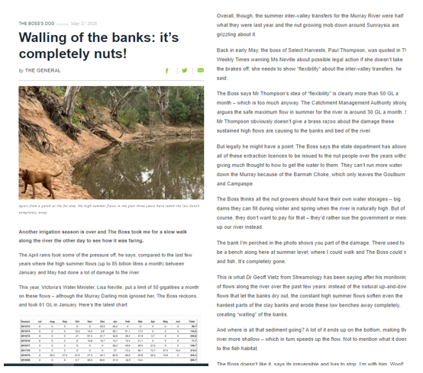
https://www.countrynews.com.au/blogs-homepage/2020/05/27/1204984/walling-of-the-banks-its-completely-nuts


https://mailchi.mp/ff28306379cb/vrfish-fishing-lines-e-news-7-may-2020?e=a42ae0b6c7
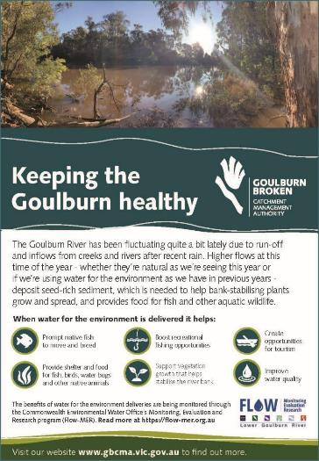
Shepparton Advisor – monthly ad – June 2020

Twitter post Feb 2020

Twitter posts July 2019

Facebook November 2019

Twitter March 2020

Country News (and also Shepparton News) December 2019
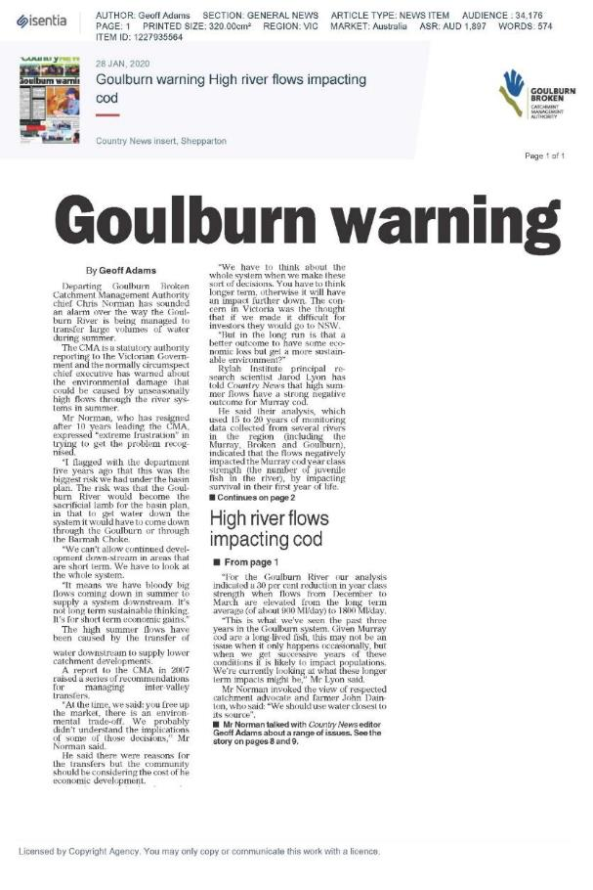
Country News January 2020

angus.webb@unimelb.edu.au

The site at Day Rd chosen in 2015-16 to replace the Moss Rd site used in 2014-15, was in turn replaced by the site at Murchison for MER. Similarly, the Darcy’s Track site used throughout the LTIM program was replaced by the nearby Arcadia Downs site for MER. These changes were brought about due to better infrastructure and accessibility of the ‘new’ sites. As DO and temperature data were already being recorded at the Shepparton Golf Club site, this site was added to the program for MER.
‘Bioavailable’ refers to those forms of nitrogen (N), carbon and phosphorus (P) most readily taken up by organisms. This typically equates to ‘dissolved’ or ‘filterable’ phosphate for P and the combination of ammonia, nitrate and nitrite for N.

