

—

**CEWO**

Monitoring, Evaluation and Research Program

2019–20 Goulburn MER Annual Summary Report

Simon Treadwell, Angus Webb, Xue Hou, Ben Baker, Simon Casanelia, Michael Grace, Joe Greet, Claudette Kellar, Wayne Koster, Daniel Lovell, Daniel McMahon, Kay Morris, Jackie Myers, Vin Pettigrove, Neil Sutton, Geoff Vietz

2 February 2021

Table of Contents

1. Monitoring and evaluation of environmental water in the lower Goulburn River 1

1.1. Description 1

1.2. Monitoring sites 1

1.3. This report 1

2. Environmental water in the lower Goulburn in 2019–20 3

3. Key outcomes from environmental water use 3

3.1. Monitoring 3

3.2. Research 18

3.3. Engagement and communications 20

4. Implications for future management of river flows, including environmental water 22

5. References 24



**Acknowledgment:** The Commonwealth Environmental Water Office acknowledges the efforts of all consortium partners in delivering the Goulburn Monitoring, Evaluation and Research Program and preparing this report.

The authors of this report as well as the Commonwealth Environmental Water Office respectfully acknowledge the traditional owners, their Elders past and present, their Nations of the Murray–Darling Basin, and their cultural, social, environmental, spiritual and economic connection to their lands and waters; in particular the Yorta Yorta, Bangerang and Taungurung nations, traditional owners of the Goulburn River catchment.

**Copyright:** © Copyright Commonwealth of Australia, 2020



This document is licensed by the Commonwealth of Australia for use under a Creative Commons By Attribution 3.0 Australia licence with the exception of the Coat of Arms of the Commonwealth of Australia, the logo of the agency responsible for publishing the report, content supplied by third parties, and any images depicting people. For licence conditions see: http://creativecommons.org/licenses/by/3.0/au/

**Citation:** This report should be attributed as:

Title: Commonwealth Environmental Water Office Monitoring Evaluation and Research Program Goulburn River Selected Area: Summary Report 2019–20.

Date: February 2021

Source: Licensed from the Commonwealth Environmental Water Office, under a Creative Commons Attribution 3.0 Australia License

Authors: Simon Treadwell, Angus Webb, Xue Hou, Ben Baker, Simon Casanelia, Michael Grace, Joe Greet, Claudette Kellar, Wayne Koster, Daniel Lovell, Daniel McMahon, Kay Morris, Jackie Myers, Vin Pettigrove, Neil Sutton, Geoff Vietz

Publisher: Commonwealth of Australia

The Commonwealth of Australia has made all reasonable efforts to identify content supplied by third parties using the following format ‘© Copyright, [name of third party]’.

**Disclaimer:** The views and opinions expressed in this publication are those of the authors and do not necessarily reflect those of the Australian Government or the Minister for the Environment.

While reasonable efforts have been made to ensure that the contents of this publication are factually correct, the Commonwealth does not accept responsibility for the accuracy or completeness of the contents, and shall not be liable for any loss or damage that may be occasioned directly or indirectly through the use of, or reliance on, the contents of this publication.

**Funding:** This monitoring project was commissioned and funded by the Commonwealth Environmental Water Office.

1. Monitoring and evaluation of environmental water in the lower Goulburn River

## Description

The Goulburn River extends from the northern slopes of the Great Dividing Range north to the Murray River near Echuca (Figure 1). The upper catchment lies within the lands of the Taungurung Nation and the lower reaches, across the northern plains, lie within the lands of the Yorta Yorta and Bangerang Nations. The lower Goulburn River is known as the Kaiela to the Yorta Yorta Nation. Mean annual flow for the catchment is approximately 3,200 GL (CSIRO, 2008), and approximately half of that is on average diverted to meet agricultural, stock and domestic demand.

Two major flow regulating structures are located on the Goulburn River; Lake Eildon and Goulburn Weir. The reach from Lake Eildon to Goulburn Weir is referred to as the mid-Goulburn and the reach from Goulburn Weir to the Murray River is the lower Goulburn. Flows in the mid-Goulburn River are now lower than natural in winter and spring (flow is stored in Lake Eildon) and higher than natural in summer and early autumn (flow is released from Lake Eildon and then mostly diverted from the river at Goulburn Weir to supply irrigation and consumptive needs).

Downstream of Goulburn Weir the overall flow volume is decreased compared to natural levels, but inflows from tributaries such as the Broken River and Seven Creeks have helped to retain the natural seasonal flow patterns (i.e. higher winter flows and low summer flows). However, more recently, there has been an increase in summer and autumn flows through the lower Goulburn River as a result of Inter-Valley Transfer (IVT) flows from Lake Eildon to supply users further downstream in the Murray River. Historical river regulation and more recent IVT flows have significantly impacted the ecological condition of the river. Managing these impacts through environmental flows is a critical outcome for the environmental water management program.

The lower Goulburn River Selected Area includes the main river channel and associated habitats connected to the river by in-channel flows up to bankfull between Goulburn Weir and the Murray River. Environmental flows in the lower Goulburn River are not used to deliver overbank flows or to water the floodplain.

## Monitoring sites

The Goulburn Monitoring, Evaluation and Research (MER) Program builds on findings of its predecessor the Long Term Intervention Monitoring (LTIM) Project. Like the LTIM Project, the MER Program divides its monitoring locations into two zones: 1) Goulburn Weir to the Broken River, 2) Broken River to the Murray River. Zone 1 and Zone 2 are physically similar, have similar hydrology and are not separated by significant barriers. Moreover, they are equally affected by the delivery of Commonwealth Environmental Water (CEW), which is controlled by the regulator at Goulburn Weir. Monitoring efforts are focused on Zone 2 to provide deeper understanding across a range of monitoring matters that would not be possible if the program were spread evenly over the two zones (Webb *et al.*, 2019b).

Ecological Matters being investigated at each site are: physical habitat - hydraulic (river flow and depth characteristics) and bank condition (erosion and sediment deposition); stream metabolism (photosynthesis and respiration as a potential source of food for macroinvertebrates and fish); macroinvertebrates (large water bugs with a focus on the biomass of crustaceans such as shrimps and prawns); bank vegetation (abundance and diversity of plant cover); and native fish spawning and populations (composition and abundance).

## This report

This report is a summary of the environmental watering outcomes in the Goulburn River Selected Area in 2019–20 and:

* Introduces the lower Goulburn River area and describes how it is treated for monitoring purposes (Section 1)
* Describes the Commonwealth environmental watering actions that occurred in the lower Goulburn River during 2019–20 (Section 2)
* Summarises the key outcomes from monitoring across the five Ecological Matters, and provides an overview of the research being undertaken and communications and engagement activities (Section 3)
* Considers the implications of the monitoring results for future management of CEW (Section 4).

More specific detail on the monitoring, including detailed descriptions of methods, results and outcomes are provided in the Goulburn River MER 2019–20 Scientific report (Treadwell *et al.*, 2020), which can be considered a technical appendix to this summary report.

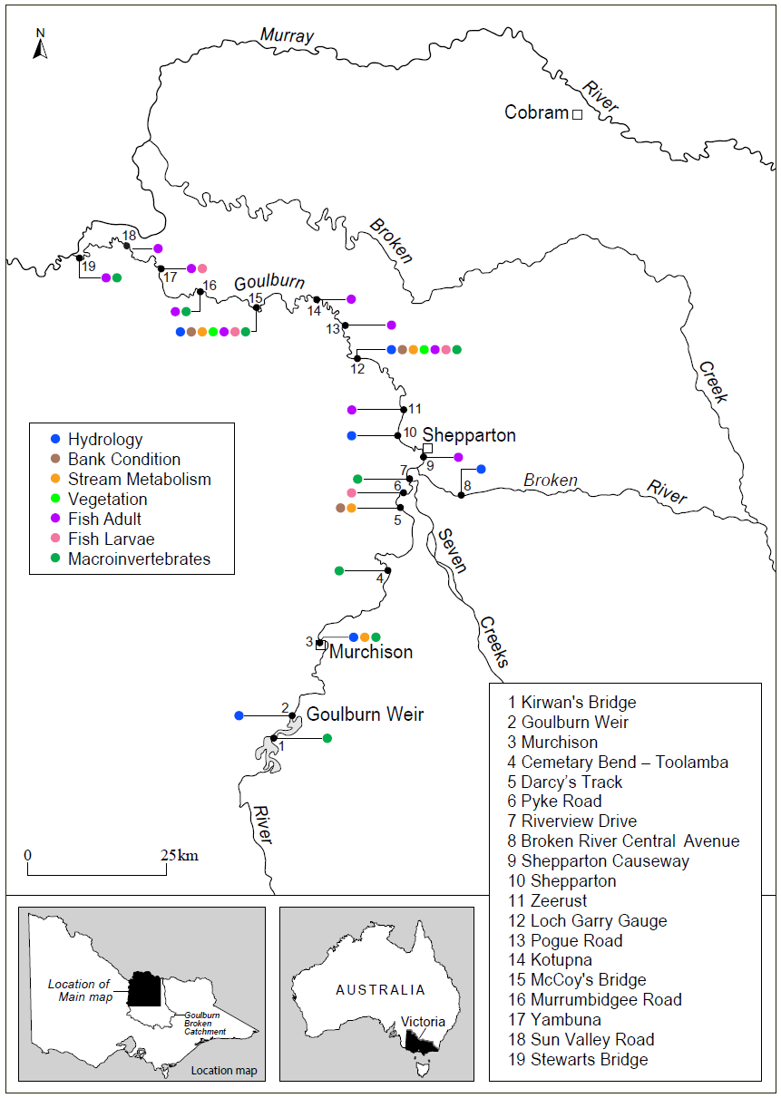

Figure 1. Map of the lower Goulburn River, with all monitoring sites marked, along with flow gauges used to generate flow data used in the MER Program. Some sites extend into the Broken River. Colours denote different monitoring activities, with some sites being used for multiple activities. Sites are indicated with site numbers, with the key providing the site name. Monitoring Zone 1 runs from Goulburn Weir to the confluence of the Broken River near Shepparton, with Zone 2 downstream from this point to the confluence with the Murray River.

1. Environmental water in the lower Goulburn in 2019–20

As of 30 September 2019, the Commonwealth held 360 GL of environmental water entitlements in the Goulburn River. The Goulburn River receives other environmental flows including from the Victorian Environmental Water Holder (VEWH) and The Living Murray (TLM) program, but the Commonwealth environmental water entitlement provides most of the environmental water used to meet specific environmental flow objectives in the lower Goulburn River channel. IVT flows have also previously been used to meet environmental flow targets when possible. CEW for the lower Goulburn is stored in Lake Eildon and delivered via Goulburn Weir. Throughout the year river flows are assessed to see how well they are meeting identified flow targets in the lower Goulburn River. If required, environmental water can be used to increase flow rate and duration to meet these targets.

High priority watering actions planned for 2019–20 in Reaches 4 and 5 included: continuous baseflows throughout the year to support habitat; winter variable baseflows, continuing an approach first trialled in 2018–19; and freshes in winter, spring and autumn primarily to support bank vegetation (GBCMA, 2019).

During 2019–20, around 390 GL of environmental water was delivered in the Goulburn River; CEW contributed 320 GL to this total (CEWO, 2020) (Figure 2). A winter fresh, peaking at ~8000 ML/d at McCoy's Bridge was delivered in July 2019; an early spring fresh of ~8000 ML/d was delivered in September/October 2019 and variable base flows were delivered during autumn 2020. During winter and early spring 2019, CEW was also used to maintain baseflows around 1000 ML/d. IVT flows commenced immediately after the spring fresh in mid-October 2019 and continued throughout the entire summer to mid-March 2020. Interim operating arrangements introduced by the Victorian Water Minister in 2019 limited IVT delivery volumes to around 50 GL/month over the 2019–20 summer, a substantial reduction on the previous two summers. Total IVT flows of 162 GL were released, lower than the 387 GL delivered in 2018–19 and 258 GL in 2017–18, but still above IVT deliveries in earlier years of the LTIM Project. The volume of IVT flows completely prevented the delivery of environmental water over the period between October 2019 and March 2020, but were released in a pulsed way attempting to reduce the amount of damage caused to lower banks and riparian vegetation (VEWH, 2020). Following the cessation of IVT flows in mid-March, environmental water was used to maintan baseflow at around 900 ML/d. This was achieved for only a short period before wet conditions and natural flows commenced with environmental water then being used to slow recession peaks associated with two unregulated high flow events in April and May 2020. Slowing recession flows was aimed at minimising risks of excessive bank erosion associated with rapid flow drawdown. The wet conditions continued into the 2020–21 year.

1. Key outcomes from environmental water use

## Monitoring

Over the five years of the LTIM Project, and now the first year of the MER Program, environmental water has been delivered with the objective of enhancing native fish spawning, notably golden perch, reducing the extent of bank erosion and enhancing opportunities for the establishment and maintenance of water dependant vegetation on the river banks, contributing to overall ecosystem carbon production, and optimising conditions for macroinvertebrate abundance.

Previously, environmental water has predominantly been delivered as spring freshes (to stimulate native fish spawning, vegetation germination/recruitment and growth, and enhance macroinvertebrate production as food for native fish) and to augment regulated baseflows throughout the year to maintain access to habitat for biota. In more recent years, adaptive management of the flows program has also seen environmental water delivered as: winter freshes to promote sediment and seed deposition on bars and banks to prime them for vegetation recruitment in the subsequent spring (2018 and 2019); in autumn to promote fish migration back into the Goulburn River from the Murray River (2018); and to control the rates of fall during the drawdown of IVT flows and following natural freshes in an attempt to minimise bank surcharge and mass-failure that can happen as a result of rapid flow drawdown (2019 and 2020).

At the start of the LTIM Project we developed a conceptual model describing the linkages between flow and various ecosystem responses. Over the years we have refined the conceptual model and confirmed a number of the linkages (Figure 3).

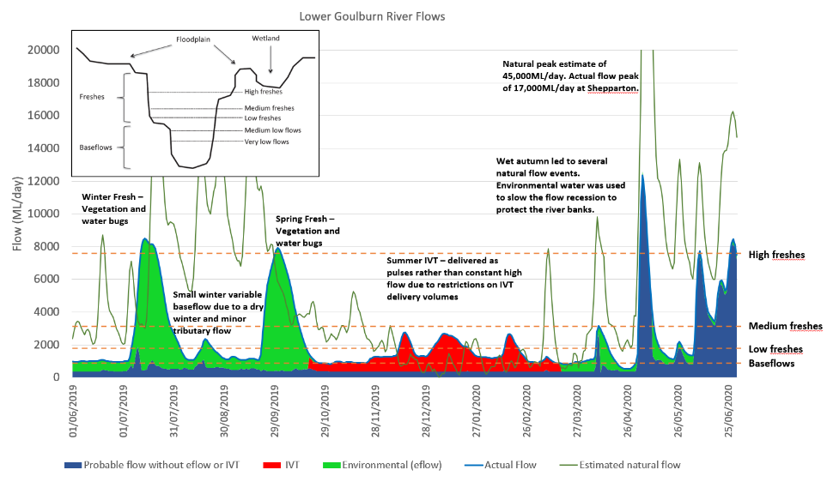

Figure 2. Relative sources of water contributing to total Goulburn River flows in 2019–20 ([https://fchmccoys.hydronet.com/](https://urldefense.com/v3/__https:/fchmccoys.hydronet.com/__;!!B5cixuoO7ltTeg!UeZUkbtCa8U8J9NXKOCPc5-n6d6CndFK27N5C6j83LAPRS6qTr4oPTzmOXnwVS5skm1M$)) at McCoy’s Bridge and specific flow magnitudes targeted by particular CEW deliveries. Inset shows the general flow components targeted with CEW in the lower Goulburn River. Note, bankfull flow is ~28,000 ML/d.

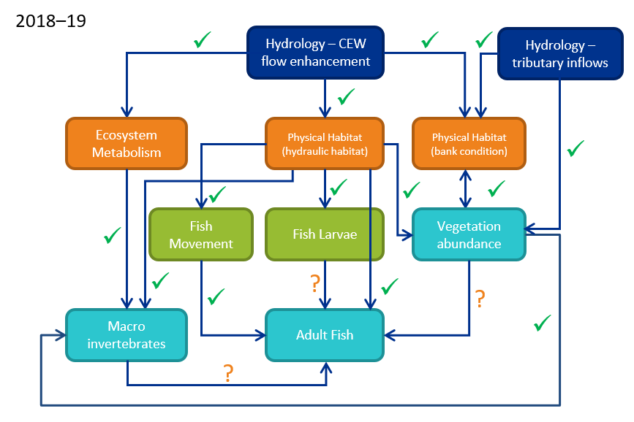

Figure 3. Conceptual model of the linkages among the different monitoring matters in the lower Goulburn River Long-Term Intervention Monitoring Project (Webb *et al.*, 2019a). The blue ‘hydrology’ box is the ultimate cause – flow enhancement with Commonwealth environmental water, plus with the addition now of unregulated tributary inflows as an additional major hydrologic driver; orange boxes are physical effects of this, with flow-on effects to intermediate (green) and ultimate (aqua) environmental variables. Arrows are hypothesized causal linkages posed at the start of the LTIM Project (with several more added over the course of that project). Ticks are linkages that we believe have been demonstrated by the monitoring data, or at least strongly suggested. Question marks are linkages that are yet to be demonstrated. No linkages were disproved throughout the LTIM Project. The great majority of this monitoring has been carried forward into the MER Program.

Based on monitoring outcomes over the course of LTIM and now MER, the strongest and most consistent relationships have been demonstrated between flow, bank condition, hydraulic habitat and vegetation dynamics. The response of native fish to flows has also been strongly demonstrated, notably increased flows in spring that also coincide with increasing water temperature have been shown to consistently stimulate spawning of golden perch and silver perch (Treadwell *et al.*, 2020).

As with previous years, the largest knowledge gap within the conceptual model remains the linkages from the other monitoring matters through to adult fish populations in the Goulburn River.

* Although eggs and larvae of species like golden perch and silver perch are often recorded, the juvenile ‘young of year’ fish that should appear during the electrofishing surveys approximately six months later are rarely caught.
* Moreover, although there are strong links between flows, metabolism and carbon production, and increased biomass of large-bodied macroinvertebrates in summer (i.e. fish food), the current approach to monitoring adult fish cannot detect any direct responses in terms of changes in the numbers and species of fish being caught.
* Similarly, a link between improved near-bank habitat condition that results from improved bankside vegetation and improved fish populations (composition and abundance) also has not yet be demonstrated because the adult fish sampling does not target these habitats specifically.

Watering actions for 2019–20 targeted winter and spring freshes for bank condition, vegetation and macroinvertebrate outcomes, and autumn base flows and recession flows to slow draw down following IVT flows and natural freshes to minimise riverbank erosion. In 2019, unlike previous some years, flows were not delivered in late spring/early summer to stimulate golden perch spawning. Table 1 summarises the main outcomes associated with each watering action over 2019–20. More details are provided in subsequent sections including how results from 2019­–20 build on our previous knowledge to further strengthen our conceptual model. We also explore interactions between monitoring matters that have become apparent through the course of LTIM and MER to date. All results, figures and tables are drawn from Treadwell *et al.* (2020) unless otherwise referenced.

Table 1. Summary of objectives and observed outcomes in response to CEW delivered over 2019–20 – shaded cells indicate the Ecological Matter was not monitored for that flow event (specific details for each monitoring matter can be found in the 2019–20 Annual Scientific Report (Treadwell *et al.*, 2020))

| Monitoring Matter | Winter fresh and variable base flows (July - August 2019) | Spring Fresh (Sept-Oct 2019) | Inter-Valley Transfer flows  (Summer 2019–20) | Autumn Augmented Flow (March-April 2020) and base flows |
| --- | --- | --- | --- | --- |
| Watering objectives | **Remove terrestrial vegetation from banks & re-establish flood tolerant native vegetation by inundating benches & banks to promote sediment & seed deposition & encourage plant germination. Also, provide carbon (e.g. leaf litter) to the channel, & improve water quality & waterbug habitat.** | **Inundate vegetation on benches and the lower banks to facilitate recruitment, sustain growth, and encourage flowering, seed development and distribution.**  **Stimulate golden perch spawn if also delivered in Nov-Dec.** | **The summer/autumn period saw the introduction of an interim operating rule that limited IVT volumes to 50 GL a month. This rule was achieved over summer and autumn 2019–20. However, the target for flows of >1,000 ML/d for no more than 20 days was not met - flows exceeded 1,000 ML/d for 99 consecutive days.** | **Following IVT, 1) top up base flows (as necessary) to maintain water quality, access to habitat for fish and waterbugs and to water bank vegetation and 2) slow rate of fall for any natural events to minimise risks of bank erosion.** |
| CEW delivered (see Figure 2 for pattern of deliveries over 2019–20) | **CEW was used to deliver base flows & two fresh events. In July flows peaked at ~9000 ML/d with 12 days >6600 ML/d, plus variable base flows of 830-2000 ML/d and in August flows peaked at ~2000 ML/d.** | **CEW was used to deliver a fresh in late Sept/early Oct that peaked at ~8000 ML/d and lasted for one month with 14 days >6000 ML/d.**  **A golden perch spawning event was not delivered in 2019.** | **CEW was not delivered during this period. IVT flows were delivered in three pulses each reaching 2500-3000 ML/d interspersed with flows of 1000-1500 ML/d.** | **CEW was used to maintain base flows ~900-1000 ML/d from March-May and to slow the rate of fall for natural events in April to June 2020.** |
| Physical habitat – bank condition |  | Low-medium erosion and deposition occurred across lower and upper bank zones within the zone of bank inundated by the fresh at >3000 ML/d | Moderate erosion (more than all other flow events) occurred primarily within bank zones corresponding to IVT flows between 1,500-3,000 ML/d. Minor notching occurred on some inside banks. No evidence of mass-failure was observed (in contrast to 2018–19 IVT delivery), so pulsing may have had a positive impact minimising excessive erosion and mass-failure. | Recession flows following natural freshes resulted in the largest volume of deposition and the second largest volume of erosion during 2019–20. Deposition was likely a result of increased % contribution of tributary flows to natural fresh events. Increased levels of erosion were largely a result of the events mimicking the shape of the earlier IVT flow, which appears to have prepared banks for increased erosion by surcharging upper banks. |
| Turf mats – sediment & seed | All in-channel features were submerged & received flow-delivered sediment & seeds. More sediment was deposited on low-level features such as bars & more seeds were deposited on both bars & higher-level features such as benches. | All in-channel features were submerged & received flow-delivered sediment & seeds in a similar distribution to the winter fresh, however daily rates of seed deposition was greater for the spring fresh than the winter fresh. | No data collected due to COVID-19 restrictions on field and lab work. | No data collected due to COVID-19 restrictions on field and lab work. |
| Macroinvertebrate composition and abundance |  | There was an increase in the total number of macroinvertebrates (e.g. shrimps, water bugs, mayflies and caddisflies) following the spring fresh, but most of the increase was associated with summer months (January onwards). It is unknown what portion of the increase can be attributed to CEW versus seasonal increases in temperature and hours of daylight. | |  |
| Crustacean biomass and abundance | There was an increase in crustacean biomass (shrimps and prawns) and the number of immature crustaceans in January and February 2020. As with the general macroinvertebrate community, it is unknown what portion of the increase can be attributed to CEW versus seasonal increases in temperature and hours of daylight. | |
| Bank vegetation abundance and diversity |  | Water dependant plants generally increased in cover after the spring freshes across the bank elevation influenced by the fresh. Grasses were restricted to higher bank elevations where inundation was shallower and for shorter duration. | IVT contributed to the absence/loss of vegetation on the banks and a narrowing of the band of water dependant plants. Modelling indicates that vegetation on the banks steadily declines if the total duration of IVT flows exceeds 55 days. |  |
| Stream metabolism: carbon production and respiration | Winter freshes contributed a combined 20 tonnes (56%) of organic carbon (food) out of a total of 36 tonnes for winter (at McCoy’s Bridge). | The spring fresh contributed 41 tonnes (53%) of organic carbon (food) out of a total of 77 tonnes for spring (at McCoy’s Bridge). | No environmental water was delivered during summer. There was a total of 80 tonnes of organic carbon produced in summer – the most of any season. | Recession flows following IVT contributed 13 tonnes (42%) of organic carbon (food) out of a total of 32 tonnes for autumn (at McCoy’s Bridge). |
| Native fish spawning |  | Environmental water was not delivered specifically for spawning of golden perch or silver perch in 2019 and no spawning of golden perch was detected in the 2019. | Silver perch eggs were collected coinciding with an increase in flow in mid-December 2019 associated with IVTs. |  |
| Fish species occurrence and abundance | Seven native and three exotic species were collected from the ten survey sites in the Goulburn River in 2020. Species of conservation significance collected were Murray cod, trout cod, silver perch and Murray River rainbowfish. Similar to the results of previous surveys, the small-bodied Australian smelt was the most abundant species collected, and the exotic carp was the most abundant large-bodied species collected. Abundance of Murray cod increased in the 2020 surveys, following a decrease in abundance in 2017 after a blackwater event. Silver perch abundance also increased in 2020, likely due to fish immigrating into the Goulburn River from the Murray River. There was a marginal increase in abundance of Murray River rainbowfish in 2020, following a decrease in abundance from 2017 to 2019. Two native (bony bream, flat-headed gudgeon) and two exotic (eastern gambusia, redfin perch) species collected in low numbers in previous surveys were not detected in 2020. | | | |

### Flow, bank condition and vegetation

Bank condition is assessed based on rates of erosion and deposition. Erosion and deposition are critical natural processes, but excessive erosion can contribute to bank failure, impact on the ability for plants to establish and persist on the banks, and reduce the overall habitat quality for a range of animals. Flow, and more importantly flow variability, influences the velocity of water, depth of inundation, duration of wet and dry periods, and variations in rates of water level rise. All these forces contribute to how bank condition responds to flow, particularly the processes of erosion and deposition. The extent of vegetation on banks mediates these processes, for example, by helping to stabilise sediments and minimise erosion. However, these forces also influence the ability of vegetation to establish and persist, or to recover from disturbance events.

Environmental objectives for the lower Goulburn River are to minimise excessive rates of erosion and encourage the re-establishment and persistence of water dependant vegetation on the river banks. These objectives are closely linked and are achieved by using environmental water to provide flows that deposit sediment and seed on the banks, provide bank moisture to support vegetation growth, restrict encroachment of terrestrial vegetation, and manage recession events to minimise risks of bank slumping. Establishing and maintaining bank vegetation in turn helps to reinforce banks from excessive erosion and further promote sediment deposition.

Rates of erosion and deposition have previously been recorded using steel pins embedded in the bank and making repeat measurements of the length of pin exposed after flow events. More recently (2018–19 and 2019–20) an unmanned aerial vehicle (drone) has been used to take images of the banks and compare changes in bank elevation before and after flow events. Drones have provided a much greater resolution of measurement over a longer length of bank compared to steel pins (see Figure 5 for an example image). Artificial turf mats (Figure 4) have been used to collect sediment and seeds at different elevation on the banks under different flow events and vegetation abundance and diversity is assessed along bank elevation gradients. These measurements are undertaken in the same areas where erosion and deposition are measured, before and after flow events, and including both environmental water delivery and operational flows such as IVT flows.

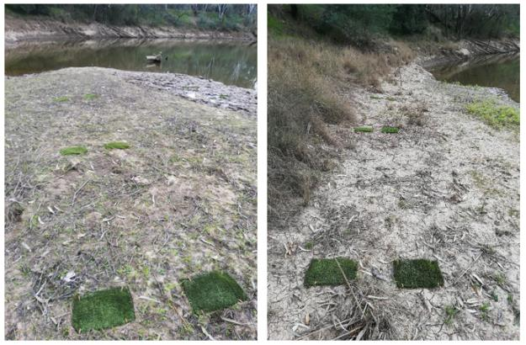

Figure 4. Artificial turf mats deployed on the banks of the lower Goulburn River. Sediment and seeds collect on the rough surface of the mats during periods of inundation. Mats are then retrieved, sediment is weighed, and seeds are sorted, counted and grown out to determine species composition. Photo: Streamology.

During most flow events (freshes and higher flows above typical baseflow levels, including both CEW and IVT flows) increased bank erosion correlated with increased duration of inundation. However, the distribution and relative magnitude of erosion or deposition depends on individual characteristics of the flow event. The spring fresh tended to result in similar total erosion rates to those that occurred during the IVT period. However, compared to erosion and deposition associated with the spring fresh, erosion in response to IVT flows was concentrated in a more defined zone (vertically) across the bank, was deeper (>5 cm on average), more consistent laterally, and ultimately lead to the steepening of the lower bank and in some cases the development of notching. Conversely, erosion and deposition associated with the spring fresh was distributed across a broader elevation band and at shallow magnitudes (< +/-3 cm on average) (Figure 5).

In contrast to erosion, deposition volume did not correspond directly with inundation duration and appears more closely related to:

* bank erosion on zones directly above areas of deposition - particularly during the IVT period where erosion was deeper and more defined.
* the proportion of tributary flow - the greater the contribution of total flow from unregulated tributaries the greater the magnitude of deposition and number of seeds (assessed using turf mats). This highlights the importance of tributaries for supplying sediment and seeds to replenish bank sediments and contribute to the seed bank.
* the vegetation cover within the inundation zone – the presence of established vegetation appears to reinforce the bank, help limit erosion to minor levels and promote deposition.

In addition to the magnitude of deposition assessed using drone imagery, turf mat monitoring recorded significant sediment and seed deposition. During winter freshes on average, 2,700 seeds from 15 different species were deposited per square metre. Seeds were evenly deposited across bars and banks, but more sediment was deposited on low-level features such as bars. Compared to winter, more seeds and sediment were deposited during the spring fresh with an average 3,900 seeds from 12 species deposited per square metre. Daily rates of seed deposition were also higher in spring than winter. Across all turf mats, a total of 42 different plant taxa (different species or genera of plants) were recorded in winter and 47 different taxa were recorded in spring. Turf mats were not recovered in 2020 following IVT flows and autumn recession flows due to COVID restrictions on field work and high flows that prevented access to lower banks.

With respect to bank responses to IVT flow delivery, observations from previous years indicate the processes occurring during IVT flows (long duration stable flows during the summer period in a narrow vertical band) are preparing the river banks for potential mass-failure events in response to later large flow events in autumn/winter months. Under these conditions, bank wetting from larger events is drawn down, leaving a saturated and unsupported bank above any notching developed during the IVT flow. The upper bank then collapses onto the undercut (Figure 6).

Inter Valley Transfer flows are likely to be an ongoing feature of the summer flow regime in the lower Goulburn River as water is transferred to downstream users. In recognition of the potential negative impacts associated with IVT flows changes have been made to the way the flow is delivered. Specifically, in 2019–20, overall IVT volume was capped compared to previous years and flows were delivered in three pulses to provide a more variable regime, limit the duration of inundation across a narrow vertical band, and reduce the severity of bank notching. At the end of IVT flows, environmental water was used to maintain baseflow in autumn and to slow the rate of recession following several natural high flow events, in an attempt to minimise upper bank saturation and subsequent collapse. Although some notching was observed in 2019–20 there was no evidence of mass-failure associated with recession flows. However, the magnitude of erosion was still high, especially in areas where notching was observed. It appears that the IVT delivery regime and management of recession flows were helpful at reducing risks of mass-failure in 2019–­20. However, notching and erosion on recession flows was still observed in some locations so it may be necessary to further manage IVT flow delivery to minimise the risks of notching even further, and for recession rates to be slowed even further if current erosion rates are still considered too high.

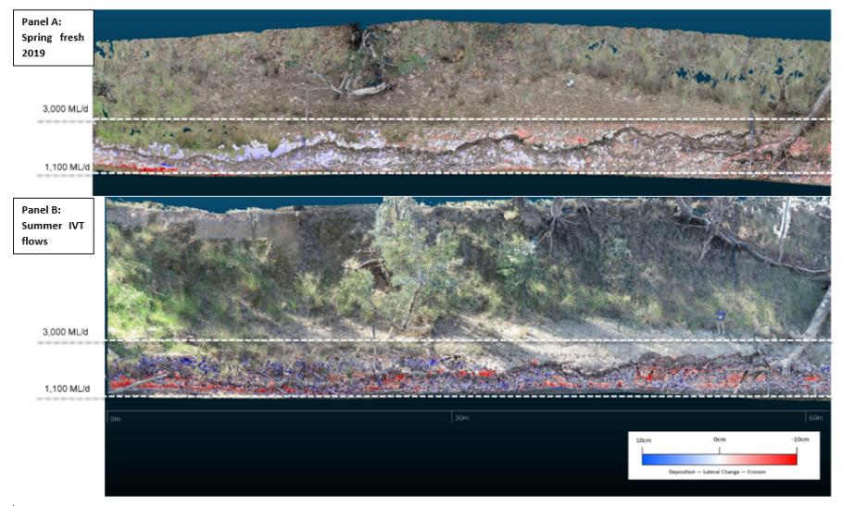

Figure 5. Results of drone imaging. Panel A shows deposition (blue) and erosion (red) following the 2019 spring fresh at Loch Gary. Deposition and erosion are relatively evenly distributed across the full flow band and is relatively minor < +/-3 cm (based on the lightness of the colour tone). Panel B shows a higher magnitude of erosion and deposition (compared to the spring fresh) across a narrower vertical band following IVT flows at the same location. Images: Streamology.

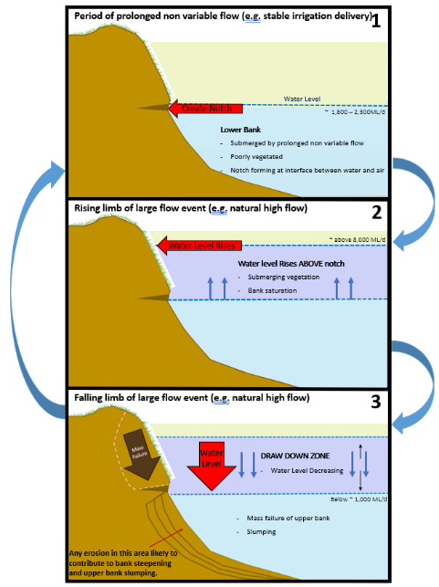

Figure 6. Step process of notching and potential mass bank failure. Step 1 - prolonged stable flows, such as summer irrigation transfer flows, create a notch at the water-bank interface. Step 2 - subsequent high flows, above the notch, such as natural high flows or environmental flows in Autumn and winter lead to saturation of the upper bank. Step 3 – drawdown from the higher flows leaves the heavy upper bank unsupported above the notch, which can slump on to the lower bank. More variable flows minimise the severity of notch development and slow rates of water level drawdown help to allow upper bank to drain and reduce the likelihood of slumping. Image: Streamology.

As noted above, the presence of vegetation helps reinforce banks and limit erosion. Vegetation monitoring over the course of the LTIM Project, and again in the MER Program during 2019–20, has shown that the cover of water dependant vegetation tends to increase across the bank elevation zone equivalent to the magnitude of the spring fresh. This supports the contention that spring freshes deliver seed (confirmed through turf mat sampling where seeds were deposited evenly across the bank gradient) and provide a suitable environment (moisture and inundation) for germination. The increase in cover is also likely to be driven by seasonal increases in temperature and photoperiod, but it is not known whether inundation enhances increases in cover beyond that which would occur in the absence of any spring fresh.

Over the course of LTIM and MER monitoring, grass cover on the upper banks (above the typical inundation elevation) has tended to increase over time. However, water dependant bank vegetation cover has varied from year to year. Although the spring fresh in 2019 resulted in an increase in cover of water dependant plants, observations following the cessation of IVT flows in autumn 2020 showed that water dependant vegetation was ultimately lost from lower bank elevations that corresponded to the inundation level of the IVT flows (Figure 7). This is consistent with observations from previous years. An analysis of inundation duration indicates that the probability of water dependant plants occurring on the banks starts to steadily decline when the total duration of inundation over the IVT period exceeds 55 days. It is not clear to what extent antecedent conditions contribute to this response, and whether responses differ if the days inundated are continuous or intermittent. However, the results indicate that a narrowing of the band of water dependent vegetation on the lower bank is likely to occur if the magnitude and duration of IVT flows increase.

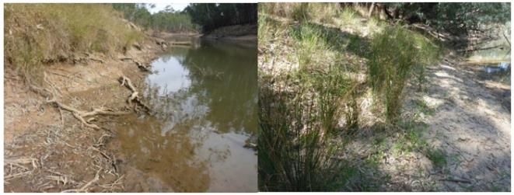

Figure 7. Bare lower banks at McCoy’s Bridge (within the zone of IVT inundation) with *Panicum coloratum* (Coolah Grass) at high elevations (left) and Juncus spp. flowering/setting seed at higher elevations (right). Also note notching in the left photo at the boundary between the bare and vegetated part of the bank. Photos were taken in March 2020 following cessation of IVT delivery. Photo: Kay Morris.

There are several important implications of a narrowing of the littoral band. First, the resilience of vegetation is likely to decline by limiting propagule production from this zone. Propagule and seed supply then become more reliant on deposition from upstream reaches rather than from local sources. Second, the loss of vegetation reduces bank reinforcement and exposes banks to higher magnitudes of erosion. Once vegetation is lost, and banks are exposed, the recovery of vegetation from seed will require an extended period of low flows over the growing season to allow seeds to germinate and progress to more mature life stages before they are inundated. Multiple successive years of favourable hydraulic conditions over the growing season will be needed to deposit seeds on the bank, allow re-established plants to expand vegetatively and to set seed. If conditions can be established that allow plant populations to mature and expand, they are likely to show greater tolerance to unfavourable inundation events and to recover more rapidly following such events.

We have previously recommended that during the IVT period flows should not exceed 1000 ML/d for more than 20 consecutive days, but during 2019–20 flows exceeded 1000 ML/d for 99 consecutive days. The latest observations strengthen our previous recommendations and suggest that at the least, the total number of days over the IVT period that flows are greater than 1000 ML/d should be limited to no more than 55 days if bank vegetation established in spring is to be retained through the summer IVT period.

### Flow and fish

The Goulburn MER fish monitoring program continues the work undertaken through the LTIM Project to evaluate the benefits of CEW to native fish populations, and to improve our understanding of flow-ecology and population dynamics of native fish to inform environmental water management for fish. Two fish monitoring methods are employed in the Lower Goulburn River, 1) Annual population surveys using electrofishing and netting; and 2) Surveys of eggs and larvae using drift nets, with the specific aim to examine the influence of flow on spawning of golden perch and silver perch.

In the 2019–20 annual fish population surveys, seven native and three exotic species were collected from the ten survey sites. A significant finding of the 2019–20 surveys was the collection of the nationally threatened trout cod (Figure 8) in both the drift surveys and electrofishing surveys. Trout cod had not been collected in the annual surveys for three years (since 2016) but were collected again in 2020. Spawning of trout cod was also detected in the November 2019 drift surveys and has now been detected in each of the last three (2017 to2019) spawning seasons. Other species of conservation significance collected were Murray cod, silver perch and Murray River rainbowfish. The small-bodied Australian smelt was the most abundant species collected, and the exotic carp was the most abundant large-bodied species collected. This is similar to the results of previous surveys. Small numbers of golden perch were also collected.

Abundances (mean number per site) of several native (Murray cod, trout cod, silver perch, Murray River rainbowfish) and exotic (goldfish and oriental weatherloach) species were higher in 2020 compared to the previous year. Two native (bony bream, flat-headed gudgeon) and two exotic (eastern gambusia, redfin perch) species that had been collected in low numbers in previous surveys were not detected in 2020. The recent increase in abundance of Murray cod is notable as it follows a large decline in abundance following a fish kill in 2017 and may indicate partial recovery of the population. Abundances, however, still remain lower than pre-2017 levels and may take many years to return to higher levels.

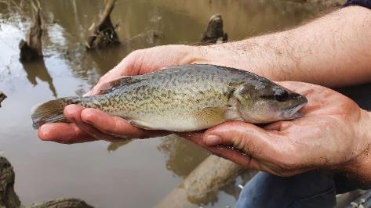

Figure 8. Trout cod collected in the Goulburn River in 2020. Photo: Wayne Koster

Following a decrease in abundance of Murray River rainbowfish from 2017 to 2019, there was a marginal increase in abundance in 2020. Nonetheless, abundance remains lower than pre-2017 levels. The causes of these fluctuations are unclear but could be related to extended periods of high IVT flow throughout summer, given that Murray River rainbowfish prefer warm slow flowing waters and wetland habitats.

Over 1400 individuals (eggs and larvae) representing 7 native species were collected from the four drift sampling sites in the Goulburn River in spring 2019. Similar to the results of previous surveys, Murray cod was the most abundant species collected, comprising 64% of the total abundance for all species. Notably, drift sampling captured 7 eggs of silver perch, in mid-December 2019 coinciding with elevated flows associated with an IVT flow (Figure 9). Water temperature at this time was about 23°C. Spawning by trout cod was also detected in 2019 with larvae collected from early to late November.

No golden perch were detected in drift samples in 2019. Models of the probability of golden perch spawning developed over the course of the LTIM project indicate that the probability of spawning is greatly increased when flows exceed 3500-4000 ML/d and water temperature exceeds 18.5°C. Models of silver perch spawning indicate the probability of spawning increases when temperature exceeds 20°C and flows exceed 2500 ML/d. The October 2019 spring fresh exceeded the flow threshold for both golden perch and silver perch, but temperature was only 15-16°C. The December 2019 fresh exceed 18.5°C, but flow only reached 2500 ML/d. The absence of golden perch larvae associated with both events, and the detection of silver perch in only the December event strengthen our predictive models and further confirms the varying flow and temperature conditions that are required to stimulate golden perch and silver perch spawning.

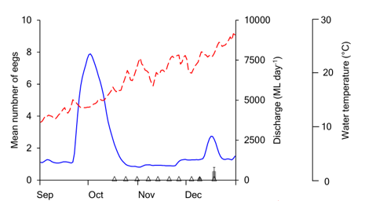

Figure 9. Mean (±se) number of silver perch eggs per drift net (grey bars) collected in the Goulburn River in 2019. Mean daily discharge (blue line) and water temperature (broken red line) of the Goulburn River at McCoy’s Bridge. Triangles denote sampling trips.

Analysis of the 2019–20 spawning data, along with data collected from previous years, now shows that flow conditions prior to spawning freshes are also important, with a higher likelihood of spawning occurring if flows are on average higher than minimum baseflows in the 5 weeks prior to spawning.

Based on these results, we have high confidence in the flow conditions required to stimulate golden perch and silver perch spawning. This typically requires flows higher than the minimum baseflow throughout spring and then an increased fresh flow in late spring once temperature is elevated. Matching flow requirements for fish spawning to the flow requirements needed to meet vegetation objectives, which are typically required earlier in spring, is challenging. This was highlighted in 2019 when the spring fresh was targeted at vegetation objectives and no golden perch spawning was detected. Further work is needed to determine if several spring freshes can be delivered targeting vegetation in early spring and fish spawning in later spring/early summer. Achieving this regime would be dependent on the volume of water available for the environment and on operational requirements related to IVT delivery. It is also necessary to ensure that late spring/early summer freshes to stimulate fish spawning do not impact on vegetation established earlier in spring. This could be achieved by ensuing the duration of the late spring fresh did not exceed critical inundation thresholds for vegetation, and by ensuring a minimum separation of the two flow events.

Despite good results in fish population surveys and increasing knowledge regarding the flow conditions required to stimulate spawning, gaps remain in our specific understanding of the role flow plays in supporting recruitment of native fish larvae into adult populations. To help address these gaps we are preparing two contingency monitoring activities for the remainder of the MER Program. The first involves tagging of juvenile Murray cod and trout cod and tracking their movements and habitat use across a range of flows. The outcomes of this monitoring will improve our understanding of cod habitat use and will inform flow management and complementary habitat restoration works to improve the recruitment of larval cod (which we observe every year in the Goulburn River) into the adult population. The second involves extending our larval drift surveys to the Murray River upstream and downstream of the Goulburn River confluence to determine the relative proportion of larval drift in the Murray River that is coming from the Goulburn River. While we know the flows required to stimulate golden perch spawning in the Goulburn River, we rarely detect young of year fish. It is assumed that larvae are swept to the Murray River and perhaps ‘lost’ from the Goulburn River. By examining the presence and abundance of eggs and larvae in the Murray River, we will be able determine the proportion of golden perch larvae that have come from the Goulburn River, providing arguments in favour of continued investment in late spring flows pulses in the Goulburn as a means of supporting golden perch populations at larger scales.

* + 1. Metabolism

Whole stream metabolism tells us how much food (also referred to as energy and organic carbon) is available in the river throughout the year for organisms (e.g. bacteria, fungi, algae) and animals (e.g. fish, shrimp, insects) to consume. Two processes are important to monitor as a means of determining this; photosynthesis and respiration. Photosynthesis (also called primary production) is the conversion by plants of sunlight (energy) into organic material and respiration is the breakdown of dead plants and animals by bacteria and fungi to also produce organic material, nutrients and carbon dioxide (CO2). The presence of oxygen, called dissolved oxygen when present in water (O2), is essential to river life. Photosynthesis produces oxygen during the daylight and respiration consumes oxygen at night (Figure 10). By measuring the changes in the concentration of dissolved oxygen in the water column over time the MER Program scientists are able to estimate the amount of organic carbon production and examine how these rates change from season to season, year to year, and in response to environmental flows

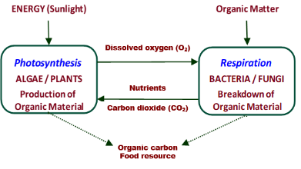

Figure 10 Relationships between photosynthesis (primary production), respiration and the production of organic carbon as a food resource for higher organisms such as macroinvertebrates and fish.

Overall rates of primary production and respiration in the Goulburn River in 2019–20 were similar to previous years and typical of those in the southern Murray-Darling Basin, but at the lower end of the ‘normal’ range found in global comparisons. Low nutrients and reduced light availability due to turbidity are likely to be the main factors constraining primary production in the Goulburn River and rivers in the Murray Darling Basin in general. Across the entire six-year data set of LTIM and MER, the highest primary production rates have been recorded during the summer, corresponding to the warmest temperatures and greatest light availabilities, and the lowest rates occurred in winter.

As with previous years, rates of primary production per litre of water decrease with increased flows as a result of dilution. However, despite a reduction in the rate of primary production, the total amount of organic carbon produced (load) increases even with small increases in flow volume. Previously held views were that significant increases in organic carbon load to the river channel required overbank flows to inundate floodplains and draw organic carbon (i.e. in the form of dead leaves, sticks and bark) and nutrients back to the river. The outcomes of the current monitoring are important because it demonstrates that increased in-channel flows are important for increasing the amount of organic carbon that is produced within the river channel, even in the absence of overbank flows. This in-channel derived carbon is likely to be an important food resource for macroinvertebrates and fish, especially in rivers like the Goulburn River where regular overbank flows are not often experienced due to river regulation.

With six years of data now available, we have analysed the amount of organic carbon that CEW contributes to the Goulburn River for a range of flow events at McCoy’s Bridge (the site with the most comprehensive metabolism dataset) (Figure 11a). Over the six-year period it is estimated that CEW produced nearly a quarter (22%) of the organic carbon produced in the river (388 of 1778 Tonnes). From an ecological perspective, CEW-enhanced production was most important in spring when 35 – 73% (53% in 2019–20) of all carbon production was associated with CEW (except for 2016 when there was large flooding and CEW was only 2% of all flow). CEW also contributed around 60-65% of winter organic carbon production in the final three years of the LTIM Project. CEW contributes very little carbon in summer because flows are either low (with no CEW contribution) or dominated by IVT delivery. From a flow perspective, most CEW-assisted carbon production occurs where CEW contributes to medium to large volume freshes (3000-7000 ML/d) in spring and autumn (Figure 11b).

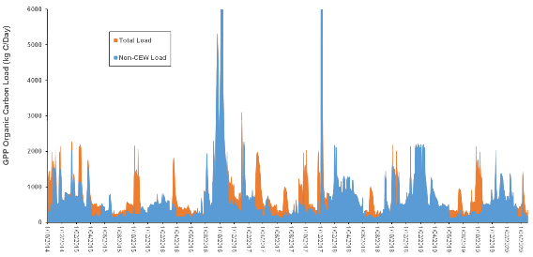

**a)**

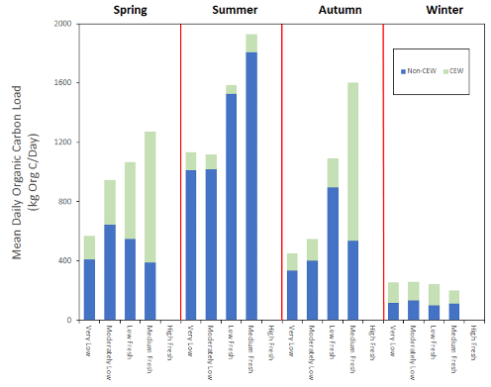

**b)**

Figure 11. Organic carbon loads associated with CEW a) estimated daily loads of organic carbon created by primary production (GPP-Gross Primary Production) at McCoy’s Bridge showing the total load and the load without the contribution of CEW. The visible orange section of each bar represents the proportion of organic carbon produced as a result of CEW. This plot estimates loads for every day over the period of record – October 2014 to April 2020. b) estimated mean daily loads of organic carbon created by primary production, stratified by season and flow category (see Figure 2 for category definitions). Data are from 2014 to 20 and pooled across all sites.

The contribution that CEW makes to carbon production, especially in spring and autumn, is important because it coincides with periods of increased macroinvertebrate biomass in spring (see Section 3.1.4) and with spawning of native fish such that it may also provide an important food resources for larval fish and assist with successful recruitment to adult populations. The results also demonstrate that CEW could be used at other times of the year to match the food demands of other organisms if it can be shown that food resources were limited. For example, winter is the season of lowest carbon production (as per Figure 11b) and this may be limiting outcomes for macroinvertebrates and fish.

* + 1. Macroinvertebrates

Macroinvertebrates (e.g. insects, snails, shrimps, prawns and yabbies) are an essential part of healthy, functioning aquatic ecosystems, providing essential ecosystem services that range from nutrient cycling to provision of food for larger aquatic organisms such as fish. Macroinvertebrate monitoring over the 5 years of the LTIM Project showed that macroinvertebrates, and particularly crustaceans (shrimp and prawns), tend to increase in numbers (abundance) and biomass following spring freshes (Webb *et al.*, 2019a). However, the largest increases in biomass were observed following natural overbank flows (e.g. in 2016–17) when presumably large amounts of organic carbon were washed into the river and subsequently consumed by macroinvertebrates. Relationships between increased flow, access to habitat and macroinvertebrate response were hypothesised but not able to be confirmed. Macroinvertebrate monitoring is continuing during MER, but with a focus on abundance and biomass of invertebrates, especially crustaceans, and on habitat use in response to flows. Given changes in method and analysis techniques between LTIM and MER monitoring, results of the first year of MER are not directly comparable to LTIM results.

In 2019–20, a total of 49,147 macroinvertebrates from 57 taxa (different species, genera or families of macroinvertebrate) were collected across all sampling periods. The most common taxa (where >100 individuals were collected) were mites, water bugs, the mayfly (Baetidae), the caddisfly (Leptoceridae), the chironomids (Chironominae and Tanypodinae), and shrimps (Atyidae). The average abundance of all these taxa increased after the 2019 spring fresh with the highest abundances occurring from January to March (Figure 12a), however there was a high degree of variation between sites as shown by the wide standard deviation bars. The average number of different taxa (richness) remained similar across the sampling period (Figure 12b).

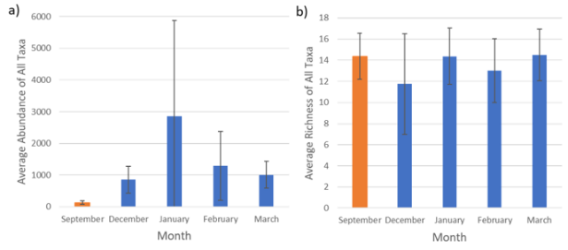

Figure 12. Results of macroinvertebrate sampling a) average abundance of all taxa (± standard deviation, which is a measure of sample variation) pooled across all sites and b) average number of different taxa (richness) (± standard deviation) pooled across all sites. The orange bar indicates pre-spring fresh sample and blue bars post-spring fresh samples.

Of all the macroinvertebrates collected, 1661 were crustaceans (shrimps and prawns). There was little difference in crustacean biomass between pre (September 2019) and post (December 2019) spring fresh sampling, however mean biomass increased in January 2020 and remained relatively high through to March (Figure 13a). There was also an increase in the average abundance of immature crustaceans from January (Figure 13b).

It is unclear how much of the observed increases in macroinvertebrate, including crustaceans, abundance is a result of changes in flow or changes in season. The greatest increases in abundance and presence of immature crustaceans occurred well after the spring fresh, in January during periods when IVT flows were occurring.

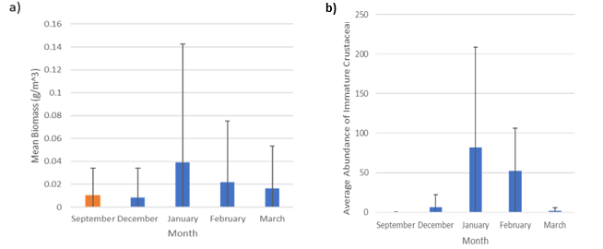

Figure 13. Results of crustacean sampling a) mean biomass (± standard deviation) pooled across all sites and b) mean abundance of immature crustacean (± standard deviation) pooled across all sites. The orange bar indicates pre-spring fresh sample and blue bars post-spring fresh samples – note the near absence of immature crustaceans in September, prior to the spring fresh.

Habitat monitoring showed no clear relationship with habitat preference (submerged and emergent plants or snags) for shrimps, although there is a trend that shrimps are more likely to be detected in habitats where there is some physical habitat, either plants or snags, rather than bare edge. Prawns appeared to have a declining abundance with increasing plant cover. However, both species were more abundant where there was some physical habitat present.

Further analysis is required as more data are collected over coming years to establish the specific responses to flow, habitat preferences and any flow/habitat interactions. Over coming years, as we gather more concurrent data on carbon production and macroinvertebrate biomass, further analysis will be undertaken to explore relationships between the availability of organic carbon and macroinvertebrate abundance or biomass. Outcomes of the metabolism monitoring show that the largest amounts of organic carbon are produced in summer (see Figure 11b in section 3.1.3). As presented above, this also coincides with the highest abundances and biomass of macroinvertebrates. It is possible that macroinvertebrates are responding to the increased carbon availability, rather than flows specifically. Confirmation of these relationships would help determine if CEW could be effective at generating additional food resources (as organic carbon) that could further enhance macroinvertebrate outcomes. This is particularly important for the lower Goulburn River if CEW could be used to help generate additional organic carbon for macroinvertebrate consumption and compensate for the impacts of the reduction in natural overbank flow events.

## Research

Through the development of the Goulburn MER Plan (Webb *et al.*, 2019b), a range of research questions were identified to help better understand the relationships between in-channel flow, hydraulic habitat conditions and ecological response:

1. What are the in-channel/hydraulic habitat types (e.g. slackwaters, backwaters, benches, etc. with different hydraulic characteristics) that are particularly important for ecological processes, specific organisms, or life history stages in the Goulburn River?
2. Does the distribution and quality of these habitat types change with different flow rates?
3. Can flow rates be manipulated to optimise the availability of habitat types that are shown to be important, or to minimise impacts on these habitats during river operations (e.g. IVT flows)?

These questions are important in the Goulburn River because the literature suggests that certain habitat types are important for various ecological processes, life history stages, etc. (e.g. as areas for organic carbon retention and processing, low-flow refuges for larval and juvenile fish, sites of sediment and seed deposition, etc.). Furthermore, research has identified the importance of slackwaters (in the form of anabranches and floodplain wetlands) as sources of carbon and zooplankton for fish food, and that these habitats generate more food than main channel habitats (<http://ewkr.com.au/fine-dining-for-fish-wetland-and-anabranch-systems-offer-the-best-fish-buffets/> ). These specific off-channel environments are not often connected to the Goulburn River. Thus we are interested in the extent to which similar habitats may be present within the main channel, and whether they can be manipulated or optimised using environmental water deliveries or physical habitat augmentation to achieve benefits for biota and ecosystem processes.

We are developing an integrative project (Integrated Research Project, IRP), with a focus on first understanding the extent of slackwater/retentive habitats in the lower Goulburn River, then assessing the biota and ecological processes occurring within those habitats. Further, we will investigate the extent that surrounding physical habitat, including manipulations of that physical habitat, can make these habitats more resistant to disturbances that occur through either natural or managed flow events.

The following outlines our process for the project:

1. Question refinement/development of hypotheses
2. Mapping hydraulic/slackwater habitat
3. Field investigations to assess ecological processes supported by slackwaters
4. Experimental manipulation to assess whether slackwater habitats can be made more resilient through habitat manipulation
5. Analysis, reporting and recommendations for using environmental flows and/or complementary habitat restoration to optimise critical habitat types

To date we have undertaken a literature review of the ecological importance of slackwater habitats, convened an expert workshop and developed a conceptual model for the Goulburn River (Figure 14).

The outcomes of the literature review, expert workshop and conceptual model are being used to establish a number of hypotheses that will be tested through a program of field investigations and data analyses. A program of works is currently being developed for implementation over the 2020–21 period, with the commencement of fieldwork partly dependent on when COVID-19 restrictions are relaxed in Victoria. Project outcomes will be reported through newsletters and subsequent annual reports.

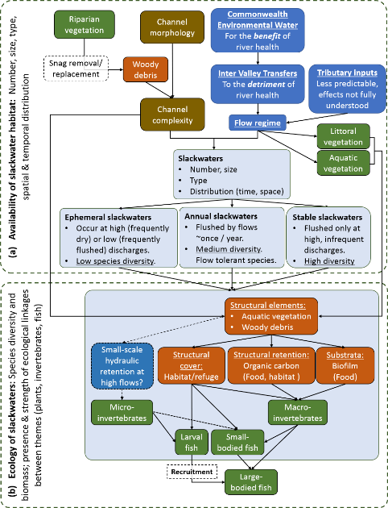

Figure 14. Conceptual model for the ecological functions supported by slackwaters in the Goulburn River.

## Engagement and communications

The Goulburn Broken Catchment Management Authority (GBCMA) coordinates Goulburn River MER communication and engagement activities. These activities are complemented by activities undertaken by partner agencies and the basin-wide communications effort led by CSIRO. Activities aim to:

* **Raise public awareness of** the Goulburn MER Program.
* **Promot**e the environmental, social and cultural benefits of water for the environment.
* Encourage the community to **advocate** for environmental water deliveries.
* **Provide feedback to key stakeholders** involved in planning, managing and delivering water for the environment.

The target audiences for communication and engagement activities include traditional owners, farmers, rural and town residents, businesses, recreational and industry groups, and local, state and federal government agencies, authorities and elected representatives. Communication and engagement activities occur through various means including community Natural Resource Management groups, management committees and advisory groups, and media (e.g. print, social, TV etc).

Key messages for communication and engagement aim to:

* Recognise the cultural, social, recreational and economic values and uses of the river.
* Highlight that the river has been impacted by water resource development and river regulation, and that climate change and ongoing water management are also affecting the river’s flows.
* Acknowledge that river regulation and management has affected native fish and other animals that rely on the river for food and shelter as well as the condition of the banks and the bed.
* Demonstrate the way that environmental water is being used to protect and improve the river’s health.
* Advocate for the adaptive management of river flows and environmental water delivery based on the outcomes of the Goulburn River MER Program.

During 2019–20, press releases, Tweets and Facebook posts (e.g. Figure 15), presentations and technical papers were completed to inform stakeholders and the broader community about the aims and results of the Goulburn River MER Program and the role of the CEWO in environmental water management. Social media continues to be the most effective engagement tool with thousands of people viewing posts. A segment for the Merv Hugh’s Fishing Show on the use of environmental water was also filmed and went to air in August 2020.

Innovative approaches, such as using drones to monitor bank condition, and fish monitoring results, continue to attract community and media attention, with posts on these topics among the most popular and engaging. The other topic that generated local, regional, state and national interest during 2019–20 was the high IVT flows in the lower Goulburn River over summer and the potential impact on bank erosion, bank vegetation and native fish. Findings from the MER Program supported community and GBCMA efforts to highlight the issue and bring about changes to river operations, including a cap on the total volume of IVT delivered each month and the introduction of a pulsed regime to minimise impacts on river banks and vegetation.

Yorta Yorta Nations Aboriginal Corporation (YYNAC) staff were engaged to assist staff from Arthur Rylah Institute to carry out the weekly larval fish monitoring between October and December 2019. This provided a great opportunity for YYNAC staff to better understand and contribute to the project and to work on country and increase their skills and knowledge in fish monitoring techniques and research.

Figure 15. GBCMA Goulburn River MER Program communications example - Facebook post November 2019

1. Implications for future management of river flows, including environmental water

Results from monitoring in 2019–20 build further on those from previous years and the following observations are notable for informing the future management of river flows in the Goulburn River:

* Results underscore the importance of winter and spring freshes for depositing sediment and seeds on river banks with minimal erosion; the importance of timing and magnitude of spring freshes for promoting water dependant vegetation (early spring) and golden perch and silver perch spawning (late spring/early summer); and the role that CEW can make to enhancing the amount of organic carbon that is generated by primary production as a potential food resource for macroinvertebrates and fish, at any time of the year.
* Outcomes from prior years monitoring has highlighted the impacts that prolonged stable summer flows associated with IVT flows have had on river banks and vegetation. This has informed changes to the way IVT flows are delivered to minimise potential impacts. Despite some changes in 2019–20 to the way IVT flows were delivered (capped monthly volumes and pulsed flows), the results indicate that negative impacts are still occurring. These include notching and erosion of the upper banks, and the loss of water dependent vegetation established in the previous spring as a result of prolonged inundation. The loss of bank vegetation is concerning because bank condition monitoring has shown that where vegetation does exist it helps reinforce the banks against erosion and promotes sediment deposition. Hence the high volumes of water delivered represent a compounding problem by causing a loss of vegetation as a result of the prolonged inundation which exposes banks to further erosion associated with the unseasonably high and prolonged stable flows.
* In 2019–20 CEW was used to help maintain base flows following IVT delivery and to slow the recession of some natural fresh events in autumn. The CEW flows aimed to reduce the likelihood of bank collapse that can occur when upper banks are saturated and water level rapidly drops. This is a particular risk where prolonged stable flows (such as IVT) have caused notching, as this undermines the strength of the upper bank and makes it more prone to collapse. In 2019–20 there were no observed mass-failure events, however the magnitude of erosion on upper banks associated with recessions flows was still high and recession flows may need to slowed even further to help control the risks of mass-failure.

Based on the cumulative outcomes of LTIM monitoring from 2014 to 2019, and the MER Program over 2019–20 the following recommendations are made:

1. **At least one spring fresh is prioritised every year**. The specific timing and duration of the fresh depends upon the target ecological endpoints: early spring for vegetation or late spring/early summer when temperature exceeds 18.5OC for golden perch and silver perch spawning. Ideally two freshes across the season would be delivered to meet multiple objectives. Native fish spawning appears to be enhanced when flow conditions prior to the actual spawning event are also high (i.e. frequently above the minimum baseflow) – so spawning is likely to be optimised when both early and late spring freshes occur. Against this however, vegetation that germinates under an early spring fresh needs enough time (~8 weeks) to become established prior to re-inundation, and so timetabling two freshes over spring will always be challenging. Environmental water managers will need to consider limitations on the amount of environmental water available and antecedent conditions. In dry years, trade-offs may be necessary, and it is recommended that a strategy for identifying critical endpoints and hence timing of spring fresh deliveries be developed. This strategy could be informed by the recent update of the Goulburn River environmental flow recommendations (Horne *et al.*, 2020) and be incorporated into seasonal environmental water planning.
2. **Where environmental water allocations allow, deliver a winter fresh.** This will help deliver sediment and seed to the banks and further enhance the likelihood of good vegetation establishment in association with subsequent spring freshes. Where possible, CEW for winter freshes should be delivered in unison with natural high flow events in tributary streams downstream of Goulburn Weir as these natural events carry a large sediment and seed load. The enhancement of winter freshes with CEW will also add additional carbon to the system through primary production which could boost food resources for macroinvertebrates and fish. Winter is currently the season of lowest carbon production and this may be limiting overall macroinvertebrate and fish outcomes.
3. **Continue to refine operational solutions to better manage unseasonably high summer/autumn flows including the delivery of IVT.** New rules for IVT deliveries in 2019–20 appeared to help reduce risks of mass bank collapse, however erosion was still high and vegetation was still impacted by the extended duration of inundation. Specific recommendations are to:

* continue with the variable, pulsed delivery of IVT flows to avoid stable water levels that lead to excessive notching
* make further effort to reduce the number of days that flows exceeded 1000 ML/d over the summer/autumn period to less than 55 days; this may require higher short pulses to be delivered during summer flow transfers.
* manage maximum rates of flow recession following high flows in autumn and winter (i.e. post the IVT period) within current levels or even slower to avoid bank surcharging of the upper bank and subsequent bank slumping.
* continue to include the MER Program team in the decision-making process to improve ecological outcomes when managing river flows.

1. **Continue to investigate the potential to deliver overbank flows.** Overbank flows are not delivered as part of the Goulburn environmental flows program because of third party risks. However, the results from the LTIM and MER monitoring underscore the importance of organic carbon input to the system as a potential food resource for macroinvertebrates and fish, and confirm that although in-channel flows can still create additional organic carbon, overbank flows remain the main source of significant carbon input to the channel. The recent environmental flows study has prioritised delivering a high flow event in winter, preferably engaging with floodplain habitats (Horne *et al.*, 2020). This outcome was reached with considerable input from local stakeholders including riparian landholders and demonstrates an evolving community attitude to inundation of the lower Goulburn River floodplain. Although reaching a solution regarding overbank flows that is acceptable for all stakeholders remains very challenging, it is recommended that environmental water managers continue to work towards this end and at the very least look for opportunities to re-engage flood runners, high flow channels and backwater/wetland areas that could be inundated with flows less than bank full; or through alternative water actions such as pumping or regulator manipulation using environmental water as the primary water source.
2. References

CEWO (2020) *Lower Goulburn Selected Area 2019/20 Acquittal report.,* Commonwealth Environmental Water Office.

CSIRO (2008) *Water availability in the Goulburn-Broken,* Commonwealth Industrial and Scientific Research Organisation.

GBCMA (2019) *Goulburn River seasonal watering proposal 2019*–*2020. ,* Goulburn Broken Catchment Management Authority, Shepparton.

Horne, A., Webb, A., Rumpff, L., Mussehl, M., Fowler, K. & John, A. (2020) *Kaiela (Lower Goulburn River) Environmental Flows Study.,* University of Melbourne, Melbourne.

Treadwell, S., Webb, A., Hou, X., Baker, B., Casanelia, S., Grace, M., Greet, J., Keller, C., Koster, W., Lovell, D., Morris, K., Pettigrove, V., Sutton, N. & Vietz, G. (2020) *Goulburn MER 2019*–*20 Annual Scientific Report. Report prepared for the Commonweath Enviornmental Water Office - Monitoring, Evalaution and Research Project.* .

VEWH (2020) *Seasonal Watering Plan 2020–21. Victorian Environmental Water Holder*.

Webb, A., Treadwell, S., Guo, D., Baker, B., Casanelia, S., Grace, M., Greet, J., Kellar, C., Koster, W., Lovell, D., McMahon, D., Morris, K., Myers, J., Pettigrove, V. & Vietz, G. (2019a) *Long Term Intervention Monitoring Project Goulburn River Selected Area Scientific Report 2018–19*.

Webb, A., Treadwell, S., Lakhanpal, G., Baker, B., Casanelia, S., Grace, M., Koster, W., Lovell, D., Morris, K., Pettigrove, V., Tonkin, Z. & Vietz, G. (2019b) *Lower Goulburn River Selected Area Monitoring, Evaluation and Research Plan (2019*–*2022). Prepared for the Commonwealth Environmental Water Office.*

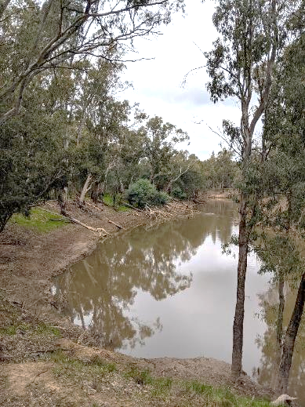



angus.webb@unimelb.edu.au