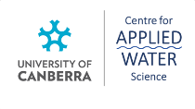

**COMMONWEALTH ENVIRONMENTAL WATER OFFICE**

**MONITORING, EVALUATION AND RESEARCH PROGRAM: LACHLAN RIVER SYSTEM**

**2019-20 SUMMARY REPORT: FINAL**

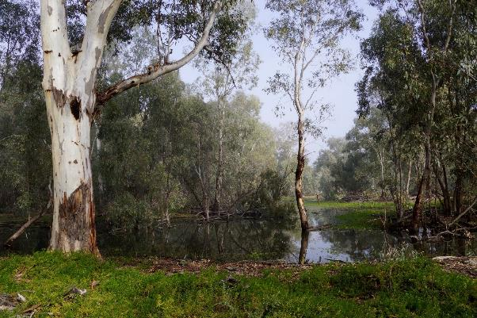

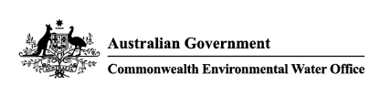**4 February 2021**

**Commonwealth Environmental Water Office**

**Monitoring Evaluation and Research Project**

**Lachlan river system 2019-20 Summary Report**

**Final February 2021**

This document has been co-ordinated by Dr Fiona Dyer and includes contributions from Mr Ben Broadhurst, Ms Alica Tschierschke, Dr Will Higgisson and Professor Ross Thompson (University of Canberra); Dr Adam Kerezsy (Dr Fish Consulting), Dr Joanne Lenehan (NSW Department of Planning, Industry and Environment); and Dr Jason Thiem and Dr Daniel Wright (NSW Department of Primary Industries, Fisheries).

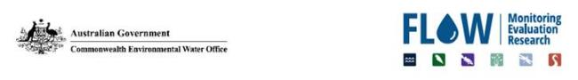

This monitoring project was commissioned and funded by Commonwealth Environmental Water Office with



G:\Fishnet\Research Projects\Logos\DPI logo colour rgb.jpg  

**Copyright**© Copyright Commonwealth of Australia, 2021



**Commonwealth Environmental Water Office Monitoring, Evaluation and Research Project: Lachlan river system Selected Area** is licensed by the Commonwealth of Australia for use under a Creative Commons By Attribution 3.0 Australia license with the exception of the Coat of Arms of the Commonwealth of Australia, the logo of the agency responsible for publishing the report, content supplied by third parties, and any images depicting people. For license conditions see: <http://creativecommons.org/licenses/by/3.0/au/>

This report should be attributed as: Dyer, F., Broadhurst, B., Tschierschke, A., Higgisson, W., Thiem, J., Wright, D., Kerezsy, A. Thompson, R. (2021). Commonwealth Environmental Water Office Monitoring, Evaluation and Research Project: Lachlan river system Selected Area 2019-20 Monitoring and Evaluation Summary Report. Commonwealth of Australia, 2021.

The Commonwealth of Australia has made all reasonable efforts to identify content supplied by third parties using the following format ‘© Copyright, [name of third party] ’.

**Disclaimer**

The views and opinions expressed in this publication are those of the authors and do not necessarily reflect those of the Australian Government or the Ministers for the Department of Agriculture, Water and the Environment.

While reasonable efforts have been made to ensure that the contents of this publication are factually correct, the Commonwealth does not accept responsibility for the accuracy or completeness of the contents, and shall not be liable for any loss or damage that may be occasioned directly or indirectly through the use of, or reliance on, the contents of this publication.

**Inquiries regarding this document should be addressed to:**

Associate Professor Fiona Dyer  
Phone: 02 6201 2452  
e-mail: Fiona.Dyer@canberra.edu.au

**Front cover photo:** Environmental water under the redgums of the Great Cumbung Swamp, June 2020. Photo by Fiona Dyer

**Table Of Contents**

Contents

List of Figures ii

List of Tables ii

Acronyms and abbreviations iii

Acknowledgments iv

1 Monitoring and evaluation of environmental water in the Lachlan river system 1

2 Environmental watering in the Lachlan river system in 2019-20 2

3 Key outcomes from environmental water use 6

3.1 Monitoring 6

3.1.1 Protect refuge habitat 6

3.1.2 Supporting native fish condition and stimulating productivity 7

3.1.3 Maintaining vegetation condition 10

3.1.4 Evaluation questions 10

3.2 Research 13

3.3 Communications and Engagement 14

4 Implications for future management of environmental water 17

4.1 Delivering environmental water during drought: maximising possible outcomes 17

4.2 Delivering freshes during spawning season 18

4.3 Telling stories with the community: capitalising on opportunities 19

5 References 21

# List of Figures

Figure 1. The lower Lachlan river system showing the region for the LTIM Project and MER Program. 2

Figure 2 Modelled natural flow (ML/day) (grey hydrograph) and actual river flow (black hydrograph) of the Lachlan River at a) Whealbah river gauge and b) Booligal river gauge from 1 July 2019 to 30 June 2020. The green shows the environmental watering actions. 7

Figure 3. Sentinel imagery from the Great Cumbung Swamp prior to the arrival of environmental water (23rd October 2019, upper image), and at the peak of the spring/summer watering (27th November 2019, lower image). Images sourced from https://www.sentinel-hub.com/explore/sentinel-playground. 8

Figure 4. Total primary production (kg O2/day) at Lane’s Bridge for the watering year 2019-20. Commonwealth environmental water (green) is shown along with estimates of river flow (flow including the licensed delivery of water but not including environmental water) in black. Estimated total primary production in the absence of Commonwealth environmental water is shown in grey and river temperatures are shown in orange. 9

Figure 5. Frequency histogram of estimated spawning date of larval Murray cod captured in 2019 (all sites and trips combined – grey bars) with water level (from gauge downstream of Ganowlia weir – blue line) and temperature (from gauge Willandra Weir – green line). 10

Figure 6. Catch per site (number of fish; mean ± SE) for Murray cod within the lower Lachlan river system target reach, sampled from 2015-2020. 11

Figure 7. Environmental watering reaching the edges of the reed beds of the Great Cumbung Swamp in November 2019. Photo by Fiona Dyer 16

Figure 8. A graphic that was used to promote the distribution of printed MER Quarterly Outcomes newsletters in May 2020. 17

Figure 9. Sentinel imagery of Noonamah wetland area prior to the arrival of environmental water (28th September 2019, upper image), and towards the peak of the water (12th November 2019, lower image). Images sourced from https://www.sentinel-hub.com/explore/sentinel-playground. 20

Figure 10. Lake Cargelligo's Down The Track Youth Program visits Robinson Crusoe Island. Photos by Mal Carnegie and Adam Kerezsy 22

# List of Tables

Table 2‑1. The components of the main 2019-20 Commonwealth environmental watering action. 4

Table 2‑2. The 2019-20 joint Commonwealth NSW environmental watering actions. 5

Table 3‑1. Evaluation questions and responses for the lower Lachlan river system Selected Area. 13

# Acronyms and abbreviations

|  |  |
| --- | --- |
| Accepted Acronym | Standard Term (capitalisation as specified) |
| ANAE | Australian National Aquatic Ecosystem |
| BASE | Bayesian Single-station Estimation |
| CEWH | Commonwealth Environmental Water Holder |
| CEWO | Commonwealth Environmental Water Office |
| CPUE | Catch per unit effort |
| CTF | Commence to fill |
| DPI | Department of Primary Industries |
| DPIE | Department of Planning, Industry and Environment |
| EPBC Act | Environment Protection and Biodiversity Conservation Act 1999 |
| ER | Ecosystem Respiration |
| GPP | Gross Primary Production |
| K | Reaeration |
| LTIM | Long Term Intervention Monitoring |
| MDBA | Murray-Darling Basin Authority |
| MDFRC | Murray-Darling Freshwater Research Centre |
| SRA | Sustainable Rivers Audit |
| WQA | Water quality allowance |
| WUM | Water Use Minute |

# Acknowledgments

The project team as well as the Commonwealth Environmental Water Office (CEWO) respectfully acknowledge the traditional owners of the land on which this work is conducted, their Elders past and present, their Nations of the Murray-Darling Basin, and their cultural, social, environmental, spiritual and economic connection to their lands and waters. The Lachlan River flows through the lands of the Nari Nari, Ngiyampaa, Wiradjuri and Yita Yita Nations, and we acknowledge these people as the traditional owners of the land on which this publication is focused.

The project team also thank the team of people who contributed to project delivery including: Rhian Clear, Damian McRae, Francis Horacek, Joanne Lenehan, Ugyen Lhendup, Yasmin Cross, Kyle McGrath, Joseph O’Connell, Patrick Driver, Sharon Bowen, Darren Giling and Daniel Scherrer. The following volunteers are thanked for their assistance with larval fish sampling: Max Mallet, Tim Kaminskas, Liam Allan, Kieran Allan, Pat Ross-Magee, Max Clear, Hugh Allan, Darren Giling. The following DPI Fisheries staff assisted with field data collection and laboratory processing: Christopher Smith, Tom Butterfield, Sam Ryan, Jarryd McGowan, Rohan Rehwinkel and Bridget Smith. The following staff and volunteers are thanked for their contribution to vegetation monitoring and research activities: Matthew Young, Jasmin Wells, Elise Palethorpe, Kyle McGrath, Yasmin Cross and Will Dunlop is thanked for calculating hydrological metrics for the reedbed sites used in the research and vegetation monitoring. Mal Carnegie (Lake Cowal Foundation) is thanked for his photographic contributions to our communication and engagement activities and local expertise.

The landholders who granted us access to sites are thanked for their interest, cooperation and support.

Vegetation sampling was conducted under NSW Scientific License SL 102011. Fish sampling was conducted under Fisheries NSW Animal Care and Ethics permit 14/10 and scientific collection permit P01/0059(A)-4.0. Larval fish sampling was conducted under NSW DPI permit No: P14/0022-2.0 and under approval from the University of Canberra Animal Ethics Committee (AEC 17-23).

# Monitoring and evaluation of environmental water in the Lachlan river system

The Lachlan River is the fourth longest river in Australia, starting in small headwater streams on the Breadalbane Plain in New South Wales (NSW) between Yass and Goulburn and flowing approximately 1,400 km west to the Great Cumbung Swamp. The focus for the Long Term Intervention Monitoring (LTIM) Project and Flow-Monitoring Evaluation and Research (MER) Program is the western end of the Lachlan River which extends from the outlet of Lake Brewster to the Great Cumbung Swamp (Figure 1). It encompasses anabranches, floodplain distributaries such as Merrowie Creek; flood runners, billabongs and wetlands such as Booligal Wetlands and Lachlan Swamp as well as the Great Cumbung Swamp. The river system is complex, with a diversity of in-channel and floodplain features that provide a variety of habitats for the species in the region. Flows and water levels are naturally variable and unpredictable providing temporally complex habitats.

The Lachlan river catchment supports many flora and fauna listed as vulnerable or endangered under federal or NSW state legislation and the focus area contains almost half a million hectares of important wetlands, nine of which are nationally listed. The Great Cumbung Swamp has historically been one of the most important waterbird breeding areas in eastern Australia and supports one of the largest remaining stands of river red gums in NSW. In addition, in 2016, the Booligal wetlands supported the largest and most successful breeding colony of straw-necked ibis in the Murray-Darling Basin since 1984.

Like many rivers of the Murray-Darling Basin, flow regulation in the Lachlan river catchment has had a significant effect on the average annual flow as well as inter-annual and seasonal variability (Driver et al. 2004, Higgisson et al. 2020). The interaction of a number of factors such as these are considered key drivers in the deterioration of the freshwater ecosystems within the catchment. The lower Lachlan river system has previously been assessed as being in poor ecosystem health as part of the Murray-Darling Basin Authority’s Sustainable Rivers Audit (SRA) because of an extremely poor native fish community, highly modified flow regime (hydrology), and a physical form and vegetation community that is in poor to moderate condition (Davies et al. 2008, MDBA 2012). The millennium drought (2001-09) resulted in large areas of river red gums becoming stressed and a decline in the condition of wetland vegetation (Thurtell et al. 2011). Some recovery of the wetlands and rivers has been observed since 2010, attributed to a series of natural flow events (2012 and 2016), translucent flow events and targeted environmental watering actions.

More than 220 gigalitres (GL) of Commonwealth environmental water (CEW) has been delivered in the Lachlan catchment since 2010 to achieve wide ranging outcomes. Within the main channel, environmental flows have sought outcomes in hydrological connectivity and variability, improvements in dissolved oxygen concentrations, providing cues for native fish spawning and providing refuge habitat. Connection with the riparian zone and ephemeral floodplain wetlands and channel system, such as Booligal Swamp, Lake Tarwong and the Great Cumbung Swamp have maintained floodplain vegetation, productivity and foraging grounds. These wetland flows in line with appropriate landscape cues, have at times sought to facilitate waterbird breeding success, improve vegetation condition, provide opportunities for native fish to move (disperse), as well as critical refugia in otherwise dry landscapes.

The Monitoring, Evaluation and Research Program (MER Program) is the primary means by which the Commonwealth Environmental Water Office (CEWO) undertakes monitoring and evaluation of the ecological outcomes of Commonwealth environmental watering. It follows the previous Long Term Intervention Monitoring Project (LTIM Project) which evaluated the ecological outcomes of Commonwealth environmental watering activities between 2014 and 2019 (Dyer et al. 2019). Monitoring activities implemented within the MER Program to evaluate the outcomes of Commonwealth environmental watering actions in the lower Lachlan river system in 2019-20 included the monitoring of stream flows (hydrology), stream metabolism and water quality (dissolved oxygen, temperature, pH, electrical conductivity, turbidity and nutrients), fish (including larval fish) and the condition and diversity of vegetation (Dyer et al. 2019).

This report summarizes the outcomes from the 2019-20 monitoring, evaluation and research program in the lower Lachlan river system. In this document the outcomes from the use of Commonwealth environmental water in 2019-20 are summarized and combined with the learning from the previous five years of evaluating environmental water use to highlight the learning from the LTIM Project and MER Program that informs the future management of environmental water. It is accompanied by a technical report (Dyer et al. 2020), which provides more details of the watering actions, the monitoring and research activities and the evaluation of the outcomes.

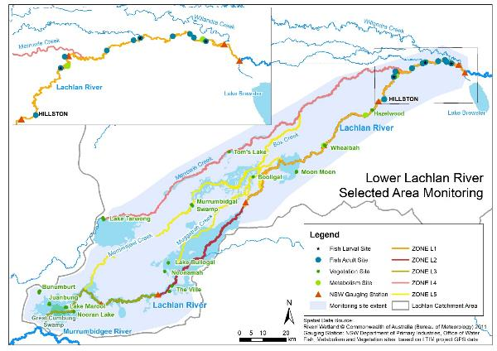

Figure 1. The lower Lachlan river system showing the region for the LTIM Project and MER Program.

# Environmental watering in the Lachlan river system in 2019-20

The dry conditions that prevailed in 2018-19 persisted through the remainder of 2019 and into the early months of 2020. These extreme conditions placed considerable pressure on the region’s water resource which continued to decline rapidly. Forty percent of the Commonwealth’s environmental water holdings were held within a drought account and unable to be used. Environmental watering actions in such dry conditions focused on protecting important refuge habitat within an otherwise extremely dry landscape.

Four watering actions using Commonwealth environmental water were delivered to the Lachlan river system in 2019-20, three of which were delivered in combination with NSW environmental water. These watering actions targeted multiple objectives and sites within the Lachlan river system and used a total of 22 777 ML (22 026 ML Commonwealth environmental water and 751 ML NSW environmental water) (Table 2‑1 and Table 2‑2).

The first watering action provided a spring pulse to the river and targeted multiple sites on its way to the Great Cumbung Swamp. This action commenced with releases from Wyangala Dam on the 16th September 2019 and reached the edge of the Great Cumbung Swamp in early November 2019. A small portion of this watering action was held over in Brewster Weir Pool to provide refuge habitat for olive perchlet and was delivered to the river system in late autumn 2020, capitalizing on natural inflows following rains. In combination, the multiple components of this watering action were designed to provide longitudinal connectivity and variability of flows, stimulate primary production, support native fish condition and protect the core reed beds and other non-woody vegetation communities of the Great Cumbung Swamp (Table 2‑1).

The remaining watering actions were small actions designed to protect refuge habitat. The second watering action provided water to Yarrabandai Lagoon in October 2019 to improve condition and provide refuge habitat in the mid-Lachlan river system. This watering action built upon the use of environmental water in 2018-19 in Yarrabandai Lagoon, continuing to support refuge habitat during dry times. The third watering action provided a spring pulse to Booberoi Creek, also in the mid-Lachlan, with water delivered between October and November 2019 to maintain the health of the creek and provide off-river channel refuge habitat. The fourth watering action provided water to the Noonamah black box woodlands in spring to maintain the health of the black box communities and provide refuge habitat for native animals (Table 2‑1).

Table 2‑1. The components of the main 2019-20 Commonwealth environmental watering action.

|  |  |  |  |  |
| --- | --- | --- | --- | --- |
| DESCRIPTION | DETAILS | | | |
| Action | 1a | 1b | 1c | 1d |
| Target Asset | Brewster Weir Pool | Lake Comayjong | Lake Bunumburt | Lachlan river channel;  Lower Lachlan River, main channel below Lake Brewster, terminating in the Great Cumbung Swamp |
| Reference | Water Use Minute 10081 (2019-20) | | | |
| Accounting Location | Lachlan River at Forbes (Cotton’s Weir) | | | |
| Flow component | Fresh flow | Wetland watering | Wetland watering | Fresh flow |
| Volume (CEW) | 2,000 ML | 1,000 ML | 1,000 ML | 13 028 ML |
| Volume (NSW) |  |  |  |  |
| Re-use | The 2,000 ML kept in Brewster Weir Pool was subsequently released to the lower Lachlan river channel in late Autumn |  |  |  |
| Total Volume | 17 028 ML | | | |
| Objectives | Primary:   * Maintain refuge area for olive perchlet, a threatened native fish   Secondary (on release from weir pool):   * Provide hydrological variability * Maintain vegetation condition, particularly of the core reed bed areas of the Great Cumbung Swamp. | Primary:   * Provide refuge for native animals including waterbirds   Secondary:   * Maintain floodplain connectivity | Primary:   * Maintain the health of black box communities * Provide refuge for native animals including waterbirds   Secondary:   * Maintain floodplain connectivity | Primary:   * Contribute to in-channel flows that maintain refuge areas for native fish, maintain native fish condition, maintain native fish communities, provide hydrological variability and connectivity, maintain aquatic vegetation condition. * Inundate the core reed bed areas of the Great Cumbung Swamp to maintain vegetation condition and provide drought refuge to native waterbirds.   Secondary:   * Maintain water quality |
| Basin Watering Priorities | Support Basin-scale population recovery of native fish by reinstating flows that promote key ecological processes across local, regional and system scales in the southern connected Basin.  Support viable populations of threatened native fish, maximise opportunities for range expansion and establish new populations. | Improve the abundance and maintain the diversity of the Basin’s waterbird population. | Maintain the extent, improve the condition and promote recruitment of forests and woodlands. | Support lateral and longitudinal connectivity along the river systems.  Support Basin-scale population recovery of native fish by reinstating flows that promote key ecological processes across local, regional and system scales in the southern connected Basin. |

Table 2‑2. The 2019-20 joint Commonwealth NSW environmental watering actions.

|  |  |  |  |  |
| --- | --- | --- | --- | --- |
| DESCRIPTION | DETAILS | | | |
| Action | 2a | 2b | 3 | 4 |
| Target Asset | Booberoi Creek |  | Yarrabandai Lagoon | Noonamah |
| Reference | Water Use Minute 10081 (2019-20) | | | |
| Accounting Location | Booberoi Weir off-take | | Private meter | Private meter |
| Flow component |  |  |  |  |
| Volume (CEW) | 2,900 ML | 1,572 ML | 400 ML | 126 ML |
| Volume (NSW) |  | 507 ML | 148 ML | 94 ML |
| Total Volume | 4,979 ML | | 548 ML | 220 ML (plus 40 ML privately owned water) |
| Objectives | Primary:   * Maintain refuge habitat for native fish, birds and frogs that are also of cultural importance * Maintain connectivity with the Lachlan River * Maintain riparian vegetation condition   Secondary:   * Maintain water quality | | Primary:   * Maintain refuge habitat for native birds and frogs * Maintain connectivity with the Lachlan River * Maintain riparian vegetation   Secondary:   * Maintain water quality | Primary:   * Maintain vegetation condition * Maintain refuge habitat for native birds and frogs   Secondary:   * Maintain floodplain connectivity |
| Basin Watering Priorities | Support Basin-scale population recovery of native fish by reinstating flows that promote key ecological processes across local, regional and system scales in the southern connected Basin.  Support viable populations of threatened native fish, maximise opportunities for range expansion and establish new populations. | | Improve the abundance and maintain the diversity of the Basin’s waterbird population | Maintain the extent, improve the condition and promote recruitment of forests and woodlands |

# Key outcomes from environmental water use

## Monitoring

The four environmental watering actions delivered in 2019-20 were designed to provide water that would protect key environmental values during one of the driest recorded periods in the catchment. In combination, these watering actions used 22 026 ML of Commonwealth environmental water. The watering actions were specifically designed to:

1. protect refuge habitats by providing longitudinal and lateral connectivity (Actions 1 to 4);
2. benefit native fish condition and stimulate stream productivity by modifying the flow regime to create specific in-channel hydrological conditions (Action 1); and
3. maintain vegetation condition by providing longitudinal and lateral connectivity (Actions 1 and 4).

By supporting lateral and longitudinal connectivity, supporting native fish, providing drought refuges in very dry catchments and maintaining the condition of species and habitat, these watering actions contributed to the watering priorities for the Murray-Darling Basin Authority (MDBA 2019).

### Protect refuge habitat

All four of the watering actions (see Table 2‑1) provided water to parts of the river system that would otherwise have been dry in 2019-20, thus contributing to the provision of refuge habitat for water dependent species.

The first watering action provided a short spring fresh in the river system that increased in-channel water levels by between 0.1 m and 1.0 m, inundating Torriganny Wetlands (Jo’s Lagoon) and other low-lying habitat. This watering action provided one of only five freshes reaching 2,000 ML/day in the mid Lachlan River and the only one occurring in spring. With re-regulation, the first watering action provided the only small freshes[1] in the river downstream of Hillston in the watering year 2019-20, one in spring and one in autumn.

Without upstream flow regulation no spring freshes would have occurred in the river downstream of Hillston in 2019 but a sequence of freshes (4 large freshes and 4 small freshes) would have occurred in autumn 2020, with extensive periods of time above 150 ML/day in the lower river( Figure 2). Environmental water returned only one small fresh to the lower river in the autumn period. Further, in the absence of upstream regulation, the lower river would have ceased to flow for more than 80 days in late spring and summer 2019-20. Flow regulation ensured that the river did not dry, but also completely removed flow variability throughout the year which has adverse effects on the floodplain wetlands.

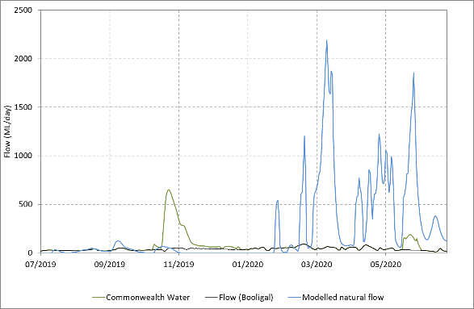

Figure 2. Flow at Booligal for the watering year 2019-20 showing Commonwealth environmental water (green); estimates of river flow (flow including the licensed delivery of water but not including environmental water) (black) and modelled natural flow (blue).

The first watering action delivered water to the Great Cumbung Swamp where it inundated low lying areas (Figure 3) for approximately six weeks, generating opportunities for water birds to access habitat and providing water for the aquatic vegetation. Part of the first watering action provided 2,000 ML to Brewster Weir pool for almost eight months (October to May) to maintain refuge areas for olive perchlet as well as providing flow to the main channel and core reed beds of the Great Cumbung Swamp to provide refuge habitat. The second watering action provided water to Booberoi Creek for 85 days ensuring that water remained in the creek during this time which otherwise may have been closed under water saving contingency measures as was Willandra Creek in December 2019. The third and fourth watering actions provided water to Yarrabandai Lagoon and Noonamah wetland, respectively, providing refuge habitat for aquatic species in an otherwise dry landscape.

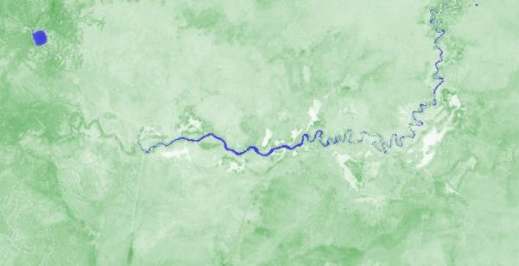

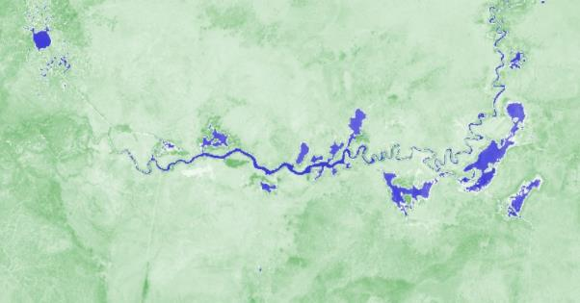

Figure 3. Sentinel imagery from the Great Cumbung Swamp prior to the arrival of environmental water (23rd October 2019, upper image), and at the peak of the spring/summer watering (27th November 2019, lower image). Images sourced from https://www.sentinel-hub.com/explore/sentinel-playground.

### Supporting native fish condition and stimulating productivity

The first watering action provided a spring fresh throughout the mid and lower Lachlan river system that was designed to stimulate primary productivity and maintain native fish condition. The timing of this watering action was in late spring to coincide with increasing water temperatures thus maximising in stream production. It was designed as a short peak to ensure efficient delivery through the system, aiming to get water to the Great Cumbung Swamp in early summer while the reeds were still growing.

The spring fresh component of this watering action was delivered to the lower river system in mid-October, when water temperatures were above 20°C. It resulted in a change in river levels of between 0.2 and 2 m between Brewster Weir and Booligal, inundating low lying areas and in-channel habitats. There was a corresponding increase in total in-stream production with the spring fresh (Figure 4). This primary production is important for generating new energy sources for the aquatic food web.

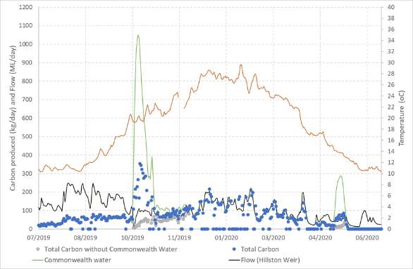

Figure 4. Total carbon produced (kg C/day) at Lane’s Bridge for the watering year 2019-20. Commonwealth environmental water (green) is shown along with estimates of river flow (flow including the licensed delivery of water but not including environmental water) in black. Estimated total carbon production in the absence of Commonwealth environmental water is shown in grey and river temperatures are shown in orange.

The spring fresh was delivered to the lower Lachlan river system during the peak spawning period for Murray cod with the potential for the disruption of spawning activities of this nesting species. An interruption to Murray cod spawning frequency was observed during the spring fresh (Figure 5) and occurred as river levels rose. However, immediately following the peak of the spring fresh, a peak in Murray cod spawning was recorded and 2019 proved to be the most productive year for Murray cod spawning, in terms of non-standardised larval fish catch, in the 6 years of LTIM and MER monitoring.

Figure 5. Frequency histogram of estimated spawning date of larval Murray cod captured in 2019 (all sites and trips combined – grey bars) with water level (from gauge downstream of Ganowlia weir – blue line) and temperature (from gauge Willandra Weir – green line).

The spawning result was followed by a strong recruitment year for Murray cod in the lower Lachlan River Selected Area. This cohort was strongly represented in the community monitoring in autumn 2020 (Figure 6), indicating that this year should positively contribute to the breeding population in the next 5+ years. This continues the recovery of this species in the selected area since the population declined dramatically in 2016, most likely because of fish kills associated with blackwater from the 2016-17 floods.

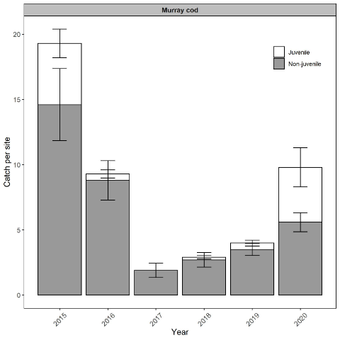

Figure 6. Catch per site (number of fish; mean ± SE) for Murray cod within the lower Lachlan river system target reach, sampled from 2015-2020.

Cumulative stacked bars separate the catch of juveniles (white bars) and non-juveniles (grey bars).

### Maintaining vegetation condition

Watering actions 1 and 4 were designed to maintain the condition of water dependent vegetation: Action 1 targeting the reed beds of the Great Cumbung Swamp and Action 4 targeting the black box vegetation community at Noonamah.

The spring fresh (Watering Action 1) inundated the central reed beds and low-lying areas of the Great Cumbung Swamp for approximately six weeks. The corresponding MER research project (see Section 3.2) that focusses on the reed beds of the Cumbung Swamp has shown that environmental water is maintaining the condition of the central reed beds of the Great Cumbung Swamp, promoting growth, cover and reproduction.

The fourth watering action inundated Noonamah wetland in early November, with water retained in the wetland until early February. While Noonamah wetland sites have only just been incorporated into the Lachlan MER monitoring program, vegetation monitoring has shown that sites which have received environmental water have a range of water dependent species which are not observed at any other site. These sites also have a greater proportion of native species compared to sites which have not received environmental water. Initial sampling at Noonamah wetland would suggest that this is also the case at Noonamah wetland.

### Evaluation questions

This was the sixth year of a program established to answer specific questions about ecological responses to environmental watering in the lower Lachlan river system. Stream flow (hydrology), stream metabolism and water quality (temperature, pH, dissolved oxygen, turbidity, conductivity, concentrations of nitrogen and phosphorus), fish (including larval fish) and the condition and diversity of vegetation were monitored to evaluate the outcomes of Commonwealth watering actions. The evaluation questions and responses for the monitored indicators are summarised in Table 3‑1 .

Table 3‑1. Evaluation questions and responses for the lower Lachlan river system Selected Area.

|  |  |  |
| --- | --- | --- |
| INDICATOR | EVALUATION QUESTION  What did Commonwealth environmental water contribute ….. | RESPONSE |
| Hydrology | to refuge habitat for a range of water dependent species? | All four watering actions provided water to parts of the river system that would otherwise have been dry in 2019-20.   * Watering action 1 provided 2000 ML to Brewster Weir pool for almost 8 months to maintain refuge areas for olive perchlet. * Watering action 1 also provided flow the main channel and core reed beds of the Great Cumbung Swamp for 6 weeks. * Watering Action 2 provided water to Booberoi Creek for 85 days. * Watering Action 3 provided water to Yarrabandai Lagoon. * Watering Action 4 provided water to Noonamah wetland. |
| to hydrological variability in the lower Lachlan River during periods of low flow? | Watering Action 1 provided a small spring fresh in both the mid and lower Lachlan river system as well as a small autumn pulse in the lower Lachlan river system. In the mid reaches, the spring fresh provided at Forbes provided one of only five pulses to reach 2000 ML/day in the watering year and the only one occurring in spring. In the lower reaches (downstream of Brewster Weir), this watering action provided the only small freshes in the river for the watering year; one in spring and one in autumn. |
| to hydrological connectivity? | Watering action 1 provided (longitudinal) hydrological connectivity to the Great Cumbung Swamp during spring and summer 2019 when it would otherwise have continued to dry. Watering actions 2, 3 and 4 provided (lateral) hydrological connectivity to Booberoi Creek, Yarrabandai Lagoon and Noonamah wetland. |
| Water Quality and Stream Metabolism | to primary production in the mid and lower Lachlan River? | During the spring watering action 1, the primary production per litre of water dipped slightly, likely because of a dilution of the organisms living in the water column and the increased depth reducing photosynthesis in the benthic zone. However, there was a much greater volume of water being delivered during the action. Consequently, action 1 generated a considerable increase in the total primary productivity at the scale of the entire ecosystem. The autumn component of watering action 1 generated a similar increase in total primary production, but of a lower magnitude, likely due to the lower flow volume and cooler water temperature. |
| to water quality outcomes? | The two freshes associated with watering action 1 appeared to mobilise small amounts of nutrients and caused slight increases in pH and reductions in salinity. |
| to patterns and rates of ecosystem respiration (decomposition - ER) and primary productivity (GPP)? | Watering events generated short pulses of GPP and ER, with GPP responses being larger in warmer conditions. |
| Fish - community | *Short-term (one yr)* | |
| to native fish community resilience? | The native fish community composition was unchanged from previous years but there were small increases in abundance of Murray cod and golden perch observed, suggesting that the community is continuing to recover post flood. |
| to native fish survival? | Recent recruits of both native and exotic species were captured. None of the species captured have specific flow needs for spawning. Their recruitment indicates that flow conditions provided appropriate habitat and food resources to enable the survival and growth of larvae. Based on captures of juveniles, 2020 was a good recruitment year for Murray cod in the lower Lachlan River. |
| *Long-term (five yrs)* | |
| to native fish populations? | The lower Lachlan native fish population was most affected by fish kills in 2016–2017 during LTIM years, which reduced the biomass of large-bodied Murray cod in 2017 and promoted the spawning and subsequent recruitment of common carp. This significant event likely drowned out other effects on the fish community over the study period. Commonwealth environmental watering actions may have contributed to the post-kill recovery of native fish populations in recent years, however it is unknown if this recovery would have differed without it. |
| to native fish diversity? | Lower Lachlan native fish diversity has been restored to 7 native species in 2020, which was previously observed in 2015–2017 but had declined to 6 species in 2018–2019. SRA expectedness metrics were at equal highest levels in 2020 compared to previous years. The temporary decline in native fish diversity over the sampling period may relate to flooding/hypoxia linked to potential fish kills in 2016–2017 and the opportunistic detection of rare species. The role of Commonwealth environmental water in the restoration of native fish diversity in the Lower Lachlan is again difficult to ascertain. |
| Fish - reproduction | *Short-term (one yr)* | |
| to native fish reproduction in the Lower Lachlan river system? | Spawning of non-flow dependent fish species was detected. In 2019 Commonwealth environmental water appears to have made a positive contribution to the spawning and early recruitment of Murray cod the lower Lachlan river system. |
| to native larval fish growth in the Lower Lachlan river system? | Impossible to answer definitively with current analysis, and in 2019, multiple peaks in spawning activity confounded interpretations from length measurements. The presence of young-of-year fish in the fish community sampling suggests that larval fish growth was supported by water management in 2019-20. |
| *Long-term (five yrs)* | |
| to native fish populations in the Lower Lachlan river system? | The spring pulse has resulted in a strong recruitment year for Murray cod in the lower Lachlan River Selected Area. This cohort was strongly represented in the community monitoring in autumn 2020, indicating that this year should positively contribute to the breeding population in the next 5+ years. This continues the recovery of this species in the selected area since the population declined dramatically in 2016, most likely because of fish kills associated with blackwater from the 2016-17 floods. |
| to native fish species diversity in the Lower Lachlan river system? | There has been no evidence of a reduction or improvement in native fish diversity in the larval fish community since the program commenced in 2014 as a result of Commonwealth environmental water. The potential of Commonwealth environmental water to increase native species diversity in the lower Lachlan River is limited with factors such as barriers to movement (caused by weirs) and regional extirpation of species likely to be greater factors in contributing to native species diversity change. |
| Vegetation | *Short-term (one yr) and long-term (five yrs)* | |
| to vegetation species? | Environmental water has contributed to the species assemblage and their cover at sites which received water over the 2019-20 watering year. The sites which have received environmental water have a range of amphibious plants which were not observed at any other site. These sites also have a greater proportion of native species compared to sites which have not received environmental water. These sites are providing important refuges for flood dependent plants. While environmental water floods a site on the floodplain the diversity and cover of species reduces, then increases shortly after the water recedes. Environmental water has maintained a greater diversity of species in the groundcover over the past three years at sites which have received environmental water compared to sites which have not been flooded since the natural flood in 2016-17. |
| to vegetation community diversity? | Environmental water has maintained the species richness, composition and cover at watered sites and through doing so has contributed to landscape diversity within the lower Lachlan river catchment. |
| to condition of floodplain and riparian trees? | Tree stand and condition data are now collected and reported every 5 years. |
| *Long-term (five yrs)* | |
| to populations of long-lived organisms? | Tree stand and condition data are now collected and reported on every 5 years. |

## Research

The reedbeds of the Great Cumbung Swamp are an important asset in the Lachlan river catchment. They are listed in the Directory of Important Wetlands in Australia and specifically mentioned in the MDBAs Basin-wide Environmental Watering Strategy, which specifies key objectives to maintain the current extent and increase periods of growth for stands of common reed and cumbungi in the Great Cumbung Swamp (MDBA 2014). The Great Cumbung Swamp has been targeted with environmental water multiple times over the past five years, receiving environmental water from whole of system watering events that deliver water to this terminal wetland system. Over the past five years, monitoring of the site has primarily involved the use of satellite imagery to track the progress of water but has not directly monitored the response of the reeds, because of the difficulties and costs involved in monitoring.

Using a range of new technologies, including drones and high-resolution satellite data, the Lachlan MER team is developing techniques to monitor the reedbeds that are practical and cost effective. This research aims to determine:

* What are the key indicators of condition for reedbeds that can be measured easily and cost effectively using remotely sensed techniques?
* What is an appropriate monitoring program for stands of common reed and cumbungi and their response to watering?

The research which commenced at the end of 2019 involves on-ground field-based data collection and data collection from drone imagery and satellite multi spectral imagery. While the method development component of our research is on-going, the field-based data collection has yielded insights into the response of common reed to environmental water.

The presence of surface water by flooding appears to be a major determinant on growth and vigour of common reed in the Great Cumbung Swamp. Height and cover appear to be strongly related to recent flooding and areas that received environmental water in November and December 2019 (Figure 7) had a greater cover of taller reeds than sites which had not received water. Reeds that had received environmental water were also more likely to have flowered which is an indicator that these reeds are in sufficiently good condition to invest in reproducing by flowering and setting seed. This suggests that environmental water is maintaining the central reedbeds of the Great Cumbung Swamp, promoting growth, cover and reproduction.

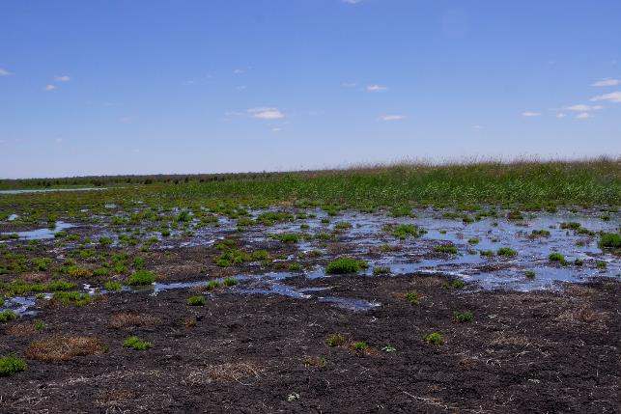

Figure 7. Environmental watering reaching the edges of the reed beds of the Great Cumbung Swamp in November 2019. Photo by Fiona Dyer

## Communications and Engagement

Under the MER Program, the lower Lachlan River Selected Area has resources dedicated to Communication and Engagement (C&E) that support two stream of activities. The first is operational project communication which relates to the activities associated with the delivery of the core monitoring and evaluation component of the MER Program. This involves the project team, the CEWO, key water delivery stakeholders and other operational stakeholders. The second is external communication and engagement which involves stakeholder groups outside of the delivery of the MER Plan and includes landholders, affected communities and the general public.

Our external communication activities are designed to ultimately influence attitudes toward the use of environmental water in the Lachlan Catchment. These activities include developing communication products, community events, local media and supporting local citizen science.

A highlight of our MER communication activities in 2019-20 has been the redevelopment of the Quarterly Outcomes Newsletter into an accessible and visually appealing format. This newsletter is now printed and distributed throughout the mid and lower communities of the catchment from May 2020 (Figure 8). Eighty copies of the October-December 2019 newsletter and eighty copies of the January-March 2020 newsletter were printed and distributed throughout towns and districts from Condobolin to Hay. In general, these newsletters have been spread between local council offices, community centres, schools, libraries and to individual landowners. DPIE–EES also send links and copies to their lower Lachlan landholder stakeholder email list of over 60 community stakeholders.

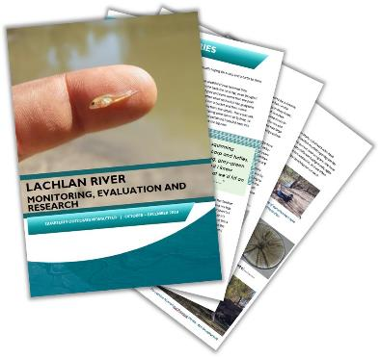

Figure 8. A graphic that was used to promote the distribution of printed MER Quarterly Outcomes newsletters in May 2020.

The MER Program was associated with six community events in 2019-20. These activities were used to provide community interest stories in the Quarterly Outcomes newsletters as well as engage and build capacity within Aboriginal communities along the Lachlan. These activities also provided opportunities for local print media to engage. Highlights included the Booberoi Creek cultural weekend; a fish demonstration event associated with an EWAG meeting; olive perchlet surveys and a Down the Track weekend.

One of our key events was a Down the Track weekend. The Down the Track project at Lake Cargelligo has become one of the most important and high-profile youth initiatives over the last two years. Existing to support disengaged and at-risk youth, the project aims to promote engagement and self-esteem. The Down the Track project itself is an off-shoot or development of the original BackTrack program founded and championed by jackaroo-turned-youth champion/advocate (not to mention Australian of the Year) Bernie Shakeshaft.

In Lake Cargelligo, 90% of Down the Track participants are Indigenous, and all are teenagers from the local area – predominantly Lake itself and the nearby former Aboriginal mission Murrin Bridge. In March 2020 our communication and engagement lead, Dr Adam Kerezsy (Dr Fish), combined with Mal Carnegie from the Lake Cowal Conservation Centre, Dr Jo Lenehan from NSW DPIE, and the Cargelligo Wetlands and Lakes Council (CWLC) chairperson Peter Skipworth to host an overnight camping and surveying trip to Robinson Crusoe Island which sits in the middle of Lake Cargelligo.

The following letter/article from Lana Masterson, who runs the Lake Cargelligo ‘Down the Track’ program for disadvantaged and at-risk youth, is perhaps the best way to summarise the event:

***Down The Track’s Island Adventure***

*On Saturday 21st March, 5 Down The Track participants along with representatives from Cargelligo Wetlands and Lakes Council (CWLC), the NSW Department of Planning, Industry and Environment, Lachlan Shire Council, Lake Cowal Foundation and ecologist Adam Kerezsy embarked on a 24 hour adventure to Robinson Crusoe Island.*

*All participants were transported to the Island by the CWLC barge skippered by Peter Skipworth, and camped the night on the Island.*

*The camp had it all - from bird identification, bush walking, photography of native species to sampling and counting fish and taking water quality measurements. The waters around the Island again yielded great results, with five native fish species sampled in healthy numbers (bony bream, gudgeon, flathead gudgeon, Australian smelt and hardyhead). The results will be passed on to both NSW and Commonwealth agencies charged with delivering environmental water in the Lachlan catchment, and they appear to be a great example of the benefits of keeping Lake Cargelligo as full as possible through the drought.*

*Lana Masterson, from Down The Track, would like to thank everyone that volunteered their time and expertise to make the camp happen.*

*The DTT crew fully immersed themselves in the Island, the wildlife and the outdoor camping experience and are looking forward to doing it all again.*

# Implications for future management of environmental water

The 2019-20 monitoring and evaluation completes six years of the LTIM and MER programs in the Lower Lachlan river system. Collectively, monitoring and evaluation information from the six years can be used to guide the future management of environmental water. In the following sections, specific learnings from 2019-20 are provided as well as cumulative learning that builds on the previous years. In combination, these provide a set of recommendations that inform the future management of environmental water.

## Delivering environmental water during drought: maximising possible outcomes

The use of environmental water in 2019-20 was controversial. At the time of planning, drought rules were in force and 16,004 (43%) of the Commonwealth’s held environmental water had been transferred to the drought account and was unable to be used. The four environmental watering actions used all of the remaining water holdings, attracting significant negative press. The environmental water was used strategically, targeting multiple outcomes and locations within the catchment, attempting to maximise the provision of refugia in an otherwise extremely dry landscape. This included provision of water to Booberoi Creek for an extended period of time to maintain a strategic drought refugia when the creek was at risk of drying out due to proposed operational water saving measures. The investment was strategic given the creek is an anabranch with numerous deep, weir pools and is known habitat for the diverse range of extant small-bodied native fish in the Lachlan as well as the threatened freshwater catfish and Murray cod (monitored 7 times in 2.5 years by DPIE-EES and Flow-MER Communications and Engagement Program).

While controversial, Commonwealth environmental water made a very small contribution to the mid Lachlan (8% of the annual flow at Forbes), with holdings by private operators dominating the flow between Forbes and Hillston. In contrast, Commonwealth environmental water provided around one third (39%) of the flow at Booligal, illustrating again the relative importance of Commonwealth water in the lower reaches of the river. The contributions of Commonwealth environmental water to flow at Booligal over the past 6 years have varied between 6 and 44% of the annual flow. The lower reaches of the Lachlan River have been disproportionately affected by flow regulation and upstream water use, and environmental water provides important hydrological connectivity to these parts of the river.

In attempting to maximise the provision of refugia, environmental water was used to target nine locations in 2019-20, including the mid and lower-Lachlan river channel. Water was successfully provided to seven of these, with channel delivery issues and slowing flow rates at the end of the system affecting the ability to get water into Lake Comayjong and Lake Bunumburt. On-ground observations by water managers and local landholders identified the channel delivery issues and the watering actions were modified. Such delivery issues are likely to occur at end of system wetlands when conditions are very dry and careful thought should be given to targeting these types of locations under such conditions. There was a robustness in the watering attempt of Lake Comayjong and Lake Bunumburt, with watering actions able to be modified when it was decided that they would be unsuccessful and the water was diverted to other parts of the Great Cumbung Swamp, still providing refuge.

The watering action that provided water to Noonamah wetland involved a combination of Commonwealth environmental water (126 ML), NSW environmental water (94 ML) and privately-owned water (40 ML). This small watering action (in total 260 ML) resulted in water in the Noonamah wetland from early November 2019 to the end of January 2020 (Figure 9), almost 3 months of refuge habitat. Such partnerships enable outcomes to be maximised and are particularly valuable in drought conditions.

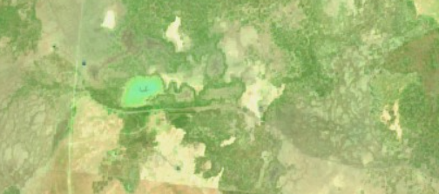

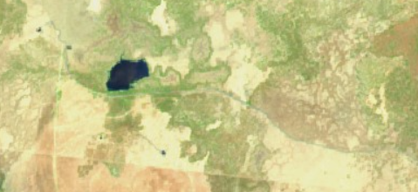

Figure 9. Sentinel imagery of Noonamah wetland area prior to the arrival of environmental water (28th September 2019, upper image), and towards the peak of the water (12th November 2019, lower image). Images sourced from https://www.sentinel-hub.com/explore/sentinel-playground.

## Delivering freshes during spawning season

The first watering action provided a spring fresh throughout the mid and lower Lachlan river system that was designed to stimulate primary productivity and maintain native fish condition. In designing this watering action, the priorities were to maximise stream production, ensure efficient delivery through the system and get water into the Great Cumbung Swamp in early summer to support the reeds while they were still growing. Specific consideration was given to delaying the fresh to not trigger spawning of any flow dependent species because projections were that the system was drying and likely to provide difficult conditions for fish as it continued to dry.

The watering action that was delivered commenced at Wyangala on the 16th September and passed through the monitoring reach in early October. It was designed as a short fresh to ensure efficient delivery through the system and coincided with rising water temperatures to maximise production outcomes. This also resulted in it coinciding with peak Murray cod nesting time (Late September through to mid-November). In general, best practice water delivery to support successful Murray cod nesting has been based around maintaining relatively stable water levels during cod nesting period, primarily avoiding large decreases in water level that can result in nest abandonment and egg desiccation. The spring fresh delivered in 2019 resulted in a river rise and fall of approximately 1.5 m, by far the largest variation during the watering year of 2019-20. It may have been expected that the large variation right in the middle of the Murray cod nesting period may have resulted in stranded nests as the water level receded.

Our data suggests that spawning activity decreased as the peak of the fresh arrived, then increased to its peak as the water level receded (Figure 4, page 9), and that larval fish abundances were the highest recorded since monitoring began in 2014. While it is unclear whether they would have been even higher in the absence of the spring fresh (or lower for that matter), this result suggests that spawning and nesting of Murray cod populations in the lower Lachlan are somewhat robust against the sharp rise and fall of the released spring fresh. This may have been achieved by selection of nesting sites low in the river channel during minimum operational flows (i.e. prior to the rise in water level associated with the fresh), which may have reduced the risk of nest desiccation. Furthermore, it is likely that stream production was bolstered by the spring fresh, which would have increased food resources for larval and early juvenile Murray cod (and other larval fish species). The higher than usual abundances of Murray cod larvae (and juveniles) was not observed in other nearby Murrumbidgee and Edward-Kolety River systems, indicating that this was localised and potentially unique to the lower Lachlan Selected area, which adds support to the finding that the spring pulse had an overall positive effect on Murray cod recruitment.

The monitoring results suggest that releasing a flow pulse (which resulted in a sharp rise and fall in water level) during the Murray cod nesting time did not adversely affect larval or juvenile Murray cod abundance, and, if anything may have contributed to enhancement through an increase in total stream productivity.

**CEWO Adaptive Management Response**: In response to this result in the Lachlan River in 2019-20, the CEWO will continue to assess the need and ability to provide flows during the Murray cod nesting period (late-September to late-November) including (a) minimum flows to prevent nest abandonment, and (b) increased variability which may improve productivity/recruitment outcomes while not adversely affecting nesting cod. This approach will be further informed by monitoring results from 2020-21 flows, which have seen a much larger translucent flow event (4,000 ML/day at Willandra Wier on 14 November 2020) move through the monitoring sites during the cod spawning period.

It is still advisable where possible for spring flow pulses to straddle the Murray cod nesting time. When delivered before nesting flows provide a cue for adults to move and provide increased connectivity. Flows after spawning may increase stream productivity and p (and potentially have the additional benefit of being delivered with suitable water temperatures to result in a spawning response from golden perch).

## Telling stories with the community: capitalising on opportunities

The CEWO defines four broad objectives for external communication and engagement activities around environmental water.

* To increase awareness, understanding and value of water for the environment and its benefits.
* To promote water for the environment as being a normal and necessary part of river operations and a healthy environment.
* To secure support, acceptance and advocacy for water for the environment.
* To increase credibility and trust in the management of water for the environment and CEWO.

One of the challenges of increasing awareness and understanding is attracting the interest of groups who have no exposure to environmental water. Part of the strategy for delivering communication and engagement activities in the Lachlan has been to capitalize on opportunities that enable us to engage with a different audience. The Down the Track weekend demonstrates the positive outcomes that arise from this approach. This weekend was the result of a local conversation and was enabled with the backing of the Lachlan MER program. The weekend was a great success with a small band of young, at risk aboriginal youth getting to spend time ‘on country’, telling stories with scientists, learning about the freshwater ecology of their country and the importance of environmental flows. The weekend also resulted in some great local media (Figure 10).

In this we see a lesson for the longer-term management of environmental water in that, just like the delivery of environmental water in the Lachlan has become more flexible and responsive to the local conditions over the course of LTIM and MER, flexibility in the delivery of communication and engagement activities can lead to some significant outcomes. The allocation of a small portion of our communication and engagement budget to be able to undertake these types of events into the future is important.

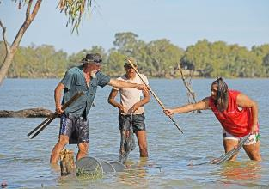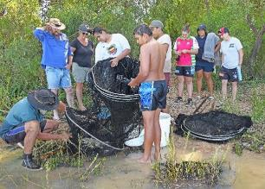

Figure 10. Lake Cargelligo's Down The Track Youth Program visits Robinson Crusoe Island. Photos by Mal Carnegie and Adam Kerezsy

The benefits of community and stakeholder driven fish monitoring projects, such as the DPIE–EES and Flow-MER partnership in Booberoi Creek over several years is clear. The majority of participants – but most notably the landowners – expressed interest (and surprise) at both the variety and abundance of small-bodied native fish, macroinvertebrates and macrophytes (habitat). Most commented that although they had lived adjacent to the creek for extended periods, they were largely unaware of the local biodiversity and requested ongoing engagement activities and monitoring to further their understanding of the relationship between environmental water delivery, and how such flows consider the various lifecycle needs of biota. A greater appreciation for local biodiversity has motivated them to consider complimentary actions on their behalf as to better protect a resource they have become to value more and more through exposure to environmental water planning, implementation and monitoring.

Similarly, support of the Murrin Bridge Community Development Program (CDP) is highly valued by participants and residents of Murrin Bridge, as well as supporting organisations such as Murrin Bridge Local Aboriginal Land Council (LALC) and Regional Enterprise Development Institute Ltd (REDI.E), the peak provider of services to Indigenous communities in western NSW. The key to success has been partnerships with Flow-MER and DPIE–EES, and an adaptive and flexible suite of activities that can respond to community identified needs and interests, rather than a pre-programed set of outputs and outcomes. The four broad objectives outlined previously have been met via meaningful participation through relationship building with ‘people’ rather than ‘process’. The Flow-MER and DPIE–EES consultation has assisted position local Aboriginal Elders from the Ngiyampaa nation as key knowledge holders and leaders on designing environmental flows for Booberoi Creek both locally and state-wide. Importantly, this grass-roots approach has brought people from all generations and backgrounds together around the nexus of providing water for their environment, which then enables them to understand the broader Basin-scale objectives of the environmental watering program as a whole across the Lachlan Catchment, including the lower Lachlan Selected Area. As a result, those involved in the Flow-MER and DPIE–EES partnership C&E program over the past 6 years have become advocates for environmental water.

# References

Davies, P. E., J. H. Harris, T. J. Hillman, and K. F. Walker. 2008. Sustainable Rivers Audit 1: A report on the ecological health of Rivers in the Murray-Darling Basin, 2004-2007. Prepared by the Independent Sustainable Rivers Audit Group for the Murray–Darling Basin Ministerial Council. Murray Darling Basin Commission, Canberra.

Driver, P. D., S. Chowdhury, T. Hameed, P. Lloyd-Jones, G. Raisin, C. Ribbons, G. Singh, and P. Wettin. 2004. Natural and modified flows of the Lachlan Valley wetlands. Resource Analysis Unit, Central West Region, NSW Department of Infrastructure, Planning and Natural Resources, Forbes.

Dyer, F., B. Broadhurst, A. Tschierschke, W. Higgisson, J. Thiem, D. Wright, A. Kereszy, and R. Thompson. 2020. Commonwealth Environmental Water Office Monitoring, Evaluation and Research Project: Lachlan river system Selected Area 2019-20 Monitoring and Evaluation Technical Report.

Dyer, F., B. Broadhurst, A. Tschierschke, W. Higgisson, R. Thompson, R. Clear, P. Driver, S. Bowen, J. Lenehan, R. Thomas, L. Thurtell, P. Packard, D. Wright, J. Thiem, and K. Brandis. 2019. Commonwealth Environmental Water Office Lachlan Selected Area Monitoring, Evaluation and Research Plan (2019-2022). University of Canberra, Canberra.

Higgisson, W., B. Higgisson, M. Powell, P. Driver, and F. Dyer. 2019. Impacts of water resource development on hydrological connectivity of different floodplain habitats in a highly variable system. River Research and Applications.

MDBA. 2012. Sustainable Rivers Audit 2: The ecological health of rivers in the Murray–Darling Basin at the end of the Millennium Drought (2008–2010). Summary. Murray-Darling Basin Authority, Canberra, Australia.

MDBA. 2014. Basin-wide enviromental watering strategy. Murray–Darling Basin Authority, Canberra, Australia.

MDBA. 2019. Basin environmental watering priorities 2019-20. Murray-Darling Basin Authority.

Thurtell, L., P. Wettin, Barma Water Resources, and Commonwealth Environmental Water (Australia). 2011. Environmental Water Delivery: Lachlan River. Canberra.

1. The Lachlan Long Term Water Plan describes a small fresh at Booligal as a flow of greater than 150 ML for 14 days, and a large fresh as a flow greater than 650 ML/day for five days.