**2019-20 Regulator Performance Report**

Departmental Narrative

The Department of Agriculture, Water and the Environment 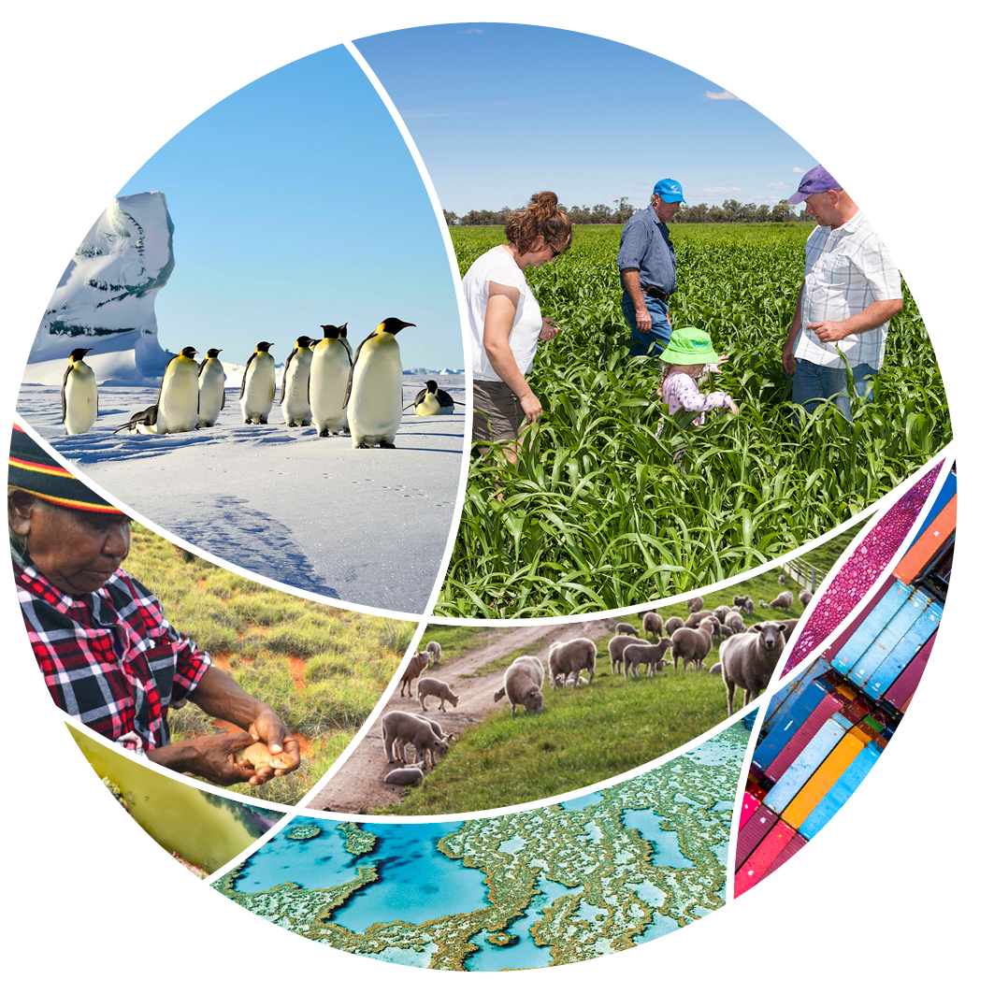

© Commonwealth of Australia 2021

**Ownership of intellectual property rights**

Unless otherwise noted, copyright (and any other intellectual property rights) in this publication is owned by the Commonwealth of Australia (referred to as the Commonwealth).

**Creative Commons licence**

All material in this publication is licensed under a [Creative Commons Attribution 4.0 International Licence](https://creativecommons.org/licenses/by/4.0/legalcode) except content supplied by third parties, logos and the Commonwealth Coat of Arms.

Inquiries about the licence and any use of this document should be emailed to [copyright@awe.gov.au](mailto:copyright@awe.gov.au).



**Cataloguing data**

This publication (and any material sourced from it) should be attributed as: 2019-20 Regulator Performance Report - Departmental Narrative, Department of Agriculture, Water and the Environment, Canberra, February. CC BY 4.0.

ISBN 978-1-76003-383-5

This publication is available at <https://www.awe.gov.au/about/commitment/regulator-performance>

Department of Agriculture, Water and the Environment

GPO Box 858 Canberra ACT 2601

Telephone 1800 900 090

Web [awe.gov.au](https://www.awe.gov.au/)

**Disclaimer**

The Australian Government acting through the Department of Agriculture, Water and the Environment has exercised due care and skill in preparing and compiling the information and data in this publication. Notwithstanding, the Department of Agriculture, Water and the Environment, its employees and advisers disclaim all liability, including liability for negligence and for any loss, damage, injury, expense or cost incurred by any person as a result of accessing, using or relying on any of the information or data in this publication to the maximum extent permitted by law.

Contents

Context 4

Our Regulatory Performance 5

Congestion Busting for Environmental Approvals 5

Modernising Exports Documentation 6

Reducing Regulatory Burden and Streamlining Audit Arrangements in the Dairy Sector 6

Digital Environmental Assessment Program 6

A New Trade Information Service for Exporters in conjunction with Austrade. 6

Associated Performance Reporting 7

Future Reporting 8

## Context

This is the first year we will be reporting as a new department on our regulatory performance. The former Departments produced reports in different formats from their own unique perspectives. Department of Agriculture reported individually on Key Performance Indicators (KPIs) for each of the seven regulators[1]  and the Department of Environment and Energy delivered a whole-of-department report informed by six[2] KPIs.

Our new department, the Department of Agriculture, Water and the Environment (the department) was formed on 1 February 2020, through a Machinery of Government (MoG) process, in the context of the world-wide COVID-19 pandemic, devastating bushfires and prevalent threats to our environment and agricultural industries, both at the border and domestically. These events have challenged us and the way we perform our role as a regulator in a way that enhances Australia’s agriculture, unique environment and heritage, and water resources.

We are a department comprised of different regulators and, through our 128 legislative instruments, collectively we interact with many sectors in the Australian economy. Whilst our primary focus is to deliver regulation in a manner relevant to shaping behaviour in each particular sector, we remain committed to bringing together our regulatory practices in the ongoing pursuit of better practice.

## Our Regulatory Performance

The department has met our contextual challenges head-on and we have set about orientating the department to meet the expectations of Government and the Australian public. In the spirit of providing the public with insight into our performance, and in accordance with the Regulator Performance Framework, we provide this narrative which outlines how we, as a new department, view our organisational regulator performance. For 2019-20, at an organisational level we assess the department, an organisation comprised of many discrete regulators, as a regulator in transition. We acknowledge the significant areas of improvement identified in various reviews of our regulatory effectiveness, efficiency and overall performance.

During 2019-20 we received a range of reports from Inspector General of Biosecurity[3], Inspector General of Live Animal Exports[4] and from the Australian National Audit Office[5]. Alongside these, we were continuing to respond to reports of regulatory systems from our constituent departments, notably the *Review of the Regulatory Capability and Culture of the Department of Agriculture and Water Resources in the Regulation of Live Animal Exports*[6] *(Moss review)*, and those currently underway, notably the *Environment Protection and Biodiversity Conservation Act (EPBC) Review*[7] and the *Special Commission of inquiry into the Ruby Princess*[8]. These reviews are being addressed at operational levels, with upfront investment in governance structures to ensure that broader, organisation-wide improvements can be leveraged. We are developing a department-wide agenda that will drive all of our regulatory functions towards better practice, with a focus on improving staff capability, transparency of decision making and strengthening engagement with industry in regulatory design and delivery. This agenda has been initiated with the public release of our new department’s single Purpose Statement which outlines (amongst other outcomes) our commitment to achieving regulatory outcomes. The agenda is currently undertaking open engagement with our stakeholders on the development of a Regulatory Practice Statement. The development of our staff and organisational capability will be at the centre of this agenda and we continue to play a key role contributing to the Government’s Deregulation Agenda.

Throughout 2019-20 the department’s contribution to the Government’s Deregulation Agenda (aligned with the Whole-of-Government deregulation focus) has included five specific areas, outlined below[9].

### Congestion Busting for Environmental Approvals[10]

The department is actively involved with major congestion busting projects and during 2019-20 our department released a series of products to support a more streamlined environmental approvals process. This included a Stakeholder Information kit[11] and a Stakeholder information video[12] made available on a single Stakeholder Information page[13]. These resources help stakeholders more easily lodge and manage applications for environmental approvals under the *Environment Protection and Biodiversity Conservation Act 1999 (Cth)*.

### Modernising Exports Documentation[14]

We updated our export permit issuing process to allow exporters to receive digital copies of approve permits, which can now be immediately printed. The update saves exporters both time and money as export processes can commence upon digital receipt rather than reliance on either physical collection or mail delivery of permits.

### Reducing Regulatory Burden and Streamlining Audit Arrangements in the Dairy Sector[15]

We have supported improved market outcomes in the Dairy Industry through;

* Identifying regulatory barriers for local dairy manufacturers to export their produce
* Aligning food safety in regulatory and commercial assurance programs with industry,
* Improved data collection which sets a firm base for a reduction in regulatory intervention for low risk, highly compliant market participants*.*

### Digital Environmental Assessment Program[16]

The Digital Environmental Assessments Program is a key Government initiative to transform the environmental assessment and approval process within Australia. Working collaboratively, the Commonwealth and the State of Western Australia will deliver: User-focused digital platforms that support the integration of assessment systems and data across jurisdictions and a biodiversity data repository to store and share information, and data standards agreed across Commonwealth, States/Territories and research entities to improve the quality of data and enable better data sharing and analysis. It will reduce the cost of doing business, improve the customer experience, increase transparency and make environmental data available for reuse.

### A New Trade Information Service for Exporters in conjunction with Austrade[17].

We are working with Austrade to create a proof of concept trade information service making a single, trusted and simple source of information on how to export which will assist with reducing the time, information barriers and costs associated with exporting for small business.

## Associated Performance Reporting

Alongside this report, the department continues to report publicly relevant performance metrics associated with the work we do and to comply with the legislation and other reporting requirements which are available on our website[18], including our published service standards[19].

## Future Reporting

The department acknowledges that this report only provides an organisational perspective on its regulatory performance. Our department-wide agenda will aim to build public trust and confidence in our regulatory role by placing a focus on the transparency of our regulatory performance and we intend to provide more detailed performance metrics in future reports published in accordance with the Regulator Performance Framework.

1. **Regulatory Systems:** Biosecurity, Export Certification, Monitoring Imported Food, Illegal Logging, Collecting Levies on Behalf of Agriculture Industries, Live Animal Exports and Water Efficiency Labelling and Standards Scheme.
2. **KPIs:** 1.Regulators do not unnecessarily impede the efficient operation of regulated entities, 2. Communication with regulated entities is clear, targeted and effective, 3. Actions undertaken by regulators are proportionate to the regulatory risk being managed, 4. Compliance and monitoring approaches are streamlined and coordinated, 5. Regulators are open and transparent in their dealings with regulated entities.
3. Inspector General of Biosecurity, *Implementation of Inspector-General of Biosecurity recommendations; Adequacy of preventative border measures to mitigate the African swine fever risk entering Australia; Effectiveness of Approved Arrangements in managing biosecurity risks in Australia*. [Inspector General of Biosecurity Website](https://www.igb.gov.au/), n.d., accessed 28 October 2020.
4. Inspector General of Live Animal Exports, *Monitoring and reporting during livestock export voyages*. [Inspector General of Live Animal Exports Website](https://www.iglae.gov.au/), n.d., accessed 28 October 2020.
5. ANAO, *Bilateral Agreement Arrangements Between Services Australia and Other Entities; Probity Management in Rural Research and Development Corporations; Design and Establishment of the Regional Investment Corporation; Implementation of ANAO and Parliamentary Committee Recommendations; Referrals, Assessments and Approvals of Controlled Actions under the Environment Protection and Biodiversity Conservation Act 1999* [ANAO Website](https://www.anao.gov.au/work?query=Department%20of%20Agriculture%20&f%5B0%5D=field_publication_type%3A1&f%5B1%5D=field_year_tabled_published%3A26&f%5B2%5D=field_report_sector%3A71&f%5B3%5D=field_report_sector%3A136) ,n.d., accessed 28 October 2020.
6. Phillip Moss AM, [Review of the Regulatory Capability and Culture of the Department of Agriculture and Water Resources in the Regulation of Live Animal Exports](https://www.agriculture.gov.au/sites/default/files/sitecollectiondocuments/export/moss-review.pdf), report to the Australian Government Department of Agriculture, Water and the Environment, 2018.
7. Graeme Samuels AC, [Environment Protection and Biodiversity Conservation Act (EPBC) Review](https://epbcactreview.environment.gov.au/), report to the Australian Government Department of Agriculture, Water and the Environment, 2020.
8. Bret Walker SC, [Special Commission of inquiry into the Ruby Princess](https://www.rubyprincessinquiry.nsw.gov.au/), report to the NSW Parliament, 2020.
9. Prime Minister and Cabinet’s website [*Busting congestion and supporting investments and jobs*,](https://www.pmc.gov.au/sites/default/files/publications/busting-congestion-and-supporting-investment-and-jobs.pdf) PM&C, n.d., accessed 28 October 2020.
10. The Hon Susan Ley MP, [*Congestion busting assessments protecting our environment and our economy*](https://minister.awe.gov.au/ley/media-releases/congestion-busting-assessments-protecting-our-environment-and-our-economy)[Media Release], 23 April 2020, accessed 10 December 2020.
11. Department of Agriculture, Water and the Environment website, [Stakeholder information Kit](https://www.environment.gov.au/epbc/information-kit) DAWE, n.d., accessed 10 December 2020
12. Department of Agriculture, Water and the Environment website, [Stakeholder Information Video](https://www.youtube.com/watch?v=u_V7kTioihk&feature=youtu.be) YouTube, n.d., accessed 10 December 2020
13. Department of Agriculture, Water and the Environment website, [Stakeholder Information Page](http://www.environment.gov.au/system/files/pages/5e1ffd9c-3871-4310-8518-ab82bffc941e/files/epbc-stakeholder-information-kit-factsheets.pdf) DAWE, n.d., accessed 10 December 2020
14. Ibid [3].
15. The Hon David Littleproud MP, [*Over $14 Million to help Australian Dairy Exports*](https://minister.awe.gov.au/littleproud/media-releases/dairy-exports) [media release], 3 March 2020, accessed 28 October 2020.
16. The Hon Mark McGowan BA LLB MLA,[*McGowan Government announces streamlined environmental assessment processes during COVID-19 recovery*](https://www.mediastatements.wa.gov.au/Pages/McGowan/2020/05/McGowan-Government-announces-streamlined-environmental-assessment-processes-during-COVID-19-recovery.aspx) [media release], 13 May 2020, accessed 28 October 2020.
17. Prime Minister and Cabinet’s website [*Busting congestion and supporting investments and jobs*,](https://www.pmc.gov.au/sites/default/files/publications/busting-congestion-and-supporting-investment-and-jobs.pdf)[2] PM&C, n.d., accessed 28 October 2020.
18. Department of Agriculture, Water and the Environment website [*Government Responses*](https://www.awe.gov.au/about/reporting/obligations/government-responses) *on DAWE Website*, DAWE, n.d., accessed 28 October 2020.
19. Department of Agriculture, Water and the Environment website [Appendix E: Service standards](https://www.transparency.gov.au/annual-reports/department-agriculture-water-and-environment/reporting-year/2019-20-21) DAWE, n.d., accessed 28 October 2020.