**COMMONWEALTH ENVIRONMENTAL WATER OFFICE**

**MONITORING, EVALUATION AND RESEARCH PROGRAM: LACHLAN RIVER SYSTEM**

**2020-21 SUMMARY REPORT: FINAL**

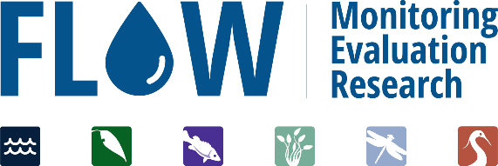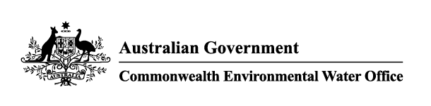**March 2022**

**Commonwealth Environmental Water Office**

**Monitoring Evaluation and Research Project**

**Lachlan river system 2020-21 Summary Report**

**Final March 2022**

This document has been co-ordinated by Dr Fiona Dyer and includes contributions from Mr Ben Broadhurst, Ms Alica Tschierschke, Dr Will Higgisson and Professor Ross Thompson (University of Canberra); Dr Adam Kerezsy (Dr Fish Consulting), Dr Joanne Lenehan (NSW Department of Planning, Industry and Environment); and Dr Jason Thiem and Dr Daniel Wright (NSW Department of Primary Industries, Fisheries).



This monitoring project was commissioned and funded by Commonwealth Environmental Water Office with



G:\Fishnet\Research Projects\Logos\DPI logo colour rgb.jpg  

**Copyright**© Copyright Commonwealth of Australia, 2022



**Commonwealth Environmental Water Office Monitoring, Evaluation and Research Project: Lachlan river system Selected Area** is licensed by the Commonwealth of Australia for use under a Creative Commons By Attribution 3.0 Australia license with the exception of the Coat of Arms of the Commonwealth of Australia, the logo of the agency responsible for publishing the report, content supplied by third parties, and any images depicting people. For license conditions see: <http://creativecommons.org/licenses/by/3.0/au/>

This report should be attributed as: Dyer, F., Broadhurst, B., Tschierschke, A., Higgisson, W., Thiem, J., Wright, D., Kerezsy, A., Giling, D., Thompson, R. (2022). Commonwealth Environmental Water Office Monitoring, Evaluation and Research Project: Lachlan river system Selected Area 2020-21 Monitoring and Evaluation Summary Report. Commonwealth of Australia, 2022.

The Commonwealth of Australia has made all reasonable efforts to identify content supplied by third parties using the following format ‘© Copyright, [name of third party] ’.

**Disclaimer**

The views and opinions expressed in this publication are those of the authors and do not necessarily reflect those of the Australian Government or the Ministers for the Department of Agriculture, Water and the Environment.

While reasonable efforts have been made to ensure that the contents of this publication are factually correct, the Commonwealth does not accept responsibility for the accuracy or completeness of the contents, and shall not be liable for any loss or damage that may be occasioned directly or indirectly through the use of, or reliance on, the contents of this publication.

**Inquiries regarding this document should be addressed to:**

Professor Fiona Dyer  
Phone: 02 6201 2452  
e-mail: Fiona.Dyer@canberra.edu.au

**Front cover photo:** The richness and cover of aquatic and amphibious plant species at Lake Noonamah, November 2020. Photo: Alica Tschierschke

**Table Of Contents**

Contents

List of Figures ii

List of Tables ii

Acronyms and abbreviations iii

Acknowledgments iv

1 Monitoring and evaluation of environmental water in the Lachlan river system 1

2 Environmental watering in the Lachlan river system in 2020-21 3

3 Key outcomes from environmental water use 7

3.1 Monitoring 7

3.1.1 Provide lateral and longitudinal connectivity to benefit vegetation and provide habitat 7

3.1.2 Supporting native fish condition and stimulating productivity 11

3.1.3 Evaluation questions 11

3.2 Research 15

3.3 Communications and Engagement 16

4 Implications for future management of environmental water 18

4.1 Delivering environmental water when it is wet: maximising possible outcomes 18

4.2 The ‘ups and downs’ of fish responses 19

4.3 Harnessing the power of local people: community-based monitoring 20

5 References 22

# List of Figures

Figure 1‑1. The lower Lachlan river system showing the region for the LTIM Project and MER Program. 2

Figure 3‑1. Flows at Willandra Weir for the period 1st of July 2020 to 30th of June 2021 showing Watering Action 2 and an estimate of Watering Action 4. 8

Figure 3‑2. Flows at Booligal for the period 1st of July 2020 to 30th of June 2021 showing estimates of Watering Actions 2, 4, 6 and 7. 9

Figure 3‑2. A carpet of Nardoo at Lake Noonamah, November 2020. Photo: Will Higgisson 10

Figure 3‑3. Gross primary production (GPP), from site Lane’s Bridge in the lower Lachlan River in 2020-21. Blue shaded vertical bars indicate watering actions. 11

Figure 3‑4. Cover images of Lachlan River MER Quarterly Outcomes newsletters 2020-21. 16

Figure 4‑1. Open section of Lake Tarwong in May and November 2021. Photo: Alica Tschierschke 19

Figure 4‑2. Estimated golden perch spawning in the Lachlan River system in 2020-21. November spawning dates were estimated from larval fish captures, December spawning dates were estimated from juvenile fish captures. 20

Figure 4‑3. Imagery provided by Waterwatch Team in relation to Blue Green Algal (BGA) alert. 21

# List of Tables

Table 2‑1. The 2020-21 joint Commonwealth and NSW environmental watering action – part 1. 4

Table 2‑2. The 2020-21 joint Commonwealth and NSW environmental watering action – part 2. 5

Table 3‑1. Evaluation questions and responses for the lower Lachlan river system Selected Area. 12

# Acronyms and abbreviations

|  |  |
| --- | --- |
| **Accepted Acronym** | **Standard Term (capitalisation as specified)** |
| ANAE | Australian National Aquatic Ecosystem |
| CEWH | Commonwealth Environmental Water Holder |
| CEWO | Commonwealth Environmental Water Office |
| DPI | Department of Primary Industries |
| DPIE | Department of Planning, Industry and Environment |
| ER | Ecosystem Respiration |
| GPP | Gross Primary Production |
| LTIM | Long Term Intervention Monitoring |
| MER | Monitoring, Evaluation and Research |
| MDBA | Murray-Darling Basin Authority |
| SRA | Sustainable Rivers Audit |

# Acknowledgments

The project team as well as the Commonwealth Environmental Water Office (CEWO) respectfully acknowledge the traditional owners of the land on which this work is conducted, their Elders past and present, their Nations of the Murray-Darling Basin, and their cultural, social, environmental, spiritual and economic connection to their lands and waters. The Lachlan River flows through the lands of the Nari Nari, Ngiyampaa, Wiradjuri and Yita Yita Nations, and we acknowledge these people as the traditional owners of the land on which this publication is focused.

The project team also thank the team of people who contributed to project delivery: Rhian Clear, Damian McRae, Michelle Groat, Joanne Lenehan, Ugyen Lhendup, Yasmin Cross, and Daniel Scherrer.

The following volunteers are thanked for their assistance with larval fish sampling, Liam Allan, Kieran Allan, Pat Ross-Magee, Max Clear, Hugh Allan, Ewen Lawler.

The following DPI Fisheries staff assisted with adult fish field data collection and laboratory processing: Rohan Rehwinkel, Jackson Wilkes-Walburn, Jarryd McGowan, Tim McGarry, Bridget Smith, Bryce Butler and Nick O'brien.

The following staff and volunteers are thanked for their contribution to vegetation monitoring and research activities: Angus Macdonald, Matt Jeromson, Matthew Young, Rhys Morcom, Blaine Serafin, Jasmin Wells, Tasha James, Jill Bartlett, the following students from UNSW: Dana Lanceman, Courtney Adams, Julia Zubonja and Keira Chrystal.

Mal Carnegie (Lake Cowal Foundation) is thanked for his photographic contributions to our communication and engagement activities and local expertise.

The landholders who granted us access to sites are thanked for their interest, cooperation and support.

Vegetation sampling was conducted under NSW Scientific License SL 102011. Fish sampling was conducted under Fisheries NSW Animal Care and Ethics permit 14/10 and scientific collection permit P01/0059(A)-4.0. Larval fish sampling was conducted under NSW DPI permit No: P14/0022-2.0 and under approval from the University of Canberra Animal Ethics Committee (AEC 17-23).

# Monitoring and evaluation of environmental water in the Lachlan river system

The Lachlan River is the fourth longest river in Australia, starting in small headwater streams on the Breadalbane Plain in New South Wales (NSW) between Yass and Goulburn and flowing approximately 1,400 km west to the Great Cumbung Swamp. The focus for the Long Term Intervention Monitoring (LTIM) Project and Flow-Monitoring Evaluation and Research (MER) Program is the western end of the Lachlan River, which extends from the outlet of Lake Brewster to the Great Cumbung Swamp (Figure 1‑1). It encompasses anabranches, floodplain distributaries such as Merrowie Creek; flood runners, billabongs and wetlands such as Booligal Wetlands and Lachlan Swamp as well as the Great Cumbung Swamp. The river system is complex, with a diversity of in-channel and floodplain features that provide a variety of habitats for the species in the region. Flows and water levels are naturally variable and unpredictable providing temporally complex habitats.

The Lachlan river catchment supports many flora and fauna listed as vulnerable or endangered under federal or NSW state legislation and the focus area contains almost half a million hectares of important wetlands, nine of which are nationally listed. The Great Cumbung Swamp has historically been one of the most important waterbird breeding areas in eastern Australia and supports one of the largest remaining stands of river red gums in NSW. In addition, in 2016, the Booligal wetlands supported the largest and most successful breeding colony of straw-necked ibis in the Murray-Darling Basin since 1984.

Like many rivers of the Murray-Darling Basin, flow regulation in the Lachlan river catchment has had a significant effect on the average annual flow as well as inter-annual and seasonal variability (Driver et al. 2004, Higgisson et al. 2019). The interaction of a number of factors such as these are considered key drivers in the deterioration of the freshwater ecosystems within the catchment. The lower Lachlan river system has previously been assessed as being in poor ecosystem health as part of the Murray-Darling Basin Authority’s Sustainable Rivers Audit (SRA) because of an extremely poor native fish community, highly modified flow regime (hydrology), and a physical form and vegetation community that is in poor to moderate condition (Davies et al. 2008, MDBA 2012). The millennium drought (2001-09) resulted in large areas of river red gums becoming stressed and a decline in the condition of wetland vegetation (Thurtell et al. 2011). Some recovery of the wetlands and rivers has been observed since 2010, attributed to a series of natural flow events (2012 and 2016), translucent flow events and targeted environmental watering actions (documented in previous CEWO monitoring reports).

More than 240 gigalitres (GL) of Commonwealth environmental water (CEW) has been delivered in the Lachlan catchment since 2010 to achieve wide ranging outcomes. Within the main channel, environmental flows have sought outcomes in hydrological connectivity and variability, improvements in dissolved oxygen concentrations, providing cues for native fish spawning and providing refuge habitat. Connection with the riparian zone and ephemeral floodplain wetlands and channel system, such as Booligal Swamp, Lake Tarwong and the Great Cumbung Swamp have maintained floodplain vegetation, productivity and foraging grounds. These wetland flows in line with appropriate landscape cues, have at times sought to facilitate waterbird breeding success, improve vegetation condition, provide opportunities for native fish to move (disperse), as well as critical refugia in an otherwise dry landscape.

The MER Program is the primary means by which the Commonwealth Environmental Water Office (CEWO) undertakes monitoring and evaluation of the ecological outcomes of Commonwealth environmental watering. It follows the previous LTIM Project which evaluated the ecological outcomes of Commonwealth environmental watering activities between 2014 and 2019 (Dyer et al. 2019). Monitoring activities implemented within the MER Program to evaluate the outcomes of Commonwealth environmental watering actions in the lower Lachlan river system in 2020-21 included the monitoring of stream flows (hydrology), stream metabolism and water quality (dissolved oxygen, temperature, pH, electrical conductivity, turbidity and nutrients), fish (including larval fish) and the condition and diversity of vegetation (Dyer et al. 2019).

This report summarizes the outcomes from the 2020-21 monitoring, evaluation and research program in the lower Lachlan river system. In this document the outcomes from the use of Commonwealth environmental water in 2020-21 are summarized and combined with the learning from the previous five years of evaluating environmental water use to highlight the learning from the LTIM Project and MER Program that informs the future management of environmental water. It is accompanied by a technical report (Dyer et al. 2022), which provides more details of the watering actions, the monitoring and research activities and the evaluation of the outcomes.

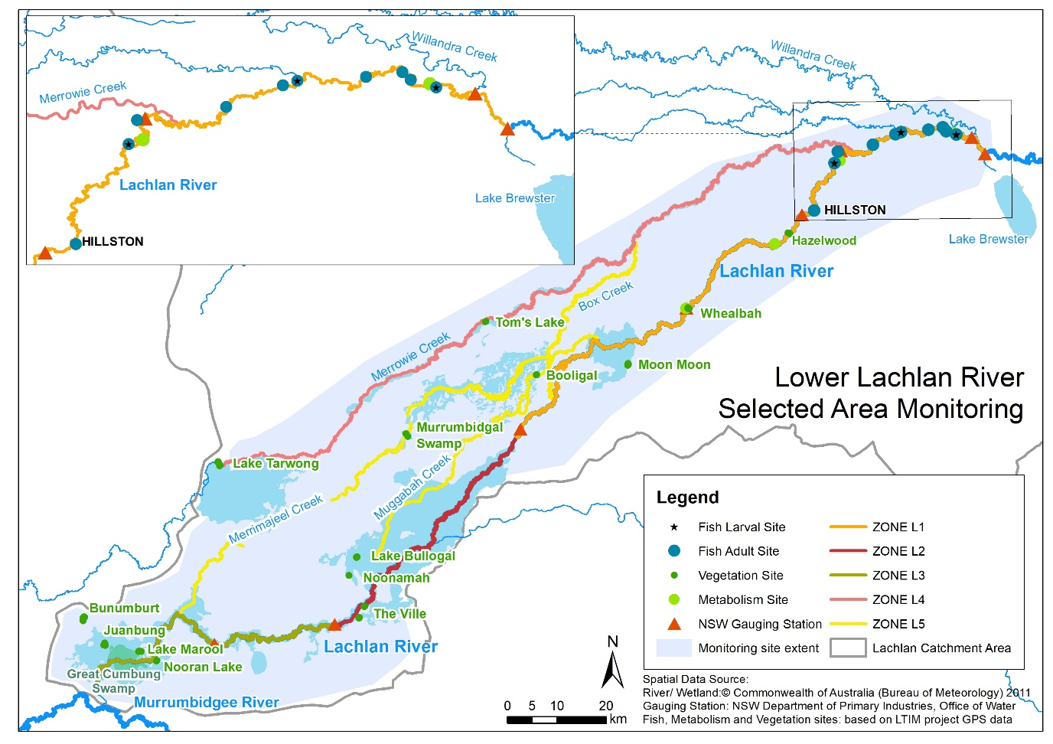

Figure 1‑1. The lower Lachlan river system showing the region for the LTIM Project and MER Program.

# Environmental watering in the Lachlan river system in 2020-21

The 2020-21 watering year was characterised by higher-than-average rainfall in the Lachlan river catchment which was in stark contrast to the extremely dry conditions faced in the two years prior. These wet conditions provided high soil moisture conditions and resulted in substantial inflows to the Lachlan River above and below the major storages such as Wyangala Dam. Inflows to Wyangala were sufficient to trigger the translucent flow rules which were administered as required under the Lachlan Regulated River Water Sharing Plan (<https://www.industry.nsw.gov.au/__data/assets/pdf_file/0010/204868/draft-appendix-a-amended-wsp-lachlan-regulated-river-water-source-2016.pdf>). Environmental watering actions under these conditions focused on making the most of the opportunities afforded by higher flows in the river.

Seven watering actions using Commonwealth environmental water were delivered to the Lachlan river system in 2020-21, six of which were delivered in combination with NSW environmental water Table 2‑1 and Table 2‑2). These watering actions used a total of 77,418 ML (42,162 ML of Commonwealth environmental water and 35,256 ML of NSW environmental water), with a further 173,000 ML of translucent flows delivered to the system. The first watering action was designed to deliver a spring fresh to Booberoi Creek following desilting works, targeting connectivity and habitat recovery. The remaining six watering actions were designed to inundate floodplain wetlands, providing and enhancing lateral connectivity, supporting vegetation and providing habitat for fish, frogs and birds. Two of these floodplain wetland inundation actions were delivered in association with translucent flow events, enabling environmental water to be used to target wetlands which are distal from the main river channel.

Table 2‑1. The 2020-21 joint Commonwealth and NSW environmental watering action – part 1.

| DESCRIPTION | DETAILS | | | |
| --- | --- | --- | --- | --- |
| Action | 1 | 2 | 3 | 4 |
| Target Asset | Booberoi Creek | Lachlan River channel;  Lower Lachlan River, main channel below Lake Brewster, terminating in the Great Cumbung Swamp | Fletcher’s Lake | Lachlan River channel;  Lower Lachlan River, main channel below Lake Brewster, terminating in the Great Cumbung Swamp |
| Reference | Water Use Minute 10081 (2019-20) | | | |
| Accounting Location | Booberoi Creek | Willandra Weir/Booligal | Fletcher’s Lake | Booligal |
| Flow component | Fresh flow (large fresh) | Wetland watering  Fresh flow | Wetland watering | Wetland watering  Fresh flow |
| Volume (CEW) | 977.5 ML | 23,261 ML | 300 ML | 13,860 ML |
| Volume (NSW) | 977.5 ML | 19,061 ML | 300 ML | 5,351.9 ML |
| Total Volume | **1,955 ML** | **42,322 ML** | **600 ML** | **19,211 ML** |
| Objectives | Primary:   * assist with habitat recovery after desilting works were completed; * support cultural values of the site; * maintain riparian and aquatic vegetation condition; * maintain connectivity with the Lachlan River; * maintain habitat for native fish; and * support cultural values and practices.   Secondary:   * maintain habitat for native birds and * maintain water quality. | Primary:   * consolidate outcomes and ecological objectives achieved by translucent flow event and 2019-20 flows (CEW Spring Pulse); * maintain floodplain vegetation, particularly the core reed beds of the Great Cumbung Swamp and black box community near back Bunumburt Lakes area; as well as numerous swamps and wetlands in the Lachlan Swamps extensive floodplain region that haven’t had water since 2016; and * maintain connectivity with the floodplain.   Secondary:   * maintain floodplain connectivity support native fish populations, and * maintain habitat for native birds and frogs. | Primary:   * maintain vegetation condition; * maintain refuge habitat for native birds and frogs; and * provide foraging habitat for waterbirds.   Secondary:   * Maintain floodplain connectivity. | Primary:   * consolidate the outcomes achieved from the August-September translucent flows event (see above); * enable higher flows to maintain connectivity with the floodplain for a long as possible; and * maintain floodplain vegetation, particularly the core reed beds of the Great Cumbung Swamp.   Secondary:   * support native fish populations; and * maintain habitat for native birds and frogs. |
| Basin Watering Priorities | Support lateral and longitudinal connectivity along the river system.  Support Basin-scale population recovery of native fish by reinstating flows that promote key ecological processes across local, regional and system scales in the southern connected Basin.  Support viable populations of threatened native fish, maximise opportunities for range expansion and establish new populations.  Avoid critical loss and (where possible) improve vegetation condition in areas where drought conditions persist. | Support lateral and longitudinal connectivity along the river system.  Maintain core wetland vegetation and refuges.  Avoid critical loss and (where possible) improve vegetation condition in areas where drought conditions persist.  Support Basin-scale population recovery of native fish by reinstating flows that promote key ecological processes across local, regional and system scales in the southern connected Basin. | Support lateral and longitudinal connectivity along the river system.  Protect drought refuges.  Avoid critical loss and (where possible) improve vegetation condition in areas where drought conditions persist. | Avoid critical loss and (where possible) improve vegetation condition in areas where drought conditions persist.  Support lateral and longitudinal connectivity along the river systems.  Support Basin-scale population recovery of native fish by reinstating flows that promote key ecological processes across local, regional and system scales in the southern connected Basin. |

Table 2‑2. The 2020-21 joint Commonwealth and NSW environmental watering action – part 2.

| DESCRIPTION | DETAILS | | |
| --- | --- | --- | --- |
| Action | 5 | 6 | 7 |
| Target Asset | Lake Brewster | Noonamah black box woodlands | Lachlan River channel;  Lower Lachlan River, main channel below Lake Brewster, terminating in the Great Cumbung Swamp |
| Reference | Water Use Minute 10081 (2019-20) | | |
| Accounting Location | Lake Brewster | Noonamah | Booligal |
| Flow component | Wetland/floodplain inundation | Wetland watering  Fresh flow | Wetland watering |
| Volume (CEW) | 993.5 ML | 164 ML | 2,606 ML |
| Volume (NSW) | 993.5 ML | 0 | 7,800 ML |
| Total Volume | 1,987 ML | 164 ML | 10,406 ML |
| Objectives | Primary:   * consolidate/ ensure outcomes sought from early season use are achieved; * seeks to support a small Australian Pelican breeding colony to completion; and * enable aquatic plants to complete their full life cycle to provide future seed reserves.   Secondary:   * provide foraging habitat for large number and diverse range of waders, including migratory species, sharp-tailed sandpiper and threatened species such as blue-billed duck. | Primary:   * maintain vegetation condition; * maintain refuge habitat for native birds and frogs; and * provide foraging habitat for waterbirds.   Secondary:   * maintain floodplain connectivity. | Primary:   * consolidate outcomes and ecological objectives achieved by earlier translucent flow events; * enhance flow variability and to repeat components of the 2019-20 autumn pulse but at a high flow rate to determine if a higher pulse improves the productivity in the river. This in turn would potentially support juvenile native fish, including golden perch detected in the river for the first time in the history of LTIM/MER in spring 2020-21; and * consolidate the outcomes achieved from the two earlier translucent flows event (see above).   Secondary:   * maintain floodplain vegetation, particularly the core reed beds of the Great Cumbung Swamp; and * maintain habitat for native birds and frogs. |
| Basin Watering Priorities | Improve the abundance and maintain the diversity of the Basin’s waterbird populations.  Avoid critical loss and (where possible) improve vegetation condition in areas where drought conditions persist. | Support lateral and longitudinal connectivity along the river system.  Protect drought refuges.  Avoid critical loss and (where possible) improve vegetation condition in areas where drought conditions persist.  Improve the abundance and maintain the diversity of the Basin’s waterbird populations. | Support lateral and longitudinal connectivity along the river system.  Support Basin-scale population recovery of native fish by reinstating flows that promote key ecological processes across local, regional and system scales in the southern connected Basin.  Avoid critical loss and (where possible) improve vegetation condition in areas where drought conditions persist. |

# Key outcomes from environmental water use

## Monitoring

The seven environmental watering actions delivered in 2020-21 were designed to provide water that would maximize the outcomes that could be achieved from the translucent flow events. In combination, these watering actions used 42,162 ML of Commonwealth environmental water. The watering actions were specifically designed to:

1. Provide lateral and longitudinal connectivity to benefit native vegetation and provide habitat for water dependent species (all watering actions except watering action 5)
2. Benefit native fish condition and stimulate stream productivity by modifying the flow regime to create specific in-channel hydrological conditions (Action 7)

By supporting lateral and longitudinal connectivity, maintaining the extent and condition of native vegetation, providing habitat for native waterbirds and supporting populations of native fish these watering actions contributed to the watering priorities for the Murray-Darling Basin Authority (MDBA 2019).

### Provide lateral and longitudinal connectivity to benefit vegetation and provide habitat

Three approaches to providing hydrological connectivity were implemented in 2020-21. These were 1) extend the duration of the translucent flows to increase the extent and duration of floodplain-wetland inundation; 2) provide freshes for targeted parts of the river system; and 3) use landholder infrastructure to pump water to key wetland assets.

#### Extend the duration of translucent flows

Watering actions two and four extended the duration of the translucent flows in August and November (Table 2‑1) thus increasing the extent and duration of floodplain-wetland inundation. In doing so, these actions maintained the connection between the river channel and the floodplain, providing water to locally important wetlands and contributing to the provision of habitat for water dependent species.

Watering Action 2 extended the duration of the translucent flow at Willandra Weir by approximately 26 days (Figure 3‑1). This included 6 days above 3,000 ML/day which pushed water through Whealbah Lagoon, Moon Moon Swamp and associated overflow swamps such as Gum Lake, the larger Torriganny system wetlands (Main Swamp), Lachlan River wetlands between Whealbah and Booligal (Lilydale wetlands) and Willandra and Middle creek systems above Hillston. These wetlands provide important habitat for water dependent species and includes locations that have supported colonial bird breeding during previous floods.

By extending the duration of the translucent flow at Willandra Weir, this watering action also met the environmental water requirement for Middle Creek to flow (>2,600 ML for around 35 days)[1]. Without the use of environmental water, such flows would not have been possible.

Watering Action 4 doubled the duration of a shorter translucent event (Figure 3‑1) and in doing so it refreshed habitats inundated by the earlier combined use of translucent flows and NSW and Commonwealth environmental water. The second pulse of water to floodplain wetland habitats provided the additional water that would enable species using those habitats to either complete life cycle requirements (e.g. extend hydro-period for frogs) or access resources to improve condition.

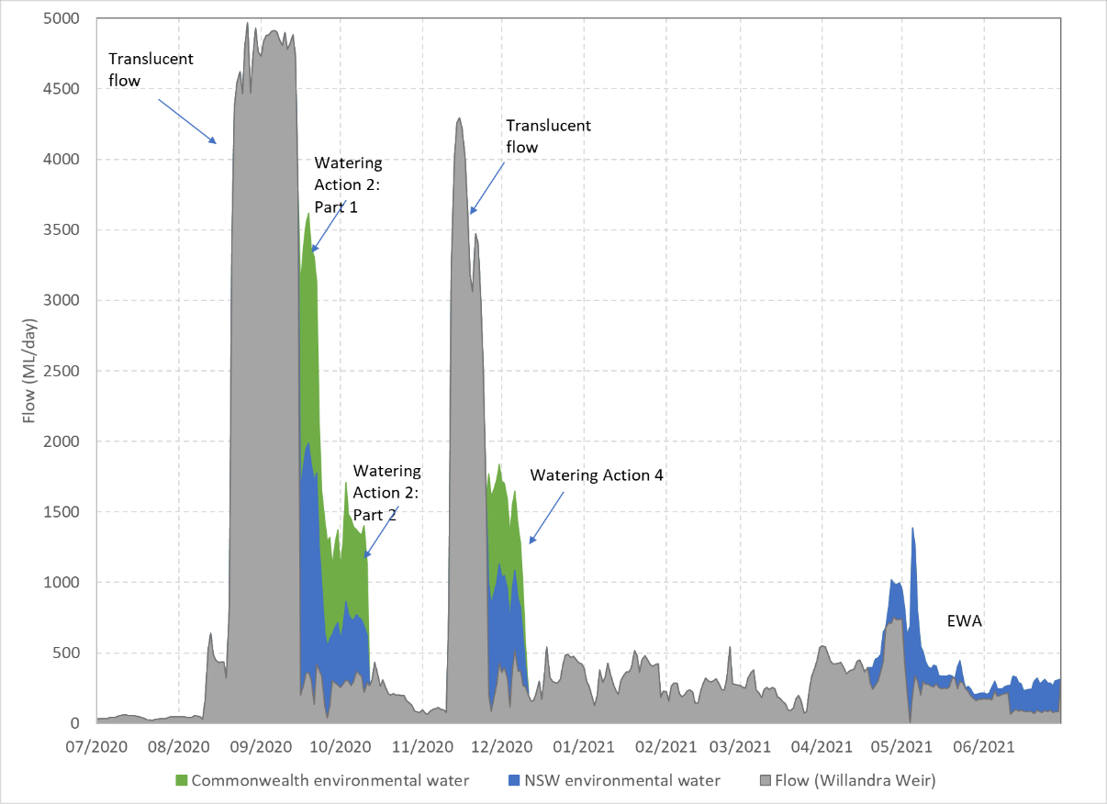

Figure 3‑1. Flows at Willandra Weir for the period 1st of July 2020 to 30th of June 2021 showing Watering Action 2 and an estimate of Watering Action 4.

Commonwealth (green) and NSW (blue) environmental water is shown along with estimates of river flow (flow including the licensed delivery of water but not including environmental water) in grey.

The additional duration of both longitudinal and lateral hydrological connection generated by Watering Actions 2 and 4 was particularly evident in the lower part of the system from Booligal (Figure 3‑2) through to the Great Cumbung Swamp, where environmental water contributed to the inundation of a range of floodplain habitats, including tall emergent marsh, river red gum and black box woodlands, lignum shrublands and open temporary lakes, which are frequented by a diverse assemblage of native birds and other animals. It is notable that floodwaters inundated an extensive area of the reedbed of the Great Cumbung Swamp including reeds which had not been flooded for at least four years. In doing so, it contributed to the provision of aquatic habitat for water dependent species.

Figure 3‑2. Flows at Booligal for the period 1st of July 2020 to 30th of June 2021 showing estimates of Watering Actions 2, 4, 6 and 7.

Commonwealth (green) and NSW (blue) environmental water is shown along with estimates of river flow (flow including the licensed delivery of water but not including environmental water) in grey.

The use of Commonwealth environmental water, in combination with NSW environmental water to augment translucent flows, extended the duration of flooding and meant that wetlands that are not usually able to receive environmental water, were watered. Lake Bullogal and Lake Tarwong are important off-channel terminal wetlands that support a range of aquatic and amphibious plant species as well as providing habitat for waterbird species in an otherwise dry landscape. These sites are difficult to water deliberately, requiring a long duration above flow thresholds. The strategic use of environmental water in 2020-21, enabled these sites to receive water which resulted in a substantial response in vegetation, providing opportunities for species to germinate, grow and reproduce. This represents an excellent way to achieve vegetation outcomes in the landscape that cannot otherwise be achieved with held environmental water alone.

#### Provide freshes

The first watering action provided a large spring fresh to Booberoi Creek in October 2020 to provide habitat for native fish and water plants. This watering action was designed to restart flow in the river and recover habitat that had been dried during de-silting works. This large fresh increased water levels by approximately 0.6 m, wetting up in-channel habitat and re-starting flow in the river, re-connecting it to the main channel.

The seventh watering action built on the use of the NSW Environmental Water Allowance and provided flow variability in the Lachlan River channel between Lake Brewster and the Great Cumbung Swamp. While this fresh didn’t quite meet the targeted 650 ML/day at Booligal, it increased the water level in the channel at Booligal by around 0.15 m, likely inundating in-channel habitats and providing a small pulse of water to the Great Cumbung Swamp.

#### Pump water to key wetland assets

Watering Actions three and six used private infrastructure to pump water to Fletcher’s Lake and Lake Noonamah and the surrounding black box wetlands. These watering actions were designed to support vegetation in and around the wetlands and provide habitat for waterbirds and frogs. Fletcher’s Lake is not monitored as part of the Flow MER program, but incidental waterbird observations confirmed the use of the created aquatic habitat by red-necked avocets and red-capped plovers.

Lake Noonamah continues to support an outstandingly rich and productive vegetation community (Figure 3‑2) and has received small volumes of pumped environmental water over the past 3 years. The provision of environmental water to this lake toward the end of the 2021 watering season, will enable the aquatic and amphibious species recorded at this site to flourish.

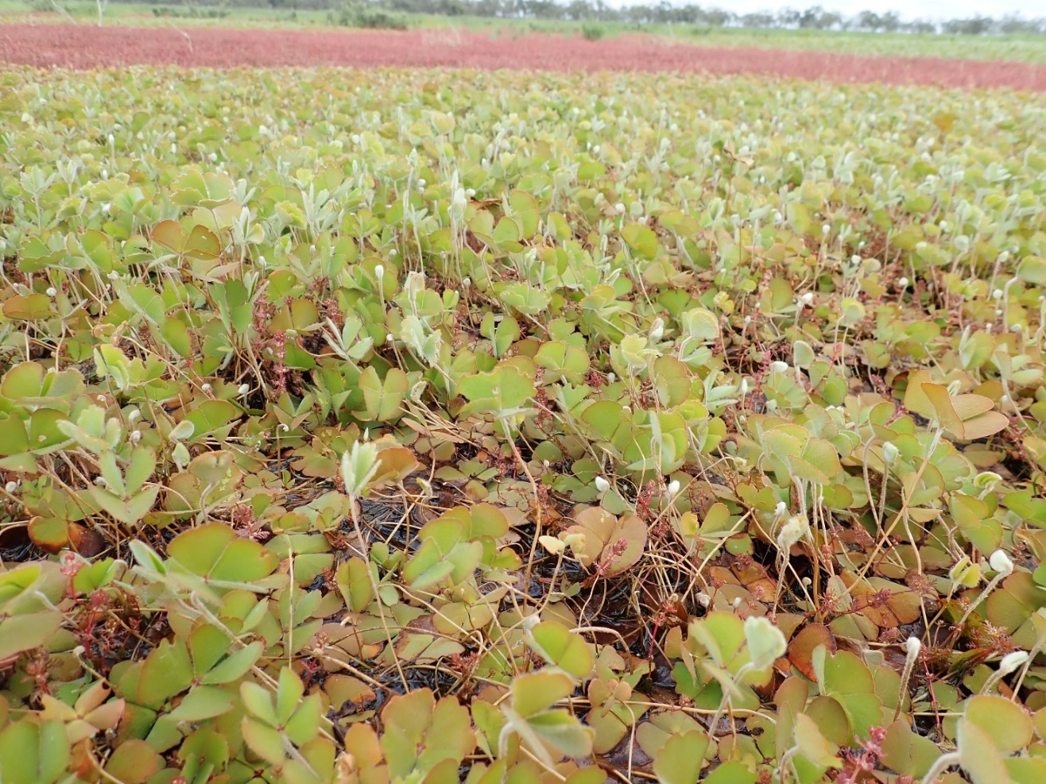

Figure 3‑2. A carpet of Nardoo at Lake Noonamah, November 2020. Photo: Will Higgisson

### Supporting native fish condition and stimulating productivity

The seventh watering action for 2020-21 was designed to improve variability in flows, benefit native fish condition and stimulate stream productivity by providing a fresh into the lower Lachlan River channel. This watering action built on the use of NSW Environmental Water Allowance to provide a 20-day Autumn pulse from the start of May at Booligal with a peak discharge just short of the large fresh requirements for the river at Booligal. The timing of this action was late in the season to provide a productivity pulse to support juvenile native fish, including juvenile golden perch which had been detected in the river for the first time in seven years of monitoring.

The fresh was delivered to the lower river system as water temperatures were around 15 degrees and declining. It resulted in a change in river levels of between 0.15 m and 0.3 m between Brewster Weir and Booligal inundating small amounts of in-channel habitat. Unfortunately monitoring data are unavailable for this period because of COVID restrictions on field work, but similar previous events have generated a small increase in productivity, and it is likely that this event will have produced a similar response. The late autumn fresh built on the significant productivity pulses that occurred in the river system following the translucent events (Figure 3‑3).

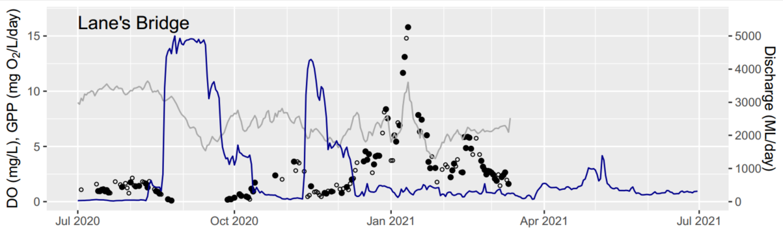

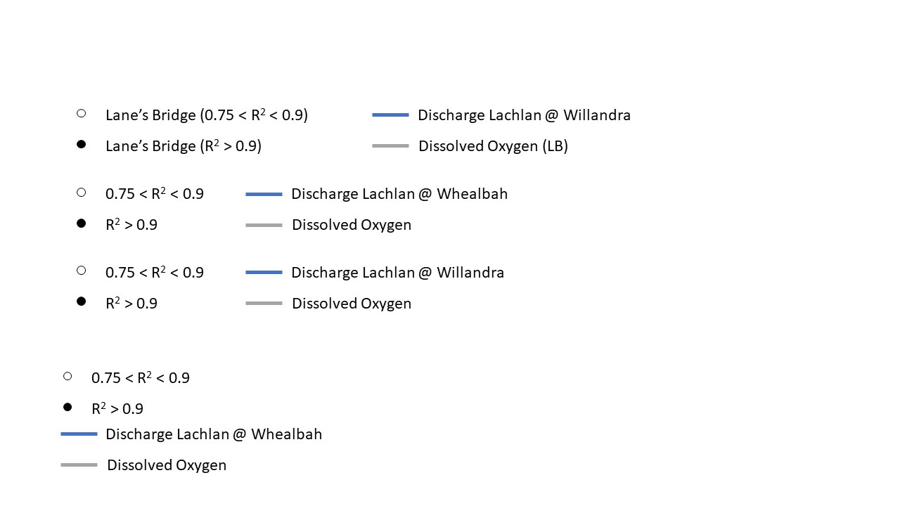

Figure 3‑3. *Gross primary production (GPP),* from site Lane’s Bridge in the lower Lachlan River in 2020-21. Blue shaded vertical bars indicate watering actions.

### Evaluation questions

This was the seventh year of a program established to answer specific questions about ecological responses to environmental watering in the lower Lachlan river system. Stream flow (hydrology), stream metabolism and water quality (temperature, pH, dissolved oxygen, turbidity, conductivity, concentrations of nitrogen and phosphorus), fish (including larval fish) and the condition and diversity of vegetation were monitored to evaluate the outcomes of Commonwealth watering actions. The evaluation questions and responses for the monitored indicators are summarised in Table 3‑1 .

Table 3‑1. Evaluation questions and responses for the lower Lachlan river system Selected Area.

| INDICATOR | EVALUATION QUESTION  What did Commonwealth environmental water contribute .. | RESPONSE |
| --- | --- | --- |
| Hydrology | .. to habitat for a range of water dependent species? | All seven watering actions contributed to habitat either within channel or on the floodplain:   * Watering action 1 provided a spring fresh to Booberoi Creek that provided flows above 150 ML/day for 14 days. * Watering actions 2 and 4 built on the translucent flows to increase the extent and duration of inundation on the floodplain, including locally important floodplain wetlands and areas of the Cumbung Swamp that had not been flooded for at least four years as well as enabling Middle Creek to flow * Watering action 3 provided water to Fletchers Lake * Watering action 5 provided habitat for native waterbirds and aquatic vegetation at Lake Brewster * Watering action 6 provided water to Noonamah wetland. * Watering action 7 increased baseflows at Booligal providing greater access to refuge habitat for native fish and southern bell frog. |
| .. to hydrological connectivity? | The watering actions delivered in 2020-21 connected in-channel habitats, provided extensive lateral connectivity between the channel and the floodplain and provided flow to the end of the river system. In particular:   * Watering action 2 extended the duration of the translucent flow at Willandra Weir enabling Middle Creek to flow * Watering actions 2 and 4 extended the duration of floodplain connection for locally important wetlands including:   + Whealbah Billabong: extending connection for 5 days   + Moon Moon Swamp: extending connection for 8 days   + Gum Swamp, Eagles Nest and Main swamp on the Torriganny system: extending connection for 25 days   + Open water wetlands at Booligal: extending connection for 10 days   + The Great Cumbung Swamp: extending connection for at least 30 days * Watering Actions 3 and 6 connected off channel habitats by providing water to Fletcher’s Lake and Noonamah wetland |
| Water Quality and Stream Metabolism | .. to primary production in the lower Lachlan River? | Primary productivity responses were dominated by the two translucent flows that generated the highest primary productivity recorded for the Lachlan in the seven years of monitoring. |
| .. to water quality outcomes? | There was no evidence that environmental watering events had large effects on water quality, but the data were limited because of access restrictions caused by Covid-19. Smaller responses included:   * Lower turbidity following Watering Action 4 consistent with dilution of fine sediment. * Some evidence for the mobilization of organic matter and associated nutrients across the translucent events |
| .. to patterns and rates of ecosystem respiration (decomposition - ER) and primary productivity (GPP)? | The patterns were dominate by the large translucent events in spring and summer that generated a large GPP response and a small increase in ER. |
| Fish - community | *Short-term (one yr)* | |
| .. to native fish community resilience and survival? | In 2021, resilience and survival of the lower Lachlan River native fish community was maintained or improved compared to previous years as a result of hydrological conditions, including Commonwealth environmental water. Recent recruits of both native and exotic species were captured with the management of water appearing to benefit native fish spawning and recruitment in 2021, including Murray cod and golden perch. SRA recruitment metrics were at their highest level or within normal ranges in 2021. |
| *Long-term (five yrs)* | |
| .. to native fish populations and diversity? | The lower Lachlan native fish population was most affected by fish kills in 2016–2017 during LTIM years, which reduced the biomass of large-bodied Murray cod in 2017 and promoted the spawning and subsequent recruitment of common carp. This significant event likely masked other effects on the fish community over the study period. Commonwealth environmental watering actions may have contributed to the post-kill recovery of native fish populations in recent years, however it is unknown if this recovery would have differed without it. |
| .. to native fish diversity? | The lower Lachlan River native fish diversity has increased to 8 native species in 2021, with the additional detection of silver perch, which was an increase from 7 in 2015 to 2017 and in 2020. SRA expectedness metrics were at equal highest levels in 2021 compared to previous years. The temporary decline in native fish abundance over the sampling period may relate to an increase in alien common carp recruitment associated with flow pulses in late 2020. The role of Commonwealth environmental water in the restoration of native fish diversity in the lower Lachlan River is again difficult to ascertain. |
| Fish - reproduction | *Short-term (one yr)* | |
| .. to native fish reproduction in the Lower Lachlan river system? | In 2020 Commonwealth environmental water appears to have made a positive contribution to the spawning and early recruitment of small bodied species and to that of golden perch in the lower Lachlan River system. Monitoring in 2020 indicates that production of small bodied larval fish was relatively high and that for the first time since monitoring began in 2014, golden perch spawning and recruitment was detected. The timing of the first translucent pulse looks to have been ideal for providing conditions conducive to flat headed gudgeon and carp gudgeon spawning and recruitment. The combination of the two translucent pulses appears to have been conducive to golden perch spawning, with the first pulse acting as a primer and spawning occurring in association with the second pulse. |
| .. to native larval fish growth in the Lower Lachlan river system? | Impossible to answer definitively with current analysis, but changes in length frequency between sampling trips suggests that the growth of both Australian smelt and flat headed gudgeons were supported with the water management regime in spring 2020. |
| *Long-term (five yrs)* | |
| .. to native fish populations in the Lower Lachlan river system? | The spring pulses in 2020 resulted in the only natural recruitment event for golden perch in the lower Lachlan River system since monitoring began. The combination of the two translucent pulses provided the appropriate cues and conditions for spawning and recruitment to juveniles to occur. It is hoped that this recruitment event will support the population until the next set of conditions are present for a subsequent spawning event. The first translucent pulse also provided suitable cues for strong spawning and recruitment response from small bodied native fish (flat headed gudgeon and carp gudgeon). |
| .. to native fish species diversity in the Lower Lachlan river system? | The main mechanism for Commonwealth environmental water to contribute to native fish species diversity in the Lower Lachlan River system thus far has been to facilitate spawning and to produce sufficient resources for larval fish growth and survival. As mentioned above, the pulses in 2020 has resulted in the first recruitment event for golden perch since monitoring began in 2014. This is a significant result for the catchment and likely provides a blueprint for which to attempt to elicit a spawning response of golden perch in future years. The flow pulses also provided suitable conditions for strong recruitment of small bodied native fish, flat headed gudgeon and carp gudgeon. Significant recruitment year for Murray cod in the selected area, as well as supporting spawning and early growth of small bodied larval fish species (albeit to a smaller scale than the previous two years). |
| Vegetation | *Short-term (one yr) and long-term (five yrs)* | |
| .. to vegetation species? | Commonwealth environmental watering actions in 2020-21 have made an important contribution in maintaining the richness and cover of plant species in the lower Lachlan River Catchment. Sites which received environmental water in the 2020-21 watering year had a more diverse and abundant assemblage of native Amphibious species compared to sites which did not receive environmental water. Further, sites which have received Commonwealth environmental water regularly (sites in watering category C) over the past seven years are the most species rich, demonstrating that the regular use of Commonwealth environmental water has resulted in a richness of plants species at these sites.  Commonwealth environmental water was used, in combination with NSW environmental water to augment translucent flows, extending the duration of flooding which meant that wetlands that are not usually able to receive environmental water, were watered (particularly Lake Bullogal). This resulted in a substantial response in vegetation, providing opportunities for species to germinate, grow and reproduce. This represents an excellent way to achieve vegetation outcomes in the landscape that cannot otherwise be achieved with held environmental water alone. |
| .. to vegetation community diversity? | The seven watering actions delivered in 2020-21 have maintained the species richness, composition and cover of the plants which make up a diversity of groundcover vegetation communities. The watering actions provided water to a diverse range of vegetation communities and ANAE vegetation types in the lower Lachlan River catchment.   * Watering actions two and four which coincided with translucent flow events in August and December 2020 inundated a diverse range of ANAE vegetation types within the lower Lachlan River. These include intermittent river red gum floodplain swamps, temporary floodplain lakes, intermittent black box woodland floodplain swamps and temporary tall emergent floodplain marsh. * Watering action five provided water to Lake Brewster and provided hydrological conditions to enhance reproduction of aquatic plants. |
| .. to condition of floodplain and riparian trees? | Tree stand and condition data are now collected and reported every 5 years. |
| *Long-term (five yrs)* | |
| .. to populations of long-lived organisms? | Tree stand and condition data are now collected and reported on every 5 years. |

## Research

The reedbeds of the Great Cumbung Swamp are an important asset in the Lachlan river catchment. They are listed in the Directory of Important Wetlands in Australia and specifically mentioned in the MDBAs Basin-wide Environmental Watering Strategy, which specifies key objectives to maintain the current extent and increase periods of growth for stands of common reed and cumbungi in the Great Cumbung Swamp (MDBA 2014). The Great Cumbung Swamp has been targeted with environmental water multiple times over the past five years, receiving environmental water from whole of system watering events that deliver water to this terminal wetland system. Over the past five years, monitoring of the site has primarily involved the use of satellite imagery to track the progress of water but has not directly monitored the response of the reeds, because of the difficulties and costs involved in monitoring.

Using a range of new technologies, including drones and high-resolution satellite data, the Lachlan MER team is developing techniques to monitor the reedbeds that are practical and cost effective. This research aims to determine:

* What are the key indicators of condition for reedbeds that can be measured easily and cost effectively using remotely sensed techniques?
* What is an appropriate monitoring program for stands of common reed and cumbungi and their response to watering?

The research which commenced at the end of 2019 involved on-ground field-based data collection and data collection from drone imagery. During 2020-21, the focus has been on the development of an approach using the deep machine learning technique Convoluted Neural Networks (CNN) on drone imagery collected from field visits to the reedbed of the Great Cumbung Swamp. This machine learning technique provides a powerful computational tool to extract information from each image based on the morphology of the plants and other landscape features. Using the information extracted from the drone images, machine learning enables the classification of different feature classes such as a plant species, water or bareground. This can then be used to estimate the cover and extent of reedbed features in the landscape, an important component of identifying the response of the reeds to inundation.

This research has demonstrated a relatively cost-effective, safe, efficient and high accuracy method to estimate cover and extent of reedbed features in a semi-arid wetland using drones and machine learning CNNs. The research has been published here: <https://onlinelibrary.wiley.com/doi/10.1002/rra.3832>.

The development of this approach included the collection of data that has provided insight into the use of environmental water for supporting the central reedbed of the Great Cumbung Swamp. Sites in the Great Cumbung Swamp which received environmental water multiple times over the two years prior to monitoring had a greater cover compared to sites that only received a single environmental watering event. In addition, sites that had not been managed with environmental water since natural flooding in early 2017 had a very low cover of (short) reeds and much higher cover of other vegetation. This demonstrates that the regular use of environmental water to the central reedbed has maintained the cover and condition of the reeds in these parts of the Great Cumbung Swamp.

## Communications and Engagement

Under the MER Program, the lower Lachlan River Selected Area has resources dedicated to Communication and Engagement (C&E) that support two streams of activities. The first is operational project communication which relates to the activities associated with the delivery of the core monitoring and evaluation component of the MER Program. This involves the project team, the CEWO, key water delivery stakeholders and other operational stakeholders. The second is external communication and engagement which involves stakeholder groups outside of the delivery of the MER Plan and includes landholders, affected communities and the general public.

Our external communication activities are designed to ultimately influence attitudes toward the use of environmental water in the Lachlan Catchment. These activities include developing communication products, community events, local media and supporting local citizen science.

Continuing the success of our redeveloped Quarterly Outcomes Newsletter distribution of printed copies commenced in 2020 to communities in the mid and lower Lachlan. In each quarter, 80 copies of the newsletter were printed, with 20 copies each allocated to the local communities of Condobolin, Lake Cargelligo, Hillston and Booligal. The printed copies have been made available to local communities through libraries, Local Land Services offices, community hubs (for example Lower Lachlan Community Services) and informal networks (Figure 3‑4).

Figure 3‑4. Cover images of Lachlan River MER Quarterly Outcomes newsletters 2020-21.

While community events were curtailed because of the COVID-19 pandemic, in 2020-21 the MER Program still managed to participate in a range of local activities including sampling demonstrations, presentations, a variety of Aboriginal engagement activities and landholder meetings.

The relationship with the Down the Track program for disadvantaged youth in Lake Cargelligo has continued with environmental education weekends held for its/their Aboriginal clientele and this has followed the model established in previous years (ie: an overnight camping trip with bird/vegetation/fish sampling and boat transport to and from an island). A highlight of this was an overnight camping and surveying trip to Robinson Crusoe Island (in the middle of Lake Cargelligo) led by Dr Fish (Adam Kerezsy) and featuring Dr Will Higgisson and Mr Jack Livingston from the University of Canberra to talk about the importance of water plants in the region. It is hoped that these events will become a regular part of the Flow MER activities, providing a unique opportunity for engagement and learning.

A significant component of the Lachlan MER communication and engagement activities has been supporting water quality monitoring by the Lake Cargelligo, Booberoi Creek and Murrin Bridge Waterwatch teams. This has seen a number of people from a wide range of community sectors trained in measuring water quality, with a focus on recording dissolved oxygen concentrations as this was identified as a gap in the surveillance monitoring that was being undertaken in the catchment and of direct relevance to water management decisions. These areas are not routinely monitored by the Lachlan MER teams or other government efforts and thus contributes data for unmonitored areas.

In 2020-21, rainfall events and high flows after an extended dry period resulted in widespread concern of increased risk of hypoxic (low oxygen) blackwater events occurring and/or algal blooms, and localised fish kills. A local drought–blackwater group was convened in the Lachlan catchment and active monitoring of dissolved oxygen conditions were commenced. The MER Waterwatch Team conducted specific monitoring to inform the Lachlan blackwater groups management of potential hypoxic (low oxygen) conditions at Lake Cargelligo Weir, and below the Lake Brewster storage, augmenting the monitoring network in the catchment and providing real-time input to decision making through local surveillance.

# Implications for future management of environmental water

The 2020-21 monitoring and evaluation completes seven years of the LTIM and MER programs in the Lower Lachlan river system. Collectively, monitoring and evaluation information from the seven years can be used to guide the future management of environmental water. In the following sections, specific learnings from 2020-21 are provided as well as cumulative learning that builds on the previous years. In combination, these provide a set of recommendations that inform the future management of environmental water.

## Delivering environmental water when it is wet: maximising possible outcomes

In contrast to the 2019-20 watering year, the use of environmental water in 2020-21 occurred with high resource availability and wet conditions across the catchment. Planning had been conducted within the context of extreme drought with a focus on avoiding severe damage and loss in the catchment. The above average rainfall that occurred required a significant and rapid shift in planning to one that would maximise the use of environmental water under wet to very wet conditions. The wet conditions and significant inflows into Wyangala Dam triggered translucent flow rules and water managers looked to maximise the outcomes that could be achieved using the translucent flow events. This required an agility among decision makers and advisors, often requiring decisions to be made quickly and courageously. A deliberate part of the management was to use the opportunity afforded by the wet conditions to build understanding of the flow-inundation relationships in the lower Lachlan floodplain wetland environments to better inform future watering actions. As a consequence, seven watering actions were delivered targeting a range of in-channel and off-channel ecological objectives and assets. Watering actions were complex, with multiple delivery points within a single action, making accounting difficult and reporting challenging. The outcomes from such a creative and agile approach to the use of environmental water under wet conditions have been significant and the learning will inform water use well into the future.

The use of Commonwealth environmental water in combination with NSW environmental water to augment translucent flows, extended the duration of flooding and meant that wetlands that are not usually able to receive environmental water were watered. Lake Bullogal and Lake Tarwong are important off-channel terminal wetlands that support a range of aquatic and amphibious plant species as well as providing habitat for waterbird species in an otherwise dry landscape. These sites are difficult to water deliberately, requiring a long duration above flow thresholds which often makes them impossible to support using small volumes of held environmental water. The strategic use of environmental water in 2020-21, enabled these sites to receive water which resulted in a substantial response in vegetation, providing opportunities for species to germinate, grow and reproduce and maintained functioning and diverse vegetation assemblages. This represents an excellent way to achieve vegetation and habitat outcomes in the landscape that cannot otherwise be achieved with held environmental water alone.

Prior to the watering, the open water sections of Lake Tarwong had been observed to be being colonised by red-gum seedlings. These were of sufficient height to require flooding soon to kill them or lose the open water habitats which are important to waterbirds in the region. The opportunity provided by the wetter conditions to provide a significantly longer duration of flooding than would be achieved with the translucent flows alone completely inundated the red gums and has provided the best opportunity for retaining the open water habitats (Figure 4‑1). Future monitoring will determine the success, but preliminary observations are positive.

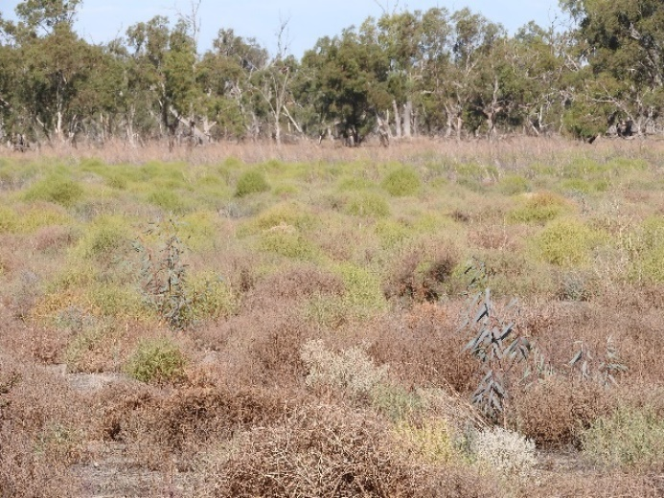 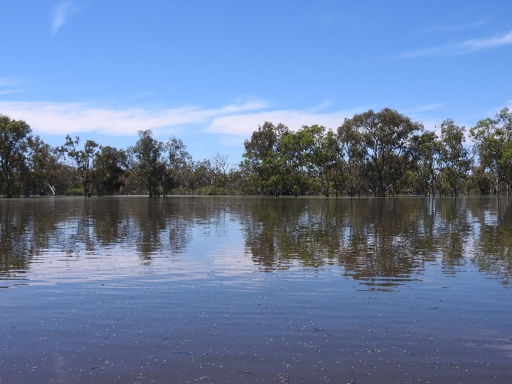

Figure 4‑1. Open section of Lake Tarwong in May and November 2021. Photo: Alica Tschierschke

Translucent flows in 2020-21 provided significant ecological outcomes and are an important component of the environmental management of the Lachlan River system. It is recommended that the approaches to managing environmental water delivery in the river during wet years continue the approach of building on the opportunities provided by translucent events to maximise environmental outcomes and learning.

## The ‘ups and downs’ of fish responses

Golden perch are a species of significance in the Lachlan catchment, but seven years of monitoring in the catchment has failed to find evidence of natural recruitment in the river system and it was thought increasingly likely that the population was being supported solely by stocking. Attempts to generate golden perch movement and spawning responses using environmental water following a translucent flow in 2015-16 had failed. Learning from that experience had established the importance of coinciding flows and water temperatures as well as the need for a flexible and responsive process for delivering environmental water.

The August 2020 translucent flows were watched carefully by water managers conscious of the opportunity to deliver an environmental water event that may trigger the movement and spawning of golden perch. The second translucent event, occurring in November 2020, was thought ideally placed to trigger spawning and no additional flow pulses were provided, removing the need to provide a spawning pulse and providing a substantial opportunity to learn. In spring 2020, golden perch larvae were detected in the larval fish monitoring and in the following February, adult fish monitoring detected golden perch young of year at multiple sites in the river. This indicated that the combination of the two translucent pulses in 2020 were suitable to elicit a spawning and recruitment event for golden perch for the first time since monitoring began in 2014. More importantly, conditions were suitable for these larval fish to become young of year.

Ageing of the larval fish and two of the juvenile golden perch suggested that there may have been two spawning events for golden perch: one in early November on the rising limb of the second translucent flow and one in mid-December (Figure 4‑2).

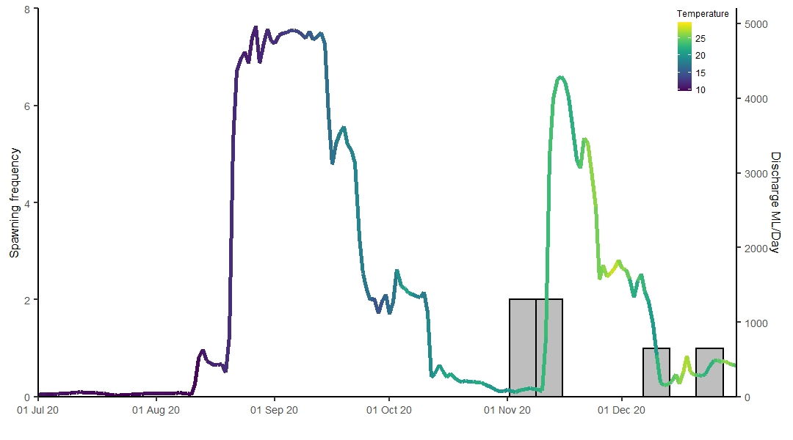

Figure 4‑2. Estimated golden perch spawning in the Lachlan River system in 2020-21. November spawning dates were estimated from larval fish captures, December spawning dates were estimated from juvenile fish captures.

The successful golden perch spawning and recruitment in 2020-21 suggests that the flow patterns observed can be used to inform future environmental water releases to support golden perch in the catchment. Future delivery of flow pulses aiming to result in golden perch spawning and recruitment should mimic as closely as possible the hydrological patterns of 2020 (recognising that e-water releases are unlikely to deliver the volumes of translucent flows), with multiple large flow pulses, a maximum of 30 days between pulses, and all pulses delivered prior to water temperatures reaching 25⁰C considered critical.

In contrast to the success of golden perch spawning, Murray cod larval abundances were very low in 2020. It is likely that a combination of high flows and falling river levels of the first translucent flow, which occurred during peak Murray cod spawning season, resulted in nest abandonment and /or egg desiccation and/or eggs being washed from nests prematurely by high water velocities. Murray cod populations in the lower Lachlan River were adversely affected by the 2016-17 flooding and have slowly been recovering in the intervening years. While the conditions provided in 2020-21 resulted in an improvement in juvenile Murray cod numbers, the lack of a good spawning in 2020 is likely to limit the possible improvements in the population in subsequent years. While the wet conditions across the catchment constrained the spring and early summer management of the flow pulses, where possible the CEWO aims to avoid delivering large flow pulses between mid-September and mid-October, and reduce the rate of fall of spring pulses if the falling limb occurs during the peak Murray cod spawning window (mid-September – mid-October).

## Harnessing the power of local people: community-based monitoring

Over the past 2.5 years, people from a wide range of community sectors have joined in the MER community-based water quality monitoring program. Members have been trained in measuring water quality and have then conducted routine monitoring as an independent local unit and with DPIE–EES delivery staff and sub-contractors during event-based monitoring. In doing so, these teams have made a notable contribution to the decision making associated with environmental watering actions.

The development and support of the Waterwatch teams within the mid Lachlan system has enabled the program to connect with local community members and has produced valuable data that has informed the management of environmental water in the region. In doing so, it meets the objectives of raising awareness, developing local champions, having a skilled local team available to be an early warning network and collecting data that informs the management of water within the Lachlan catchment. The program has also provided valuable opportunities for casual employment in the region, thus contributing to local communities as well as the objectives of the CEWO.

The program has been collecting regular data from the mid-Lachlan River in the vicinity of Murrin Bridge and at various locations in Booberoi Creek for the past 2 years. In the 2020-21 watering year, routine sites were added along the Lachlan River above and below Lake Cargelligo weir and outlet channel in response to an operational need. The Waterwatch teams also provided important local knowledge and data collection that informed the management of hypoxic blackwater as well as helping the water management teams to understand the possible development of a blue-green algae and hypoxic blackwater event in Mountain Creek (Figure 4‑3). In 2020-21, the data from this program has been incorporated into the Flow MER technical reporting.

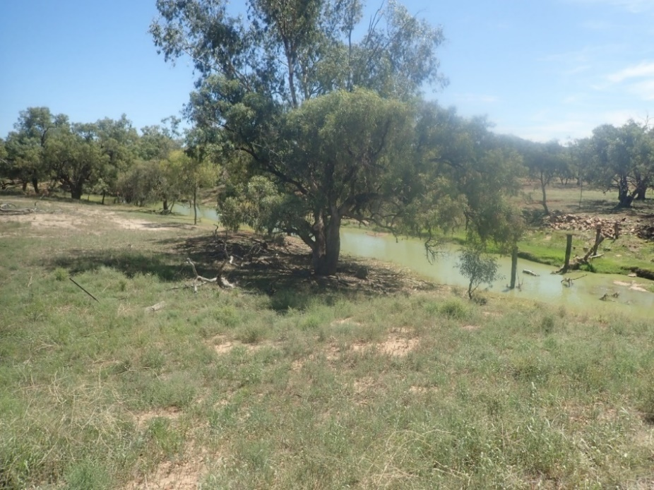

Figure 4‑3. Imagery provided by Waterwatch Team in relation to Blue Green Algal (BGA) alert.

Left: 7th January 2021 confirming the source of BGA was Lake Brewster storage system via the outlet channel in Mountain Creek. Right: 17th January, two weeks after initial BGA alert.

The monitoring that is undertaken by the Waterwatch team helps fill some of the gaps in our understanding of these systems. The routine sites in Booberoi Creek and around Murrin Bridge are currently not monitored by the Flow MER teams and the lack of longer-term data limits the capacity to interpret short term monitoring results. As the community-based water quality program has matured, there is an opportunity to revise and expand the monitoring, and better embed it into the future communication and engagement activities of the Lachlan Flow MER program.

# References

Davies, P. E., J. H. Harris, T. J. Hillman, and K. F. Walker. 2008. Sustainable Rivers Audit 1: A report on the ecological health of Rivers in the Murray-Darling Basin, 2004-2007. Prepared by the Independent Sustainable Rivers Audit Group for the Murray–Darling Basin Ministerial Council. Murray Darling Basin Commission, Canberra.

Driver, P. D., S. Chowdhury, T. Hameed, P. Lloyd-Jones, G. Raisin, C. Ribbons, G. Singh, and P. Wettin. 2004. Natural and modified flows of the Lachlan Valley wetlands. Resource Analysis Unit, Central West Region, NSW Department of Infrastructure, Planning and Natural Resources, Forbes.

Dyer, F., B. Broadhurst, A. Tschierschke, W. Higgisson, J. Thiem, D. Wright, A. Kerezsy, J. Lenehan, and R. Thompson. 2022. Commonwealth Environmental Water Office Monitoring, Evaluation and Research Project: Lachlan river system Selected Area 2020-21 Monitoring and Evaluation Technical Report.

Dyer, F., B. Broadhurst, A. Tschierschke, R. Thompson, R. Clear, P. Driver, S. Bowen, J. Lenehan, R. Thomas, L. Thurtell, P. Packard, D. Wright, J. Thiem, and K. Brandis. 2019. Commonwealth Environmental Water Office Lachlan Selected Area Monitoring, Evaluation and Research Plan (2019-2022). University of Canberra, Canberra.

Higgisson, W., B. Higgisson, M. Powell, P. Driver, and F. Dyer. 2019. Impacts of water resource development on hydrological connectivity of different floodplain habitats in a highly variable system. River Research and Applications.

MDBA. 2012. Sustainable Rivers Audit 2: The ecological health of rivers in the Murray–Darling Basin at the end of the Millennium Drought (2008–2010). Summary. Murray-Darling Basin Authority, Canberra, Australia.

MDBA. 2014. Basin-wide enviromental watering strategy. Murray–Darling Basin Authority, Canberra, Australia.

MDBA. 2019. Basin environmental watering priorities 2019-20. Murray-Darling Basin Authority, Canberra.

Thurtell, L., P. Wettin, Barma Water Resources, and Commonwealth Environmental Water (Australia). 2011. Environmental Water Delivery: Lachlan River. Canberra.

1. Based on field estimates from Driver et al. (2004) and advice from the NSW Environmental Water Manager as reported in Higgisson et al. (2019).