

COMMONWEALTH ENVIRONMENTAL WATER OFFICE
MONITORING, EVALUATION AND RESEARCH PROGRAM: LACHLAN RIVER SYSTEM
2020-21 TECHNICAL REPORT: FINAL
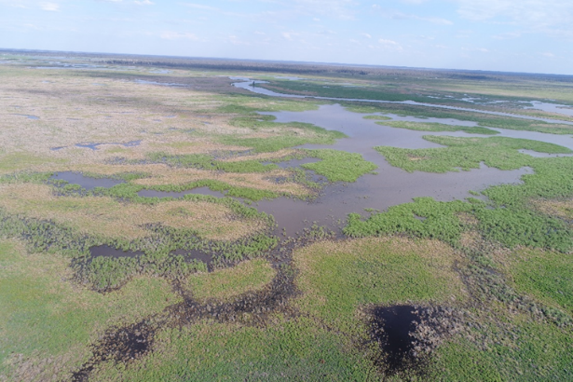


March 2022

Commonwealth Environmental Water Office
Monitoring, Evaluation and Research Project
Lachlan river system 2020-21 Technical Report

Final March 2022
This document has been co-ordinated by Dr Fiona Dyer and includes contributions from Mr Ben Broadhurst, Ms Alica Tschierschke, Dr Will Higgisson, Dr Darren Giling and Professor Ross Thompson (University of Canberra); Dr Adam Kerezsy (Dr Fish Consulting), Dr Joanne Lenehan (NSW Department of Planning, Industry and Environment); and Dr Jason Thiem and Dr Daniel Wright (NSW Department of Primary Industries, Fisheries).


This monitoring project was commissioned and funded by Commonwealth Environmental Water Office with





Copyright
© Copyright Commonwealth of Australia, 2022


Commonwealth Environmental Water Office Monitoring, Evaluation and Research Project: Lachlan river system Selected Area is licensed by the Commonwealth of Australia for use under a Creative Commons By Attribution 3.0 Australia license with the exception of the Coat of Arms of the Commonwealth of Australia, the logo of the agency responsible for publishing the report, content supplied by third parties, and any images depicting people. For license conditions see: http://creativecommons.org/licenses/by/3.0/au/
This report should be attributed as: Dyer, F., Broadhurst, B., Tschierschke, A., Higgisson, W., Giling, D., Thiem, J., Wright, D., Kerezsy, A., Lenehan, J., Thompson, R. (2022). Commonwealth Environmental Water Office Monitoring, Evaluation and Research Project: Lachlan river system Selected Area 2020-21 Monitoring and Evaluation Technical Report. Commonwealth of Australia, 2022.

The Commonwealth of Australia has made all reasonable efforts to identify content supplied by third parties using the following format ‘© Copyright, [name of third party] ’.

Disclaimer
The views and opinions expressed in this publication are those of the authors and do not necessarily reflect those of the Australian Government or the Minister for the Environment and Energy.
While reasonable efforts have been made to ensure that the contents of this publication are factually correct, the Commonwealth does not accept responsibility for the accuracy or completeness of the contents, and shall not be liable for any loss or damage that may be occasioned directly or indirectly through the use of, or reliance on, the contents of this publication.

Inquiries regarding this document should be addressed to:
Professor Fiona Dyer
Phone: 02 6201 2452
e-mail: Fiona.Dyer@canberra.edu.au

Front cover photo: Inundation of the reedbeds of the Great Cumbung Swamp, November 2020. Photo: Alica Tschierschke

Table Of Contents
Contents
List of Figures v
List of Tables x
Acronyms and abbreviations xii
Acknowledgments xiii
1 Introduction 1
2 Lower Lachlan river system – Selected Area 2
3 2020-21 Watering Actions 4
3.1 Catchment and weather conditions 4
3.2 Environmental Water Holdings 6
3.3 Planned Water Use 7
3.4 Implemented watering actions 8
3.4.1 Commonwealth environmental water delivery 8
4 Hydrology – the watering actions 13
4.1 Introduction 13
4.2 Methods 14
4.2.1 A note on the NSW environmental water portfolio 15
4.3 Results 15
4.3.1 Watering Action 1: Booberoi Creek Spring Pulse 16
4.3.2 Watering Action 2: August-September Lake Brewster translucent flow 17
4.3.3 Watering Action 3: Fletcher’s Lake 19
4.3.4 Watering Action 4: Augmenting translucent flow in the lower river 21
4.3.5 Watering Action 5: Lake Brewster 21
4.3.6 Watering Action 6: Noonamah black box woodlands 22
4.3.7 Watering Action 7: Autumn Pulse with EWA 22
4.4 Evaluation 23
4.5 Final comments and recommendations 25
5 Hydrology – water resource development and environmental water 26
5.1 Introduction and methods 26
5.2 This watering year (2020-21) 27
5.3 Seven years of river regulation and environmental water 29
5.4 Changes to key flow components under current conditions (using 135 years of modeled flow data) for freshes and small overbank flows 33
5.5 Discussion 33
6 Stream metabolism and water quality 35
6.1 Introduction 35
6.1.1 Selected Area Specific evaluation questions: 36
6.2 Methods 36
6.3 Results 39
6.3.1 Water quality – 2020-21 39
6.3.2 Water quality – 2014-21 43
6.3.3 Stream Metabolism – 2020-21 47
6.3.4 Stream metabolism – 2014-21 50
6.4 Discussion 53
6.4.1 Watering Actions 2020-21 53
6.4.2 Watering Actions over the period 2014-21 54
6.5 Evaluation 54
6.6 Final comments and recommendations 55
6.7 Appendix 1: Stream metabolism plots for three additional sites in the lower Lachlan River 2014-20 57
7 Fish community 61
7.1 Introduction 61
7.1.1 Short-term evaluation questions: 62
7.1.2 Long-term evaluation questions: 62
7.2 Methods 62
7.3 Results 64
7.3.1 Watering year 2020-21 64
7.3.2 2020-21 vs Previous years 72
7.4 Discussion 74
7.5 Evaluation 76
7.6 Recommendations 77
7.7 Appendix 79
8 Spawning and larval fish 83
8.1 Introduction 83
8.1.1 Short-term evaluation questions: 83
8.1.2 Long-term evaluation questions: 83
8.2 Methods 83
8.2.1 Field sampling 83
8.2.2 Laboratory processing 84
8.2.3 Data analysis 85
8.3 Results 85
8.3.1 Watering year 2020-21 85
8.3.2 2020-21 vs Previous years 90
8.4 Discussion 92
8.5 Evaluation 95
8.6 Final Comments and Recommendations 97
8.7 Appendix 1: Estimating fish spawning dates 2020 99
9 Vegetation 102
9.1 Introduction 102
9.1.1 Selected area specific evaluation questions: 103
9.2 Methods 103
9.2.1 Evaluation approach 106
9.2.2 Data analysis 110
9.3 Results 111
9.3.1 Species richness 111
9.3.2 Vegetation community diversity 121
9.3.3 With and without environmental water in this watering year 126
9.4 Discussion 128
9.5 Evaluation 129
9.6 Further comments and recommendations 130
10 Communication and engagement 133
10.1 Introduction 133
10.2 Results 133
10.2.1 Operational Project Communications 133
10.2.2 External Project Communication 136
11 Community monitoring 145
11.1 Introduction 145
11.2 Approach 145
11.2.1 Routine monitoring 146
11.2.2 Issue based monitoring 146
11.3 Routine monitoring of water quality 147
11.4 Issue based monitoring 148
11.4.1 Case Study 1: Hypoxic blackwater risk mitigation 148
11.4.2 Case Study 2: Lake Brewster system blue green algal (BGA) alert 149
11.5 Discussion 151
12 Research: Estimating the cover of Phragmites australis using unmanned aerial vehicles and neural networks 152
12.1 Introduction 152
12.2 Methods 153
12.2.1 Study area 153
12.2.1 Sampling design 153
12.2.1 Image collection and processing 154
12.3 Machine learning 155
12.4 Results 155
12.4.1 Model performance 155
12.4.2 Examples of density maps and cover estimates 157
12.5 Discussion 159
13 References 161
14 Appendix 168
14.1 Species observed during monitoring (2020-21) within the tree community plots sites 168
14.2 Species observed during monitoring (2020-21) within the non-tree transect sites 169
14.3 Species Accumulation Curves – replication in vegetation surveys in Non-tree sites 170

List of Figures
Figure 2-1. The Lower Lachlan river system showing the region for the LTIM project and MER program. 3
Figure 3-1. Rainfall deciles for New South Wales for the 2019-20 compared to the 2020-21 watering year. 4
Figure 3-2. Monthly rainfall totals at a) Forbes Airport (065103), b) Hillston Airport (075032), and c) Booligal (075007) and the daily highest rainfall events for 2020-21 per month compared with the long-term median rainfall for the entire period of records available. 5
Figure 3-3. Mean temperature deciles for NSW for the 2020-21 watering year (right) and the summer months December 2020 to February 2021 (left). 6
Figure 4-1. The location of relevant gauging stations in the lower Lachlan river system. 15
Figure 4-2. Flow at Booberoi Creek for the period 1st of July 2020 to 30th of June 2021 showing Watering Action 1. 16
Figure 4-3. Flows at Willandra Weir for the period 1st of July 2020 to 30th of June 2021 showing Watering Action 2 and an estimate of Watering Action 4. 18
Figure 4-4. Flows at Booligal for the period 1st of July 2020 to 30th of June 2021 showing estimates of Watering Actions 2, 4, 6 and 7. 19
Figure 4-5. Sentinel imagery of Fletcher’s Lake prior to the arrival of environmental water (12 October 2020 upper image) and the full lake (26 November 2020 lower image). 20
Figure 4-6. Pelicans during a pelican survey on the 15th April 2021 at Lake Brewster. Photo: DPIE-EES and Mal Carnegie (Lake Cowal Foundation) 22
Figure 4-7. Sentinel imagery of Lake Noonamah wetland prior to the arrival of environmental water (30th May upper image) and the full lake (19th June 2021 lower image). 23
Figure 5-1. Modelled natural flow (ML/day) (grey hydrograph) and actual river flow (black hydrograph) of the Lachlan River at Booligal river gauge from 1 July 2020 to 30 June 2021. The green roughly represents environmental water actions. 28
Figure 5-2 Modelled natural flow (ML/day) (blue hydrograph) and actual river flow (orange hydrograph) of the Lachlan River at Booligal river gauge on the Lachlan River from 1 July 2014 to 30 June 2021. 30
Figure 5-3. Modelled natural flow (ML/day) (blue hydrograph) and actual river flow (orange hydrograph) of the Lachlan River at Whealbah river gauge on the Lachlan River from 1 July 2014 to 30 June 2021. 31
Figure 6-1. Map of monitoring sites for adult and larval fish, stream metabolism and gauging stations in the lower Lachlan River Zone L1. 37
Figure 6-2. Stream metabolism sites in the lower Lachlan river during low flows in June 2020 (top left to bottom: CC, LB, WB (WAL not shown). Photos: Matthew Young 38
Figure 6-3. Water temperature, dissolved oxygen for Lane’s Bridge compared to Hillston Weir, and Hillston Weir discharge over the sampling period 2020-21. 40
Figure 6-4. Mean water quality measurements (± standard error) for the four lower Lachlan river sites (Cowl Cowl, Lane’s Bridge, Wallanthery and Whealbah) over the sampling period 2020-21: physico chemical attributes. 41
Figure 6-5. Mean water quality measurements (± standard error) for the four lower Lachlan river sites (Cowl Cowl, Lane’s Bridge, Wallanthery and Whealbah) over the sampling period 2020-21: nutrients and chlorophyll a. 42
Figure 6-6. Water temperature and dissolved oxygen for the four study sites from the lower Lachlan river sites (Wallanthery, Lane’s Bridge, Cowl Cowl, and Whealbah) over the sampling period 2020-21. 43
Figure 6-7. Mean water quality measurements (± standard error) for four lower Lachlan river sites (Cowl Cowl, Lane’s Bridge, Wallanthery and Whealbah) over the sampling period 2014-2021: physico chemical attributes. 45
Figure 6-8. Mean water quality measurements (± standard error) for the four lower Lachlan river sites (Cowl Cowl, Lane’s Bridge, Wallanthery and Whealbah) over the sampling period 2014-2021: nutrients and chlorophyll a. 46
Figure 6-9. Gross primary production (GPP), Ecosystem respiration (ER), Reaeration (K) and the GPP/ ER ratio from Lane’s Bridge in the lower Lachlan River, May 2020 - July 2021. 49
Figure 6-10. Summary statistics for stream metabolism data for all four variables and all four Lower Lachlan river sites (Cowl Cowl, Lane’s Bridge, Wallanthery and Whealbah) over the sampling period 2014-2021 under the standard acceptance criteria. 51
Figure 6-11. Gross primary production (GPP), Ecosystem respiration (ER), Reaeration (K) and the GPP/ ER ratio from Lane’s Bridge in the lower Lachlan River, August 2014 - June 2021. 52
Figure 6-12. Total carbon produced (kg C/day) at Lane’s Bridge for the entire monitoring period 2014-21. Flow at Hillston Weir is also shown. 53
Figure 6-14. Gross primary production (GPP) from Wallanthery, Cowl Cowl and Whealbah in the lower Lachlan River, August 2014 - June 2020. 57
Figure 6-15. Ecosystem respiration (ER) from Wallanthery, Cowl Cowl and Whealbah in the lower Lachlan River, August 2014 - June 2020. 58
Figure 6-16. Reaeration (K) from Wallanthery, Cowl Cowl and Whealbah in the lower Lachlan River, August 2014 - June 2020. 59
Figure 6-17. GPP/ ER ratio from Wallanthery, Cowl Cowl and Whealbah in the lower Lachlan River, August 2014 - June 2020. 60
Figure 7-1. Proportions of sites (colour-coded) that each fish species were caught at from 2015-2021, separated into juveniles, non-juveniles and all fish categories combined (total). 66
Figure 7-2. Proportions of sites (colour-coded) that each fish species were caught at from 2015-2021, separated by capture method. 67
Figure 7-3. Catch per site (number of fish; mean ± SE) for each fish species within the lower Lachlan river system target reach, sampled from 2015-2021. 68
Figure 7-4. Biomass per site (g; mean ± SE) of each fish species within the lower Lachlan river system target reach, sampled from 2015-21. 69
Figure 7-5. Proportionate length-frequencies of the six most abundant species captured in the Lachlan River from 2015–2021 (red line for current year, and grey lines for previous years of darker shades over time). 70
Figure 7-6. Otolith from a 65 mm golden perch which was subjected to daily ageing. 70
Figure 7-7. Spawning to capture periods (thick lines) of two golden perch individuals captured in 2021 which were below and close to size limit used to distinguish new recruits (75 mm). 71
Figure 7-8. SRA metrics (mean ± SE) for the lower Lachlan River from 2015–2021. 73
Figure 7-9. Example of mapped boat electrofishing units used for Category 1 fish community sampling in the Lachlan River. Each unit was sampled using 90 seconds of ‘on-time’. 78
Figure 8-1. Larval fish site Wallanthery (top) and Lanes Bridge (bottom) at high flows in November 2020. Photo: Ben Broadhurst 83
Figure 8-2. Fish larval catch results of overnight drift netting (left and mid) and light traps (right) in 250 µm sieves in November 2020. Photos: Ben Broadhurst 84
Figure 8-3. A flatheaded gudgeon from Booberoi Creek in the mid-Lachlan. Photo: Mal Carnegie 85
Figure 8-4. Larval golden perch form the Lachlan River in late spring 2020. Photo: Rhian Clear 85
Figure 8-5. Mean catch per unit effort (± standard error) of the commonly caught larval native fish for drift nets per sampling event in spring / summer 2020. 87
Figure 8-6. Mean catch per unit effort (± standard error) of the commonly caught larval native fish for drift nets per sampling event in spring / summer 2020. 88
Figure 8-7. Length frequency histograms for each sampling event of commonly captured larval native fish species with site (n = 3) and sampling technique (n = 2) combined for 2020. 88
Figure 8-8. Mean raw abundances of larval fish species captured in light traps from spring – summer 2014 – 2020. Note: light traps were not set in 2016 due to river being in flood. 90
Figure 8-9. Mean raw abundances of larval fish species captured in drift nets from spring – summer 2014 – 2020. 90
Figure 8-10. Annual larval fish community composition per site (plotted in multidimensional space via principal component analysis ordination) captured from the lower Lachlan River Selected Area using drift nets and light traps from spring/summer 2014 – 2020. 91
Figure 8-11. Estimated spawning date frequency (grey bars) and associated discharge and temperature for larval native fish species in 2020. 99
Figure 9-1. The Great Cumbung Swamp in flood in January 2021. Photo: Will Higgisson 104
Figure 9-2. Whealbah Lagoon in flood November 2020. Photo: Alica Tschierschke 105
Figure 9-3. River Red Gums in Moon Moon Wetland in flood. November 2020. Photo: Will Higgisson 105
Figure 9-4. Conceptualisation of recent watering history categories (defined in see Table 9-2). 107
Figure 9-5. Map of the actual and recent vegetation monitoring sites categorised according to watering history. 107
Figure 9-6. (Mean) species richness per woodland tree community site, across all sites in each trip. Vertical lines show the standard deviation from the mean. 110
Figure 9-7. Comparison of groundcover vegetation diversity in the tree community between seasons and years using Simpson’s diversity index (D). 112
Figure 9-8. Comparison of groundcover vegetation species richness in the tree community between seasons and years. 114
Figure 9-9. (Mean) species richness at each non-tree community site between season and year. Vertical lines are standard deviation from the mean. 116
Figure 9-10. Comparison of groundcover vegetation diversity in the non-tree community between seasons and years using Simpson’s diversity index (D). 117
Figure 9-11. Comparison of groundcover vegetation diversity in the non-tree community between seasons and years using species richness. 118
Figure 9-12. Average percent cover of terrestrial and amphibious species (refer to Table 9-3, on page 111 for description) within the tree community for sites from each watering history over the sampling period. 120
Figure 9-13. Average species richness of terrestrial and amphibious species (refer to Table 9-3, on page 111 for description) within the tree community for sites from each watering history over the sampling period. 121
Figure 9-14. Average percent cover of native and exotic species for the tree communities for sites from each watering history over the sampling period. 122
Figure 9-15. Average percent cover of terrestrial and amphibious species (refer to Table 9-3, on page 111 for description) within the non-tree community for sites from each watering history over the sampling period. 123
Figure 9-16. Average percent cover of native and exotic species for the tree communities for sites from each watering history over the sampling period. 124
Figure 9-17. Proportional cover of plant functional groups (refer to Table 9-3, on page 111 for description) at sites that did and did not received environmental water (ewater) in 2020-21. 125
Figure 9-18. The relative proportion of species numbers in each water plant functional group (refer to Table 9-3, on page 111 for description) recorded at sites that did and did not receive environmental water (ewater) in 2020-21. 125
Figure 9-19. Lake Tarwong river red gum plot (in watering category A) in November 2020. Photo: Will Higgisson 126
Figure 9-20. Lake Bullogal river red gum plot 1 (in watering category A) in November 2020. Photo: Matthew Young 126
Figure 10-1. Cover images of Lachlan River MER Quarterly Outcomes newsletters 2020-21. 138
Figure 10-2. Images of photo story created by Flow MER Lachlan team 2020-21. See https//flow-mer.org.au for more. 139
Figure 10-3. Example from social media (twitter and facebook) over Lachlan River post in 2020-21 140
Figure 10-4. Adam Kerezsy during a Down The Track (DTT) event at Lake Cargelligo. Photo: Mal Carnegie. 141
Figure 10-5. Newspaper article published in local/regional print media, Hillston-Ivanhoe Spectator (10th February 2021, left), Lake News (24th March 2021, right) and Condobolin Argus (10th February 2021, bottom) 142
Figure 11-1. Waterwatch locations at Booberoi Creek, Murrin Bridge, and around Lake Cargelligo 145
Figure 11-2. Waterwatch locations around Lake Brewster system and in the lower Lachlan river and wetlands. 146
Figure 11-3. Mean water quality measurements (± standard error) for Booberoi Creek sites between January 2019 and March 2021. 147
Figure 11-4. Discharge and Dissolved Oxygen from Lake Cargelligo Weir (412011) from the 1st December 2020 to 1st February 2021 148
Figure 11-5. Discharge and Dissolved Oxygen from Bensons Drop Weir (412047) (top) and Willandra Weir (412038) (bottom) 20th December 2020 to 5th January 2021 149
Figure 11-6. Imagery provided by Waterwatch Team in relation to Blue Green Algal (BGA) alert. 150
Figure 12-1. The location of the nine 50 X 50 m sites within the reed bed of the Great Cumbung Swamp. 153
Figure 12-2. Site 3 (in watering category A) in November 2020. The left image is the site in RGB and the right image is a density map showing the output of the model prediction. 156
Figure 12-3. Site 8 (in watering category B) in November 2020. The left image is the site in RGB and the right image is a density map showing the output of the model prediction. 157
Figure 12-4. Site 6 (in watering category C) in November 2020. The left image is the site in RGB and the right image is a density map showing the output of the model prediction. 157
Figure 14-1. Randomized species accumulation curves for Murrumbidgil Swamp in Spring 2014 and Autumn 2015, generated using number of individuals and the number of 1 X 1m quadrats (sites). 171
Figure 14-2. Randomized species accumulation curves for Booligal Swamp in Autumn 2016, Autumn 2017 and Autumn 2019, generated using number of individuals and the number of 1 X 1m quadrats (sites). 172
Figure 14-3. Randomized species accumulation curves for Whealbah Lagoon in Autumn 2016, Spring 2017 and Spring 2019, generated using number of individuals and the number of 1 X 1m quadrats (sites). 173
Figure 14-4. Randomized species accumulation curves for Hazelwood, The Ville, Lake Bullogal, Lake Marool, and Nooran Lake in Autumn 2017 and Spring 2019, generated using number of individuals and the number of 1 X 1m quadrats (sites). 175
Figure 14-5. Randomized species accumulation curves for Lake Tarwong and Moon Moon Swamp in Spring 2017 and Autumn 2019, generated using number of individuals and the number of 1 X 1m quadrats (sites). 176
Figure 14-6. Randomized species accumulation curves for Lake Marool (open), Juanbung, and Bunumburt in Spring 2019, generated using number of individuals and the number of 1 X 1m quadrats (sites). 177

List of Tables
Table 3-1. Environmental water held entitlements in the Lachlan River Valley from 1 July 2020 to 30 June 2021. 6
Table 3-2. The 2020-21 joint Commonwealth and NSW environmental watering action – part 1. 10
Table 3-3. The 2020-21 joint Commonwealth and NSW environmental watering action – part 2. 11
Table 4-1. The 2020-21 accounted Commonwealth and NSW environmental water in the Lachlan river system. 16
Table 5-1. River – floodplain connection metrics for six locations on the floodplain of the lower Lachlan River under modelled natural flow conditions (N) and current flow conditions (C) over the 2020-21 watering year. 28
Table 5-2. River – floodplain connection metrics for nine locations on the floodplain of the lower Lachlan River under modelled natural flow conditions (N), and current (actual) flow conditions from 1 July 2014 through 30 June 2021. 32
Table 5-3. The frequency and interannual variability of small freshes, medium freshes, and small overbank flows at Booligal Gauge on the Lachlan River and the percentage change from natural conditions using 135 years of modelled Natural and Current flow conditions, and actual flow data with and without commonwealth environmental water over 2014-21. 33
Table 6-1. Stream metabolism data obtained from Lane’s Bridge during the sampling period 2020-21. 47
Table 7-1. Size limits used to distinguish new recruits for each fish species. Values represent the length at one year of age for longer-lived species or the age at sexual maturity for species that reach maturity within one year. 63
Table 7-2. Total (non-standardised) catch from the lower Lachlan river system target reach. Sampling was undertaken in autumn 2021 using a combination of four sampling gear types. 65
Table 7-3. Summary of SRA fish indices over the seven LTIM project sampling years in the lower Lachlan River. 72
Table 7-4. Contributions of fish species abundance to variability among years in the lower Lachlan River, determined through SIMPER analysis. 79
Table 7-5. Contributions of fish species biomass to variability among years in the lower Lachlan River, determined through SIMPER analysis. 80
Table 7-6. Pre-European (PERCH = Pre-European Reference Condition for fisH) list of the expected native fish species present in the lowland Lachlan river basin, their associated rarity and subsequent detection during LTIM annual censuses from 2015-2021. 81
Table 8-1. Capture summary of larval fish from sampling conducted between mid-October to mid-December 2020 in the lower Lachlan river system Selected Area. 85
Table 8-2. Results of PERMANOVA analysis of larval fish captures (fourth-root transformed numerical data from drift net and light traps combined) in the lower Lachlan River Selected Area 2014 – 2020. 89
Table 9-1. Wetland sampling dates and observations 2020-21. Watering categories correspond to the historical watering of the sites (see Table 9-2, on page 104). 103
Table 9-2. Watering history used to structure analysis of vegetation data. 106
Table 9-3. Plant functional group classifications of Brock and Casanova (1997) and Casanova (2011). 108
Table 9-4. Overall species number observed over the last seven watering years in the tree community 109
Table 9-5. Overall species numbers observed over the last seven watering years in the non-tree community 115
Table 10-1. Primary stakeholders for the Lachlan Selected Area MER program 132
Table 10-2. Operational project communication activities for the Lachlan Selected Area delivered in 2020-21 132
Table 10-3. External communication and engagement activities in 2020-21. For more on Citizen Science activities, please see Section 11. 136
Table 12-1. The True Positive (TP) Rate and False Positive (FP) Rate for each feature class. 155
Table 12-2. Confusion matrix, in which the columns represent the true classes while the rows represent the model’s predictions. 155
Table 12-3. Results from manual (visual) verification of 100 randomly selected images from each feature class on the models predictive performance. The bareground feature class only had 40 images assigned, so all images were used in the verification process. 155

Acronyms and abbreviations
Accepted Acronym | Standard Term (capitalisation as specified)
ANAE | Australian National Aquatic Ecosystem
BASE | BAyesian Single-station Estimation
CEWH | Commonwealth Environmental Water Holder
CEWO | Commonwealth Environmental Water Office
CPUE | Catch per unit effort
CTF | Commence to fill
DPI | Department of Primary Industries
DPIE | Department of Planning, Industry and Environment
EPBC Act | Environment Protection and Biodiversity Conservation Act 1999
ER | Ecosystem Respiration
GPP | Gross Primary Production
K | Reaeration
LTIM | Long Term Intervention Monitoring
MER | Monitoring, Evaluation and Research
MDBA | Murray-Darling Basin Authority
MDFRC | Murray-Darling Freshwater Research Centre
OEH | Office of Environment and Heritage
SRA | Sustainable Rivers Audit
WQA | Water quality allowance
WUM | Water Use Minute

Acknowledgments
The project team as well as the Commonwealth Environmental Water Office (CEWO) respectfully acknowledge the traditional owners of the land on which this work is conducted, their Elders past and present, their Nations of the Murray-Darling Basin, and their cultural, social, environmental, spiritual and economic connection to their lands and waters. The Lachlan River flows through the lands of the Nari Nari, Ngiyampaa, Wiradjuri and Yita Yita Nations, and we acknowledge these people as the traditional owners of the land on which this publication is focused.
The project team also thank the team of people who contributed to project delivery: Rhian Clear, Damian McRae, Michelle Groat, Joanne Lenehan, Ugyen Lhendup, Yasmin Cross, and Daniel Scherrer.
The following volunteers are thanked for their assistance with larval fish sampling, Liam Allan, Kieran Allan, Pat Ross-Magee, Max Clear, Hugh Allan, Ewen Lawler.
The following DPI Fisheries staff assisted with adult fish field data collection and laboratory processing: Rohan Rehwinkel, Jackson Wilkes-Walburn, Jarryd McGowan, Tim McGarry, Bridget Smith, Bryce Butler and Nick O'brien.
The following staff and volunteers are thanked for their contribution to vegetation monitoring and research activities: Angus Macdonald, Matt Jeromson, Matthew Young, Rhys Morcom, Blaine Serafin, Jasmin Wells, Tasha James, Jill Bartlett, the following students from UNSW: Dana Lanceman, Courtney Adams, Julia Zubonja and Keira Chrystal.
Mal Carnegie (Lake Cowal Foundation) is thanked for his photographic contributions to our communication and engagement activities and local expertise.
The landholders who granted us access to sites are thanked for their interest, cooperation and support.
Vegetation sampling was conducted under NSW Scientific License SL 102011. Fish sampling was conducted under Fisheries NSW Animal Care and Ethics permit 14/10 and scientific collection permit P01/0059(A)-4.0. Larval fish sampling was conducted under NSW DPI permit No: P14/0022-2.0 and under approval from the University of Canberra Animal Ethics Committee (AEC 17-23).

Introduction
The 2020-21 watering year was characterised by higher-than-average rainfall in the Lachlan river catchment which was in stark contrast to the very dry conditions faced in the two years prior. These wet conditions provided high soil moisture conditions and resulted in substantial inflow into the Lachlan River above and below the major storages such as Wyangala Dam. Environmental watering actions under these conditions focused on making the most of the opportunities afforded by higher flows in the river.
Seven watering actions using Commonwealth environmental water were delivered to the Lachlan river system in 2020-21, six of which were delivered in combination with NSW environmental water (Table 3-2 on page 10). These watering actions used a total of 77,418 ML (42,162 ML Commonwealth environmental water and 35,256 ML NSW environmental water), with a further 173,000 ML of translucent flows delivered to the system. The first watering action was designed to deliver a spring fresh to Booberoi Creek following desilting works, targeting connectivity and habitat recovery. The remaining six watering actions were designed to inundate floodplain wetlands, providing and enhancing lateral connectivity, supporting vegetation and providing habitat for fish, frogs and birds. Two of these floodplain wetland inundation actions were delivered in association with translucent flow events, enabling environmental water to be used to target wetlands which are at some distance from the main river channel.
In combination, the seven watering actions contribute to the priorities of the Murray-Darling Basin Authority of supporting lateral and longitudinal connectivity, maintaining the extent and condition of native vegetation, providing habitat for native waterbirds and supporting populations of native fish (MDBA 2019).
The Monitoring, Evaluation and Research program (MER program) is the primary means by which the Commonwealth Environmental Water Office (CEWO) undertakes monitoring and evaluation of the ecological outcomes of Commonwealth environmental watering. It follows the previous Long-Term Intervention Monitoring project (LTIM project) which evaluated the ecological outcomes of Commonwealth environmental watering activities between 2014 and 2019. Monitoring activities implemented within the MER program to evaluate the outcomes of Commonwealth environmental watering actions in the lower Lachlan river system in 2020-21 included the monitoring of stream flows (hydrology), stream metabolism and water quality (dissolved oxygen, temperature, pH, electrical conductivity, turbidity and nutrients), fish (including larval fish) and the condition and diversity of vegetation. We also describe the research component of the MER program where we report a method to estimate the cover of Phragmites australis and other wetland attributes in the Great Cumbung Swamp using unmanned aerial vehicles.
This document provides the technical reports for the 2020-21 monitoring and evaluation of Commonwealth environmental watering in the lower Lachlan river system. It is designed as a record of the supporting technical material for the summary report (Dyer et al. 2020).
This report describes the context in which the water was delivered, the environmental objectives of the watering actions, the monitoring activities undertaken, and evaluates the outcomes of the watering actions.

Lower Lachlan river system – Selected Area
The area of the lower Lachlan river system (referred to as the Selected Area) identified as the focus for the LTIM project and MER programs is the western end of the Lachlan River, and extends from the outlet of Lake Brewster to the Great Cumbung Swamp (Figure 2-1). It encompasses anabranches, flood runners, billabongs and terminal wetlands, such as Merrowie Creek, Booligal Wetlands and Lachlan Swamp but excludes Middle Creek and other creeks to the north. The river system is complex, with a diversity of in-channel and floodplain features that provide a variety of habitats for the species in the region. Flows and water levels are naturally variable and unpredictable providing temporally complex habitats.
The Lachlan River catchment supports many flora and fauna listed as vulnerable or endangered under federal or NSW state legislation, including the Sloane’s froglet, Australian painted snipe, osprey, blue-billed duck and the fishing bat. The Selected Area comprises the majority of the Lachlan River endangered ecological community. In addition, the Great Cumbung Swamp has historically been one of the most important waterbird breeding areas in eastern Australia and supports one of the largest remaining stands of river red gums in NSW. The Lachlan River catchment supports many plants and animals used by Aboriginal peoples as food, fibre, medicine and for cultural purposes. The Lachlan River and its wetlands also contain many culturally significant sites valued for their resources or cultural value.
Like many rivers of the Murray-Darling Basin, flow regulation in the Lachlan River catchment has had a significant effect on the average annual flow as well as inter-annual and seasonal variability (Driver et al. 2004, Higgisson et al. 2019). The interaction of a number of factors such as these are considered key drivers in the deterioration of the freshwater ecosystems within the catchment. The lower Lachlan river system has previously been assessed as being in poor ecosystem health as part of the Murray-Darling Basin Authority’s Sustainable Rivers Audit (SRA) (Davies et al. 2008, MDBA 2012b). This assessment was primarily due to having an extremely poor native fish community (with low native species richness and poor recruitment) and poor hydrological condition. Macroinvertebrate communities were assessed as being in moderate condition whereas the physical form of the river and the vegetation were assessed as being in poor to moderate condition, respectively.
The millennium drought (2001-2009) resulted in large areas of river red gums becoming stressed, and in wetlands, vegetation became dominated by terrestrial, drought tolerant species (Thurtell et al. 2011). Some recovery of the wetlands and rivers has been observed since 2010, attributed to a series of natural flow events (2012 and 2016), translucent flow events and targeted environmental watering actions. In 2016, the Booligal wetlands supported the largest and most successful breeding colony of straw-necked ibis in the Murray-Darling Basin since 1984.

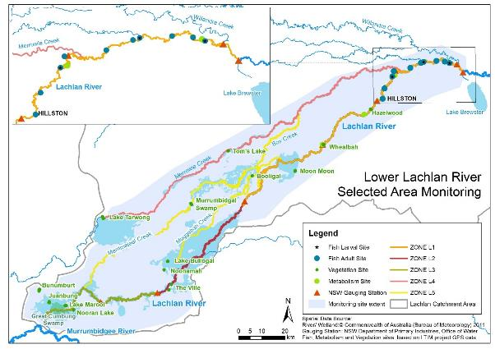
Figure 2-1. The Lower Lachlan river system showing the region for the LTIM project and MER program.

2020-21 Watering Actions
Environmental watering actions are influenced by a combination of catchment and climate conditions as well as the volume of water holdings. Catchment condition provides the context for evaluating ecosystem responses to watering.

Catchment and weather conditions
New South Wales experienced a mixture of average, below average and very much below average rainfall in the 2019-20 watering year with some parts of the state experiencing the lowest rainfall on record (Figure 3-1). In contrast, the 2020-21 watering year experienced above and very much above average rainfall across much of New South Wales, particularly in the east of the state. The Lachlan river catchment has experienced above average rainfall across nearly the entire catchment in the 2020-21 watering year with a third of the catchment experiencing very much above the average rainfall (Figure 3-1).
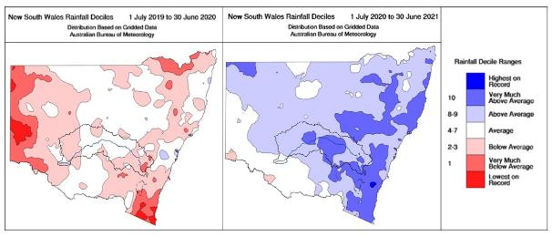
Figure 3-1. Rainfall deciles for New South Wales for the 2019-20 compared to the 2020-21 watering year.
Images from the Bureau of Meteorology Rainfall Archive.
Most months in the catchment experienced above average rainfall in 2020-21, with a significant event at the start of 2021 (Figure 3-2). The highest daily record for the region was in Forbes with 89 mm (at Forbes Airport) in March which was the highest daily rainfall since 1970. The former highest recorded rainfall in the catchment was at Forbes (Muddy Water) in March 1982 with 85 mm. In contrast, only 0.2 mm of rainfall was recorded during April 2021 at Forbes (Figure 3-2, a).
Even though the south western regions of the catchment experienced less rainfall, they still recorded above average annual rainfall for the 2020-21 watering year (Figure 3-1 and Figure 3-2). The annual totals for this period ranged from 933 mm at Forbes, which was more than twice the median rainfall, 477 mm at Hillston and 353 mm at Booligal and 319 mm at Oxley, which was 100 mm above the annual median rainfall.
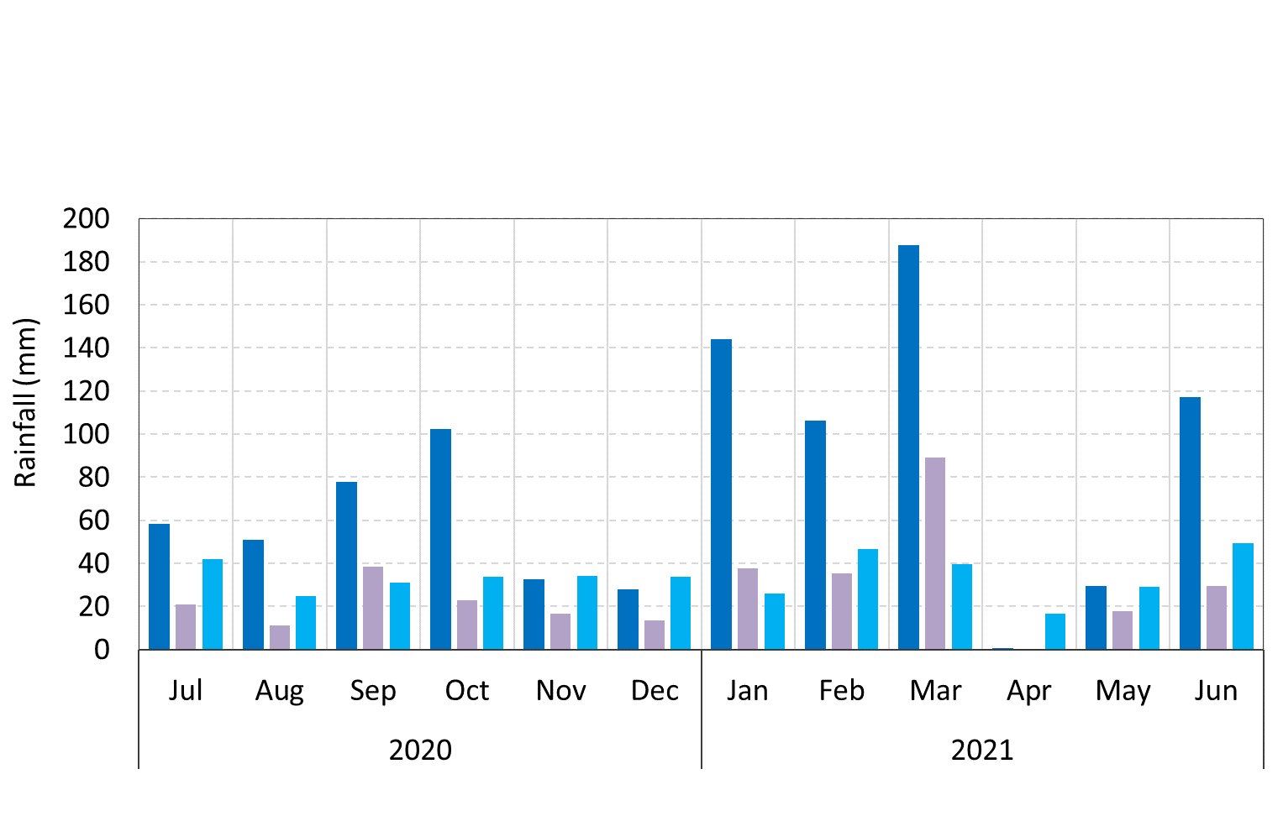
a) Forbes
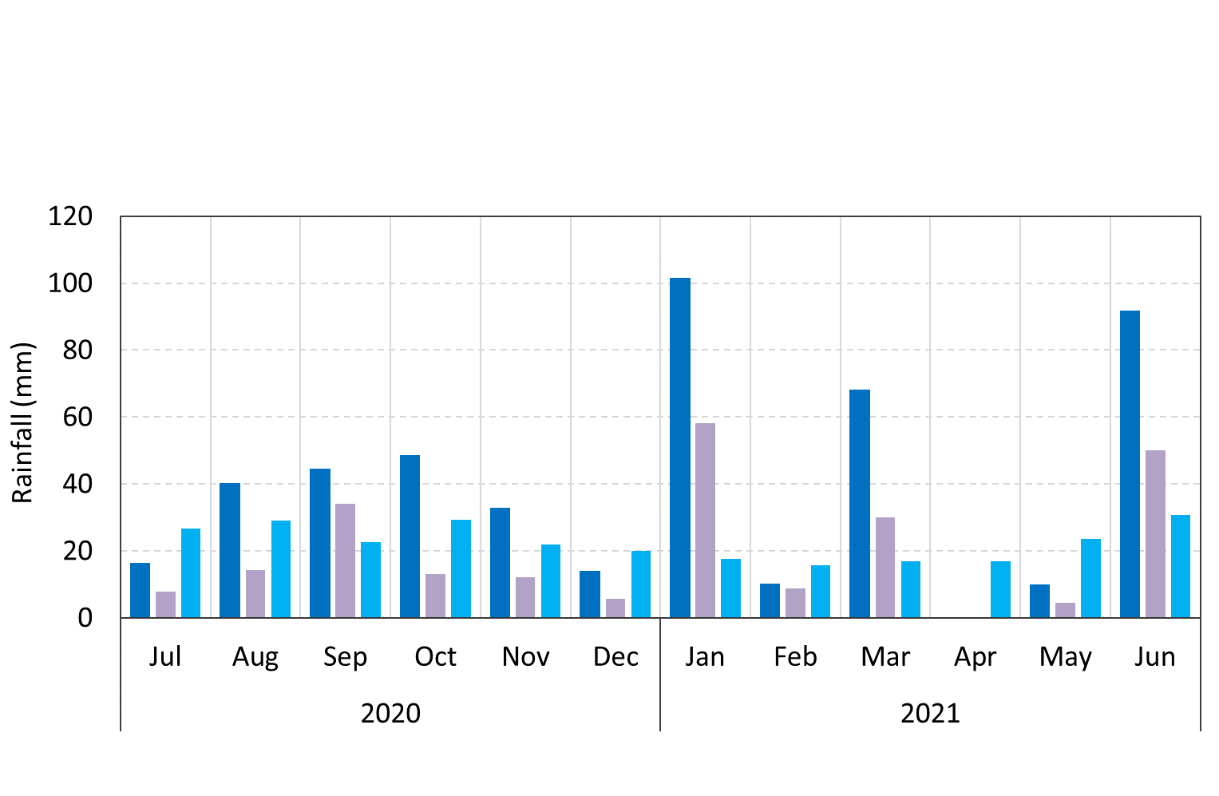
b) Hillston
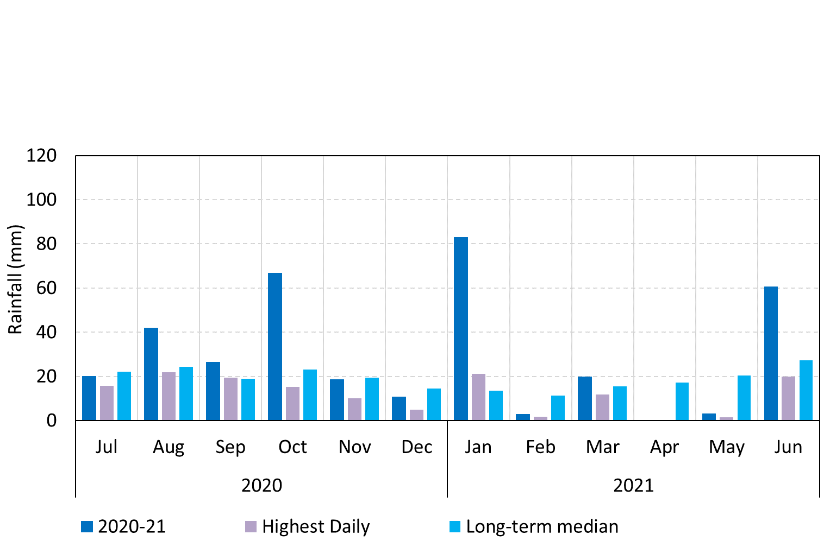
c) Booligal
Figure 3-2. Monthly rainfall totals at a) Forbes Airport (065103), b) Hillston Airport (075032), and c) Booligal (075007) and the daily highest rainfall events for 2020-21 per month compared with the long-term median rainfall for the entire period of records available.
Data sourced from Climate Data Online, Bureau of Meteorology. Note: a) Forbes on larger scale.
Throughout the 2020-21 watering year mean temperatures were comparable to the long-term historic averages across the catchment. However, the temperatures during the summer months were several degrees below average (Figure 3-3).
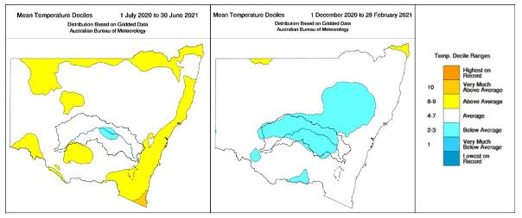
Figure 3-3. Mean temperature deciles for NSW for the 2020-21 watering year (right) and the summer months December 2020 to February 2021 (left).
Note: Images adapted from the Bureau of Meteorology Temperature Archive.

Environmental Water Holdings
Environmental water has been allocated to the Lachlan River since 1992 (from NSW) and more recently the river system has received Commonwealth environmental water. Thus, environmental water for the Lachlan River comprises both Commonwealth government holdings of water entitlements (Commonwealth environmental water) and NSW government-held licensed environmental water (NSW environmental water holdings) and planned water under the Lachlan Regulated Water Sharing Plan (https://legislation.nsw.gov.au/#/view/regulation/2016/365/full). Commonwealth water holdings have been consistent since 2014-15 and at the beginning of the 2020-21 water year, the Commonwealth government held a total of 87,856 ML in entitlement (Table 3-1).
Table 3-1. Environmental water held entitlements in the Lachlan River Valley from 1 July 2020 to 30 June 2021.
 | WATER HOLDINGS (ML) BY ENTITLEMENT TYPE
WATER HOLDER | HIGH SECURITY | GENERAL SECURITY | TOTAL
CEWH | 933 | 86,923 | 87,856
NSW | 1,795 | 36,569 | 38,364
TOTAL | 2,728 | 123,492 | 126,220

As at the 30th June 2020, 16 GL of the Commonwealth environmental water was held within the Water NSW Drought Account and the Commonwealth environmental water office had only 650 ML of environmental water available for use (Commonwealth Environmental Water Office 2020).

Planned Water Use
Planning for environmental watering in 2020-21 was undertaken within the context of extreme drought. The catchment was being managed under the NSW Extreme Event Policy, although good rainfall in March and April 2020 and forecasts for a wet spring gave some indication that extreme conditions would be easing. This meant that the focus of the planning was to manage water to avoid damage and protect the health and resilience of aquatic ecosystems and wetland areas. Under these circumstances, a single watering action (in combination with NSW) was proposed. This action would deliver a small fresh down Booberoi Creek aiming to re-start the system after the completion of de-silting works to help maintain Booberoi Creek as an important drought refugia site in the Lachlan system.
The annual watering priorities of the Murray-Darling Basin Authority (MDBA 2020) were set in anticipation of dry conditions across large parts of the Murray Darling Basin. Consequently, the focus was on:
- avoiding irretrievable loss of species and habitat, and providing drought refuges in catchments assessed as having a ‘very dry’ resource availability scenario;
- maintaining the condition of species and habitat where water is available in catchments assessed as having a ‘dry’ resource availability scenario; and
- maintaining or improving ecological health, condition and resilience of water-dependent ecosystems in catchments in regulated systems assessed as having a ‘moderate’ resource availability scenario.
There were not specific annual environmental watering priorities relevant to the Lachlan catchment and thus the Commonwealth Environmental Water Portfolio Management Plan: Lachlan River 2020-21 (Commonwealth Environmental Water Office 2020) suggests that the CEWO was aiming to contribute to the following 2020–21 Basin multi-year priorities relevant to the Lachlan River region:
- protect drought refuges;
- support lateral and longitudinal connectivity along the river systems;
- maintain core wetland vegetation and refuges; Avoid critical loss and (where possible) improve vegetation condition in areas where drought conditions persist;
- maintain the extent and improve the condition of lignum shrublands;
- improve the abundance and maintain the diversity of the Basin’s waterbird populations;
- support Basin-scale population recovery of native fish by reinstating flows that promote key ecological processes across local, regional and system scales in the southern connected Basin; and
- support viable populations of threatened native fish, maximize opportunities for range expansion and establish new populations.

Implemented watering actions

Commonwealth environmental water delivery
Above average rainfall occurred across the catchment in 2020-21 and resulted in increased allocations throughout the year. Inflows to Wyangala were sufficient to trigger the the translucent flow rules which were administered as required under the Lachlan Regulated River Water Sharing Plan (https://www.industry.nsw.gov.au/__data/assets/pdf_file/0010/204868/draft-appendix-a-amended-wsp-lachlan-regulated-river-water-source-2016.pdf). This changed focus from planning to protect drought refuges to maximizing the outcomes that could be achieved using the translucent flow events. As a consequence, the total Commonwealth environmental water delivered to the Lachlan river system in 2020-21 was 42,162 ML which was used across multiple watering actions and targeted a range of in-channel and off-channel ecological objectives and assets (Table 3-2 and Table 3-3). These watering actions were delivered in combination with 35,256 ML of NSW environmental water as well as 173,000 ML of translucent flows.
The change in approach following increased allocations meant that the primary expected outcomes of the watering actions for the 2020-21 watering year were to:
- Extend natural translucent flow events to maintain connectivity between the river channel and the floodplain for as long as possible to support native vegetation, waterbirds and frogs.
- Support lateral and longitudinal connectivity along the river system.
- Extend periods of inundation to enable aquatic plants to complete their full lifecycle and provide future seed reserves.
- Provide foraging and breeding habitat for wading birds, including migratory and threatened species.
- Support populations of native fish, maximise opportunities for range expansion and establish new populations.
As well as secondary expected outcomes to:
- Provide flows to maintain core wetland areas and refuge habitat.
- Provide cultural flows to areas of significant cultural value to Traditional Custodians.

The first watering action was the Booberoi Creek spring pulse which commenced on the 17th of August 2020 to provide off-river habitat in the mid-Lachlan, and maintain the riparian vegetation condition and provide connectivity (hereafter Watering Action 1, Table 3-2).
The second watering action (hereafter Watering Action 2, Table 3-2) was the first of two translucent flow events in the Lachlan in 2020-21 and was delivered from Lake Brewster. Under the water sharing plan, translucent flow releases from Wyangala Dam may be substituted with releases from Lake Cargelligo and Lake Brewster if there is agreement with environmental agencies and approval from DPIE Water. As Wyangala Dam was only ~24% full in August 2020, translucent flows commenced on the 21st August at Lake Brewster/Willandra Weir using arriving tributary flows for the most part and supplementing small volumes from Lake Brewster after a few weeks to meet the minimum target in the Water Sharing Plan. Both Commonwealth and NSW DPIE Environmental Water were used to extend the duration of the translucent event to sustain floodplain inundation, maximise outcomes from the translucent flow and then produce a more natural end to the translucent flow than would occur under normal operations. This was designed to maintain riparian and floodplain vegetation in wetlands along the main Lachlan river channel, off-channel terminal wetlands, and an extensive area of the Great Cumbung Swamp where the Lachlan river terminates.
The third watering action was delivered to Fletchers Lake and was the first use of Commonwealth Environmental Water at this site (Watering Action 3, Table 3-2). Water delivery occurred using pumping by landholder owned infrastructure. This action aimed to maintain riparian vegetation condition and provide habitat for native frogs and birds.
The second of the translucent flow releases (Watering Action 4, Table 3-2) commenced on the 8th December from Wyangala Dam and Commonwealth environmental water was again used to consolidate the outcomes achieved from the August-September translucent flow event. This was achieved by enabling higher flows than what would have occurred solely from the translucent flow event to maintain connectivity with the floodplain for as long as possible and provide water to the floodplain habitats of the lower Lachlan.
The Lake Brewster watering action, which commenced on the 21st December 2020 (Watering Action 5, Table 3-3) sought to support the Australian pelican rookery which had become established at Lake Brewster by mid-December 2020. This action also provided foraging habitat for a large number and diverse range of waders, including migratory species, sharp-tailed sandpiper and threatened species such as blue-billed duck. This action also aimed to enable aquatic plants (particularly red milfoil) to complete their full life cycle to provide future seed reserves.
The Noonamah wetlands action (Watering Action 6, Table 3-3) which commenced on the 1st June 2021 continued a pattern of annual watering by environmental water holders to create high quality habitat in off-river areas of the lower Lachlan River. Water delivery occurred via pumping using landholder infrastructure.
The Autumn Pulse commenced on the 20th April 2021 from Lake Brewster (Watering Action 7, Table 3-3). This action sought to enhance flow-variability in the delivery of NSW Environmental Water Allowance and enable a comparison of productivity to previous pulses delivered at a cooler time of year.

Table 3-2. The 2020-21 joint Commonwealth and NSW environmental watering action – part 1.
DESCRIPTION | DETAILS
Action | 1 | 2 | 3 | 4
Target Asset | Booberoi Creek | Lachlan River channel;  Lower Lachlan River, main channel below Lake Brewster, terminating in the Great Cumbung Swamp | Fletcher’s Lake | Lachlan River channel;  Lower Lachlan River, main channel below Lake Brewster, terminating in the Great Cumbung Swamp
Reference | Water Use Minute 10081 (2019-20)
Accounting Location | Booberoi Creek | Willandra Weir/Booligal | Fletcher’s Lake | Booligal
Flow component | Fresh flow (large fresh) | Wetland watering  Fresh flow | Wetland watering | Wetland watering  Fresh flow
Volume (CEW) | 977.5 ML | 23,261 ML | 300 ML | 13,860 ML
Volume (NSW) | 977.5 ML | 19,061 ML | 300 ML | 5,351.9 ML
Total Volume | 1,955 ML | 42,322 ML | 600 ML | 19,211 ML
Objectives | Primary:  - assist with habitat recovery after desilting works were completed;  - support cultural values of the site;  - maintain riparian and aquatic vegetation condition;  - maintain connectivity with the Lachlan River;  - maintain habitat for native fish; and  - support cultural values and practices.  Secondary:  - maintain habitat for native birds and  - maintain water quality. | Primary:  - consolidate outcomes and ecological objectives achieved by translucent flow event and 2019-20 flows (CEW Spring Pulse);  - maintain floodplain vegetation, particularly the core reed beds of the Great Cumbung Swamp and black box community near back Bunumburt Lakes area; as well as numerous swamps and wetlands in the Lachlan Swamps extensive floodplain region that haven’t had water since 2016; and  - maintain connectivity with the floodplain.  Secondary:  - maintain floodplain connectivity support native fish populations, and  - maintain habitat for native birds and frogs. | Primary:  - maintain vegetation condition;  - maintain refuge habitat for native birds and frogs; and  - provide foraging habitat for waterbirds.  Secondary:  - Maintain floodplain connectivity. | Primary:  - consolidate the outcomes achieved from the August-September translucent flows event (see above);  - enable higher flows to maintain connectivity with the floodplain for a long as possible; and  - maintain floodplain vegetation, particularly the core reed beds of the Great Cumbung Swamp.  Secondary:  - support native fish populations; and  - maintain habitat for native birds and frogs.
Basin Watering Priorities | Support lateral and longitudinal connectivity along the river system.  Support Basin-scale population recovery of native fish by reinstating flows that promote key ecological processes across local, regional and system scales in the southern connected Basin.  Support viable populations of threatened native fish, maximise opportunities for range expansion and establish new populations.  Avoid critical loss and (where possible) improve vegetation condition in areas where drought conditions persist. | Support lateral and longitudinal connectivity along the river system.  Maintain core wetland vegetation and refuges.  Avoid critical loss and (where possible) improve vegetation condition in areas where drought conditions persist.  Support Basin-scale population recovery of native fish by reinstating flows that promote key ecological processes across local, regional and system scales in the southern connected Basin. | Support lateral and longitudinal connectivity along the river system.  Protect drought refuges.  Avoid critical loss and (where possible) improve vegetation condition in areas where drought conditions persist. | Avoid critical loss and (where possible) improve vegetation condition in areas where drought conditions persist.  Support lateral and longitudinal connectivity along the river systems.  Support Basin-scale population recovery of native fish by reinstating flows that promote key ecological processes across local, regional and system scales in the southern connected Basin.

Table 3-3. The 2020-21 joint Commonwealth and NSW environmental watering action – part 2.
DESCRIPTION | DETAILS
Action | 5 | 6 | 7
Target Asset | Lake Brewster | Noonamah black box woodlands | Lachlan River channel;  Lower Lachlan River, main channel below Lake Brewster, terminating in the Great Cumbung Swamp
Reference | Water Use Minute 10081 (2019-20)
Accounting Location | Lake Brewster | Noonamah | Booligal
Flow component | Wetland/floodplain inundation | Wetland watering  Fresh flow | Wetland watering
Volume (CEW) | 993.5 ML | 164 ML | 2,606 ML
Volume (NSW) | 993.5 ML | 0 | 7,800 ML
Total Volume | 1,987 ML | 164 ML | 10,406 ML
Objectives | Primary:  - consolidate/ ensure outcomes sought from early season use are achieved;  - seeks to support a small Australian Pelican breeding colony to completion; and  - enable aquatic plants to complete their full life cycle to provide future seed reserves.  Secondary:  - provide foraging habitat for large number and diverse range of waders, including migratory species, sharp-tailed sandpiper and threatened species such as blue-billed duck. | Primary:  - maintain vegetation condition;  - maintain refuge habitat for native birds and frogs; and  - provide foraging habitat for waterbirds.  Secondary:  - maintain floodplain connectivity. | Primary:  - consolidate outcomes and ecological objectives achieved by earlier translucent flow events;  - enhance flow variability and to repeat components of the 2019-20 autumn pulse but at a high flow rate to determine if a higher pulse improves the productivity in the river. This in turn would potentially support juvenile native fish, including golden perch detected in the river for the first time in the history of LTIM/MER in spring 2020-21; and  - consolidate the outcomes achieved from the two earlier translucent flows event (see above).  Secondary:  - maintain floodplain vegetation, particularly the core reed beds of the Great Cumbung Swamp; and  - maintain habitat for native birds and frogs.
Basin Watering Priorities | Improve the abundance and maintain the diversity of the Basin’s waterbird populations.  Avoid critical loss and (where possible) improve vegetation condition in areas where drought conditions persist. | Support lateral and longitudinal connectivity along the river system.  Protect drought refuges.  Avoid critical loss and (where possible) improve vegetation condition in areas where drought conditions persist.  Improve the abundance and maintain the diversity of the Basin’s waterbird populations. | Support lateral and longitudinal connectivity along the river system.  Support Basin-scale population recovery of native fish by reinstating flows that promote key ecological processes across local, regional and system scales in the southern connected Basin.  Avoid critical loss and (where possible) improve vegetation condition in areas where drought conditions persist.

Hydrology – the watering actions

Introduction
The provision of water to maintain and restore riverine environments is based on the premise that the hydrological regime is one of the fundamental drivers of the structure and function of riverine and floodplain ecosystems (Nilsson and Berggren 2000, Bunn and Arthington 2002). Flow drives physical processes, providing longitudinal and lateral connectivity, moving sediments and nutrients and providing a diversity of hydraulic conditions for aquatic biota (Bunn and Arthington 2002). Altering flow regimes, through various water resource development activities, markedly affects the health of freshwater ecosystems (Walker and Thoms 1993, Gehrke et al. 1995, Kingsford 2000). Returning elements of the natural flow regime is an important part of managing and restoring river health.
In this section we evaluate the hydrological outcomes of providing Commonwealth environmental water to the Lachlan river system. There are two components to the evaluation. The first is an evaluation of the hydrological outcomes in relation to the defined hydrological objectives of the watering actions (WA). The second is an evaluation of the watering outcomes framed in the context of evaluation questions defined in the Monitoring, Evaluation and Research Plan for the Lachlan river system (Dyer et al. 2014b, Dyer et al. 2019). This section provides the analysis of the managed flow and water levels that will underpin the interpretation of the outcomes presented in later sections.
Seven watering actions using Commonwealth environmental water were delivered to the Lachlan river system in 2020-21, six of which were delivered in combination with NSW environmental water Table 3-2 and Table 3-3). Three of these actions were designed to deliver a fresh to the system and inundate floodplain wetlands. Three actions were designed to inundate floodplain wetlands, two of which (Fletcher’s Lake and Noonamah) used pumping infrastructure, while one action was designed to produce a spring fresh in Booberoi Creek.
The first watering action was designed to deliver a spring fresh to Booberoi Creek, assisting with habitat recovery after desilting works were completed and maintaining riparian vegetation, habitat for native fish and birds and providing connectivity.
The second watering action followed the first of two translucent flow events using both Commonwealth and NSW DPIE environmental water to extend the duration of translucent flows. In doing so, this action was designed to sustain floodplain inundation and consolidate the outcomes from the August 2020 translucent event, producing a more natural end to the translucent flow than would occur under normal operations. The ecological objectives were to maintain riparian and floodplain vegetation in wetlands along the main Lachlan river channel, off-channel terminal wetlands, and an extensive area of the Great Cumbung Swamp where the Lachlan river terminates.
The third watering action targeted Fletcher’s Lake involving the delivery of 600 ML which was pumped by the landholder using private infrastructure. This action aimed to restore aquatic vegetation and provide foraging and refuge habitat for native birds and frogs.
The fourth watering action built on the second translucent event in December 2020 and aimed to maintain connectivity with the floodplain and provide water to the floodplain habitats of the Lower Lachlan river system.
The fifth watering action which occurred in January 2021 supported a small Australian Pelican breeding colony to completion and enabled aquatic plants to complete their full life cycle to provide future seed reserves.
The sixth watering action targeted Lake Noonamah and the surrounding black box woodland, involving 164 ML of Commonwealth environmental water using landholder pumping infrastructure. This event aimed to maintain vegetation condition and provide habitat for waterbirds and frogs.
The final watering action of the 2020-21 watering year provided an autumn pulse in the Lachlan River from Lake Brewster to the Great Cumbung Swamp. The aim was to increase flow variability during winter when baseflow targets were otherwise low and flat. It further complemented outcomes in the Great Cumbung Swamp from previous watering actions.
The outcomes for both riverine and wetland hydrology are examined in this technical report and the following questions addressed:
4.1.1 AREA SPECIFIC EVALUATION QUESTIONS:
1) What did Commonwealth environmental water contribute to habitat for water dependent species?
4.1.2 SELECTED AREA SPECIFIC EVALUATION QUESTIONS:
2) What did Commonwealth environmental water contribute to hydrological connectivity?

Methods
The evaluation of the hydrological outcomes used a combination of flow data, river height data, wetland inundation information and observations. Mean daily discharge (ML/day) and daily mean ‘stage’ (as relative water level in metres) data were obtained from the Water NSW site (https://realtimedata.waternsw.com.au/) for gauging sites within the Selected Area (Figure 4-1). The selected gauging sites were those relevant to the locations at which monitoring activities were occurring as well as sites that could be used to evaluate the hydrological outcomes of Commonwealth environmental water.
Data apportioning the daily contribution of Commonwealth and NSW environmental water (ML/day) to the flow in the river was provided by the Commonwealth Environmental Water Office and the NSW Department of Planning, Industry and Environment (DPIE) obtained from WaterNSW. These contributions were subtracted from the flow at the relevant water accounting locations to produce hydrographs illustrating the relative contribution to the flow.
River levels were obtained from the gauges and the water levels in the absence of Commonwealth and NSW environmental water were estimated from the rating curves at each site or were modelled based on empirical relationships between sites.
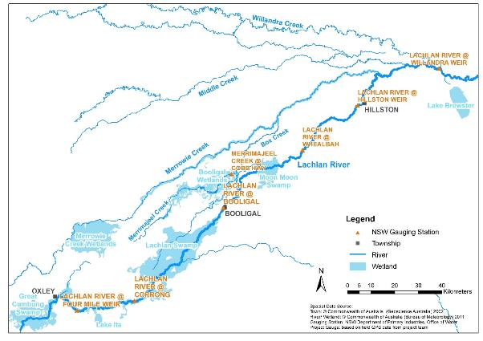
Figure 4-1. The location of relevant gauging stations in the lower Lachlan river system.

A note on the NSW environmental water portfolio
The NSW environmental water portfolio includes both licensed general and high security water entitlement, and a discretionary form of planned environmental water called Environmental Water Allowance (EWA). EWA is not available every year as it is linked to the volumes available in general security accounts as per the allocation rules in the Water Sharing Plan. In general, it is available during higher water availability years and accounted at the point of release (Wyangala Dam and Lake Brewster). NSW DPIE–EES have discretion over the use of EWA similar to its licensed water accounts. In this report, the general reference to NSW environmental water includes both licensed general security and high security, and EWA. Other forms of planned environmental water in this report are referred to specifically as either translucent releases and water quality allowance (WQA). The first is rules-based or non-discretionary and managed by the river operators (WaterNSW) and the second by DPIE-Water.
In this report the term operational river flows is used to refer to other forms of water in the system, mainly other consumptive orders (irrigation) and river operations essential requirements (town water, stock and domestic, base flow requirements) managed by WaterNSW.

Results
A total of 41,168 ML of Commonwealth environmental water was used in the Lachlan river system in 2020-21 across seven watering actions. While at face value, this contributed 3% of the flow in the river at Forbes, 14% at Hillston and 21% at Booligal (Table 4-1), the delivery of water from different sources and to multiple locations means that the contribution of the environmental water to the river system is a far more complex story.
Table 4-1. The 2020-21 accounted Commonwealth and NSW environmental water in the Lachlan river system.
 | Total Annual Flow (ML) | Commonwealth environmental water (ML) | NSW environmental water (ML) | Planned environmental water (translucent flow)
Forbes (Cotton’s Weir) | 526,768 | 14,837 | 6,329.4 | 44 GL
Hillston Weir | 264,503 | 37,867 | 25,513 | 129 GL
Booligal | 143,979 | 32,986 | 24,161 | NA

Watering Action 1: Booberoi Creek Spring Pulse
The first watering action provided a large fresh to Booberoi Creek in October 2020 to recover habitat after a prolonged shutdown to complete efficiency works (desilting). The action was designed to provide habitat for native fish and water plants, thus supporting First Nations values. The spring pulse commenced on the 17th September and finished on the 26th October, delivering 977.5 ML of Commonwealth environmental water and 977.5 ML of NSW licensed environmental water accounted for over 40 days (Figure 4-2). During the watering action, a total of 3,141 ML of environmental water was delivered through the Booberoi Creek offtake, however, only 1,955 ML was accounted for as Commonwealth and NSW environmental water due to return flows into the Lachlan River being recredited.
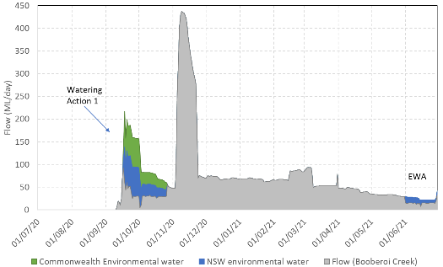
Figure 4-2. Flow at Booberoi Creek for the period 1st of July 2020 to 30th of June 2021 showing Watering Action 1.
Commonwealth (green) and NSW (blue) environmental water is shown along with estimates of operational river flow in grey.
This action was not monitored under the MER program in 2020-21.

Watering Action 2: August-September Lake Brewster translucent flow
The second watering action involved modifying the first of two translucent flow events in the Lachlan in 2020-21, providing lateral and longitudinal connectivity along the river system. This involved managing the flows to:
- extend the duration of the translucent event to sustain and extend floodplain inundation, thus maximising outcomes from the translucent flow; and
- produce a more natural end to the translucent flow, than would occur under normal operations.
In doing so, the action aimed to increase the duration of inundation of floodplain vegetation, particularly the core reed beds of the Great Cumbung Swamp, the black box community near back Bunumburt Lakes area and the numerous swamps and wetlands in the Lachlan Swamps floodplain region that haven’t had water since the 2016 flooding. A deliberate part of the watering action was a focus on extending the duration of the event to build understanding of the flow-inundation relationships in the lower Lachlan floodplain wetland environments to better inform future watering actions. To achieve these aims, the watering action was designed in two parts.
The hydrograph for Part 1 targeted Willandra Weir (412038) to maintain peak discharge at >3,000 ML/day for an additional 6 days to maintain head pressure behind floodplain flows for Whealbah Lagoon, Moon Moon Swamp and associated overflow swamps such as Gum Lake, the larger Torriganny system wetlands (Main Swamp), Lachlan River wetlands between Whealbah and Booligal (Lilydale wetlands) and Willandra and Middle creek systems above Hillston. The 6-day peak was followed by 3-days between 2,500 ML/day and 1,600 ML/day. The 9-days targeting higher flows were designed to combine with floodplain return and provide a similar short but high energy pulse to pushout further across the Lachlan Swamps floodplain system below Booligal and north and south of the Lachlan River. As Part 1 attenuated, Part 2 was designed at Booligal Weir targeting >1,200 ML/day, which is the minimum flow rate in the Lachlan Long Term Watering Plan to produce large wetland inundation for the Western Lachlan watercourse planning unit. A longer duration at this critical flow rate was expected to increase depth and extent of inundation for priority environmental assets such as Lake Waljeers–Peppermint Swamp–Lake Bullogal–Ullonga (Erins Billabong)–The Ville connected floodrunners; Pimpara Creek on Kalyarr National Park; further attenuating to add substantial additional days of flow at the lower thresholds for the Greater Cumbung Region wetlands including Baconian Swamp to Lake Muloga floodplain as well as the Great Cumbung Swamp wetland complex itself.
A total of 129 GL of translucent flows were delivered from Brewster Weir between 21st August and 16th September. Part 1 of the environmental watering action commenced at Willandra Weir on the 17th September, finishing on the 25th September. Both Commonwealth and NSW DPIE environmental water were used, delivering a combined total of 24,490 ML (12,245 ML each of Commonwealth and NSW environmental water). The environmental water prevented the river from suddenly dropping from flows of almost 4,000 ML/day to flows of around 2-400 ML/day in 24 hours and instead allowed the river to transition to lower flows over a 9-day period.
Part two of the environmental watering action was accounted for at Booligal and was delivered between the 10th October and the 2nd November 2020. The total environmental water use for part 2 was 17,832 ML comprising 11,016 ML of Commonwealth and 6,816 ML of NSW environmental water. While the target hydrograph for Part two was designed to benefit the Booligal floodplain wetland system, it also contributed to sustained higher flows from Lake Brewster to Booligal.
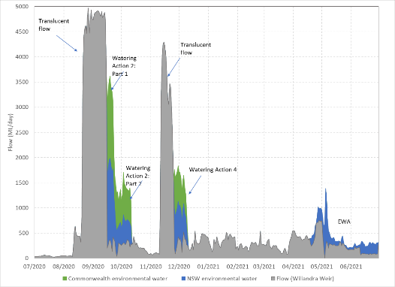
Figure 4-3. Flows at Willandra Weir for the period 1st of July 2020 to 30th of June 2021 showing Watering Action 2 and an estimate of Watering Action 4.
Commonwealth (green) and NSW (blue) environmental water is shown along with estimates of river flow (flow including the licensed delivery of water but not including environmental water) in grey.
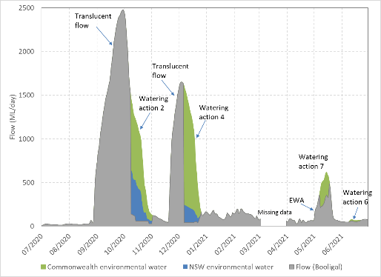
Figure 4-4. Flows at Booligal for the period 1st of July 2020 to 30th of June 2021 showing estimates of Watering Actions 2, 4, 6 and 7.
Commonwealth (green) and NSW (blue) environmental water is shown along with estimates of river flow (flow including the licensed delivery of water but not including environmental water) in grey.

Watering Action 3: Fletcher’s Lake
The third watering action targeted long-term improvement in aquatic vegetation species diversity and condition and provision of refuge habitat for waterbirds and frogs. The timing of the fill and draw down sequence was managed to provide mudflat habitats for migratory and resident shorebirds and waders. Landholder infrastructure was used to pump 600 ML of Commonwealth (300 ML) and NSW (300 ML) environmental water to the Lake, with pumping commencing on the 5th October and finishing on the 30th November 2020 (Figure 4-5.). The lake retained water through summer and still held water at the end of the reporting period.
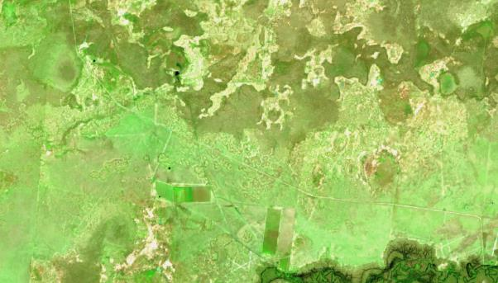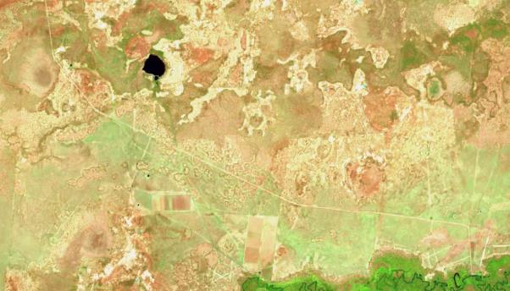
Figure 4-5. Sentinel imagery of Fletcher’s Lake prior to the arrival of environmental water (12 October 2020 upper image) and the full lake (26 November 2020 lower image).
Images sourced from https://www.sentinel-hub.com/explore/sentinel-playground.
This action was not monitored under the MER program in 2020-21. NSW DPIE-EES incidental waterbird observations confirmed red-necked avocets and red-capped plover using the desired mudflat habitats.

Watering Action 4: Augmenting translucent flow in the lower river
The fourth watering action followed the second translucent flow event in December 2020 in the Lower Lachlan river system. Similar to the second watering action, it was designed to double the duration of a shorter translucent event to top up and refresh habitats inundated by the combined use of translucent flows and NSW and Commonwealth environmental water to enable species using those habitats to either complete life cycle requirements (e.g. extend hydro-period for frogs) or access resources to improve condition.
Translucent releases commenced from Wyangala Dam on the 28th October and finished on the 7th December with a total of 44.6 GL. Given improved inflows into Wyangala Dam, government environment agencies requested that releases be from Wyangala Dam to provide the full length of the river with a fresh. Environmental water was used to modify the translucent flow at two different locations, and converging on a target hydrograph for Booligal. NSW DPIE environmental water was ordered to manage the recession at Wyangala Dam, and maintain a base flow to small fresh in the Lachlan River between the dam and the first tributary confluence while demand was unseasonally low. A total of 3,299 ML of NSW environmental water was accounted for over 4 days from the 8th to 11th of November 2020 (not shown) and the small fresh-baseflow component was not required because of an increase in irrigation demand as the time since last rainfall increased. This recession passed through Willandra Weir after the Translucent flows and before water was released from Lake Brewster to meet the target of >1,300 ML/day accounted for at Booligal. This latter component of the watering action used 13,860 ML of Commonwealth environmental water and 2,052 ML of NSW environmental water and passed Booligal Weir from the 8th to 19th of December 2020 (Figure 4-4) .

Watering Action 5: Lake Brewster
The fifth watering action involved the management of water levels in Lake Brewster to support the Australian pelican rookery on the eastern outflow baffle banks that established in December 2020 (Figure 4-7). In doing so, the action also provided additional habitat for a large number and diverse suite of waterbird species when other wetland refugia in the Lachlan landscape was drying down. It also provided foraging habitat for a large number and diverse range of waders, including migratory species, sharp-tailed sandpiper, pectoral sandpiper and threatened species such as blue-billed duck. This action also aimed to enable aquatic plants (particularly red milfoil) to complete their full life cycle to provide future seed reserves. This action was not monitored under the MER program in 2020-21.

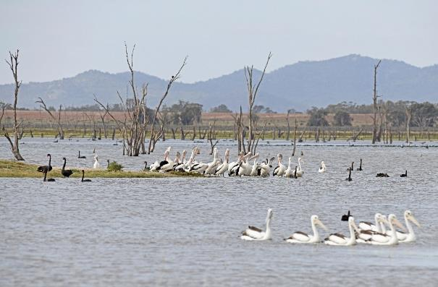
Figure 4-6. Pelicans during a survey on the 15th April 2021 at Lake Brewster. Photo: DPIE-EES and Mal Carnegie (Lake Cowal Foundation)

Watering Action 6: Noonamah black box woodlands
The sixth Commonwealth environmental watering action targeted wetland vegetation at Lake Noonamah. A total of 164 ML of Commonwealth environmental water was delivered to the wetland in June (Figure 4-8). This wetland has been monitored since the commencement of the MER Program in 2019.

Watering Action 7: Autumn Pulse with EWA
The seventh watering action aimed to provide flow variability in the lower Lachlan River channel and provide a small pulse to the Great Cumbung Swamp. By providing variability in Autumn flows, the watering action was designed to enable a comparison of productivity to previous pulses delivered at a cooler time of year.
This action provided a 20-day Autumn pulse (2,604 ML) from start of May at Booligal with a peak discharge of approximately 650 ML/day. Commonwealth environmental water was used to build on the use of NSW Environmental Water Allowance to increase base flow during Autumn/Winter to provide greater access to refuge habitat for native fish and southern bell frog in the Lower Lachlan, including the Great Cumbung Swamp (Figure 4-4).
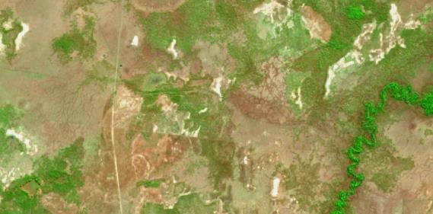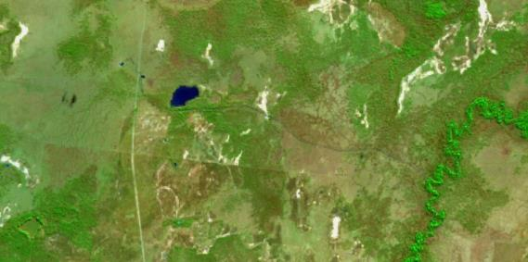
Figure 4-7. Sentinel imagery of Lake Noonamah wetland prior to the arrival of environmental water (30th May upper image) and the full lake (19th June 2021 lower image).
Images sourced from https://www.sentinel-hub.com/explore/sentinel-playground.

Evaluation
The hydrological analysis presented here provides the context for evaluating observed ecological responses. The evaluation provided in this section is confined to the hydrological metrics, subsequent chapters evaluate the efficacy of the watering actions for achieving ecological outcomes.
The seven environmental watering actions delivered in 2020-21 were significant, building on substantial flows derived from the translucent flows and high soil moisture conditions across the catchment. Delivery was complex with volumes delivered strategically to modify flow recessions and augment the duration of floodplain wetland inundation from multiple locations, targeting multiple outcomes. The nature of the translucent flows (of relatively short duration) and the distribution of the water resources across the catchment meant that environmental water managers had to be responsive to the conditions and agile in their delivery to achieve the outcomes desired.
In relation to the effects of Commonwealth environmental water, the evaluation questions are addressed as follows:
- What did Commonwealth environmental water contribute to habitat for water dependent species?
The watering actions in the 2020-21 watering year contributed to habitat within channel and off-channel, either through building on the translucent flow events or by watering parts of the river system that would have otherwise been dry in 2020-21. The first watering action provided water to Booberoi Creek which provided a spring pulse to the creek and ensured that water remained in the creek during this time.Watering actions two and four built on the translucent flows in August and November by increasing the extent and duration of inundation on the floodplain, including locally important wetlands. For example, the pulse was of sufficient discharge and duration to fill several River Red Gum-lignum wetlands on the Torriganny Creek anabranch system that supported colonial bird breeding during previous floods.
The additional duration of connection was particularly evident in the lower part of the system in and around the Great Cumbung Swamp, where environmental water was used to inundate a range of floodplain habitats, including tall emergent marsh, river red gum and black box woodlands, lignum shrublands and open temporary lakes, which are frequented by a diverse assemblage of native birds and other animals. Floodwater inundated an extensive area of the reedbed of the Great Cumbung Swamp including reeds which had not been flooded for at least four years. In doing so, it contributed to the provision of aquatic habitat for water dependent species.
The third and sixth watering actions provided water to Fletchers Lake and Lake Noonamah providing habitat for aquatic species. The fifth watering action provided vital breeding or reproductive habitat for Australian pelicans, that successfully fledged and red milfoil that set seed (surveys by NSW DPIE). This action also provided foraging habitat for a large number and diverse suite of waterbird species including migratory species, sharp-tailed sandpiper and pectoral sandpipe, and threatened species such as blue-billed duck when other wetland refugia in the Lachlan landscape was drying down.
Watering action seven increased the baseflow for 20 days at Booligal and improved flow variability, providing greater access to refuge habitat for native fish and southern bell frog in the Lower Lachlan.
- What did Commonwealth environmental water contribute to hydrological connectivity?
The watering actions delivered in 2020-21 connected in-channel habitats, provided extensive lateral connectivity between the channel and the floodplain and provided flow to the end of the river system.
Watering actions two and four provided extensive lateral connectivity between the main channel of the Lachlan River and the floodplain of the lower Lachlan River. In doing so it enabled the environmental water requirement for Middle Creek to flow (>2,600 ML for around 35 days) by extending the duration of the translucent flow at Willandra Weir. Is also extended the duration of connection of some of the locally important wetlands including:
- Whealbah Billabong: extending connection for 5 days;
- Moon Moon Swamp: extending connection for 8 days;
- Gum Swamp, Eagles Nest and Main swamp on the Torriganny system: extending connection for 25 days; and
- open water wetlands at Booligal: extending connection for 10 days.
The additional duration of connection was particularly evident in the lower part of the system in and around the Great Cumbung Swamp where environmental water extended the connection by at least 30 days. This enabled movement of a range of biota and allowed dispersal and recolonisation of habitat patches that would have otherwise been hydrologically disconnected.

Final comments and recommendations
The outcomes from the use of environmental water in conjunction with the two translucent flow events which occurred during the 2020-21 watering year needs to be considered from the perspective that the translucent flows were the bulk of the water in the system at those times and hence primarily responsible for a number of the ecological outcomes observed. As per previous watering actions in the Lachlan river, it will be difficult to tease apart what environmental water contributed to these outcomes versus the contribution made by translucent flows.

Recommendation 1: Consider coordinated investment with NSW DPI-EES around improved inundation mapping for the Lachlan river system
The 2020-21 watering actions were used strategically to build an understanding of the flow-inundation relationships in the lower Lachlan floodplain wetland environments. When designing watering actions, environmental water managers consider available information on the flows that enable wetlands to commence to fill or flow (known as the wetlands CTF) for priority floodplain wetlands, and the relative benefit from higher peak discharge rates for shorter durations and lower peak discharge rates for longer durations. It is rare to be able to test the influence of different rates.
During the second watering action, a combination of landholder observations and strategically located time lapse cameras and gauge plates confirmed that the 1,200 ML/day target at Booligal maintained connection to the Lachlan Swamps floodplain, however, 1,300–1,500 ML correlated with a notably greater flow depth and inundated more in-channel and fringing habitat. Such an approach to learning opportunistically from the local conditions is invaluable to future planning for watering actions. While this mechanism of data collection represents a practical allocation of (scarce) resources, if accompanied by good mapping of floodplain inundation extents, it would provide a very useful resource for quantifying the relative contribution to floodplain inundation. Mapping of floodplain inundation extent in the Lachlan river system has seen considerably less investment than in other NSW river systems and it would be valuable to consider some coordinated investment with NSW to improve the inundation mapping of the area to inform the use of environmental water.

Hydrology – water resource development and environmental water

Introduction and methods
The flow regime of a river shapes the evolutionary and ecological processes which occur within the river and its floodplains. Critical flow components such as magnitude, frequency and duration of a specific flow condition (eg. cease-to-flow, small and large fresh, and overbank flows) structure river ecosystems (Poff et al. 1997) and are often defined at locations along a river (for example the lower Lachlan River, OEH NSW 2018). These flow characteristics contribute to the hydrological regime on floodplains via lateral connection between the river and its floodplain (Junk et al. 1989). Important characteristics of the flooding regime on floodplains include flood frequency, flood duration, number of days between floods, and flood predictability (Poff and Ward 1989). Understanding how these flow components have changed under current flow conditions is vital in determining the impacts of flow regulation and how environmental water contributes to maintaining the natural flow regime.
This section provides the results of hydrological modeling over a short (1 year), medium (the seven years of LTIM/MERP), and long (135 years) term, to improve our understanding of the impacts of flow regulation on in-channel flows and wetland inundation in the lower Lachlan River system. Further, we describe the contribution that environmental water has made to the regulated flow regime during this watering year (2020-21) and over the LTIM and MER Projects (2014-21) in the context of the natural flow regime.
Firstly, we describe the hydrological character of the Lachlan River over this watering year (2020-21) under current (actual) flow conditions and the contribution that environmental water has made and compare this to modeled natural (without development) flows at Booligal (river gauge) on the lower Lachlan River. We then compare current (actual) flow conditions with modeled natural (without development) flows over the last seven years of LTIM Project and MER Program. In these sections, we highlight how the hydrological conditions have changed related to river regulation and describe the contribution that environmental water has made. We have selected a range of wetlands in which we monitor vegetation condition and diversity, which have been inundated over this period (either one or seven years). Using commence to fill (CTF) values derived from Higgisson et al. (2019) and the modelled natural and actual current flow records we calculated eight connection metrics representing important components of the flow regime of intermittent streams (Olden and Poff 2003). The approximate volume (ML) of water that was likely to have inundated the floodplain was estimated as the total flow above the CTF value at each site. These volumes of water may have inundated other sites with similar positions on the floodplain. Modeling was undertaken using the Integrated Quantity and Quality Model (IQQM) designed to examine long-term flow behavior under different management regimes (Hameed and Podger 2001). The modeled natural (without development) flow conditions have water management infrastructure and water extraction activities removed.
Using long-term hydrological data sets under modeled flow scenarios, we then describe three key flow components and how they have changed under current flow conditions through comparing modeled natural (without development) flows to modeled current (with development) flow conditions using 135 years of modeled flow data at Booligal gauge. The use of long-term data sets such as this improves our ability to effectively describe the characteristics in river flow patterns (Poff et al. 1997). The key flow components we use in this analysis are small freshes, large freshes and small overbanks. These components are characteristic of highly variable river systems such as the Lachlan River. We compared modeled flow scenarios (natural and current flow conditions) to account for changes in climatic conditions, land-use effects and water infrastructure, which have occurred in the Lachlan Catchment over the past 100 years. The modeled natural (without development) flow conditions have water management infrastructure and water extraction activities removed, while the current flow conditions represent current water resource development conditions, including current water supply infrastructure and licensed extractions modeled over the 135 years of available (daily) flow data at Booligal. We also describe the contribution environmental water has made by calculating the number of each of these flow components over the watering year (2020-21) and over the past seven years (2014-201) with and without environmental water.
A small fresh occurs when > 150 ML/day passes Booligal gauge for > 10 consecutive days, a large fresh occurs when > 650 ML/day passes Booligal gauge for > 5 consecutive days, and a small overbank occurs when > 2,700 ML/day passes Booligal gauge for > 30 consecutive days (OEH 2018). We present the percentage change from natural flow conditions to current flow conditions for these key flow components.

This watering year (2020-21)
The higher-than-average rainfall experienced in the Lachlan Catchment in the 2020-21 watering year would have resulted in some very large pulses of water moving through the Lachlan River system under natural flow conditions (Figure 5-1). Under current flow conditions, two of these flow pulses did occur as a result of translucent flows with contribution of environmental water, although they were lower in magnitude and duration. The first of these pulses which occurred in September 2020 reached nearly 2,480 ML/day at Booligal whilst under natural flow conditions this event is expected to have peaked at 4,342 ML/day. The second translucent flow event which occurred in late November and early December 2020 peaked at 1,652 ML/day at Booligal, whilst this event is expected to have peaked at 3,454 ML/day at this gauge under natural flow conditions. Environmental water was used to extend the duration of these (translucent flow) events to sustain and extend floodplain inundation.
Under natural flow conditions the river would have experienced greater flow variability with much greater volumes of water in the system during the 2020-21 watering year. Under natural flow conditions, apart from the two translucent flow events in late 2020, the Lachlan River experienced low and stable flow conditions with little flow variability.
The two translucent flow events in late 2020 flooded wetlands on the floodplain of the lower Lachlan River, including wetlands that had not been inundated since late 2016. On average the wetlands of the lower Lachlan would have connected to the river eight times under natural flow conditions while they connected on average just twice in 2020-21 (Table 5-1), resulting from the two translucent flow events in late 2020. The number of days these wetlands connected to the river by flooding was approximately 43% of what would have occurred under natural flow conditions (62 days compared with 145 days under natural flow conditions). On average, only 20% of the total volumes of water that would have inundated the floodplain of the lower Lachlan River made it on to the floodplain during 2020-21.
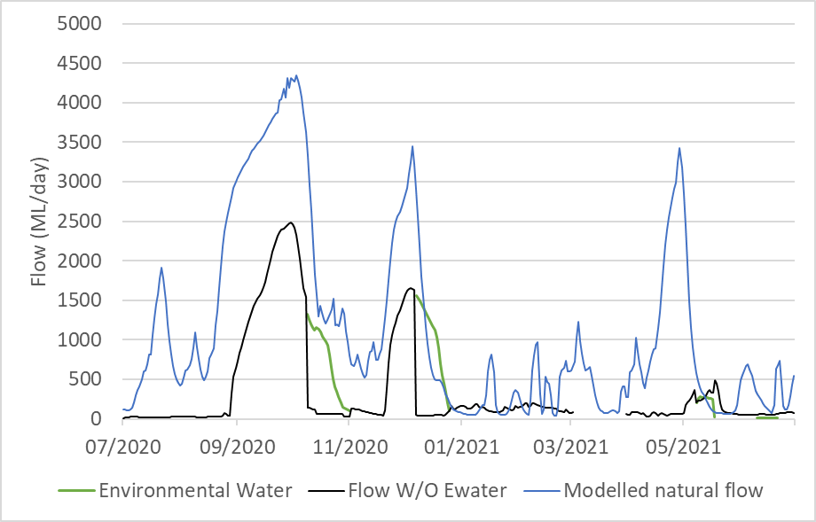
Figure 5-1. Modelled natural flow (ML/day) (grey hydrograph) and actual river flow (black hydrograph) of the Lachlan River at Booligal river gauge from 1 July 2020 to 30 June 2021. The green roughly represents environmental water actions.

Table 5-1. River – floodplain connection metrics for six locations on the floodplain of the lower Lachlan River under modelled natural flow conditions (N) and current flow conditions (C) over the 2020-21 watering year.
* The Great Cumbung Swamp (GCS) includes Nooran Lake. They have similar CTF and are in close proximity.
 | The Ville  CTF 950 ML/day  (Corrong) |  | Moon Moon  CTF 1,600 ML/day (Whealbah) |  | Whealbah  CTF 2,700 ML/day (Whealbah) |  | Lake Marool  CTF 730 ML/day  (Corrong) |  | Lake Ita  CTF 650 ML/day  (Corrong) |  | GCS *  CTF 350 ML/day  (Corrong) |  | Floodplain of the lower Lachlan  (Average)
 | N | C | N | C | N | C | N | C | N | C | N | C | N | C
No. of connections | 6 | 1 | 6 | 2 | 3 | 2 | 11 | 2 | 11 | 2 | 11 | 3 | 8 | 2
Total of days connected | 114 | 16 | 106 | 60 | 79 | 40 | 150 | 66 | 166 | 78 | 255 | 110 | 145 | 62
Mean days connected | 19 | 16 | 18 | 30 | 26 | 20 | 14 | 33 | 15 | 39 | 23 | 37 | 19 | 29
Longest connection | 66 | 16 | 56 | 37 | 50 | 30 | 72 | 47 | 74 | 52 | 136 | 60 | 76 | 40
No. of dis-connections | 7 | 2 | 7 | 3 | 4 | 3 | 12 | 3 | 12 | 3 | 11 | 4 | 9 | 3
Mean days disconnected | 36 | 175 | 37 | 102 | 72 | 108 | 18 | 100 | 17 | 96 | 10 | 64 | 32 | 108
Longest dis-connection | 71 | 243 | 128 | 203 | 132 | 213 | 28 | 183 | 28 | 181 | 23 | 131 | 68 | 192
Total volume (GL) | 78.9 | 0.9 | 231.2 | 85.6 | 135.6 | 32.1 | 107.5 | 9.2 | 120.2 | 15.0 | 184.4 | 43.0 | 143 | 28.6

Seven years of river regulation and environmental water
The Lachlan River is characteristically a river of extremes. Under natural flow conditions, over the past seven years (2014-21) the flow of the Lachlan River would have experienced a highly variable flow regime, with interannual variation in flow regime, and large irregular flow pulses broken up by periods where the river ceased to flow (Figure 5-2 and Figure 5-3). Unlike, rivers in more seasonally predictable climates, the Lachlan River relies on rainfall during wet years, and interannual variability in climate and rainfall patterns are evident in the natural flow regime of the Lachlan (Figure 5-2 and Figure 5-3). Under natural flow conditions the Lachlan River would have ceased to flow at Booligal for a total of 537 days over the past seven years.
Under current flow conditions the large irregular flow pulses which are a characteristic of the Natural flow regime of the Lachlan have been removed or significantly reduced in frequency and magnitude (Figure 5-2 and Figure 5-3). Under current flow conditions the river did not cease to flow since 2014. The loss of these larger flow events in the Lachlan has reduced the frequency and duration of events that connect the river to the floodplain of the lower Lachlan (Table 5-2).
Over the past seven years, the floodplain wetlands of the lower Lachlan River connected less often compared to what would have occurred under natural flow conditions. The floodplain of the lower Lachlan connected to the river half (53%) the number of days it would have under natural flow conditions. The number of connection events was considerably reduced at all wetlands with an average of five connections occurring over the seven years compared with 29 under natural flow conditions. Despite, the floodplain wetlands varying in the number of connections (and other river-floodplain connection metrics) experienced under natural flow conditions (eight at Whealbah Lagoon and Booligal Swamp to 62 in the reed bed of the Great Cumbung Swamp) most wetland sites used in this analysis have experienced four connections over the seven years. As well as less frequent connection regimes, this highlights reduced spatial and temporal variability in river-floodplain connection regimes across the different wetlands that make up the floodplain of the lower Lachlan. Under current flow conditions wetlands now experience an increased number of days between connection events. The longest disconnection period over the seven years exceeded four years in Booligal Swamp, whilst it would have flooded within three years under natural flow conditions (Table 5-2). The lower lying reed bed of the Great Cumbung Swamp would have connected to the river by floodwater once a month on average under natural flow conditions, while over the past seven years connected just once every six months (Table 5-2).
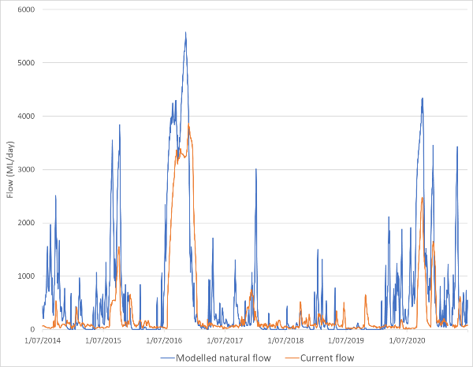
Figure 5-2 Modelled natural flow (ML/day) (blue hydrograph) and actual river flow (orange hydrograph) of the Lachlan River at Booligal river gauge on the Lachlan River from 1 July 2014 to 30 June 2021.
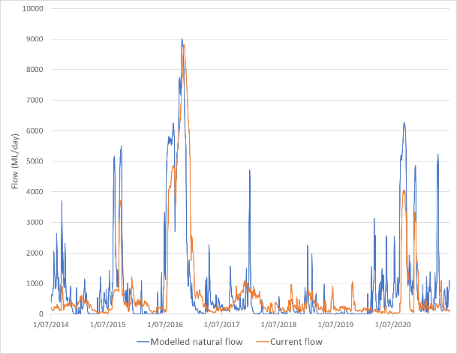
Figure 5-3. Modelled natural flow (ML/day) (blue hydrograph) and actual river flow (orange hydrograph) of the Lachlan River at Whealbah river gauge on the Lachlan River from 1 July 2014 to 30 June 2021.

Table 5-2. River – floodplain connection metrics for nine locations on the floodplain of the lower Lachlan River under modelled natural flow conditions (N), and current (actual) flow conditions from 1 July 2014 through 30 June 2021.
 | No. of connections |  | Mean days connected |  | Total days connection |  | Longest connection |  | Mean days disconnected |  | Longest disconnection |  | Total volume (GL)
 | N | C | N | C | N | C | N | C | N | C | N | C | N | C
Booligal Swamp | 8 | 1 | 30 | 126 | 236 | 126 | 135 | 126 | 258 | 1216 | 962 | 1649 | 290.9 | 99.9
Hazelwood Lagoon | 11 | 4 | 22 | 48 | 246 | 193 | 75 | 144 | 192 | 473 | 795 | 1355 | 610.8 | 444.7
Lake Ita | 44 | 4 | 13 | 70 | 580 | 279 | 164 | 175 | 44 | 456 | 378 | 1327 | 493 | 162.7
Lake Marool | 40 | 4 | 13 | 65 | 529 | 259 | 160 | 172 | 49 | 460 | 379 | 1331 | 448.7 | 141.1
Moon Moon | 20 | 4 | 19 | 62 | 372 | 247 | 144 | 168 | 104 | 462 | 424 | 1330 | 951.6 | 594.4
Whealbah | 8 | 4 | 33 | 49 | 266 | 197 | 139 | 145 | 255 | 472 | 957 | 1354 | 618.4 | 353.3
Nooran Lake | 41 | 5 | 15 | 59 | 628 | 294 | 167 | 176 | 46 | 377 | 356 | 966 | 523.3 | 177
GCS Reedbed | 62 | 11 | 16 | 39 | 918 | 424 | 200 | 182 | 26 | 178 | 276 | 420 | 716.4 | 265.6
Averages | 29 | 5 | 20 | 65 | 472 | 252 | 148 | 161 | 122 | 512 | 566 | 1217 | 581.6 | 279.8

Changes to key flow components under current conditions (using 135 years of modeled flow data) for freshes and small overbank flows
Comparing 135 years of modelled natural and current flow conditions, under natural flow conditions, at Booligal, on average a small fresh would have occurred at least twice a year, a large fresh three times a year, and a small overbank flow once every two years. These key flow components would have experienced a high degree of interannual variability (Table 5-3).
The frequency of small freshes, large freshes and small overbank flows have all been reduced under current flow conditions. The frequency of small freshes has not changed considerably. However, the frequency of large freshes and small overbank flows has been substantially reduced, and now occur half as often as they would have under natural flow conditions (Table 5-3).
Over the past seven years, environmental water has made a significant contribution to increasing the number of small freshes that have occurred in the lower Lachlan at Booligal. Without environmental water a total of eleven small freshes would have occurred, while environmental water has contributed to an additional four small freshes, resulting in at least two small freshes on average each year. Environmental water has not contributed to large freshes or small overbank flows at Booligal.
During the 2020-21 watering year a total of four small freshes (one of which was attributed to environmental water) and two large freshes occurred. The two large freshes were both a result of the translucent flow events in late 2020.
Table 5-3. The frequency and interannual variability of small freshes, medium freshes, and small overbank flows at Booligal Gauge on the Lachlan River and the percentage change from natural conditions using 135 years of modelled Natural and Current flow conditions, and actual flow data with (+ CEW) and without (- CEW) commonwealth environmental water over 2014-21.
Note: Small fresh: > 150 ML/day for > 10 consecutive days, large fresh: > 650 for > 5 consecutive days, and small overbank: > 2,700 ML/day for > 30 consecutive days. Numbers in brackets are the total number of each flow component which occurred between 2014-21.
 | Natural Flow  Conditions | Current Flow  Conditions | Percentage change | 2014-21  - CEW | 2014-21  + CEW | 2020-21  - CEW | 2020-21  + CEW
Frequency of small freshes (per year) | 2.63 | 2.57 | -2.02 | 1.57 (11) | 2.14 (15) | 3 (3) | 4 (4)
Frequency of large freshes (per year) | 3.09 | 1.36 | -56.1 | 0.71 (5) | 0.71 (5) | 2 (2) | 2 (2)
Frequency of small over-bank flows (per year) | 0.52 | 0.31 | -40.4 | 0.14 (1) | 0.14 (1) | 0 (0) | 0 (0)

Discussion
The Lachlan River naturally experiences a highly variable flow regime experiencing large differences in flow magnitude and interannual variability. A highly variable flow regime is a defining feature of Australia’s dryland river systems (Walker et al. 1995). This variability in flow has resulted in a reliance on flow regulation to improve the reliability of water supply in the Lachlan Catchment. The flow of the Lachlan River has now been extensively modified by flow regulation and water resource developments. Under current flow conditions, most of the larger flows have been removed or considerably reduced in magnitude and duration and the flow of the Lachlan River is typically low and stable. This has reduced the flow variability within channel and the amount of water available to the floodplain wetlands of the lower Lachlan.
The two large flow events which occurred in late 2020 were a result of translucent flows with contribution from environmental water. These two events would have occurred under natural flow conditions albeit larger in magnitude. These events provided large freshes with in-channel and inundated off-channel habitat providing a range of ecological benefits, including increased instream and off-channel habitat, increased instream productivity, and recharging groundwater. These events inundated a range of floodplain wetlands which had not been inundated since late 2016. This highlights the important role translucent flows make in regulated river systems such as the Lachlan in replacing flow components which have been lost as a result of water resource developments. Further, it also highlights how environmental water can be used alongside translucent flows to replace parts of the natural flow regime.
Over the past seven years, environmental water has made an important contribution to replacing components of the natural flow regime which were removed under current flow conditions. Environmental water has provided a range of small to medium sized flow events (especially small freshes), which would not have occurred otherwise under current flow conditions. Environmental water has not contributed to increasing the number of larger flow events such as overbank flows. Environmental water increased the duration of two translucent flow events in late 2020, increasing the number of floodplain-river connection days and amount of water on the floodplain during this event.

Stream metabolism and water quality

Introduction
Stream metabolism describes the fluxes of energy into ecosystems that ultimately provide the building blocks for all plants and animals. Two major energy sources may fuel river food webs: primary producers such as aquatic plants and algae, and detrital organic matter such as leaves and dissolved organic carbon (Bunn et al. 2006).
Gross primary productivity (GPP) is the conversion of energy from sunlight into biomass during photosynthesis and is carried out by all autotrophs (phytoplankton, benthic algae, water plants). The process is a net producer of oxygen.
Ecosystem Respiration (ER) is the collective respiration of all the aquatic organisms present. This includes autotrophs and heterotrophs (bacteria, fungi, animals) and is carried out as organisms obtain energy through oxidising carbon compounds. This process is a net consumer of oxygen.
Both these processes are influenced by the availability of key nutrients, particularly nitrogen and phosphorus, and water temperature and light. The collective production and respiration of carbon in an ecosystem is termed ecosystem metabolism, an integrated measure of carbon cycling in the river (Bernhardt et al. 2018). Gross primary production, ecosystem respiration and ecosystem metabolism are determined by measuring changes in the concentration of oxygen in water. Because physical processes (diffusion, turbulence) can also incorporate oxygen directly from the atmosphere, a value K is modelled to take into account these non-biologically mediated processes.
The delivery of environmental flows has the potential to alter primary production and organic matter breakdown rates in several ways (Bernhardt et al. 2018).
- Mobilisation of carbon and nutrients. Flow can mobilize carbon and nutrients off in-channel benches, the floodplain or from upstream (Boulton and Lake 1992, MDFRC 2013, Stewardson et al. 2013), potentially increasing GPP (nutrients) and/or ER (organic matter).
- Influencing light availability. Environmental flows may affect turbidity, which can act to reduce GPP, because of light limitation, and may increase water depth over photosynthetic surfaces, which in combination with turbidity may result in light limitation.
- Alteration of water temperature. Warmer temperatures tend to increase ER and to a lesser extent GPP.
- Increase in habitat. Submerging in-stream habitat such as benches and woody debris can provide increased availability of surfaces for photosynthetic activity and bacteria or fungi. Increased water volumes can provide increased habitat for planktonic autotrophs.
- Disturbance and scouring. The direct physical effects of environmental flows can dilute water column primary producers and bacteria, and scour biofilms from in-channel substrate which can reduce GPP and ER.
In this section we evaluate the outcomes of providing Commonwealth environmental water to the lower Lachlan river system in terms of measured changes in water nutrients and GPP, ER, K and the GPP/ER ratio.
The 2020-21 Commonwealth environmental watering actions in the lower Lachlan river system are described in detail in Section 3 and 4 and Table 3-2 and Table 3-3 (on page 10).
For watering action two significant rainfall events in the catchment in August triggered a translucent flow event, released from Lake Brewster commencing on the 21st of August 2020. Both Commonwealth and NSW environmental water was used following the translucent event to sustain floodplain inundation, maximise outcomes from the translucent flow and then produce a more natural end to the translucent flow than would occur under normal operations. The use of environmental water commenced at Willandra Weir on the 16th September 2020.
For watering action four the translucent event was released from Wyangala Dam instead of Lake Brewster. It was supplemented with release from Lake Brewster and Lake Cargelligo, passing Willandra Weir in mid-November 2020. It was again extended using a combination of Commonwealth and NSW environmental water, released from Lake Brewster and passing Willandra Weir between the 27th November and the 8th December.
The delivery of watering action seven was from Lake Brewster. It sought to use Commonwealth environmental water to improve variability in the delivery of NSW Environmental Water Allowance and enable a comparison of productivity to previous pulses delivered at a cooler time of year. This action provided a 20-day Autumn pulse (2,604 ML) from start of May. This action built on the use of NSW Environmental Water Allowance to increase base flow from average of 30 ML/day to 100 ML/day during Autumn/Winter to provide greater access to refuge habitat for native fish and southern bell frog in the Lower Lachlan, including the Great Cumbung Swamp.
In evaluating the outcomes of providing Commonwealth environmental water to the lower Lachlan river system the following evaluation questions are addressed.

Selected Area Specific evaluation questions:
- What did Commonwealth environmental water contribute to water quality outcomes?
2) What did Commonwealth environmental water contribute to patterns and rates of ecosystem respiration (ER) and gross primary productivity (GPP)?

Methods
The evaluation of the stream metabolism and water quality outcomes uses a combination of river height data (as described in Section 4), water quality data and stream metabolism data (modelled from dissolved oxygen measurements as described below). Data are collected from four lower Lachlan River sites; Wallanthery (WAL), Lane’s Bridge (Wagner et al.), Cowl Cowl (CC) and Whealbah (WB) (Figure 6-1).
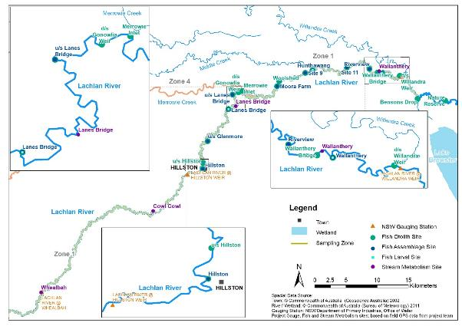
Figure 6-1. Map of monitoring sites for adult and larval fish, stream metabolism and gauging stations in the lower Lachlan River Zone L1.
Dissolved oxygen and temperature were measured continuously using automated stream loggers.
Other water quality measures were collected manually as spot measurements during sampling for other indicators, when downloading and servicing loggers and when sites were accesssible.
Conductivity, pH and turbidity are manual point measures and were recorded as spot measurements using a handheld water quality meter (Horiba U-52 Multi Parameter).
For nutrients and chlorophyll a, water samples were taken two meters from the water’s edge at one-meter depth. These were placed on ice and transferred to ALS (Australian Laboratory Services Pty Ltd) in Canberra for analysis of total nitrogen, nitrate/ nitrite, total phosphorus, dissolved reactive phosphorus and ammonia. Chlorophyll-a samples were analysed at the University of Canberra using standard spectrophotometric methods.
Stream metabolism was measured applying the standard methods for the MER program (Dyer et al. 2019). Dissolved oxygen (DO) and water temperature were logged at 10-min intervals using MiniDOT sensors (Precision Measurement Engineering Inc., Vista, USA) installed in the water column at the edge of the stream (Figure 6-2). The three download dates for the watering year 2020-21 were 05/06/20, 27/10/20, and 11/03/21. Fieldwork for downloading at the end of June 2021 was disrupted by COVID-19 restrictions. As the latest download was only shortly before the previous reporting period finished in early June, we started to report 2020-21 at the end of May 2020.
A data quality procedure was performed to identify and correct sudden and short-term drops in DO, that are not considered to represent true conditions in the river. In these instances, sudden drops in DO measurements to values around and below 4 mg/L were recorded for an average of 1.25 hours. This suggests organic material such as leaf material was temporarily lodging on the sensor. Overall, there were 134 occurrences of low DO readings followed by a sudden drop over the period of 280 days (05/06/20 till 11/03/21). Most sudden drops occurred in January and February with none occurring from June to August. We interpolated the ‘incorrect’ 10-minute-interval readings linear unless more than 18 consecutive readings (180 minutes) occurred at the very low level, which suggest a true water level change and therefore affected the DO reading.
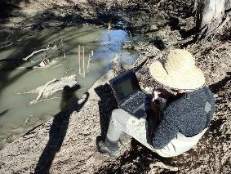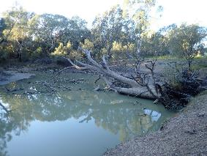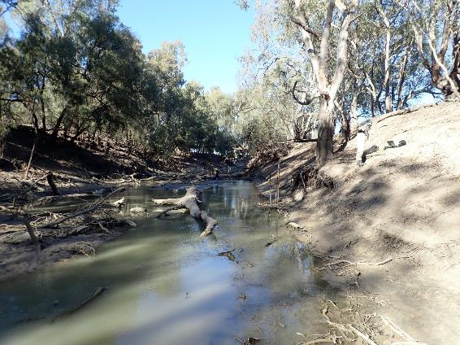
Figure 6-2. Stream metabolism sites in the lower Lachlan river during low flows in June 2020 (top left to bottom: CC, LB, WB (WAL not shown). Photos: Matthew Young
Barometric pressure was measured with a Silva Atmospheric Data Centre Pro (Silva, Sollentuna, Sweden). Photosynthetic active radiation (PAR) was measured in an adjacent unshaded location at 10-min intervals using photosynthetic irradiance loggers (Odyssey, Christchurch, New Zealand). However due to logger failures of all three PAR loggers (located at LB, WB and CC) in 2020-21 we downloaded Global Horizontal Irradiation (GHI in W/m²) data from Solcast API (provided by Solar and Storage Modelling Pty Ltd) in 10-minute interval for site Lane’s bridge. The irradiance measures were converted to photon flux (measured in in μ mol m²/s) in the photosynthetically active 4.0 to 7.0 μm range, using a factor of 2.3 following Knauer et al. (2018). A number of similar conversion factors ranging between 2.02 and 2.17 (Thimijan and Heins 1983, Foken 2017, Carruthers et al. 2001) were considered, but had been unfit in comparison to last year results on modelled metabolic rates. Downloading previous years’ GHI data and correlating it with measured PAR data from those years showed a very close relationship (R-squared >0.8) suggesting that the GHI data provides an excellent surrogate for the logger-derived data.
Daily rates of GPP and ER (along with reaeration rates, K) were estimated using the BASE model (BAyesian Single-station Estimation) (Grace et al. 2015). Estimates derived from curve fits with R² < 0.9 and/or CV for GPP of > 50% were reviewed. The version of the model used incorporated a series of updates which have been applied across the MER program and was current from the 18th of June 2018 (V2.3.3).

Results

Water quality – 2020-21
Logged water temperature showed a typical seasonal pattern, ranging from 7.9 °C in winter, to 28.0 °C in summer, with no clear association to flow events. The logged dissolved oxygen (DO) data show a decrease during the September 2020 translucent flow event, and an otherwise seasonal pattern with values lower during summer (Figure 6-3). The exception to this was an unexplained spike for the logged data in January 2021.
The logged water temperature and dissolved oxygen data are very similar and followed the overall trend to downloaded data from the nearest NSW gauging station data at Hillston (obtained from https://realtimedata.waternsw.com.au/). As stated above fieldwork for downloading loggers at the end of June 2021 was disrupted by COVID-19 restrictions, therefore our data stopped at 11th of March 2021.
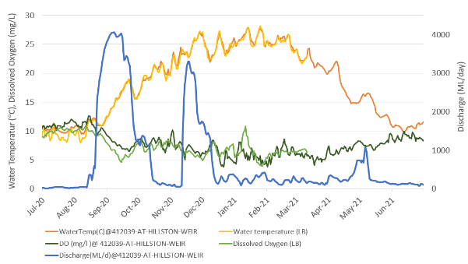

Figure 6-3. Water temperature, dissolved oxygen for Lane’s Bridge compared to Hillston Weir, and Hillston Weir discharge over the sampling period 2020-21.
Blue shaded vertical bars indicate watering actions based on Willandra discharge (light blue).
Interpretation of water quality parameters derived from spot measurements was challenging in the 2020-21 year, because of a lack of sampling access due to COVID-19 restrictions on travel. As a consequence, inferring patterns from the limited amount of data available requires caution. There was no evidence from the data that environmental watering events had large effects on water quality in 2020-21 (Figure 6-3 to Figure 6-5). There was no evidence of an effect of environmental flows on dissolved oxygen concentrations and water temperature (Figure 6-3). There was some limited evidence for lower turbidity and potentially salinity following the mid-November/ December translucent flow of Watering Action 4, consistent with dilution of ions and fine sediment associated with the flow event (Figure 6-4), consistent with what has been observed in previous years.
Values for total nitrogen and nitrate/nitrite were low during low flows from October through until mid-November. There was some evidence of increased total nitrogen associated with high flow levels during the second translucent flow, although this bioavailable nitrogen (nitrate/ nitrite) concentrations were low, suggestive of inputs of particulate or bound nitrogen. The same flow event was associated with some evidence for higher ammonium, total and reactive phosphorus concentrations, consistent with mobilisation of organic material within the channel (Figure 6-5). This was supported by the DOC data for the same period. Data for DOC and chlorophyll (a measure of algal biomass) are sparse but there is evidence for slight increases during delivery of flows in mid-November/ December are rising, which is again consistent with mobilisation of organic matter (Figure 6-5).

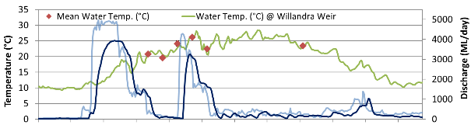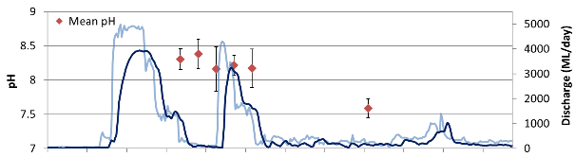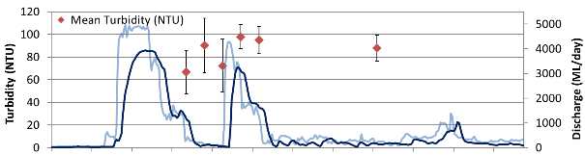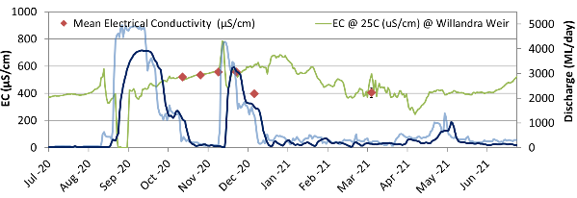

Figure 6-4. Mean water quality measurements (± standard error) for the four lower Lachlan river sites (Cowl Cowl, Lane’s Bridge, Wallanthery and Whealbah) over the sampling period 2020-21: physico chemical attributes.
Blue shaded vertical bars indicate watering actions based on Willandra discharge (light blue).

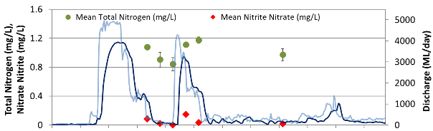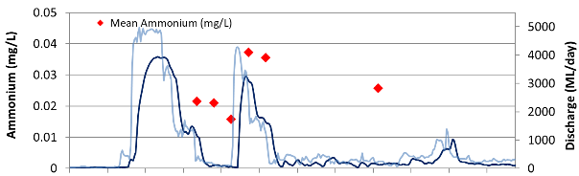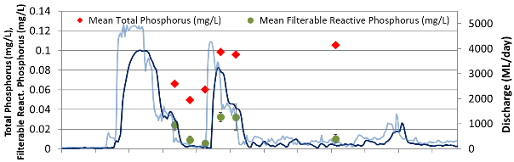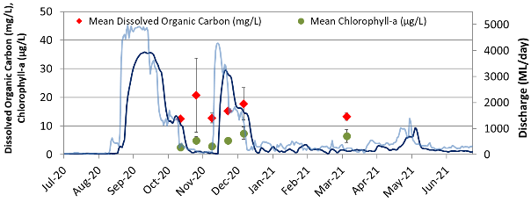

Figure 6-5. Mean water quality measurements (± standard error) for the four lower Lachlan river sites (Cowl Cowl, Lane’s Bridge, Wallanthery and Whealbah) over the sampling period 2020-21: nutrients and chlorophyll a.
Blue shaded vertical bars indicate watering actions based on Willandra discharge.

Water quality – 2014-21
The consolidated water quality data set from the lower Lachlan River site shows some clear overall patterns. As outlined above, limitations on data collection during the 2020-21 monitoring period mean that water quality data are relatively sparse.
- Strong seasonality in temperature data, with any effect of environmental flow delivery being very slight against this natural variability.
- High variability in parameters, which is likely to reflect genuine patchiness in water quality as a consequence of low rates of mixing and inputs from shallow groundwater systems and tributaries.
- Striking effects of a large natural flood in 2016-17 and smaller but evident effects of high flows during 2020-21.
- Evidence of a pattern of increased turbidity, higher DOC and periodically higher nutrients and algal concentrations associated with environmental flow delivery indicating likely mobilisation of material in the channel and dilution of ions.
Water temperature and dissolved oxygen showed a strong typical seasonal pattern (Figure 6-6). Years with lower or higher inflows did not show any deviation from this general pattern.
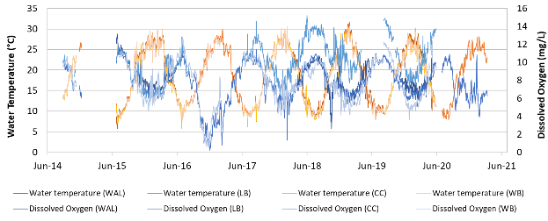
Figure 6-6. Water temperature and dissolved oxygen for the four study sites from the lower Lachlan river sites (Wallanthery, Lane’s Bridge, Cowl Cowl, and Whealbah) over the sampling period 2020-21.
Note: Because of initial issues with access to sites, there is incomplete data prior to and including November 2014. Continuous sampling took place from 25th June 2015. For 2020-21 only Lane’s Bridge (Wagner et al.) logger recorded accurate data.
Turbidity, pH and conductivity were relatively variable (Figure 6-7) but showed clear evidence of lower values associated with large natural flow events in 2016-17, likely reflecting dilution as a consequence of the very high inflows. Environmental flow events had much smaller effects on these parameters and were limited to slight increases in turbidity consistent with mobilisation of organic material. Relatively large flow events in 2020-21 did not have the same magnitude of impact on these parameters.
Results for major nutrients (Figure 6-8) showed striking effects of the large natural flow in 2016-17 which are associated with high concentrations of total nitrogen, phosphorus and ammonia. These may be sourced from organic material in channel or from return flows from newly wetted anabranches, wetlands, billabongs or flows returning to the river from flooded agricultural land (Commonwealth Environmental Water Office 2017). The relatively large flow events in 2020-21 did not have the same magnitude of impact on these water quality parameters as the larger and more prolonged natural high flow events in 2016-17. In 2016-17 large peaks were observed in nitrogen, phosphorus and dissolved organic carbon. The lack of a similar response associated with high flows in 2020-21 could be due to a number of factors including 1) large gaps in data collection meant that peak values were not captured in the sampling, 2) the timing of larger in spring/summer 2020-21 (as compared to winter 2016-17) meant that biological processes were able to take up nutrients, meaning that these were not reflected in water quality data or 3) the longer duration of high flows in 2016-17 contributed to higher measured values. Environmental flows do show some association with slightly higher concentrations of phosphorus, although of a much lower magnitude than the effect seen during large natural flows.
Concentrations of key basal resources were variable, particularly in the case of DOC (Figure 6-8) The large natural flow event resulted in uniformly higher values of DOC, indicative of carbon being mobilised into the water column. However, single values for measurements at low flow or during environmental flows were as large or exceeded the values observed during that high flow event. Several environmental flow events showed evidence of slight increases in DOC consistent with increased carbon availability. Natural high flows in 2016-17 were associated with a prolonged period of high DOC concentrations, and the shorter duration high flows also were associated with higher DOC values.
Chlorophyll data were relatively sparse, and effects of variability in flow were much smaller or non-detectable. For both the high natural flow and several environmental flow events there was evidence of initial dilution of algal cells (lower chlorophyll) on the ascending limb of the hydrograph and then a lagged increase after the peak flow. It is not possible to differentiate the physical effects of dilution, proliferation and then concentration from responses to nutrients, which also show the same pattern. However, it appears that environmental flows with even small peaks in nutrient availability were those that were associated with high values of chlorophyll (compare panels in Figure 6-8). There is a limited amount of data available for making clear conclusions on the effects of environmental water in the lower Lachlan River, and interpretation is made more complex by the high year to year variability in inflows.

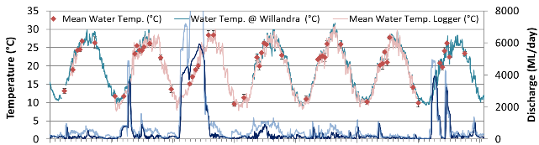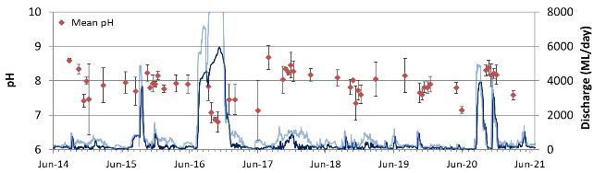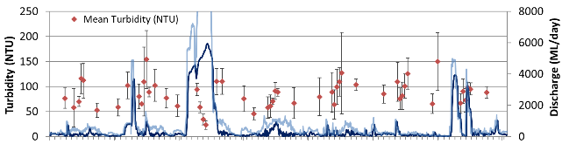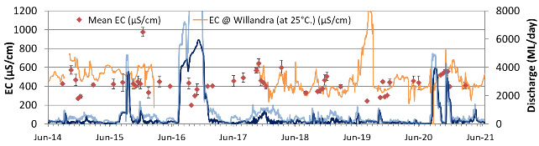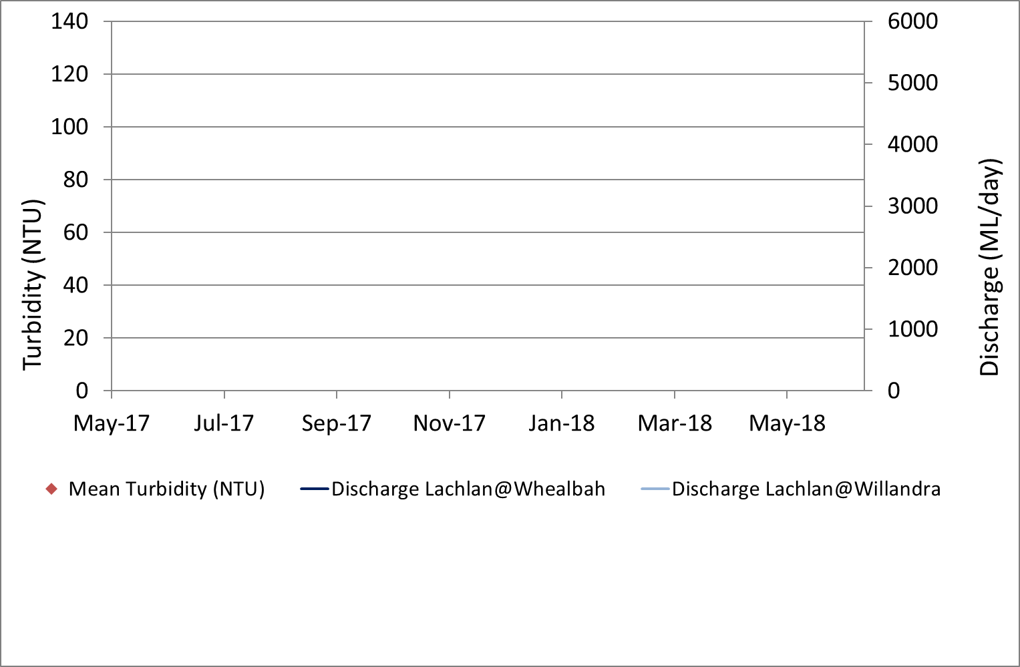

Figure 6-7. Mean water quality measurements (± standard error) for four lower Lachlan river sites (Cowl Cowl, Lane’s Bridge, Wallanthery and Whealbah) over the sampling period 2014-2021: physico chemical attributes.
Note: Blue shaded vertical bars indicate watering actions.
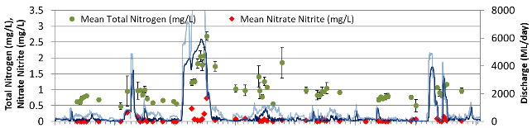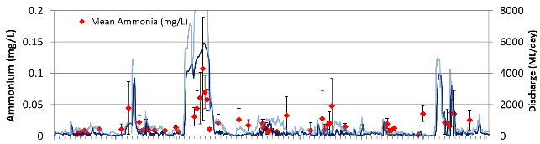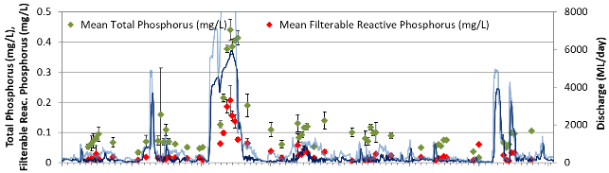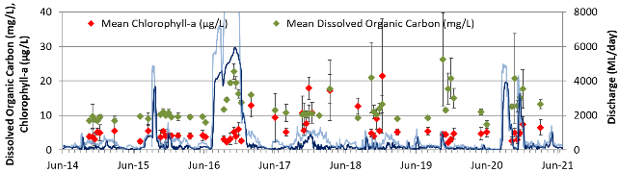

Figure 6-8. Mean water quality measurements (± standard error) for the four lower Lachlan river sites (Cowl Cowl, Lane’s Bridge, Wallanthery and Whealbah) over the sampling period 2014-2021: nutrients and chlorophyll a.
Note: Blue shaded vertical bars indicate watering actions.

Stream Metabolism – 2020-21
The availability of stream gauge data for the site in 2020-21 allowed us to ascertain when loggers may have been exposed to the air due to very low river levels. This happened at the end of May to the start of June 2020 over an interval of several days, and we excluded an extra four days due to air exposure.
This watering year the logger at Cowl Cowl, Whealbah and Wallenthery recorded unreliable data, as indicated by oxygen values exceeding saturation, rapid and unrealistic fluctuations in measurements and poor curve fits for metabolism models. This is likely to be due to the loggers being in water of too great a depth to reliably measure dissolved oxygen, organic material such as leaves lodging on the sensors and very high levels of reaeration which swamped out the biological oxygen signal. These issues were compounded by a lack of access to download and calibrate loggers due to restrictions arising from the COVID-19 pandemic. As a consequence, results are reported only from the Lane’s Bridge (Wagner et al.) site.
Due to issues with accessing and downloading data loggers associated with COVID-19 restrictions the latest download for the watering year 2019-20 was only shortly before the reporting period finished in early June. To incorporate that data, this report section dates from 5th of June 2020. COVID-19 restrictions on travel in 2020-21 means that the last download of data possible was in early May 2021, and as a consequence reporting for 2020-21 ends on the 11th of March 2021 (see time period in Table 6-1).
Table 6-1. Stream metabolism data obtained from Lane’s Bridge during the sampling period 2020-21.
Shown is the number of logged days for each site with the count ‘Y’ and percentile ‘%’ for which a GPP, ER and K estimate could be modelled under the standard and modified (lowered R² in brackets) acceptance criteria.
Site | Time Period | # logged days | Y | % | (Y) | (%) | Notes  (gaps in logging due to batterie issue and Air exposure)
Lane’s Bridge (Wagner et al.) | 05/06/2020 – 11/03/2021 | 280 | 96 | 35 | 64 | 57 | Air exposure for 4 days, at the start of June 2020

Table 6-1 shows the percentage of data days for which a GPP, ER and K estimate could be modelled under the standard acceptance criteria are shown for the reporting period. Stream metabolism data was able to be used from a total of 35% days from site Lane’s Bridge.
In order to allow more days to be modelled for the analysis we lowered the R² value from 0.9 to 0.75. This allow an addition 63 days of data to be included, which equals an additional 22 % of otherwise rejected data days (Table 6-1).
After applying the standard acceptance and modified (lowered R² values) criteria, we visually inspected plotted GPP, ER, and K values as well as the GPP/ER ratios and rejected two additional data days because of unrealistically high ER values. One value was associated with low flows in June 2020, and the other with the arrival of the translucent flow at the end of August, when discharge level rose of around 1,000 ML within a day.
Time series plots of logged temperature, dissolved oxygen (DO) shown in Figure 6-3 (page 40). Discharge from Willandra Weir logged DO, Gross Primary Production (GPP), Ecosystem Respiration (ER), Reaeration (K) and the GGP/ER ratio for Lane’s Bridge represented in Figure 6-9.
Two clear patterns are evident in the ecosystem metabolism estimates during 2020-21: a seasonal component and flow-related responses.
Seasonal patterns were consistent with those observed in previous years. Low temperatures constrain rates of GPP and ER during winter months (Figure 6-9). Conversely, high temperatures drive high metabolic rates during summer, particularly during periods of lower and stable flows, such as during early January 2021.
The rate of GPP per litre of water was lower during watering actions in September/October 2020 and November/December 2020. One of the limiting factors for GPP is the amount of light in the water column. Turbidity is strongly related to the degree of light attenuation in the water column, and turbidity did not change substantially during the higher flows. As a consequence, photosynthetically active surfaces in the channel would have been in deeper water and potentially experiencing light limitation during the early stages of high flow events. These areas may also be subjected to hydrologic scour.
The depth of the photic zone (upper area of the water column where there is enough light for photosynthesis) remained similar during the flow events. This photic zone may have a slightly larger surface area as the water fills more of the U-shaped channel. Notwithstanding this, the increased volume of water deeper than the photic zone and the dilution of planktonic algal cells means the productivity per litre is reduced during the higher flows, even though the total productivity of the system increases due to more litres of water.
Although productivity was suppressed as expected during the flow events, the 2020-21 observations suggest that flows support high rates of productivity following the events. This can be seen in the elevated GPP rates in early November 2020 (between the two flow peaks at Willandra) and at the beginning of January 2021 (Figure 6-9). Flows mobilised biologically available nutrients which may have been used or stored by organisms during the flow events and available in the environment afterwards. The lack of high concentrations of bioavailable nutrients during these high flows may be reflective of rapid uptake of available nutrients by algae. Space is created for the production of new biomass by algae if sediments have been moved and algal patches scoured. Combined with high temperatures, these factors contributed to the highest estimates of GPP that have been validated at this site over the entire 2014-21 monitoring period occurring in summer 2021 (Figure 6-10 and Figure 6-11).
Ecosystem respiration (ER) followed a similar trend to GPP but was not suppressed as much during the spring and summer flow events. ER tends to be strongly linked to GPP because a considerable proportion of ER is performed by autotrophs or by heterotrophs that are quickly utilizing the fresh and highly bioavailable carbon that has been recently fixed by autotrophs. This fresh in-stream carbon is not as available during large floods, but available carbon and nutrients are released from terrestrial leaf litter and soils, supporting the maintenance of ER during these events. The high ER in January reflects increased rates due to temperature dependence in addition to the rapid breakdown of bioavailable DOC exuded from the highly productive algal communities at that time.
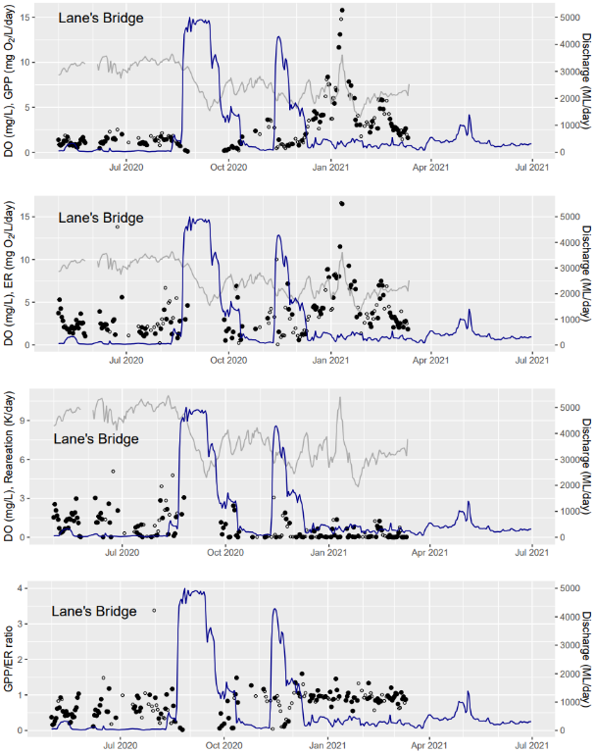

Figure 6-9. Gross primary production (GPP), Ecosystem respiration (ER), Reaeration (K) and the GPP/ ER ratio from Lane’s Bridge in the lower Lachlan River, May 2020 - July 2021.
Note: Blue shaded vertical bars indicate watering actions.

Stream metabolism – 2014-21
The 2020-21 sampling period for Lanes Bridge generated the highest estimates of GPP that have been validated at this site over the entire 7-year monitoring period (Figure 6-10 and Figure 6-11). These results when combined with the existing metabolism data from the lower Lachlan River shows clear overall patterns.
- Strong seasonality in Gross Primary Production and Ecosystem Respiration, indicating a close coupling with water temperature. Effects of environmental flow delivery on GPP and ER are marked even when considered against this natural variability.
- High variability in both GPP and ER, which appears to be both a consequence of variability in the physical process of reaeration and biological responses in the parameters. This variability means that there are large intervals where estimates for GPP and ER cannot be calculated, and these correlate with times of higher flows, including the large natural flood in 2016-17 and environmental flow events.
- Evidence of a pattern of increased GPP and ER correlated with higher DOC and higher nutrient and algal concentrations during environmental flow delivery, particularly if this was associated with warm water conditions. This pattern was particularly evident in the 2020-21 watering year. In cooler conditions, the GPP response was considerably less, whereas the ER response appeared to be maintained. A positive effect on ER after a winter environmental flow is apparent in the June 2020 data.
GPP and ER showed a seasonal pattern (Figure 6-11 and Section 6.7), which are strongly correlated with seasonal variation in temperature (Figure 6-6 and Figure 6-7 in Section 6.3.2). This pattern was particularly marked for GPP, however environmental flows in warmer months were also associated with increased GPP, generally lagged by a short period after the flow delivery commenced.
While total carbon production in the river shows a similar seasonal pattern (Figure 6-12), there is a very strong relationship with flow. Even small increases in flow result in an increase in total carbon produced.
ER responses were also seasonal, but the pattern was less marked and there were also intermittent very high values. Some of these values are likely to be artefacts of loggers becoming exposed to the air, however there were clear high ER events that were not simply correlated with flow – for example at Cowl Cowl in June 2016, preceding the large natural flood (Figure 6-11 and Section 6.7).
ER rates were generally significantly higher than the corresponding GPP rates, meaning that the sites are predominantly heterotrophic (P:R<1) and dominated by externally-sourced organic carbon rather than in situ photosynthesis.
Very high variation in reaeration (Figure 6-10) is characteristic of the Lachlan, reflecting the complex nature of the banks and the presence of in-stream structures (see site images in Figure 6-2, on page 38), which appears to generate a complex reaeration response as flows rise and fall (see for Lanes Bridge 2014-21, Figure 6-11).
In particular fluctuations in ER create considerable variability in the GPP/ER ratios through time (Figure 6-10). This relationship appears to vary in space – at Cowl Cowl there is evidence for a response to environmental flows which is marked, but at the other three sites there is no clear pattern (Figure 6-11 and Figure 6-17). There is a limited amount of data available for making clear conclusions on the effects of environmental water in the lower Lachlan River, and interpretation is made more complex by the high year to year variability in inflows.
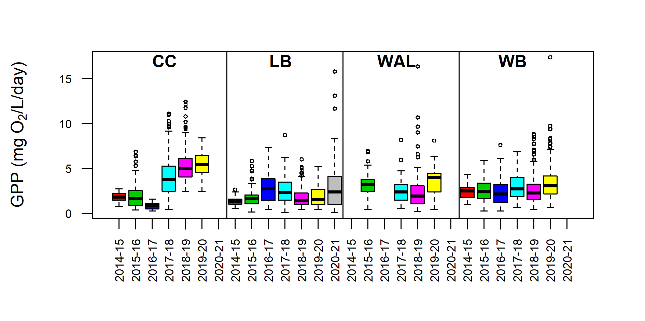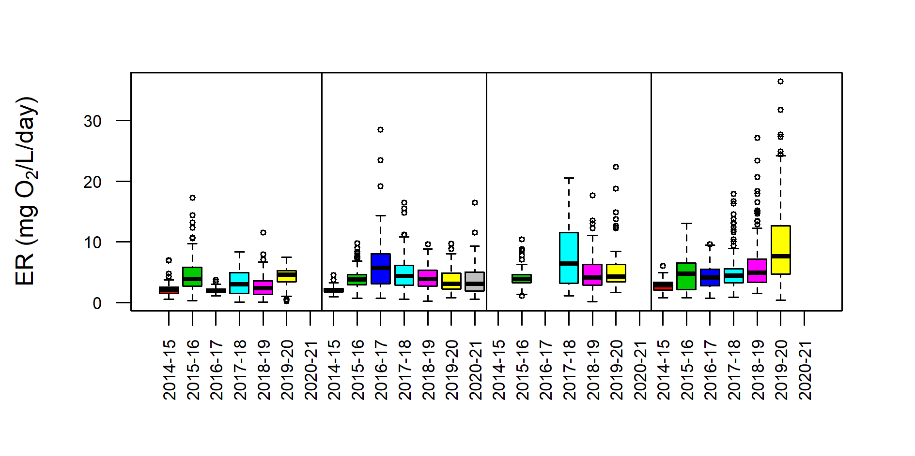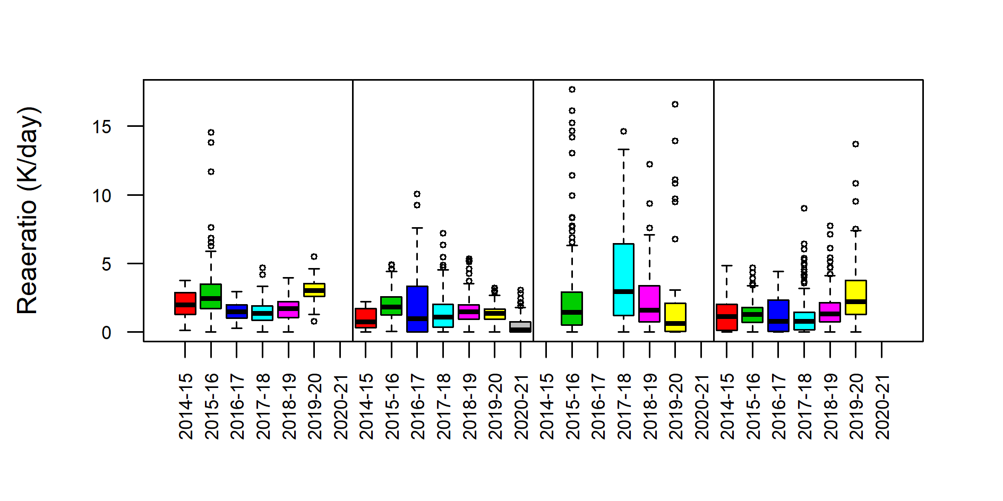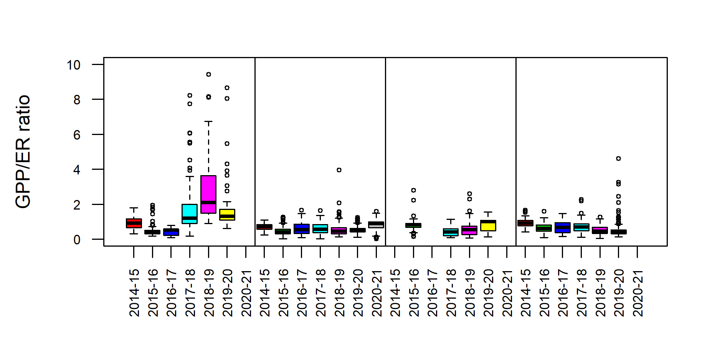
Figure 6-10. Summary statistics for stream metabolism data for all four variables and all four Lower Lachlan river sites (Cowl Cowl, Lane’s Bridge, Wallanthery and Whealbah) over the sampling period 2014-2021 under the standard acceptance criteria.
Note: Stream metabolism variables on different scales.
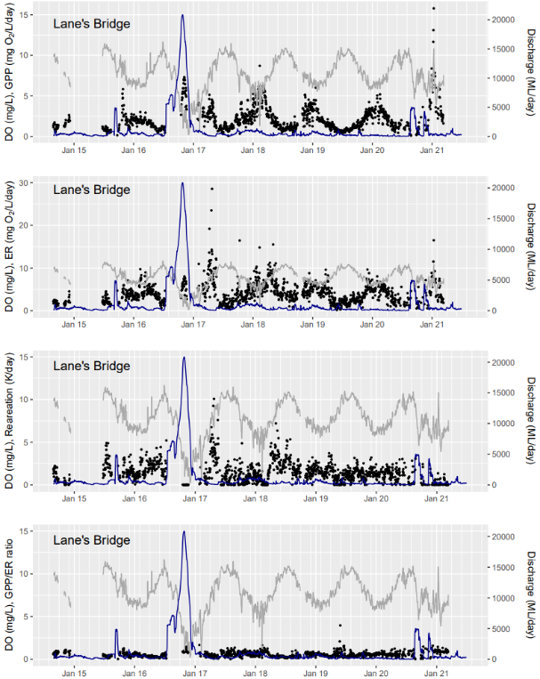

Figure 6-11. Gross primary production (GPP), Ecosystem respiration (ER), Reaeration (K) and the GPP/ ER ratio from Lane’s Bridge in the lower Lachlan River, August 2014 - June 2021.
Blue shaded vertical bars indicate watering actions. Note: Ecosystem respiration (ER) on higher scale.

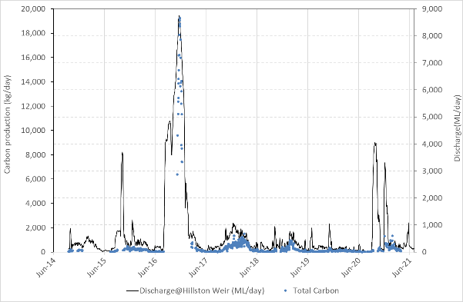
Figure 6-12. Total carbon produced (kg C/day) at Lane’s Bridge for the entire monitoring period 2014-21. Flow at Hillston Weir is also shown.

Discussion
The 2020-21 watering year was characterised by higher-than-average rainfall in the Lachlan river catchment, which was in stark contrast to the very dry conditions faced in the two years prior. These wet conditions provided high soil moisture conditions and resulted in substantial inflow into the Lachlan River above and below the major storages such as Wyangala Dam. Environmental watering actions under these conditions focused on making the most of the opportunities afforded by higher flows in the river.

Watering Actions 2020-21
Seven watering actions using Commonwealth environmental water were delivered to the Lachlan river system in 2020-21, six of which were delivered in combination with NSW environmental water (details in detail in Section 3 in Table 3-2 and Table 3-3, and in Section 4). These watering actions used a total of 77,418 ML of environmental water, with a further 173,000 ML of translucent flows delivered to the system. These large transluscent flows were sufficient to allow comparisons between the effects of flows provided in this way and the large natural flow events observed in 2016-17.
None of the seven watering actions were primarily targetted to influence water quality or stream metabolism. In the 2020-21 watering years the actions focussed on connectivity and habitat recovery, particularly inundation of floodplain wetlands, providing and enhancing lateral connectivity, supporting vegetation and providing habitat for fish, frogs and birds. Two of the actions were delivered in association with translucent flow events, enabling environmental water to be used to target wetland which are at some distance from the main river channel.
Interpretation of the data was complicated by interruptions as a consequence of travel restrictions arising from the COVID-19 pandemic. This meant that data were sparse, and that there were temporal and spatial gaps in the data.
The higher GPP and ER levels after large flow events such as the translucent flows in October 2020 provided evidence for the generation of high in-channel productivity, and there is evidence that environmental flows can mobilise nutrients and carbon in channel. Responses in GPP or ER appear to be greatest when the flows are largest and are associated with warmer conditions. The fact that water quality responses remain substantively smaller than those seen during large natural flows in 2016-17 may reflect 1) gaps in data collection in 2020-21 meaning that peak values were not sampled, 2) rapid uptake of nutrients due to the larger flows occurring in warmer conditions in 2020-21 and/or 3) the longer duration of high flows in 2016-17 contributed to higher measured values.

Watering Actions over the period 2014-21
There is a strong seasonal pattern in GPP and ER, but despite this there is evidence for effects of environmental flow delivery on GPP and ER. Both GPP and ER increase during flow delivery, correlated with higher DOC and higher nutrient and algal concentrations. The 2020-21 data show similar patterns for the fact, that these responses are greater when environmental flows are provided in spring and summer. In cooler conditions, the GPP response was considerably less, whereas the ER response appeared to be maintained.
High variability in both GPP and ER is a consequence of variability in the physical process of reaeration and biological responses in the parameters. Reaeration becomes the dominant process during higher flows, meaning that estimates for GPP and ER cannot be calculated during peak flows. This complicates determining the magnitude of metabolism responses.
Delivery of small autumn and winter flows has now been achieved several times in the Lachlan. Despite lower water temperatures at this time, there is evidence that this produces increases in ecosystem respiration, and potentially smaller but detectable increases in algal production. There is emerging evidence that productivity responses seen in the previous year may increase the magnitude of responses to later flow events. However it is still not possible to make definitive conclusions about this relationship, given the very low number of years for which relevant data exist. It remains premature to make predictions about how flows in preceding years may play in determining the magnitude of spring responses in the following year.

Evaluation
Evaluation is complicated by major changes in the climatic context for flow responses over the five years program to date. A dry year in 2015-16 was followed by one of the wettest years on record in 2016-17, with natural flooding completely dominating the watering of the lower Lachlan river system. The 2017-18 year was much dryer and environmental flows were responsible for relatively large flow events in comparison to operational flows. The 2019-20 year was also characterised by progressive drying through summer then significant rainfall in autumn and early winter. The 2020-21 year was relatively wet later in the year, following extremely dry conditions early in the watering year.
In relation to the effects of Commonwealth environmental water, the evaluation questions are addressed as follows:
- What did Commonwealth environmental water contribute to water quality outcomes?
There is evidence that watering events can alter water quality parameters, particularly through increasing carbon and nutrients, although these effects appear to be relatively transient and can be highly variable in magnitude in both space (site to site) and time. These effects are much smaller than those observed during large natural flows, but larger flow events such as those delivered as translucent flows do appear to provide larger productivity responses which approach the magnitude of the effects of natural flows. The two large translucent flows provided in 2020-21 generated the highest GPP values recorded for the Lachlan. This should not be interpreted as meaning that smaller environmental flow events do not generate productivity responses, rather productivity responses appear to be positively correlated with the size of the managed flow. Smaller environmental flows appear to deliver smaller productivity pulses, particularly in cooler conditions.
- What did Commonwealth environmental water contribute to patterns and rates of ecosystem respiration (ER) and primary productivity (GPP)?
There was evidence for watering events generating short pulses of GPP and ER, with GPP responses being larger in warmer conditions. Relatively minor changes in nutrients and carbon (relative to background variability) do appear to support relatively larger (compared to background variability) responses in productivity. In the most recent watering year large translucent flows provided in warm conditions in spring and summer generated large productivity responses, and a small increase in ecosystem respiration.

Final comments and recommendations
Evaluation is complicated by major changes in the climatic context for flow responses over the seven years program to date. A dry year in 2015-16 was followed by one of the wettest years on record in 2016-17, with natural flooding completely dominated the watering of the lower Lachlan river system. The 2017-18 year was much dryer and environmental flows were responsible for relatively large flow events in comparison to operational flows. The 2019-20 year was also characterised by progressive drying through summer then significant rainfall in autumn and early winter. The 2020-21 year was a wetter and cooler year overall.
In relation to the effects of Commonwealth environmental water, the evaluation questions are addressed as follows:
What did Commonwealth environmental water contribute to water quality outcomes?
There is evidence that watering events can alter water quality parameters, particularly through increasing carbon and nutrients, although these effects appear to be relatively transient and can be highly variable in magnitude in both space (site to site) and time. These effects are much smaller than those observed during large natural flows but would still be expected to have ecological important effects on energy flow through food webs, particularly when systems are already in a low-flow or low-productivity state.
What did Commonwealth environmental water contribute to patterns and rates of ecosystem respiration (ER) and primary productivity (GPP)?
There was evidence for watering events generating short pulses of GPP and ER, with GPP responses being larger in warmer conditions. Relatively minor changes in nutrients and carbon (relative to background variability) do appear to support relatively larger (compared to background variability) responses in productivity. The two large translucent flow events provided in warm conditions in 2020-21 generated the highest productivity values recorded for the site and support the emerging view that larger environmental flow events delivered in warmer conditions generate the largest productivity responses.
There appears to be significant productivity pulses when relatively larger translucent flows are delivered. There is some evidence that environmental flows delivered after translucent flows generate relatively larger productivity responses that those delivered without the preceding flow. It is recommended that environmental water managers consider these potential water quality and productivity outcomes as a part of managing for a suite of environmental objectives including lateral connectivity.

CEWO Adaptive Management Response:
The CEWO agrees with the recommendation above, particularly in considering how water quality and productivity outcomes may be more clearly stated in the designing of watering actions that seek to prolong periods on floodplain connection and inundation. This applies both (a) when water is moving onto the floodplain, and (b) when it returns from the floodplain to the river channel and can present a water quality risk during the warmer periods of the year.

Appendix 1: Stream metabolism plots for three additional sites in the lower Lachlan River 2014-20
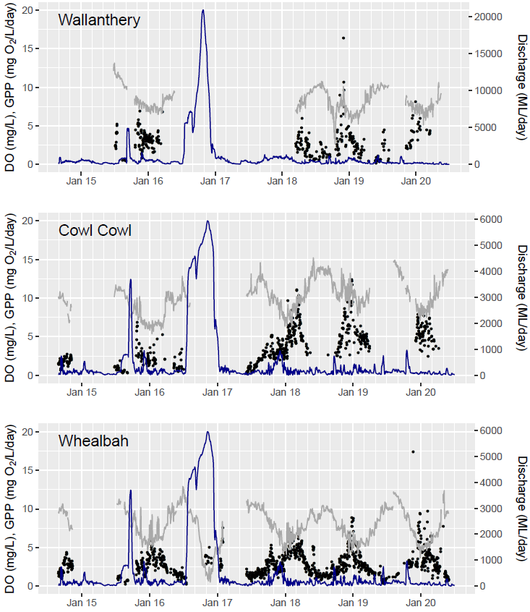

Figure 6-14. Gross primary production (GPP) from Wallanthery, Cowl Cowl and Whealbah in the lower Lachlan River, August 2014 - June 2020.
Blue shaded vertical bars indicate watering actions based on Whealbah discharge.
Note: Wallanthery on a higher scale for discharge.

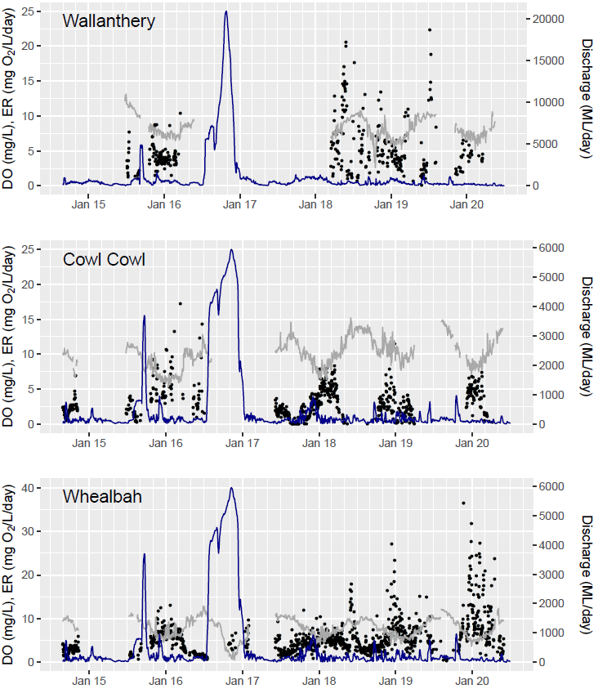

Figure 6-15. Ecosystem respiration (ER) from Wallanthery, Cowl Cowl and Whealbah in the lower Lachlan River, August 2014 - June 2020.
Blue shaded vertical bars indicate watering actions based on Whealbah discharge.
Note: Whealbah on a higher scale for dissolved oxygen (DO) and ER. Wallanthery on a higher scale for discharge.
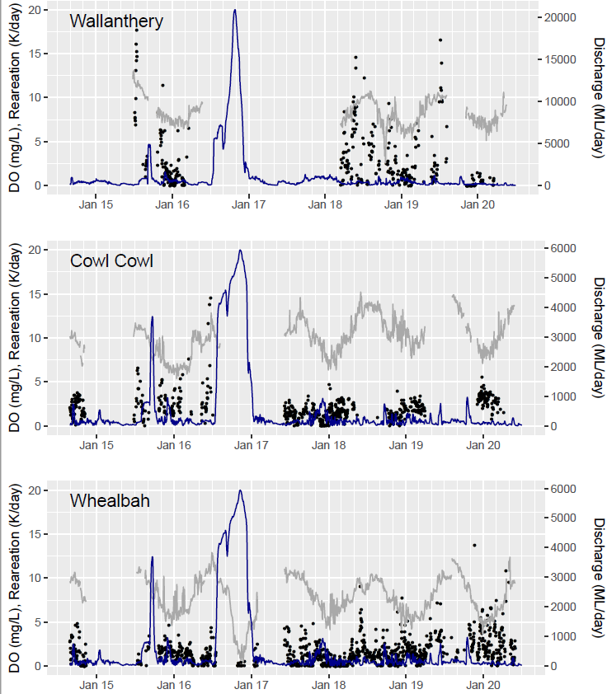

Figure 6-16. Reaeration (K) from Wallanthery, Cowl Cowl and Whealbah in the lower Lachlan River, August 2014 - June 2020.
Blue shaded vertical bars indicate watering actions based on Whealbah discharge.
Note: Wallanthery on a higher scale for discharge.
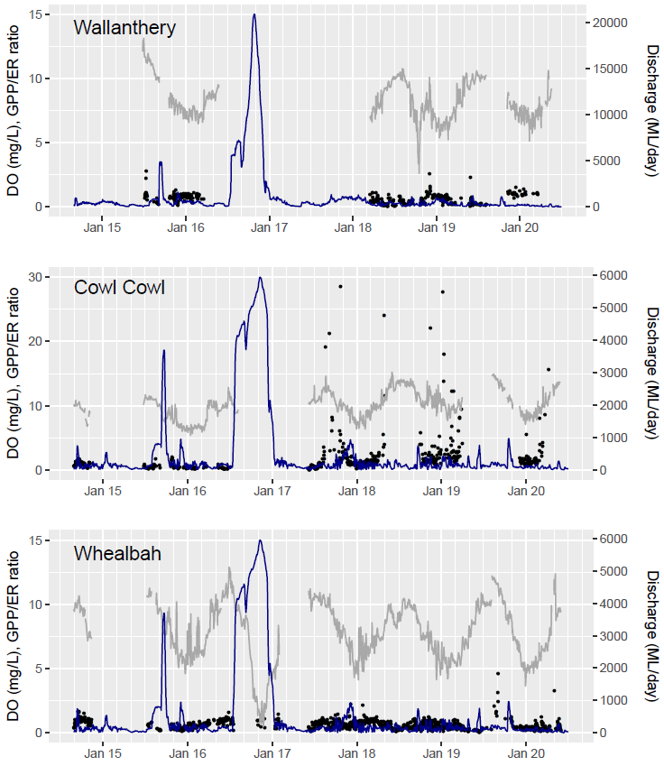

Figure 6-17. GPP/ ER ratio from Wallanthery, Cowl Cowl and Whealbah in the lower Lachlan River, August 2014 - June 2020.
Blue shaded vertical bars indicate watering actions based on Whealbah discharge.
Note: Cowl Cowl on a higher scale for dissolved oxygen and the GPP/ ER ratio. Not shown 20 outlier for Cowl Cowl for the GPP/ ER ratio above 30. Wallanthery on a higher scale for discharge.

Fish community

Introduction
As a key part of aquatic ecosystems, fish are used as an indicator of aquatic ecosystem health in several large monitoring programs in south-east Australia (Davies et al. 2010, Muschal et al. 2010, Turak and Linke 2011). Advantages of using fish as an indicator include that i) some fish species are long-lived and mobile, so fish can reflect short to longer-term and local to catchment scale processes, ii) some species occupy higher trophic levels within aquatic ecosystems and, in turn, fish can directly impact lower trophic level organisms, iii) they are relatively easily and rapidly collected and can be sampled non-destructively, iv) they are typically present in most waterbodies, and v) biological integrity of fish assemblages can be assessed easily and interpretation of indicators is relatively intuitive (Harris 1995). Further, as fish have a high public profile, with significant recreational, economic and social values, they foster substantial public interest (MDBC 2004).
In the lower Lachlan river system, 14 species of native fish are believed to have occurred in the recent past (Dean Gilligan, NSW DPI, unpublished data). However, current monitoring activities indicate that 10 of these species are still present in this system, leaving four species either locally extinct or extremely rare (NSW DPI, unpublished data). These four species are the flat-headed galaxias (Galaxias rostratus), southern pygmy perch (Nannoperca australis), southern purple spotted gudgeon (Mogurnda adspersa) and the Murray-Darling rainbowfish (Melanotaenia fluviatilis). Of the 10 species confirmed to be present, olive perchlet (Ambassis agassizii), silver perch (Bidyanus bidyanus) and freshwater catfish (Tandanus tandanus) are at low abundance and/or have a restricted distribution. Whereas carp-gudgeon (Hypseleotris spp.) and bony herring (Nematalosa erebi) could be considered widespread and abundant.
Flow is an important determinant in native fish lifecycles from larval through to adult life stages. Water discharged in flow inundates terrestrial habitat which boosts primary productivity and recruitment success; maintains natural geomorphic processes which improves habitat quality; and increases connectivity enabling fish movement through river channels and into floodplain/off-channel nursery grounds. Furthermore, flow dependent fish species (e.g. golden perch Macquaria ambigua and silver perch) may rely on flow as a trigger to spawn. The timing, volume and duration of a flow trigger leading up to or during the typical spawning period is also critically important to spawning and recruitment success. Beyond spawning and recruitment events, flow helps maintain high quality refugia for adult fish in aquatic ecosystems, so they survive extreme conditions such as drought. Unlike other taxa, fish have no mechanisms to cope with loss of water for even very brief periods of time. The persistence of native fish species therefore depends heavily on flow and its effects.
From 2014-15 to 2018-19 the CEWH conducted a Long Term Intervention Monitoring project (LTIM project) across the lower Lachlan River system to quantify changes in ecosystem health in response to Commonwealth environmental water delivery, including fish community responses. This continues under a Monitoring Evaluation and Research (MER) program set up by the CEWO from 2019-20 to 2021-22, and here we report on data from 2020-21 compared to previous years.
Several Commonwealth environmental watering actions relevant to riverine native fish communities were delivered in 2020-21, including actions used to extend translucent flow events in August to September (Action 2) and in November to December (Action 4), see for more information Section 4. The flow event including action 4, which occurred during warm water temperatures over the spring-summer fish spawning period, was of particular interest to environmental water managers as it had the potential to trigger spawning of golden perch. To assess the contributions of Commonwealth environmental water to the fish community, the relevant short term and long-term questions evaluated are:

Short-term evaluation questions:
- What did Commonwealth environmental water contribute to native fish community resilience?
- What did Commonwealth environmental water contribute to native fish survival?

Long-term evaluation questions:
- What did Commonwealth environmental water contribute to native fish populations?
- What did Commonwealth environmental water contribute to native fish diversity?

In 2020-21, the aim of this component of the Lachlan River MER program was to assess changes in the fish community, in terms of abundance, biomass and community health, in the Lower Lachlan river system Selected Area in relation to the general hydrological regime, and thereby provide a basis for determining potential changes in relation to current and future use of environmental water. The current study reports on the second year of the three-year MER program in the lower Lachlan River.

Methods
Fish community data was collected from 10 in-channel sites from the lower Lachlan River system Selected Area, from Wallanthery to Hillston (see Figure 6-1, on page 32). All sites were randomly selected for this study or had previously been randomly selected as part of another study (i.e. SRA; Davies et al. 2008, Davies et al. 2012). This year, a new site ‘Upstream Glenmore’ was randomly selected to replace a previous site ‘Riama’ which can no longer be sampled due to landholder access. Sampling was undertaken in March-April 2021, and each site was sampled once using a suite of passive and active gears including boat-electrofishing (n=32 operations, each consisting of 90 seconds ‘on-time’, see Figure 7-9 on p. 73), unbaited bait traps (n=10) and small fyke nets (n=10) (Hale et al. 2014). Decapods were also surveyed using baited opera house traps (n=5).
All captures (fish and other non-target taxa) were identified to species level and released onsite, except for a selection of the periodic species bony herring which were retained for annual ageing (n=100) (Hale et al. 2014). Individuals were measured to the nearest mm and weighed to the nearest gram. Where large catches of a species occurred, a sub-sample of individuals was measured for each gear type. For fyke netting, sub-sampling involved measuring all individuals for body size in each operation until 10 of a species was reached and then only counting the remainder of this species. For boat electrofishing, all individuals were measured for body size across operations until 50 individuals of a species were reached, and then only the first 20 individuals of this species were measured for body size in each operation while the remainder were only counted. Fish that escaped capture but could be positively identified were also counted and recorded as “observed” instead of “caught”.
Total catch was pooled for all sites and operations of methods, except when calculating SRA metrics for which only the first 12 electrofishing shots and bait trap data were used (Davies et al. 2010). Data from large fyke nets, previously used at lower Lachlan River sites from 2014-2015 to 2018-2019 to increase detection of freshwater catfish, were removed as they are no longer in use. Differences in fish communities between years (2014-15 to 2020-21) in the lower Lachlan River system Selected Area were determined using one-way fixed factor Permutational Multivariate Analysis of Variance (PERMANOVA; Anderson et al. 2008), with abundance and biomass data analysed separately. These analyses were performed using the vegan package (Oksanen et al. 2019) in R. Raw data were fourth root transformed and used to produce a similarity matrix using the Bray-Curtis resemblance measure. All tests were considered significant at P < 0.05. Where significant differences were identified, pair-wise post-hoc contrasts determined which years differed. Similarity percentage (SIMPER) tests identified individual species contributions to average dissimilarities between years.
Sustainable Rivers Audit (SRA) indices of fish community condition (Expectedness, Nativeness, Recruitment) were calculated to quantify the overall condition of the fish community assemblage. Data were first portioned into recruits and non-recruits. Large-bodied and generally longer-lived species (maximum age >3 years) were considered recruits when length was less than the minimum of that for a one year old. Small-bodied and generally short-lived species, that reach sexual maturity in less than one year, were considered recruits when length was less than the average length at sexual maturity. Recruitment lengths were derived from published scientific literature or by expert opinion when literature was not available (Table 7-1). Eight fish metrics were calculated using the methods described by Robinson (2012) which are briefly outlined below.
Table 7-1. Size limits used to distinguish new recruits for each fish species. Values represent the length at one year of age for longer-lived species or the age at sexual maturity for species that reach maturity within one year.
SPECIES | ESTIMATED SIZE AT 1 YEAR OLD OR AT SEXUAL MATURITY (FORK OR TOTAL LENGTH)
NATIVE SPECIES
Australian smelt | 40 mm (Pusey et al. 2004)
bony herring | 67 mm (Cadwallader 1977)
carp gudgeon | 35 mm (Pusey et al. 2004)
flatheaded gudgeon | 58 mm (Pusey et al. 2004, Llewellyn 2007)
freshwater catfish | 83 mm (Davies 1977)
golden perch | 75 mm (Mallen-Cooper 1996)
Murray cod | 222 mm (Gavin Butler, Unpublished data)
silver perch | 75 mm (Mallen-Cooper 1996)
un-specked hardyhead | 38 mm (Pusey et al. 2004)
ALIEN SPECIES
common carp | 155 mm (Vilizzi and Walker 1999)
Eastern gambusia | 20 mm (McDowall 1996)
goldfish | 127 mm (Lorenzoni et al. 2007)
redfin perch | 60 mm (maximum reported by Heibo et al. 2005)

Nativeness metrics determined the proportion of native compared to alien species in the fish community. Specifically, these calculated the proportion of native fish contributing to total species richness (PropNS), total abundance (PropNAbund) and total biomass (PropNBiomass) (Robinson 2012). Recruitment metrics examined the recent reproductive activity of the native fish community. These examined the proportion of recruiting vs total native fish species (PropRTaxa), the average proportion that recruiting vs total abundances across native fish species (PropRAbund), and the average proportion of sites that native fish species were recruiting at vs that which was expected (PropRSites) (Robinson 2012). Expectedness metrics compared the native fish community found in relevant catchment and altitudinal zones compared to a historical reference condition. These assessed the proportion of observed vs expected native fish species at each site (OE or Observed/ Expected), and in each zone (OP or Observed/Predicted) (note that all lower Lachlan river sites fall within a single zone) (Robinson 2012).
Due to the presence of golden perch considered to be new recruits for the first time in LTIM/MER sampling of the lower Lachlan River, two golden perch were daily aged to gather further information. One was below the new recruit length cut-off and one was just above it. Daily ageing involved lethally sampling the fish and removing sagittal otoliths or ear bones and followed methods described in Stocks et al. (2019). Briefly, otoliths were mounted on a microscope slide with crystalbond adhesive, polished to the core with 9 μm lapping film and viewed under a camera-fitted compound microscope. To account for ring visibility changing during polishing, several images were taken throughout this process and overlaid on each other to allow ageing. An experienced reader counted daily rings from primordium to outer edge of otoliths. From daily ages, spawning timing was back-calculated and matched to daily mean flow and water temperature levels recorded at Hillston Weir (see Figure 6-1 on page 32).

Results

Watering year 2020-21
A total of 1,791 fish comprising eight native and three alien species were captured at the 10 in-channel sampling sites along the lower Lachlan River in autumn 2021 (Table 7-2, and Figure 7-1 to Figure 7-3). In descending order, Bony herring (Nematalosa erebi), common carp (Cyprinus carpio), carp gudgeon (Hypseleotris spp.) and Eastern gambusia (Gambusia holbrooki) were the most abundant species. Whereas, common carp, golden perch (Macquaria ambigua), Murray cod (Maccullochella peelli) and bony herring contributed the greatest overall biomass in 2020-21, respectively (Figure 7-4).
New recruits (juveniles) were detected in three native longer-lived species (bony herring at 6 of 10 sites, golden perch at 2 of 10 sites and Murray cod at 9 of 10 sites (Figure 7-1, Figure 7-3 and Figure 7-5), and three native short-lived species (flatheaded gudgeon (Philypnodon grandiceps) at 8 of 10 sites, carp gudgeon at 10 of 10 sites and un-specked hardyhead (Craterocephalus fulvus stercusmuscarum) at 1 of 10 sites). No native long-lived silver perch or native short-lived Australian smelt (Retropinna semoni) new recruits were captured. New recruits of three alien species were captured (common carp at 10 of 10 sites, goldfish (Carassius auratus) at 3 of 10 sites, and Eastern gambusia at 5 of 10 sites).
Two golden perch, one below the new recruit length cut-off from Hillston and one just above it from Upstream Glenmore, were daily aged to give an indication of spawning timing (Figure 7-5 to Figure 7-7). Based on daily ages, these fish were estimated to have hatched on 14 and 25 December 2020 when daily mean water temperatures were 24 and 23°C, respectively. This estimated spawning timing followed a flow pulse from 14 November to 13 December in which daily mean flow levels ranged from 500 – 3,300 ML day⁻¹ and daily mean water temperatures ranged from 22-27°C.
No turtles were captured during fish community monitoring. Freshwater prawns (Macrobrachium australiense; n=5033) were the most abundant taxa in small mesh fyke nets, bait traps and opera house traps. Freshwater shrimp (Paratya australiensis; n=916) and a small number of yabbies (Cherax destructor; n=27) were also captured (Table 7-2).
Table 7-2. Total (non-standardised) catch from the lower Lachlan river system target reach. Sampling was undertaken in autumn 2021 using a combination of four sampling gear types.
 | SAMPLING METHOD
COMMON NAME | BOAT ELECTRO-FISHING | SMALL FYKE NET | BAIT TRAP | OPERA HOUSE TRAP | TOTAL
Fish (Native species)
Australian smelt | 8 |  |  |  | 8
bony herring | 686 | 3 |  |  | 689
carp gudgeon complex | 13 | 222 | 11 |  | 246
flatheaded gudgeon | 2 | 37 | 2 |  | 41
golden perch | 131 | 1 |  |  | 132
Murray cod | 190 |  |  |  | 190
un-specked hardyhead | 5 | 1 |  |  | 6
Fish (Alien species)
common carp | 407 | 6 |  |  | 413
Eastern gambusia | 9 | 230 |  |  | 239
goldfish | 16 |  |  |  | 16
redfin perch |  |  |  |  | 0
Turtles
long-necked turtle |  |  |  |  | 0
Murray River turtle |  |  |  |  | 0
Decapods
freshwater prawn | 47 | 4,668 | 240 | 78 | 5,033
freshwater shrimp | 10 | 881 | 25 |  | 916
freshwater yabby |  | 17 |  | 10 | 27

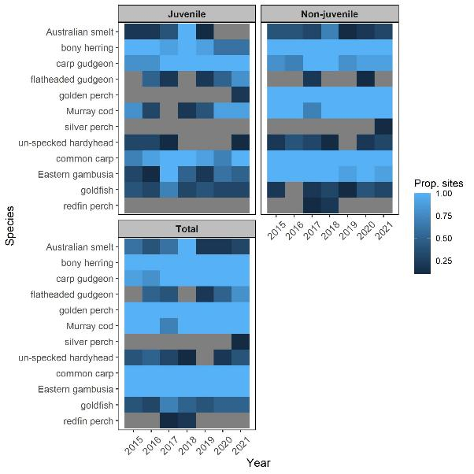
Figure 7-1. Proportions of sites (colour-coded) that each fish species were caught at from 2015-2021, separated into juveniles, non-juveniles and all fish categories combined (total).

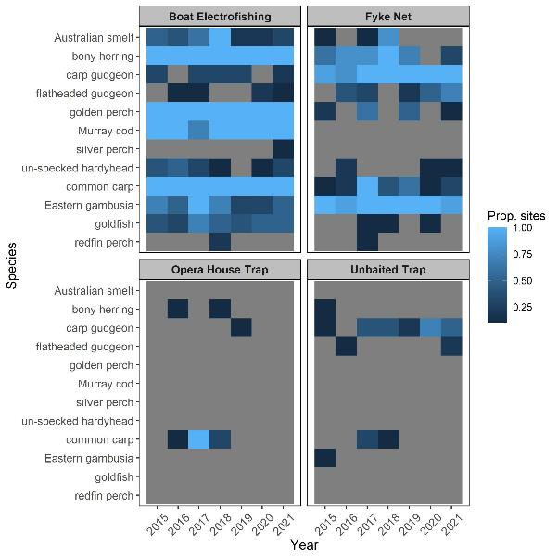
Figure 7-2. Proportions of sites (colour-coded) that each fish species were caught at from 2015-2021, separated by capture method.
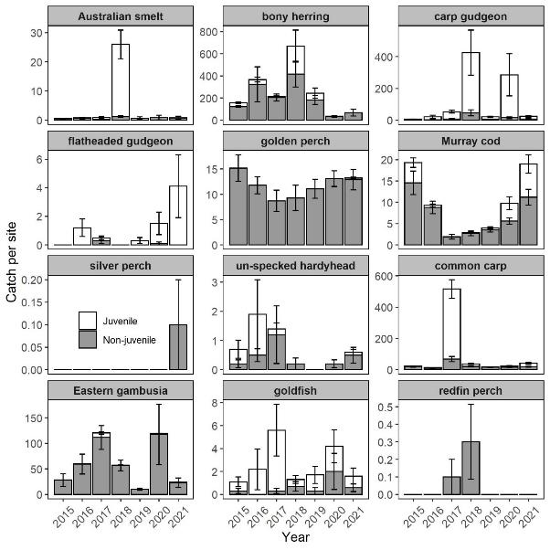
Figure 7-3. Catch per site (number of fish; mean ± SE) for each fish species within the lower Lachlan river system target reach, sampled from 2015-2021.
Cumulative stacked bars separate the catch of juveniles (white bars) and non-juveniles (grey bars).
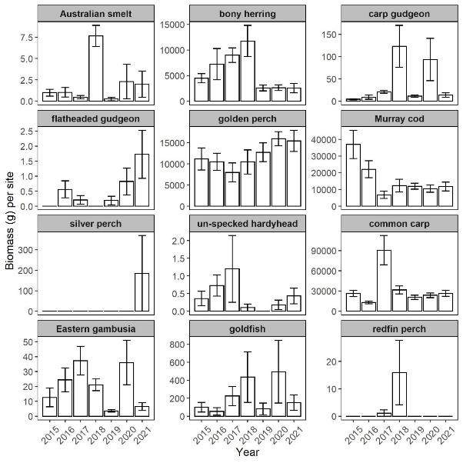
Figure 7-4. Biomass per site (g; mean ± SE) of each fish species within the lower Lachlan river system target reach, sampled from 2015-21.
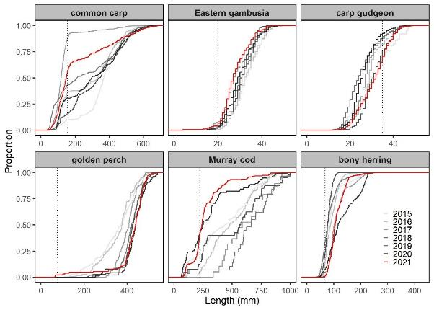
Figure 7-5. Proportionate length-frequencies of the six most abundant species captured in the Lachlan River from 2015–2021 (red line for current year, and grey lines for previous years of darker shades over time).
The dashed lines indicate approximate size limits used to distinguish new recruits for each species (see Table 7-1).
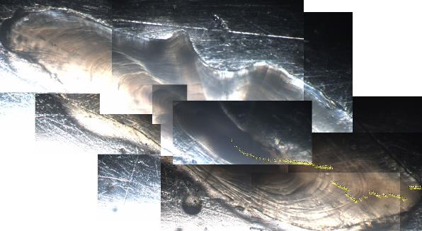
Figure 7-6. Otolith from a 65 mm golden perch which was subjected to daily ageing.
Note that multiple images were taken and overlaid on each other to enable aging as ring visibility changed depending on location during polishing. The estimated age was 88 days.
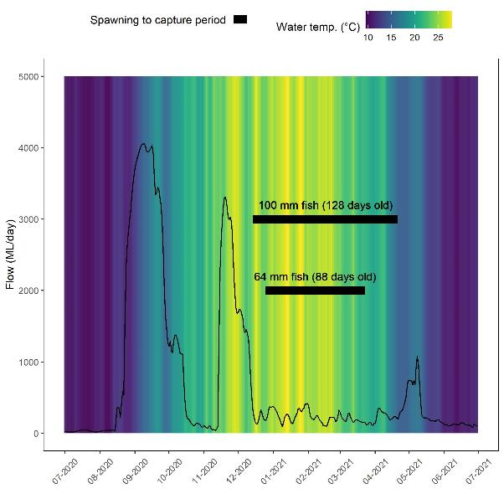
Figure 7-7. Spawning to capture periods (thick lines) of two golden perch individuals captured in 2021 which were below and close to size limit used to distinguish new recruits (75 mm).
Note: Daily mean flow (thin lines) and water temperature levels (background shading) recorded at the Hillston Weir are also shown.

2020-21 vs Previous years
Sustainable Rivers Audit metric values in 2021 were generally comparable with those in previous years. Nativeness metrics, which reached their lowest levels 2017 after flooding, remain at similar levels to non-flood years (Table 7-3 and Figure 7-7). Although the Nativeness metric PropNAbund was lower than other non-flood years and indicated an increase in the abundance of alien relative to native fish. Recruitment metric values in 2021 were also within the ranges of values previously observed in 2015-2020. Expectedness metrics OE and OP were equal or above the highest levels previously observed, and were largely similar to levels in 2020, illustrating proportions of native fish species observed relative to reference conditions remained elevated relative to other years.
Table 7-3. Summary of SRA fish indices over the seven LTIM project sampling years in the lower Lachlan River.
 | Expectedness |  | Nativeness |  |  | Recruitment
 | OE | OP | Prop  NS | Prop  NAbund | Prop  NBiomass | Prop  RTaxa | Prop  RAbund | Prop  RSites
2015 | 0.42 ± 0.04 | 0.43 | 0.63 ± 0.05 | 0.88 ± 0.02 | 0.56 ± 0.06 | 0.50 | 0.13 | 0.36
2016 | 0.46 ± 0.02 | 0.43 | 0.73 ± 0.02 | 0.94 ± 0.02 | 0.72 ± 0.07 | 0.67 | 0.46 | 0.41
2017 | 0.44 ± 0.04 | 0.50 | 0.57 ± 0.03 | 0.36 ± 0.05 | 0.20 ± 0.05 | 0.71 | 0.49 | 0.44
2018 | 0.54 ± 0.04 | 0.43 | 0.71 ± 0.03 | 0.90 ± 0.03 | 0.49 ± 0.06 | 0.67 | 0.36 | 0.48
2019 | 0.44 ± 0.04 | 0.36 | 0.69 ± 0.02 | 0.90 ± 0.02 | 0.58 ± 0.10 | 0.80 | 0.27 | 0.42
2020 | 0.54 ± 0.04 | 0.50 | 0.71 ± 0.03 | 0.75 ± 0.06 | 0.56 ± 0.10 | 0.57 | 0.31 | 0.49
2021 | 0.54 ± 0.04 | 0.50 | 0.74 ± 0.02 | 0.66 ± 0.03 | 0.56 ± 0.07 | 0.71 | 0.24 | 0.45

There were significant differences in the abundance (Pseudo-F_{6, 63} = 12.287, P < 0.001) of the fish community among years (Figure 7-3). Pair-wise comparisons indicated that abundances differed between all combinations of years, except between 2015 to 2016 (t = 1.993, P = 1.000) and 2016 to 2019 (t = 3.667, P = 0.105). Differences were primarily driven by a higher abundance of alien common carp in 2017; native carp gudgeon in 2018, 2019 and 2020; bony herring in 2015, 2016 and 2018; and flatheaded gudgeon in 2021 (Table 7-4).
Similarly, differences in biomass occurred among years (Pseudo-F_{6, 63} = 2.960, P < 0.001) (Figure 7-4), with differences found between all combinations of years except for 2015 to 2016 (t = 1.469, P = 1.000), 2015 to 2019 (t = 3.140, P = 0.399), 2015 to 2021 (t = 1.393, P = 0.294), 2016 to 2018 (t = 4.143, P = 0.084), 2016 to 2019 (t = 2.710, P = 0.756), 2016 to 2020 (t = 3.078, P = 0.378), 2016 to 2021 (t = 1.334, P = 0.861), 2019 to 2020 (t = 2.152, P = 1.000), 2019 to 2021 (t = 1.009, P = 1.000) and 2020 to 2021 (t = 1.002, P = 1.000). Differences in biomass were mainly attributed to a higher biomass of native Murray cod in 2015 and 2016; alien common carp in 2017; and native silver perch in 2021 (Table 7-5 in Section 7.7).

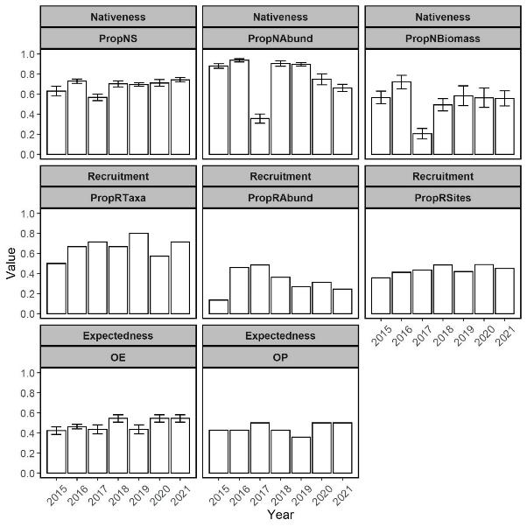
Figure 7-8. SRA metrics (mean ± SE) for the lower Lachlan River from 2015–2021.
Note that Recruitment metrics and the Expectedness metric OP are given single zone-level values, rather than values for many sites like other metrics, so standard errors could not be calculated. OE and OP refer to Observed/Expected and Observed/Predicted, respectively.

Discussion
In autumn 2021, eight native species of freshwater fish were captured in the lower Lachlan River. Based on bait trap, boat electrofishing and small fyke netting catches, all native fish species previously detected in 2015-2020 were recorded in the current year, with the addition of silver perch. Freshwater catfish were detected in 2015 (using fyke nets - large and small), see Table 7-6 in Section 7.7 and Dyer et al. (2015). While large fyke nets were used between 2015-2019, they were not deployed in 2020-2021, which may have contributed to the absence of freshwater catfish in this year. Murray-Darling rainbowfish is the only remaining native fish species presumed to be historically common in lowland sections of the Lachlan River and not detected in the target reach of this monitoring program (see Table 7-6 in Section 7.7). Flat-headed galaxias, olive perchlet, southern purple spotted gudgeon and southern pygmy perch are another four native fish species historically present in lowland regions of the Lachlan. Olive perchlet has recently been detected at this location (Wallace and Bindokas 2011, DPI Fisheries, unpublished data). Despite numerous species absences, native fish species richness in the lower Lachlan River is generally higher than in other parts of the catchment. The data presented indicates that the level of native fish species richness has been largely maintained over the monitoring period.
SRA metric values in 2021 were higher or within the ranges of those recorded in previous years. The two Expectedness metrics, OE and OP, were at their equal highest levels in 2021. For Nativeness metrics, Prop NS, was at its highest level in 2021, while PropNAbund and PropNBiomass were within ranges of previous years. Strong recruitment and an abundance increase of alien common carp in 2021 explained a slight reduction in the PropNAbund metric in 2021, which was particularly low in 2017 when mass recruitment of alien common carp followed a flooding event. Recruitment metrics PropRTaxa, PropRAbund and PropRSites were within ranges of previous years. However, PropRTaxa was high in 2021 compared to previous years partly due to the first detection of golden perch recruitment in the sampling program. PropRAbund levels, however, have shown a gradual decline since 2017. Declining bony herring recruitment and abundance in recent years may underlie this trend. In general, SRA metric values suggested that the overall condition of the native fish community in the lower Lachlan River has been sustained or improved over the course of the monitoring program.
In response to hydrological conditions in 2020-21, including Commonwealth watering actions, native bony herring recruitment and abundance remained low in 2021 compared to previous years. Greater winter die-off due to low temperature tolerance thresholds, pathogens or predation pressure along with reduced spawning and recruitment from poor phyto/ microzooplankton resources are possible explanations (Pusey et al. 2004). Although, adults currently present in the population may support future spawning and recruitment of this highly fecund species (Puckridge and Walker 1990), which can rebound substantially within 12–18 months following a major disturbance (Pusey et al. 2004). In contrast, several other native fish species (Murray cod, flathead gudgeon, unspecked hardyhead) increased in abundance in 2021 compared to 2020. Longer-lived Murray cod and golden perch had previously declined in abundance following poor water quality associated with the 2016–2017 floods but in 2021 both were at similar abundances to 2015 and 2016 surveys. Resurgence in Murray cod new recruits at an abundance exceeding their highest level in 2015 prior to flooding suggests that the hydrological conditions, supplemented by Commonwealth watering actions, is contributing to the recovery of this long-lived species in the system. Increased foraging opportunities from in-channel flows likely translate to enhanced Murray cod growth (Stoffels et al. 2019), and potentially improve the success of larvae developing into juvenile and adult stages.
The declines in abundances of several fish species from 2015 to 2017 were attributed to dissolved oxygen concentrations at or below those inducing mortality in several large-bodied native species during 2016-17 (Small et al. 2014). While widespread fish kills were not observed, anecdotal reports from local landholders suggest that hypoxia-related fish kills most likely explained the reduced abundance (and biomass) of Murray cod in the focal reach. Substantial fish kills occurred in other parts of the (southern) Murray-Darling Basin in both 2010-11 (Hladyz et al. 2011, King et al. 2012, Whitworth et al. 2012) and 2016-17 flooding events (DPI Fisheries, unpublished data). Encouragingly, recent evidence from the Edward-Wakool system indicates that recovery of the Murray cod population from the 2010-11 fish kills was predominantly driven by localised spawning and recruitment originating from surviving remnant adults (Thiem et al. 2017). Annual stocking of Murray cod in the lower Lachlan River (DPI Fisheries, unpublished data) potentially confounds the interpretation of new recruits, but ongoing work is being undertaken to disentangle and appropriately attribute the correct management intervention for this species. Given evidence in the Lachlan Selected Area of a remnant adult population, as well as documented localised spawning under this LTIM/MER project, it is anticipated that natural processes are the most likely recovery pathway for this species. It is therefore important that future water delivery continues to provide breeding opportunities, by facilitating the movement of pre-spawning fish and maintaining spawning habitat during nesting periods to prevent rapid water level drops and nest abandonment or desiccation. An acknowledgement that flow-recruitment relationships for Murray cod are specific to individual river systems also appears wise (Tonkin et al. 2021).
In 2021, golden perch recruits were captured for the first time since annual sampling began in 2015. DNA familial testing of these golden perch recruits indicated that their parents were not from a NSW hatchery facility according to the current FishGen genetic database (FishGen project funded by the Joint Ventures Monitoring and Evaluation Program; Flinders University, unpublished data) and most likely wild-bred. This was further supported by no stocking occurring in the vicinity of the Lachlan River Selected Area in the 12 months prior to sampling in 2021 (DPI Fisheries, unpublished data). Daily ageing from otoliths indicated that the golden perch recruits were indeed young-of-year or < 1 year of age (88-128 days old). Spawning dates estimated from daily ages were after a flow pulse (500-3,300 ML day⁻¹) from mid-November to mid-December. However, daily ages are commonly underestimated, especially when dealing with larger otoliths (Campana and Moksness 1991). If this was the case for the large otoliths of individuals examined here, the actual spawning dates may have more tightly aligned with the flow pulse rather than followed it. According to the spawning and larval fish section, golden perch larvae were also detected for the first time in the 2020-21 period, on 26 November 2020, and associated with the mid-November to mid-December flow pulse. Collectively, this information suggests that golden perch may have spawned locally in the lower Lachlan River in association with a flow pulse of 500-3,300 ML day⁻¹ when temperatures were between 22-27°C. This is in agreement with Koehn et al. (2020), which indicates that golden perch in the southern Murray-Darling Basin spawn at water temperatures exceeding 17°C and at flows surpassing a certain magnitude or velocity (e.g. 0.3 m s⁻¹).

Previously, in-channel spawning of golden perch has been detected in other Selected Areas (e.g. Murrumbidgee; Wassens et al. 2015), although new recruits are rarely encountered. While spawning and young-of-year recruitment of golden perch was detected in 2021, size structure information indicates that the golden perch population is still dominated by larger and older individuals. However, golden perch abundance in 2021 remained similar to the previous year and was equivalent to that observed in 2015-2016. This suggests that the population is currently being maintained despite sporadic natural recruitment. Stocking of golden perch has been undertaken in the Lachlan River since the 1970’s, including on numerous occasions within the Selected Area in the past 10 years (DPI Fisheries, unpublished data). Shams et al. (2020) recently reported that both natural recruitment and stocking contribute to riverine golden perch populations in the Lachlan River based on otolith microchemistry and genetic analyses, but that stocking is the dominant source. Substantial variability in the contribution of stocking to riverine populations of golden perch (Crook et al. 2016, Forbes et al. 2016) and declines in stocking effectiveness have been observed with increasing riverine connectedness (e.g Hunt et al. 2010). As golden perch are “Flow pulse specialists”, which rely on freshes to trigger spawning responses (Baumgartner et al. 2014), it is important that freshes occur in the Lachlan River, in order to promote opportunities for natural spawning and subsequent recruitment for this species. It is also worth noting that floodplain/off-channel habitats function as productive nursery environments for golden perch (e.g. in the Menindee lakes) (Stuart and Sharpe 2020). Therefore, connections between in-channel and off-channel habitats via flows may be necessary to achieve a mass recruitment event of golden perch within in-channel areas of the lower Lachlan River, which have so far been absent during the 2015-2021 monitoring period.

Evaluation
In relation to the effects of Commonwealth environmental water, the short and long term evaluation questions are addressed as follows:
- What did Commonwealth environmental water contribute to native fish community resilience and survival?
In 2021, resilience and survival of the lower Lachlan River native fish community was maintained or improved compared to previous years as a result of hydrological conditions, including Commonwealth environmental water. The targeted watering actions appeared to benefit native fish spawning and recruitment in 2021, including Murray cod and golden perch. SRA recruitment metrics were at their highest level or within normal ranges in 2021.
- What did Commonwealth environmental water contribute to native fish populations and diversity?
The lower Lachlan River native fish population was most affected by flooding/hypoxia and potential fish kills (anecdotal reports) in 2016–17 during LTIM project years, which reduced the biomass of large-bodied Murray cod in 2017 and promoted the spawning and subsequent recruitment of common carp. This significant event likely masked other effects on the fish community over the study period. Commonwealth environmental watering actions may have contributed to the post-kill recovery of native fish populations in 2018-21, however it is unknown if this recovery would have differed without it.
The lower Lachlan River native fish diversity has increased to 8 native species in 2021, with the additional detection of silver perch, which was an increase from 7 in 2015 to 2017 and in 2020. SRA expectedness metrics were at equal highest levels in 2021 compared to previous years. The temporary decline in native fish abundance over the sampling period may relate to an increase in alien common carp recruitment associated with flow pulses in late 2020. The role of Commonwealth environmental water in the restoration of native fish diversity in the lower Lachlan River is again difficult to ascertain.

Recommendations
- Future water delivery, focussing on native fish outcomes, should utilise natural triggers such as tributary inflows.
- During low water resource years, the primary focus of environmental flows should be on maintenance of native fish populations and the provision of refuge habitat where possible.
- Ongoing assessment of the source of new recruits for stocked species (Murray cod and golden perch) is required to tease out the effects of different management interventions such as fish stocking and flow management, and subsequently attribute the outcome to the correct intervention.
- Watering actions to support golden perch appear possible during years of above average water availability. In 2021, golden perch spawning and recruitment was detected in association with a translucent flow supplemented by Commonwealth environmental water in a high water resource year. This experience will help to design watering actions to trigger golden perch spawning into the future. Building on knowledge gained from other catchments being monitored as part of LTIM/MER (e.g. Goulburn River) is helping to further refine these releases for golden perch spawning and recruitment outcomes.
- Future efforts to support golden perch could also consider reconnections of in-channel habitat to floodplain/off-channel habitats. These areas can function as nursery grounds for golden perch by promoting the growth and survival of juveniles. Scoping of potential floodplain/off-channel nursery areas for golden perch to utilize in the lower Lachlan River could be undertaken.
- It is important that future water delivery continues to provide breeding opportunities for Murray cod, by facilitating the movement of pre-spawning fish and maintaining spawning habitat during nesting periods to prevent rapid water level drops and nest abandonment or desiccation.
- It is possible that watering actions aimed at facilitating the movement and re-distribution of long-lived species contributed to the small increase in abundances in 2020-21, although this cannot be tested as fish movement is not a monitored indicator in the Lachlan Selected Area. To better understand the outcomes from using environmental water to generate movement in fish species, it is recommended that some targeted monitoring of movement is undertaken. This would require some co-design of the monitoring activities around actions that aim to facilitate movement and could test assumptions around increases in flow providing access to more habitat.

CEWO Adaptive Management Response:
The CEWO agrees with the recommendations above, most of which are similar to recommendations made in Dyer et al. (2020). The CEWO’s adaptive management responses provided in Dyer et al. (2020) remain applicable to the relevant recommendations above.

The need to reconnect in-channel and floodplain habitat to provide nursery areas for golden perch is noted. This can be explored at sites where environmental water can be delivered regularly (e.g., Booberoi Creek, Lake Brewster), and through monitoring new sites to determine if flows contribute to spawning and larval drift of golden perch between the river channel and potential nursery sites (e.g., Lake Cargelligo). The CEWO recognises the value of off-channel habitats in the Lachlan catchment to fish species such as freshwater catfish (e.g., Wallaroi Creek (A Kerezsy 2021, pers. comm., 5 March)), of which none are currently monitored under the Lachlan MER project.

Appendix
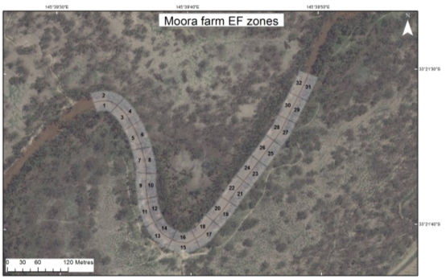
Figure 7-9. Example of mapped boat electrofishing units used for Category 1 fish community sampling in the Lachlan River. Each unit was sampled using 90 seconds of ‘on-time’.
Table 7-4. Contributions of fish species abundance to variability among years in the lower Lachlan River, determined through SIMPER analysis.
Note that only the top 3 species contributing (dissimilarity) to changes in community composition are included. Comparisons that were not significant are not included.
INDICATOR | YEAR  COMPARISON | SPECIES | CONTRIBUTION TO  DIFFERENCE (%) | YEAR WITH  GREATER VALUE
 | 2015-2017 | common carp | 30 |  | 2017
 |  | Eastern gambusia | 14 |  | 2017
 |  | carp gudgeon | 14 |  | 2017
 | 2015-2018 | carp gudgeon | 30 |  | 2018
 |  | Australian smelt | 18 |  | 2018
 |  | bony herring | 14 |  | 2018
 | 2015-2019 | carp gudgeon | 16 |  | 2019
 |  | Murray cod | 16 | 2015
 |  | Australian smelt | 14 | 2015
 | 2015-2020 | carp gudgeon | 29 |  | 2020
 |  | bony herring | 18 | 2015
 |  | Eastern gambusia | 14 |  | 2020
 | 2015-2021 | bony herring | 19 | 2015
 |  | flatheaded gudgeon | 17 |  | 2021
 |  | carp gudgeon | 12 |  | 2021
 | 2016-2017 | common carp | 31 |  | 2017
 |  | carp gudgeon | 14 |  | 2017
 |  | Eastern gambusia | 10 |  | 2017
 | 2016-2018 | carp gudgeon | 28 |  | 2018
 |  | Australian smelt | 19 |  | 2018
 |  | bony herring | 13 |  | 2018
ABUNDANCE | 2016-2020 | carp gudgeon | 28 |  | 2020
 |  | bony herring | 23 | 2016
 |  | Eastern gambusia | 12 |  | 2020
 | 2016-2021 | bony herring | 22 | 2016
 |  | Eastern gambusia | 14 | 2016
 |  | carp gudgeon | 14 |  | 2021
 | 2017-2018 | common carp | 25 | 2017
 |  | Australian smelt | 17 |  | 2018
 |  | carp gudgeon | 16 |  | 2018
 | 2017-2019 | common carp | 33 | 2017
 |  | Eastern gambusia | 18 | 2017
 |  | carp gudgeon | 9 | 2017
 | 2017-2020 | common carp | 28 | 2017
 |  | bony herring | 16 | 2017
 |  | carp gudgeon | 12 |  | 2020
 | 2017-2021 | common carp | 23 | 2017
 |  | Eastern gambusia | 14 | 2017
 |  | bony herring | 14 | 2017
 | 2018-2019 | carp gudgeon | 26 | 2018
 |  | Australian smelt | 25 | 2018
 |  | bony herring | 16 | 2018
 | 2018-2020 | bony herring | 28 | 2018
 |  | Australian smelt | 22 | 2018
 |  | carp gudgeon | 15 | 2018
 | 2018-2021 | bony herring | 21 | 2018
 |  | carp gudgeon | 19 | 2018
 |  | Australian smelt | 17 | 2018
 | 2019-2020 | carp gudgeon | 25 |  | 2020
 |  | bony herring | 23 | 2019
 |  | Eastern gambusia | 19 |  | 2020
 | 2019-2021 | bony herring | 22 | 2019
 |  | flatheaded gudgeon | 16 |  | 2021
 |  | Murray cod | 11 |  | 2021
 | 2020-2021 | carp gudgeon | 24 | 2020
 |  | Eastern gambusia | 18 | 2020
 |  | flatheaded gudgeon | 12 |  | 2021

Table 7-5. Contributions of fish species biomass to variability among years in the lower Lachlan River, determined through SIMPER analysis.
Note that only the top 3 species contributing (dissimilarity) to changes in community composition are included. Comparisons that were not significant are not included.
INDICATOR | YEAR  COMPARISON | SPECIES | CONTRIBUTION TO  DIFFERENCE (%) | YEAR WITH  GREATER VALUE
BIOMASS | 2015-2017 | Murray cod | 37 | 2015
 |  | common carp | 24 |  | 2017
 |  | golden perch | 13 | 2015
 | 2015-2018 | Murray cod | 27 | 2015
 |  | common carp | 15 |  | 2018
 |  | bony herring | 15 |  | 2018
 | 2015-2020 | Murray cod | 30 | 2015
 |  | golden perch | 16 |  | 2020
 |  | common carp | 14 | 2015
 | 2016-2017 | common carp | 30 |  | 2017
 |  | Murray cod | 30 | 2016
 |  | golden perch | 12 | 2016
 | 2017-2018 | Murray cod | 28 |  | 2018
 |  | common carp | 25 | 2017
 |  | golden perch | 14 |  | 2018
 | 2017-2019 | common carp | 28 | 2017
 |  | Murray cod | 26 |  | 2019
 |  | bony herring | 15 | 2017
 | 2017-2020 | common carp | 25 | 2017
 |  | Murray cod | 25 |  | 2020
 |  | golden perch | 16 |  | 2020
 | 2017-2021 | silver perch | 33 |  | 2021
 |  | Murray cod | 16 |  | 2021
 |  | common carp | 16 | 2017
 | 2018-2019 | bony herring | 22 | 2018
 |  | common carp | 16 | 2018
 |  | Murray cod | 15 |  | 2019
 | 2018-2020 | bony herring | 23 | 2018
 |  | golden perch | 16 |  | 2020
 |  | Murray cod | 15 | 2018
 | 2018-2021 | silver perch | 38 |  | 2021
 |  | bony herring | 15 | 2018
 |  | common carp | 9 | 2018

Table 7-6. Pre-European (PERCH = Pre-European Reference Condition for fisH) list of the expected native fish species present in the lowland Lachlan river basin, their associated rarity and subsequent detection during LTIM annual censuses from 2015-2021.
Descriptions of predominance (occurrence) correspond to reference condition categories for the Murray-Darling Basin SRA program and are used to generate fish condition metrics.
COMMON NAME | SCIENTIFIC NAME | OCCURRENCE | 2015 | 2016 | 2017 | 2018 | 2019 | 2020 | 2021
Australian smelt | Retropinna semoni | common | Y | Y | Y | Y | Y | Y | Y
bony herring | Nematalosa erebi | common | Y | Y | Y | Y | Y | Y | Y
carp gudgeon | Hypseleotris spp | common | Y | Y | Y | Y | Y | Y | Y
freshwater catfish | Tandanus tandanus | common | Y
golden perch | Macquaria ambigua | common | Y | Y | Y | Y | Y | Y | Y
Murray-Darling rainbowfish | Melanotaenia fluviatilis | common
silver perch | Bidyanus bidyanus | common |  |  |  |  |  |  | Y
Murray cod | Maccullochella peelii | occasional | Y | Y | Y | Y | Y | Y | Y
un-specked hardyhead | Craterocephalus stercusmuscarum fulvus | occasional | Y | Y | Y | Y |  | Y | Y
flathead galaxias | Galaxias rostratus | rare
flat-headed gudgeon | Philypnodon grandiceps | rare |  | Y | Y |  | Y | Y | Y
olive perchlet | Ambassis agassizii | rare
southern purple spotted gudgeon | Mogurnda adspersa | rare
southern pygmy perch | Nannoperca australis | rare

Spawning and larval fish

Introduction
Environmental flow regimes commonly aim to maintain and enhance native fish community populations (King et al. 2010). The premise being that aspects of the flow regime are linked to key components of the life history of fish, including pre-spawning condition and maturation, movement cues, spawning cues and behaviour, and larval and juvenile survival (Junk et al. 1989, Humphries et al. 1999, King et al. 2003, Balcombe et al. 2006). Since the strength of recruitment to adulthood is largely driven by spawning success, and growth and survival of young, understanding how the flow regime influences the early life history of fishes is critical to managing fish populations (King et al. 2010).
To assess the contribution of Commonwealth environmental water to native fish spawning and recruitment, the relevant short term and long-term questions to be evaluated are:

Short-term evaluation questions:
- What did Commonwealth environmental water contribute to native fish reproduction in the lower Lachlan River catchment?
- What did Commonwealth environmental water contribute to native larval fish growth and survival in the lower Lachlan River catchment?

Long-term evaluation questions:
- What did Commonwealth environmental water contribute to native fish populations in the lower Lachlan River catchment?
- What did Commonwealth environmental water contribute to native fish species diversity in the lower Lachlan River catchment?

The larval fish monitoring implemented within the Lower Lachlan River system is directed at Basin scale evaluation and is confined to a single zone within the Lower Lachlan River system Selected Area. There are likely to be strong differences in the fish community and habitats between zones within the Selected Area resulting in the evaluation of outcomes for the Selected Area being confined to the target reach (i.e. Zone 1) (Dyer et al. 2014b). There are two components to the evaluation provided in this report. The first evaluates the 2019-20 watering actions in relation to the specific objectives for fish, the second aims to address the short-term and long-term evaluation questions.

Methods

Field sampling
Larval fish were sampled at three sites (Dyer et al. 2014b) on the lower Lachlan river system Selected Area (Wallanthery, Hunthawang and Lanes Bridge, see map Figure 6-1 on page 32 and site images Figure 8-1). To capture larval fish, three drift nets and 10 light traps were set overnight at each site (for more detail see Dyer et al. 2014a). Samples collected from drift nets were processed separately. Samples collected from light traps were pooled per site per trip. Five sampling events were undertaken at fortnightly intervals between 12th October 2020 and 8th December 2020:
The timing of sampling is targeted around watering actions with expected outcomes for native fish spawning, with considerations for seasonal requirements of target species. The target species include representatives from each of the three reproductive guilds:
- Equilibrium: Murray cod (Maccullochella peeli) and freshwater catfish (Tandanus tandanus)
- Periodic: Golden perch (Macquaria ambigua) and bony herring (Nematalosa erebi)
- Opportunistic: Australian smelt (Retropinna semoni) and flat headed gudgeon (Philypnodon grandiceps).
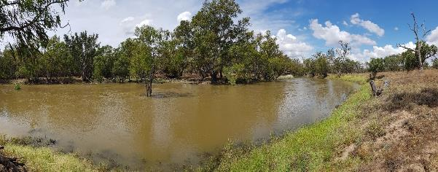
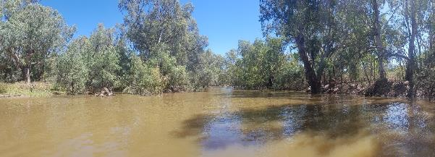
Figure 8-1. Larval fish site Wallanthery (top) and Lanes Bridge (bottom) at high flows in November 2020. Photo: Ben Broadhurst

Laboratory processing
Preserved samples were examined in the laboratory and all fish were removed. Extracted fish were identified where possible (using Serafini and Humphries 2004) and measured (standard length) under magnification using a digital graticule to the nearest 0.001 mm. If individuals were not able to be identified, individuals were measured and labelled “unidentified”. Only the first 50 individuals were measured per species per site per trip per operation (operation = an individual drift net or 10 light traps), with the other individuals being counted only.
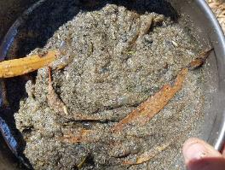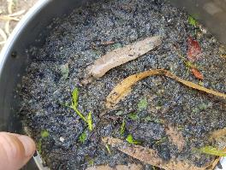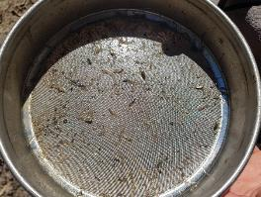
Figure 8-2. Fish larval catch results of overnight drift netting (left and mid) and light traps (right) in 250 µm sieves in November 2020. Photos: Ben Broadhurst

Data analysis
For catch per unit effort figures, catches of larval fish for drift nets was standardised as the number of individuals per m³ of water sampled. Set and retrieval times of light traps were recorded so that relative abundance can be expressed as catch-per-unit-effort (CPUE). Total larval fish captures (all trips grouped by site) between years were examined using a permutational analysis of variance (PERMANOVA) with Type I sum of squares. Raw captured data was fourth-root transformed, then a resemblance matrix was constructed with the Bray-Curtis similarity measure. All species were included as variables, with year as a fixed factor and site as a random factor nested within year for a maximum of 9999 permutations. Principal Component analysis ordinations (PCoA) of the transformed data were arranged into resemblance matrices using the Bray-Curtis Similarity measure. Vectors are the raw Pearson's correlations for the taxa that are most correlated (> 0.5) with each of the PCoA axes.

Results

Watering year 2020-21
A total of 1870 larval fish were captured across the five sampling events of spring-summer 2020 comprising five native species (Murray cod, golden perch, flat headed gudgeon, Australian smelt and carp gudgeon) and two alien fish species (Eastern gambusia and common carp) (Table 8-1).
Light traps captured the majority of larval fish, though this was mostly driven by high abundances of flat headed gudgeon. Numbers of larval fish were variable between sampling events, with trips 4 and 5 capturing the majority of fish (94% of all trips) comprising 33% and 61%, respectively. Flat headed gudgeon were by far the most numerous species caught, comprising 79% of the total number of larval fish captured in 2020. Carp gudgeon were the next most dominant species, comprising nearly 13% of the total number of fish captured (Table 8-1).
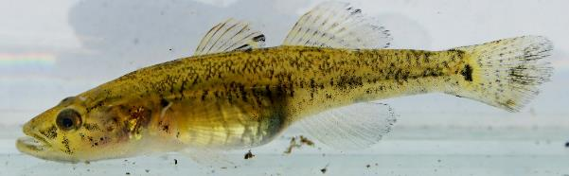
Figure 8-3. A flatheaded gudgeon from Booberoi Creek in the mid-Lachlan. Photo: Mal Carnegie
Four of the six target species of larval fish species were captured in 2020: one Equilibrium species, Murray Cod, two Opportunistic species, Australian smelt and flat headed gudgeon, and for the first time since monitoring began a periodic representative species (golden perch) were collected during larval sampling in 2020 (Table 8-1).
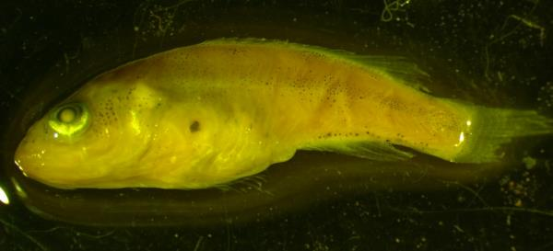
Figure 8-4. Larval golden perch form the Lachlan River in late spring 2020. Photo: Rhian Clear
Murray cod abundances were low compared to all other years (except 2016 when none were captured). Murray cod were only captured in trips 3 and 4, with most being captured from trip 3 from a single site (Lanes Bridge, 16 of 26 individuals) (Figure 8-5 and Figure 8-6). Larval Murray cod ranged in length from 7.903 – 10.228 mm, corresponding to ages of 9 – 16 days (Figure 8-7). Estimated spawning window for Murray cod in 2019 was between 17/10/20 – 3/11/20 (see Figure 8-11 in Section 8.7).

Table 8-1. Capture summary of larval fish from sampling conducted between mid-October to mid-December 2020 in the lower Lachlan river system Selected Area.
SPECIES | DRIFT NETS | LIGHT TRAPS | TOTAL
Murray cod | 17 | 9 | 26
flat headed gudgeon | 189 | 1289 | 1478
Australian smelt | 0 | 39 | 39
carp gudgeon | 1 | 234 | 235
freshwater catfish | 0 | 0 | 0
golden perch | 2 | 2 | 4
Eastern gambusia | 3 | 19 | 22
common carp | 35 | 31 | 66
TOTAL | 247 | 1623 | 1870

Three Opportunistic species were collected during larval sampling in 2020, these were Australian smelt, flat headed gudgeon and carp gudgeon. Australian smelt were captured in light traps during all five sampling events and in drift nets in four of the five sampling events.
Flat headed gudgeon were captured in all sampling events, though sampling events 4 and 5 accounted for 99% of captures for this species in 2020 (Figure 8-5 and Figure 8-6). Flat headed gudgeon ranged in length from 4.96 – 21.38 mm (Figure 8-7), with an estimated age of 9 –96 days. This corresponds to an estimated spawning window from early-August to mid-November, with the bulk of spawning occurring between mid-September and mid-October 2020 when water temperatures were ~16 - 20 °C (see Figure 8-11 in Section 8.7). This coincided with the tail of the translucent flow and the use of environmental water to modify the flow recession (Figure 4-3 on page 18), suggesting that spawning was associated with declining river levels. There was a clear increase in the length frequency of flat headed gudgeons between sampling events 4 and 5, indicating that conditions were suitable for growth and survival Figure 8-7).
Australian smelt larvae were most abundant on sampling events 1 and 2 (Table 8-1, Figure 8-5 and Figure 8-6). The vast majority (95%) of larval Australian smelt came from a single site (Lanes Bridge). Australian smelt captured ranged in size from 11.37 – 21.081 mm (Figure 8-7) and ranged in estimated age from 9 – 38 days. Length frequency distribution and associated back calculation of estimated spawning dates indicate that Australian smelt had a spawning window spanning mid-September to mid-November in 2020 (see Figure 8-11 in Section 8.7). Peak spawning activity occurred around mid/late September 2020, when water temperatures were around 15 – 18 °C and the first translucent flow pulse was receding (see Figure 8-11 in Section 8.7). Length of Australian smelt increased between sampling trip 1 and 2, indicating that individuals survived and grew between sampling events (Figure 8-7).
Catches of larval carp gudgeon were the highest since monitoring began in 2014. Larval carp gudgeon were only present in sampling events 4 and 5, with the later event accounting for 95% of the total number of carp gudgeon captured in 2020 (Table 8-1, Figure 8-5 and Figure 8-6). Carp gudgeon captured ranged in size from 7.184 – 18.923 mm (Figure 8-7) and ranged in estimated age from 25 – 93 days. Length frequency distribution and associated back calculation of estimated spawning dates indicate that carp gudgeon had a spawning window spanning mid-August to early-November in 2020 (see Figure 8-11 in Section 8.7). Peak spawning activity occurred during October 2020, between the two translucent flow events, when river levels were low and stable and water temperatures were around 17 – 20 °C (see Figure 8-11 in Section 8.7). There was no obvious change in length frequency of carp gudgeons between sampling event 4 and 5 (Figure 8-7).
Four larval golden perch were captured in 2020, all from the same site (Lanes Bridge) and the same sampling event (event 4 – 26 /11/20). The four golden perch larvae measured 8.19, 8.59, 14.56 and 15.33 mm and ranged in estimate age from 10 – 20 days old (based on SL / age relationships taken from Ebner et al. (2009). The two age classes of golden perch larvae indicated that there were two spawning events, one early November (2 / 3rd) and one approximately 9 days later (11th) when river temperatures were ~21 and ~23 °C, respectively. The estimated timing of spawning aligns with the arrival of the second translucent flow pulse in early November 2020.
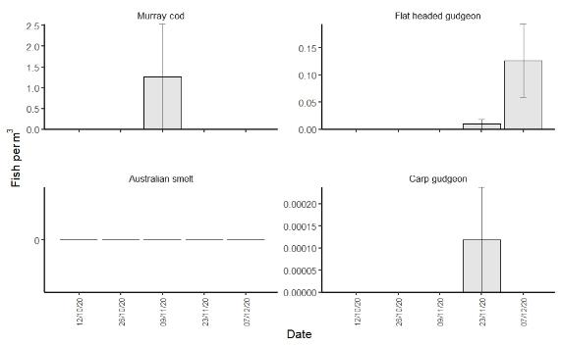
Figure 8-5. Mean catch per unit effort (± standard error) of the commonly caught larval native fish for drift nets per sampling event in spring / summer 2020.
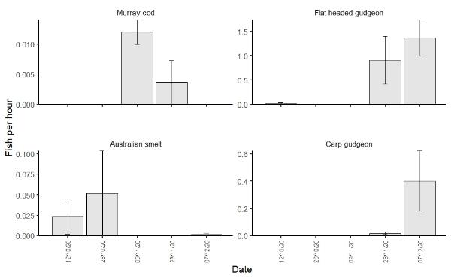
Figure 8-6. Mean catch per unit effort (± standard error) of the commonly caught larval native fish for light traps per sampling event in spring / summer 2020.
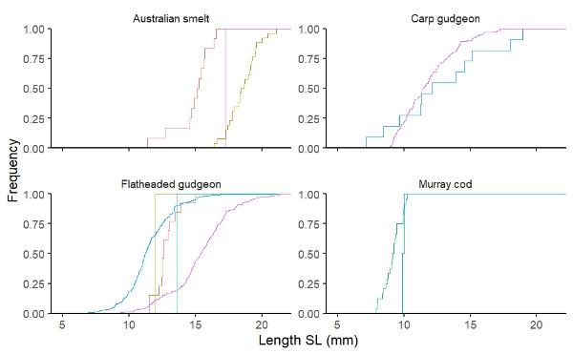
Figure 8-7. Length frequency histograms for each sampling event of commonly captured larval native fish species with site (n = 3) and sampling technique (n = 2) combined for 2020.
Note: Red line indicates sampling event 1 (12/10/20), olive line indicates sampling event 2 (26/10/20), green line indicates sampling event 3 (9/11/20), blue line indicates sampling event 4 (23/11/20) and pink line indicates sampling event 5 (7/12/20).
A total of 88 alien fish larvae were captured in 2020 comprising 66 common carp and 22 Eastern gambusia (Table 8-1). Carp abundances varied between sampling events, with sampling events 1, 4 and 5 recording approximately a third each of the total catch for 2020. Common carp ranged in length from 8.64 – 17.55 mm and estimated ages from 9 – 33 days old. The estimated spawning window of common carp spanned mid-September to mid-November, and spawning frequency was bimodal, with peaks in mid-September and early-mid-November when water temperatures were 16 – 18 °C and 20 – 23°C, respectively (see Figure 8-11 in Section 8.7). Peaks in carp spawning aligned with translucent flow pulses, but this did not translate to a large spawning response of common carp. Eastern gambusia were captured in all sampling events except event 4 (late November 2020). Eastern gambusia ranged in size from 10.60 – 18.35 mm and were between 27 and 50 days old (based on estimated length vs age estimate equations presented in Humphries et al. 2008).

2020-21 vs Previous years
There was a significant difference in the larval fish community between years in the lower Lachlan River Selected Area (Table 8-2). Pairwise tests revealed that the larval fish community of 2020 was not statistically different to any other year, and was most similar to 2017 and 2018 in being dominated by small bodied species. The large abundance of common carp was the discriminating factor between 2016 and all other years. The larval fish community in 2017 and 2018 was typified by far higher abundances of Australian smelt and flat headed gudgeon than other years (Figure 8-8 to Figure 8-10).
Table 8-2. Results of PERMANOVA analysis of larval fish captures (fourth-root transformed numerical data from drift net and light traps combined) in the lower Lachlan River Selected Area 2014 – 2020.
Source | df | SS | R2 | Pseudo-F | P(>F)
Year | 6 | 0.2524 | 0.86324 | 14.728 | 0.0001
Residual | 14 | 0.3999 | 0.13676
Total | 20 | 0.29238

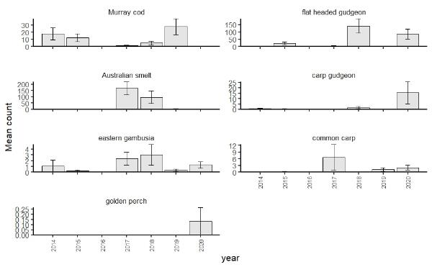
Figure 8-8. Mean raw abundances of larval fish species captured in light traps from spring – summer 2014 – 2020. Note: light traps were not set in 2016 due to river being in flood.

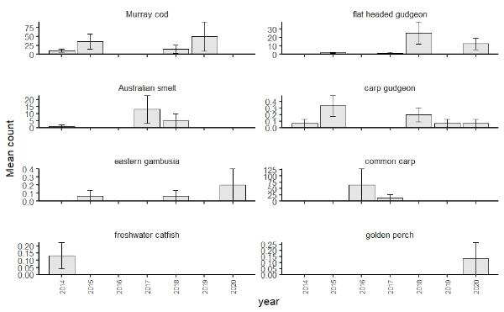
Figure 8-9. Mean raw abundances of larval fish species captured in drift nets from spring – summer 2014 – 2020.
Figure 8-10. Annual larval fish community composition per site (plotted in multidimensional space using principal component analysis ordination) captured from the lower Lachlan River Selected Area using drift nets and light traps from spring/summer 2014 – 2020.
Each point on the figure represents an annual larval fish community for a given site (3 points per year). Points closer to each other indicate that the annual larval fish communities are similar, points further apart indicate larval fish communities are dissimilar. Vectors (in this case fish species) indicate how the annual fish communities are best discriminated from each other.

Discussion
Two translucent flows passed through the Lachlan River main channel during the spawning season of native fish in 2020. The first translucent pulse passed through between mid-August and late September 2020, with an extended recession provided into mid-October 2020 by CEW. This first pulse raised the river by approximately 4 m, and passed through when water temperatures were between 12 – 20 ⁰C. The second translucent flow was shorter in duration, with the main pulse passed through between mid to late November, with an extended recession into mid-December 2020 provided by CEW. This second pulse raised the river by approximately 3.5 m, and passed through when water temperatures were between 22 – 25 ⁰C. These pulses would likely have provided increased connectivity to habitat and mates, increased productivity (food production) and cues for native fish spawning activity.
For the first time since this monitoring program began in 2014, larval golden perch were detected in monitoring in 2020. Two individuals each were captured in light traps and drift nets at a single site (Lanes Bridge) from a single sampling event (sampling trip 4 – 23/11/21). Estimated spawning dates have these individuals spawned in early-November and mid-November 2020, likely associated with the second translucent pulse (though attributing exact spawning date to exact part of the hydrograph is not possible as it is possible that spawning may have occurred some distance upstream of the site of larval capture – see Stuart and Sharpe (2020)). There are some similarities between 2015 and 2020 in terms of a pair of flow pulses during spring and early summer. Why the 2020 season resulted in spawning of golden perch and not that of 2015, is likely to be a result of a number of factors. Firstly, the timing of the pulses was slightly different between the two years. The timings and duration of the first pulses differ slightly, in that the 2020 pulse commenced in mid-August and finished in mid-October (duration of ~2 months). Whilst the first pulse in 2015 was later (commenced early – mid September) and shorter (finished mid-late September, a duration of 2 – 3 weeks). It is likely that both of these first pulses occurred at water temperatures too low to initiate spawning of golden perch (optimum temperatures are believed to be ~20 ⁰C, King et al. 2005, Stuart and Jones 2006). Though it is likely that these pulses would have acted as primers for golden perch adults to move and ready for spawning. Indeed, ripe adult golden perch were observed by researchers following the first pulse in 2015, confirming that adults in the systems were primed for spawning activity. The time between the first and second pulses differed between 2015 and 2020 as well. In 2015, time between the two pulse was a lot longer (approximately two months), whereas it was just less than a month in 2020. There was also a stark difference in the magnitudes of the second pulses between 2015 and 2020. The second pulse in 2015 was smaller in magnitude (rise in river of ~1.5 m) than the translucent pulse of 2020 (rise of approximately 3.5 m). This would likely have result in different in channel hydraulic conditions, which are hypothesised to be important for golden perch spawning activity (Mallen-Cooper and Zampatti 2018). The rise of each of the second pulses also differed, with the pulse in 2015 being a slower rise, whereas the rise in 2020 was very rapid. Although only based on limited datapoints, the learnings from the monitoring suggest that both magnitude and timing of flow pulses are important for golden perch spawning in the lower Lachlan River system, with the period between the pulses emerging as particularly important.
Murray cod larval abundances were the lowest since monitoring began, with the exception of 2016, when no larval Murray cod were captured. In general, best practice water delivery to support successful Murray cod nesting has been based around maintaining relatively stable water levels during cod nesting period (Late September through to mid-November (Koehn and Harrington 2006, Sharpe 2019). There are a few factors that likely contributed to low larval Murray cod abundances in 2020. The onset of Murray cod spawning in 2020 (approximately end of September – mid-October) would have coincided with the recession of the first pulse. The recession, which commenced in mid-late September 2020, lasted until mid-October and resulted in the river dropping by approximately 4 m during this time. This large recession may have resulted in desiccation of eggs as the water level dropped to below spawning site levels. Another possible cause of low larval abundances is that any eggs from spawning are maybe being displaced from nests by increased water velocities during high flow events (Humphries et al. 1999). Both hypotheses are supported by the result that the earliest predicted spawning date was 16th October, approximately the date at which the Lachlan River ceased to recede and had returned to typical level for this time of year. It is unlikely that this was the start of the onset of spawning, just the first date at which eggs are likely to have survived as the recession of high flow had completed. The combination of high flows and a sudden recession of the river between the end of September and mid-October 2020 appears to have had a negative effect on the abundance of larval Murray cod present in the lower Lachlan River system, likely due to some combination of desiccation of nesting sites, eggs being displaced prematurely from nests or the dampening of spawning activity. Future watering, aiming to promote Murray cod spawning and early recruitment, should aim to prevent a sudden drop in water level between late-September and mid-October. Furthermore, planned spring pulses should be avoided from mid-September – mid-October to prevent eggs being washed from nests by high water velocities.
In contrast to the larval monitoring results, fish community sampling in autumn 2021 detected a strong recruitment event of Murray cod from the 2020 spawning season. The discrepancy between the two datasets could be due to a number of factors. It may be that although abundances of larval Murray cod were low in 2020, survival of those that were present was high. The two large pulses of water that moved through the system would likely have resulted in a boom in resources and food availability (see Section 6). This may have led to proportionally large survival for recruits. Alternatively, Murray cod spawning in 2020 may have been significantly contracted, and that coupled with the relatively short period for which they are capturable in the drift may have meant that the bulk of Murray cod larvae spawned in 2020 were missed by fortnightly sampling.

As for all 2019, bony herring were again not detected during larval monitoring in 2020. Contrary to other previous years where recruits were detected in the community fish sampling in autumn, there was little evidence of recruitment for this species at all for 2020 and 2021 (see Section 7). It is difficult to explain the recruitment failure of this species in the lower Lachlan over the past two years, especially as eggs or larvae have never been detected during this monitoring program (despite the latter recruits showing up in great abundances during the fish community sampling in the following autumn), so the lines of evidence are missing with respect to early life history patterns in the lower Lachlan River Selected Area. Based on results from previous years of this monitoring program and from previous studies elsewhere (e.g. Balcombe et al. 2006), bony herring recruit over a wide range of hydrological conditions, including extreme flooding and low flow periods, so it appears as though hydrology alone is not the driver behind the lack of recruitment over the past two years. This species is relatively long lived (5+ years, see Pusey et al. 2004) and does go through boom and bust cycles in its population dynamics, so missing two years of recruitment is unlikely to have lasting effects of the population.
As for 2017 and 2018, larval fish captures were dominated by small-bodied native fish in 2020. Flat headed gudgeon (79%) and carp gudgeon (13%) contributed the highest percentage of total abundances of larval fish from all sites and sampling trips in 2020. Flat headed gudgeon were most abundant in trips 4 and 5, where they numerically dominated light trap catches. Flat headed gudgeon spawning appears to be a single large event that spanned early September to end of October, with the peak in early October. Peak spawning activity of flat headed gudgeon occurred during the falling limb of the first translucent pulse, when water temperatures were 15 – 22 ⁰C. As for the other years for which there were high numbers of larval flat headed gudgeon captured (2015 and 2018), 2020 saw a flow pulse move though the system in September. Spawning of this species was found to be initiated by increases in food resources in earthen ponds (Llewllyn 2007), which is somewhat congruent with the results of the current monitoring program. The years with the highest abundance of larval flat headed gudgeon (2015, 2018 and 2020) were years in which spring pulses were delivered in mid-September. It appears as though spawning and survival to early juvenile stage of flat headed gudgeon is related to whether or not a spring pulse had arrived just prior to the estimated spawning window.
Abundances of larval carp gudgeon in 2020 were 10-fold the next highest year (2018), with most individuals (95%) captured in trip 5 in light traps. Spawning of carp gudgeon in 2020 spanned late august to start of November, with the peak spawning activity occurring in October. Peak spawning occurred in the falling limb and immediately following the first translucent pulse, when water temperatures were ~18 – 22 ⁰C. Previous studies found that carp gudgeon were found to have enhanced recruitment during flooding (associated with wetland inundation) (Beesley et al. 2012) or used floodplain inundation for recruitment (King et al. 2003). It’s likely that carp gudgeon used inundated off-channel habitats for spawning in the lower Lachlan River in 2020.
In terms of Australian smelt, the spawning season of 2020 appears to have produced small abundances of recruits (based on larval fish sampling and fish community monitoring). Previous years has resulted in large numbers of larval Australian smelt either higher than average flows or followed on from large flooding event (e.g. 2017 and 2018). The driver behind the low abundances of larval Australian smelt again in 2020 (as for 2019) is not clear at this stage.
Sixty-six common carp were captured in 2020, suggesting that although some spawning occurred, overall common carp spawning activity (as detected in the larval fish monitoring) in the targeted area was relatively low. There were two distinct peaks in carp spawning activity, one in mid-September and the other in early-November. The first spawning peak aligns with the peak of the first translucent pulse, when water temperatures were ~16 – 20 ⁰C. The second and more significant peak in spawning activity was estimated during early November, just prior to the arrival of the second translucent pulse to the monitored reach. Spawning of carp in 2020 was somewhat to be expected as increased carp recruitment with floodplain inundation is well documented in the Murray-Darling Basin (e.g. King et al. 2003, Crook and Gillanders 2006, Stoffels et al. 2014). Though widespread floodplain inundation was not achieved in 2020, many off channel habitats were inundated and would’ve served as prime spawning locations for common carp. This aligns with the first spawning peak in 2020, though not so much with the second peak. The discrepancy may be caused by a few factors. Firstly, our spawning estimates are based on length-age relationships from a different catchment, so some error in spawning dates may be present in estimates. Secondly, common carp collected in the study reach may have spawned on the peak of the second translucent pulse and travelled down with the pulse from further upstream. Regardless, although some spawning of common carp was detected, it was at relatively low levels compared to that of the 2016 flood.

Evaluation
There were two Commonwealth environmental watering actions in the lower Lachlan River system that aimed to have expected outcomes for native fish in 2020;
- August-September Brewster translucent flow
- November – December Wyangala translucent flow
These watering actions both had the same secondary objective relating to native fish:
- Support native fish populations
The translucent flows that passed through the lower Lachlan River system would have been expected to support native fish communities by providing a boost to food resources, increased connectivity, between individuals and habitat and to provide cues important for spawning. Our results indicated a strong response in the larval fish community, with high abundances of larval small-bodied native fish species, likely associated with the flow pulses. Furthermore, golden perch spawning was observed in the lower Lachlan River system for the first time since monitoring began in 2014. The timing of the two pulses appears to have provided the ideal cues and condition for golden perch recruitment in the lower Lachlan system, an event that appears to be extremely rare in recent history.
The fall of the first pulse looks to have been detrimental to Murray cod spawning in 2020, almost the entire falling limb occurred during peak Murray cod spawning window in the reach which would likely have resulted in nest abandonment and egg desiccation as the river dropped by ~4 m. Based on results from the 2016 flood year, we could expect that the high flows in spring – summer 2020 (and resulted connectivity with off channel habitats) would have provide significant resource input into the system and that growth and spawning of native fish would be supported in the coming years. To assess the contribution of Commonwealth environmental water to native fish spawning and recruitment, the relevant short-term and long-term questions to be evaluated are:
Short-term (one year) evaluation questions:
- What did Commonwealth environmental water contribute to native fish reproduction in the Lower Lachlan River system?
In 2020 Commonwealth environmental water appears to have made a positive contribution to the spawning and early recruitment of small bodied species and to that of golden perch in the lower Lachlan River system. Monitoring in 2020 indicates that production of small bodied larval fish was relatively high and that for the first time since monitoring began in 2014, golden perch spawning and recruitment was detected. The timing of the first translucent pulse looks to have been ideal for providing conditions conducive to flat headed gudgeon and carp gudgeon spawning and recruitment. The combination of the two translucent pulses appears to have been conducive to golden perch spawning, with the first pulse acting as a primer and spawning occurring in association with the second pulse.
- What did Commonwealth environmental water contribute to native larval fish growth in the Lower Lachlan River system?
Based on changes in length frequency between sampling trips, it appears as though growth of larval fish was supported for both Australian smelt (between sampling trips 1 and 2) and flat headed gudgeon (between sampling trips 4 and 5).
Long-term (five year) evaluation questions:
- What did Commonwealth environmental water contribute to native fish populations in the Lower Lachlan River system?
The spring pulses in 2020 resulted in the only natural recruitment event for golden perch in the lower Lachlan River system since monitoring began. The combination of the two translucent pulses provided the appropriate cues and conditions for spawning and recruitment to juveniles to occur. It is hoped that this recruitment event will support the population until the next set of conditions are present for a subsequent spawning event. The first translucent pulse also provided suitable cues for strong spawning and recruitment response from small bodied native fish (flat headed gudgeon and carp gudgeon).
- What did Commonwealth environmental water contribute to native fish species diversity in the Lower Lachlan River system?
The main mechanism for Commonwealth environmental water to contribute to native fish species diversity in the Lower Lachlan River system thus far has been to facilitate spawning and to produce sufficient resources for larval fish growth and survival. As mentioned above, the pulses in 2020 has resulted in the first recruitment event for golden perch since monitoring began in 2014. This is a significant result for the catchment and likely provides a blueprint for which to attempt to elicit a spawning response of golden perch in future years. The flow pulses also provided suitable conditions for strong recruitment of small bodied native fish, flat headed gudgeon and carp gudgeon.

Final Comments and Recommendations
- The combination of the two translucent pulses in 2020 were suitable to elicit a spawning and recruitment event for golden perch for the first time since monitoring began in 2014.
CEWO Adaptive Management Response:
Future delivery of flow pulses aiming to result in golden perch spawning and recruitment should mimic as closely as possible the hydrological patterns of 2020 (recognising that e-water releases are unlikely to deliver the volumes of translucent flows), with these critical components;
→ multiple large flow pulses,
→ maximum of 30 days between pulses, and
→ all pulses delivered prior to water temperatures reaching 25 ⁰C.

- Murray cod larval abundances in 2020 were very low. It is likely that a combination of high flows and falling river levels of the first translucent flow, which occurred during peak Murray cod spawning season, resulted in nest abandonment and /or eggs desiccation and/or eggs being washed from nests prematurely by high water velocities.
CEWO Adaptive Management Response:
Where possible the CEWO will avoid delivering large flow pulses between mid-September and mid-October, and reduce the rate of fall of spring pulses if the falling limb occurs during peak Murray cod spawning window (mid-September – mid-October).

- Despite multiple large flow pulses (which inundated off-channel habitats) in 2020, there was not a significant response in common carp spawning and early recruitment. This was also the case in 2015 when multiple large flows passed through the system during common carp spawning season.
CEWO Adaptive Management Response:
The CEWO notes that large flow pulses can be delivered in the lower Lachlan selected area with minimal risk of triggering a significant carp spawning event. The CEWO is also aware that certain locations in the lower Lachlan remain significant sources of carp recruitment in the lower Lachlan.

- Whilst the absence of bony herring larvae from this program is common, the absence of recruits from the community monitoring program is of some concern. Furthermore, there was a large decline in abundance of non-recruits of this species over the past two years. Although this species lives for 5+ years, a series of recruitment failures could have disastrous effects on this population.
CEWO Adaptive Management Response:
The CEWO also refers to the November 2021 survey results reported for Lake Cargelligo which noted the presence of big bony herring (over 300mm), however no recruits were caught (A Kerezsy 2021, pers. comm., 26 November). This was assessed to be an unusual result for Lake Cargelligo where there are usually small bony herring (from 40 – 100mm) year-round. The reasons for this are not know but may be due to cooler than usual spring conditions. The CEWO notes that in the Murrumbidgee River catchment, Wassens et al. (2021) also found a lower percentage catch of juveniles compared to adult (non-juveniles) bony herring during 2021.

Appendix 1: Estimating fish spawning dates 2020
The most accurate and precise method of estimating larval fish age and hence deriving a spawning date is by direct daily aging using otoliths of larval fish (Anderson et al. 1992, Campana and Thorrold 2001). Resource constraints meant direct aging was not currently feasible for this project (although Murray cod and Australian smelt larvae captured in 2014 – 2018 were aged to construct age-length keys outlined below), and this forced the use of less accurate indirect methods of aging and spawning date estimation.
Ages for Australian smelt were calculated using an age-length model (Age = -1/0.059904*LOG10 (1 - Ln/19.738043)+3.712221) derived from Australian smelt known age fish collected from the Lachlan river 2014 – 2018 (see Dyer et al. 2020). Ages of other small bodied species (carp gudgeon and flat headed gudgeon) were estimated from length-age equations for each species for a site on the Lower Murray floodplain (Lindsay Island), provided in Humphries et al. (2008) and matched to capture month. Hatching times for small bodied species were taken from Lintermans (2007).
Murray cod larval age were estimated by multiplying length by 1.372 (a factor to compensate for shrinkage in ethanol) matched against linear length age equation derived from length-age data collected in the Lachlan River from 2014 – 2018 (see Dyer et al. 2020) (Age = -14.2478+ (2.78*Ln)+1.924). This age along with estimated incubation period (= 20.67-0.667*[WaterTemp(°C)] taken from Ryan et al. (2003) – where water temperature was for the five days prior to the estimated spawning date was subtracted from the capture date to provide an estimate of spawning date. Age of larval common carp was estimated using age vs growth relationships from Vilizzi (1998), and hatching time was taken from Lintermans 2007.

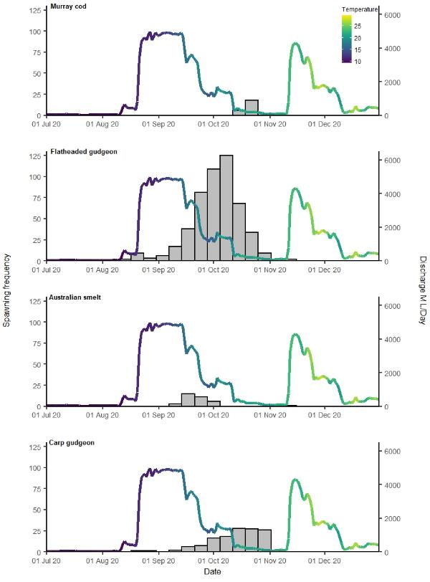
Figure 8-11. Estimated spawning date frequency (grey bars) and associated discharge and temperature for larval native fish species in 2020.
Note: Mean daily discharge and temperature taken from Lachlan River at Willandra Weir. Data are from all sites and methods combined.

Vegetation

Introduction
Inundation by flooding facilitates the exchange of water, living organisms and resources (inorganic and organic matter) between the main channel, and the floodplain and is the predominant factor that controls the observed ecological patterns and processes, and biological productivity on the floodplain (Junk et al. 1989, Poff and Ward 1989, Bayley 1995). Plants on floodplains often require flooding for survival, growth and reproduction as rainfall alone is often insufficient (Roberts and Marston 2011, Doody et al. 2014, Catelotti et al. 2015).
Hydrological analysis described in the Flow MER Basin Wide Vegetation Theme report 2019-20 highlighted how the floodplain of the Lachlan River exhibits the most spatially variable hydrological conditions of all selected areas in the Basin, with some of the most frequently and infrequently flooded of all sample points (Dyer et al. 2021). The Lachlan River is also highly temporally variable, and under natural unregulated conditions, experienced large and extensive flood events as well as extended periods where it would have ceased to flow (Driver et al. 2004, Higgisson et al. 2019). Whilst, the flow variability and magnitude has been considerably reduced under current flow conditions (see Section 5 of the 2019-20 Lachlan technical report, Dyer et al. 2020), this variability has shaped the vegetation communities that occur on the riverbanks, floodplains and wetlands.
The lower Lachlan river system is a very low gradient alluvial plain, experiencing very low run-off, and river flows typically occur in response to rainfall in the upper catchment (Roberts et al. 2016). The lower Lachlan river (below the junction of the Lachlan River and Willandra Creek) is characterised by numerous distributary channels and anabranches, and an expansive network of irregularly flooded floodplains (Green et al. 2011), including many sites of national significance (Environment Australia 2001, SEWPaC 2011). Typical floodplain habitats in the lower Lachlan River system include temporary floodplain lakes, river red gum woodlands, black box woodlands and lignum shrublands. These floodplain habitats depend on over-bank flows during wet periods and are distributed across floodplains in relation to flow related gradients in flood frequency and duration (Roberts et al. 2016).
The groundcover diversity on the floodplain of the Lachlan River has been monitored since 2014 as part of the LTIM Project and MER Program. The 2020-21 watering year was a year of greater than average rainfall in the catchment which resulted in increased flow into water storages, triggering two translucent flow events. These inundated large areas of the floodplain of the lower Lachlan River in spring and early summer 2020, much of which had not been flooded since widescale natural flooding in early 2017. In the second half of the watering year, the lower Lachlan River system experienced low rainfall and correspondingly lower flows in the river. In Autumn 2021, floodwaters had receded from most of the floodplain leaving high soil moisture at some sites and surface water persisting in lower-lying wetlands.
Six of the seven environmental watering actions in the Lachlan river during the 2020-21 watering year included vegetation as an objective or primary expected outcome. Watering action one targeted Booberoi Creek and action three targeted Fletchers Lake and included the maintenance of riparian vegetation as expected outcomes. Watering action five targeted Lake Brewster and was designed among other things to enabled aquatic plants (particularly red-milfoil) to complete their full life cycle to provide future seed reserves. These three wetlands have not been monitored as part of the MER Program. Watering actions two and four were designed to build on the outcomes achieved by the translucent flow events in August and November 2020 including the maintenance of floodplain vegetation (Table 3-2 in Section 3). These larger watering actions inundated many of our sample points. Watering action six targeted Lake Noonamah and was in part designed to maintain vegetation condition. Lake Noonamah has been monitored as part of the MER Program since 2019. The objectives associated with watering action seven included, as a secondary outcome, the maintenance of floodplain vegetation, particularly the core reed beds of the Great Cumbung Swamp.
This technical report provides an evaluation of the outcomes for vegetation in the lower Lachlan river system and addresses the selected area specific evaluation questions (listed in 9.5). The results have been described in relation to the hydrological and climatic conditions, and environmental watering actions which have occurred over the 2020-21 watering year. The results gathered over the past seven years are used to provide context to this year’s findings.

Selected area specific evaluation questions:
- What did Commonwealth environmental water contribute to native riparian and wetland vegetation communities?
  - What did Commonwealth environmental water contribute to populations of long-lived organisms (measured through cover and recruitment of tree species)?
  - What did Commonwealth environmental water contribute to individual plant species across the Selected Area including changes to species presence, distribution and cover?
  - What did Commonwealth environmental water contribute to vegetation communities within the interim Australian National Aquatic Ecosystem (ANAE) vegetation types, including changes in species richness, composition, cover and structure?

Methods
Vegetation monitoring sites were selected to provide a sample from the different vegetation communities distributed across wetlands and riparian zones with different environmental watering probabilities, see Dyer et al. (2014b), Table 9-1 (on page 101), and Figure 9-5 (on page 105).
The non-tree community survey was conducted along 2 replicate 100 m transects extending from the fringing woodland into the deeper section of the wetlands and billabongs at each of 13 sites (Figure 9-5, page 105) and Table 9-1, page 101) using the methods of Driver et al. (2003) described in Dyer et al. (2014b). Species abundance and cover were recorded in 1 m² quadrats placed at 10 m intervals along the 100 m transects (n=10 per transect).
Woodland tree communities were surveyed in a minimum of 2 replicate 0.1 ha plots at each of 14 sites (Figure 9-5, page 110) and Table 9-1, page 106) using the methods of Bowen (2013) described in Dyer et al. (2014b). An understory floristic survey was undertaken in a nested 0.04 ha plot inside the 0.1 ha plots. Tree condition was observed not to be sensitive to watering over the past five years of LTIM project, and as such stand and tree condition will now be recorded every five years and not annually. The next year where tree condition is planned to be included as part of the vegetation evaluation is 2025. However, at the sites that were newly established stand and tree condition were recorded in Autumn 2020. In each 0.1 ha plot, measures of stand and tree condition (basal area, canopy openness, canopy extent, live/dead limbs) were recorded as well as the number of seedlings and saplings <10 cm diameter at breast height (DBH). In each 0.04 ha plot, the floristic survey recorded species abundance (of all species including trees) and cover. Stand and tree condition data is not presented in this report.
All plants observed were identified to species either during field surveys or from field specimens which were preserved for later identification. Where plants were not able to be identified to species (because of a lack of suitable identifying features) they were recorded to the lowest taxonomic level possible and as distinct species based on morphological differences.

Table 9-1. Wetland sampling dates and observations 2020-21. Watering categories correspond to the historical watering of the sites (see Table 9-2, on page 104).
 | OBSERVATION (inundation averaged across plots/transects at each site) |  |  |  | NOTES (plot and transect specific observations) |  | WATERING HISTORY  (see Table 9-2)
 | Spring 2020 |  | Autumn 2021
SITE (CODE) | Transect | Plot | Transect | Plot | Transect | Plot | Transect | Plot
ZONE 1
Hazelwood (HW) | 25% |  | dry |  | only billabong flooded |  | B
Whealbah (WB) | 40% |  | 20% |  | only billabong flooded |  | B
Moon Moon (MM) | 100% | 100% | 100% | 100% |  |  | B | B
ZONE 2
Lake Bullogal (LBU) | 60% | 20% | dry | dry |  |  | A | A
Murrumbidgal Swamp (MB) | 15% | 10% | dry | dry | transects partially inundated prior to monitoring |  | B | B
Noonamah (NO) |  | 20% |  | dry |  | Evidence of recent flooding in Spring |  | C
The Ville (TV) | 30% | 15% | dry | dry |  | Evidence of recent flooding in Spring | B | B
ZONE 3
Nooran Lake (NL) | 35% | 5% | dry | dry | flooding on the lower part of the transects towards lake |  | C | B
Lake Marrool (LM) | 40% | dry | dry | dry | back end of transects towards Lachlan River |  | B | A
Open Lake Marrool (OLM) | 100% |  | dry |  |  |  | B
Juanbung (JU) | 100% | 80% | dry | dry | Water on transect in Autumn trip and just prior to Spring trip |  | C | C
Bunnumburt (BU) | dry | dry | dry | dry |  |  | B | B
ZONE 4
Tom's Lake (TL) |  | dry |  | 20% | Evidence of flooding over back of plot prior to Spring monitoring | 40% waterlogged at Autumn sampling |  | B
Lake Tarwong (LT): BBX |  | dry |  | dry |  |  |  | A
Lake Tarwong (LT): RRG | dry | dry | dry | dry |  |  | A | A
ZONE 5
Booligal (BO) |  | dry |  | dry |  |  | B | B

Evaluation approach

Action specific evaluation
The translucent flow releases which occurred between August and December which were augmented with the use of Commonwealth and NSW DPIE environmental water, flooded a large extent of the floodplain of the lower Lachlan River late in 2020. These releases inundated 10 of 12 non-wooded (transect) sites and eight of the 13 wooded (plot) sites (Table 9-1). Flood water persisted at two sites, Whealbah and Moon Moon, between the Autumn and Spring surveys, and water was still present during Autumn surveys at these sites.
In the last quarter of the watering year two watering actions using Commonwealth environmental water were delivered with potential vegetation outcomes. The first of these was the Autumn fresh (watering action 7) a 20-day pulse (2,604 ML), with a peak discharge of 650 ML/day in May at Booligal. This action provided greater access to refuge habitat for native fish and southern bell frog in the lower Lachlan, including the Great Cumbung Swamp. While some of this water likely ended up in the Great Cumbung Swamp and would have supported the vegetation diversity and condition, the water from this action did not inundate our monitoring plots or transects at any of our sites (from in-situ and satellite observations).
The second watering action provided water to Lake Noonamah to maintain the health of the black box community, the groundcover vegetation within the lake, and provide habitat for native animals. This action was likely to at least partially inundate our plots within the black box community at Lake Noonamah. However, Autumn monitoring occurred prior to this watering action occurring while the lake was dry, so the response of the groundcover vegetation to this action will be observed during spring 2021 surveys.
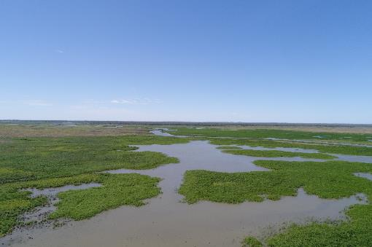
Figure 9-1. The Great Cumbung Swamp in flood in January 2021. Photo: Will Higgisson

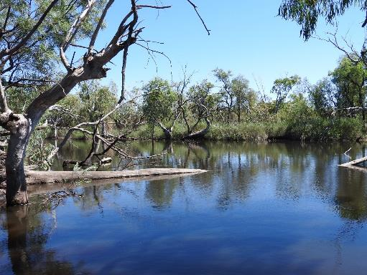
Figure 9-2. Whealbah Lagoon in flood November 2020. Photo: Alica Tschierschke

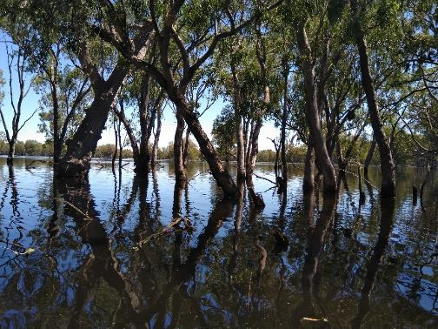
Figure 9-3. River Red Gums in Moon Moon Wetland in flood. November 2020. Photo: Will Higgisson

Selected Area evaluation
To address the Selected Area evaluation questions, the 2020-21 vegetation data were combined with the data collected over the previous six years and considered in the context of annual weather patterns and watering history. To enable this, the seven years of monitoring were characterised in terms of the context provided by the annual weather patterns. At each site, transects and plots were assigned a watering history based on the watering that has occurred since 2012-13 (Table 9-2 and Figure 9-4). These categories were used to structure the data analysis and interpret the response of the vegetation observed. Sites were compared based on the occurrence of environmental water during the 2020-21 watering year.
This watering year, one of the wetlands (Lake Bullogal) categorised as watering category A was flooded during the translucent flow events. Watering category A sites (including Lake Bullogal) are wetlands which need a considerable flooding event to inundate. Lake Bullogal was flooded because environmental water was used to extend the duration of the translucent flow providing the duration required to get flood waters to parts of the floodplain that cannot otherwise be watered with environmental water.
One site from watering category B (Bunumburt), was not flooded during the translucent flow events despite all other transects in watering category B being flooded. The watering history categories are designed to group sample points based on long-term watering history and as such these differences within year will not change the groupings. However, we do interpret the results in context of the watering they received within this watering year.
Table 9-2. Watering history used to structure analysis of vegetation data.
WATERING  HISTORY | DESCRIPTION
A | - Received water only with the large floods of 2012-13 and 2016-17 and 2020-21  - 2020-21 water was either translucent releases, environmental water or a combination
B | - Received water in 2012-13, 2015-16, 2016-17 and 2020-21  - 2015-16 and 2020-21 water was either translucent releases, environmental water or a combination
C | - Received water in 2012-13, 2015-16, 2016-17, 2017-18, 2018-19, 2019-20 and 2020-21  - 2015-16 and 2020-21 water was either translucent releases, environmental water or a combination, 2017-18, 2018-19 and 2019-20 water was Commonwealth environmental water.

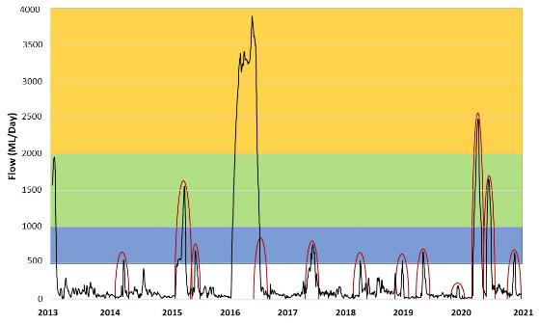
Figure 9-4. Conceptualisation of recent watering history categories (defined in see Table 9-2).
Yellow shading represents watering category A, green shading represents watering category B and the blue shading represents watering category C. Red circles show environmental watering actions resulting in inundation of at least one LTIM monitoring site. Black line indicates river flow (ML/day) taken from the Lachlan River at Booligal.
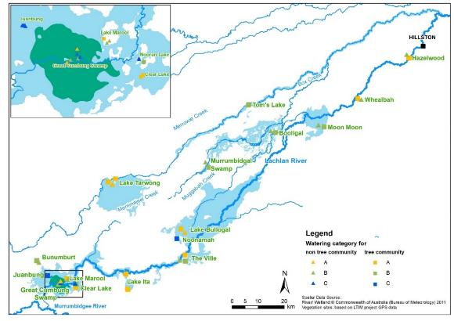
Figure 9-5. Map of the actual and recent vegetation monitoring sites categorised according to watering history.
To evaluate vegetation outcomes the following approach was applied:
- Vegetation species diversity is defined as the number of groundcover species and the evenness of their abundance. Simpson’s Diversity Index has been calculated for each site and compared across years for each watering history.
- Species richness of groundcover has been calculated for each site and compared across years for each watering history.
- Vegetation community diversity is taken to mean the composition of the community in terms of species composition, functional type and nativeness. For the evaluation, species have been classified according to the plant functional types (Table 9-3) of Brock and Casanova (1997) and Casanova (2011). Plants were allocated to plant functional groups based on unpublished data from DoPIE. Species were also classified as native/non-native using information provided on PlantNET (http://plantnet.rbgsyd.nsw.gov.au/). A list of all species observed within non-tree and tree community sites is presented in Section 14.1 and 14.2 in the Appendix.
- The relative proportion of species numbers and cover in the plant functional types was calculated and compared between sites that did and did not receive environmental water during the 2020-21 watering year.
- The relative proportion of cover and richness of water plant functional groups between tree community sites with and without environmental water in the 2020-21 watering year. The majority of non-tree community sites were inundated, therefore, the low sample size of without environmental water sites didn’t allow non-tree community sites to be compared in the same way.

Table 9-3. Plant functional group classifications of Brock and Casanova (1997) and Casanova (2011).
FUNCTIONAL TYPE | DESCRIPTION
Amphibious responders (AmR) | Plants which change their growth form in response to flooding and drying cycles.
Amphibious tolerators (AmT) | Plants which tolerate flooding patterns without changing their growth form.
Terrestrial-damp plants (Tda) | Plants which are terrestrial species but tend to grow close to the water margin on damp soils.
Terrestrial-dry plants (Tdr) | Plants which are terrestrial species which don’t normally grow in wetlands but may be encroaching into the area due to prolonged drying.

Data analysis
For the analysis presented in this report the survey data have been treated in the following way:
- Species richness was calculated as average of the data from multiple plots or transects at each site.
- Simpson's Diversity Index (D) is calculated as: D = 1 – (∑n(n-1)/N(N-1)) where
n = the total number of organisms of a particular species
N = the total number of organisms of all species.
The observations relating to land-use and other activities that may confound the interpretation of vegetation response to watering were recorded. The frequency and time since activity were recorded for grazing by livestock, firewood collection and site disturbance. The presence of feral animals was also noted.

Results

Species richness

Tree community
A total of 165 species were observed across the woodland tree community plots during the 2020-21 watering year. This was slightly fewer species than observed in the previous watering year (173 species). The number of species observed each year has varied over the seven years of monitoring and is related to climatic and hydrological conditions, with fewer species recorded during dry years (Table 9-4).
Table 9-4. Overall species number observed over the last seven watering years in the tree community
Watering season | Species Richness (number of species across all sites)
2014-15 | 135
2015-16 | 157
2016-17 | 170
2017-18 | 154
2018-19 | 119
2019-20 | 173
2020-21 | 165

A total of 153 species were observed across the woodland tree community sites during spring 2020, with an average of 30 species recorded at each site (mean across plots). This was the greatest total number of species and number of species per site during spring or autumn monitoring over the past seven years (Figure 9-6). A total of seven of the 13 woodland tree community sites were at least partially inundated in Spring 2020. Most of the sampling trips with high numbers of species were during and following large flooding events, such as those that occurred in, Autumn and Spring 2017 following widescale natural flooding, Spring 2020 as a result of the translucent flows and to a lesser extent Spring 2015, following the translucent flows in 2015. Likewise, the sampling trips with the lowest species richness were during very dry periods, with lower than average rainfall conditions, such as Autumn and Spring 2018 and Autumn 2019.
In contrast to the high number of species recorded in Spring 2020, fewer species were recorded during Autumn 2021, with a total of 97 species recorded in Autumn 2021 across all woodland tree community sites, with an average of 18 species per site (Figure 9-10). Autumn 2021 was very dry, with no rainfall recorded in April and just 10 mm recorded in May at Hillston (Airport) prior to our monitoring trips.
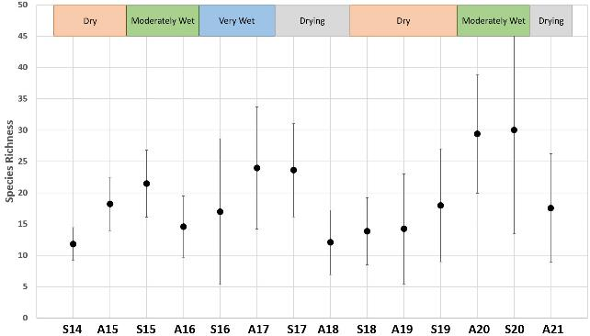
Figure 9-6. (Mean) species richness per woodland tree community site, across all sites in each trip. Vertical lines show the standard deviation from the mean.
Seasons are defined as S14: Spring 2014; A15: Autumn 2015; S15: Spring 2015; A16: Autumn 2016; A17: Autumn 2017, S17: Spring 2017, A18: Autumn 2018, S18: Spring 2018, A19: Autumn 2019, S20: Spring 2020, and A21: Autumn 2021.
Error bars represent ± 1 standard error of the mean.

In Spring 2020, the number of species observed at a site (average across plots) ranged from a single species recorded at Moon Moon Swamp (Azolla sp.), from plots that were completely inundated (depth of water averaged 40 cm) to 67 species recorded at Lake Noonamah (which is the greatest number of species we have recorded at any site during a single monitoring trip). Lake Noonamah was partially inundated (20% of the plot) in Spring 2020, which provided a diverse range of conditions (inundated, soaked, and dry) on the plot promoting plants that display a diverse array of plant functional groups and traits.
The groundcover in Spring 2020 was made up of a diverse range of species with varying life-history traits (annuals/perennials), growth forms and from different water plant functional groups. A range of herbs, including native species lesser Joyweed (Alternanthera denticulata) (9 sites), yellow twin-heads (Eclipta platyglossa) (8 sites), Caustic weed (Euphorbia drumondii) (7 sites), annual spinach (Tetragonia moorei) (7 sites), black crumb weed (Dysphania pumilio) (6 sites) and exotic species Cirsium vulgare (9 sites), smooth mustard weed (Sisymbrium erysimoides) (9 sites), black-berry nightshade (Solanum nigrum) (10 sites), common sowthistle (Sonchus oleraceus) (9 sites) and burr medic (Medicago polymorpha) (8 sites) were common. A range of Chenopod species such as black roly-poly (Sclerolaena muricata) (11 sites), climbing saltbush (Einadia nutans) (10 sites), bluebush (Maireana sp.) (7 sites), spiny saltbush (Rhagodia spinescens) (8 sites), ruby saltbush (Enchylaena tomentosa) (8 sites), nitre goosefoot (Chenopodium nitrariaceum), nettle-leaf goosefoot (Chenopodium murale) (7 sites each), lagoon saltbush (Atriplex suberecta) and creeping saltbush (Atriplex semibaccata) (8 sites each) were common, however more so on non-flooded plots. Grass species (Poaceae), the exotic barley grass (Hordeum leporinum) (7 sites) and the native blown grass (Lachnagrostis filiformis) (6 sites) were also common. Amphibious species common spike-rush (Eleocharis acuta) (6 sites) and common nardoo (Marsilea drumondii) (7 sites) were also common and abundant.
The number of species observed at a site in Autumn 2021 ranged from two species recorded at Moon Moon, from plots that were still inundated to a depth of approximately 20 cm, to Juanbung with 45 species. The groundcover in Autumn 2021 was dominated by Chenopod species, including climbing saltbush (11 sites), creeping saltbush (9 sites), nitre goosefoot (8 sites), ruby saltbush (9 sites) spiny saltbush (9 sites) and black roly-poly (10 sites). Herb species such as the native species lesser Joyweed (7 sites), yellow twin-heads (6 sites), and hairy carpet-weed (Glinus lotoides) (5 sites) and exotic gooseberry cucumber (Cucumis myriocarpus) (5 sites), black-berry nightshade (8 sites) and Bathurst burr (Xanthium spinosum) (5 sites) were also common. Most of these are terrestrial-dry species which are tolerant of dry conditions. Many annual species and aquatic/amphibious species which were observed in Spring 2020 were not observed in Autumn 2021.
Within watering category A, site scale groundcover vegetation diversity (Simpson’s diversity index) increased between Autumn 2020 and Spring 2020 and increased slightly between Spring 2020 and Autumn 2021 (Figure 9-7). Groundcover vegetation diversity in watering category B remained fairly constant between Autumn 2020 and Spring 2020 and dropped slightly in Autumn 2021. In contrast, site scale groundcover vegetation diversity in watering category C has varied considerably over the two years we have been monitoring these sites. Watering category C has recorded the highest Simpson’s Diversity Index score recorded (over the past seven years) in Spring 2019 and the lowest in Spring 2020. Sites in watering category C have been regularly watered, and this response is likely related to changes in diversity related to hydrological conditions and plant growth responses to flooding, more so than climatic conditions.
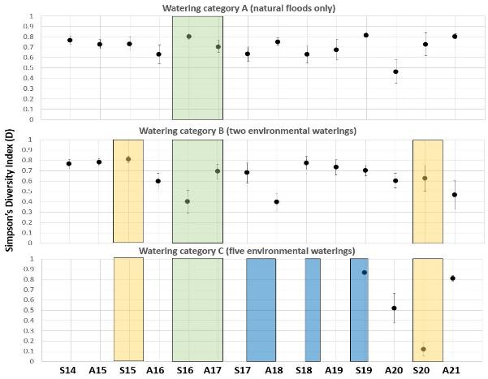
Figure 9-7. Comparison of groundcover vegetation diversity in the tree community between seasons and years using Simpson’s diversity index (D).
The data points are the mean diversity index for each watering treatment (refer to Table 9-2, page 109).
Yellow represents the period that environmental watering occurred at sites in watering category B, the green represents the flooding event in 2016-17 that flooded all sites, and the blue represents the period that environmental watering occurred at sites in watering category C.
Seasons are defined as S14: Spring 2014; A15: Autumn 2015; S15: Spring 2015; A16: Autumn 2016; A17: Autumn 2017, S17: Spring 2017, A18: Autumn 2018, S18: Spring 2018, A19: Autumn 2019, S20: Spring 2020, and A21: Autumn 2021.
Error bars represent ± 1 standard error of the mean.

While the Simpson’s Diversity Index is a useful and widely adopted index for measuring species diversity, it is a measure of dominance which weights toward the abundance of the most common species. That is, the analysis calculates a probability that two individuals randomly drawn from the community will be different species, and as such measures uncertainty. The more equal taxa are in abundance in an ecosystem the more effective this measure of diversity.
Unlike other more stable ecosystems, floodplain wetlands (such as those which occur on the lower Lachlan) shift between wet and dry cycles and are considered as disturbance dependent systems. As observed on the floodplains of the Lachlan River over the past seven years of monitoring, the composition of species changes in response to the hydrological and climatic conditions. During and following flooding, aquatic and amphibious plants are often the dominant plants we record, and these are often recorded in very high numbers.
For example, In Spring 2020, 420,000 (average across both plots) plants of the amphibious Isolepis australiensis at Lake Noonamah and 65,000 of the amphibious mosquito fern (Azolla sp.) at Juanbung were recorded (along with others), both sites in watering category C. These are small, fast growing and native annual plants which capitalise on the flooded conditions. These very high abundances of a few species (along with others not described here) resulted in watering category C in Spring 2020 having the lowest Simpson’s Diversity Index despite Lake Noonamah recording the greatest species richness we have recorded over the seven years. In fact, of the 10 records with the greatest abundances (between 2014-21), four of the 10 are amphibious plants, despite this functional group making up a small fraction (15%) of the total species pool we have recorded and consist entirely of native species. This observation shouldn’t negate the use of a diversity measure such as the Simpson’s Diversity Index however, we should acknowledge that in disturbance dominated systems such as these, an (over) abundance of a few species at a given time may not be a bad thing. The volumes of these amphibious plants suggest that they are providing significant input to primary productivity among other things.
Therefore, we also present the site scale groundcover vegetation species richness within each watering category. Species richness measures the total number of species at a site and does not take into consideration their relative abundance. Species richness has fluctuated since 2014 in all watering categories Figure 9-8). This fluctuation appears to be consistent between watering categories, with the three watering categories showing similar patterns through time. However, species richness in watering category C has been consistently greater than watering category A and B over the past two years.
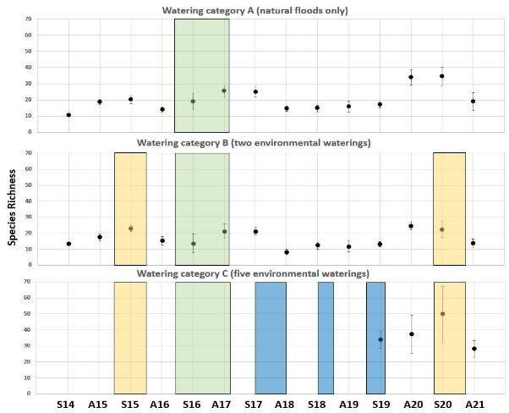
Figure 9-8. Comparison of groundcover vegetation species richness in the tree community between seasons and years.
The data points are the mean diversity index for each watering treatment (refer to Table 9-2, page 109).
Yellow represents the period that environmental watering occurred at sites in watering category B, the green represents the flooding event in 2016-17 that flooded all sites, and the blue represents the period that environmental watering occurred at sites in watering category C.
Seasons are defined as S14: Spring 2014; A15: Autumn 2015; S15: Spring 2015; A16: Autumn 2016; A17: Autumn 2017, S17: Spring 2017, A18: Autumn 2018, S18: Spring 2018, A19: Autumn 2019, S20: Spring 2020, and A21: Autumn 2021.
Error bars represent ± 1 standard error of the mean.

Non-tree community
A total of 122 species were observed across the non-tree community sites during the 2020-21 watering year. This was lower than the number recorded in the previous year (2019-20) (Table 9-5).

Table 9-5. Overall species numbers observed over the last seven watering years in the non-tree community
Watering season | Species Richness (number of species across all sites)
2014-15 | 97
2015-16 | 121
2016-17 | 90
2017-18 | 122
2018-19 | 96
2019-20 | 142
2020-21 | 122

Non-tree community sites had an average of 20 species recorded in Spring 2020 and ranged from a single species at Moon Moon Swamp to 38 species at Lake Nooran. In Autumn 2021, non-tree sites had an average of 18 species recorded and ranged from two species at Moon Moon Swamp to 32 species at Lake Bullogal (Figure 9-9). Species richness has fluctuated over the seven years since 2014, related to climatic and hydrological conditions. Seasons with higher species richness occur during periods with high rainfall (such as Autumn 2020) or shortly following flood recession (such as Spring 2017). Conversely, seasons with low species richness occur during very dry periods with lower than average rainfall (such as Spring 2018).
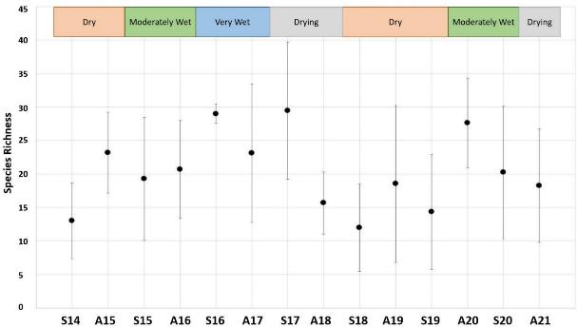
Figure 9-9. (Mean) species richness at each non-tree community site between season and year. Vertical lines are standard deviation from the mean.
Seasons are defined as S14: Spring 2014; A15: Autumn 2015; S15: Spring 2015; A16: Autumn 2016; A17: Autumn 2017, S17: Spring 2017, A18: Autumn 2018, S18: Spring 2018, A19: Autumn 2019, S20: Spring 2020, and A21: Autumn 2021.
Error bars represent ± 1 standard error of the mean.
A total of ten of the 12 non-tree community sites were inundated in the second half of 2020 as a result of the translucent flow events which were augmented with Commonwealth environmental water. In Spring 2020, Herbs burr medic (recorded at nine sites), lesser joyweed, old man weed (Centipeda cunninghamii), and caustic weed (all recorded at six sites) were common. Chenopod species climbing saltbush (recorded at 11 sites), black roly-poly (recorded at eight sites), ruby saltbush, spiny saltbush (both recorded at seven sites) and lagoon saltbush (recorded at six sites) were also common. Free-floating aquatic plant duck weed (Lemna) was abundant at Moon Moon Swamp and Whealbah Lagoon, and mosquito fern at Juanbung, as these sites were flooded during monitoring.
A range of amphibious and terrestrial-damp species which were common and abundant in Spring 2020 had reduced in occurrence and abundance in Autumn 2021 in response to the drying conditions. These included butter cup (Ranunculus spp.) (3 species), bushy groundsel (Senecio cunninghamii), tall groundsel (Senecio runcinifolius), annual spinach, grey raspwort (Haloragis glauca) and Polygonum. In Autumn 2021, annual forbs, including old man weed (recorded at eight sites), lesser joyweed (recorded at seven sites), hairy carpet-weed (recorded at eight sites), caustic weed (recorded at seven sites), small crumb weed (recorded at seven sites) and exotic species Bathurst burr (recorded at seven sites) and burr medic (recorded at six sites) were common occurrences. Chenopod species, black roly-poly (recorded at seven sites) and spiny saltbush (recorded at six sites) were also common.
Site scale species diversity (Simpson’s Diversity Index) increased over the two years from Autumn 2019 to Spring 2021 in watering category A (Figure 9-10). Watering category A had the greatest site scale species diversity (of all watering categories) recorded in the 2020-21 watering year in Autumn 2021. In watering category A, the seasons in which had the greatest diversity were during and following flooding events in Spring 2017 and Autumn 2021. Site scale species diversity in watering category B and C dropped between Autumn and Spring 2020 and increased in Autumn 2021, prior to this it had remained stable over the two preceding years (Figure 9-10).

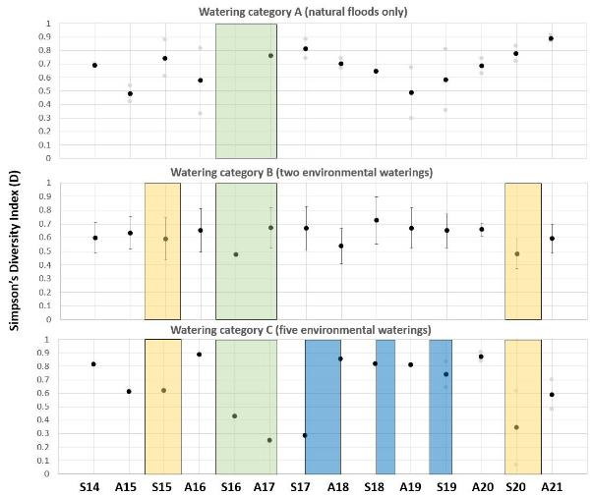
Figure 9-10. Comparison of groundcover vegetation diversity in the non-tree community between seasons and years using Simpson’s diversity index (D).
The data points are the mean diversity index for each watering treatment (refer to Table 9-2, page 109).
Yellow represents the period that environmental watering occurred at sites in watering category B, the green represents the flooding event in 2016-17 that flooded all sites, and the blue represents the period that environmental watering occurred at sites in watering category C.
Seasons are defined as S14: Spring 2014; A15: Autumn 2015; S15: Spring 2015; A16: Autumn 2016; A17: Autumn 2017, S17: Spring 2017, A18: Autumn 2018, S18: Spring 2018, A19: Autumn 2019, S20: Spring 2020, and A21: Autumn 2021.
Error bars represent ± 1 standard error of the mean.
Similarly, to the Simpson’s Diversity Index for the tree community sites, in the non-tree community sites, high Simpson’s Diversity scores were often observed during very dry periods or at sites that had not experienced flooding. This was a result of the low and even abundances of species recorded at dry sites compared with the high abundances of a few amphibious species which are often recorded at flooded sites. This result reflects differences in structure and life-history traits of flooded vs non-flooded habitat.
Watering category C had the greatest species richness of the watering categories in both Spring 2020 and Autumn 2021. This highlights the important role of the regular use of Commonwealth environmental water in maintaining a diverse assemblage of species at these sites. In watering category A, species richness dropped slightly between Autumn and Spring 2020, and dropped again between Spring 2020 and Autumn 2021. To note is that one of the sites representing watering category A (Lake Bullogal) received environmental water as a result of the translucent flows in November 2020. Species richness varied considerably between the two sites that make up watering category A, Lake Bullogal (species richness = 23) and Lake Tarwong (species richness = 6.5) which did not receive environmental water. In watering category B, species richness dropped between Autumn and Spring 2020, then remained at a similar level between Spring 2020 and Autumn 2021. In watering category C, species richness remained fairly consistent between Autumn and Spring 2020 then dropped in Autumn 2021 (Figure 9-11).
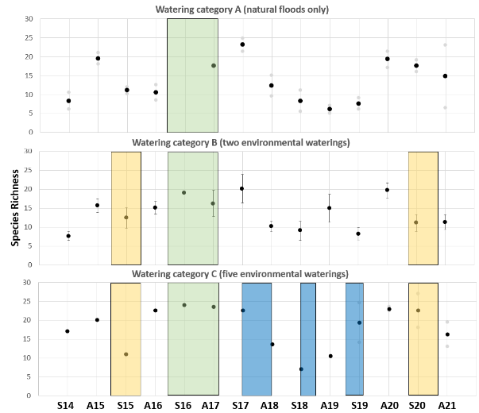
Figure 9-11. Comparison of groundcover vegetation diversity in the non-tree community between seasons and years using species richness.
The data points are the mean diversity index for each watering treatment (refer to Table 9-2, page 109).
Yellow represents the period that environmental watering occurred at sites in watering category B, the green represents the flooding event in 2016-17 that flooded all sites, and the blue represents the period that environmental watering occurred at sites in watering category C.
Seasons are defined as S14: Spring 2014; A15: Autumn 2015; S15: Spring 2015; A16: Autumn 2016; A17: Autumn 2017, S17: Spring 2017, A18: Autumn 2018, S18: Spring 2018, A19: Autumn 2019, S20: Spring 2020, and A21: Autumn 2021.
Error bars represent ± 1 standard error of the mean.

Vegetation community diversity

Nativeness and functional types: tree community
Within the tree community sites, the relatively high groundcover recorded in Autumn 2020 remained high in Spring 2020 and reduced slightly in Autumn 2021 (mean across all sites 42.2% ± 7.4 in Autumn 2020, 35.9% ± 7.9 in Spring 2020 and 32.1% ± 6.5 in Autumn 2021). In Spring 2020, watering category C had the greatest total groundcover, and Lake Noonamah in watering category C was the site with the greatest groundcover (79.0%). In Autumn 2021, watering category B had the greatest total groundcover and watering category A had the least. In Autumn 2021, The Ville in watering category B was the site with the greatest groundcover with 76.5%, while Lake Bullogal in watering category A had the least with 7.9%.
Groundcover in watering category A was dominated by terrestrial-dry species in the 2020-21 watering year, with amphibious species contributing less than 1% in Spring 2020 and <0.1% in Autumn 2021. Groundcover in watering category A reduced between Spring 2020 and Autumn 2021 and this was related to a reduced cover of terrestrial-dry species and terrestrial-damp species (Figure 9-12). In Spring 2020, watering category A had the greatest diversity of terrestrial-dry species and the lowest diversity of amphibious species of all watering categories. Watering category A has consistently had the lowest cover and diversity of amphibious species over the past two years (Figure 9-13).
Groundcover in watering category B increased between Spring 2020 and Autumn 2021 and this was related to an increase in groundcover of terrestrial-damp species. In Autumn 2021, watering category B had the greatest groundcover of amphibious species of the watering categories, and a fairly even groundcover of all functional groups (Figure 9-12).
Watering category C had the greatest percent groundcover of all the watering categories in Spring 2020, with all three functional groups contributed fairly evenly to the total groundcover (Figure 9-12). Groundcover in watering category C, reduced by approximately half between Spring 2020 and Autumn 2021, and this was predominantly related to the loss of amphibious and terrestrial-damp species. Watering category C had the greatest diversity of amphibious and terrestrial-damp species in Spring 2020 (Figure 9-13). Watering category C has consistently had the greatest diversity of amphibious species of all watering categories over the two years these sites have been monitored (Figure 9-13).
Over the 2020-21 watering year, watering categories B and C are maintaining a much greater cover and diversity of amphibious and terrestrial-damp species compared to sites in watering category A (Figure 9-12 and Figure 9-13).

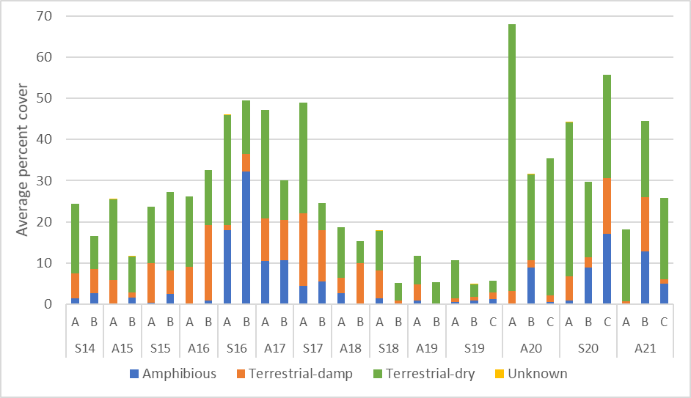
Figure 9-12. Average percent cover of terrestrial and amphibious species (refer to Table 9-3, on page 111 for description) within the tree community for sites from each watering history over the sampling period.
Watering treatments are defined as A, B or C (refer to Table 9-2 for explanations, page 109).
Seasons are defined as S14: Spring 2014; A15: Autumn 2015; S15: Spring 2015; A16: Autumn 2016; A17: Autumn 2017, S17: Spring 2017, A18: Autumn 2018, S18: Spring 2018, A19: Autumn 2019, S19: Spring 2019, A20: Autumn 2020, S20: Spring 2020 and A21: Autumn 2021.
Unknown represents species that were unable to be identified to a suitable level for classification.

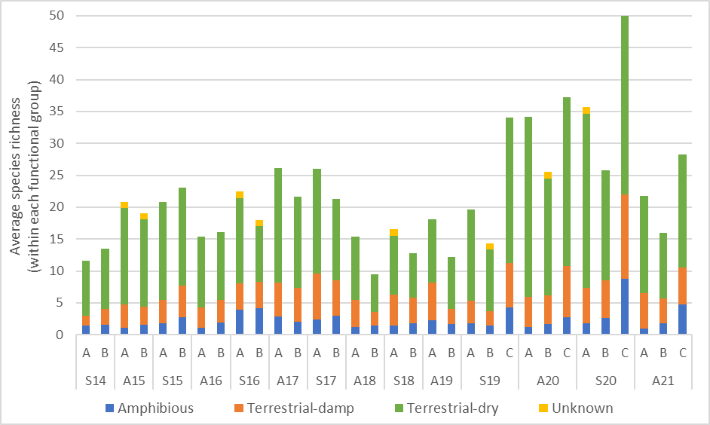
Figure 9-13. Average species richness of terrestrial and amphibious species (refer to Table 9-3, on page 111 for description) within the tree community for sites from each watering history over the sampling period.
Watering treatments are defined as A, B or C (refer to Table 9-2 for explanations, page 109).
Seasons are defined as S14: Spring 2014; A15: Autumn 2015; S15: Spring 2015; A16: Autumn 2016; A17: Autumn 2017, S17: Spring 2017, A18: Autumn 2018, S18: Spring 2018, A19: Autumn 2019, S19: Spring 2019, A20: Autumn 2020, S20: Spring 2020 and A21: Autumn 2021.
Unknown represents species that were unable to be identified to a suitable level for classification.

Exotic species made up a small fraction (~ 6%) of the groundcover during the 2020-21 watering year across all sites. This was substantially less than the previous watering year (~ 20%). In Spring 2020, watering categories A and B consisted of approximately 2.3% and 3.4% exotic groundcover respectively, while sites in watering category C consisted of approximately 1.0% exotic groundcover. In Autumn 2021, exotic cover contributed only 1.1% and 2.1% of the groundcover in watering categories A and B, while watering category C had a groundcover made up of 11.4% exotic species (Figure 9-14).
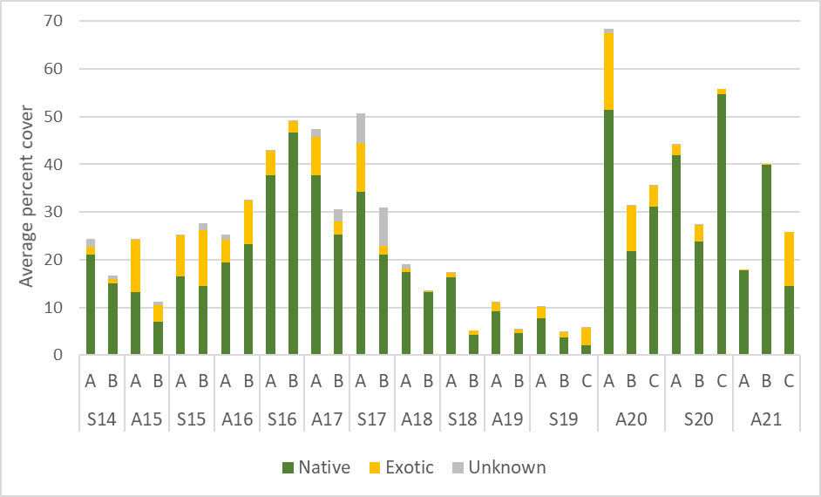
Figure 9-14. Average percent cover of native and exotic species for the tree communities for sites from each watering history over the sampling period.
Watering treatments are defined as A, B or C (refer to Table 9-2 for explanations, page 109).
Seasons are defined as S14: Spring 2014; A15: Autumn 2015; S15: Spring 2015; A16: Autumn 2016; A17: Autumn 2017, S17: Spring 2017, A18: Autumn 2018, S18: Spring 2018, A19: Autumn 2019, S19: Spring 2019, A20: Autumn 2020, S20: Spring 2020 and A21: Autumn 2021.
Unknown represents species that were unable to be identified to a suitable level for classification.

Nativeness and functional types: non-tree community
Groundcover in the non-tree community sites varied between the three watering categories in the 2020-21 watering year (Figure 9-15). In watering category A, groundcover was low in both Spring 2020 (~11%) and Autumn 2021 (~8%), and had dropped considerably from Autumn 2020 (>60%). In Spring 2020, groundcover in watering category A was made up predominately of terrestrial-dry species, and in Autumn 2021, the proportion of terrestrial-dry species increased with very low cover of terrestrial-damp or amphibious species.
Groundcover in watering category B dropped between Autumn 2020 and Spring 2020, then increased in Autumn 2021. Watering category B had the greatest groundcover of the watering categories in Autumn 2021, and this was made up of a fairly even contribution of the different plant functional groups. Watering category B also had the greatest cover of terrestrial-damp species in Autumn 2021 of the watering categories recorded over the past seven years. Many terrestrial-damp species establish and grow following flood recession and have responded following the recession of floodwater.
Groundcover in watering category C remained fairly constant between Autumn 2020 and Autumn 2021. Watering category C had the greatest total groundcover of the watering categories in spring 2020, and the greatest cover of amphibious species (Figure 9-15). This was the greatest cover of amphibious species recorded since Spring 2017, following widescale natural flooding. These species grow in or on water and increased in cover as a result of the translucent flows in Spring 2020.
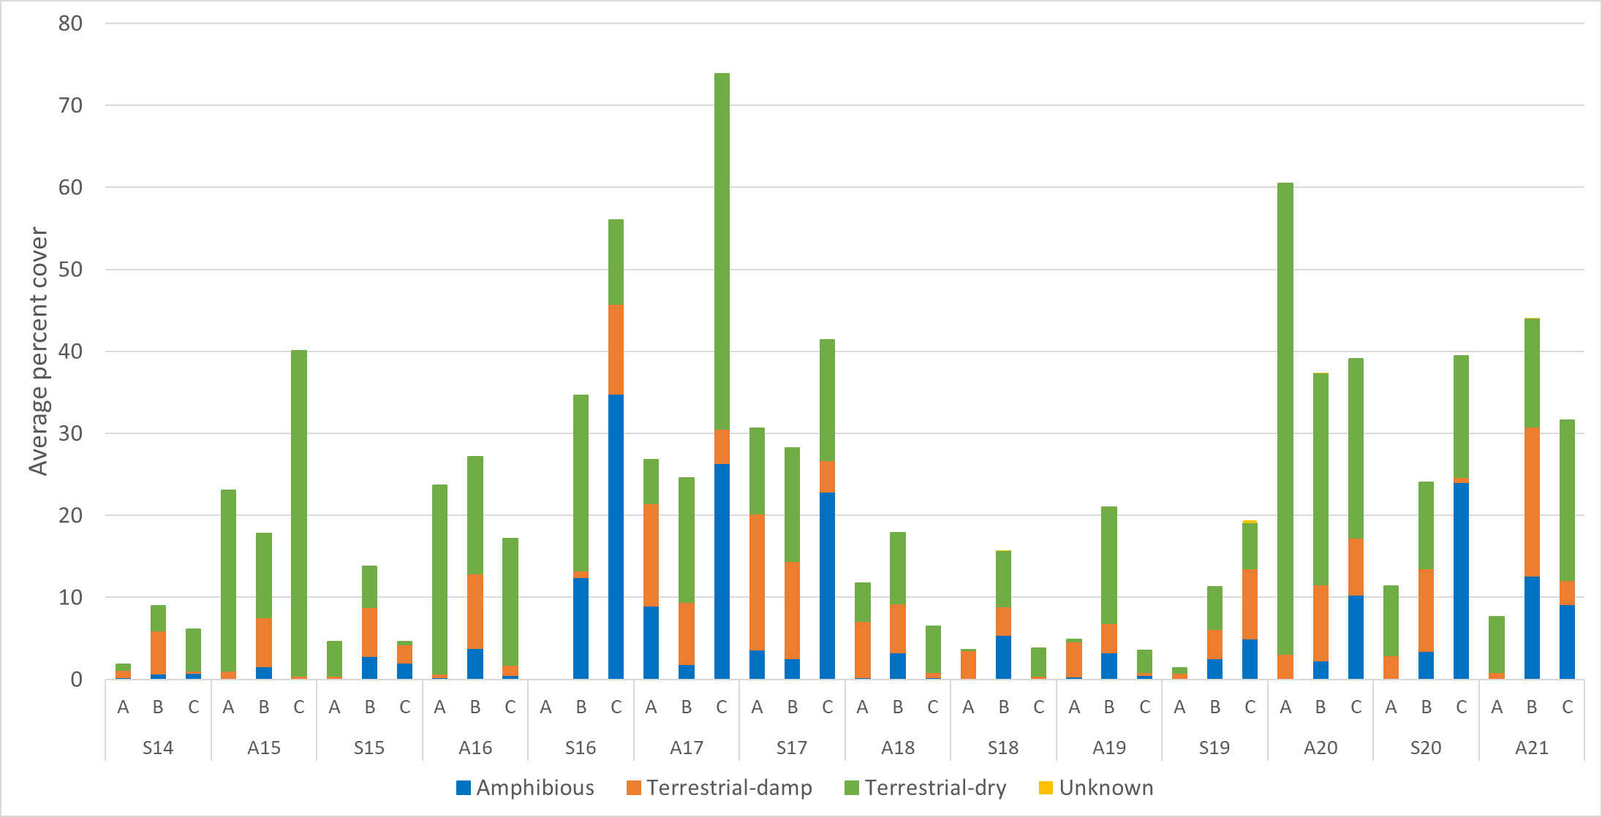
Figure 9-15. Average percent cover of terrestrial and amphibious species (refer to Table 9-3, on page 111 for description) within the non-tree community for sites from each watering history over the sampling period.
Watering treatments are defined as A, B or C (refer to Table 9-2 for explanations, page 109).
Seasons are defined as S14: Spring 2014; A15: Autumn 2015; S15: Spring 2015; A16: Autumn 2016; A17: Autumn 2017, S17: Spring 2017, A18: Autumn 2018, S18: Spring 2018, A19: Autumn 2019, S19: Spring 2019, A20: Autumn 2020, S20: Spring 2020 and A21: Autumn 2021.
Unknown represents species that were unable to be identified to a suitable level for classification.

Across all monitored sites, ~87% of the groundcover at non-tree community sites was made up of native species in Spring 2020 and Autumn 2021. The proportion of exotic plants making up the groundcover was considerably greater in the previous monitoring trip in Autumn 2020, when the groundcover was made up of 38% exotic species. This is related to the increased numbers of native amphibious species which have increased in cover during and following the translucent flows in November 2020 and fewer exotic terrestrial-dry annual species which cannot tolerate flooding and anoxic soil conditions.
In Spring 2020, watering category A had the lowest proportion of exotic species making up the groundcover of the watering categories, while the proportion of native to exotic species in watering categories B and C were similar. In Autumn 2021, watering category C had the lowest proportion of exotic species making up the groundcover of the watering categories (Figure 9-16).
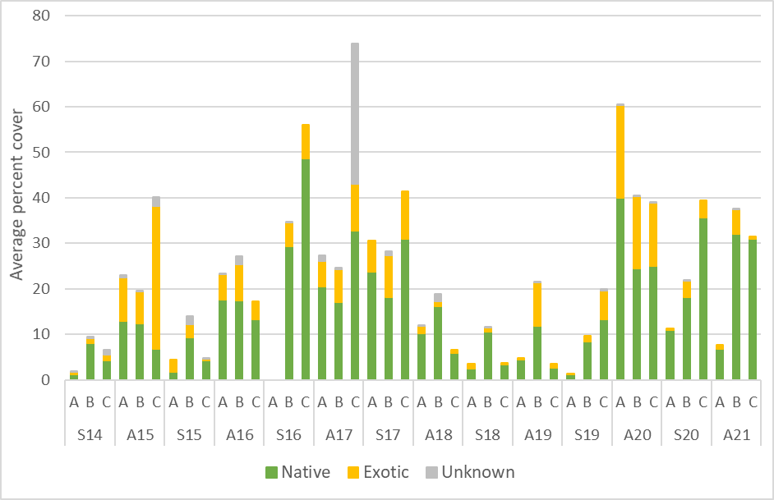
Figure 9-16. Average percent cover of native and exotic species for the tree communities for sites from each watering history over the sampling period.
Watering treatments are defined as A, B or C (refer to Table 9-2 for explanations, page 109).
Seasons are defined as S14: Spring 2014; A15: Autumn 2015; S15: Spring 2015; A16: Autumn 2016; A17: Autumn 2017, S17: Spring 2017, A18: Autumn 2018, S18: Spring 2018, A19: Autumn 2019, S19: Spring 2019, A20: Autumn 2020, S20: Spring 2020 and A21: Autumn 2021.
Unknown represents species that were unable to be identified to a suitable level for classification

With and without environmental water in this watering year

Cover and richness of functional types: tree community sites
The eight (or 13) tree community sites that received environmental water during the 2020-21 watering year had a greater cover of amphibious and terrestrial-damp species in both Spring 2020 and Autumn 2021 (Figure 9-17) compared with the sites which did not receive environmental water. Tree community sites that received environmental water in the 2020-21 watering year had much greater cover of terrestrial-damp species in Autumn 2021 compared with sites which did not receive environmental water.
During the spring 2020 monitoring trip sites that received environmental water had a very high cover of native species (not shown as a plot). For example, Juanbung had a groundcover of 42.5%, consisting of 41.4% native species, Whealbah Lagoon had a groundcover of 11.1%, consisting of 10.4% native species, and groundcover at The Ville was made up entirely of (nine) native species. The Ville is located within the Kalyarr National Park, and the high nativeness maybe a result of the hydrological conditions as well as the land management and lack of grazing.
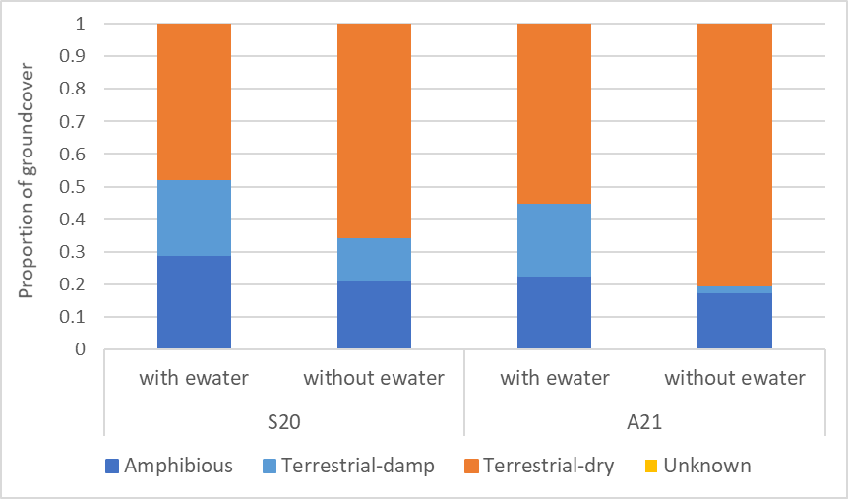
Figure 9-17. Proportional cover of plant functional groups (refer to Table 9-3, on page 111 for description) at sites that did and did not received environmental water (ewater) in 2020-21.
Sites which received environmental water in the 2020-21 watering year had at least three times more amphibious species in Spring 2020 and at least two times more amphibious species in Autumn 2021 compared with sites which did not receive environmental water (Figure 9-18). Sites which received environmental water also had slightly more terrestrial-damp species, while sites which did not receive environmental water had a much greater proportion of terrestrial-dry species in both Spring 2020 and Autumn 2021 (Figure 9-18).
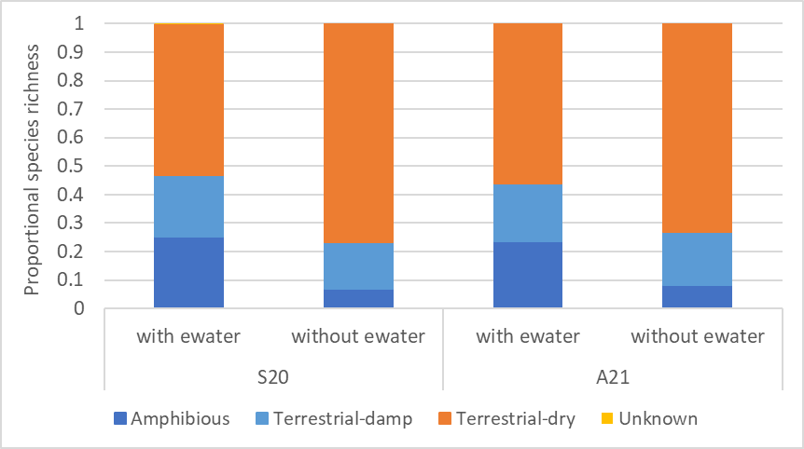
Figure 9-18. The relative proportion of species numbers in each water plant functional group (refer to Table 9-3, on page 111 for description) recorded at sites that did and did not receive environmental water (ewater) in 2020-21.

Discussion
Commonwealth environmental watering actions in 2020-21 have been important in maintaining a diversity of plants on the floodplain of the lower Lachlan River. Wetlands which have received multiple flooding events over the past seven years of monitoring are the most species rich. These sites are flooded most years, and these flood events are maintaining a diverse assemblage of species in the groundcover including a range of amphibious plants. However, this year has also showed the benefit of getting water to rarely flooded sites. Lake Bullogal (in watering category A), which hadn’t been flooded since early 2017 responded to the flooded conditions with a much greater diversity of species compared with Lake Tarwong (also in watering category A) which did not receive environmental water this year. This was a result of a change in environmental water management approach using water holdings to extend flooding to enable a greater area of floodplain wetland to be inundated. This appears to have had some very positive outcomes.
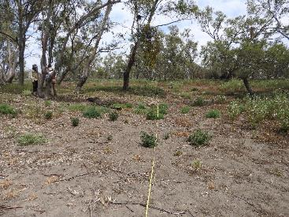
Figure 9-19. Lake Tarwong river red gum plot (in watering category A) in November 2020. Photo: Will Higgisson
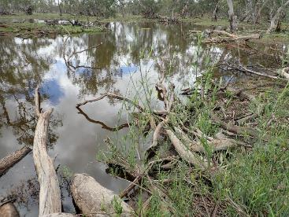
Figure 9-20. Lake Bullogal river red gum plot 1 (in watering category A) in November 2020. Photo: Matthew Young
Sites which received environmental water in 2020-21 had much greater species richness and cover of amphibious plants compared with sites that did not receive environmental water. These amphibious plants are all native and play a range of important roles in the functioning of the river-floodplain ecosystem including providing habitat and food, contributing to primary productivity, and improving water quality. The fact that sites which did not receive environmental water in 2020-21 had far fewer amphibious species demonstrates how Commonwealth environmental water is likely to have made a significant role in maintaining these flood-dependent plants. Emergent and submergent aquatic plants are often rare or absent at the sites where we observe diverse assemblages of amphibious species such as Lake Bullogal, so these amphibious plants are likely to provide a disproportionate benefit to these freshwater habitats.
Sites which are not flooded have a greater abundance of terrestrial-dry species, and during very dry periods with low rainfall, these species are predominately Chenopod species. These dry loving species are common on our drier plots which are rarely flooded and rarer on more regularly flooded sites.
Typically, the volumes of environmental water have been a small portion of that of total catchment volumes since monitoring commenced in 2014. This has often meant a process of prioritisation in regard to which wetlands receive water and which do not. These are the constraints under which environmental water delivery occurs. Translucent flow events such as those that occurred in 2020, allow large volumes of water in the river system and in regulated rivers systems such as the Lachlan are critical for maintaining a functioning and diverse floodplain. Flooding events under current flow conditions occur less often and are of lower magnitude than what would have occurred under pre-water resource development conditions (Section 5). Over-bank flow conditions which are needed to inundate the floodplain now rarely occur. Here we show how the translucent flows in the second half of 2020 which were augmented with Commonwealth environmental water have maintained a range of native amphibious and terrestrial-damp species on the floodplain of the lower Lachlan River. These species provide productivity and vital habitat and food for birds and fish during and following flooding events. In the absence of flooding, these plants maybe completely lost from wetlands, lowering their ecological value.

Evaluation
In relation to the effects of Commonwealth environmental water, the evaluation three questions are addressed as follows:
- What did Commonwealth environmental water contribute to populations of long-lived organisms (measured through cover and recruitment of tree species)?
Stand and tree condition data were collected in Autumn 2020 at the newly established sites. These data will be combined with the data collected at all other sites and reported every five years.
- What did Commonwealth environmental water contribute to individual plant species across the Selected Area including changes to species presence, distribution and cover?
Commonwealth environmental watering actions in 2020-21 have made an important contribution in maintaining the richness and cover of plant species in the lower Lachlan River Catchment. Sites which received environmental water in the 2020-21 watering year had a more diverse and abundant assemblage of native amphibious species compared to sites which did not receive environmental water. Further, sites which have received Commonwealth environmental water regularly (sites in watering category C) over the past seven years are the most species rich, demonstrating that the regular use of Commonwealth environmental water has resulted in a richness of plants species at these sites.
Commonwealth environmental water was used, in combination with NSW environmental water to augment translucent flows, extending the duration of flooding which meant that wetlands that are not usually able to receive environmental water, were watered (particularly Lake Bullogal). This resulted in a substantial response in vegetation, providing opportunities for species to germinate, grow and reproduce. This represents an excellent way to achieve vegetation outcomes in the landscape that cannot otherwise be achieved with held environmental water alone.
- What did Commonwealth environmental water contribute to vegetation communities within the interim Australian National Aquatic Ecosystem (ANAE) vegetation types, including changes in species richness, composition, cover and structure?
The seven watering actions provided water to a diverse range of vegetation communities and ANAE vegetation types in the lower Lachlan River catchment. Watering actions two and four which coincided with translucent flow events in August and December 2020 inundated a diverse range of ANAE vegetation types within the lower Lachlan River. These include intermittent river red gum floodplain swamps, temporary floodplain lakes, intermittent black box woodland floodplain swamps and temporary tall emergent floodplain marsh all of which we monitor. Watering action five provided water to Lake Brewster and provided hydrological conditions to enhance reproduction of aquatic plants. As we have shown here, these flow events have maintained the species richness, composition and cover of the plants which make up the groundcover.

Further comments and recommendations
The translucent flows in 2020 have made a significant contribution to providing the hydrological conditions required to maintain and promote amphibious and terrestrial-damp species across a large extent of the floodplain of the lower Lachlan river.

Recommendation 1: Consider using environmental water to extend the duration of translucent events
In 2020-21, Commonwealth environmental water was used in combination with NSW environmental water to modify translucent flow events, extending the duration of flooding which meant that wetlands that are not usually able to receive environmental water, were watered (particularly Lake Bullogal). This makes optimal use of environmental water by achieving vegetation outcomes at places in the landscape that cannot otherwise be achieved with held environmental water alone. It is recommended that this strategy continue to be used when possible to maximise outcomes for floodplain wetland vegetation.
There are different ways in which this strategy can be implemented with a fixed volume of available water. Environmental water can be used to maintain a higher flow rate for a short period of time followed by a long recession or maintain the higher flow rate for a longer period of time with a much shorter recession. The latter option was adopted in 2020-21 with the objective of maintaining the floodplain connection for a long as possible through the higher flow rate. Such an approach appears to have been effective at optimising the floodplain connection and inundation and does not appear to have had adverse effects (such as stranding of biota because of the short recession). When planning similar approaches in the future, it is important to consider the objectives for the use of the environmental water and the potential for adverse outcomes.
CEWO Adaptive Management Response:

The CEWO agrees with the recommendation above. Additional translucent flows have occurred in the Lachlan catchment during 2021-22. The approach of complementing translucent flows by using environmental water to maintain higher flow rates and related connectivity to the floodplain for as long as possible have again been sought. The CEWO notes that large flow pulses can be delivered in the lower Lachlan selected area with minimal risk of triggering a significant carp spawning event. The CEWO is also aware that certain locations in the lower Lachlan remain significant sources of carp recruitment in the lower Lachlan.

Recommendation 2: Develop specific objectives for vegetation outcomes
Here we have attempted to describe the response of the plants which make up the groundcover of the floodplain of the Lachlan river by categorizing species in to guilds or functional groups and comparing these in relation to long-term (7 years) and short-term (< 1 year) responses to hydrological and climatic conditions. Our experience has shown that objectives for vegetation outcomes must be specific, considered in relation to broader objectives, and measurable. Typical measures of condition, such as maintain diversity may not be suitable for floodplain wetlands in semi-arid systems such as the Lachlan. More targeted expected outcomes or objectives of watering actions could include, maintain or enhance cover and richness of native amphibious plants.
CEWO Adaptive Management Response:

The CEWO agrees with the recommendation above. The challenge remains on how to align such objectives with key factors of flow delivery, such as timing, depth, and duration, to target both vegetation species and sites of priority. This can be particularly challenging for system scale, multi-objective, watering events. The CEWO remains interested in developing the approach used under the Lachlan Long Term Water Plan to help further refine vegetation watering requirements and related objectives for watering actions. At sites that can be targeted through highly controlled watering actions, such as pumped sites, the development of specific and achievable targets could be trialed.

Recommendation 3: Monitor the growth and condition of lignum shrublands and their response to environmental watering
The basin wide environmental watering strategy has expected outcomes for lignum shrublands that include the lower Lachlan river system.
The outcomes expected for shrubland vegetation are:
- to maintain the current extent of extensive lignum shrubland areas within the Basin
- by 2024, improvement in the condition of lignum shrublands.
The response of lignum is not specifically monitored as part of the MER program, simply captured in the groundcover metrics. In future iterations of the program it would be valuable to 1. include specific objectives for lignum in the catchment and 2. Monitor the responses of lignum extent and condition to environmental water.
CEWO Adaptive Management Response:

The CEWO agrees with the recommendation above. In addition to the outcomes listed above, this could also be linked to outcomes related to the provision of nesting habitat for colonial waterbirds. For example, it could assess what condition is required to maintain lignum in ‘event ready’ breeding habitat for colonial waterbirds, or if lignum is ‘event ready’ regardless of its condition.

Recommendation 4: Consider watering wetlands earlier in the season to maximise vegetation outcomes
Results for previous years has demonstrated that there is benefit in getting environmental water to wetlands earlier in the season (i.e., during autumn/winter) than is often attempted for vegetation outcomes. Delivery into wetlands such as Murphy’s Lake and Lake Noonamah indicated a positive aquatic vegetation response from delivering earlier in the season and having the assets full before Spring to enable sediment to settle (less turbidity) and improve light penetration (and prior to peak carp movement). Earlier delivery into wetlands may also reduce the opportunity for Carp to breed within the wetlands. Preliminary analysis of the Phragmites research component also indicated peak growth period earlier than literature may suggest during winter.
CEWO Adaptive Management Response:

The CEWO agrees with the recommendation above. Subject to water availability, the provision of an annual autumn pulse in the Lachlan system may be important to being able to implement this recommendation (e.g., higher river levels may be required to enable pumping to some sites). This recommendation also needs to be balanced with recommendations from other parts of this report, such as the provision of higher flows/freshes during the warmer time of year to potentially improve productivity and/or fish spawning (for golden perch for example).

Communication and engagement

Introduction
There are a diversity of views and interest groups across the Murray-Darling Basin and the long-term success of environmental watering programs requires strong relationships with stakeholders, including local communities. The CEWO recognise the importance of effective communication and engagement in building relationships and achieving their goals for environmental watering across the basin. Thus, communication and engagement (C&E) activities are an integral part of the MER program within Selected Areas.
Under the MER program, the lower Lachlan River Selected Area has resources dedicated to C&E that support two components of communication and engagement activities. The first is operational project communication which relates to the activities associated with the delivery of the core monitoring and evaluation component of the MER program. This involves the project team, the CEWO, key water delivery stakeholders and other operational stakeholders. The second is external communication and engagement which involves stakeholder groups outside of the delivery of the MER Plan and includes landholders, affected communities and the general public.

Results
This section of the technical report provides an overview of the C&E activities delivered in 2020-21.

Operational Project Communications
Operational project communication has underpinned the delivery of the monitoring and evaluation activities. It has involved our primary stakeholders: the project team, landholders who support ongoing access to MER sites, key water delivery stakeholders and other operational stakeholders (Table 10-1). The objectives of our operation project communications (defined in the Lachlan MER Plan, Dyer et al. 2019) are to:
- Facilitate smooth and efficient implementation of the MER Plan (Objective C1).
- Facilitate engagement and support on-going relationships among core stakeholders (Objective C2).
- Disseminate learning and results from project activities (Objective C3).
- Contribute to on-going adaptive management associated with environmental watering (Objective C4).
- Foster opportunities for collaboration among core stakeholders to optimise the use of public funds for monitoring, evaluation and research in the Lachlan Selected Area and across the Basin (Objective C5).
Activities that meet the aims of the operational project communication were divided into four activity streams and the activities delivered are summarised in Table 10-2. In addition to these activities there have been numerous phone calls among the key stakeholders to communicate findings, observations and operational matters.

Table 10-1. Primary stakeholders for the Lachlan Selected Area MER program
Stakeholder Groups
M & E Delivery | Project Team
Operational Stakeholders | CEWO – Lachlan Delivery Team  Lachlan environmental water manager  Regional operations group with responsibility for the Lachlan River watering  Members of the Lachlan Environmental Water Advisory Group (EWAG)  Key members of other state agencies incl. NSW OEH Science Team, DoI Water, Water NSW
MER program teams | Basin MER Team  Other Selected Area MER Teams  CEWO MER program Team
Key Landholders | Landholders who provide access to monitoring sites.

Table 10-2. Operational project communication activities for the Lachlan Selected Area delivered in 2020-21
ACTIVITY | ACTIVITIES | OBJECTIVE ADDRESSED | OUTCOMES ACHIEVED
ACTIVITY STREAM: DELIVERY
Monthly project meetings (PM) | - Eleven (11) monthly project meetings held between the project leader and CEWO contact. These meetings have typically also included the research theme lead and frequently another team member. | C1, C2, C3, C4 | - Verbal project updates that have  - ensured that the project is tracking as expected;  - dealt with issues arising from the monitoring;  - communicated early observations from monitoring  - communicated a variety of operational matters
Selected Area working group meetings (PM) | - Numerous informal meetings among the project team members. | C1, C2, C3, C4 | - Regular contact between project partners and sub-contractor personnel has been used to establish and revise workplans; ensure project is tracking as expected; deal with any issues arising from the monitoring; communicate early observations from monitoring; and coordinate activities
Quarterly Progress Reports (PM) | - Four written progress reports provided in September, December, March and June | C1 | - Ensured clear communication of project progress against milestones
Quarterly Outcomes Newsletter (PM) | - Four quarterly outcomes newsletters provided for September, December, March and June. These are now published at:  https://www.environment.gov.au/water/cewo/publications/lachlan-mer-quarterly-reports | C3  O1 and O4 | - Quarterly outcomes newsletter used to communicate with a broader public audience.
Annual Summary and Technical Report (PM) | - Annual Technical and Summary reports developed | C3  O1 and O4 | - Annual technical report communicated detailed scientific findings to a technical audience; annual summary report focuses on annual highlights
ACTIVITY STREAM: OPERATIONAL STAKEHOLDERS
Lachlan EWAG meetings (C&E) | - Three EWAG meetings were attended, One of the EWAG meetings involved subsequent field trips. | C1, C2, C3, C4 and C5  O1, O3 and O4 | - Presentation of project findings at the EWAGs which support an exchange of information and intelligence that supports the implementation of the MER program and environmental water delivery in the catchment
TAG meetings (C&E) | - Five TAG meetings attended associated with Translucent flows (Waterbird meetings, Blackwater meetings) A further Golden Perch TAG style meeting was also attended. | C1, C2, C3, C4 and C5  O1, O3 and O4 | - Attendance at TAG meetings which have supported an exchange of operational information and underpinned decision-making processes.
ACTIVITY STREAM: MER PROGRAM TEAMS
Steering Committee Meetings (PM) | - Two steering committees attended | C1, C2, C3, C4 and C5 | - Established a process for regular contact between project leaders across Selected Areas and the Basin Team.
Annual forum (PM) | - Presentations given at the 2020 Forum (held in September 2020)  - Attended the Annual Research forum | C1, C2, C3, C4 and C5 | - Provided opportunities to share learning and to learn from other selected areas.
Flow MER Stories (C&E) | - Content for the web site provided and is at: https://flow-mer.org.au/selected-area-lachlan/ | O1, O2, O4 | - Landing place available for people to find information about the monitoring and research activities being undertaken in the Lachlan Selected Area.
Thematic working groups meeting (PM) | - Team members attended: 3 Diversity Theme meetings, and 2 Vegetation Theme meetings | C1, C2, C3, C4 and C5
ACTIVITY STREAM: KEY LANDHOLDERS
Landholder Access Protocols (LAPs) (C&E) | - Landholder access protocols were reviewed and developed for new sites. | C1 | - Ensures clear communication about site access and ensures landholders wishes in regard to site access are documented.
Landholder update (C&E) | - Landholders provided with links to quarterly newsletters and to the annual reports.  - Species lists were provided to interested landholders following field activities. | C1, C2, C3  O1, O2, O4 | - Tailored information, relevant to the landholders, was provided.

External Project Communication
The external C&E activities build on the work of the LTIM project that were focussed on informing key stakeholders of watering events and monitoring activities, as well as activities that convey findings to the broader scientific community. Under the LTIM project, external engagement activities were mostly based on the C&E Theme Leaders existing communication and relationship networks across the Lachlan Catchment, and involved participation in/support of community events. Under the MER program, support for these activities has been continued, with additional activities supported by the flexibility to tackle small amounts of C&E opportunistically.
The objectives of the external C&E activities – defined in greater in the Lachlan MER Plan (Dyer et al. 2019) - are to:
- To increase awareness, understanding and value of water for the environment and its benefits (Objective O1).
- To promote water for the environment as being normal and necessary part of river operations and a healthy environment (Objective O2).
- To secure support, acceptance and advocacy for water for the environment (Objective O3).
- To increase credibility and trust in the management of water for the environment and CEWO (Objective O4).
The ultimate goal of the external C&E activities under the MER program is to influence attitudes towards use of environmental water in the Lachlan Catchment.
The 2020-21 year was affected by the challenges of COVID-19 disrupting the delivery of some of the planned C&E activities (Dyer et al 2019). Some community events were not held; The Hillston Hook Line and Sinker event usually held in August, was cancelled. However, the disruptions provided an opportunity to engage with the community at a smaller scale, with demonstrations of fish and other aquatic sampling approaches providing Dr Adam Kerezsy opportunities to engage with school children, local landholders and the broader community. It also provided opportunities for UC staff and our team to undertake engagement virtually through online presentations (see the engagement with Murrin Bridge LALC –Table 10-3). Engagement with the local Aboriginal community occurred at a small scale with support of Down the Track camps, publicising the Bundaburrah video series and involving local members of the community in the Waterwatch monitoring.
The 2020-21 external C&E activities can be grouped into 4 activity streams:
- Communication products
- Community events
- Media
- Citizen Science.
These external activities are summarised in Table 10-3.

Table 10-3. External communication and engagement activities in 2020-21. For more on Citizen Science activities, please see Section 11.
ACTIVITY | ACTIVITITY | OBJECTIVE ADDRESSED | OUTCOMES ACHIEVED
Communication products
Newsletter | - Communication and distribution of printed quarterly newsletter (Figure 10-1) to mid and downstream Lachlan communities | C3  O1, O2, O3, O4 | - Results from MER activities reported in the newsletter distributed to a larger audience within the catchment.
Social Media | - Selected stories on the Flow-MER website and through Facebook and Twitter (see examples in Figure 10-3) | C3  O1, O2, O3, O4 | - Results from MER activities and relevant stories distributed to a larger/different audience both within and outside the catchment.
Community events
Demonstrations | - Booberoi Creek fish sampling demonstration to WaterNSW and contractors.  - Electrofishing demonstration at EWAG meeting and presentation by Danny Wright of DPI-Fisheries Team.  - Host CEWO visit to Booberoi Creek and Lake Cargelligo | C2  O3, O4 | - Positive engagement with contractors and agency staff working within the catchment on water infrastructure.  - Positive engagement with stakeholders
Aboriginal Engagement | - Three Down the Track/Backtrack camps involving fish and vegetation sampling | C2, C3  O1, O2, O3, O4 | - Positive engagement with local youth advocacy group, plus teaching ecological survey skills.  - Promotion of MER, Down The Track and the local area to agencies and funding bodies outside the catchment.
Publicity | - Promotion of the Bundaburrah cultural short-video series with Forbes, Orange and Cowra Aboriginal community highlighting the importance of in-stream and riparian vegetation for traditional practices, well-being and ecological functions and values (e.g. habitat for small-bodied native fish).  - Online presentation to launch event. | O4 | - Positive engagement with local aboriginal and art groups
Landholder Engagement | - Fish sampling at Oxley and Booligal multiple landholder properties (including Tupra, Juanbung, Bunumburt, Waljeers, Wallaby, Riverlea) with Dr Adam Kerezsy (partnered with DPIE-EES) and guided by Wiradjuri Elder, Ray Woods from Hay (3-5 December 2020). | C2, C3  O1, O2, O3, O4 | - Engagement with multiple landowners and local Aboriginal community (Ray Woods).
Presentations | - Presented [Will Higgisson] and provided out of session support (vegetation advice) to Murrin Bridge LALC and University of Technology discussion with students Zoom session for Landscape Design Projects incorporating cultural values and socio-ecological needs | C3, O1 | - Provided opportunities for UC staff and our team to undertake engagement virtually through online presentations
Engagement with School Groups | - Aquatic sampling with Year 11 Canowindra High biology as part of overnight excursion to Belubula River and Flyer’s Creek  - Presented to students and staff at Euabalong West Public School. Discussed existing programs/ research | O1, O2, O4 | - Promotion of MER, positive engagement with local youth, raised awareness of environmental water
Stakeholder/ Landholder meetings | - Host CEWO visit to Booberoi Creek and Lake Cargelligo  - Meeting with landholders around the Cumbung  - Meeting with the Cowra community regarding the Golden Perch flow | C2, O1, O2, O3, O4 | - Promotion of MER, positive engagement with local stakeholders, raised awareness of environmental water
Media
Printed Media | - Articles relating to Great Cumbung Swamp published in four regional newspapers in February 2021 (ie: Condobolin Argus, Hillston-Ivanhoe Spectator, Riverine Grazier, Lake News), Examples provided in Figure 10-5 | C3  O1, O2, O3, O4 | - Results of sampling and importance of water for the Great Cumbung Swamp disseminated throughout communities within the mid and lower Lachlan.
Printed Media | - Articles related to Down The Track Robinson Crusoe camp in March 2021 (Figure 10-5) | C3  O1, O2, O3, O4 | - Results and activities communicated to local and regional audiences
Radio | - ABC radio interviews regarding the Great Cumbung Swamp; fish in Lachlan and MDB | C3  O1, O2, O3, O4 | - Results from MER activities and relevant stories distributed to a larger/different audience both within and outside the catchment.
Citizen Science (see also Section 11)
Citizen Science | - Support for Lake Cargelligo and Murrin Bridge Waterwatch Team who have undertaken water quality sampling including:  - water quality sampling and inspection of return flows in Booberoi Creek  - field sampling (and provision of data to the Lachlan Blackwater Group to confirm logger maintenance required  - comparative water quality sampling in Lake Brewster cells, and rapid assessment of vegetation community composition in inflow wetland to inform proposed watering action (blackwater risk assessment from biomass). | C5, C4, O1, O2, O3, O4 | - Data collection by local people that contributes to the better management of environmental water and better informed management decisions

Communication products
To potentially broaden the local and regional readership of the quarterly newsletter, distribution of printed copies commenced in 2020 to communities in the mid and lower Lachlan (Figure 10-1). In each quarter, 80 copies of the newsletter were printed, with 20 copies each allocated to the local communities of Condobolin, Lake Cargelligo, Hillston and Booligal. The printed copies have been made available to local communities through libraries, Local Land Services offices, community hubs (for example Lower Lachlan Community Services) and informal networks.
Electronic products and/or stories relating to MER continue to be shared on social media platforms such as Facebook and Twitter (as well as the Flow-MER website), and these reflect the diversity of monitoring and associated activities (Table 10-3, Figure 10-2 and Figure 10-3).
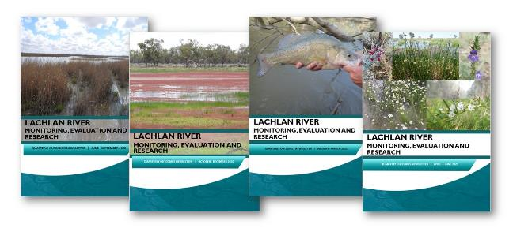
Figure 10-1. Cover images of Lachlan River MER Quarterly Outcomes newsletters 2020-21.
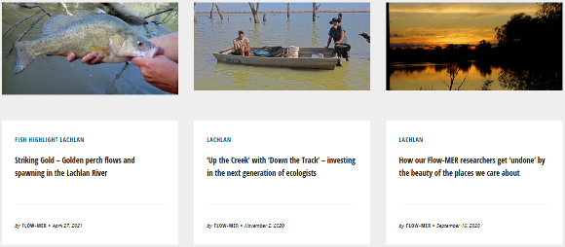
Figure 10-2. Images of photo story created by Flow MER Lachlan team 2020-21. See https//flow-mer.org.au for more.

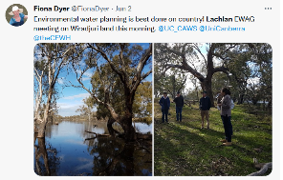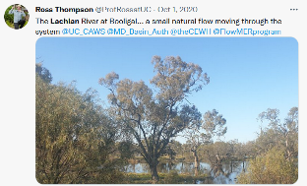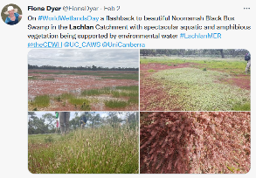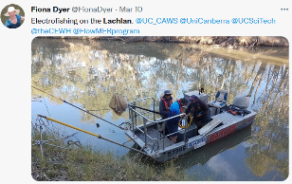
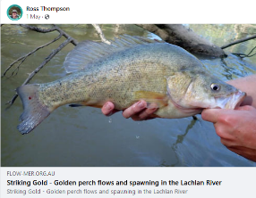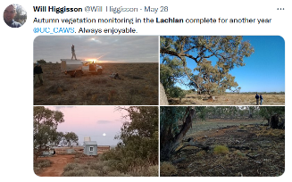
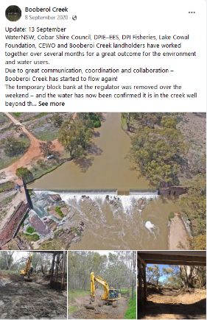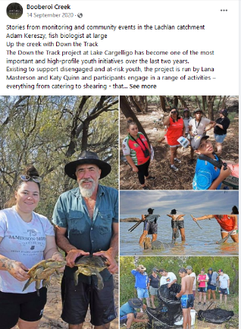
Figure 10-3. Example from social media (twitter and facebook) over Lachlan River post in 2020-21

Community events
Community events have been diverse in 2020-21 and have included sampling demonstrations, presentations, a variety of Aboriginal engagement activities, and landholder meetings (Table 10-3).
The Down The Track program (DTT) for disadvantaged youth in Lake Cargelligo has continued to conduct environmental education weekends for its/their Aboriginal clientele and this has followed the model established in previous years (ie: an overnight camping trip with bird/ vegetation/ fish sampling and boat transport to and from an island: Figure 10-4, and news article in Figure 10-5). Down The Track have expressed interest in formalising the environmental education weekends as part of their youth programs and are currently seeking funding in order to facilitate such events.
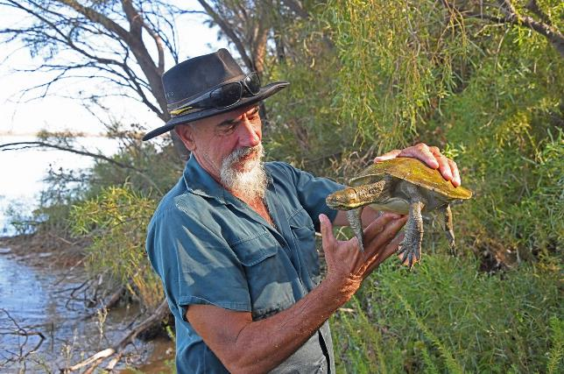
Figure 10-4. Adam Kerezsy during a Down The Track (DTT) event at Lake Cargelligo. Photo: Mal Carnegie.

Media
Printed media articles have targeted local and regional newspapers in 2020-21 (Figure 10-5), and a radio interview relating to the Great Cumbung Swamp aired on ABC Central West in February 2021 (Table 10-3).
Newspapers including the Condobolin Argus, Lake News, Hillston-Ivanhoe Spectator and Riverine Grazier all carried the Great Cumbung Swamp article in February and/or March 2021, and a separate full-page article relating to a Down The Track weekend (see ‘Community events’) was featured in the Lake News (Figure 10-5). Informal feedback from community members who live in the mid and lower Lachlan suggest that local newspapers (though somewhat ‘old-fashioned’ compared with electronic media) remain a very effective way of communicating MER activities to local communities.
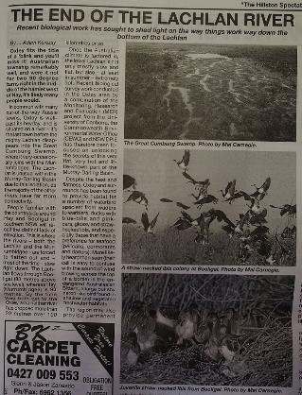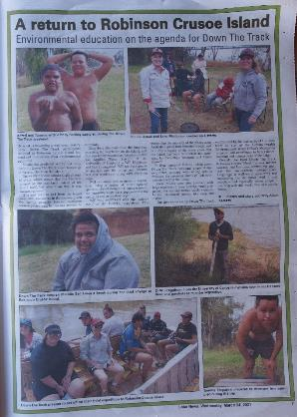
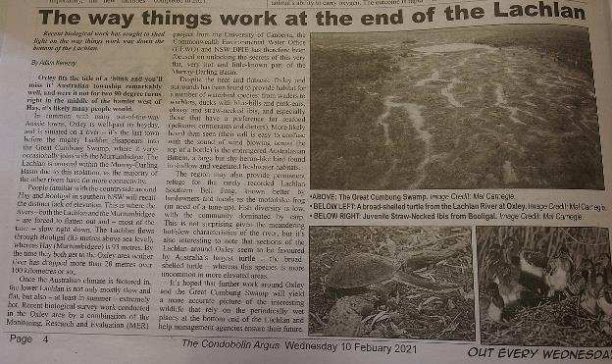
Figure 10-5. Newspaper article published in local/regional print media, Hillston-Ivanhoe Spectator (10th February 2021, left), Lake News (24th March 2021, right) and Condobolin Argus (10th February 2021, bottom)

Citizen Science
The Lachlan MER program provided support for a Waterwatch and Waterbug Blitz Team at Murrin Bridge Aboriginal community and Lake Cargelligo. Members of the Waterwatch teams not only conducted regular monitoring but were able to undertake issue-based monitoring.
Citizen science is dealt with in more specific detail in Section 11, however it should be noted that data collected during many of the community events (for example Down The Track weekends) and alluded to in media stories and communication products contribute to the data-sets used in much of the reporting and formal literature relating to (and associated with) the MER program: as such, sampling and monitoring work that includes landholders and local people always evinces an element of citizen science even if this is not explicit.

Community monitoring

Introduction
The MER Waterwatch community monitoring forms part of the Communication and Engagement (C&E) activities of the Lachlan Flow MER program. It contributes to meeting the following key objectives of the C&E program (see section 10):
- To increase awareness, understanding and value of water for the environment and its benefits (Objective O1).
- To secure support, acceptance and advocacy for water for the environment (Objective O3).
- To increase credibility and trust in the management of water for the environment and CEWO (Objective O4).
As well as:
- Disseminate learning and results from project activities (Objective C3).
- Contribute to on-going adaptive management associated with environmental watering (Objective C4).
The specific aims of the Waterwatch activities were to:
- Raise awareness of the MER and water for the environment program through the principle of ‘learn by doing’.
- Develop ‘local champions’ for use of environmental water in regional/local assets and functions eg. Booberoi Creek, Lake Brewster.
- Provide a local Waterwatch team with the skills and equipment to conduct routine water quality monitoring and be ‘deployed’ at short-notice to investigate potential water quality issues or incidents. Members of the team were to also function as an ‘early warning network’ having been trained to be alert for visible signs of emerging issues and being part of the local community network.
- Collect data that can inform the management of water within the Lachlan catchment.
This section focuses on water quality monitoring undertaken by the Lake Cargelligo, Booberoi Creek and Murrin Bridge Waterwatch Team.

Approach
A number of people from a wide range of community sectors joined in the MER community monitoring program over the past 2.5 years. Community members were trained in measuring water quality, with a focus on recording dissolved oxygen concentrations as this was identified as a gap in the surveillance monitoring that was being undertaken in the catchment and of direct relevance to water management decisions. They then conducted routine water quality monitoring as an independent local unit and with DPIE–EES delivery staff and sub-contractors during event-based monitoring.

Routine monitoring
The majority of the early community monitoring was undertaken in the Lachlan River in vicinity of Murrin Bridge and at various locations in Booberoi Creek (Figure 11-1). As the program developed, routine sites were added for Lachlan River above and below Lake Cargelligo weir and outlet channel in response to an operational need (Figure 11-1).
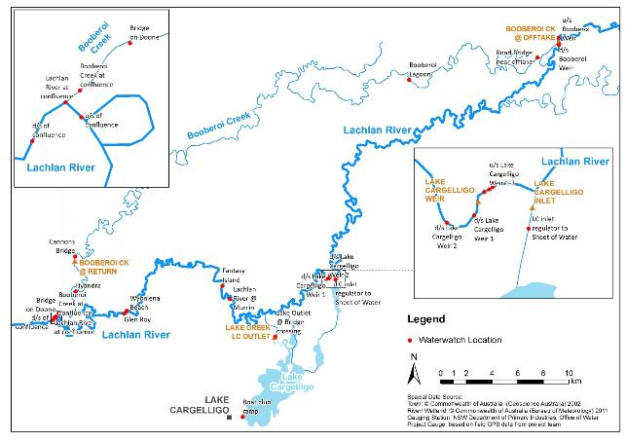
Figure 11-1. Waterwatch locations at Booberoi Creek, Murrin Bridge, and around Lake Cargelligo

Issue based monitoring
The Waterwatch teams collected data that informed the water management teams to understand the possible development of a blue-green algae and as well as helping to manage the hypoxic blackwater event in Mountain Creek. This means that opportunistic records were obtained for other locations across the catchment including Lake Brewster system and in the lower Lachlan river and wetlands (Figure 11-2).
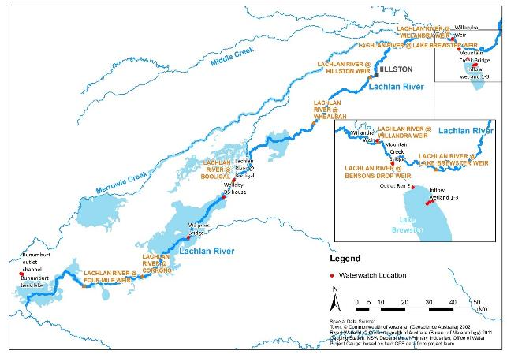
Figure 11-2. Waterwatch locations around Lake Brewster system and in the lower Lachlan river and wetlands.
The monitoring and how it informed the management of water in the catchment is described below.

Routine monitoring of water quality
Spot water quality measurements have been taken in Booberoi Creek since January 2021 (Figure 11-3) and were undertaken with increasing frequency during spring and summer 2020-21. These data show consistent pH throughout the period of record. They also show rapid increases in water temperatures over the summer and correspondingly lower dissolved oxygen concentrations. The dissolved oxygen concentrations were generally above 5 mg/L even during the warmest periods (between December 2020 and February 2021).
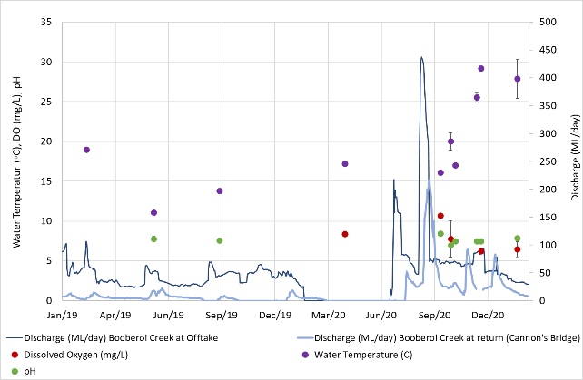
Figure 11-3. Mean water quality measurements (± standard error) for Booberoi Creek sites between January 2019 and March 2021.
Booberoi Creek is not directly monitored by the University of Canberra team as part of the Flow MER program. Water quality or dissolved oxygen loggers are not installed on any of the Booberoi Creek WaterNSW gauges, which feed into the NSW Real Time Water Data network. The regular observations and monitoring undertaken by the Waterwatch team provides baseline water quality information for the Creek that is not otherwise available. This demonstrates the potential for local teams to contribute to data collection that augments the work of the Universities and departments.

Issue based monitoring

Case Study 1: Hypoxic blackwater risk mitigation
In 2019 conditions were drier and hotter than any other NSW drought in the last 120 years. From January 2017 to December 2019, rainfall was the lowest on record. However, by August–September 2020, the Bureau of Meteorology (BOM) had declared La Niña was officially underway, signalling a wet spring and summer.
With potential rainfall events and or high flows after an extended dry period (and in some areas bush fire), there was widespread concern of increased risk of hypoxic (low oxygen) blackwater events occurring and/or algal blooms, and localised fish kills. DPIE–Water convened local drought–blackwater groups across the valleys including Lachlan. DPIE–Water issued a Media Release on 24 September 2020 addressing these risks, also stating that hypoxic blackwater was occurring in the Lachlan River at Booligal and is likely to continue until higher flows from upstream reach this area or we experience cooler conditions. The Lachlan blackwater group began to actively monitor and manage that risk in subsequent months, including use of the Water Quality Allowance (WQA). The MER Waterwatch Team conducted specific monitoring to inform the Lachlan blackwater groups management of potential hypoxic (low oxygen) conditions.
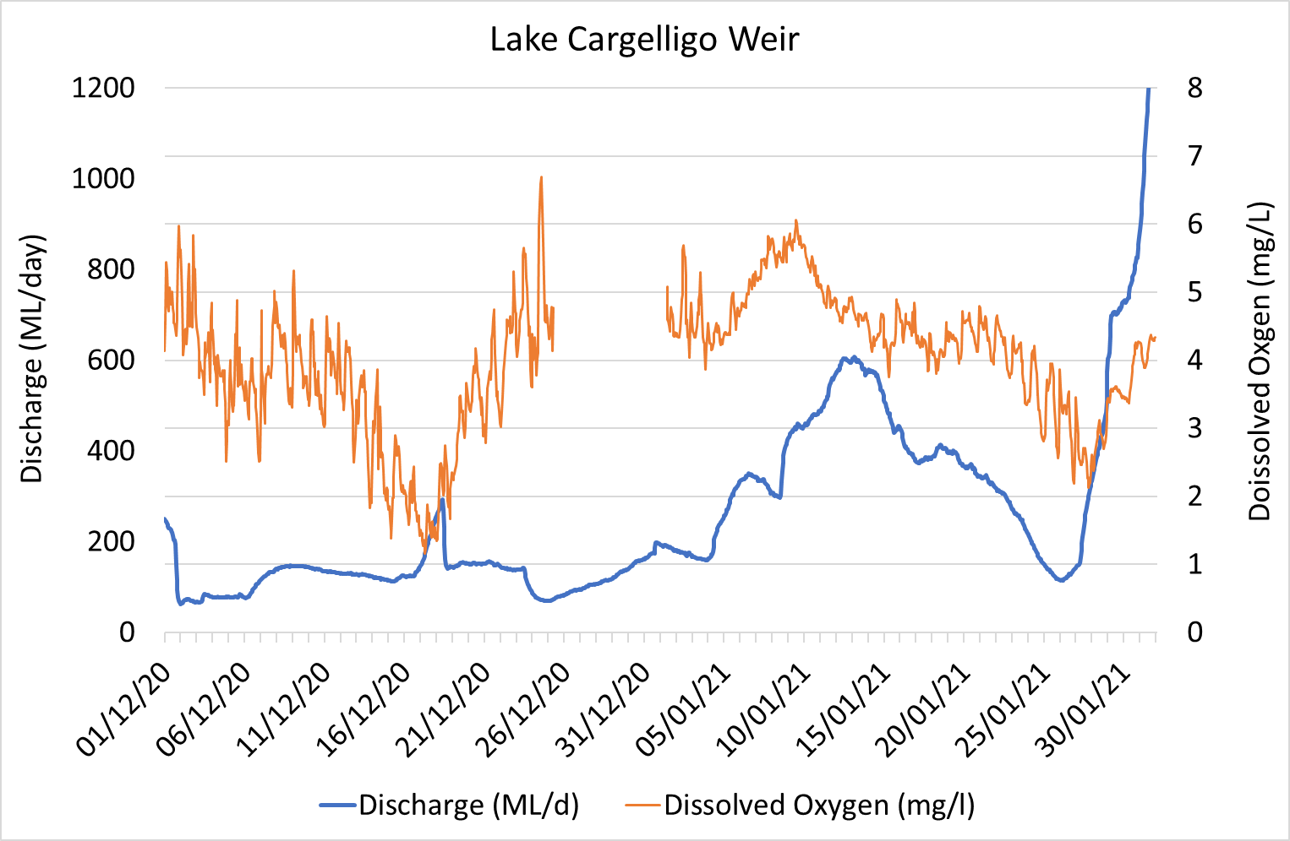
Figure 11-4. Discharge and Dissolved Oxygen from Lake Cargelligo Weir (412011) from the 1st December 2020 to 1st February 2021

Case Study 2: Lake Brewster system blue green algal (BGA) alert
On the 6 January 2021, several members of the Lake Cargelligo MER Waterwatch Team informed the DPIE–EES Senior Environmental Water Manager (SEWMO) of a facebook post, that was highly critical of recent and current releases from Lake Brewster outlet into Mountain Creek. The criticism was related to the quality of water that was being released from the Lake Brewster outlet into Mountain Creek, suggesting the water was full of toxic algae. It is important to note that Mountain Creek is considered habitat and part of current distribution of the Lachlan’s only remaining population of the Olive Perchlet (Ambassis agassizii).
The SEWMO was able to then immediately notify the Lachlan Blackwater Group, who were unaware of the emerging situation, as they had no direct connection to the local community. The MER Waterwatch Team informed government decision making forums, contributing to, and improving the management of an emerging blue green algal and low dissolved oxygen event below Lake Brewster storage by:
- Alerting the relevant agencies who were in a position to take direct and immediate action, including DPIE–Water (Blackwater Group and delegate for use of Water Quality Allowance, WQA) and WaterNSW, owner/ operator for Lake Brewster storage as the likely source of the BGA issue in Mountain Creek.
- Conducted visual inspections confirmed the source and extent of the BGA issue on the 7th January 2021 and provide that intelligence to the Lachlan Blackwater Group (Figure 11-6). This included spot water quality readings and observations at Willandra Weir pool and Lake Brewster outlet (Regulator E) on the 8 January 2021.
- This enabled WaterNSW to shut down all releases from the Lake Brewster system immediately and instigate immediate additional water quality samples and fast track the results. Algal monitoring was increased from monthly to weekly at additional sites in the vicinity.
- WaterNSW also issue a Media Release on 8th January 2021 and notified local newspapers and councils. The Waterwatch Team were able to distribute that Media Release and provide further information via local networks. This included introducing the SEWMO to the people who posted the facebook post and those that made comments, and subsequently form new relationships and add them to the community update email distribution list. There was agreement they could contact DPIE-Water directly, if they observe similar events unfolding in future rather than use social media.
- The Lake Cargelligo and Lake Brewster algal protocol was instigated including the use of the Water Quality Allowance (WQA) approved by DPIE–Water to offset increased evaporative losses from taking Lake Brewster offline for several weeks.
- The Waterwatch Team continued surveillance and monitoring of the system (e.g. again on 17th January 2021, Figure 11-6) and provided real-time input into restarting water delivery from Lake Brewster in terms of recommendations on dilution ratio based on the information they had gathered in the field and local knowledge.
It is worth noting, that the results of the algal sample obtained at Lake Brewster outlet channel on the 8th January 2021 after the Waterwatch notification were a red alert, which can represent ‘bloom’ conditions. The toxic cyanobacterial species community was dominated by Sphaerospermopsis aphanizomenoide with 2,047,000 cells/mL. In addition, it was the Waterwatch notification that led to immediate action even though the Benson’s Drop and Willandra Weir Real Time Data dissolved oxygen data had been trending downwards and showing large diurnal fluctuations, which can indicate high algal activity (Figure 11-5).
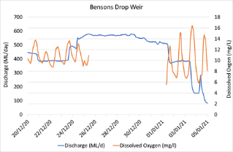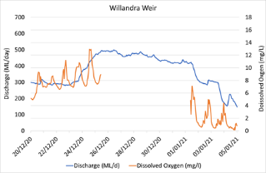
Figure 11-5. Discharge and Dissolved Oxygen from Bensons Drop Weir (412047) (top) and Willandra Weir (412038) (bottom) 20th December 2020 to 5th January 2021

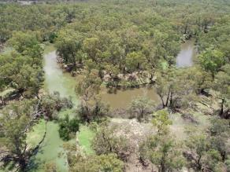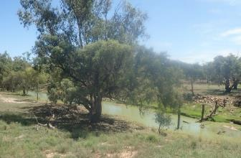
Figure 11-6. Imagery provided by Waterwatch Team in relation to Blue Green Algal (BGA) alert.
Left: 7th January 2021 confirming the source of BGA was Lake Brewster storage system via the outlet channel in Mountain Creek. Right: 17th January, two weeks after initial BGA alert.

Discussion
The development and support of the Waterwatch teams within the mid Lachlan system has enabled the program to connect with local community members and has produced valuable data that has informed the management of environmental water in the region. In doing so, it meets the objectives of raising awareness, developing local champions, having a skilled local team available to be an early warning network and collecting that that informs the management of water within the Lachlan catchment. The regular monitoring that is undertaken in Booberoi Creek has the potential to contribute data in unmonitored areas. We have also shown through case studies for Lake Brewster, how the teams have been able to contribute valuable data that directly informs management.

Research: Estimating the cover of Phragmites australis using unmanned aerial vehicles and neural networks

Introduction
Access to wetlands is often limited because of local conditions, risk to the site, habitat and species, and field personnel which makes the regular collection of data costly and slow and often results in considerable differences between available and needed data. In such locations, data collection through remote sensing has become an important tool for research and management (Chapple and Dronova 2017, Samiappan et al. 2017, Camarretta et al. 2020). Imagery collected using unmanned aerial vehicles (UAV) such as drones can provide high resolution and detailed imagery (Samiappan et al. 2017, Cohen and Lewis 2020).
Computational deep-learning techniques are transforming the way in which remotely sensed imagery and data can be used and are having an increasing role in remote sensing (Kattenborn et al. 2021). Computational deep-learning techniques involve learning features from data using a general-purpose learning procedure (LeCun et al. 2015). In remotely sensed data, Convolutional Neural Networks (CNN) automatically learn features through object detection and pattern recognition from large numbers of training samples using deep learning algorithms (Sun et al. 2017). CNNs have been shown to successfully recognise plant features such as leaves and fruit, and identify vegetation communities and species (Sun et al. 2017, Csillik et al. 2018, Kattenborn et al. 2019, Wagner et al. 2019). Unmanned aerial vehicles and CNNs offer promise for monitoring wetland vegetation – addressing some of the challenges around accessing sites and reliably estimating the cover and abundance of specific species. New technologies such as CNN and UAVs are useful if they provide meaningful and accurate data which are addressing ecological questions, in a repeatable and cost-effective manner.
The Great Cumbung Swamp (GCS) is a terminal reed swamp that lies at the termination of the low-gradient Lachlan river system, west of Hay, NSW, where the Lachlan River joins the Murrumbidgee River during floods which occur in 15-20% of years (O'Brien and Burne 1994, MDBA 2012a). The GCS supports one of the largest areas of common reed in NSW (MDBA 2012a). The size of the GCS makes it one of the most important wetlands for waterbirds in south western NSW, including species listed as threatened under Commonwealth and state legislation as well as species which are recognized in international migratory bird agreements (Maher 1990, MDBA 2012a). The central reed beds of the GCS also provide an important drought refuge for birds (MDBA 2012a).
The reed beds of the GCS have not been monitored as part of the LTIM project because of the logistical challenges around access to site and data collection. The reed beds of the GCS are mentioned in the Basin-wide environmental watering strategy, which specifies key objectives to maintain the current extent and increase periods of growth for stands of common reed and cumbungi in the GCS (MDBA 2014) and they have been targeted with environmental water over the past five years (see Dyer et al. 2016). As such, the inability to monitor the reed beds of the GCS is a notable omission.
For these reasons, research has been undertaken to address two key research questions: what are the key indicators of condition for reed beds? and what is an appropriate monitoring program for stands of common reed and their response to watering? The benefits of this research are three-fold:
- During the development of the monitoring approach, data will be collected that will facilitate the evaluation of the reed bed response to watering during the MER program, thus enhancing the evaluation provided for the vegetation diversity in the Lachlan Selected Area.
- Methods will be developed that will underpin monitoring in subsequent programs.
- Methods will be transferable to other areas in which water is provided to support stands of reeds.
During the first year of the MER Program (the 2019-20 watering year), we focused on addressing the first of the key research questions regarding the key indicators of condition for reed beds. The presence of surface water by flooding was found to be a major determinant on growth and vigour of common reed in the GCS, with height of green reeds, cover of green reeds, and number of flower heads showed to be strongly related to recent flooding. The fact that these metrics responded to environmental water, show their utility to detect a measurable response in reed bed condition. The height and cover of green shoots have been shown to be correlated with other reed attributes (such as stem diameter, leaf size and plant biomass (Poulin et al. 2010, Whitaker et al. 2015), highlighting that these indicators may be useful as an overall measure of condition.
Here we report on the findings from the second year of this research project, and address the second of the key research questions: what is an appropriate monitoring program for stands of common reed and their response to watering? We report on a method of calculating cover of reeds and other wetland attributes (such as water, bareground and leaf litter) from drone imagery that can be used in monitoring reed beds and their response to environmental water. This research was published in the Journal of River Research and Application in July 2021 https://onlinelibrary.wiley.com/doi/10.1002/rra.3832. Here we describe the key results of this work with exerts and figures from the original manuscript and highlight the application of this method in detecting and measuring reedbed condition in response to environmental water. The full manuscript which includes a more detailed description of the process and methodologies can be found on Research Gate: https://www.researchgate.net/publication/352927814_Estimating_the_cover_of_Phragmites_australis_using_unmanned_aerial_vehicles_and_neural_networks_in_a_semi-arid_wetland.

Methods

Study area
The GCS is a terminal reed swamp surrounded by floodplain forests, woodlands, and shrublands (MDBA 2012a). The central GCS contains a large reed bed dominated by common reed, which is the most extensive environment within the GCS (O'Brien and Burne 1994). In the central reed beds, common reed surrounds bodies of open water along the channel of the Lachlan River and smaller ephemeral flood channels (O'Brien and Burne 1994, Driver et al. 2011) (Figure 12-1).

Sampling design
A total of nine (50 X 50 m) sites were established in the reedbed of the Great Cumbung Swamp (Figure 12-1). These sites are distributed across a hydrological gradient and were grouped based on the number of inundation events each site had received. Sites in watering category A were inundated in November 2020, during the last survey, and prior to this had not been flooded since natural largescale flooding in 2016, and floodwater had receded at these sites by January 2017. This event flooded (all nine) sites in all three watering categories. Sites in watering category B were inundated in June-July 2019 and November 2020, and sites in watering category C were inundated in June-July 2019, November 2019 and November 2020. We conducted unmanned aerial vehicles (UAV) surveys at all nine sites, 10 times between October 2019 and May 2021 (October and November 2019, February, March, May, September, November and December 2020 and March and May 2021).
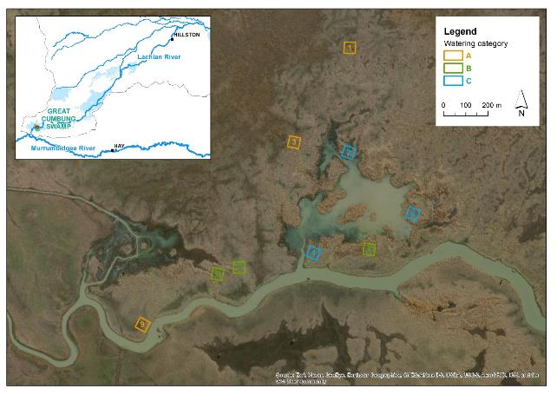
Figure 12-1. The location of the nine 50 X 50 m sites within the reed bed of the Great Cumbung Swamp.
Sites in: watering category A have not been inundated since > January 2017, watering category B received one environmental watering in June 2019, and watering category C received two environmental watering actions in 2019 (in June and November).

Image collection and processing
Imagery of all 9 sites was acquired in clear conditions during each trip using an UAV. All flights complied with Commonwealth regulations and were conducted by a licensed pilot. Surface water was present at most sites in November 2020, and a few sites in November 2019 but was not present during any other site visits.
Map Pilot version 4.0.8 (DJI) was used to plan and execute flights, enabling flight replication. The missions were set in a normal grid, with an overlap along and across-track of 80% at an altitude of 25 metres, which gave us a resolution of 0.9 pixels per centimetre by using the minimum UAV speed possible at 2.0 m/s (as the maximum rate is 1 image every 2.5 seconds). Cohen and Lewis (2020), through executing flights at multiple altitudes (20, 30, and 60 metres) determined that the optimal altitude for UAV was 20 metres, at which reeds can be readily identifiable by ecologists. Images were aligned and processed - after a dense point cloud generation - into a single high-resolution true ortho-mosaic for each day and site using Agisoft Metashape v 1.5.3. development.

Machine learning
In order to convert the drone imagery into useable data, required a way in which to characterise and group the different parts of each image into meaningful groups or classes. As part of this research we developed an approach that used the deep machine learning technique CNN on drone imagery collected in the reedbed of the Great Cumbung Swamp. This machine learning technique provides a powerful computational tool to extract information from each image based on the morphology of the plants and other landscape features. Using the information extracted from the drone images, machine learning enables the classification of different feature classes such as a plant species, water or bareground. This process involves the building of a model that learns how to recognise features of a given class. Then the model can be used to classify imagery, unseen by the model into these defined classes. As we were interested in estimating the cover of Phragmites australis reeds and other wetlands features, we initially trained the model to learn and detect Phragmites australis reeds and wetland features bareground, leaf litter, water and other vegetation. We then tested the finalised model on data that hadn’t been seen by the model and calculated a number of commonly used performance indicators to test its performance. We then used the model on imagery of reedbed sites with different environmental watering histories to demonstrate its application. This approach has been peer-reviewed as part of the publication process thus ensuring scientific integrity of the methods. A more detailed description of the methods can be found in the paper published at https://www.researchgate.net/publication/352927814_Estimating_the_cover_of_Phragmites_australis_using_unmanned_aerial_vehicles_and_neural_networks_in_a_semi-arid_wetland.

Results

Model performance

Testing
The results from the testing data group demonstrated that the model had an overall accuracy of 0.947 (94.7%), loss of 0.146, precision of 0.950, recall of 0.947, and an F-Score of 0.945. The True Positive (TP) Rate and False Positive (FP) Rate varied between the feature classes. The reeds class (Phragmites australis) had the highest TP Rate (0.998) and lowest FP Rate (0.002) of all classes (Table 12-1). The leaf litter and other vegetation classes had a TP Rate of approx. 0.921 and water slightly lower (0.907). The bareground class had the lowest TP Rate (0.137) of all feature classes, which was related to miss-labelling this feature class as water and leaf litter at times (Table 12-1).
Table 12-1. The True Positive (TP) Rate and False Positive (FP) Rate for each feature class.
 | Bareground | Trash | Leaf Litter | Other Veg | Reeds | Water
TP | 0.137 | 0.954 | 0.921 | 0.917 | 0.998 | 0.907
FP | 0.222 | 0.204 | 0.035 | 0.026 | 0.002 | 0.090

Table 12-2. Confusion matrix, in which the columns represent the true classes while the rows represent the model’s predictions.
Note: The numbers highlighted in darker blue are the (true positive) correctly classified images. The numbers not highlighted are the omission errors.
Confusion Matrix
 | Bareground | Trash | Leaf Litter | Other Veg | Reeds | Water
Bareground | 7 | 29 | 4 | 0 | 0 | 11
Trash | 0 | 666 | 22 | 7 | 1 | 2
Leaf Litter | 2 | 92 | 1185 | 5 | 0 | 2
Other Veg | 0 | 28 | 12 | 606 | 2 | 13
Reeds | 0 | 1 | 2 | 0 | 1936 | 0
Water | 0 | 21 | 3 | 4 | 1 | 283

Prediction - Manual verification
To test the model’s predictive performance, images from four sites which had been kept separate were categorised to one of the six classes. Manual verification demonstrated the reeds, leaf litter, and trash classes performed very well (>98%) (Table 12-3). The water class was 90% correct. The other vegetation (other veg) class was 78% correct, with those incorrectly grouped as other vegetation consisting mostly of slices containing reeds. The bareground feature class had the lowest percentage correctly classed (41%) (Table 12-3). The majority of the slices incorrectly identified as bareground were either water or leaf litter.
Table 12-3. Results from manual (visual) verification of 100 randomly selected images from each feature class on the models predictive performance. The bareground feature class only had 40 images assigned, so all images were used in the verification process.
Feature class | % Correctly classed
Bareground | 41
Trash | 100
Leaf Litter | 99
Other Veg | 78
Reeds | 98
Water | 90

Examples of density maps and cover estimates
Using the model, we developed density maps showing the cover and extent of Phragmites australis and the other wetland features at three sites taken in November 2020 and report the percentage cover of each wetland feature at each site as examples. Site 3 (in watering category A), which had been flooded in November 2020 (during the survey), but prior to this had not been flooded since January 2017 consisted primarily of other vegetation (62.1%) and leaf litter (37.3%) and had a very low cover of Phragmites australis reeds 0.02% and less than 1% of the plot had surface water present (Figure 12-2).
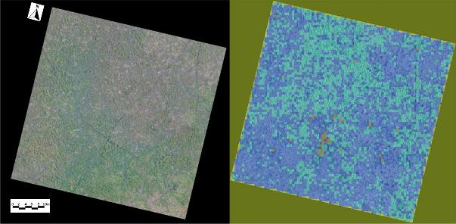
Figure 12-2. Site 3 (in watering category A) in November 2020. The left image is the site in RGB and the right image is a density map showing the output of the model prediction.
In the right image the dark blue = other vegetation (62.1%), light blue = leaf litter (37.3%), green = Phragmites australis reeds (0.02%), and brown = water (0.6%). The site represents an area of 50 X 50 metres.
Site 8 (in watering category B), which had received environmental water in June/July 2019 and again in November 2020 had a much higher cover of Phragmites australis reeds (57.7%), and at the time of monitoring had 25.1% of the plot covered in water, and 8.7% and 8.1% of leaf litter and other vegetation respectively and 0.5% bareground (Figure 12-3).
Site 6 (in watering category C) which had received environmental water in June-July 2019, November 2019 and November 2020, had the greatest cover of Phragmites australis reeds consisting of 83.3%, and 4.6% leaf litter, 4.7% other vegetation and 7.3% water (Figure 12-4). It is likely that there was surface water under the reeds during the time of surveying, so the estimate of water may be substantially greater than what is reported.

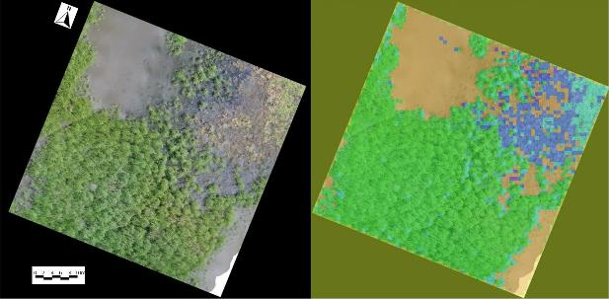
Figure 12-3. Site 8 (in watering category B) in November 2020. The left image is the site in RGB and the right image is a density map showing the output of the model prediction.
The olive green represents the trash class which was removed prior to estimating percent cover. The purple = bareground (0.5%), dark blue = leaf litter (8.7%), light blue = other vegetation (8.1%), green = Phragmites australis reed (57.7%), and brown = water (25.1%). The site represents an area of 50 X 50 metres.

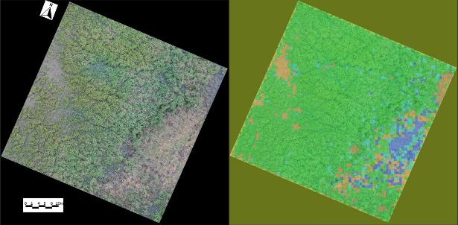
Figure 12-4. Site 6 (in watering category C) in November 2020. The left image is the site in RGB and the right image is a density map showing the output of the model prediction.
In the right dark blue = leaf litter (4.6%), light blue = other vegetation (4.7%), green = Phragmites australis reed (83.3%), and brown = water (7.3%). The site represents an area of 50 X 50 metres.

Discussion
Here we describe an image analysis technique using UAV and machine learning CNNs for mapping the cover and extent of features of the Phragmites australis reedbed of the Great Cumbung Swamp. We show its use in comparing sites with different environmental watering histories. The validation process demonstrated an overall high precision and reproducibility in recognising reeds (Phragmites australis), and other wetland features. The model demonstrated that it could correctly identify Phragmites australis with a TP Rate of >98%.
The high accuracy and precision shown here in recognising key wetland features (especially Phragmites australis reeds), demonstrates the applicability of this technique to estimate a change or response in cover or distribution of Phragmites australis reeds in response to management actions or changes in flow regime. The reedbeds of the Great Cumbung Swamp are mentioned in the Murray-Darling Basin-wide environmental watering strategy, which specifies key objectives to maintain the current extent and increase periods of growth for stands of Phragmites australis (MDBA 2014) and they have been managed with environmental water over the past five years (see Dyer et al. 2016). Field-based data collection within the reedbeds of the Great Cumbung Swamp is often challenging and may be not possible especially during floods. The main idea behind using UAVs and CNNs is to devise an alternative data collection method to field-based techniques which is accurate and repeatable. The development and optimization of the model (including training, validation and testing), took a considerable amount of time (approx. 100 hours). However, once developed, the model can now classify each new site in approximately five minutes. The stitching and processing of aerial imagery also takes approximately 10 minutes per site. We typically capture the drone imagery at all nine sites in around five hours (not including travel time).
The regular use of environmental water to the central reedbed has maintained the cover and condition of the reeds in these parts of the Great Cumbung Swamp. Cover of Phragmites australis was much greater at sites that had received environmental over the past four years compared to sites which have not been flooded since natural flooding occurred in early 2017. The sites that had not been managed with environmental water in the intervening period since natural flooding in early 2017 had a very low cover of (short) reeds and much higher cover of other vegetation. The recommended frequency of flooding for maintenance and regeneration of Phragmites australis is flooding every one to two years (Roberts and Marston 2011), and this research demonstrates the importance of regular flooding in the maintenance of Phragmites australis reedbeds. The sites which received multiple floods over the two years prior to monitoring had a greater cover compared to sites that only received a single flooding event, demonstrating that cover of Phragmites australis continues to improve with multiple floods.
Here we have demonstrated a relatively cost-effective, safe, efficient and high accuracy method to estimate cover and extent of reedbed features in a semi-arid wetland using drones and machine learning CNNs and show its use in monitoring Phragmites australis reedbeds and their response to environmental watering. Both cover and height of green reeds are important metrics in describing overall reedbed condition. In the next stage of this research we will use the model we describe here to firstly estimate the cover of Phragmites australis reeds and through selecting only parts of the drone imagery defined as reeds, then estimate the height of the reeds. This will provide a way to measure the height of reeds, while removing the potential influence of other landscape features or vegetation on reed height. This combined approach will allow us to estimate the change in cover and height of reeds over time in response to an action such as environmental watering or compare different sites (in space) that have received different management actions, such as with and without environmental watering.

References
Anderson, J. R., A. K. Morison, and D. J. Ray. 1992. Validation of the use of thin-sectioned Otoliths for determining the age and growth of Golden Perch, Macquaria ambigua (Perciformes: Percichthyidae), in the Lower Murray-Darling Basin, Australia. Australian Journal for Marine and Freshwater Research 43:1103-1128.
Anderson, M. J., R. N. Gorley, and K. R. Clarke. 2008. PERMANOVA+ for PRIMER: Guide to Software and Statistical Methods. PRIMER-E, Plymouth, UK.
Balcombe, S. R., A. H. Arthington, N. D. Foster, M. C. Thoms, G. G. Wilson, and S. E. Bunn. 2006. Fish assemblages of an Australian dryland river: abundance, assemblage structure and recruitment patterns in the Warrego River, Murray-Darling Basin. Marine and Freshwater Research 57:619-633.
Baumgartner, L. J., J. Conallin, I. Wooden, B. Campbell, R. Gee, W. A. Robinson, and M. Mallen-Cooper. 2014. Using flow guilds of freshwater fish in an adaptive management framework to simplify environmental flow delivery for semi-arid riverine systems. Fish and Fisheries 15:410-427.
Bayley, P. B. 1995. Understanding Large River: Floodplain Ecosystems. BioScience 45:153-158.
Beesley, L., A. J. King, F. Amtstaetter, J. D. Koehn, B. E. N. Gawne, A. Price, D. L. Nielsen, L. Vilizzi, and S. N. Meredith. 2012. Does flooding affect spatiotemporal variation of fish assemblages in temperate floodplain wetlands? Freshwater Biology 57:2230-2246.
Bernhardt, E. S., J. B. Heffernan, N. B. Grimm, E. H. Stanley, J. W. Harvey, M. Arroita, A. P. Appling, M. J. Cohen, W. H. McDowell, J. Hall, R.O., J. S. Read, B. J. Roberts, E. G. Stets, and C. B. Yackulik. 2018. The metabolic regimes of flowing waters. Limnology and Oceanography 63:99-118.
Boulton, A. J., and P. S. Lake. 1992. Benthic organic matter and detritivorous macroinvertebrates in two intermittent streams in south-eastern Australia. Hydrobiologia 241:107-118.
Bowen, S. 2013. NSW OEH Environmental Flow Monitoring Program: Methods for monitoring of flood-dependent vegetation communities., Water and Rivers Team, NSW Office of Environmental and Heritage, Sydney.
Brock, M. A., and M. Casanova. 1997. Plant life at the edge of wetlands: ecological responses to wetting and drying patterns. Pages 181–192 in N. Klomp and I. Lunt, editors. Frontiers in ecology: building the links. Elsevier Science, Oxford.
Bunn, S. E., and A. H. Arthington. 2002. Basic Principles and Ecological Consequences of Altered Flow Regimes for Aquatic Biodiversity. Environmental Management 30:492-507.
Bunn, S. E., S. R. Balcombe, P. M. Davies, C. S. Fellows, and F. J. McKenzie-Smith. 2006. Aquatic productivity and food webs of desert river ecosystems. Pages 76-99 in R. T. Kingsford, editor. Ecology of desert rivers. Cambridge University Press, Cambridge.
Cadwallader, P. L. 1977. J.O. Langtry's 1949-50 Murray River Investigations. Fisheries and Wildlife Division, Victoria, Melbourne.
Camarretta, N., P. A. Harrison, T. Bailey, B. Potts, A. Lucieer, N. Davidson, and M. Hunt. 2020. Monitoring forest structure to guide adaptive management of forest restoration: a review of remote sensing approaches. New Forests 51:573-596.
Campana, S. E., and E. Moksness. 1991. Accuracy and precision of age and hatch date estimates from otolith microstructure examination. ICES Journal of Marine Science 48:303–316.
Campana, S. E., and S. R. Thorrold. 2001. Otoliths, increments, and elements: keys to a comprehensive understanding of fish populations? Canadian Journal of Fisheries and Aquatic Sciences 58:30-38.
Casanova, M. T. 2011. Using water plant functional groups to investigate environmental water requirements. Freshwater Biology 56:2637-2652.
Catelotti, K., R. Kingsford, G. Bino, and P. Bacon. 2015. Inundation requirements for persistence and recovery of river red gums (Eucalyptus camaldulensis) in semi-arid Australia. Biological Conservation 184:346-356.
Chapple, D., and I. Dronova. 2017. Vegetation development in a tidal marsh restoration project during a historic drought: a remote sensing approach. Frontiers in Marine Science 4:243.
Cohen, J. G., and M. J. Lewis. 2020. Development of an Automated Monitoring Platform for Invasive Plants in a Rare Great Lakes Ecosystem Using Uncrewed Aerial Systems and Convolutional Neural Networks. Pages 1553-1564 in 2020 International Conference on Unmanned Aircraft Systems (ICUAS). IEEE.
Commonwealth Environmental Water Office. 2017. Blackwater Review. Environmental water used to moderate low dissolved oxygen levels in the southern Murray Darling Basin during 2016/17. Commonwealth of Australia.
Commonwealth Environmental Water Office. 2020. Water Management Plan 2020-21.
Crook, D. A., and B. M. Gillanders. 2006. Use of otolith chemical signatures to estimate carp recruitment sources in the mid‐Murray River, Australia. River Research and Applications 22:871-879.
Crook, D. A., D. J. O'Mahony, B. M. Gillanders, A. R. Munro, A. C. Sanger, S. Thurstan, and L. J. Baumgartner. 2016. Contribution of stocked fish to riverine populations of golden perch (Macquaria ambigua) in the Murray–Darling Basin, Australia. Marine and Freshwater Research 67:1401-1409.
Csillik, O., J. Cherbini, R. Johnson, A. Lyons, and M. Kelly. 2018. Identification of citrus trees from unmanned aerial vehicle imagery using convolutional neural networks. Drones 2:39.
Davies, P. E., J. Harris, T. Hillman, and K. F. Walker. 2010. The Sustainable Rivers Audit: assessing river ecosystem health in the Murray-Darling Basin, Australia. (Special Issue: Peter Cullen's legacy: Integrating science, policy and management of rivers). Marine and Freshwater Research 61:764-777.
Davies, P. E., J. H. Harris, T. J. Hillman, and K. F. Walker. 2008. Sustainable Rivers Audit 1: A report on the ecological health of Rivers in the Murray-Darling Basin, 2004-2007. Prepared by the Independent Sustainable Rivers Audit Group for the Murray–Darling Basin Ministerial Council. Murray Darling Basin Commission, Canberra.
Davies, P. E., M. Stewardson, T. Hillman, J. Roberts, and M. Thoms. 2012. Sustainable rivers audit 2: The ecological health of rivers in the Murray-Darling Basin at the end of the Millennium Drought (2008-2010). Murray-Darling Basin Authority, Canberra.
Davies, T. L. O. 1977. Age determination and growth of the freshwater catfish, Tandanus tandanus Mitchell, in the Gwydir River, Australia. Australian Journal for Marine and Freshwater Research 28:119-137.
Doody, T. M., S. N. Benger, J. L. Pritchard, and I. C. Overton. 2014. Ecological response of Eucalyptus camaldulensis (river red gum) to extended drought and flooding along the River Murray, South Australia (1997–2011) and implications for environmental flow management. Marine and Freshwater Research 65:1082-1093.
Driver, P. D., E. Barbour, and K. Michener. 2011. An integrated surface water, groundwater and wetland plant model of drought response and recovery for environmental water management. Pages 12-16 in 19th International Congress on Modelling and Simulation, Perth, Australia.
Driver, P. D., S. Chowdhury, T. Hameed, P. Lloyd-Jones, G. Raisin, C. Ribbons, G. Singh, and P. Wettin. 2004. Natural and modified flows of the Lachlan Valley wetlands. Resource Analysis Unit, Central West Region, NSW Department of Infrastructure, Planning and Natural Resources, Forbes.
Driver, P. D., L. Hardwick, J. Maguire, and P. Lloyd-Jones. 2003. Vegetation Survey for Billabongs. New South Wales Department of Infrastructure, Planning and Natural Resources.
Dyer, F., B. Broadhurst, J. Thiem, R. Thompson, P. Driver, S. Bowen, M. Asmus, and J. Lenehan. 2015. Commonwealth Environmental Water Office Long Term Intervention Monitoring Project Lower Lachlan river system 2015 Annual Report. University of Canberra: Canberra.
Dyer, F., B. Broadhurst, R. Thompson, K. Jenkins, P. Driver, N. Saintilan, S. Bowen, P. Packard, D. Gilligan, K. Brandis, C. Amos, A. Hall, and J. Lenehan. 2014a. Commonwealth Environmental Water Office Long Term Intervention Monitoring Project. Lachlan river system. Commonwealth Environmental Water Office, University of Canberra, NSW Environment and Heritage and NSW Department of Primary Industries.
Dyer, F., B. Broadhurst, R. Thompson, K. M. Jenkins, P. D. Driver, N. Saintilan, S. Bowen, P. Packard, D. Gilligan, A. Thiem, M. Asmus, C. Amos, K. J. Brandis, F. Martin, A. Hall, and J. R. Lenehan. 2014b. Long term intervention monitoring and evaluation plan: Lachlan river system. Commonwealth Environmental Water Office, Canberra.
Dyer, F., B. Broadhurst, A. Tschierschke, W. Higgisson, J. Thiem, D. Wright, A. Kerezsy, and R. Thompson. 2020. Commonwealth Environmental Water Office Monitoring, Evaluation and Research Project: Lachlan river system Selected Area 2019-20 Monitoring and Evaluation Technical Report.
Dyer, F., B. Broadhurst, A. Tschierschke, J. Thiem, R. Thompson, P. D. Driver, S. Bowen, M. Asmus, S. Wassens, A. Walcott, and J. R. Lenehan. 2016. Commonwealth Environmental Water Office Long Term Intervention Monitoring Project: Lower Lachlan river system Selected Area 2015-16 Monitoring and Evaluation Synthesis Report. Commonwealth Environmental Water Office, Canberra.
Dyer, F., B. Broadhurst, A. Tschierschke, R. Thompson, R. Clear, P. Driver, S. Bowen, J. Lenehan, R. Thomas, L. Thurtell, P. Packard, D. Wright, J. Thiem, and K. Brandis. 2019. Commonwealth Environmental Water Office Lachlan Selected Area Monitoring, Evaluation and Research Plan (2019-2022). University of Canberra, Canberra.
Dyer, F., C. Campbell, W. Higgisson, A. Tschierschke, and T. M. Doody. 2021. Basin-scale evaluation of 2019–20 Commonwealth environmental water: Vegetation. Flow-MER Program. Commonwealth Environmental Water Office (CEWO): Monitoring, Evaluation and Research Program. Department of Agriculture, Water and the Environment, Australia.
Ebner, B. C., O. Scholz, and B. Gawne. 2009. Golden perch Macquaria ambigua are flexible spawners in the Darling River, Australia. New Zealand Journal of Marine and Freshwater Research 43:571-578.
Environment Australia. 2001. A Directory of Important Wetlands in Australia. Environment Australia, Canberra.
Forbes, J., R. J. Watts, W. A. Robinson, L. J. Baumgartner, P. McGuffie, L. M. Cameron, and D. A. Crook. 2016. Assessment of stocking effectiveness for Murray cod (Maccullochella peelii) and golden perch (Macquaria ambigua) in rivers and impoundments of south-eastern Australia. Marine and Freshwater Research:-.
Gehrke, P. C., P. Brown, C. B. Schiller, D. B. Moffatt, and A. M. Bruce. 1995. River regulation and fish communities in the Murray-Darling river system, Australia. Regulated Rivers: Research & Management 11:363-375.
Grace, M. R., D. P. Giling, S. Hladyz, V. Caron, R. M. Thompson, and R. Mac Nally. 2015. Fast processing of diel oxygen curves: estimating stream metabolism with BASE (BAyesian Single-station Estimation). Limnology and Oceanography Methods 13:103-114.
Green, D., J. Petrovic, P. Moss, and M. Burrell. 2011. Water resources and management overview: Lachlan Catchment. NSW Office of Water, Sydney.
Hale, J., R. Stoffels, R. Butcher, M. Shackleton, S. Brooks, and B. Gawne. 2014. Commonwealth Environmental Water Office Long Term Intervention Monitoring Project – Standard Methods. Final Report prepared for the Commonwealth Environmental Water Office by The Murray-Darling Freshwater Research Centre. MDFRC Publication 29.2/2014.
Hameed, T., and G. Podger. 2001. Use of the IQQM simulation model for planning and management of a regulated river system. Pages 83-90 in M. Marino and S. Simonovic, editors. International Symposium on Integrated Water Resources Management. IAHS Publication, Davis, California, USA.
Harris, J. H. 1995. The use of fish in ecological assessments. Australian Journal of Ecology 20:65-80.
Heibo, E., C. Magnhagen, and L. A. Vøllestad. 2005. Latitudinal variation in life-history traits in Eurasian perch. Ecology 86:3377-3386.
Higgisson, W., B. Higgisson, M. Powell, P. Driver, and F. Dyer. 2019. Impacts of water resource development on hydrological connectivity of different floodplain habitats in a highly variable system. River Research and Applications.
Hladyz, S., S. C. Watkins, K. L. Whitworth, and D. S. Baldwin. 2011. Flows and hypoxic blackwater events in managed ephemeral river channels. Journal of Hydrology 401:117-125.
Humphries, P., A. J. King, and J. D. Koehn. 1999. Fish, flows and flood plains: links between freshwater fishes and their environment in the Murray-Darling River system, Australia. Environmental Biology of Fishes 56:129-151.
Humphries, P., G. G. Wilson, A. J. Richardson, and T. Ellison. 2008. Impacts of Managed Flows on Fish Spawning and Recruitment. Report prepared for the Murray–darling Basin Commission. Murray-Darling Freshwater Research Centre, Wodonga.
Hunt, T. L., M. S. Allen, J. Douglas, and A. Gason. 2010. Evaluation of a Sport Fish Stocking Program in Lakes of the Southern Murray–Darling Basin, Australia. North American Journal of Fisheries Management 30:805-811.
Junk, W. J., P. B. Bayley, and R. E. Sparks. 1989. The flood pulse concept in river-floodplain systems. Canadian Journal of Fisheries and Aquatic Sciences 106:110-127.
Kattenborn, T., J. Eichel, and F. E. Fassnacht. 2019. Convolutional Neural Networks enable efficient, accurate and fine-grained segmentation of plant species and communities from high-resolution UAV imagery. Scientific reports 9:1-9.
Kattenborn, T., J. Leitloff, F. Schiefer, and S. Hinz. 2021. Review on Convolutional Neural Networks (CNN) in vegetation remote sensing. ISPRS Journal of Photogrammetry and Remote Sensing 173:24-49.
King, A. J., P. Humphries, and P. S. Lake. 2003. Fish recruitment on floodplains: the roles of patterns of flooding and life history characteristics. Canadian Journal of Fisheries and Aquatic Sciences 60:773–786.
King, A. J., Z. Tonkin, and J. Lieschke. 2012. Short-term effects of a prolonged blackwater event on aquatic fauna in the Murray River, Australia: considerations for future events. Marine and Freshwater Research 63:576-586.
King, A. J., K. A. Ward, P. O'Connor, D. Green, Z. Tonkin, and J. Mahoney. 2010. Adaptive management of an environmental watering event to enhance native fish spawning and recruitment. Freshwater Biology 55:17-31.
Kingsford, R. T. 2000. Ecological impacts of dams, water diversions and river management on floodplain wetlands in Australia. Austral Ecology 25:109-127.
Knauer, J., T. El-Madany, S. Zaehle, and M. Migliavacca. 2018. Bigleaf—An R package for the calculation of physical and physiological ecosystem properties from eddy covariance data. PLoS ONE 13.
Koehn, J. D., and D. J. Harrington. 2006. Environmental conditions and timing for the spawning of Murray cod (Maccullochella peelii peelii) and the endangered trout cod (M. macquariensis) in southeastern Australian rivers. River Research and Applications 18:327-342.
Koehn, J. D., S. M. Raymond, I. Stuart, C. R. Todd, S. R. Balcombe, B. P. Zampatti, H. Bamford, B. A. Ingram, C. M. Bice, K. Burndred, G. Butler, L. Baumgartner, P. Clunie, I. Ellis, J. P. Forbes, M. Hutchison, W. M. Koster, M. Lintermans, J. P. Lyon, M. Mallen-Cooper, M. McLellan, L. Pearce, J. Ryall, C. Sharpe, D. J. Stoessel, J. D. Thiem, Z. Tonkin, A. Townsend, and Q. Ye. 2020. A compendium of ecological knowledge for restoration of freshwater fishes in Australia’s Murray–Darling Basin. Marine and Freshwater Research 71:1391-1463.
LeCun, Y., Y. Bengio, and G. Hinton. 2015. Deep learning. nature 521:436-444.
Lintermans, M. 2007. Fishes of the Murray-Darling Basin: An introductory guide. Murray-Darling Basin Commission, Canberra.
Llewellyn, L. 2007. Spawning and development of the Flat-headed Gudgeon Philypnodon grandiceps (Krefft, 1864) (Teleostei:Eleotridae). Australian Zoologis 34:1-21.
Lorenzoni, M., M. Corboli, L. Ghetti, G. Pedicillo, and A. Carosi. 2007. Growth and reproduction of the goldfish Carassius auratus: a case study from Italy. Pages 259-273 in F. Gherardi, editor. Biological invaders in inland waters: Profiles, distribution, and threats. Springer Netherlands, Dordrecht.
Maher, P. N. 1990. Bird survey of the Lachlan/Murrumbidgee confluence wetlands. NSW National Parks and Wildlife Service Griffith.
Mallen-Cooper, M. 1996. Fishways and Freshwater Fish Migration in South-Eastern Australia. PhD Thesis. University of Technology, Sydney.
Mallen-Cooper, M., and B. P. Zampatti. 2018. History, hydrology and hydraulics: Rethinking the ecological management of large rivers. Ecohydrology 11:23.
McDowall, R. M. 1996. Family Poecilidae: livebearers. Pages 116-122 in R. M. McDowall, editor. Freshwater Fishes of South-Eastern Australia. Reed Books, Sydney.
MDBA. 2012a. Assessment of environmental water requirements for the proposed Basin Plan: Great Cumbung Swamp. MDBA, Canberra.
MDBA. 2012b. Sustainable Rivers Audit 2: The ecological health of rivers in the Murray–Darling Basin at the end of the Millennium Drought (2008–2010). Summary. Murray-Darling Basin Authority, Canberra, Australia.
MDBA. 2014. Basin-wide environmental watering strategy. Murray-Darling Basin Authority, Canberra.
MDBA. 2019. Basin environmental watering priorities 2019-20. Murray-Darling Basin Authority.
MDBA. 2020. Basin annual environmental watering priorities 2020-21. Murray‒Darling Basin Authority, Canberra.
MDBC. 2004. Native Fish Strategy for the Murray-Darling Basin 2003-2013. Murray-Darling Basin Commission, Canberra.
MDFRC. 2013. Long-term Intervention Monitoring - Generic Cause and Effect Diagrams. Report prepared for the Commonwealth Environmental Water Office. Murray-Darling Freshwater Research Centre (MDFRC).
Muschal, M., E. Turak, D. Gilligan, J. Sayers, and M. Healey. 2010. Riverine ecosystems, Technical report series of the NSW Monitoring, Evaluation and Reporting Program. NSW Office of Water, Sydney.
Nilsson, C., and K. Berggren. 2000. Alterations of Riparian Ecosystems Caused by River Regulation: Dam operations have caused global-scale ecological changes in riparian ecosystems. How to protect river environments and human needs of rivers remains one of the most important questions of our time. BioScience 50:783-792.
O'Brien, P., and R. Burne. 1994. The Great Cumbung Swamp--terminus of the low-gradient Lachlan River, Eastern Australia. AGSO Journal of Australian Geology and Geophysics 15:223-234.
OEH. 2018. Lachlan Long Term Water Plan Part B: Lachlan planning units. Office of Environment and Heritage, Sydney.
Office of Environment and Heritage NSW, S. 2018. Lachlan Long Term Water Plan Part B: Lachlan planning units. Office of Environment and Heritage, Sydney.
Oksanen, J., F. Guillaume Blanchet, M. Friendly, R. Kindt, P. Legendre, D. McGlinn, R. Peter, P. Minchin, R. B. O'Hara, G. L. Simpson, P. Solymos, M. Henry, H. Stevens, S. E., and H. Wagner. 2019. vegan: Community Ecology Package. Rpackage version 2.5-5. https://CRAN.R-project.org/package=vegan.
Olden, J. D., and N. L. R. Poff. 2003. Redundancy and the choice of hydrologic indices for characterizing streamflow regimes. River Research and Applications 19:101-121.
Poff, N. L., J. D. Allan, M. B. Bain, J. R. Karr, K. L. Prestegaard, B. D. Richter, R. E. Sparks, and J. C. Stromberg. 1997. The Natural Flow Regime. BioScience 47:769-784.
Poff, N. L. R., and J. C. Ward. 1989. Implications of streamflow variability and predictability for lotic community structure: a regional analysis of streamflow patterns. Canadian Journal of Fisheries and Aquatic Sciences 46:1805-1818.
Poulin, B., A. Davranche, and G. Lefebvre. 2010. Ecological assessment of Phragmites australis wetlands using multi-season SPOT-5 scenes. Remote Sensing of Environment 114:1602-1609.
Puckridge, J. T., and K. F. Walker. 1990. Reproductive biology and larval development of a gizzard shad, Nematalosa erebi (Günther) (Dorosomatinae: Teleostei), in the River Murray, South Australia. Australian Journal of Marine & Freshwater Research 41:695-712.
Pusey, B., M. Kennard, and A. Arthington. 2004. Freshwater fishes of north-eastern Australia. CSIRO publishing.
Roberts, J., M. Colloff, and T. Doody. 2016. Riverine vegetation of inland south‐eastern Australia. Pages 177-199 in S. Capon, C. James, and M. Reid, editors. Vegetation of Australian Riverine Landscapes: Biology, Ecology and Management. CSIRO, Melbourne.
Roberts, J., and F. Marston. 2011. Water Regime for Wetland and Floodplain Plants: A Source Book for the Murray-Darling Basin. National Water Commission, Canberra, ACT, Australia.
Robinson, W. A. 2012. Calculating statistics, metrics, sub-indicators and the SRA Fish theme index. A Sustainable Rivers Audit Technical Report. Murray-Darling Basin Authority, Canberra.
Ryan, T., R. Lennie, and J. Lyon. 2003. Thermal Rehabilitation of the Southern Murray-Darling Basin. Final Report to Agriculture, Forestry, Fisheries Australia: MD 2001 Fish Rehab Program. Arthur Rylah Institute for Environmental Research, Heidelberg.
Samiappan, S., G. Turnage, L. Hathcock, L. Casagrande, P. Stinson, and R. Moorhead. 2017. Using unmanned aerial vehicles for high-resolution remote sensing to map invasive Phragmites australis in coastal wetlands. International Journal of Remote Sensing 38:2199-2217.
Serafini, L. G., and P. Humphries. 2004. Preliminary Guide to the Identification of Larvae of Fish, with a bibliography of their studies, from the Murray-Darling Basin. Cooperative Centre for Freshwater Ecology, Thurgoona.
SEWPaC. 2011. Environmental Water Delivery: Lachlan River. Prepared for Commonwealth Environmental Water, Department of Sustainability, Environment, Water, Population and Communities. Commonwealth Environmental Water Holder for the Australian Government.
Shams, F., F. Dyer, R. Thompson, R. P. Duncan, J. D. Thiem, T. G. Enge, and T. Ezaz. 2020. Multiple Lines of Evidence Indicate Limited Natural Recruitment of Golden Perch (Macquaria ambigua) in the Highly Regulated Lachlan River. Water 12.
Sharpe, C. 2019. Murray cod spawning in the lower Darling River 2017. CPS Enviro report to The Commonwealth Environmental Water Office.
Small, K., R. K. Kopf, R. J. Watts, and J. A. Howitt. 2014. Hypoxia, Blackwater and Fish Kills: Experimental Lethal Oxygen Thresholds in Juvenile Predatory Lowland River Fishes. PLoS ONE 9.
Stewardson, M. J., M. Jones, W. M. Koster, G. N. Rees, D. S. Skinner, R. M. Thompson, G. L. Vietz, and J. A. Webb. 2013. Monitoring of ecosystem responses to the delivery of environmental water in the lower Goulburn River and Broken Creek in 2012-13. The University of Melbourne for the Commonwealth Environmental Water Office. Commonwealth of Australia. Melbourne.
Stocks, J. R., K. F. Scott, and D. M. Gilligan. 2019. Daily age determination and growth rates of freshwater fish throughout a regulated lotic system of the Murray-Darling Basin Australia. Applied Ichthyology 35:457-464.
Stoffels, R., K. Weatherman, B. N., J. Thiem, G. Butler, M. J., R. Keller Kopf, M. N., Z. B., Q. Ye, and B. Broadhurst. 2019. Effects of river flows and temperature on the growth dynamics of Murray cod and golden perch.
Stoffels, R. J., K. R. Clarke, R. A. Rehwinkel, and B. J. McCarthy. 2014. Response of a floodplain fish community to river-floodplain connectivity: natural versus managed reconnection. Canadian Journal of Fisheries and Aquatic Sciences 71:236-245.
Stuart, I. G., and C. P. Sharpe. 2020. Riverine spawning, long distance larval drift, and floodplain recruitment of a pelagophilic fish: A case study of golden perch (Macquaria ambigua) in the arid Darling River, Australia. Aquatic Conservation: Marine and Freshwater Ecosystems 30:675-690.
Sun, Y., Y. Liu, G. Wang, and H. Zhang. 2017. Deep learning for plant identification in natural environment. Computational intelligence and neuroscience 2017.
Thiem, J. D., I. J. Wooden, L. J. Baumgartner, G. L. Butler, J. P. Forbes, and J. Conallin. 2017. Recovery from a fish kill in a semi-arid Australian river: Can stocking augment natural recruitment processes? Austral Ecology 42:218-226.
Thurtell, L., P. Wettin, Barma Water Resources, and Commonwealth Environmental Water (Australia). 2011. Environmental Water Delivery: Lachlan River. Canberra.
Tonkin, Z., J. Yen, J. Lyon, A. Kitchingman, J. D. Koehn, W. M. Koster, Lieschke, J., S. Raymond, J. Sharley, I. Stuart, and C. Todd. 2021. Linking flow attributes to recruitment to inform water management for an Australian freshwater fish with an equilibrium life-history strategy. Science of The Total Environment.
Turak, E., and S. Linke. 2011. Freshwater conservation planning: an introduction. Freshwater Biology 56:1-5.
Vilizzi, L. 1998. Age, growth and cohort composition of 0+ carp in the River Murray, Australia. Journal of Fish Biology 52:997-1013.
Vilizzi, L., and K. F. Walker. 1999. Age and growth of the common carp, Cyprinus carpio, in the River Murray, Australia: validation, consistency of age interpretation, and growth models. Environmental Biology of Fishes 54:77-106.
Wagner, F. H., A. Sanchez, Y. Tarabalka, R. G. Lotte, M. P. Ferreira, M. P. Aidar, E. Gloor, O. L. Phillips, and L. E. Aragao. 2019. Using the U‐net convolutional network to map forest types and disturbance in the Atlantic rainforest with very high resolution images. Remote Sensing in Ecology and Conservation 5:360-375.
Walker, K. F., F. Sheldon, and J. T. Puckridge. 1995. A perspective on dryland river ecosystems. Regulated Rivers: Research & Management 11:85-104.
Walker, K. F., and M. C. Thoms. 1993. Environmental effects of flow regulation on the lower river Murray, Australia. Regulated Rivers: Research & Management 8:103-119.
Wallace, T., and J. Bindokas. 2011. The impact of drought on water quality and fish communities within refuge pools in the Lachlan River.
Wassens, S., Michael, D., J. Spencer, J. Thiem, D. Wright, R. Thomas, T. Kobayashi, J. Turner, Bino, G., K. Brandis, A. Turner, J. Heath, and Hall. 2021. Commonwealth Environmental Water Office Monitoring, Evaluation and Research Program Murrumbidgee River System Technical Report, 2014-21.
Wassens, S., J. Thiem, J. Spencer, G. Bino, A. Hall, R. Thomas, K. Jenkins, B. Wolfenden, J. Ocock, E. Lenon, T. Kobayashi, J. Heath, and F. Cory. 2015. Long Term Intervention Monitoring Murrumbidgee Selected Area 2014-15 Technical report., Commonwealth of Australia.
Whitaker, K., K. Rogers, N. Saintilan, D. Mazumder, L. Wen, and R. J. Morrison. 2015. Vegetation persistence and carbon storage: Implications for environmental water management for P hragmites australis. Water Resources Research 51:5284-5300.
Whitworth, K. L., D. S. Baldwin, and J. L. Kerr. 2012. Drought, floods and water quality: Drivers of a severe hypoxic blackwater event in a major river system (the southern Murray–Darling Basin, Australia). Journal of Hydrology 450:190-198.

Appendix

Species observed during monitoring (2020-21) within the tree community plots sites

Species name
Abutilon theophrasti
Acacia salicina
Acacia stenophylla
Alternanthera denticulata
Ammannia multiflora
Asperula gemella
Atriplex eardleyae
Atriplex holocarpa
Atriplex leptocarpa
Atriplex pseudocampanulata
Atriplex semibaccata
Atriplex suberecta
Atriplex vesicaria
Austrostipa scabra
Azolla
Boerhavia dominii
Brachyscome
Brachyscome paludicola
Bulbine alata
Calotis
Calotis hispidula
Calotis scabiosifolia
Calotis scapigera
Carpobrotus
Carrichtera annua
Centipeda
Centipeda cunninghamii
Centipeda minima
Chenopodium album
Chenopodium murale
Chenopodium nitrariaceum
Chloris pectinata
Cirsium vulgare
Convolvulus erubescens
Cucumis
Cucumis myriocarpus
Cucurbitaceae
Cuscuta campestris
Cynodon dactylon
Cyperaceae
Cyperus
Cyperus gunnii
Cyperus gymnocaulos
Damasonium minus
Duma florulenta
Duma horrida
Dysphania cristata
Dysphania pumilio
Echium plantagineum
Eclipta platyglossa
Einadia nutans
Elatine gratioloides
Eleocharis acuta
Eleocharis pusilla
Enchylaena tomentosa
Eragrostis dielsii
Erigeron bonariensis
Erodium crinitum
Eucalyptus camaldulensis
Eucalyptus largiflorens
Euchiton sphaericus
Euphorbia drummondii
Euphorbia stevenii
Glinus lotoides
Glycyrrhiza acanthocarpa
Goodenia glauca
Goodenia heteromera
Haloragis glauca
Heliotropium curassavicum
Heliotropium europaeum
Hordeum leporinum
Isolepis australiensis
Juncus
Juncus aridicola
Lachnagrostis filiformis
Lactuca
Lactuca saligna
Lactuca serriola
Lemna
Lepidium fasciculatum
Lobelia concolor
Ludwigia peploides
Lycium ferocissimum
Lysimachia arvensis
Lythrum hyssopifolia
Maireana
Maireana brevifolia
Malva
Malva parviflora
Malva preissiana
Marrubium vulgare
Marsilea drummondii
Medicago polymorpha
Melilotus indicus
Mentha australis
Myoporum parvifolium
Myriophyllum
Myriophyllum verrucosum
Nicotiana
Nicotiana suaveolens
Nitraria billardierei
Onopordum acanthium
Oxalis corniculata
Paspalidium jubiflorum
Persicaria decipiens
Persicaria prostrata
Phalaris aquatica
Phyla nodiflora
Physalis
Plantago cunninghamii
Poa fordeana
Polygonum
Polygonum plebeium
Portulaca oleracea
Potamogeton tricarinatus
Pseudognaphalium luteoalbum
Psilocaulon granulicaule
Ranunculus inundatus
Ranunculus pumilio
Ranunculus undosus
Rhagodia spinescens
Rhodanthe corymbiflora
Rhodanthe floribunda
Roepera
Roepera ammophila
Roepera apiculata
Roepera iodocarpa
Roepera similis
Rorippa
Rorippa palustris
Rumex
Rumex tenax
Salsola australis
Schenkia australis
Schismus barbatus
Scleroblitum atriplicinum
Sclerolaena
Sclerolaena birchii
Sclerolaena brachyptera
Sclerolaena diacantha
Sclerolaena muricata
Sclerolaena stelligera
Sclerolaena tricuspis
Senecio cunninghamii
Senecio runcinifolius
Sida
Sida intricata
Sisymbrium erysimoides
Solanum esuriale
Solanum nigrum
Sonchus oleraceus
Spergularia diandroides
Sphaeromorphaea australis
Sporobolus mitchellii
Stellaria angustifolia
Stemodia florulenta
Tetragonia
Tetragonia moorei
Teucrium racemosum
Vallisneria australis
Verbena
Verbena officinalis
Veronica anagallis-aquatica
Vittadinia cuneata
Xanthium occidentale
Xanthium spinosum

Species observed during monitoring (2020-21) within the non-tree transect sites

Species name
Abutilon theophrasti
Acacia stenophylla
Alternanthera denticulata
Asperula gemella
Asteraceae
Atriplex
Atriplex leptocarpa
Atriplex pseudocampanulata
Atriplex semibaccata
Atriplex suberecta
Atriplex vesicaria
Azolla
Boerhavia dominii
Brachyscome paludicola
Capsella bursa-pastoris
Centipeda cunninghamii
Centipeda minima
Chenopodium murale
Chenopodium nitrariaceum
Cirsium vulgare
Convolvulus erubescens
Cucumis
Cucumis myriocarpus
Cynodon dactylon
Cyperus gymnocaulos
Duma florulenta
Dysphania
Dysphania pumilio
Eclipta platyglossa
Einadia nutans
Elatine gratioloides
Eleocharis acuta
Enchylaena tomentosa
Eragrostis dielsii
Erigeron
Erodium crinitum
Eucalyptus camaldulensis
Euphorbia drummondii
Fumaria capreolata
Glinus lotoides
Goodenia
Goodenia heteromera
Haloragis glauca
Heliotropium curassavicum
Heliotropium europaeum
Hordeum leporinum
Juncus aridicola
Lachnagrostis filiformis
Lactuca
Lactuca saligna
Lemna
Lemna minor
Lobelia concolor
Ludwigia peploides
Lycium ferocissimum
Lythrum hyssopifolia
Maireana
Maireana brevifolia
Malva
Malva parviflora
Malva preissiana
Marrubium vulgare
Marsilea drummondii
Medicago polymorpha
Melilotus indicus
Mentha australis
Myriophyllum verrucosum
Nitraria billardierei
Oxalis corniculata
Paspalidium jubiflorum
Paspalum distichum
Persicaria decipiens
Phalaris aquatica
Phragmites australis
Physalis
Poa fordeana
Poaceae
Polygonaceae
Polygonum
Polygonum aviculare
Polygonum plebeium
Portulaca oleracea
Potamogeton tricarinatus
Pseudognaphalium luteoalbum
Ranunculus inundatus
Ranunculus pumilio
Ranunculus undosus
Rhagodia spinescens
Roepera
Roepera ammophila
Roepera iodocarpa
Roepera similis
Rorippa
Rumex
Rumex tenax
Salsola australis
Schenkia australis
Schismus barbatus
Scleroblitum atriplicinum
Sclerolaena birchii
Sclerolaena brachyptera
Sclerolaena muricata
Senecio
Senecio cunninghamii
Senecio runcinifolius
Sisymbrium
Sisymbrium erysimoides
Solanum esuriale
Solanum nigrum
Sonchus oleraceus
Sphaeromorphaea australis
Sporobolus mitchellii
Stemodia florulenta
Tetragonia moorei
Verbena
Verbena officinalis
Verbena supina
Veronica anagallis-aquatica
Vittadinia cuneata
Xanthium
Xanthium occidentale
Xanthium spinosum

Species Accumulation Curves – replication in vegetation surveys in Non-tree sites
In order to determine if we are currently sampling an adequate number of quadrats (sampling units) at a given site, species accumulation curves (SAC) were undertaken for each non-tree site used as part of LTIM and MER within the lower Lachlan river catchment.
Species accumulation curves are concerned with accumulation rates of new species over a sampled area and can be used to determine the adequacy in a survey effort (number of sampling units) in representing the number of species. In an ideal scenario biological surveys would obtain a count of all the species present within an area. In this scenario a SAC would reach an asymptote at the point at which all species within that survey area have been counted. In situations where for logistical reasons or in difficult habitats to survey, one may not be able to count all species present. In this situation estimates of species richness (SR) are reported along with the sampling effort used, and the SAC should be approaching an asymptote.
In the lower Lachlan selected area, within non-tree sites, we currently sample 1 X 1 m quadrats every 10 metres along two 100 metre transects. This results in a total of 20 quadrats. These quadrats are the sampling unit from which we calculate site-based metrics such as average species abundance and cover. We have monitored non-tree sites in Spring and Autumn each year since 2014.
Randomized species accumulation curves were derived for each non-tree site using the Function specaccum in the package Vegan in R using the number of individuals of each species observed within each quadrat and the number of quadrats. The classic (random) method was used which finds the mean species accumulation curves and its standard deviation from random permutations of the data. At some locations, not all quadrats contained plants, and as such the analysis used only the quadrats which contained plants. As 20 quadrats were still surveyed for this result, each site was plotted with 20 sites included. In Figure 14-1 to Figure 14-6 the X axis although called sites represents the number of quadrats.
While our standard approach in the lower Lachlan has been to monitor two 100 metre transects consisting of 20 1 X 1m quadrats at each non-tree location, we initially monitored double this number at a single site (Murrumbidgil Swamp) in the first two years of LTIM. At Murrumbidgil Swamp during Spring 2014 and Autumn 2015 we monitored a total of four 100 metre transects each with 10 quadrats. This extra sampling effort has allowed us to explore the adequacy of our current sampling effort.
At Murrumbidgil Swamp a total of 16 species and 20 species were observed in Spring 2014 and Autumn 2015 respectively through monitoring 40 quadrats (Figure 14-1). The figure shows that by monitoring only 20 sites (quadrats) > 80% of this number of species would have been observed and that the SACs are approaching an asymptote in both instances. It should be noted that during both these monitoring events, Murrumbidigil Swamp was in a dry period.

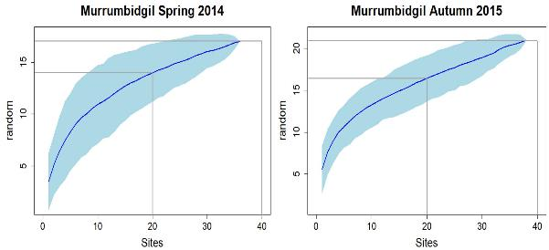
Figure 14-1. Randomized species accumulation curves for Murrumbidgil Swamp in Spring 2014 and Autumn 2015, generated using number of individuals and the number of 1 X 1m quadrats (sites).
The vegetation on semi-arid floodplains such as the vegetation which occurs on the lower Lachlan river is known to change in species assemblage and the abundance and cover of different species related to hydrological conditions. For this reason, a SAC is presented for each non-tree site using more than one sampling trip under different hydrological conditions, i.e., directly following large scale flooding, a drying period, or during a very dry period.
At Booligal, SACs were derived using data obtained during Autumn 2016, Autumn 2017 and Autumn 2019. The first two SACs (Autumn 2016 and Autumn 2017) are following inundation in the preceding Summer while the third SAC (Autumn 2019) is during a very period. The SACs during/following inundated conditions in 2016 and 2017 are approaching an asymptote while the SAC during a dry period may continue to increase in number of species with increasing sampling effort before the curve flattens (Figure 14-2). The number of species observed is much higher following flooded conditions compared to that observed in dry conditions.
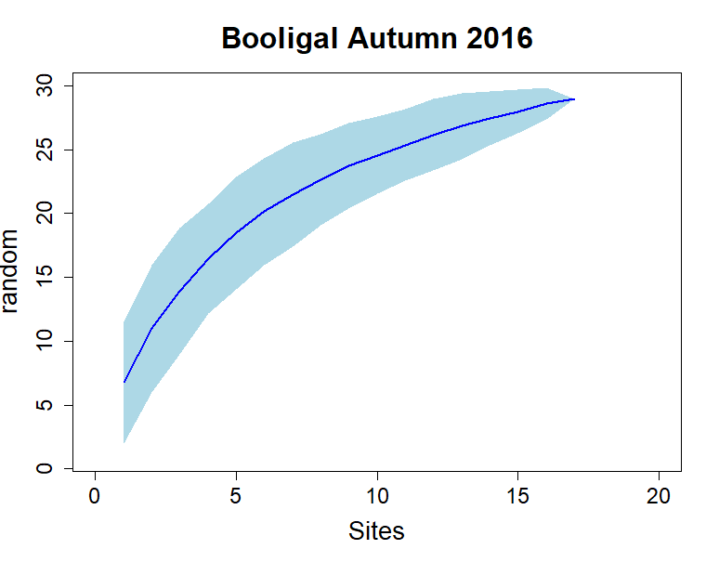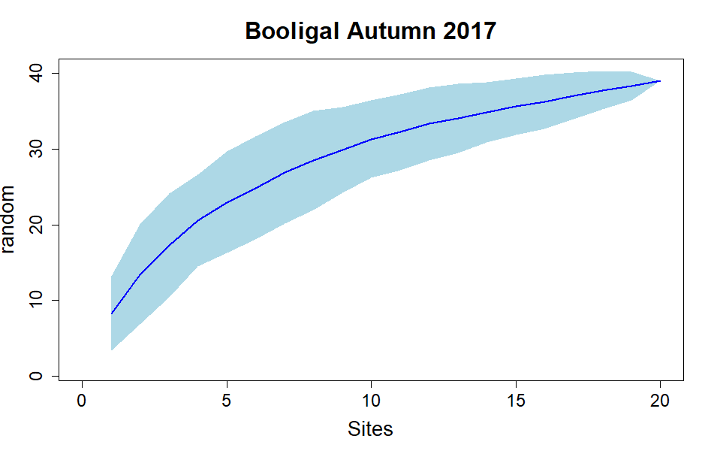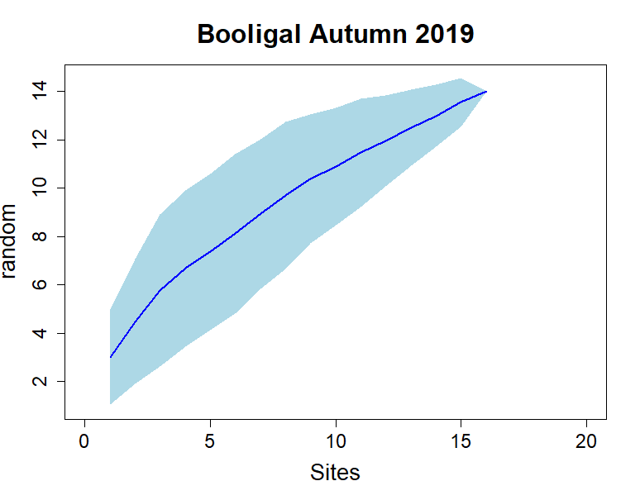
Figure 14-2. Randomized species accumulation curves for Booligal Swamp in Autumn 2016, Autumn 2017 and Autumn 2019, generated using number of individuals and the number of 1 X 1m quadrats (sites).
At Whealbah Lagoon, SACs were derived using data obtained during Autumn 2016, Spring 2017 and Spring 2019. Again, the first two SACs are during a period of high rainfall and Whealbah Lagoon was monitored following flood recession, while the third SAC was during an extended dry period. While different numbers of species were observed in dry and wet conditions, all three SACs are approaching an asymptote (Figure 14-3).
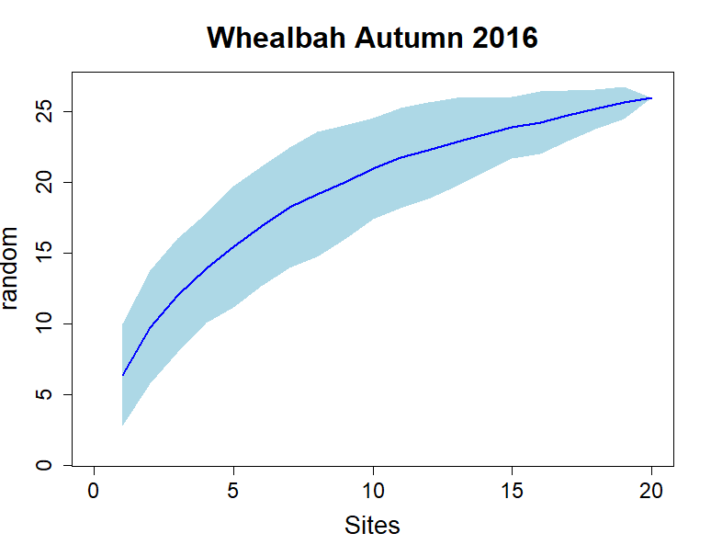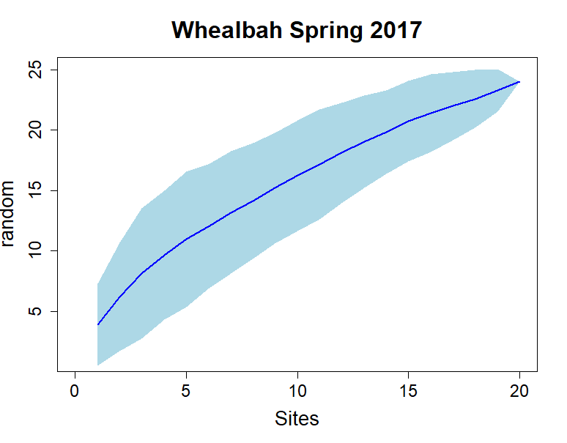
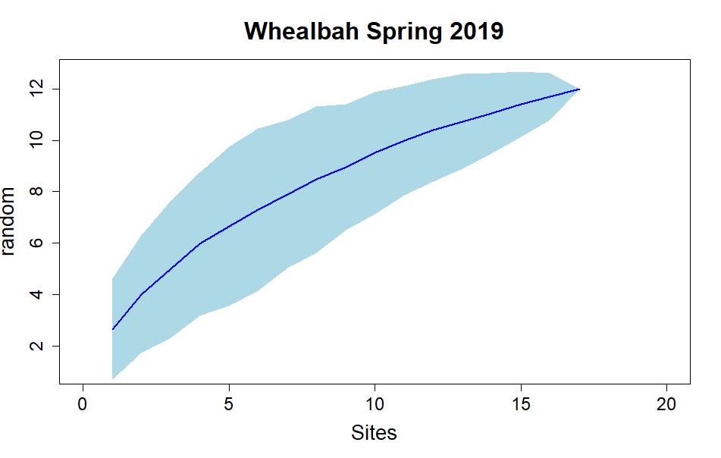
Figure 14-3. Randomized species accumulation curves for Whealbah Lagoon in Autumn 2016, Spring 2017 and Spring 2019, generated using number of individuals and the number of 1 X 1m quadrats (sites).
A similar result was observed at Hazelwood, The Ville, Lake Bullogal, Lake Marool, and Nooran Lake. The SAC in Autumn 2017 at these sites was following widespread flooding and in Spring 2019 during a dry period. While different numbers of species were observed between sampling points, in all cases these appear to be approaching an asymptote (Figure 14-4).
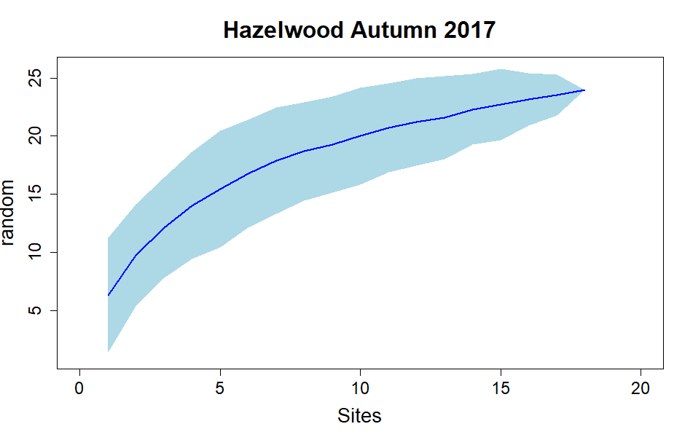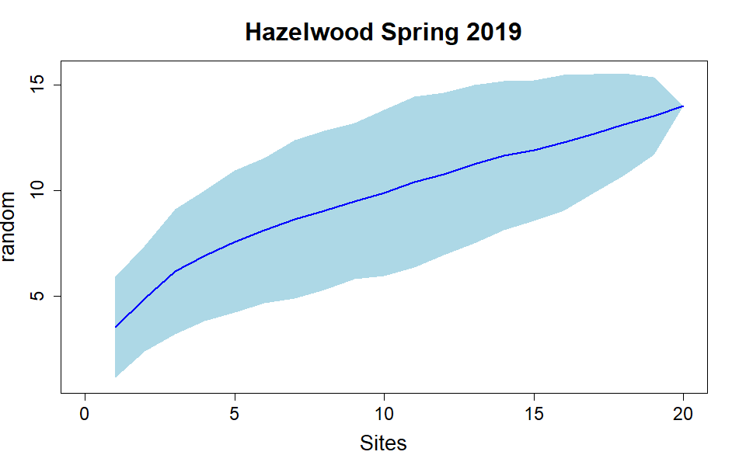
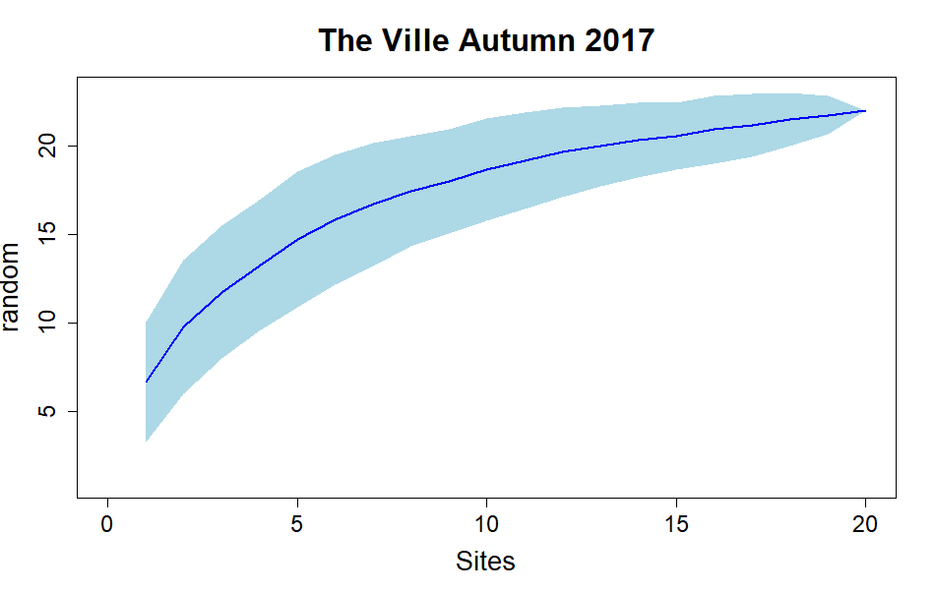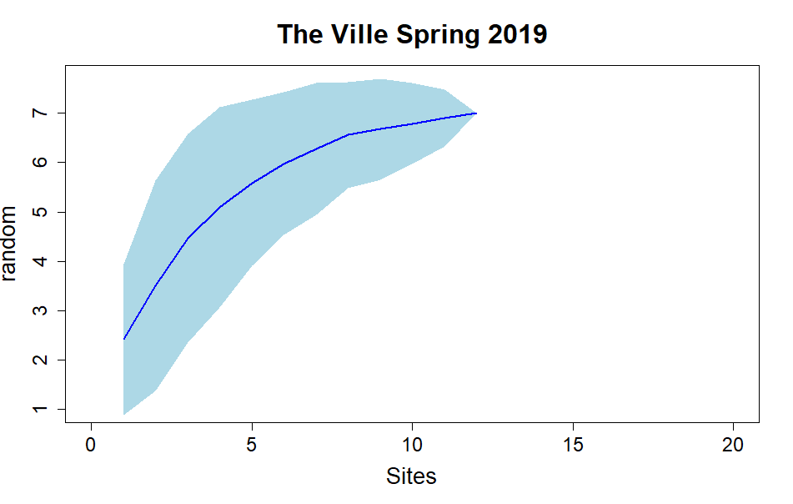
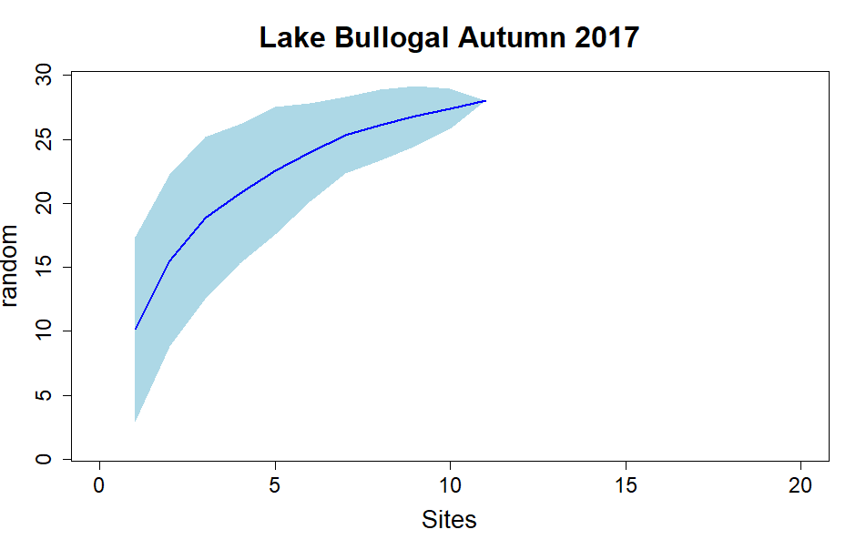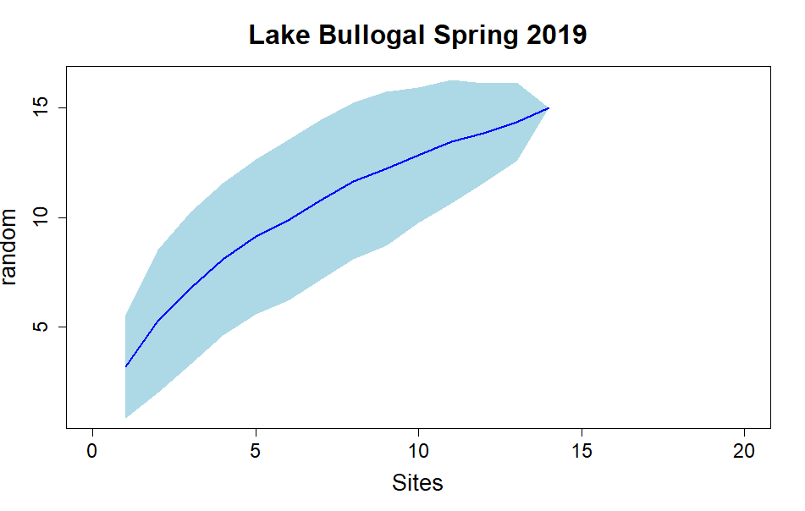
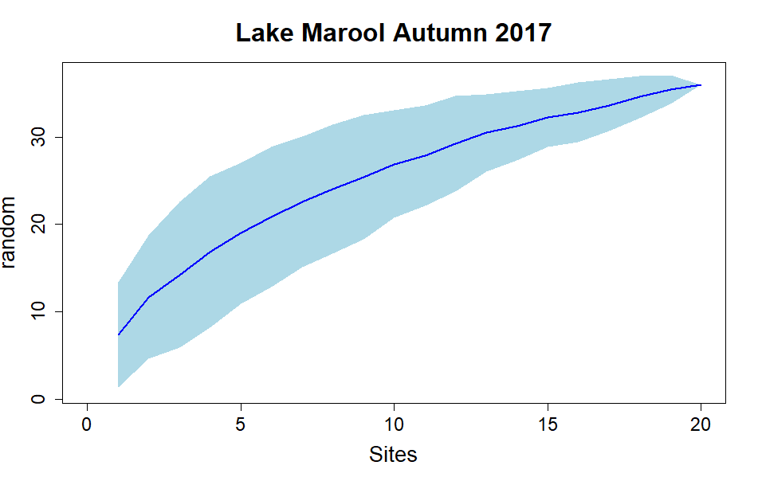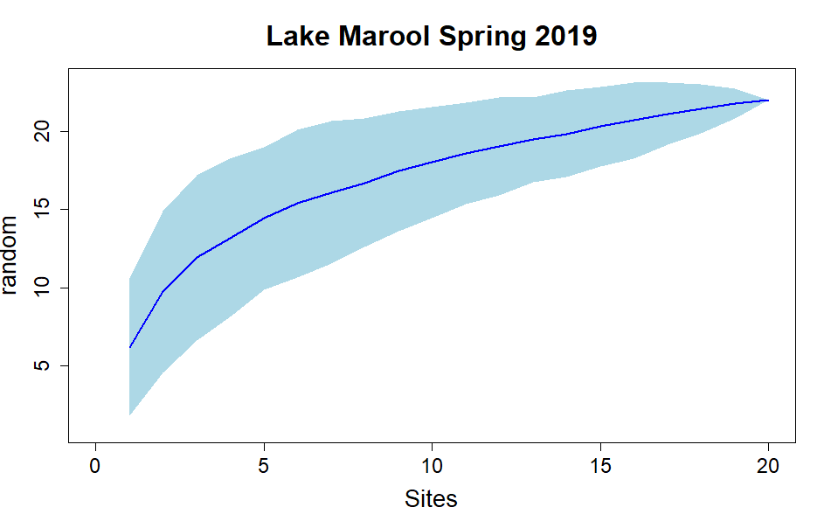
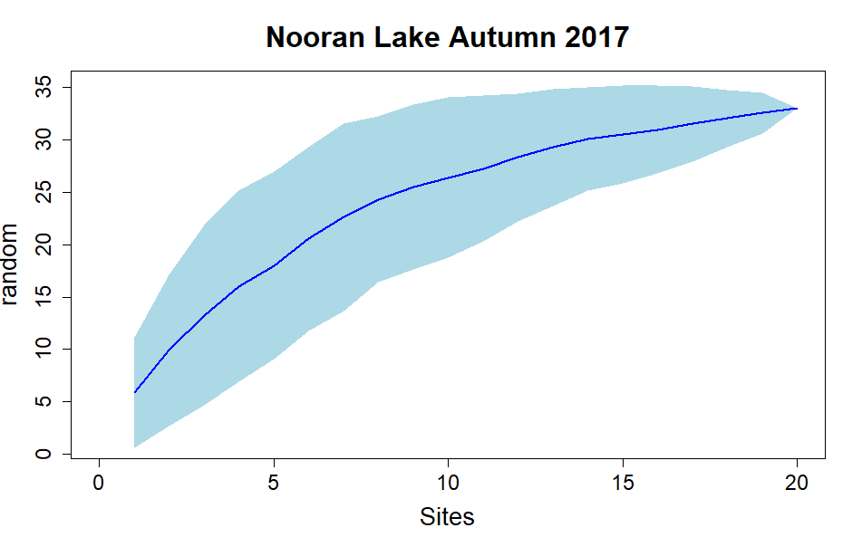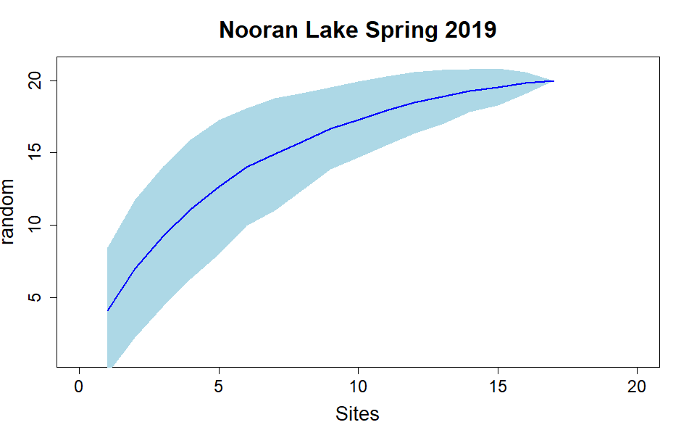
Figure 14-4. Randomized species accumulation curves for Hazelwood, The Ville, Lake Bullogal, Lake Marool, and Nooran Lake in Autumn 2017 and Spring 2019, generated using number of individuals and the number of 1 X 1m quadrats (sites).
At Lake Tarwong and Moon Moon, SACs were undertaken for Spring 2017 (following flood recession) and Autumn 2019 during a dry period. Again, Figure 14-5 shows that the SACs in both conditions appear to be reaching an asymptote. During Autumn 2019 Moon Moon was monitor following higher than average rainfall over the preceding 2 months resulting in very high cover of groundcover species while Lake Tarwong was monitored two months earlier in the same year before this rainfall occurred following lower than average rainfall conditions. This resulted in Lake Tarwong having quadrats containing no plants (Figure 14-5).
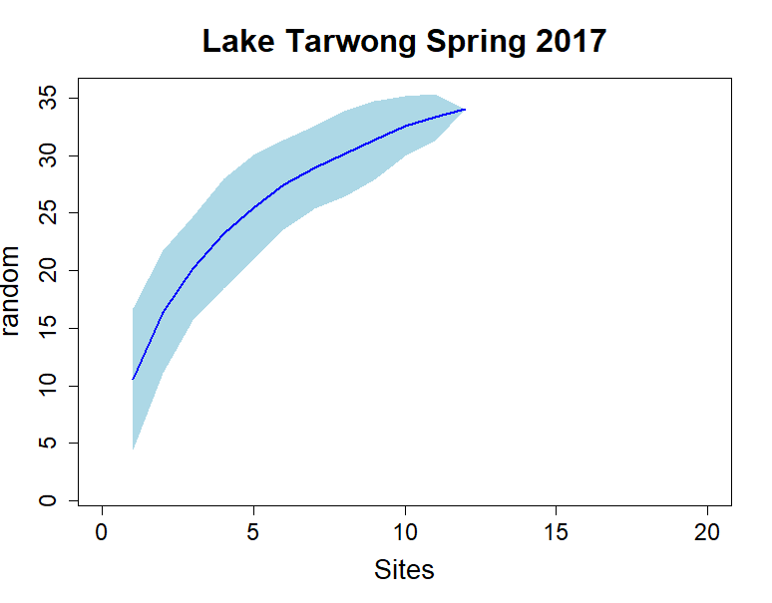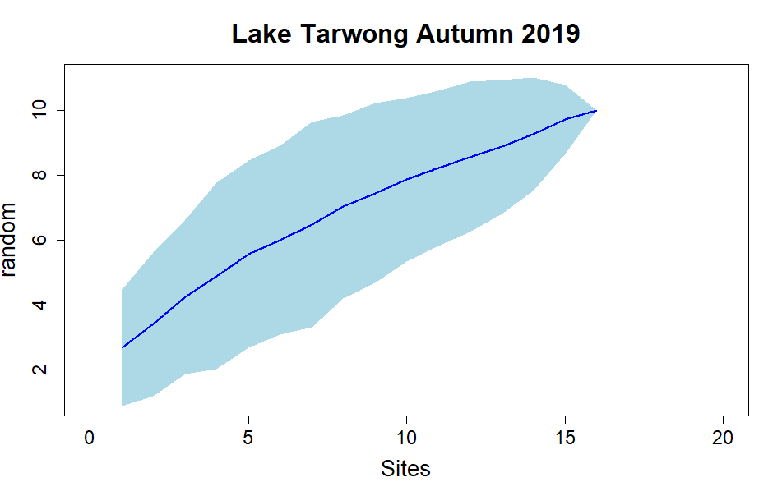
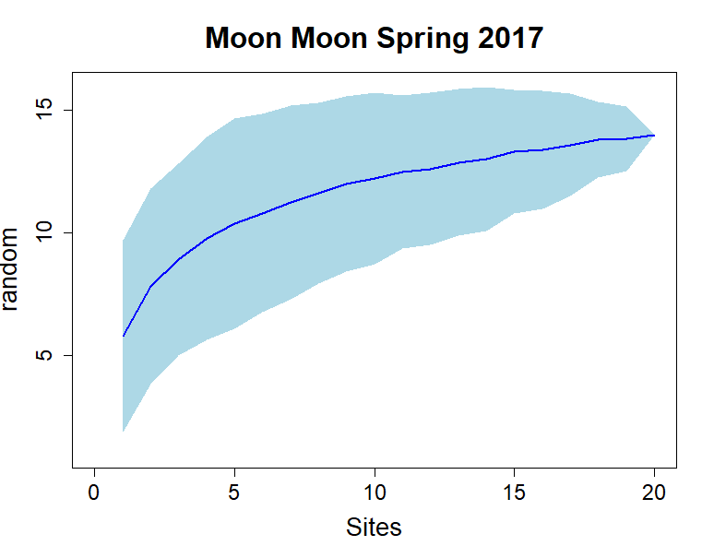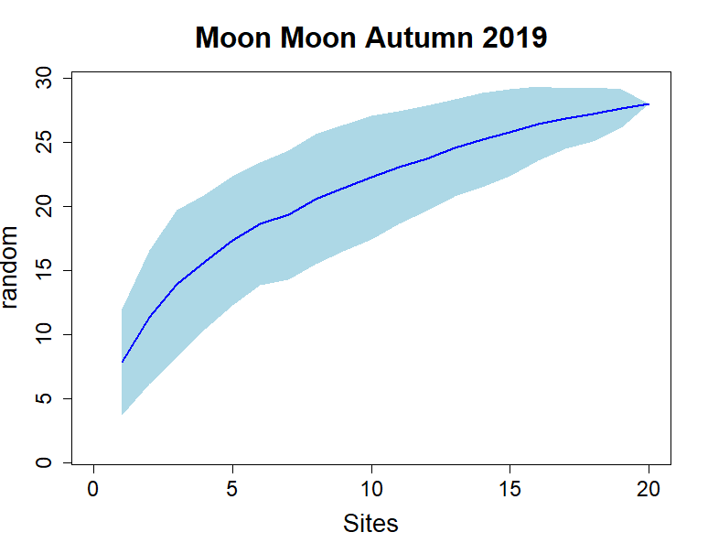
Figure 14-5. Randomized species accumulation curves for Lake Tarwong and Moon Moon Swamp in Spring 2017 and Autumn 2019, generated using number of individuals and the number of 1 X 1m quadrats (sites).
At the commencement of the MER program in Spring 2019 three additional non-tree sites were included that had not been monitored as part of LTIM. These included an additional site at Lake Marool within the open lake, and Juanbung and Bunumburt. SACs were undertaken using vegetation data obtained during Spring 2019, which was a dry period, although Juanbung had been recently flooded. These newly established sites appear to be behaving similarly to the existing sites and 20 quadrats appears to be adequate to represent the species richness at each site (Figure 14-6).
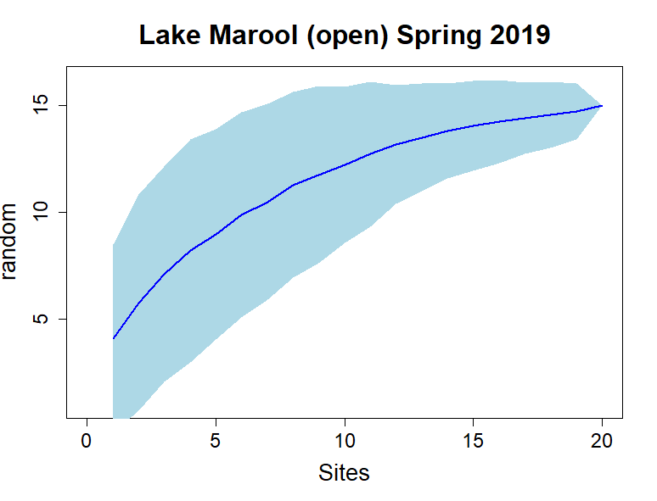
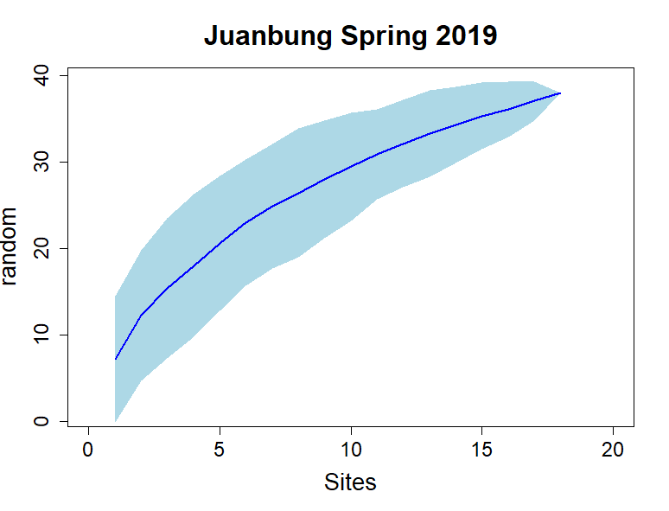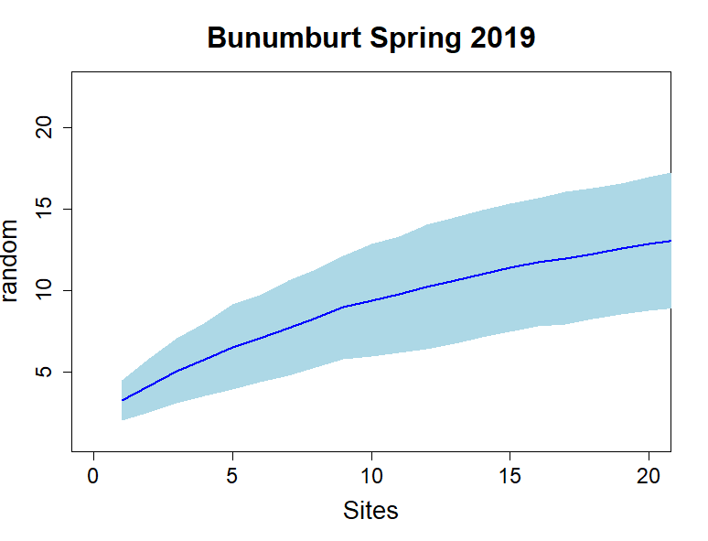
Figure 14-6. Randomized species accumulation curves for Lake Marool (open), Juanbung, and Bunumburt in Spring 2019, generated using number of individuals and the number of 1 X 1m quadrats (sites).
Some monitoring events have more quadrats containing no plants compared to other times. We have tried to avoid using monitoring events with few species observed within few quadrats. These monitoring events are usually periods where water was covering some quadrats or had inundated the quadrats for an extended period prior to monitoring. This occurred at sites such as Lake Tarwong, Lake Bullogal, Moon Moon and Juanbung. These sites retain water for extended periods. This was also observed during extended dry periods at some sites, where there was a very low ground cover of live vegetation.

Note that the NSW Government Department that was the Office of Environment and Heritage is now a part of the Department of Planning, Industry and Environment. The acronym remains as documents published prior to 2019, still retain the OEH authorship.
Based on field estimates from Driver et al. (2004) and advice from the NSW Environmental Water Manager as reported in Higgisson et al. (2019).
Installed by the NSW environmental water team

