# Attachment 2: Instructions for registration of businesses under Article 9 of GACC Decree 248 to fill online single window application form

**Step 1:** Open the [single window service system](https://app.singlewindow.cn/userserver/user/userEtpsRegister/choseRgtWay?service=https%3A%2F%2Fswapp.singlewindow.cn%2Fdeskserver%2Fj_spring_cas_security_check) online registration platform. This link will take you to the below page.

Click on the blue globe for overseas establishment registration as shown by the red arrow.

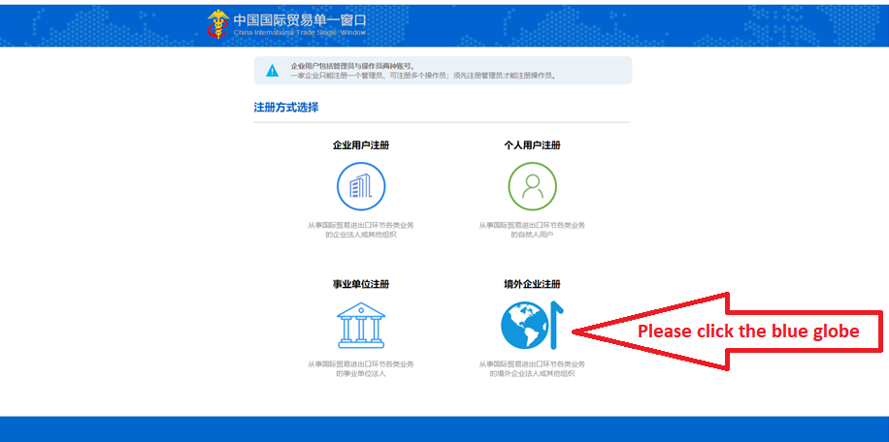

**Step 2:** After clicking on the blue globe, a [new page](https://app.singlewindow.cn/userserver/user/abroad/index) will appear (refer below).

This is the online application form.

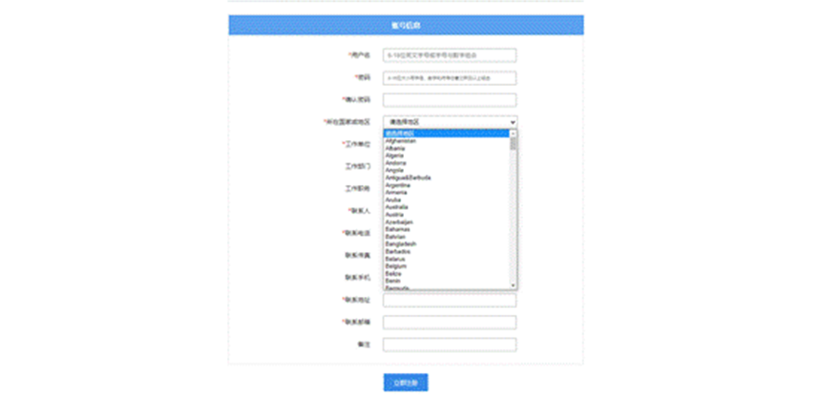

**Step 3:** Fill in the form (below is the unofficial translation of the form)

**境外账号注册Overseas account registration**

**账号信息Account information**

*用户名 Username (6-18 digits of English letters, or letters combined with numbers）[Control]

*密码 Password (6 to16 digits of lower-or higher-case letters with numbers and symbols)[Control]

*确认密码 Password confirmation [Control]

*所在国家或地区 Located country or region[Control]

*工作单位 Work organisation[Control]

工作部门 Work division in the organisation [Control]

工作职务 Work position[Control]

*联系人 Contact person [Control]

*联系电话 Contact phone[Control]

联系传真 Contact fax[Control]

联系手机 Contact mobile phone[Control]

*联系地址 Contact address[Control]

*联系邮箱 Contact email [Control]

备注 Remark [Control]

'立即注册 Submit the form immediately

**Step 4:** Once registered successfully you will be automatically re-directed to the below [logon platform](https://app.singlewindow.cn/cas/login?service=https%3A%2F%2Fapp.singlewindow.cn%2Fuserserver%2Fj_spring_cas_security_check).

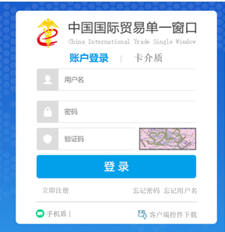

**Step 5:** Fill out login platform details. Below is an unofficial translation of [the logon platform](https://app.singlewindow.cn/cas/login?service=https%3A%2F%2Fapp.singlewindow.cn%2Fuserserver%2Fj_spring_cas_security_check).

|  |  |  |
| --- | --- | --- |
| **中国国际贸易单一窗口 China International Trade Single Window** | | |
| 用户名 Username | | |
| 密码 Password | | |
| 验证码 Verification code (If the code on the right side cannot be seen clearly, please click it to change for a new code) | |  |
| 登录 Logon | | |
| 立即注册 Register immediately | 忘记密码 Forgot password? | 忘记用户名 Forgot username? |
| 手机盾 Mobile phone shield | | 客户端控件加载 Client control APP download |

Once login is completed, there are no more steps for users and you are successfully registered. GACC may use the logon platform to request users provide extra information or provide further guidance on next steps at a later date.