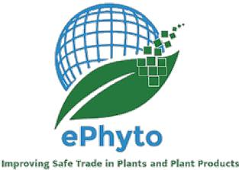

ePHYTO WORKSHOP BY THE INDUSTRY ADVISORY GROUP SUPPORTED BY THE IPPC

SECRETARIAT

THEME: EPHYTO AND STATE OF PLAY IN AUSTRALIA AND NEW ZEALAND

**28th July 2022**

**09:00 AM – 10:00 AM CEST / 17:00 – 18:00 PM AEST / 19:00 – 20:00 PM NZST**

PROVISIONAL PROGRAMME

1. **WELCOME AND OPENING REMARKS**

1.1. BENEFITS AND EXPERIENCE OF THE PRIVATE SECTOR - INDUSTRY ADVISORY GROUP (IAG)

Speakers: Co-Chairs of the ePhyto IAG: Rose Souza Richards (ISF) and Alejandra Danielson Castillo (U.S. Grains Council)

1.2. INTRODUCTION OF EPHYTO FROM THE IPPC SECRETARIAT
  
Speaker: Craig Fedchock, IPPC Secretariat

1.3. CURRENT STAGE OF ePHYTO SOLUTION IMPLEMENTATION IN AUSTRALIA AND NEW ZEA­LAND

Speakers:

1. **Q&A**

Audience members are invited to ask questions and/or to provide remarks.

1. **END OF THE WORKSHOP**

Presenters will make brief closing remarks and the Co-Chairs of the IAG will make a sum­mary of the main outcomes of the deliberations before bringing the workshop to a close.