Meat notice

| Meat notice number: | 2023-07 |
| --- | --- |
| Meat notice title: | **Security seal disposal process** |
| Category: | Legal requirements incl market access requirements |

| NSFS reference | Issue date | Date of effect | Review date |
| --- | --- | --- | --- |
| 5 |  | 1 October 2023 | October 2025 |

| Contact officers | Distribution categories |
| --- | --- |
| officialmarks.exportmeat@agriculture.gov.au | X Central and regional office  X Departmental on-plant officer(s) |
| Adam Balcerak  Director Meat Export Branch Exports and Veterinary Division.  Ph: +61 435 244 366  Email: Adam.Balcerak@aff.gov.au | X Managers, export meat establishments  State/Territory regulatory authorities  X Approved Islamic organisations  Other: |

### Purpose

This notice provides notification of the process that will be undertaken to dispose of superseded official marks – bolt seals and tamper-indicative metal strap seals.

### Scope

This notice applies to all export registered establishments.

### 3. Summary of changes

The department will commence a process to dispose of superseded official marks – bolt seals and tamper-indicative metal strap seal from 1 October 2023, by engaging our security seal provider to coordinate the return of all department seals for destruction.

Establishments that do not have a department official onsite must complete the Export Security Seal Return Form and email to [vemgplanning&coord@aff.gov.au](mailto:vemgplanning&coord@aff.gov.au). The return form will be processed, and seals will be collected from establishments and prepared for destruction.

Establishments that do have a department official onsite, please use the table below to identify the action required.

All superseded security seals must be returned by 24 November 2023.

|  |  |
| --- | --- |
| **Description** | **Details** |
| **1 box or less** of bolt or tamper indicative seals (Tyden/metal) | To be destroyed at the establishment – Certificate of Destruction to be completed by company representative and endorsed by department official and emailed to [vemgplanning&coord@aff.gov.au](mailto:vemgplanning&coord@aff.gov.au). |
| **More than 1 box** of bolt or tamper indicative seals (Tyden/metal) | Company representative to complete the export security seal return form, prepare the boxes for collection by courier and email [vemgplanning&coord@aff.gov.au](mailto:vemgplanning&coord@aff.gov.au) their return form. Direct Freight Express will collect the seals as return forms are processed by Mega Fortris. |

Superseded Seals are pictured below.

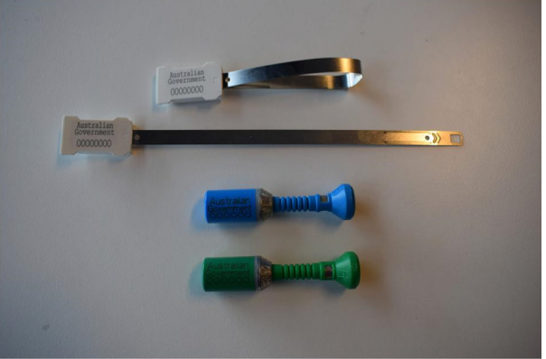

4. Requirements

Establishments must email the completed security return form or destruction certificate to [VEMGPlanning&Coord@agriculture.gov.au](mailto:VEMGPlanning&Coord@agriculture.gov.au).

The export-security seal certificate of destruction form and the export security seal return form are provided with this meat notice, additionally the forms will be available on the Agriculture website. [Order forms for Container and Tamper-indicative seals - DAFF (agriculture.gov.au)](https://aus01.safelinks.protection.outlook.com/?url=https%3A%2F%2Fwww.agriculture.gov.au%2Fbiosecurity-trade%2Fexport%2Fcontrolled-goods%2Fmeat%2Felmer-3%2Fcontainer-seals&data=05%7C01%7CBelinda.Ansford%40aff.gov.au%7C6eded30bec1141d6035b08db96d12b7c%7C2be67eb7400c4b3fa5a11258c0da0696%7C0%7C0%7C638269597336345794%7CUnknown%7CTWFpbGZsb3d8eyJWIjoiMC4wLjAwMDAiLCJQIjoiV2luMzIiLCJBTiI6Ik1haWwiLCJXVCI6Mn0%3D%7C3000%7C%7C%7C&sdata=zhPAktu3azyh1C25XI4lmY8OzmDY0g1ISEq%2FDuhtd1c%3D&reserved=0)

Adam Balcerak

Director Meat Export Branch Exports and Veterinary Division.

21/09/2023

## 

|  |  |  |  |  |
| --- | --- | --- | --- | --- |
| **Appendix 1** | | | |  |
| Department of Agriculture, Fisheries and Forestry | | | | **Export Security Seal Return Form**  **Email Address:** [VEMGPlanning&Coord@aff.gov.au](mailto:VEMGPlanning&Coord@aff.gov.au) |
| **COMPANY USE ONLY** | | | | |
| **To be completed by company representative.** | | | | ***Please type your responses.*** |
| **Establishment No.:** | | | | **Company Name:** |
| **Company Representative: (printed name)** | | | | **Address:** |
| **Company Contact Number:** | | | |
| **Description of Item/s** | **No. of Seals** | **Total Weight (kgs)** | **Original Packaging Y/N** | **Serial Numbers (please ensure all serial numbers are clearly listed in the spaces below for each seal type.** |
| **Bolt Seals - Green (supplied in boxes of 200)** |  |  |  |  |
|  |
|  |
|  |
|  |
|  |
| **Bolt Seals - Blue (supplied in boxes of 200)** |  |  |  |  |
|  |
|  |
|  |
|  |
|  |
| **Tamper Indicative Seals – White (supplied in boxes of 1000)** |  |  |  |  |
|  |
|  |
|  |
|  |
|  |
| * *All superseded export security seals provided by the Australian Government must be destroyed.* * *This form must be completed and returned to the department for processing prior to seals being collected for destruction.* * *Please return this form to the department via email* [*VEMGPlanning&Coord@aff.gov.au*](mailto:VEMGPlanning&Coord@aff.gov.au)*. On receipt of the form the department’s third-party provider will contact you to arrange collection of seals.* * *For seals being destroyed under supervision by an authorised government representative a Destruction Certificate must be completed (separate form).* | | | | |

|  |  |
| --- | --- |
| **Appendix 2** | |
| Department of Agriculture, Fisheries and Forestry | **Export Security Seal Destruction Certificate**  **Email Address:** [VEMGPlanning&Coord@aff.gov.au](mailto:VEMGPlanning&Coord@aff.gov.au) |
| **To be completed by company representative.** | ***Please type your responses.*** |
| **Establishment No.:** | **Company Name:** |
| **Company Representative: (printed name)** | **Signature:** |
| **Description of Item/s** | **Serial Numbers (please ensure all serial numbers are clearly listed in the spaces below for each seal type.** |
| **Bolt Seals - Green** | |
|  |  |
|  |  |
|  |  |
|  |  |
|  |  |
| **Bolt Seals - Blue** | |
|  |  |
|  |  |
|  |  |
|  |  |
|  |  |
| **Tamper Indicative Seals – White** | |
|  |  |
|  |  |
|  |  |
|  |  |
|  |  |
| **Acknowledgement of Destruction:** | **Department Use Only:** |
| **Printed Name:** | **Signature:** |
| **Date:** |
| *All superseded export security seals provided by the Australian Government must be destroyed.* | |