Biosecurity funding and expenditure report 2024‒25

© Commonwealth of Australia 2025
Ownership of intellectual property rights
Unless otherwise noted, copyright (and any other intellectual property rights) in this publication is owned by the Commonwealth of Australia (referred to as the Commonwealth).
Creative Commons licence
All material in this publication is licensed under a Creative Commons Attribution 4.0 International Licence except content supplied by third parties, logos and the Commonwealth Coat of Arms.

Cataloguing data
This publication (and any material sourced from it) should be attributed as: DAFF 2025, Biosecurity funding and expenditure report 2024‒25, Department of Agriculture, Fisheries and Forestry, Canberra. CC BY 4.0.
This publication is available at agriculture.gov.au/biosecurity-trade/policy/sustainable-biosecurity-funding.
Department of Agriculture, Fisheries and Forestry
GPO Box 858 Canberra ACT 2601
Telephone 1800 900 090
Web agriculture.gov.au
Disclaimer
The Australian Government acting through the Department of Agriculture, Fisheries and Forestry has exercised due care and skill in preparing and compiling the information and data in this publication. Notwithstanding, the Department of Agriculture, Fisheries and Forestry, its employees and advisers disclaim all liability, including liability for negligence and for any loss, damage, injury, expense or cost incurred by any person as a result of accessing, using or relying on any of the information or data in this publication to the maximum extent permitted by law.
Acknowledgement of Country
We acknowledge the continuous connection of First Nations Traditional Owners and Custodians to the lands, seas and waters of Australia. We recognise their care for and cultivation of Country. We pay respect to Elders past and present, and recognise their knowledge and contribution to the productivity, innovation and sustainability of Australia’s agriculture, fisheries and forestry industries.

Contents
Introduction 1
Biosecurity in action 2
Funding the biosecurity system 3
Appropriations from government 3
Cost recovery revenue 3
Own-source revenue 4
Emergency response and incursion management 4
Biosecurity budget 6
Biosecurity expenditure 7
Financial performance 11
Progress against DAFF Biosecurity 2030 Roadmap 13
Tables
Table 1 Biosecurity budget, by funding source, 2024‒25 to 2028‒29 6
Table 2 Biosecurity budget, by funding source and subcategory, 2024–25 to 2028–29 6
Table 3 Biosecurity expenses, by activity, 2024‒25 8
Table 4 Biosecurity expenditure and budget variance, 2024‒25 11
Figures
Figure 1 Commonwealth biosecurity funding sources 3
Figure 2 Expenditure in 2024–25, by control stage 9
Figure 3 Expenditure in 2024–25, by pathway class 10
Figure 4 Cargo volume growth, 2020‒21 to 2024‒25 12
Case studies
Case study 1 Remote surveillance of varroa mite in honey bee hives 13
Case study 2 AusTreat pre-border treatment provider assurance scheme 14
Case study 3 Papua New Guinea Biosecurity Twinning Program 14
Case study 4 Northern Australia Biosecurity Strategy 2030 15
Case study 5 Modern Technologies and Diagnostic Tools 15
Case study 6 Junior Biosecurity Officer program 16
Case study 7 Simplified Targeting and Enhanced Processing Systems program 16
Case study 8 Exercise Volare – whole-of-government H5 HPAI preparedness exercise 17
Case study 9 National Management Agreement for H5 HPAI in Wildlife 17

Introduction
The Biosecurity funding and expenditure report 2024–25 marks the second year of dedicated transparent biosecurity financial reporting. The report is a continuation of the Australian Government’s sustainable biosecurity funding commitment to provide greater transparency of biosecurity activities, budget and expenditure.
The Biosecurity funding and expenditure report 2023‒24 report established the foundation for future versions, presenting biosecurity-specific financial data from our internal reporting systems. This year’s report expands on that foundation, introducing analysis of our biosecurity expenditure and progress reporting against the DAFF Biosecurity 2030 Roadmap.
We have included greater insight into how we manage the Commonwealth’s biosecurity system and use our resources to manage growing and increasingly complex biosecurity risks. This report complements existing public reporting such as the portfolio budget statements, annual reports and corporate plans. For a complete view of the Department of Agriculture, Fisheries and Forestry’s financial and non-financial performance for 2024–25, see the annual report.
While budget statements and annual reports present aggregated financial data at an outcome (biosecurity and export services) and department level, this report shows biosecurity-specific funding and expenditure. Funding is represented as budgeted figures up to and including Budget 2025‒26. Expenditure figures are actuals for the 2024‒25 financial year.

Biosecurity in action
Australia’s biosecurity system is fundamental to protecting our environment, economy and way of life. Australia’s extensive coastline, large agricultural export volumes, unique biodiversity and increased global connectedness make us particularly vulnerable to biosecurity threats.
In their report on valuing Australia’s biosecurity system, the Centre of Excellence for Biosecurity Risk Analysis estimates that without the biosecurity system, newly introduced pests and diseases would cause $670 billion in damages to vulnerable assets such as agriculture, forestry and infrastructure over a 50-year period. In contrast, damages would be less than 50% of that amount with the biosecurity system in place over the same period.
Complexity and volumes of trade, travel and environmental pressures are increasing. This means we need a productive, resilient and sustainable biosecurity system that can prevent, detect and respond to emerging threats.
In 2024‒25 volumes of cargo, people, mail and vessels continued to increase. We assessed over 26,000 import permit applications and supported the clearance of more than:
- 154 million import cargo consignments (resulting in over 19,400 pest and disease identifications)
- 2.6 million containers (with over 680,000 requiring the department’s intervention)
- 23 million international travellers, consisting of over 22.7 million air travellers and over 490,000 sea travellers (resulting in over 6,400 pest and disease identifications)
- 19,100 vessels arriving in Australia (resulting in over 3,700 pest and disease identifications)
- 109,800 international aircraft
- 7,800 animals (cats, dogs and horses).
Activities in 2024‒25 that have contributed to a productive, resilient and sustainable biosecurity system are reported through case studies in this report (see Progress against the DAFF Biosecurity 2030 Roadmap).

Funding the biosecurity system
Funding for the Commonwealth biosecurity system is allocated to meet the department’s statutory responsibilities for managing biosecurity risks. The Secretary of the Department of Agriculture, Fisheries and Forestry is the Director of Biosecurity and is responsible for the general administration of the Biosecurity Act 2015. The Commonwealth biosecurity system is funded through appropriations from government, cost recovery revenue and own-source revenue. A fourth source of funding is committed separately by government for emergency response and incursion management (Figure 1).
Figure 1 Commonwealth biosecurity funding sources
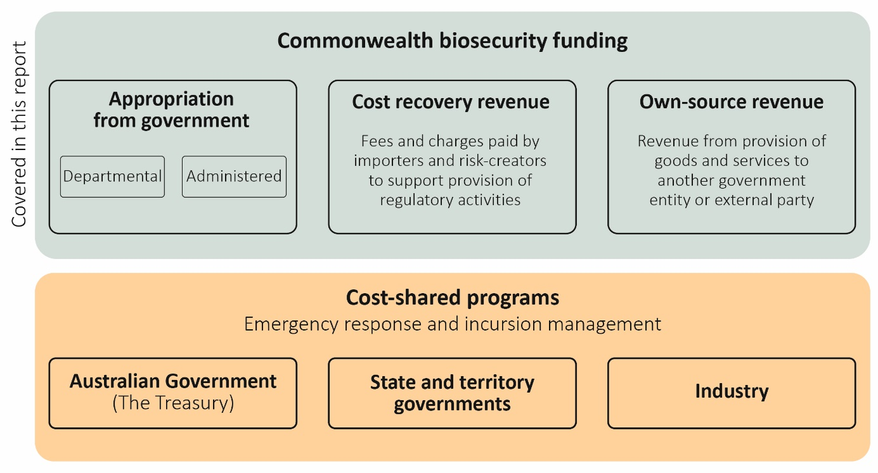

Appropriations from government
We receive departmental and administered appropriations from government:
- Departmental appropriations – We have control over these funds to run day-to-day and program support operations (e.g. staff salaries, purchasing goods and services, property-related costs and other operational expenditure).
- Administered appropriations – We manage these funds on behalf of the government, including for payments to state and territories, grant programs and other expenditure for specific government or public purposes.

Cost recovery revenue
We recover costs from industry for a range of regulatory activities and receive revenue through fees and charges for the provision of biosecurity regulatory activities under the biosecurity cost recovery arrangement. Cost recovery activities must comply with the Australian Government Charging Framework.
The 2024‒25 Biosecurity Cost Recovery Implementation Statement sets out the fees and charges applied under the biosecurity cost recovery arrangement during the financial year.
We also receive a legislated annual fee from Australia Post for conducting biosecurity clearance on items processed at international mail gateway facilities.
The self-assessed clearance (SAC) cost recovery charge of 36 cents per consignment for low-value goods imported into Australia commenced on 1 October 2024. The charge, which applies to goods valued at less than $1,000, enables the department to sustainably fund activities in the SAC pathway. The cost for biosecurity clearance of SAC goods was previously met by taxpayers.

Own-source revenue
We raise other revenue to offset the costs of providing biosecurity goods and services.
Section 74 of the Public Governance, Performance and Accountability Act 2013 provides a mechanism that allows us to retain funds (revenue) to cover the costs of specified activities. This includes revenue to meet the costs of providing a good or service – e.g. offshore biosecurity inspections, application or processing fees, and the provision of services to other government agencies.
We raise additional revenue from service contracts and activities we participate in that are funded by other departments – for example:
- offshore inspections and auditing – activities undertaken offshore by the department, or an approved provider, to mitigate certain biosecurity risks
- National Arbovirus Monitoring Program – revenue from Animal Health Australia to deliver the program
- Pacific Biosecurity Strategy – delivering capacity-building activities, supported by funding from the Department of Foreign Affairs and Trade (DFAT)
- Australian Plague Locust Commission – cost-shared arrangement to monitor and manage locust populations across New South Wales, Victoria, Queensland and South Australia.
We also recover biosecurity costs associated with the movement of military goods, conveyances and personnel into Australia via a memorandum of understanding (MoU) with the Department of Defence. This includes an indexed annual payment from Defence to cover costs associated with Australian Defence Force movements.
This arrangement funds dedicated resourcing for these activities, reducing the demand on biosecurity resources intended to support clearance of commercial cargo, passengers and conveyances.

Emergency response and incursion management
We lead the Australian Government’s efforts to minimise the impact of pests and diseases on Australian agriculture and our environment. Funding for these emergency biosecurity responses is separate to the biosecurity operational funding outlined in this report.
The Australian Government contributes to nationally cost-shared emergency biosecurity responses under:
- Emergency Animal Disease Response Agreement (EADRA)
- Emergency Plant Pest Response Deed (EPPRD)
- National Environmental Biosecurity Response Agreement (NEBRA)
- National Fire Ant Eradication Program (NFAEP)
- other responses established outside of EADRA, EPPRD, NEBRA and NFAEP.
In 2024‒25, in consultation with the National Biosecurity Committee (NBC), we led the development of the National Management Agreement – H5 HPAI in Wildlife to share the costs of any future response to high pathogenicity avian influenza (see Strategic Action 9).
National biosecurity emergency responses are cost shared between the Commonwealth, states and territories and, where appropriate, industry parties to EADRA and EPPRD. The Project Agreement for Pest and Disease Preparedness and Response Programs provides the mechanism for the Commonwealth to pay its cost-sharing contribution to the responsible jurisdiction on an individual response basis. The impacted state or territory delivers the response activities.
Funding contributions by parties, including industry, are approved by the National Management Group (NMG) as set out in the relevant deed or agreement in response to biosecurity incidents. The NMG comprises a representative of each cost-sharing party to the individual response.
At Budget 2025‒26 the Australian Government had committed $582.6 million in funding from
2024‒25 to 2028‒29 under the project agreement (Budget Paper No. 3, page 95). This includes provision for underwriting industry contributions, which are repaid through levy arrangements prescribed in each deed or agreement, or voluntary means. Because these payments are made to states and territories for specific purposes, the Treasury facilitates the payments in consultation with our department.
Under the terms of the emergency response cost-sharing agreements, the Australian Government is liable for a portion of the total government funding for a national response to a pest or disease incursion. Accordingly, the Australian Government discloses an unquantifiable contingent liability for emergency pest and disease response arrangements (Budget Paper No. 1, page 202).

Biosecurity budget
The department has a biosecurity budget of over $850 million per year, which is split relatively evenly between appropriation funding and cost recovery revenue.
Table 1 shows the biosecurity budget by funding source for 2024‒25 and over the forward estimates. An observable decline in appropriation funding from 2025–26 to 2026–27 is primarily due to the planned conclusion of terminating measures announced since the 2023–24 Budget. A further breakdown of the budget by funding sources is detailed in Table 2 covering the same period.
Table 1 Biosecurity budget, by funding source, 2024‒25 to 2028‒29
Funding source | 2024‒25 ($m) | 2025‒26 ($m) | 2026‒27 ($m) | 2027‒28 ($m) | 2028‒29 ($m)
Cost recovery ª | 423.1 | 480.5 | 494.9 | 505.3 | 515.7
Base appropriation | 403.4 | 404.5 | 364.3 | 361.4 | 373.3
STEPS program appropriation | 59.2 | 50.0 | n/a | n/a | n/a
Total biosecurity funding | 885.7 | 935.0 | 859.2 | 866.7 | 889.0
Note: Figures reflect government decisions made up to and including Budget 2025‒26. a Includes the cost recovery arrangement, Australia Post, Defence and other own-source revenue. n/a Not applicable. STEPS Simplified Targeting and Enhanced Processing System.
Table 2 Biosecurity budget, by funding source and subcategory, 2024–25 to 2028–29
Funding source | Subcategory | 2024‒25 ($m) | 2025‒26 ($m) | 2026‒27 ($m) | 2027‒28 ($m) | 2028‒29 ($m)
Cost recovery | Existing cost recovery arrangement | 368.8 | 390.9 | 398.2 | 407.7 | 417.5
Cost recovery | Cost recovery – SAC | 27.1 | 64.4 | 65.9 | 67.5 | 69.1
Cost recovery | Australia Post | 15.3 | 15.6 | 15.8 | 16.0 | 16.0
Cost recovery | Defence | 1.9 | 1.5 | 2.3 | 1.8 | 1.8
Cost recovery | Other s74 revenue | 10.0 | 8.1 | 12.7 | 12.2 | 11.3
Cost recovery | Total cost recovery | 423.1 | 480.5 | 494.9 | 505.3 | 515.7
Appropriation | Departmental appropriation | 369.0 | 394.9 | 337.9 | 336.0 | 347.7
Appropriation | Departmental equity injection | 32.5 | 26.8 | 2.5 | 0.6 | 0.3
Appropriation | Department of Finance gateway review departmental appropriation | 0.1 | 0.1 | – | – | –
Appropriation | Administered | 61.0 | 32.7 | 23.9 | 24.8 | 25.3
Appropriation | Total appropriation | 462.6 | 454.5 | 364.3 | 361.4 | 373.3
Total |  | 885.7 | 935.0 | 859.2 | 866.7 | 889.0
Note: Figures do not reflect decisions made after Budget 2025–26, including finalisation of memorandum of understanding between DAFF and Department of Defence for biosecurity clearance. Revised figures will be published in 2025‒26 Mid-Year Economic and Fiscal Outlook. SAC Self-assessed clearance.

Biosecurity expenditure
In 2024‒25 our biosecurity expenses totalled $868.2 million. Direct border regulatory activities, except for biosecurity clearance of passengers, are typically cost recovered and cover:
- inspecting, assessing and managing the risks associated with imported goods and packaging, including air and sea cargo, containers, food, live animals and plants
- assessing and inspecting vessels and aircraft entering Australia
- managing administration, policy processes and conditions for regulatory arrangements approved by the department
- managing biosecurity risks associated with international traveller baggage.
In addition, appropriation funding supports biosecurity activities that may not be recoverable, including statutory functions. Examples of these activities include:
- providing scientific and policy advice
- undertaking preparedness and surveillance activities under the Northern Australia Quarantine Strategy and the Indigenous Ranger Biosecurity Program
- supporting the work of the Australian Chief Veterinary Officer, Australian Chief Plant Protection Officer and Australian Chief Environmental Biosecurity Officer and their offices to provide
  - technical expertise and advice to government on Australia’s animal, plant and environmental health status
  - assistance to continue and expand overseas market access
  - international representation, to include international standard setting
- meeting international obligations and building the capability of other nations (particularly in the Pacific) to reduce biosecurity risk, through the provision of vaccines, training and development
- meeting obligations and sustaining a strong national biosecurity system across animal, plant, environment and marine sectors per the Intergovernmental Agreement on Biosecurity
- delivering research, innovation and new technologies to improve biosecurity outcomes and address emerging risks
- supporting the Commonwealth’s effort towards emergency response functions separate to established cost-sharing and funding arrangements for responses
- continuing investment in improved diagnostics and data analytics to better manage risk
- funding the Australian Bureau of Agricultural and Resource Economics and Sciences for research and analysis of biosecurity science and economics for the department and other organisations
- funding frontline activities such as international mail and passenger clearance, fixed costs for operating the Post Entry Quarantine Facility at Mickleham, and certain laboratory and diagnostic work
- supporting access to overseas export markets, underpinned by an effective biosecurity system that promotes Australia’s reputation as a source of quality products.
Our biosecurity expenditure includes the supporting and enabling services required to deliver on our outcomes – for example, payroll, human resources, finance, ICT, legal and communication support, uniforms and operational consumables such as personal protective equipment and scientific equipment. Table 3 shows these expenses disbursed across activities for 2024–25.
Table 3 Biosecurity expenses, by activity, 2024‒25
Activities | Expenses (actuals, $m)
Import clearance (international air cargo, sea cargo and containers) | 276.6
Self-assessed clearance | 37.1
Post-entry quarantine | 28.8
Seaports program (maritime vessels entering Australia) | 36.0
International mail | 24.8
International passengers | 102.9
Total direct border protection activities | 506.2
Administered funding – biosecurity activities and programs | 41.4
Government-funded and s74 external revenue (including offshore) biosecurity activities ª | 215.6
Simplified Targeting and Enhanced Processing Systems | 50.2
Digital capability and overseas counsellor network | 6.0
ABARES | 10.6
Indirect costs ^{b} | 38.3
Total non-direct border activities | 362.0
Total expenses | 868.2
a Includes surveillance, compliance, risk analysis, workforce management, policy development, international engagement, commodity import forecasting and staff training activities. b Includes asset and/or lease-related expenses such as depreciation and amortisation (e.g. Lease expenses from Melbourne Mickleham office are attributable to post-entry quarantine activities within the biosecurity cost recovery arrangement).

Expenditure by control stage and pathway
Australia’s biosecurity system involves multiple control stages and pathways. The department spend resources to manage and respond to pre-border, at-border and post-border biosecurity risks across multiple pathways. These controls and pathways are detailed further below. This type of reporting is new and subject to change and may be further refined for further reports.

Control stages
Biosecurity controls are designed to reduce the probability of entry, establishment and spread of pests, diseases and weeds in Australia. Almost half of this biosecurity expenditure supports activities to manage risks at Australia’s border (Figure 2).
Over a quarter of expenditure is dedicated to activities that support the biosecurity system across the continuum, including investments in:
- ICT systems and data analytics capability
- regulatory capability
- strategy and reform
- intelligence, engagement and coordination efforts.
Figure 2 Expenditure in 2024–25, by control stage
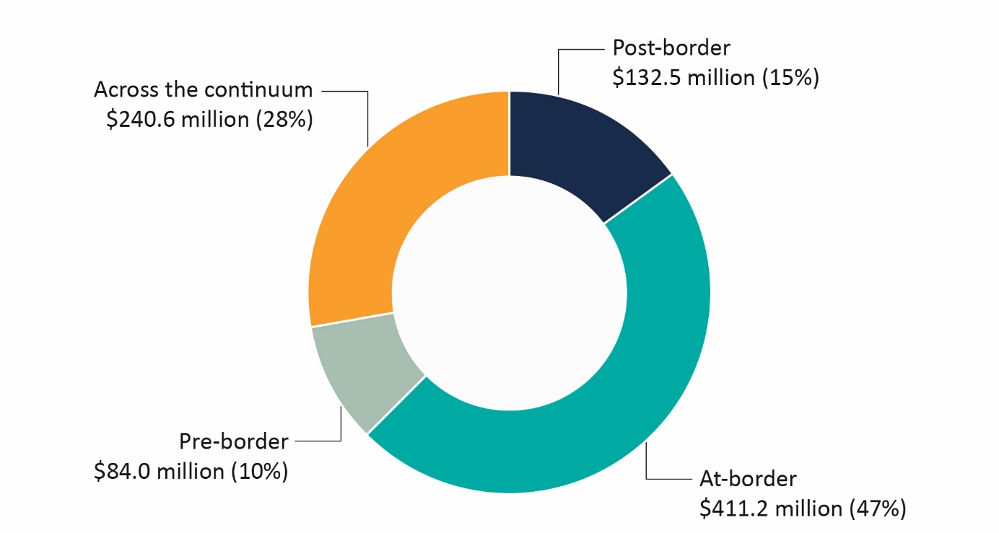

Control stage definitions
- Pre-border (overseas)
  - Working with overseas governments, agencies, importers and other stakeholders to mitigate risk and reduce the number and frequency of pests and diseases that reach Australia.
- At-border
  - Screening and inspection of air and sea vessels, cargo, mail and travellers to assess and manage biosecurity risk.
  - Conducting surveillance to ensure the earliest and most effective response to exotic pests, diseases and weeds.
  - Undertaking laboratory diagnostics, verification, assurance and post-entry quarantine to prevent pests and diseases entering Australia.
- Post-border
  - Addressing non-compliance with biosecurity legislation.
  - Working with the states, territories and industry partners to detect and respond to incursions and contain and eradicate pests and diseases within Australia.
- Across the continuum
  - Delivering whole-of system strategy, engagement, business administration or law reform activities.
  - Includes costs that cannot be assigned to a specific stage.

Pathway classes
Biosecurity risk pathway describes how a pest, disease or weed travels to and arrives in Australia. Pathway classes define the different channels. Understanding these pathways and investing in effective measures is critical in the prevention of risk.
The largest category of expenditure is the post-border and across-the-continuum pathway class. This includes preparing for and detecting pest and disease incursions post-border, and compliance and enforcement across the system. Significantly, a substantial portion of expenditure is directed to the cargo, containers and conveyances pathway, reflecting the level of assessed risk and importance of managing this pathway (Figure 3).
Figure 3 Expenditure in 2024–25, by pathway class
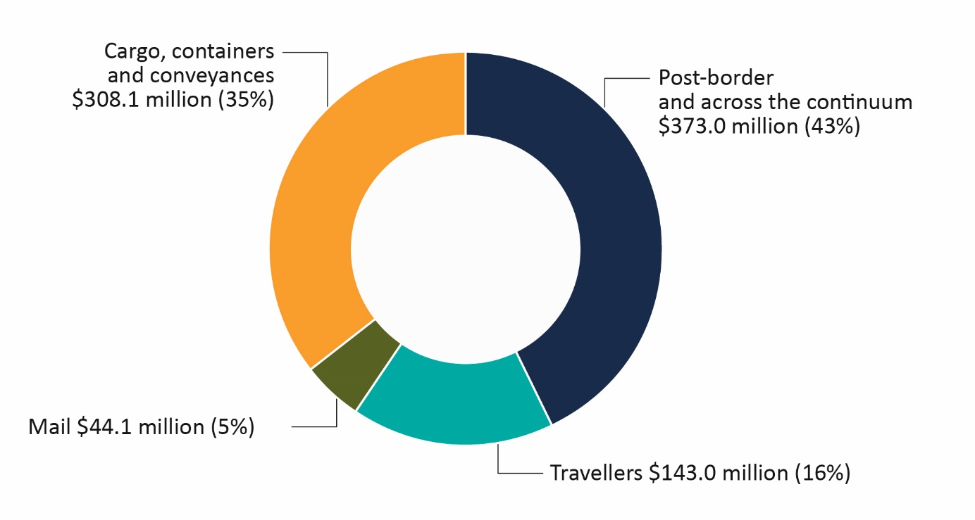Pathway class definitions
- Travellers – Airline and cruise ship passengers and crew and their accompanying luggage. This category excludes people arriving in Australia on any other vessels, which are considered in the conveyances pathway class.
- Mail – International mail managed by Australia Post.
- Cargo, containers and conveyances – Vessels, aircraft, external and internal surfaces of sea and air containers, and imported cargo (excluding mail items handled by Australia Post).
- Post-border and across the continuum – This expenditure is not assigned to a specific pathway class. It supports:
  - system-wide functions such as ICT delivery
  - preparedness activities
  - responses to pest and disease incursions that may bypass pathway-specific controls, including those arising from natural events such as migration or weather.

Financial performance
Table 4 shows a breakdown of the department’s biosecurity budget, expenditure and variance for 2024–25. The budget for 2024–25 was $885.7 million and expenditure was $868.2 million.
Table 4 Biosecurity expenditure and budget variance, 2024‒25
Category | Actual ($m) | Budget ($m) ª | Variance ($m)
Appropriation and other s74 revenue | 354.5 | 379.0 | 24.5 ^{b}
Existing cost recovery arrangement | 408.3 | 395.9 | −12.4 c
Australia Post | 27.3 | 15.3 | −12.0 ^{d}
Defence | 7.2 | 1.9 | −5.3 ^{e}
Departmental equity injection | 29.5 | 32.5 | 3.0 ^{f}
Department of Finance gateway review departmental appropriation | 0.1 | 0.1 | n/a
Administered | 41.4 | 61.0 | 19.6 ^{g}
Total biosecurity expenditure | 868.2 | 885.7 | 17.5
a At Budget 2025‒26. b Underspend due to delays in delivering key initiatives such as the Simplified Targeting and Enhanced Processing Systems program, Western Sydney International Airport project, and the hitchhiker pests project. c Includes self-assessed clearance (SAC). Additional expenses driven by growth in SAC volumes. d Additional expenses driven by increased volumes. Australia Post statutory fee of $15.3 million is supplemented by ongoing appropriation funding of around $7 million per annum. e Additional expenses incurred due to memorandum of understanding with Department of Defence. Revised budget will be reflected in 2025‒26 Mid-Year Economic and Fiscal Outlook. f We are exploring options to move unspent equity (capital) to future years. g We are exploring options to move unspent administered funding for high pathogenicity avian influenza communications, biosecurity and scientific capability to future years.

Cost recovery revenue performance
Cost recovery revenue collected from importers, excluding Australia Post, increased from $365 million in 2023–24 to $428.8 million in 2024–25 (including $40.3 million for SAC). This increase of $63.8 million (around 17%) is largely attributable to the growth in SAC volumes, indexation of regulatory charging and increased volumes of fee-for-service activities. The department’s expenditure was below budget primarily due to continued challenges in staff recruitment.
Australia Post pays the department a legislated annual fee of $15.3 million for biosecurity clearance activities at international mail gateway facilities. However, the costs of managing and assessing biosecurity risks have increased due to the increase in biosecurity risks associated with incoming mail, leading to a funding shortfall. To help close this gap, the government has provided the department with an additional $7 million per year in ongoing appropriation funding from 2024‒25.

Cargo volumes and self-assessed clearance reform
In 2024‒25 total cargo volumes increased by 24.8% compared to the previous year. Full import declarations and long-form SAC volumes increased by 3.7%, reaching more than 4.5 million. SAC consignments, which account for more than 97% of total cargo, grew by 25.6% to 150.3 million. This continues the trend of increased volumes over past years (Figure 4).
Figure 4 Cargo volume growth, 2020‒21 to 2024‒25
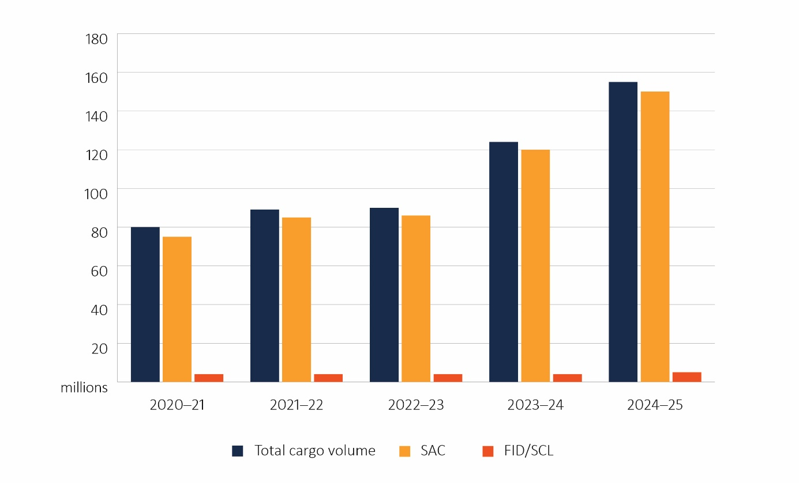
SAC Self-assessed clearance. FID Full import declaration. SCL Cargo reported (long-form) self-assessed clearance.
The department is delivering a SAC reform program to deliver fit-for-purpose biosecurity activities to ensure risks are being effectively and efficiently managed. The reform program will see improved SAC data and information management systems, an increased number of frontline staff, a structured program of verification and assurance, and better utilisation of a range of detection capabilities.

Progress against DAFF Biosecurity 2030 Roadmap
The DAFF Biosecurity 2030 Roadmap outlines our strategic direction for strengthening the Australian biosecurity system to 2030 and beyond. It sets out 9 strategic actions that guide our efforts to ensure the system remains fit for purpose amid evolving challenges and opportunities. These strategic actions align with the 6 priority areas of the National Biosecurity Strategy. The case studies in this section showcase the progress of key initiatives undertaken during 2024‒25 against the roadmap’s strategic actions.

Strategic action 1: Accelerate our efforts with key partners to create a strong, future-oriented and efficient national biosecurity system and to better promote our leadership role
We prioritise strong partnerships with Australian Government agencies, state and territory governments, industry, research institutions, First Nations people and community groups to implement system improvements that manage biosecurity risks efficiently and effectively.
Case study 1 Remote surveillance of varroa mite in honey bee hives
Varroa mite (Varroa destructor), a highly destructive parasite threatening European honey bees globally, was detected in Newcastle, NSW in 2022. It poses a major threat to pollination-dependent industries and threatens Australia’s food security. After initial eradication efforts, the National Management Group shifted to a transition-to-management phase in 2023.
To support this shift, a pilot study was launched under the Catalysing Australia’s Biosecurity (CAB) initiative, led by the department and CSIRO, in partnership with state and territory governments, industry, and community beekeepers. Using a citizen-science approach, the study trialled a novel non-invasive technology to monitor and detect varroa mites in beehives.
The pilot showed the benefits of remote hive monitoring and enhanced real-time data sharing between industry and government. This enables faster responses, laying the foundation for technology-driven pest management and citizen-science engagement in biosecurity.
Building on this success, CAB in collaboration with our research and industry partners launched a global innovation challenge to identify novel and innovative technologies for managing European honey bee mites in Australia, including through mite surveillance and monitoring. This activity aims to boost border detection capabilities and empower beekeepers by providing smarter tools to manage a global pest.

Strategic action 2: Expand offshore assurance arrangements and overseas supply chain integration
Addressing biosecurity risks offshore helps prevent threats from reaching our borders and reduces the need for costly interventions. We continue to implement measures to enhance compliance with our import standards overseas, enabling faster and safer processing of goods at the border.
Case study 2 AusTreat pre-border treatment provider assurance scheme
Clear and consistent rules for offshore treatment providers are essential for preventing biosecurity risks and ensuring that goods entering Australia meet our required safety standards.
Introduced in July 2024, the AusTreat pre-border biosecurity treatment assurance scheme increases our coverage and flexibility in responding to biosecurity risks by improving offshore treatment assurance, reducing border interventions and eliminating the need for new pest-specific schemes. This flexibility enables the department to expand offshore assurance arrangements to respond to new biosecurity risks, while providing greater visibility, traceability and proactive management of biosecurity risks.
Implementation of the program in 2024‒25 included targeted compliance checks, training, and diplomatic engagement in Europe, the United States of America, Singapore and China to support industry compliance.
Better processes for collecting and reviewing data helped effectively process approximately 62,000 treatment certificates. Around 7,000 of these were rejected for non-compliance before reaching Australia. Compliant consignments were allowed through with fewer checks, helping to speed up border processes while keeping biosecurity risks low.

Strategic action 3: Increase partnership activities with Australia’s near neighbours
Preventing biosecurity risks from reaching Australia is just as crucial as supporting neighbouring countries in protecting their environments from biosecurity threats and promoting economic development. We strengthen regional biosecurity through partnerships and collaboration with international organisations to improve global standards and practices.
Case study 3 Papua New Guinea Biosecurity Twinning Program
Australia collaborates with Indo-Pacific neighbours to address growing threats ‒ such as exotic fruit fly, Huanglongbing, lumpy skin disease and foot-and-mouth disease. This strengthens resilience and protects agricultural industries in Australia and the region.
The Australian Government is assisting our nearest neighbour Papua New Guinea (PNG) to build a robust, biosecurity system to bolster food security and agricultural trade in the region. Launched in 2024, the Biosecurity Twinning Program helps build PNG capability to manage border biosecurity risks and respond effectively to emerging threats.
Delivered in partnership with PNG’s National Agriculture Quarantine and Inspection Authority (NAQIA) and Australia’s DFAT, the program aims to sustainably improve PNG’s baseline biosecurity system to support trade objectives. This includes improved risk management and enhanced preparedness and response capabilities for animal and plant pests and diseases, to build the required biosecurity capabilities for international market access.
Early achievements include a 3-day emergency incident management training workshop for around 60 NAQIA staff, and commencement of reform of NAQIA’s border operations across PNG’s 22 international ports of entry.
This initiative builds on long-standing capacity-building efforts by the Australian Chief Veterinary Officer and the Australian Chief Plant Protection Officer, contributing to a more robust biosecurity system across the region and helping to protect Australia.

Strategic action 4: Invest in a skilled and responsive workforce supported by improved regulatory tools and information
A skilled and responsive workforce is essential to managing biosecurity risks. We empower our staff and people working under third-party arrangements by investing in their knowledge, skills and technology, supporting ongoing development and providing key regulatory tools. This boosts our effectiveness, agility and resilience as a regulator.
Case study 4 Northern Australia Biosecurity Strategy 2030
Northern Australia is the frontline in our national defence against many biosecurity threats due to its proximity to neighbouring countries. The Northern Australia Biosecurity Strategy 2030 fosters collaboration across government, industry, private veterinarians and First Nations communities to enhance preparedness and responsiveness to biosecurity threats in a unique and challenging environment.
Key initiatives of the strategy are helping to build a skilled biosecurity workforce in the region and strengthen partnerships and shared biosecurity responsibility. These successful initiatives include:
- First Nations Board Intern Program – aims to increase diversity on boards and committees across Northern Australia. Ten interns have completed the program, 4 of whom secured long-term roles.
- Northern Australia Biosecurity Strategy Mentoring Program – reinforces biosecurity efforts by building cross-sectoral networks and sharing knowledge, which is especially vital in remote areas. Nearly 80 participants have completed the program, and positive feedback has affirmed its value.
- Industry Toolbox Workshops – helps industry stakeholders operationalise national strategies. Two sessions have been held so far: crisis communication planning and decision-making for biosecurity.
- Veterinary Student Subsidy Program – addresses the challenge of attracting veterinarians to Northern Australia. Six students are now employed in the region, strengthening on-ground biosecurity capabilities.

Strategic action 5: Adopt advancements and innovations in detection technologies, risk assessments and business practices
Innovative and emerging technologies offer enhanced ways for us to operate. We explore and integrate new tools, technologies and work practices to strengthen our systems. Through collaboration with industry and other stakeholders, we aim to improve system efficiency and resilience, helping to mitigate biosecurity threats.
Case study 5 Modern Technologies and Diagnostic Tools
The Modern Technologies and Diagnostic Tools (MTDT) program transformed Australia’s biosecurity diagnostics. Over 4 years, the Australian Government invested $22 million to modernise systems to keep pace with evolving biosecurity threats.
The program introduced cutting-edge equipment, practices and training to improve diagnostic speed and accuracy. Technologies such as MALDI-TOF mass spectrometry and MinION portable DNA sequencing now identify unknown pests in under 7 hours – down from a week. MALDI-TOF creates digital fingerprints to rapidly identify bacteria and fungi, while MinION sequences DNA onsite to support identification of unknown specimens. These tools are critical in preventing pests and disease incursions.
MTDT enabled thousands of rapid identifications, including spotted wing drosophila (Drosophila suzukii) larvae in cherry imports within 48 hours. This detection triggered protective measures for fruit industries, preventing major incursion-related economic damage, demonstrating the program’s value to industry and government.
Following the conclusion of the program in 2024–25, we continue to improve our biosecurity system through ongoing laboratory and diagnostic reform.

Strategic action 6: Generate a stronger shared responsibility and commitment to biosecurity by enhancing awareness and understanding
Everyone has a role to play in protecting Australia’s economy and environment from biosecurity risks. We work together with all biosecurity stakeholders to raise awareness and understanding of these risks across the Australian community and business sectors.
Case study 6 Junior Biosecurity Officer program
Engaging young people in biosecurity early helps build a strong understanding of its purpose, raises awareness of potential risks, and encourages the development of positive biosecurity habits that are essential for protecting our environment, economy and health.
The Junior Biosecurity Officer program is an educational initiative for primary school children that fosters their understanding of biosecurity and their role within the system. The program integrates tailored biosecurity messaging and specific learning goals into curriculum-based resources.
This initiative seeks to develop a positive connection between students and biosecurity, enabling them to promote awareness among their families and peers while practising responsible biosecurity behaviours. The program strengthens partnerships between the department, schools and educators to enhance the effectiveness of our national biosecurity messaging.
Program resources include:
- curriculum-linked lesson plans and teaching guides for Year 2 to Year 5 educators
- interactive presentations, activities and challenges to engage students
- pre-recorded virtual excursions to departmental frontline locations, including Melbourne Airport and the Mickleham Post Entry Quarantine Facility, to demonstrate real-world biosecurity operations.

Strategic action 7: Increase use of offshore intelligence, research and data to support risk-based interventions, preparedness and response
We are strengthening our overseas strategic and operational intelligence and analytics to quickly detect current and emerging risks. This will enhance future planning, border security, intervention and preparedness for potential incursions.
Case study 7 Simplified Targeting and Enhanced Processing Systems program
STEPS is a $145 million investment to modernise the department’s digital systems, streamlining cargo clearance through faster, simpler and more integrated processes.
The program simplifies complex biosecurity import procedures, enhancing efficiency, visibility and data insights for industry and government. In 2024–25, we continued to roll out products released in 2023–24, delivering increased self-service options and data sharing with industry:
- Enhanced industry reporting – improved visibility for class 19 biosecurity participants on cargo status, service (fee) records and arrangement uptake and usage.
- Integrated Cargo and Container Platform – a core digital application to streamline commodity assessment and inspection, enabling Full Import Declaration for Personal Effects to be processed.
- Approved Arrangements Management Product – allows biosecurity industry participants who operate approved arrangements to view and update arrangement details via self-service.
- Expanded External Verification of eCertificates – expanded access to digital certificates to New Zealand, the USA, the Republic of Korea and Sri Lanka.
- Centralised Cargo Data Repository – a unified data source to support analysis and evidence-based decisions across the cargo pathway.
- Cargo Online Lodgement System upgrade – simplifies document lodgements by increasing upload file size limits.

Strategic action 8: Lift our national preparedness, resilience and response to exotic pest and disease incursions and strengthen our national leadership role
As the national leader in biosecurity, we prepare and act promptly to protect Australia from exotic biosecurity threats. We continue to invest in prevention, preparedness, resilience and response strategies to minimise potential impacts and disruptions.
Case study 8 Exercise Volare – whole-of-government H5 HPAI preparedness exercise
H5 high pathogenicity avian influenza (HPAI) has resulted in mass deaths of poultry and wildlife globally and led to human fatalities in rare cases. While Australia is currently free from H5 HPAI, the risk of an outbreak remains high due to transmission through wild bird populations, threatening both endangered wildlife and livestock.
In 2024 the Australian Government’s HPAI Preparedness Taskforce conducted Exercise Volare ‒ national simulation exercises to enhance cross-sectoral preparedness and protective action.
Supported by a $95 million investment by the Australian Government, the initiative prompted a One Health approach, addressing environmental, animal and human health impacts.
The exercise identified opportunities, strengths, gaps and the need for a Commonwealth–state governance and cost-sharing agreement for responses to manage the impacts of H5 HPAI in wildlife. It also identified improvements to communication strategies, including culturally appropriate materials for First Nations and culturally and linguistically diverse communities. A national information campaign launched in December 2024 resulted in 349,000 visits to birdflu.gov.au, reflecting the importance of accurate and reliable information in supporting strong stakeholder engagement.
Exercise Volare has guided further investment to strengthen Australia’s biosecurity capacity and capability to respond to HPAI and future emergencies.

Strategic action 9: Align our funding and investment model to emerging system needs
Consistent and collaborative investment by government, businesses and community groups is crucial for addressing emerging challenges and enhancing the effectiveness of the national biosecurity system.
Case study 9 National Management Agreement for H5 HPAI in Wildlife
In recognition of the cross-sectoral threat posed by H5 HPAI, Australian agriculture ministers prioritised the development of the National Management Agreement for H5 HPAI in Wildlife to support Commonwealth, state and territory governments in managing and sharing the costs of a national response. The agreement came into effect in March 2025, following work led by the department across the Australian Government and in collaboration with the NBC.
Underpinned by a One Health approach, the agreement strengthens Commonwealth, state and territory capacity to respond to disease outbreaks by improving:
- coordination and resource sharing
- training and research
- locally tailored response plans, informed by environmental needs, First Nations input and regional expertise.
This work exemplifies the department’s commitment to partnering with stakeholders to strengthen the national biosecurity system through co-funding and investment, ensuring it is well equipped and adaptable to emerging challenges.

