Imported food inspection data: January to December 2024

Imported Food Inspection Scheme

© Commonwealth of Australia 2025
Ownership of intellectual property rights
Unless otherwise noted, copyright (and any other intellectual property rights) in this publication is owned by the Commonwealth of Australia (referred to as the Commonwealth).
Creative Commons licence
All material in this publication is licensed under a Creative Commons Attribution 4.0 International Licence except content supplied by third parties, logos and the Commonwealth Coat of Arms.

Cataloguing data
This publication (and any material sourced from it) should be attributed as: DAFF 2025, Imported food inspection data: January to December 2024, Department of Agriculture, Fisheries and Forestry, Canberra. CC BY 4.0.
This publication is available at agriculture.gov.au/biosecurity-trade/import/goods/food/inspection-testing/surveys-data.
Department of Agriculture, Fisheries and Forestry
GPO Box 858 Canberra ACT 2601
Telephone 1800 900 090
Web agriculture.gov.au
Disclaimer
The Australian Government acting through the Department of Agriculture, Fisheries and Forestry has exercised due care and skill in preparing and compiling the information and data in this publication. Notwithstanding, the Department of Agriculture, Fisheries and Forestry, its employees and advisers disclaim all liability, including liability for negligence and for any loss, damage, injury, expense or cost incurred by any person as a result of accessing, using or relying on any of the information or data in this publication to the maximum extent permitted by law.
Acknowledgement of Country
We acknowledge the continuous connection of First Nations Traditional Owners and Custodians to the lands, seas and waters of Australia. We recognise their care for and cultivation of Country. We pay respect to Elders past and present, and recognise their knowledge and contribution to the productivity, innovation and sustainability of Australia’s agriculture, fisheries and forestry industries.

Contents
Introduction 1
Imported Food Inspection Scheme 2
Legislation 2
Food classification 2
Inspection rates 2
Australian food trade 3
Australian food imports 4
Source of Australian food imports 4
Inspection and testing summary 6
Inspection and testing results 7
Compliance rates 7
Labelling 8
Analytical tests 8
Other checks 11
Analytical tests by commodity group 12
Results by commodity group 13
Inspections by country of origin 14
Virtual label and visual inspections 15
Food Import Compliance Agreements 17
Monitoring and response to international alerts and recalls 18
Response to international alerts and recalls 18
Food safety notifications investigated in 2024 18
Appendix A: Analytical tests 19
Glossary 21

Tables
Table 1 All tests, product compliance rates, 2024 7
Table 2 Analytical tests, compliance rates, 2024 9
Table 3 Chemical tests, product compliance rates, 2024 9
Table 4 Composition analytical tests, product compliance rates, 2024 10
Table 5 Contaminant tests, product compliance rates, 2024 10
Table 6 Microbiological test, product compliance rates, 2024 11
Table 7 Other checks, 2024 12
Table 8 Inspection and test data, by commodity group, 2024 13
Table 9 Number of inspections, by country of origin, 2024 14
Table 10 Number of virtual inspections, by importer location, 2024 16
Table 11 Food Import Compliance Agreement activity, 2024 17
Table 12 Food safety notifications investigated in 2024 18

Figures
Figure 1 Australian food trade, by value, 2003–04 to 2023–24 3
Figure 2 Australian food imports, by commodity, 2022–23, 2023–24 and 3-year average to 2013—14 4
Figure 3 Share of imported food, by country of origin, 2022–23, 2023–24 and 3-year average to 2013–14 5
Figure 4 Non-compliant results, by type, 2024 7
Figure 5 Non-compliant labelling, by information type, 2024 8
Figure 6 Percentage of tests applied, by commodity group, 2024 13
Figure 7 Percentage of tests applied, by country of origin, 2024 15

Introduction
The Department of Agriculture, Fisheries and Forestry administers 2 Acts that apply to food imported into Australia:
- Biosecurity Act 2015 – manages biosecurity threats to plants, animals and human health in Australia and its external territories.
- Imported Food Control Act 1992 (IFC Act) – manages food safety risks to protect human health.
This report provides compliance data for activities under the IFC Act.
Importers are legally responsible for ensuring the foods they import for sale in Australia comply with Australia’s food standards and do not pose a risk to human health.
We monitor the compliance and safety of imported food at the border through the Imported Food Inspection Scheme (IFIS), a risk-based border inspection program. Foods are referred for inspection and testing under the IFIS based on whether they have been classified as risk or surveillance foods. Risk food is initially referred at a higher rate than surveillance food. Inspection rates decrease or increase depending on compliance history and recognition of certification.
This report provides summary data from inspections conducted under the IFIS from 1 January to 31 December 2024.
Every month, we publish failing food reports on our website. These are foods that:
- failed analytical testing
- were found to contain non-permitted additives or ingredients, or
- were found to be prohibited plants or fungi.

Imported Food Inspection Scheme

Legislation
The IFC Act provides for the department to administer the IFIS.
The Imported Food Control Regulations 2019 set out how the IFIS operates, including the rates that foods are referred for inspection.
The Imported Food Control Order 2019 lists foods that are classified as ‘risk food’ or require certification.

Food classification
The minister classifies food as risk food in the Order. This is based on advice from Food Standards Australia New Zealand (FSANZ) that the food has the potential to pose a medium or high risk to public health. FSANZ is an independent statutory authority that develops and maintains the Australia New Zealand Food Standards Code. FSANZ also provides risk advice on food imported into Australia.
Food that is not classified as risk food is surveillance food unless it is compliance agreement food. Compliance agreement food is imported by a business under a Food Import Compliance Agreement (FICA). FICAs offer food importers an alternative regulatory arrangement to inspection and testing of their products under the IFIS. Under this arrangement, we audit an importer’s existing documented food safety management system. Foods that are imported under a compliance agreement are not referred to the IFIS.

Inspection rates
Risk food is initially referred for inspection and analysis at a rate of 100% of consignments. This inspection rate is reduced to 25% following 5 consecutive passes and is then reduced to 5% of consignments after a further 20 consecutive passes. The inspection rate for Risk food may vary when imported under recognised certification.
Surveillance food is referred for inspection and analysis at an initial rate of 5% of consignments.
When imported food fails inspection, the importer must take follow-up action, such as treatment of the food to bring it into compliance (where applicable), destruction or export. Subsequent imports of the same food (same product, producer and country of origin) are subject to inspection at the rate of 100% of consignments until the food demonstrates a history of compliance.
We use electronic profiles in the Department of Home Affairs Integrated Cargo System (ICS) to identify foods of interest and appropriate rates of referral. Once food is referred, our system applies relevant tests as described in Appendix A. The inspection rates are based on the risk the food may pose and the compliance history of the food producer.

Australian food trade
To help contextualise the inspection data, this report includes information on food trade, such as the composition of Australian food imports and countries of origin.
Data on food imports and food exports is presented in value terms for each financial year. Figure 1 shows the trend for the last 25 years, including the net value for food exports (difference between the value of food exports and food imports).
The value of Australian food exports was $63 billion in 2023–24, down 8.4% compared with the previous year.
The value of food imported by Australian food businesses was $27.6 billion in 2023–24, down by 1.4% compared with the previous year. As a result, Australia’s net value for food exports decreased by 7.1% to $35.8 billion in 2023–24 (compared with $42.9 billion in 2022–23).
Figure 1 Australian food trade, by value, 2003–04 to 2023–24
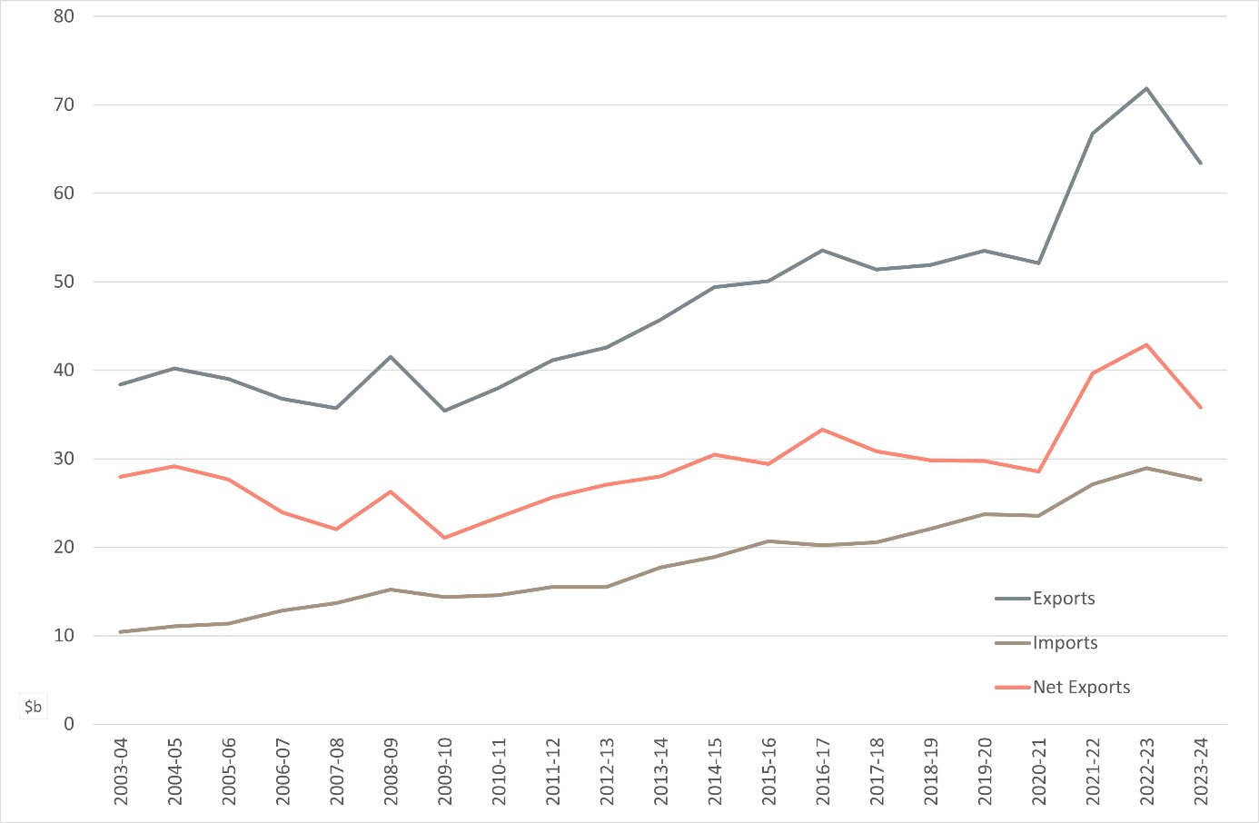
Source: Australian Bureau of Statistics

Australian food imports
Over the past 20 years, the value of food imported by Australian food businesses has increased. As shown in Figure 2, fruit, vegetables, and processed food continue to represent the highest proportion of food imported into Australia in 2023–24. For other commodities, the percentage was similar to previous years or showed a decline.
Figure 2 Australian food imports, by commodity, 2022–23, 2023–24 and 3-year average to 2013—14
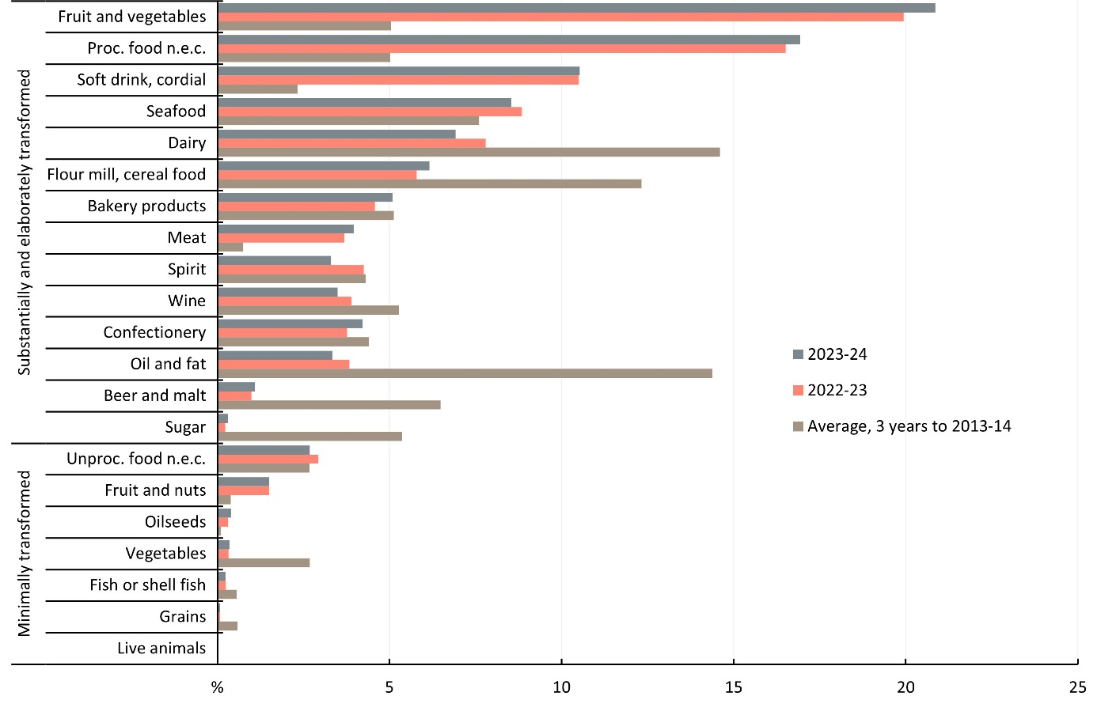
Proc. Processed. n.e.c. Not elsewhere classified. Unproc. Unprocessed.
Source: Agriculture Import Management System

Source of Australian food imports
The source of Australian food imports remained consistent over the 11 years to June 2024, as shown in Figure 3 Share of imported food, by country of origin, 2022–23, 2023–24 and 3-year average to 2013–14.
By value, New Zealand remains the major source of food imported by Australian businesses, accounting for 14.5% of the total value of food imported in 2023—24. However, food imports from New Zealand have declined since 2013.
Other major sources of food imports in 2023—24 were the United States (8.8%), China (8.3%) and Singapore (8.0%).
Figure 3 Share of imported food, by country of origin, 2022–23, 2023–24 and 3-year average to 2013–14
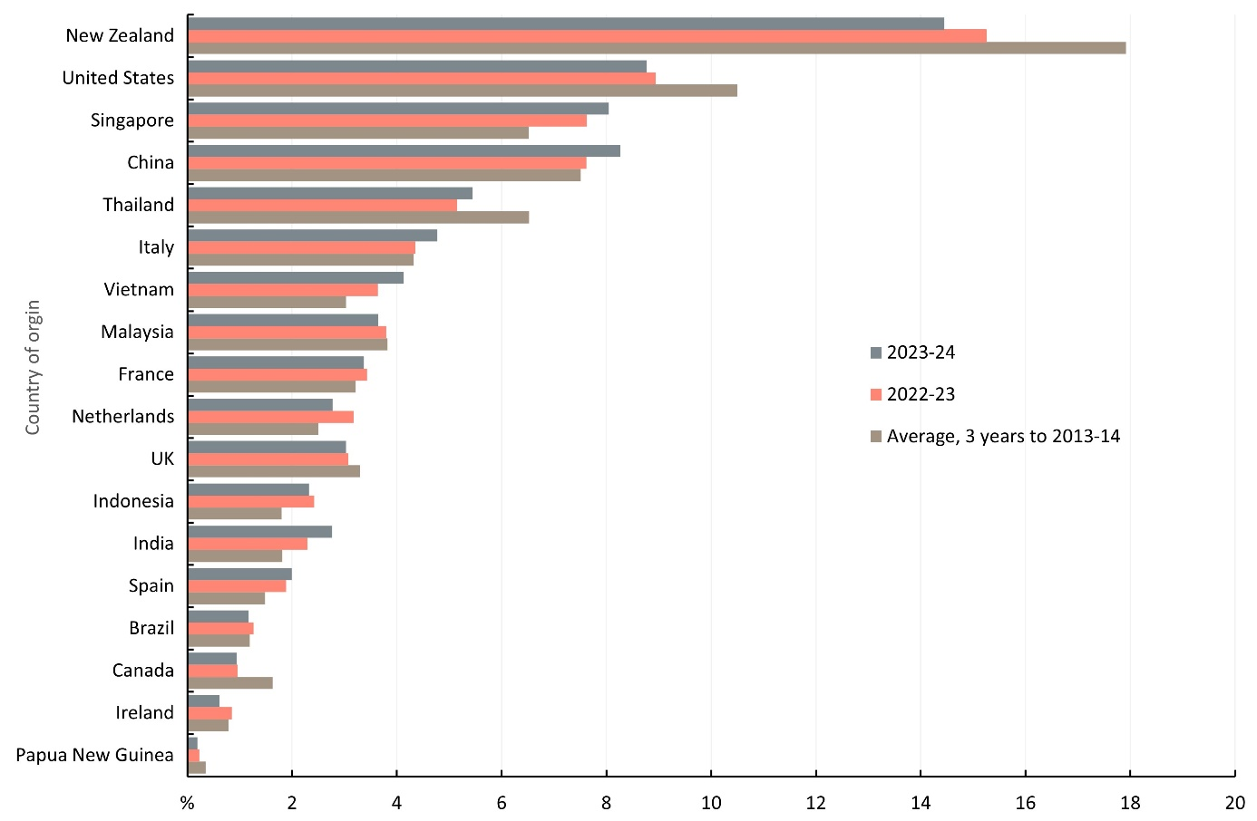
Source: Australian Bureau of Statistics

Inspection and testing summary
From 1 January to 31 December 2024, the compliance rate for all food inspected was 98.5%.
During this period:
- 25,198 entries of imported food were referred and subject to inspection or analysis
- 49,710 lines of these entries were inspected, of which
  - 27.1% were risk food
  - 68.5% were surveillance food
  - 4.3% were surveillance food subject to a holding order
- 139,345 tests (including label and visual checks) were conducted on the food, comprising
  - 20,841 analytical tests
  - 57,895 label and composition assessments
  - 60,609 other tests.
Generally, multiple tests are applied to each food.
For detailed analysis of data see Inspection and testing results.
For definitions of ‘entry’ and ‘line’, see Glossary.

Inspection and testing results

Compliance rates
In 2024, 98.5% of all imported foods inspected under the IFIS complied with the test applied. Table 1 shows the compliance rates for the testing groups.
Table 1 All tests, product compliance rates, 2024
Test group | Tests applied (no.) | Compliant (no.) | Non-compliant (no.) | Compliant (%)
Labelling/composition | 57,895 | 56,170 | 1,725 | 97
Analytical | 20,841 | 20,475 | 366 | 98.2
Other ª | 60,609 | 60,596 | 13 | >99.9
Total | 139,345 | 137,241 | 2,104 | 98.5
ª includes visual assessment, government certificate assessment, food safety management certificate assessment.
Source: Agriculture Import Management System
Figure 4 summarises the reasons for non-compliant results (n = 2,104).
Figure 4 Non-compliant results, by type, 2024
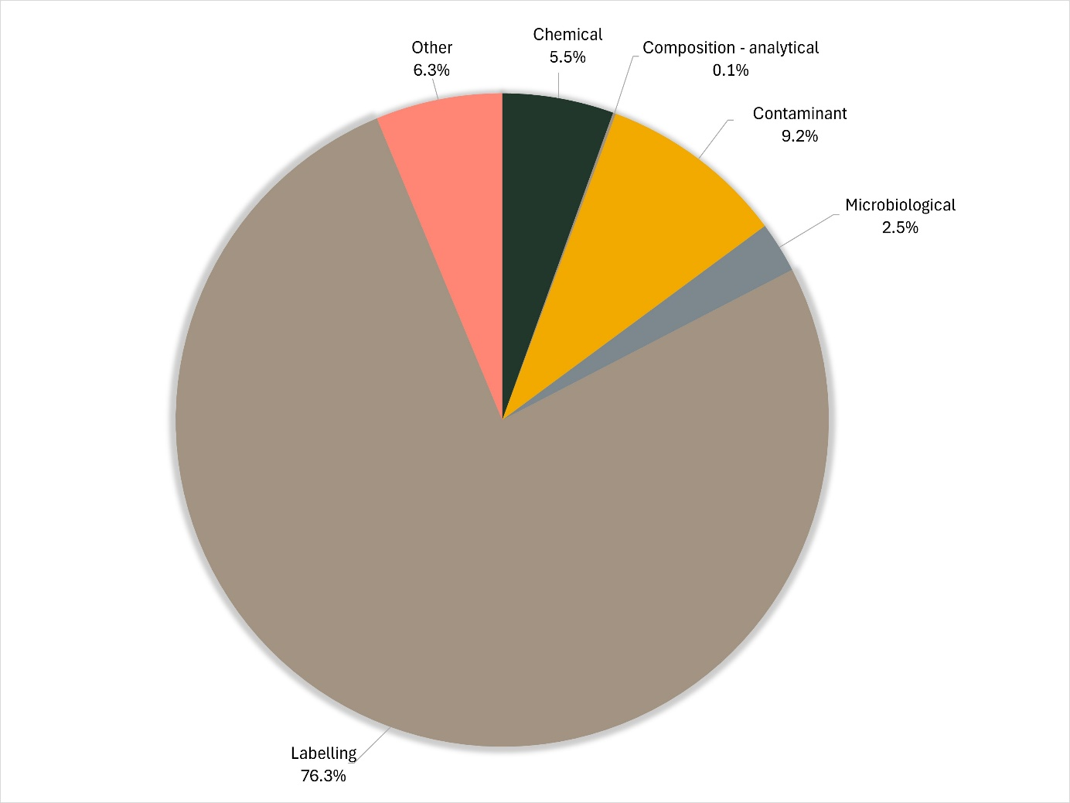
Source: Agriculture Import Management System

Labelling
In 2024, labels that did not comply with Australian food standards were the main source of non-compliance. Figure 5 summarises the reason for non-compliant labelling.
Most notably:
- 26.5% lacked or listed either incomplete or incorrect nutritional details
- 18.5% lacked or listed either incomplete or incorrect ingredient lists
- 17.7% were non-compliant with mandatory warning statements
- 15.8% lacked or listed incorrect importer details
- 12.2% were non-compliant with country of origin labelling requirements
- 4% lacked or listed incomplete product descriptions.
Figure 5 Non-compliant labelling, by information type, 2024
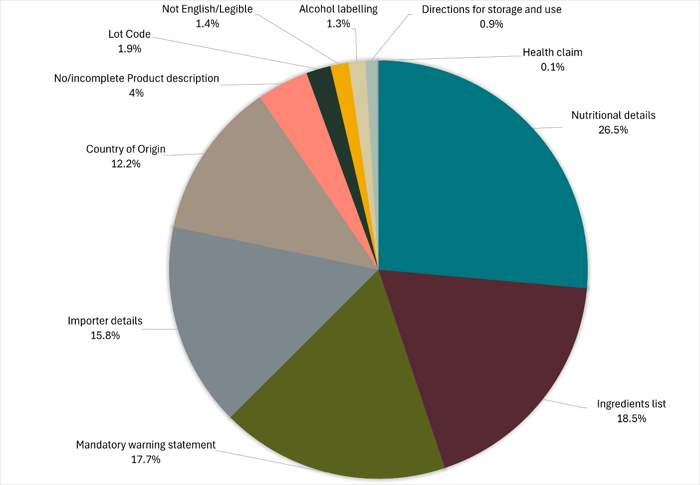
Source: Agriculture Import Management System

Analytical tests
Analytical tests conducted under the IFIS are grouped into 4 categories:
- chemical
- composition (analytical assessment)
- contaminant
- microbiological.
For details of tests applied to different food groups, see Appendix A.
The number of lines of food referred for inspection under the IFIS and the number of tests applied to food may differ. This is because food subject to inspection is sampled and analysed based on the number of:
- batches (or types of food) and lots within each batch of food on the line referred for inspection
- test types applied to each sample of that food taken during inspection.
Example of analytical tests applied to one line of cooked and processed meat products
A line of cooked and processed meat product is referred for inspection under the IFIS. The line contains 2 batches (e.g. whole prosciutto ham and sliced prosciutto ham), each with one lot code. An officer takes one sample from each batch and applies relevant tests. In this example, the tests are Listeria monocytogenes and Salmonella.
This means 2 samples are taken from this one line of imported food and 2 microbiological tests are applied to each sample. This is reported as one line, with 4 separate test results.
Table 2 Analytical tests, compliance rates, 2024
Test type | Tests applied (no.) | Compliant (no.) | Non-compliant (no.) | Compliant (%)
Chemical | 5,219 | 5,103 | 116 | 97.8%
Composition | 90 | 87 | 3 | 96.7%
Contaminant | 8,703 | 8,509 | 194 | 97.8%
Microbiological | 6,829 | 6,776 | 53 | 99.2%
Total | 20,841 | 20,475 | 366 | 98.2%
Source: Agriculture Import Management System
Table 3 summarises the chemical tests conducted, products tested and their compliance rates in 2024.
Table 4 summarises the composition analytical tests applied and their compliance rates in 2024.
Table 5 summarises the contaminant tests applied and their compliance rates in 2024
Table 6 summarises the microbial tests applied and their compliance rates in 2024
Table 3 Chemical tests, product compliance rates, 2024
Chemical | Food type | Tests applied (no.) | Compliant (no.) | Non-compliant (no.) | Compliant (%)
Cannabidiol | Hemp seed and hemp seed products | 3 | 3 | 0 | 100%
Cephalosporins | Meat | 698 | 698 | 0 | 100%
Fluoroquinolones | Meat; Farmed fish and prawns | 1,196 | 1,187 | 9 | 99.2%
Fruit and vegetable residue screen | Fruit and vegetables | 1,852 | 1,751 | 101 | 94.5%
Malachite green | Farmed fish | 300 | 300 | 0 | 100%
Nitrofurans | Farmed prawns | 169 | 163 | 6 | 96.4%
Quinolones | Farmed fish | 300 | 300 | 0 | 100%
Total THC | Hemp seed and hemp seed product | 3 | 3 | 0 | 100%
Virginiamycin | Meat | 698 | 698 | 0 | 100%
Total | – | 5,219 | 5,103 | 116 | 97.8%
Source: Agriculture Import Management System
Table 4 Composition analytical tests, product compliance rates, 2024
Composition test | Food type | Tests applied (no.) | Compliant (no.) | Non-compliant (no.) | Compliant (%)
Allergen – Dairy | Coconut drinks and coconut powders | 8 | 6 | 2 | 75%
C4 adulteration | Honey | 27 | 27 | 0 | 100%
Moisture content | Honey | 27 | 27 | 0 | 100%
Reducing sugar content | Honey | 28 | 27 | 1 | 96.4%
Total | – | 90 | 87 | 3 | 96.7%
Source: Agriculture Import Management System
Table 5 Contaminant tests, product compliance rates, 2024
Contaminant | Food type | Tests applied (no.) | Compliant (no.) | Non-compliant (no.) | Compliant (%)
Aflatoxins | Nuts | 1,561 | 1,513 | 48 | 96.9%
Arsenic total | Cereal grains, cereal flours and processed cereals | 1,259 | 1,259 | 0 | 100%
Domoic acid | Bivalve molluscs | 658 | 658 | 0 | 100%
Histamine | Fish | 2,474 | 2,444 | 30 | 98.8%
Hydrocyanic acid | Cassava chips | 193 | 102 | 91 | 52.8%
Inorganic arsenic | Seaweed (hijiki) | 7 | 7 | 0 | 100%
Iodine | Seaweed (brown algae) | 196 | 174 | 22 | 88.8%
Lead | Cereal grains, cereal flours, processed cereals, fresh and frozen vegetables | 1,904 | 1,901 | 3 | 99.8%
PSP toxin | Bivalve molluscs | 451 | 451 | 0 | 100%
Total | – | 8,703 | 8,509 | 194 | 97.8%
Source: Agriculture Import Management System
Table 6 Microbiological test, product compliance rates, 2024
Microbial agent | Food type | Tests applied (no.) | Compliant (no.) | Non-compliant (no.) | Compliant (%)
Bacillus cereus | Bean curd, tofu | 90 | 87 | 3 | 96.7%
Cronobacter | Infant formula (0 to 6 months) | 11 | 11 | 0 | 100%
Escherichia coli | Beef products, seafood, cheese, fruit and vegetables | 330 | 323 | 7 | 97.9%
Listeria monocytogenes | Cheese, ready-to-eat seafood, processed meats | 2,063 | 2,058 | 5 | 99.8%
Listeria monocytogenes (enumerated) | Cheese, RTE finfish, slow-cured ham | 297 | 295 | 2 | 99.3%
Salmonella | Processed meats, seafood, dried coconut, dried paprika, pepper, capsicum and chilli, sesame seeds, cheese, infant formula | 3,651 | 3,616 | 35 | 99%
Vibrio cholerae | Cooked prawns | 387 | 386 | 1 | 99.7%
Total | – | 6,829 | 6,776 | 53 | 99.2%
Source: Agriculture Import Management System

Other checks
In addition to analytical testing, other checks are conducted on imported food to verify safety and compliance with the Food Standards Code.

Composition
During the inspection, the officer assesses the food label for the presence of ingredients or substances that are either not permitted or in excess of permitted levels – for example, non-permitted colours, added vitamins or prohibited substances.

Visual
The officer conducts a visual assessment of the condition of the food during the inspection to assess if the food is potentially unsafe or unfit for human consumption – for example, mould growth on food, damage to packaging or evidence of pest infestation.

Certification
Analytical tests are sometimes not sufficient to provide assurance that food safety risks are managed. For these foods, certification is required to verify the management of foodborne hazards. At the border, the authorised officer will check the certificate meets our requirements. The foods that require certification and the type of certification required are:
- Beef and beef products – Government certificates provide evidence the origin is a country with a satisfactory BSE risk status from Food Standards Australia New Zealand (FSANZ). For raw fresh beef, government certificates also provide evidence the foodborne hazards of concern are being managed.
- Bivalve molluscs, human milk and raw milk cheese – Government certificates provide evidence that a country’s system for the production and processing of food provides an equivalent food safety outcomes to Australia’s system.
- Berries that are ready to eat and pomegranate arils that are ready to eat – Food safety management certificates provide evidence that a food has been produced under a recognised food safety management system based on HACCP principles.
Table 7 lists the other checks applied, the number of checks conducted and the compliance rates.
Table 7 Other checks, 2024
Type | Tests applied (no.) | Compliant (no.) | Non-compliant (no.) | Compliant (%)
Composition | 315 | 196 | 119 | 62.2%
Visual | 56,659 | 56,648 | 11 | 99.9%
BSE Certificates | 1,112 | 1,112 | 0 | 100%
Food Safety Management Certificates | 1,290 | 1,288 | 2 | 99.8%
Foreign Government Certificates (including raw milk cheese) | 1,548 | 1,548 | 0 | 100%
Total | 60 924 | 60 792 | 132 | 99.8%
Source: Agriculture Import Management System

Analytical tests by commodity group
As shown in Figure 6, horticulture was the commodity subject to the most testing (16.7%) in 2024. Horticulture includes fresh and processed fruit and vegetables. Seafood (fresh, chilled, frozen and processed seafood products) was second highest (14.4%).
Figure 6 Percentage of tests applied, by commodity group, 2024
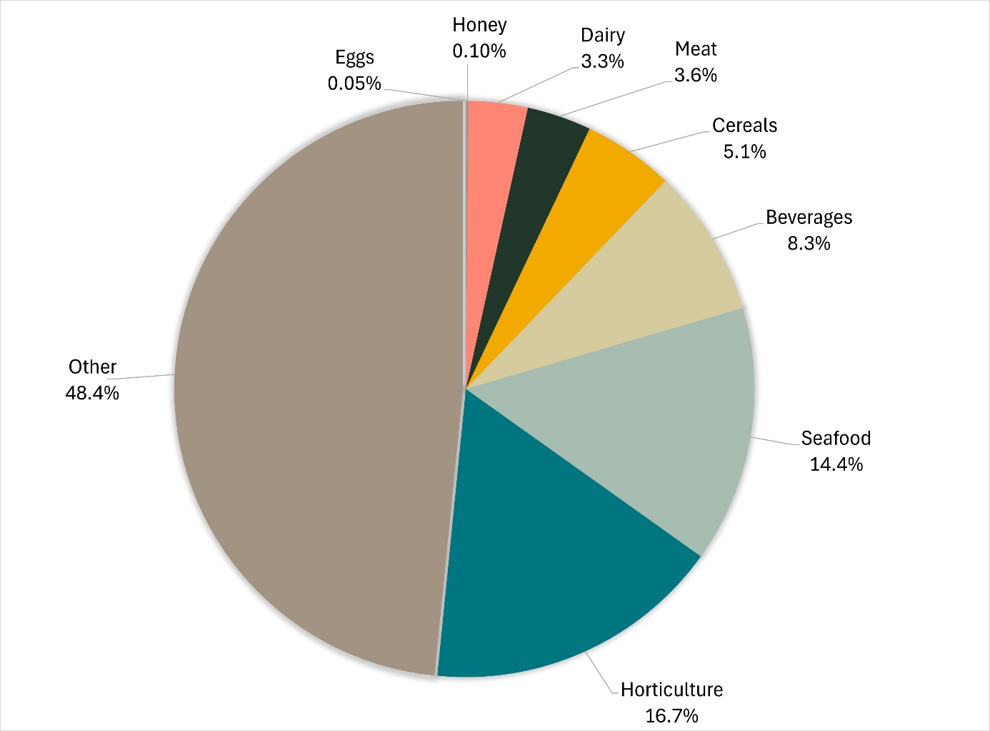
Note: ‘Other’ captures a range of tariff codes, including processed foods such as cereals, canned vegetables, vegetable oils, spices, confectionery, biscuits, coffee and tea.
Source: Agriculture Import Management System

Results by commodity group
Commodity groups that contain risk food or are imported more frequently will have a higher representation under the inspection activity.
Table 8 provides the number of tests applied and compliance rates for food commodity groups. These are not indicative of the volume of trade in each commodity group.
The commodity group ‘other’ represents the largest group tested because it captures a range of processed foods such as cereals, canned vegetables, vegetable oils, spices, confectionery, biscuits, coffee and tea.
Appendix A provides an overview of the analytical tests applied to the commodity groups.
Table 8 Inspection and test data, by commodity group, 2024
Commodity group | Tests applied (no.) | Compliant (no.) | Non-compliant (no.) | Compliant (%)
Beverages | 11 498 | 11 279 | 219 | 98.1%
Cereals, flours and milled products | 7 127 | 72 | 72 | 99%
Dairy | 4 656 | 96 | 96 | 97.9%
Egg products | 63 | 0 | 0 | 100%
Honey | 145 | 3 | 3 | 97.9%
Horticulture | 23 262 | 284 | 284 | 98.8%
Meat | 5 000 | 9 | 9 | 99.8%
Other (incl. processed food) a | 67 475 | 1 260 | 1 260 | 98.1%
Seafood | 20 119 | 161 | 161 | 99.2%
Total | 139 345 | 2 104 | 2 104 | 98.5%
a Captures a range of tariff codes, including processed foods such as cereals, canned vegetables, vegetable oils, spices, confectionery, biscuits, coffee and tea.
Source: Agriculture Import Management System

Inspections by country of origin
Under the IFIS, food is referred for inspection based on its risk classification, not the country of export. The exception is where a food has previously failed inspection. Future consignments of that food from the producer in the exporting country are inspected at rate of 100% until a history of compliance is established. The number of inspections by country of origin is provided in Table 9.
Table 9 Number of inspections, by country of origin, 2024
Country of origin | Lines inspected (no.) | Lines inspected (%)
China | 7 652 | 15.4%
Thailand | 4 629 | 9.3%
Japan | 4 209 | 8.5%
India | 4 153 | 8.4%
Italy | 2 965 | 6%
Republic of Korea | 2 872 | 5.8%
Vietnam | 2 147 | 4.3%
United States of America | 1 798 | 3.6%
France | 1 598 | 3.2%
Malaysia | 1 478 | 3%
Other | 16 208 | 32.5%
Total | 49 709 | 100.0%
Source: Agriculture Import Management System
As shown in Figure 7, from 1 January to 31 December 2024:
- food from China, Thailand and Japan were subject to the most inspections
- 67.5% of inspections were conducted on food from 10 countries; the remaining 32.5% were conducted on food from 134 countries.
Figure 7 Percentage of tests applied, by country of origin, 2024
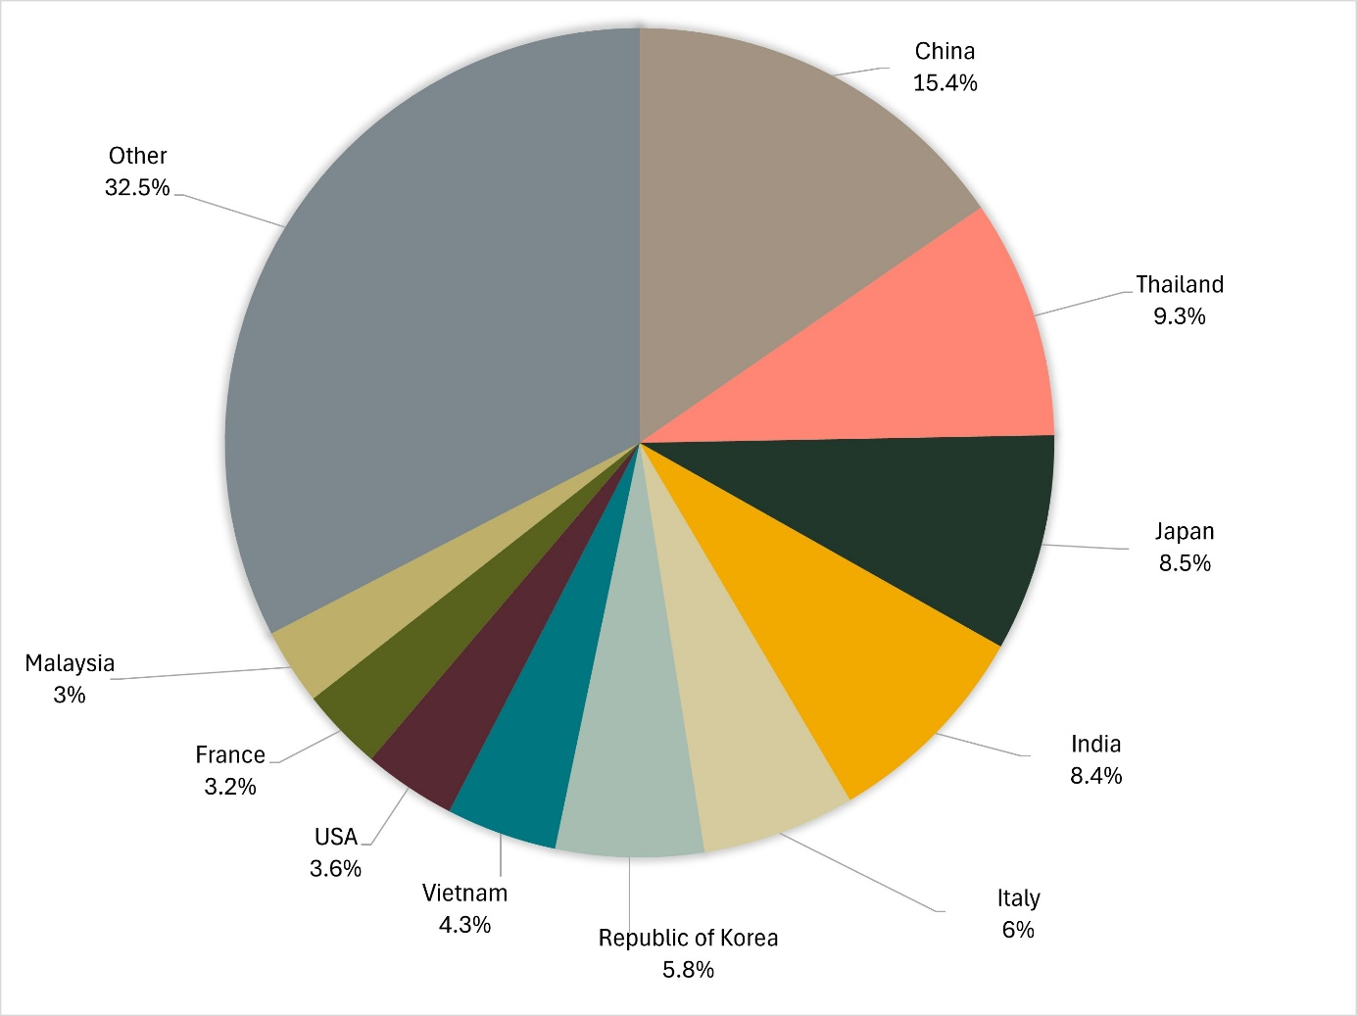
Source: Agriculture Import Management System
A significant proportion of food imports are from New Zealand, but few are subject to the IFC Act. Food imported from New Zealand is exempt from the IFIS unless specific in the IFC Order. Currently, the Order specifies that the Act applies to beef, beef products, ready-to-eat cassava chips and brown seaweed from New Zealand. The exemption in the Act for food imported from New Zealand was included following the signing of the Trans-Tasman Mutual Recognition Arrangement between Australia and New Zealand in 1996. Under the arrangement, goods produced by or imported into either country that meet one country’s legal requirements may be legally sold in the other country.

Virtual label and visual inspections
Virtual label and visual inspections are conducted remotely using Microsoft Teams to connect a departmental officer with a food importer or nominated representative. The virtual inspection is equivalent to a physical inspection under the IFIS.
The imported food virtual label and visual inspections initiative was implemented in July 2021, primarily to reduce inspection waiting times for food importers. These inspections apply to consignments flagged for a visual and label check only, because no samples need to be taken at these types of inspections.

Importing businesses approved for virtual inspection
Importing businesses wanting to book a virtual inspection need to be assessed to check that the business can support these inspections. For example, the premises where the inspections will be conducted must have a reliable internet connection.
During 2024, an additional 213 importing businesses were approved for virtual inspections. At the end of 2024, 613 businesses were approved for virtual label and visual inspections.

Virtual inspections conducted
A total of 2,727 virtual inspections were conducted in 2024. Table 10 lists the number of virtual inspections conducted at each location. The highest number of virtual inspections were conducted in NSW, followed by Victoria, reflecting the high volume of food imported into these states.
Table 10 Number of virtual inspections, by importer location, 2024
Importer location | Virtual inspections (no.)
New South Wales | 1,206
Victoria | 874
Queensland | 559
Western Australia | 68
South Australia | 9
Northern Territory | 6
Australian Capital Territory | 4
Tasmania | 1
Total | 2,727
Risk food is not eligible for virtual inspection, except for permitted kava products.
Virtual inspections are only available for surveillance food, excluding:
- formulated supplementary sport foods
- food subject to a holding order
- food subject to analytical testing.
The surveillance foods most often inspected virtually are:
- alcohol for retail sale
- bulk food ingredients such as juice concentrates for further processing
- noodles and pasta
- confectionery, tea and coffee
- sauces.

Food Import Compliance Agreements
Food importers can enter into a Food Import Compliance Agreement (FICA) with the department. These agreements are made under section 35A of the Imported Food Control Act 1992.
A FICA recognises an importer’s documented food safety compliance system as an alternative to inspection and testing under the IFIS. Therefore, food imported under a FICA is not referred for inspection and testing at the border. Instead, we assess the importer’s compliance with the FICA requirements through regular audits.
Table 11 summarises activity related to FICAs.
Table 11 Food Import Compliance Agreement activity, 2024
No. of FICAs in place as at end of 2024 | No. of FICAs ceased in 2024 | No. of FICAs commenced in 2024 | No. of FICA audits conducted in 2024
42 | – | 4 | 30
Source: DAFF, Imported Food

Monitoring and response to international alerts and recalls

Response to international alerts and recalls
We scan information on international food safety alerts and food recalls to assist with identifying if food has been imported and that may be unsafe. If this has occurred, we provide information about the imports to the relevant state or territory authority and FSANZ to consider action, including a food recall where appropriate. Where relevant, we will also apply holding orders to ensure further imports are referred for inspection to verify compliance.

Food safety notifications investigated in 2024
In 2024, we investigated 237 international food safety notifications due to evidence of the food being imported into Australia. Of these notifications, 21 were subject to follow up action. Table 12 lists these foods and the reason for notification.
Table 12 Food safety notifications investigated in 2024
Food | Reason for notification
Baby biscuits | contamination (foreign matter)
BBQ hot sauce | undeclared allergen (gluten)
Black vinegar | undeclared sulphites (sulphur dioxide)
Cooking oil | contamination (chemical)
Corn chips | undeclared allergen (gluten)
Energy drinks | novel food ingredient (citicoline)
Energy drinks | exceeded permitted levels (caffeine)
Energy drinks | novel food ingredient (citicoline)
Energy drinks | exceeded permitted levels (caffeine)
Fish ball with fish roe | undeclared allergen (egg)
Fish cake products | undeclared allergen (egg)
Frozen Acai products | microbial contamination (Salmonella, Bacillus cereus)
Gummies | unexpected toxicity
Hulled sesame seed | Salmonella contamination
Instant noodles | undeclared allergen (peanut)
Instant noodles | undeclared allergens (prawn, fish, milk and egg)
Mustard products | undeclared allergen (peanut)
Processed snack foods | unfit for human consumption (unidentified)
Shrimp chips | undeclared allergen (sulphites)
Soy sauce | undeclared allergens (gluten, soy, sulphites, wheat)
Tahini paste | Salmonella contamination
Source: DAFF, Imported Food

Appendix A: Analytical tests
Food group | Test
Caffeinated products | - Label assessment
Cereal grains and products | - Arsenic  - Lead
Coconut | - Salmonella
Coconut products | Dairy allergen tests:  - Beta-lactoglobulin  - Casein  - Total milk
Dairy | Cheese:  - Listeria monocytogenes  Dried milk  - Salmonella  Raw milk cheese:  - Recognised Government Certification
Fruit and vegetables | - Fruit and vegetable residue screen  - Lead  - E coli  Fresh chilled or frozen berries and pomegranate arils:  - Food Safety Management Certificates
Hemp and hemp seed products | - Total THC  - Cannabidiol
Herbs and spices | - Salmonella
Honey | - C4 Adulteration  - Moisture content  - Reducing sugar content
Human milk | - Recognised Government Certification
Infant formula | - Salmonella  - Cronobacter
Kava | - Label assessment
Meat | - E coli  - Listeria monocytogenes  - Salmonella  - Shiga toxin-producing E coli  - Cephalosporins  - Fluoroquinolones  - Virginiamycin  Beef and beef products:  - Government certification for Bovine Spongiform Encephalopathy freedom
Peanut and pistachio products | - Aflatoxin (peanut and pistachio products)
Cassava chips | - Hydrocyanic acid
Tofu, soy-bean curd, soymilk curd | - Bacillus cereus
Mini jelly cups containing konjac | - Not permitted
Prohibited plants and fungi | - Not permitted
Seafood | - Histamine  - Listeria monocytogenes  - Coagulase-positive staphylococci  - E. coli  - Salmonella  - Paralytic shellfish poison (PSP)  - Domoic acid  - Vibrio cholerae  - Fluoroquinolones  - Malachite green  - Nitrofurans  - Quinolones
Seaweed | - Iodine  - Inorganic arsenic
Sesame seeds and products | - Salmonella
Supplementary sports food | - Label assessment for substances not permitted

Glossary
Term | Definition
Agriculture Import Management System (AIMS) | Computer system that receives data on imported goods from the Integrated Cargo System (ICS) and processes entries for imported food and biosecurity purposes.
Australia New Zealand Food Standards Code | Details food standards applicable to food for human consumption in Australia. See the Food Standards Code.
batch | Food of a particular kind, made or packed in a distinct manner that may include one or more lots.
compliance agreement food | Food imported under a Food Import Compliance Agreement (FICA). FICAs offer food importers an alternative regulatory arrangement to inspection and testing of their products under the IFIS. This involves the department auditing an importer’s existing documented food safety management system.
entry | Department of Home Affairs electronic document generated using the ICS identifying items imported within a single import declaration. An entry may contain one or more lines of food.
food | Under section 3 of the Imported Food Control Act 1992,  (1) Food includes:  (a) any substance or thing of a kind used, capable of being used, or represented as being for use, for human consumption (whether it is live, raw, prepared or partly prepared)  (b) any substance or thing of a kind used, capable of being used, or represented as being for use, as an ingredient or additive in a substance or thing referred to in paragraph (a)  (c) any substance used in preparing a substance or thing referred to in paragraph (a)  (d) chewing gum or an ingredient or additive in chewing gum, or any substance used in preparing chewing gum  (e) any substance or thing declared to be a food under a declaration in force under section 6 of the Food Standards Australia New Zealand Act 1991.  (It does not matter whether the substance, thing or chewing gum is in a condition fit for human consumption.)  (2) However, food does not include a therapeutic good within the meaning of the Therapeutic Goods Act 1989.  (3) To avoid doubt, food may include live animals and plants.
FSANZ | Food Standards Australia New Zealand is an Australian Government authority responsible for developing food standards for Australia and New Zealand. FSANZ also advises the Department of Agriculture, Fisheries and Forestry on imported food that poses a medium or high risk to public health.
holding order | An order made under section 15 of the Imported Food Control Act 1992 that increases the rate of inspection of a surveillance food that has failed an imported food inspection. This targets the specific food from the specific producer in a specific country at a rate of 100% of consignments.
Integrated Cargo System (ICS) | A computer system managed by the Department of Home Affairs for the movement of cargo into and out of Australia.
Imported Food Inspection Scheme (IFIS) | IFIS is established under the Imported Food Control Regulations 2019. It provides for the inspection of food at the border to monitor for safety and compliance with Australia’s food standards.
inspection | Includes inspection (visual and label assessment) or inspection and analysis (samples taken and sent for analysis) as required.
line | Items of food being imported are recorded in the ICS as lines within the import entry. An import entry may consist of one or more lines of products.  Lines are referred to the IFIS through electronic profiling within the ICS. Tests are applied to lines where required, based on the tariff code identifying the food.
lot | A quantity of a food prepared or packed under the same conditions (ordinarily from a particular preparation or packing unit and during a particular time, ordinarily not exceeding 24 hours).
lot code | A unique code that identifies a lot (quantity of food) and can be used for recall purposes if necessary.
risk food | Food that is classified as risk food in the Imported Food Control Order 2019. This kind of food is referred to AIMS by the ICS for inspection at the rate of 100% of consignments. The rate is reduced in accordance with a history of compliance.
surveillance food | All other food not classified as risk food or compliance agreement food. This kind of food is randomly referred to AIMS by the ICS for inspection at the rate of 5% of consignments.

