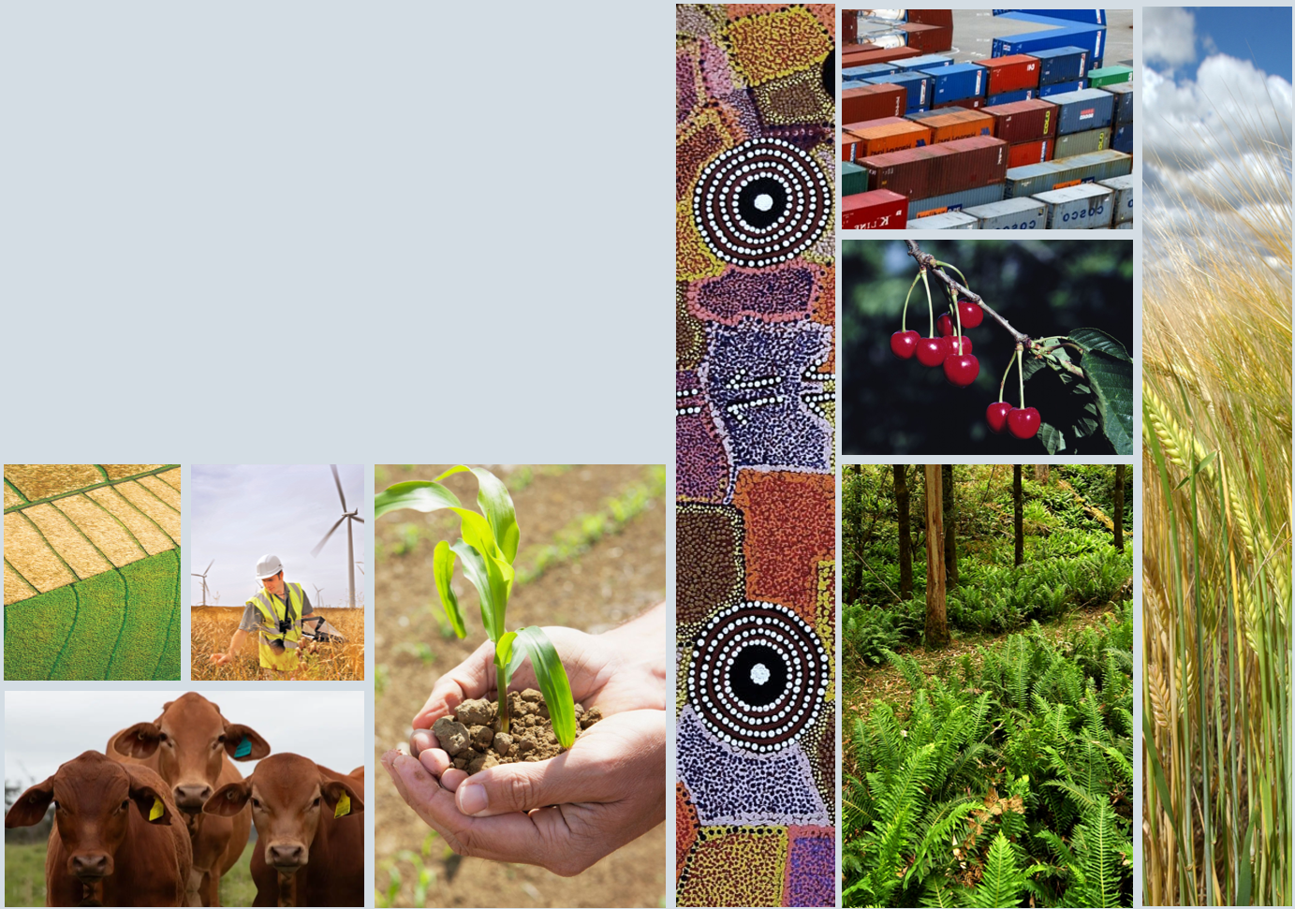

2024 Intergovernmental Agreement on Biosecurity Review:

Implementation Plan
National Biosecurity Committee

2024 Intergovernmental Agreement on Biosecurity Review: Implementation Plan
Table 1 Implementation plan
IGAB recommendation | Response | Implementation approach and deliverables | Lead | Timeframe
- That the IGAB be amended to specifically mention inclusion of First Nations peoples to foster a truly collaborative biosecurity system. | Agreed | The NBC will implement this recommendation by:  - amending the IGAB to include a reference to First Nations peoples (subject to relevant approvals)  - engaging with First Nations peoples and signatories to the IGAB in making this change  - developing high-level principles to guide how this change will be implemented and ensure First Nations peoples are meaningfully engaged to ensure collaboration across the systems. | NBC | First half 2026
- That the NBC considers ways to meaningfully collaborate with First Nations people’s knowledge and wisdom through consultative mechanisms, such as including First Nations people in established advisory groups to the NBC for biosecurity surveillance, planning and responses. | Agreed | The NBC will implement this recommendation by building on work already underway to:  - engage with First Nations peoples on opportunities to collaborate within the biosecurity system  - refine a national approach to embedding First Nations engagement across all the national biosecurity system and its work  - ensure the NBS Implementation Committee has a First Nations representative. | NBC | End of 2025
- That the NBC consider the most appropriate mechanism for inclusion of Research and Development Corporations’ biosecurity research projects, and their outcomes, in the committee’s strategic view of the national biosecurity system. | Agreed | The NBC will implement this recommendation by building on work already underway to:  - review and agree how best to engage with research and development corporations on biosecurity research projects and outcomes  - incorporate relevant outcomes from the Australian Government’s Strategic Examination of Research and Development that are agreed by the government  - adopt the agreed approach to inform annual strategic deep dives for the NBC (in the last quarter of each financial year) and inform the NBC’s 3-year rolling workplan.  Implementation is supported by the NBS priorities: Integration supported by technology, research and data, providing opportunities for coordination of national efforts in biosecurity research. | NBC | First half of 2026
- That Agriculture Ministers require the NBC to meet their reporting obligations under the IGAB, including the annual work plan and making and reporting progress against that work plan, and publicly report its findings. | Agreed | The NBC will implement this recommendation by building on work already underway to:  - finalise a workplan considering national biosecurity risks, threats and opportunities including oversight of the implementation of the NBS  - develop a range of new NBC communications and reporting activities to increase transparency and increase engagement with stakeholders  - publish an NBC annual workplan (that forms part of a 3-year rolling workplan)  - publicly report progress against the workplan. | NBC | Finalise NBC workplan by end 2025.  Remaining deliverables by first half of 2026.
- That the NBC undertakes a review of the NBC’s structure, membership and terms of reference (including that of its sub-committees) to ensure it has a strong foundation to continue to effectively provide strategic leadership in managing national approaches to emerging and ongoing biosecurity policy issues. | Agreed | The NBC will implement this recommendation by building on work already underway to:  - amend refreshed governance to ensure a more strategic leadership approach for the national biosecurity system, including implementing the NBC governance review (conducted in late 2024 and early 2025) outcomes  - seek Agriculture Ministers endorsement of the refreshed NBC’s Terms of Reference (ToR) and refreshed NBC communications plan  - drive a renewed focus on identifying and managing systemic strategic risks  - review NBC subcommittees to ensure they are fit for purpose and that their workplans are aligned to the NBC’s workplan and key priorities  - develop an assurance process to ensure that the biosecurity system continues to deliver an appropriate level of protection. | NBC | Seek Ministerial endorsement of revised ToR and refreshed communication plan by end of 2025.  Remaining deliverables by first half of 2026.
- That Agriculture Ministers and Agriculture Senior Officials consider delaying any potential future reviews of biosecurity cost-sharing and funding until such time as recommendations from previous reviews, and work scheduled in the National Biosecurity Strategy Action Plan ‘Sustainable Investment’ priority are finalised and implemented or closed. Ministers and Agriculture Senior Officials should also ensure that this work is appropriately prioritised and resourced. | Agreed-in-principle | The NBC will implement this recommendation by building on work already underway to provide advice to Agriculture Ministers and agriculture senior officials on:  - progress towards implementing NBS sustainable investment priorities, as part of the NBC annual progress report  - cost sharing and funding issues for specific national biosecurity emergency responses, as needed  - conduct a review with Plant Health Australia and Animal Health Australia on long-standing cost sharing issues from previous and current reviews of cost sharing with potential reform opportunities. | NBC | NBS annual report – early 2026  - Reporting for biosecurity emergency responses ongoing.  - Review of long-standing cross-cutting cost-sharing and funding issues with reform options by the second half of 2026.
- That Agriculture Ministers consider a collaborative, yet simpler approach to future reviews of the IGAB, to be conducted by a team of skilled individuals across state, territory and Commonwealth Departments of Agriculture to allow resources to be redirected to ensuring effective implementation of the IGAB. | Agreed | The NBC will implement this recommendation by providing Agriculture Ministers with options for future IGAB reviews. | NBC | Second half of 2026

Acknowledgement of Country
We acknowledge the continuous connection of First Nations Traditional Owners and Custodians to the lands, seas and waters of Australia. We recognise their care for and cultivation of Country. We pay respect to Elders past and present, and recognise their knowledge and contribution to the productivity, innovation and sustainability of Australia’s agriculture, fisheries and forestry industries.
© Commonwealth of Australia 2025
Unless otherwise noted, copyright (and any other intellectual property rights) in this publication is owned by the Commonwealth of Australia (referred to as the Commonwealth).
All material in this publication is licensed under a Creative Commons Attribution 4.0 International Licence except content supplied by third parties, logos and the Commonwealth Coat of Arms.
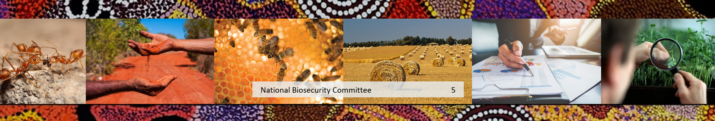
The Australian Government acting through the Department of Agriculture, Fisheries and Forestry has exercised due care and skill in preparing and compiling the information and data in this publication. Notwithstanding, the Department of Agriculture, Fisheries and Forestry, its employees and advisers disclaim all liability, including liability for negligence and for any loss, damage, injury, expense or cost incurred by any person as a result of accessing, using or relying on any of the information or data in this publication to the maximum extent permitted by law.

