Imported food inspection data: January to December 2025
Imported Food Inspection Scheme

© Commonwealth of Australia 2026
Ownership of intellectual property rights
Unless otherwise noted, copyright (and any other intellectual property rights) in this publication is owned by the Commonwealth of Australia (referred to as the Commonwealth).
Creative Commons licence
All material in this publication is licensed under a Creative Commons Attribution 4.0 International Licence except content supplied by third parties, logos and the Commonwealth Coat of Arms.

Cataloguing data
This publication (and any material sourced from it) should be attributed as: DAFF 2026, Imported food inspection data: January to December 2025, Department of Agriculture, Fisheries and Forestry, Canberra. CC BY 4.0.
This publication is available at https://www.agriculture.gov.au/biosecurity-trade/import/goods/food/inspection-testing/surveys-data
Department of Agriculture, Fisheries and Forestry
GPO Box 858 Canberra ACT 2601
Telephone 1800 900 090
Web agriculture.gov.au
Disclaimer
The Australian Government acting through the Department of Agriculture, Fisheries and Forestry has exercised due care and skill in preparing and compiling the information and data in this publication. Notwithstanding, the Department of Agriculture, Fisheries and Forestry, its employees and advisers disclaim all liability, including liability for negligence and for any loss, damage, injury, expense or cost incurred by any person as a result of accessing, using or relying on any of the information or data in this publication to the maximum extent permitted by law.
Acknowledgement of Country
We acknowledge the continuous connection of First Nations Traditional Owners and Custodians to the lands, seas and waters of Australia. We recognise their care for and cultivation of Country. We pay respect to Elders past and present, and recognise their knowledge and contribution to the productivity, innovation and sustainability of Australia’s agriculture, fisheries and forestry industries.

Contents
Executive summary 5
Introduction 7
Imported Food Inspection Scheme 8
Legislation 8
Food classification 8
Inspection rates 8
Australian food trade 9
Commodity types of food imports 10
Source (country of export) of Australian food imports 11
Inspection and test results 13
Compliance rates 13
Labelling 14
Analytical tests 15
Other checks 17
Analytical tests by commodity group 19
Results by commodity group 19
Inspections by country of origin 20
Virtual label and visual inspections 22
Comparing five years of inspection data reports – 2020-25 24
Imports referred to the IFIS - 2020 to 2025 25
Compliance rates - 2020 to 2025 26
Food Import Compliance Agreements 28
Monitoring and response to international alerts and recalls 29
Response to international alerts and recalls 29
Food safety notifications investigated in 2025 29
Appendix A: Analytical tests and assessments 30
Glossary 32

Tables
Table 1 All tests, product compliance rates, 2025 13
Table 2 Analytical tests, compliance rates, 2025 15
Table 3 Chemical tests, product compliance rates, 2025 16
Table 4 Composition analytical tests, product compliance rates, 2025 16
Table 5 Contaminant tests, product compliance rates, 2025 16
Table 6 Microbiological test, product compliance rates, 2025 17
Table 7 Other checks, 2025 18
Table 8 Inspection and test data, by commodity group, 2025 20
Table 9 Number of inspections, by country of origin, 2025 20
Table 10 Number of virtual inspections, by importer location, 2025 22
Table 11 Food Import Compliance Agreement activity, 2025 28
Table 12 Food safety notifications investigated in 2025 29

Figures
Figure 1 Value of food exports, imports and net exports, 2005-2025 9
Figure 2 Food import value, by commodity 10
Figure 3 Food import volume, by commodity 11
Figure 4 Food import value by country of export 12
Figure 5 Food import volume by country of export 12
Figure 6 Non-compliant results, by type, 2025 13
Figure 7 Non-compliant labelling, by information type, 2025 14
Figure 8 Percentage of tests applied, by commodity group, 2025 19
Figure 9 Percentage of tests applied, by country of origin, 2025 21
Figure 10 Number of import entries and lines referred to the Imported Food Inspection Scheme each year – 2020 to 2025 25
Figure 11 Summary of compliance for each of the five years 2020 to 2025 26
Figure 12 Number of tests conducted under the Imported Food Inspection Scheme each year – 2020 to 2025 27

Executive summary
The annual Imported Food Inspection Data reports activities conducted under the Imported Food Inspection Scheme (IFIS). This report provides summary data from inspections conducted under the IFIS from 1 January to 31 December 2025 and compares this data with inspections conducted since 2020. It also provides an update on Food Import Compliance Agreements (FICAs) and our monitoring and response activities.
To help contextualise the inspection data, the report includes information on food trade, such as the composition of Australian food imports and countries of origin.
Australia continues (by value) to export more food than we import. The value of Australian food exports was $72 billion in 2025, compared to the value of food imported by Australian food businesses, which was $33 billion in 2025.
New Zealand is Australia’s largest source of imported food, both in terms of value and volume. Based on import value, Singapore and the United States are the next largest source of food imports after New Zealand. However, when measured by imports volume, China and Thailand rank ahead of these countries making them Australia’s largest food import sources after New Zealand.
Fruit and vegetables accounted for the highest value of imports in 2025, followed by processed food.
From 1 January to 31 December 2025, the compliance rate for all food inspected was 98.9%.
During this period:
- 23,995 entries of imported food were referred and subject to inspection or analysis
- 50,444 lines of these entries were inspected. Of these lines
  - 32.3% were risk food
  - 64.6% were surveillance food
  - 3.1% were surveillance food subject to a holding order
- 135,372 tests (including label and visual checks) were conducted on the food, comprising
  - 21,403 analytical tests
  - 53,921 label and composition assessments
  - 60,048 other tests.
Since 2021, surveillance foods requiring only a label and visual inspection may be inspected virtually through Microsoft Teams. This enables departmental officers to conduct inspections remotely with food importers or their nominated representatives, reducing processing times and the need for an in-person inspection. This allows importers or their nominated representatives to connect with departmental officers remotely, reducing wait times for inspections.

In 2025, 3,013 virtual inspections were conducted, an increase of 268 compared with the 2,745 inspections conducted in 2024.
The 2025 report now includes a comparison of inspection activity under the IFIS from 2020-2025. Overall, the data indicates that, despite variations in the number of import referrals and tests conducted over time, compliance rates have remained stable.
An additional three businesses commenced Food Import Compliance Agreements (FICA) as an alternative to having their imports inspected under the IFIS, increasing the number to 40. Twenty-seven audits were conducted on these businesses in 2025.
The department continues to monitor and investigate international food safety notifications, with sixteen notifications in 2025 subject to follow up actions.

Introduction
The Department of Agriculture, Fisheries and Forestry administers two Acts that apply to food imported into Australia:
- Biosecurity Act 2015 – manages biosecurity threats to plants, animals and human health in Australia and its external territories.
- Imported Food Control Act 1992 (IFC Act) – manages food safety risks to protect human health.
This report provides compliance data for activities under the IFC Act.
Importers are legally responsible for ensuring the foods they import for sale in Australia comply with Australia’s food standards and do not pose a risk to human health.
We monitor the compliance and safety of imported food at the border through the Imported Food Inspection Scheme (IFIS), a risk-based border inspection program. Foods are referred for inspection and testing under the IFIS based on whether they have been classified as risk or surveillance foods. Risk food is initially referred at a higher rate than surveillance food. Inspection rates decrease or increase depending on compliance history and recognition of certification.
This report provides summary data from inspections conducted under the IFIS from 1 January to 31 December 2025.
Every month, we publish failing food reports on our website. These are foods that:
- failed analytical testing
- were found to contain non-permitted additives or ingredients, or
- were found to be prohibited plants or fungi.
Every year, we publish an annual report on inspections conducted under the IFIS on our website.

Imported Food Inspection Scheme

Legislation
The IFC Act provides for the department to administer the IFIS.
The Imported Food Control Regulations 2019 set out how the IFIS operates, including the rates at which food consignments are referred for inspection.
The Imported Food Control Order 2019 lists foods that are classified as ‘risk food’ or require certification.

Food classification
The Minister classifies foods as risk foods under the Order based on advice from Food Standards Australia New Zealand (FSANZ) that they have the potential to pose a medium or high risk to public health. FSANZ is an independent statutory authority responsible for developing and maintaining the Australia New Zealand Food Standards Code and providing risk advice on food imported into Australia.
Food that is not classified as risk food is considered surveillance food, unless it is compliance agreement food. Compliance agreement food is imported by a business under a Food Import Compliance Agreement (FICA). A FICA provides food importers with an alternative regulatory arrangement to product inspection and testing under the IFIS. Under this arrangement, the department audits an importer's documented food safety management system rather than routinely inspecting and testing individual consignments. As a result, food imported under a FICA is not referred for inspection under the IFIS.

Inspection rates
Risk food is initially referred for inspection and analysis at a rate of 100% of consignments. This inspection rate is reduced to 25% following 5 consecutive passes and is then reduced to 5% of consignments after a further 20 consecutive passes. The inspection rate for Risk food may vary when imported under recognised certification.
Surveillance food is referred for inspection and analysis at an initial rate of 5% of consignments.
When imported food fails inspection, the importer must take follow-up action, such as treatment of the food to bring it into compliance (where applicable), destruction or export. Subsequent imports of the same food (same product, producer and country of origin) are subject to inspection at the rate of 100% of consignments until the food demonstrates a history of compliance.
The department uses electronic profiles in the Department of Home Affairs Integrated Cargo System (ICS) to identify foods of interest and appropriate rates of referral. Foods referred for inspection are subject to the relevant tests as outlined in Appendix A. The inspection rates are based on the risk the food may pose and the compliance history of the food producer.

Australian food trade
To help contextualise the inspection data, this report includes information on food trade, such as the composition of Australian food imports and countries of origin.
Data on food imports and food exports is presented in value terms for each financial year. Figure 1 shows the trend for the last 20 years, including the net value for food exports (difference between the value of food exports and food imports). In the context of imported food, this indicates that the value of imports has been steadily increasing over the last twenty years.
The value of food imported by Australian food businesses was $33 billion in 2025, an increase of 8.6% compared with the previous year.
The value of Australian food exports was $72 billion in 2025, an increase of 12.2% compared with the previous year.
As a result, Australia’s net value for food exports increased by 15.3% to $39 billion in 2025. This means Australia continues (by value) to export more food than we import.
Figure 1 Value of food exports, imports and net exports, 2005-2025
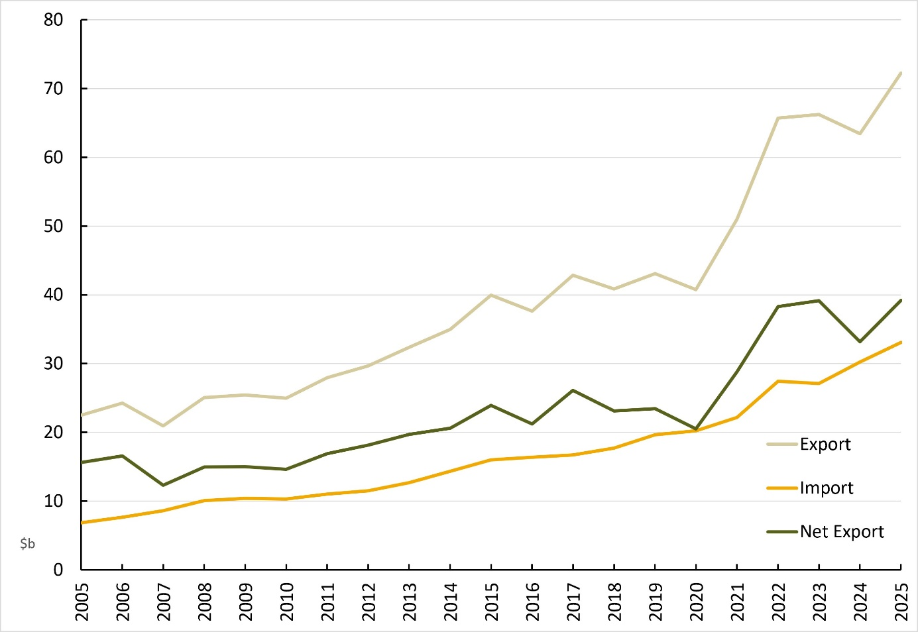
Source: ABARES; ABS International Trade in Goods

Commodity types of food imports
Figure 2 shows the type of products imported into Australia in 2025 and 2024, compared with the average annual value over the previous 10 years (2013-2023).
In 2025, fruit and vegetables remained the highest-value food import commodity, followed by processed food not elsewhere classified. The value of imports increased across most commodity groups between 2024 and 2025. Compared with the average of the previous 10 years (2013-2023), soft drinks and cordials recorded the largest increase in import value.
Figure 2 Food import value, by commodity
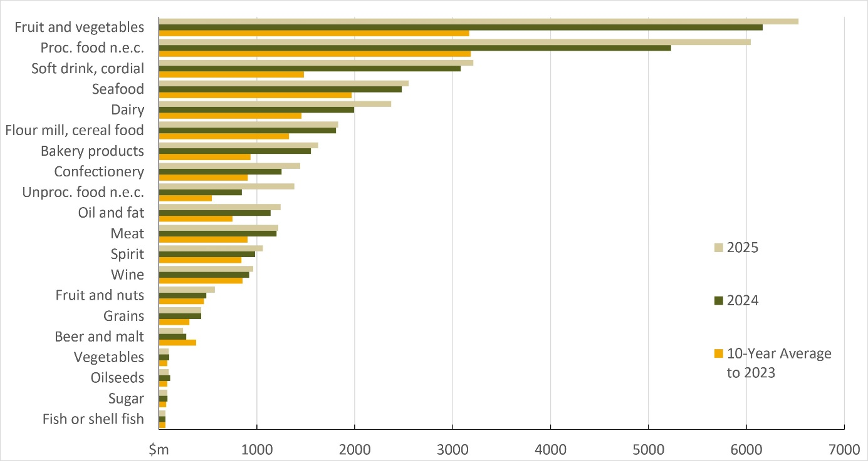
Source: Proc. Processed. n.e.c. Not elsewhere classified. Unproc. Unprocessed. Volume is an aggregation of different quantity units converted to kilograms where possible.
Source: ABARES; ABS International Trade in Goods
Figure 3 shows the volume of food imports into Australia by commodity for 2025 and 2024, compared with the average annual import volume over the previous 10 years (2013-2023). In both 2024 and 2025, fruit and vegetables were the largest imported commodity by volume, followed by flour mill and cereal foods. Compared with the 10-year average, import volumes of fruit and vegetables increased significantly. The figure also shows a decline in the import volume of beer and malt.

Figure 3 Food import volume, by commodity
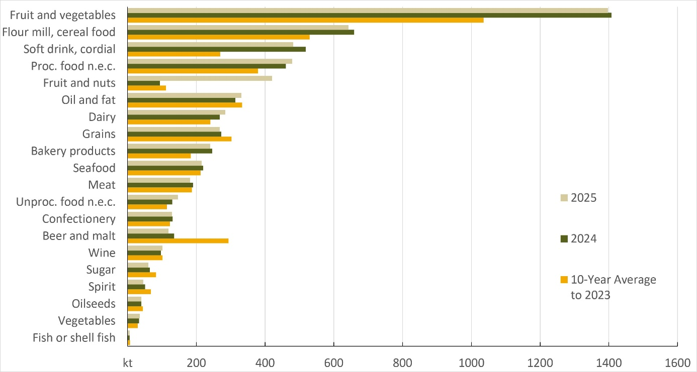
Source: Proc. Processed. n.e.c. Not elsewhere classified. Unproc. Unprocessed. Volume is an aggregation of different quantity units converted to kilograms where possible.
Source: ABARES; ABS International Trade in Goods

Source (country of export) of Australian food imports
Figure 4 and Figure 5 show the source countries of Australia's food imports by value and volume, respectively. Both figures present data for 2025 and 2024, alongside the average for the previous 10 years (2013-2023)
New Zealand remained Australia's largest source of food imports in both value and volume terms. By import value, Singapore and the United States were the next largest source countries. By import volume, however, China and Thailand ranked second and third after New Zealand.
Compared with the 10-year average, imports from Singapore increased significantly in value. In terms of volume, imports from China and Thailand increased substantially, with a decline in imports from the United States and Canada.

Figure 4 Food import value by country of export
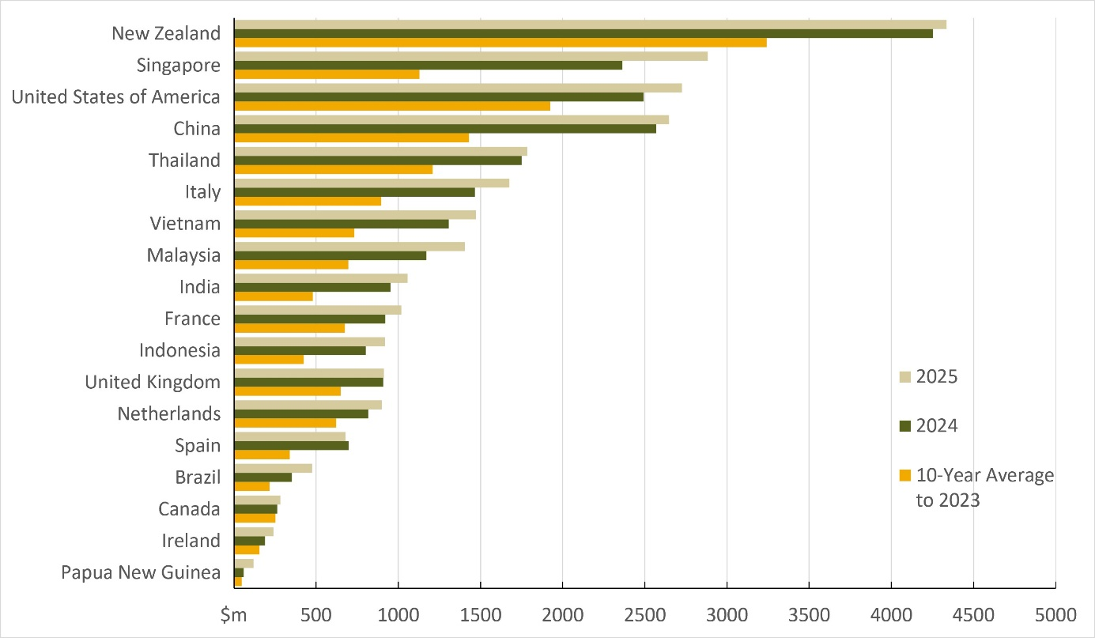
Source: ABARES

Figure 5 Food import volume by country of export
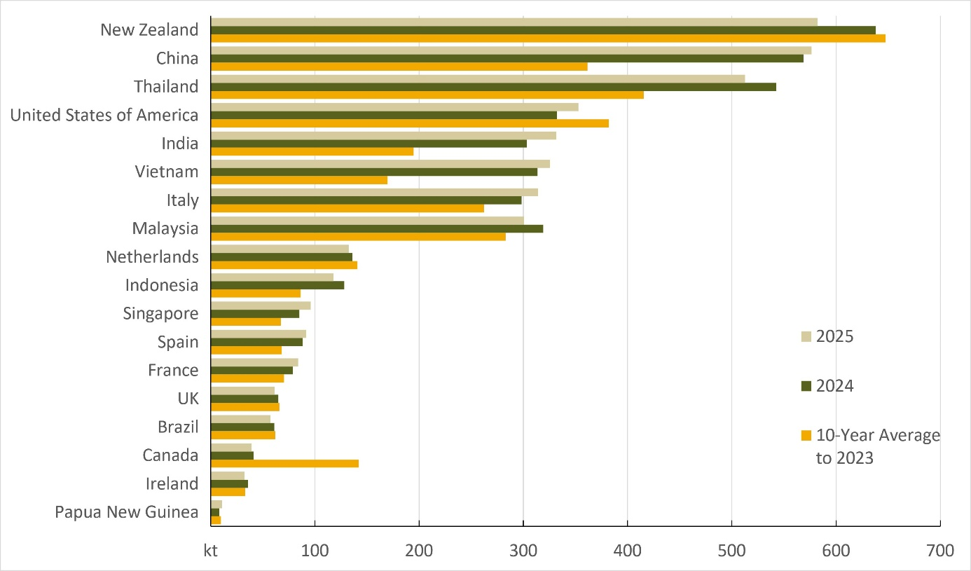
Source: ABARES

Inspection and test results

Compliance rates
In 2025, 98.9% of all imported foods inspected under the IFIS complied with the test applied. Table 1 shows the compliance rates for the testing groups.
Table 1 All tests, product compliance rates, 2025
Test group | Tests applied (no.) | Compliant (no.) | Non-compliant (no.) | Compliant (%)
Labelling/composition | 53,921 | 52,821 | 1,100 | 98.0
Analytical | 21,403 | 21,108 | 295 | 98.6
Other ª | 60,048 | 59,906 | 142 | 99.8
Total | 135,372 | 133,835 | 1,537 | 98.9
ª includes visual assessment, government certificate assessment, food safety management certificate assessment.
Source: Agriculture Import Management System
Figure 6 summarises the reasons for non-compliant results (n = 1,537).
Figure 6 Non-compliant results, by type, 2025
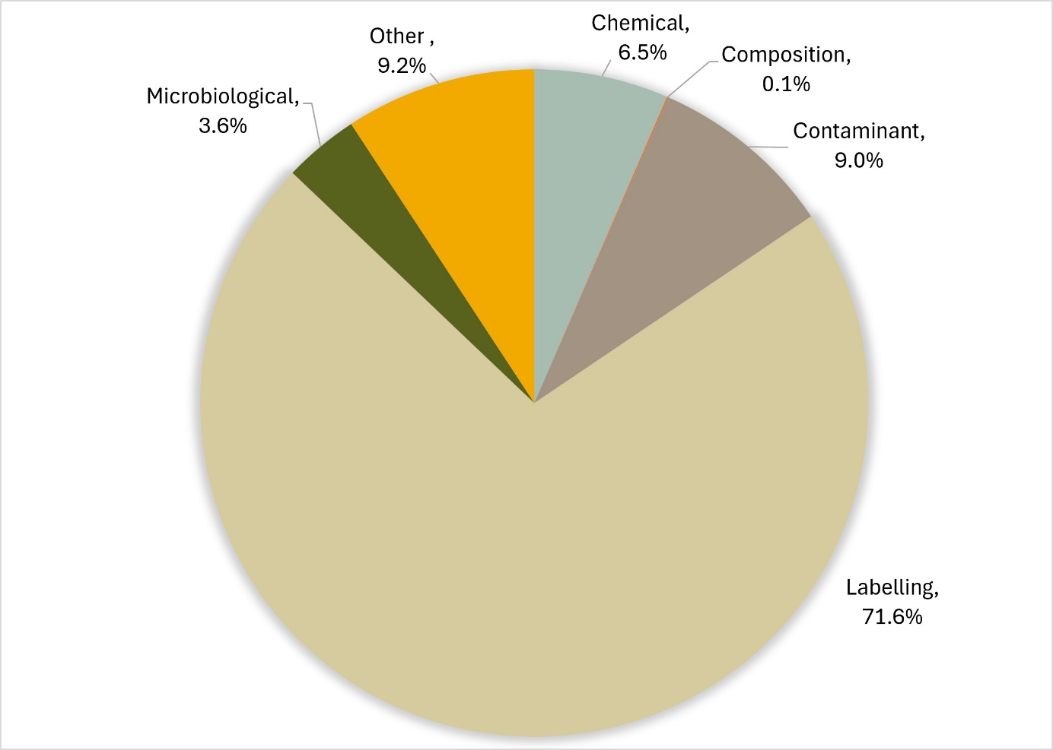
Source: Agriculture Import Management System

Labelling
In 2025, labels that did not comply with Australian food standards were the main source of non-compliance. Figure 7 summarises the reason for non-compliant labelling.
Most notably:
- 31% lacked or listed either incomplete or incorrect nutritional details
- 18.4% lacked or listed incorrect importer details
- 17.6% were non-compliant with mandatory warning statements
- 16% lacked or listed either incomplete or incorrect ingredient lists
- 9.5% were non-compliant with country of origin labelling requirements
- 3.9% lacked or listed incomplete product descriptions.
Figure 7 Non-compliant labelling, by information type, 2025
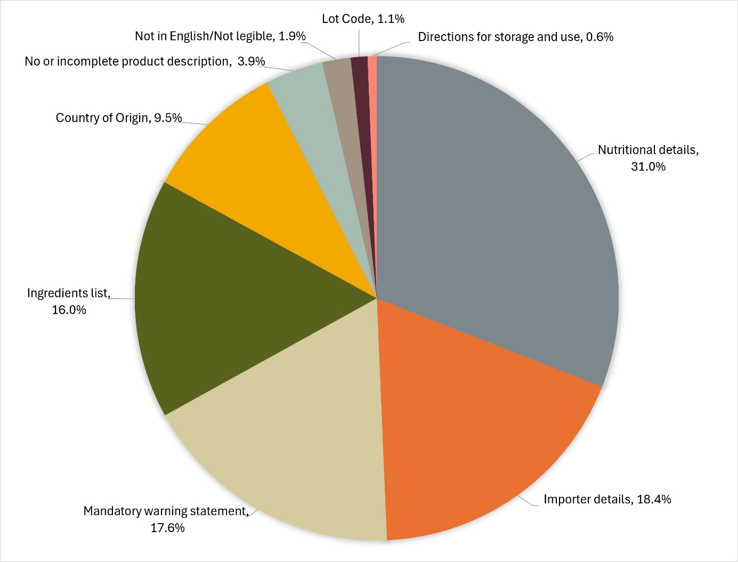
Source: Agriculture Import Management System

Analytical tests
Analytical tests conducted under the IFIS are grouped into 4 categories:
- chemical
- composition (analytical assessment)
- contaminant
- microbiological.
For details of tests applied to different food groups, see Appendix A.
The number of lines of food referred for inspection under the IFIS and the number of tests applied to food may differ. This is because food subject to inspection is sampled and analysed based on the number of:
- batches (or types of food) and lots within each batch of food on the line referred for inspection
- test types applied to each sample of that food taken during inspection.
Example of analytical tests applied to one line of cooked and processed meat products
A line of cooked and processed meat product is referred for inspection under the IFIS. The line contains 2 batches (e.g. whole prosciutto ham and sliced prosciutto ham), each with one lot code. An officer takes one sample from each batch and applies relevant tests. In this example, the tests are Listeria monocytogenes and Salmonella.
This means 2 samples are taken from this one line of imported food and 2 microbiological tests are applied to each sample. This is reported as one line, with 4 separate test results.
Table 2 provides a summary of compliance rates for all analytical tests.
Table 2 Analytical tests, compliance rates, 2025
Test type | Tests applied (no.) | Compliant (no.) | Non-compliant (no.) | Compliant (%)
Chemical | 5,617 | 5,517 | 100 | 98.2
Composition | 76 | 75 | 1 | 98.7
Contaminant | 8,808 | 8,670 | 138 | 98.4
Microbiological | 6,902 | 6,846 | 56 | 99.2
Total | 21,403 | 21,108 | 295 | 98.6
Source: Agriculture Import Management System
Table 3 provides a summary of compliance rates for all chemical tests.
Table 3 Chemical tests, product compliance rates, 2025
Chemical | Food type | Tests applied (no.) | Compliant (no.) | Non-compliant (no.) | Compliant (%)
Cannabidiol | Hemp seed and hemp seed products | 3 | 3 | 0 | 100
Cephalosporins | Meat | 727 | 727 | 0 | 100
Fluoroquinolones | Meat; Farmed fish and prawns | 1,300 | 1,296 | 4 | 99.7
Fruit and vegetable residue screen | Fruit and vegetables | 1,885 | 1,790 | 95 | 95
Malachite green | Farmed fish | 410 | 410 | 0 | 100
Nitrofurans | Farmed prawns | 150 | 150 | 0 | 100
Quinolones | Farmed fish | 412 | 411 | 1 | 99.8
Total THC | Hemp seed and hemp seed product | 3 | 3 | 0 | 100
Virginiamycin | Meat | 727 | 727 | 0 | 100
Total | – | 5,617 | 5,517 | 100 | 98.2
Source: Agriculture Import Management System
Table 4 Composition analytical tests, product compliance rates, 2025
Composition test | Food type | Tests applied (no.) | Compliant (no.) | Non-compliant (no.) | Compliant (%)
Allergen – Dairy | Coconut drinks and coconut powders | 22 | 21 | 1 | 95.5
C4 adulteration | Honey | 18 | 18 | 0 | 100
Moisture content | Honey | 18 | 18 | 0 | 100
Reducing sugar content | Honey | 18 | 18 | 0 | 100
Total | – | 76 | 75 | 1 | 98.7
Source: Agriculture Import Management System
Table 5 Contaminant tests, product compliance rates, 2025
Contaminant | Food type | Tests applied (no.) | Compliant (no.) | Non-compliant (no.) | Compliant (%)
Aflatoxins | Nuts | 1,665 | 1,602 | 63 | 96.2
Arsenic total | Cereal grains, cereal flours and processed cereals | 1,233 | 1,230 | 3 | 99.8
Domoic acid | Bivalve molluscs | 612 | 612 | 0 | 100
Histamine | Fish | 2,687 | 2,653 | 34 | 98.7
Hydrocyanic acid | Cassava chips | 126 | 99 | 27 | 78.6
Inorganic arsenic | Seaweed (hijiki) | 8 | 8 | 0 | 100
Iodine | Seaweed (brown algae) | 215 | 204 | 11 | 94.9
Lead | Cereal grains, cereal flours, processed cereals, fresh and frozen vegetables | 1,826 | 1,826 | 0 | 100
PSP toxin | Bivalve molluscs | 436 | 436 | 0 | 100
Total | – | 8,808 | 8,670 | 138 | 98.4
Source: Agriculture Import Management System
Table 6 Microbiological test, product compliance rates, 2025
Microbial agent | Food type | Tests applied (no.) | Compliant (no.) | Non-compliant (no.) | Compliant (%)
Bacillus cereus | Bean curd, tofu | 99 | 97 | 2 | 98
Cronobacter | Infant formula (0 to 6 months) | 9 | 9 | 0 | 100
Escherichia coli | Beef products, seafood, cheese, fruit and vegetables | 409 | 403 | 6 | 98.5
Listeria monocytogenes | Cheese, ready-to-eat seafood, processed meats | 2,022 | 2,010 | 12 | 99.4
Listeria monocytogenes (enumerated) | Cheese, RTE finfish, slow-cured ham | 322 | 322 | 0 | 100
Salmonella | Processed meats, seafood, dried coconut, dried paprika, pepper, capsicum and chilli, sesame seeds, cheese, infant formula | 3,571 | 3,535 | 36 | 99
Vibrio cholerae | Cooked prawns | 470 | 470 | 0 | 100
Total | – | 6,902 | 6,846 | 56 | 99.2
Source: Agriculture Import Management System

Other checks
In addition to analytical testing, other checks are conducted on imported food to verify safety and compliance with the Food Standards Code.

Composition
During the inspection, the officer assesses the food label for the presence of ingredients or substances that are either not permitted or in excess of permitted levels – for example, non-permitted colours, added vitamins or prohibited substances.

Visual
As part of the inspection, the officer conducts a visual assessment of the food to determine whether it may be unsafe or unfit for human consumption. This includes checking for signs such as mould growth on food, damaged packaging, or evidence of pest infestation.

Certification
Analytical testing alone may not always provide sufficient assurance that food safety risks are being effectively managed. For certain foods, certification is therefore required to verify that foodborne hazards have been appropriately controlled. At the border, an authorised officer checks that the certification meets the department's requirements. The foods that require certification, and the types of certification required, are outlined below.
- Beef and beef products – Government certificates provide evidence the origin is a country with a satisfactory BSE risk status from Food Standards Australia New Zealand (FSANZ). For raw fresh beef, government certificates also provide evidence the foodborne hazards of concern are being managed.
- Bivalve molluscs, human milk and raw milk cheese – Government certificates provide evidence that a country’s system for the production and processing of food provides an equivalent food safety outcomes to Australia’s system.
- Berries that are ready to eat and pomegranate arils that are ready to eat – Food safety management certificates provide evidence that a food has been produced under a recognised food safety management system based on HACCP principles.
Table 7 lists the other checks applied, the number of checks conducted and the compliance rates.
Table 7 Other checks, 2025
Type | Tests applied (no.) | Compliant (no.) | Non-compliant (no.) | Compliant (%)
Composition | 252 | 137 | 115 | 54.4
Visual | 53,245 | 53,230 | 15 | 100
BSE Certificates | 1,307 | 1,296 | 11 | 99.2
Food Safety Management Certificates | 2,287 | 2,286 | 1 | 100
Foreign Government Certificates (including raw milk cheese) | 2,957 | 2,957 | 0 | 100
Total | 60,048 | 59,906 | 142 | 99.8
Source: Agriculture Import Management System

Analytical tests by commodity group
As shown in Figure 8 , seafood (fresh, chilled, frozen and processed seafood products) was the commodity subject to the most testing (17.8%) in 2025. Horticulture was second highest (17.2%). Horticulture includes fresh and processed fruit and vegetables.
Figure 8 Percentage of tests applied, by commodity group, 2025
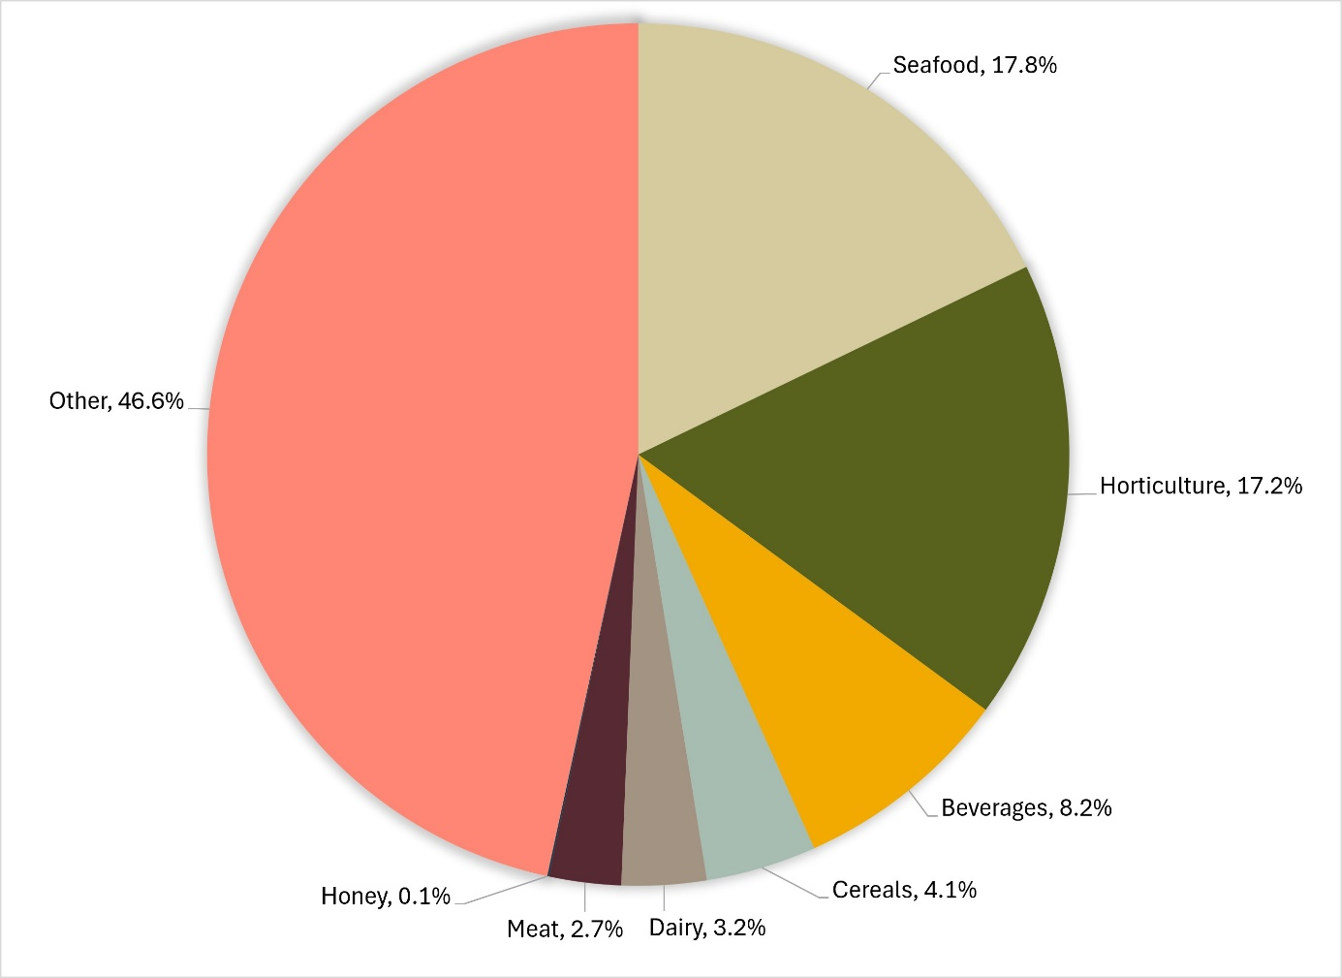
Note: ‘Other’ captures a range of tariff codes, including processed foods such as cereals, canned vegetables, vegetable oils, spices, confectionery, biscuits, coffee and tea.
Source: Agriculture Import Management System

Results by commodity group
Commodity groups that contain risk food or are imported more frequently will have a higher representation under the inspection activity.
Table 8 provides the number of tests applied and compliance rates for food commodity groups. These are not indicative of the volume of trade in each commodity group.
The commodity group ‘other’ represents the largest group tested because it captures a range of processed foods such as cereals, canned vegetables, vegetable oils, spices, confectionery, biscuits, coffee and tea.
Appendix A provides an overview of the analytical tests applied to the commodity groups.
Table 8 Inspection and test data, by commodity group, 2025
Commodity group | Tests applied (no.) | Compliant (no.) | Non-compliant (no.) | Compliant (%)
Beverages | 9,715 | 9,496 | 219 | 97.7
Cereals, flours and milled products | 4,891 | 4,831 | 60 | 98.8
Dairy | 3,754 | 3,723 | 31 | 99.2
Egg products | 32 | 32 | 0 | 100
Honey | 70 | 70 | 0 | 100
Horticulture | 20,372 | 19,958 | 414 | 98
Meat | 15 | 3,173 | 3,188 | 99.5
Other (incl. processed food) a | 55,047 | 53,586 | 1,461 | 97.3
Seafood | 21,060 | 20,856 | 204 | 99
Total | 118,129 | 115,725 | 2404 | 98
a Captures a range of tariff codes, including processed foods such as cereals, canned vegetables, vegetable oils, spices, confectionery, biscuits, coffee and tea.
Source: Agriculture Import Management System

Inspections by country of origin
Under the IFIS, food is referred for inspection based on its risk classification, not the country of export. The exception is where a food has previously failed inspection. Future consignments of that food from the producer in the exporting country are inspected at rate of 100% until a history of compliance is established. The number of inspections by country of origin is provided in Table 9.
Table 9 Number of inspections, by country of origin, 2025
Country of origin | Lines inspected (no.) | Lines inspected %
Thailand | 8,572 | 15.3
China | 7,959 | 14.2
Japan | 4,900 | 8.7
India | 4,266 | 7.6
Italy | 2,977 | 5.3
Chile | 2,967 | 5.3
Republic of Korea | 2,688 | 4.8
Viet Nam | 2,288 | 4.1
United States of America | 1,700 | 3.0
France | 1,458 | 2.6
Other | 16,284 | 29.0
Total | 56,059 | 100
Source: Agriculture Import Management System

As shown in Figure 9, from 1 January to 31 December 2025:
- food from Thailand, China and Japan were subject to the most inspections
- 71% of inspections were conducted on food from 10 countries; the remaining 29% were conducted on food from 120 countries.
Figure 9 Percentage of tests applied, by country of origin, 2025
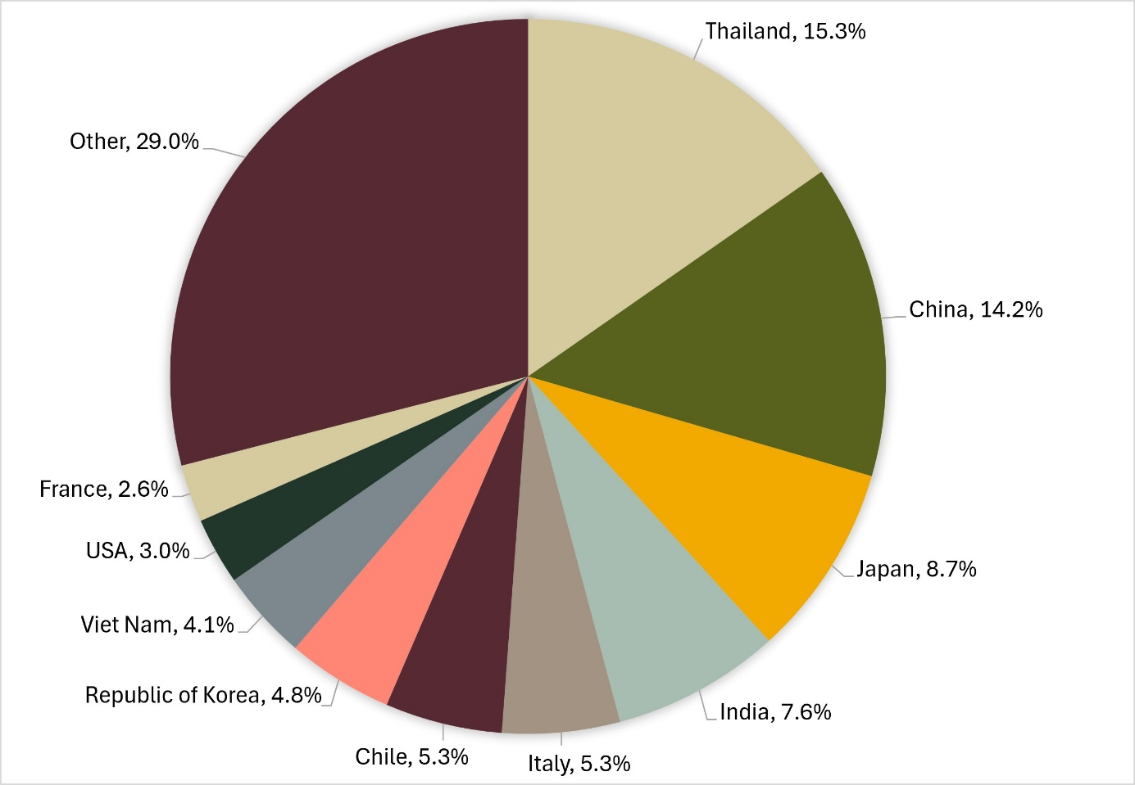
Source: Agriculture Import Management System
As indicated by Figure 4 and Figure 5, most of our food imports are from New Zealand, but few are subject to the IFC Act. Food imported from New Zealand is exempt from the IFIS unless specified in the IFC Order. Currently, the Order specifies that the IFC Act applies to beef, beef products, ready-to-eat cassava chips and brown seaweed from New Zealand. The exemption in the IFC Act for food imported from New Zealand was included following the signing of the Trans-Tasman Mutual Recognition Arrangement between Australia and New Zealand in 1996. Under the arrangement, goods produced by or imported into either country that meet one country’s legal requirements may be legally sold in the other country.

Virtual label and visual inspections
Virtual label and visual inspections are conducted remotely using Microsoft Teams to connect a departmental officer with a food importer or nominated representative. The virtual inspection is equivalent to a physical inspection under the IFIS.
The imported food virtual label and visual inspections initiative was implemented in July 2021, primarily to reduce inspection waiting times for food importers. These inspections apply to consignments flagged for a visual and label check only, because no samples need to be taken at these types of inspections.

Importing businesses approved for virtual inspection
Importing businesses wanting to book a virtual inspection need to be assessed to check that the business can support these inspections. For example, the premises where the inspections will be conducted must have a reliable internet connection.
During 2025, an additional 259 importing businesses were approved for virtual inspections. At the end of 2025, 874 businesses were approved for virtual label and visual inspections.

Virtual inspections conducted
A total of 3,013 virtual inspections were conducted in 2025. This was a net increase of 268 imports from 2024. The highest number of virtual inspections were conducted in NSW, followed by Victoria, reflecting the high volume of food imported into these states.
Table 10 lists the number of virtual inspections conducted at each location
Table 10 Number of virtual inspections, by importer location, 2025
Importer location | Virtual inspections (no.)
New South Wales | 1,278
Victoria | 1,083
Queensland | 552
Western Australia | 78
South Australia | 11
Northern Territory | 8
Tasmania | 2
Australian Capital Territory | 1
Total | 3,013
Risk food is not eligible for virtual inspection, except for permitted kava products.
Virtual inspections are available for surveillance food, excluding:
- formulated supplementary sport foods
- food subject to a holding order
- food subject to analytical testing.
The surveillance foods most often inspected virtually are:
- alcohol for retail sale
- bulk food ingredients such as juice concentrates for further processing
- noodles and pasta
- confectionery, tea and coffee
- sauces.

Comparing five years of inspection data reports – 2020-25
The department has been publishing Imported Food Inspection Data reports on activities dating back to July 2006.
Activity occurring under the IFIS can be influenced by factors such as change in the international and domestic economy; change in consumer tastes and requirements; international trade agreements; changes to Biosecurity market access and import conditions; and the COVID-19 pandemic which impacted on trade globally.
The following figures compare the last five years of data for the number of entries and lines referred to the IFIS, the number of tests conducted and compliance rates. Overall, these figures show that while the number of imports referred and tests conducted have varied, compliance rates have remained stable.

Imports referred to the IFIS - 2020 to 2025
Over the five-year period 2020 to 2025, the average number of import entries referred to the IFIS was 23,159. The average number of import lines referred was 47,173. Figure 10 shows the number of import entries and lines each year for the period 2020 to 2025. There is a noticeable drop in the number of entries and lines referred in the years 2021-23, likely due to the COVID-19 pandemic which impacted on trade volumes globally.
Figure 10 Number of import entries and lines referred to the Imported Food Inspection Scheme each year – 2020 to 2025
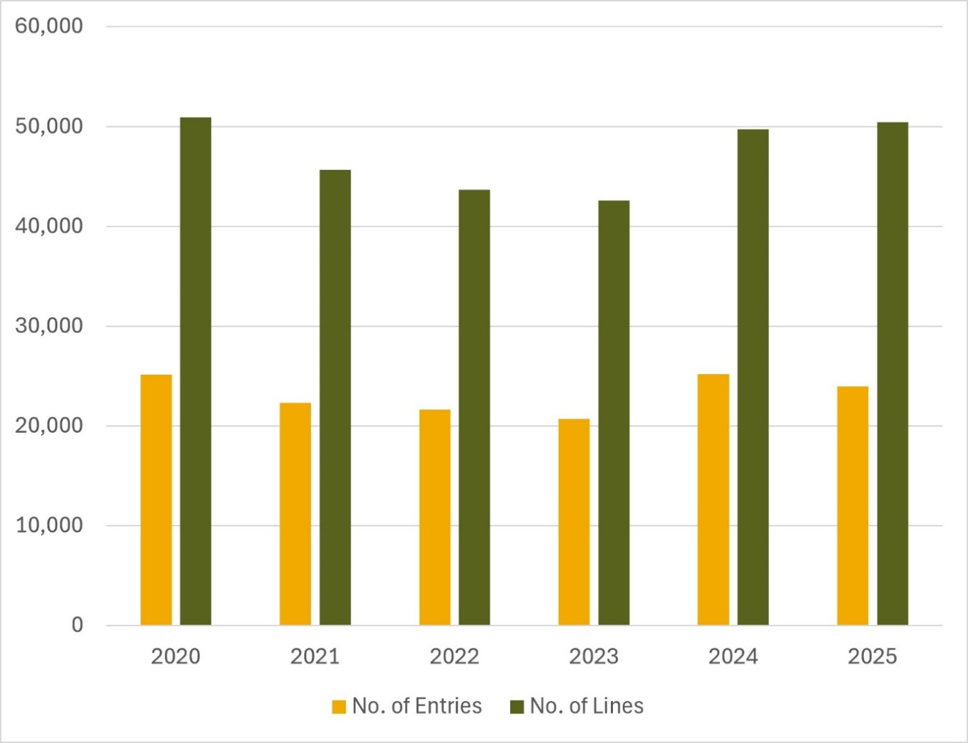

Compliance rates - 2020 to 2025
Over the five-year period 2020 to 2025, the variation in compliance rates for the test types Labelling, Analytical and Other has been less than 2%. Figure 11 shows a summary of the overall compliance each year for the five years 2020 to 2025.
Figure 11 Summary of compliance for each of the five years 2020 to 2025

Figure 12 summarises the number of tests applied under the Imported Food Inspection Scheme each year for the five years 2020 to 2025. The number of tests noticeably decreased between 2021 to 2023 which reflects the decrease in the number of lines referred for inspection (Figure 10).
Figure 12 Number of tests conducted under the Imported Food Inspection Scheme each year – 2020 to 2025
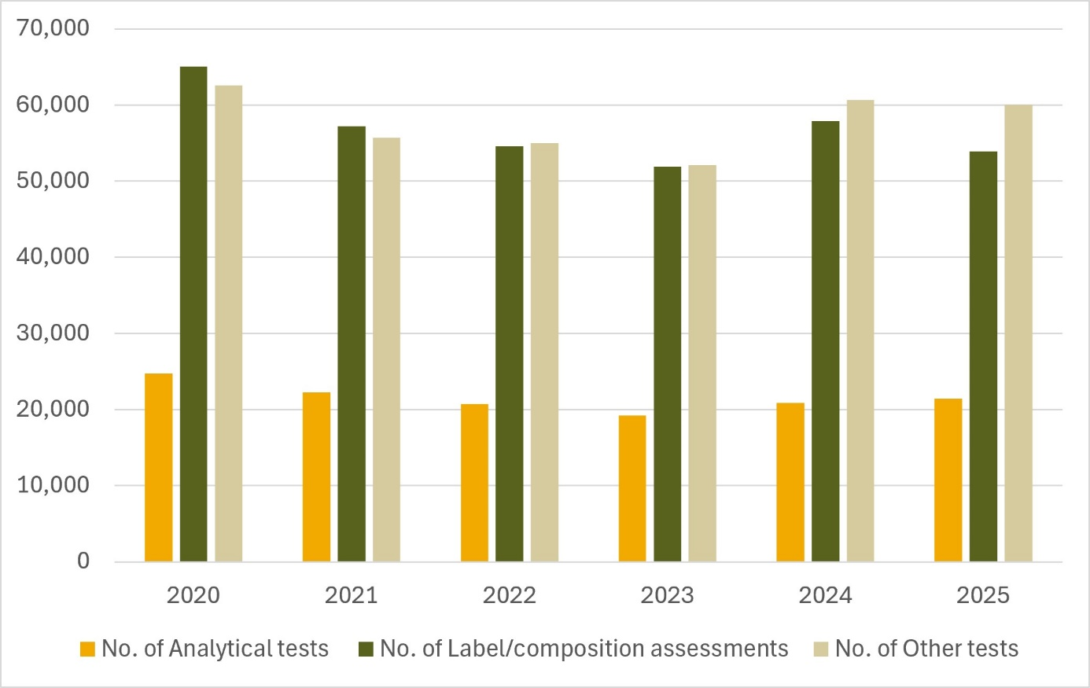

Food Import Compliance Agreements
Food importers can enter into a Food Import Compliance Agreement (FICA) with the department. These agreements are made under section 35A of the Imported Food Control Act 1992.
A FICA recognises an importer’s documented food safety compliance system as an alternative to inspection and testing under the IFIS. Therefore, food imported under a FICA is not referred for inspection and testing at the border. Instead, we assess the importer’s compliance with the FICA requirements through regular audits.
Table 11 summarises activity related to FICAs.
Table 11 Food Import Compliance Agreement activity, 2025
No. of FICAs in place as at end of 2025 | No. of FICAs ceased in 2025 | No. of FICAs commenced in 2025 | No. of FICA audits conducted in 2025
40 primary entities and 5 subsidiary entities* | 0 | 3 | 27
Source: DAFF, Imported Food
*The 2024 imported food data report only provided information on total numbers. Of the 42 FICAs reported in 2024, 37 were primary entities and 5 were subsidiary companies.

Monitoring and response to international alerts and recalls

Response to international alerts and recalls
We scan information on international food safety alerts and food recalls to assist with identifying if unsafe food has been imported. If this has occurred, we provide information about the imports to the relevant state or territory food regulator to consider action, including a food recall where appropriate. Where relevant, we will also apply holding orders to ensure further imports are referred for inspection to verify compliance.

Food safety notifications investigated in 2025
In 2025, we investigated 198 international food safety notifications due to evidence of potentially unsafe food being imported into Australia. Of these notifications, 16 were subject to follow up action. Table 12 lists these foods and the reason for notification.
Table 12 Food safety notifications investigated in 2025
Food | Reason for notification
Frozen Berries | microbial contamination (Hepatitis A)
Canned Tuna | undeclared allergen (wheat, gluten)
Carbonated beverages | contamination (chemical – chlorate)
Taro Powder | undeclared allergen (milk)
Crushed garlic | contamination (heavy metal – lead)
Cheese | microbial contamination (Listeria monocytogenes)
Alcoholic beverage | contamination (chemical – cleaning fluid)
Coffee | novel food ingredients (Lion’s Mane, Reishi, Cordyceps)
Frozen dairy confection | undeclared allergen (egg)
Frozen confection | undeclared allergen (milk)
Chili sauce | undeclared allergen (gluten)
Frozen vegetables and fruit products | microbial contamination (Salmonella)
Various seafood | contamination (chemical – arsenic)
Tahini paste | microbial contamination (Salmonella)
Fried onions | undeclared allergen (gluten)
Mini jelly cups | undeclared allergens (milk)
Source: DAFF, Imported Food

Appendix A: Analytical tests and assessments
Food group | Test
Caffeine products - pure and highly concentrated | - Caffeine concentration determined by label assessment
Cassava chips | - Hydrocyanic acid
Cereal grains and products | - Arsenic  - Lead
Coconut | - Salmonella
Coconut milk drinks | Dairy allergens:  - Beta-lactoglobulin  - Casein  - Total milk
Dairy | Cheese:  - Listeria monocytogenes  Dried milk  - Salmonella  Raw milk cheese:  - Recognised Government Certification
Fruit and vegetables | - Fruit and vegetable residue screen  - Lead  - E coli  Fresh chilled or frozen berries and pomegranate arils:  - Food Safety Management Certificates  Enoki mushrooms  - Directions for use determined by label assessment  - Listeria monocytogenes
Hemp and hemp seed products | - Total THC  - Cannabidiol
Herbs, pepper and paprika - dried | - Salmonella
Honey | - C4 Adulteration  - Moisture content  - Reducing sugar content
Human milk | - Recognised Government Certification
Infant formula | - Salmonella  - Cronobacter
Kava | - Warning statements determined by label assessment
Meat | - E coli  - Listeria monocytogenes  - Salmonella  - Shiga toxin-producing E coli  - Cephalosporins  - Fluoroquinolones  - Virginiamycin  Fresh beef and beef products:  - Recognised Government Certification  All Beef and beef products:  - Government certification for Bovine Spongiform Encephalopathy freedom
Mini jelly cups containing konjac | - Not permitted
Peanut and pistachio products | - Aflatoxin (peanut and pistachio products)
Prohibited plants and fungi | - Not permitted
Seafood | Bivalve molluscs  - Recognised Government Certification  Fish from aquaculture and crustaceans  - Fluoroquinolones  - Malachite green  - Quinolones  - Nitrofurans  - Paralytic shellfish poison (PSP)  - Domoic acid  Histamine susceptible fish  - Histamine  Processed finfish  - Listeria monocytogenes  Cooked crustaceans  - Listeria monocytogenes  - Salmonella  - Vibrio cholerae
Seaweed, brown | - Iodine  - Inorganic arsenic
Sesame seeds and products | - Salmonella
Soy-bean curd, soymilk curd, tofu | - Bacillus cereus
Supplementary sports food | - Label assessment for substances not permitted

Glossary
Term | Definition
Agriculture Import Management System (AIMS) | Computer system that receives data on imported goods from the Integrated Cargo System (ICS) and processes entries for imported food and biosecurity purposes.
Australia New Zealand Food Standards Code | Details food standards applicable to food for human consumption in Australia. See the Food Standards Code.
batch | Food of a particular kind, made or packed in a distinct manner that may include one or more lots.
compliance agreement food | Food imported under a Food Import Compliance Agreement (FICA). FICAs offer food importers an alternative regulatory arrangement to inspection and testing of their products under the IFIS. This involves the department auditing an importer’s existing documented food safety management system.
entry | Department of Home Affairs electronic document generated using the ICS identifying items imported within a single import declaration. An entry may contain one or more lines of food.
food | Under section 3 of the Imported Food Control Act 1992,  (1) Food includes:  (a) any substance or thing of a kind used, capable of being used, or represented as being for use, for human consumption (whether it is live, raw, prepared or partly prepared)  (b) any substance or thing of a kind used, capable of being used, or represented as being for use, as an ingredient or additive in a substance or thing referred to in paragraph (a)  (c) any substance used in preparing a substance or thing referred to in paragraph (a)  (d) chewing gum or an ingredient or additive in chewing gum, or any substance used in preparing chewing gum  (e) any substance or thing declared to be a food under a declaration in force under section 6 of the Food Standards Australia New Zealand Act 1991.  (It does not matter whether the substance, thing or chewing gum is in a condition fit for human consumption.)  (2) However, food does not include a therapeutic good within the meaning of the Therapeutic Goods Act 1989.  (3) To avoid doubt, food may include live animals and plants.
FSANZ | Food Standards Australia New Zealand is an Australian Government authority responsible for developing food standards for Australia and New Zealand. FSANZ also advises the Department of Agriculture, Fisheries and Forestry on imported food that poses a medium or high risk to public health.
holding order | An order made under section 15 of the Imported Food Control Act 1992 that increases the rate of inspection of a surveillance food that has failed an imported food inspection. This targets the specific food from the specific producer in a specific country at a rate of 100% of consignments.
Integrated Cargo System (ICS) | A computer system managed by the Department of Home Affairs for the movement of cargo into and out of Australia.
Imported Food Inspection Scheme (IFIS) | IFIS is established under the Imported Food Control Regulations 2019. It provides for the inspection of food at the border to monitor for safety and compliance with Australia’s food standards.
inspection | Includes inspection (visual and label assessment) or inspection and analysis (samples taken and sent for analysis) as required.
line | Items of food being imported are recorded in the ICS as lines within the import entry. An import entry may consist of one or more lines of products.  Lines are referred to the IFIS through electronic profiling within the ICS. Tests are applied to lines where required, based on the tariff code identifying the food.
lot | A quantity of a food prepared or packed under the same conditions (ordinarily from a particular preparation or packing unit and during a particular time, ordinarily not exceeding 24 hours).
lot code | A unique code that identifies a lot (quantity of food) and can be used for recall purposes if necessary.
risk food | Food that is classified as risk food in the Imported Food Control Order 2019. This kind of food is referred to AIMS by the ICS for inspection at the rate of 100% of consignments. The rate is reduced in accordance with a history of compliance.
surveillance food | All other food not classified as risk food or compliance agreement food. This kind of food is randomly referred to AIMS by the ICS for inspection at the rate of 5% of consignments.

