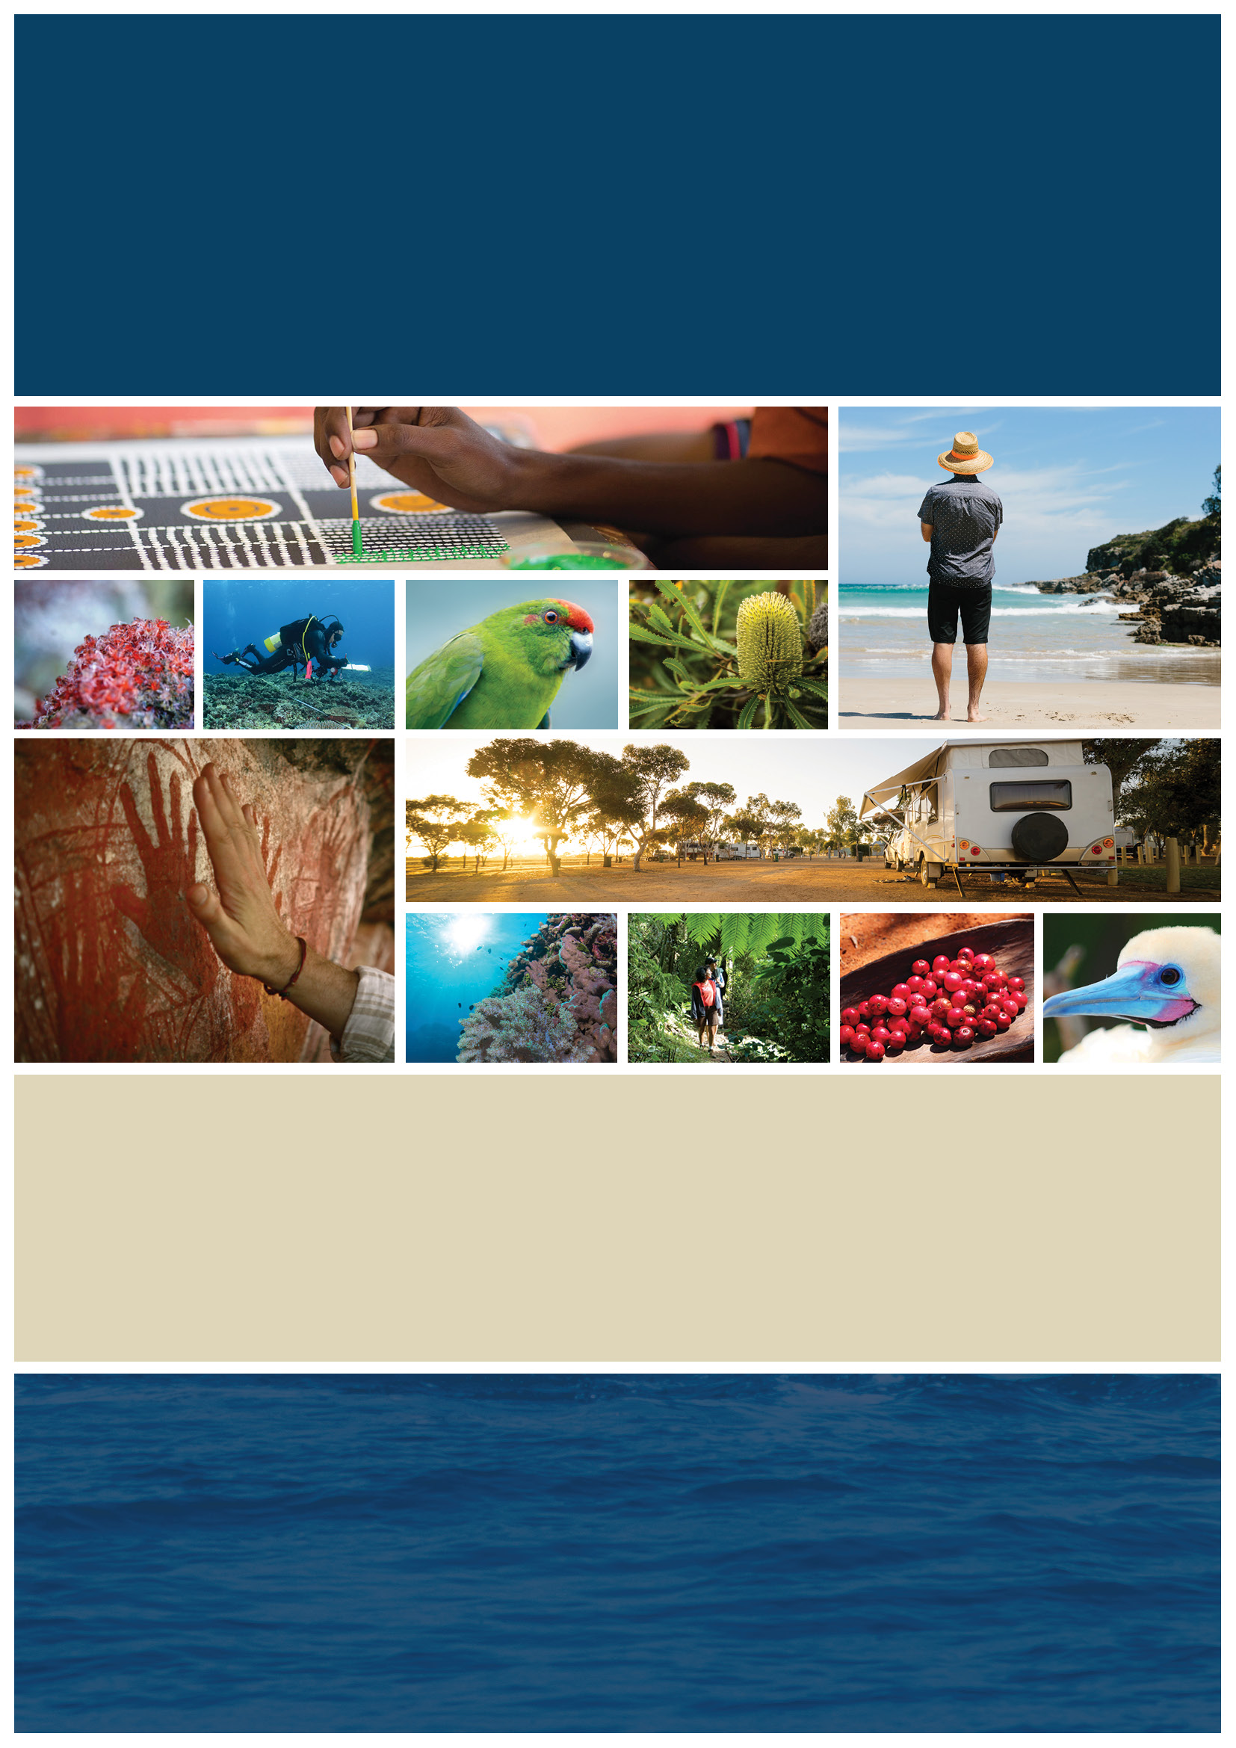

Director of National Parks logo

**Director of National Parks**

Corporate Plan 2019-2023

# 

# Message from the Director of National Parks

|  |  |
| --- | --- |
| Photograph of Dr James Findlay, Director of National Parks | I am pleased to present this corporate plan for the next four years (2019-20 to 2022-23). The plan sets out the steps toward achieving our vision – outstanding natural places that enhance Australia’s well-being. The plan presents management strategies that reflect the complexity of our operating environment and the geographic and natural diversity of our reserves.  Our people are our most valuable asset and we will continue to build our capabilities across Parks Australia in the coming years and prioritise the well-being of our staff.  I am looking forward to working with the dedicated and experienced staff of Parks Australia, with Traditional Owners, with our wide range of stakeholders and our Minister to manage the investment entrusted to us to deliver real benefits for all Australians. |

# Statement of Preparation

I, Dr James Findlay, as the accountable authority of the Director of National Parks, present the Director of National Parks Corporate Plan 2019-23, which covers the reporting periods of 2019-2020 to 2022-23, as required under paragraph 35(1) (b) of the *Public Governance, Performance and Accountability Act 2013*. The plan is prepared in accordance with the *Public Governance, Performance and Accountability Rule 2014*.

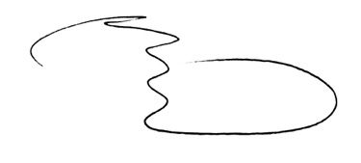

Director of National Parks

21 August 2019

# Introduction

Australia’s natural and cultural heritage is unique. Our land and seascapes are distinctive, home to plants and animals found nowhere else in the world, and to the oldest living cultures on earth. These environments and cultures are an essential part of our national identity, and visitors travel from across the country and the world to experience them.

The Director of National Parks (the Director) is responsible for seven Commonwealth terrestrial reserves, 58 Australian Marine Parks and the Heard Island and McDonald Islands Marine Reserve established under the *Environment Protection and Biodiversity Conservation Act 1999*.

The six national parks and the Australian National Botanic Gardens (ANBG) and 58 marine parks are directly managed by Parks Australia, a division of the Department of the Environment and Energy (the Department). Under delegation from the Director, the Department’s Australian Antarctic Division manages the Heard Island and McDonald Islands Marine Reserve.

Australia has one of the largest networks of marine parks in the world. Marine parks protect the diversity of life in our oceans–from astonishing coral reefs in our tropical seas to deep ocean canyons and undersea mountains in temperate marine regions.

Onshore, we manage a rich and fascinating range of ecosystems and communities, including oceanic Pulu Keeling, Norfolk and Christmas Islands, the coastal habitats of Booderee and the world-heritage listed stone country of Kakadu and spinifex sand plains of arid Uluru-Kata Tjuta.

Three of our national parks are leased by their Aboriginal owners to the Director of National Parks, to be jointly managed by their Traditional Owners and Parks Australia.

Australia’s National Botanic Gardens (ANBG) is the nation’s largest living collection of Australian native plants. It’s a tranquil setting for walking and spending time with family and friends, and a living classroom for visitors of all ages. The Gardens play a significant role in the conservation and propagation of rare and threatened plants.

Our biodiversity science programs–the Australian Biological Resources Study, the Centre for Australian National Biodiversity Research, the National Seed Bank­ and Biodiversity Informatics–are partnerships for research, for management of physical and digital biological collections, and for management of fundamental national biodiversity data and information and are accessed nationally and internationally.

We want to showcase these natural and cultural wonders to the world, demonstrating to all   
why these places are so special, and inspiring communities to become more invested in their   
care and future.

Figure 1: Location of Commonwealth parks and reserves

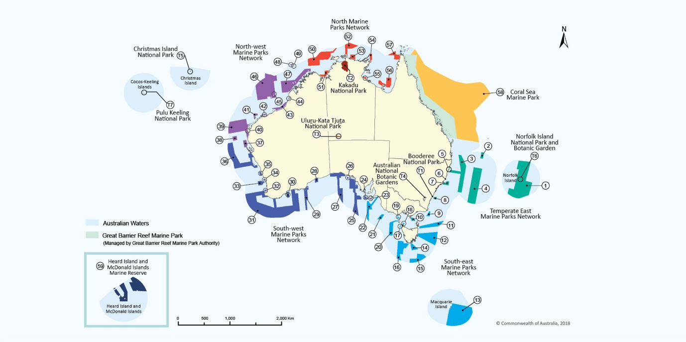

Location key

|  | Reserve Name | Map Label |
| --- | --- | --- |
|  | **Terrestrial parks** |  |
|  | Booderee National Park | T1 |
|  | Kakadu National Park | T2 |
|  | Uluru-Kata Tjuta National Park | T3 |
|  | Australian National Botanic Gardens | T4 |
|  | Christmas Island National Park | T5 |
|  | Norfolk Island National Park and Botanic Garden | T6 |
|  | Pulu Keeling National Park | T7 |
|  | Temperate East  Marine Parks Network |  |
|  | Norfolk | 1 |
|  | Gifford | 2 |
|  | Central Eastern | 3 |
|  | Lord Howe | 4 |
|  | Solitary Islands | 5 |
|  | Cod Grounds | 6 |
|  | Hunter | 7 |
|  | Jervis | 8 |
|  | South-east  Marine Parks Network |  |
|  | East Gippsland | 9 |
|  | Beagle | 10 |
|  | Flinders | 11 |
|  | Freycinet | 12 |
|  | Macquarie Island | 13 |
|  | Huon | 14 |
|  | South Tasman Rise | 15 |
|  | Tasman Fracture | 16 |
|  | Zeehan | 17 |
|  | Boags | 18 |
|  | Apollo | 19 |
|  | Franklin | 20 |
|  | Nelson | 21 |
|  | Murray | 22 |
|  | **South-west Marine Parks Network** |  |
|  | Southern Kangaroo Island | 23 |
|  | Western Kangaroo Island | 24 |
|  | Western Eyre | 25 |
|  | Murat | 26 |
|  | Great Australian Bight | 27 |
|  | Twilight | 28 |
|  | Eastern Recherche | 29 |
|  | Bremer | 30 |
|  | South-west Corner | 31 |
|  | Two Rocks | 32 |
|  | Geographe | 33 |
|  | Perth Canyon | 34 |
|  | Jurien | 35 |
|  | Abrolhos | 36 |
|  | North-west  Marine Parks Network |  |
|  | Shark Bay | 37 |
|  | Carnarvon Canyon | 38 |
|  | Gascoyne | 39 |
|  | Ningaloo | 40 |
|  | Montebello | 41 |
|  | Dampier | 42 |
|  | Eighty Mile Beach | 43 |
|  | Roebuck | 44 |
|  | Mermaid Reef | 45 |
|  | Argo-Rowley Terrace | 46 |
|  | Kimberley | 47 |
|  | Ashmore Reef | 48 |
|  | Cartier Island | 49 |
|  | North Marine Parks Network |  |
|  | Joseph Bonaparte Gulf | 50 |
|  | Oceanic Shoals | 51 |
|  | Arafura | 52 |
|  | Limmen | 53 |
|  | Arnhem | 54 |
|  | West Cape York | 55 |
|  | Gulf of Carpentaria | 56 |
|  | Wessel | 57 |
|  | Coral Sea  Marine Park | 58 |
|  | Heard Island and McDonald Islands Marine Reserve | 59 |

# Parks Australia’s outcome, program and purposes

Parks Australia’s long term objectives are described in our three purposes (Table 1) as reflected in the Portfolio Budget Statement for the Director of National Parks entity (pages 217-234). The four ‘ways of working’ are the ways we achieve our goals.

Table 1: Our vision, outcome, program, purposes and ways of working

|  |  |
| --- | --- |
| Vision | Outstanding natural places that enhance Australia’s well-being |

|  |  |
| --- | --- |
| Outcome 1 | Management of Commonwealth reserves as outstanding natural places that enhance Australia’s well-being through the protection and conservation of their natural and cultural values, supporting the aspirations of Aboriginal and Torres Strait Islander people in managing their traditional land and sea country, and offering world class natural and cultural visitor experiences |

|  |  |
| --- | --- |
| Program 1.1 | Healthy and resilient parks, gardens and marine reserves, protecting nature and culture and valued by the community now and into the future |

|  |  |  |
| --- | --- | --- |
|  | 1. Resilient places  and ecosystems | To protect and conserve the natural and cultural values of Commonwealth reserves |
| Purposes (goals) | 2. Multiple benefits to Traditional Owners and  local communities | To support the aspirations of Traditional Owners  and local communities in managing land and sea country |
|  | 3. Amazing destinations | To offer world class natural and cultural  experiences, enhancing Australia’s visitor economy |

|  |  |  |  |  |
| --- | --- | --- | --- | --- |
|  | **Evidence-based management** | **Ecologically sustainable use** | **Partnerships and co-investments** | **Responsive organisation** |
| Ways of working | Science, research and traditional knowledge are used to make management decisions | Parks Australia acts to enhance Australia’s social and economic well-being through ecologically sustainable use of our places, with awareness of our own environmental footprint | Partnerships and working together with our stakeholders to support delivery of innovative programs that achieve our purposes (goals) | Parks Australia is an efficient and effective agency with a proud and motivated workforce, supported by efficient business systems |

## Beneficiaries

Our work contributes social, economic and environmental benefits to all Australians and to the world. Aboriginal people have looked after land and sea country for tens of thousands of years. Parks Australia understands that the Traditional Owners of the land and sea we manage   
together have significant cultural and spiritual responsibilities to keep plants, animals and ecosystems healthy.

# The Director of National Parks’ statutory functions

The Director of National Parks is a Corporate Commonwealth Entity, operating under the *Environment Protection and Biodiversity Conservation Act 1999* (EPBC Act). The Director is responsible for the administration of Divisions 4 and 5 of Part 15 of the EPBC Act (Commonwealth reserves and conservation zones) and regulations made for the purposes of those divisions.

The functions of the Director, as set out in subsection 514B(1) of the EPBC Act, are to:

* administer, manage and control Commonwealth reserves and conservation zones
* protect, conserve and manage biodiversity and heritage in Commonwealth reserves and conservation zones
* contribute to the protection, conservation and management of biodiversity and heritage in areas outside Commonwealth reserves and conservation zones
* cooperate with any country in matters relating to the establishment and management of national parks and nature reserves in that country
* provide, and assist in the provision of, training in knowledge and skills relevant to the establishment and management of national parks and nature reserves
* carry out alone, or in cooperation with other institutions and persons, and arrange for any other institution or person to carry out research and investigations relevant to the establishment and management of Commonwealth reserves
* make recommendations to the Minister in relation to the establishment and management of Commonwealth reserves
* administer the Australian National Parks Fund
* undertake any other functions conferred on the Director under the EPBC Act or any other Act
* do anything incidental or conducive to the performance of any of the functions mentioned above.

The Director, in conjunction with a Board of Management (for jointly managed reserves), also has primary responsibility for the preparation of management plans for Commonwealth reserves (see sections 366-368 of the EPBC Act). These plans must provide for the protection and conservation of the relevant reserve. A management plan has legal effect for 10 years, subject to it being amended or revoked and replaced by another management plan during that time. The plans enable management of a reserve to proceed in an orderly way, help to reconcile competing interests, and identify priorities for the allocation of available resources.

## Other responsibilities

In addition to statutory functions under the EPBC Act, the Director of National Parks has a range   
of obligations under the leases for Kakadu, Booderee and Uluru-Kata Tjuta National Parks.

The Director also has delegated responsibility from the Department for providing legal certainty   
for the use of biological resources in research in line with international standards by advising on   
and maintaining documentary consistency with the Nagoya Protocol and providing a focal point for the domestic implementation of access and benefit sharing issues under the Convention for Biological Diversity.

# Operating environment

Parks Australia has differing levels of influence over a range of often complex challenges in managing the natural and cultural values of our reserves.

* we have the **most influence** over how we conduct our work, who we engage with, how and where we allocate our resources, our approach to risk and the quality of the information and advice we provide, and how we implement practical management under management plans
* we have **moderate influence** over government policy decisions facing our parks
* we have **some influence** over external pressures facing our parks and how others engage with government decisions, policies and regulations, the actions they take in response and the value they place on our role and our work.

Over the four years of this corporate plan, **external** factors that influence our work include:

* *working in remote areas and in nature* – most of our parks are remote and involve working with nature, presenting specific challenges such as extreme weather and logistical difficulties in delivering our programs, some of which are inherently risky
* *cultural values* – supporting intergenerational transfer of traditional knowledge
* *climate change* – a changing climate will exacerbate threats and bring new challenges   
  for adaptive management including managing species, ecosystems, infrastructure, visitors   
  and revenue
* *pressures on terrestrial biodiversity* – invasive species, wild fire, habitat loss, climate change and changing land use
* *pressures on marine biodiversity* – pollution and marine debris, illegal unreported and unregulated fishing and climate change
* *responding to government priorities and community expectations* – many of our programs are long-term and outcomes may take many years to fully realise
* *responding to the motivation and demands of visitors to our parks*.

Over the four years of this corporate plan, **internal** factors that influence our work include:

* *work, health and safety* – a proactive approach to risk management and a shared responsibility for WHS are vital to how we manage the safety and well-being of our staff, contractors and visitors in our places, fully implementing a Departmental WHS management system, policies and safe operating procedures and ensuring our staff have appropriate guidance and capacity to work safely is an ongoing priority
* *Operations and Corporate Change project* – the outcomes of this project will support effective and transparent delivery of shared services and responsibilities by the Secretary of the Department and the Director. Areas of focus will include safety, security and human and financial resources.
* *information communication and technology (ICT)* – reducing inefficiencies on-ground by improving our ICT environment to keep pace with the changing needs of Parks Australia will be a focus for 2019-20
* *expanded responsibilities* – adapting and scaling up capabilities to effectively manage a significantly expanded marine parks estate (six times larger since July 2018)
* *budget limitations* – delivering quality and timely programs in a consistent and efficient way in an operating environment where costs are increasing is an ongoing challenge.

## Working together

We do not work alone. Parks Australia works with a diversity of partners and stakeholders who   
assist us to deliver and undertake projects. Engagement in management of our parks includes:

* Traditional Owners and communities are at the heart of joint management arrangements,   
  from the way work is planned and implemented to the day-to-day relationships in our jointly managed parks
* community engagement including citizen science and volunteering opportunities that enable communities and visitors alike to contribute their enthusiasm and goodwill, expertise and capability, to help us to understand and look after our parks
* multi-sector advisory committees that contribute their knowledge and experience to advise on the management of our parks
* strong partnerships and relationships and long term collaborations such as:
  + *research organisations*, for example CSIRO in the Centre for Australian National Biodiversity Research, the National Environmental Science Program and the National Marine Science Committee, through scientific advisory panels who provide support on terrestrial parks
  + *industry bodies*, for example Tourism Australia, our tourism partners, peak bodies, tourism agencies and licensed tour operators, who bring a significant number of people to our places
  + *operational agencies*, for example the Maritime Border Command, the Australian Fisheries Management Authority and state and territory government counterparts, which contribute to a whole-of-government approach to surveillance and enforcement in parks
  + *other Government agencies*, for example land councils, the Department of Infrastructure, Transport, Cities and Regional Development, the Great Barrier Reef Marine Park Authority (GBRMPA) and the National Offshore Petroleum Safety and Environmental Management Authority (NOPSEMA).

## Government priorities

We support our Minister in achieving government objectives and by meeting our legislative and policy responsibilities as set out in our program and purposes:

* to make it easier for individuals to access government services through digital platforms we will continue to support our Parks Australia Online Services customer-focused portal, to make it easier to pre-purchase park passes
* to contribute to the Government’s strategies to develop northern Australia, we will continue to develop our significant footprint in the economy of communities in Kakadu (including the future of Jabiru township)
* to reduce regulatory burden, we will look for opportunities to simplify our application and approval processes, with clear and logical guidance and complementing our regulatory partners, for example the Australian Fisheries Management Authority, the NOPSEMA and the GBRMPA.

## Regulatory Performance Framework

The Director contributes to the Department’s reporting under the Regulatory Performance Framework for provisions relating to protected area management under the EPBC Act.

# Capability

## Our people

The Portfolio Budget Statement for the Director of National Parks states that Parks Australia will have an estimated average staffing level of 331 in 2019-20 (page 220). Our workforce is diverse, spread across remote and metropolitan centres, with a range of roles from seasonal rangers and scientists to strategic policy planners.

In 2019-20 our key areas of focus, led by our senior executive, will identify realistic and achievable improvements about how we work together to deliver our organisational goals for environmental protection and growing other park benefits to communities and especially Traditional Owners.

These key areas are:

* staff well-being, including improvements to our work, health and safety culture to ensure our people stay safe, proud and motivated
* strengthening collaboration across Parks Australia
* looking for ways to work more efficiently with a focus on IT and procurement
* understanding and monitoring for improvement and success
* effective internal communication
* developing sustainable partnerships with a range of external bodies, including academic, financial, social and other government institutions
* pursuing a strategic, Parks Australia-wide approach to genuine stakeholder engagement
* building leadership and governance and skills capability.

## Our budget

The Portfolio Budget Statement for the Director of National Parks (page 229) states that in 2019-20 the Director of National Parks’ annual budget will comprise $45.805 million funds from government and $30.640 million funds from a mix of other sources, including park entry fees (page 229).

Parks Australia is responsible for a large portfolio of capital assets, including visitor facilities, offices, workshops and staff housing. In 2019-20, we will continue our program to revitalise high use tourism and essential park infrastructure.

Parks Australia will continue to consider revenue sustainability, expand our revenue base from other sources (particularly pursuing innovative partnership opportunities) and to look for opportunities to streamline our costs.

Governance

On 1 April 2019 Parks Australia was restructured to better enable us to organise our business and deliver our strategic priorities (Diagram 1).

Diagram 1: Parks Australia Branch Structure, as at 1 April

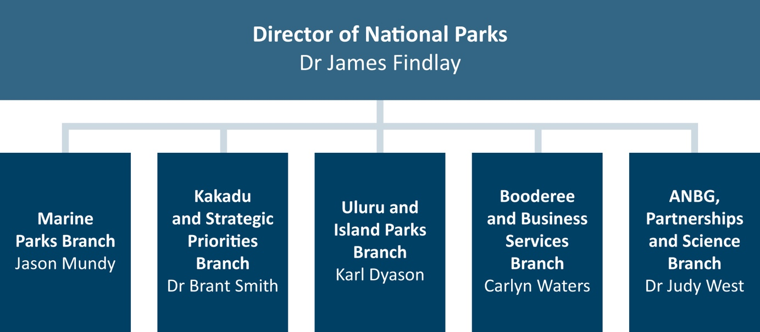

Parks Australia is served by two main Executive governance bodies – the Parks Australia Executive Board and the Parks Australia Project Board. Communiques from each meeting are circulated to all Park’s staff. To improve the governance of projects, the Director has adopted the project management framework developed by the Department. A review of the governance and project monitoring processes for the Director’s Project Board has commenced and will be completed in the next twelve months. A suite of corporate training videos and procurement guidance material will be completed in early 2019-20 that will build governance understanding and capability across our diverse and remote staff network.

Kakadu, Uluru-Kata Tjuta and Booderee National Parks are managed jointly by the Director and Traditional Owners and other key representatives in accordance with the EPBC Act. Each park has   
a Board of Management established under the EPBC Act, with a majority of Aboriginal members   
who are nominated by the Traditional Owners of land in the park. The Boards are chaired by Traditional Owners.

Membership of the Boards includes the Director, Australian Government representatives and members representing stakeholder groups or individuals with particular skills relevant to managing the park. Parks Australia employees provide secretariat support to each of the Boards. Park managers report to the board at each meeting. Chapter 3 of the Director of National Parks’ annual reports provides details of Board Members as at 30 June each year.

In addition to the Joint Boards of Management for Kakadu, Booderee and Uluru-Kata Tjuta National Parks, there are also Advisory Committees who provide advice to the Director on the management of other parks. These Boards and committees play crucial roles in determining the policies and priorities for the management of each protected area in line with the relevant management plan.

# Risk oversight and management

Employees, volunteers and contractors who undertake Parks Australia business often operate   
in remote areas. We also operate in a dynamic environmental, social and business context, and   
our people manage a diverse and complex array of issues. Parks Australia has a responsibility   
to ensure that risks to ourselves, to residents and to our visitors are minimised, so far as   
reasonably practicable.

We need to be realistic about what we can deliver and always consider the risk of the particular threats in our extraordinary places. Effective risk management is critical to achieve our purposes   
in our evolving operating environment.

The Director is committed to strengthening the management of risk, including through the role that Boards of Management deliver for jointly managed national parks. The Director will continue working with the Department in 2019-20 to develop a new risk and incident management system that will better record risks and monitor the implementation of treatment measures. The Director will also continue to receive advice from the Portfolio Audit Committee on the appropriateness of Parks Australia’s systems for managing risk.

# Performance

This corporate plan is the central planning document within our planning and reporting framework. It sets the strategic direction for other internal planning documents (Diagram 2).

Diagram 2: Parks Australia hierarchy of planning documents (Adapted from Department of Finance (January 2017) Resource Management Guide 132, Figure 3 page 12)

Triangular diagram showing Corporate Plan at the top (published; 4 year horizon), followed by Parks Australia Strategic Operational Plan (internal; 4 year horizon), followed by Place/Section Annual Operational Plans (internal; 1 year horizon), and at the bottom Individual Performance Plans (internal; 1 year horizon)

The following tables represent a rolling four-year plan, which describes our corporate management strategies and areas of focus against each of our three purposes (goals).

This is the fifth corporate plan prepared in accordance with the *Public Governance, Performance and Accountability Act 2013* (PGPA Act). Over this time we have continued to develop performance indicators, refine our data sources and streamline our monitoring approach as presented in our corporate plans under the PGPA Act. This current corporate plan represents a departure from previous plans and a transition towards a new structure.

We have listened to feedback and have refocussed the content in the tables to directly align with the performance information in the Portfolio Budget Statement. We have streamlined the level of detail to include only those strategies and actions that directly relate to the purpose (goal) and associated performance criteria/targets. The Parks Australia Strategic Operational Plan identified in Diagram 2 introduces a new layer of internal reporting that reflects the full suite of management strategies and activities across the four years of the corporate plan.

## Review of performance information

To continue this transition to a new corporate plan structure, in 2019-20 we will review these various improvements and make adjustments to ensure our performance information is reliable, complete and relevant; in line with the Department of Finance’s *Resource Management Guide 131 Developing good performance information* and best practice examples and in response to recommendations from the Australian National Audit Office (ANAO). We will also link our performance reporting review with the parallel reviews of risk and governance. Notes on the   
metrics used for 2019-20 are provided on page 28.

On 21 June 2019 the ANAO tabled its report *Management of Commonwealth National Parks* following an audit commenced in August 2018. The Director agreed with all the recommendations   
in the report. The Director is committed to continual improvement and a number of business improvement projects are underway that cover many of the recommendations in the report.   
A copy of the report is available at:

[www.anao.gov.au/work/performance-audit/management-commonwealth-national-parks](http://www.anao.gov.au/work/performance-audit/management-commonwealth-national-parks)

| Purpose (Goal) 1: Resilient places and ecosystems |
| --- |

|  |  |
| --- | --- |
| Objective | To protect and conserve the natural and cultural values of Commonwealth reserves |
| Intended result | Living culture and cultural heritage values are identified, protected and conserved  The health and integrity of natural values are protected, conserved and where appropriate restored |
| Management strategies | * Take action to protect threatened and significant species * Reduce the overall impact of threatening processes, invasive species and inappropriate fire on natural and cultural values * Conduct monitoring programs on threatened species to assess management effectiveness * Work with Traditional Owners and communities to protect cultural heritage values * Research, document, curate and share scientific knowledge to build understanding of Australia’s biodiversity * Implement park compliance and authorisation programs * Conduct or enable high priority management-relevant science activities across Parks Australia |

| Performance criterion 1.1  Enhance level of active management of Australian Marine Parks  and engagement of users and stakeholders | 2019-20 | 2020-21 | 2021-22 | 2022-23 |
| --- | --- | --- | --- | --- |
| Target 1.1.1 |  |  |  |  |
| **Number of management plans for Australian marine parks in effect**  **Rationale:** Management plans set out how the Director of National Parks manages Australian Marine Parks to provide for the protection and conservation of biodiversity and other natural, cultural and heritage values of the parks and sustainable uses. There are six management plans covering the 58 Australian Marine Parks.  **Data source:** Federal Register of Legislation at [www.legislation.gov.au](http://www.legislation.gov.au).  **Baseline:** In the baseline year of 2016-17 there was one marine parks network management plan in place – the *South-east Commonwealth Marine Reserves Network Management Plan 2013-2023*. Other marine parks networks and the Coral Sea Marine Park were under transitional management arrangements which ended with the commencement of management plans on 1 July 2018. | 6 (100 per cent) | 6 (100 per cent) | 6 (100 per cent) | 6 (100 per cent) |
| Target 1.1.2 |  |  |  |  |
| **Number of advisory committee meetings**  **Rationale:** The Director of National Parks has established advisory committees for each marine park network and the Coral Sea Marine Park to support collaborative park management, to achieve the Director's vision for Australian Marine Parks to be healthy, resilient and well-managed to enhance Australia's well-being.  **Data source:** Number of advisory committee meetings held across Australian marine parks in the financial year.  **Baseline:** In the baseline year of 2016-17 there was one informal marine park advisory forum in operation – the South-east Commonwealth Marine Reserves Network Forum. Advisory forums were not established for the other marine park networks and Coral Sea Marine Park while they were under transitional management arrangements (which ended with the commencement of management plans on 1 July 2018). In 2018-19 six formal advisory committees, one for each marine park network and the Coral Sea Marine Park were established and each committee held its inaugural meeting. | Two meetings  of each Committee | Two meetings  of each Committee | Two meetings  of each Committee | Two meetings  of each Committee |
| Areas of focus |  |  |  |  |
| Implement the Fisheries Assistance and User Engagement Package |  |  |  |  |
| Develop and apply implementation plans for each of the five marine parks networks and the Coral Sea Marine Park |  |  |  |  |
| Implement seven management programs for Australian Marine Parks – communication, education and awareness; tourism and visitor experience; Indigenous engagement; marine science; assessments and authorisations; park protection and management; and compliance |  |  |  |  |
| Develop and implement a monitoring, evaluation reporting and improvement framework and associated plans |  |  |  |  |
| Manage high level engagement and relations with Australian Marine Parks stakeholders, Indigenous people and Traditional Owners, and Australian Marine Park Advisory Committees, and establish partnerships that deliver effective management outcomes |  |  |  |  |

| Performance criterion 1.2 Populations of threatened and significant species are increasing | 2019-20 | 2020-21 | 2021-22 | 2022-23 |
| --- | --- | --- | --- | --- |
| Target 1.2.1 |  |  |  |  |
| **Increase in populations of prioritised threatened and significant species**  **Rationale:** Trends for populations of threatened and significant species are an indicator of the health of the natural systems in terrestrial national parks. The targets establish an improvement in result from previous year’s result. Results for 2018-19 are not yet available, but will be incorporated in the Director of National Parks 2018-19 Annual Report. Results for subsequent years will be published in subsequent Annual Reports.  **Data sources:** Information sources include terrestrial park level monitoring programs, external research, expert consultations and scientific literature. These may vary for an individual species over time. Parks Australia compiles and quality checks the input received from these information sources. Since 2015-16 Parks Australia has refined and improved reporting and will continue to sharpen our focus on the data used, updating field methods and revising data management procedures. From 2018-19, in compiling data for this metric a confidence level (high/medium/low) is being included for each trend reported, and the evidence base for the data is documented.  **Baseline:** In 2016-17, 30 per cent of threatened species were increasing or stable and 21 per cent were declining (totalling 51 per cent of threatened species monitored for trends). In 2017-18, 37 per cent of threatened species were increasing or stable and nine per cent were declining (totalling 46 per cent monitored for trends).  A detailed explanation of the rationale, data sources and formulae used to support the baselines can be found in the ‘Note on Metrics’ provided on page 28. | 1. Increase (from 2018-19 baseline) in proportion of threatened species with stable or increasing populations  2. Increase (from 2018-19 baseline) in proportion of threatened species monitored for population trends | 1. Increase (from 2019-20 baseline) in proportion of threatened species with stable or increasing populations  2. Increase (from 2019-20 baseline) in proportion of threatened species monitored for population trends | 1. Increase (from 2020-21 baseline) in proportion of threatened species with stable or increasing populations  2. Increase (from 2020-21 baseline) in proportion of threatened species monitored for population trends | 1. Increase (from 2021-22 baseline) in proportion of threatened species with stable or increasing populations  2. Increase (from 2021-22 baseline) in proportion of threatened species monitored for population trends |
| Areas of focus |  |  |  |  |
| Continue seed banking and *ex-situ* plant conservation programs |  |  |  |  |
| Finalise a feasibility study for the translocation of the blue-tailed skink to the Cocos islands |  |  |  |  |
| Continue prioritised park level monitoring programs (including *Tjakura* and mala populations at Uluru-Kata Tjuta National Park, flying fox populations on Christmas Island and green parrots on Norfolk Island) |  |  |  |  |

| Performance criterion 1.3  Populations of priority invasive species are reduced | 2019-20 | 2020-21 | 2021-22 | 2022-23 |
| --- | --- | --- | --- | --- |
| Target 1.3.1 |  |  |  |  |
| **Decrease in the size of populations of prioritised invasive species**  **Rationale:** Trends for populations of invasive species are an indicator of the health and integrity of the natural values of terrestrial national parks. The targets establish an improvement in result from each previous year’s results. Results for 2018-19 are not yet available, but will be published in the Director of National Parks 2018-19 Annual Report. Results for subsequent years will be published in subsequent Annual Reports.  **Data sources:** Information sources include terrestrial park level monitoring programs, external research, expert consultations and scientific literature. These may vary for an individual species over time. Parks Australia compiles and quality checks the input received from these information sources. Since 2015-16 Parks Australia has refined and improved reporting and will continue to sharpen our focus on the data used, updating field methods and revising data management procedures. From 2018-19, in compiling data for this metric a confidence level (high/medium/low) is being included for each trend reported, and the evidence base for the data is documented.  **Baseline:** In 2016-17, 23 per cent of invasive species were stable or declining and five per cent were increasing (totalling 28 per cent of invasive species being monitored for trends). In 2017-18, 17 per cent of invasive species were stable or declining and four per cent were increasing (totalling 21 per cent monitored for trends).  A detailed explanation of the rationale and formulae used to support the baselines can be found in the ‘Note on Metrics’ is provided on page 28. | 1. Increase (from 2018-19 baseline) in proportion of invasive species with stable or declining populations  2. Increase (from 2018-19 baseline) in proportion of invasive species monitored for population trends | 1. Increase (from 2019-20 baseline) in proportion of invasive species with stable or declining populations  2. Increase (from 2019-20 baseline) in proportion of invasive species monitored for population trends | 1. Increase (from 2020-21 baseline) in proportion of invasive species with stable or declining populations  2. Increase (from 2020-21 baseline) in proportion of invasive species monitored for population trends | 1. Increase (from 2021-22 baseline) in proportion of invasive species with stable or declining populations  2. Increase (from 2021-22 baseline) in proportion of invasive species monitored for population trends |
| Areas of focus |  |  |  |  |
| Continue efforts to minimise the impact of invasive species on the natural values of our parks (including managing cats on Christmas and Norfolk islands, yellow crazy ant control on Christmas Island, and fox and bitou bush control in Booderee National Park) |  |  |  |  |

| Performance criterion 1.4  Increase the knowledge base for long term adaptive management  of the marine reserves | 2019-20 | 2020-21 | 2021-22 | 2022-23 |
| --- | --- | --- | --- | --- |
| Target 1.4.1 |  |  |  |  |
| **Increase in the number of marine reserves long-term monitoring sites**  **Rationale:** Increased management-relevant inventory and monitoring information is essential to support adaptive management of Australian Marine Parks to ensure that management is best targeted to protect and conserve park values.  **Data sources:** Long-term monitoring sites that have two or more data points in time and form part of a long time series of data.  **Baseline:** In 2016-17 there were long term monitoring sites on coral reefs and some coral cays or islands at the Coral Sea, Ashmore, Mermaid, Elizabeth and Middleton/Lord Howe, Cod Grounds and Solitary Islands marine parks. There were also monitoring sites for the Freycinet, Flinders, Huon and Great Australian Bight marine parks. In 2017-18 there were no new long-term monitoring sites established; new monitoring baselines were collected in the Western Eyre, Montebello and Dampier marine parks (in partnership with state and scientific agencies). | Increase in the number of marine reserves  long-term monitoring sites compared to the 2016-17 baseline | Increase in management-relevant information about Australian Marine Parks | Increase in management-relevant information about Australian Marine Parks | Increase in management-relevant information about Australian Marine Parks |
| Areas of focus |  |  |  |  |
| Commission and influence research to establish environmental, social and economic baselines and build knowledge about the marine parks to inform park management |  |  |  |  |

| Cross-cutting high level management activities | 2019-20 | 2020-21 | 2021-22 | 2022-23 |
| --- | --- | --- | --- | --- |
| Develop and implement priorities for cultural heritage management for the jointly managed parks, and undertake activities in consultation with Traditional Owners and Boards of Management |  |  |  |  |
| Outline priorities for research and monitoring in Parks Australia, through the development of a Marine Park and Terrestrial Park science strategy, to ensure that research on park is directed to support management outcomes |  |  |  |  |
| Plan and implement prescribed annual burning programs, guided by Traditional Owners, at Kakadu and Uluru-Kata Tjuta national parks |  |  |  |  |
| Develop appropriate strategies for understanding and responding to a changing climate across our places |  |  |  |  |
| Implement an effective risk-based compliance program to help park users comply with management plan rules, and take enforcement action as appropriate |  |  |  |  |

|  |
| --- |
| Purpose (Goal) 2: Multiple benefits for Traditional Owners and local communities |

|  |  |
| --- | --- |
| Objective | To support the aspirations of Traditional Owners and local communities in managing land and sea country |
| Intended result | Traditional Owners and local communities receive a measurable economic, social and/or cultural benefit |
| Management strategies | * Work with Traditional Owners and local communities to improve governance and better reflect and achieve their aspirations and priorities for park management * Work with Traditional Owners to develop employment opportunities on parks |

| Performance criterion 2.1  Increase in numbers of Indigenous staff and/or contractors directly or indirectly providing park services | 2019-20 | 2020-21 | 2021-22 | 2022-23 |
| --- | --- | --- | --- | --- |
| Target 2.1.1 |  |  |  |  |
| **Increase in numbers of Indigenous staff across the Division**  **Rationale:** On-park employment is a priority for the Director of National Parks and the Traditional Owners in each park to support the aspirations of Traditional Owners and local communities in managing land and sea country. It is also a key feature of each of the management plans for the jointly managed parks. This measure will also contribute to improving Indigenous representation in the Australian Public Service in line with the *Closing the Gap* strategy and the *Commonwealth Aboriginal and Torres Strait Islander Employment Strategy.*  **Data source:** SAP system at the end of the financial year for ongoing and non-ongoing staff (including casuals).  **Baseline:** In 2015-16 – the baseline year - 70 (17.5 per cent) ongoing and non-ongoing employees (including casuals) identified as Aboriginal or Torres Strait Islander. In 2016-17 the figure was 154 (29 per cent); in 2017-18, the figure was 198 (36 per cent). | 38 per cent | 41 per cent | 44 per cent | 47 per cent |
| Target 2.1.2 |  |  |  |  |
| **Increase in value of services provided by Indigenous providers**  **Rationale:** The Director is committed to using our purchasing power to generate economic activity for Indigenous people and Traditional Owners. We continue to engage Indigenous contractors under the Australian Government’s Indigenous Procurement Policy that commenced on 1 July 2015. The purpose of the policy is to leverage procurement spend by Commonwealth agencies to Indigenous businesses.  **Data source:** Indigenous Procurement Policy records from 1 July to 30 June supplemented by additional information from parks on the impact of the value investment.  **Baseline:** In 2016-17 – the baseline year – 99 reportable contracts and sub-contracts to 28 Indigenous suppliers totalling over $2.1 million, 93 per cent of the contracts were for work in remote areas. In 2017-18, 44 new contracts to 33 Indigenous suppliers totalling approximately $1.3 million, 95 per cent of the contracts were for work in remote areas. | Increase the value of services provided by Indigenous providers by 4 per cent compared to the 2018-19 reported value | Increase the value of services provided by Indigenous providers by 4 per cent compared to the 2019-20 reported value | Increase the value of services provided by Indigenous providers by 4 per cent compared to the 2020-21 reported value | Increase the value of services provided by Indigenous providers by 4 per cent compared to the 2021-22 reported value |
| Areas of focus |  |  |  |  |
| Continue development of the Booderee National Park Sustainable Business Plan |  |  |  |  |
| Identify clear employment pathway plans for *Bininj* and other employees of Kakadu National Park and for *Aṉangu* at Uluru-Kata Tjuta |  |  |  |  |
| Develop invasive species management trials that engage Traditional Owners in on-country research programs |  |  |  |  |
| Build partnerships with Traditional Owners and Indigenous groups to manage sea country in marine parks |  |  |  |  |

|  |  |  |  |  |
| --- | --- | --- | --- | --- |
| Cross-cutting high level management activities | 2019-20 | 2020-21 | 2021-22 | 2022-23 |
| Complete the implementation of the *Uluru Climb Closure Strategy* |  |  |  |  |
| Undertake an internal review of lease obligations in the jointly managed national parks |  |  |  |  |
| Enhance decision-making capabilities of Boards of Management and Traditional Owner input into decision-making including convening a combined Joint Boards of Management meeting in 2019-20 (subject to the agreement of Boards) |  |  |  |  |
| In partnership with Traditional Owners and in accordance with relevant agreements, mobilise fire management activities in Kakadu National Park funded by carbon credits |  |  |  |  |

|  |
| --- |
| Purpose (Goal) 3: Amazing destinations |

|  |  |
| --- | --- |
| Objective | To offer world class natural and cultural experiences, enhancing Australia’s visitor economy |
| Intended result | Our contribution to Australia’s visitor economy is maintained or increased |
| Management strategies | * Improve the visitor experience by refreshing and improving visitor infrastructure in high use areas * Ensure the reputation of the DNP is maintained through effective communication strategies * Promote visitor experiences and nature learning through the use of best practice digital technology * Provide assistance for the transition to active management of Australian Marine Parks * Facilitate investment in new infrastructure, new products and experiences in priority areas * Provide clear direction for growth and development through marketing, communications and tourism planning |

| Performance criterion 3.1  Maintain or improve the level of visitor satisfaction and number of visitors | 2019-20 | 2020-21 | 2021-22 | 2022-23 |
| --- | --- | --- | --- | --- |
| Target 3.1.1 |  |  |  |  |
| **Maintain or improve levels of visitor satisfaction**  **Rationale:** Visitor satisfaction is an important qualitative indicator of customer demand and important for understanding consumer preferences. Customer demand is determined by a range of factors including the experience and recommendation of others. Social media, blogs and other review sources play an important role in the decision making of many travellers. Obtaining visitor feedback through official surveys is important to gain insight on customer satisfaction and the competitiveness of the tourist offering. This can inform future decision making for marketing, infrastructure, resourcing and experience priorities. A consistently high customer satisfaction rating across a range of criteria and high stated intention to repeat visit would indicate a competitive destination, now and in the foreseeable future. This is an accepted performance indicator internationally (OECD 2013 *Indicators for Measuring* *Competitiveness in Tourism* & UNWTO 2004 *Guidebook on Indicators of Sustainable Development for Tourism Destinations*), and adopted by the Australian Government (Tourism 2020).  **Data source:** Citizen Space online surveys for Uluru-Kata Tjuta, Kakadu and Booderee National Parks and the ANBG as well as *ad hoc* surveys (by park, external researcher or local tourism organisation).  **Baseline:** In2017-18 based on 1500 surveys across the three terrestrial parks and the ANBG, over 89 per cent said they were ‘satisfied’ or ‘very satisfied’. | 89 per cent  or above ‘satisfied’ or ‘very satisfied’ | 89 per cent  or above ‘satisfied’ or ‘very satisfied’ | 89 per cent  or above ‘satisfied’ or ‘very satisfied’ | 89 per cent  or above ‘satisfied’ or ‘very satisfied’ |
| Target 3.1.2 |  |  |  |  |
| **Five per cent increase in visitor numbers**  **Rationale:** Visitor numbers allows analysis of the total volume of visitors on a monthly, quarterly and per annum basis. Looking at visitor numbers on a seasonal basis allows for tourism planning (in terms of capacity of infrastructure and staffing resources) and potential scheduling of events. Visitor numbers is an achievable indicator for those parks with entry fees as number of entry tickets sold can be measured. This also indicates the monetary value of tourism to the protected area, and monetary benefits to Traditional Owners given the jointly managed parks direct a percentage of revenue to Traditional Owners. This is an accepted performance indicator internationally (OECD 2013 *Indicators for Measuring* *Competitiveness in Tourism* & UNWTO 2004 *Guidebook on Indicators of Sustainable Development for Tourism Destinations*), and adopted by the Australian Government (Tourism 2020).  **Data source:** Park ticket sales (online, event ticketing, visitor centres, commercial tour operators, and park gates), camping bookings and traffic counter data at jointly managed parks and the ANBG. There is no formal monitoring of parks with low visitation (Pulu Keeling, Christmas Island, Norfolk Island or marine reserves). There is some reporting for these terrestrial parks from local tourism associations.  **Baseline:** In 2015-16 the number of visitors to terrestrial reserves was 1,328,535. In 2016-17 1,383,979 and in 2017-18 1,474,108. | 1.547 million | 1.625 million | 1.706 million | 1.791 million |
| Areas of focus |  |  |  |  |
| Develop Visitor Infrastructure and Visitor Interpretation Plans for Uluru-Kata Tjuta National Park |  |  |  |  |
| Produce and implement plans for the ANBG’s 50th anniversary celebrations |  |  |  |  |
| Implement *Growing Tourism in Kakadu* package |  |  |  |  |

|  |  |  |  |  |
| --- | --- | --- | --- | --- |
| Cross-cutting high level management activities | 2019-20 | 2020-21 | 2021-22 | 2022-23 |
| Continue to provide informed and educational experience in the discovery, visitor and cultural centres at Uluru-Kata Tjuta, Norfolk Island, Booderee and Kakadu national parks and at the ANBG |  |  |  |  |
| Continue to develop high quality commercial tourism experiences that also benefit Traditional Owners through licence and other relevant agreements |  |  |  |  |

**A note on metrics**

In 2019-20 we will review our capabilities in measuring and monitoring the measures we use to assess our performance and future direction. How the base metrics and methods presented in this corporate plan are derived are below.

**Increase in populations of prioritised threatened and significant species:** Since 2015-16, “prioritised threatened and significant species” have been defined as all EPBC listed threatened species with known populations being supported within parks, including seasonal migratory species. Species categorised as “vagrant or occasional visitor” or “presumed no longer extant” have been excluded. Data is presented as proportions (percentage) as this is more meaningful, for example 37 per cent of threatened species with an increasing or stable trend is more easily understood than 48 threatened species out of 131 with an increasing or stable trend. Also, as the number of threatened species in parks may change from year to year, due to new species becoming EPBC listed, or new species moving into parks, either through reintroductions or natural dispersal, it is more meaningful to compare proportions between years than numbers.

Since 2015-16 “Monitored for trend” has been defined as either being monitored through a formal sampling-based monitoring program or being assessed for trend through expert assessment. Monitoring/assessment that can provide only distribution or other non-trend data is not included. Since 2015-16, data has been presented using the following formulae:

* Per cent monitored = per cent stable + per cent increasing + per cent declining (the rationale is that if a species is monitored/assessed for trend, then the trend will be known (ie will not be “unknown”).
* Per cent increasing or stable = per cent stable + per cent increasing
* Per cent not monitored = per cent unknown

In 2018-19 it may be the case for the first time that the percentage monitored will be greater than the sum of species with stable, increasing or declining trends. This will be because a new robust monitoring program that will provide trend data for eight threatened fauna species in Kakadu National Park was implemented only in May 2019 and there has not have been time for the data to be analysed.

In the Director’s Annual Report the headline figure we report is the percentage of species that have stable or increasing trends. As it is not possible for populations to have an increasingly upward trend forever (for example due to reaching carrying capacity), we have included species with stable trends in our reporting, as maintaining stable populations can also be an indicator of the good health of ecosystems. We present this as a graph showing the percentage for each of these three categories: per cent unknown, per cent declining, per cent stable and increasing. These categories can be compared across years.

**Decrease in the size of populations of invasive species:** Since 2015-16, “priority invasive species” have been defined as the list of invasive species that have been identified by park Natural Resource Managers as species of management concern. Invasive species present but not of concern are excluded. Data is presented as proportions (percentage), as this is more meaningful, for example 17 per cent of invasive species with a decreasing or stable trend is more easily understood than 14 invasive species out of 81 species with a decreasing or stable trend. Also, as the number of invasive species in parks may change from year to year (for example due to sleeper species starting to increase in impact) it is more meaningful to compare proportions between years than numbers.

Since 2015-16 “Monitored for trend” has been defined as either being monitored through a formal sampling-based monitoring program or being assessed for trend through expert assessment. Monitoring/assessment that can provide only distribution or other non-trend data is not included. Since 2015-16, data has been presented using the following formula:

* Per cent monitored = per cent stable + per cent increasing + per cent declining (the rationale is that if a species is monitored/assessed for trend, then the trend will be known (ie will not be “unknown”).
* Per cent decreasing or stable = per cent stable + per cent decreasing
* Per cent not monitored = per cent unknown

In the Director’s Annual Report the headline figure we report on is the percentage of invasive species that have stable or decreasing trends. In some cases it is not possible for populations to have a decreasing trend forever (ie it may not be possible to completely eradicate a species, as even if all individuals are removed, new individuals may be able to re-invade). Therefore, we have included species with stable trends in our reporting, as maintaining stable low populations can also be an indicator of the good health of ecosystems (for example maintaining stable but very low fox abundance in Booderee National Park). We present this as a graph showing the percentage for each of these three categories: per cent unknown, per cent declining, per cent stable and increasing. Each category can be compared across years.

**Marine reserve long-term monitoring sites:** Long-term monitoring sites are defined as sites that have two or more data points in time and form part of a long time series of data. Depending on the survey type, monitored sites are quantified at different spatial scales. Monitoring sites are established through projects commissioned by Parks Australia and delivered as part of the National Environmental Science Program (NESP) Marine Biodiversity Hub, Reef Life Survey and other research institutes. The information on monitoring sites is collated by Parks Australia into a spreadsheet that identifies new long term sites between years and determined the percentage of existing ‘sites’ that underwent any additional surveys during the financial year.

**Numbers of Indigenous staff:** Staff are provided an opportunity to identify if they are Indigenous when they join Parks Australia and this information is stored in the Department’s SAP employment system. To determine the number of staff working for Parks Australia that identify as Indigenous, a report is run through the SAP system at the end of the financial year for ongoing and non-ongoing staff (including casuals). Parks Australia is likely to have limited growth potential in the coming years. Representation improvements will be limited to positions vacated as part of regular turnover. The three per cent increase requires approximately 20 per cent of all positions vacated to be filled by an Indigenous person who identifies as Aboriginal or Torres Strait Islander in the SAP employment system.

**Value of services provided by Indigenous providers:** The Government’s Indigenous Procurement Policy requires all Commonwealth entities to report their contracts and subcontracts with Indigenous businesses. The total value of these contracts is calculated by Parks Australia through the SAP system. The approached taken to ‘value’ is to appropriately apportion the spend for each year a contract remains active.

**Visitor satisfaction:** The jointly managed national parks collect visitor satisfaction information via online visitor surveys using the Department’s Citizen Space survey platform. These are emailed to visitors that purchase their entrance ticket via the Parks Australia online ticketing system. The online surveys use a five point system from ‘very dissatisfied’ to ‘very satisfied’ to measure visitor satisfaction.

The ANBG collect visitor satisfaction information via online visitor surveys issues after events, from venue hire transactions, and satisfaction surveys at the Visitor Centre kiosk. These are combined to produce an overall satisfaction rating. Every four years the ANBG also take part in a Botanic Gardens benchmarking survey through the University of Adelaide. The visitor satisfaction information for the four terrestrial parks are combined by Parks Australia to determine the percentage of visitors who indicate they are ‘satisfied’ or ‘very satisfied’ from park surveys. There is limited ability to survey visitors at the island parks due to the remote location of the parks. There is no entry fee/park pass purchase requirement at the island parks which is how we obtain visitor contact details and contact people to undertake the Citizen Space surveys.

**Visitor numbers:** Data is collected from park ticket sales (online, event ticketing, visitor centres, commercial tour operators, and park gates), camping bookings and traffic counter data. For jointly managed parks and the ANBG visitor number data is collated by Parks Australia. Estimates, for example from data collected by local tourism associations, are used to monitor visitor numbers at the island parks.

**parksaustralia.gov.au**

**The web address for this corporate plan is:  
environment.gov.au/resource/corporate-plan-2019-23-director-national-parks**