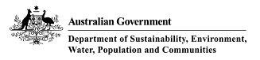
Lakes Argyle and Kununurra
Ramsar site

Ecological Character Description

Citation: Hale, J. and Morgan, D., 2010, Ecological Character Description for the Lakes Argyle and Kununurra Ramsar Site. Report to the Department of Sustainability, Environment, Water, Population and Communities, Canberra.

Acknowledgements:
Danny Rogers, Australasian Waders Studies Group (expert advice)
Halina Kobryn, Murdoch University (mapping and GIS)

The steering committee was comprised of representatives of the following organisations:
- Department of the Environment, Water, Heritage and the Arts
- WA Department of Environment and Conservation (Kununurra)
- WA Department of Water (Kununurra)
- Shire of Wyndham East Kimberley

Introductory Notes

This Ecological Character Description (ECD Publication) has been prepared in accordance with the National Framework and Guidance for Describing the Ecological Character of Australia’s Ramsar Wetlands (National Framework) (Department of the Environment, Water, Heritage and the Arts, 2008).

The Environment Protection and Biodiversity Conservation Act 1999 (EPBC Act) prohibits actions that are likely to have a significant impact on the ecological character of a Ramsar wetland unless the Commonwealth Environment Minister has approved the taking of the action, or some other provision in the EPBC Act allows the action to be taken. The information in this ECD Publication does not indicate any commitment to a particular course of action, policy position or decision. Further, it does not provide assessment of any particular action within the meaning of the Environment Protection and Biodiversity Conservation Act 1999 (Cth), nor replace the role of the Minister or his delegate in making an informed decision to approve an action.

The Water Act 2007 requires that in preparing the [Murray-Darling] Basin Plan, the Murray Darling Basin Authority (MDBA) must take into account Ecological Character Descriptions of declared Ramsar wetlands prepared in accordance with the National Framework.

This ECD Publication is provided without prejudice to any final decision by the Administrative Authority for Ramsar in Australia on change in ecological character in accordance with the requirements of Article 3.2 of the Ramsar Convention.

Disclaimer

While reasonable efforts have been made to ensure the contents of this ECD are correct, the Commonwealth of Australia as represented by the Department of Sustainability, Environment, Water, Population and Communities does not guarantee and accepts no legal liability whatsoever arising from or connected to the currency, accuracy, completeness, reliability or suitability of the information in this ECD.

Note: There may be differences in the type of information contained in this ECD publication, to those of other Ramsar wetlands.

.
Table of Contents
Glossary iii
List of Abbreviations vi
Executive Summary vii
1. Introduction 1
1.1 Site details 1
1.2 Statement of purpose 1
1.3 Relevant treaties, legislation and regulations 3
1.4 Method 5
2. General Description of the Lakes Argyle and Kununurra Ramsar Site 7
2.1 Location 7
2.2 Land tenure 7
2.3 Wetland types 10
2.4 Ramsar criteria 13
2.4.1 Criteria under which the site was designated 13
2.4.2 Assessment based on current information and Ramsar criteria 14
3. Critical Components and Processes 19
3.1 Identifying critical components and processes 19
3.2 Essential elements 21
3.2.1 Climate 21
3.2.2 Geomorphology 23
3.2.3 Water quality 25
3.2.4 Wetland vegetation 27
3.2.5 Invertebrates 30
3.3 Critical components and processes 30
3.3.1 Hydrology 31
3.3.2 Fish 32
3.4.3 Waterbirds 34
3.5.4 Freshwater Crocodiles 36
3.6.5 Other fauna 37
4 Ecosystem services 38
4.1 Overview of benefits and services 38
4.2 Identifying critical ecosystem services and benefits 39
4.3 Critical services 39
4.3.1 Provides physical habitat for large numbers of waterbirds 39
4.3.2 Priority wetland species – supports migratory birds 41
4.3.3 Biodiversity – supports fish 43
4.3.4 Distinct wetland species - Crocodiles 44
4.3.5 Water supply 45
4.4 Non-critical services 45
4.4.1 Commercial fishing 45
4.4.2 Recreation and tourism 46
4.4.3 Indigenous cultural values 46
4.5 Conceptual models 47
5. Threats to Ecological Character 50
5.1 Invasive species 52
5.1.1 Cane toad (Chaunus [Bufo] marinas) 52
5.1.1 Redclaw crayfish (Cherax quadricarinatus) 52
5.1.3 Weeds 53
5.2 Water resource development 54
5.3 Commercial fishing 54
5.4 Urban development and stormwater 55
5.5 Fire 55
5.6 Summary of threats 55
6. Limits of Acceptable Change 57
6.1 Process for setting Limits of Acceptable Change (LAC) 57
6.2 LAC for the Lakes Argyle and Kununurra Ramsar site 57
7. Current Ecological Character and Changes Since Designation 62
7.1 Hydrology 62
7.2 Fish 63
7.3 Waterbirds 64
7.4 Crocodiles 64
7.5 Overall change in ecological character 64
8. Knowledge Gaps 65
9. Monitoring needs 66
10. Communication and Education Messages 67
References 68
Appendix A: Methods 75
A.1 Approach 75
A.2 Consultant Team 76
Appendix B: Fish 78
Appendix C: Waterbirds 79

Glossary
Definitions of words associated with ecological character descriptions (DEWHA 2008 and references cited within).

Benefits | benefits/services are defined in accordance with the Millennium Ecosystem Assessment definition of ecosystem services as "the benefits that people receive from ecosystems (Ramsar Convention 2005, Resolution IX.1 Annex A).  See also “Ecosystem Services”.
Biogeographic region | a scientifically rigorous determination of regions as established using biological and physical parameters such as climate, soil type, vegetation cover, etc (Ramsar Convention 2005).
Biological diversity | the variability among living organisms from all sources including, inter alia, terrestrial, marine and other aquatic ecosystems and the ecological complexes of which they are part; this includes diversity within species (genetic diversity), between species (species diversity), of ecosystems (ecosystem diversity), and of ecological processes. This definition is largely based on the one contained in Article 2 of the Convention on Biological Diversity (Ramsar Convention 2005).
Change in ecological character | is defined as the human-induced adverse alteration of any ecosystem component, process, and/or ecosystem benefit/service (Ramsar Convention 2005, Resolution IX.1 Annex A).
Community | an assemblage of organisms characterised by a distinctive combination of species occupying a common environment and interacting with one another (ANZECC and ARMCANZ 2000).
Community Composition | all the types of taxa present in a community (ANZECC and ARMCANZ 2000).
Conceptual model | wetland conceptual models express ideas about components and processes deemed important for wetland ecosystems (Gross 2003)
Contracting Parties | are countries that are Member States to the Ramsar Convention on Wetlands; 153 as at September 2006. Membership in the Convention is open to all states that are members of the United Nations, one of the UN specialized agencies, or the International Atomic Energy Agency, or is a Party to the Statute of the International Court of Justice
Critical stage | meaning stage of the life cycle of wetland-dependent species. Critical stages being those activities (breeding, migration stopovers, moulting etc.) which if interrupted or prevented from occurring may threaten long-term conservation of the species. (Ramsar Convention 2005).
Ecological character | is the combination of the ecosystem components, processes and benefits/services that characterise the wetland at a given point in time.
Ecosystems | the complex of living communities (including human communities) and non-living environment (Ecosystem Components) interacting (through Ecological Processes) as a functional unit which provides inter alia a variety of benefits to people (Ecosystem Services). (Millennium Ecosystem Assessment 2005).
Ecosystem components | include the physical, chemical and biological parts of a wetland (from large scale to very small scale, for example habitat, species and genes) (Millennium Ecosystem Assessment 2005).
Ecosystem processes | are the changes or reactions which occur naturally within wetland systems. They may be physical, chemical or biological. (Ramsar Convention 1996, Resolution VI.1 Annex A). They include all those processes that occur between organisms and within and between populations and communities, including interactions with the non-living environment, that result in existing ecosystems and bring about changes in ecosystems over time (Australian Heritage Commission 2002)
Ecosystem services | are the benefits that people receive or obtain from an ecosystem. The components of ecosystem services are provisioning (for example food & water), regulating (for example flood control), cultural (for example spiritual, recreational), and supporting (e.g nutrient cycling, ecological value). (Millennium Ecosystem Assessment 2005).  See also “Benefits”.
Essential elements | a component or process that has an essential influence on the critical components, processes or services (CPS) of the wetland. Should the essential element cease, reduce, or is lost, it would result in a detrimental impact on one or more critical CPS. Critical CPS may depend in part or fully on essential elements, but an essential element is not in itself critical for defining the ecological character of the site.
Fluvial geomorphology | the study of water-shaped landforms (Gordon et al. 1999)
Indigenous species | a species that originates and occurs naturally in a particular country (Ramsar Convention 2005).
Limits of Acceptable Change | the variation that is considered acceptable in a particular component or process of the ecological character of the wetland without indicating change in ecological character which may lead to a reduction or loss of the criteria for which the site was Ramsar listed’ (modified from definition adopted by Phillips 2006).
List of Wetlands of International Importance ("the Ramsar List") | the list of wetlands which have been designated by the Ramsar Contracting Party in which they reside as internationally important, according to one or more of the criteria that have been adopted by the Conference of the Parties.
Ramsar | city in Iran, on the shores of the Caspian Sea, where the Convention on Wetlands was signed on 2 February 1971; thus the Convention's short title, "Ramsar Convention on Wetlands".
Ramsar Criteria | Criteria for Identifying Wetlands of International Importance, used by Contracting Parties and advisory bodies to identify wetlands as qualifying for the Ramsar List on the basis of representativeness or uniqueness or of biodiversity values.
Ramsar Convention | Convention on Wetlands of International Importance especially as Waterfowl Habitat. Ramsar (Iran), 2 February 1971. UN Treaty Series No. 14583. As amended by the Paris Protocol, 3 December 1982, and Regina Amendments, 28 May 1987. The abbreviated names "Convention on Wetlands (Ramsar, Iran, 1971)" or "Ramsar Convention" are more commonly used.
Ramsar Information Sheet (RIS) | the form upon which Contracting Parties record relevant data on proposed Wetlands of International Importance for inclusion in the Ramsar Database; covers identifying details like geographical coordinates and surface area, criteria for inclusion in the Ramsar List and wetland types present, hydrological, ecological, and socioeconomic issues among others, ownership and jurisdictions, and conservation measures taken and needed.
Ramsar List | the List of Wetlands of International Importance
Ramsar Sites | wetlands designated by the Contracting Parties for inclusion in the List of Wetlands of International Importance because they meet one or more of the Ramsar Criteria
Waterbirds | "birds ecologically dependent on wetlands" (Article 1.2). This definition thus includes any wetland bird species. However, at the broad level of taxonomic order, it includes especially:  - penguins: Sphenisciformes.  - divers: Gaviiformes;  - grebes: Podicipediformes;  - wetland related pelicans, cormorants, darters and allies: Pelecaniformes;  - herons, bitterns, storks, ibises and spoonbills: Ciconiiformes;  - flamingos: Phoenicopteriformes:  - screamers, swans, geese and ducks (wildfowl): Anseriformes;  - wetland related raptors: Accipitriformes and Falconiformes;  - wetland related cranes, rails and allies: Gruiformes;  - Hoatzin: Opisthocomiformes;  - wetland related jacanas, waders (or shorebirds), gulls, skimmers and terns: Charadriiformes;  - coucals: Cuculiformes; and  - wetland related owls: Strigiformes.
Waterfowl | Waterbirds of the order Anseriformes, especially members of the family Anatidae, which includes ducks, geese, and swans.
Wetlands | are areas of marsh, fen, peatland or water, whether natural or artificial, permanent or temporary with water that is static or flowing, fresh, brackish or salt, including areas of marine water the depth of which at low tide does not exceed six metres (Ramsar Convention 1987).
Wetland types | as defined by the Ramsar Convention’s wetland classification system.

List of Abbreviations

CALM | Department of Conservation and Land Management (former Western Australian government department)
AWSG | Australasian Waders Studies Group
CAMBA | China Australia Migratory Bird Agreement
CEPA | Communication, Education, Participation and Awareness
CMS | Bonn Convention on Migratory Species
CPS | Components, Processes and Services
DEC | Department of Environment and Conservation (Western Australia)
DEWHA | Department of the Environment, Water, Heritage and the Arts (Commonwealth)
DoW | Department of Water (Western Australia)
EAAF | East Asian Australasian Flyway
ECD | Ecological Character Description
EPBC Act | Environment Protection and Biodiversity Conservation Act, 1999 (Commonwealth)
IUCN | International Union for Conservation of Nature
JAMBA | Japan Australia Migratory Bird Agreement
LAC | Limits of Acceptable Change
ORIA | Ord River Irrigation Area
RAOU | Royal Australian Ornithological Union
ROKAMBA | Republic of Korea Australia Migratory Bird Agreement

Executive Summary
The Lakes Argyle and Kununurra Ramsar site is located in the north east of Western Australia, within the Timor Sea Drainage Division (bioregion). The site covers approximately 117 000 hectares and lies within the Shire of Wyndham – East Kimberley (see current Ramsar information sheet for precise area). The northern extent of the site (Lake Kununurra) is within the town of Kununurra (population in 2006; 5700) and Lake Argyle is immediately upstream (Figure E1). Lakes Argyle and Kununurra were formed by the construction of dams on the Ord River for the supply of irrigation water to the Ord River Irrigation Area (ORIA). Lake Kununurra was formed in 1963, with the construction of the 20 metres tall Lake Kununurra Diversion Dam, located approximately five kilometres east of Kununurra. Lake Argyle was formed following the construction of the Ord River Dam 55 kilometres upstream, which was completed in 1973 (DoW 2006). In 1996 the spillway from Lake Argyle was raised by six metres to improve reliability of water for hydroelectric power generation.

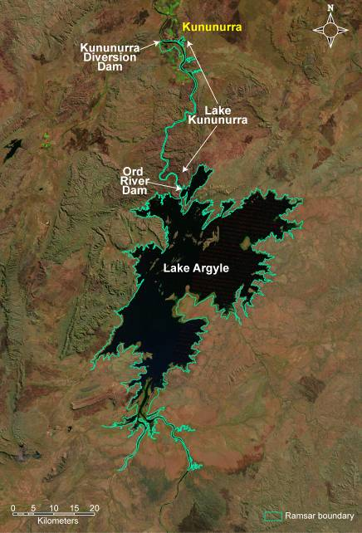
Figure E1: Location of the Lakes Argyle and Kununurra Ramsar Site (data supplied by DEC). Note Lake Kununurra extends the entire length of the previous Ord River Channel from the Ord River Dam to the Kununurra Diversion Dam.

The Lakes Argyle and Kununurra Ramsar site meets the following Ramsar criteria:

Criterion 4: “A wetland should be considered internationally important if it supports plant and/or animal species at a critical stage in their life cycles, or provides refuge during adverse conditions.”
The Lakes Argyle and Kununurra Ramsar site supports the critical life stages of migration (migratory shorebirds); breeding (fish and a small number of waterbirds) and moulting of waterfowl in the large expanse of open water on Lake Argyle.

Criterion 5: “A wetland should be considered internationally important if it regularly supports 20 000 or more waterbirds.”
Comprehensive bird survey data for the Lakes Argyle and Kununurra Ramsar site are limited. A single count from the 1980s (Jaensch and Vervest 1990) and counts from 2005 (Hassell et al. 2005) and 2007 (Bennelongia 2007) are they only examples of surveys that covered large portions of the Ramsar site. All of these resulted in summer total waterbird numbers in excess of 150 000.

Criterion 6: “A wetland should be considered internationally important if it regularly supports one percent of the individuals in a population of one species or subspecies of waterbird.”
Counts are limited, but based on available data (Jaensch and Vervest 1990; Hassell et al. 2005; and Bennelongia 2007) the Ramsar site supports greater than one percent of the relevant populations of 11 species of birds: little curlew (Numenius minutus); wood sandpiper (Tringa glareola); sharp-tailed sandpiper (Calidris acuminata); oriental pratincole (Glareola maldivarum); black-winged stilt (Himantopus himantopus); red-capped plover (Charadrius ruficapillus); magpie goose (Anseranas semipalmata); wandering whistling duck (Dendrocygna arcuata); hardhead (Aythya australis); Eurasian coot (Fulica atra); and green pygmy goose (Nettapus pulchellus).

Criteria 7: “A wetland should be considered internationally important if it supports a significant proportion of indigenous fish subspecies, species or families, life-history stages, species interactions and/or populations that are representative of wetland benefits and/or values and thereby contributes to global biological diversity.”
A total of 29 species of native fish have been recorded from these two Ramsar sites, and these represent the only Western Australian populations of the giant glassfish (Parambassis gulliveri), and potentially important populations of a few terapontid species. The majority of species in these sites are Australian endemics, with some endemic to the Kimberley. A number of adjunct populations of specifically, terapontids (grunters, Syncomistes spp.) that are endemic to the Kimberley are found within Lake Argyle.

Criterion 9: “A wetland should be considered internationally important if it regularly supports one percent of the individuals in a population of one species or subspecies of wetland-dependent non-avian animal species.”
The Lakes Argyle and Kununurra Ramsar site supports over one percent of the global population of freshwater crocodiles (Crocodylus johnstoni).

Ecological character is defined as:
“is the combination of the ecosystem components, processes and benefits/services that characterise the wetland at a given point in time.”

The Lakes Argyle and Kununurra Ramsar site was listed in 1990 and this is the point in time for which the ecological character description is based. A summary of the components, processes important to the ecological character of the Lakes Argyle and Kununurra Ramsar site is provided in Table E1. This includes those that are considered essential elements as well as those identified as critical to the ecological character of the site and for which Limits of Acceptable Change have been developed. Critical components and processes as well as essential elements were selected on the basis of their role in maintaining the ecological character of the site, the ecosystem services they support (Table E2) and the Ramsar criteria for which the site is listed.

Table E1: Summary of components and processes important for maintaining the ecological character of the Lakes Argyle and Kununurra Ramsar site.
Component / process | Description
Essential elements
Climate | - Located in the dry tropics with a semi arid, monsoonal climate.  - Eighty percent of rainfall occurs in the wet season (December to February).  - On average evaporation exceeds rainfall in 11 months of the year.
Geomorphology | - Lake Kununurra was formed within the channel of the Ord River and is approximately 55 kilometres long and 100 – 400 metres wide.  - Lake Argyle was formed within a natural gorge of the Carr Boyd Range; it has over 70 islands and a large area of the shoreline is of low elevation.  - Erosion in the catchment results in 11.5 million tonnes of sediment per year depositing in Lake Argyle.
Water quality | - The water in both lakes is fresh and of low salinity year round.  - Lake Argyle is seasonally stratified with low dissolved oxygen and high nutrients in bottom waters during the wet season.  - Lake Kununurra has higher concentrations of total nitrogen than Lake Argyle, but phytoplankton biomass (as indicated by chlorophyll-a concentrations) is low.  - Water quality varies spatially in Lake Kununurra, with higher concentrations of nutrients and lower visibility in Lily Lagoon than the main channel of the waterbody.
Vegetation | - Lake Argyle has little remanent riparian vegetation and only small localised areas of aquatic vegetation.  - Lake Kununurra is highly productive and dense riparian and aquatic vegetation occurs.  - Weeds dominate Lake Kununurra, in particular.
Invertebrates | - Eighty-five species of freshwater aquatic macroinvertebrates from 40 families have been recorded in Lake Kununurra.
Critical components and processes
Hydrology | - The lakes are permanent and operated for the supply of irrigation water.  - Lake Argyle has a storage capacity of approximately 10 000 GL and fluctuates seasonally by as much as 10 metres in depth.  - Lake Kununurra is a re-regulating structure that is maintained at constant water levels throughout the year.
Fish | - Lakes are dominated by potamodromous species, or those that complete their life-cycles within freshwater. This includes 27 potamodromous species, and a further two that are diadromous (relicts from pre –regulation that require migratory routes to complete lifecycles).
Waterbirds | - Seventy-five species of waterbird including 22 international migratory species have been recorded in the site.  - Abundances are high, with 150 000 to 240 000 waterbirds recorded in the three comprehensive surveys to date.  - The site supports greater than one percent of the population of 11 species of waterbird.  - There are limited waterbird breeding records, but anecdotal evidence that Lake Kununurra was significant as a breeding site.
Freshwater Crocodiles | - The site supports greater than one percent of the global population of freshwater crocodiles.  - Annual surveys in Lake Kununurra and Lake Argyle indicate stable populations in both lakes.

Ecosystem benefits and services are defined under the Millennium Ecosystem Assessment definition of ecosystem services as "the benefits that people receive from ecosystems (Ramsar Convention 2005, Resolution IX.1 Annex A). This includes benefits that directly affect people such as the provision of food or water resources as well as indirect ecological benefits.

Identified benefits and services of the Lakes Argyle and Kununurra Ramsar site are summarised in Table E2. This includes provisioning services (products obtained from ecosystems); cultural services (benefits people obtain through spiritual enrichment, recreation, education and aesthetics) and supporting services (services that underpin other services and have indirect benefits to humans). Water supply, together with the four supporting services: physical habitat, biodiversity priority wetland species and distinct wetland species were identified as critical to the ecological character of the Ramsar site.

Table E2: Summary of the benefits and services of the Lakes Argyle and Kununurra Ramsar site (critical services are shown shaded).
Category | Description
Provisioning services
Water supply | The system was created to supply water for irrigation in the ORIA.  Since the time of listing this has been expanded to include energy production (hydroelectricity) and an environmental water provision for the Lower Ord River Floodplain.
Commercial fishing | Lake Argyle contains the only commercial freshwater fishery in Western Australia (silver cobbler; Neoarius midgleyi).
Cultural services
Recreation and tourism | A viable tourism industry operates on both Lakes Argyle and Kununurra, with boat operators, helicopter and plane flights, fishing, canoeing and bird watching. High recreational boating use including skiing and swimming.
Spiritual and inspirational | The region is spiritually and culturally significant for the Miriuwung, Gajerrong Peoples who have joint management of part of the site (Packsaddle Swamp). Use Lake Kununurra for fishing especially communities of Munthama, Geboowama and Mud Springs.  Culturally significant for residents of Kununurra for recreation and relaxation.
Supporting services
Physical habitat | Lakes Argyle and Kununurra provide habitat for feeding and moulting of waterbirds.
Biodiversity | Twenty-nine species of fish have been recorded from the lakes, the highest number of species in an inland wetland in Western Australia.
Priority wetland species | Lake Argyle supports 22 species of migratory shorebird listed under international agreements.
Distinct wetland species | The Lakes Argyle and Kununurra Ramsar site supports over one percent of the global population of freshwater crocodile.

“Limits of acceptable change” (LAC) is the terminology used to describe complex judgements as to how what extent critical components, processes benefits and services of the site can vary without representing a change in the ecological character as defined by the Ramsar Convention. Limits of acceptable change for the Lakes Argyle and Kununurra Ramsar site have been proposed for critical components, processes and benefits and services based on existing data and guidelines and are summarised in Tables E3.

Table E3: Proposed LAC for the Lakes Argyle and Kununurra Ramsar site.
Component/Process  Benefit / Service | Limit of Acceptable Change
Component:  - Hydrology  Services:  - Water supply  - Physical habitat - for waterbird moulting and feeding  - Supports biodiversity (fish) | Lake Argyle:  - Annual fluctuation of water levels of at least 3 metres annually.  - Storage to remain greater than 5000 gigalitres for more than 10 months of every year.
Lake Kununurra:
Water levels between 41.1 and 41.7 metres AHD for 90 percent of any given 12 month period.
Component:  - Fish  Service:  - Biodiversity | Maintenance of 24 species of native fish.
Component:  - Fish  Service:  - Biodiversity | - Silver cobbler CPUE of 16 to 42 kilograms per 100 metres per net days.  - See also LAC for freshwater crocodiles below.
Component:  - Waterbirds  Services:  - Physical habitat for moulting and feeding waterbirds  - Priority wetland species | Numbers greater than 100 000 during November / December.
 | Little curlew, wood sandpiper, sharp-tailed sandpiper, oriental pratincole - greater than one percent of flyway population recorded in at least two years in every five year period.
- Black-winged stilt - greater than 3000 individuals recorded in at least three years in every five year period.
- Red-capped plover - greater than 1000 individuals recorded in at least two years in every five year period.
- Magpie goose - greater than 20 000 individuals recorded in at least four years in every five year period.
- Wandering whistling duck - greater than 20 000 individuals recorded in at least four years in every five year period.
- Hardhead - greater than 10 000 individuals recorded in at least four years in every five year period.
- Eurasian coot - greater than 10 000 individuals recorded in at least three years in every five year period.
- Green pygmy goose - greater than 20 000 individuals recorded in at least four years in every five year period.
Component:  - Freshwater crocodiles  Service:  - Distinct wetland species | - Lake Argyle - greater than 700 crocodiles recorded in annual helicopter surveys.  - Lake Kununurra - greater than 140 crocodiles recorded in annual helicopter surveys.

The remote location of the site, together with the fact that the site is a created wetland constructed to provide water for irrigation and hydro-power, decreases the number and magnitude of threats to the character of the Lakes Argyle and Kununurra Ramsar site. Construction of the site occurred many decades prior to listing as a Wetland of International Importance and evidence suggests that by 1990 the majority of the site had achieved a relatively stable state. There are, however, a number of threats that could significantly impact on the ecological character of the site. A description of each of these threats is provided in Table E4.

Table E4: Summary of threats to the ecological character of the Ramsar site.
Actual or likely threat or threatening activities | Potential impact(s) to wetland components, processes and/or service | Location | Likelihood¹ | Timing
Cane toads | Death of fishes, birds, reptiles preying on eggs, larvae and adults. | Lakes Argyle and Kununurra | Certain | Current
Redclaw crayfish | Disruption of food webs at all trophic levels; competition with cherabin and aquatic invertebrates; impact to aquatic vegetation. | Lake Kununurra | Certain | Current
Weeds | - Displacement of native flora.  - Erosion of banks. | Lakes Argyle and Kununurra | Certain | Current
Water resource development | Accumulating nutrients and sediment. | Lake Argyle | Medium | Long-term
Water resource development | Barriers to fish migration. | Lakes Argyle and Kununurra | Certain | Current
Commercial fishing | - Direct impacts to target species.  - Death of other large fish (barramundi) and freshwater crocodiles, birds and turtles as bycatch. | Lake Argyle | Certain | Current
Fire | Increased erosion of riparian areas and sedimentation of wetlands. | Lakes Argyle and Kununurra | Certain | Current
Urban development and stormwater | Clearing of riparian vegetation, waste management, erosion, reduced public access. | Lake Kununurra | Certain | Current
Urban development and stormwater | Increased sediment, litter and nutrients. | Lake Kununurra | Certain | Current
¹ Where Certain is defined as known to occur at the site or has occurred in the past; Medium is defined as not known from the site but occurs at similar sites; and Low is defined as theoretically possible, but not recorded at this or similar sites.

There have been some changes to the Lakes Argyle and Kununurra Ramsar site in the two decades since listing in 1990. The most significant of these was a raising of the spillway of Lake Argyle in 1996, by six metres. This was undertaken to increase the supply of water to accommodate hydro-electricity production. However, despite this major construction, there has been little change in the ecological character of the site, and all Ramsar criteria are still clearly met and no LAC have been breached.

Knowledge gaps have been identified (Table E5) and monitoring to address knowledge gaps and assess against LAC recommended (Table E6).

Table E5: Knowledge gaps relevant to the ecological character of the Ramsar site.
Location | Knowledge Gap | Recommended Action
Lake Kununurra | Water quality within the main lake and associated swamps. | Monthly water quality monitoring within the main lake and swamps.
Lake Kununurra | Nutrient cycling and accumulation due to aquatic vegetation and reduced flows in associated wetlands such as Lily Lagoon. | Nutrient cycling analysis and modelling in aquatic vegetation and associated waterbodies.
Lake Kununurra | Extent and impact of weeds and exacerbated native vegetation growth on native flora and aquatic fauna. | Weed and aquatic vegetation mapping.
Lake Kununurra | Long-term viability of native riparian vegetation in the absence of pulse flows to stimulate germination and recruitment. | Monitoring of tree health and riparian vegetation condition.
Lake Kununurra | Impact of redclaw crayfish on food webs and competition with cherabin. | Food web and dietary analyses; abundance and spread of redclaw crayfish and abundance of cherabin
Lake Kununurra | Waterbird breeding within the Ramsar site and the significance of the site for breeding waterbirds. | Annual waterbird surveys to include nesting records from waterbird species at Packsaddle Swamp and Lily Lagoon.
Lake Kununurra | Abundance and diversity of other aquatic fauna within Lake Kununurra. | Surveys of frogs, tortoises and water rats to determine if the site is an important site for maintaining diversity or breeding populations of aquatic species.
Lake Argyle | The magnitude and potential impact of the raising of the spillway to littoral and mudflat habitat. | Assessment of changes in inundation since 1996.
Lake Argyle | Biology of fishes, including commercial species such as silver cobbler. | Document distribution, ecology and habitat associations of fishes.
Lake Argyle | Abundance and diversity of other aquatic fauna. | Surveys of frogs and tortoises to determine if the site is an important site for maintaining diversity or breeding populations of aquatic species.
Lake Argyle | Long term variability in waterbird diversity ad abundance; the importance of Lake argyle as a site for international migratory birds. | Include Lake Argyle in network of sites monitored annually Australia wide for migratory birds (for example Shorebirds 2020).
Table E6: Recommended monitoring for the Lakes Argyle and Kununurra Ramsar site.
Component/ Process | Purpose | Indicator | Locations | Frequency | Priority
Hydrology | Assessment against LAC | Water level | Entire Ramsar site | Weekly | Moderate
Water quality | Threat indicator | Dissolved Oxygen  Nutrients | Entire Ramsar site | Monthly | Moderate
Vegetation – extent of weeds | Threat indicator | Extent of noxious weeds – salvinia | Lake Kununurra | Annual | High
Cane toads | Threat indicator | Location, abundance | Entire Ramsar site | Seasonal | High
Redclaw crayfish | Threat indicator | Location, abundance | Entire Ramsar site | Seasonal | Moderate
Fish | Assessment against LAC | Abundance and community composition | Entire Ramsar site | Seasonal | High
Waterbirds | Assessment against LAC | Abundance and species identifications, breeding observations | Entire Ramsar site | November / December | High
Freshwater Crocodile | Assessment against LAC | Abundance | Entire Ramsar site | Annual | High

1. Introduction

1.1 Site details
The Lakes Argyle and Kununurra Ramsar site is located in East Kimberley region in north Western Australia. It was originally nominated as a Wetland of International Importance under the Ramsar Convention in 1990. Site details for this Ramsar wetland are provided in Table 1.

Table 1: Site details for the Lakes Argyle and Kununurra Ramsar site taken from the Ramsar Information Sheet (2003).
Site Name | Lakes Argyle and Kununurra
Location in coordinates | Latitude: 15° 48' S to 16° 50' S  Longitude: 128° 28' E to 129° 00' E
General location of the site | The Argyle and Kununurra Ramsar site is located in the Shire of Wyndham East Kimberley in Western Australia.  Drainage Division 3: Timor Sea (Australia’s River Basins Australian Water Resources Council 1987).
Area | Approximately 117 000 hectares (see most recent Ramsar Information Sheet for precise area).
Date of Ramsar site designation | Designated on 7 June 1990
Ramsar/DIWA Criteria met by wetland | Ramsar criteria 4, 5, 6, 7, 9
Management authority for the site | The Lakes are managed by the Water Corporation, which controls the supply of water for irrigation. The Department of Water is responsible for water allocations and environmental water provisions. The Department of Environment and Conservation is responsible for management of Ramsar values. Packsaddle Swamp is managed jointly between DEC and the Miriuwung-Gajerrong.
Date the ECD applies | 1990
Status of Description | This represents the first ECD for the site.
Date of Compilation | May 2010
Name(s) of compiler(s) | Jennifer Hale and David Morgan on behalf of DEWHA.
References to the Ramsar Information Sheet (RIS) | RIS compiled by CALM in 2003.  Updated by Jennifer Hale on behalf of DEWHA 2010.
References to Management Plan(s) | In 2010 there was no management plan for the site.

1.2 Statement of purpose
The act of designating a wetland as a Ramsar site carries with it certain obligations, including managing the site to retain its ‘ecological character’ and to have procedures in place to detect if any threatening processes are likely to, or have altered the ‘ecological character’. Thus, understanding and describing the ‘ecological character’ of a Ramsar site is a fundamental management tool for signatories and local site managers which should form the baseline or benchmark for management planning and action, including site monitoring to detect negative impacts.

The Ramsar Convention has defined “ecological character” and “change in ecological character” as (Ramsar 2005):

“Ecological character is the combination of the ecosystem components, processes and benefits/services that characterise the wetlands at a given point in time”

And

“…change in ecological character is the human induced adverse alteration of any ecosystem component, process and or ecosystem benefit/service.”

In order to detect change it is necessary to establish a benchmark for management and planning purposes. Ecological character descriptions (ECD) form the foundation on which a site management plan and associated monitoring and evaluation activities are based. The legal framework for ensuring the ecological character of all Australian Ramsar sites is maintained is the Environment Protection and Biodiversity Conservation Act, 1999 (the EPBC Act) (Figure 1). A Ramsar Information Sheet is prepared at the time of designation. However whilst there is some link between the data used for listing a site (based on the various criteria) the information in an RIS does not provide sufficient detail on the interactions between ecological components, processes and functions to constitute a comprehensive description of ecological character. In response to the short fall, the Australian and state/territory governments have developed a National Framework and Guidance for Describing the Ecological Character of Australia’s Ramsar Wetlands. Module 2 of Australian National Guidelines for Ramsar Wetlands – Implementing the Ramsar Convention in Australia (DEWHA 2008).

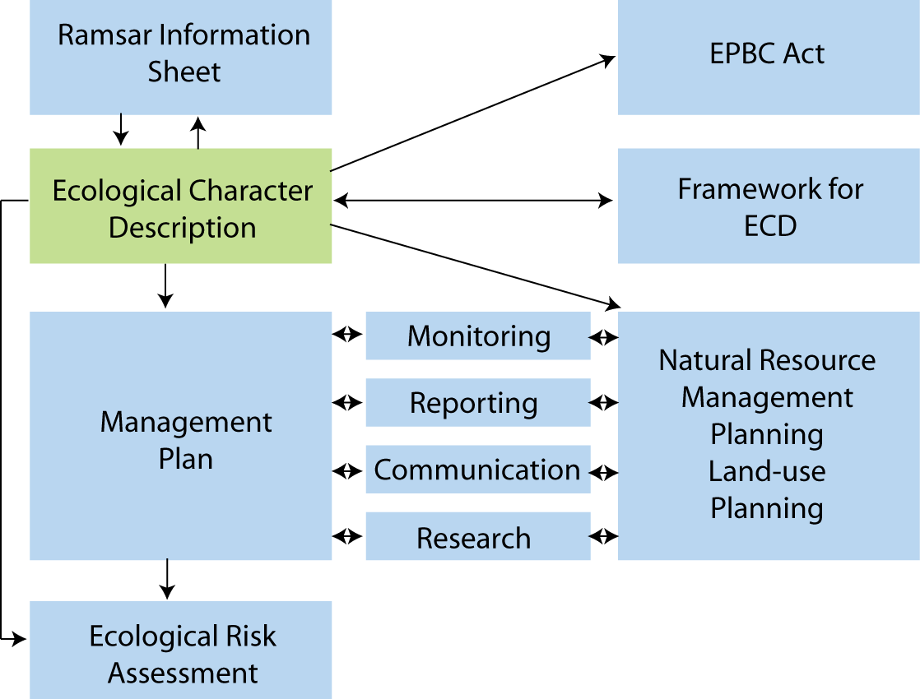

Figure 1: The ecological character description in the context of other requirements for the management of Ramsar sites (adapted from DEWHA 2008).

The framework emphasises the importance of describing and quantifying the ecosystem components, processes and benefits/services of the wetland and the relationship between them. It is also important that information is provided on the benchmarks or ecologically significant limits of acceptable change that would indicate when the ecological character has or is likely to change.

McGrath (2006) detailed the general aims of an ECD as follows:

- To assist in implementing Australia’s obligations under the Ramsar Convention, as stated in Schedule 6 (Managing wetlands of international importance) of the Environment Protection and Biodiversity Conservation Regulations 2000 (Commonwealth):
  - To describe and maintain the ecological character of declared Ramsar wetlands in Australia; and
  - To formulate and implement planning that promotes:
    - Conservation of the wetland; and
    - Wise and sustainable use of the wetland for the benefit of humanity in a way that is compatible with maintenance of the natural properties of the ecosystem.
- To assist in fulfilling Australia’s obligation under the Ramsar Convention to arrange to be informed at the earliest possible time if the ecological character of any wetland in its territory and included in the Ramsar List has changed, is changing or is likely to change as the result of technological developments, pollution or other human interference.
- To supplement the description of the ecological character contained in the Ramsar Information Sheet submitted under the Ramsar Convention for each listed wetland and, collectively, form an official record of the ecological character of the site.
- To assist the administration of the EPBC Act, particularly:
  - To determine whether an action has, will have or is likely to have a significant impact on a declared Ramsar wetland in contravention of sections 16 and 17B of the EPBC Act; or
  - To assess the impacts that actions referred to the Minister under Part 7 of the EPBC Act have had, will have or are likely to have on a declared Ramsar wetland.
- To assist any person considering taking an action that may impact on a declared Ramsar wetland whether to refer the action to the Minister under Part 7 of the EPBC Act for assessment and approval.
- To inform members of the public who are interested generally in declared Ramsar wetlands to understand and value the wetlands.

1.3 Relevant treaties, legislation and regulations
This section provides a brief listing of the legislation and policy that is relevant to the description of the ecological character of the Ramsar site. There is a significant amount of legislation, particularly at the state/local level, relevant to the management of the site which will be documented more fully in the management plan for the site and as such is not repeated here.

International
Ramsar Convention
The Convention on wetlands, otherwise known as the Ramsar Convention, was signed in Ramsar Iran in 1971 and came into force in 1975. It provides the framework for local, regional and national actions, and international cooperation, for the conservation and wise use of wetlands. Wetlands of International Importance are selected on the basis of their international significance in terms of ecology, botany, zoology, limnology and or hydrology

Migratory bird bilateral agreements and conventions
Australia is party to a number of bilateral agreements, initiatives and conventions for the conservation of migratory birds, which are relevant to the Lakes Argyle and Kununurra Ramsar site. The bilateral agreements are:

- JAMBA – The agreement between the Government of Australia and the Government of Japan for the Protection of Migratory Birds in Danger of Extinction and their Environment, 1974;
- CAMBA - The Agreement between the Government of Australia and the Government of the People's Republic of China for the Protection of Migratory Birds and their Environment 1986;
- ROKAMBA - The Agreement between the Government of Australia and the Republic of Korea for the Protection of Migratory Birds and their Environment, 2006; and
- The Bonn Convention on Migratory Species (CMS) - The Bonn Convention adopts a framework in which countries with jurisdiction over any part of the range of a particular species co-operate to prevent migratory species becoming endangered. For Australian purposes, many of the species are migratory birds.

National legislation
Environment Protection and Biodiversity Conservation Act 1999 (EPBC Act)
The EPBC Act regulates actions that will have or are likely to have a significant impact on any matter of national environmental significance, which includes the ecological character of a Ramsar wetland (EPBC Act s16(1)). An action that will have or is likely to have a significant impact on a Ramsar wetland will require an environmental assessment and approval under the EPBC Act. An ‘action’ includes a project, a development, an undertaking or an activity or series of activities (http://www.environment.gov.au/epbc/index.html).

The EPBC Act establishes a framework for managing Ramsar wetlands, through the Australian Ramsar Management Principles (EPBC Act s335), which are set out in Schedule 6 of the Environment Protection and Biodiversity Conservation Regulations 2000. These principles are intended to promote national standards of management, planning, environmental impact assessment, community involvement, and monitoring, for all of Australia’s Ramsar wetlands in a way that is consistent with Australia’s obligations under the Ramsar Convention. Some matters protected under the EPBC Act are not protected under local or state/territory legislation, and as such, many migratory birds are not specifically protected under State legislation (though they are in Western Australia). Species listed under international treaties JAMBA, CAMBA, ROKAMBA and CMS have been included in the List of Migratory species under the Act. Threatened species and communities listed under the EPBC Act may also occur, or have habitat in the Ramsar site; some species listed under State legislation as threatened are not listed under the EPBC Act as threatened, usually because they are not threatened at the national (often equivalent to whole-of-population) level. The Regulations also cover matters relevant to the preparation of management plans, environmental assessment of actions that may affect the site, and the community consultation process.

Western Australia state policy and legislation
Wildlife Conservation Act 1950
This Act provides for the protection of wildlife and all fauna in Western Australia is protected under section 14 of the Wildlife Conservation Act 1950. The Act establishes licensing frameworks for the taking and possession of protected fauna and also establishes offences and penalties for interactions with fauna.

Conservation and Land Management Act 1984
This Act is administered by the State Department of Environment and Conservation (DEC) and applies to public lands. It sets the framework for the creation and management of marine and terrestrial parks, reserves and management areas in Western Australia, and deals with the protection of flora and fauna within reserve systems.

Aboriginal Heritage Act 1972
There are several important Aboriginal heritage sites around Lakes Argyle and Kununurra, which are protected under this act including ceremonial, mythological and burial sites, associated with the Ord River.

Fisheries Resource Management Act 1995
The Fisheries Resource Management Act 1995 establishes a regulatory framework for managing commercial fishing in WA and has a primary objective: ‘to conserve, develop and share the fish resources of the State for the benefit of present and future generations’. The Act provides stipulations for specific fishing equipment and also covers aquaculture industries. It is administered by Fisheries Western Australia.

Environmental Protection Act 1986
The Environmental Protection (Clearing of Native Vegetation) Regulations 2004 under the Act prohibit clearing of native vegetation, unless a clearing permit is granted by the Department of Environment and Conservation or the clearing is for an exempt purpose. The exemptions allow low impact day-to-day activities involving clearing to be undertaken in accordance with the regulations. People who wish to clear native vegetation are required to obtain a permit if an exemption does not apply. Ramsar wetlands and the area within 50 metres of their boundary are identified as environmentally sensitive areas. The clearing exemptions of the Act do not apply in environmentally sensitive areas

Rights in Water and Irrigation Act 1914
The Rights in Water Irrigation Act 1914 provides for the management of water resources in the state. There are provisions for the control of both groundwater and surface water use to meet the needs of current and future users as well as for the protection of water resources and associated environments.

1.4 Method
The method used to develop the ecological character description for the Lakes Argyle and Kununurra Ramsar site is based on the twelve-step approach provided in the National Framework and Guidance for Describing the Ecological Character of Australia’s Ramsar Wetlands (DEWHA 2008) illustrated in Figure 2. A more detailed description of each of the steps and outputs required is provided in the source document. This ECD was developed primarily through a desktop assessment and is based on existing data and information. A steering committee was formed to provide input and comment on the ECD.

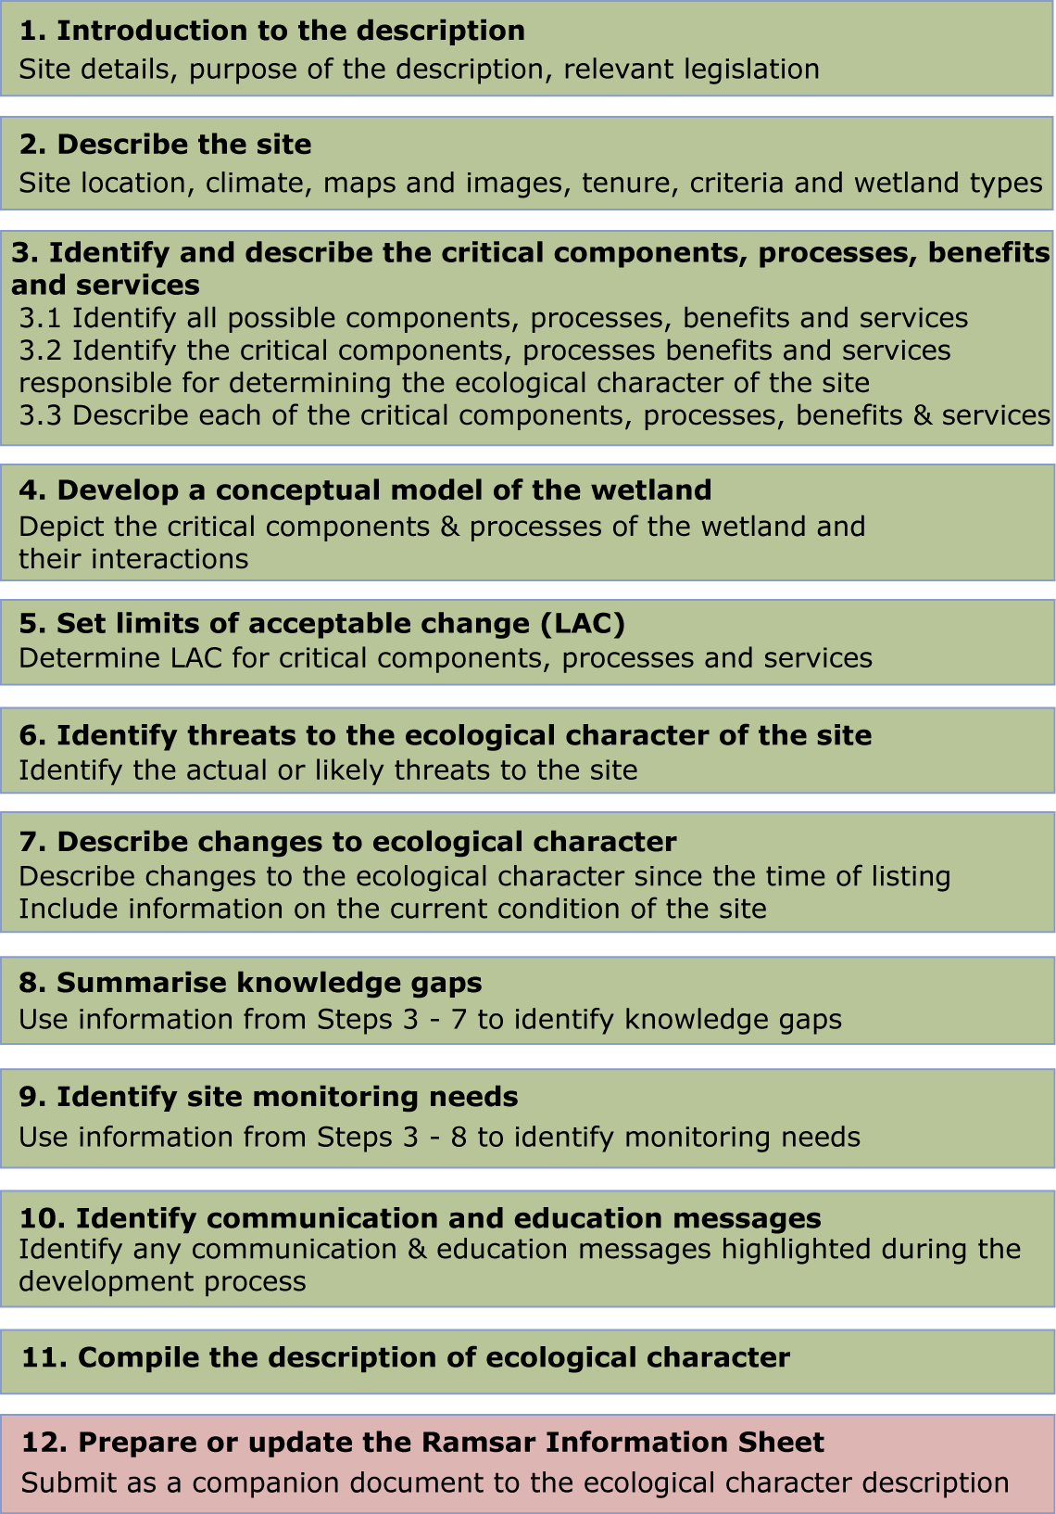

Figure 2: Twelve step process for developing an ECD (adapted from DEWHA 2008).

2. General Description of the Lakes Argyle and Kununurra Ramsar Site

2.1 Location
The Lakes Argyle and Kununurra Ramsar site is located in the north east of Western Australia, within the Timor Sea Drainage Division (bioregion). The site covers approximately 117 000 hectares (see most recent RIS for precise area) and lies within the Shire of Wyndham – East Kimberley. The northern extent of the site (Lake Kununurra) is within the town of Kununurra (population in 2006; 5700) and Lake Argyle is immediately upstream (Figure 3).

Lakes Kununurra and Argyle are within the Ord River catchment which covers over 53 000 square kilometres (to the mouth of Cambridge Gulf; DoW 2006). The lakes are within the channel of the 650 kilometre long Ord River, which has its source near Halls Creek and drains into Cambridge Gulf through the Ord River Floodplain Ramsar site. The Ord River is the central water supply for large scale irrigated agriculture in the area and Lakes Argyle and Kununurra were formed by the construction of dams within the river. Lake Kununurra was formed in 1963, with the construction of the 20 metres tall Lake Kununurra Diversion Dam, located approximately five kilometres east of Kununurra. Lake Argyle was formed following the construction of the Ord River Dam 55 kilometres upstream, which was completed in 1973 (DoW 2006). In 1996 the spillway from Lake Argyle was raised by six metres to improve reliability of water for hydroelectric power generation.

2.2 Land tenure
The Lakes themselves are vested with the Water Corporation and managed for the supply of water for irrigation, domestic use and the production of hydroelectricity. The area was subject to a native title claim by the Miriuwung Gajerrong people, which was ratified in December 2003. As a result of the Ord Final Agreement negotiations, formal processes for Aboriginal consultation and interaction in management and management planning have commenced via the Joint Management Initiative. This involves the Miriuwung Gajerrong people and the Department of Environment and Conservation co-managing three existing and five newly created reserves within the Kimberley region. The Ramsar site contains one of these reserves: Packsaddle Swamps. Another reserve (31165), managed by the Miriuwung Gajerrong people and the Department of Water, borders the southern portion of the site (Figure 4).

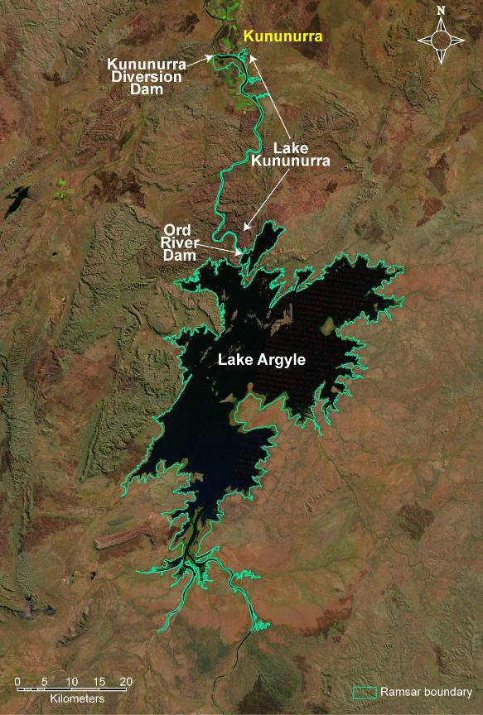
Figure 3: Location of the Lakes Argyle and Kununurra Ramsar Site (data supplied by DEC). Note Lake Kununurra extends the entire length of the previous Ord River Channel from the Ord River Dam to the Kununurra Diversion Dam.

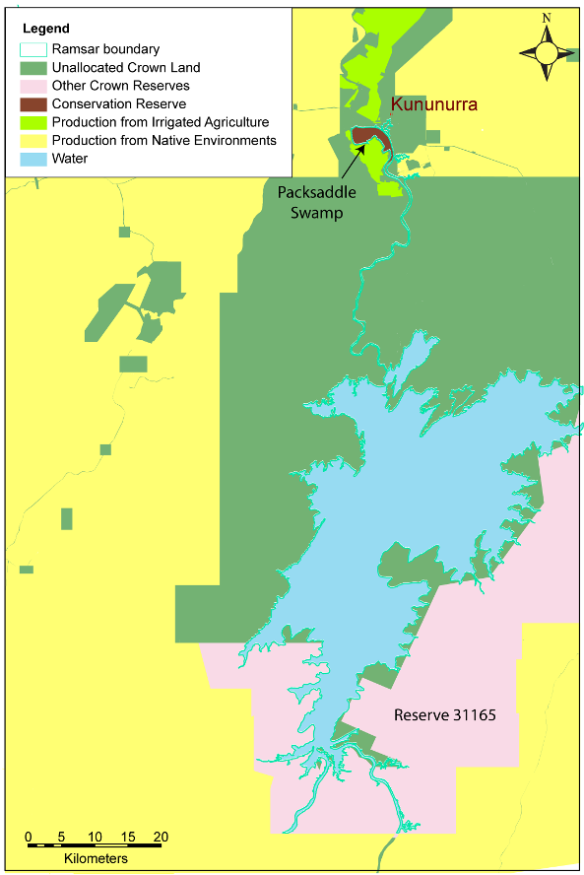
Figure 4: Land tenure within and adjacent to the site (adapted from Hill et al. 2008).

2.3 Wetland types
There are three wetland types within the Lakes Argyle and Kununurra Ramsar site:

- Type 6 — Water storage areas; reservoirs/barrages/dams/impoundments (generally over 8 ha);
- Type M — Permanent rivers/streams/creeks; and.
- Type O — Permanent freshwater lakes (over 8 ha).

Although wetland mapping and aerial extent of each type is not possible with available information, the general locations of each type are shown in Figure 5 and a description of the hydrology can be found in section 3.3.1.

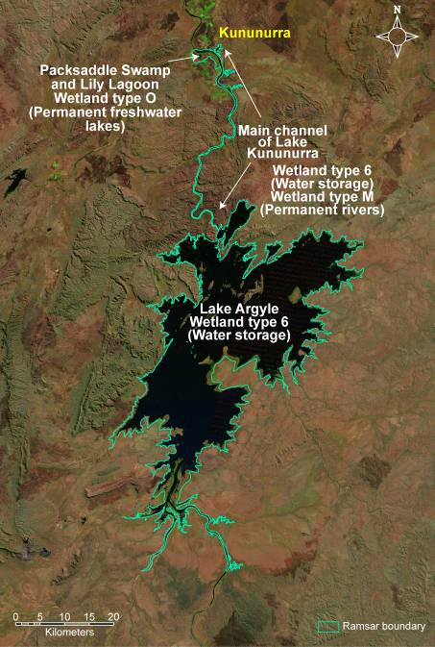

Figure 5: General location of wetland types in the Lakes Argyle and Kununurra Ramsar site.
Lakes Argyle and Kununurra are artificial wetlands, brought about by the construction of two dams. As such, the majority of the site could be considered to be Ramsar wetland type 6 - “Water storage areas”. This is most evident in the large expanse of Lake Argyle (Figure 6), which at full supply level covers an area of approximately 100 000 hectares.

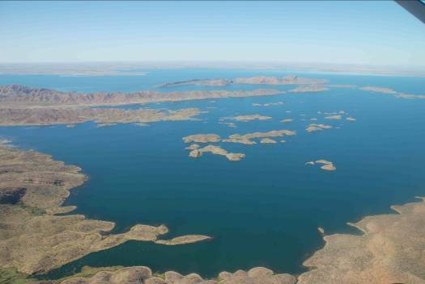
Figure 6: Wetland type 6 - Lake Argyle (photo B. Hale).

Lake Kununurra, while certainly a water storage and clearly within the same human-made Ramsar wetland category as Lake Argyle; is contained mostly within the channel of the Ord River (Figure 7). The wetland is permanently inundated, but does flow; carrying water from Lake Argyle to the Kununurra Diversion Dam. The water body is approximately 50 kilometres in length with the upstream half riverine in nature. As such, this section of the Ramsar site could be considered Type M “Permanent rivers/streams/creeks”.

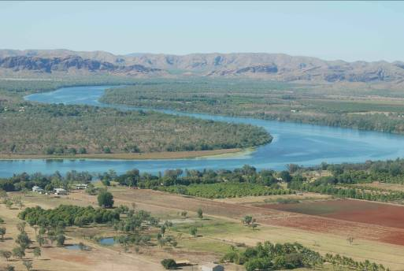
Figure 7: Wetland Type M – Lake Kununurra (photo B. Hale).
Two areas within the Ramsar site; Packsaddle Swamp and Lily Lagoon (Figure 8) are shallow, vegetated wetland basins that are largely kept permanently inundated by the Kununurra Diversion dam. These sections of the Ramsar site could be considered to be Type O “Permanent freshwater lakes (over 8 hectares)”.

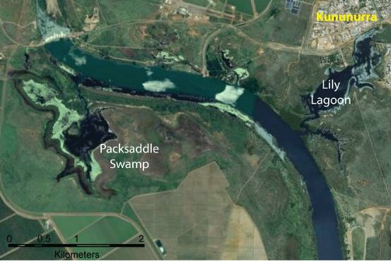
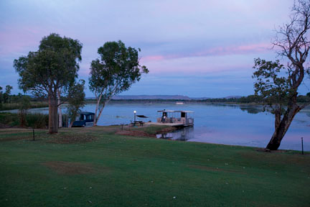
Figure 8: Wetland type “O” – Packsaddle Swamp and Lily Lagoon; location shown above; and Lily Lagoon below (Photo M. McAulay).

2.4 Ramsar criteria

2.4.1 Criteria under which the site was designated
At the time that Lakes Argyle and Kununurra were first nominated as a Wetland of International Importance, there were six criteria against which a wetland site could qualify (Table 2). At this time, the Ramsar site was considered to meet two of these criteria: 2a and 3a.

Table 2: Criteria for Identifying Wetlands of International Importance as at listing date, 1990. Criteria for which Lakes Argyle and Kununurra were listed are highlighted in green.
Basis | Number | Description
Criteria for representative or unique wetlands | 1a | it is a particularly good representative example of a natural or near-natural wetland, characteristic of the appropriate biogeographical region.
Criteria for representative or unique wetlands | 1b | it is a particularly good representative example of a natural or near-natural wetland, common to more than one biogeographical region.
Criteria for representative or unique wetlands | 1c | it is a particularly good representative example of a wetland, which plays a substantial hydrological, biological or ecological role in the natural functioning of a major river basin or coastal system, especially where it is located in a trans-border position.
Criteria for representative or unique wetlands | 1d | it is an example of a specific type of wetland, rare or unusual in the appropriate biogeographical region.
General Criteria based on plants and animals | 2a | it supports an appreciable assemblage of rare, vulnerable or endangered species or subspecies of plant or animal, or an appreciable number of individuals of any one or more of these species.
General Criteria based on plants and animals | 2b | it is of special value for maintaining the genetic and ecological diversity of a region because of the quality and peculiarities of its flora and fauna.
General Criteria based on plants and animals | 2c | it is of special value as the habitat of plants or animals at a critical stage of their biological cycle.
General Criteria based on plants and animals | 2d | it is of special value for one or more endemic plant or animal species or communities.
Specific criteria based on waterfowl | 3a | it regularly supports 20 000 waterfowl
Specific criteria based on waterfowl | 3b | it regularly supports substantial numbers of individuals from particular groups of waterfowl, indicative of wetland values, productivity or diversity.
Specific criteria based on waterfowl | 3c | where data on populations are available, it regularly supports one percent of the individuals in a population of one species or subspecies of waterfowl.

The 2003 RIS assessed the site against the eight criteria adopted at the 6th Conference of Contracting Parties in Brisbane in 1996, and acknowledged in the strategic framework in the 7th Conference (1999), four of which the Lakes Argyle and Kununurra Ramsar site was considered to meet. Justification for the criteria (as contained in the 2003 RIS) was as follows:

Criterion 2: The site supports a large population of the vulnerable freshwater crocodile (Crocodylus johnstoni), which is specially protected by the Western Australian Wildlife Conservation Act (1950) and the EPBC Act.

Criterion 3: At least 15 species of freshwater fishes (mainly catfishes, grunters and gudgeons) are know to occur at the Site, while four fishes (two catfish Arius spp., strawman Quirichthys stramineus, and giant glassfish Parambassis gulliveri) are known in Western Australia only from the site and other parts of the Ord River System. Three species of freshwater turtle are known from the Site and one of these, Emydura australis, is restricted to the Kimberley – Victoria River region.

Criterion 4: Lakes Argyle and Kununurra are important dry-season refuges for waterbirds.

Criterion 5: The Site regularly supports very large numbers of waterbirds. In August 1986, Lake Argyle supported more than 180 000 while in September 1978, 12 000 were recorded using Lake Kununurra.

2.4.2 Assessment based on current information and Ramsar criteria
There have been a number of developments in the past decade that influence the application of the Ramsar criteria to wetland sites this includes:

- Refinements and revisions of the Ramsar criteria since 1999. An additional criterion was added at the 9th Ramsar Conference in Uganda in 2005.

- Revision of population estimates for waterbirds (Wetlands International 2006; Bamford et al. 2008), which influences the application of criterion six.

- A decision with respect to the appropriate bioregionalisation for aquatic systems in Australia, which for inland systems are now based on drainage divisions and for marine systems the interim marine classification and regionalisation for Australia (IMCRA). This affects the application of criteria one and three.

- Updating of threatened species listings, which affects criterion two.

- Additional data have been collected for the site, which could potentially influence the application of all criteria.

Therefore an assessment of the Lakes Argyle and Kununurra Ramsar site against the current nine Ramsar criteria has been undertaken and included in the updated RIS completed in conjunction with this ECD (Table 3). In deciding if the site qualifies under criterion six (regularly supports one percent of the individuals in a population of one species of waterbird), an approach consistent with the Ramsar Convention has been adopted.

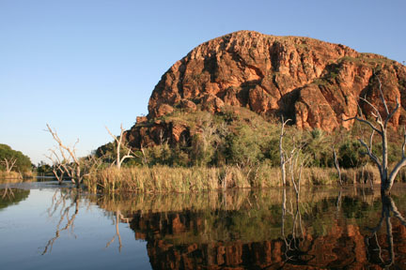
Lake Kununurra (photo Anne Brady).

Table 3: Criteria for Identifying Wetlands of International Importance (adopted by the 6th (1996) and 9th (2005) Meetings of the Conference of the Contracting Parties). Criteria for which the Lakes Argyle and Kununurra Ramsar site qualifies are highlighted in green.
Number | Basis | Description
Group A. Sites containing representative, rare or unique wetland types
Criterion 1 |  | A wetland should be considered internationally important if it contains a representative, rare, or unique example of a natural or near-natural wetland type found within the appropriate biogeographic region.
Group B. Sites of international importance for conserving biological diversity
Criterion 2 | Species and ecological communities | A wetland should be considered internationally important if it supports vulnerable, endangered, or critically endangered species or threatened ecological communities.
Criterion 3 | Species and ecological communities | A wetland should be considered internationally important if it supports populations of plant and/or animal species important for maintaining the biological diversity of a particular biogeographic region.
Criterion 4 | Species and ecological communities | A wetland should be considered internationally important if it supports plant and/or animal species at a critical stage in their life cycles, or provides refuge during adverse conditions.
Criterion 5 | Waterbirds | A wetland should be considered internationally important if it regularly supports 20 000 or more waterbirds.
Criterion 6 | Waterbirds | A wetland should be considered internationally important if it regularly supports one percent of the individuals in a population of one species or subspecies of waterbird.
Criterion 7 | Fish | A wetland should be considered internationally important if it supports a significant proportion of indigenous fish subspecies, species or families, life-history stages, species interactions and/or populations that are representative of wetland benefits and/or values and thereby contributes to global biological diversity.
Criterion 8 | Fish | A wetland should be considered internationally important if it is an important source of food for fishes, spawning ground, nursery and/or migration path on which fish stocks, either within the wetland or elsewhere, depend.
Criterion 9 | Other taxa | A wetland should be considered internationally important if it regularly supports one percent of the individuals in a population of one species or subspecies of wetland-dependent non-avian animal species.

An assessment against each of the criteria for the Lakes Argyle and Kununurra Ramsar site is as follows:

Criterion 1: This criterion applies to natural and near-natural wetland systems. As artificial (human-made) wetlands, Lakes Argyle and Kununurra cannot be considered to meet this criterion.

Criterion 2: In the Australian context, it is recommended that this criterion should only be applied with respect to nationally threatened species/communities, listed under the EPBC Act or the International Union for Conservation of Nature (IUCN) Red List. This does not apply to the freshwater crocodile (Crocodylus johnstoni), which is not listed as threatened under the EPBC Act or the IUCN Red List.

The freshwater sawfish (Pristis microdon) which is listed as vulnerable under the EPBC Act 1999 and critically endangered by the IUCN has been recorded from Lake Kununurra (Gill et al. 2006). However, due to it having a diadromous life-cycle, whereby the adults are found within the marine environment and the juveniles utilise freshwaters, barriers to connectivity with the marine environment (the Diversion Dam) prevent the system from supporting this species. Therefore this criterion was not met at the time of listing and is not met under current conditions.

Criterion 3: The application of this criterion must now be considered in the context of the newly adopted bioregionalisation for aquatic systems, which is based on drainage divisions. The site lies within the Timor Sea drainage division, which extends across northern Australia from Broome in Western Australia to north east tip of the Northern Territory. There is no comprehensive biodiversity inventory for this bioregion and this lack of data across the bioregion makes application of this criterion difficult. In the absence of any species unique to the Ramsar site, or evidence that this site is substantially more species rich or diverse than other wetlands, it is not possible to definitively state that this criterion is met.

Criterion 4: The basic description of this criterion implies a number of common functions/roles that wetlands provide including supporting fauna during migration, providing drought refuge, supporting breeding and moulting in waterfowl. The Lakes Argyle and Kununurra Ramsar site provides a number of these functions and roles as described below and clearly meets this criterion.

The critical life stage of migration
Lake Argyle supports large numbers of migratory shorebirds and it has been suggested that this site is one of the most significant inland waterbodies for shorebirds in northern Australia (Hassel et al. 2005).

The critical life stage of drought refuge
The majority of inland, freshwater wetlands in Australia are temporary systems, either filling annually during winter / spring or intermittently during years of above average rainfall. The permanent freshwaters of Lakes Argyle and Kununurra provide valuable habitat for waterfowl and other native species in the arid northern Australia, particularly when these other wetlands are dry.

The critical life stage of moulting
There is evidence that waterfowl such as hardheads, use the large expanses of open water at Lake Argyle during times of moult (Hassel et al. 2005).

Criterion 5: Comprehensive bird survey data for the Lakes Argyle and Kununurra Ramsar site are limited. A single count from the 1980s (Jaensch and Vervest 1990) and counts from 2005 (Hassell et al. 2005) and 2007 (Bennelongia 2007) are the only examples of surveys that covered large portions of the Ramsar site. All of these resulted in summer total waterbird numbers in excess of 150 000. As such this criterion was met at the time of listing and continues to be met.

Criterion 6: Assessment of the Lakes Argyle and Kununurra Ramsar site against this criterion has been made using the latest Waterbird Population Estimates (Wetlands International 2006). Counts are limited, but based on available data (Jaensch and Vervest 1990; Hassell et al. 2005; and Bennelongia 2007) the Ramsar site supports greater than one percent of the relevant populations of 11 species of birds; four internationally migrant species, two Australian resident wader species and five species of waterfowl (Table 4).

Table 4: Waterbirds species for which the Lakes Argyle and Kununurra Ramsar site supports greater than one percent of the relevant population.
Common name | Species name | Population (one percent) | Maximum Count | Reference
Little curlew | Numenius minutus | EAAF (1000) | 1687, Dec 2005 | Hassell et al. 2005
Wood sandpiper | Tringa glareola | EAAF (1000) | 2308, Dec 2005 | Hassell et al. 2005
Sharp-tailed sandpiper | Calidris acuminata | EAAF (1600) | 18 144, Dec 2005 | Hassell et al. 2005
Oriental pratincole | Glareola maldivarum | EAAF (1000) | 3000, 1988 | Jaensch and Vervest 1990
Black-winged stilt | Himantopus himantopus | Australia (3000) | 14 622, Dec 2005 | Hassell et al. 2005
Red-capped plover | Charadrius ruficapillus | Australia (950) | 3670, Dec 2005 | Hassell et al. 2005
Magpie goose | Anseranas semipalmata | Australia  (20 000) | 71 821, Nov 2007 | Bennelongia 2007
Wandering whistling duck | Dendrocygna arcuata | Australia  (10 000) | 74 610, Nov 2007 | Bennelongia 2007
Hardhead | Aythya australis | Australia  (10 000) | 51 433, 1988 | Jaensch and Vervest 1990
Eurasian coot | Fulica atra | Australia  (10 000) | 54 327, Dec 2005 | Hassell et al. 2005
Green pygmy goose | Nettapus pulchellus | Australia  (1000) | 4404, Dec 2005 | Hassell et al. 2005

Criteria 7: Guidance from the Ramsar Convention (Ramsar 2009) on the application of this criterion indicates that in order to meet this criterion, a site should have a high degree of endemism or biodisparity in fish communities. This criterion is very difficult to apply. A site can potentially qualify based on the proportion of fish species present that are endemic to the site (must be greater than ten percent) or by having a high degree of biodisparity in the fish community.

A total of 29 species have been recorded from this Ramsar site (Appendix B), and these represent the only Western Australian populations of the giant glassfish (Parambassis gulliveri), and potentially important populations of a few species of grunter. The majority of species in these sites are Australian endemics, with some endemic to the Kimberley (and therefore the drainage division and bioregion). A number of adjunct populations of specifically, grunters (Syncomistes spp.) that are endemic to the Kimberley are found within Lake Argyle. For example, it is one of only two locations that the Kimberley grunter (Syncomistes kimberleyensis) is known from (see Morgan 2008); the other being a single site on the Durack River (Allen and Allen 1998). Furthermore, the Drysdale grunter (Syncomistes rastellus) was believed to be endemic to the Drysdale River, but there is a single recent record in the Western Australian Museum from Lake Argyle. An outlying record for the long-nose grunter (Syncomistes trigonicus) also exists for Lake Argyle in the Western Australian Museum catalogue (Morgan 2008; Figure 9). Whether these records represent an expansion of the range of these species or the recent observations are due to escapees from aquaculture facilities is unknown. Nevertheless, they are endemic to the Kimberley region and should be considered in this context. Therefore this criterion was likely met at the time of listing and continues to be met.

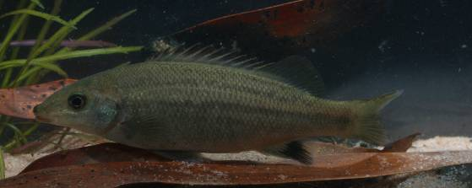

Figure 9: Long-nose grunter (Syncomistes trigonicus); one of four species of Syncomistes reported from Lake Argyle (photograph, D. Morgan)

Criterion 8: Guidance from the Convention indicates that this criterion is about providing a network of sites that maintain fish populations as they migrate during their lifecycle. Lakes Argyle and Kununurra are isolated from downstream rivers and the coast by the presence of two major dams that prevent fish passage. As such, it is unlikely that this criterion was met at the time of listing or is met now.

Criterion 9: The application of this criterion relies on estimates of the total population of non-bird species. In the case of Lakes Argyle and Kununurra this would require population estimates of fish, crustacean, crocodile and / or frog species not only within the site, but nationally and globally. While data for most non-avian species is lacking, The Ramsar Strategic Framework (Ramsar 2009) provides a global population estimate for the freshwater crocodile of 30 000 to 60 000 (one percent equivalent to 600). Crocodile monitoring within the Lakes Argyle and Kununurra Ramsar site has counted between 700 and 2300 Freshwater Crocodiles annually from 1988 to 2007 (Wildlife Management International 2007). These counts represent a fraction of the total population of this species within the Ramsar site and are consistently in excess of the one percent population threshold. This criterion was met at the time of listing and continues to be met.

3. Critical Components and Processes

3.1 Identifying critical components and processes
The basis of an ECD is the identification, description and where possible, quantification of the critical components, processes, benefits and services of the site. Wetlands are complex ecological systems and the complete list of physical, chemical and biological components and processes for even the simplest of wetlands would be extensive and difficult to conceptualise. It is not possible, or in fact desirable, to identify and characterise every organism and all the associated abiotic attributes that are affected by, or cause effect to, that organism to describe the ecological character of a system. This would result in volumes of data and theory but bring us no closer to understanding the system and how to best manage it. What is required is to identify the key components, the initial state of the systems, and the basic rules that link the key components and cause changes in state (Holland 1998). Thus, we need to identify and characterise the key or critical components, processes, benefits and services that determine the character of the site. These are the aspects of the ecology of the wetland, which, if they were to be significantly altered, would result in a significant change in the system.

DEWHA (2008) suggest the minimum components, processes, benefits and services, which should be included in an ECD are those:
- that are important determinants of the sites unique character;
- that are important for supporting the Ramsar or DIWA criteria under which the site was listed;
- for which change is reasonably likely to occur over short to medium time scales (less than 100 years); and / or
- that will cause significant negative consequences if change occurs.

In addition, the role that components and processes play in the provision of critical ecosystem services should also be considered in the selection of critical components and processes. The linkages between components, processes, benefits and services and the criteria under which the site was listed are illustrated conceptually in Figure 10. Note that cultural services such as recreation and tourism are not shown, but are underpinned by all critical components and processes and all other services.

It is difficult to separate components (physical, chemical and biological parts) and processes (reactions and changes). For example, aspects of geomorphology such as bathymetry and topography may be considered as components, while other aspects of geomorphology such as sediment transport and erosion could be considered processes. Similarly the species composition of birds at a site may be considered a component, but feeding and breeding are processes. In the context of this ECD a separation of the ecology of wetlands into nouns (components) and verbs (processes) is an artificial boundary and does not add clarity to the description. As such components and processes are considered together. The interactions between components and processes, the functions that they perform and the benefits and services that result are considered in detail in section 4.

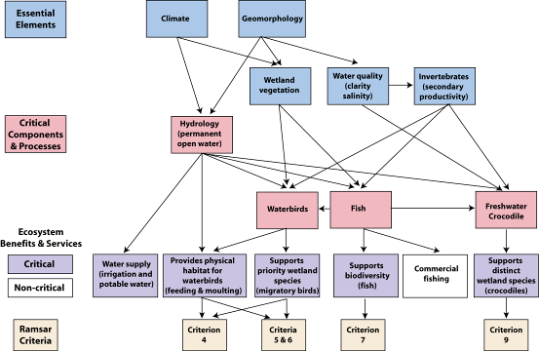

Figure 10: Simple conceptual model showing the key relationships between components and processes; benefits and services and the reasons for the site being listed as a wetland of international importance.

Each of the identified critical components and processes meet the four criteria provided by DEWHA (2008a) in that they are central to the character of the site, are directly linked to the Ramsar criteria for which the site was listed, could potentially change in the next 100 years and for which change would result in negative consequences and a change in the ecological character of the site. In addition, they are important in providing the benefits and services that the site provides. The identified critical components and processes of the Lakes Argyle and Kununurra Ramsar site are:

- hydrology;
- fish;
- waterbirds; and
- freshwater crocodiles.

In additional to the identified critical components and processes are characteristics of the site, which are not critical (that is if they were to change, they would not lead directly to a change in character) but are still important in the ecology of the system. These are termed “essential elements” and include some of the characteristics of the site, which may act as early warning indicators of a potential change in character and therefore should be considered in management planning for the site. The identified essential elements for the Lakes Argyle and Kununurra Ramsar site are:

- climate;
- geomorphology;
- water quality;
- vegetation; and
- invertebrates.

3.2 Essential elements
The components and processes of the Lakes Argyle and Kununurra Ramsar site that are considered important in supporting the critical components, processes, benefits and services of the site are described briefly below and summarised in Table 5.

Table 5: Summary of essential elements within the Lakes Argyle and Kununurra Ramsar site.
Component / process | Description
Climate | - Located in the dry tropics with a semi arid, monsoonal climate.  - Eighty percent of rainfall occurs in the wet season (December to February).  - On average evaporation exceeds rainfall in 11 months of the year.
Geomorphic setting | - Lake Kununurra was formed within the channel of the Ord River and is approximately 55 kilometres long and 100 – 400 metres wide.  - Lake Argyle was formed within a natural gorge of the Carr Boyd Range; it has over 70 islands and a large area of the shoreline is of low elevation.  - Erosion in the catchment results in 11.5 million tonnes of sediment per year depositing in Lake Argyle.
Water quality | - The water in both lakes is fresh and of low salinity year round.  - Lake Argyle is seasonally stratified with low dissolved oxygen and high nutrients in bottom waters during the wet season.  - Lake Kununurra has higher concentrations of total nitrogen than Lake Argyle, but phytoplankton biomass (as indicated by chlorophyll-a concentrations) is low.  - Water quality varies spatially in Lake Kununurra, with higher concentrations of nutrients and lower visibility in Lily Lagoon than the main channel of the waterbody.
Vegetation | - Lake Argyle has little remanent riparian vegetation and only small, localised areas of aquatic vegetation.  - Lake Kununurra is highly productive and dense riparian and aquatic vegetation occurs.  - Weeds dominate Lake Kununurra, in particular.
Invertebrates | - Eighty-five species of freshwater aquatic macroinvertebrates from 40 families have been recorded in Lake Kununurra.

3.2.1 Climate
Lakes Argyle and Kununurra are situated in the dry tropics of northern Australia. The climate is semi arid, monsoonal with a prolonged dry season. More than 80 percent of the rainfall falls in the summer, wet season (December to February). The climate is highly variable both inter-annually (between years) and intra-annually (within a year). The three aspects of climate that most directly affect wetland ecology are rainfall (both local and in the catchment), temperature and relative humidity as these all fundamentally affect wetland hydrology and the water budget.

Rainfall falls almost exclusively in the wet season (November to April) with highest monthly average rainfall in January and February (greater than 200 millimetres). However, there is considerable variability in rainfall as evidenced by the 10th and 90th percentiles, which range from less 70 millimetres per month to more than 350 millimetres per month for these months (Figure 11). The majority of the rainfall occurs during cyclonic events, resulting in large rain events over relatively short periods of time.

Annual average rainfall at Kununurra is in the order of 850 millimetres per year. However, there is high inter-annual variation with annual rainfalls ranging from less than 500 millimetres to more than 1500 millimetres in the past 40 years (Figure 12). This cycle of drought and flood is a dominant feature of the climate (McDonald and McAlpine 1991).

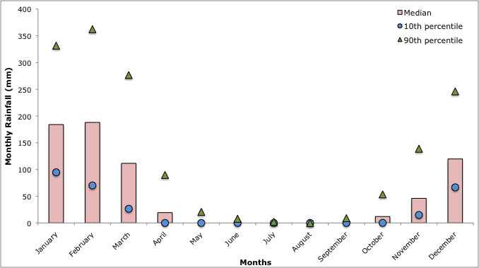

Figure 11: Median (10th and 90th percentile) monthly rainfall at Kununurra (1969 – 2008; Bureau of Meteorology).

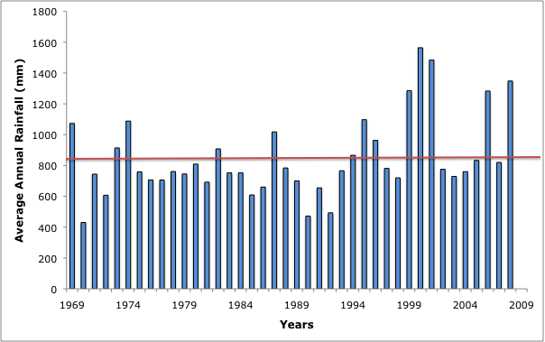

Figure 12: Average annual rainfall at Kununurra (1969 – 2008; Bureau of Meteorology). Note horizontal line shows long term average.

Temperatures range from warm to hot year round, with average wet season maximum temperatures between 35 and 39 degrees Celsius and average monthly minimum temperatures between 25 and 27 degrees Celsius. During the dry season average maximum temperatures are slightly cooler (31 to 35 degrees Celsius). June and July are the coolest months with average maximum temperatures around 31 degrees Celsius and average minimum temperatures of approximately 17 degrees Celsius (Figure 13).

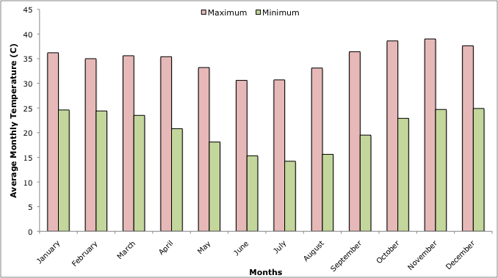

Figure 13: Average monthly maximum and minimum temperatures at Kununurra (1969 – 2008; Bureau of Meteorology).

Relative humidity ranges from 50 to 70 percent in the wet season to 30 to 40 percent in the dry months. This, combined with the high temperatures produces evaporation that, on average greatly exceeds rainfall (Figure 14). As a consequence, rainfall alone is insufficient to sustain plant growth for eight months of the year (Beard 1990).

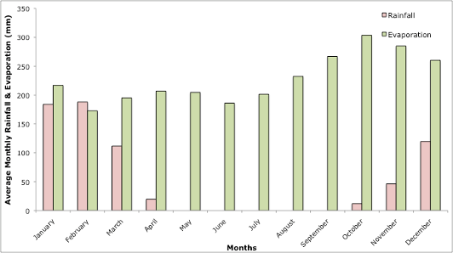

Figure 14: Average monthly rainfall and evaporation at the Kimberley Research Station (1944 – 2008; Bureau of Meteorology).

3.2.2 Geomorphic setting
Lakes Argyle and Kununurra were formed by the construction of two dams on the Ord River. The Kununurra Diversion dam located at Bandicoot Bar (a natural quartzite bar on the Ord River) is 20 metres high. The barrier forms Lake Kununurra, in the former channel of the Ord River. The lake is approximately 55 kilometres long, stretching between the Kununurra Diversion Dam and the Ord River Dam. The lake is predominantly in-channel and up to 25 metres deep in the centre; this long linear section of the lake ranges in width from approximately 400 metres near the Diversion Dam to more than 100 metres further upstream near Lake Argyle. Lake Kununurra also extends across a series of formerly temporary wetlands, such as Lily Lagoon and Packsaddle Swamp in the northern sections. These areas are shallower (0.5 to one metre in depth) due to the low topography (Jaensch and Vervest 1990).

Lake Argyle is formed behind the Ord River Dam, which at the time of listing was 86.7 metres AHD. The lake is formed within a former natural gorge in the Carr Boyd Ranges (Figure 15) and at full supply level covers an area of 980 square kilometres (King et al. 2001). Lake Argyle is more than 50 metres deep in the former river channel), with a mean depth of 10 metres. However there are extensive areas of shoreline with low gradients and it is estimated that 280 kilometres of the 360 kilometres shoreline comprises flat expanses of shallow water less than 0.5 metres deep (Hassell et al. 2005). The topography of the former gorge and ranges resulted in the formation of over 70 islands once the lake was inundated (see Figure 6 above). These range from small rocky outcrops to the largest island (Hagan Island) which is approximately seven kilometres long, three kilometres wide and the tallest peak (Mt Misery) rises to approximately 200 metres AHD.

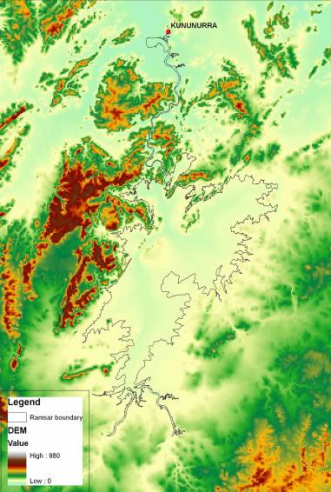

Figure 15: Digital elevation model of the area surrounding the Lakes Argyle and Kununurra Ramsar site (Geoscience Australia).

The geomorphic processes of erosion and deposition feature strongly in the operation of the Lakes Argyle and Kununurra water storage and supply system. An estimated 11.5 million tonnes of sediment per year is eroded from the catchment and transported via streamflow to Lake Argyle (Dixon and Palmer 2009). Approximately 96 percent of this sediment comes from the Cambrian sediments of the Hardman Syncline, which comprise less than 10 percent of the total catchment area (Figure 16). The soils in this formation are deep loams and clays and approximately 90 percent is mobilised through channel and gully erosion (Wasson et al. 2002). The design and operation of Lake Argyle result in 99 percent of incoming sediment loads being trapped and deposited. The sediments in Lake Argyle reflect their origins, with approximately 80 percent of the sediment comprising silt and clay and a very small fraction occurring as coarse sand (Wasson et al. 2002).

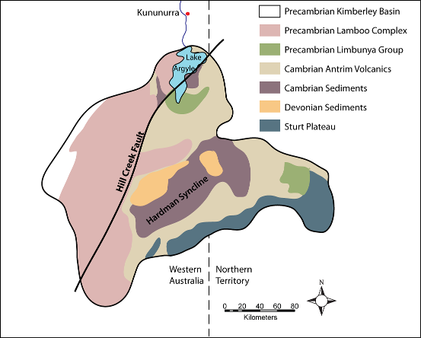

Figure 16: Geology of the catchment of the Ramsar site (adapted from Wasson et al. 2002).

3.2.3 Water quality
Water quality characteristics of Lake Argyle are not well known and information presented here is based on limited surveys. The water quality in Lake Argyle, based predominantly on sampling in May 2003, can be summarised as follows (Felsing and Glencross 2004):

- During the hotter, wet season, the lake becomes stratified, with low concentrations of dissolved oxygen in bottom waters (less than 10 percent saturation);
- The anaerobic environment in the lower waters results in the release of ammonium from the sediments as a by-product of decomposition, with average dissolved organic nitrogen concentrations in bottom waters greater than 700 micrograms per litre (Figure 17);
- Concentrations of dissolved reactive phosphorus range from 80 to 570 micrograms per litre, indicating that the system is likely to be nitrogen limited;
- Chlorophyll-a concentrations are generally less than one microgram per litre, but as high as 10 micrograms per litre on occasions;
- The water column is generally clear and secchi depths of two to five metres indicate that compensation depths are between six and 15 metres; and
- During the cooler, dry season, temperature and oxygen stratification breaks down and the lake becomes well mixed.

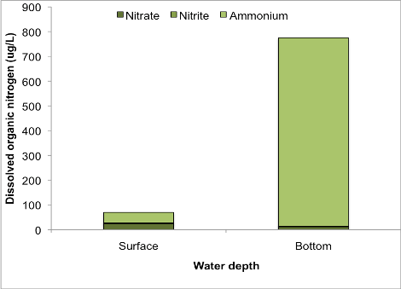

Figure 17: Average dissolved organic nitrogen in Lake Argyle May 2003 (data from Felsing an Glencross 2004).

Water quality in Lake Kununurra is less variable seasonally than Lake Argyle. However, during the wet season slight temperature and oxygen stratification can occur, with dissolved oxygen concentrations in the bottom waters as low as 60 percent saturation (Water and River Commission 2003). Temperature of surface water is high (20 to 30 degrees Celsius), both in the main body of the lake (former river channel) and in the inundated wetland areas such as Lily Lagoon, with highest water temperatures generally from November to February (DoW unpublished data). Turbidity is highly variable ranging from less than one NTU (Nephelometric Turbidity Unit) to over 1000 NTU and this is reflected in the differences between the average (44 NTU) and the median (3.2 NTU) values recorded from 1998 to 2008 (DoW unpublished data).

Nitrogen concentrations are higher in Lily Lagoon than in the main body of Lake Kununurra. In the main body of the lake, mean (± standard deviation) total nitrogen concentrations (1998 to 2008) were 175 (± 105) micrograms per litre and were highest in April and May, and lowest in September (DoW unpublished; Figure 18). The majority of nitrogen is in particulate form, however during March and April approximately 30 percent (on average) is in dissolved inorganic form and available for plant uptake (DoW unpublished). Despite this phytoplankton biomass is low, probably due to a combination of low phosphorus concentrations limiting growth and high aquatic macrophyte cover acting as competition.

Nitrogen concentrations in Lily Lagoon are approximately double those in the main body of the Lake. In addition, seasonal variation is significantly less and dissolved inorganic nitrogen is consistently less than ten percent of the total nitrogen in the water column (DoW unpublished; Figure 19). Similar to the main body of the lake, phosphorus concentrations are low as is phytoplankton biomass.

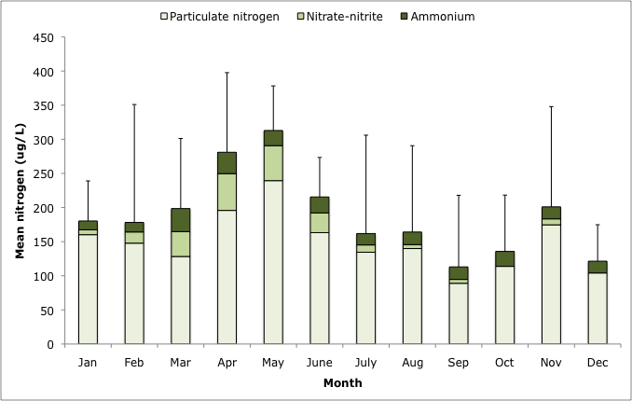

Figure 18: Mean nitrogen concentrations in the main body of Lake Kununurra (1998 to 2008; data from DoW unpublished).

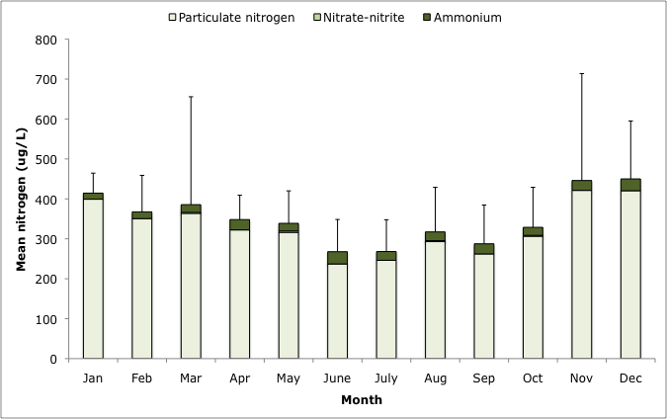

Figure 19: Mean nitrogen concentrations in Lily Lagoon, Lake Kununurra (1998 to 2008; data from DoW unpublished).

3.2.4 Wetland vegetation
The Ramsar site boundary is located at the full supply level and as such much of the fringing vegetation is outside the Ramsar site. However, there are areas of inundated aquatic and riparian vegetation contained within the site.

Much of the eastern and southern shoreline of Lake Argyle is bare sediment, with highly variable water levels preventing the establishment of plants (Hassell et al. 2005). There are areas of emergent sedges (Eleocharis brassii) as well as submerged aquatic plants such as Myriophyllum spp., Najas tenufolia and Potamogeton sp. (Kinhill 2000). However distribution is limited to localised patches where large weed mats can form. The Western and northern shorelines are generally steeper and consists of rock exposed by wave action.

Lake Kununurra, with more stable water levels, has extensive areas of riparian and aquatic vegetation. The riparian vegetation is dominated by perennial species, with few annual wetland or aquatic plants present. A typical cross section of riparian vegetation (Figure 20) shows trees such as white paperbark (Melaleuca leucadendra) and screwpine (Pandanus spiralis) closer to the water’s edge, grading to cabbage gum (Corymbia confertiflora); coolibah (Eucalyptus microtheca) and river red gum (E. camaldulensis) further back. The understorey is dominated by weeds such as stinking passionflower (Passiflora foetida), darwin pea (Clitoria ternatea) and siratro (Macroptilium atropurpureum) (see section 5. Threats).

Species diversity and richness of riparian plants is low compared to unregulated streams in the region. Total species richness in the Kununurra riparian zone was just eight in 2003, compared to 27 in the Dunham River (Water and Rivers Commission 2003). Total foliage cover of plants in the riparian zone is high (100 to 150 percent) with 50 to 60 percent cover accounted for by weed species. Productivity is higher than in other riparian areas in the region (particularly those in unregulated reaches) with an average of 9.4 tonnes of carbon per hectare per year recorded in Lake Kununurra compared to 1.2 to 3.5 tonnes of carbon per hectare per year at other stream sites (Water and Rivers Commission 2003).

In addition, stable water levels have influenced recruitment of riparian trees. The flood pulses required to stimulate flowering, seed setting and germination are no longer present and as such the riparian zone is characterised by a narrow band of single aged trees that established during the setting of the new riparian zone following the filling of the Lake (Doupe and Petit 2002). The lower reaches of Lake Kununurra are also dominated by exotic plant species such as neem (Azadirachta indica), raintree (Dalbergia sissoo) and luecana (Leucaena leucocephala).

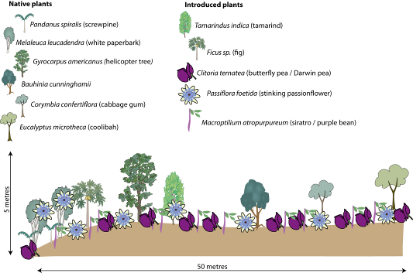

Figure 20: Zonation of species along riparian vegetation transect at Lake Kununurra, from the river channel (left) to terrestrial vegetation (right) adapted from (Water and Rivers Commission 2003).

High productivity and dense growth is also evident in the aquatic flora of Lake Kununurra, which is described as “dense and diverse” (Gill et al. 2006). There are areas of thick sedges on the margins (Eleocharis brassii, Typha spp.) and an array of submerged, floating and emergent plants in slower moving water and pools such as Lily Lagoon and Packsaddle Swamp. Species include: Myriophyllum spp., Potamogeton tricarinatus, Vallisneria nana, Vallisneria annua, Najas tenufolia, Wolffia angusta and Nymphoides indica. Typha (Typha domingensis) was the dominant emergent species in Lily Lagoon at the time of listing and covered large areas of this wetland (Figure 21; Kimberley TAFE and SWEK 2008). Similar to the riparian zone, there are a number of widespread weed species present. At the time of listing, this included the declared noxious weed salvina (Salvinia molesta) (see section 5. Threats).

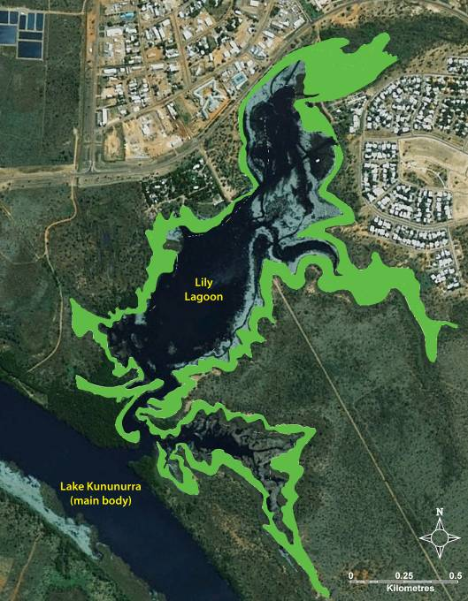

Figure 21: Extent of Typha in Lily Lagoon in 1993 (adapted from Kimberly TAFE and SWEK 2008).

3.2.5 Invertebrates
Invertebrates are important in the Lakes Argyle and Kununurra Ramsar site for their role in food webs and secondary production. However, there is little information on abundance or species distributions. The results of a single investigation in Lake Kununurra recorded 85 species of aquatic macroinvertebrates from 40 families (Table 6; Water and Rivers Commission 2003).

Table 6: Summary of aquatic invertebrates recorded in Lake Kununurra (Water and Rivers Commission 2003).
Taxonomic group | Comments
Platyhelminthes | Two species from two families
Mollusca | - Six species; five families  - Five gastropods and one bivalve
Annelida | Six species, four families
Crustacea | - Thirteen species, four families  - Includes a record of the introduced redclaw crayfish
Insecta | - Fifty-five species, 25 families  - Includes a large number of predatory species such as Odonata (dragonflies) as well as predatory Coleptera (beetles), Tricoptera (caddis flies) and Hemiptera (bugs).

3.3 Critical components and processes
The attributes and characteristics of each of the identified critical components and processes of the Lakes Argyle and Kununurra Ramsar site are described below. Where possible, quantitative information is included. However, as with many ecological character descriptions, there are significant knowledge gaps (see section 8). A summary of the critical components and processes within the Lakes Argyle and Kununurra Ramsar site is provided in Table 7.

Table 7: Summary of critical components and processes within the Lakes Argyle and Kununurra Ramsar site.
Component / process | Description
Hydrology | - The lakes are permanent and operated for the supply of irrigation water.  - Lake Argyle has a storage capacity of approximately 10 000 GL and fluctuates seasonally by as much as 10 metres in depth.  - Lake Kununurra is a re-regulating structure that is maintained at constant water levels throughout the year.
Fish | - Lakes are dominated by potamodromous species, or those that complete their life-cycles within freshwater. This includes 27 potamodromous species, and a further two that are diadromous (relicts from pre –regulation that require migratory routes to complete lifecycles).
Waterbirds | - Seventy-five species of waterbird including 22 international migratory species have been recorded in the site.  - Abundances are high, with 150 000 to 240 000 waterbirds recorded in the three comprehensive surveys to date.  - The site supports greater than one percent of the population of 11 species of waterbird.  - There are limited waterbird breeding records, but anecdotal evidence that Lake Kununurra was significant as a breeding site.
Freshwater Crocodiles | - The site supports greater than one percent of the global population of freshwater crocodiles.  - Annual surveys in Lake Kununurra and Lake Argyle indicate stable populations in both lakes.

3.3.1 Hydrology
At the time of listing, the hydrology of Lakes Argyle and Kununurra were managed primarily for the supply of irrigation water to downstream users in the Ord River Irrigation Area (ORIA). Although the system was designed to accommodate the generation of electricity, modifications were not made until post listing (see section 7 changes since listing).

Lake Argyle has a storage capacity of over 10 000 gigalitres (full supply level), which fluctuates seasonally, peaking in March / April at the end of the wet season and lowest in October / November at the end of the dry season (Figure 22). Inter-annual variability is high and in the 15 year period from 1981 to 1995, storage volume peaked in March 1982 (greater than 15 000 gigalitres) and was lowest in January 1991 (less than 2000 gigalitres).

Water depth at full supply level is approximately 50 metres above the old river channel, grading to about five metres on the steeper western shore. On the south-eastern shore the low level topography provides large areas of shallow inundation (less than 0.5 metres deep).

Fluctuations in storage volume change the surface area and water depth and average seasonal fluctuations are in the order of three metres. However, water depth can fluctuate by as much as ten metres in a few months (Felsing and Glencross 2004). This combined with the low degree of slope on much of the margins of the water body (particularly in the south-east), results in extreme fluctuations of inundation in the littoral zone.

Storage volume is strongly influenced by rainfall and catchment inflows (in response to rainfall). Average annual inflows are in the order of 4250 gigaltres per year, but range from less than 200 gigaltres per year to over 15 000 gigaltres per year (CSIRO 2009). At the time of listing, discharge over the spillway from Lake Argyle was almost continuous and there were only a small number of occasions when water levels fell below the spillway level.

At the time of listing there were only two major outflows of water from Lake Argyle; evaporation (average of 2000 gigaltres per year) and discharges for irrigation (average of 348 gigaltres per year) (CSIRO 2009).

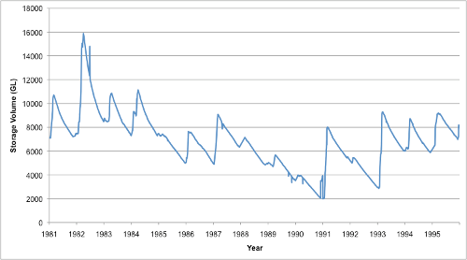
Figure 22: Storage volume in Lake Argyle January 1981 to December 1996 (Water Corporation 2009).

Lake Kununurra is managed as a re-regulating structure and operated within a very narrow range. The Lake is approximately 2500 hectares and holds 108 gigalitres of water (full supply level). It is operated between 41.1 and 41.7 metres AHD, with a target of 41.5 metres AHD (CSIRO). As a consequence, water volume, depths and extent of inundation are relatively stable year round. At full supply level it has a depth of approximately 25 metres over the old river channel and the swamps are permanent inundated at approximately one metre. Although the Water Corporation may draw down the lake during the wet season, levels remain within the operational range.

3.3.2 Fish
Although there was limited information regarding the fishes of Lakes Argyle and Kununurra at the time of listing, the fauna is likely to be relatively similar to recent data collected in 2002 by Doupe et al. (2003) and Gill et al. (2006). At total of 29 species have been recorded in the entire Ramsar site (Appendix B). Nineteen fish species in 13 families were recorded in Lake Kununurra in the 2002 surveys (Table 8; Figure 23) and a further three species have been recorded by others, including Rendahl’s catfish (Porochilus rendahli), giant glassfish (Parambassis gulliveri) and freshwater sawfish (Pristis microdon) (see Allen & Allen (1998), Gill et al. (2006).

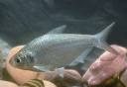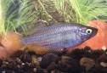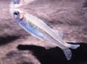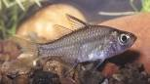
Figure 23: The four most abundant fishes in Lake Kununurra (from Doupe et al. 2003, Gill et al. 2006) (photographs, D. Morgan)

Table 8: Fish species and abundance in Lake Kununurra (Doupe et al. 2003)
Species | Number captured | Percentage
Bony bream | 1133 | 27.25
Strawman | 837 | 20.14
Western rainbowfish | 775 | 18.64
Mueller’s glassfish | 357 | 8.59
Silver cobbler | 201 | 4.84
Mouth almighty | 197 | 4.74
Barred grunter | 132 | 3.18
Jenkins’ grunter | 117 | 2.82
Flathead goby | 98 | 2.36
Lesser salmon catfish | 96 | 2.31
Seven-spot archerfish | 66 | 1.59
Black catfish | 53 | 1.28
Freshwater longtom | 43 | 1.03
Spangled perch | 29 | 0.70
Butler’s grunter | 14 | 0.34
Barramundi | 4 | 0.10
Northern trout gudgeon | 3 | 0.07
Macleay’s glassfish | 1 | 0.02
Sleepy cod | 1 | 0.02
TOTAL | 4157 | 100

There is limited information for the fishes of Lake Argyle, however, Morgan (2008) compiled species maps of fishes of the Kimberley and included Western Australian Museum records, from which 25 species from 14 families have been recorded (Table 9). Twenty-four of these species are potamadromous (that is complete their life-cycle in freshwater), and this is likely to be the highest number of freshwater species in a single waterbody in Western Australia (see Morgan et al. 2004b, Morgan 2008). Further, Lake Argyle is a major locality of a number of restricted Western Australian endemic fishes, including three species of Syncomistes. It is also one of the only systems in Western Australia that houses silver cobbler, tongued sole, giant glassfish and the strawman (Allen et al. 2002, Morgan 2008). Most notable are the large abundance of silver cobbler (Neoarius midgleyi) and the high diversity of terapontids, with seven species.

Table 9: Fishes of Lake Argyle (from Morgan 2008 which includes Western Australian Museum collections)
Family | Species name | Common name
Clupeidae | Nematalosa erebi | Bony bream
Ariidae | Neoarius graeffei | Lesser-salmon catfish
Ariidae | Neoarius midgleyi¹ | Silver cobbler
Plotosidae | Neosilurus ater | Black catfish
Plotosidae | Neosilurus pseudospinosus | False-spined catfish
Belonidae | Strongylura krefftii | Freshwater longtom
Atherinidae | Craterocephalus stramineus | Strawman
Melanotaeniidae | Melanotaenia australis | Western rainbowfish
Ambassidae | Ambassis macleayi | Macleay’s glassfish
Ambassidae | Parambassis gulliveri | Giant glassfish
Centropomidae | Lates calcarifer | Barramundi
Terapontidae | Amniataba percoides | Barred grunter
Terapontidae | Hephaestus jenkinsi | Jenkins’ grunter
Terapontidae | Leiopotherapon unicolor | Spangled perch
Terapontidae | Syncomistes butleri | Butler’s grunter
Terapontidae | Syncomistes kimberleyensis | Kimberley grunter
Terapontidae | Syncomistes rastellus | Drysdale grunter
Terapontidae | Syncomistes trigonicus | Long-nose grunter
Apogonidae | Glossamia aprion | Mouth almighty
Toxotidae | Toxotes chatareus | Seven-spot archerfish
Eleotridae | Mogurnda mogurnda | Northern trout gudgeon
Eleotridae | Oxyeleotris lineolata | Sleepy cod
Eleotridae | Oxyeleotris selheimi | Giant gudgeon
Gobiidae | Glossogobius giurus | Flathead goby
Soleidae | Leptachirus triramus² | Tailed sole
¹Paratype in Kailola & Pierce (1988).
²Described in 2007 by Randall (2007).

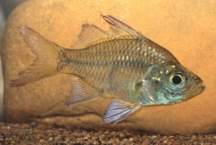
Macleay’s Glassfish (Ambassis macleayi) (photograph, D. Morgan)

Lake Argyle supports the only commercial freshwater fishery in the Kimberley, with silver cobbler as the target species. Around the time of listing approximately 120 tonnes of fish (mean 1987 to 1997) were caught annually, with the mean Catch per Unit Effort (CPUE) of 29 kilograms per 100 metres per net days (Fisheries Western Australia 1999; Figure 24).

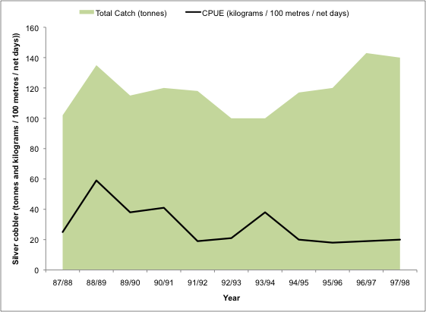

Figure 24: Annual catch of silver cobbler from Lake Argyle 1987 to 1997 (data from Fisheries Western Australia 1999).

3.4.3 Waterbirds
Information on waterbirds within the Ramsar site at the time of listing is limited to a single comprehensive count (Jaensch and Vervest 1990). However, as there is no evidence that there have been changes to waterbird populations and communities at the site since listing, the results of two more recent studies (Hassell et al. 2005; and Bennelongia 2007) have also been used as indicative of waterbird usage of the site at the time of listing.

The Lakes Argyle and Kununurra Ramsar site supports a high diversity and abundance of waterbirds. A total of 75 species of wetland bird have been recorded within the site; 69 in Lake Argyle and 47 in Lake Kununurra (Table 10, Appendix C). The list includes 22 species that are listed under international migratory agreements CAMBA (19), JAMBA (20) ROKAMBA (17) and the Bonn Convention (17) as well as an additional 28 Australian species that are listed under the EPBC Act.

Complete counts of the Ramsar site are very limited. Based on systematic aerial and ground surveys, it is evident that Lake Argyle in particular supports large numbers of waterbirds during both the wet and dry seasons. However, it operates as a significant dry season refuge with large numbers of birds recorded at the end of the dry / beginning of the wet in November / December. Total numbers of waterbirds at Lake Argyle from aerial surveys are as follows:

- December 1986 181 400
- July 2005 71 233
- November 2005 152 105
- November 2007 244 765

Table 10: Number of wetland birds recorded within the Lakes Argyle and Kununurra Ramsar site (Jaensch and Vervest 1990; Hassell et al. 2005; Bennelongia 2007). See Appendix C for full list of species.
Bird group | Typical feeding requirements | Number of species
Ducks and allies | Shallow or deeper open water foragers.  Vegetarian (for example Black Swan) or omnivorous with diet including leaves, seeds and invertebrates. | 14
Grebes | Deeper open waters feeding mainly on fish. | 3
Pelicans, Cormorants, Darters | Deeper open waters feeding mainly on fish. | 5
Heron, Ibis, Spoonbills | Shallow water or mudflats.  Feeding mainly on animals (fish and invertebrates). | 14
Hawks, Eagles | Shallow or deeper open water on fish and occasionally waterbirds and carrion. | 3
Cranes, Crakes, Rails, Water Hens, Coots | Coots in open water; others in shallow water within cover of dense emergent vegetation such as sedge. Some species vegetarian, others mainly take invertebrates, some are omnivores. | 6
Shorebirds | Shallow water, bare mud and salt marsh.  Feeding mainly on animals (invertebrates and some fish). | 24
Gulls, Terns | Terns, over open water feeding on fish and invertebrates; gulls, opportunistic feeders over a wide range of habitats. | 5
Other | Non water birds that are reliant on wetlands for breeding or feeding (Clamorous Reed Warbler). | 1
Total |  | 129

Given the size of Lake Argyle and the difficulty of assessing the entire wetland, it is likely that these counts represent only a portion of the total numbers of waterbirds present. Specifically, large numbers of shorebirds that were observed in ground surveys were not recorded from aerial surveys of the entire site (Hassell et al. 2005).

Lake Kununurra supports smaller numbers of waterbirds, with only 1088 and 1511 wetland birds recorded in 2005 and 2007 respectively. There are previous records of higher counts (12 000 in 1978 and 7000 in 1980; Hassel et al. 2005). However, the number of surveys is too small to draw any conclusions about change versus variability.

Lake Argyle is also significant for the role it plays in supporting individual waterbird species. Maximum counts for 11 bird species exceed the one percent population thresholds (Wetland International 2006; Table 4). The limited count data makes application of the concept of “regularly” supports difficult, especially for species such as migratory shorebirds that are difficult to distinguish from aerial surveys. Available data from the three aerial counts (Jaensch and Vervest 1990; Hassell et al. 2005 and Bennelongia 2007) provide some evidence to support the claim that the Ramsar site “regularly” supports greater than one percent of the population of six Australian resident species listed in Table 4 above (magpie goose, green pygmy goose, hardhead, wandering whistling duck, Eurasian coot and black-winged stilt). These species have been recorded at greater than one percent population thresholds in at least two of the three surveys, and in the case of the hardhead and wandering whistling duck, on all three occasions (Figure 25).

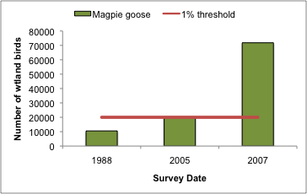 | 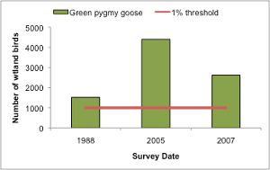
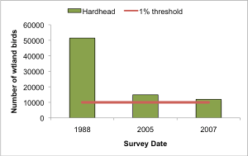 | 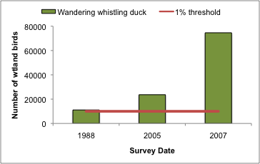
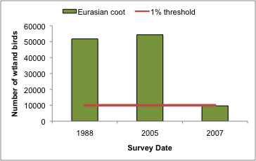 | 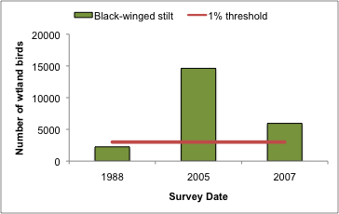

Figure 25: Waterbird abundance for six species that exceed the one percent population threshold at Lake Argyle (data from Jaensch and Vervest 1990; Hassell et al. 2005; and Bennelongia 2007).

There are few records of waterbird breeding at Lakes Argyle and Kununurra. In the case of Lake Argyle, this may reflect the available habitats (open water and bare substrates). However, Lake Kununurra has a wide range of habitats and inundated riparian vegetation and the lack of waterbird breeding observations may reflect sampling effort and timing of surveys, rather than the situation on site. Anecdotal evidence suggests that the site supports breeding of species that rely on vegetated habitats such as comb-crested jacana and water hens.

3.5.4 Freshwater Crocodiles
Lakes Argyle and Kununurra support large numbers of freshwater crocodile (Crocodylus johnstoni). Population estimates, based on comprehensive boat spot-light surveys in 1989 are 25 000 for Lake Argyle and 7500 for Lake Kununurra (CALM 2003). Comprehensive spotlighting census of populations in the Ramsar site have been repeated in 2009 but results were not available at the time of publication.

Annual helicopter surveys provide an indication of the variability in numbers (Figure 26). The surveys cover a portion of the site and include adult (non-hatchling) animals only. Average numbers (mean ± standard deviation) recorded over the period 1989 to 2007 are 208 ± 67 for Lake Kununurra and 1108 ± 375 for Lake Argyle (data from CALM 2003 and Wildlife Management International 2007). Despite the degree of variability in counts between years, this is influenced not only by the variability in populations of crocodiles within the site, but also environmental (for example temperature, water levels, wind) and other factors (for example wariness), which influence sightability during surveys (Wildlife Management International 2007). Therefore, it is likely that populations are more stable than reflected in Figure 26.

Freshwater crocodiles are one of the few non-avian species for which population estimates exist. According to the Ramsar Strategic Framework (Ramsar 2008) the global population estimates for freshwater crocodiles are 30 000 to 60 000. On this basis, the site clearly supports a substantial percentage of the population; 1.2 to 3.9 percent based on surveys of a portion of the site, and up to 50 percent if the total population survey of 1989 is considered.

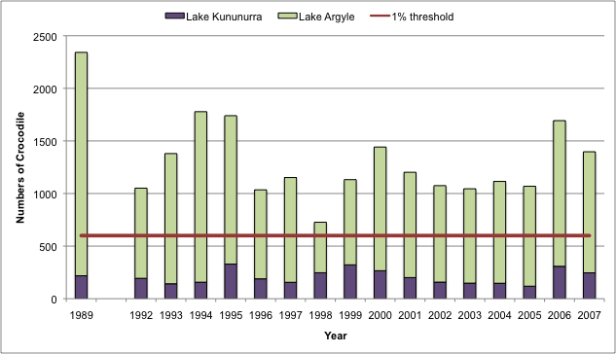

Figure 26: Numbers of freshwater crocodiles recorded in annual helicopter surveys of Lake Kununurra and Lake Argyle (data from CALM 2003 and Wildlife Management International 2007).

3.6.5 Other fauna
There is some evidence that the Lakes Argyle and Kununurra Ramsar site supports other wetland fauna such as frogs, turtles and reptiles. For example, Naturemap (DEC 2009) records indicate that the site supports at least three species of frog:

- flat-headed frog (Limnodynastes depressus);
- long-footed frog (Cyclorana longipes); and
- northern toadlet (Uperoleia borealis).

In addition, the 2003 RIS (CALM 2003) indicates that the native water rat (Hydromys chrysogaster) also occurs at the site. However, there is insufficient information to determine populations, frequency of occurrence and the extent to which other species are reliant on the Ramsar site. This remains a knowledge gap.

4 Ecosystem services

4.1 Overview of benefits and services
Ecosystem benefits and services are defined under the Millennium Ecosystem Assessment definition of ecosystem services as "the benefits that people receive from ecosystems (Ramsar Convention 2005, Resolution IX.1 Annex A). This includes benefits that directly affect people such as the provision of food or water resources as well as indirect ecological benefits. The Millennium Ecosystem Assessment (Millennium Ecosystem Assessment 2005) defines four main categories of ecosystem services:

- Provisioning services - the products obtained from the ecosystem such as food, fuel and fresh water;
- Regulating services – the benefits obtained from the regulation of ecosystem processes such as climate regulation, water regulation and natural hazard regulation;
- Cultural services – the benefits people obtain through spiritual enrichment, recreation, education and aesthetics; and
- Supporting services – the services necessary for the production of all other ecosystem services such as water cycling, nutrient cycling and habitat for biota. These services will generally have an indirect benefit to humans or a direct benefit over a long period of time.

The ecosystem benefits and services of the Lakes Argyle and Kununurra Ramsar site are outlined in Table 11.

Table 11: Ecosystem services and benefits provided by the Lakes Argyle and Kununurra Ramsar site (those considered critical are shown shaded (see section 4.2).
Category | Description
Provisioning services
Water supply | The system was created to supply water for irrigation in the ORIA.  Since the time of listing this has been expanded to include energy production (hydroelectricity) and an environmental water provision for the Lower Ord River Floodplain.
Commercial fishing | Lake Argyle contains the only freshwater commercial fishery in Western Australia (silver cobbler; Neoarius midgleyi).
Cultural services
Recreation and tourism | A viable tourism industry operates on both Lakes argyle and Kununurra, with boat operators, helicopter and plane flights, fishing, canoeing and bird watching. High recreational boating use including skiing and swimming.
Spiritual and inspirational | The region is spiritually and culturally significant for the Miriuwung, Gajerrong Peoples who have joint management of part of the site (Packsaddle Swamp). Use Lake Kununurra for fishing especially communities of Munthama, Geboowama and Mud Springs.  Culturally significant for residents of Kununurra for recreation and relaxation.
Supporting services
Physical habitat | Lakes Argyle and Kununurra provide habitat for feeding and moulting of waterbirds.
Biodiversity | 29 species of fish have been recorded from the lakes, the highest number of species in an inland wetland in Wester Australia.
Priority wetland species | Lake Argyle supports 22 species of migratory shorebird listed under international agreements.
Distinct wetland species | The Lakes Argyle and Kununurra Ramsar site supports over one percent of the global population of Freshwater Crocodile.

4.2 Identifying critical ecosystem services and benefits
The critical ecologically based ecosystem services and benefits of a Ramsar site have been identified using the same criteria provided by DEWHA (2008a) used as a guide for selecting critical components and processes; i.e. services that at a minimum:

- are important determinants of the site’s unique character;
- are important for supporting the Ramsar or DIWA criteria under which the site was listed;
- for which change is reasonably likely to occur over short or medium time scales (less than 100 years); and / or
- that will cause significant negative consequences if change occurs.

Using these criteria it was considered that all of the supporting services (that is, those that are ecologically based) could be considered “critical”. In addition, the provisioning service of water supply could also be considered critical to the ecological character of the site as it is the primary reason that permanent water is present in this arid landscape. While the site is undoubtedly beneficial in terms of cultural services and commercial fishing; these were not considered “critical” services in that a reduction in any of these services would not necessarily indicate a change in ecological character.

Therefore the critical ecosystem benefits and services of the Lakes Argyle and Kununurra Ramsar site are:

- water supply;
- physical habitat;
- biodiversity;
- priority wetland species; and
- distinct wetland species.

4.3 Critical services

4.3.1 Provides physical habitat for large numbers of waterbirds
Lake Argyle, and to a lesser extent Lake Kununurra, provide a range of habitats that support large numbers of waterbirds in terms of moulting, feeding and breeding.

Moulting
Waterfowl (with the exception of the magpie goose) undergo an annual moult of their primary flight feathers. Much of the information on moulting in waterfowl comes from the northern hemisphere where predictable patterns of moulting following breeding are related to predictable seasons and climatic patterns. The more variable climate in Australia may result in more variable patterns of moulting (Kingsford and Norman 2002).

During primary moult individuals are flightless for a period of two to five weeks, which makes them more vulnerable to predators. In addition, protein comprises greater than 80 percent of flight feathers and during moult birds have a high requirement for protein in their diets (Ringelman 1990). This includes green fodder for herbivores and invertebrates for carnivorous waterfowl.

The permanent open water of Lake Argyle provides ideal habitat for moulting waterfowl, where they can congregate at distance from the shore and be safe from predators during their flightless period.

Feeding
The Lakes Argyle and Kununurra Ramsar site supports large numbers of waterbirds. These are considered in terms of broad feeding / habitat guilds.

Piscivores
There are a number of waterbirds within the Ramsar site whose diet is wholly or mostly comprised of fish. This includes the gulls and terns, cormorants and the Australian pelican.

The general habitat requirements for a number of piscivorous waterbirds that occur within the Lake Argyle and Kununurra Ramsar site are provide in Table 12.

Table 12: General habitat requirements of a number of piscivorous waterbirds in the Lakes Argyle and Kununurra Ramsar site (Marchant and Higgins 1990 unless otherwise specified).
Species | Habitat characteristics
Australian pelican | - Colonial feeder, often working in groups to drive prey (small schools of fish) to shallow water. Feeds in shallow water by scooping water and fish into the pouch and discarding the water.
Pied cormorant | - Roost in trees near water or on cliffs, offshore rocks.  - Diet consists mainly of small to medium size fish.  - Feed by pursuit diving.
Crested tern | - Roost on bare flat sand areas (for example the shoreline of Lake Argyle)  - Diet mainly small to medium fish.  - Feed from the surface to less than one metre deep mainly in shallow areas.
Osprey | - Feeds mainly on medium-sized live fish, which it does not swallow whole, but rips apart to eat. Feeds from the surface or near surface.

Waterfowl and associated waterbirds
This group includes not just ducks, swans and geese but also grebes, coots and waterhens. The Ramsar site supports large numbers of waterfowl as a group and significant numbers (greater than one percent of the population) of wandering whistling duck, hardhead, green pygmy goose, magpie goose and Eurasian coot. There is a range of feeding strategies and foraging and roosting habitats for this group of waterbirds, some of which are described in Table 13.

Table 13: General habitat requirements of selected species of waterfowl within the Ramsar site (information from Marchant et al. 1994)
Species | Habitat characteristics
Eurasian coot | - Food is mainly obtained during underwater dives, lasting up to 15 seconds and ranging down to seven metres in depth. Birds also graze on the land and on the surface of the water. In Australia, Eurasian coots feed almost entirely on vegetable matter, supplemented with only a few insects, worms and fish. However, birds of the northern hemisphere tend to take much more animal prey and this may also hold true for the populations at Lake Argyle in northern Australia.
Green pygmy goose | - Resident species, but may move disperse in the wet season. Prefers deep, still or slow moving water. Feeds predominantly on aquatic vegetation.
Hardhead | - Prefer larger lakes, swamps and rivers with deep, still water. As a general rule, they avoid coastal waters and they rarely come to land. They feed by diving deeply, often staying submerged for as long as a minute at a time. They slip under the water with barely a ripple, simply lowering their heads and thrusting with their powerful webbed feet. They eat a broad range of small aquatic creatures, and supplement this with aquatic plants.
Magpie goose | - The magpie goose is a specialized feeder with wild rice (Oryza) and spike-rush (Eleocharis), forming the bulk of its diet. Within the Ramsar site, feeding grounds are predominantly around Lake Kununurra, with Lake Argyle providing roosting sites.
Wandering whistling duck | - Prefers deeper waters where aquatic plants and insects are plentiful. feeds almost entirely on aquatic vegetation and seeds, but also on young grass, the bulbs of rushes and other herbage, insects and other small aquatic animals.

Waders
This group includes species in the two families, Ardeidae and Threskiornithidae, (herons, egrets, spoonbills and ibis) as well as the shorebirds (see section 4.3.3 below). Wading species of bird feed in shallow water (usually less than 15 centimetres) and within the Ramsar site favour the shallow, unvegetated shoreline of Lake Argyle. They are diurnal; spending the day feeding on a wide range of invertebrates and small vertebrates: ibises and herons by probing in soft earth or mud, spoonbills by swinging the bill from side to side in shallow water.

4.3.2 Priority wetland species – supports migratory birds
Lake Argyle is an important site for migratory shorebirds in the East Asian-Australasian Flyway. The majority of birds in the East Asian-Australasian Flyway migrate from breeding grounds in North-east Asia and Alaska to non-breeding grounds in Australia and New Zealand, covering the journey of 10 000 kilometres twice in a single year (Figure 27).

The lifecycle of most international migratory shorebirds involves (Bamford et al. 2008):

- breeding in May to August (northern hemisphere);
- southward migration to the southern hemisphere (August to November);
- feeding and foraging in the southern hemisphere (August to April); and
- northward migration to breeding grounds (March to May).

During both northward and southward migration, birds may stop at areas on route to rest and feed. These stopovers are referred to as “staging” areas and are important for the bird’s survival. In addition, birds on their first southward migration have not yet reached breeding maturity and may remain in Australia over the southern winter period.

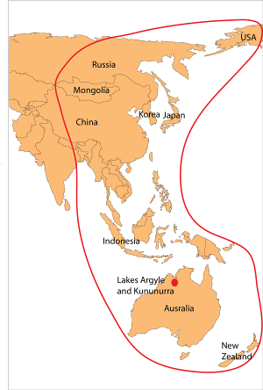

Figure 27: East Asian-Australasian Flyway (adapted from Bamford et al. 2008).

Utilisation of foraging and feeding habitats by shorebirds is a complex interaction between factors such as trophic structure, food partition (Davis and Smith 2001), prey availability (Hubbard and Dugan 2003) and selectivity (Kalejta 1993; Backwell et al. 1998), predation risk (Cresswell 1994; Ydenberg et al. 2002), and abiotic factors such as water level (Recher 1966; Boettcher et al. 1995; Colwell and Dodd 1995; Cole et al. 2002), tidal cycle (Recher 1966; Burger et al. 1997) and substrate particle size (Danufsky and Colwell 2003).

There is a wide body of literature describing the habitat requirements (with respect to feeding) of shorebirds based both on observational and experimental studies. In general terms, the habitat requirements of species for which the Lakes Argyle and Kununurra Ramsar site supports greater than one percent of the population are described in Table 14. It should be noted that these are not the only species of shorebird that feed in the Ramsar site and that numbers of other species also utilise these habitats. However, the six identified key species cover a range of morphologies (size and bill shape) and lifecycles (residents and international migrants).

Table 14: Habitat requirements of shorebirds for which the Lakes Argyle and Kununurra Ramsar site supports greater than one percent of the population (information from BirdLife International, 2009 unless otherwise specified).
Species | Lifecycle | Non-breeding habitat characteristics
Curlew sandpiper | East Asian-Australasian Flyway. Breeds in Siberia. Adults spend non-breeding season (September to March) in Australia. However, juveniles may remain in Australia for up to three years before returning to the northern hemisphere to breed. | Forages in dryland environments such as plains and saltmarsh. May use the Ramsar site as a staging area or roosting site, feeding on nearby plains. Diet consists predominantly of adult and larval insects (for example grasshoppers, crickets, weevils, beetles, caterpillars, ants and termites) and spiders as well as vegetable matter including seeds.
Oriental pratincole | East Asian-Australasian Flyway. Breeds in northern China. Adults spend non-breeding season (September to March) in Australia. However, juveniles may remain in Australia for up to three years before returning to the northern hemisphere to breed. | Open country often near water, grassy flats and mudflats but primarily an aerial feeder. Feeding in dryland areas and roosting in the Ramsar site during the heat of the day.
Sharp-tailed sandpiper | East Asian-Australasian Flyway. Breeds in Siberia. Adults spend non-breeding season (September to March) in Australia. However, juveniles may remain in Australia for up to three years before returning to the northern hemisphere to breed. | Forage on wet mud, preferring areas with short, surrounding vegetation to bare substrate (Collins and Jessop 1998). Diet is predominantly polychaetes, crustaceans and molluscs.
Wood sandpiper | East Asian-Australasian Flyway. Breeds in Siberia. Adults spend non-breeding season (September to March) in Australia. However, juveniles may remain in Australia for up to three years before returning to the northern hemisphere to breed. | More commonly found in open areas such as the margins of inland freshwater lakes and reservoirs, muddy marshlands, grassy stream banks, sewage farms, flooded grassland and irrigation channels. Diet consists of aquatic and terrestrial insects and their larvae, worms, spiders, crustaceans, gastropod molluscs, small fish (up to two centimetres long) and frogs, as well as plant matter such as seeds.
Red-capped plover | Australian resident, breeding across Australia. | Fund mainly on coastal and salt lakes, but within the Ramsar site is abundant in Lake Argyle. Feeds on molluscs and benthic invertebrates in sallow water / wet sediment. Visual feeder.
Black-winged stilt | Australian resident, breeding in the interior and west of Australia. Opportunistic breeders and dispersive in response to rainfall and changing water levels. | Widespread throughout Australia. Feed mainly on aquatic insects, but will also take molluscs and crustaceans. Feed mainly in shallow water, and seize prey on or near the surface. Occasionally, birds plunge their heads below the surface to catch sub-aquatic prey.

Shorebirds within the Ramsar site are reliant on abundant food sources to build up reserves prior to the journey back to breeding grounds.

4.3.3 Biodiversity – supports fish
The fishes of Lakes Kununurra and Argyle are diverse by Western Australian standards, with a total of 29 fish species recorded, including 22 species (13 families) from Lake Kununurra and 25 species (14 families) from Lake Argyle (Gill et al. 2006, Morgan 2008; see Appendix B). There is almost certainly to be additional taxa in Lake Argyle, which has been subjected to limited surveys. This diversity is realised when considering that there is only 13 species recorded from all Pilbara rivers (Morgan & Gill 2004), and 23 freshwater fish species from the nearby Fitzroy River (Morgan et al. 2004b). Further, there is some confusion surrounding three Kimberley outlying populations of endemic terapontids in Lake Argyle (see Morgan 2008), and taxonomic issues (or translocations) may aid in identifying the true species composition of the lake.

Based on the findings by Morgan et al. (2004a), the fishes of Lake Kununurra belong to the following dietary guilds: carnivores, detritivores, herbivores and omnivores. Those within the carnivorous group include barramundi, freshwater sawfish, freshwater longtom, western rainbowfish, barred grunter, mouth almighty, flathead goby and sleepy cod. Within the carnivores, there are few species, which have diets dominated by other fish (that is piscivores), and includes barramundi (greater than 70 percent teleost prey as large animals) and freshwater longtom (greater than 70 percent teleost prey). These carnivores, with very different mouth morphology and habitat associations prey on different taxa of fish. The only recognised detritivore in the system is the bony bream, with detritus comprising over 50 percent of the diet of this species. Bony bream also feeds on plant material and the occasional aquatic invertebrate. Herbivorous fishes are limited to Butler’s grunter. The other species of Syncomistes, which are known only from Lake Argyle, are also considered to have diets comprised of plant material (Allen et al. 2002). Many of the species are omnivorous, including lesser-salmon catfish, silver cobbler, strawman, Jenkins’ grunter, spangled perch and seven-spot archerfish (Morgan et al. 2004a).

The high abundance of strawman, western rainbowfish, Meuller's glassfish and mouth almighty in Lake Kununurra is intrinsically linked to the relative high abundance of aquatic vegetation in the waterbody which these species utilise as spawning sites, for feeding and for predator avoidance (Doupe et al. 2003, Morgan et al. 2004a, Gill et al. 2006). It also provides omnivorous and herbivorous species with an abundance of food. Seven-spot archerfish, Jenkin’s grunter and Butler’s grunter are associated with the steep banks, which due to river regulation are common habitats with Lake Kununurra. The absence of large sandy banks and shallow creeks within Lake Kununurra are believed to have limited the abundance of spangled perch and flathead goby. The abundance of deep water and steep drop-offs may be a factor in the success of species such as bony bream, silver cobbler and lesser-salmon catfish. Approximately 42 percent of the diet of silver cobbler within Lake Kununurra was teleosts, with bony bream and lesser-salmon catfish contributing to approximately 44 and 22 percent of the teleost proportion of the diet. The success of silver cobbler may be fundamentally linked to the high abundances of bony bream and lesser-salmon catfish in the lakes (Morgan et al. 2004a).

There is limited information of the breeding ecology of fishes in this system, however, many species are likely to breed during the wet season or may breed throughout the year (for example bony bream, western rainbowfish). These perennial breeders are the most common in Lake Kununurra and are likely to be important in the structure and function of food webs in the system (Morgan, D. unpublished data).

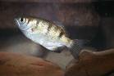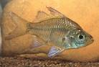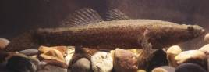
Seven-spot archerfish, Macleay’s glassfish and sleepy cod (photographs, D. Morgan).

4.3.4 Distinct wetland species - Crocodiles
The Freshwater crocodile is endemic to Australia occurring only in the tropics (Webb and Manolis 1989). The freshwater crocodile prefers upstream freshwater areas and is found in rivers, billabongs and lakes. Although young males may be nomadic (Tucker 1997; Kay 2004) adults rarely move outside their home river system (Tucker 1997). The freshwater crocodile occurs in large numbers in both Lake Argyle and Kununurra and breeds in both areas of the Ramsar site. Some of the characteristics of the ecology of this species are provided in Table 15.

Table 15: Characteristics of freshwater crocodiles (Webb and Manolis 1989; Webb et al. 1983).
Characteristic | Freshwater Crocodile
Adult size | Two to three metres.
Diet | Fish, crustaceans and small invertebrates.
Physical habitat | Mainly rivers and freshwater billabongs. In unregulated systems during the dry season they remain in isolated pools and do not feed again until the wet season. However, in Lakes Argyle and Kununurra where water is permanent, they are known to feed year round.
Breeding | Females nest in holes in sandy embankments (usually July – August). There is no parental guarding of nest, but adults will return on hatching to aid young.

The permanent water regime, large numbers of islands and the high abundance of fish within the Ramsar site all contribute to the abundance of crocodiles within the Ramsar site. The abundance of fish, in particular may be a strong influencing factor, with observations from comparable systems in northern Australia linking abundance of prey (fish) to freshwater crocodile numbers (Morgan et al. 2008).

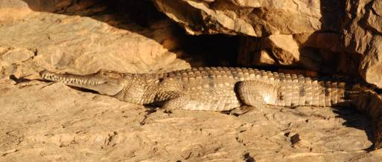
Freshwater Crocodile, Lake Argyle (photograph, B. Hale).

4.3.5 Water supply
The purpose and function of the Ramsar site, at the time of listing, was primarily as a water supply for downstream irrigators in the Ord River Irrigation Area (ORIA). The ORIA prior to 1990 consisted of approximately 4400 hectares of irrigated land around Kununurra (Rangelands NRM Coordinating Group 2005). Water enters the irrigation area from Lake Kununurra via a gravity fed main channel (M1), from which a series of smaller channels carry the water to the farms (S channels). The waters are then collected in a series of drains (D channels) and returned to the Ord River, downstream of the Ramsar site. Due to the high variability in rainfall, irrigation demand may occur in the wet or the dry season, but approximately two thirds of demand is between May and September (Department of Water 2006).

In addition to irrigation supply, water from the Ramsar site was and continues to be extracted to supply communities along the river. Since listing there have been increased demands on water supply from the system including for hydro-electricity and an Environmental Water Provision (EWP) for the Lower Ord River. However, these were not in place at the time of listing and are considered further in the section on changes since listing (section 7).

4.4 Non-critical services

4.4.1 Commercial fishing
As mentioned in section 3.3.2 above, Lake Argyle is the site of the only inland commercial fishery in Western Australia. Annual catches of the target species (silver cobbler) from the Ramsar site were approximately 120 tonnes per annum at the time of listing (Figure 24). Fish are caught by gillnet, with a 1500 metre limit on total net length. At the time of listing there were five licenses, with boat crews averaging two per boat. Possessing facilities near Kununurra provide additional regional employment and the estimated value of the catch is over $300 000 per annum (Fisheries Western Australia 2002).

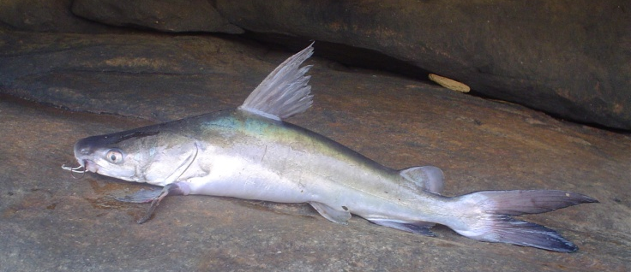
Silver cobbler (Neoarius midgleyi) (Photograph: D. Morgan).

4.4.2 Recreation and tourism
Lakes Argyle and Kununurra are major tourism and recreational sites in northern Australia and it is estimated that recreation and tourism is worth approximately $40 million annually (Trayler and King 2001). A range of boating tour, fishing charters and aerial scenic flights operate in both Lake Argyle and Lake Kununurra. The majority of water based activities are recreational boating such as canoeing, skiing and swimming. Recreational fishing within the Ramsar site boundary also occurs by local residents (including the indigenous community) and tourists. Target species are barramundi, silver cobbler and bony bream (West et al. 1996).

4.4.3 Indigenous cultural values
The area within and surrounding the Lakes Argyle and Kununurra Ramsar site is culturally significant to local indigenous people. The Ord River (including that within and under the Ramsar site, is of great cultural significance to local indigenous people (Text Box 2). There are a number of Aboriginal sites within the Ramsar site that are now submerged including the Miriwun Rock Shelter, dating back 18 000 years, which is evidence of the long association with the land (Hill and Miriuwung Gajerrong Peoples 2008).

Our ancestors created Miriuwung and Gajerrong country in the Ngarranggarni, the Dreaming. At the dawn of time our land was covered by the waters of an enormous flood. The waters eventually receded, placing some of the Dreamings, the ancestral beings, on the landscape. Other Dreamings roamed the land, creating creeks, billabongs, hills and escarpments on tracks through our country. They created the different soils, plants and animals, and all the seasons of our country, ying-geng (the wet season), gerloong (big storm), barndinyirriny (dry season) and wan-gang (cold weather). During these sagas of journey and creation, our ancestral beings, who were simultaneously human and animal, also established the all-encompassing moral and practical rules by which succeeding generations of Aboriginal people have lived for thousands of years—our Law, languages and ceremonies.

Our Dreamings became different features of our landscape, and are still present in our country today. Every part of our country has a song. Our Dreamings make connections between our people, plants, animals and parts of our country like water holes, creeks, hills, mountains and tracks through our country. Yarndungarll (dingo) lemoogeng (blue-tongue lizard), diwanang and jalareng (wedge-tailed eagle and egret), bilbiljing (grass-hopper) goorrgoorrjing (tawny frog-mouth owl), and gerdan (frill-necked lizard) are some of the Dreaming stories and places on our country

Text Box 2: Miriuwung and Gajerrong culture (Hill, R. and Miriuwung-Gajerrong Peoples. 2008).

The Ramsar site was part of a Native Title Claim by the Miriuwung and Gajerrong people, which commenced in the 1990s and was ratified in 2003. The Ord Final Agreement (2007) provides for co-management by the Miriuwung Gajerrong and DEC over eight reserves in the Kimberley region including the Packsaddle Swamp (Darram), which comprises part of the Ramsar site. The vision of the Miriuwung Gajerrong with respect to Packsaddle Swamp is (Hill and Miriuwung Gajerrong Peoples 2008; pg 41):

“…protecting the swamp, keeping it as close to nature as possible, and leaving it as a sanctuary for the birds to nest.”

4.5 Conceptual models
Simple conceptual models of Lakes Argyle (Figure 28) and Kununurra (Figure 29) provide an overview of how components and processes interact to provide the critical supporting services of the site. These two diagrams also highlight the stark differences in the two parts of the Ramsar site, driven predominantly by the hydrology of each system. Lake Argyle with its large capacity, deep water and rapidly fluctuating water levels, provides a different range of habitats than the hydrologically stable Lake Kununurra. Major habitats in Lake Argyle include:

- unvegetated, shallow shorelines, where large numbers of migratory shorebirds feed and roost;
- sandy islands and shorelines where crocodiles nest and rest;
- deep water for large bodied fish; and
- open water for feeding piscivorous birds and moulting waterfowl.

In contrast, Lake Kununurra is characterised diverse and dense riparian, littoral and submerged vegetation and high productivity.

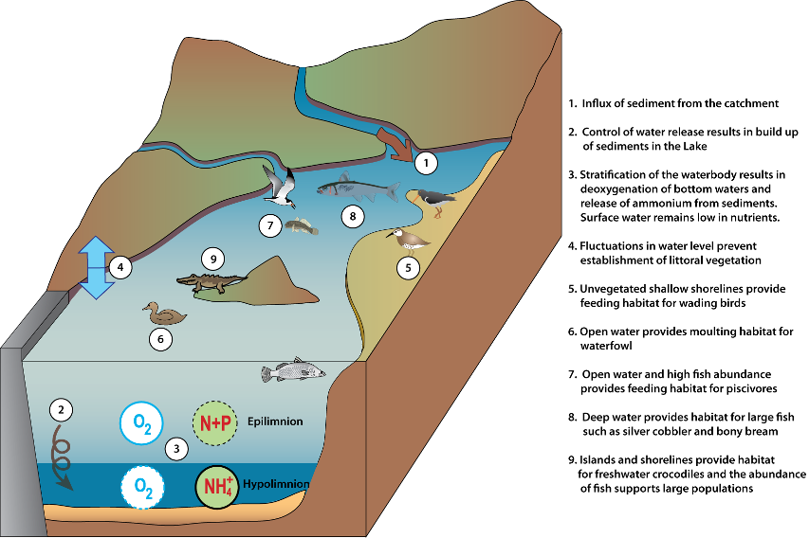

Figure 28: Simple conceptual model of Lake Argyle showing the major interactions between components, processes and services.

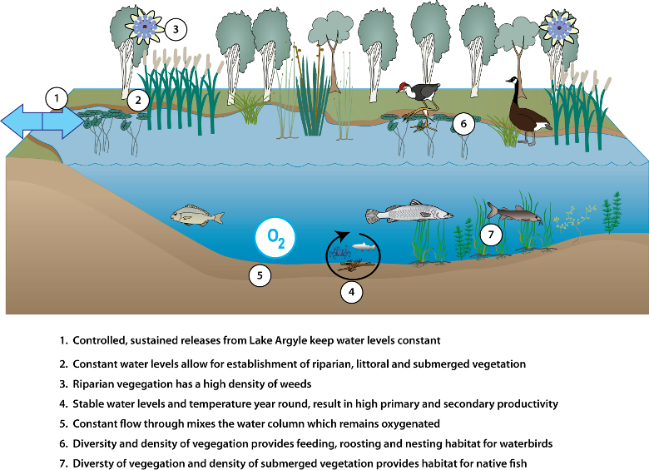

Figure 29: Simple conceptual model of Lake Kununurra showing the major interactions between components, processes and services

5. Threats to Ecological Character
Wetlands are complex systems and an understanding of components and processes and the interactions or linkages between them is necessary to describe ecological character. Similarly threats to ecological character need to be described not just in terms of their potential effects, but the interactions between them. One mechanism for exploring these relationships is the use of stressor models (Gross 2003). The use of stressor models in ecological character descriptions has been suggested by a number of authors to describe ecological character (Phillips and Muller, 2006; Hale and Butcher 2008) and to aid in the determination of limits of acceptable change (Davis and Brock 2008).

Stressors are defined as (Barrett et al. 1976):

“physical, chemical, or biological perturbations to a system that are either (a) foreign to that system or (b) natural to the system but applied at an excessive [or deficient] level”

In evaluating threats it is useful (in terms of management) to separate the driver or threatening activity from the stressor. In this manner, the causes of impacts to natural assets are made clear, which provides clarity for the management of natural resources by focussing management actions on tangible threatening activities. For example, increased turbidity may be identified as a threat for seagrasses in the Bay. However, management actions cannot be targeted at increased turbidity without some understanding of why the increase is taking place. By identifying the threatening activities that could contribute to increased nutrients (for example stormwater inflows, dredging) management actions can be targeted at these threatening activities and reduce the impact to the wetland.

The remote location of the site, together with the fact that the site is a created wetland constructed to provide water for irrigation and hydro-power, decreases the number and magnitude of threats to the character of the Lakes Argyle and Kununurra Ramsar site. Construction of the site occurred many decades prior to its listing as a wetland of international importance and evidence suggests that by 1990 the site had achieved a relatively stable state. There are, however, a number of threats that could significantly impact on the ecological character of the site. The stressor model (Figure 30) illustrates the major threats (threatening activities), stressors and resulting effects on critical components, processes and services the Lakes Argyle and Kununurra Ramsar site. A description of each of these threats is provided below.

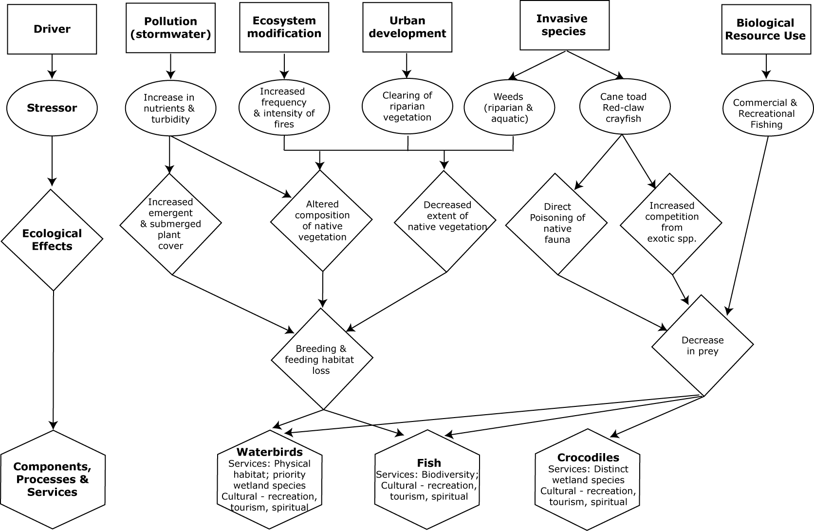
Figure 30: Stressor model of the Lakes Argyle and Kununurra Ramsar site (after Gross 2003 and Davis and Brock 2008).

5.1 Invasive species

5.1.1 Cane toad (Chaunus [Bufo] marinas)
Anuran introductions can have wide ranging ecosystem impacts including competition with other anurans, predation, and cause mortality in various animal groups due to ingestion of toxins. The cane toad has been introduced to 41 countries in tropical regions throughout the world and was first introduced to Australia in 1935 and has spread through much of tropical Australia (Phillips et al. 2007). The species has been demonstrated to have had major impacts on ecosystem structure and function (for example Burnett 1997; Lever 2001) and is now listed as a key Threatening Process by the Australian Government. A major cause of its impact is the fact that all life-history stages (that is eggs, tadpoles, adults) of the species are toxic with many predatory species in Australia being susceptible to the bufo-toxin (Crossland & Alford 1998; Phillips et al. 2003). They are also voracious invertebrate predators and can reduce their species richness and abundance and effectively act as large nutrient sinks in floodplain ecosystems as they tie up nutrients that are not available to higher order consumers (Greenlees et al. 2006).

The species has rapid movement capabilities (average of 55 kilometres per year through Northern Territory but one individual recorded moving 21.8 kilometres in a 30 day period) and is predicted to establish in the east Kimberley region in the near future (Phillips et al. 2007). Its potential introduction into the Lake Kununurra and Lake Argyle is therefore of major concern. The most obvious potential impact is causing the mortality of a wide range of consumers for various animal groups including birds, reptiles and fish. For example, the vast majority of fish (with the possible exception of the herbivorous Syncomistes spp.) in Lake Kununurra and Lake Argyle would be susceptible to poisoning which could subsequently severely affect the existing food web. However, Crossland (2001) found that barramundi and sooty grunter learnt to avoid cane toad tadpole consumption in laboratory situation apparently due to their unpalatability.

There is strong evidence, however, that cane toads can have significant effects on freshwater crocodile populations. In the Victoria River District of the Northern Territory there have been drastic reductions in crocodile populations following the arrival of cane toads. This reduction in crocodile numbers was coincident with observations of dead crocodiles, which on examination were found to contain cane toads in the stomachs contents (Letnic et al. 2008).

It is likely that the loss of a significant number of top-end predators will have significant flow-on effects within freshwater and riparian ecosystems. Studies in both aquatic and terrestrial environments have shown that the disruption or total cessation of interactions between top-order predators and their prey species can have dramatic effects on the organization and function of ecosystems. These effects include the irruption of prey species and an increase in the abundance of smaller predators owing to the absence of competition or predation by larger carnivores and changes in the composition of plant communities owing to altered-plant-herbivore relationships (Letnic et al. 2008).

5.1.1 Redclaw crayfish (Cherax quadricarinatus)
Redclaw crayfish is native to New Guinea, Northern Territory and northern Queensland (Austin 1986). It has broad environmental tolerances (including ability to move overland to colonise new habitats), rapid growth rate and high reproductive potential (that is fecund females, potential for multiple broods over an extended spring-summer breeding period) which has seen it widely used as widely in aquaculture both within Australian and also overseas (for example Jones 1995; Bortolini et al. 2007). However, the above traits that result in it being an ideal aquaculture species are also those typical of successful invasive species and allow rapid colonisation of new environments. As a result, feral populations have been established in Australia, South Africa, Mexico, Jamaica, Puerto Rico, and Singapore (Mendoza 2004; Williams et al. 2001; Zimmerman 2003; Ahyong & Yeo 2007).

Redclaw were first introduced into a quarantine station near Kununurra by Fisheries, Western Australia in 1998 for assessment of their aquaculture potential in the Ord River region (Doupe et al. 2004). Licenses for farms in the region were issued following a one year disease assessment period and the species was first discovered in Lake Kununurra in 2000 (Doupe et al. 2004). However, the strain of redclaw in Lake Kununurra was subsequently determined to be not the ‘Walkamin’ strain in the aquaculture program but that more closely related to Northern Territory populations (Greenway & Mather 2000). This suggests that other translocation event/s of the species has/have occurred into the east Kimberley which is of great concern. Their range is still expanding up Lake Kununurra, a and it is likely they will find their way into Lake Argyle within the next 10 years (Troy Sinclair, DEC, pers. comm.).

Although there are no native freshwater crayfishes Lake Kununurra, the potential impact of this species on the structure and functioning of the aquatic ecosystem are serious and wide ranging; however, this has not previously been well documented. As with other freshwater crayfishes, its introduction may have wide ranging and serious ecological impacts in Lake Kununurra including: disease introduction, habitat alterations (for example macrophyte consumption), competition and predation with native fishes and invertebrates, displacement of those species and hybridisation (for example Holdich 1988; Horwitz 1990; Mather and Stein 1993; Perry et al. 2002; Beatty 2006). The species is known to be primarily a detritivore (Loya-Javellana et al. 1993), however, is likely to be an opportunistic omnivore that would take advantage of any available food source; particularly animal matter. For example, juvenile redclaw were found to be predators in a feral Mexican population (Mendoza 2004).

A specific likely impact would be to likely directly compete for resources and potentially predate on the largest native decapod in the system, the cherabin (Macrobrachium rosenbergii). Furthermore, redclaw has been found to be consumed by two fish species in Lake Kununurra, the lesser-salmon catfish and silver cobbler highlighting that it has become incorporated into the food web in the system. Finally, the potential for the species to introduce disease and a wide variety of symbionts into Lake Kununurra is also of great concern as it has previously been demonstrated to be a vector for disease (for example Bowater et al. 2002).

5.1.3 Weeds
Salvinia (Salvinia molesta)
Salvinia is an aquatic fern that is free floating in the water and a declared a weed of national significance in Australia. The plant is sterile (produces no viable spores) and reproduction is entirely vegetative. It is capable of incredible growth rates, doubling biomass in just two days and producing up to 400 tonnes of wet weight per hectare (ARMCANZ and ANZECC 2000). Optimum growth is achieved at temperatures between 20 and 30 degrees Celsius in still or slow moving water, making the Ramsar site the perfect environment.

The thick growth of salvinia on the surface of the water, blocks out all light in the water column and prevents the growth of phytoplankton or submerged aquatic plants. It also prevents the exchange of oxygen between the air and water column, and this combined with the decomposition of benthic plants underneath the salvina mass can quickly lead to deoxygenation and death of aquatic fauna.

Salvinia was first discovered in Lake Kununurra (Lily Lagoon) in 2000 by a local resident. It is thought that a home aquarium was the likely source. At the time of detection, the area covered by the weed was relatively small (15 square metres) and contained by a barrier of Typha. Control measures included the use of booms to stop further spread, hand removal of plant material (over 100 kilograms wet weight was removed in the first season) and follow spraying with herbicides (CRC Weed Management 2003). It has not been found in the control area since 2007 and is therefore considered eradicated (Troy Sinclair, DEC, pers. comm.). Although the spread of salvina downstream was prevented, continued monitoring is required (Ord Land and Water undated).

Other weeds
The riparian area of Lake Kununurra has large weed infestations and major weeds include (Ord Land and Water undated; Water and Rivers Commission 2002):

- leucaena (Leucaena leucocephala), – a leguminous shrub used as cattle fodder;
- Neem (Azadirachta Indica) – slargetree grown mainly to produce shade in residential areas;
- annual crop species – Darwin pea, siratro;
- fruit trees – Bananas, date palm, paw paw, some deliberately planted, others agricultural escapees;
- garden plants - Poinciana, coral vine, moringa and carpentaria palms;
- perrenial grasses – Buffel grass (Cenchrus ciliaris) and mission grass (Pennisetum polystachion); and
- bellyache bush (Jatropha gossypifolia).

All weeds have the ability to displace native flora species and disrupt the food chain. Leucaena and neem have formed monocultures along parts of the shoreline of Lake Kununurra, excluding understorey pants and increasing the risk of erosion (Ord Land and Water undated).

5.2 Water resource development
Although Lakes Argyle and Kununurra were created as water supply reservoirs, there are aspects to water resource development and management that could be considered on going threats to the system.

Large amounts of sediment are carried into Lake Argyle from the catchment (11.5 million tonnes annually; Dixon and Palmer 2009). Due to the long distance from the Ord River discharge into Lake Argyle to the dam wall and the low flow velocity within Lake Argyle the majority of the sediment and nutrient loads from the catchment are deposited in Lake Argyle. The long-term ecological effects of this remain unknown. Given the sheer size of Lake Argyle, it may be many decades before any effects are detected. However, an increase in nutrient concentrations within the water column could promote the growth of phytoplankton, macrophytes and or potential weeds such as salvinia.

Threats to the ecological character of the system have occurred as a result of barriers to fish migrations (see Doupé et al. 2003, 2004; Gill et al. 2006). This poses particular threats to fish with diadromous life cycles such as the barramundi and EPBC Act listed species the freshwater sawfish. Individuals within the Ramsar site are effectively trapped and cannot complete reproductive parts of their lifecycles. In recognition of the impact of the barrier to this Ramsar site, some effort has gone into designing a fishway for this site.

The stability of the Lake Kununurra has led to more stable macrophyte beds, limits lake depth fluctuation and in turn a more stable fish fauna, while some species appear less abundant than would be expected in a system operating under natural conditions (see Gill et al. 2006).

At the time of listing the spillway allowed for some connectivity between Lakes Argyle and Kununurra, but raising it in 1996, by the construction of the six metre extension to the spillway (the plug) reduced connectivity between the two waterbodies. For example, freshwater crocodiles previously moved along this corridor, which is now blocked for some of the year by the plug. In flood years when the spillway floods, between five and twenty freshwater crocodiles are removed from this area by natural resource management staff (or perish) when lake level drops below spillway height (Troy Sinclair, DEC, pers. comm.).

5.3 Commercial fishing
The commercial fishing in Lake Argyle is both a service provided by the site as well as a potential threat to ecological character. Fishing is undertaken with gillnets and there is no mesh size restrictions, but the fishers have adopted a code of practice in that nets should have a mesh size of less than or equal to159 millimetres. There is a closed season from the first of November until 31st of December each year. The fishery was developed in 1979 as an operation to reduce catfish numbers in preparation for planned release of barramundi fingerlings. Formal release programs never eventuated and the fishery has persisted. Catches fluctuated between 90 and 145 tonnes until 1997 after which they peaked at 231 tonnes, which was thought to be unsustainable (Fisheries Western Australia 2008). Voluntary reduction efforts have seen catches drop since to the target range of 95 to 115 tonnes. However, in 2008, Jenkins’ grunter (Hephaestus jenkinsi) were reported for the first time, with 8.8 tonnes landed (Fisheries Western Australia 2009). Bycatch is reduced by the large mesh sizes, and probably limited to barramundi, freshwater crocodiles, turtles and some bird species. Annual crocodile surveys count small numbers (less than 10) dead freshwater crocodiles annually, which are attributed to commercial fishing activities (Wildlife Management International 2007). New management initiatives include working on a Bycatch Action Plan in order to reduce bycatch.

There have been a number of proposals to enhance the recreational fishing in Lake Kununurra and Argyle through either the introduction of hatchery barramundi or through the construction of a fishway (see Doupe et al. 2003, 2005, Morgan et al. 2004a). A trial program of 124 stocked barramundi in Lake Kununurra (see Bird 1992) resulted in seven percent of fish being recaptured, all of which were downstream of the Diversion Dam.

5.4 Urban development and stormwater
The northern portion of Lake Kununurra, including Lily Lagoon are located adjacent to the city of Kununurra. The population in Kununurra increased by 40 percent between 1991 and 2006 and has increased again since (Western Australian Planning Commission 2008). Threats to the Ramsar site from urban development include direct clearing of vegetation as well as increased runoff and stormwater.

The majority of residential development in the town in the period 2001 – 2008 was in the area known as the Lakeside precinct which is on the shores of Lily Lagoon and adjacent to the Ramsar site (Western Australian Planning Commission 2008). This has resulted in reduced buffering for pollutants entering the system and increased recreational pressure.

In addition, stormwater and industrial discharges entering Lake Kununurra (main body) and Lily Lagoon have been shown to contribute significantly to nutrient and sediment loads in the receiving waterbodies (Tripp and Tingle 2009). This has the potential to impact on the ecological character of the Ramsar site by increasing macrophyte growth (particularly of invasive species such as typha) and effect habitat availability and quality for waterbirds and fish.

5.5 Fire
Fire regimes have changed over much of the bioregion since the disruption to traditional Aboriginal management, with generally fewer but more extensive and hotter fires. The summer wet season is a time of high productivity and rapid vegetation growth (particularly of non-woody plants). This high biomass subsequently cures during winter, resulting in a high fuel load by the late dry season (Williams 2002). Late dry season fires, particularly if between fire intervals have been long, can be very intense and have significant environmental impacts including tree death, change in species composition (with a loss of fire sensitive species), loss of nutrients from the soil and flow on effects to fauna from habitat and food source loss.

There have been fires in the littoral and riparian zones of Lakes Argyle and Kununurra in recent years (North Australia Fire Information 2009). However, the extent of damage to the vegetation within the Ramsar boundary is not known.

5.6 Summary of threats
Although a risk assessment is beyond the scope of an ECD, the DEWHA (2008a) framework states that an indication of the impacts of threats to ecological character, likelihood and timing of threats should be included. The major threats considered in the previous sections have been summarised for each location within the Ramsar site in accordance with the DEWHA (2008a) framework Table 16.

Table 16: Summary of the main threats to the Lakes Argyle and Kununurra Ramsar site.
Actual or likely threat or threatening activities | Potential impact(s) to wetland components, processes and/or service | Location | Likelihood¹ | Timing²
Cane toads | Death of fishes, birds, reptiles preying on eggs, larvae and adults. | Lakes Argyle and Kununurra | Certain | Current
Redclaw crayfish | Disruption of food webs at all trophic levels; competition with cherabin and aquatic invertebrates; impact to aquatic vegetation. | Lake Kununurra | Certain | Current
Weeds | - Displacement of native flora.  - Erosion of banks. | Lakes Argyle and Kununurra | Certain | Current
Water resource development | Accumulating nutrients and sediment. | Lake Argyle | Medium | Long-term
Water resource development | Barriers to fish migration. | Lakes Argyle and Kununurra | Certain | Current
Commercial fishing | - Direct impacts to target species.  - Death of other large fish (barramundi) and freshwater crocodiles, birds and turtles as bycatch. | Lake Argyle | Certain | Current
Fire | Increased erosion of riparian areas and sedimentation of wetlands. | Lakes Argyle and Kununurra | Certain | Current
Urban development and stormwater | Clearing of riparian vegetation, waste management, erosion, reduced public access. | Lake Kununurra | Certain | Current
Urban development and stormwater | Increased sediment, litter and nutrients. | Lake Kununurra | Certain | Current
¹ Where Certain is defined as known to occur at the site or has occurred in the past; Medium is defined as not known from the site but occurs at similar sites; and Low is defined as theoretically possible, but not recorded at this or similar sites.
² Where Current is defined as happening at the time of writing (2010); Long-term is defined as greater than 10 years.

6. Limits of Acceptable Change

6.1 Process for setting Limits of Acceptable Change (LAC)
Limits of acceptable change are defined by Phillips (2006) as:

“…the variation that is considered acceptable in a particular measure or feature of the ecological character of the wetland. This may include population measures, hectares covered by a particular wetland type, the range of certain water quality parameter, etc. The inference is that if the particular measure or parameter moves outside the ‘limits of acceptable change’ this may indicate a change in ecological character that could lead to a reduction or loss of the values for which the site was Ramsar listed. In most cases, change is considered in a negative context, leading to a reduction in the values for which a site was listed”.

LAC and the natural variability in the parameters for which limits are set are inextricably linked. Phillips (2006) suggested that LAC should be beyond the levels of natural variation. Setting limits in consideration with natural variability is an important, but complex concept. Wetlands are complex systems and there is both spatial and temporal variability associated with all components and processes. Defining this variability such that trends away from “natural” can be reliably detected is far from straight forward.

Hale and Butcher (2008b) considered that it is not sufficient to simply define the extreme measures of a given parameter and to set LAC beyond those limits. What is required is a method of detecting change in pattern and setting limits that indicate a distinct shift from natural variability (be that positive or negative). This may mean accounting for changes in the frequency and magnitude of extreme events, changes in the temporal or seasonal patterns and changes in spatial variability as well as changes in the mean or median conditions.

It should be noted that LAC are not synonymous with management values or “trigger levels”. The LAC described here represents what would be considered a change in ecological character at the site in absolute terms with no regard for detecting change prior to irrevocable changes in wetland ecology. Detecting change with sufficient time to instigate management actions to prevent an irrevocable change in ecological character is the role of wetland management and the management plan for a site must develop and implement a set of management triggers with this aim.

6.2 LAC for the Lakes Argyle and Kununurra Ramsar site
LAC have been set for the Lakes Argyle and Kununurra Ramsar site based on conditions at the time of listing (Table 17). Where possible, site specific information has been used to statistically determine LAC. In the absence of sufficient site specific data, LAC are based on recognised standards or information in the scientific literature that is relevant to the site. In all these cases, the source of the information upon which the LAC has been determined is provided. However, it should be noted that for many of the critical components and processes there are limited quantitative data on which to set limits. In these instances, LAC have been recommended. These are qualitative, based on the precautionary principle, and will require careful review with increased information gained from future monitoring.

LAC are required for all identified critical components, processes, benefits and services. However, due to the interrelated nature of components, processes and services a single LAC may in fact account for multiple components, process and services. For example, the LAC that addresses hydrology at Lakes Argyle and Kununurra also covers the critical service of water provision and physical habitat. If hydrology were significantly altered this would lead to a loss of the services. In order to limit repetition in the LAC for Lakes Argyle and Kununurra, a hierarchical approach has been adopted where LAC have been set for components, which in this case has also covered critical services.
Additional LAC explanatory notes
- Limits of Acceptable Change are a tool by which ecological change can be measured. However, Ecological Character Descriptions are not management plans and Limits of Acceptable Change do not constitute a management regime for the Ramsar site.
- Exceeding or not meeting Limits of Acceptable Change does not necessarily indicate that there has been a change in ecological character within the meaning of the Ramsar Convention. However, exceeding or not meeting Limits of Acceptable Change may require investigation to determine whether there has been a change in ecological character.
- While the best available information has been used to prepare this Ecological Character Description and define Limits of Acceptable Change for the site, a comprehensive understanding of site character may not be possible as in many cases only limited information and data is available for these purposes. The Limits of Acceptable Change may not accurately represent the variability of the critical components, processes, benefits or services under the management regime and natural conditions that prevailed at the time the site was listed as a Ramsar wetland.
- Users should exercise their own skill and care with respect to their use of the information in this Ecological Character Description and carefully evaluate the suitability of the information for their own purposes.
- Limits of Acceptable Change can be updated as new information becomes available to ensure they more accurately reflect the natural variability (or normal range for artificial sites) of critical components, processes, benefits or services of the Ramsar wetland.

The columns in Table 17 contain the following information:
Primary critical Component / Process for the LAC | The component or processes that the LAC is a direct measure of.
Baseline / supporting evidence | Relevant baseline information (relevant to the time of listing) and any additional supporting evidence from the scientific literature and / or local knowledge.
Limit of Acceptable Change | The LAC stated as it is to be assessed against.
Confidence level | The degree to which the authors ore confident that the LAC represents the point at which a change in character has occurred. Assigned as follows:  High – Quantitative site specific data; good understanding linking the indicator to the ecological character of the site; LAC is objectively measureable.  Medium – Some site specific data or strong evidence for similar systems elsewhere derived from the scientific literature; or informed expert opinion; LAC is objectively measureable.  Low – no site specific data or reliable evidence from the scientific literature or expert opinion, LAC may not be objectively measurable and / or the importance of the indicator to the ecological character of the site is unknown.
Secondary critical components/ processes/services addressed through this LAC | These are other critical components, processes or services that are protected indirectly by the LAC.

Table 17: Proposed Limits of Acceptable Change for the Lakes Argyle and Kununurra Ramsar site.
Primary critical Component / Process for the LAC | Baseline/Supporting Evidence | Limit of Acceptable Change | Confidence level | Secondary critical components/ processes/services addressed through this LAC
Hydrology | At the time of listing Lakes Argyle and Kununurra were permanent systems. The water depth (and hence inundation of shorelines) on Lake Argyle was variable, providing important feeding habitat for migratory shorebirds on the shallow, inundated bare sediments (Hassel et al. 2005).  Water levels were stable in Lake Kununurra allowing for the establishment of dense littoral vegetation, which provides habitat for fish and waterbirds (Water and Rivers Commission 2003).  At the time of listing the site was operated as a water supply storage and this service must be recognised with respect to managing the water regime. | Lake Argyle:  - Annual fluctuation of water levels of at least three metres annually.  - Storage to remain greater than 5000 gigalitres for more than 10 months of every year.  Lake Kununurra:  - Water levels between 41.1 and 41.7 metres AHD for 90 percent of any given 12 month period. | High | Services:  - Water supply  - Physical habitat - for waterbird moulting and feeding;  - Supports biodiversity (fish)
Fish | There are 29 species of native fish known to be within the system (see Appendix B), the highest diversity of native inland fish in Western Australia. Of these, 27 are capable of completing their entire life cycle within the Ramsar site. Two species (barramundi and freshwater sawfish) require migration to estuarine / marine environments for reproduction, and with the barriers of the Ord River Dam and Kununurra Diversion Dam in place this migration cannot occur (Morgan et al. 2004a). As such populations of only 27 species of fish can be expected to be maintained in the long-term. | Maintenance of 27 species of native fish. | Medium | Service:  - Biodiversity
Fish | Abundance data for silver cobbler only (from commercial fishing) indicates that 120 ± 15 tonnes is caught annually; with a CPUE of 29 ± 13 kilograms per 100 metres per net days (Fisheries Western Australia 1999). CPUE provides a more suitable basis for the LAC as it takes into account variability in fishing effort between years.  Silver cobbler are a predator and so may provide a suitable indicator species for fish abundance. In an attempt to incorporate the level of variability limits are proposed based on mean ± one standard deviation.  There are links between fish abundance and abundance of top-end predators such as freshwater crocodiles (Morgan 2008). As such the LAC for crocodiles (see below) is also relevant. | Silver cobbler CPUE of 16 to 42 kilograms per 100 metres per net days  See also LAC for freshwater crocodiles below | Medium | Service:  - Biodiversity
Component: Waterbirds | Limited surveys; but consistently between 150 000 and 250 000 waterbirds on Lake Argyle in November / December (Hassell et al. 2005; Bennelongia 2007). | Numbers greater than 100 000 during November / December. | Medium | Service:  - Priority wetland species
Component: Waterbirds | Supports greater than one percent of the flyway population of four species of shorebird (Jaensch and Vervest 1990; Hassell et al. 2005; and Bennelongia 2007).  LAC set for total numbers recorded across the site. Data is limited and so reliability is low; LAC should be revised as new data are available. | Little curlew, wood sandpiper, sharp-tailed sandpiper, oriental pratincole - greater than one percent of flyway population recorded in at least two years in every five year period. | Low | Service:  - Priority wetland species
Component: Waterbirds | Supports greater than one percent of the flyway population of a further seven species of Australian resident waterbird (Jaensch and Vervest 1990; Hassell et al. 2005; and Bennelongia 2007).  More certainty in data for species that are easily identified from aerial surveys. | - Black-winged stilt - greater than 3000 individuals recorded in at least three years in every five year period.  - Red-capped plover - greater than 1000 individuals recorded in at least two years in every five year period.  - Magpie goose - greater than 20 000 individuals recorded in at least four years in every five year period.  - Wandering whistling duck - greater than 20 000 individuals recorded in at least four years in every five year period.  - Hardhead - greater than 10 000 individuals recorded in at least four years in every five year period.  - Eurasian coot - greater than 10 000 individuals recorded in at least three years in every five year period.  - Green pygmy goose - greater than 20 000 individuals recorded in at least four years in every five year period. | Low | Service:  - Priority wetland species
Component: Freshwater crocodiles | Lakes Argyle and Kununurra support large numbers of freshwater crocodiles and greater than one percent of the global population of this species. Total populations estimates are more than 25 000 individuals in Lake Argyle and 7500 in Lake Kununurra (CALM 2003). However, complete census of populations is not feasible for annual monitoring so LAC are based on annual helicopter surveys 1989 to 2007 (mean minus standard deviation); Lake Kununurra 208 ± 67; Lake Argyle 1107 ± 375 (CALM 2003). | Lake Argyle - greater than 700 crocodiles recorded in annual helicopter surveys.  Lake Kununurra greater than 140 crocodiles recorded in annual helicopter surveys. | High | Service:  - Distinct wetland species

7. Current Ecological Character and Changes Since Designation

It has been a quarter of a century since the Lakes Argyle and Kununurra Ramsar site was designated as a Wetland of International Importance. As such, changes to the system are to be expected. However, as indicated in section 2.5, the site clearly still meets the criteria for listing under the Ramsar Convention and maintains significant environmental values.

The major changes to the site since 1990 are described below, together with clear indication if the change has resulted in a breach of a LAC and therefore has resulted in a change in ecological character. Relative confidence levels (based on the extent and type of data available) have also been provided based on the following scale:

- High confidence – where there is sufficient data for statistical comparisons;
- Medium confidence – where there is insufficient data for statistical analysis, but sufficient data to allow for considered expert opinion; and
- Low confidence – where there is little or no data, but judgements have been made on observations or opinion.

For a number of components and processes there was no quantitative information at the time of listing (for example fish populations, extent of some vegetation communities) and therefore no indication of change can be made.

7.1 Hydrology
The spillway at Lake Argyle was increased by six metres in 1996 to accommodate increased demands, predominantly for hydroelectricity. This had the effect of increasing the storage capacity of Lake Argyle and reducing the frequency and magnitude of uncontrolled releases (spills) down the spillway. Water levels are generally higher now than at the time of listing, but fluctuations within and between years are similar to those pre 1996 (Figure 31). Additional impacts of raising the spillway on inundation and littoral habitats remain unknown.

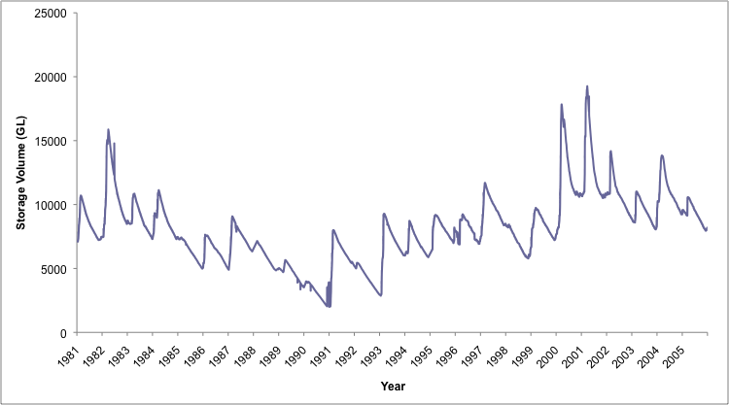

Figure 31: Water level in Lake Argyle 1981 to 2005 (data from Water Corporation).

Lake Kununurra is managed to maintain water levels between 41.1 and 41.7m AHD, and still is within the LAC set for water level stability.

No change in ecological character with respect to hydrology has been detected. Confidence level: High

7.2 Fish
There is no data to demonstrate that the fauna of Lake Kununurra and Lake Argyle has changed since 1990, however, diadromous species such as barramundi, freshwater sawfish, freshwater whipray, bull sharks and tarpon are now likely to have disappeared from these systems as a result of river regulation (Doupe et al. 2003, 2005, Gill et al. 2006). The fact that the freshwater sawfish was still recorded in the system post listing, indicates that the site is probably still experiencing lag-effects of dam construction.

Changes in diets of fishes and food webs may have occurred as a result of the introduction of redclaw crayfish (Cherax quadquecarinatus) (Doupé et al. 2004). This species was recorded in the diet of at least two species of fish (see Rowland 2003, Morgan et al. 2004).

Barramundi aquaculture commenced in Lake Argyle in the early 1990s, with production expanding up until 2005, when a major facility closed. The biggest impact that the operations have had on the ecological character of the Lake is via the escape of fish and the reintroduction of barramundi into both Lake Argyle and Kununurra (Doupe and Petit 2002).

There is no evidence of long term change in silver cobbler abundance since the time of listing (Figure 32) with mean CPUE (1990 to 2009) 22 kilograms per 100 metres per net days, within the LAC of 16 to 42 kilograms per 100 metres per net days.

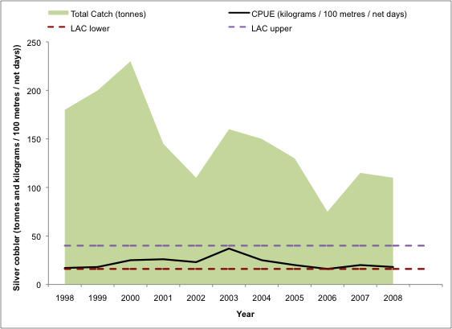

Figure 32: Catch of silver cobbler in Lake Argyle, 1998 to 2008 (data from Department of Fisheries 2009).

No change in ecological character with respect to fish has been detected. Confidence level: Medium.

7.3 Waterbirds
There is no data to indicate a change in character at the Lakes Argyle and Kununurra Ramsar site with respect to waterbird abundance and diversity. Available data is from three surveys only (Jaensch and Vervest 1990; Hassell et al. 2005 and Bennelongia 2007). There is no evidence from these surveys that waterbird abundance or diversity has changed over time. However, waterbird abundance is highly variable between years and surveys and more data is required before any conclusions can be drawn.

No change in ecological character with respect to waterbirds has been detected. Confidence level: Medium.

7.4 Crocodiles
There is no information on the abundance of freshwater crocodiles at the time of listing and data collected from 1989 to 2007 has been used to describe the character of the site (see section 3.3.5 above). Data collected over the 18 years to date indicates a stable population of crocodiles within the system (Wildlife Management Systems 2007).

No change in ecological character with respect to freshwater crocodiles has been detected. Confidence level: High.

7.5 Overall change in ecological character
Given that there has been no definitive change in the any of the identified critical components and processes, and where sufficient data exists, no LAC have been breached, the ecological character of the Lakes Argyle and Kununurra Ramsar site are not considered to have changed since the time of listing.

8. Knowledge Gaps
Throughout the Ecological Character Description for the Lakes Argyle and Kununurra Ramsar site, mention has been made of knowledge gaps and data deficiencies for the site. While it is tempting to produce an infinite list of research and monitoring needs for this wetland system, it is important to focus on the purpose of an ecological character description and identify and prioritise knowledge gaps that are important for describing and maintaining the ecological character of the system. As such knowledge gaps that are required to fully describe the ecological character of this site and enable rigorous and defensible limits of acceptable change to be met are relatively few and listed in Table 18.

Table 18: Knowledge Gaps for the Lakes Argyle and Kununurra Ramsar site
Location | Knowledge Gap | Recommended Action
Lake Kununurra | Water quality within the main lake and associated swamps. | Monthly water quality monitoring within the main lake and swamps.
Lake Kununurra | Nutrient cycling and accumulation due to aquatic vegetation and reduced flows in associated wetlands such as Lily Lagoon. | Nutrient cycling analysis and modelling in aquatic vegetation and associated waterbodies.
Lake Kununurra | Extent and impact of weeds and exacerbated native vegetation growth on native flora and aquatic fauna. | Weed and aquatic vegetation mapping.
Lake Kununurra | Long-term viability of native riparian vegetation in the absence of pulse flows to stimulate germination and recruitment. | Monitoring of tree health and riparian vegetation condition.
Lake Kununurra | Impact of redclaw crayfish on food webs and competition with cherabin. | Food web and dietary analyses; abundance and spread of redclaw crayfish and abundance of cherabin.
Lake Kununurra | Waterbird breeding within the Ramsar site and the significance of the site for breeding waterbirds. | Annual waterbird surveys to include nesting records from waterbird species at Packsaddle Swamp and Lily Lagoon.
Lake Kununurra | Abundance and diversity of other aquatic fauna within Lake Kununurra. | Surveys of frogs, tortoises and water rats to determine if the site is an important site for maintaining diversity or breeding populations of aquatic species.
Lake Argyle | The magnitude and potential impact of the raising of the spillway to littoral and mudflat habitat. | Assessment of changes in inundation since 1996.
Lake Argyle | Biology of fishes, including commercial species such as silver cobbler. | Document distribution, ecology and habitat associations of fishes.
Lake Argyle | Abundance and diversity of other aquatic fauna. | Surveys of frogs and tortoises to determine if the site is an important site for maintaining diversity or breeding populations of aquatic species.
Lake Argyle | Long term variability in waterbird diversity and abundance; the importance of Lake argyle as a site for international migratory birds. | Include Lake Argyle in network of sites monitored annually Australia wide for migratory birds (for example Shorebirds 2020).

9. Monitoring needs

As a signatory to the Ramsar Convention, Australia has made a commitment to protect the ecological character of its Wetlands of International Importance. Under Part three of the EPBC Act a person must not take an action that has, will have or is likely to have a significant impact on the ecological character of a declared Ramsar wetland. While there is no explicit requirement for monitoring the site, in order to ascertain if the ecological character of the wetland site is being protected a monitoring program is required.

A comprehensive monitoring program is beyond the scope of an ECD. What is provided is an identification of monitoring needs required to both set baselines for critical components and processes and to assess against limits of acceptable change. It should be noted that the focus of the monitoring recommended in an ECD is an assessment against LAC and determination of changes in ecological character. This monitoring is not designed as an early warning system whereby trends in data are assessed to detect changes in components and processes prior to a change in ecological character of the site. This must be included in the management plan for the site.

The recommended monitoring to meet the obligations under the Ramsar Convention and the EPBC Act with respect to the Lakes Argyle and Kununurra Ramsar site are provided in Table 19.

Table 19: Monitoring needs for the Lake Argyle and Kununurra Ramsar site
Component/ Process | Purpose | Indicator | Locations | Frequency | Priority
Hydrology | Assessment against LAC | Water level | Entire Ramsar site | Weekly | Moderate
Water quality | Threat indicator | Dissolved oxygen  Nutrients | Entire Ramsar site | Monthly | Moderate
Vegetation – extent of weeds | Threat indicator | Extent of noxious weeds | Lake Kununurra | Annual | High
Cane toads | Threat indicator | Location, abundance | Entire Ramsar site | Seasonal | High
Redclaw crayfish | Threat indicator | Location, abundance | Entire Ramsar site | Seasonal | Moderate
Fish | Assessment against LAC | Abundance and community composition | Entire Ramsar site | Seasonal | High
Waterbirds | Assessment against LAC | Abundance and species identifications, breeding observations | Entire Ramsar site | November / December | High
Freshwater crocodile | Assessment against LAC | Abundance | Entire Ramsar site | Annual | High

10. Communication and Education Messages

Under the Ramsar Convention a Program of Communication, Education, Participation and Awareness (CEPA) was established to help raise awareness of wetland values and functions. At the Conference of Contracting Parties in Korea in 2008, a resolution was made to continue the CEPA program in its third iteration for the next two triennia (2009 – 2015).

The vision of the Ramsar Convention’s CEPA Program is: “People taking action for the wise use of wetlands.” To achieve this vision, three guiding principles have been developed:

- The CEPA Program offers tools to help people understand the values of wetlands so that they are motivated to become advocates for wetland conservation and wise use and may act to become involved in relevant policy formulation, planning and management.
- The CEPA Program fosters the production of effective CEPA tools and expertise to engage major stakeholders’ participation in the wise use of wetlands and to convey appropriate messages in order to promote the wise use principle throughout society.
- The Ramsar Convention believes that CEPA should form a central part of implementing the Convention by each Contracting Party. Investment in CEPA will increase the number of informed advocates, actors and networks involved in wetland issues and build an informed decision-making and public constituency.

The Ramsar Convention encourages that communication, education, participation and awareness are used effectively at all levels, from local to international, to promote the value of wetlands. A comprehensive CEPA program for an individual Ramsar site is beyond the scope of an ECD.

There are a number of programs currently in place, which focus on communication, and education of wetland values in the Lakes Argyle and Kununurra Ramsar site. For example, the Department of Water and the University of Western Australia have developed a waterways education program for the Kimberley. The program engages local people in discussions regarding management of their local waterways and in addressing broader issues of significance. This program aims to provide targeted school and ranger groups with the skills to assess and ultimately manage their local waterways. The delivery of the program focuses on four waterways themes: Awareness, Training, Research and Management, and Long-term Monitoring.

Key CEPA messages for the Lakes Argyle and Kununurra Ramsar site arising from this ECD, which should be promoted through these programs, include:

- The Ramsar values of the site and the importance of the Ramsar site as a habitat for shorebirds and waterfowl to meet different needs in their lifecycles.

- The significance of the site for international migratory birds; their journey through the East Asian-Australasian Flyway, the habitats they use within the site and the potentially significant consequences of disturbance by walking, boating, vehicles and domestic pets.

- The concept of “wise use” as defined by the Convention and the example that the site provides in the practice of this principle.

- The threat of cane toads and the impact they can have on the sites values.

- Climate change, the potential impacts on the benefits and services of the Ramsar site and the steps community members can make to minimise impacts associated with climate change, particularly to inland aquatic and coastal environments.

- The need for cooperative and coordinated management across this complex site with the large number of stakeholders and bodies responsible for management.

References
Allen, G.R. and Allen, M., 1998, Sampling of freshwater fishes in the Kimberley region of Western Australia. Unpublished report to the Western Australia Museum.

Allen, G.R., Midgley, S.H. and Allen, M., 2002, Field guide to the freshwater fishes of Australia. Western Australia Museum, Perth.

Ahyong S.T. and Yeo D.C.J., 2007, Feral populations of the Australian Red-Claw crayfish (Cherax quadricarinatus von Martens) in water supply catchments of Singapore. Biological Invasions 9: 943-946.

ANZECC and ARMCANZ, 2000, Australian and New Zealand Guidelines for Fresh and Marine Water Quality National Water Quality Management Strategy Paper no. 4.Australian and New Zealand Environment and Conservation Council / Agriculture and Resource Management Council of Australia and New Zealand

Austin C. M., 1986, Electrophoretic and morphological systematic studies of the genus Cherax (Decapoda: Parastacidae) in Australia. PhD thesis, University of Western Australia.

Australian Heritage Commission, 2002, Australian Natural Heritage Charter for conservation of places of natural heritage significance. Second Edition. Australian Heritage Commission. Canberra

Australian Water Resources Council 1987, Review of Australia's Water Resources and Water Use 1985, Vol. 1 and 2, Water Resources Data Set, Australian Government Publishing Service, Canberra.

Bamford, M, D. Watkins, W. Bancroft, G. Tischler and J. Wahl. 2008. Migratory Shorebirds of the East Asian - Australasian Flyway; Population Estimates and Internationally Important Sites. Wetlands International Oceania. Canberra, Australia.

Barrett, G.W., Van Dyne, G.M. and Odum, E.P., 1976. Stress ecology, BioScience 26: 192 – 194.

Beard, J., 1990, Plant Life of Western Australia, Kangaroo Press, Sydney.

Beatty, S. J., 2006, The diet and trophic positions of translocated, sympatric populations of Cherax destructor and Cherax cainii in the Hutt River, Western Australia: evidence of resource overlap. Marine & Freshwater Research 57(8): 825-835.

Bennelongia, 2007, Waterbird Monitoring at the Lake Argyle and Lake Kununurra Ramsar Sites, North-Eastern Kimberley Region, Prepared for Department of Environment and Conservation.

Bird, C., 1992, Trial barramundi trapping and tagging program on the Ord River. Bernard Bowen Fisheries Research Institute, Western Australian Marine Research Laboratories, Perth

BirdLife International, 2009, Species factsheet: Various. Downloaded from http://www.birdlife.org on 21/4/2009

Backwell P., O’Hara, P.D. and Christy, J.H., 1998, Prey availability and selective foraging in shorebirds. Animal Behaviour 55:1659–1667

Boettcher, R., Haig, S.M. and Bridges, W.C., 1995, Habitat-related factors affecting the distribution of nonbreeding American Avocets in coastal South-Carolina. Condor 97: 68–81

Bortolini J.L., Alvarez F. and Rodriquez-Almaraz G., 2007, On the presence of the Australian redclaw crayfish, Cherax quadricarinatus, in Mexico. Biological Invasions 9: 615-620.

Bowater R.O., Wingfield M., Fisk A., Condon K.M.L., Reid A., Prior H. & Kulpa E.C., 2002, A parvo-like virus in cultured redclaw crayfish Cherax qudricarinatus from Queensland, Australia. Diseases of Aquatic Organisms 50: 79-86

Bureau of Meteorology, 2009, Climate data online, downloaded from http://www.bom.gov.au/climate/averages/ on 15/11/2009.

Burger, J., Howe, M.A., Hahn, D,C, and Chase, J., 1997. Effects of tide cycles on habitat selection and habitat partitioning by migrating shorebirds. Auk 94:743–758

Burnett S. (1997) Colonizing cane toads cause population declines in native predators: reliable anecdotal information and management implications. Pacific Conservation Biology 3: 65–72

CALM (Department of Conservation and Land Management), 2003, Saltwater Crocodile (Crocodylus porosus) and Freshwater Crocodile (Crocodylus johnstoni) Management Plan for Western Australia 2004-2008, CALM, WA.

Cole, M.L., Leslie, D.M. and Fisher, W.L., 2002, Habitat use by shorebirds at a stopover site in the southern Great Plains. Southwest Naturalist 47:372–378

Colwell, M.A. and Dodd. S.L., 1995, Waterbird communities and habitat relationships in coastal pastures of Northern California. Conservation Biology 9:827–834

CRC Weed Management, 2003, Technical Series # 7: Improving the selection, testing and evaluation of weed biological control agents, CRC for Australian Weed Management, Waite Campus, University of Adelaide.

Cresswell, W, 1994, Age-dependent choice of redshank (Tringa totanus) feeding location: profitability or risk? Journal of Animal Ecology 63:589–600

Crossland M.R. (2001). Ability of predatory native Australian fishes to learn to avoid toxic larvae of the introduced toad Bufo marinus. Journal of Fish Biology 59: 319-329.

Crossland M.R. & Alford R.A. (1998). Evaluation of the toxicity of eggs, hatchlings and tadpoles of the introduced toad Bufo marinus (Anura: Bufonidae) to native Australian aquatic predators. Australian Journal of Ecology 23: 129-137

CSIRO, 2009, Water in the Ord-Bonaparte region, pp 183-272 in CSIRO (2009) Water in the Timor Sea Drainage Division. A report to the Australian Government from the CSIRO Northern Australia Sustainable Yields Project. CSIRO Water for a Healthy Country Flagship, Australia.

Danufsky, T. and Colwell M.A., 2003, Winter shorebird communities and tidal flat characteristics at Humboldt Bay, California. Condor 105:117–129

Davis, J. and Brock, M., 2008, Detecting unacceptable change in the ecological character of Ramsar wetlands, Ecological Management and Restoration, 9: 26-32.

Davis, C.A. and Smith, L.M., 2001, Foraging strategies and niche dynamics of coexisting shorebirds at stopover sites in the southern Great Plains. Auk 118:484–495

DEC, 2009, NatureMap: Mapping Western Australia's Biodiversity. Department of Environment and Conservation. http://naturemap.dec.wa.gov.au/

DEWHA (Department of Environment, Water, Heritage and the Arts), 2008, National Framework and Guidance for Describing the Ecological Character of Australia’s Ramsar Wetlands. Module 2 of Australian National Guidelines for Ramsar Wetlands – Implementing the Ramsar Convention in Australia.

Dixon, R.N.M. and Palmer, D.W., 2009, 2006 Sediment Survey in Lake Argyle, Western Australia Department of Water, Salinity and Land Use Impacts Series, Report no. SLUI 42

DoW (Department of Water), 2006, Ord River Water Management Plan. Department of Water, Government of Western Australia, Water Resource Allocation Planning Series Report No WRAP 15.

DoW (unpublished) Water INformation (WIN) database - discrete sample data. [provided February 2010]. Department of Water, Water Information Provision section, Perth Western Australia.

Doupé, R.G. and Lymbery, A.J. (1999). Escape of cultured barramundi (Lates calcarifer Bloch) into impoundments of the Ord River system, Western Australia. Journal of the Royal Society of Western Australia 82,131-136

Doupé, R.G., Morgan, D.L. and Gill, H.S., 2005, Prospects for a restorative fishery enhancement of Lake Kununurra: a high-level tropical impoundment on the Ord River, Western Australia. Pacific Conservation Biology 11: 136-146

Doupé, R.G., Morgan, D.L., Gill, H.S. and Rowland, A.J., 2004, Introduction of redclaw crayfish Cherax quadricarinatus (von Matrens) to Lake Kununurra, Ord River, Western Australia: prospects for a 'yabby' in the Kimberley. Journal of the Royal Society of Western Australia 87: 187-191.

Doupé, R., Morgan, D., Gill, H., Rowland, A and Annandale, D., 2003, Ecological and social issues concerning the establishment of a recreational barramundi fishery in Lake Kununurra. Report to the Lake Kununurra Fish Stock Enhancement Committee & Ord Land and Water Inc.

Doupé, R. and Petit, N., 2002, Ecological perspectives on regulation and water allocation for the Ord River, Western Australia, River Res. Applic. 18: 307-20.

Felsing, M. and Glencross, B., 2004, Defining the impact of hydrological changes associated with lake-turnover events on barramundi cage aquaculture in Lake Argyle, Final Report – Aquaculture Development Fund of WA Project Fisheries Research Contract Report No. 7, Department of Fisheries, Western Australia

Fisheries Western Australia, 1999, State of the Fisheries Report 1998/9, Fisheries WA, Western Australia.

Fisheries Western Australia, 2002, State of the Fisheries Report 2001/2, Fisheries WA, Western Australia.

Fisheries Western Australia, 2008, State of the Fisheries Report 2007/8, Fisheries WA, Western Australia.

Fisheries Western Australia, 2009, State of the Fisheries Report 2008/9, Fisheries WA, Western Australia.

Gill, H.S., Morgan, D.L., Doupé, R.G. & Rowland, A.J. (2006). The fishes of Lake Kununurra, a highly regulated section of the Ord River in northern Western Australia. Records of the Western Australian Museum 23, 1-6

Gordon, N.D., McMahon, T.A., Finlayson, B.L., Gippel, C.J. and Nathan, R.J., 1999, Stream Hydrology - An Introduction for Ecologists (2nd Edition), John Wiley & Sons

Greenlees, M.J., Brown, G.P., Webb, J.K., Phillips, B.L. and Shine, R., 2006, Effects of an invasive anuran (the cane toad, Bufo marinus) on the invertebrate fauna of a tropical Australian floodplain. Animal Conservation 9:431-438.

Greenway S. & Mather P. (2000). Report on genotyping of Western Australian crayfish samples. Unpublished Report to Fisheries Western Australia, Kununurra.

Gross, J., 2003, Developing Conceptual Models for Monitoring Programs http://science.nature.nps.gov/im/monitor/docs/Conceptual_Modelling.pdf
Hale, J. and Butcher, R., 2008, Ecological Character Description of the Peel-Yalgorup Ramsar Site, Report to DEC and PHCC.

Hassell, C., Rogers, D. and Holliday, S., 2005, Assessment of the current status of East Kimberley Ramsar Sites: Waterbird surveys of Lakes Argyle and Kununurra, and Ord River
Floodplain, July-Aug 2005 and Nov.-Dec. 2005, Report to the Department of Conservation and Land Management, Kununurra.

Hill, R., Miriuwung and Gajerrong peoples, Hill, D.G. and Goodson, S. 2008. Miriuwung-Gajerrong Cultural Planning Framework. MG Guidelines for developing Management Plans for Conservation Parks and Nature Reserves under the Ord Final Agreement. Endorsed by the Yoorrooyang Dawang Regional Park Council. Presented by Miriuwung and Gajerrong peoples. Perth, Kununurra and Cairns: WA Department of Environment and Conservation, Yawoorroong Miriuwung Gajerrong Yirrgeb Noong Dawang Aboriginal Corporation and CSIRO.

Holdich, D. M, 1988, The dangers of introducing alien animals with particular reference to crayfish, Freshwater Crayfish 7: 15–30.

Holland J., 1998, Emergence: From Chaos to Order, Addison-Wesley, Reading, MA,.

Horwitz, P., 1990, The translocation of freshwater crayfish in Australia: Potential impact, the need for control and global relevance. Biological Conservation 54: 291–305.

Jaensch, R.P. and Vervest, R.M., 1990, Waterbirds at remote wetlands in Western Australia, 1986-88, Part One: Lake MacLeod, Shark Bay, Camballin Floodplain and Parry Floodplain, Royal Australasian Ornithologists Union Report 32.

Jones, C. M., 1995, Production of juvenile redclaw crayfish, Cherax quadricarinatus (Von Martens) (Decapoda, Parastacidae). Development of hatchery and nursery procedures. Aquaculture 138: 221–38.

Kalejta, B., 1993, Diets of shorebirds at the Berg River Estuary, South-Africa—spatial and temporal variation. Ostrich 64:123–133

Kay, W.R., 2004, Population ecology of Crocodylus porposus in the Kimberley of Western Australia, PhD Thesis, University of Queensland, Brisbane.

Kimberley TAFE and SWEK, 2008, Lake Kununurra and Lily Creek Lagoon Vegetation Management Plan, Shire of Wyndham East Kimberley, Kununurra.

King, R., Loh, I. and Rodgers, S., 2001, Dollars and sense: water allocation decision making In tropical western Australia. Globalization And Water Resources Management: The Changing Value Of Wateraugust 6-8 Awra/Iwlri-University Of Dundee International Specialty Conference

Kingsford, R., and Norman, F., 2002, Australian waterbirds – products of the continent’s ecology, Emu 102: 47–69

Kinhill, 2000, Proposed Development of the M2 Supply Area of the Ord River
Irrigation Project -Environmental Review and Management Program.

Letnic, M., Webb, J.K. and Shine, R., 2008, Invasive cane toads (Bufo marinus) cause mass mortality of freshwater crocodiles (Crocodylus johnstoni) in tropical Australia. Biological Conservation: 141, 1773 - 1782.

Lever C., 2001, The Cane Toad. The History and Ecology of a Successful Colonist. Westbury, Otley.

Loya-Javellana G.N., Fielder D.R. and Thorne M.J., 1993, Food choice by free-living stages of the tropical freshwater crayfish, Cherax quadricarinatus (Parastacidae: Decapoda). Aquaculture 118: 299-308.

Marchant, S., and Higgins, P.J. (eds), 1990, Handbook of Australian, New Zealand and Antarctic Birds. Oxford University Press: Melbourne

Mather, M. A., and Stein, R. A., 1993, Direct and indirect effects of fish predation on the replacement of a native crayfish by an invading congener. Canadian Journal of Fisheries and Aquatic Sciences 50: 1279–288.

McDonald, N.S. and McAlpine, J., 1991, Floods and droughts: the northern climate. In Haynes, D. Ridpath, M.G. and Williams, M.A.J. (eds.) Monsoonal Australia: Landscape, ecology and man in the northern lowlands.

McGrath, C. 2006, unpublished Legal review of the framework for describing the ecological character of Ramsar wetlands to support implementation of the EPBC Act. Report to the Department of the Environment and Heritage, Unpublished.

Mendoza R., 2004, Strategies to prevent the spread of invasive aquatic species in Mexico. In: Annual Meeting of the Western regional Panel on Aquatic Nuisance Species, La Jolla, 9-11 September 2004.

Millennium Ecosystem Assessment, 2005, Ecosystem Services and Human Well-Being: Wetlands & Water: Synthesis. 2005. Millennium Ecosystem Assessment report to the Ramsar
Convention: World Resources Institute, Washington D.C.

Morgan, D.L., 2008, Freshwater fishes of the Kimberley region of Western Australia. Centre for Fish & Fisheries Report, Murdoch University for the Northern Australian Freshwater Fish Project to the Department of the Environment and Heritage.

Morgan, D.L., Allen, M.G., Bedford, P. and Horstman, M., 2004b, Fish fauna of the Fitzroy River in the Kimberley region of Western Australia – including the Bunuba, Gooniyandi, Ngarinyin, Nyikina and Walmajarri Aboriginal names. Records of the Western Australian Museum 22: 147-161.

Morgan, D.L., Ebner, B.C., Beatty, S.J., and Whitty, J.M., 2008, Fish fauna of Snake (Uralla) Creek, Fitzroy River, Kimberley, Western Australia, Centre for Fish & Fisheries Research Murdoch University, Perth

Morgan, D.L. and Gill, H.S., 2004, Fish fauna in inland waters of the Pilbara (Indian Ocean) Drainage Division of Western Australia – evidence for three subprovinces. Zootaxa 636:1-43.

Morgan, D.L., Rowland, D., Gill, H.S and Doupé, R.G., 2004a, Implications of introducing a large piscivore (Lates calcarifer) into a regulated northern Australian river (Lake Kununurra, Western Australia). Lakes & Reservoirs: Research and Management 9: 181-193.
Native Fish Australia, http://www.nativefish.asn.au/ Accessed April 26, 2009.

Northern Australia Fire Information (2009), www.firenorth.org.au accessed February 2010.

Perry, W. L., Lodge, D. M., and Feder, J. L., 2002, Importance of hybridisation between indigenous and nonindigenous freshwater species: and overlooked threat to North American biodiversity. Systematic Biology 51: 255-75.

Phillips B. L., Brown G. P., Greenlees M., Webb, J.K. and Shine R., 2007, Rapid expansion of the cane toad (Bufo marinus) invasion front in tropical Australia. Austral Ecology 32: 169-176.

Phillips B. L., Brown G. P. and Shine R., 2003, Assessing the potential impact of cane toads on Australian snakes. Conservation Biology 17: 1738–47.

Phillips, B., 2006, Critique of the Framework for describing the ecological character of Ramsar Wetlands (Department of Sustainability and Environment, Victoria, 2005) based on its application at three Ramsar sites: Ashmore Reed National Nature Reserve, the Coral Sea Reserves (Coringa-Herald and Lihou Reeds and Cays), and Elizabeth and Middleton Reeds Marine National Nature Reserve. Mainstream Environmental Consulting Pty Ltd, Waramanga ACT.

Phillips, B. and Muller, K., 2006, Ecological Character Description of the Coorong, Lakes Alexandrina and Albert Wetland of International Importance, Department of Environment and Heritage, Adelaide, South Australia

Ramsar Convention, 1996, Resolution VI.1. Annex to Resolution VI.1. Working Definitions, Guidelines for Describing and Maintaining Ecological Character of Listed Sites, and Guidelines for Operation on the Montreux Record.

Ramsar Convention, 1987, Convention on Wetlands of International Importance especially as Waterfowl Habitat.

Ramsar Convention 2005, Resolution IX.1 Annex A. A Conceptual Framework for the wise use of wetlands and the maintenance of their ecological character. http://www.ramsar.org/res/key_res_ix_01_annexa_e.htm

Ramsar Convention, 2009, Strategic Framework for the List of Wetlands of International Importance, edition 2009. http://www.ramsar.org/key_guide_list2009_e.htm#V

Recher, H., 1966, Some aspects of the ecology of migrant shore-birds. Ecology 47:393–407

Ringelman, J., 1990, Habitat management for moulting waterfowl, Fish and Wildlife Leaflet 13.4.4, Colorado Division of Wildlife

RIS (Ramsar Information Sheet), 2003, RIS for the Lakes Argyle and Kununurra Ramsar site complied by DEC

Rowland, A.J., 2003, The fish fauna of Lake Kununurra, including dietary comparisons, and aspects of the biology of the lesser salmon catfish Arius graeffei. Honours Thesis, Murdoch University, Perth, Western Australia.

Trayler, K. and King, R., 2001, Ord River allocation planning – environmental valuations, past, present and future; Globalization And Water Resources Management: The Changing Value Of Water August 6-8 awra/iwlri-university of Dundee International Specialty Conference

Tripp, K. and Tingle, F., 2009, Kununurra Storm Water Quality Monitoring Report, Shire of Wyndham East Kimberley and Brolga’s Environment, Kununurra.

Tucker, A.D., 1997, Ecology and demography of freshwater crocodiles in the Lynd River of north Queensland, PhD Thesis, University of Queensland, Brisbane.

Wasson R.J., Caitcheon, G., Murray, A.S., McCulloch, M. and Quade, J., 2002, Sourcing sediment using multiple tracers in the catchment of Lake Argyle, Northwestern Australia. Environmental Management 29 (5): 634-646

Water and Rivers Commission, 2003, Productivity and water flow regulation in the Ord River of North- Western Australia, Environmental Flows Initiative Project Final Report on Sampling, May 2003, Water and Rivers Commission, East Perth.

Water Corporation, 2009, Statewide dam storage http://www.watercorporation.com.au/D/dams_storagedetail.cfm?id=22241 accessed November 22, 2009

Webb, G. and Manolis, S., 1989, Crocodiles of Australia, Reed Books, Sydney.

West, L.D., Pepperrell, J.G., and Waugh, G., 1996, Ord River Fishing Survey, Report to the East Kimberley Recreational Fishing Advisory Committee.

Western Australian Planning Commission, 2008, Kununurra Regional Hotspots Land Supply Update, Perth.

Wetlands International, 2006, Waterbird Population Estimates, fourth edition.

Wildlife Management International, 2007, Results of Spotlight and Helicopter Surveys of
Crocodiles in Cambridge Gulf, Lake Argyle and Lake Kununurra, 2007.

Williams, P., 2002, The effect of fire regime on tropical savannas of north-eastern Australia: interpreting floristic patterns through critical life events, PhD Thesis, James Cook University.

Williams E.W. Jr, Bunkley-Williams L., Lilyestrom C.G. and Ortiz-Corps E.A., 2001, A review of recent introductions of aquatic invertebrates in Puerto Rico and implications for the management of non-indigenous species. Caribbean Journal of Science 37: 246-251.

Ydenberg, R.C., Butler, R.W., Lank, D.B., Guglielmo, C.G., Lemon, M. and Wolf, N., 2002, Trade-offs, condition dependence and stopover site selection by migrating sandpipers. Journal of Avian Biology 33:47–55

Zimmerman H.G., 2003, South Africa. In: McDonald I.A.W., Reaser J.K., Bright C., Neville L.E., Howard G.W., Murphy S.J., Preston G. (eds). Invasive alien species in southern Africa: national reports and directory of resources. Global Invasive Species Programme, Cape Town, South Africa.

Appendix A: Methods

A.1 Approach
The method for compiling this ECD comprised of the following tasks:

Project Inception:
Consultant team leader Jennifer Hale met with the then Department of the Environment Water Heritage and the Arts (DEWHA) project manager to confirm the scope of works and timelines as well as identifying relevant stakeholders that would be consulted.

Task 1: Review and compilation of available data
The consultant team undertook a thorough desktop review of existing information on the ecology of the Lakes Argyle and Kununurra Ramsar site.

Task 2: Stakeholder engagement and consultation
A Steering Committee was formed for the Lakes Argyle and Kununurra Ramsar site ECD. This group was comprised of representatives of the following stakeholder groups with an interest in the ECD and management planning process:

- Department of the Environment, Water, Heritage and the Arts
- WA Department of Environment and Conservation (Kununurra)
- WA Department of Water (Kununurra)
- Shire of Wyndham East Kimberley

Task 3: Development of a draft ECD
Consistent with the national guidance and framework (2008) the following steps were undertaken to describe the ecological character of the Lakes Argyle and Kununurra Ramsar site.

Steps from the national framework (DEWHA 2008) | Activities
1. Document introductory details | Prepare basic details: site details, purpose, legislation.
2. Describe the site | Based on the Ramsar RIS and the above literature review describe the site in terms of: location, land tenure, Ramsar criteria, wetland types (using Ramsar classification).
3. Identify and describe the critical components, processes and services | - Identify all possible components, services and benefits.  - Identify and describe the critical components, services and benefits responsible for determining ecological character
4. Develop a conceptual model of the system. | Two types of models were developed for the system:  - A series of control models that describe important aspects of the ecology of the site, including feedback loops. Aiding in the understanding of the system and its ecological functions.  - A stressor model that highlights the threats and their effects on ecological components and processes. Aiding in understanding management of the system.
5. Set Limits of Acceptable Change | For each critical component process and service, establish the limits of acceptable change.
6. Identify threats to the site | This process identified both actual and potential future threats to the ecological character of the wetland system.
7. Describe changes to ecological character since the time of listing | This section describes in quantitative terms (where possible) changes to the wetlands since the initial listing in 1990.
8. Summarise knowledge gaps | This identifies the knowledge gaps for not only the ecological character description, but also for its management.
9. Identify site monitoring needs | Based on the identification of knowledge gaps above, recommendations for future monitoring are described.
10. Identify communication, education and public awareness messages | Following the identification of threats, management actions and incorporating stakeholder comments, a general description of the broad communication / education messages are described.

Task 4: Revision of the Ramsar Information Sheet (RIS)
The information collated during Task 1, together with the draft Ecological Character Description was used to produce a revised RIS in the standard format provided by Ramsar.

Task 5 Finalising the ECD and RIS
The draft ECD and RIS were submitted to DEWHA, and the Steering Committee for review. Comments from agencies and stakeholders were incorporated to produce revised ECD and RIS documents.

A.2 Consultant Team
Jennifer Hale
Jennifer has over twenty years experience in the water industry having started her career with the State Water Laboratory in Victoria. Jennifer is an aquatic ecologist with expertise in freshwater, estuarine and near-shore marine systems. She is qualified with a Bachelor of Science (Natural Resource Management) and a Masters of Business Administration. Jennifer is an aquatic ecologist with specialist fields of expertise including phytoplankton dynamics, aquatic macrophytes, sediment water interactions and nutrient dynamics. She has a broad understanding of the ecology of aquatic macrophytes, fish, waterbirds, macroinvertebrates and floodplain vegetation as well as geomorphic processes. She has a solid knowledge of the development of ecological character descriptions and has been involved in the development of ECDs for the Peel-Yalgorup, the Ord River Floodplain, Eighty-mile Beach, the Coorong and Lakes Alexandrina and Albert, Lake MacLeod, Elizabeth and Middleton Reefs, Ashmore Reef and the Coral Seas Ramsar sites.

David Morgan
David Morgan is a fish biologist specialising in zoogeography of fishes, habitat and environmental associations of fishes, biology of fishes, ontogenetic changes in diet of fishes, parasitism of fishes, impacts of introduced fishes and habitat modification on native fishes, utilisation of fishways and ethnobiology. He is a lecturer at Murdoch University and a member of the Centre for Fish and Fisheries Research. He is the Western Australian representative on the Exotic Fishes Committee of the Australian Society for Fish Biology and a member of the Western Australian Recreational Freshwater Fisheries Stakeholder Sub-committee. David has extensive experience and expertise in the fish communities within the Lakes Argyle and Kununurra Ramsar Ramsar site, having completed field surveys and research in the area over the past decade.
Halina Kobryn
Dr Halina Kobryn has over fifteen years of experience in applications of GIS and remote sensing in environmental applications. She is a GIS and remote sensing expert, specialising in natural resource assessment. Dr Kobryn has a BSc in Physical Geography and Cartography, Graduate Diploma in Surveying and Mapping and a PhD which explored impacts of stormwater on an urban wetland and explored GIS methods for such applications. She has worked at a university as a lecturer for over 15 years and taught many subjects including GIS, remote sensing, environmental monitoring and management of aquatic systems. She has developed the first course in Australia (at a graduate level) on Environmental Monitoring. She has been involved in many research and consulting projects and her cv outlines the breadth of her expertise. She has also supervised over 20 research students (honours, Masters and PhD). She has worked in Indonesia, Malaysia (Sarawak) and East Timor on projects related to water quality and river health.

Danny Rogers
Danny is an experienced ornithologist with a particular interest in shorebird ecology. He has a strong background in general ornithology, and gained a great deal of experience of avian taxonomic issues, and Australian and Asian bird literature, in the course of ten years spent working as senior plumages subeditor for the Handbook of Australian, New Zealand and Antarctic Birds. Danny has had a long-standing interest in bird identification, distribution and migration, and has been a member of the Birds Australia Rarities Committee since 1990, a commitment that has enabled him to stay abreast of current literature and work in these fields. Danny has a strong interest in conservation of shorebirds and their habitats, both in Australia and elsewhere in the East Asian – Australasian Flyway. He firmly believes that shorebird conservation requires adequate monitoring and a solid understanding of how they select their habitats. This principle has underpinned many of his publications, and has led to him managing or co-managing several large projects dependent on the co-operation of large numbers of volunteers. These include (in partnership with the Threatened Bird Network) a research and conservation project on the Australian Painted Snipe, co-management of the Saemangeum Shorebird Monitoring Project (involving a large field program in South Korea), and co-management of Monitoring Yellow Sea Migrants in Australia (MYSMA), a shorebird monitoring project being undertaken by the AWSG with DEHWA funding.

Appendix B: Fish

Fishes present in Lakes Argyle and Kununurra (Doupe et al. 2003, Gill et al. 2006, Morgan 2008).
Common Name | Species Name | Lake Argyle | Lake Kununurra
Freshwater sawfish | Pristis microdon | X | √
Bony bream | Nematalosa erebi | √ | √
Lesser-salmon catfish | Neoarius graeffei | √ | √
Silver cobbler | Neoarius midgleyi | √ | √
Black catfish | Neosilurus ater | √ | √
Hyrtl’s tandan | Neosilurus hyrtlii | √ | X
False-spined catfish | Neosilurus pseudospinosus | √ | X
Rendahl’s catfish | Porochilus rendahli | X | √
Freshwater longtom | Strongylura krefftii | √ | √
Strawman | Craterocephalus stramineus | √ | √
Western rainbowfish | Melanotaenia australis | √ | √
Macleay’s glassfish | Ambassis macleayi | √ | X
Mueller’s glassfish | Ambassis mulleri | X | √
Giant glassfish | Parambassis gulliveri | √ | √
Barramundi | Lates calcarifer | √ | √
Barred grunter | Amniataba percoides | √ | √
Jenkins’ grunter | Hephaestus jenkinsi | √ | √
Spangled perch | Leiopotherapon unicolor | √ | √
Butler’s grunter | Syncomistes butleri | √ | √
Kimberley grunter | Syncomistes kimberleyensis | √ | X
Drysdale grunter | Syncomistes rastellus | √ | X
Long-nose grunter | Syncomistes trigonicus | √ | X
Mouth almighty | Glossamia aprion | √ | √
Seven-spot archerfish | Toxotes chatareus | √ | √
Northern trout gudgeon | Mogurnda mogurnda | √ | √
Sleepy cod | Oxyeleotris lineolata | √ | √
Giant gudgeon | Oxyeleotris selheimi | √ | X
Flathead goby | Glossogobius giurus | √ | √
Tailed sole | Leptachirus triramus² | √ | X

Appendix C: Waterbirds
Species listing: M = Listed as migratory or marine under the EPBC Act; J = JAMBA; C= CAMBA; R = ROKAMBA, B = Bonn; V = Vulnerable; E = Endangered nationally or internationally.
Species list compiled from Jaensch and Vervest 1990; Hassel et al. 2005; and Bennelongia 2007.

Common Name | Species name | Location |  | Listing
Common Name | Species name | Argyle | Kununurra | Listing
Australasian shoveler | Anas rhynchotis | X |  | M
Australian wood duck | Chenonetta jubata | X |  | M
Black swan | Cygnus atratus | X | X | M
Chestnut teal | Anas castanea | X |  | M
Freckled duck | Stictonetta naevosa | X |  | M
Green pygmy-goose | Nettapus pulchellus | X | X | M
Grey teal | Anas gracilis | X |  | M
Hardhead | Aythya australis | X | X | M
Magpie goose | Anseranas semipalmata | X | X | M
Pacific black duck | Anas superciliosa | X | X | M
Pink-eared duck | Malacorhynchus membranaceus | X | X | M
Plumed whistling-duck | Dendrocygna eytoni | X | X | M
Radjah shelduck | Tadorna radjah | X | X | M
Wandering whistling-duck | Dendrocygna arcuata | X | X | M
Australasian grebe | Tachybaptus novaehollandiae | X | X
Great crested grebe | Podiceps cristatus | X | X
Hoary-headed grebe | Poliocephalus poliocephalus | X
Australian pelican | Pelecanus conspicillatus | X | X | M
Darter | Anhinga melanogaster | X | X
Little black cormorant | Phalacrocorax sulcirostris | X | X
Little pied cormorant | Phalacrocorax melanoleucos | X | X
Pied cormorant | Phalacrocorax varius | X | X
Australian white ibis | Threskiornis molucca | X | X | M
Black bittern | Ixobrychus flavicollis |  | X
Black-necked stork | Ephippiorhynchus asiaticus | X | X
Cattle egret | Ardea ibis | X | X | M, C, J
Glossy ibis | Plegadis falcinellus | X | X | M, B, C
Great egret | Ardea alba | X | X | M, C, J
Intermediate egret | Ardea intermedia | X | X | M
Little egret | Egretta garzetta | X | X | M
Nankeen night heron | Nycticorax caledonicus | X | X
Pied heron | Ardea picata | X | X
Royal spoonbill | Platalea regia | X
Straw-necked Ibis | Threskiornis spinicollis | X | X | M
White-faced heron | Egretta novaehollandiae | X | X
White-necked heron | Ardea pacifica | X | X
Yellow-billed spoonbill | Platalea flavipes
Osprey | Pandion haliaetus | X | X | M, B
Swamp harrier | Circus approximans | X | X | M
White-bellied sea eagle | Haliaeetus leucogaster | X | X | M
Baillon's crake | Porzana pusilla |  | X | M
Brolga | Grus rubicunda | X
Eurasian coot | Fulica atra | X | X
Purple swamphen | Porphyrio porphyrio |  | X
White-browed crake | Porzana cinerea |  | X
Comb-crested jacana | Irediparra gallinacea | X | X
Australian pratincole | Stiltia isabella | X |  | M
Black-fronted dotterel | Elseyornis melanops | X | X
Black-tailed godwit | Limosa limosa | X |  | M, B, C, J, R
Black-winged stilt | Himantopus himantopus | X | X | M
Broad-billed sandpiper | Limicola falcinellus | x |  | M, B, C, J, R
Common greenshank | Tringa nebularia | X |  | M, B, C, J, R
Common sandpiper | Actitis hypoleucos |  | X | M, B, C, J, R
Curlew sandpiper | Calidris ferruginea | X |  | M, B, C, J, R
Grey plover | Pluvialis squatarola | X |  | M, B, C, J, R
Lesser sand plover | Charadrius mongolus | X
Little curlew | Numenius minutus | X |  | M, B, C, J, R
Long-toed stint | Calidris subminuta | X |  | M, B, C, J, R
Marsh sandpiper | Tringa stagnatilis | X |  | M, B, C, J, R
Masked lapwing | Vanellus miles | X | X
Oriental plover | Charadrius veredus | X |  | M, B, J, R
Oriental pratincole | Glareola maldivarum | X |  | M, C, J, R
Pacific golden plover | Pluvialis fulva | X |  | M, B, C, J, R
Pectoral sandpiper | Calidris melanotos | X |  | M, B, J, R
Red-capped plover | Charadrius ruficapillus | X
Red-kneed dotterel | Erythrogonys cinctus | X | X
Red-necked avocet | Recurvirostra novaehollandiae | X | X | M
Red-necked stint | Calidris ruficollis | X |  | M, B, C, J, R
Sharp-tailed sandpiper | Calidris acuminata | X |  | M, B, C, J, R
Wood sandpiper | Tringa glareola | X | X | M, B, C, J, R
Caspian tern | Sterna caspia | X | X | M, C, J
Gull-billed tern | Sterna nilotica | X |  | M
Silver gull | Larus novaehollandiae | X |  | M
Whiskered tern | Chlidonias hybridus | X | X | M
White-winged black tern | Chlidonias leucopterus | X |  | M, C, J, R
Clamorous reed warbler | Acrocephalus stentoreus |  | X

Note that the barramundi aquaculture facility in Lake Argyle was not in place at the time of listing and has since ceased operation and so has not been considered further.
Note that this equates to the term waterbird in the current context (see glossary for definition of waterbird).
The freshwater crocodile is listed as a marine species, but is not (and never has been) listed as threatened under the EPBC Act.
Note that the barramundi aquaculture facility in Lake Argyle was not in place at the time of listing and has since ceased operation and so has not been considered further.

