

Pulu Keeling National Park Ramsar Site
Ecological Character Description
Citation: Hale, J., 2010, Ecological Character Description for the Pulu Keeling National Park Ramsar Site. Report to the Department of Sustainability, Environment, Water, Population and Communities, Canberra.

Acknowledgements:
Jean-Paul Hobbs, James Cook University (technical advice, local knowledge and review)
Rhonda Butcher, Water’s Edge Consulting (technical advice and review)
Halina Kobryn, Murdoch University (mapping and GIS)

Steering committee members:
Department of Sustainability, Environment, Water, Population and Communities
- Parks Australia, Planning, Tourism and National Landscapes Section
- Parks Australia, Pulu Keeling National Park
- Parks Australia, Christmas Island National Park
- Water Reform Division, Wetlands Section

This report was compiled according to the Department of Sustainability, Environment, Water, Population and Communities style guide.

Disclaimer: The views and opinions expressed in this publication are those of the authors and do not necessarily reflect those of the Australian Government or the Minister for Sustainability, Environment, Water, Population and Communities or the Administrative Authority for Ramsar in Australia.
While reasonable efforts have been made to ensure the contents of this publication are factually correct, the Commonwealth does not accept responsibility for the accuracy or completeness of the contents, and shall not be liable for any loss or damage that may be occasioned directly or indirectly through the use of, or reliance on, the contents of this publication. Guidance on the development of Ecological Character Descriptions, including Limits of Acceptable change, are areas of active policy development. Accordingly there may be differences in the type of information contained in this Ecological Character Description, to those of other Ramsar wetlands.
This information does not create a policy position to be applied in statutory decision making. Further it does not provide assessment of any particular action within the meaning of the EPBC Act, nor replace the role of the Minister or his delegate in making an informed decision on any action.
This report is not a substitute for professional advice rather it is intended to inform professional opinion by providing the authors' assessment of available evidence on change in ecological character. This information is provided without prejudice to any final decision by the Administrative Authority for Ramsar in Australia on change in ecological character in accordance with the requirements of Article 3.2 of the Ramsar Convention. Users should obtain any appropriate professional advice relevant to their particular circumstances.
Table of Contents
Glossary iii
List of Abbreviations vi
Executive Summary vii
1. Introduction 1
1.1 Site details 1
1.2 Statement of purpose 1
1.3 Relevant treaties, legislation and regulations 3
1.4 Method 5
2. General Description of the PKNP Ramsar Site 6
2.1 Location 6
2.2 Overview of the site 7
2.3 Land tenure 7
2.4 Wetland types 8
2.5 Ramsar criteria 12
2.5.1 Criteria under which the site was designated 12
2.5.2 Assessment based on current information and Ramsar criteria 12
3. Critical Components and Processes 17
3.1 Identifying critical components and processes 17
3.2 Essential elements 19
3.2.1 Climate 20
3.2.2 Geomorphology 22
3.2.3 Hydrology 22
3.2.4 Water Quality 23
3.2.5 Vegetation 23
3.3 Critical components and processes 25
3.3.1 Seagrass 25
3.3.2 Marine Invertebrates 25
3.3.3 Fish 26
3.3.4 Marine Turtles 27
3.3.5 Waterbirds 28
4 Ecosystem services 30
4.1 Overview of benefits and services 30
4.2 Identifying critical ecosystem services and benefits 31
4.3 Critical services 31
4.3.1 Supports near natural wetland types 31
4.3.2 Supports threatened species – Cocos buff-banded rail 32
4.3.3 Supports threatened species – Marine turtles 33
4.3.4 Provides physical habitat for breeding waterbirds 35
4.4.5 Supports biodiversity 37
4.4 Non-critical Services 39
4.4.1 Recreation and tourism 39
4.5.2 Cultural heritage 39
4.5.3 Scientific research 39
5. Threats to Ecological Character 40
5.1 Biological resource utilisation 42
5.2 Recreation 43
5.3 Invasive species 43
5.3.1 Weeds 43
5.3.2 Yellow crazy ants 43
5.4 Climate change 45
5.5 Summary of threats 46
6. Limits of Acceptable Change 47
6.1 Process for setting Limits of Acceptable Change (LAC) 47
6.2 LAC for the PKNP Ramsar site 47
7. Current Ecological Character and Changes Since Designation 51
8. Knowledge Gaps 52
9. Monitoring needs 53
10. Communication and Education Messages 55
References 56
Appendix A: Methods 62
A.1 Approach 62
A.2 Consultant Team 63
Appendix B: Wetland birds recorded in the PKNP Ramsar Site 65
Appendix C: Invertebrates 67
Appendix D: Fish 72
Appendix E: Flora (vascular) 76

Glossary
Definitions of words associated with ecological character descriptions (DEWHA 2008 and references cited within).

Benefits | benefits/services are defined in accordance with the Millennium Ecosystem Assessment definition of ecosystem services as "the benefits that people receive from ecosystems (Ramsar Convention 2005, Resolution IX.1 Annex A).  See also “Ecosystem Services”.
Biogeographic region | a scientifically rigorous determination of regions as established using biological and physical parameters such as climate, soil type, vegetation cover, etc (Ramsar Convention 2005).
Biological diversity | the variability among living organisms from all sources including, inter alia, terrestrial, marine and other aquatic ecosystems and the ecological complexes of which they are part; this includes diversity within species (genetic diversity), between species (species diversity), of ecosystems (ecosystem diversity), and of ecological processes. This definition is largely based on the one contained in Article 2 of the Convention on Biological Diversity (Ramsar Convention 2005).
Change in ecological character | is defined as the human-induced adverse alteration of any ecosystem component, process, and/or ecosystem benefit/service (Ramsar Convention 2005, Resolution IX.1 Annex A).
Community | an assemblage of organisms characterised by a distinctive combination of species occupying a common environment and interacting with one another (ANZECC and ARMCANZ 2000).
Community Composition | all the types of taxa present in a community (ANZECC and ARMCANZ 2000).
Conceptual model | wetland conceptual models express ideas about components and processes deemed important for wetland ecosystems (Gross 2003)
Contracting Parties | are countries that are Member States to the Ramsar Convention on Wetlands; 153 as at September 2006. Membership in the Convention is open to all states that are members of the United Nations, one of the UN specialized agencies, or the International Atomic Energy Agency, or is a Party to the Statute of the International Court of Justice
Critical stage | meaning stage of the life cycle of wetland-dependent species. Critical stages being those activities (breeding, migration stopovers, moulting etc.) which if interrupted or prevented from occurring may threaten long-term conservation of the species. (Ramsar Convention 2005).
Ecological character | is the combination of the ecosystem components, processes and benefits/services that characterise the wetland at a given point in time.
Ecosystems | the complex of living communities (including human communities) and non-living environment (Ecosystem Components) interacting (through Ecological Processes) as a functional unit which provides inter alia a variety of benefits to people (Ecosystem Services). (Millennium Ecosystem Assessment 2005).
Ecosystem components | include the physical, chemical and biological parts of a wetland (from large scale to very small scale, e.g. habitat, species and genes) (Millennium Ecosystem Assessment 2005).
Ecosystem processes | are the changes or reactions which occur naturally within wetland systems. They may be physical, chemical or biological. (Ramsar Convention 1996, Resolution VI.1 Annex A). They include all those processes that occur between organisms and within and between populations and communities, including interactions with the non-living environment, that result in existing ecosystems and bring about changes in ecosystems over time (Australian Heritage Commission 2002)
Ecosystem services | are the benefits that people receive or obtain from an ecosystem. The components of ecosystem services are provisioning (e.g. food & water), regulating (e.g. flood control), cultural (e.g. spiritual, recreational), and supporting (e.g. nutrient cycling, ecological value). (Millennium Ecosystem Assessment 2005).  See also “Benefits”.
Essential elements | a component or process that has an essential influence on the critical CPS of the wetland. Should the essential element cease, reduce, or is lost, it would result in a detrimental impact on one or more critical component, process or service. Critical component, process or service may depend in part or fully on essential elements, but an essential element is not in itself critical for defining the ecological character of the site.
Fluvial geomorphology | the study of water-shaped landforms (Gordon et al. 1999); synonymous with “geomorphology” for this report.
Indigenous species | a species that originates and occurs naturally in a particular country (Ramsar Convention 2005).
Limits of Acceptable Change | the variation that is considered acceptable in a particular component or process of the ecological character of the wetland without indicating change in ecological character which may lead to a reduction or loss of the criteria for which the site was Ramsar listed’ (modified from definition adopted by Phillips 2006).
List of Wetlands of International Importance ("the Ramsar List") | the list of wetlands which have been designated by the Ramsar Contracting Party in which they reside as internationally important, according to one or more of the criteria that have been adopted by the Conference of the Parties.
Ramsar | city in Iran, on the shores of the Caspian Sea, where the Convention on Wetlands was signed on 2 February 1971; thus the Convention's short title, "Ramsar Convention on Wetlands".
Ramsar Criteria | Criteria for Identifying Wetlands of International Importance, used by Contracting Parties and advisory bodies to identify wetlands as qualifying for the Ramsar List on the basis of representativeness or uniqueness or of biodiversity values.
Ramsar Convention | Convention on Wetlands of International Importance especially as Waterfowl Habitat. Ramsar (Iran), 2 February 1971. UN Treaty Series No. 14583. As amended by the Paris Protocol, 3 December 1982, and Regina Amendments, 28 May 1987. The abbreviated names "Convention on Wetlands (Ramsar, Iran, 1971)" or "Ramsar Convention" are more commonly used.
Ramsar Information Sheet (RIS) | the form upon which Contracting Parties record relevant data on proposed Wetlands of International Importance for inclusion in the Ramsar Database; covers identifying details like geographical coordinates and surface area, criteria for inclusion in the Ramsar List and wetland types present, hydrological, ecological, and socioeconomic issues among others, ownership and jurisdictions, and conservation measures taken and needed.
Ramsar List | the List of Wetlands of International Importance
Ramsar Sites | wetlands designated by the Contracting Parties for inclusion in the List of Wetlands of International Importance because they meet one or more of the Ramsar Criteria
Waterbirds | "birds ecologically dependent on wetlands" (Article 1.2). This definition thus includes any wetland bird species. However, at the broad level of taxonomic order, it includes especially:  - penguins: Sphenisciformes.  - divers: Gaviiformes;  - grebes: Podicipediformes;  - wetland related pelicans, cormorants, darters and allies: Pelecaniformes;  - herons, bitterns, storks, ibises and spoonbills: Ciconiiformes;  - flamingos: Phoenicopteriformes:  - screamers, swans, geese and ducks (wildfowl): Anseriformes;  - wetland related raptors: Accipitriformes and Falconiformes;  - wetland related cranes, rails and allies: Gruiformes;  - Hoatzin: Opisthocomiformes;  - wetland related jacanas, waders (or shorebirds), gulls, skimmers and terns: Charadriiformes;  - coucals: Cuculiformes; and  - wetland related owls: Strigiformes;
Wetlands | are areas of marsh, fen, peatland or water, whether natural or artificial, permanent or temporary with water that is static or flowing, fresh, brackish or salt, including areas of marine water the depth of which at low tide does not exceed six metres (Ramsar Convention 1987).
Wetland types | as defined by the Ramsar Convention’s wetland classification system [http://www.ramsar.org/ris/key_ris.htm#type].

List of Abbreviations

CAMBA | China Australia Migratory Bird Agreement
CEPA | Communication, Education, Participation and Awareness
CMS | Bonn Convention on Migratory Species
DEWHA | Department of the Environment, Water, Heritage and the Arts (Commonwealth)
DSEWPaC | Department of Sustainability, Environment, Water, Population and Communities (formerly DEWHA)
ECD | Ecological Character Description
EPBC Act | Environment Protection and Biodiversity Conservation Act, 1999 (Commonwealth)
IUCN | International Union for Conservation of Nature
JAMBA | Japan Australia Migratory Bird Agreement
LAC | Limits of Acceptable Change
PKNP | Pulu Keeling National Park
RAOU | Royal Australian Ornithological Union
ROKAMBA | Republic of Korea Australia Migratory Bird Agreement

Executive Summary
The Pulu Keeling National Park (PKNP) Ramsar site is located in the Indian Ocean approximately 2900 kilometres northwest of Perth, Australia and 900 kilometres southwest of Christmas Island. The Cocos (Keeling) Islands are an Australian territory comprising twenty-seven coral islands with a total land area of approximately 14 square kilometres. There are 26 islands in the southern atoll of which two, Home Island and West Island, are inhabited. North Keeling Island (the PKNP Ramsar site) is located 24 kilometres to the north (Figure E1).

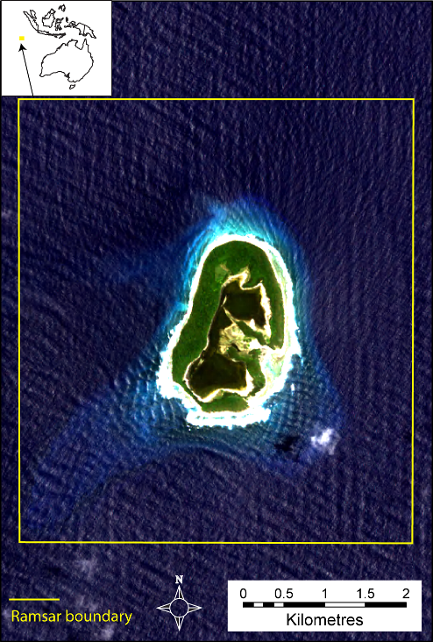

Figure E1: Location of the PKNP Ramsar site.

PKNP Ramsar site meets the following six Ramsar listing criteria:

Criterion 1: A wetland should be considered internationally important if it contains a representative, rare, or unique example of a natural or near-natural wetland type found within the appropriate biogeographic region.
The northern Pulu Keeling Island has never been permanently inhabited and this, coupled with the remote location of this site has resulted in wetlands in near-natural condition. As such the PKNP Ramsar site contains the best examples of coral, sandy and rocky shore wetland types in the bioregion.

Criterion 2: A wetland should be considered internationally important if it supports vulnerable, endangered, or critically endangered species or threatened ecological communities.
PKNP Ramsar wetland supports three threatened species; Cocos buff-banded rail (Gallirallus philippensis andrewsi) listed as endangered under the EPBC Act and restricted to the Ramsar site (Director of National Parks 2004); green turtle (Chelonia mydas) and hawksbill turtle (Eretmochelys imbricata) both listed as vulnerable under the EPBC Act and endangered under the IUCN Red List.

Criterion 3: A wetland should be considered internationally important if it supports populations of plant and/or animal species important for maintaining the biological diversity of a particular biogeographic region.
The PKNP Ramsar site supports three endemic species: the Cocos buff-banded rail; the Cocos sub-species of Pandanus tectorius; and the angelfish Centropyge joculator, which only occurs at Christmas and the Cocos (Keeling) Islands (Woodroffe and Berry 1994). In addition, the PKNP Ramsar site supports a number of species of plant and animal that are not recorded in the southern atoll islands. It has been suggested that this is due to the lack of human activity in the Ramsar site (Williams 1994; Stokes 1994). Stokes et al. 1984 described the main atoll as “virtually barren of birds” and considered the North Keeling Island (synonymous with the Ramsar site) as one of the few remaining pristine tropical islands in the Indian Ocean. As such the site, which supports flora and fauna that no longer occurs on the southern atoll islands, is important in maintaining biodiversity within the bioregion.

Criterion 4: A wetland should be considered internationally important if it supports plant and/or animal species at a critical stage in their life cycles, or provides refuge during adverse conditions.
The PKNP Ramsar site supports 13 species of waterbird listed as migratory under international treaties (see Appendix B) and two species of migratory turtles (green and hawksbill). In addition, the site support breeding of 15 species of waterbird (Appendix B); including the red-footed booby (Sula sula); lesser frigatebird (Fregata ariel), greater frigatebird (Fregata minor) and common noddy (Anous stolidus) that all breed in significant numbers within the Ramsar site (Director of National Parks 2004):

Criterion 5: A wetland should be considered internationally important if it regularly supports 20 000 or more waterbirds.
The site regularly supports more than 30 000 pairs of red-footed booby; up to 15 000 common noddy and 3000 greater and lesser frigate birds (Stokes et al. 1984).

Criterion 6: A wetland should be considered internationally important if it regularly supports one percent of the individuals in a population of one species or subspecies of waterbird.
The PKNP Ramsar site regularly supports 30 000 breeding pairs of red-footed booby (six percent of the global population; and 3000 breeding pairs of lesser frigatebirds (three percent of the global population).

The PKNP Ramsar site was listed in 1996 and this is the point in time for which the ecological character description is based. A summary of the components and processes important to the ecological character of the PKNP Ramsar site is provided in Table E1. This includes those that are considered essential elements as well as those identified as critical to the ecological character of the site and for which Limits of Acceptable Change have been developed. Critical components and processes as well as essential elements were selected on the basis of their role in maintaining the ecological character of the site, the ecosystem services they support (Table E2) and the Ramsar criteria for which the site is listed. The interactions between components and process, benefits and services and the Ramsar criteria the site meets are illustrated in a simple conceptual model (Figure E2).

Table E1: Summary of components and processes important for maintaining the ecological character of the PKNP Ramsar site.
Component / process | Description
Essential elements
Climate |  | - Warm tropical climatic zone.  - High rainfall (2000 millimetres per year).  - Warm to hot year round.
Geomorphology |  | - Island comprises calcareous sand and rubble of coral origin.  - Reef crest surrounding island.  - Central lagoon of sand and muds with intertidal sandy area.  - Sandy beach on northern shores.
Hydrology |  | - No surface freshwater.  - Semi -diurnal tide of 1 to 1.5 metres.  - Hydrological connection between lagoon and Indian Ocean.
Water quality |  | - Data deficient – no information could be sourced.
Vegetation |  | - Tall (30 metre) pisonia forest covers much of the island.  - Saltmarsh herblands and Octopus shrublands near the lagoon shores.
Critical components and processes
Seagrass |  | - Data deficient - seagrass (turtle grass) in the lagoon area.
Marine invertebrates |  | - Diverse community of Indo-Pacific species. A number of species recorded in the site do not occur in the southern atoll including the coconut or robber crab (Birgus latro).  - A small number of red crab (Gecarcoidea natalis) are also present.
Fish |  | - Community predominantly of Indo-Pacific origin.  - Endemism is low, but a number of species are at the western extent of their range at Cocos Island and there is evidence of hybridisation.
Turtles |  | - Important foraging for the hawksbill turtle and breeding for the green turtle (both listed as vulnerable under the EPBC Act).  - The green turtle population is believed to be resident in the Cocos (Keeling) Islands
Waterbirds |  | - 23 species of waterbird; 15 species recorded breeding.  - Significant numbers of red-footed booby (30 000 pairs annually)  - Large numbers of lesser and greater frigatebirds and common noddy  - Cocos buff-banded rail is endemic and the Ramsar site has the only known population.

Ecosystem benefits and services are defined under the Millennium Ecosystem Assessment definition of ecosystem services as "the benefits that people receive from ecosystems” (Ramsar Convention 2005, Resolution IX.1 Annex A). This includes benefits that directly affect people such as the provision of food or water resources as well as indirect ecological benefits.

Identified benefits and services of the PKNP Ramsar site are summarised in Table E2. There is no evidence to substantiate a case for provisioning or regulating services within the PKNP Ramsar site. The site is wholly contained within a national park and although resources were used in the past (timber, nuts, birds) the site is now largely protected from resource harvesting. In addition, the small size of the site and its remote location makes it unlikely to play a substantial role in regulating the surrounding environment. The four supporting services: near natural wetland types, threatened species, biodiversity and provides physical habitat for breeding waterbirds were identified as critical to the ecological character of the Ramsar site.

Table E2: Summary of the benefits and services of the PKNP Ramsar site (critical services shown shaded).
Category | Description
Cultural services
Recreation and tourism | - Although the site is remote and access is controlled, the site is important for passive recreation such as diving and bird watching.
Cultural heritage | - Shipwreck of the Emden  - Historical significance for the Cocos Malay people
Scientific and educational | - PKNP Ramsar site has been (and continues to be) used for long-term scientific studies. Examples include red-footed booby surveys; breeding and migration of turtles and reef health.
Supporting services
Supports near-natural wetland types | - PKNP is regarded as one of the most pristine coral atolls in the Indian Ocean (Director of National Parks 2004) and supports a number of largely unmodified wetland types.
Threatened species | - The PKNP Ramsar site supports the following threatened species:  - the endangered Cocos buff-banded rail  - the vulnerable green turtle and hawksbill turtle
Biodiversity | - PKNP Ramsar site supports a number of species that are no longer present in the southern atoll, making it significant in the Cocos Island IMCRA Province.  - In addition, the site supports a diversity of fish and marine invertebrates, many at the extent of their ranges.
Provides physical habitat for breeding waterbirds | - The site supports large colonial waterbird breeding of red-footed booby, lesser frigate bird and common noddy

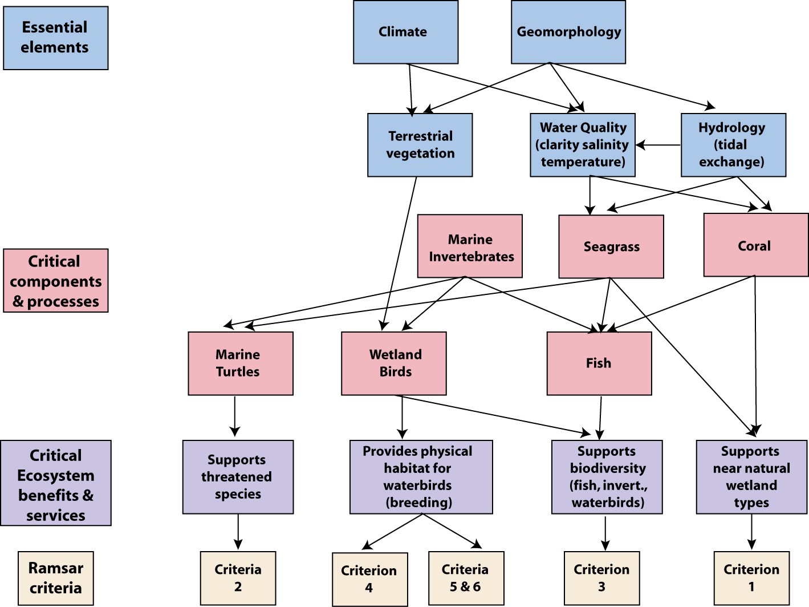
Figure E2: Simple conceptual model for the PKNP Ramsar site.
“Limits of acceptable change” (LAC) is the terminology used to describe complex judgements as to what extent critical components, processes benefits and services of the site can vary without representing a change in the ecological character. Limits of acceptable change for the PKNP Ramsar site have been proposed for critical components, processes and benefits and services based on existing data and guidelines and are summarised in Table E3.

Table E3: Proposed LAC for the PKNP Ramsar site.
Component/Process  Benefit / Service | Limit of Acceptable Change
Component: Seagrass  Services: Biodiversity | Presence of seagrass within the lagoon
Component: Marine invertebrates - coral  Services: Biodiversity | Coral damage, bleaching and disease at the monitoring location (Bunya Coral) to be “low” as defined in the reef monitoring methodology (Commonwealth of Australia 2005a)
Component: Fish  Service: Biodiversity | Data deficient, baseline must be determined before limits can be set
Component: Turtles  Service: Threatened species | - Presence of hawksbill turtles within the site.  - Successful nesting of green turtle on the sandy beaches each year.
Component: Waterbirds  Services: Physical habitat for breeding waterbirds; ecological connectivity, threatened species | Mean abundance of red-footed booby greater than  23 000 pairs (calculated over five years)
 | Mean abundance of Cocos buff-banded rail greater than 5.5 birds per hectare.

The remote location of the site, together with the fact that the site is located within a national park, decreases the number and magnitude of threats to the ecological character of the PKNP Ramsar site. There are, however, a number of threats that could potentially impact on the ecological character of the site. A description of each of these threats is provided in Table E4.

Table E4: Summary of threats to the ecological character of the Ramsar site.
Actual or likely threat | Potential impact(s) to wetland components, processes and/or service | Likelihood¹ | Timing
Biological resource use - fishing | - Changed fish community composition  - Ecological effects to reef community | Medium | Medium to long term
Biological resource use – hunting seabirds | - Decreased population of seabirds  - Food chain effects | Medium | Immediate to long term
Invasive species (yellow crazy ant) | - Impacts to land based invertebrate populations  - Food chain effects  - Loss of Pisonia canopy and subsequent effects on seabird breeding | Certain | Immediate
Human intrusions and disturbance – recreation and tourism. | - Disturbance of nesting seabirds  - Introduction of additional invasive species | Medium | Immediate
Climate change:  Increased sea temperature; storms; sea level rise | - Loss of vegetation, leading to a decline in seabirds  - Increase in coral bleaching and disease | Medium | Long-term

There is no evidence of any significant changes in the coral reef areas of the PKNP Ramsar site, or in numbers of birds. However, in 2005, the lagoon entrance within the Ramsar site closed (as a result of natural forces of deposition) which has led to significant changes within this habitat (Hobbs in prep.). Seagrass is no longer present in the lagoon area, but has been replaced by a cyanobacterial mat one to 50 centimetres thick across the entire lagoon surface. As a consequence the lagoon no longer supports large numbers of fish and invertebrates and it is considered that the mud crab (Scylla sp) and bonefish (Albula glossodonta) have become locally extinct (Hobbs in prep.). The impact of the lagoon closure on the Cocos buff-banded rail remains unknown. However, as this species was often observed feeding on invertebrates along the lagoon shore, the impact on food resources may be significant. The closure of the lagoon, although due to natural, rather than anthropogenic causes is considered to represent a change in ecological character of the PKNP Ramsar site.

Knowledge gaps that are required to fully describe the ecological character of this site and enable rigorous and defensible limits of acceptable change to be met are relatively few and listed in Table E5. Collection of information at PKNP Ramsar site is difficult due to the remote location and difficulty of access. In recognition of this, recommended actions are aimed at developing indicators of ecological character that could fill knowledge gaps and help in the design of on-going monitoring. Monitoring to fill knowledge gaps and assess against LAC has also been recommended and is summarised in Table E6

Table E5: Knowledge gaps for the PKNP Ramsar site
Component / process | Knowledge Gap | Recommended Action
Terrestrial vegetation | Knowledge of the extent and distribution of vegetation is limited to a single survey in 1994. There is no information on vegetation condition or variability in extent and canopy cover. Observations of a reduction in canopy cover following cyclones have been made (Director of National Parks 2004) but no indication of rates of recovery. | Assessment of vegetation extent from high resolution aerial photography or satellite imagery; including impacts of cyclones and recovery of canopy.
Invertebrates | No indication of variability in community composition and abundance. | Development of indicator species and implementation of a monitoring program
Fish | No indication of variability in community composition and abundance | Development of indicator species and implementation of a monitoring program
Marine turtles | Importance of the site for foraging marine turtles remains unknown. No indication of variability in green turtle nesting numbers | Regular marine turtle surveys
Waterbirds | Abundance, diversity and variability in seabird numbers within the Ramsar site | Regular seabird counts.

Table E6: Recommended monitoring for the PKNP Ramsar site
Component/ Process | Purpose | Indicator | Frequency | Priority
Vegetation - extent | Inform site management | Extent | Every 5 years | Moderate
Weeds | Threat indicator | Location, extent, species | Annual | Moderate
Yellow crazy ants | Threat indicator | Abundance, presence of scale | Every 2 years | High
Coral | Assessment against LAC | Coral health | Annual | Moderate
Fish | Fill knowledge gap, set baseline | Abundance, community composition | Every 2 – 5 years | High
Waterbirds | Assessment against LAC | Abundance and species identifications, breeding observations | Annual | High
Marine turtles | Assessment against LAC | Nesting surveys | Annual | Moderate

1. Introduction

1.1 Site details
The Pulu Keeling National Park Ramsar site (henceforth referred to as PKNP Ramsar Site) comprises North Keeling Island in the Australian territory of the Cocos (Keeling) Islands, approximately 2800 kilometres northwest of Perth in the Indian Ocean. It was originally nominated as a “Wetland of International Importance” under the Ramsar Convention in 1996. Site details for this Ramsar wetland are provided in Table 1.

Table 1: Site details for the PKNP Ramsar site taken from the Ramsar Information Sheet (1999).
Site Name | Pulu Keeling National Park
Location in coordinates | Latitude: 11° 49' S  Longitude: 96° 49' E
General location of the site | The PKNP Ramsar site is located in the Australian Territory of the Cocos (Keeling) Islands in the Indian Ocean. The site is 3685 kilometres west of Darwin (NT) and 2768 kilometres north-west of Perth (WA); 24 kilometres north of the southern atolls of the Cocos (Keeling) Islands.  Cocos (Keeling) Island Province (IMCRA v4 Commonwealth of Australia 2006).
Area | 2602 hectares
Date of Ramsar site designation | Designated on 17 March 1996
Ramsar criteria met by wetland | Ramsar criteria 1, 2, 3, 4, 5, 6
Management authority for the site | Director of National Parks, Australia under lease from the Cocos (Keeling) Islands Shire Council.
Date the ECD applies | 1996
Status of description | This represents the first ECD for the site
Date of compilation | June 2010
Name(s) of compiler(s) | Jennifer Hale on behalf of the Department of Sustainability, Environment, Water, Population and Communities
References to the Ramsar Information Sheet (RIS) | Pulu Keeling National Park Ramsar Site RIS compiled by Environment Australia in 1999.  Updated by Jennifer Hale on behalf of the Department of Sustainability, Environment, Water, Population and Communities 2010
References to management plan(s) | Pulu Keeling National Park Management Plan, Director of National Parks, 2004

1.2 Statement of purpose
The act of designating a wetland as a Ramsar site carries with it certain obligations, including managing the site to retain its ‘ecological character’ and to have procedures in place to detect if any threatening processes are likely to, or have altered the ‘ecological character’. Thus, understanding and describing the ‘ecological character’ of a Ramsar site is a fundamental management tool for signatories and local site managers which should form the baseline or benchmark for management planning and action, including site monitoring to detect negative impacts.

The Ramsar Convention has defined “ecological character” and “change in ecological character” as (Ramsar 2005):

“Ecological character is the combination of the ecosystem components, processes and benefits/services that characterise the wetlands at a given point in time”
And
“…change in ecological character is the human induced adverse alteration of any ecosystem component, process and or ecosystem benefit/service.”

In order to detect change it is necessary to establish a benchmark for management and planning purposes. Ecological character descriptions (ECD) form the foundation on which a site management plan and associated monitoring and evaluation activities are based. The legal framework for ensuring the ecological character of all Australian Ramsar sites is maintained is the Environment Protection and Biodiversity Conservation Act 1999 (the EPBC Act) (Figure 1). A Ramsar Information Sheet is prepared at the time of designation. However whilst there is some link between the data used for listing a site (based on the various criteria) the information in an RIS does not provide sufficient detail on the interactions between ecological components, processes and functions to constitute a comprehensive description of ecological character. In response to the short fall, the Australian and state/territory governments have developed a National Framework and Guidance for Describing the Ecological Character of Australia’s Ramsar Wetlands. Module 2 of Australian National Guidelines for Ramsar Wetlands – Implementing the Ramsar Convention in Australia (DEWHA 2008).

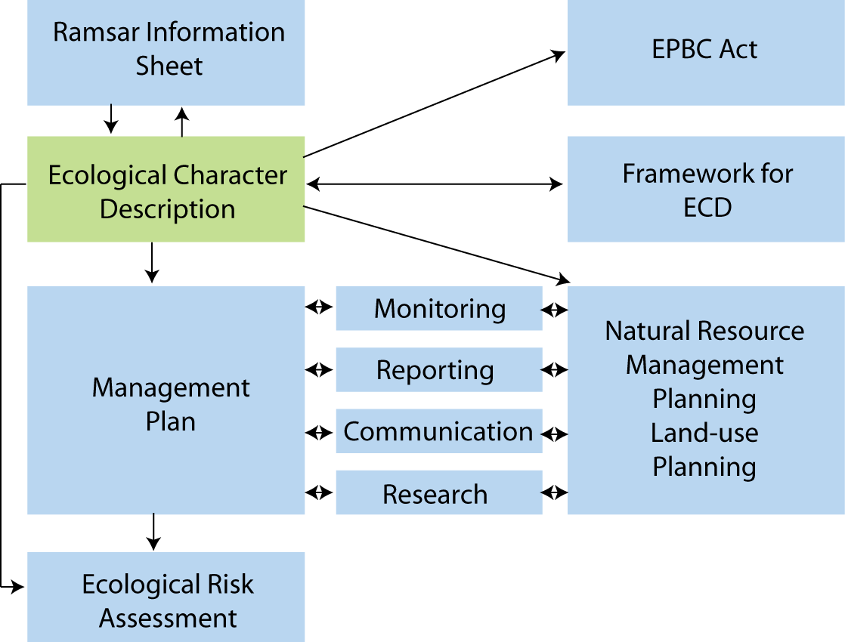

Figure 1: The ecological character description in the context of other requirements for the management of Ramsar sites (adapted from DEWHA 2008).

The framework emphasises the importance of describing and quantifying the ecosystem components, processes and benefits/services of the wetland and the relationship between them. It is also important that information is provided on the benchmarks or ecologically significant limits of acceptable change that would indicate when the ecological character has or is likely to change.

McGrath (2006) detailed the general aims of an ECD as follows:

- To assist in implementing Australia’s obligations under the Ramsar Convention, as stated in Schedule 6 (Managing wetlands of international importance) of the Environment Protection and Biodiversity Conservation Regulations 2000 (Commonwealth):
  - To describe and maintain the ecological character of declared Ramsar wetlands in Australia; and
  - To formulate and implement planning that promotes:
    - Conservation of the wetland; and
    - Wise and sustainable use of the wetland for the benefit of humanity in a way that is compatible with maintenance of the natural properties of the ecosystem.
- To assist in fulfilling Australia’s obligation under the Ramsar Convention to arrange to be informed at the earliest possible time if the ecological character of any wetland in its territory and included in the Ramsar List has changed, is changing or is likely to change as the result of technological developments, pollution or other human interference.
- To supplement the description of the ecological character contained in the Ramsar Information Sheet submitted under the Ramsar Convention for each listed wetland and, collectively, form an official record of the ecological character of the site.
- To assist the administration of the EPBC Act, particularly:
  - To determine whether an action has, will have or is likely to have a significant impact on a declared Ramsar wetland in contravention of sections 16 and 17B of the EPBC Act; or
  - To assess the impacts that actions referred to the Minister under Part 7 of the EPBC Act have had, will have or are likely to have on a declared Ramsar wetland.
- To assist any person considering taking an action that may impact on a declared Ramsar wetland whether to refer the action to the Minister under Part 7 of the EPBC Act for assessment and approval.
- To inform members of the public who are interested generally in declared Ramsar wetlands to understand and value the wetlands.

1.3 Relevant treaties, legislation and regulations
This section provides a brief listing of the legislation and policy that is relevant to the description of the ecological character of the Ramsar site.

International
Ramsar Convention
The Convention on Wetlands of International Importance, otherwise known as the Ramsar Convention, was signed in Ramsar Iran in 1971 and came into force in 1975. It provides the framework for local, regional and national actions, and international cooperation, for the conservation and wise use of wetlands. Wetlands of international importance are selected on the basis of their international significance in terms of ecology, botany, zoology, limnology and or hydrology.

Migratory bird bilateral agreements and conventions
Australia is party to a number of bilateral agreements, initiatives and conventions for the conservation of migratory birds, which are relevant to the PKNP Ramsar site. The bilateral agreements are:

- JAMBA – The agreement between the Government of Australia and the Government of Japan for the Protection of Migratory Birds in Danger of Extinction and their Environment, 1974;
- CAMBA - The Agreement between the Government of Australia and the Government of the People's Republic of China for the Protection of Migratory Birds and their Environment 1986;
- ROKAMBA - The Agreement between the Government of Australia and the Republic of Korea for the Protection of Migratory Birds and their Environment, 2006; and
- The Bonn Convention on Migratory Species (CMS) - The Bonn Convention adopts a framework in which countries with jurisdiction over any part of the range of a particular species co-operate to prevent migratory species becoming endangered. For Australian purposes, many of the species are migratory birds.

National legislation
Environment Protection and Biodiversity Conservation Act 1999 (EPBC Act)
The EPBC Act regulates actions that will have or are likely to have a significant impact on any matter of national environmental significance, which includes the ecological character of a Ramsar wetland (EPBC Act 1999 s16(1)). An action that will have or is likely to have a significant impact on a Ramsar wetland will require an environmental assessment and approval under the EPBC Act. An ‘action’ includes a project, a development, an undertaking or an activity or series of activities (http://www.environment.gov.au/epbc/index.html).

The EPBC Act establishes a framework for managing Ramsar wetlands, through the Australian Ramsar Management Principles (EPBC Act 1999 s335), which are set out in Schedule 6 of the Environment Protection and Biodiversity Conservation Regulations 2000. These principles are intended to promote national standards of management, planning, environmental impact assessment, community involvement, and monitoring, for all of Australia’s Ramsar wetlands in a way that is consistent with Australia’s obligations under the Ramsar Convention. Some matters protected under the EPBC Act are not protected under local or state/territory legislation, and as such, many migratory birds are not specifically protected under State legislation (though they are in Western Australia). Species listed under international treaties JAMBA, CAMBA and CMS have been included in the List of Migratory species under the Act. Threatened species and communities listed under the EPBC Act may also occur, or have habitat in the Ramsar site; some species listed under State legislation as threatened are not listed under the EPBC Act as threatened, usually because they are not threatened at the national (often equivalent to whole-of-population) level. The Regulations also cover matters relevant to the preparation of management plans, environmental assessment of actions that may affect the site, and the community consultation process.

The Pulu Keeling National Park was proclaimed under the National Parks and Wildlife
Conservation Act 1975 (which was replaced by the EPBC Act) and the Park is continued as a Commonwealth reserve under the EPBC Act by the Environmental Reform (Consequential Provisions) Act 1999 which deems the Park to have been declared for:
- the preservation of the area in its natural condition; and
- the encouragement and regulation of the appropriate use, appreciation and enjoyment of the area by the public.

Administration and management of Commonwealth reserves are a function of the Director of National Parks under the EPBC Act (s.514B).

Historic Shipwrecks Act 1976
The Ramsar site contains a shipwreck (HMS Emden) is a declared historic shipwreck under this Act. The Act prohibits conduct that: destroys or causes damage to a historic shipwreck; causes interference with a historic shipwreck; causes the disposal of a historic shipwreck; or causes a historic shipwreck to be removed from Australia.

Lease agreement
Pulu Keeling National Park is leased to the Director of National Parks by the Cocos (Keeling) Islands Shire Council. The island is leased for the purposes of administration, management and control of the Park in accordance with the EPBC Act. Under the Lease agreement the Director has covenanted:
- that the flora, fauna and natural environment of the Park will be preserved, managed and maintained according to the best comparable management practices established for national parks anywhere in the world (or if no comparable management practices exist, to the highest standards practicable); and
- to take all practicable steps to ensure compliance with the Lease, the EPBC Act, the EPBC Regulations and the management plans for the Park.

The lease provides for the establishment and continuation of the Pulu Keeling National Park Community Management Committee to advise on matters relating to the management of the site.

1.4 Method
The method used to develop the ecological character description for the PKNP Ramsar site is based on the twelve-step approach provided in the National Framework and Guidance for Describing the Ecological Character of Australia’s Ramsar Wetlands (DEWHA 2008) illustrated in Figure 2. A more detailed description of each of the steps and outputs required is provided in the source document.

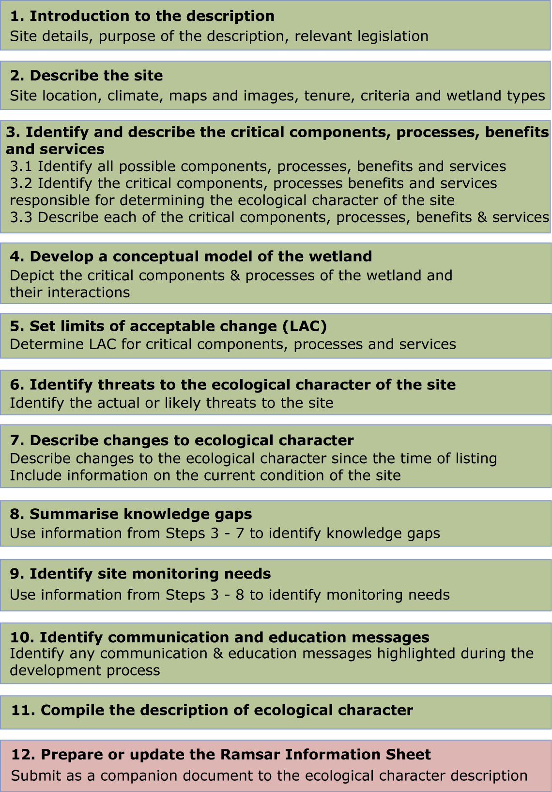
Figure 2: Twelve step process for developing an ECD (adapted from DEWHA 2008).

This ECD was developed primarily through a desktop assessment and is based on existing data and information. A stakeholder advisory group was formed to provide input and comment on the ECD. Details of members of this group and more details of the method are provided in Appendix A.

2. General Description of the PKNP Ramsar Site

2.1 Location
The PKNP Ramsar site is located in the Indian Ocean approximately 2900 kilometres northwest of Perth, Australia and 900 kilometres southwest of Christmas Island. The Cocos (Keeling) Islands are an Australian territory comprising twenty-seven coral islands with a total land area of approximately 14 square kilometres. There are 26 islands in the southern atoll of which two, Home Island and West Island, are inhabited. North Keeling Island (the PKNP Ramsar site) is located 24 kilometres to the north and the boundary of the Ramsar site coincides with that of the National Park (Figure 3). The population of the Cocos (Keeling) Islands was 621 in 2006; 130 residents on West Island and the remainder on Home Island. The Ramsar site is uninhabited (Attorney General’s Department 2009). The Cocos (Keeling) Island Shire Council is the local government authority.

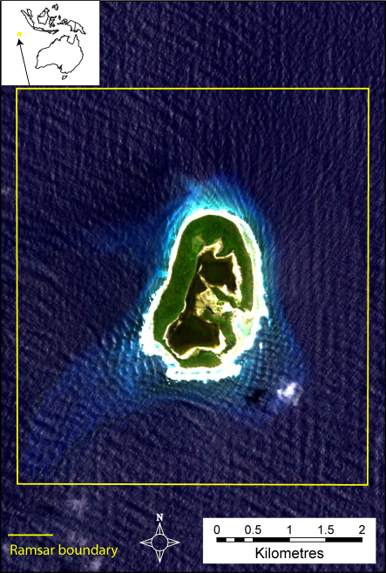
Figure 3: Location of the PKNP Ramsar Site (data supplied by DSEWPaC).

2.2 Overview of the site
PKNP Ramsar site is a coral atoll comprising of approximately 122 hectares of land above high water mark and 2480 hectares of surrounding coral reef and sea. The centre of the atoll contains a single, tidal lagoon with a narrow connection to the Indian Ocean on the eastern side. The island is young in geological terms, having formed less than 4000 years ago. As such all of the terrestrial flora and fauna have colonised since this time and community compositions reflect the Indo-Malay origins (Williams 1994).

Thirty-nine species of vascular plant (including six exotic species) have been recorded within the Ramsar site (Director of National Parks 2004). Vegetation of the site is floristically distinct from that of the southern atolls, which Williams (1994) suggested was due to decreased impacts from human activities. The vascular plant list includes a single species of seagrass (Thalassia hemprichii), which occurs within the lagoon (Director of National Parks 2004).

Terrestrial vegetation on the site is dominated by forests of pisona (Pisonia grandis) and coconut (Cocos nucifera) the former of which is suspected to be an endemic sub-species (Williams 1994). There are also areas of octopus bush (Heliotropium foertherianum); tea shrub (Pemphis acidula) and ironwood (Cordia subcordata) shrublands and halopytic herblands.

Terrestrial fauna is limited to birds, land crabs and one species of gecko (Lepidodactylus lugubris). The site formerly contained rabbits, but these had disappeared by the time of listing and the site has never been colonised by rats (Director of National Parks 2004). The site is significant for the number of seabirds it supports including large breeding colonies of red-footed booby (Sula sula) and lesser frigatebirds (Fregata ariel). An endemic species of buff-banded rail (Gallirallus philippensis andrews) is a resident within the Ramsar site. Fish and marine invertebrate fauna are abundant, but surveys are limited. While there are few endemic species present, the fish fauna is considered unique due to the mixing of Indian and Pacific Ocean species which are at the edge of their distributions (Hobbs and Salmond 2008). This mixing has led to considerable hybridisation and the Cocos (Keeling) Islands (including North Keeling) and Christmas Island are considered global hotspots for hybridisation in marine fishes (Hobbs et al. 2009).

The site has remained largely uninhabited, with the exception of visits for short periods from the southern atoll residents for timber and nut collecting as well as bird hunting (Bunce 1988). In 1914 the German warship the SMS Emden ran aground at Pulu Keeling following an encounter with the HMS Sydney. The salvage of the vessel from October 1915 to January 1916 by islanders probably represents the longest period of settlement within the Ramsar site (Woodroffe and McLean 1994). Despite further salvage of the vessel by a professional Japanese salvage company in the 1950s, parts of the wreck remain on the reef of the southern shore and are protected by Australia's Historic Shipwreck Act.

Pulu Keeling is important to the local Cocos Malay community both economically and spiritually. The pristine nature of the site attracts tourists and special interest groups that must be transported to and from the island daily and accommodated on the southern atoll (camping is forbidden in the Ramsar site). This provides a valuable source of income for local residents of the southern atoll (Director of National Parks 2004). In addition, the PKNP Ramsar site features in traditional stories, including that of the female penunggu of guardian of the island, who lives in an area surrounding the landing place on Pulu Keeling and protects the atoll (Bunce 1988).

2.3 Land tenure
The entire PKNP Ramsar site is a declared Commonwealth National Park on lease from the Cocos (Keeling) Shire Council to the Director of National Parks.

2.4 Wetland types
Classification of wetlands into discrete types is a difficult exercise and an inexact science. Clear boundaries are difficult to define or delineate and multiple wetland types could be considered to apply to the same wetland (e.g. Type B - Marine subtidal aquatic beds and Type J – Coastal saline lagoons; at PKNP are not necessarily mutually exclusive and could both be applied to the lagoon within the Ramsar site).

The 1999 RIS for the site (Environment Australia 1999) identified the following four Ramsar wetland types within the PKNP Ramsar site (see section 4.3.1 for descriptions):

- B - Marine subtidal aquatic beds; includes kelp beds, sea-grass beds, tropical marine meadows (applies to the areas of seagrass within the lagoon in the Ramsar site).
- C - Coral reefs (extensive coral reefs surround the atoll).
- D - Rocky marine shores; includes rocky offshore islands, sea cliffs (applies to areas of rocky outcrops along the western and southern shores).
- E - Sand, shingle or pebble shores; includes sand bars, spits and sandy islets; includes dune systems and humid dune slacks (the atoll has an area of sandy beach on the north coast; and more extensive areas of pebble beaches around the remainder of the island).

The lagoon within the PKNP Ramsar site has a narrow connection to the Indian Ocean on the eastern side of the island through which water is exchanged during tidal cycles. As such, a fifth wetland type could also be considered to occur within the site:

- J - Coastal brackish/saline lagoons; brackish to saline lagoons with at least one relatively narrow connection to the sea.

Although there is insufficient information to map wetland types within the Ramsar site, indicative locations are provided in Figure 4 and examples of some types in Figures 5 to 7.

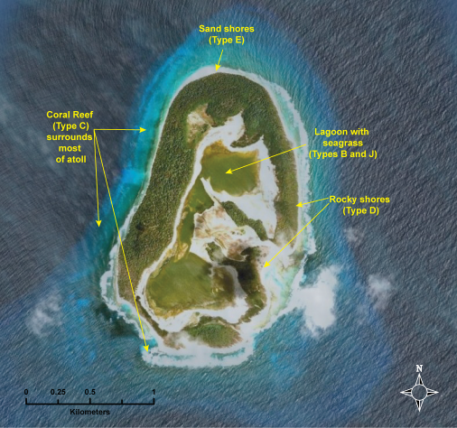
Figure 4: General location of examples of wetlands types within the PKNP Ramsar site.
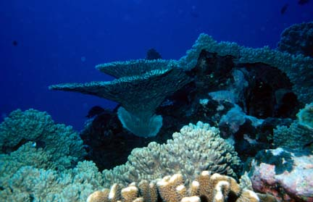
Figure 5: Example of wetland type C - “coral reef”; photograph by Robert Thorn.

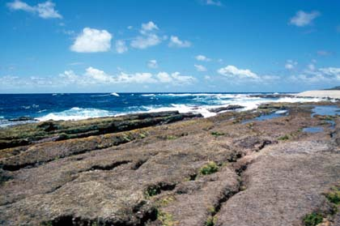
Figure 6: Example of wetland type D- “rocky marine shores”; photograph by Robert Thorn.

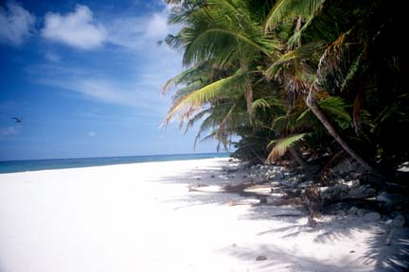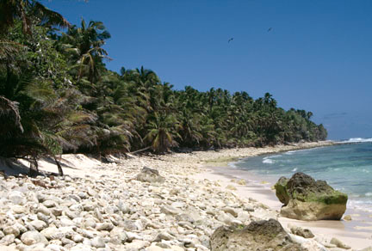
Figure 7: Examples of wetland type E- “sand shingle or pebble shores”; photograph by Robert Thorn.

2.5 Ramsar criteria

2.5.1 Criteria under which the site was designated
At the time that the PKNP site was first nominated as a Wetland of International Importance (1996), the criteria for identifying Wetlands of International Importance were those, adopted at the fourth conference of contracting parties in Montreaux in 1990. The original nomination documentation for the PKNP Ramsar site considered that the site met five of these criteria as shown in (Table 2). However, no specific justification for these criteria was provided.

Table 2: Criteria for Identifying Wetlands of International Importance as at listing date, 1990. Criteria for which the PKNP Ramsar site has been listed are highlighted in green.
Basis | Number | Description
Criteria for representative or unique wetlands | 1a | it is a particularly good representative example of a natural or near-natural wetland, characteristic of the appropriate biogeographical region.
Criteria for representative or unique wetlands | 1b | it is a particularly good representative example of a natural or near-natural wetland, common to more than one biogeographical region.
Criteria for representative or unique wetlands | 1c | it is a particularly good representative example of a wetland, which plays a substantial hydrological, biological or ecological role in the natural functioning of a major river basin or coastal system, especially where it is located in a trans-border position.
Criteria for representative or unique wetlands | 1d | it is an example of a specific type of wetland, rare or unusual in the appropriate biogeographical region.
General Criteria based on plants and animals | 2a | it supports an appreciable assemblage of rare, vulnerable or endangered species or subspecies of plant or animal, or an appreciable number of individuals of any one or more of these species.
General Criteria based on plants and animals | 2b | it is of special value for maintaining the genetic and ecological diversity of a region because of the quality and peculiarities of its flora and fauna.
General Criteria based on plants and animals | 2c | it is of special value as the habitat of plants or animals at a critical stage of their biological cycle.
General Criteria based on plants and animals | 2d | it is of special value for one or more endemic plant or animal species or communities.
Specific criteria based on waterfowl | 3a | it regularly supports 20,000 waterfowl.
Specific criteria based on waterfowl | 3b | it regularly supports substantial numbers of individuals from particular groups of waterfowl, indicative of wetland values, productivity or diversity.
Specific criteria based on waterfowl | 3c | where data on populations are available, it regularly supports one percent of the individuals in a population of one species or subspecies of waterfowl.

2.5.2 Assessment based on current information and Ramsar criteria
There have been a number of developments since the site was nominated in 1995 (and listed in 1996) that influence the application of the Ramsar criteria to wetland sites this includes:

- Refinements and revisions of the Ramsar criteria. They have been re-numbered and in 1996, an additional two criteria (criteria seven and eight) were adopted by the Ramsar Convention in Brisbane and a ninth criterion was added at the ninth Ramsar Conference in Uganda in 2005.

- Revision of population estimates for waterbirds (Wetlands International 2006; Bamford et al. 2008), which influences the application of criterion six.

- A decision with respect to the appropriate bioregionalisation for aquatic systems in Australia, which for inland systems are now based on drainage divisions and for marine systems the interim marine classification and regionalisation for Australia (IMCRA). This affects the application of criteria one and three.

- Updating of threatened species listings, which affects criterion two.

Therefore an assessment of the PKNP Ramsar site against the current nine Ramsar criteria has been undertaken and included in the updated RIS completed in conjunction with this ECD (Table 3). In deciding if the site qualifies under criterion six (regularly supports one percent of the individuals in a population of one species of waterbird), an approach consistent with the Ramsar Convention has been adopted.

Table 3: Criteria for Identifying Wetlands of International Importance (adopted by the 7th (1999) and 9th (2005) Meetings of the Conference of the Contracting Parties). Criteria for which the PKNP Ramsar site qualifies are highlighted in green.
Number | Basis | Description
Group A. Sites containing representative, rare or unique wetland types
Criterion 1 |  | A wetland should be considered internationally important if it contains a representative, rare, or unique example of a natural or near-natural wetland type found within the appropriate biogeographic region.
Group B. Sites of international importance for conserving biological diversity
Criterion 2 | Species and ecological communities | A wetland should be considered internationally important if it supports vulnerable, endangered, or critically endangered species or threatened ecological communities.
Criterion 3 | Species and ecological communities | A wetland should be considered internationally important if it supports populations of plant and/or animal species important for maintaining the biological diversity of a particular biogeographic region.
Criterion 4 | Species and ecological communities | A wetland should be considered internationally important if it supports plant and/or animal species at a critical stage in their life cycles, or provides refuge during adverse conditions.
Criterion 5 | Waterbirds | A wetland should be considered internationally important if it regularly supports 20 000 or more waterbirds.
Criterion 6 | Waterbirds | A wetland should be considered internationally important if it regularly supports one percent of the individuals in a population of one species or subspecies of waterbird.
Criterion 7 | Fish | A wetland should be considered internationally important if it supports a significant proportion of indigenous fish subspecies, species or families, life-history stages, species interactions and/or populations that are representative of wetland benefits and/or values and thereby contributes to global biological diversity.
Criterion 8 | Fish | A wetland should be considered internationally important if it is an important source of food for fishes, spawning ground, nursery and/or migration path on which fish stocks, either within the wetland or elsewhere, depend.
Criterion 9 | Other taxa | A wetland should be considered internationally important if it regularly supports one percent of the individuals in a population of one species or subspecies of wetland-dependent non-avian animal species.

An assessment against each of the criteria for the PKNP Ramsar site is as follows:

Criterion 1: The application of this criterion must be considered in the context of the Bioregion within which the site is located. As an offshore marine site, the appropriate bioregionalisation is the IMCRA v4.0 (Commonwealth of Australia 2006). The corresponding bioregion is the Cocos (Keeling) Island Province, which encompasses 467 260 square kilometres of the Indian Ocean surrounding the Cocos Keeling Islands (Heap et al. 2005).

The 27 islands that comprise the Cocos (Keeling) Islands represent the only land within the bioregion. Although all of the wetland types within the PKNP Ramsar site are represented in the islands of the southern atoll, there is a strong argument for those at the Ramsar site representing the best examples. The southern atolls are inhabited and have been impacted by various human activities (Woodroffe and Berry 1994). The northern Pulu Keeling Island has never been permanently inhabited and this, coupled with the remote location of this site has resulted in wetlands in near-natural condition. As such the PKNP Ramsar site met this criterion at the time of listing and continues to do so.

Criterion 2: In the Australian context, it is recommended that this criterion should only be applied with respect to nationally threatened species/communities, listed under the EPBC Act or the International Union for Conservation of Nature (IUCN) Red List. A number of threatened species listed at the national and / or international level have been recorded within the boundary of the PKNP Ramsar site. However, central to the application of this criterion are the words “a wetland” and “supports”. Guidance from Ramsar (Ramsar 2005) in applying the criteria indicates that the wetland must provide habitat for the species concerned. For this reason, vagrant species; such as the observations of passing whales and the single observation of a Christmas Island frigatebird (Fregata andrewsi) in 1986 (Stokes 1994) have not been considered to contribute to the meeting of this criterion. In addition, DEH (1999) suggests that the PKNP Ramsar site is the sole Australian location for the Round Island petrel. However, the single record for this species from the 1980s has not been verified and it has not been recorded within the site since, despite a number of dedicated surveys (DEW 2005) and as such cannot be said on available evidence to contribute to the site meeting this criterion.

There are three threatened species supported by the wetlands within the PKNP Ramsar site that contribute to the site meeting this criterion. This comprises a bird and two reptiles:

- Cocos buff-banded rail (Gallirallus philippensis andrewsi) listed as endangered under the EPBC Act is restricted to the Ramsar site (Director of National Parks 2004).

- Green turtle (Chelonia mydas) listed as vulnerable under the EPBC Act and endangered under the IUCN Red List regularly breeds in the sand beaches of the Ramsar site (Whiting 2006).

- Hawksbill turtle (Eretmochelys imbricata) listed as vulnerable under the EPBC Act and critically endangered under the IUCN Red List. Waters within the Ramsar site are considered critical feeding habitat for this species (Environment Australia 2003).

This criterion was met at the time of listing and continues to be met.

Criterion 3: Like criterion one, application of this criterion must be taken in the context of the appropriate bioregion, in this instance the IMCRA (v4) Cocos (Keeling) Province. Guidance from the Convention indicates that this criteria should be applied to "hotspots" of biological diversity, centres of endemism, sites that contain the range of biological diversity (including habitat types) occurring in a region; and/or support particular elements of biological diversity that are rare or particularly characteristic of the biogeographic region.

The island of the PKNP Ramsar site is of relatively recent geological age having formed some 3000 to 4000 years ago (Woodroffe et al. 1994) with sediments dating back only 1000 to 2000 years before present (Woodroffe and McLean 1994). This suggests that all of the biota associated with the land portion of the island have colonised in the past few thousand years and very low levels of endemism reflect this with the majority of biota from Indo-Malay origins (Woodroffe and Berry 1994).

However, the PKNP Ramsar site supports three endemic species: the Cocos buff-banded Rail; the Cocos sub-species of Pandanus tectorius; and the angelfish Centropyge joculator, which is only recorded from Christmas and the Cocos (Keeling) Islands (Woodroffe and Berry 1994). In addition, the PKNP Ramsar site supports a number of species of plant and animal that are not recorded in the southern atoll islands. It has been suggested that this is due to the lack of human activity in the Ramsar site (Williams 1994; Stokes 1994). Stokes et al. 1984 described the main atoll as “virtually barren of birds” and considered the North Keeling Island (synonymous with the Ramsar site) as one of the few remaining pristine tropical islands in the Indian Ocean. As such the site, which supports flora and fauna that no longer occurs on the southern atoll islands, is important in maintaining biodiversity within the bioregion.

A total of eight species of fish recorded at Pulu Keeling have not been observed in the southern atoll (Hobbs in prep.). In addition, Hobbs and Salmond (2008) indicated that the coral reef communities of the Cocos (Keeling) and Christmas Islands were globally unique. This was based on a high proportion of species occurring at the edge of their geographical range and the co-habitation of Indian and Pacific Oceans’ regional biota. The unique fish communities at these islands have produced the most recorded marine fish hybrids of any location in the world (Hobbs et al. 2009). Therefore, the islands are of global importance to the evolution of reef fishes, and possibly other coral reef taxa (Hobbs et al. 2009). Due to their isolated nature and protected status, the coral reefs of the PKNP Ramsar site represent the most pristine examples of this habitat type in the bioregion.

This criterion was met at the time of listing and continues to be met.

Criterion 4: The basic description of this criterion implies a number of common functions/roles that wetlands provide including supporting fauna during migration and supporting breeding. The PKNP Ramsar site supports 13 species of waterbird listed as migratory under international treaties (see Appendix B) and two species of migratory turtles (green and hawksbill). Although in the context of this site, many of these species of waterbird and the green turtle are considered resident populations (Stokes 1994; Whiting et al. 2008).

The site also supports breeding of green turtles (Whiting 2006) and15 species of waterbird (Appendix B); including the following species that breed in significant numbers within the Ramsar site (Director of National Parks 2004):

- Red-footed booby (Sula sula) – over 30 000 pairs observed in 1982 (Stokes et al. 1984) and similar numbers remain (Director of National Parks 2004);

- Lesser frigatebirds (Fregata ariel) – estimated that approximately 3000 breeding pairs regularly use the Ramsar site (Director of National Parks 2004);

- Greater frigatebirds (Fregata minor) – estimated that up to 3000 regularly use the island and many of these for breeding (Stokes 1982); and

- Common noddy (Anous stolidus) – 500 to 750 breeding pairs recorded (Stokes 1982).

This criterion was met at the time of listing and continues to be met.

Criteria 5 and 6: These criteria were not included in the original nomination document, but on examination of information on birds within the PKNP Ramsar site, a strong case can be made for both of these criteria. Ramsar defines waterbirds as “birds ecologically dependent on wetlands" and includes the family Pelicaniformes in the list of taxa included in this definition (Ramsar Convention 2009). Although the taxonomy of the Pelicaniformes is contentious (Hackett et al. 2008) both the EPBC Act and the IUCN Red List include a number of seabirds in this order including the red-footed booby, and the greater and lesser frigatebird. If these birds are considered to be waterbirds under the Ramsar definition, then the site clearly meets criteria five and six.

Although complete counts of waterbirds within the Ramsar site are rare, there is strong evidence to suggest that the site regularly supports in excess of 20 000 waterbirds. Stokes et al. (1984) reported more than 15 000 common noddy; 60 000 red-footed booby and upwards of 3000 greater and lesser frigatebirds. It is estimated that the site regularly supports approximately 30 000 pairs of red-footed booby (Baker et al. 2004).

The Waterbird Population Estimates (Wetlands International 2006) does not include seabirds such as the red-footed booby or frigatebirds. However, Birdlife International (2009) provide the following global population estimates for these species:

- Red-footed booby – 1 000 000
- Lesser frigatebird – 200 000
- Greater frigatebird – 340 000 to 1 000 000

The PKNP Ramsar site regularly supports 30 000 breeding pairs of red-footed booby (six percent of the global population); and 3000 breeding pairs of lesser frigatebirds (three percent of the global population).

Criteria 5 and 6 were met at the time of listing and continue to be met.

Criteria 7, 8 and 9: While there is information on fish in the wider Cocos (Keeling) region; surveys within the Ramsar site itself are rare. Data currently available (e.g. Allen and Smith-Vanz 1994) does not separate fish recorded within the Ramsar site from those recorded elsewhere in the bioregion. In addition, there are no data on the fish within the lagoon of the Ramsar site at the time of listing, which may have supported a different suite of species. These criteria cannot be assessed based on current information.

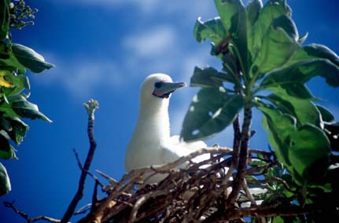
Nesting red-footed booby on Pulu Keeling; photograph by Robert Thorn.

3. Critical Components and Processes

3.1 Identifying critical components and processes
The basis of an ECD is the identification, description and where possible, quantification of the critical components, processes, benefits and services of the site. Wetlands are complex ecological systems and the complete list of physical, chemical and biological components and processes for even the simplest of wetlands would be extensive and difficult to conceptualise. It is not possible, or in fact desirable, to identify and characterise every organism and all the associated abiotic attributes that are affected by, or cause effect to, that organism to describe the ecological character of a system. This would result in volumes of data and theory but bring us no closer to understanding the system and how to best manage it. What is required is to identify the key components, the initial state of the systems, and the basic rules that link the key components and cause changes in state (Holland 1998). Thus, we need to identify and characterise the key or critical components, processes, benefits and services that determine the character of the site. These are the aspects of the ecology of the wetland, which, if they were to be significantly altered, would result in a significant change in the system.

DEWHA (2008) suggest the minimum components, processes, benefits and services, which should be included in an ECD are those:

- that are important determinants of the sites unique character;
- that are important for supporting the Ramsar or DIWA criteria under which the site was listed;
- for which change is reasonably likely to occur over short to medium time scales (less than 100 years); and / or
- that will cause significant negative consequences if change occurs.

In addition, the role that components and processes play in the provision of critical ecosystem services should also be considered in the selection of critical components and processes. The linkages between components, processes, benefits and services and the criteria under which the site was listed are illustrated conceptually in Figure 8. This simple conceptual model for the PKNP Ramsar site shows not only the components and processes that are directly related to critical ecosystem services and benefits and are considered critical to the ecological character of the site, but also but also the components and processes that are important in supporting these and the critical services the site provides.

It is difficult to separate components (physical, chemical and biological parts) and processes (reactions and changes). For example, aspects of geomorphology such as bathymetry and topography may be considered as components, while other aspects of geomorphology such as sediment transport and erosion could be considered processes. Similarly the species composition of birds at a site may be considered a component, but feeding and breeding are processes. In the context of this ECD a separation of the ecology of wetlands into nouns (components) and verbs (processes) is an artificial boundary and does not add clarity to the description. As such components and processes are considered together. The interactions between components and processes, the functions that they perform and the benefits and services that result are considered in detail in section 4.

Figure 8: Simple conceptual model showing the key relationships between components and processes; benefits and services and the reasons for the site being listed as a Wetland of International Importance.

Each of the identified critical components and processes meet the four criteria provided by DEWHA (2008) in that they are central to the character of the site, are directly linked to the Ramsar criteria for which the site was listed, could potentially change in the next 100 years and for which change would result in negative consequences and a change in the ecological character of the site. The identified critical components and processes of the PKNP Ramsar site are:

- Seagrass;
- Marine invertebrates;
- Fish;
- Turtles; and
- Waterbirds.

In additional to the identified critical components and processes are characteristics of the site, which are not critical (that is if they were to change, they would not lead directly to a change in character) but are still important in the ecology of the system. These are termed “essential elements” and include some of the characteristics of the site, which may act as early warning indicators of a potential change in character and therefore should be considered in management planning for the site. The identified essential elements for the PKNP Ramsar site are:

- Climate;
- Geomorphology;
- Hydrology;
- Water quality; and
- Terrestrial vegetation.

3.2 Essential elements
The components and processes of the PKNP Ramsar site that are considered important in supporting the critical components, processes, benefits and services of the site are described briefly below and summarised in Table 4.

Table 4: Summary of essential elements within the PKNP Ramsar site.
Component / process | Description
Climate | - Warm tropical climatic zone.  - High rainfall (2000 millimetres per year).  - Warm to hot year round.
Geomorphology | - Island comprises calcareous sand and rubble of coral origin.  - Reef crest surrounding island.  - Central lagoon of sand and muds with intertidal sandy area.  - Sandy beach on northern shores.
Hydrology | - No surface freshwater.  - Semi -diurnal of 1 to 1.5 metres.  - Hydrological connection between lagoon and Indian Ocean.
Water quality | - Data deficient – no information could be sourced.
Vegetation | - Tall (30 metre) pisonia forest covers much of the island.  - Saltmarsh herblands and octopus shrublands near the lagoon shores.

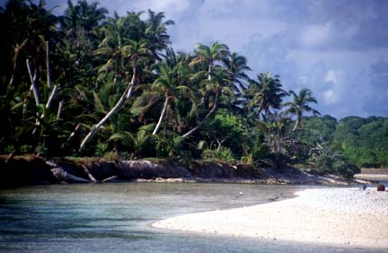
Lagoon entrance; photograph by Robert Thorn.

3.2.1 Climate
Pulu Keeling lies within the moist tropical climatic zone of the Indian Ocean. The general climatic pattern is warm to hot temperatures and high rainfall occurring year round. The nearest weather station to the PKNP Ramsar site is located in the southern atoll islands (24 kilometres to south). However, broad climate patterns are similar across the entire Cocos (Keeling) Islands (Falkland 1994).

Rainfall, on average, occurs year round with highest monthly average rainfall in April (256 mm) and lowest in October (82 millimetres). There is some degree of variability in rainfall as evidenced by the 10th and 90th percentiles, which range from less than 10 millimetres per month to greater than 400 millimetres per month (Figure 9). However, this is considerably more stable than rainfall in arid zones within Australia (Bureau of Meteorology 2009a).

Annual average rainfall at the Cocos (Keeling) Islands is in the order of 2000 millimetres per year. Once again, although there is some degree of variability in annual rainfall (ranging from less than 850 millimetres to more than 3000 millimetres in 40 years of records from this site) (Figure 10) this is relatively low compared to areas in mainland Australia.

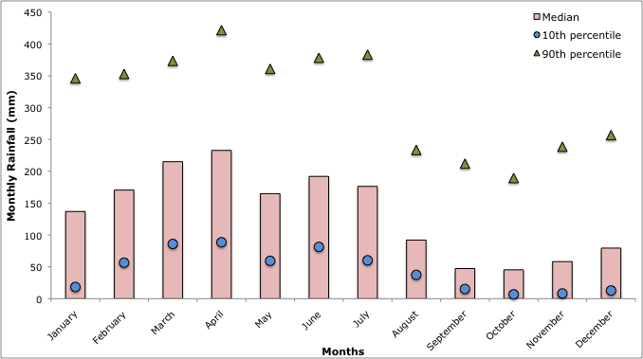
Figure 9: Median (10th and 90th percentile) monthly rainfall at Cocos (Keeling) Airport (1956 – 2009; Bureau of Meteorology 2009a).

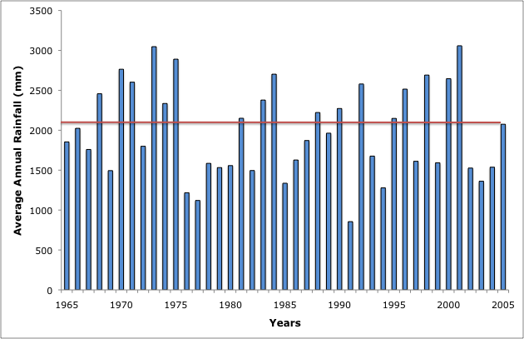
Figure 10: Average annual rainfall at Cocos (Keeling) Airport (1966 – 2006; Bureau of Meteorology 2009a). Note horizontal line shows long term average.

Temperatures are warm to hot year round (Figure 11), with little seasonal variation. Maximum monthly temperatures are between 28 and 30 degrees Celsius and average minimum temperatures between 24 and 25 degrees Celsius.

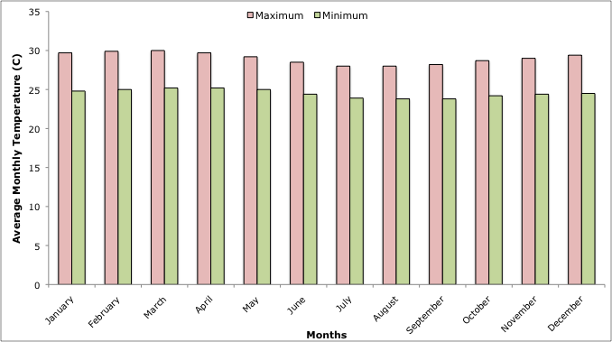
Figure 11: Average monthly maximum and minimum temperatures at Cocos (Keeling Island Airport (1952 – 2009; Bureau of Meteorology 2009a).

Cocos (Keeling) Islands are located in an area subject to tropical cyclones. Twenty-seven tropical cyclones were recorded in the vicinity of Cocos (Keeling) Islands between 1955 and 2005; four of which caused destructive winds gusts of at least of 125 kilometres per hour (Doreen January 1968, Annie November 1973, Pedro November 1989 and Harriet February 1992). On average this equates to a tropical cyclone every two years and one causing destructive winds every 14 years. The highest wind gust recorded in recent times was 176 kilometres per hour during Doreen in January 1968. Historically the most significant cyclone to affect the Islands occurred in 1909 when a wind gust of 225 kilometres per hour was estimated (Bureau of Meteorology 2009a).

3.2.2 Geomorphology
The Island within the PKNP Ramsar site is approximately two kilometres long and 1.3 kilometres wide, with a shallow (less than 2 metre deep) lagoon occupying the centre. The lagoon is connected to the Indian Ocean by a single channel on the south eastern shore (Woodroffe and McLean 1994). The Island is young in geological terms, with coral conglomerate from the surrounding reef radiocarbon dated at approximately 3000 to 4000 years before present (Woodroffe and McLean 1994).

The island is comprised mostly of calcareous sand and rubble of coral origin, with a broad sandy beach along the north shore. The lagoon sediments are predominantly composed of sands and sandy mud, with a broad intertidal sand area near the connection to the Indian Ocean. There are areas of beach rock and shingle along the eastern and southern shore and areas of coral conglomerate platform. A reef crest surrounds the island on all but the north-western shore (Woodroffe and McLean 1994; Figure 12).

A profile from west to east (Figure 12) illustrates the steep nature of parts of the western shore, which rise up to approximately 4 m above sea level. Parts of the lagoon lie below sea level, but the majority is located within intertidal elevations.

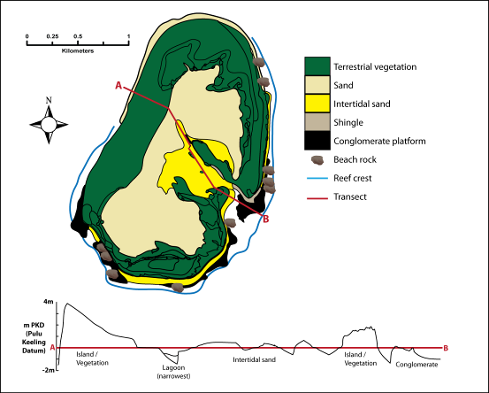
Figure 12: Geomorphology and major sediment types of Pulu Keeling Island within the Ramsar site (adapted from Woodroffe and McLean 1994).

3.2.3 Hydrology
There is no surface freshwater within the Ramsar site. There are reports of a brackish groundwater aquifer recharged from rainfall (Woodroffe and Berry 1994). However, the island is considered too small and narrow to develop a freshwater lens (Bunce 1988).

Tides are diurnal with a range of 1 to 1.5 metres (Bureau of Meteorology 2009b; Figure 13). Connectivity between the lagoon and the ocean is important for maintaining water quality within the lagoon and at low tide, the lagoon is almost completely drained, filling again each tidal cycle (twice daily).

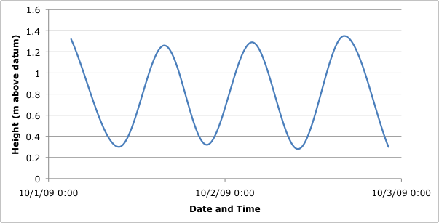
Figure 13: Indicative daily tidal range at PKNP Ramsar site (data from Bureau of Meteorology 2009b; south atoll tide gauge).

3.2.4 Water Quality
Water quality is important for maintaining shallow reef communities and is particularly important in the shallow lagoon area. Although there is no data from within the Ramsar site, in March 1983, a combination of climatic conditions resulted in a temporary cessation of flushing in the lagoon of the southern atoll. The resulting decrease in dissolved oxygen resulted in large numbers of fish deaths and an increase in nutrients, from bottom sediments and a corresponding increase in phytoplankton (Bunce 1988). This decline in water quality was echoed within the lagoon at Pulu Keeling following the lagoon closure in 2005 (see section 7 changes in ecological character since listing).

In the absence of data, there can only be hypotheses about the water quality within the Ramsar site. However, in the absence of anthropogenic inputs that could affect water quality, it is assumed that the site was characterised by good water quality conditions at the time of listing. The lagoon supported seagrass beds and a number of fish species (Hobbs in prep.), which indicates good light availability and moderate to high dissolved oxygen concentrations.

3.2.5 Vegetation
Terrestrial vegetation is important to the ecological character of the Ramsar site as it provides nesting and roosting habitat for waterbirds using the Ramsar site (Stokes et al. 1984). It is in this context that the vegetation is considered in this ECD. Terrestrial vegetation is dominated by coconut and pisonia forest (Figure 14), which tower 30 metres above the ground (Figure 15). Octopus bush shrubland lines the eastern shore with a more diverse community of shrubs and saltmarsh herblands along the shore of the lagoon. The most diverse communities are located on the sandy spits adjacent to the lagoon entrance (Williams 1994). Thirty-three species of native vascular plant have been recorded within the Ramsar site (Director of National Parks 2004; Appendix E) or which seven no longer occur on the southern atoll (Williams 1994).

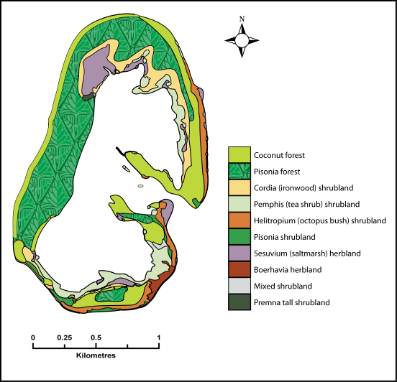
Figure 14: Terrestrial vegetation within the Ramsar site (adapted from Williams 1994).

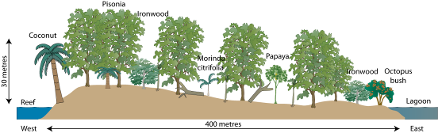
Figure 15: Vegetation profile at Pulu Keeling from the reef to the lagoon (adapted from Bunce 1988).

3.3 Critical components and processes
The attributes and characteristics of each of the identified critical components and processes of the PKNP Ramsar site are described below (sections 3.3.1 to 3.3.5). Where possible, quantitative information is included. However, as with many Ramsar sites in Australia, there are significant knowledge gaps (see section 8). A summary of the critical components and processes within the PKNP Ramsar site is provided in Table 5.

Table 5: Summary of critical components and processes within the PKNP Ramsar site.
Component / process | Description
Seagrass | - Data deficient - seagrass (turtle grass) in the lagoon area.
Marine invertebrates | - Diverse community of Indo-Pacific species. A number of species recorded in the site do not occur in the southern atoll including the coconut or robber crab (Birgus latro).  - A small number of red crab (Gecarcoidea natalis) are also present.
Fish | - Community predominantly of Indo-Pacific origin.  - Endemism is low, but a number of species are at the western extent of their range at Cocos Island and there is evidence of hybridisation.
Turtles | - Important foraging for the hawksbill turtle and breeding for the green turtle (both listed as vulnerable under the EPBC Act).  - The green turtle population is believed to be resident in the Cocos (Keeling) Islands
Waterbirds | - 24 species of waterbird; 15 species recorded breeding.  - Significant numbers of red-footed booby (30 000 pairs annually)  - Large numbers of lesser and greater frigatebirds and common noddy  - Cocos buff-banded rail is endemic and the Ramsar site has the only known population.

3.3.1 Seagrass
Vegetation within the Ramsar site is limited to terrestrial communities, seagrass and macroalgae. There is no published information on macroalgal communities, nor is there any information on the seagrass within the lagoon, except that it is comprised of turtle grass (Thalassia hemprichii). Turtle grass is a tropical species of seagrass common in lagoons and coastal embayments protected from strong currents. Leaves cannot withstand prolonged periods of exposure or desiccation, but rhizomes are tolerant and so it can occupy subtidal and marginal intertidal environments (Larkum et al. 2006). The extent, cover and distribution of seagrass within the Ramsar site are knowledge gaps; although it is believed that seagrass was confined to the lagoon (Bunce 1988).

3.3.2 Marine Invertebrates
Corals, molluscs, echinoderms, barnacles and decapod crustaceans of the Cocos (Keeling) Islands were all surveyed in the 1990s (Jones 1994; Marsh 1994; Morgan 1994; Veron 1994; Wells 1994; Table 6). Although surveys included three reef sites within the PKNP Ramsar site (all on the western shore), not all studies reported the locations of species recorded. Therefore, although 99 species of coral have been recorded within the bioregion, for example, it is not known how many, or which species are / were present within the Ramsar site. Where location data have been provided, species recorded within the Ramsar site boundary have been listed in Appendix C.

Table 6: Summary of marine invertebrates.
Taxonomic group | Comments
Coral | - 99 species within the Cocos (Keeling) Islands, unknown number within PKNP Ramsar site.  - The vast majority (greater than 85 percent) are known from Western Australia.  - Nine species have not been recorded elsewhere in the eastern Indian Ocean (Veron 1994).
Molluscs | - 610 species from the Cocos (Keeling) Islands.  - 117 reported within the Ramsar site (but this does not represent a complete survey).  - 26 species recorded within the Ramsar site are not known from the Southern Atoll.  - The majority of the species are common to the Indo-Pacific region (Wells 1994).
Echinoderms | - 89 species from the Cocos (Keeling) Islands.  - 11 reported within the Ramsar site.  - Two species recorded within the Ramsar site are not known from the Southern Atoll.  - The majority of the species are common to the Indo-Pacific but there are several extensions of known ranges (Marsh 1994).
Barnacles | - 13 species from the Cocos (Keeling) Islands.  - Two reported within the Ramsar site.  - The majority of the species are common to the Indo-Pacific or are considered cosmopolitan (Jones 1994).
Decapods | - 198 species from the Cocos (Keeling) Islands.  - 26 reported within the Ramsar site.  - Four species recorded within the Ramsar site are not known from the Southern Atoll (Morgan 1994). This includes the land based red crab (Gecarcoidea natalis), which occurs in small numbers within the Ramsar site.

Distribution and diversity (abundance and species richness) is a knowledge gap for most of the invertebrate communities within the Ramsar site. Coral does not occur in the lagoon area, but coral reef and reef flats surround most of the island (see Figure 12 above). Data from a single coral reef monitoring site at Pulu Keeling indicates that the area is comprised predominantly of soft corals (Alcyonacea) with smaller amounts of reef building hard corals (Commonwealth of Australia 2005a). However, whether this is applicable to the entire site is not known.

The Ramsar site supports at least 26 species of crabs, including hermit crabs (terrestrial and aquatic), the red spider crab (Schizophrys aspera) and swimmer crabs. Of note is the presence of the coconut or robber crab (Birgus latro) which was formerly abundant on the southern atoll, but now rare or absent (Bunce 1988). In addition, a small number of red crab (Gecarcoidea natalis) occur, which together with those present on the southern atoll, represent the only known populations outside Christmas Island (Director of National Parks 2004).

3.3.3 Fish
The fish within the Ramsar site were surveyed in 1989 (Allen and Smith-Vanz 1994). However, similar to a number of other fauna surveys in the Cocos (Keeling) Islands, location data were not reported and it is not possible to separate records from the Ramsar site from those of the southern atoll. Therefore, while over 500 species of fish occur within the bioregion, the number of species, their abundance and distribution within the Ramsar site at the time of listing remains a knowledge gap.

Results of a recent survey (2008; Hobbs in prep.) together with the results from Lincoln-Smith et al. (1995) provide a combined list of 193 fish species from within the PKNP Ramsar site (Appendix D). This list does not include cryptic species that are difficult to detect or identify visually and so the number of fish species present is likely to increase with further survey work. In the absence of evidence of significant change to the reef within the Ramsar site, the fish recorded recently can be considered indicative of the fish community at the time of listing.

Most of the fish within the Cocos (Keeling) Islands are either cosmopolitan or common within the Indo-Pacific region (Allen and Smith-Vanz 1994). However, a number of Pacific and Indian Ocean species reach the edge of their distribution at Cocos (Keeling Islands). The angelfish, Centropyge joculator is known only from Christmas Island and the Cocos (Keeling) Islands (Director of National Parks 2004); and has been recorded from within the Ramsar site (Hobbs in prep.). Although endemism is low, there is evidence of hybridisation of a number of species within the bioregion, which contributes to the uniqueness of the community (Hobbs and Salmond 2008).

Director of National Parks (2004) reported substantial populations of butterfly fish (Chaetodontidae) and sharks (black-tip - Carcharhinus, Loxodon, white-tip - Triaenodon obesus and grey reef - Carcharhinus amblyrhynchos) within the Ramsar site. However, the numbers of butterfly fish, groupers (Serranidae), parrotfish (Scaridae), humphead wrasse (Cheilinus undulatus), bumphead parrotfish (Bolbometapon muricatum), sweetlips (Haemulidae), barramundi cod (Cromileptes altivelis) and moray eels (Muraenidae) are lower at the monitoring site within the Ramsar site than most of the sites within the southern atoll (Commonwealth of Australia 2005a). Numbers of snapper (Lutjanidae), which are predatory fish, however, were higher than at any other site (Figure 16). Whether this reflects conditions throughout the Ramsar site is unknown.

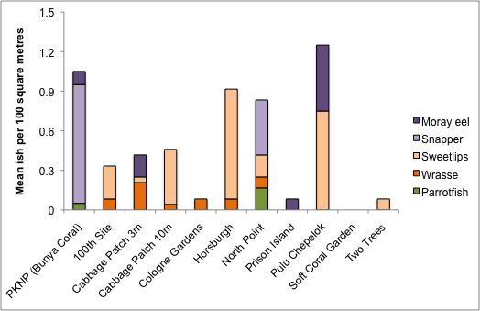

Figure 16: Mean number of selected fish within the Ramsar site (Column 1) compared to the southern atoll (remaining columns); data from Commonwealth of Australia 2005a. Colours indicate functional feeding groups; green = herbivorous; orange = feeds mainly on invertebrates; purple = feeds mainly on other fish.

3.3.4 Marine Turtles
Two species of marine turtle are known to occur within the PKNP Ramsar site: green turtle and hawksbill turtle; with the site considered an important rookery for the former (Director of National Parks 2004). There is no data on foraging turtles within the Ramsar site and the distribution and abundance of marine turtles is a knowledge gap.

Nesting of green turtles was monitored in January 2006 and in the absence of any evidence to the contrary this is considered indicative of the conditions at the time of listing in 1996. Moderate numbers of green turtle nest on the sandy northern beaches of the site, with a total of 48 fresh tracks recorded over three nights in January 2006 (Whiting 2006). Nesting success was low, with only three nests laid within the monitoring period. However, this is influenced by the short sampling period and low rainfall prior to sampling (reducing sand stability).

3.3.5 Waterbirds
The PKNP Ramsar site supports large numbers of waterbirds, both resident and migratory, which contribute to the sites listing as a wetland of international importance.

A total of 24 species of waterbird have been recorded within the PKNP Ramsar site (Appendix B). This includes 15 species that are listed under international migratory agreements CAMBA (13), JAMBA (13) and ROKAMBA (7) and all species recorded are listed under the EPBC Act. There are two species that are considered threatened at the national and international levels; the Cocos buff-banded rail (endangered) and the Round Island petrel (critically endangered).

The majority of birds within the Ramsar site are seabirds that live predominantly out at sea, utilising the site for breeding. The site is particularly important in a regional context due to the absence of most of these species from the southern atoll (Stokes et al. 1984). It is thought that the lack of significant numbers of birds in the southern atoll islands is a result of both hunting and loss of habitat (replacement of native forest with coconut plantations).

There are records of large numbers of birds at PKNP, although surveys are limited to red-footed booby, with other species recorded on an ad hoc basis. Population data, based on numbers of active nests from 1987 to 2002 was analysed by Baker et al. (2004) and this could be considered to represent variability in red-footed booby populations within the Ramsar site at the time of listing (Figure 17). Of note is the relative decline in numbers and subsequent recovery, following significant cyclone events in January 1989 and April 2001 (Baker et al. 2004) this is examined further in sections 6 (threats to ecological character) and 7 (changes in ecological character).

A mean population estimate of 30 000 breeding pairs (7700 standard deviation) was made for the years 1993 to 2006 (Baker and Cunningham 2007). This is considered to be conservative as it does not take into account approximately 16 hectares of low quality habitat within the Ramsar site.

Surveys of the Cocos buff-banded rail indicate mean densities of between four and nine birds per hectare (Figure 18), which equates to a population of approximately 850 to 1000 birds (Reid and Hill 2005). As this is the only known population of this sub-species of bird (Commonwealth of Australia 2005b), the Ramsar site is considered to support 100 percent of the population.

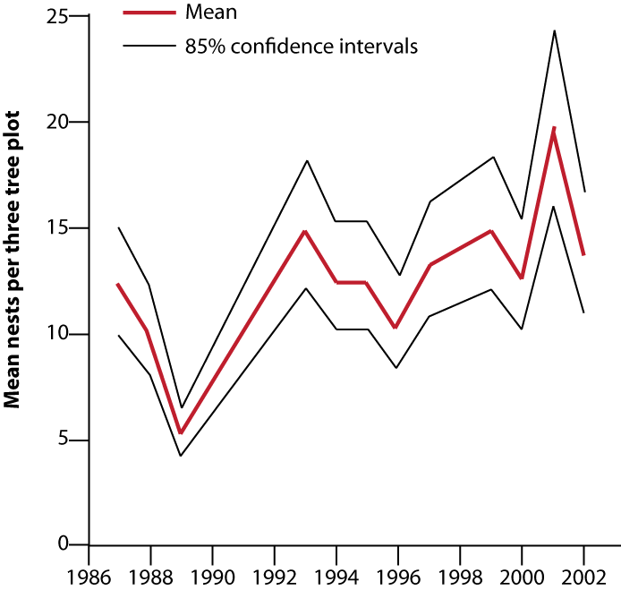

Figure 17: Mean density of red-footed booby nests in monitoring locations within the Ramsar site (Baker et al. 2004).

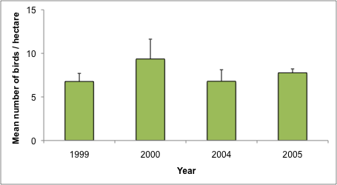

Figure 18: Mean number of Cocos buff-banded rail (per hectare) from surveys in 1999 to 2005 (data from Reid and Hill 2005).

Data for the remaining species are limited to observational records (Director of National Parks 2004). These indicate that the site supports breeding of at least 15 species (see Appendix B) and significant populations of greater frigatebirds (3000 individuals); lesser frigatebirds (more than 3000 breeding pairs) and common noddy (approximately 15 000 individuals). There is insufficient data, however, to determine levels of variability or mean numbers of birds. All other bird species have been recorded in relatively low abundances (Stokes et al. 1984; Director of National Parks 2004).

4 Ecosystem services

4.1 Overview of benefits and services
Ecosystem benefits and services are defined under the Millennium Ecosystem Assessment definition of ecosystem services as "the benefits that people receive from ecosystems (Ramsar Convention 2005, Resolution IX.1 Annex A). This includes benefits that directly affect people such as the provision of food or water resources as well as indirect ecological benefits. The Millennium Ecosystem Assessment (Millennium Ecosystem Assessment 2005) defines four main categories of ecosystem services:
- Provisioning services - the products obtained from the ecosystem such as food, fuel and fresh water;
- Regulating services – the benefits obtained from the regulation of ecosystem processes such as climate regulation, water regulation and natural hazard regulation;
- Cultural services – the benefits people obtain through spiritual enrichment, recreation, education and aesthetics; and
- Supporting services – the services necessary for the production of all other ecosystem services such as water cycling, nutrient cycling and habitat for biota. These services will generally have an indirect benefit to humans or a direct benefit over a long period of time.

There is no evidence to substantiate a case for provisioning or regulating services within the PKNP Ramsar site. The site is wholly contained within a national park and although resources were used in the past (timber, nuts, birds) the site is now largely protected from resource harvesting. In addition, the small size of the site and its remote location makes it unlikely to play a substantial role in regulating the surrounding environment. The cultural and supporting ecosystem benefits and services of the PKNP Ramsar site are outlined in Table 7.

Table 7: Ecosystem services and benefits provided by the PKNP Ramsar site (those critical to the ecological character of the site are shaded; see section 4.2 below).
Category | Description
Cultural services
Recreation and tourism | - Although remote and access is controlled, the site is important for passive recreation such as diving and bird watching.
Cultural heritage | - Shipwreck of the Emden.  - Historical significance for the Cocos Malay people.
Scientific and educational | - PKNP Ramsar site has been (and continues to be) used for long-term scientific studies. Examples include red-footed booby surveys; breeding and migration of turtles and reef health.
Supporting services
Supports near-natural wetland types | - PKNP is regarded as one of the most pristine coal atolls in the Indian Ocean (Director of National Parks 2004) and supports a number of largely unmodified wetland types.
Threatened species | - The PKNP Ramsar site supports the following threatened species:  - the endangered Cocos buff-banded rail; and  - the vulnerable green turtle and hawksbill turtle.
Biodiversity | - PKNP Ramsar site supports a number of species that are no longer present in the southern atoll, making it significant in the Cocos Island IMCRA Province.  - In addition, the site supports a diversity of fish and marine invertebrates, many at the extent of their ranges.
Provides physical habitat for breeding waterbirds | - The site supports large colonial waterbird breeding of red-footed booby, lesser frigate bird and common noddy.

4.2 Identifying critical ecosystem services and benefits
The critical ecologically based ecosystem services and benefits of a Ramsar site have been identified using the same criteria provided by DEWHA (2008) used for selecting critical components and processes; i.e. services that at a minimum:

- are important determinants of the site’s unique character;
- are important for supporting the Ramsar or DIWA criteria under which the site was listed;
- for which change is reasonably likely to occur over short or medium time scales (< 100 years); and / or
- that will cause significant negative consequences if change occurs.

Using these criteria it was considered that all of the supporting services (that is, those that are ecologically based) could be considered “critical”. While the site is undoubtedly beneficial in terms of recreation, tourism cultural heritage and scientific research; these were not considered “critical” services in that a reduction in any of these services would not necessarily indicate a change in ecological character. However, cultural services are considered important for the PKNP Ramsar site and so have been described further in section 4.4.

4.3 Critical services

4.3.1 Supports near natural wetland types
As described in section 2.5, the PKNP Ramsar site contains a small number of wetland types that by virtue of the remote location and protected status of the site can be considered in near natural condition. The wetland types present in the site are brought about by the interactions between geomorphology, hydrology, water quality, vegetation and invertebrates (Figure 19). Although there is little data from the site to provide direct evidence of the interactions of components and processes that support these wetland types, general ecological theory can provide an approximation of the likely interactions for each of the types as follows;

B-Marine sub-tidal aquatic beds / Type J – Coastal saline lagoon:
The lagoon area contains seagrass beds over sandy sediments. The connection between the Indian Ocean, combined with the twice daily tidal cycle provides flushing of the lagoon and maintains water quality. The seagrass binds the sandy substrate, stabilising the sediment and decreasing suspended sediment. Both of these factors combine to provide adequate light for seagrass. The tidal exchange also regulates temperature, dissolved oxygen and nutrient concentrations in the shallow lagoon, with inflows of cool, low nutrient, oxygenated ocean water maintaining good water quality conditions (Lalli and Parsons 1995).

C- Coral reefs:
The conglomerate reef platforms within the PKNP Ramsar site are composed of cemented coral shingle and rubble accumulated over the past 3000 – 4000 years (Woodroffe et al. 1994). Fossilised Porite (boulder coral) and Acropora (staghorn corals) have been found within the reef flats and crests indicating the roles of these species in the construction of the coral atoll (Woodroffe et al. 1994). Ocean currents, tidal exchange and bathymetry all play an important role in the formation and maintenance of this wetland type and the zonation of corals (Block and Bruno 2008). Corals on the reef flat are within shallow water and may be exposed at low tide, providing a high light and temperature environment. Conversely the corals on the crest and the seaward side are exposed to greater wave action, but lower temperature and light environments. These factors affect the community composition and distribution of coral reefs, although specifics for the Ramsar site remain a knowledge gap.

D-Rocky shores and E- Sand shores:
Much of the shore of the Ramsar site (outside the lagoon) is comprised of shingle, rubble and beach rock (Woodroffe and McLean 1994). The sand beaches, which are important habitat for nesting turtles (see section 2.3.3 below) are mostly confined to the northern area of the atoll, where the reef crest is absent. This higher energy environment, maintains an area of finer sandy sediments, which together with tides and currents is important for maintaining this wetland type (Lalli and Parsons 1995).

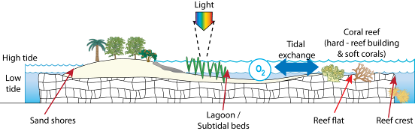

Figure 19: Stylised illustration of wetland types within the PKNP Ramsar site and the major components and processes that influence them.

4.3.2 Supports threatened species – Cocos buff-banded rail
The Cocos buff-banded rail is a subspecies of the buff-banded rail (Gallirallus philippensis) that is endemic to the Cocos (Keeling Islands. It was once widespread across the southern atoll; but is now limited to a single population within the PKNP Ramsar site (Reid and Hill 2005). The species is a resident on the island using the full range of habitats on the small atoll for foraging and breeding. It occurs in pisonia forest, ironwood forest, coconut forest and the lagoon shores; appearing to use each habitat in approximate proportion to each habitats' occurrence (Garnett & Crowley 2000).

Little is known about the ecology of this sub-species and most information is inferred from studies at the species level. Buff-banded rails are omnivorous, feeding on mostly on invertebrates (crustaceans, molluscs, worms) in the intertidal zone, but also taking fruit and seed from the forest floor (Garnett and Crowley 2000). Observations from the Ramsar site indicate that the birds may preferentially feed in the drying margins of the lagoon at low tide (Reid and Hill 2005). It has been suggested that the increased productivity as a result of the large seabird rookery within the Ramsar site helps to maintain the Cocos buff-banded rail, by increasing productivity and thereby food availability (Commonwealth of Australia 2005b).

There is some evidence to suggest that the Cocos buff-banded rail breeds year round on the island; with nests recorded in January, May and August and mating observed in May and November (Reid 2000). Nests have been observed in litter in the pisonia forest, debris, grass tussocks or similar ground layer vegetation, the forks of pisonia trees, and the bases of coconut palms (Garnett and Crowley 2000). Clutches of 5 – 8 eggs are typical with laying usually occurring at intervals of 24 hours, and the incubation period is 18-25 days. Successive clutches may be laid at intervals of two months, and pairs may breed up to three times in a year (Marchant and Higgins 1993).

The critical components and processes that are important in supporting the Cocos buff-banded rail are therefore, terrestrial vegetation communities (nesting and foraging habitat); the intertidal area of the lagoon (foraging habitat) and the interaction between seabirds, and primary / secondary production which provide adequate food resources for the population (Figure 20).

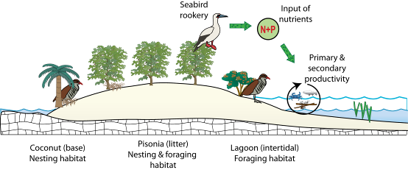
Figure 20: Interactions between critical components and processes that are important in supporting Coco Buff-banded Rail within the Ramsar site.

4.3.3 Supports threatened species – Marine turtles
The PKNP Ramsar site provides foraging habitat for the hawksbill turtle and breeding habitat for the green turtle, both of which are listed as vulnerable under the EPBC Act. It is estimated that there are several thousand hawksbill turtles that forage within the Cocos (Keeling) Islands feeding on algae, seagrass and sponges (Whiting 2006). However data is limited to monitoring from the southern atoll and the importance of the PKNP Ramsar site for this species is not known.

The Ramsar site is the major site of green turtle breeding within the Cocos (Keeling) Islands. This species has a complex lifecycle (similar to most other marine turtles), with different habitat requirements (including food resources) at different life history stages (Figure 21). Females nest on sandy beaches and within the Ramsar site suitable habitat is restricted generally to the northern shore (Whiting 2006). The requirements of nesting beaches (although not fully understood) have been characterised by (Mortimer 1979):

- Accessibility from the sea;
- Sufficient elevation to prevent inundation of nests by tide;
- Substrate must facilitate gas exchange; and
- Sediment must be moist enough to prevent collapse of the egg chamber during construction.

Females may produce several clutches, utilising nearby inter-nesting habitat during the breeding season (Limpus 2008). Sex of hatchlings is temperature dependant and the temperature that produces a one to one hatchling sex ratio varies between breeding sites and populations (Limpus 2008). Lower temperatures produce increased male hatchlings and increased temperatures more females (within tolerance ranges). Within the Great Barrier Reef, optimal temperature is between 27.6 degrees Celsius and 29.3 degrees Celsius (Limpus 2008) but temperature requirements within the Ramsar site are not known.

Hatchlings make their way to the sea although significant numbers may be predated prior to reaching post-hatchling size. Within the Ramsar site ghost crabs have been observed catching hatchlings on the open sand; and while Hermit crabs may not be fast enough to catch a hatchling in open ground, hatchlings caught up in debris on the shore are vulnerable (Whiting 2006).

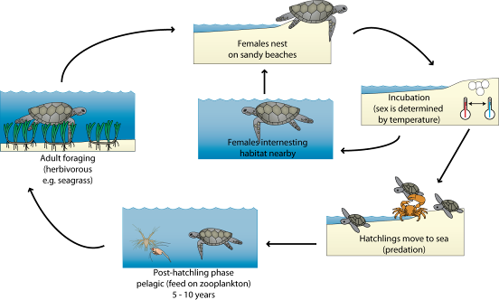
Figure 21: Stylised lifecycle and general habitat requirements of the green turtle.

Post-hatchling phase in green turtles is thought to be pelagic, with turtles spending 5 – 10 years in the open ocean feeding on Macro-zooplankton (Limpus 2008). In most populations of green turtles, foraging habitat is known to be some distance from breeding areas (1000s of km). However, within the Cocos (Keeling) Islands there is strong evidence to suggest that the green turtle population is resident (Whiting et al. 2008). Tracking of six turtles within the Cocos (Keeling) Islands indicated that on average turtles migrated only 35 kilometres from the breeding grounds within the PKNP Ramsar site to feeding grounds in the southern atoll (Whiting et al. 2008; Figure 22). The authors of the study hypothesised that although this is an advantage to the population in terms of energy requirements (the lower energy costs associated with short distance travel) it makes the population susceptible to small scale catastrophic events such as cyclones.

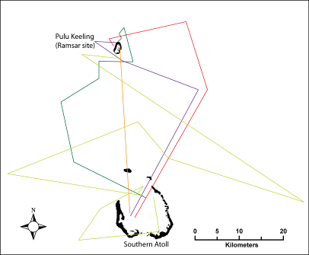

Figure 22: Migration paths of six green turtles nesting within the Ramsar site (duration = 155±54 days; mean±standard deviation; Whiting et al. 2008).

4.3.4 Provides physical habitat for breeding waterbirds
Fifteen species of waterbird have been recorded breeding within the PKNP Ramsar site, the majority of which are seabirds. The species recorded breeding at the site utilise a range of different habitats within the system (Table 8). This includes the pisonia and coconut forests, the ground beneath shrub vegetation and the shingle beaches. Maintaining this diversity of habitat is essential to maintaining this service.

Table 8: Breeding habitat requirements of waterbirds recorded breeding in the PKNP Ramsar site.
Species | Breeding habitat and behaviour
Eastern reef egret | Nests constructed of sticks in trees or under shrubs; within the Ramsar site nests constructed of octopus bush debris in coconut trees (Director of National Parks 2004). Nesting occurs in single pairs or in small colonies. Both sexes incubate the eggs and the young remain in the nest for up to six weeks (Marchant and Higgins 1990).
Nankeen night heron | Usually nests in stick platform over water, but observed in the Ramsar site nesting among red-footed booby and frigate birds in pisonia trees (Director of National Parks 2004). Both sexes incubate the eggs and the young remain in the nest for six to seven weeks (Jaensch 2002).
Cocos buff-banded rail | Nests in litter in the pisonia forest, debris, grass tussocks or similar ground layer vegetation, the forks of pisonia trees, and the bases of coconut. Clutches of five to eight eggs are typical with laying usually occurring at intervals of 24 hours, and the incubation period is 18 to 25 days (Reid and Hill 2005)
White tern | Nests are not constructed; rather, eggs are laid on whatever suitable depression is found. Within the Ramsar site nesting observed in Coconut trees (Stokes et al. 2004). Typically remain near their breeding colonies year-round, seldom venturing far from shore. Both parents incubate egg and brood and feed the chick. Fledglings are dependent on adults for up to two months. Birds first breed at five years of age, and can be long-lived with the oldest known individual 42 years old (USFWS 2005).
Bridled tern | Only a single record of possible breeding within the Ramsar site (Stokes 1994). Nests in a scrape in the ground in a cave or under vegetation (rarely in the open); clutch size is generally one and fledging can take eight to12 weeks (Higgins and Davies 1996).
Sooty tern | Nest in scrape on the ground; within the Ramsar site on shingle shores in the north and east of the island (Stokes 1994). Single egg is laid and incubated by both adults for a period of 28 days. Young stay in colonies for up to 70 days and then probably accompany their parents at sea for several months. Breeding success rates may be low and breeding age is thought to be four to five years (Higgins and Davies 1996).
Common noddy | Nests in trees or on ground; within the Ramsar site observed nesting in a wide range of habitats including in pisonia and coconut trees, in holes in dead timber and on the shingle beaches (Stokes et al. 1984). A single egg is laid and young are fledged at six to seven weeks (Higgins and Davies 1996).
Wedge-tailed shearwater | Nest in burrows and within the Ramsar site burrows are located in coarse sandy soil near the south east corner of the island (Stokes et al. 1984). A single egg is laid and incubated by both parents for up to 50 days. Hatchlings fledge at 100 to 115 days.
Red-footed booby | Nests constructed of sticks in trees and low shrubs within the Ramsar site have been observed in all vegetated habitats from the coconut and pisonia forests through to the shrubland along the lagoon shore (Stokes et al. 1984). One egg is laid and incubated by both parents (40 days); young fledge after one month, but parents may continue to support young for some time after (Marchant and Higgins 1990).
Brown booby | Nests on the ground, within the Ramsar site in the same location as Masked Boobies (Stokes et al. 1984). Two eggs laid, eggs incubated by both parents, incubation period of about 45 days. The first chick most often kills the weaker sibling (Anderson 1990). Fledging occurs 85 to103 days after hatching. Post-fledging care and feeding continues for one to two months.
Masked booby | Nests in scrape on open ground; within the Ramsar site in open ground near the south-west corner (Stokes et al. 1984). Recently established vegetated areas adjacent to the closed lagoon entrance provide additional nesting sites for masked booby. Growing number of adult birds and chicks have been observed using the sites (Director of National Parks, pers, comm.). Typically lays two eggs, which are incubated by both parents for 45 days. The first chick most often kills the weaker sibling (Anderson 1990). Fledge after 2 months, but parental care extends for several more months.
Lesser frigatebird | Nest in trees and shrubs; within the Ramsar site in tea shrub and Ironwood along the edge of the lagoon (Stokes et al. 1984). One egg is laid and incubated for about 40 to 50 days. Young are brooded until fledged (up to seven weeks) to avoid predation by other seabirds and parental care extends for some time after (Marchant and Higgins 1990).
Greater frigatebird | Nests in large platforms of loosely woven twigs within trees and shrubs; within the Ramsar site nests with lesser frigate birds (Stokes et al. 1984). Single egg is laid which incubated by both parents, incubation takes about 55 days. Chicks are brooded for two weeks. Fledging occurs after four to six months, post fledging parental care is long, with fledging chicks continuing to receive parental care for between 150 to 428 days (Marchant and Higgins 1990).
White-tailed tropicbird | Nests in a range of habitats from bare ground to trees; within the Ramsar site uses forks and hollows in pisonia trees (Stokes et al. 1984). One egg is laid and incubated by both parents; incubation of approximately 40 days. Fledging occurs in 10 to 12 weeks (Phillips 1987).
Red-tailed tropicbird | Nests in a range of habitats from bare ground to trees; within the Ramsar site a single nest within coral rubble recorded (Stokes et al. 1984). One egg is laid and incubated by both parents; incubation of approximately 40 to 50 days. Fledging occurs in 10 to 13 weeks.

Components and processes that support waterbird breeding at the Ramsar site include not only the nesting sites (as described in Table 8); but also maintaining adequate food resources to sustain breeding (Figure 23). The majority of the birds that breed within the Ramsar site are piscivorous feeding either by contact dipping in shallow water (less than 20 centimetres) e.g. terns, common noddy and wedge-tailed shearwater; or by deep diving for fish e.g. boobies (Marchant and Higgins 1990; Higgins and Davies 1996). Methods of hunting are reflected in the habitats theses birds have been observed foraging in within the Ramsar site, with the lagoon area utilised by terns and common noddy; and the boobies recorded feeding in areas beyond the fringing reef, where the water is deeper (Stokes et al. 1984).

Frigatebirds also feed on fish and squid in shallow waters; but are also known to “steal” food from other seabirds by attacking parents returning to the nest causing them to disgorge their stomach contents; these birds are also known to feed on chicks of terns and common noddy (Marchant and Higgins 1990).

Nankeen night heron and eastern reef egret are both wading species of birds that feed in the intertidal area of the lagoon on a range of small fish, crustaceans and molluscs. Similarly, the Coco buff-banded rail has been observed to use the intertidal margins of the lagoon as a primary feeding ground (Reid and Hill 2005).

Breeding and chick rearing is the period with the lifecycle where energetic demand is highest (Drent and Dann 1980) and food availability is generally accepted as the most important factor in determining the timing and success of breeding in most bird populations (Dann et al. 1988). Relatively high productivity is required to sustain the large seabird breeding colonies found within the relatively small Ramsar site. As mentioned above, seabird guano has been identified as an important factor in maintaining productivity for breeding waterbirds such as the Coco buff-banded rail (Commonwealth of Australia 2005b). Additionally, it has been suggested that movements of schools of predatory fish such as tuna can be important for successful breeding of seabirds such as red-footed booby (Corre 2001). Many seabirds including the boobies and frigate birds have been observed to use the schooling techniques of predatory fish, that concentrate small fish, to improve hunting success (Marchant and Higgins 1990) and reduce the energy costs of foraging. Although not proven for the Ramsar site, there is anecdotal evidence from the site that tuna and seabirds fish together in the waters surrounding the Cocos (Keeling Islands (Jean-Paul Hobbs, pers. comm.). It is therefore possible that tuna populations within the waters surrounding the Ramsar site could be important for maintaining the success of seabird breeding within the site.

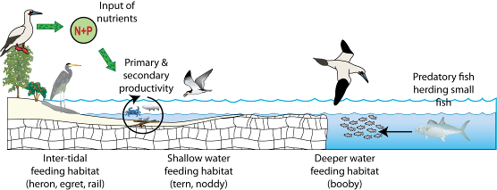

Figure 23: Simplified illustration of foraging habitats and factors potentially influencing food availability for breeding seabirds in the PKNP Ramsar site.

4.4.5 Supports biodiversity
The PKNP Ramsar site supports a number of species that are no longer found within the southern atoll. This includes a number of waterbirds as well as fish and invertebrate species. This is mostly due to the isolation of the Ramsar site compared to the southern atoll and the protection of biota from harvest and use by the National Park status (Stokes 1994).

Biodiversity at the site is supported by the habitat provided by the near natural wetland types (see section 4.3.1) and the interactions between the biota within the atoll environment, such as trophic relationships and the transfer of energy (Figure 24). Interactions between components and processes are complex and resource partitioning further complicates processes such as predation and competition. Resource partitioning includes spatially distinct and separate habitats such as the lagoon, reef and terrestrial environments. For example the seagrass within the lagoon is not generally available to grazing green turtles due to the narrow connection to the reef and sea. An example of temporal separation of resources can be seen in the lifecycle of the land crabs; whose larvae are marine and an important food source for a number of organisms that feed on zooplankton, but only present during breeding seasons.

It has been suggested from studies on other uninhabited coral atolls, that the pristine nature of these systems results in an increased resilience to global changes such as climate change (Sandin et al. 2008). Although data are limited, there are similarities between the biota within the Ramsar site, as compared to the southern atoll and the findings of research in similar atolls in the Pacific Ocean. In both instances there are a greater proportion of top predators in the fish community (see Figure 16 above) in pristine environments; a higher proportion of coral, as opposed to macroalgae; and a significantly lower amount of coral disease and die-off (data from Commonwealth of Australia 2005a for Cocos (Keeling) Islands and Sandin et al. 2008 for Line Islands). The potential impacts of various human activities on the biodiversity and function of coral atolls is explored further in section 5. In addition, the potential for the above mentioned components and processes (proportion of predatory fish; coral / macroalgae cover and extent of coral disease) as indicators for measuring ecological character (and change in character) at the site is considered in section 6.

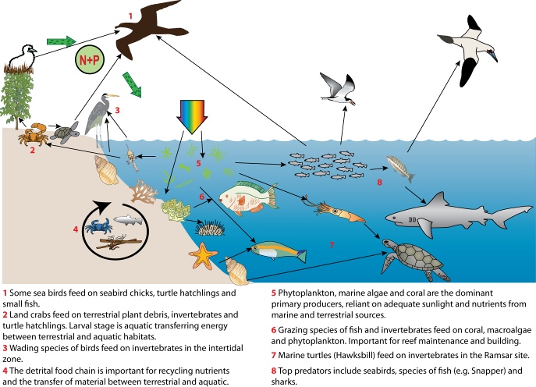

Figure 24: Indicative trophic relationships between groups of biota within the PKNP Ramsar site.

4.4 Non-critical Services

4.4.1 Recreation and tourism
Despite the difficulty of access, the PKNP Ramsar site is valued for recreation and tourism. Licensed tour operators conduct day trips to the site for bird watching, diving, snorkelling and sight seeing. As visitors are not permitted to stay within the Ramsar site overnight, these activities provide a valuable source of income for the residents of the southern atoll in terms of boat operators and accommodation providers (Director of National Parks 2004).

Cocos residents are allowed to fish recreationally within the site by trolling, with a valid permit.

4.5.2 Cultural heritage
Although the Ramsar site has never been permanently inhabited, there is a long and colourful history associated with the site. In the late 19th century small camps were established on the island for a number of Cocos-Malays with the vitamin B deficiency beriberi. It was thought that walking on the shores of the island would improve their health. The graves of three of the sufferers are located on the island (Bunce 1988).

In November 1914 the German warship the SMS Emden ran aground on the southern reef of the Ramsar site, following an encounter with the HMAS Sydney (Bunce 1988). Although the ship was the subject of a number of salvage operations, the hull and other parts remain within the Ramsar site and are protected under the Historic Shipwrecks Act.

There are also artefacts from other historical events that remain within the Ramsar site including the engine of a Second World War De Havilland Mosquito aircraft, A52-606, which crashed on the island in 1945; and the remains of a hut and railway tracks used by groups of workers between the wars that were stationed in the island to harvest timber, coconuts and birds (Bunce 1988).

Prior to the declaration of the PKNP in 1995 and the subsequent enactment of the EPBC Act in 1999, the site was important to residents of the southern atoll for food and timber resources including the hunting of seabirds (Bunce 1988). However, as the seabirds of the Ramsar site are listed as migratory species under the EPBC Act, authorised harvesting is no longer a feature of the site (Director of National Parks 2004).

4.5.3 Scientific research
The remote nature of the PKNP Ramsar site and its near pristine nature provide a rare opportunity in the Indian Ocean to collect baseline information on coral reef and atoll ecology.

The Ramsar site was surveyed by the Western Australian Museum in the late 1980s including fish, birds, vegetation, and marine invertebrates (Woodroffe and Berry 1994). However, difficulty of access meant that not all studies conducted on the southern atoll were undertaken in PKNP (e.g. marine habitat surveys). Access remains a barrier to extensive research today, with landings requiring a swim of 100 metres across the reef with equipment (Director of National Parks 2004). Despite this, annual surveys of red-footed booby have been conducted since 1986; turtle monitoring has been conducted on green and hawksbill Turtles (Whiting 2006; Whiting et al. 2008) and a reef condition monitoring site has been established (Commonwealth of Australia 2005a).

5. Threats to Ecological Character
Wetlands are complex systems and an understanding of components and processes and the interactions or linkages between them is necessary to describe ecological character. Similarly threats to ecological character need to be described not just in terms of their potential effects, but the interactions between them. One mechanism for exploring these relationships is the use of stressor models (Gross 2003). The use of stressor models in ecological character descriptions has been suggested by a number of authors to describe ecological character (Phillips and Muller, 2006; Hale and Butcher 2008) and to aid in the determination of limits of acceptable change (Davis and Brock 2008).

Stressors are defined as (Barrett et al. 1976):

“physical, chemical, or biological perturbations to a system that are either (a) foreign to that system or (b) natural to the system but applied at an excessive [or deficient] level”

In evaluating threats it is useful (in terms of management) to separate the threatening activity from the stressor. In this manner, the causes of impacts to natural assets are made clear, which provides clarity for the management of natural resources by focussing management actions on tangible threatening activities. For example, increased macroalgae may be identified as a threat for coral communities in the reef. However, management actions cannot be targeted at increased macroalgae without some understanding of why the increase is taking place. By identifying the threatening activities that could contribute to increased macroalgae (e.g. selective fishing, removing grazers, pollution resulting in increased nutrients) management actions can be targeted at these threatening activities and reduce the impact to the wetland.

There are a number of potential and actual threats that may impact on the ecological character of the PKNP Ramsar site. The stressor model (Figure 25) illustrates the major threatening activities, stressors and resulting ecological effects in the PKNP Ramsar site. A description of these major threats is provided below.

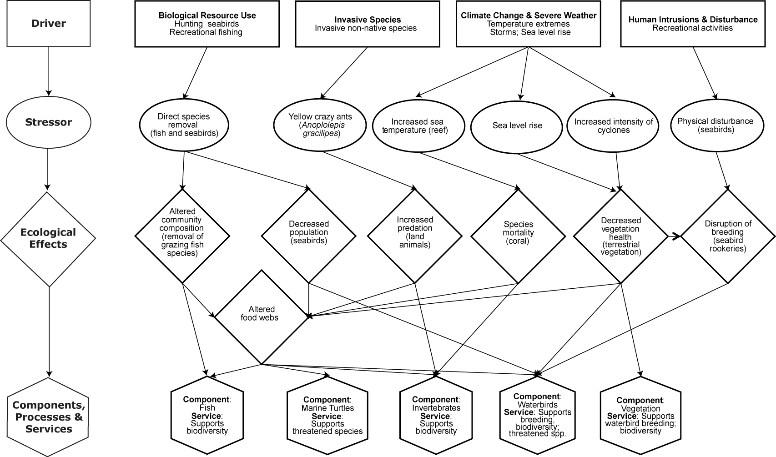

Figure 25: Stressor model of the PKNP Ramsar site (after Gross 2003 and Davis and Brock 2008).

5.1 Biological resource utilisation
Fishing and hunting of seabirds have long been a part of the culture of the Cocos Malay people (Bunce 1988). Fishing occurs within the PKNP Ramsar site by residents of the southern atoll, under a permit system from Parks Australia. The only approved method is trolling, which involves towing a bait fish behind a boat to lure and catch pelagic fish. This method protects reef fish and limits the catch to predatory fish. The impacts of this fishing are likely to be minimal as large quantities offish cannot be caught at a time (as with net fishing) and only pelagic species can be caught.

If recreational fishing were to be expanded to include reef fish, the potential effects to ecological character are more serious. Research in similar systems has shown that recreational fishing in coral reefs can result in significant ecological changes in reef state (McClanahan 1995; McClanahan et al. 2002). It has been suggested that recreational fishing can result in a removal of herbivorous fish and a subsequent increase in fleshy algae (due to reduced grazing pressure). Another possibility is due to the removal of fish that feed on grazing invertebrates, reef can become dominated by grazing sea urchins (which may also feed on live coral; McClanahan 1995). Both of these scenarios can lead to significant changes in reef structure, function and community composition, which in terms of the PKNP Ramsar site would equate to a change in ecological character.

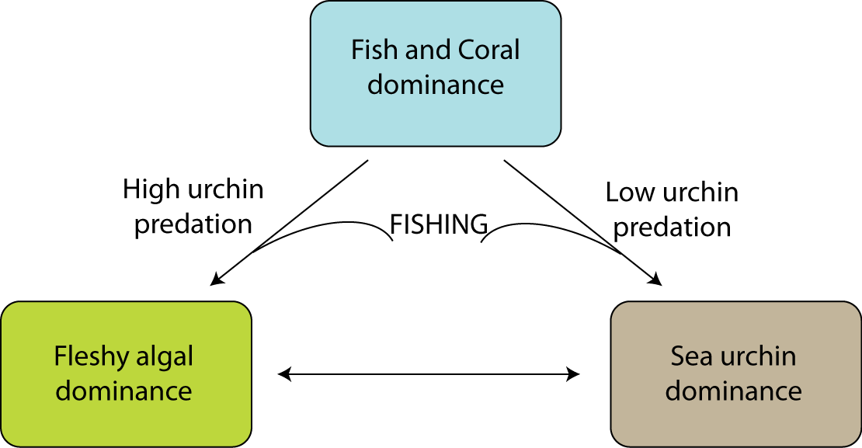
Figure 26: Conceptual model of three alternative ecological states of a coral reef and the potential impact of fishing. The desired ecological state is one where the reef is dominated by coral and fish (McClanahan 1995).

Hunting of seabirds was once a common practice in the Cocos (Keeling) Islands (Bunce 1988). Although hunting within the PKNP Ramsar site is now prohibited, poaching may continue to pose a threat to seabird populations (Director of National Parks 2004). It is estimated that between 2000 and 3000 birds are illegally taken from the Ramsar site each year and in some years this may be as much as 10 000 (Baker et al. 2004).

It has been suggested that past hunting is partially responsible for the low numbers of birds that occur on the southern atoll (Stokes 1994). Hunting results not only in the direct removal of a part of the population of seabirds within the Ramsar site, but the disturbance of birds during the breeding season can lead to a disruption of breeding, abandoning of chicks and eggs and reduced recruitment (Director of National Parks 2004).

5.2 Recreation
Access to the PKNP Ramsar site is restricted not only by its remote location and difficulty of access but by a strict permit system administered by Parks Australia. Entry to the site is prohibited without a permit and prescriptions are in place governing visitor access, boating, recreational fishing and scuba diving. Although commercial tourism is encouraged as an economic benefit to the Cocos Malay people and for the promotion of conservation values, activities are restricted to passive pursuits such as bird watching and limited snorkelling and diving. All forms of fishing charter are prohibited and visitors are not permitted to land on the atoll (Director of National Parks 2004).

Threats from visitor access include disturbance of breeding seabirds (and subsequent reductions in recruitment), damage to reef by boats and anchors and accidental introduction of exotic species.

5.3 Invasive species

5.3.1 Weeds
There are few weeds present within the PKNP Ramsar site and most are not considered to pose a serious threat. A recent survey on the island recorded the extent and location of a number of weed species including: Acalypha lanceolata, pigweed (Portulaca oleracea), pawpaw (Carica papaya), lime berry (Triphasia trifolia) and goose berry (Physalis minima), which all occurred in isolated or restricted distributions. However, coral berry (Rivina humilis) extended over much of the island (Figure 27). This tropical American native has become naturalised over much of the indo-Pacific and is known to displace small understorey native plants (Pacific Island Ecosystems at Risk 2010). Its effect on the ecological character of the Ramsar site is not known.

In addition, significant weed species occur on the southern atoll, including Mossman River grass (Cenchrus echinatus), para grass (Brachiaria mutica), buffel grass, (Cenchrus ciliaris), siam weed (Chromolaena odorata) and a photosynthetic bacterium (Director of National Parks 2004). Translocation of these weed species to the Ramsar site could result in severe effects to terrestrial vegetation and subsequent flow on effects to fauna that are supported by the current vegetations communities. This could include a loss of seabird breeding sites, and a disruption of the food chain for herbivorous species.

5.3.2 Yellow crazy ants
Yellow crazy ants (Anoplolepis gracilipes) occur within the Ramsar site in areas of pisonia forest (Neville et al. 2008). Listed as one of the top 100 worst invasive alien species in the world by the Global Invasive Species Database (2009), they have caused wide scale impacts to tropical ecosystems on Christmas Islands, Hawaii and the Seychelles. Yellow crazy ants forage over a large range of habitats, including forest floor and canopy and are scavengers feeding on a range of invertebrates, but may also be reliant on carbohydrates, which they obtain from plant nectar or honeydew-producing scale insects (particularly of the Homoptera genus). On Christmas Island the relationship between yellow crazy ants and scale insects has resulted in the formation of multi-queen “super colonies” which have caused extensive impacts to biodiversity (Abbott 2005).

It is possible that growth and population expansion may be limited in the absence of Homoptera insect populations (Global Invasive Species Database 2009). Impacts from yellow crazy ants include both mortality of prey items (such as the red crab on Christmas Island) and orphaned seabirds, as well as defoliation of the forest, through the combined action of ants and scale insects (Hill et al. 2003). Within the Ramsar site this would have flow on ecological effects on nesting bird species such as the red-footed booby, which rely on the forest habitat for breeding.

Within the Ramsar site, yellow crazy ants are likely to have been present at the time of listing, in relatively low numbers (Neville at al. 2008). Surveys in 2005 confirmed the presence of this invasive species in the pisonia forest of the Ramsar site, and in some areas, abundance was high rivalling that found in super colonies on Christmas Island (Neville et al. 2008). Although the scale insects that are thought necessary to promote the formation of super colonies have not found within the Ramsar site, a survey in 2009 detected yellow crazy ants over 59 hectares of island’s surveyed 142 hectares and super-colonies at 11 percent of survey sites (unpublished data provided by Parks Australia). Although the impact of the ants on the character of the site is as yet unknown, it may prove to be significant (Neville et al. 2008).

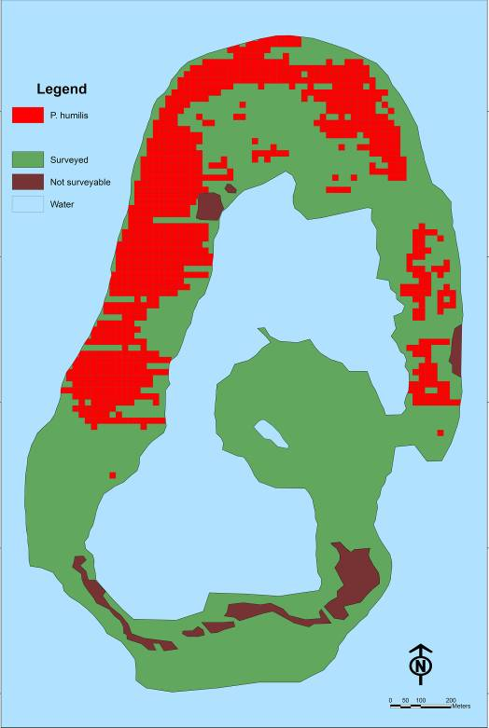
Figure 27: Distribution of coral berry within the PKNP Ramsar site from the Island Wide Survey 2010 (Parks Australia in prep).

5.4 Climate change
There are a variety of climate change predictions for Cocos (Keeling) Islands (McInnes et al. 2008) those of direct relevance to the PKNP Ramsar site are related to sea level, sea temperature and tropical storms. There is uncertainty in the predicted change in climate for the Cocos (Keeling) Islands, but in general it is thought that sea level and sea surface temperatures will increase and that the intensity (if not the frequency) of tropical storms could increase (McInnes et al. 2008).

Table 9: Climate change predictions for the Cocos (Keeling) Islands (McInnes et al. 2008).
Variable | Predicted change by 2030  (since 1990) | Predicted change by 2070  (since 1990)
Sea level | + 13.9 centimetres | + 40.1 centimetres
Sea temperature | + 0.6 degrees Celsius | + 1.8 degrees Celsius
Tropical cyclones - all | Decline from 2.4 to 1.8 per year | Decline from 2.4 to 0.8 per year
Tropical cyclones category 4 and 5 | Increase from 33 percent of all cyclones to 67 percent | Increase from 33 percent of all cyclones to 88 percent

An increase in sea level could result in an increase in submerged areas and intertidal sands at the expense of terrestrial vegetation. Tropical cyclones, with strong winds also have the potential to cause direct physical damage to the vegetation at the site. There are examples in the recent past of tropical cyclones causing extensive damage to the pisonia trees, which in turn resulted in declines in red-footed booby (Baker et al. 2004). To date, vegetation and seabirds have recovered from the effects of tropical cyclones in the intervals between intense storms (Baker and Cunningham 2007). However, an increase in the frequency of category 4 and 5 tropical cyclones may reduce the potential for recovery and lead to sustained changes in vegetation and the seabirds that rely on the vegetation for nesting and roosting.

An increase in sea surface temperature could have significant impacts to the reef and coral communities within the Ramsar site. Although no coral bleaching or disease has been recorded in the Ramsar site to date (Commonwealth of Australia 2005a); white syndrome, or coral bleaching, has been linked to increased water temperature in other parts of the world (Hobbs and Frisch in prep).

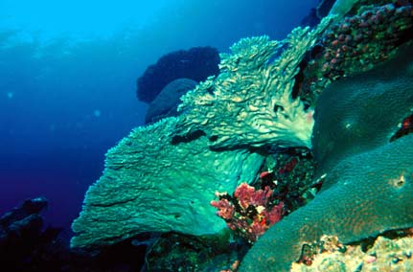
Coral at Pulu Keeling; photography by Robert Thorn (DSEWPaC image library).

5.5 Summary of threats
Although a risk assessment is beyond the scope of an ECD, the DEWHA (2008) framework states that an indication of the impacts of threats to ecological character, likelihood and timing of threats should be included. The major threats considered in the previous sections have been summarised for each location within the Ramsar site in accordance with the DEWHA (2008) framework Table 10.

Table 10: Summary of the main threats to the PKNP Ramsar site.
Actual or likely threat | Potential impact(s) to wetland components, processes and/or service | Likelihood¹ | Timing
Biological resource use - fishing | - Changed fish community composition  - Ecological effects to reef community | Medium | Medium to long term
Biological resource use – hunting seabirds | - Decreased population of seabirds  - Food chain effects | Medium | Immediate to long term
Invasive species (yellow crazy ant) | - Impacts to land based invertebrate populations  - Food chain effects  - Loss of pisonia canopy and subsequent effects on seabird breeding | Certain | Immediate
Human intrusions and disturbance – recreation and tourism | - Disturbance of nesting seabirds  - Introduction of additional invasive species | Medium | Immediate
Climate change:  Sea temperature, storms, sea level | - Loss of vegetation, leading to a decline in seabirds  - Increase in coral bleaching and disease | Medium | Long-term
¹ Where Certain is defined as known to occur at the site or has occurred in the past Medium is defined as not known from the site but occurs at similar sites; and Low is defined as theoretically possible, but not recorded at this or similar sites.

6. Limits of Acceptable Change

6.1 Process for setting Limits of Acceptable Change (LAC)
Limits of acceptable change are defined by Phillips (2006) as:

“…the variation that is considered acceptable in a particular measure or feature of the ecological character of the wetland. This may include population measures, hectares covered by a particular wetland type, the range of certain water quality parameter, etc. The inference is that if the particular measure or parameter moves outside the ‘limits of acceptable change’ this may indicate a change in ecological character that could lead to a reduction or loss of the values for which the site was Ramsar listed. In most cases, change is considered in a negative context, leading to a reduction in the values for which a site was listed”.

LAC and the natural variability in the parameters for which limits are set are inextricably linked. Phillips (2006) suggested that LAC should be beyond the levels of natural variation. Setting limits in consideration with natural variability is an important, but complex concept. Wetlands are complex systems and there is both spatial and temporal variability associated with all components and processes. Defining this variability such that trends away from “natural” can be reliably detected is far from straight forward.

Hale and Butcher (2008b) considered that it is not sufficient to simply define the extreme measures of a given parameter and to set LAC beyond those limits. What is required is a method of detecting change in pattern and setting limits that indicate a distinct shift from natural variability (be that positive or negative). This may mean accounting for changes in the frequency and magnitude of extreme events, changes in the temporal or seasonal patterns and changes in spatial variability as well as changes in the mean or median conditions.

It should be noted that LAC are not synonymous with management values or “trigger levels”. The LAC described here represents what would be considered a change in ecological character at the site in absolute terms with no regard for detecting change prior to irrevocable changes in wetland ecology. Detecting change with sufficient time to instigate management actions to prevent an irrevocable change in ecological character is the role of wetland management and the management plan for a site must develop and implement a set of management triggers with this aim.

6.2 LAC for the PKNP Ramsar site
LAC have been set for the PKNP Ramsar site based on conditions at the time of listing, which in terms of this site may be considered synonymous with natural (Table 11). Where possible, site specific information has been used to statistically determine LAC. In the absence of sufficient site specific data, LAC are based on recognised standards or information in the scientific literature that is relevant to the site. In all these cases, the source of the information upon which the LAC has been determined is provided.

However, it should be noted that for most critical components and processes there are limited quantitative data on which to set limits. In these instances, qualitative LAC based on the precautionary principle have been developed. These will require careful review with increased information gained from future monitoring.

LAC are required for all identified critical components, processes, benefits and services. However, due to the interrelated nature of components, processes and services a single LAC may in fact account for multiple components, process and services. For example, the LAC that addresses marine turtles at PKNP also covers the critical service of threatened species and biodiversity. If either the population of green turtles were significantly altered this would lead to a loss of the service. In order to limit repetition in the LAC for PKNP a hierarchical approach has been adopted where LAC have been set for components, which in this case has also covered critical services.
The columns in Table 11 contain the following information:

Primary critical component / process for the LAC | The component or processes that the LAC is a direct measure of.
Baseline / supporting evidence | Relevant baseline information (relevant to the time of listing) and any additional supporting evidence from the scientific literature and / or local knowledge.
Limit of Acceptable Change | The LAC stated as it is to be assessed against.
Confidence level | The degree to which the authors ore confident that the LAC represents the point at which a change in character has occurred. Assigned as follows:  High – Quantitative site specific data; good understanding linking the indicator to the ecological character of the site;  LAC is objectively measurable.  Medium – Some site specific data or strong evidence for similar systems elsewhere derived from the scientific literature; or informed expert opinion; LAC is objectively measurable  Low – no site specific data or reliable evidence from the scientific literature or expert opinion, LAC may not be objectively measurable and / or the importance of the indicator to the ecological character of the site is unknown.
Secondary critical components/ processes/services addressed through this LAC | These are other critical components, processes or services that are protected indirectly by the LAC.

Table 11: Proposed Limits of Acceptable Change for the PKNP Ramsar site.
Primary critical component / process for the LAC | Baseline / supporting evidence | Limit of Acceptable Change | Confidence level | Secondary critical components/ processes/services addressed through this LAC
Seagrass | Seagrass was present within the lagoon at the time of listing. However, there is insufficient information from this time to set a quantitative LAC. Given the closure of the lagoon (by natural process) and the subsequent loss of the seagrass (see section 7) collection of information on which to base this LAC will no longer be possible. | Presence of seagrass within the lagoon | Low | Service:  - Biodiversity
Invertebrates | Although invertebrate abundance and community composition is a critical component of the Ramsar site and significant changes would represent a change in ecological character, there is no quantitative information on which to base a quantitative LAC and a qualitative LAC based on coral health and state is proposed, but will need to be reassessed in light of information collected in the future.  The LAC is set for the monitoring location at Bunya Coral (Commonwealth of Australia 2005a), as an indicator of reef heath across the Ramsar site. | Coral damage, bleaching and disease at the monitoring location (Bunya Coral) to be “low” as defined in the reef monitoring methodology (Commonwealth of Australia 2005a) | Low | Component:  - Fish  Service:  - Biodiversity  - Near natural wetland types
Fish | Although fish abundance and community composition is a critical component of the Ramsar site and significant changes would represent a change in ecological character, there is no quantitative information on which to base this LAC. | Data deficient, baseline must be determined before limits can be set | Not applicable | Service:  - Biodiversity
Marine Turtles | There is no quantitative information on numbers of hawksbill turtles within the site and nesting green turtle data is limited to a single monitoring occasion in 2006 (Whiting 2006). As such a quantitative LAC cannot be set and a qualitative LAC based on presence / absence of these two species is provided. | Presence of hawksbill turtles within the site.  Successful nesting of green turtle on the sandy beaches each year. | Low | Service:  - Threatened species
Waterbirds | Red-footed booby – mean breeding population 1996 to 2006 was estimated at 30 000 pairs, with a standard deviation of 7700 (Baker and Cunningham 2007). Based on figures presented in Baker et al. (2004) population may vary from 10 000 pairs (in years following cyclonic activity) to more than 40 000 pairs (1987 to 2002).  The LAC is based on the statistics of mean minus one standard deviation to account for variability in populations, and to allow for recovery following cyclonic activity. | Mean abundance of red-footed booby greater than 23 000 pairs (calculated over five years). | Medium | Service:  - Biodiversity  - Physical habitat for waterbird breeding
Waterbirds | Cocos buff-banded rail – mean numbers of birds per hectare (1998 – 2005) is 7.6; ranging from 6.8 to 9.4 (Reid and Hill 2005). LAC based on mean minus one standard error. | Mean abundance of Cocos buff-banded rail greater than 5.5 birds per hectare. | Low | Service:  - Threatened wetland species
Waterbirds | There is little quantitative information on numbers of other waterbirds within the Ramsar site and insufficient data to set a quantitative limit of acceptable change. With the exception of greater frigatebirds, lesser frigatebirds and common noddy, numbers of individual species are potentially low (Director of National Parks 2004). | Data deficient, baseline must be determined before limits can be set. | Not applicable | Service:  - Biodiversity

7. Current Ecological Character and Changes Since Designation

There is no evidence of any significant changes in the coral reef areas of the PKNP Ramsar site, or in numbers of birds (see Figure 17 and Figure 18 above). However, in 2005, the lagoon entrance within the Ramsar site closed as a result of natural forces of deposition. It seems unlikely that the lagoon will naturally reopen as the sealed entrance has now been colonised by substantial terrestrial vegetation (Parks Australia, Cocos (Keeling), pers. com.). The lagoon closure has lead to significant changes within this habitat (Hobbs in prep.).

Seagrass is no longer present in the lagoon area, but has been replaced by a cyanobacterial mat one to 50 centimetres thick across the entire lagoon surface. Below this is a layer of organic, black mud that emits sulphurous odours when disturbed. As a consequence of these changes in habitat and water quality, the lagoon no longer supports large numbers of fish and invertebrates and it is considered that the mud crab (Scylla sp) and bonefish (Albula glossodonta) have become locally extinct (Hobbs in prep.).

Hobbs (in prep.) speculated that the seagrass habitat of the lagoon was an important nursery habitat for a number of fish species, including blacktip reef sharks, mullets, emperors, trevallies and cods; and these species may become locally extinct if suitable alternative nursery habitats cannot be found. The lagoon habitat was also important for species of pipefish and other small fish that may be significantly affected by the lagoon closure.

The impact of the lagoon closure of the Cocos buff-banded rail remains unknown. However, as this species was often observed feeding on invertebrates along the lagoon shore, the impact on food resources may be significant.

The closure of the lagoon, although due to natural, rather than anthropogenic causes is considered to represent a change in ecological character of the PKNP Ramsar site. However, this has not affected the site with respect to the listing criteria met (see section 2.5).

8. Knowledge Gaps
Throughout the Ecological Character Description for the PKNP Ramsar site, mention has been made of knowledge gaps and data deficiencies for the site. While it is tempting to produce an infinite list of research and monitoring needs for this wetland system, it is important to focus on the purpose of an ecological character description and identify and prioritise knowledge gaps that are important for describing and maintaining the ecological character of the system.

Knowledge gaps that are required to fully describe the ecological character of this site and enable rigorous and defensible limits of acceptable change to be met are relatively few and listed in Table 12. Collection of information at PKNP Ramsar site is difficult due to the remote location and difficulty of access. In recognition of this, recommended actions are aimed at developing indicators of ecological character that could fill knowledge gas and help in the design of on going monitoring.

Table 12: Knowledge Gaps for the PKNP Ramsar site
Component / process | Knowledge Gap | Recommended Action
Lagoon closure | The closure of the lagoon and loss of seagrass and associated communities, together with the altered connectivity at the site has the potential for serious impacts to ecological character (see section 7). The resulting changes in productivity and food resources for wading species of bird (including the Cocos buff-banded rail) and fish biodiversity is not known. | Possibly can be addressed through monitoring of potentially affected species, particularly Cocos buff-banded rail and fish.
Terrestrial vegetation | Knowledge of the extent and distribution of vegetation is limited to a single survey in 1994. There is no information on vegetation condition or and variability in extent and canopy cover. Observations of a reduction in canopy cover following cyclones have been made (Director of National Parks 2004) but no indication of rates of recovery. | Assessment of vegetation extent from high resolution aerial photography or satellite imagery; including impacts of cyclones and recovery of canopy.
Invertebrates | No indication of variability in community composition and abundance. | Development of indicator species and implementation of a monitoring program
Fish | No indication of variability in community composition and abundance | Development of indicator species and implementation of a monitoring program
Marine turtles | Importance of the site for foraging marine turtles remains unknown. No indication of variability in green turtle nesting numbers | Regular marine turtle surveys
Waterbirds | Abundance, diversity and variability in seabird numbers within the Ramsar site | Regular seabird counts.

9. Monitoring needs

As a signatory to the Ramsar Convention, Australia has made a commitment to protect the ecological character of its Wetlands of International Importance. Under Part 3 of the Environment Protection and Biodiversity Conservation Act 1999 a person must not take an action that has, will have or is likely to have a significant impact on the ecological character of a declared Ramsar wetland. While there is no explicit requirement for monitoring the site, in order to ascertain if the ecological character of the wetland site is being protected a monitoring program is required.

A comprehensive monitoring program is beyond the scope of an ECD, but an important component of a management plan. What is provided here is an identification of monitoring needs required to both set baselines for key components and processes and to assess against limits of acceptable change. It should be noted that the focus of the monitoring recommended in an ECD is an assessment against LAC and determination of changes in ecological character. This monitoring is not designed as an early warning system whereby trends in data are assessed to detect changes in components and processes prior to a change in ecological character of the site. This must be included in the management plan for the site.

The recommended monitoring to meet the obligations under Ramsar and the EPBC Act (1999) with respect to the PKNP Ramsar site are provided in Table 13. There are a number of existing monitoring programs within the PKNP Ramsar site and some of the monitoring recommended may already be contained in these existing programs.
Table 13: Monitoring needs for the PKNP Ramsar site
Component/Process | Purpose | Indicator | Locations | Frequency | Priority
Vegetation - extent | Identified knowledge gap, although there is no LAC for vegetation, survey data can inform on condition and extent of major vegetation types.  This could be used as an indicator for seabird habitat in management planning. | Extent of broad vegetation types (pisonia, coconut, ironwood, octopus bush) by remote sensing. | Entire Ramsar site | Every 5 years | Medium
Weeds | Determination of impact | Identification and determining extent of weeds by land survey. | Entire Ramsar site | Annual | Low
Yellow crazy ants | Determination of impact | Abundance, presence of scale insects | Pisonia forest | Every 2 years | High
Marine Invertebrates - coral | Assessment against LAC | Coral extent and health | Existing Bunya Coral site | Annual | High
Fish | Establishment of indicator species, and baseline on which a LAC can be developed. | Abundance and community composition | Reef | Every 2 - 5 years | Moderate
Waterbirds | Assessment against LAC | Counts and species identifications, breeding observations | Atoll | Annual | High
Marine Turtles | Assessment against LAC | Nesting surveys | Northern and southern beaches | Annual | Moderate

10. Communication and Education Messages

Under the Ramsar Convention a Program of Communication, Education, Participation and Awareness (CEPA) was established to help raise awareness of wetland values and functions. At the Conference of Contracting Parties in Korea in 2008, a resolution was made to continue the CEPA program in its third iteration for the next two triennia (2009 – 2015).

The vision of the Ramsar Convention’s CEPA Program is: “People taking action for the wise use of wetlands.” To achieve this vision, three guiding principles have been developed:

- The CEPA Program offers tools to help people understand the values of wetlands so that they are motivated to become advocates for wetland conservation and wise use and may act to become involved in relevant policy formulation, planning and management.
- The CEPA Program fosters the production of effective CEPA tools and expertise to engage major stakeholders’ participation in the wise use of wetlands and to convey appropriate messages in order to promote the wise use principle throughout society.
- The Ramsar Convention believes that CEPA should form a central part of implementing the Convention by each Contracting Party. Investment in CEPA will increase the number of informed advocates, actors and networks involved in wetland issues and build an informed decision-making and public constituency.

The Ramsar Convention encourages that communication, education, participation and awareness are used effectively at all levels, from local to international, to promote the value of wetlands.

A comprehensive CEPA program for an individual Ramsar site is beyond the scope of an ECD, but key communication messages and CEPA actions, such as a community education program, can be used as a component of a management plan.

The management plan for the PKNP Ramsar site contains a number of key communication messages and a program for implementing community education. Key CEPA messages for the PKNP Ramsar site arising from this ECD, which should be promoted through this program, include:

- The Ramsar values of the site and the importance of the Ramsar site as a habitat for breeding seabirds.

- The significance of the site in maintaining biodiversity in the region, particularly in light of the reduced biodiversity in the Southern Atoll.

- The threats that hunting, fishing and inappropriate recreational activities pose to the ecological character of the site.

- The threat of yellow crazy ants and the impact they could have on the sites values.

- Climate change, the potential impacts on the benefits and services of the Ramsar site and the ways in which additional pressures from activities such as boating, fishing and hunting can exacerbate the effects of climate change on marine and tropical environments.

- The importance of cooperative management of site involving the local community on maintaining the ecological character of the PKNP Ramsar site.

References
Abbott, K.L., 2005, Supercolonies of the invasive yellow crazy ant, Anteplolepis gracilipes, on an oceanic island: Forager patterns, density and biomass, Insectes Sociaux 52: 266–273.

Allen, G.R. and Smith-Vanz, 1994, Fishes of the Cocos (Keeling) Islands), Atoll Research Bulletin 412, Natural Museum of Natural History, Smithsonian Institute, Washington DC, USA.

Anderson, D.J., 1990, Evaluation of obligate suicide in boobies. 1. A test of the Insurance-Egg Hypothesis, The American Naturalist 135 (3): 334-350

ANZECC and ARMCANZ, 2000, Australian and New Zealand Guidelines for Fresh and Marine Water Quality National Water Quality Management Strategy Paper no. 4.Australian and New Zealand Environment and Conservation Council / Agriculture and Resource Management Council of Australia and New Zealand

Attorney General’s Department 2009; Cocos (Keeling Islands http://www.ag.gov.au/www/agd/agd.nsf/Page/TerritoriesofAustralia_Cocos(Keeling)Islands_CocosIslandsEnvironmentandHeritage#pop accessed 15/9/09

Australian Heritage Commission, 2002, Australian Natural Heritage Charter for conservation of places of natural heritage significance. Second Edition. Australian Heritage Commission. Canberra

Baker, G.B. and Cunningham, R.B., 2007, Data Analysis System for Red-footed Booby Program at Cocos (Keeling) Islands 2007, Report prepared for the Department of Environment and Water Resources, Canberra.

Baker, G.B., Cunningham, R.B. and Murray, W., 2004, Are red-footed boobies Sula sula at risk from harvesting by humans on Cocos (Keeling) Islands, Indian Ocean? Biological Conservation 119: 271–278

Bamford, M, D. Watkins, W. Bancroft, G. Tischler and J. Wahl. 2008. Migratory Shorebirds of the East Asian - Australasian Flyway; Population Estimates and Internationally Important Sites. Wetlands International Oceania. Canberra, Australia.

Barrett, G.W., Van Dyne, G.M. and Odum, E. P., 1976. Stress ecology. BioScience 26:192-194

BirdLife International, 2009, Species factsheet: Sula sula. Downloaded from http://www.birdlife.org on 18/9/2009

Birds Australia, unpublished, Australian Bird Atlas data extracted May 2009.

Block, H. and Bruno, J., 2008, Coral reef zonation, In: Cutler J (Ed.) Encyclopaedia of Earth, Washington, D.C.: Environmental Information Coalition, National Council for Science and the Environment.

Bureau of Meteorology, 2009a, Climate data online, downloaded from http://www.bom.gov.au/climate/averages/ on 15/9/2009.

Bureau of Meteorology, 2009b, Australian tide predictions, downloaded from http://www.bom.gov.au/cgi-bin/oceanography/tides/tide_predications.cgi on 22/9/2009.

Bunce, P., 1988, The Cocos (Keeling) Islands: Australian Atolls in the Indian Ocean, Jacaranda Press: Milton, Queensland

Commonwealth of Australia, 2005a, Status of the Coral Reefs at the Cocos (Keeling) Islands
A report on the status of the marine community at Cocos (Keeling) Islands, East Indian Ocean, 1997–2005

Commonwealth of Australia, 2005b, National Recovery Plan for the Buff-banded Rail (Cocos (Keeling) Islands) Gallirallus philippensis andrewsi. Department of the Environment and Heritage, Canberra.

Commonwealth of Australia, 2006, A guide to The Integrated Marine and Coastal Regionalisation of Australia - version 4.0 June 2006 (IMCRA v4.0)

Corre, M., 2001, Breeding seasons of seabirds at Europa Island (southern Mozambique Channel) in relation to seasonal changes in the marine environment, Journal of Zoology, 254 (2): 239-249

Dann, S., Dijkstra, C., Drent, R. and Meijer, T., 1988, Food supply and the annual timing of avian reproduction. In Ouellet, H. (Ed.) Proc. XIX Int. Congr. Ornithol., Ottawa, University Ottawa, Canada: pp. 392-407.

Davis, J. and Brock, M., 2008, Detecting unacceptable change in the ecological character of Ramsar wetlands, Ecological Management and Restoration, 9: 26-32.

DEH (Department of Environment and Heritage), 1999, Population status and threats to ten seabird species listed as threatened under the Environment Protection and Biodiversity Conservation Act, Australian Government, Canberra.

DEH (Department of Environment and Heritage), 2005, Recovery Plan for 10 Seabirds, 2005 – 2010, Australian Government, Canberra.

DEW (Department of Environment and Water) 2005, Background Paper to the Wildlife
Conservation Plan for Migratory Shorebirds, http://www.environment.gov.au/biodiversity/migratory/waterbirds/shorebird-plan/background-paper.html

DEWHA (Department of Environment, Water, Heritage and the Arts), 2008, National Framework and Guidance for Describing the Ecological Character of Australia’s Ramsar Wetlands. Module 2 of Australian National Guidelines for Ramsar Wetlands – Implementing the Ramsar Convention in Australia.

Director of National Parks, 2004, Second Pulu Keeling National Park Management Plan, Commonwealth of Australia, Canberra

Drent, R.H. and Dann, S., 1980, The prudent parent: energetic adjustments in avian breeding, Ardea 68: 225-252.

Environment Australia, 2003, Recovery plan for marine turtles in Australia, Environment Australia, Canberra.

Environment Australia, 1999, Ramsar Information Sheet for the Pulu Keeling National Park Ramsar site, Environment Australia, Canberra

Falkland, A.C, 1994, Climate, hydrology and water resources of the Cocos (Keeling) Islands, Atoll Research Bulletin 400, Natural Museum of Natural History, Smithsonian Institute, Washington DC, USA.

Garnett, S. and Crowley, G., 2000, National Action Plan for Australian Birds, Environment Australia, Canberra.

Global Invasive Species Database, 2009, (http://www.issg.org/database) accessed October 4, 2009.

Gross, J., 2003, Developing Conceptual Models for Monitoring Programs http://science.nature.nps.gov/im/monitor/docs/Conceptual_Modelling.pdf

Hackett, S. J., Kimball, R. T., Reddy, S., Bowie, R. C. K., Braun, E. L., Braun, M. J., Chojnowski, J. L., Cox, W. A., Han, K.-L., Harshman, J., Huddleston, C. J., Marks, B. D., Miglia, K. J., Moore, W. A., Sheldon, F. H., Steadman, D. W., Witt, C. C., and Yuri, T. 2008, A phylogenomic study of birds reveals their evolutionary history. Science 320 (5884): 1763-1768.

Hale, J. and Butcher, R., 2008, Ecological Character Description of the Peel-Yalgorup Ramsar Site, Report to DEC and PHCC.

Heap, A.D., Harris, P.T., Hinde, A. and Woods, M., 2005, Report to the National Oceans Office on the Development of a National Benthic Marine Bioregionalisation in support of Regional Marine Planning, GeoScience Australia, Canberra

Higgins, P.J. and Davies. S., 1996, Handbook of Australian, New Zealand and Antarctic Birds, Volume 3: Snipe to Pigeons. Oxford University Press, Melbourne.

Hill, M.K., Holm, T.V., Shah, N.J. and Hill, P.M., 2003, Impact of the introduced yellow crazy ant Anoplolepis gracilipes on Bird Island, Seychelles. Biodiversity and Conservation 12:1969–1984

Hobbs, J-P, in prep., Fishes of North Keeling Island (Pulu Keeling National Park) and the impact of the lagoon closure, report to Parks Australia.

Hobbs, J-P., Frisch, A.J., Allen, G.R., Herwerden, L.V., 2009, Marine hybrid hotspot at Indo-Pacific biogeographic border, Biol. Lett. 5: 258-261

Hobbs, J-P. and Salmond, J.K., 2008, Cohabitation of Indian and Pacific Ocean species at Christmas and Cocos (Keeling) Islands, Coral Reefs, 27:933

Holland J., 1998, Emergence: From Chaos to Order, Addison-Wesley, Reading, MA,.

Larkum, A.W.D., Orth, R.J. and Duarte, C.M., Seagrass: Biology and Conservation, Springer, The Netherlands.

Limpus, C.J., 2008, Biological Review of Australian Marine Turtles: Green Turtle Chelonia mydas (Linnaeus), Queensland. Environmental Protection Agency

Lincoln Smith, M.P., Skilleter, G.A., Underwood, A.J., Stark, J., Smith, A.K., Hawes, P.M.H., Howitt, L., White, G.A. and Chapman, M.G., 1995, Cocos (Keeling) Islands: Quantitative baseline surveys for core marine reserves and biosphere reserve in the South Keeling Lagoon. Report to the Australian Nature Conservation Agency by the Institute of Marine Ecology, University of Sydney and The Ecology Lab Pty. Limited.

Lalli, C.M. and Parsons, T.R., 1995, Biological Oceanography: An Introduction. Oxford, UK: Butterworth-Heinemann Ltd.

Jaensch, R., 2002, Ecological requirements and guilds of waterbirds recorded at the Menindee Lakes system, NSW, Report to Biosis Research and the NSW Department of Land and Water Conservation, Wetlands International, Oceania.

Jones, D.S., 1994, Barnacles (Cirripedia, Thoracica) of the Cocos (Keeling) Islands, Atoll Research Bulletin 413, Natural Museum of Natural History, Smithsonian Institute, Washington DC, USA.

Marchant, S. and Higgins, P.J., (Eds) 1990. Handbook of Australian, New Zealand and Antarctic Birds, Volume 1: Ratites to Ducks, Oxford University Press, Melbourne.

Marchant, S. and Higgins, P.J. (Eds), 1993, Handbook of Australian, New Zealand and Antarctic Birds, Volume Two - Raptors to Lapwings. Melbourne, Victoria: Oxford University Press.

Marsh, L.M., 1994, Echinoderms of the Cocos (Keeling) Islands, Atoll Research Bulletin 411, Natural Museum of Natural History, Smithsonian Institute, Washington DC, USA

McClanahan, T., 1995, A coral reef ecosystem-fisheries model: impacts of fishing intensity and catch selection on reef structure and processes, Ecological Modelling 80: 1-19

McClanahan, T., Polunin, N. and Done, T., 2002, Ecological states and the resilience of coral reefs, Conservation Ecology 6(2): 18. [online] URL: http://www.consecol.org/vol6/iss2/art18

McGrath, C. 2006, unpublished Legal review of the framework for describing the ecological character of Ramsar wetlands to support implementation of the EPBC Act. Report to the Department of the Environment and Heritage, Unpublished.

McInnes, KL., Macadam, I., Hemer, M., Abbs, D., White, N., Church, J. and Bathols, J. 2008, Recent and future climate conditions for Cocos and Christmas Islands. A project undertaken for Maunsell Pty Ltd, CSIRO Marine and Atmospheric Research

Millennium Ecosystem Assessment, 2005, Ecosystem Services and Human Well-Being: Wetlands & Water: Synthesis. 2005. Millennium Ecosystem Assessment report to the Ramsar
Convention: World Resources Institute, Washington D.C.

Mortimer, J. A., 1979, Factors influencing beach selection by nesting turtles, Biology and Conservation of Sea Turtles, World Conference on Sea Turtle Conservation, Revised Edition 1995, Washington.

Morgan, G.J., 1994, Decapod Crustaceans of the Cocos (Keeling) Islands, Atoll Research Bulletin 414, Natural Museum of Natural History, Smithsonian Institute, Washington DC, USA.

Neville, P.J., O’Dowd, D.J., and Yen. A.L., 2008, Issues and implications for research on disturbed oceanic islands illustrated through an ant survey of the Cocos (Keeling) Islands, Journal of Insect Conservation 12: 313–323

Pacific Island Ecosystems at Risk 2010, Plant threats to Pacific ecosystems, http://www.hear.org/Pier/index.html accessed February 2010.

Phillips, B., 2006, Critique of the Framework for describing the ecological character of Ramsar Wetlands (Department of Sustainability and Environment, Victoria, 2005) based on its application at three Ramsar sites: Ashmore Reed National Nature Reserve, the Coral Sea Reserves (Coringa-Herald and Lihou Reeds and Cays), and Elizabeth and Middleton Reeds Marine National Nature Reserve. Mainstream Environmental Consulting Pty Ltd, Waramanga ACT.

Phillips, B. and Muller, K., 2006, Ecological Character Description of the Coorong, Lakes Alexandrina and Albert Wetland of International Importance, Department of Environment and Heritage, Adelaide, South Australia

Phillips, N.J., 1987, The breeding biology of White-tailed Tropicbirds Phaethon lepturus at Cousin Island, Seychelles. Ibis 129:10–24

Ramsar Convention, 1987, Convention on Wetlands of International Importance especially as Waterfowl Habitat.

Ramsar Convention 2005, Resolution IX.1 Annex A. A Conceptual Framework for the wise use of wetlands and the maintenance of their ecological character. http://www.ramsar.org/res/key_res_ix_01_annexa_e.htm

Ramsar Convention, 2009, Strategic Framework for the List of Wetlands of International Importance, Third edition, as adopted by Resolution VII.11 (COP7, 1999) and amended by Resolutions VII.13 (1999), VIII.11 and VIII.33 (COP8, 2002), IX.1 Annexes A and B (COP9, 2005), and X.20 (COP10, 2008). http://ramsar.rgis.ch/dev/ramsar/display/main/main.jsp?zn=ramsar&cp=1-31-105^20823_4000_0__

Reid, J.R.W., 2000, Survey of the Buff-banded Rail (Gallirallus philippensis andrewsi) in Pulu Keeling National Park, Cocos Islands, Indian Ocean

Reid J.R.W. and Hill B.M., 2005, Recent Surveys of the Cocos Buff-banded Rail Gallirallus philippensis andrewsi. Report to the Australian Government Department of the Environment and Heritage. Centre for Resource and Environmental Studies, Australian National University, Canberra

Sandin, S, A,, Smith, J.E., DeMartini, E.E., Dinsdale, E.A., Donner, S.D., Friedlander, A.L., Konotchick, T., Malay, M., Maragos, J.E., Obura, D., Pantos, O., Paulay, G., Richie, M., Rohwer, F., Schroeder, R.E., Walsh, S., Jackson, J.B.C., Knowlton, N. and Sala, E., 2008, Baselines and Degradation of Coral Reefs in the Northern Line Islands. PLoS ONE 3(2): e1548.

Stokes, T., 1982, Birds of the Cocos (Keeling) Islands, Indian Ocean. Australian National Parks and Wildlife Service Internal Report.

Stokes, T., 1994, An update on birds of the Cocos (Keeling) Islands, Atoll Research Bulletin 405, Natural Museum of Natural History, Smithsonian Institute, Washington DC, USA.

Stokes, T., Shiels, W., and Dunn, K., 1984, Birds of the Cocos (Keeling) Islands, The Emu, 84: 23–28.

USFWS (United States Fish and Wildlife Service), 2005, Regional seabird conservation plan, Pacific Region, USFWS, Migratory Birds and Habitat Programs, Pacific Region. Portland.

Veron, J.E., 1994, Hermatypic Corals of Cocos (Keeling) Islands: a Summary, Atoll Research Bulletin 409, Natural Museum of Natural History, Smithsonian Institute, Washington DC, USA.

Wells, F.E., 1994, Marine Molluscs of the Cocos (Keeling) Islands, Atoll Research Bulletin 410, Natural Museum of Natural History, Smithsonian Institute, Washington DC, USA.

Wetlands International, 2006, Waterbird Population Estimates, fourth edition.

Whiting, S., 2006, Sea Turtle Study Cocos (Keeling ) Islands, Indian Ocean, Year 7, Parks Australia, Canberra

Whiting, S. Murray, W., Macrae, I., Thorn, R., Chongkin, M. and Koch, A., 2008, Non-migratory breeding by isolated green sea turtles (Chelonia mydas) in the Indian Ocean: biological and conservation implications, Naturwissenschaften, Short Communication

Williams, D.G., 1994, Vegetation and Flora of the Cocos (Keeling) Islands, Atoll Research Bulletin 404, Natural Museum of Natural History, Smithsonian Institute, Washington DC, USA.

Woodroffe, C.D., and Berry, P.F., 1994, Scientific Studies In the Cocos (Keeling) Islands, Atoll Research Bulletin 399, Natural Museum of Natural History, Smithsonian Institute, Washington DC, USA.

Woodroffe, C.D., and McLean, R.F., 1994, Reef Islands of the Cocos (Keeling) Islands, Atoll Research Bulletin 403, Natural Museum of Natural History, Smithsonian Institute, Washington DC, USA.

Woodroffe, C.D., McLean, R.F., and Wallensky, E., 1994, Geomorphology of the Cocos (Keeling) Islands, Atoll Research Bulletin 402, Natural Museum of Natural History, Smithsonian Institute, Washington DC, USA

Appendix A: Methods

A.1 Approach
Project Inception:
Consultant team leader Jennifer Hale met with the Department of Sustainability, Environment, Water, Population and Communities (DSEWPaC) project manager to confirm the scope of works and timelines as well as identifying relevant stakeholders that would be consulted.

Task 1: Review and compilation of available data
The consultant team undertook a thorough desktop review of existing information on the ecology of the PKNP Ramsar site.

Task 2: Stakeholder engagement and consultation
A Steering Committee was formed for the PKNP Ramsar site ECD. This group was comprised of members from:

Department of Sustainability, Environment, Water, Population and Communities
- Parks Australia, Planning, Tourism and National Landscapes Section
- Parks Australia, Pulu Keeling National Park
- Parks Australia, Christmas Island National Park
- Water Reform Division, Wetlands Section

The Steering Committee met by teleconference in late 2009 and mid 2010 to discuss the components, processes, services and benefits of the PKNP Ramsar site. In addition, members of the Steering Committee provided written comments on drafts of the ECD.

Task 3: Development of a draft ECD
Consistent with the national guidance and framework (DEWHA 2008) the following steps were undertaken to describe the ecological character of the PKNP Ramsar site.

Steps from the national draft (2008) framework | Activities
1. Document introductory details | Prepare basic details: site details, purpose, legislation.
2. Describe the site | Based on the Ramsar RIS and the above literature review describe the site in terms of: location, land tenure, Ramsar criteria, wetland types (using Ramsar classification).
3. Identify and describe the critical components, processes and services | - Identify all possible components, services and benefits.  - Identify and describe the critical components, services and benefits responsible for determining ecological character.
4. Develop a conceptual model of the system. | Two types of models were developed for the system:  - A series of control models that describe important aspects of the ecology of the site, including feedback loops. Aiding in the understanding of the system and its ecological functions; and  - A stressor model that highlights the threats and their effects on ecological components and processes. Aiding in understanding management of the system.
5. Set Limits of Acceptable Change | For each critical component process and service, establish the limits of acceptable change.
6. Identify threats to the site | This process identified both actual and potential future threats to the ecological character of the wetland system.
7. Describe changes to ecological character since the time of listing | This section describes in quantitative terms (where possible) changes to the wetlands since the initial listing in 1996
8. Summarise knowledge gaps | This identifies the knowledge gaps for not only the ecological character description, but also for its management.
9. Identify site monitoring needs | Based on the identification of knowledge gaps above, recommendations for future monitoring are described.
10. Identify communication, education and public awareness messages | Following the identification of threats, management actions and incorporating stakeholder comments, a general description of the broad communication / education messages are described.

Task 4: Revision of the Ramsar Information Sheet (RIS)
The information collated during Task 1, together with the draft Ecological Character Description was used to produce a revised RIS in the standard format provided by Ramsar.

Task 5 Finalising the ECD and RIS
The draft ECD and RIS were submitted to DSEWPaC, and the Steering Committee for review. Comments from agencies and stakeholders were incorporated to produce revised ECD and RIS documents.

A.2 Consultant Team
Jennifer Hale (team leader)
Jennifer has over twenty years experience in the water industry having started her career with the State Water Laboratory in Victoria. Jennifer is an aquatic ecologist with expertise in freshwater, estuarine and near-shore marine systems. She is qualified with a Bachelor of Science (Natural Resource Management) and a Masters of Business Administration. Jennifer is an aquatic ecologist with specialist fields of expertise including phytoplankton dynamics, aquatic macrophytes, sediment water interactions and nutrient dynamics. She has a broad understanding of the ecology of aquatic macrophytes, fish, waterbirds, macroinvertebrates and floodplain vegetation as well as geomorphic processes. She has a solid knowledge of the development of ecological character descriptions and has been involved in the development of ECDs for Port Phillip Bay and Bellarine Peninsula, the Peel-Yalgorup, the Ord River Floodplain, Eighty-mile Beach, the Coorong and Lakes Alexandrina and Albert, Lake MacLeod, Elizabeth and Middleton Reefs, Ashmore Reef and the Coral Seas Ramsar sites.

Rhonda Butcher
Rhonda is considered an expert in wetland ecology and assessment. She has a BSc (hons) and a PhD in Wetland Ecology together with over twenty years of experience in the field of aquatic science. She has extensive experience in biological monitoring, biodiversity assessment, invertebrate ecology as well as wetland and river ecology having worked for CSIRO/Murray Darling Freshwater Research Centre, Monash University/CRC for Freshwater Ecology, Museum of Victoria, Victorian EPA and the State Water Laboratories of Victoria. Rhonda has worked on numerous Ramsar related projects over the past eight years, including the first pilot studies into describing ecological character. She has subsequently co-authored, provided technical input, and peer reviewed a number of Ecological Character Descriptions. She recently project managed the preparation of Ramsar nomination documents for Piccaninnie Ponds Karst Wetlands and Banrock Station Wetland Complex in South Australia, which included preparation of the ECD, RIS and Ramsar Management Plan. Other ECD project’s Rhonda has had technical input to include the Coorong and Lakes Alexandrina and Albert, Lake MacLeod, Peel-Yalgorup, Eighty-mile Beach, Port Phillip Bay, Lake Albacutya.

Halina Kobryn
Dr Halina Kobryn has over fifteen years of experience in applications of GIS and remote sensing in environmental applications. She is a GIS and remote sensing expert, specialising in natural resource assessment. Dr Kobryn has a BSc in Physical Geography and Cartography, Graduate Diploma in Surveying and Mapping and a PhD which explored impacts of stormwater on an urban wetland and explored GIS methods for such applications. She has worked at a university as a lecturer for over 15 years and taught many subjects including GIS, remote sensing, environmental monitoring and management of aquatic systems. She has developed the first course in Australia (at a graduate level) on Environmental Monitoring. She has been involved in many research and consulting projects and her cv outlines the breadth of her expertise. She has also supervised over 20 research students (honours, Masters and PhD). She has worked in Indonesia, Malaysia (Sarawak) and East Timor on projects related to water quality and river health.

Jean-Paul Hobbs
Jean-Paul is a marine ecologists specialising in the ecology of tropical coral reefs and in particular isolated island systems. He is a member of the ARC Centre of Excellence for Coral Reef Studies and a lecturer at James Cook University in Queensland. He has undertaken extensive surveys and research into the marine environments at Christmas Island and Cocos Island. He is currently finishing a report to Parks Australia on the status of North Keeling Ramsar site at Cocos and the loss of marine diversity and local extinctions that have recently occurred in this wetland following the closure of the lagoon.

Appendix B: Wetland birds recorded in the PKNP Ramsar Site
Species list compiled from Birds Australia Bird Atlas, Stokes et al. 1984; Stokes 1994; Director of National Parks 2004.
Order | Scientific Name | Common name | EPBC Listing | Comments
Ardeiformes | Ardea ibis | Cattle egret | Marine; Migratory (CAMBA, JAMBA) | Vagrant
Ardeiformes | Egretta sacra | Eastern reef egret | Marine; Migratory (CAMBA) | Resident  Breeding
Ardeiformes | Nycticorax caledonicus | Nankeen night heron | Marine | Resident  Breeding
Charadriiformes | Chlidonias leucopterus | White-winged tern | Marine; Migratory (CAMBA, JAMBA, ROKAMBA) | Migratory  Single sighting
Charadriiformes | Gygis alba | White tern | Marine | Resident  Breeding
Charadriiformes | Onychoprion anaethetus | Bridled tern | Marine; Migratory (CAMBA, JAMBA) | Vagrant  Breeding
Charadriiformes | Onychoprion fuscata | Sooty tern | Marine | Resident  Breeding
Charadriiformes | Arenaria interpres | Ruddy turnstone | Marine; Migratory (Bonn, CAMBA, JAMBA, ROKAMBA) | Migratory
Charadriiformes | Anous stolidus | Common noddy | Marine; Migratory (CAMBA, JAMBA) | Resident  Breeding
Charadriiformes | Calidris alba | Sanderling | Marine; Migratory (Bonn, CAMBA, JAMBA, ROKAMBA) | Migratory
Charadriiformes | Gallinago stenura | Pin-tailed snipe | Marine; Migratory (Bonn, CAMBA, JAMBA, ROKAMBA) | Migratory
Ciconiiformes | Phoenicopterus ruber | Greater flamingo | Marine | Vagrant
Gruiformes | Gallirallus philippensis andrewsi | Cocos buff-banded rail | Endangered | Resident Breeding
Pelecaniformes | Sula dactylatra | Masked booby | Marine; Migratory (JAMBA, ROKAMBA) | Resident Breeding
Pelecaniformes | Sula leucogaster | Brown booby | Marine; Migratory (CAMBA, JAMBA, ROKAMBA) | Resident Breeding
Pelecaniformes | Sula sula | Red-footed Booby | Marine; Migratory (CAMBA, JAMBA) | Resident Breeding
Pelecaniformes | Fregata andrewsi | Christmas Island frigatebird, | Vulnerable; Marine; Migratory (CAMBA) | Vagrant
Pelecaniformes | Fregata ariel | Lesser frigatebird | Marine; Migratory (CAMBA, JAMBA, ROKAMBA) | Resident Breeding
Pelecaniformes | Fregata minor | Greater frigatebird | Marine; Migratory (CAMBA, JAMBA) | Resident Breeding
Pelecaniformes | Phaethon lepturus fulvus | White-tailed tropicbird | Marine | Resident Breeding
Pelecaniformes | Phaethon rubricauda | Red-tailed tropicbird | Marine | Resident Breeding
Procellariiformes | Puffinus pacificus | Wedge-tailed shearwater | Marine; Migratory (JAMBA) | Migratory  Breeding
Procellariiformes | Pterodroma arminjoniana s. str. | Round Island petrel | Critically Endangered | Single record
 | Puffinus lherminieri | Tropical shearwater | Marine | Single record; Breeding?

Appendix C: Invertebrates
Molluscs recorded within the Ramsar site (Wells 1994).
Bold indicates species not recorded elsewhere in the Cocos Islands
Class | Family | Species
Gastropoda | Trochidae | Monilea cf. nucleus
Gastropoda | Turbindae | Astralium calcar
Gastropoda | Turbindae | Turbo lajonkairii
Gastropoda | Neritopsidae | Neritopsis radula
Gastropoda | Architectonicidae | Heliacus sp.
Gastropoda | Cerithiidae | Cerithim atromarginatum
Gastropoda | Cerithiidae | Cerithiurn colurnm
Gastropoda | Cerithiidae | Cerithim echinatum
Gastropoda | Cerithiidae | Cerithium egenum
Gastropoda | Cerithiidae | Cerithium cf . ianthinum
Gastropoda | Cerithiidae | Cerithium nesioticum
Gastropoda | Cerithiidae | Cerithium rarirnaculatum
Gastropoda | Cerithiidae | Cerithium rostratum
Gastropoda | Cerithiidae | Rhinoclavis dicadema
Gastropoda | Eulimidae | Balcis curningi
Gastropoda | Naticidae | Polinices tumidus
Gastropoda | Ovulidae | Calpurneus lacteus
Gastropoda | Cypraidae | Cypraea carneola
Gastropoda | Cypraidae | Cypraea fimbricata
Gastropoda | Cypraidae | Cypraea helvola
Gastropoda | Cypraidae | Cypraea histrio
Gastropoda | Cypraidae | Cypraea isahella
Gastropoda | Cypraidae | Cypraea labrolineata
Gastropoda | Cypraidae | Cypraea poraria
Gastropoda | Cypraidae | Cypraea punctata
Gastropoda | Cypraidae | Cypraea stolida
Gastropoda | Cypraidae | Cypraea talpa
Gastropoda | Cypraidae | Cypraea teres
Gastropoda | Cymatiidae | Cyrnatium ruhecullm
Gastropoda | Cymatiidae | Gelagna succincta
Gastropoda | Bursidae | Bursa cruentata
Gastropoda | Bursidae | Bursa granularis
Gastropoda | Muricidae | Chicoreus saulii
Gastropoda | Thaididae | Drupella rubusidaeus
Gastropoda | Thaididae | Drupella chaidea
Gastropoda | Thaididae | Maculotriton digitalis
Gastropoda | Thaididae | Maculotriton serriale
Gastropoda | Thaididae | Morula margariticola
Gastropoda | Thaididae | Morula nodicostata
Gastropoda | Thaididae | Morula spinosa
Gastropoda | Thaididae | Morula uva
Gastropoda | Coralliophilidae | Coralliophila erosa
Gastropoda | Coralliophilidae | Coralliophila robillardi
Gastropoda | Coralliophilidae | Coralliophila violacea
Gastropoda | Coralliophilidae | Quoyula madreporarum
Gastropoda | Coralliophilidae | Rapa rapa
Gastropoda | Columbellidae | Pyrene obtusa
Gastropoda | Columbellidae | Pyrene turturim
Gastropoda | Columbellidae | Pyrene varians
Gastropoda | Buccinidae | Cantharus pulcher
Gastropoda | Buccinidae | Engina lineata
Gastropoda | Buccinidae | Engina parva
Gastropoda | Nassariidae | Nassarius graniferus
Gastropoda | Nassariidae | Nassarius papillmus
Gastropoda | Fasciolariidae | Latirus polygonus
Gastropoda | Fasciolariidae | Latirus turritus
Gastropoda | Fasciolariidae | Latirus sp
Gastropoda | Fasciolariidae | Peristernia nassatula
Gastropoda | Olividae | Oliva annulata
Gastropoda | Olividae | Oliva caerulea
Gastropoda | Olividae | Oliva panniculara
Gastropoda | Mitridae | Imbricaria conovula
Gastropoda | Mitridae | Mitra contracts
Gastropoda | Mitridae | Mitra fraga
Gastropoda | Mitridae | Mitra ticaonica
Gastropoda | Costellariidae | Vexillum cancellarioides
Gastropoda | Costellariidae | Vexillum pardalis
Gastropoda | Costellariidae | Vexillum speciosum
Gastropoda | Turridae | Clavus lamberti
Gastropoda | Turridae | Clavus sp.
Gastropoda | Turridae | Crassispira sp.
Gastropoda | Turridae | Daphnella sp.
Gastropoda | Turridae | Turridrupa sp.
Gastropoda | Conidae | Conus capitaneus
Gastropoda | Conidae | Conus imperialis
Gastropoda | Conidae | Conus lividus
Gastropoda | Conidae | Conus miles
Gastropoda | Conidae | Conus miliaris
Gastropoda | Conidae | Conus moreleti
Gastropoda | Conidae | Conus musicus
Gastropoda | Conidae | Conus obscurus
Gastropoda | Conidae | Conus pertusus
Gastropoda | Conidae | Conus pulicarius
Gastropoda | Conidae | Conus rattus
Gastropoda | Conidae | Gonus sponsalis
Gastropoda | Conidae | Conus straite!lus
Gastropoda | Conidae | Conus tenuistriatus
Gastropoda | Conidae | Conus vexi!lum
Gastropoda | Terebridae | Hastula penicillata
Gastropoda | Terebridae | Terebra affinis
Gastropoda | Terebridae | Terebra argus
Gastropoda | Terebridae | Terebra babylonia
Gastropoda | Terebridae | Terebra crenulata
Gastropoda | Terebridae | Terebra dimidiata
Gastropoda | Terebridae | Terebra funiculata
Gastropoda | Terebridae | Terebra lanceata
Gastropoda | Terebridae | Terebra maculata
Gastropoda | Terebridae | Terenolla pygmaea
Gastropoda | Pyramidellidae | Pyramidella acus
Gastropoda | Gastropteridae | Gastropteron sp.
Gastropoda | Dorididae | Platydoris scabra
Gastropoda | Phyllidiidae | Phyllidia elegans
Gastropoda | Phyllidiidae | Phyllidia sp. 3
Gastropoda | Ellobiidae | Melarnpus flavus
Bivalvia | Arcidae | Arca plicata
Bivalvia | Pinnidae | Streptopinna saccata
Bivalvia | Isogonomonidae | Isognomon perna
Bivalvia | Pectinidae | Chlamys irregularis
Bivalvia | Pectinidae | Chlamys sp.
Bivalvia | Spondylidae | Spondylus nicobaricus
Bivalvia | Spondylidae | Spondylus sanguineus
Bivalvia | Limidae | Lima cf. annulata
Bivalvia | Limidae | Limaria orientalis
Bivalvia | Lucinidae | Codakia punctata
Bivalvia | Carditidae | Cardita variegata
Bivalvia | Tellinidae | Arcopagia scobinata
Bivalvia | Tellinidae | Tellina robusta
Bivalvia | Tellinidae | Tellina tongana

Echinoderms recorded within the Ramsar site (Marsh 1994).
Bold indicates species not recorded elsewhere in the Cocos Islands; common names from Codes for Australian aquatic biota (CAAB) – where no common name is designated, the group or type of organism is provided http://www.cmar.csiro.au/caab/caabsearch.htm
Class | Family | Species | Common Name / Type
Crinoidea | Mariametridae | Stephanometra spicata | Indian feather star
Asteroidea | Ophidiasteridae | Fromia milleporella | A sea star
Asteroidea | Ophidiasteridae | Linckia multifora | A sea star
Ophiuroidea | Ophiotrichidae | Ophiactis savignyi | Savigny's brittlestar
Ophiuroidea | Ophiocomidae | Ophiarthrum elegans | A brittle star
Ophiuroidea | Ophiocomidae | Ophiocoma dentata | A brittle star
Ophiuroidea | Ophiocomidae | Ophiocoma erinaceus | A brittle star
Ophiuroidea | Ophiocomidae | Ophiocoma pica | Brown & gold brittlestar
Ophiuroidea | Ophiocomidae | Ophiocoma pusilla | A brittle star
Ophiuroidea | Ophiodermatidae | Ophiarachnella similis | A brittle star
Echinoidea | Cidaridae | Eucidaris metularia | A sea urchin

Barnacles recorded within the Ramsar site (Jones 1994).
Type of organism from CAAB http://www.cmar.csiro.au/caab/caabsearch.htm
Order | Family | Species | Type
Thoracica | Scalpellidae | Lithotrya nicobarica | A goose barnacle
Thoracica | Lepadidae | Lepas anserifera | A goose barnacle

Decapods recorded within the Ramsar site (Morgan 1994).
Bold indicates species not recorded elsewhere in the Cocos Islands; common names from CAAB – where no common name is designated, the group or type of organism is provided http://www.cmar.csiro.au/caab/caabsearch.htm
Order | Family | Species | Common Name / Type
Anomura | Diogenidae | Aniculus retipes | A hermit crab
Anomura | Diogenidae | Calcinus minutus | A hermit crab
Anomura | Diogenidae | Calcinus pulcher | A hermit crab
Anomura | Diogenidae | Calcinus sp. 1 | A hermit crab
Anomura | Diogenidae | Dardanus crassimanus | A hermit crab
Anomura | Diogenidae | Dardanus lagopodes | A hermit crab
Anomura | Diogenidae | Paguristes sp. | A hermit crab
Anomura | Paguridae | Pagurixus sp. | A hermit crab
Anomura | Paguridae | Pylopaguropsis magnimanus | A hermit crab
Anomura | Coenobitidae | Birgus latro | Coconut crab (robber crab)
Anomura | Coenobitidae | Coenobita brevimanus | A land hermit crab
Anomura | Coenobitidae | Coenobita perlatus | A land hermit crab
Anomura | Coenobitidae | Coenobita rugosus | A land hermit crab
Brachyura | Dynomenidae | Dynomene cf. pilumnoides | A crab
 |  | Dynomene praedator | A crab
 | Majidae | Schizophrys aspera | Red spider crab
 | Portunidae | Thalamitoides quadridens | A swimmer crab
 | Xanthidae | Liomera venosa | A crab
 |  | Paramedaeus simplex | A crab
 |  | Platypodia pseudogranulosa | A crab
 |  | Paraetisus sp. | A crab
 |  | Tweedieia odhneri | A crab
 | Trapeziidae | Trapezia cymodoce | A crab
 |  | Trapezia ferruginea | A crab
 | Menippidae | Geograpsus crinipes | A shore crab
 | Grapsidae | Geograpsus grayi | A shore crab
 | Gecarcinidae | Gecarcoidea natalis | Red crab

Appendix D: Fish
Species list for PKNP compiled from Hobbs in prep; Lincoln-Smith et al. 1995
Family | Species | Distribution
Carcharhinidae - Requiem sharks | Carcharhinus amblyrhynchos | Indo-Pacific
Carcharhinidae - Requiem sharks | C. melanopterus | Indo-Pacific
Mobulidae - Manta rays | Manta birostris | Cosmopolitan
Muraenidae - Moray eels | Gymnothorax pictus | Indo-Pacific
Albulidae - bonefishes | Albula glossodonta | Indo-Pacific
Chanidae - Milkfishes | Chanos chanos | Indo-Pacific
Belonidae - Needlefishes | Tylosurus crocodilus | Indo-Pacific
Holocentridae - Squirrelfishes | Myripristis pralinia | Indo-Pacific
Holocentridae - Squirrelfishes | Sargocentron diadema | Indo-Pacific
Holocentridae - Squirrelfishes | S. microstoma | Indo-Pacific
Holocentridae - Squirrelfishes | S. spiniferum | Indo-Pacific
Scorpaenidae - Scorpionfishes | Pterois radiata | Indo-Pacific
Caracanthidae - Orbicular velvetfishes | C. unipinna | Indo-Pacific
Serranidae - Sea basses | Anyperodon leucogrammicus | Indo-Pacific
Serranidae - Sea basses | Cephalopholis argus | Indo-Pacific
Serranidae - Sea basses | C. miniata | Indo-Pacific
Serranidae - Sea basses | Epinephelus fuscoguttatus | Indo-Pacific
Serranidae - Sea basses | E. hexagonatus | Indo-Pacific
Serranidae - Sea basses | E. merra | Indo-Pacific
Serranidae - Sea basses | E. spilotoceps | Indo-Pacific
Serranidae - Sea basses | E. tauvina | Indo-Pacific
Serranidae - Sea basses | Gracila albomarginata | Indo-Pacific
Serranidae - Sea basses | Grammistes sexlineatus | Indo-Pacific
Serranidae - Sea basses | Pseudanthias evansi | Indian Ocean
Serranidae - Sea basses | P. smithvanizi | West Pacific
Serranidae - Sea basses | Variola louti | Indo-Pacific
Kuhliidae - Flagtails | Kuhlia mugil | Indo-Pacific
Apogonidae - Cardinalfishes | Apogon taeniophorus | Indo-Pacific
Carangidae - Trevallies | Carangoides ferdau | Indo-Pacific
Carangidae - Trevallies | C. orthogrammus | Indo-Pacific
Carangidae - Trevallies | Caranx ignobilis | Indo-Pacific
Carangidae - Trevallies | C. lugubris | Cosmopolitan
Carangidae - Trevallies | C. melampygus | Indo-Pacific
Carangidae - Trevallies | Decapterus macarellus | Cosmopolitan
Carangidae - Trevallies | Elagatis bipinnulatus | Cosmopolitan
Carangidae - Trevallies | Trachinotus bailloni | Indo-Pacific
Carangidae - Trevallies | T. blochii | Indo-Pacific
Lutjanidae - Snappers | Aphareus furca | Indo-Pacific
Lutjanidae - Snappers | Aprion virescens | Indo-Pacific
Lutjanidae - Snappers | Lutjanus bohar | Indo-Pacific
Lutjanidae - Snappers | L. fulvus | Indo-Pacific
Lutjanidae - Snappers | L. gibbus | Indo-Pacific
Lutjanidae - Snappers | L. monostigma | Indo-Pacific
Lutjanidae - Snappers | L. rivulatus | Indo-Pacific
Lutjanidae - Snappers | Macolor niger | Indo-Pacific
Caesionidae - Fusiliers | Caesio lunaris | Indo-Pacific
Caesionidae - Fusiliers | C. teres | Indo-Pacific
Caesionidae - Fusiliers | Pterocaesio tile | Indo-Pacific
Lethrinidae - Emperors | Gnathodentex aurolineatus | Indo-Pacific
Lethrinidae - Emperors | Lethrinus atkinsoni | West Pacific
Lethrinidae - Emperors | L. obsoletus | Indo-Pacific
Lethrinidae - Emperors | L. xanthochilus | Indo-Pacific
Lethrinidae - Emperors | Monotaxis grandoculis | Indo-Pacific
Gerreidae - Mojarras | Gerres acinaces | Indo-Pacific
Mullidae - Goatfishes | Mulloidichthys flavolineatus | Indo-Pacific
Mullidae - Goatfishes | M. vanicolensis | Indo-Pacific
Mullidae - Goatfishes | Parupeneus trifasciatus | Indo-Pacific
Mullidae - Goatfishes | P. cyclostomus | Indo-Pacific
Mullidae - Goatfishes | P. macronemus | Indo-Pacific
Kyphosidae - Rudderfishes | Kyphosus vaigiensis | Indo-Pacific
Pempheridae - Sweepers | Pempheris oualensis | Indo-Pacific
Chaetodontidae - Butterflyfishes | Chaetodon auriga | Indo-Pacific
Chaetodontidae - Butterflyfishes | C. citrinellus | Indo-Pacific
Chaetodontidae - Butterflyfishes | C. decussatus | Indian Ocean
Chaetodontidae - Butterflyfishes | C. ephippium | Indo-Pacific
Chaetodontidae - Butterflyfishes | C. guttatissimus | Indian Ocean
Chaetodontidae - Butterflyfishes | C. lineolatus | Indo-Pacific
Chaetodontidae - Butterflyfishes | C. lunula | Indo-Pacific
Chaetodontidae - Butterflyfishes | C. melannotus | Indo-Pacific
Chaetodontidae - Butterflyfishes | C. meyeri | Indo-Pacific
Chaetodontidae - Butterflyfishes | C. ornatissimus | Indo-Pacific
Chaetodontidae - Butterflyfishes | C. trifascialis | Indo-Pacific
Chaetodontidae - Butterflyfishes | C. trifasciatus | Indo-Pacific
Chaetodontidae - Butterflyfishes | C. ulietensis | West Pacific
Chaetodontidae - Butterflyfishes | C. unimaculatus | Indo-Pacific
Chaetodontidae - Butterflyfishes | Forcipiger flavissimus | Indo-Pacific
Chaetodontidae - Butterflyfishes | Hemitaurichthys polylepis | West Pacific
Chaetodontidae - Butterflyfishes | Heniochus chrysostomus | Indo-Pacific
Chaetodontidae - Butterflyfishes | H. monoceros | Indo-Pacific
Pomacanthidae - Angelfishes | Apolemichthys trimaculatus | Indo-Pacific
Pomacanthidae - Angelfishes | Centropyge flavissimus | Indo-Pacific
Pomacanthidae - Angelfishes | C. joculator | Endemic
Pomacanthidae - Angelfishes | Paracentropyge multifasciatus | West Pacific
Pomacanthidae - Angelfishes | Pomacanthus imperator | Indo-Pacific
Pomacanthidae - Angelfishes | Pygoplites diacanthus | Indo-Pacific
Pomacentridae - Damselfishes | Abudefduf notatus | Indo-Pacific
Pomacentridae - Damselfishes | A. septemfasciatus | Indo-Pacific
Pomacentridae - Damselfishes | A. sordidus | Indo-Pacific
Pomacentridae - Damselfishes | A. vaigiensis | Indo-Pacific
Pomacentridae - Damselfishes | Amphiprion clarkii | Indo-Pacific
Pomacentridae - Damselfishes | Chromis margaritifer | West Pacific
Pomacentridae - Damselfishes | C. nigrura | Indian Ocean
Pomacentridae - Damselfishes | C. opercularis | Indian Ocean
Pomacentridae - Damselfishes | C. ternatensis | Indo-Pacific
Pomacentridae - Damselfishes | Chrysiptera glauca | Indo-Pacific
Pomacentridae - Damselfishes | Dascyllus aruanus | Indo-Pacific
Pomacentridae - Damselfishes | D. trimaculatus | Indo-Pacific
Pomacentridae - Damselfishes | Plectroglyphidodon dickii | Indo-Pacific
Pomacentridae - Damselfishes | P. imparipennis | Indo-Pacific
Pomacentridae - Damselfishes | P. johnstonianus | Indo-Pacific
Pomacentridae - Damselfishes | P. lacrymatus | Indo-Pacific
Pomacentridae - Damselfishes | P. phoenixensis | Indo-Pacific
Pomacentridae - Damselfishes | Stegastes albifasciatus | Indo-Pacific
Pomacentridae - Damselfishes | S. fasciolatus | Indo-Pacific
Pomacentridae - Damselfishes | S. nigricans | Indo-Pacific
Cirrhitidae - Hawkfishes | Paracirrhites arcatus | Indo-Pacific
Cirrhitidae - Hawkfishes | P. forsteri | Indo-Pacific
Cirrhitidae - Hawkfishes | P. hemistictus | Indo-Pacific
Mugilidae - Mullets | Crenimugil crenilabis | Indo-Pacific
Mugilidae - Mullets | Liza vaigiensis | Indo-Pacific
Sphyraenidae - Barracudas | Sphyraena barracuda | Cosmopolitan
Labridae – Wrasses and Parrofishes | Anampses caeruleopunctatus | Indo-Pacific
Labridae – Wrasses and Parrofishes | A. meleagrides | Indo-Pacific
Labridae – Wrasses and Parrofishes | A. twistii | Indo-Pacific
Labridae – Wrasses and Parrofishes | Bodianus anthioides | Indo-Pacific
Labridae – Wrasses and Parrofishes | B. axillaris | Indo-Pacific
Labridae – Wrasses and Parrofishes | Cheilinus trilobatus | Indo-Pacific
Labridae – Wrasses and Parrofishes | C. undulatus | Indo-Pacific
Labridae – Wrasses and Parrofishes | Cheilio inermis | Indo-Pacific
Labridae – Wrasses and Parrofishes | Chlorurus sordidus | Indo-Pacific
Labridae – Wrasses and Parrofishes | C. strongylocephalus | Indian Ocean
Labridae – Wrasses and Parrofishes | Coris aygula | Indo-Pacific
Labridae – Wrasses and Parrofishes | C. gaimard | Indo-Pacific
Labridae – Wrasses and Parrofishes | Gomphosus varius | West Pacific
Labridae – Wrasses and Parrofishes | Halichoeres hortulanus | Indo-Pacific
Labridae – Wrasses and Parrofishes | H. margaritaceus | West Pacific
Labridae – Wrasses and Parrofishes | H. marginatus | Indo-Pacific
Labridae – Wrasses and Parrofishes | H. ornatissimus | West Pacific
Labridae – Wrasses and Parrofishes | H. trimaculatus | West Pacific
Labridae – Wrasses and Parrofishes | Hemigymnus fasciatus | Indo-Pacific
Labridae – Wrasses and Parrofishes | Hipposcarus harid | Indian Ocean
Labridae – Wrasses and Parrofishes | Hologymnosus annulatus | Indo-Pacific
Labridae – Wrasses and Parrofishes | Labroides bicolor | Indo-Pacific
Labridae – Wrasses and Parrofishes | L. dimidiatus | Indo-Pacific
Labridae – Wrasses and Parrofishes | Labrichthys unilineatus | Indo-Pacific
Labridae – Wrasses and Parrofishes | Macropharyngodon meleagris | West Pacific
Labridae – Wrasses and Parrofishes | Novaculichthys taeniourus | Indo-Pacific
Labridae – Wrasses and Parrofishes | Oxycheilinus unifasciatus | West Pacific
Labridae – Wrasses and Parrofishes | Pseudocheilinus hexataenia | Indo-Pacific
Labridae – Wrasses and Parrofishes | Scarus forsteni | West Pacific
Labridae – Wrasses and Parrofishes | S. globiceps | Indo-Pacific
Labridae – Wrasses and Parrofishes | S. rubroviolaceus | Indo-Pacific
Labridae – Wrasses and Parrofishes | Stethojulis bandanensis | West Pacific
Labridae – Wrasses and Parrofishes | Thalassoma amblycephalum | Indo-Pacific
Labridae – Wrasses and Parrofishes | T. hardwicke | Indo-Pacific
Labridae – Wrasses and Parrofishes | T. jansenii | Indo-Pacific
Labridae – Wrasses and Parrofishes | T. lutescens | Indo-Pacific
Labridae – Wrasses and Parrofishes | T. purpureum | Indo-Pacific
Labridae – Wrasses and Parrofishes | T. quinquevittatum | Indo-Pacific
Labridae – Wrasses and Parrofishes | T. trilobatum | Indo-Pacific
Pinguipedidae - Sandperches | Parapercis clathrata | Indo-Pacific
Pinguipedidae - Sandperches | P. hexophthalma | Indo-Pacific
Ptereleotridae - Dartfishes | Ptereleotris evides | Indo-Pacific
Acanthuridae – Surgeonfishes and Unicornfishes | Acanthurus blochii | Indo-Pacific
Acanthuridae – Surgeonfishes and Unicornfishes | A. guttatus | West Pacific
Acanthuridae – Surgeonfishes and Unicornfishes | A. leucosternon | Indian Ocean
Acanthuridae – Surgeonfishes and Unicornfishes | A. lineatus | Indo-Pacific
Acanthuridae – Surgeonfishes and Unicornfishes | A. nigricans | West Pacific
Acanthuridae – Surgeonfishes and Unicornfishes | A. nigricauda | Indo-Pacific
Acanthuridae – Surgeonfishes and Unicornfishes | A. nigrofuscus | Indo-Pacific
Acanthuridae – Surgeonfishes and Unicornfishes | A. olivaceus | West Pacific
Acanthuridae – Surgeonfishes and Unicornfishes | A. thompsoni | Indo-Pacific
Acanthuridae – Surgeonfishes and Unicornfishes | A. triostegus | Indo-Pacific
Acanthuridae – Surgeonfishes and Unicornfishes | A. xanthopterus | Indo-Pacific
Acanthuridae – Surgeonfishes and Unicornfishes | Ctenochaetus striatus | Indo-Pacific
Acanthuridae – Surgeonfishes and Unicornfishes | C. truncatus | Indian Ocean
Acanthuridae – Surgeonfishes and Unicornfishes | Naso annulatus | Indo-Pacific
Acanthuridae – Surgeonfishes and Unicornfishes | N. elegans | Indian Ocean
Acanthuridae – Surgeonfishes and Unicornfishes | N. hexacanthus | Indo-Pacific
Acanthuridae – Surgeonfishes and Unicornfishes | N. lituratus | West Pacific
Acanthuridae – Surgeonfishes and Unicornfishes | N. unicornis | Indo-Pacific
Acanthuridae – Surgeonfishes and Unicornfishes | Zebrasoma desjardinii | Indian Ocean
Acanthuridae – Surgeonfishes and Unicornfishes | Z. scopas | Indo-Pacific
Zanclidae - Moorish Idols | Zanclus cornutus | Indo-Pacific
Siganidae - Rabbitfishes | Siganus argenteus | Indo-Pacific
Scombridae - Tunas | Acanthocybium solandri | Cosmopolitan
Scombridae - Tunas | Gymnosarda unicolor | Indo-Pacific
Scombridae - Tunas | Thunnus albacares | Cosmopolitan
Bothidae - Flounders | Bothus mancus | Indo-Pacific
Balistidae - Triggerfishes | Balistapus undulatus | Indo-Pacific
Balistidae - Triggerfishes | Balistoides viridescens | Indo-Pacific
Balistidae - Triggerfishes | Melichthys indicus | Indo-Pacific
Balistidae - Triggerfishes | M. niger | Cosmopolitan
Balistidae - Triggerfishes | M. vidua | Indo-Pacific
Balistidae - Triggerfishes | Rhinecanthus aculeatus | Indo-Pacific
Balistidae - Triggerfishes | R. rectangulus | Indo-Pacific
Balistidae - Triggerfishes | Sufflamen bursa | Indo-Pacific
Balistidae - Triggerfishes | S. chrysopterus | Indo-Pacific
Monacanthidae - Leatherjackets | Aluterus scriptus | Cosmopolitan
Monacanthidae - Leatherjackets | Cantherines dumerili | Indo-Pacific
Ostraciontidae - Boxfishes | Ostracion cubicus | Indo-Pacific
Tetraodontidae - Puffers | Canthigaster amboinensis | Indo-Pacific
Diodontidae - Porcupinefishes | Diodon hystrix | Cosmopolitan

Appendix E: Flora (vascular)

* Indicates exotic species; bold indicates species not recorded elsewhere in the Cocos Islands; local names from Director of National Parks (2004); taxonomy and common names from Australia Flora Online http://www.anbg.gov.au/ibis/speciesLinks.html

Family | Species | Common name
Acanthaceae | Dicliptera ciliata
Aizoaceae | Sesuvium portulacastrum
Amaranthaceae | Achyranthes aspera | Chaff-flower
Arecaceae | Cocos nucifera | Coconut palm, Kelapa (besar, betul & rambai)
Boraginaceae | Heliotropium foertherianum  (formerly Argusia argentea) | Octopus tree, Kayu Sirch
Boraginaceae | Cordia subcordata | Ironwood, Gerong gang
Caesalpiniaceae | Caesalpinia bonduc | Grey-nicker
Capparaceae | Cleome gynandra
Caricaceae | Carica papaya* | Pawpaw, papaya, Katis
Clusiaceae | Calophyllum inophyllum
Combretaceae | Terminalia catappa | Indian almond, Ketapang
Convolvulaceae | Ipomoea macrantha | Moon flower
Convolvulaceae | Ipomoea pes-caprae ssp. brasiliensis | Kangkon meryap
Cyperaceae | Mariscus javanicus
Euphorbiaceae | Acalypha indica*
Euphorbiaceae | Acalypha lanceolata*
Fabaceae | Canavalia cathartica
Fabaceae | Erythrina variegata | Indian coral tree, Dadup Keyu Dedap
Goodeniaceae | Scaevola taccada | Cabbage tree, Kayu Kankong
Hernandiaceae | Hernandia nymphaeifolia | Sea hearse, Kayu Jambu Hutan
Hydrocharitaceae | Thalassia hemprichii | Turtle grass
Lamiaceae | Premna serratifolia
Lythraceae | Pemphis acidula | Mentigi, Kayu Burong
Malvaceae | Sida acuta
Nyctaginaceae | Boerhavia albiflora
Nyctaginaceae | Boerhavia repens
Nyctaginaceae | Pisonia grandis | Ampol
Phytolaccaceae | Rivina humilis* | Coral berry
Poaceae | Lepturus repens | Stalky grass
Poaceae | Paspalum vaginatum | Salt water couch
Poaceae | Stenotaphrum micranthum
Portulacaceae | Portulaca oleracea* | Purslane
Rubiaceae | Guettarda speciosa | Beach gardenia. Kembang melati hutan
Rubiaceae | Morinda citrifolia | Cheese fruit, Mengkudu
Rutaceae | Triphasia trifolia* | Limeberry
Sapindaceae | Allophylus cobbe
Solanaceae | Physalis minima* | Wild gooseberry
Urticaceae | Laportea aestuans
Verbenaceae | Clerodendrum inerme

Formerly Argusia argentea
Note in this equates to the term waterbird in the current context (see glossary for definition of waterbird).
Although not illustrated in Figure 8, it should be noted that all critical components and processes as well as the ecological services shown are important in supporting the cultural services of tourism, recreation and scientific research (see section 4.4).
Note that the tropical shearwater (Puffinus lherminieri) has also been observed on the ground within the Ramsar site and this may be indicative of attempted breeding.

