**Ashmore Reef Commonwealth Marine Reserve**

**Ramsar site**

**Ecological Character Description**

September 2013

Citation: Hale, J. and Butcher, R. (2013) Ashmore Reef Commonwealth Marine Reserve Ramsar Site Ecological Character Description. A report to the Department of the Environment, Canberra

Steering committee members:

Department of the Environment (Canberra)

Parks Australia (Canberra)

**Copyright**

© Copyright Commonwealth of Australia, 2013.



Ashmore Reef Commonwealth Marine Reserve Ramsar Site Ecological Character Description is licensed by the Commonwealth of Australia for use under a Creative Commons By Attribution 3.0 Australia licence with the exception of the Coat of Arms of the Commonwealth of Australia, the logo of the agency responsible for publishing the report, content supplied by third parties, and any images depicting people. For licence conditions see: <http://creativecommons.org/licenses/by/3.0/au/>

This report should be attributed as ‘Ashmore Reef Commonwealth Marine Reserve Ramsar Site Ecological Character Description, Commonwealth of Australia, 2011’.

The Commonwealth of Australia has made all reasonable efforts to identify content supplied by third parties using the following format ‘© Copyright, [name of third party] ’.

**Introductory Notes**

This Ecological Character Description (ECD Publication) has been prepared in accordance with the *National Framework and Guidance for Describing the Ecological Character of Australia’s Ramsar Wetlands* (National Framework) (Department of the Environment, Water, Heritage and the Arts, 2008).

The *Environment Protection and Biodiversity Conservation Act 1999* (EPBC Act) prohibits actions that are likely to have a significant impact on the ecological character of a Ramsar wetland unless the Commonwealth Environment Minister has approved the taking of the action, or some other provision in the EPBC Act allows the action to be taken. The information in this ECD Publication does not indicate any commitment to a particular course of action, policy position or decision. Further, it does not provide assessment of any particular action within the meaning of the *Environment Protection and Biodiversity Conservation Act 1999* (Cath), nor replace the role of the Minister or his delegate in making an informed decision to approve an action.

This ECD Publication is provided without prejudice to any final decision by the Administrative Authority for Ramsar in Australia on change in ecological character in accordance with the requirements of Article 3.2 of the Ramsar Convention.

**Disclaimer**

The views and opinions expressed in this publication are those of the authors and do not necessarily reflect those of the Australian Government or the Minister for the Environment.

While reasonable efforts have been made to ensure the contents of this ECD are correct, the Commonwealth of Australia as represented by the Department of the Environment does not guarantee and accepts no legal liability whatsoever arising from or connected to the currency, accuracy, completeness, reliability or suitability of the information in this ECD.

*Note: There may be differences in the type of information contained in this ECD publication, to those of other Ramsar wetlands.*

Cover photo credits: Australian Heritage Commission, Anna Farnham, John Hicks (© Copyright Director of National Parks), Anna Farnham and Anna Farnham.

**Table of contents**

Glossary iii

List of abbreviations vi

Executive summary vii

1. Introduction 1

1.1 Site details 1

1.2 Statement of purpose 1

1.3 Relevant treaties, legislation and regulations 3

1.4 Method 5

2. General description of the Ashmore Reef Ramsar Site 6

2.1 Location 6

2.2 Land tenure 6

2.3 Wetland types 6

2.4 Ramsar criteria 7

2.4.1 Criteria under which the site was designated 7

2.4.2 Assessment based on current information and Ramsar criteria 8

3. Critical components and processes 16

3.1 Identifying critical components and processes 16

3.2 Supporting components and processes 18

3.2.1 Climate 18

3.2.2 Geomorphic setting 18

3.2.3 Tides and currents 20

3.2.4 Water quality 21

3.2.5 Vegetation 22

3.3 Critical components and processes 25

3.3.1 Marine invertebrates 26

3.3.2 Fish 30

3.3.3 Seasnakes 31

3.3.4 Turtles 32

3.3.5 Seabirds and shorebirds 32

3.3.6 Dugong 35

4 Ecosystem services 36

4.1 Overview of benefits and services 36

4.2 Identifying critical ecosystem services and benefits 37

4.3 Critical services 37

4.3.1 Supports near natural wetland types 37

4.3.2 Supports biodiversity 38

4.3.3 Provides physical habitat for breeding waterbirds 40

4.3.4 Priority wetland species – supports migratory birds 41

4.3.5 Supports threatened species 44

4.4 Non-critical Services 49

4.4.1 Recreation and tourism 49

4.5.2 Cultural heritage 49

4.5.3 Scientific research 49

5. Threats to ecological character 50

5.1 Biological resource use 52

5.2 Oil and gas exploration and mining 52

5.3 Invasive species 53

5.3.1 Ginger ants 53

5.3.2 Other invasive species 53

5.4 Climate change 54

5.5 Marine debris 54

5.6 Summary of threats 55

6. Limits of Acceptable Change 57

6.1 Process for setting Limits of Acceptable Change (LAC) 57

6.2 LAC for the Ashmore Reef Ramsar site 58

7. Current Ecological Character and changes since designation 65

8. Knowledge gaps 69

9. Monitoring needs 70

10. Communication and education messages 72

References 73

Appendix A: Methods 80

A.1 Approach 80

A.2 Consultant Team 81

Appendix B: Wetland birds recorded in the Ashmore Reef Ramsar Site 82

# Glossary

Definitions of words associated with ecological character descriptions (DEWHA 2008 and references cited within).

|  |  |
| --- | --- |
| **Benefits** | benefits/services are defined in accordance with the Millennium Ecosystem Assessment definition of ecosystem services as "the benefits that people receive from ecosystems (Ramsar Convention 2005, Resolution IX.1 Annex A).  See also “Ecosystem Services”. |
| **Biogeographic region** | a scientifically rigorous determination of regions as established using biological and physical parameters such as climate, soil type, vegetation cover, etc (Ramsar Convention 2005). |
| **Biological diversity** | the variability among living organisms from all sources including, inter alia, terrestrial, marine and other aquatic ecosystems and the ecological complexes of which they are part; this includes diversity within species (genetic diversity), between species (species diversity), of ecosystems (ecosystem diversity), and of ecological processes. This definition is largely based on the one contained in Article 2 of the Convention on Biological Diversity (Ramsar Convention 2005). |
| **Change in ecological character** | is defined as the human-induced adverse alteration of any ecosystem component, process, and/or ecosystem benefit/service (Ramsar Convention 2005, Resolution IX.1 Annex A). |
| **Community** | an assemblage of organisms characterised by a distinctive combination of species occupying a common environment and interacting with one another (ANZECC and ARMCANZ 2000). |
| **Community Composition** | all the types of taxa present in a community (ANZECC and ARMCANZ 2000). |
| **Conceptual model** | wetland conceptual models express ideas about components and processes deemed important for wetland ecosystems (Gross 2003) |
| **Contracting Parties** | are countries that are Member States to the Ramsar Convention on Wetlands; 168 as at 2013. Membership in the Convention is open to all states that are members of the United Nations, one of the UN specialized agencies, or the International Atomic Energy Agency, or is a Party to the Statute of the International Court of Justice |
| **Critical stage** | meaning stage of the life cycle of wetland-dependent species. Critical stages being those activities (breeding, migration stopovers, moulting etc.) which if interrupted or prevented from occurring may threaten long-term conservation of the species. (Ramsar Convention 2005). |
| **Ecological character** | is the combination of the ecosystem components, processes and benefits/services that characterise the wetland at a given point in time. |
| **Ecosystems** | the complex of living communities (including human communities) and non-living environment (Ecosystem Components) interacting (through Ecological Processes) as a functional unit which provides inter alia a variety of benefits to people (Ecosystem Services). (Millennium Ecosystem Assessment 2005). |
| **Ecosystem components** | include the physical, chemical and biological parts of a wetland (from large scale to very small scale, e.g. habitat, species and genes) (Millennium Ecosystem Assessment 2005). |
| **Ecosystem processes** | are the changes or reactions which occur naturally within wetland systems. They may be physical, chemical or biological. (Ramsar Convention 1996, Resolution VI.1 Annex A). They include all those processes that occur between organisms and within and between populations and communities, including interactions with the non-living environment, that result in existing ecosystems and bring about changes in ecosystems over time (Australian Heritage Commission 2002) |
| **Ecosystem services** | are the benefits that people receive or obtain from an ecosystem. The components of ecosystem services are provisioning (e.g. food & water), regulating (e.g. flood control), cultural (e.g. spiritual, recreational), and supporting (e.g. nutrient cycling, ecological value). (Millennium Ecosystem Assessment 2005).  See also “Benefits”. |
| **Fluvial geomorphology** | the study of water-shaped landforms (Gordon et al. 1999); synonymous with “geomorphology” for this report. |
| **Key Ecological Features (KEF)** | are elements of the Commonwealth marine environment that are considered to be of regional importance for either a region’s biodiversity or its ecosystem function and integrity (DEWHA 2008a) |
| **Indigenous species** | a species that originates and occurs naturally in a particular country (Ramsar Convention 2005). |
| **Limits of Acceptable Change** | the variation that is considered acceptable in a particular component or process of the ecological character of the wetland without indicating change in ecological character which may lead to a reduction or loss of the criteria for which the site was Ramsar listed’ (modified from definition adopted by Phillips 2006). |
| **List of Wetlands of International Importance ("the Ramsar List")** | the list of wetlands which have been designated by the Ramsar Contracting Party in which they reside as internationally important, according to one or more of the criteria that have been adopted by the Conference of the Parties. |
| **Ramsar** | City in Iran, on the shores of the Caspian Sea, where the Convention on Wetlands of International Importance was signed on 2 February 1971; thus the Convention's short title, “Ramsar Convention on Wetlands". |
| **Ramsar criteria** | Criteria for Identifying Wetlands of International Importance, used by Contracting Parties and advisory bodies to identify wetlands as qualifying for the Ramsar List on the basis of representativeness or uniqueness or of biodiversity values. |
| **Ramsar Convention** | Convention on Wetlands of International Importance especially as Waterfowl Habitat. Ramsar (Iran), 2 February 1971. UN Treaty Series No. 14583. As amended by the Paris Protocol, 3 December 1982, and Regina Amendments, 28 May 1987. The abbreviated names "Convention on Wetlands (Ramsar, Iran, 1971)" or "Ramsar Convention" are more commonly used. |
| **Ramsar Information Sheet (RIS)** | the form upon which Contracting Parties record relevant data on proposed Wetlands of International Importance for inclusion in the Ramsar Database; covers identifying details like geographical coordinates and surface area, criteria for inclusion in the Ramsar List and wetland types present, hydrological, ecological, and socioeconomic issues among others, ownership and jurisdictions, and conservation measures taken and needed. |
| **Ramsar List** | the List of Wetlands of International Importance |
| **Ramsar Sites** | wetlands designated by the Contracting Parties for inclusion in the List of Wetlands of International Importance because they meet one or more of the Ramsar criteria |
| **Supporting components, processes or services (CPS)** | a component or process that has an essential influence on the critical CPS of the wetland. Should the supporting CPS cease, reduce, or is lost, it would result in a detrimental impact on one or more critical component, process or service. Critical component, process or service may depend in part or fully on supporting CPS, but a supporting CPS is not in itself critical for defining the ecological character of the site. |
| **Waterbirds** | "birds ecologically dependent on wetlands" (Article 1.2). This definition thus includes any wetland bird species. However, at the broad level of taxonomic order, it includes especially:   * penguins: *Sphenisciformes*. * divers: *Gaviiformes*; * grebes: *Podicipediformes*; * wetland related pelicans, cormorants, darters and allies: *Pelecaniformes*; * herons, bitterns, storks, ibises and spoonbills: *Ciconiiformes*; * flamingos: *Phoenicopteriformes*: * screamers, swans, geese and ducks (wildfowl): *Anseriforme*s; * wetland related raptors: *Accipitriformes* and *Falconiformes*; * wetland related cranes, rails and allies: *Gruiformes*; * Hoatzin: *Opisthocomiformes*; * wetland related jacanas, waders (or shorebirds), gulls, skimmers and terns: *Charadriiformes;* * coucals*: Cuculiformes;* and * wetland related owls: *Strigiformes*; |
| **Wetlands** | are areas of marsh, fen, peatland or water, whether natural or artificial, permanent or temporary with water that is static or flowing, fresh, brackish or salt, including areas of marine water the depth of which at low tide does not exceed six metres (Ramsar Convention 1987). |
| **Wetland types** | as defined by the Ramsar Convention’s wetland classification system (<http://www.ramsar.org/cda/ramsar/display/main/main.jsp?zn=ramsar&cp=1-26-76%5E21235_4000_0__>). |

# List of abbreviations

|  |  |
| --- | --- |
| **Ashmore Reef Ramsar site** | Ashmore Reef Commonwealth Marine Reserve Ramsar site |
| **CAMBA** | China Australia Migratory Bird Agreement |
| **CEPA** | Communication, Education, Participation and Awareness |
| **CMS** | Bonn Convention on Migratory Species |
| **CPS** | Components, processes or services |
| **DEWHA** | Department of the Environment, Water, Heritage and the Arts (Commonwealth) |
| **DSEWPaC** | Department of Sustainability, Environment, Water, Population and Communities (Commonwealth) |
| **ECD** | Ecological Character Description |
| **EPBC Act** | *Environment Protection and Biodiversity Conservation Act 1999* (Commonwealth) |
| **IMCRA** | Integrated Marine and Coastal Regionalisation of Australia |
| **IUCN** | International Union for Conservation of Nature |
| **JAMBA** | Japan Australia Migratory Bird Agreement |
| **KEF** | Key Ecological Features |
| **LAC** | Limits of Acceptable Change |
| **ROKAMBA** | Republic of Korea Australia Migratory Bird Agreement |

# Executive summary

The Ashmore Reef Commonwealth Marine Reserve Ramsar site (Ashmore Reef Ramsar site) is located in the Indian Ocean approximately 840 kilometres west of Darwin, Australia and 610 kilometres north of Broome. The Reserve is located in Australia’s External Territory of Ashmore and Cartier Islands and is under the jurisdiction of the Australian Government. Ashmore Reef and Cartier Island and surrounding Commonwealth waters is a Key Ecological Feature (KEF) in the Marine Bioregional Plan for the North-west Marine Region (DEWHA 2008a).

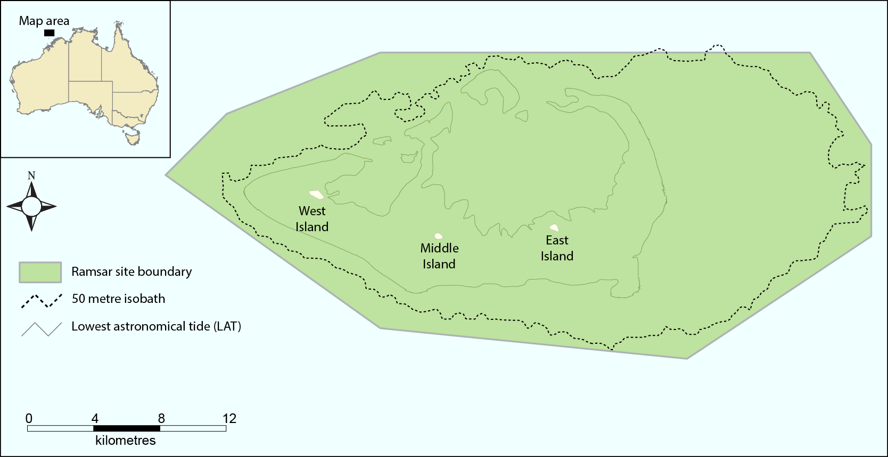

**Figure E1: Location of the Ashmore Reef Ramsar site.**

Ashmore Reef Ramsar site meets the following six Ramsar listing criteria:

**Criterion 1:** *A wetland should be considered internationally important if it contains a representative, rare, or unique example of a natural or near-natural wetland type found within the appropriate biogeographic region.*

There are a number of other coral atolls and reefs within the Timor Province including Cartier Island, Seringapatam Reef and Scott Reef. These contain some of the same types of wetlands and habitats as Ashmore Reef Ramsar site, notably coral reefs, intertidal sand flats and sub-tidal beds. However, Ashmore is the largest of the atolls in the region and has been managed for the purposes of conservation for three decades. Each of the wetland types present at Ashmore Reef Ramsar site is in near natural condition, with low densities of coral predators and disease (Richards et al. 2009). The Ashmore Reef Ramsar site also has the highest seagrass cover in the bioregion (Russell et al. 2005). In addition, the three islands at Ashmore Reef Ramsar site (West, Middle and East) represent the only vegetated islands within the Timor Province bioregion (DEWHA 2008a). Thus, by definition the site contains bioregionally unique examples of wetland type E (sand, shingle or pebble shores).

**Criterion 2:** *A wetland should be considered internationally important if it supports vulnerable, endangered, or critically endangered species or threatened ecological communities.*

There are 64 threatened species that were supported by the Ashmore Reef Ramsar site at the time of listing, 41 species of hard, reef forming coral, one species of soft coral, two species of giant clam, five species of sea cucumber, eight fish, six reptiles and a mammal.

**Criterion 3:** *A wetland should be considered internationally important if it supports populations of plant and/or animal species important for maintaining the biological diversity of a particular biogeographic region.*

There is abundant evidence that Ashmore Reef Ramsar site represents a true “hotspot” of biological diversity within the Timor Province bioregion and within the broader north-west marine region (Wells and Allen 2005). The Ashmore Reef Ramsar site has the highest diversity of hermatypic (reef building corals) on the West Australian coast with 275 species from 56 genera recorded (Vernon 1993, Griffith 1997) and the highest diversity of non-reef building corals in the region (Marsh 1993). The site also has a higher diversity of molluscs than other reefs in the bioregion with over 600 species recorded (Wells 1993, Willan 2005). A total of 13 species of sea cucumber are known to occur at Ashmore Reef Ramsar site, which is higher than other reefs in the bioregion (Skewes et al. 1999a). Ninety-nine species of decapod crustacean have been recorded at Ashmore Reef Ramsar site and Cartier Island, nearly twice that recorded at Scott and Seringapatam Reefs (Morgan and Berry 1993). The diversity of fish is also higher than other comparable reefs in the bioregion with over 760 species recorded (Russell et al. 2005, Kospartov et al. 2006).

**Criterion 4:** *A wetland should be considered internationally important if it supports plant and/or animal species at a critical stage in their life cycles, or provides refuge during adverse conditions.*

Ashmore Reef Ramsar site supports 47 species of waterbird listed as migratory under international treaties and three species of migratory turtles (green, hawksbill and loggerhead). The site also supports breeding of green and hawksbill turtles (Whiting and Guinea 2005a) dugongs (Whiting and Guinea 2005b) and 20 species of waterbird.

**Criterion 5:** *A wetland should be considered internationally important if it regularly supports 20 000 or more waterbirds*

The Ashmore Reef Ramsar site regularly supports over 40 000 waterbirds including large numbers of migratory shorebirds and breeding seabirds (Clarke et al. 2011).

**Criterion 6:** *A wetland should be considered internationally important if it regularly supports one per cent of the individuals in a population of one species or subspecies of waterbird.*

Ashmore Reef Ramsar site regularly supports more than one per cent of the populations of five species of shorebird and one species of seabird: bar-tailed godwit (*Limosa lapponica*), grey-tailed tattler (*Tringa brevipes*), ruddy turnstone (*Arenaria interpres*), sanderling (*Calidris alba*), greater sand plover (*Charadrius leschenaultia*) and sooty tern (*Onychoprion fuscata*).

Ashmore Reef Ramsar site was listed in 2002 and this is the point in time for which the Ecological Character Description (ECD) is based. A summary of the components and processes important to the ecological character of the Ashmore Reef Ramsar site is provided in Table E1. This includes those that are considered supporting components and processes as well as those identified as critical to the ecological character of the site and for which Limits of Acceptable Change (LAC) have been developed. Critical and supporting components and processes were selected on the basis of their role in maintaining the ecological character of the site, the ecosystem services they support (Table E2) and the Ramsar criteria for which the site is listed. The interactions between components and process, benefits and services and the Ramsar criteria the site meets are illustrated in a simple conceptual model (Figure E2).

**Table E1: Summary of components and processes important for maintaining the ecological character of the Ashmore Reef Ramsar site.**

| **Component / process** | **Description** | |
| --- | --- | --- |
| **Supporting components and processes** | | |
| Climate | * Arid tropical monsoonal climate * Located outside the main belt of tropical cyclones in the Timor Sea (Berry 1993) | |
| Geomorphic setting | * Located in an area of high oil and gas reserves, with active hydrocarbon seeps (O’Brien et al. 2002) * Geomorphic groups within the site include reef slope, reef crest, reef flat, back reef sands, lagoons and islands (Glenn and Collins 2005) | |
| Tides and currents | * Strong seasonal influences of the Indonesian Throughflow and Holloway currents (DEWHA 2008a) * Internal waves are a feature of the region and Ashmore Reef Ramsar site may act to break these resulting in increased nutrients from bottom waters * High energy environment with spring tides over 4.5 metres and large flushing on tidal cycles (Wienberg et al. 2009) | |
| Water quality | * Seasonal variations in temperature and salinity in ocean and lagoon water (Wienberg et al. 2009) * Water clarity, turbidity and other water quality parameters remain a knowledge gap | |
| Vegetation | * Five species of seagrass recorded with *Thalassia hemprichii* dominant, comprising over 85 per cent of total cover * Total cover of 470 hectares, but much of this is sparse and there is only 220 hectares with a mean cover of greater than 10 per cent * Over 3000 hectares of macroalgae, mostly on the reef slope and crest areas * Algae dominated by turf and coralline algae with fleshy macroalgae comprising typically less than 10 per cent of total algal cover (Skewes et al. 1999b) | |
| **Critical components and processes** | | |
| Marine invertebrates | | * 275 species of hard coral, covering an area of around 700 hectares (Vernon 1993, Griffith 1997, Skewes et al. 1999a) * 39 taxa of soft coral, covering an area of around 300 hectares (Marsh 1993, Skewes et al. 1999b) * Total coral cover was low around the time of listing following the 1998 bleaching event, but recovered in recent years to baseline levels (Ceccarelli et al. 2011b) * Over 600 species of mollusc, including two endemic species (Wells 1993, Willan 2005) * Over 180 species of echinoderm, including 18 species of sea cucumber (Marsh et al. 1993, Skewes et al. 1999a) * Sea cucumber density is highly variable, but on average exceeds 30 per hectare (Skewes et al. 1999a) * 99 species of decapod crustacean (Morgan and Berry 1993) |
| Fish | | * Over 750 species of fish, including five species of fish and 3 species of shark listed as threatened (Allen 1993, Russell et al. 2005) * Predominantly shallow water, benthic taxa that are common throughout the Indo-Pacific * Density of small reef fishes is around 20 000 to 40 000 per hectare (Kospartov et al. 2006, Heyward et al. 2012) * Low density of sharks (less than one per hectare) (Skewes et al. 1999a, Richards et al. 2009, Heyward et al. 2012) |
| Seasnakes | | * Prior to listing there was a high diversity and population, peaking in 1998 with an estimated total population of 40 000 snakes in the site (Guinea and Whiting 2005) * However, by the time of listing in 2002 the site was on a trajectory of decline and diversity and abundance was low (Guinea 2008) |
| Turtles | | * Three species of marine turtle: green (*Chelonia mydas*), hawksbill (*Eretmochelys imbricata*) and loggerhead (*Caretta caretta*), all of which are listed threatened species * Green turtles are the most abundant, with a total estimated population of around 10 000 * Nesting by two species: green turtles and hawksbill turtles (Whiting and Guinea 2005a) |
| Seabirds and shorebirds | | * 72 species of wetland dependent bird recorded within the Ramsar site * 47 species listed under international migratory agreements * Average of around 48 000 seabirds and shorebirds annually * Six species are regularly recorded in numbers greater than one per cent of the population * Nesting of 20 species, 14 of which regularly breed in the site (Milton 2005, Clarke 2010) |
| Dugong | | * Small but significant population, that may breed within the site (Whiting and Guinea 2005b) * Data deficient |

Ecosystem benefits and services are defined under the Millennium Ecosystem Assessment definition of ecosystem services as "the benefits that people receive from ecosystems (Ramsar Convention 2005, Resolution IX.1 Annex A). This includes benefits that directly affect people such as the provision of food or water resources as well as indirect ecological benefits.

Identified benefits and services of the Ashmore Reef Ramsar site are summarised in Table E2.

**Table E2: Summary of the benefits and services of the Ashmore Reef Ramsar site (critical services shown shaded)**.

| Category | Description |
| --- | --- |
| Cultural services | |
| Recreation and tourism | * Although remote and access is controlled, the site is important for passive recreation such as diving and bird watching. |
| Cultural heritage and identity | * The site has been regularly visited and fished by Indonesians since the early eighteenth century. West Island contains some archaeological artefacts and graves. |
| Scientific and educational | * The reef has high value for scientific research because it currently receives relatively low use and is ecologically unique within the bioregion. |
| Provisioning services | |
| Freshwater | * Indonesian fishers use the freshwater lens at West Island. |
| Supporting services | |
| Near-natural wetland types | * Ashmore Reef Ramsar site supports a number of largely unmodified wetland types. |
| Biodiversity | * Ashmore Reef Ramsar site is a hotspot of biodiversity within the Timor Province bioregion:   + Highest diversity of reef building corals (275 species from 56 genera)   + Highest diversity of soft corals (39 taxa)   + More than 600 species of mollusc   + Over 180 species of echinoderm, including 13 species of sea cucumber   + Nearly 100 species of decapod crustacean   + Over 750 species of finfish   + High diversity of seasnakes |
| Physical habitat | * The site supports large breeding colonies of seabirds |
| Priority wetland species | * Ashmore Reef Ramsar site supports 47 species of shorebird listed under international migratory bird treaties. |
| Threatened species | * Ashmore Reef Ramsar site supports 62 species listed as threatened at the national and / or international level. |

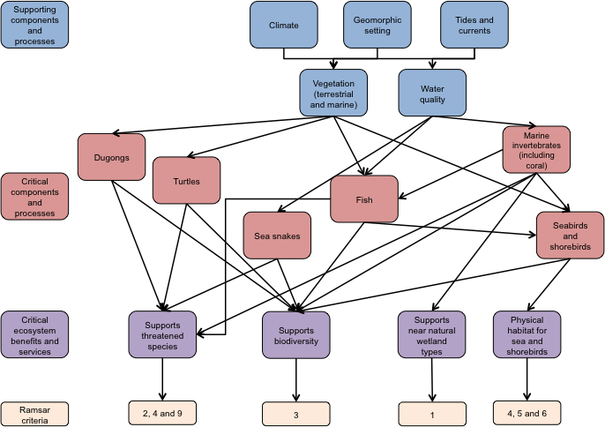

**Figure E2: Simple conceptual model for the As Reef Ramsar site.**

The remote location of the site, together with the fact that the site is located within a Commonwealth Marine Reserve, decreases the number and magnitude of threats to the character of the Ashmore Reef Ramsar site. There are, however, a number of threats that could potentially impact on the ecological character of the site. A brief description of each of these threats is provided in Table E3.

**Table E3: Summary of threats to the ecological character of the Ashmore Reef Ramsar site.**

| **Actual or likely threat** | **Potential impact(s) to wetland components, processes and/or service** | **Likelihood1** | **Timing** |
| --- | --- | --- | --- |
| Biological resource use – fishing and hunting marine fauna | * Changed fish community composition * Ecological effects to reef community | Medium | Immediate to long term |
| Oil and gas exploration and mining | * Impacts to turtles, dugongs and seasnakes from underwater noise * Increased risk of boat strike * Decreased diversity and abundance of fauna due to toxic effects of oil spills | Certain | Immediate to long term |
| Invasive species (ginger ant) | * Impacts to nesting success of seabirds and marine turtles | Certain | Immediate |
| Invasive species (weeds and pest animal species) | * Impacts to diversity and abundance of terrestrial species and habitats. | Medium | Immediate |
| Climate change:  Sea temperature, sea level, acidification | * Loss of vegetation and sand habitat, leading to a decline in seabird and turtle nesting sites * Increase in coral bleaching and disease * Impacts to fauna such as seasnakes from increased temperatures * Changes to marine flora and fauna biodiversity either directly or through habitat alteration | Certain | Long-term |
| Marine debris | * Ingestion by feeding birds, fish, reptiles and mammals. * Entanglement of biota | Medium | Immediate |

1 Where Certain is defined as known to occur at the site or has occurred in the past Medium is defined as not known from the site but occurs at similar sites; and Low is defined as theoretically possible, but not recorded at this or similar sites.

LAC is the terminology used to describe complex judgements as to how what extent critical components, processes benefits and services of the site can vary without representing a potential change in the ecological character as defined by the Ramsar Convention (Section 6). LAC for Ashmore Reef Ramsar site have been proposed for critical components, processes and benefits and services based on existing data and guidelines. LAC are summarised in Tables E3 together with an indication of whether based on current information, the LAC are met and what changes to the site have occurred.

The following should be considered when reading Table E4 and considering LAC:

* Limits of Acceptable Change are a tool by which ecological change can be measured. However, Ecological Character Descriptions are not management plans and Limits of Acceptable Change do not constitute a management regime for the Ramsar site.
* Exceeding or not meeting Limits of Acceptable Change does not necessarily indicate that there has been a change in ecological character within the meaning of the Ramsar Convention. However, exceeding or not meeting Limits of Acceptable Change may require investigation to determine whether there has been a change in ecological character.
* While the best available information has been used to prepare this Ecological Character Description and define Limits of Acceptable Change for the site, a comprehensive understanding of site character may not be possible as in many cases only limited information and data is available for these purposes. The Limits of Acceptable Change may not accurately represent the variability of the critical components, processes, benefits or services under the management regime and natural conditions that prevailed at the time the site was listed as a Ramsar wetland.
* Users should exercise their own skill and care with respect to their use of the information in this Ecological Character Description and carefully evaluate the suitability of the information for their own purposes.
* Limits of Acceptable Change can be updated as new information becomes available to ensure they more accurately reflect the natural variability (or normal range for artificial sites) of critical components, processes, benefits or services of the Ramsar wetland.

**Table E4: LAC for the Ashmore Reef Ramsar site and assessment of current conditions.**

| **Component / process** | **Limit of Acceptable Change** | **Current conditions** | **Confidence in LAC assessment** |
| --- | --- | --- | --- |
| Invertebrates - coral | *Cover of hard coral to be 20 per cent and soft coral greater than five per cent. Recovery after a bleaching event within 10 years.* | Average hard coral cover was between 24 and 29 per cent from 2009 to 2011; and soft coral between 6 and 8 per cent.  **LAC is met.** | High |
| Invertebrates - molluscs | *Presence of the following mollusc species within the Ramsar site:*  Trochus niloticus*,* Tridacna maxima, T. gigas, Hippopus hippopus, T. squamosa, T. derasa *and* T. Crocea. | Surveys in 2009 recorded five of the species of clam and the Trocus, but not *Tridacna gigas.* However, this is only from one survey and no more recent data was available.  **LAC may be exceeded.** | Low |
| Invertebrates – sea cucumbers | *Presence of the following species of sea cucumber within the Ramsar site:*  Actinopyga echinites, Actinopyga mauritiana, Actinopyga miliaris, Holothuria fuscogilva *and* Holothuria nobilis.  *Mean density of sea cucumbers to exceed 40 individuals per hectare in two out of three years for which adequate data are available.* | Of the listed species only one (*Holothuria nobilis*) was recorded in 2009 and mean density was only 20 individuals per hectare. However, more recent data is required and there was no targeted survey for rare / listed species.  **LAC may be exceeded.** | Low |
| Fish | *Mean density of fish (in surveys that include small reef fishes) of more than 30 000 fish per hectare in two out of three years for which adequate data are available.* | Differences between surveys make this LAC difficult to assess, but it seems likely that mean density exceeded 30 000 fish per hectare for the 2009, 2010 and 2011 surveys.  **LAC is met.** | Medium |
| Seasnakes | *Presence of the following species within the Ramsar site:*  *turtle-headed seasnake (*Emydocephalus annulatus*); olive seasnake (*Aipysurus laevis*); leaf-scaled seasnake (*Aipysurus foliosquama*).*  *Mean abundance of seasnakes to exceed 10 snakes per hour in two out of three years for which adequate data are available.* | The leaf-scaled seasnake has not been recorded since 2005, and turtle-headed seasnake not since 2006, despite surveys in 2006, 2007, 2008 and 2010 (Lukoschek et al. 2013).  Mean seasnake abundance has been less than 2 snakes per hour for all surveys since 2006.  **LAC has been exceeded.** | Medium |
| Marine turtles | *Presence of the following species of marine turtle within the Ramsar site:* Chelonia mydas, Eretmochelys imbricata *and* Caretta caretta.  *Mean density of green turtles to exceed four individuals per hectare in two out of three years for which adequate data are available.*  *Annual nesting by green and hawksbill turtles within the site.* | There is no data post 1999 on which to assess this LAC.  **Insufficient data to assess LAC.** | Not applicable |
| Seabirds and shorebirds | *Total waterbird numbers not less than 28 000 in a minimum of three years in any five year period.* | Total seabird and shorebird abundance in 2010 was over 60 000, but there are no complete counts for years immediately before or after this date.  **LAC is met.** | Medium |
| *Total counts for each of the following species to exceed the nominated percentage of the flyway population in at least three out of five surveys:*  *Sooty tern – one per cent*  *Bar-tailed godwit – two per cent*  *Grey-tailed tattler – three per cent*  *Ruddy turnstone – five per cent*  *Sanderling – three per cent*  *Greater sand plover – two per cent.* | Surveys for shorebirds are reported from 2005 and then not again until 2010, when the survey was in April and it is likely that shorebirds had already departed for breeding grounds.  **Insufficient data to assess LAC.** | Not applicable |
| *Breeding of the following seabird species within the site in at least three out of five surveys:*  *Black noddy*  *Bridled tern*  *Brown booby*  *Brown (common) noddy*  *Crested tern*  *Eastern reef egret*  *Great frigatebird*  *Lesser frigatebird*  *Masked booby*  *Red-footed booby*  *Red-tailed tropicbird*  *Sooty tern*  *Wedge-tailed shearwater*  *White-tailed tropicbird.* | All species were recorded in 2010, but additional survey data is needed to properly assess this LAC.  **LAC is met.** | Medium |
| Dugong | *Presence of dugong across multiple age ranges within the site.* | There is insufficient data to assess this LAC.  **Insufficient data to assess LAC.** | Not applicable |
| Near natural wetland types | *Presence of the following wetland types within the Ramsar site: A – Permanent shallow marine waters, B - Marine subtidal aquatic beds, C - Coral reefs, E - Sand shores, and G - Intertidal mud and sand.* | There is some evidence of erosion and sand encroaching into the lagoon areas. However, all wetland types are still present in the site.  **LAC is met.** | High |

Knowledge gaps that are required to fully describe the ecological character of this site and enable rigorous and defensible limits of acceptable change to be met are relatively few and listed in Table E5. In some instances, consistent data collection over a number of years is all that is required.

Monitoring to fill knowledge gaps and assess against LAC have also been recommended and is summarised in Table E6.

Table E5: Knowledge gaps for Ashmore Reef Ramsar site

| **Component / process** | **Knowledge Gap** | **Recommended Action** |
| --- | --- | --- |
| Marine invertebrates – coral, molluscs, sea cucumbers | Data has been collected and reported using different techniques over the past decade. This has made it difficult to set a LAC for diversity or to assess changes in character with certainty. | Repeated monitoring annually or bi-annually, with consistent reporting parameters. |
| Fish | As with invertebrates, surveys for fish have used different methods and reporting techniques, hampering development of LAC that adequate considers variability and allow for an assessment of change over time. | Repeated monitoring annually or bi-annually, with consistent reporting parameters. |
| Seasnakes | There is evidence of a decline in seasnake populations, but the potential causes of this remain unknown. The last survey reported was nearly five years ago and current status is not known. | Regular surveys.  Consolidation and reporting of information from research projects that are targeting potential causes of the decline. |
| Marine turtles | Quantitative data on marine turtles from within the site is nearly a decade old (or more recent surveys have not been reported). Data on abundance of foraging turtles and nesting success is required to assess changes in character over time. | Repeated monitoring annually or bi-annually, with consistent reporting parameters. |
| Seabirds and shorebirds | A strong baseline for seabirds and shorebirds was established in 2010 (Clarke 2010). However variability over time has not been regularly captured, especially for shorebirds. | Repeated monitoring using the 2010 protocol (which is consistent with the Shorebirds 2020 method) annually or biannually. |
| Dugongs | The importance of the site for dugong is unknown, with data mostly limited to observations of customs ships. | Consolidation and reporting of the data collected to date. A targeted assessment of the site for the species including abundance and age ranges. |

Table E6: Recommended monitoring for Ashmore Reef Ramsar site

|  |  |  |  |
| --- | --- | --- | --- |
| **Component/ process** | **Purpose** | **Indicator** | **Frequency** |
| Marine invertebrates - coral | Confirm the baseline and assess changes in character | Per cent cover and mean species richness | Annually or bi-annually |
| Marine invertebrates - molluscs | Confirm the baseline and assess changes in character | Abundance of target species (Trochus and giant clams), mean species richness of other species | Annually or bi-annually |
| Marine invertebrates - echinoderms | Confirm the baseline and assess changes in character | Abundance of target species (sea cucumbers; particularly listed species), mean species richness of other species | Annually or bi-annually |
| Marine invertebrates - other | Characterise character, assess variability and set LAC. | Abundance and mean species richness of crustaceans | Annually or bi-annually |
| Fish | Confirm the baseline and assess changes in character | Mean abundance and species richness, presence of threatened species | Annually or bi-annually |
| Seasnakes | Confirm the baseline and assess changes in character | Species and abundance | Annually or bi-annually |
| Marine turtles | Confirm the baseline and assess changes in character | Foraging and nesting surveys | Annually or bi-annually |
| Seabirds | Assessment against LAC | Counts and species identifications, breeding observations | Annually or bi-annually |
| Shorebirds | Assessment against LAC | Counts (at appropriate times of the year) | Annually or bi-annually |
| Dugong | Establishment of a baseline on which a LAC can be developed | Abundance and age distributions | Annually or bi-annually |

# 1. Introduction

## 1.1 Site details

The Ashmore Reef Commonwealth Marine Reserve Ramsar site (Ashmore Reef Ramsar site) is located in Australia’s External Territory of Ashmore and Cartier Islands and is under the jurisdiction of the Commonwealth Government of Australia. It was originally nominated as a “Wetland of International Importance” under the Ramsar Convention in 2002. Site details for this Ramsar wetland are provided in Table 1.

Table 1: Site details for Ashmore Reef Ramsar site taken from the Ramsar Information Sheet (2002).

|  |  |
| --- | --- |
| Site Name | Ashmore Reef Commonwealth Marine Reserve |
| Location in coordinates | Latitude: 12° 14' S  Longitude: 123° 07' E |
| General location of the site | The Ramsar site is located in the Australian Territory of Ashmore and Cartier Islands in the Indian Ocean. The site is 840 kilometres west of Darwin (Northern Territory), Australia and 610 kilometres north of Broome (Western Australia).  Timor Province (IMCRA v4 Commonwealth of Australia 2006). |
| Area | 58 300 hectares |
| Date of Ramsar site designation | Designated on 21 October 2002 |
| Ramsar criteria met by wetland | Ramsar criteria 1, 2, 3, 4, 5, 6, 8 |
| Management authority for the site | Director of National Parks, Australia. |
| Date the ECD applies | 2002 |
| Status of description | This represents the first official Ecological Character Description (ECD) for the site, building on an unpublished ECD prepared in 2005. |
| Date of compilation | September 2013 |
| Name(s) of compiler(s) | Jennifer Hale and Rhonda Butcher on behalf of the Department of the Environment. |
| References to the Ramsar Information Sheet (RIS) | Ashmore Reef National Nature Reserve Ramsar Site RIS (2002) compiled by Environment Australia. Updated by Jennifer Hale on behalf of the Department of the Environment 2013. |
| References to management plan(s) | North-west Commonwealth Marine Reserves Network Management Plan 2014-24.  Marine Bioregional Plan for the North-west Marine Region, 2012.  Ashmore Reef National Nature Reserve and Cartier Island Marine Reserve  (Commonwealth Waters) Management Plans, 2002. |

## 1.2 Statement of purpose

The act of designating a wetland as a Ramsar site carries with it certain obligations, including managing the site to retain its ‘ecological character’ and to have procedures in place to detect if any threatening processes are likely to, or have altered the ‘ecological character’. Thus, understanding and describing the ‘ecological character’ of a Ramsar site is a fundamental management tool for signatories and local site managers which should form the baseline or benchmark for management planning and action, including site monitoring to detect negative impacts.

The Ramsar Convention has defined “ecological character” and “change in ecological character” as (Ramsar Convention 2005):

“Ecological character is the combination of the ecosystem components, processes and benefits/services that characterise the wetlands at a given point in time”

And

“…change in ecological character is the human induced adverse alteration of any ecosystem component, process and or ecosystem benefit/service.”

In order to detect change it is necessary to establish a benchmark for management and planning purposes. Ecological character descriptions (ECD) form the foundation on which a site management plan and associated monitoring and evaluation activities are based. The legal framework for ensuring the ecological character of all Australian Ramsar sites is maintained is the *Environment Protection and Biodiversity Conservation Act 1999* (EPBC Act) (Figure 1). A Ramsar Information Sheet (RIS) is prepared at the time of designation. However whilst there is some link between the data used for listing a site (based on the various criteria) the information in a RIS does not provide sufficient detail on the interactions between ecological components, processes and functions to constitute a comprehensive description of ecological character. In response to the short fall, the Australian and state/territory governments have developed a *National Framework and Guidance for Describing the Ecological Character of Australia’s Ramsar Wetlands. Module 2 of Australian National Guidelines for Ramsar Wetlands – Implementing the Ramsar Convention in Australia* (DEWHA 2008b).

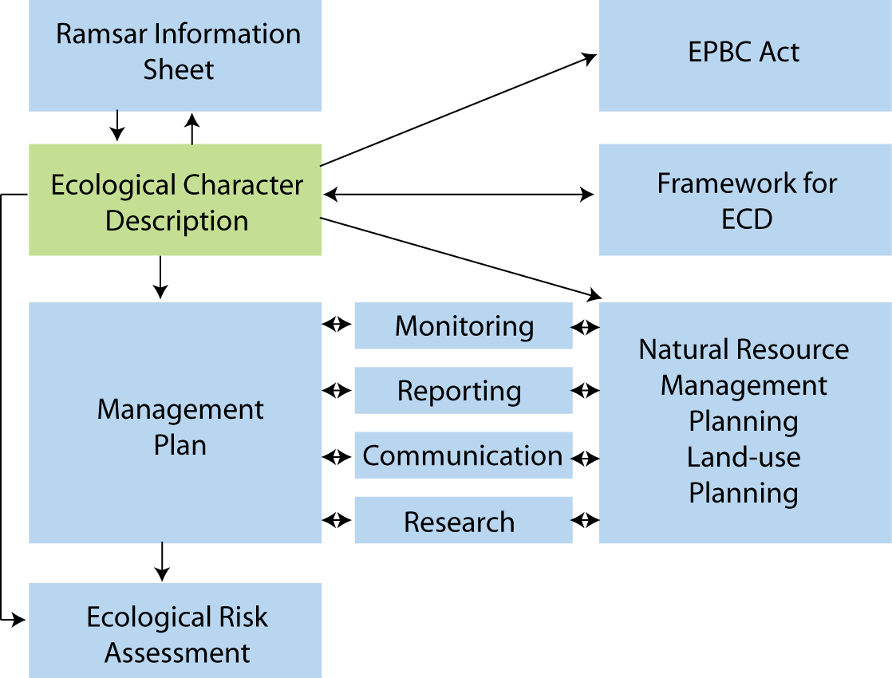

Figure 1: The ecological character description in the context of other requirements for the management of Ramsar sites (adapted from DEWHA 2008).

The framework emphasises the importance of describing and quantifying the ecosystem components, processes and benefits/services of the wetland and the relationship between them. It is also important that information is provided on the benchmarks or ecologically significant limits of acceptable change that would indicate when the ecological character has or is likely to change.

McGrath (2006) detailed the general aims of an ECD as follows:

1. To assist in implementing Australia’s obligations under the Ramsar Convention, as stated in Schedule 6 (Managing wetlands of international importance) of the *Environment Protection and Biodiversity Conservation Regulations* 2000 (Commonwealth):
   1. To describe and maintain the ecological character of declared Ramsar wetlands in Australia; and
   2. To formulate and implement planning that promotes:
      1. Conservation of the wetland; and
      2. Wise and sustainable use of the wetland for the benefit of humanity in a way that is compatible with maintenance of the natural properties of the ecosystem.
2. To assist in fulfilling Australia’s obligation under the Ramsar Convention to arrange to be informed at the earliest possible time if the ecological character of any wetland in its territory and included in the Ramsar List has changed, is changing or is likely to change as the result of technological developments, pollution or other human interference.
3. To supplement the description of the ecological character contained in the Ramsar Information Sheet submitted under the Ramsar Convention for each listed wetland and, collectively, form an official record of the ecological character of the site.
4. To assist the administration of the EPBC Act, particularly:
   1. To determine whether an action has, will have or is likely to have a significant impact on a declared Ramsar wetland in contravention of sections 16 and 17B of the EPBC Act; or
   2. To assess the impacts that actions referred to the Minister under Part 7 of the EPBC Act have had, will have or are likely to have on a declared Ramsar wetland.
5. To assist any person considering taking an action that may impact on a declared Ramsar wetland whether to refer the action to the Minister under Part 7 of the EPBC Act for assessment and approval.
6. To inform members of the public who are interested generally in declared Ramsar wetlands to understand and value the wetlands.

## 1.3 Relevant treaties, legislation and regulations

This section provides a brief listing of the legislation and policy that is relevant to the description of the ecological character of the Ashmore Reef Ramsar site.

**International**

*Ramsar Convention*

The Convention on Wetlands of International Importance, otherwise known as the Ramsar Convention, was signed in Ramsar Iran in 1971 and came into force in 1975. It provides the framework for local, regional and national actions, and international cooperation, for the conservation and wise use of wetlands. Wetlands of international importance are selected on the basis of their international significance in terms of ecology, botany, zoology, limnology and or hydrology

*Migratory bird bilateral agreements and conventions*

Australia is party to a number of bilateral agreements, initiatives and conventions for the conservation of migratory birds, which are relevant to the Ashmore Reef Ramsar site. The bilateral agreements are:

* *JAMBA –* The agreement between the Government of Australia and the Government of Japan for the Protection of Migratory Birds in Danger of Extinction and their Environment, 1974;
* *CAMBA* - The Agreement between the Government of Australia and the Government of the People's Republic of China for the Protection of Migratory Birds and their Environment 1986;
* *ROKAMBA* - The Agreement between the Government of Australia and the Republic of Korea for the Protection of Migratory Birds and their Environment, 2006; and
* *The Bonn Convention on Migratory Species (CMS)* - The Bonn Convention adopts a framework in which countries with jurisdiction over any part of the range of a particular species co-operate to prevent migratory species becoming endangered. For Australian purposes, many of the species are migratory birds.

*MOU with Indonesia*

In 1974 Australia established a Memorandum of Understanding (MOU) with Indonesia with respect to fishing on the northwest Australian continental shelf. Under this agreement, Indonesian fishermen are given access to five small areas including Ashmore Reef Commonwealth Marine Reserve. The Memorandum allowed fishing using traditional methods at the site including the taking of trochus, trepan (*bêche-de-mer* or sea cucumber), abalone, green snail, sponges and all molluscs on the seabed, but not turtles of any species. It permitted landings to obtain freshwater at two points in the site.

The MOU was updated and revised in 1989, with a prohibition on fishing in the Ashmore Reef Commonwealth Marine Reserve. Traditional fishermen under the revised MOU are permitted to land at West Island for the purpose of obtaining supplies of fresh water.

**National legislation**

*Environment Protection and Biodiversity Conservation Act 1999* (EPBC Act)

The EPBC Act regulates actions that will have or are likely to have a significant impact on any matter of national environmental significance, which includes the ecological character of a Ramsar wetland (EPBC Act 1999 s16(1)). An action that will have or is likely to have a significant impact on a Ramsar wetland will require an environmental assessment and approval under the EPBC Act. An ‘action’ includes a project, a development, an undertaking or an activity or series of activities (<http://www.environment.gov.au/epbc/index.html>).

The EPBC Act establishes a framework for managing Ramsar wetlands, through the Australian Ramsar Management Principles (EPBC Act 1999 s335), which are set out in Schedule 6 of the *Environment Protection and Biodiversity Conservation Regulations 2000*. These principles are intended to promote national standards of management, planning, environmental impact assessment, community involvement, and monitoring, for all of Australia’s Ramsar wetlands in a way that is consistent with Australia’s obligations under the Ramsar Convention. Some matters protected under the EPBC Act are not protected under local or state/territory legislation, and as such, many migratory birds are not specifically protected under State legislation (though they are in Western Australia). Species listed under international treaties JAMBA, CAMBA and CMS have been included in the List of Migratory species under the Act. Threatened species and communities listed under the EPBC Act may also occur, or have habitat in the Ramsar site; some species listed under State legislation as threatened are not listed under the EPBC Act as threatened, usually because they are not threatened at the national (often equivalent to whole-of-population) level. The Regulations also cover matters relevant to the preparation of management plans, environmental assessment of actions that may affect the site, and the community consultation process.

The Ashmore Reef National Nature Reserve was proclaimed in 1983 under the *National Parks and Wildlife Conservation Act 1975* (which was replaced by the EPBC Act) and the Park is continued as a Commonwealth reserve under the EPBC Act by the *Environmental Reform (Consequential Provisions) Act 1999* which deems the Park to have been declared for:

1. the preservation of the area in its natural condition; and
2. the encouragement and regulation of the appropriate use, appreciation and enjoyment of the area by the public.

Administration and management of Commonwealth reserves are a function of the Director of National Parks under the EPBC Act (s.514B). In November 2012, the Reserve was renamed Ashmore Reef Commonwealth Marine Reserve forming part of the North-west Commonwealth Marine Reserves Network.

## 1.4 Method

The method used to develop the ecological character description for Ashmore Reef Ramsar site is based on the twelve-step approach provided in the *National Framework and Guidance for Describing the Ecological Character of Australia’s Ramsar Wetlands* (DEWHA 2008) illustrated in Figure 2. A more detailed description of each of the steps and outputs required is provided in the source document.

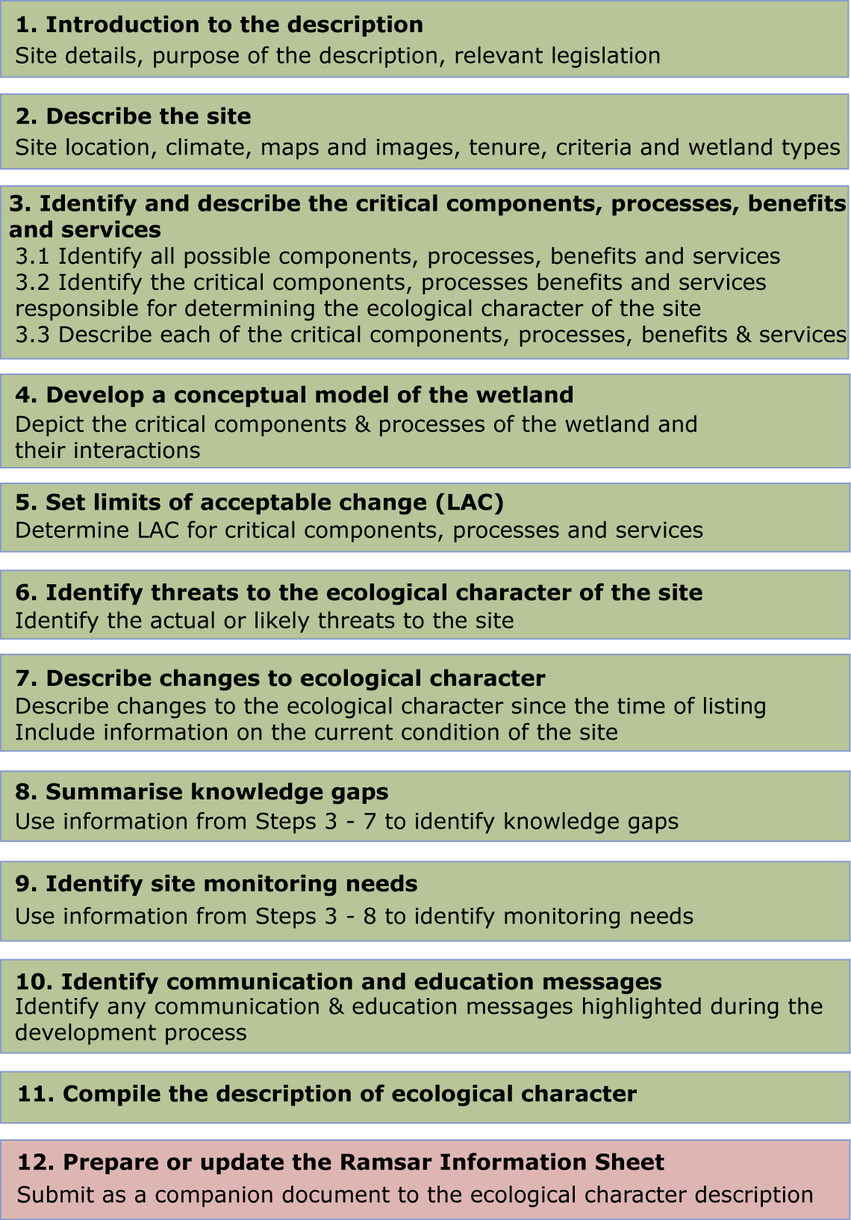

Figure 2: Twelve step process for developing an ECD (adapted from DEWHA 2008).

This ECD was developed primarily through a desktop assessment and is based on existing data and information. Further information on the method and authors can be found in Appendix A.

# 2. General description of the Ashmore Reef Ramsar Site

## 2.1 Location

The Territory of Ashmore and Cartier Islands comprises West, Middle and East Islands of the Ashmore Reef, Cartier Island and the 12 nautical mile territorial sea generated by these islands. The Territory is located on the outer edge of the continental shelf in the Indian Ocean and Timor Sea. The Ashmore Reef Ramsar site is located in the Indian Ocean approximately 840 kilometres west of Darwin (Northern Territory), Australia and 610 kilometres north of Broome (Western Australia). The Ramsar site comprises the area proclaimed as the Ashmore Reef Commonwealth Marine Reserve (Figure 3) and is identified as a Key Ecological Feature (KEF) in the Marine Bioregional Plan for the North-west Marine Region (DEWHA 2008a). The Territory does not support a permanent population, but Indonesian fishermen visit the Ashmore Reef Ramsar site each year under a Memorandum of Understanding signed by the Australian and Indonesian Governments, which allows them to land at West Island to obtain freshwater.



Figure 3: Location of the Ashmore Reef Ramsar Site (adapted from Commonwealth of Australia 2002).

## 2.2 Land tenure

The entire Ashmore Reef Ramsar site is a declared Commonwealth Marine Reserve.

## 2.3 Wetland types

Classification of wetlands into discrete types is a difficult exercise and an inexact science. Clear boundaries are difficult to define or delineate and multiple wetland types could be considered to apply to the same wetland. For example Ramsar Type B - Marine subtidal aquatic beds and Type A – Permanent shallow marine waters; at Ashmore Reef are not necessarily mutually exclusive and could both be applied to the lagoon areas within the Ramsar site.

The 2002 RIS for the site (Environment Australia 2002) identified the following five Ramsar wetland types within the Ashmore Reef Ramsar site (see section 4.3.1 for descriptions):

* A – Permanent shallow marine waters
* B - Marine subtidal aquatic beds; includes kelp beds, sea-grass beds, tropical marine meadows.
* C - Coral reefs
* E - Sand, shingle or pebble shores; includes sand bars, spits and sandy islets; includes dune systems and humid dune slacks
* G - Intertidal mud, sand or salt flats.

Mapping of habitats from satellite imagery (Skewes et al. 1999b) provides an indication of the extent and location of wetland types within the Ramsar site (Figure 4). However, as mentioned above, many of the habitats contain multiple wetland types, with seagrass, algae and coral occurring in subtidal reef as well as lagoon habitats. Also over 50 per cent of the area within the Ramsar site boundary can be described as shoals at depths of 15 to 50 metres, which is outside the Ramsar wetland definition, which only includes areas of the ocean less than six metres deep.

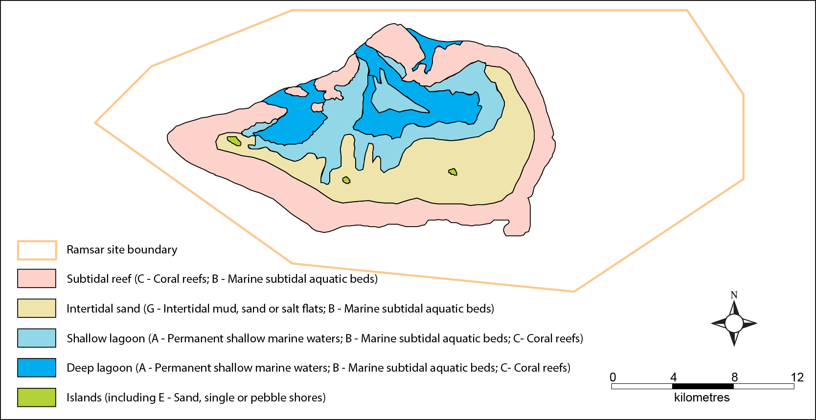

Figure 4: General location of wetlands types within the Ashmore Reef Ramsar site (adapted from © Copyright Skewes et al. 1999b).

## 2.4 Ramsar criteria

### 2.4.1 Criteria under which the site was designated

At the time that the Ashmore Reef Ramsar site was first nominated as a Wetland of International Importance (2002), there were eight criteria for identifying Wetlands of International Importance, of which the site was considered to meet seven (Table 2).

Table 2: Criteria for Identifying Wetlands of International Importance as at listing date, 2002. Criteria for which the Ashmore Reef Ramsar site was considered to meet at the time of listing are shaded.

| **Number** | **Basis** | **Description** |
| --- | --- | --- |
| **Group A. Sites containing representative, rare or unique wetland types** | | |
| Criterion 1 |  | A wetland should be considered internationally important if it contains a representative, rare, or unique example of a natural or near-natural wetland type found within the appropriate biogeographic region. |
| **Group B. Sites of international importance for conserving biological diversity** | | |
| Criterion 2 | Species and ecological communities | A wetland should be considered internationally important if it supports vulnerable, endangered, or critically endangered species or threatened ecological communities. |
| Criterion 3 | Species and ecological communities | A wetland should be considered internationally important if it supports populations of plant and/or animal species important for maintaining the biological diversity of a particular biogeographic region. |
| Criterion 4 | Species and ecological communities | A wetland should be considered internationally important if it supports plant and/or animal species at a critical stage in their life cycles, or provides refuge during adverse conditions. |
| Criterion 5 | Waterbirds | A wetland should be considered internationally important if it regularly supports 20 000 or more waterbirds. |
| Criterion 6 | Waterbirds | A wetland should be considered internationally important if it regularly supports one per cent of the individuals in a population of one species or subspecies of waterbird. |
| Criterion 7 | Fish | A wetland should be considered internationally important if it supports a significant proportion of indigenous fish subspecies, species or families, life-history stages, species interactions and/or populations that are representative of wetland benefits and/or values and thereby contributes to global biological diversity. |
| Criterion 8 | Fish | A wetland should be considered internationally important if it is an important source of food for fishes, spawning ground, nursery and/or migration path on which fish stocks, either within the wetland or elsewhere, depend. |

**Regularly** (Criteria 5 & 6) - as in supports regularly - a wetland regularly supports a population of a given size if:

1. the requisite number of birds is known to have occurred in two thirds of the seasons for which adequate data are available, the total number of seasons being not less than three; or
2. the mean of the maxima of those seasons in which the site is internationally important, taken over at least five years, amounts to the required level (means based on three or four years may be quoted in provisional assessments only).

In establishing long-term 'use' of a site by birds, natural variability in population levels should be considered especially in relation to the ecological needs of the populations present. Thus in some situations (e.g., sites of importance as drought or cold weather refuges or temporary wetlands in semi-arid or arid areas - which may be quite variable in extent between years), the simple arithmetical average number of birds using a site over several years may not adequately reflect the true ecological importance of the site. In these instances, a site may be of crucial importance at certain times ('ecological bottlenecks'), but hold lesser numbers at other times. In such situations, there is a need for interpretation of data from an appropriate time period in order to ensure that the importance of sites is accurately assessed.

In some instances, however, for species occurring in very remote areas or which are particularly rare, or where there are particular constraints on national capacity to undertake surveys, areas may be considered suitable on the basis of fewer counts. For some countries or sites where there is very little information, single counts can help establish the relative importance of the site for a species.

The International Waterbird Census data collated by Wetlands International is the key reference source.

Text Box 1: Definition of regularly supports (Ramsar Convention 2009).

### 2.4.2 Assessment based on current information and Ramsar criteria

There have been a few developments since the site was nominated in 2002 that influence the application of the Ramsar criteria to wetland sites, this includes:

* Refinements and revisions of the Ramsar criteria: a ninth criterion was added at the ninth Conference of the Contracting Parties to the Ramsar Conference in Uganda in 2005.
* Revision of population estimates for waterbirds (Wetlands International 2013), which influences the application of criterion six.
* A decision with respect to the appropriate bioregionalisation for aquatic systems in Australia, which for inland systems are now based on drainage divisions and for marine systems the integrated marine classification and regionalisation for Australia (IMCRA). This affects the application of criteria one and three.
* Updating of threatened species listings, which affects criterion two.

Therefore an assessment of the Ashmore Reef Ramsar site against the current nine Ramsar criteria has been undertaken (). In deciding if the site qualifies under criteria five and six (regularly supports one per cent of the individuals in a population of one species of waterbird), an approach consistent with the Ramsar Convention has been adopted (Text Box 1).

Table 3: Criteria for Identifying Wetlands of International Importance (adopted by the 6th (1996) and 9th (2005) Meetings of the Conference of the Contracting Parties). Criteria for which the Ashmore Reef Ramsar site qualifies are shaded.

|  |  |  |
| --- | --- | --- |
| **Number** | **Basis** | **Description** |
| **Group A. Sites containing representative, rare or unique wetland types** | | |
| Criterion 1 |  | A wetland should be considered internationally important if it contains a representative, rare, or unique example of a natural or near-natural wetland type found within the appropriate biogeographic region. |
| **Group B. Sites of international importance for conserving biological diversity** | | |
| Criterion 2 | Species and ecological communities | A wetland should be considered internationally important if it supports vulnerable, endangered, or critically endangered species or threatened ecological communities. |
| Criterion 3 | Species and ecological communities | A wetland should be considered internationally important if it supports populations of plant and/or animal species important for maintaining the biological diversity of a particular biogeographic region. |
| Criterion 4 | Species and ecological communities | A wetland should be considered internationally important if it supports plant and/or animal species at a critical stage in their life cycles, or provides refuge during adverse conditions. |
| Criterion 5 | Waterbirds | A wetland should be considered internationally important if it regularly supports 20 000 or more waterbirds. |
| Criterion 6 | Waterbirds | A wetland should be considered internationally important if it regularly supports one per cent of the individuals in a population of one species or subspecies of waterbird. |
| Criterion 7 | Fish | A wetland should be considered internationally important if it supports a significant proportion of indigenous fish subspecies, species or families, life-history stages, species interactions and/or populations that are representative of wetland benefits and/or values and thereby contributes to global biological diversity. |
| Criterion 8 | Fish | A wetland should be considered internationally important if it is an important source of food for fishes, spawning ground, nursery and/or migration path on which fish stocks, either within the wetland or elsewhere, depend. |
| Criterion 9 | Other taxa | A wetland should be considered internationally important if it regularly supports one per cent of the individuals in a population of one species or subspecies of wetland-dependent non-avian animal species. |

**Criterion 1:** The application of this criterion must be considered in the context of the Bioregion within which the site is located. As an offshore marine site, the appropriate bioregionalisation is the IMCRA v4.0 (Commonwealth of Australia 2006). The corresponding bioregion is the Timor Province, which encompasses 160 690 square kilometres of the Indian Ocean off the coast of north-west Australia (Heap et al. 2005).

There are a number of other coral atolls and reefs within the Timor Province including Cartier Island, Seringapatam Reef and Scott Reef. These contain some of the same types of wetlands and habitats as Ashmore Reef, notably coral reefs, intertidal sand flats and sub-tidal beds. However, Ashmore is the largest of the atolls in the region and has been managed for the purposes of conservation for three decades. Each of the wetland types present at Ashmore reef is in near natural condition, with low densities of coral predators and disease (Richards et al. 2009). Ashmore Reef also has the highest seagrass cover in the bioregion (Russell et al. 2005). In addition, the three islands at Ashmore Reef Ramsar site (West, Middle and East) represent the only vegetated islands within the Timor Province bioregion (DEWHA 2008a). Thus, by definition the site contains bioregionally unique examples of wetland type E (sand, shingle or pebble shores).

Ashmore Reef Ramsar site met this criterion at the time of listing and continues to do so.

**Criterion 2:** In the Australian context, it is recommended that this criterion should only be applied with respect to nationally threatened species/communities, listed under the EPBC Act or the International Union for Conservation of Nature (IUCN) Red List. A number of threatened species listed at the national and / or international level have been recorded within the boundary of the Ashmore Reef Ramsar site. However, central to the application of this criterion are the words “a wetland” and “supports”. Guidance from Ramsar (Ramsar 2005) in applying the criteria indicates that the wetland must provide habitat for the species concerned. For this reason, vagrant species, such as the observations of passing whales, have not been considered to contribute to the meeting of this criterion.

There are 62 threatened species that were supported by the Ashmore Reef Ramsar site at the time of listing, 41 species of hard, reef forming coral, one species of soft coral, five species of sea cucumber, eight fish, six reptiles and a mammal (Table 4).

Table 4: Listed threatened species recorded from within the Ashmore Reef Ramsar site.

| **Common name** | **Species name** | **EPBC** | **IUCN** | **Reference** |
| --- | --- | --- | --- | --- |
| Starry cup coral | *Acanthastrea bowerbanki* |  | Vulnerable | Vernon 1993 |
| A staghorn coral | *Acropora abrolhosensis* |  | Vulnerable | Vernon 1993, Griffith 1997 |
| A staghorn coral | *Acropora acuminata* |  | Vulnerable | Vernon 1993, Griffith 1997 |
| A staghorn coral | *Acropora aculeus* |  | Vulnerable | Kospartov et al. 2006 |
| A staghorn coral | *Acropora anthocercis* |  | Vulnerable | Vernon 1993, Griffith 1997 |
| A staghorn coral | *Acropora aspera* |  | Vulnerable | Vernon 1993, Griffith 1997 |
| A staghorn coral | *Acropora caroliniana* |  | Vulnerable | Vernon 1993 |
| A staghorn coral | *Acropora horrida* |  | Vulnerable | Vernon 1993, Griffith 1997 |
| A staghorn coral | *Acropora listeri* |  | Vulnerable | Kospartov et al. 2006 |
| A staghorn coral | *Acropora microclados* |  | Vulnerable | Richards et al. 2009 |
| A staghorn coral | *Acropora spicifera* |  | Vulnerable | Richards et al. 2009 |
| A staghorn coral | *Acropora willisae* |  | Vulnerable | Richards et al. 2009 |
| A staghorn coral | *Acropora paniculata* |  | Vulnerable | Vernon 1993, Griffith 1997 |
| A staghorn coral | *Acropora solitaryensis* |  | Vulnerable | Vernon 1993, Griffith 1997 |
| A staghorn coral | *Acropora verweyi* |  | Vulnerable | Vernon 1993 |
| A net coral | *Alveopora fenestrata* |  | Vulnerable | Vernon 1993 |
| A net coral | *Alveopora verrilliana* |  | Vulnerable | Vernon 1993 |
| A hedgehog coral | *Echinopora ashmorensis* |  | Vulnerable | Vernon 1993 |
| Hammer coral | *Euphyllia ancora* |  | Vulnerable | Vernon 1993 |
| Starburst coral | *Galaxea astreata* |  | Vulnerable | Vernon 1993, Griffith 1997 |
| Mushroom coral | *Heliofungia actiniformis* |  | Vulnerable | Vernon 1993 |
| Yabe’s coral | *Leptoseris yabei* |  | Vulnerable | Richards et al. 2009 |
| A lobed cactus coral | *Lobophyllia diminuta* |  | Vulnerable | Kospartov et al. 2006 |
| A lobed cactus coral | *Lobophyllia flabelliformis* |  | Vulnerable | Kospartov et al. 2006 |
| A pore coral | *Montipora calcarea* |  | Vulnerable | Richards et al. 2009 |
| A pore coral | *Montipora caliculata* |  | Vulnerable | Vernon 1993, Griffith 1997, Kospartov et al. 2006 |
| A pore coral | *Montipora crassituberculata* |  | Vulnerable | Kospartov et al. 2006 |
| Elephant skin coral | *Pachyseris rugosa* |  | Vulnerable | Vernon 1993, Griffith 1997 |
| A lettuce coral | *Pavona cactus* |  | Vulnerable | Vernon 1993, Griffith 1997, Kospartov et al. 2006 |
| A lettuce coral | *Pavona decussata* |  | Vulnerable | Vernon 1993, Kospartov et al. 2006 |
| A lettuce coral | *Pavona venosa* |  | Vulnerable | Vernon 1993, Griffith 1997, Kospartov et al. 2006 |
| An antler coral | *Pectinia alcicornis* |  | Vulnerable | Vernon 1993, Griffith 1997 |
| An antler coral | *Pectinia lactuca* |  | Vulnerable | Vernon 1993, Griffith 1997, Kospartov et al. 2006 |
| Pearl bubble coral | *Physogyra lichtensteini* |  | Vulnerable | Vernon 1993, Griffith 1997, Kospartov et al. 2006 |
| Lesser valley coral | *Platygyra yaeyamaensis* |  | Vulnerable | Kospartov et al. 2006 |
| Hump coral | *Porites nigrescens* |  | Vulnerable | Vernon 1993, Griffith 1997, Kospartov et al. 2006 |
| A stony coral | *Seriatopora aculeata* |  | Vulnerable | Kospartov et al. 2006 |
| A turban coral | *Turbinaria mesenterina* |  | Vulnerable | Vernon 1993, Kospartov et al. 2006 |
| A turban coral | *Turbinaria peltata* |  | Vulnerable | Vernon 1993, Griffith 1997, Kospartov et al. 2006 |
| A turban coral | *Turbinaria reniformis* |  | Vulnerable | Vernon 1993, Griffith 1997, Kospartov et al. 2006 |
| A turban coral | *Turbinaria stellulata* |  | Vulnerable | Vernon 1993, Griffith 1997, Kospartov et al. 2006 |
| Blue coral | *Heliopora coerulea* |  | Vulnerable | Marsh 1993 |
| A giant clam | *Tridacna gigas* |  | Vulnerable | Skewes et al. 1999a |
| Southern giant clam | *Tridacna derasa* |  | Vulnerable | Skewes et al. 1999a |
| Deep water redfish (sea cucumber) | *Actinopyga echinites* |  | Vulnerable | Marsh et al. 1993, Skewes et al. 1999a, Smith et al. 2000 |
| Surf redfish (sea cucumber) | *Actinopyga mauritiana* |  | Vulnerable | Marsh et al. 1993, Skewes et al. 1999a, Smith et al. 2000 |
| Hairy Blackfish (sea cucumber) | *Actinopyga miliaris* |  | Vulnerable | Ceccarelli et al. 2011a |
| White teatfish (sea cucumber) | *Holothuria fuscogilva* |  | Vulnerable | Marsh et al. 1993, Skewes et al. 1999a, Smith et al. 2000 |
| Black teatfish (sea cucumber) | *Holothuria nobilis* |  | Endangered | Marsh et al. 1993, Skewes et al. 1999a, Smith et al. 2000 |
| Blacksaddled coral grouper | *Plectropomus laevis* |  | Vulnerable | Skewes et al. 1999a, Dennis et al. 2005, Kospartov et al. 2006 |
| Green humphead parrotfish | *Bolbometopon muricatum* |  | Vulnerable | Kospartov et al. 2006 |
| Humpback grouper | *Cromileptes altivelis* |  | Vulnerable | Kospartov et al. 2006 |
| Humphead wrasse | *Cheilinus undulatus* |  | Endangered | Allen 1993, Skewes et al. 1999a, Dennis et al. 2005, Kospartov et al. 2006 |
| Squaretail leopard grouper) | *Plectropomus areolatus* |  | Vulnerable | Russell et al. 2005 |
| Snaggletooth shark | *Hemipristis elongata* |  | Vulnerable | Meekan et al. 2006 |
| Scalloped hammerhead | *Sphyrna lewini* |  | Endangered | Meekan et al. 2006 |
| Squat-headed hammerhead | *Sphyrna mokarran* |  | Endangered | Meekan et al. 2006 |
| Dusky seasnake | *Aipysurus fuscus* |  | Endangered | Guinea 2008 |
| Leaf-scaled seasnake | *Aipysurus foliosquama* | Critically endangered | Critically endangered | Guinea 2008 |
| Short-nosed seasnake | *Aipysurus apraefrontalis* | Critically endangered | Critically endangered | Guinea 2008 |
| Green turtle | *Chelonia mydas* | Vulnerable | Endangered | Whiting and Guinea 2005a |
| Hawksbill turtle | *Eretmochelys imbricata* | Vulnerable | Critically endangered | Whiting and Guinea 2005a |
| Loggerhead turtle | *Caretta caretta* | Endangered | Endangered | Whiting and Guinea 2005a |
| Dugong | *Dugong dugon* |  | Vulnerable | Whiting and Guinea 2005b |

This criterion was met at the time of listing and continues to be met.

**Criterion 3:** Like criterion one, application of this criterion must be taken in the context of the appropriate bioregion, in this instance the IMCRA (v4) Timor Province. Guidance from the Convention indicates that this criteria should be applied to "hotspots" of biological diversity, centres of endemism, sites that contain the range of biological diversity (including habitat types) occurring in a region; and/or support particular elements of biological diversity that are rare or particularly characteristic of the biogeographic region.

Until recently, it was thought that Ashmore Reef Ramsar site played an important role in maintaining biodiversity of reef systems further to the south, with transport of genetic material through the Indonesian Through Flow current (Simpson 1991). However, more recent research has indicated that there is very limited opportunity for direct physical transport from the northern atolls to southern coastal reefs and that connectivity between Ashmore Reef Ramsar site and the Kimberly coast is generally absent (Underwood et al. 2012, 2013).

There is, however, abundant evidence that Ashmore Reef Ramsar site represents a true “hotspot” of biological diversity within the Timor Province bioregion and within the broader north-west marine region (Wells and Allen 2005). The Ramsar site has the highest diversity of hermatypic (reef building corals) on the West Australian coast with 275 species from 56 genera recorded (Vernon 1993, Griffith 1997) and the highest diversity of non-reef building corals in the region (Marsh 1993). The site also has a higher diversity of molluscs than other reefs in the bioregion with over 600 species recorded (Wells 1993, Willan 2005). A total of 13 species of sea cucumber are known to occur at Ashmore Reef, which is higher than other reefs in the bioregion (Skewes et al. 1999a). Ninety-nine species of decapod crustacean have been recorded at Ashmore Reef and Cartier Island, nearly twice that recorded at Scott and Seringapatam Reefs (Morgan and Berry 1993). The diversity of fish is also higher than other comparable reefs in the bioregion with over 760 species recorded (Russell et al. 2005, Kospartov et al. 2006). The site supports important populations of marine turtles and dugongs.

Prior to the time of listing, the site was globally significant in terms of its seasnake abundance and diversity. Seventeen species of seasnake have been recorded from the waters of Ashmore Reef including two that are considered to be endemic to the site, the leaf-scaled seasnake (*Aipysurus foliosquama*) and the short-nosed seasnake (*Aipysurus apraefrontalis*) (Guinea 2008). However, recent data suggests that at the time of listing, the site was on a trajectory of decline with respect to abundance and diversity of seasnakes. Despite this, seasnake population contributed to meeting this criterion at the time of listing in 2002.

This criterion was met at the time of listing and continues to be met.

**Criterion 4:** The basic description of this criterion implies a number of common functions/roles that wetlands provide including supporting fauna during migration and supporting breeding. The Ashmore Reef Ramsar site supports 47 species of waterbird listed as migratory under international treaties (see Appendix B) and three species of migratory turtles (green, hawksbill and loggerhead).

The site also supports breeding of green and hawksbill turtles (Whiting and Guinea 2005a) dugongs (Whiting and Guinea 2005b) and 20 species of waterbird (Clarke et al. 2011); including the following species that breed in significant numbers within the Ramsar site :

* Brown booby (*Sula leucogaster*) – over 4000 breeding pairs in 2010 (Clarke 2010);
* Lesser frigatebirds (*Fregata ariel*) – estimated that over 2000 breeding pairs occur on occasion (Clarke 2010);
* Crested tern (*Thalasseus bergii*) – 1000 to 4000 breeding pairs estimated (Milton 1999) although the number regularly supported is more likely to be 1000 (Clarke 2010);
* Bridled tern (*Onychoprion anaethetus*) – 500 to 1000 breeding pairs breed regularly at the site (Clarke 2010);
* Sooty tern (*Onychoprion fuscata*) – up to 50 000 pairs (Milton 1999) and more recently 40,000 individual recorded (Clarke 2010); and
* Common noddy (*Anous stolidus*) – estimates of 13 500 to 35 000 breeding pairs (Milton 1999), with more recent counts of up to 45 000 individuals (Clarke 2010).

This criterion was met at the time of listing and continues to be met.

**Criterion 5:** Comprehensive bird survey data for the Ashmore Reef Ramsar site are relatively rare. Data from around the time of listing are reported as maximum counts of individual species over a number of years (Milton 2005) and so do not allow for an application of the principles of “regularly supports”. More recent data have been collected from 2002 to 2010 (Clarke et al. 2011) and these have been presented as total counts in Table 5. This data does not consistently cover all parts of the Ramsar site and does not always include counts of shorebirds; as such total counts are likely to be higher. However, it is clear that there is sufficient evidence to state that the Ashmore Reef Ramsar site meets this criterion, with total waterbirds greater than 20 000 in six out of eight counts over the period 2002 to 2010.

Table 5: Counts of sea and shorebirds from Ashmore Reef 2002 to 2010 (data from Clarke et al. 2011).

|  |  |  |  |  |  |  |  |  |
| --- | --- | --- | --- | --- | --- | --- | --- | --- |
| **Location** | **Jan 2002** | **Jan 2003** | **Jan 2005** | **Oct 2005** | **Oct 2006** | **Oct 2007** | **Oct 2009** | **Apr 2010** |
| Seabirds Middle Island | 19 338 | 6971 | 3291 | 4540 | 17 613 | 21 924 | 6733 | 22 124 |
| Seabirds – East Island | 32 416 | 16 157 | 3845 | 14 360 | 19 046 | 14 396 | 10 468 | 41 057 |
| Shorebirds – complete | 11 334 | 14 164 | 18 255 |  |  |  |  | 4213 |
| **Total** | **63 088** | **37 292** | **25 391** | **18 900** | **36 659** | **36 293** | **17 201** | **67 394** |

This criterion was met at the time of listing and continues to be met.

**Criterion 6:** Assessment of the Ashmore Ramsar site against this criterion has been made using the latest Waterbird Population Estimates (Wetlands International 2013). There are no population estimates for frigatebirds or boobies and so this criterion cannot be applied to these species. As mentioned above, records from around the time of listing (and the proceeding decade) are reported only as maximum counts over a number of years (Milton 2005) and so the test for “regularly supports” cannot be applied to these counts. Species for which maximum counts have exceeded the relevant one per cent population thresholds are provided in (Table 6). Given the lack of consistent count data, an application of the principle “regularly supports” is difficult. However, it is considered that one per cent population thresholds were exceeded in at least two thirds of seasons in which data is available for at least six species.

Table 6: Waterbirds species for which maximum counts in the Ashmore Reef Ramsar site exceed one per cent of the relevant population (those with sufficient evidence to meet the provision of “regularly supports” are shown shaded). Data from Milton (1999) and Clarke et al. (2011).

| **Common name** | **Species name** | **Population (one per cent)** | **Maximum count** | **Years with counts above threshold** |
| --- | --- | --- | --- | --- |
| Sooty tern | *Onychoprion fuscata* | 13 400 | 45 000 (1979-1998) | 2003, 2005, 2006, 2007 |
| Common noddy | *Anous stolidus* | 20 000 | 54 000 (1979-1998) | 2010 |
| Bar-tailed godwit | *Limosa lapponica* | 1500 | 4560 (2005) | 2002, 2003, 2005 |
| Grey-tailed tattler | *Tringa brevipes* | 500 | 1791 (2005) | 1998, 2002, 2003, 2005, 2010 |
| Ruddy turnstone | *Arenaria interpres* | 290 | 1708 (2003) | 1998, 2002, 2003, 2005, 2010 |
| Sanderling | *Calidris alba* | 220 | 1132 (2003) | 2002, 2003, 2005, 2010 |
| Lesser sand plover | *Charadrius mongolus* | 260 | 550 (1979-1998) |  |
| Greater sand plover | *Charadrius leschenaultii* | 790 | 2559 (2005) | 2002, 2003, 2005 |
| Grey plover | *Pluvialis squatarola* | 1000 | 1511 (2005) | 2003, 2005 |

**Criteria 7:** Guidance from the Ramsar Convention (Ramsar Convention 2009) indicates that in order to meet this criterion, a site should have a high degree of endemism or biodisparity in fish communities. This criterion is very difficult to apply. A site can potentially qualify based on the proportion of fish species present that are endemic to the site (must be greater than ten per cent) or by having a high degree of biodisparity in the fish community.

Ashmore Reef has a high diversity of fish species, with over 760 species recorded (Kospartov et al. 2006, Richards et al. 2009). However, the composition is typical of coral reefs throughout the tropical Indo-Pacific region such as Christmas Island and the Capricorn-Bunker Group on the Southern Great Barrier Reef and there are no endemic fish species (Allen 1993). This is supported by comparisons of the fish communities at Ashmore with other Reefs in the bioregion (Scott Reef and Cartier Island) which found no significant difference between reefs (Kospartov et al. 2006).

This criterion was not met at the time of listing and remains not met currently.

**Criterion 8:** Guidance from the Convention indicates that this criterion is about providing a network of sites that maintain fish populations as they migrate during their lifecycle. The 2002 RIS for Ashmore Reef considered that this criterion was met due to the theory that biological material (and fish larvae) were transported from Ashmore to southern reefs via the Indonesian Through Flow current (Simpson 1991). However, more recent evidence suggests that this is not the case and that Ashmore is most likely to be disconnected with respect to biological materials from southern reefs and the Kimberley coast (Underwood et al. 2013).

This criterion was not met at the time of listing and remains not met currently.

**Criterion 9:** The application of this criterion relies on estimates of the total population of non-bird species. These are not available and as such this criterion cannot be assessed based on available data.

# 3. Critical components and processes

## 3.1 Identifying critical components and processes

The basis of an ECD is the identification, description and where possible, quantification of the critical components, processes, benefits and services of the site. Wetlands are complex ecological systems and the complete list of physical, chemical and biological components and processes for even the simplest of wetlands would be extensive and difficult to conceptualise. It is not possible, or in fact desirable, to identify and characterise every organism and all the associated abiotic attributes that are affected by, or cause effect to, that organism to describe the ecological character of a system. This would result in volumes of data and theory but bring us no closer to understanding the system and how to best manage it. What is required is to identify the key components, the initial state of the systems, and the basic rules that link the key components and cause changes in state (Holland 1998). Thus, we need to identify and characterise the key or critical components, processes, benefits and services that determine the character of the site. These are the aspects of the ecology of the wetland, which, if they were to be significantly altered, would result in a significant change in the system.

DEWHA (2008) suggest the minimum components, processes, benefits and services, which should be included in an ECD are those:

1. that are important determinants of the sites unique character;
2. that are important for supporting the Ramsar criteria under which the site was listed;
3. for which change is reasonably likely to occur over short to medium time scales (less than 100 years); and / or
4. that will cause significant negative consequences if change occurs.

In addition, the role that components and processes play in the provision of critical ecosystem services should also be considered in the selection of critical components and processes. The linkages between components, processes, benefits and services and the criteria under which the site was listed are illustrated conceptually in Figure 5. This simple conceptual model for the Ashmore Reef Ramsar site shows not only the components and processes that are directly related to critical ecosystem services and benefits and are considered critical to the ecological character of the site, but also, the components and processes that are important in supporting these and the critical services the site provides.

It is difficult to separate components (physical, chemical and biological parts) and processes (reactions and changes). For example, aspects of geomorphology such as bathymetry and topography may be considered as components, while other aspects of geomorphology such as sediment transport and erosion could be considered processes. Similarly the species composition of birds at a site may be considered a component, but feeding and breeding are processes. In the context of this ECD a separation of the ecology of wetlands into nouns (components) and verbs (processes) is an artificial boundary and does not add clarity to the description. As such components and processes are considered together, with associated processes captured in the descriptions of components. For example, the component “Seabirds and shorebirds” includes a description of the abundance and diversity of this group as well as the processes of reproduction and migration. The interactions between components and processes, the functions that they perform and the benefits and services that result are considered in detail in section 4.



Figure 5: Simple conceptual model showing the key relationships between components and processes; benefits and services and the reasons for the site being listed as a wetland of international importance. Note that each of the named component includes associated processes.

Each of the identified critical components and processes meet the four criteria provided by DEWHA (2008) in that they are central to the character of the site, are directly linked to the Ramsar criteria for which the site was listed, could potentially change in the next 100 years and for which change would result in negative consequences and a change in the ecological character of the site. The identified critical components and processes of the Ashmore Reef Ramsar site are:

* Marine invertebrates
* Fish
* Seabirds and shorebirds
* Seasnakes
* Turtles
* Dugongs

In additional to the identified critical components and processes are characteristics of the site, which are not critical (that is if they were to change, they would not lead directly to a change in character) but are still important in the ecology of the system. These are termed “supporting components and processes” and include some of the characteristics of the site, which may act as early warning indicators of a potential change in character and therefore should be considered in management planning for the site. The identified supporting components and processes for the Ashmore Reef Ramsar site are:

* Climate
* Geomorphic setting
* Tides and currents
* Water quality
* Vegetation (terrestrial and marine)

## 3.2 Supporting components and processes

The components and processes of the Ashmore Reef Ramsar site that are considered important in supporting the critical components, processes, benefits and services of the site are described briefly below and summarised in Table 7.

Table 7: Summary of supporting components and processes within the Ashmore Reef Ramsar site.

| **Component / process** | **Description** |
| --- | --- |
| Climate | * Arid tropical monsoonal climate * Located outside the main belt of tropical cyclones in the Timor Sea (Berry 1993) |
| Geomorphic setting | * Located in an area of high oil and gas reserves, with active hydrocarbon seeps (O’Brien et al. 2002) * Geomorphic groups within the site include reef slope, reef crest, reef flat, back reef sands, lagoons and islands (Glenn and Collins 2005) |
| Tides and currents | * Strong seasonal influences of the Indonesian Throughflow and Holloway currents (DEWHA 2008a) * Internal waves are a feature of the region and Ashmore Reef may act to break these resulting in increased nutrients from bottom waters * High energy environment with spring tides over 4.5 metres and large flushing on tidal cycles (Wienberg et al. 2009) |
| Water quality | * Seasonal variations in temperature and salinity in ocean and lagoon water (Wienberg et al. 2009) * Water clarity, turbidity and other water quality parameters remain a knowledge gap |
| Vegetation | * Five species of seagrass recorded with *Thalassia hemprichii* dominant, comprising over 85 per cent of total cover * Total cover of 470 hectares, but much of this is sparse and there is only 220 hectares with a mean cover of greater than 10 per cent * Over 3000 hectares of macroalgae, mostly on the reef slope and crest areas * Algae dominated by turf and coralline algae with fleshy macroalgae comprising typically less than 10 per cent of total algal cover (Skewes et al. 1999b) |

### 3.2.1 Climate

Ashmore Reef lies within the arid tropical climatic zone of the Indian Ocean. There is no weather station within 200 kilometres, and so only a qualitative description of climate can be provided. The general climatic pattern is warm to hot temperatures and low rainfall. Annual rainfall is around 950 millimetres and annual evaporation (approximately 1800 millimetres) exceeds rainfall by a factor of two (Commonwealth of Australia 2002). There is a prevailing westerly and north-westerly rain bearing monsoon from November to March and dry south-easterly trade winds from May to September (Berry 1993). Ashmore Reef lies to the north of the main belt of tropical cyclones which form in the Timor Sea (January to March) and few cyclones pass close to the site (Berry 1993).

### 3.2.2 Geomorphic setting

Ashmore Reef is located at the north-western boundary of the Browse and Bonaparte Basins, south-east of the Timor Trough. The reef rises from a depth of more than 400 metres to the south and slopes gently to a depth of 220 metres in the east-north-east (Glenn and Collins 2005). The region is a significant area of oil and gas reserves and natural hydrocarbon seepage. There is a strong spatial and potentially causal relationship between the location of hydrocarbon seeps in the Timor Sea and the presence of reefs. The formation of Ashmore Reef may have commenced some two to five million years ago, by bacterial communities feeding on these hydrocarbon sources and forming carbonate structures. These higher relief features were then colonised by reef building biota as follows (O’Brien et al. 2002, O’Brien and Glenn 2005):

* Seven to six thousand years ago – reef vertical growth began on the underlying Pleistocene layers and kept pace with sea levels;
* Six to four thousand years ago – a transitional phase of reef growth in response to slowly rising sea levels; and
* Four thousand years ago to present – lateral extension of the reef, resulting in pronounced reef flats and the infilling of lagoons as mobile sand flats formed.

Glenn and Collins (2005) identified and described the geomorphology of Ashmore Reef, and produced a schematic diagram of geomorphic environments at the site (Figure 6). They identified and described the following environments:

**Reef front** – sloping, active growth area of the reef with a spur and grove morphology. The reef front extends down to a depth of approximately 18 metres on the leeward (north) side.

**Reef crest** – most prominent on the windward (southern) margin where it is emergent by up to 1.7 metres in a spring tide. Characterised by coralline algae and a coral boulder zone.

**Reef flat** – comprises 32 per cent of Ashmore Reef and is up to two kilometres wide on the southern margin. The reef flat comprises coral micro-atolls, coral boulders and slabs of coralline-algal pavement.

**Back reef sands** – comprises 40 per cent of the total reef and is characterised by intertidal and sub-tidal sands.

**Lagoon** – two large lagoons with a total area of 55 square kilometres (25 per cent of the total reef area). The east lagoon is three times larger than the west and has a depth of five to 15 metres. The west lagoon is deeper, with maximum depths exceeding 25 metres.

**Islands** – three vegetated sandy cay islands each with a freshwater lens. West Island is the largest (one kilometre in length) while Middle and East Island are about half this size.

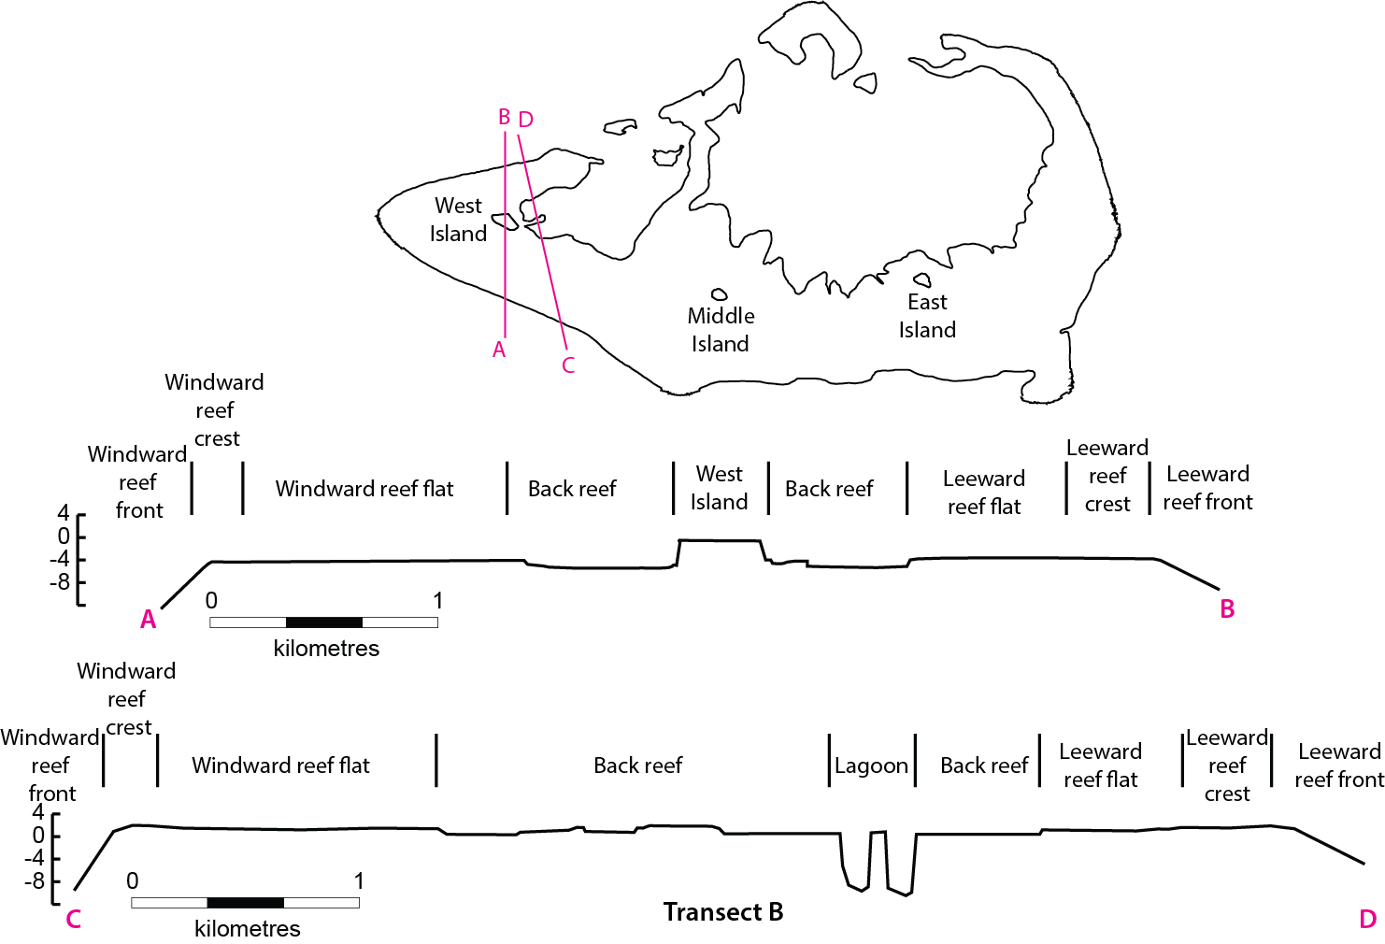

Figure 6: Schematic representation of the geomorphic environments at Ashmore Reef (adapted from © Copyright Glenn and Collins 2005).

### 3.2.3 Tides and currents

Ashmore Reef lies on the confluence of the Pacific and Indian Oceans. The high temperature, low salinity waters of the Western Pacific Warm Pool flow into the Indian Ocean through the Indonesian archipelago forming the major ocean current known as the Indonesian Throughflow (Figure 7). The surface flow of warm, low nutrient water varies seasonally. During autumn and winter there is a strong south-westerly flow along the coastal margin, recently named the Holloway Current. This creates a strong thermocline of warm, low nutrient water over cooler, comparatively nutrient rich waters at depth. During the summer monsoonal months, however, the Indonesian Throughflow and Holloway Currents are weakened as the pressure gradient between the Pacific and Indian Oceans is reduced. During this time, wind driven currents result in recirculation of surface waters in an easterly or northerly direction (DEWHA 2008a, Underwood et al. 2013).

Surface currents around Ashore Reef are also influenced by broad climatic patterns, such as the Southern Oscillation / El Nino and La Nina events. The effect of these climatic events is complex and to some extent uncertain. While El Nino events coincide with a weakening of the strength of the Indonesian Throughflow in general (DEWHA 2008a); there is evidence that such events may also result in increased transport through the Timor Strait (close to Ashmore Reef) and reduced transport through the Indonesian archipelago (Sprintall et al. 2003).

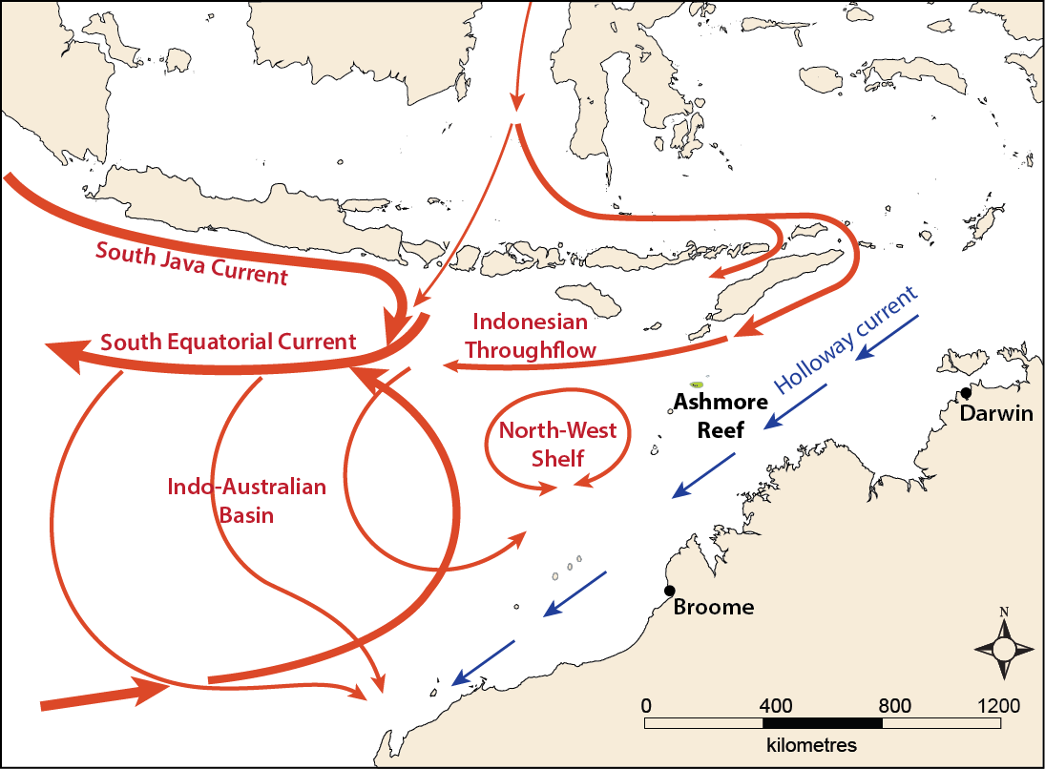

Figure 7: Surface water currents in the Ashmore Region (adapted from © Copyright Underwood et al. 2013).

Internal waves form at the thermocline, where the warm waters of the Indonesian Flow Through overlay cooler, more saline water, particularly in places where there are marked changes in water depth (such as the continental shelf margin). These sub-surface waves can be tens of kilometres long and extend to depths of 75 metres and are characteristic of the North West Shelf region (DEWHA 2008a). Ashmore Reef, as an isolated atoll, may act to break these internal waves resulting in near-bottom turbulence and a mixing of the water column. The mixing of the cooler, nutrient rich waters below the thermocline, with surface waters results in increased nutrients at shallow depths where photosynthesis can occur, resulting in increased primary productivity (DEWHA 2008a). This may be an important influence on ecosystem processes and diversity at Ashmore Reef.

The hydrodynamic energy at Ashmore Reef is high with a mean wave height of one to two metres and tidal currents averaging one metre per second (Glenn and Collins 2005). Tides are semi-diurnal (two tidal cycles per day) with a spring tidal range of 4.75 metres and a neap tide of 1.8 metres (Wienberg et al. 2009). Glenn and Collins (2005) estimated that on a spring tide 7500 gigalitres of water washes over the reef at the Ramsar site.

### 3.2.4 Water quality

Ocean

Temperature and salinity of the oceanic water surrounding Ashmore Reef varies seasonally, with longer term variation linked to broad climatic patterns of El Nino and La Nina (Wienberg et al. 2009). Sea surface temperatures from a logger located off the west of Ashmore Reef from 1995 to 1999 indicated an average of 28.6 degrees Celsius and a range from 25 degrees Celsius in June / July to 31 degrees Celsius in November / December (Sprintall et al. 2003). The water column is relatively well mixed over at least 50 metres, with little change in temperature over this distance (Glenn 2005).

Salinity of ocean waters adjacent to Ashmore Reef also vary seasonally with a freshening in March to May due to increased rainfall during the monsoon resulting in increased river discharge (Wienberg et al. 2009). From 1995 to 1999 surface water salinity averaged 34 parts per thousand near Ashmore Reef, with seasonal variations of around 0.5 parts per thousand (Sprintall et al. 2003). During the El Nino event of 1997-1998 resulted in a clear increase in salinity due to decreased rainfall-runoff and higher temperatures, with average salinity increasing by one part per thousand (Sprintall et al. 2003).

As mentioned above, the waters of the Indonesian Throughflow are low in nutrients, but it is thought that the action of atolls such as Ashmore on internal waves can result in mixing of comparatively nutrient rich water from below the thermocline. No data on nutrient concentrations, however, could be sourced to confirm this theory or provide a quantitative description.

Lagoon

Satellite measurements of the lagoon waters of Ashmore Reef indicate a seasonal cycle in water temperature ranging from 27 degrees Celsius in June/July to over 33 degrees Celsius in November / December (Glenn 2005). Direct measures from the lagoon indicate temperature variations from 25 to 38 degrees Celsius; salinity ranging from 31 to 39 parts per thousand and pH averaging around 7.6 (Glenn 2005).

Profiles measured through the water column indicate generally well mixed conditions with temperature variations of less than two degrees Celsius over 16 metres. However, on occasion, during tropical rainstorms, and during neap tides and calm weather, the lagoon waters can become stratified with a layer of cool lower salinity water over a warmer saltier layer at depth. Periods of stratification are relatively short lived due to the high tides and mixing that occurs (Glenn 2005).

No information on other aspects of water quality such as water clarity or nutrient concentrations in the lagoon waters could be sourced and this remains a knowledge gap (see section 8).

Freshwater lenses

All three islands at Ashmore Reef have freshwater lenses, although water quality data is available only for the groundwater at West Island. Measurements taken in October 2000 and March 2001 suggest a seasonal variation in salinity and dissolved oxygen (Table 8). Glenn (2005) also noted that the depth to groundwater varied from 2.6 metres in the height of the wet season to 2.9 metres in the dry season.

Table 8: Water quality of the groundwater at West Island 2000 – 2001 (Glenn 2005).

|  |  |  |  |  |
| --- | --- | --- | --- | --- |
| **Month** | **Temperature**  **(degrees Celsius)** | **Salinity**  **(parts per thousand)** | **Dissolved oxygen (percentage)** | **pH** |
| October | 28 | 3.94 | 28 | 7.64 |
| March | 29 | 0.03 | 51 | 7.64 |

### 3.2.5 Vegetation

Terrestrial

A total of 39 terrestrial plant species have been recorded from the islands within the Ramsar site (Russell et al. 2004). The number of plant species is small, but probably dynamic as new species are introduced through seed drift and others lost due to cyclones, high tides, beach erosion on the actions of animals (Bellio et al. 2007). Therefore the mapping of vegetation by Pike and Leach (1997) as shown in Figure 8, Figure 9 and Figure 10 should be considered as indicative and a snap-shot in time, rather than a benchmark.

The interior of all three of the islands consists of grasslands and herb fields dominated by annual species that are mostly wind dispersed. The woody octopus bush (*Heliotropium foertherianum*[1]) grows in a band within 15 metres of the shore fringing West Island, forming the dominant structural layer at this site and reaching heights of up to six metres. In contrast, Middle and East Islands have lower vegetation, with isolated shrubs up to three metres in height.

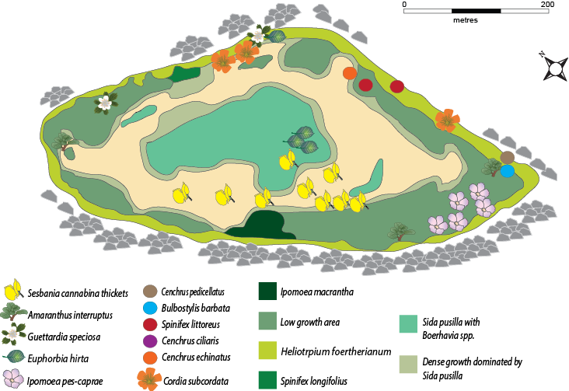

Figure 8: Terrestrial vegetation communities at West Island (adapted from © Copyright Pike and Leach 1997).

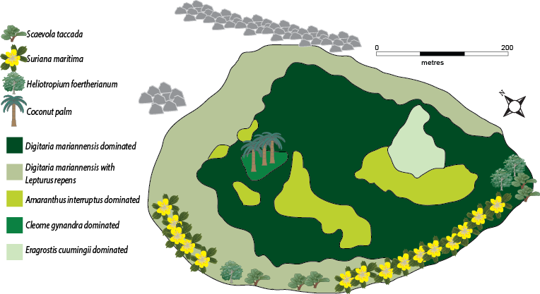

Figure 9: Terrestrial vegetation communities at Middle Island (adapted from © Copyright Pike and Leach 1997).

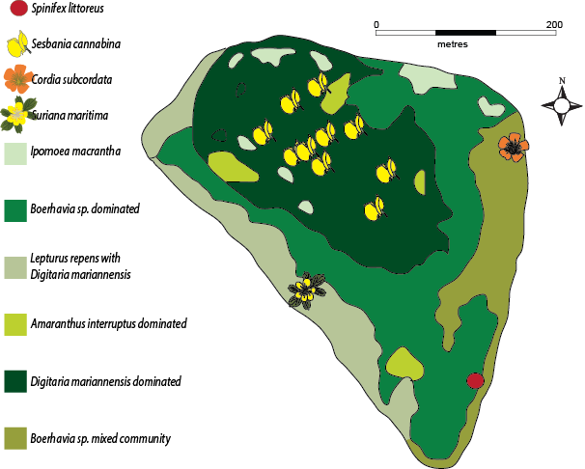

Figure 10: Terrestrial vegetation communities at East Island (adapted from © Copyright Pike and Leach 1997).

Aquatic

Five species of seagrass have been reported at Ashmore Reef: *Thalassia hemprichii*, *Thalassodendron ciliatum*, *Halophila ovalis*, *Halophila decipiens* and *Halodule pinifolia* (Pike and Leach 1997). However, only the first three of these have been confirmed in subsequent surveys (Skewes et al. 1999b, Brown and Skewes 2005). The dominant species is *Thalassia hemprichii,* which comprises over 85 per cent of the total seagrass cover within the Ramsar site, followed by *Thalassodendron ciliatum*, with 13 per cent and *Halophila ovalis* with just one per cent (Skewes et al. 1999b). The total area of seagrass at Ashmore Reef in 1999 was estimated to be 470 hectares (Skewes et al. 1999b). However, much of this is very sparse cover and there is only 220 hectares of seagrass with a greater than 10 per cent cover (Brown and Skewes 2005).

Seagrass grows in a sparse, patchy distribution across the sand flats, but has a higher coverage on the reef flat area, where it extends to within 100 metres of the reef crest. The area of greatest cover and diversity is in the west and south west of the site in the inner reef flat (Brown and Skewes 2005).

Comparatively little is known about the algal communities at Ashmore Reef with no comprehensive species list. Mapping in 1999 indicated a total cover of 3292 hectares of algae at the site, comprising about 30 per cent of the reef habitat (Skewes et al. 1999b, Kospartov et al. 2006). The area of different algal groups in 1999 is provided in Table 9.

Table 9: Area of algae within the Ashmore Reef Ramsar site (Skewes et al. 1999b).

|  |  |
| --- | --- |
| **Algae** | **Area (hectares)** |
| *Halimeda* spp. | 983 |
| *Dictyota* spp | 209 |
| *Turbinaria ornata* | 125 |
| *Caulerpa* spp. | 108 |
| *Ceratodictyon* spp. | 142 |
| *Gracilaria* spp. | 22 |
| *Laurencia* spp*.* | 264 |
| *Padina* spp. | 109 |
| *Cladophora socialis* | 80 |
| Turf algae | 472 |
| Crustose coralline algae | 216 |

Most of the algae at Ashmore Reef comprises coralline or turf algae growing on the reef slope and reef crest habitats, with fleshy macroalgae typically comprising less than 10 per cent of the community (Kospartov et al. 2006, Richards et al. 2009). There are also algae, covering a smaller area on the hard surfaces of the lagoon area. The distribution of algae in 2005 is provided in Figure 11, noting that the 1999 and 2005 studies used different categories.

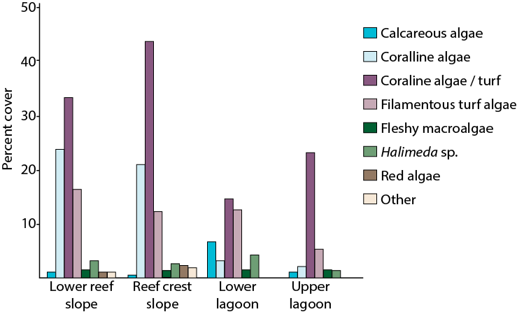

Figure 11: Mean per cent cover of different algal groups at Ashmore Reef in 2005

( © Copyright Kospartov et al. 2006).

## 3.3 Critical components and processes

The attributes and characteristics of each of the identified critical components and processes of the Ashmore Reef Ramsar site are described below (sections 3.3.1 to 3.3.6). Where possible, quantitative information is included. A summary of the critical components and processes within the Ashmore Reef Ramsar site is provided in Table 10.

Table 10: Summary of critical components and processes within the Ashmore Reef Ramsar site.

| **Component / process** | **Description** |
| --- | --- |
| Marine invertebrates | * 275 species of hard coral, covering an area of around 700 hectares (Vernon 1993, Griffith 1997, Skewes et al. 1999a) * 39 taxa of soft coral, covering an area of around 300 hectares (Marsh 1993, Skewes et al. 1999b) * Total coral cover was low around the time of listing following the 1998 bleaching event, but recovered in recent years to baseline levels (Ceccarelli et al. 2011b) * Over 600 species of mollusc, including two endemic species (Wells 1993, Willan 2005) * Over 180 species of echinoderm, including 18 species of sea cucumber (Marsh et al. 1993, Skewes et al. 1999a) * Sea cucumber density is highly variable, but on average exceeds 30 per hectare (Skewes et al. 1999a) * 99 species of decapod crustacean (Morgan and Berry 1993) |
| Fish | * Over 750 species of fish, including five species of fish and 3 species of shark listed as threatened (Allen 1993, Russell et al. 2005) * Predominantly shallow water, benthic taxa that are common throughout the Indo-Pacific * Density of small reef fishes is around 20 000 to 40 000 per hectare (Kospartov et al. 2006, Heyward et al. 2012) * Low density of sharks (less than one per hectare) (Skewes et al. 1999a, Richards et al. 2009, Heyward et al. 2012) |
| Seasnakes | * Prior to listing there was a high diversity and population, peaking in 1998 with an estimated total population of 40 000 snakes in the site (Guinea and Whiting 2005) * However, by the time of listing in 2002 the site was on a trajectory of decline and diversity and abundance was low (Guinea 2008) |
| Turtles | * Three species of marine turtle: green (*Chelonia mydas*), hawksbill (*Eretmochelys imbricata*) and loggerhead (*Caretta caretta*), all of which are listed threatened species * Green turtles are the most abundant, with a total estimated population of around 10 000 * Nesting by two species: green turtles and hawksbill turtles (Whiting and Guinea 2005a) |
| Seabirds and shorebirds | * 72 species of wetland dependent bird recorded within the Ramsar site * 47 species listed under international migratory agreements * Average of around 48 000 seabirds and shorebirds annually * Six species are regularly recorded in numbers greater than one per cent of the population * Nesting of 20 species, 14 of which regularly breed in the site (Milton 2005, Clarke 2010) |
| Dugong | * Small but significant population, that may breed within the site (Whiting and Guinea 2005b) * Data deficient |

### 3.3.1 Marine invertebrates

Ashmore Reef has a diversity of marine invertebrates including hard and soft corals, molluscs, echinoderms and crustaceans. Species composition of marine invertebrates was surveyed in 1986 by the Western Australian Museum (Berry 1993) and estimates of abundance and species distribution made in 1998 (Skewes et al. 1999a, 1999b). Subsequent surveys were undertaken in 2000 (Smith et al. 2000), 2003 (Rees et al. 2003), 2005 (Kospartov et al. 2006), 2009 (Richards et al. 2009), 2010 (Heyward et al. 2010) and 2011 (Heyward et al. 2012). Not all communities were surveyed on each occasion and methods changed between programs, making quantitative comparisons difficult. However, where possible, temporal variation has been considered to inform the benchmark description and help to set limits of acceptable change (see section 6) and / or assess potential changes in character since listing (see section 7).

Hard coral

Diversity of reef building (hermatypic) coral at Ashmore Reef is high, with 255 species from 56 genera recorded in 1986 (Vernon 1993). Taxonomic revisions and additional surveys have resulted in a net increase in species numbers to 275 (Griffith 1997, Ceccarelli et al. 2011c). Species are typical of the indo-pacific region and none are unique or considered endemic. However, 41 species (15 per cent of the total hard coral species at the site) are listed as vulnerable on the IUCN Red List (see Table 4 above). Dominant families (in terms of numbers of species and cover) are Acroporidae, Faviidae and Poritidae (Vernon 1993).

In 1998, hard coral covered an area of around 717 hectares at Ashmore Reef. The majority of hard corals occur in the deep lagoon (265 hectares) and shallow reef top (315 hectares) with small areas in the shallow lagoons, and reef edge / slope habitats (Skewes et al. 1999b). In terms of growth form, coral cover is mostly massive and submassive, with smaller proportions of other forms (Table 11).

Table 11: Area of hard coral within the Ashmore Reef Ramsar site (Skewes et al. 1999b).

|  |  |
| --- | --- |
| **Algae** | **Area (hectares)** |
| Massive | 232 |
| Branching | 105 |
| Digitate | 95 |
| Foliose | 6 |
| Submassive | 210 |
| Plate | 15 |
| Encrusting | 46 |

Temporal changes in coral cover at Ashmore Reef have been dramatic (Figure 12), with an eight fold increase in coral cover from 1998 to 2009. In describing conditions at the time of listing, it is important to take a long term view, as the site was listed in 2002, after a significant bleaching event in 1998 that impacted coral communities across the Indian Ocean. The subsequent increase in live hard coral cover as illustrated in Figure 12, may be indicative of recovery of the community to previous levels and represent part of a cycle of variation (Ceccarelli et al. 2011c).

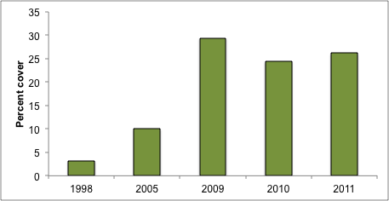

Figure 12: Mean cover (percentage) of hard coral at Ashmore Reef from 1998 to 2011 (data from Skewes et al. 1999b, Kospartov et al. 2006, Richards et al. 2009, Heyward et al. 2010, 2012).

Soft coral

The soft, non-reef building corals are less well studied at Ashmore Reef than the hard corals. Many of the identifications are to genus only and so an exact species count is not possible. In 1986, 39 soft coral taxa were recorded within the site, including the vulnerable blue coral (*Heliopora coerulea*) which was moderately common on the reef flats (Marsh 1993). In 1998, the total cover of soft coral at Ashmore Reef was 323 hectares and *Sarcophyton* spp. were the dominant taxa covering around 19 hectares in total (Skewes et al. 1999b).

Temporal changes in soft coral cover have followed a similar pattern to that described for hard corals above. Differences in survey methods notwithstanding, there has been an increase from 1998 (less than two per cent cover) to 2009 (over eight per cent) as illustrated in Figure 13. As described above for hard corals, consideration must be given to variability over time when setting a benchmark for ecological character, with evidence that soft corals may have been at a low point with respect to cover and condition in 2002 when the site was listed, after the widespread bleaching event; and that current cover is an indication of recovery and a return to baseline conditions (Ceccarelli et al. 2011c).

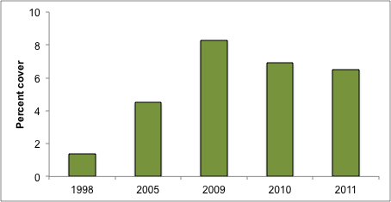

Figure 13: Mean cover (percentage) of soft coral at Ashmore Reef from 1998 to 2011 (data from Skewes et al. 1999b, Kospartov et al. 2006, Richards et al. 2009, Heyward et al. 2010, 2012).

Molluscs

Over six hundred species of mollusc have been recorded from within the Ashmore Reef Ramsar site (Wells 1993, Willan 2005). The majority of species are from the gastropod family (greater than 80 per cent) with approximately 15 per cent of species being bivalves, and only seven species of cephalopod (octopus, squid) recorded. Two species of mollusc are considered to be endemic to Ashmore Reef, both are volute shells from the family Volutidae; *Amoria spenceriana* and *Cymbiola baili* (Willan 2005).

The mollusc community at Ashmore Reef includes the commercially valuable topshell (*Trochus niloticus*). Ashmore Reef represents the highest known population of this species in the region, with an estimated population of over 21 000 individuals in 1998, with an average density of almost one per hectare (Skewes et al. 1999a). Density varies temporally for this species (Figure 14) and it is not known if this is a true reflection of changes in population, or just insufficient survey effort for a highly mobile species that forms aggregations (Richards et al. 2009). It is possible that the survey in 2005 had a large aggregation in a sampling site and that by 2009, individuals were aggregating in areas outside the survey.

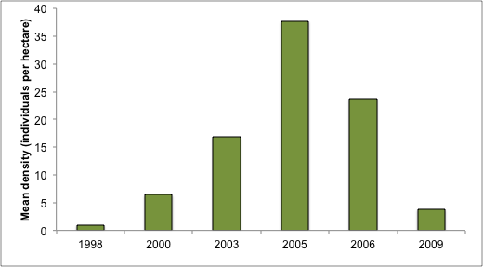

Figure 14: Mean density (individuals per hectare) of topshell (*Trochus niloticus*) at Ashmore Reef (data from Skewes et al. 1999a, Smith et al. 2000, Rees et al. 2003, Kospartov et al. 2006, Richards et al. 2009).

Ashmore Reef also supports six of the eight known species of giant clam (*Tridacna maxima, T. gigas, Hippopus hippopus, T. squamosa, T. derasa* and *T. crocea)*. As with the top shell, Ashmore Reef is considered a refuge for these commercially valuable species. Horse’s hoof clam (*Hippopus hippopus*) is the dominant giant clam species at Ashmore Reef with a mean density of almost 50 per hectare in reef flat habitats in 1998 (Skewes et al. 1999a) (Table 12).

Table 12: Estimate of total population and mean density of giant clam species at Ashmore Reef in 1998 (Skewes et al. 1999a).

|  |  |  |
| --- | --- | --- |
| **Species** | **Population** | **Mean density per hectare** |
| *Tridacna crocea* | 80 325 | 3.5 |
| *Tridacna maxima and squamosa* | 19 796 | 0.9 |
| *Tridacna derasa* | 10 527 | 0.5 |
| *Hippopus hippopus* | 1 084 646 | 47.8 |
| *Tridacna gigas* | 21 053 | 0.9 |

Echinoderms

Over 180 species of echinoderms have been recorded within the Ashmore Reef Ramsar site (Marsh et al. 1993). Dominant groups (in terms of numbers of species) include: sea lilies and feather stars (Crinoidea), starfish (Asteroidea), brittle stars (Ophiuroidea), sea urchins (Echinoidea) and sea cucumbers or *bêche-de-mer* (Holothurioidea).

Of note is the very low abundance of the crown of thorns starfish (*Acanthaster planci*), which was recorded visually only once in the 1986 survey and not at all in 1998. By contrast, the commercially valuable (for the aquarium trade) blue starfish (*Linckia laevigata*) is common in the Ramsar site, with a total population estimated as almost one million and a mean density of 43 individuals per hectare (Skewes et al. 1999a).

Ashmore Reef is considered a refuge for commercially valuable sea cucumber species, and supports significant populations of many species including five listed threatened species (see Table 4 above). In 1998, the total estimated population of sea-cucumbers at Ashmore Reef was approximately 33.5 million, dominated by the low commercial value species white thread fish (*Holothuria leucospilota*) which comprised over 96 per cent of the total population (Table 13).

Table 13: Estimate of total population and mean density of 12 most abundant sea cucumber species at Ashmore Reef in 1998 (Skewes et al. 1999a).

| **Species** | **Population** | **Mean density per hectare** |
| --- | --- | --- |
| *Actinopyga spp.* | 18 438 | 0.8 |
| *Bohabscia argus* | 44 751 | 2.0 |
| *Stichopus chloronotus* | 91 930 | 4.0 |
| *Holothuria atra* | 791 650 | 35 |
| *Holothuria edulis* | 86 833 | 3.8 |
| *Holothuria fuscogilva* | 1630 | 0.1 |
| *Holothuria leucospilota* | 32 368 451 | 1426 |
| *Holothuria nobilis* | 11 802 | 0.5 |
| *Holothuria fuscopuntata* | 638 | 0.1 |
| *Stichopus variegatus* | 44 240 | 2.0 |
| *Thelenota ananas* | 3136 | 0.1 |
| *Thelenota anax* | 638 | 0.1 |

Temporal variation in sea cucumber populations is difficult to decipher as survey methods and ways of reporting results vary significantly between studies. Estimates of density across the Ashmore Reef Ramsar site for commercially valuable species (that is excluding species such as *Holothuria leucospilota*) show no clear pattern (Figure 15) and for individual species (Figure 16) are equally difficult to determine.

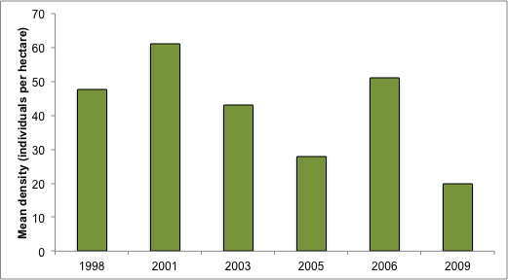

Figure 15: Mean density (individuals per hectare) of total commercially valuable sea cucumber species at Ashmore Reef (data from Kospartov et al. 2006, Richards et al. 2009).

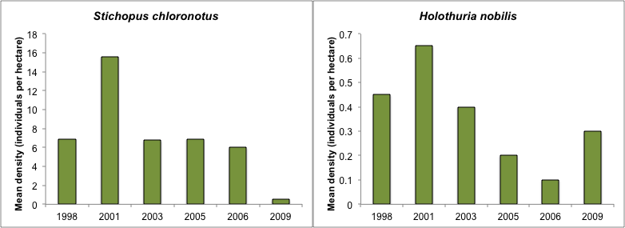

Figure 16: Mean density (individuals per hectare) of two individual sea cucumber species at Ashmore Reef (Richards et al. 2009, Ceccarelli et al. 2011a).

Crustaceans

Information on crustacean communities and populations at Ashmore Reef is limited to decapod crustaceans (crabs, crayfish and prawns). Ninety-nine species of decapod crustacean were recorded at Ashmore Reef in 1986 (Morgan and Berry 1993). Xanthoid crabs were dominant in terms of species diversity (39 species) followed by hermit crabs (25 species). However, given the low survey effort for this group of invertebrates, total species diversity is likely under represented (Morgan and Berry 1993). More recent survey data is not available and this forms the benchmark for the site, with crustacean diversity and abundance remaining a knowledge gap for the site.

### 3.3.2 Fish

Over 750 species of fish have been recorded from within the Ashmore Reef Ramsar site (Allen 1993, Russell et al. 2005). This includes five species of finfish and three species of shark listed as vulnerable or endangered internationally (see Table 4 above). The vast majority of fish species at Ashmore Reef are shallow water, benthic taxa that typically inhabit depths down to 100 metres and are widely distributed throughout the Indo-West Pacific (Russell et al. 2005). The most species rich groups (in descending order) are: gobies (Gobiidae), damselfishes (Pomacentridae), wrasses (Labridae), cardinal fishes (Apogonidae), moray eels (Muraenidae), butterflyfishes (Chaetodontidae), and rockcods and groupers (Serranidae) (Allen 1993, Russell et al. 2005).

Despite a number of surveys of fish within Ashmore Reef being conducted over the past decade (Skewes et al. 1999a, Kospartov et al. 2006, Richards et al. 2009, Heyward et al. 2012) the difference in methods makes it very difficult to quantitatively characterise the fish communities within the Ramsar site. For example, surveys in 1998 suggested a mean fish density of 554 individuals per hectare across the Ramsar site (Skewes et al. 1999a). However, surveys were targeted at large fish of commercial value and in 2005, surveys that more broadly looked at the reef and small and cryptic species that included additional reef areas within the site calculated fish density at 40 000 fish per hectare, with more than half of this attributed to damselfish (Kospartov et al. 2006). Survey methods also have a significant impact on estimates of populations from within a survey. For example, a 2011 survey calculated mean density of fish at Ashmore Reef as over 30 000 fish per hectare using underwater visual census versus less than 20 000 fish per hectare using diver operated video (Heyward et al. 2012).

Surveys that have covered all fish species (rather than restricted to large commercially important species) have consistently found that small fish (less than five centimetres in length) are the dominant feature of the fish community. Damselfish are the most abundant taxonomic group at Ashmore Reef accounting for between 50 and 88 per cent of the total abundance of fishes within the site. This is followed by surgeonfish (Acanthuridae), which comprise between 5 and 13 per cent of the total fish abundance (Kospartov et al. 2006, Richards et al. 2009, Heyward et al. 2012).

All surveys reported similar results for reef sharks, with less than one individual per hectare reported in 1998, 2009 and 2011 (Skewes et al. 1999a, Richards et al. 2009, Heyward et al. 2012). This is considered low for oceanic reefs. The most common species reported from Ashmore Reef s the white tip reef shark (*Triaenodon obesus*) followed by the grey reef shark (*Carcharhinus amblyrhynchos*).

### 3.3.3 Seasnakes

Seventeen species of seasnake have been recorded within the Ashmore Reef Ramsar site, including three species listed as critically endangered or endangered (see Table 4 above). In 1998, nine species of seasnake were considered resident and three were considered to be common at Ashmore Reef: turtle-headed seasnake (*Emydocephalus annulatus*); olive seasnake (*Aipysurus laevis*) and leaf-scaled seasnake (*Aipysurus foliosquama*) (Table 14). Density of seasnakes in 1998 was estimated at 2.2 individuals per hectare on the reef flat and the total population at Ashmore Reef estimated at almost 40 000 (Guinea and Whiting 2005).

Table 14: Summary of the results of seasnake surveys at Ashmore Reef from 1994 to 1998 (Guinea and Whiting 2005)

|  |  |  |  |
| --- | --- | --- | --- |
| **Common name** | **Species name** | **Number** | **Percentage of total** |
| Turtle-headed seasnake | *Emydocephalus annulatus* | 28 | 34 |
| Olive seasnake | *Aipysurus laevis* | 17 | 20 |
| Leaf-scaled seasnake | *Aipysurus foliosquama* | 14 | 17 |
| Horned seasnake | *Acalyptophis peronii* | 7 | 8 |
| Short-nosed seasnake | *Aipysurus apraefrontalis* | 5 | 6 |
| Dusky seasnake | *Aipysurus fuscus* | 3 | 4 |
| Stokes’ seasnake | *Astrotia stokesii* | 3 | 4 |
| Cogger’s seasnake | *Hydrophis coggeri* | 3 | 4 |
| Dubois seasnake | *Aipysurus duboisii* | Small numbers in West Lagoon | |

Variability in sea-snake abundance from the period 1994 to 2003 is illustrated in Figure 17. The CPUE (catch per unit effort; in this case snakes per hour) varies significantly with a peak across many species in 1998. Whether this reflects differences in survey methods, high spatial and temporal variability; or a genuine jump in seasnake abundance in 1998, is not known. At the time of listing seasnake abundance and diversity was on a trajectory of decline, but an abundance of more than 10 snakes per hour was recorded consistently up until and including 2003. Subsequent changes in seasnake populations within the Ramsar site are explored in section 7 (changes since designation).

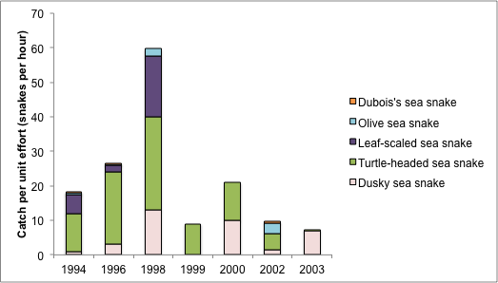

Figure 17: Catch per unit effort (snakes per hour) for seasnakes in the inner mooring at West Island from 1994 to 2003 (data from Guinea 2006).

### 3.3.4 Turtles

Three species of marine turtle have been recorded within the Ashmore Reef Ramsar site, green (*Chelonia mydas*), hawksbill (*Eretmochelys imbricata*) and loggerhead (*Caretta caretta*). All three species are listed threatened species under both the EPBC Act and IUCN Red List (see Table 4 above). Although there are records from as early as 1952 of green turtles nesting on Ashmore Reef the first quantitative surveys are from the period 1996 to 1999 and these are the closest estimate for setting a benchmark for the Ashmore Reef Ramsar site at the time of listing.

Green turtles are the most abundant of the three species and comprise of 90 per cent of the total turtle population at Ashmore Reef (Figure 18). Loggerhead turtles comprise some seven per cent of total turtle numbers and hawksbill just over one per cent (Whiting and Guinea 2005a). This species composition varied little between the years of surveys (1996 to 1999). Total population estimates for green turtles are around 10 000 (six individuals per hectare) for the Ashmore Reef Ramsar site (Whiting and Guinea 2005a).

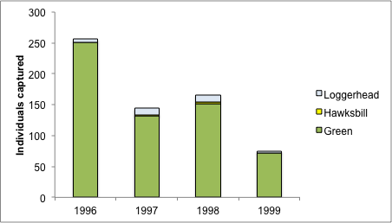

Figure 18: Turtles recorded in surveys at Ashmore Reef 1996 to 1999 (data from Whiting and Guinea 2005a).

The vast majority of turtles caught were juvenile; 93 per cent of green turtles, 77 per cent of loggerheads and all hawksbills. Only 31 green turtles and six logger head turtles of adult size were caught over the four year study (Whiting and Guinea 2005a).

Green turtles are known to nest at West Island in the Ashmore Reef Ramsar site, with occasional records of hawksbill turtle nests. There are unconfirmed records of two loggerheads and one flatback turtle nest from the site, but these have not been observed in recent monitoring (Whiting and Guinea 2005a). Numbers of turtles nesting each year is highly variable, for example there was an average of 0.7 green turtle nests per night in 1998 and 34 nests per night in 1999 (Whiting and Guinea 2005a), making it difficult to estimate average nesting numbers. Hatching success varied between 75 and 93 per cent, which is within the range found on other beaches in Australia.

### 3.3.5 Seabirds and shorebirds

Ashmore Reef supports an abundance and diversity of wetland birds. A total of 72 species have been recorded within the Ramsar site (Table 15). This includes 47 species that are listed under international migratory agreements CAMBA (40), JAMBA (43) and ROKAMBA (35) as well as an additional 22 Australian species that are listed as marine under the *Environmental Protection and Biodiversity Conservation Act 1999* (EPBC). The majority of species recorded at the site are seabirds and shorebirds from the families Charadriformes, Pelecaniformes and Procellariformes (Table 15).

Table 15: Number of wetland bird species recorded within the Ashmore Reef Ramsar site (Milton 2005, Clarke 2010).

| **Bird group** | **Typical feeding requirements** | **Number of species** |
| --- | --- | --- |
| Anseriformes  (ducks and allies) | Shallow or deeper open water foragers  Vegetarian or omnivorous with diet including leaves, seeds and invertebrates | 1 |
| Pelecaniformes  (pelicans, boobies, cormorants and frigatebirds) | Large waterbirds that forage in deeper open waters feeding mainly on fish. | 8 |
| Phaethontiformes  (tropicbirds) | Pelagic seabirds that spend most of their lives at sea feeding on fish; returning to shore to breed. | 2 |
| Ciconiiformes  (herons, egrets, storks and spoonbills) | Long-legged wading birds with large bills, feeding mainly in shallow water and mudflats. | 7 |
| Falconiformes  (birds of prey) | Shallow or deeper open water on fish and occasionally waterbirds and carrion | 1 |
| Rallidae  (rails, crakes and coots) | Small, ground dwelling birds that are mostly omnivorous. | 1 |
| Shorebirds (Charadriiformes) | Shallow water, bare mud and salt marsh  Feeding mainly on animals (invertebrates and some fish) | 34 |
| Gulls and terns (Charadriiformes) | Terns, over open water feeding on fish; gulls, opportunistic feeders over a wide range of habitats. | 13 |
| Procellariformes  (petrels and shearwaters) | Pelagic seabirds that spend most of their life at sea returning to land only to breed. | 5 |
| Total |  | 72 |

Complete counts of the Ramsar site are very limited. There is no consistent count data from the years pre and post listing in 2002. However, available data from counts in from 2002 to 2010 provides an indication of abundance, noting that data from October 2005 to October 2009 does not include shorebirds (Figure 19). The site supports large numbers of seabirds and shorebirds, with an average of over 48 000 birds for years where complete counts are available. When considering individual groups, there are, on average over 32 000 seabirds at Ashmore Reef each year and 12 000 shorebirds (data from Clarke 2010).

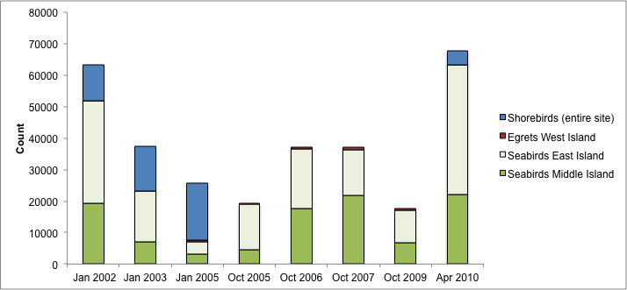

Figure 19: Abundance of seabirds and shorebirds at Ashmore Reef (data from Clarke 2010). Note there were no shorebird counts for the period October 2005 to 2009 inclusive.

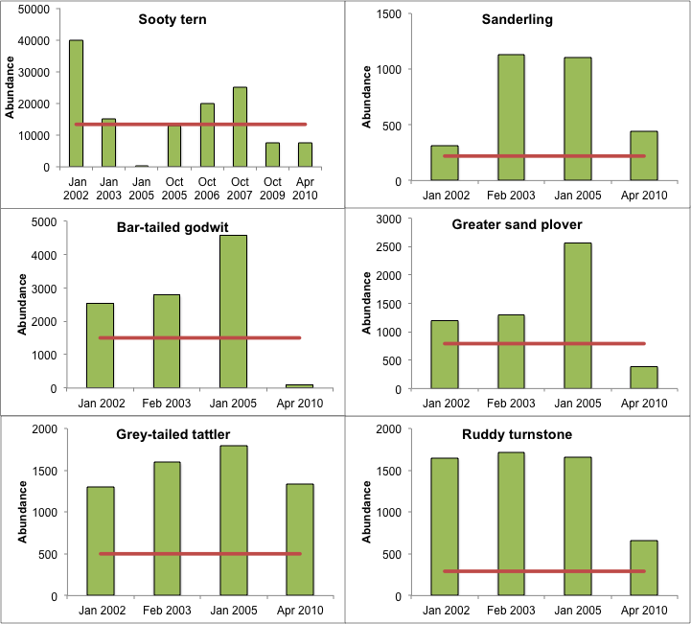

Figure 20: Abundance of bird species for which Ashmore Reef regularly supports greater than one per cent of the population (red line indicates one per cent threshold) (data from Clarke 2010).

The Ashmore Reef Ramsar site is also significant for the role it plays in supporting individual bird species. Maximum counts for eight bird species exceed the one per cent population thresholds (Wetlands International 2013; Table 6). The limited count data makes application of the concept of “regularly” supports difficult. However, available data provide sufficient evidence that the site regularly supports more than one per cent of the relevant populations of six species (Figure 20). In addition, the site supports moderate to large numbers of brown booby (*Sula leucogaster*) and lesser frigatebirds (*Fregata ariel*), with average abundance from 2002 to 2010 of over 4000 and 2000, respectively. However, there are no population estimates for these species against which these numbers can be assessed.

Twenty species of wetland bird have been recorded breeding within the Ashmore Reef Ramsar site (Table 16). This includes fifteen species that regularly nest at the site and a further five that use the site occasionally. Middle and East Islands are the major sites for seabird breeding in terms of both numbers of species and abundance of nest sites. Recent analysis has indicated that the Ashmore Reef Ramsar site supports over 100 000 breeding seabirds in a 12 month cycle (Clarke et al. 2011).

Table 16: Breeding distribution of waterbirds on the three islands within the Ashmore Reef Ramsar site (Clarke et al. 2011).

|  |  |  |  |
| --- | --- | --- | --- |
| **Species** | **West Island** | **Middle Island** | **East Island** |
| Black noddy |  | Regular | Regular |
| Bridled tern |  | Regular | Regular |
| Brown booby |  | Regular | Regular |
| Brown (common) noddy |  | Regular | Regular |
| Crested tern |  | Regular | Regular |
| Eastern reef egret | Regular | Regular | Regular |
| Great egret |  | Occasional |  |
| Great frigatebird |  | Regular | Occasional |
| Lesser crested tern |  | Occasional | Occasional |
| Lesser frigatebird |  | Regular | Regular |
| Lesser noddy |  | Occasional | Occasional |
| Little egret | Occasional | Occasional | Occasional |
| Masked booby |  | Regular | Regular |
| Nankeen night-heron | Occasional |  |  |
| Red-footed booby |  | Regular | Regular |
| Red-tailed tropicbird | Regular | Occasional | Occasional |
| Roseate tern |  | Occasional | Occasional |
| Sooty tern |  | Regular | Regular |
| Wedge-tailed shearwater | Regular |  |  |
| White-tailed tropicbird | Regular | Occasional | Occasional |

### 3.3.6 Dugong

Ashmore Reef supports a small, but significant population of the internationally listed vulnerable mammal species, dugong (*Dugong dugon*). The population is estimated at around 100 individuals and comprises of all age classes from calves to mature adults (Whiting and Guinea 2005b). Dugongs have been observed during most months of the year, suggesting that they are resident or regular visitors to the site, which is used for foraging and perhaps breeding.

# 4 Ecosystem services

## 4.1 Overview of benefits and services

Ecosystem benefits and services are defined under the Millennium Ecosystem Assessment definition of ecosystem services as "the benefits that people receive from ecosystems (Ramsar Convention 2005, Resolution IX.1 Annex A). This includes benefits that directly affect people such as the provision of food or water resources as well as indirect ecological benefits. The Millennium Ecosystem Assessment (Millennium Ecosystem Assessment 2005) defines four main categories of ecosystem services:

1. **Provisioning services** - the products obtained from the ecosystem such as food, fuel and fresh water;
2. **Regulating services** – the benefits obtained from the regulation of ecosystem processes such as climate regulation, water regulation and natural hazard regulation;
3. **Cultural services** – the benefits people obtain through spiritual enrichment, recreation, education and aesthetics; and
4. **Supporting services** – the services necessary for the production of all other ecosystem services such as water cycling, nutrient cycling and habitat for biota. These services will generally have an indirect benefit to humans or a direct benefit over a long period of time.

The ecosystem benefits and services of the Ashmore Reef Ramsar site are outlined in Table 17.

Table 17: Ecosystem services and benefits provided by the Ashmore Reef Ramsar site (those critical to the ecological character of the site are shaded; see section 4.2 below).

| **Category** | **Description** |
| --- | --- |
| **Cultural services** | |
| Recreation and tourism | * Although remote and access is controlled, the site is important for passive recreation such as diving and bird watching. |
| Cultural heritage and identity | * Ashmore Reef has been regularly visited and fished by Indonesians since the early eighteenth century. West Island contains some archaeological artefacts and graves. |
| Scientific and educational | * The reef has high value for scientific research because it currently receives relatively low use and is ecologically unique within the bioregion. |
| **Provisioning services** | |
| Freshwater | * Indonesian fishers use the freshwater lens at West Island. |
| **Supporting services** | |
| Near-natural wetland types | * Ashmore Reef supports a number of largely unmodified wetland types. |
| Biodiversity | * Ashmore Reef is a hotspot of biodiversity within the Timor Province bioregion:   + Highest diversity of reef building corals (275 species from 56 genera)   + Highest diversity of soft corals (39 taxa)   + More than 600 species of mollusc   + Over 180 species of echinoderm, including 13 species of sea cucumber   + Nearly 100 species of decapod crustacean   + Over 750 species of finfish   + High diversity of seasnakes   + Populations of turtles and dugongs |
| Physical habitat | * The site supports large breeding colonies of seabirds |
| Priority wetland species | * The Ramsar site supports 47 species of shorebird listed under international migratory bird treaties. |
| Threatened species | * Ashmore Reef supports 62 species listed as threatened at the national and / or international level. |

## 4.2 Identifying critical ecosystem services and benefits

The critical ecologically based ecosystem services and benefits of a Ramsar site have been identified using the same criteria provided by DEWHA (2008) used for selecting critical components and processes; i.e. services that at a minimum:

1. are important determinants of the site’s unique character;
2. are important for supporting the Ramsar or DIWA criteria under which the site was listed;
3. for which change is reasonably likely to occur over short or medium time scales (< 100 years); and / or
4. that will cause significant negative consequences if change occurs.

Using these criteria it was considered that all of the supporting services (that is, those that are ecologically based) could be considered “critical”. While the site is undoubtedly beneficial in terms of recreation, tourism, cultural heritage and scientific research; these were not considered “critical” services in that a reduction in any of these services would not necessarily indicate a change in ecological character. However, cultural services are considered important for the Ashmore Reef Ramsar site and so have been described further in section 4.4.

## 4.3 Critical services

### 4.3.1 Supports near natural wetland types

As described in section 2.3, the Ashmore Reef Ramsar site contains a small number of wetland types that by virtue of the remote location and protected status of the site can be considered in near natural condition. The wetland types present in the site are brought about by the interactions between geomorphology, hydrology, water quality, vegetation and invertebrates (Figure 21). Although there is little data from the site to provide direct evidence of the interactions of components and processes that support these wetland types, general ecological theory can provide an approximation of the likely interactions for each of the types as described below.

* A – Permanent shallow marine waters
* B - Marine subtidal aquatic beds; includes kelp beds, sea-grass beds, tropical marine meadows.
* C - Coral reefs
* E - Sand, shingle or pebble shores; includes sand bars, spits and sandy islets; includes dune systems and humid dune slacks
* G - Intertidal mud, sand or salt flats.

A-Permanent shallow marine waters / B-Marine sub-tidal aquatic beds / G-Intertidal sand flats:

The lagoon areas contain seagrass beds over sandy sediments. The connection between the Indian Ocean, combined with the twice-daily tidal cycle provides flushing of the lagoon and maintains water quality. The dominant species of seagrass (*Thalassia hemprichii*) can tolerate high temperatures and exposure and so extends into intertidal sand flat areas of the site (Brown and Skewes 2005). The seagrass binds the sandy substrate, stabilising the sediment and decreasing suspended sediment. Both of these factors combine to provide adequate light for seagrass. The tidal exchange also regulates temperature, dissolved oxygen and nutrient concentrations in the shallow waters, with inflows of cool, low nutrient, oxygenated ocean water maintaining good water quality conditions (Lalli and Parsons 1997).

C- Coral reefs:

Ocean currents, tidal exchange and bathymetry all play an important role in the formation and maintenance of this wetland type and the zonation of corals (Lalli and Parsons 1997). The southern (windward) margin of the outer reef slope forms a shelf about 150 metres wide and is exposed to strong wave surge. As a result soft corals predominate in this area and hard corals are sparsely scattered. On the northern (leeward) margin the outer reef slope is steep and more sheltered from strong wave and surge action. In this area hard, reef-building coral dominate. The reef crest and flat is composed of loosely consolidated rubble, dead coral slabs with hard and soft coral growth (Berry 1993)

E- Sand shores:

The sand beaches, which are important habitat for nesting turtles (see section 4.3.5 below), are restricted to the small islands within the Ramsar site. This higher energy environment, maintains an area of finer sandy sediments, which together with tides and currents is important for maintaining this wetland type (Lalli and Parsons 1995).

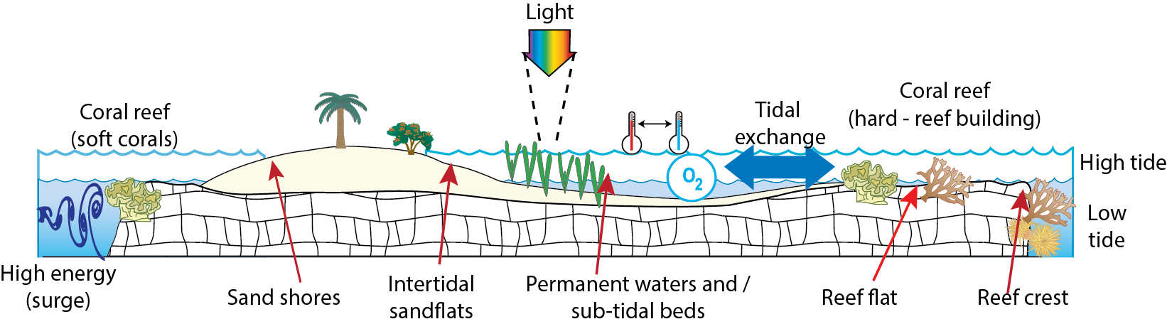

Figure 21: Stylised illustration of wetland types within the Ashmore Reef Ramsar site and the major components and processes that influence them.

### 4.3.2 Supports biodiversity

The Ashmore Reef Ramsar site is considered a hotspot of biodiversity with the highest species richness of many groups of fauna in the bioregion and more broadly across the Northwest Shelf. This includes many groups of invertebrates such as coral, molluscs, echinoderms and crustaceans as well as finfish and seasnakes. The site also supports a diversity of seabirds as well as endangered turtles, sharks and dugongs.

Biodiversity at the site is supported by the habitat provided by the near natural wetland types (see section 4.3.1) and the interactions between the biota within the atoll environment, such as trophic relationships and the transfer of energy (Figure 22). There have been a number of theories put forward as to why biodiversity is higher at Ashmore Reef than other atoll and reef systems in the bioregion. Willan (2005) suggested that the larger diversity and extent of habitat types at Ashmore Reef may play a significant role in the increased diversity at this site. The author also suggested that its larger size enabled Ashmore Reef to retain more particulate organic matter, providing more energy and resources for the ecosystem in general and filter feeders in particular.

The proximity of Ashmore Reef to the Indonesian archipelago, which has the world’s most diverse fish fauna, has been suggested as a causal factor for the relatively high diversity of finfish at Ashmore Reef (Russell et al. 2004). While, the protected status of Ashmore Reef, within the Marine Park, has been cited as a causal factor in high diversity and abundance of commercially important species such as sea cucumbers and trochus shells (Skewes et al. 2005).

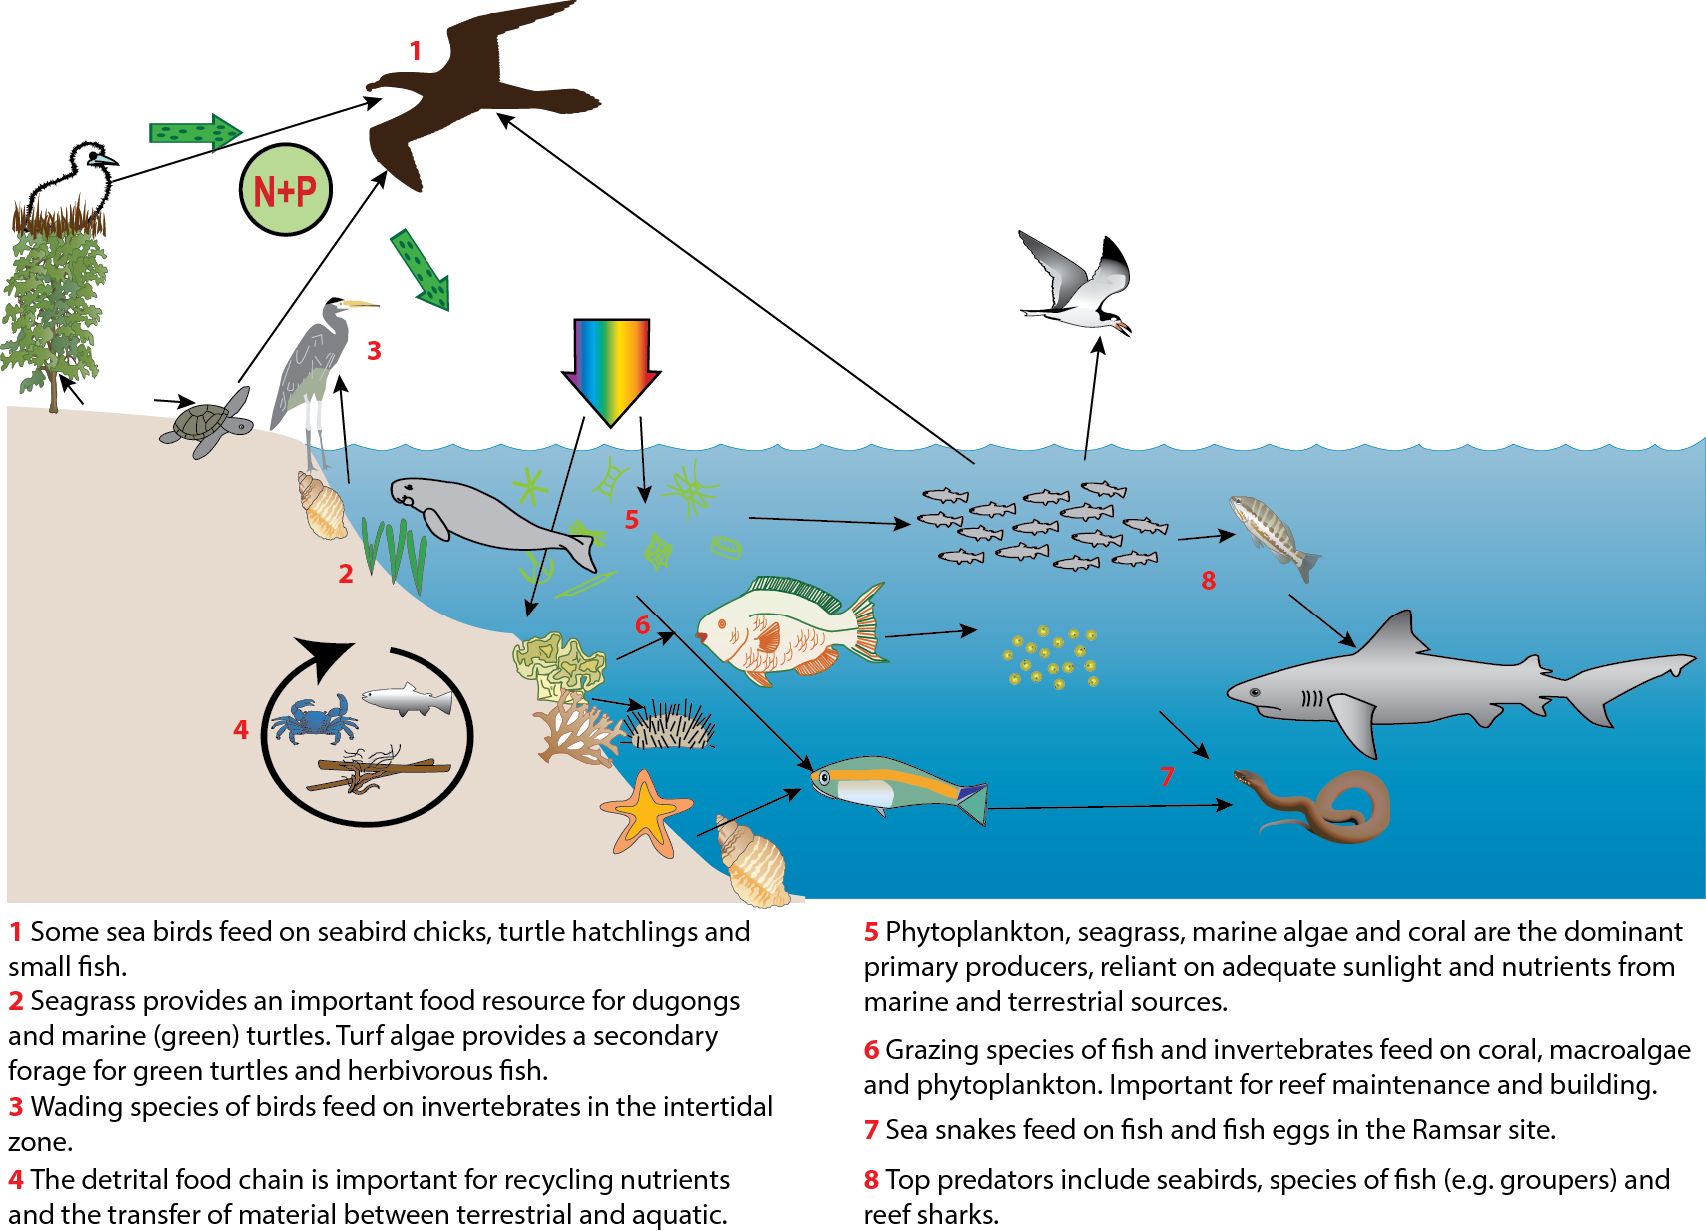

Figure 22: Indicative trophic relationships between groups of biota within the Ashmore Reef Ramsar site.

### 4.3.3 Provides physical habitat for breeding waterbirds

Twenty species of wetland bird have been recorded breeding within the Ashmore Reef Ramsar site, the majority of which are seabirds. The species recorded breeding at the site utilise a range of different habitats within the system (Table 18). This includes the shrubby and grassy vegetation, the ground beneath shrub vegetation and the sandy beaches. Maintaining this diversity of habitat is essential to maintaining this service.

Table 18: Breeding habitat requirements of some seabird species recorded breeding in the Ashmore Reef Ramsar site (Bellio et al. 2007, Clarke 2010 unless otherwise stated).

| **Species / group** | **Breeding habitat and behaviour** |
| --- | --- |
| Egrets and herons | Nests constructed of sticks in trees or under shrubs; within the Ramsar site nests constructed in octopus bush and other shrubs on West Island and on or close to the ground in low vegetation on Middle and East Islands. |
| Wedge-tailed shearwater | Nests in shallow burrows dug in the soft sand under low vegetation on West Island. Up to 30 burrows have been recorded at any one time, but due to the fragile nature of burrows exact counts are not available. Both parents in shifts of two to five days incubate one single egg. When parents are brooding they do not leave the nest, however, once hatched chicks are left alone while parents feed at sea. |
| Crested tern | Nest is usually placed on bare ground, in shallow recesses in rock, depressions among coral or rock fragments, or scrapes in shallow sand. In the Ramsar site they nest on Middle and East Islands in dense colonies immediately above the high tide mark in exposed shell beds. One or two eggs are laid and parental care is required for a long time after hatching. |
| Bridled tern | Nests in a scrape in the ground in a cave or under vegetation (rarely in the open). In the Ramsar site they typically nest in loose aggregations of birds on Middle and East Island concealed under herbaceous vegetation. Lays only a single egg, but breeds every seven or eight months, with young requiring care for only a few days after hatching. |
| Sooty tern | Nest in scrape on the ground; within the Ramsar site in densely packed aggregations of birds on Middle and East Island in herbaceous vegetation or bare ground. Breeding across an entire colony is highly synchronised with egg laying by most colony members occurring over several weeks. |
| Brown (common) noddy | Nests in trees or on ground; within the Ramsar site both on and amongst herbaceous vegetation on Middle and East Island in dense colonies. Usually only one egg is laid and after hatching parental care is required for only a short time. |
| Red-footed booby | Nests in trees or shrubs and in the Ramsar site have been observed nesting in octopus bush on Middle and East Islands. Only a single egg is laid and both parents share incubation. Hatchlings require care for several months. |
| Brown booby | Nest is variable and maybe a scrape on the ground or a substantial structure of sticks and other material. In the Ramsar site, nesting is mostly in exposed areas or bare substrate on Middle and East Island. Nesting abundance is high with over 4000 nests recorded across the two islands. |
| Masked booby | Nests in scrape on open ground; within the Ramsar site in open ground on Middle and East Islands. A growing number of adult birds and chicks have been observed using the sites from just a couple of nests 1983 – 1988 to over 33 nests in 2010. Once hatched chicks are very vulnerable, requiring constant brooding until three to four weeks old. |
| Lesser frigatebird | Nest in trees and shrubs; within the Ramsar site low lying shrubs on Middle and East Island in dense colonies. Only breed every two years, with parental care of the single chick lasting up to six months. |
| Greater frigatebird | Nests in large platforms of loosely woven twigs within trees and shrubs; within the Ramsar site nests only on Middle Island on a collection of dead woody shrubs with the availability of nesting sites perhaps a limiting factor. Only breed every two years and the breeding season lasts for at least 14 months. |
| White-tailed tropicbird | Nests in a range of habitats from bare ground to trees; within the Ramsar site just two nests have been recorded, but on an annual basis. Nest sites to date have been found under shrubby vegetation on West Island. |
| Red-tailed tropicbird | Nests in a range of habitats from bare ground to trees; within the Ramsar site a very small number of nests (up to ten) have been recorded under octopus bushes on West Island. |

Components and processes that support waterbird breeding at the Ramsar site include not only the nesting sites (as described in Table 18); but also maintaining adequate food resources to sustain breeding (Figure 23). The majority of the birds that breed within the Ramsar site are piscivorous feeding either by contact dipping in shallow water (less than 20 centimetres), for example, terns, common noddy and wedge-tailed shearwater; or by deep diving for fish; for example, boobies (Higgins and Davies 1990, Higgins and Marchant 1993). Frigatebirds also feed on fish and squid in shallow waters; but are also known to “steal” food from other seabirds by attacking parents returning to the nest causing them to disgorge their stomach contents; these birds are also known to feed on chicks of terns and common noddy (Higgins and Marchant 1993). Many of the seabirds within the Ramsar site have been reported foraging in the open ocean surrounding the Ramsar site and at distances of over 200 kilometres away (Clarke 2010).

Nankeen night heron and the egret species are wading species of birds that feed in the intertidal area of the lagoon, islands and sand flats on a range of small fish, crustaceans and molluscs. They have also been reported feeding on turtle hatchlings from West Island (Whiting and Guinea 2005a).

Breeding and chick rearing is the period with the lifecycle where energetic demand is highest (Drent and Dan 1980) and food availability is generally accepted as the most important factor in determining the timing and success of breeding in most bird populations (Dan et al. 1988). Relatively high productivity is required to sustain the large seabird breeding colonies found within the relatively small Ramsar site. Additionally, it has been suggested that movements of schools of predatory fish such as tuna can be important for successful breeding of seabirds such as red-footed booby (Le Corre 2001). Many seabirds including the boobies and frigate birds have been observed to use the schooling techniques of predatory fish, that concentrate small fish, to improve hunting success (Higgins and Marchant 1993) and reduce the energy costs of foraging. Although not proven for the Ramsar site, it is possible that predatory fish populations within the waters surrounding the Ramsar site could be important for maintaining the success of seabird breeding within the site.

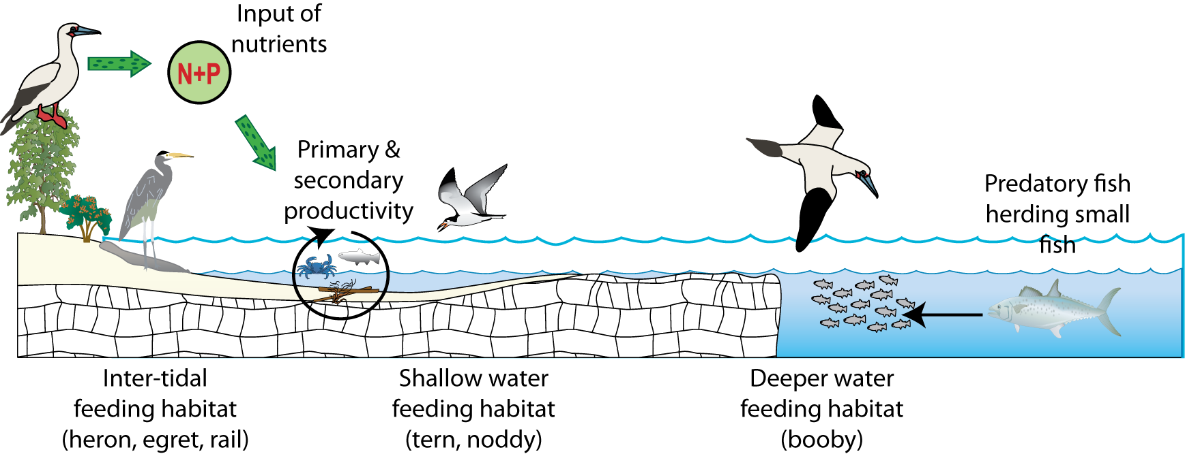

Figure 23: Simplified illustration of foraging habitats and factors potentially influencing food availability for breeding seabirds in the Ashmore Reef Ramsar site.

### 4.3.4 Priority wetland species – supports migratory birds

Ashmore Reef Ramsar site supports a diversity and abundance of migratory shorebirds in the East Asian-Australasian Flyway. The majority of birds in the East Asian-Australasian Flyway migrate from breeding grounds in North-east Asia and Alaska to non-breeding grounds in Australia and New Zealand, covering the journey of 10 000 kilometres twice in a single year (Figure 24).

The lifecycle of most international migratory shorebirds involves (Bamford et al. 2008):

* breeding in May to August (northern hemisphere);
* southward migration to the southern hemisphere (August to November);
* feeding and foraging in the southern hemisphere (August to April); and
* northward migration to breeding grounds (March to May).

During both northward and southward migration, birds may stop at areas on route to rest and feed. These stopovers are referred to as “staging” areas and are important for the bird’s survival. In the past it has been suggested that Ashmore Reef Ramsar site acted as a stop-over or staging area for birds on route to and from the Australian mainland. However, recent data indicates that the site is an important wintering site for shorebirds in the East Asian-Australasian Flyway (Clarke 2010).

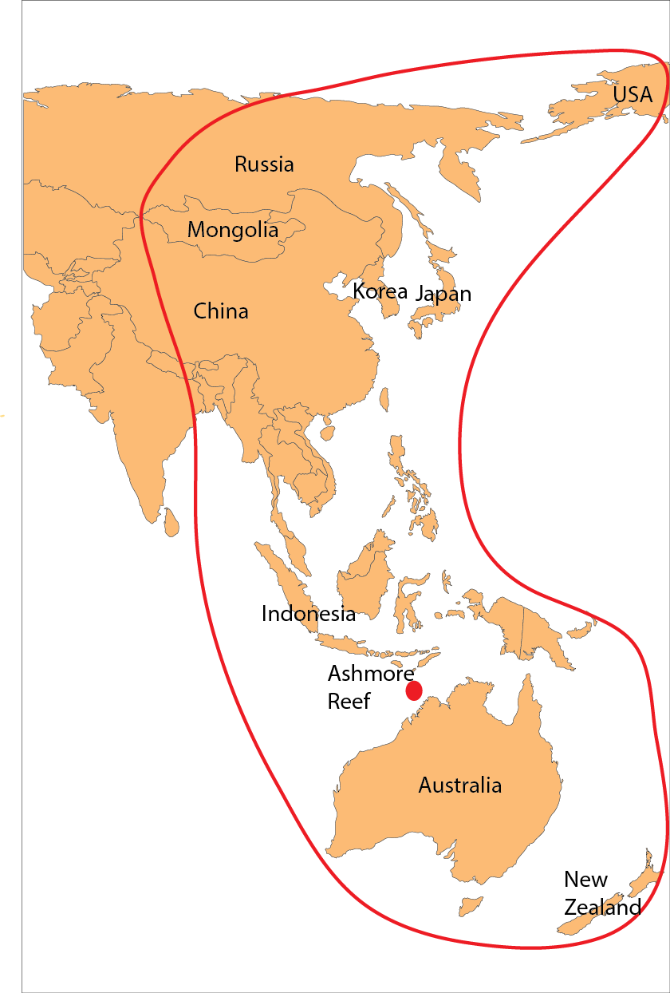

Figure 24: East Asian-Australasian Flyway (© Copyright Bamford et al. 2008).

Utilisation of foraging and feeding habitats by shorebirds is a complex interaction between factors such as trophic structure, food partition (Davis and Smith 2001), prey availability (Hubbard and Dugan 2003) and selectivity (Kalejta 1993), predation risk (Cresswell 1994, Ydenberg et al. 2002), and abiotic factors such as water level (Recher 1966, Colwell and Dodd 1995, Boettcher et al. 1995, Cole et al. 2002), tidal cycle (Burger et al. 1977) and substrate particle size (Danufsky and Colwell 2003).

There is a wide body of literature describing the habitat requirements (with respect to feeding) of shorebirds based both on observational and experimental studies. In general terms, the habitat requirements of some of the species which the Ashmore Reef Ramsar site regularly supports are described in Table 19. Shorebirds within the Ramsar site are reliant on abundant food sources to build up reserves prior to the journey back to breeding grounds.

Table 19: Habitat requirements of a number of migratory shorebird species, recorded in the Ashmore Reef Ramsar site (Swann 2005, BirdLife International 2013).

| **Shorebird** | **Breeding Area** | **Feeding, foraging and other habitat requirements** |
| --- | --- | --- |
| Bar-tailed godwit | Northern Russia | Mudflat and intertidal zone forager. In intertidal areas the diet consists of annelids, bivalves and crustaceans, although it will also occasionally take small fish. In the Ramsar site forages around the muddy sand flats at East and Middle Islands. |
| Common greenshank | Arctic circle,  Siberia | Wide variety of inland and sheltered coastal wetlands – mudflats and salt marshes. In the Ramsar site it shows a preference for the extensive muddy sand flats towards the eastern side of the reserve, about Middle Island and East Island. Predominantly carnivorous, diet consisting of insects and their larvae (especially beetles), crustaceans, annelids, molluscs, amphibians, small fish and occasionally rodents. |
| Great knot | Northern Siberia | Coastal habitats, intertidal mudflats and sand flats, in the Ramsar site; favours intertidal muddy sand flats around Middle Island. Diet consists of bivalves up to 36 millimetres long as well as gastropods, crustaceans (crabs and shrimps), annelid worms and echinoderms (sea cucumbers). |
| Greater sand plover | China, Mongolia, Siberia | Coastal wetlands, intertidal mudflats or sand flats. It has been recorded over much of the Ramsar site in a number of different habitats, including many of the intertidal areas where a sandy surface predominates and also feeding and loafing on the herb fields of West Island and to a lesser extent at Middle and East Islands. Diet contains mainly marine invertebrates such as molluscs (snails), worms and crustaceans (such as shrimps and crabs). |
| Grey plover | Arctic tundras,  Siberia | Coastal, intertidal mudflats, sand flats, in the Ramsar site favour the sand flats around East Island. Diet consists of marine polychaete worms, molluscs and crustaceans (crabs, sand shrimps), occasionally also taking insects. |
| Grey-tailed tattler | Siberia | In the Ramsar site it favours rocky reefs and coralline rubble and sand flat. Described as a visual hunter of small active invertebrates in intertidal mud and sand. Diet consists of crustaceans and other invertebrates. |
| Sanderling | Arctic circle Siberia | Range of feeding habitats, but within the Ramsar site, sandy beaches and coral shores, also observed foraging in terrestrial vegetation on West Island. During the winter its diet consists of small molluscs, crustaceans, polychaete worms and adult, larval and pupal insects, as well as occasionally fish and carrion. |
| Ruddy turnstone | Northern Siberia | Forages in intertidal areas and in the Ramsar site utilises coralline sand flats and reef flat habitat. Diet consists of insects, crustaceans, molluscs (especially mussels), annelids, echinoderms, small fish, carrion and birds eggs. |
| Terek sandpiper | Russia | Intertidal coastal, - mainly saline mudflats. Often recorded roosting on exposed sandbars in the Ramsar site. Diet consists of consisting of a variety of insects, small molluscs, crustaceans (including crabs), spiders and annelid worms. |
| Whimbrel | Siberia | Range of feeding habitats in the Ramsar site including the herbfields of the islands as well as intertidal zones. Diet consists of crustaceans (e.g. crabs), molluscs, large polychaete worms and occasionally fish, reptiles or young birds. |

### 4.3.5 Supports threatened species

#### Corals

There are 42 threatened species of coral recorded from the Ashmore Reef Ramsar site; 41 species of hard, reef-building coral and a single soft coral species. Corals require warm (25 to 29 degrees Celsius), moderate salinity (25 to 35 parts per thousand), low nutrient waters for growth and reef building (James 1978). They are mixatrophs, gaining energy from both autotrophic and heterotrophic pathways. Hard corals have a symbiotic relationship with algae, and gain approximately 60 per cent of their energy from primary production, 20 per cent from predation on zooplankton; and ten per cent each from filter feeding on particles and assimilation of dissolved organic substances in the water column (Titlyanov and Titlyanova 2002). This mix of energy sources makes them particularly adapted to low nutrient environments, where nutrient availability may limit the growth of organisms such as macroalgae that rely solely on photosynthesis for energy and water column dissolved nutrients (Burkepile et al. 2013). Thus under conditions of higher nutrient concentrations, coral dominated systems may become more macroalgal dominated.

A diversity of coral species is maintained by a diversity of physical habitats, with different species of coral more or less tolerant of conditions of low light, high wave action and periodic exposure. The general habitat requirements of the threatened coral species in the Ramsar site (Table 20) exhibit a broad range of preferred conditions. Some species, such as *Acanthastrea bowerbanki,* are tolerant of lower light conditions, but not of high wave energy and so can grow on lower reef slopes but only in protected positions. Others, such as *Acropora verweyi,* can withstand exposure to high wave and surge energy and can grow on the upper reef slope.

The coral reef species at Ashmore Reef Ramsar site have shown to be resilient to disturbance and able to recover from events such as the 1998 coral bleaching (Ceccarelli et al. 2011c). However, recent research indicates that most recruitment at the isolated reefs in the Timor Province bioregion is from within individual reef systems and not from long distance transport of spawn or larvae (Gilmour et al. 2009). This is particularly so for species such as the blue coral (*Heliopora coerulea*) which do not mass spawn, but brood releasing larvae directly (Harii et al. 2002). Therefore, it is critical to maintain viable populations of these threatened coral species at Ashmore Reef for the site to continue to support these species long term.

Table 20: General habitat requirements of listed coral species recorded within Ashmore Reef Ramsar site (IUCN 2013).

| **Species name** | **Habitat** |
| --- | --- |
| *Acanthastrea bowerbanki* | Lower reef slopes protected from wave action. |
| *Acropora abrolhosensis* | Lagoons or reef slopes protected from strong wave action. |
| *Acropora acuminata* | Turbid or clear water on upper or lower reef slopes. |
| *Acropora aculeus* | Upper reef slopes and lagoons. |
| *Acropora anthocercis* | Upper reef slopes exposed to strong wave action. |
| *Acropora aspera* | Upper reef slopes and lagoons. |
| *Acropora caroliniana* | Upper reef slopes. |
| *Acropora horrida* | Turbid water around fringing reefs and subtidally on protected deepwater flats, lagoons, and sandy slopes. |
| *Acropora listeri* | Upper reef slopes, especially those exposed to strong wave action. |
| *Acropora microclados* | Upper reef slopes. |
| *Acropora spicifera* | Reef slopes |
| *Acropora willisae* | A wide range of environments from lower reef slopes to lagoons. |
| *Acropora paniculata* | Upper reef slopes. |
| *Acropora solitaryensis* | Shallow reef environments and rocky foreshores. |
| *Acropora verweyi* | Upper reef slopes, especially those exposed to wave action or currents. |
| *Alveopora fenestrata* | Shallow reef environments. |
| *Alveopora verrilliana* | Shallow reef environments. |
| *Echinopora ashmorensis* | Shallow protected reef environments. |
| *Euphyllia ancora* | Large colonies are usually found in shallow environments exposed to moderate wave action. |
| *Galaxea astreata* | Reef environments protected from strong wave action. |
| *Heliofungia actiniformis* | Usually found on flat soft or rubble substrates especially in reef lagoons. |
| *Leptoseris yabei* | Usually found on flat substrates. |
| *Lobophyllia diminuta* | Upper reef slopes and lagoons. |
| *Lobophyllia flabelliformis* | Most shallow reef environments, especially clear waters. |
| *Montipora calcarea* | Shallow reef environments. |
| *Montipora caliculata* | Most reef environments. |
| *Montipora crassituberculata* | Upper and lower reef slopes. |
| *Pachyseris rugosa* | May develop into large mound-shaped colonies in shallow water but smaller colonies occur in a wide range of habitats including those exposed to strong wave action. |
| *Pavona cactus* | Usually found in lagoons and on upper reef slopes, especially those of fringing reefs, and in turbid water protected from wave action. |
| *Pavona decussata* | Most reef environments. |
| *Pavona venosa* | Shallow reef environments. |
| *Pectinia alcicornis* | Turbid water, especially on horizontal substrates. |
| *Pectinia lactuca* | Most reef environments, especially lower reef slopes and turbid water habitats. |
| *Physogyra lichtensteini* | Protected habitats such as crevices and overhangs, especially in turbid water with tidal currents. |
| *Platygyra yaeyamaensis* | Most reef environments. |
| *Porites nigrescens* | Common on lower reef slopes and lagoons protected from wave action. |
| *Seriatopora aculeata* | Shallow reef environments. |
| *Turbinaria mesenterina* | Shallow turbid environments. |
| *Turbinaria peltata* | Protected environments, especially shallow rocky foreshores with turbid water. Also occurs on shallow reef slopes. |
| *Turbinaria reniformis* | Shallow turbid environments. |
| *Turbinaria stellulata* | May form conspicuous dome-shaped colonies on upper reef slopes. Unlike other *Turbinaria* this species is seldom found in turbid waters. |
| *Heliopora coerulea* | Shallow reef (generally less than 2 metres), exposed reef locations, reef flats and intertidal zones |

#### Sea cucumbers

There are five listed threatened species of echinoderms within the Ashmore Reef Ramsar site, all of which are sea cucumbers. These detritus feeders occur across a range of habitats in the Ramsar site (Table 21) and habitat diversity is one factor contributing to maintaining diversity and abundance. Of greater importance, however, is protection from harvesting (see section 5, threats).

Table 21: General habitat requirements of listed sea cucumber species recorded within Ashmore Reef Ramsar site (IUCN 2013).

| **Species name** | **Habitat** |
| --- | --- |
| *Actinopyga echinites* | Found along outer reef flats, in the littoral zone, and in estuaries and lagoons in moderately shallow waters. In the Ramsar site most common in the deep lagoon areas. |
| *Actinopyga mauritiana* | Prefers outer reef flats and fringing reefs, mostly in the surf zone between five and ten metres deep. Low abundance in the Ramsar site, but its preference for high energy sites may make it under surveyed. |
| *Actinopyga miliaris* | Prefers reef flats of fringing and lagoon-islet reefs between live or dead coral heads, and in seagrass beds. Low abundance in the Ramsar site in deeper water. |
| *Holothuria fuscogilva* | Reef flats and lagoons recruiting in seagrass beds. Adults occur in deeper water up to 40 metres. In the Ramsar site most common in the deep lagoon areas. |
| *Holothuria nobilis* | Distributed mainly in shallow coral reef areas, on reef flats, slopes and shallow seagrass beds, preferring sandy hard substrate. Unlike other sea cucumber species, is mostly solitary not occurring in aggregations. In the Ramsar site most common on the reef flat and crest. |

#### Fish

There are five listed threatened species of reef fish and three species of shark within the Ashmore Reef Ramsar site. All are piscivorous with the exception of the green humphead parrotfish, which feeds mainly on algae and coral. The species occur across a range of habitats in the Ramsar site (Table 22) and habitat diversity is one factor contributing to maintaining diversity and abundance. However, as with sea cucumbers, of primary importance in maintaining populations within the Ramsar site is protection from fishing (see section 5, threats).

Table 22: General habitat requirements of listed fish species recorded within Ashmore Reef Ramsar site (IUCN 2013).

| **Species name** | **Habitat** |
| --- | --- |
| Blacksaddled coral grouper (*Plectropomus laevis*) | Inhabits coral lagoons and outer reef slopes. Piscivorous, feeding on a variety of large reef fish including groupers. Diet also includes crustaceans and squid. Recorded in small numbers in the Ramsar site, but consistently over time. |
| Green humphead parrotfish (*Bolbometopon muricatum*) | Juveniles found in lagoons; adults in clear outer lagoon and seaward reefs up to depths of at least 30 metres. Feeds on benthic algae, live corals and shellfishes, ramming its head against corals to facilitate feeding. In the Ramsar site it is rarely recorded. |
| Humpback grouper (*Cromileptes altivelis*) | Generally inhabits lagoon and seaward reefs in low energy areas, feeding on small fishes and crustaceans. Very few records from within the Ramsar site. |
| Humphead wrasse (*Cheilinus undulatus*) | Inhabit steep outer reef slopes, channel slopes, and lagoon reefs. Usually solitary but may occur in pairs. Juveniles are encountered in coral-rich areas of lagoon reefs, where Acropora corals are abundant. Primary food includes molluscs, fishes, sea urchins, crustaceans, and other invertebrates, including crown of thorn starfish. Recorded in the Ramsar site in low numbers. |
| Squaretail leopard grouper (*Plectropomus areolatus*) | Adults inhabit lagoon and seaward reefs, in areas with rich coral growth. Most frequently encountered in channels along the reef front. Feeds exclusively on fish. Recorded in low numbers infrequently in the Ramsar site. |
| Snaggletooth shark (*Hemipristis elongata*) | A coastal species, found inshore and offshore on the continental and insular shelves. Feeds on sharks, rays and bony fishes. A single record from the Ramsar site. |
| Scalloped hammerhead (*Sphyrna lewini*) | A coastal-pelagic, semi-oceanic shark occurring over continental and insular shelves and adjacent deep water, often approaching into lagoon areas. Feeds on fish and squid, but also crustaceans. A single record from the Ramsar site. |
| Squat-headed hammerhead (*Sphyrna mokarran*) | A coastal-pelagic, semi-oceanic shark, found close inshore and well offshore, over the continental shelves, island terraces, and in passes and lagoons. Prefers to feed on stingrays, groupers and sea catfishes, but also preys on other small bony fishes. Two records from the Ramsar site. |

#### Seasnakes

In the years prior to listing there were three listed threatened species of seasnake within the Ashmore Reef Ramsar site. Seasnakes are air breathers, having to surface to breathe and give birth to live young. In the Ramsar site they utilise a small range of habitats, hunting on the reef flat for prey (Table 23). Water depth is an important habitat factor with diversity decreasing with depth, possibly due to their benthic feeding and decreased foraging time at greater depths (Whiting and Guinea 2005a).

Recent research has indicated that seasnakes may not travel long distances and the isolated nature of Ashmore Reef may mean that recruitment must come from within the site (Lukoschek and Shine 2012). This has implication for the long term viability of the threatened seasnake species within the Ramsar site, increasing their vulnerability.

Table 23: General habitat requirements of listed seasnake species recorded within Ashmore Reef Ramsar site (IUCN 2013).

| **Species name** | **Habitat** |
| --- | --- |
| Dusky seasnake (*Aipysurus fuscus*) | Occurs in a range of reef habitats, primarily in shallow waters. It feeds mostly on small reef fishes such as wrasses and gobies as well as eels and fish eggs. In the Ramsar site occurs over the reef flat and sandy subtidal areas at West Island. |
| Leaf-scaled seasnake (*Aipysurus foliosquama*) | Occurs primarily on the reef flat or the in shallow waters of the outer reef edge, usually no more than 10 metres depth and is a predator on small coral reef fishes, which it finds by poking its head into crevices and hollows of coral reefs and then catches by strike predation. In the Ramsar site was seen commonly over the reef flat area forging in burrows. |
| Short-nosed seasnake (*Aipysurus apraefrontalis*) | Found on the reef flat and the reef edge associated with coral reefs and prefers sandy substrata with sparse coral. Feeds primarily on small fish and eels. In the Ramsar site was most commonly observed over the reef flat. |

#### Marine turtles

There are three listed threatened species of marine turtle that are supported by the Ashmore Reef Ramsar site. The site provides foraging habitat for all three species (Table 24) and breeding habitat for both hawksbill and green turtles. However, records of hawksbill nests are few and the site cannot be considered a significant breeding location for this species.

Table 24: General habitat requirements of listed marine turtle species recorded within Ashmore Reef Ramsar site (IUCN 2013).

| **Species name** | **Foraging habitat** |
| --- | --- |
| Green turtle (*Chelonia mydas*) | Green turtles feed on macroalgae and seagrass in shallow waters along coasts and at coral atolls. In the Ramsar site they feed predominantly on the seagrass *Thalassia hemprichii* in the intertidal and subtidal sand flats and lagoon areas. |
| Hawksbill turtle (*Eretmochelys imbricata*) | Hawksbill turtles inhabit coastal rocky reefs, bays, estuaries, lagoons and coral reefs. They feed predominantly on sponges, but also seagrasses, algae, soft corals and shellfish. |
| Loggerhead turtle (*Caretta caretta*) | Loggerhead turtles inhabit subtidal and intertidal coral and rocky reefs and seagrass meadows as well as deeper soft-bottomed habitats of the continental shelf. They are benthic foragers, feeding predominantly on invertebrates such as crabs, sea urchins, and jellyfish. |

Ashmore Reef Ramsar site supports significant numbers of breeding green turtles. This species has a complex lifecycle (similar to most other marine turtles), with different habitat requirements (including food resources) at different life history stages (Figure 25). Females nest on sandy beaches and within the Ramsar site suitable habitat is restricted generally to the islands, with the vast majority of nesting occurring on West Island (Whiting and Guinea 2005a). The requirements of nesting beaches (although not fully understood) have been characterised by (Mortimer 1979):

* Accessibility from the sea;
* Sufficient elevation to prevent inundation of nests by tide;
* Substrate must facilitate gas exchange; and
* Sediment must be moist enough to prevent collapse of the egg chamber during construction.

Within the Ramsar site, the warm climate and dry conditions may affect the success of breeding green turtles, with females having to make many attempts over multiple nights to find a suitable nest site. Sites under octopus bush where the sand retains more moisture are less prone to collapse (Whiting and Guinea 2005a).

Females may produce several clutches, utilising nearby inter-nesting habitat during the breeding season (Limpus et al. 2009). Sex of hatchlings is temperature dependant and the temperature that produces a one to one hatchling sex ratio varies between breeding sites and populations (Limpus et al. 2009). Lower temperatures produce increased male hatchlings and increased temperatures more females (within tolerance ranges). Within the Great Barrier Reef, optimal temperature is between 27.6 degrees Celsius and 29.3 degrees Celsius (Limpus et al. 2009) but temperature requirements within the Ramsar site are not known.

Hatchlings make their way to the sea although significant numbers may be predated prior to reaching post-hatchling size. Within the Ramsar site herons and egrets have been observed predating on hatchlings (Whiting and Guinea 2005a). Juveniles may spend a number of years in foraging grounds, before returning to breeding grounds at maturity. Genetic research has indicated that the green turtles at Ashmore Reef may be a genetically distinct population (Moritz et al. 2002).

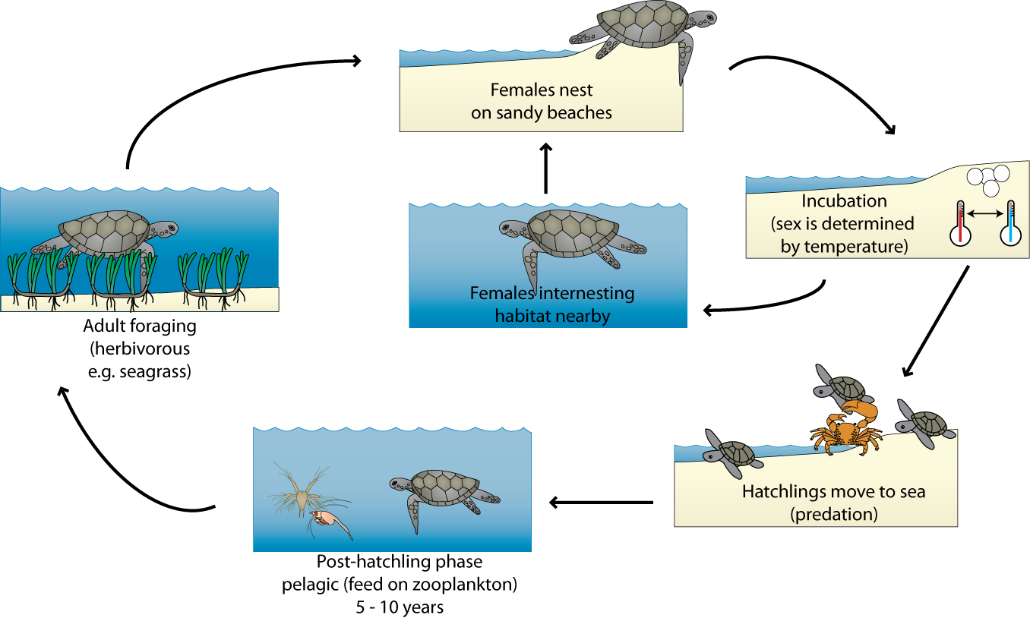

Figure 25: Stylised lifecycle and general habitat requirements of the green turtle.

#### Dugong

Ashmore Reef supports a small population of the internationally vulnerable dugong. These marine mammals are restricted to tropical and subtropical shallow waters and feed only on seagrass. In the Ramsar site, they presumably feed mostly on the seagrass *Thalassia hemprichii*. Dugong are capable of long distance migration, but only as adults (United Nations Environment Programme 2002) and so the presence of calves within the Ramsar site suggests that this species breeds at Ashmore Reef. The shallow sandy areas of the site would provide suitable habitat for calving (United Nations Environment Programme 2002). However, little is known about the dugong population at Ashmore Reef, and the importance of the site for this species.

## 4.4 Non-critical Services

### 4.4.1 Recreation and tourism

Ashmore Reef Ramsar site is closed to the general public and visitation is by permit only. Despite this the there are one or two visits per year by a commercial tourist boat with up to 20 passengers, primarily for wildlife viewing. Recreational yachts also visit the Ramsar site, usually only for several days each visit, and only 15 to 20 vessels per annum.

### 4.5.2 Cultural heritage

Indonesians have traditionally fished the reefs of the Ashmore region for several centuries and it is thought that the Bajo and Makassan people from Sulawesi explored the system in the mid 1700s. Traditional fishers replenished water from the fresh water wells on the islands of the Ramsar site and harvested fish, birds, bird eggs, sea cucumbers, clam flesh, shells, turtles and turtle eggs for food and trade. The islands within the Ramsar site contain a number of Indonesian artefacts including ceramics and a relic cooking site; and there are graves located on both West and Middle Islands (Russell et al. 2004).

### 4.5.3 Scientific research

The remote nature of the Ashmore Reef Ramsar site and its near pristine nature provide a rare opportunity in the Indian Ocean to collect baseline information on coral reef and atoll ecology. The Ramsar site was surveyed by the Western Australian Museum in the late 1980s including fish, birds, vegetation, and marine invertebrates (Berry 1993). Research continues today with a number of long term monitoring and research projects conducted at the site.

# 5. Threats to ecological character

Wetlands are complex systems and an understanding of components and processes and the interactions or linkages between them is necessary to describe ecological character. Similarly threats to ecological character need to be described not just in terms of their potential effects, but the interactions between them. One mechanism for exploring these relationships is the use of stressor models (Gross 2003). The use of stressor models in ecological character descriptions has been suggested by a number of authors to describe ecological character (Hale and Butcher 2008) and to aid in the determination of limits of acceptable change (Davis and Brock 2008).

Stressors are defined as (Barrett et al. 1976):

“*physical, chemical, or biological perturbations to a system that are either (a) foreign to that system or (b) natural to the system but applied at an excessive [or deficient] level*”

In evaluating threats it is useful (in terms of management) to separate the threatening activity from the stressor. In this manner, the causes of impacts to natural assets are made clear, which provides clarity for the management of natural resources by focussing management actions on tangible threatening activities. For example, increased macroalgae may be identified as a threat for coral communities in the reef. However, management actions cannot be targeted at increased macroalgae without some understanding of why the increase is taking place. By identifying the threatening activities that could contribute to increased macroalgae (e.g. selective fishing, removing grazers, pollution resulting in increased nutrients) management actions can be targeted at these threatening activities and reduce the impact to the wetland.

There are a number of potential and actual threats that may impact on the ecological character of the Ashmore Reef Ramsar site and these have been assessed as a pressure analysis as part of the North-west Marine Bioregional Planning process (Commonwealth of Australia 2012a). The stressor model (Figure 26) illustrates the major threatening activities, stressors and resulting ecological effects in the Ashmore Reef Ramsar site. A description of these major threats is provided below.

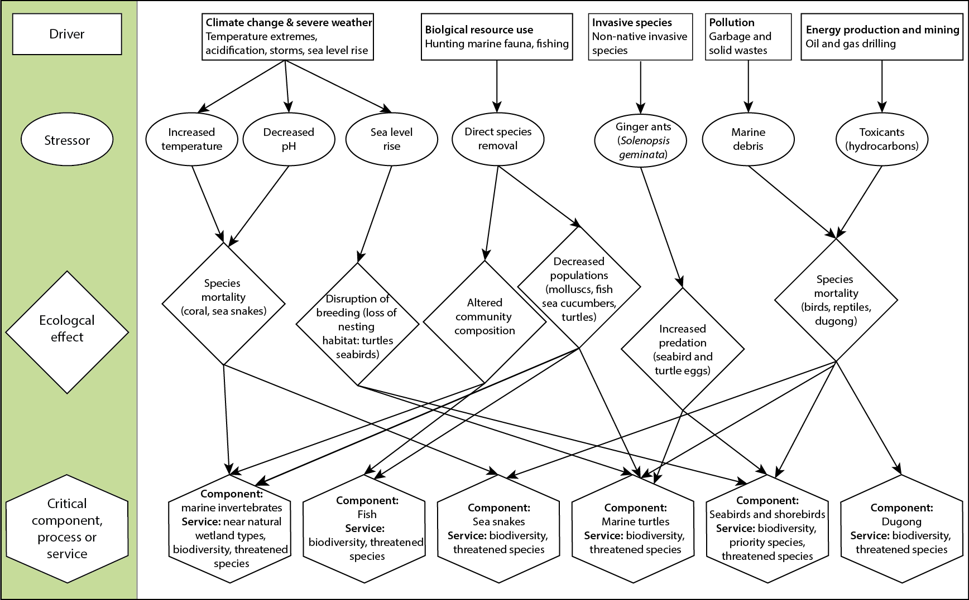

Figure 26: Stressor model of the Ashmore Reef Ramsar site (after Gross 2003, Davis and Brock 2008).

## 5.1 Biological resource use

Fishing and hunting of marine fauna have historically been major activities in the Ashmore Reef Ramsar site. Target species included (Skewes et al. 1999a, Russell et al. 2004):

* Topshell (*Trochus niloticus*), which is commercially important in the manufacture of mother of pearl buttons
* Sea cucumbers, which are a valued economic commodity in many Asian markets
* Giant clams, for their flesh
* Finfish and sharks, including some species for shark fin
* Turtles and turtle eggs
* Seabirds and seabird eggs
* Dugong

There is strong evidence to suggest that past hunting and fishing activities have resulted in a decline in the diversity and abundance of target species and communities within the Ramsar site (Skewes et al. 1999a). The site is now managed for conservation and harvesting of biota from within the Ramsar site is illegal. From 1990, the federal government contracted a private vessel and crew to be stationed at Ashmore Reef, partially to deter illegal fishing. The vessel remained at Ashmore Reef for nine to ten months each year, returning to Darwin during the cyclone season. While stationed at Ashmore, the vessel and crew ensured that biota within the Ramsar site were protected. However, during the period that they were absent, there is evidence to suggest that illegal hunting and fishing continued (Whiting 2000). Similarly a period in 2005 where the site was unpatrolled for a number of months coincided with a marked decline in sea cucumbers and top shell (Ceccarelli et al. 2011a).

More recently, a customs vessel (the Ashmore Garden) has been stationed at Ashmore Reef for 330 days each year. This enforces the prohibitions on harvesting of marine biota for commercial use.

## 5.2 Oil and gas exploration and mining

The northwest shelf region of Australia is significant for its reserves of oil and gas. Ashmore Reef Ramsar site is located in the Bonaparte Basin of this region and oil exploration commenced within the site in 1968 with the drilling of the Ashmore Reef – 1 exploration well (Department of Resources, Energy and Tourism 2011). Although no hydrocarbons were found, the potential for oil and gas mining was confirmed. Exploration of the area immediately adjacent to the Ramsar site continues, with an acreage release in 2011 (Figure 27).

Information highlighting the matters of national environmental significance protected under the EPBC Act, such as Ramsar sites, that occur within or in the vicinity of the proposed releases, is made available to the oil and gas industry who need to consider the sensitivities should exploration be proposed for any of the released areas. The impacts of this threat are described in the Marine Bioregional Plan for the North-west Marine Region (Commonwealth of Australia 2012a).

The impact of offshore oil and gas exploration and production on the marine environment are well documented and include (Swan et al. 1994):

* Underwater noise from seismic surveys
* Toxicants released from formation water during the drilling process
* Waste from exploration and production
* Increased vessel activity and associated risks of boat strike
* Lighting at night disturbing fauna
* Oil spills and associated impacts to marine life (including from clean up operations and the use of dispersants).

The most significant threats to the ecological character of the Ashmore Reef Ramsar site are from seismic surveys, drilling activities and oil spills. Oil and gas exploration uses airguns as part of the process for surveying potential drilling sites. In certain circumstances, the noise created by these surveys is known to negatively impact the behaviour and health of marine fauna including: whales, green and loggerhead turtles, finfish, squid and dugong (McCauley et al. 2000). The impact may extend for many kilometres from the source. In addition, it has been suggested that it may affect the behaviour and health of seasnakes affecting the ability to hunt and this is currently been investigated by Australian researchers (<http://www.apscience.org.au/projects/APSF_12_5/apsf_12_5.html>, accessed July 14, 2013).

Oil spills are a risk in the area as evidenced by the recent, significant spill from the Montara wellhead platform located approximately 180 kilometres east of the Ramsar site. On 21 August 2009, Montara reservoir fluids and gases were accidently released, with an estimated 64 000 litres of crude oil released per day and the spill continuing for 72 days (Gilbert et al. 2010). Trajectory modelling indicated that surface oil, in low concentrations, might have extended into the Ramsar site boundary (Gilbert et al. 2010). Scientific monitoring, including sediment sampling, was carried out at Ashmore Reef as part of the Montara Environmental Monitoring Program in 2010 and 2011: a pattern of higher hydrocarbon concentrations was found at Ashmore Reef Ramsar site (compared to the other study sites), but the concentrations were very low and highly degraded and hence could not be positively identified. The studies also indicated that natural hydrocarbon breakdown processes were strong, and that coral health and reproduction appeared unaffected by the Montara spill (Heyward et al. 2010). Nevertheless, increased exploration and the potential for production wells close to the Ramsar site may be viewed as a significant threat to ecological character.

## 5.3 Invasive species

### 5.3.1 Ginger ants

Ginger ants (*Solenopsis geminate*; also known as tropical fire ants)were first formally recorded on the islands within the Ramsar site in 1992, but are likely to have been at the site for some years prior to this, arriving from Indonesia with fishers (Bellio et al. 2007). They are an opportunistic feeder and actively prey on invertebrates, vertebrates and plants. With respect to the Ashmore Reef Ramsar site, they are considered a threat to nesting seabirds and turtles, attacking nestlings and eggs that have just started to hatch and have a broken shell, providing the ants with access (Bellio et al. 2007).

Within the Ramsar site, they have been recorded on all three islands, with the highest density on Middle Island. They have been attributed to the death of a number of chicks of ground nesting seabirds, in particular common noddy and brown booby (Bellio et al. 2007). There is an active management program in place with baiting of ants within the Ramsar site (Jarrod Hodgson, personal communication).

### 5.3.2 Other invasive species

There are a variety of introduced species that have been recorded within the Ashmore Reef Ramsar site (Table 25). With the exception of the ginger ant, described above, none are known to be having a significant impact on the ecological character of the Ramsar site. However, adopting a precautionary approach, management action and/or further investigation has been recommended (Russell et al. 2004).

Table 25: Introduced species known from Ashmore Reef (Russell et al. 2004)

|  |  |  |
| --- | --- | --- |
| **Invasive species** | **Status within the Ramsar site** | **Potential impacts** |
| **Plants** | | |
| Beach caltrop (*Tribulus cistoides*) | Well established on all three islands | Weeds species, impacts on bird nesting areas. |
| Burr grass (*Cenchrus brownii*) | Well established on West Island | Weed species, impacts on native terrestrial vegetation |
| Buffel grass (*Cenchrus ciliaris*) | Well established on West Island | Weed species, can form mono-specific stands |
| Mossman River Grass (*Cenchrus echinatus*) | Previously established on West Island, possibly now eliminated | Weed species |
| Feather grass (*Pennisetum pedicellatum*) | Established on West Island | Weeds species, vigorous coloniser |
| Water grass (*Bolbostylis barbata*) | Established on West Island | Weeds species, may not pose a significant problem |
| Asthma weed (*Euphorbia hita*) | Established on West Island | Weeds species, may harbour whitlefly pest species |
| Cat’s whisker (*Cleome gynandra*) | Established on West Island | Weeds species |
| **Animals** | | |
| Black field cricket (*Teleogryllus oceanicus*) | Established on West Island | Potential pest species |
| Asian house gecko (*Hemidactylus frenatus*) | Established on West Island, population may be increasing | Potential pest species, ecological impact unknown |
| House mouse (*Mus Musculus*) | Established on East and Middle Islands | Known pest species, impacts to nesting birds |
| Black rat (*Rattus rattus*) | Eradicated in the 1980’s | Known pest species, impacts to nesting birds |

## 5.4 Climate change

The Commonwealth Marine Environment Report Card for the North-west Marine Region (Commonwealth of Australia 2012b) indicates that there are three aspects of climate change that have the potential to impact on Ashmore Reef; sea level rise, increases in sea surface temperature and ocean acidification.

There is strong evidence to confirm that global sea levels are rising, although with a great degree of temporal and spatial variability. In Australia the highest levels of sea level rise are recorded in the north, with the area around Ashmore Reef averaging an annual increase in sea level of seven to nine millimetres per year from 1993 to 2011 (Church et al. 2012). The Intergovernmental Panel on Climate Change (IPCC) projections are for a rise of 18 to 79 centimetres by 2095 compared to 1990 (IPCC 2007). Ashmore Reef has a relatively low profile, with the islands just a few metres above mean sea level. An increase in sea level could result in an increase in submerged areas and intertidal sands at the expense of terrestrial vegetation and a corresponding loss of nesting sites for seabirds and green turtles.

Globally, sea surface temperatures are rising and at an accelerated rate (Lough et al. 2012). What is of more concern for Ashmore Reef Ramsar site is the high degree of variability and increased incidents of elevated sea surface temperatures. In 1998, high sea surface temperature led to widespread bleaching of corals at Ashmore Reef and nearby atoll systems (Ceccarelli et al. 2011c). This led to a change in community composition, with more resilient species increasing and a decrease in cover of susceptible species and possible flow on effects to invertebrate and fish communities from the change in habitat (Kospartov et al. 2006). There is evidence from elsewhere that increased sea surface temperatures can also negatively impact on larvae of invertebrates and fish decreasing recruitment (Commonwealth of Australia 2012b). There have also been suggestions that increases in sea surface temperature have affected seasnake abundance and diversity (Guinea 2008).

Increased carbon dioxide in the Earth’s atmosphere results in increased dissolved carbon dioxide in the oceans. While sea water has a large buffering capacity, the net result is a decrease in pH (Howard et al. 2012). This impacts the ability of organisms such as hard coral to grow and impairs the ability of species with calcareous shells (molluscs, echinoderms, crustaceans) to maintain shell integrity (Commonwealth of Australia 2012b). This ultimately could lead not only to a change in the composition, diversity and abundance of reef organisms through direct impacts; but have flow on effects to fish and other organisms due to a loss of habitat.

## 5.5 Marine debris

Marine debris from shipping and from activities as far away as Indonesia washes up on the shores of the vegetated islands, and is commonly seen within the aquatic ecosystems. Seabirds have been observed incorporating plastics and other debris material into nests and there is the potential for toxic and physical impacts on biota. Although entanglement by nesting birds is a low risk, it is likely that surface feeds such as shearwaters are ingesting plastics and other artificial material (Rohan Clarke, Monash University, Personal Communication).

## 5.6 Summary of threats

Although a risk assessment is beyond the scope of an ECD, the (DEWHA 2008b) framework states that an indication of the impacts of threats to ecological character, likelihood and timing of threats should be included. The major threats considered in the previous sections have been summarised in accordance with the DEWHA (2008) framework (Table 26).

Table 26: Summary of the main threats to the Ashmore Reef Ramsar site.

| **Actual or likely threat** | **Potential impact(s) to wetland components, processes and/or service** | **Likelihood1** | **Timing** |
| --- | --- | --- | --- |
| Biological resource use – fishing and hunting marine fauna | * Changed fish community composition * Ecological effects to reef community | Medium | Immediate to long term |
| Oil and gas exploration and mining | * Impacts to turtles, dugongs and seasnakes from underwater noise * Increased risk of boat strike * Decreased diversity and abundance of fauna due to toxic effects of oil spills | Certain | Immediate to long term |
| Invasive species (ginger ant) | * Impacts to nesting success of seabirds and marine turtles | Certain | Immediate |
| Invasive species (weeds and pest animal species) | * Impacts to diversity and abundance of terrestrial species and habitats. | Medium | Immediate |
| Climate change:  Sea temperature, sea level, acidification | * Loss of vegetation and sand habitat, leading to a decline in seabird and turtle nesting sites * Increase in coral bleaching and disease * Impacts to fauna such as seasnakes from increased temperatures * Changes to marine flora and fauna biodiversity either directly or through habitat alteration | Certain | Long-term |
| Marine debris | * Ingestion by feeding birds, fish, reptiles and mammals. * Entanglement of biota | Medium | Immediate |

1 Where Certain is defined as known to occur at the site or has occurred in the past Medium is defined as not known from the site but occurs at similar sites; and Low is defined as theoretically possible, but not recorded at this or similar sites.

# 6. Limits of Acceptable Change

## 6.1 Process for setting Limits of Acceptable Change (LAC)

Limits of acceptable change are defined by Phillips (2006) as:

*“…the variation that is considered acceptable in a particular measure or feature of the ecological character of the wetland. This may include population measures, hectares covered by a particular wetland type, the range of certain water quality parameter, etc. The inference is that if the particular measure or parameter moves outside the ‘limits of acceptable change’ this may indicate a change in ecological character that could lead to a reduction or loss of the values for which the site was Ramsar listed. In most cases, change is considered in a negative context, leading to a reduction in the values for which a site was listed”.*

LAC and the natural variability in the parameters for which limits are set are inextricably linked. Phillips (2006) suggested that LAC should be beyond the levels of natural variation. Setting limits in consideration with natural variability is an important, but complex concept. Wetlands are complex systems and there is both spatial and temporal variability associated with all components and processes. Defining this variability such that trends away from “natural” can be reliably detected is far from straight forward.

Hale and Butcher (2008) considered that it is not sufficient to simply define the extreme measures of a given parameter and to set LAC beyond those limits. What is required is a method of detecting change in pattern and setting limits that indicate a distinct shift from natural variability (be that positive or negative). This may mean accounting for changes in the frequency and magnitude of extreme events, changes in the temporal or seasonal patterns and changes in spatial variability as well as changes in the mean or median conditions.

It should be noted that LAC are not synonymous with management values or “trigger levels”. The LAC described here represents what would be considered a change in ecological character at the site in absolute terms with no regard for detecting change prior to irrevocable changes in wetland ecology. Detecting change with sufficient time to instigate management actions to prevent an irrevocable change in ecological character is the role of wetland management and the management plan for a site must develop and implement a set of management triggers with this aim.

The following should be considered when developing and assessing LAC:

* Limits of Acceptable Change are a tool by which ecological change can be measured. However, Ecological Character Descriptions are not management plans and Limits of Acceptable Change do not constitute a management regime for the Ramsar site.
* Exceeding or not meeting Limits of Acceptable Change does not necessarily indicate that there has been a change in ecological character within the meaning of the Ramsar Convention. However, exceeding or not meeting Limits of Acceptable Change may require investigation to determine whether there has been a change in ecological character.
* While the best available information has been used to prepare this Ecological Character Description and define Limits of Acceptable Change for the site, a comprehensive understanding of site character may not be possible as in many cases only limited information and data is available for these purposes. The Limits of Acceptable Change may not accurately represent the variability of the critical components, processes, benefits or services under the management regime and natural conditions that prevailed at the time the site was listed as a Ramsar wetland.
* Users should exercise their own skill and care with respect to their use of the information in this Ecological Character Description and carefully evaluate the suitability of the information for their own purposes.
* Limits of Acceptable Change can be updated as new information becomes available to ensure they more accurately reflect the natural variability (or normal range for artificial sites) of critical components, processes, benefits or services of the Ramsar wetland.

## 6.2 LAC for the Ashmore Reef Ramsar site

LAC have been set for the Ashmore Reef Ramsar site based on conditions at the time of listing (Table 27). Where possible, site specific information has been used to statistically determine LAC. In the absence of sufficient site specific data, LAC are based on recognised standards or information in the scientific literature that is relevant to the site. In all these cases, the source of the information upon which the LAC has been determined is provided.

However, it should be noted that for most critical components and processes there are limited quantitative data on which to set limits. In these instances, qualitative LAC based on the precautionary principle have been developed. These will require careful review with increased information gained from future monitoring.

LAC are required for all identified critical components, processes, benefits and services. However, due to the interrelated nature of components, processes and services a single LAC may in fact account for multiple components, process and services. For example, the LAC that addresses marine turtles at Ashmore Reef also covers the critical service of threatened species and biodiversity. If the population of green turtles were significantly altered this would lead to a loss of the service. In order to limit repetition in the LAC for Ashmore Reef a hierarchical approach has been adopted where LAC have been set for components, which in this case has also covered critical services.

The columns in Table 27 contain the following information:

|  |  |
| --- | --- |
| **Primary critical component / process for the LAC** | The component or processes that the LAC is a direct measure of. |
| **Baseline / supporting evidence** | Relevant baseline information (relevant to the time of listing) and any additional supporting evidence from the scientific literature and / or local knowledge. |
| **Limit of Acceptable Change** | The LAC. |
| **Confidence level** | The degree to which the authors are confident that the LAC represents the point at which a change in character has occurred. Assigned as follows:  High – Quantitative site specific data; good understanding linking the indicator to the ecological character of the site;  LAC is objectively measureable.  Medium – Some site specific data or strong evidence for similar systems elsewhere derived from the scientific literature; or informed expert opinion; LAC is objectively measureable  Low – no site specific data or reliable evidence from the scientific literature or expert opinion, LAC may not be objectively measurable and / or the importance of the indicator to the ecological character of the site is unknown. |

Table 27: Limits of Acceptable Change for the Ashmore Reef Ramsar site.

| **Component, process, service** | **Baseline / supporting evidence** | **Limit of Acceptable Change** | **Confidence level** |
| --- | --- | --- | --- |
| **Critical components and processes** | | | |
| Invertebrates - coral | There is a high degree of variability in coral cover within the Ramsar site and at the time of listing the per cent cover of both hard and soft corals was lower than it currently is, possibly due to the effects of the 1998 bleaching event and subsequent recovery (see Figure 12 and Figure 13; (Skewes et al. 1999b)). Per cent cover of corals has remained relatively stable over the past three monitoring occasions, but there may be longer term cycles of bleaching due to periodic elevations in sea surface temperature. Therefore, the LAC provided tries to capture both short term changes and the resilience of the system and its ability to recover.  Diversity of corals is difficult to measure against, as many species are rare and unlikely to be recorded in every survey. Mean species richness at a given site could be useful in informing a LAC, but data to date have varied in location and survey technique that prevents the development of a quantitative LAC for this variable. | *Hard coral comprise greater than 20 per cent cover and soft coral greater than five per cent. Recovery after a bleaching event within 10 years.* | Medium |
| Invertebrates - molluscs | Quantitative data for molluscs is limited to commercially valuable species: top shell and giant clams. These species were selected for monitoring, not as representatives of overall reef condition (or ecological character) but because of their commercial value. In addition, abundance over time has an extreme variability, particularly for the top shell (Richards et al. 2009). Setting a quantitative LAC is also hampered by the difference in methods used in surveys, preventing a comparison of data over medium time scales.  There are no measures of diversity of molluscs upon which a LAC can be developed, but if in the future monitoring programs reported mean species richness at sites, a LAC could be developed.  A qualitative LAC based on presence/absence of commercially important species has been developed. | *Presence of the following mollusc species within the Ramsar site:*  Trochus niloticus, Tridacna maxima, T. gigas, Hippopus hippopus, T. squamosa, T. derasa *and* T. Crocea. | Low |
| Invertebrates – sea cucumbers | Quantitative data from within the Ramsar site for echinoderms is limited to sea cucumbers (Skewes et al. 1999a, Rees et al. 2003, Kospartov et al. 2006), again for their commercial value, rather than as an indicator of ecosystem condition or ecological character. As with other critical components, differences in survey locations, methods and effort hamper the derivation of quantitative, justified LAC, that account for natural temporal variability.  LAC have been set based on presence of known threatened species and mean density over time. | *Presence of the following species of sea cucumber within the Ramsar site:*  Actinopyga echinites, Actinopyga mauritiana, Actinopyga miliaris, Holothuria fuscogilva, Holothuria nobilis*.*  *Mean density of sea cucumbers to exceed 40 individuals per hectare in two out of three years for which adequate data are available.* | Low |
| Fish | Despite a number of surveys of fish within Ashmore Reef being conducted over the past decade the difference in methods makes it very difficult to quantitatively characterise the fish communities within the Ramsar site. For example, fish density estimates range from 554 per hectare (Skewes et al. 1999a) to 40 000 per hectare (Kospartov et al. 2006) although the latter may be an adequate benchmark if small reef fish are included (Heyward et al. 2012).  Quantitatively characterising fish diversity is also hampered by differences in surveys and reporting of results, as well has high spatial variability. For example 2009 surveys reported species richness per transect ranging from 11 to 73 (Richards et al. 2009).  Threatened fish species are of low abundance in the site and it is not feasible to suggest they would be detected in every survey.  A LAC has been set for fish abundance, but there is insufficient data on which to base a LAC on diversity or species richness. | *Mean density of fish (in surveys that include small reef fishes) of more than 30 000 fish per hectare in two out of three years for which adequate data are available.* | Medium |
| Seasnakes | Available data indicate that seasnakes were diverse and abundant within the Ramsar site in the years prior to listing (Guinea and Whiting 2005, Lukoschek et al. 2013). There were nine resident seasnakes species within the Ramsar site, of which three were considered common (Guinea and Whiting 2005, Lukoschek et al. 2013). Around the time of listing (2000 to 2003) abundance (as expressed as catch per unit effort) was around 10 snakes per hour, although the site was on a trajectory of decline with respect to both diversity and abundance (Lukoschek and Shine 2012).  LAC have been set based on presence of common species and abundance (snakes per hour) at the time of listing. | *Presence of the following species within the Ramsar site:*  *turtle-headed seasnake (*Emydocephalus annulatus*); olive seasnake (*Aipysurus laevis*)and leaf-scaled seasnake (*Aipysurus foliosquama*).*  *Mean abundance of seasnakes to exceed 10 snakes per hour in two out of three years for which adequate data are available.* | Medium  Low |
| Marine turtles | Three species of marine turtle have been recorded within the Ashmore Reef Ramsar site, green (*Chelonia mydas*), hawksbill (*Eretmochelys imbricata*) and loggerhead (*Caretta caretta*), all of which are listed threatened species. In terms of abundance, green turtles account for over 90 per cent of the total turtle population. Estimates are for around six green turtles per hectare, as an average density across the Ramsar site (Whiting and Guinea 2005a) but variability around this number is not known.  Nesting data for turtles shows a high degree of variability that prevents the determination of a quantitative LAC.  LAC have been set based on presence / absence of species, abundance of green turtles and the presence of nesting green and hawksbill turtles. | *Presence of the following species of marine turtle within the Ramsar site:* Chelonia mydas, Eretmochelys imbricata *and* Caretta caretta.  *Mean density of green turtles to exceed four individuals per hectare in two out of three years for which adequate data are available.*  *Annual nesting by green and hawksbill turtles within the site.* | Low |
| Seabirds and shorebirds | Ashmore Reef supports an abundance of seabirds and shorebirds.    In an attempt to incorporate the level of variability in bird counts, limits are proposed based on mean minus one standard deviation. | *Total waterbird numbers not less than 28 000 in a minimum of three years in any five-year period.* | Medium |
| Ashmore Reef regularly supports greater than one per cent of the population of sooty tern, sanderling. bar-tailed godwit, greater sand plover, grey-tailed tattler and ruddy turnstone (see section 3.3.5) (Clarke 2010).  LAC is based on percentage of population to account for changes in the wider population of these species to be reflected in the LAC into the future. | *Total counts for each of the following species to exceed the nominated percentage of the flyway population in at least three out of five surveys:*  *Sooty tern – one per cent*  *Bar-tailed godwit – two per cent*  *Grey-tailed tattler – three per cent*  *Ruddy turnstone – five per cent*  *Sanderling – three per cent*  *Greater sand plover – two per cent.* |  |
| Ashmore Reef supports breeding of 20 species of seabird, of which 14 are regularly recorded to breed in the site(Clarke 2010). Numbers that nest each year are highly variable, and to some extent this abundance is captured in the LAC for overall bird abundance.  LAC is based on the number of species breeding. | *Breeding of the following seabird species within the site in at least three out of five surveys:*  *Black noddy*  *Bridled tern*  *Brown booby*  *Brown (common) noddy*  *Crested tern*  *Eastern reef egret*  *Great frigatebird*  *Lesser frigatebird*  *Masked booby*  *Red-footed booby*  *Red-tailed tropicbird*  *Sooty tern*  *Wedge-tailed shearwater*  *White-tailed tropicbird.* |  |
| Dugong | There is little or no quantitative data upon which to base a LAC for dugong in the Ramsar site. Information is limited to a single survey and observations (Whiting and Guinea 2005b). As such a quantitative LAC cannot be set and a qualitative LAC based on presence / absence of these two species is provided. | *Presence of dugong across multiple age ranges within the site.* | Low |
| **Critical services** | | | |
| Near natural wetland types | There are five wetland types within the Ramsar site: A – Permanent shallow marine waters, B - Marine subtidal aquatic beds, C - Coral reefs, E - Sand shores, and G - Intertidal mud and sand. However there is no definitive measure of the extent of each type within the site. Therefore a qualitative LAC based on presence of each type is proposed. | *Presence of the following wetland types within the Ramsar site: A – Permanent shallow marine waters, B - Marine subtidal aquatic beds, C - Coral reefs, E - Sand shores, and G - Intertidal mud and sand.* | Low |
| Biodiversity | Ashmore Reef is considered a hotspot of biodiversity with high species richness of marine invertebrates, reef fish and wetland birds. Assessing changes in diversity, however, is difficult with extensive sampling effort required to detect species that are rare or have a restricted distribution in the site. For this reason no LAC can be established for diversity. | *LAC cannot be set. Service is assessed through the surrogates of LAC for invertebrates, fish, waterbirds, turtles and dugongs.* | Low |
| Physical habitat | Physical habitat for waterbirds is maintained through wetland types and can be indicated by the numbers of waterbirds supported by the site | *See LAC for waterbirds.* | Not applicable |
| Priority wetland species | Priority species at the Ashmore Reef Ramsar site are the 47 international migratory shorebirds. | *See LAC for waterbirds.* | Not applicable |
| Threatened species | The Ashmore Reef Ramsar site supports a large number of threatened species. Many of these (such as the coral and fish species are rare in the site and/or have restricted distributions. This limits the ability of surveys to detect these species on regular occasions. | *LAC cannot be set. Service is assessed through the surrogates of LAC for invertebrates, fish, seasnakes and turtles.* | Low |

# 7. Current Ecological Character and changes since designation

For the vast majority of critical components, processes and services, there is little evidence of significant changes since the site was listed in 2002. This is demonstrated by a comparison of current status against the LAC (Table 28). In some cases, this is due to a lack of current data and this applies to dugongs and marine turtles, for which there is little recent data, particularly in the decade since the site was designated under the Convention. In other cases, such as for fish, the disparity in survey methods and ways in which data is reported has meant that a quantitative assessment of change is not possible. However, there is no evidence of a decline and fish communities are still considered to be in good condition (Heyward et al. 2012).

For some components, processes and services, such as seabirds and shorebirds, current data (from 2010) indicate not only that there has not been a decline in abundance and diversity, but also that there have been some increases in seabirds at the site. For example, change analysis of five large bodies seabirds that breed at the site showed positive changes over the past decade (Clarke et al. 2011).

For a small number of critical components, processes and services at Ashmore Reef Ramsar site, the setting of an appropriate benchmark complicates an assessment of change in character. The site was listed in 2002, and for at least three groups of marine species abundance and / or diversity at that time, was considerably lower than what might be considered natural condition. This is illustrated by examining changes in: coral, sea cucumbers and seasnakes.

Hard and soft coral cover has improved at the Ashmore Reef Ramsar site since listing. Percentage cover of hard and soft corals within the Ramsar site at listing were relatively low, but by 2009 had dramatically increased (see Figure 12 and Figure 13 above). This has been the topic of much analysis, with the conclusion being drawn that coral cover was perhaps higher prior to the 1998 bleaching event, and the subsequent rise over the next decade was indicative of recovery. Maintaining resilience in these communities is therefore critical for long term maintenance of ecological character (Ceccarelli et al. 2011c). This should be seen as an improvement in the ecological character of the site.

Diversity and abundance of sea cucumbers at the time of listing was low, particularly for commercially important species. This has been attributed to harvesting of valuable species for the Asian market, an activity that had been occurring for many years prior to listing (Skewes et al. 1999a, Ceccarelli et al. 2011a). For the vast number of species, populations have not improved over the last decade and there has been a shift to a community dominated by species that can reproduce asexually by fission. Researchers have suggested some sea cucumber species at the site may be depleted beyond recovery, as sexually reproducing populations are likely to be highly self-recruiting and current populations are too low to support this reproductive strategy (Ceccarelli et al. 2011a). This is therefore not a change in ecological character, but a maintaining of already poor conditions at the time of listing.

At the time of listing, diversity and abundance of seasnakes was on a declining trajectory. However, unlike sea cucumbers, which had exhibited low densities for many years prior to listing, seasnakes were abundant and highly diverse at the site just four years prior to designation (Figure 28). From 1998, there has been a decline in seasnake populations at the Ashmore Reef Ramsar site. The exact causes of this are not known. It may be related to sea surface temperatures, perhaps to harvesting, or increased vessel traffic, or due to oil and gas activities in the area (Guinea 2008). Other potential courses include disease, invasive species and pollution, recruitment failure, decline in prey and habitat loss (Lukoschek et al. 2013). The reason for the decline and the potential for recovery remains a significant knowledge gap.

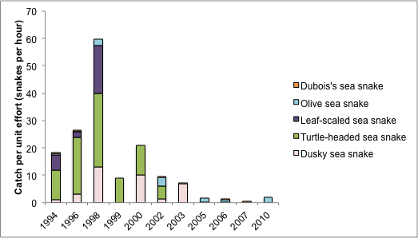

Figure 28: Abundance of seasnakes in Ashmore Reef 1994 to 2010 (data from Guinea 2008, Lukoschek et al. 2013).

Table 28: Assessment of current conditions against LAC for the Ashmore Reef Ramsar site.

| **Component / process** | **Limit of Acceptable Change** | **Current conditions** | **Confidence in LAC assessment** |
| --- | --- | --- | --- |
| Invertebrates - coral | *Cover of hard coral to be 20 per cent and soft coral greater than five per cent. Recovery after a bleaching event within 10 years.* | Average hard coral cover was between 24 and 29 per cent from 2009 to 2011; and soft coral between 6 and 8 per cent.  **LAC is met.** | High |
| Invertebrates - molluscs | *Presence of the following mollusc species within the Ramsar site:*  Trochus niloticus, Tridacna maxima, T. gigas, Hippopus hippopus, T. squamosa, T. derasa *and* T. Crocea. | Surveys in 2009 recorded five of the species of clam and the Trochus, but not *Tridacna gigas.* However, this is only from one survey and no more recent data was available.  **LAC may be exceeded.** | Low |
| Invertebrates – sea cucumbers | *Presence of the following species of sea cucumber within the Ramsar site:*  Actinopyga echinites, Actinopyga mauritiana, Actinopyga miliaris, Holothuria fuscogilva, Holothuria nobilis.  *Mean density of sea cucumbers to exceed 40 individuals per hectare in two out of three years for which adequate data are available.* | Of the listed species only one (*Holothuria nobilis*) was recorded in 2009 and mean density was only 20 individuals per hectare. However, more recent data is required and there was no targeted survey for rare / listed species.  **LAC may be exceeded.** | Low |
| Fish | *Mean density of fish (in surveys that include small reef fishes) of more than 30 000 fish per hectare in two out of three years for which adequate data are available.* | Differences between surveys make this LAC difficult to assess, but it seems likely that mean density exceeded 30 000 fish per hectare for the 2009, 2010 and 2011 surveys.  **LAC is met.** | Medium |
| Seasnakes | *Presence of the following species within the Ramsar site:*  *turtle-headed seasnake (*Emydocephalus annulatus*); olive seasnake (*Aipysurus laevis*)*and *leaf-scaled seasnake (*Aipysurus foliosquama*).*  *Mean abundance of seasnakes to exceed 10 snakes per hour in two out of three years for which adequate data are available.* | The leaf-scaled seasnake has not been recorded since 2005, and turtle-headed seasnake not since 2006, despite surveys in 2006, 2007, 2008 and 2010 (Lukoschek et al. 2013).  Mean seasnake abundance has been less than 2 snakes per hour for all surveys since 2006.  **LAC has been exceeded.** | Medium  Low |
| Marine turtles | *Presence of the following species of marine turtle within the Ramsar site:* Chelonia mydas, Eretmochelys imbricata *and* Caretta caretta*.*  *Mean density of green turtles to exceed four individuals per hectare in two out of three years for which adequate data are available.*  *Annual nesting by green and hawksbill turtles within the site.* | There is no data post 1999 on which to assess this LAC.  **Insufficient data to assess LAC** | Not applicable |
| Seabirds and shorebirds | *Total waterbird numbers not less than 28 000 in a minimum of three years in any five year period.* | Total seabird and shorebird abundance in 2010 was over 60 000, but there are no complete counts for years immediately before or after this date.  **LAC is met.** | Medium |
| *Total counts for each of the following species to exceed the nominated percentage of the flyway population in at least three out of five surveys:*  *Sooty tern – one per cent*  *Bar-tailed godwit – two per cent*  *Grey-tailed tattler – three per cent*  *Ruddy turnstone – five per cent*  *Sanderling – three per cent*  *Greater sand plover – two per cent* | Surveys for shorebirds are reported from 2005 and then not again until 2010, when the survey was in April and it is likely that shorebirds had already departed for breeding grounds.  **Insufficient data to assess LAC.** | Not applicable |
| *Breeding of the following seabird species within the site in at least three out of five surveys:*  *Black noddy*  *Bridled tern*  *Brown booby*  *Brown (common) noddy*  *Crested tern*  *Eastern reef egret*  *Great frigatebird*  *Lesser frigatebird*  *Masked booby*  *Red-footed booby*  *Red-tailed tropicbird*  *Sooty tern*  *Wedge-tailed shearwater*  *White-tailed tropicbird.* | All species were recorded in 2010, but additional survey data is needed to properly assess this LAC.  **LAC is met.** | Medium |
| Dugong | *Presence of dugong across multiple age ranges within the site.* | There is insufficient data to assess this LAC.  **Insufficient data to assess LAC.** | Not applicable |
| Near natural wetland types | *Presence of the following wetland types within the Ramsar site: A – Permanent shallow marine waters, B - Marine subtidal aquatic beds, C - Coral reefs, E - Sand shores, and G - Intertidal mud and sand* | There is some evidence of erosion and sand encroaching into the lagoon areas. However, all wetland types are still present in the site.  **LAC is met.** | High |

## 8. Knowledge gaps

Throughout the Ecological Character Description for the Ashmore Reef Ramsar site, mention has been made of knowledge gaps and data deficiencies for the site. While it is tempting to produce an infinite list of research and monitoring needs for this wetland system, it is important to focus on the purpose of an ecological character description and identify and prioritise knowledge gaps that are important for describing and maintaining the ecological character of the system.

Knowledge gaps that are required to fully describe the ecological character of this site and enable rigorous and defensible limits of acceptable change to be met are relatively few and listed in Table 29. In some instances, consistent data collection over a number of years is all that is required.

Table 29: Knowledge Gaps for the Ashmore Reef Ramsar site

| **Component / process** | **Knowledge Gap** | **Recommended Action** |
| --- | --- | --- |
| Marine invertebrates – coral, molluscs, sea cucumbers | Data has been collected and reported using different techniques over the past decade. This has made it difficult to set a LAC for diversity or to assess changes in character with certainty. | Repeated monitoring annually or bi-annually, with consistent reporting parameters. |
| Fish | As with invertebrates, surveys for fish have used different methods and reporting techniques, hampering development of LAC that adequate considers variability and allow for an assessment of change over time. | Repeated monitoring annually or bi-annually, with consistent reporting parameters. |
| Seasnakes | There is evidence of a decline in seasnake populations, but the potential causes of this remain unknown. The last survey reported was nearly five years ago and current status is not known. | Regular surveys.  Consolidation and reporting of information from research projects that are targeting potential causes of the decline. |
| Marine turtles | Quantitative data on marine turtles from within the site is nearly a decade old (or more recent surveys have not been reported). Data on abundance of foraging turtles and nesting success is required to assess changes in character over time. | Repeated monitoring annually or bi-annually, with consistent reporting parameters. |
| Seabirds and shorebirds | A strong baseline for seabirds and shorebirds was established in 2010 (Clarke 2010). However variability over time has not been regularly captured, especially for shorebirds. | Repeated monitoring using the 2010 protocol (which is consistent with the national program Shorebirds 2020) annually or biannually. |
| Dugongs | The importance of the site for dugong is unknown, with data mostly limited to observations of customs ships. | Consolidation and reporting of the data collected to date. A targeted assessment of the site for the species including abundance and age ranges. |

# 9. Monitoring needs

As a signatory to the Ramsar Convention, Australia has made a commitment to protect the ecological character of its Wetlands of International Importance. Under Part 3 of the EPBC Acta person must not take an action that has, will have or is likely to have a significant impact on the ecological character of a declared Ramsar wetland. While there is no explicit requirement for monitoring the site, in order to ascertain if the ecological character of the wetland site is being protected a monitoring program is required.

A comprehensive monitoring program is beyond the scope of an ECD, but an important component of a management plan. What is provided here is an identification of monitoring needs required to both set baselines for key components and processes and to assess against limits of acceptable change. It should be noted that the focus of the monitoring recommended in an ECD is an assessment against LAC and determination of changes in ecological character. This monitoring is not designed as an early warning system whereby trends in data are assessed to detect changes in components and processes prior to a change in ecological character of the site. This must be included in the management plan for the site.

The recommended monitoring to meet the obligations under Ramsar and the EPBC Act with respect to the Ashmore Reef Ramsar site are provided in Table 30. There are a number of existing monitoring programs within the Ashmore Reef Ramsar site and some of the monitoring recommended may already be contained in these existing programs.

Table 30: Monitoring needs for the Ashmore Reef Ramsar site

|  |  |  |  |  |
| --- | --- | --- | --- | --- |
| **Component/Process** | **Purpose** | **Indicator** | **Frequency** | **Priority** |
| Marine invertebrates - coral | Confirm the baseline and assess changes in character | Percentage cover and mean species richness | Annually or bi-annually | High |
| Marine invertebrates - molluscs | Confirm the baseline and assess changes in character | Abundance of target species (Trochus and giant clams), mean species richness of other species | Annually or bi-annually | Medium |
| Marine invertebrates - echinoderms | Confirm the baseline and assess changes in character | Abundance of target species (sea cucumbers; particularly listed species), mean species richness of other species | Annually or bi-annually | High |
| Marine invertebrates - other | Characterise character, assess variability and set LAC. | Abundance and mean species richness of crustaceans | Annually or bi-annually | Low |
| Fish | Confirm the baseline and assess changes in character | Mean abundance and species richness, presence of threatened species | Annually or bi-annually | High |
| Seasnakes | Confirm the baseline and assess changes in character | Species and abundance | Annually or bi-annually | High |
| Marine turtles | Confirm the baseline and assess changes in character | Foraging and nesting surveys | Annually or bi-annually | High |
| Seabirds | Assessment against LAC | Counts and species identifications, breeding observations | Annually or bi-annually | High |
| Shorebirds | Assessment against LAC | Counts (at appropriate times of the year) | Annually or bi-annually | High |
| Dugong | Establishment of a baseline on which a LAC can be developed | Abundance and age distributions | Annually or bi-annually | High |

# 10. Communication and education messages

Under the Ramsar Convention a Program of Communication, Education, Participation and Awareness (CEPA) was established to help raise awareness of wetland values and functions. At the Conference of Contracting Parties in Korea in 2008, a resolution was made to continue the CEPA program in its third iteration for the next two triennia (2009 – 2015).

The vision of the Ramsar Convention’s CEPA Program is: “People taking action for the wise use of wetlands.” To achieve this vision, three guiding principles have been developed:

1. The CEPA Program offers tools to help people understand the values of wetlands so that they are motivated to become advocates for wetland conservation and wise use and may act to become involved in relevant policy formulation, planning and management.
2. The CEPA Program fosters the production of effective CEPA tools and expertise to engage major stakeholders’ participation in the wise use of wetlands and to convey appropriate messages in order to promote the wise use principle throughout society.
3. The Ramsar Convention believes that CEPA should form a central part of implementing the Convention by each Contracting Party. Investment in CEPA will increase the number of informed advocates, actors and networks involved in wetland issues and build an informed decision-making and public constituency.

The Ramsar Convention encourages that communication, education, participation and awareness are used effectively at all levels, from local to international, to promote the value of wetlands.

A comprehensive CEPA program for an individual Ramsar site is beyond the scope of an ECD, but key communication messages and CEPA actions, such as a community education program, can be used as a component of a management plan.

Ashmore Reef Ramsar Site is in a special category with respect to CEPA, in that it is mostly closed to the public and the main target group for informing about the site is Indonesian fishers that arrive to use the freshwater resources under the MOU agreement. There is currently a program in place whereby they are provided with information about the site, via that Customs Officers play to any arrivals and through an information booklet distributed to fishing villages. Key messages include:

1. The Australian and Indonesian Governments are working together to manage the environment within the MOU Box.

2. Landing of vessels is not permitted on Ashmore/Cartier with the exception of obtaining fresh water from specified locations and to visit graves of ancestors.

3. What is and isn’t allowed to occur in MOU Box and Commonwealth Marine Reserve with regard to certain fishing methods and taking of marine animals.

4. Fishing is permitted within the MOU Box using traditional vessels (non-motorised) only.

5. Safety recommendations.

# References

Allen, G.R. (1993). Fishes of Ashmore Reef and Cartier Island. *In* Marine and Faunal Surveys of Ashmore Reef and Cartier Island North-western Australia. *Edited by* P.F. Berry. Western Australian Museum, Perth, Western Australia. pp. 67–91.

ANZECC and ARMCANZ (2000). Australian and New Zealand Guidelines for Fresh and Marine Water Quality National Water Quality Management Strategy Paper No. 4. Australian and New Zealand Environment and Conservation Council / Agriculture and Resource Management Council of Australia and New Zealand.

Australian Heritage Commission (2002). Australian Natural Heritage Charter for conservation of places of natural heritage significance. Second Edition. Australian Heritage Commission, Canberra.

Bamford, M., Watkins, D., Tischler, G., and Wahl, J. (2008). Migratory shorebirds of the East Asian-Australasian flyway population estimates and internationally important sites. Wetlands International-Oceania, Canberra.

Barrett, G.W., van Dyne, G.M., and Odum, E.P. (1976). Stress Ecology. BioScience **26**(3): 192–194.

Bellio, M.G., Bayliss, P., Williams, A.J., van Dam, R., Fox, G.J., and Moulden, J.H. (2007). A preliminary ecological risk assessment of the impact of tropical fire ants (*Solenopsis geminata*) on colonies of seabirds at Ashmore Reef. Department of the Environment and Water Resources Supervising Scientist, Canberra.

Berry, P.F. (1993). Marine and Faunal Surveys of Ashmore Reef and Cartier Island North-western Australia. Western Australian Museum, Perth, Western Australia.

BirdLife International. (2013). IUCN Red List for Birds.

Boettcher, R., Haig, S.M., and Bridges, W.C. (1995). Habitat-related factors affecting the distribution of nonbreeding American avocets in coastal South Carolina. The Condor **97**(1): 68–81.

Brown, K. and Skewes, T. (2005). A preliminary assessment of the ecology of seagrasses at Ashmore Reef. *In* Understanding the Cultural and Natural Heritage Values and Management Challenges of the Ashmore Region, Proceedings of a Symposium organised by the Australian Marine Sciences Association and the Museum and Art Gallery of the Northern Territory, Darwin, 4-6 April 2001. *Edited by* B. Russell, H. Larson, C.J. Glasby, R.C. Willan, and J. Martin. Museum and Art Galleries of the Northern Territory &​ Australian Marine Sciences Association, Darwin, Northern Territory. pp. 143–152.

Burger, J., Howe, M.A., Hahn, D.C., and Chase, J. (1977). Effects of tide cycles on habitat selection and habitat partitioning by migrating shorebirds. The Auk **94**(4): 743–758.

Burkepile, D.E., Allgeier, J.E., Shantz, A.A., Pritchard, C.E., Lemoine, N.P., Bhatti, L.H., and Layman, C.A. (2013). Nutrient supply from fishes facilitates macroalgae and suppresses corals in a Caribbean coral reef ecosystem. Scientific Reports **3**.

Ceccarelli, D., Beger, M., Kospartov, M., Richards, Z., and Birrell, C. (2011a). Population trends of remote invertebrate resources in a marine reserve: trochus and holothurians at Ashmore Reef. Pacific Conservation Biology **17**: 132–140.

Ceccarelli, D.M., Richards, Z.T., Pratchett, M.S., and Cvitanovic, C. (2011b). Rapid increase in coral cover on an isolated coral reef, the Ashmore Reef National Nature Reserve, north-western Australia. Marine and Freshwater Research **62**(10): 1214.

Ceccarelli, D.M., Richards, Z.T., Pratchett, M.S., and Cvitanovic, C. (2011c). Rapid increase in coral cover on an isolated coral reef, the Ashmore Reef National Nature Reserve, north-western Australia. Marine and Freshwater Research **62**(10): 1214.

Church, J., White, N., Hunter, J., and McInnes, K. (2012). Sea level. *In* A Marine Climate Change Impacts and Adaptation Report Card for Australia 2012. *Edited by* E. Poloczanska, A. Hobday, and A. Richardson. Centre for Australian Weather and Climate Research, Hobart, TAS.

Clarke, R. (2010). The Status of Seabirds and Shorebirds at Ashmore Reef and Cartier and Browse Islands: Monitoring program for the Montara Well release - Pre-impact Assessment and First Post-impact Field Survey. Australian Centre for Biodiversity, Monash University, Clayton, Victoria.

Clarke, R., Carter, M., Swann, G., and Thomson, J. (2011). The status of breeding seabirds and herons at Ashmore Reef, off the Kimberley coast, Australia. Journal of the Royal Society of Western Australia **94**: 171–182.

Cole, M.L., Leslie, D.M., and Fisher, W.L. (2002). Habitat use by shorebirds at a stopover site in the southern Great Plains. The Southwestern Naturalist **47**(3): 372.

Colwell, M.A. and Dodd, S.L. (1995). Waterbird communities and habitat relationships in coastal pastures of Northern California. Conservation Biology **9**(4): 827–834.

Commonwealth of Australia. (2002). Ashmore Reef National Nature Reserve and Cartier Island Marine Reserve (Commonwealth Waters) Management Plans. Environment Australia, Canberra.

Commonwealth of Australia (2006). A guide to The Integrated Marine and Coastal Regionalization of Australia Version 4.0. Department of the Environment and Heritage, Canberra.

Commonwealth of Australia. (2012a). Marine Bioregional Plan for the North-west Marine Region. Department of Sustainability, Environment, Water, Population and Communities, Canberra.

Commonwealth of Australia. (2012b). Commonwealth Marine Environment Report Card: Supporting the marine bioregional plan for the North-west Marine Region. Department of Sustainability, Environment, Water, Population and Communities, Canberra.

Le Corre, M. (2001). Breeding seasons of seabirds at Europa Island (southern Mozambique Channel) in relation to seasonal changes in the marine environment. Journal of Zoology **254**(2): 239–249.

Cresswell, W. (1994). Age-dependent choice of redshank (*Tringa totanus*) feeding location: Profitability or risk? The Journal of Animal Ecology **63**(3): 589.

Dan, S., Dijkstra, C., Drent, R.H., and Meijer, T. (1988). Food supply and the annual timing of avian reproduction. Proceedings of the International Ornithology Congress **19**: 392–407.

Danufsky, T. and Colwell, M.A. (2003). Winter shorebird communities and tidal flat characteristics at Humboldt Bay, California. The Condor **105**(1): 117–129.

Davis, C.A. and Smith, L.M. (2001). Foraging strategies and niche dynamics of coexisting shorebirds at stopover sites in the southern great plains. The Auk **118**(2): 484–495.

Davis, J. and Brock, M. (2008). Detecting unacceptable change in the ecological character of Ramsar wetlands. Ecological Management & Restoration **9**(1): 26–32.

Dennis, D.M., Milton, D., Skewes, T.D., Taranto, T.J., and Haywood, M. (2005). A rapid assessment of the fin-fish and shark resources on the shallow reefs in the Timor Sea MOU74 Box. *In* Understanding the Cultural and Natural Heritage Values and Management Challenges of the Ashmore Region, Proceedings of a Symposium organised by the Australian Marine Sciences Association and the Museum and Art Gallery of the Northern Territory, Darwin, 4-6 April 2001. *Edited by* B. Russell, H. Larson, C.J. Glasby, R.C. Willan, and J. Martin. Museum and Art Galleries of the Northern Territory &​ Australian Marine Sciences Association, Darwin, Northern Territory. pp. 185–198.

Department of Resources, Energy and Tourism. (2011). Petroleum Geological Summary: Release Areas AC11-1 and AC11-2, Ashmore Platform, Boneparte Basin, Territory of Ashmore and Cartier Islands. Australian Government, Canberra.

Department of the Environment, Water, Heritage and the Arts. (2008a). The North-west Marine Bioregional Plan: Bioregional Profile. Australian Government Department of the Environment, Water, Heritage and the Arts, Canberra.

Department of the Environment, Water, Heritage and the Arts. (2008b). National framework and guidance for describing the ecological character of Australian Ramsar Wetlands. Module 2 of the National Guidelines for Ramsar Wetlands - implementing the Ramsar Convention in Australia. Australian Government Department of the Environment, Water, Heritage and the Arts, Canberra.

Drent, R.H. and Dan, S. (1980). The prudent parent: energetic adjustments in avian breeding. Ardea **68**(1-4): 225–252.

Gilbert, T., King, B., Brushett, B., and Bernard, J. (2010). Montara Well Release Monitoring Study S7.1 Oil Fates and Effects Assessment: Spill Trajectory Analysis. APASA.

Gilmour, J.P., Smith, L.D., and Brinkman, R.M. (2009). Biannual spawning, rapid larval development and evidence of self-seeding for scleractinian corals at an isolated system of reefs. Marine Biology **156**(6): 1297–1309.

Glenn, K. (2005). Water properties of Ashmore Reef, North-west Shelf, Australia. *In* Understanding the Cultural and Natural Heritage Values and Management Challenges of the Ashmore Region, Proceedings of a Symposium organised by the Australian Marine Sciences Association and the Museum and Art Gallery of the Northern Territory, Darwin, 4-6 April 2001. *Edited by* B. Russell, H. Larson, C.J. Glasby, R.C. Willan, and J. Martin. Museum and Art Galleries of the Northern Territory &​ Australian Marine Sciences Association, Darwin, Northern Territory. pp. 9–12.

Glenn, K. and Collins, D. (2005). Ashmore Reef’s sedimentological and morphological response to the Holocene sea level rise. *In* Understanding the Cultural and Natural Heritage Values and Management Challenges of the Ashmore Region, Proceedings of a Symposium organised by the Australian Marine Sciences Association and the Museum and Art Gallery of the Northern Territory, Darwin, 4-6 April 2001. *Edited by* B. Russell, H. Larson, C.J. Glasby, R.C. Willan, and J. Martin. Museum and Art Galleries of the Northern Territory &​ Australian Marine Sciences Association, Darwin, Northern Territory. pp. 13–29.

Gordon, N.D., McMahon, T.A. and Finlayson, B.L. (1999). Stream Hydrology: An Introduction for Ecologists. John Wiley & Sons Ltd, Chinchester England.

Griffith, J.K. (1997). The Corals Collected During September / October at Ashmore Reef, Timor Sea. Parks Australia.

Gross, J. (2003). Developing Conceptual Models for Monitoring Programs. NPS Inventory and Monitoring Program, USA.

Guinea, M. (2006). Survey 2005: Seasnakes of Ashmore Reef, Hibernia Reef and Cartier Island. Charles Darwin University, Darwin, Northern Territory.

Guinea, M. (2008). An Assessment of Seasnake Abundance at Ashmore Reef National Nature Reserve, Ashmore Reef and Cartier Island Territory, Stage Three. Charles Darwin University, Darwin, Northern Territory.

Guinea, M. and Whiting, S. (2005). Insights into the distribution and abundance of seasnakes at Ashmore Reef. *In* Understanding the Cultural and Natural Heritage Values and Management Challenges of the Ashmore Region, Proceedings of a Symposium organised by the Australian Marine Sciences Association and the Museum and Art Gallery of the Northern Territory, Darwin, 4-6 April 2001. *Edited by* B. Russell, H. Larson, C.J. Glasby, R.C. Willan, and J. Martin. Museum and Art Galleries of the Northern Territory &​ Australian Marine Sciences Association, Darwin, Northern Territory. pp. 199–205.

Hale, J. and Butcher, R. (2008). Ecological Character Description of the Peel-Yalgorup Ramsar Site, Report to DEC and PHCC.

Harii, S., Kayanne, H., Takigawa, H., Hayashibara, T., and Yamamoto, M. (2002). Larval survivorship, competency periods and settlement of two brooding corals, *Heliopora coerulea* and *Pocillopora damicornis*. Marine Biology **141**(1): 39–46.

Heyward, A., Jones, R., Travers, M., Burns, K., Suosaari, G., Colquhoun, J., Case, M., Radford, B., Meekan, M., Markey, K., Schenk, T., O’Leary, R., Brooks, K., Tinkler, P., Cooper, T., and Emslie, M. (2012). Montara: 2011 Shallow Reef Surveys at Ashmore, Cartier and Seringapatam Reefs. Australian Institute of Marine Science, Townsville, Qld.

Heyward, A., Moore, C., Radford, B., and Colquhoun, J. (2010). Monitoring Program for the Montara Well Release Timor Sea: Final Report on the Nature of Barracouta and Vulcan Shoals.

Higgins, P.J. and Davies, S. (1990). Handbook of Australian, New Zealand & Antarctic birds: Volume 3: Snipe to Pigeons. Oxford University Press, Melbourne.

Higgins, P.J. and Marchant, S. (1993). Handbook of Australian, New Zealand and Antarctic Birds. Vol. 2: Raptors to Lapwings. Oxford University Press, Melbourne [u.a.].

Howard, W., Nash, M., Anthony, K., and Schmutter, K. (2012). Ocean acidification. *In* A Marine Climate Change Impacts and Adaptation Report Card for Australia 2012. *Edited by* E. Poloczanska, A. Hobday, and A. Richardson. Centre for Australian Weather and Climate Research, Hobart, TAS.

Hubbard, D.M. and Dugan, J.E. (2003). Shorebird use of an exposed sandy beach in southern California. Estuarine, Coastal and Shelf Science **58, Supplement**: 41–54.

Intergovernmental Panel on Climate Change. (2007). Climate change 2007: impacts, adaptation and vulnerability: contribution of Working Group II to the fourth assessment report of the Intergovernmental Panel on Climate Change. Cambridge University Press, Cambridge, U.K. ; New York.

IUCN. (2013). IUCNRed List of Threatened Species, Version 2013.1.

James, N.P. (1978). Neritic carbonate depositional environments. *In* Sedimentology. Springer Berlin Heidelberg. pp. 759–775.

Kalejta, B. (1993). Intense predation cannot always be detected experimentally: A case study of shorebird predation on nereid polychaetes in South Africa. Netherlands Journal of Sea Research **31**(4): 385–393.

Kospartov, M., Beger, M., Ceccarelli, D., and Richards, Z. (2006). An Assessment of the Distribution and Abundance of Sea Cucumbers, Trochus, Giant Clams, Coral, Fish and Invasive Marine Species at Ashmore Reef National Nature Reserve and Cartier Island Marine Reserve. UniQuest Pty Ltd.

Lalli, C.M. and Parsons, T.R. (1997). Biological oceanography: An introduction. Butterworth-Heinemann, Oxford

Limpus, C.J., Queensland, and Environmental Protection Agency. (2009). A biological review of Australian marine turtles. Qld Government, Brisbane, QLD.

Lough, J., Gupta, A., and Hobday, J. (2012). Temperature. *In* A Marine Climate Change Impacts and Adaptation Report Card for Australia 2012. *Edited by* E. Poloczanska, A. Hobday, and A. Richardson. Centre for Australian Weather and Climate Research, Hobart, TAS.

Lukoschek, V., Beger, M., Ceccarelli, D., Richards, Z., and Pratchett, M. (2013). Enigmatic declines of Australia’s seasnakes from a biodiversity hotspot. Biological Conservation **166**: 191–202.

Lukoschek, V. and Shine, R. (2012). Seasnakes rarely venture far from home. Ecology and Evolution **2**(6): 1113–1121.

Marsh, L.M. (1993). Cnidaria, other than reef-building corals of Ashmore Reef and Cartier Island. *In* Marine and Faunal Surveys of Ashmore Reef and Cartier Island North-western Australia. *Edited by* P.F. Berry. Western Australian Museum, Perth, Western Australia. pp. 21–23.

Marsh, L.M., Vail, L.L., Hoggett, A.K., and Rowe. (1993). Echinoderms of Ashmore Reef and Cartier Island. *In* Marine and Faunal Surveys of Ashmore Reef and Cartier Island North-western Australia. *Edited by* P.F. Berry. Western Australian Museum, Perth, Western Australia. pp. 53–65.

McCauley, R., Fewtrell, J., Duncan, A., Jenner, C., Jenner, M., Penrose, J., Prince, R., Adhitya, A., Murdoch, J., and McCabe, K. (2000). Marine seismic surveys - A study of environmental implications. APPEA Journal: 692–708.

McGrath, C. (2006). Legal review of the framework for describing the ecological character of Ramsar wetlands to support implementation of the EPBC Act. Report to the Department of the Environment and Heritage, Unpublished.

Meekan, M.M., Cappo, M.M., Carleton, J.J., and Marriott, R.R. (2006). Surveys of shark and fin-fish abundance on reefs within the MOU74 Box and Rowleys Shoals using baited remote underwater video systems. Prepared for the Australian Government Department of the Environment and Heritage.

Millennium Ecosystem Assessment (2005). Ecosystem Services and Human Well-Being: Wetlands & Water: Synthesis. 2005. Millennium Ecosystem Assessment report to the Ramsar Convention: World Resources Institute, Washington D.C.

Milton, D. (2005). Birds of Ashmore Reef National Nature Reserve: an assessment of its importance for seabirds and waders. *In* Understanding the Cultural and Natural Heritage Values and Management Challenges of the Ashmore Region, Proceedings of a Symposium organised by the Australian Marine Sciences Association and the Museum and Art Gallery of the Northern Territory, Darwin, 4-6 April 2001. *Edited by* B. Russell, H. Larson, C.J. Glasby, R.C. Willan, and J. Martin. Museum and Art Galleries of the Northern Territory &​ Australian Marine Sciences Association, Darwin, Northern Territory. pp. 133–141.

Milton, D.A. (1999). Survey and Stock Size Estimates of the Shallow Reef (0-15 M Deep) and Shoal Area (15-50 M Deep) Marine Resources and Habitat Mapping Within the Timor Sea Mou74 Box Volume 3: Seabirds and Shorebirds of Ashmore Reef. CSIRO Marine Research.

Morgan, G.J. and Berry, P.F. (1993). Decapod crustacea of Ashmore Reef and Cartier Island. *In* Marine and Faunal Surveys of Ashmore Reef and Cartier Island North-western Australia. *Edited by* P.F. Berry. Western Australian Museum, Perth, Western Australia. pp. 47–65.

Moritz, C., Broderick, D., Dethmers, K., FitzSimmons, N., and Limpus, C. (2002). Population genetics of Southeast Asian and Western Pacific green turtles, *Chelonia mydas*. Australian Government, Department of the Environment and Water Resources.

O’Brien, G. and Glenn, K. (2005). Natural hydrocarbon seepage, sub-seafloor geology and eustatic sea-level variations as key determiners of the nature and distribution of carbonate build-ups and other benthic habitats in the Timor Sea, Australia. *In* Understanding the Cultural and Natural Heritage Values and Management Challenges of the Ashmore Region, Proceedings of a Symposium organised by the Australian Marine Sciences Association and the Museum and Art Gallery of the Northern Territory, Darwin, 4-6 April 2001. *Edited by* B. Russell, H. Larson, C.J. Glasby, R.C. Willan, and J. Martin. Museum and Art Galleries of the Northern Territory &​ Australian Marine Sciences Association, Darwin, Northern Territory. pp. 31–42.

O’Brien, G., Glenn, K., Lawrence, G., Williams, A.K., Webster, M., Burns, S., and Cowley, R. (2002). Influence of hydrocarbon migration and seepage on benthic communities in the Timor Sea, Australia. APPEA Journal **March**: 225–240.

Phillips, B. (2006). Critique of the Framework for describing the ecological character of Ramsar Wetlands (Department of Sustainability and Environment, Victoria, 2005) based on its application at three Ramsar sites: Ashmore Reed National Nature Reserve, the Coral Sea Reserves (Coringa-Herald and Lihou Reeds and Cays), and Elizabeth and Middleton Reeds Marine National Nature Reserve. Mainstream Environmental Consulting, Waramanga ACT.

Pike, G.. and Leach, G.J. (1997). Handbook of Vascular Plants of Ashmore and Cartier Islands. Parks and Wildlife Commission of the Northern Territory and Parks Australia, Canberra.

Ramsar Convention, 1987, Convention on Wetlands of International Importance especially as Waterfowl Habitat.

Ramsar Convention. (2005). Resolution IX.1 Annex A. A Conceptual Framework for the wise use of wetlands and the maintenance of their ecological character.

Ramsar Convention. (2009). Strategic Framework for the List of Wetlands of International Importance, Third edition, as adopted by Resolution VII.11 (COP7, 1999) and amended by Resolutions VII.13 (1999), VIII.11 and VIII.33 (COP8, 2002), IX.1 Annexes A and B (COP9, 2005), and X.20 (COP10, 2008).

Recher, H.F. (1966). Some aspects of the ecology of migrant shorebirds. Ecology **47**(3): 393.

Rees, M., Colquhoun, J., Smith, L., and Heyward, A. (2003). Surveys of Trochus, Holothuria, Giant Clams and the Coral Communities at Ashmore Reef, Cartier Island and Mermaid Reef, Northwestern Australia: 2003. The Australian Institute of Marine Science.

Richards, Z., Bowling, T., Beger, M., Hobbs, J.-P., Chong-Seng, K., and Pratchett, M. (2009). Ashmore Reef National Nature Reserve and Cartier Island Marine Reserve: Marine Survey 2009. James Cook University, Townsville, Qld.

Russell, B., Larson, H., Hutchins, J., and Allen, G.R. (2005). Reef Fishes of the Sahul Shelf. *In* Understanding the Cultural and Natural Heritage Values and Management Challenges of the Ashmore Region, Proceedings of a Symposium organised by the Australian Marine Sciences Association and the Museum and Art Gallery of the Northern Territory, Darwin, 4-6 April 2001. *Edited by* B. Russell, H. Larson, C.J. Glasby, R.C. Willan, and J. Martin. Museum and Art Galleries of the Northern Territory &​ Australian Marine Sciences Association, Darwin, Northern Territory. pp. 83–105.

Russell, B., Neil, K., and Hilliard, R. (2004). Ashmore Reef National Nature Reserve and Cartier Island Marine Reserve: Marine and Terrestrial Introduced Species Prevention and Management Strategy. Department of Environment and Heritage.

Simpson, C.J. (1991). Mass spawning of corals on Western Australian reefs and comparisons with the Great Barrier Reef, in The Leeuwin Current: an Influence on the Coastal Climate and Marine Life of Western Australia. Journal of the Royal Society of Western Australia **74**: 85–91.

Skewes, T.D., Dennis, D.M., Jacobs, D.R., Gordon, S.R., Taranto, T.J., Haywood, M., Pitcher, C.R., Smith, G.P., Milton, D., and Poiner, I.R. (1999a). Survey and Stock Size Estimates of the Shallow Reef (0-15 M Deep) and Shoal Area (15-50 M Deep) Marine Resources and Habitat Mapping Within the Timor Sea Mou74 Box Volume 1: Stock Estimates and Stock Status. CSIRO Marine Research.

Skewes, T.D., Dennis, D.M., Jacobs, D.R., Taranto, T.J., Gordon, S.R., Haywood, M., Milton, D.A., Smith, G.P., and Pitcher, C.R. (2005). Abundance, stock size and fishery status of sedentary benthic resources of the reefs and shoals of the MOU74 Box. *In* Understanding the Cultural and Natural Heritage Values and Management Challenges of the Ashmore Region, Proceedings of a Symposium organised by the Australian Marine Sciences Association and the Museum and Art Gallery of the Northern Territory, Darwin, 4-6 April 2001. *Edited by* B. Russell, H. Russell, C. Larson, C.J. Glasby, R.C. Willan, and J. Martin. Museum and Art Galleries of the Northern Territory &​ Australian Marine Sciences Association, Darwin, Northern Territory. pp. 163–175.

Skewes, T.D., Gordon, S.R., McLeod, I.R., Taranto, T.J., Dennis, D.M., Jacobs, D.R., Pitcher, C.R., Haywood, M., Smith, G.P., Poiner, I.R., Milton, D., Griffin, D., and Hunter, C. (1999b). Survey and Stock Size Estimates of the Shallow Reef (0-15 M Deep) and Shoal Area (15-50 M Deep) Marine Resources and Habitat Mapping Within the Timor Sea Mou74 Box Volume 2: Habitat Mapping and Coral Dieback. CSIRO Marine Research.

Smith, L., Rees, M., Heyward, A., and Colquhoun, J. (2000). Survey 2000: Beche-de-mer and Trochus Populations at Ashmore Reef. Australian Institute of Marine Science.

Sprintall, J., Potemra, J.T., Hautala, S.L., Bray, N.A., and Pandoe, W.W. (2003). Temperature and salinity variability in the exit passages of the Indonesian Throughflow. Deep Sea Research Part II: Topical Studies in Oceanography **50**(12-13): 2183–2204.

Swan, J., Neff, J., and Young, P. (1994). Environmental implications of offshore oil and gas development in Australia: the findings of an independent scientific review. Australian Petroleum Exploration Association, Sydney, NSW.

Swann, G. (2005). Occasional count number 7: Ashmore Reef, 21 to 30 January 2002. The Stilt **47**: 26–33.

Titlyanov, E.A. and Titlyanova, T.V. (2002). Reef-building corals—symbiotic autotrophic organisms: 1. General structure, feeding pattern, and light-dependent distribution in the shelf. Russian Journal of Marine Biology **28**(1): S1–S15.

Underwood, J.N., Travers, M.J., and Gilmour, J.P. (2012). Subtle genetic structure reveals restricted connectivity among populations of a coral reef fish inhabiting remote atolls. Ecology and Evolution **2**(3): 666–679.

Underwood, J.N., Wilson, S.K., Ludgerus, L., and Evans, R.D. (2013). Integrating connectivity science and spatial conservation management of coral reefs in north-west Australia. Journal for Nature Conservation **21**(3): 163–172.

United Nations Environment Programme. (2002). Dugong: status report and action plans for countries and territories. United Nations Environment Programme, Nairobi, Kenya.

Vernon, J. (1993). Hermatypic corals of Ashmore Reef and Cartier Island. *In* Marine and Faunal Surveys of Ashmore Reef and Cartier Island North-western Australia. *Edited by* P.F. Berry. Western Australian Museum, Perth, Western Australia. pp. 13–20.

Wells, F. and Allen, G.R. (2005). Marine biodiversity on offshore coral reefs in north-western Australia. *In* Understanding the Cultural and Natural Heritage Values and Management Challenges of the Ashmore Region, Proceedings of a Symposium organised by the Australian Marine Sciences Association and the Museum and Art Gallery of the Northern Territory, Darwin, 4-6 April 2001. *Edited by* B. Russell, H. Larson, C.J. Glasby, R.C. Willan, and J. Martin. Museum and Art Galleries of the Northern Territory &​ Australian Marine Sciences Association, Darwin, Northern Territory. pp. 43–50.

Wells, F.E. (1993). Molluscs of Ashmore Reef and Cartier Island. *In* Marine and Faunal Surveys of Ashmore Reef and Cartier Island North-western Australia. *Edited by* P.F. Berry. Western Australian Museum, Perth, Western Australia. pp. 25–45.

Wetlands International. (2013). Waterbird Population Estimates, Fifth Edition.

Whiting, S. (2000). Management and Research Issues at Ashmore Reef National Nature Reserve: Field Trip to Ashmore Reef 23 May to 15 June 2000. Biomarine International.

Whiting, S. and Guinea, M. (2005a). The Sea Turtles of Ashmore Reef: History, current status and future direction research and management. Biomarine International.

Whiting, S. and Guinea, M. (2005b). Dugongs of Ashmore Reef and the Sahul Banks: a review of current knowledge and a distribution of sightings. *In* Understanding the Cultural and Natural Heritage Values and Management Challenges of the Ashmore Region, Proceedings of a Symposium organised by the Australian Marine Sciences Association and the Museum and Art Gallery of the Northern Territory, Darwin, 4-6 April 2001. *Edited by* B. Russell, H. Larson, C.J. Glasby, R.C. Willan, and J. Martin. Museum and Art Galleries of the Northern Territory &​ Australian Marine Sciences Association, Darwin, Northern Territory. pp. 207–210.

Wienberg, C., Westphal, H., Kwoll, E., and Hebbeln, D. (2009). An isolated carbonate knoll in the Timor Sea (Sahul Shelf, NW Australia): facies zonation and sediment composition. Facies **56**(2): 179–193.

Willan, R. (2005). The molluscan fauna from the emergent reefs of the northmost Sahul Shelf, Timor Sea - Ashmore, Cartier and Hibernia Reefs; biodiversity and zoogeography. *In* Understanding the Cultural and Natural Heritage Values and Management Challenges of the Ashmore Region, Proceedings of a Symposium organised by the Australian Marine Sciences Association and the Museum and Art Gallery of the Northern Territory, Darwin, 4-6 April 2001. *Edited by* B. Russell, H. Larson, C.J. Glasby, R.C. Willan, and J. Martin. Museum and Art Galleries of the Northern Territory &​ Australian Marine Sciences Association, Darwin, Northern Territory. pp. 51–81.

Ydenberg, R.C., Butler, R.W., Lank, D.B., Guglielmo, C.G., Lemon, M., and Wolf, N. (2002). Trade-offs, condition dependence and stopover site selection by migrating sandpipers. Journal of Avian Biology **33**(1): 47–55.

# Appendix A: Methods

## A.1 Approach

**Project Inception:**

Consultant team leader Jennifer Hale met with the then Department of Sustainability, Environment, Water, Population and Communities (DSEWPaC) project manager to confirm the scope of works and timelines as well as identifying relevant stakeholders that would be consulted.

**Task 1: Review and compilation of available data**

The consultant team undertook a thorough desktop review of existing information on the ecology of the Ashmore Reef Ramsar site.

**Task 2: Stakeholder engagement and consultation**

A Steering Committee was formed for the Ashmore Reef Ramsar site ECD. This group was comprised of members of Parks Australia (in Canberra) and DSEWPaC. The Steering Committee met by teleconference in 2013 to discuss the components, processes, services and benefits of the Ashmore Reef Ramsar site. In addition, members of the Steering Committee provided written comments on drafts of the ECD.

**Task 3: Development of a draft ECD**

Consistent with the national guidance and framework (DEWHA 2008) the following steps were undertaken to describe the ecological character of the Ashmore Reef Ramsar site.

|  |  |
| --- | --- |
| **Steps from the national draft (2008) framework** | **Activities** |
| 1. Document introductory details | Prepare basic details: site details, purpose, legislation. |
| 2. Describe the site | Based on the Ramsar RIS and the above literature review describe the site in terms of: location, land tenure, Ramsar criteria, wetland types (using Ramsar classification). |
| 3. Identify and describe the critical components, processes and services | * Identify all possible components, services and benefits. * Identify and describe the critical components, services and benefits responsible for determining ecological character. |
| 4. Develop a conceptual model of the system. | Two types of models were developed for the system:   * A series of control models that describe important aspects of the ecology of the site, including feedback loops. Aiding in the understanding of the system and its ecological functions; and * A stressor model that highlights the threats and their effects on ecological components and processes. Aiding in understanding management of the system. |
| 5. Set Limits of Acceptable Change | For each critical component process and service, establish the limits of acceptable change. |
| 6. Identify threats to the site | This process identified both actual and potential future threats to the ecological character of the wetland system. |
| 7. Describe changes to ecological character since the time of listing | This section describes in quantitative terms (where possible) changes to the wetlands since the initial listing in 2002 |
| 8. Summarise knowledge gaps | This identifies the knowledge gaps for not only the ecological character description, but also for its management. |
| 9. Identify site monitoring needs | Based on the identification of knowledge gaps above, recommendations for future monitoring are described. |
| 10. Identify communication, education and public awareness messages | Following the identification of threats, management actions and incorporating stakeholder comments, a general description of the broad communication / education messages are described. |

**Task 4: Revision of the Ramsar Information Sheet (RIS)**

The information collated during Task 1, together with the draft Ecological Character Description was used to produce a revised RIS in the standard format provided by Ramsar.

**Task 5 Finalising the ECD and RIS**

The draft ECD and RIS were submitted to the Department of the Environment, and the Steering Committee for review. Comments from agencies and stakeholders were incorporated to produce revised ECD and RIS documents.

## A.2 Consultant Team

***Jennifer Hale (team leader)***

Jennifer has over 25 years experience in the water industry having started her career with the State Water Laboratory in Victoria. Jennifer is an aquatic ecologist with expertise in freshwater, estuarine and near-shore marine systems. She is qualified with a Bachelor of Science (botany and geography); a Masters of Business Administration (Technology Management); and is currently completing a Research Masters in the effects of climate change in Ramsar sites. Jennifer is an aquatic ecologist with specialist fields of expertise including phytoplankton dynamics, aquatic macrophytes, sediment water interactions and nutrient dynamics. She has a broad understanding of the ecology of aquatic macrophytes, fish, waterbirds, macroinvertebrates and floodplain vegetation as well as geomorphic processes. She has a solid knowledge of the development of ecological character descriptions and has been involved in the development of ECDs for 24 Ramsar sites including Cocos Islands (Pulu Keeling), Christmas Island, Ord River Floodplain, Eighty-mile Beach and Apsley Marshes. She was member of the team that undertook the Ramsar Rolling Review and was a lead member of the technical review panel for Ramsar documentation and reviewed ECDs, RIS and management plans for over 20 Ramsar sites.

***Rhonda Butcher***

Rhonda is considered an expert in wetland ecology and assessment. She has a BSc (hons) and a PhD in Wetland Ecology together with over twenty years of experience in the field of aquatic science. She trades as an independent consultant under Water’s Edge Consulting and is an Adjunct Research Associate at Monash University. Rhonda has worked on numerous Ramsar related projects since 2001, including the first pilot studies into describing ecological character. She has subsequently co-authored, provided technical input, and peer reviewed at a significant number of ECDs. In 2008 she project managed the preparation of Ramsar nomination documents for Piccaninnie Ponds Karst Wetlands in South Australia, which included preparation of the ECD, RIS and Ramsar Management Plan. In 2009/2010 she project managed the preparation of the ECD and update of the RIS for Banrock Station Wetland Complex in the Riverland of South Australia and is currently lead author on the ECD for The Dales on Christmas Island and contributing to three other ECDs. Past ECD project’s Rhonda has had technical input to include the Coorong and Lakes Alexandrina and Albert, Lake MacLeod, and Peel-Yalgorup, Eighty-mile Beach, Port Phillip Bay and Bellarine Peninsula (current), and Lake Albacutya Ramsar sites. Rhonda was also project manager of the Ramsar Rolling Review which developed a reporting framework for all 65 Australian Ramsar sites.

# Appendix B: Wetland birds recorded in the Ashmore Reef Ramsar Site

Species list compiled from (Milton 2005, Clarke 2010). M= marine and or migratory; B = Bonn, C = CAMBA, J = JAMBA, R = ROKAMBA.

A complete species list for flora and fauna that has been recorded within the Ashmore Reef Ramsar site is held by Parks Australia. Contact the Commonwealth Marine Reserves Branch, Parks Australia at [marinereserves@environment.gov.au](mailto:marinereserves@environment.gov.au).

| **Common name** | **Scientific name** | **EPBC Listing** | **Comments** |
| --- | --- | --- | --- |
| Buff-banded rail | *Gallirallus philippensis* |  |  |
| Hardhead | *Aythya australis* | M |  |
| Eastern reef egret | *Egretta sacra* | C | Breeding |
| Great egret | *Ardea modesta* | C, J | Breeding |
| Little egret | *Egretta garzetta* | M | Breeding |
| Nankeen night-heron | *Nycticorax caledonicus* | M | Breeding |
| Black-crowned night heron | *Nycticorax nycticorax* | M |  |
| Intermediate egret | *Ardea intermedia* | M |  |
| White-faced heron | *Egretta novaehollandiae* |  |  |
| Great frigatebird | *Fregata minor* | C, J | Breeding |
| Red-footed booby | *Sula sula* | C, J | Breeding |
| Brown booby | *Sula leucogaster* | C, J, R | Breeding |
| Lesser frigatebird | *Fregata ariel* | C, J, R | Breeding |
| Masked booby | *Sula dactylatra* | J, R | Breeding |
| Red-tailed tropicbird | *Phaethon rubricauda* | M | Breeding |
| White-tailed tropicbird | *Phaethon lepturus fulvus* | M | Breeding |
| Australian pelican | *Pelecanus conspicillatus* | M |  |
| Little black cormorant | *Phalacrocorax sulcirostris* |  |  |
| Little pied cormorant | *Microcarbo melanoleucos* |  |  |
| Wedge-tailed shearwater | *Ardenna pacifica* | J | Breeding |
| Wilson's storm petrel | *Oceanites oceanicus* | J |  |
| Bulwer's petrel | *Bulweria bulwerii* | M |  |
| Matsudaira's storm petrel | *Oceanodroma matsudairae* | M |  |
| Leach's storm petrel | *Oceanodroma leucorhoa* | M, C, J |  |
| Swamp harrier | *Circus approximans* | M |  |
| Roseate tern | *Sterna dougallii* | J | Breeding |
| Black noddy | *Anous minutus* | M | Breeding |
| Crested tern | *Thalasseus bergii* | M | Breeding |
| Lesser noddy | *Anous tenuirostris* | M | Breeding |
| Sooty tern | *Onychoprion fuscata* | M | Breeding |
| Gull-billed tern | *Gelochelidon nilotica* | M |  |
| White tern | *Gyfis alba* | M |  |
| Little tern | *Sternula albifrons* | M, B, C, J, R |  |
| Lesser crested tern | *Sterna bengalensis* | M, C | Breeding |
| Brown noddy | *Anous stolidus* | M, C, J | Breeding |
| Bridled tern | *Onychoprion anaethetus* | M, C, J, | Breeding |
| Common tern | *Sterna hirundo* | M, C, J, R |  |
| White-winged black tern | *Chlidonias leucopterus* | M, C, J, R |  |
| Australian pratincole | *Stiltia isabella* | M |  |
| Beach stone curlew | *Esacus magnirostris* | M |  |
| Black-winged stilt | *Himantopus himantopus* | M |  |
| Asian dowitcher | *Limnodromus semipalmatus* | M, B, C, J, R |  |
| Bar-tailed godwit | *Limosa lapponica* | M, B, C, J, R |  |
| Black-tailed godwit | *Limosa limosa* | M, B, C, J, R |  |
| Broad-billed sandpiper | *Limicola falcinellus* | M, B, C, J, R |  |
| Common greenshank | *Tringa nebularia* | M, B, C, J, R |  |
| Common sandpiper | *Actitis hypoleucos* | M, B, C, J, R |  |
| Curlew sandpiper | *Calidris ferruginea* | M, B, C, J, R |  |
| Eastern curlew | *Numenius madagascariensis* | M, B, C, J, R |  |
| Great knot | *Calidris tenuirostris* | M, B, C, J, R |  |
| Greater sand plover | *Charadrius leschenaultii* | M, B, C, J, R |  |
| Grey plover | *Pluvialis squatarola* | M, B, C, J, R |  |
| Grey-tailed tattler | *Tringa brevipes* | M, B, C, J, R |  |
| Lesser sand plover | *Charadrius mongolus* | M, B, C, J, R |  |
| Little curlew | *Numenius minutus* | M, B, C, J, R |  |
| Marsh sandpiper | *Tringa stagnatilis* | M, B, C, J, R |  |
| Oriental pratincole | *Glareola maldivarum* | M, B, C, J, R |  |
| Pacific golden plover | *Pluvialis fulva* | M, B, C, J, R |  |
| Red knot | *Calidris canutus* | M, B, C, J, R |  |
| Red-necked phalarope | *Phalaropus lobatus* | M, B, C, J, R |  |
| Red-necked stint | *Calidris ruficollis* | M, B, C, J, R |  |
| Ruddy turnstone | *Arenaria interpres* | M, B, C, J, R |  |
| Sanderling | *Calidris alba* | M, B, C, J, R |  |
| Sharp-tailed sandpiper | *Calidris acuminata* | M, B, C, J, R |  |
| Swinhoe's snipe | *Gallirallus megala* | M, B, C, J, R |  |
| Terek sandpiper | *Xenus cinereus* | M, B, C, J, R |  |
| Whimbrel | *Numenius phaeopus* | M, B, C, J, R |  |
| Common redshank | *Tringa totanus* | M, B, C, R |  |
| Wandering tattler | *Tringa incana* | M, B, J, C |  |
| Oriental plover | *Charadrius veredus* | M, B, J, R |  |
| Little stint | *Calidris minuta* | M, R |  |
| Masked lapwing | *Vanellus miles* |  |  |

1. Formerly *Argusia argentea*