Coral Sea National Nature Reserves
Ramsar Wetland
Ecological Character Description

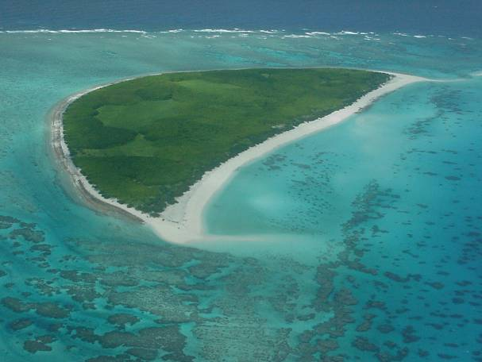

May 2006

Prepared by
Dr Bill Phillips (MainStream Environmental Consulting Pty Ltd),
Dr Mathew Maliel and Jennifer Hale,
with advice from an expert panel and peer reviewers

Funded by the Australian Government Department of the Environment and Heritage through the Natural Heritage Trust


ECD Disclaimer
The views and opinions expressed in this publication are those of the authors and do not necessarily reflect those of the Australian Government or the Minister for Environment Protection, Heritage and the Arts or the Minister for Climate Change, Energy Efficiency and Water or the Administrative Authority for Ramsar in Australia.
While reasonable efforts have been made to ensure the contents of this publication are factually correct, the Commonwealth does not accept responsibility for the accuracy or completeness of the contents, and shall not be liable for any loss or damage that may be occasioned directly or indirectly through the use of, or reliance on, the contents of this publication. Guidance on the development of Ecological Character Descriptions, including Limits of Acceptable Change, are areas of active policy development. Accordingly there may be differences in the type of information contained in this Ecological Character Description, to those of other Ramsar wetlands.
This information does not create a policy position to be applied in statutory decision making. Further it does not provide assessment of any particular action within the meaning of the EPBC Act, nor replace the role of the Minister or his delegate in making an informed decision on any action.
This report is not a substitute for professional advice rather it is intended to inform professional opinion by providing the authors' assessment of available evidence on change in ecological character. This information is provided without prejudice to any final decision by the Administrative Authority for Ramsar in Australia on change in ecological character in accordance with the requirements of Article 3.2 of the Ramsar Convention. Users should obtain any appropriate professional advice relevant to their particular circumstances.

Expert Panel and Peer Reviewers
An expert panel assembled for this project reviewed and contributed to drafts of this report, and the final draft was also peer reviewed. Information on members of the expert panel and peer reviewers is provided below. The draft was also reviewed by officers of the Australian Government Department of the Environment and Heritage.

Expert Panel
Katrina Jensz (Latitude 42 Environmental Consulting) - Environment Protection and Biodiversity Conservation Act 1999; threatened species; marine conservation issues; recovery program; threatened seabirds

Dr Adam Smith (Great Barrier Reef Marine Park Authority) - fish and fisheries; surveys of habitats, invertebrates, fish and sharks; fisheries assessments under Environment Protection and Biodiversity Conservation Act 1999

Mary Wakeford (Australian Institute of Marine Science) - coral taxonomy and coral reef ecology; disturbance impacts on coral communities; reef surveys assessing coral biodiversity and health

Dr Ashley Williams (CRC Reef Research Centre) - coral reef fish research, particularly on the Great Barrier Reef; new Management Plan for the Elizabeth and Middleton Reefs Marine National Nature Reserve

Peer reviewers
Barry Baker (Australian Government Department of the Environment and Heritage) - threatened species; threat abatement plans for key threatening processes; demographic analyses and modelling of threatened bird populations; long-term seabird monitoring program in National Nature Reserves in the Coral Sea

Mr Vainuupo Jungblut (Ramsar Officer, Secretariat of the South Pacific Regional Environment Program) - Samoa’s Biodiversity Strategy; marine conservation programs; coral health; coastal zone hazard mapping

Acknowledgements
In addition to members of the expert panel and peer reviewers, the authors would like to express their thanks to various staff members from the Australian Government Department of the Environment and Heritage, including Trevor Costa, Nancy Dahl-Tacconi, Bruce Gray and Sarah Hatch. Special thanks to the Australian Institute of Marine Science for allowing the reproduction in this report of photographs and figures from their survey reports of Coringa-Herald and Lihou Reef National Nature Reserves of March-April 2003 and March 2004, respectively. Special thanks to Mary Wakeford for providing the breakdown of geomorphic types under ecosystem service 1. Mark Hallum and Barry Baker kindly provided photographs and access to publications they had prepared.

Front cover collage of photographs of the site
Courtesy of the Marine Division, Department of Environment and Heritage
Table of Contents

 | Page
Executive summary | i
1. Introduction | 1
2. Approach taken | 3
3. Description of ecological character | 5
3.1 Introductory details (Step 1) | 5
3.2 Ecosystem services of the site (Step 2) | 9
3.3 Ecosystem services to be used as the basis for the ecological character  description (Step 3) | 10
3.4 Define the selected ecosystem services in specific terms (Step 4) AND Link  the selected ecosystem services with the critical ecological components  and processes that support them, and select those components to be further  specified (Step 5a) | 11
Ecosystem service 1: Representative of a unique ecosystem in the bioregion | 12
Ecosystem service 2: Supports threatened species – marine turtles | 21
Ecosystem service 3: Supports high species diversity, with notable occurrences  of: | 25
3(a) marine molluscs | 25
3(b) fish | 27
3(c) decapod crustaceans | 32
3(d) marine algae | 34
3(e) hydroids | 37
3(f) bêche-de-mer (sea cucumbers) | 39
3(g) sponges | 42
3(h) soft and hard corals | 44
3(i) waterbirds (migratory and other seabirds) – see ecosystem service 6 | 47
Ecosystem service 4: Supports significant forests of Pisonia grandis in the  bioregion | 47
Ecosystem service 5: Supports animal taxa at a vulnerable or critical stage of  their lifecycle | 49
5(a) breeding Green turtles – see ecosystem service 2 | 49
5(b) nursery area of fish with open-water adult stages - – see ecosystem service 3(b) | 49
5(c) breeding seabirds – see ecosystem service 6(a) | 49
Ecosystem service 6: Supports large number of waterbirds (migratory and other  seabirds) | 50
3.5 Link the selected ecosystem services with the critical ecological components  and processes that support them and select those components to be further  specified (Step 5b) | 55
3.6 Specify the selected critical components and processes that support the  selected ecosystem services (Step 6) | 57
3.7 Ecological character management benchmarks (Step 7), key knowledge  gaps and recommended monitoring | 62
3.8 Threats, risks and monitoring | 71
4. Cited references and further reading | 75
Appendix A: Ramsar Information Sheet for the Coral Sea Reserves (Coringa-Herald and Lihou Reefs and Cays) Wetland of International Importance | 77

List of figures | Page
1. Location of Coringa-Herald and Lihou Reef Marine National Nature Reserves | 6
2. Boundaries of the Coringa-Herald National Nature Reserve and Ramsar site | 7
3. Boundaries of the Lihou Reef National Nature Reserve and Ramsar site | 8
4. Generalised cross-section of reefs at Coringa-Herald | 13
5. Coringa-Herald Reefs and Cays - schematic representation of their geomorphologic  categories | 15
6. South West and North East Herald Cays - schematic representation of their  geomorphologic categories | 16
7. South West Islet and Chilcott Islet (Coringa Islets) - schematic representation of their  geomorphologic categories | 16
8. Magdelaine Cays - schematic representation of their geomorphologic categories | 17
9. Lihou Reefs and Cays - schematic representation of their geomorphologic categories | 18
10. Fish abundances from transect surveys at the Coringa-Herald Reserve | 28
11. Species richness for the 8 most abundant families of large mobile reef fishes at Lihou  Reef | 28
12. Mean species richness at each of the survey reefs, Lihou Reef | 29
13. Comparison of average abundances of large mobile reef fishes at each of the survey  reefs, Lihou Reef | 29
14. Comparison of average abundances of damselfishes at each of the survey reefs,  Lihou Reef | 29
15. Benthic cover of major groups on each surveyed reef, Coringa-Herald Reserve | 35
16. Numbers of Red-footed Booby observed, North East Herald Cay | 53
17. Numbers of Frigatebirds observed in Argusia shrubs, North East Herald Cay | 53
18. Numbers of nests of Black noddy in Pisonia forest, North East Herald Cay | 54
19. Maximum annual counts of Red-tailed tropic birds breeding at North East Herald Cay  and the stage of breeding at the time of the count | 54
20. Average sea surface temperature for the waters of the Coral Sea Reserves during  1991-2004 | 59
21. Per cent cover of hard coral at all sites surveyed at Lihou Reef Reserve | 59
22. Average total hard coral and average coral cover of the top four families at Lihou  Reef Reserve | 60

List of tables | Page
1. Ecosystem services of the Coral Sea National Nature Reserves Ramsar site | 9
2. Relating ecosystem services to the Ramsar criteria for this site | 10
3. Ecosystem services selected for detailed consideration | 11
4. Estimated areas of geomorphologic categories for the Coringa-Herald Reefs and Cays | 19
5. Estimated areas of geomorphologic categories for the Herald Cays | 19
6. Estimated areas of geomorphologic categories for the Coringa Islets | 19
7. Estimated areas of geomorphologic categories for the Magdelaine Cays | 20
8. Estimated areas of geomorphologic categories for the Lihou Reefs and Cays | 20
9. Fish species richness accumulated over all timed swims at each reef (Swim total) and  over all observations (Reef total) | 28
10. Comparison of three families of reef fish between surveys in 1984 and 2004, Lihou Reef | 30
11. Average density of six holothurian species recorded in Coringa-Herald Reserve reef  flats by the 2003 AIMS survey | 40
12. Average density of six holothurian species recorded in Coringa-Herald Reserve back  reef habitat by the 2003 AIMS survey | 40
13. Average density of four holothurian species recorded in Lihou Reef Reserve back reef  habitat by the 2004 AIMS survey | 40
14. Coringa-Herald Reserve - Comparison of present mean benthic cover estimates with  surveys from 1984 and 1997 | 42
15. Lihou Reef Reserve - Comparison of mean benthic cover estimates between the 198  survey of Ayling and Ayling (1985) | 43
16. Coringa-Herald Reserve – Hard coral species recorded at nine or more of the 17  survey sites | 45
17. Lihou Reef Reserve – Coral species recorded at > 50% of sites | 46
18. List of migratory and waterbird species recorded in the Coral Sea National Nature  Reserve Ramsar site | 52
19. Linking the selected ecosystem services with the critical ecological components and  processes | 55
20. Critical components and processes that support the selected ecosystem services | 57
21. Ecological character management benchmarks, key knowledge gaps and  recommended monitoring | 62
22. Threats, risks and monitoring | 71

Executive summary

The need for an assessment of the ecological character of the Coral Sea National Nature Reserves (comprising the Coringa-Herald and Lihou Reefs and Cays) comes from their designation as ‘Wetlands of International Importance’ under the Ramsar Convention, in October 2002. The act of designating a site as a Wetland of International Importance (a Ramsar site) carries with it certain obligations, including to manage the site to retain its ‘ecological character’ and have procedures in place to detect if any threatening processes are likely to, or have altered ‘ecological character’. Understanding and describing the ‘ecological character’ of a Ramsar site is a fundamental management tool for signatory governments and the local site managers. A good understanding of ‘ecological character’ should form the baseline or benchmark for management planning and action, including site monitoring to detect negative impacts.

Domestically, the Australian Government has introduced legislation, the Environment Protection and Biodiversity Conservation Act 1999 (the EPBC Act), that provides a legal framework for seeing that the ‘ecological character’ of all Australian Ramsar sites is retained. The EPBC Act establishes a Commonwealth process for the referral, and possible assessment, of proposed actions that may have a significant detrimental impact on ‘matters of national environmental significance’, which includes Ramsar sites.

The EPBC Act also requires that the Commonwealth “… use its best endeavours to ensure a plan for managing the wetland in a way that is not inconsistent with Australia’s obligations under the Ramsar Convention or the Australian Ramsar management principles is prepared and implemented in cooperation with the State and Territory” (Section 3.3.3).

The Australian Ramsar Management Principles (provided as Schedule 6 of the Regulations under the Act) set out general principles and the expectations the Commonwealth has for management plans pertaining to Ramsar wetlands. Among these expectations are that the ‘ecological character’ of the site be described and how it will be both monitored and maintained.

At present there is no globally agreed method for describing the ‘ecological character’ of Ramsar-listed wetlands. In early 2005, a trial method was documented by the Victorian Department of Sustainability and Environment (DSE, 2005). The DSE framework for describing ‘ecological character’ applies a step-by-step process using the ‘ecosystem services’ of the site as the entry point for a structured approach to setting ‘condition’ benchmarks for the wetland. It does this through identifying and describing the attributes that qualified the site for Ramsar listing, and those underlying ecological components and processes which support the related ecosystem services. The project team for this report on the Coral Sea National Nature Reserves Ramsar site was requested to apply the DSE approach, which it has done with some minor modifications.

A key aspect of describing ecological character is to quantify the significant ecological and biological assets of the site wherever possible and then ascribe to these assets robust ‘limits of acceptable change’. Such limits of change can then be used to guide management actions, design monitoring programs and, if necessary, even used to help inform referral-related decisions under the Commonwealth’s EPBC Act. In order to set robust limits of acceptable change, a sound understanding of the baselines and natural variability inherent in all populations and ecological communities is needed; the better these are understood, the more robust will be the limits of acceptable change identified.

For this site, setting such limits of acceptable change has proven very challenging due to the lack of long-term, rigorously collected datasets to help set baselines, and document natural variability within the populations and key system parameters, especially for Lihou Reef. However, on advice from the Department of the Environment and Heritage every effort was made to indicate such limits of change so that future management actions had baselines against which to manage and monitor the condition of the site. Thus, interim limits of acceptable change have been included in this report although it should be clearly understood that they represent “educated or best guesses” on the part of the project team, and should not be considered as long-term management benchmarks. They are provided as interim indicators of condition pending further surveys, research, monitoring and analyses to allow them to be modified based on these future findings.

It is also noted that for sites such as this, with many species that are seasonal visitors only, external factors away from the site may play a significant role in determining population sizes. However, the important consideration is to use the indicated ‘limits of change’ to detect where such impacts may have occurred, irrespective of their origin, in order to invoke (where indicated) appropriate on-site management responses or broader regional or even international responses. One example is the possible decline in marine turtles within the Ramsar site, as a consequence of habitat loss or hunting pressure in other parts of their migratory range. While it may be beyond the scope of the site managers to address such external impacts, there is a responsibility to detect such changes and seek to identify the responsible threatening process for attention by other arms of DEH or the Australian government. In the same way, addressing the cause of coral bleaching on the site may be beyond the scope of the managers, but there is still an expectation that these impacts be monitored (since the coral communities comprise part of the ecological character of the site) and to draw these impacts to the attention of DEH, the government and relevant international processes.

The ‘ecosystem services’ of the Coral Sea National Nature Reserves Ramsar site documented in this report are:

1. Representative of a unique ecosystem in the bioregion;
2. Supports threatened species of marine turtles: Green Turtle Chelonia mydas and Hawksbill Turtle Eretmochelys imbricata;
3. Supports high species diversity with notable occurrences of:
(a) marine molluscs;
(b) fish;
(c) decapod crustaceans;
(d) marine algae;
(e) hydroids;
(f) bêche-de-mer (sea cucumbers);
(g) sponges;
(h) soft and hard corals; and
(i) waterbirds (migratory and other seabirds) – see ecosystem service 6 below;
4. Supports significant forests of Pisonia grandis in the bioregion;
5. Supports animal taxa at a vulnerable or critical stage of their lifecycle:
(a) breeding Green turtles – see ecosystem service 2;
(b) nursery area of fish with open-water adult stages - – see ecosystem service 3(b);
and
(c) breeding seabirds – see ecosystem service 6; and
6. Supports large numbers of waterbirds (migratory and other seabirds).

For each of the above, the ecological components and processes that operate at the site, and work collectively to offer habitat suitable for them, are documented. Those ecological components and processes considered most critical for sustaining these communities and species at the site are as shown below (and see Tables 19 and 20).

1. Available habitats, geomorphology and substrates;
2. Food sources and productivity;
3. Water quality and temperature; and
4. Terrestrial vegetation – Pisonia forest.

Ideally, limits of acceptable change would be recommended for each of these; however, lack of data prevented this from being done and remains a priority knowledge gap for future investigations.

A summary description of ecological character is provided in Table 21 along with advice regarding priority knowledge gaps and recommended monitoring in relation to each element of the description of ecological character. Table 22 summarises the threats and risks to retaining the ecological character of the site (see final paragraph below), and again provides advice regarding knowledge gaps and recommended monitoring.

As noted above, while the Coral Sea National Nature Reserves Ramsar site has been subjected to some surveys and investigations over the years, the lack of long-term data sets (with the exception of monitoring of some seabirds – see Ecosystem 6 in Section 3.4) was a major obstacle that prevented this project providing strongly supported limits of acceptable change (LAC) in order to benchmark the ecological character of the system. Future investments in surveys and monitoring are urged to take into account the findings of this report, and should aim to establish long-term, repeatable survey methods that can help strengthen the interim LACs recommended herein.

It should also be acknowledged that the isolation of these Reserves dictates that any long term monitoring carries a number of safety risks and is logistically difficult and expensive to conduct. Lihou Reef in particular is logistically difficult to visit even on an ad-hoc basis.

Of particular note is that this site has experienced significant coral bleaching, as reported in Table 20, and this is a major concern for the ecological character of the site. As observed above, it is acknowledged that the elevated sea surface temperatures causing this problem are beyond the control of the site managers. However, the threat seems so serious that close monitoring of the situation, and any flow-ons impacts it may have is clearly warranted. Equally, the loss of all 16 hectares of Pisonia forest on Coringa South West Islet between 1993-2000 due to the soft scale insect (Pulvinaria urbicola), also poses a significant threat to the ecological character of this site (as also reported in Table 20). While biological control methods seem to be proving successful, this situation also warrants careful monitoring.

1. Introduction

The need for an assessment of the ecological character of the Coral Sea National Nature Reserves Ramsar site (comprising the Coringa-Herald and Lihou Reefs and Cays) comes from the joint designation of the sites as Australian ‘Wetland of International Importance’ under the Ramsar Convention, in October 2002. The act of designating a site as a Wetland of International Importance (Australia’s 59th Ramsar site) carries with it certain obligations, including to manage the site to retain its ‘ecological character’ and have procedures in place to detect if any threatening processes are likely to, or have altered the ‘ecological character’. Thus, understanding and describing the ‘ecological character’ of a Ramsar site is a fundamental management tool for signatory governments and the local site managers. A good understanding of ‘ecological character’ should form the baseline or benchmark for management planning and action, including site monitoring to detect negative impacts.

The Ramsar Convention defines ‘ecological character’ and ‘change in ecological character’ as shown below, and, while the Convention provides frameworks and guidelines for management planning, establishing monitoring programs and undertaking risk assessments, there is at present no definitive guidance on how to describe ‘ecological character’.

At the 9th Meeting of the Conference of the Contracting Parties to the Ramsar Convention held in November 2005, in Kampala, Uganda the following revised definitions of ‘ecological character’ and ‘change in ecological character were adopted:
"Ecological character is the combination of the ecosystem components, processes and benefits*/services that characterise the wetland at a given point in time."

(*Within this context, ecosystem benefits are defined in accordance with the definition of ecosystem services as used by the Millenium Ecosystem Assessment; "the benefits that people receive from ecosystems" – see Section 3.2 of this report.)

"For the purposes of implementation of Article 3.2 [of the Convention], change in ecological character is the human-induced adverse alteration of any ecosystem component, process, and/or ecosystem benefit/service."

Domestically, the Australian Government has introduced legislation, the Environment Protection and Biodiversity Conservation Act 1999 (the EPBC Act), that provides a legal framework for seeing that the ‘ecological character’ of all Australian Ramsar sites is retained. The EPBC Act establishes a Commonwealth process for the referral, and possible assessment, of proposed actions that may have a significant detrimental impact on ‘matters of national environmental significance’, which includes Ramsar sites.

The EPBC Act also requires that the Commonwealth “… use its best endeavours to ensure a plan for managing the wetland in a way that is not inconsistent with Australia’s obligations under the Ramsar Convention or the Australian Ramsar management principles is prepared and implemented in cooperation with the State and Territory” (Section 3.3.3).

The Australian Ramsar Management Principles (provided as Schedule 6 of the Regulations under the Act) set out general principles and the expectations the Commonwealth has for management plans pertaining to Ramsar wetlands. Among these expectations are that the ‘ecological character’ of the site be described and how it will be both monitored and maintained.

Taken together, Australia has obligations under the Ramsar Convention with respect to how designated Wetlands of International Importance are managed. In order to meet these obligations the ‘ecological character’ of each site needs to be carefully described, and then used to guide management action and ongoing monitoring. Such descriptions of ‘ecological character’ are also fundamental to the effective implementation of the EPBC Act, which is designed to ensure Australia is not contravening its site management obligations under the Ramsar Convention.

The Coral Sea National Nature Reserves Ramsar site is managed under a joint management plan. The first management plan for these reserves was put in place in 1989 under the now-repealed National Parks and Wildlife Conservation Act 1975. It has been replaced by the current joint management plan (DEH, 2001), which came into effect on 5 September 2001 under the EPBC Act. As required by the EPBC Act, the current plan will have effect for seven years until 4 September 2008. Although the 1989 and 2001 plans give some insights into the ecological assets of the Ramsar area, they do not provide the level of detailed description of ‘ecological character’ required of Ramsar sites. The current project is intended to provide such a baseline description so that monitoring of the site and future management actions can be geared toward retaining the unique ‘ecological character’ of this nature reserve Ramsar site.

2. Approach taken

As part of a broader project brief this report focuses on one of three separate studies aimed at producing the following outputs:

- A description of the ecological character of Ashmore Reef National Nature Reserve, Coral Sea National Nature Reserves (Coringa-Herald and Lihou Reefs and Cays), and Elizabeth and Middleton Reefs Marine National Nature Reserve Ramsar sites based on existing data.

- Recommendations regarding:
- any further data required to refine the ecological character descriptions for the three sites; and
- indicators and limits of acceptable change for monitoring ecological character at the three sites.

Note: The descriptions and other information relating to Ashmore Reef National Nature Reserve and Elizabeth and Middleton Reefs National Nature Reserve are the subject of separate reports.

As noted in the preceding section, at present there is no globally agreed method for describing the ‘ecological character’ of Ramsar-listed wetlands. In early 2005, a trial method was documented by the Victorian Department of Sustainability and Environment (DSE, 2005) and pilot-tested on the Barmah Forest Ramsar site. The DSE framework for describing ‘ecological character’ applies a step-by-step process using the ‘ecosystem services’ of the site as the entry point for a structured approach to setting ‘condition’ benchmarks for the wetland. It does this through identifying and describing the attributes that qualified the site for Ramsar listing, and those underlying ecological components and processes which support the related ecosystem services.

The project team for this report on the Coral Sea National Nature Reserves was requested to apply the DSE approach, while noting that in their report DSE acknowledged that the “Application of the framework at other Ramsar sites is proposed and may result in further refinement with the aim of producing a standard method for describing ecological character for Ramsar sites in Australia that has national support.”

In preparing the current description of the ‘ecological character’ of the Coringa-Herald and Lihou Reefs and Cays (the Coral Sea National Nature Reserves) Ramsar site, the DSE method was used with the following minor modifications:

- This description of ‘ecological character’ combines steps four and five (in part) of the DSE method so as to provide for a more streamlined presentation;
- While the DSE method expects knowledge gaps to be noted at each step, this information has been consolidated in Section 3.7 for presentational reasons; and
- Although the DSE method does not specifically anticipate that threats and risks to the ecological character of the site will be documented, the project team, expert panel and peer reviewers all believed this was an important addition to make (see Section 3.8).

Important notes

A key aspect of describing ecological character is to quantify the significant ecological and biological assets of the site wherever possible and then ascribe to these assets robust ‘limits of acceptable change’. Such limits of change can then be used to guide management actions, design monitoring programs and, if necessary, even used to help inform referral-related decisions under the Commonwealth’s EPBC Act. In order to set robust limits of acceptable change, a sound understanding of the baselines and natural variability inherent in all populations and ecological communities is needed; the better these are understood, the more robust will be the limits of acceptable change identified.

For this site, setting such limits of acceptable change has proven very challenging due to the lack of long-term, rigorously collected datasets to help set baselines and document natural variability within the populations and key system parameters, especially for Lihou Reef. However, the project team was advised by the Department of Environment and Heritage that every effort should be made to indicate such limits of change so that future management actions had baselines against which to manage and monitor the condition of the site. Accordingly, interim limits of acceptable change have been included in this report. It should be clearly understood that these represent “educated or best guesses” on the part of the project team, and should not be considered as long-term management benchmarks. They are provided as interim indicators of condition pending further surveys, research, monitoring and analyses to allow them to be modified based on these future findings.

It is also noted that for sites such as this, with many species that are seasonal visitors only, external factors away from the site may play a significant role in determining population sizes. However, the important consideration is to use the indicated ‘limits of change’ to detect where such impacts may have occurred, irrespective of their origin, in order to invoke (where indicated) appropriate on-site management responses or broader regional or even international responses. One example is the possible decline in marine turtles within the Ramsar site, as a consequence of habitat loss or hunting pressure in other parts of their migratory range. While it may be beyond the scope of the site managers to address such external impacts, there is a responsibility to detect such changes and seek to identify the responsible threatening process for attention by other arms of DEH or the Australian government. In the same way, addressing the cause of coral bleaching on the site may be beyond the scope of the managers, but there is still an expectation that these impacts be monitored (since the coral communities comprise part of the ecological character of the site) and to draw these impacts to the attention of DEH, the government and relevant international processes.

It should also be acknowledged that the isolation of these Reserves dictates that any long term monitoring carries a number of safety risks and is logistically difficult and expensive to conduct. Lihou Reef in particular is logistically difficult to visit even on an ad-hoc basis. Long-term monitoring of sea turtles and seabirds has been conducted for a number of years within the Coringa-Herald Reserve.
3. Description of ecological character

This section presents the description of ecological character using the step-wise approach proposed by the Victorian Department of Sustainability and Environment (2005), with some minor modifications as discussed in Section 2.

3.1 Introductory details (Step 1)

Site name | Coral Sea Reserves (Coringa-Herald and Lihou Reefs and Cays)
Location | The Coral Sea Reserves are located in the Coral Sea within Coral Sea Islands Territory. Coringa-Herald National Nature Reserve is approximately 440 km east of Cairns, Queensland. Lihou Reef National Nature Reserve is about 650 km east-southeast of Cairns. The two reserves are about 100 km apart and together they lie on the Coral Sea Plateau, which is separated from the Great Barrier Reef by an area of deep water known as the Queensland Trough. The Coral Sea Reserves lie within the Tweed-Moreton Bioregion.  Coringa-Herald National Nature Reserve:  Herald Cays – Latitude: 16° 58' S; Longitude: 149° 08' E;  Coringa Islets – Latitude: 16° 56' S; Longitude: 150° 00' E; and  Magdelaine Cays – Latitude: 16° 30' S; Longitude: 150° 17' E.  Lihou Reef National Nature Reserve:  A horseshoe-shaped line of cays and reefs from  Nellie Cay – Latitude: 17° 39' S; Longitude: 151° 18' E, to  Licklick Cay – Latitude: 17° 07' S; Longitude: 152° 11' E.
Area | Coral Sea Reserves: approximately 1,729,200 ha.  Coringa-Herald National Nature Reserve: approximately 885,600 ha,  Lihou Reef National Nature Reserve: approximately 843,600 ha.
Date of listing as a Ramsar site | 21 October 2002
Date for which the description of ecological character applies | October 2002
Status of description | This is the first detailed description of the ecological character of this site.
Name of compiler | Dr Bill Phillips (MainStream Environmental Consulting), Dr Mathew Maliel and Jennifer Hale.  Contact: Dr Bill Phillips (email: mainstream@mainstream.com.au)
Date of compilation | May 2006
Reference for Ramsar Information Sheet | Information Sheet on Ramsar wetlands (see Appendix A).  Also available online at the Australian Wetlands Database website,  http://www.wetlands.org/RSDB/_COP9Directory/Directory/ris/5AU060en.pdf
Reference for management plan | Coringa-Herald National Nature Reserve and Lihou Reef National Nature Reserve Management Plan 2001. Available online at  http://www.deh.gov.au/coasts/mpa/coringa/plan/index.html
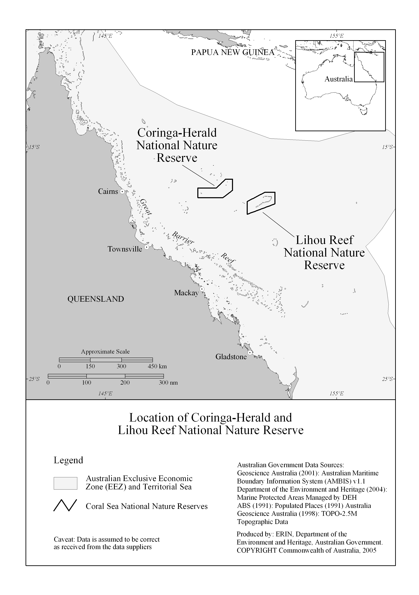

Figure 1: Location of Coringa-Herald and Lihou Reef National Nature Reserves
Source: Department of the Environment Heritage, Australian Government
http://www.environment.gov.au/cgi-bin/wetlands/ramsardetails.pl?refcode=59#

Coringa-Herald National Nature Reserve contains six islets and cays ranging in size from 16 to 37 ha and covering a total area of 124 ha (terrestrial component) (see Figure 2 ). South-East Magdelaine Cay is the largest of these, being about 1200 m by 500 m in size. The islets are made up of coral sand, rocks and coral rubble, and are no more than about five metres above sea level. North-West Magdelaine Islet has no vegetation, although grasses and low shrubs do grow on the other islets. North-East Herald Cay and parts of South-East Magdelaine Cay have thick forests of Pisonia and Cordia trees.
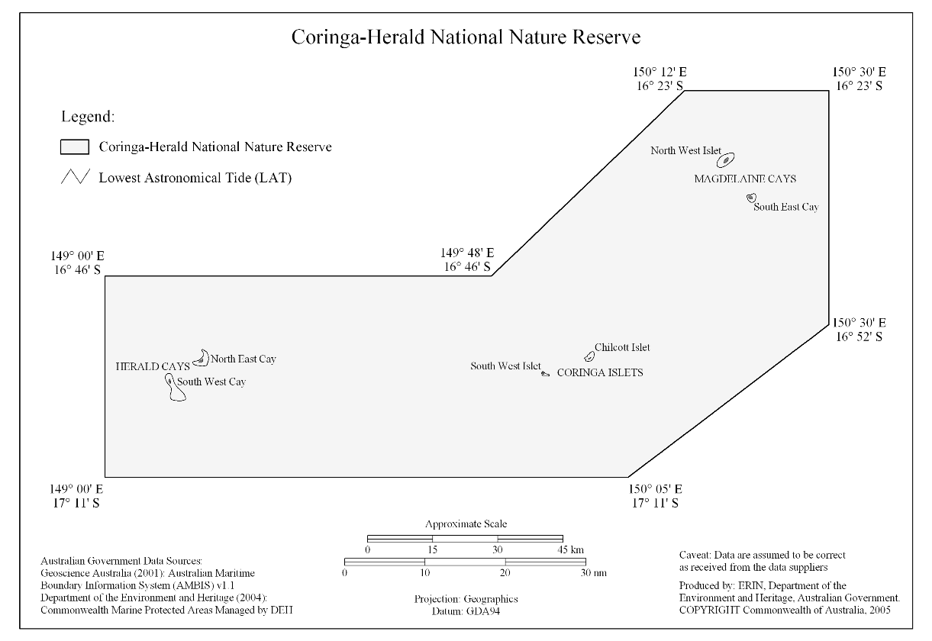
Figure 2: Boundaries of the Coringa-Herald National Nature Reserve and Ramsar site
Source: Department of the Environment Heritage, Australian Government
http://www.environment.gov.au/cgi-bin/wetlands/ramsardetails.pl?refcode=59#
Lihou Reef National Nature Reserve contains 18 cays ranging in size from 0.7 to 17 ha, and covers a total area of about 91 ha (terrestrial component) (see Figure 3). The cays are found around the edge of Lihou Reef, a ‘U’-shaped line of reefs facing west-south-west and enclosing a lagoon. The lagoon is about 100 km by 30 km, and up to 60 m deep. Grasses and small herb-like plants grow on five of the cays. The others, which are often flooded during severe storms and cyclones, are mostly exposed coral sand, rock and coral rubble.
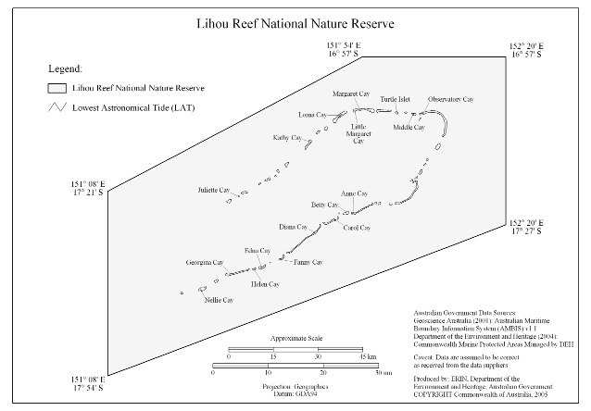
Figure 3: Boundaries of the Lihou Reef National Nature Reserve and Ramsar site
Source: Department of the Environment and Heritage, Australian Government
http://www.environment.gov.au/cgi-bin/wetlands/ramsardetails.pl?refcode=59#

3.2 Ecosystem services of the site (Step 2)

The Coral Sea National Nature Reserves Ramsar site provides the following ecosystem services.

Table 1: Ecosystem services of the Coral Sea National Nature Reserve Ramsar site

Ecosystem service | Reference*
Provisioning services
Nursery habitat for open-water fish (commercial species) | Jaensch et al. (2002)
Cultural services
Nature observation (bird watching) | DEH (2001)
Scenic / aesthetic values | DEH (2001)
Recreational activities (snorkeling, scuba diving) | DEH (2001)
Large number of shipwrecks protected under the Historic Shipwrecks Act, 1976 | DEH (2001)
Supporting services
Representative of a unique ecosystem in the bioregion | Jaensch et al. (2002)
Supports threatened species - marine turtle species | DEH (2001);  Jaensch et al. (2002)
Supports high species diversity with notable occurrences of marine molluscs, fish, decapod crustaceans, marine algae, hydroids and bêche-de-mer (sea cucumbers), sponges, soft and hard corals, waterbirds and seabirds. | DEH (2001);  Oxley et al. (2003, 2004);  Jaensch et al. (2002)
Supports significant forests of Pisonia grandis in the bioregion | DEH (2001),  Batianoff (2001)
Supports animal taxa at a vulnerable or critical stage of their lifecycle (breeding, migration) | DEH (2001),  Jaensch et al. (2002)
Supports large numbers of waterbirds (migratory and other seabirds) | DEH (2001);  Jaensch et al. (2002)

*see Section 5 for details

3.3 Ecosystem services to be used as the basis for the ecological character description (Step 3)

The Coral Sea National Nature Reserves (Coringa-Herald and Lihou Reefs and Cays) were listed under Ramsar criteria 2, 3, 4, 5 and 8 (see below). The nominating document specified Criterion 4 as being the most significant (see Appendix A).

- Criterion 2: Supports vulnerable, endangered or critically endangered species or threatened ecological communities.
- Criterion 3: Supports populations of plant and/or animal species important for maintaining the biological diversity of the region.

- Criterion 4: Supports plant and/or animal species at a critical stage in their life cycles, or provides refuge during adverse conditions.

- Criterion 5: Regularly supports 20,000 or more waterbirds.

- Criterion 8: Is an important source of food for fishes, spawning ground, nursery and/or migration path on which fish stocks, either within the wetland or elsewhere, depend.

Note: At Ramsar’s 9th Meeting of the Conference of the Contracting Parties held in November 2005, in Uganda an additional criterion was adopted, as follows:

Criterion 9: A wetland should be considered internationally important if it regularly supports 1% of the individuals in a population of one species or subspecies of wetland-dependent non-avian animal species.

Based on the information currently available it seems unlikely that the Coral Sea Reserves also qualify against this new criterion.

The ecosystem services listed in Table 2 below (as selected from the table in Section 3.2 above) are those that relate to the above criteria and have been used as the basis for the ecological character description of the Coral Sea National Nature Reserves (Coringa-Herald and Lihou Reefs and Cays) Ramsar site.

Table 2: Relating ecosystem services to the Ramsar criteria for this site

Ecosystem service | Ramsar criteria
Representative of a unique ecosystem in the bioregion | 3
Supports threatened species - marine turtle species | 2
Supports high species diversity with notable occurrences of marine molluscs, fish, decapod crustaceans, marine algae, hydroids and bêche-de-mer (sea cucumbers), sponges, soft and hard corals and migratory and other seabirds | 3
Supports significant forests of Pisonia grandis in the bioregion | 3
Supports animal taxa at a vulnerable or critical stage of their lifecycle (breeding, migration) | 4, 8
Supports large numbers of waterbirds (migratory and other seabirds) | 5
3.4 Define the selected ecosystem services in specific terms (Step 4)

AND

Link the selected ecosystem services with the critical ecological components and processes that support them, and select those components to be further specified (Step 5a; see Section 3.5 for Step 5b)

In this section (and Section 3.5 following) two steps from the DSE method have been combined (in part) to streamline the presentation of information. In addition, two of the five ecosystem services referred to in the preceding steps has been sub-divided as shown below. This is to allow for greater resolution in the analysis.

Table 3: Ecosystem services selected for detailed consideration

Ecosystem service | Ramsar criteria
1. Representative of a unique ecosystem in the bioregion | 3
2. Supports threatened species of marine turtles; Green Turtle Chelonia  mydas and Hawksbill Turtle Eretmochelys imbricata. | 2
3. Supports high species diversity with notable occurrences of:  (a) marine molluscs;  (b) fish;  (c) decapod crustaceans;  (d) marine algae;  (e) hydroids;  (f) bêche-de-mer (sea cucumbers);  (g) sponges;  (h) soft and hard corals; and,  (i) waterbirds (migratory and other seabirds) – see ecosystem service 6  below. | 3
4. Supports significant forests of Pisonia grandis in the bioregion | 3
5. Supports animal taxa at a vulnerable or critical stage of their lifecycle:  (a) breeding Green turtles – see ecosystem service 2;  (b) nursery area of fish with open-water adult stages - – see ecosystem  service 3(b); and,  (c) breeding seabirds – see ecosystem service 6. | 4, 8
6. Supports large numbers of waterbirds (migratory and other seabirds)  Note: the Ramsar Information Sheet (see Appendix A) indicates as follows in relation to migratory shorebirds and criterion 4: “In addition, at least eight species of migratory shorebirds, including the Pacific Golden Plover Pluvialis fulva and Ruddy Turnstone Arenaria interpres, use the site’s reefs and cays as migration stop-over areas (Environment Australia 2002c).” It was decided that in the context of this description of ecological character these did not warrant detailed consideration as the numbers observed are so small (B.Baker, Pers. Comm., 2006). | 5

Ecosystem service 1: Representative of a unique ecosystem in the bioregion

Qualitative description

As recorded in the Ramsar Information Sheet for the site (see Appendix A), “The site is comprised of a series of oceanic islets and associated coral reefs, occurring on the Coral Sea (Queensland) Plateau. They represent one of the largest carbonate platforms in today’s oceans and are the dominant feature of the site.

Coringa-Herald National Nature Reserve includes three separate platform reef systems, each at a different stage of reef formation. Islets and cays supported by these reefs are the Herald Cays (South-West Cay, North-East Cay), Coringa Islets (Chilcott Islet, South-West Islet) and Magdelaine Cays (North-West Islet, South-East Cay). The islets and cays are composed of sand, rock and coral rubble and range from 16 to 37 ha in area. Each has a fringing coral reef fully exposed to the influences of oceanic currents and swells. Reef flats are up to 4 m deep and are composed of turf and coralline algae along with sponges and soft and hard corals.

Lihou Reef National Nature Reserve includes the largest reef structure in the Coral Sea (Environment Australia 2002c): the reef forms an incomplete loop with 18 small sand cays along its edge. The cays extend from Nellie Cay in the far south-west, eastward to Licklick Cay in the far north-east, thence westward to Juliette Cay. Lihou Reef is separated from the Coringa-Herald system by deep ocean.

The marine habitats present in the shallower areas of both Reserves are front (windward) reef slopes, exposed reef crests/rims, reef flats, back (leeward) reef crests, back reef slopes, reef shoals, and inter-reef channels. Lihou Reef has a lagoon habitat formed within the U-shaped structure of the reef system; detailed information on the habitats of the deeper lagoonal areas is not available.”

The Coral Sea National Nature Reserves are representative of the Coral Sea region and in near-pristine condition. The reserves are noted for their significant island and reef ecosystems and shallow and deep water habitats with spectacular and unusual underwater topography and reef structure. These habitats support a rich and diverse marine flora and fauna, characteristic of a major reef province including potentially undescribed species. The reef habitat supports marine benthic flora and fauna that are distinct from those of the Great Barrier Reef.

From Figures 5 – 10 below it is possible to estimate the aerial extent of the geomorphological categories for both reefs (see Table 4), however, these have not been ground-truthed nor correlated with habitats types to allow the setting of limits of acceptable change. The geomorphological catergories were classified from high-resolution (30 meter) multispectral Landsat 7 images (see http://imars.marine.usf.edu/corals/index.html).

Quantitative description | Typical range of variability and limits of acceptable change (LACs) | Reference*
Aerial extent of habitats:  See comment above regarding geomorphological categories for both reefs, as given in Table 4.  Other notable species or groups thereof: see Ecosystem services 2-6 below. | Knowledge gap.  LAC: insufficient information. | For Figures 5-10 – see Source details in caption of Figure 5. Mary Wakeford (Expert panel member – see inside front cover, calculated aerial extents, as presented in Table 4.)

*see Section 5 for details

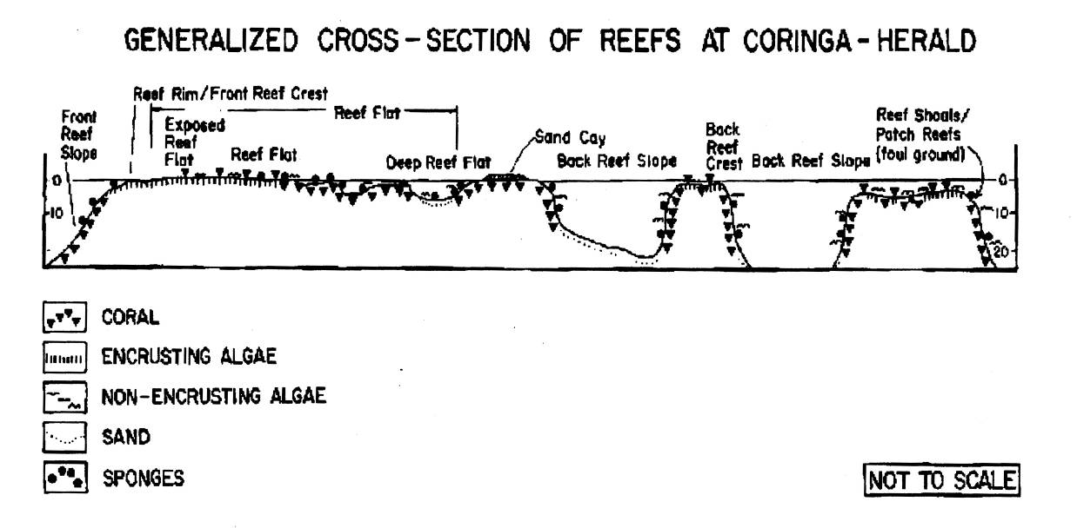

Figure 4: Generalised cross-section of reefs at Coringa-Herald
Source: Department of the Environment and Heritage, Australian Government
http://www.environment.gov.au/cgi-bin/wetlands/ramsardetails.pl?refcode=59#
(originally from Coringa-Herald National Nature Reserve Plan of Management, 1989)

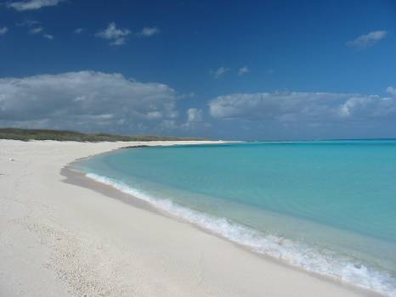

Typical profile of the vegetated islets and cays of the Coringa-Herald group.
Photographer: Barry Baker

Primary ecosystem components and processes | How they support the ecosystem service | Reference*
Oceanic currents | Although the oceanic currents in this area are poorly understood, there is evidence to suggest that westward currents, which operate for most of the year, bring propagules and larvae from the Solomon Islands to the Coral Sea. During June to September northward currents dominate and can result in the dispersal of biota from the Great Barrier Reef to the Coral Sea. These currents are important for the dispersal of biota and the transfer of nutrients. | Brinkman et al (2001)  Smith (1994)
Diversity of habitat | There are eight geomorphological types within the Coral Sea Reserves Ramsar site (see Figures 5-10 below):  - Deep terrace  - Outer slope  - Reef flat (intertidal)  - Subtidal reef flat (shallow pass)  - Subtidal patch reef flat  - Enclosed lagoon  - Drowned bank  - Bank-reef-top land  There are a number of vegetated cays within the site, which provide terrestrial habitat.  This diversity of habitat provides for a wide variety of species and communities. | DEH (2001)
Geomorphology | The cays of Coringa-Herald and Lihou Reef Reserves are located on the Coral Seas Plateau (one of the largest carbonate platforms in the oceans). Geomorphic zonation is a product of underlying geology and exposure to wind, swells and cyclones resulting in diverse habitats. | Royal Geographic Society of Queensland (2001)
Water quality | The oligotrophic waters of the Coral Sea support relatively low phytoplankton populations (although “red-tides” have been observed periodically since the 1770s). The low-nutrient, clear water allows maximum light penetration and supports the growth of submerged flora (macroalgae and seagrass). | Oxley et al (2003)
Substrate | The hard and persistent substrate of the atolls provides a stable platform within shallow water to allow for the colonisation and survival of coral and algal species. The terrestrial areas offer suitable substrate for Pisonia forest, grasslands and shrublands; all of these used by seabirds for breeding. | DEH (2001)
Terrestrial habitat | The islands provide terrestrial habitat for 16 species of vascular plants, nesting and roosting sites for birds and nesting habitat for Green Turtles. | Royal Geographic Society of Queensland (2001)

*see Section 5 for details

Critical ecosystem components and processes
For this ecosystem service, the critical parameters are diversity of habitats/geomorphology followed by water quality and terrestrial habitat. These are discussed in Sections 3.5 and 3.6.

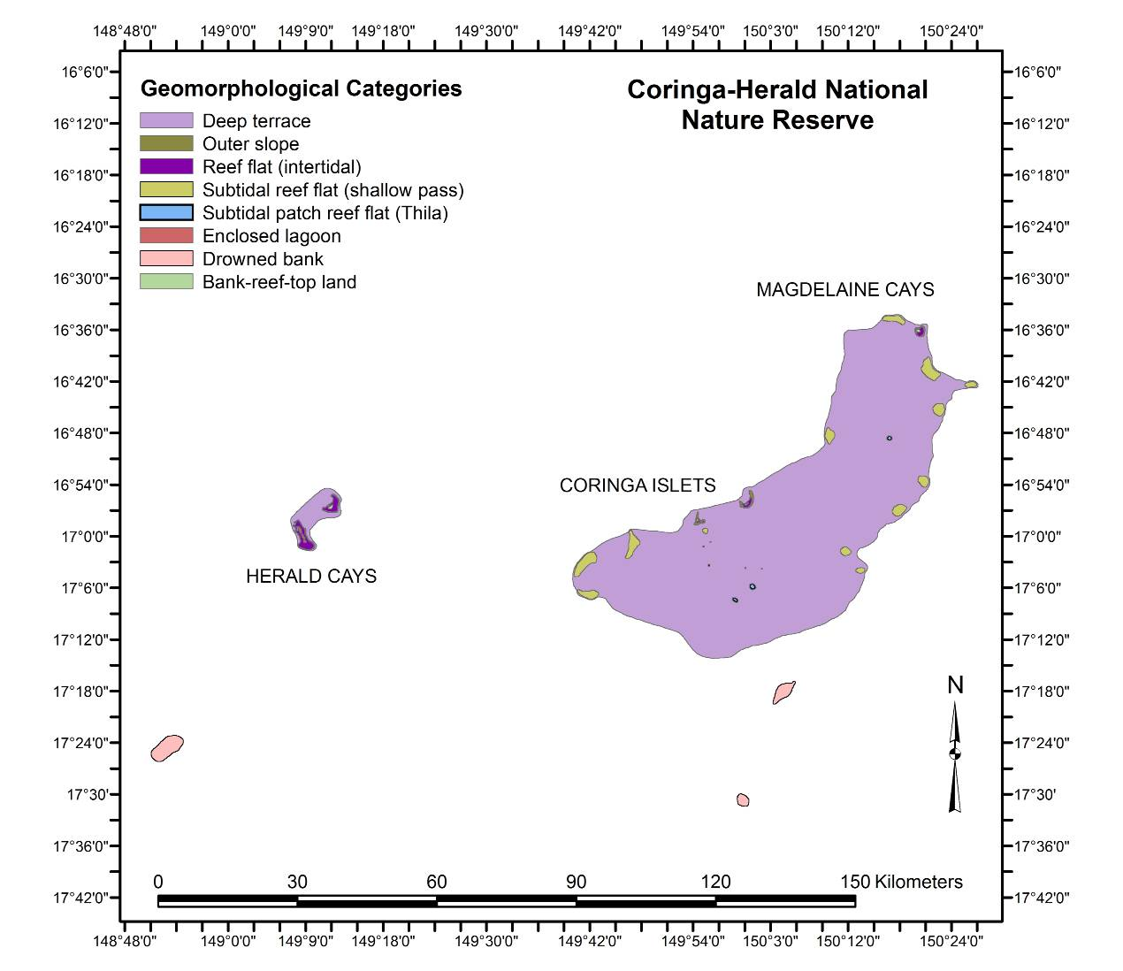

Figure 5: Coringa-Herald Reefs and Cays - schematic representation of their geomorphologic categories. See Figures following for higher resolution of the Herald Cays, Coringa Islets and Magdelaine Cays. See Table 4 for estimated aerial extent of each reef habitat.

(Source: Products from Millennium Coral Reef Mapping Project, Institute for Marine Remote Sensing at University of South Florida (Imars/USF), USA, and Institut de Recherche pour le Developpement (IRD) at Noumea, New Caledonia. Landsat images NASA/USGS. Processing: S. Andrefouet (IRD)/C. Kranenburg (IMARS/USF).

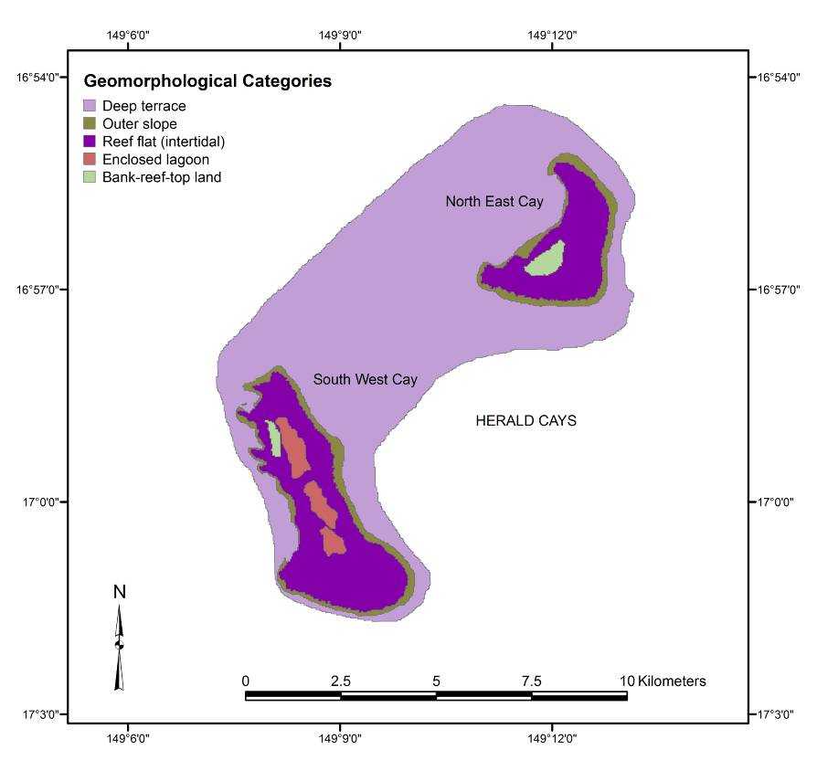
Figure 6: South West and North East Herald Cays - schematic representation of their geomorphologic categories. See Table 5 for estimated aerial extent of each reef habitat.
(Source: See Figure 5)
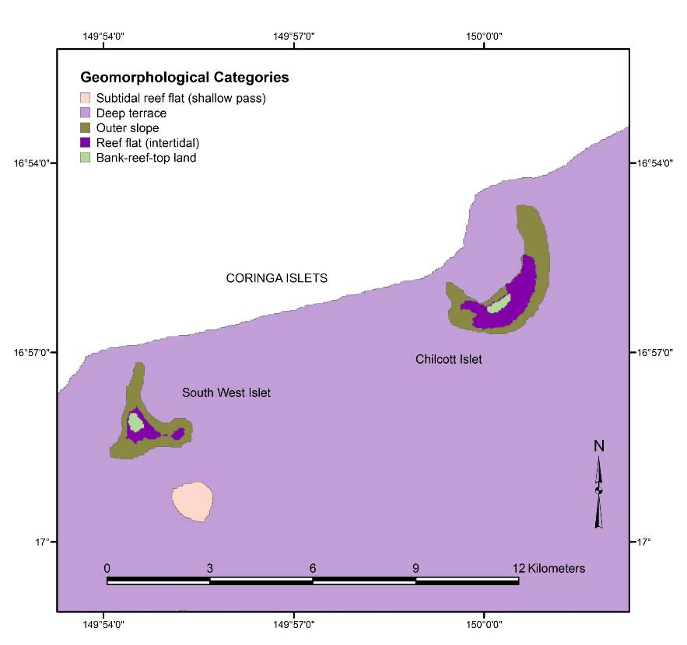
Figure 7: South West Islet and Chilcott Islet (Coringa Islets) - schematic representation of their geomorphologic categories. See Table 6 for estimated aerial extent of each reef habitat.
(Source: See Figure 5)

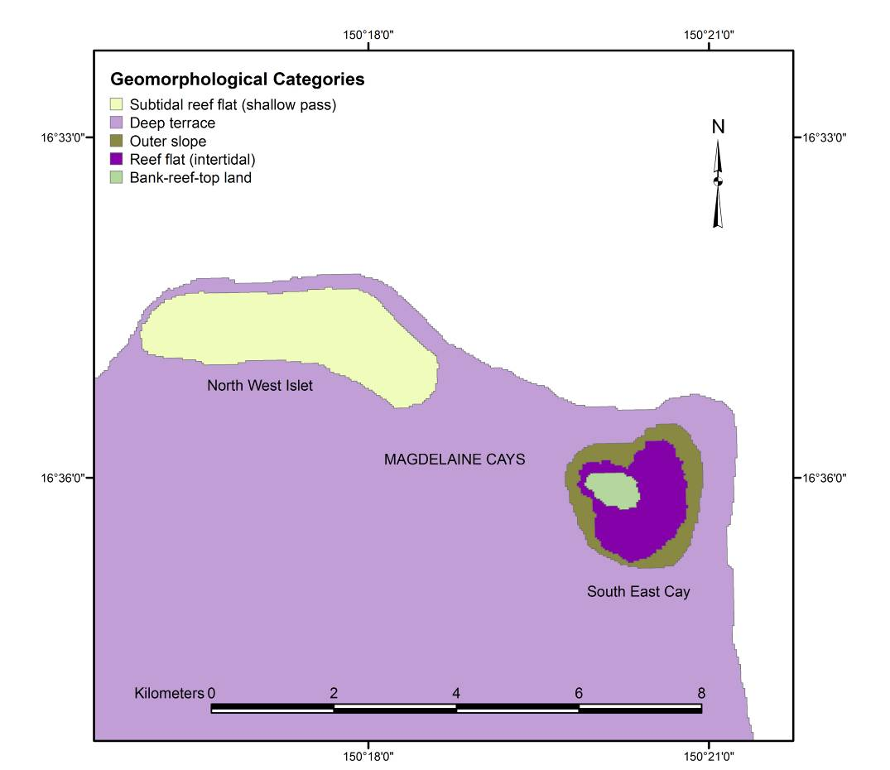

Figure 8: Magdelaine Cays - schematic representation of their geomorphologic categories. See Table 7 for estimated aerial extent of each reef habitat.
(Source: See Figure 5)

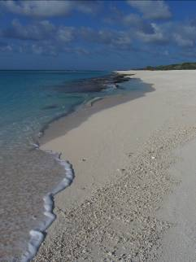

Another typical profile of the vegetated islets and cays of the Coringa-Herald group; this one including Pisonia forest (at far right).
Photographer: Barry Baker

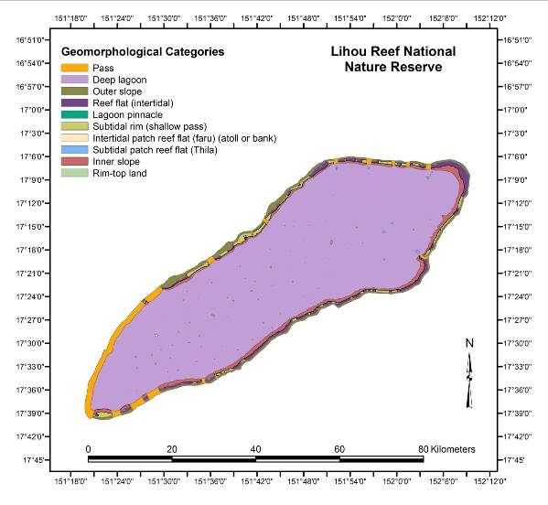

Figure 9. Lihou Reefs and Cays - schematic representation of their geomorphologic categories. See Table 8 for estimated aerial extent of each reef habitat.
(Source: See Figure 5)

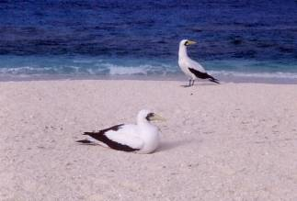

Masked boobies – Lihou Reef. Photographer – Bill Phillips

Table 4: Estimated areas of geomorphologic categories for the Coringa-Herald Reefs and Cays – areas are based on Figures 5 – 9 above

Coringa-Herald Reefs and Cays | Estimated area (square kilometres)
Deep terrace | 2391.52
Outer slope | 10.02
Reef flat (intertidal) | 18.30
Subtidal reef flat (shallow pass) | 68.71
Subtidal patch reef flat | 3.51
Enclosed lagoon | 1.41
Drowned bank | 37.86
Bank-reef-top land | 1.46
Total | 2532.79

Table 5: Estimated areas of geomorphologic categories for the Herald Cays of the Coringa-Herald National Nature Reserves – areas are based on Figure 6 above

Herald Cay s- South West Cay and North East Cay (see Figure 6) | Estimated area (square kilometres)
Deep terrace | 49.60
South West Cay
Outer slope | 2.14
Reef flat (intertidal) | 9.02
Enclosed lagoon | 1.41
Bank-reef-top land | 0.21
North East Cay
Outer slope | 1.72
Reef flat (intertidal) | 5.13
Bank-reef-top land | 0.52

Table 6: Estimated areas of geomorphologic categories for the Coringa Islets of the Coringa-Herald National Nature Reserves – areas are based on Figure 7 above

Coringa Islets – South West Islet and Chilcott Islet (see Figure 7) | Estimated area (square kilometres)
Deep terrace | 2341.91
South West Islet
Outer slope | 1.93
Reef flat (intertidal) | 0.51
Bank-reef-top land | 0.17
Chilcott Islet
Outer slope | 2.72
Reef flat (intertidal) | 1.67
Bank-reef-top land | 0.18

Table 7: Estimated areas of geomorphologic categories for the Magdelaine Cays of the Coringa-Herald National Nature Reserves – areas are based on Figure 8 above

Magdelaine Cays – North West Cay and South East Cay (see Figures 8 and 9) | Estimated area (square kilometres)
North West Cay
Subtidal reef flat (shallow pass) | 5.38
South East Cay
Outer slope | 1.52
Reef flat (intertidal) | 1.96
Bank-reef-top land | 0.38

Table 8: Estimated areas of geomorphologic categories for the Lihou Reefs and Cays – areas are based on Figure 9 above

Lihou Reefs and Cays | Estimated area (square kilometres)
Pass | 70.62
Deep lagoon | 2011.23
Outer slope | 90.10
Reef flat (intertidal) | 65.09
Lagoon pinnacle | 0.21
Subtidal rim (shallow pass) | 40.24
Intertidal patch reef flat | 0.36
Subtidal patch reef flat | 3.47
Inner slope | 106.69
Rim-top land | 1.20
Total | 2389.24

Ecosystem service 2: Supports threatened species – marine turtles

Qualitative description

The Coral Sea Nature Reserves comprise important habitats that support significant populations of the Green Turtle Chelonia mydas and the Hawksbill Turtle Eretmochelys imbricata. Green Turtles nest regularly in the Coringa-Herald Reserve, while Hawksbill Turtles forage in the reef areas surrounding several islands in the Coral Sea Reserves.
These two species are listed under the 2000 IUCN Red List of Threatened Species, the Convention on the International Trade of Endangered Species of Wild Animals (CITES) and Convention on Migratory Species (CMS), and are protected nationally under the Commonwealth’s Environment Protection and Biodiversity Conservation Act 1999.
Turtles that nest in the Coringa-Herald Reserve utilise foraging areas away from the Coral Sea Plateau, as far as the northern NSW and Queensland coast and the Torres Strait/PNG region. Adult Green Turtles that have been feeding elsewhere as juveniles return to the reserve for breeding and nesting. Undisturbed reef flats and sandy beaches are important to support these populations and help to ensure their reproductive success. The Green Turtle population in the Coringa-Herald Reserve is important to Australia’s overall turtle breeding stocks.
Earlier genetic studies had indicated that the nesting population of Green Turtle within the site is of the same genetic stock as those in the Great Barrier Reef and Torres Strait – a finding reflected in both the Management Plan (DEH 2001) and the Ramsar Information Sheet (Jaensch et al. 2002). However, a more recent study by Moritz et et al. (2002) based on mitrochondrial DNA evidence indicates that although the genetic unit of Green Turtles nesting in the Coral Sea Reserves is linked to the southern Great Barrier Reef stock, it is sufficiently different to be regarded as a separate genetic breeding stock or ‘management unit’.
Nesting by Hawksbill Turtles has not been recorded at any of the sites in the reserve. Because no tagged Hawksbill turtles have been captured in the Coringa-Herald Reserve and no tagging program has been conducted there, the foraging areas and genetic affinity of the Hawksbill Turtles seen in the Reserve is unknown.
The current status of turtle nesting in the Liihou Reef Nature Reserve is not known. Past surveys have indicated that nesting occurs on several cays but the relative importance of the level of nesting has not been determined nor has the species composition been ascertained.

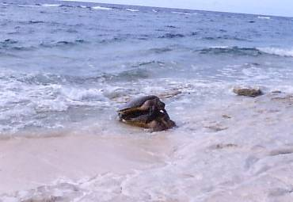

Green turtles mating on the beach in the Coral Seas Reserves – Coringa Islet.
Photographer: Bill Phillips

Quantitative description | Typical range of variability and limits of acceptable change (LACs) | Reference*
Coringa-Herald Nature Reserve:  Green turtles:  The review of nesting turtle data provided by Harvey et al (2005) indicates annual census numbers ranging from 12 – 1393 across the 1991-2 to 2001-2 breeding seasons.  For Chilcott Islet, North-East and South-West Herald Cay and South-West Coringa Islet, across the period 1991-2 to 2003-4 (no survey in 1992-3), a total of 6,193 turtles were recorded, at the major nesting sites, over 173 nights of recording.  Harvey et al (2005) also provide data on a range of other nesting-related attributes (inter-nesting interval, hatchling success, Curved Carapace Length, etc), however, a review of the sea turtle monitoring program is underway at present, and it is expected this will recommend future approaches to data collection that will help to better document population trends in this breeding population.  Hawksbill turtles: No quantitative data of their occurrence in the reserve is available.  Lihou Reef Reserve:  Knowledge gap. | Coringa-Herald Nature Reserve  Interim LACs (See Important Notes – page 4 – in relation to external impacts on species such as turtles and seabirds):  Green turtles:  The high variation in breeding numbers recorded (see at left) makes nominating an LAC, even an interim one, impossible at this time.  Hawksbill turtles:  Knowledge gap.  Lihou Reef Reserve:  Knowledge gap. | DEH (2001)  Jaensch et al. (2002)  Miller et al. (2001)  Harvey et al. (2005)
Primary habitat zone(s) used for each life history stage: (See Ecosystem service 1 above)  Green Turtle:  Nesting - sandy beaches, Argusia argentea shrubs  Feeding - algal beds and coral reefs (herbivorous)  Hawksbill Turtle:  Feeding – coral reefs (sponges, sea cucumbers) |  | DEH (2004)

*see Section 5 for details

Primary ecosystem components and processes | How they support the ecosystem service | Reference*
Geographical location | Green Turtles are known to migrate for foraging purposes but return to natal areas to nest. The Green Turtles that have been recorded nesting in the Coral Sea National Nature Reserves have also been recorded foraging in seagrass meadows along the Queensland Coast and beyond the Coral sea, into the Torres Strait/PNG region. | Miller et al. (2001)  Harvey et al. (2005)
Oceanic currents | Turtle hatchlings drift passively in oceanic gyre systems for several years in migrations that may involve circumnavigating entire ocean basins. When the post-hatchlings are large enough they enter shallow water foraging grounds, which may be considerable distances from their natal beaches, where they will feed and grow. | Harvey et al. (2005)
Diversity of habitats | The Coral Sea Nature Reserves provide feeding habitat for these two species of marine turtles in both marine algal beds and reef zones.  Although Green Turtles from this site have been recorded foraging elsewhere, the macroalgal beds at the Coral Sea Reserves provide some foraging habitat (see Ecosystem service 3(d)).  Hawksbill Turtles also forage in shallow benthic habitat but feed predominantly on sponges; the extensive sponge gardens on reef slopes would provide feeding grounds (see ecosystem service 3(g)).  Green Turtles nest on sandy beaches. Temperature of the nests determines the sex of the hatchlings: lower temperatures producing proportionately more males and higher temperatures, more females. At other locations Green Turtles have been observed nesting under Argusia argentea shrubs in cooler sands. The  A. argentea shrubs on many of the cays within the Coral Sea Nature Reserves may serve a similar function. | DEH (2001)  Jaensch et al. (2002)  Harvey et al. (2005)  Miller (1977)
Food sources / productivity | Macroalgal productivity and biomass are important for Green Turtles, while the abundance of sponges is important for Hawksbill Turtles.
Geomorphology | The geomorphic zonation of the Coringa-Herald cays provides for an outer algal ridge, a wide algal turf sub-zone and an inner belt of large reef blocks. The reef flat provides for an abundance of turf and macroalgae. | Neil and Jell (2001a)
Water quality | Low turbidity and good water quality are essential requirements for the maintenance of seagrass and benthic algal growth. Water quality therefore has a strong indirect bearing on marine turtle populations through the food chain. | Expert Panel
Water temperature | As reptiles, marine turtles cannot regulate their body temperatures and as such require tropical water temperatures to maintain metabolic functions. | DEH (2004)
Terrestrial habitat | The temperature of nests determines the sex of hatchlings in Green Turtles. Females may be laying eggs in the cooler sands beneath shrub vegetation. | DEH (2004)
Climate | The patterns of nesting attempts appear to be linked to El Nino Southern Oscillation events and show a similar pattern to that of Raine and Heron islands. There also appears to be a link between rainfall and nesting success in years with particularly high rainfall.  The effect of climate on water temperature, light and therefore, food availability (see above), influences the timing and number of turtles present at the site. | Harvey et al. (2005)

*see Section 5 for details

Critical ecosystem components and processes
For this ecosystem service, the diversity of habitats (feeding, and breeding for Green turtles in particular) coupled with the geomorphology are the critical parameters; these being followed by water quality which in turn helps ensure suitable food sources are available. These are discussed further in Sections 3.5 and 3.6.

Green turtle nesting is commonly under or near to Argusia argentea shrubs, such as these found on several of the Coringa-Herald Cays. Photographer: Barry Baker.
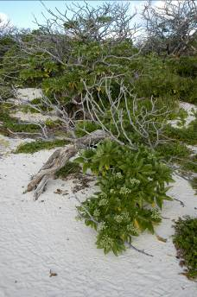

Ecosystem service 3(a): Supports high species diversity – marine molluscs

Qualitative description

745 species of mollusc have been recorded at North-East Herald Cay and the site has two species, Rissopsis typica and Cypraea childreni, that are quite common at the site although rare over much of the rest of their range (Loch, 2001 in the RGSofQ report). These species were collected from the following zones: back reef, beach rock, reef flat and beach (dead shell on beach areas). No sampling was done on the reef slope. At the time of the 1997 survey 671 species were collected from the beach, most likely a legacy of recent cyclonic activity. It was observed that “the Coenobita hermit crab occupy virtually all available dead gastropod shells over 1 cm with round or oval body whorl and aperture shape…” (Loch, 2001 in the RGSofQ report).

Loch also noted that there were none of the typically common large chiton grazing molluscs; those present being predators of mostly sessile invertebrates. He also observed that “Sponge feeding groups such as Triphoridae and Cerithiopsidae were relatively depauperate, in spite of the presence of extensive sponge gardens on the reef flats.” (Loch, 2001 in the RGSofQ report).

No information was located in relation to the molluscs of the Lihou Reef Reserve.
Quantitative description | Typical range of variability and limits of acceptable change (LACs) | Reference*
Coringa-Herald Reserve  745 species of mollusc have been recorded at North-East Herald Cay. However no data on species abundance is available.  Lihou Reef Reserve  Knowledge gap | Interim LAC:  No loss of observed species, and any additional species observed in future surveys across the whole site. | (Loch, 2001 in the RGSofQ report).
Primary habitat zone(s) used for each life history stage: (See Ecosystem service 1 above)  Back reef, beach rock, reef flat and beach (dead shell on beach areas). Reef slope. |  | (Loch, 2001 in the RGSofQ report).
*see Section 5 for details

Primary ecosystem components and processes | How they support the ecosystem service | Reference*
Ocean currents | On a smaller scale water currents might be important for species such as nautilus, squids and pelagic nudibranchs. | Expert Panel
Available habitat and connectivity | Although the diversity of habitats found in the Coral Sea Reserves is comparatively low, the combination of exposed and protected reefs and lagoons provide a variety of habitats for these many different species. | Expert Panel
Food sources / productivity | The highly productive ecosystem of the Coral Sea Reserves provides sufficient food for filter feeders to supply large and diverse populations. | Expert Panel
Geomorphology and substrates | The geomorphically complex topography of the Coral Sea Reserves provides a wide range of niches and habitats for marine flora and fauna. | Expert Panel
Climate | The effect of climate on water temperature, light and therefore, food availability (see above), influences the availability and suitability of habitats. | Expert Panel

*see Section 5 for details

Critical ecosystem components and processes:
For this ecosystem service, the diversity of habitats coupled with their geomorphology and substrates are the critical parameter; followed by food sources. Sections 3.5 and 3.6 expand on this further.

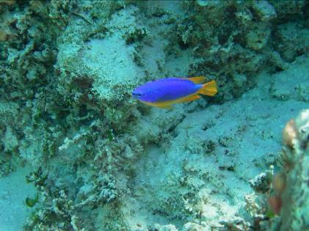

Fish communities are part of the ecological character of this site. Photographer: Barry Baker

Ecosystem service 3(b): Supports high species diversity - fish

Qualitative description

The RIS notes in relation to Ramsar criterion 8, that “It is assumed that the productive shallow waters of the site’s reefs and lagoon are a significant nursery area for fishes that have open-water adult stages (Ramsar Convention 2002). Coral Sea reefs also act as aggregation areas for Bigeye Tuna Thunnus obesus - a target species in Australia’s Eastern Tuna and Billfish Fishery.” This statement warrants further investigation, as one expert panel members (Adam Smith) indicates as follows; “the main fishing areas are much closer inshore and offshore from Moolalabah. The main spawning aggregation areas are offshore from Cairns. “

Preliminary surveys of the site have indicated that the families of fishes with the greatest species diversity are the Labridae (wrasses), Pomacentridae (damselfishes), Acanthuridae (surgeonfishes), Chaetodontidae (butterfly fishes), Serranidae (cods and coral trout), and Scaridae (parrotfishes) (Environment Australia 2002c). Some of the fish species common at the site are rare or absent from the Great Barrier Reef, and vice versa. (Based on text from the RIS – see Attachment A).

Quantitative description | Typical range of variability and limits of acceptable change (LACs) | Reference*
Coringa-Herald Reserve  A 2003 survey of the North-East Herald Cay (Oxley et al) recorded 342 species of fish – see Table 9.  Lihou Reef Reserve  294 species of fish with a community similar to that at Coringa-Herald Reserve. | Interim LAC:  No loss of observed species, and any additional species observed in future surveys at both reserves.  With further surveys to establish natural variabilities, it should be possible to use abundance and species richness data, such as that provided in Tables 9 and 10 and Figures 10-14 below to develop LACs. | DEH (2001);  Jaensch et al. (2002)  Oxley et al. 2003  Byron et al. 2001
Primary habitat zone(s) used for each life history stage: (See Ecosystem service 1 above)  Larvae: mostly pelagic, but some species lay benthic eggs. Reef slopes, flats and crests  Adults: Reef slopes, flats and crests, lagoon, inter-reef channels. |  | Expert panel

*see Section 5 for details

Table 9: Fish species richness accumulated over all timed swims at each reef (Swim total) and over all observations (Reef total). The grand total is the number observed over all reefs.
(Table 10 from report on AIMS survey in March-April 2003)

Reef | Back |  | Front | NE Flank |  | South Flank | West Flank | Flat Gutter | Swim Total | Reef Total
NE HERALD |  |  |  |  | 113 | 95 | 89 | 113 | 156 | 223
SW HERALD | 117 |  | 133 |  | 129 | 123 |  |  | 169 | 257*
CORINGA SW | 96 | 91 |  |  | 79 |  | 110 |  | 129 | 183
CHILCOTT | 89 | 78 |  |  | 65 |  | 105 |  | 128 | 187
MAGDELAINE SE |  |  |  |  |  |  | 113 |  | 113 | 133**
 |  |  |  |  |  |  | Grand Total |  | 299 | 342

* 20 of these species were observed in greater than 15m, a depth not observed on other reefs.
** only one site was surveyed on this reef .

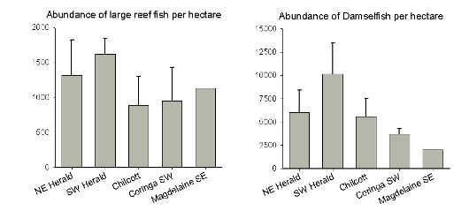

Figure 10: Fish abundances from transect surveys at the Coringa-Herald Reserve.
(Figure 22 from report on AIMS survey in March-April 2003).

Figure 11: Species richness for the 8 most abundant families of large mobile reef fishes at Lihou Reef.
(Figure 21 from report on AIMS survey in March 2004).

Figure 12: Mean species richness at each of the survey reefs, Lihou Reef. Fours sites were sampled at Anne Cay, one at Georgina Cay and two sites at each of the other reefs.
(Figure 22 from report on AIMS survey in March 2004).

Figure 13: Comparison of average abundances of large mobile reef fishes at each of the survey reefs, Lihou Reef.
(Figure 24 from report on AIMS survey in March 2004)

Figure 14: Comparison of average abundances of damselfishes at each of the survey reefs, Lihou Reef.
(Figure 25 from report on AIMS survey in March 2004)

Table 10: Comparison of three families of reef fish between surveys in 1984 and 2004, Lihou Reef. Data are presented as mean abundances per hectare at each survey reef +/- standard error. (Table 8 from report on AIMS survey in March 2004)

 | 1984 |  |  | 2004
Species | Anne | Georgina | Middle | Anne | Georgina | Middle
Serranidae
Plectropomus leopardus | 0.5 ± 0.5 | 0 | 0.75±0.9 | 3.3±7.7 | 0 | 0
P. laevis | 0 | 0 | 0.25±0.4 | 2.5±10 | 16.7±0.0 | 0
Variola louti | 0 | 0.25±0.4 | 0.25±0.4 | 0 | 0 | 13.3±0.0
Scaridae
Calatomus carolinus | 4.5±1.6 | 1.5±1.1 | 4.0±1.4 | 0 | 0 | 0
Cetoscarus bicolor | 1.5±1.1 | 2.0±1.0 | 0.5±0.5 | 10±6.4 | 26.7±0.0 | 0
Chlorurus sordidus | 15±6.4 | 1.5±1.1 | 6.5±2.3 | 73.3±53.5 | 93.3±0.0 | 80±0.0
Hipposcarus longiceps | 15±4.5 | 4±2.6 | 10.5±8.4 | 13.3±5.4 | 13.3±0.0 | 0
Scarus altipinnis | 14±2.3 | 13.5±2.8 | 0 | 70±38.2 | 253±0.0 | 0
S. frenatus | 0 | 0.5±0.5 | 0 | 0 | 0 | 0
S. longipinnis | 21.5±3.1 | 40.5±5.5 | 39.5±9.9 | 53.3±36.5 | 107±0.0 | 53.3±0
S. niger | 7.5±1.8 | 4.0±1.1 | 0 | 16.7±16.7 | 66.7±0.0 | 0
S. psittacus | 3.0±3.4 | 0 | 0.5±0.5 | 40±19.6 | 40±0.0 | 26.7±1.0
S. schlegeli | 6.5±3.4 | 4.0±2.6 | 6.5±3.3 | 6.7±3.85 | 107±0.0 | 13.3±1.0
S. rubroviolaceus | 0 | 0 | 1.0±1.1 | 6.7±6.7 | 0 | 0
Chaetodontidae
Chaetodon auriga | 4.5±2.3 | 1.0±0.6 | 0 | 6.7±6.7 | 0 | 0
C. citrinellus | 0.5±0.5 | 1.0±1.1 | 2.0±1.4 | 26.7±10.9 | 66.7±0.0 | 66.7±5.0
C. ephippium | 2.0±1.4 | 0 | 2.0±1.4 | 0 | 0 | 0
C. flavirostris | 1.0±1.1 | 0 | 1.0±1.1 | 0 | 0 | 0
C. kleinii | 0 | 0 | 21.5±2.9 | 0 | 0 | 60±2.5
C. lineolatus | 1.5±1.1 | 0 | 0 | 0 | 0 | 0
C. melonnotus | 11.5±3.6 | 1.0±1.1 | 0 | 0 | 0 | 0
C. mertensii | 0 | 9.5±2.3 | 8.0±1.0 | 3.3±3.3 | 53.3±0.0 | 100±4.5
C. pelewensis | 0 | 5.0±1.8 | 16.5±2.8 | 50±17.5 | 40±0.0 | 53.3±0
C. plebius | 4.5±1.6 | 4.0±1.1 | 1.5±1.6 | 10±6.4 | 0 | 13.3±1.0
C. reticulatus | 0 | 0 | 1.5±1.1 | 3.3±3.3 | 0 | 0
C. speculum | 1.5±0.6 | 0 | 0 | 3.3±3.3 | 0 | 0
C. trifascialis | 0 | 0 | 1.5±1.6 | 0 | 0 | 6.7±0.5
C. trifasciatus | 4.5±1.4 | 2.0±1.4 | 4.0±2.1 | 10±10 | 0 | 0
C. ulitensis | 1.0±1.1 | 0 | 0 | 0 | 0 | 0
C. unimaculatus | 1.0±0.6 | 0 | 1.0±1.1 | 0 | 0 | 6.7±0.5

Primary ecosystem components and processes | How they support the ecosystem service | Reference*
Oceanic currents | Ocean currents are likely to transport larvae of fish and coral species to these reserves: the larvae of tropical species are brought from north through the East Australian Current, while the temperate species larvae are brought from south through the Tasman front. | Expert Panel
Diversity of habitats and connectivity | Although the diversity of habitats is comparatively low at this site, the combination of exposed and protected reef provides a variety of habitats for different species. | Royal Geographic Society of Queensland (2001)
Food sources / productivity | The species of fish found at these sites cover a wide trophic spectrum from detritvores to carnivores. The sites provide the wide range of food sources necessary to support the diversity of fish species, including algae, corals, sponges, crustaceans, molluscs, echinoderms and fish. | Expert Panel
Geomorphology and substrate | The geomorphically complex topography of Coringa-Herald and Lihou Reefs provides a wide range of niche habitats for marine flora and fauna (See Figures 5-9). The geomorphology allows the growth of corals, sponges, algae etc. and, therefore, the provision of food and habitat. | Expert Panel
Water temperature | Coringa-Herald and Lihou Reefs experience annual sea surface temperatures ranging from approx 24°C to 29 °C (see section 3.6). Higher sea surface temperatures were recorded regularly from 1999 onwards, this resulting in extensive coral bleaching. See also section 3.6. | Expert Panel

*see Section 5 for details

Critical ecosystem components and processes:
For this ecosystem service, the diversity of habitats and their connectivity coupled with substrate are the critical parameters. Sections 3.5 and 3.6 expand on this further.

Ecosystem service 3(c): Supports high species diversity - decapod crustaceans

Qualitative description

Coringa-Herald Reserve
A 1997 survey (Davie and Short, 2001 in the RGSofQ report) of the North East Herald Cay recorded 125 species of decapod crustaceans. Nine of these were at that time undescribed species and 16 had not been recorded previously in Australian waters. Surveys were restricted (due to weather conditions) to the patch reefs on the back reef slopes and sheltered areas, plus the reef flat and intertidal zone.

Of note in this context is that Davie and Short indicated that the diversity and abundance of species was relatively low, compared to other comparable sites (such as Cartier Reef and Hibernia Reef). This they attribute to the relative lack of coral cover and loose substrate due to strong wave action and powerful currents in the areas they surveyed. Davie and Short, 2001( in the RGSofQ report) provide useful information on habitat preferences for many of the species recorded; this information should be built on to better document the habitat:species associations, and to gain insights into species diversity and abundance within each habitat zone.

Also notable are the semi-terrestrial and terrestrial crustacean species; two species of Ghost crab (Ocypode) found on the beaches, large rock crabs (Grapsus) and three species of hermit crabs (Coenobita) living beneath and within the vegetation. Davie and Short (2001) observe that these species are present in “huge numbers” and “must play an enormously important ecological role in the islands food chains.”

Lihou Reef Reserve
Knowledge gap.
Quantitative description | Typical range of variability and limits of acceptable change (LACs) | Reference*
Coringa-Herald Reserve  125 species (North East Herald Cay) including six semi-terrestrial and terrestrial species (see above).  Lihou Reef Reserve  Knowledge gap. | Interim LAC:  Coringa-Herald Reserve  No loss of observed species, and any additional species observed in future surveys in the reserve.  Lihou Reef Reserve  Knowledge gap. | Davie and Short, 2001 in the RGSofQ report
Primary habitat zone(s) used for each life history stage: (See Ecosystem service 1 above)

All habitats, it is assumed.

*see Section 5 for details

Primary ecosystem components and processes | How they support the ecosystem service | Reference*
Oceanic currents | Ocean currents are likely to transport larvae to these reserves: the larvae of tropical species are brought from north through the East Australian Current, while the temperate species larvae are brought from south through the Tasman front. | Expert Panel
Diversity of habitat | Although the diversity of habitats is comparatively low at this site, the combination of exposed and protected reef provides a variety of habitats for different species. | Royal Geographic Society of Queensland (2001)
Food sources / productivity | Marine forms are typically more common where there is good coral cover. | Expert Panel
Geomorphology | The geomorphically complex topography of Coringa-Herald and Lihou Reefs provides a wide range of niche habitats for marine flora and fauna (See Figures 5-9). The geomorphology allows the growth of corals, sponges, algae etc. and, therefore, the provision of food and habitat. The islets and cays are important for supporting the terrestrial species. | Expert Panel
Substrate | See above. | Expert Panel
Terrestrial vegetation | Hermit crabs (Coenobita) live beneath and within the terrestrial vegetation, especially Argusia and Pisonia. | Expert Panel
Water quality | Water quality aspects such as water temperature, turbidity, nutrient concentrations and potential contaminants influence the biota at the site. For example the balance between phytoplankton dominated systems and those dominated by benthic flora (seagrass, microphytobenthos) is controlled by water clarity and nutrient concentrations. | Expert Panel

*see Section 5 for details

Critical ecosystem components and processes:
For this ecosystem service, the diversity of habitats, their connectivity and substrates coupled with food sources are the critical parameters for the marine species. For the terrestrial species vegetation cover is of critical importance, as are food sources. Sections 3.5 and 3.6 expand on this further.

Ecosystem service 3(d): Supports high species diversity – marine algae

Qualitative description

Sixty-six species of marine benthic algae were recorded in 1997 surveys of North-East Herald Cay by recorded Millar (2001, in the RGSofQ report).

The RIS (Appendix A) notes as follows: “Marine algal communities are an important ecological feature of the site, frequently covering a greater area than the corals. During a 1997 preliminary survey of marine algae of North East (Herald) Cay, 66 species were recorded, though this is expected to be only a fraction of the total present. Forty-one species of red algae, 23 of green algae and two of brown algae were recorded. Halimeda spp., a calcified algae of warm seas, is a prominent feature of the benthic habitat. The near absence of brown algae is unusual for what appears to be a typical reef environment (Environment Australia 2002c).”

Quantitative description | Typical range of variability and limits of acceptable change (LACs) | Reference*
Coringa-Herald Reserve  66 species (Millar 2001, in the RGSofQ report); 41 species of red algae, 23 of green algae and two of brown algae were recorded. Halimeda spp is a prominent feature of the benthic habitat.  Lihou Reef Reserve (Oxley et al. 2004)  Knowledge gap | Interim LAC:  Coringa-Herald Reserve  No loss of observed species, and any additional species observed in future surveys in the reserve.  Lihou Reef Reserve  Knowledge gap.  With further surveys to establish natural variabilities, it should be possible to use benthic cover data, such as that provided in Figure 15 below to develop LACs. | DEH (2001);  Jaensch et al. (2002)
Primary habitat zone(s) used for each life history stage: (See Ecosystem service 1 above)  All habitats, it is assumed. |  | Expert Panel
*see Section 5 for details

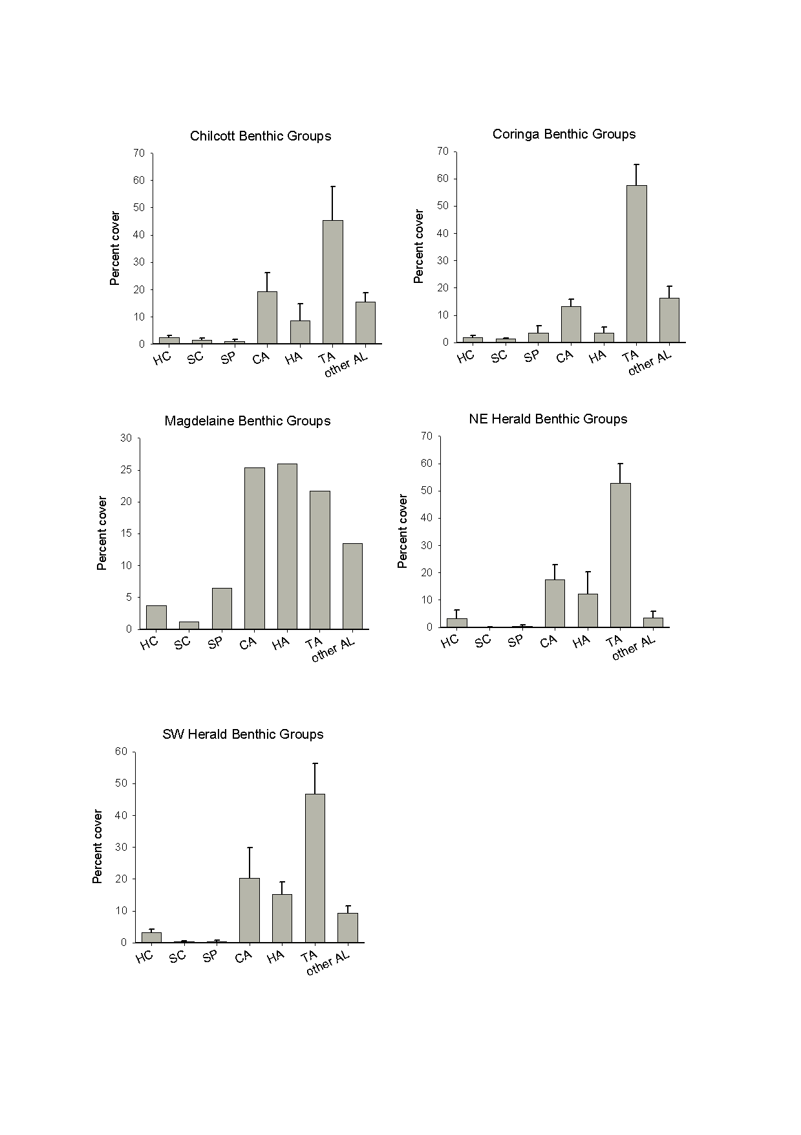

Figure 15: Benthic cover of major groups on each surveyed reef, Coringa-Herald Reserve. HC = hard coral, SC = soft coral, SP = sponge, CA = coralline algae, HA = Halimeda, TA = turf algae, and AL = other algae. Error bars indicate standard errors.
(Figure 17 from report on AIMS survey in March-April 2003)

Primary ecosystem components and processes | How they support the ecosystem service | Reference*
Oceanic currents | Ocean currents are likely to transport algae to these reserves: the larvae of tropical species are brought from north through the East Australian Current, while the temperate species larvae are brought from south through the Tasman front. | Expert Panel
Diversity of habitat | Although the diversity of habitats is comparatively low at this site, the combination of exposed and protected reef provides a variety of habitats for different species.  As noted under Ecosystem service 2, the macroalgal beds in the Coral Sea Reserves provide foraging habitat for Green Turtles. | Royal Geographic Society of Queensland (2001)
Geomorphology | The geomorphically complex topography of Coringa-Herald and Lihou Reefs provides a wide range of niche habitats for marine algae (See Figures 5-9). | Expert Panel
Substrate | See above.
Water quality | Water quality aspects such as water temperature, turbidity, nutrient concentrations and potential contaminants influence the biota at the site. For example the balance between phytoplankton dominated systems and those dominated by benthic flora (seagrass, microphytobenthos) is controlled by water clarity and nutrient concentrations. | Expert Panel

*see Section 5 for details

Critical ecosystem components and processes:
For this ecosystem service, the diversity of geomorphology/habitats coupled with substrates are the critical parameter; these being followed by water quality. Sections 3.5 and 3.6 expand on this further.

Deep exposed front reef community showing thallous algae and sponges, Coringa-Herald Reefs. (Figure 5 from the AIMS report by Oxley et al, 2003)

Ecosystem service 3(e): Supports high species diversity - hydroids

Qualitative description

Coringa-Herald Reserve:
The site supports a relatively rich diversity of hydroid faunas with some 55 species recorded by Preker (2001 in the RGSofQ report); this being from only a partial survey that excluded the exposed reef front due to adverse weather conditions.
Lihou Reef Reserve:
Knowledge gap.
Quantitative description | Typical range of variability and limits of acceptable change (LACs) | Reference*
Coringa-Herald Reserve  A 1997 survey of intertidal and subtidal habitats (Preker, 2001 in the RGSofQ report) of the North East Herald Cay recorded 55 species of hydroid (9 of which have not been previously recorded in Australian waters).  Lihou Reef Reserve  Knowledge gap | Interim LAC.  Coringa-Herald Reserve  No loss of species recorded in surveys to date within the habitats specified by Preker 2001; namely: beachrock, shallow reef flat, lagoon, patch reef in shallow water (<10m), patch reef in medium-depth water (10-20m) and patch reef in deep waters (>25m).  Lihou Reef Reserve  Knowledge gap | Preker, 2001 in the RGSofQ report
Primary habitat zone(s) used for each life history stage: (See Ecosystem service 1 above)  Preker (2001) collected specimens from beachrock on both sides of North East Herald Cay, shallow reef flat, the lagoon and shallow, medium and deep patch reefs. |  | Preker, 2001 in the RGSofQ report
*see Section 5 for details

Primary ecosystem components and processes | How they support the ecosystem service | Reference*
Oceanic currents | Ocean currents are likely to transport larvae to these reserves: the larvae of tropical species are brought from north through the East Australian Current, while the temperate species larvae are brought from south through the Tasman front. | Expert Panel
Diversity of habitat | Although the diversity of habitats is comparatively low at this site, the combination of exposed and protected reef provides a variety of habitats for different species.  As noted under Ecosystem service 2, the macroalgal beds in the Coral Sea Reserves provide foraging habitat for Green Turtles. | Royal Geographic Society of Queensland (2001)
Geomorphology | The geomorphically complex topography of Coringa-Herald and Lihou Reefs provides a wide range of niche habitats for hydroids (See Figures 5-9). | Expert Panel
Substrate | See above.
Water quality | Water quality aspects such as water temperature, turbidity, nutrient concentrations and potential contaminants influence the biota at the site. For example the balance between phytoplankton dominated systems and those dominated by benthic flora (seagrass, microphytobenthos) is controlled by water clarity and nutrient concentrations. | Expert Panel

*see Section 5 for details

Critical ecosystem components and processes:
For this ecosystem service, the diversity of geomorphology/habitats coupled with substrates are the critical parameter; these being followed by water quality. Sections 3.5 and 3.6 expand on this further.

Ecosystem service 3(f): Supports regionally high species diversity – bêche-de-mer (sea cucumbers)

Qualitative description

The Coral Sea National Nature Reserves have an abundant bêche-de-mer population. This is particularly significant as sea cucumber populations of other reefs in the region have been over-exploited and as a result are now found in very low densities.

Quantitative description | Typical range of variability and limits of acceptable change (LACs) | Reference*
Coringa-Herald Reserve  Average densities of six holothurian species recorded in reef flat and back reef habitats by the 2003 AIMS survey are shown in Tables 11 and 12, respectively.  Lihou Reef Reserve  Average densities of four holothurian species recorded in back reef habitat by the 2004 AIMS survey are shown in Table 13. | Interim LAC:  No loss of observed species, and any additional species observed in future surveys in the reserves.  With longer term data sets it may be possible to set abundance-related LACs as well, especially for those species considered in the AIMS 2003 and 2004 surveys – See Tables below. | Oxley et al (2003)
Primary habitat zone(s) used for each life history stage: (See Ecosystem service 1 above)  Lagoon, reefs slopes, sandy habitats. Highest densities were recorded from back reef habitat. |  | Oxley et al (2003)

*see Section 5 for details

Table 11: Average density of six holothurian species recorded in Coringa-Herald Reserve reef flats by the 2003 AIMS survey. Data are given in individuals/ha, with standard deviations in brackets.

Reef | Area sampled (ha) | Habitat/  substrate | H.nobilis | H.atra | S.chloro-notus | B.argus | A.mauri-tania | T.ananus
Chilcott | 1.0 | Reef flat | 8 (8.6) | 45 (8.9) | 3 (2) | 0 | 0 | 0
Coringa | 1.0 | Reef flat | 0 | 42 (31.1) | 0 | 0 | 0 | 0
NE Herald | 1.0 | Reef flat | 0 | 0 | 0 | 1 (2) | 0 | 0
SE Magdelaine | 1.0 | Reef flat | 0 | 22 (8.5) | 0 | 0 | 0 | 0
SW Herald | 2.0 | Reef flat, sandy cay | 0 | 0 | 0 | 0 | 0 | 0

Table 12: Average density of six holothurian species recorded in Coringa-Herald Reserve back reef habitat by the 2003 AIMS survey. Data are given in individuals/ha, with standard deviations in brackets.

Reef | Area sampled  (ha) | Habitat/  substrate | H.nobilis | H.atra | S.chloro-notus | B.argus | A.mauri-tania | T.ananus
Chilcott | 0.52 | Back reef | 3.9 (7.1) | 3414.4 (5035.5) | 61.5 (96.9) | 7.7 (21.8) | 1.9 (5.4) | 0
Coringa | 0.52 | Back reef | 25.0 (24.6) | 9.6 (11.4) | 0 | 5.8 (8.0) | 5.8 (16.3) | 0
NE Herald | 0.52 | Back reef | 0 | 0 | 0 | 5.8 (8.0) | 0 | 13.5 (17.3)
SE Magdelaine | 0.50 | Back reef | 2 | 10 | 14 | 0 | 0 | 0
SW Herald | 0.65 | Back reef | 1.5 (4.9) | 20.0 (20.6) | 3.1 (9.7) | 4.6 (7.4) | 0 | 18.5 (23.8)

Table 13: Average density of four holothurian species recorded in Lihou Reef Reserve back reef habitat by the 2004 AIMS survey. Data are given in individuals/ha, with standard deviations in brackets.

Location | Area sampled (ha)/replicates | H.whitmaei (nobilis) | H.atra | T.ananus | B.argus
Back reef Anne Cay | 0.88/5 | 2.29 (3.13) | 0 | 0 | 1.14 (2.56)
Reef flat Anne Cay | 2.0/4 | 4.00 (4.32) | 2.50 (3.79) | 0 | 0
Reef flat Lorna Cay | 2.0/4 | 1.00 (1.15) | 0.50 (1.00) | 0 | 0.50(1.00)
Shallow reef slope Anne Cay | 0.3/12 | 3.33 (11.54) | 0 | 0 | 0
Shallow reef slope Lorna Cay | 0.15/6 | 0 | 0 | 6.67 (16.32) | 0
Shallow reef slope Turtle Cay | 0.15/6 | 0 | 0 | 0 | 0
Shallow reef slope Middle Cay | 0.15/6 | 6.67 (16.33) | 0 | 0 | 0
Shallow reef slope Georgina Cay | 0.12/5 | 16.00 (21.91) | 0 | 8.00 (17.89) | 0

Primary ecosystem components and processes | How they support the ecosystem service | Reference*
Diversity of habitats and their connectivity | The diversity of habitats at the Coringa Herald and Lihou Reefs provides for a range of species of bêche-de-mer (especially sandy lagoon areas and reef slopes). | Oxley et al (2003)
Climate | The effect of climate on water temperature, light and therefore, food availability (see above), influences the availability and suitability of habitats. | Expert Panel
Food source / productivity | As detritus feeders, bêche-de-mer require high productivity environments that supply adequate organic detritus. | Expert Panel
Geomorphology | Sea cucumbers are shallow water (< 30m) species and require shallow benthic habitat. | Expert Panel
Substrate | Bêche-de-mer are predominantly deposit feeders, ingesting sediment and extracting the nutrients. Some require sandy substrates, while others are reef specialists. | Expert Panel

*see Section 5 for details

Critical ecosystem components and processes
For this ecosystem service, the diversity of habitats coupled with the geomorphology and substrate form is the critical parameter; this being followed by food sources (organic detritus). Sections 3.5 and 3.6 expand on this further.

Ecosystem service 3(g): Supports high species diversity - sponges

Qualitative description

Coringa-Herald Reserve:
Within the site, “..sponges (Family Spongiidae) form an important part of the reef fauna and often are more abundant than coral. This is markedly different to the shallow reefal areas of the Great Barrier Reef.” And “Commonly occurring sponges in the site’s large and spectacular sponge gardens include Thorecta n. sp., Polyfibrospongia flabellifera, Phyllospongia n. subsp., Carteriospongia lamellosa, Carteriospongia n. sp., and C. pennatula. Phyllospongia pennatula, which had not been collected since 1889, is common at Chilcott Islet.” (RIS – Appendix A)
Lihou Reef Reserve:
Knowledge gap.
Quantitative description | Typical range of variability and limits of acceptable change (LACs) | Reference*
Coringa-Herald Reserve  See Figure 15 under Ecosystem service 3(d) marine algae, and Table 14 below. These provide preliminary estimates on the per cent benthic cover of sponges.  Lihou Reef Reserve  See Table 15 below which provides estimates on benthic cover from 1984 and 2004. | Interim LAC:  No loss of observed species, and any additional species observed in future surveys in the reserves.  With longer term data sets it may be possible to set benthic cover-related LACs as well. | AIMS (2003, 2004)
Primary habitat zone(s) used for each life history stage: (See Ecosystem service 1 above)  Lagoon, outer reefs slopes and reef crests. |  | Expert Panel
*see Section 5 for details

Table 14: Coringa-Herald Reserve - Comparison of present mean benthic cover estimates with surveys from 1984 and 1997. Early studies done by Ayling and Ayling (1985) in 1984 and Byron et al (2001) in 1997. Note that site positions are only approximately comparable and that no fronts were surveyed in 1997 due to strong winds. Numbers in parentheses are Standard Errors.
(Table 11 from report on AIMS survey in March-April 2003)

Reef | Year | No. Sites | Hard coral | Soft coral | Sponges
NE Herald | 1984 | 5 | 13.6 (6.9) | 3.7 (4.3) | 1.6 (3.3)
NE Herald | 1997 | 3 | 20.0 (5.5) | 3.2 (1.1) | 2.8 (0.5)
NE Herald | 2003 | 4 | 3.2 (5.2) | 0.1 (0.2) | 0.4 (0.7)
Chilcott | 1984 | 3 | 17.7 (15.0) | 16.4 (8.9) | 16.4 (16.9)
Chilcott | 2003 | 4 | 2.5 (1.0) | 1.5 (1.2) | 1.0 (2.3)

Table 15: Lihou Reef Reserve - Comparison of mean benthic cover estimates between the 1984 survey of Ayling and Ayling (1985) and this study. Note that site positions are only approximately comparable. Numbers in parentheses are Standard Errors.
(Table 7 from report on AIMS survey in March 2004)

Reef | # sites  (in common) | Hard Coral |  | Soft Coral |  | Sponge
Reef | # sites  (in common) | 1984 | 2004 | 1984 | 2004 | 1984 | 2004
Middle | 2 | 21.5 (14.10) | 7.7  (1.65) | 8.1  (2.80) | 2.7  (0.94) | 6.4  (0.05) | 3.1  (0.09)
Turtle | 1 | 12.9  (3.7) | 6.8  (1.35) | 16.1  (11.1) | 2.4  (0.58) | 3.6  (0.70) | 1.0  (0.51)
Georgina | 1 | 12.9  (3.7) | 6.8  (1.35) | 16.1  (11.1) | 2.4  (0.58) | 3.6  (0.70) | 1.0  (0.51)
Reserve level | 4 | 19.5 (3.36) | 7.8  (0.64) | 8.47  (4.31) | 1.7  (0.84) | 4.5  (0.93) | 1.5  (0.85)

Primary ecosystem components and processes | How they support the ecosystem service | Reference*
Diversity of habitats | The diversity of habitats at the Coringa Herald and Lihou Reefs provides for a range of sponge species. | Oxley et al (2003)
Climate | The effect of climate on water temperature, light and therefore, food availability (see above), influences the availability and suitability of habitats. | Expert Panel
Oceanic currents | Ocean currents are likely to transport larvae to these reserves: the larvae of tropical species are brought from north through the East Australian Current, while the temperate species larvae are brought from south through the Tasman front. | Expert Panel
Geomorphology and substrate | Knowledge gap
Water quality | Water quality aspects such as water temperature, turbidity, nutrient concentrations and potential contaminants influence the biota at the site. For example the balance between phytoplankton dominated systems and those dominated by benthic flora (seagrass, microphytobenthos) is controlled by water clarity and nutrient concentrations. | Expert Panel

*see Section 5 for details

Critical ecosystem components and processes:
For this ecosystem service, the diversity of habitats coupled with water quality are the critical parameters. Sections 3.5 and 3.6 expand on this further.

Ecosystem service 3(h): Supports high species diversity - soft and hard corals

Qualitative description

Diversity and cover of hard and soft coral at both Coringa-Herald and Lihou Reefs (AIMS, 2003 and 2004) are low compared to sites in the Great Barrier Reef where there has been more intensive and deeper sampling. This is likely to be due to isolation of the Coral Seas reefs, limited habitats and recent disturbance, most notably from coral bleaching – see Section 3.6.
Coringa-Herald Reserve:
Of the hard corals, Oxley et al 2004 reported Poritidae as having the greatest cover, followed by Acroporidae. Oxley et al 2003, observed that Sinularia spp. was most abundant soft coral at all survey sites.
Lihou Reef Reserve:
A comparison between the 1984 survey results (Ayling and Ayling 1985) and the 2004 study (Oxley et al. 2004) shows evidence for a decline in cover of hard coral, soft coral and sponges (see Ecosystem service 3(g) above). It is clear from the 2004 survey that the reefs are under significant pressure, especially from the effects of coral bleaching and cyclones. In 2004, Acroporidae were the most abundant family, followed by Poritidae, Pocilloporidae and Faviidae (Oxley et al, 2004).

Quantitative description | Typical range of variability and limits of acceptable change (LACs) | Reference*
Coringa-Herald Reserve  A 1997 survey (Byron et al. 2001) of the North-East Herald Cay recorded 99 species of hard coral; and  Oxley et al. 2003 report 99 species of hard coral and 9 genera of soft coral.  See Table 16 below for details of the most commonly recorded hard corals.  See Table 14 (above) for mean benthic cover estimates, and how these compare between 1984, 1997 and 2003.  Lihou Reef Reserve  100 species of hard coral were recorded in 2004 and two genera of soft coral.  See Table 17 below for details of the most commonly recorded corals.  See Table 15 (above) for mean benthic cover estimates, and how these compare between 1984 and 2004. The declines in cover are thought to be the product of coral bleaching (see section 3.6), cyclones, storm wave action and disease following after bleaching events (AIMS, 2003 report). In section 3.6, data are presented for Lihou reef showing per cent cover of hard coral at several sites, and the proportion of this observed to be bleached. | Interim LAC:  No loss of observed species, and any additional species observed in future surveys in the reserves.  With longer term data sets it may be possible to set diversity and per cent cover-related LACs as well.  Given the apparent declines reported in the 2003 and 2004 AIMS surveys, repeat surveys are recommended as a matter of urgency. | DEH (2001);  Jaensch et al. (2002)  Oxley et al. (2003)
Primary habitat zone(s) used for each life history stage: (See Ecosystem service 1 above)  Lagoon, outer reefs slopes and reef crests. |  | Expert Panel
*see Section 5 for details

Table 16: Coringa-Herald Reserve – Hard coral species recorded at nine or more of the 17 survey sites. (Table 7 from report on AIMS survey in March-April 2003)

Coral species recorded at >13 sites | Coral species recorded from 9-12 sites
Pocillopora verrucosa | Montipora grisea
Astreopora myriophthalma | Acropora anthocercis
Porites massive | Acropora gemmifera
Coscinarea columna | Porites murrayensis?
Pavona varians | Goniopora tenuidens
Acanthastrea echinate | Pavona duerdeni
Favia species | Pavona maldivensis
Favia stelligera | Symphyllia recta
Platygyra sinensis | Hydnophora microconos
Leptastrea inequalis | Favitea halicora
Cyphastrea seralia | Goniastrea pectinata
 | Goniastrea retiformis
 | Platygyra pini
 | Leptoria phrygia
 | Leptastrea purpurea

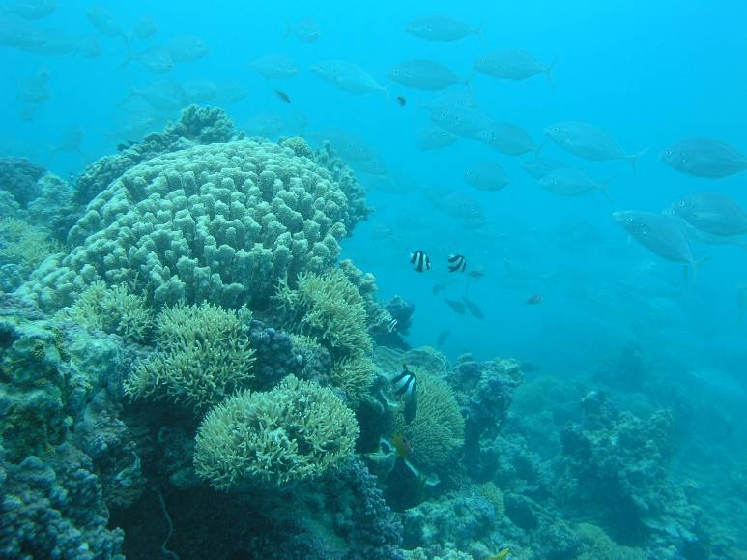

View of the reef slope at Georgina Cay, Lihou Reef. Note the sponges and bleached coral colonies. (DEWHA, Marine Division)

Table 17: Lihou Reef Reserve – Coral species recorded at > 50% of sites.
(Table 6 from report on AIMS survey in March 2004)

Acropora digitifera | Acropora gemmifera
Acropora humilis | Acropora hyacinthus
Acropora nasuta | Acropora valida
Astreopora myriophthalma | Montipora foveolata
Pocillopora verrucosa | Pocillopora eydouxi
Porites lichen | Coscinarea columna
Coscinarea excesa | Acanthastrea echinata
Symphyllia recta | Favia favus
Platygyra pini | Montastrea curta
Leptoria phrygia | Cyphastrea serailia
Seriatopora hystrix | Stylophora pistillata

Ocean currents | Coringa-Herald and Lihou Reef Reserves are characterised by isolation from recruitment sources. Oceanic currents in this area are poorly understood, however evidence suggests that westward currents, which operate for most of the year, bring propagules and larvae from the Solomon Islands to the Coral Sea. During June to September northward currents dominate and can result in the dispersal of biota from the Great Barrier Reef to the Coral Sea (Brinkman). | Expert Panel
Diversity of habitat | Habitats suitable for coral growth are restricted due to exposure to oceanic currents, swells and cyclones | Expert Panel
Geomorphology | The geomorphically complex topography of the Coral Sea Reserves provides a wide range of niche habitats for coral communities (See Figures 5-9), despite some of these being exposed to oceanic currents, swells and cyclones. | Expert Panel
Water quality | Coral require clear water with good light penetration for the survival and growth of the symbiotic algae within their structures as well as for the growth of phytoplankton that are used as a food source. | Expert Panel
Water temperature | Coringa-Herald and Lihou Reefs experience annual sea surface temperatures ranging from approx 24°C to 29 °C (see section 3.6). Higher sea surface temperatures were recorded regularly from 1999 onwards, this resulting in extensive coral bleaching. See also section 3.6. | Oxley et al, 2003
Substrate | Coral larvae require stable substrates in relatively shallow water in order to settle and grow. The Coral Sea Reserves provide morphologically complex reef habitats in reef front, crest, slope and lagoon zones that provide conditions suitable for a wide range of coral species. | Expert Panel

*see Section 5 for details

Critical ecosystem components and processes
For this ecosystem service, the diversity of habitats (even though restricted due to exposure to currents, swells and cyclones) coupled with the geomorphology and substrate form is the critical parameter; this being followed by water quality and water temperature. Sections 3.5 and 3.6 expand on this further.

Ecosystem service 3(i): Supports high species diversity - seabirds – see Ecosystem service 6 below.

Ecosystem service 4: Supports significant forest of Pisonia grandis in the bioregion

Qualitative description

The islands in the Coringa-Herald National Nature Reserve include the only forested cays in the Coral Sea Islands Territory. Within the Coringa-Herald Reserve, Pisonia grandis forest occurs on only two cays, namely North East Herald Cay and South East Magdelaine Cay. This forest type is uncommon in Australia and also elsewhere due to extensive clearing that has taken place in the Indo-Pacific region. Globally, the remaining significant examples of such forest occur on only 44 of the 950 islands within the Great Barrier Reef region.

The Pisonia grandis forest has been under threat from the soft scale insect (Pulvinaria urbicola), especially on Coringa South West Islet where all 16 ha was destroyed between 1993 and 2000 (Smith et al, 2004). The two other islets where Pisonia is found today also have infestations with scale insects, although the introduction of natural predators of the scale have seen it controlled. Sections 3.6 and 3.8 consider this further. Another threat to this forest type is from defoliation by hawkmoths (Hippotion velox (Fabricus) and Theretia sp.) – see Section 3.8.

Quantitative description | Typical range of variability and limits of acceptable change (LACs) | Reference*
Pisonia grandis forests covered (prior to 1990), approx. 16 ha on both Coringa South West Islet and North East Herald Cay, and, 2 ha on South East Magdelaine Cay.  Current aerial extent not known – see comment above about scale insect impacts. | Interim LAC:  No further loss of the Pisonia grandis forests, and preferably to see re-establishment of those areas lost. | Smith et al, 2004
Primary habitat zone(s) used for each life history stage: (See Ecosystem service 1 above)  Terrestrial islands with sufficient freshwater lenses to support woody terrestrial vegetation. |  | DEH (2001)

*see Section 5 for details

Primary ecosystem components and processes | How they support the ecosystem service | Reference*
Cyclones | There are reports of cyclonic activity damaging areas of Pisonia grandis forest within the Coringa-Herald cluster during the 1980s. | Expert Panel
Ocean currents | Possibly a disperser of seed. | Smith et al, 2004
Geomorphology | Important for maintaining the existing Pisonia grandis forest. The geomorphic instability at North East Herald Cay is destroying the fringing Argusia argentea shrubland that normally provides a windbreak for the Pisonia forest. It has been suggested that this in the long term may contribute to a decline in the island’s Pisonia forest. | Neil and Jell (2001b)
Water quality | Knowledge gap.
Substrate | See geomorphology (above)

*see Section 5 for details

Critical ecosystem components and processes:
For this ecosystem service geomorphology is the critical parameter. Sections 3.5 and 3.6 expand on this further.

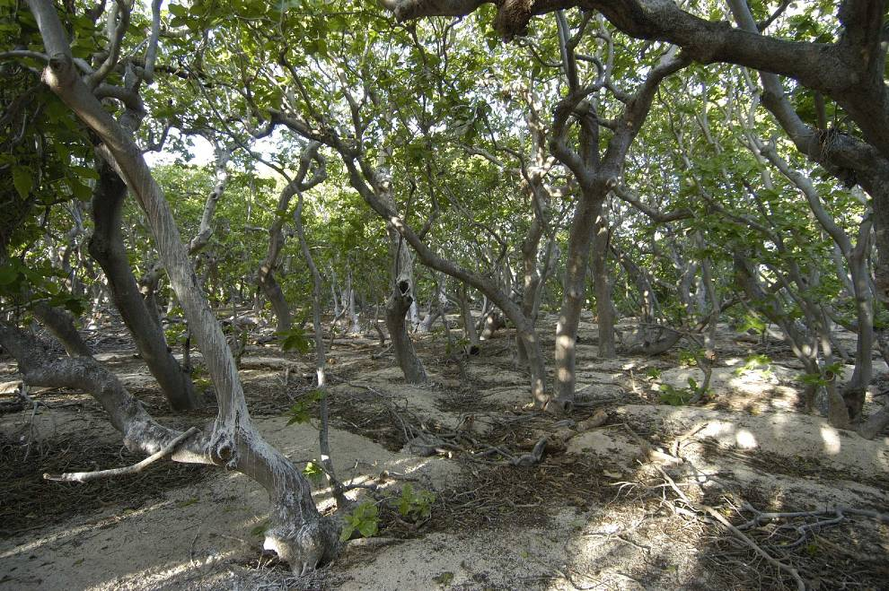

Pisonia forest – North East Herald Cay. Photograph: Barry Baker

Ecosystem service 5: Supports animal taxa at a vulnerable or critical stage of their lifecycle -
(a) breeding Green turtles – see ecosystem service 2;
(b) nursery area of fish with open-water adult stages - – see ecosystem service 3(b); and,
(c) breeding seabirds – see ecosystem service 6.

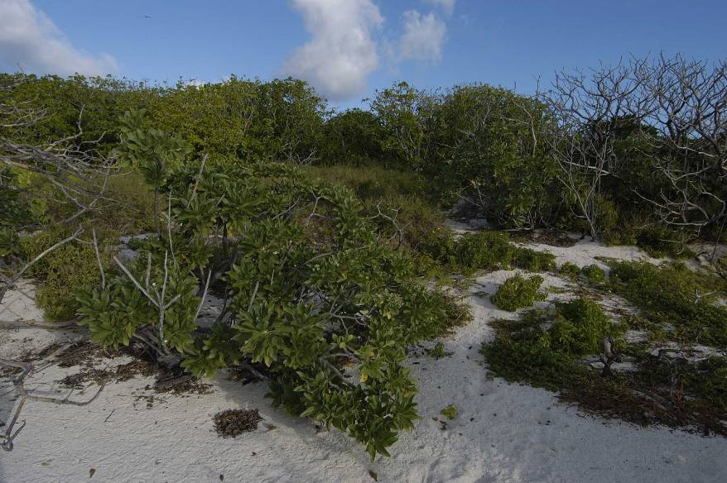

North East Herald Cay (August 2005), showing Argusia shrubs in the foreground and Pisonia forest behind. Photograph: Barry Baker

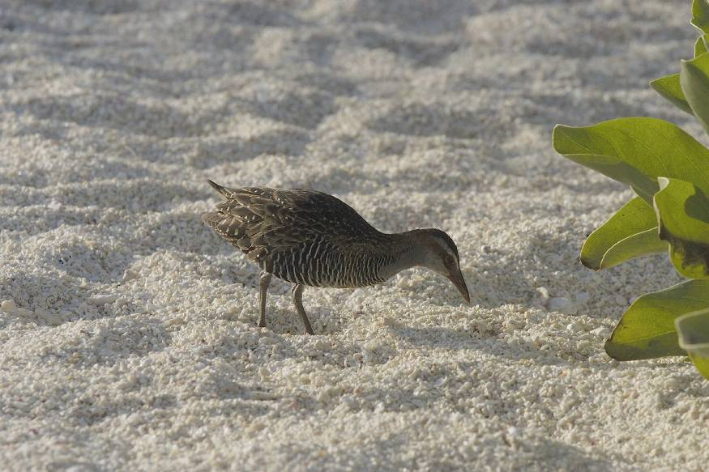

Buff-banded Rail. One of only two species of land birds that breed within the Reserve (see below). Photograph: Barry Baker.

Ecosystem service 6: Supports large numbers of waterbirds - seabirds

Qualitative description

Nineteen species of migratory and other seabirds have been recorded in the Coral Sea National Nature Reserves. Of these, 13 species have been recorded breeding in these reserves (Baker et al, 2004), as shown in Table 18. The cays provide plant species and vegetation structure that are used for nesting sites.

Both Coringa Herald and Lihou Reef Reserves contain extensive and regionally significant seabird colonies. Many of the species recorded from the Reserve are also listed under Australia’s bilateral migratory bird agreements with Japan and China (see Table 18). The Buff-banded rail, Gallirallus philippensis subsp. and the Purple swamphen, Porphyra porphyra, are the only species of land birds breeding within the Reserve.

Quantitative description | Typical range of variability and limits of acceptable change (LACs) | Reference*
Baker# et al (2004) report the findings of annual seabird surveys on North East Herald Cay since 1992. These surveys were timed to coincide with periods of peak breeding activity for three species; Red-footed booby, Least frigatebird and Greater frigatebird. This monitoring has been done with great rigour and so provides robust data for the purpose of setting LACs (see at right).  Baker# (Pers. Comm.., 2006) notes; “Frigate birds have declined by more than 20% since 1998. We’ve been waiting for recovery to pre-1998 levels but the 2005 figure was 761pairs. This is now being interpreted as a population decline from the 1990s when 3,000 to 3,500 pairs bred each year, to a level which has since stabilised at around 1500 annual breeding pairs. The causes for this decline have not been determined as yet, but are believed to be related to oceanographic changes”  # Note – as indicated on page ii, Barry Baker of DEH is also a peer reviewer of this report. | Interim LACs (for North East Herald Cay) - See Important Notes – page 4 – in relation to external impacts on species such as turtles and seabirds:  Red-footed Booby (see Figure 16 below).  A difference of 20% between any two five-year periods in the mean number of breeding pairs will be strong evidence of a systematic change and hence a reason for concern.  Masked Booby, Frigatebirds, Red-tailed Tropicbird and Black Noddy  As for Red-footed Booby. See Figures 17 -19 below.  Buff-banded Rail and Purple swamphen:  Knowledge gap  The Marine Protected Area Management Section of DEH is currently conducting a review (through a consultancy) into the seabird monitoring program that has been conducted in the Coringa-Herald Reserve for several years. The outcome of the review will include a recommendation for the optimal design of seabird monitoring programs within the reserves scheduled to be implemented from the 2006 season. | Baker et al (2004)
Primary habitat zone(s) used for each life history stage: (See Ecosystem service 1 above)  Nesting – in the open on bare ground, grassy areas and other vegetation, including stems and sticks often cemented together with guano.  Feeding – open water, by skimming or diving (piscivorous). |  | Batianoff (2001)

*see Section 5 for details

Primary ecosystem components and processes | How they support the ecosystem service | Reference*
Diversity of habitats | Given the number of seabird species and their differing habitat, breeding and foraging preferences, Coringa-Herald and Lihou Reefs are important for the variety of these it offers. The juxtaposition and connectivity of these feeding and breeding habitats provide the ideal environment for these species. | Expert panel
Terrestrial vegetation | Provides roosting and nesting sites for a number of seabird species. See also under Ecosystem Service 4(a) – marine turtles. | Expert panel
Food sources / productivity | Large populations of small fish provide food for large populations of seabirds. | Expert panel
Geomorphology | Presence of the sandy, vegetated islands in Coringa-Herald is essential for breeding, as are the range of reef, intertidal and lagoon habitats | Expert panel

*see Section 5 for details

Critical ecosystem components and processes:
For this ecosystem service, the diversity of habitats coupled with the geomorphology is the critical parameter; this being followed by food sources and terrestrial vegetation (for the breeding of certain species). Sections 3.5 and 3.6 expand on this further.

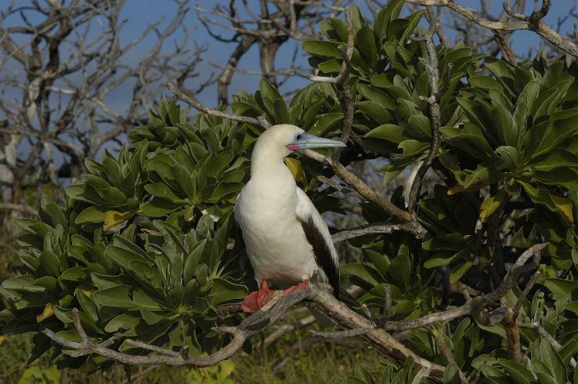

Red-footed Booby (August 2005). Photograph: Barry Baker
Table 18: List of migratory and waterbird species recorded in the Coral Sea National Nature Reserve Ramsar site (source: Management Plan for the site, 2001)

[Note – this table has been extracted from the current management plan for the site. It has been reviewed by Barry Baker of DEH – a peer reviewer of this report – and he has indicated which of these species can be considered as ‘vagrant’s or occurring in very low (< 10 birds) numbers – see column at far right. He has also provided some advisory notes in relation to some species and these are provided below each species name]

Species | Coringa-Herald National Nature Reserve | Lihou Reef National Nature Reserve | Vagrants – low numbers  (see above)
Herald petrel Pterodroma arminjoniana  Following taxonomic clarification, this species/sub-species should now be known as Pterodroma heraldica |  | X | X
*Wedge-tailed shearwater Puffinus pacificus | B | B
*Red-footed booby Sula sula | B | B
*Masked booby Sula dactulatra | B | B
*Brown Booby Sula leucogaster | B | B
*Great frigatebird Fregata minor | B | X
*Least frigatebird Fregata ariel | B | B
Sacred ibis Threskiornis aethiopica |  | X | X
Red-tailed tropicbird Phaethon rubricauda | B
White-tailed tropicbird Phaethon lepturus | X |  | X
Buff-banded rail Gallirallus philippensis subsp | B | B
Purple swamphen Porphyrio porphyrio | B
*Lesser golden plover Pluvialis dominica | X | X | X
*Grey-tailed tattler Tringa incana | X | X | X
*Wandering tattler Heteroscelus incanus | X |  | X
*Great knot Calidris tenuirostris | X | X | X
*Bar-tailed godwit Limosa lapponica | X |  | X
(indeterminate) tattler Tringa spp. | X | X | X
*Eastern reef egret Egretta sacra | X |  | X
*Sharp-tailed sandpiper Calidris acuminata | X |  | X
*Ruddy turnstone Arenaria interpres | X | X | X
*Wimbrel Numenius phaeopus | X | X | X
*Little wimbrel Numenius minutus |  | X | X
Silver gull Larus novaehollandiae |  | X | X
*Black-naped tern Stema sumatrana | B | B
Sooty tern Stema fuscata | B | B
*Bridled tern Sterna anaethetus | X
Crested tern Sterna bergii | B
*Little tern Sterna albifrons |  | B | X
Roseate tern Sterna dougallii | X
Fairy tern Sterna nereis  [Doubtful record] | X |  | X
*Common noddy Anous stolidus | B | B
Black noddy Anous minutus  [Doubtful record] | B | B
Pelican Pelicanus conspicillatus |  | X | X
Sacred Kingfisher Halycon sancta | X

* Species listed under JAMBA and/or CAMBA, B = breeding

Figure 16: Numbers of Red-footed Booby observed, North East Herald Cay. See also the full report by Baker et al for a correlation of these data with breeding stage information.
(Figure 1 from Baker et al, 2004)

Figure 17: Numbers of Frigatebirds observed in Argusia shrubs, North East Herald Cay. See also the full report by Baker et al for a correlation of these data with breeding stage information.
(Figure 2 from Baker et al, 2004)

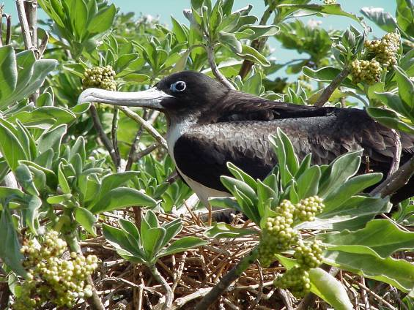

Frigatebird. Photograph: Barry Baker

Figure 18: Numbers of nests of Black noddy in Pisonia forest, North East Herald Cay. Error bars indicate 85% confidence intervals. Estimates from 1998-2004 are based on ‘total counts’. Baker (Pers. Comm) advises that this data has be interpreted cautiously as this species “…builds a number of nests to display from and hence one nest does not equate to one breeding pair.” (Figure 3 from Baker et al, 2004)

Figure 19: Maximum annual counts of Red-tailed tropic birds breeding at North East Herald Cay and the stage of breeding at the time of the count. Nesting occurs only in the Argusia shrubs. (Figure 4 from Baker et al, 2004)

3.5 Link the selected ecosystem services with the critical ecological components and processes that support them and select those components to be further specified (Step 5 – in part, see Section 3.4 also)
Also part of Step 5 (see Section 3.4 above also) is to cross-reference the primary ecological components and processes with the ecosystem services and from this select the most critical of these to be further specified (see selection criteria below). The key below indicates the primary ecological components and processes and those selected as the most critical of these.

Table 19: Linking the selected ecosystem services with the critical ecological components and processes

Ecosystem Services | Primary ecosystem components and processes
Ecosystem Services | Available habitats | Habitat connectivity | Food sources, productivity | Oceanic currents | Climate (including winds) | Geomorphology | Water quality | Water temperature | Substrate | Terrestrial habitat
1. Representative of unique ecosystem in the bioregion
2. Marine Turtles
3(a). Marine molluscs
3 (b). Fishes
3(c). Decapod crustaceans
3(d). Marine algae
3(e). Hydroids
3(f) Bêche-de-mer
3(g). Sponges
3(h). Soft and hard corals
4. Pisonia forest
5. Animal taxa at critical stages – see 2, 3(b) and 6
6. Seabirds
Selecting the critical components and processes (DSE Framework, 2005): |  |  |  |  |  |  | Key:  Black shaded cells = critical ecological components and processes – specified further in Section 3.6  Grey shaded cells = primary ecological components and processes  White cells = not a primary ecological component and process for this ecosystem service
Critical ecosystem components and processes should be selected based on the following criteria:
1. for which baseline data is available to specify the component or process;
2. for which change is reasonably likely to occur over short or medium time scales (<100 years);
3. which will cause significant negative consequences if change occurs; or,
4. those which are practical and meaningful to monitor.
Note: 1. above was not applied here as it would disqualify the majority of the components and processes, and, in relation to 4, this project has added the word “meaningful” for obvious reasons.

Critical ecological components and processes to be specified:
From table 19 above further clarifications are needed in relation to the following ecosystem components and processes identified as being critical parts of the ecological character (shaded black):

1. Available habitats, geomorphology and substrates.
These are all closely linked and have been considered in the foregoing section, and through Ecosystem Service 1 in particular.

2. Food sources and productivity.
These components and processes are related directly to the overall ecosystem of the Coral Sea Reserves (see Ecosystem Services 1-6 in Section 3.4) and the biota that is found there.

3. Water quality and temperature are critical ecosystem components. At present there are no major concerns about water quality, however, the same cannot be said for sea surface temperature which, based on the amount of coral bleaching evident, is major concern.

4. Terrestrial vegetation – Pisonia forest
This is of critical importance for a number of the breeding seabirds found at the site, and for turtle nesting.

Section 3.6 examines these critical ecological components and processes in more detail.

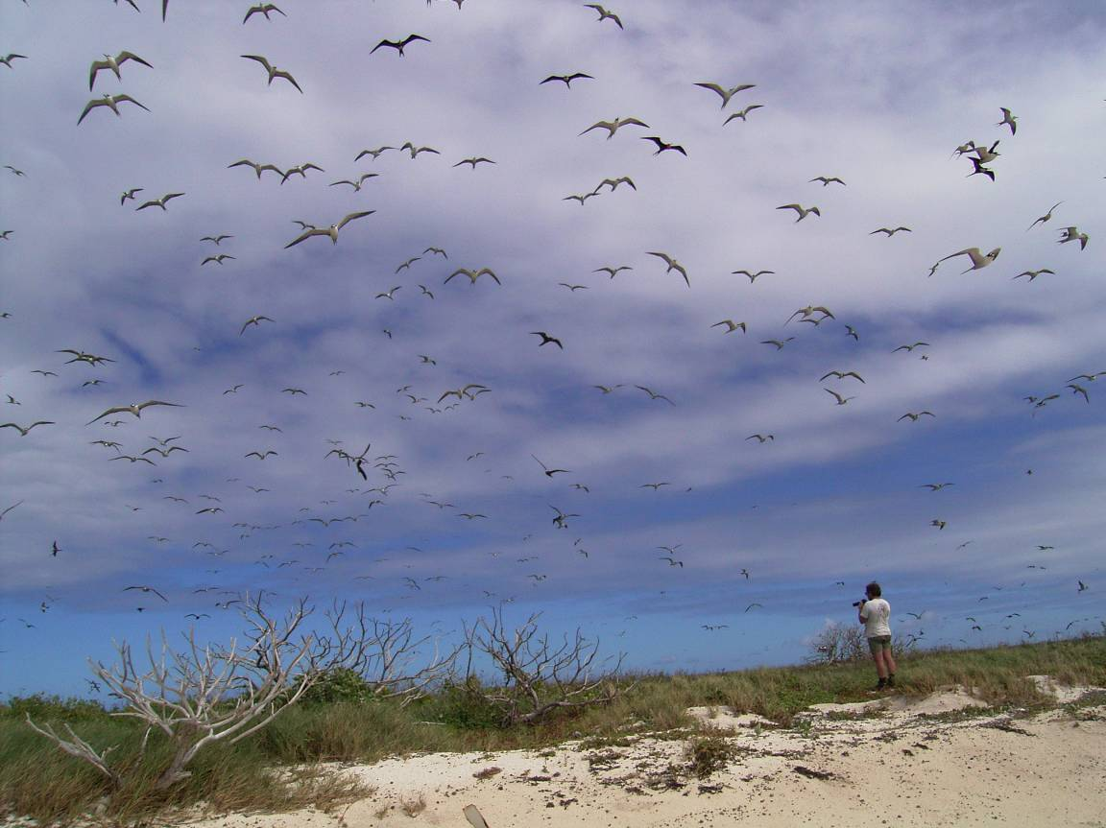

Seabirds circling – Coringa-Herald Reserve. Photographer: Barry Baker

3.6 Specify the selected critical components and processes that support the selected ecosystem services (Step 6)

Based on the preceding section, the critical components and processes are now described in detail, wherever possible providing limits of acceptable change (see Important note in Section 2, page 3).

Table 20: Critical components and processes that support the selected ecosystem services

Critical component or process (see preceding section) | Quantitative description | Limits of acceptable change (LACs)
1. Available habitat types, geomorphology and substrate | As advised under Ecosystem service 1 in Section 3.4, the aerial extent of the geomorphological categories has been estimated. However, this has not been ground truthed nor correlated with habitat types as yet. | See comment at left. LAC cannot be set at present.
2. Food sources and productivity | While dietary habits are known for many of the notable species or species groups considered in Section 3.4, it is not possible to quantify this in a meaningful way for this exercise. | It is not possible to set LACs for the various food sources referred to at left as there is little or no know data at present.
3. Water temperature and water quality | Coringa-Herald and Lihou Reefs experience annual sea surface temperatures ranging from approx 24°C to 29 °C. Higher sea surface temperatures were recorded regularly from 1999 onwards, this resulting in extensive coral bleaching. See Figures 20-22 below. | Water temperatures exceeding 35ºC are considered lethal for most marine species. Lower temperatures (31-32ºC) experienced for several days can also be lethal.  Oxley et al , 2004 report that the AIMS survey of Lihou Reef in March 2004 took place while a bleaching event was underway. Water temperatures at the time were up to 31°C at 9m depth, despite strong winds and large swells that could be expected to mix the water column. Figures 21 and 22 reflect the seriousness of the bleaching at Lihou Reef. The AIMS survey estimated, using their Rapid Assessment Protocol, that 65% of the hard coral cover (at the Reserve level) was bleached. The figure varied between cays, reef habitats and coral family groups – see Figures 21 and 22.  Coral bleaching is beyond the direct control of the site managers and so no LAC is indicated. However, as highlighted in section 3.8, it poses a serious threat to the ecological character of the Ramsar site and therefore warrants close monitoring.
4. Terrestrial vegetation – Pisonia forest | As noted under Ecosystem service 4 in section 3.4, the Pisonia forest supports large rookeries of seabird such as Red footed boobies, Least and Great frigatebirds, Common and Black (Anous minutes) noddies. The forest has been under threat from the soft scale insect (Pulvinaria urbicola), especially on Coringa South West Islet where all 16 ha was destroyed between 1993 and 2000 (Smith et al, 2004). Both other islets with Pisonia remaining (North East Herald Cay and South East Magdelaine Cay) also have infestation with scale insects, although the introduction of natural predators of the scale (the ladybird, C. montrouzieri, and the parasitoids C. ceroplastae, E. flavithorax and M. luteolus) have seen it controlled.  Photographs below show the before and after impact of the scale on Coringa South West Islet.  Another threat to this forest type is from defoliation by hawkmoths (Hippotion velox (Fabricus) and Theretia sp.). | Interim LACs (as per Ecosystem service 4 in section 3.4):  No further loss of the Pisonia grandis forests, and preferably to see re-establishment of those areas lost.

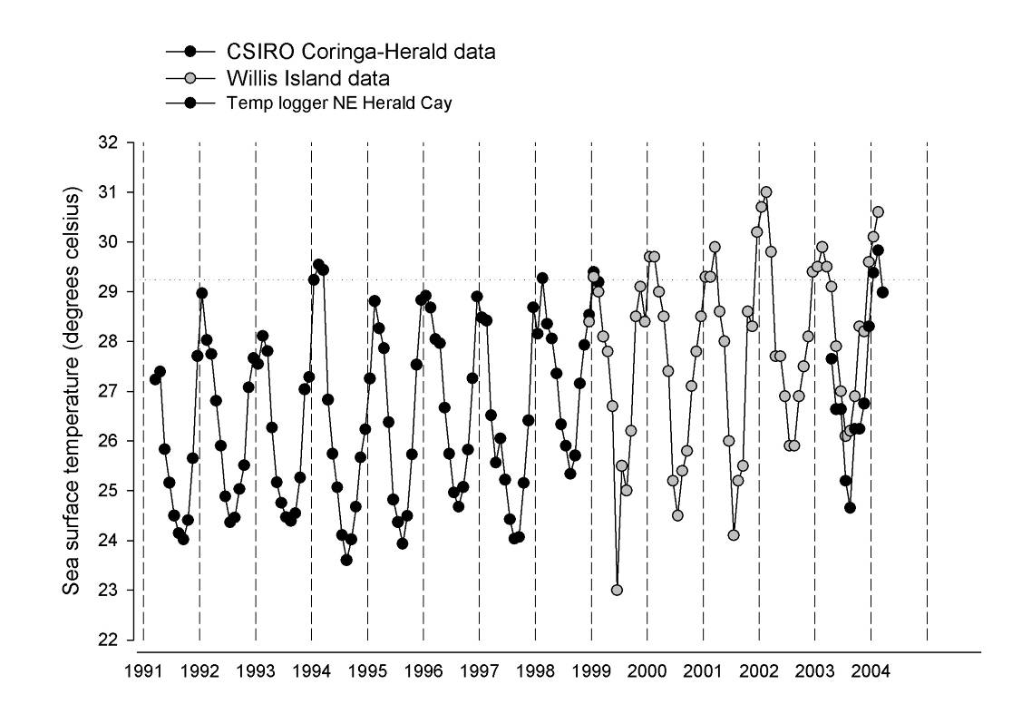

Figure 20: Average sea surface temperature for the waters of the Coral Sea Reserves during 1991-2004
Source: (Figure 3 from AIMS 2004 survey report by Oxley et al. 2004)

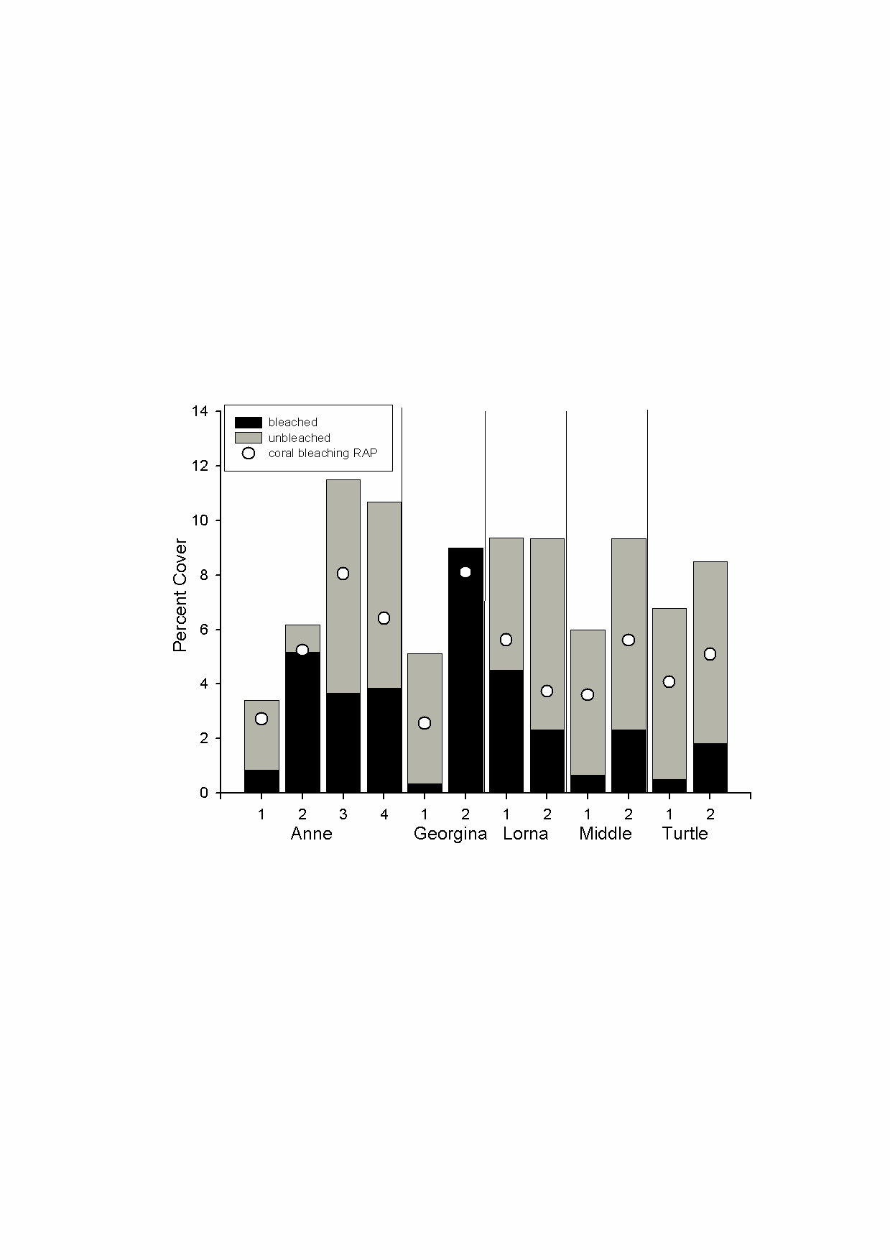
Figure 21: Per cent cover of hard coral at all sites surveyed at Lihou Reef Reserve. For each site two estimates of the proportion of bleached hard coral are shown. The black fill on the bar represents the bleaching estimated from the video transects and the white circles represent the estimates made using the Rapid Assessment Protocol (RAP).
Source: (Figure 18 from AIMS 2004 survey report by Oxley et al. 2004)

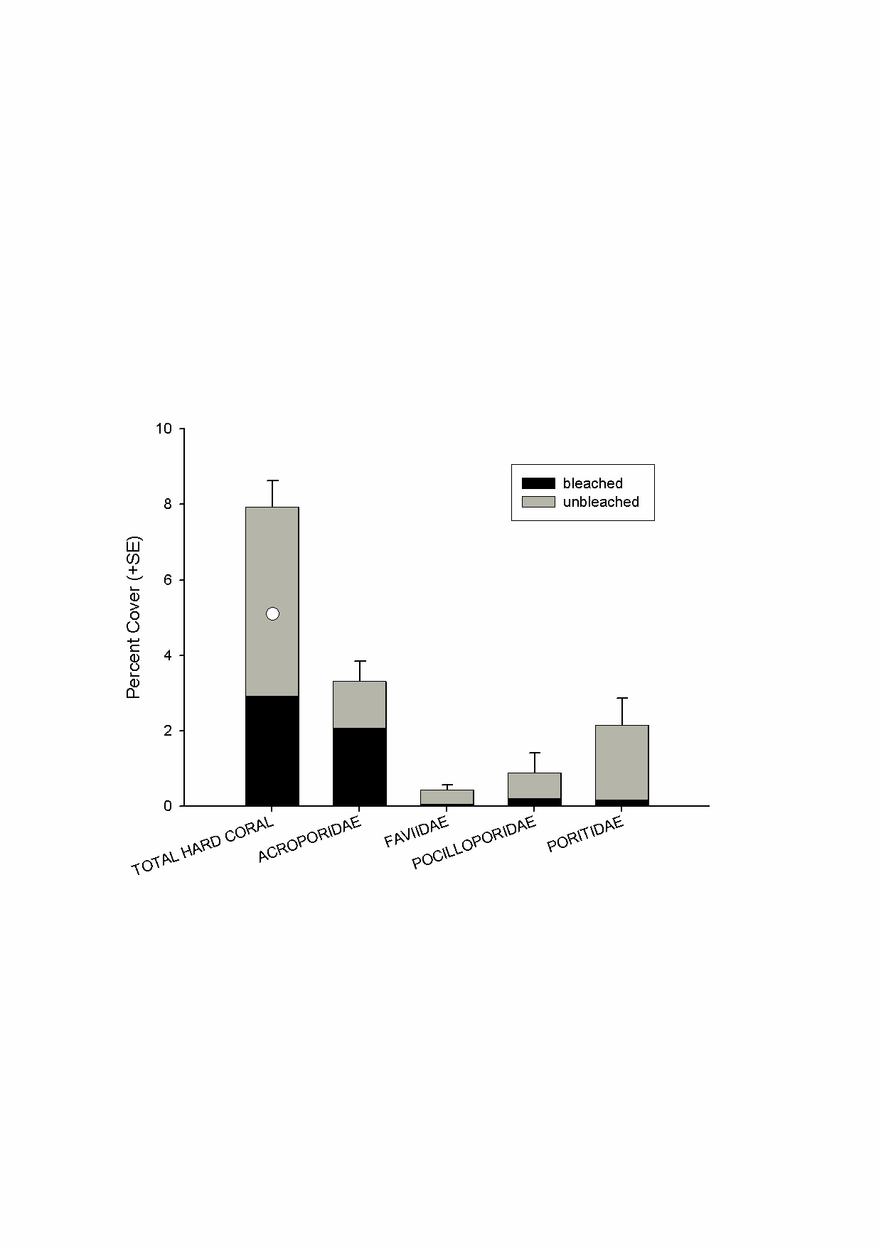

Figure 22: Average total hard coral and average coral cover of the top four families at Lihou Reef Reserve. Black shading indicates the proportion of bleaching within each of the categories. Error bars are standard errors. The white circle on the total hard coral bar represents the average relative proportion of bleaching determined during the Rapid Assessment Protocol (RAP) surveys, which covered a larger depth range than the video transects. Source: (Figure 19 from AIMS 2004 survey report by Oxley et al. 2004)

Coral bleaching at Georgina Cay. (From AIMS report by Oxley et al, 2004)

Impact of scale insect on the Pisonia forest on Coringa South West Islet.
Photographs kindly provided by Mark Hallum.

“Below are a before and an after photo from Coringa Islet which graphically show the massive changes that took place in a few years:

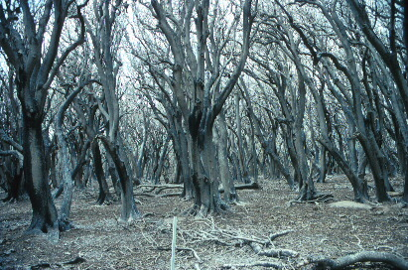

Coringa Islet Pisonia forest – September, 1991

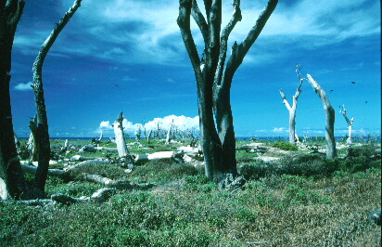

Coringa Islet Pisonia forest – December, 1997
(NB: This is the same scene as above - the trees still standing here in 1997,
had fallen down by the time of our December 1999 patrol visit)

Mark Hallam - Marine Protected Area Section, 17 January, 2001.”

3.7 Ecological character management benchmarks (Step 7), key knowledge gaps and recommended monitoring

Based on the information presented in Sections 3.4 and 3.5, the following are the ecological character management benchmarks for this Ramsar site, based on the currently available knowledge (see ‘Important note’ in Section 2, page 3).

Table 21: Ecological character management benchmarks, key knowledge gaps and recommended monitoring

Ecosystem service | Quantitative description | Typical range of variability and limits of acceptable change (LACs) | Key knowledge gaps and recommended monitoring
1: Representative of a unique ecosystem in the bioregion | Aerial extent of habitats:  See comment above regarding geomorphological categories for both reefs, as given in Table 4.  Other notable species or groups thereof: see Ecosystem services 2-6 below. | LAC: insufficient information. | Key knowledge gaps:  The areal extent of the broad habitats, how these relate to the geomorphological categories, and the more detailed breakdown of niches and habitats, including the reef benthos communities.  Monitoring: The areal extents of the broad habitats and the reef benthos communities. It should be possible to do this in part by using remote sensing, with complementary ground-truthing. Bi-annual assessments should be adequate.
2: Supports threatened species – marine turtles | Coringa-Herald Nature Reserve:  Green turtles:  The review of nesting turtle data provided by Harvey et al (2005) indicates annual census numbers ranging from 12 – 1393 across the 1991-2 to 2001-2 breeding seasons.  For Chilcott Islet, North-East and South-West Herald Cay and South-West Coringa Islet, across the period 1991-2 to 2003-4 (no survey in 1992-3), a total of 6,193 turtles were recorded at the major nesting sites, over 173 nights of recording.  Harvey et al (2005) also provide data on a range of other nesting-related attributes (inter-nesting interval, hatchling success, Curved Carapace Length, etc), however, as noted above, a review of the sea turtle monitoring program is underway at present, and it is expected this will recommend future approaches to data collection that will help to better document population trends in this breeding population.  Hawksbill turtles: No quantitative data of their occurrence in the reserve is available.  Lihou Reef Reserve:  Knowledge gap. | Coringa-Herald Nature Reserve  Interim LACs (See Important Notes – page 4 – in relation to external impacts on species such as turtles and seabirds):  Green turtles:  The high variation in breeding numbers recorded (see at left) makes nominating an LAC, even an interim one, impossible at this time.  Hawksbill turtles:  Knowledge gap.  Lihou Reef Reserve:  Knowledge gap. | Key knowledge gaps:  Size and natural fluctuations in these breeding and foraging populations.  Location of and extent of primary breeding and feeding habitats.  Nesting studies – identify peak in nesting season through established ongoing surveys at same periods each year. Gather information on nesting numbers, nesting success, hatching success, genetic composition.  Monitoring * : Over a minimum 5 year time frame, regular surveys and focused assessments at key times to help address the knowledge gaps and provide for more robust LACs. See the recommendations contained in Harevey et al (2005).  *The Marine Protected Area Management Section of DEH is currently conducting a review (through a consultancy) into the sea turtle and seabird monitoring programs that have been conducted in the Coringa-Herald Reserve. The outcome of the review will include a recommendation for the optimal design of the sea turtle and seabird monitoring programs within the reserves scheduled to be implemented from the 2006 season.
3(a): Supports high species diversity – marine molluscs | Coringa-Herald Reserve  745 species of mollusc have been recorded at North-East Herald Cay. However no data on species abundance is available.  Lihou Reef Reserve  Knowledge gap | Interim LAC:  No loss of observed species, and any additional species observed in future surveys across the whole site. | Key knowledge gaps:  Habitat needs and population dynamics of species.  Monitoring: Over a minimum 5 year time frame, regular surveys and intensive assessments at key times to help address the key knowledge gaps and provide for more robust LACs.
3(b): Supports high species diversity - fish | Coringa-Herald Reserve  A 2003 survey of the North-East Herald Cay (Oxley et al) recorded 342 species of fish – see Table 9.  Lihou Reef Reserve  294 species of fish with a community similar to that at Coringa-Herald Reserve. | Interim LAC:  No loss of observed species, and any additional species observed in future surveys at both reserves.  With further surveys to establish natural variabilities, it should be possible to use abundance and species richness data, such as that provided in Tables 9 and 10 and Figures 10-14 below to develop LACs. | Key knowledge gaps:  Habitat needs and population dynamics of species.  Lack of information on sharks, pelagic fishes, potential endemic species that could serve as indicators of system condition.  Monitoring: Over a minimum 5 year time frame, regular surveys (at least yearly) and intensive assessments at key times to help address the key knowledge gaps and provide for more robust LACs.  Data comparison with a control site such as Lord Howe Island.
3(c): Supports high species diversity - decapod crustaceans | Coringa-Herald Reserve  125 species (North East Herald Cay) including six semi-terrestrial and terrestrial species (see above).  Lihou Reef Reserve  Knowledge gap. | Interim LAC:  Coringa-Herald Reserve  No loss of observed species, and any additional species observed in future surveys in the reserve.  Lihou Reef Reserve  Knowledge gap. | Key knowledge gaps:  Habitat needs and population dynamics of species.  Monitoring: Over a minimum 5 year time frame, regular surveys and intensive assessments at key times to help address the key knowledge gaps and provide for more robust LACs.
3(d): Supports high species diversity – marine algae | Coringa-Herald Reserve  66 species (Millar 2001, in the RGSofQ report); 41 species of red algae, 23 of green algae and two of brown algae were recorded. Halimeda spp is a prominent feature of the benthic habitat.  Lihou Reef Reserve (Oxley et al. 2004)  Knowledge gap | Interim LAC:  Coringa-Herald Reserve  No loss of observed species, and any additional species observed in future surveys in the reserve.  Lihou Reef Reserve  Knowledge gap.  With further surveys to establish natural variabilities, it should be possible to use benthic cover data, such as that provided in Figure 15 below to develop LACs. | Key knowledge gaps:  Habitat needs and population dynamics of species.  Monitoring: Over a minimum 5 year time frame, regular surveys and intensive assessments at key times to help address the key knowledge gaps and provide for more robust LACs.
3(g): Supports high species diversity - hydroids | Coringa-Herald Reserve  A 1997 survey of intertidal and subtidal habitats (Preker, 2001 in the RGSofQ report) of the North East Herald Cay recorded 55 species of hydroid (9 of which have not been previously recorded in Australian waters).  Lihou Reef Reserve  Knowledge gap | Interim LAC.  Coringa-Herald Reserve  No loss of species recorded in surveys to date within the habitats specified by Preker 2001; namely: beachrock, shallow reef flat, lagoon, patch reef in shallow water (<10m), patch reef in medium-depth water (10-20m) and patch reef in deep waters (>25m).  Lihou Reef Reserve  Knowledge gap | Key knowledge gaps:  Habitat needs and population dynamics of species.  Monitoring: Over a minimum 5 year time frame, regular surveys and intensive assessments at key times to help address the key knowledge gaps and provide for more robust LACs.
3(f): Supports regionally high species diversity – bêche-de-mer (sea cucumbers) | Coringa-Herald Reserve  Average densities of six holothurian species recorded in reef flat and back reef habitats by the 2003 AIMS survey are shown in Tables 11 and 12, respectively.  Lihou Reef Reserve  Average densities of four holothurian species recorded in back reef habitat by the 2004 AIMS survey are shown in Table 13. | Interim LAC:  No loss of observed species, and any additional species observed in future surveys in the reserves.  With longer term data sets it may be possible to set abundance-related LACs as well, especially for those species considered in the AIMS 2003 and 2004 surveys – See Tables below. | Key knowledge gaps:  Habitat needs and population dynamics of species.  Monitoring: Over a minimum 5 year time frame, regular surveys and intensive assessments at key times to help address the key knowledge gaps and provide for more robust LACs.
3(g): Supports high species diversity - sponges | Coringa-Herald Reserve  See Figure 15 under Ecosystem service 3(d) marine algae, and Table 14 below. These provide preliminary estimates on the per cent benthic cover of sponges.  Lihou Reef Reserve  See Table 15 below which provides estimates on benthic cover from 1984 and 2004. | Interim LAC:  No loss of observed species, and any additional species observed in future surveys in the reserves.  With longer term data sets it may be possible to set benthic cover-related LACs as well. | Key knowledge gaps:  Habitat needs and population dynamics of species.  Monitoring: Over a minimum 5 year time frame, regular surveys and intensive assessments at key times to help address the key knowledge gaps and provide for more robust LACs.
3(h): Supports high species diversity - soft and hard corals | Coringa-Herald Reserve  A 1997 survey (Byron et al. 2001) of the North-East Herald Cay recorded 99 species of hard coral; and  Oxley et al. 2003 report 99 species of hard coral and 9 genera of soft coral.  See Table 16 below for details of the most commonly recorded hard corals.  See Table 14 (above) for mean benthic cover estimates, and how these compare between 1984, 1997 and 2003.  Lihou Reef Reserve  100 species of hard coral were recorded in 2004 and two genera of soft coral.  See Table 17 below for details of the most commonly recorded corals.  See Table 15 (above) for mean benthic cover estimates, and how these compare between 1984 and 2004. The declines in cover are thought to be the product of coral bleaching (see section 3.6), cyclones, storm wave action and disease following after bleaching events (AIMS, 2003 report). In section 3.6, data are presented for Lihou reef showing per cent cover of hard coral at several sites, and the proportion of this observed to be bleached. | Interim LAC:  No loss of observed species, and any additional species observed in future surveys in the reserves.  With longer term data sets it may be possible to set diversity and per cent cover-related LACs as well.  Given the apparent declines reported in the 2003 and 2004 AIMS surveys, repeat surveys are recommended as a matter of urgency. | Key knowledge gaps:  Habitat needs and population dynamics of the soft and hard coral species.  Monitoring: Over a minimum 5 year time frame, regular surveys (at least yearly) and intensive assessments at key times to help address the key knowledge gaps and provide for more robust LACs. Repeat of surveys at the sites used by AIMS in 2003 and 2004 is needed to apply the interim LAC.  Data comparison with a control site such as Lord Howe Island.
3(i): Supports high species diversity - seabirds | See Ecosystem service 6 below.
4: Supports significant forest of Pisonia grandis in the bioregion | Pisonia grandis forests covered (prior to 1993), approx. 16 ha on both Coringa South West Islet and North East Herald Cay, and, 2 ha on South East Magdelaine Cay. It is no longer present on Coringa South West Islet due to scale insect – see Sections 3.6 and 3.8.  Current aerial extent not known – see comment above about scale insect impacts. | Interim LAC:  No further loss of the Pisonia grandis forests, and preferably to see re-establishment of those areas lost. | Key knowledge gaps:  Vulnerability of the Pisonia forest to re-establishment of the scale insect.  Time-frame for re-establishment of lost Pisonia, if at all.  Monitoring: Continue current monitoring effort answer the above knowledge gaps.
5: Supports animal taxa at a vulnerable or critical stage of their lifecycle | (a) breeding Green turtles – see ecosystem service 2;  (b) nursery area of fish with open-water adult stages - – see ecosystem service 3(b); and,  (c) breeding seabirds – see ecosystem service 6
6: Supports large numbers of waterbirds - seabirds | Coringa-Herald Reserve  Baker# et al (2004) report the findings of annual seabird surveys on North East Herald Cay since 1992. These surveys were timed to coincide with periods of peak breeding activity for three species; Red-footed booby, Least frigatebird and Greater frigatebird. This monitoring has been done with great rigour and so provides robust data for the purpose of setting LACs (see at right).  Baker# (Pers. Comm.., 2006) notes; “Frigate birds have declined by more than 20% since 1998. We’ve been waiting for recovery to pre-1998 levels but the 2005 figure was 761pairs. This is now being interpreted as a population decline from the 1990s when 3,000 to 3,500 pairs bred each year, to a level which has since stabilised at around 1500 annual breeding pairs. The causes for this decline have not been determined as yet, but are believed to be related to oceanographic changes”  # Note – as indicated on page ii, Barry Baker of DEH is also a peer reviewer of this report.  Lihou Reef Reserve  Knowledge gap | Interim LACs (for North East Herald Cay):  (See Important Notes – page 4 – in relation to external impacts on species such as turtles and seabirds)  Red-footed Booby (see Figure 16 below).  A difference of 20% between any two five-year periods in the mean number of breeding pairs will be strong evidence of a systematic change and hence a reason for concern.  Masked Booby, Frigatebirds, Red-tailed Tropicbird and Black Noddy  As for Red-footed Booby. See Figures 17 -19 below.  Buff-banded Rail and Purple swamphen:  Knowledge gap | Key knowledge gaps:  Habitat needs and population dynamics of species.  Better understanding of seabird breeding on Lihou Reef.  Monitoring*: Continue current monitoring effort as documented in Baker et al, 2004 in order to further strengthen the LACs.  *The Marine Protected Area Management Section of DEH is currently conducting a review (through a consultancy) into the sea turtle and seabird monitoring programs that have been conducted in the Coringa-Herald Reserve. The outcome of the review will include a recommendation for the optimal design of the sea turtle and seabird monitoring programs within the reserves scheduled to be implemented from the 2006 season.
Key component or process
1. Available habitat types, geomorphology and substrate | As advised under Ecosystem service 1 in Section 3.4, the aerial extent of the geomorphological categories has been estimated. However, this has not been ground truthed nor correlated with habitat types as yet. | See comment at left. LAC cannot be set at present. | Key knowledge gaps:  See Ecosystem service 1 above.
2. Food sources and productivity | While dietary habits are known for many of the notable species or species groups considered in Section 3.4, it is not possible to quantify this in a meaningful way for this exercise. | It is not possible to set LACs for the various food sources referred to at left as there is little or no know data at present. | Key knowledge gaps:  Future surveys undertaken in relation to each notable taxa or group will clarify dietary needs and allow for better understanding of the food webs within this ecosystem.
3. Water temperature and water quality | Coringa-Herald and Lihou Reefs experience annual sea surface temperatures ranging from approx 24°C to 29 °C. Higher sea surface temperatures were recorded regularly from 1999 onwards, this resulting in extensive coral bleaching. See Figures 20-22 below. | Water temperatures exceeding 35ºC are considered lethal for most marine species. Lower temperatures (31-32ºC) experienced for several days can also be lethal.  Oxley et al , 2004 report that the AIMS survey of Lihou Reef in March 2004 took place while a bleaching event was underway. Water temperatures at the time were up to 31°C at 9m depth, despite strong winds and large swells that could be expected to mix the water column. Figures 21 and 22 reflect the seriousness of the bleaching at Lihou Reef. The AIMS survey estimated, using their Rapid Assessment Protocol, that 65% of the hard coral cover (at the Reserve level) was bleached. The figure varied between cays, reef habitats and coral family groups – see Figures 21 and 22.  Coral bleaching is beyond the direct control of the site managers and so no LAC is indicated. However, as highlighted in section 3.8, it poses a serious threat to the ecological character of the Ramsar site and therefore warrants close monitoring. | Key knowledge gaps:  Establish the water quality tolerances of key biota, starting with the species and groups considered ‘Ramsar significant’ (ie those addressed in this report).  Monitoring:  Continue to monitor see surface temperature.  Ideally – 1 year of continuous data logging on turbidity or light meters at a number of key habitat zones (Outer reef slopes, reef crests and lagoons).  Week of intensive measuring (conducted annually) of dissolved oxygen profiles and nutrients (TN, NH₄, NO_{x}, TP, PO₄, SiO₄) at a number of sites in the lagoon.
4. Terrestrial vegetation – Pisonia forest | As noted under Ecosystem service 4 in section 3.4, the Pisonia forest supports large rookeries of seabird such as Red footed boobies, Least and Great frigatebirds, Common and Black (Anous minutes) noddies. The forest has been under threat from the soft scale insect (Pulvinaria urbicola), especially on Coringa South West Islet where all 16 ha was destroyed between 1993 and 2000 (Smith et al, 2004). Both other islets with Pisonia (North East Herald Cay and South East Magdelaine Cay) also have infestation with scale insects, although the introduction of natural predators of the scale (the ladybird, C. montrouzieri, and the parasitoids C. ceroplastae, E. flavithorax and M. luteolus) have seen it controlled.  Another threat to this forest type is from defoliation by hawkmoths (Hippotion velox (Fabricus) and Theretia sp.). | Interim LACs (as per Ecosystem service 4 in section 3.4):  No further loss of the Pisonia grandis forests, and preferably to see re-establishment of those areas lost. | See above under Ecosystem service 6.

3.8 Threats, risks and monitoring

The foregoing section set out the (interim) ecological character management benchmarks for the Coral Sea National Nature Reserves Ramsar site, and recommended monitoring approaches to gain insights into the condition of the ecosystem over time. Related to this is the issue of threat mitigation and risk management; these being factors that can alter ecological character if not addressed.

For this site the following are recognised as the primary threats. While some are more regional in scope, they have been included here for the sake of completeness.

Table 22: Threats, risks and monitoring

Threats | Qualitative description | Risk to ecosystem services as specified in the Table in Section 3.4 | Key knowledge gaps and recommended monitoring
Scale insect Pulvinaria urbicola | The former forest on South-West (Coringa) Islet was extensively damaged, reduced to herbfield, by an outbreak of the scale insect Pulvinaria urbicola in 1991; scale insect attack is now monitored. See Ecosystem service 6. | The loss of Pisonia forest impacts especially on those seabirds that use it for breeding purposes. Threats are to Ecosystem services 4, 5(c) and 6. | Key knowledge gap: See Ecosystem service 6 in Table 21.  Monitoring: See Ecosystem service 6 in Table 21.
Defoliation by Hawkmoths | Another threat to the Pisonia forest is from defoliation by hawkmoths (Hippotion velox (Fabricus) and Theretia sp.). – see Ecosystem service 4 in section 3.4 and Key component of process 4in Table 21. | The defoliation of Pisonia forest impacts especially on those seabirds that use it for breeding purposes. Threats are to Ecosystem services 4, 5(c) and 6. | Key knowledge gaps: The long-term impact this may have on P. grandis forest distribution, and, in turn on the abundance of dependent breeding seabirds.  Monitoring: Continue current monitoring effort to answer the above knowledge gaps.
Thermal anomalies and coral bleaching | Repeated incidences of pan-tropical coral bleaching, and global sea temperature rises are a particular concern for these wetland habitats in the Coringa-Herald and Lihou Reefs.  See Table 20 in Section 3.6 for about this issue. | Higher than normal sea surface temperatures have the potential to cause coral bleaching and possibly impact on some other marine biota.  Threats are to Ecosystem services 3 (h) and indirectly to most others.  See also Section 3.6, critical component 3 – water temperature. | Key knowledge gap: Impact on endemic flora and fauna and significant ecological communities.  Monitoring: While thermal anomalies are beyond the scope of the site managers, ongoing monitoring of sea surface temperatures may help gain a better understanding of climate change phenomenon regionally and globally.  Regular monitoring of the impact of past and future coral bleaching events on the coral and other benthic species should be a very high priority, as it could fundamentally alter ecological character, if it has not done so already.
Cyclones and increased frequency and severity of storms | Cyclones have been suggested as possible causes of drastically reduced coral cover and consequent impacts on fish abundance and species richness, particularly on the exposed reef crest and front slope (Ayling & Ayling 1984; Royal Geographical Society of Queensland 2001).  These can also impact on the Pisonia forest | Threats are to Ecosystem services 3, 4 and 6. | Monitoring: Cyclones and storms are beyond the control of the site managers. Post-cyclone and storm impacts should be recorded (where possible), and then recovery monitored as appropriate.  Data should also be collected to assess long-term trends in cyclone and storm frequency and severity and the interval between events.
Sea level rise | Global sea level rises would directly threaten these very low lying atolls and cays, through direct inundation, increased wave action etc. | Sea level rises could significantly alter much of the ecological character of this site, and impact on most of the ecosystem services. | Monitoring: Data collected to detect changes to sea level. The impacts this may have on ecological character will be measured by the other monitoring in place.
Beach erosion | In 1997, a survey of North East (Herald) Cay recorded that the windward beach was actively eroding. This was leading to destabilisation of the fringing Argusia shrubland that provides a windbreak for the P. grandis forest. Some forest areas have already been destroyed as a result, and it is possible that if erosion continues the forest will gradually be replaced with grassland. | This could have implications for the terrestrial ecology of the cay, particularly the composition of the nesting seabirds, and the hatching success and sex ratios of breeding Green Turtles (Royal Geographical Society of Queensland 2001).  Threat is to Ecosystem services 3(i), 4, 5© and 6. | Key knowledge gaps: The long-term impact this may have on the Argusia shrubland and P. grandis forest distribution, and , in turn on the abundance of dependent breeding seabirds.  Monitoring: Ongoing monitoring to remain aware of the possible expansion or escalation of this beach erosion.
Crown of thorns star-fish (COTS) | Several Crown-of-thorns Starfish Acanthaster planci, have been observed within the site, however it seems they do not currently occur in numbers sufficient to cause disturbance to the indigenous reef fauna (Royal Geographical Society of Queensland 2001). | The serious impact COTS can have on coral communities is well documented from other sites, such as the Great Barrier Reef.  Threat is to Ecosystem services 1 and 3(h) in particular. | Key knowledge gaps: The distribution and abundance of this species across the two reefs and the current status of that population (stable, declining, increasing).  Monitoring: Ongoing monitoring to remain aware of the possible spread and impact of the COTS on this ecosystem.  This would include: routine monitoring and estimation of COTS densities; comparison of densities with historical estimates; correlation with estimated coral cover; and assessment of size frequency distributions (temporal patterns in recruitment and an early warning of potential outbreaks).
Illegal fishing | This is potentially an issue for this site, especially in relation to bêche-de-mer. Commercial fishing is banned, although this may not totally preclude illegal take. | Threat is to Ecosystem services 3(b), (c) and (f) in particualr. | Monitoring: Is undertaken as part of ongoing management arrangements.
Illegal collection of fish for the aquarium trade | The reefs have many species considered attractive to the aquarium trade. | Small scale collecting may not have a serious impact on ecological character, but would be a concern nonetheless.  Threat is to Ecosystem service 3(b) | Monitoring: Is undertaken as part of ongoing management arrangements.
Disturbance to seabird and turtle breeding colonies | Human visitors could impact on these breeding areas by trampling, noise, fire, handling wildlife etc. | Threats are to Ecosystem services 2 and 6 in particualr. | Monitoring: See advice under Ecosystem services 2 and 6 in Table 21.
Anchor damage | Service and enforcement vessels as well as other visitors, authorised (scientific) or illegal (fishing – see above), may cause damage to coral areas with indiscrete use of anchors. | Coral damage.  Threats are to Ecosystem services 1-3. | Monitoring: Monitoring of vessel numbers using and not using moorings and the impact the latter is having on the coral communities in those locations.
Ballast water and other pollution | There is the potential to impact on the ecology of the reefs through the release of ballast waters, and other pollutants by service and enforcement vessels as well as other visitors, authorised (scientific) or illegal (fishing – see above). Other vessels passing nearby could deposit disused nets or other rubbish. | Ballast water could introduce marine pest species, and other pollutants (eg. discarded fishing nets) could cause mortalities among the marine biota.  Threats are to Ecosystem services 1-6. | Monitoring: Is undertaken as part of ongoing management arrangements.
Shipping accidents | Modern shipping routes pass relatively close to the reefs and pose a potential risk of direct grounding and/or pollution from oil spills. | Threats are potentially to all Ecosystem services. | Monitoring: Is undertaken as part of ongoing management arrangements.
4. Cited references and further reading

Ayling, A.M. and Ayling, A.L., 1985. Coral Sea Surveys. Unpublished Report to Australian National Parks and Wildlife Service, Canberra.

Baker, G.B., Hallam, M. and Double, M. 2003. Seabird monitoring program - Coral Sea Island Territory. Report on 2002 field season and update of Herald Cays longitudinal datasets for the period 1992 to 2002.

Baker, G.B. Personal communication, 2006.

Batianoff, G.N., 2001. Observation of tropical seabird breeding sites and utilisation of seashore plants on North East Cay (Herald Cays), Coral Sea. In: Herald Cays Scientific Study Report. Royal Geographic Society of Queensland Geography Monograph Series N0. 6. Brisbane, Queensland. pp. 11-20.

Brinkman, R., Wolanski, E., Deleersnijder, E., McAllister, F. and Skirving, W., 2001. Oceanic Inflow from the Coral Sea into the Great Barrier Reef. http://www.aims.gov.au/ibm/pages/research/oceanic-inflow.html

Byron, G., Malcolm, H. and Thompson, A.A., 2001. The benthic communities and associated fish faunal assemblages of North East Cay, Herald Cays, Coral Sea. In: Herald Cays Scientific Study Report. Royal Geographic Society of Queensland Geography Monograph Series N0. 6. Brisbane, Queensland. pp. 33-68.

Davie, J.F. and Short, J.W., Decapod crustacean of North East Cay, Herald Cay, Coral Sea. sIn: Herald Cays Scientific Study Report. Royal Geographic Society of Queensland Geography Monograph Series N0. 6. Brisbane, Queensland. pp. 75-86.

DEH, 2001. Coringa-Herald National Nature Reserve and Lihou Reef National Nature Reserve Management Plan. Environment Australia, Department of the Environment and Heritage, Canberra. 52pp.

DEH, 2004. Species Profile and Threats Database (SPRAT) http://www.environment.gov.au/cgi-bin/sprat/public/sprat.pl (updated link, 2010).

DEWHA Australian Wetlands Database (updated 2010)
http://www.environment.gov.au/cgi-bin/wetlands/ramsardetails.pl?refcode=59#)

DSE, 2005. Framework for describing the ecological character of Ramsar Wetlands, including a description of the ecological character of Barmah Forest Ramsar Site. Department of Sustainability and Environment, Victoria.

Hallam, Mark, Personal communication, 2006.

Harvey, T., Townsend, S., Kenyon, N., and Redfern, G. 2005. Monitoring of Nesting Sea Turtles in the Coringa-Herald National Nature Reserve (1991/92-2003/04 nesting seasons). A report to the Department of the Environment and Heritage: October 2005).

Jaensch, R., Long, W.L. and Jenkins, A., 2002. Ramsar Information Sheet for Coral Sea Reserves (Coringa-Herald and Lihou Reefs and Cays). Accessed 27 March 2006, online at
http://www.wetlands.org/RSDB/_COP9Directory/Directory/ris/5AU060en.pdf

Millennium Coral Reef Mapping Project, Institute for Marine Remote Sensing at University of South Florida (Imars/USF), USA, and Institut de Recherche pour le Developpement (IRD) at Noumea, New Caledonia. Landsat images NASA/USGS. Processing: S. Andrefouet (IRD)/C. Kranenburg (IMARS/USF).

Miller, J.D., 1977. Reproduction in Sea Turtles. In: Lutz, P.L., Musick, J.A. (eds). The Biology of Sea Turtles. CRC Press. Boca Raton. pp 51-81.

Miller, J., Bell, I., Craven, S., Dobbs, K., Koloi, P. and Mattocks, N., 2001. Marine Turtle Research in the Coringa-Herald National Nature Reserve: Synthesis of 7 years of data 1991-1998, Queensland Parks and Wildlife Service, Queensland.

Moritz, C., Broderick, D., Dethmers, K., FitzSimmons, N., and Limpus, C., 2002. Population Genetics of Southeast Asian and Western Pacific green turtles, Chelonia mydas. Final report to UNEP/CMS. pp 42.

Neil, D. and Jell, J., 2001a. Aspects of the climate and geomorphology of North-East Herald Cay and its reef: a preliminary report. In: Herald Cays Scientific Study Report. Royal Geographic Society of Queensland Geography Monograph Series N0. 6. Brisbane, Queensland. pp. 131-142.

Neil, D. and Jell, J., 2001b. Pisonia grandis ecosystem stability in response to geomorphic change: an hypothesis. In: Herald Cays Scientific Study Report. Royal Geographic Society of Queensland Geography Monograph Series N0. 6. Brisbane, Queensland. pp. 143-150.

Oxley, W.G., Ayling, A.M., Cheal, A.J. and Thompson, A.A., 2003. Marine surveys undertaken in the Coringa-Herald National Nature Reserve, March-April 2003. Australian Institute of Marine Science.

Oxley, W.G., Emslie, M., Muir, P. and Thompson, A.A., 2004. Marine surveys undertaken in the Lihou Reef National Nature Reserve, March 2004. Australian Institute of Marine Science.

Royal Geographic Society of Queensland, 2001. Herald Cays Scientific Study Report. Geography Monograph Series N0. 6. Brisbane.

Smith, J., 1994. Patterns of disseminule dispersal by drift in the north-west Coral Sea, New Zealand Journal of Botany, Vol. 32: 453-461.
Appendix A

Information Sheet on Ramsar Wetlands
Categories approved by Recommendation 4.7 of the Conference of the Contracting Parties.

- Date this sheet was completed/updated:
October 2002.

2. Country: Australia

3. Name of wetland: Coral Sea Reserves (Coringa-Herald and Lihou Reefs and Cays)

4. Geographical coordinates: The site includes the following major components:

Coringa-Herald National Nature Reserve:
Herald Cays – Latitude: 16° 58' S; Longitude: 149° 08' E;
Coringa Islets – Latitude: 16° 56' S; Longitude: 150° 00' E; and
Magdelaine Cays – Latitude: 16° 30' S; Longitude: 150° 17' E.

Lihou Reef National Nature Reserve:
A horseshoe-shaped line of cays and reefs from
Nellie (No. 9) Cay – Latitude: 17° 39' S; Longitude: 151° 18' E, to
Licklick Cay – Latitude: 17° 07' S; Longitude: 152° 11' E.

5. Altitude: Wetland areas within the site are situated at, and several metres below, mean sea level. Small islands and sand cays within the site have an elevation of no more than 5 metres above mean sea level.

6. Area:
Total area of Coral Sea Reserves: 1,729,200 ha
Coringa-Herald National Nature Reserve 885,600 ha
Lihou Reef National Nature Reserve 843,600 ha

The site boundary corresponds to the boundaries of Coringa-Herald National Nature Reserve (885,600 ha, including a 124 ha terrestrial component), and Lihou Reef National Nature Reserve (843,600 ha, including a 91 ha terrestrial component).

The total area of cay-associated wetland (primarily fringing reef) within the Reserves is estimated to be 10,600 ha, approximately 3,700 ha in Coringa-Herald National Nature Reserve and 6,900 ha in Lihou Reef National Nature Reserve. The estimate for Lihou Reef includes only a small proportion of the interior of the lagoon: the lagoon comprises in the order of 300,000 ha of water of varied depth. For both Reserves, the estimated area of wetland includes some water more than 6.0 metres deep at low tide.

7. Overview:
The site comprises oceanic islet and reef habitats that are representative of the Coral Sea region and are in near-pristine condition. Several islets within the site comprise undisturbed sandy habitat used for nesting by the globally endangered Green Turtle Chelonia mydas, along with forest and shrubland that supports important breeding populations of terns and other seabirds. Coral reef habitat within the site supports a distinct community of marine benthic flora and fauna, a relatively rich diversity of decapod crustacean and hydroid fauna, and significant feeding habitat for migratory shorebirds and seabirds.

8. Wetland Type:
marine-coastal: | A | B | C | D | E | F | G | H | I | J | K
inland: | L | M | N | O | P | Q | R | Sp | Ss | Tp | Ts
 | U | Va | Vt | W | Xf | Xp | Y | Zg | Zk
man-made: | 1 | 2 | 3 | 4 | 5 | 6 | 7 | 8 | 9

Please now rank these wetland types by listing from the most to the least dominant: C, E.

9. Ramsar Criteria: 2, 3, 4, 5 and 8.

1 | 2 | 3 | 4 | 5 | 6 | 7 | 8

Please specify the most significant criterion applicable to the site: 4.

10. Map of site included? Please tick yes ☑ -or- no.□

11. Name and address of the compiler of this form:
Roger Jaensch, Warren Lee Long & Aaron Jenkins,
Wetlands International – Oceania, GPO Box 787, Canberra ACT 2601, Australia.
Contact details (RJ): tel. = +61-7-3406-6047; fax. = +61-7-3896-9624; email = roger.jaensch@epa.qld.gov.au

12. Justification of the criteria selected under point 9, on previous page.

Criterion 2.
Green Turtle Chelonia mydas is listed as vulnerable under Australian Commonwealth legislation (Environment Protection and Biodiversity Conservation [EPBC] Act 1999), is classified as endangered on the IUCN Red List, and is protected under the Convention on International Trade in Endangered Species of Wild Fauna and Flora (CITES) to which Australia is a signatory. Green Turtle breed on sandy islets of the Coringa-Herald cluster and on 11 cays of Lihou Reef. Hawksbill Turtle Eretmochelys imbricata, also listed as vulnerable under the Australian EPBC Act, and classified as critically endangered on the IUCN Red List, has been sighted within the Reserves but has not been observed nesting (Environment Australia 2002c).

Criterion 3.
Formal inventories of wetland biodiversity in the Coral Sea are incomplete, and a biogeographic regionalisation for Australia’s oceanic territory has not been finalised. However, given the type of environment typically associated with isolated oceanic reefs, the site can be considered a ‘hotspot’ of biological diversity (Ramsar Convention 2002) within the Coral Sea. The limited scientific investigations of the site to date have recorded moderately large numbers of marine animal species (Environment Australia 2002c), including:
- 745 species of marine molluscs (representing 118 families, of which 87 are gastropods);
- 356 species of fish (54 families);
- 128 species of decapod crustaceans (includes some terrestrial species);
- 66 species of marine algae;
- 55 species of hydroid (representing 14 families);
- 29 species of waterbird (as defined by Ramsar: see Annex); and
- corals, starfishes, brittle stars, feather stars, sea urchins, sea cucumbers and other invertebrate groups not yet comprehensively surveyed (Environment Australia 2002c).

Nine of the decapod crustacean species recorded appear not to have been previously described, and therefore may be endemic to the site. Furthermore, 17 of the decapod crustacean species and nine of the hydroid species have not been recorded elsewhere in Australian waters (Environment Australia 2002c).

Criterion 4.
The sandy cays of the site support important breeding colonies of Green Turtle. Genetic studies have indicated that the nesting population of Green Turtle within the site are of the same genetic stock as Green Turtle in the Great Barrier Reef and Torres Strait (Environment Australia 2002c). Therefore, it is possible that this highly migratory species is travelling between these locations. The nesting sites within the Coral Sea Reserves are particularly important as they are primarily free from disturbances including lighting, beach use, pollution, feral animals and boat traffic, which are current threats throughout the Great Barrier Reef. The site therefore provides reference against which the impact of such disturbances on Green Turtle populations can be measured.

The Coral Sea Reserves support breeding colonies of 14 seabird species, 12 of which (boobies, frigatebirds, tropicbirds and terns: see Annex) are defined by the Ramsar Convention as waterbirds. The seabirds gather from an extensive oceanic ‘catchment’ for breeding, which generally commences at the end of the cyclone season in March-April and continues during the cooler months. Therefore, the site is important to the ecological balance of the Coral Sea region (Environment Australia 2002c). Some of these seabird species have an extensive distribution outside of Australian waters, however have a limited distribution within Australia. The site therefore supports a significant proportion of the Coral Sea’s breeding populations. In 1997, a breeding population of 386 pairs of Red-tailed Tropicbird Phaethon rubricauda were recorded on North-East (Herald) Cay. This represents the largest-known breeding population of this species in the Coral Sea, and the second largest in Australia after Christmas Island, Indian Ocean (Royal Geographical Society of Queensland 2001, p. 70). In addition, at least eight species of migratory shorebirds, including the Pacific Golden Plover Pluvialis fulva and Ruddy Turnstone Arenaria interpres, use the site’s reefs and cays as migration stop-over areas (Environment Australia 2002c).

Furthermore, the site includes the only forested cays in the Coral Sea Islands Territory and the reefs, islands and associated habitats within the boundaries of the site provide the only habitat for a diverse community of sedentary reef-inhabiting animals within an extensive area of deep ocean. Conceivably, the reefs provide rare shelter for other species during severe storms.

Criterion 5.
Breeding waterbirds at the North-East (Herald) Cay have regularly been recorded in numbers in excess of 20 000 (Royal Geographical Society of Queensland 2001). This estimate includes a population of Black Noddy Anous minutus which has been recorded in numbers in the order of tens of thousands, with 37,000 active nests reported in 1984 (Royal Geographical Society of Queensland 2001, p. 71), in Pisonia forest associated with this Cay. Other breeding populations recorded at the North-East Cay include Least Frigatebird Fregata ariel (a few thousand pairs), Great Frigatebird F. minor (high hundreds), Red-footed Booby Sula sula (about 150 pairs in Argusia shrubland and 1000 pairs in the Pisonia/Cordia forest) and Red-tailed Tropicbird Phaethon rubricauda (up to 386 pairs; Royal Geographical Society of Queensland 2001, pp. 70-71). Data has not been collected for other cays within the site.

Criterion 8.
It is assumed that the productive shallow waters of the site’s reefs and lagoon are a significant nursery area for fishes that have open-water adult stages (Ramsar Convention 2002). Coral Sea reefs also act as aggregation areas for Bigeye Tuna Thunnus obesus - a target species in Australia’s Eastern Tuna and Billfish Fishery.

13. General location:
Coringa-Herald National Nature Reserve is located in the central Coral Sea, its centre is approximately 440 km east of Cairns (population approximately 100,000), Queensland. Lihou Reef National Nature Reserve is also located in the central Coral Sea, its centre being about 650 km east-south-east of Cairns and 200 km east-south-east of Coringa-Herald National Nature Reserve. The Reserves lie about 300 km north-east of the Great Barrier Reef. They are located within the Coral Sea Islands Territory, administered by the Commonwealth of Australia (see item 28).

14. Physical features:
The site is comprised of a series of oceanic islets and associated coral reefs, occurring on the Coral Sea (Queensland) Plateau. They represent one of the largest carbonate platforms in today’s oceans and are the dominant feature of the site.

Coringa-Herald National Nature Reserve includes three separate platform reef systems, each at a different stage of reef formation. Islets and cays supported by these reefs are the Herald Cays (South-West Cay, North-East Cay), Coringa Islets (Chilcott Islet, South-West Islet) and Magdelaine Cays (North-West Islet, South-East Cay). The islets and cays are composed of sand, rock and coral rubble and range from 16 to 37 ha in area. Each has a fringing coral reef fully exposed to the influences of oceanic currents and swells. Reef flats are up to 4 m deep and are composed of turf and coralline algae along with sponges and soft and hard corals.

Lihou Reef National Nature Reserve includes the largest reef structure in the Coral Sea (Environment Australia 2002c): the reef forms an incomplete loop with 18 small sand cays along its edge. The cays extend from Nellie Cay in the far south-west, eastward to Licklick Cay in the far north-east, thence westward to Juliette Cay. Lihou Reef is separated from the Coringa-Herald system by deep ocean.

The marine habitats present in the shallower areas of both Reserves are front (windward) reef slopes, exposed reef crests/rims, reef flats, back (leeward) reef crests, back reef slopes, reef shoals, and inter-reef channels. Lihou Reef has a lagoon habitat formed within the U-shaped structure of the reef system; detailed information on the habitats of the deeper lagoonal areas is not available.

Due to the tropical location and the oceanic influence, there is little variation in daily or annual temperatures at these Reserves. Annual air temperatures range between 21°C and 31°C. Mean daily temperatures during the two hottest months (December, January) range from a minimum of 25°C to a maximum of 31°C; for the coldest month (August), these data are 22°C and 26°C respectively. Data from Willis Islets, approximately 50 km north-west of Magdelaine Cays, indicate mean annual rainfall of 1094 mm with 68% falling between January and April (Royal Geographical Society of Queensland 2001; Bureau of Meteorology 2002). Wind energy and direction have a critical influence on sediment transport dynamics, cay location on reefs, and the distribution and growth of flora. South-east winds and swells are typical in the Coral Sea between March and November (windiest from April to September). North-west monsoons and cyclones occur in the summer months (December to March). Destructive winds and swells may occur during this period (Proh 1995; Royal Geographical Society of Queensland 2001).

Tidal range in the Coral Sea Reserves is approximately 2 m. The waters are a mix of warm, moderately saline equatorial water and cooler, more saline sub-tropical water. The salinity is constant at about 35.2 parts per thousand. The characteristics of salinity and temperature of the water are believed to be important to coral development.

15. Hydrological values:
The site comprises mostly isolated oceanic wetlands (coral reefs) with only small scattered islets of dry land. The islets are low (not exceeding 5 m above mean sea level) but have minimal freshwater lenses and perform no hydrological value with regards to this information category.

16. Ecological features:
Vegetation (23 plant species) occurs on all Coringa-Herald cays except North-West Cay, and on five of the Lihou cays (Turtle Islet and Georgina, Nellie, Lorna and Anne Cays: seven plant species). Grassland and herbfield communities occur in both Reserves; dominant grass species are Lepturus repens, Stenotaphrum micranthum and Sporobolus virginicus. Shrubland (open-scrub) of Argusia argentea occurs on the vegetated Coringa-Herald cays and low closed-forest of Pisonia grandis, with some Cordia subcordata, to 10 m height occurs on North-East (Herald) Cay and South-East (Magdelaine) Cay (Environment Australia 2002c; Royal Geographical Society of Queensland 2001). Although these are not wetland plant communities, some are important as habitat for breeding waterbirds (seabirds).

The marine habitats present in the shallower areas of both Reserves are front (windward) reef slopes, exposed reef crests/rims, reef flats, back (leeward) reef crests, back reef slopes, reef shoals, and inter-reef channels.

Marine algal communities are an important ecological feature of the site, frequently covering a greater area than the corals. During a 1997 preliminary survey of marine algae of North East (Herald) Cay, 66 species were recorded, though this is expected to be only a fraction of the total present. Forty-one species of red algae, 23 of green algae and two of brown algae were recorded. Halimeda spp., a calcified algae of warm seas, is a prominent feature of the benthic habitat. The near absence of brown algae is unusual for what appears to be a typical reef environment (Environment Australia 2002c). The apparent absence of seagrasses (from benthic survey data) is also unusual for reef platforms containing vegetated islands in the Western Pacific.

17. Noteworthy flora:
Pisonia grandis forest ecosystem is relatively uncommon, both in Australia and globally, despite having an extensive Indo-Pacific distribution. Throughout much of its range, P. grandis forests have been cleared for subsistence agriculture and guano mining. P. grandis forests are known to remain on only 44 (of 950) islands within the Great Barrier Reef region. The species is rare on reef islands in the north of this region and does not generally form monospecific stands. In this context, the P. grandis forests of Coringa-Herald are of intrinsic value. They also play a significant role in providing habitat for nesting waterbirds (seabirds). Some of the forest has suffered damage caused by cyclonic storms, scale insects and erosion of the islets (Environment Australia 2002c).

18. Noteworthy fauna:
The faunal assemblage of the site is distinctive for a number of reasons. Namely, sponges (family Spongiidae) form an important part of the reef fauna and often are more abundant than coral. This is markedly different to the shallow reefal areas of the Great Barrier Reef. In addition, hard corals cover a relatively small proportion of reef area compared to the hard corals of the Great Barrier Reef and other sites in the western Pacific. The site also supports a relatively rich diversity of decapod crustacean and hydroid faunas, and some of the fish species common at the site are rare or absent from the Great Barrier Reef, and vice versa.

Commonly occurring sponges in the site’s large and spectacular sponge gardens include Thorecta n. sp., Polyfibrospongia flabellifera, Phyllospongia n. subsp., Carteriospongia lamellosa, Carteriospongia n. sp., and C. pennatula. Phyllospongia pennatula, which had not been collected since 1889, is common at Chilcott Islet. The dominant hard corals of the site are Acropora palifera, A. humilis and Poecilopora spp. and the dominant soft corals are Sarcophyton sp. Two species of marine molluscs, Rissopsis typica and Cypraea childreni, are quite common at the site despite being rare over much of the rest of their range (Environment Australia 2002c).

Based on preliminary surveys of the site, the families of fishes with the greatest diversity of species are the Labridae (wrasses), Pomacentridae (damselfishes), Acanthuridae (surgeonfishes), Chaetodontidae (butterfly fishes), Serranidae (cods and coral trout), and Scaridae (parrotfishes) (Environment Australia 2002c).

Three non-colonial waterbirds—Eastern Reef Egret Egretta sacra, Buff-banded Rail Gallirallus philippensis tournelieri and Purple Swamphen Porphyrio porphyrio—breed at the site (Royal Geographical Society of Queensland 2001).

Non-waterbirds that use the site include 60,000 to130,000 breeding pairs, annually, of Wedge-tailed Shearwater Puffinus pacificus (Royal Geographical Society of Queensland 2001).

19. Social and cultural values:
The Coringa Islets were named after the cargo ship Coringa Packet, wrecked there in 1845. However, Lihou Reef appears to have been the site of more shipwrecks than the Coringa-Herald cays. There are several well-documented wrecks on Lihou Reef, dating back to the 1890’s. Shipwrecks located within the Reserves are protected under the Historic Shipwrecks Act 1976 if they are more than 75 years old.

Guano mining occurred on Chilcott Islet in the 1860s-70s and some relics remain from this enterprise (ANPWS, 1989a; Coleman, 1992).

20. Land tenure/ownership:
- Site
- Surrounding area
The Ramsar site comprises two separate National Nature Reserves that are owned by the Commonwealth Government of Australia. The Reserves and surrounding oceanic waters lie within the Coral Sea Islands Territory of Australia.

21. Current land use:
- Site
- Surroundings/catchment
The site is used for nature conservation and scientific research, also some recreational diving. There is no resident human population on the site or in surrounding areas. Surrounding areas support the commercial Coral Sea Fishery and Eastern Tuna and Billfish Fishery, which are managed by the Australian Fisheries Management Authority.

22. Factors (past, present or potential) adversely affecting the site's ecological character, including changes in land use and development projects:
- Site
- Around the site
The site is currently in near-pristine condition: no exotic species have been observed since the Black Rat Rattus rattus (1940s to 1991) was eradicated, and mining for guano (1860s-70s) has long ceased. The site is now subject to infrequent and largely benign visitation by humans. Human influences on or external to the site with the potential to adversely affect its ecological character include general marine pollution, oil spills associated with shipwrecks, impacts of anchoring and diving, disturbance to seabird and turtle breeding colonies, and introduction of exotic species. With the increasing availability of new technology, notably global positioning systems, human visits to the site may increase in the future.

Some natural factors have impacted the site’s ecological character. There are reports of cyclonic activity damaging areas of Pisonia grandis forest within the Coringa-Herald cluster during the 1980s. The former forest on South-West (Coringa) Islet was extensively damaged, reduced to herbfield, by an outbreak of the scale insect Pulvinaria urbicola in 1991; scale insect attack is now monitored. In 1997, a survey of North East (Herald) Cay recorded that the windward beach was actively eroding. This was leading to destabilisation of the fringing Argusia shrubland that provides a windbreak for the P. grandis forest. Some forest areas have already been destroyed as a result, and it is possible that if erosion continues the forest will gradually be replaced with grassland. This would have implications for the terrestrial ecology of the cay, particularly the composition of the nesting seabirds, and the hatching success and sex ratios of breeding Green Turtles (Royal Geographical Society of Queensland 2001).

Cyclones have also been suggested as possible causes of drastically reduced coral cover and consequent impacts on fish abundance and species richness, particularly on the exposed reef crest and front slope (Ayling & Ayling 1984; Royal Geographical Society of Queensland 2001). Repeated incidences of pan-tropical coral bleaching, and global sea temperature rises are a particular concern for these wetland habitats in the Coringa-Herald and Lihou Reefs.

Several Crown-of-thorns Starfish Acanthaster planci, have been observed within the site, however it seems they do not currently occur in numbers sufficient to cause disturbance to the indigenous reef fauna (Royal Geographical Society of Queensland 2001).

23. Conservation measures taken:
Coringa-Herald National Nature Reserve, and Lihou Reef National Nature Reserve, were proclaimed in August 1982 and are subject to provisions of the Commonwealth Environment Protection and Biodiversity Conservation Act 1999. Both Reserves are Category 1a Nature Reserves under the IUCN classification, meaning they are managed primarily for scientific research and environmental monitoring.

A comprehensive Management Plan for each Reserve came into effect in 1989; the Plans were amalgamated and updated in 2001 and will apply for the following seven years (Environment Australia 2002c). The strategic objectives of the Plan are: to protect, preserve and manage the natural and cultural values of the Reserves; to protect key breeding and nesting habitat for listed species such as Green Turtle and seabirds; to manage the Reserves as a reference site for scientific research and long-term monitoring; to allow for limited and appropriate public access to the Reserves for education and enjoyment; and to manage the Reserves as part of a comprehensive, adequate, and representative system of marine protected areas.

Activities such as scientific research, dive charter tours and other commercial activities are managed by use of permits. A limit of 10 commercial tours per year, with up to 30 passengers per tour, has been set. Visitor logbooks are maintained at the Reserves to monitor use of the site. Commercial and recreational fishing, fish-feeding, camping on the islets, bio-prospecting and operations for the recovery of minerals are not permitted during the period of the Plan. Staff of Environment Australia generally undertake three management patrols per year to the Reserves, using Royal Australian Navy patrol boats or Customs vessels for transport and support. Patrols in December and March focus on monitoring the nesting success of Green Turtle, while patrols in August focus on monitoring the abundance of selected seabird populations. Coastwatch undertakes regular aerial surveillance and photo monitoring of the Reserves.

In 1991 an intensive baiting program was carried out to eradicate introduced rats from the South-West (Coringa) Islet and no evidence of rats has been found subsequently (Environment Australia 2002c).

24. Conservation measures proposed but not yet implemented:
A monitoring program focussing on commercially viable marine species is in preparation. The monitoring program will be designed to detect any significant decline in populations of commercially viable species to indicate potential illegal harvesting inside the reserve boundaries.

25. Current scientific research and facilities:
Due to the remote location, research opportunities are limited and no permanent field station exists at the Reefs. However, the remoteness and undisturbed condition of the site presents a valuable ‘control’ site for monitoring of changes in other reef systems such as the Great Barrier Reef to the west. The site has been visited by a number of scientific expeditions, notably three in the early 1960s, and a multi-disciplinary scientific expedition organised by the Royal Geographical Society of Queensland which visited the Herald Cays and surrounding reef in June 1997. Since 1979, a number of scientific surveys have been conducted on a primarily opportunistic basis in conjunction with the regular management/monitoring patrols.

A systematic tagging program for Green Turtle was established in 1991 in collaboration with the Queensland Parks and Wildlife Service, and has continued to the present. The monitoring program has two components: monitoring of nesting activity, tagging and measuring of turtles; and determining the hatching success of stock from the previous nesting survey. The life history of turtles is such that impacts on populations can only be determined from long-term monitoring (20+ years). With a nesting interval of four to eight years, inter-season tag returns are just becoming apparent, and additional years of monitoring are required to obtain results from the effort expended in previous years (Environment Australia 2002c).

A program is also undertaken to monitor impacts on the stability of the region’s seabird populations, and focuses on the following breeding species: Least Frigatebird Fregata ariel, Great Frigatebird F. minor, Red-footed Booby Sula sula, Brown Booby S. leucogaster, Masked Booby S. dactylatra, Black Noddy Anous minutus, and Red-tailed Tropicbird Phaethon rubricauda.

The Australian Bureau of Meteorology operates an automatic weather station on Turtle Islet within Lihou Reef National Nature Reserve.

26. Current conservation education:
Due to the remote location, the site is not suitable for a substantial visitor education program. However, education aspirations are included in the Management Plan and signs and other interpretive material exist at the site. Detailed information on the Reefs, including the Management Plan and photographs, and a brochure, is available on the internet (Environment Australia 2002a,b,c).

27. Current recreation and tourism:
The reefs of the site, with their spectacular and unusual topographic features, great variety of marine life and world-renowned reputation for extreme clarity of water, are a prime diving venue. Snorkelling and bird watching also occur. However, the remote oceanic location and high cost of gaining access provide a natural limit to visitor numbers. Charter tours visit the Reserves under permit issued by Environment Australia. Estimated numbers of visitors to the Reserves have ranged from 100 to 200 per year over the last decade, with no discernible upward trend (Environment Australia 2002c).

28. Jurisdiction:
The Reserves are situated in the Coral Sea Islands Territory, which is under the territorial jurisdiction of the Commonwealth Government of Australia; functional jurisdiction lies with the Director of National Parks, Department of Environment and Heritage, Canberra.

29. Management authority:
The Reserves are managed by the Marine Protected Areas Section, Marine and Water Division, Environment Australia, GPO Box 787, Canberra ACT 2601, Australia.

30. Bibliographical references:
ANPWS (1989a) Coringa-Herald National Nature Reserve Plan of Management. Australian National Parks and Wildlife Service, Canberra.
ANPWS (1989b) Lihou Reef National Nature Reserve Plan of Management. Australian National Parks and Wildlife Service, Canberra.
Ayling, A.M. and Ayling, A.L. (1984) Coral Sea National Nature Reserves: Report on a Preliminary Survey of Lihou Reef and Coringa-Herald National Nature Reserves, Australian National Parks and Wildlife Service, Canberra (unpubl.).
Bureau of Meteorology (2002) Climate Averages for Australian Sites [Online], http://www.bom.gov.au/climate/averages/tables/cw_200283.shtml, 15 June 2002.
Coleman, R. (1992) Shipwreck survey: Chilcott Islet, Coral Sea. Queensland Museum. Unpublished report.
Environment Australia (2002a) Coringa-Herald National Nature Reserve. [Online], http://www.ea.gov.au/coasts/mpa/coringa/index.html, 5 June 2002.
Environment Australia (2002b) Lihou Reef National Nature Reserve. [Online], http://www.ea.gov.au/coasts/mpa/lihou/index.html, 5 June 2002.
Environment Australia (2002c) Coringa-Herald National Nature Reserve and Lihou Reef National Nature Reserve Management Plan. [Online], http://www.ea.gov.au/coasts/mpa/coringa/plan.html, 5 June 2002.
Proh, D.L. (1995) Historical Climate Variation in the Northern Coral Sea. M.Eng. Sci. Thesis, Dept. Civil Eng., The University of Queensland. 419 pp (Unpubl.).
Ramsar Convention (2002) Strategic Framework and guidelines for the future development of the List of Wetlands of International Importance of the Convention on Wetlands. [Online], http://www.ramsar.org/key_guide_list_e.htm, 4 June 2002.
Royal Geographical Society of Queensland (2001) Herald Cays Scientific Study Report. Geography Monograph Series No.6. Royal Geographical Society of Queensland, Brisbane. 168 pp.
Weston, J.G., Barrett, J., Pike, D. and Scougall, R. (1991) Report of Coral Sea Patrol No. 2 of 1991. Australian National Parks and Wildlife Service. Unpublished report.

Annex: Waterbird Species Recorded from the Site
(* Species listed under migratory bird agreements between Australia and Japan/China)
(B = Breeding, X = Present but not breeding, – = Not recorded)

Species | Coringa-Herald NNR | Lihou Reef NNR
Red-tailed Tropicbird Phaethon rubricauda | B | -
* Masked Booby Sula dactylatra | B | B
* Red-footed Booby Sula sula | B | B
* Brown Booby Sula leucogaster | B | B
Little Black Cormorant Phalacrocorax sulcirostris | X
Australian Pelican Pelecanus conspicillatus | - | X
* Great Frigatebird Fregata minor | B | X
* Least Frigatebird Fregata ariel | B | B
* Eastern Reef Egret Egretta sacra | X | -
Australian White Ibis Threskiornis molucca | - | X
Buff-banded Rail Gallirallus philippensis tournelieri | B | B
Purple Swamphen Porphyrio porphyrio | B | -
* Bar-tailed Godwit Limosa lapponica | X | -
* Little Curlew Numenius minutus | - | X
* Whimbrel Numenius phaeopus | X | X
* Grey-tailed Tattler Heteroscelus incana | X | X
* Ruddy Turnstone Arenaria interpres | X | X
* Great Knot Calidris tenuirostris | - | X
* Sharp-tailed Sandpiper Calidris acuminata | X | -
* Pacific Golden Plover Pluvialis fulva | X | X
Silver Gull Larus novaehollandiae | - | X
Crested Tern Sterna bergii | B | -
* Black-naped Tern Sterna sumatrana | X | B
* Little Tern Sterna albifrons | - | B
Fairy Tern Sterna nereis | X | -
* Bridled Tern Sterna anaethetus | X | -
Sooty Tern Sterna fuscata | B | B
* Common Noddy Anous stolidus | B | B
Black Noddy Anous minutus | B | B

Sources: ANPWS 1989a,b; Royal Geographical Society of Queensland 2001; Weston et al. 1991.

