

Approved arrangement

6.11: bulbs

information

**Version 4.2**

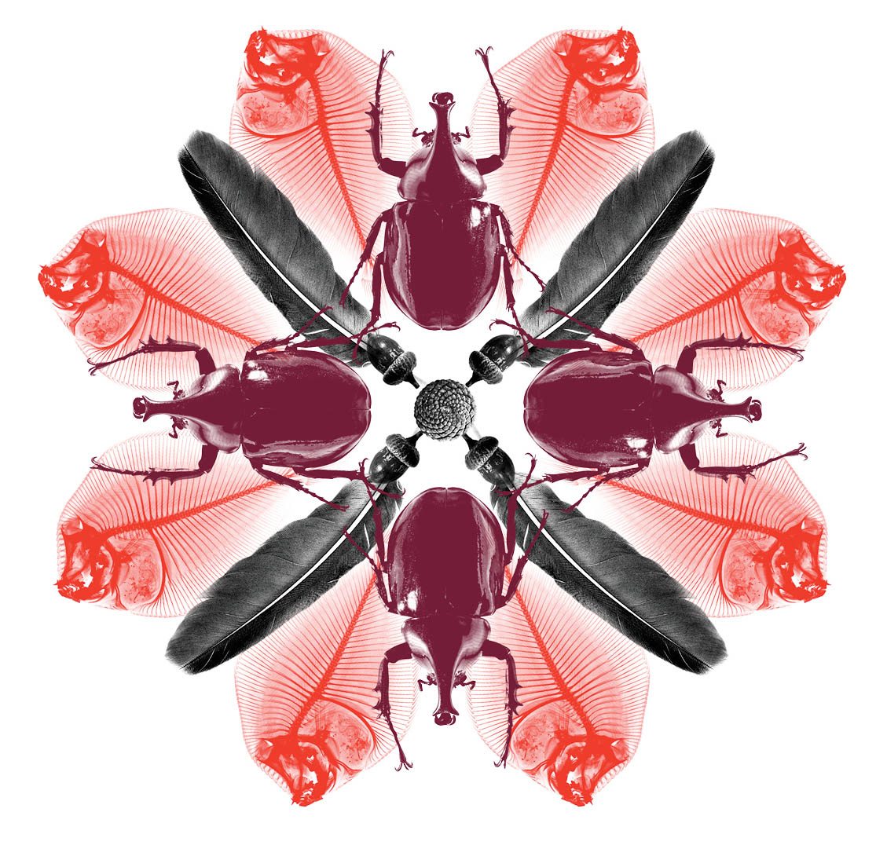

© Commonwealth of Australia 2015

**Ownership of intellectual property rights**

Unless otherwise noted, copyright (and any other intellectual property rights, if any) in this publication is owned by the Commonwealth of Australia (referred to as the Commonwealth).

**Creative Commons Licence**

All material in this publication is licensed under a Creative Commons Attribution 3.0 Australia Licence, save for content supplied by third parties, logos and the Commonwealth Coat of Arms.

Creative Commons Attribution 3.0 Australia Licence is a standard form licence agreement that allows you to copy, distribute, transmit and adapt this publication provided you attribute the work. A summary of the licence terms is available from creativecommons.org/licenses/by/3.0/au/deed.en. The full licence terms are available from creativecommons.org/licenses/by/3.0/au/legalcode.

This publication (and any material sourced from it) should be attributed as: Approved Arrangements section, 2016, Approved arrangement for bulbs - information, (Approved arrangement for bulbs - information prepared for the Department of Agriculture, Water and the Environment ), Canberra.

**Department of Agriculture, Water and the Environment**

Postal address GPO Box 858

Canberra ACT 2601

Switchboard +61 2 6272 3933

Web [awe.gov.au](http://www.agriculture.gov.au)

Inquiries regarding the licence and any use of this document should be sent to: [copyright@awe.gov.au](mailto:copyright@awe.gov.au).

The Australian Government acting through the Department of Agriculture, Water and the Emvironment has exercised due care and skill in the preparation and compilation of the information and data in this publication. Notwithstanding, the Department of Agriculture, Water and the Environment, its employees and advisers disclaim all liability, including liability for negligence, for any loss, damage, injury, expense or cost incurred by any person as a result of accessing, using or relying upon any of the information or data in this publication to the maximum extent permitted by law.

**Version control**

Updates to this document will occur automatically on the department’s website and the revision table below will list the amendments as they are approved. Specific sections updated are as follows:

| Date | Version | Amendments | Approved by |
| --- | --- | --- | --- |
| Oct 2013 | 1.0 | First release | Caroline Martin, Director Industry Arrangements Reform Program |
| Mar 2014 | 1.1 | Second release – minor typographical changes and changes to assessment guide. | Caroline Martin, Director Industry Arrangements Reform Program |
| Jun 2014 | 2.0 | Removal of Criteria 1.3-Payment of Fees. | Caroline Gibson, Director  Approved Arrangements section |
| Apr 2015 | 3.0 | * Removal of mandated movement forms and requirement to submit SOP for endorsement * Addition of criteria for permission for state quarantine activates to occur at a non QAP, state approved quarantine premises * Amendment to signage criteria. | Jon Webber, A/g Director  Approved Arrangements section |
| Dec 2015 | 3.1 | Amended caption for Fig. B2 | Caroline Gibson, Director  Approved Arrangements section |
| Apr 2016 | 3.2 | Updated branding | Caroline Gibson, Director Approved Arrangements section |
| May 2016 | 4.0 | Updated to reflect references to the *Biosecurity Act 2015.* | Approved Arrangements section |
| Oct 2018 | 4.1 | Removal of images of Tulipa with sufficient/insufficient growth | Plant Import Operations  Approved arrangements section |
| Mar 2020 | 4.2 | Updated to reflect the rebranding of the department | Approved Arrangements section |

## Table of contents

Table of contents iv

Part A: General information 1

Introduction 1

Contacts 1

Purpose of an approved arrangement site for bulbs 1

Risks associated with imported bulbs 1

Part B: Supporting information 2

Administrative conditions 2

1 Administrative conditions—Scope 2

2 Operating conditions—Compliance 2

3 Operating conditions—Approval for changes to the approved arrangement site 3

4 Operating conditions—Workplace health and safety 3

5 Structural conditions—Plans 3

6 Structural conditions 3

7 Structural conditions—Site access 4

8 Operating conditions—Handling of bulbs 4

9 Operating conditions—Site records management 4

10 Operating conditions—Pest management 4

11 Operating conditions—Hygiene 5

12 Operating conditions—Isolation 5

13 Operating conditions—Movement of bulbs 5

14 Operating conditions—Identification 6

15 Operating conditions—Security arrangements and incident notification 6

16 Operating conditions—Inspection conditions for all bulbs 7

17 Operating conditions—Additional conditions for self-inspection of certified bulbs 8

18 Biosecurity waste 8

Appendix A: Bulb movement record system example 10

Appendix B: Bulb grower inspection guide 11

Introduction 11

Background 11

Final inspection at sufficient growth stage 11

Taking digital images 15

How to refer disease symptoms to the department for advice 15

Symptoms and signs 16

Glossary 17

## Part A: General information

### Introduction

The purpose of this document is to provide information which will assist in understanding and complying with the obligations and conditions for the operation of an approved arrangement site for bulbs. Guidance on the establishment and operation of sites for other commodities are out of scope of this document.

Pests and diseases associated with the importation of bulbs pose a biosecurity risk to domestic plants and the wider Australian environment. The information in this document is intended to convey a better understanding of the risk that these pests and diseases pose and why specific conditions are necessary to address these biosecurity risks.

Approved arrangement site applicants and operators are encouraged to read this document along with the approved arrangement site for bulbs conditions. In contrast to the information in this document, the purpose of the conditions is to specify the set of conditions to be met for the approval, operation and audit of an approved arrangement site for bulbs.

For more information on site auditing, refer to approved arrangement section of [the](http://www.agriculture.gov.au/import/general-info/qap/qap-general-policies) department’s website.

### Contacts

For further information regarding an approved arrangement site for bulbs please contact the Department of Agriculture, Water and the Environment. See the department‘s website for a full listing of contact details. Unless specified otherwise any references to contacting Department of Agriculture, Water and the Environment means contacting Audit and Assurance Business Centre

### Purpose of an approved arrangement site for bulbs

Imported bulbs have the potential to introduce exotic plant pests and diseases into Australia. As disease status cannot be easily determined from bulbs without growth, imported bulbs must undergo a Post Entry Quarantine (PEQ) period after inspection and treatment on arrival.

The purpose of an approved arrangement site for bulbs is to provide the required containment during the growth and screening of bulbs undergoing open quarantine.

### Risks associated with imported bulbs

This conditions have been developed to address the risks associated with imported bulbs including:

* exotic viral diseases (Strawberry latent ringspot virus, Tomato black ring virus, Plantago asiatica mosaic virus)
* bacterial pathogens including Fasciation (*Corynebacterium fascians*/Rhodococcus fascians*)*
* fungal pathogens including dry rot of narcissus (*Stromatinia narcissi*) and Smoulder (*Sclerotium wakkeri*).

For more information on these diseases refer to: [bugwood.org/fungi.html](http://www.bugwood.org/fungi.html)

## Part B: Supporting information

This part of the document explains the reasoning behind the conditions and provides selected examples of how to comply with it. For consistency, the section headings within this part of the document align with those within the conditions i.e.:

* administrative conditions
* site and building conditions
* operational conditions
* biosecurity waste.

### Administrative conditions

The overarching intent of this group of conditions is to address high level conditions that encompass both the initial approval of a site plus its ongoing administration.

1. Administrative conditions—Scope

The site class was developed in response to the operational conditions associated with imported bulbs.

A biosecurity industry participant can use this site:

* to store and grow imported bulbs for open quarantine, or
* for bulb storage only.

There are two types of imported bulbs: non-certified and certified. Non-certified bulbs are those which have not been sourced from suppliers under Department of Agriculture approved health standardschemes. Certified bulbs are sourced from Department of Agriculture approved health standardschemes that monitor the production through inspection and testing regimes for pests and diseases. As this certification addresses pathogen/disease risk to a greater extent, certified bulbs pose a lower biosecurity risk. The department has therefore altered its policy to permit biosecurity industry participants to perform final inspections at sufficient growth stage for certified bulbs. This is known as self inspection.

The scope of this approved arrangement site allows the biosecurity industry participant to nominate how certified bulbs will be inspected – the biosecurity industry participant may choose to inspect the certified bulbs or to have the department continue to inspect the certified bulbs.

If a biosecurity industry participant receives both certified and non-certified bulbs, the department will continue inspecting non-certified bulbs as per the existing conditions.

When applying for this class, the biosecurity industry participant must indicate if they wish to perform self inspections. While the site is being used for open quarantine of imported bulbs, the grower may grow domestic plants (with the exception of potatoes) in the biosecurity area, however, if a disease is found, all the plants may become subject to biosecurity control and treated as required.

1. Operating conditions—Compliance

In being granted an approval to operate a site, a biosecurity industry participant is taking responsibility for the performance of biosecurity activities. The purpose of this conditions is to make site operators aware of legislation and administrative policy that must be complied with. Compliance with the *Biosecurity Act 2015*, import permit conditions, and any directions given by the department will be assessed during inspections and audits.

1. Operating conditions—Approval for changes to the approved arrangement site

The purpose of condition related to the condition for a biosecurity industry participant to gain approval for any changes to their site and its operations is to ensure that the proposed changes will not compromise the performance of biosecurity activities.

Approval to change a site and its operations is neither automatic nor guaranteed and will be assessed on the merits of each individual circumstance. In circumstances where a biosecurity industry participant intends to relocate a site, this will involve closing down the existing approval and submitting an application for the approval of the proposed site, prior to relocating.

Upon the permanent closure of a site the biosecurity industry participant will need to work with the department to ensure that any remaining bulbs and growing plants held within the site are properly managed in terms of biosecurity right up until the closure of the site.

1. Operating conditions—Workplace health and safety

A biosecurity industry participant must always ensure workplace health and safety conditions are maintained so that any biosecurity officer undertaking open quarantine activities or monitoring compliance of the site through inspections or audits can proceed safely.

#### **Site and building conditions**

The overarching intent of this group of requirement is to ensure that a site is suitably constructed and maintained to enable the containment of any goods subject to biosecurity control and that the site as constructed can support or facilitate the implementation of appropriate work practices.

1. Structural conditions—Plans

A current site plan which accurately describes the physical layout of the site enables the containment boundary to be clearly identified as well as the areas where biosecurity activities will be conducted. Information on a site plan helps the department understand where biosecurity activities will occur within the site, including where various work practices and procedures are performed.

An approved arrangement site for bulbs must have designated biosecurity areas for both the storage and growth of bulbs. To facilitate the nature of approved arrangement sites for bulbs the site is permitted to have multiple biosecurity areas designated for the growth of bulbs and these biosecurity areas can be rearranged or moved depending on the operations of the site. The biosecurity areas should be reflected in the growing plan, which is provided to the department to assist in inspections and audits.

Site plans must be provided with the application form for approval.

1. Structural conditions

The conditions in relation to biosecurity areas are to ensure that all bulbs and plants are contained therefore preventing pests and diseases from spreading to other plants, or the broader Australian environment.

The biosecurity areas must be surrounded by a 3 metre wide buffer which may be lawn, a cleared area or separated by a physical barrier, such as a poly house. As defined in the Macquarie Dictionary, lawn is a stretch of grass-covered land, especially one closely mowed.

1. Structural conditions—Site access

The department requires adequate access to a site in order to monitor and manage compliance. An all-weather road to the site and a parking space for use by biosecurity officers is necessary to achieve this. For example, a local authority gravel road would normally be sufficient to provide access for vehicles to the site.

The site’s nominated business hours must be submitted at the time of application for approval.

#### **Operating conditions**

The overarching intent of this group of conditions is to specify the operational activities that must occur within the site or be performed by a biosecurity industry participant so as to properly manage open quarantine of bulbs.

1. Operating conditions—Handling of bulbs

The purpose of the conditions related to the handling of bulbs undergoing open quarantine is to ensure that a biosecurity industry participant only performs biosecurity activities for which they have departmental approval. It is also about ensuring that the activities in relation to biosecurity are controlled and that the persons performing biosecurity activities understand their responsibilities.

The department must be notified as soon as practical within 48 hours of the arrival of any unsolicited goods, and/or substituted goods. This includes goods or volumes that are not detailed in the biosecurity Entry. The purpose of this condition is to pre-empt the handling of biosecurity goods or plant material outside the scope of the sites approval and ensure that the department is notified in a timely manner in order to implement appropriate steps to manage the situation. For example, contact the department immediately if potatoes are found in the consignment.

1. Operating conditions—Site records management

Records must be maintained in relation to any biosecurity activities, including treatments, movements or disposal, pest control and biosecurity waste. These records will be assessed within the audit activities performed by the department, to monitor compliance with the approved arrangement conditions.

The records required will depend on the scope of the business activities at the site, e.g. importation and/or growth. The conditions recognise the different records that must be maintained by the site in certain circumstances.

1. Operating conditions—Pest management

The department must be notified of the detection of any pest or exotic disease outbreak and/or establishment as soon as practical within 48 hours. This condition is to ensure that the department is notified in a timely manner in order to implement appropriate steps to manage the situation.

Thrips present a specific biosecurity risk to tulips because they can transmit a number of viruses that are of biosecurity concern. A site that grows imported tulips is required to have a pest management system in place within their sites. Weed management, removal of spent and unwanted flowers or plants, and crop monitoring for thrips with yellow sticky traps must be employed by the biosecurity industry participant as part of the pest management system. This is to ensure that pest management measures are in place to limit the presence of thrips in tulip crops and the resultant risk of virus transmission to domestic plants within or outside the site.

If a site does not grow imported tulips, the condition for a pest management system is not applicable.

1. Operating conditions—Hygiene

A site must be maintained to a standard of hygiene so that there is no accumulation of garbage that could harbour or attract pests or vectors of pests.

Controlling weed growth is particularly important as weeds can attract and conceal unwanted pests, and can facilitate the transfer, growth and multiplication of pests and pathogens throughout a crop. Excessive weed growth can make it difficult to inspect plants in open quarantine for pest and disease symptoms.

1. Operating conditions—Isolation

The purpose of prohibiting growing domestic potatoes within the site or within 20 metres of the biosecurity area is to ensure that there is minimal risk of transmission of diseases of biosecurity concern. Potatoes are specifically noted as pathogens pass easily from bulbs to potatoes and there are several pathogens and nematodes of concern (e.g. tobacco rattle virus).

1. Operating conditions—Movement of bulbs

Conditions regarding the movement of bulbs are to ensure that bulbs in open quarantine can be traced in the event of a disease outbreak. Previously, it was a requirement to submit a movement form to the department every time bulbs were moved to another site or planted out. The movement of bulbs between approved arrangement sites for bulbs is a low risk activity, provided accurate records are maintained. The department has determined that biosecurity industry participants can manage this activity on behalf of the department, allowing the department to invest resources into higher risk activities; however, biosecurity industry participants must maintain records of the movements which will be audited by the department.

When moving bulbs to another approved arrangement site for bulbs, the biosecurity industry participant must maintain records of all bulbs transferred. When receiving bulbs from another approved arrangement site for bulbs, the biosecurity industry participant must maintain records of bulbs received.

**Note**: the *Movement of Bulbs to Another Biosecurity approved arrangement site Form* may be used for this purpose

Records of bulb transfer must be made available to biosecurity officers during inspection or audit so that the department can be assured of the volumes of bulbs a site has moved/received. This must match with bulbs in storage plus bulbs planted in the field or released.

A contingency plan is required to ensure that the biosecurity industry participant has considered the action required in the event of spillage of bulbs during movement.

If there are many movements of bulbs to and from a site, it may be beneficial to keep a summary of these movements to facilitate the reconciliation of bulbs at the time of audit.

**Appendix A** provides an example of a bulb movement record system. While use of this form is not mandatory, it has been provided as an example to facilitate reconciliation of bulb movements against a biosecurity Entry. Record systems may differ from the example shown in Attachment 1 and may be computer based or hand written provided that the information can be made available to the department on request.

If there is a need to move bulbs to a location that is not an approved arrangement site for bulbs a biosecurity direction is required. For example, it may be necessary to move the bulbs to a treatment site.

Bulbs transported between interstate sites may also be subject to individual state/domestic biosecurity conditions and, in some cases, a state biosecurity inspection. The department sites and state biosecurity approved sites are not one and the same. Bulbs are permitted to be directed to a state approved facility (regardless of site status) for the purposes of enabling inspection by the relevant state authority without these requiring site approval. Records of movement must be maintained.

**Note:** the *Movement of Bulbs to Another Biosecurity approved arrangement site Form* may be used for this purpose

Additionally, the department must be notified of any unauthorised movements of bulbs or plant material as soon as practical but within 48 hours.

1. Operating conditions—Identification

All biosecurity areas are required to display biosecurity signage. The purpose of the conditions is to advise all persons that they are entering a restricted biosecurity area where biosecurity conditions and procedures are being undertaken.

All bulbs undergoing open quarantine are required to be identifiable and able to be reconciled.

The department does not prescribe how bulbs are to be identified in the conditions. Examples of how to achieve the identification outcomes for the bulbs in storage may include:

1. labelling the crates and boxes with all of the following:

* date of arrival
* biosecurity entry number
* plant variety/species (botanical and common name)
* import permit number

1. a unique identifier linked to the previous four data elements, and
2. placing a marker with the information above at the end of each planted row during growth.
3. Operating conditions—Security arrangements and incident notification

Incidents that could threaten or compromise the security of the site may include wilful damage, vandalism, trespass or unauthorised entry, or the unauthorised removal of biosecurity goods. The department requires notification of any such incidents in order to monitor the integrity of the site and to manage compliance.

These incidents include:

* structural damage
* flooding or storm surge events
* spillages of quarantine material during transport
* any outbreak and/or establishment of pests or disease.

1. Operating conditions—Inspection conditions for all bulbs

As a biosecurity industry participant has regular access to plants, the department recognises that a biosecurity industry participant plays an important role in identifying diseases of biosecurity concern. For this reason, all plants are required to be inspected for disease symptoms by the biosecurity industry participant on a weekly basis. This condition applies to all plants grown in open quarantine, regardless of who performs the final inspection at sufficient growth stage before release. This condition is to ensure diseases of biosecurity concern are identified and correctly diagnosed for timely treatment. It is also about ensuring that the persons performing disease inspections understand their responsibilities and limitations. In addition to this, all plants grown from non-certified bulbs must be inspected by a biosecurity officer after the bulbs are planted and begin to emerge.

All plants grown from certified or non-certified bulbs must have a final inspection at sufficient growth stage to detect any disease of quarantine concern. The final inspection of non-certified bulbs at sufficient growth stage must be performed by a biosecurity officer. The final inspection of certified bulbs at sufficient growth stage may be performed by a biosecurity officer or by a biosecurity industry participant who has elected to self-inspect plants. A biosecurity industry participant is responsible for scheduling an appointment for the biosecurity officer to perform the final inspection at sufficient growth stage and must therefore carefully plan the timing of the final inspection to ensure it occurs when the plants are at the sufficient growth stage.

A growing plan must be provided to the biosecurity officer to assist in the location of bulbs that require an inspection. A growing plan should demonstrate the type, location of and amount of bulbs being grown.

The following table is to clarify the inspection conditions based on type of bulb—certified or non-certified—and the person performing the inspection—a biosecurity officer or the biosecurity industry participant:

Table 1 Inspection conditions

|  |  |  |  |  |  |
| --- | --- | --- | --- | --- | --- |
| Inspections required | Biosecurity industry participant weekly inspection | Biosecurity officer inspection after planting and emergence of plants | Biosecurity officer  final inspection at sufficient growth stage | Biosecurity industry participant final inspection at sufficient growth stage | Biannual biosecurity officer inspections |
| Certified bulbs  Self inspected | Yes | No | No | Yes | Yes |
| Certified bulbs  Not self inspected | Yes | No | Yes | No | No |
| Non-certified bulbs  Not self inspected | Yes | Yes | Yes | No | No |

1. Operating conditions—Additional conditions for self-inspection of certified bulbs

As certified bulbs pose a lower biosecurity risk, the department has changed its policy and now permits biosecurity industry participants to perform the final inspection at sufficient stage of growth for plants grown from certified bulbs. The purpose of the requirement related to self-inspections is to ensure that final inspection at sufficient growth stage is performed by staff with appropriate skills, to ensure that the plants are at the sufficient growth stage, as defined in the Bulbs Grower Inspection Guide (Attachment 2).

Biosecurity industry participants must perform the final inspection of the plants at the sufficient growth stage, prior to release from biosecurity control. The biosecurity industry participant is required to submit the Request for Release of Certified Bulbs from Biosecurity Control Form for approval by the department, detailing which plants and what volumes have been inspected and whether they are free from disease symptoms.

No plants can be released until the Request for Release of Certified Bulbs from Biosecurity Control Form is approved by a biosecurity officer. An approved form is one that has been signed by a biosecurity officer and returned to the biosecurity industry participant. The department cannot delegate the legal authority to release goods from biosecurity control and therefore must provide a formal release from biosecurity to the biosecurity industry participant.

For biosecurity industry participants who choose self-inspection, the department will perform a minimum of two inspections of certified bulbs per calendar year regardless of the quantity or number of plantings. This is to verify that the biosecurity industry participant is effectively performing the final inspection at sufficient growth stage and to ensure that all the plants are free from diseases of biosecurity concern. The biosecurity industry participant is responsible for booking inspections by biosecurity officers twice per year to ensure that the inspections are performed while bulbs are undergoing open quarantine.

The purpose of these inspections is to verify that the biosecurity industry participant is effectively performing inspections of the plants and to ensure that all plants are free of diseases of biosecurity concern.

The Bulb Growers Guide (Attachment 2) provides explanations and photographic examples of the minimum growth stage required for final inspection

1. Biosecurity waste

The purpose of the condition is to ensure biosecurity waste is treated appropriately. If not treated correctly, such material can become a source of risk for the transmission of pests or diseases of biosecurity concern.

Biosecurity waste for the purpose of an approved arrangement site for bulbs includes:

1. unwanted or rejected unplanted bulbs
2. plant material to be disposed of as directed by the department
3. any diseased material.

Unwanted or rejected bulbs that have not been planted must be treated as biosecurity waste. These bulbs do not comply with the import permit conditions as they cannot be proven to be free of disease symptoms. The department may approve procedures for alternative management of these bulbs; however, the biosecurity industry participant must contact the department for any such approval prior to treating the biosecurity waste.

Any other biosecurity waste must be treated in a manner approved by the department. This is to ensure that biosecurity waste is treated appropriately as per the Biosecurity Waste Management Business Policy.

Material used for packaging, such as crates and liners, are not considered biosecurity waste unless the directed otherwise by the department.

# 

## Appendix A: Bulb movement record system example

**Note:** Use of this attachment is not mandatory; however, it may make the audit process easier and therefore quicker if this information is stored on a single spreadsheet.

Biosecurity entry number: AA44MMTR

Import Permit number: IP1234567

Bulb type and quantity: Lilium Laguna 8000; Lilium Cobra 5000

Table 2 Bulb movement record system example

|  |  |  |  |  |  |  |  |  |  |
| --- | --- | --- | --- | --- | --- | --- | --- | --- | --- |
| Sending Site ID number | Receiving Site Name | Receiving Site number | Receiving Site address | Transfer to state  premises y/n? | Genus | Varieties | Quantity | Certified y/n? | Date of movement |
| V1122_1/3/2012_1 | Happy bulbs | VXXXX | 1 Happy Bulb lane, Melbourne | No | Lilium | Laguna | 5,000 | Yes | 1/03/2012 |
| V1122_1/3/2012_1 | Happy bulbs | VXXXX | 1 Happy Bulb lane, Melbourne | No | Lilium | Cobra | 1,000 | Yes | 1/03/2012 |
| V1122_18/3/2012_1 | Flower grower | VXXXX | 13 Smith street, Melbourne | No | Lilium | Laguna | 3,000 | Yes | 18/03/2012 |
| V1122_18/3/2012_1 | Floral Pride | WXXXX | 57 Jones street, Perth | Yes | Lilium | Cobra | 2,000 | Yes | 18/03/2012 |
| V1122_15/4/2012_1 | Internal | Internal | Growing area A | No | Lilium | Cobra | 2,000 | Yes | 15/04/2012 |

## Appendix B: Bulb grower inspection guide

### Introduction

The purpose of this guide is to provide sites with approval from the department to inspect certified bulbs with information on:

1. the minimum growth stage required to inspect plantings of certified bulbs for disease symptoms for release from biosecurity control
2. how to refer disease symptoms to the department for advice.

### Background

The approved arrangement site provides an opportunity for biosecurity industry participants to inspect certified bulbs undergoing open quarantine.

Certified bulbs are produced in the Netherlands under one of the following certification schemes: *Bloembollkeeuringsdienst* (BKD) or *Naktuinbouw* (NAKT). Certification provides measures of protection against the importation of pests and diseases of biosecurity concern, through disease testing, field inspections and good horticultural practices. However certification alone does not address all issues of biosecurity concern to Australia, so additional measures are required on arrival in Australia. This includes treatment and growth in open quarantine with two inspections per year.

**Note:** Biosecurity officers will continue inspections of certified bulbs where biosecurity industry participants choose not to self inspect.

**Table 1:** Certified bulbs from the Netherlands

|  |  |
| --- | --- |
| Bulb type | Certification Scheme |
| Crocus | BKD |
| Dutch Iris | BKD |
| Freesia | NAKT |
| Gladiolus | BKD |
| Hippeastrum | BKD |
| Hyacinthus | BKD |
| Lilium | BKD |
| Narcissus | BKD |
| Tulipa | BKD |

### 

### Final inspection at sufficient growth stage

The biosecurity industry participant must ensure plants are inspected weekly to monitor for disease symptoms. Additionally, before plants can be released from biosecurity, a final inspection of plants at the sufficient growth stage to inspect that the plants are free from disease must be performed. Plants must be developed enough to allow any disease causing organisms – fungi, bacteria, viruses – to produce symptoms. Records of results from the final inspection at sufficient stage of growth must be kept for audit purposes. A minimum of 75% of plants must show sufficient growth for release.

Growth conditions before release differ between the different plants but essentially there is a condition that the plants have multiple green, open leaves. The exception to this rule is Hippeastrums.

The following pages provide examples of how to apply this rule when completing the final inspection at sufficient growth stage and applying for release.

Figure B1 Lilium plant with two–three weeks growth; these plants have insufficient growth to inspect for release.

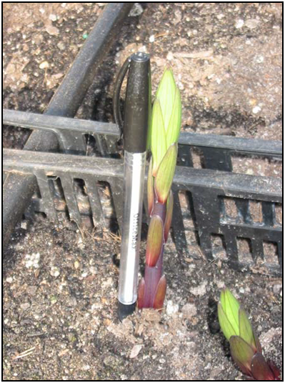

Figure B2 Lilium plant with two–three weeks growth; these plants have sufficient growth to inspect for release. The plants have multiple open leaves but have not yet developed flower buds.

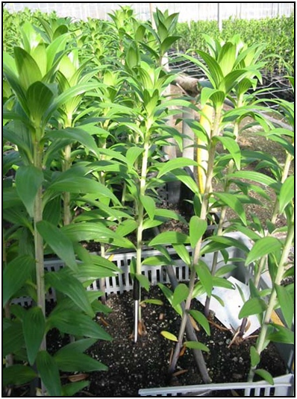

Figure B3 Hyacinth plants that have insufficient growth to inspect for release; the plants are also yellow and need to be grown for longer to allow leaves to go green.

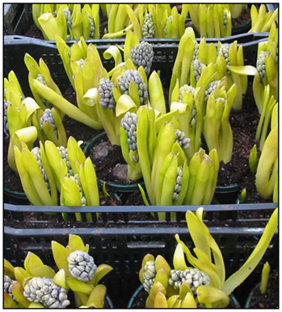

Figure B4Hyacinth plants that have sufficient growth to inspect for release; the plants have multiple green, open leaves plants and formed flower heads.

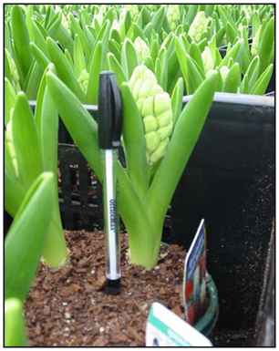

**Hippeastrum bulbs** may produce foliage and then a flower stalk *or* the flower stalk may grow prior to any foliage. Thus the inspection may take place on the flower stalk only. Plants are eligible to inspect for release once the flower head has formed, coloured and begun to open.

Figure B5 A Hippeastrum plant with insufficient growth to inspect for release.

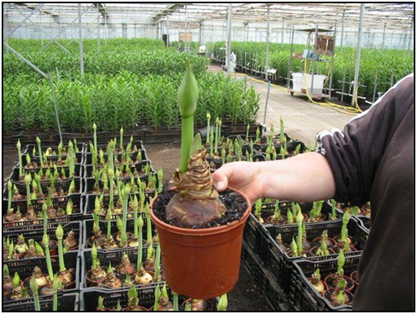

Figure B6 Hippeastrum plants with sufficient growth to inspect for release; the plants have formed flower heads with colour and are beginning to open. If foliage appears first, multiple leaves must be open and green before plants can be inspected.

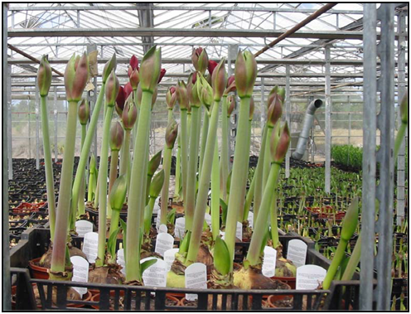

### Taking digital images

The following should be considered when taking photographs:

* photograph specimens immediately, while they are in good condition
* photograph symptoms at three magnifications:
* general symptoms characteristic of the disease within the crop
* details of spot, lesions etc at approximately the natural size
* a close up view of symptoms fungal growth, chlorosis etc
* ensure correct lighting for the subject i.e. sunlight or shade, flash or no flash
* emphasise details of lesions, rots, blights, leaf spots, chlorosis etc
* eliminate all unnecessary parts of the subject.

### ****How to refer disease symptoms to the department for advice****

If any exotic disease symptoms are detected, the department must be notified as soon as possible within 48 hours. If the biosecurity industry participant is unsure of a particular disease symptom, they should contact the department but if they have experience and know the disease symptom is not exotic, they do not have to contact the department.

There are two options for contacting the department:

1. Email diagnostic information and digital images of symptomatic plants to the Operational Science Program (OSP) [ospplantpathologists@awe.gov.au](mailto:ospplantpathologists@awe.gov.au)
2. Contact the Regional Nursery Stock Office (RNSO) and retain plants for inspection by a biosecurity officer. [awe.gov.au/biosecurity/about/contact](http://www.daff.gov.au/biosecurity/about/contact)

**Note:** The better the image and accompanying information, the better the diagnosis. However, some diagnoses are not possible with digital images alone and the department may request a physical sample.

Providing the following information along with digital images of disease symptoms will facilitate disease identification and timely advice on action to be taken:

|  |
| --- |
| Infected plant species |
| Biosecurity Entry |
| Importer name |
| Site number and contact phone number |
| Date of planting |
| Number of plants |
| Symptoms observed:  □ Wilted □ Spotted □ Yellowed □ Abnormal growth □ Stunted □ Mosaic □ Other: |
| Disease severity  □ Severe – disease symptoms infecting most plants within the plantings  □ Moderate – disease symptoms seen regularly throughout the plantings  □ Light – few disease symptoms observed throughout the plantings |
| Distribution e.g. in patches, edges |
| Plant part affected e.g. new growth, leaf tips |
| Possible abiotic causes e.g. nutrition, mechanical damage |
| Recent cultural operations e.g. fertilised, sprayed |
| Recent weather events e.g. frost, high humidity |
| Distribution e.g. in patches, edges |

Following assessment, the department will advise whether further action is required. If the symptom is of biosecurity concern, a biosecurity officer may arrange to collect samples for further diagnostics or provide advice on appropriate risk mitigation measures.

### ****Symptoms and signs****

Identify characteristic symptoms. Accurately describing the characteristic symptoms exhibited by a plant can be difficult. Because of this the department requests photos of specimens or for a biosecurity officer to collect samples for diagnosis by a plant pathologist.

Symptoms can be grouped as follows:

* **Underdevelopment of tissue.** Examples include such symptoms as stunting of plants, shortened internodes, malformation of leaves, inadequate production of chlorophyll and other pigments and failure flowers to develop.
* **Necrosis or death of plant parts.** These may be some of the most noticeable symptoms, especially when they affect the entire plant, such as wilts or diebacks. Other examples include shoot or leaf blights, leaf spots, and fruit rots.
* **Alteration of normal appearance.** Examples include mosaic patterns of light and dark green on leaves, and altered coloration in leaves and flowers.
* **Overdevelopment of tissue or organs.** Examples include: galls on roots, stems or leaves, and profuse flowering.

## Glossary

**Blights** A sudden, severe, and extensive spotting, discoloration, wilting, or destruction of leaves, flowers, stems, or entire plants caused by bacterial of fungal infections.

**Chlorosis** The failure of chlorophyll development, caused by disease or a nutritional disturbance; fading of green plant colour to light green, yellow, or white.

**Damping off** Collapse and rot of seedlings near soil level before emergence or soon after emergence, caused by fungi such as *Pythium* and *Rhizoctonia*.

**Disease incidence** The number of plants affected by a disease within a crop.

**Disease severity** The measure of damage done by a disease (e.g. area of plant tissue affected by affected disease).

**Flower Break** Colour breaking on the flowers caused by a viral infection characterised by flecks, streaks, stipes or patches of irregular colouration.

**Leaf spot** Localised lesion on a leaf caused by bacteria or fungal infection.

**Rot** A softening, discoloration, and often disintegration of plant tissue as a result of fungal or bacterial infection.

**Rust** Rust coloured pustule-like lesions on the leaves and stems caused by fungal infection.

**Sign** A visible manifestation of a causal agent of plant disease e.g. fungal spores or bacterial ooze.

**Smut** Is generally a mass of black powdery spores caused by a fungal (smut) infection.

**Symptom** An indication of disease by reaction of the host, e.g. canker, leaf spot and wilt.

**Mosaic** A disease symptom characterised by non-uniform colouration, with intermingled normal, light green and yellowish patches, usually caused by a virus.

**Mottle** A disease symptom comprising light and dark areas in an irregular pattern, usually caused by a virus.

**Vein clearing** The disappearance of green colour in or around leaf veins.

**Wilt** The drooping of leaves and stems from lack of water; a vascular disease that interrupts normal water uptake.