

FINAL REPORT FOR THE AUSTRALIAN GOVERNMENT DEPARTMENT OF THE ENVIRONMENT, WATER, HERITAGE AND THE ARTS

Emerging amphibian diseases and disease surveillance in Queensland – Stage 2
(February 2007 – April 2010)

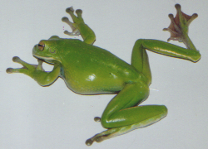 | 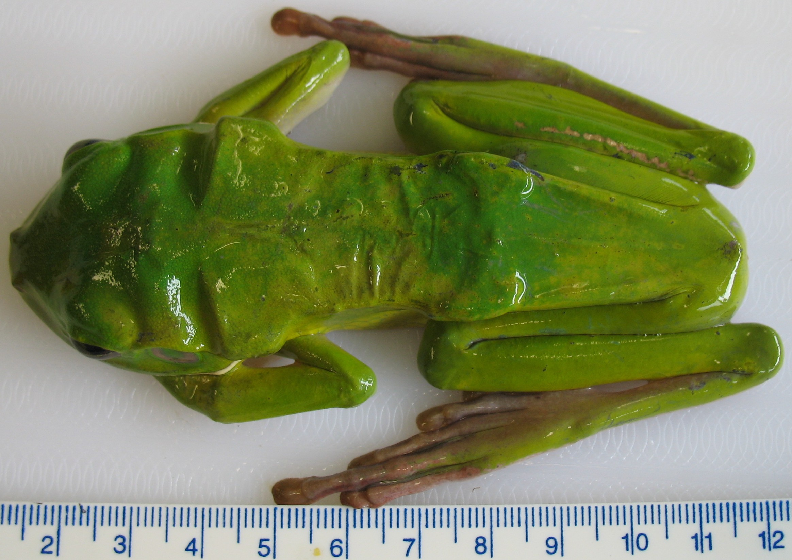

Prepared by: Sam Young¹, Rick Speare¹, Lee Berger¹, Lee F. Skerratt¹ & Diana Mendez¹

¹ Amphibian Disease Ecology Group, School of Public Health, Tropical Medicine and Rehabilitation Sciences, James Cook University, Townsville, Qld 4811

Cover images: left - photo of a healthy mature adult Litoria infrafrenata by S. Young; right – photo of a mature Litoria infrafrenata affected by the wasting syndrome, a previously undescribed disease syndrome affecting tree frogs in far northern Queensland, by S. Young.

© Commonwealth of Australia (2010). Published May 2010.

Information contained in this publication may be copied or reproduced for study, research, information or educational purposes, subject to inclusion of an acknowledgment of the source. This report should be cited as: Young S, Speare R, Berger L, Skerratt LF & Mendez D (2010). Emerging Amphibian Diseases and Disease Surveillance in Queensland – Stage 2 (February 2007 – April 2010). Final report for the project Emerging Amphibian Diseases and Disease Surveillance in Queensland – Stage 2 (February 2007 – April 2010) to the Australian Government Department of the Environment, Water, Heritage and the Arts.

The views and opinions expressed in this publication are those of the authors and do not necessarily reflect those of the Commonwealth Government or the Commonwealth Minister for the Environment and Water Resources This project was funded by the Australian Government Department of the Environment, Water, Heritage and the Arts through the Commonwealth Environment Research Facilities (CERF) programme.

Executive Summary

The aim of this project was to complete investigations into Emerging Amphibian Diseases and Disease Surveillance in Queensland, a four-year research programme carried out by the Amphibian Disease Ecology Group at James Cook University. There were three general and 14 specific objectives, as outlined below. The project was a direct continuation of Emerging Amphibian Diseases and Disease Surveillance in Queensland - Stage 1 (January 2006 - January 2007) (Young et al., 2007b). This is the final report for the current project and directly follows on from the first progress report (Young et al., 2007c). All research activities were carried out under an approved Queensland Parks and Wildlife Service Scientific Purposes Permit (WISP03866106) and James Cook University Animal Ethics Application (A1085).

Declines and extinctions of amphibian populations have been increasing globally over the past three decades. Over 30 percent of amphibian species are threatened and at least 43 percent are experiencing population declines (IUCN, 2001, 2004; Stuart et al., 2004). Since 1980, rapid declines have been reported in over 400 species, with just over half of these attributed to habitat degradation and overexploitation (IUCN 2001; Stuart et al., 2004). Until recently, in at least 200 of these species declines had been enigmatic, predominantly affecting stream-associated frogs in forests and tropical montane habitats in the Neotropics and Australia (Stuart et al., 2004). Many of these declines have now been linked to the emerging infectious disease, chytridiomycosis, of which the impact on frog populations is thought to represent the most spectacular loss of biodiversity resulting from disease in recorded history (Berger et al., 1998; Bosch et al., 2001; Carey et al., 2003; Daszak et al., 2003; Lips et al., 2006; Schloegel et al., 2006; Skerratt et al., 2007).

Community wildlife care groups exist in many countries throughout the world for the purpose of wildlife rescue and rehabilitation. A number of these groups are active in every state within Australia. They play an important but under-utilised role, both directly and indirectly, in wildlife disease surveillance. The Cairns Frog Hospital (CFH) is a small, non-profit community wildlife group that has been receiving injured and diseased amphibians from the public since 1998. Information has been collected by the CFH about cases, individuals have been treated with a view towards recovery and return to the wild, and limited diagnostic pathology has been carried out. A retrospective analysis of submission data from the CFH over a six-year period, from January 1999 through to December 2004, has been carried out as part of this study, which also involves investigating an immunodeficiency-like wasting syndrome in the white-lipped tree frog, Litoria infrafrenata.

Summary of the Objectives of the Project

- To determine the aetiology of the wasting syndrome in Litoria caerulea and L. infrafrenata, whether this disease has extended outside Cairns, and to assess its significance to amphibian populations in the wet tropics.
- To determine what diseases occur in peri-urban amphibians in the wet tropics and whether any are undescribed.
- To develop suitable techniques for wildlife care groups to collect disease data that is relevant for surveillance for emerging diseases, and to determine how this data can be transmitted in a cost-effective way to the Australian Wildlife Health Network using the Cairns Frog Hospital as a model for the surveillance of amphibian disease.

Investigating new and emerging amphibian diseases in Queensland, with a particular focus in the region of the port city of Cairns, will further the knowledge base regarding amphibian diseases and the risks they pose to amphibian populations globally. Identification of new wildlife diseases in the Cairns region is of particular importance since entry of emerging diseases into countries often occurs through ports. Evaluating disease surveillance techniques and integration of community surveillance into the Australian Wildlife Health Network (AWHN) will be of benefit to a number of government organisations, community groups, amphibian ecologists, scientists and veterinarians. The outcomes from this study will ultimately enhance both the capacity of community groups to deal with amphibian diseases, and the ability of the AWHN to monitor and diagnose important and emerging diseases affecting these species.

This research is significant to conservation and is an important contribution to the field of wildlife disease investigation and management. It is an opportunity to study emerging diseases that may be relevant to global efforts to preserve amphibians. Recently, another emerging disease, chytridiomycosis, has caused an unprecedented loss of species and may be a current driving force in the evolution of amphibians. Australia has been at the forefront of research and management of amphibian diseases and this research project will help maintain this position.

Specific Objectives Outlined in the Funding Agreement
There are 14 specific objectives outlined in the funding agreement (Table 1), against each of which the final progress will be outlined in this report.

Objective | Activities to be undertaken between February 2007 – April 2010
(1) | Blood collection from 20 L. infrafrenata and 20 L. caerulea to establish baseline haematology and biochemistry values – wet season 1
(2) | Blood collection from 20 L. infrafrenata and 20 L. caerulea to establish baseline haematology and biochemistry values – dry season 1
(3) | Blood collection from 20 L. infrafrenata and 20 L. caerulea to establish baseline haematology and biochemistry values – wet season 2
(4) | Blood collection from 20 L. infrafrenata and 20 L. caerulea to establish baseline haematology and biochemistry values – dry season 2
(5) | Experimental laboratory investigations to characterise the acquired immune response in healthy L. infrafrenata and L. caerulea
(6) | Experimental laboratory investigations to characterise the acquired immune response to the disease chytridiomycosis in L. infrafrenata and L. caerulea
(7) | Experimental laboratory investigations to determine if protective immunity is present following reinfection with the amphibian chytrid fungus in L. caerulea
(8) | Experimental laboratory investigations to characterise the acquired immune response in L. infrafrenata affected by the wasting syndrome and comparison with healthy specimens
(9) | Pathological investigations into the aetiology of the wasting syndrome in L. infrafrenata, including blood collection, immune testing, microbial culture, histology, PCR, ultramicroscopy
(10) | Determination and implementation of epidemiological techniques for surveying L. infrafrenata populations affected with the wasting syndrome, to investigate the epidemiology of this disease
(11) | Evaluation and comparison of passive and active surveillance techniques for amphibian diseases in the Cairns region
(12) | Development of suitable techniques for collection of relevant disease surveillance data by community wildlife care groups and determining how this can be transmitted in a practical and cost-effective way to the Australian Wildlife Health Network
(13) | Identification of amphibian diseases in Queensland via passive and active surveillance and subsequent pathological investigations
(14) | Journal publications as data is collected throughout the project

Table 1. Specific objectives for the project Emerging Amphibian Diseases and Disease Surveillance in Queensland – Stage 2 (February 2007 – April 2010).
Summary of Final Progress Towards Meeting the Objectives

Objective 1. Blood collection from 20 Litoria infrafrenata and 20 Litoria caerulea to establish baseline haematology and biochemistry values (wet season 1).

Objective 2. Blood collection from 20 Litoria infrafrenata and 20 Litoria caerulea to establish baseline haematology and biochemistry values (dry season 1).

Objective 3. Blood collection from 20 Litoria infrafrenata and 20 Litoria caerulea to establish baseline haematology and biochemistry values (wet season 2).

Objective 4. Blood collection from 20 Litoria infrafrenata and 20 Litoria caerulea to establish baseline haematology and biochemistry values (dry season 2).

Objectives 1 – 4 have been achieved. Blood samples were collected from 20 healthy wild Litoria infrafrenata and 20 healthy wild L. caerulea each over two wet and two dry seasons in order to establish baseline values for haematology and biochemistry. This is the largest known controlled study (n = 160) reporting baseline values for haematology and biochemistry in amphibians to date. Statistical analysis and compilation of a draft manuscript for submission to Veterinary Clinical Pathology (an International Journal of Laboratory Medicine) have been completed (Appendix A). The manuscript will be submitted for peer review in May 2010.

In order to thoroughly investigate an unknown disease syndrome, baseline values for various diagnostic tests in healthy individuals of the same species must be determined. The majority of published reports on amphibian haematology have little clinical relevance due to the wide range of reported normal values resulting from variations in sampling techniques, sampling conditions, restricted sample size, analytical techniques, physiological state, gender, season and unrecognised pathologies (Wright, 2001). Few clinical reports based on controlled studies of normal values for anurans exist and there are no baseline values published for Litoria species.

A range of haematology parameters was determined manually in the laboratory at James Cook University for each of the blood samples collected (Figure 1).

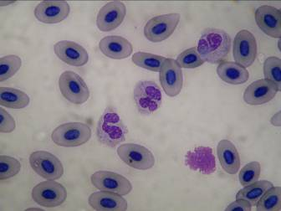

Figure 1. A blood smear prepared from a sample collected from a healthy wild white-lipped tree frog (Litoria infrafrenata). The smear is used to perform a manual differential white cell count under high magnification as a component of the haematology parameters analysed. Stained with Wright’s stain, 1000 x magnification. Photo by S. Young.

For those samples for which there was sufficient volume, an aliquot of serum was sent to Gribbles Veterinary Pathology for protein electrophoresis testing to gain valuable information about serum protein fractions (Figure 2).

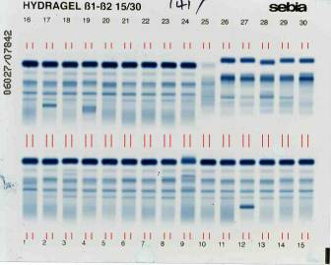

Figure 2. An electrophoretogram of serum samples collected from healthy wild white-lipped tree frogs (Litoria infrafrenata). Individual bands in each numbered vertical lane represent the different protein (albumins, globulins) fractions that make up the total serum protein in each sample. Photo by Gribbles Veterinary Pathology.

Specific haematology parameters measured in this study to determine baseline values for healthy Australian tree frogs (L. infrafrenata and L. caerulea) include:

- Packed cell volume (%);
- Buffy coat (%);
- Total serum/plasma protein via refractometer (g/L);
- Serum/plasma colour;
- Haemoparasites (%);
- Red blood cell count (x 10⁹/L);
- Platelet count (x 10⁹/L);
- Total white blood cell count (x 10⁹/L);
- Differential white cell count – neutrophils, lymphocytes, monocytes, azurophils, basophils, eosiniphils (% of each cell type); and
- Polychromasia (%).

A range of biochemistry analytes was measured for each sample collected using the in-house VetScan VS2TM Chemistry Analyser (Figure 3). This is the first known use of this machine in amphibians in Australia and one of the critical advantages it has over conventional laboratory biochemistry analysers is the extremely small volume (0.1 ml) of blood required to measure a comprehensive panel of 12 different serum/plasma biochemistry analytes (Figure 4). Without the VetScan, we would not have been able to measure nearly as many blood parameters (each of which provides valuable information about the health status of the individual) due to limitations associated with the small sample volume that can be collected from frogs.

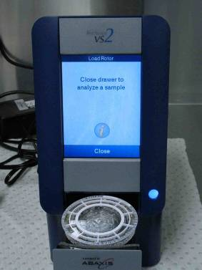

Figure 3. The compact in-house VetScan VS2TM Chemistry Analyser installed and running in the laboratory at James Cook University. The blood sample is loaded into the rotor and then the rotor is placed in the drawer. Sample analysis takes approximately 8 minutes, at the end of which a print out listing the values for 12 individual analytes is produced. Photo by S. Young.

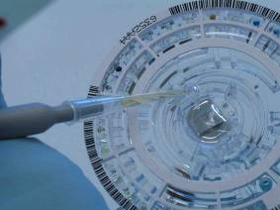

Figure 4. Loading a blood serum sample into the VetScan VS2TM Chemistry Analyser rotor. Note the extremely small sample size required (100 microlitres, or 0.1 ml), allowing the full panel of analytes to be run even with the small sample volumes collected from frogs. Photo by S. Young.

Specific serum/plasma biochemistry analytes measured in this study to determine baseline values for healthy Australian tree frogs (L. infrafrenata and L. caerulea) are as follows:

- Aspartate transferase (U/L);
- Bile acids (µmol/L);
- Creatinine kinase (U/L);
- Uric acid (µmol/L);
- Glucose (mmol/L);
- Calcium (mmol/L);
- Phosphorus (mmol/L);
- Total protein (g/L);
- Albumin (g/L);
- Globulins (g/L);
- Potassium (mmol/L); and
- Sodium (mmol/L).

Objective 5. Experimental laboratory investigations to characterise the acquired immune response in healthy L. infrafrenata and L. caerulea.

This objective has been achieved. Experimental laboratory investigations to characterise various aspects of acquired immune function in healthy L. infrafrenata and L. caerulea have been successfully completed and the majority of the data collated. Following statistical analysis of results, a manuscript will be submitted for publication in a peer-reviewed immunological methods journal. Importantly, the data represents baseline values for healthy tree frogs, and will be used to compare the acquired immune response of diseased versus healthy animals to gain important information about amphibian disease.

Laboratory and field studies have been developed in mammalian and avian species as measures of immune structure and function. Commonly used methods include assessment of immune organs (e.g. Figures 5 & 6), total and differential peripheral white blood cell counts and serum protein concentrations, and a range of more complex in vivo and in vitro tests (Horton et al., 1976; Rollins-Smith & Cohen, 1982; Gearing et al., 1984; Hsu & Du Pasquier, 1984; Rollins-Smith et al., 1984; Zettergren et al., 1991; Rollins-Smith & Blair, 1993; Whittington & Speare, 1996; Whittington et al., 1997; Zupanovic et al., 1998; Work et al., 2001; Grasman, 2002; Rosenberg et al., 2002; Gantress et al., 2003; Berger et al., 2005; Burnham et al., 2005; Kinney & Cohen, 2005). Although there has been much progress made in understanding innate and acquired immunity in many vertebrates (Du Pasquier & Flajnik, 1999), little is known about the mechanisms of defense against viral and fungal pathogens that have been causally implicated in global amphibian population and species declines (Berger et al., 1999; Carey et al., 1999; Daszak et al., 1999; Robert et al., 2005). There are no reports describing acquired immunity in Litoria species.
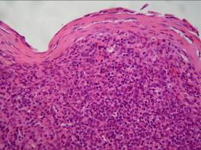

Figure 5. Histological section of the spleen from a healthy mature adult Litoria infrafrenata. Stained with haematoxylin and eosin, viewed at 400 x magnification via light microscopy. Photo by S. Young.

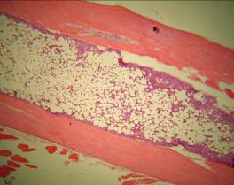

Figure 6. Histological section of the left humerus from a healthy mature adult Litoria infrafrenata, showing the external dense cortical bone and internal bone marrow. Stained with haematoxylin and eosin, viewed at 100 x magnification via light microscopy. Photo by S. Young.
Table 2 summarises results from selected immune function tests in L. caerulea. Blood samples were collected pre-immune stimulation, then each frog received an intracoelomic red blood cell and intradermal phytohaemagglutinin injections. Skin thickness was measured up to 48 hours post-intradermal injections, and various samples were collected seven days post-RBC injection.

 | Pre-Immune Stimulation |  |  | Post-Immune Stimulation
Immune Parameter | Mean | SD | Range | Mean | SD | Range
PHA Skin Test LHS (mm) | - | - | - | 0.57 | 0.30 | 0.26 – 1.28
PHA Skin Test RHS (mm) | - | - | - | 0.43 | 0.28 | 0.02 – 1.02
Splenic Lymphocyte Count | - | - | - | 364 | 148 | 159 – 688
Splenic Trypan Blue Exclusion Viable Cell Count | - | - | - | 39.3 | 22.9 | 15 – 92
Splenic Trypan Blue Exclusion Non-Viable Cell Count | - | - | - | 18.3 | 12.1 | 3 – 40
Splenic Plaque-forming Cells (per 100 μL) | - | - | - | 1469 | 513 | 510 – 2452
Kidney Weight (g) | - | - | - | 0.24 | 0.09 | 0.15 – 0.4
Liver Weight (g) | - | - | - | 2.01 | 0.62 | 1.12 – 2.98
Spleen Weight (g) | - | - | - | 0.014 | 0.009 | 0.01 – 0.04
PCV (%) | 36 | 3.4 | 31 – 42 | 29 | 4.8 | 20 – 37
Total Protein (g/L) | 54 | 8.7 | 39 – 70 | 56 | 6.2 | 47 – 65
Hb (g/dL) | 8.7 | 1.2 | 6.9 – 10.6 | 6.2 | 1.4 | 4.5 – 8.7
RBC (x10⁹/L) | 694 | 135 | 500 – 910 | 588 | 120 | 440 – 880
Thrombocyte (x10⁹/L) | 34.8 | 9.0 | 20.9 – 51.1 | 30.5 | 7.3 | 17.9 – 38.9
WBC (x10⁹/L) | 24.6 | 8.9 | 13.1 – 38.4 | 39.7 | 15.4 | 18.7 – 73.1
AST (U/L) | 69 | 37 | 17 – 145 | 73 | 34 | 31 – 153
CK (U/L) | 495 | 344 | 174 – 1365 | 636 | 496 | 0 – 1713
Uric Acid (μmol/L) | 37 | 26 | 7 – 80 | 40 | 22 | 7 – 69
Glucose (mmol/L) | 3.5 | 0.8 | 1.9 – 4.7 | 3.4 | 0.7 | 1.9 – 4.2
Calcium (mmol/L) | 3.03 | 0.46 | 2.48 – 4.02 | 3.00 | 0.54 | 2.22 – 4.01
Phosphorus (mmol/L) | 1.69 | 0.46 | 1.30 – 2.73 | 1.49 | 0.42 | 0.91 – 2.11
Potassium (mmol/L) | 4.8 | 1.7 | 2.2 – 7.3 | 4.2 | 1.9 | 2.2 – 8.3
Sodium (mmol/L) | 112 | 15 | 102 – 121 | 112 | 5 | 100 - 119

Table 2. Values for selected immune function tests in Litoria caerulea (n = 10) before and after immune stimulation with intradermal phytohaemagglutinin and intracoelomic red blood cells.
Results from these immune function tests will be analysed statistically to determine significant differences, following which a manuscript will be submitted to a peer-reviewed journal.
Objective 6. Experimental laboratory investigations to characterise the acquired immune response to the disease chytridiomycosis in L. infrafrenata and L. caerulea.

This objective has been achieved for L. caerulea. The L. infrafrenata failed to become infected with Batrachochytrium dendobatidis during concurrent infection experiments, most likely due to species-specific resistance to infection.

Table 3 summarises results from selected immune function tests in B. dendrobatidis-infected L. caerulea. Experimental procedures were carried out as outlined in Objective 5.

 | Pre-Immune Stimulation |  |  | Post-Immune Stimulation
Immune Parameter | Mean | SD | Range | Mean | SD | Range
PHA Skin Test LHS (mm) | - | - | - | 0.23 | 0.23 | 0 – 0.76
PHA Skin Test RHS (mm) | - | - | - | 0.20 | 0.24 | 0 – 0.66
Splenic Lymphocyte Count | - | - | - | 127 | 86 | 41 – 324
Splenic Trypan Blue Exclusion Viable Cell Count | - | - | - | 6.6 | 4.3 | 3 – 17
Splenic Trypan Blue Exclusion Non-Viable Cell Count | - | - | - | 13.9 | 9.9 | 5 – 32
Splenic Plaque-forming Cells (per 100 μL) | - | - | - | 740 | 592 | 133 – 1887
Kidney Weight (g) | - | - | - | 0.31 | 0.14 | 0.17 – 0.56
Liver Weight (g) | - | - | - | 1.76 | 0.61 | 1.01 – 2.72
Spleen Weight (g) | - | - | - | 0.026 | 0.011 | 0.01 – 0.04
PCV (%) | 36 | 4.0 | 29 – 42 | 35 | 7.5 | 25 – 47
Total Protein (g/L) | 54 | 5.4 | 42 – 62 | 49 | 6.3 | 38 – 61
Hb (g/dL) | 8.9 | 2.4 | 5.3 – 13.6 | 8.6 | 1.8 | 6.5 – 11.3
RBC (x10⁹/L) | 553 | 90 | 410 – 710 | 580 | 132 | 380 – 760
Thrombocyte (x10⁹/L) | 27.0 | 5.9 | 19.3 – 35.5 | 23.6 | 4.0 | 17.1 – 28.9
WBC (x10⁹/L) | 6.8 | 1.9 | 4.4 – 9.8 | 8.5 | 4.0 | 4.2 – 18.0
AST (U/L) | 68 | 14 | 46 – 97 | 97 | 42 | 38 – 165
CK (U/L) | 282 | 185 | 114 – 661 | 555 | 337 | 150 – 1035
Uric Acid (μmol/L) | 35 | 18 | 7 – 69 | 37 | 29 | 16 – 116
Glucose (mmol/L) | 4.5 | 0.9 | 3.1 – 6.6 | 4.6 | 0.9 | 3.1 – 6.3
Calcium (mmol/L) | 2.75 | 0.40 | 2.36 – 3.55 | 2.72 | 0.39 | 2.15 – 3.24
Phosphorus (mmol/L) | 0.88 | 0.23 | 0.54 – 1.27 | 0.78 | 0.34 | 0.41 – 1.38
Potassium (mmol/L) | 5.2 | 1.5 | 3.1 – 8.0 | 4.2 | 2.2 | 1.5 – 8.5
Sodium (mmol/L) | 110 | 6 | 100 – 122 | 109 | 5 | 100 - 114

Table 3. Values for selected immune function tests in Batrachochytrium dendrobatidis-infected Litoria caerulea (n = 10) before and after immune stimulation.

Results from these immune function tests will be analysed statistically to determine significant differences, following which a manuscript will be submitted to a peer-reviewed journal.

An important manuscript reviewing amphibian chytridiomycosis, with a particular emphasis on the role of zoological institutions in the global response to this formidable emerging infectious disease, was produced as part of this project (Young et al., 2007a) and included in the first progress report (Young et al., 2007c).

Objective 7. Experimental laboratory investigations to determine if protective immunity is present following reinfection with the amphibian chytrid fungus in L. caerulea.

This objective has been completed. A large group of L. caerulea (n = 20) were exposed to the amphibian chytrid fungus following harvesting of the organism from in vitro cultures (Figures 7 & 8). Once infection was established, as determined by regular swabbing of ventral skin surfaces for polymerase chain reaction (PCR) analysis for Batrachochytrium dendrobatidis zoospore equivalents, frogs were treated with chloramphenicol to effect cure. Approximately four months after the first exposure, the same frogs were re-exposed to the pathogen concurrently with a naïve positive control group to monitor the progress of infection (or lack thereof) and determine differences between the two groups. None of the treatment or control frogs became infected following this exposure experiment; the reason for this is unknown but may have related to culture failure or unknown intrinsic/extrinsic factors. The experiment was then expanded to include a second wild-caught naïve positive control group to evaluate whether captive conditions had any influence on infection rates. All groups (excepting the negative controls) were then exposed to B. dendrobatidis and infection status monitored for over six months. There were no differences in infection rates between any of the groups, indicating that long-term protective immunity does NOT occur following infection with B. dendrobatidis in L. caerulea. This has extremely important implications for future management strategies of chytridiomycosis in wild amphibian populations. This study will be submitted for publication in a peer-reviewed journal.

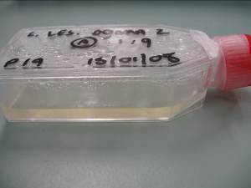

Figure 7. In vitro broth culture of the amphibian chytrid fungus Batrachochytrium dendrobatidis in the laboratory at James Cook University. Photo by S. Young.

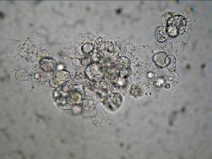

Figure 8. Zoosporangia of the amphibian chytrid fungus Batrachochytrium dendrobatidis cultured in broth in the laboratory at James Cook University, viewed at 400 x magnification via light microscopy. Infective zoospores released by the zoosporangia are harvested and used to experimentally infect frogs for important infection and disease studies. Photo by S. Young.
Objective 8. Experimental laboratory investigations to characterise the acquired immune response in L. infrafrenata affected by the wasting syndrome and comparison with healthy specimens.

This objective has been completed as far as possible, as outlined in the previous progress report. There was no collaborative support from the Cairns Frog Hospital for this objective of the study since the first progress report was submitted, and it was impossible to progress further with investigations into the wasting syndrome in L. infrafrenata. Some of the immunological tests outlined in Objective 5 to characterise acquired immune function have been successfully carried out in L. infrafrenata affected by the wasting syndrome. However, it was been impossible to perform the whole panel of immunological tests for several reasons. Firstly, no specimens were received for this study from the Cairns Frog Hospital since prior to publication in February 2007 of the Final Report for the project Emerging Amphibian Diseases and Disease Surveillance in Queensland - Stage 1 (January 2006 - January 2007) to the Australian Government Department of the Environment and Water Resources (Young et al., 2007b). Secondly, while affected specimens have been received independently from members of the public since that time, all of the frogs were in the terminal stages of the disease and either died or required euthanasia within 24-48 hours of being received at JCU (Figure 9). This precluded carrying out the more complex immunological tests in which a minimum number of days must elapse prior to sample collection to measure the immune response. Nevertheless, as many immunological tests have been carried out as possible in the specimens received to characterise the acquired immune response in L. infrafrenata affected by the wasting syndrome. Finally, field surveillance of properties from which specimens have been received failed to find other affected individuals in which the disease is less advanced and which could feasibly be used for the experimental investigations in their entirity.

Other objectives of this project were prioritised due to their importance in global amphibian research and the greater likelihood of achieving tangible and practical outcomes for this project.
The limited data collected for Objective 8 during the first and second stages of this project has been incorporated into a submitted manuscript Community Surveillance for Diseases of the White-lipped Tree Frog (Litoria infrafrenata) in Northern Queensland, Australia, the details of which are summarised in previous reports (Young et al., 2007b,c).

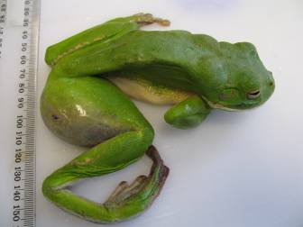
Figure 9. A mature adult white-lipped tree frog (Litoria infrafrenata) received from the public by JCU as part of this study. The frog is in the terminal stages of the wasting disease and has a severely swollen and haemorrhagic thigh due to the presence of a heavy burden of the tapeworm Spirometra erinacei and secondary bacterial invasion. The advanced stage of the disease precluded implementing the full panel of immune tests. Photo by S. Young.

Objective 9. Pathological investigations into the aetiology of the wasting syndrome in L. infrafrenata, including blood collection, immune testing, microbial culture, histology, PCR, ultramicroscopy.

This objective has been completed as far as possible given the limitations outlined in Objective 8. A comprehensive range of tissue and organ samples were collected from specimens received for pathological diagnostic investigations into the aetiology of the wasting syndrome in L. infrafrenata (Table 4).

Clinical Pathological Test | Sample
Morphometrics and clinical examination | whole specimen
Haematology | blood (see Objective 1)
Serum/plasma biochemistry | blood (see Objective 1)
Serum protein electrophoresis | blood (see Objective 1)
Urinalysis | urine
Faecal analysis | faeces
Immunological tests | various (see Objective 5)
Gross necropsy | whole specimen
Bacterial and fungal culture | various tissues/fluids
Histology | various tissues
Electron microscopy | various tissues
Polymerase chain reaction assay | various tissues

Table 4. Summary of the range of clinical pathological testing performed in this study to investigate the aetiology of the wasting syndrome in Litoria infrafrenata.

A detailed case definition for the wasting syndrome in L. infrafrenata has been developed and epidemiological investigations (see Objective 10) suggest that this is a new disease endemic in this species in northern Queensland, manifesting as irreversible emaciation (Figure 10). Preliminary evidence from this study suggests that the tapeworm Spirometra erinacei may be a newly discovered pathogenic aetiological agent causing secondary immunosuppression and irreversible emaciation (Figures 11 & 12). The limited data collected for Objective 9 during the first and second stages of this project has been incorporated into a submitted manuscript as described in Objective 8.

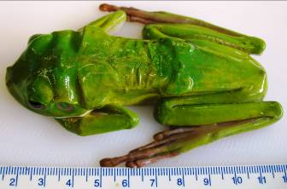
Figure 10. A mature adult white-lipped tree frog (Litoria infrafrenata) with the wasting syndrome, in the terminal stages of the disease. Affected individuals present clinically in poor body condition with no obvious cause, and become progressively emaciated despite treatment, eventually dying. Photo by S. Young.

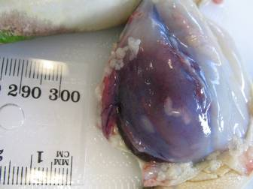

Figure 11. A mature adult white-lipped tree frog (Litoria infrafrenata) with the wasting disease and concurrent severe infection with the tapeworm Spirometra erinacei. The skin has been reflected during a necropsy examination to reveal the parasites overlying and within the thigh muscles, along with significant secondary bacterial abscessation and haemorrhage of the infected tissues. Photo by S. Young.

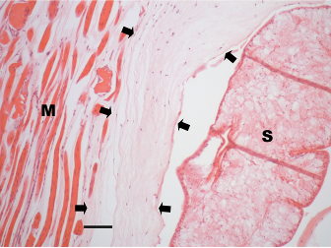

Figure 12. Histological section of thigh muscle from a white-lipped tree frog (Litoria infrafrenata) with the wasting disease and concurrent severe infection with the tapeworm Spirometra erinacei. There is severe and widespread necrosis of muscle cells around the tapeworm plerocercoid and little associated inflammatory response (region between the arrows). M = muscle, S = Spirometra erinacei tapeworm. Stained with haematoxylin & eosin, bar = 10 μm. Photo by D. Méndez.

Objective 10. Determination and implementation of epidemiological techniques for surveying L. infrafrenata populations affected with the wasting syndrome, to investigate the epidemiology of this disease.

This objective has been completed as far as is possible given the limitations outline in Objective 8. Other objectives of this project were prioritised due to their importance in global amphibian research and the greater likelihood of achieving tangible and practical outcomes for this project. There was no collaborative support from the Cairns Frog Hospital for this objective of the study since the first progress report was submitted in February 2007 and it was impossible to progress further with investigations into the wasting syndrome in L. infrafrenata. Difficulties have been encountered with receiving sufficient specimens, as outlined in Objective 8. Field surveillance of properties from which L. infrafrenata specimens affected with the wasting syndrome were received failed to find other affected individuals.

A retrospective spatial and temporal analysis of CFH submission data from January 1999 to
December 2004 has been carried out (summarised by Young et al., 2007b,c), the results of which are summarised in the submitted manuscript Community Surveillance for Diseases of the White-lipped Tree Frog (Litoria infrafrenata) in Northern Queensland, Australia as described in Objective 8. This manuscript not only reports results from an extensive analysis of the CFH amphibian disease surveillance data, but also forms a preliminary scientific paper documenting the wasting syndrome as a previously unidentified disease syndrome in tree frogs in far northern Queensland, establishing a detailed case definition and quantifying the range of parasite infections present in affected individuals.
Objective 11. Evaluation and comparison of passive and active surveillance techniques for amphibian diseases in the Cairns region.

Preliminary results for this objective were outlined in the first progress report (Young et al., 2007c). In summary, results from limited active surveillance conducted during the dry season suggest that active surveillance at this time of year in northern Queensland is a largely ineffective tool for amphibian disease surveillance. Furthermore, passive surveillance appears to be more effective for amphibian disease surveillance versus active surveillance during the dry season. Since the 2007 dry season, JCU investigators involved with this project were inundated with experimental work involved in Objectives 1 – 9, with submissions via their passive surveillance networks, and with diagnostic investigations into amphibian disease under a separate DEWR tender. Furthermore, Objective 7 (Experimental laboratory investigations to determine if protective immunity is present following reinfection with the amphibian chytrid fungus in L. caerulea) is a large experimental trial that was added onto this project after its commencement and was prioritised due to its critical importance in global chytridiomycosis research and the greater likelihood of achieving tangible and practical outcomes for this project. As a result, there was insufficient time and resources to continue comprehensive investigations in order to complete Objective 11 within the current project.

Objective 12. Development of suitable techniques for collection of relevant disease surveillance data by community wildlife care groups and determining how this can be transmitted in a practical and cost-effective way to the Australian Wildlife Health Network.

This objective has been completed for this project, to the extent that is possible given the limitations outlined in Objective 8. More detailed investigations regarding integration of surveillance data collected by community wildlife care groups and trained wildlife disease professionals into the AWHN were carried out under a separate DEWR tender.

A detailed set of clinical pathology reporting parameters were developed during this study, representing part of the JCU node in the Australian Registry of Wildlife Health (ARWH) (Table 5). This information has been integrated into the database maintained by the Registry and developed further as an amphibian disease reporting template. This project was also involved in setting up the Diagnostic Imaging Network System, a national collaborative diagnostic pathology network involving JCU, CSIRO and ARWH.

Clinical Pathology Parameters | Reporting Categories
Morphometrics and clinical examination | body weight, snout-urostyle length, body condition, behaviour, posture, heart rate, respiratory rate, body temperature, mucous membrane colour, blood oxygen saturation, physical abnormalities
Haematology | blood collection method, volume collected, packed cell volume, buffy coat, total protein (refractometer), haemoglobin, serum/plasma colour, haemoparasites, red blood cell count, platelet count, total white bood cell count, differential white blood cell count
Serum/plasma biochemistry | aspartate transferase, bile acids, creatinine kinase, uric acid, glucose, calcium, phosphorus, total protein, albumin, globulins, potassium, sodium, haemolysis, lipaemia, icteric index, comments
Serum protein electrophoresis | total protein, albumin, total globulins, globulin fractions
Urinalysis | urine specific gravity, dipstick (glucose, bilirubin, ketones, blood, pH, protein, urobilinogen), cytology, other, comments
Faecal analysis | form/colour, direct saline preparation, floatation, cytology (diff quik, gram, other), comments
General cytology | sample type, method, results, comments
Culture and sensitivity | sample type, method, results, comments
Chytrid qPCR | sample type, qPCR JCU ID, number wells positive, sample concentration
Other PCR assays | sample type, method, results, comments
Electron microscopy | sample type, method, results, comments
Necropsy | gross findings
Histology | findings by tissue type

Table 5. Summary of the range of clinical pathology reporting parameters for amphibian disease investigations developed during this study.
Objective 13. Identification of amphibian diseases in Queensland via passive and active surveillance and subsequent pathological investigations.

This objective has been completed. During the project, 160 specimens were received through the passive surveillance system set up at JCU. Priority for processing and diagnostic analysis was given to the following: endangered species; live specimens from which a detailed history and clinical presentation, and clinical pathology and immunology results, could be obtained; and individuals which had received no prior treatment to avoid confusion and bias in results. For each case, thorough physical examination, necropsy and sample collection protocols were established and implemented. A large range of diagnostic samples were collected and analysed including haematology, serum biochemistry, and parasite identification. Formalin-fixed tissues were processed from each case and histological analysis carried out where possible. Similarly, a range of tissue samples from each specimen was frozen for further diagnostic testing if required. Table 6 summarises the diagnostic findings in the frog specimens received during this project.

Case ID | Species | Age/Sex | Origin | Diagnostic Findings
FDRQ 001 | Litoria infrafrenata | Mature adult female | Cooktown | Emaciation  Spirometra erinacei infection
FDRQ 002 | Litoria infrafrenata | Mature adult female | Edge Hill Cairns | Injury
FDRQ 003 | Litoria infrafrenata | Mature adult female | Holloways Beach Cairns | Injury  Ascites
FDRQ 004 | Litoria infrafrenata | Mature adult female | Trinity Beach Cairns | Emaciation  Spirometra erinacei infection
FDRQ 005 | Litoria infrafrenata | Mature adult female | Edmonton Cairns | Injury – abdominal hernia  Hyperbiliverdinaemia
FDRQ 006 | Litoria infrafrenata | Mature adult | Trinity Bay Cairns | Emaciation
FDRQ 007 | Litoria infrafrenata | Mature adult | Brinsmead Cairns | Emaciation
FDRQ 008 | Litoria infrafrenata | Mature adult | Edmonton Cairns | Emaciation
FDRQ 009 | Litoria infrafrenata | Mature adult | Trinity Beach Cairns | Emaciation  Spirometra erinacei infection
FDRQ 010 | Litoria infrafrenata | Young adult | Brinsmead Cairns | Emaciation
FDRQ 011 | Litoria infrafrenata | Mature adult | Yarrabah | Emaciation  Spirometra erinacei infection
FDRQ 012 | Litoria infrafrenata | Mature adult | Edmonton Cairns | Emaciation  Spirometra erinacei infection

Table 6. Summary of case details and diagnostic findings in the frog specimens received during the project.

Case ID | Species | Age/Sex | Origin | Diagnostic Findings
FDRQ 013 | Litoria infrafrenata | Mature adult | Manunda Cairns | Emaciation  Spirometra erinacei infection
FDRQ 014 | Litoria caerulea | Mature adult male | Mooroobool Cairns | Skin condition
FDRQ 015 | Litoria infrafrenata | Mature adult male | Manoora Cairns | Anasarca (blue-tinged fluid)  Fair body condition
FDRQ 016 | Litoria caerulea | Young adult male | Edmonton Cairns | Gastrointestinal parasitism
FDRQ 017 | Litoria infrafrenata | Mature adult female | Mooroobool Cairns | Mild anasarca (blue-tinged fluid)
FDRQ 018 | Litoria infrafrenata | Mature adult female | Mooroobool Cairns | Mild anasarca (blue-tinged fluid)
FDRQ 019 | Litoria infrafrenata | Mature adult female | Mooroobool Cairns | Mild anasarca (blue-tinged fluid)
FDRQ 020 | Litoria infrafrenata | Mature adult male | Mooroobool Cairns | Spirometra erinacei infection
FDRQ 021 | Litoria infrafrenata | Mature adult | Gordonvale Cairns | Emaciation  Spirometra erinacei infection
FDRQ 022 | Litoria infrafrenata | Mature adult | Edge Hill Cairns | Skin condition
FDRQ 023 | Litoria infrafrenata | Mature adult | Machans Beach Cairns | Spirometra erinacei infection  Coelomic mass
FDRQ 024 | Litoria infrafrenata | Mature adult | Cairns | Spirometra erinacei infection  Hepatic mass
FDRQ 025 | Bufo marinus | Mature adult | Edmonton Cairns | No significant histological findings
FDRQ 026 | Litoria infrafrenata | Mature adult | Edge Hill Cairns | Emaciation
FDRQ 027 | Litoria infrafrenata | Mature adult | Cairns | Injury
FDRQ 028 | Litoria infrafrenata | Mature adult female | Cooktown | Poor body condition after prolonged captivity
FDRQ 029 | Litoria infrafrenata | Mature adult male | Stratford Cairns | Poor body condition after prolonged captivity
FDRQ 030 | Litoria infrafrenata | Mature adult female | Mooroobool Cairns | Emaciation  Spirometra erinacei infection
FDRQ 031 | Litoria infrafrenata | Mature adult male | Mooroobool Cairns | Anasarca (blue-tinged fluid)  Hyperbiliverdinaemia
FDRQ 032 | Litoria infrafrenata | Mature adult male | Portsmith Cairns | Anasarca (blue-tinged fluid)  Poor body condition (captive)

Table 6 (cont.). Summary of case details and diagnostic findings in the frog specimens received during the project.
Case ID | Species | Age/Sex | Origin | Diagnostic Findings
FDRQ 033 | Litoria infrafrenata | Mature adult female | Mooroobool Cairns | Hyperbiliverdinaemia
FDRQ 034 | Litoria infrafrenata | Mature adult female | Bayview Heights Cairns | Poor body condition (captive)  Renal parasitism
FDRQ  035 – 048 | Cyclorana novaehollandiae | Metamorphs x 11  Tadpoles x 3 | Mount Carbine | Hepatic necrosis  Skeletal abnormalities  Ascites, Lipaemia  Suspect toxic or nutritional aetiology
FDRQ 049 | Litoria infrafrenata | Mature adult female | White Rock Cairns | Injury  Hyperbiliverdinaemia  Renal parasitism
FDRQ 050 | Litoria infrafrenata | Mature adult female | Edge Hill Cairns | Injury  Coelomic nematodes
FDRQ 051 | Litoria infrafrenata | Mature adult female | Mooroobool Cairns | Injury  Hyperbiliverdinaemia
FDRQ 052 | Litoria infrafrenata | Mature adult female | Manoora Cairns | Emaciation  Spirometra erinacei infection
FDRQ 053 | Litoria caerulea | Mature adult female | Peachester SE Qld via QPWS | Chytridiomycosis
FDRQ 054 | Litoria caerulea | Mature adult female | SE Qld via QPWS | Systemic microsporidiosis
FDRQ 055 | Litoria caerulea | Mature adult male | Brighton SE Qld via QPWS | Injury
FDRQ 056 | Litoria infrafrenata | Mature adult female | Mooroobool Cairns | Emaciation  Spirometra erinacei infection  Hyperbiliverdinaemia
FDRQ 057 | Litoria infrafrenata | Mature adult female | Yorkeys Knob Cairns | Hepatic and renal cysts  Encysted nematodes - bladder
FDRQ 058 | Litoria infrafrenata | Mature adult male | Manunda  Cairns | Emaciation  Spirometra erinacei infection
FDRQ 059 | Limnodynastes terraereginae | Mature adult female | Calliope SE Qld via QPWS | Cause of death unknown
FDRQ 060 | Litoria caerulea | Mature adult male | Redland Bay SE Qld via QPWS | Dermatitis  Renal disease
FDRQ 061 | Litoria caerulea | Subadult male | Sunshine Coast via QPWS | Suspect chytridiomycosis
FDRQ 062 | Litoria caerulea | Subadult male | Brighton SE Qld via QPWS | Injury
FDRQ 063 | Bufo marinus | Mature adult male | Nth Maleny SE Qld via QPWS | Hepatic disease  Pulmonary Rhabdias infection
FDRQ 064 | Adelotus brevis | Mature adult female | Greenslopes SE Qld via QPWS | Chytridiomycosis

Table 6 (cont.). Summary of case details and diagnostic findings in the frog specimens received during the project.
Case ID | Species | Age/Sex | Origin | Diagnostic Findings
FDRQ 065 | Litoria peronii | Mature adult male | Peachester SE Qld via QPWS | Chytridiomycosis
FDRQ 066 | Litoria nasuta | Mature adult female | SE Qld via QPWS | Chytridiomycosis
FDRQ 067 | Litoria nasuta | Mature adult male | SE Qld via QPWS | Injury  Bilateral blindness
FDRQ 068 | Litoria nasuta | Mature adult female | Fernvale SE Qld via QPWS | Injury
FDRQ 069 | Litoria rubella | Mature adult | Sunshine Coast via QPWS | Cause of death unknown
FDRQ 070 | Litoria nasuta | Mature adult male | Fernvale SE Qld via QPWS | Injury
FDRQ 071 | Litoria infrafrenata | Mature adult female | Clifton Beach Cairns | Emaciation  Spirometra erinacei infection  Pulmonary Rhabdias infection
FDRQ 072 | Litoria caerulea | Mature adult female | Redlynch Cairns | Coelomic mass
FDRQ 073 | Litoria caerulea | Mature adult male | Gordonvale Cairns | Poor body condition after prolonged captivity
FDRQ 074 | Litoria infrafrenata | Mature adult female | Machans Beach Cairns | Injury
FDRQ 075 | Litoria infrafrenata | Mature adult male | Manoora Cairns | Emaciation  Spirometra erinacei infection  Pulmonary Rhabdias infection  Gastrointestinal nematodes  Hepatozoon sp. infection
FDRQ 076 | Litoria nasuta | Mature adult male | Kuranda | Cause of death unknown
FDRQ 077 | Litoria infrafrenata | Mature adult female | Manoora  Cairns | Emaciation  Spirometra erinacei infection  Hyperbiliverdinaemia  Hepatozoon sp. infection
FDRQ 078 | Litoria infrafrenata | Mature adult male | Machans Beach Cairns | Otic chondroma
FDRQ 079 | Litoria infrafrenata | Mature adult female | Kuranda | Emaciation  Spirometra erinacei infection  Pulmonary Rhabdias infection  Encysted coelomic nematodes
FDRQ 080 | Litoria infrafrenata | Mature adult male | Edge Hill Cairns | Injury  Hepatozoon sp. infection  Microfilaria infection
FDRQ 081 | Litoria caerulea | Mature adult female | Mooroobool Cairns | Spirometra erinacei infection

Table 6 (cont.). Summary of case details and diagnostic findings in the frog specimens received during the project.
Case ID | Species | Age/Sex | Origin | Diagnostic Findings
FDRQ 082 | Litoria infrafrenata | Mature adult female | Mooroobool Cairns | Emaciation  Spirometra erinacei infection
FDRQ 083 | Litoria infrafrenata | Mature adult male | Cooktown | Massive cloacal prolapse  Hepatozoon sp. infection
FDRQ 084 | Litoria infrafrenata | Mature adult male | Brinsmead Cairns | Injury  Hepatozoon sp. infection
FDRQ 085 | Litoria infrafrenata | Mature adult female | Clifton Beach Cairns | Dermal squamous papilloma  Spirometra erinacei infection  Hepatozoon sp. infection
FDRQ 086 | Litoria lesueuri | Mature adult female | Kuranda | Injury  Gastrointestinal nematodes
FDRQ 087 | Litoria infrafrenata | Mature adult female | Holloways Beach Cairns | Mandibular cellulitis  Pulmonary Rhabdias infection  Encysted coelomic nematodes
FDRQ 088 | Litoria infrafrenata | Mature adult female | Holloways Beach Cairns | Injury  Gastrointestinal nematodes
FDRQ 089 | Litoria infrafrenata | Mature adult female | Edmonton Cairns | Emaciation  Spirometra erinacei infection
FDRQ 090 | Litoria infrafrenata | Subadult | Wonga Beach | Severe skeletal deformities after prolonged captivity
FDRQ 091 | Litoria infrafrenata | Subadult | Aeroglen Cairns | Severe skeletal deformities after prolonged captivity
FDRQ 092 | Litoria caerulea | Mature adult male | Edmonton Cairns | Emaciation  Spirometra erinacei infection  Pulmonary Rhabdias infection  Gastrointestinal nematodes
FDRQ 093 | Litoria infrafrenata | Mature adult male | Freshwater  Cairns | Injury
FDRQ 094 | Litoria infrafrenata | Mature adult male | Edge Hill Cairns | Pulmonary Rhabdias infection  Encysted coelomic nematodes
FDRQ 095 | Litoria caerulea | Subadult male | Mossman | Injury  Gastrointestinal nematodes
FDRQ 096 | Litoria infrafrenata | Mature adult female | Manunda Cairns | Emaciation  Spirometra erinacei infection  Hepatozoon sp. infection  Gastrointestinal nematodes  Hyperbiliverdinaemia
FDRQ 097 | Litoria infrafrenata | Mature adult male | Smithfield Cairns | Injury
FDRQ 098 | Litoria infrafrenata | Mature adult female | Machans Beach Cairns | Emaciation  Spirometra erinacei infection  Pulmonary Rhabdias infection  Hepatozoon sp. infection

Table 6 (cont.). Summary of case details and diagnostic findings in the frog specimens received during the project.
Case ID | Species | Age/Sex | Origin | Diagnostic Findings
FDRQ 099 | Litoria infrafrenata | Mature adult | Forest Gardens Cairns | Injury
FDRQ 100 | Litoria infrafrenata | Young adult | Brinsmead Cairns | Injury
FDRQ 101 | Litoria infrafrenata | Mature adult | Manunda Cairns | Urinary tract nematodes  Myopathy
FDRQ 102 | Litoria infrafrenata | Mature adult | Trinity Beach Cairns | Emaciation  Spirometra erinacei infection
FDRQ 103 | Litoria caerulea | Young adult male | Redlynch Cairns | Injury
FDRQ 104 | Litoria splendida | Subadult | Kuranda (captive) | Chytridiomycosis
FDRQ 105 | Litoria splendida | Subadult | Kuranda (captive) | Chytridiomycosis
FDRQ 106 | Litoria splendida | Subadult | Kuranda (captive) | Chytridiomycosis
FDRQ 107 | Litoria splendida | Subadult | Kuranda (captive) | Chytridiomycosis
FDRQ 108 | Litoria splendida | Subadult | Kuranda (captive) | Chytridiomycosis
FDRQ 109 | Litoria splendida | Subadult | Kuranda (captive) | Chytridiomycosis
FDRQ 110 | Litoria splendida | Subadult | Kuranda (captive) | Chytridiomycosis
FDRQ 111 | Litoria wilcoxii | Mature adult male | Eungella National Park via QPWS | Renal parasitism  Cause of death open pending further investigation
FDRQ 112 | Litoria wilcoxii | Mature adult male | Eungella National Park via QPWS | Injury
FDRQ 113  A B C D | Taudactylus eungellensis | Tadpoles x 4 | Eungella National Park via QPWS | Cause of death open pending further investigation
FDRQ 114 | Litoria infrafrenata | Mature adult female | Aeroglen Cairns | Bacterial septicaemia
FDRQ 115 | Litoria xanthomera | Mature adult | Wondecla via QPWS | Injury
FDRQ 116 | Litoria caerulea | Mature adult female | Townsville | Severe generalised bacterial abscessation
FDRQ 117 | Bufo marinus | Mature adult male | Mount Tambourine | Severe bacterial skin abscessation
FDRQ 118 | Litoria caerulea | Young adult female | Townsville | Anasarca, anaemia  Pulmonary Rhabdias infection

Table 6 (cont.). Summary of case details and diagnostic findings in the frog specimens received during the project.
Case ID | Species | Age/Sex | Origin | Diagnostic Findings
FDRQ 119 | Litoria infrafrenata | Mature adult | Aeroglen Cairns | Systemic organ dysfunction, cause open pending further investigation
FDRQ 120 | Litoria infrafrenata | Mature adult female | Freshwater Cairns | Injury
FDRQ 121 | Litoria infrafrenata | Mature adult female | Cooktown | Emaciation  Spirometra erinacei infection
FDRQ 122 | Litoria caerulea | Juvenile | Townsville (captive) | Severe generalised metabolic bone disease
FDRQ 123 | Litoria caerulea | Juvenile | Townsville (captive) | Severe generalised metabolic bone disease
FDRQ 124 | Litoria caerulea | Juvenile | Townsville (captive) | Severe generalised metabolic bone disease
FDRQ 125 | Litoria caerulea | Juvenile | Townsville (captive) | Severe generalised metabolic bone disease
FDRQ 126 | Litoria splendida | Mature adult male | Gordonvale Cairns | Emaciation  Spirometra erinacei infection
FDRQ 127 | Litoria nannotis | Subadult | Mount Spurgeon | Chytridiomycosis
FDRQ 128 | Litoria genimaculata | Subadult | Mount Spurgeon | Chytridiomycosis
FDRQ 129 | Litoria genimaculata | Subadult | Kirrama | Chytridiomycosis
FDRQ 130 | Litoria infrafrenata | Mature adult | Cairns | Emaciation  Spirometra erinacei infection
FDRQ 131 | Litoria infrafrenata | Mature adult | Cairns | Severe bacterial dermatopathy  Nephropathy
FDRQ 132 | Litoria caerulea | Mature adult | Townsville | Severe bacterial dermatopathy  Pulmonary Rhabdias infection
FDRQ 133 | Litoria rheocola | Juvenile male | Tully Gorge National Park | Suspect chytridiomycosis
FDRQ 134 | Litoria nasuta | Mature adult female | Tully Gorge National Park | Injury
FDRQ 135 | Litoria caerulea | Mature adult female | Townsville | Emaciation
FDRQ 136 | Litoria nannotis | Juvenile male | Windin | Cause of death open pending further investigation
FDRQ 137 | Litoria caerulea | Subadult female | Trinity Beach | Injury
FDRQ 138 | Litoria caerulea | Mature adult male | Townsville | Hepatopathy, cause open pending further investigation

Table 6 (cont.). Summary of case details and diagnostic findings in the frog specimens received during the project.

Case ID | Species | Age/Sex | Origin | Diagnostic Findings
FDRQ 139  A B C D | Litoria infrafrenata | Tadpoles x 4 | Cairns | Platyhelminth infection
FDRQ 140 | Litoria caerulea | Mature adult female | Cairns  (captive) | Suspect acute bacterial septicaemia
FDRQ 141 | Physignathus lesueurii | Mature adult female | Clifton Beach | Emaciation  Spirometra erinacei infection
FDRQ 142 | Litoria caerulea | Juvenile | Clifton Beach | Injury
FDRQ 143 | Litoria caerulea | Mature adult male | Cairns  (captive) | Bacterial pneumonia
FDRQ 144 | Litoria caerulea | Mature adult male | Cairns  (captive) | Intracoelomic haemorrhage
FDRQ 145 | Litoria caerulea | Mature adult male | Cairns  (captive) | No significant histological findings
FDRQ 146 | Litoria nannotis | Juvenile | Mount Spurgeon | Chytridiomycosis
FDRQ 147 | Litoria genimaculata | Mature adult male | Mount Spurgeon | Chytridiomycosis
FDRQ 148 | Litoria caerulea | Mature adult male | Cairns  (captive) | Bacterial septicaemia
FDRQ 149 | Litoria caerulea | Mature adult male | Cairns  (captive) | Chytridiomycosis (mild)  Leukopaenia (severe)
FDRQ 150 | Litoria caerulea | Mature adult male | Cairns  (captive) | Nephropathy, cause open pending further investigation
FDRQ 151 | Litoria nannotis | Immature male | Mount Spurgeon | Chytridiomycosis
FDRQ 152 | Litoria caerulea | Mature adult female | Cairns  (captive) | Chytridiomycosis
FDRQ 153 | Litoria infrafrenata | Mature adult female | Tully | Injury
FDRQ 154 | Litoria infrafrenata | Mature adult female | Tully | Injury
FDRQ 155 | Litoria caerulea | Mature adult female | Cairns | Bacterial septicaemia
FDRQ 156 | Mixophyes fleayi | Mature adult male | Mount Cougal National Park | Hepatopathy, cause open pending further investigation
FDRQ 157  A B C D E | Litoria spenceri | Tadpoles x 5 | Currumbin  (captive) | Cause of death unknown, suspect toxic or nutritional

Table 6 (cont.). Summary of case details and diagnostic findings in the frog specimens received during the project.

Case ID | Species | Age/Sex | Origin | Diagnostic Findings
FDRQ 158 | Mixophyes fasciolatus | Mature adult female | Currumbin  (captive) | Cause of death open pending further investigation
FDRQ 159 | Bufo marinus | Mature adult male | Currumbin | No significant histological findings
FDRQ 160 | Litoria caerulea | Mature adult male | Kuranda | Injury

Table 6 (cont.). Summary of case details and diagnostic findings in the frog specimens received during the project.

Significant disease and/or pathological lesions were found in several cases and these were intensively further investigated. A large dermal squamous papilloma was diagnosed histologically in Case ID FDRQ 085, and tissue was submitted for transmission electron microscopy and polymerase chain reaction analysis for further aetiological classification (Figures 13 & 14). Systemic microsporidiosis was diagnosed histologically in Case ID FDRQ 054, and tissue was submitted for transmission electron microscopy and polymerase chain reaction analysis for further aetiological classification (Figures 15 & 16). Comprehensive case reports for these will be submitted to peer-reviewed scientific journals during 2010.

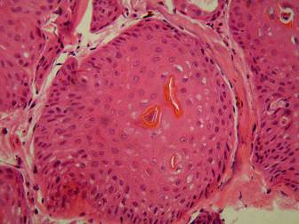

Figure 13. Histological section of an extensive dermal papilloma from a white-lipped tree frog (Litoria infrafrenata), case ID FDRQ 085. Stained with haematoxylin & eosin, 400x magnification. Photo by R.Slocombe.

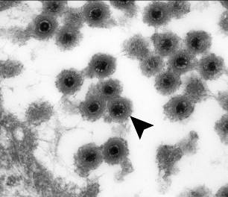

Figure 14. Transmission electron micrograph of the dermal papilloma from white-lipped tree frog (Litoria infrafrenata) case ID FDRQ 085, showing intracellular multiple viral particles (arrow). 144,000x magnification. Photo by L. Tatarczuch.

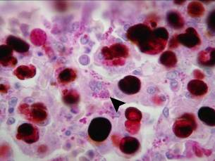

Figure 15. Histological section of liver from a white-lipped tree frog (Litoria infrafrenata), case ID FDRQ 054, showing mutiple intracellular protozoal organisms (arrow). Stained with Periodic Acid Schiff, 1000x magnification. Photo by R.Slocombe.

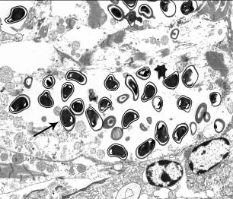

Figure 16. Transmission electron micrograph of cardiac muscle from white-lipped tree frog (Litoria infrafrenata) case ID FDRQ 054, showing multiple intracellular microsporidial organisms (arrow). 7,360x magnification. Photo by L. Tatarczuch.

Objective 14. Journal publications as data is collected throughout the project.

Publications associated with this project are listed below.

(1) Young, S., Speare, R., Berger, L., Skerratt, L. & Mendez, D. (2007a). Emerging Amphibian Diseases and Disease Surveillance in Queensland - Stage 1 (January 2006 - January 2007). Final report for the project Emerging Amphibian Diseases and Disease Surveillance in Queensland - Stage 1 (January 2006 - January 2007) to the Australian Government Department of the Environment and Water Resources.

(2) Young, S., Speare, R., Berger, L., Skerratt, L. & Mendez, D. (2007b). Emerging Amphibian Diseases and Disease Surveillance in Queensland – Stage 2 (February 2007 – June 2008). Progress report for the project Emerging Amphibian Diseases and Disease Surveillance in Queensland – Stage 2 (February 2007 – June 2008) to the Australian Government Department of the Environment and Water Resources.

(3) Young, S., Berger, L. & Speare, R. (2007). Amphibian chytridiomycosis: strategies for captive management and conservation. International Zoo Yearbook 41:85-95.

(4) Voyles, J., Berger, L., Young, S., Speare, R., Webb, R., Warner, J., Rudd, D., Campbell, R. & Skerratt, L. F. (2007). Electrolyte depletion and osmotic imbalance in amphibians with chytridiomycosis. Diseases of Aquatic Organisms 77:113-118.

(5) Berger, L., Skerratt, L., Zhu, X.-Q., Young, S. & Speare, R. (2007). Severe sparganosis in Australian tree frogs. Journal of Wildlife Diseases 45(4):921-929.

(6) Phillot, A. D. & Young, S. (2009). Occurrence of cloacal prolapse in wild hylids in the Wet Tropics, Australia. Diseases of Aquatic Organisms 86:77-80.

(7) Voyles, J., Young, S., Berger, L., Campbell, C., Voyles, W. F., Dinudom, A., Cook, D., Webb, R., Alford, R. A., Skerratt, L. F. & Speare, R. (2009). Pathogenesis of chytridiomycosis, a cause of catastrophic amphibian declines. Science 326:582-585.

(8) Young, S., Speare, R., Berger, L., Skerratt, L. & Mendez, D. (2010). Emerging Amphibian Diseases and Disease Surveillance in Queensland – Stage 2 (February 2007 – April 2010). Final report for the project Emerging Amphibian Diseases and Disease Surveillance in Queensland – Stage 2 (February 2007 – April 2010) to the Australian Government Department of the Environment, Water, Heritage and the Arts.

(9) Community Surveillance for Diseases of the White-lipped Tree Frog (Litoria infrafrenata) in Northern Queensland, Australia. Ecohealth (submitted).

(10) Young, S., Warner, J., Speare, R., Berger, L., Skerratt, L. & Muller, R. Hematologic and Plasma Biochemical Reference Values for Two Species of Free-ranging Australian Tree Frogs, Litoria caerulea and L. infrafrenata (in preparation).

Bibliography

Berger, L., Speare, R., Daszak, P., Green, D. E., Cunningham, A. A., Goggin, C. L., Slocombe, R., Ragan, M. A., Hyatt, A. D., McDonald, K. R., Hines, H. B., Lips, K. R., Marantelli, G. & Parkes, H. (1998). Chytridiomycosis causes amphibian mortality associated with population declines in the rainforests of Australia and Central America. Proceedings of the National Academy of Sciences of the United States of America 95:9031-6.

Berger, L., Speare, R., Hyatt, A. (1999). Chytrid fungi and amphibian declines: overview, implications and future directions. In Campbell, A. (Ed.): Declines and Disappearances of Australian Frogs. Environment Australia, Canberra. Pp 23-33.

Berger, S., Martin, L. B., Wikelski, M., Romero, L. M., Kalko, E. K., Vitousek, M. N. & Rodl, T. (2005). Corticosterone suppresses immune activity in territorial Galapagos marine iguanas during reproduction. Hormones and Behaviour 47:419-429.

Bosch, J., Martínez-Solano, I. & García-París, M. (2001). Evidence of a chytrid fungus infection involved in the decline of the common midwife toad (Alytes obstetricans) in protected areas of central Spain. Biological Conservation 97:331-337.

Burnham, D. K., Keall, S. N., Nelson, N. J. & Daugherty, C. H. (2005). T cell function in tuatara (Sphenodon punctatus). Comparative Immunology, Microbiology and Infectious Diseases 28(3):213-222.

Carey, C., Bradford, D. F., Brunner, J. F., Collins, J. P., Davidson, E. W., Longcore, J. E., Ouellet, M., Pessier, A. P. & Schock, D. M. (2003). Biotic factors in amphibian declines. In Linder G, Sparling DW, Krest SK (Eds): Multiple Stressors and Declining Amphibian Populations: Evaluating Cause and Effect. Society for Environmental Toxicology and Chemistry Press, Pensacola, Florida. Pp 153-208.

Carey, C., Cohen, N. & Rollins-Smith, L. (1999). Amphibian declines: an immunological perspective. Developmental and Comparative Immunology 23:459-472.

Daszak, P., Cunningham, A. A. & Hyatt, A. D. (2003). Infectious disease and amphibian population declines. Diversity and Distributions 9:141-150.

Daszak, P., Berger, L., Cunningham, A. A., Hyatt, A. D., Green, D. E. & Speare, R. (1999). Emerging infectious diseases and amphibian population declines. Emerging Infectious Diseases 5:735-748.

Du Pasquier, L. & Flajnik, M. F. (1999). Origin and evolution of the vertebrate immune system. In Paul E (Ed.): Fundamental Immunology. Lippincott-Raven, Philadelphia. Pp 605-650.

Farrar, E. S. & Frye, B. E. (1979). Factors affecting normal carbohydrate levels in Rana pipiens. General Comparative Endocrinology 39:358-371.

Gantress, J., Maniero, G. D., Cohen, N. & Robert, J. (2003). Development and characterization of a model system to study amphibian immune responses to iridoviruses. Virology 311:254-262.

Gearing, A. J., Cribbin, F. A. & Horton, J. D. (1984). Restoration of the antibody response to sheep erythrocytes in thymectomised Xenopus implanted with MHC-compatible or MHC-incompatible thymus. Journal of Embryology and Experimental Morphology 84:287-302.

Grasman, K. A. (2002). Assessing immunological function in toxicological studies of avian wildlife. Integrative and Comparative Biology 42:34-42.

Horton, J. D., Rimmer, J. J. & Horton, T. L. (1976). The effect of thymectomy at different stages of larval development on the immune response of the clawed toad to sheep erythrocytes. Journal of Experimental Zoology 196(2):243-249.

Hsu, E. & Du Pasquier, L. (1984). Studies in Xenopus immunoglobulins using monoclonal antibodies. Molecular Immunology 21:257.

IUCN (The World Conservation Union) (2001). IUCN Red List Categories and Criteria. IUCN, Gland, Switzerland.

IUCN (The World Conservation Union) (2004). IUCN Global Amphibian Assessment. IUCN Species Survival Commission, Conservation International Center for Applied Biodiversity Science, NatureServe. Accessed at: http://www.globalamphibians.org

Kinney, K.S. & Cohen, N. (2005). Increased splenocyte mitogenesis following sympathetic denervation in Xenopus laevis. Developmental and Comparative Immunology 29(4):287-293.

Lips, K. R., Brem, F., Brenes, R., Reeve, J. D., Alford, R.A., Voyles, J., Carey, C., Livo, L., Pessier, A. P. & Collins, J. P. (2006). Emerging infectious disease and the loss of biodiversity in a Neotropical amphibian community. Proceedings of the National Academy of Sciences of the United States of America 103:3165-3170.

Robert, J., Morales, H., Buck, W., Cohen, N., Marr, S. & Gantress, J. (2005). Adaptive immunity and histopathology in frog virus 3-infected Xenopus. Virology 332:667-675.

Rollins-Smith, L. A. & Blair, P. J. (1993). The effects of corticosteroid hormones and thyroid hormones on lymphocyte viability and proliferation during development and metamorphosis of Xenopus laevis. Differentiation 54(3):155-160.

Rollins-Smith, L. A. & Cohen, N. (1982). Effects of early larval thymectomy on mitogen responses in leopard frog (Rana pipiens) tadpoles. Developmental and Comparative Immunology 6(2):303-309.

Rollins-Smith, L. A., Parsons, S. C. & Cohen, N. (1984). During frog ontogeny, PHA and Con A responsiveness of splenocytes precedes that of thymocytes. Immunology 52(3):491-500.

Rosenberg, C. E., Salibian, A. & Fink, N. E. (2002). An enzyme-linked immunosorbent assay for measuring anti-sheep red blood cells antibodies in lead-exposed toads. Journal of Pharmacological and Toxicological Methods 47(2):121-128.

Schloegel, L. M., Hero, J.-M., Berger, L., Speare, R., McDonald, K. & Daszak, P. (2006). The decline of the sharp-snouted day frog: the first documented case of extinction by infection in a free-ranging wildlife species? EcoHealth 3:35-40.

Skerratt, L. F., Berger, L., Speare, R., Cashins, S., McDonald, K. R., Phillott, A. D., Hines, H. B. & Kenyon, N. (2007). Spread of chytridiomycosis has caused the rapid global decline and extinction of frogs. EcoHealth 4:125-134

Stuart, S. N., Chanson, J. S., Cox, N. A., Young, B. E., Rodriques, A. S. L., Fischman, D. L. & Waller, R. W. (2004). Status and trends of amphibian declines and extinctions worldwide. Science 306:1783-1786.

Whittington, R. J., Kearns, C. & Speare, R. (1997). Detection of antibodies against iridoviruses in the serum of the amphibian Bufo marinus. Journal of Virological Methods 68:105-108.

Whittington, R. & Speare, R. (1996). Sensitive detection of serum antibodies in the cane toad Bufo marinus. Diseases of Aquatic Organisms 26:59-65.

Work, T. M., Rameyer, R. A., Balazs, G. H., Cray, C. & Chang, S. P. (2001). Immune status of free-ranging green turtles with fibropapillomatosis from Hawaii. Journal of Wildlife Diseases 37(3):574-581.

Wright, K. M. (2001). Amphibian haematology. In Wright KM, Whittaker BR (Eds): Amphibian Medicine and Captive Husbandry. Krieger Publishing Company, Florida. Pp 129-146.

Young, S., Berger, L. & Speare, R. (2007a). Amphibian chytridiomycosis: strategies for captive management and conservation. International Zoo Yearbook (2007) 41: 1-11.

Young, S., Speare, R., Berger, L., Skerratt, L. & Mendez, D. (2007b). Emerging Amphibian Diseases and Disease Surveillance in Queensland - Stage 1 (January 2006 - January 2007). Final report for the project Emerging Amphibian Diseases and Disease Surveillance in Queensland - Stage 1 (January 2006 - January 2007) to the Australian Government Department of the Environment and Water Resources.

Young S, Speare R, Berger L, Skerratt L & Mendez D (2007c). Emerging Amphibian Diseases and Disease Surveillance in Queensland – Stage 2 (February 2007 – June 2008). Progress report for the project Emerging Amphibian Diseases and Disease Surveillance in Queensland – Stage 2 (February 2007 – June 2008) to the Australian Government Department of the Environment and Water Resources.

Young, S., Speare, R., Berger, L., Skerratt, L. & Mendez, D. (2010). Emerging Amphibian Diseases and Disease Surveillance in Queensland – Stage 2 (February 2007 – April 2010). Final report for the project Emerging Amphibian Diseases and Disease Surveillance in Queensland – Stage 2 (February 2007 – April 2010) to the Australian Government Department of the Environment, Water, Heritage and the Arts.

Zettergren, L. D., Boldt, B. W., Petering, D. H., Goodrich, M. S., Weber, D. N. & Zettergren, J. G. (1991). Effects of prolonged low-level cadmium exposure on the tadpole immune system. Toxicology Letters 55(1):11-19.

Zupanovic, Z., Lopez, G., Hyatt, A. D., Green, B., Bartran, G., Parkes, H., Whittington, R. J. & Speare, R. (1998). Giant toads Bufo marinus in Australia and Venezuela have antibodies against ‘ranaviruses’. Diseases of Aquatic Organisms 32:1-8.
Appendix A

The following DRAFT manuscript will be submitted in May 2010 to Veterinary Clinical Pathology (an International Laboratory Medicine Journal) for publication. The final published version may vary considerably from the draft version. Veterinary Clinical Pathology (www.asvcp.org) is a peer-reviewed journal; following acceptance and publication of the manuscript by a peer-reviewed journal, the information within the manuscript should be cited as per the journal and not this report. The manuscript is specifically formatted for the journal.

Hematologic and plasma biochemical reference values for two species of free-ranging Australian tree frogs, Litoria caerulea and L. infrafrenata

Sam Young¹, Jeff Warner², Rick Speare¹, Lee Berger¹, Lee Skerratt¹, Reinhold Muller¹

¹Amphibian Disease Ecology Group, School of Public Health, Tropical Medicine and Rehabilitation Sciences, James Cook University, Townsville, Australia
²School of Veterinary and Biomedical Sciences, James Cook University, Townsville, Australia

Correspondence: Sam Young, Amphibian Disease Ecology Group, School of Public Health, Tropical Medicine and Rehabilitation Sciences, James Cook University, Townsville, Queensland, 4811, Australia
E-mail: sam.young@jcu.edu.au

Key Words: biochemistry, hematology, Litoria caerulea, Litoria infrafrenata, reference values, tree frog
Abstract

Background: There is little information available on hematologic and plasma biochemical reference values in clinically normal amphibians, and there are no reports describing these values in free-ranging anurans. Such information is important for veterinary and conservation medicine, disease investigation and species management.

Objective: The purpose of this study was to establish reference ranges for a wide range of hematologic and plasma biochemistry parameters for two species of Australian tree frogs. The effects of season (wet versus dry) and year (2007 versus 2008) of collection on blood values were analyzed.

Methods: Blood samples were collected from 161 wild-caught, clinically normal adult common green tree frogs (Litoria caerulea, n = 80) and white-lipped tree frogs (L. infrafrenata, n = 81). Hematologic parameters were measured manually, and plasma biochemical values were measured using a commercially available automated chemistry analyzer. Serum protein electrophoresis was outsourced to a commercial reference laboratory, and values were compared with in-house techniques to assess concordance.

Results: Reference hematology and plasma biochemistry values for the two tree frog species are presented. Significant inter- and intra-specific differences were found for a number of hematologic and biochemical parameters. Intra-specific differences were largely associated with seasonal variations in both species, highlighting the need for the establishment of reference ranges in amphibians to take into account seasonal effects.

Conclusions: This is the first known report establishing hematologic and plasma biochemical reference values for (i) clinically normal free-ranging anurans, (ii) Australian frog species, and (iii) different seasons in anurans, and is the first report of such magnitude establishing a wide range of reference values for amphibians. It is an important contribution to contemporary amphibian medicine and species management.
Introduction

There is little information available on hematologic and serum/plasma biochemical reference values in clinically normal frogs, and there are no reports describing these values in free-ranging amphibians. Establishment of reference values in a given species is essential for meaningful diagnostic evaluation of individuals of that species. Hematologic and biochemical tests can provide valuable information to aid in disease diagnosis, evaluate nutritional status, detect toxicoses and pollutant exposure, and monitor population health across vertebrate taxa (Campbell & Ellis, 2007).¹ Accurate disease diagnosis is critical in the identification and management of emerging and endemic amphibian diseases.

Two comprehensive detailed reports on amphibian blood cell morphology, cytochemistry and ultrastructure exist, but are confined to adult Xenopus laevis laevis² (Hadji-Azimi et al., 1987) and a review of various anurans of commercial importance in the Americas, primarily Bufo, Rana and Xenopus species (Turner 1988).³ Nevertheless, these provide a solid basis for amphibian blood cell identification and hematopoiesis. There are few published reports on amphibian hematology and biochemistry reference values, and of those that exist many, if not all, are dated, difficult to obtain or of limited clinical value due to small sample sizes (Cathers et al., 1997; Wright, 2001).^{4,5} The only current report of normal values for an amphibian (the American bullfrog, Rana catesbeiana) is limited to 14 anesthetised adult laboratory frogs, 7 individuals of each sex (Cathers et al., 1997).⁴ There are no known published reports of hematologic and biochemical reference ranges in free-ranging anurans, Australian frog species or across different seasons within frog species.

With many reptiles and amphibians, the establishment of reference values is complicated by difficulties associated with sample collection, and variations in specific blood values relating to age, gender, nutritional status, health status, temperature, season, and analytical methods (Wright, 2001; Harris, 1972; Robertson, 1978; Graczyk et al., 1996; Romanova & Egorikhina, 2006; Davis et al., 2009).⁵⁻¹⁰ Several biochemical parameters have been reported to vary widely according to intrinsic and extrinsic factors; there have been fewer studies on factors affecting specific amphibian hematologic values (Cathers et al., 1997; Wright, 2001; Romanova & Egorikhina, 2006; Davis et al., 2010).^{4,5,9,10}

The objectives of this study were to: (1) establish reference values for a wide range of hematologic and plasma biochemistry parameters for two species of Australian tree frogs; (2) identify differences in blood values between species; and (3) within species, identify the effect of season (wet versus dry) and year (2007 versus 2008) of collection on blood values.
Materials and Methods

All animal procedures in this study were approved by the James Cook University Animal Ethics Committee (approval number A1085) and Queensland Parks and Wildlife Service (Scientific Purposes Permit number WISP03866106).

Study Design and Experimental Animals
Free-ranging clinically healthy adult individuals of the common green tree frog (Litoria caerulea, n = 80) and the white-lipped tree frog (Litoria infrafrenata, n = 81) were collected from residential areas around Cairns and Townsville in far northern Queensland, Australia. Blood samples were collected over two consecutive wet (November to April) and dry (May to October) seasons during 2007 and 2008. Each frog was manually placed, using a new powder-free nitrile medical examination glove (Supergloves Australia Pty Ltd, Gold Coast, QLD, 4217, Australia), into an individual plastic holding container (70 x 95 x 150 mm³) for transport. Frogs were housed in individual plastic containers (230 x 230 x 350 mm³) in temperature (20 – 22ºC) and light (12L/12D) controlled facilities at James Cook University, Cairns, Australia, for a maximum of 48 hours before release back to the wild. Aged tap water was changed daily and frogs were fed large domestic crickets (Acheta domestica, Pisces Enterprises Inc., Kenmore, QLD, 4069, Australia) dusted with superfine calcium carbonate (Cattlekare®, Dandenong, VIC, 3770, Australia) and multivitamin powder (ReptiviteTM, Zoo Med Laboratories Inc., San Luis Obispo, CA, 93401, USA), ad libitum each day.

Sample Collection and Processing
Blood samples (250-500 μL, < 1 % frog weight) were collected from dorsally recumbent anesthetized frogs via cardiocentesis with a 1 mL syringe and 25 gauge needle (Terumo Corporation, Binan, Laguna, 4024, Philippines) following shallow immersion in 0.20 % (L. infrafrenata) or 0.25 % (L. caerulea) ethyl 3-aminobenzoate methanesulfonic acid solution (tricaine methanesulfonate, Sigma-Aldrich Inc., St Louis, MO, 63103, USA) buffered with 10 mEq/L sodium bicarbonate solution (8.4%, Pro Care Animal Health, Dandenong, VIC, 3175, Australia). Samples were apportioned as follows: fresh blood smears were made directly from the syringe, air dried and immediately fixed with 100 % methanol; 200 μL was collected into a 0.2 mL Microtainer® pediatric lithium heparin tube (Becton, Dickinson and Company, Franklin Lakes, New Jersey, 07417, USA); and, for samples where there was sufficient volume, 150 – 200 μL was collected into a plain 1.0 mL microcentrifuge tube (Eppendorf AG, Hamburg, 22339, Germany), immediately centrifuged (10,000 g for 10 minutes) and the supernatant decanted and refrigerated for later analysis.

Physical Data
Body weight, snout-urostyle length, body condition score (1 = poor, 2 = fair, 3 = good, 4 = very good, 5 = obese), body temperature, manual heart rate and pulse oximetry (heart rate and oxygen saturation) measurements were recorded for each frog. All individuals were thoroughly examed by a veterinarian; abnormalities were recorded and each frog received a physical examination score (0 = no abnormalities detected, 1 = old insignificant healed injury, 2 = mild superficial localised lesion, 3 = moderate/severe superficial localised lesion, 4 = multiple superficial abnormalities, 5 = generalised/systemic abnormality). A sterile swab sample was collected from the ventral skin surfaces of each frog during anesthesia for determination of Batrachochytrium dendrobatidis zoospore equivalents by real-time polymerase chain reaction (PCR) analysis (James Cook University, Townsville, Australia) (Boyle et al. 2004).¹¹ Where possible a fecal sample was collected and a standard fecal floatation performed to identify gastrointestinal and pulmonary parasite ova and larvae, and burdens were scored (0 = no parasitic ova/larvae present at 50x magnification, 1 = less than 10 per slide, 2 = up to 1 per field of view, 3 = more than 1 per field of view).

Hematologic Analysis
Total RBC, WBC and thrombocytes per mm³ of blood were counted in a modified Neubauer hemocytometer at 400x magnification using well-mixed whole blood diluted 1:200 with Natt-Herrick’s solution (Wright, 2001; Natt & Herrick, 1952; Wright, 2006).^{5,12,13} RBC were counted in the large central square of the Neubauer grid, only in the four corner and the center squares; WBC and thrombocytes were counted in all of the nine large squares of the Neubauer grid. Counts were converted to cells x 10⁹/L.

One hundred WBC from Wright’s-stained (HD Scientific Supplies Pty Ltd, Wetherill Park, NSW, 1851, Australia) blood smears were differentiated at 1000x magnification into neutrophils, lymphocytes, monocytes, eosinophils and basophils. Relative and absolute concentrations of each WBC type were calculated. Polychromatophilic RBC, basophilic erythroblasts, mitotic RBC, anucleate RBC, progranulocytes and promononuclear WBC were counted and recorded per 100 mature WBC counted. Intracytoplasmic RBC parasites and inclusions were counted and recorded as % of total RBC. RBC, WBC and thrombocyte cell dimensions were measured for each sample.

Well-mixed whole blood (5 μL) was drawn into a pediatric microhematocrit tube (Becton, Dickinson and Company, Franklin Lakes, New Jersey, 07417, USA), scanned at 40 x magnification for microfilarial larvae and centrifuged (1000 g for 2 minutes) for PCV, buffy coat and total plasma protein (TP) measurements. The latter was measured using a commercially available hand-held refractometer (VetQuip, Castle Hill, NSW, 2154, Australia).

Hemoglobin (Hb) was assayed manually using the centrifuged blood-reagent spectrophotometric cyanomethemoglobin method (Drabkin’s reagent and triton X-100, Sigma-Aldrich Inc., St Louis, MO, 63103, USA) (Drabkin, 1945)¹⁴ modified for species with nucleated RBC (Melrose et al., 1995).¹⁵ Assayed whole blood Meter TraxTM Control solutions for Hb testing (BioRad Laboratories Pty Ltd, Regent’s Park, NSW, 2143, Australia) were used for the standard curve, from which sample values were calculated. MCV, MCH and MCHC were calculated from Hb and RBC values using standard formulae.

Plasma Biochemical Analysis
Plasma biochemical analysis was performed using the automated bench-top VetScan® VS2 Chemistry Analyzer (Abaxis Inc., Union City, CA, 94587, USA). Twelve biochemical parameters were measured from 100 μL of whole blood with the VetScan® Avian/Reptilian Profile Plus rotor (Abaxis Inc., Union City, CA, 94587, USA): aspartate aminotransferase (AST), uric acid, creatine kinase (CK), glucose, calcium, phosphorus, potassium, sodium, TP, albumin, globulin and quantitative Hb as an index of plasma hemolysis. VetScan® TP and albumin concentrations are measured using the biuret and the bromocresol green dye-binding methods, respectively.

Biuret Total Protein/Protein Electrophoresis
Serum samples (100 – 150 μL, n = 51) were submitted to a commercial reference laboratory (Gribbles Veterinary Pathology, Clayton, VIC, 3168, Australia) for total protein measurement using the biuret method, and for albumin and globulin measurement using gel electrophoresis. Values obtained from the VetScan® chemistry analyzer (TP, albumin and globulin) and the refractometer (TP) were compared with the biuret and serum electrophoresis values to assess concordance of methods.

Statistical Analysis
Up to 98 variables were measured for each frog, including spatial, temporal, physical and clinical pathology data. Thirty-six variables: 2 physical (body condition and gastrointestinal/pulmonary parasite burden scores); 22 hematologic (PCV, TP, Hb, RBC, MCV, MCH, MCHC, thrombocytes, WBC, relative and absolute neutrophils, lymphocytes, monocytes, eosinophils and basophils, and polychromasia, basophilic erythroblast and hemogregarine %); 9 biochemical (AST, CK, uric acid, glucose, calcium, phosphorus, calcium:phosphorus ratio, potassium, and sodium); and 3 biuret/electrophoretic (TP, albumin and globulin) were selected and analyzed for interspecific and intraspecific differences, the latter according to season and/or year of sample collection. Statistical significance was set at < 0.05 for these analyses.

A subset of these variables (body condition score and all of the hematologic parameters excluding MCV, MCH and MCHC) was analyzed to determine the effect of gastrointestinal/pulmonary parasites on blood values within each species. Two physical (body condition and gastrointestinal/pulmonary parasite burden scores), 22 hematologic (PCV, TP, Hb, RBC, MCV, MCH, MCHC, thrombocytes, WBC, relative and absolute neutrophils, lymphocytes, monocytes, eosinophils and basophils, polychromasia, basophilic erythroblast and mitotic RBC %), and 1 biochemical (hemolysis index) variables were analyzed to determine the effect of intraerythrocytic hemogregarines on blood values in L. infrafrenata. Statistical significance was set at < 0.01 for these analyses to reduce the chance of false positive associations.

Of the full set of variables, 2 were categorical (body condition score and parasite burden score) and were analyzed using Pearson’s Chi Square tests; the remaining 36 numerical variables were analyzed using independent t-tests and Levene’s test for homogeneity of variance. Analytic methods for total protein, albumin and globulin were compared by calculating intra-class correlation coefficients and plotting linear regression to assess method concordance and constant and proportional errors. The software package PASW® Statistics (Version 18, 2009, SPSS Inc., Chicago, IL, 660606, USA) was used for all analyses.
Results

Reference values presented in this section are mean +/- SD unless otherwise specified.

Physical Data
Selected physical data values are presented in Table 1. There were no differences in mean body condition score (P = 0.052) or fecal parasite burden score (P = 0.330) between the two frog species. Within each species, there were no differences in either of the two variables between season (wet versus dry) or year (2007 versus 2008) (P > 0.050 in all cases). For both frog species, there were no differences in body condition score or any of the hematologic parameters analyzed between frogs testing positive for gastrointestinal/pulmonary parasites (41/71 L. caerulea, 46/65 L. infrafrenata), most commonly Rhabdias spp., compared with those testing negative (30/71 L. caerulea, 19/65 L. infrafrenata) (P > 0.010 in all cases). Body temperature of individual frogs (n = 161) at the time of sample collection ranged from 20.4 – 23.8°C. All frogs (n = 161) tested negative via PCR for B. dendrobatidis.

Hematology
Hematologic reference values for L. caerulea (n = 80) and L. infrafrenata (n = 81) are presented in Table 2. There were interspecific differences in 14 of the 22 hematologic parameters analyzed. Mean PCV, TP, Hb, MCV, MCH, relative and absolute eosinophil counts and polychromasia values were significantly greater in L. caerulea, while mean absolute thrombocyte, WBC and lymphocyte counts, relative and absolute basophil counts and hemogregarine values were significantly greater in L. infrafrenata. All L. caerulea serum and plasma samples were clear straw in colour, while all of those from L. infrafrenata were clear bright blue.

Lymphocytes were the most abundant WBC present in both frog species, followed by neutrophils, monocytes, eosinophils and basophils. Two distinct neutrophil phenotypes were identified in both species: large, round cells with no/indistinct cytoplasmic staining, consistent with the mammalian counterpart (classified as large neutrophils) (Figure 1); and smaller round cells with distinctly eosinophilic cytoplasmic staining with or without granular detail (classified as small neutrophils) (Figure 2). Small neutrophils predominated in L. caerulea and were present in 100 % of frogs (80/80). Large neutrophils predominated in L. infrafrenata and were present in 77 % of frogs (62/81). Both phenotypes were present in 2.5 % L. caerulea (2/80) and 25 % L. infrafrenata (20/81). Prominent Dohle-like intracytoplasmic bodies were present in all L. caerulea (n = 80) in 97.9 +/- 5.1 % of total neutrophils, and in all L. infrafrenata (n = 81) in 87.6 +/- 15.3 % of total neutrophils (Figure 1). There were also two distinct monocyte phenotypes identified in both species: large, round cells with abundant, pale blue/grey cytoplasm, consistent with the mammalian counterpart (classified as large monocytes) (Figure 3); and smaller round cells with less abundant, more densely basophilic cytoplasm (classified as small monocytes) (Figure 4). Small monocytes predominated and were present in 100 % L. caerulea (80/80) and 90 % L. infrafrenata (73/81). Both phenotypes were present in 10 % of L. caerulea (8/80) and 20 % of L. infrafrenata (16/81). Occasional cytoplasmic vacuolation of neutrophils, and less frequently monocytes, was seen.

Eosinophils were distinctive large round cells with deeply eosinophilic, usually refractile, round cytoplasmic granules, and were present in 7 % L. caerulea (62/80) and 38 % L. infrafrenata (31/81). In L. caerulea, granules were abundant and of regular size and stain uptake (Figure 5); in L. infrafrenata, granules varied in both size and stain uptake (Figure 6). Degranulation of eosinophils occurred in 5 % L. caerulea (3/62) and 16 % L. infrafrenata (5/31), in up to 50 and 100 % of cells, respectively. Basophils were distinctive, irregular ovoid cells with large densely staining purple/black round cytoplasmic granules, generally obscuring all nuclear and cytoplasmic detail, and were present in 5 % L. caerulea (4/80) and 32 % L. infrafrenata (26/81) (Figures 1 & 7). Degranulation of basophils occurred in 75 % L. caerulea (3/4) and 19 % L. infrafrenata (5/26), in up to 100 and 40 % of cells, respectively. A subset of basophils with poor granular stain uptake (classified as poorly differentiated basophils) was identified in 46 % L. infrafrenata (12/26, up to 100 % cells). Condensed, apoptotic granulocytes were unable to be further classified in 40 % L. caerulea (32/80, 0.7 +/- 1.0 % total WBC) and 38 % L. infrafrenata (31/81, 1.3 +/- 2.1 % total WBC) samples.

Mean blood cell sizes for each of the two frog species are presented in Table 3. In both frog species, mature RBC were the largest cells. In L. caerulea, this was followed by eosinophils, large monocytes, large neutrophils, small neutrophils, basophils, small monocytes and lymphocytes; in L. infrafrenata by large neutrophils, eosinophils, large monocytes, small neutrophils, small monocytes, basophils and lymphocytes. Thrombocyte cytoplasmic membranes were rarely clearly defined so nucleus dimensions only were recorded in the majority of cases; whole cells were clear in two L. caerulea samples and measured 4.0 x 13.0 and 6.0 x 12.0 μm. Polychromasia was present in 100 % L. caerulea (80/80, up to 25 % total RBC) and 96 % L. infrafrenata (78/81, up to 15 % total RBC) (Figure 8). Basophilic erythroblasts were identified in 59 % L. caerulea (47/80, up to 19 cells per 100 WBC counted) and 60 % L. infrafrenata (49/81, up to 18 cells per 100 WBC counted) (Figure 8). Mitotic and anucleate RBC were identified in low numbers in 9 % L. caerulea and 15 % L.infrafrenata samples, and in 9 % L. caerulea and 7 % L. infrafrenata samples, respectively (Figure 9).

Intracytoplasmic RBC hemogregarine gametocytes were identified in 19 % (15/81) of L. infrafrenata samples, with infections ranging from 0.1 to 10 % of total RBC (Figure 10). Thrombocyte and absolute lymphocyte counts and polychromasia % were significantly higher, while TP and hemolysis index were significantly lower, in hemogregarine-infected L. infrafrenata (Table 4). There were no differences between infected and uninfected frogs in the other 18 hematologic and the 2 physical variables analyzed (P > 0.010 in all cases). Two extraerythrocytic microfilaria were detected in one L. infrafrenata sample only. Hemogregarines and microfilaria were not detected in any of the L. caerulea samples.

Litoria caerulea
Differences were found between wet and dry season samples in L. caerulea in 7 of the 22 hematologic parameters analyzed (Table 5). TP, total WBC count, and relative and absolute lymphocyte and eosinophil counts were higher in the dry season, while the relative neutrophil count was higher in the wet season.

MCH was significantly greater in L. caerulea samples from 2007 (137 +/- 31 pg, n = 39) compared with 2008 (123 +/- 26 pg, n = 41) (P = 0.033). There were no differences between 2007 and 2008 in L. caerulea for any of the other hematologic parameters analyzed (P > 0.050 in all cases).

Litoria infrafrenata
Seasonal differences were found in 9 of the 22 hematologic parameters analyzed in L. infrafrenata (Table 6). PCV, Hb, RBC count, thrombocyte count, relative and absolute basophil counts and hemogregarine values were higher in the wet season, while relative and absolute neutrophil counts were higher in the dry season.

Thrombocyte count, relative lymphocyte count and hemogregarine values were higher in 2007 in L. infrafrenata, while TP and relative neutrophil count were higher in 2008 (Table 7).

Plasma Biochemistry
Plasma biochemistry reference values for L. caerulea (n = 80) and L. infrafrenata (n = 81) are presented in Table 8. There were interspecific differences in 5 of the 8 parameters analyzed. Mean uric acid, calcium, calcium-phosphorus ratio, potassium and sodium values were all significantly higher in L. caerulea.

Litoria caerulea
Uric acid was significantly greater in the dry season (36.8 +/- 21.1 μmol/L, n = 41) in L. caerulea versus the wet season (25.0 +/- 21.3 μmol/L, n = 39) (P = 0.015). Glucose and potassium values were significantly higher in the wet season: glucose 4.1 +/- 1.1 mmol/L (n = 39, wet) versus 3.3 +/- 0.8 mmol/L (n = 41, dry) (P = 0.001); potassium 6.5 +/- 1.7 mmol/L (n = 39, wet) versus 5.7 +/- 1.8 mmol/L (n = 41, dry) (P = 0.037).

Potassium was significantly higher in L. caerulea samples from 2008 (6.6 +/- 1.9 mmol/L, n = 41) compared with 2007 (5.5 +/- 1.6 mmol/L, n = 41) (P = 0.011). There were no differences between 2007 and 2008 in L. caerulea for any of the other plasma biochemical parameters analyzed (P > 0.050 in all cases).

Litoria infrafrenata
Mean uric acid and calcium-phosphorus ratio values were significantly higher in the dry season in L. infrafrenata, while glucose, phosphorus and sodium values were significantly higher in the wet season (Table 9).

Mean phosphorus and potassium values were significantly higher in 2007, while the mean calcium-phosphorus ratio was significantly higher in 2008 (Table 9).

Protein Electrophoresis
Reference values for biuret TP determination from the reference laboratory and serum protein electrophoresis are presented in Table 10 for the two frog species. Mean TP, albumin and globulin values were all significantly higher in L. caerulea (n = 27) compared with L. infrafrenata (n = 24). There was no effect of season on protein values in either of the two frog species (P > 0.050 in all cases). There were insufficient samples collected during 2008 (n = 1) to assess the effect of year on protein values in L. caerulea. Total protein (43.3 +/- 7.5 g/L) and albumin (23.7 +/- 4.2 g/L) were significantly higher during 2008 compared with 2007 (31.8 +/- 8.3 and 16.1 +/- 4.9 g/L, respectively) in L. infrafrenata.
Reference laboratory biuret/electrophoresis values for TP, albumin and globulin, representing the gold analytic standard, were compared with VetScan® TP, albumin and globulin values and refractometer TP values to assess agreement. For TP, relatively good correlation was found between the protein electrophoresis and the VetScan® (n = 51, intra-class correlation coefficient 0.93 (P < 0.001), R² -0.78) (Figure 11) and refractometer (n = 51, intra-class correlation coefficient 0.86 (P < 0.001), R² -0.77) (Figure 12) analytic methods. Conversely, the protein electrophoresis and VetScan® analytic methods for both albumin (n = 51, intra-class correlation coefficient 0.76 (P < 0.001), R² -0.70) and globulin (n = 51, intra-class correlation coefficient 0.25 (P < 0.001), R² -0.44) were only weakly correlated (Figures 13 and 14).
Discussion

Seasonal and gender variation in PCV, Hb, and RBC counts have been reported in anurans (Harris, 1972; Anvier & Pond, 1984). Environmental temperature is thought to have an important influence in amphibians on PCV, and in reptiles erythropoiesis is depressed during colder weather, reducing RBC count and PCV (Harris, 1972; Anvier & Pond, 1984; Frye, 1991). The amphibian thrombocyte plays a major role in coagulation, being functionally equivalent to the mammalian platelet (Turner, 1988; Wright, 2001); a reduction in circulating numbers is thought to be clinically relevant (Campbell & Ellis, 2007).

Total WBC count can increase with elevated levels of any of the differential cell types. Amphibian neutrophils have migratory and phagocytic activity, are involved in inflammatory responses, and contain many of the same enzymes found in analogous cells in other vertebrate taxa (Turner, 1988; Campbell & Ellis, 2007). Anuran phagocytic neutrophil levels may be affected by environmental pollution (Romanova & Egorikhina, 2006), and in reptiles, analogous heterophil counts may vary with season, gender and age (Sypek & Borysenko, 1988; Frye, 1991; Campbell, 2006). In one species of Ranid frog (Rana perezi), exogenous (dexamethasone) and endogenous (restraint-associated) glucocorticoids caused neutrophilia and lymphopenia (Garrido et al., 1987), consistent with a classic mammalian stress leukogram. Anuran lymphocytes demonstrate immunological sophistication similar to those of higher vertebrates, including B cells that produce immunoglobulins and T cell populations of functional diversity (Hadji-Azimi, 1979; Turner, 1988; Cambpell & Ellis, 2007). Lymphocyte numbers may also increase due to excitement in amphibians (Pfeiffer et al., 1990), along with immune system stimulation (Campbell & Ellis, 2007). In reptiles, there are variations in lymphocyte counts within species due to gender, age, stage of breeding, stage of ecdysis and season; lymphocytosis can occur with wound healing, viral infections and a variety of parasitic infections including hematozoa (Frye, 1991; Sypek & Borysenko, 1988). The stress response of lymphocytes in reptiles and amphibians is unclear.

Amphibian eosinophils are thought to have a role in responding to parasitic stimuli (Mitchell, 1982; Wright, 2001). In three species of Ranid frogs, hematologic response to heavy pollution of an aquatic environment included decreases in total WBC and lymphocyte counts, and increases in monocyte, eosinophil and basophil counts (Romanova & Egorikhina, 2006). In reptiles, eosinophil numbers vary with season and can increase with gastrointestinal and RBC parasitism (Frye, 1991; Sypek & Borysenko, 1988). In other vertebrates, eosinophils are known to respond to parasitic, environmental and non-specific stimuli (Campbell & Ellis, 2007). Basophil numbers are reported to vary widely between amphibian species (Cannon & Cannon, 1979; Turner, 1988; Pfeiffer et al., 1990; Wright, 2001). They may play a significant immunosurveillance role and be involved in host response to helminth infections and allergic reactions as in other vertebrates (Turner, 1988; Pfeiffer et al., 1990; Wright, 2001). Amphibian basophil degranulation has been noted to be relatively common in some species (Pfeiffer et al., 1990; Wright, 2001). Seasonal decreases in basophil numbers may occur in reptiles, and extreme agitation of snakes during handling for blood collection may cause a basophilia (Sypek & Borysenko, 1988; Frye, 1991).

Reports of amphibian serum/plasma biochemistry values are generally rare. Gender differences in plasma protein, sodium and calcium have been reported in American bullfrogs (Rana catesbeiana) (Cathers et al. 1997). Plasma protein levels may vary in amphibians with species, diet and disease (Wright, 2001), and in reptiles with gender, maturity, stage of breeding cycle, season and physiological state (Campbell, 2006a). Plasma glucose levels in the Northern leopard frog (Rana pipiens) have been shown to vary with geographic origin, season, time of day, transport, handling, anesthesia and analytic method (Baranowski-Kish & Smith, 1976; Farrar & Frye, 1979; Hutchinson & Turney, 1975; Wright, 2001). Reptiles become hyperglycaemic with stressful handling, post-feeding and increased environmental temperature (Frye, 1991).

Plasma calcium was found to be higher in female versus male R. catesbeiana (Cathers et al. 1997); in adult male R. pipiens, plasma and urinary calcium levels were both lower in spring and early summer, probably related to cyclical patterns of parathyroid activity and mobilization of calcium stores (Robertson, 1978). In the same adult male R. pipiens, monthly variations in plasma sodium and urinary sodium and potassium concentrations were found, likely related to annual cyclic changes in circulating aldosterone and tissue receptivity; plasma potassium was relatively stable throughout the year with a decrease only in the last month of spring, corresponding with peak urinary sodium and potassium levels (Robertson, 1978). Plasma uric acid levels in reptiles may vary following feeding and with gravidity in females (Frye, 1991; Maixner et al., 1987); uric acid and urea levels did not vary with gender in R. catesbeiana (Cathers et al., 1997). Little information is available about the other biochemical parameters measured in this study in amphibians or reptiles.

Other pathological causes of variations in reference hematologic and biochemical values are not discussed here. All frogs in this study were clinically normal, and while subclinical disease could not be ruled out, no underlying pathology was identified in any individuals with the exception of the presence of fecal and erythrocytic parasites.

Interspecific Differences
Significant interspecific differences were found between L. caerulea and L. infrafrenata for 15 hematologic and 12 plasma biochemical parameters measured. This emphasises the importance of establishing species-specific reference values, even for closely related species found in similar geographical areas and environmental conditions. While some of the reference values may have been reliably interchanged between the two species, important general routine health monitoring parameters such as PCV, TP, total WBC count, uric acid, calcium, potassium and sodium values were significantly different and interchanging these reference values would have provided misleading diagnostic information.

The reason for the differences was not clear, but may reflect adaptations associated with microhabitat preference and host-parasite co-evolution. For example, L. infrafrenata may have more continual access to permanent water sources, reducing the need for physiological water conservation, leading to lower PCV, TP, uric acid and electrolyte levels. Differences in nutritional composition of prey items consumed by each species, or in preferred water/substrate sources, may also account for some of these variations. There are distinct temperament differences between the 2 species, with L. caerulea generally being calm and tolerant of handling, while L. infrafrenata is less tractable and individuals readily exhibit clinical signs of stress associated with handling and confinement. This may account for the significantly increased total WBC and lymphocyte counts in L. infrafrenata compared with L. caerulea. While sample collection would have caused some stress to the frogs, the large number of samples collected ensured streamlining of all processes, and anesthesia for blood collection was considered to be far less stressful than manual restraint of conscious frogs for cardiocentesis.

It is unknown why L. caerulea had higher relative and absolute eosinophil counts, particularly since eosinophils are often associated with parasitic infections; there were no differences in gastrointestinal/pulmonary parasite burdens between the 2 species and there were no hemogregarines found in L. caerulea. However, L. caerulea may be less immunotolerant of parasites. Litoria infrafrenata had lower eosinophil counts but greater relative and absolute basophil counts. This may reflect a greater eosinophilic tolerance to parasite infection, an enhanced role of basophils in host response to parasites, a basophilic response to hemoparasites, and/or increased immune stimulation by intrinsic or extrinsic allergens in L. infrafrenata.
Litoria caerulea
Significant differences were found between the wet and dry seasons in L. caerulea for 6 hematologic and 3 plasma biochemical parameters measured. TP, total WBC, absolute and relative lymphocyte and eosinophil counts, and uric acid values were all higher in the dry season; relative neutrophil count and plasma glucose and potassium values were higher in the wet season.

The dry season increase in uric acid in L. caerulea may reflect seasonally reduced water availability and the subsequent need for physiological water conservation, non-pathological/sub-clinical seasonal alterations in hydration status or electrolyte conservation, alterations in renal metabolism, and/or seasonal variations in prey or water/substrate nutrient composition. The increase in TP may also reflect seasonal differences in hydration status, electrolyte availability or diet, and/or increased immune system stimulation. There were no seasonal differences in protein electrophoretic values, although the sample sizes for analysis were much smaller (wet season n = 8, dry season n = 19) than those for TP measured via refractometer (wet n = 39, dry n = 41). Further investigation is needed to determine whether the increased TP is due to albumin and/or globulin fractions.

Higher total WBC values in L. caerulea in the dry season were due to increased lymphocyte and eosinophil counts. It is unknown whether L. caerulea responds to stress with a lymphocytopenia and concurrent neutrophilia, similar to R. perezi (Garrido et al., 1987), or a lymphocytosis, similar to that possibly seen in the Japanese newt (Cynops pyrrhogaster) (Pfeiffer et al., 1990). The lymphocytosis in L. caerulea in this study may be due to increased seasonal environmental stress e.g. reduced food and/or water availability, and increased conspecific competition for dwindling resources. Lymphocytosis associated with seasonal variations in host-parasite interactions may also occur if anurans are able to mount a lymphocytic response to parasite infections analogous to reptiles (Frye, 1991; Sypek & Borysenko, 1988). Unknown seasonal, gender, age and breeding influences may also have accounted for the dry season lymphocytosis in L. caerulea. Increased numbers of circulating eosinophils in L. caerulea during the dry season may have been caused by seasonal variations in host-parasite interactions, increased contact with polluted urban water sources, and/or unknown seasonal, environmental or non-specific stimuli.

Neutrophil values increased in L. caerulea during the wet season, but without a concurrent increase in total WBC values. This may have been due to increased environmental stress associated with breeding or other stressors, if this species exhibits a neutrophilic stress response. It may also represent non-specific immune stimulation, or other unidentified seasonal and/or gender variations. Increased wet season glucose levels may also have been attributable to increased intrinsic or extrinsic stressors, increased ambient temperatures, and/or other seasonal factors. Increased potassium levels during the wet season may represent seasonal alterations in renal and/or electrolyte metabolism, including a requirement for sodium conservation since potassium and sodium ion concentrations have a direct molar relationship (Robertson, 1978). The potassium variation may also have been caused by seasonal prey/water/substrate nutrient composition variations, or other unknown seasonal factors. In adult male R. pipiens, plasma potassium decreased only in the last month of spring, corresponding with peak urinary sodium and potassium levels (Robertson, 1978). This is contrary to our findings, but R. pipiens hibernates during winter and so would be expected to have significantly different seasonal metabolic patterns compared with non-hibernating tropical frogs such as L. caerulea. Further studies into seasonal plasma and urinary electrolyte concentrations would provide valuable insight into this.

There were only 2 differences in hematologic and biochemical parameters in L. caerulea between 2007 and 2008. The reason for the higher MCH values in 2007 is unknown, but is unlikely to be relevant due to the lack of changes in other RBC indices. The higher potassium values in 2008 were unexpected based on previous findings of plasma potassium being relatively stable throughout the year (Robertson, 1978). However, plasma potassium was reported to decrease significantly only in the last month of spring in R. pipiens (Robertson, 1978), so it is possible that the exact timing of sample collection between the 2 years varied enough to produce a bias towards a seasonal dip in levels in 2007.

Litoria infrafrenata
Significant differences were found between the wet and dry seasons in Litoria infrafrenata for 9 hematologic and 5 plasma biochemical parameters measured. PCV, Hb, RBC count, thrombocyte count, relative and absolute basophil counts, hemogregarine %, glucose, phosphorus and sodium were all higher in the wet season. Conversely, relative and absolute neutrophil counts, uric acid and calcium:phosphorus ratio were higher in the dry season.

The elevated wet season PCV, Hb and RBC values may reflect enhanced erythropoiesis associated with warmer ambient temperatures; this may be associated with thrombopoietic stimulation. Increased basophil numbers may have be due to greater immune stimulation during the wet season e.g. greater environmental allergen load, differences in host-parasite interactions, or other unknown seasonal factors. The higher level of hemogregarine infection in L. infrafrenata during the wet season may reflect seasonal differences in host-parasite interactions, or increased intermediate host activity and greater exposure to infective stages of the parasite. Reptile and amphibian coccidia in the family Hemogregarinidae (Phylum Apicomplexa, Subclass Coccidiasina) have an indirect life cycle with intermediate hosts including leeches, ticks, mosquitoes or mites (Campbell, 2006b).

As with L. caerulea, increased wet season glucose levels in L. infrafrenata may have been attributable to similar environmental stressors, increased ambient temperatures and/or other seasonal factors. Increased sodium and phosphorus levels found during the wet season may represent seasonal alterations in renal and/or electrolyte metabolism, including a need for sodium conservation, seasonal prey nutrient composition or substrate/water mineral variations, or other unknown seasonal factors. In adult male R. pipiens, plasma sodium concentration peaked during summer (Robertson, 1978).

Neutrophil values increased in L. infrafrenata during the dry season, opposite to the seasonal effect in L. caerulea, but again without a concurrent increase in total WBC values. This may have been caused by increased environmental (e.g. reduced food and/or water availability, and increased conspecific competition for dwindling resources) or other stress, if this species exhibits a neutrophilic stress response. It may also represent non-specific immune stimulation, or other unidentified seasonal and/or gender variations. Similar to L. caerulea, the dry season increase in uric acid in L. infrafrenata may reflect seasonally reduced water availability, alterations in hydration status, electrolyte conservation or renal metabolism, and/or seasonal variation in prey or water/substrate nutrient composition. The higher calcium:phosphorus ratio found during the dry season may represent the relatively lower phosphorus levels compared with the wet season, or other seasonal variations in metabolism and/or nutrient availability.

There were fewer differences in hematologic and biochemical parameters in L. infrafrenata between 2007 and 2008, although there was more variation in parameters compared with L. caerulea. The reason for the differences is unknown but is likely to reflect variations in environmental conditions. The fact that relative and not absolute lymphocyte and neutrophil counts were different indicates that absolute counts for the WBC types may be a more reliable parameter to compare against reference values. The reason for the higher phosphorus and potassium values, and the lower reference laboratory TP and albumin values, in 2007 is unknown, but warrants further investigation, particularly in relation to the increased hemoparasite levels.

The increased absolute lymphocyte counts and polychromasia %, and the lower plasma TP, in L. infrafrenata infected with intracytoplasmic RBC hemogregarines may represent clinically relevant associations. Common intraerythrocytic parasites found in amphibians include hemogregarines and Aegyptianella rickettsial species (Barta & Desser, 1984; Desser & Barta, 1989; Wright, 2001; Wright, 2006). Low levels of hemoparasites are generally thought to be unimportant (Graczyk et al., 1996; Campbell & Ellis, 2007; Wright, 2001), but moderate to high levels may be of clinical significance, particularly if coupled with signs of anemia such as low PCV or RBC count, increased polychromasia, microcytosis or hypohemoglobinemia (Wright, 2001; Wright, 2006). Increased numbers of immature RBC may be indicative of a erythroid diseases (e.g. iridovirus infection), or may indicate a regenerative response (Gruia-Gray & Desser, 1992; Graczyk et al., 1996; Campbell & Ellis, 2007). Lymphocytosis can occur in reptiles in response to a variety of parasitic infections including hematozoa (Sypek & Borysenko, 1988; Frye, 1991). The relevance of the increased thrombocyte values in infected frogs is unknown but may reflect concurrent thrombopoietic and erythropoietic stimulation. The lower hemolysis index values found in infected frogs are probably incidental and unlikely to be clinically relevant. Further investigation is needed to determine the clinical significance of the hemogregarines identified in this study, and whether the parasite is endemic or emerging in Australian L. infrafrenata populations.

Serum/Plasma Protein Measurements
The biuret method for total protein determination is the most accurate laboratory method available (Campbell, 2006a), and electrophoretic techniques for measuring serum or plasma protein concentrations are the reference standard (Kaneko, 1997). In avian species, refractometry has been reported to give higher TP values than the biuret method due to the presence of increased non-protein solids e.g. cholesterol, urea, lipoproteins and glucose (George, 2001). Mean refractometry TP values in this study were slightly lower for both frog species than mean biuret TP values. Since the 2 methods were relatively well correlated, refractometry can be recommended for rapid in-house TP determination in L. caerulea and L. infrafrenata, particularly if sample volume is small or there are cost constraints.

The bromocresol green dye-binding method for measurement of albumin concentration is known to be less accurate than electrophoresis in birds and in turtles (Lumeij et al., 1990; Spagnolo et al., 2008; Muller & Brunnberg, 2009). It is not recommended for diagnostic use in these species as it may lead to inaccurate results, particularly in diseased animals (Muller & Brunnberg, 2009). In both L. caerulea and L. infrafrenata, albumin concentrations measured by the dye-binding method were only weakly correlated with the electrophoretic method, and resulted in falsely low albumin and falsely high globulin concentrations (globulin values are determined by subtraction of albumin from TP in the VetScan® system). The bromocresol green dye-binding method for albumin measurement cannot be recommended for use in L. caerulea or L. infrafrenata, and as a result, the VetScan® system cannot be recommended for albumin or globulin determination in these species; protein electrophoresis should be used instead. However, the chemistry analyzer was found to be a valuable in-house tool for rapid measurement of the other biochemical parameters in the 2 frog species. Advantages of the system compared with commercial laboratories include compact size and portability, ease of use, fast turn-round time for results and the relatively small sample volume required (100 μL of whole blood for the whole panel of analytes); one disadvantage compared with other in-house analyzers is that individual analytes cannot be measured separately in the case of sample volumes < 100 μL.

In conclusion, the wide seasonal variation in hematologic and biochemical reference values within each species highlights the importance of establishing these values taking into account seasonal effects. Ideally reference values should be established for all parameters for different seasons, as was done in this study. This is the first known report establishing hematologic and biochemical reference values for: (i) clinically normal free-ranging anurans, (ii) Australian frog species; and (iii) different seasons in anurans, and is the first study of this magnitude in amphibians. There was little variation in L caerulea values between 2007 and 2008, compared with seasonal variations, indicating that the populations studied are stable in terms of emerging/endemic diseases, and that the reference values are true baseline values and will invaluable for future diagnostic investigations in these species. In L. infrafrenata, the 2007/2008 differences were relatively few compared with the seasonal variations, but there were enough discrepancies to warrant further sampling from and surveillance of these populations. The majority of the reference values in L. infrafrenata presented here represent true baseline values; serial sampling of individuals and/or concurrent sampling of normal healthy individuals from the same population is recommended during disease and diagnostic investigations in this species for the parameters which varied significantly between years.
Acknowledgments

We thank Jamie Voyles and Rob Puschendorf for assistance with collection of frogs, and the Australian Government Department of the Environment and Heritage for provision of funding for this project.
References

- Campbell TW, Ellis CK (eds). Avian and Exotic Animal Hematology and Cytology. Oxford, UK:Blackwell Publishing Ltd; 2007.
- Hadji-Azimi I, Coosemans V, Canicatti C, Perrenot N. Atlas of adult Xenopus laevis laevis hematology. Dev Comp Immunol 1987;11:807-874.
- Turner RJ. Amphibians. In: Rowley AF, Ratcliffe NA, eds. Vertebrate Blood Cells. Cambridge, UK:Cambridge University Press; 1988:129-209.
- Cathers T, Lewbart GA, Correa M, Stevens JB. Serum chemistry and hematology values for anesthetised American bullfrogs (Rana catesbeiana). J Zoo Wildl Med 1997;28:171-174.
- Wright KM. Amphibian hematology. In: Wright KM, Whitaker BR, eds. Amphibian Medicine and Captive Husbandry. Malabar, FL:Krieger Publishing Company; 2001:129-146.
- Harris JA. Seasonal variation in some haematological characteristics of Rana pipiens. Comp Biochem Physiol 1972;43A:875-989.
- Robertson DR. Seasonal changes in plasma and urinary sodium, potassium and calcium in the frog, Rana pipiens. J Comp Physiol [A] 1978;60:387-390.
- Graczyk TK, Cranfield MR, Bicknese EJ, Wisnieski AP. Progressive ulcerative dermatitis in a captive wild-caught South American giant treefrog (Phyllomedusa bicolour) with microsporidial septicemia. J Zoo Wildl Med 1996;27:522-527.
- Romanova EB, Egorikhina MN. Changes in haematological parameters of Rana frogs in a transformed urban environment. Russ J Ecol 2006;37(3):208-213.
- Davis AK, Keel, MK, Ferreira A, Maerz JC. Effects of chytridiomycosis on circulating white blood cell distributions of bullfrog larvae (Rana catesbeiana). Comp Clin Pathol 2010;19:49-55.
- Boyle DG, Boyle DB, Olsen V, Morgan JAT, Hyatt AD. Rapid quantitative detection of chytridiomycosis (Batrachochytrium dendrobatidis) in amphibian samples using real-time Taqman PCR assay. Dis Aquat Org 2004;60:141-148.
- Natt MP, Herrick CA. A new blood diluent for counting the erythrocytes and leukocytes of the chicken. Poult Sci 1952;31:735.
- Wright KM. Overview of amphibian medicine. In: Mader DR, ed. Reptile Medicine and Surgery. 2nd ed. St Louis, MO:WB Saunders Elselvier; 2006:941-971.
- Drabkin DR. Crystallographic and optical properties of human hemoglobin. A proposal for the standardisation of hemoglobin. Am J Med Sci 1945;209:268-270.
- Melrose WD, Brown PB, Holdsworth MC, Bryant SL. Haematology and red cell enzymes of the Australian orange-bellied parrot, Neophema chrysogaster. Comp Haematol Int 1995;5:7-9.

Anvier MR and Pond CL. Biology and diseases of amphibians. In: Fox J, Cohen B, Lowe F, eds. Laboratory Animal Medicine. Orlando FL:Academic Press; 1984:427-445.

Barta JR, Desser SS. Blood parasites of amphibians from Algonquin Park, Ontario. J Wildl Dis 1984;20:180-189.

Desser SS, Barta JR. The morphological features of Aegyptianella bacterifera: an intraerythrocytic rickettsia of frogs from Corsica. J Wildl Dis 1989;25:313-318.

Baranowski-Kish LL, Smith CJV. A diurnal study of plasma glucose levels in adult Rana pipiens. Am Zool 1976;16:249.

Farrar ES, Frye BE. Factors affecting normal carbohydrate levels in Rana pipiens. Gen Comp Endocrinol 1979;39:358-371.

Hutchison VH, Turney LD. Glucose and lactate concentrations during activity in the leopard frog Rana pipiens. J Comp Physiol 1975;99:278-295.

Frye FL. Hematology as applied to clinical reptile medicine. In: Frye FL, ed. Biomedical and Surgical Aspects of Captive Reptile Husbandry. Malabar, FL:Kreiger Publishing Co; 1991:209-277.

Maixner JM, Ramsay EC, Arp LH. Effect of feeding on serum uric acid in captive reptiles. J Zoo An Med 1987;18:62-65.

Garrido E, Gomariz RP, Leceta J, Zapata A. Effects of dexamethasone on the lymphoid organs of Rana perezi. Dev Comp Immunol 1987;11:375-384.

Pfeiffer CJ, Pyle H, Asashima M. Blood cell morphology and counts in the Japanese newt (Cynops pyrrhogaster). J Zoo Wildl Med 1990;21:56-64.

Hadji-Azimi I. Anuran immunoglobulins, a review. Dev Comp Immunol 1979;3:223-243.

Sypek I, Borysenko M. Reptiles. In: Rowley AF, Ratcliffe NA, eds. Vertebrate Blood Cells. Cambridge, UK:Cambridge University Press; 1988:1211-256.

Cannon MS, Cannon AM. The blood leukocytes of Bufo alvarius: a light, phase-contrast and histochemical study. Can J Zool 1979;57:314-322.

Campbell TW. Clinical pathology of reptiles. In: Mader DR, ed. Reptile Medicine and Surgery. 2nd ed. St Louis, MO:WB Saunders Elselvier; 2006a:453-470.

Mitchell JB. The effect of host age on Rana temporaria and Gorgoderina vitelliloba interactions. Int J Parasitol 1982;12:601-604.

Gruia-Gray J, Desser SS. Cytopathological observations and epizootiology of frog erythrocytic virus in bullfrogs (Rana catesbeiana). J Wildl Dis 1992;28:34-41.

Campbell TW. Hemoparasites. In: Mader DR, ed. Reptile Medicine and Surgery. 2nd ed. St Louis, MO:WB Saunders Elselvier; 2006b:801-805.

Kaneko JJ. Serum proteins and dysproteinemias. In: Kaneko JJ, Harvey JW, Bruss ML, eds. Clinical Biochemistry of Domestic Animals. 5th ed. San Diego, CA:Academic Press; 1997:117-138.

George JW. The usefulness and limitations of hand-held refractometers in veterinary and laboratory medicine: an historical and technical review. Vet Clin Pathol 2001;30:201-210.

Lumeij JT, de Bruijne JJ, Kwant MM. Comparison of different methods of measuring protein and albumin in pigeon sera. Avian Pathol 1990;19:255-261.

Spagnolo V, Crippa V, Marzia A, Alberti I, Sartorelli P. Hematologic, biochemical, and protein electrophoretic values in captive tawny owls (Strix aluco). Vet Clin Pathol 2008;37:225-228.

Muller K, Brunnberg L. Determination of plasma albumin concentration in healthy and diseased turtles: a comparison of protein electrophoresis and the bromcresol green dye-binding method. Vet Clin Pathol 2010;39:79-82.
Table 1. Physical data for common green (Litoria caerulea) and white-lipped (L. infrafrenata) tree frogs. SU = snout urostyle, BC = body condition, PE = physical examination, FP = fecal parasite.

 | Litoria caerulea |  |  |  | Litoria infrafrenata
 | n | Mean | SD | Range | n | Mean | SD | Range
Body Weight (g) | 80 | 51.5 | 17.0 | 23.2 – 100.1 | 81 | 54.2 | 19.5 | 22.9 – 119.9
SU Length (mm) | 80 | 81.6 | 8.6 | 58.8 – 102.2 | 81 | 91.5 | 9.3 | 71.7 – 125.4
BC Score (1-5) | 80 | 3 | 0.4 | 2 – 4 | 81 | 2.8 | 0.5 | 2 – 4
PE Score (0-5) | 80 | 0.5 | 0.8 | 0 - 2 | 81 | 0.6 | 0.9 | 0 – 3
FP Score (0-3) | 71 | 0.8 | 0.9 | 0 - 3 | 65 | 1.1 | 0.9 | 0 – 3

Table 2. Hematologic reference values for common green (Litoria caerulea) and white-lipped (L. infrafrenata) tree frogs. Mean values with different superscripts within the same row are significantly different (P < 0.05). *Cells present per 100 WBC counted.

Species | Litoria caerulea (n = 80) |  |  | Litoria infrafrenata (n = 81)
Hematology Parameter | Mean | SD | Range | Mean | SD | Range | P value
PCV (%) | 37.1ª | 6.3 | 14.0 – 49.0 | 30.1^{b} | 6.7 | 16.0 – 54.0 | 0.000
Total Protein (g/L) | 53.9ª | 9.3 | 31.0 – 82.0 | 31.4^{b} | 9.8 | 10.0 – 58.0 | 0.000
Buffy Coat (%) | 1.9 | 0.5 | 1.0 – 3.0 | 1.9 | 0.7 | 1.0 – 4.0 | -
Hb (g/dL) | 9.2ª | 2.0 | 3.7 – 13.6 | 7.2^{b} | 2.0 | 1.7 – 12.2 | 0.000
RBC (x10⁹/L) | 723ª | 148 | 300 – 1160 | 731ª | 170 | 360 – 1150 | 0.732
MCV (fL) | 526ª | 102 | 346 – 880 | 423^{b} | 94 | 254 – 718 | 0.000
MCH p(g) | 130 ª | 29 | 62 – 236 | 101^{b} | 31 | 40 – 256 | 0.000
MCHC (g/L) | 249ª | 41 | 131 – 373 | 240ª | 61 | 68 – 538 | 0.282
Thrombocyte (x10⁹/L) | 28.7ª | 8.1 | 13.1 – 51.1 | 36.3^{b} | 12.7 | 17.8 – 78.1 | 0.000
WBC (x10⁹/L) | 17.8ª | 7.4 | 5.6 – 38.4 | 23.6^{b} | 10.6 | 4.2 – 51.9 | 0.000
Neutrophil (%) | 21.4ª | 9.1 | 3.0 – 45.0 | 22.5ª | 12.2 | 3.0 – 53.0 | 0.511
Neutrophil (x10⁹/L) | 3.6ª | 1.9 | 0.7 – 8.7 | 5.3^{b} | 4.1 | 0.5 – 20.2 | 0.001
Lymphocyte (%) | 67.5ª | 11.3 | 32.0 – 89.0 | 67.4ª | 14.5 | 28.0 – 89.0 | 0.959
Lymphocyte (x10⁹/L) | 12.2ª | 5.9 | 3.8 – 29.0 | 15.9^{b} | 8.2 | 3.2 – 41.5 | 0.001
Monocyte (%) | 7.9ª | 3.9 | 2.0 – 24.0 | 6.7ª | 4.4 | 1.0 – 22.0 | 0.066
Monocyte (x10⁹/L) | 1.4ª | 0.9 | 0.3 – 5.0 | 1.7ª | 1.5 | 0.1 – 7.9 | 0.210
Eosinophil (%) | 3.0ª | 3.0 | 0.0 – 15.0 | 1.2^{b} | 2.4 | 0.0 – 16.0 | 0.000
Eosinophil (x10⁹/L) | 0.6ª | 0.8 | 0.0 – 5.2 | 0.3^{b} | 0.5 | 0.0 – 2.3 | 0.006
Basophil (%) | 0.3ª | 1.4 | 0.0 – 9.0 | 2.1^{b} | 5.9 | 0.0 – 31.0 | 0.009
Basophil (x10⁹/L) | 0.1ª | 0.3 | 0.0 – 1.9 | 0.4^{b} | 1.0 | 0.0 – 5.1 | 0.004
Polychromasia (%) | 5.3ª | 3.9 | 0.5 – 25.0 | 2.8^{b} | 3.2 | 0.0 – 15.0 | 0.000
Basophilic Erythroblasts* | 1.6ª | 2.6 | 0.0 – 19.0 | 2.0ª | 3.4 | 0.0 – 18.0 | 0.388
Hemogregarines (%) | 0.0ª | 0.0 | 0.0 – 0.0 | 0.3^{b} | 1.3 | 0.0 – 10.0 | 0.037
Progranulocytes* | 0.1 | 0.4 | 0.0 – 2.0 | 0.2 | 0.4 | 0.0 – 2.0 | -
Promononuclear WBC* | 0.8 | 1.0 | 0.0 – 5.0 | 0.4 | 0.8 | 0.0 – 4.0 | -
Table 3. Blood cell sizes in common green (Litoria caerulea) and white-lipped (Litoria infrafrenata) tree frogs. *Nucleus dimensions.

 | Size (μm)
Species | Litoria caerulea |  |  |  | Litoria infrafrenata
Cell Type | n | Mean | SD | Range | n | Mean | SD | Range
RBC length | 80 | 19.3 | 1.4 | 16 – 22 | 81 | 18.0 | 0.9 | 16 – 20
RBC width | 80 | 12.2 | 0.7 | 11 – 14 | 81 | 11.0 | 0.8 | 9 – 13
Thrombocyte length* | 80 | 9.0 | 1.3 | 6 – 11 | 81 | 10.0 | 1.4 | 7 – 13
Thrombocyte width* | 80 | 5.0 | 0.8 | 3 – 7 | 81 | 5.2 | 0.8 | 4 – 8
Neutrophil length (large) | 2 | 13.0 | 1.4 | 12 - 14 | 62 | 16.7 | 1.4 | 14 – 19
Neutrophil width (large) | 2 | 12.5 | 0.7 | 12 - 13 | 62 | 15.7 | 1.4 | 13 – 18
Neutrophil length (small) | 80 | 11.7 | 1.2 | 8 – 14 | 39 | 11.4 | 1.2 | 9 – 13
Neutrophil width (small) | 80 | 11.2 | 1.2 | 8 – 14 | 39 | 10.5 | 1.4 | 8 – 13
Lymphocyte length | 80 | 7.8 | 0.8 | 6 – 9 | 81 | 8.5 | 0.9 | 7 – 10
Lymphocyte width | 80 | 7.6 | 0.8 | 6 – 9 | 81 | 8.0 | 0.8 | 7 – 10
Monocyte length (large) | 8 | 13.4 | 0.5 | 13 - 14 | 24 | 15.1 | 1.3 | 13 – 19
Monocyte width (large) | 8 | 12.6 | 0.7 | 12 - 14 | 24 | 14.3 | 1.5 | 12 – 19
Monocyte length (small) | 80 | 10.5 | 0.9 | 8 – 12 | 73 | 11.2 | 1.1 | 9 – 14
Monocyte width (small) | 80 | 9.9 | 0.9 | 7 – 12 | 73 | 10.6 | 1.0 | 9 – 13
Eosinophil length | 62 | 13.5 | 1.8 | 9 – 17 | 30 | 16.0 | 1.7 | 12 – 19
Eosinophil width | 62 | 13.0 | 1.7 | 9 – 16 | 30 | 15.1 | 1.6 | 11 – 18
Basophil length | 4 | 11.3 | 2.1 | 9 – 13 | 26 | 12.3 | 1.2 | 11 – 15
Basophil width | 4 | 9.8 | 1.5 | 8 – 11 | 26 | 10.0 | 1.0 | 8 – 12

Table 4. Effect of intracytoplasmic RBC hemogregarine infection on hematologic values in the white-lipped tree frog (Litoria infrafrenata). P < 0.01 indicates statistical significance.

Infection Status | Negative (n = 66) |  | Positive (n = 15)
 | Mean | SD | Mean | SD | P value
Total Protein (g/L) | 32.9 | 9.4 | 24.9 | 9.0 | 0.003
Thrombocyte (x10⁹/L) | 33.7 | 10.6 | 48.3 | 14.5 | 0.000
Lymphocyte (x10⁹/L) | 14.6 | 7.7 | 21.8 | 8.1 | 0.002
Polychromasia (%) | 2.4 | 3.1 | 4.7 | 3.2 | 0.010
Hemolysis Index (g/dL Hb) | 14.7 | 8.9 | 5.7 | 5.7 | 0.000

Table 5. Seasonal differences in hematologic values of the common green tree frog (Litoria caerulea). P < 0.05 indicates statistical significance.

Season | Wet (n = 39) |  | Dry (n = 41)
 | Mean | SD | Mean | SD | P value
Total Protein (g/L) | 51.2 | 8.7 | 56.5 | 9.1 | 0.010
WBC (x10⁹/L) | 15.9 | 5.9 | 19.7 | 8.2 | 0.021
Neutrophil (%) | 25.3 | 9.4 | 17.6 | 7.1 | 0.000
Lymphocyte (%) | 63.6 | 12.1 | 71.2 | 9.1 | 0.002
Lymphocyte (x10⁹/L) | 10.1 | 4.2 | 14.2 | 6.6 | 0.001
Eosinophil (%) | 2.3 | 2.0 | 3.7 | 3.6 | 0.042
Eosinophil (x10⁹/L) | 0.4 | 0.3 | 0.7 | 1.0 | 0.022

Table 6. Seasonal differences in hematologic values of the white-lipped tree frog (Litoria infrafrenata). P < 0.05 indicates statistical significance.

Season | Wet (n = 40) |  | Dry (n = 41)
 | Mean | SD | Mean | SD | P value
PCV (%) | 32.2 | 7.6 | 28.0 | 5.0 | 0.004
Hb (g/dL) | 7.9 | 2.2 | 6.4 | 1.3 | 0.000
RBC (x10⁹/L) | 780 | 167 | 684 | 161 | 0.010
Thrombocyte (x10⁹/L) | 42.2 | 13.6 | 30.7 | 8.6 | 0.000
Neutrophil (%) | 18.5 | 11.6 | 26.3 | 11.7 | 0.003
Neutrophil (x10⁹/L) | 4.0 | 3.7 | 6.6 | 4.1 | 0.004
Basophil (%) | 3.9 | 8.0 | 0.4 | 1.1 | 0.009
Basophil (x10⁹/L) | 0.7 | 1.3 | 0.1 | 0.1 | 0.002
Hemogregarines (%) | 0.60 | 1.80 | 0.02 | 0.10 | 0.50

Table 7. Effect of year of sample collection on hematologic values for the white-lipped tree frog (Litoria infrafrenata). P < 0.05 indicates statistical significance.

Year | 2007 (n = 39) |  | 2008 (n = 42)
 | Mean | SD | Mean | SD | P value
Total Protein (g/L) | 29.2 | 10.7 | 33.5 | 8.4 | 0.046
Thrombocyte (x10⁹/L) | 41.9 | 13.8 | 31.2 | 8.9 | 0.000
Neutrophil (%) | 19.6 | 11.8 | 25.1 | 12.1 | 0.042
Lymphocyte (%) | 71.3 | 13.1 | 63.8 | 15.0 | 0.018
Hemogregarines (%) | 0.62 | 1.81 | 0.01 | 0.03 | 0.041

Table 8. Plasma biochemistry reference values for common green (Litoria caerulea) and white-lipped (L. infrafrenata) tree frogs. Mean values with different superscripts within the same row are significantly different (P < 0.05). *n = 78, **n = 80.

 | Litoria caerulea (n = 80) |  |  | Litoria infrafrenata (n = 81)
Biochemical Parameter | Mean | SD | Range | Mean | SD | Range | P value
AST (U/L) | 110ª | 78 | 17 – 449 | 111ª | 165 | 25 – 1370 | 0.943
CK (U/L) | 602*ª | 489 | 4 – 2805 | 603ª | 694 | 0 – 5155 | 0.997
Uric Acid (μmol/L) | 31ª | 22 | 3 – 89 | 11**^{b} | 8 | 0 – 55 | 0.000
Glucose (mmol/L) | 3.7ª | 1.0 | 1.8 – 6.7 | 3.6ª | 1.3 | 1.9 – 8.0 | 0.606
Calcium (mmol/L) | 3.20ª | 0.52 | 1.90 – 4.56 | 2.54^{b} | 0.91 | 1.37 – 8.21 | 0.000
Phosphorus (mmol/L) | 1.37ª | 0.44 | 0.68 – 2.73 | 1.40ª | 0.49 | 0.55 – 3.15 | 0.718
Ca:P Ratio | 2.35ª | 0.62 | 1.07 – 4.31 | 1.91^{b} | 0.55 | 0.85 – 3.41 | 0.000
Potassium (mmol/L) | 6.1ª | 1.8 | 2.2 – 9.5 | 3.9^{b} | 1.2 | 1.8 – 9.6 | 0.000
Sodium (mmol/L) | 110ª | 5 | 99 – 123 | 106^{b} | 4 | 99 – 119 | 0.000

Table 9. Effects of season and year of sample collection on plasma biochemistry values in the white-lipped tree frog (Litoria infrafrenata). P < 0.05 indicates statistical significance.

 | n | Mean | SD | n | Mean | SD | P value
Season | Wet |  |  | Dry
Uric Acid (μmol/L) | 40 | 7.9 | 9.0 | 40 | 14.3 | 5.1 | 0.000
Glucose (mmol/L) | 40 | 4.3 | 1.3 | 41 | 2.9 | 0.8 | 0.000
Phosphorus (mmol/L) | 40 | 1.55 | 0.54 | 41 | 1.25 | 0.39 | 0.006
Ca:P Ratio | 40 | 1.67 | 0.43 | 41 | 2.15 | 0.55 | 0.000
Na (mmol/L) | 40 | 107 | 3 | 41 | 105 | 4 | 0.037
Year | 2007 |  |  | 2008
Phosphorus (mmol/L) | 39 | 1.53 | 0.56 | 39 | 1.28 | 0.39 | 0.021
Ca:P Ratio | 39 | 1.71 | 0.50 | 39 | 2.10 | 0.52 | 0.001
Potassium (mmol/L) | 39 | 3.6 | 0.7 | 39 | 4.2 | 1.4 | 0.020

Table 10. Reference laboratory biuret total protein and electrophoretic albumin and globulin reference values for common green (Litoria caerulea) and white-lipped (L. infrafrenata) tree frogs, and comparison with the two in-house analytical methods (VetScan® chemistry analyzer and refractometry).

Analytical Method | Litoria caerulea (n = 27) |  |  | Litoria infrafrenata (n = 24)
Biuret/Electrophoresis | Mean | SD | Range | Mean | SD | Range | P value
Total Protein (g/L) | 56 | 11 | 22 – 73 | 35 | 10 | 16 – 53 | 0.000
Albumin (g/L) | 35 | 7 | 16 – 45 | 18 | 6 | 4 – 29 | 0.000
Globulin (g/L) | 21 | 6 | 6 – 30 | 17 | 7 | 6 – 39 | 0.015
Chemistry Analyzer
Total Protein (g/L) | 61 | 10 | 35 – 88 | 34 | 9 | 14 – 57 | -
Albumin (g/L) | 27 | 5 | 13 – 37 | 11 | 5 | 1 – 23 | -
Globulin (g/L) | 34 | 8 | 16 – 51 | 23 | 5 | 12 – 36 | -
Refractometer
Total Protein (g/L) | 54 | 9 | 31 – 82 | 31 | 10 | 10 – 58 | 0.000

Figure 1. Wright’s stained blood smear from a white-lipped tree frog (Litoria infrafrenata) showing two neutrophils (N) of the large phenotype; both have prominent cytoplasmic Dohle-like bodies (D) and one has multiple cytoplasmic vacuoles. The basophil (B) has variable granule stain uptake. R = mature RBC, T = thrombocyte. Bar = 10 μm.

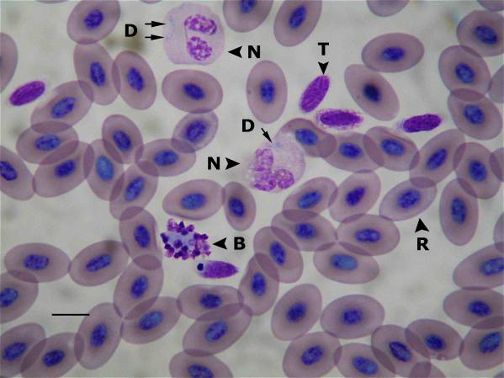
Figure 2. Wright’s stained blood smear from a white-lipped tree frog (Litoria infrafrenata) showing a neutrophil (N) of the small phenotype. D = damaged unidentifiable cell, E = eosinophil, L = lymphocyte, R = mature RBC, T = thrombocyte. Bar = 10 μm.
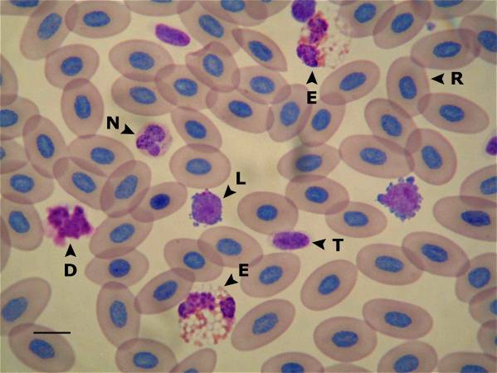
Figure 3. Wright’s stained blood smear from a white-lipped tree frog (Litoria infrafrenata) showing a monocyte (M) of the large phenotype. L = lymphocyte, R = mature RBC, T = thrombocyte. Bar = 10 μm.

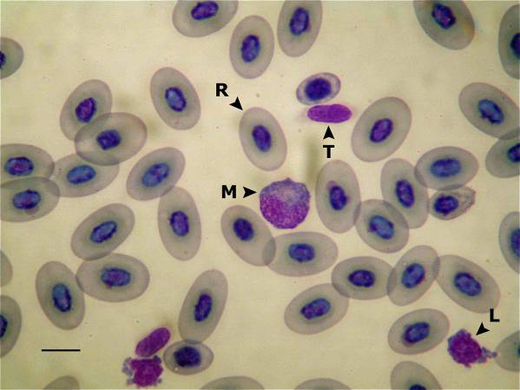
Figure 4. Wright’s stained blood smear from a white-lipped tree frog (Litoria infrafrenata) showing a monocyte (M) of the small phenotype. L = lymphocyte, R = mature RBC, S = smudged RBC. Bar = 10 μm.

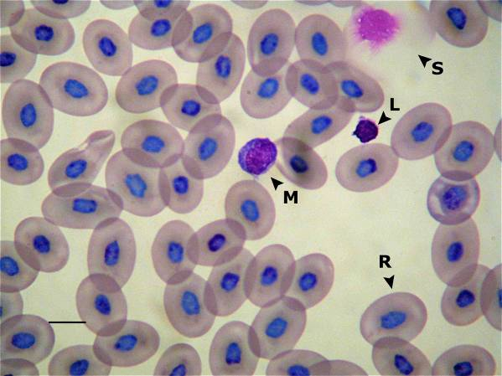
Figure 5. Wright’s stained blood smear from a common green tree frog (Litoria caerulea) showing an eosinophil. Bar = 10 μm.

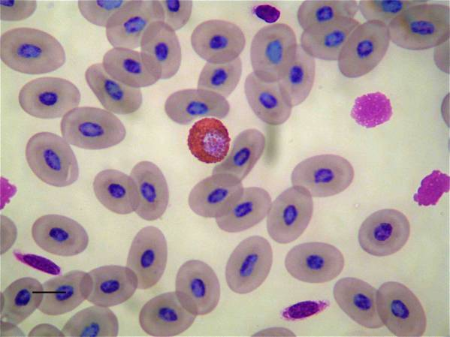
Figure 6. Wright’s stained blood smear from a white-lipped tree frog (Litoria infrafrenata) showing an eosinophil. Bar = 10 μm.

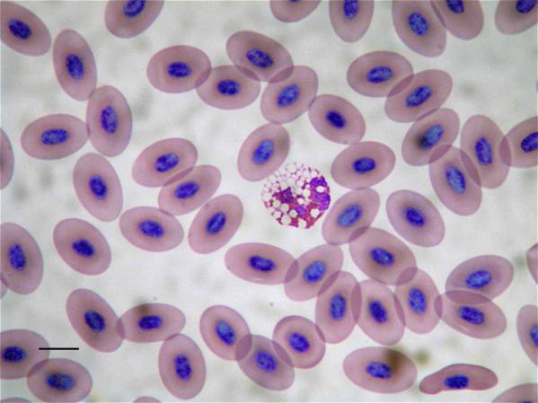
Figure 7. Wright’s stained blood smear from a white-lipped tree frog (Litoria infrafrenata) showing a basophil. Bar = 10 μm.

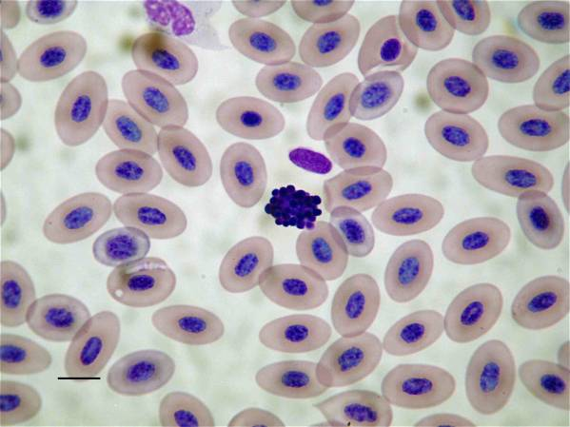
Figure 8. Wright’s stained blood smear from a common green tree frog (Litoria caerulea) showing polychromasia and a basophilic erythroblast (BE). R = mature RBC, P = polychromatophilic RBC. Bar = 10 μm.

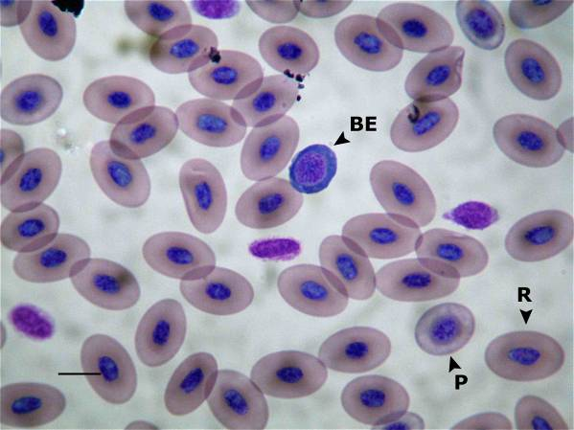
Figure 9. Wright’s stained blood smear from a common green tree frog (Litoria caerulea) showing a mitotic RBC. Bar = 10 μm.

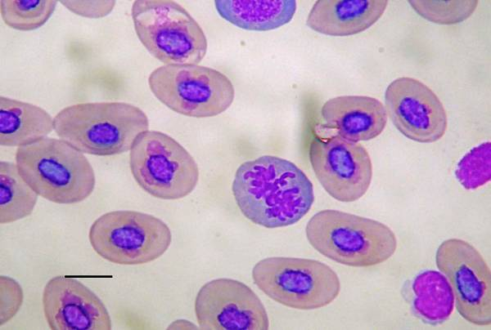
Figure 10. Wright’s stained blood smear from a white-lipped tree frog (Litoria infrafrenata) with a heavy burden of intracytoplasmic RBC hemogregarine gametocytes and extensive polychromasia. Bar = 10 μm.

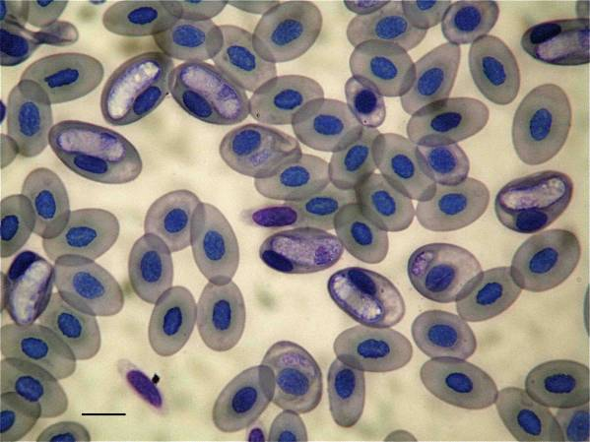
Figure 11. Regression plot for total protein concentration measurement for Litoria spp. tree frogs (n = 51) by the biuret method and refractometry; y-intercept = 0.095, slope = 0.937.

Figure 12. Regression plot for total protein concentration measurement for Litoria spp. tree frogs (n = 51) by the biuret method at the commercial reference laboratory and using the VetScan® chemistry analyzer; y-intercept = -0.695, slope = 1.066.

Figure 13. Regression plot for albumin concentration measurement for Litoria spp. tree frogs (n = 51) by protein electrophoresis and the bromcresol green dye-binding method; y-intercept = -3.582, slope = 0.846.

Figure 14. Regression plot for globulin concentration measurement for Litoria spp. tree frogs (n = 51) by protein electrophoresis and the VetScan® chemistry analyzer; y-intercept = 11.395, slope = 0.933.

