

**Fivebough and Tuckerbil Wetlands**

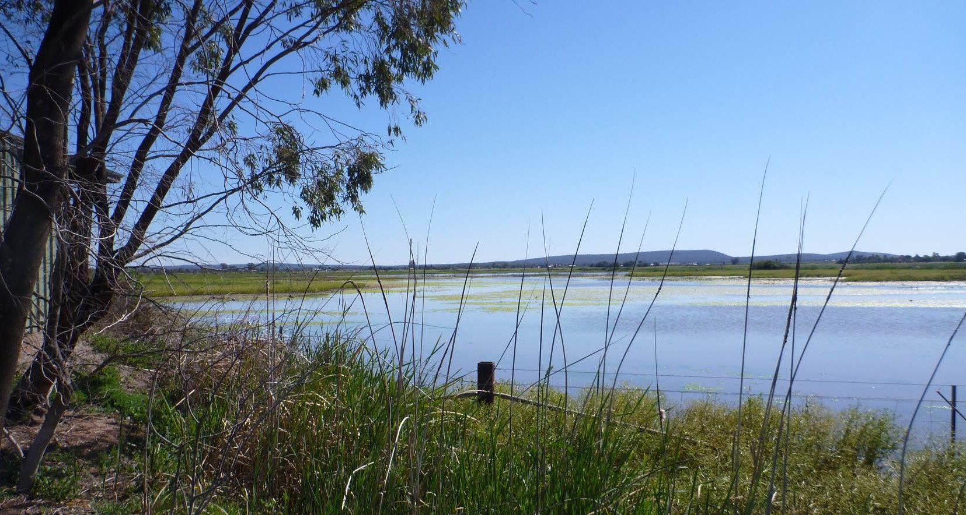**Ecological Character Description**



**Citation:** White, L., 2014. Ecological Character Description for Fivebough and Tuckerbil Wetlands. Report prepared for Australian Government Department of the Environment. WetlandCare Australia, Ballina, NSW.

#### Copyright

© Copyright Commonwealth of Australia, 2011.

The Ecological Character Description for the Fivebough and Tuckerbil Ramsar site is licensed by the Commonwealth of Australia for use under a Creative Commons By Attribution 3.0 Australia licence with the exception of the Coat of Arms of the Commonwealth of Australia, the logo of the agency responsible for publishing the report, content supplied by third parties, and any images depicting people. For licence conditions see: <http://creativecommons.org/licenses/by/3.0/au/>

This report should be attributed as ‘Ecological Character Description for the Fivebough and Tuckerbil Wetlands Ramsar site, Commonwealth of Australia 2011’.

The Commonwealth of Australia has made all reasonable efforts to identify content supplied by third parties using the following format ‘© Copyright.

#### Acknowledgements

This document was prepared in consultation with NSW Trade and Investment, Crown Lands with funding provided by Riverina Local Land Services. Guidance was also provided by NSW Office of Environment and Heritage and the Australian Government Department of the Environment.

#### Introductory Notes

This Ecological Character Description (ECD Publication) has been prepared in accordance with the *National Framework and Guidance for Describing the Ecological Character of Australia’s Ramsar Wetlands (National Framework)* (Department of the Environment, Water, Heritage and the Arts 2008).

The *Environment Protection and Biodiversity Conservation Act 1999* (EPBC Act) prohibits actions that are likely to have a significant impact on the ecological character of a Ramsar wetland unless the Commonwealth Environment Minister has approved the taking of the action, or some other provision in the EPBC Act allows the action to be taken. The information in this ECD Publication does not indicate any commitment to a particular course of action, policy position or decision. Further, it does not provide assessment of any particular action within the meaning of the EPBC Act, nor replace the role of the Minister or his delegate in making an informed decision to approve an action.

The *Water Act 2007* requires that in preparing the Murray-Darling Basin Plan, the Murray-Darling Basin Authority (MDBA) must take into account Ecological Character Descriptions of declared Ramsar wetlands prepared in accordance with the National Framework.

This ECD Publication is provided without prejudices to any final decision by the Administrative Authority for Ramsar in Australia on change in ecological character in accordance with the requirements of Article

3.2 of the Ramsar Convention.

#### Disclaimer

The views and opinions expressed in this publication are those of the authors and do not necessarily reflect those of the Australian Government or the Minister for the Environment.

While reasonable efforts have been made to ensure the contents of this ECD are factually correct, the Commonwealth of Australia as represented by the Department of the Environment does not accept responsibility for the accuracy or completeness of the contents, and shall not be liable for any loss or damage that may be occasioned directly or indirectly through the use of, or reliance on, the contents of this publication.

Note: There may be differences in the type of information contained in this ECD Publication, to those of other Ramsar wetlands.

Ecological Character Description – Fivebough and Tuckerbil Wetlands **1**

Contents

Contents 2

List of abbreviations 3

Executive summary 4

1. Introduction 9
   1. Site details 9
   2. Statement of purpose 11
   3. Preparing the ECD 13
   4. Relevant treaties, legislation, and regulations 15
2. General description of the Fivebough and Tuckerbil Wetlands 17
   1. Site location 17
   2. Site history and management framework 18
   3. Land tenure 20
   4. Wetland types 25
   5. Ramsar criteria 30
3. Ecosystem components and processes 33
   1. Essential components and processes 33
   2. Critical components and processes 40
4. Benefits and services 46
   1. Critical benefits and services 46
   2. Supplementary benefits and services 52
5. Critical components, processes and services 55
6. Limits of acceptable change 60
   1. LAC for the Fivebough and Tuckerbil Wetlands 60
7. Threats 66
8. Changes in ecological character 72
9. Knowledge gaps 78
10. Key monitoring needs 79
11. Communication, education and public awareness messages 80

References 81

Glossary 83

Appendices 85

# List of abbreviations

|  |  |
| --- | --- |
| CAMBA | China-Australia Migratory Bird Agreement |
| CEPA | Communication, Education, Participation and Awareness |
| CSIRO | Commonwealth Scientific and Industrial Research Organisation |
| DEWHA | Department of Environment, Water, Heritage and Arts (Commonwealth, now DoE) |
| DIWA | Directory of Important Wetlands in Australia |
| DOI Lands | Department of Industry Lands |
| DoE | Department of Environment (Commonwealth) |
| ECD | Ecological Character Description |
| EPA | Environmental Protection Authority (NSW) |
| EPBC Act | *Environment Protection and Biodiversity Conservation Act 1999* (Commonwealth) |
| IUCN | International Union for Conservation of Nature |
| JAMBA | Japan-Australia Migratory Bird Agreement |
| L&DLALC | Leeton and District Local Aboriginal Land Council |
| LAC | Limit/s of Acceptable Change |
| LEP | Local Environment Plan |
| MWWG | Murrumbidgee Wetlands Working Group |
| NPWS | National Parks and Wildlife Service (NSW) |
| NSW | New South Wales |
| OEH | Office of Environment and Heritage (NSW) |
| RIS | Ramsar Information Sheet |
| ROKAMBA | Republic of Korea-Australia Migratory Bird Agreement |
| STP | Sewage Treatment Plant |

# Executive summary

This Ecological Character Description (ECD) has been prepared to document the ecological character of Fivebough and Tuckerbil Wetlands at the time of listing as a Wetland of International Importance in 2002, in line with the *National Framework and Guidance for describing the Ecological Character of Australia’s Ramsar Wetlands*. It has been developed as an update to a draft Ecological Character Description which was compiled for the Fivebough and Tuckerbil Wetlands in March 2006 by the New South Wales (NSW) Department of Environment and Conservation, prior to development of the National Framework.

Fivebough and Tuckerbil Wetlands are located on separate parcels of Crown Land, less than 10 km apart, near Leeton in the Riverina region of NSW in the Murray Darling Drainage Division. Both sites are reserved for environmental protection and public recreation and Fivebough Wetland is open to the public for nature-based recreation. Fivebough Wetland receives treated effluent water from the Leeton Sewage Treatment Plant. Both sites are subject to grazing licenses for the purpose of environmental management. Surrounding land uses are primarily agricultural (grazing and cropping), rural and residential. Both sites have Aboriginal cultural significance.

Fivebough Wetland comprises permanent and intermittent fresh-brackish, shallow wetlands and Tuckerbil Wetland is a seasonal, shallow, brackish-saline wetland. Both wetlands support a high abundance and diversity of waterbirds, including migratory shorebirds and threatened species. Together the two wetlands form the Fivebough and Tuckerbil Wetlands Ramsar site, which was listed under various criteria based on its value as waterbird habitat, which is provided by the availability of extensive seasonal shallow wetlands and patchy vegetation communities.

Fivebough and Tuckerbil Wetlands meets the following four of nine critieria for listing as a wetland of International Importance:

#### Criterion 2: A wetland should be considered internationally important if it supports vulnerable, endangered, or critically endangered species or threatened ecological communities.

The site supports Australasian Bittern (*Botaurus poiciloptilus*) and Australian Painted Snipe (*Rostratula australis*), both of which are listed as ‘Endangered’ under the *Environment Protection and Biodiversity Conservation Act 1999*.

#### Criterion 3: A wetland should be considered internationally important if it supports populations of plant and/or animal species important for maintaining the biological diversity of a particular biogeographic region.

The site is important for maintaining a high diversity of species of waterbirds within the Murray-Darling Basin drainage division, with Fivebough Wetland and Tuckerbil Wetland having the highest and the second highest number of waterbird species respectively recorded in that region. A total of 83 species of waterbirds have been recorded at Fivebough Wetland and 69 species at Tuckerbil Wetland.

**Criterion 4: A wetland should be considered internationally important if it supports plant and/or animal species at a critical stage in their life cycles, or provides refuge during adverse conditions.** At least 22 species of waterbird have been recorded breeding at Fivebough Wetland and 11 species at Tuckerbil Wetland. Tuckerbil Wetland is a post-breeding roost site for up to 130 Brolga (*Grus rubicunda*). Fivebough Wetland is a sigificnant roosting site for large numbers of Glossy Ibis (*Plegadis falcinellus*) and Whiskered Tern (*Chlidonias hybridus*) during spring-summer. Fivebough Wetland provides important feeding habitat for four species of egret during their breeding season. The site is also important for migratory waterbirds with 24 species (19 shorebirds) recorded at Fivebough Wetland and 13 species (10 shorebirds) at Tuckerbil Wetland which are listed under the Japan-Australia and/or the China-Australia Migratory Bird Agreements (JAMBA and CAMBA). The wetlands support seventeen species of waterbirds listed under the Republic of Korea-Australia Migratory Bird Agreement (ROKAMBA).

#### Criterion 6: A wetland should be considered internationally important if it regularly supports 1% of the individuals in a population of one species or subspecies of waterbird.

Up to 2,253 Sharp-tailed Sandpiper (*Calidris acuminata*) and 20,000 Glossy Ibis (*Plegadis falcinellus*) have been recorded at the site, which exceeds the 1% population estimates for these species of 1,600 and 10,000 respectively.

This ECD identifies and describes the essential and critical components, processes and services at the time of listing, and develops limits of acceptable change for for each of the critical components, processes and services identified.

Essential components and processes are those which are not necessarily critical to the site’s character, but play an important role in supporting the critical components, processes and services. Essential elements at Fivebough and Tuckerbil Wetlands include the landform and soils, climate, groundwater, water quality, vegetation, non-waterbird fauna and livestock grazing. Both wetlands are located in shallow depressions which are remnant ancient lakes underlain by saline clay soils. It has been suggested that the saline groundwater table below the lakes is rising. The site experiences a semi-arid climate with evaporation greatly exceeding rainfall during summer. Water within the wetands is reportedly saline.

Much of the original vegetation has been lost, however the wetlands support vegetation communities including Cumbungi (*Typha sp*) beds, Water Couch (*Paspalum distichum*) grassland, salt tolerant vegetation communities and remnant Black Box (*Eucalyptus largiflorens*) woodland. Aside from waterbirds, the site supports aquatic and terrestrial fauna including water rats, long-necked tortoise, frogs, snakes, lizards and kangaroo. Grazing of cattle is managed under licence at both wetlands and plays a role in maintaining a mosaic of vegetation communities.

Components and processes which are considered critical to the ecological character of the site, and directly support the listing critera, are hydrology and waterbirds. Both wetlands were originally ephemeral wetlands with the water balance determined by rainfall and evaporation. The hydrology of Fivebough and Tuckerbil Wetlands has been highly modified, and inflows now consist primarily of local rainfall and irrigation runoff, floodwaters which exceed drainage system capacity, treated effluent releases from the Leeton Sewage Treatment Plant (Fivebough Wetland only) and environmental water allocations (since after the date of listing). Regular treated effluent discharge of approximately 2.5 ML per day results in a permanent wetland area in the central southern part of Fivebough Wetland of approximately 39 ha. The remainder of Fivebough Wetland fills in most years during autumn/winter, when evaporation rates are low, to a maximum depth of 45 cm and an average depth of 21.5 cm. The area of intermittent inundation at Fivebough Wetland usually dries out rapidly due to high evaporation rates during spring/summer. It becomes shallow then contracts to the deepest section within the central eastern part of the wetland, exposing extensive waterlogged mudflats, which becomes a series of disconnected pools before drying completely. Tuckerbil Wetland fills intermittently during autumn/winter, when evaporation rates are low.

Tuckerbil Wetland has an average depth of 30 cm and a maximum depth of approximately 40 cm when full. Like Fivebough Wetland, Tuckerbil Wetland dries rapidly during late spring /early summer. Water levels recede in the central and south western parts of the wetland prior to the eastern portion of the wetland. Wetland hydrology drives the temporal and spatial diversity of waterbird habitats at Fivebough and Tuckerbil Wetlands.

Both Fivebough and Tuckerbil Wetlands have long been recognised as important sites for waterbirds and significant waterbird species, populations and activity have been recorded. Nationally threatened Australasian Bittern and Australian Painted Snipe have been regularly recorded within the site. Both wetlands support a high diversity of waterbirds with 83 species recorded at Fivebough Wetland and 69 species at Tuckerbil Wetland. Both Fivebough and Tuckerbil Wetlands provide habitat for internationally significant migratory waterbirds with 24 species (19 shorebirds) recorded at Fivebough Wetland and 13 species (10 shorebirds) at Tuckerbil Wetland. At Fivebough Wetland, 22 waterbird species have been recorded breeding, and 11 at Tuckerbil Wetland. The wetlands also provide significant feeding and roosting habitat for waterbirds including egrets and brolgas. At least 20,000 waterbirds have been recorded at Fivebough Wetland on several occasions, principally in summer, with the highest count of 50,000 birds at one time. Counts of Sharp-tailed Sandpiper and Glossy Ibis exceeding the 1% population threshold have been recorded at one or both wetlands.

The provision of waterbird habitat is considered to be a critical service provided by the Fivebough and Tuckerbil Wetlands. Waterbird habitat at Fivebough and Tuckerbil Wetlands is primarily a function of the critical component/process of wetland hydrology and supporting elements including geomorphology, climate, vegetation communities and livestock grazing. The distinct hydrological cycle of Fivebough and Tuckerbil Wetlands (as a function of the prevailing geomorphology and climate) drives wetland vegetation communities and provides a spatial and temporal diversity of habitats which support the significant numbers, species and activities of waterbirds. These elements interact, and where possible are managed, to produce the range of significant habitats provided by the site which support the critical waterbird services. The significant habitats for waterbirds occurring at Fivebough and Tuckerbil Wetlands at the time of listing have been generally identified, however habitat assemblages have not been

comprehensively surveyed or described and distributions and areas have not been comprehensively mapped.

Significant waterbird habitat at Fivebough and Tuckerbil Wetlands is provided by:

* A substantial area of healthy Cumbungi and/or tall sedge vegetation which is present each year at Fivebough Wetland and is present (to lesser extent) in most years at Tuckerbil Wetland. Substantial areas of sedge and/or Cumbungi occurred in both the temporary and permanent sections of Fivebough Wetland at date of listing and a small area occurred at Tuckerbil Wetland.
* Substantial areas that are bare or that have sparse or patchy vegetation cover, and are shallowly inundated or muddy, and have adjacent wet mud, which are normally present each year at Fivebough Wetland and are often extensive.
* Extensive areas of shallow water (i.e. with an average depth less than 3 cm and/or is suitable for wading and feeding by shorebirds) which occur at Fivebough and Tuckerbil Wetlands every year.
* A diverse assemblage of wetland habitats including woodland and shrubland (limited extent), Cumbungi beds, sedgeland, grassy meadows, and bare open areas which is normally present (collectively) at Fivebough and Tuckerbil Wetlands.
* Habitat suitable for the most abundant species (Glossy Ibis and Whiskered Tern) comprising shallow open water or inundated couch grassland of variable depth and with some dry patches which occurs extensively at Fivebough Wetland in spring-summer each year.
* Habitat suitable for waterbird roosting for the Brolga, comprising open dry land near open water which occurs extensively at Tuckerbil Wetland in spring-summer each year

Other benefits and services provided by the site include stock grazing, flood mitigation, assimilation of treated wastewater, supporting predators of agricultural pests, as well as providing opportunities for nature observation, education and research. Cultural services are also provided through the existence of Indigenous cultural heritage sites in or closely associated with the wetlands.

Limits of acceptable change (LACs) have been developed for the critical components, processes and services at the site, based on available information, through which ecological change can be measured. LACs acknowledge the natural variability exhibited by critical components, process and services within the wetland ecosystem and establish guidelines that facilitate the assessment of change (either positive or negative) to the ecological character resulting from human activities..

Additional explanatory notes on LACs

LACs are a tool by which ecological change can be measured. However, ECDs are not management plans and LACs do not constitute a management regime for the Ramsar site.

Exceeding or not meeting LACs does not necessarily indicate that there has been a change in ecological character within the meaning of the Ramsar Convention. However, exceeding or not meeting LACs may require investigation to determine whether there has been a change in ecological character.

In reading the ECD and the LACs, it should be recognised that the hydrology of many catchments in the Murray-Darling Basin is highly regulated, despite many of the wetlands forming under natural hydrological regimes that were more variable and less predictable. Many of the Ramsar wetlands of the Murray- Darling Basin were listed at a time when the rivers were highly regulated and water over allocated, with the character of these sites reflecting the prevailing conditions. When listed under the Ramsar Convention, many sites were already on a long-term trend of ecological decline.

While the best available information has been used to prepare this ECD and define LACs for the site, a comprehensive understanding of site character may not be possible as in many cases only limited information and data is available for these purposes. The LACs may not accurately represent the variability of the critical components, processes, benefits or services under the management regime and natural conditions that prevailed at the time the site was listed as a Ramsar wetland.

Users should exercise their own skill and care with respect to their use of the information in this ECD and carefully evaluate the suitability of the information for their own purposes.

LACs can be updated as new information becomes available to ensure they more accurately reflect the natural variability (or normal range for artificial sites) of critical components, processes, benefits or services of the Ramsar wetland.

The LACs for Fivebough and Tuckerbil Wetlands have been defined as follows:

#### Table E1. Limits of Acceptable Change for the Fivebough and Tuckerbil Wetlands

|  |  |  |
| --- | --- | --- |
| **Critical component, process or service** | **Limits of acceptable change** | **Confidence level** |
| **Hydrology** | 1. Availability of a permanent wetland area at Fivebough Wetland. 2. Availability of extensive intermittent shallow water at Fivebough Wetland in at least nine of every ten years. 3. Inundation of Fivebough Wetland to 45 cm at deepest point of intermittent zone in at least seven of every ten years, and inundation of Tuckerbil Wetland to at least 30 cm in at least four of every ten years. | High |
| **Critical component, process or service** | **Limits of acceptable change** | **Confidence level** |
| **Waterbirds** | 1. Australasian Bittern occurs at Fivebough Wetland on average in eight of every ten years and at Tuckerbil Wetland on average in five of every 15 years. 2. Australian Painted Snipe occurs at Fivebough Wetland on average in two of every ten years. 3. The total number of species at Fivebough Wetland should not decline substantially over a ten year period: i.e. no less than 79 species (95% from date of listing) should occur. The total number of species at Tuckerbil Wetland should not decline substantially over a ten year period: i.e. no less than 65 species (95% from date of listing) should occur. 4. Over any ten year period, occurrence of less than 18 migratory shorebird species (95% from date of listing) at Fivebough Wetland or less than 9 migratory shorebird species (95% from date of listing) at Tuckerbil Wetland would be unacceptable. 5. Substantial occurrence of migratory shorebirds at Fivebough Wetland or at Tuckerbil Wetland in less than nine of every ten years would be unacceptable. 6. Occurrence of less than 1,000 migratory shorebirds at either Fivebough Wetland or Tuckerbil Wetland, in less than four of every ten years, would be unacceptable. 7. Over any ten year period, the number of breeding species remains at least 90% (20 species) of the number at date of listing. 8. The number of egrets feeding in Fivebough Wetland in the colony-active period should exceed 100 (i.e. 'hundreds' should be present). 9. Over a ten year period, use of Tuckerbil Wetland for roosting by substantial numbers of Brolga in less than nine years would be unacceptable. 10. Over a ten year period, use of Fivebough Wetland for roosting by less than 1,000 Glossy Ibis, in less than eight years, would be unacceptable. 11. Over a ten year period, use of Fivebough Wetland for roosting by less than 1,000 Whiskered Terns, in less than five years, would be unacceptable. 12. Occurrence of more than 1% population threshold (currently 1,600) Sharp- tailed Sandpipers at Fivebough Wetland in less than four of every ten years would be unacceptable. 13. Occurrence of more than 1% population threshold (1,600) Sharp-tailed Sandpipers at Tuckerbil Wetland in less than four of every ten years would be unacceptable. 14. Over a ten year period, occurrence of more than 1% population threshold (10,000) Glossy Ibis at Fivebough Wetland in less than two years would be unacceptable. | Medium |
| **Provides significant** | 18. A reduction by more than 25% (from date of listing) in the area of habitat for Australasian Bittern (Cumbungi and/or tall sedge vegetation), at Fivebough or Tuckerbil Wetland would be unacceptable. | Low |

|  |  |  |
| --- | --- | --- |
| **waterbird habitat** | 1. A reduction by more than 25% (from date of listing) in the area of habitat for Painted Snipe (shallowly inundated, sparse or patchy vegetation cover with adjacent wet mud) at Fivebough Wetland would be unacceptable. 2. A reduction by more than 25% (from date of listing) in the area of habitat for shorebirds (bare or sparse vegetation cover, and shallowly inundated or muddy) at Fivebough or Tuckerbil Wetland would be unacceptable. 3. A reduction in the total area of any of the diverse waterbird habitats (woodland and shrubland, Cumbungi beds, sedgeland, grassy meadows, and bare open areas) at Fivebough or Tuckerbil Wetland, constituting more than 25% of the area at date of listing, would be unacceptable. 4. A reduction in the total area of any of the waterbird nesting habitats (including Cumbungi beds, sedgeland, grassy meadows, and bare open areas) at Fivebough Wetland, constituting more than 25% of the area at date of listing, would be unacceptable. 5. Loss of extensive areas of shallow open water of variable depth (Glossy Ibis and Whiskered Tern roosting habitat) at Fivebough Wetland would be unacceptable. 6. Loss of extensive areas of shallow open water with adjacent open dry land   (Brolga roosting habitat) at Tuckerbil Wetland would be unacceptable. |  |

Key threats to the ecological character of the Fivebough and Tuckerbil Wetlands Ramsar site have been identified as hydrological changes to the wetlands, changes to vegetation communities, innapropriate grazing regimes, introduced weeds and pest animals, poor water quality, climate variation, human disturbance and fire. Management arrangements are currently in place to mitigate these threats to the greatest extent possible and to maintain and promote the ecological character of the site. Key management actions include environmental water allocations and adaptive grazing management.

There is no evidence that there has been any changes in the condition of the ecological character of the site since the time of listing, however there is generally a lack of data available to comprehensively define the condition of critical components, processes and services at the time of listing, to set robust LACs, and to assess current condition of the site against the LAC. Key monitoring activities have been identified or are being undertaken to address these knowledge gaps within the site.

Key knowledge gaps include:

* Lack of comprehensive information on water depths, wetland areas and water quality at both wetlands.
* Long-term continuous comprehensive waterbird data including counts, species and breeding activity across both wetlands is not available.
* The condition and extent of waterbird habitat (including the composition and condition of vegetation assemblages) within Fivebough and Tuckerbil Wetlands both historically and up to the present time has not been comprehensively described or mapped.

# Introduction

## Site details

The Fivebough and Tuckerbil Wetlands are located near Leeton, in the Riverina region of NSW. The Fivebough and Tuckerbil Wetlands are located on Crown Land administered by NSW Department of Industry Lands (DOI Lands) as *Reserve for Environmental Protection and Public Recreation* under the *Crown Lands Act 1989.* Summary details for the Fivebough and Tuckerbil Wetlands are provided in Table 1.

Fivebough Wetland is a permanent, but fluctuating, fresh-brackish, shallow wetland and Tuckerbil Wetland is a seasonal, shallow, brackish-saline wetland. Both wetlands support a high abundance and diversity of waterbirds, including migratory shorebirds and threatened species. Together the two wetlands form the Fivebough and Tuckerbil Wetlands Ramsar site, which was designated in 2002. The site was listed under various criteria based on its value as waterbird habitat, which is provided by the availability of extensive seasonal shallow wetlands and patchy vegetation communities.

Leeton Shire Council utilises Fivebough Wetland to dispose of tertiary treated effluent by evaporation, which contributes to a permanent wetland area at the site. The wetlands are used for flood mitigation during periods of heavy rainfall and receive environmental water allocations under the Office of Environment and Heritage (OEH) annual environmental watering plans for the Murrumbidgee Valley. Parts of both wetlands are leased for grazing under licence as a management tool in the conservation of the site’s ecological character. Fivebough Wetland is open to the public and provides opportunities for nature based recreational use with low impact visitor infrastructure. Tuckerbil Wetland is not open to the public.

Fivebough Wetland is adjoined by freehold agricultural, rural and residential land, while Tuckerbil Wetland is surrounded by freehold irrigation farms mainly used for rice growing, cereal cropping and grazing.

Tuckerbil Wetland, and the surrounding land, was a traditional hunting/fishing area for the Wiradjuri Aboriginal people. Koonadan Historic Site lies to the south-east of Tuckerbil Wetland and is considered to have significant cultural heritage value to the Aboriginal people of the area.

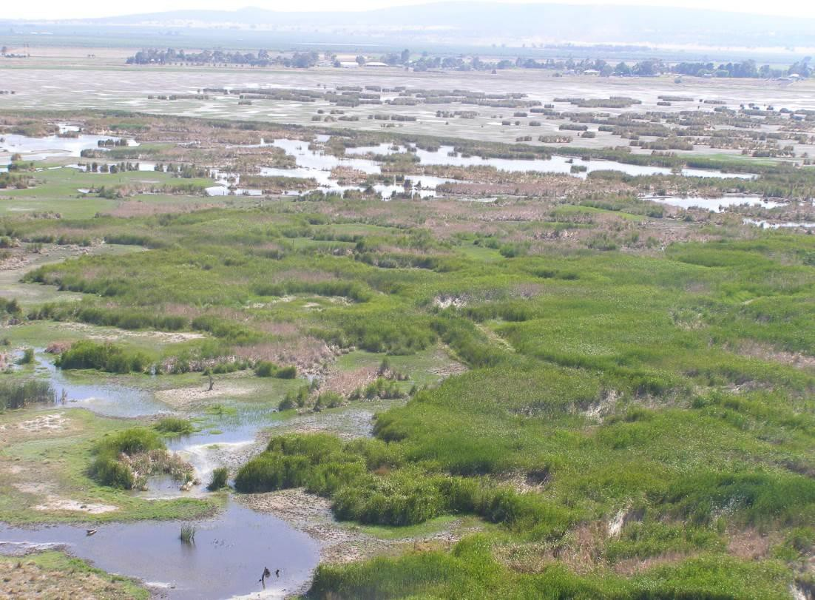

#### Aerial view of the Fivebough Wetlands Ramsar site.

**Table 1. Site details of the Fivebough and Tuckerbil Wetlands**

|  |  |
| --- | --- |
| **Name** | Fivebough and Tuckerbil Wetlands. |
| **Location in Co-ordinates** | Fivebough Wetland Latitude 34 31’ 50’’ S Longitude 146 25’ 50’’ E.  Tuckerbil Wetland Latitude 34 29’ 10’’ S Longitude 146 21’ 0’’ E. |
| **General Location** | Fivebough and Tuckerbil Wetlands are located near Leeton in the Riverina region of NSW. Fivebough Wetland is 4 km north-east of Leeton, and Tuckerbil Wetland is approximately 12 km north-west of Leeton. |
| **Area** | Total - 619 ha  (Fivebough Wetland - 342 ha, Tuckerbil Wetland – 277.5 ha). |
| **Date of Ramsar site designation** | 21st October 2002. |
| **Ramsar criteria met - current (2005)** | 2, 3, 4, and 6. |
| **Management authority** | The NSW Department of Industry- Lands. An Advisory Committee has been appointed to provide advice, local perspective and liaison with the project managers. The Advisory Committee is made up of 12 members comprising State Government, Local Government, local interest groups and community representatives. |
| **Date the Ecological Character Description applies** | Date of Listing: 21st October 2002. |
| **Status of description** | A draft Ecological Character Description (ECD) was compiled for the Fivebough and Tuckerbil Wetlands in March 2006 by the NSW Department of Environment and Conservation (Biosis Research Pty Ltd and Wetlands International Oceania 2006), prior to the development of the *National Framework and Guidance for Describing the Ecological Character of Australia’s Ramsar Wetlands (National Framework)* (DEWHA 2008). This ECD has been prepared as an update to the ECD developed in 2006, to bring it into compliance with the National Framework, and as such, is the first compliant ECD for the site. |
| **Date of compilation** | August 2014 |
| **Name of compiler(s)** | Laura White, WetlandCare Australia |
| **Reference for Ramsar Information Sheet** | Fivebough and Tuckerbil Wetlands Ramsar Information Sheet (RIS)  RIS updated November 2014 |
| **Reference for management plan** | Price C., White, L. and Haigh, S. (2014). Fivebough and Tuckerbil Wetlands - Adaptive Environmental Management Plan, compiled for NSW Trade and Investment, Crown Lands. WetlandCare Australia, Ballina, NSW. |

## Statement of purpose

The *Convention on Wetlands of International Importance especially as Waterfowl Habitat,* to which Australia is a signatory, was initially adopted in Ramsar, Iran, in 1971. Commonly known as the Ramsar Convention, this was the first modern intergovernmental treaty between nations with the aim of conserving natural resources.

The original intent of the Ramsar Convention was to protect waterbird habitat, however the convention has broadened its scope to cover all aspects of wetland conservation and 'wise use'.

Australia signed the Ramsar Convention in 1974, becoming one of the first contracting parties and agreeing to a number of actions including to:

* + - Designate suitable wetlands for inclusion on the List of Wetlands of International Importance;
    - Maintain the ecological character of listed sites;
    - Arrange to be informed at the earliest possible time if the ecological character of any listed wetland has changed, is changing or is likely to change as a result of technological developments, pollution or other human interference, and report any such changes to the Ramsar Convention.

While management of Ramsar wetlands is the responsibility of each individual site manager, the Australian Government, through the Department of the Environment (DoE) works closely with state governments, regional bodies and Ramsar site managers to implement Australia’s Ramsar Convention obligations. In accordance with the Ramsar Convention, appropriate management of Ramsar wetlands includes describing and maintaining the ecological character of the wetland and implementing planning processes that promote conservation and wise use. These management principles are supported by national legislation under the *Environment Protection and Biodiversity Conservation Act 1999* (EPBC Act).

The role of the Ecological Character Description (ECD) is to describe the ecological character of the Ramsar site as a management tool for signatories and site managers to detect, manage and monitor any threatening processes which are likely to alter, or have altered, the ecological character from the baseline or benchmark. Thus, the assessment of ecological character is linked to the Ramsar criteria fulfilled by the site at the time of designation for the Ramsar list.

The Ramsar Convention provides the following relevant definitions:

##### Ecological character is the combination of the ecosystem components, processes and benefits and services that characterise the wetland at a given point in time.

***…change in ecological character is the human induced adverse alteration of any ecosystem component, process and or ecosystem benefit/service.***

The specific aims of the ECD are as follows:

1. To assist in implementing Australia’s obligations under the Ramsar Convention, as stated in Schedule 6 (Managing wetlands of international importance) of the *Environment Protection and Biodiversity Conservation Regulations 2000*:
   1. To describe and maintain the ecological character of declared Ramsar wetlands in Australia; and
   2. To formulate and implement planning that promotes:
      1. Conservation of the wetland; and
      2. Wise and sustainable use of the wetland for the benefit of humanity in a way that is compatible with maintenance of the natural properties of the ecosystem.
2. To assist in fulfilling Australia’s obligation under the Ramsar Convention, to arrange to be informed at the earliest possible time if the ecological character of any wetland in its territory and included in the Ramsar List has changed, is changing or is likely to change as the result of technological developments, pollution or other human interference.
3. To supplement the description of the ecological character contained in the Ramsar Information Sheet submitted under the Ramsar Convention for each listed wetland and, collectively, to form an official record of the ecological character of the site.
4. To assist the administration of the EPBC Act, particularly:
   1. to determine whether an action has, will have or is likely to have a significant impact on a declared Ramsar wetland in contravention of sections 16 and 17B of the EPBC Act, or
   2. to assess the impacts that actions referred to the Minister under Part 7 of the EPBC Act have had, will have or are likely to have on a declared Ramsar wetland.
5. To assist any person considering taking an action that may impact on a declared Ramsar wetland to determine whether to refer the action to the Minister under Part 7 of the EPBC Act for assessment and approval.
6. To inform members of the public who are interested generally in declared Ramsar wetlands to understand and value the wetlands.

Figure 1 places the ECD in the context of legislation, other planning and support documents, and various management and monitoring reports.

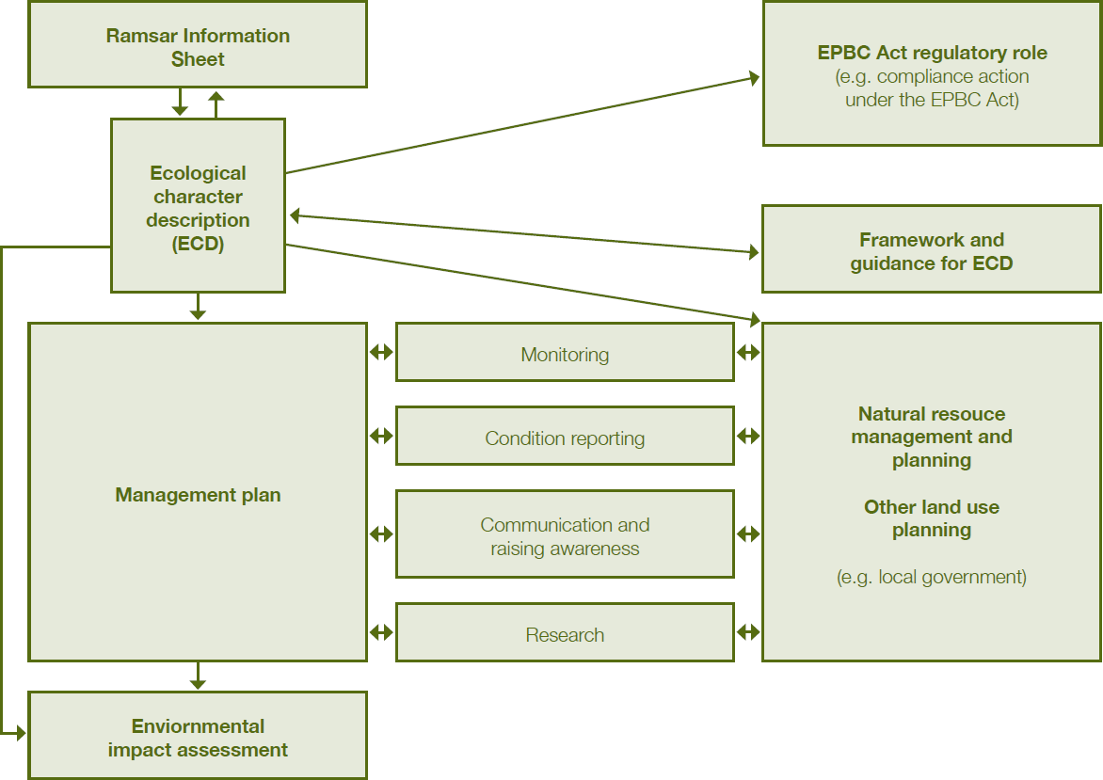

#### Figure 1. Relationship between the ECD and other documents (DEWHA 2008).

* 1. **Preparing the Ecological Character Description**

In order to maintain the ecological character of a declared Ramsar wetland it is important to know the ecological conditions at the time of listing. As a result the ecological character is described at a particular point in time, and contracting parties are expected to notify the Ramsar Secretariat if the ecological character changes.

To ensure the Ecological Character Description (ECD) provides sufficient detail on the interactions between ecological components, processes and functions to comprehensively describe the ecological character and identify any changes in ecological character, the Australian Government has developed a *National Framework and Guidance for describing the Ecological Character of Australia’s Ramsar Wetlands* (National Framework) (DEWHA 2008).

The method used to develop this ECD of the Fivebough and Tuckerbil Wetlands follows the twelve step process outlined in the National Framework (DEWHA 2008) as shown in Figure 2.

An ECD was compiled for the Fivebough and Tuckerbil Wetlands in March 2006 by the NSW Department of Environment and Conservation, prior to development of the National Framework. The current ECD has been prepared as an update to the previous ECD, to bring it into compliance with the National Framework. This document primarily incorporates information from the previous ECD as well as updated data where available and relevant.

Both the previous and current ECD aim to document the ecological character of Fivebough and Tuckerbil Wetlands at the time of listing in 2002, and identify any changes since that time. Identifying the natural variability, defining limits of acceptable change or identifying change in ecological character for some of

the Ramsar site’s critical components, processes and benefits and services has not been possible due to limited information. Dates have been used to identify where older or more recent data has been used to establish a baseline for specific components, processes and services or to document change. Knowledge gaps have been identified where insufficient information exists.

The provision of specific waterbird habitat services by Fivebough and Tuckerbil Wetlands can be summarised as the provision of a diversity of waterbird habitats by the site. Waterbird habitat at Fivebough and Tuckerbil Wetlands is primarily a function of the critical component/process of wetland hydrology and supporting elements including geomorphology, climate, vegetation communities and livestock grazing, which are described in Section 2. These elements interact, and where possible are managed, to produce the range of significant habitats provided by the site which support the critical waterbird services described above. The overarching critical service of the site is the diversity of waterbird habitat it provides, which in turn provides habitat to meet each of the specific waterbird habitat services is summarised below in Table 8. The significant habitats for waterbirds occurring at Fivebough and Tuckerbil Wetlands at the time of listing have been identified and described (Table 8), however habitat assemblages have not been comprehensively surveyed and distributions and areas have not been comprehensively mapped.

|  |
| --- |
| **1. Introduction to the description**  Site details, purpose of the description and relevant legislation |
| **2. Describe the site**  Site location, climate, maps and images, tenure, wetland criteria and types |
| 1. **Identify and describe the critical components, processes and services**    1. Identify all possible components, processes and benefits    2. Of these, identify the critical components, processes and benefits responsible for determining the ecological character of the site    3. Describe each of the critical components, processes and benefits |
| **4. Develop a conceptual model for the wetland**  Depict the critical components and processes of the wetland (e.g. hydrology, biogeochemical processes, biota and vegetation, and their relationships) |
| **5. Set limits of acceptable change**  Determine limits of acceptable change for critical components, processes and services of the site |
| **6. Identify threats to the ecological character of the site**  Use information from Steps 3–5 and other information to identify the actual or likely threats to the site |
| **7. Describe changes to ecological character**  Describe any changes to the ecological character of the site since the time of listing; include information on the current condition of the site |
| **8. Summarise the knowledge gaps**  Use information from Steps 3–7 to identify the knowledge gaps |
| **9. Identify site monitoring needs**  Use information from steps 3–8 to identify monitoring needs |
| **10. Identify communication and education messages**  Identify any communication and education messages highlighted during the development of the description |
| **11. Compile the description of ecological character** |
| **12. Prepare or update the Ramsar Information Sheet**  Submit as a companion document to the ecological character description |

#### Figure 2. Key steps in preparing an ecological character description (DEWHA 2008).

## Relevant treaties, legislation, and regulations

Effective management of the Fivebough and Tuckerbil Wetlands incorporates the principles and actions identified in various international agreements, national and state legislation and regional strategies and plans. The following have been identified as most relevant to management of the site.

* + 1. **International agreements**
    - The Ramsar Convention - an intergovernmental treaty that provides the framework for national action and international cooperation for the conservation and wise use of wetlands and their resources.
    - The Agreement between the Australian Government and the Government of Japan for the Protection of Migratory Birds in Danger of Extinction and their Environment (JAMBA).
    - The Agreement between the Australian Government and the Government of the People's Republic of China for the Protection of Migratory Birds and their Environment (CAMBA).
    - The Agreement between the Australian Government and the Republic of Korea for the Protection of Migratory Birds and their Environment (ROKAMBA).
    - The Convention on the Conservation of Migratory Species of Wild Animals (the Bonn Convention).
    - The Convention on Biological Diversity which was signed by 150 government leaders at the 1992 Rio Earth Summit and is dedicated to promoting sustainable development.

### National legislation and policy

* + - *Environment Protection and Biodiversity Conservation Act 1999* (EPBC Act) - the Australian Government's central piece of environmental legislation. It provides a legal framework to protect and manage nationally and internationally important flora, fauna, and ecological communities, including Ramsar sites.
    - *Environment Protection and Biodiversity Conservation Regulations 2000 (EPBC Regulations) -* the Australian Ramsar Management Principles are identified in Schedule 6 of the EPBC Regulations. These principles provide a framework for the management of Ramsar wetlands within Australia in a way that is consistent with Australia’s obligations under the Ramsar Convention (DEWHA 2009).
    - *Water Act 2007* and *Water Amendment Act 2008* - the Water Act 2007 establishes the Murray- Darling Basin Authority (MDBA) with the functions and powers, including enforcement powers, needed to ensure that Murray-Darling Basin water resources are managed in an integrated and sustainable way. The Act requires the MDBA to prepare the Basin Plan and establishes a Commonwealth Environmental Water Holder to manage the Commonwealth’s environmental water to protect and restore the environmental assets of the Murray-Darling Basin, and outside the Basin where the Commonwealth owns water. The *Water Amendment Act 2008* amends the *Water Act 2007* to transfer functions and powers from the Murray-Darling Basin Commission to the MDBA.
    - *Australia’s Biodiversity Conservation Strategy 2010-2030* - a national policy document that will guide how governments, the community, industry and scientists manage and protect Australia’s plants, animals and ecosystems over the next 20 years.
    - *Australian Heritage Council Act 2003* - provides protection for places of National significance placed on the Register of the National Estate.

### NSW legislation and policy

* + - *Crown Lands Act 1989 -* provides for management of Crown land including environmental protection and administration, preservation of natural resources, public use and enjoyment, multiple uses to be sustained in perpetuity in the best interests of the State.
    - *Threatened Species Conservation Act 1995* - provides for the conservation of threatened species, populations and ecological communities of plants and animals. It sets out processes of

identification, classification and management through the preparation of recovery plans and abatement of key threatening processes.

* + - *Catchment Management Authorities Act 2003* - establishes Catchment Management Authorities and their natural resource management functions including natural resource planning and decision-making at a local and catchment-wide level in line with state concerns and standards.
    - *NSW Wetlands Policy -* promotes sustainable conservation, management and wise use of wetlands in NSW by providing a set of guiding principles that government agencies will adopt and stakeholders can refer to when making decisions on wetland management and conservation.
    - *Environmental Planning and Assessment Act 1979* - concerns the conservation and protection of natural areas through ecologically sustainable planning and development.
    - *Noxious Weeds Act 1993 -* provides for the identification, classification and control of noxious weeds. It defines the roles of government, councils, private landholders and public authorities in the management of noxious weeds. The Act sets up categorisation and control actions for the various noxious weeds, according to their potential to cause harm to the environment.
    - *Local Government Act 1993 -* an Act to provide for local government in NSW.
    - *Rural Fires Act 1997 -* an Act to establish the NSW Rural Fire Service and define its functions; to make provision for the prevention, mitigation and suppression of rural fires; to repeal the Bush Fires Act 1949 ; to amend certain other Acts; and for other purposes.
    - *Water Management Act 2000 -* an Act to provide for the protection, conservation and ecologically sustainable development of the water sources of the State, and for other purposes.

### Regional plans and strategies

* + - Fivebough and Tuckerbil Wetlands Adaptive Environmental Management Plan, 2014, NSW Trade and Investment, Crown Lands.
    - Murrumbidgee Catchment Action Plan, 2013 - sets a regional strategic plan for natural resource management in the Murrumbidgee catchment.
    - Regional Weed Strategy for the Murrumbidgee Catchment, 2007 - provides strategic direction and coordinated weed management regime weeds in the entire catchment.
    - Draft Local Environmental Plan (LEP) 2013, Leeton Shire Council - Under this plan the Fivebough and Tuckerbil Wetlands are zoned ‘E2 - Environmental Conservation’ and are subject to the corresponding protection and planning approvals.
    - The Water Sharing Plan for the Murrumbidgee Regulated River Water Source 2003 - includes rules for protecting the environment, water extractions, managing licence holders' water accounts, and water trading in the plan area.

# General description of the Fivebough and Tuckerbil Wetlands

## Site location

The Fivebough and Tuckerbil Wetlands are located near the small town of Leeton, in the Riverina region of NSW, about 40 km south east of Griffith and 100 km north west of Wagga Wagga. Fivebough Wetland is 4 km north-east of Leeton, and Tuckerbil Wetland is approximately 12 km north-west of Leeton. The site is located in the Murrumbidgee River Catchment within the Murray Darling Drainage Division. The location of Fivebough and Tuckerbil Wetlands is shown below in Figure 3.

Fivebough Wetland is located on Crown Land (342 ha) comprising Lot 7303 DP 1159880, Parish Willimbong, County Cooper, in the locality of Leeton NSW. The eastern boundary does not include the part of Lot 7303 included in a perpetual grazing licences located inside the contour drain. Five freehold properties and a sewage treatment plant adjoin the site’s boundary (Lot 22 DP 914401, Lot 897 DP 821549, Lot 99 DP 751742, Lot 102 DP 751742, Lot 633 DP 44540 and Lot 1 DP 786496). None of those

properties or lots are included in the Ramsar site. The boundary joins Lot 633 DP 44540 at the Lot’s

north-eastern corner and extends north running parallel to the Crown land boundary and west to a vehicle track. The boundary then runs south-west along the boundary of Lot 897 DP 821549 and then to the edge of a contour drain then follows the contour drain (excluding the drain) south. It then follows the northern and eastern boundaries of Lot 99 DP 751742 and the eastern and southern boundaries of Lot 102 DP 751742 to the south-western corner of Lot 102, and then it again follows the contour drain (excluding the drain) south-east till it reaches and follows the boundaries of Lot 1 DP 786496 east and then to the south- west corner of Lot 633 DP 44540. A map depicting the Ramsar boundary of Fivebough Wetland is shown in Figure 4.

Tuckerbil Wetland is located on Crown Land (277.5 ha) comprising Lots 139, 165, 166, 167 and 283 in DP 751735, Parish Tuckerbil, County Cooper, in the locality of Leeton NSW. The Ramsar site boundary is the cadastral boundary of these properties except along the south-western boundary of Tuckerbil Wetland where the boundary is the inside edge (north eastern side) of the adjoining contour drain. From where the contour drain intersects the south-eastern cadastral boundary of Lot 167, the Ramsar boundary follows the contour drain from 14621’00” E 3429’46” S, west to 14620’55” E 3429’46”S and then northwest to 14620’23” E 3429’2” S where it exits the western side of Lot 139. The contour drain is not included in the Ramsar site. A map depicting the Ramsar boundary of Fivebough Wetland is shown in Figure 5.

Fivebough and Tuckerbil Wetlands are within the Murray Darling Drainage Division, a [sedimentary basin](http://en.wikipedia.org/wiki/Sedimentary_basin) formed during the Cenozoic Era (Maunsell 1996). The Murray Darling Basin covers over 1 million square kilometers, incorporating approximately 30,000 wetlands and supporting a vast biodiversity of plants, animals and ecosystems. Most of the inland basin is flat and low lying and is the most significant agricultural area of the Australian continent. Although the Murray Darling Basin receives only 6% of Australia's rainfall, it is the scene of 70% of Australia's irrigation. It contains 42% of Australia's farmland and produces 40% of the nation's food. The Basin is used to provide water for domestic and agricultural needs, and water has been over-allocated for human use. Total water flow in the Murray Darling Basin averages 14,000 GL per year, of which 11,500 GL is removed for irrigation, industrial use, and domestic supply. Agricultural irrigation accounts for about 95% of the water removed. Environmental impacts from over consumption have been exacerbated by drought in recent times with decreasing river flows and increasing salinity (Ladson 2008).

The Fivebough and Tuckerbil Wetlands are located on the eastern margin of the Riverine Plain of NSW in the Murrumbidgee Catchment of the Riverina bioregion. The Murrumbidgee is the second largest river in the Murray Darling Basin. The Murrumbidgee Catchment covers over 84,000 square km and supports a population of 550,000 people, including Australia’s capital city of Canberra and NSW’s largest inland city of Wagga Wagga. More than 75% of the catchment is used for dryland grazing and cereal cropping, with 5% of the catchment under irrigation. The Murrumbidgee catchment contains a diverse range of riverine habitats and wetland types that provide valuable aquatic habitat for a range of native plant and animal species. The Fivebough and Tuckerbil Wetlands are the only Ramsar listed wetlands within the catchment.

The Fivebough and Tuckerbil Wetlands are situated approximately 135 m above sea level in shallow, circular depressions on the eastern margin of the Riverine Plain of NSW. They once were semi- permanent wetlands, part of a series of wetlands and lagoons associated with a natural watercourse that flowed westerly across heavy clay soils onto the Murrumbidgee floodplain 15 km north of the river. Water

flows in the region are now heavily regulated by irrigation channels and water inputs into Fivebough and Tuckerbil Wetlands now consist primarily of naturally occurring rainfall runoff when it exceeds drainage system capacity, treated effluent releases from the Leeton Sewage Treatment Plant (STP) (Fivebough Wetland only) and environmental water allocations. Parts in the south of Fivebough Wetland are semi- permanent due to treated effluent from the STP and land in the eastern and southern parts of the wetland are covered by shallow water following high rainfall periods (ephemeral and frequently wet). Land to the north and the far west is higher and tends to flood only after very high rainfall (ephemeral and infrequently wet). Tuckerbil Wetland is still ephemeral, usually drying out completely during late spring/early summer.

Fivebough and Tuckerbil Wetlands are located in Australia’s semi-arid zone. Climate is characterised by hot summers and cool winters, with temperatures generally exceeding 30° Celsius in the summer months. The marked seasonal pattern strongly influences evaporation rates and consequently the hydrology of the wetlands. Rainfall is relatively evenly distributed throughout the year, however there are extreme differences in evaporation rates between the summer and winter months. Evaporative losses generally exceed rainfall in the summer months, contributing to the ephemeral hydrology of the wetlands.

Fivebough Wetland is adjoined by freehold agricultural, rural and residential land, while Tuckerbil Wetland is surrounded by freehold irrigation farms mainly used for rice growing, cereal cropping and grazing.

Koonadan Historic Site adjoins the south-eastern boundary of Tuckerbil Wetland and is considered to have significant cultural heritage value to the Aboriginal people of the area. Koonadan was declared an Aboriginal place in 1983, then reserved as an historic site in 1998, under the *National Parks and Wildlife Act 1974*.

The major importance of Koonadan Historic Site lies in its value to the Aboriginal community as a Wiradjuri burial ground, surrounding hunting area and corroboree site and bora ceremonial site. The Wetlands and adjacent historic site have both traditional and contemporary significance with continuity of Aboriginal association from pre-European times to the present day. The site was instrumental in the cultural re-awakening of the local Aboriginal people following their return from missions earlier this century and has been the focus of heightened awareness of cultural tradition and unity within the community in the past decade. The historic site has considerable educational value as it contains a number of significant Aboriginal sites which can be interpreted to explain the traditional and spiritual life of the Aboriginal people (NPWS 1996).

## Site history and management framework

During 1996, the Murrumbidgee Field Naturalists and the NSW National Parks and Wildlife Service (NPWS) brought the conservation values of the Fivebough and Tuckerbil Wetlands, and the need for a management plan to maintain these values, to the attention of the NSW Minister for Land and Water Conservation. The Minister agreed to facilitate the development of a management plan for the site through the mechanism of the Murrumbidgee Wetlands Working Group (MWWG). In late 1998 the MWWG formed a management committee for Fivebough and Tuckerbil Wetlands comprising nominated representatives and interested community members. In 2001 the Management Committee became a Trust and in 2002 an incorporated body.

In August 2001 the Fivebough and Tuckerbil Wetlands Trust commenced the nomination for the listing of Fivebough and Tuckerbil Wetlands as a Wetland of International Importance under the Ramsar Convention (Ramsar site). This initiative was also supported by a range of local and other organisations and interest groups including Leeton Shire Council, Murrumbidgee River Management Committee, Murrumbidgee Irrigation, the Ricegrower’s Association of Australia, the Council of Horticultural Associations, Leeton Chamber of Commerce, Murrumbidgee Field Naturalists, World Wide Fund for Nature, Birds Australia and the NSW Field Ornithologists Club.

The nomination of Fivebough and Tuckerbil Wetlands as a Ramsar site was submitted to the Australian and NSW Governments on May 29, 2002. The nomination was accepted and the wetlands were designated as a Ramsar site on October 21, 2002. As part of the nomination a comprehensive plan of management was developed and implemented by the Fivebough and Tuckerbil Wetlands Trust. The Fivebough and Tuckerbil Wetlands Trust ceased its involvement with the management of the Fivebough and Tuckerbil Wetlands Ramsar site in November 2010. In January 2011, the management of Fivebough and Tuckerbil Wetlands devolved to NSW Trade and Investment, Crown Lands simultaneously with the land being ‘Reserved for Environmental Protection and Public Recreation’. The wetlands are managed in accordance with the *Crown Lands Act 1989* for environmental protection, public recreation, tourism and education.

Under management of the site by NSW Trade and Investment, Crown Lands, an advisory committee was appointed in 2011 and continues to provide advice, local perspective and liaison with the project managers. The Advisory Committee is made up of 12 members comprising State Government, Local Government, local interest groups and community representatives (Table 2).

#### Table 2. Existing partnerships in the management of Fivebough and Tuckerbil Wetlands

|  |  |  |
| --- | --- | --- |
| **Partner** | **Role** | **Responsibility** |
| NSW Trade and Investment, Crown Lands | Owner, Manager | Overall coordination, administration and management of site |
| Leeton Shire Council | Advisory Committee and Delivery Partner | Maintenance, tourism and treated effluent delivery |
| Murrumbidgee Irrigation | Advisory Committee and Delivery Partner | Environmental water supply and drain maintenance |
| Riverina Local Land Services | Advisory Committee Catchment Management | Landscape context, funding,  supporting advice and pest management |
| Office of Environment and Heritage | Advisory Committee | Supporting advice and provision of environmental water |
| Leeton and District Local Aboriginal Land Council (L&DLALC) | Advisory Committee and Delivery Partner | Indigenous value and advice |
| Two community representatives | Advisory Committee and Delivery Partner | Supporting advice |
| Murrumbidgee Field Naturalists | Advisory Committee and Delivery Partner | Volunteer data collection and monitoring |
| Leeton High School | Advisory Committee and Delivery Partner | Volunteer works program |
| Leeton Tourism | Delivery Partner | Promotion and tourism linkages |

An Adaptive Environmental Management Plan for the site has recently been developed (Price *et al.* 2014). The overarching management aim for the site, in line with the Australian Ramsar Management Principles, is to maintain the ecological character of the wetland and promote its wise use.

Specific objectives to achieve this management aim include:

1. To actively conserve and enhance the wetlands to provide a range of habitats for waterbirds, in particular, threatened species, migratory waders and those species found at the site in numbers greater than their 1% population estimate.
2. To provide opportunities and facilities for learning and enjoyment of the wetlands, that is both sympathetic to and engaging in the values of the wetland and the diversity of birdlife within them.
3. To utilise Fivebough Wetland to generate increased visitation and eco-tourism for Leeton, that is sympathetic to the values of the wetland.
4. To respect and celebrate the cultural significance of the wetlands to the traditional custodians.
5. To achieve balanced wise-use management of the wetlands that includes waterbird conservation, flood mitigation, grazing, sewage treatment, recreation and ecotourism.
6. To create lasting partnerships that will be enduring in their contribution to the ongoing management of the wetlands.

## Land tenure

The Fivebough and Tuckerbil Wetlands were notified in the Government Gazette as Reserve 1030008 for ‘Environmental Purposes and Public Recreation’ on 3 December 2010. The land is owned and managed by New South Wales (NSW) Trade and Investment, Crown Lands. Both Fivebough and Tuckerbil Wetlands are managed pursuant to the *Crown Lands Act 1989* for ‘Environmental Protection and Public Recreation’.

Sections of the wetlands are held under grazing licence for the purpose of ‘Environmental Protection and Sustainable Grazing’ to limit negative impacts on the wetlands. Grazing is managed by NSW Trade and Investment, Crown Lands as an important tool to control wetland weeds in a broad-acre situation and to promote the variation of native wetland vegetation to maintain the diversity and abundance of wetland birds. The management plan for the site (Price *et al.* 2014) sets out an adaptive grazing management regime and grazing zones for each wetland to enable grazing to occur in a manner which protects and enhances the ecological value of the site. The Advisory Committee and current grazing lessee/s monitor vegetation condition to inform management decisions regarding stocking rates and grazing management actions in response to prevailing seasonal and wetland conditions.

Leeton Shire Council utilises Fivebough Wetland to dispose of tertiary treated effluent by evaporation. The Leeton Sewage Treatment Plant (STP) has been operating since 1937 and is located at the southern end of Fivebough Wetland. Effluent released into Fivebough Wetland is treated via a combination of trickling filters, an Extended Aeration Tank with a total biological capacity of 27,000 EP (equivalent persons), and a chemical dosing facility installed in 2005 to provide for phosphorus/nutrient removal.

Effluent sources are domestic sewage and industrial waste. The sewage load produced by local industry represents a significant portion of the total sewage load treated at the plant, and increased sewage loads are expected with new and expanding citrus, rice, cheese and wine industries. Current treated effluent release volumes into Fivebough Wetland are variable, however yearly averages are estimated to be in the order of 1,000 ML.

Fivebough Wetland plays an important role in alleviating flooding in the irrigation and urban drainage system that surrounds the wetland. Large volumes of water can be diverted into the wetland during prolonged or heavy rain. Fivebough Wetland receives water from surrounding areas via a contour irrigation drain constructed in 1939 via five flow control devices. The drain diverts water that would normally flow into Fivebough Wetland, bypassing Tuckerbil Wetland, into Mirrool Creek and then Barren Box Wetland to be stored for irrigation use. The contour drain collects urban and agricultural drainage water from the catchment area south of Fivebough Wetland. During prolonged or heavy rainfall, excess water in the drainage system is directed into Fivebough Wetland via a series of water control structures in order to help alleviate local flooding.

Both Fivebough and Tuckerbil Wetlands have an ongoing listing in the OEH Annual Environmental Watering Plans as potential recipients of environmental flows under a variety of scenarios. Currently water levels at the wetlands are assessed visually, in conjunction with quarterly bird surveying (funded by OEH), and a recommendation is then made by the Advisory Committee as to whether or not an environmental water allocation request is made to OEH . The current management plan for the site (Price *et al.* 2014) sets out an adaptive environmental watering management regime for each wetland which aims to protect and enhance the ecological value of the site.

The wetlands have long been important to the traditional custodians of the land on which they are found. Fivebough and Tuckerbil Wetlands, and the surrounding land, was a traditional hunting/fishing area for the Wiradjuri Aboriginal people. The wetlands were extensive and supported sufficient wildlife to permit a permanent existence when managed sustainably. The wetlands were also historically used as stopovers when journeying between the Murrumbidgee River and the nearby mountains. The ongoing cultural significance and the Traditional Owners’ connection to the wetlands are communicated to the wider community by the Budyaan Baamirra Interpretive Centre, constructed at Fivebough Wetland by the Fivebough Tuckerbil Wetlands Trust in August 2001. Budyaan means birds and Baamirra swamp/wetland in the local Wiradjuri language, thus the name is Wiradjuri for ‘birds at the swamp'. The walking trail contains many points of interest illustrating the traditional uses of the area. The Wiradjuri gardens contain plants of spiritual and cultural significance such as Ruby Salt Bush, Old Man Salt Bush and Spiny Salt Bush. There is also a group of story poles along the trail, each representative of the different animal totems of the Clans within the Wiradjuri Nation such as turtles, snakes, ants and lizards. (L&DLALC 2011).

Fivebough and Tuckerbil Wetlands are important sites for birdwatching and nature based tourism due to their biological richness. Tuckerbil Wetland is not open to the public but is used by local birdwatchers by arrangement with the Advisory Committee. Currently, Fivebough Wetland is used by local, national and international visitors, who are primarily interested in the waterbirds at the site. There is no commercial tourism at either Fivebough or Tuckerbil Wetland. Fivebough Wetland is often used for local passive recreational activities such as bushwalking and birdwatching. The wetland has excellent potential as an educational resource, as well as being a regionally, nationally and internationally important tourist destination for nature-based recreation, given the rich birdlife at the wetland.

Only certain management zones of Fivebough Wetland are open to the public as set out by the Fivebough Wetland Visitation & Promotion Strategy (Price 2014). Fivebough Wetland has some elements of visitation infrastructure (some functional and some degraded) including site and trail signage, interpretive signs, an undercover eating area, a cultural walk, designated walking paths, viewing mound and two bird hides. Current visitors include some locals, birdwatchers, schools, Charles Sturt University students, out of town visitors, interstate visitors and international visitors. Although there are few estimates of visitation rates, it is evident that the site has frequent visitors (used most days by one or more) and annual visitors would exceed 500 people. The recently completed promotional strategy sets out recommended actions for improving visitor numbers, visitor experience and engagement with the Fivebough Wetland.

Both wetlands are of national (DIWA listed) and international importance (Ramsar listed) because of the presence, abundance and diversity of waterbirds that have been recorded there, including migratory shorebirds and threatened species. Both wetlands operate as important waterbird habitat and refuge within an agricultural landscape. In fact, the wetlands gain some of their habitat values from the human uses of the wetlands and surrounding areas such as grazing, flood mitigation and sewage treatment. As such, the site is a good demonstration of Ramsar’s wise use principles under the Ramsar Convention and also has considerable potential for the development of eco-tourism based on the site’s waterbirds.

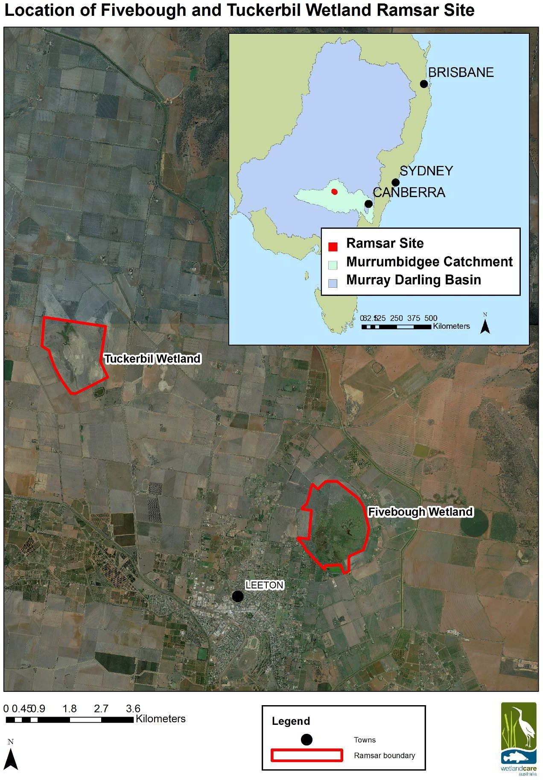

#### Figure 3. Location of Fivebough and Tuckerbil Wetlands within a regional (main) and broader (insert) context.

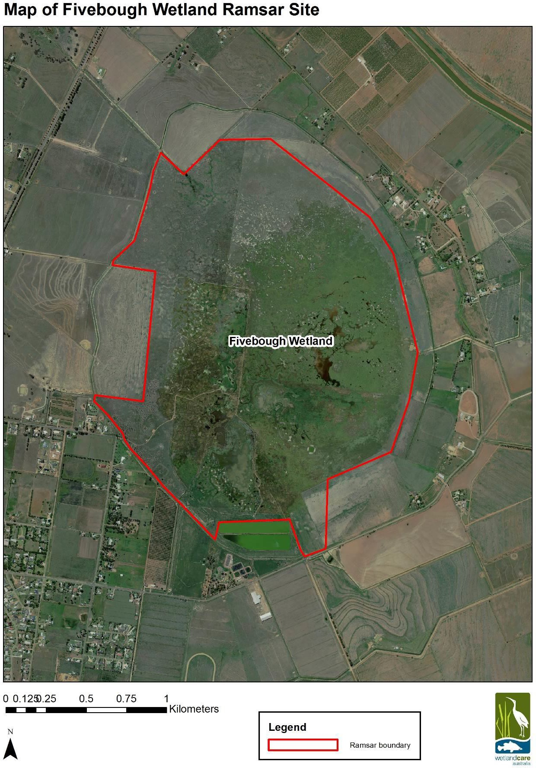

**Figure 4. Map of Fivebough Wetland component area of 342 ha.**

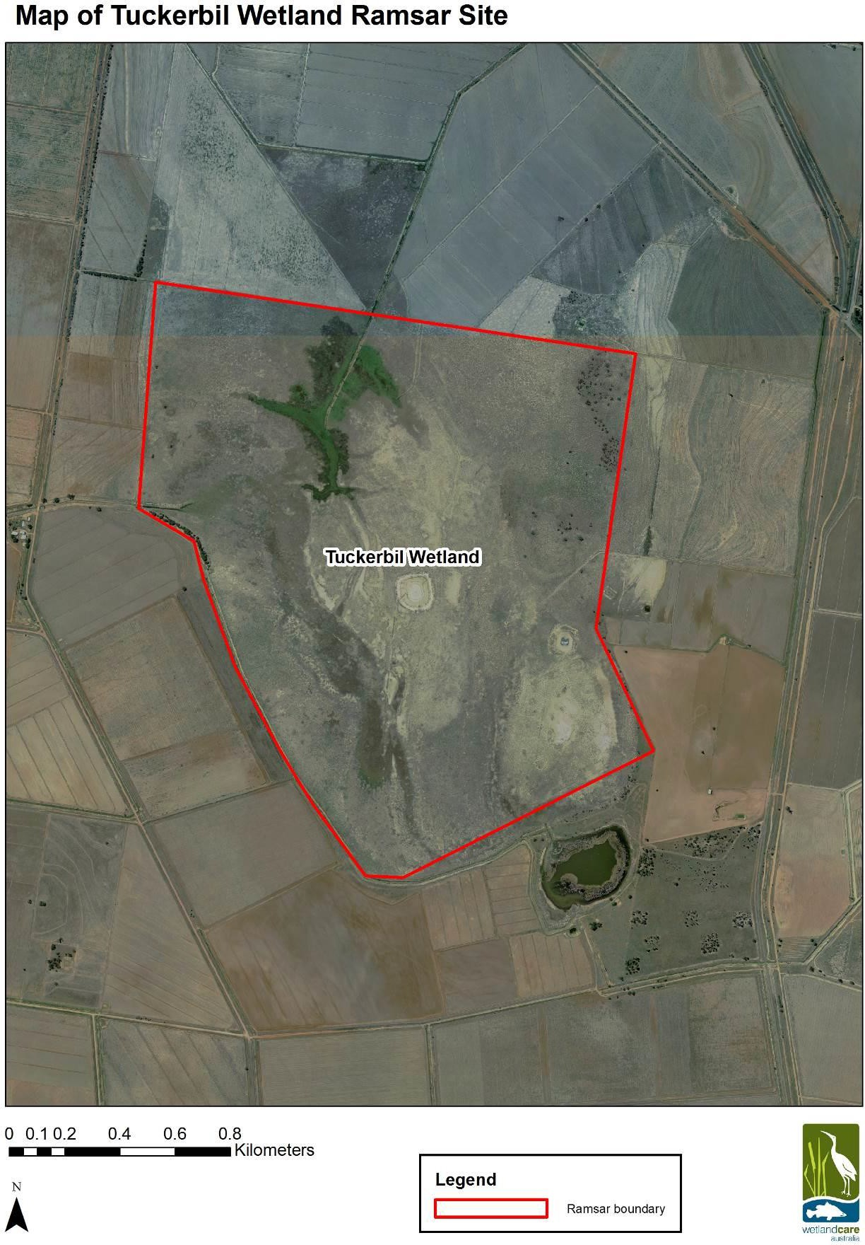

**Figure 5. Map of Tuckerbil Wetland component area of 277.5 ha.**

## Wetland types

According to the Ramsar Classification System there are two wetland types within the Fivebough and Tuckerbil Wetlands site; Category Q: Permanent saline/brackish/alkaline lakes and Category Ss: Seasonal/intermittent saline/brackish/alkaline marshes/pools. Both fall within the inland wetlands’ group. Fivebough Wetland supports both wetland types, while Tuckerbil Wetland supports only Category Ss: Seasonal/intermittent saline/brackish/alkaline marshes/pools.

Fivebough and Tuckerbil Wetlands were originally ephemeral wetlands in separate natural depressions and the water regime was determined by the balance between rainfall and evaporation. Although the original hydrological regime was variable, generally the wetlands would fill over autumn and winter due to precipitation exceeding evaporative losses, then dry out over the summer months when evaporative losses exceeded inputs from precipitation. The wetlands rarely filled completely, and only after exceptionally heavy and prolonged rainfall was water likely to flow out of the wetlands. The natural drainage line was originally from Fivebough Wetland through Tuckerbil Wetland flowing westerly into Mirrool Creek.

The hydrology has since been highly modified, affecting both the volume of water which would have naturally entered the wetlands, and its seasonality. There is a system of drains around the wetlands, including a ring drain around Fivebough constructed in 1939, which effectively intercept runoff from the 600 ha catchment area. During times of flood, excess water is released into Fivebough Wetlands from the drainage channel. Otherwise, water that would normally naturally enter the wetlands now must be allocated as an environmental flow out of the Office of Environment and Heritage’s (OEH) annual environmental water budget. Fivebough Wetland receives water from treated sewage effluent discharges and as a result an area of the wetland is now permanently inundated.

Currently, no comprehensive data exists on the water quality of either permanent or intermittent wetland types at Fivebough or Tuckerbil Wetland, however Electrical Conductivity readings taken at locations near the wetlands indicate conditions of 3,000 - 4,000 µS/cm in the region. Salinisation has occurred where pressure levels have developed close to the surface in the relatively shallow sand strata, and may have risen over time in line with other shallow groundwater rises in the Murrumbidgee Irrigation Area. Some areas within both wetlands support a salt tolerant vegetative assemblage, including species such as Seablite (*Suaeda baccifera*), Samphire (*Sclerostegia tenuis*) and Sea Barley Grass (*Hordeum marinum*). Based on this evidence, both wetlands are classified as falling into the brackish category (salinity of 0.5 - 30 g/L).

**Category Q: Permanent saline/brackish/alkaline lakes**.

This wetland type exists within Fivebough Wetland only. Fivebough Wetland has a permanently inundated section which is primarily provided by treated effluent discharge from the Leeton Sewage Treatment Plant. Current treated effluent release volumes into Fivebough Wetland are variable, however are estimated to be in the order of at least 2.5 ML per day with an annual average of 1,000 ML, and are increasing with expanding domestic and industrial sewage loads. Treated effluent is discharged via two outflow drains around the south western side of the wetland. This currently results in an area of approximately 39 ha of permanent wetland in the central southern part Fivebough Wetland (Figures 6, 7 and 12). The treated effluent load entering the wetland is expected to increase further with industrial expansion of the region, therefore the permanent wetland area may be expanding and may continue to expand. It is unclear whether water in the permanent wetland area within Fivebough Wetland would be fresh, rather than brackish or saline, due to the ongoing inflow of treated effluent water. Planned water quality monitoring may further establish the water condition within the permanent wetland and may assist to further define the correct wetland category for this part of the system.

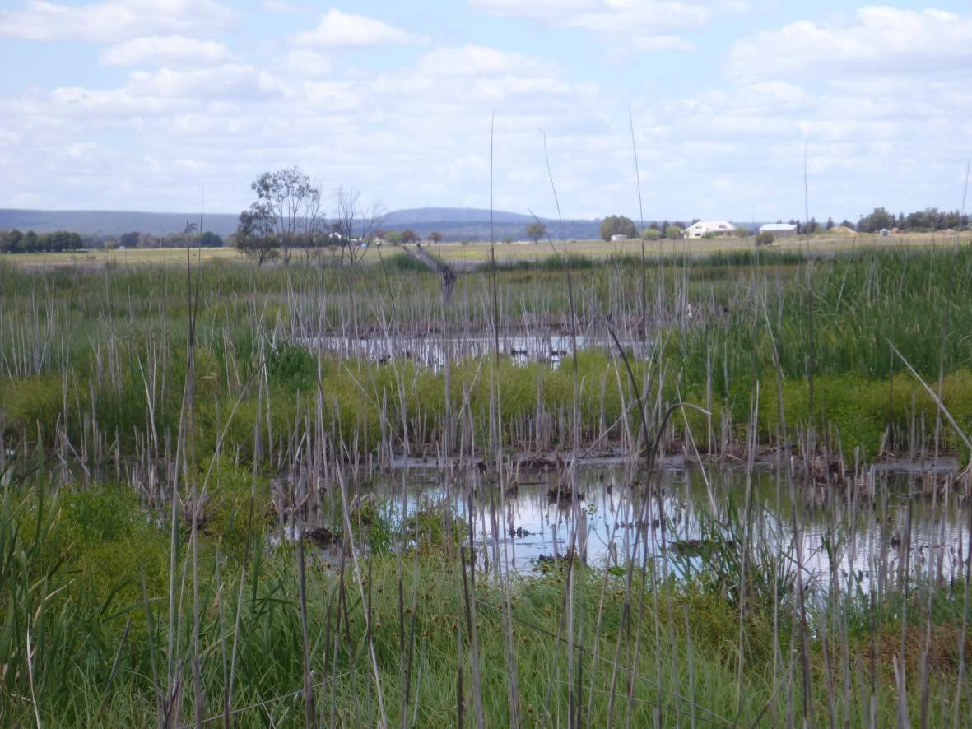

#### Figure 6. Parts of the permanent wetland area at Fivebough Wetland.

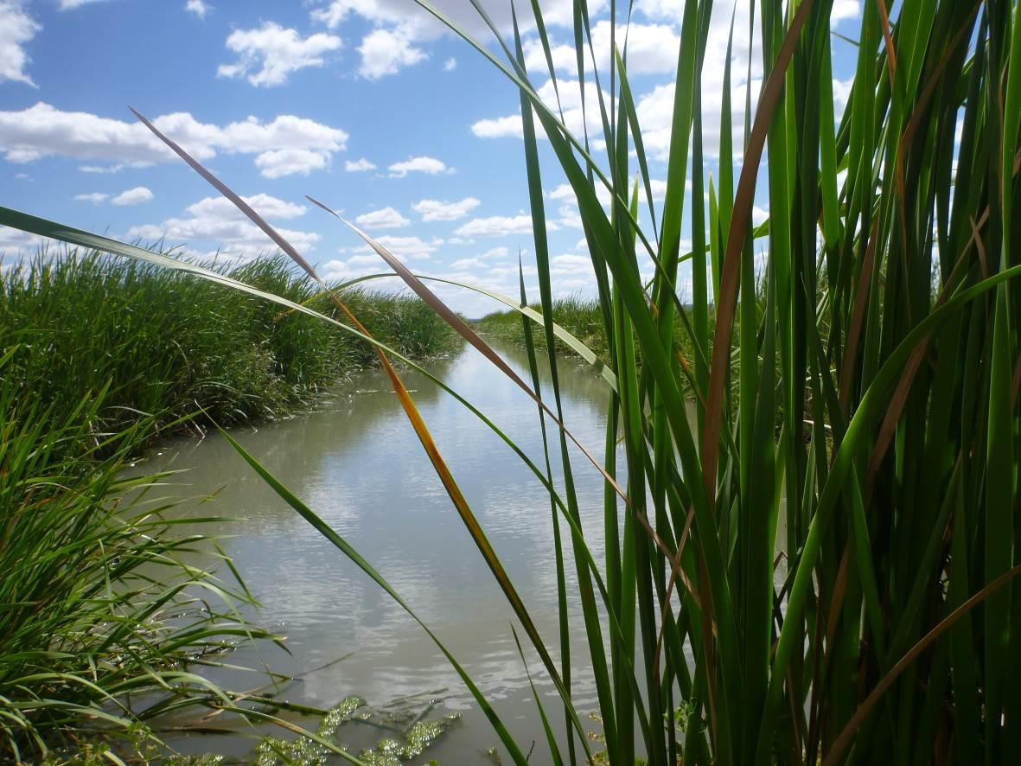

**Figure 7. Channel from Leeton STP into permanent wetland area at Fivebough Wetland.**

**Category Ss: Seasonal/intermittent saline/brackish/alkaline marshes/pools.**

This wetland type exists within Fivebough Wetland and Tuckerbil Wetland. Land in the eastern and south eastern parts of Fivebough Wetland is covered by shallow water seasonally almost every year due to local rainfall, excess floodwater from the surrounding drainage system, and/or environmental water releases, forming extensive mudflats as the water evaporates. Land to the north and the far west is higher and tends to flood only after very high rainfall. Approximately 303 ha of seasonal intermittent wetland occurs within the Fivebough Wetland Ramsar site (Figure 12), 184 ha that are ephemeral but more frequently wet (Figure 8) and 119 ha that are ephemeral but less frequently wet (Figure 9).

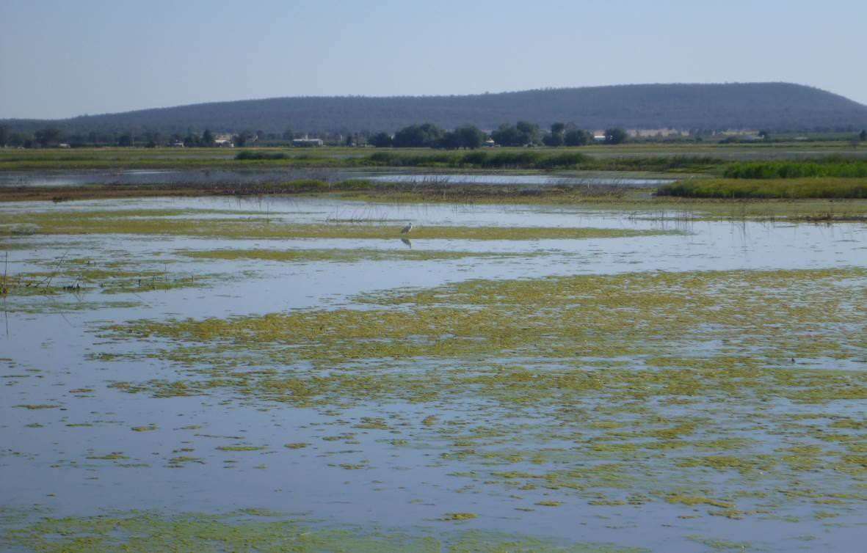

#### Figure 8. Frequently inundated seasonal wetland at Fivebough Wetland.

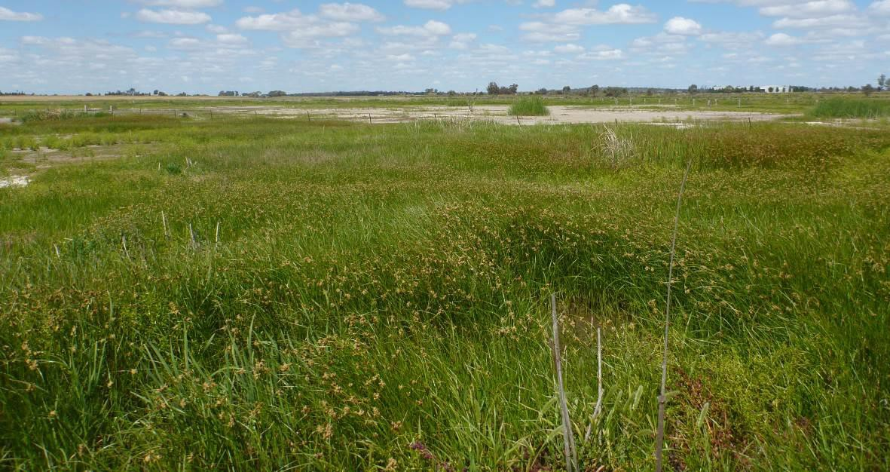

**Figure 9. Less frequently inundated seasonal wetland at Fivebough Wetland.**

The inner part of Tuckerbil Wetland is covered by shallow water seasonally (in winter/spring) almost every year due to local rainfall, and/or environmental water releases usually drying out completely during late spring/early summer. The depth and extent of water varies considerably from year to year, however there is no permanent wetland area at Tuckerbil Wetland. The potential area of seasonal wetland includes the entire Tuckerbil Ramsar site of 283 ha, however the area of inundation varies between years (Figures 10 and 11).

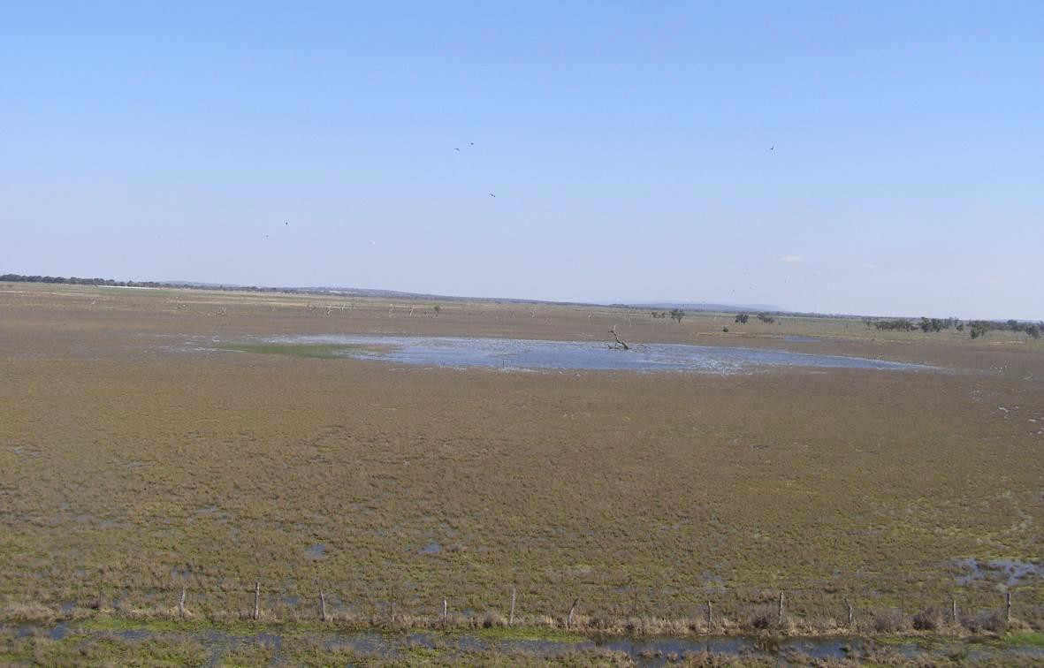

#### Figure 10. Seasonal wetland at Tuckerbil Wetland.

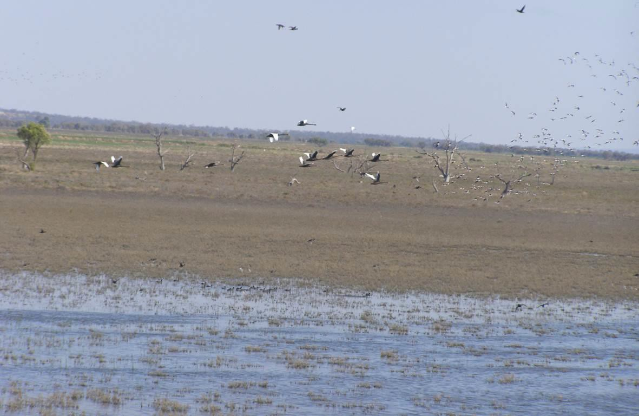

**Figure 11. Seasonal wetland at Tuckerbil Wetland.**

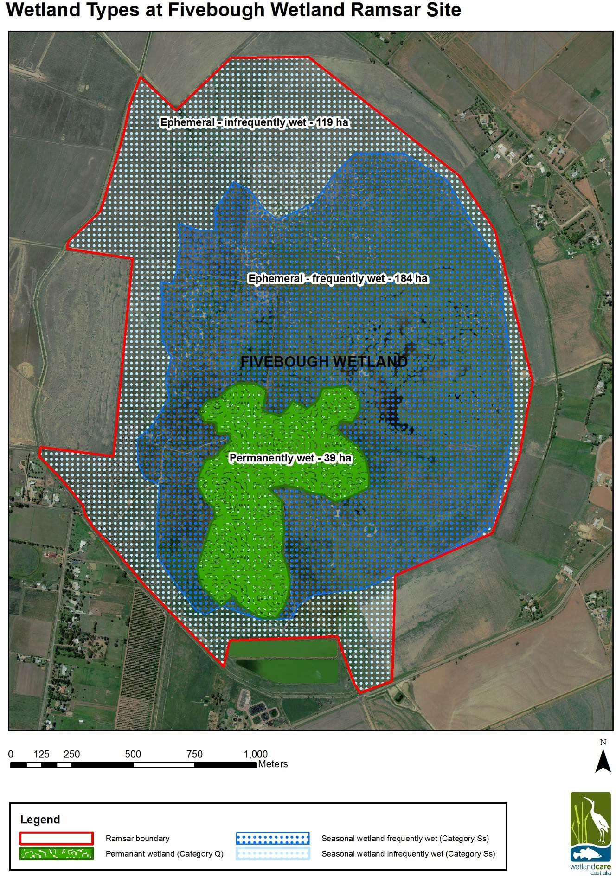

**Figure 12. Approximate areas of wetland types at Fivebough Wetland.**

## Ramsar criteria

The Ramsar criteria for identifying wetlands of international importance are shown below in Table 2. At the date of listing, the Fivebough and Tuckerbil Wetlands site was designated as meeting four criteria: Criterion 2, 3, 4, and 6.

#### Table 2. Criteria for identifying Wetlands of International Importance. Criteria met by Fivebough and Tuckerbil Wetlands are highlighted.

|  |  |  |
| --- | --- | --- |
| Group A of the Criteria. Sites containing representative, rare or unique wetland types | Criteria based on representative, rare or unique wetland types | **Criterion 1:** A wetland should be considered internationally important if it contains a representative, rare, or unique example of a natural or near-natural wetland type found within the appropriate biogeographic region. |
| Group B of the Criteria. Sites of international importance for conserving biological diversity | Criteria based on species and ecological communities | **Criterion 2:** A wetland should be considered internationally important if it supports vulnerable, endangered, or critically endangered species or threatened ecological communities. |
| **Criterion 3:** A wetland should be considered internationally important if it supports populations of plant and/or animal species important for maintaining the biological diversity of a particular biogeographic region. |
| **Criterion 4:** A wetland should be considered internationally important if it supports plant and/or animal species at a critical stage in their life cycles, or provides refuge during adverse conditions. |
| Specific criteria based on waterbirds | **Criterion 6:** A wetland should be considered internationally important if it regularly supports 1% of the individuals in a population of one species or subspecies of waterbird. |
| **Criterion 7:** A wetland should be considered internationally important if it supports a significant proportion of indigenous fish subspecies, species or families, life-history stages, species interactions and/or populations that are representative of wetland benefits and/or values and thereby contributes to global biological diversity. |
| Specific criteria based on fish | **Criterion 8:** A wetland should be considered internationally important if it is an important source of food for fishes, spawning ground, nursery and/or migration path on which fish stocks, either within the wetland or elsewhere, depend. |
| **Criterion 9:** A wetland should be considered internationally important if it regularly supports 1% of the individuals in a population of one species or subspecies of wetland-dependent non-avian animal species. |
| Specific criteria based on other taxa |  |

The initial Ramsar Information Sheet (RIS) for the Fivebough and Tuckerbil Wetlands was developed at the time of listing in 2002 provides justification of the values of the site against each of the criteria claimed. The data used to justify the criteria at the time of listing are provided below in Table 3. Any data relevant to the Ramsar criteria since the date of listing is discussed in *Section 7: Changes in ecological character*.

#### Table 3. Assessment of the Fivebough and Tuckerbil Wetlands against the Ramsar criteria met at the time of listing (information adapted from Schultz *et al*. 2002 and Biosis Research Pty Ltd and Wetlands International Oceania 2006 where not otherwise sourced).

|  |  |
| --- | --- |
| **Criteria** | **Justification against Criteria designated as being met at the time of listing** |
| **Criterion 2** | The site supports Australasian Bittern (*Botaurus poiciloptilus*) which is listed as ‘Endangered’ under the *Environment Protection and Biodiversity Conservation Act 1999* and the IUCN Red List (IUCN 2000). This species occurs regularly at both Fivebough and Tuckerbil Wetlands with maximum recorded counts of 17 and six respectively.  Australasian Bittern was recorded at only six other sites during the 1994 - 1997 Murray Darling Waterbird Project (Glazebrook & Taylor 1998). Stevens *et al.* (2002) recorded numerous sightings of Australasian Bittern from 1994 - 2001. Taylor and Richardson (2000) recorded the species five times during surveys from October 1999 to January 2000. Australasian Bittern were recorded in 2011 (OEH 2014) and frequently in 2013/14 at both Fivebough (count of up to 4 birds) and Tuckerbil Wetlands (count of up to 6 birds) (K. Hutton, *pers.comm.* 2014). Much of the habitat needed to support Australasian Bittern in the Riverina bioregion has been lost (Mike Schultz *pers. comm.*). Fivebough Wetland provides suitable habitat for Australasian Bittern, which favours wetlands with large areas (>5 ha) of tall, dense vegetation dominated by *Typha* spp. and *Phragmites australis* (DLWC 2002).  The site also supports Australian Painted Snipe (*Rostratula australis*), which has been listed, first as Vulnerable (2003), and then as Endangered (2013) under the *Environment Protection and Biodiversity Conservation Act 1999*. The RIS (Schultz *et al*. 2002) indicates that the species occurred at both Fivebough Wetland (counts of up to eight birds) and Tuckerbil Wetland at the time of listing. The species was also recorded in 2012 and 2013 (K. Hutton, *pers.comm.* 2014). |
| **Criterion 3** | The site is important for maintaining a high diversity of species of waterbirds within the Murray Darling Basin drainage division an area with few other non-riparian wetlands. The number of species listed under international treaties, or as threatened species and the abundances of some bird species are amongst the highest recorded in the Murray Darling Basin.  Fivebough Wetland and Tuckerbil Wetland had the highest and the second highest number respectively of waterbird species recorded (65 and 64 species respectively) in the 1994 - 1997 Murray Darling Waterbird Project (Glazebrook & Taylor 1998).  Fivebough Wetland was the second highest ranked site out of 360 sites for the maximum number of species recorded in a single survey with 43 species; and Tuckerbil Wetland was the seventh highest ranked site with 33 species.  A total of 83 species of waterbirds have been recorded at Fivebough Wetland and 69 species at Tuckerbil Wetland. |
| **Criterion 4** | 22 species of waterbird have been recorded breeding at Fivebough Wetland and 11 species at Tuckerbil Wetland. At least 12 of these species are known to breed regularly at the site.  Tuckerbil Wetland is a post-breeding roost site for up to 130 Brolga (*Grus rubicunda*). During spring-summer, thousands of Glossy Ibis (*Plegadis falcinellus*) gather at Fivebough Wetland in the evenings to roost, although many also feed extensively in the wetland. This also applies to a lesser extent to Whiskered Tern (*Chlidonias hybridus*). Fivebough Wetland provides important feeding habitat for four species of egret during their breeding season between September and February: Little Egret (*Egretta garzetta*), Great Egret (*Ardea alba*), Intermediate Egret (*Ardea intermedia*) and Cattle Egret (*Ardea ibis*). An Egret breeding colony with around 500 - 700 nests located 600 m south of the wetland is regularly used each year (Richardson 1999).  The site is important for migratory waterbirds with 24 species recorded at Fivebough Wetland and 13 species at Tuckerbil Wetland which are listed under the Japan-Australia and/or the China-Australia Migratory Bird Agreements (JAMBA and CAMBA). Of these recorded migratory waterbird species, 19 and 10 respectivley are shorebirds. The |

|  |  |
| --- | --- |
|  | wetlands support seventeen species of waterbirds listed under the Republic of Korea- Australia Migratory Bird Agreement (ROKAMBA). |
|  |  |
| **Criterion 6** | The RIS for the site at the time of listing (Schultz *et al*. 2002) reported five species of waterbird at numbers estimated to represent greater than 1% of their population: Glossy Ibis - 20,000 recorded at Fivebough Wetland.  Sharp-tailed Sandpiper (*Calidris acuminata)* - 2,015 at Fivebough Wetland and 2,253 at Tuckerbil Wetland.  Whiskered Tern - 20,000 at Fivebough Wetland and 900 at Tuckerbil Wetland. Australasian Bittern - 17 at Fivebough Wetland and 6 at Tuckerbil Wetland.  Brolga - 9 at Fivebough Wetland and up to 130 at Tuckerbil Wetland.  The claim for Criterion 6 should be based on waterbird numbers at the date of listing measured against the most accurate population estimates up to the current time. Further investigation of available population estimate data based on updated information since the time of listing indicated that the numbers of waterbirds recorded up to the time of listing met the 1% thresholds only for the Sharp-tailed Sandpiper and Glossy Ibis based on 1% population estimates of 1,600 and 10,000 respectively (Biosis Research Pty Ltd & Wetlands International Oceania 2006, Wetlands International 2006). Revised population estimates indicate that highest count of 17 Australasian Bittern at Fivebough and Tuckerbil Wetlands does not meet the 1% threshold for the species of 20 (Wetlands International 2006). It is presently unclear wether the northern and southern population of the Brolga should be regarded as separate populations (Wetlands International 2006) so this criterion can not be met with any certainty based on a likely 1% population threshold of 1,000 for this species. Whiskered Tern at Fivebough Wetland have met the 1% threshold of 10,000 (Wetlands International 2006) on at least 1 occasion, however there is no evidence that this is a regular occurance, with numbers recorded usually between several hundred to a few thousand.  This criterion is met at least for Glossy Ibis and Sharp-tailed Sandpiper. |

# Ecosystem components and processes

Ecosystem components are the tangible physical, biological and chemical entities that comprise the wetland (including factors such as the physical size and shape of the wetland, wetland communities, species and genes, soil, water quality, and chemical compounds), whereas the ecosystem processes are the dynamic forces which contribute to the functioning of the wetland (including physical, chemical and biological actions such as reproduction, predation, decomposition, erosion, nutrient and carbon cycling, evaporation, and hydrology) (DEWHA 2008).

Ecosystem components and processes together with the ecosystem services they provide form the ecological character of the site. Critical components and processes are those which are fundamental to the ecological site because they are:

* important determinants of the site’s unique character
* important for supporting the Ramsar criteria under which the site was listed
* for which change is reasonably likely to occur over short or medium time scales (<100 years)
* likely to cause significant negative consequences if change occurs.

This Ecological Character Descriptions aims to describe the ecological character of the site at the time it was designated as a Ramsar site in 2002 by defining the components and processes which are critical to the ecological character of the site and describing their natural variability. There may be other essential elements which support the critical components, processes and services provided by the site and these are also described in this context.

The critical components and processes for the Fivebough and Tuckerbil Wetlands are described in Section 3.2. The essential elements (components and processes) for the Fivebough and Tuckerbil Wetlands are described below in Section 3.1. The conceptual models for the site (Figures 15 - 17) illustrate the linkages between critical components, processes and services, as well as the essential elements which support the critical components, processes and services, and how these contribute to the site meeting the listed Ramsar criteria.

## Essential components and processes

The essential elements are those components and processes which contribute to the site’s ecological character by supporting the critical components, processes and services for which the site was listed. A summary of supporting components and processes is provided in Table 4 and a description of each essential component and process is described below (section 3.1.1 - 3.1.7)

#### Table 4. Summary of essential elements within Fivebough and Tuckerbil Wetlands.

|  |  |
| --- | --- |
| **Component/processes** | **Description** |
| Landform and soils | Fivebough and Tuckerbil Wetlands are located in shallow, circular depressions within the north eastern edge of the Murray Basin in NSW. Both wetlands are remnant ancient lakes and are underlain by saline clay soils with lunette dunes on their eastern margins. |
| Climate | Fivebough and Tuckerbil Wetlands are located in Australia’s semi-arid zone, with hot summers and cool winters. Mean annual rainfall is 490 mm per year and distributed relatively evenly throughout months of the year. Evaporation rates are highly seasonal throughout the year, greatly exceeding rainfall in  summer. Average total evaporation from October to March is 1,547 mm and only 490 mm between April and September. |
| Groundwater | Before irrigation began in the region, shallow groundwater levels were generally about 20 m below the surface. It is suggested that regional groundwater has risen to within 2.5 m of the surface. It is suggested that groundwater levels sit near to or just below the ground surface within the  Fivebough and Tuckerbil Wetlands basins. |
| Water quality | Comprehensive water quality data is lacking for Fivebough and Tuckerbil Wetlands. There are reports of highly saline water within Tuckerbil Wetland, and Electrical Conductivity readings indicate saline conditions of 3,000 - 4,000 µS/cm in the region. Fivebough Wetland receives treated effluent  which is monitored by Leeton Shire Council to comply with EPA licence conditions |
| Vegetation communities | Vegetation communities at Fivebough and Tuckerbil Wetlands have never been comprehensively classified or mapped in terms of species composition, diversity, structure, extent or spatial/temporal distribution.  Vegetation communities at Fivebough and Tuckerbil Wetlands have changed significantly since European settlement. Black Box (*Eucalyptus largiflorens*) associations which used to dominate both wetlands have been lost due to clearing, land use and changes in hydrological and fire regimes. Vegetation communities currently occurring at Fivebough Wetland include Cumbungi (*Typha sp*) sedgeland, Water Couch (*Paspalum disticum)* grassland, dry grassland, salt tolerant communities and limited areas of woodland and shrubland. Tuckerbil Wetland is dominated by salt tolerant vegetation including Samphire (*Sclerostegia tenus)*, Seablite (*Suaeda baccifera)* and Sea Barley Grass (*Hordeum marinum)* with areas of  Cumbungi, Water Couch and remnants of the original Black Box woodland. |
| Fauna (non waterbird) | There have been no comprehensive surveys of non-waterbird fauna at Fivebough and Tuckerbil Wetlands, however the presence of echidnas, lizards, snakes, water rats and Eastern Long-necked Tortoise have been recorded. Terrestrial birds including White-winged Wrens, Blue-winged Parrots, Orange Chats and numerous raptors have been recorded. Frogs found in the wetlands include *Litoria tasmaniensis*, *L. fletcherii*, *Crinia parinsignifera*, *L. interioris*, and *L. peronii*. A population of Eastern Grey Kangaroo frequents the site, with up to 53 recorded at Fivebough Wetland. Fish (other than carp) have not been recorded. Numerous invertebrates  such as midges, mosquito larvae and gastropods have been recorded however diversity was reported to be low. |
| Livestock grazing | Both Fivebough and Tuckerbil Wetlands have a long history of grazing with various management regimes, and both are subject to managed grazing up to the present time. Grazing occurs under licence on parts of Fivebough Wetland and intermittently on Tuckerbil Wetland. Grazing of the wetlands is restricted by licence conditions to a management regime which supports the sites ecological character. Grazing at both sites is adaptively managed in terms of timing, extent and stocking rate in order to promote a mosaic of native wetland vegetation to maintain the diversity and abundance of waterbird habitats whilst being sensitive to seasonal and spatial inundation  patterns and key waterbird times and areas of use to avoid wetland degradation and habitat disturbance. |

* + 1. **Landform and soils**

The wetlands lie within the north eastern edge of the Murray Basin, a sedimentary basin formed during the Cenozoic Era (Maunsell 1996). The Murray Basin is mainly filled with a sequence of sediments deposited during the Tertiary period (Ollier 1995). Depositional types in the Basin formed from limestones, shelf muds, marine, beach and alluvial sands, estuarine clays, and Aeolian dunes (Munday *et al*. 2004).

Major relief in the area includes the Cocoparra Range about 35 km to the north of the Ramsar site which rises up to 250 m above the plain; the Brobenah Range which lies about 10 km north-east of Fivebough Wetland and comprises wooded, dry rocky hills; and the Corbie and Merungle Hills to the south-east of Leeton, also dry rocky hills, emerging from the Quaternary deposits which are part of the same base rock system as the Narrandera Ranges.

The Fivebough and Tuckerbil Wetlands are located in shallow, circular depressions on the eastern margin of the Riverine Plain of NSW in the Murrumbidgee subregion of the Riverina bioregion. They once were semi-permanent wetlands, part of a series of wetlands and lagoons associated with a natural watercourse that flowed westerly across heavy clay soils onto the Murrumbidgee floodplain 15 km north of the Murrumbidgee River.

Fivebough Wetland is a remnant ancient lake and the shallow wetland depression is bordered on its eastern margin by a low lunette dune comprising saline clay sediments derived from the depression by wind during historical dry periods. Sediments surrounding the wetland away from the lunette dune consist mainly of silts and clays. Course sand and fine gravel sediments have been observed along the western side of the wetland at depth of between 3 to 7 m below ground level indicating the presence of a prior stream deposit. Tuckerbil Wetland is bordered by an extensive sandy lunette dune on it’s south-eastern margin.

Soils in the Fivebough Wetland basin are cracking grey clays with varying degrees of self-mulching properties. These soils have a moderate to high clay content and a marked shrink-swell potential. Crusting and sealing is counteracted by shrinkage and cracking. Fivebough Wetland basin is underlain by at least 10 m of extensive, impermeable clays (Glazebrook & Taylor 1998). The surface of Tuckerbil Wetland basin is predominantly grey/dark grey clay to an average depth of 7.2 m. A lens of sandy soils intersects beneath the clay and extends to a depth of 11.6 m (Glazebrook & Taylor 1998). The clays are overlain to the east of the wetland by red earth soils grading up to an extensive sand hill with low elevation forming the Koonadan Historic Site

Microrelief is provided in the northern section of Fivebough and the north-eastern section of Tuckerbil by gilgai (mounds and depressions formed from shrinking and swelling of cracking clay soils) (Glazebrook & Taylor 2008). Gilgai can form a series of small pools when flooded, enhancing the diversity of habitats found in the wetlands.

* + 1. **Climate**

Fivebough and Tuckerbil Wetlands are located in Australia’s semi-arid zone. Climate is characterised by hot summers and cool winters, with temperatures generally exceeding 30° Celsius in the summer months (Figure 13). Frosts can occur between May and September. The marked seasonal pattern strongly influences evaporation rates and consequently the hydrology of the wetlands.

Although rainfall and evaporation rates are highly variable there is a pronounced seasonal trend for evaporation which has significant consequences for the hydrology of the wetlands. Average monthly rainfall is relatively evenly distributed throughout the year, however there are extreme differences in evaporation rates between the summer and winter months. Evaporative losses generally exceed rainfall for most of the year and this is particularly pronounced in the summer months. This can clearly be seen in Figure 14, which provides a direct comparison of mean monthly rainfall and recent monthly evaporation rates at the nearby Yanco Agricultural station. Mean annual rainfall is 433 mm and is distributed relatively evenly throughout the year. Total evaporation from October to March is 1547 mm and only 490 mm between April and September (Glazebrook & Taylor 1998). In summer, evaporation greatly exceeds rainfall. Monthly evaporation in December is almost 10 times greater than monthly rainfall (a ratio of 9.7:1), whereas monthly evaporation in June and July only slightly exceeds monthly rainfall (a ratio of 1.3:1).

**Temperature**

#### Figure 13. Mean maximum and minimum monthly temperatures from 1999 to 2013, recorded at the Yanco Agricultural institute near Fivebough and Tuckerbil Wetlands.

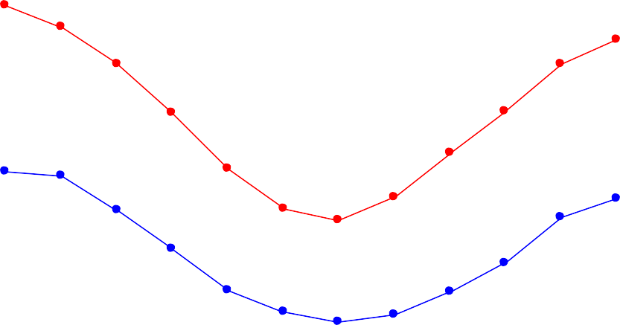

Jan Feb Mar Apr May Jun Jul Aug Sep Oct Nov Dec

**Month**

10

5

0

Mean minimum temperature (°C)

20

15

Mean maximum temperature (°C)

40

35

30

25

**Month**

Jul Aug Sep Oct Nov Dec

Jan Feb Mar Apr May Jun

0

50

100

150

200

250

300

Rainfall

Evaporation

**Rainfall / Evaporation (mm)**

**Figure 14. Comparison of mean monthly rainfall from 1957 to 2013 and total monthly evaporation in 2013 recorded at the Yanco Agricultural institute near Fivebough and Tuckerbil Wetlands.**

* + 1. **Groundwater**

Before irrigation began in the region, shallow groundwater levels were generally about 20 m below the surface. Groundwater data collected by the NSW Department of Land and Water Conservation from 1969 to 1996 indicates that the regional watertable is now within 2.5 m of the surface (DLWC 2002).

Groundwater data is not available within the basins of Fivebough or Tuckerbil Wetland, however, groundwater data collected around the wetlands suggest that the water table has risen to within 1 - 2 m below ground level around the wetland depressions (Maunsell 1996). Thus it is suggested that groundwater levels sit near to or just below the ground surface within the wetland depressions.

Fivebough and Tuckerbil Wetlands Management Trust (FTWMT 2002) reported that Water Resources Commission (WRC) studies in 1984 suggested that a perched saline watertable had developed beneath the lunette formation surrounding Fivebough Wetland due to percolation of rainfall and irrigation water into heavy sub-soil horizons beneath the lunette.

### Water quality

Currently, no comprehensive data exists on the water quality of either Fivebough or Tuckerbil Wetland. Leeton Council monitors effluent regularly to comply with EPA licence conditions. Murrumbidgee Irrigation was previously required to monitor water quality parameters, including pesticides and metals, at key points in drainage structures as a requirement of the *Water Management Act 2000*, however this was not required once the organisation was privatized and older data is not available. Water quality was reportedly collected at Fivebough Wetland prior to 2002 (FTWMT 2002), however data is not available.

There are reports of water quality sampling at dams within the Tuckerbil Wetland basin prior to 2002 finding the water to be highly saline (FTWMT 2002), however data is not available. Electrical Conductivity readings taken at locations near the wetlands indicate saline conditions of 3,000 - 4,000 µS/cm in the region. Salinisation has occurred where pressure levels have developed close to the surface in the relatively shallow sand strata, and may have risen over time in line with groundwater rises in the region.

Tuckerbil Wetland is the shallower of the two wetlands, although both are subject to seasonal drying, and as it dries out pan evaporation results in an increase in salt concentration (Glazebrook & Taylor 1998).

Some areas show evidence of being salt affected through a change toward a salt tolerant vegetative assemblage. Patches of bare ground exist within Fivebough Wetland and the presence of salt tolerant species such as Seablite (*Suaeda baccifera*), Sea Barley Grass (*Hordeum marinum*), and Samphire (*Sclerostegia tenuis*) on some gilgai puffs indicates that these areas may be salt affected.

Water quality within the wetland is likely to impact on the invertebrate assemblage, which in turn has important implications for waterbird prey availability and waterbird habitat values.

### Vegetation communities

Vegetation assemblages at the wetland have changed significantly since European settlement and have evolved in response to changes in the type and frequency of inundation (hydrology), land use practices (clearing, grazing and drainage) and changing soil characteristics (salinity), water chemistry and site topography.

The dominant vegetation at Fivebough Wetland was once a Black Box (*Eucalyptus largiflorens*) - Lignum (*Muehlenbeckia cunninghamii*) association. The dominant vegetation at Tuckerbil Wetland was once a Black Box - Lignum - Belah (*Casuarina cristata*) association and small remnants exist today on higher ground to the north east of the wetland. Both wetlands historically contained extensive stands of Cumbungi (*Typha sp*). Broadscale clearing for agricultural purposes, periods of extended (unnatural) inundation, fire and grazing, have all combined to result in a substantial loss of the original vegetation since European settlement.

During the 1930s, Fivebough Wetland was filled with water for a prolonged period following the rupture of a drainage pipe. This, combined with changes in fire regime, resulted in the loss of the Black Box community from Fivebough Wetland. The wetland became extensively covered with a thick growth of Cumbungi (*Typha spp)*. By the 1980s, heavy grazing of livestock (cattle), together with drought, resulted in loss of vegetation in the central part of the wetland, which became open mud flats (Taylor & Richardson 2000). Grazing temporarily ceased in parts of the wetland in 1997 followed by rapid regeneration of Cumbungi and Water Couch (*Paspalum disticum)*. This produced a vegetation structure in parts of the wetland preferred by cryptic waterbird species and significantly reduced the amount of mudflat available to shorebirds.

Taylor and Richardson (2000) assessed vegetation at Fivebough Wetland and estimated that 42 - 46% of the wetland was a bare mud substrate and not vegetated. There was very little vegetation less than 20 cm or over 50 cm tall. Modal vegetation heights were 21 to 40 cm with this band comprising 42% of the wetland area. Vegetation taller than 100 cm was mostly Cumbungi which occurred mainly in the south and western central sections of the wetland. Vegetation up to 2 m occurred in the north but mostly consisted of introduced weeds. Most vegetation of 50 cm and less was Water Couch which formed dense deep mats. Cumbungi and Water Couch were spreading rapidly following the removal of livestock.

At the time of listing the following vegetation communities were identified as occurring at Fivebough Wetland;

* + - A substantial area of healthy Cumbungi and/or Tall Sedge,
    - Substantial areas of sparse or patchy vegetation within shallow, muddy areas,
    - Substantial areas of Water Couch grassland of variable depth, and
    - Limited areas of woodland and shrubland,
    - Non-wetland vegetation Common Couch (*Cynodon dactylon)* and Barley Grass (*Hordeum leporinum)* on drier areas, and
    - Seablight (*Suaeda baccifera)* on some Gilgai puffs indicating saline conditions.

The dominant vegetation at Tuckerbil Wetland was once a Black Box - Lignum association. Following the establishment of irrigated farming, the wetland served as a drainage basin and held irrigation water for extended periods. The Black Box died and was replaced by a thick growth of Cumbungi and Water Couch. Fire reduced the extent of Cumbungi in the 1960s.

At the time of listing, vegetation communities at Tuckerbil Wetland were described as;

* + - Localised areas of saline flats covered by salt-tolerant species such as Samphire (*Sclerostegia tenus)*,
    - Seablite on salt flat margins and in areas inundated for considerable periods,
    - Sea Barley Grass (*Hordeum marinum)* and Samphire on Gilgai country in the north east of the wetland,
    - Drier areas of the wetland dominated by Sea Barley Grass and introduced ‘grazing’ species,
    - Remnants of the original Black Box, Belah (*Casuarina cristata*) and Lignum vegetation on and near the northern, eastern and southern margins of the wetland,
    - Cumbungi within the central western part of the wetland and along the Stony Point Main Drain to the north, and
    - Water couch restricted to the wetter north-western end of the wetland and sustained by water from the drainage outflow.

Vegetation communities at Fivebough and Tuckerbil Wetlands have never been comprehensively classified or mapped in terms of species composition, diversity, structure, extent or spatial/temporal distribution. Vegetation data is limited to presence/absence species lists which have been compiled for each wetland (Appendix 2). At the time of listing a diverse assemblage of wetland habitats including woodland and shrubland, Cumbungi beds, sedgeland, grassy meadows, and bare open areas was noted as being present collectively at Fivebough and Tuckerbil Wetlands.

The vegetation assemblages at Fivebough and Tuckerbil Wetlands underpin the waterbird habitat at the site. The extent and distribution of vegetation communities are primarily a factor of the hydrological regime and change according to the hydrology gradient, with a noticeable change occurring between the dry outer rim of each wetland and areas of more permanent water (at Fivebough Wetland) or regularly inundated areas (at Tuckerbil Wetland). Grazing and weed management activities also impact on the composition, structure and extent of vegetation communities within Fivebough and Tuckerbil Wetlands. The current management plan for the site (Price *et al.* 2014) indicates that appropriate grazing regimes are now a key component of effective vegetation management for the purpose of waterbird and habitat management. The current management plan outlines a hydrological and grazing management regime intended to maintain a diversity of wetland vegetation communities as part of waterbird habitat.

It is not known whether any threatened flora species, populations or communities exist at Fivebough or Tuckerbil Wetland. Flora lists from the most recent comprehensive surveys undertaken at the wetlands (1997) are included in Appendix 2 and do not indicate the presence of threatened species or communities.

### Fauna

Waterbirds are a critical component of Fivebough and Tuckerbil Wetlands and are discussed further in Section 3.2.2. Non-waterbird fauna underpin the ecological character of the site by providing a waterbird food source and contributing to the cultural and recreational values of the site.

Prey sampling was conducted at Fivebough Wetland by Taylor and Richardson (2000) and found a scarcity of vertebrate prey over much of the wetland. Fish were not recorded, other than some small carp, and a low number of frog tadpoles were recorded. Invertebrate prey, such as aquatic insects, insect larvae and gastropods were reasonably numerous, however diversity was low (Taylor & Richardson 2000).

There have been no comprehensive surveys of mammals, reptiles, amphibians or fish at Fivebough or Tuckerbil Wetland, however species observed at Fivebough Wetland include echidnas, lizards, snakes, water rats and Eastern Long-necked Tortoises. As well as waterbirds, the site provides habitat for many other species of bird such as White-winged Wrens, Blue-winged Parrots, Orange Chats and numerous raptors. Frogs found in the wetlands include *Litoria tasmaniensis*, *L. fletcherii*, *Crinia parinsignifera*, *L. interioris*, and *L. peronii* (Wassens 2006). A population of Eastern Grey Kangaroo frequents the site, with up to 53 recorded at Fivebough Wetland.

### Livestock grazing

Both Fivebough and Tuckerbil Wetlands have a long history of grazing with various management regimes, and both are subject to managed grazing up to the present time. Grazing occurs under licence on parts of Fivebough Wetland and intermittently on Tuckerbil Wetland. Grazing of the wetlands is restricted by licence conditions to a management regime which supports the sites ecological character.

The direct impact of stock on wetlands can include alterations to soil structure and nutrient levels, reduction in vegetation biomass, changes to vegetation assemblages and changes to water quality. While no long-term studies have been conducted to quantify the effect of domestic livestock grazing on the ecology of Fivebough or Tuckerbil Wetland, anecdotal information and Taylor and Richardson (2000) suggest that poorly regulated grazing in the past has had negative impacts on wetland ecology, especially on Fivebough Wetland where the extent of Cumbungi had previously been greatly reduced (Hutton pers. comm. and Schultz pers. comm. in Glazebrook & Taylor 1998). Equally, periods of little or no grazing have reportedly had negative impacts on the wetlands, allowing weeds to become established and out- compete native wetland vegetation communities.

The current management plan for the site (Price *et al.* 2014) outlines an adaptive grazing strategy for both Fivebough and Tuckerbil Wetlands, in which grazing under specific licence conditions is used as a management tool to control weed growth within each site and to promote a mosaic of native wetland vegetation to maintain the diversity and abundance of waterbird habitats. Ongoing limited grazing of Fivebough and Tuckerbil Wetlands is managed adaptively in terms of timing, extent and stocking rate in order to be sensitive to seasonal and spatial inundation patterns and key waterbird times and areas of use to avoid wetland degradation and habitat disturbance.

Fivebough Wetland is currently leased perpetually and is divided into management zones. Cattle are generally excluded from permanently wet areas and public use areas. Drier areas are grazed continually with stocking rates varied according to vegetation growth. Intermittently wet areas are grazed during dry times with the grazing area expanding progressively as the wetland dries. Tuckerbil Wetland has in the past been leased intermittently to allow adaptive grazing when required for weed management. Tuckerbil Wetland will shortly be placed under a perpetual licence for grazing similar to Fivebough Wetland whereby livestock, type, density and distribution will be moderated according to the site conditions and seasonality.

Grazing of Fivebough and Tuckerbil Wetlands is subject to licence conditions under the direction and discretion of the Advisory Committee to ensure grazing is undertaken in such a way as to preserve the ecological significance and enhance the biological diversity of the wetlands, and as such grazing regimes may be subject to change for this purpose, depending on the condition and ecological requirements of the wetlands.

## Critical components and processes

The critical components and processes are those elements which contribute directly to site’s ecological character for which the site was listed as internationally important. A summary table of each critical component and process and the Ramsar criteria to which it relates is provided below (Table 5). A description of each essential component and process is described below (Section 3.2.1 - 3.2.2).

#### Table 5: Summary of critical components and processes within Fivebough and Tuckerbil Wetlands.

|  |  |
| --- | --- |
| **Component/processes** | **Description** |
| Hydrology | The hydrology of Fivebough and Tuckerbil Wetlands has been highly modified, and inflows now consist primarily of local rainfall and irrigation runoff, floodwaters which exceed drainage system capacity, treated effluent releases from the Leeton Sewage Treatment Plant (Fivebough Wetland only) and, environmental water allocations (since after the date of listing).  Fivebough Wetland fills in most years during autumn/winter, when evaporation rates are low, to a maximum depth of 45 cm and an average depth of 21.5 cm. Fivebough Wetland usually dries out rapidly due to high evaporation rates during spring/summer. The area of intermittent inundation becomes shallow then contracts to the deepest section within the central eastern part of the wetland, exposing extensive waterlogged mudflats, which becomes a series of disconnected pools before drying completely.  Regular treated effluent discharge of approximately 2.5 ML per day results in a permanent wetland area in the central southern part of Fivebough Wetland of approximately 39 ha.  Tuckerbil Wetland fills intermittently during autumn/winter, when evaporation rates are low. Tuckerbil Wetland has an average depth of 30 cm and a maximum depth of approximately 40 cm when full. Like Fivebough Wetland, Tuckerbil Wetland dries rapidly during late spring/early summer. Water levels recede in the central and south western parts of the wetland prior to the eastern portion of the wetland. Wetland hydrology drives the temporal and spatial diversity of waterbird habitats at Fivebough and Tuckerbil Wetlands. |
| Waterbirds | Both Fivebough and Tuckerbil Wetlands have long been recognised as important sites for waterbirds and significant waterbird species, populations and activity have been recorded. Nationally threatened Australasian Bittern (*Botaurus poiciloptilus*) and Australian Painted Snipe (*Rostratula australis*) have been regularly recorded within the site. Both wetlands support a high diversity of waterbirds with 83 species recorded at Fivebough Wetland and 69 species at Tuckerbil Wetland. Both Fivebough and Tuckerbil Wetlands provide habitat for internationally significant migratory waterbirds with 24 species (19 shorebirds) recorded at Fivebough Wetland and 13 species (10 shorebirds) at Tuckerbil Wetland. At Fivebough Wetland, 22 waterbird species have been recorded breeding, and 11 at Tuckerbil Wetland. The wetlands also provide significant feeding and roosting habitat for waterbirds including egrets and brolgas. At least 20,000 waterbirds have been recorded at Fivebough Wetland on several occasions, principally in summer, with the highest count of 50,000 birds at one time. Counts of Sharp-tailed Sandpiper and Glossy Ibis exceeding the 1% population threshold have been recorded at one or both wetlands. |

* + 1. **Hydrology**

Wetland hydrology is a key driver of vegetation communities and waterbird habitat at Fivebough and Tuckerbil Wetlands and directly contributes to many of the benefits and services provided by the site, including those critical to the site’s Ramsar listing.

The hydrology of the site plays a key role in supporting waterbird habitat, so is a critical part of the site’s ecological character. The seasonal wetting and drying of intermittent wetlands within the Murray Darling Basin drives the nutrient cycling which provides abundant invertebrates and microorganisms and supports numerous waterbirds (Kingsford *et al.* 2014). The various species of waterbird using the wetlands have different water depth preferences related to their size and foraging technique. There is a succession of species present, each reaching their maximum numbers at different stages as the wetland dries (Taylor & Richardson 2000). Consequently, the pattern of wetting and drying is essential to maintain the productivity and diversity of waterbird species using the wetlands.

Fivebough and Tuckerbil Wetlands were originally ephemeral wetlands in separate natural depressions and the water regime was determined by the balance between rainfall runoff and evaporation. Although the original hydrological regime was variable, generally the wetlands would fill over autumn and winter due to precipitation exceeding evaporative losses, then dry out over the summer months when evaporative losses exceeded inputs from precipitation. The wetlands rarely filled completely, and only after exceptionally heavy and prolonged rainfall was water likely to flow out of the wetlands. The natural drainage line was originally from Fivebough Wetland through Tuckerbil Wetland flowing westerly into Mirrool Creek.

#### Inflows

The hydrology of Fivebough and Tuckerbil Wetlands has been highly modified, affecting both the volume of water which would have naturally entered the wetlands, and its seasonality. There is a system of drains around the wetlands, including a ring drain around Fivebough Wetland constructed in 1939, which effectively intercepts runoff from the 600 ha catchment area. Water inputs into Fivebough and Tuckerbil Wetlands now consist primarily of local rainfall and irrigation runoff, floodwaters which exceed drainage system capacity, treated effluent releases from the Leeton Sewage Treatment Plant (Fivebough Wetland only) and (since 2004) environmental water allocations.

Leeton Shire Council uses Fivebough Wetland to dispose of tertiary treated effluent by evaporation and this represents a significant water input to the wetland. The Leeton Sewage Treatment Plant (STP) treats both domestic sewage and industrial waste. Effluent released into Fivebough Wetland is treated via a combination of trickling filters, an Extended Aeration Tank with a total biological capacity of 27,000 EP (equivalent persons), and a chemical dosing facility installed in 2005 to provide for phosphorus/nutrient removal. Leeton Shire Council and the NSW Office of Water monitor effluent regularly. Current treated effluent release volumes into Fivebough Wetland are variable, however yearly averages are estimated to be in the order of 1,000 ML with a daily average of between 2 - 4 ML per day. Increased sewage loads are expected with new and expanding citrus, rice, cheese and wine industries (DPWS 1999). Treated effluent is discharged via two outflow drains around the south western side of Fivebough Wetland resulting in a permanent wetland area in the southern central part of the wetland.

Fivebough Wetland plays an important role in alleviating flooding in the irrigation and urban drainage system that surrounds the wetland and as such, the natural flooding regime is retained. Fivebough Wetland receives floodwaters from surrounding areas via a contour irrigation drain constructed in 1939 via five flow control devices. The contour drain collects urban and agricultural drainage water from the catchment area south of Fivebough Wetland and usually diverts water that would normally flow into Fivebough Wetland, bypassing Tuckerbil Wetland, into Mirrool Creek and then Barren Box Storage and Wetland to be stored for irrigation use. Smaller rainfall events (approximately <25 mm) are now diverted around the wetlands by the irrigation drainage system. During prolonged or heavy rainfall, excess water in the drainage system is directed into Fivebough Wetland via a series of water control structures in order to help alleviate local flooding. In circumstances of extreme storm conditions (1 in 10 year events), Murrumbidgee Irrigation can release water into the wetland via several regulatory structures. The volume and frequency of excess water entering the wetland from the drainage system has not been quantified.

The contour drain does not completely encircle the wetland and consequently a considerable volume of stormwater runoff enters the wetland from the southern end of the basin. Inflows of large volumes of floodwater during prolonged or heavy rain contribute significantly to the filling of Fivebough Wetland, which mimics the natural inflows to the wetland during heavy rainfall and flood times.

Natural inflows to Tuckerbil Wetland have also been modified by the constructed drainage network which diverts catchment flows around Tuckerbil Wetland via the south-western boundary and north-west to Barren Box Swamp 35 km west of Griffith. This network of drains captures water that would previously have flowed directly into Tuckerbil Wetland. At the time of listing Fivebough Wetland received only rainfall and irrigation runoff from the local catchment and overflows from the drainage system during heavy rainfall. At times Murrumbidgee Irrigation also manually diverted floodwaters into Tuckerbil Wetland (Glazebrook & Taylor 1998) via a manual earthen drainage structure.

Since the time of listing both Fivebough and Tuckerbil Wetlands have become eligible to receive environmental water allocations under the Office of Environment and Heritage (OEH) annual environmental watering plans for the Murrumbidgee Valley. Opportunities for environmental watering at target sites across the state are considered in the context of the availability of environmental water and the likely ecological response to water at any given time. Both Fivebough and Tuckerbil Wetlands have an ongoing listing in the OEH Annual Environmental Watering Plans as potential recipients of environmental flows under a variety of scenarios with the primary objective being to protect and maintain waterbird habitat within both sites. Water levels at the wetlands are assessed visually, in conjunction with quarterly bird surveying, and a recommendation is then made by the Advisory Committee as to whether or not an environmental water allocation request is made to OEH. Allocated environmental water releases are delivered to each wetland via Murrumbidgee Irrigation supply channels. Recently, this has occurred between April and December, depending on the seasonal availability of water. Until recently, environmental water delivery to Tuckerbil Wetland required earth works to be undertaken in drainage structures to the south of Tuckerbil Wetland to divert drainage flows resulting in operational inefficiencies. In January 2015 Murrumbidgee Irrigation completed construction of a permanent delivery structure to deliver environmental water to Tuckerbil Wetland.

The availability of environmental water means that hydrological cycles at Fivebough and Tuckerbil Wetlands can now be controlled to a greater extent. Collectively, Fivebough and Tuckerbil Wetlands have received five environmental waterings in the ten years prior to 2014. At times during that period, large releases (up to 1,000 ML as a single amount delivered only to Fivebough Wetland) were made, which resulted in flooding of the wetlands when combined with prevailing rainfall conditions at the time (e.g.

1,000 ML environmental flow in 2011 followed by a 1 in 100 year flood in 2012). In November 2013,

265 ML of environmental water was allocated to Tuckerbil Wetland which maintained shallow coverage of water in the wetland well into December. The current management plan for the site (Price et al. 2014) outlines an inflow management regime to mimic the wetting and drying cycles reflective of historic conditions and to maintain the productivity and diversity of waterbird habitats. The management regime going forward is intended to use environmental water allocations, delivered between June and September, when nececessary to supplement other inflows into the wetland to maintain wetland hydrology to support the ecological character of the Fivebough and Tuckerbil Wetlands at the time of listing.

#### Wetland hydrology

Comprehensive systematic data on water depth and hydrology are not available for Fivebough or Tuckerbil Wetlands, however available information outlining the key hydrological characteristics is summarised below.

Fivebough Wetland has a maximum depth of 45 cm and an average depth of 21.5 cm when full (Taylor & Richardson 2000). The wetland has a holding capacity of approximately 2,000 ML, with a volume of

500 ML is required to inundate approximately 60% of the wetland (Sinclair Knight Merz 2011). The ongoing consistent effluent discharge results in a permanent wetland area in the central southern part Fivebough Wetland of approximately 39 ha. Fivebough Wetland fills rapidly during flooding, and much of the 342 ha wetland is inundated. However, when full, only a small percentage of the inundated area (2%) reaches the maximum depth of 45 cm and most of the inundated area is less than 25 cm deep (Taylor & Richardson 2000). Much of the wetland is uniformly shallow with a gently sloping surface with only slight undulations (Taylor & Richardson 2000). The deepest portion of the intermittent wetland is located within the south eastern zone of Fivebough Wetland and this section holds water more often and for longer periods than surrounding higher areas to the north and west of the wetland as shown in Figure 12. Land to the north and the far west is higher and tends to flood only after very high rainfall and dries out sooner than central eastern parts of the wetland. Figure 12 indicates the approximate areas of Fivebough Wetland that are permanently wet from effluent discharge, ephemeral but more frequently wet and ephemeral but less frequently wet.

After filling, Fivebough Wetland usually dries out rapidly (within 1 - 3 months) during spring/summer due to high evaporation rates and its uniformly shallow basin. As the wetland dries, much of the wetland becomes shallow and the area of inundation rapidly recedes, exposing extensive waterlogged mudflats.

The area of intermittent inundation contracts rapidly to the deepest section within the central eastern part of the wetland, which becomes a series of disconnected pools before drying completely. (Taylor & Richardson 2000).

Tuckerbil Wetland has an average depth of 30 cm and a maximum depth of approximately 40 cm when full. A volume of approximately 500 ML is required to fill Tuckerbil Wetland (Sinclair Knight Merz 2011). Like Fivebough Wetland, Tuckerbil Wetland dries rapidly during late spring /early summer. Water levels recede in the central and south western parts of the wetland prior to the eastern portion of the wetland.

There is little height and depth variation across much of both Fivebough and Tuckerbil Wetlands and inundation of intermittent wetland areas is temporary and relatively short. Therefore the presence and diversity of waterbird habitats is provided temporally, as well as spatially, and relies on the regularity of the annual seasonal wetting and drying cycle of the wetlands. The hydrological cycle of the wetlands is dependant upon them receiving adequate water to inundate the wetland basins during winter but not so much as to prevent seasonal drying during summer. Either too much or too little water entering intermittent wetlands within the Murray Darling Basin can disrupt the seasonal cycle which drives conditions for waterbird habitat (Kingsford *et al.* 2014).

The current management regime for Fivebough and Tuckerbil Wetlands (Price *et al.* 2014) is intended to ensure that Fivebough Wetland maintains not only small sections of permanent water (now largely unavoidable due to the ongoing receipt of treated water) but also that Fivebough and Tuckerbil Wetlands regularly experiences large expanses of shallow water over the majority of the intermittent wetland areas which gradually dry throughout summer. As Fivebough Wetland receives large drainage inflows during peak flood times, large environmental water releases are unadvised, and it is planned that environmental water should be released into the wetlands, if required, in smaller amounts during winter/early spring to best extend the duration and extent of waterbird habitat for the maintenance of the ecological character of the site. The management regime for Tuckerbil Wetland suggests that smaller intermittent releases of environmental water allocations are made during winter/early spring, where required to maintain regular extensive inundation and drying, and that larger releases are made every 7 - 10 years to mimic flood pulses.

* + 1. **Waterbirds**

Both Fivebough and Tuckerbil Wetlands have long been recognised as important sites for birdlife. Waterbird records for both sites date back to the period 1900 - 1930. The Fivebough and Tuckerbil Wetlands were designated Ramsar wetlands in 2002 because of their international importance primarily as waterbird habitat. The following elements contributed to the sites listing for criteria relating to waterbirds:

* Threatened wetland species Australasian Bittern (*Botaurus poiciloptilus*) and Painted Snipe (*Rostratula australis*).
* A high diversity of waterbird species.
* Migratory species and waterbird roosting and breeding.
* Numbers of Sharp-tailed Sandpiper and Glossy Ibis in excess of the 1% of the population.

#### Threatened species

Two species listed as ‘Endangered’ at a national level under the Commonwealth *EPBC Act* have been recorded at Fivebough Wetland and Tuckerbil Wetland; Australasian Bittern (*Botaurus poiciloptilus*) and Australian Painted Snipe (*Rostratula australis*). At the time of listing Australian Painted Snipe was not listed as nationally threatened, however, records show that the species was recorded at the site (both Fivebough and Tuckerbil Wetlands) prior to listing.

Australasian Bittern have been listed as regularly occurring at the site (Biosis Research Pty Ltd & Wetlands International Oceania 2006). Maximum recorded numbers of Australasian Bittern are 17 at Fivebough Wetland (Taylor & Richardson 2000) and 6 at Tuckerbil Wetland, however this does not appear to be reflective of average numbers of Australasian Bittern at the sites in the longer term (Biosis Research Pty Ltd & Wetlands International Oceania 2006, K Hutton *pers. comm.* 2014). Field Naturalist records from 1994 - 2002 (Stevens *et al.* 2002) recorded numerous sightings of Australasian Bittern at the site from 1994 - 2001. Taylor and Richardson (2000) recorded Australasian Bittern at the site five times during surveys from October 1999 to January 2000. Australasian Bittern were recorded in 2011 (OEH 2014) and frequently between 2013-14 at both Fivebough (count of up to 4 birds) and Tuckerbil Wetlands (count of up to 6 birds) (K. Hutton, *pers.comm.* 2014). Australasian Bittern were recorded at only six other

sites during the 1994 - 1997 Murray Darling Waterbird Project (Glazebrook & Taylor 1998) making their regular occurrence within the site particularly significant.

Australian Painted Snipe occur at Fivebough Wetland intermittently but, on average, in three of every ten years (e.g. Jun 1996, Feb 2001 and Oct 2004). They were recorded at Fivebough Wetland during the spring, summer and autumn seasons of 2013/2014 (K Hutton, *pers. comm.* 2014). Australian Painted Snipe occur at Tuckerbil Wetland rarely, with only one documented record in November 1996.

#### Species diversity

At Fivebough Wetland, 83 waterbird species have been recorded (see Appendix 2). Of these species, 55 are regularly recorded, with other species being occasionally or rarely recorded. Of 360 wetlands surveyed during the 1994 - 1997 Murray Darling Waterbird Project Fivebough Wetland recorded the highest diversity of waterbird species and it ranked second within the Murray Darling Basin for the maximum number of species recorded in a single survey. (Glazebrook & Taylor 1998).

At Tuckerbil Wetland, 69 waterbird species have been recorded (see Appendix 2). Of these species, 46 species are regularly recorded, with other species being occasionally or rarely recorded. During the 1994

- 1997 Murray Darling Waterbird Project Tuckerbil Wetland recorded the second highest diversity of waterbird species and it ranked seventh for the maximum number of species recorded in a single survey. (Glazebrook & Taylor 1998).

#### Migratory species

Both Fivebough and Tuckerbil Wetlands provide habitat for internationally significant migratory waterbirds listed under JAMBA, CAMBA and/or ROKAMBA, Australia’s migratory bird agreements with Japan, China and the Republic of Korea respectively. At Fivebough Wetland, 24 species of migratory waterbirds (19 shorebird species) have been recorded. Eight of these species tend to be recorded in most years. At Tuckerbil Wetland, 13 species of migratory waterbirds (10 shorebird species) have been recorded. Five to six of these species tend to be recorded in most years.

#### Waterbird feeding, roosting and breeding

At least 22 waterbird species have been recorded breeding at Fivebough Wetland, and 11 at Tuckerbil Wetland. At least 12 species are regular breeders across the sites. Two of these are regarded as regular breeders only at Tuckerbil Wetland but not at Fivebough Wetland. Fivebough Wetland also supports egrets breeding in the nearby Almond Road rookery a small 2 ha woodland about 3 - 4 km from Fivebough Wetland (Biosis Research Pty Ltd & Wetlands International Oceania 2006). This colony consists of 4 species of egret (mainly intermediate egret (*Ardea intermedia*)), with up to 800 nests.

Hundreds of egrets are observed foraging within Fivebough Wetland, which provides an important food source for their nestlings when alternative feeding habitat (rice fields) tend to be declining. Up to 130 Brolgas (*Grus rubicunda*) regularly use Tuckerbil Wetland as a post-breeding roost (Biosis Research Pty Ltd & Wetlands International Oceania 2006).

#### Waterbird numbers

At least 20,000 waterbirds have been recorded at Fivebough Wetland on several occasions, principally in summer, with the highest count of 50,000 birds at one time. Many surveys have been conducted but, up to the date of listing, they were not necessarily regular. At Fivebough Wetland counts of 20,000 Whiskered Terns (*Chlidonias hybridus)* and 20,000 Glossy Ibis (*Plegadis falcinellus)* have been recorded (Glazebrook & Taylor 1998). In December 1995 approximately 50,000 birds were counted at Fivebough Wetland by local naturalists and verified by the Royal Australasian Ornithologists Union (RAOU) (Glazebrook & Taylor 1998). Taylor and Richardson (2000) recorded in excess of 20,000 waterbirds across the eastern half of Fivebough Wetland in November and December 1999.

#### Significant waterbird populations

A maximum count of Sharp-tailed Sandpiper at Fivebough Wetland has been an estimated 3,000 birds (2003/04) and several counts over the 1% threshold (1,600 birds) have been documented (e.g. in 1996). The maximum count of Sharp-tailed Sandpiper at Tuckerbil Wetland has been estimated at 4,000 birds and several counts over the 1% threshold have been documented (e.g. in 1995, 1997). (Biosis Research Pty Ltd & Wetlands International Oceania 2006).

A maximum count of 20,000 Glossy Ibis at Fivebough Wetland was recorded in December 1995, and 15,000 were counted in November 2004. These counts represent a regular occurrence of greater than the 1% population threshold of 10,000 for this species. In most years at least several thousand occur. (Biosis Research Pty Ltd & Wetlands International Oceania 2006).

Large numbers of Whiskered Tern have also been recorded at Fivebough Wetland, an estimated 20,000 on one occasion, possibly representing more than the 1% population threshold for this species (10,000). This species roosts at the site regularly in counts of hundreds to a few thousand but numbers are highly variable from year to year. (Biosis Research Pty Ltd & Wetlands International Oceania 2006).

Up to 130 Brolgas (*Grus rubicunda*) have been recorded using the site, which may represent greater than 1% of the southern Australian population of the species of 10 (Wetlands International 2006). It is unclear whether there are in fact distinct southern and northern populations of this species, however, and if not, the 1% estimate would be be in excess of 1,000 (Wetlands International 2006). (Biosis Research Pty Ltd & Wetlands International Oceania 2006).

#### Waterbird habitat

Waterbird habitat provided by Fivebough and Tuckerbil Wetlands is primarily determined by wetland hydrology (described in Section 3.2.1). The seasonal wetting and drying of intermittent wetlands within the Murray Darling Basin drives the nutrient cycling which provides abundant invertebrates and microorganisms and supports numerous waterbirds (Kingsford *et al.* 2014). The distinct hydrological cycle of Fivebough and Tuckerbil Wetlands (as a function of the prevailing geomorphology and climate) drives wetland vegetation communities and provides a spatial and temporal diversity of habitats which support the significant numbers, species and activities of waterbirds described above. The provision of waterbird habitat is considered to be a critical service provided by the site and is discussed further in Section 4.1.1.

# Benefits and services

Benefits and services are defined as the benefits that people receive from ecosystems, including items such as food, water, hazard regulation, recreation opportunities, economic resources and cultural values (DEWHA 2008). It is important to note, however, that the underlying components and processes within the system are crucial for ecological functioning and for the production of all ecosystem services.

Ecosystem components and processes together with the ecosystem services they provide form the ecological character of the site.

The Millennium Ecosystem Assessment (Millennium Ecosystem Assessment 2005) identifies four main categories of ecosystem benefits and services:

1. **Provisioning services**: the products obtained from ecosystems such as food, fuel and fresh water;
2. **Regulating services** - the benefits obtained from the regulation of ecosystem processes such as climate regulation, water regulation and natural hazard reduction;
3. **Cultural services** - the benefits people obtain through spiritual enrichment, recreation, education and aesthetics; and
4. **Supporting services** - the services necessary for the production of all other ecosystem services such as water cycling, nutrient cycling and habitat for biota. These services will generally have an indirect benefit to humans or a direct benefit over a long period of time.

Critical benefits and services are those which are fundamental to the ecological site because they are:

* important determinants of the site’s unique character
* important for supporting the Ramsar criteria under which the site was listed
* for which change is reasonably likely to occur over short or medium time scales (<100 years)
* likely to cause significant negative consequences if change occurs.

This Ecological Character Description aims to describe the ecological character of the site at the time it was designated as a Ramsar site in 2002 by defining the services which are critical to the ecological character of the site and describing their natural variability. Other services provided by the site are also described.

The critical services provided by the Fivebough and Tuckerbil Wetlands have been identified as those relate to the criteria for which the site was nominated as a wetland of international significance. Critical services are described in Section 4.1. Other services provided by the Fivebough and Tuckerbil Wetlands are described in Section 4.2.

## Critical benefits and services

The critical benefits and services provided by Fivebough and Tuckerbil Wetlands have been identified as those which contribute directly to the ecological character and Ramsar criteria for which the site was listed as internationally important. Each of the critical benefits or services identified falls into the category of supporting services and relates to the provision of habitat for waterbirds. A summary table of critical benefits and services and the Ramsar criteria to which they relate is provided below (Table 6). Each of the specific critical benefits and services identified can be encompassed by the overarching benefit/service of the provision of waterbird habitat at Fivebough and Tuckerbil Wetlands. There is much overlap and interrelatedness in the habitat services provided by the site which contribute to each specific benefit/service. As such, specific benefits and services are described in the context of the overarching benefit/service of waterbird habitat to avoid repetition and confusion (Section 4.1.1).

#### Table 6. Summary of critical benefits and services provided by Fivebough and Tuckerbil Wetlands.

|  |  |  |  |
| --- | --- | --- | --- |
| **Overarching benefit/service** | **Specific benefit/service** | **Description** | **Related Ramsar criteria** |
| Provides significant waterbird habitats | Supports threatened waterbird species. | Fivebough and Tuckerbil Wetlands provides habitat which regularly supports nationally threatened Australasian Bittern (*Botaurus poiciloptilus*) and Australian Painted Snipe (*Rostratula australis*). | 2 |
| Supports a high diversity of waterbird species. | Fivebough and Tuckerbil Wetlands provides habitat important for maintaining a high diversity of waterbirds within the Murray Darling Basin drainage division with 83 species recorded at Fivebough Wetland and 69 species at Tuckerbil Wetland. Fivebough and Tuckerbil Wetlands recorded the highest and second highest respective species diversity out of 360 wetlands surveyed throughout the Murray Darling Basin during 1994 - 1997. | 3 |
| Supports a high proportion of migratory waterbird species and significant waterbird breeding, feeding and roosting. | Both Fivebough and Tuckerbil Wetlands provide habitat for internationally significant migratory waterbirds, 24 and 13 migratory waterbird species have been recorded at Fivebough and Tuckerbil Wetlands respectively (19 and 10 respectively are shorebird species). At Fivebough Wetland, 22 species have been recorded breeding, and 11 at Tuckerbil Wetland. The wetlands also provide significant feeding and roosting habitat for waterbirds including egrets, brolgas, Glossy Ibis and Whiskered Tern. | 4 |
| Supports 1% of the individuals in populations of waterbird species. | Counts of Sharp-tailed Sandpiper and Glossy Ibis exceeding the 1% population threshold have been recorded at one or both wetlands. | 6 |

**4.1.1 Provides significant waterbird habitats**

Both Fivebough and Tuckerbil Wetlands provide significant habitat which supports feeding, breeding and roosting of a high diversity and abundance of waterbirds (as described in section 3.2.2).

Fivebough Wetland encompasses areas of both permanent and intermittent wetland habitat, providing a spatial and temporal diversity of habitat for waterbirds during the annual wetting-drying cycle. The various species of waterbird using Fivebough Wetland have different water depth preferences related to their size and foraging technique (Table 7). Waterbird numbers at Fivebough Wetland indicate a succession of species, each reaching their maximum numbers at different stages as the wetland dries (Taylor & Richardson 2000). Consequently, the pattern of intermittent wetting and seasonal drying across much of the wetland is essential to maintain the productivity and diversity of waterbird habitats. Tuckerbil Wetland is generally shallower throughout and tends to dry out before Fivebough, offering more shallow water and wet mud habitat for smaller waders when water depths in Fivebough Wetland are higher (Taylor & Richardson 2000).

#### Table 7. Preferred foraging depths for various waterbirds at Fivebough Wetland (Taylor & Richardson 2000).

|  |  |  |  |  |  |  |  |  |  |
| --- | --- | --- | --- | --- | --- | --- | --- | --- | --- |
| **Species** | **Water Depth (cm)** | | | | | | | | |
| **0** | **1-2** | **3-4** | **5-6** | **7-8** | **9-10** | **11-12** | **13-14** | **15-16** |
| Red-necked Avocet |  |  |  |  |  |  | ** | ** | ** |
| Black-winged Stilt |  |  |  | * | ** | ** | ** | ** | * |
| Black-tailed Godwit |  |  |  | ** | ** | ** | ** |  |  |
| Marsh Sandpiper |  |  | ** | ** | ** |  |  |  |  |
| Sharp-tailed Sandpiper |  | ** | ** | ** |  |  |  |  |  |
| Red-kneed Dotterel | ** | ** | ** |  |  |  |  |  |  |
| Red-capped Plover | ** | ** |  |  |  |  |  |  |  |
| Masked Lapwing | ** | ** |  |  |  |  |  |  |  |

Wetland vegetation communities at Fivebough and Tuckerbil Wetlands, as described in Section 3.1.5, also play a role in the diversity of waterbird habitat. Some species (e.g. Australasian Bittern) prefer dense shelter vegetation, while most shorebirds prefer sparse or low vegetation. The mosaic of vegetation communities provided at both wetlands is primarily a function of wetland hydrology (and management actions such as grazing) and, through interactions with wetland hydrology, contribute to the provision of waterbird habitat.

Taylor and Richardson (2000) studied waterbird ecology and distribution at Fivebough Wetland. They found that most shorebirds preferred to forage in water or mud within a bare substrate. Most species were found to forage adjacent to short vegetation but all species studied avoided foraging within 25 cm of tall vegetation. Some species (e.g. Blank-winged Stilts) showed a preference for foraging in bare areas among patchy short vegetation (<50 cm tall e.g. Couch Grass), while others (e.g. Red-kneed Dotterel) showed a foraging preference for bare areas among patchy tall vegetation (>50cm e.g. Cumbungi).

Overall, bare areas or patchy vegetation were found to provide shorebird habitat, while dense vegetation was avoided by shorebird species. Australasian Bittern were found to occur within Cumbungi beds in the southern sections of Fivebough Wetland and among gilgai in the north. Egrets and spoonbill species occurred within a large area of the wetland including flooded gilgai habitat, open areas and to a lesser extent among long vegetation. Ibis species preferred very shallow water or exposed wet substrate.

Tuckerbil Wetland is less than 10 km from Fivebough Wetland and the two wetlands are considered to be key parts of the wetland habitat of the local region. A variety of other wetland habitats, including ricefields which are filled with shallow open water in October, are available in the immediate area. Waterbirds could move between the wetlands, and use the habitat variation between them advantageously. Further studies are required to demonstrate the importance of each habitat and its use by waterbirds at each site.

Waterbird habitat at Fivebough and Tuckerbil Wetlands is primarily a function of the hydrology and interactions between hydrology and vegetation at each site. Key habitat requirements relating to specific benefits and services provided by the site are discussed below and are adapted from the draft ECD for the site (Biosis Research Pty Ltd & Wetlands International Oceania 2006).

#### Supports threatened waterbird species

Fivebough and Tuckerbil Wetlands support two nationally threatened waterbird species, Australasian Bittern (*Botaurus poiciloptilus*) and Australian Painted Snipe (*Rostratula australis*).

Australasian Bittern typically occurs at Fivebough Wetland every year and at Tuckerbil Wetland in at least four years out of ten. Much of the habitat needed to maintain Australasian Bittern in the Riverina bioregion has been lost. The species favours permanent and seasonal freshwater habitats, particularly those dominated by sedges, rushes and/or reeds (e.g. genus Phragmites, Cyperus, Eleocharis, Juncus, Typha, Baumea, Bolboschoenus) or cutting grass (Gahnia) growing over muddy or peaty substrate (Marchant & Higgins 1990). It forages in still, shallow water up to 0.3 m deep, often at the edges of pools or waterways, or from platforms or mats of vegetation over deep water. Australasian Bittern require inundated tall dense vegetation for shelter and favours wetlands (such as Fivebough Wetland) which include large inundated areas and greater than 5 ha of tall dense vegetation (DLWC 2002). This habitat is generally provided at Fivebough and Tuckerbil Wetlands by Cumbungi and/or tall sedge vegetation. This vegetation community is reliant on regular inundation and appropriate grazing management and is likely to occur in areas of permanent water or more frequently and deeply inundated wetland areas. There is

inadequate knowledge of dietary requirements of Australasian Bittern at Fivebough and Tuckerbil Wetlands, however the availability of food items (e.g. frogs, tadpoles and fishes are important factors determining the suitability of habitat for Australasian Bittern at the site.

Australian Painted Snipe occurs at Fivebough Wetland intermittently but, on average, in three of every ten years. Australian Painted Snipe occur at Tuckerbil Wetland rarely, with only one documented record.

The ecological requirements of Australian Painted Snipe are not well understood, however it is thought to use a diversity of habitats including open wetlands with only logs or rocks for cover, although it mainly occurs in sparsely vegetated marshes and wetlands where patches of low or tall vegetation occur in very shallow water with areas of wet mud (especially small low islands). Suitable habitat may occur in any part of Fivebough Wetland, and records of the species are scattered throughout the wetland. The site may be of low suitability for this species if completely covered in dense vegetation that provided no open areas for feeding. Requirements of Australian Painted Snipe at Fivebough Wetland include extensive areas of shallow inundation with sparse or patchy vegetation and adjacent wet mud and the availability of invertebrate prey. This is generally provided by the wetland hydrology with appropriate vegetation management such as grazing.

#### Supports a high diversity of waterbird species

At Fivebough Wetland, 83 waterbird species have been recorded, with about 55 species commonly seen and the others occasionally or rarely seen. At Tuckerbil Wetland, 69 waterbird species have been recorded, with about 46 species are commonly seen and the others occasionally or rarely seen.

Fivebough and Tuckerbil Wetlands recorded the highest and second highest respective species diversity out of 360 wetlands surveyed throughout the Murray Darling Basin during 1994 - 1997. The number of waterbird species present is a factor of the range and types of habitats present, which in turn depend on the hydrological regime of Fivebough and Tuckerbil Wetlands. A diverse assemblage of wetland habitats including Cumbungi beds, sedgeland, grassy meadows, bare open areas and woodland and shrubland remnants contribute to the habitat diversity at Fivebough and Tuckerbil Wetlands. Regular inundation of both wetlands is required to support vegetation communities and provide substantial diverse waterbird habitat.

#### Supports migratory waterbird species and significant waterbird breeding, feeding and roosting

Both Fivebough and Tuckerbil Wetlands provide habitat for internationally significant migratory waterbirds (24 and 13 species at Fivebough and Tuckerbil Wetlands respectively). At Fivebough Wetland, 22 waterbird species have been recorded breeding, and 11 at Tuckerbil Wetland. The wetlands also provide significant feeding and roosting habitat for waterbirds including egrets and brolgas.

Both Fivebough and Tuckerbil Wetlands provide habitat for internationally significant migratory waterbirds listed under JAMBA, CAMBA and/or ROKAMBA, Australia’s migratory bird agreements with Japan, China and the Republic of Korea respectively. At Fivebough Wetland, 24 species of migratory waterbird have been recorded of which 19 are shorebird species. Eight of these species tend to be recorded in most years. At Tuckerbil Wetland, 13 species of migratory waterbird have been recorded of which 10 are shorebird species. Five to six of these species tend to be recorded in most years. Both wetlands often support large numbers of migratory shorebirds (up to several thousand at each wetland). Habitat for migratory shorebirds at Fivebough and Tuckerbil Wetlands is provided by substantial shallow or muddy areas with sparse or no vegetation cover and the availability of invertebrates. Such habitat is temporary at both wetlands and is a factor of wetland hydrology, in particular, the regime of regular inundation and drying.

At Fivebough Wetland, at least 22 waterbird species have been recorded breeding and 11 at Tuckerbil Wetland, with 12 species recorded as regular breeders within the whole site. This service relies on the availability of a diverse range of nesting habitats within Fivebough and Tuckerbil Wetlands which is provided by the various wetland communities including Cumbungi beds, sedgeland, grassy meadows and bare open areas. Breeding of a range of waterbird species is highly dependent on the hydrological regime of Fivebough and Tuckerbil Wetlands which underpins spatial and temporal habitat diversity.

Fivebough Wetland also supports egrets (mainly Intermediate Egret (*Ardea intermedia*)) breeding in the nearby Almond Road rookery of up to 800 nests, about 3 km from Fivebough Wetland. Hundreds of egrets use Fivebough Wetland as foraging habitat during nesting periods when alternative feeding habitat (rice fields) tends to be declining, relying on the availability of food items (e.g. frogs, tadpoles, fishes) at Fivebough Wetland in late spring and early summer. Feeding habitat and food availability for the breeding egret colony is a function of the seasonal inundation pattern of wetland hydrology at Fivebough Wetland.

Up to 130 Brolgas also regularly use Tuckerbil Wetland as a post-breeding roost in most years (Biosis Research Pty Ltd & Wetlands International Oceania 2006). Several thousand Glossy Ibis and several hundred to thousands of Whiskered Tern roost seasonally at Fivebough Wetland in most years. Brolgas roost in open areas at Tuckerbil Wetland, out of, but immediately adjacent to, inundated areas. Glossy Ibis roost at Fivebough Wetland in extensive, shallow open water or inundated couch grassland, on higher knolls, i.e. where water is most shallow. Whiskered Terns roost at Fivebough Wetland in extensive, shallow open water or inundated couch grassland, on higher knolls that ensure the terns are out or nearly out of the water. Each of these species requires availability of suitable roosting habitat that is undisturbed. Roosting habitat availability at both wetlands relies on the seasonal hydrological cycle.

#### Supports 1% of the individuals in populations of waterbird species

More than 1% of the flyway populations of Sharp-tailed Sandpiper and Glossy Ibis regularly occur within the Fivebough and Tuckerbil Wetlands site.

Counts of over 1,600 Sharp-tailed Sandpiper exceed the 1% population threshold and significantly larger numbers of this species occur at both Fivebough and Tuckerbil Wetlands approximately five out of ten years. Maximum counts are 3,000 and 4,000 birds recorded at Fivebough and Tuckerbil Wetlands respectively. The Sharp-tailed Sandpiper may be scarce or absent in some years due to external factors such as the occasional availability of habitat in other inland wetlands. Occurrence of >1,600 Sharp-tailed Sandpipers need not be simultaneous at the two wetlands; generally sandpipers first occur at Tuckerbil Wetland (which dries earlier) and then at Fivebough Wetland, so it is possibly that these are largely the same birds. Habitat for large numbers of Sharp-tailed Sandpiper are provided at Fivebough and Tuckerbil Wetlands by extensive areas of little or no vegetation cover which are shallowly inundated or muddy and the availability of abundant food (invertebrates). The availability of this habitat is dependent upon the seasonal wetting and drying of much of the wetland area, typical of the wetland hydrology at both sites.

Counts of over 10,000 Glossy Ibis exceed the 1% population threshold and significantly larger numbers of this species occurs at Fivebough Wetland approximately two out of ten years, with a maximum count of 20,000 birds. In most years at least several thousand occur. Habitat for large numbers of feeding and/or roosting Glossy Ibis is provided at Fivebough Wetland by extensive areas of shallow open water or inundated couch grassland, of variable depth. The availability of this habitat is dependent upon the seasonal wetting and drying of much of the wetland area, typical of the wetland hydrology at the site.

Suitable baseline data are not available on food availability for this species and the ecological requirements of Glossy Ibis with respect to this wetland are not adequately understood. External factors such as habitat availability elsewhere in the inland may cause numbers at Fivebough Wetland to be low in some years.

#### Critical waterbird habitat at Fivebough and Tuckerbil Wetlands

The provision of specific waterbird habitat services by Fivebough and Tuckerbil Wetlands can be summarised as the provision of a diversity of waterbird habitats by the site. Waterbird habitat at Fivebough and Tuckerbil Wetlands is primarily a function of the critical component/process of wetland hydrology and supporting elements including geomorphology, climate, vegetation communities and livestock grazing, which are described in Section 2. These elements interact, and where possible are managed, to produce the range of significant habitats provided by the site which support the critical waterbird services described above. The overarching critical service of the site is the diversity of waterbird habitat it provides, which in turn provides habitat to meet each of the specific waterbird habitat services is summarised below in Table 8. The significant habitats for waterbirds occurring at Fivebough and Tuckerbil Wetlands at the time of listing have been identified and described (Table 8), however habitat assemblages have not been comprehensively surveyed and distributions and areas have not been comprehensively mapped.

#### Table 8: Habitat values associated with critical benefits and services provided by Fivebough and Tuckerbil Wetlands.

|  |  |
| --- | --- |
| **Critical waterbird habitat provided by Fivebough and Tuckerbil Wetlands** | **Specific service supported** |
| A substantial area of healthy Cumbungi and/or tall sedge vegetation is present each year at Fivebough Wetland and is present (to lesser extent) in most years at Tuckerbil Wetland. | Supports a threatened species (Australasian Bittern). |
| Substantial areas that are bare or that have sparse or patchy vegetation cover, and which are shallowly inundated or muddy, and have adjacent wet mud, are normally present each year at Fivebough Wetland and are often extensive. | Supports a threatened species (Australian Painted Snipe).  Supports 1% of the individuals in populations of waterbird species (Sharp-tailed Sandpiper).  Supports migratory waterbird species and significant waterbird breeding, feeding and roosting. |
| Extensive areas of shallow water (i.e. with an average depth less than 3 cm and/or is suitable for wading and feeding by shorebirds) occur at Fivebough and Tuckerbil Wetlands every year. | Supports migratory waterbird species and significant waterbird breeding, feeding and roosting.  Supports 1% of the individuals in populations of waterbird species (Sharp-tailed Sandpiper). |
| Habitat suitable for feeding and roosting by Glossy Ibis occurs extensively at Fivebough Wetland in spring-summer each year: this comprises shallow open water or inundated couch grassland, of variable depth. | Supports 1% of the individuals in populations of waterbird species (Glossy Ibis).  Supports migratory waterbird species and significant waterbird breeding, feeding and roosting. |
| A diverse assemblage of wetland habitats including woodland and shrubland (limited extent), Cumbungi beds, sedgeland, grassy meadows, and bare open areas is normally present (collectively) at Fivebough and Tuckerbil Wetlands (NSW DEC unpublished 2006). | Supports a high diversity of waterbird species. |
| A diverse assemblage of wetland habitats including Cumbungi beds, sedgeland, grassy meadows, and bare open areas is normally present at Fivebough Wetland (NSW DEC unpublished 2006). | Supports waterbird breeding. |
| Habitat suitable for waterbirds occurs extensively at Fivebough Wetland in spring-summer each year: for the most abundant species (Glossy Ibis and Whiskered Tern) this comprises shallow open water or inundated couch grassland of variable depth and with some dry patches (NSW DEC unpublished 2006). | Supports in excess of 20,000 waterbirds. |
| Habitat suitable for waterbird roosting occurs extensively at Fivebough and Tuckerbil Wetlands in spring-summer each year: for the Brolga, this comprises open dry land near open water, whereas for the abundant Glossy Ibis and Whiskered Tern this comprises shallow open water or inundated couch grassland of variable depth and with some dry patches (NSW DEC unpublished 2006). | Supports waterbird roosting. |

## Supplementary benefits and services

Fivebough and Tuckerbil Wetlands provides a range of services which do not relate directly to the critical ecological character of the site or Ramsar criteria, but deliver human benefits including hazard regulation, recreation opportunities, economic resources and cultural values. These supplementary services are summarised in Table 9 and described below.

#### Table 9. Summary of supplementary benefits and services provided by Fivebough and Tuckerbil Wetlands.

|  |  |
| --- | --- |
| **Benefit/Service** | **Description** |
| ***Provisioning services*** *- the products obtained from ecosystems such as food, fuel and fresh water.* | |
| Stock grazing | Grazing occurs under licence on parts of Fivebough Wetland and intermittently on Tuckerbil Wetland. Grazing of the wetlands is restricted by licence conditions to a management regime which  assists to support the sites ecological character. |
| ***Regulating services*** *- the benefits obtained from the regulation of ecosystem processes such as climate regulation, water regulation and natural hazard reduction.* | |
| Flood mitigation | Fivebough Wetland plays an important role in alleviating flooding in the irrigation and urban drainage system that surrounds the wetland. During prolonged or heavy rainfall, excess water in the drainage system is directed into Fivebough  Wetland. |
| Assimilation of post-treated domestic and industrial wastewaters from sewage treatment plants | Fivebough Wetland assimilates a typical daily discharge of 2.5 ML of treated effluent water from the Leeton sewage treatment plant. |
| Supports predators (Ibis) of agricultural pests | The principal native predator of agricultural pests (crickets, grasshoppers) in this region is the Straw-necked Ibis, which commonly feeds on the pests in dryland areas but also depends on nearby wetlands for roosting and/or breeding. Up to 1,200 birds have been recorded at Fivebough Wetland and up to 1,750 at count at Tuckerbil  Wetland. |
| ***Cultural services*** - *the benefits people obtain through spiritual enrichment, recreation, education and aesthetics.* | |
| Provides opportunities for nature observation | Currently, Fivebough Wetland is used by local, national and international visitors, who are primarily interested in the waterbirds at the site. Fivebough Wetland has a designated public use area with various visitation infrastructure.  Tuckerbil Wetland is not open to the public, however provides opportunities for nature observation by arrangement. |
| Provides opportunities for education and research on wetlands | A visitor centre and educational infrastructure exists at Fivebough Wetland and school groups visit the site. A number of scientific research projects have been completed at Fivebough Wetland, most in association with Charles Sturt  University. The site provides opportunities for ecological and cultural education and research. |
| Existence of Indigenous cultural heritage sites in or closely associated with the wetlands | The Narrungadera Wiradjuri community has traditional and ongoing connections with the wetlands. A major burial ground (Koonadan Historic Site) occurs beside and is inherently associated with Tuckerbil Wetland. Occupation sites exist at Fivebough Wetland. |

* + 1. **Stock grazing**

Both Fivebough and Tuckerbil Wetlands have a long history of grazing with various management regimes, and both are subject to managed grazing up to the present time. Grazing occurs under licence on parts of Fivebough Wetland and intermittently on Tuckerbil Wetland. Grazing of the wetlands is restricted by licence conditions to a management regime which supports the sites ecological character. The current management plan for the site (Price *et al.* 2014) outlines an adaptive grazing strategy for both Fivebough and Tuckerbil Wetlands, in which grazing under specific licence conditions is used as a management tool to control weed growth within each site and to promote a mosaic of native wetland vegetation to maintain the diversity and abundance of waterbird habitats.

Fivebough Wetland is currently leased perpetually and is divided into management zones with a total of 256 ha used for grazing at various times. Cattle are generally excluded from permanently wet areas and public use areas. Drier zones (totalling 78 ha) are grazed continually with stocking rates varied according to vegetation growth. The intermittently wet zone (with a total area of 178 ha) is grazed during dry times with the grazing area expanding progressively as the wetland dries. Grazing infrastructure including fencing, water troughs and tanks have been installed which enable functional and best practice grazing management within the site. Tuckerbil Wetland has in the past been leased intermittently to allow adaptive grazing when required for weed management with the potential to graze the entire 283 ha wetland site. Tuckerbil Wetland will shortly be placed under a perpetual grazing licence and excluded from proposed re-vegetation areas and as seasonally required.

Ongoing limited grazing of Fivebough and Tuckerbil Wetlands is managed adaptively in terms of timing, extent and stocking range in order to be sensitive to seasonal and spatial inundation patterns and key waterbird times and areas of use to avoid wetland degradation and habitat disturbance.

Both Fivebough and Tuckerbil Wetlands provide a valuable grazing resource due to their hydrology which produces intermittently abundant vegetation suitable for fodder. Grazing of these sites is of mutual benefit to both the graziers and the site managers to assist with maintaining the ecological character of the site, through the control of weeds and regulation of vegetation communities.

* + 1. **Flood mitigation**

Fivebough Wetland plays an important role in alleviating flooding in the irrigation and urban drainage system that surrounds the wetland (the Murrumbidgee Irrigation System). During prolonged or heavy rainfall, excess water in the drainage system is directed into Fivebough Wetland. Drains surrounding Fivebough Wetland have the capacity to spill stormwater into Fivebough Wetland and these are designed for 'automatic' spillover. In circumstances of extreme storm conditions (1 in 10 year events), Murrumbidgee Irrigation can release water into the wetland via several regulatory structures. Tuckerbil Wetland may also accept floodwaters, however infrastructure for inflow of floodwaters is less suitable than at Fivebough Wetland, and little or no water has entered the wetland in this way. The volume and frequency of excess water entering the wetlands from the drainage system has not been quantified, however floodwaters have entered Fivebough Wetland many times up to date of listing. Flood mitigation infrastructure continues to improve at both wetlands, increasing the viability of this service. Fivebough Wetland has a holding capacity of approximately 2,000 ML and Tuckerbil Wetland has a holding capacity of approximately 500 ML.

### Assimilation of post-treated wastewaters from sewage treatment plants

Leeton Shire Council uses Fivebough Wetland to dispose of tertiary treated effluent by evaporation and has done so since 1965. The Leeton Sewage Treatment Plant (STP) treats both domestic sewage and industrial waste. Leeton Shire Council and the NSW Office of Water monitor effluent regularly. The STP was upgraded in 1999 - 2000 to increase the capacity of the plant and improve the level of treatment.

Effluent released into Fivebough Wetland is treated via a combination of trickling filters, an Extended Aeration Tank with a total biological capacity of 27,000 EP (equivalent persons), and a chemical dosing facility installed in 2005 to provide for phosphorus/nutrient removal.

Current treated effluent release volumes into Fivebough Wetland are variable, however yearly averages are estimated to be in the order of 1,000 ML with a daily average of between 2 - 4 ML per day. Increased sewage loads are expected with new and expanding citrus, rice, cheese and wine industries (DPWS 1999).

The regular inflow of water from the STP into Fivebough Wetland has resulted in the establishment of a permanent wetland area within the southern portion of the site which contributes to the wetland habitat

and ecological values of the site. Some conservation values (as at date of listing) may be reduced if there is substantially less discharge into the wetland. It has been suggested that Fivebough Wetland can accept larger discharge (up to doubled) without compromising ecological values of the site (Biosis Research Pty Ltd & Wetlands International Oceania 2006).

### Supports predators of agricultural pests (Ibis)

The principal native predator of agricultural pests (crickets, grasshoppers) in this region is the Straw- necked Ibis, which commonly feeds on the pests in dryland areas but also utilizes Fivebough and Tuckerbil Wetlands for roosting and/or breeding. Straw-necked Ibis may provide considerable benefit to surrounding landholders by way of pest control because they typically occur in flocks of thousands. The maximum count at Fivebough Wetland has been 1,200 birds and hundreds have been recorded in most years. The maximum count at Tuckerbil Wetland has been 1,750 birds with hundreds recorded in most years. (Biosis Research Pty Ltd & Wetlands International Oceania 2006).

For this service to apply to the site, some form of dependence on the site's wetlands should be evident,

e.g. breeding or roosting (the species typically feeds outside of inundated areas so feeding is not the most useful measure in this case). Breeding has not been recorded at either wetland. At both wetlands it is not known if Straw-necked Ibis are roosting, flying over, feeding in dryland components of the site, and/or feeding in the wetland itself, however it is likely that the presence of habitat at both wetlands contributes to sustaining the local population. (Biosis Research Pty Ltd & Wetlands International Oceania 2006).

### Provides opportunities for nature observation

As a large, easily accessible wetland with abundant birdlife, Fivebough Wetland provides an exceptional opportunity for passive recreational activities such as bushwalking and birdwatching. It is a naturally beautiful environment that has the potential to be a local draw card for visitors to Leeton. Current visitors include some locals, birdwatchers, schools, university students, out of town visitors, interstate visitors and international visitors. Many local, national and international visitors are primarily interested in the waterbirds at the site. Although there are few estimates of visitation rates, it is evident that the site has frequent visitors (used most days by one or more) and annual visitors would exceed 500 people.

Fivebough Wetland has a designated visitor’s area with some infrastructure including site and trail signage, small interpretive signs, an undercover eating area, a cultural walk, designated walking paths and two bird hides. The infrastructure at the site is currently in various states of condition and utility. A Visitation Strategy has recently been developed for the Fivebough Wetland (Price 2014) which outlines future works to improve public use infrastructure as well as promotion of recreational values of the site.

Tuckerbil Wetland is not open to the public, however provides opportunities for nature observation by arrangement. There is no commercial tourism at either Fivebough or Tuckerbil Wetland.

### Provides opportunities for wetland education and research

Situated close to the township of Leeton, Fivebough Wetland has excellent potential as an educational resource, as well as a regionally, nationally and internationally important tourist destination for nature- based recreation focusing on the rich birdlife that is attracted to the wetland. A visitor centre with educational displays has been constructed inside the Ramsar boundary at Fivebough Wetland, providing an educational resource for visitors and school students, although the number of students visiting each year at and before date of listing is not known. Fivebough Wetland also provides an education opportunity for people to learn about the Ramsar Convention and Ramsar Wetlands.

A number of scientific research projects have been completed at Fivebough Wetland, most in association with Charles Sturt University. Research areas have primarily included waterbirds and other fauna. In the period from about 1995 to 2002 there was at least one research project underway each year. These projects have provided information to assist in the management of Fivebough Wetland. Further research is planned or underway. Occurrence of research activity at Fivebough Wetland may be influenced by external factors such as lack of funding or non-availability of personnel.

The site also lends itself to education regarding the cultural significance and the Traditional Owners’ connection to the wetlands which is communicated to the wider community by the Budyaan Baamirra Interpretive Centre, at Fivebough Wetland. Budyaan means birds and Baamirra swamp/wetland in the local Wiradjuri language, thus the name is Wiradjuri for ‘birds at the swamp'. The cultural education walking trail contains many points of interest illustrating the traditional uses of the area. The Wiradjuri gardens contain plants of spiritual and cultural significance such as Ruby Salt Bush, Old Man Salt Bush

and Spiny Salt Bush. There is also a group of story poles along the trail, each representative of the different animal totems of the Clans within the Wiradjuri Nation such as turtles, snakes, ants and lizards.

### Existence of Indigenous cultural heritage sites in or closely associated with the wetlands

Leeton is located in the country of the Wiradjuri nation. Both the Fivebough and Tuckerbil Wetlands were a rich source of food for the Wiradjuri people, who continue to maintain a strong connection with the wetlands. The wetlands were historically used while travelling between the Murrumbidgee River and the nearby mountains, when eggs, nestlings, yabbies, mussels and plants would be gathered in spring. On the return journey in autumn, emu eggs and young could be added to this diet of wetland species.

Sustainable practices such as leaving breeding stock unharmed ensured that there were adequate food resources for the following season. Many plant and animal species traditionally used for food still thrive in the wetlands to this day. The wetlands were also used after corroborees at nearby Yanco (NPWS 1996).

Tuckerbil Wetland is a traditional hunting and fishing area for the Wiradjuri people. The Koonadan Historic Site occurs adjacent to the Tuckerbil Wetland. It is the location of a major burial ground, and as such has significant cultural heritage value (NPWS 1996). Artifacts such as stone tools and ground ovens also occur at the site and ceremonial grounds and scar trees are reported to have occurred at the site but evidence of them has been lost due to ploughing and clearing of the land for agriculture (NPWS 1996).

The area surrounding Fivebough Wetland is likely to also contain Aboriginal objects, possibly including Aboriginal burial sites in the lunette on the eastern side (Robson 1997).

# Critical components, processes and services

Critical ecosystem components, processes and services are those that, if altered, will result in a significant change in ecological character of the site.

General guidance has been developed to assist with the identification of critical components, processes and services (DEWHA 2008):

* They are important determinants of the site’s unique character.
* They are important for supporting the Ramsar criteria under which the site was listed.
* Change to which is reasonably likely to occur over short or medium time scales (less than 100 years).
* They will cause significant negative consequences if change occurs.

A summary of the critical components/processes and services for the Fivebough and Tuckerbil Wetlands is shown in Table 10. The relationship between the components and processes, critical benefits and services for Fivebough and Tuckerbil Wetlands are illustrated in Figure 15. Conceptual models of ecological character of Fivebough and Tuckerbil Wetlands, showing the interactions between critical components, processes and services are shown in Figures 16 and 17.

#### Table 10. Summary of the critical components, processes and services for Fivebough and Tuckerbil Wetlands.

|  |  |
| --- | --- |
| **Components and Processes** | |
| **Critical element** | **Description** |
| Hydrology | Fivebough Wetland fills in most years during autumn/winter, when evaporation rates are low, to a maximum depth of 45 cm and an average depth of 21.5 cm. Fivebough Wetland usually dries out rapidly due to high evaporation rates during spring/summer. The area of intermittent inundation becomes shallow then contracts to the deepest section within the central eastern part of the wetland, exposing extensive waterlogged mudflats, which becomes a series of disconnected pools before drying completely. Regular treated effluent discharge of approximately 2.5 ML per day results in a permanent wetland area in the central southern part Fivebough Wetland of approximately 39 ha.  Tuckerbil Wetland fills intermittently during autumn/winter, when evaporation rates are low. Tuckerbil Wetland has an average depth of 30 cm and a maximum depth of approximately 40 cm when full. Like Fivebough Wetland, Tuckerbil Wetland dries rapidly during late spring /early summer. Water levels recede in the central and south western parts of the wetland prior to the eastern portion of the wetland. |
| Waterbirds | Both Fivebough and Tuckerbil Wetlands have long been recognised as important sites for waterbirds and significant waterbird species, populations and activity have been recorded. Nationally threatened Australasian Bittern (*Botaurus poiciloptilus*) and Australian Painted Snipe (*Rostratula australis*) have been regularly recorded within the site. Both wetlands support a high diversity of waterbirds with 83 species recorded at Fivebough Wetland and 69 species at Tuckerbil Wetland. Both Fivebough and Tuckerbil Wetlands provide habitat for internationally significant migratory waterbirds (24 and 13 species at Fivebough and Tuckerbil Wetlands respectively, of which 19 and 10 respectively are shorebird species). At Fivebough Wetland, 22 waterbird species have been recorded breeding, and 11 at Tuckerbil Wetland. The wetlands also provide significant feeding and roosting habitat for waterbirds including egret species and Brolga. At least 20,000 waterbirds have been recorded at Fivebough Wetland on several occasions, principally in summer, with the highest count of 50,000 birds at one time. Counts of Sharp-tailed Sandpiper and Glossy Ibis exceeding the 1% population threshold have been recorded at one or both wetlands. |
| **Services** | |
| **Critical element** | **Description** |
| Provides significant waterbird habitats:   * Supports threatened waterbird species (Australasian Bittern and Australian Painted Snipe). * Supports a high diversity of waterbird species. * Supports a high proportion of migratory waterbird species and significant waterbird breeding, feeding and roosting. * Supports in excess of 20,000 waterbirds. * Supports 1% of the individuals in populations of waterbird species (Sharp-tailed Sandpiper and Glossy Ibis). | Significant waterbird habitat at Fivebough and Tuckerbil Wetlands is provided by:  A substantial area of healthy Cumbungi and/or tall sedge vegetation which is present each year at Fivebough Wetland and is present (to lesser extent) in most years at Tuckerbil Wetland. Substantial areas of sedge and/or Cumbungi occurred in both the temporary and permanent sections of Fivebough Wetland at date of listing and a small area occurred at Tuckerbil Wetland.  Substantial areas that are bare or that have sparse or patchy vegetation cover, and are shallowly inundated or muddy, and have adjacent wet mud, which are normally present each year at Fivebough Wetland and are often extensive.  Extensive areas of shallow water (i.e. with an average depth less than 3 cm and/or is suitable for wading and feeding by shorebirds) which occur at Fivebough and Tuckerbil Wetlands every year.  A diverse assemblage of wetland habitats including woodland and shrubland (limited extent), Cumbungi beds, sedgeland, grassy meadows, and bare open areas which is normally present (collectively) at Fivebough and Tuckerbil Wetlands.  Habitat suitable for the most abundant species (Glossy Ibis and Whiskered Tern) comprising shallow open water or inundated couch grassland of variable depth and with some dry patches which occurs extensively at Fivebough Wetland in spring- summer each year.  Habitat suitable for waterbird roosting for the Brolga, comprising open dry land near open water which occurs extensively at Tuckerbil Wetland in spring-summer each year. |

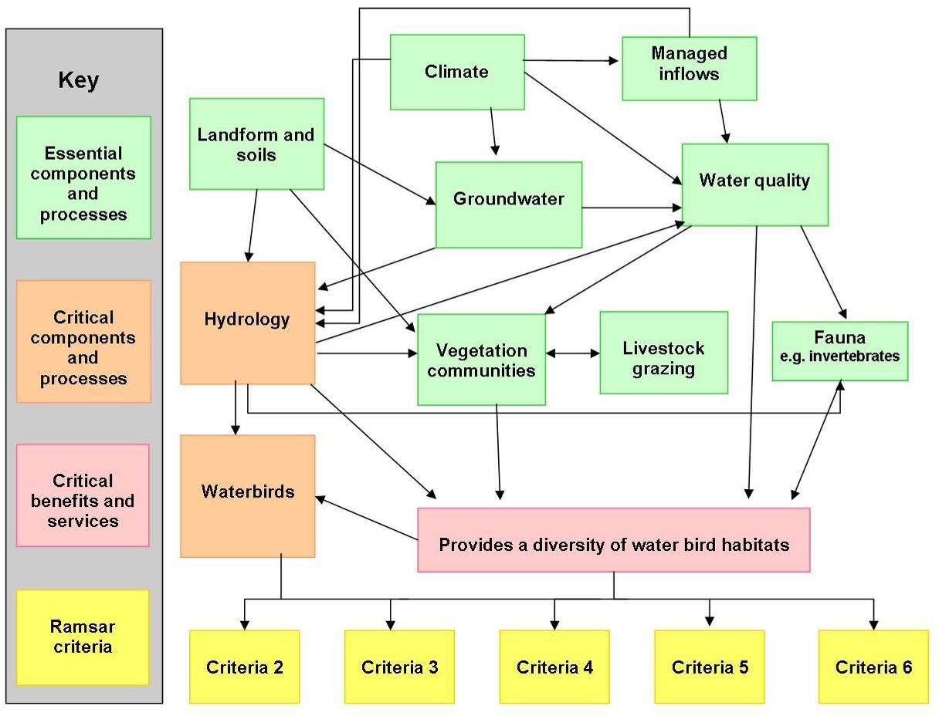

**Figure 15. Relationships between components, processes, benefits and services for Fivebough and Tuckerbil Wetlands and how they contribute to the Ramsar criteria.**

.

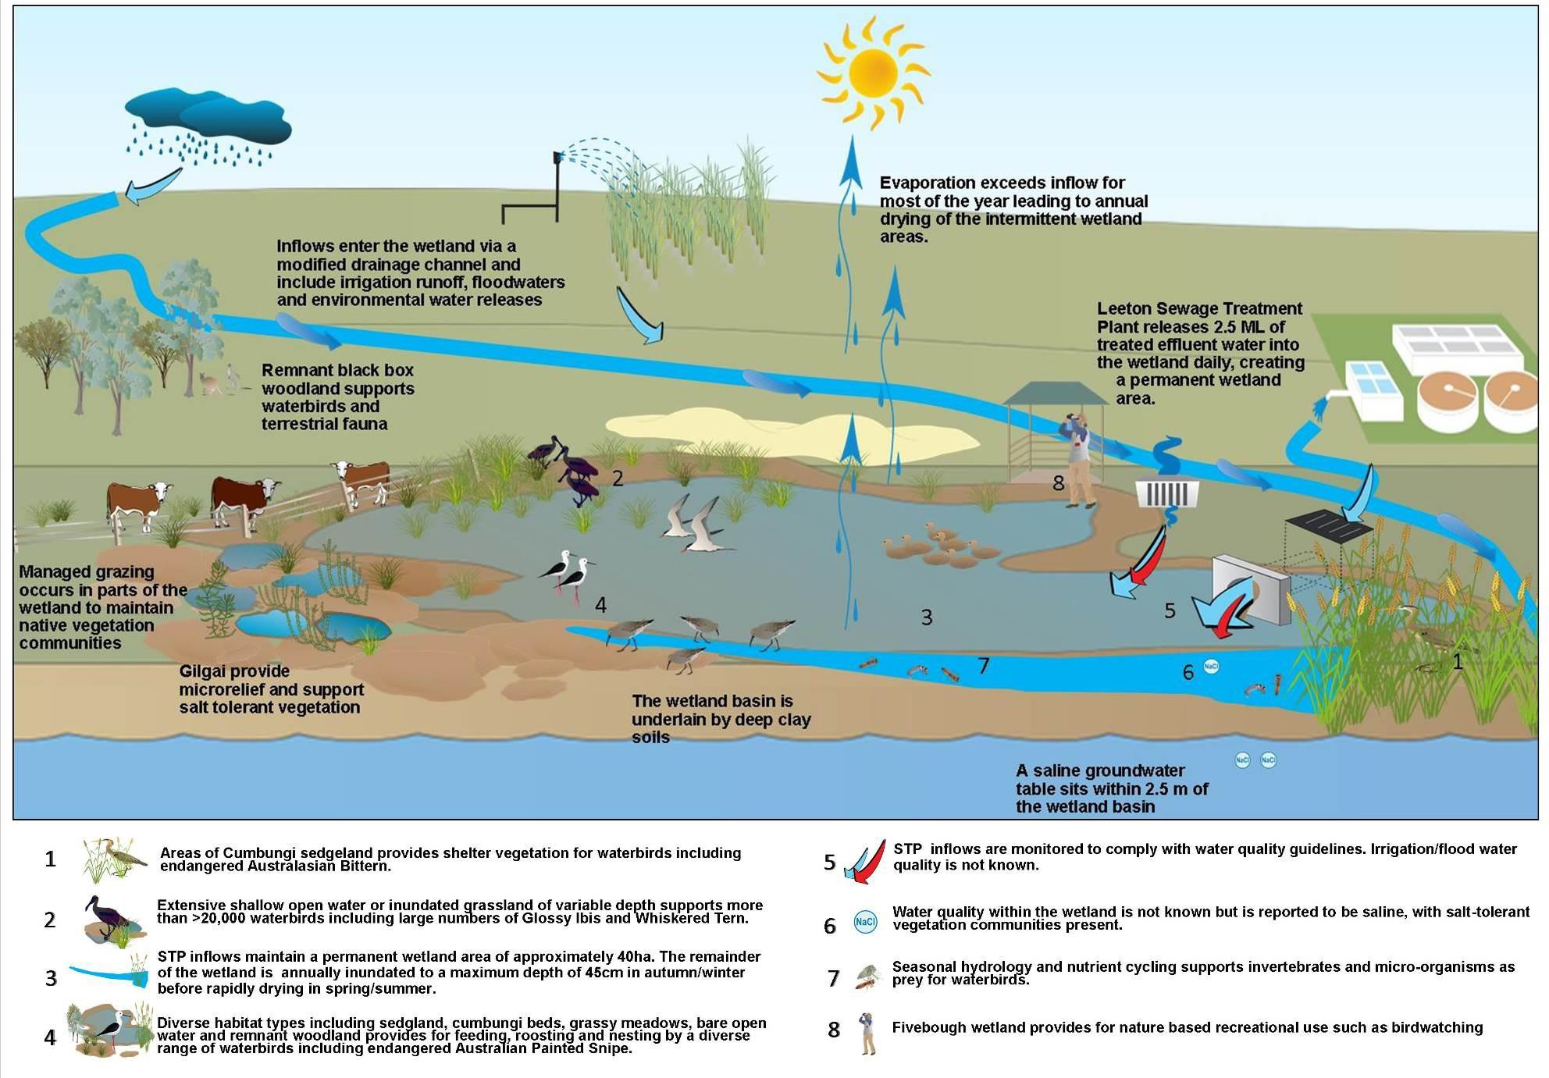

#### Figure 16. Ecological character model for Fivebough Wetland

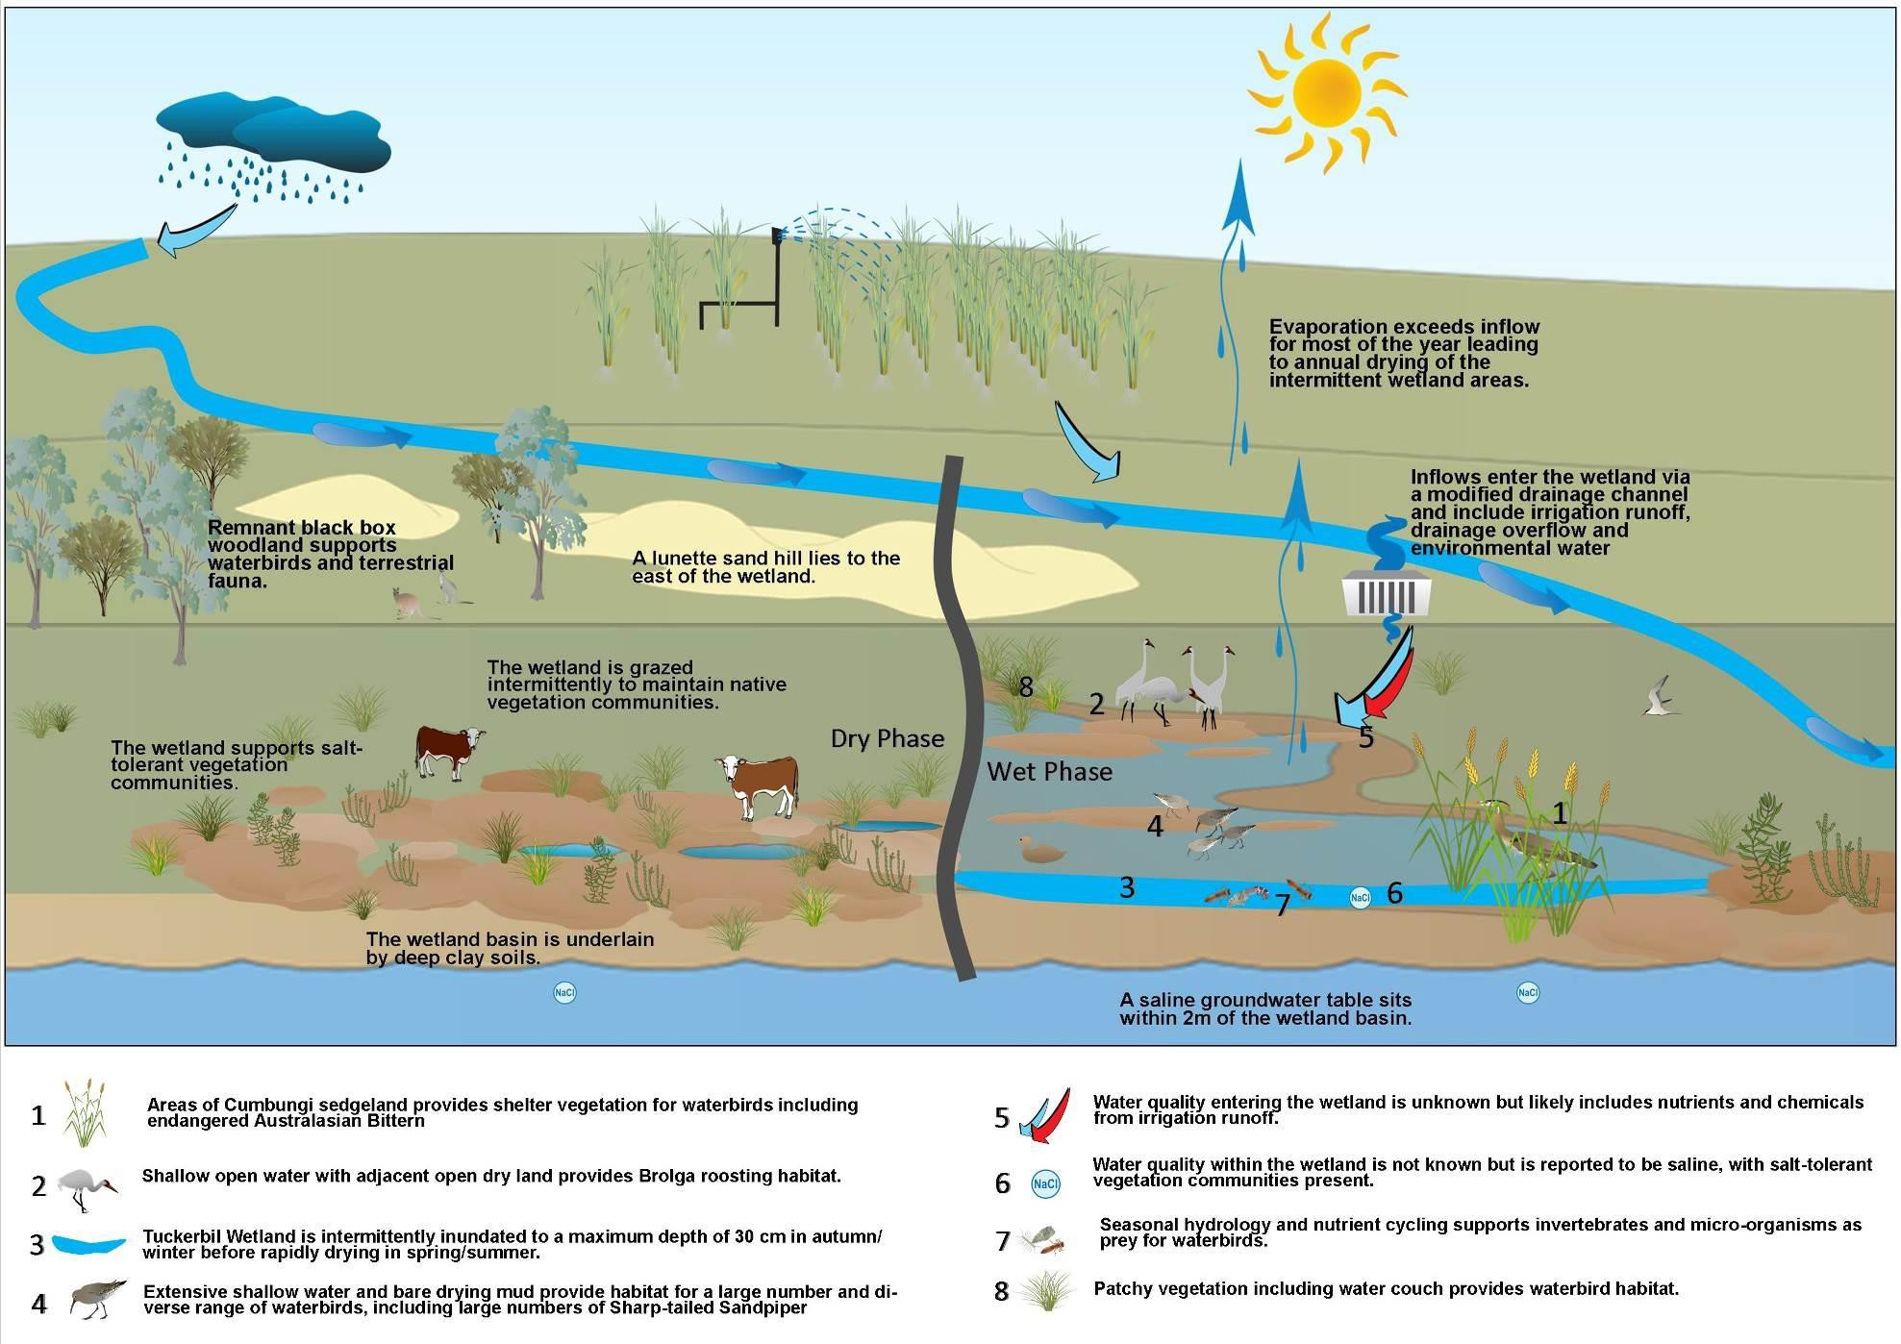

**Figure 17. Ecological character model for Tuckerbil Wetland**

# Limits of acceptable change

Change in ecological character occurs when the critical parameters of the wetland ecosystem fall outside their normal range (Ramsar Secretariat 1996), and as a signatory to the Ramsar Convention, Australia is obliged to maintain the ecological character of the site. Phillips (2006) as cited in DEWHA (2008) has defined limits of acceptable change (LACs) as the variation that is considered acceptable in a particular measure or feature of the ecological character of the wetland, inferring that if a parameter moves beyond the LAC this may indicate a change in ecological character.

The LAC may equal the natural variability of the site or may be set, with justification, at some other value (DEWHA 2008). Many Australian wetlands have a high degree of variability which has not been accurately recorded and as a result it is sometimes difficult or even impossible to establish the natural variation in a particular parameter.

Additional explanatory notes on LACs

LACs are a tool by which ecological change can be measured. However, ECDs are not management plans and LACs do not constitute a management regime for the Ramsar site.

Exceeding or not meeting LACs does not necessarily indicate that there has been a change in ecological character within the meaning of the Ramsar Convention. However, exceeding or not meeting LACs may require investigation to determine whether there has been a change in ecological character.

In reading the ECD and the LACs, it should be recognised that the hydrology of many catchments in the Murray-Darling Basin is highly regulated, despite many of the wetlands forming under natural hydrological regimes that were more variable and less predictable. Many of the Ramsar wetlands of the Murray-Darling Basin were listed at a time when the rivers were highly regulated and water over allocated, with the character of these sites reflecting the prevailing conditions. When listed under the Ramsar Convention, many sites were already on a long-term trend of ecological decline.

While the best available information has been used to prepare this ECD and define LACs for the site, a comprehensive understanding of site character may not be possible as in many cases only limited information and data is available for these purposes. The LACs may not accurately represent the variability of the critical components, processes, benefits or services under the management regime and natural conditions that prevailed at the time the site was listed as a Ramsar wetland.

Users should exercise their own skill and care with respect to their use of the information in this ECD and carefully evaluate the suitability of the information for their own purposes.

LACs can be updated as new information becomes available to ensure they more accurately reflect the natural variability (or normal range for artificial sites) of critical components, processes, benefits or services of the Ramsar wetland.

Confidence levels for LACs have been determined based on a subjective assessment of the reliability of the data used to determine the LACs (i.e. duration of data collection, number of measurements, consistency of methodology) and the known or expected variability of a measure. That assessment has been used to determine a confidence level of high, medium or low as follows:

* High - reliable or long-term data set for baseline condition; LAC derived from other reputable studies or guidelines; variability of measure well understood; LAC is objectively measurable.
* Medium - less long-term data for baseline condition, or data available but some uncertainty about direct applicability of LAC to measure; variability of measure understood to certain extent.
* Low - little long-term data or insufficient data collected using consistent methodology; LAC largely based on expert opinion; variability of measure not well understood.
  1. **LACs for the Fivebough and Tuckerbil Wetlands**

The LACs for the Fivebough and Tuckerbil Wetlands Ramsar site are described in Table 11.

The natural range in condition of a critical component, process or services, where it can be defined or inferred with any level of confidence, has provided the basis for the LACs for the Fivebough and Tuckerbil Wetlands Ramsar site. LACs have been developed for the critical components, processes and services with an aim to maintain the ecological character of the site so that it continues to meet the Ramsar criteria for which it was listed. Therefore LACs have been developed based on the condition of the site at the time

of listing. A lack of comprehensive data for various elements at this site have limited both the level of detail and level of confidence in the LACs developed.

Only limited hydrological data including wetland depths and capacity volumes is available for Fivebough and Tuckerbil Wetlands, however, the general wetland hydrological cycle is primarily a factor of the prevailing climate. Providing there is an availability of regular inflows to fill the wetlands during autumn/winter, without being an excessive volume which would prevent annual drying of intermittent wetland areas during spring/summer, the hydrological cycle can be maintained. Thus assumptions can be made which enable LACs for hydrology to be set with a high level of confidence.

Waterbird records for both sites date back to the period 1900 - 1930, however comprehensive and consistent waterbird species and count data is available only since 2011. There is some lack of information on the ecology of waterbirds at the site and factors driving waterbird numbers and behavior within the sites. Therefore waterbird LACs have been set with a medium level of confidence.

Vegetation communities and waterbird habitats have not been mapped or areas estimated at Fivebough or Tuckerbil Wetland either before or since the time of listing. Condition of various waterbird habitats in terms of composition and structure of vegetation assemblages has also not been comprehensively assessed or documented. Changes in the extent and condition of habitats have occurred (before and after the date of listing) and continue to occur, due to both natural variation and changes in management regime. The extent and condition of waterbird habitat (including vegetation communities) at both wetlands is primarily driven by wetland hydrology, however wetland vegetation communities are further shaped through management actions including grazing. Further research into the extent and condition of habitats within the Fivebough and Tuckerbil Wetlands including current surveys and review of available aerial imagery at the time of listing is required to accurately document habitat extent and condition at the time of listing and the present time.

Without comprehensive habitat mapping it is impossible to provide a quantitative LAC for the extent or condition of waterbird habitats. Therefore LACs are provided with a low confidence limit and are unable to be assessed. It is recommended that further assessment of waterbird habitat is undertaken at both wetlands and LACs are updated accordingly. In the interim, the LACs for hydrology which have a high confidence level should provide a reasonable surrogate. Additionally the number and type of waterbirds at the site inherently provide a good indication of the availability of waterbird habitat, therefore the waterbird LACs also acts as a surrogate LAC for the provision of waterbird habitat.

#### Table 11. Limits of acceptable change for the ecological character of Fivebough and Tuckerbil Wetlands Ramsar site

|  |  |  |  |
| --- | --- | --- | --- |
| **Critical component, process or service** | **Baseline condition and range of natural variation** | **Limits of acceptable change** | **Confidence level** |
| **Critical components and processes** | | | |
| **Hydrology** | Regular treated effluent discharge of approximately 2.5 ML per day results in a permanent wetland area in the central southern part Fivebough Wetland of approximately 39 ha.  Fivebough Wetland fills in most years to a maximum depth of 45 cm and an average depth of 21.5 cm. Fivebough Wetland usually dries out rapidly due to high evaporation rates during spring/summer. The area of intermittent inundation becomes shallow then contracts to the deepest section within the central eastern part of the wetland, exposing extensive waterlogged mudflats, which becomes a series of disconnected pools before drying completely. Inundation of an extensive intermittent wetland zone occurs seasonally every year at Fivebough Wetland. Thus, there are extensive areas of shallow water (i.e. less than 3 cm deep) suitable for wading and feeding by Painted Snipe, for feeding and roosting by Glossy Ibis and for wading and feeding by shorebirds in Fivebough Wetland every year.  Tuckerbil Wetland fills intermittently during autumn/winter, when evaporation rates are low. Tuckerbil Wetland has an average depth of 30 cm and a maximum depth of approximately 40 cm when full. Like Fivebough Wetland, Tuckerbil Wetland dries rapidly during late spring /early summer. Water levels recede in the central and south western parts of the wetland prior to the eastern portion of the wetland.  Inundation of Fivebough Wetland (permanent and temporary zones) to at least 45 cm depth (at deepest point) would have occurred in about eight of ten years and inundation of Tuckerbil Wetland to at least 30 cm depth would have occurred in about five of ten years, up to the date of Ramsar listing. | 1. Availability of a permanent wetland area at Fivebough Wetland. 2. Availability of extensive intermittent shallow water at Fivebough Wetland in at least nine of every ten years. 3. Inundation of Fivebough Wetland to 45 cm at deepest point of intermittent zone in at least seven of every ten years, and inundation of Tuckerbil Wetland to at least 30 cm in at least four of every ten years. | High |

*Ecological Character Description – Fivebough and Tuckerbil Wetlands* ***62***

|  |  |  |  |
| --- | --- | --- | --- |
| **Waterbirds** | Threatened species:  Nationally threatened Australasian Bittern (*Botaurus poiciloptilus*) and Australian Painted Snipe (*Rostratula australis*) have been regularly recorded within the site. Australasian Bittern occurs at Fivebough Wetland in most years and at Tuckerbil Wetland on average in five of every ten years. Australian Painted Snipe occurs at Fivebough Wetland intermittently but, on average, in three of every ten years (e.g. records in Jun 1996, Feb 2001, Oct 2004.).  Species diversity:  At Fivebough Wetland, 83 waterbird species have been recorded (most of them were observed during the ten years up to date of Ramsar-listing); probably two-thirds of these (55 spp.) are commonly seen, the others occasionally or rarely seen  At Tuckerbil Wetland, 69 waterbird species have been recorded (most of them were observed during the ten years up to date of Ramsar-listing); probably two-thirds of these (46 spp.) are commonly seen, the others occasionally or rarely seen.  Migratory species:  At Fivebough Wetland 24 species of internationally listed (JAMBA/CAMBA) migratory waterbird (19 shorebird species) have been recorded in the ten years up to date of listing. Eight of these species tend to be recorded in most years. At Tuckerbil Wetland 13 species of migratory waterbird (10 shorebird species) have been recorded, five to six of these species tend to be recorded in most years. There is a substantial occurrence (not just a few birds) of migratory shorebirds at Fivebough Wetland and at Tuckerbil Wetland, every year. Several thousand migratory shorebirds (principally Sharp-tailed Sandpipers) occur at Fivebough Wetland and several thousand at Tuckerbil Wetland, and in both wetlands this happens in at least five of every ten years.  Breeding, feeding and roosting:  At Fivebough Wetland, 22 waterbird species have been recorded breeding in the 10 - 15 year period up to date of listing. 12 species are regarded as regular breeders at the whole Ramsar site but it is not known which component wetlands this applies to, species-by-species.  A large colony of Intermediate Egrets obtain food for their nestlings from many sites across the local area but are dependent on Fivebough Wetland when they have nestlings because ricefield habitat tends to be declining at that time (late spring, early summer). The colony is active in most years. The highest average count for Intermediate Egret during the colony-active period has been 286 (range 176 to 380), in November - December 2001.  Up to 130 Brolgas have been recorded roosting (seasonally) at Tuckerbil Wetland; roosting is regular (near-annual) and numbers may vary but they generally comprise a substantial proportion of this number each year. | 1. Australasian Bittern occurs at Fivebough Wetland on average in eight of every ten years and at Tuckerbil Wetland on average of five in every 15 years. 2. Australian Painted Snipe occurs at Fivebough Wetland on average in two of every ten years. 3. The total number of species at Fivebough Wetland should not decline substantially over a ten year period: i.e. no less than 79 species (95% from date of listing) should occur. The total number of species at Tuckerbil Wetland should not decline substantially over a ten year period: i.e. no less than 65 species (95% from date of listing) should occur. 4. Over any ten year period, occurrence of less than 18 migratory shorebird species (95% from date of listing) at Fivebough Wetland or less than nine migratory shorebird species (95% from date of listing) at Tuckerbil Wetland would be unacceptable. 5. Substantial occurrence of migratory shorebirds at Fivebough Wetland or at Tuckerbil Wetland in less than nine of every ten years would be unacceptable. 6. Occurrence of less than 1,000 migratory shorebirds at either Fivebough Wetland or Tuckerbil Wetland, in less than four of every ten years, would be unacceptable. 7. Over any ten year period, the number of breeding species at Fivebough Wetland remains at least 90% (20 species) of the number at date of listing. 8. The number of egrets feeding in Fivebough Wetland in the colony-active period should exceed 100 (i.e. 'hundreds' should be present). 9. Over a ten year period, use of Tuckerbil Wetland for roosting by substantial numbers of | Medium |

|  |  |  |  |
| --- | --- | --- | --- |
|  | Up to 20,000 Glossy Ibis have been recorded roosting (seasonally) at Fivebough Wetland; roosting is regular (near-annual) and numbers are highly variable, fluctuating year-to-year by one or two orders of magnitude. A few thousand is the usual number roosting.  Up to 20,000 Whiskered Terns have been recorded roosting (seasonally) at Fivebough Wetland; roosting is regular (near-annual) and numbers are highly variable, fluctuating year-to-year by one or two orders of magnitude. A few hundred to a few thousand is the usual number roosting.  .  Significant populations >1%:  Over a ten year period, more than 1% of the Flyway population of Sharp-tailed Sandpiper occurs at Fivebough Wetland and at Tuckerbil Wetland in at least five years. The maximum count at Fivebough Wetland has been ca. 3,000 birds (2003/4) and several counts over the 1% threshold (1,600) have been documented (e.g. in 1996); it is likely that such numbers occur in at least five of every ten years  The maximum count at Tuckerbil Wetland has been ca. 4,000 birds and several counts over the 1% threshold (1,600) have been documented (e.g. in 1995, 1997); it is likely that such numbers occur in at least five of every ten years  Over a ten year period, more than 1% of the Australian population of Glossy Ibis occurs at Fivebough Wetland on average in at least two years Although a robust population estimate for this species in Australia is yet to be finalised, counts over 10,000 almost certainly are at the 1% level. The maximum count at Fivebough Wetland has been 20,000 birds (December 1995) and 15,000 were counted in November 2004. At least several thousand (probably below the 1% level) occur in most years. | Brolga in less than nine years would be unacceptable.   1. Over a ten year period, use of Fivebough Wetland for roosting by less than 1,000 Glossy Ibis, in less than eight years, would be unacceptable. 2. Over a ten year period, use of Fivebough Wetland for roosting by less than 1,000 Whiskered Terns, in less than five years, would be unacceptable. 3. Occurrence of more than 1% population threshold (currently1,600) Sharp-tailed Sandpipers at Fivebough Wetland in less than four of every ten years would be unacceptable. 4. Occurrence of more than 1% population threshold (1,600) Sharp-tailed Sandpipers at Tuckerbil Wetland in less than four of every ten years would be unacceptable. 5. Over a ten year period, occurrence of more than 1% population threshold (10,000) Glossy Ibis at Fivebough Wetland in less than two years would be unacceptable. |  |
| **Critical benefits and services** | | | |
| **Provides significant waterbird habitat** | Fivebough and Tuckerbil Wetlands supports significant waterbird species, populations and activities, specifically it:   * Supports threatened waterbird species (Australasian Bittern and Australian Painted Snipe). * Supports a high diversity of waterbird species. * Supports a high proportion of migratory waterbird species and significant waterbird breeding, feeding and roosting. * Supports 1% of the individuals in populations of waterbird species (Sharp-tailed Sandpiper and Glossy Ibis).   Significant waterbird habitat at Fivebough and Tuckerbil Wetlands is provided by: Extent of vegetation/habitat types. | 18. A reduction by more than 25% (from date of listing) in the area of habitat for Australasian Bittern (Cumbungi and/or tall sedge vegetation), at Fivebough or Tuckerbil Wetland would be unacceptable. | Low |
|  | 19. A reduction by more than 25% (from date of listing) in the area of habitat for Painted Snipe (shallowly inundated, sparse or patchy vegetation cover with adjacent wet mud) at Fivebough Wetland would be unacceptable. |  |
|  | 20. A reduction by more than 25% (from date of listing) in the area of habitat for shorebirds |  |

|  |  |  |  |
| --- | --- | --- | --- |
|  | A substantial area of healthy Cumbungi and/or tall sedge vegetation is present each year at Fivebough Wetland (principally in the zone of temporary inundation) and is present (to lesser extent) in most years at Tuckerbil Wetland. Substantial areas that are bare or that have sparse or patchy vegetation cover, and which are shallowly inundated or muddy, and have adjacent wet mud, are normally present each year at Fivebough Wetland and are often extensive. Habitat suitable for feeding and roosting by Glossy Ibises occurs extensively at Fivebough in spring/summer each year: this comprises shallow open water or inundated couch grassland, of variable depth.  Diversity of waterbird habitats.  A diverse assemblage of wetland habitats including woodland and shrubland (limited extent), Cumbungi beds, sedgeland, grassy meadows, and bare open areas is normally present (collectively) at Fivebough and Tuckerbil Wetlands.  Diversity of nesting habitats.  A diverse assemblage of wetland habitats including Cumbungi beds, sedgeland, grassy meadows, and bare open areas is normally present at Fivebough Wetland. Each of these habitats can support breeding by at least one waterbird species.  Availability of waterbird roosting sites.  Habitat suitable for waterbird roosting occurs extensively at Tuckerbil and at Fivebough in spring summer each year. For the most abundant species (Glossy Ibis and Whiskered Tern) this comprises shallow open water or inundated couch grassland of variable depth and with some dry patches. Brolgas roost out of water at Tuckerbil Wetland, in the open, but with areas of water immediately adjacent. These conditions occur each year at Tuckerbil Wetland, mainly in late spring and early summer. | (bare or sparse vegetation cover, and shallowly inundated or muddy) at Fivebough or Tuckerbil Wetland would be unacceptable.   1. A reduction in the total area of any of the diverse waterbird habitats (woodland and shrubland, Cumbungi beds, sedgeland, grassy meadows, and bare open areas) at Fivebough or Tuckerbil Wetland, constituting more than 25% of the area at date of listing, would be unacceptable. 2. A reduction in the total area of any of the waterbird nesting habitats (including Cumbungi beds, sedgeland, grassy meadows, and bare open areas) at Fivebough Wetland, constituting more than 25% of the area at date of listing, would be unacceptable. 3. Loss of extensive areas of shallow open water of variable depth (Glossy Ibis and Whiskered Tern roosting habitat) at Fivebough Wetland would be unacceptable. 4. Loss of extensive areas of shallow open water with adjacent open dry land (Brolga roosting habitat) at Tuckerbil Wetland would be unacceptable.   **Also see Hydrology and Waterbird LAC** |  |

# Threats

Identifying actual and likely threats to ecological character serves an important function in framing future management planning and action. They may also provide initial guidance in assessing likely impacts of potential development proposals under the *EPBC Act* (DEWHA 2008).

This section provides an overview of the major threats to the Fivebough and Tuckerbil Wetlands. This chapter is not a comprehensive threat assessment. Rather, only those factors that pose a significant threat to the critical components, processes, benefits, and services, are discussed. Therefore threats identified are key considerations for management in maintaining the ecological character of the site

The critical elements of Fivebough and Tuckerbil Wetlands are potentially at risk from a number of direct and indirect threats, occurring both on and off the site. There are also inherent differences in the potential for successful management of various threats. For example, hydrological changes are a significant threat to the ecological character of the site, however while inflows to the site can be managed to a large extent, climate change is beyond the scope of site management.

The recently developed management plan for the site (Price *et al.* 2014) provides strategies for the control of key threats to the ecological character of the site or compensatory actions to maintain ecological character at the site where threats cannot be alleviated altogether.

#### Table 12. Summary of key threats to the ecological character of Fivebough and Tuckerbil Wetlands Ramsar site.

|  |  |  |  |
| --- | --- | --- | --- |
| **Threat** | **Potential impacts** | **Likelihood of occurrence** | **Timing** |
| Hydrological changes | Either an excess or lack of inflows may result in the loss of annual wetting and drying of intermittent wetland areas at Fivebough and Tuckerbil Wetlands and consequent loss of waterbird habitat.  A lack of regular daily inflows of treated effluent water may result in the loss of a permanent wetland area at Fivebough Wetland and consequent loss of habitat. | Low with current management regime in place  Low | Short to long term (ongoing) |
| Changes to native vegetation communities | The suite of vegetative assemblages (a mosaic of densely vegetated areas sedgelands, grasslands, and salt tolerant communities, and sparsely vegetated or bare areas) is critical for ensuring habitat persistence at Fivebough and Tuckerbil Wetlands. Vegetation change may occur due to hydrological changes, inappropriate grazing regimes, weeds and fire. | Low to medium, depending on success of management actions | Medium to long term |
| Inappropriate grazing regimes | Grazing is an important management tool to maintain the ecological character of the site playing a key role in shaping native vegetation communities and consequently in maintaining waterbird habitat. Overgrazing, however, can lead to a loss of shelter for species such as Australasian Bittern. Improper grazing of sensitive wetland areas may also create soil compaction and erosion, reduce water quality and disturb waterbirds. | Low with current management regime in place | Short to long term (ongoing) |
| Weeds | Numerous introduced weed species have been identified at Fivebough and Tuckerbil Wetlands. Weeds are a significant problem for wetland ecology as they outcompete native aquatic, emergent and terrestrial species growing in the wetland basin, reducing habitat availability and food resources for native fauna including waterbirds. | Certain - impacts can be reduced with management | Short to long term (ongoing) |
| Pest animals | Foxes (*Vulpes vulpes*) and feral cats (*Felis catus*) are known to occur at Fivebough and Tuckerbil Wetlands. These predators are particularly damaging to the bird populations critical to the ecological character of the site. Breeding waterbirds may be particularly vulnerable to predation from pest animals. Uncontrolled domestic cats and dogs (*Canis familiaris*) also have the potential to impact waterbird populations. | Certain - impacts can be reduced with management | Short to long term (ongoing) |

*Ecological Character Description – Fivebough and Tuckerbil Wetlands* ***66***

|  |  |  |  |
| --- | --- | --- | --- |
| Water quality | No comprehensive water quality data is available for Fivebough or Tuckerbil Wetland however poor water quality could result in reduced macro invertebrate diversity and density, leading to a loss of waterbird habitat. | Unknown | Unknown |
| Climate variation | Climatic predictions point to a warming and drying trend over south eastern Australia and this has significant implications for the hydrology of Fivebough and Tuckerbil Wetlands. Hydrology is a key driver of the ecological character of the wetlands which is at risk from increased evaporation and reduced availability of environmental water for delivery to Fivebough and Tuckerbil Wetlands at critical times. Potential increases in water temperature pose a threat to the productivity of both Fivebough and Tuckerbil Wetlands and consequently to habitat quality for waterbirds. | High | Medium to long term |
| Human disturbance | Human access including recreational use can cause disturbance to waterbird feeding, roosting and breeding. Many species of waterbird are highly susceptible to disturbance however flight distances vary between species and habitats. | Low with current management regime in place | Short to long term (ongoing) |
| Fire | Increased fire risk or frequency is a potential threat to Fivebough and Tuckerbil Wetlands as it may alter vegetation communities and thus impact on wetland habitat. | Low | Short to long term (ongoing) |

* 1. **Hydrological changes**

Water management is a key driver of the ecological character of the wetland and the hydrological regime plays a vital role in maintaining the mosaic of habitats required to support the range of waterbird habitats at the site. The natural water regimes at Fivebough and Tuckerbil Wetlands have been highly modified through drainage for irrigation and the release of water from the Leeton STP.

The annual pattern of winter-spring inundation and drying out in summer-autumn driven by natural rainfall and evaporation has been altered through the diversion and regulation of flows for irrigation. Fivebough Wetland also now has a permanently inundated section due to releases from the Leeton STP that is gradually expanding. Climatic variation may also complicate hydrological modification factors.

Wetland hydrology would be severely compromised by a reduction in flows to either of the wetlands, however overwatering would also impact negatively on wetland habitat. Loss of extensive areas of shallow open water with adjacent open dry land would be unacceptable as this would reduce the availability of suitable habitat for waterbirds which regularly occur at the site. It is important that hydrological flows and depths are regularly monitored to ensure acceptable hydrological conditions are maintained as described in previous sections.

Due to the regulation of inflows into both Fivebough and Tuckerbil Wetlands, hydrology can generally be managed relatively easily with water entering the wetlands primarily through delivery structures. The management plan for the site (Price *et al.* 2014) sets out a water delivery strategy to maintain the hydrological cycles of the wetlands. It should be noted, however, that hydrological maintenance relies heavily on the availability of environmental water allocations to the wetlands, which is beyond the control of site managers.

Significant changes in the quantity or timing of treated effluent water releases from Leeton Sewage Treatment Plant also have the ability to impact on the hydrological regime of Fivebough Wetland. The permanent wetland area which was part of the ecological character of the site at the time of listing is reliant on regular inflows of effluent water of approximately 2.5 ML per day. A loss of this inflow would impact on permanent wetland habitat at Fivebough Wetland. It is more likely that effluent water releases from the STP will increase rather than decrease, with the expansion of domestic and industrial water use in the region. It has been suggested (Biosis Research Pty Ltd & Wetlands International Oceania 2006) that the wetland can accept up to double the inflows at the time of listing (up to 5 ML per day) without significant impacts on the ecological character of the wetland.

## Change to vegetation communities

Native vegetation assemblages have changed dramatically since European settlement. As discussed in previous sections, the original vegetation at Fivebough and Tuckerbil Wetlands was predominantly forested with large stands of Cumbungi which has since changed in response to various disturbances to a mixture of sedgelands, grasslands, and salt tolerant communities, with areas which are devoid of vegetation. Despite these changes, at the time of listing the site represented high habitat value for waterbirds and other fauna species and maintaining the current suite of vegetative assemblages (a mosaic of densely vegetated areas and sparsely vegetated or bare areas) is critical for ensuring habitat persistence. For example, while Australasian Bittern require extensive areas of medium-tall vegetation for shelter and/or feeding, an over-abundance of dense vegetation poses a threat to the Painted Snipe which requires open areas for feeding. Migratory waders also prefer mud flat and low vegetation habitats.

Hydrological management and water quality are key drivers in determining the extent and type of vegetation communities at Fivebough and Tuckerbil Wetlands and management of this is discussed in section 7.1. Other factors may threaten the condition and extent of vegetation communities and consequently waterbird habitat including inappropriate grazing regimes, weeds and fire. These are discussed in sections 7.3, 7.4 and 7.9.

## Inappropriate grazing regimes

Grazing regimes at Fivebough and Tuckerbil Wetlands including extent, timing and stocking rates play a key role in shaping native vegetation communities and consequently in maintaining waterbird habitat at the site. Grazing is therefore an important management tool to maintain the ecological character of the site. Grazing can control weed problems at the site and prevent the overproliferation of dense vegetation such as Cumbungi into areas of wader habitat. Overgrazing, however, can lead to a loss of shelter for species such as Australasian Bittern. Improper grazing of sensitive wetland areas may also create soil compaction and erosion, reduce water quality and disturb waterbirds. Therefore it is vital that grazing regimes are carefully managed to avoid negative impacts to the site.

Grazing on both wetlands is restricted by licence conditions to a management regime which supports the sites ecological character, including the exclusion of stock before the start of the spring breeding season and arrival of the migratory species. The current Grazier at Fivebough Wetlands undertakes ongoing exclusion trials to monitor cattle impacts on wetland vegetation. The pending licence at Tuckerbil will also be subject to management conditions which best support the site’s ecological character, also including the exclusion of stock before the start of the spring breeding season and arrival of migratory species and to protect proposed re-vegetation areas within the overall site.

The management plan for the site (Price *et al.* 2014) sets out suggested strategies to maximise the benefits of site grazing as a management tool, whilst preventing damage to wetland values. Grazing must be managed adaptively in conjunction with ongoing monitoring to avoid negative impacts to critical services at the site.

## Weeds

Numerous introduced weed species have been identified at Fivebough Wetland (see Appendix 2), some of which are listed noxious weeds. These include African Boxthorn (*Lycium ferocissimum*), Khaki Weed (*Alternanthera pungens*) and Star Thistle (*Centaurea calcitrapa*), along with Bathurst Burr (*Xanthium spinosum*) and Golden Dodder (*Cuscuta campestris*) which have been a problem in sections of Fivebough Wetland for many decades. Bathurst Burr is rarely grazed by livestock due to its large spines. Golden Dodder can reshoot from stem fragments and stems and seeds can be transported by water, posing a risk of downstream spread. Major weed issues in Tuckerbil Wetland are Noogoora Burr (*Xanthium occidentale*), which is toxic to cattle, and Bathurst Burr.

Weeds are a significant problem for wetland ecology as they outcompete native aquatic, emergent and terrestrial species growing in the wetland basin, reducing habitat availability and food resources for native fauna including waterbirds.

The management plan for the site (Price *et al.* 2014) outlines strategies to reduce the impacts of weeds on the ecological character of the site. Integrated weed control methods are suggested including strategic grazing, revegetation, mechanical, chemical and biological control.

## Pest animals

Foxes (*Vulpes vulpes*) and feral cats (*Felis catus*) are known to occur at Fivebough and Tuckerbil Wetlands. These species can have a significant impact on waterbird breeding activities, as occurred in September 1996 when water levels fell to a level which allowed them to kill young and adult Black Swans. The ongoing impact of foxes and feral cats on the fauna of the site is not known, although there is strong anecdotal evidence of heavy predation on Long-necked Tortoises. Recent fox activity has been noted as part of bird surveys at the site. Foxes are known predators of nesting shorebirds and their eggs and young. Feral cats are also known to eat frogs and lizards.

These predators are particularly damaging to the bird populations critical to the ecological character of the site. The management plan for the site (Price *et al.* 2014) recommends that a strategic pest control program be ongoing at the site including fox and cat trapping and baiting as appropriate to reduce pest predator populations.

Domestic cats and dogs (*Canis familiaris*) also have the potential to affect the native fauna of the wetlands, and especially the smaller bush birds and waterbirds. Free roaming dogs in particular can disturb or kill wildlife, while some domestic cats are skilled hunters like their feral relatives. Unrestrained domestic cats and dogs are therefore to be discouraged from both sites.

Hares (*Lepus capensis*) have been sighted at both wetlands and rabbits (*Oryctolagus cuniculus*) at Fivebough Wetland. Hares and rabbits both compete with native animals and stock for food, and intensify predation by foxes and cats. Rabbits contribute significantly to soil erosion by burrowing, removing vegetation and disturbing soil, as well as suppressing habitat regeneration via predation on native vegetation.

## Water quality

No comprehensive water quality data is available for Fivebough or Tuckerbil Wetland however poor water quality could result in reduced macro invertebrate diversity and density, leading to a loss of waterbird habitat. Leeton Shire Council monitors effluent discharge into Fivebough Wetland regularly to ensure that water quality levels comply with the NSW Environment Protection Authority licence conditions.

Piezometers deployed at nearby areas by Murrumbidgee Irrigation indicate mildly saline conditions (3,000

- 4,000 µS/cm, or approximately 1,920 -2,560 mg/L). The optimum salinity for freshwater plants and zooplankton is < 3,000 mg/L. Above this level decreases in zooplankton species begin. The optimum conditions for macroinvertebrates is < 5,000 mg/L with losses of species groups starting to occur at salinities above this (Neilsen & Brock 2006). Rice farming and horticulture are the principle users of irrigation water, and nutrient and chemical inflows potentially affect the water quality entering the wetland. Water quality within the wetlands should be closely monitored to identify any water quality issues.

## Climate variation

It is widely accepted that Australia’s climate will undergo significant changes over the coming decades. Figure 18 displays a clear warming trend for the continent, with well above average temperatures displayed for the Leeton region for 2012 and 2013.

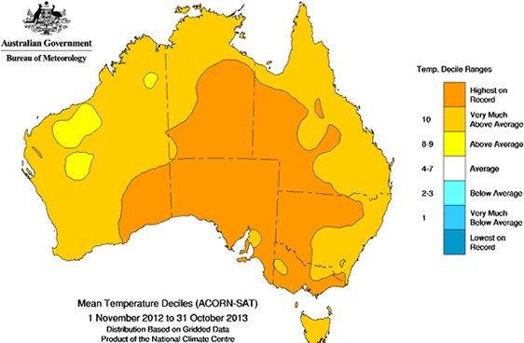

#### Figure 18. November 2012 to October 2013 mean temperature deciles for Australia. (Source: Australian Bureau of Meteorology)

The best estimate of annual average warming by 2030 (above 1990 temperatures) is around 1 - 1.2 ºC in inland areas, with drying more likely in southern areas of Australia due to a contraction in the rainfall belt towards the higher latitudes of the southern hemisphere (CSIRO 2011). Intense rainfall events in most locations will become more extreme, driven by a warmer, wetter atmosphere. The combination of drying and increased evaporation means soil moisture is likely to decline over much of southern Australia.

Despite potential increases in intense rainfall events, climate change predictions point toward an overall reduction in annual rainfall over south eastern Australia (Hughes 2003).

The factors discussed above have significant implications for the Fivebough and Tuckerbil Wetlandss in light of the fact that hydrology is a key driver of the ecological character of the wetlands, and that rainfall and particularly evaporation are key drivers of hydrology. Predicted higher future temperatures place wetlands at risk from increased evaporation (Finlayson *et al.* 2013). Appropriate environmental water releases can be designed to counteract these changing conditions, however large-scale changes in climate, in particular an overall drying across the region may reduce the availability of environmental water for delivery to Fivebough and Tuckerbil Wetlands at critical times.

Increased water temperature associated with climate change may also threaten the ecological character of Fivebough and Tuckerbil Wetlands. As these wetlands are characteristically shallow, non-flowing wetlands, increased water temperature may cause water quality deterioration that can have negative impacts on aquatic micro-organism and benthic invertebrate communities and their associated food webs (Desta *et al.* 2012). In particular, this may have detrimental impacts on waterbird populations through decrease in the availability of food resources.

## Human disturbance

The predominant land uses at Fivebough Wetland are conservation, recreation, water treatment and grazing, while Tuckerbil Wetland supports conservation and grazing. While these uses can work together, careful management is required to consider how to mitigate negative impacts.

The abundance and variety of waterbirds utilising the wetlands contributes greatly to its recreational values including bird watching and nature appreciation. However recreational use and access must be carefully managed to avoid excessive disturbance to waterbird feeding, roosting and breeding. Many species of waterbird are highly susceptible to disturbance however flight distances vary between species and habitats. Under the current management regime (Price *et al.* 2014) recreational use of the site is limited to a designated visitor area at Fivebough Wetland to minimise disturbance to waterbirds.

## Fire

Wetlands in the southern catchments of the Murray Darling Basin are particularly vulnerable to the impacts of climate change due to predicted increases in temperatures and declining rainfall (Pittock & Finlayson 2011) and fire frequency is also expected to increase with climate change (CSIRO 2011). The fourth Intergovernmental Panel on Climate Change report states that the frequency of very high and extreme fire danger days in South East Australia is likely to rise by 4 - 25% by 2020 and 15 - 70% by 2050, and across Australia the fire season length is likely to extend (Hennessey *et al.* 2007).

Increased fire risk or frequency is a potential threat to Fivebough and Tuckerbil Wetlands. Fire has altered the vegetative assemblages in the past. The fire that occurred at the wetlands in the 1940s has been implicated in killing the only remnant stands of Black Box trees that remained after land clearing early in the century.

The NSW Guidelines for Ecologically Sustainable Fire Management suggest acceptable fire intervals to be between 6 to 35 years for freshwater wetlands, which are classified as ‘swamp heaths, bogs, and floodplain shrublands. These may be either periodically or permanently inundated with fresh water’.

Optimum fire regimes are not known for the site, however development of a Fire Management Strategy is planned for the site.

Certain wetland species occurring at the site, such as cumbungi, water couch and sedges, reshoot quickly from rootstocks and rhizomes and germinate after fire and rainfall. However, herbaceous species, including weeds, may gain a competitive advantage as a result of fire if intervals are too low, thus causing changes to the optimal vegetative assemblages at the site.

# Changes in ecological character

There have been changes in the management of the site since the time of listing. At the time of listing the site was managed by the Fivebough and Tuckerbil Wetlands Trust. In November 2010 the Fivebough and Tuckerbil Wetlands Trust ceased its involvement with the management of the Fivebough and Tuckerbil Wetlands Ramsar site. In January 2011, the management of Fivebough and Tuckerbil Wetlands devolved to NSW Trade and Investment, Crown Lands simultaneously with the land being ‘Reserved for Environmental Protection and Public Recreation’. An Advisory Committee has been appointed and is made up of 12 members comprising State Government, Local Government, local interest groups and community representatives. An updated Adaptive Environmental Management Plan was developed in 2014 (Price *et al.* 2014) and the site is now managed in accordance with this along with the *Crown Lands Act 1989* for environmental protection, public recreation, tourism and education. The objectives of the current plan are to maintain the ecological character of the wetland and promote its wise use in line with the Australian Ramsar Management Principles.

Changes in critical components, processes and services, can best be identified by comparing the current condition of each element with relevant limits of acceptable change (LACs). In some cases, a low LAC confidence level or the lack of available data up to the present time make detailed comparisons difficult. Table 13 below compares LAC for the site with available data to determine if any changes in ecological character are likely to have occurred or if further investigation is required.

Detailed hydrological data has not been recorded for Fivebough or Tuckerbil Wetland either prior to listing or up to the present time. Since the time of listing environmental water allocations have become available under the Murrumbidgee Water Sharing Plan which commenced in 2004, enabling hydrology of the site to be maintained under the highly modified hydrological regime. In 2011 a large environmental flow of 1,000 ML was released and this was followed by natural flooding from a 1 in 100 year flood in 2012. This resulted in excessive and prolonged inundation of Fivebough Wetland which may have impacted on bird numbers and wetland vegetation, however water levels have now returned to within natural limits.

Waterbird species and numbers have been recorded quarterly at Fivebough and Tuckerbil Wetlands since 2011 and 2012 respectively, however comprehensive data is unavailable prior to this commencement of regular monitoring. Without a longer period of comprehensive data it is impossible to adequately identify the appropriateness of the LAC for waterbirds with a high level of confidence, or to identify any potential changes in waterbird components, processes and services.

Vegetation communities and waterbird habitats have not been comprehensively mapped or quantified either before listing or up to the present time. The LAC is therefore set with a low level of confidence and the confidence in identifying changes since the time of listing is also low.

For the vast majority of critical components, processes and services, there is little evidence of significant changes since the site was listed in 2002. As discussed above, in many cases, this is due to a lack of detailed or long-term data at the time of listing and/or up to the present time.

In summary, there is no evidence to suggest that a significant change in the ecological character of the Fivebough and Tuckerbil Wetlands site has occurred since listing, or that any of the listing criteria are no longer met.

#### Table 13. Assessment of current conditions against limits of acceptable change for Fivebough and Tuckerbil Wetlands.

|  |  |  |  |  |
| --- | --- | --- | --- | --- |
| **Critical component,**  **process or service** | **Limit of Acceptable Change** | **Current conditions** | **LAC**  **confidence limit** | **Confidence in change assessment** |
| **Hydrology** | Availability of a permanent wetland area at Fivebough Wetland. | Regular flows from Leeton SPT maintain a permanent wetland area at Fivebough Wetland of approximately 39 ha.  **LAC is met.** | High | High |
| Availability of extensive intermittent shallow water at Fivebough Wetland in at least nine of every ten years. | Long-term hydrological data is unavailable up to the current time. Extensive shallow open water existed at Fivebough Wetland in January 2013, April 2013 and July 2013, covering  60%, 40% and 50% of basin respectively (Keith Hutton unpublished data 2013).  Hydrological management is in place to meet this LAC and is likely to be successful.  **Insufficient data but LAC is likely to be met.** | High | Medium |
| Inundation of Fivebough Wetland to 45 cm at deepest point of intermittent zone in at least seven of every ten years, and inundation of Tuckerbil Wetland to at least 30 cm in at least four of every ten years. | Long-term hydrological data, in particular water depth, is unavailable up to the current time. Hydrological management is in place to meet this LAC and is likely to be successful.  **Insufficient data but LAC is likely to be met.** | High | Medium |
| **Waterbirds** | Australasian Bittern occurs at Fivebough Wetland on average in eight of every ten years and at Tuckerbil Wetland on average of five in every 15 years. | Long-term comprehensive waterbird data is unavailable up to the current time. Since comprehensive monitoring began in 2011, Australasian Bittern have been recorded at both Fivebough and Tuckerbil Wetlands in 2013 and 2014 (Keith Hutton pers. comm.  2014).  **Insufficient data to assess LAC.** | Medium | N/A |
| Australian Painted Snipe occurs at Fivebough Wetland on average in two of every ten years. | Long-term comprehensive waterbird data is unavailable up to the current time. Since comprehensive monitoring began in 2011, Australian Painted Snipe have been recorded at Fivebough Wetland on two occasions (October and December 2012) (Keith Hutton unpublished data 2014).  **Insufficient data to assess LAC.** | Medium | N/A |

|  |  |  |  |  |
| --- | --- | --- | --- | --- |
|  | The total number of species at Fivebough Wetland should not decline substantially over a ten year period: i.e. no less than 79 species (95%) should occur. The total number of species at Tuckerbil Wetland should not decline substantially over a ten year period: i.e. no less than 65 species (95%) should occur. | Long-term comprehensive waterbird data is unavailable up to the current time. Since comprehensive monitoring began in 2011, 62 species have been recorded at Fivebough Wetland and 45 at Tuckerbil Wetland (Keith Hutton unpublished data 2014).  **Insufficient data to assess LAC.** | Medium | N/A |
| Over any ten year period, occurrence of less than 18 migratory shorebird species (95%) at Fivebough Wetland or less than nine migratory shorebird species (95%) at Tuckerbil Wetland would be unacceptable. | Long-term comprehensive waterbird data is unavailable up to the current time. Since comprehensive monitoring began in 2011, 9 migratory species have been recorded at Fivebough Wetland and 4 at Tuckerbil Wetland (Keith Hutton unpublished data 2014).  **Insufficient data to assess LAC.** | Medium | N/A |
| Occurrence of less than 1,000 migratory shorebirds at either Fivebough Wetland or Tuckerbil Wetland, in less than four of every ten years, would be unacceptable | Long-term comprehensive waterbird data is unavailable up to the current time. Since comprehensive monitoring began in 2011, counts of over 1,000 migratory species have been recorded at Fivebough Wetland in October 2013 (Keith Hutton unpublished data 2014). **Insufficient data to assess LAC.** | Medium | N/A |
| Over any ten year period, the number of breeding species remains at least 90% (20 species) of the number at date of listing. | Long-term comprehensive waterbird data is unavailable up to the current time.  **Insufficient data to assess LAC.** | Medium | N/A |
| The number of egrets feeding in Fivebough Wetland in the colony-active period (i.e. late spring, early summer) should exceed 100 (i.e. 'hundreds' should be present). | Since comprehensive monitoring began in 2011, counts of over 100 egret species have been recorded at Fivebough Wetland on only one occasion (Jan 2013). (Keith Hutton unpublished data 2014).  **LAC may be exceeded.** | Medium | Low |
| Over a ten year period, use of Tuckerbil Wetland for roosting by substantial numbers of Brolga in less than nine years would be unacceptable. | Since comprehensive monitoring began in 2012, Brolga have been recorded at Tuckerbil Wetland on only one occasion (July 2013) with only 5 birds, however up to 30 have been recorded at Fivebough Wetland (May 2013). (Keith Hutton pers. Comm. 2014).  **Insufficient data but LAC may be exceeded.** | Medium | N/A |

|  |  |  |  |  |
| --- | --- | --- | --- | --- |
|  | Over a ten year period, use of Fivebough Wetland for roosting by less than 1,000 Glossy Ibis, in less than eight years, would be unacceptable. | Long-term comprehensive waterbird data is unavailable up to the current time. Since comprehensive monitoring began in 2011, counts of over 1,000 Glossy Ibis have been recorded at Fivebough Wetland on 2 occasions (10,216 in Dec  2012 and >1710 in Oct 2014). (Keith Hutton unpublished data 2014).  **Insufficient data to assess LAC.** | Medium | N/A |
| Over a ten year period, use of Fivebough Wetland for roosting by less than 1,000 Whiskered Terns, in less than five years, would be unacceptable. | Long-term comprehensive waterbird data is unavailable up to the current time. Since comprehensive monitoring began in 2011, counts of over 1,000 Whiskered Terns have been recorded at Fivebough Wetland in Dec 2012, Oct 2013 and Oct & Dec 2014. (Keith Hutton unpublished data 2014). **Insufficient data to assess LAC.** | Medium | N/A |
| At least 20,000 waterbirds occur at Fivebough Wetland on average once every ten years | Long-term comprehensive waterbird data is unavailable up to the current time. Since comprehensive monitoring began in 2011, a maximum count of around 11,300 waterbirds has been recorded at Fivebough Wetland (Dec 2012). (Keith Hutton  unpublished data 2014). **Insufficient data to assess LAC.** | Medium | N/A |
| Occurrence of more than 1% population threshold (currently1,600) Sharp-tailed Sandpipers at Fivebough Wetland in less than four of every ten years would be unacceptable. | Long-term comprehensive waterbird data is unavailable up to the current time. Since comprehensive monitoring began in 2011, over 1,600 Sharp-tailed Sandpiper have been recorded at Fivebough Wetland on one occasion (2,800 in Oct 213). (Keith Hutton unpublished data 2014).  **Insufficient data to assess LAC.** | Medium | N/A |
| Occurrence of more than 1% population threshold (currently1,600) Sharp-tailed Sandpipers at Tuckerbil Wetland in less than four of every ten years would be unacceptable. | Long-term comprehensive waterbird data is unavailable up to the current time. Since comprehensive monitoring began in 2012, over 1,600 Sharp-tailed Sandpiper have not been recorded at Tuckerbil Wetland. (Keith Hutton unpublished data 2014).  **Insufficient data to assess LAC.** | Medium | N/A |

|  |  |  |  |  |
| --- | --- | --- | --- | --- |
|  | Over a ten year period, occurrence of more than 1% population threshold (currently10,000) Glossy Ibis at Fivebough Wetland in less than two years would be unacceptable. | Long-term comprehensive waterbird data is unavailable up to the current time. Since comprehensive monitoring began in 2011, counts of over 10,000 Glossy Ibis have been recorded at Fivebough Wetland on one occasion (10,216 in Dec 2012). (Keith Hutton  unpublished data 2014). **Insufficient data to assess LAC.** | Medium | N/A |
| A reduction by more than 25% (from date of listing) in the area of habitat for Australasian Bittern (Cumbungi and/or tall sedge vegetation), at Fivebough or Tuckerbil Wetland would be unacceptable. | Comprehensive vegetation and habitat mapping has not been undertaken up to the current time. Extensive Cumbungi was observed by the authors at Fivebough and Tuckerbil Wetlands in August 2013.  **Insufficient data to assess LAC.** | Low | N/A |
| **Provides significant waterbird habitat** | A reduction by more than 25% (from date of listing) in the area of habitat for Australian Painted Snipe (shallowly inundated, sparse or patchy vegetation cover with adjacent wet mud) at Fivebough Wetland would be unacceptable. | Comprehensive vegetation and habitat mapping has not been undertaken up to the current time. Extensive open mud with sedges and couch grass and extensive shallow water was noted at Fivebough Wetland in April 2013 (Keith Hutton unpublished data 2013).  **Insufficient data to assess LAC.** | Low | N/A |
| A reduction by more than 25% (from date of listing) in the area of habitat for shorebirds (bare or sparse vegetation cover, and shallowly inundated or muddy) at Fivebough or Tuckerbil Wetland would be unacceptable. | Comprehensive vegetation and habitat mapping has not been undertaken up to the current time. Extensive open mud with sedges and couch grass and extensive shallow water was noted at Fivebough Wetland in April 2013, and shallow water was noted at Tuckerbil Wetland in January and July 2013 (Keith Hutton unpublished data 2013). **Insufficient data to assess LAC.** | Low | N/A |
| A reduction in the total area of any of the diverse waterbird habitats (woodland and shrubland, Cumbungi beds, sedgeland, grassy meadows, and bare open areas) at Fivebough or Tuckerbil Wetland, constituting more than 25% of the area at date of listing, would be unacceptable. | Comprehensive vegetation and habitat mapping has not been undertaken up to the current time. **Insufficient data to assess LAC.** | Low | N/A |

|  |  |  |  |  |
| --- | --- | --- | --- | --- |
|  | A reduction in the total area of any of the waterbird nesting habitats (including Cumbungi beds, sedgeland, grassy meadows, and bare open areas) at Fivebough Wetland, constituting more than 25% of the area at date of listing, would be unacceptable. | Comprehensive vegetation and habitat mapping has not been undertaken up to the current time. **Insufficient data to assess LAC.** | Low | N/A |
| Loss of extensive areas of shallow open water of variable depth (Glossy Ibis and Whiskered Tern roosting habitat) at Fivebough Wetland would be unacceptable. | Comprehensive vegetation and habitat mapping has not been undertaken up to the current time. Extensive shallow water was noted at Fivebough Wetland in April 2013, (Keith Hutton unpublished data 2013). **Insufficient data to assess LAC.** | Low | N/A |
| Loss of extensive areas of shallow open water with adjacent open dry land (Brolga roosting habitat) at Tuckerbil Wetland would be unacceptable | Comprehensive vegetation and habitat mapping has not been undertaken up to the current time. Shallow water was noted at Tuckerbil Wetland in January and July 2013 (Keith Hutton unpublished data 2013).  **Insufficient data to assess LAC.** | Low | N/A |

# Knowledge gaps

Throughout the Ecological Character Description for Fivebough and Tuckerbil Wetlands, significant knowledge gaps and data deficiencies have been identified that are important for describing and maintaining the ecological character of the site. Comprehensive, qualitative or consistent data over reasonable timeframes are required for improving the understanding of the natural variability and condition of Fivebough and Tuckerbil Wetlands. The most vital knowledge gaps to be addressed are those which will assist in further describing the ecological character of the site, improving the confidence level of limits of acceptable change, or identifying any changes in ecological character. These knowledge gaps are identified in Table 14.

#### Table 14. Knowledge gaps for Fivebough and Tuckerbil Wetlands.

|  |  |  |
| --- | --- | --- |
| **Component/ process/ service** | **Knowledge Gap** | **Recommended Action** |
| Hydrology | Comprehensive systematic data on water depth are not available for Fivebough or Tuckerbil Wetland. | Regular (at least monthly) depth gauge recordings from various points within each wetland. |
| Extent and distribution of permanent and intermittent wetland areas have not been comprehensively mapped over time for Fivebough or Tuckerbil Wetland. | Analysis of historical and ongoing aerial imagery. |
| Little or no comprehensive water quality data exists for Fivebough or Tuckerbil Wetland. | Install permanent data loggers to measure standard suite of water quality parameters in each wetland. |
| Waterbirds | Comprehensive waterbird data including species counts and breeding are not available for Fivebough or Tuckerbil Wetland prior to 2011. | Continue comprehensive quarterly waterbird monitoring at Fivebough and Tuckerbil Wetlands. |
| The ecology of waterbirds at Fivebough and Tuckerbil Wetlands are not fully understood | Facilitate research into waterbird ecology at Fivebough and Tuckerbil Wetlands. |
| Provides a diversity of waterbird habitats | Condition and extent of various waterbird habitats (including vegetation assemblages) within Fivebough and Tuckerbil Wetlands, either historically and up to the present time, has not been comprehensively described or mapped. | Utilise historical imagery and available data to determine the condition and extent of waterbird habitats and vegetation assemblages at the time of listing. |
|  |  | Undertake on-ground surveys and aerial imagery analysis to describe the condition and map the extent of waterbird habitats and vegetation assemblages within Fivebough and Tuckerbil Wetlands. |
|  |  | Undertake ongoing monitoring of the condition and extent of waterbird habitat and vegetation assemblages at Fivebough and Tuckerbil Wetlands. |

# Key monitoring needs

As a signatory to the Ramsar Convention, Australia has made a commitment to maintain the ecological character of its Wetlands of International Importance. Whilst there is no explicit requirement for monitoring the site, a monitoring program provides the data necessary to identify any changes to the site, and thereby to

determine if the site’s ecological character is being maintained. The monitoring recommendations provided by this ECD identify the data required to confirm baselines for key components, processes and services and to compare ecological condition with limits of acceptable change (Table 15). There are a number of existing monitoring programs being undertaken within the Fivebough and Tuckerbil Wetlands site and some of the required monitoring may already be contained in these existing programs.

The purpose of the monitoring recommended in this ECD is to:

* + - Identify objectives for monitoring critical components, processes, services or threats;
    - Recommend indicators or measures to be used and the frequency of monitoring;
    - Provide priorities for monitoring; and
    - Address key knowledge gaps identified for the site.

#### Table 15. Monitoring recommendations for Fivebough and Tuckerbil Wetlands Ramsar site.

|  |  |  |  |  |
| --- | --- | --- | --- | --- |
| **Component or process** | **Monitoring objective** | **Indicator** | **Frequency** | **Priority** |
| Hydrology - water depth across wetlands | Confirm appropriateness of LAC and assess variability against LAC. | Water depth at various set points across both wetlands. | At least monthly. | High |
| Hydrology - historical and current extent of permanent and intermittent wetland areas | Establish baseline and assess changes in character. | Description of areas (ha) of each wetland type at listing (using aerial imagery) at current time and ongoing (using aerial imagery and ground truthing). | One-off review of historical data.  Undertake current assessment and repeat biannually (wet and dry  phases). | Medium |
| Hydrology - water quality | Establish baseline and assess changes in character. | Salinity, pH, dissolved oxygen, turbidity, nutrients, organic carbon, chlorophyll from various set points across each wetland. | At least monthly. | Low |
| Waterbirds | Confirm appropriateness of LAC and assess variability against LAC. | Comprehensive waterbird data including counts for each species present.  Observations on breeding, roosting and feeding behaviour. | At least quarterly. With opportunistic observations during key times of waterbird activity. | High |
| Waterbird habitats - historical and current condition and extent | Refine LAC and assess variability against LAC. | Description of areas (ha) and condition (including vegetation assemblages) of each various waterbird habitat at listing (using aerial imagery), at current time and ongoing (using aerial imagery and on-ground surveys). | One-off review of historical data.  Undertake current assessment and repeat biannually (wet and dry phases). | High |

# Communication, education and public awareness messages

The Ramsar Convention's Program on Communication, Education, Participation and Awareness (CEPA) was established to help raise awareness of wetland values and functions with the vision of “People taking action for the wise use of wetlands” (Ramsar Secretariat 2008). The CEPA Program is underpinned by three guiding principles:

1. The CEPA Program offers tools to help people understand the values of wetlands so that they are motivated to become advocates for wetland conservation and wise use and may act to become involved in relevant policy formulation, planning and management.
2. The CEPA Program fosters the production of effective CEPA tools and expertise to engage major

stakeholders’ participation in the wise use of wetlands and to convey appropriate messages in order to promote the wise use principle throughout society.

1. The Ramsar Convention believes that CEPA should form a central part of implementing the Convention by each Contracting Party. Investment in CEPA will increase the number of informed advocates, actors and networks involved in wetland issues and build an informed decision-making and public constituency.

The Ramsar Convention encourages that communication, education, participation and awareness are used effectively at all levels, from local to international, to promote the value of wetlands. The site is gazetted as ‘Reserve for ‘Environmental Protection and Public Recreation’ under the *Crown Lands Act 1989.*

Fivebough and Tuckerbil Wetlands are currently known for their high ecological value, international Ramsar listing and use by migratory birds and waterfowl. Current visitors include Leeton residents, birdwatchers, schools, university students and local, interstate and international visitors. Fivebough Wetland already has some educational and promotional infrastructure including walking trails, interpretive signage, a cultural walk, and two bird hides. The Fivebough Wetland Visitation and Promotion Strategy (Price 2014) outlines recommendations to improve educational and visitor infrastructure and promotional opportunities for the site.

Key CEPA messages that arise from the specific ecological character of Fivebough and Tuckerbil Wetlands, and which should be promoted include:

* Promotion of the values underpinning the Ramsar criteria for the site; that Fivebough and Tuckerbil Wetlands provides internationally significant habitat for waterbirds including threatened species, waterbird biodiversity, migratory species, significant populations, large numbers of waterbirds and waterbird breeding, roosting and feeding.
* That Fivebough Wetland provides an excellent opportunity for nature based recreation, especially bird watching, in the Riverina region.
* That Fivebough and Tuckerbil Wetlands are sites of considerable cultural significance to the Traditional Owners, the Wiradjuri Aboriginal people.
* That grazing at Fivebough and Tuckerbil Wetlands and effluent water evaporation at Fivebough Wetland are undertaken in conjunction with the Ramsar principles of wise use and contribute to the maintenance of the ecological character of the site.
* That the hydrological regime and regional land use has been highly modified and environmental water allocations assist to maintain the natural hydrology and ecological character of the site.
* That Fivebough Wetland provides opportunities for education for school and university students in the region.
* That visitor to the site can assist with maintaining the ecological character of the site by minimizing disturbance to waterbirds and abiding by the low impact use guidelines for site visitation.

# References

Biosis Research Pty Ltd and Wetlands International Oceania, 2006. Ecological Character of Fivebough and Tuckerbil Swamps private Ramsar site in NSW. Unpublished report to the NSW Department of Environment and Conservation, Dubbo, NSW.

CSIRO, 2011. Climate Change: Science and Solutions for Australia. Editors: Cleugh, H., Stafford Smith, M., Battaglia, M. and Graham, P., CSIRO Publishing.

Desta, H., Lemma, B. and Fetene, A., 2012. Aspects of climate change and its associated impacts on wetland ecosystem functions - a review. *Journal of American Science*, **8** (10), pp 582-596.

DEWHA, 2008. National Framework and Guidance for Describing the Ecological Character of Australian Ramsar Wetlands. Department of Environment, Water, Heritage and Arts, Australian Government, Canberra.

DLWC, 2002. Draft Western Riverina Regional Vegetation Management Plan and Advisory Manual. Department of Land and Water Conservation, Sydney.

DPWS, 1999. Leeton Sewerage Scheme Augmentation - Concept Development for Interim Augmentation. Prepared for Leeton Shire Council. Department of Public Works and Services, Sydney, NSW.

Finlayson, C.M., Davis, J.A., Gell, P.A., Kingsford, R.T. and Parton, K.A., 2013. The status of wetlands and the predicted effects of global climate change: the situation in Australia. *Aquatic Sciences,* **75**, pp 73-93.

FTWMT (with the assistance of MainStream Environmental Consulting Pty Ltd), 2002. Management Plan for Fivebough and Tuckerbil Swamps. Fivebough and Tuckerbil Wetlands Management Trust Inc. Leeton, NSW.

Glazebrook, H. and Taylor, I.R., 1998. Fivebough and Tuckerbil Swamps, A review of their history, conservation values and future management options. The Johnstone Centre, Report No. 105, Charles Sturt University, Albury.

Hennessey, K., Fitzharris, B., Bates, B.C., Harvey, N., Howden, S.M., Hughes, L., Salinger, J. and Warrick, R., 2007. Australia and New Zealand. Climate Change 2007: Impacts, Adaptation and Vulnerability.

Contribution of Working Group II to the Fourth Assessment Report of the Intergovernmental Panel on Climate Change, Cambridge University Press.

Hughes, L., 2003. Climate Change and Australia: Trends predictions and impacts. *Austral Ecology*, **28**, pp 423-443.

Hutchison, M, 1998. Murray-Darling Basin Waterbird Project Database. RAOU (Birds Australia) (unpublished).

IUCN, 2000. IUCN Red List of Threatened Species. International Union for Conservation of Nature, Gland, Switzerland and Cambridge, UK.

Kingsford, R., Lau, J. and O’Conner, J., 2014. Birds of the Murray Darling Basin. BirdLife Australia Conservation Statement No. 16, Birdlife Australia.

Ladson, A, 2008. Hydrology-An Australian Introduction. South Melbourne, Oxford University Press.

L&DLALC, 2011. Leeton and District Local Aboriginal Land Council Website. <http://www.ldlalc.com.au/lalalc> Marchant, S. and Higgins, P.J., 1990. Handbook of Australian, New Zealand and Antarctic Birds. Volume One

* Ratites to Ducks. Oxford University Press Melbourne, Victoria.

Maunsell Pty Ltd, 1996. Environmental Impact Statement for Proposed Recreational Lake with Wetlands at Fivebough Swamp. Leeton Council, Leeton, NSW.

Millennium Ecosystem Assessment, 2005. Ecosystems and Human Wellbeing: Wetlands and Water - Synthesis, Island Press, Washington, DC.

Munday, T.J., Hill, A.J., Wilson, T., Hopkins, B., Telfer, A.L., White, G.J. and Green A.A., 2004. Combining Geology and Geophysics to Develop a Hydrogeologic Framework for Salt Interception in the Loxton Sands Aquifer, Central Murray Basin, Australia. Australian Water Environments CRC.

Neilsen, D. and Brock, M., 2006. Wetland salinity: Predicting the ecological consequences. In: Wetlands of the Murrumbidgee River Catchment: practical management in an altered environment. Edited by I.R. Taylor, PA. Murray and S.G. Taylor, Fivebough and Tuckerbil Wetlands Trust, Leeton, NSW.

Nolan M.J. and Wilson, N.R., 1996. Flora, Fauna and Cultural Heritage Assessment - Fivebough Swamp. Farrer Centre, Charles Sturt University, Wagga Wagga.

NPWS, 1996. Koonadan Historic Site Plan of Management, NSW National Parks and Wildlife Service.

NSW DEC (Department of Environment and Conservation) (2006). Ecological Character of the Fivebough and Tuckerbil Swamps Private Ramsar Site Final Report, Unpublished report- August 2006, Department of Environment and Conservation- NSW North West Branch, DUBBO NSW*.*

[Ollier,](http://www.sciencedirect.com/science/article/pii/0169555X94000753) C.D., 1995. Tectonics and landscape evolution in southeast Australia. *Geomorphology,* **12** (1), pp 37- 44.

Pittock, J. and Finlayson, C.M., 2011. Australia’s Murray Darling Basin: freshwater ecosystem conservation options in an era of climate change. *Marine and Freshwater Research*, **62**, pp 232-243.

Price C., 2014. Fivebough Wetland - Visitation and Promotion Strategy. Compiled for NSW Trade and Investment, Crown Lands, WetlandCare Australia, Ballina, NSW.

Price C., White, L. and Haigh, S., 2014. Fivebough and Tuckerbil Wetlands - Adaptive Environmental Management Plan. Compiled for NSW Trade and Investment, Crown Lands, WetlandCare Australia, Ballina, NSW.

Ramsar Secretariat, 2006. The Ramsar Convention Manual: a guide to the Convention on Wetlands. 4th ed. Ramsar Convention Secretariat, Gland, Switzerland.

Ramsar Secretariat, 2008. Program on Communication, Education Participation and Awareness (CEPA) of the Convention on Wetlands. Ramsar Secretariat, Gland, Switzerland.

Richardson, A. J., 1999. The foraging ecology of egrets and other wetland birds in rice fields around Fivebough Swamp, Leeton, NSW. Honours thesis, Faculty of Science and Agriculture, Charles Sturt University, Albury.

Robson, D., 1997. Review of the exhibited EIS for a proposed recreational lake at Fivebough Swamp, Leeton NSW. NSW National Parks and Wildlife Service. Dubbo, NSW.

Rose, P.M. and Scott, D.A., 1997. Waterfowl Population Estimates - Second edition. Wetlands International Wageningen, Netherlands.

Schultz, M., NSW National Parks and Wildlife Service, Phillips, B. and NSW Land and Water Conservation, 2002. Information Sheet on Ramsar Wetlands: Fivebough and Tuckerbil Swamps. Leeton, NSW.

Sinclair Knight Merz, 2011. Environmental Water Delivery: Murrumbidgee Valley. Prepared for Commonweatlh Department of Sustainability, Environment, Water, Population and Communities, Canberra, NSW.

Stevens, G., Schultz M. and Whiting R. (Eds), 1994-2002. The Murrumbidgee Naturalist. Issues 1-88. Murrumbidgee Field Naturalists.

Taylor, I. and Richardson, R., 2000. The Ecology and Management of Waterbirds on Fivebough Swamp. Charles Sturt University, Albury.

Wassens, S., 2006. Frog communities of the Murrumbidgee Irrigation Area, NSW. In: Wetlands of the Murrumbidgee River Catchment: practical management in an altered environment. Edited by I.R. Taylor, PA. Murray and S.G. Taylor, Fivebough and Tuckerbil Wetlands Trust, Leeton, NSW.

Wetlands International, 2006. Waterbird Population Estimates - Fourth Edition. Wetlands International, Wageningen, The Netherlands.

# Glossary

*Baseline* - Condition at a starting point. For Ramsar wetlands, this usually refers to the time of listing.

*Benefits* - see ecosystem services.

*Biogeographic region* - A scientifically rigorous determination of regions as established using biological and physical parameters such as climate, soil type, vegetation cover, etc (DEWHA 2008).

*Biological diversity* - The variability among living organisms from all sources including, inter alia, terrestrial, marine and other aquatic ecosystems and the ecological complexes of which they are part; this includes diversity within species (genetic diversity), between species (species diversity), of ecosystems (ecosystem diversity), and of ecological processes (DEWHA 2008).

*Catchment* - The area of land drained by a stream or stream system where a number of internal subcatchments contribute to the whole. ([National Land and Water Resources Audit](http://catalogue.nla.gov.au/Search/Home?lookfor=author%3A%22National%20Land%20and%20Water%20Resources%20Audit%22&amp;iknowwhatimean=1) 2002).

*Change in ecological character* - The human-induced adverse alteration of any ecosystem component, process, and/or ecosystem benefit/service (Ramsar Secretariat 2006).

*Community* - An assemblage of organisms characterised by a distinctive combination of species occupying a common environment and interacting with one another (DEWHA 2008).

*Community composition* - All the types of taxa present in a community (DEWHA 2008).

*Community structure* - All the types of taxa present in a community and their relative abundances (DEWHA 2008).

*Conceptual model* - Wetland conceptual models express ideas about components and processes deemed important for wetland ecosystems (DEWHA 2008).

*Drainage division* - broad regions of the Australian continent defined by aggregation of adjoining river basins with comparable climate or geography or shared discharge points ([National Land and Water Resources Audit](http://catalogue.nla.gov.au/Search/Home?lookfor=author%3A%22National%20Land%20and%20Water%20Resources%20Audit%22&amp;iknowwhatimean=1) 2002).

*Ecological character* - The combination of the ecosystem components, processes and benefits/services that characterise the wetland at a given point in time (Ramsar Secretariat 2006).

*Ecological community* - Any naturally occurring group of species interacting with each other especially through food relationships, and which inhabit a common environment and is relatively independent of other groups. Ecological communities may be of varying sizes, and larger ones may contain smaller ones (DEWHA 2008).

*Ecosystems* - The complex of living communities (including human communities) and nonliving environment (ecosystem components) interacting (through ecological processes) as a functional unit, which provides, inter alia, a variety of benefits to people (ecosystem services) (DEWHA 2008).

*Ecosystem components* - Include the physical, chemical and biological parts of a wetland (from large scale to very small scale, e.g. habitat, species and genes) (DEWHA 2008).

*Ecosystem processes* - Dynamic forces within an ecosystem. They include all those processes that occur between organisms and within and between populations and communities, including interactions with the nonliving environment, that result in existing ecosystems and that bring about changes in ecosystems over time. They may be physical, chemical or biological (DEWHA 2008).

*Ecosystem services* - Benefits that people receive or obtain from an ecosystem. The types of ecosystem services include:

* + cultural services - the benefits people obtain through spiritual enrichment, recreation, education and aesthetics
  + provisioning services - such as food, fuel and fresh water
  + regulating services - the benefits obtained from the regulation of ecosystem processes such as climate regulation, water regulation and natural hazard regulation
  + supporting services - the services necessary for the production of all other ecosystem services such as water cycling, nutrient cycling and habitat for biota. These services will generally have an indirect benefit to humans or a direct benefit in the long term. (DEWHA 2008).

*Essential element* - a component or process that has an essential influence on the critical components, processes and services/benefits of the wetland. Should the essential element cease, reduce, or be lost, it would result in a detrimental impact on one or more critical component, process and service/benefit.

*Evapotranspiration* - the amount of water lost to the atmosphere at field sites, which is affected by factors influencing pan evaporation, and also surface area and the transpiration of vegetation - see pan evaporation (BoM 2010).

*Groundwater* - A subsurface water that lies below the water table in the saturated or phreatic zone (Ramsar Secretariat 2006)

*Limits of acceptable change -* Variation that is considered acceptable in a particular component or process of the ecological character of the wetland without indicating change in ecological character that may lead to a reduction or loss of the criteria for which the site was Ramsar listed (DEWHA 2008a).

*Monitoring* - Collection of specific information for management purposes in response to hypotheses derived from assessment activities, and the use of these monitoring results for implementing management (DEWHA 2008a).

*Pan evaporation* - the amount of evaporation measured from an open Class A evaporation pan which includes the effects of solar radiation, cloudiness, temperature and wind - see evapotranspiration (BoM 2010).

*Population* - A group of individuals of one species in an area, though the size and nature of the area is defined, often arbitrarily, for the purposes of study being undertaken.

*Ramsar criteria* - Criteria for Identifying Wetlands of International Importance, used by Contracting Parties and advisory bodies to identify wetlands that qualify for the Ramsar List on the basis of representativeness or uniqueness or of biodiversity values (Ramsar Secretariat 2006).

*Ramsar list* - the List of Wetlands of International Importance; see Ramsar sites.

*Ramsar sites* - Wetlands designated by the Contracting Parties for inclusion in the List of Wetlands of International Importance because they meet one or more of the Ramsar Criteria (Ramsar Secretariat 2006).

*River basin* - Catchment areas of major rivers draining to the sea and named after these rivers. The 245 river basins as defined by the former Australian Water Resources Council. These form sub-basins of the drainage divisions ([National Land and Water Resources Audit](http://catalogue.nla.gov.au/Search/Home?lookfor=author%3A%22National%20Land%20and%20Water%20Resources%20Audit%22&amp;iknowwhatimean=1) 2002).

*Significant impact* - A ‘significant impact’ is an impact which is important, notable, or of consequence, having regard to its context or intensity. Whether or not an action is likely to have a significant impact depends upon the sensitivity, value, and quality of the environment which is impacted, and upon the intensity, duration, magnitude and geographic extent of the impacts (Department of Environment and Heritage 2006).

*Wetlands* - Areas of marsh, fen, peatland or water, whether natural or artificial, permanent or temporary, with water that is static or flowing, fresh, brackish or salt, including areas of marine water the depth of which at low tide does not exceed 6 m (Ramsar Secretariat 2006).

# Appendices

## Appendix 1 - Methods

### A - Approach

A nationally agreed framework for describing the ecological character of Australia’s Ramsar-listed wetlands has been developed which outlines the minimum set of information required and provides a preferred process in the form of a step-by-step guide (DEWHA 2008). A draft ECD had previously been compiled for the Fivebough and Tuckerbil Wetlands Ramsar site (Biosis Research Pty Ltd and Wetlands International Oceania 2006) prior to the development of the framework. This updated ecological character description was developed based upon information within the 2006 draft ECD using the methods outlined in the framework, in order to bring the document in line with the requirements of the framework. Additional relevant information which had become available since the draft ECD was developed in 2006 was reviewed and incorporated into the current ECD.

A draft of this updated ECD document was developed consistent with the national framework and guidance (DEWHA 2008) and submitted to NSW Trades and Investment, Crown Lands (the site managers) for review in August 2014. A reviewed version was developed in September 2014 for further review by NSW OEH and the Australian Government to ensure compliance with the national guidelines. The Ramsar Information Sheet was also updated in September 2014 to reflect the updated ECD.

The following methodology was followed in developing this updated ECD.

* 1. Introduction - describe the site details, purpose of the description and relevant legislation.
  2. Site description - describe the site location, climate, maps and images, tenure, wetland criteria and types.
  3. Identify and describe the critical components, processes and services:
     + Identify and describe all possible components, processes and benefits (minor components and processes were not identified)
     + Of these, identify the critical components, processes and benefits responsible for determining the ecological character of the site.
  4. Develop a conceptual model for the wetland - one ecological character model was developed for each of the two significant wetlands at the site identifying the critical components and processes, and other aspects of the ecology.
  5. Set limits of acceptable change - limits of acceptable change for critical components, processes and services of the site were adapted from the draft ECD (Biosis Research Pty Ltd and Wetlands International Oceania 2006).
  6. Identify threats to the ecological character of the site - information from Steps 3-5 and other information was used to identify the actual or likely threats to the site.
  7. Describe changes to ecological character - changes to the ecological character of the site since the time of listing were described, including information on the current condition of the site.
  8. Summarise the knowledge gaps - information from Steps 3-7 was used to identify knowledge gaps.
  9. Identify site monitoring needs - information from steps 3-8 was used to identify monitoring needs.
  10. Identify communication and education messages - communication and education messages highlighted during the development of the description were identified.
  11. Update the Ramsar Information Sheet - this was completed as a companion document to the ecological character description following the 2014 format provided by the Ramsar Secretariat.

This document was prepared with funding from Riverina Local Land Services under the Australian Government’s Caring for Our Country program.

### 1. B - Project team

#### Cassie Price

Cassie has over ten years experience in natural resource management, particularly in aquatic systems in NSW and Queensland. She has a wide range of expertise in wetland assessment, mapping, prioritisation and management; wetland vegetation identification, legislation, policy and Ramsar; stakeholder liaison, partnership and project development and implementation. Cassie's broad expertise and experience supports her role as Regional Manager for WetlandCare Australia.

#### Laura White

Laura has a Bachelor of Tropical Environmental Science and First Class Honours in Aquatic Food Web Ecology followed by 10 years experience in the NRM industry in areas of ecological research, wetland ecology, environmental reporting, wetland assessment and management, GIS mapping and analysis and environmental education and communication. Laura has worked with WetlandCare Australia since 2008 and has assisted in the delivery of ECDs for the Lake Albacutya Ramsar site and the Little Llangothlin Lagoon Ramsar site for the Australian Government.

#### About WetlandCare Australia

WetlandCare Australia is a not-for-profit company dedicated to achieving healthy wetlands in healthy catchments. WetlandCare Australia came into existence in 1991 because the founding members (many were wetland scientists) wanted to do practical things that would have long-term benefits for wetlands.

WetlandCare Australia has a solid track record in managing and delivering a broad range of natural resource management projects that have resulted in improved environments and biodiversity.

WCA is a registered charity, listed on the Australian Register of Environmental Organisations, and all donations are tax-deductible.

WCA undertakes many small Natural Resource Management projects in consultation with landowners and authorities, as well as major programs such as the Coastal Wetland Protection program in QLD (with Conservation Volunteers Australia), WetlandLink communications, northern NSW Fish Unlimited, and the Sustainable Coastal Wetlands Project covering NSW coastal wetlands from Tweed Heads to Gosford.

## Appendix 2 - Species lists for Fivebough and Tuckerbil Wetlands Ramsar site

#### Table A1. Waterbird data for Fivebough and Tuckerbil Wetlands Ramsar site prior to the date of listing.

|  |  |  |  |  |
| --- | --- | --- | --- | --- |
| **Common name** | **Scientific name** | **Status** | **Fivebough Wetland** | **Tuckerbil Wetland** |
| Australasian Bittern | *Botaurus poiciloptilus* | T | 17 | 6 |
| Australasian Grebe | *Tachybaptus novaehollandiae* |  | 18 | 4 |
| Australasian Shoveler | *Anas rhynchotis* |  | 489(b) | 90 |
| Australian Painted Snipe | *Rostratula australiss* | T J C | 8 | 1 |
| Australian Pelican | *Pelecanus conspicillatus* |  | 33 | 30 |
| Australian Pratincole | *Stiltia isabella* | * | nc | nc |
| Australian Shelduck | *Tadorna tadorniodes* |  | 590 | 164 |
| Australian Spotted Crake | *Porzana flumina* |  | 11(b) | 8 |
| Australian White Ibis | *Threskiornis molucca* |  | 474 | 90 |
| Australian Wood Duck | *Chenonetta jubata* |  | 127 | 10 |
| Baillon's Crake | *Porzana pusilla* |  | 20 | 1 |
| Banded Lapwing | *Vanellus tricolor* | * | 2 | 1 |
| Banded Stilt | *Cladorhynchus leucocephalus* | * | 21 | 3 |
| Bar-tailed Godwit | *Limosa lapponica* | * P R | 1 | nr |
| Black Swan | *Cygnus atratus* |  | 812(b) | 285(b) |
| Black-fronted Dotterel | *Elseyornis melanops* |  | 68 (b) | 11 |
| Black-tailed Godwit | *Limosa limosa* | P R | 7 | nr |
| Black-tailed Native-hen | *Gallinula ventralis* |  | 500 | 37 |
| Black-winged Stilt | *Himantopus himantopus* |  | 2835(b) | 1347(b) |
| Blue-billed Duck | *Oxyura australis* |  | 8(b) | nr |
| Brolga | *Grus rubicunda* |  | 9 | 81 |
| Buff-banded Rail | *Gallirallus philippensis* |  | 5(b) | 1 |
| Caspian Tern | *Sterna caspia* | *J C | 2 | nr |
| Cattle Egret | *Ardea ibis* | J C | 76 | nc |
| Chestnut Teal | *Anas castanea* |  | 60 | 115 |
| Common Greenshank | *Tringa nebularia* | P R | 42 | 95 |
| Common Sandpiper | *Actitis hypoleucos* | *P R | 1 | 1 |
| Curlew Sandpiper | *Calidris ferruginea* | P R | 12 | nr |
| Darter | *Anhinga melanogaster* |  | 1 | 2 |
| Double-banded Plover | *Charadrius bicinctus* | NZ | 11 | nr |
| Dusky Moorhen | *Gallinula tenebrosa* |  | 14(b) | 1 |
| Eurasian Coot | *Fulica atra* |  | 1451(b) | 65 |
| Freckled Duck | *Stictonetta naevosa* |  | 1 | 2 |
| Glossy Ibis | *Plegadis falcinellus* | S J C | 20000 | 500 |
| Great Cormorant | *Phalacrocorax carbo* |  | 7 | 26(b) |
| Great Crested Grebe | *Podiceps cristatus* | * | 1 | nr |
| Great Egret | *Ardea alba* | J C | 32 | 11 |
| Grey Teal | *Anas gracilis* |  | 6504(b) | 5500(b) |
| Gull-billed Tern | *Sterna nilotica* |  | 18 | 1 |
| Hardhead | *Aythya australis* |  | 700(b) | 68 |
| Hoary-headed Grebe | *Poliocephalus poliocephalus* |  | 180 | 16 |
| Intermediate Egret | *Ardea intermedia* |  | 233 | 84 |
| Latham's Snipe | *Gallinago hardwickii* | P R | 6 | 4 |
| Lewin's Rail | *Rallus pectoralis* | * | nr | 1 |
| Little Bittern | *Ixobrychus minutus* | * | 6 | nr |
| Little Black Cormorant | *Phalacrocorax sulcirostris* |  | 3 | 53 |
| Little Curlew | *Numenius minutus* | *P R | 3 | nr |
| Little Egret | *Egretta garzetta* |  | 4 | 10 |
| Little Pied Cormorant | *Phalacrocorax melanoleucos* |  | 16 | 7 |
| Long-toed Stint | *Calidris subminuta* | *P R | 1 | nr |

|  |  |  |  |  |
| --- | --- | --- | --- | --- |
| Magpie Goose | *Anseranas semipalmata* |  | 8 | nr |
| Mallard | *Anas platyrhynchos* | I | nr | 1 |
| Marsh Sandpiper | *Tringa stagnatilis* | P R | 360 | 661 |
| Masked Lapwing | *Vanellus miles* |  | 330(b) | 187(b) |
| Musk Duck | *Biziura lobata* |  | 6(b) | 1 |
| Nankeen Night Heron | *Nycticorax caledonicus* |  | 14 | 15 |
| Pacific Black Duck | *Anas superciliosa* |  | 265(b) | 2330(b) |
| Pacific Golden Plover | *Pluvialis fulva* | *P R | 2 | 2 |
| Pectoral Sandpiper | *Calidris melanotos* | P R | 11 | 2 |
| Pied Cormorant | *Phalacrocorax varlus* |  | nc | 6 |
| Pink-eared Duck | *Malacorhynchus* |  | 200 | 110 |
| Plumed Whistling-Duck | *Dendrocygna eytoni* |  | 811 | 33 |
| Purple Swamphen | *Porphyrio porphyrio* |  | 288(b) | 273(b) |
| Red Knot | *Calidris canutus* | *P R | 1 | nr |
| Red-capped Plover | *Charadrius ruficapillus* |  | 113(b) | 42 |
| Red-kneed Dotterel | *Erythrogonys cinctus* |  | 265(b) | 96(b) |
| Red-necked Avocet | *Recurvirostra novaehollandiae* |  | 600(b) | 196 |
| Red-necked Stint | *Calidris ruficollis* | P R | 15 | 4 |
| Royal Spoonbill | *Platalea regia* |  | 12 | 23 |
| Ruddy Turnstone | *Arenaria interpres* | *P R | 2 | nr |
| Ruff | *Philomachus pugnax* | *P | 2 | nr |
| Sharp-tailed Sandpiper | *Calidris acuminata* | S P R | 2015 | 2253 |
| Silver Gull | *Larus novaehollandiae* |  | 21 | 250 |
| Spotless Crake | *Porzana tabuensis* |  | 1 | 1 |
| Straw-necked Ibis | *Threskiornis spinicollis* |  | 4000 | 1750 |
| Wandering Whistling-Duck | *Dendrocygna arcuata* |  | 9 | nr |
| Whiskered Tern | *Chlidonias hybridus* |  | 20000(b) | 900 |
| White-faced Heron | *Egretta novaehollandiae* |  | 180 | 319(b) |
| White-necked Heron | *Ardea pacifica* |  | 31 | 11 |
| White-winged Black Tern | *Chlidonias leucopterus* | *J C R | 2 | nr |
| Wood Sandpiper | *Tringa glareola* | P R | 16 | 2 |
| Yellow-billed Spoonbill | *Platalea flavipes* |  | 90 | 52 |

**Key**

T Threatened Species - *EPBC Act*

S Species recorded occurring in numbers greater than 1% of their population estimate P Palaearctic migrant shorebird species (JAMBA, CAMBA and/or ROKAMBA listed)

J,C,R Waterbird species listed under migratory bird agreements (JAMBA, CAMBA and/or ROKAMBA) NZ Winter migrant from New Zealand

I Introduced species

b) Recorded breeding in wetlands (nests and eggs, altricial and precocial young observed etc). nr Not recorded at this wetland

nc Observed at this site, but no count provided

* Irregular observations of the species in the past 10-20 years at Fivebough and Tuckerbil Swamps

#### Source

Count information is from 1979 to 2001, and are the highest species counts recorded during the RAOU Murray-Darling Basin Waterbird Project (Hutchison 1998), and by the following ornithologists and naturalists: Adam Bester, Richard Langdale-Smith, (pers. comms.); Keith Hutton (pers. comms. and *in* Glazebrook and Taylor 1998); Mike Schultz (pers. comms., *in* Stevens *et al*. 1994-2002 and *in* Glazebrook and Taylor 1998); Michael Hutchison, Phil Straw (*in* Glazebrook and Taylor 1998); Adam Richardson, Iain Taylor (*in* Taylor and Richardson *and in* Stevens *et al*. 1994-2002); Peter Bird (pers. comms. and *in* Stevens *et al*. 1994-2002); Dot Green, Phil Green, Henry Hancock, Bill Moller, Les Mulloy, Ian Oag, Bill Phillips, Tom Smith and David Webb (*in* Stevens *et al*. 1994-2002).

#### Table A2. Waterbird count data for Fivebough Wetland Ramsar site 2011 - 2013.

|  |  |  |  |  |  |  |  |  |  |  |  |  |  |  |
| --- | --- | --- | --- | --- | --- | --- | --- | --- | --- | --- | --- | --- | --- | --- |
| **Common Name** | **Scientific Name** | **Breeds at site** | **Feb 2011** | **July 2011** | **Dec 2011** | **April 2012** | **July 2012** | **Oct 2012** | **Dec 2012** | **Dec 2012** | **Jan 2013** | **April 2013** | **July 2013** | **Oct 2013** |
| Australasian Bittern | *Botaurus poiciloptilus* |  |  |  |  |  |  |  |  |  |  |  |  |  |
| Australasian Darter | *Anhinga novaehollandiae* |  |  |  |  |  | 4 | 5 |  |  | 16 | 1 |  |  |
| Australasian Grebe | *Tachybaptus novaehollandiae* | B |  | 3 |  | 7 | 12 | 4 |  |  | 3 | 3 |  |  |
| Australasian Shoveler | *Anas rhynchotis* | B | 2 | 15 | 2 | 1 | 45 | 5 |  |  | 22 | 51 | 84 | 5 |
| Australian Little Bittern | *Ixobrychus dubius* | B |  |  |  |  |  |  |  |  |  |  |  |  |
| Australian Painted Snipe | *Rostratula australis* | ? |  |  |  |  |  | 1 |  | 1 |  |  |  |  |
| Australian Pelican | *Pelecanus conspicillatus* |  | 154 | 43 |  | 6 | 10 | 47 |  |  | 537 | 52 | 67 | 13 |
| Australian Pratincole | *Stiltia isabella* |  |  |  |  |  |  |  |  |  |  |  |  |  |
| Australian Reed- Warbler | *Acrocephalus australis* | B | 30 | 3 | 17 | 1 | 8 | nc |  |  | 8 | 1 |  | 11 |
| Australian Shelduck | *Tadorna tadornoides* |  | 40 | 4 | 30 |  |  | 2 |  |  |  | 33 | 2 | 132 |
| Australian Spotted Crake | *Porzana fluminea* | B | 18 | 2 |  |  |  | 6 |  |  | 1 | 5 | 1 |  |
| Australian White Ibis | *Threskiornis molucca* |  | 28 | 1 | 18 | 58 | 2 | 17 |  |  | 9 | 3 | 6 | 1 |
| Australian Wood Duck | *Chenonetta jubata* | B | 2 | 46 |  | 37 | 4 |  |  |  | 3 | 51 | 12 |  |
| Baillon's Crake | *Porzana pusilla* |  | 1 |  |  |  |  | 4 |  |  |  |  |  |  |
| Banded Lapwing | *Vanellus tricolor* |  |  |  |  |  |  |  |  |  |  |  |  |  |
| Banded Stilt | *Cladorhynchus leucocephalus* |  |  |  |  |  |  |  |  |  |  |  |  |  |
| Bar-tailed Godwit | *Limosa lapponica* |  |  |  |  |  |  |  |  |  |  |  |  |  |

|  |  |  |  |  |  |  |  |  |  |  |  |  |  |  |
| --- | --- | --- | --- | --- | --- | --- | --- | --- | --- | --- | --- | --- | --- | --- |
| Black Swan | *Cygnus atratus* | B | 86 | 45 |  | 149 | 86 | 11 |  |  | 2 | 64 | 270 | 6 |
| Black-fronted Dotterel | *Elseyornis melanops* | B | 2 | 13 | 13 | 3 | 4 | 9 |  |  | 16 | 5 | 25 |  |
| Black-tailed Godwit | *Limosa limosa* |  |  |  |  |  |  |  |  |  | 1 |  |  |  |
| Black-tailed Native- hen | *Tribonyx ventralis* | B | 3 |  | 10 |  | 37 | 147 |  |  | 273 | 177 |  | 3 |
| Black-winged Stilt | *Himantopus himantopus* | B | 223 | 53 |  |  | 13 | 63 |  |  | 303 | 372 | 147 | 1049 |
| Blue-billed Duck | *Oxyura australis* | B |  | 1 |  |  |  | 2 |  |  |  |  |  |  |
| Brolga | *Grus rubicunda* |  |  |  |  |  |  |  |  |  |  | 4 | 5 |  |
| Buff-banded Rail | *Gallirallus philippensis* |  | 1 | 1 |  |  |  |  |  |  |  |  |  |  |
| Cape Barren Goose | *Cereopsis novaehollandiae* |  |  |  |  |  |  |  |  |  |  |  |  |  |
| Caspian Tern | *Hydroprogne caspia* |  |  |  |  |  |  |  |  |  |  |  |  |  |
| Cattle Egret | *Ardea ibis* |  |  | 4 | 1 | 20 | 3 | 10 |  |  | 4 |  | 4 | 1 |
| Chestnut Teal | *Anas castanea* |  | 8 | 45 | 26 | 70 | 131 | 68 |  |  | 50 | 85 | 55 | 63 |
| Common Greenshank | *Tringa nebularia* |  |  |  |  |  |  |  |  |  |  |  |  |  |
| Common Sandpiper | *Actitis hypoleucos* |  |  |  |  |  |  |  |  |  |  |  |  |  |
| Curlew Sandpiper | *Calidris ferruginea* |  |  |  |  |  |  |  |  |  |  |  |  |  |
| Double-banded Plover | *Charadrius bicinctus* |  |  |  |  |  |  |  |  |  |  |  | 3 |  |
| Dusky Moorhen | *Gallinula tenebrosa* | B | 8 | 7 | 4 | 16 | 22 | 7 |  |  | 4 | 7 |  | 2 |
| Eastern Great Egret | *Ardea modesta* |  | 15 | 8 | 9 |  | 1 | 4 |  |  | 136 |  | 7 | 1 |

|  |  |  |  |  |  |  |  |  |  |  |  |  |  |  |
| --- | --- | --- | --- | --- | --- | --- | --- | --- | --- | --- | --- | --- | --- | --- |
| Eurasian Coot | *Fulica atra* | B | 628 | 33 | 30 | 985 | 253 | 803 |  |  | 299 | 111 | 64 | 10 |
| Freckled Duck | *Stictonetta naevosa* | B |  |  |  |  |  | 24 |  |  | 250 | 33 | 35 |  |
| Glossy Ibis | *Plegadis falcinellus* |  | 121 |  | 20 |  |  | 123 | 10216 |  | 239 |  |  | 89 |
| Golden-headed Cisticola | *Cisticola exilis* | B |  |  | 8 |  | 5 | nc |  |  | 2 | 2 | 11 | 5 |
| Great Cormorant | *Phalacrocorax carbo* |  | 79 | 3 | 11 | 1 | 24 | 17 |  |  | 80 | 8 | 21 | 2 |
| Great Crested Grebe | *Podiceps cristatus* | B |  |  |  |  |  |  |  |  |  |  |  |  |
| Grey Teal | *Anas gracilis* | B | 4750 | 624 | 281 | 195 | 757 | 2510 |  |  | 4519 | 2860 | 5000 | 2593 |
| Gull-billed Tern | *Gelochelidon nilotica* |  |  |  |  |  |  |  |  |  |  |  |  |  |
| Hardhead | *Aythya australis* | B | 200 | 34 |  | 115 | 294 | 231 |  |  | 84 | 12 | 51 | 70 |
| Hoary-headed Grebe | *Poliocephalus poliocephalus* | B | 5 | 46 | 4 | 220 | 334 | 22 |  |  | 161 | 16 | 125 | 29 |
| Intermediate Egret | *Ardea intermedia* |  |  |  |  |  |  | 2 |  |  |  |  |  |  |
| Latham's Snipe | *Gallinago hardwickii* |  |  |  |  |  |  |  |  |  |  |  |  |  |
| Little Black Cormorant | *Phalacrocorax sulcirostris* |  |  |  |  | 6 | 1 | 4 |  |  | 20 |  |  |  |
| Little Curlew | *Numenius minutus* |  |  |  |  |  |  |  |  |  |  |  |  | 1 |
| Little Egret | *Egretta garzetta* |  |  |  |  |  |  |  |  |  |  |  |  |  |
| Little Grassbird | *Megalurus gramineus* | B | 9 |  | 17 | 1 | 6 | nc |  |  | 1 | nc | 11 | 5 |
| Little Pied Cormorant | *Microcarbo melanoleucos* | B | 1 | 5 | 1 | 8 | 7 | 4 |  |  | 10 | 4 | 2 |  |
| Long-toed Stint | *Calidris subminuta* |  |  |  |  |  |  |  |  |  |  |  |  |  |

|  |  |  |  |  |  |  |  |  |  |  |  |  |  |  |
| --- | --- | --- | --- | --- | --- | --- | --- | --- | --- | --- | --- | --- | --- | --- |
| Magpie Goose | *Anseranas semipalmata* | B |  |  |  | 1 |  | 2 |  |  |  |  |  |  |
| Marsh Sandpiper | *Tringa stagnatilis* |  |  |  | 1 |  |  | 4 |  |  | 11 |  |  |  |
| Masked Lapwing | *Vanellus miles* | B | 25 | 6 | 11 | 11 | 31 | 8 |  |  | 33 | 36 | 17 | 38 |
| Musk Duck | *Biziura lobata* | B |  |  |  | 1 | 4 |  |  |  | 2 |  |  |  |
| Nankeen Night- Heron | *Nycticorax caledonicus* |  |  |  |  |  | 2 |  |  |  |  |  |  |  |
| Pacific Black Duck | *Anas superciliosa* | B | 535 | 463 | 105 | 135 | 127 | 30 |  |  | 158 | 29 | 272 | 53 |
| Pacific Golden Plover | *Pluvialis fulva* |  |  |  |  |  |  |  |  |  |  |  |  |  |
| Pectoral Sandpiper | *Calidris melanotos* |  |  |  |  |  |  |  |  |  |  |  |  |  |
| Pied Cormorant | *Phalacrocorax varius* |  |  |  |  |  |  |  |  |  | 2 |  |  |  |
| Pink-eared Duck | *Malacorhynchus membranaceus* | B |  |  |  | 11 | 3000 | 212 |  |  | 454 | 433 | 2500 |  |
| Plumed Whistling- Duck | *Dendrocygna eytoni* |  | 14 |  |  |  | 12 | 12 |  |  |  |  |  |  |
| Purple Swamphen | *Porphyrio porphyrio* | B | 69 |  | 12 | 11 | 6 | 40 |  |  | 9 | 352 | 230 | 40 |
| Red Knot | *Calidris canutus* |  |  |  |  |  |  |  |  |  |  |  |  |  |
| Red-capped Plover | *Charadrius ruficapillus* | B | 18 | 2 |  |  |  | 4 |  |  | 13 | 27 | 11 | 8 |
| Red-kneed Dotterel | *Erythrogonys cinctus* | B | 25 | 10 | 15 |  | 2 | 13 |  |  | 322 | 221 | 1 |  |
| Red-necked Avocet | *Recurvirostra novaehollandiae* | B | 150 | 35 |  |  | 3 | 34 |  | 80 | 20 | 285 | 90 | 275 |
| Red-necked Stint | *Calidris ruficollis* |  |  |  |  |  |  |  |  |  |  |  | 1 |  |
| Royal Spoonbill | *Platalea regia* |  |  |  |  |  | 1 |  |  |  | 25 | 20 | 1 |  |

|  |  |  |  |  |  |  |  |  |  |  |  |  |  |  |
| --- | --- | --- | --- | --- | --- | --- | --- | --- | --- | --- | --- | --- | --- | --- |
| Ruddy Turnstone | *Arenaria interpres* |  |  |  |  |  |  |  |  |  |  |  |  |  |
| Ruff | *Philomachus pugnax* |  |  |  |  |  |  |  |  |  |  |  |  |  |
| Sharp-tailed Sandpiper | *Calidris acuminata* |  | 225 |  |  |  |  | 48 |  |  | 202 | 4 |  | 2800 |
| Silver Gull | *Chroicocephalus novaehollandiae* |  | 3 | 7 |  | 32 | 69 | 6 |  |  | 233 | 250 | 83 | 21 |
| Spotless Crake | *Porzana tabuensis* |  | 1 |  | 1 |  | 1 |  |  |  |  |  |  |  |
| Straw-necked Ibis | *Threskiornis spinicollis* |  | 26 | 22 | 3 | 7 | 66 | 27 |  |  | 35 | 32 | 131 | 1471 |
| Swamp Harrier | *Circus approximans* | B | 4 | 3 | 1 | 1 | 4 | 2 |  |  | 4 | 1 | 3 | 2 |
| Wandering Whistling-Duck | *Dendrocygna arcuata* |  |  |  |  |  |  |  |  |  |  |  |  |  |
| Whiskered Tern (Roosting) | *Chlidonias hybrida* | B | 400 |  |  |  |  | 9 | 1111 |  | 542 |  |  | 1240 |
| White-bellied Sea- Eagle | *Haliaeetus leucogaster* |  | 1 |  |  | 1 |  | 1 |  |  | 1 | 2 | 1 |  |
| White-faced Heron | *Egretta novaehollandiae* |  | 5 | 15 | 1 | 10 | 5 | 4 |  |  | 5 | 4 | 2 | 3 |
| White-necked Heron | *Ardea pacifica* |  | 2 | 2 |  | 1 | 1 | 2 |  |  | 4 | 1 | 3 |  |
| White-winged Black Tern | *Chlidonias leucopterus* |  |  |  |  |  |  |  |  |  |  |  |  |  |
| Wood Sandpiper | *Tringa glareola* |  |  |  |  |  |  |  |  |  | 1 |  | 1 |  |
| Yellow-billed Spoonbill | *Platalea flavipes* |  | 4 | 1 |  |  | 2 | 3 |  |  | 16 | 75 | 5 | 7 |
| **Total no. of birds** |  |  | **7921** | **1605** | **652** | **2121** | **5399** | **4613** | **11327** | **81** | **9145** | **5732** | **9360** | **10049** |

Data provided by Keith Hutton, 2014, pers. comm.

#### Table A3. Waterbird count data for Fivebough Wetland Ramsar site 2014 - January 2015.

|  |  |  |  |  |  |  |  |  |  |  |  |
| --- | --- | --- | --- | --- | --- | --- | --- | --- | --- | --- | --- |
| **Common Name** | **Scientific Name** | **Breeds at site** | **26/01**  **2014** | **28/04**  **2014** | **27/07**  **2014** | **11/10**  **2014** | **29/10**  **2014** | **18/11**  **2014** | **09/12**  **2014** | **30/12**  **2014** | **29/01**  **2015** |
| Australasian Bittern | *Botaurus poiciloptilus* |  |  | 1 |  | 1 | 1 |  | 4 |  |  |
| Australasian Darter | *Anhinga novaehollandiae* |  | 1 | 1 | 1 |  |  | 2 | 2 |  |  |
| Australasian Grebe | *Tachybaptus novaehollandiae* | B | 3 | 2 |  |  | 2 |  | 3 | 1 | 4 |
| Australasian Shoveler | *Anas rhynchotis* | B | 15 | 30 | 125 | 1 |  | 3 | 6 | 9 | 7 |
| Australian Little Bittern | *Ixobrychus dubius* | B |  |  |  |  |  |  | 6 | 3 | 2 |
| Australian Painted Snipe | *Rostratula australis* | ? |  |  |  |  |  |  |  |  |  |
| Australian Pelican | *Pelecanus conspicillatus* |  | 11 | 60 | 6 | 3 | 2 | 4 | 11 | 3 | 6 |
| Australian Pratincole | *Stiltia isabella* |  |  |  |  |  |  |  |  |  |  |
| Australian Reed- Warbler | *Acrocephalus australis* | B | >50 | 4 | 4 | >35 | >41 | 52 | 45 | 14 | 15 |
| Australian Shelduck | *Tadorna tadornoides* |  |  | 65 | 9 | 112 | 107 | 1 | 3 | 1 | 5 |
| Australian Spotted Crake | *Porzana fluminea* | B | 1 | 4 | 5 | 2 | 2 | 3 | 2 |  | 1 |
| Australian White Ibis | *Threskiornis molucca* |  | 12 | 14 | 2 | 8 | 3 | 6 | 1 | 15 | 8 |
| Australian Wood Duck | *Chenonetta jubata* | B | 12 | 2 | 4 | 7 |  |  | 4 | 3 | 8 |
| Baillon's Crake | *Porzana pusilla* |  |  |  |  | 1 | 1 | 2 | 2 |  |  |
| Banded Lapwing | *Vanellus tricolor* |  |  |  |  |  |  |  |  |  |  |
| Banded Stilt | *Cladorhynchus leucocephalus* |  |  |  |  |  |  |  |  |  |  |
| Bar-tailed Godwit | *Limosa lapponica* |  |  |  |  |  |  |  |  |  |  |

|  |  |  |  |  |  |  |  |  |  |  |  |
| --- | --- | --- | --- | --- | --- | --- | --- | --- | --- | --- | --- |
| Black Swan | *Cygnus atratus* | B |  | 218 | 364 | 11 | 2 |  |  |  | 4 |
| Black-fronted Dotterel | *Elseyornis melanops* | B | 1 | 62 | 93 | 2 |  |  | 3 | 2 | 11 |
| Black-tailed Godwit | *Limosa limosa* |  |  |  |  |  |  |  |  |  |  |
| Black-tailed Native- hen | *Tribonyx ventralis* | B | 8 |  |  |  |  | 4 | 11 | 2 |  |
| Black-winged Stilt | *Himantopus himantopus* | B | 4 | 240 | 279 | 1000 | >2000 | 161 | 69 | 39 | 27 |
| Blue-billed Duck | *Oxyura australis* | B |  |  |  |  |  |  |  |  |  |
| Brolga | *Grus rubicunda* |  |  | 16 |  |  | 5 |  |  |  |  |
| Buff-banded Rail | *Gallirallus philippensis* |  |  |  |  |  |  |  | 1 |  |  |
| Cape Barren Goose | *Cereopsis novaehollandiae* |  |  |  |  |  |  |  |  |  |  |
| Caspian Tern | *Hydroprogne caspia* |  |  |  |  |  |  |  |  |  |  |
| Cattle Egret | *Ardea ibis* |  | 4 | 1 |  |  | 6 | 3 | 7 | 10 | 118 |
| Chestnut Teal | *Anas castanea* |  | 20 | 25 | 32 | 8 | 12 | 24 | 20 | 5 | 22 |
| Common Greenshank | *Tringa nebularia* |  |  |  |  |  |  |  |  |  |  |
| Common Sandpiper | *Actitis hypoleucos* |  |  |  |  |  |  |  |  |  |  |
| Curlew Sandpiper | *Calidris ferruginea* |  |  |  |  |  |  |  |  |  |  |
| Double-banded Plover | *Charadrius bicinctus* |  |  |  | 2 |  |  |  |  |  |  |
| Dusky Moorhen | *Gallinula tenebrosa* | B |  |  | 2 | 1 | 3 |  | 2 | 7 | 3 |
| Eastern Great Egret | *Ardea modesta* |  | 3 | 1 |  | 4 |  | 4 | 8 | 11 | 16 |

|  |  |  |  |  |  |  |  |  |  |  |  |
| --- | --- | --- | --- | --- | --- | --- | --- | --- | --- | --- | --- |
| Eurasian Coot | *Fulica atra* | B | 2 | 35 | 44 | 102 | 114 | 16 | 7 | 30 | 67 |
| Freckled Duck | *Stictonetta naevosa* | B | 9 | 15 | 2 |  |  |  | 2 | 2 | 2 |
| Glossy Ibis | *Plegadis falcinellus* |  | 60 |  | 5 | 434 | >1710 | 1 | 54 | 98 | 18 |
| Golden-headed Cisticola | *Cisticola exilis* | B | >25 | 1 | 8 | 2 | 7 | 7 | 8 | 2 | 1 |
| Great Cormorant | *Phalacrocorax carbo* |  | 12 | 26 | 1 | 5 | 1 | 4 | 2 | 1 | 1 |
| Great Crested Grebe | *Podiceps cristatus* | B |  |  |  |  |  |  |  |  |  |
| Grey Teal | *Anas gracilis* | B | 402 | 455 | 1058 | 1500 | 1706 | 725 | 475 | 286 | 292 |
| Gull-billed Tern | *Gelochelidon nilotica* |  |  |  |  |  |  |  |  |  |  |
| Hardhead | *Aythya australis* | B | 15 | 15 | 4 | 3 | 17 | 27 | 25 | 14 | 13 |
| Hoary-headed Grebe | *Poliocephalus poliocephalus* | B | 28 | 9 | 10 | 7 | 25 | 18 | 12 |  |  |
| Intermediate Egret | *Ardea intermedia* |  |  |  |  |  |  | 2 | 2 | 10 | 5 |
| Latham's Snipe | *Gallinago hardwickii* |  |  |  |  |  |  |  |  |  |  |
| Little Black Cormorant | *Phalacrocorax sulcirostris* |  | 22 |  | 1 | 9 |  | 13 | 12 | 3 | 1 |
| Little Curlew | *Numenius minutus* |  |  |  |  |  |  |  |  |  |  |
| Little Egret | *Egretta garzetta* |  |  |  |  |  | 1 | 1 | 3 | 5 | 3 |
| Little Grassbird | *Megalurus gramineus* | B | >10 | 2 | 10 | >8 | >12 | 9 | 2 | 10 | 2 |
| Little Pied Cormorant | *Microcarbo melanoleucos* | B | 2 | 1 | 3 | 1 |  | 2 | 6 | 5 | 2 |
| Long-toed Stint | *Calidris subminuta* |  |  |  |  |  |  |  |  |  |  |

|  |  |  |  |  |  |  |  |  |  |  |  |
| --- | --- | --- | --- | --- | --- | --- | --- | --- | --- | --- | --- |
| Magpie Goose | *Anseranas semipalmata* | B |  |  |  |  |  |  |  |  |  |
| Marsh Sandpiper | *Tringa stagnatilis* |  |  |  |  | 2 | 7 | 5 | 40 | 14 | 10 |
| Masked Lapwing | *Vanellus miles* | B | 46 | 50 | 32 | 25 | 42 | 4 | 7 | 4 | 39 |
| Musk Duck | *Biziura lobata* | B |  |  |  |  |  |  |  |  |  |
| Nankeen Night- Heron | *Nycticorax caledonicus* |  |  |  |  |  |  |  |  |  |  |
| Pacific Black Duck | *Anas superciliosa* | B | 52 | 16 | 98 | 25 | 37 | 25 | 35 | 44 | 28 |
| Pacific Golden Plover | *Pluvialis fulva* |  |  |  |  |  |  |  |  |  |  |
| Pectoral Sandpiper | *Calidris melanotos* |  |  |  |  |  |  |  |  | 1 |  |
| Pied Cormorant | *Phalacrocorax varius* |  |  |  |  |  |  |  |  |  |  |
| Pink-eared Duck | *Malacorhynchus membranaceus* | B | 224 | 210 | 450 |  |  | 8 | 71 | 102 | 30 |
| Plumed Whistling- Duck | *Dendrocygna eytoni* |  |  |  |  |  | 2 |  |  |  |  |
| Purple Swamphen | *Porphyrio porphyrio* | B | 2 | 11 | 54 | 86 | 11 | 28 | 17 | 11 | 21 |
| Red Knot | *Calidris canutus* |  |  |  |  |  |  |  |  |  |  |
| Red-capped Plover | *Charadrius ruficapillus* | B | 1 |  | 31 |  | 5 | 37 | 11 | 1 |  |
| Red-kneed Dotterel | *Erythrogonys cinctus* | B | 2 | 1 | 3 | 4 | 20 | 59 | 14 | 21 |  |
| Red-necked Avocet | *Recurvirostra novaehollandiae* | B |  |  | 70 | 130 | 116 | 11 | 73 | 88 |  |
| Red-necked Stint | *Calidris ruficollis* |  |  |  |  |  |  |  |  |  |  |
| Royal Spoonbill | *Platalea regia* |  |  | 1 |  | 3 | 4 | 2 | 4 | 7 | 12 |

|  |  |  |  |  |  |  |  |  |  |  |  |
| --- | --- | --- | --- | --- | --- | --- | --- | --- | --- | --- | --- |
| Ruddy Turnstone | *Arenaria interpres* |  |  |  |  |  |  |  |  |  |  |
| Ruff | *Philomachus pugnax* |  |  |  |  |  |  |  |  |  |  |
| Sharp-tailed Sandpiper | *Calidris acuminata* |  | 16 |  |  | 50 | 700 |  | 187 | 36 |  |
| Silver Gull | *Chroicocephalus novaehollandiae* |  |  | 33 | 40 | 18 |  | 1 |  | 1 |  |
| Spotless Crake | *Porzana tabuensis* |  | 1 | 1 | 3 | 3 | 1 | 1 |  |  | 3 |
| Straw-necked Ibis | *Threskiornis spinicollis* |  | 1 | 25 | 1 | 25 | 64 | 33 | 6 | 113 | 29 |
| Swamp Harrier | *Circus approximans* | B | 1 | 2 | 2 | 3 | 3 | 3 | 1 | 2 | 5 |
| Wandering Whistling-Duck | *Dendrocygna arcuata* |  |  |  |  |  |  |  |  | 4 |  |
| Whiskered Tern (Roosting) | *Chlidonias hybrida* | B |  |  |  | 176 | >2850 | 200 | 410 | 1620 |  |
| White-bellied Sea- Eagle | *Haliaeetus leucogaster* |  |  |  | 3 |  |  |  |  |  |  |
| White-faced Heron | *Egretta novaehollandiae* |  | 7 | 35 | 4 | 9 | 16 | 9 | 13 | 21 | 5 |
| White-necked Heron | *Ardea pacifica* |  |  | 1 | 4 | 5 | 7 | 1 |  | 2 | 1 |
| White-winged Black Tern | *Chlidonias leucopterus* |  |  |  |  |  |  |  |  |  |  |
| Wood Sandpiper | *Tringa glareola* |  |  | 2 |  |  |  | 1 |  | 4 |  |
| Yellow-billed Spoonbill | *Platalea flavipes* |  | 14 | 19 | 12 | 25 | 31 | 12 | 8 | 11 | 5 |
| **Total no. of birds** |  |  | **1099** | **1712** | **2881** | **3856** | **9696** | **1534** | **1717** | **2698** | **852** |

Data provided by Keith Hutton, 2015, pers. comm.

#### Table A4. Waterbird count data for Tuckerbil Wetland Ramsar site 2012 - January 2015.

|  |  |  |  |  |  |  |  |  |  |  |  |  |  |  |  |  |  |
| --- | --- | --- | --- | --- | --- | --- | --- | --- | --- | --- | --- | --- | --- | --- | --- | --- | --- |
| **Common Name** | **Scientific Name** | **Jan 2012** | **July 2012** | **Oct 2012** | **Jan 2013** | **24/04**  **2013** | **30/07**  **2013** | **27/10**  **2013** | **27/01**  **2014** | **29/04**  **2014** | **29/07**  **2014** | **12/10**  **2014** | **30/10**  **2014** | **19/11**  **2014** | **10/12**  **2014** | **31/12**  **2014** | **27/01**  **2015** |
| Australasian Bittern | *Botaurus poiciloptilus* |  |  |  |  |  |  |  |  |  |  | 1 | 6 | 1 |  |  |  |
| Australasian Darter | *Anhinga novaehollandiae* | 3 | 1 |  |  |  |  |  |  |  |  |  |  | 3 |  |  |  |
| Australasian Grebe | *Tachybaptus novaehollandiae* | 4 | 5 | 6 | 6 |  |  | 3 |  |  |  |  |  | 1 | 2 | 4 | 2 |
| Australasian Shoveler | *Anas rhynchotis* | 5 |  |  |  |  | 5 |  |  |  |  |  |  |  | 17 | 10 | 12 |
| Australian Little Bittern | *Ixobrychus dubius* |  |  |  |  |  |  |  |  |  |  |  |  | 2 |  |  |  |
| Australian Painted Snipe | *Rostratula australis* |  |  |  |  |  |  |  |  |  |  |  |  |  |  |  |  |
| Australian Pelican | *Pelecanus conspicillatus* |  | 51 | 5 | 6 | 33 | 13 | 6 | 2 | 5 | 8 | 3 | 9 | 13 | 9 | 12 | 30 |
| Australian Reed- Warbler | *Acrocephalus australis* |  | 1 | nc |  |  |  | 2 | 4 |  |  | 2 | 6 | 13 | 6 | 2 | 5 |
| Australian Shelduck | *Tadorna tadornoides* |  |  | 6 |  |  | 2 |  |  |  |  |  |  |  |  |  | 5 |
| Australian Spotted Crake | *Porzana fluminea* |  |  | 1 |  |  |  | 2 |  |  |  |  |  |  |  |  |  |
| Australian White Ibis | *Threskiornis molucca* | 1 |  | 2 | 3 | 7 |  |  |  | 3 |  | 2 | 1 |  | 6 |  | 2 |
| Australian Wood Duck | *Chenonetta jubata* |  | 4 | 13 |  | 15 | 2 | 2 |  |  | 2 | 2 |  | 4 | 8 |  |  |
| Banded Lapwing | *Vanellus tricolor* |  |  |  |  |  |  |  |  |  |  |  | 2 |  |  |  |  |
| Black Swan | *Cygnus atratus* |  | 3 |  |  |  | 32 |  |  |  |  |  |  |  |  |  | 2 |
| Black-fronted Dotterel | *Elseyornis melanops* | 6 | 48 |  | 4 |  | 1 | 2 |  |  |  |  |  |  |  |  |  |
| Black-tailed Native- hen | *Tribonyx ventralis* |  |  | 12 | 13 |  |  | 11 | 19 |  |  |  |  | 2 |  |  |  |
| Black-winged Stilt | *Himantopus himantopus* | 6 | 337 |  | 8 |  | 208 |  | 30 |  |  | 200 | 100 | 50 |  | 500+ | 60 |

|  |  |  |  |  |  |  |  |  |  |  |  |  |  |  |  |  |  |
| --- | --- | --- | --- | --- | --- | --- | --- | --- | --- | --- | --- | --- | --- | --- | --- | --- | --- |
| Brolga | *Grus rubicunda* |  |  |  |  |  | 5 |  |  |  |  |  |  |  |  |  |  |
| Cattle Egret | *Ardea ibis* |  | 1 |  |  |  |  |  |  |  |  |  | 1 | 9 |  |  | 28 |
| Chestnut Teal | *Anas castanea* |  |  |  |  |  |  |  |  |  |  |  |  |  |  | 2 |  |
| Common Greenshank | *Tringa nebularia* |  |  | 1 |  |  |  |  |  |  |  |  |  |  |  |  |  |
| Eastern Great Egret | *Ardea modesta* |  | 14 | 2 | 6 | 1 |  |  | 2 |  |  | 1 | 4 | 2 | 2 | 3 | 50 |
| Eurasian Coot | *Fulica atra* | 1 | 36 | 18 | 3 |  | 8 | 4 | 1 |  |  |  | 10 | 7 | 15 | 80 | 46 |
| Freckled Duck | *Stictonetta naevosa* |  |  |  |  |  |  |  |  |  |  |  |  |  | 1 |  | 9 |
| Glossy Ibis | *Plegadis falcinellus* | 5 | 25 |  | 30 |  |  |  |  |  |  |  | 60 | 277 | 1 | 55 | 55 |
| Golden-headed Cisticola | *Cisticola exilis* |  | 8 | nc | 1 | 1 | 2 |  |  |  | 8 |  |  |  |  |  | 1 |
| Great Cormorant | *Phalacrocorax carbo* | 6 | 17 | 3 | 20 | 9 | 2 | 3 | 7 | 2 |  | 1 | 6 | 1 | 1 | 4 | 7 |
| Great Crested Grebe | *Podiceps cristatus* |  |  |  |  |  |  |  |  |  |  |  |  |  |  |  |  |
| Grey Teal | *Anas gracilis* | 155 | 1560 | 29 | 1502 | 3 | 5500 | 2 | 262 |  | 70 | 800 | 70 | 306 | 390 | 150 | 850 |
| Hardhead | *Aythya australis* | 50 |  |  |  |  | 4 |  | 41 |  |  | 25 |  | 1 | 10 | 3 | 10 |
| Hoary-headed Grebe | *Poliocephalus poliocephalus* |  |  |  |  |  | 2 |  | 6 |  |  |  |  | 1 |  | 9 |  |
| Intermediate Egret | *Ardea intermedia* |  |  |  |  |  |  |  |  |  |  |  | 1 | 1 |  | 1 | 1 |
| Little Black Cormorant | *Phalacrocorax sulcirostris* | 5 | 1 | 2 |  |  |  |  | 2 |  |  |  | 17 | 10 | 1 | 7 | 1 |
| Little Egret | *Egretta garzetta* |  |  |  |  |  |  |  |  |  |  |  | 2 | 1 |  |  |  |
| Little Grassbird | *Megalurus gramineus* | 2 | 1 | nc | 1 |  | 2 | 2 |  | 1 | 1 | 2 |  | 1 |  |  |  |

|  |  |  |  |  |  |  |  |  |  |  |  |  |  |  |  |  |  |
| --- | --- | --- | --- | --- | --- | --- | --- | --- | --- | --- | --- | --- | --- | --- | --- | --- | --- |
| Little Pied Cormorant | *Microcarbo melanoleucos* | 1 | 3 | 1 | 4 | 2 | 1 |  | 1 |  |  | 3 | 44 | 5 | 1 | 2 | 7 |
| Masked Lapwing | *Vanellus miles* | 20 | 17 |  | 4 |  | 6 |  | 2 | 2 |  | 4 | 2 |  |  |  | 2 |
| Pacific Black Duck | *Anas superciliosa* | 150 | 417 | 146 | 4 | 12 | 332 | 162 | 181 | 28 | 59 | 416 | 308 | 71 | 18 | 24 | 27 |
| Pied Cormorant | *Phalacrocorax varius* |  |  |  |  |  |  |  |  |  |  |  |  |  |  |  |  |
| Pink-eared Duck | *Malacorhynchus membranaceus* |  |  |  | 2 |  |  |  |  |  |  |  |  |  |  |  | 2 |
| Plumed Whistling- Duck | *Dendrocygna eytoni* |  |  |  |  |  |  |  | 16 |  |  |  |  |  |  |  |  |
| Purple Swamphen | *Porphyrio porphyrio* |  | 6 | 26 |  |  | 1 | 3 | 1 |  |  | 2 | 2 | 2 |  | 2 | 1 |
| Red-capped Plover | *Charadrius ruficapillus* |  | 9 |  |  |  |  |  |  |  |  |  |  |  |  |  |  |
| Red-kneed Dotterel | *Erythrogonys cinctus* | 12 | 8 |  | 73 |  | 20 | 13 |  |  |  |  |  | 15 | 1 |  |  |
| Red-necked Avocet | *Recurvirostra novaehollandiae* |  | 37 |  |  |  |  |  |  |  |  |  |  |  |  |  |  |
| Royal Spoonbill | *Platalea regia* | 2 | 3 |  | 4 | 7 |  |  | 3 | 1 |  |  |  | 1 | 3 | 5 | 1 |
| Sharp-tailed Sandpiper | *Calidris acuminata* |  |  | 1 | 6 |  |  |  |  |  |  |  |  |  |  | 200+ | 10 |
| Silver Gull | *Chroicocephalus novaehollandiae* |  |  | 6 |  |  |  |  |  |  |  |  |  |  |  |  |  |
| Spotless Crake | *Porzana tabuensis* |  | 1 |  |  |  |  |  |  |  |  |  |  |  |  |  |  |
| Straw-necked Ibis | *Threskiornis spinicollis* | 100 | 22 | 1 |  | 10 | 21 |  | 2 | 9 |  | 2 |  |  | 51 | 8 | 1 |
| Swamp Harrier | *Circus approximans* | 1 | 2 |  | 1 |  | 2 | 3 | 1 | 2 |  | 1 | 2 | 2 |  | 1 | 1 |
| Wandering Whistling-duck | *Dendrocygna arcuata* |  |  |  |  |  |  |  |  |  |  |  |  |  | 2 |  |  |
| Whiskered Tern | *Chlidonias hybrida* |  |  | 16 |  |  |  |  |  |  |  | 2 | 8 |  |  | 12 | 14 |

|  |  |  |  |  |  |  |  |  |  |  |  |  |  |  |  |  |  |
| --- | --- | --- | --- | --- | --- | --- | --- | --- | --- | --- | --- | --- | --- | --- | --- | --- | --- |
| White-faced Heron | *Egretta novaehollandiae* | 15 | 22 | 2 | 2 | 5 | 2 | 5 | 4 | 5 | 7 | 4 | 7 | 5 | 3 | 14 | 9 |
| White-necked Heron | *Ardea pacifica* | 8 | 3 | 2 | 3 | 6 | 7 | 2 | 1 | 1 |  | 18 | 10 |  | 1 | 3 |  |
| Yellow-billed Spoonbill | *Platalea flavipes* | 1 | 14 |  | 4 | 4 | 2 | 2 | 7 | 9 | 6 | 4 | 8 | 6 | 3 | 5 | 1 |
| **Total Number of Birds** |  | **559** | **2677** | **301** | **1710** | **115** | **6162** | **236** | **608** | **68** | **161** | **1495** | **686** | **813** | **552** | **1118** | **1252** |

Data provided by Keith Hutton, 2014, pers. comm.

#### Table A5. Other birds recorded at Fivbebough and Tuckerbil Wetland Ramsar site.

|  |  |  |  |
| --- | --- | --- | --- |
| **Common name** | **Scientific name** | **Fivebough Wetland** | **Tuckerbil Wetland** |
| Australian Hobby | *Falco longipennis* |  |  |
| Australian Magpie | *Gymnorhina tibicen* |  |  |
| Australian Raven | *Corvus coronoides* |  |  |
| Barn Owl | *Tyto alba* | nr |  |
| Black Falcon | *Falco subniger* |  |  |
| Black Kite | *Milvus migrans* |  |  |
| Black-faced Cuckoo-shrike | *Coracina novaehollandiae* |  |  |
| Black-shouldered Kite | *Elanus axillaris* | (b) |  |
| Blue Bonnet | *Northiella haematogaster* |  |  |
| Blue-faced Honeyeater | *Entomyzon cyantos* |  |  |
| Brown Falcon | *Falco berigora* |  |  |
| Brown Goshawk | *Accipiter fasciatus* |  |  |
| Brown Quail | *Coturnix ypislophora* | (b) |  |
| Brown Songlark | *Cincloramphus cruralis* | (b) |  |
| Budgerigar | *Melopsittacus undulatus* |  |  |
| Clamorous Reed-Warbler | *Acrocephalus stentoreus* | 45(b) | 60(b) |
| Cockatiel | *Nymphicus hollandicus* |  |  |
| Collared Sparrowhawk | *Accipter cirrhocephalus* |  |  |
| Common Blackbird | *Turdus merula* |  | nr |
| Common Starling | *Sturnus vulgaris* |  |  |
| Crested Pigeon | *Ocyphaps lophotes* |  |  |
| Crimson Chat | *Epthianura tricolor* |  |  |
| Eastern Rosella | *Platycerus eximus* |  |  |
| European Goldfinch | *Carduelis carduelis* |  |  |
| Fairy Martin | *Hirundo ariel* |  |  |
| Flame Robin | *Petroica phoenicea* |  |  |
| Galah | *Cacatua roseicapilla* |  |  |
| Golden-headed Cisticola | *Cisticola exilis* | (b) |  |
| Grey Fantail | *Rhipidura fuliginosa* |  |  |
| House Sparrow | *Passer domesticus* |  |  |
| Little Eagle | *Hieraaetus morphnoides* |  |  |
| Little Friarbird | *Philermon citreogularis* |  |  |
| Little Grassbird | *Megalurus gramineus* | 24(b) | 29(b) |
| Magpie-lark | *Grallina cyanoleuca* |  |  |
| Mistletoe bird | *Dicaeum hirundinaceum* |  | nr |
| Nankeen Kestrel | *Falco cenchroides* | (b) |  |
| Noisy Miner | *Manorina melanocephala* | nr |  |
| Orange Chat | *Epthianura aurifrons* |  |  |
| Pallid Cuckoo | *Cucullus palliidus* |  |  |
| Peregrine Falcon | *Falco peregrinus* |  |  |
| Pied Butcherbird | *Craccticus nigrogularis* |  |  |
| Pied Currawong | *Strepera graculina* |  | nr |
| Rainbow Bee-eater | *Merops ornatus* |  |  |
| Red-rumped Parrot | *Psephotus haematonotus* |  |  |
| Restless Flycatcher | *Myiagra inquieta* |  |  |
| Richard's Pipit | *Anthus novaeseelandiae* | (b) |  |
| Rock Dove (Feral Pigeon) | *Columba livia* |  | nr |
| Rufous songlark | *Cincloramphus mathewsi* | (b) |  |
| Sacred Kingfisher | *Todiramphus santus* | nr |  |
| Silvereye | *Zosterops lateralis* |  | nr |
| Spotted Harrier | *Circus assimilis* |  |  |
| Striated Pardalote | *Parrdalotus striatus* | nr |  |
| Stubble Quail | *Coturnix pectoralis* |  |  |

|  |  |  |  |
| --- | --- | --- | --- |
| Sulphur-crested Cockatoo | *Cacatua galerita* |  | nr |
| Superb Parrot | *Polytelis swainsonii* |  |  |
| Swamp Harrier | *Circus approximans* | 4 | 7 |
| Tree Martin | *Hirundo nigricans* |  |  |
| Variegated Fairy-wren | *Malurus lamberti* |  |  |
| Wedge-tailed Eagle | *Aquila audax* |  |  |
| Welcome Swallow | *Hirundo neoxena* |  |  |
| Whistling Kite | *Haliastur sphenurus* | 4 | 7 |
| White-bellied Sea-Eagle | *Haliaeetus leucogaster* | 1 | 1 |
| White-breasted Wood swallow | *Artamus leucorynchus* | nr |  |
| White-browed Wood swallow | *Artamus superciliosus* |  |  |
| White-fronted Chat | *Epthianura albifrons* | (b) |  |
| White-plumed Honeyeater | *Lichenostomus penicillatus* |  |  |
| White-winged Fairy-wren | *Malrus leucopterus* | nr |  |
| White-winged Triller | *Lalage sueurii* |  |  |
| Willie Wagtail | *Rhipidura leucophrys* |  |  |
| Yellow Rosella | *Platycercus elegans ssp* |  |  |
| Yellow-rumped Thornbill | *Acanthiza chrysorrhoa* |  |  |
| Yellow-throated Miner | *Manorina flavigula* |  |  |
| Zebra Finch | *Taeniopygia guttata* |  |  |

**Key**

b) Recorded breeding in wetlands (nests and eggs, altricial and precocial young observed etc). nr Not recorded at this wetland

#### Source

Count information is from 1979 to 2001, and are the highest species counts recorded during the RAOU Murray-Darling Basin Waterbird Project (Hutchison 1998), and by the following ornithologists and naturalists: Adam Bester, Richard Langdale-Smith, (pers. comms.); Keith Hutton (pers. comms. and *in* Glazebrook and Taylor 1998); Mike Schultz (pers. comms., *in* Stevens *et al*. 1994-2002 and *in* Glazebrook and Taylor 1998); Michael Hutchison, Phil Straw (*in* Glazebrook and Taylor 1998); Adam Richardson, Iain Taylor (*in* Taylor and Richardson *and in* Stevens *et al*. 1994-2002); Peter Bird (pers. comms. and *in* Stevens *et al*. 1994-2002); Dot Green, Phil Green, Henry Hancock, Bill Moller, Les Mulloy, Ian Oag, Bill Phillips, Tom Smith and David Webb (*in* Stevens *et al*. 1994-2002).

#### Table A6. Mammals, reptiles, amphibians and fish recorded at Fivbebough Wetland Ramsar site.

|  |  |
| --- | --- |
| **Common name** | **Scientific name** |
| **MAMMALS** | |
| Short-beaked Echidna | *Tachyglossus aculeatus* |
| Eastern Grey Kangaroo | *Macropus giganteus* |
| Swamp Wallaby | *Wallabia bicolor* |
| Cat* | *Felis catus\** |
| Red Fox* | *Vulpes vulpes\** |
| Water Rat | *Hydromys chrysogaster* |
| Black Rat* | *Rattus rattus\** |
| House Mouse* | *Mus musculus\** |
| Brown Hare* | *Lepus capensis\** |
| Rabbit* | *Oryctolagus cuniculus\** |
| **REPTILES** | |
| Olive Legless Lizard | *Delma inornata* |
| Bearded Dragon | *Pogona barbata* |
| Red-throated Skink | *Pseudemoia platynota* |
| Striped Skink | *Ctenotus robustus* |
| Eastern Blue-Tongued Lizard | *Tiliqua scincoides* |
| Red-bellied Black Snake | *Pseudechis porphyriacus* |
| Eastern Brown Snake | *Pseudonaja textilis* |
| Long-necked Tortoise | *Chelodina longicollis* |
| **AMPHIBIANS** | |
| Common Eastern Froglet | *Crinia parinsignifera* |
| Eastern Banjo Frog | *Limnodynastes dumerilii* |
| Giant Banjo Frog | *Limnodynastes interioris* |
| Barking Marsh Frog | *Limnodynastes fletcheri* |
| Spotted Marsh Frog | *Limnodynastes tasmaniensis* |
| Peron’s Tree Frog | *Litoria peronii* |
| **FISH** | |
| Gambusia* | *Gambusia affinis\** |
| Carp* | *Cyprinus carpio\** |

* denotes introduced species

#### Source

List of species was compiled from Henry Hancock (pers comm. *and in* Stevens *et al*. 1994-2002*),* Iain Taylor and Adam Richardson (*in* Taylor and Richardson 2000), Mike Schultz (*in* Glazebrook and Taylor 1998, and *in* Stevens *et al*. 1994-2002*),* Keith Hutton (*in* Glazebrook and Taylor 1998).

#### Table A7. Flora list - Fivebough Wetland.

|  |  |
| --- | --- |
| **Scientific name** | **Common name** |
| *Acacia oswaldii Miljee* | Umbrella Wattle |
| *Acacia pendula Boree* | Weeping Myall |
| *Agrostis avenacea* | Blown Grass |
| *Alternanthera pungens\** | Khaki Weed* |
| *Amyema quandang* | Grey Mistletoe |
| *Arctotheca calendula\** | Capeweed* |
| *Asparagus officinalis\** | Asparagus* |
| *Aster subulatus\** | Bushy Starwort* |
| *Atriplex semibaccata* | Creeping Saltbush |
| *Atriplex suberecta* | Lagoon Saltbush |

|  |  |
| --- | --- |
| *Avena fatua\** | Wild Oats* |
| *Azolla filiculoides* | Red Azolla |
| *Boerhavia dominii* | Tarvine |
| *Bolboschoenus caldwellii* | Marsh Club Rush |
| *Bromus catharticus\** | Prairie Grass* |
| *Bromus diandrus\** | Great Brome* |
| *Bromus sterilis\** | Sterile Brome* |
| *Bulbinopsis bulbosa* | Bulbine Lily |
| *Capsella bursa-pastoris\** | Shepherd’s Purse* |
| *Carduus pycnocephalus\** | Slender Thistle* |
| *Carex bichenoviana* | Tufted Sedge |
| *Carthamus lanatus\** | Saffron Thistle* |
| *Centaurea calcitrapa\** | Star Thistle* |
| *Chenopodium album\** | Fat Hen* |
| *Chloris truncata* | Windmill Grass |
| *Chondrilla juncea\** | Skeleton Weed* |
| *Chrysocephalum apiculatum* | Yellow Buttons |
| *Cirsium vulgare\** | Spear Thistle* |
| *Convolvulus erubescens* | Australian Bindweed |
| *Conyza bonariensis\** | Flaxleaf Fleabane* |
| *Cotula coronopifolia\** | Water Buttons* |
| *Cressa cretica* | Rosinweed |
| *Cucumis myriocarpus\** | Paddy Melon* |
| *Cuscuta campestris\** | Golden Dodder* |
| *Cynodon dactylon* | Couch Grass |
| *Cyperus difformis* | Dirty Dora |
| *Cyperus eragrostis\** | Umbrella Sedge* |
| *Damasonium minus* | Starfruit |
| *Echinochloa colona* | Awnless Barnyard Grass |
| *Echinochloa crus-galli\** | Barnyard Grass* |
| *Echium plantagineum\** | Paterson’s Curse* |
| *Einadia nutans* | Climbing Saltbush |
| *Eleocharis plana* | Ribbed Spike Rush |
| *Elodea canadensis\** | Canadian Pondweed* |
| *Epilobium billardierianum* | Hoary Willowherb |
| *Eragrostis cilianensis\** | Stinkgrass* |
| *Erodium cicutarium\** | Common Crowfoot* |
| *Eucalyptus largiflorens* | Black Box |
| *Foeniculum vulgare\** | Fennel* |
| *Glycyrrhiza acanthocarpa* | Native Liquorice |
| *Heliotropium europaeum* | Common Heliotrope |
| *Helminthotheca echioides\** | Ox-tongue* |
| *Hordeum hystrix\** | Mediterranean Barley Grass* |
| *Hordeum leporinum\** | Barley Grass* |
| *Hordeum marinum\** | Sea Barley Grass* |
| *Juncus usitatus* | Common Rush |
| *Lactuca serriola\** | Prickly Lettuce* |
| *Lemna minor* | Common Duck Weed |
| *Leontodon taraxacoides\** | Lesser Hawkbit* |
| *Lepidium africanum\** | Peppercress* |
| *Lolium perenne\** | Perennial Ryegrass* |
| *Ludwigia peploides* | Water Primrose |
| *Lycium ferocissimum\** | African Boxthorn* |
| *Lythrum hyssopifolia* | Hyssop Loosestrife |
| *Malva parviflora\** | Small-flowered Mallow* |
| *Marrubium vulgare\** | Horehound* |

|  |  |
| --- | --- |
| *Medicago polymorpha\** | Burr Medic* |
| *Melilotus indicus\** | Hexham Scent* |
| *Myriophyllum propinquum* | Common Water-milfoil |
| *Oxalis exilis* | Wood sorrel |
| *Paspalum dilatatum\** | Paspalum* |
| *Paspalum distichum* | Water Couch |
| *Pennisetum clandestinum\** | Kikuyu Grass* |
| *Persicaria hydropiper* | Water Pepper |
| *Persicaria lapathifolia* | Pale Knotweed |
| *Phalaris minor\** | Lesser Canary Grass* |
| *Phalaris paradoxa\** | Paradoxa Grass* |
| *Phyla nodiflora\** | Lippia* |
| *Physalis ixocarpa\** | Ground Cherry* |
| *Plantago lanceolata\** | Plantain* |
| *Poa fordeana* | Sweet Swamp Grass |
| *Polygonum arenastrum\** | Wireweed* |
| *Polypogon monspeliensis\** | Annual Beardgrass* |
| *Portulaca oleracea* | Pigweed |
| *Potamogeton crispus* | Curly Pondweed |
| *Ranunculus lappaceus* | Common Buttercup |
| *Ranunculus sceleratus\** | Celery Buttercup* |
| *Rapistrum rugosum\** | Turnip Weed* |
| *Rumex brownii* | Swamp Dock |
| *Rumex crispus\** | Curled Dock* |
| *Sagittaria montevidensis\** | Arrowhead* |
| *Salsola kali* | Buckbush |
| *Schinus areira\** | Pepper Tree* |
| *Sclerolaena birchii\** | Galvanised Burr* |
| *Sclerolaena convexula* | Tall Copper Burr |
| *Sclerolaena muricata* | Black Rolypoly |
| *Sida corrugata* | Corrugated Sida |
| *Sida cunninghamii* | Ridge Sida |
| *Silybum marianum\** | Variegated Thistle* |
| *Solanum esuriale* | Quena |
| *Sonchus asper\** | Prickly Sowthistle* |
| *Sonchus oleraceus\** | Common Sowthistle* |
| *Suaeda baccifera\** | Seablite* |
| *Taraxacum officinale\** | Dandelion* |
| *Tragopogon porrifolius\** | Salsify* |
| *Tribulus terrestris\** | Cat-head* |
| *Trifolium campestre\** | Hop Clover* |
| *Trifolium fragiferum\** | Strawberry Clover* |
| *Trifolium glomeratum\** | Clustered Clover* |
| *Trifolium repens\** | White Clover* |
| *Typha domingensis* | Narrow-leaved Cumbungi |
| *Typha orientalis* | Broad-leaved Cumbungi |
| *Vicia sativa\** | Common Vetch* |
| *Wolffia sp.* | Tiny Duck Weed |
| *Xanthium spinosum\** | Bathurst Burr* |

* denotes introduced species

#### Source

List of flora species compiled from from surveys carried out between 1986 and 1997. Taxonomy follows Harden (1990-1993). Where common names were not given in Harden, local common names have been used. Surveys were carried out by Eric Whiting (*in* Glazebrook and Taylor 1998) and Michael Schultz, Maunsell P/L and the Riverina-Murray Institute of Higher Education (*in* Nolan and Wilson 1996).

#### Table A8. Flora list - Tuckerbil Wetland.

|  |  |
| --- | --- |
| **Scientific name** | **Common name** |
| *Azolla filiculoides* | Red Azolla |
| *Bolboschoenus caldwellii* | Marsh Club Rush |
| *Eleocharis plana* | Ribbed Spike Rush |
| *Agrostis avenacea* | Blown Grass |
| *Cynodon dactylon* | Couch Grass |
| *Hordeum marinum\** | Sea Barley Grass* |
| *Lolium perenne\** | Perennial Ryegrass* |
| *Paspalum distichum* | Water Couch |
| *Phalaris minor\** | Lesser Canary Grass* |
| *Polypogon monspeliensis\** | Annual Beardgrass* |
| *Typha domingensis* | Narrow-leaved Cumbungi |
| *Carthamus lanatus\** | Saffron Thistle* |
| *Cirsium vulgare\** | Spear Thistle* |
| *Cotula coronopifolia\** | Water Buttons* |
| *Sonchus asper\** | Prickly Sowthistle* |
| *Sonchus oleraceus\** | Common Sowthistle* |
| *Lepidium africanum\** | Peppercress* |
| *Sisymbrium irio* | London Rocket |
| *Spergularia marina\** | Lesser Sea Spurrey* |
| *Atriplex suberecta* | Lagoon Saltbush |
| *Chenopodium nitrariaceum* | Nitre Goosefoot |
| *Salsola kali* | Buckbush |
| *Sclerolaena muricata* | Black Rolypoly |
| *Sclerostegia tenuis* | Slender Samphire |
| *Suaeda baccifera\** | Seablite* |
| *Melilotus indicus\** | Hexham Scent* |
| *Lythrum hyssopifolia* | Hyssop Loosestrife |
| *Eucalyptus largiflorens* | Black Box |
| *Muehlenbeckia cunninghamii* | Lignum |
| *Polygonum arenastrum\** | Wireweed* |
| *Ranunculus sceleratus\** | Celery Buttercup* |
| *Lycium ferocissimum\** | African Boxthorn* |
| *Solanum esuriale* | Quena |

* denotes introduced species

#### Source

Preliminary species list was compiled following a brief visit to the wetland in November 1997 by Eric Whiting (in Glazebrook and Taylor 1998).