
Apsley Marshes
Ramsar Site
Ecological Character Description
Citation: Hale, J. and Butcher, R., 2011, Ecological Character Description for the Apsley Marshes Ramsar Site. Report to the Department of Sustainability, Environment, Water, Population and Communities, Canberra.

Acknowledgements:
Eric Woehler, Birds Tasmania (expert advice)
Liz Znidersic, Birds Tasmania (waterbird surveys and expert advice)
Halina Kobryn, Murdoch University (mapping and GIS)

The steering committee comprised:

- Private landowners
- Ken Morgan, Australian Government Department of Sustainability, Environment, Water, Population and Communities
- Stewart Blackhall, Tasmanian Department of Primary Industry, Parks, Water and Environment
- Micah Visoiu, Tasmanian Department of Primary Industry, Parks, Water and Environment
- Melanie Kelly, NRM South

The views and opinions expressed in this publication are those of the authors and do not necessarily reflect those of the Australian Government or the Minister for Sustainability, Environment, Water, Population and Communities or the Administrative Authority for Ramsar in Australia.
While reasonable efforts have been made to ensure the contents of this publication are factually correct, the Australian Government does not accept responsibility for the accuracy or completeness of the contents, and shall not be liable for any loss or damage that may be occasioned directly or indirectly through the use of, or reliance on, the contents of this publication. Guidance on the development of Ecological Character Descriptions, including Limits of Acceptable Change, are areas of active policy development. Accordingly there may be differences in the type of information contained in this Ecological Character Description, to those of other Ramsar wetlands.
This information does not create a policy position to be applied in statutory decision making. Further, it does not provide assessment of any particular action within the meaning of the Environment Protection and Biodiversity Conservation Act 1999 (EPBC Act), nor replace the role of the Minister or his delegate in making an informed decision on any action.
This report is not a substitute for professional advice; rather, it is intended to inform professional opinion by providing the authors' assessment of available evidence on change in ecological character. This information is provided without prejudice to any final decision by the Administrative Authority for Ramsar in Australia on change in ecological character in accordance with the requirements of Article 3.2 of the Ramsar Convention. Users should obtain any appropriate professional advice relevant to their particular circumstances.

Table of Contents
Glossary ii
List of Abbreviations ii
Executive summary iii
1. Introduction 1
1.1 Site details 1
1.2 Statement of purpose 1
1.3 Relevant treaties, legislation and regulations 3
1.4 Method 5
2. General Description of the Apsley Marshes Ramsar Site 6
2.1 Location 6
2.2 Land tenure 7
2.3 Wetland types 8
2.4 Ramsar criteria 14
2.4.1 Criteria under which the site was designated 14
2.4.2 Assessment based on current information and Ramsar criteria 14
3. Critical Components and Processes 18
3.1 Identifying critical components and processes 18
3.2 Essential elements 20
3.2.1 Climate 20
3.2.2 Geomorphic setting 23
3.2.3 Water quality 24
3.2.4 Fish 26
3.2.5 Invertebrates 26
3.3 Critical components and processes 27
3.3.1 Hydrology 27
3.3.2 Vegetation 29
3.4.3 Waterbirds 34
4 Ecosystem Services 36
4.1 Overview of benefits and services 36
4.2 Provisioning service – fodder for cattle 38
4.3 Supports a diversity of wetland types 38
4.4 Supports biodiversity 40
4.5 Provides physical habitat for feeding and breeding of waterbirds 40
4.5.1 Feeding 40
4.5.2 Breeding 42
4.6 Threatened wetland species 42
4.7 Ecological connectivity 43
5. Threats to Ecological Character 45
5.1 Water resource development 47
5.2 Acid Sulphate Soils 47
5.3 Invasive species and pathogens 48
5.4 Resource utilisation 48
5.5 Climate change 49
5.6 Summary of threats 51
6. Limits of Acceptable Change 52
6.1 Process for setting Limits of Acceptable Change (LAC) 52
6.2 LAC for the Apsley Marshes Ramsar site 52
7. Current Ecological Character and Changes Since Designation 57
8. Knowledge Gaps 59
9. Monitoring Needs 60
10. Communication and Education Messages 61
References 62
Appendix A: Methods 67
A.1 Approach 67
A.2 Consultant Team 68
Appendix B: Vegetation 70
Appendix C: Waterbirds 72

Glossary
Definitions of words associated with ecological character descriptions (DEWHA 2008 and references cited within).

Benefits | benefits/services are defined in accordance with the Millennium Ecosystem Assessment definition of ecosystem services as "the benefits that people receive from ecosystems (Ramsar Convention 2005, Resolution IX.1 Annex A).  See also “Ecosystem Services”.
Biogeographic region | a scientifically rigorous determination of regions as established using biological and physical parameters such as climate, soil type, vegetation cover, etc (Ramsar Convention 2005).
Biological diversity | the variability among living organisms from all sources including, inter alia, terrestrial, marine and other aquatic ecosystems and the ecological complexes of which they are part; this includes diversity within species (genetic diversity), between species (species diversity), of ecosystems (ecosystem diversity), and of ecological processes. This definition is largely based on the one contained in Article 2 of the Convention on Biological Diversity (Ramsar Convention 2005).
Change in ecological character | is defined as the human-induced adverse alteration of any ecosystem component, process, and/or ecosystem benefit/service (Ramsar Convention 2005, Resolution IX.1 Annex A).
Community | an assemblage of organisms characterised by a distinctive combination of species occupying a common environment and interacting with one another (ANZECC and ARMCANZ 2000).
Community Composition | all the types of taxa present in a community (ANZECC and ARMCANZ 2000).
Conceptual model | wetland conceptual models express ideas about components and processes deemed important for wetland ecosystems (Gross 2003).
Contracting Parties | are countries that are Member States to the Ramsar Convention on Wetlands; 160 as at December 2010. Membership in the Convention is open to all states that are members of the United Nations, one of the UN specialized agencies, or the International Atomic Energy Agency, or is a Party to the Statute of the International Court of Justice.
Critical stage | meaning stage of the life cycle of wetland-dependent species. Critical stages being those activities (breeding, migration stopovers, moulting etc.) which if interrupted or prevented from occurring may threaten long-term conservation of the species. (Ramsar Convention 2005).
Ecological character | is the combination of the ecosystem components, processes and benefits/services that characterise the wetland at a given point in time.
Ecosystems | the complex of living communities (including human communities) and non-living environment (Ecosystem Components) interacting (through Ecological Processes) as a functional unit which provides inter alia a variety of benefits to people (Ecosystem Services). (Millennium Ecosystem Assessment 2005).
Ecosystem components | include the physical, chemical and biological parts of a wetland (from large scale to very small scale, for example habitat, species and genes) (Millennium Ecosystem Assessment 2005).

Ecosystem processes | are the changes or reactions which occur naturally within wetland systems. They may be physical, chemical or biological. (Ramsar Convention 1996, Resolution VI.1 Annex A). They include all those processes that occur between organisms and within and between populations and communities, including interactions with the non-living environment, that result in existing ecosystems and bring about changes in ecosystems over time (Australian Heritage Commission 2002).
Ecosystem services | are the benefits that people receive or obtain from an ecosystem. The components of ecosystem services are provisioning (for example food & water), regulating (for example flood control), cultural (for example spiritual, recreational), and supporting (e.g nutrient cycling, ecological value). (Millennium Ecosystem Assessment 2005).  See also “Benefits”.
Essential elements | a component or process that has an essential influence on the critical components, processes or services (CPS) of the wetland. Should the essential element cease, reduce, or is lost, it would result in a detrimental impact on one or more critical CPS. Critical CPS may depend in part or fully on essential elements, but an essential element is not in itself critical for defining the ecological character of the site.
Fluvial geomorphology | the study of water-shaped landforms (Gordon et al. 1999)
Indigenous species | a species that originates and occurs naturally in a particular country (Ramsar Convention 2005).
Limits of Acceptable Change | the variation that is considered acceptable in a particular component or process of the ecological character of the wetland without indicating change in ecological character which may lead to a reduction or loss of the criteria for which the site was Ramsar listed’ (modified from definition adopted by Phillips 2006).
List of Wetlands of International Importance ("the Ramsar List") | the list of wetlands which have been designated by the Ramsar Contracting Party in which they reside as internationally important, according to one or more of the criteria that have been adopted by the Conference of the Parties.
Ramsar | city in Iran, on the shores of the Caspian Sea, where the Convention on Wetlands was signed on 2 February 1971; thus the Convention's short title, "Ramsar Convention on Wetlands".
Ramsar Criteria | Criteria for Identifying Wetlands of International Importance, used by Contracting Parties and advisory bodies to identify wetlands as qualifying for the Ramsar List on the basis of representativeness or uniqueness or of biodiversity values.
Ramsar Convention | Convention on Wetlands of International Importance especially as Waterfowl Habitat. Ramsar (Iran), 2 February 1971. UN Treaty Series No. 14583. As amended by the Paris Protocol, 3 December 1982, and Regina Amendments, 28 May 1987. The abbreviated names "Convention on Wetlands (Ramsar, Iran, 1971)" or "Ramsar Convention" are more commonly used.
Ramsar Information Sheet (RIS) | the form upon which Contracting Parties record relevant data on proposed Wetlands of International Importance for inclusion in the Ramsar Database; covers identifying details like geographical coordinates and surface area, criteria for inclusion in the Ramsar List and wetland types present, hydrological, ecological, and socioeconomic issues among others, ownership and jurisdictions, and conservation measures taken and needed.
Ramsar List | the List of Wetlands of International Importance
Ramsar Sites | wetlands designated by the Contracting Parties for inclusion in the List of Wetlands of International Importance because they meet one or more of the Ramsar Criteria

Waterbirds | "birds ecologically dependent on wetlands" (Article 1.2). This definition thus includes any wetland bird species. However, at the broad level of taxonomic order, it includes especially:  - penguins: Sphenisciformes.  - divers: Gaviiformes;  - grebes: Podicipediformes;  - wetland related pelicans, cormorants, darters and allies: Pelecaniformes;  - herons, bitterns, storks, ibises and spoonbills: Ciconiiformes;  - flamingos: Phoenicopteriformes:  - screamers, swans, geese and ducks (wildfowl): Anseriformes;  - wetland related raptors: Accipitriformes and Falconiformes;  - wetland related cranes, rails and allies: Gruiformes;  - Hoatzin: Opisthocomiformes;  - wetland related jacanas, waders (or shorebirds), gulls, skimmers and terns: Charadriiformes;  - coucals: Cuculiformes; and  - wetland related owls: Strigiformes.
Waterfowl | Waterbirds of the order Anseriformes, especially members of the family Anatidae, which includes ducks, geese, and swans.
Wetlands | are areas of marsh, fen, peatland or water, whether natural or artificial, permanent or temporary with water that is static or flowing, fresh, brackish or salt, including areas of marine water the depth of which at low tide does not exceed six metres (Ramsar Convention 1987).
Wetland types | as defined by the Ramsar Convention’s wetland classification system.

List of Abbreviations

AWSG | Australasian Waders Studies Group
CAMBA | China Australia Migratory Bird Agreement
CFEV | Conservation of Freshwater Ecosystem Values
CEPA | Communication, Education, Participation and Awareness
CMS | Bonn Convention on Migratory Species
CPS | Components, Processes and Services
DEC | Department of Environment and Conservation (Western Australia)
DEWHA | Department of the Environment, Water, Heritage and the Arts (Commonwealth)
DPIPWE | Department of Primary Industries, Parks, Water and Environment (Tasmania)
EAAF | East Asian Australasian Flyway
ECD | Ecological Character Description
EPBC Act | Environment Protection and Biodiversity Conservation Act 1999 (Commonwealth)
IUCN | International Union for Conservation of Nature
JAMBA | Japan Australia Migratory Bird Agreement
LAC | Limits of Acceptable Change
RAOU | Royal Australian Ornithological Union
ROKAMBA | Republic of Korea Australia Migratory Bird Agreement
SEWPAC | Department of Sustainability, Environment, Water, Population and Communities (formerly DEWHA)
TSPA Threatened Species Protection Act 1995 (Tasmanian)

Executive summary
The Apsley Marshes Ramsar site is located on the east coast of Tasmania, within the Tasmanian Drainage Division (bioregion), 14 kilometres south west of the town of Bicheno (population in 2007; 640). The site covers approximately 880 hectares and lies within the municipality of Glamorgan-Spring Bay. The site is situated almost entirely within private (freehold) land and is contiguous with Moulting Lagoon Ramsar site (Figure E1).

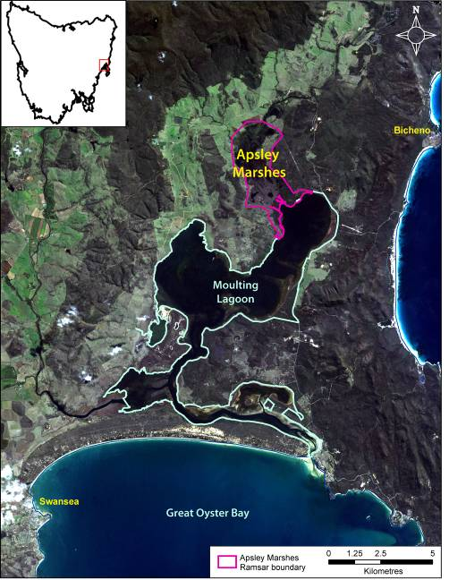
Figure E1: Location of the Apsley Marshes Ramsar Site (Base image by TASMAP (www.tasmap.tas.gov.au), © State of Tasmania).

The Apsley Marshes Ramsar site was listed in 1982 and this is the point in time for which the ecological character description is based. However, there is little evidence of change in ecological character since that time. The site met (at the time of listing) and continues to meet five of the criteria for identifying Wetlands of International Importance.

Criterion 1: A wetland should be considered internationally important if it contains a representative, rare, or unique example of a natural or near-natural wetland type found within the appropriate biogeographic region.
Apsley Marshes are considered to be one of the best examples of freshwater marsh and intertidal saltmarshes in the bioregion (DPIPWE 2010).

Criterion 2: A wetland should be considered internationally important if it supports vulnerable, endangered, or critically endangered species or threatened ecological communities.
There are two threatened species supported by the wetlands within the Apsley Marshes Ramsar site a plant and a waterbird:

- Australasian bittern (Botaurus poiciloptilus) listed as endangered under the IUCN Red List has been recorded within the Ramsar site (Blackhall unpublished) and is frequently seen by the landowner (landholder, personal communication).

- Swamp everlasting (Xerochrysum palustre) listed as vulnerable under the EPBC Act, is found in the seasonally inundated freshwater wetlands of the site (Barnes and Visoiu 2002).

Criterion 3: A wetland should be considered internationally important if it supports populations of plant and/or animal species important for maintaining the biological diversity of a particular biogeographic region.
Apsley Marshes meets this criterion with respect to its diverse flora and number of species that are considered rare in the bioregion (Tasmania). Ninety-four flora species have been recorded in the marshes; 82 of which are wetland dependent and native (Barnes and Visoiu 2002) and it has been described as one of the most floristically rich wetlands in Tasmania (Kirkpatrick and Harwood 1981). The site is known to support six wetland related flora species considered rare and threatened within the bioregion. In addition, the white-bellied sea-eagle (Haliaeetus leucogaster), which is listed as vulnerable under Tasmanian, threatened species legislation, and therefore considered rare in the bioregion, has been recorded breeding within the site (Znidersic, unpublished).

Criterion 4: A wetland should be considered internationally important if it supports plant and/or animal species at a critical stage in their life cycles, or provides refuge during adverse conditions.
The basic description of this criterion implies a number of common functions/roles that wetlands provide including supporting fauna during migration, providing drought refuge, supporting breeding and moulting in waterfowl. The Apsley Marshes Ramsar site is regionally important in terms of nesting of black swans, with up to 1000 nests recorded in a single occasion (Blackhall 1988). In addition the bioregionally rare white-bellied sea-eagle has been recorded breeding within the site.

Criterion 8: A wetland should be considered internationally important if it is an important source of food for fishes, spawning ground, nursery and/or migration path on which fish stocks, either within the wetland or elsewhere, depend.
Apsley Marshes provide a linkage between the inland waters of the Apsley River and the Southern Ocean, via Moulting Lagoon. The landowner reports regular migrations of short-finned eels (Anguilla australis) both on their seaward migration to breed as well as returning juveniles. In addition, black bream (Acanthopagrus butcheri) are known to travel up the drains into the Apsley Marsh Ramsar site in order to spawn (S. Blackhall, personal communication). Australian grayling (listed as vulnerable under the EPBC Act and the TSPA) have also been recorded in the river upstream and presumably would use the site as a migratory route during breeding.

A summary of the components and processes important to the ecological character of the Apsley Marshes Ramsar site is provided in Table E1 and illustrated conceptually in Figure E2. This includes those that are considered essential elements as well as those identified as critical to the ecological character of the site and for which Limits of Acceptable Change have been developed. Critical components and processes as well as essential elements were selected on the basis of their role in maintaining the ecological character of the site, the ecosystem services they support (Table E2) and the Ramsar criteria for which the site is listed.

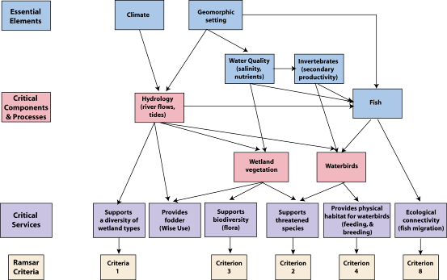

Figure E2: Simple conceptual model showing the key relationships between components and processes; benefits and services and the reasons for the site being listed as a wetland of international importance.

Table E1: Summary of components and processes important for maintaining the ecological character of the Apsley Marshes Ramsar site.
Component / process | Description
Essential elements
Climate | - Located in temperate climatic zone with warm summers and cool winters.  - Rainfall occurs year round and is low for temperate conditions.  - On average evaporation exceeds rainfall for ten months of each year.
Geomorphic setting | - Part of the Oyster Bay / Moulting Lagoon graben.  - Contains a broadwater reach of the Apsley River and a broad floodplain, which is a depositional environment.  - Southern end contains a number of tidal and artificial drainage channels.
Water quality | - No information from within the site.  - Inflowing water from the Apsley River is mostly fresh, neutral, low turbidity with low nutrient concentrations.  - Water flowing in from Moulting Lagoon on the tide is saline, low turbidity and low nutrient concentrations.
Fish | - Data deficient.  - Three species observed by the landowner.
Invertebrates | - Data deficient – no information could be sourced.
Critical components and processes
Hydrology | - Freshwater flows from the Apsley River, highest in winter and lowest in autumn and summer.  - Tidal influence extends over lower marshes.
Vegetation | - Eighty-two native species of wetland plant; including six species that are considered rare or threatened within the bioregion and the nationally vulnerable swamp everlasting (Xerochrysum palustre).  - Ten wetland vegetation associations.
Waterbirds | - Twenty-six species recorded.  - Internationally endangered Australasian bittern (Botaurus poiciloptilus).  - Significant breeding of black swans (Cygnus atratus); confirmed breeding of three additional species including the white-bellied sea-eagle and potential breeding of three more waterbird species.

Ecosystem benefits and services are defined under the Millennium Ecosystem Assessment definition of ecosystem services as "the benefits that people receive from ecosystems (Ramsar Convention 2005, Resolution IX.1 Annex A). This includes benefits that directly affect people such as the provision of food or water resources as well as indirect ecological benefits.

Identified benefits and services of the Apsley Ramsar site are summarised in Table E2. This includes provisioning services (products obtained from ecosystems); cultural services (benefits people obtain through spiritual enrichment, recreation, education and aesthetics) and supporting services (services that underpin other services and have indirect benefits to humans). Apsley Marshes Ramsar site is privately owned and so cultural services such as tourism and recreation are not applicable. In addition, there is no evidence that the site plays a significant regulatory role with respect to hydrology, water quality or climate. However, the site is managed for the dual purposes of conservation and agricultural production, providing an excellent example of the “Wise Use” principle. In addition, there are a number of critical supporting services that are provided by the site.

Table E2: Summary of the critical services of the Apsley Marshes Ramsar site.
Category | Description
Provisioning services
Fodder for cattle | The site has been used for cattle grazing for decades and wetland plant communities, particularly in the freshwater rushland and sedgeland communities which are an important source of fodder.
Supporting services
Diversity of wetland types | The Apsley Marshes Ramsar site contains a diversity of freshwater and marine wetland types.
Supports biodiversity | The Apsley Marshes Ramsar site contains over 80 native species of wetland plant including eight species of bioregional conservation significance.
Physical habitat | Apsley Marshes provide habitat for feeding and breeding of waterbirds.
Threatened species | The Apsley Marshes Ramsar site supports one nationally threatened species of plant (swamp everlasting) and one internationally threatened species of animal (Australasian bittern).
Ecological connectivity | The Apsley Marshes provide a migration route from inland waters to the sea for migratory fish species.

“Limits of acceptable change” (LAC) is the terminology used to describe complex judgements as to what extent critical components, processes benefits and services of the site can vary without representing a change in the ecological character as defined by the Ramsar Convention. Limits of acceptable change for the Apsley Marshes Ramsar site have been proposed for critical components, processes and benefits and services based on existing data and guidelines and are summarised in Table E3.

Table E3: Proposed LAC for the Apsley Marshes Ramsar site.
Component/Process  Benefit / Service | Limit of Acceptable Change*
Hydrology | No change in wetland hydrological types present within the site. That is, the following hydrological regimes maintained:  - Permanent freshwater across part of the north area of the site;  - Areas of sedgeland inundated with freshwater annually;  - Tidal inundation of saltmarsh and paperbarks daily; and  - Presence of permanent saline channels and pools in the lower portion of the marsh.
Vegetation | Presence of the following species within the site:  - Swamp everlasting  - Water woodruff  - Swamp violet  - Drooping sedge  - Purple loosestrife  - Southern swampgrass  - Gentle rush.
Vegetation | Presence of the following vegetation communities within the Ramsar site (as described by Barnes and Visoiu 2002):  - Succulent saltmarsh  - Saw sedge saltmarsh  - Sea rush rushland  - Saline aquatic wetland  - Paperbark forest  - Common rush rushland  - Typha rushland  - Twig rush sedgeland  - Freshwater aquatic wetland  - Riparian vegetation.
Vegetation | Presence of at least 65 species of wetland dependent, native floral species within the site.
Waterbirds | Presence and breeding of black swans within the site, annually.
Waterbirds | Presence and breeding of white-bellied sea eagle in at least three out of any five year period.
Waterbirds | Presence of Australasian bittern within the site.
Provisioning service – fodder for cattle | See LAC for hydrology and vegetation communities.
Diversity of wetland types | See LAC for hydrology and vegetation communities.
Biodiversity | See LAC for vegetation.
Threatened species | See LAC for plant species and Australasian bittern.
Physical habitat | See LAC for hydrology, vegetation and waterbirds.
Ecological connectivity | No barriers to hydrological connectivity between Moulting Lagoon and the Apsley River within the Ramsar site.
*Exceeding or not meeting a LAC does not automatically indicate that there has been a change in ecological character.
There are few threats that are likely to significantly impact on the ecological character of the site. However a number of localised or minor threats are present. A description of each of the threats is provided in Table E4.

Table E4: Summary of threats to the ecological character of the Ramsar site.
Actual or likely threat or threatening activities | Potential impact(s) to wetland components, processes and/or service | Likelihood¹ | Timing²
Water resource development | - Reduced inflows of freshwater and loss of freshwater marsh habitat. | Medium | Long term
Acid sulphate soils | - Reduced water quality.  - Health impacts to flora and fauna. | Medium | Current – long term
Invasive species and pathogens | - Altered composition of vegetation communities.  - Pressure on waterbird breeding.  - Reduced health of amphibians. | Medium | Current
Resource utilisation | - Overgrazing/stocking could lead to loss of rare plants.  - Reduced health of biota – lead poisoning. | Medium | Current – long term
Climate change (increased temperature) | - Reduced freshwater inflows. | Low | Long term
Climate change (increased sea level and storms) | - Storm surge flooding of vegetation (paperbark and saltmarsh). | Medium | Long term
¹ Where Certain is defined as known to occur at the site or has occurred in the past; Medium is defined as not known from the site but occurs at similar sites; and Low is defined as theoretically possible, but not recorded at this or similar sites.
² Where Current is defined as happening at the time of writing (2010); Long-term is defined as greater than 10 years.

It has been over a quarter of a century since the Apsley Marshes Ramsar site was designated as a Wetland of International Importance. As such, changes to the system are to be expected. However, there is no evidence of significant change. Whether this is due to a lack of empirical data or the maintenance of ecological character is not certain. However, anecdotal evidence suggests that the site has not changed significantly since listing in 1982 (landholder, personal communication).

Knowledge gaps have been identified and those of high priority comprised current status of vegetation, fish community composition and abundance and waterbird community composition and population dynamics (Table E5). Monitoring to address knowledge gaps and assess against LAC has been recommended (Table E6).

Table E5: High priority knowledge gaps relevant to the ecological character of the Ramsar site.
Knowledge Gap | Recommended Action
Vegetation – survey and mapping undertaken in 2002 represents the only available information on vegetation at the site. There are no estimates of abundance of rare plants, vegetation community extent or degree of variability. | Repeated surveys on a regular basis (3 – 5 years) to determine variability in community composition and extent (including threatened flora).
Fish – only anecdotal records of fish use within the site. No information available on diversity, abundance and the importance of the site as a migratory route. | Annual surveys of fish from within the site, timed to match likely breeding migrations of significant species such as the Australian grayling.
Waterbirds – information is limited to surveys conducted in 1984 – 1986 and two surveys in 2010. Long term records of abundance, diversity and nesting are lacking. | Annual waterbird surveys and nest counts. Could be timed to match those undertaken in the adjacent Moulting Lagoon.
Extent of weeds. | Weed control monitoring.

Table E6: Recommended monitoring for the Apsley Marshes Ramsar site.
Component/ Process | Purpose | Indicator | Locations | Frequency | Priority
Hydrology | Assessment against LAC | Extent and duration of inundation | Entire site | Every two years | Medium
Water quality | Threat indicator, knowledge gap | Salinity  Nutrients | Freshwater sections of the site | Monthly | Low
Vegetation communities | Assessment against LAC | Extent and community composition | Entire site | Every two to five years | High
Rare and threatened plant species | Assessment against LAC | Location, abundance | Known locations within the site. | Every two to five years | High
Invertebrates | Assessment against LAC | Abundance and species identifications | Entire Ramsar site | Annual | Low
Fish | Fill knowledge gap, inform LAC | Community composition and abundance | Entire Ramsar site | Annual | High
Amphibians | Fill knowledge gap | Community composition and abundance | Entire site | Annual | Medium
Waterbirds | Assessment against LAC | Abundance and species identifications, breeding observations, black swan nest counts | Entire site | Annual | High
Weeds | Threat assessment | Extent and distribution | Entire site | Annual | High
Pest animals | Threat assessment | Abundance | Entire site | Every two years | Low

1. Introduction

1.1 Site details
The Apsley Marshes Ramsar site is located on the east coast of Tasmania, within the Tasmanian Drainage Division (bioregion), 14 kilometres south west of the town of Bicheno. It was originally nominated as a Wetland of International Importance under the Ramsar Convention in 1982. Site details for this Ramsar wetland are provided in Table 1.

Table 1: Site details for the Apsley Marshes Ramsar site.
Site Name | Apsley Marshes
Location in coordinates | Latitude: 41° 59' S  Longitude: 148° 12' E
General location of the site | The Apsley Marshes Ramsar site is located in the Glamorgan-Spring Bay municipality in Tasmania.  Drainage Division: Tasmania (Australia’s River Basins Australian Water Resources Council 1987).
Area | 880 hectares (DPIWE 2005; based on updated mapping).
Date of Ramsar site designation | Designated on 16 November 1982
Ramsar/DIWA Criteria met by wetland | Ramsar criteria 1, 2, 3, 4, 8
Management authority for the site | The site is managed by a private landholder.
Date the ECD applies | 1982
Status of Description | This represents the first ECD for the site.
Date of Compilation | December 2010
Name(s) of compiler(s) | Jennifer Hale and Rhonda Butcher on behalf of DEWHA.
References to the Ramsar Information Sheet (RIS) | RIS compiled by DIPWE in 2005.  Updated by Jennifer Hale on behalf of DSEWPaC 2010.
References to Management Plan(s) | No current management plan exists for this site

1.2 Statement of purpose
The act of designating a wetland as a Ramsar site carries with it certain obligations, including managing the site to retain its ‘ecological character’ and to have procedures in place to detect if any threatening processes are likely to, or have altered the ‘ecological character’. Thus, understanding and describing the ‘ecological character’ of a Ramsar site is a fundamental management tool for signatories and local site managers which should form the baseline or benchmark for management planning and action, including site monitoring to detect negative impacts.

The Ramsar Convention has defined “ecological character” and “change in ecological character” as (Ramsar 2005):

“Ecological character is the combination of the ecosystem components, processes and benefits/services that characterise the wetlands at a given point in time”

And

“…change in ecological character is the human induced adverse alteration of any ecosystem component, process and or ecosystem benefit/service.”

In order to detect change it is necessary to establish a benchmark for management and planning purposes. Ecological character descriptions (ECD) form the foundation on which a site management plan and associated monitoring and evaluation activities are based. The legal framework for ensuring the ecological character of all Australian Ramsar sites is maintained is the Environment Protection and Biodiversity Conservation Act 1999 (EPBC Act) (Figure 1). A Ramsar Information Sheet is prepared at the time of designation. However whilst there is some link between the data used for listing a site (based on the various criteria) the information in an RIS does not provide sufficient detail on the interactions between ecological components, processes and functions to constitute a comprehensive description of ecological character. In response to the short fall, the Australian and state/territory governments have developed a National Framework and Guidance for Describing the Ecological Character of Australia’s Ramsar Wetlands. Module 2 of Australian National Guidelines for Ramsar Wetlands – Implementing the Ramsar Convention in Australia (DEWHA 2008).

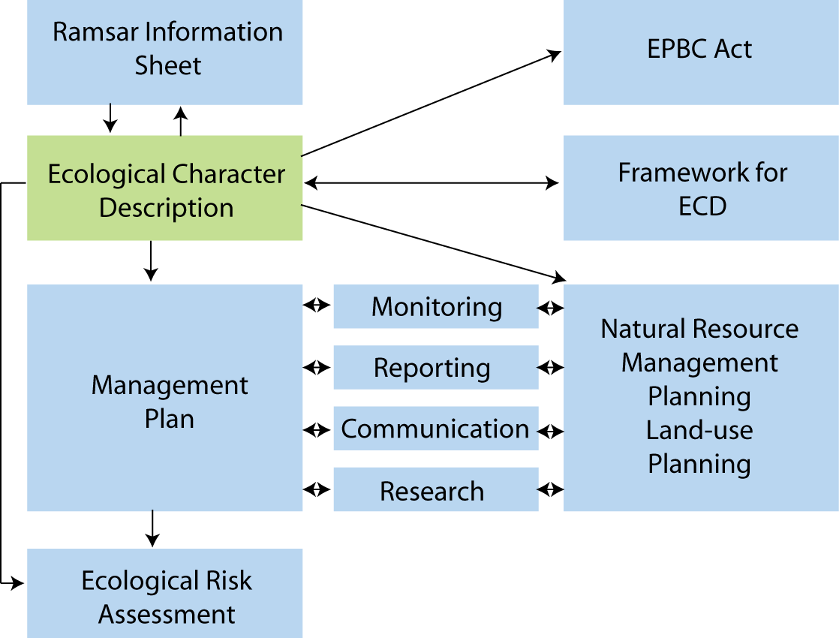

Figure 1: The ecological character description in the context of other requirements for the management of Ramsar sites (adapted from DEWHA 2008).

The framework emphasises the importance of describing and quantifying the ecosystem components, processes and benefits/services of the wetland and the relationship between them. It is also important that information is provided on the benchmarks or ecologically significant limits of acceptable change that would indicate when the ecological character has or is likely to change.

McGrath (2006) detailed the general aims of an ECD as follows:

- To assist in implementing Australia’s obligations under the Ramsar Convention, as stated in Schedule 6 (Managing wetlands of international importance) of the Environment Protection and Biodiversity Conservation Regulations 2000 (Commonwealth):
  - To describe and maintain the ecological character of declared Ramsar wetlands in Australia; and
  - To formulate and implement planning that promotes:
    - Conservation of the wetland; and
    - Wise and sustainable use of the wetland for the benefit of humanity in a way that is compatible with maintenance of the natural properties of the ecosystem.
- To assist in fulfilling Australia’s obligation under the Ramsar Convention to arrange to be informed at the earliest possible time if the ecological character of any wetland in its territory and included in the Ramsar List has changed, is changing or is likely to change as the result of technological developments, pollution or other human interference.
- To supplement the description of the ecological character contained in the Ramsar Information Sheet submitted under the Ramsar Convention for each listed wetland and, collectively, form an official record of the ecological character of the site.
- To assist the administration of the EPBC Act, particularly:
  - To determine whether an action has, will have or is likely to have a significant impact on a declared Ramsar wetland in contravention of sections 16 and 17B of the EPBC Act; or
  - To assess the impacts that actions referred to the Minister under Part 7 of the EPBC Act have had, will have or are likely to have on a declared Ramsar wetland.
- To assist any person considering taking an action that may impact on a declared Ramsar wetland whether to refer the action to the Minister under Part 7 of the EPBC Act for assessment and approval.
- To inform members of the public who are interested generally in declared Ramsar wetlands to understand and value the wetlands.

1.3 Relevant treaties, legislation and regulations
This section provides a brief listing of the legislation and policy that is relevant to the description of the ecological character of the Ramsar site. There is a significant amount of legislation, particularly at the state/local level, relevant to the management of the site, which will be documented more fully in the management plan for the site and as such is not repeated here.

International
Ramsar Convention
The Convention on Wetlands, otherwise known as the Ramsar Convention, was signed in Ramsar Iran in 1971 and came into force in 1975. It provides the framework for local, regional and national actions, and international cooperation, for the conservation and wise use of wetlands. Wetlands of International Importance are selected on the basis of their international significance in terms of ecology, botany, zoology, limnology and/or hydrology

Migratory bird bilateral agreements and conventions
Australia is party to a number of bilateral agreements, initiatives and conventions for the conservation of migratory birds, which are relevant to the Apsley Marshes Ramsar site. The bilateral agreements are:

- JAMBA – The agreement between the Government of Australia and the Government of Japan for the Protection of Migratory Birds in Danger of Extinction and their Environment, 1974;
- CAMBA - The Agreement between the Government of Australia and the Government of the People's Republic of China for the Protection of Migratory Birds and their Environment 1986;
- ROKAMBA - The Agreement between the Government of Australia and the Republic of Korea for the Protection of Migratory Birds and their Environment, 2006; and
- The Bonn Convention on Migratory Species (CMS) - The Bonn Convention adopts a framework in which countries with jurisdiction over any part of the range of a particular species co-operate to prevent migratory species becoming endangered. For Australian purposes, many of the species are migratory birds.

National legislation
Environment Protection and Biodiversity Conservation Act 1999 (EPBC Act)
Aims of the EPBC Act include to provide for the protection of the environment and promote conservation of biodiversity. It regulates actions that will have or are likely to have a significant impact on any matter of national environmental significance, which includes the ecological character of a Ramsar wetland (s16(1)). An action that will have or is likely to have a significant impact on a Ramsar wetland will require an environmental assessment and approval under the EPBC Act before proceeding. An ‘action’ includes a project, a development, an undertaking or an activity or series of activities (http://www.environment.gov.au/epbc/index.html).

The EPBC Act establishes a framework for managing Ramsar wetlands, through the Australian Ramsar Management Principles which are set out in Schedule 6 of the Environment Protection and Biodiversity Conservation Regulations 2000. These principles are intended to promote national standards of management, planning, environmental impact assessment, community involvement, and monitoring, for all of Australia’s Ramsar wetlands in a way that is consistent with Australia’s obligations under the Ramsar Convention. Some matters protected under the EPBC Act are not protected under local or state/territory legislation, and as such, many migratory birds are not specifically protected under state legislation (though they are in Western Australia). Species listed under international treaties JAMBA, CAMBA, ROKAMBA and CMS have been included in the List of Migratory species under the Act. Threatened species and communities listed under the EPBC Act may also occur, or have habitat in the Ramsar site; some species listed under state legislation as threatened are not listed under the EPBC Act, usually because they are not threatened at the national (often equivalent to whole-of-population) level. The Regulations also cover matters relevant to the preparation of management plans, environmental assessment of actions that may affect the site, and the community consultation process.

Tasmanian state policy and legislation
Threatened Species Protection Act 1995
Threatened Species Protection Act aims to provide for the protection and management of threatened native flora and fauna and to promote the conservation of these species. The Act establishes a Scientific Advisory Committee and enables the development of threatened species lists, strategies, threat abatement and recovery plans. The Act also enables the imposition of interim protection orders and facilitates the development of land-management plans.

Inland Fisheries Act 1995
Inland Fisheries Act regulates recreational and commercial fishing in inland waters. The Act establishes the Inland Fisheries Advisory Council and a licensing system for commercial and recreational fishing. The Act also governs aquaculture and fish farming practices.

Nature Conservation Act 2002 and Forest Practices Amendment (Threatened Native Vegetation Communities Act) 2006
The Nature Conservation Act establishes a list of threatened communities, which are then protected from clearance and conversion under amendments to the Forest Practices Act.

Land Uses Planning and Approvals Act 1993
This Act regulates land use and development through planning schemes and a permit system. The Act requires the environmental assessments to be conducted, ensuring appropriate conditions and restrictions are included in permits issued by planning authorities.

1.4 Method
The method used to develop the ecological character description for the Apsley Marshes Ramsar site is based on the twelve-step approach provided in the National Framework and Guidance for Describing the Ecological Character of Australia’s Ramsar Wetlands (DEWHA 2008) illustrated in Figure 2. A more detailed description of each of the steps and outputs required is provided in the source document. This ECD was developed primarily through a desktop assessment and is based on existing data and information. A steering committee was formed to provide input and comment on the ECD.

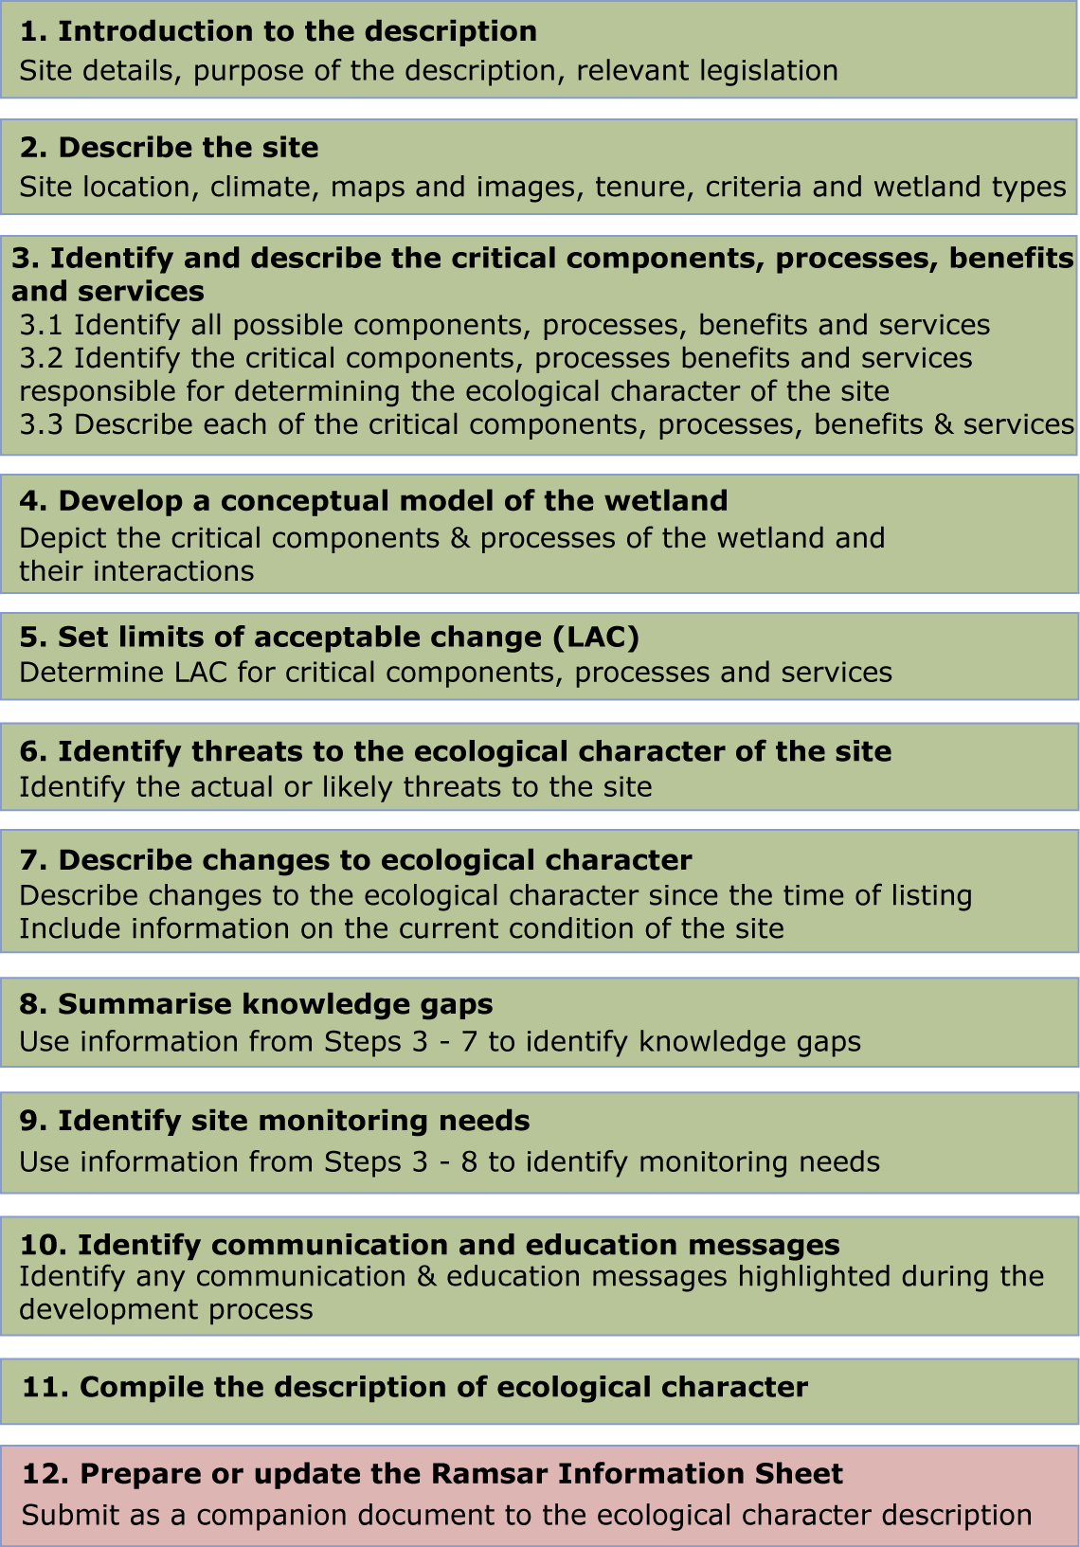

Figure 2: Twelve step process for developing an ECD (adapted from DEWHA 2008).

2. General Description of the Apsley Marshes Ramsar Site

2.1 Location
The Apsley Marshes Ramsar site is located on the east coast of Tasmania, within the Tasmanian Drainage Division (inland bioregion) and the Tasmanian IMCRA province (marine bioregion), 14 kilometres south west of the town of Bicheno (population in 2007; 640). The site covers approximately 880 hectares and lies within the municipality of Glamorgan-Spring Bay. The site is situated almost entirely within private (freehold) land and is contiguous with Moulting Lagoon Ramsar site (Figure 5).

The Apsley Marshes are within the Swan-Apsley catchment, which covers approximately
1400 square kilometres and contains the two sub catchments of the Swan and Apsley Rivers. The Apsley River rises in the Douglas-Apsley National Park, and flows through areas of grazing and forestry before reaching Apsley Marshes and ultimately discharging to Moulting Lagoon and Great Oyster Bay.
Figure 3: Location of the Apsley Marshes Ramsar Site (Base image by TASMAP (www.tasmap.tas.gov.au), © State of Tasmania).

2.2 Land tenure
Land tenure within the site is predominantly freehold on the property of Apslawn, which has been in the same family for over 100 years. A small portion of the site in the south-east is within the Moulting Lagoon Game Reserve, under the management of the Tasmanian Parks and Wildlife Service (Figure 4).
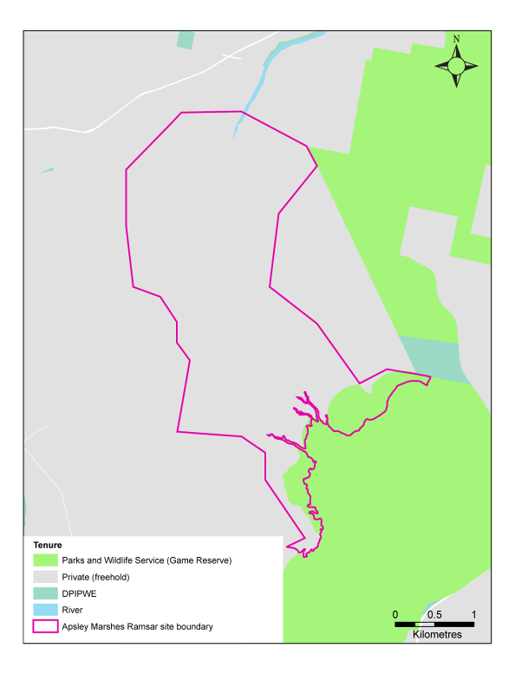
Figure 4: Land tenure within and adjacent to the site (Base data from theLIST (www.thelist.tas.gov.au, © State of Tasmania).

2.3 Wetland types
The 2005 RIS for the site (DPIWE 2005) identified the following three Ramsar wetland types within the Apsley Marshes Ramsar site:

- F - Estuarine waters;
- R - Seasonal/intermittent saline/brackish/alkaline lakes and flats; and
- Tp - Permanent freshwater marshes and pools.

However, although Apsley Marshes adjoins the estuarine waters of Moulting Lagoon, there are no open expanses of estuarine water within the site. Rather, the areas under tidal influence are covered with vegetation such as saltmarsh and melaleuca (Barnes and Visoiu 2002). As such these areas fit better into the categories of intertidal marshes and intertidal forested wetlands. Similarly, the saline areas of the site are not saline due to inland processes, but due to tidal influences and so do not readily fit into the inland wetland category of seasonal /intermittent saline/brackish/alkaline lakes and flats, but into the marine category of intertidal marshes.

Therefore, for the purposes of this ECD, the dominant wetland types within the Apsley Marshes Ramsar site are:

- H - Intertidal marshes;
- I - Intertidal forested wetlands;
- M – Permanent rivers / streams / creeks;
- Tp – Permanent freshwater marshes and pools;
- Ts - Seasonal/intermittent freshwater marshes and pools; and
- 9 – Canals, drainage channels, ditches.

Comprehensive mapping of wetland types within the site is not available. Existing information on broad wetland types (base data from theLIST) and vegetation mapping (Barnes and Visoiu 2002) have been used to produce an indicatory map (Figure 5), relative location (Figure 6) and approximate areas (Table 2). It should be noted that the extent of many of these wetland types is variable over time. For example, following periods of high astronomical tides (such as king tides) and low rainfall (and freshwater flow in the Apsley River) the extent of intertidal marshes is greater than under periods of high river flow and greater freshwater influences. Therefore, the map shown here is indicative of conditions in 2002, with an unknown pattern of variability.

Table 2: Approximate extent of Ramsar wetland types within the Apsley Marshes Ramsar site (calculated from wetland mapping provided by theLIST (www.thelist.tas.gov.au, © State of Tasmania and mapping by Barnes and Visoiu 2002).

Wetland type | Approximate area (hectares)
H - Intertidal marshes | 155
I - Intertidal forested wetlands | 155
M – Permanent rivers / streams / creeks | unknown
Tp – Permanent freshwater marshes and pools | 250
Ts - Seasonal/intermittent freshwater marshes and pools | 190
9 – Canals, drainage channels, ditches | unknown

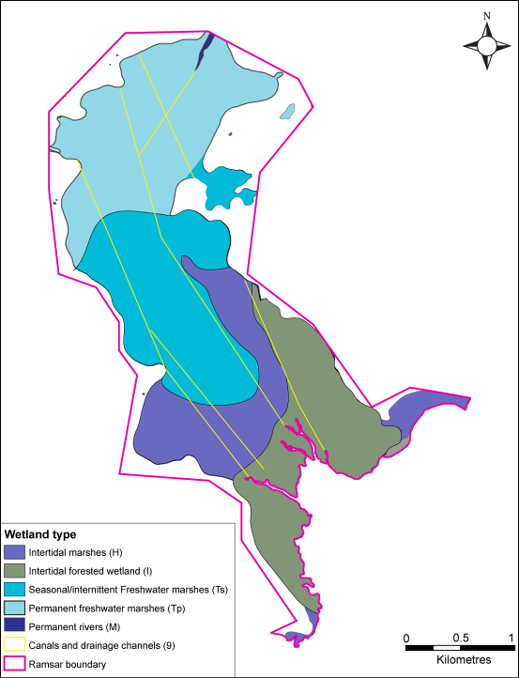
Figure 5: General location of dominant wetland types in the Apsley Marshes Ramsar site (Base data on wetland types from theLIST (www.thelist.tas.gov.au, © State of Tasmania; vegetation mapping from Barnes and Visoiu 2002).

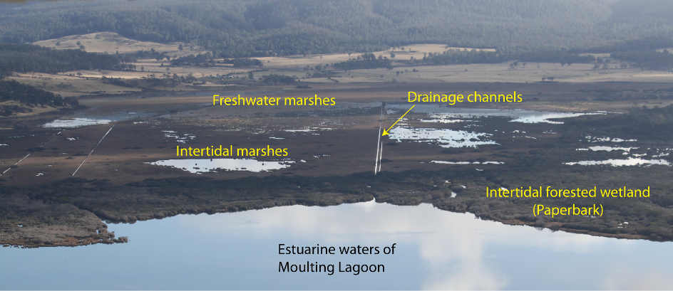
Figure 6: Examples of wetland types within the Apsley Marshes Ramsar site (photo K. Morgan; 2010).
Intertidal marshes (Type H)
This wetland type applies to the saltmarsh and saline rushland within the site (Figure 7). This includes succulent saltmarsh dominated by species such as beaded glasswort (Sarcocornia quinqueflora) as well as grassy saltmarsh comprising species such as thatch saw-sedge (Gahnia filum) and saline rushland dominated by sea-rush (Juncus kraussii). This wetland type is mostly inland of the paperbark forest in areas subject to regular tidal inundation.

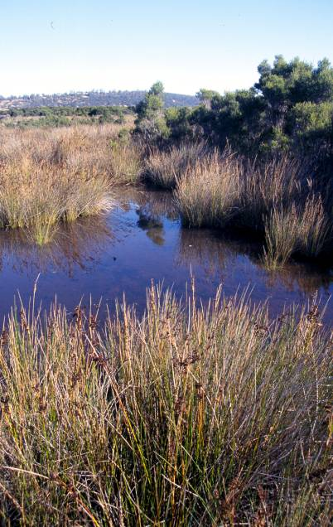

Figure 7: Intertidal marshes – type H from the Apsley Marshes Ramsar site
(photo M. Visoiu; 2002).

Intertidal forested wetland (Type I)
This wetland type applies to the paperbark communities that occur along the southern margins of the site, where Apsley Marshes adjoins Moulting Lagoon (Figure 6). Swamp paperbark (Melaleuca ericifolia) is the dominant species and occurs mostly as a monoculture. This area is subject to the most tidal influences and is rarely (if ever) inundated with freshwater.

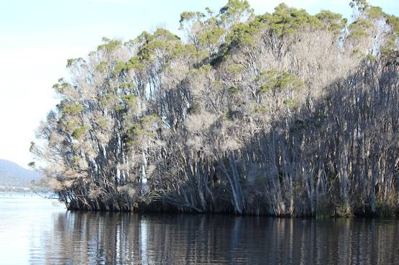
Figure 8: Intertidal forest – type I from the Apsley Marshes Ramsar site
(photo L. Znidersic; 2010).

Permanent rivers / streams / creeks (Type M)
Within the Apsley Marshes Ramsar site, this wetland type applies to the Apsley River at the northern end of the site. However, the river quickly expands to inundate large areas of the marsh and is contained within a defined channel for only a very small section (less than 500 metres).

Permanent freshwater marshes (Type Tp) and seasonal / Intermittent freshwater marshes (Type Ts)
The hydrographic data supplied by theLIST (www.thelist.tas.gov.au © State of Tasmania) identifies almost the entire site as “perennial swamp”. However, discussions with the landowner and information in Barnes and Visoiu (2002) indicate that the freshwater area is highly variable and largely dependent on annual climatic and river flow patterns. In some years much of the area marked as “permanent freshwater marshes” may remain inundated (or at the least retain a saturated soil profile). However, in dry years, the area may dry down to small remnant pools.

The area mapped as intermittent freshwater marsh is dominated by jointed twig-rush (Baumea arthrophylla). This area would receive inundation to a lower depth than the area marked as permanent and would be subject to long periods of dry conditions (Barnes and Visoiu 2002).

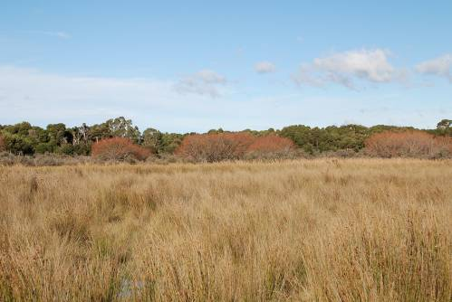
Figure 9: Intermittent freshwater marshes – type Ts at Apsley Marshes Ramsar site (Photo J. Hale; 2010).

Drainage channels (Type 9)
Apsley Marshes contains a number of drainage lines, the first of which were constructed over 100 years ago in an attempt to drain the land and make it more suitable for agriculture (landholder, personal communication). These drainage lines carry both freshwater downstream and saline water upstream, with the tide.

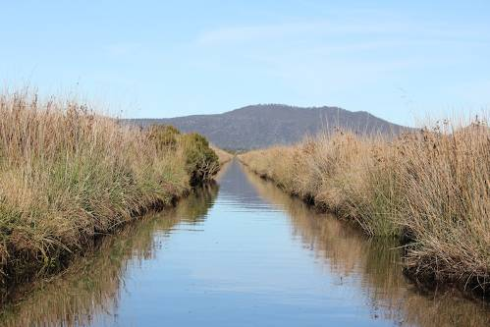

Figure 10: Drainage channels – type 9 at the Apsley Marshes Ramsar site
(photo L. Znidersic; 2010).

2.4 Ramsar criteria

2.4.1 Criteria under which the site was designated
At the time that Apsley Marshes was first nominated as a Wetland of International Importance, the criteria for identifying wetlands of international importance were the “Cagliari criteria”, adopted at the first conference of contracting parties in Cagliari in 1980. The original nomination documentation for the Apsley Marshes Ramsar site considered that the site met two of these criteria as shown in (Table 3). However, no specific justification for these criteria was provided.

Table 3: Criteria for Identifying Wetlands of International Importance as at listing date, 1990. Criteria for which Apsley Marshes were listed are highlighted in green.
Basis | Number | Description
Criteria for waterfowl | 1a | it regularly supports 10,000 ducks, geese and swans; or 10,000 coots or 20,000 waders.
Criteria for waterfowl | 1b | it regularly supports 1% of the individuals in a population of one species or subspecies of waterfowl.
Criteria for waterfowl | 1c | it regularly supports 1% of the breeding pairs in a population of one species or subspecies of waterfowl.
Criteria based on plants and animals | 2a | it supports an appreciable number of rare, vulnerable or endangered species or subspecies of plant or animal.
Criteria based on plants and animals | 2b | it is of special value for maintaining the genetic and ecological diversity of a region because of the quality and peculiarities of its flora and fauna.
Criteria based on plants and animals | 2c | it is of special value as the habitat of plants or animals at a critical stage of their biological cycle.
Criteria based on plants and animals | 2d | it is of special value for one or more endemic plant or animal species or communities.
Criterion based on representative wetlands | 3 | it is a particularly good example of a specific type of wetland characteristic of its region.

2.4.2 Assessment based on current information and Ramsar criteria
There have been a number of developments in the past two decades that influence the application of the Ramsar criteria to wetland sites:

- Refinements and revisions of the Ramsar criteria since 1982. They have been re-numbered and in 1996, an additional two criteria (criteria seven and eight) were adopted by the Ramsar Convention in Brisbane and a ninth criterion was added at the 9th Ramsar Conference in Uganda in 2005.

- Revision of population estimates for waterbirds (Wetlands International 2006; Bamford et al. 2008), which influences the application of criterion six.

- A decision with respect to the appropriate bioregionalisation for aquatic systems in Australia, which for inland systems are now based on drainage divisions and for marine systems the interim marine classification and regionalisation for Australia (IMCRA). This affects the application of criteria one and three.

- Updating of threatened species listings, which affects criterion two.

- Additional data have been collected for the site, which could potentially influence the application of all criteria.

Therefore an assessment of the Apsley Marshes Ramsar site against the current nine Ramsar criteria has been undertaken and included in the updated RIS completed in conjunction with this ECD (Table 4).

Table 4: Criteria for Identifying Wetlands of International Importance (adopted by the 6th (1996) and 9th (2005) Meetings of the Conference of the Contracting Parties). Criteria for which the Apsley Marshes Ramsar site qualifies are highlighted in green.

Number | Basis | Description
Group A. Sites containing representative, rare or unique wetland types
Criterion 1 |  | A wetland should be considered internationally important if it contains a representative, rare, or unique example of a natural or near-natural wetland type found within the appropriate biogeographic region.
Group B. Sites of international importance for conserving biological diversity
Criterion 2 | Species and ecological communities | A wetland should be considered internationally important if it supports vulnerable, endangered, or critically endangered species or threatened ecological communities.
Criterion 3 | Species and ecological communities | A wetland should be considered internationally important if it supports populations of plant and/or animal species important for maintaining the biological diversity of a particular biogeographic region.
Criterion 4 | Species and ecological communities | A wetland should be considered internationally important if it supports plant and/or animal species at a critical stage in their life cycles, or provides refuge during adverse conditions.
Criterion 5 | Waterbirds | A wetland should be considered internationally important if it regularly supports 20 000 or more waterbirds.
Criterion 6 | Waterbirds | A wetland should be considered internationally important if it regularly supports one percent of the individuals in a population of one species or subspecies of waterbird.
Criterion 7 | Fish | A wetland should be considered internationally important if it supports a significant proportion of indigenous fish subspecies, species or families, life-history stages, species interactions and/or populations that are representative of wetland benefits and/or values and thereby contributes to global biological diversity.
Criterion 8 | Fish | A wetland should be considered internationally important if it is an important source of food for fishes, spawning ground, nursery and/or migration path on which fish stocks, either within the wetland or elsewhere, depend.
Criterion 9 | Other taxa | A wetland should be considered internationally important if it regularly supports one percent of the individuals in a population of one species or subspecies of wetland-dependent non-avian animal species.

An assessment against each of the criteria for the Apsley Marshes Ramsar site is as follows:

Criterion 1: The application of this criterion must now be considered in the context of the adopted bioregionalisation for aquatic systems, which is based on drainage divisions. The site lies within the Tasmanian Drainage Division, which covers the entire state. The Conservation of Freshwater Ecosystems Values (CFEV) project has assessed wetlands across the State with respect to representativeness and rarity (amongst other values). In terms of representative value, naturalness and representativeness measures are used to rank wetlands against other wetlands in the State (which in this instance is also the bioregion; DIPW 2007). This is consistent with the advice from the Convention (Ramsar 2009) that in applying criterion one contracting parties should select the “best examples” of each wetland type within a bioregion.

The CFEV assessment affords Apsley Marshes the highest ranking under representative value (DPIPWE 2010). The site is considered to be one of the best examples of freshwater marsh and intertidal saltmarshes in the bioregion. Therefore this criterion was met at the time of listing and continues to be met.

Criterion 2: In the Australian context, it is recommended that this criterion should only be applied with respect to nationally threatened species/communities, listed under the EPBC Act or the International Union for Conservation of Nature (IUCN) Red List. A number of threatened species listed at the national and / or international level have been recorded within the boundary of the Apsley Marshes Ramsar site. However, central to the application of this criterion are the words “a wetland” and “supports”. Guidance from Ramsar (Ramsar 2005) in applying the criteria indicates that the wetland must provide habitat for the species concerned. For this reason, vagrant species, such as the single record of a fairy prion, Pachyptila turtur in 1982 and the shy albatross, Thalassarche cauta in 1983 (Birds Australia unpublished) have not been considered to contribute to the meeting of this criterion. In addition, although the site may act as a migratory route for the Australian grayling, Prototroctes maraena (listed as vulnerable under the EPBC Act) that has been recorded in the river upstream (DPIPWE 2010) and presumably must pass through the Apsley Marshes on its way to and from estuarine / marine waters during part of its life cycle, there is no record of this species from within the site.

There are two threatened species supported by the wetlands within the Apsley Marshes Ramsar site, a plant and a waterbird:

- Australasian bittern (Botaurus poiciloptilus) listed as endangered under the IUCN Red List has been recorded within the Ramsar site (Blackhall, DPIPWE, unpublished) and is frequently seen by the landowner (landholder, personal communication).

- Swamp everlasting (Xerochrysum palustre) listed as vulnerable under the EPBC Act, is found in the seasonally inundated freshwater wetlands of the site (Barnes and Visoiu 2002).

Criterion 3: Like Criterion 1, application of this criterion must be made in the context of the revised bioregionalisation for aquatic systems. Guidance from the Convention indicates that Criterion 3 should be applied to sites that (Ramsar 2009):

i) are “hotspots” of biological diversity and are evidently species-rich even though the number of species present may not be accurately known; and/or
ii) are centres of endemism or otherwise contain significant numbers of endemic species; and/or
iii) contain the range of biological diversity (including habitat types) occurring in a region; and/or
iv) contain a significant proportion of species adapted to special environmental conditions (such as temporary wetlands in semi-arid or arid areas); and/or
v) support particular elements of biological diversity that are rare or particularly characteristic of the biogeographic region.

Apsley Marshes meets this criterion with respect to its diverse flora and number of species that are considered rare in the bioregion. Ninety-four flora species have been recorded in the marshes (Barnes and Visoiu 2002) and it has been described as one of the most floristically rich wetlands in Tasmania (Kirkpatrick and Harwood 1981). The site contains six wetland related flora species considered rare and threatened within the bioregion including (Barnes and Visoiu 2002):

- water woodruff (Asperula subsimplex)
- drooping sedge (Carex longebrachiata)
- purple loosestrife (Lythrum salicaria)
- southern swampgrass (Amphibromus neesii)
- gentle rush (Juncus amabilis)
- swamp violet (Viola caleyana)

The site also supports a number of ecological communities that are considered rare in Tasmania including: Melaleuca ericifolia swamp forest, Melaleuca squarrosa scrub, freshwater aquatic herbland and freshwater aquatic sedgeland and rushland.

In addition, the white-bellied sea-eagle (Haliaeetus leucogaster), which is listed as vulnerable under Tasmanian threatened species legislation, and therefore considered rare in the bioregion, has been recorded breeding within the site (Znidersic, unpublished). Therefore this criterion was met at the time of listing and continues to be met.

Criterion 4: The basic description of this criterion implies a number of common functions/roles that wetlands provide including supporting fauna during migration, providing drought refuge and supporting breeding and moulting in waterfowl. The Apsley Marshes Ramsar site is important in terms of nesting of black swans (Cygnus atratus), with up to 1000 nests recorded at one time (Blackhall 1988). In additional, the bioregionally rare white-bellied sea-eagle is known to breed at the site (Znidersic unpublished). Therefore this criterion was met at the time of listing and continues to be met.

Criterion 5 and 6: Comprehensive bird surveys of the Apsley Marshes are rare. However, from the surveys that have been undertaken at the site, there is no evidence to suggest that the site supports over 20 000 birds or greater than one percent of the population of a single species. This criterions was not met at the time of listing nor currently.

Criteria 7: Guidance from the Ramsar Convention (Ramsar 2009) on the application of this criterion indicates that in order to meet this criterion, a site should have a high degree of endemism or biodisparity in fish communities. This criterion is very difficult to apply. However, as only a handful of fish species have been observed at the site, this criterion is unlikely to apply. This criterions was not met at the time of listing nor currently.

Criterion 8: Guidance from the Convention indicates that this criterion is about providing a network of sites that maintain fish populations as they migrate during their lifecycle. Apsley Marshes provide a linkage between the inland waters of the Apsley River and the Southern Ocean, via Moulting Lagoon. The landowner reports regular migrations of short-finned eels (Anguilla australis) both on their seaward migration to breed as well as returning juveniles. In addition, black bream (Acanthopagrus butcheri) are known to travel up the drains into the Apsley Marsh Ramsar site in order to spawn (S. Blackhall, DPIPWE, personal communication). Australian grayling (nationally and state listed threatened species) have also been recorded in the river upstream and presumably would use the site as a migratory route during breeding. This criterion was met at the time of listing and continues to be met.

Criterion 9: The application of this criterion relies on estimates of the total population of non-bird species. In the case of Apsley Marshes this would require population estimates of frog or fish species. In the absence of population data, this criterion cannot be applied, but on the basis of available evidence, is not met by the site.

3. Critical Components and Processes
This description of the ecological character of the Apsley Marshes Ramsar site is for conditions at the time of listing (1982). In order to capture temporal variation in components and processes, the following description is focussed on data spanning the decade before listing and the decade after (i.e. 1972 – 1992). However, in some instances, where data from around the time of listing could not be sourced, more recent information has been used (this is clearly indicated in the text). As there is no evidence of change in character since listing (section 7) it is likely that more recent data is applicable to character in 1982.

3.1 Identifying critical components and processes
The basis of an ECD is the identification, description and where possible, quantification of the critical components, processes, benefits and services of the site. Wetlands are complex ecological systems and the complete list of physical, chemical and biological components and processes for even the simplest of wetlands would be extensive and difficult to conceptualise. It is not possible, or in fact desirable, to identify and characterise every organism and all the associated abiotic attributes that are affected by, or cause effect to, that organism to describe the ecological character of a system. This would result in volumes of data and theory but bring us no closer to understanding the system and how to best manage it. What is required is to identify the key components, the initial state of the systems, and the basic rules that link the key components and cause changes in state (Holland 1998). Thus, we need to identify and characterise the key or critical components, processes, benefits and services that determine the character of the site. These are the aspects of the ecology of the wetland, which, if they were to be significantly altered, would result in a significant change in the system.

DEWHA (2008) suggest the minimum components, processes, benefits and services, which should be included in an ECD are those:

- that are important determinants of the site’s unique character
- that are important for supporting the Ramsar or DIWA criteria under which the site was listed
- for which change is reasonably likely to occur over short to medium time scales (less than 100 years) and / or
- that will cause significant negative consequences if change occurs.

In addition, the role that components and processes play in the provision of critical ecosystem services should also be considered in the selection of critical components and processes. The linkages between components, processes, benefits and services and the criteria under which the site was listed are illustrated conceptually in Figure 11.

It is difficult to separate components (physical, chemical and biological parts) and processes (reactions and changes). For example, aspects of geomorphology such as bathymetry and topography may be considered as components, while other aspects of geomorphology such as sediment transport and erosion could be considered processes. Similarly the species composition of birds at a site may be considered a component, but feeding and breeding are processes. In the context of this ECD a separation of the ecology of wetlands into nouns (components) and verbs (processes) is an artificial boundary and does not add clarity to the description. As such components and processes are considered together. The interactions between components and processes, the functions that they perform and the benefits and services that result are considered in detail in section 4.

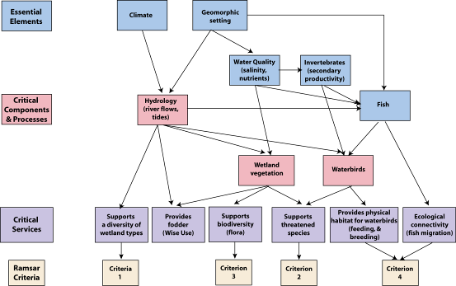

Figure 11: Simple conceptual model showing the key relationships between components and processes; benefits and services and the reasons for the site being listed as a wetland of international importance.

The identified critical components and processes of the Apsley Marshes Ramsar site are:

- hydrology
- wetland vegetation
- waterbirds.

Each of the identified critical components and processes meet the four criteria provided by DEWHA (2008) in that they are central to the character of the site, are directly linked to the Ramsar criteria for which the site was listed, could potentially change in the next 100 years and for which change would result in negative consequences and a change in the ecological character of the site. In addition, they are important in providing the benefits and services that the site provides.

In addition to the identified critical components and processes are characteristics of the site, which are not critical (that is if they were to change, they would not lead directly to a change in character) but are still important in the ecology of the system. These are termed “essential elements” and include some of the characteristics of the site, which may act as early warning indicators of a potential change in character and therefore should be considered in management planning for the site. The identified essential elements for the Apsley Marshes Ramsar site are:

- climate
- geomorphic setting
- water quality
- fish
- aquatic invertebrates.

3.2 Essential elements
The components and processes of the Apsley Marshes Ramsar site that are considered important in supporting the critical components, processes, benefits and services of the site are described briefly below and summarised in Table 5.

Table 5: Summary of essential elements within the Apsley Marshes Ramsar site.
Component / process | Description
Climate | - Located in temperate climatic zone with warm summers and cool winters.  - Rainfall occurs year round and is low for temperate conditions.  - On average evaporation exceeds rainfall for ten months of each year.
Geomorphic setting | - Part of the Oyster Bay / Moulting Lagoon graben.  - Contains a broadwater reach of the Apsley River and a broad floodplain which is a depositional environment.  - Southern end contains a number of tidal and artificial drainage channels, which facilitate connectivity between the marine and freshwater environments for native fish.
Water quality | - No information from within the site.  - Inflowing water from the Apsley River is mostly fresh, neutral, low turbidity with low nutrient concentrations.  - Water flowing in from Moulting Lagoon on the tide is saline, low turbidity and low nutrient concentrations.
Fish | - Data deficient.  - Four native and one introduced species observed.
Invertebrates | - Data deficient – no information could be sourced.

3.2.1 Climate
The Apsley Marshes site is situated within the temperate climatic zone of south eastern Australia (Bureau of Meteorology 2010). The general climatic pattern is cool winters and warm summers, with rainfall occurring year round. The three aspects of climate that most directly affect wetland ecology are rainfall (both local and in the catchment), temperature and (to a lesser extent in temperate systems) relative humidity as these all fundamentally affect the critical component wetland hydrology and the water budget.

Rainfall, on average, occurs year round with highest monthly average rainfall in December (60 millimetres) and lowest in September (41 millimetres). There is some degree of variability in rainfall as evidenced by the 10th and 90th percentiles, which range from less than 10 millimetres per month to greater than 100 millimetres per month (Figure 12). However, this is considerably more stable than rainfall in arid and topical zones within Australia (Bureau of Meteorology 2010).

Annual average rainfall at Swansea is in the order of 560 millimetres per year. Once again, although there is some degree of variability in annual rainfall (ranging from less than 400 millimetres to more than 950 millimetres in 40 years of records from this site) (Figure 13) this is relatively low compared to other areas in Australia.

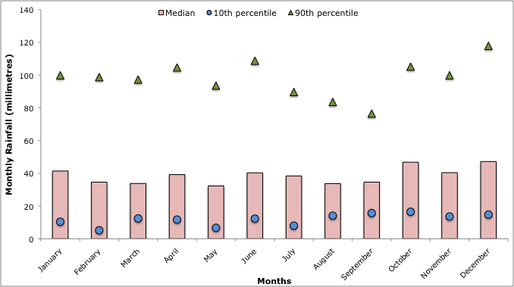

Figure 12: Median (with 10th and 90th percentile) monthly rainfall at Swansea (1884 – 2009; Bureau of Meteorology).

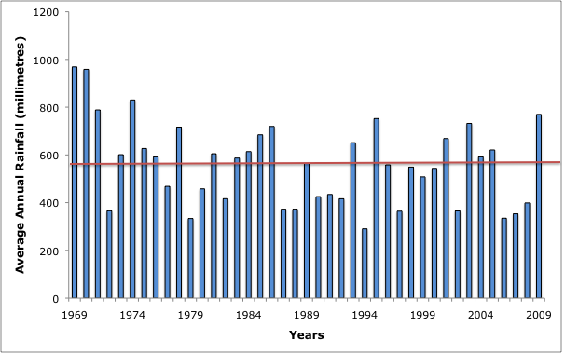

Figure 13: Average annual rainfall at Swansea (1969 – 2009; Bureau of Meteorology). Note horizontal line shows long term average.

Temperatures range from cool to warm (Figure 14), with average summer maximum temperatures around 22 degrees Celsius and average minimum temperatures around 11 degrees Celsius. During winter average maximum temperatures are considerably cooler (13 to 14 degrees Celsius) as are average minimum temperatures (four to five degrees Celsius). Relative humidity ranges from 60 per cent during summer to 80 per cent during winter months. Despite the relatively mild temperatures and high humidity, evaporation exceeds rainfall in ten months of the year, with rainfall marginally higher than evaporation, on average, in June and July (Figure 15).

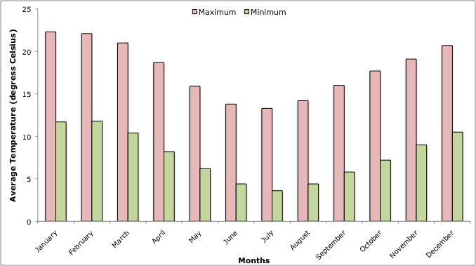

Figure 14: Average monthly maximum and minimum temperatures at Swansea
(1957 – 2009; Bureau of Meteorology).

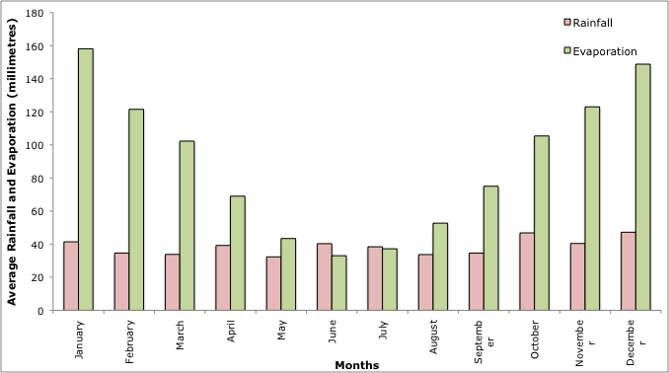

Figure 15: Average monthly rainfall and evaporation at Swansea
(1957 – 2009; Bureau of Meteorology).

3.2.2 Geomorphic setting
The geomorphic setting of the Ramsar site is considered an essential element for its role in affecting the critical component of wetland hydrology and the critical service of maintaining ecological connectivity between freshwater and marine environments.

The Apsley Marshes site is located at the mouth of the Apsley River, where it discharges to Moulting Lagoon and ultimately Great Oyster Bay. The basins are within a graben (an area of the earth’s crust that has fallen relative to surrounding faults) that formed following the separation of Antarctica and Australia (DTAE 2003). The area (including Apsley Marshes) has been listed as a site of geo-conservation significance due to the presence of this feature (State of Tasmania undated, theLIST).

The marshes themselves are characterised by low relief topography and deposited alluvial sediment. The underlying geology is almost entirely alluvium sand, gravel and talus of Holocene origin (DTAE 2003). The northern part of the Ramsar site contains the last part of the Apsley River within a defined channel. This broadwater reach is a low slope, low energy environment that formed from scour of the soft sediments (Jerie et al. 2003); and from here the river disperses across the marshy floodplain (Figure 16).

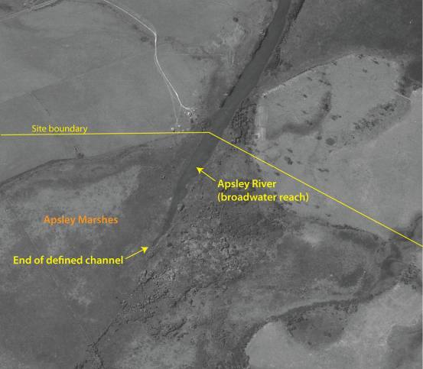

Figure 16: Upper area of the Apsley Marshes Ramsar site, showing the broadwater reach of the Apsley River as it enters the site and the end of the defined channel as the water disperses across the floodplain (1985 aerial image provided by TASMAP (www.tasmap.tas.gov.au), © State of Tasmania).

The bottom (downstream) region of the site is characterised by a series of drains and channels (Figure 17). The natural (but modified) tidal channels carry marine and estuarine water into the site. However, the water within the larger natural channels is within the Moulting Lagoon Ramsar site, rather than the Apsley Marshes site; with the site boundary following the channel edges. The artificial drainage channels were constructed to facilitate the movement of freshwater from the marshes into Moulting Lagoon to increase arable land. However, they also act to carry tidal water further inland than would have occurred under natural conditions.

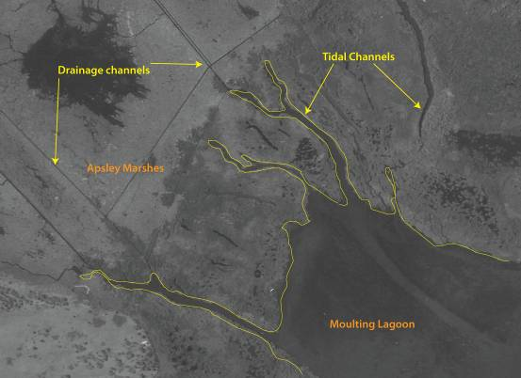
Figure 17: Lower area of the Apsley Marshes Ramsar site, showing the straight lines of the constructed drainage channels and the irregular shaped tidal channels that carry water between the marshes and Moulting Lagoon (1985 aerial image provided by TASMAP (www.tasmap.tas.gov.au), © State of Tasmania).

3.2.3 Water quality
There are no data for water quality from within the Apsley Marshes Ramsar site. Data collected from the Apsley River approximately two kilometres upstream of the site provide an indication of the quality of freshwater inflows. Although, these data were collected from December 2003 to present, some two decades after the site was listed under the Ramsar Convention, without any evidence to the contrary, they are also considered indicative of conditions at the time of listing.

Inflowing water from the Apsley River is fresh, neutral and of relatively low turbidity. Salinity (as indicated by electrical conductivity) ranges from less than 100 to over 300 microSiemens per centimetre and turbidity from less than one to over 20 NTU. Salinity and turbidity have an inverse relationship; with peaks in turbidity coinciding with lows in salinity (Figure 18). This most likely reflects river flows, with high flows bringing in freshwater and higher sediments loads. The pH remained mostly neutral with a mean of seven; but ranging from a low of six to a high of 8.5 (State of Tasmania 2010).

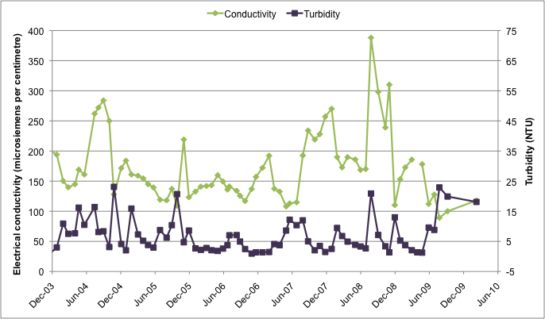
Figure 18: Salinity (as indicated by electrical conductivity) and turbidity (NTU) from the Apsley River at Coles Bay Road (data from State of Tasmania 2010).

Total and dissolved nutrient concentrations within the river are relatively low for a lowland river and indicative of mesotrophic conditions. Mean total nitrogen concentration is approximately 300 micrograms per litre and dissolved inorganic nitrogen (the portion available for plant uptake) is very low and generally comprises less than five percent of the total (Figure 19).

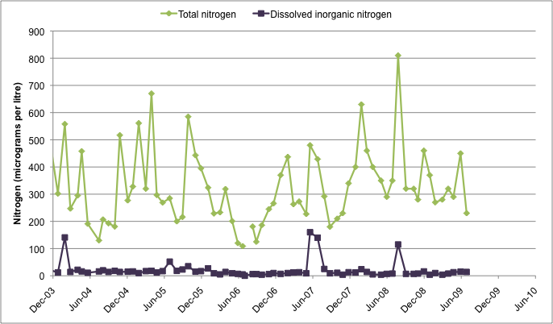
Figure 19: Total and dissolved inorganic nitrogen concentrations at from the Apsley River at Coles Bay Road (data from State of Tasmania 2010).

Total and dissolved inorganic phosphorus concentrations are also relatively low for a lowland river (Figure 20). Mean total phosphorus was approximately 10 micrograms per litre. However, the proportion of this that is in bioavailable form is highly variable, ranging from nearly 100 percent to less than 10 percent. Seasonal patterns of both nitrogen and phosphorus also seem to follow river flow, with the highest concentrations coinciding with high flows.

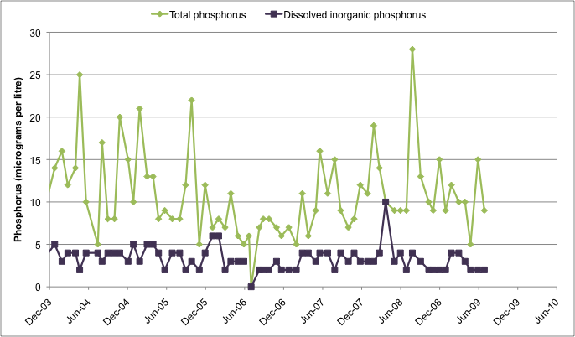
Figure 20: Total and dissolved inorganic nitrogen concentrations at from the Apsley River at Coles Bay Road (data from State of Tasmania 2010).

Water also enters the site with the inflowing tide from the Moulting Lagoon and Great Swanport estuaries. While there is little water quality information from the estuaries, in general, salinity is around that of seawater (34 to 35 parts per thousand) and nutrients and turbidity are considerably lower than those entering via the Apsley River (Murphy et al. 2002).

Processes within the Apsley Marshes would also influence water quality. In particular, the cattle that graze within the site would add to the nutrient loads, contributing to primary (and secondary) productivity. Cattle are also likely to increase turbidity.

3.2.4 Fish
Fish are considered an essential element for their role in the food web, supporting the critical component of waterbirds as well as for their role in the critical service of ecological connectivity. There is little information on fish within the Apsley Marshes Ramsar site and no quantitative data could be sourced. Observations of at least three species have been made by the landowner; the native short-finned eel (Anguilla australis), and black bream (Acanthopagrus butcheri) as well as the introduced brown trout (Salmo trutta). In addition, tupong (Pseudaphritis urvillei) and jollytails galaxids (Galaxius maculatus) have been observed in the site (M. Visiou, DPIPWE, personal communication). The Australian grayling (Ptototroctes maraena) has been recorded in the Apsley River upstream of the site and must migrate through the Apsley Marshes to complete its lifecycle in estuarine / marine waters.

3.2.5 Invertebrates
Invertebrates are important in the Apsley Marshes Ramsar site for their role in food webs and secondary production. However, there is no data on species that are found within the site.

3.3 Critical components and processes
The attributes and characteristics of each of the identified critical components and processes of the Apsley Marshes Ramsar site are described below. Where possible, quantitative information is included. However, there are significant knowledge gaps (see section 8). A summary of the critical components and processes within the Apsley Marshes Ramsar site is provided in Table 6.

Table 6: Summary of critical components and processes within the Apsley Marshes Ramsar site.
Component / process | Description
Hydrology | - Freshwater flows from the Apsley River, highest in winter and lowest in autumn and summer.  - Tidal influence extends over lower marshes.
Vegetation | - Eighty-two native species of wetland plant; including six species that are considered rare or threatened within the bioregion and the nationally vulnerable swamp everlasting (Xerochrysum palustre).  - Ten wetland vegetation associations.
Waterbirds | - Twenty-six species recorded.  - Internationally endangered Australasian bittern (Botaurus poiciloptilus).  - Significant breeding of black swans (Cygnus atratus); confirmed breeding of three additional species including white-bellied sea-eagle and potential breeding of three more waterbird species.

3.3.1 Hydrology
Hydrology at the Apsley Marshes Ramsar site is driven by the freshwater inflows from the Apsley River and the tidal cycles in Great Oyster Bay and Moulting Lagoon. Although groundwater contribution to the site is a knowledge gap there is no evidence that it is a significant contributor to the water budget. The combination of freshwater inflows and tidal exchange results in a seasonal pattern of inundation and salinity as well as variation over longer periods of drought, high rainfall and inter-annual tides.

Freshwater flows into the Apsley Marshes site from the north via the Apsley River. Data from two kilometres upstream of the Ramsar site indicate the interannual variability (Figure 21) as well as seasonal patterns (Figure 22). Flow is generally highest in winter and lowest in summer and autumn. Although the data from the gauging station indicate cease to flow over summer months, the landowner indicates the river is permanent and acts as the sole supply of domestic water for the property.

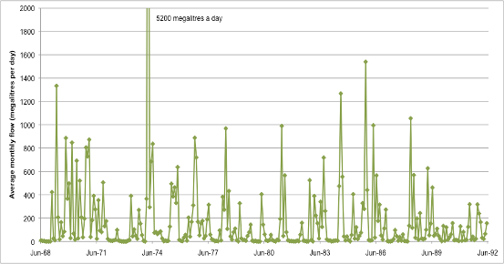
Figure 21: Average monthly flow (megalitres per day) from the Apsley River at Coles Bay Road 1968 to 1992 (data from State of Tasmania 2010).

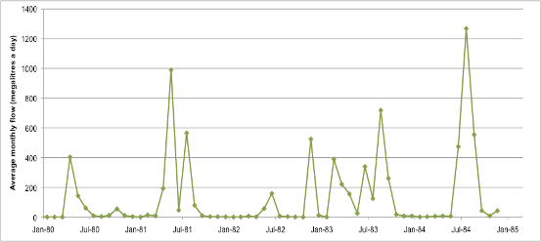
Figure 22: Average monthly flow (megalitres per day) in the Apsley River at Coles Bay Road January 1980 to December 1984 (data from State of Tasmania 2010).

Tide has a strong influence on the site; however, there is no quantitative data available for tides in the area. Average tidal range at the top of Moulting Lagoon (adjacent to the Ramsar site) is approximately 30 centimetres (Temby and Crawford 2008). However, ranges would vary considerably and “king tides” have been known to occur, resulting in large scale inundation of normally freshwater areas within the Marshes (landholder, personal communication). The most recent of these was in autumn 2009, when king tides were reported across the east coast of Tasmania.

The seasonality of rainfall and river flow, as well as evaporation results in a cyclic hydrology of the wetlands within the Ramsar site. During winter and spring months when river flow is highest, freshwater extends over much of the site and pressure from the flow of freshwater limits the intrusion of salt water in tidal cycles. In late summer and autumn, the situation is reversed, with little or no freshwater inputs, and higher evaporation resulting in a drying of marsh areas and an increase in the area affected by salt water from Moulting Lagoon.

3.3.2 Vegetation
Vegetation within the Apsley Marshes Ramsar site was comprehensively surveyed and mapped in 2002 (Barnes and Visoiu 2002) and in the absence of any evidence of significant changes since 1982, this is considered indicative of conditions at the time of listing. Barnes and Visoiu (2002) note that all previous vegetation data from the site has been lost and as such their survey represents the only recorded information upon which a description can be made.

Ninety-four species were recorded from within the Apsley Marshes, comprising 82 native and 12 introduced species (Appendix B). This includes the swamp everlasting (Xerochrysum palustre) which is listed as vulnerable under national legislation and a further six species listed under Tasmanian threatened species legislation (Table 7). The site also supports five threatened native vegetation communities listed as threatened under Schedule 3A of the Nature Conservation Act 2002 (Table 8).

Table 7: Wetland plants listed under threatened species legislation recorded from Apsley Marshes (Barnes and Visoiu 2002).
Species name | Common Name | Conservation status
Xerochrysum palustre | swamp everlasting | Vulnerable (EPBC Act)
Asperula subsimplex | water woodruff | Rare (TSP Act)
Viola caleyana | swamp violet | Rare (TSP Act)
Carex longebrachiata | drooping sedge | Rare (TSP Act)
Lythrum salicaria | purple loosestrife | Rare (TSP Act)
Amphibromus neesii | southern swampgrass | Rare (TSP Act)
Juncus amabilis | gentle rush | Rare (TSP Act)

Table 8: Threatened native vegetation communities recorded from Apsley Marshes (Barnes and Visiou 2002).
Vegetation community name | TASVEG Code
Eucalyptus ovata forest and woodland | DOV
Melaleuca ericifolia swamp forest | NME
Freshwater aquatic herbland | AHF
Saline aquatic herbland | AHS
Freshwater aquatic sedgeland and rushland | ASF

Barnes and Visoiu (2002) developed an expanded TASVEG community classification to describe the wetland vegetation within the site. The description of the ten major wetland vegetation communities and sub-groups are summarised below and an indicative map provided in Figure 23. It should be noted that mapping undertaken in 2002 is no longer available in a digital format and the map presented is a reproduction from a faded hard copy, overlaid on 1985 aerial photography. Some of the vegetation communities are dynamic, shifting in response to hydrology and salinity and this map should be considered indicative only.

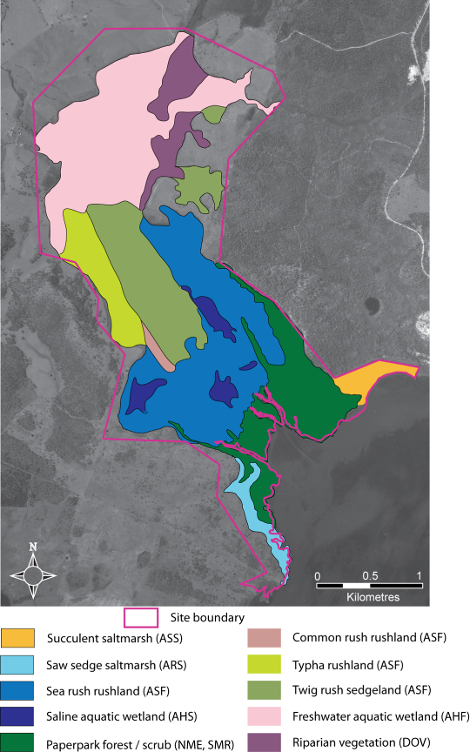

Figure 23: Wetland vegetation communities in the Apsley Marshes Ramsar site. Adapted from Barnes and Visoiu (2002), indicative only.

Wetland vegetation community descriptions (Barnes and Visoiu 2002):

Succulent saltmarsh (TASVEG Code ASS) – occurs in a small patch in the south of the site on the shores of Moulting Lagoon. Within the Ramsar site, the community is dominated by beaded glasswort (Sarcocornia quinqueflora) but also contains salt angianthus (Angianthus preissianus), swamp weed (Selliera radicans), shiny bog-rush (Schoenus nitens) and creeping brookweed (Samolus repens). Vegetation cover is patchy, with areas of bare sediment and salt crust evident.

Saw sedge saltmarsh (TASVEG Code ARS) – occurs in a large patch on the shores of Moulting Lagoon in the south west of the Ramsar site. It is dominated by thatch saw-sedge (Gahnia filum), which grows in a mosaic with areas of open water. Other species that grow in this area are creeping brookweed (Samolus repens), Australian salt grass (Distichlis distichophylla), sea-rush (Juncus kraussii) and club rush (Isolepis cernua).

Sea rush rushland (TASVEG Code ASF; Figure 24) – occurs over large areas in the southern portions of the Ramsar site that are subject to saline inundation from tidal flows. The community is dominated by sea rush (Juncus kraussii). In the most saline areas other species include beaded glasswort (Sarcocornia quinqueflora), long cotula (Leptinella longipes), shiny bog-rush (Schoenus nitens), and streaked arrow-grass (Triglochin striata). In areas that grade into freshwater communities, pale rush (Juncus pallidus) and common rush (J. procerus) are present with the sea-rush.

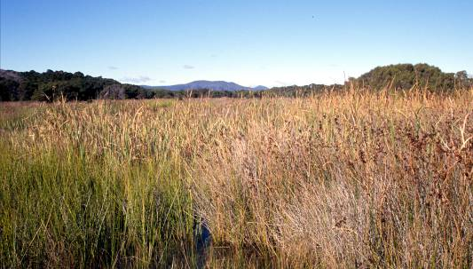
Figure 24: Sea rush rushland (photo M. Visoiu; 2002).

Saline aquatic wetland (TASVEG Code AHS) – occurs in semi-permanent saline to brackish pools in the lower to mid marshes. The community is species poor with only two species recorded: brackish water-milfoil (Myriophyllum salsugineum) and common widgeon grass (Ruppia polycarpa). The pools also support an abundance of algae.

Paperbark forest / scrub (TASVEG codes NME and SMR) – occurs along much of the lower shores of the Ramsar site and extends up along the drainage lines. The community is dominated by swamp paperbark (Melaleuca ericifolia), which is commonly the only tree species present, although there are occasional woolly tea trees (Leptospermum lanigerum) on the margins. The canopy is generally dense, with little or no understorey. However, there is a sparse cover of small herbs and sedges such as sea parsley (Apium prostratum), swamp weed (Selliera radicans), monkey flower (Mimulus repens), long cotula (Leptinella longipes) and club rush (Isolepis cernua).

Common rush rushland (TASVEG Code ASF; Figure 25) – this is one of the communities that is highly dynamic and changes in extent and distribution in response to changing hydrology. In 2002 it occurred in a distinctive strip between two drainage lines in the mid portion of the Ramsar site. The community is a monoculture of the grass, common rush (Phragmites australe).

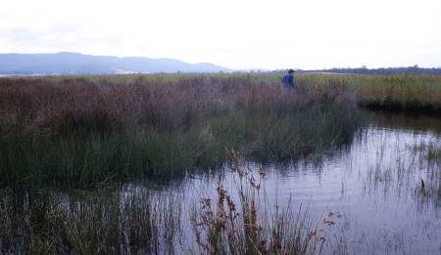
Figure 25: Common rush rushland (photo M. Visoiu; 2002).

Typha rushland (TASVEG Code ASF) – this community is also known to expand and contract as a result of a number of factors relating to salinity, hydrology and temperature. In 2002, there was a 30 hectare patch of cumbungi (Typha orientalis) and narrow cumbungi (T. domingensis) on the western margin of the site. However, during a site visit in 2010 this had contracted to an isolated patch of less than two hectares (but appeared to be increasing).

Twig rush sedgeland (TASVEG Code ASF; Figure 26) – occurs over extensive areas of the middle portion of the Ramsar site in areas that are shallowly inundated, but dry annually. The dominant species is jointed twig-rush (Baumea arthrophylla), which forms extensive stands. In the shallowest areas usually on the edge of the wetland, soft sword sedge (Lepidosperma longitudinale) is common. Other species include: bog-rush (Schoenus tesquorum), running marsh flower (Villarsia reniformis), coarse twin rush (Apodasmia brownii), floating bog rush (Schoenus fluitans), floating club rush (Isolepis fluitans) and fairies aprons (Utricularia dichotoma).

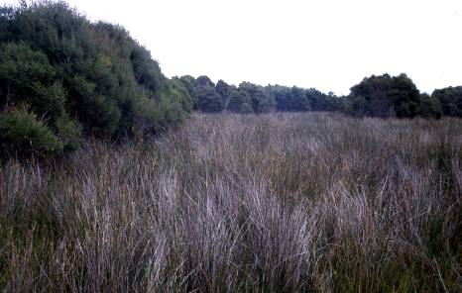
Figure 26: Twig rush sedgeland (photo M. Visoiu; 2002).

Freshwater aquatic wetland ((TASVEG Code AHF; Figure 27) – extends over much of the northern portion of the site and comprises a series of different communities in permanent pools and annually inundated plains. Community composition is highly variable both spatially and temporally. Common species include: water milfoil (Myriophyllum simulans), running marsh flower (Villarsia reniformis), jointed rush (Juncus articulatus), mud pratia (Pratia surrepens), and floating bog-rush (Schoenus fluitans).

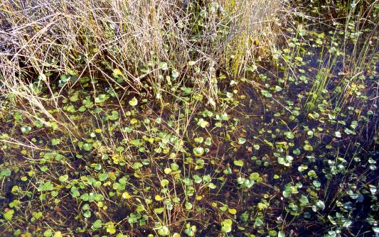
Figure 27: Freshwater aquatic wetland (photo M. Visoiu; 2002).

Riparian vegetation (Includes TASVEG Code DOV) – occurs predominantly along the Apsley River in the north of the site. Swamp gum (Eucalyptus ovata) form a sparse canopy with occasional crack willows (Salix fragilis) also present on the banks of the river. The understorey contains leafy flat sedge (Cyperus lucidus), bristly knotweed (Persicaria praetermissa) and millet grass (Isachne globosa).

3.4.3 Waterbirds
As with most of the components and processes within the Apsley Marshes Ramsar site, information on waterbirds is sparse. A total of 26 species of waterbird have been recorded within the site (Table 9, Appendix C). The list includes three species that are listed under international migratory agreements CAMBA and JAMBA, although all of these species (Caspian tern, Hydropogne caspia, eastern great egret, Ardea modesta and the white-bellied sea eagle, Haliaeetus leucogaster) are considered resident in Australia, not known to undertake international migrations (R. Jaensch, Wetlands International, personal communication). An additional 13 Australian species that are listed as migratory or marine under the EPBC Act have been recorded at the site including the white-bellied sea eagle, which is listed as vulnerable under Tasmanian threatened species legislation.

Table 9: Number of wetland birds recorded within the Apsley Marshes Ramsar site
(S. Blackhall unpublished; Znidersic unpublished). See Appendix C for full list of species.
Bird group | Typical feeding requirements | Number of species
Ducks and allies | Shallow or deeper open water foragers.  Vegetarian (for example black swan) or omnivorous with diet including leaves, seeds and invertebrates. | 8
Pelicans, Cormorants, Darters | Deeper open waters feeding mainly on fish. | 3
Heron, Ibis, Spoonbills | Shallow water or mudflats.  Feeding mainly on animals (fish and invertebrates). | 3
Hawks, Eagles | Shallow or deeper open water on fish and occasionally waterbirds and carrion. | 2
Cranes, Crakes, Rails, Water Hens, Coots | Coots in open water; others in shallow water within cover of dense emergent vegetation such as sedge. Some species vegetarian, others mainly take invertebrates, some are omnivores. | 1
Shorebirds | Shallow water, bare mud and salt marsh.  Feeding mainly on animals (invertebrates and some fish). | 4
Gulls, Terns | Terns, over open water feeding on fish and invertebrates; gulls, opportunistic feeders over a wide range of habitats. | 4
Other | Non-waterbirds that are reliant on wetlands for breeding or feeding (white-fronted chat). | 1
Total |  | 26

Waterbird count data from around the time of listing indicate generally low numbers of birds at the site with maximum counts of approximately 1300 birds (S. Blackhall unpublished). However, black swans (Cygnus atratus) are a consistent presence, with records from 90 percent of surveys and accounting for the majority of the total abundance of waterbirds (Figure 28). The site is considered significant for breeding black swans, with moderate numbers of nests observed every year.

The site also supports breeding of the white-bellied sea eagle which nests in the riparian trees along the river at the northern end of the site (Znidersic unpublished). The Australasian bittern (Botaurus poiciloptilus), which is listed as endangered on the IUCN Red List, is a resident within the site, occurring along the heavily vegetated drainage lines. It is suspected that this species also nests within the Ramsar site (S. Blackhall, DPIPWE, personal communication).

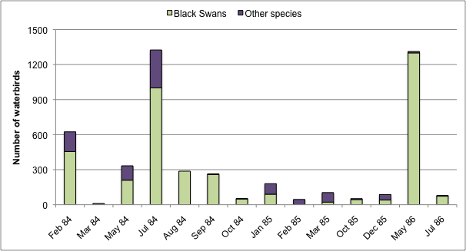
Figure 28: Total waterbird abundance and number of black swans in the Apsley Marshes Ramsar site (data from S. Blackhall unpublished).

Recent observations confirm breeding of chestnut teal (Anas castanea) and masked lapwing (Vanellus miles) within the site and suggest that Australian shelduck (Tadorna tadornoides), Caspian tern (Hydropogne caspia) and swamp harrier (Circus approximans) may also use the site for breeding (Znidersic unpublished).

4 Ecosystem Services

4.1 Overview of benefits and services
Ecosystem benefits and services are defined under the Millennium Ecosystem Assessment definition of ecosystem services as "the benefits that people receive from ecosystems” (Ramsar Convention 2005, Resolution IX.1 Annex A). This includes benefits that directly affect people such as the provision of food or water resources as well as indirect ecological benefits. The Millennium Ecosystem Assessment (Millennium Ecosystem Assessment 2005) defines four main categories of ecosystem services:

- Provisioning services - the products obtained from the ecosystem such as food, fuel and fresh water;
- Regulating services – the benefits obtained from the regulation of ecosystem processes such as climate regulation, water regulation and natural hazard regulation;
- Cultural services – the benefits people obtain through spiritual enrichment, recreation, education and aesthetics; and
- Supporting services – the services necessary for the production of all other ecosystem services such as water cycling, nutrient cycling and habitat for biota. These services will generally have an indirect benefit to humans or a direct benefit over a long period of time.

The Apsley Marshes site is privately owned and so cultural services such as tourism and recreation are not applicable. In addition, there is no evidence that the site plays a significant regulatory role with respect to hydrology, water quality or climate. However, the site is managed for the dual purposes of conservation and agricultural production, providing an excellent example of the “Wise Use” principle. In addition, there are a number of supporting services that are provided by the site (Table 10).

Table 10: Ecosystem services and benefits provided by the Apsley Marshes Ramsar site.
Category | Description
Provisioning services
Fodder for cattle | The site has been used for cattle grazing for decades and wetland plant communities, particularly in the freshwater rushland and sedgeland communities are an important source of fodder.
Supporting services
Diversity of wetland types | The site contains a diversity of freshwater and marine wetland types.
Supports biodiversity | The site contains 82 native species of wetland plant including six species of bioregional conservation significance.
Physical habitat | The site provides habitat for feeding and breeding of waterbirds.
Threatened species | The site supports one nationally threatened species of plant (swamp everlasting) and one internationally threatened species of animal (Australasian bittern).
Ecological connectivity | The site provides a migration route from inland waters to the sea for migratory fish species.

The critical ecologically based ecosystem services and benefits of a Ramsar site have been identified using the same criteria provided by DEWHA (2008) as a guide for selecting critical components and processes; that is, services that at a minimum:

- are important determinants of the site’s unique character;
- are important for supporting the Ramsar or DIWA criteria under which the site was listed;
- for which change is reasonably likely to occur over short or medium time scales (less than 100 years); and / or
- that will cause significant negative consequences if change occurs.

Using these criteria it was considered that all of the services listed in Table 10 could be considered “critical”.
While it is easy to see how the ecologically based supporting services could be considered critical to ecological character in that they are related to the criteria under which the site was listed, there is also a strong argument for including the provisioning service in the list of critical services.

The long history of agricultural production (cattle grazing) on the site has played a significant role in shaping the ecological character of Apsley Marshes. It is likely that selective grazing, nutrient inputs from the cattle and other farming practices have influenced the productivity and vegetation community composition. Given that the benchmark for ecological character of Ramsar sites is the time of listing, agricultural practices at the site should be considered an integral part of the character of the Apsley Marshes.

This is illustrated in the conceptual model for the site (Figure 29) which demonstrates the interactions between critical components, processes and services that define the ecological character of the Apsley Marshes Ramsar site.

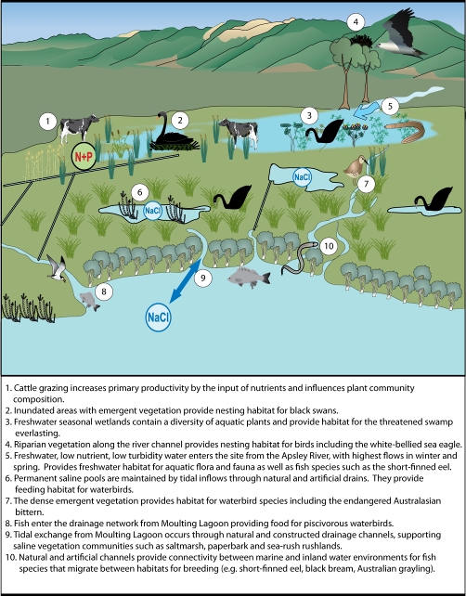
Figure 29: Simple conceptual model illustrating the interaction between critical components and processes at the site and the services that they provide.

4.2 Provisioning service – fodder for cattle
The Apsley Marshes site has been part of a working agricultural property since 1836 and has had a long history of cattle grazing. Currently 125 head of breeding cows are run on the property and grazed in the freshwater rush and sedgelands for between six and 12 months of the year, depending on weather conditions. To increase fodder production and manage the vegetation, parts of the freshwater sedge / rushlands are burned on an annual basis, when dry. This removes old dried vegetation and initiates fresh green growth, with a return of cover within six months of burning (landholder personal communication).

Cattle grazing is known to have effects on wetlands, in that they can alter plant community composition via consumption of select plants and trampling; increase compaction of the soil and increase primary productivity by the inputs of nutrients from excretions (Reeves and Champion 2004). In many cases this is considered as a negative impact on wetland condition. However, in the instance of Apsley Marshes, the effects of cattle grazing and management of grazing lands have contributed to the character of the wetland.

The benchmark for ecological character is not a “natural” state, but the conditions at the time of listing as a wetland of international importance. The Apsley Marshes Ramsar site was designated in 1982, after more than 100 years of cattle grazing. The effects of grazing and land management were evident at the time of listing and so form a part of the ecological character of the site. The management of the site to maintain ecological character is an example of the concept of “wise use”.

Wise use of wetlands is defined by the Convention as (Ramsar Convention, 2010):

" ….the maintenance of their ecological character, achieved through the implementation of ecosystem approaches, within the context of sustainable development."

The current land owner of the Apsley Marshes site manages the wetland to provide both economic and conservation outcomes and he and his family have done so for generations. The site has not changed in character since the time of listing (see section 7) adding further evidence of the sustainable practices implemented at the site.

4.3 Supports a diversity of wetland types
As described in section 2.3, the Apsley Marshes Ramsar site contains a range of wetland types, some of which can be considered significant in a bioregional context (DIPW 2007). The diversity of habitat is brought about by the interactions between geomorphology, hydrology, salinity and vegetation. Some of the wetland types such as intertidal forest are permanent features, varying little in composition and extent over time. Other types, such as the intertidal and freshwater marshes, vary considerably in extent and composition in response to the shifting boundary of saline water intrusion into the site.

The dominant determinant of the extent and distribution of wetland types at the site is the balance between freshwater and marine inflows (Figure 30). During winter and spring, when rainfall and run-off is highest, large amounts of fresh, low nutrient, high clarity water enter the site via the Apsley River. Water disperses across the floodplain, inundating a large proportion of the site. Seasonal / intermittent wetlands fill and aquatic plants germinate or emerge form underground dormant states. The pressure exerted by this water flowing towards Moulting Lagoon limits the extent to which marine water can enter the site via tidal cycles. As such, large areas are covered with freshwater emergent vegetation. Areas of saline / marine wetland remain in the southern portion of the site, including the intertidal forests dominated by paperbark, saltmarsh and sea-rush rushlands.

During summer and autumn months, freshwater inflows are at a minimum and evaporation at a maximum, resulting in a contraction of freshwater wetland extent. Some areas dry, with plants setting seed or returning to dormant vegetative states. Reduced pressure from freshwater flow seaward results in an increase in marine water intrusion to the site via tidal cycles. The inflow of marine water is increased by the network of constructed drainage channels. As a consequence the balance between freshwater and saline wetland marshes is shifted.

During extreme tide events, such as the king tide that occurred in late autumn 2009, marine water may flood over substantial areas of the site, resulting in the decline of freshwater wetland plant communities. The 2009 event, for example, resulted in the death of a large portion of the twig-rush (Baumea arthrophylla) and typha (Typha orientalis, T. domingensis) dominated communities. However, following freshwater inflows during winter and spring, these communities (and wetland types) recovered within a 12 month period (landholder, personal communication).

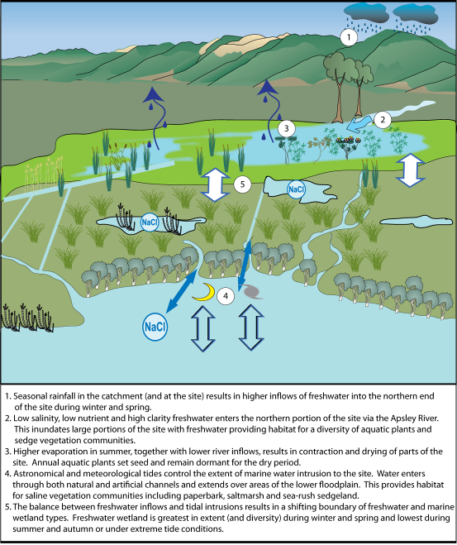
Figure 30: Conceptual model of wetland diversity and habitat types within the Apsley Marshes Ramsar site.

4.4 Supports biodiversity
The Apsley Marshes site is important for maintaining regional biodiversity in general, supporting species of waterbird, fish and most likely amphibians as well as a range of invertebrates. However, the site is particularly important in terms of diversity of flora. Barnes and Visoiu (2002) described the flora diversity at the site as “truly remarkable” with over 80 species of native wetland flora species recorded within the site during this single survey.

In general terms, the diversity of flora is maintained by the interaction of climate, hydrology and geomorphology at the site and in particular the hydrological processes described in section 4.3 and Figure 30. The site also supports six wetland flora species of bioregional significance (Barnes and Visoiu 2002):

- water woodruff (Asperula subsimplex),
- drooping sedge (Carex longebrachiata),
- swamp violet (Viola caleyana),
- purple loosestrife (Lythrum salicaria),
- southern swampgrass (Amphibromus neesii) and
- gentle rush (Juncus amabilis).

All of these species are considered freshwater plants and are reliant on continued inflows of high quality freshwater from the Apsley River into the site. They were found predominantly in the northern portion of the site where the river enters the marshes and at a location mid-marsh adjacent to the main drainage channel. Barnes and Visoiu (2002) suggested that these species were also maintained by a lack of cattle access to the locations in which they occurred due to deep water barriers between grazing areas and rare plant locations.

4.5 Provides physical habitat for feeding and breeding of waterbirds
The Apsley Marshes site provides a range of habitats that support waterbirds in terms of feeding and breeding.

4.5.1 Feeding
The Apsley Marshes Ramsar site supports a range of waterbirds. These are considered below in terms of broad feeding / habitat guilds.

Piscivores
There are a number of waterbirds within the Ramsar site whose diet is wholly or mostly comprised of fish. This includes the gulls and terns, cormorants and the Australian pelican as well as the white-bellied sea eagle. The general feeding requirements for four piscivorous waterbirds that have been observed within the Apsley Marshes Ramsar site are provided in Table 11.

Table 11: General feeding habitat requirements of four piscivorous waterbirds in the Apsley Marshes Ramsar site (Marchant and Higgins 1990).
Species | Feeding habitat requirements
Australian pelican | - Colonial feeder, often working in groups to drive prey (small schools of fish) to shallow water. Feeds in shallow water by scooping water and fish into the pouch and discarding the water.
Caspian tern | - Diet consists mainly of small to medium size fish.  - Feed by shallow plunging, swallowing fish in flight.
Great cormorant | - Diet mainly of fish, but supplemented with crustaceans and frogs.  - Feeds by capturing prey in shallow underwater dives, which often last for more than a minute.
White-bellied sea eagle | - Feed mainly on fish, but also other birds and mammals; will also take prey from other birds and feed on carrion such as dead sheep.

Waterfowl and associated waterbirds
This group includes not just ducks, swans and geese but also grebes, coots and waterhens. These are the most numerous in terms of abundance (black swan) and number of species (nine) within the site. There is a range of feeding strategies and foraging and roosting habitats for this group of waterbirds, some of which are described in Table 12.

Table 12: General habitat and requirements of selected species of waterfowl within the Ramsar site (information from Marchant et al. 1994)
Species | Feeding habitat requirements
Eurasian coot | Prefer vegetated lagoons and swamps.  Diet – almost entirely vegetable matter (seeds and plant material).  Foraging - Food is mainly obtained during underwater dives, lasting up to 15 seconds and ranging down to seven metres in depth. Birds also graze on the land and on the surface of the water.
Australasian shoveler | Prefer deep, large permanent waterbodies.  Roost on open water.  Diet – plants and animals (molluscs and insect larvae).  Foraging – filter feeder dabbling in mud or in surface water.
Australian shelduck | Wide range of habitats but prefer shallow wetlands.  Diet – vegetation and invertebrates.  Foraging – opportunistic grazing, dabbling, etc.
Chestnut teal | Prefer saline wetlands.  Diet – seeds and insects.  Foraging – dabbling at the water’s edge or in bottom waters.
Black swan | Inland and estuarine shallow waters where floating, submerged or emergent vegetation is plentiful; in the Apsley Marshes Ramsar site large numbers have been recorded year round.  Roost – mostly over water, but occasionally on shore.  Diet – herbivorous feeding on the shoots and leaves of aquatic plants including filamentous algae and seagrass.  Foraging – grazers.

Waders
This group includes species in the two families, Ardeidae and Threskiornithidae, (herons, egrets, spoonbills and ibis) as well as the shorebirds. Wading species of bird feed in shallow water (usually less than 15 centimetres) and within the Ramsar site favour the shallow, marine inundated areas. Foraging and feeding strategies of some of the wading species of birds found within the Ramsar site are provided in Table 13.

Table 13: General habitat and diet requirements of selected species of waterfowl within the Ramsar site (information from Marchant and Higgins 1990)
Species | Feeding habitat requirements
Black-fronted dotterel | Prefer inland freshwater marshes.  Diet – feed mainly on small molluscs but also aquatic insects and crustaceans.  Foraging – wade in shallow water and seize prey at or near the surface, but occasionally taking sub-surface prey.
Pied oyster catcher | Prefer coastal environments with soft sediments.  Diet – predominantly bivalve molluscs for which their bill is specifically adapted.  Foraging – predominantly for surface prey (by sight), but also probing mudflats.
Red-capped plover | Prefer saline and brackish wetlands.  Diet – mainly molluscs and small crustaceans, but also vegetation.  Foraging – wading in shallow water / wet mud and saltmarsh.
White-faced heron | Very diverse array of habitats from arid inland to temperate coasts.  Feeds on a diversity of prey including aquatic insects, molluscs, crustaceans, frogs and fish.  Foraging – variety of techniques, wading and disturbing prey, ambush hunting and probing crevices and mud.

4.5.2 Breeding
Apsley Marshes is significant for supporting breeding of black swans. The adjacent Moulting Lagoon supports 8000 black swans year round (Parks and Wildlife Service 2007) but suitable breeding habitat is limited (S. Blackhall, DPIPWE, personal communication).

Black swans form monogamous pairs and are capable of breeding year round (Braithwaite 1967). In southern Australia, breeding is most common from July to December and is influenced by rainfall, water depth and available food resources (Braithwaite and Frith 1969). Braithwaite (1967) suggested that a rising water level indicated inundation of littoral habitats and stimulated productivity providing an abundance of food (both for adults and cygnets) and this provided a strong stimulus for the onset of breeding.

A nest is generally constructed within inundated reed beds with nesting material provided by emergent aquatic vegetation. New nests are generally constructed each year, although suitable nests from the previous year may be used up to four times (Braithwaite 1969). Typically four to seven eggs are laid and both males and females incubate the eggs for approximately 40 days. Cygnets leave the nest after about two days, but remain dependent on parents for three to four weeks, during which time parents may carry them on their backs over deeper water. Family units may stay together for up to six months (Braithwaite 1981).

Within the Ramsar site, black swans are observed breeding in both freshwater and saline environments. This includes the freshwater rush and sedgelands in the west of the site and the saline marshes to the south and along the constructed drains (Znidersic unpublished).

The site is also known to support breeding of at least one pair of white-bellied sea eagles. This species generally nests in live trees near to water (river, lake or estuary (Debus 2008) and within the Ramsar site, nests in a riparian eucalypt tree along the Apsley River. Nests are permanently constructed from sticks and bark within the canopy of the tree and lined with fresh, green plant material just prior to egg laying (Debus 2008). The breeding season is variable, but generally commences in winter (July), with fledging of young complete by November / December. Both parents incubate the eggs and hatching occurs approximately 40 days after laying. Young remain in nest for a minimum of two months before fledging and first flight (Debus 2008). Successful breeding is reliant on food resources, which are generally dependent on inundation of wetlands during winter and spring and the corresponding increase in productivity.

4.6 Threatened wetland species
The Apsley Marshes Ramsar site supports two nationally threatened species: the Australasian bittern (Botaurus poiciloptilus) and the swamp everlasting (Xerochrysum palustre).

The swamp everlasting is an annual or perennial herb, with large, yellow, everlasting daisy flowers from spring to autumn (Figure 31). It grows in permanent or intermittent freshwater wetlands in water up to one metre deep (Carter and Walsh 2010). Within the Ramsar site a single patch was observed in 2002 in the mid marshes, next to a drain (Barnes and Visoiu 2002). This threatened species is reliant on annual freshwater inundation and protection from grazing animals (native and introduced) to maintain its population.

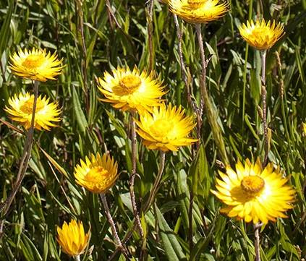

Figure 31: Swamp everlasting (Xerochrysum palustre).

The Australasian bittern is a shy and cryptic wading species of wetland bird. Habitat preferences are for permanent, densely vegetated freshwater wetlands (Garnett 1992). It forages mainly at night in shallow water up to 30 centimetres deep and feeds on frogs, fish and invertebrates as well as occasionally plant material (Marchant and Higgins 1990). The dense rushlands and sedgelands of Apsley Marshes provide ideal habitat and it is most likely a resident at the site. Although it has not been observed breeding, the habitat at the site is suitable, with ample emergent vegetation in shallow water for nest construction. It is likely that the species does breed in the site, but that its cryptic nature coupled with the low survey effort has resulted in the lack of observations.

4.7 Ecological connectivity
The Apsley Marshes Ramsar site connects Moulting Lagoon (and the ocean) with inland freshwater environments acting as a migratory route for diadromous fish species. Most migrations are for feeding or breeding with fish being classified in the following groups:

- diadromous fish migrate between salt and fresh water
- anadromous fish live mostly in the sea, but migrate to breed in fresh or estuarine water
- catadromous fish live in fresh water, migrate to breed in the sea
- amphidromous fish migrate between fresh and salt water during some part of life cycle, but not for breeding
- potamodromous fish migrate within fresh water only
- oceanodromous fish migrate within salt water only.

Within the site there are three species that are known to use migratory routes; these are illustrated in Figure 32 and described in Table 14.

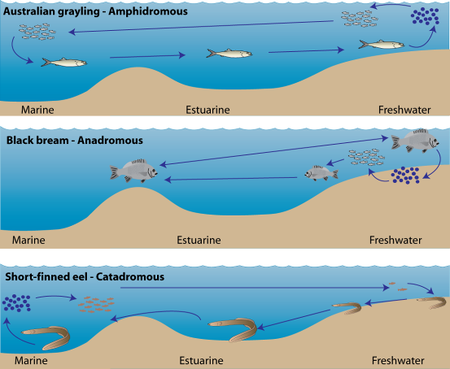
Figure 32: Fish migration in the Apsley Marshes Ramsar site.

Table 14: Lifecycles of migratory fish supported by the Apsley Marshes Ramsar site.
Species | Lifecycle
Australian grayling (Prototroctes maraena) | Adults spend their lives in freshwater most commonly found in clear, gravelly streams with a moderate flow. Spawn in freshwater in autumn and larvae move passively to the sea with the current. Juveniles return to freshwater in spring at about six months of age (Backhouse et al. 2008).
Black bream (Acanthopagrus butcheri) | Adults spend most of their lives in estuaries and near shore coastal environments, rarely venturing into the open ocean. In southern waters, adults migrate during summer into freshwater reaches of rivers and creeks to spawn. A large number of pelagic eggs are laid and adults return to estuarine and near shore marine waters. Juveniles remain in freshwater for up to four years before migrating back to estuaries. Sexually maturity is reached at five years and the species is relatively long lived (Norris et al. 2002).
Short-finned eel (Anguilla australis) | Mature adults migrate from fresh water to the sea in order to spawn in the South Coral Sea, after which it is believed they die. The eel larvae are carried south by the East Australian Current from their spawning grounds until they reach the continental shelf. At around this time they metamorphose into glass eels and subsequently remain at sea for one to three years. After this they begin the long migration to freshwater reaching Tasmania by mid spring. Glass eels remain in estuarine waters to develop into elvers and adjust to fresh water. Upstream migration from the estuary to freshwaters occurs at night and they can overcome barriers to connectivity by travelling across damp grasslands at night. Eels are long lived and are unlikely to breed until 10 – 35 years old (Native Fish Australia 2010).

5. Threats to Ecological Character
Wetlands are complex systems and an understanding of components and processes and the interactions or linkages between them is necessary to describe ecological character. Similarly, threats to ecological character need to be described not just in terms of their potential effects, but the interactions between them. One mechanism for exploring these relationships is the use of stressor models (Gross 2003). The use of stressor models in ecological character descriptions has been suggested by a number of authors to describe ecological character (Phillips and Muller, 2006; Hale and Butcher 2008) and to aid in the determination of limits of acceptable change (Davis and Brock 2008).

Stressors are defined as (Barrett et al. 1976):

“physical, chemical, or biological perturbations to a system that are either (a) foreign to that system or (b) natural to the system but applied at an excessive [or deficient] level”

In evaluating threats it is useful (in terms of management) to separate the driver or threatening activity from the stressor. In this manner, the causes of impacts to natural assets are made clear, which provides clarity for the management of natural resources by focussing management actions on tangible threatening activities.

There are few threats that are likely to significantly impact on the ecological character of the site. However, there are a number of localised or minor threats to identified critical components, processes and services which are illustrated in the stressor model (figure 33). A brief description of each of these threats as well as those that have the potential to impact on essential elements is provided below.

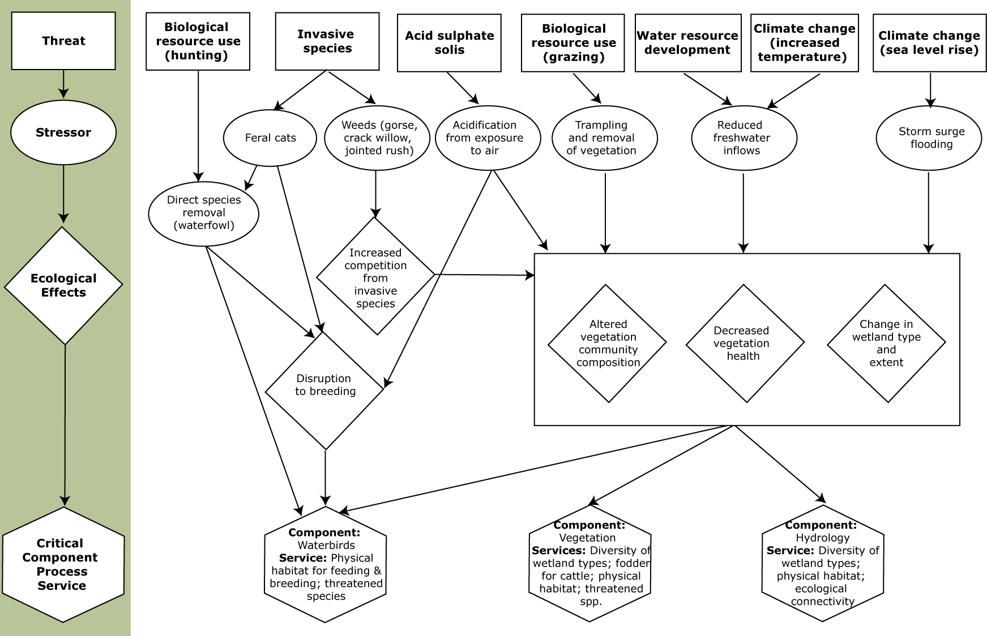

Figure 33: Stressor model of the Apsley Marshes Ramsar site (after Gross 2003 and Davis and Brock 2008).

5.1 Water resource development
The balance of freshwater inputs against saline water from tidal influences is a critical to the site’s ecological character. Any significant changes to the hydrology of the site in the form of reduced inflows or altered season of inflows would have an impact on the ecology of the site. Water resource development is limited in the catchment and predictions for future development are low (see section 5.4). At the time of listing, stream inflows were higher than they have been in the decade 1997 to 2007. However even with lower inflows the ecological character of the site has not changed (see section 7). Currently this is not considered a major threat to the ecological character of the site.

5.2 Acid Sulphate Soils
Acid sulphate soils (ASS) form in coastal, estuarine and some inland wetland environments where water-logged soil provides ideal conditions for the build up of mineral iron pyrite (FeS₂). Left undisturbed, ASS are benign, but disturbance exposes sulphidic compounds in the soil to air and results in the formation of sulphuric acid. This can have direct negative effects on aquatic biota, through decreased pH; and further effects are caused by the action of the acid on other elements in the soil, which includes the production of high concentrations of toxic metals (Hicks et al. 1999).

Predictive mapping of potential ASS undertaken for Tasmania identifies Apsley Marshes as having a high probability of ASS (Figure 34). Any disturbance to soil / sediment that results in exposure to the air such as from construction of additional drainage channels has the potential to significantly impact the ecological character of the site.

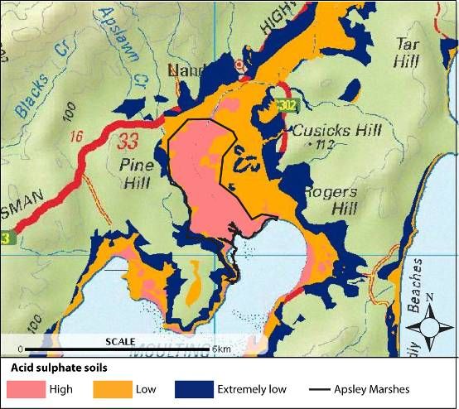
Figure 34: Acid Sulphate Soil predictive mapping (downloaded from theLIST).

5.3 Invasive species and pathogens
Apsley Marshes has a number of invasive species present including rabbits, and feral cats, the former of which is unlikely to cause significant damage to wetland areas and the latter which may result in predation on waterbird adults and young.

Eighteen invasive plants were recorded by Barnes and Visoiu (2002) with three species listed as being of particular concern: gorse (Ulex europeus), crack willow (Salix fragilis), and jointed rush (Juncus articulatus). The remaining introduced species are associated with pasture and disturbed areas and were not considered to pose a significant threat to native vegetation (Barnes and Visoiu 2002).

Gorse is listed as a Weed of National Significance and considered one of the worst weeds in Australia due to its invasive properties. It spreads very quickly and can have considerable economic and environmental impacts (CRC Weed Management 2003). In pastoral areas it provides shelter for rabbits and reduces stocking rates. It is also a fire risk as it is highly flammable (CRC Weed Management 2003). Gorse is widespread in the Ramsar site, occurring in many locations (Barnes and Visoiu 2002).

Conditions within the Ramsar site may not be ideal for crack willow. Whilst only a few trees were recorded by Barnes and Visoiu (2002) colonisation from upstream sources is likely to ensure their continued presence within the site. Jointed rush is considered a potentially serious aquatic weed (Humphries et al. 1991) and is widespread throughout the freshwater zones of the Ramsar site, particularly in areas where cattle frequent (Barnes and Visoiu 2002). Jointed rush is typically found along drainage lines, creeks, rivers and the margins of wetlands, preferring stable inundation of less than 45 centimetres. It can tolerate short periods of flooding and drought (CSIRO 2006). Jointed rush exhibits vigorous growth and a creeping rootstock, allowing it to become locally common and compete with native species. Impacts on native fauna are not well documented, but it can out compete native vegetation (CSIRO 2006).

A clear understanding of the relative impacts of the invasive species within the Ramsar site on ecological character is lacking and remains a knowledge gap. However, other than predation on waterbirds, the impacts of invasive species are thought to be relatively minor and unlikely to lead to a change in ecological character.

Chytridiomycosis is a fatal disease of amphibians and is caused by the chytrid fungus Batrachochytrium dendrobatidis. Chytridiomycosis is a global epidemic and is widespread across Australia (DECC 2009). The fungus invades the surface layers of the frog’s skin, causing damage to the keratin layer. Although the disease is known to cause death, the exact mechanism is not known. It is thought that the fungus either releases a toxin that is absorbed by the skin or prevents respiration and water absorption through the skin (DEH 2006). Four of the eleven Tasmanian frog species occur on the site; brown froglet (Crinia signifera), eastern banjo frog (Lymnodynastes dumerilii), spotted marsh frog (Lymnodynastes tasmaniensis) and brown tree frog (Litoria ewingii). Abundance and distribution remains a knowledge gap. Chytrid fungus could pose a serious threat to frogs within the site.

5.4 Resource utilisation
Floodplain resources of the Apsley Marshes have been utilised as part of a working agricultural property since 1836. Cattle grazing has been occurring at the site for many decades (see section 4.2) particularly in the freshwater rush and sedgelands. As grazing practices were an integral part of the site at the time of listing, and for considerable time prior to listing, grazing would only be a significant threat to the site if high stocking rates led to extensive damage of the wetland, and in particular the loss of threatened plants. However, under current management this is not considered a serious threat to the site’s ecological character, rather it has shaped the character of the site (see section 4.2).

Duck shooting occurs in the site on an annual basis with between 30 to 50 shooters using the site each year (S. Blackhall, DPIPWE, personal communication). Lead pellets have been reported in the surface sediments of Apsley Marshes and there is some concern over lead levels in grazing waterbirds (Smith et al. 1995), however the impact of this on the species which use the site is not monitored.

Recreational fishing may also occur within the site either by invitation from the landholder or by access from the public via Moulting Lagoon. However this is a minor activity and not likely to pose any significant threat to the ecological character of the site.

5.5 Climate change
Climate change predictions for Tasmania include an increase in temperature, a change in rainfall distribution (Grose et al. 2010) and an increase in sea level and storm surge flooding (Sharples 2006). From 1950 to 2007, temperatures in southern Tasmania increased by approximately 0.1 degrees Celsius per decade. It is predicted that by the end of the 21st century, temperatures in Tasmania will have increased by 1.6 to 2.9 degrees Celsius (Grose et al. 2010). Total annual rainfall in Tasmania is not predicted to change significantly by 2100, but the distribution of rainfall may change, with increases on the west coast and decreases in central Tasmania. No significant change in rainfall is predicted for the south-east coast region of the Ramsar site (Grose et al. 2010). This is supported by the findings of CSIRO (2009) who suggest that average river flows for the Swan-Apsley catchment are predicted to decrease by less than one percent.

Rising sea levels and storm surge are likely to be a more significant threat to the ecological character of the Ramsar site. A sea-level rise relative to the land of about 14 centimetres since 1841 has been measured on the south-east Tasmanian coast (Sharples 2006). Global sea-level rise of between nine and 88 centimetres is now projected to occur by 2100 relative to 1990 sea level. The magnitude and frequency of coastal storms is also predicted to increase, which will result in increased extent of flooding (Sharples 2006). Predicted inundation mapping has been produced for 2100 conditions, which indicate significant areas of the southern portion of the Ramsar site vulnerable to storm surge flooding (Figure 35). This has the potential to affect tidal vegetation communities such as paperbark forest and saltmarsh.

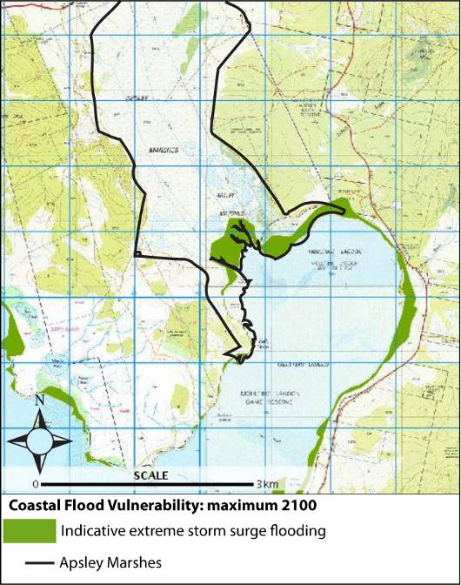

Figure 35: Predicted extent of storm surge flooding (downloaded from theLIST).

5.6 Summary of threats
Although a risk assessment is beyond the scope of an ECD, the DEWHA (2008) framework states that an indication of the impacts of threats to ecological character, likelihood and timing of threats with respect to impact on ecological character should be included. The threats considered in the previous sections have been summarised for the Ramsar site in accordance with the DEWHA (2008) framework Table 15.

Table 15: Summary of the main threats to the Apsley Marshes Ramsar site.
Actual or likely threat or threatening activities | Potential impact(s) to wetland components, processes and/or service | Likelihood¹ | Timing²
Water resource development | - Reduced inflows of freshwater and loss of freshwater marsh habitat. | Medium | Long term
Acid sulphate soils | - Reduced water quality.  - Health impacts to flora and fauna. | Medium | Current – long term
Invasive species and pathogens | - Altered composition of vegetation communities.  - Pressure on waterbird breeding.  - Reduced health of amphibians. | Medium | Current
Resource utilisation | - Overgrazing/stocking could lead to loss of rare plants.  - Reduced health of biota – lead poisoning. | Medium | Current – long term
Climate change (increased temperature) | - Reduced freshwater inflows. | Low | Long term
Climate change (increased sea level and storms) | - Storm surge flooding of vegetation (paperbark and saltmarsh). | Medium | Long term

¹ Where Certain is defined as known to occur at the site or has occurred in the past; Medium is defined as not known from the site but occurs at similar sites; and Low is defined as theoretically possible, but not recorded at this or similar sites.
² Where Current is defined as happening at the time of writing (2010); Long-term is defined as greater than 10 years.

6. Limits of Acceptable Change

6.1 Process for setting Limits of Acceptable Change (LAC)
Limits of acceptable change are defined by Phillips (2006) as:

“…the variation that is considered acceptable in a particular measure or feature of the ecological character of the wetland. This may include population measures, hectares covered by a particular wetland type, the range of certain water quality parameter, etc. The inference is that if the particular measure or parameter moves outside the ‘limits of acceptable change’ this may indicate a change in ecological character that could lead to a reduction or loss of the values for which the site was Ramsar listed. In most cases, change is considered in a negative context, leading to a reduction in the values for which a site was listed.”

LAC and the natural variability in the parameters for which limits are set are inextricably linked. Phillips (2006) suggested that LAC should be beyond the levels of natural variation. Setting limits in consideration with natural variability is an important, but complex concept. Wetlands are complex systems and there is both spatial and temporal variability associated with all components and processes. Defining this variability such that trends away from “natural” can be reliably detected is far from straight forward.

Hale and Butcher (2008) considered that it is not sufficient to simply define the extreme measures of a given parameter and to set LAC beyond those limits. What is required is a method of detecting change in patterns and setting limits that indicate a distinct shift from natural variability (be that positive or negative). This may mean accounting for changes in the frequency and magnitude of extreme events, changes in the temporal or seasonal patterns and changes in spatial variability, as well as changes in the mean or median conditions.

It should be noted that LAC are not synonymous with management values or “trigger levels”. The LAC described here represents what would be considered a change in ecological character at the site in absolute terms, with no regard for detecting change prior to irrevocable changes in wetland ecology. Detecting change with sufficient time to instigate management actions to prevent an irrevocable change in ecological character is the role of wetland management and the management plan for a site should develop and implement a set of management triggers with this aim.

6.2 LAC for the Apsley Marshes Ramsar site
LAC have been set for the Apsley Marshes Ramsar site based on conditions at the time of listing (Table 16). Ideally, site specific information would be used to statistically determine LAC. However there is insufficient quantitative information for any of the identified critical components, processes, benefits and services to develop rigorous, defensible LAC for the Apsley Marshes Ramsar site. As such, all that can be provided at this time are qualitative LAC based on the precautionary principle. It must be recognised that these will require careful review as increased information is gained from future monitoring.

LAC are required for all identified critical components, processes, benefits and services. However, due to the interrelated nature of components, processes and services a single LAC may in fact account for multiple components, process and services. For example, the LAC that address hydrology and vegetation at Apsley Marshes also cover the critical services of providing fodder for cattle, diversity of wetland types and physical habitat. If hydrology and/or vegetation were significantly altered this would lead to a loss of the services. In order to limit repetition in the LAC for Apsley Marshes, a hierarchical approach has been adopted where LAC have been set for components, which in this case has also covered critical services.
The columns in Table 16 contain the following information:

Critical component / process or service | The critical component, processes or service that is addressed by the LAC.
Baseline / supporting evidence | Relevant baseline information (relevant to the time of listing) and any additional supporting evidence from the scientific literature and / or local knowledge.
Limit of Acceptable Change | The LAC to be assessed against.
Confidence level | The degree to which the authors are confident that the LAC represents the point at which a change in character has occurred. Assigned as follows:  High – Quantitative site specific data; good understanding linking the indicator to the ecological character of the site; LAC is objectively measureable.  Medium – Some site specific data or strong evidence for similar systems elsewhere derived from the scientific literature; or informed expert opinion; LAC is objectively measureable.  Low – no site specific data or reliable evidence from the scientific literature or expert opinion, LAC may not be objectively measurable and / or the importance of the indicator to the ecological character of the site is unknown.

Table 16: Limits of Acceptable Change for the Apsley Marshes Ramsar site.
Component, Process and Service | Baseline/Supporting Evidence | Limit of Acceptable Change* | Confidence level
Critical components and processes
Hydrology | The Apsley Marshes receive freshwater inflows from the Apsley River. Although there is no information for flows into the site, data from immediately upstream indicate a relatively high degree of interannual variability (Figure 21). For example, from 1968 to 1992 average daily flow during winter ranged from less than 10 megalitres a day to over 5000 megalitres a day (data from State of Tasmania 2010).  Of equal importance is the estuarine water that enters the site on tides from Moulting Lagoon. However, there is no quantitative information on this source of water.  The site supports freshwater and saline permanent and intermittent wetlands. However mapping and other information is insufficient to determine extent and variability.  In the absence of sufficient data LAC are based on no change in hydrological wetland types. | No change in wetland hydrological types present within the site. That is the following hydrological regimes maintained:  - Permanent freshwater across part of the north area of the site;  - Areas of sedgeland inundated with freshwater annually;  - Tidal inundation of saltmarsh and paperbarks daily; and  - Presence of permanent saline channels and pools in the lower portion of the marsh. | Low
Vegetation – rare and threatened species | Over eighty native species of wetland plant were recorded in 2002, including a nationally threatened species (swamp everlasting) and a further six species of bioregional conservation significance (Barnes and Visoiu 2002).  A qualitative LAC based on presence of rare and threatened species has been provided. | Presence of the following species within the site:  - Swamp everlasting  - Water woodruff  - Swamp violet  - Drooping sedge  - Purple loosestrife  - Southern swampgrass  - Gentle rush. | Low
Vegetation - communities | Ten wetland vegetation communities were described by Barnes and Visoiu 2002), although extent was not determined and there is no quantitative information on variability (seasonally or interannually).  A qualitative LAC based on presence vegetation communities has been provided. | Presence of the following vegetation communities within the Ramsar site (as described by Barnes and Visoiu 2002):  - Succulent saltmarsh  - Saw sedge saltmarsh  - Sea rush rushland  - Saline aquatic wetland  - Paperbark forest  - Common rush rushland  - Typha rushland  - Twig rush sedgeland  - Freshwater aquatic wetland  - Riparian vegetation. | Low
Vegetation - diversity | Eighty-two, native wetland dependent species have been recorded from within the site (Barnes and Visiou 2002) and the site is considered significant in terms of floral diversity. However, variability in extent and community composition is unknown.  A LAC based on retaining at least 80% of the taxa listed in Appendix B is proposed. | Presence of at least 65 species of wetland dependent, native floral species within the site. | Low
Waterbirds | Data on waterbird usage at the site is based on two sets of surveys, one conducted in the early 1980s (Blackhall unpublished) and one undertaken as part of this ECD process (Znidersic unpublished). The most significant species in terms of occurrence and abundance is the black swan, which breeds annually within the site. The site also supports the internationally endangered Australasian bittern, which is a resident at the site and the white-bellied sea eagle which is known to breed at the site..  In the absence of sufficient data to develop quantitative LAC, qualitative LAC are proposed. | Presence and breeding of black swans within the site, annually. | Low
Waterbirds |  | Presence and breeding of white-bellied sea eagle in at least three out of any five year period. | Low
Waterbirds |  | Presence of Australasian bittern within the site. | Low
Critical Services
Provisioning service – fodder for cattle | Service provided by the inundation of freshwater sedge and rush communities on the site and so maintained by hydrology and vegetation communities. | See LAC for hydrology and vegetation communities. | Not applicable
Diversity of wetland types | Wetland types are maintained by hydrology and vegetation. | See LAC for hydrology and vegetation communities. | Not applicable
Biodiversity | Biodiversity values of the site lie predominantly with the high diversity of wetland flora and can be indicated by the species richness of wetland plants. | See LAC for vegetation. | Not applicable
Threatened species | The site supports two threatened species, the swamp everlasting and Australasian bittern, both of which are represented in LAC for components. | See LAC for plant species and Australasian bittern. | Not applicable
Physical habitat | Physical habitat for waterbirds is maintained through wetland types and can be indicated by the numbers of waterbirds supported by the site | See LAC for hydrology, vegetation and waterbirds. | Not applicable
Ecological connectivity | Connectivity for fish migration is maintained through hydrological connections from Moulting Lagoon to inland freshwater wetlands via the Apsley River. While the LAC for hydrology partially address this service, it is important that physical connectivity is also retained and that obstructions to water flow are not introduced to the site. | No barriers to hydrological connectivity between Moulting Lagoon and the Apsley River within the Ramsar site. | High
*Exceeding or not meeting a LAC does not automatically indicate that there has been a change in ecological character.

7. Current Ecological Character and Changes Since Designation

It has been over a quarter of a century since the Apsley Marshes Ramsar site was designated as a Wetland of International Importance. As such, changes to the system are to be expected. However, there is no evidence of change in character. Whether this is due to a lack of empirical data or the maintenance of ecological character is not certain. However, anecdotal evidence suggests that the site has not changed significantly since listing in 1982 (landholder, personal communication).

An assessment of current conditions with respect to LAC is provided in Table 17. This highlights the lack of data available to determine change in character for some components.

Table 17: Assessment of current conditions against LAC for the Apsley Marshes Ramsar site.
Critical component / process | Limit of Acceptable Change* | Current conditions | Confidence that LAC is met.
Hydrology | No change in wetland hydrological types present within the site. That is the following hydrological regimes maintained:  - Permanent freshwater across part of the north area of the site;  - Areas of sedgeland inundated with freshwater annually;  - Tidal inundation of saltmarsh and paperbarks daily; and  - Presence of permanent saline channels and pools in the lower portion of the marsh. | Site visits in 2010 indicated that wetland types described are still present within the site. | High
Vegetation | Presence of the following species within the site:  - Swamp everlasting  - Purple Loosestrife  - Water Woodruff  - Swamp Violet  - Drooping Sedge  - Southern swampgrass  - Gentle rush. | Species were recorded in 2002, but no survey has been conducted since this time. | Low
Vegetation | Presence of the following vegetation communities within the Ramsar site (as described by Barnes and Visoiu 2002):  - Succulent saltmarsh  - Saw sedge saltmarsh  - Sea rush rushland  - Saline aquatic wetland  - Paperbark forest  - Common rush rushland  - Typha rushland  - Twig rush sedgeland  - Freshwater aquatic wetland  - Riparian vegetation. | Although no vegetation survey was undertaken, most of these vegetation communities were observed during field visits in 2010. | Medium
Vegetation | Presence of at least 65 species of wetland dependent, native floral species within the site. | Eighty-two species were recorded in 2002, but no survey has been conducted since this time. | Low
Waterbirds | Presence and breeding of black swans within the site, annually. | Black swans were recorded breeding during 2010. | High
Waterbirds | Presence and breeding of white-bellied sea eagle in at least three out of any five year period. | White-bellied sea eagle was recorded near nest in 2010. | High
Waterbirds | Presence of Australasian bittern within the site. | Australasian bittern was recorded in 2010. | High

*Exceeding or not meeting a LAC does not automatically indicate that there has been a change in ecological character.

8. Knowledge Gaps
Throughout the Ecological Character Description for the Apsley Marshes Ramsar site, mention has been made of knowledge gaps and data deficiencies for the site. While it is tempting to produce an infinite list of research and monitoring needs for this wetland system, it is important to focus on the purpose of an ecological character description and identify and prioritise knowledge gaps that are important for describing and maintaining the ecological character of the system. As such knowledge gaps that are required to fully describe the ecological character of this site and enable rigorous and defensible limits of acceptable change to be met are relatively few and listed in Table 18.

Table 18: Knowledge Gaps for the Apsley Marshes Ramsar site.
Knowledge Gap | Recommended Action | Priority
Hydrological cycles – there is currently no information on the variability in extent and duration of inundation of the wetlands within the site. | Mapping of inundation cycles either from aerial imagery time series or from hydrological modelling to provide clear information on cycles of inundation. | Medium
Groundwater contributions to the hydrology of the site remain unknown, but are not thought to be significant. | Hydrological investigation of water sources and a water balance for the site. | Low
Water quality – there is no information available on water quality from within the site. Of note are salinity and nutrient concentrations. | Monitoring of water quality within the marshes. | Low
Vegetation – survey and mapping undertaken in 2002 represents the only available information on vegetation at the site. There are no estimates of abundance of rare plants, vegetation community extent or degree of variability in community composition and extent. | Repeated surveys on a regular basis (3 – 5 years) to determine variability in community composition and extent (including threatened flora). | High
Invertebrates – no information on aquatic invertebrate community composition and abundance at the site. | Investigation of invertebrate species composition and abundance in freshwater and marine areas of the site. | Low
Fish – only anecdotal records of fish use within the site. No information available on diversity, abundance and the importance of the site as a migratory route. | Annual surveys of fish from within the site, timed to match likely breeding migrations of significant species such as the Australian grayling. | High
Amphibians – limited information on the species, abundance and distribution of frogs within the site. | Survey of amphibians within the site and an assessment of the status of chytrid fungus. | Medium
Waterbirds – information is limited to surveys conducted in 1984 – 1986 and two surveys in 2010. Long term records of abundance, diversity and nesting are lacking. | Annual waterbird surveys and nest counts. Could be timed to match those undertaken in the adjacent Moulting Lagoon. | High
Pest plants and animals – no information on the extent / abundance of pest plants and animals at the site. | Weed control monitoring. | High
 | Pest animal monitoring. | Medium

9. Monitoring Needs
As a signatory to the Ramsar Convention, Australia has made a commitment to protect the ecological character of its Wetlands of International Importance. While there is no explicit requirement for monitoring the site, in order to ascertain if the ecological character of the wetland site is being protected a monitoring program is required.

A comprehensive monitoring program is beyond the scope of an ECD. What is provided is an identification of monitoring needs required to both set baselines for critical components and processes and to assess against limits of acceptable change. It should be noted that the focus of the monitoring recommended in an ECD is an assessment against LAC and determination of changes in ecological character. This monitoring is not designed as an early warning system whereby trends in data are assessed to detect changes in components and processes prior to a change in ecological character of the site. This must be included in the management plan for the site.

The recommended monitoring to meet the obligations under the Ramsar Convention and the EPBC Act with respect to the Apsley Marshes Ramsar site are provided in Table 19.

Table 19: Monitoring needs for the Apsley Marshes Ramsar site
Component/ Process | Purpose | Indicator | Locations | Frequency | Priority
Hydrology | Assessment against LAC | Extent and duration of inundation | Entire site | Every two years | Medium
Water quality | Threat indicator, knowledge gap | Salinity  Nutrients | Freshwater sections of the site | Monthly | Low
Vegetation communities | Assessment against LAC | Extent and community composition | Entire site | Every two to five years | High
Rare and threatened plant species | Assessment against LAC | Location, abundance | Known locations within the site. | Every two to five years | High
Invertebrates | Fill knowledge gap | Abundance and species identifications | Entire site | Annual | Low
Fish | Fill knowledge gap, inform LAC | Community composition and abundance | Entire site | Annual | High
Amphibians | Fill knowledge gap | Community composition and abundance | Entire site | Annual | Medium
Waterbirds | Assessment against LAC | Abundance and species identifications, breeding observations, black swan nest counts | Entire site | Annual | High
Weeds | Threat assessment | Extent and distribution | Entire site | Annual | High
Pest animals | Threat assessment | Abundance | Entire site | Every two years | Low

10. Communication and Education Messages

Under the Ramsar Convention a Program of Communication, Education, Participation and Awareness (CEPA) was established to help raise awareness of wetland values and functions. At the Conference of Contracting Parties in Korea in 2008, a resolution was made to continue the CEPA program in its third iteration for the next two triennia (2009 – 2015).

The vision of the Ramsar Convention’s CEPA Program is: “People taking action for the wise use of wetlands.” To achieve this vision, three guiding principles have been developed:

- The CEPA Program offers tools to help people understand the values of wetlands so that they are motivated to become advocates for wetland conservation and wise use and may act to become involved in relevant policy formulation, planning and management.
- The CEPA Program fosters the production of effective CEPA tools and expertise to engage major stakeholders’ participation in the wise use of wetlands and to convey appropriate messages in order to promote the wise use principle throughout society.
- The Ramsar Convention believes that CEPA should form a central part of implementing the Convention by each Contracting Party. Investment in CEPA will increase the number of informed advocates, actors and networks involved in wetland issues and build an informed decision-making and public constituency.

The Ramsar Convention encourages that communication, education, participation and awareness are used effectively at all levels, from local to international, to promote the value of wetlands. A comprehensive CEPA program for an individual Ramsar site is beyond the scope of an ECD.

Key CEPA messages for the Apsley Marshes Ramsar site arising from this ECD, which should be promoted through these programs, are focussed on wise use of the site by the landholder. The site is privately owned and there is no public access so opportunities and the need for wider community education through this site are limited. Key messages include:

- The Ramsar values of the site and the importance of the Ramsar site as a habitat for shorebirds and waterfowl to meet different needs in their lifecycles.

- The role of past and present site management and agricultural practices in maintaining ecological character of the site.

- Cooperation between the land owner and government agencies for effective management of the site. Recognising and implementing the “wise use” principle to allow for both economic and conservation outcomes from the wetland.

References

Australian Heritage Commission (2002). Australian Natural Heritage Charter for conservation of places of natural heritage significance. Second Edition. Australian Heritage Commission . Canberra.

ANZECC and ARMCANZ, 2000, Australian and New Zealand Guidelines for Fresh and Marine Water Quality National Water Quality Management Strategy Paper no. 4.Australian and New Zealand Environment and Conservation Council / Agriculture and Resource Management Council of Australia and New Zealand

Australian Water Resources Council 1987, Review of Australia's Water Resources and Water Use 1985, Vol. 1 and 2, Water Resources Data Set, Australian Government Publishing Service, Canberra.

Backhouse, G., Jackson, J. and O’Connor, J. 2008. Background and Implementation Information for the Australian Grayling Prototroctes maraena National Recovery Plan. Department of Sustainability and Environment, Melbourne.

Bamford, M, D. Watkins, W. Bancroft, G. Tischler and J. Wahl. 2008. Migratory Shorebirds of the East Asian - Australasian Flyway; Population Estimates and Internationally Important Sites. Wetlands International Oceania. Canberra, Australia.

Barnes, R. and Visoiu, M., 2002, Bushcare Report and Botanical Survey for Apsley Marshes, ‘Apslawn’ Tasmania. Bushcare Technical Extension, Nature Conservation Branch, Department of Primary Industries, Water and Environment, Tasmania.

Barrett, G.W., Van Dyne, G.M. and Odum, E.P., 1976. Stress ecology, BioScience 26: 192 – 194.

Birds Australia, unpublished, extract for the Australian Bird Atlas, May 2010.

Blackhall, S.A., 1988, A Survey to Determine Waterbird Usage and Conservation Significance of Selected Tasmanian Wetlands: Stage 2. Dept. Lands, Parks and Wildlife, Tasmania, Occasional Paper No. 16.

Blackhall, S., unpublished, Waterbird observations from Apsley Marshes 1984 to 1986.

Braithwaite, L.W., 1967, The ecology of the black swan (Cygnus atratus), Masters Thesis, University of Sydney.

Braithwaite, L.W., 1981, Ecological studies of the black swan III. Behaviour and social organisation, Australian Wildlife Research, 14: 65-109.

Braithwaite, L.W. and Frith, H.J., 1969, Waterfowl in an inland swamp in New South Wales: 3 breeding, CSIRO Wildlife Research, 8 (1): 135-146.

Bureau of Meteorology, 2010, Climate data online, downloaded from http://www.bom.gov.au/climate/averages/ on 12/7/2010.

Carter, O. and Walsh, N., 2010, National Recovery Plan for the Swamp Everlasting Xerochrysum palustre, Draft for publics comment, Victorian Government Department of Sustainability and Environment (DSE) East Melbourne.

CRC Weed Management 2003, Weed management guide: Gorse (Ulex europaeus). Weeds of National Significance. http://www.weeds.gov.au/publications/guidelines/wons/pubs/u-europaeus.pdf

CSIRO 2006, Water for a Healthy Country: Taxon attribute profile Juncus artiuclatus http://www.anbg.gov.au/cpbr/WfHC/Juncus-articulatus/index.html

CSIRO 2009, Water availability for the Derwent-South East region. Report seven of seven to the Australian Government from the CSIRO Tasmania Sustainable Yields Project, CSIRO Water for a Healthy Country Flagship, Australia.

Davis, J. and Brock, M., 2008, Detecting unacceptable change in the ecological character of Ramsar wetlands, Ecological Management and Restoration, 9: 26-32.

Debus, S.J.S., 2008, Biology and diet of the White-bellied Sea-Eagle Haliaeetus leucogaster breeding in northern inland New South Wales, Australian Field Ornithology, 25: 165–193.

DECC (Department of Environment and Climate Change NSW), 2009, Infection of frogs by amphibian chytrid causing the disease chytridiomycosis - key threatening process listing, http://www.environment.nsw.gov.au/animals/AmphibianChytridKTPListing.htm

DEH 2006, Background document for the threat abatement plan infection of amphibians with chytrid fungus resulting in chytridiomycosis. http://www.environment.gov.au/biodiversity/threatened/publications/tap/pubs/chytrid-background.pdf

DEWHA (Department of Environment, Water, Heritage and the Arts), 2008, National Framework and Guidance for Describing the Ecological Character of Australia’s Ramsar Wetlands. Module 2 of Australian National Guidelines for Ramsar Wetlands – Implementing the Ramsar Convention in Australia.

DPIPWE (Department of Primary Industry, Parks, Water and Environment), 2010, Natural Values Atlas Report for Apslawn, DPIPWE, Hobart, Tasmania.

DPIW (Department of Primary Industry Water), 2007, Auditing Tasmania’s Freshwater Ecosystem Values. Summary of assessment framework A strategic framework for statewide management and conservation of Tasmania’s freshwater ecosystem values. Water Assessment Branch, Water Resources Division, DPIW, Tasmania.
DTAE (Department of Tourism, Arts and the Environment), 2003, Moulting Lagoon Game Reserve (Ramsar Site) Management Plan.

Garnett, S.T., 1992, Threatened and Extinct Birds of Australia. RAOU Report 82. RAOU, Melbourne & ANPWS, Canberra.

Gordon, N.D., McMahon, T.A., Finlayson, B.L., Gippel, C.J. and Nathan, R.J., 1999, Stream Hydrology - An Introduction for Ecologists (2nd Edition), John Wiley & Sons
Grose, M.R., Barnes-Keoghan, I., Corney, S.P., White, C.J., Holz, G.K., Bennett, J.B., Gaynor, S.M. and Bindoff .N.L., 2010, Climate Futures for Tasmania: general climate impacts technical report, Antarctic Climate & Ecosystems Cooperative Research Centre, Hobart, Tasmania.

Gross, J., 2003, Developing Conceptual Models for Monitoring Programs http://science.nature.nps.gov/im/monitor/docs/Conceptual_Modelling.pdf
Hale, J. and Butcher, R., 2008, Ecological Character Description of the Peel-Yalgorup Ramsar Site, Report to DEC and PHCC.

Holland J., 1998, Emergence: From Chaos to Order, Addison-Wesley, Reading, MA,.

Hicks, W.S., Bowman, G.M. and Fitzpatrick, R.W., 1999, East Trinity Acid Sulfate Soils, Part 1: Environmental Hazards, CSIRO Land and Water Technical Report 14/99.

Humphries, S.E., Groves, R.H. and Mitchell, D.S. 1991. Plant invasions of Australian ecosystems. Report to: Australian National Parks and Wildlife Service Endangered Species Program, Project No. 58, Australian National Parks and Wildlife Service, Canberra.

Jerie, K., Houshold, I. and Peters, D., 2003, Tasmania’s river geomorphology: stream character and regional analysis. Nature Conservation Report 03/5, Nature Conservation Branch, DPIWE.

Kirkpatrick, J.B. and Harwood, C.E., 1981, The conservation of Tasmanian wetland macrophytic species and communities. A Report to the Australian Heritage Commission from the Tasmanian Conservation Trust Inc., Hobart.

Marchant, S., and Higgins, P.J. (eds), 1990, Handbook of Australian, New Zealand and Antarctic Birds. Oxford University Press: Melbourne

McGrath, C. 2006, unpublished Legal review of the framework for describing the ecological character of Ramsar wetlands to support implementation of the EPBC Act. Report to the Department of the Environment and Heritage, Unpublished.

Millennium Ecosystem Assessment, 2005, Ecosystem Services and Human Well-Being: Wetlands & Water: Synthesis. 2005. Millennium Ecosystem Assessment report to the Ramsar
Convention: World Resources Institute, Washington D.C.

Murphy R.J., Crawford, C.M. and Barmuta, L., 2002, Estuarine health in Tasmania, status and indicators: water quality. TAFI Technical report no 16, Hobart.

Native Fish Australia, 2010 http://www.nativefish.asn.au/sfeel.html accessed October 2010.

Norris, J.V. Tregonning, J., Lenanton, R. and Sorre, G., 2002, Biological synopsis of the Black Bream, Acanthopagrus butcheri in Western Australia with reference to information from other states" Fisheries Research Report (Perth: Department of Fisheries, Government of Western Australia).

Parks and Wildlife Service 2007, Moulting Lagoon Game Reserve (Ramsar Site) Management Plan 2003, Department of Tourism, Arts and the Environment, Hobart.

Phillips, B., 2006, Critique of the Framework for describing the ecological character of Ramsar Wetlands (Department of Sustainability and Environment, Victoria, 2005) based on its application at three Ramsar sites: Ashmore Reed National Nature Reserve, the Coral Sea Reserves (Coringa-Herald and Lihou Reeds and Cays), and Elizabeth and Middleton Reeds Marine National Nature Reserve. Mainstream Environmental Consulting Pty Ltd, Waramanga ACT.

Phillips, B. and Muller, K., 2006, Ecological Character Description of the Coorong, Lakes Alexandrina and Albert Wetland of International Importance, Department of Environment and Heritage, Adelaide, South Australia

Ramsar Convention, 2010, What is Wise Use of Wetlands? http://www.ramsar.org/cda/en/ramsar-about-faqs-what-is-wise-use/main/ramsar/1-36-37%5E7724_4000_0__ Accessed October 2010.

Ramsar Convention, 1996, Resolution VI.1. Annex to Resolution VI.1. Working Definitions, Guidelines for Describing and Maintaining Ecological Character of Listed Sites, and Guidelines for Operation on the Montreux Record.

Ramsar Convention, 1987, Convention on Wetlands of International Importance especially as Waterfowl Habitat.

Ramsar Convention 2005, Resolution IX.1 Annex A. A Conceptual Framework for the wise use of wetlands and the maintenance of their ecological character. http://www.ramsar.org/res/key_res_ix_01_annexa_e.htm

Ramsar Convention, 2009, Strategic Framework for the List of Wetlands of International Importance, edition 2009. http://www.ramsar.org/key_guide_list2009_e.htm#V

Reeves, P.N. and Champion, P.D., 2004, Effects of Livestock Grazing on Wetlands: Literature Review, National Institute of Water and Atmospheric Research Ltd., New Zealand.

Sharples, C., 2006: Indicative Mapping of Tasmanian Coastal Vulnerability to Climate Change and Sea-Level Rise: Explanatory Report (Second Edition); Consultant Report to Department of Primary Industries & Water, Tasmania.

Smith, O.L., Goede, A. and Blackhall, S.A., 1995, Lead contamination of waterfowl in Tasmania by ingestion of shotgun pellets from duck shooting. Wildl. Res. 22(5): 611-623.

State of Tasmania, 2010, WIST (Water Information System of Australia) http://water.dpiw.tas.gov.au accessed July 20, 2010.

State of Tasmania (undated), theLIST (Land Information System Tasmania) http://www.thelist.tas.gov.au/ and TASMAP (https://www.tasmap.tas.gov.au/) data supplied by Information & Land Services Division (ILS) of the Department of Primary Industries, Parks, Water and Environment (DPIPWE).

Temby, N. and Crawford, C., 2008, Coastal and Estuarine Resource Condition Assessment: A baseline survey in the Southern NRM Region, Tasmania, Tasmanian Aquaculture and Fisheries Institute, University of Tasmania.

Wetlands International, 2006, Waterbird Population Estimates, fourth edition.

Znidersic, L., unpublished, Results of waterbird surveys conducted at Apsley Marshes in July and October, 2010, Birds Tasmania, Hobart.

Appendix A: Methods

A.1 Approach
The method for compiling this ECD comprised of the following tasks:

Project Inception:
Consultant team leader Jennifer Hale met with the Department of the Sustainability, Environment, Water, Population and Communities (SEWPaC) project manager to confirm the scope of works and timelines as well as identifying relevant stakeholders that would be consulted.

Task 1: Review and compilation of available data
The consultant team undertook a thorough desktop review of existing information on the ecology of the Apsley Marshes Ramsar site.

Task 2: Stakeholder engagement and consultation
A Steering Committee was formed for the Apsley Marshes Ramsar site ECD. This group was comprised of representatives of the following stakeholder groups with an interest in the ECD and management planning process:

- Private landowners
- Ken Morgan, Australian Government Department of Sustainability, Environment, Water, Population and Communities
- Stewart Blackhall, Tasmanian Department of Primary Industry, Parks, Water and Environment
- Micah Visoiu, Tasmanian Department of Primary Industry, Parks, Water and Environment
- Melanie Kelly, NRM South

Task 3: Development of a draft ECD
Consistent with the national guidance and framework (2008) the following steps were undertaken to describe the ecological character of the Apsley Marshes Ramsar site.

Steps from the national framework (DEWHA 2008) | Activities
1. Document introductory details | Prepare basic details: site details, purpose, legislation.
2. Describe the site | Based on the Ramsar RIS and the above literature review describe the site in terms of: location, land tenure, Ramsar criteria, wetland types (using Ramsar classification).
3. Identify and describe the critical components, processes and services | - Identify all possible components, processes services and benefits.  - Identify and describe the critical components, services and benefits responsible for determining ecological character
4. Develop a conceptual model of the system. | Two types of models were developed for the system:  - A series of control models that describe important aspects of the ecology of the site, including feedback loops. Aiding in the understanding of the system and its ecological functions.  - A stressor model that highlights the threats and their effects on ecological components and processes. Aiding in understanding management of the system.
5. Set Limits of Acceptable Change | For each critical component, process and service, establish the limits of acceptable change.
6. Identify threats to the site | This process identified both actual and potential future threats to the ecological character of the wetland system.
7. Describe changes to ecological character since the time of listing | This section describes in quantitative terms (where possible) changes to the wetlands since the initial listing in 1990.
8. Summarise knowledge gaps | This identifies the knowledge gaps for not only the ecological character description, but also for its management.
9. Identify site monitoring needs | Based on the identification of knowledge gaps above, recommendations for future monitoring are described.
10. Identify communication, education and public awareness messages | Following the identification of threats, management actions and incorporating stakeholder comments, a general description of the broad communication / education messages are described.

Task 4: Revision of the Ramsar Information Sheet (RIS)
The information collated during Task 1, together with the draft ecological character description, was used to produce a revised RIS in the standard format provided by Ramsar.

Task 5 Finalising the ECD and RIS
The draft ECD and RIS were submitted to DEWHA, and the Steering Committee for review. Comments from agencies and stakeholders were incorporated to produce revised ECD and RIS documents.

A.2 Consultant Team
Jennifer Hale
Jennifer has over twenty years experience in the water industry having started her career with the State Water Laboratory in Victoria. Jennifer is an aquatic ecologist with expertise in freshwater, estuarine and near-shore marine systems. She is qualified with a Bachelor of Science (Natural Resource Management) and a Masters of Business Administration. Jennifer’s fields of expertise include phytoplankton dynamics, aquatic macrophytes, sediment water interactions and nutrient dynamics. She has a broad understanding of the ecology of aquatic macrophytes, fish, waterbirds, macroinvertebrates and floodplain vegetation as well as geomorphic processes. She has a solid knowledge of the development of ecological character descriptions and has been involved in the development of ECDs for the Peel-Yalgorup, the Ord River Floodplain, Eighty-mile Beach, the Coorong and Lakes Alexandrina and Albert, Lake MacLeod, Elizabeth and Middleton Reefs, Ashmore Reef and the Coral Seas Ramsar sites.

Rhonda Butcher
Rhonda is considered an expert in wetland ecology and assessment. She has a BSc (hons) and a PhD in Wetland Ecology together with over twenty years of experience in the field of aquatic science. She has extensive experience in biological monitoring, biodiversity assessment, invertebrate ecology as well as wetland and river ecology having worked for CSIRO/Murray Darling Freshwater Research Centre, Monash University/CRC for Freshwater Ecology, Museum of Victoria, Victorian EPA and the State Water Laboratories of Victoria. Rhonda has worked on numerous Ramsar related projects over the past eight years, including the first pilot studies into describing ecological character. She has subsequently co-authored, provided technical input, and peer reviewed a number of Ecological Character Descriptions. She project managed the preparation of Ramsar nomination documents for Piccaninnie Ponds Karst Wetlands in South Australia, which included preparation of the ECD, RIS and Ramsar Management Plan. Other Ramsar sites she has been involved with the development of ECD include Coongie Lakes, Banrock Station Wetland Complex, Coorong and Lakes Alexandrina and Albert, Lake MacLeod, Peel-Yalgorup, Eighty-mile Beach, Narran Lakes, The Dales and Hosnies Spring on Christmas Island. Rhonda is currently project managing the Ramsar Rolling Review developing a framework for reporting the status of ecological character at all 64 Ramsar sites in Australia.

Halina Kobryn
Dr Halina Kobryn has over fifteen years of experience in applications of GIS and remote sensing in environmental applications. She is a GIS and remote sensing expert, specialising in natural resource assessment. Dr Kobryn has a BSc in Physical Geography and Cartography, Graduate Diploma in Surveying and Mapping and a PhD which explored impacts of stormwater on an urban wetland and explored GIS methods for such applications. She has worked at a university as a lecturer for over 15 years and taught many subjects including GIS, remote sensing, environmental monitoring and management of aquatic systems. She has developed the first course in Australia (at a graduate level) on Environmental Monitoring. She has been involved in many research and consulting projects and her cv outlines the breadth of her expertise. She has also supervised over 20 research students (honours, Masters and PhD). She has worked in Indonesia, Malaysia (Sarawak) and East Timor on projects related to water quality and river health.

Appendix B: Vegetation
From Barnes and Visoiu 2002.
i = introduced and naturalised in Tasmania
e = endemic in Tasmania (i.e. only occurs naturally in Tasmania)
V= Vulnerable (EPBC Act)
V = Vulnerable (Tasmanian Threatened Species Protection Act)
R = Rare (Tasmanian Threatened Species Protection Act).

Family |  | Species name | Common name
Apiaceae |  | Angianthus preissianus | Salt Angianthus
Apiaceae |  | Apium prostratum | Sea Parsley
Apiaceae |  | Hydrocotyle muscosa | Mossy Pennywort
Apiaceae |  | Hydrocotyle pterocarpa | Wing Pennywort
Apiaceae |  | Lilaeopsis polyantha | Australian Lilaeopsis
Asteraceae |  | Brachyscome graminea | Grass Daisy
Asteraceae | V | Xerochrysum palustre | Swamp Everlasting
Asteraceae | i | Cotula coronopifolia | Water Buttons
Asteraceae |  | Leptinella longipes | Long Cotula
Boraginaceae | i | Myosotis laxa subsp. caespitosa | Water Forget-me-note
Campanulaceae |  | Isotoma fluviatilis | Swamp Isotome
Campanulaceae |  | Pratia pedunculata | Matted Pratia
Campanulaceae |  | Pratia surrepens | Mud Pratia
Chenopodiaceae | i | Atriplex prostrata | Hastate orach
Chenopodiaceae | i | Chenopodium glaucum | Pale Goosefoot
Chenopodiaceae |  | Sarcocornia quinqueflora | Beaded Glasswort
Crassulaceae |  | Crassula helmsii | Swamp Stonecrop
Fabaceae | i | Lotus uliginosus | Greater Trefoil
Fabaceae | i | Ulex europaeus | Gorse
Goodeniaceae |  | Selliera radicans | Swamp-weed
Haloragaceae |  | Myriophyllum salsugineum | Brackish Water-milfoil
Haloragaceae |  | Myriophyllum variifolium | Variable Water-milfoil
Haloragaceae |  | Myriophyllum simulans | Water-milfoil
Lentibulariaceae |  | Utricularia dichotoma | Fairies' Aprons
Lythraceae | V | Lythrum salicaria | Purple Loosestrife
Menyanthaceae |  | Villarsia reniformis | Running Marsh-flower
Myrtaceae |  | Eucalyptus ovata | Black Gum
Myrtaceae |  | Leptospermum lanigerum | Woolly Tea-tree
Myrtaceae |  | Melaleuca ericifolia | Swamp Paperbark
Polygonaceae |  | Persicaria praetermissa | Bristly knotweed
Polygonaceae |  | Rumex brownii | Swamp Dock
Polygonaceae | i | Rumex crispus | Curled Dock
Portulacaceae |  | Neopaxia australasica | White Purslane
Primulaceae | i | Anagallis arvensis | Scarlet Pimpernel
Primulaceae |  | Samolus repens | Creeping Brookweed
Ranunculaceae | i | Batrachium trichophyllum | Frogwort
Ranunculaceae |  | Ranunculus amphitrichus | River Buttercup
Rubiaceae | R | Asperula subsimplex | Water Woodruff
Salicaceae | i | Salix fragilis | Crack Willow
Scrophulariaceae |  | Gratiola peruviana | Austral Brooklime
Scrophulariaceae |  | Limosella australis | Mudwort
Scrophulariaceae |  | Mimulus repens | Creeping Monkey Flower
Violaceae | R | Viola caleyana | Swamp Violet
Cyperaceae |  | Baumea arthrophylla | Jointed Twig-rush
Cyperaceae |  | Baumea juncea | Bare Twig-rush
Cyperaceae |  | Carex appressa | Tall sedge
Cyperaceae |  | Carex gaudichaudiana | Sedge
Cyperaceae | R | Carex longebrachiata | Bergalia Tussock; Drooping Sedge
Cyperaceae |  | Cyperus lucidus | Common Leaf-rush
Cyperaceae |  | Eleocharis acuta | Common Spike-rush
Cyperaceae |  | Eleocharis sphacelata | Tall Spike-rush
Cyperaceae |  | Gahnia filum | Chaffy Saw-sedge
Cyperaceae |  | Isolepis cernua | Nodding Grassy Club-rush
Cyperaceae |  | Isolepis fluitans | Floating Club-rush
Cyperaceae |  | Isolepis inundata | Swamp Club-rush
Cyperaceae |  | Isolepis marginata | Club-rush
Cyperaceae |  | Isolepis nodosa | Knobby Club-rush
Cyperaceae |  | Isolepis platycarpa | Club-rush
Cyperaceae |  | Lepidosperma longitudinale | Common Sword-sedge
Cyperaceae |  | Schoenus fluitans | Floating Bog-rush
Cyperaceae |  | Schoenus nitens | Shiny Bog-rush
Cyperaceae |  | Schoenus tesquorum | Bog-rush
Juncaceae | R | Juncus amabilis | Gentle Juncus
Juncaceae | i | Juncus articulatus | Jointed Rush
Juncaceae |  | Juncus holoschoenus | Joint-leaf Rush
Juncaceae |  | Juncus kraussii | Sea Rush
Juncaceae |  | Juncus pallidus | Pale Rush
Juncaceae |  | Juncus planifolius | Broad-leaf Rush
Juncaceae |  | Juncus procerus | Great Rush
Juncaceae |  | Juncus sarophorus | Fleshy Rush
Juncaginaceae |  | Triglochin rheophilum | Riverine Water-ribbons
Juncaginaceae |  | Triglochin striatum | Streaked Arrow-grass
Juncaginaceae |  | Triglochin procera | Water-ribbons
Lemnaceae |  | Lemna disperma | Common Duck-weed
Poaceae |  | Amphibromus sp. | Swamp Wallaby Grass
Poaceae | R | Amphibromus neesii | Swamp Wallaby Grass
Poaceae |  | Agrostis sp. | Blown Grass
Poaceae |  | Agrostis aemula | Blown Grass
Poaceae |  | Distichlis distichophylla | Australian Salt-grass
Poaceae |  | Ehrharta stipoides | Weeping Grass
Poaceae |  | Glyceria australis | Australian Sweet-grass
Poaceae | i | Holcus lanatus | Yorkshire fog-grass
Poaceae |  | Isachne globosa | Millet Grass
Poaceae |  | Phragmites australis | Common Reed
Poaceae |  | Poa labillardierei | Silver Tussock
Poaceae |  | Poa poiformis | Coastal Tussock Grass
Potamogetonaceae |  | Potamogeton ochreatus | Smooth Pond-weed
Potamogetonaceae |  | Potamogeton tricarinatus | Rosette Pond-weed
Restionaceae |  | Apodasmia brownii | Coarse Twine-rush
Restionaceae |  | Leptocarpus tenax | Slender Twine-rush
Restionaceae |  | Lepyrodia muelleri | Common or Erect Scale-rush
Ruppiaceae |  | Ruppia polycarpa | Widgeon Grass
Typhaceae |  | Typha domingensis | Slender Cumbungi
Typhaceae |  | Typha orientalis | Cumbungi

Appendix C: Waterbirds

Species listing: M = Listed as migratory or marine under the EPBC Act; J = JAMBA;
C= CAMBA; E = Endangered internationally (IUCN Red List).
Species list compiled from S. Blackhall unpublished and Znidersic unpublished.

Common Name | Species name | Breeding | Listing
Australasian bittern | Botaurus poiciloptilus | Likely | E
Australasian shoveler | Anas rhynchotis |  | M
Australian pelican | Pelecanus conspicillatus |  | M
Australian shelduck | Tadorna tadornoides |  | M
Australian wood duck | Chenonetta jubata |  | M
Black swan | Cygnus atratus | Yes | M
Black-fronted dotterel | Elseyornis melanops
Caspian tern | Hydropogne caspia | Likely | M, C, J
Chestnut teal | Anas castanea | Yes | M
Crested tern | Sterna bergii |  | M
Eastern great egret | Ardea modesta |  | M, C, J
Eurasian coot | Fulica atra
Great cormorant | Phalacrocorax carbo
Little pied cormorant | Microcarbo melanoleucos
Masked lapwing | Vanellus miles | Yes
Musk duck | Biziura lobata |  | M
Pacific black duck | Anas superciliosa |  | M
Pacific gull | Larus pacificus |  | M
Pied oyster catcher | Haematopus longirostris
Purple swamphen | Porphyrio porphyrio
Red-capped plover | Charadrius ruficapillus
Silver gull | Chroicocephalus novaehollandiae |  | M
Swamp harrier | Circus approximans | Likely | M
White-bellied sea eagle | Haliaeetus leucogaster | Yes | M, C
White-faced heron | Egretta novaehollandiae
White-fronted chat | Epthianura albifrons

Formerly Bracteantha palustris
Formerly Bracteantha palustris

